

Creative encounters: A new materialist interpretation of creativity in early childhood education

Zoe Lewis

A thesis submitted in partial fulfilment of the requirements for the degree of
Doctor of Education

The University of Sheffield
Faculty of Social Sciences
School of Education

Submission Date
February 2022

Abstract
Creativity is a complex concept which is open to multiple interpretations. For creativity research in education to be effective, it is important to be clear about precisely what forms of creativity are being fostered, in what contexts and why. In this thesis my aim is to contribute to the discourse around definitions and differing interpretations of the creative process in the context of young children’s visits to an art gallery and forest school setting. I adopt a new materialist theoretical framework as a means of using theory to think differently about creativity and to contribute a new perspective which I describe as ‘creative encounters’.
The study is guided by the research question, ‘What does a new materialist perspective reveal about creativity in early childhood education?’. The methodological approach is underpinned by the onto-epistem-ology of Karen Barad together with a post-qualitative stance in which I bring new materialist thinking into conversation with existing creativity theory.
My findings are grounded in practice through a sensory, ethnographically informed approach that aims to investigate young children’s creativity in their encounters with people, places, spaces and materials. To preserve the liveliness of the data and leave spaces for further interpretation, the resulting fieldnotes, reflections and photographs are presented as a series of interruptions and woven throughout the text. I offer a diffractive analysis which challenges individualistic views of creativity, the innate traits of exceptional individuals and developmental trajectories towards increasingly more advanced products or outcomes. I argue that everyone has the potential to be creative and it is the intra-action between people and the material world that produces creativity, creative identities and creative outcomes. Therefore, rather than being the product of an individual’s cognition, I offer the term ‘creative encounters’ as an alternative view of creativity that is both participatory and distributed across dynamic assemblages of bodies, material things, spaces, places, senses, emotions, memories and experiences. This expanded definition of creativity calls for closer attention to the role of material affect in research and practice, and a more inclusive view of who and what is considered creative in early childhood education.

Acknowledgements
I would like to say a big thank you to the Gallery, Forest School, learning team members, children and families who have made this research possible. I have learned so much from your practice and your dedication to fostering children’s creativity in all aspects of life. Thank you for the warm welcome and the ongoing friendships. I have thoroughly enjoyed sharing all the mud, clay, water, fresh air and lively conversation within the gallery and woodland spaces that have been so central in my deep hanging out with you in this wonderful setting.
I am privileged to have been supported by the supervisory ‘dream team’ for early childhood studies. Thank you, Professor Elizabeth Wood and Dr Liz Chesworth, for your constant encouragement during what has been a challenging year for us all. I will always be grateful that your wisdom, challenges to my thinking, philosophical conversation, and overall willingness to facilitate my own creativity have made me a better, more confident, researcher and writer.
Thank you to my friends and colleagues at BCU for all the office chat and ‘breakfast club’ meetings that have kept me going. Thank you to my fellow EdD students for the deep and meaningful chats and the camaraderie of our study weekends.
To Elizabeth, thank you for all these years of togetherness and for always believing in me. You have a talent for knowing exactly when to ask about my research and when to remind me that there is more to life than academic writing. I’m so lucky to have you as my dear friend.
Finally, thank you to my fabulous family. Thank you, Mum, for everything. I would never have been able to begin my journey into academia without you by side - and all the babysitting of course! Thank you, Gary, for your patience and going without all those holidays to give me the space for writing. Thank you to my two grown-up children, Tamsin and Rowan who have navigated your entire childhoods around a mum who is always reading and ‘just finishing’ her work. I’m so proud of you both.
I could not have done any of this without you all. Thank you!
Table of Contents
Abstract 2
Acknowledgements 3
Chapter 1 8
Introduction 8
Introducing the thesis 8
Defining creativity in an early years context and why definitions matter 9
Evolution of the research question 13
Introducing the setting and research participants 15
Personal and professional context in relation to creativity 18
Structure of the thesis 21
Chapter 2 23
Literature Review 23
Novelty, originality and the creative genius 23
Creativity as outcome or product 25
Creativity, wisdom and ethics 27
The importance of imagination within the creative process 31
Young children’s creativity 34
Little-c creativity 38
Possibility thinking 41
Social and distributed conceptualisations of creativity 43
The creative potential of the material environment 46
Creative spaces and places 49
New materialism, posthumanism and agential realism 53
Assemblage 57
Intra-action 58
To affect and to be affected 59
Agency of materials 59
Putting new materialist theory to work in early childhood 62
New Materialist insights into creativity 63
Chapter 3 67
Introduction 67
Research setting 67
Participants 69
Timetable of fieldwork 70
Traditional ethnographic ways of knowing 72
Participant observation 73
Jottings and fieldnotes 74
Photography, visual and sensory ethnography 75
Framing my photographs 77
Towards a relational material ethnography 80
An onto-epistemological approach 82
Post-qualitative inquiry 85
Concept as method 88
Methodology as experimentation and creativity 89
A new materialist reflexivity 91
Recording my reflexive notes 93
Response-able research 96
Ethical approach 97
Listening as ethical practice 98
Institutional ethics and practical approach 100
Voluntary informed consent 100
Right to withdraw 102
Anonymity and confidentiality 103
Thinking about data 106
Creative encounters with data - Diffractive analysis 109
Conversations with visual data - learning to be affected 114
Conclusion 116
Chapter 4 117
Findings and discussion 117
Challenges of presenting or re-presenting my findings 117
Creativity as intra-action 119
Intra-action, flow and affect 123
Creative encounters with materials - how matter matters 133
Creative encounters as embodied, multi-sensory and multimodal experiences 140
Distributed agency and becoming-with in assemblage 147
Creative encounters as an alternative to the creative individual 148
The wider social, theoretical and political assemblage 149
Becoming artist 153
Interruption 21: Introductions 153
Becoming musician 159
Becoming-with parents and becoming creative 161
Flat ontologies in conversation with creativity 162
Response-ability, wisdom and power 165
Chapter 5 168
Contribution to Knowledge 168
Introduction 168
What are creative encounters and why do they matter? 169
Embodied ways of knowing 171
Multi-sensory possibilities 173
‘Dancing along the edge’ of creativity theory 174
Implications of creative encounters for practice 175
Recognising the creativity of all children 176
Implications for research 179
Personal implications 180
Trustworthiness of the research 182
Final thoughts and future possibilities 185
Postscript: Another perspective 186
References 190
Appendices 214
Appendix A – Participant Information Sheets 214
Appendix B – Information Poster 222
Appendix C –Participant Information for Children 223
Appendix D – Participant Consent Forms 226
Appendix E– Ethical Approval Letter 230

Table of interruptions

Interruption 1: Learning to think with theory | 12
Interruption 2: Forest school assemblage | 17
Interruption 3: Encounters with mud | 34
Interruption 4: Are these images able to convey a sense of place? If so, how? | 48
Interruption 5: Photographing creativity | 76
Interruption 6: Materialist framing | 77
Interruption 7: A sense of place | 78
Interruption 8: Uncertainty | 78
Interruption 9: The posthuman challenge | 85
Interruption 10: No! | 104
Interruption 11: Moving to think | 110
Interruption 12: Diffractive analysis | 114
Interruption 13: Thinking with water | 120
Interruption 14: Intra-action and flow | 124
Interruption 15: Creative encounters with clay | 131
Interruption 16: Where people and materials meet? | 138
Interruption 17: Creative spaces | 141
Interruption 18: Indoor / Outdoor Encounters | 143
Interruption 19: Entanglements with schooling | 150
Interruption 20: New encounters | 151
Interruption 21: Introductions | 153
Interruption 22: Big-C creativity? | 157
Interruption 23: Creative encounters with sound | 159
Interruption 24: Becoming researcher | 180
Interruption 25: Open Day | 186

Chapter 1

Introduction

Introducing the thesis

This study is underpinned by new materialist philosophy (Fox & Alldred, 2017) and the agential realism of Karen Barad (2007). It draws upon post-qualitative approaches (Lather & St. Pierre, 2013) and sensory ethnographic methodologies (Pink, 2015) to investigate young children’s creativity in their encounters with people, places, spaces, and materials in a rural art gallery and forest school setting. The aim is to think differently (Barad, 2007) about creativity thereby contributing to the literature regarding its nature and the ways in which it might be fostered in early years education.
The research is guided by the single, but deliberately open, research question ‘What does a new materialist perspective reveal about creativity in early childhood education?’. It argues for a concept of ‘creative encounters’ in which an embodied creativity is produced when people and materials come together and interact. This distributed perspective offers an alternative to more individualistic and developmental conceptualisations of creativity. I suggest that it also offers an entangled, ethical responsibility for the outcomes of creativity and their potential impact on others, both human and more-than-human. Therefore, I offer ‘creative encounters’ as a means of fostering creativity with wisdom in early years.
In this first chapter, I will introduce the study by analysing the theoretical context and the evolution of my research question. I will explain the setting and participants and introduce myself and my own personal and professional context. This will be followed by an overview of the structure of the rest of the thesis.

Defining creativity in an early years context and why definitions matter
Creativity is a complex concept which has resulted in multiple interpretations in both research and practice (Feldman, 2008). These conceptualisations of creativity are frequently associated with novelty, originality, divergent thinking and the innate personal traits of the creative genius who has made an outstanding contribution to a particular field (Beghetto & Kaufman, 2007). This elite perspective has underpinned studies of the lives of exceptionally creative people (for example Gardner, 1997), and a clear focus on the assessment of the relative value of creative products and outcomes (Hennessey, 2018). Along with others (for example Bannerman, 2008, Cremin, 2015), I will argue that this image of the creative genius, the Western individualism on which it is based, and the resulting focus on the assessment of creative products, continue to influence both policy and practice that seek to foster creativity in early childhood education.
Moving away from elite interpretations, much of the creativity literature in education has sought to relate it to everyday thinking (Beghetto & Kaufman, 2007), arguing that everyone has the capacity to be creative and it is an important life skill that should be fostered in settings (Durham Commission, 2019). These more democratic interpretations of creativity acknowledge the creative potential of young children and open up possibilities for creative thinking and action to be fostered in early childhood education (Craft, 2002; Prentice, 2000), through creative pedagogies (Cremin & Chappell, 2021). This is the starting point for my own research.
Further conceptualisations of creativity are focused on systems-based approaches (Csikszentmihalyi, 1996), the role of collaboration and shared participation in the production of creative ideas (Clapp, 2017). Research in these areas has led to interpretations from cultural psychology in which creativity is ‘distributed between people, objects and places’ (Glăveanu, 2014: 1). While these distributed perspectives of creativity have been well documented in psychological research, they have received relatively little attention in education and, as far as I am aware, they have not been applied to early childhood education.
As I will explain later in this chapter, I have chosen to take a new materialist theoretical approach (Coole & Frost, 2010; Fox & Alldred, 2017) as a means of thinking differently and aiming to explore new possibilities for creativity in early childhood education that build on these differing conceptualisations. This ‘thinking with theory’ (Jackson & Mazzei, 2012) is grounded in my fieldwork with young children and families in an art gallery and forest school setting, and my diffractive analysis has taken me on a journey that has led me towards more distributed interpretations of creativity, but also a focus on the role of the material world and the importance of sensory affect within children’s ‘creative encounters’.
The multiple interpretations of creativity in theoretical research will be analysed further in Chapter 2, but here it is significant to note that definitions have proved to be problematic. Plucker et al. (2004) note there are many myths and stereotypes that hinder creativity research and consequently, they call for more precision and explicit definitions. Similarly, Puryear and Lamb (2020) suggest that there is a lack of coherence when considering creativity across a range of different domains. Despite these concerns, in many educational and practice-based research reports there is little or no attempt to define creativity, or to make it clear which kinds of creativity the authors are seeking to investigate (Cremin & Chappell, 2021). There may be some commonality in generalised definitions that mention originality, everyday or little-c creativity (Craft, 2002), systems-based models (Csikszentmihalyi, 1996) or the frequently cited NACCCE/DfEE definition of ‘imaginative activity fashioned so as to produce outcomes that are both original and of value’ (NACCCE/DfEE, 1999: 29). However, in their systematic review of studies investigating creative pedagogies, Cremin and Chappell (2021) argue that none of their sample of 35 papers had arrived at a working definition of creativity to guide their research. These findings are concerning given the aims of such projects and that it is difficult to show the effectiveness of the various approaches if their objectives were not made clear at the outset. Therefore, Cremin and Chappell’s findings highlight a significant omission, and one that needs to be addressed through further research into the nature, and multiple interpretations of, what it means to be creative. This thesis aims to contribute to that debate.
A further common assumption in education is that creativity, imagination and innovation are ‘inherently valuable traits’ (Forgeard & Kaufman, 2016: 250) that have the potential to enhance business and economic outcomes and are therefore in high demand in the workplace. For policy makers in particular, this economic imperative makes creativity a key factor in global competition and consequently it is an important skill for children to develop through educational programmes of study (Robinson, 2011).
Alternatively, creativity can be understood as a fundamental life skill (Kupers et al., 2019) and a way of coping with uncertainty, complexity and the rapid pace of change in modern life (Hernandez-Torrano & Ibrayeva, 2020). It is a form of self-expression (Malaguzzi, 2012) that has taken on renewed importance as a coping mechanism during the recent Covid-19 pandemic (Durham Commission, 2021), and a means of understanding and connecting with the world (Vecchi, 2010). From this perspective, all children should be entitled to the opportunity to develop these skills and dispositions as a ‘lifewide approach to life’ (Craft, 2002: 47) that will help them to reach their full potential.
Despite these various arguments for the importance of fostering creativity in education, Craft et al. (2008) problematise the assumption that all creativity is inherently valuable. When used for egocentric or malevolent purposes, human imagination and creativity also have the potential for significant harm (Cropley et al., 2014) and ‘incredible destruction’ (Craft, 2008: 28). This raises the question of how such skills might be used for the common good, or as Craft et al. (2008) suggest, with the ‘wisdom’ to ensure that creative outcomes are of benefit to others in both the short and long term. For creativity to be developed alongside wisdom, there is an urgent need to recalibrate the balance between marketised and individualistic perspectives, and what may well be competing other societal and environmental values. This will be essential if we are to find the solutions to complex global and environmental problems and creativity is to be developed with the necessary wisdom to be truly ‘transformational’ by making a positive difference in the world (Feldman, 2008: 81).
As I shall explain, in this thesis I arrived at a research question that required me to use a new materialist theoretical framework to focus on interconnection, interrelationship, interdependence and interaction throughout each stage of the project. The outcome is my offer of ‘creative encounters’ as a means of combining ethics and ontology, and to interpret the creative process as being entangled with responsibility and accountability for the outcomes of our creative endeavours. Or to quote Barad (2007: p.x) my interpretation of creativity as creative encounters aims to ‘…to breathe life into ever new possibilities for living justly’ when we create.

Interruption 1: Learning to think with theory

Bright sunlight streams through the glass wall in front of me as I sit eating my hotel breakfast and watching the sea. I’m spending a few days with my daughter in Brighton but prefer to stay in this hotel rather than being based in her student accommodation. It’s relaxing and feels more like a break from work.
I’ve just completed the first year of the EdD programme. My assignments have all been submitted and I have a rare opportunity for some self-directed wider reading. The first book I am drawn to is Glenda MacNaughton’s 2005 edition of ‘Doing Foucault in Early Childhood Studies: Applying Post-Structural Ideas’.
I have seen this book before and often wondered who or what Foucault might be. Now the book is drawing me into its pages. I write copious notes as I start to understand the workings of power in early childhood settings. This makes sense! I recognise the connections with my own experiences of practice and begin to see my work from a new and exciting theoretical perspective…
The large dining room has emptied and the space has become quiet. I glance up at the sea, notice the light catching the waves and then return to the book. This is a pattern that I will repeat many times over the coming days.
********
A beautiful day, the steady motion of the sea, a relaxing time away from my everyday responsibilities and this book will create a significant memory. Its embodied affect will stay with me when I return to my work as a lecturer. It is the beginning of my long journey with ‘the posts’.

Evolution of the research question
The process of writing my research question has been a ‘messy’ one (Lather, 2013: 642). At the start of this study, I was keen to understand the role of the material learning environment in children’s creativity and I devised a research question that asked, ‘How do young children use creative spaces to develop their possibility thinking?’. I wanted to contribute to existing interpretations of creativity and hopefully to be able to think differently about them, but ‘creative spaces’ were not defined in the literature and proved to be a slippery concept to interpret. This led me to a focus more specifically on the physical environment and its material connection with children’s responses in a revised question asking, ‘How do young children’s embodied experiences with people, places, spaces and materials contribute to their perceptions of themselves as powerful, competent, capable learners?’. My new question served me well during my initial review of the literature but as I read further, I realised that there were already studies of children’s learning environments and their contribution to opportunities for creative development was clear, most notably in a systematic literature review of creative learning environments in education by Davies et al. in 2013. My work was not enabling me to add anything new or to think differently. This is where I found that I needed a clearer theoretical framework to guide my thinking.
It was several months later that I discovered ‘The Posthuman Child’ (Murris, 2016) and immediately went on to read ‘Going Beyond the Theory/Practice Divide in Early Childhood Education’ (Lenz Taguchi, 2010). I found a personal connection with posthuman philosophy and began to think that this might provide a way of thinking differently about young children’s creativity. The idea that everything and everyone is connected, and we are only produced in relation to others, suggested a fundamental need for responsibility and I wondered how this might lead to the creativity with wisdom that Craft and her colleagues (2008) had called for as a future direction for research. I revised my research question again, and after realising that perhaps creativity might not reside in the minds of individual children, it became ‘What does a posthuman perspective reveal about creativity in early childhood education?’.
This is how my research question remained throughout the fieldwork and the start of my analysis. However, I struggled to reconcile the term ‘posthuman’ with a study that aimed to investigate creativity in early childhood education where the primary focus was human children. How could my study be about the ‘posthuman’ while simultaneously aiming to educate the human, and what can posthuman inquiry offer to practice beyond philosophising? It can be challenging for early years practitioners to completely ‘escape (or bracket out) the human’ (Bennett, 2016: 67) when the emphasis is often on child-centred, and therefore human-centred, practice. Therefore, I have opted for what might be considered a ‘mild’ posthumanism where researchers decentre, rather than remove, the human from inquiry and consequently their aim is simply to attend more equally to the more-than-human. To reflect this change in my own viewpoint, I have decided to use what I interpret as the umbrella term of ‘new materialism’ (Coole & Frost, 2010; Fox & Alldred, 2017) rather than ‘posthumanism’ throughout the thesis. One last revision was necessary, and my final research question became, ‘What does a new materialist perspective reveal about creativity in early childhood education?’

Introducing the setting and research participants
My research question is a theoretical one, but I have decided to ground my thinking with theory in everyday practice with young children. In doing so, I hope that the findings might be of use to practitioners when teaching for creativity in settings as well as contributing the theoretical discourse.
I have adopted, and adapted, an ethnographically informed approach (Hammersley & Atkinson, 1995) in which I completed my fieldwork through a series of ten visits to an art gallery and parkland setting in the Midlands of England. The primary method of data collection was participant observation using written fieldnotes and still photographs. My new materialist framework led me to focus on sensory and ordinary affect (Stewart, 2007), and young children’s embodied responses when they engaged in a range of activities that were planned and organised with the aim of encouraging and fostering their creativity.
The gallery buildings are set within a substantial area of landscaped grounds that are open for visitors to explore, and within this is a dedicated forest school area. ‘Early Years Forest School’ takes place every Thursday and it is open to any families with children under five who are visiting the park and gallery and wish to attend. Following the UK Forest School Association principles, the setting’s aims include the provision of opportunities for exploration, discovery, appropriate risk and to build ‘strong, positive relationships with the natural world’ (Forest School Association, 2022). While some families choose to attend the forest school on a regular basis there is no requirement to do this, and the participants for this study were drawn from regular visitors as well as those who came less frequently.
The main art gallery encourages visitors of all ages but there is also a dedicated children’s gallery and learning space. During the period from 6th August to 17th October 2019, when I conducted my fieldwork, there were additional holiday activities for children including ‘Painting with Robots’ in the learning space and daily opportunities to try clay modelling in the main gallery. I planned my visits to coincide with these forest school and holiday activities, making the ten fieldwork visits in total, and observing for the whole day on each occasion.
Families were recruited to the research project through my verbal invitation during which they were given a written information sheet and consent form. Parents often saw the information posters that I displayed in several places around the forest school site and next to me when I was observing in the gallery. This was a particularly useful method of engaging parents and encouraging them to invite their children to participate without me interrupting their activities. Over the course of the project, 11 families completed consent forms and agreed to take part in the research. The children who took part in the forest school were aged between birth and five years, while the participants in the gallery activities were all under seven.
In addition to the children and families, there were three arts practitioners from the gallery who agreed to participate. Two were involved in leading the forest school and one was responsible for leading and co-ordinating the learning team as a whole. I did not observe these practitioners specifically, but occasionally they were included in my observations of the children and they regularly engaged with me in discussions about creativity and their roles in fostering it. Rather than being formal interviews, these were natural conversations that often occurred as we were tidying up after the sessions. I see them as part of my ethnographically informed methodology and a key source of information regarding the ways in which theory is related to practice in this setting.
More detailed information about my approach is included in Chapter 3, while the following section introduces me as the researcher and my personal and professional context.
Interruption 2: Forest school assemblage

Personal and professional context in relation to creativity
Education is a contested and controversial subject and will always be impacted by the values of those who research it (Pring, 2015). As Hartas (2010: 20) agues, ‘epistemology, methodology and the choice of paradigms are all influenced by the values and beliefs, as well as the identities, of researchers and the researched’. Consequently, my own values and experiences are inevitably an entangled part of my research, influencing all aspects of the process including my choice of research question, the methodological approach and my interpretation of the findings. I need this account of my research to be truthful and trustworthy (Golafshani, 2003) so that it can be of value to the reader, therefore I must acknowledge and reflect upon my own position in relation to young children’s creativity and make this explicit (Greenbank, 2003).
My initial interest in researching creativity stemmed from a dissatisfaction with what I saw as a ‘what works’ approach to teaching in early years with a focus on literacy and numeracy that seemed to leave little space for the development of the learning dispositions and social skills that I felt were critically important for children’s success in their schooling and throughout their lives (Lewis, 2018).
During the EdD programme, I have reflected on the values that underpin these beliefs and traced their origins back to my own childhood and the twenty-five years that I spent working as a leader and trainer for the Girl Guide Association before I became a teacher. Over a decade later, it is interesting to recall that there was no set curriculum for the weekly group activities. I always planned them together with the girls and they usually involved a combination of arts and outdoor experiences. My aim as a leader was to support the girls in developing their confidence, independence and social skills and to help them to pursue their own individual interests just as the Guide Association had done for me as a child and young adult. It is only with the benefit of hindsight that I can now see how these experiences have been influential in my own development, my success in the workplace and the values that I bring with me to this research project. And it is only through my research that I have come to recognise the connections between these dispositions and those that underpin creativity.
As a child, my own experiences of schooling contrasted with my outside interests as I never found school particularly interesting or exciting. I had followed an academic pathway that culminated in studying biology, chemistry and mathematics at A-level. From an educational perspective I was a successful student, but I was completely disengaged. It is unsurprising that my lack of engagement led to a lack of effort, and I failed all my final exams, leaving school with very few qualifications to offer potential employers, and a belief that I was unsuited to academic work. If the purpose of schooling is interpreted as enabling students to achieve the necessary qualifications to enter higher education, my own experience resulted in complete failure.
And yet, after a successful 13-year career in office management, I made the decision to return to education and study for a degree in early childhood studies. My interests outside of formal schooling had equipped me with the necessary confidence, determination, problem solving and thinking skills to enable me to make such a significant change and to be successful in my new role. Anna Craft (2002) would probably argue that this required ‘possibility thinking’, the fundamental basis of creativity and an important lifewide foundation, although I was yet to discover this for myself.
A key message from the influential NACCCE/DfEE (1999) report was that a new balance was needed in educational discourse as this seemed to have been lost in favour of a series of exclusive alternatives or dichotomies. These included arts/science, core/wider curriculum, academic standards/creativity, and freedom/authority in pedagogical approaches. From my own experiences, I agree with the NACCCE/DfEE (1999: 9) that these dichotomies are potentially ‘misleading and unhelpful’. Children and young people require all these elements in their schooling if they are to stay motivated and reach their full potential. Rather than dichotomies, we need a synergy and balance across all these aspects of education, from national policy making to the ‘in the moment’ decision making in classroom teaching. To me, this balance seemed to be lacking in my own experience of schooling, but it is one which I hold as a core value in both my teaching and my research.
During my subsequent training and work as an early years teacher, I have been greatly influenced by the Reggio Emilia approach in Italian preschools (Edwards et al., 2012) which uses arts-based methods (Vecchi, 2010) to foster a ‘pedagogy of relationships and listening’ (Rinaldi, 2012: 234) within an environment in which children’s rights as citizens are respected, their voices are heard, and their knowledge and understandings are taken seriously. I share this view of young children as being active in their engagement with the world, competent, producers of knowledge, and therefore, creative.
To me, there are many parallels between new materialist philosophy and the Reggio Emilia ‘pedagogy of relationships’ which aims to transform an inherently individualised world into something that is shared, and in which ‘…knowledge and identity are constructed by the other’ (Rinaldi, 2006: 113). In new materialist approaches, children, adults and materials are afforded equal status as constructers of knowledge (Murris, 2016) within what can be described as ‘assemblages’ (Deleuze & Guattari, 2004) or ‘entanglements of matter’ (Barad, 2007). Therefore, new materialism aims to work with the complexity of the world and to challenge adult/child and mind/body dualisms.
In this research, I have engaged directly with my fieldwork through participant observation and brought my own experiences into conversation with a new materialist theoretical framework through my entangled thinking with theory (Jackson & Mazzei, 2013). I argue that this methodological approach has the potential to offer new insights into the nature of creativity in early childhood education.

Structure of the thesis
In the chapters that follow, I begin (in Chapter 2) with an analysis of the body of literature that aims to define creativity, firstly more generally, and then in relation to young children. The literature review will go on to explore new materialist philosophy and the potential for applying it to creativity research.
In Chapter 3, I explain the methodological and ethical approach that I have taken in my fieldwork. I offer my own interpretation of post-qualitative methods (Lather & St. Pierre, 2013) including the diffraction (Barad, 2007) and thinking with theory (Jackson & Mazzei, 2013) that I have applied to my analysis of the findings.
In Chapter 4, I share Honan and Bright (2016) and Franks and Thomson’s (2019) struggles with the dual crises of language and representation in ethnography when working within a post-qualitative approach while simultaneously attempting to meet the necessary but potentially limiting expectations of a written doctoral thesis. I explain my decision to use interruptions throughout the thesis as a means of disrupting the linear and misleadingly neat and tidy appearance of the finished text when reporting what was in fact a messy and entangled project. I use photographs throughout the thesis to record some of the moments when the linguistic mode seemed insufficient.
I discuss my findings through a weaving of these interruptions, images and personal reflections. These are the ‘agential cuts’ (Barad, 2007) that I have chosen to make in order to share the outcomes of my fieldwork. However, I stress that they represent just one interpretation among many possibilities for making sense of what it might mean to be creative early childhood education. I hope that by presenting my findings as a series of interruptions throughout the whole thesis, I may have retained some of the liveliness of the data (MacLure, 2013a) and held a space for these other possibilities to continue to emerge as they are read and interpreted by others.
Finally in Chapter 5, I make my claim to knowledge and suggest some of the potential implications of the research for creativity theory, for practice, for research and for me personally and professionally. I analyse the rigour of my research and explore some potential avenues for further inquiry.

Chapter 2

Literature Review

In this chapter I will outline the main areas of literature that have informed my thinking throughout the thesis. I begin by exploring the ways in which creativity has been understood in the fields of psychology and early childhood education. I will then follow a research trajectory that has led from what I now see as a false dichotomy between the creativity of children and adults and an unhelpful separation of the creative process from its products. My analysis leads towards more distributed and participatory models that are beginning to recognise the role of the material environment within both the creative process and product. In the second part of the chapter, I outline the main features of posthuman and new materialist philosophy, focusing on the key concepts of assemblages (Deleuze & Guattari, 2004), intra-action (Barad, 2007) and the vibrant and productive nature of materials (Bennett, 2010) that are most relevant to my own research question. In the final part I analyse the ways in which posthuman thinking has been put to work in early childhood research before exploring recent developments of posthumanism in the field of creativity. This provides the theoretical framework for my study and I will argue that it identifies the ways in which my research contributes to the field.

Novelty, originality and the creative genius
Runco and Jaeger (2012: 92) argue that in psychology there is a broadly accepted ‘standard definition’ of creativity that demands both originality and effectiveness of an outcome or product. Similarly, a generally accepted understanding of creativity in education is ‘imaginative activity fashioned so as to produce outcomes that are both original and of value’ (NACCCE/DfEE, 1999: 29). Runco and Jaeger (2012) claim that these definitions have a long history which can be traced back to researchers such as Stein (1953) who contributed key ideas about the nature of the creative experience and the novelty and usefulness of the outcome, Guilford (1950) who proposed that what he saw as ‘the creative personality’ was an important concern for research in psychology and education. He argued that noteworthy creative individuals were capable of producing ‘novel ideas’ (p.452) and evaluating them to ensure that they were ‘realistic’ (p.453). These ideas underpin the majority of creativity research which identifies it as an individual trait.
When considering the creativity of adults, novelty or originality can be understood as being unique or world changing, relative to a particular peer group, or individual in relation to a person’s previous work or thinking. This has led to a variety of different conceptualisations of creativity that are based on its outcomes (Beghetto & Kaufman, 2007). Firstly, there are the elite definitions that are found in much psychological research focussing on the lives and work of exceptional individuals who have made a unique contribution or changed the direction of a particular field (for example Gardner, 1997). That contribution usually relies on the innate talent of one individual who stands apart from the general population and as such, this interpretation sets aside the creative person as being separate from society, eccentric and possibly even anti-social (Glăveanu, 2010b). This perspective does not consider the support that the creative individual may have received from other people, the inspiration taken from earlier creative work or the social and material context in which the creative individual was working. It excludes the potential for collaboration or co-creation and, in Western psychology, the creative genius is typically white and male which raises questions regarding the inclusivity of such a definition. Therefore, I would argue that this view of the lone creative genius offers a very narrow interpretation of what is a complex and multidimensional process. Furthermore, definitions of novelty and originality are highly contested (Silvia, 2018) and even if it were desirable, it is likely to be impossible to arrive at a single, universal interpretation of which characteristics define such a creative genius.
Although it is important that the potential of exceptional individuals is fostered throughout their schooling, there is limited scope for the development of exceptional levels of creativity in educational settings because most children (and adults) are unlikely to ever reach these levels of creative achievement (Glăveanu, 2011). Therefore, educational research has tended to focus on more inclusive and democratic views of the creative individual.

Creativity as outcome or product
Hennessey (2018) argues that it is easier to focus on the tangible outcomes of creativity rather than the creative processes themselves which she claims are ephemeral, intra-personal and can only be inferred by researchers. She draws upon Amabile’s (1983) consensual assessment technique, to argue that ‘creativity is something that we recognise and agree upon when we see it’ (Hennessey, 2018: 114) and she proposes a methodology for the assessment of classroom creativity using the consensus of a panel of expert judges, who may be teachers with prior knowledge of the work of children in the relevant age group. However, this reliance on creative products reduces the complexity of the creative process, and may even overlook it, in the interest of finding a workable solution to the question of assessing children’s creativity in educational settings.
Furthermore, for Hennessey (2018) a product can only be considered to be creative to the extent that a group of appropriate observers agree that it is creative. Glăveanu (2011) stresses that these judgements always reflect the point in history when they are made and will vary according to the concerns of the day. Therefore, whether or not a product is considered to be original and of value is a social construction and likely to change in accordance with the context, priorities and values of the time. Researchers have also argued that an over-reliance on the finished product can be problematic when conceptualising creativity as it excludes any outcome that does not meet with the approval of others (Runco, 2017). For example, there may be cultural (Karwowski et al., 2020), or gender differences and this raises ethical questions about who gets to decide what is, or is not, useful or appropriate (Silvia, 2018). I would add that in early years, where practitioners are assessing children’s creativity, their judgements will be based upon their own varied experiences (Karwowski et al., 2020), and importantly their personal interpretations of what constitutes a desirable creative outcome. As Forgeard and Kaufman (2016) explain, some teachers may regard the impulsivity and non-conforming behaviour of creative children as problematic and possibly even an indicator of additional learning or behavioural needs. This has the potential to become a significant issue in pedagogical practice that seeks to foster creativity. It indicates a need for greater clarity when considering more inclusive interpretations of creativity and this is a theme that will be developed further in relation to children’s creativity later in this chapter.
Weisberg (2018: 351) challenges the requirement for a valuable outcome further by claiming that ‘a creative advance is something that is novel and produced intentionally’. Therefore, as long as the outcome is produced intentionally, it does not need to be valued by anyone else. Weisberg’s definition relies totally on novelty and he claims that if a creative act or experiment does not go according to plan, even the creator may not value the outcome, although they may of course value the creative learning process. This perspective raises interesting questions for young children’s creativity as they are often credited with novel observations and comments, but these can easily be dismissed by adults as being due to a lack of understanding or the making of superficial connections (Csikszentmihalyi, 2018) rather than being intentional creative acts. Without taking time to understand children’s thoughts and intentions it is probably impossible to know whether this is the case or whether, in fact, they are offering valid creative ideas or novel solutions that are simply different to the expectations of adults.
Social judgement is also pertinent here because creativity may be viewed uncritically and its potential may be exaggerated, producing what Claxton (2016) terms ‘the fetishisation of creativity’ as a universal good. However, some products may be inappropriate or unsuitable for the task in hand, while others, however well-intentioned, may lead to negative outcomes and some may be deliberately destructive if not evil (Cropley et al., 2014).

Creativity, wisdom and ethics
Craft (2005) identifies further tensions when fostering creativity in educational contexts where it is often presented in policy as being ‘value neutral’ and therefore ‘lacking a moral and ethical framework’ (Craft et al., 2008: 5). However, Craft (2006) and Sternberg (2003) argue that the reasons for fostering creativity in education are underpinned by the values of the marketplace, competition, profits and economic growth. Examples of these tensions can be seen in today’s market-driven, consumerist, and throwaway society where the latest new product or fashion is valued over longevity and products may even be designed with a short life to generate more consumer demand. Innovation is highly prized while the traditional and the ability to repair or reuse something that is broken (which could also be interpreted as being creative) are viewed as being old fashioned (Craft, 2005).
Given current concerns over the climate emergency (Gills & Morgan, 2020), for example, extreme weather conditions such as wildfires destroying substantial areas of Australia (BBC News, 2020, Australia Fires), and the melting of polar sea ice and glaciers in Greenland (Gills & Morgan, 2020), the need for a more considered analysis of the use of resources and the outcomes of creativity seems to be particularly pressing. As Coleman and Osgood (2019) discovered when they chose to use both plastic and biodegradable glitter for an activity in higher education, these issues of environmental sustainability are being brought to the fore in diverse areas of research and, given that creativity is about responding resourcefully to challenge and change, I believe that research in this field has an important role to play here.
Taking up this point in their review of current concerns in creativity research, Sternberg and Kaufman (2018) conclude that in troubled times, there is a growing need to question how creativity might help to improve issues of social justice and make the world a better place. To do so, they argue that future creativity research should embrace the principles of ‘wisdom, ethics and kindness’ (p.378).
Craft (2006) suggests that the fostering of creativity with wisdom adds an ethical or moral dimension that challenges these market-driven approaches and the often-hidden values of Western individualism so that creativity might be used for positive social and environmental change. Similarly, in his balance theory, Sternberg (2003: 152-158) argues that ‘wise solutions are often creative ones’ but that creative thinking is not necessarily wise. Therefore, it is important to act responsibly and to balance the interests of the creator with a concern for others and the potential consequences for the wider ‘context in which one lives’. Silvia (2018) illustrates this point, showing how the capitalist values used to evaluate the latest innovation may be seen quite differently from the perspective of workers in the developing world who provide the labour for such new products in poor conditions and with little financial reward. Therefore, these value judgements involve power imbalances that need to be addressed if creativity is to be humane and to contribute to ‘good work’ (Gardner, 2008).
Craft’s (2005) similar call for a more humane framework for understanding creativity is taken up by Chappell (2008) and Chappell et al. (2012). Chappell (2008: 8) suggests that a ‘humanising framework’ is ‘one which is guided by compassion, empathy, alleviation of difficulty, and some reference to a shared value system’. Her model is one which is based on collaboration, co-operation and shared responsibility, while leaving space for individual development. Interestingly, Chappell (2008: 9) also argues that, in the context of dance education, ‘humanising creativity’ is grounded in ‘socially-distributed, relationship-oriented’ views of learning and that ‘creativity is dispersed across the communal group, in the spaces between the dance teacher, the students, the school teacher, the connected institutions and their cultures’ (p.16). Although at this point, Chappell is writing from an anthropocentric perspective, this distributed, collaborative and relational view of creativity is significant for the present study because it offers a shift from Western individualistic views of what it means to be creative and begins to explore the dialogic spaces in between people as a potential source of creativity.
Later, Chappell et al. (2012) acknowledge potential tensions in their use of the term ‘humanising’ but they distance their work from humanist traditions noting that there are varying cultural, racial and gendered positions regarding who and what is considered within the category of being human. They make it clear that it is the ‘humanising process’ (p.25) that is of primary concern and that creativity is humane when creators are ‘mindful of the consequences’ of their activities and creative outcomes. Chappell et al. (2012) also explain that the driver of humanising creativity is ‘embodied dialogue’ and their research highlights important relationships between creativity and identity. They demonstrate that in a secondary school dance project, students took on different roles and were supported by the group to adopt ‘multiple, fluid and shifting identities’ in an empathetic, responsible and socially constructed ‘embodied process of becoming’. Therefore, Chappell et al. (2012:18) argue that though their creative activities, the students engaged in a ‘process of becoming themselves. They were making and being made’. It seems then, that during these dance activities, the individual students, the group and the dance outcomes were all affected and changed as a result of the encounter, and that perhaps ‘there is a complex, multi-layered ongoing conversation at the heart of creativity’ (Chappell et al., 2012: 18) which contributes to the formation of identities as well as creative products and ideas.
These important links between creativity and identity are explored in relation to early years settings through Chappell et al.’s (2016) analysis of ‘wise, humanising creativity’ (Chappell et al., 2011; Craft, 2012) which brings together the values and principles of Chappell’s (2008) ‘humanising creativity’ and Craft’s (2005) ‘wise creativity’ into one combined model of creativity that unsettles the universalised, market-driven versions that are presented in educational policy (Craft, 2012). Again, Chappell et al. (2016) focus on embodied dialogue, but they also incorporate an aesthetic element whereby children’s feelings, emotions and senses are seen as part of the creative process. There was ‘a reciprocal relationship between embodied identity and the creative process’ and as the children created, they also went ‘on a humanising ‘journey of becoming’’ (Chappell et al., 2016: 255).
This reciprocal relationship requires individual immersion in the ‘embodied, creative flow’ (Chappell et al., 2016: 258) but also the taking and sharing of control over the process and the making of decisions as that process unfolds. Therefore, Chappell et al.’s (2016) view of wise humanising creativity in early years suggests a central role for agency and autonomy within the creative process which may be lacking in the creative opportunities that are offered to young children. However, without this autonomy, young creators may not be able to exercise the necessary critical thinking and decision-making skills or to consider the range of different perspectives, forms of knowledge and understandings, that are required to assess the potential value of a creative outcome to others and to the community as a whole (Chappell et al., 2012). Importantly, Chappell et al. (2012) question whose ethics and values might determine what is, or is not, considered to be wise action, calling for a collaborative approach to creativity, with an emphasis on social responsibility, that creates connections between individuals and the development of a shared creative identity.
From the above, it can be seen that wise humanising creativity presents a social view of the creative process and one that underpins the wise, ethical and kind conceptualisation of creativity that Sternberg and Kaufman (2018) were seeking in their recommendations for further research. Therefore, in this thesis I will continue Chappell et al.’s (2016) exploration of wise humanising creativity through a new materialist lens. I will also return to the issue of wisdom in my discussion of posthuman and new materialist views of creativity later in this chapter. However, firstly I will complete my review of the established features of creativity by considering the role of imagination.

The importance of imagination within the creative process
From the discussion so far, it can be seen that outcomes or products have been a major focus in creativity research. This may be because the product is more visible and measurable than the process (Silvia, 2018; Singer & Singer, 1990), although it is imagination and its role within the creative process that seem to have the most power and meaning for young children. As Vygotsky suggests:
It must not be forgotten that the basic law of children’s creativity is that its value lies not in its results, not in the product of creation, but in the process itself. It is not important what children create, but that they do create, that they exercise and implement their creative imagination.
(Vygotsky, 2004: 72)
Furthermore, it is often the process rather than the product that is considered most helpful when fostering children’s thinking skills (Thompson, 2011) and creativity in early childhood education (Fernández-Santín & Feliu-Torruella, 2020). While I do not agree that these processes and products of children’s creativity are entirely separate or easily disentangled from each other, it does seem to be essential that research works with the complexity of the creative process and seeks to deepen our understanding of its central characteristics. Perhaps the most significant of these characteristics is imagination (Beetlestone, 1998; Singer & Singer, 1990), and returning to Vygotsky, it can be seen that:
…imagination, as the basis of all creative activity, is an important component of absolutely all aspects of cultural life, enabling artistic, scientific, and technical creation alike. In this sense, absolutely everything around us that was created by the hand of man, the entire world of human culture, as distinct from the world of nature, all this is the product of human imagination and of creation based on this imagination.
(Vygotsky, 2004: 9)
Vygotsky is making a clear distinction between human culture and the material world here but being imaginative is not just creating mental representations of things or imaging (Craft, 2002), it requires thought and behaviour that results in something original or unexpected, something that the creator has not seen or encountered before. This involves combining, re-interpreting or re-presenting ideas, making new connections or seeing new relationships between objects, as well as ideas, before they are embodied in a finished product. Initially, there needs to be a problem or issue that is the basis for, or reason to be, creative. Needs, motives, desires and new encounters can all act as stimuli for the creative impulse - they trigger the imagination. Emotions also have the potential to trigger the imagination by producing specific images and thoughts that resonate with the mood of particular moment in time (Vygotsky, 2004). Consequently, we often link unrelated images in our imagination when they are connected with the same emotion. For example, the colour blue being associated with coolness, while red is associated with warmth because of the feelings that they induce in us. There are affective elements in all forms of imagination; our feelings influence our imagination and our imagination can also influence our feelings. This is why representations in art, music or literature that have been created in created in someone else’s imagination can have such an emotional effect on us.
Vygotsky (2004: 24) seems to be indicating a potentially powerful influence of the material world on the human imagination in his suggestion that each piece has its own internal logic which comes ‘from the relationships the work establishes between its own world and the external world’. Citing Theodule Ribot, Vygotsky claims that imagination is ‘a structure erected in the mind through the agency of new combinations and relationships…’ (2004: 10, my emphasis). Although the imagination is placed firmly in the mind of the individual human, Vygotsky seems to be suggesting that works of art have an agency of their own and an ability to affect others through their relationships within what he sees as a world that is external to them. These new combinations and relationships appear to be central to his argument about the development of the imagination and therefore in the production of creativity.
However, Vygotsky was writing from the humanist position of his time and cultural context rather than an entangled new materialist perspective. In the second half of the present chapter and the remainder of this thesis, I will develop an alternative argument that shifts imagination, as well as the creative process, from being contained solely within the mind of the individual to being distributed across the social and material world. To do this, I will explore the key relational, new materialist concept of ‘intra-action’ (Barad, 2007), but firstly, it is important to consider the ways in which ideas about imagination, originality and intentionality have been applied specifically to the creativity of young children.

Interruption 3: Encounters with mud

Young children’s creativity
Prentice (2000) reflects the views of many researchers by drawing parallels between young children’s imaginative play and creativity, arguing that children make imaginative connections between their experiences, they imagine future possibilities. They play, draw, paint, dance, sing, tell stories, readily engage in fantasy and they make connections between who they are and who they might become. These observations have led many researchers to argue that children’s pretend play is an ‘early childhood precursor to creativity’ (Sawyer et al., 2003: 4) and an important factor in the development of the imagination and divergent thought in adulthood (Singer & Singer, 1990). However, this position could be interpreted as a romanticised or idealist view of children and childhood (Sawyer et al., 2003) and one that cannot meet the requirements for the ‘high-range’ creativity of adults (Feldman in Sawyer et al., 2003: 220) as measured by the standardised definitions that rely on novelty and originality.
Writing together, Feldman, Csikszentmihalyi, John-Steiner, Moran, Nakamura, Gardner and Sawyer (in Sawyer et al., 2003) offer an examination of what they see as the ‘folk myth’ (p. 219) that young children are naturally creative and as they grow older, society squashes these abilities. Their analysis draws upon existing definitions of creativity to argue that children cannot possibly be as creative as adults. Instead, they argue for a developmental view in which children move from what Feldman terms ‘low-range creativity’ towards higher ranges as they gain more experience and develop the necessary ‘sustained focus, hard work, well-organized knowledge, persistence in the face of failure, and a coherent presentation of the work’ (Feldman in Sawyer et al., 2003: 220). I do not agree that young children lack focus, hard work and persistence and I suggest that many of the interruptions in this thesis offer a more positive interpretation of their abilities. I would also suggest that while these qualities may be characteristics of a generalised view of the creative person, they do not constitute a definition of creativity. However, these are persistent developmental views in creativity research and they continue to be highly influential in educational policy. Therefore, in this thesis I will argue that it is important to be clear about the origins and differing perspectives of such definitions, their social and material contexts, and the types of creativity that are being fostered in each case.
Furthermore, and perhaps most significantly, researchers who share such developmental views may choose to focus their efforts on identifying children’s creative potential for later life by administering tests of divergent thinking or on assessing their creativity in accordance with generalised normative stages of creative development, that are presumed to predict the path towards ‘genuine’ adult level creativity. The child then becomes an object for research who is measured, controlled and actively shaped into the ‘fully-formed’ (Murris, 2016: 82) creative adult. However, as I have argued above, normative and generalised measures of creativity often position children in negative terms, as being less able, immature and less developed. I suggest that they leave little room for individuality or wider, more complex views of what it means to be creative.
While many of these normative approaches to measuring children’s creativity are based on the need for novelty and originality, others are based on the criteria of intentionality (Glăveanu, 2011). To be regarded as being creative, the outcome or product must be brought about intentionally and cannot be seen as resulting from pure luck or accident. However, without careful tuning in and listening to young children, much of their thinking and questioning remains ‘invisible’ (Burnard et al., 2006: 251), perhaps until the final outcome is produced. Only then can it be surmised that the child was intentionally creative. Furthermore, in developmental approaches to creativity, young children are often not credited with ‘real’ knowledge of the world, the capacity for self-reflection, or clear intentions for the outcomes of their work because they do not yet think as adults and therefore without this understanding, they are assumed not to be creative (Glăveanu, 2011).
Glăveanu (2011: 126) rightly highlights an interesting link here to the ‘implicit assumption that human beings are rational and goal-directed thinkers and creators’. He goes on to demonstrate that, even successful adult creators do not always have a clear plan for their finished work and what, in retrospect, may look like a predetermined, linear creative journey is more likely to be ‘a continuous cycle of micro-discoveries, of uncertainties and re-evaluations’. Dewey (1934) argues similarly in the case of artists, where the creator is always part of a physical and social environment, acting on and reacting to the world. Therefore, unplanned and unintentional experiences are a core part of being creative. For example:
The unexpected turn, something which the artist himself does not definitely foresee, is a condition for the felicitous quality of a work of art; it saves it from being mechanical. It gives the spontaneity of the unpremeditated to what would otherwise be a fruit of calculation. The painter and poet like the scientific inquirer know the delights of discovery. Those who carry on their work as a demonstration of a preconceived thesis may have the joys of egotistic success but not the fulfilment of an experience for its own sake. In the latter they learn by their work, as they proceed, to see and feel what had not been part of their original plan and purpose.
(Dewey, 2005: 144-145)
Dewey demonstrates a clear link between creativity and learning and he shows that it is possible for young children to be creative without necessarily having a precise idea of how and what they will create. Creativity is about producing something different, something new, and in my view, there are often unplanned or unexpected elements of the process that do indeed contribute to new discoveries. This more open-ended view of creativity has significant implications for research methodologies that seek to be creative and to generate new knowledge. Therefore, this is a point that I will return to in the methodology chapter of this thesis too.
Returning to the question of whether young children can be considered creative, an alternative argument could be made that children are the embodiment of creativity. There are also non-verbal, corporeal elements to children’s creativity that express their passions, emotions, spirit and unique viewpoints (Churchill Dower, 2020) but these embodied elements do not seem to be fully addressed in existing definitions of adult creativity outlined above. It is likely that these more inclusive interpretations of young children’s creative abilities stem from an entirely different view of the child (Lewis, 2018) in which they are regarded as already being capable, confident and therefore creative in their own right (Malaguzzi, 2012). Perhaps then, as Robinson (2011) has argued, as they grow older, young children’s creative potential is diminished by a developmental system of schooling that fails to acknowledge their existing abilities and often tends to focus on academic standards at the expense of nurturing creativity (Durham Commission, 2019).
Whereas developmental approaches to children’s creativity may view the child as lacking in comparison to the adult, and the purpose of education as being to pass on the necessary knowledge to enable children to become ‘fully-formed’ creative human beings, Murris (2016) proposes a posthuman perspective, from which it could also be argued that there is no ideal child or ideal human being, ‘there is only a child, a human, in relation to their own experiences and culture’ (Rinaldi, 2006: 63). Therefore, instead of seeing children (and their creativity) as being different to adults in the negative and sometimes demeaning ways outlined above, the posthuman perspective views the child as being rich, resourceful, and resilient as a result of their entangled relationships in an interconnected world (Murris, 2016). This view challenges the conceptualisation of the child as a ‘predetermined map’ (Olsson, 2009: 15) towards adulthood and it appears to fit closely with the broader, and perhaps more inclusive, Durham Commission (2019: 2) definition of creativity which simply states that it is ‘the capacity to imagine, conceive, express, or make something that was not there before’. These posthuman perspectives produce an interesting philosophy of connection and interdependence which resonates with my own view of the child (Lewis, 2018). It leads me to question how young children’s creativity might be understood if instead of seeing it as less than that of the fully-formed adult, it is re-conceptualised as the process and product of the child’s interaction and relationships with the social and material world. This is the axiological basis of my thesis.

Little-c creativity
Despite the challenges of the developmental models outlined above, from an educational perspective, it has been helpful to think of young children’s creativity in more general, everyday terms. Rather than being limited to exceptional individuals, researchers have argued that everyone has the potential to be creative ‘provided that the conditions are right and they have acquired the relevant knowledge and skills’ in that area (NACCCE/DfEE, 1999: 28). Following Stein (1953) and Luckenbach (1986), in early childhood education, Craft (2002: 44) uses the term ‘little-c creativity’ to distinguish this everyday interpretation from elite, historical and world-changing creativity which she terms Big-C creativity. She also distinguishes little-c creativity from the domain of the arts, claiming that little-c creativity involves identifying and making effective personal choices and ‘route-finding’ throughout life. Developing these ideas further, Beghetto and Kaufman (2007: 73) propose a third category, ‘mini-c creativity’, which they define as ‘the novel and personally meaningful interpretation of experiences, actions and events’. Mini-c creativity is similar to Runco’s (2017) ‘personal creativity’ and Vygotsky’s view that:
Any human act that gives rise to something new is referred to as a creative act, regardless of whether what is created is a physical object or some mental or emotional construct that lives within the person who created it and is known only to him.
(Vygotsky, 2004: 7)
Like the Durham Commission (2019) definition above, these interpretations of creativity remove the requirement for novelty and appropriateness to be judged by others and instead, they leave the evaluation to the individual creator, making creativity a more personal part of everyday life.
The concept of mini-c creativity suggests a link between creativity and learning whereby ‘people filter and interpret information through the lens of their existing conceptions, personal histories, and past experiences’ to make connections and transform their existing mental structures (Beghetto & Kaufman, 2007:73). As with little-c, this everyday or ordinary conceptualisation of creativity suggests that everyone is capable of creative behaviour and therefore, it becomes possible to recognise the creative potential of all individuals, in all fields of endeavour, including the creativity of young children (Prentice, 2000). Although Beghetto and Kaufman do not claim that learning and creativity are the same thing, they argue that mini-c creativity is an interpretive and transformative process and this would appear to closely mirror the pretend play (Russ, 2018) and learning processes of young children (Holzman, 2017), making it a central part of early childhood education.
Beghetto and Kaufman (2007; 2015) accept that there is likely to be some overlap between different levels of creativity, but they follow a similar argument to that of Sawyer et al. (2003) suggesting that their work provides a useful framework in which mini-c creativity forms the beginning of a developmental continuum that progresses to the later forms of creative expression associated with little-c (Luckenbach, 1986; Craft, 2002), professional or Pro-C (Kaufman & Beghetto, 2009) and Big-C creativity (Merrotsy, 2013; Stein, 1953). Although Beghetto and Kaufman (2007; 2015) accept that creativity is not necessarily age related, they claim that this progression suggests a starting point for young children’s creativity and something that should be fostered in early education if children are to reach their full creative potential, albeit from the developmental perspective outlined above.
However, these more generalised, democratic definitions make it more challenging to identify what would and what would not be interpreted as creative behaviour when it is seen as such a central part of ordinary everyday life. When trying to consider the many and varied ways in which young children express their creativity in terms of mini-c and little-c, it appears that Silvia (2018: 297) may be correct his conclusion that ‘creativity is everywhere’ when you look for it and it is impossible to arrive at a single, all encompassing, context free definition.
This makes everyday, personal creativity a challenging concept to investigate in early years settings where practitioners may also hold differing interpretations of the term and where policy frameworks are often focused on other priorities (Durham Commission, 2019). Therefore, Thomson and Sefton-Green (2011: 9) conclude that it is essential for researchers to reflect on their own, as well as their participants, ‘naming and framing practices’ throughout the research process to address the lack of consensus. I agree that it is both challenging, and yet essential, to explore different perspectives and interpretations of what it means to be creative and to make these explicit in research. This is a key aim for my research and the chapters that follow in the present thesis.
Despite the challenges of defining young children’s creativity, the interest in more everyday creativity has been reflected in much postmodern research, such as Engle’s (1993) case study of the creativity of two first grade children over the course of a year. Her research revealed the value of moving towards more interpretivist methodological approaches in identifying the individual characteristics, and importantly the environmental conditions, that led to what she described as children’s somewhat unpredictable ‘bursts of creativity’ (p.309). Research such as Engle’s that is underpinned by these democratic interpretations of creativity has been helpful in educational contexts because it offers insights into the pedagogical approaches that foster creativity, implying that rather than being an innate gift, creativity is something that can and should be developed in all children through education and experience.

Possibility thinking
It can be seen from the discussion so far, that mini and little-c creativity require a balance of intuitive as well as rational thinking. Examples might include playing with ideas, identifying and solving problems, evaluating possibilities, taking risks, tolerating mistakes and overcoming setbacks (Craft, 2001). Sternberg (2018: 318) defines these processes as ‘an attitude toward life’ and Runco (2018: 249) links creativity to learning in both formal and informal contexts, defining it as ‘the construction of original meaning’. Craft (2003: 148) takes a broad approach, arguing that little-c creativity is ‘a life-wide resourcefulness which is effective in successfully enabling the individual to chart a course of action by seeing opportunities as well as overcoming obstacles’. Similarly Prentice (2000) identifies inventiveness, imagination, exploration, originality, curiosity and wonder as key features of this life-wide creativity.
In their analysis of young children’s play, Hutt et al. (1989: 221-222) distinguished between play and exploration. They categorised behaviours in which the children in their study questioned ‘What does this object do?’ as ‘exploration’ (and later as ‘epistemic play’), and any behaviours where the same children ‘were concerned with the implicit question ‘What can I do with this object?’’ as ‘ludic play’. Craft (2002: 114) extends these ideas about play, exploration and learning to creativity in her conceptualisation of creative thought as ‘possibility thinking’. She argues that this can be seen as problem finding and problem solving through asking questions such as ‘What if?’, ‘What is this and what does it do?’ which she argues, leads to ‘What can I do with this?’ as well as the ‘as if’ thinking that is so often seen in young children’s dramatic play. In summary, Craft claims that possibility thinking combines ‘imagination, intelligence, self-creation, self-expression and know-how’ and it lies at the heart of children’s everyday creative actions and ideas (Craft, 2002: 114).
Central to possibility thinking is the questioning outlined above, as well as ‘play and immersion, self-determination and risk-taking, being imaginative and making connections’ (Burnard et al., 2006: 255). Although different domains of knowledge are likely to hold different views about what is considered to be creative, new or of value in their area, the fundamental problem solving in possibility thinking has the potential to lead to new ideas and creative solutions in any field of endeavour, highlighting its importance as a generic life-wide attribute (Craft, 2002). In young children, possibility thinking is frequently expressed in their free or pretend play activities where they also demonstrate imagination and exploration (Freer, 2011). However, as they get older, perhaps formal schooling ceases to recognise or value these skills and experiences, favouring instead what is considered as work. Consequently, individual achievement, rote learning and testing are often prioritised over play and the development of possibility thinking skills in what is cited as a desire for academic standards (Holzman, 2018). But possibility thinking is equally important in science, language, mathematics, the arts and in everyday life. There is a clear role for the application of subject knowledge and skills within creative expression (Vygotsky, 2004) and this role challenges the dichotomy that sets creativity against curricular content (Beghetto, 2018). These aspects of education are not dichotomous or mutually exclusive (Marjanovic-Shane et al., 2018), and both can be enhanced by being fostered together through a focus on play, exploration, imagination (Freer, 2011) and possibility thinking (Craft, 2002). These relationships are best explored by locating creativity within its a socio-cultural context as I shall explain in the following section.

Social and distributed conceptualisations of creativity
Plucker (2018) argues that definitions of creativity are incomplete unless the social aspects are considered. Similarly, Sawyer (2012) suggests that sociocultural approaches offer more holistic accounts of the messiness of the creative process without separating it into its different features or adapting individualistic approaches. The importance of the social is also stressed by Plucker et al. who claim that:
Creativity is the interaction among aptitude, process and environment by which an individual or group produces a perceptible product that is both novel and useful as defined within a social context.
(Plucker et al., 2004: 90)
Engel (1993: 312) adds that ‘creativity is not in the child, but represents the convergence of situation with impulse, method of work, and material’. Amabile (1983: 358) explains that creativity is best conceptualised as ‘a behaviour resulting from particular constellations of personal characteristics, cognitive abilities, and social environments’. Creativity can only be fully explained when all three of these factors are considered together.
These ideas can be traced back to Csikszentmihalyi’s (1996) systems approach which argues that creativity does not reside in the minds of individuals. Instead, it connects the field, the domain and the individual, and recognises that even the creative genius builds on the work of others (Vygotsky, 2004) and depends upon a social climate that is receptive to their new ideas. Therefore, it is important to acknowledge not only the person who has the creative idea, but also those who have supported its generation and adoption by the group or wider society (Hanchett Hanson, 2015).
These social interpretations of creativity work against the current climate of individualism and suggest that nothing is achieved in isolation (Csikszentmihalyi, 2018). As Clapp (2017) argues, ‘there is no one way to be creative, but rather multiple ways to participate in creativity’, therefore:
creativity can be said to be socially distributed. No one person is doing the creativity or being creative. Instead, all members of the team are participating in creativity – and each member’s creativity looks different.
(Clapp, 2017: 6)
Therefore, from these perspectives, creativity can be seen as a ‘distributed process’ in which a network of individuals, technologies and environments contribute to the generation of ideas over time (Clapp, 2017: 7). ‘Information exists neither “inside” nor “outside” the person but “in between” perceiver and environment’ (Glăveanu, 2013: 73). Glăveanu (2010a) takes a cultural approach to this participatory creativity. He argues that creations are ‘points of connection’ between self and other as they are the products of cultural engagement and are made to be shared, discussed and appreciated by others (p.16). They are the means by which cultures at all levels are sustained and developed. Therefore, Glăveanu’s (2010a: 62) concept of ‘creativity as cultural participation’ highlights the interdependence of culture and creativity whereby culture provides the artefacts and materials for creative expression and the domains in which it is given value and meaning, while creativity is the driving force for cultural change (Pelaprat & Cole, 2011).
It may appear from these arguments that systems and ideas-based approaches to creativity emphasise the role of the group at the expense of the individual. However, Hanchett Hanson (2015) stresses that although ownership of ideas cannot be ascribed to individuals, and creativity is not an individual process, there is still scope for individual agency. Each actor will choose their own role and ‘profile of participation’ (Clapp, 2017: 187). Therefore, while some interpretations of creativity may see it either as an individual process or a social and cultural one, Glăveanu (2010a) argues that it should be understood as both, and consequently, ‘creative expression is at once an individual, social and cultural act’ (Glăveanu, 2010a: 50) and can only be interpreted as ‘a fundamentally relational, intersubjective phenomenon’ (p.80). This definition represents a significant shift towards creativity being interpreted as a socio-cultural phenomenon, and it is a theoretical position that has gained much support within contemporary research (Glăveanu et al., 2019) although perhaps not in the field of early childhood education.
The majority of the research outlined in this review so far has focused on studying creativity as separate components. Examples of this approach include Rhodes’ (1961) ‘4 Ps’ of the creative person, process, product and press and Lubart’s socio-cultural seven Cs’ of ‘Creators, Creating, Collaborations, Contexts, Creations, Consumption and Curricula’ (2018: 135). However, a recent strand of creativity research has explored the ways in which these different dimensions might be studied interactively, so that instead of focusing on the individual elements of creativity, often in isolation, researchers are seeking a lens that could support a focus on the ‘dynamics among elements’ (Moran, 2009: 294). One such promising line of inquiry is Kupers et al.’s (2019) theoretical ‘complex dynamic systems model’ of children’s creativity which uses the methodology of a systematic literature review to connect the role of social interaction with that of the individual. The authors take a social-constructivist approach, claiming that the key difference in research using a complex dynamic systems model is that ‘…the student and the student’s environment shape each other. The teacher not only influences the student, but also the other way around’ (p. 95).
This approach is evident in early years settings where a teacher’s views about the nature of creativity can shape a child’s self-image and whether or not they see themselves as being creative (Engle, 1993), while an individual child’s creative response may also impact on what that teacher will view as being creative in future interactions. As a result, the whole group’s values and priorities can have both positive and negative effects on creativity. Kupers et al. (2019) also acknowledge the role of these ‘continuous transactions between the child and the child’s (direct) environment’ (p. 96) but it is not clear how they are defining this environment. Although the social environment is a clear focus for Kupers et al. (2019), there is also a role for the material environment in any creative task and therefore, it is that material environment to which I will turn next.

The creative potential of the material environment
Burnard et al. (2006: 257) argue that young children require ‘an enabling context’ where adults and children work together in an environment that promotes the posing of questions, play and immersion, self-determination and risk-taking, being imaginative and making connections that were identified as the features of possibility thinking above. Alongside the social aspects of this enabling environment, Prentice (2000) shows that teachers’ pedagogical practices are crucial in selecting the materials and creative possibilities that are available within the setting and MacLure et al. (2017) add that to foster creativity ‘…children need organized, materials-rich environments that invite discovery, interaction, sensory and kinaesthetic exploration, wonder, inquiry, and imagination…’ (MacLure et al., 2017: 154).
In their systematic literature review of creative environments, Davies et al. (2013: 80) found ‘comparatively few empirical studies’ relating to creative learning environments in school settings, but they did find evidence supporting the importance of a flexible physical space, a consideration of its sensory qualities and the availability of a range of materials, particularly those such as clay that can take on any shape. It is clear from this range of research, that the creative possibilities presented by the material environment are more than mere backdrop, they are an intrinsic part of the web of connections that comprise the creative process itself. This force of the physical environment and the objects within it has been explored in the field of ecological psychology through Gibson’s (1986) theory of affordances which defines an affordance of an environment as ‘…what it offers the animal, what it provides or furnishes, either for good or ill’ (p.127). Gibson’s theory shows how ideas and cognition are produced through dynamic interaction with the environment so that the ‘person and context actively shape each other’ (Kupers et al., 2019: 101). Affordances cut across the subject-object dichotomy because an affordance is unique to that particular encounter between human/animal and environment and it can only be measured relative to the behaviour of that human/animal (Gibson, 1986). For example, the physical properties of the surface of my chair only offer the affordance of support when I actually sit down and interact with it. Glăveanu (2012) notes that people do not all take advantage of these affordances in the same way. That depends on the person’s knowledge, experience and abilities and could be interpreted as producing something similar to Clapp’s ‘profile of participation’ (2017: 187) as outlined above. Glăveanu suggests that uncovering previously unknown affordances of objects and environments is a notable feature of creative expression, and central to his interpretation of the theory of affordances, is that creativity lies ‘not “in” the newly perceived affordances themselves, but “in” the very acts of perception, invention and utilization’ (2012: 99). Glăveanu goes on to analyse examples from the craft of Easter egg decoration to demonstrate how new uses of objects are gradually discovered and developed through cultural practice to produce new possibilities. In doing so, he successfully presents a revised ‘dynamic, relational, and action-oriented’ interpretation of creativity which connects ‘the social, the material, and the psychological through the use of affordance theory’ (p.205).
The theory of affordances and Glăveanu’s model of creativity show that the everyday materials of early childhood environments such as sand, water, mud, paper and clay are important and consequently, worthy of much more consideration in research (Horton and Kraftl, 2006). Materials have a central role to play in fostering creativity because creative action always involves an engagement with the material, during which objects call out to children, ‘act back’ (Horton & Kraftl, 2006: 73) and shape what a creator can and cannot do. As Pacini-Ketchabaw et al. propose, materials have the power to:
…affect us, provoke us to think and feel, attach us to the world and detach us from it, force us into action, demand from us, prompt us to care, concern us, bring us into question.
(Pacini-Ketchabaw et al., 2017:1)
It seems that although Gibson’s original theory of affordances proved to be quite radical for its time and has not gained much leverage in the field of psychology (Glăveanu, 2012) and ‘there is much for researchers and educators to learn from even the most mundane of things’ (Horton & Kraftl, 2006: 73), particularly regarding creativity in early years.

Interruption 4: Are these images able to convey a sense of place? If so, how?

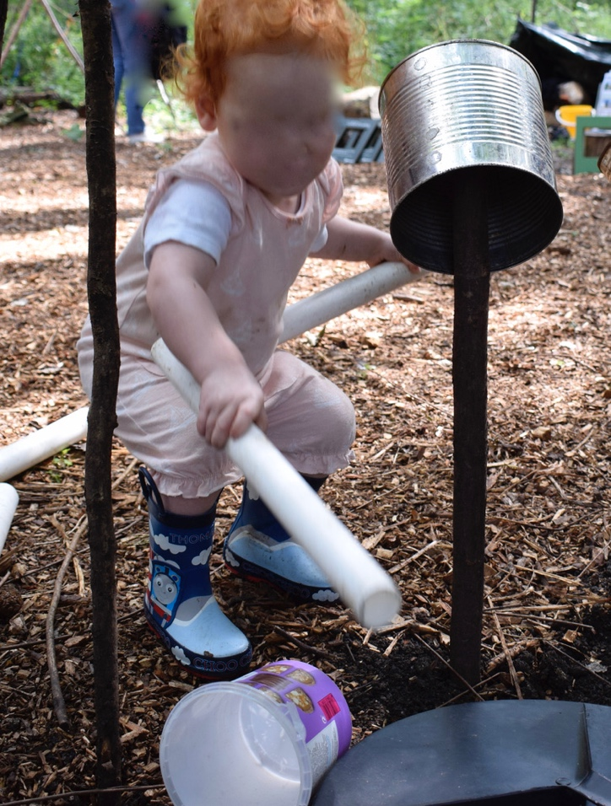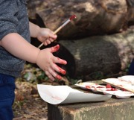

Creative spaces and places
My own practice as a teacher has been influenced by the Reggio Emilia approach to early childhood education where the physical space is regarded as a culturally specific, powerful language that is interpreted keenly by young children, making the environment ‘the third pedagogue’ (Lenz Taguchi, 2010: 10). Vecchi (2010: 82) argues for children’s right to beauty in their environments as ‘a condition of their physical and psychological well-being’ and demonstrates that a carefully presented physical environment shows that children are valued, and this has a powerful influence on their construction of identity as well as their creativity. Eisner (2004) makes an additional claim that cognition is not limited to language. Feeling and thinking are inseparable, as are the form and content of creative expression, and importantly, he stresses the relationship between art, thinking and materials. Drawing parallels with Dewey’s (2005) ‘Art as Experience’, he argues that ‘Having a nose for telling questions and a feel for incisive answers are not empty metaphors’ (Eisner, 2004: 7). People rely on the arts to express tacit knowledge, feelings and emotions when literal language fails them. In early childhood, the learning environment could be viewed metaphorically as an ‘atelier’, making ‘a strong declaration of the importance given to expression, creativity, and aesthetics as natural fibers within education’ that connect and integrate learning experiences (Cooper, 2012: 298) and promote creative expression through what Loris Malaguzzi famously termed the ‘hundred languages’ of children (Malaguzzi, 2012: 2). All of this research demonstrates the central role of the physical and material environment in both early education and practice that seeks to foster creativity.
In the field of children’s geography, Horton & Kraftl (2006) explain that rather than space being a singular, fixed entity, there are multiple, complex spaces operating at different levels from the topology to the individual people and things with each space, all of which are created through different encounters and relationships. These spaces can never be fully known and therefore Horton and Kraftl (2006: 85) use the term ‘spacings’ to move away from the singular noun and show that spaces are always in the process of becoming - they are never finished. Following a similar argument, Ingold (2008: 1807) claims that an environment could be interpreted as a ‘zone of entanglement’ with crossing trajectories that create the ‘texture’ of the world.
Eriksson Bergström (2021: 5) also distinguishes between ‘spaces’ and ‘places’ that are provided for children and the potential impact on their autonomy. Importantly, Eriksson Bergström suggests that there is a discrepancy between the levels of interaction with the physical environment that are afforded to children. While ‘spaces that are designed for children’ are often modelled on an adult view of what children are interested in, and what is needed to keep them safe, protected and probably separate from adult spaces, these child-friendly spaces may prove to be too restrictive for the children themselves. Alternatively, Eriksson Bergström suggests that ‘places’ can be seen as ‘leftover kinds of spaces’ where children can take ownership, and in which they have the freedom to create for themselves. She summarises this as the difference between ‘environments of children’ and ‘environments for children’ (Eriksson Bergström, 2021: 5) and she argues that this difference is related to their agency. This perspective suggests that the level of adult control over the physical environment is likely to be influential in fostering children’s creativity and that planning environments with specific pedagogical outcomes in mind may prove to be counterproductive.
These complex interpretations of space and place produce a socio-cultural and relational view of the creative learning environment which ‘is never neutral; it includes values, ideologies, preferences, regulations, and rules constraining the possibilities for action’ (Vuorisalo et al., 2015: 76). This relational interpretation of space has the potential to challenge the reductionist and individualistic approaches to creativity outlined at the start of this review and to develop an enhanced view of creativity as a distributed, contextually situated and materially mediated process.
Glăveanu’s 5 A’s framework (2013) aims to offer such a relational model. Once again, taking distributed views of creativity as his starting point, Glăveanu proposes a similar approach to his interpretation of the theory of affordances discussed previously. In this 5 A’s model he draws upon ecological psychology to shift the basic unit of analysis from the individual elements of creativity (person, product, process and press) to the ‘interaction between these elements’ (2013: 70 my emphasis). Briefly, Glăveanu’s model changes Rhodes’ (1961) terminology of the 4 P’s to 5 A’s so that the creative person becomes the ‘Actor’ to acknowledge that people are shaped by their social context, and to shift the focus of research from the internal attributes of the individual to studying the person’s creative attributes in relation to that context (Glăveanu, 2013: 72). The second ‘A’ shifts from creative process to creative ‘Action’, acknowledging that creativity is not just an internal cognitive process, it also involves an element of external behaviour and these two aspects are interconnected. As with distributed models of creativity, the process does not take place inside or outside of the person but instead, it is situated in between the actor and the environment and informed by continuous ‘feedback loops’ between the two (p.73). Glăveanu’s third ‘A’ focuses on ‘Artefacts’ (p.74) rather than creative products, reflecting his argument for the cultural nature of creative outcomes. The fourth and fifth ‘A’ s refer to what was previously termed the creative press (Rhodes, 1961) but this is where Glăveanu makes a significant departure. While the fourth ‘A’ is ‘Audience’ (p.74) and reflects the social environment, Glăveanu builds on his earlier work (2012) to introduce a fifth ‘A’ which is ‘Affordances’. This brings greater attention to the role of the material as Glăveanu argues that:
Even poets rely on a physical environment to be stimulated, inspired and capable to write, edit, and publish their work. Material objects both constrain and allow creative action in ways that deserve further attention.
(Glăveanu, 2012: 75)
In addition to bringing the role of the material into greater focus, Glăveanu’s main point is that affordances, and the human abilities to exploit them, are evolved through culture, over time, as actors discover more and more possibilities within their environment and begin to shape it for their own purposes. Whilst I agree with the need for renewed attention to the material in creativity research, I see Glăveanu’s five ‘A’s model as a deeply socio-cultural, and therefore anthropocentric, view of the world in which the human remains at the centre of the creative process, albeit in connection and relation with their material environment. In this thesis, I will de-centre this positioning of the human to explore the posthuman view of the child as presented by Murris (2016) and discussed above in relation to young children’s creativity. This will bring new materialism and the posthuman child into conversation with and through Chappell et al.’s (2011) wise humanising creativity to explore what else is made possible for our understanding of the complex, distributed, contextually situated and materially mediated processes of young children’s creativity. Therefore, in the next section I will interpret posthuman and new materialist philosophies in more detail before analysing their implications for creativity research.

New materialism, posthumanism and agential realism
There is a wide and rapidly growing range of theoretical and methodological approaches that focus on the material and the more-than-human, each having distinct characteristics but overlapping features and origins (Kuby, 2017). These ‘more-than-human ontologies’ (Kuby, 2017: 877), including ‘posthumanism’ (Braidotti, 2013a), ‘new materialism’ (Coole & Frost, 2010; Fox & Alldred, 2017), ‘agential realism’ (Barad, 2007) and ‘feminist new materialism’ (Alaimo & Hekman, 2008; Dolphijn & van der Tuin, 2012) are often grouped together under the umbrella terms of ‘posthumanism’ or ‘new materialism’, although these are constantly shifting concepts, or are, as I shall explain in the following section, ‘an active theoretical assemblage’ (Taylor, 2016: 21). However, as I have discussed in relation to the evolution of my research question, in this thesis I find the term ‘new materialism’ preferable to ‘posthumanism’ as I adopt a ‘mild notion of the posthuman’ (Bennett, 2016: 72) where the human is decentred but cannot be removed completely from an educational context in which I, as a human researcher, seek to explore creativity in the experiences of young human children.
New materialist philosophical approaches have led to an ontological turn, that decentres the human and focuses on the material to work with complexity and offer new insights into human and more-than-human relations. In this section, my aim is to put these new materialist ontologies to work to explore how creativity might be conceived as being produced through the relations of humans and more-than-humans in early childhood education, with a view to opening up new possibilities for theory, methodology and pedagogies that seek to foster creativity. To achieve this, I have drawn inspiration from several of these new materialist approaches, although my primary concern is with relational and feminist new materialism, and following Barad (2014), I have read the different theoretical positions ‘diffractively’, with and through one another, to produce something new - something that might offer a new perspective on creativity in early education.
New materialist approaches require a substantial shift in thinking to pay closer attention to the force of material objects and artefacts rather than focusing exclusively on the human (Barad, 2007). They unsettle the dominant humanist position as being the centre of the universe and the measure of all things (Braidotti, 2013a), and challenge ‘our habitual and anthropocentric ways of seeing’ (Hultman & Lenz Taguchi, 2010: 527). Therefore, it is important to consider why these shifts might be necessary.
Braidotti argues that:
The human of Humanism is neither an ideal or an objective statistical average or middle ground. It rather spells out a systematised standard of recognizability - of Sameness - by which all others can be assessed, regulated, and allotted to a designated social location. The human is a normative convention…
(Braidotti, 2013a: 26).
Braidotti identifies a particular (usually Western, male) view of the rational human as the norm against which ‘…Otherness is defined as its negative and specular counterpart: irrationality, immorality, femininity and non-westernness’ (Braidotti, 2013b: 15). This difference has profound and destructive consequences for those who are labelled as ‘others’. They are interpreted as being inferior ‘…the sexualized, radicalized, and naturalized others, who are reduced to the less than human status of disposable bodies’ (Braidotti, 2013b: 15). Similarly, the human of Humanism leads to a developmentalist logic that separates the child from the fully-formed-human, setting out a predetermined linear path towards maturity that does not respect individuality and works against complexity and diversity (Murris, 2016). As I have argued earlier in this chapter, this normative position leads to the view of the young child as not being developmentally capable of being truly creative. I suggest that this view devalues children’s abilities, producing what Fricker (2007) terms an ‘epistemic injustice’. Therefore, it seems to me that the ethics and equity of a new materialist approach which unsettles this view of the human appeals to a study that values young children’s creativity.
The new materialist lens also blurs the boundaries between the social, the cultural and the material and moves beyond the often-constraining binary differences of human and non-human, nature and culture, mind and body, reason and emotion (Fox and Alldred, 2017). This produces a flat, or monist, ontology (Braidotti, 2013a) and with it, new possibilities for creativity. Rather than focusing on the differences between the material, the cultural and the social, or rejecting the socio-cultural altogether, new materialism explores the relationships between them and how one affects the other. It foregrounds the body and materiality and challenges the view that thinking takes place in a mind that is separate from the body, therefore valuing other embodied ways of knowing and doing (Springgay & Rotas, 2015).
Similarly, posthumanism does not distinguish between the human and the non-human to privilege one above the other. Instead, the interest is in how materials can be social actors and make things happen. Consequently,
The turn to matter offers a re-immersion in the materiality of life and struggle, and a recognition that in a monist world - because there is no ‘other level’ that makes things do what they do - everything is necessarily relational and contextual rather than essential and absolute.
(Fox & Alldred, 2017: 8)
Therefore, Barad (2007) argues that ethics and justice are deeply rooted in new materialist concepts because humans are an entangled part of the world’s becoming (Kuby, 2017). This produces a ‘different kind of ethics’ (St. Pierre, 2013a: 652) which is not about the ‘right response to a radically exterior/ized other’ or tied to the ‘economic imperatives of advanced capitalism’ (Braidotti, 2013a: 171) but ‘responsibility and accountability for the lively relationalities of becoming of which we are a part’ (Barad, 2007: 393).
However, the affirmative and ethical approach of post humanism (Braidotti, 2013a) could potentially foreground the material without fully acknowledging the challenges of social inequalities (Quinn, 2013) and by removing dualisms it becomes more difficult to identify the power imbalances that are caused by differences in age, gender, race and social position (Coole & Frost, 2010). While on a practical level, it is important to acknowledge the hard-won battles of human rights, Braidotti argues that ‘it is impossible, both intellectually and ethically, to disengage the positive elements of Humanism from their problematic counterparts’ (2013a: 30).
Haraway (2016) demonstrates that the nature/culture distinction is being eroded by scientific advances and new technologies, but it may not be possible to completely dissolve the binary when humans wield so much power over the more-than-human. Furthermore, there may be occasions where it is not ethical to prioritise the non-human, for example, in situations where human lives are at risk. Therefore, critics of posthumanism have argued that it produces an ‘unserious’ philosophical position (van Ingen, 2016: 538). My interpretation is that posthuman perspectives offer the potential to think differently, more widely and to engage with the complexity of processes such as creativity. Perhaps, at times, this may produce a rather utopian view of what is achievable in early years settings where practitioners are juggling so many competing demands for their time and attention, and of course I would not suggest that the material should always be prioritised over the human, especially in matters of child safety and protection. However, my interpretation of the new materialist position is that ontologically and epistemologically, there has been an overemphasis on human agency in creativity research and there is much to be gained by blurring the boundaries between the human and the material and considering them as equal actors in an already entangled more-than-human world (Taylor, 2016). This conceptualisation offers new perspectives and ways of thinking about issues of ethics and justice while still being ‘perfectly compatible with the best humanist values’ (Braidotti, 2013a: 11). As a result, my suggestion is that a new materialist perspective may offer insights into how the ‘wisdom’ might be developed within our understandings of Chappell et al.’s (2011) ‘wise humanising creativity’. To explore this suggestion further it is necessary to analyse the implications of some of the main concepts in new materialist philosophy most notably, the assemblage (Deleuze & Guattari, 2004), intra-action (Barad, 2007) and the vibrant and productive nature of materials (Bennett, 2010).

Assemblage
Murris (2016) argues that there are no clear boundaries between children, adults and the material environment and that they all exist together in an ‘assemblage’ (Deleuze & Guattari, 2004) or ‘entanglement of matter and meaning’ (Barad, 2007). Assemblages involve combinations of bodies, things, utterances and modes of expression as well as thoughts, feelings, memories and emotions which, in ‘assemblage theory’ (DeLanda, 2006), ‘…can be treated in exactly the same way as other (seemingly more ‘material’) relations’ (Fox and Alldred, 2017: 26). Assemblages are ‘living throbbing confederations’ (Bennett, 2010: 23-24), unpredictable networks that are always in flux, assembling and reassembling in different ways and being held together by relations of affect (Fox & Alldred, 2017). Each actant within the assemblage has its own ‘vital force’ but there is also an agency within the group, making each one ‘an open-ended collective’ with a ‘distinctive history of formation but a finite life span’ (Bennett, 2010: 24).
It is not always possible to predict the formations of particular networks of relations within assemblages and it is not sufficient to simply observe and list the actants involved because they cannot be fully separated from their entanglement (Lenz Taguchi, 2011), and their agency is distributed (Bennett, 2010) across the assemblage. As Murris (2017: 533) writes, ‘things ‘are’ because they are always in relation to and influencing each other’. Consequently, the concern of new materialist research is not to identify the nature of bodies, things, or social institutions, but to identify the capacities for action, interaction, feeling and desire that are produced by the affective flows and intensities within an assemblage (Fox and Alldred, 2017). Therefore, to understand the complexity and distributed agency of an assemblage it is essential to observe the moment-by-moment relations when the actants are assembled together (Fox & Alldred, 2017). However, even with the most detailed observation, de Freitas (2017: 746) warns that in relational ontologies there is a danger of claiming that everything is ‘connected or inter-dependent without adequately addressing the complex structure’ of that connectivity. This requires a focus on Barad’s (2007) notion of intra-action.

Intra-action
In her agential realism, Barad (2007) argues that matter, meaning, time and space are all entangled and only emerge through ‘intra-action’ (p.ix). She uses this term to describe the complex web of material-discursive practices and relations within an assemblage and to differentiate this from the more usual social ‘inter-action’. Barad and the material feminists who have followed her (for example Alaimo and Hekman, 2008) claim that humans are not alone in their potential to act upon the world and to gain agency through their intra-action with more-than-human others (Lenz Taguchi, 2010: 4). This is a ‘mutual relationship of intra-dependence’ (Kuby, 2017: 884) and moment-by-moment connections in which ‘things ‘are’ because they are in relation to and influencing each other’ (Murris, 2016: 156). Identities are not fixed because everything is in a continuous process of becoming (Haraway, 2008). St. Pierre (2013a: 652) explains the ethical potential in the use of the term intra-action because it creates a ‘logic of connection, a logic of the and (this and this and this and…)’ and disrupts ‘the possibility of fixed, objective descriptions and identities’ including those of ‘woman’ and ‘child’. Consequently, the relationship of ‘intra-dependence and intra-connection between humans and nonhumans’ (Kuby, 2017: 884) repositions the child as rich, resourceful and powerful as a result of their relationships in an entangled world (Murris, 2016), but brings with it an ethical responsibility for the outcomes of their intra-action with others (Bennett, 2010). I interpret these fundamental new materialist principles as an ethical basis for social and ecological wisdom and importantly, a theoretical framework for researching wise, complex and distributed interpretations of creativity.

To affect and to be affected
The concept of intra-action within assemblages changes the focus of research so that rather than describing and representing what matter is, the focus shifts to ‘…what it does: what associations it makes, what capacities it has to affect its relations or to be affected by them, what consequences derive from these interactions’ (Fox & Alldred, 2017: 24). Massumi (2015: vii) explains that affect is a ‘dimension of life…which carries a political valence’ and ‘to affect and be affected is to be open to the world, to be active in it and to be patient for its return activity’ (p.ix). Affect can be felt in the body as much as in the mind and it is the means by which a body is changed, however slightly, through its encounter with another in the assemblage. Therefore, the openness to affect and to be affected is a crucial source of change, transformation (Massumi, 2015), and I would argue, creativity.

Agency of materials
Bennett (2010) argues for greater recognition of the role of materials and the force of things. Her work draws upon diverse examples of commonplace man-made items and material phenomena, including discarded rubbish, electricity and fish oils, to demonstrate their lively, self-organising capacity for affect in what she calls ‘thing power’ (p.xvi) and ‘vibrant materiality’ (p. xviii). Bennett (2010) argues that the world is not made up of active subjects and passive objects, but that organisms and matter have:
an agency of their own, being performative agents. They are intra-acting with each other differently, with different intensities and force, depending on the different potentialities of each organism and matter.
(Lenz Taguchi, 2010: 36)
While some agents may be fixed and have limited potential for affect, others, such as water or clay can ‘transform with great intensities and speed’ (Lenz Taguchi, 2010: 36) increasing their capacity to affect and be affected. Therefore, each element of an assemblage has the potential for its own agentic force, and through intra-action within an assemblage, ‘matter is produced and productive, generated and generative’ (Barad, 2007: 137) and what is produced may arrive ‘through humans but not entirely because of them’ (Bennett, 2010: 17). From a new materialist perspective, matter is ‘ontologically free’ (Braidotti, 2013a: 56), it is not in binary opposition to the human mind and there is not necessarily anything ‘inside or outside’ of it that causes it to do what it does (Fox and Alldred, 2017: 24). Instead, the human and the more-than-human are always in entangled relationship and their agency, or capacity to affect and be affected, is as a result of their ongoing intra-action.
It is important to note at this point that these ideas have a long history, particularly in indigenous populations where their connections with nature, the agency of place and the liveliness of the more-than-human world have long been understood (MacLure, 2015). Smartt Gullion (2018) advises that the ‘new’ in new materialism is only to signify that it is different to Marxist historical materialism in which humans are both part of nature and yet still separate from, or different to, it. The word ‘new’ is not making any claims to have first discovered these connections with the material world. Therefore, in an attempt to address this issue, Coole and Frost (2010: 4) suggest that perhaps ‘renewed’ materialism would be a better term to take into account this ‘rich materialist heritage’ (Coole & Frost, 2010: 4).
Although not new, the vibrant and agentic nature of objects and materials is a central strand in new materialist philosophy, but it is probably one of the most difficult aspects to understand from a Western perspective that is used to being dominated by the Humanist position. This is where I have found Lenz Taguchi’s examples from educational contexts particularly helpful. In one such example, she describes a teaching episode in which a group of children were asked to use buttons to demonstrate their understanding of division. However, instead of dividing the pile of buttons equally as requested, the children were repeatedly drawn to sorting them according to their colour and then their size and shape. Therefore, according to new materialist theory, the buttons can be seen to have agency in this intra-action as they were calling to the child’s affective understandings so that they ‘practically scream out, ‘Sort me!’ ‘Put me into piles’’ (Lenz Taguchi, 2011: 42). When reflecting after this incident, the teacher felt that she needed to order, or striate, the space (Deleuze & Guattari, 2004) and remove any potential for sorting by only offering buttons of the same colour, size and shape in future. From my own experience, I recognise this tension between the desire to follow children’s interests and the need to meet policy requirements with their associated predetermined learning objectives (Lewis, 2020). However, when working in her own assemblage of policy and practice, this method of striating the space appeared to be the only way that the teacher could make her voice heard over the ‘flows in the affective intensities’ that were produced by the colours and shapes of the buttons and deliver the mathematical instruction that was required (Lenz Taguchi, 2011: 42).
When considering creativity rather than new materialist research, it is interesting to note that it is still possible to see these effects of vital materialism and the multi-directional forces that are at play (Pacini-Ketchabaw et al., 2017). For example, Eisner (2004: 8) argues that in art ‘each material imposes its own distinctive demands and to use it well we have to learn to think with it’ and in arts-based research methods, McNiff (2012) talks of a connection to ‘forces of transformation and insight that are outside the realm of rational thought’ (McNiff, 2012: 5).
For research that seeks to widen current interpretations of creativity, a significant finding is related to imagination and can be found in McNiff’s claim that ‘in the creative process, the most meaningful insights often come by surprise, unexpectedly and even against the will of the creator’ (2012: 13). Perhaps these insights might be produced through the intra-action of the creator, their materials and their environment?

Putting new materialist theory to work in early childhood
New materialist thinking has begun to influence research in a wide and varied range of disciplines, but it is interesting to note that Somerville and Powell (2019) claim early childhood is leading the field of educational research in posthuman scholarship. Throughout my research I have been using an Endnote library and spreadsheet to keep track of these developments and create summaries of the most recent entries. Although it is never possible to identify all of the research in this area, and the task is made more difficult because articles do not always include posthumanism or new materialism in the title, my review does provide an overview of the different ways in which posthuman thinking has been put to work in the fields of early childhood studies and early childhood education.
Perhaps unsurprisingly, the common theme that is immediately apparent is the emphasis on connection and intra-action. Posthuman and new materialist theory has been used to highlight the intra-active nature of children’s relations with the human and more-than-human world in multiple examples of their play and their everyday lives. Researchers have chosen to analyse moment-by-moment examples, slowing down video and pausing to revisit photographs and fieldnotes that seem to call out to them and challenge them to think differently. This has resulted in findings that make the familiar strange and disrupt or provide new interpretations of areas of traditional early years practice including, observation (Lawrence, 2019), pedagogical documentation (Albin-Clark, 2019), outdoor play and learning (Merewether, 2019) child development theory (MacRae, 2019; Osgood, 2019), notions of caring (Hodgins, 2019) and children’s interests (Chesworth, 2019).
The ethical implications of posthuman and new materialist approaches that were outlined earlier in this chapter also seem to have motivated the majority of these early childhood researchers and there is a common theme of offering posthuman interpretations of empirical data to challenge narrow assessment regimes and instrumental policy discourses (for example: Chesworth, 2019; Mac Rae, 2019; Osgood, 2019). A further strand can be seen in the common worlds research of Taylor (2013), Do Nascimento (2019) and Somerville and Powell (2019) where observations of children’s intra-actions with the natural world are offered as potential ways for research to address the environmental crisis of the Anthropocene.
An interesting finding from my review of the new materialist literature in early childhood is that most research involves returning to fragments of data from larger studies. This methodological approach offers helpful insights into the process of data analysis but leaves little or no guidance for anyone wishing to embark on a project that aims to adopt a new materialist framework from the start and throughout data collection. This is an issue that I will return to later in the Methodology chapter of my thesis but first, it is necessary to consider the ways in which posthuman thinking might contribute to conceptualisations of creativity.

New Materialist insights into creativity
The first section of this review identified a trajectory of creativity research that has moved from studies of the creative genius and creative products to more everyday notions of little-c creativity and possibility thinking (Craft, 2002). The need for wisdom has been highlighted in the concept of wise humanising creativity (Chappell et al., 2011) and researchers have argued for distributed and participatory perspectives (Clapp, 2017; Glăveanu, 2010), recognising the role of social culture and the fact that creative outcomes are rarely achieved by one person alone. More recent research has begun to acknowledge the role of materials in creativity from a socio-cultural perspective, as illustrated by Tanggaard’s (2012: 20) argument that there is a close relationship between a creator and their material tools in the ‘sociomateriality of creativity in everyday life’ and Glăveanu’s (2013) 5 A’s model. However, as I have argued in relation to creative spaces and spaces, this is still an anthropocentric model where creative products are seen as cultural artefacts and the affordances of materials require the intervention of a human to bring them into being (Vuorisalo et al., 2015). In this thesis I do not intend to reject or contest these views of creativity, but I aim to add to them and think differently about creativity in early childhood by offering an alternative new materialist perspective.
Interestingly, Fox and Alldred (2017) argue for the central role of creativity in social production and change and they suggest applying the new materialist philosophy outlined earlier in this review to research. By developing these ideas, they arrive at a framework for materialist creativity as an ‘affective flow between assembled bodies, things and ideas’ (p.86) within a ‘creativity-assemblage’ (p.85). Therefore, rather than focusing on creators and outputs, new materialist creativity research would analyse ‘assemblages of human and non-human relations…flows of affect within assemblages…economies and micropolitics of assemblages and their effect… and the affective capacities of creative products themselves’ (p.86).
Similar proposals are made by Roudavski and Mc Cormack (2016) who explore ‘post-anthropocentric creativity’ in the context of digital creativity. The authors argue for a more inclusive notion of creative agency to include the material. They question the desirability of novelty in a finite world and wonder whether current power relationships should be reshaped away from the human desire to gain mastery over nature towards a slow, deep listening and a focus on stewardship. I can see parallels here between the concerns of these researchers in digital creativity and those of the early childhood researchers discussed above.
In the field of education, the potential of a posthuman approach to creativity is identified by Chappell (2018) who also proposes a shift away from ‘humanist driven approaches’ to allow for a ‘full range of players’ within the creative process’ (p.280) Chappell proposes a ‘(posthumanising) creativity’ although she chooses to place the word ‘posthumanising’ in brackets because she stresses that this is not a conceptual term but that it:
…indicates a cluster of flexible of ideas about creativity that will continue to change and develop as they are worked with, applied and interrogated, and that how they are referred to may also shift and develop in the future.
(Chappell, 2018: 280)
Chappell (2018) illustrates her discussion with examples from cross-arts and digital education with teenagers and young adults. She firmly places dialogue and relationally at the heart of creativity but draws upon posthuman philosophy to extend her understanding of dialogue to include intra-action between humans, materials, technology and environments. This posthuman view of dialogue is developed in a further article regarding materiality in science/arts (STEAM) pedagogy in which Chappell et al. (2019) present the findings from four case studies as a series of ‘diffractions’ taking the assemblage as the primary unit of analysis.
Chappell’s work (2018; 2019) is also concerned with relational ethics and, building on her concept of wise humanising creativity, she now suggests that the original interpretation of wisdom did not go far enough because it was too anthropocentric. In contrast, she proposes an ethics that is contextually relevant, emergent from intra-action and inclusive of materials and technology as equal actants in the creative process.
The research presented here shows the potential of a new and emerging interest in developing a posthuman view of creativity but this has yet to be extended to the field of early childhood. This is despite the extensive body of research that has enabled practitioners to think differently about a wide range of other key areas of early years practice and therefore, I suggest that there is much to be gained through a thesis that aims to answer the research question: What does a new materialist perspective reveal about creativity in early childhood education?
In this chapter I have presented the literature and made a case for creativity as intra-action. In the next chapter I will consider the implications of a new materialist framework for my methodological approach.

Chapter 3
Methodology

Introduction
In this chapter I provide an analysis of the methodological approach that I have taken to my research. I explain how I have applied Lenz Taguchi and St. Pierre’s (2017) approach of ‘concept as method’ and a diffractive analysis (Barad, 2007) to reconcile Barad’s onto-epistemology (2007) with methods drawn from traditional (Hammersley & Atkinson, 1995), visual (Pink, 2013) and sensory ethnography (Pink, 2015).
I also explain the challenges that I have faced over balancing new materialist thinking and post-qualitative approaches with the practical need to complete my fieldwork and share the findings of the research coherently within the relatively confined space of this written thesis. It is difficult to write linearly about an iterative process where so many things are happening simultaneously (Jackson & Mazzei, 2012). I hope that the inclusion of written and photographic interruptions disrupts a little of the traditional ordered narrative of the thesis and reflects the messy and ongoing process of my ‘becoming researcher’ (Lambert, 2019). What I present in this chapter then, is a mapping of my journey into post-qualitative research and thinking differently about knowledge production in the field of creativity in early childhood education.

Research setting
In Chapter 1, I gave an overview of the setting for the research, which was a rural art gallery and parkland in the Midlands of England. I also introduced the learning team members, children and families who participated in the study. Here I provide more detail regarding my fieldwork activities and the timescales involved, starting with the decisions I made regarding the context for the study.
The research question suggested that I needed to locate a setting for my fieldwork in which young children’s creative opportunities were regarded as important, and consequently, there would be a likelihood that I would be able to observe their creative encounters during the relatively short time that I spent in the field. As Churchley (2011) illustrates, there is no guarantee that these creative experiences will happen while a researcher is present and as I visited potential places and people to study, I began to realise the extent of this issue (Wellington, 2000). Even with the very youngest children, practitioners in schools and nurseries are required to teach across the curriculum and cannot devote large periods of time to creativity or the arts. After several exploratory visits to settings and attempts to explain my new materialist framework for the research, I realised that the arts-based context of an art gallery and park would offer several advantages. Firstly, the practitioners were practising artists and the children’s learning activities were all designed to foster their creativity, which increased the likelihood that I would be able to observe and participate in dedicated creative activities. Secondly, the setting was open throughout the year and offered enhanced creative activities during the school holidays. This meant that I was able to balance my part-time research with a full-time job by carrying out much of the fieldwork during the holiday period. Finally, and perhaps most importantly, the arts practitioners seemed to intuitively understand the central role of materials and the wider environment in their own creativity. This made communication about the aims of the research and the subsequent negotiation of access much easier. It also helped to establish a theoretical connection from the start. Therefore, my selection of this particular case matched the purpose of the research, was relevant to the issue that I wanted to investigate and provided opportunities for the observation of creativity as the phenomenon under investigation, while giving a holistic view of an educational setting (Cohen, Manion & Morrison, 2018).
As an existing member of the gallery, I was able to explore the potential of the setting independently before requesting a meeting with members of the learning team and then the Director of Creative and Engagement who was enthusiastic about the research and willing to grant permission of access as the main gatekeeper. As well as providing a positive start to the research relationship, this first meeting was particularly helpful for me in the planning stages the study. We explored and debated our individual understandings of the term creativity, and I was able to learn about the aims of the organisation and the activities that it provided for young children and their families.
All three of the adult participants were members of the setting’s learning team and one of them was the parent of one of the child participants. The adults were self-selected and offered to take part after reading the information that I provided as part of the ethical approach or through hearing about it from other members of the team. Children and families were invited to participate during the activities, following the procedure that I will outline in relation to ethical considerations later in this chapter. I joined in with the regular activities in the setting and then invited children to take part, and sought consent from their parents, when families approached me or when a child seemed to be particularly interested in an activity. Again, this process is explained in more detail later in the chapter.

Participants
11 families completed consent forms and agreed to participate in the research. The children were all under eight years of age and most were regular visitors to the park and gallery, especially the forest school.
An interesting aspect of completing the research in an arts-based setting, rather than a school or nursery, was that parents and children attended and took part in the activities together. When I began the research, I had not appreciated the difference that this would make to the fieldwork and the knowledge that the study would produce, but as I became more familiar with the setting, I began to realise that the learning team were providing the activities for both parents and children and the aim was to support and engage both as an inseparable dyad. Therefore, while my participants were primarily the children, their parents and other family members were also important contributors to the research assemblage (Fox & Alldred, 2017).
Millei and Rautio (2017) highlight the danger of researchers only selecting participants who meet their own expectations of what the area of study should look like, and in this research, I have tried to guard against only inviting people to participate when they were engaged in what I deemed to be creative activities. However, my choice of setting meant that the participants were drawn from a similar social group, all having chosen to visit a gallery and all able to afford the entrance fee. The rural location added a further layer of restriction as nearly everyone travelled to the setting by car. While it would have been preferable to involve a more diverse group of participants, my new materialist approach (Fox & Alldred, 2017) focuses on the material and on individual events, or assemblages, while making no attempt to generalise. Therefore, I believe that the benefits of situating the research in the gallery outweigh the limitations of not being able to recruit from a more diverse group of participants.
The overall approach to my fieldwork is summarised in the following table:

Timetable of fieldwork

Date | Activities completed
23rd May 2019 | Preliminary visit to explore the possibility of carrying out the research and potential participant groups.  Explored the park and gallery.  Made contact with the learning team members.
25th May 2019 | Meeting with Director of Creative and Engagement as main gatekeeper and Grounds Learning Programmer. Agreed the purpose of the research and my request to carry out observations as a form of ‘deep hanging out’.
13th June 2019 | Meeting to confirm dates and plans for the fieldwork.
Thursday 20th June 2019 | Preliminary visit to forest school.  Met leaders and volunteers and participated in activities.  Met some of the children and families.  Confirmed ethical arrangements and information for participants.
Tuesday 6th August 2019 | Participating in and observing holiday activities:  Morning– Painting with robots  Afternoon - Clay
Thursday 8th August 2019 | Participating in and observing activities in forest school
Tuesday 13th August 2019 | Participating in and observing holiday activities:  Morning - Stop motion animation in STEAM workshop  Lunchtime - Children’s gallery  Afternoon - Clay
Tuesday 20th August 2019 | Participating in and observing holiday activities:  Morning – Painting with robots  Afternoon - Clay
Thursday 22nd August 2019 | Participating in and observing activities in forest school
Thursday 5th September 2019 | Participating in and observing activities in forest school
Thursday 26th September 2019 | Participating in and observing activities in forest school
Thursday 3rd October 2019 | Participating in and observing activities in forest school
Thursday 10th October 2019 | Participating in and observing activities in forest school
Thursday 17th October 2019 | Participating in and observing activities in forest school
2nd April 2020 | Follow up visit and volunteer session arranged for forest school but this was cancelled due to Covid-19 and the temporary closure of the setting.
10th June 2021 | Return visit to meet with adult participants from the learning team.

Traditional ethnographic ways of knowing
Living is full of encounters that intrigue and provoke us
(St. Pierre, 2013b: 226)

Ethnography is usually understood as the prolonged study of people in naturally occurring environments (Cohen, Manion & Morrison, 2018). It has a long and varied history rooted in anthropology and sociology which led Van Maanen (2011: 2) to argue that ‘fieldwork is one answer - some say the best - to the question of how the understanding of others, close or distant, is achieved’. Given the age and developing language skills of the participants in this study, I needed a methodological approach that could attend to the embodied and multi-modal aspects of their activities and therefore, observation appeared to be a suitable method to achieve this. Brewer (2000) explains that ethnographers immerse themselves in the day-to-day activities of the fieldwork setting and rely on first-hand observation to understand people’s actions and experiences. Therefore, following Van Maanen (2011), I felt that ethnography offered a promising approach for this study. However, ethnography is concerned with language, meanings, understandings and the social world, making it a wholly anthropocentric approach and this has led to tensions with my new materialist desire to pay closer attention to the material world. Therefore, throughout this chapter, I will draw upon new materialist and post-qualitative research to explain and justify the ways in which I have balanced these tensions between traditional humanist ethnography and my new materialist research question, while using still photography and participant observation as the main methods of engaging with the field.

Participant observation
Participant observation seemed to offer an advantageous way in which to investigate creativity as it unfolded in the setting, moment by moment, through the largely play-based activities. Observation does not necessarily rely on language and therefore it opened up interesting possibilities for an exploration of the sensory and material aspects of creativity (Pink, 2015). I found Geertz’s (1998) concept of ‘deep hanging out’ to be a useful starting point for my observations and a way in which I could intra-act with children and materials by participating in the play and creative activities that were on offer in the gallery and forest school setting.
From a traditional ethnographic perspective, there was a fine balance to be struck between observation and participation (Hammersley & Atkinson, 1995). Along with Franks and Thomson (2019), I found that it was not feasible to write detailed notes or take many photographs when fully immersed in activities with the children and families. As Wellington (2000: 93) argues, participant observation ‘requires time, acceptance, carefully negotiated access and tact’ and such authentic participation is not easily achieved when one is busy writing notes or taking photographs. Additionally, there is an embodied, sensory, and practical element to creativity that is not necessarily rational. It defies representation in the static form of fieldnotes and can only be observed in the time and space in which it occurs. Consequently, I needed to be fully immersed in the activities in the field to be able to create my own embodied and sensory memories that could then be ‘re-animated’ during analysis through my brief fieldnotes and photographs (Franks & Thomson, 2019: 3). As I built relationships, became more familiar with the setting and confident in producing written fieldnotes, I found that my own balance shifted significantly in favour of near full participation. I took fewer photographs and limited my notes to brief jottings (Emerson et al., 2011). Although I was not conscious of it at the time, I have found that this strategy fits well with the post-qualitative position in which the researcher can only know the world from within and the notion of a detached observer is unthinkable (St. Pierre, 2014). In the words of Woodyer (2008: 354), I found that when researching creativity, ‘participant observation becomes more about the doing than the observing’.

Jottings and fieldnotes
I found the task of writing fieldnotes to be one of the more challenging aspects of the study. There is wide variation in what researchers regard as fieldnotes and relatively little instruction regarding an appropriate format or approach to writing them in the research methods literature (Emerson et al., 2011). Furthermore, when observing in everyday situations it is difficult not to take things for granted and to question the mundane and familiar when recording fieldnotes. Hall et al., (2008: 1022) argue that this requires ‘an estranging sensitivity’ which is more frequently found in the arts than the sciences. This was challenging for me as I was relying on my experience as a teacher in early years to determine my actions in the field and yet trying to bring something different in my current role as an academic and researcher when recording my fieldnotes. I found new materialist theoretical perspectives helpful in this respect as they enabled me to develop this estranging sensitivity by shifting my focus from the human towards the material and attending to embodied affect. Therefore, these overarching principles governed my decisions about what to record in my fieldnotes. I also relied on my reading about creativity as participation and interaction with the social and material world, as I have outlined in Chapter 2, to help me to determine what I felt to be significant and important to record.
In practice, my approach was to write my jottings (Emerson et al., 2011) about the activities, the material world, my general impressions of the children’s creative experiences and their sensory engagement, as well as reminders of any events or conversations that I thought were important and I may otherwise forget. My jottings were handwritten in a notebook that I had saved for this purpose, and I completed them as I engaged in the activities with the children and families. These jottings then formed the basis of my more detailed fieldnotes which I usually completed in the same notebook as I worked alone in the gallery cafe immediately after each daily period of observation. This maintained a useful physical connection with the field which helped me to recall more of the detail when writing the fieldnotes.

Photography, visual and sensory ethnography
Still, digital photography has been widely used by ethnographers as a method of documenting their fieldwork, sometimes only as an aide-memoire for their future writing and sometimes as data in their own right (Banks & Zeitlyn, 2015). As I began to design the research, I was aware that it is not possible to record and represent everything that one experiences in writing, and therefore, I decided to take photographs as an additional visual means of evoking memories of the field when I came to write more detailed fieldnotes. However, this seemingly simple method revealed its complexity as I spent increasing amounts of time in the setting. Pink (2013) notes that a camera can become part of the researcher’s identity and I felt this myself as I entered the field with all my participant information, consent forms and a relatively large digital SLR camera around my neck. Participants seemed to arrive at a conclusion that I was there primarily to take photographs, sometimes posing to invite me to take a photograph and passing comments about what would make a good one. This split identity as photographer and researcher was frustrating because I had hoped not to intrude on the activities that were taking place. I became increasingly conscious of having the camera with me and as a result, I often chose to leave it in my bag out of sight.
Clearly a video camera and audio recording might have widened the range of sensory information that I could have collected (Pink, 2015), and this is an area that I would like to pursue in future. However, in the confined and busy spaces of the gallery and forest school area, with many visiting members of the public, this was neither feasible nor ethical. Therefore, I decided not to make use of these functions on my digital camera and opted for still photography alone. In making this decision, I recognise the limitations of trying to represent sensory information in just words and images (Pink, 2015) and the influence of positivism that has led to a higher value being placed on seeing as a way of proving things by making them visible over and above all the other senses (Weaver & Snaza, 2017).

Interruption 5: Photographing creativity

I have chosen this camera with a view to obtaining high quality photographs. I recall the many photographs I have taken as practitioner documenting children’s learning in my work as a teacher. I love to focus on the awe and wonder on children’s faces and believe that this shows their enjoyment of creative activities in ways that cannot be achieved through words alone. I’m ready and looking for moments of obvious creativity - a creative product, a new discovery, dramatic play unfolding before me. But these moments are rare and cannot be guaranteed to occur at moments of my choosing.
Fieldnote 20th August 2019

Framing my photographs
Many of my photographs were taken in quick succession in an attempt to reflect the high levels of concentration and absorption that individual children displayed during their creative activities. However, in the moment of taking several photographs in a short space of time, there was little time for reflection about how or why I was taking each one. I tried to record a little of the embodied intra-action between child and material and hoped that the camera might draw my attention to other details and ways of knowing that I would have missed if I had relied solely on my own eyes and note taking skills (Cohen, Manion & Morrison, 2018).

Interruption 6: Materialist framing

I’m aware of my new materialist theoretical framing. I must focus on the material world as much as the children. I decide to photograph the feet, shoes, clay, floor assemblage that is occurring under the gallery table. It’s a constant challenge to frame my photographs in this way. I have never deliberately focused away from children’s faces and it feels strange to be chopping off heads and isolating individual body parts.
Fieldnote 20th August 2019

As I progressed through the fieldwork, I made a gradual shift from always photographing whole people in the way I had become accustomed to when documenting children’s learning in my teaching (Carr & Lee, 2012; Vecchi, 2010), to framing some of the shots around hands, fingers and sometimes feet, in an attempt to focus on the interface, and hopefully record something of the intra-action, between children and materials.

Interruption 7: A sense of place

It’s a bright sunny day at forest school. I decide to focus my camera on the trees, the sky and the surrounding parkland. I think this will provide important contextual and background information to support my observations of the action. Following the same theme, I take further photographs through the gallery windows.
Fieldnote 8th August 2019
Many of the later photographs were focused on the material environment and some excluded people altogether. This was often in an attempt to record something of the atmosphere and feel of the space on that particular day. Seasonal changes, nature, weather, layout and the materials provided for the children were all of interest as I began to adopt a more sensory approach to photographic documentation (Pink, 2015).

Interruption 8: Uncertainty

I’m becoming more confident in shifting the focus of my photographs. I zoom in on hands, fingers, shoes, mud, berries, pots and pans. I’m not sure what these photographs will reveal about creativity - this concerns me. I have to trust that something meaningful will come out of this research, but worry that there is no link to be made between new materialism and creativity.
(Fieldnote 22nd August 2019)
Although I have used the visual method of photography, I have come to see ethnography as an embodied and multisensory way of being with the world rather than merely thinking about it (Mellander & Wismeg, 2016). Therefore, throughout my fieldwork I have aimed to apply Weaver and Snaza’s concept of ‘listening’ rather than seeing as an alternative, open and connected means of hearing the world and coming to know in ways which include the material and the sensory, so that ‘we see more with our ears as well as our eyes’ (2017: 1059-1060). Creative experiences are not limited by language and words, and I was seeking to investigate intra-action through what Kaufmann and Holbrook (2016) term ‘hypermodal enquiry’ in which the affordances of technology are used to move away from qualitative inquiry’s reliance on ‘word-only methods’. My aim was to explore the embodied dimensions of ‘affect’ (Rose, 2016: 159) and question ‘what kinds of sights, expressions, soundscapes, narratives can emerge that have not yet been thought’.
I took 313 photographs in total. I found them to be useful, not as an objective record of events in the field (Pink, 2013) as I had initially imagined, but as a way of slowing down the action (Millei & Rautio, 2017), pressing pause or, as I will discuss later in this chapter, making an ‘agential cut’ (Barad, 2007: 175) at a particular moment to facilitate an analysis of the constantly moving forces, energies, flows and sensations between children, spaces, places and materials.
Although I shared some of my photographs with the participants on an informal basis, I retained ‘documentary control’ (Banks & Zeitlyn, 2015:113) over when to take photographs, what to include and the role that each image would play in the research findings. Rautio (2020: 2) refers to these decisions about when and where to pause the intra-action, what to include, and consequently what to exclude, in a recording of data as making an ‘activist cut’ where the aim is to focus on an issue and ultimately to bring about change. Similarly, when considering visual ethnography, Hayashi and Tobin (2012:18) reflect on the effects on research outcomes of shifting the focus of the camera, or ‘reframing’, to attend to those who may not have previously been considered as the key protagonists in the main action. They are referring to other children in a classroom setting, but from a new materialist perspective, this idea can be extended to include the material world. These are important ethical decisions which I will consider later in the chapter in relation to data analysis, but here it is significant to recognise that both my photographs and my fieldnotes represent a personal interpretation of the encounters that I observed. In practice, this was an iterative process of reading theory before and after each of my visits to the setting, with that reading informing my decisions regarding what to record, and my observations of practice informing my interpretations of theory. However, I recognise that it is not possible to fully represent the complexity of the social world in a set of fieldnotes and photographs. They will always be recorded from a theoretical, political and value position (St. Pierre, 2016a) and on a different day, I may have focused on other people, things or encounters and produced a different account of the same day’s activities. Furthermore, another observer would also be likely to have focused on other aspects of creativity that they found significant within the same activities on the same day (Wolf, 1992). Therefore, any account will always be situated and partial (Emerson et al., 2011) and any research findings represent just one interpretation among many possibilities.

Towards a relational material ethnography
The planning of my own ‘methodological’ approach has been informed by Hultman and Lenz Taguchi’s (2010: 525) relational materialist challenge to anthropocentric analysis, in which they question their own ‘perceptual style’ and ‘habits of seeing’ when working with photographic images of children playing in a variety of different contexts. Although their argument is primarily focused on the analysis of existing data, Hultman and Lenz Taguchi bring together the work of posthuman, poststructural and feminist new materialist theorists to argue for a methodology that pays closer attention to the material. They claim that language and discourse have been treated as the primary way in which reality is constructed and that this has been at the exclusion of other ways of knowing and being, including the material, that which is sensed through the body (Somerville, 2016) and ‘all other non-human forces that are at play’ (Murris, 2018: 1613). Or as Barad (2007: 801) writes ‘Language matters. Discourse matters. Culture matters. There is an important sense in which the only thing that does not seem to matter anymore is matter’. Matter is treated as the passive backdrop to human activity and ‘is not granted active agency or considered mutually agentic in transforming discourse, discursive practices and human subjectivities’ (Hultman & Lenz Taguchi, 2010: 526). Ultimately, while there is still a role for the human and the social, language has become dominant and ‘has been given too much power’ (Barad, 2003: 801).
Therefore, posthuman and new materialist methodologies focus on the entanglement and relationships between discourse, humans and nonhumans and their capacity for affect (Stewart, 2007). As I have indicated above in relation to Weaver and Snaza’s (2017) concept of listening, and as Murris (2018) clearly argues, this requires ‘a different type of ‘listening’, not only with the organ ear, but also by focusing on what is invisible and perhaps cannot be articulated, and a response ability for what is included and excluded’ (p.1613). Consequently, in my own research and through my reading, particularly of Barad (2003, 2007), Lather and St. Pierre (2013) and Hultman and Lenz Taguchi (2010), I have begun to question whether language is really able to represent the reality it claims to reflect. Is it possible to represent everything in words? Can knowledge fully represent an already existing, stable or fixed reality? Is there a clear distinction between knower, knowledge and the known, and if not, where does this leave me as a researcher?
From an agential realist and new materialist perspective, the answers to these questions present ‘an ontological gap’ (Barad, 2003: 804) that has ‘radical implications for qualitative methodology’ (MacLure, 2013a: 660) and the ways in which I have approached my fieldwork, analysis and the presentation of my findings in this thesis.

An onto-epistemological approach
The new materialist emphasis on matter, and the materiality of the world, unsettles epistemology (how we come to know), axiology (what is valued) and methodology (Coole & Frost, 2010). This has significant implications for my research because of the challenges of seeking to work with the complexity of a world that is always entangled and in flux as well as the need to take a broader, more inclusive approach to what it means to be human (St. Pierre, 2016a).
New materialism is founded on a flat ontology rather than a dualist one (Coole & Frost, 2010). This ontology rejects nature/culture, mind/matter dualisms so that rather than setting them apart, research can begin to explore how they affect each other and therefore how materials and the more-than-human can make things happen and act as social agents (Fox & Alldred, 2017). This ontological perspective is central to my new materialist research question and my views about creativity, therefore a flat, new materialist, ontology must also be central to my methodological approach.
A further implication of the flat new materialist ontology is its challenge to the dichotomy of inside and outside, or self/other, in research. There is no stable subject in new materialist thought because everything is relational and constructed through intra-action. Importantly, who and what we ‘are’ cannot be separated from the processes of how we come to know, or in other words, ontology cannot be separated from epistemology (Lenz Taguchi, 2010). Consequently, Barad (2007: 185) argues for a ‘study of practices in being’ or combined ‘onto-epistem-ology’ in which each of these aspects of research are closely entangled and things, including research methods, methodology, data and findings, are what they are capable of, or what they do (Thiele, 2014: 207).
Following this new materialist onto-epistemological perspective, St. Pierre (2014) argues that in qualitative social research the focus has tended to be on epistemology and methodology at the expense of ontology, with this false separation risking research becoming instrumental and reduced to ‘methods, process, and technique’ (p.3). Much of this critique (Lather & St. Pierre. 2013) challenges the objective, value free position of positivist research where ‘scientific methods’ claim to offer ‘context-free’ theories and predict cause and effect relationships in the continual search for scientifically based evidence and measurement (St. Pierre, 2016a: 116). Knowledge is presumed to build incrementally in a linear fashion and where there is a ‘gap in knowledge’ further research will seek to ‘fill’ it. Language must be neutral, precise, and objective to accurately observe a world that is separate from humans and can be ‘known in its entirety’ through direct sensory experience (St. Pierre, 2016a: 117). At the centre of all this is the neutral, objective researcher who pre-exists the study.
In their argument for a ‘post-qualitative’ approach, Lather and St. Pierre (2013) claim that these positivist principles continue to influence aspects of ethnography and qualitative research where the hallmarks of quality and trustworthiness are to be found in the systematic and authentic recording of reality, thick description, personal reflection and accurate written reproduction of participants’ experiences so that others may read the finished text and ‘be there too’ (St. Pierre, 2014, p.7). Therefore, while taking a sensory, ethnographically informed approach, I remain conscious that these methods are problematic in a new materialist onto-epistemology where there is no fixed and stable reality to be recorded, the researcher cannot stand back and reflect from a distance and language is insufficient when trying to represent the complexity of the world.
Despite the ontological appeal of post-qualitative inquiry, I note that Mellander and Wiszmeg (2016) rightly argue that all research methodology is a cultural and historical product and is in debt to what has come before. Similarly, Greene (2013) warns against post-qualitative approaches abandoning all that has been achieved by poststructural and postmodern qualitative research in recognising, reflecting on and making explicit the philosophical frameworks on which it is based. As Barad (2007: 394) argues, time does not flow in a linear progression, ‘future moments don’t follow present ones like beads on a string’ and therefore post-qualitative inquiry cannot be disentangled from other approaches and ways of knowing, including positivism, and must work with and through them.
Although positivist research may be favoured by policy makers who seek scientific facts or ‘truths’ as evidence of how children learn and what works in education (Ball, 2016), these methodological approaches have been unsettled by feminist and critical qualitative research that argues for diversity, inclusion and social justice. When considering posthuman and new materialist approaches it is important to recognise that many marginalised groups, including young children, are still fighting to claim the category of the human through this critical research. Therefore, when arguing for the inclusion of a posthuman, materialist perspective, I am not creating another dichotomy or suggesting that these crucial strands of humanist qualitative research should be diminished or replaced. I am simply seeking to add another perspective, to think differently and question what else could be considered in research that seeks to understand creativity in early childhood education.
With this aim in mind, Lather and St. Pierre’s (2013) post-qualitative approach does seem to work with a relational materialist onto-epistemology and to address some of the challenges of researching beyond anthropocentric thinking. Therefore, I shall explore and analyse the potential and the practicalities of post-qualitative approaches in the remainder of the present chapter.
Interruption 9: The posthuman challenge

After rereading Lenz Taguchi (2010), Barad (2007) and Bennett (2010) I look back at my ‘contextual photographs’ and realise that I have slipped back into my old habits of humanist thinking. The material environment is not a mere backdrop to the human action. The material world is a powerful actant within the assemblage. My camera, the parkland, clay-covered shoes, the gallery space are all intra-acting with each other, and any creative outcome is produced as a result of their entanglement.
What does this mean for my understanding of creativity? How does the material environment come to matter in this assemblage? Do the outcomes of intra-action in this assemblage change as a result of this material environment? If so, how? Does it matter that I am researching creativity in this particular environment and how does that impact on what is possible for me to know?
(Journal entry 7th January 2021)

Post-qualitative inquiry
‘New empiricism’ (St. Pierre, 2016a), ‘post-qualitative research’ (Lather & St. Pierre, 2013; St. Pierre, 2011), new materialist (Fox & Alldred, 2017) and Deleuzian methodologies (Coole & Frost, 2010) all offer ways of inquiring that are grounded in the transcendental empiricism of Deleuze and Guattari, as well as Foucauldian and Derridean thinking. In keeping with her emphasis on ontology, St. Pierre (2018) suggests that in order ‘to do post qualitative inquiry’ it is necessary to ‘read and reread as many primary and secondary sources about theory(ies) and/or theorist(s) until one becomes Foucauldian, becomes Deleuzian, becomes Derridean’ (p. 604) and the deconstruction of existing categories or structures together with the constant analysis of power relations, become second nature and a way of life.
This reading and ‘living with theory’ (St. Pierre, 2018: 604) has been a time-consuming and challenging journey into the unknown for me, but one that I have also enjoyed. Through my reading and thinking with poststructural, postmodern and posthuman ideas, I have developed a keen interest in philosophy, and this is something that I will continue to pursue after my doctoral journey is complete. I have found myself challenging what I have seen as ‘regimes of truth’ after reading Foucault (Lewis, 2018), becoming excited by the potential of a world that is always in the process of becoming after encountering the work of Deleuze and Guattari as interpreted by Lenz Taguchi (2010), and even returning to vegetarianism after contemplating the oppressive human-animal relations presented by Pedersen (2013). I am becoming entangled with the history, politics and philosophy of postmodernism, poststructuralism and posthumanism and it is impacting on my thinking in all aspects of my life.
Furthermore, it is only through reading St. Pierre (2013a, 2013b, 2014, 2016a, 2016b, 2019), as well as the work of other post-qualitative researchers (for example Coleman & Ringrose, 2013; Fox & Alldred, 2017; Guttorm et al., 2015; Koro-Ljungberg, 2012) who have followed her, that I am now able to recognise the humanistic empirical assumptions in my own methodological thinking and teaching. For example, I have written positionality statements to explain a seemingly stable and finite subjectivity, talked about data collection as if data pre-existed research and were ‘out there’ waiting to be collected then coded them on the assumption that meaning can be captured in words and the world can be reduced to such simplified categories and themes, before highlighting the lack of generalisability as a limitation of my studies. As St. Pierre (2016a) suggests, these are all examples of interpretivist qualitative methodology drawing upon humanist, and to some extent positivist, concepts. My own experiences of research practice seem to serve as examples of methodology being separated from philosophy, inquiry reduced to methodology and method to a toolbox of standardised techniques.
Tanggaard (2013) takes a post-qualitative approach to trouble the ‘messiness’ or complexity of research that is often omitted from more mechanistic approaches to research methods and the writing of reports. She claims that inquiry does not always go according to the initial methodological plan. In practice, research is highly dependent on, and determined by, experiences in the field, to the extent that it is difficult to predict what might happen in advance ‘and even harder to explain what guided the concrete steps along the way’ (p.413). Furthermore, thinking, learning and knowledge production are all dependent on the non-human as well as the human (Latour, 2005). ‘The material world acts upon our thinking just as much as our thinking acts upon it’ (Lenz Taguchi, 2010: 49). Rather than being extracted from the world, knowledge is produced by engaging with the world. Thoughts and ideas happen to us ‘from without’ and there is often a ‘necessity to thinking’ that involves chance encounters that are beyond our own choosing (Colebrook, 2002: 38).
My own experiences support Tanggaard’s view that ‘the field moves you in unexpected directions’ (2013: 413), indicating that the experience of ethnographic fieldwork has the potential to affect both the researcher and the direction of the research. I have attempted to give a flavour of these influences and affects in the interruptions that are woven throughout the thesis but the challenges of representing the affective flows of so many different actors and the messiness of research within a relatively linear report continues to challenge my thinking about methodology and methods, as well as my own creativity.
In this research, I have considered the poststructural rejection of pre-existing methods and methodology altogether (St. Pierre, 2021), but then realised that many of the philosophical concepts that I have been grappling with were only intended to re-orient thought rather than to organise practical human experience (St. Pierre, 2021). This has left me wondering how I might proceed with my new materialist exploration of creativity without setting a methodological design in advance or even having any clear guidelines for what one does in post-qualitative inquiry.
Tanggaard (2013) suggests that a possible way forward might involve a creative ‘theoretical re-working’ of research materials (p.415) while following, describing and being an active part of the associations of the field. This theoretical re-working appears to echo Lenz Taguchi and St. Pierre’s (2017) use of theoretical concepts themselves as a research method.

Concept as method
Following the new materialist emphasis on ontology and philosophy, Lenz Taguchi and St. Pierre (2017) propose a research practice of ‘concept as method’, as a means of asking different questions and thinking differently in post-qualitative research that is underpinned by Deleuze and Guattari’s transcendental empiricism (Deleuze, 1994; Deleuze and Guattari, 1994). Lenz Taguchi demonstrates how the application of concept as method can be achieved through a doubled action of the tracing and mapping of concepts and laying them out on the same ‘plane of thinking’ (2017: 700) or ‘map’ (Deleuze & Guattari, 2004: 12).
I see the first step in this methodology as reading and studying poststructural, postmodern, posthuman and new materialist philosophy to identify the key concepts that might help to re-orient my thinking and enable me to think differently about creativity in early education. As a result of this reading, I feel that the most useful concepts for me to think with are the flat new materialist ontology (Coole & Frost, 2010), the liveliness of materials (Bennett, 2010), intra-action (Barad, 2007) and the concept of the assemblage (Deleuze & Guattari, 2004). Therefore, I have taken these philosophical concepts and put them on the ‘map’ by weaving them together and bringing them into conversation with existing conceptualisations of creativity and the empirical materials from my own research. As I will explain later in the chapter, I have used a diffractive analysis (Barad, 2007) to identify points where these concepts converge and where they diverge to identify potential ‘lines of flight’ (Deleuze & Parnet, 1987: 125) that might lead to ways of thinking differently.
The result of this conceptual weaving is not intended to be a representation of creativity in early education, neither can it be generalised or reduced to simple definitions. Instead, by enacting concept as method, I have sought to add to current conceptualisations of creativity, to ask different questions, to seek other possibilities and to enable a new ‘face’ of creativity to emerge (Deleuze and Guattari, 1994: 19; Lenz Taguchi, 2017). Rather than a predetermined method, this conceptual weaving might be interpreted as a methodological process of creative experimentation.

Methodology as experimentation and creativity
I never made a painting as a work of art, it’s all research
(Pablo Picasso cited in McNiff, 2012: 29)
Post-qualitative inquiry produces different knowledge, and it produces knowledge differently (St. Pierre, 2018) but, as I have indicated above, it means that there is ‘no methodological road map’ for research beyond the human (Bennett, 2016: 66), no textbook or ‘recipe’ (St, Pierre, 2014: 10) other than to innovate and keep thinking with theory (Jackson & Mazzei, 2012).
Lather (2013: 635) suggests that rethinking methodology in the posthuman results in ‘a thousand tiny methodologies’ that are created ‘in the moment’ (Kuby, 2017: 879) and ‘trouble what it means to know and tell’ (Lather, 2013: 638). There is no clear beginning or end to post-qualitative research and there are no easy answers. Things come into being through intra-action (Barad, 2007) and methodology is always in a state of becoming. Therefore, post-qualitative approaches must offer innovative, experimental methodologies that work with complexity (Law, 2004), ‘the incalculable, the messy, not knowing’ (Lather, 2013: 642). The practice of inquiry then becomes a matter of invention rather than critique (Lather, 2016) and an experimentation in the middle of things (St. Pierre, 2019). For me, this experimentation in post-qualitative inquiry presents an enticing shift away from reproductive, deductive or inductive science (Deleuze & Guattari, 2004) and the associated desire for research that is often ‘expected to be fast, risk-free, and sterile’ (Koro-Lungberg, 2012: 808).
This concern for creativity in research is not new. It builds on earlier interpretations of ethnography such as Wolcott’s (1995) ‘The Art of Fieldwork’. Here, Wolcott argues that there is room for an artistic interpretation of the field alongside objective science. Throughout a study, and particularly when writing ethnographic reports, the researcher’s imagination and emotion bring further, possibly more artistic, dimensions to the work that have the potential to contribute to its liveliness and lasting affect/effect on the reader. Although Wolcott is not writing from a new materialist position, these are interesting connections between his work and the new materialist ontological challenge to the art/science dichotomy. I have taken inspiration from these connections and aimed to build on them in the development of my own interpretation of ethnography, methodology and my approach to the writing of this thesis.
Although post-qualitative research is creative and experimental and must be invented anew in every inquiry (St. Pierre, 2021), I do not think that means anything goes. Smartt Guillion (2018: 102) cautions that it is essential to be clear about the purpose of a study so that researchers are able to determine the most suitable approach in each individual case. Therefore, the aims and purposes of this inquiry guided my single, open research question. This has made space for lines of flight in any number of directions and from the beginning, my aim has been to think differently, identify new possibilities for creativity in early childhood education and as a result, to make a contribution to knowledge.
Where Picasso viewed his art as research in the quotation above, I now see post-qualitative research as an intellectual art form in which creative approaches to issues of methodology open up new possibilities for change, transformation and living life differently. Consequently, it becomes a matter of learning how to live in the middle of things and being ‘open to being surprised where it might take you’ (Kuby, 2017: 882).
I genuinely did not know what I would find or what the outcomes of this inquiry might be. This not knowing, and not having methodology books telling me what to do, has caused much uncertainty for me throughout my research. Initially, I resisted making a commitment to post-qualitative methodologies. I studied grounded theory (Charmaz, 2014) and experimented with computer-based methods of analysis (Gibbs, 2017) in an attempt to set out a clear methodology and offer a credible approach. Along with Ulmer (2017a) I have experienced periods of self-doubt and uncertainty as I found the complexity of new materialist onto-epistemology confusing, and the unfamiliar vocabulary presented what seemed like an insurmountable obstacle to my understanding. The challenge to think and research so differently also felt like a risky strategy for a doctoral thesis.
However, I have now come to realise that in the absence of set methods, ‘we have to trust in the world’ (St. Pierre, 2018: 606) and that the world will come to meet us halfway (Barad, 2007). We have to be willing to ‘trust that something may come out, though one is not yet completely sure what’ (Rajchman, 2000: 7). This thesis is the product of that trust.

A new materialist reflexivity
All ethnography is part philosophy and a good deal of the rest is confession
(Geertz, 1973: 346)
Ethnography can be interpreted as ‘a process of creating and representing knowledge’ on the basis of the researcher’s own experiences in the field (Pink, 2015: 5). Therefore, while some kind of representation is probably unavoidable, qualitative researchers do not claim to be objective or to provide the only true representation of a singular reality. Instead, they offer accounts of their own experiences (Pink, 2015) and as a result, their own subjectivity is central to the entire research process, as well as the knowledge that is produced. Bhatti (2017: 88) mirrors the expectation in many research methods textbooks with her argument that ‘a successful ethnographer is one who is self-aware and reflexive’. Consequently, this is something that I have aimed to demonstrate through the inclusion of my own views and questioning processes in the interruptions that are woven through the thesis. In Chapter 1, I have explained my own position in relation to the development of my research question. Similarly, earlier in this chapter, I reflected on the development of my theoretical position and personal philosophy, and in Chapter 4, I will offer my personal interpretations of the findings and the way in which I have chosen to present this thesis.
My first attempts at reflexive writing began with a positionality statement, but I found it difficult to decide what to include. Initially I felt that there was too much information about myself and commented to my supervisor that this felt self-indulgent, reminding me of Van Maanen’s (2011: 73) ‘confessional tales’. Yet when trying to redraft the statement, I wondered whether I had included enough information to demonstrate the credibility and trustworthiness of my research. When revisiting it again a year later, I found that my views had shifted, and my position was no longer the one that I had written in the redrafted version. I needed to rewrite again. It was difficult, if not impossible, to fix my position and capture it in one all-encompassing statement that would demonstrate the ongoing process of my reflexivity.
I now understand that these difficulties are consistent with my new materialist ontological position in which I could be interpreted as being just one part of a wider research assemblage (Fairchild, 2016) that is producing my ‘becoming researcher’ (Lambert, 2019). From this perspective, who I am and who I might be as an ethnographer becomes much more ‘fluid’, ‘nomadic’, ‘contingent on circumstances’ and ‘likely to change at any moment’ (Franks & Thomson, 2019: 8).

Recording my reflexive notes
Reflexivity is particularly important when recording fieldnotes and Pillow (2010) highlights the need for careful and critical journaling as one begins to represent others in research findings. I have sought to follow her advice by recording my own notes in a series of handwritten notebooks which have been an important tool to develop my thinking as well as my engagement with the personal, relational and emotional aspects of the research (Punch, 2010). One notebook contains my fieldnotes, including my own thoughts, experiences and feelings after each fieldwork visit to the park and gallery. Another set of notebooks includes a record of my reading and the development of my thinking about philosophy, ontology, epistemology and methodology, although there is some overlap where theory began to influence my fieldwork and vice versa. Finally, a third notebook acts as my personal journal. This is also my diary which I carry with me wherever I go. It is where I have recorded my notes about meetings with my supervisors and any thoughts that have occurred to me outside of the times when I have been carrying out fieldwork or reading specifically for this project. These journals map my thinking at every stage of the research process, and they have provided an invaluable resource in creating the interruptions and data fragments that are presented and shared in this thesis. As I review all my notebook entries, I now see my reflexivity as ‘the interplay’, or intra-action perhaps, ‘between theory and data; between researcher and researched, between field and text’ (Pillow, 2010: 278).
As I wrote my notes and reflections, I was influenced by Van Maanen’s (2011: 101) model of ‘impressionistic tales’ in ethnography and wondered how I might be able to produce work that is ‘figurative’ while still giving a ‘highly personal perspective’ in which the viewer is presented with ‘an apparent position in time and space’. My representation of the field is therefore personal, told as I remember it, with no claim to present a complete view or account for the many different ways in which others might have interpreted the same events. While I have constantly strived to keep an open mind regarding the outcomes of the research and to work with others to think differently about creativity, it remains inevitable that my own interests and experiences will have impacted on every stage of the research process (Punch & Oancea, 2014).
Throughout the thesis I have used personal language, choosing to use the words ‘I’ and ‘my’ despite their anthropocentric basis and the posthuman critique of these terms (Murris, 2016). This is because, rather than ‘taking refuge’ in methodological convention (Mellander & Wiszmeg, 2016: 95), I see reflexivity as taking personal responsibility for my own values, beliefs and methodological decisions as well as their impact on the research and the knowledge that is produced. I use ‘my’ to signify what is my own thinking rather than that of the participants or other researchers. However, this is not intended to detract from the new materialist position whereby what I refer to as ‘I’ and ‘mine’ is produced through intra-action in assemblage with others, both human and more-than-human (Barad, 2007). These issues highlight an ontological problem with the notion of reflexivity in post-qualitative and new materialist research.
I am attempting to understand the world from within the research assemblage rather than reflecting on it ‘from the outside’ (Barad, 2007: 88). Therefore, I am always already entangled in this inquiry, there is no clear beginning or end. I am starting in the middle (St. Pierre, 2016a) and engaging in a kind of ‘entangled post-reflexivity’ (Vagle & Hofsess, 2016: 334) rather than reflecting from an individual subjective position (MacRae et al., 2018). Barad (2007) and Haraway (1991) follow similar ontological arguments in their critique of reflexivity and its relationship with representation. Barad (2007) claims that reflection ‘holds the world at a distance’ (p.87) and ‘always produces the same elsewhere’ (p.89) while Haraway (1997: 268) writes that ‘reflexivity is not enough’.
This is an argument taken up by Pillow (2010: 275) who claims that reflexivity about every stage of the research process can reveal the power of the researcher, and question habits of thought and unconscious categories that challenge research relationships. Reflexivity is important in deconstructing the politics of representation and addressing issues of power and voice by questioning whose story is being told and who has the right to tell, but as Pillow notes, this is not a comfortable experience. I agree with Pillow’s argument that researcher reflexivity is often only loosely defined in methodological textbooks and it is a label that is applied in many different ways in practice (Koro-Ljungberg, 2016). Furthermore, it will only ever be ‘as deep as our methodological and epistemological knowledges’ (Pillow, 2010: 278). Along with many feminist new materialist researchers (for example Barad, 2007; Haraway, 1997; Pillow, 2010), I would question whether it is really possible, or even desirable, to fully represent others in research reports.
No amount of critical self-analysis can completely mitigate the power imbalances in society or fully overcome the fundamental issues with representation and legitimation in qualitative research (Mellander & Wiszmeg, 2016). However, again I agree with Pillow’s (2003) argument that although talking about the consequences of my position cannot help me to escape them, the solution is not to stop thinking and talking about them. Therefore, my aim has been to remain vigilant about my practice, to move beyond reflexivity as a static, bounded or taken for granted methodological exercise (Koro-Ljungberg, 2016) and to develop a more rigorous, questioning, ‘uncomfortable’ (Lather, 2001; Pillow, 2003: 188) and perhaps ‘dangerous’ (Pillow, 2010: 278) reflexivity that accepts the loss of certainty, pushes the limits of my understanding and engages with the difficult questions of my own position within the research. Barad (2007) proposes the concept of a response-able approach as a method of meeting these aims.

Response-able research
What is at issue is response-ability - the ability to respond. The range of possible responses that are invited, the kinds of responses that are disinvited or ruled out as fitting responses, are constrained and conditioned by the questions asked, where questions are not simply innocent queries, but particular practices of engagement.
(Karen Barad in Kleinmann, 2012: 81)

Haraway (1992; 1997) has become critical of the optical metaphor of reflection. She argues instead that researchers should focus on ‘effects of connection, of embodiment, and of responsibility for an imagined elsewhere’ through a process of diffraction (Haraway, 1992: 295). Diffraction is about mapping the effects of difference (Haraway, 1992: 300) where difference is affirmative and creative. It reads insights through one another and ‘alters lines of seeing’ (Schneider, 2002: 462) to identify differences and alternative ways of ‘looking at - or rather, being in and with - the world’ (Pacini-Ketchabaw et al., 2017: 14). Furthermore, diffraction engages with materiality, intra-action and co-constitution in ways that reflection and reflexive methodologies do not (Lenz Taguchi, 2012).
Barad (2007; 2014) builds on Haraway’s (1992; 1997) concept of diffraction to produce a methodological approach that works with these affirmative notions of difference and attends to the entanglement of matter and intra-action. Rather than being set against each another in opposition, following feminist queer theory, Barad’s diffraction reads insights from one theory, or discipline, or text through another with care and detailed attention (Bozalek & Zembylas, 2017). Consequently, instead of notions of critique, which Barad sees as a negative and potentially destructive practice of exclusion and turning on certain ideas in favour of others (Dolphijn & van der Tuin, 2012), diffractive methodologies are about taking responsibility and a deep concern for social justice. ‘Diffractive readings bring inventive provocations; they are good to think with’ (Dolphijn & van der Tuin, 2012: 50). They are respectful, detailed, ethical engagements as part of what Barad (2007) refers to as ‘response-ability’ and Haraway (1997) describes as a move towards possible worlds.
Pillow (2010: 278) argues that ‘we have not gone far enough’ in ethical and critical reflection for it to be truly transformational. But endless reflexivity and concern about representation and legitimation in research can become paralysing. As a doctoral student, I needed to get on with the business of conducting my research and Barad’s diffractive analysis with a response-ability for my actions and the knowledge that I produce would appear to offer an approach that fits with well with the entangled ethico-onto-epistem-oloigcal basis of my research question. In summary, in my new materialist approach to reflexivity, my aim is to acknowledge how my own subjectivity has come to matter in the research (Thiele, 2014) and always to ‘strive to figure new ways of thinking and making research better’ (Mellander & Wismeg, 2016: 100).

Ethical approach
Barad writes of an ethics, or ‘justice’, which requires:
…the ongoing practice of being open and alive to each meeting, each intra-action, so that we might use our ability to respond, our responsibility, to help awaken, to breathe life into ever new possibilities for living justly.
(Barad, 2007, p. x)
I see this not as a box ticking exercise, or a matter of institutional ethics (Davies, 2018), but a more complex and ongoing accountability or ‘response-ability’ in intra-action with others, both human and more-than-human (Thiele, 2014: 213). Barad (2008: 122) explains that this is ‘not a static relationality but a doing’ in which boundaries are enacted as part of the world’s becoming and where researcher and researched are ‘mutually constituted’ (Mellander & Wiszmeg, 2016: 100).
This response-ability seems to be particularly pertinent in my experimental and creative approach to inquiry where I am working on the basis of what ‘feels right’ within each intra-action to determine what is included or excluded (Koro-Ljungberg, 2016). I am relying on my own embodied response to research relationships and encounters which is a partial view, and as Haraway (1997) remarks, it is not possible to know everything about the participants, their differing interests and the field in which I am working. In ethnography, there is a particular closeness both physically and emotionally, an entanglement of researcher and researched, that ‘interferes with the world’ and has the potential for harm (Mellander & Wiszmeg, 2016: 94). Davies (2018) describes the resulting ethical response-ability that arises from this potential for harm as ‘opening to the possibility of acting differently in the world in ways that matter’ (p.119). I see this as an opening to affect, an embodied ‘responsiveness to something or a happening that cannot always be seen but is always present’ (Blaise et al., 2017: 32). Therefore, throughout the research I have constantly questioned my own thinking and feeling and tried to remain open to other ways of thinking, knowing and being. In this way, I remain accountable for my choices and the ‘entangled webs’ that I am weaving (Barad, 2007: 384). This accountability is magnified when researching with young children.

Listening as ethical practice
Although I do not believe that it is necessary to create separate child-friendly research methods, my axiological position as outlined in Chapter 1 means that I consider young children’s views to be as important as those of adults and I wanted the research design to facilitate a shared exploration of creativity between people of all ages. At the start of my research, I felt that this required a participatory approach and perhaps given more time, I could have involved the children in the research design and analysis. However, an important feature of the gallery and park activities is that families are free to decide whether or not to attend on week-by-week basis and I did not want the research to imply that more regular attendance was required. Furthermore, as I began to participate in the activities myself, I became aware that visits to the setting provided relatively brief opportunities for family time and I did not wish to intrude or distract either the parents or the children from this. Consequently, whilst I wholeheartedly believe in the value and importance of participatory approaches when researching the views of young children (for example Clark et al., 2014; Groundwater-Smith et al., 2015; Kellett, 2010), on this occasion I agree with Holland et al. (2010: 373) who caution against assuming that participatory designs necessarily produce ‘better’ research and that it is perhaps more important to focus on how that participation is enacted.
As I shall argue later in relation to creativity, Murris (2016) asserts that there is an ‘epistemic injustice’ (Fricker, 2007) that is done to children because their knowledge is not always given the same credibility as that of adults. Despite the considerable efforts of researchers to adopt participatory approaches (for example Groundwater-Smith et al., 2015; Eckhoff, 2019), the asymmetrical power relationships between children and adults may still result in one-way communication rather than a two-way exploration and this is something that I was keen to avoid as I participated in the fieldwork activities. Even the most well-intentioned attempts to engage in meaningful dialogue with children can sometimes result in what Davies (2014: 25) terms ‘listening-as-usual’ in which adults are listening for what they already know and are not really engaging with what they are hearing. I was conscious that this epistemic injustice might lead to an ‘illusion of participation’ (Palaiologou, 2014: 690), and position children has having ‘voice’ yet masking the power imbalance where I am, in fact, speaking for the child (Pillow, 2003) while serving my own interests in constructing creativity as I see it. Therefore, I have attempted a different kind of listening based on affect.
Davies (2014: 21) suggests an approach to listening as an ethical practice which she terms ‘emergent listening’ through what she describes as ‘difference, kindness and experimentation’. Davies claims that respectful listening requires the researcher to be ‘open to being affected’ (p.20) and to combine with children to create a ‘more powerful whole’ (Deleuze, 1988: 19) so that each encounter opens ‘each particular being to the intensity of their own experience in relation to others’ (Davies, 2014: 20). Although there is still scope for adult assumptions about children’s perspectives, this more embodied, affective interpretation of listening seemed to fit well with my new materialist theoretical framework, as well as my understanding of creativity and affect. Therefore, in my participant observations it was this intensity of experience that I aimed to record through my fieldnotes and photographs, while still being mindful of the asymmetrical power relations between children and adults, and the ethical principle of trustworthiness that calls for an ongoing attentiveness and responsiveness to affect in each research encounter. This has been the guiding principle for my practical ethical approach which I shall explain in more detail in the following section.

Institutional ethics and practical approach
My research is underpinned by the guidelines set out by the University of Sheffield and the British Educational Research Association (BERA, 2018) and it has received ethical approval from The University of Sheffield’s ethical review panel (see Appendix E). As I have noted above, I see this as an important aspect of all research, but only the starting point for the wider ethical response-ability of my personal and new materialist approach in which ‘ethics explodes anew in every circumstance’ (St. Pierre, 1997: 176).

Voluntary informed consent
My decision to research in an art gallery and park where my participants were visiting members of the public presented several ethical challenges. The first of these was the question of how to recruit the participants and obtain their informed consent on the day of their visit. I had prepared written information and suitable consent forms (see Appendices A and D), and at the gatekeeper’s request, I also prepared an A4 poster (see Appendix B) which I displayed at the entrance to the area in which I was observing. However, the process of recruiting participants when they arrived was time consuming and felt intrusive as the children and families were keen to get straight on with the activities. After discussing the issue with the learning team at the end of my first visit, they kindly offered to enlarge my poster and to print and laminate several copies. We displayed these all around the setting which enabled families to read the information at the same time as supervising their children. It was their choice whether to engage or not and I waited for them to speak to me if they were interested in participating. This simple change made a significant improvement to the way in which I recruited families. They quickly came to know about me and the research. Often that was enough, and they chose not to participate in the research but to engage with me as another member of the learning team. However, many families came to talk to me about their own thoughts and experiences of creativity, or often the lack of it, in early education. These conversations gave me a wider perspective on the topic as well as making the recruitment of the participants a less intrusive process. By the end of the fieldwork, eleven families and three Learning Team members had chosen to complete consent forms and participate.
The question of how to explain my research to the children troubled me for some time. Once the parents had signed consent forms it was important to explain my research to the children and to seek their consent to being observed and photographed. In the planning phase, the most challenging aspect of this was how to make the information meaningful and engaging. It was difficult to explain the complex and contested concept of creativity in a way that avoided my own biases and still made sense to children under the age of eight, but eventually I followed Alderson and Morrow’s (2011) advice and designed an information booklet which I called ‘Creativity Cats’ (see Appendix C). I shared this with each family who participated in the research, and they were given a copy to keep and hopefully enjoy at home afterwards.

Right to withdraw
Dockett et al. (2009) examine the challenges of gaining consent from young children and argue for the importance of seeking ‘assent’ (BERA, 2018: 15) where children may not yet have the necessary experience to fully understand the implications of taking part in research. This was a recurring issue throughout my research. Not disturbing the children’s activities by my presence in the setting was a constant consideration and I found that I needed to remain attentive to the verbal and non-verbal communication in each research encounter to determine my response. I understood that my presence in the setting would inevitably impact on the encounter but relied on my experience as a teacher in early years to be able to sense when my engagement was likely to result in genuine interaction and when it was more likely to interfere with or inhibit the children’s creativity and enjoyment of the activity (Fisher, 2016), in which case, I would move away.
I regarded the children’s assent as being provisional (Flewitt, 2005) and chose to remain in one area at a time while the children and families moved in and out as they wished. This worked particularly well in the forest school where children were free to move around to different activities according to their own interests. The parents generally followed their children or stayed in the middle to talk with friends, therefore the children were able to make their own decisions about whether they stayed with me or not.
However, there was still a power imbalance between me as an adult researcher and the young participants who were generally more used to following adult instructions, often without question. Again, this meant that I needed to be attentive to non-verbal communication, both the children’s and my own, to remain sensitive to the ways in which they exercised their right to exclude me from their play, move away or disengage (Clark et al., 2014). As with all of my new materialist approach, this required me to remain open to new possibilities, ‘embrace uncertainty’ and maintain an ‘ethical responsiveness’ within each research encounter (Chesworth, 2018: 851).

Anonymity and confidentiality
Another significant ethical concern stemmed from my decision to take photographs. Anonymity and confidentiality are central tenets in ethical practice, and I have taken care to use pseudonyms and avoid any information that might reveal the identity of the participants. However, the use of photography has been an important element of my methodological approach. Therefore, in the planning stages of the research, I followed generally agreed ethical practice and made a commitment to blurring faces and adjusting camera angles wherever possible to prevent individuals from being identified (Banks & Zeitlyn, 2015).
This proved to be helpful in shifting my focus from the human towards the material, but I was frustrated by the missed opportunities to include facial expressions - the intense concentration as a child worked in earnest to transport a bowl of water across the mud kitchen without spilling it, or the sheer delight as colours mixed and spread across a parent’s nose with aid of a child’s paint-smeared hands. Several parents recognised the limitations of this approach to photography and repeatedly stated that it was ‘fine’ for me take photographs of their children including their faces. One even recounted her disappointment at not being able to see a complete image of her child having so much fun.
From the perspective of the research, my own interest was in the desire to explore and remain open to the power of affect in intra-action between children and materials, but in the photographs I had produced this was often masked by the burring and framing that I had used to maintain anonymity. Although I regard child protection as paramount in all aspects of my work and research with children, I felt that to some extent the children and their views about creativity had been erased from my findings as a result of my approach to taking and processing photographs. This seems to highlight a tension between institutional ethical requirements, the fundamental need to protect children from harm and the ethical principle of including children’s perspectives in research. Nutbrown (2010) argues that the practice of pixilating photographs of children ‘may represent a further “crisis of representation”’ and that it is ‘an example of the “Othering” of young children in research’ (Nutbrown, 2010: 3). Although I believe that this was the right approach to have taken in this project, there are no easy solutions. The tension is something that I will continue to reflect on in future.

Interruption 10: No!

She slaps the damp clay onto the tray and wipes her hands, looks at them and grins at the sticky mess. She bangs her hand down on the ball of clay, ‘It’s a pancake!’
She presses a finger deep into the circle of clay and chuckles at the hole before making another one. The two holes look like eyes - ‘Daddy!’
Mum asks about the nose and she pushes her finger into the clay once more to make one, ‘Here!’.
Mum asks, ‘Where’s his mouth?’
She uses her finger to draw a horizontal line separating the eyes from the nose, ‘Here!’
I think this misconception is interesting and I draw the finished face in my fieldnotes.
She takes another ball of clay and makes ‘Mummy’. The she makes herself, ‘Me!’
She asks for another ball of clay to make her brother. I pass the clay and ask her whether I can take a photograph of the clay faces. ‘No!’, she says firmly. But then she grins and tilts her head as though she is posing for photograph of herself. Mum explains that her daughter hates having her photograph taken and they have trouble getting any family photographs. Mum seemed to be apologising for her daughter’s lack of co-operation.
I put my camera away in my bag (again).
(Fieldnote 3rd October 2019)

I reflected on this observation several weeks after recording it in my fieldnotes. Children are often photographed by adults without having any say whether they are willing for that to happen, and without necessarily understanding how the photographs will be used (Fox & Hoy, 2019). In this observation, the young child seems to be conflicted as she considers my request to take a photograph, not of herself, but of the clay representation of her family. It was the product of her creativity and a very personal one in which she was exploring ideas about the people who are most important to her. I have no means of understanding how the young child interpreted these clay faces. Are they just clay representations or do they hold a deeper connection or meaning to her? Her mother seemed keen for me to take the photograph, possibly because she had just signed a consent form and given her permission for me to involve her daughter in my research. Immediately the girl changed from the firm ‘No’ to a pose that suggested she was willing to be photographed along with the clay faces. Both parent and child seemed surprised when I put the camera away without further comment.
The term ‘sharenting’ (Fox & Hoy, 2019) has been used to describe the habitual sharing of information about one’s child on social media and it has become commonplace since technology has become so closely entangled with everyday life. It is likely that many of the parents and families in this study have grown up with social media, and in their desire to be seen as ‘good’ parents, and particularly ‘good mothers’, they may not fully understand the potential consequences or impact on the child (Fox & Hoy, 2019). However, perhaps this young child’s refusal of my request to take a photograph, and her general dislike of being photographed, might be an act of resistance against this growing desire to document and narrate children’s lives in such detail (Choi & Lewallen, 2018).

Thinking about data
Responding to the double crises of language and representation and the new materialist turn, post-qualitative researchers have begun to question the nature and role of what is considered to be data in qualitative research (Koro-Ljungberg & MacLure, 2013). Following Deleuzian philosophy, there is a resistance to answering ‘“what is” questions (St. Pierre, 2013b) and a desire not to limit the possibilities for new and different kinds of data by providing fixed definitions. Therefore, I have made a post-qualitative move towards the inclusion of a wider variety of materials and experiences than the ethnographic fieldnotes and photographs that I had envisioned as being my data at the start of this inquiry (Brinkmann, 2014; Koro-Ljungberg et al., 2017; St. Pierre, 1997).
Although I had carefully planned my fieldwork and identified the kinds of data that I intended to collect, there were also unexpected events that occurred during my research and have contributed to my thinking. Brinkmann (2014: 723) describes the materials that are collected in daily life as ‘stumble data’ because the researcher ‘stumbles’ across something that stands out to them as surprising, strange or confusing. For me these ‘encounters’ with data (Koro-Ljungberg et al., 2018: 472), or data producing assemblages, included serendipitous conversations, often prompted by my research information poster, but not as a direct result of my engagement with the research participants. Other experiences in my teaching, my engagement with theory and research literature and attending workshops and conferences also provided potential sources of data that were unplanned and unexpected.
Mirroring my own interpretation of intra-action, St. Pierre offers the notion of ‘response data’ (1997: 184) as a source which recognises the often-unacknowledged contribution of others in developing the researcher’s thinking. For me, this includes the informal conversations with learning team members during my time in the field, as well as discussions with my supervisors, friends and colleagues that form an integral part of what I consider to be my data assemblage.
While the term data may mean different things to different researchers, my materialist onto-epistem-ological position suggests that they are certainly not passive in the research assemblage or waiting to be analysed and transformed into knowledge by a researcher who is separate from them (Lenz Taguchi, 2012). Koro-Ljungberg et al. (2018) also question the ontological status of data as being stable, concrete, knowable and fixed in linear time or space, arguing that they are not innocent and instead actively serve particular groups of people, policies, discourses, values and master narratives. An example of this might be where data is recruited as evidence and an indicator of scientific rigour for accountability purposes or in ‘evidence-based’ policy initiatives. Data are performative within these research assemblages.
Fragments of data are also capable of calling out and attracting the researcher’s attention, invoking a sense of something that defies explanation or expression in words (Somerville, 2016). This aligns with the embodied sensual data that Pink (2015: xv) describes in her sensory ethnography as adding a richness to research findings that ‘communicate something of both the ethnographer’s own experiences and those of the people participating in the research’. Or what St. Pierre (1997: 175) refers to as ‘transgressive data’, which she suggests might include the ‘emotional data’ (p.180) that make the researcher feel uncomfortable and prove impossible to ignore. Data might be considered as ‘glowing’, ‘resonating in the body as well as the brain’ (MacLure, 2013a: 661) and producing affect that may lead to new thinking, but also sensations of ‘excitement, energy’ (MacLure, 2010: 282). Or puzzlement in the researcher where data resists analysis and refuses to ‘render up its meaning’ (MacLure, 2013a; 662). Throughout this study, my own research encounters with data have enabled me to rethink and widen my understanding of the term data beyond just written words and photographs. Therefore, my data include all the movements, emotions, sensations, politics and affect (Holmes & Jones, 2016: 122) that constitute the research assemblage. It is these entangled relations with data assemblages that form the basis of my diffractive analysis (Barad, 2014).
The notions of data encounters, stumble data, transgressive data, response data and lively data have led me to see data as a form of participation in the world. Again, I am not arguing that ‘anything goes’, rather I agree with Rautio’s claim (2020) that it is not always possible to identify what is to be counted as data until towards the end of the project when it becomes clear which experiences, encounters and materials have contributed the most to the researcher’s thinking about the phenomenon that is being studied. Consequently, it is only now that I am approaching the end of the study that I am in a position to present those materials that seem most significant, meaningful or insightful to me and my understanding(s) of creativity as data within the interruptions and findings in this thesis. My aim is that these different kinds of data will help to produce different kinds of knowledge about creativity in early childhood education and an original contribution to the field. To achieve this, I have adopted a post-qualitative, diffractive approach to what I interpret as my creative conversations with data.

Creative encounters with data - Diffractive analysis
Reading insights through one another diffractively is about experimenting with different patterns of relationality, opening things up, turning them over and over again, to see how the patterns shift. This is not about solving paradoxes or synthesizing different points of view from the outside…but rather about the material intra-implication of putting “oneself” at risk, troubling “oneself,” one’s ideas, one’s dreams, all the different ways of touching and being in touch, and sensing the differences and entanglements from within.
(Karen Barad in Kleinmann, 2012: 77)

Following Haraway (1992), Barad (2007) draws upon classical physics to explain that ‘diffraction has to do with the way waves combine when they overlap and the apparent bending and spreading of waves that occurs when waves encounter an obstruction’ (p.74). Barad proposes diffraction as a methodological approach that challenges the taken for granted assumptions of humanism and offers an alternative to individualist perspectives where man is seen as the ‘measure of all things’ and ‘the centre of the universe’ (Bozalek & Zembylas, 2017: 117). Waves cannot be separated from one another because they are not ‘discrete entities’ (Smartt Gullion, 2018: 115) but diffraction patterns are formed as waves interfere (or intra-act) with each other. This interference always leads to something new. Therefore, it is the difference that is produced within assemblages that is the focus of my diffractive analysis (Smartt Gullion, 2018).
In this thesis, rather than engaging in the restrictive practice of looking for cause and effect or thematically coding my data to classify meaning (Jackson & Mazzei, 2012; Lather, 2016) and identify already existing humanistic truths (Kuby, 2017), I was interested in bringing images, sensory perceptions, emotions (Rose, 2016), theories and bodies into conversation with each other (Davies, 2014; Murris, 2017). I aimed to explore the unpredictable, multiple and fluid affective flows within and across different encounters in research assemblages of theory, fieldnotes and photographs. I see these flows, patterns and differences as examples of creative conversations with data from within an agentic research assemblage or what Jackson (2013) conceptualises as a Deleuzian becoming of ‘data-as-machine’ where data is always on the move and actively seeking new connections.
When considering the materiality of data, MacLure (2013b: 229) draws upon Deleuzian philosophy to describe of the ‘wonder of objects’ that resides in ‘their capacity to enter into relation with researchers …as an event’ (p.231). MacLure suggests that this wonder is felt in the body, the gut or the heart, as well as the mind. She cautions that while data may produce a positive or comforting experience it may also result in ‘curiosity, horror, fascination, disgust, and monstrosity’ (p.229) creating tensions, stuck places and challenges for the researcher. These affects and effects of our relations with data are often unexpected and are not always within our control but as Deleuze explains, such events ‘are actualized in us, they wait for us’ and if we are lucky, ‘they invite is in’ (Deleuze, 2004: 169).

Interruption 11: Moving to think

I take a walk to free up some thinking space and let these ideas intra-act with my own thinking, experiences and physical movement. Writing is not the only way to make sense of these things. Diffractive analysis can take many different forms. It is creative and benefits from multi-modal encounters.
(Journal entry 7th January 2021)

Through my thinking with both theory and data, I arrived at a diffractive approach to analysis whereby I used my fieldnotes and photographs to re-enter my encounters in the field and explore the memories and emotions that they evoked, always working with and reworking the ‘data’ to produce new analytical encounters with the material (Millei & Rautio, 2017). I ‘re-turned’ (Barad, 2014: 168) to specific ‘data chunks’ (Jackson & Mazzei, 2012: 139), reading and re-reading my fieldnotes, writing and re-rewriting the interruptions.
I found that writing provided a useful additional method of analysis that enabled me to articulate ideas that were on the limits of my consciousness and forced me to move forward (St. Pierre, 2011). This was a more intuitive kind of writing to that which I was using to write the thesis itself and an iterative, experimental process of writing, thinking, reading and then writing a little more. Regular free writing sessions of this nature became an important ‘way of weaving theory and empirical materials together’ and ‘threading back and forth between the two’ (Coles & Thomson, 2016: 254).
Hammersley and Atkinson (1995) argue that ethnographic research is constructed through writing, while St. Pierre (2018) talks of phrases that seemed to write themselves and words appearing on the computer screen almost unconsciously. I see my own writing as a method of clarifying and developing my thinking, or an embodied ‘think-writing’ (St. Pierre, 2018: 605; Tanggaard, 2013) that enabled me to put different ‘data into relation with theory’ (Augustine, 2014: 752) and produce knowledge through intra-action (Sellers, 2013). I tried to slow down in my analysis (Banks, 2014; Ulmer, 2017b) and put the data into relation with my own embodied experiences and the different theoretical conceptualisations of creativity that I have outlined in Chapter 2. Throughout this iterative process of diffractive analysis, my own life frequently cut with the research and materialised it in different ways as a means of thinking with self and data to produce something new.
Manning and Massumi talk of ‘a commotion of relational activity, each vying to be written down, to be the conduit of the field’s summing up in a determinate expression’ (2014: 12). In my diffractive analysis I was thinking with this commotion, posing questions about how the assemblages worked together to make things happen and come to matter. What were the sensory, spatial, temporal, affective dimensions of each encounter with my data? What seemed insightful in my search for flows and patterns of intra-action and creativity? What was not? What was I leaving out? What else? Not seeking truths or meanings, pre-existing realities or narrow definitions, but seeking ‘categories like Interesting, Remarkable, or Important’ (Deleuze & Guattari, 1994: 82) and asking how things happened, how they worked and what was produced (Lenz Taguchi, 2012).
Jackson and Mazzei (2013: 262) describe this methodological and philosophical thinking with theory as a way of ‘plugging in’ or entering into assemblages and intra-acting to make new connections from the inside (Jackson & Mazzei, 2012). I was becoming-with (Haraway, 2008) data as a ‘constitutive force’ (Lenz Taguchi, 2012: 274) in each encounter, rather than analysing it in a mind that was separate from it. My own embodied and sensory responses determined what was included as data and what was not (Lupton, 2018). The data fragments and extracts from my questioning became the interruptions that are woven through this thesis. They are intended as ‘inventive provocations’ (Barad in Dolphijn & van der Tuin, 2012: 50), inviting alternative perspectives from the reader that might take the diffractive analysis beyond the boundaries of these pages and this thesis.
My own experience of trying to weave together the various strands and potential lines of flight within the thesis supports Jackson and Mazzei’s (2012) view that the ‘plugging in’ is relevantly straightforward, but the much more challenging aspect of thinking with theory is the act of ‘putting it to work to make something new’ (p.262). They stress that the research assemblage is not a thing, but a process and it is this ‘process of arranging, organising fitting together’ (p.262) or ‘reading-the-data-while-thinking-the-theory’ (p.264) that might be considered as an analysis that is generative of difference, creating new possibilities that are always on the move and in the process of becoming.
There are so many possible paths that I might have followed, interruptions that given more time and space, I could have included. So many new directions that I have become aware of since presenting my initial ideas, talking to others and writing about my work. My initial focus on creativity in early education has widened and become complicated through my thinking with theory and I have struggled to pin down and present my ideas coherently without closing down important alternatives (Vagle & Hofsess, 2016). However, further embodied diffractive readings and writings have enabled me to temporarily organise and structure my responses to the affective flows within the research assemblage. I have cut across the various interruptions, bringing together theory and data fragments from different times and spaces, to produce the narrative which I offer as one possibility for making sense of the findings and answering the research question ‘What does a new materialist perspective reveal about creativity in early childhood education?’ These are the ‘data narratives’ (Lupton, 2018:8) and possibilities for creativity that I have presented in the discussion chapter, and they represent the materialisations or cuts that I have chosen to make at this point in time. Taking inspiration from my reading of theory and weaving that with the empirical materials from my fieldwork, I maintain that rather than mechanically following predetermined methods, it is this reading and weaving of theory that gives my work its academic rigour.
I see this as a call for wisdom and a ‘response-able reading’ (Murris & Bozalek, 2019). I draw upon feminist perspectives to recognise that at every moment, it matters which ‘agential cuts’ (Barad, 2007: 148) I make and how I choose to (re)present them in my thesis. It matters whose and which knowledges are produced, and whose and which knowledges are excluded (Thiele, 2014). If others are ‘co-constituted and entangled through the very cuts “we” help to enact’ (Barad, 2007: 179), making an agential cut is a power move (Fox & Alldred, 2017). Therefore, a new materialist diffractive analysis must be about being response-able for ‘the entangled materializations of which we are a part, including new configurations, new subjectivities, new possibilities - even the smallest cuts matter’ (Barad, 2007: 384). Consequently, analysis and ethics are mutually entangled throughout the thesis in my ‘ethico-onto-epistemological’ approach (Barad, 2007: 381; Thiel, 2014).
Again, I do not attempt to determine meaning or represent what I have observed (Latour, 2014) but to open up new possibilities for understanding creativity in early childhood. I see this analysis as a way of temporarily pausing the ongoing intra-action within assemblages so that phenomena such as creativity become solid and tangible for a period of time and can be interpreted. These response-able agential cuts and potential lines of flight form the basis of my claim to knowledge in this thesis.

Interruption 12: Diffractive analysis

‘Ah no don’t ruin them by analysing them! Become an artist instead and just curate and display them somewhere’
(Discussing analysis of the photographs. Personal communication with learning team member, October 2019)

Conversations with visual data - learning to be affected
My early attempts to analyse the images from my fieldwork resulted in frustration. As I studied each photograph, I was instinctively looking for evidence of the children’s creative products that would enable me to document their creative experiences and individual potential. However, as I studied the photographs, I could not see anything that stood out as being particularly creative. My professional heritage as an early years teacher and my habitual reliance on child development theory meant that I could only see the Piagetian schematic play and the Vygotskian social construction that I had come to expect in early years settings. I needed to ‘re-turn’ (Barad, 2014: 168) to new materialist theory to realise that I was imposing my existing thinking on the photographs and considering their two-dimensional content rather than taking time to (re)create or (re)experience their potential and their capacity for affect. As Ulmer (2017b) suggests, I was missing the opportunity to intra-act with the images in their becoming and had not yet learned to be affected by them (Springgay & Zaliwska, 2017).
My experience mirrors Banks’ (2014) view that the strength, and also the frustration, of using photographs in research is in their refusal to be confined by text or context and that images can speak in different ways and offer new insights that are not always accessible through language and text. Banks (2014: 73) stresses the importance of ‘slow research’ and recommends standing back and taking the time to ‘let an image breathe’ within a text to engage with its ‘full power’ to inform research and offer new insights.
At the time of my analysis, my research was impacted by the coronavirus pandemic, and I found myself with limited periods of time for study within a busy work schedule. The situation forced me to step away from my research for a while, which had an unintended benefit of letting the images settle and for me to re-engage with them several months later with a little more distance from the fieldwork. This additional time changed my thinking about the photographs, fieldwork and theoretical framework and gave me the time and space to learn to be affected by them. I began to ask different, and often better, questions of the photographs.
I re-viewed and rearranged the photographs again and again on my computer screen. I tried grouping them into similar events or focusing on the points where human meets more-than-human, where fingers touched water containers, clay, iPads etc or where feet and shoes met paint and clay. As I explored different groupings of the photographs and began to see their relations with existing concepts and theoretical perspectives, I experimented with alternative interpretations and ways to present the findings within the thesis while maintaining their liveliness. A serendipitous encounter between the photographs and the automated design suggestions in Microsoft PowerPoint led to an interesting method of focussing on the different elements of each photograph which enabled me to consider the effects and sensory affect of different groupings or presentation styles. This process enabled me to bring the photographic data to life in new and unexpected ways. As particular groupings or assemblages of photographs, fieldnotes and theory came together they caught my interest, generating new questions and intra-acting with my understandings of creativity research so that they ‘glowed’ (MacLure, 2010) and seemed to offer a potential line of flight through which to explore embodied affective relations, rhythms and patterns of movement and alternative becomings. This process offered the potential to generate new questions, to imagine alternative possibilities and eventually to think differently about creativity in early childhood education.

Conclusion
In this chapter I have explained my fieldwork and analysed my decision to adopt a diffractive and post-qualitative methodological approach as a means of working with the ontological underpinnings of my new materialist research question. I have also analysed my interpretation of reflexivity and ethics as an entangled response-ability for the research participants and the outcomes of the project.
In an attempt to preserve the liveliness of the data, and to remain open to new and alternative possibilities, I have chosen to report the cuts that I have made in the selection of my findings as interruptions throughout the thesis. I explain and interpret these interruptions in more detail in the following chapter.

Chapter 4

Findings and discussion

Challenges of presenting or re-presenting my findings
In the previous chapter I explored some of the theoretical challenges of representation in research. Here I develop these theoretical concerns to explain how they have played out in the presentation and analysis of what would conventionally be termed the ‘findings’ of my research.
At the start of the project, I felt that my findings needed to represent or redefine creativity in some way. I expected that this would be achieved through an inductive thematic analysis (Braun & Clarke, 2006) of the photographs and observational notes that I had collected during my time in the field. However, new materialist thinking grapples with the double crises of language and representation in ethnography and my reading of Barad (2007), as well as the philosophy of the ‘posts’, has led me to question this aim.
Coles and Thomson (2016: 256) show that rather than seeking objective truths, ethnographers have held that ‘words are not a transparent window on the world’ and that when writing ethnography ‘authoring a text is also simultaneously authoring an interpretation of the world’. Similarly, MacLure (2013a) adds that ‘language cannot achieve the distance and externality that would allow it to represent - i.e. to stand over, stand for and stand in for - the world’ (p.660). This has left me with the recurring question of how I might use language within this thesis to share the findings and outcomes of my time in the field without limiting or fixing what creativity is, and what it might become, as a result of my personal interpretation of the world. Consequently, in my own methodological approach, although I have represented my findings as written and photographic interruptions in this thesis, I have continued to draw inspiration from post-qualitative nonrepresentational ethnography in which ‘ethnographers consider their work to be impressionistic and inevitably creative. Although they are inspired by their lived experiences in the field, ‘they do not claim to be able, or even interested, in reporting on those in an impersonal, neutral, or reliable manner’ (Vannini, 2015: 318). However, I also have sympathy with Greene (2013:754) who challenges this post-qualitative ‘wholesale rejection of representation’, arguing that it is an unavoidable aspect of academic work regardless of the mode of communication that is adopted. Researchers might use photography, opera, or dance as alternatives to writing but they still need to communicate what they have learned, and this will always involve a degree of representation.
Ulmer (2017a) offers a possible way out of this bind, suggesting that representation might be ‘troubled in degrees’. If ‘purely non-representational research’ is what post-qualitative researchers aspire to, then perhaps, Ulmer argues, ‘less-representational research might be an intermediate goal’ (p.839). For me this seems to offer a compromise in my own balancing act between wanting to speak with clarity about creativity and the outcomes of my research while also trying to avoid a representation of it that leaves little room for complexity, ‘the not-yet-known, the emerging, the wild, the uncategorizable’ (Rautio, 2020: 2).
Therefore, what I present in the following chapter is a weaving, or a story (Haraway, 2016), that I have created after much to-ing and fro-ing between different possibilities and versions of the same events. This weaving is determined by the agential cuts (Barad, 2007) that I have chosen to make in the selection and presentation of my findings. However, by presenting the images, notes and reflections as interruptions throughout the thesis, I am also offering them as provocations in which I am asking the reader to join me in reflecting on what else is produced and how I might account for the messy, entangled relations and connections that took place in the field. In doing so, I interpret the findings of this research not as a thing that is there to be analysed but as an act or a doing that is both performative and affective in its own right - a means of engaging with the ongoing flows and intensities of the creative process.
In Chapter 3, I examined the potential of thinking with theory as a methodological approach that involves ‘plugging in’ or entering research assemblages and intra-acting with these flows and intensities of my experiences in the field to make new connections. I identified the concepts of a flat new materialist ontology (Coole & Frost, 2010), the liveliness of materials (Bennett, 2010), the concept of the assemblage (Deleuze & Guattari, 2004) and intra-action (Barad, 2007) as being the most relevant and useful aspects of new materialist theory for me to think with and bring into conversation with existing conceptualisations of creativity. In the following sections, I offer the cuts and weavings of this diffractive post-qualitative analysis as a means of exploring new interpretations of creativity from a new materialist perspective. I begin with the concept of intra-action.

Creativity as intra-action
Creativity research has begun to move away from the study of exceptional individuals towards a more everyday interpretation that includes the creativity of young children. Furthermore, systems-based approaches such as that of Csikszentmihalyi (1996: 23) emphasise the role of other people in determining the value of creative products, arguing that ‘…creativity does not happen inside people’s heads, but in the interaction between a person’s thoughts and a sociocultural context’. As I have discussed in Chapter 2, this focus on the social aspects of creativity can be traced back to Vygotsky (2004) and has been developed further by Clapp’s (2017) model of participatory creativity in which it is ideas rather than individuals that are creative and there are multiple ways in which an individual might participate in the development of creative ideas within a social context.
This fundamental importance of the social context is also apparent in my own observations, most noticeably in the numerous examples of parents engaging in the activities alongside their children, scaffolding their learning by drawing on their deep understanding of the child, their prior experiences and their interests. The members of the learning team also played an important role in valuing and developing the children’s creative responses, forming what I will go on to argue later, could be interpreted as an assemblage in which social participants work together as one to produce creative identities.
Tanggaard (2012) and Glăveanu (2012) have drawn on the theory of affordances to add an important further dimension to the assemblage that provides a role for the material environment in what Glăveanu (2012: 205) describes as a ‘dynamic, relational, and action-oriented’ interpretation of creativity that connects ‘the social, the material, and the psychological’. Glăveanu (2014: 27) goes on to describe creativity as occurring as a result of ‘an encounter with the world’ and it is this socially and materially distributed model of creativity that I would like to bring into conversation with new materialist thinking and my fieldwork observations within my diffractive analysis.
Interruption 13: Thinking with water

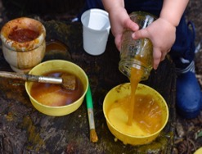

Water challenges the children, it demands concentration as they try to transport it, while it seems to be constantly seeking to escape. They take pleasure in its ability to flow freely and delight when this goes in unexpected directions. Sometimes water can be contained, but never for long. It loses its interest for the children when it is still. The potential is in its movement – its liveliness.

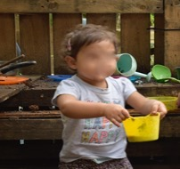

The water wall, with its different pipes, funnels and pouring devices, poses further questions. The children are drawn to this area for long periods of time, fascinated by water’s ability to take unexpected paths and produce the occasional surprise as it breaks free of the pipework, pours out onto the ground and over the children’s wellingtons. Although several children play alongside one another, this is in parallel. The assemblage is child-water-pipes-mud-buckets.
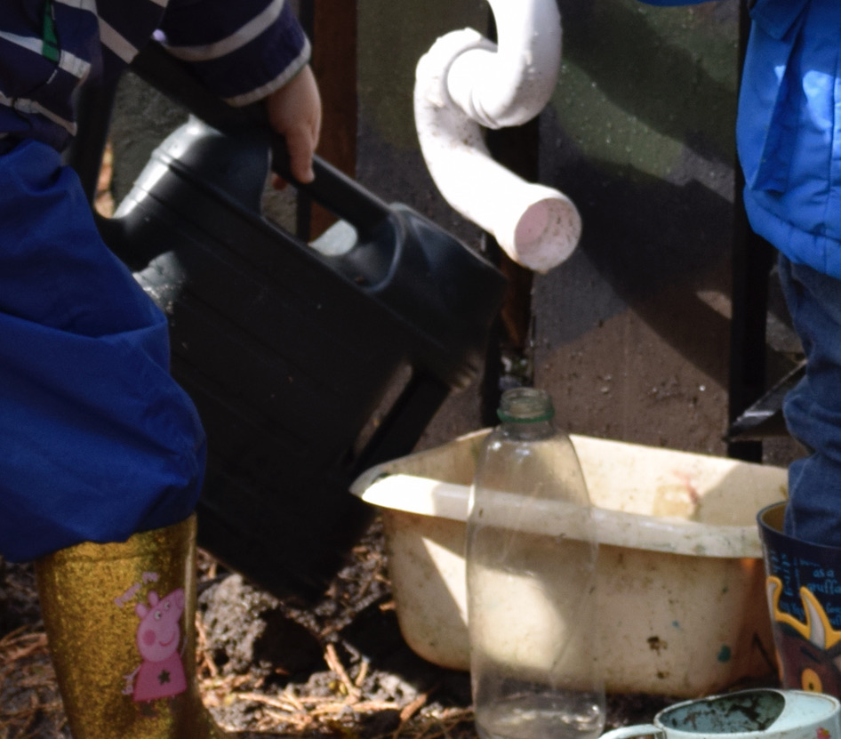

(Fieldnotes 3rd October 2019)
There are clear examples here of children solving problems, exploring, and experimenting, but it is hard for me to single out particular moments of creativity from the ongoing interaction. However, I can see a range of different actors, including both children and the socio-material environment, and it is easy to concur with Glăveanu (2014) that the children are exploiting the affordances of water in their creative encounters. Glăveanu writes from the perspective of cultural psychology and although he recognises the role of the material in the production of cultural artefacts, he refuses a new materialist perspective, due to concerns regarding object agency and the potential charge of anthropomorphism (Corazza & Glăveanu, 2020). This is an issue that I shall return to later in this chapter, but first there are further similarities between Glăveanu’s distributed model and new materialist thinking that are worthy of note.
Glăveanu (2014) argues that the social, material and temporal world are entangled. They exist in, and are defined by, their inseparable relationships with each other. Therefore, it is the interaction between these three dimensions that produces creativity. Consequently, it seems to me that there are clear parallels with Barad’s (2007) agential realism in which matter, meaning, time and space are all entangled in a complex web of relations which she terms ‘intra-action’. When these two theoretical perspectives are brought into conversation with each other, there is potential for Glăveanu’s (2014: 68) ‘microgenesis’ of distributed creativity to be interpreted as being produced through intra-action in the relational spaces between people and the material world. Kuby (2017: 883) follows a similar argument, claiming that as children are playing with, or becoming-with others, both human and material, ‘[t]he speaking back-and-forth-between-child-and-the-materials produce newness’. Perhaps then, this ‘speaking’ might be interpreted as the ongoing intra-action within assemblages of people and materials, and importantly, that it is this intra-action that has the potential to produce creative products and ideas.
While this finding may be helpful in bringing distributed creativity into conversation with new materialist thinking, there is limited value in simply offering intra-action as an alternative term for the concept. Therefore, it is necessary to explore the idea of young children’s creativity as intra-action in more depth. To consider what else is produced by this concept, and how these ideas might lead to new possibilities for research and practice.

Intra-action, flow and affect
Throughout my fieldwork, I was looking for flows and patterns in the children’s activities that might lead to what Glăveanu (2014: 71) terms ‘creative action’, and what I will conceptualise in this chapter as ‘creative encounters’. As I reviewed my notes and photographs, I was repeatedly drawn back to the following sequence of photographs:

Interruption 14: Intra-action and flow
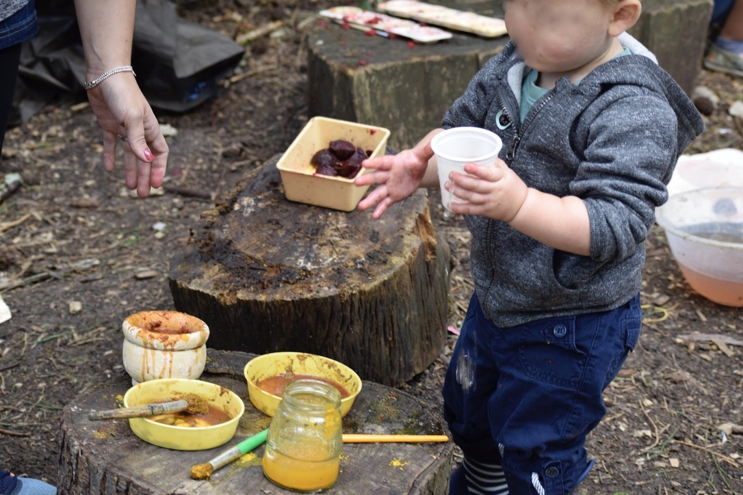
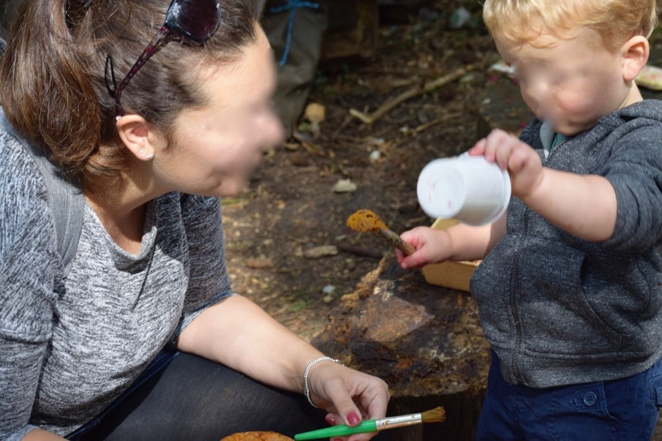
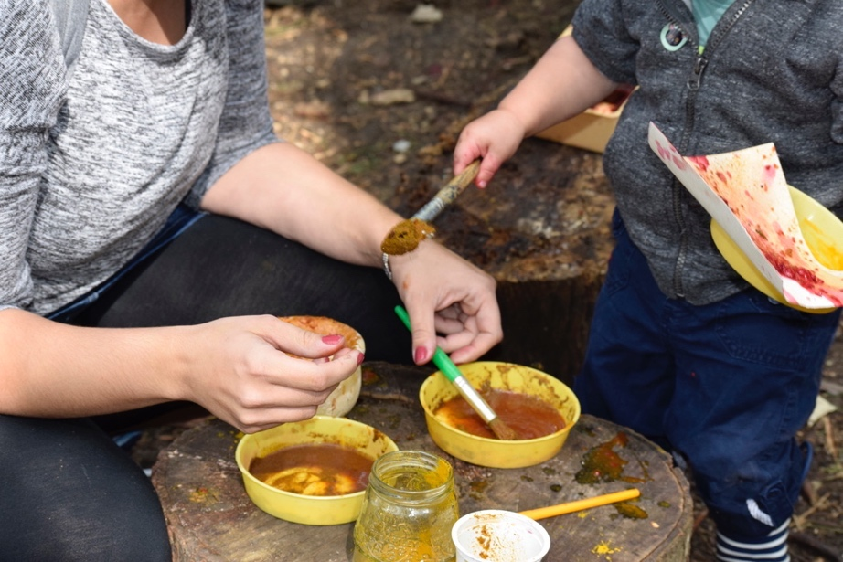

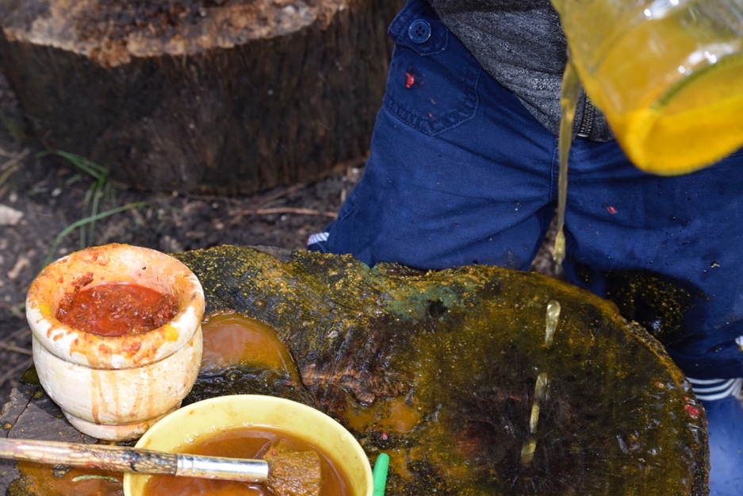
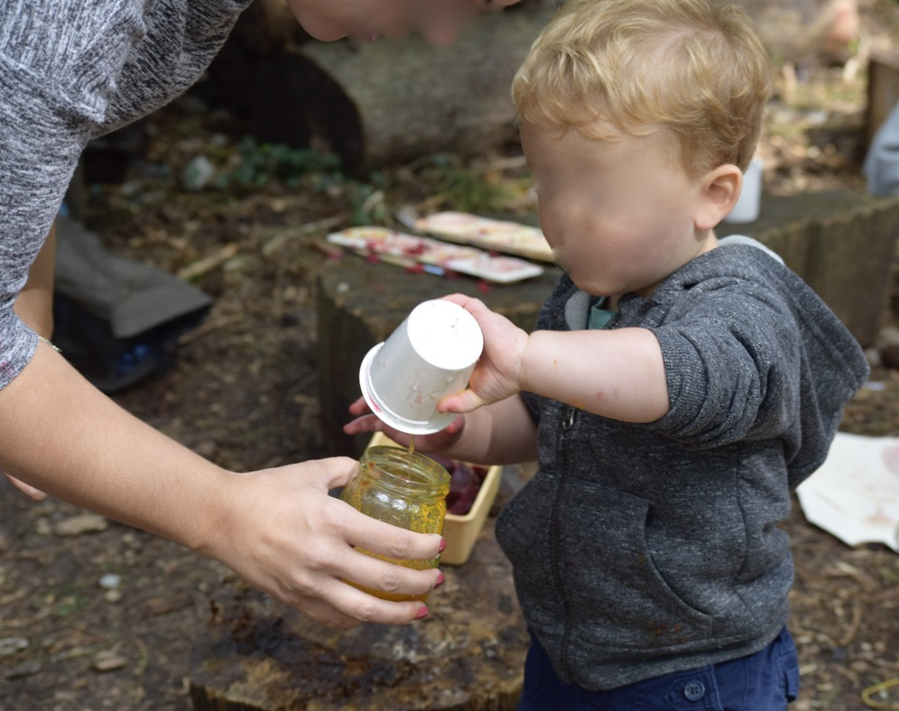
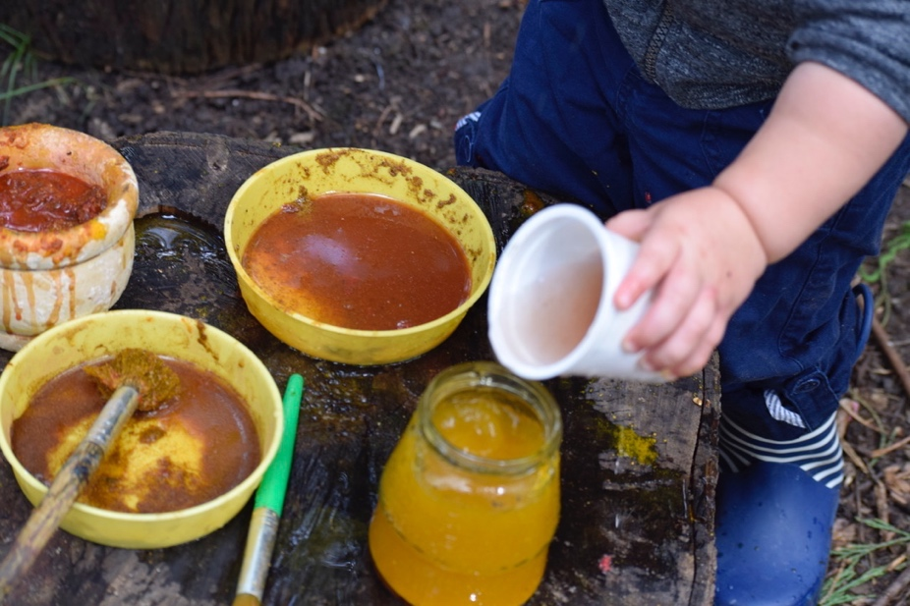

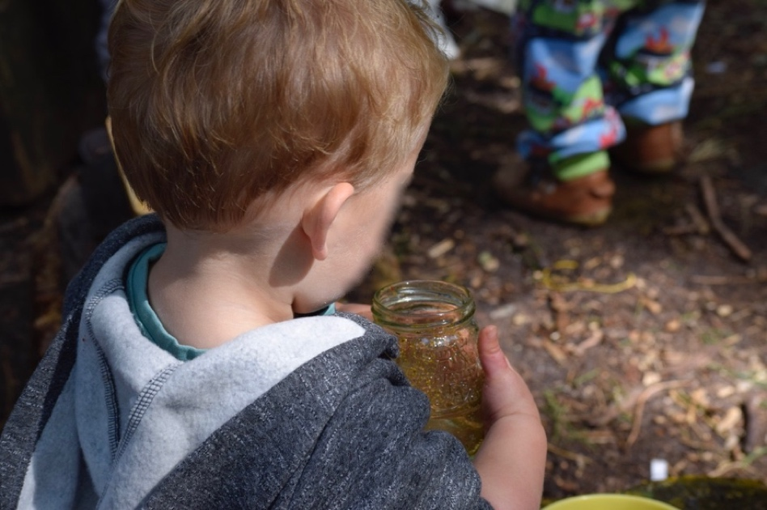
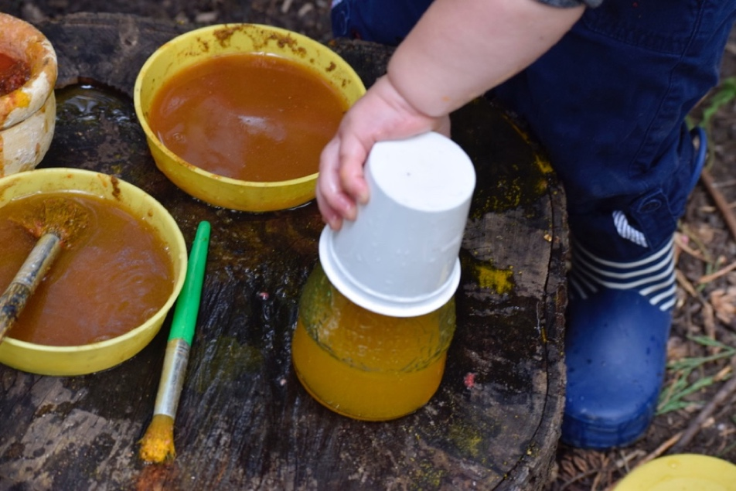
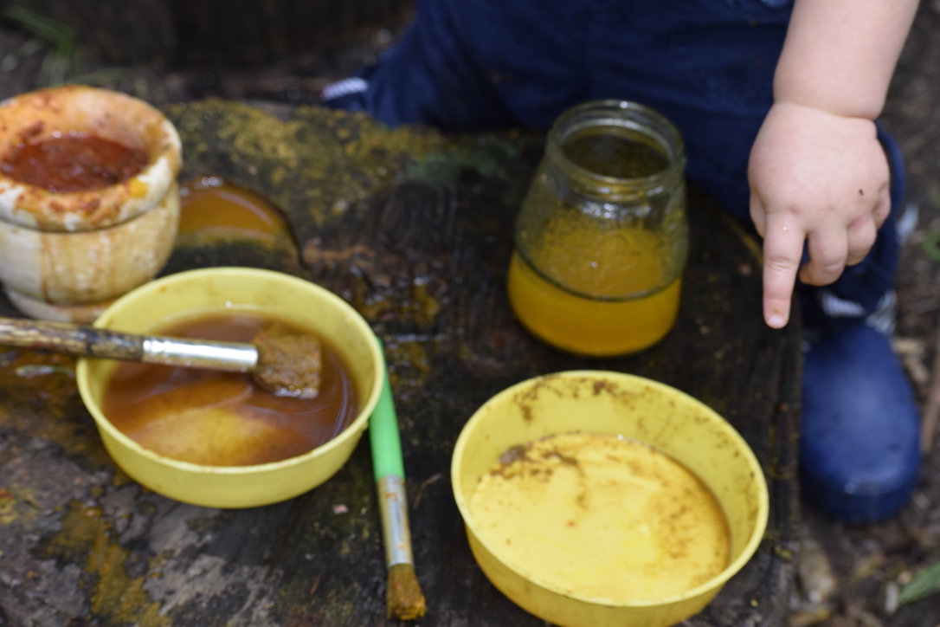

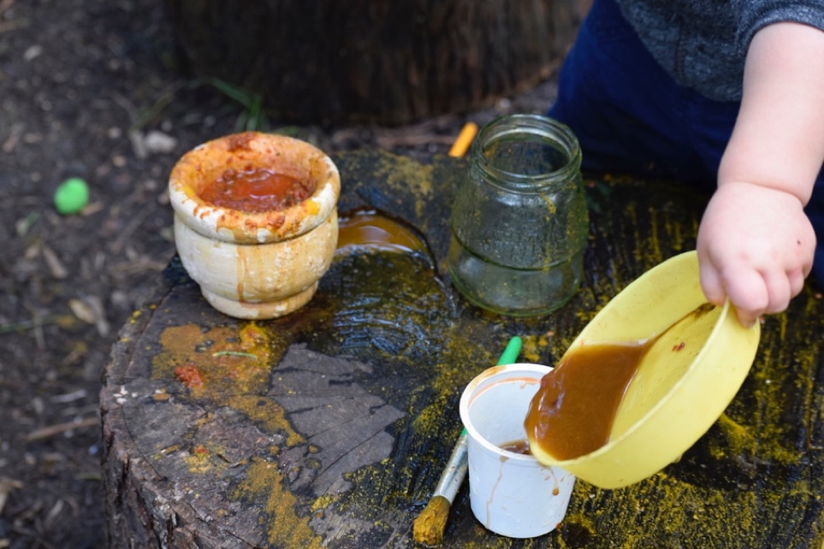
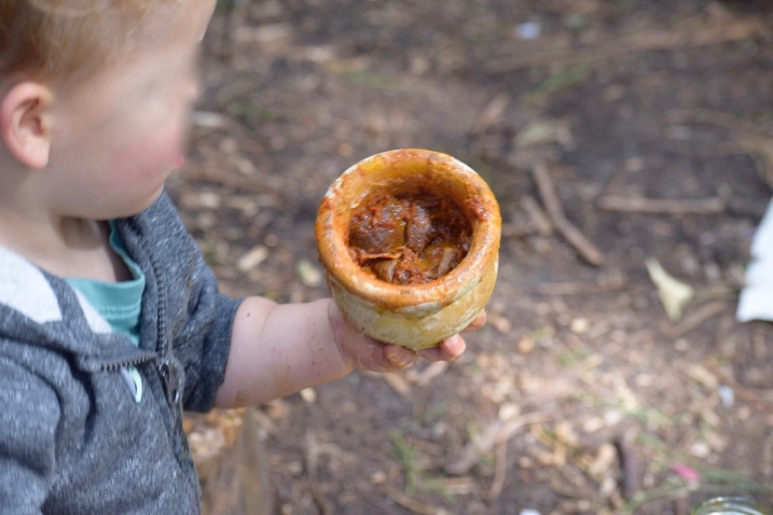
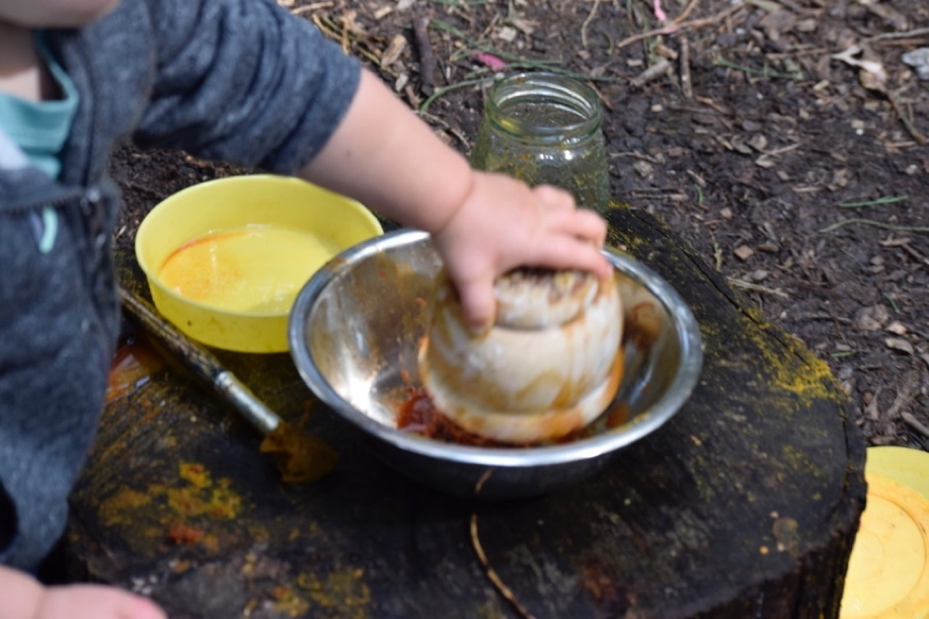

The child is clearly focused on this self-chosen activity and deeply engaged in his carrying and pouring activities. He persists carefully with this transporting and pouring for over twenty minutes, repeatedly pushing back against water’s insistence on flowing and overflowing in unexpected directions. I would suggest that through this intra-action, the young child demonstrates the ‘sustained focus, hard work…’ and ‘persistence in the face of failure’ that Feldman (in Sawyer et al., 2003: 220) argues are features of the ‘high-range’ levels of creativity. He may also be organising knowledge through his active learning and offering a coherent presentation of the work, although these are matters of interpretation which would depend on the positionality of the interpreter and the social context in which the encounter is taking place. My own professional heritage in child development and primary school teaching impacts on my thinking once again as I quickly identify the potential for mathematical learning and cognitive development that is occurring through his interaction with the physical environment. But moving away from Feldman’s definitions of ‘high’ and ‘low-range’ creativity (in Sawyer et al., 2003: 220), is this creative? And if so, how?
I ‘re-turn’ (Barad, 2014: 168) to this sequence again and again during my analysis as I continue to search for creativity but remain lost without an end product to support my belief that this was indeed a creative encounter. This habitual reliance on creative products is also reflected in the psychological literature, for example where the four Ps of creativity, person, process, product and press are often studied in isolation with little or no consideration of how the different components might interact with each other in real-world situations. In my thinking with theory, I feel that I need to get inside the creative process, to understand it from within, to explore what is, or is not, being produced in each moment, how it is being produced and by whom or what.
Interest, intimacy, curiosity, and wonder come to mind as I revisit each photograph in turn on my computer screen. Problems seem to be being identified and sometimes solved. ‘What if?’ questions are being generated as part of an intrinsically motivated process for the child. He seems to be gaining pleasure and interest from the activity itself rather than seeking a particular end product. The materials are responding to the child’s actions, but also determining them. They are engaging in the process through their individual affordances and capacity for affect, but also as a consequence of being part of the wider forest school assemblage. The material responses to each of the child’s actions are deepening the interaction and offering new challenges.
This back and forth between child and material world could not occur solely inside the mind of the person. It takes place through intra-action, in the relational spaces between the person and the physical world. A continuous process of becoming-with (Barad, 2014), interdependence and moment-by-moment connection (Murris, 2016) in which all actants have the capacity to affect and be affected (Massumi, 2015) and the ephemeral flows and intensities of their assemblages have the potential to produce creative encounters.
In his systems approach to creativity Csikszentmihalyi (1996:110) also defines the creative process as a ‘flow experience’ that is closely linked to the enjoyment that people experience during periods of creative activity. It is interesting to question why the child in these photographs chose to continue his pouring activities for extended periods and, although there was clearly learning taking place, one possible explanation could simply be that he was enjoying them. Or in new materialist terms, the intra-action within these assemblages was producing enjoyment within the child.
Csikszentmihalyi’s theory of creative flow, would seem to support this view. When studying the lives of notably creative adults, he found that they continued to pursue their creative activities because of the feelings they experienced when they were fully engaged in them. Csikszentmihalyi (1996:110) suggests that this optimal flow experience is an ‘almost automatic, effortless, yet highly focussed state of consciousness’ that creators feel during their activities, and this is a consistent finding regardless of social background or whether the individual is engaged in rock climbing, athletics, science or art. To me, this is ordinary affect (Stewart, 2007). Assemblages that produce creative flow have the potential to produce a sense of enjoyment and deep engagement that may be overlooked in more instrumental accounts of the phenomenon.
This foregrounding of the role of affect and its embodied nature is a common theme in new materialist research as well as the study of distributed creativity. Similarly, informal conversations between myself and the learning team members often returned to our attempts to communicate what we understood about the nature and importance of creativity, and knew ‘in our bones’, but struggled to express in words. A focus on affect when researching creativity, brings to the fore the sensory pleasures of connecting with materials as well as the laughter, joy, and importantly, wonder that is produced through intra-action across these creative assemblages. Therefore, when taking a new materialist perspective, I am led to concur once again with Glăveanu (2014) that being receptive to the ‘qualities, rhythms, forces, relations, and movements’ (Stewart, 2011: 445) of affect provides a helpful means of understanding what else comes to matter in these creative assemblages, and consequently as Horton & Kraftl (2006: 75) remind us, how much is missed or effaced in accounts of the world that focus only on words and reason.
Returning to his systems model, Csikszentmihalyi (1996) defines nine key elements that contribute to the optimal experience of creative flow and can be brought into conversation with this sequence of photographs. Firstly, the water and containers are providing a balance between the level of challenge in the activity and the skills of the creator through their intra-action. Initially, the child seems to instinctively understand what to do in this space. He appears to have chosen to pursue this pouring activity independently and to be in full control of the goals and the level of challenge that he sets for himself at each step. However, water pushes back and spills in unexpected directions as he tries to contain it. These unexpected responses from water produce new provocations, and another feature of creative flow by providing ‘immediate feedback to one’s actions’ (Csikszentmihalyi, 1996:111). This in turn, seems to prompt new ‘what if?’ questions from the child who chooses to watch carefully as he pours the remaining water onto the log before exploring the pouring qualities of other materials. In their intra-action, both child and material are affected.
The child’s high level of concentration is apparent from the photographs, and he is not easily distracted by the actions of the other children who are playing in the same area. Therefore, following Csikszentmihalyi’s remaining elements of creative flow, it would be possible to conclude that the child’s sense of time is distorted, or possibly that he is working on a different temporal plane, so that he senses the passing of time differently when concentrating on his encounters with water. It is also possible that the activity has become autotelic (Rautio, 2013a), and a satisfying end in itself.

Interruption 15: Creative encounters with clay

1. She rolls the ball of clay between the palms of her hands. It forms a sausage shape. She rolls the sausage into a spiral - ‘A snail!’.
‘I’m gonna make a butterfly. I’m really good at butterflies!’
She rolls more clay. It seems to demand to be rolled rather than shaped with the moulds provided. ‘I’m gonna make a whole family of snails. Big ones and little ones.’
‘I’m going to make a hotdog … oh it’s a snake’
Various tools poke into clay, making interesting holes. Fingers poke into clay, ‘I’m making art!’
2. Fingers squeeze another piece of clay. Two hands work together to roll it. She seems content to explore its texture and willingness to become smooth and spherical.
Mum returns to the table, ‘What are you making?’
‘I’m making a ball!’
3. Clay asks to be rolled, banged flat, squeezed and pinched. Its willingness to take different forms seems to speak to the child.
‘I’m going to make a caterpillar’
She sees the garlic press on the table and immediately tries to press the clay through it. Curly strings of clay appear on the other side of the press.
‘Hair! … I’m making me!’
(Fieldnotes 20th August 2019)

In Clapp’s (2017) theory of participatory creativity, it is ideas rather than people that are creative, but where do creative ideas come from? In these examples, clay seems to play an active role in the generation of ideas. It intra-acts with hands, fingers, tables and garlic presses but also with children’s interests, ideas and understandings. What are the most important features of snails, snakes and hotdogs? What does this gallery space suggest about ‘making art’?
The generation of these creative ideas does not follow a clear, rational or linear pattern. In my fieldnotes and photographs, it is difficult to identify the source of an idea or indeed, when or whether the creative process ever finishes. Creative encounters are complex and dynamic. Ideas, people and things are constantly changing and interacting within the gallery space and beyond. Like a rhizome (Deleuze & Guattari, 2004), or a ‘tangle of spaghetti’ (Malaguzzi cited in Dahlberg & Moss, 2009: xx) there is no beginning or end. Everything is in an entangled state of becoming (Colebrook, 2002) and creative outcomes are the result of this ongoing intra-action with the social and material world (Barad, 2007).
These nonrepresentational and affective connections between intra-action, creative flow, engagement and enjoyment offer an interesting potential direction for further study of creativity in the field of early childhood education. It is one that indicates a possible alternative to the linear cognitive and developmental narratives that often dominate current policy and practice and have the power to shape children’s subjectivities (Lewis, 2018). Children make sense of their experiences and participate in creative encounters, not just through language and discourse, but through their embodied engagement with a varied repertoire of sensory and aesthetic practices. Reconceptualising creative action as intra-action within creative encounters such as those observed above, acknowledges that feeling, thinking and the material environment are in fact inseparable and that creativity must be distributed across the social and material world. In the following section, I will consider the implications of this conceptualisation of creativity as intra-action within ‘creative encounters’ further by focusing more deeply on the central role of the material world.

Creative encounters with materials - how matter matters
Much creative work is located in the physical world, therefore when bringing new materialist thinking into conversation with creativity theory, a central theme must be the role of materials within the creative process. The affective entanglements between humans and the material world are often overlooked in child development theory, psychology and some traditions of educational research, in favour of what can be explained through human relationships, rationality and reason (Barron et al. 2020). However, materiality has frequently been recognised in political and critical research where the human body is seen to be shaped, ‘gendered, sexed, pacified and excited’ through the micro and macro cultural forces of which it is a part (Bennett, 2004: 348). New materialist thinking has pushed this focus on materiality further by attending to the agency of the more-than-human material world, in what Bennett (2004: 348) describes as the ‘thing-power’ that flows around, and also through, humans. This is the ‘curious ability of innate things to animate, to act, to produce effects dramatic and subtle’ (Bennett, 2004: 351).
Thing power is probably the most challenging aspect of new materialist thinking as it adopts a flat ontology which places humans on the same plane as the material. This is frequently interpreted as anthropomorphism, or the ascription of human characteristics to non-human actants, which in child development, is often considered to be a sign of immaturity and something that young children do but will soon grow out of. In the natural sciences anthropomorphism may be regarded as naive folklore and the antithesis of the rational human cognition that forms the basis of traditional research. However, in applied philosophy and environmental ethics anthropomorphic approaches are considered to contribute to an ethical approach (Rautio, 2011).
Drawing on examples from the work of Darwin, Latour and Dewey, Bennett (2010) has led the challenge to the nature/culture binary and anthropocentric views by illustrating the intelligence, wilfulness, and agency of simple organisms such as worms to make a difference in the world that is equal to, if not greater than, that of humans. Bennett goes on to use complexity theory to highlight the ways in which ‘clusters of neurons in the human brain, groupings of buildings in a city, and colonies of slime moulds’ (p.100) have all been shown to develop organisational patterns and rules that are remarkably similar to those found in the organisation of human culture. Bennett’s point is that the boundary between the human and more-than-human is a porous one. Humans rely on the material world for survival and there are elements of the human body, such as gut bacteria for example, that are distinctly non-human.
When the nature/culture divide is broken down, Bennett (2010) and other new materialist researchers have shown that with careful analysis, anthropomorphism can help to challenge anthropocentrism, and the idea that language and cognition make humans the only species capable of being at the top of a biological hierarchy that is actually socially constructed. As I began to suggest in Chapters 2 and 3, and I will continue to argue in this chapter, the breaking down of these hierarchies between who or what is granted the status of the fully formed human, and importantly who or what is not (Braidotti, 2013a; Goodley et al. 2014), carries the greatest potential for posthuman and new materialist thinking to make a critical contribution to ethical approaches, response-ability and wisdom. It is when new materialist research moves beyond the inevitable lists of how and where materials might act or demonstrate agency to consider the wider implications for social justice, policy and practice that it has the most value (Kraftl, 2018). In the context of this study, the careful use of anthropomorphism and a posthuman acceptance of the vitality of materials has helped me to reveal the entangled role of the material world within creative encounters, and importantly, it’s role in the production of young children’s ‘creative subjectivities’ (Taylor & Littleton, 2012: 29).
Cultural psychologist, Lene Tanggaard (2012) also proposes a key role for materiality in her interpretation of distributed creativity, where she argues that there is a close relationship between creators, the material tools they work with and the material artefacts they produce. As Glăveanu (2014) notes, the affordances of materials often facilitate the creative process, but they may also constrain and shape it in new directions that go beyond the original ideas of the human creator.
Rubio (2012) cites an interesting example of this shaping of creativity by the natural environment in the construction of Spiral Jetty, a well-known large earthwork sculpture built in the Great Salt Lake in Utah by the artist Robert Smithson (Dia, 2021). Smithson’s original design was for a simple J-shaped jetty, but this was dramatically reconfigured into its iconic counter-clockwise spiral form through the constraints of, and necessary adaptations to, working on the site. These included working with heavy machinery on soft oozy mud, protecting the safety of the workforce, and building with sharp heavy rocks that could easily have damaged the construction equipment. Rubio notes that although the work is generally accredited to the imagination of its lone human creator, construction records show that the spiral form, for which it is most well-known, emerged gradually ‘through the complex interaction between different actors and materials’ as the artist worked to solve the many construction problems as they were presented in each moment (p.151). Therefore, the site was ‘not a simple inert recipient of Smithson’s mental image of the jetty’ (p.153). Like the clay and water in the findings of this research, the affordances of this site actively presented the problems that led to specific courses of action being taken throughout the project. Or from a new materialist interpretation, the artist, his intentions, and his responses intra-acted with both the demands of the site, and the site’s intra-action with the various construction materials. The sculpture emerged and evolved from material engagement with the world, and creative ideas were produced as result of this intra-action. To summarise, creativity and these seemingly imaginative outcomes happened when the human creator met with resistance from, and was challenged by, the materials they were working with (Dewey, 2005).
Taking further examples from anthropology, archaeology, art and architecture, Ingold’s work (2013:31) also comes close to the new materialist concept of intra-action, when noting the active role of materials in pushing back against the intensions of the creator so that:
in the act of making the artisan couples his own movements and gestures - indeed his very life - with the becoming of his materials, joining with and following the forces and flows that bring his work to fruition.
(Ingold, 2013: 31)

Ingold and Hallam (2007) take this point further, claiming that imagination is ‘inseparable from our performative engagements with the material that surrounds us’ (p. 3). Furthermore, relating this issue of material engagement to the fields of arts and education, Eisner (2004: 8) offers an argument that ‘each material imposes its own distinctive demands and to use it well, we have to learn to think with it’ (2004: 8), while Robinson (2009: 75) states simply that ‘[y]ou can think of creativity as a conversation between what we’re trying to figure out and the media we are using’.
Writing back in 1962, Bruner might also be interpreted as reflecting Bennett’s (2010) notion of thing-power in his claim that the artist should have the ‘freedom to be dominated’ by their emerging creations, as ‘it is at this point that we get our creative second wind, at the point where the object takes over’ (p.25). It appears then, that although none of these authors were writing from a new materialist position, there is a broad agreement that materials play a central role in the production of creative work and that both artist and materials are challenged and shaped through their intra-active encounters with the world.
Similarly, in my own fieldwork, the children’s creative encounters were shaped by the available materials, as well as the wider social and material contexts in which they took place. These encounters were formed through a dynamic, sensory and embodied engagement with the material world that, once again, went beyond the purely rational and cognitive (Tanggaard, 2012). The children did not always appear have a clear idea about what they were creating but seemed instead to be responding to the materials moment by moment. As a result of each encounter, they became increasing familiar with the affordances of mud, clay, sticks, plastic containers, water, iPads and paint as they experimented with different tools and manipulated materials in their fingers, allowing creations to take shape organically through these intra-actions.
A key feature of this engagement with, and response to, the material was the involvement of all the different senses.
Interruption 16: Where people and materials meet?

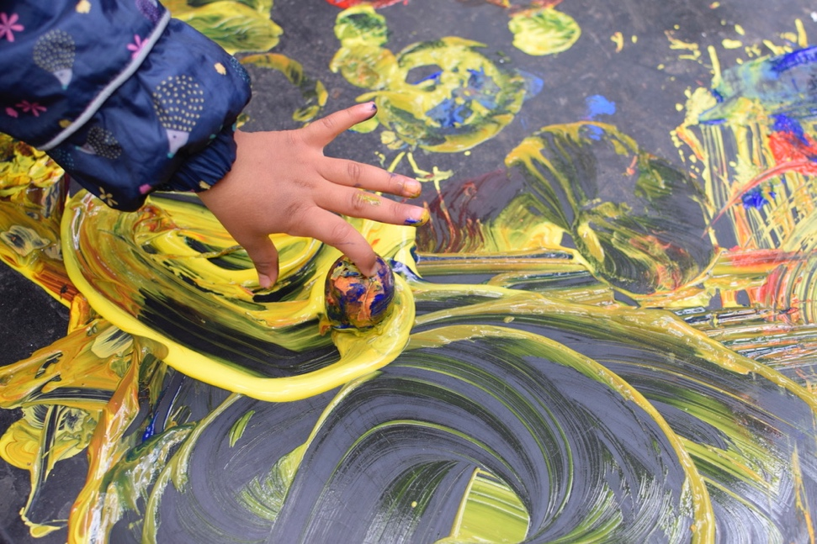

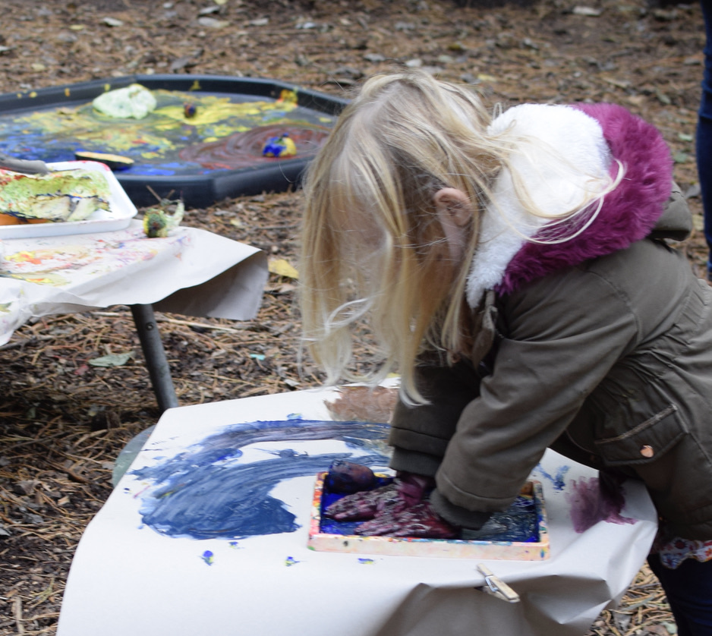

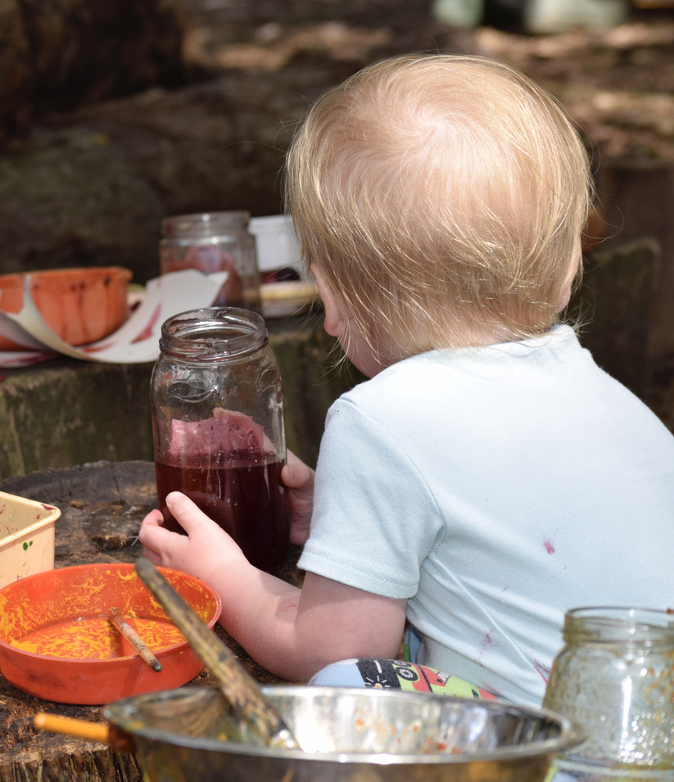

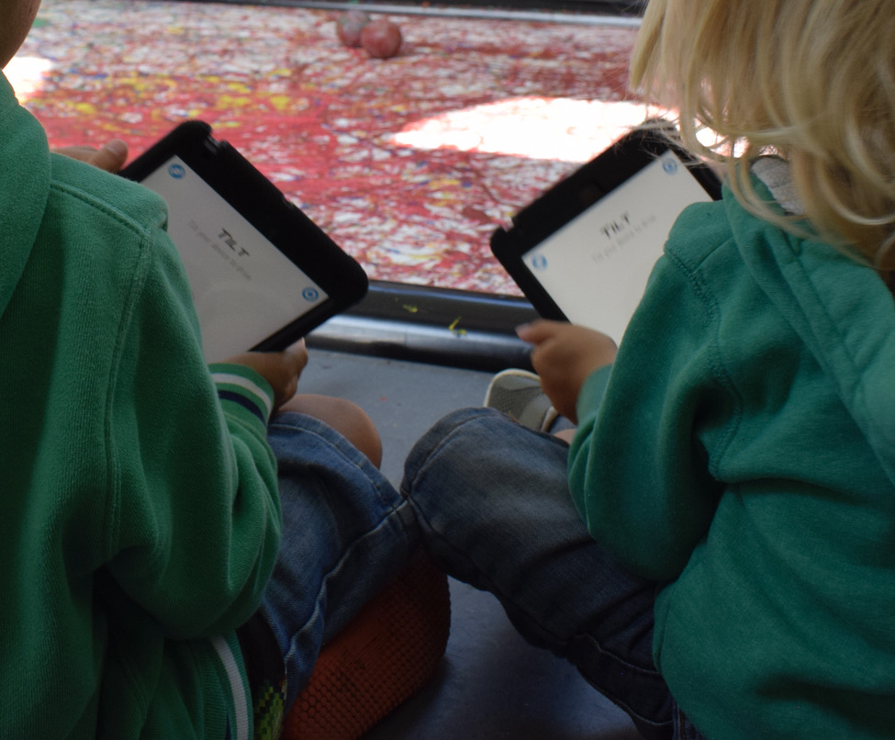

Creative encounters as embodied, multi-sensory and multimodal experiences
As I became more confident in my own new materialist and sensory approach, my fieldnotes and photographs were increasingly focussed on the meeting places between children’s bodies and the material world. Consequently, my eye was often drawn to fingers when I was taking photographs, and as a result when I came to analyse these images, the role of touch seemed to be particularly significant. Children frequently explored the sensory properties of materials, their textures and temperatures and the moisture of their surfaces. Exploration and the search for understanding seemed to guide their fingers in each intra-action. Hands and eyes worked in tandem in their perceiving and creating, showing that ‘[a]s we manipulate, we touch and feel, as we look, we see; as we listen we hear’ and ‘the eye reports the consequence of what is done’ in an ‘intimate connection’ (Dewey, 2005: 51), while curiosity, imagination and the emotions are stirred. Throughout my observations, this sensory thinking and knowing is deeply entangled with the material and the affective (Barron et al., 2020), leading me to support Ingold and Hallam’s (2007) view that it is indeed impossible to separate imagination and creativity from the material encounters in which they occur.
Perhaps then, the role of the material world in creative encounters might be that it speaks to children’s senses (Jacucci & Wagner, 2007, cited in Tanggaard 2012), leading to ‘shared experiences, dynamic interactions and bodily engagements beyond the purely cognitive’ (Tanggaard, 2012: 25). When creating, we bring all our experiences and our whole bodies to bear on the problem before us. Therefore, I am suggesting that these embodied, affective, and sensory entanglements with the material must be at the heart of children’s creative encounters. In doing so, I concur with Weaver and Snaza (2017: 1064) that in creativity research, we need to ‘care more about touching, and being touched by the world’. Sometimes, as well as just seeing, we need to touch, feel, and grasp things to be able to understand and create with them.

Interruption 17: Creative spaces

The Learning Centre is located in a large, light and airy room with high windows and a grey washable floor. The children arrive at different times so the activities are often already in full flow. They stay close to their parents and siblings. ‘What is this space?’ ‘What can I do here?’


… He watches the Sphero robot with his finger in his mouth - he seems unsure. He stays close to Mum but moves to a spot where he can see better. One hand holds Mum’s shirt while he watches, ‘It’s moving!’ He follows it with his eyes, watching very closely. ‘It’s paint - don’t eat it!’ He holds onto Mum with two hands but is still facing the Sphero. He stands on one foot and sways (losing interest?). Mum offers him an iPad. They both hold it, 2 hands each and rotate it to work the computer program. He smiles and jumps up and down as the pattern moves on the screen and simultaneously, the Sphero begins to move across the room.
(Field note 20th August 2019)

An environment could be interpreted as a combination of affordances that can be perceived and understood through our different senses (Gibson, 1986). The children in this study seemed to be very skilled at making these sensory connections, supporting Nutbrown’s (2013) belief that young children respond to the world primarily through sensory and aesthetic means. They quickly established that clay invites squeezing or banging, iPad screens ask to be touched and tapped, the log circle encourages continuous jumping from log to log, an old boat provokes drama and stories, while the single overhanging branch calls out for children to swing on it. This is a different kind of sensory perception that is not easily explained in words or ascribed to a particular one of the Western five senses with which educators are often most familiar (Pink, 2015). It is an embodied and multi-sensory way of knowing and reading an environment that is holistic and experienced differently by each individual. In psychology this is described as ‘haptic perception’ (O’Neill, 2001: 3) which involves the integration of combinations of senses such as touch, hearing, balance, positional awareness, movement, emotion and memory that enable us to read spaces and places and to become connected to them in intimate and unselfconscious ways through activity and movement. This haptic learning was apparent throughout the children’s experiences in both the gallery and the forest school, and it is reflected in many of my fieldnotes and photographs. Consequently, this leads me to believe that the affordances and affect of the material world are keenly interpreted by young children through a combination of sensory responses, and therefore, haptic perception is likely to be a means by which humans and materials intra-act and create.
These considerations of the senses and the role of space and place have led me to reflect further on the affordances and affective relations of the indoor gallery space and the outdoor environment of the forest school within the children’s creative encounters.

Interruption 18: Indoor / Outdoor Encounters

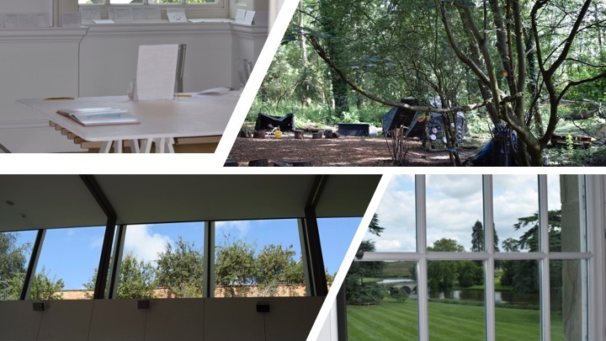

The high ceilings, bright light and carefully curated spaces of the gallery lighten my mood and invite investigation and reflection. Does the outdoor parkland setting also influence the creativity that takes place indoors in the gallery? Do the forest school activities influence the gallery? How do these different parts of the setting intra-act? The learning team are keen to make more connections between these spaces, but to me they seem to already be deeply entangled. It matters that the forest school is part of a gallery setting and it matters that the indoor gallery space is surrounded by open parkland.
(Journal entry 5th January 2021)
As I revisit my photographs and reread my fieldnotes, the sensations of being in these spaces return to me. The park and gallery assemblage intra-acts with those who visit, but again this is not something that is easily expressed in words. It is more of a feeling, an openness, an invitation to let go and just create.
Children and families seem to weave in, out, and in-between these spaces in their intra-actions without necessarily moving physically between the indoor and outdoor environments. Windows provide a constant connection between indoors and out. A sunny day, fresh air, the sound of the wind in the trees or the sharpness of a cold day when everyone needs to wrap up and huddle together to keep warm. Textures, smells, sights and sounds produce multi-sensory affect and haptic learning that mingles with the experience of a day out in this setting. All these encounters have the potential to produce creativity, although perhaps the outdoor environment of the parkland setting might be of particular significance.
Close and intimate creative encounters with the outdoors, such as those observed in this study, have the potential to produce new and lasting connections between child and the more-than-human world that may have implications for their future creativity. When children’s encounters with a place involve ‘total physical engagement’ and ‘the repeated occurrence of ordinary events’ they are more likely to develop strong sentimental attachments to that place (O’Neill, 2001: 4), and in the case of outdoor environments like the parkland setting in this study, these attachments may contribute to the development of children’s feelings of connectedness with the natural world. Edwards (2019: 85) describes these feelings as a ‘blend’ that mixes ‘familiarity and curiosity’ whereby we may be drawn to particular places such as an open seascape, a tree-lined path leading to the forest school area or the view from a gallery window that ‘activates all our senses’. Edwards (2019: 85) suggests that these encounters ‘kindle’ or act as ‘catalysts’ for creativity, leading to key moments in which ideas are born.
As I discussed in Chapter 2, if creativity is to be valued and fostered in educational settings, it is of the utmost importance that creators learn to understand, predict and interpret the impact of their ideas and creations on society, and also on a more-than-human world that is currently under threat. Therefore, research has established a need to combine creativity with ‘wisdom, ethics and kindness’ (Sternberg & Kaufman, 2018: 378) or ‘wise humanising creativity’ (Chappell et al., 2011; Craft, 2012). I suggest that this wisdom, ethics and kindness must extend to the more-than-human world if creativity is to be sustainable. My fieldwork leads me to wonder whether regular creative encounters in natural, outdoor environments might develop deeper, embodied and entangled connections with nature (Rautio, 2013b). Perhaps then, that increased awareness might produce children who are more likely to want to protect the natural, more-than-human world in their creative encounters and therefore a wiser and more sustainable creativity.
The Common Worlds Research Collective (2021) is an interdisciplinary network that seeks to apply posthuman and new materialist thinking across the fields of early childhood (Taylor, 2013), indigenous (Pacini-Ketchabaw, 2013) and environmental education (Do Nascimento, 2019) to emphasise these entangled connections between children, place, other species, and the material world. Together, their collective research aims to extend Latour’s term (2014: 302) ‘common world’ to challenge the nature/culture divide by re-situating the past, present and future lives of humans as being inseparable from those of animate and inanimate others. This inseparability is central to the creative encounters that I have observed in my fieldwork, and therefore I have turned to the work of these common worlds researchers to think with new materialist theory in my attempts to resolve these tensions around the nature/culture binary. A key author is Rautio (2013b: 446) who reiterates that the tension arises not from the anthropocentric view of humans ‘being with nature’ but about humans already being nature, and in all aspects of life, not just those where we find ourselves in outdoor or naturalistic settings. Rautio (2013b: 446) goes on to suggest that from a posthuman perspective this relationship is neither the often cited ‘idyllic state of harmony’ through being in nature, as implied by Edwards (2019) above, or a Darwinian battle ‘over survival of the fittest’ - ‘It just is’.
Rautio’s argument leads me to rethink my question above regarding how children’s creative encounters might offer a means of fostering creativity with the wisdom to create in sustainable ways. If children are already an entangled part of the world and are no different from nature, perhaps it is not so much a matter of developing those connections but of realising that they are already there in our everyday being-with the world. Rather than anthropocentric learning about ‘nature’, or learning how to care for it, perhaps the aim should be to make and learn in sensitive encounters with our more-than-human kin (Engelmann, 2019).
As I have explained in relation to the evolution of my research question, it can be difficult for practitioners to relate these posthuman ideas to education where the primary focus is on the human child. However, what this thinking with theory seems to suggest is that rather than aiming for humans to be closer to nature, we should accept that we are nature. Consequently, it becomes important to acknowledge, explore and communicate our interdependent, entangled, embodied and multi-sensory relations with our more-than-human kin if we are to act response-ably and therefore create with wisdom.
Although these common world views of environmental education are beginning to move beyond the scope of the present study’s aim to explore definitions of creativity, it would be helpful for further research to explore in more detail exactly what is produced in such outdoor creative encounters and how these interrelationships might contribute to the development of sustainable, environmentally conscious, wise creative action. Furthermore, these considerations lead to the wider implications of creative encounters for social justice, policy and practice which will be the focus of the remainder of this chapter, beginning with the concept of the assemblage.

Distributed agency and becoming-with in assemblage
In Chapter 2, I analysed the central concept of the ‘assemblage’ (Deleuze & Guattari, 2004) in new materialist thinking. These entanglements of matter and meaning (Barad, 2007) are understood as networks of bodies, things, utterances, feelings, emotions and memories that are held together by affective relations, but are always in flux (Fox & Alldred, 2017). Assemblages come together and reassemble in different ways with each actant having its own agentic force, but together they acquire a distributed agency (Barad, 2007). This distributed agency occurs as a result of the intra-action or ‘flows in the affective intensities’ (Lenz-Taguchi, 2011: 42) that are produced across entanglements of people and the material world. Therefore, an assemblage might be regarded as a process of making things happen, or of cause and effect, rather than an object or collection of things (Barad, 2007). Consequently, by applying a new materialist perspective and regarding children as actants within social and material assemblages, it becomes possible to consider a wider variety of factors (Murris, 2016) that contribute to their creative encounters.
When thinking with and through the photographs and notes from my own fieldwork, in my diffractive analysis, I have chosen to create artificial pauses in the ongoing flow of intra-action that I have observed and of which I have become a part. It has been necessary to make these ‘agential cuts’ (Barad, 2007) to bring my observations and fieldwork into conversation with theoretical perspectives and to enable the weaving of this story of my research. However, it is important to note that from a new materialist perspective, it is not ontologically possible to stop the flows of intra-action in assemblages as everything is always in a state of change and becoming. To recognise this collective, constantly changing, and productive nature of assemblages, I have chosen to use the term ‘creative encounters’ throughout my analysis. Rather than seeking to simply identify the individual components of each individual encounter, I have followed Murris (2017) in an attempt to understand what was produced as a result of the flows and intensities, moment-by-moment, as actants came together in the field. What came to matter and what might the production of creativity look like if it occurs as a result of distributed agency across wider assemblages?

Creative encounters as an alternative to the creative individual
Following developments in cultural psychology, creativity has been shown to exploit, and also be constrained by, the affordances of the environment (Glăveanu, 2014). However, the environment is far more than a static backdrop. New materialist approaches argue that environments, and what I am proposing as creative encounters, can be interpreted as dynamic, productive and agentic assemblages (Lenz Taguchi, 2010) and as I have argued above, creativity occurs as a result of the intra-action between people and materials within them.
This theoretical interpretation of creativity reflects cultural and social conceptualisations of creativity that have moved away from the individual human creator and are significant in that they challenge individualistic approaches to fostering creativity in education, choosing instead to value it as a collective and entangled process. Furthermore, to study creativity as such a complex and entangled phenomenon, the concept of assemblages suggests that it is necessary to consider the micro level of intra-action between child, other people and the material world in the present moment, as I have done so far, while simultaneously widening the gaze of research to focus on the macro-level social and political assemblages that situate and determine such creative encounters. That is my aim for the following sections of the present chapter.

The wider social, theoretical and political assemblage
Importantly, creative encounters are not limited to the actants that are physically present at a particular time. Children bring with them their past experiences, affects, memories, interests and hopes for the future which all form entangled actants within the assemblage or encounter. The musically talented uncle who has fostered Sam’s love of playing the drums - a skill that he demonstrates to great effect using the pots and pans in the music area. A love of marmalade that translates into a thick muddy ‘marmalade sandwich’ where the filling must be spread carefully to make sure it reaches all the edges, a fascination with sticking things together that turns the forest mud into ‘sticky glue’ that has to be checked regularly to see if it is ‘dry’ and ‘ready yet’. All these elements intra-act and produce ever-changing spatial and temporal patterns of creativity. A ‘becoming-with’ (Haraway, 2008: 244) that is produced within the assemblage as things are turned over and over and given new life (Barad, 2014) through the children’s creative play.
Although there were three broadly different areas of the setting that formed the context of my fieldwork, namely forest school, clay work in the gallery space and painting with robots in the learning centre, as I have already argued above, these contexts are entangled and they overlap when the wider temporal, cultural and political assemblage is considered. The setting as a whole might be regarded as offering informal education and not being part of the mainstream school system, however there were several occasions when the wider educational/schooling assemblage impacted on the children and their activities in this informal setting and demonstrated their interconnection.
The learning team worked closely with schools offering day visits with a range of activities designed to meet the relevant curricular goals for each age group. Several of the team members had worked in formal education settings before joining the gallery and they continued to use these experiences to inform their planning. However, most expressed a preference for the informal setting and a move away from formal curricular requirements, usually citing more opportunities for the development of their own creativity as a major factor. Parents also expressed a desire to offer their children something different, and perhaps more creative, to formal schooling. Regular visitors included several families who had chosen to home educate, again citing a lack of creativity and limited opportunities to meet their child’s individual needs as a reason for the move.
Interruption 19: Entanglements with schooling

Parents showed an interest in my research after reading my information poster, ‘I’ve become really interested in creativity. Especially since he started school because they just don’t seem to do any. It’s all about phonics. All the work they send home seems to be anyway.’
(Field note 20th August 2019)

The children also brought their own concerns and recent educational experiences to be explored through their creative encounters. The timing of my fieldwork over the summer holiday meant that many families were preparing for the children to start school in the weeks ahead.
Interruption 20: New encounters

Sophie comes to the painting tent and I offer her a piece of paper. She doesn’t make eye contact and rushes past me. Her mother explains that she has ‘done one day at preschool and it’s traumatised her. Now she won’t talk to anybody and she’s really clingy’. I move away.
Later, Mum asks me to watch Sophie while she fetches the buggy. As soon as Mum is out of sight, Sophie runs towards the fire. I follow as I am concerned for her safety. Sophie turns off and into the reading tent, so I hold back. Moments later she runs out again, looks towards the exit where Mum has gone, but then goes back into the painting tent and is busy painting when her mother returns. I explain what happened to Mum.
Sophie runs back to into the reading tent. A team member hears her chatting to herself, ‘Now where is she…now where is she…?’ Sophie runs back to the painting tent, then back to the reading tent, repeating the sequence four more times. Mum positions herself in the middle of the forest school area enabling her daughter to run into the different tents and return. As they leave at the end of the session, Sophie runs ahead to the exit and calls back ‘Where are you Mum, where are you?’
(Field note 5th September 2019)

Sophie’s experiences of starting preschool and being separated from her mother were integral to her creative experiences in the forest school space on that day. The carefully arranged space reciprocated, enabling Sophie to follow her exploration of being apart from, and then back together with, her mother. Together, this assemblage of parent, child, prior experiences, anxieties, freedom, and an open space combined to produce confidence in Sophie through her exploration in this creative encounter.
My own experiences within these creative encounters lead me to reflect again on the question of what comes to matter and what is produced through such intra-action. If creativity occurs through intra-action across assemblages, how might early years settings foster that creativity and how might children be supported in developing their confidence, willingness to explore and ability to take an active role when participating in creative encounters?
In new materialist approaches, identities or subjectivities (Taylor & Littleton, 2012) are understood as being emergent and produced through affective relations within human and more-than-human encounters. Identities, including creative identities, do not pre-exist these encounters, and are never finished or fixed. They are always in the process of becoming, deeply entangled and clearly situated within a multiplicity of cultural, social and political affective assemblages (Lenz Taguchi, 2010; Nxumalo, 2012). This suggests that perhaps educators should attend more closely to the production of creative early years settings, creative activities or creative practices rather than creative individuals. However, remaining with the theme of subjectivities and identity, it is interesting to consider how individuals might have been produced as being creative within some of the specific assemblages from my fieldwork.

Becoming artist

Interruption 21: Introductions

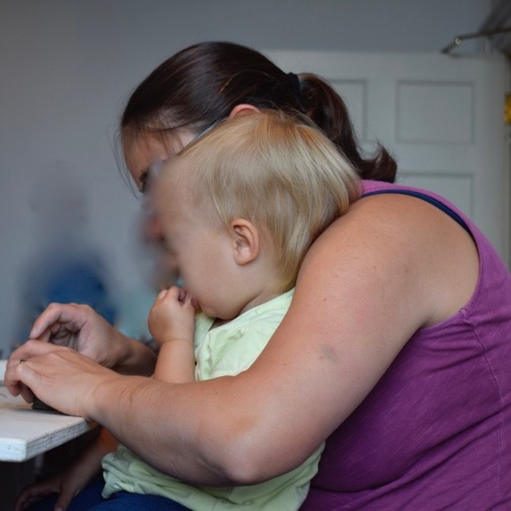
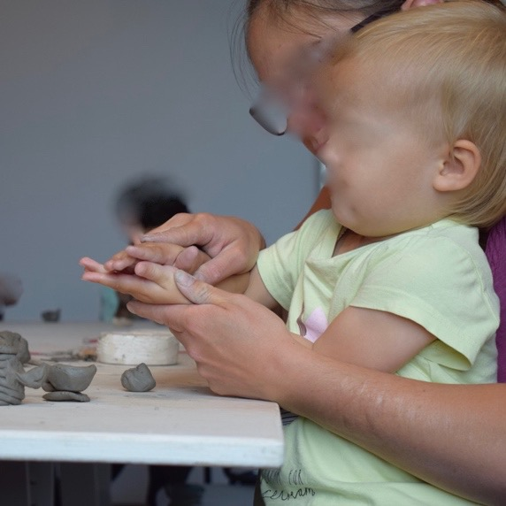

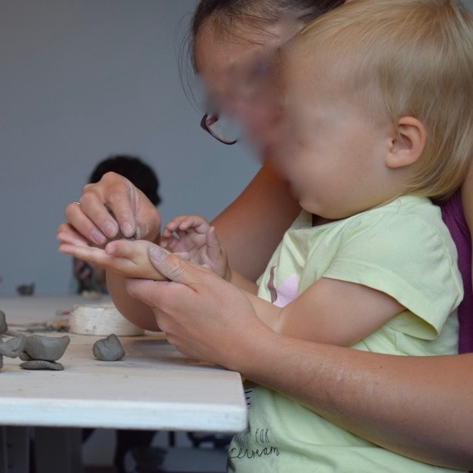

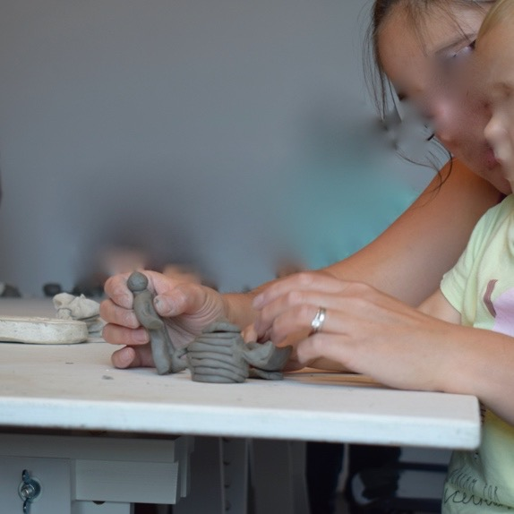
At first, she is nervous of the cold, damp clay. She sucks her thumb and pulls back from the table towards the comfort of the mother’s body. Mum rolls the clay to make a teapot - just like the one on display.
(Field note 6th August 2019)

For some of the youngest children, this was a first opportunity to work with clay, an introduction of sorts, and a new experience. Clay is cold to the touch, messy and a little unpredictable. The gallery space and its occupants are unfamiliar to some children. In this observation, the girl’s mother is aware of the child’s uncertainty and is determined to overcome it. She gently invites her daughter to touch the clay and explore its potential as a modelling material. As I watch, I interpret this event as careful scaffolding by the parent as she helps her daughter to overcome her initial fear and begins make space for imaginative play and exploration. A gentle and supportive introduction to the affordances of the material from which the child is able to continue the encounter through her own imagination. As the observation progresses, my fieldnotes indicate this developing confidence as the very young child gets to know the clay and starts to ‘think with it’ (Eisner, 2004: 8). She becomes more self-assured, applies her own imagination, and begins to direct the encounter:

Interruption 21: Introductions (continued)
‘We need a spout’… ‘you put it on’.
Cautiously she starts to touch the clay.
‘We need a handle’ … she begins to roll one herself.
‘Do we need a saucer?… No saucer?
‘No’ she says,
‘We need a man…you can do a lady…different man…’
(Fieldnote 6th August 2019)
At the same time, her fingers begin to touch and roll the clay, potentially feeding her imagination with new possibilities.

Interruption 21: Introductions (continued)

‘We need an octopus…. we need a dinosaur (like the other children) …we need a dinosaur!’
Mum encourages her to join in as she fashions each model.
When the models are complete, Mum offers to buy some clay to use at home and she nods her head excitedly in agreement.
(Fieldnote 6th August 2019)
By the end of this brief encounter, both the child and the clay are changed. As Ingold (2013:1) argues, ‘[t]o know things you have to grow into them, and let them grow into you, so that they become a part of who you are’. From a new materialist perspective, this getting to know things, could be interpreted as this child’s growing, or becoming-with clay, as child and material come together and become entangled in assemblage. A socio-material scaffolding process perhaps, that may well continue at home with her own new bag of clay or at the gallery on a subsequent visit.
When thinking with new materialist theory, it is clear that this encounter takes place within a wider assemblage. Both mother and child are taking part in a clay activity that has been provided by the learning team and is intended to encourage people of all ages to explore and be creative. The gallery space and the activities within it have been designed in collaboration with established artist Phoebe Cummings. Her image is displayed on the walls, her work can be explored in the adjacent gallery, and there is a library of her moulds on the shelf for families to work with.
Interruption 22: Big-C creativity?
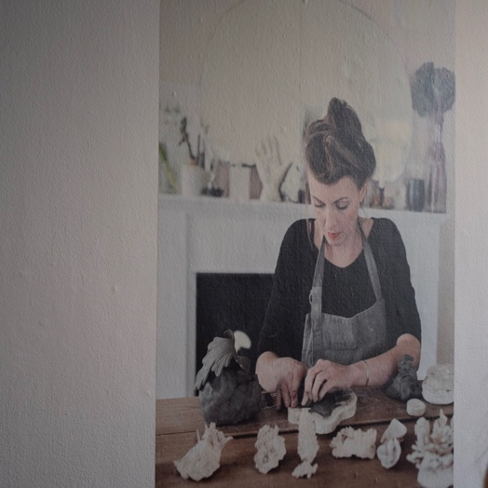
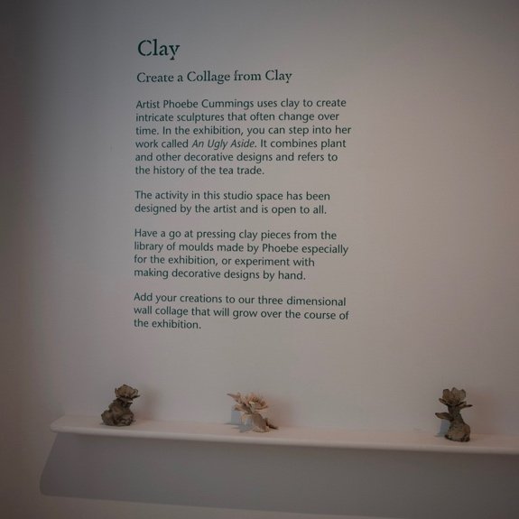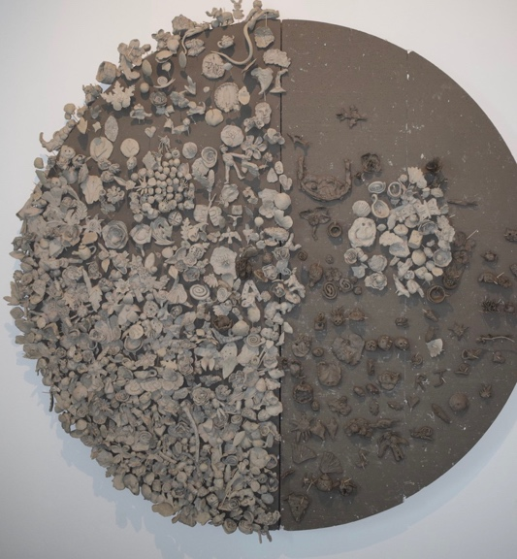

These moulds and display boards also show the history of this type of clay work, forming temporal connections, and producing a space where creativity is an integral part of cultural practice. During their visits, children and families are invited to become part of this tradition. The distinctions and boundaries between established artist, learning team member, enthusiastic amateur, beginner and child are deliberately blurred in this space, and everyone is produced as an artist.
The gallery staff and learning team members work together to enhance this boundary blurring through their own relationships and intra-actions with the children. They respect the models that have been made during each session, handling them carefully and where people are willing, they help to add each one to a collective piece of work where they will be displayed proudly for the next visitors to appreciate. Team members also work tirelessly to facilitate clay work in what is usually a clean, white, and carefully curated space. The messiness of clay presents particular challenges for staff who are working without a sink and with limited cleaning materials. However, nobody minds the clay footprints that lead downstairs, right through to the shop. The precious artworks in the rest of the gallery are protected through the cleaning work of a large team of volunteers. To me, this seems to be an entangled part of the culture in this gallery space and my fieldnotes and photographs appear to show how that culture is expressed in practice. Children and their creativity are highly valued, and everything is planned to support them. I made similar observations in the forest school.

Interruption 23: Creative encounters with sound

Becoming musician
An assemblage of tins, pots, wooden poles, cardboard tubes and sticks attracts children’s attention. They peep underneath the larger tins, lifting them off the poles to see what’s inside, but it is not long before they are drawn to pick up a tube or stick and begin to drum. Sometimes it is a parent who decides to do this first, encouraging their child to have a go. Often the sound of drumming attracts more children to this area, but the sight of the materials arranged in this way is also capable of drawing children in without any other human input. The assemblage seems to be calling them to create, and the children instinctively know how to respond. They do not question whether they have sufficient musical talent, they may not even label this as a musical activity until adults refer to it as such. They are simply exploring sound and responding to the materials as they see fit. They pose creative questions such as ‘What can I do with this?’, ‘What if I use another tube?’, ‘What might this sound like?’. And together with the materials, they begin to create their own new patterns of sound.
The girl in the photographs above was particularly drawn to this area, choosing to go straight there at the start of every visit to forest school. Her mother was aware of this interest and commented that her daughter appeared to be musical. This was something that this parent intended to support with more musical opportunities both inside and outside of the family home. Another child, Sam who I have already mentioned above, came from a family where music was a central part of their daily activities. He had an uncle who played several instruments and had spent a great deal of time showing the young child how to play. Sam wanted to be a drummer and, at the age of three, had been watching YouTube videos to develop his skills. He came to my attention when the incredibly rhythmic sounds of his drumming filled the forest school, and I too was drawn to the music area.
Both children had been identified by their parents as having musical potential at an early age. The assemblage of the music area in this forest school intra-acted with the parents and their own perceptions of creativity to produce these two children as being musical and therefore creative in this domain. These two children are highly likely to be provided with further opportunities to develop their musical and creative abilities, but what of the other children who came to play the drums at forest school? Do they not have the same musical potential, and how might their creative talents also be nurtured? This assemblage appears to be intra-acting with parental views, values, experiences and social circumstances, as well as wider creativity theories that value the creative individual. My observations indicate that while some people gain from these approaches, perhaps due to their access to expensive resources, a large majority is excluded by not being regarded as particularly musical and therefore not provided with the same level of opportunity. This exclusivity was particularly apparent in relation to music, but it also has significant implications for the fostering of creativity more generally.

Becoming-with parents and becoming creative
Unlike schools where families are often kept outside the gate, parents were powerful actants in forest school and gallery encounters, firstly by virtue of having made the decision to visit the setting and devote their family time to creative and outdoor pursuits. Once at the setting, they usually engaged in the activities alongside their children, supporting them and encouraging them to explore and investigate. The close relationship between parent and child and their physical connection are evident in many of my photographs. Parents often have an instinctive, unspoken understanding of their children’s needs and current interests, enabling them to take the lead, to direct encounters and therefore to be constructed as being autonomous, capable, and naturally creative.
Parents also valued the products and outcomes of the children’s encounters by photographing them or carefully wrapping them up to take them home for other family members to see. In creativity theory, there has been extensive focus on creative products or outcomes and the ways in which society judges what is, or is not, considered to be creative, but here in both the forest and the gallery, parental intra-action adds to the potential for creative encounters by recognising and responding to children’s work with joy, fondness and excitement. Again, this demonstrates how creative agency and becomings are fluid and always emerging through intra-action with and through different phenomena (Barad, 2014). It is yet another example of how young children might be rendered capable and creative ‘by and with both things and living beings’ (Haraway, 2016: 16), but also that this is dependent upon power relations within the assemblage. This is where I believe the new materialist flat ontological position offers its greatest potential for positive change in creativity research and practice.

Flat ontologies in conversation with creativity
The last of the new materialist concepts that I have used in my thinking with theory is the flat ontological position that underpins new materialist philosophy. It is an alternative way of seeing the world as being entangled and with no hierarchies where one species or material is considered dominant over others. As everything is understood as being in relation, this flat ontological perspective resists potentially damaging dichotomies including the nature/culture, human/non-human binaries that measure, assess, value and regulate all things against what is often a standardised, classed, and racialised, Western male view of what it means to human. This new materialist unsettling of anthropocentric ways of seeing the world (Hultman & Lenz Taguchi, 2010) makes space for those who have been Othered and reduced to the status of less than human as a consequence of their difference or deviance from this standardised view of humanity. Therefore, in new materialist approaches, difference is regarded as a positive thing (Deleuze, 1994) in a world that is always entangled and relational. Significantly for the present study, this unsettling extends to the developmentalist logic that separates the child from the fully formed human and lays out a predetermined path towards maturity that often takes little account of the complexity, diversity and relational nature of children’s becoming (Haynes & Murris, 2021; Murris, 2016). This posthuman collapsing of the adult/child binary is particularly relevant when applied to the creativity of young children and brought into conversation with existing creativity theory.
Earlier in this chapter I documented the clay work that took place in the art gallery during my fieldwork and the relationships that were formed between the artist Phoebe Cummings and the work of the children and families who took part in these activities. I described this as a deliberate blurring of the boundaries between adult, child, visitor, artist, expert and amateur, and on reflection, it seems possible that this blurring could be extended to creativity theory itself.
As I described in Chapter 2, much has been made of the distinctions between those who have achieved exceptional levels of creativity, or made a significant impact on their respective fields, when compared to the everyday creativity of ordinary people dealing with the more mundane challenges of life, or the creativity of young children who may not be regarded as having sufficient knowledge or experience to achieve the creativity of adults. These distinctions are usually made through the conceptual labels of Big-C (Stein, 1953; Merrotsy, 2013), little-c (Craft, 2002; Luckenbach, 1986), mini-c (Beghetto & Kaufman, 2007), personal (Runco, 2017), and professional or Pro-C (Kaufman & Beghetto, 2009) creativity. However, when thinking with and through the new materialist flat ontological position, these dichotomies are challenged and seen as being produced in relation with each other. This new materialist perspective leads me to wonder whether Weisberg’s view (2018) of just one creative process underpinning all creative acts or encounters might be more helpful.
There are several psychological perspectives that claim, ‘there is no difference in between the thought processes underlying the most radical creative advances and those underlying our ordinary interactions with the world’ (Weisberg, 2018: 371) and that creativity could be interpreted as more of ‘a continuum’ (Ward, 2018: 346) than a series of developmental steps.
Furthermore, differences between the processes involved in making great creative leaps and more everyday achievements are difficult to distinguish. They usually rely on a product that can be assessed, within a particular social and temporal context, to fall into one of these categories (Ward, 2018), rather than an assessment of the process itself where the differences are less marked (Runco, 2014). Despite the helpful democratic intentions of little-c and mini-c creativity, this assessment of individual autonomous achievement, and product over process, tends to devalue young children’s creativity when it is continuously compared with that of adults.
Alternatively, Weisberg (2018) suggests that everyone is equally capable of being creative and the difference in outcomes is more likely to be found in people’s motivation to take on the challenge rather than in any ability to think differently. Weisberg (2018: 371) goes on to argue that ‘[m]ost people are not creative because they do not think they have the capacity to be creative’ and therefore they do not give themselves the chance to do so. Adding a further explanation for perceived individual differences, Ward (2018: 347) claims that rather than being an individual trait, greater levels of creativity are produced as a consequence of the creator receiving just the right ‘balance of accurate praise and constructive criticism’. As I have argued above, it seems likely that such praise, criticism and other forms of feedback might come from the material as well as the social environment, or to use new materialist terminology, from the wider assemblage in which a creative act is produced.
My own observations and analysis of ‘becoming artist’, ‘becoming musician’ and ‘becoming creative’ demonstrate the power, as well as the potential dangers, of these assemblages that produce individuals as being creative and separate out those who are thought to have more creative potential to receive additional resources and interventions while often overlooking others. These findings are particularly significant for educational settings that aim to foster creativity as a fundamentally important life skill and to provide equality of opportunity for all children.
Therefore, to recap, from a new materialist perspective and from my analysis so far, the level of confidence in one’s own creative abilities, the feedback received, and the levels of challenge and resistance experienced are all produced in assemblage. They do not reside within an individual but are the product of intra-action with and through the social and material world. Person, product, process and press (Rhodes, 1961) are all entangled, as are actors, actions, artefacts, and audiences (Glăveanu, 2013), and as Glăveanu (2012; 2014) implies, it is the patterns of interrelationships between these elements that are most likely to offer meaningful insights into the production of creativity. Therefore, rather than trying to identify, assess and separate these different levels and aspects of creativity, perhaps it might be more helpful to investigate their relationships within each encounter and the ways in which they intra-act? Rather than seeing and evaluating creativity as a purely individual act, might it be possible to understand it as simultaneously being social, material, personal (Glăveanu, 2010a); cognitive, affective, embodied (Tanggaard, 2012) and becoming-with (Haraway, 2008) in each creative encounter? This would have the advantage of making creativity truly democratic while shifting the focus from autonomous individual achievement toward interdependence, collaboration, co-creation and the entanglements that render all children as being capable (Murris, 2019) and creative.

Response-ability, wisdom and power
This collective and entangled view of creative encounters contrasts sharply with Western individualism and capitalism where the market is supreme and competition through constant innovation is highly prized. Where advertising creates a ‘universalised, free global market-linked version of creativity’, disposing of old products and always desiring the latest new invention (Craft, 2008: 2) with the damaging consequences that I have outlined briefly above. Viewing creativity as creative encounters with, and within, the social and material world, brings with it a response-ability (Barad, 2007), and a moral and ethical framework that shifts from trying to control or dominate the more-than-human other, to being in interdependent and nurturing ‘creative relationships’ with it (Glăveanu, 2014: 104). Like the children in this study making kin in forest school, it is important that we learn to listen for other perspectives and develop empathy for the non-self if we are to be able to evaluate the relative value, impact and likely consequences of our creations for our human and more-than-human counterparts.
In creative encounters we can direct our own creativity, but we also participate in the creativity of others. Through intra-action and interconnection, we open up possibilities and we can also shut them down. Creative outcomes are often designed for, and subsequently judged by, others. One person might see something as creative while another may not, or something might be valued as being creative at one point in time but then dismissed at another. Those who are doing the judging hold great power as we are often discouraged if we compare ourselves to the creative achievements of others or are told that our imaginative ideas are not helpful, realistic or of any value. In education, this evaluation of creativity requires trusting and respectful relationships where children and adults are free to question and challenge each other and there is room for diverse opinions and different ways of knowing.
Craft (2008: 25) claims that developing creativity with wisdom in education means ‘being alert to the potential for unintentionally abusing the power that we hold in fostering the life-changing potential of generative creativity’. This is an ethical responsibility and one that reflects my earlier argument regarding the ways in which some assemblages produce individuals as being creative while others are left with a damaging belief that they are not. There are implications here for equality of opportunity and inclusive practices where creativity is generally understood as an essential life skill for coping in a rapidly changing global environment, an increasingly common requirement in the workplace (Durham Commission, 2019) and one of the ‘characteristics of effective learning’ in the English Statutory Framework for the Early Years Foundation Stage (DfE, 2021:16).
Creative individuals can only be produced in relation to the wider assemblage, and consequently, creative encounters are simultaneously personal, social and material. All creative action has consequences for the rest of the assemblage because in any intra-action all parties have the capacity to affect and to be affected. Creative actors also have the potential to shape the environment and the actions of others as well as themselves. This is why wisdom is essential if creativity is to be a positive force and not a negative one. Therefore, my new materialist conceptualisation of creative encounters offers a context in which individuals are not competing with one another for the latest innovation. Instead, they aim to facilitate the relations and connections that make creativity possible.
Furthermore, such relations within creative encounters should be fostered with a response-ability for equality of opportunity, interconnection, interdependence, sensitivity to affect and multiple ways of knowing. As Craft (2008) has argued, creativity with wisdom demands an appreciation of the many different personal and cultural values that people bring to their understandings of creativity itself, and an expanded new materialist interpretation of creativity must also value and incorporate these multiple interpretations.

Chapter 5

Contribution to Knowledge

Introduction
In this chapter, I draw together my findings to consider the emergence of knowledge in the thesis and its potential implications for creativity theory, for practice, for research and finally for me personally.
The project has been guided by the single research question, ‘What does a new materialist perspective reveal about creativity in early childhood education?’. From the outset my aim has been to contribute to the discourse around how creativity is defined and therefore, what it means to be creative. I have argued that this is an important foundation and starting point for any research that seeks to contribute to the development of creativity in education and is therefore worthy of further investigation.
To make an original contribution to the literature, I needed to be able to add to the discourse around how creativity is conceptualised in early childhood education. My early engagement with the literature led me to the new materialist theoretical framework that is now incorporated into my research question. Following that early reworking of my question, the philosophy of the ‘posts’, as well as the more contemporary writing of Barad (2007), Murris (2016) and Lenz Taguchi (2010) have enabled me to think differently through my use of, or ‘thinking with’ (Jackson & Mazzei, 2013), both creativity research literature and new materialist theory. My contribution is the bringing together of these two theoretical perspectives into conversation with and through each other. This ‘conversation’ has resulted in a theoretical and methodological focus on the intra-action (Barad, 2007) between children and the socio-material world in which they are entangled. I have argued that intra-action is the means through which creativity is produced, and in my analysis of the findings I suggest that such intra-action might usefully be interpreted as ‘creative encounters’.
In my fieldwork, I have used an approach informed by sensory ethnography (Pink, 2015) to show what was produced when young children and materials came together within an arts-based, informal early years setting. This fieldwork has enabled me to ground my findings in practice by exploring some of the interconnections, interrelationships and intra-actions that were implicated in the production of the creativity during the period of my participant observation. Therefore, throughout this thesis I have developed an argument for ‘creative encounters’ as a term that reflects the new materialist position of my research question and the intra-active nature of my proposed interpretation of creativity. I offer ‘creative encounters’ as an expanded definition of creativity in early years education that builds on theories of participatory creativity (Clapp, 2017) and distributed creativity (Glăveanu, 2014), while being guided by broader philosophical questions of how creativity might be fostered in relationship with the wisdom to take responsibility for its outcomes and their potential impact on others (Craft et al., 2008) both social and environmental. Rather than a creativity that is located in the minds of talented individuals, I use the term ‘creative encounters’ to reflect my interrelated, interdependent and entangled interpretation of a creativity that is produced through our response-able engagement with the world.
To consider my contribution to knowledge and the potential implications of these entangled and intra-active creative encounters I will begin by briefly recapping on my findings.

What are creative encounters and why do they matter?
By bringing existing theories about the nature of creativity into conversation with new materialist philosophy, I have shown how creativity is produced through intra-action (Barad, 2007). This is much broader than the more familiar term ‘interaction’ in that all actants have the capacity to affect, and also to be affected by, the flows and intensities of their encounters with others (Lenz-Taguchi, 2010). Therefore, the basis of my term ‘creative encounters’ is a philosophy of entanglement (Barad, 2007) where everything is interconnected and interdependent on everything else. Intra-action occurs within complex and dynamic socio-material assemblages (Barad, 2007) and my findings show that in the context of my fieldwork, actants can include prior experiences, social circumstances, theoretical perspectives and personal interests, and not just those things that are physically present in one space or at one time. Children themselves are assemblages of bodies, feelings, interests and experiences and they bring these entanglements with them as they form part of the forest school, gallery, and research assemblages. It is when such assemblages come together that they obtain a distributed agency (Lenz Taguchi, 2010), and that distributed agency produces new ideas and/or actions, and therefore creativity. Consequently, by bringing together new materialist philosophy, sensory ethnography and creativity research, I argue that my proposal of the term ‘creative encounters’ contributes to knowledge by expanding the definition of creativity in early education in a way that gestures towards its complexity. It pays deeper attention to the role of materials and maintains a clear focus on interdependence in a world that is relational and always in the process of becoming (Haraway, 2008).
The entangled and interdependent nature of creative encounters brings with it a response-ability (Barad, 2007) for those with whom we intra-act. Similarly, researchers are responsible for the knowledge that they produce and its socio-material consequences (Barad, 2007). The emphasis on the collective, rather than the individual is evidenced throughout the findings of this study, indicating the need for a focus on the social and material relationships that produce creativity. In doing so, we may better understand what is produced when the social and the material intra-act, what comes to matter, and importantly, what is left out or excluded. It is my hope that this shift of focus might bring renewed attention to the ethics and values that determine such interrelationships (Craft, 2008) and contribute to a meaningful, response-able, and therefore wiser creativity. Or at least, as Bannerman (2008: 139) remarks, ‘the conditions to recognise, acknowledge and value it’.
The diffractive analysis (Barad, 2007; Haraway, 1992) in this research has shown that creative encounters do not necessarily relate to the human, and that the material world plays a significant role in the production of creativity. In my fieldwork, I have identified the fundamental importance of touch and sensory affect (Massumi, 2015; Pink, 2015; Stewart, 2007) as a means of connecting with, and creating with, the more-than-human. As I have argued above, I believe that this would be an interesting and potentially valuable avenue for further research, especially in relation to the role of our interconnection and interdependence with naturalistic outdoor environments. Further research in this area has the potential to contribute to the wisdom that is so urgently needed when applying creativity to the complex environmental challenges that the world is currently facing.
Although much of their work lies beyond the scope of this thesis, further links could be made between creativity research and the common worlds research that is already using new materialist philosophy to explore children’s relations with place, other species and the material world (for example Taylor, 2013) and the ways in which education might be reimagined for sustainability in the future (Common Worlds Research Collective, 2020).

Embodied ways of knowing
Throughout this research, the practitioner participants and I have frequently struggled to express our embodied understandings of creativity through the linguistic mode. The requirements of a written doctoral thesis have compounded this feeling of inadequacy for me, and I have documented some of my feelings and findings in the introduction to Chapter 4 and in my analysis of the flat onto-epistem-ology of new materialism. Through my thinking with theory, I have come to understand first-hand some of the privileging of intellectual thought and language over more tacit, embodied and emotional ways of knowing in academic research (Springgay & Rotas, 2015), as well as some of the limitations of the traditional written academic text. The personal, the affective and the emotional are often overlooked in favour of what is often interpreted as the intellectual and theoretical side of a Cartesian mind/body dualism (Lenz Taguchi, 2010). However, the flat onto-epistem-ological position of new materialism suggests that the boundaries between these different ways of knowing and being are in fact porous and should be challenged so that theories and intellectual ideas might be put to work together with, and in relation to, embodied lived experience.
The potential of a broader, more inclusive, view of knowledge is already being evidenced by indigenous approaches. For example, in the New Zealand secondary school curriculum, the medium of dance was used in a case study to explore embodied knowledge with trainee teachers (Fitzgerald, 2012). This brought about what Fitzgerald (2012) describes as an ‘epistemological shift’ in their concepts of knowledge and what constitutes meaningful learning. It is significant that without such a shift, existing concepts of knowledge may ‘continue to reproduce existing ideologies’ based on the ‘…exploitation of others and of the environment, and concerned primarily with competition and individualism rather than the collective’ (Fitzgerald, 2012: 2). I would argue that the omission of such embodied ways of knowing and being from research may also lead to a one-dimensional view of creativity, and one which lacks the wisdom of being able to accommodate multiple perspectives.
I have argued above that creative encounters offer an important means of bringing together intellectual and embodied understandings so that wise creativity might be understood as the interrelationship, interconnection and intra-action of diverse and inclusive ways of knowing and being. Multi-sensory approaches contribute further to the discourse.

Multi-sensory possibilities
Research has traditionally relied on seeing as the primary means of understanding the world, but the role of the other senses in our engagement with the world has been highlighted in sensory ethnography (Pink, 2015). I have adopted a similar sensory ethnography in my own thinking about creativity, particularly in relation to touch and hearing, where I have explored some of the multi-sensory possibilities of attending to these more tacit knowledges that are not easily accessed through rational and linguistic thought.
I have noted from my observations the many ways in which the young children in this study seemed to intuitively connect with the material world through their senses. By definition, to touch means to connect, and creativity is often associated with making new connections and relationships (NACCCE/ DfEE, 1999). If the senses are so clearly implicated in children’s ability to connect and create, these findings are significant not only for theorising about the nature of creativity but also for planning the experiences that are offered to young children in our attempts to nurture their creative development. Therefore, I shall return to these ideas later in this chapter when I consider the implications of the research for practice.
In research, Serres (2012) suggests that rather than always aiming to see, the notion of listening might offer a ‘more sharing, open, connected way of knowing’ (2012: 33). Weaver and Snaza (2017) develop a similar argument from a posthuman perspective, claiming that a broader range of methodological approaches might offer a means of listening to the world, connecting with the more-than-human and deepening our understanding. Perhaps then, this research also contributes to that discourse. My findings certainly suggest that through multi-sensory listening, as well as seeing, we may gain a deeper understanding of the complex relationships between children, the senses, materials and creativity.

‘Dancing along the edge’ of creativity theory
I have aimed to be creative in my own methodological approach to this research, but I am also conscious of the reality that all creative outcomes build upon what is already there (Glăveanu, 2014). Rather than any extremes of divergent thinking or what is commonly termed ‘thinking outside the box’, Stadil and Tanggaard (2014: 30) argue that if creative ideas diverge too far away from what already exists, they are often rejected as being too far-fetched or unrealistic. Instead, they suggest that creative outcomes are the result of ‘dancing along the edge of the box’, which could also be interpreted as pushing the boundaries of what is already known. I see my contribution to the theoretical discourse as being grounded in the culture and context of existing interpretations of what it means to be creative. I am drawing upon the ideas of the past to produce those of the future (Glăveanu, 2012).
My findings clearly support and speak to distributed and collaborative conceptualisations of creativity Glăveanu (2014), while placing a stronger emphasis on interdependence and the role of the material. My research is also focused specifically on the experiences of young children. Therefore, as well as bringing new materialist perspectives to the wider field of creativity research, my findings also contribute to research in early childhood education.

Implications of creative encounters for practice
Although the primary aim of my research is to contribute to the theoretical discourse around definitions of creativity, I have grounded my thinking in sensory, ethnographically informed fieldwork so that it remains relevant and of practical use in early years settings. In this methodological approach, I have aimed to address Greene’s (2013) challenge that post-qualitative research risks merely theorising rather than contributing to the lives of participants or the public good. At the start of the project, I had no idea where my exploration might lead, but now that I have completed my analysis, I suggest that perhaps the most significant implication for practice is the focus on the material learning environment and a renewed understanding of its contribution to the production of creativity in early childhood settings.
In Chapter 2, I drew upon Gibson’s (1986) theory of affordances to argue that the learning environment is far more than a mere backdrop. Along with Pacini-Ketchabaw et al. (2017), I argue for the power of the material to force us into thinking, feeling, caring and acting. My findings have demonstrated the role of everyday materials such as mud, clay and water in creative encounters as well as their potential to push back and provide new challenges that provoke children’s curiosity, generate questions and make new connections. Therefore, I argue that there is certainly more to learn from ‘even the most mundane things’ (Horton and Kraftl, 2006: 73).
My findings position the more-than-human environment as an intrinsic part of the dynamic flows of intra-action within the assemblages that produce creativity. However, in their influential review of creative learning environments, Davies et al. (2013) focused only briefly on the embodied and the material, although they did draw upon the work Vecchi (2010) and the Reggio Emilia approach to note the importance of an environment’s sensory qualities. I develop this argument further to suggest that there is an important relationship between the senses and the material world in which new connections are formed and creativity is produced through intra-action. Embodied ways of knowing and learning through the senses, particularly through touch, are easily overlooked in the preparation of children’s learning environments. Therefore, a key implication of this study would be to extend the focus when planning learning environments to attend more closely to these important multi-sensory intra-actions. It is hoped that in doing so, educators might also develop greater sensitivity to the diverse range of skills, knowledges and materials that contribute to young children’s creative encounters.
Through my fieldwork, interruptions and thinking with theory (Jackson & Mazzei, 2013), I have shifted the anthropocentric gaze to focus more equally on the material world and I have demonstrated the contribution of the more-than-human to creative encounters. I have also shown how creativity can unfold when time and space is made for the unexpected in our encounters with the material world. The children in this study were free to explore and develop their own individual profiles of participation (Clapp, 2017), with and through these materials, and without the constraints of a formal curriculum, developmental checklists and adult agendas. They were given the time, space and encouragement to follow their own interests and for these to evolve and develop authentically through their creative encounters. While I would not wish to create a tick list of requirements for fostering creative encounters, it seems that these opportunities for children to explore freely with people and materials, to express themselves and to participate in learning on their own terms are the features that are likely to be most helpful in fostering creative encounters in practice.

Recognising the creativity of all children
This research has focussed on creative encounters in an informal arts-based setting but there may be implications for more formal settings as what children experience in all contexts and settings is entangled and therefore influential in their ability to create. If it is agreed that creativity is a fundamental life skill (Durham Commission, 2019) and something that is in high demand in the workplace (NACCCE/DfEE, 1999), surely all children should be given equal opportunities to develop their creative abilities.
However, my findings have shown how assemblages of people, ideas, social values and materials come together to produce identities such as being musical, being artistic and being creative. Western culture emphasises the individual and therefore it tends to value individual achievement. This frequently translates into a belief that creative talents are both innate and stable, and therefore in education attempts are often made to identify those children in settings who have the most creative potential (Clapp, 2017). As I have argued in Chapter 4, these fortunate children may then be provided with additional resources and opportunities to create, but as a consequence, other children may be constructed as not being creative - a belief that is likely to impact negatively on their creative potential throughout their lives (Weisberg, 2018). Therefore, potential practical implications of the distributed view of creative encounters arise from the flat ontological position that underpins them. In this research, I have argued that the new materialist rejection of the nature/culture binary leads to a similar breaking down of the boundary between fully formed adult and immature child. Along with existing psychological perspectives such as those presented by Runco (2014) and Weisberg (2018), when this new materialist philosophy is brought into conversation with creativity theory, it also unsettles the Big-C / little-c creativity dichotomy (Runco, 2014) which is founded on individualistic interpretations of what it means to be creative.
This distributed interpretation of creativity can be difficult for practitioners to grasp when so much of their professional knowledge is based on linear notions of learning and development in which children are expected to progress through predictable milestones towards an ideal, adult version of creativity, and perhaps go on to reach exceptional levels of Big-C creativity in later life (Beghetto & Kaufman, 2007). However, I have argued above that the dichotomy between children’s and adults’ creativity produces an injustice that is done to children and one that is potentially damaging to the democratic view that everyone can, and should be encouraged to, be creative. I hope that the findings of this research might support the work of those in psychology who are already seeking new and more inclusive interpretations of creativity (Glăveanu & Beghetto, 2021) and ways in which they may be applied in practice.
However, for such theory to be translated into practice, teachers and practitioners would need support, and opportunities to question and develop their own values and beliefs in relation to creativity within the complexity of their own classroom contexts. This is essential if they are to know which forms of creativity they are aiming to foster and they are to develop a sensitivity to the diverse ways in which they might be expressed. Back in 1999 the NACCCE/DfEE report recommended that teachers should encourage children to believe that they are already creative and support them to identify their own creativity. My research contributes some possibilities as to how that might be achieved through the facilitation of creative encounters. The NACCCE/DfEE report (1999) also recommended that teachers should provide opportunities for children to develop creative dispositions through a collaborative and hands on approach. I argue that the multi-sensory, distributed model of creative encounters opens up new possibilities for achieving that aim in practice. However, my findings have also uncovered some of the barriers that teachers might face when trying to adopt creative approaches within the boundaries of a formal school curriculum. I have approached this research from the privileged position of an academic with an interest in creativity and therefore the voices of teachers and practitioners are likely to have been marginalised in my findings due to that limited scope of the study. This is something that could, and should, be addressed through further research as without the support for individual teachers in the classroom, creative encounters are likely to remain a utopian ideal (Moss, 2014) rather than a practical reality.

Implications for research
The aim of this research was to think differently about creativity in early childhood education. It was only through my initial engagement with the literature that I realised I needed a theoretical framework to help me to do that. In Chapters 1 and 3, I described how I had been reading about the application of Foucault’s work in early childhood (Mac Naughton, 2005) and become interested in the ways in which his philosophy could help me to think differently about my own work as a lecturer. I began to see regimes of truth and imbalances of power at every turn, eventually publishing some of my interpretations of how these ideas played out in early childhood policy (Lewis, 2018). This work sparked my interest in philosophy and led me to read Murris (2016) and Lenz Taguchi (2010), two more books in the Contesting Early Childhood series. These authors write with such clarity that I felt enthused and confident to pursue a research question that was based on new materialist thinking. Three years later, as I come towards the end of this part of my journey into post-qualitative and new materialist research, I can now see my own naivety. As I have described above, the impenetrable language and dense texts that underpin new materialist thinking have presented what frequently felt like an insurmountable challenge. Therefore, perhaps my contribution to research might be the fact that I have simply kept on reading and thinking with theory to reach a position whereby I am able to complete this thesis and offer my own interpretations of such a complex philosophical and methodological approach.
Furthermore, I agree with St. Pierre’s (2021) argument that new materialist theory cannot be bolted on to other interpretivist methodological approaches. The same philosophy must be woven through the whole of the research and to do this, I have had to think with theory in my fieldwork, my reading, and my writing as well as in my analysis and writing up. Every post-qualitative researcher must work creatively to design methods that are best suited to their own questions and contexts (Koro-Ljungberg, 2012) and from a new materialist perspective, every research encounter between theory and practice must be newly created ‘in the moment’ (Kuby, 2017: 885). All creatives require a deep knowledge of the materials they are working with and my experiences of working and thinking with theory in research certainly support this view. Therefore, I offer this thesis, and particularly the interruptions that share my own thinking, as my personal interpretation of these philosophical materials. My contribution is to offer just one example of how post-qualitative and new materialist research might be achieved in practice.

Personal implications

Interruption 24: Becoming researcher

I arrive at the setting with my rucksack, waterproof coat, notebook, participant information forms and, of course, my camera. I am immediately identifiable as ‘the researcher’.
Having a camera in a public space is problematic. People change as soon as they see it - children go shy and move towards their parents, adults adapt their behaviour in the knowledge that someone is watching and possibly judging them.
(Fieldnote 20th August 2019)
My doctoral studies have become part of yet another process of becoming-with (Haraway, 2008). The ‘plugging of theory into data into theory’ (Jackson & Mazzei, 2013: 266) produces researcher subjectivities within assemblages of my professional heritage as a volunteer youth leader and teacher, EdD weekends, supervisors, notebooks, fellow students, theories, research participants, the fieldwork setting and many hours working at/with my computer. In the interruption above, I ‘re-turned’ (Barad, 2014: 168) to Pink’s (2013) argument that a camera can become part of a researcher’s identity and was interested in the ways in which my own notebook and camera positioned me as a researcher in the setting. However, as I have argued in relation to my positionality and reflexivity, there is no clear starting point for this journey into research. Did it begin when I joined the EdD programme? Or when I started my job as a university lecturer? I certainly didn’t feel as qualified or confident to be ‘the researcher’ as my camera and notebook implied during my early visits to the fieldwork setting. And yet, as part of the ongoing, iterative, or intra-active, process of reading, engaging in fieldwork, attending EdD study weekends, talking, writing, thinking, analysing and addressing the knotty problems as and when they arose, the research encounter and my researcher identity have been co-constructed (Jackson & Mazzei, 2012). From this perspective I am just one part of a dynamic, intra-acting research assemblage (Franks & Thomson, 2019). Not an objective or separate individual making autonomous decisions, but a researcher identity that is being produced in relationship with an entangled and wider whole.
For me personally, the experience of completing this thesis has also uncovered more of my own relationship with creativity. I can see that my doctoral thesis was never likely to follow a traditional methodological path in which the data collection and analytical processes are determined in advance. Encouraged by Koro-Ljungberg’s (2012) call for ‘researchers of the world to create’, I now recognise my own need to find opportunities to be creative in all areas of my work if I am to be able to find it meaningful and worthwhile. Through my wider reading for this research, I have also come to realise that I have a fundamental need to be creative outside of work, as creative pursuits are essential to my own wellbeing and are an increasingly important part of my identity. They enable me to achieve the ‘flow’ that Csikszentmihalyi (2002: 110) describes as a creative state of total involvement in which problems seem to disappear and where there is ‘a sense of unity’ with the world. Or to put it more simply, for me, creativity offers a route to happiness and a more meaningful life.

Trustworthiness of the research
The aim of this research has been to contribute to the discourse around how creativity is understood in early childhood education. Through my early engagement with the literature, it became clear that I needed a theoretical framework to use as a ‘thinking tool’ and a means of contributing something new. Therefore, the study has been guided by the single, deliberately open research question, ‘What does a new materialist perspective reveal about creativity in early childhood education?’.
Clearly there can be no single unifying definition of creativity and no simplistic ‘what works’ approach (Biesta, 2010) to fostering it in education. Therefore, rather than arguing against other theoretical perspectives that have already been valuable in understanding, researching and fostering creativity, in this this thesis I have merely sought to think differently with the aim of offering provocations and new possibilities. In such a complex field there will always be room for diversity of opinion and multiple perspectives, and that is how it should be. My overall hope is that my contribution of creative encounters might add to that diversity.
I have argued that creativity is valuable as a means of competing in a global economy but also as a form of self-expression that can help children and adults to reach their full potential. However, creativity can also be used malevolently and the individualistic culture of always wanting the latest invention or fashion and then throwing away the old is using up precious resources and causing significant harm to the planet (Craft, 2008). Therefore, while creativity can be seen as a worthy area for research (Tracy, 2010), it must be applied with the wisdom to take responsibility for its products and outcomes.
Furthermore, Cremin and Chappell (2021) note that research into pedagogical strategies aiming to foster creativity in education often neglects to offer any definition of which type of creativity is being investigated. I have argued that this is a significant omission as research cannot claim to demonstrate the effectiveness of a particular approach if the objective is not made clear from the outset. Therefore, definitions matter, and I claim that this research is of value because it is timely, relevant, and challenging of some of the common-sense assumptions (Cohen, Manion & Morrison, 2018) regarding the nature of creativity in early childhood education.
Rigour (Cohen, Manion & Morrison, 2018) is provided in this research through my constant thinking with theory (Jackson & Mazzei, 2013) and the consistent thread of new materialist philosophy (Barad, 2007; Fox & Alldred, 2017) which runs throughout the work to provide its coherence (Tracy, 2010). The interruptions serve as a means of adding richness and maintaining the liveliness of the data (MacLure, 2013b; Koro-Ljungberg & Löytönen, 2017). They are a sincere attempt to leave spaces for multiple interpretations while being open and honest about my own introspection and reflection. In keeping with new materialist onto-epistem-ology (Barad, 2007), I have presented myself and my own values as an inseparable and entangled part of every stage of the research. Therefore, my journal notes are presented alongside interruptions that I have produced from the notes and photographs that I have taken in the field as a means of making my reflexivity explicit and highlighting the equally entangled ethical response-ability (Barad, 2007) of new materialist and post-qualitative research.
The photographs and fieldnotes are also offered as interruptions to the theoretical discussion as a means of bringing theory into conversation with lived experience and of ‘showing rather than telling’ (Tracy, 2010: 840) the outcomes of my time in the field. I have been systematic in the recording of these participant observations and consistent in journaling my own experiences and reflections so that I might add to the ‘thick description’ (Geertz, 1973) that gives this research its credibility (Hammersley & Atkinson, 1995).
Through the discussion of my findings and the analysis of their implications, I stake my claim to knowledge as my offer of the term ‘creative encounters’ to describe creativity in early childhood education. I suggest that this term might resonate with readers who are interested in expanding existing theoretical understandings of creativity as well as those who seek to foster it in early years contexts. These are important areas for both research and practice, and therefore this work has theoretical significance, contributing knowledge to the field.
To summarise, I argue that this thesis meets the methodological requirements for effective research as outlined by Cohen, Manion & Morrison, (2018: 290) as well as Tracy’s (2010: 840) ‘eight markers of quality in qualitative research’ by exploring a worthwhile topic, being rich in its rigour, sincere, credible, coherent, ethical and by offering resonance as well as a significant contribution.

Final thoughts and future possibilities
The writing of this thesis might be interpreted as the writing of my personal view of the world (Coles & Thomson, 2016) and therefore it will always be a partial one. Consequently, what I offer here is not intended to be a conclusion or a ‘fixed destination’ (Lenz Taguchi, 2010: 23) but yet another interruption, or provocation for further research, that might suggest an ‘intra-active possibility’ (Kaufman & Holbrook, 2016: 160) for reconceptualising creativity. The limits of space and time in this project have prevented me from adopting a collaborative approach that would have been more in keeping with the post-qualitative troubling of language and representation. Therefore, I suggest that further research could usefully build on the findings presented here by seeking to ‘collectively experiment’ and ‘invent’ (Olsson, 2009: 97) with children, and with the adults who seek to support them, so that their multiple voices might also be heard from within a diverse range of contexts and creative encounters.
The new materialist theoretical framework of this thesis has challenged my own ontological position, and particularly my Western individualistic thinking. The research has taught me that entanglement, interconnection and interdependence are the foundations of all aspects of life. Therefore, in my future work, I will take forward the strong belief that for it to be wise, creativity must also be collective, participatory, and distributed, and it is essential that it is recognised and valued as such.

Postscript: Another perspective

Interruption 25: Open Day

It is Open Day at my university and as part of an introduction to the course team I am briefly presenting about my own research. I explain my background as a former teacher and that my research is about creativity in early childhood education. After the talk, a parent approaches me and asks whether I taught in Reception. I confirm that I did.
She asks me about my research but quickly changes the topic to her own experiences. She is a reception teacher too. She explains what she describes as a ‘completely negative OFSTED inspection’ in which the inspector cited the recent government document ‘Bold Beginnings’ (OFSTED, 2017) as a reason to include ‘less play’ in her approach as there was ‘no sense of urgency’ in her teaching. The focus of the visit had been on performance data and in this teacher’s opinion the inspector had not considered the starting points for these children and the ‘value added’ through her teaching.
She explains that she values, and is always keen to foster, creativity and exploratory play but has been forced to adopt a more didactic and formal approach, focused mainly on phonics and mathematics, in response to this inspection feedback. Her headteacher understands her point of view but still needs to change the approach in line with the inspection guidance.
This teacher broke down in front of me. She was crying and visibly shaking as she explained that she had visited the doctor and been signed off sick for several months. She said that ultimately, she knew what she was doing was ‘wrong for the children’ and therefore she could no longer continue in the classroom.
(Fictionalised account of a real event. Quotes are as I recorded them in my journal afterwards.)
As I revisit this journal entry, my own emotional responses to the encounter return to me. The interaction has challenged my own thinking, and to some extent the direction of my research. While I have the privileged position of being able to follow my own interests and values, and the freedom to study creativity as an academic, this teacher is caught up in the wider assemblage of the school system and what might be interpreted as a very different set of priorities and concerns. For me, this personal encounter has produced a deeper understanding of the power imbalances between researcher and researched. It has changed my views about what can reasonably be asked of teachers whose identities are also being produced through the complex and sometimes challenging policy assemblages of formal schooling. Hearing the views of this one teacher produced a shocking and unexpected finding that will continue to intra-act with my becoming-researcher identity.
Although the experiences of teachers who seek to foster creativity may not relate directly to my current research question regarding the nature of creativity, I do feel a response-ability to attend more closely to the lived experiences of practising teachers in future. Therefore, this finding is likely to influence the direction of any future work in which I seek to explore the fostering of creative encounters in more formal educational settings.
The ‘All Our Futures’ report (NACCCE/DfEE, 1999: 89-90) highlighted distinctions between ‘teaching for creativity’ and ‘teaching creatively’. However, from a new materialist perspective, these two facets of creativity in education are entangled and therefore produced in relation with each other through intra-action. As Jeffrey and Craft (2004:84) have argued, this separation of creative pedagogical approaches from the creativity they seek to foster may be another false dichotomy whereas in fact, ‘the relationship between teaching creatively and teaching for creativity is an integral one’. This view is more in keeping with my own relational understanding of creative teaching and learning, although perhaps such a view is of less use in practical classroom contexts.
It can be challenging to provide clear research evidence of the effectiveness of pedagogical approaches when they seek to foster such a complex phenomenon as creative development. However, there is a consensus suggesting that teaching for creativity requires a pedagogical approach that is flexible, playful, collaborative, questioning and willing to take risks (Cremin & Chappell, 2021), and in early childhood education it is important that the approach is adapted to the needs, ages, interests and contexts of individual learners. Teachers need to be confident enough to ‘stand back’ and leave space ‘learner agency’ (Cremin et al., 2006: 113-114). This approach requires creativity on the part of the educator as well as a supportive learning environment. For children to have the autonomy to be imaginative, playful, take risks and therefore exercise their own creativity, I suggest that educators also need to be part of an assemblage that offers them the support, trust, freedom and autonomy to be able to do the same.
Creativity is recognised as a disposition, or to use the nomenclature of the English Early Years Foundation Stage (DfE, 2021), it is a characteristic of effective learning rather than specific curricular content such as phonics or mathematics that are often taught using more didactic approaches. Rather than direct teaching, creativity is perhaps best fostered through modelling where educators demonstrate their own sense of self-belief, active exploration, self-expression, and therefore show that they value children’s creative outputs (Cremin, 2015). I would argue that this modelling and facilitation of creativity was probably the aim of the play-based approach that the teacher in the encounter above had adopted. However, the wider assemblage of formal schooling had expected her to conform to a rather different agenda of uniformity, externally determined standards (Ball, 2003) and in the case of this teacher, to work in opposition to her own values and beliefs. Significantly, when applied in the punitive manner experienced by the teacher above, this powerful assemblage of accountability measures and inspection policy risks overriding any commitment to creativity and the characteristics of effective learning as stated in the English Statutory Framework for the Early Years Foundation Stage (DfE, 2021), by seemingly constructing the identities of creative teachers as being inefficient or even ineffective. This teacher’s experiences suggest that there is now an urgent need for further research evidence to show the effectiveness of more creative pedagogies (Cremin & Chappell, 2021).
The observation above is also an example of how my own encounters with the data from my journal entries, photographs and fieldnotes produced new thoughts, feelings and ideas. These encounters with data have contributed to the interruptions, quotes and photographs that have been selected for this thesis, but they are in excess of the individual records of my fieldwork and my own reflective thoughts as a researcher (Lenz Taguchi, 2012). My creative encounters with data have intra-acted to produce new insights and understandings of creativity, but also a deeper understanding of how agency and power is produced and enacted within each encounter in the field and therefore a new sensitivity to what else is produced as a result. By thinking with and through my own encounters with children, parents, practitioners and materials, I have a renewed appreciation of the daily challenges that many teachers face in their pedagogical decision-making. Furthermore, these challenges seem to take on increased significance when teachers’ personal values regarding creativity are challenged or brought into question by others in the assemblage of formal schooling. These findings appear to be an additional outcome of the present project, linking my thesis with some of my earlier work around policy issues. As a result of the above encounter, I feel an increased response-ability to attend more closely to the lived experiences of teachers within the context of formal schooling and it will be important for me to explore these powerful assemblages further as my research journey continues.

References
List of References

Alaimo, S. & Hekman, S. (2008) Material feminisms. Bloomington: Indiana University Press.
Albin-Clark, J. (2019) What forms of material-discursive intra-action are generated through documentation practices in early childhood education? Unpublished EdD thesis. University of Sheffield.
Alderson, P. A. & Morrow, V. (2011) The ethics of research with children and young people: A practical guide. London: Sage.
Amabile, T. M. (1983) The social psychology of creativity: Componential conceptualization. Journal of Personality and Social Psychology, 45 (2) 357-376.
Amabile, T. M. (1996) Creativity in context. Colorado, Westview Press.
Augustine, S. (2014) Living in a post-coding world: analysis as assemblage. Qualitative Inquiry, 20 (6) 747-753.
Ball, S. (2003) The teacher’s sole and the terrors of performativity. Journal of Education Policy, 18, 215-228.
Ball, S. (2016) Subjectivity as a site of struggle: refusing neoliberalism? British Journal of Sociology of Education, 37 (8) 1129-1145.
Banks, B. (2014) Slow research: Exploring one’s own visual archive. Cadernos de Arte e Antropologia, 3 (2) 69-83.
Banks, B. & Zeitlyn, D. (2015) Visual methods in social research. London: Sage.
Bannerman, C. (2008) Creativity and wisdom. In A. Craft, H. Gardner & G. Claxton (eds) Creativity, wisdom, and trusteeship: Exploring the role of education. Thousand Oaks: Corwin Press, pp. 133- 142.
Barad, K. (2003) Posthumanist performativity: Toward an understanding of how matter comes to matter. Signs, 28 (3) 801-831.
Barad, K. (2007) Meeting the universe halfway: Quantum physics and the entanglement of matter and meaning. New York: Duke University Press.
Barad, K. (2008) Posthumanist performativity: Toward an understanding of how matter comes to matter. In: S. Alaimo & S. Hekman (eds) Material feminisms. Bloomington: Indiana Press. pp. 120-156.
Barad. K. (2014) Diffracting diffraction: Cutting together-apart. Parallax, 20 (3) 168-187.
Barron, I, Taylor, L. Macrae, C. (2020) Seeking space for entanglements with young children in immanent material relationality. Early Years: An International Research Journal. Available from: https://doi.org/10.1080/09575146.2020.1818696 [Accessed 21 October 2020].
BBC News (2020) Australia fires: A visual guide to the bushfire crisis. Available from: https://www.bbc.co.uk/news/world-australia-50951043 [Accessed 15th January 2020]
Beetlestone, F. (1998) Creative children, imaginative teaching, Buckingham: Open University Press.
Beghetto, R. A. (2018) Do we choose our scholarly paths or do they choose us? My reflections on exploring the nature of creativity in educational settings. In: R. J. Sternberg & J. C. Kaufman (eds) The nature of human creativity. Cambridge, Cambridge University Press. pp. 32-46.
Beghetto, R. A. & Kaufman, J. C. (2007) Toward a broader conception of creativity: A case for “mini- c” creativity. Psychology of Aesthetics, Creativity, and the Arts, 1, 73-79.
Beghetto, R. A. & Kaufman, J. C. (2015) Promise and pitfalls in differentiating amongst the Cs of creativity. Creativity Research Journal, 27, 240-241.
Bennett, J. (2004) The force of things: steps towards an ecology of matter. Political Theory, 32 (3) 374-372.
Bennett, J. (2010) Vibrant matter. New York: Duke University Press.
Bennett, L. (2016) Thinking like a brick. In C.A. Taylor & C. Hughes (eds) Posthuman research practices in education. New York: Palgrave Macmillan. pp. 58-74.
Bhatti, G. (2017) Ethnographic research. In R. Coe, M Waring, L.V. Hedges & J. Arthur (eds.) Research Methodologies in Education (2nd edition). London: Sage, pp. 85-91.
Biesta, G. J. J. (2010) Why ‘what works’ still won’t work: from evidence-based education to value-based education. Studies in Philosophy and Education, 29 (5) 491-503.
Blaise, M., Hamm, C. Iorio, J. M. (2017) Modest witness(ing) and lively stories: paying attention to matters of concern in early childhood. Pedagogy, Culture & Society, 25 (1) 31-42.
Bozalek, V. & Zembylas, M. (2017) Diffraction or reflection? Sketching the contours of two methodologies in educational research. International Journal of Qualitative Studies in Education, 30 (2) 111-127.
Braidotti, R. (2013a) The posthuman. Cambridge: Polity Press.
Braidotti, R. (2013b) Posthuman humanities. European Educational Research Journal, 12 (1) 2013.
Braun, V. & Clarke, V. (2006) Using thematic analysis in psychology. Qualitative Research in Psychology, 3 (2) 77-101.
Brewer, J. (2000) Ethnography. Buckingham: Open University Press.
Brinkmann, S. (2014) Doing without data. Qualitative Inquiry, 20 (6) 720-725.
British Educational Research Association (BERA) (2018) Ethical guidelines for educational research (4th edition). Available from: https://www.bera.ac.uk/publication/ethical-guidelines-for-educational-research-2018 [Accessed 13 December 2021].
Bruner, J. (1962) On knowing: Essays for the left hand. Cambridge MA: Belknap Press.
Burnard, P., Craft, A., Cremin, T., Duffy, B., Hanson, R., Keene, J., Haynes, L. & Burns, D. (2006) Documenting ‘possibility thinking’: a journey of collaborative enquiry. International Journal of Early Years Education, 14, 243-262.
Carr, M. & Lee, W. (2012) Learning stories: constructing learner identities in early education. London: Sage.
Chappell, K. (2008) Towards humanising creativity. UNESCO Observatory, Faculty of Architecture, Building and Planning, The University of Melbourne Refereed E-Journal. Available at https://www.unescoejournal.com/wp-content/uploads/2020/01/1-3-6-chappell.pdf [Accessed 23 December 2021].
Chappell, K. (2018) From wise humanising creativity to (post)humanising creativity. In K. Snepvangers, P. Thomson & A. Harris (eds) Creativity, policy, partnership and practice in education. New York: Palgrave Macmillan. pp.279-306.
Chappell, K., Craft, A., Rolfe, L. & Jobbins, V. (2012) Humanising creativity: valuing our journeys of becoming. International Journal of Education & the Arts, 13 (8) 1-35.
Chappell, K., Hetherington, L., Keene, H. R., Wren, H., Alexopoulos, A., Ben-Horin, O., Nikolopoulos, K., Robberstad, J., Sotiriou, S. & Bogner, F. X. (2019) Dialogue, materiality/embodiment in science/arts creative pedagogy: Their role and manifestation. Thinking Skills and Creativity, 31, 296-322.
Chappell, K., Rolfe, L., Craft, A. & Jobbins, V. (2011) Close encounters: Dance partners for creativity. Stoke on Trent: Trentham Books.
Chappell, K. A., Pender, T., Swinford, E. & Ford, K. (2016) Making and being made: wise humanising creativity in interdisciplinary early years arts education. International Journal of Early Years Education, 24 (3) 254-278.
Charmaz, K. (2014) Constructing grounded theory (2nd edition). London: Sage.
Chesworth, L. (2018) Embracing uncertainty in research with young children. International Journal of Qualitative Studies in Education, 31 (9) 851-862.
Chesworth, L. (2019) Theorising young children’s interests: Making connections and in-the-moment happenings. Learning, culture and social interaction, 23. Available from: https://www-sciencedirect-com.sheffield.idm.oclc.org/science/article/pii/S2210656118301624 [Accessed 14 August 2020].
Choi, G. Y. & Lewallen, J. (2018) “Say Instagram kids!”: Examining sharenting and children’s digital representations on Instagram. Howard Journal of Communications, 29 (2) 144-164.
Churchill Dower, R. (2020) Creativity and the arts in early childhood: Supporting young children’s development and wellbeing. London: Jessica Kingsley Publishers.
Churchley, J. (2011) Capturing the ‘plaid’ moment: the use of practitioner research and student researchers in researching experiences with the arts. In P. Thomson & J. Sefton-Green (eds) Researching creative learning: Methods and issues. London: Routledge. pp. 17-28.
Clapp, E. P. (2017) Participatory creativity: Introducing access and equity into the creative classroom. New York, Routledge.
Clark, A., Flewitt, R. Hammersley, M. & Robb, M. (2014) Understanding research with children and young people. London: Sage.
Claxton, G. (2016) Anna Craft memorial lecture. Available from: https://www.youtube.com/watch?v=2wFGVVFMmyI [Accessed 27 January 2020].
Cohen, L., Manion, L. & Morrison, K. (2018) Research methods in education (8th Edition). Abingdon: Routledge.
Colebrook, C. (2002) Giles Deleuze. New York: Routledge.
Coleman, R. & Osgood, J. (2019) PhEMaterialist encounters with glitter: the materialisation of ethics, politics and care in arts-based research. Reconceptualizing Educational Research methodology, 2 (3) 2 Special Issue. Available from: https://journals.hioa.no/index.php/rerm/issue/view/397 [Accessed 14 August 2020].
Coleman, R. & Ringrose, J. (2013) Deleuze and research methodologies. Edinburgh: Edinburgh University Press Ltd.
Coles, R. & Thomson, P. (2016) Beyond records and representations: in-between writing in educational ethnography. Ethnography and Education, 11 (3) 253-266.
Common Worlds Research Collective (2020) Learning to become with the world: Education for future survival. Available from https://unesdoc.unesco.org/ark:/48223/pf0000374032 [Accessed 6 September 2021].
Common Worlds Research Collective (2021) About the Collective. Available from: https://commonworlds.net/about-the-collective/ [Accessed 6 September 2021].
Coole & Frost (2010) New materialisms: ontology, agency, politics. Durham NC: Duke University Press.
Cooper, M. (2012) Is beauty a way of knowing? In C. Edwards, L. Gandini & G. Forman (eds) The hundred languages of children: The Reggio Emilia experience in transformation (3rd edition). Santa Barbara, Praeger, pp. 295-302.
Corazza, G. E. & Glăveanu, V. P. (2020) Potential in creativity: Individual, social, material perspectives, and a dynamic integrative framework. Creativity Research Journal, 32 (1) 81-91.
Craft, A. (2001) An analysis of research and literature on creativity in education. London: Qualifications and Curriculum Authority.
Craft, A. (2002) Creativity and early years education: a lifewide foundation. London: Continuum.
Craft, A. (2003) Creative thinking in the early years. Early Years: An International Journal of Research and Development, 23 (2) 143-154.
Craft, A. (2005) Creativity in schools: Tensions and dilemmas. Abingdon: Routledge.
Craft, A. (2006) Fostering creativity with wisdom. Cambridge Journal of Education, 36 (3) 337-350.
Craft, A. (2008) Tensions in creativity and education: Enter wisdom and trusteeship? In A. Craft, H. Gardner & G. Claxton (eds) Creativity, wisdom, and trusteeship: Exploring the role of education. Thousand Oaks: Corwin Press. pp. 16-34.
Craft, A. (2012) Childhood in a digital age: Creative challenges for educational futures. London Review of Education, 10 (2) 173-190.
Craft, A. (2013) Childhood, possibility thinking and wise, humanising educational futures. International Journal of Educational Research, 61, 126-134.
Craft, A. Gardner, H. & Claxton, G. (2008) Nurturing creativity, wisdom, and trusteeship in education: A collective debate. In A. Craft, H. Gardner & G. Claxton (eds) Creativity, wisdom, and trusteeship: Exploring the role of education. Thousand Oaks: Corwin Press. pp. 1-13.
Cremin, T. (2015) Perspectives on creative pedagogy: exploring challenges, possibilities and potential. Education 3-13, 43 (40) 353-359.
Cremin, T., Burnard, P. & Craft, A. (2006) Pedagogy and Possibility Thinking in the Early Years. Thinking Skills and Creativity, 1 (2006) 108-119.
Cremin, T. & Chappell, K. (2021) Creative pedagogies: a systematic review. Research Papers in Education, 36 (3) 299-331.
Cropley, D. H., Kaufman, J. C., White, A. E. & Chiera, B. A. (2014) Layperson perceptions of malevolent creativity: the good, the bad, and the ambiguous. Psychology of Aesthetics, Creativity and the Arts, 8 (4) 400-412.
Csikszentmihalyi, M. (1996) Society, culture and person: a systems view of creativity. In R. J. Sternberg (ed) The Nature of Creativity. Cambridge: Cambridge University Press. pp. 325-339.
Csikszentmihalyi, M. (2002) Creativity, flow and the psychology of discovery and invention. New York: HarperCollins.
Csikszentmihalyi, M. (2018) Foreword. In: R. J. Sternberg & J. C. Kaufman (eds) The nature of human creativity. Cambridge: Cambridge University Press. p. xii-xvii.
Dahlberg, G. & Moss, P. (2009) Foreword. In L.M. Olsson, Movement and experimentation in young children’s learning. London: Routledge. pp. xiii-xxviii.
Davies, B. (2014) Listening to children: Being and becoming. London: Routledge.
Davies, B. (2018) Ethics and the new materialism: a brief genealogy of the ‘post’ philosophies in the social sciences. Discourse: Studies in the Cultural Politics of Education, 39 (1) 113-127.
Davies, D., Jindal-Snape, D., Collier, C., Digby, R., Hay, P. & Howe, A. (2013) Creative Learning Environments in Education: A Systematic Literature Review. Thinking Skills and Creativity, 8, 80-91.
DeLanda, M. (2006) A new philosophy of society: Assemblage theory and social complexity. Bloomsbury: Oxford.
de Freitas, E. (2017) Karen Barad’s quantum ontology and posthuman ethics: Rethinking the concept of relationality. Qualitative Inquiry, 23 (9) 741-748.
Deleuze, G. (1988) Spinoza: Practical philosophy. Translated by R. Hurley. San Francisco: City Lights Books.
Deleuze, G. (2004) The logic of sense. Translated by M. Lester & C. Stivale. London: Continuum.
Deleuze, G. (1994) Difference and repetition. New York: Columbia University Press.
Deleuze, G. & Guattari, F. (1994) What is philosophy? London: Verso.
Deleuze, G. & Guattari, F. (2004) A thousand plateaus: capitalism and schizophrenia. Translated by B. Massumi. Minneapolis, University of Minnesota Press.
Deleuze, G. & Parnet, C. (1987) Dialogues. Translated by H. Tomlinson & B. Habberjam. New York: Columbia University Press.
Department of Education (DfE) (2021) Statutory framework for the early years foundation stage: setting the standards for learning, development and care for children from birth to five. Available from: https://assets.publishing.service.gov.uk/government/uploads/system/uploads/attachment_data/file/974907/EYFS_framework_-_March_2021.pdf [Accessed 27 July 2021].
Dewey, J. (2005) Art as experience. New York, The Berkley Publishing Group.
Dia (2021) Robert Smithson, Spiral Jetty. Available from: https://www.diaart.org/visit/visit-our-locations-sites/robert-smithson-spiral-jetty [Accessed 27 May 2021].
Dockett, S., Einarsdottir, J. & Perry, B. (2009) Researching with young children: Ethical tensions. Journal of Early Childhood Research, 7 (3) 283-298.
Dolphijn, R. & van der Tuin, I. (2012) Interview with Karen Barad. In R. Dolphijn & I. van Der Tuin (eds), New materialism: Interviews and cartographies. Michigan: Open Humanities Press. pp.48-70.
Do Nascimento, A. (2019) “Rain, rain go away!” Engaging rain pedagogies in practices with children: From water politics to environmental education. Journal of Childhood Studies, 44 (3) 42-55.
Durham Commission (2019) Durham Commission on Creativity and Education - Final report. The Durham Commission on Creativity and Education, Arts Council/Durham University. Available from: https://www.dur.ac.uk/resources/creativitycommission/DurhamReport.pdf [Accessed 21 July 2021].
Durham Commission (2021) Durham Commission on Creativity and Education - second report. The Durham Commission on Creativity and Education, Arts Council/Durham University. Available from: https://www.dur.ac.uk/resources/creativitycommission/DurhamCommissionsecondreport-21April.pdf [Accessed 6 August 2021].
Eckhoff, A. (2019) Participatory research with young children, Cham, Switzerland: Springer.
Edwards, A. R. (2019) Renewal: How nature awakens our creativity, compassion and joy. Gabriola Island Canada: New Society Publishers.
Edwards, C., Gandini, L. & Forman, G. (2012) The hundred languages of children: The Reggio Emilia experience in transformation. Santa Barbara CA: Prager.
Eisner, E. W. (2004) What can education learn from the arts about the practice of education? International Journal of Education & the Arts, 5, 1-13.
Emerson, R. M., Fretz, R. I. & Shaw, L.L. (2011) Writing ethnographic fieldnotes (2nd edition). Chicago: University of Chicago Press.
Engel, S. (1993) Children’s bursts of creativity. Creativity Research Journal, 6 (3) 309-318.
Engelmann, S. (2019) Kindred spirits: Learning to love nature the posthuman way. Journal of Philosophy of Education, 53 (3) 503-517.
Eriksson Bergström, S. (2021) Glitter, flshlights, and building pillows - about physical prerequisites for creativity. European Early Childhood Education Research Journal. Available from: https://doi.org/10.1080/1350293X.2021.1895271 [Accessed 7 November 2021].
Fairchild, N. (2016) Plugging into the umbra: Creative experimentation (in) (on) the boundaries of knowledge production in ECEC research. Reconceptualising Educational Research Methodology, 7 (1) 16-30.
Feldman, D. H. (2008) Creativity and wisdom: Are they incompatible? In A. Craft, H. Gardner & G. Claxton (eds) Creativity, wisdom, and trusteeship: Exploring the role of education. Thousand Oaks: Corwin Press, pp.77- 83.
Fernández-Santín, M. & Feliu-Torruella, M. (2020) Developing critical thinking in early childhood through the philosophy of Reggio Emilia. Thinking Skills and Creativity, 37. Available from: https://find.shef.ac.uk/primo-explore/fulldisplay?docid=TN_cdi_crossref_primary_10_1016_j_tsc_2020_100686&context=PC&vid=44SFD_VU2&lang=en_US&search_scope=SCOP_EVERYTHING&adaptor=primo_central_multiple_fe&tab=everything&query=any,contains,developing%20critical%20thinking%20Reggio&offset=0 [Accessed 5 November 2021].
Fisher, J. (2016) Interacting or interfering? Improving interactions in the early years. Maidenhead: Open University Press.
Fitzgerald, K. (2012) The contribution of embodied ways of knowing in reconceptualising dance in the New Zealand Curriculum: A grounded pathway for the twenty-first century. A case study. Wellington: Teaching and Learning Research Initiative. Available from: http://www.tlri.org.nz/sites/default/files/projects/The%20Contribution%20of%20embodied%20ways.pdf [Accessed 7 September 2021].
Flewitt, R. (2005) Conducting research with young children: Some ethical considerations. Early Child Development and Care, 175, 553-565.
Forest Schools Association (2022) What is quality Forest School? Available from: https://forestschoolassociation.org/what-is-forest-school/ [Accessed 11 January 2022].
Forgeard, M. J. C. & Kaufman, J. C. (2016) Who cares about imagination, creativity, and innovation and why? A review. Psychology of Aesthetics, Creativity, and the Arts, 10 (3) 250-269.
Foucault, M. (1988) Michel Foucault: Politics, philosophy, culture: Interviews and other writings. Translated A. Sheridan & others. London: Routledge.
Fox, N. J. & Alldred, P. (2017) Sociology and the new materialism. Theory, research, action. London: Sage.
Fox, A. K. & Hoy, M. G. (2019) Smart devices, smart decisions? Implications of parent’s sharenting for children’s online privacy. Journal of Public Policy and Marketing, 38 (4) 414-432.
Franks, A. & Thomson, P. (2019) Changing play - writing, researching and learning in an early years arts project, Ethnography and Education. Available from: https://www-tandf-com.sheffield.idm.oclc.org/doi/full/10.1080/17457823.2019.1579659 [Accessed 2 March 2010].
Freer, M. (2011) ‘Conceptual play’: foregrounding imagination and cognition during concept formation in early years education. Contemporary Issues in Early Childhood, 12 (3) 224-240.
Fricker, M. (2007) Epistemic injustice: power & the ethics of knowing. Oxford: Oxford University Press.
Gardner, H. (1997) Extraordinary minds. New York. Basic Books.
Gardner, H. (2008) Creativity, wisdom and trusteeship. In A. Craft, H. Gardner & G. Claxton (eds) Creativity, wisdom and trusteeship: Exploring the role of education. Thousand Oaks: Corwin Press. pp. 49-66.
Geertz, C. (1973) The Interpretation of Cultures. New York: Basic Books.
Geertz, C. (1998) Deep hanging out. The New York Review of Books, 45 (16) 69.
Gibbs, G. R. (2017) Using software in qualitative data analysis. In R. Coe, M Waring, L.V. Hedges & J. Arthur (eds) Research Methodologies in Education (2nd edition). London: Sage. pp. 243-251.
Gibson, J. J. (1986) The ecological approach to visual perception. Boston, MA: Houghton Mifflin.
Gills, B. & Morgan, J. (2020) Global climate emergency: after COP24, climate science, urgency, and the threat to humanity. Globalizations, 17 (6) 885-902.
Glăveanu, V. P. (2010a) Creativity as cultural participation. Journal for the Theory of Social Behaviour, 41 (1) 48- 67.
Glăveanu, V. P. (2010b) Paradigms in the study of creativity: Introducing the perspective of cultural psychology. New Ideas in Psychology, 28 (10) 79-83.
Glăveanu, V. P. (2011) Children and creativity: A most (un)likely pair? Thinking Skills and Creativity 6, 122-131.
Glăveanu, V. P. (2012) What can be done with an egg? Creativity, Material objects, and the theory of affordances. Journal of Creative Behaviour, 46 (3) 192-208.
Glăveanu, V. P. (2013) Rewriting the language of creativity: The five A’s framework. Review of General Psychology, 17 (1) 69-81.
Glăveanu, V. P. (2014) Distributed creativity: Thinking outside the box of the creative individual. London: Springer.
Glăveanu, V. P., Hanson, M. H., Baer, J., Barbot, B., Clapp, E. P., Corazza, G. E., Hennessey, B., Kaufman, J. C. Lebuda, I., Lubart, T., Montuori, A., Ness, I. J., Plucker, J., Reiter-Palmon, R., Sierra, Z., Simonton, D. K., Neves-Pereira, M. S. & Sternberg, R. J. (2019) Advancing creativity theory and research: A socio-cultural manifesto. Journal of Creative Behaviour, 0 (0) 1-5.
Glăveanu, V. P. & Beghetto, R. A. (2021) Creative experience: A non-standard definition of creativity. Creativity Research Journal, 33 (2) 75-80.
Golafshani, N. (2003) Understanding reliability and validity in qualitative research. The Qualitative Report, 8 (4) 597-607.
Goodley, D., Lawthom, R. & Runswick-Cole, K. (2014) Posthuman disability studies. Subjectivity, 7, 342-361.
Greenbank, P. (2003) The role of values in educational research: the case for reflexivity. British Educational Research Journal, 29 (6) 791-801.
Greene, J. C. (2013) On rhizomes, lines of flight, mangles and other assemblages, International Journal of Qualitative Studies in Education, 26 (6) 749-758.
Groundwater-Smith, S. Dockett, S. & Bottrell, D. (2015) Participatory research with children and young people. London: Sage.
Guilford, J. P. (1950) Creativity. American Psychologist, 5, 444-454.
Guttorm, H., Hohti, R. & Paakkari, A. (2015) “Do the next thing”: an interview with Elizabeth Adams St. Pierre on post-qualitative methodology. Reconceptualising Educational Research Methodologies, 6 (1) 15-22.
Hall, T. Lashua, B. & Coffey, A. (2008) Sound and the everyday in qualitative research. Qualitative Inquiry, 14, 1019-1040.
Hammersley, M. & Atkinson, P. (1995) Ethnography principles and practice (2nd edition). Abingdon: Routledge.
Hanchett Hanson, M. (2015) The ideology of creativity and challenges of participation. Europe’s Journal of Psychology, 11 (3) 369-378.
Haraway, D. (1991) Simians, cyborgs, and women: The reinvention of nature. New York: Routledge.
Haraway, D. (1992) The promise of monsters: A regenerative politics for inappropriate/d others. In L. Grossberg, C. Nelson & P. Treichler (eds) Cultural Studies. New York: Routledge. pp.295-337.
Haraway, D. (1997) Modest_witness@second_millenium. FemaleMan@_meets_onco mouse. Feminism and technoscience. New York: Routledge.
Haraway, D. (2008) When species meet. Minneapolis: University of Minnesota Press.
Haraway, D. (2016) Staying with the trouble: Making kin in the Chthulucene. London: Duke University Press.
Hartas, D. (2010) Educational research and inquiry: Qualitative and quantitative approaches. London: Continuum.
Hayashi, A. & Tobin, J. (2012) Reframing a visual ethnography of a Japanese preschool classroom. Visual Anthropology Review, 28 (1) 13-31.
Haynes, J. & Murris, K. (2021) Right under our noses: the postponement of children’s political equality and the now. Childhood and Philosophy, 17 (21) 01-21.
Hennessey, B. A. (2018) I never intended to become a research psychologist. In: R. Sternberg & J. Kaufman (eds) The Nature of Human Creativity. Cambridge: Cambridge University Press. pp.110-124.
Hernandez- Torrano, D. & Ibrayeva, L. (2020) Creativity and education: A bibliometric mapping of the research literature (1975-2019). Thinking Skills and Creativity, 25 (2020) 10625.
Hodgins, B. D. (2019) Caring as affect, obligation and action. In D. Hodgins (ed) Feminist research for 21st-century childhoods: common worlds methods. London: Bloomsbury Academic. pp.171-178.
Holland, S., Renold, E., Ross, N. J. & Hillman, A. (2010) Power, agency and participatory agendas: A critical exploration of young people’s engagement in participative qualitative research. Childhood: A Global Journal of Child Research, 17 (3) 360-375.
Holmes, R. & Jones, L. (2016) Flickering, spilling and diffusing body/knowledge in the posthuman years. In C.A. Taylor & C. Hughes (eds) Posthuman research practices in education. New York: Palgrave Macmillan. pp.108-127.
Holzman, L. (2017) Vygotsky at work and play. London: Routledge.
Holzman, L. (2018) Without creating ZPDs there is no creativity. In C. Connery, V. John-Steiner & A. Marjanovic-Shane (eds) Vygotsky & creativity: A cultural-historical approach to play, meaning-making and the arts (2nd edition). New York: Peter Lang Publishers. pp. 27-40.
Honan, E. & Bright, D. (2016) Writing a thesis differently. International Journal of Qualitative Studies in Education, 29 (5) 731-743.
Horton, J. & Kraftl, P. (2006) What else? Some more ways thinking and doing ‘children’s geographies’, Children’s geographies, 4 (1) 69-95.
Hultman, K & Lenz-Taguchi, H. (2010) Challenging anthropocentric analysis of visual data: a relational materialist methodological approach to educational research. International Journal of Qualitative Studies in Education, 23 (5) 525-542.
Hutt, S. J., Tyler, S. Hutt, C. & Christopherson, H. (1989) Play, exploration and learning: A natural history of the pre-school. London: Routledge.
Ingold, T. (2008) Buildings against boundaries: entanglements of life in an open world. Environment and Planning, 40, 1796-1810.
Ingold, T. (2013) Making: Anthropology, archaeology, art and architecture. London: Routledge.
Ingold, T. & Hallam, E. (2007) Creativity and cultural improvisation. Oxford: Berg.
Jackson, A. Y. (2013) Data-as-machine: A Deleuzian becoming. In R. Coleman and J. Ringrose (eds) Deleuze and Research Methodologies. Edinburgh: Edinburgh University Press. pp. 111-124.
Jackson, A. Y. & Mazzei, L.A. (2012) Thinking with theory in qualitative research: Viewing data across multiple perspectives. Abingdon: Routledge.
Jackson, A. Y. & Mazzei, L. A. (2013) Plugging one text into another: Thinking with theory in qualitative research. Qualitative Inquiry, 19 (4) 261-271.
Jeffrey, B. & Craft, A. (2004) Teaching creatively and teaching for creativity: distinctions and relationships. Educational Studies. 30 (1) 77-87.
Karwowski, M., Gralewski, J., Patston, T., Cropley, D. H. & Kaufman, J. C. (2020) The creative student in the eyes of a teacher: A cross-cultural study. Thinking Skills and Creativity, 35 (2020) 100636.
Kellett, M. (2010) Rethinking children and research: Attitudes in contemporary society. London: Continuum.
Kaufman, J. C. & Beghetto, R. A. (2009) Beyond big and little: The four C model of creativity. Review of General Psychology, 13, 1-12.
Kaufmann, J. & Holbrook, T. (2016) Introduction. Qualitative Inquiry, 22 (3) 159-160.
Kleinmann, A. (2012) Intra-actions: An interview with Karen Barad. Mousse Magazine, 34, 76-81.
Koro-Ljungberg, M. (2012) Researchers of the world create! Qualitative Inquiry, 18 (9) 808-818.
Koro-Ljungberg, M. (2016) Reconceptualising qualitative research: Methodologies without Methodology. London: Sage.
Koro-Ljungberg, M. & Löytönen, T. (2017) A slow reading of notes and some possibilities of liberated, open, becoming universities. Cultural Studies ↔ Critical Methodologies, 17 (3) 294-303.
Koro-Ljungberg, M., Löytönen, T. & Tesar, M. (2017) Disrupting data in qualitative inquiry: Entanglements with the post-critical and post-anthropocentric. New York: Peter Lang.
Koro-Ljungberg, M. & MacLure, M. (2013) Provocations, re-un-visions, death, and other possibilities of “data”. Cultural Studies ↔ Critical Methodologies 13 (4) 219-222.
Koro-Ljungberg, M., MacLure, M. & Ulmer, J. (2018) D…a…t…a…, data++, data, and some problematics. In N. K. Denzin & Y. S. Lincoln (eds) The SAGE handbook of qualitative research. Thousand Oaks CA: Sage. pp. 462-484.
Kraftl, P. (2018) A double-bind? Taking new materialisms elsewhere in studies of education and childhood. Research in Education, 101 (1) 30-38.
Kuby, C. R. (2017) Why a paradigm shift of ‘more than human ontologies’ is needed: putting to work poststructural and posthuman theories in writers’ studio. International Journal of Qualitative Studies in Education, 30 (9) 877-896.
Kupers, E., Lehmann-Wermser, A., McPherson, G. & van Geert, P. (2019) Children’s creativity: A theoretical framework and systematic review. Review of Educational Research, 89 (1) 93-124.
Lambert, L. (2019) Becoming teacher, becoming researcher: reconsidering data analysis in post-qualitative practitioner research. Practice, 1 (2) 151-168.
Lather, P. (2001) Working in the ruins of feminist ethnography. Signs, 27 (1) 199-227.
Lather, P. (2013) Methodology-21: what do we do in the afterward? International Journal of Qualitative Studies in Education, 26 (6) 634-645.
Lather, P. (2016) Top ten+ list: (Re)thinking ontology in (post)qualitative research, Cultural Studies ↔ Critical Methodologies, 16 (2) 125-131.
Lather, P. & St. Pierre. E. A. (2013) Post-qualitative research, International Journal of Qualitative Studies in Education, 26 (6) 629-633.
Latour, B. (2005) Reassembling the social. Oxford: Oxford University Press.
Latour, B. (2014) Another way to compose the common world. HAU: Journal of Ethnographic Theory, 4 (1) 301-307.
Law, J. (2004) After method: mess in social science research. Abingdon: Routledge.
Lawrence, P. (2019) Dialogical agency: children’s interactions with human and more-than-human. European Early Childhood Education Research Journal, 27 (3) 318-333.
Lenz-Taguchi, H. (2010) Going beyond the theory/practice divide in early childhood education: Introducing an intra-active pedagogy. Oxford: Routledge.
Lenz Taguchi, H. (2011) Investigating learning, participation and becoming in early childhood practices with a relational materialist approach. Global Studies of Childhood, 1 (1) 36-50.
Lenz Taguchi, H. (2012) A diffractive and Deleuzian approach to analysing interview data. Feminist Theory, 13 (3) 265-281.
Lenz Taguchi, H. (2017) “This is not a photograph of a fetus”: a feminist reconfiguration of the concept of posthumanism as the ultrasoundfetusimage. Qualitative Inquiry, 23 (9) 699-710.
Lenz Taguchi, H. & St. Pierre, E. (2017) Using concept as method in educational and social science research. Qualitative Inquiry, 23 (9) 643-648.
Lewis, Z. (2018) Policy and the image of the child: a critical analysis of drivers and levers in English early years curriculum policy. Early Years. Available from: https://www-tandfonline-com.sheffield.idm.oclc.org/doi/full/10.1080/09575146.2018.1501552 [Accessed 19 May 2020].
Lewis, Z. (2020) What is effective pedagogy in the Reception year? In V. Bower (ed) Debates in Primary Education. Abingdon: Routledge. pp62-77.
Lubart, T. (2018) Creativity across the seven Cs. In R. Sternberg & J. Kaufman (eds) The Nature of Human Creativity. Cambridge: Cambridge University Press. pp. 134-146.
Luckenbach, T. A. (1986) Encouraging ‘little c’ and ‘Big C’ creativity. Research Management, 29 (2) 9-10.
Lupton, D. (2018) How do data come to matter? Living and becoming with personal data. Big Data and Society, 1-11.
MacLure, M. (2010) “The offence of theory”. Journal of Education Policy, 25 (2) 277-286.
MacLure, M. (2013a) Researching without representation? Language and materiality in post-qualitative methodology. International Journal of Qualitative Studies in Education, 26 (6) 658-667.
MacLure, M. (2013b) The wonder of data. Cultural Studies ↔ Critical Methodologies, 13 (4) 228-232.
MacLure, M. (2015) The ‘new materialisms’: a thorn in the flesh of critical qualitative inquiry? In G. Cannella, M.S. Perez & P. Pasque (eds) Critical Qualitative Inquiry: Foundations and Futures. Walnut Creek, CA: Left Coast Press. pp. 93-112.
MacLure, M., Tarr, P., Thompson, C. M. & Eckhoff, A. (2017) Defining quality in visual art education for young children: Building on the position statement of the Early Childhood Art Educators. Arts, Education Policy Review, 118, 154-163.
MacNaughton, G. (2005) Doing Foucault in Early Childhood Studies: Applying Post-Structural Ideas. Abingdon: Routledge
MacRae, C. (2019) ‘Grace taking form’ Re-animating Piaget’s concept of the sensors-motor through slow-motion video. Video Journal of Education and Pedagogy. Available from: https://brill.com/view/journals/vjep/4/1/article-p151_151.xml [Accessed 14 August 2020].
MacRae, C., Hackett, A., Holmes, R. & Jones, L. (2018) Vibrancy, repletion and movement: posthuman theories for reconceptualising young children museums. Children’s Geographies, 16 (5) 503-515.
Malaguzzi, L. (2012) No way. The hundred is there. In C. Edwards, L. Gandini & G. Forman (eds) The hundred languages of children: The Reggio Emilia experience in transformation (3rd edition). Santa Barbara: Praeger. pp. 2-4.
Manning, E. & Massumi, B. (2014) Thought in the act: Passages in the ecology of experience. Minneapolis: University of Minnesota Press.
Marjanovic-Shane, A., Connery, C. & John-Steiner, V. (2018) A cultural-historical approach to creative education. In C. Connery, V. John-Steiner & A. Marjanovic-Shane (eds) Vygotsky & creativity: A cultural-historical approach to play, meaning-making and the arts (2nd edition). New York: Peter Lang Publishers. pp. 311-328.
Massumi, B. (2015) Politics of affect. Cambridge, Polity Press.
McNiff, S. (2012) Arts based research. In J. G. Knowles & A. L. Cole (eds) Handbook of the arts in qualitative research: perspectives, methodologies, examples and issues. Available from: https://methods-sagepub-com.sheffield.idm.oclc.org/book/handbook-of-the-arts-in-qualitative-research [Accessed 14 August 2020].
Merewether, J. (2019) New materialisms and children’s outdoor environments: murmurative diffractions. Children’s Geographies, 17 (1) 105-117.
Mellander, E. & Wiszmeg, A. (2016) Interfering with others - re-configuring ethnography as a diffractive practice. Kulturstudier, 1, 93-115.
Merrotsy, P. (2013) A note on Big-C creativity and little-c creativity, Creativity Research Journal, 25 (4) 474-476.
Millei, Z. & Rautio, P. (2017) ‘Overspills’ of research with children: an argument for slow research. Children’s Geographies, 15 (94) 466-477.
Moran, S. (2009) Creativity: a systems approach. In T. Rickards, M. A. Runco & S. More (eds) The Routledge companion to creativity. London: Routledge. pp. 292-301.
Moss, P. (2014) Transformative change and real utopias in early childhood education: A story of democracy, experimentation and potentiality. London: Routledge.
Murris, K. (2016) The posthuman child: educational transformation through philosophy with picturebooks. Oxford: Routledge
Murris, K. (2017) Reading two rhizomatic pedagogies diffractively through one another: A Reggio inspired philosophy with children for the postdevelopmental child. Pedagogy, Culture & Society, 25 (4) 531-550.
Murris, K. (2018) Keeping the question ‘what comes after postmodernism?’ open. Educational Philosophy and Theory, 50 (14) 1613-1614.
Murris, K. (2019) Children’s development, capability approaches and post developmental child: The birth to four curriculum in South Africa. Global Studies of Childhood, 9 (1) 56-71.
Murris, K. & Bozalek, V. (2019) Diffraction and response-able reading of texts: the relational ontologies of Barad and Deleuze. International Journal of Qualitative Studies in Education, 32 (7) 872-866.
National Advisory Committee on Creative and Cultural Education / Department of Education (NACCCE/ DfEE) (1999) All our futures: Creativity, culture and education. Sudbury: DfEE Publications.
Nutbrown, C. (2010) Naked by the pool? Blurring the image? Ethical issues in the portrayal of young children in arts-based research. Qualitative Inquiry, 17 (1) 3-14.
Nutbrown, C. (2013) Conceptualising arts-based learning in the early years. Research Papers in Education, 28 (2) 239-263.
Nxumalo, F. (2012) Unsettling representational practices: Inhabiting relational becomings in early childhood education. Child & Youth Services, 33 (3-4) 281-302.
Ofsted (Office for Standards in Education) (2017) Bold beginnings: The Reception curriculum in a sample of good and outstanding primary schools. Available from: https://www.gov.uk/government/uploads/system/uploads/attachment_data/file/663560/28933_Ofsted_-_Early_Years_Curriculum_Report_-_Accessible.pdf [Accessed 3rd December 2017]
Olsson, L. M. (2009) Movement and experimentation in young children’s learning: Deleuze and Guattari in early childhood education. Abingdon: Routledge.
O’Neill, M. E. (2001) Corporeal experience: A haptic way of knowing. Journal of Architectural Education, 55 (1) 3-12.
Osgood, J. (2019) ‘You can’t separate it from anything’: Glitter’s doings as materialized figurations of childhood (and) art. In M. Sakr & J. Osgood (eds) Postdevelopmental approaches to childhood art. London: Bloomsbury Academic. pp.111-135.
Pacini-Ketchabaw, V. (2013) Frictions in forest pedagogies: common world in settler colonial spaces. Global Studies of Childhood, 3 (4) 355- 365.
Pacini-Ketchabaw, V., Kind, S. & Kocher, L. L. M. (2017) Encounters with materials in early childhood education. Abingdon, Routledge.
Palaiologou, I. (2014) ‘Do we hear what children want to say?’ Ethical praxis when choosing research tools with children under five. Early Child Development and Care, 184 (5) 689-705.
Pedersen, H. (2013) Follow the Judas sheep: materialising post-qualitative methodology in zooethnographic space. International Journal of Qualitative Studies in Education, 26 (6) 717-731.
Pelaprat, E. & Cole, M. (2011) “Minding the gap”: Imagination creativity and human cognition. Integrative psychology and behavioural science, 45 (4) 397-418.
Pillow, W. S. (2003) Confession, catharsis or cure? Rethinking the uses of reflexivity as methodological power in qualitative research. International Journal of Qualitative Studies in Education, 16 (2) 175-196.
Pillow, W. S. (2010) ‘Dangerous reflexivity’ Rigour, responsibility and reflexivity in qualitative research. In P. Thomson & M. Walker (eds) The Routledge doctoral student’s companion: Getting to grips with research in education and the social sciences. London: Routledge. pp.270-282.
Pink, S. (2013) Doing visual ethnography (3rd edition). London: Sage.
Pink, S. (2015) Doing sensory ethnography (2nd edition). London: Sage.
Plucker, J. A. (2018) It all makes sense now that I think about it. In R. J. Strenberg & J. C. Kaufman (eds) The nature of human creativity. Cambridge, Cambridge University Press. pp.166- 183.
Plucker, J. A., Beghetto, R. A. & Dow, G. T. (2004) Why Isn't Creativity More Important to Educational Psychologists? Potentials, Pitfalls, and Future Directions in Creativity Research. Educational Psychologist, 39 (2) 83-96.
Prentice, R. (2000) Creativity: a reaffirmation of its place in early childhood education. Curriculum Journal, 11, 145-158.
Pring, R. (2015) Philosophy of educational research (3rd edition). London: Bloomsbury.
Punch, S. (2010) Hidden struggles of fieldwork: Exploring the role and use of field diaries. Emotion, Space and Society, 5, 86-93.
Punch, S. & Oancea, A. (2014) Introduction to research methods in education (2nd edition). London: Sage.
Puryear, J. S, & Lamb, K. N. (2020) Defining creativity: How far have we come since Plucker, Beghetto, and Dow? Creativity Research Journal, 32 (3) 206-214.
Quinn, J. (2013) Theorising learning and nature: post-human possibilities and problems. Gender and education, 25 (6) 738-753.
Rajchman, J. (2000) The Deleuze connections. Cambridge, MA: The MIT Press.
Rautio, P. (2011) Writing about everyday beauty: Anthropomorphizing and distancing as literary practices. Environmental Communication, 5 (1) 104-123.
Rautio, P. (2013a) Children who carry stones in their pockets: on autotelic material practices in everyday life. Children’s Geographies, 11 (4) 394-408.
Rautio, P. (2013b) Being nature: Interspecies articulation as a species-specific practice of relating to environment. Environmental Education Research, 19 (4) 445-457.
Rautio, P. (2020) Post-qualitative inquiry: Four balancing acts in crafting alternative stories to live by. Qualitative Inquiry. Available from: https://doi-org.sheffield.idm.oclc.org/10.1177/1077800420933297 [Accessed 4 August 2020].
Rhodes, M. (1961) An analysis of creativity. Phi Delta Kappan, 42, 305-311.
Rinaldi, C. (2006) In dialogue with Reggio Emilia: listening, researching, and learning. London, Routledge.
Rinaldi, C. (2012) The pedagogy of listening: The listening perspective from Reggio Emilia. In: C. Edwards, L. Gandini & G. Forman (eds) The hundred languages of children: The Reggio Emilia experience in transformation (3rd edition). Santa Barbara: Praeger. pp.233-246.
Robinson, K. (2009) The element: How finding your passion changes everything. London: Penguin Books.
Robinson, K. (2011) Out of our minds. Chichester: Capstone.
Rose, G. (2016) Visual methodologies: An introduction to researching with visual methods (4th edition). London: Sage.
Roudavski, S. & Mc Cormack, J. (2016) Post-anthropocentric creativity. Digital Creativity, 27 (1) 3-6.
Rubio, F. D. (2012) The material production of the Spiral Jetty: A study of culture in the making. Cultural Sociology, 6 (2) 143-161.
Runco, M. A. (2014) “Big C, little c” creativity as a false dichotomy: Reality is not categorical. Creativity Research Journal, 26 (1) 131-132.
Runco, M. A. (2017) Comments on where the creativity research has been and where is it going. Journal of Creative Behavior, 51, 308-313.
Runco, M. A. (2018) Authentic creativity. In: R. Sternberg & J. Kaufman (eds) The Nature of Human Creativity. Cambridge: Cambridge University Press, pp. 246- 263.
Runco, M. A. & Jaeger, G. J. (2012) The Standard Definition of Creativity. Creativity Research Journal, 24, 92-96.
Russ, S. W. (2018) Pretend play and creativity: two templates for the future. In: R. J. Sternberg & J. C. Kaufman (eds) The nature of human creativity. Cambridge, Cambridge University Press. pp.264-279.
Sawyer, R. K. (2012) Explaining creativity: The science of human innovation (2nd Edition). Oxford: Oxford University Press.
Sawyer, R. K., John-Steiner, V., Moran, S., Sternberg, R. J., Feldman, D. H., Nakamura, J. & Csikszentmihalyi, M. (2003) Creativity and Development. Oxford: Oxford University Press.
Schneider, J. (2002) Reflexive/diffractive ethnography. Cultural Studies ↔ Critical Methodologies, 2 (4) 460-482.
Sellers, M. (2013) Young children becoming curriculum: Deleuze, Te Whariki and curricular understandings. Abingdon: Routledge.
Serres, M. (2012) Biogea. Minneapolis: Univocal.
Silvia, P. (2018) Creativity is undefinable, controllable, and everywhere. In: R. J. Sternberg & J. C. Kaufman (eds) The nature of human creativity. Cambridge, Cambridge University Press. p.291-301.
Singer, D. G. & Singer, J. L. (1990) The house of make-believe: Play and the developing imagination. Cambridge, MA: Harvard University Press.
Smartt Gullion, J. (2018) Diffractive ethnography: Social sciences and the ontological turn. Abingdon: Routledge.
Somerville, M. (2016) The post-human I: encountering ‘data’ in new materialism. International Journal of Qualitative Studies Education, 29 (9) 1161-1172.
Somerville, M. & Powell, S. (2019) Researching with children of the Anthropocene: A new paradigm? In V. Reyes, J. Charteris, A. Nye & S. Mavropoulou (eds) Educational Research in the Age of the Anthropocene. Hershey, PA: IGI Global, pp. 14-35.
Springgay, S. & Rotas, N. (2015) How Do You Make a Classroom Operate Like a Work of Art? Deleuzeguattarian Methodologies of Research-Creation. International Journal of Qualitative Studies in Education (QSE), 28, 552-572.
Springgay, S. & Zaliwska, Z. (2017) Learning to be affected: Maters of pedagogy in the artists’ soup kitchen. Educational Philosophy and Theory, 49 (3) 273-283.
St. Pierre, E.A. (1997) Methodology in the fold and the irruption of transgressive data. Qualitative Studies in Education, 10 (2) 175-189.
St. Pierre, E. A. (2011) Post qualitative research: The critique and the coming after. In N. K. Denzin & Y.S. Lincoln (eds) The SAGE handbook of qualitative inquiry (4th edition). London: Sage. pp. 611-635.
St. Pierre, E.A. (2013a) The posts continue: becoming. International Journal of Qualitative Studies in Education, 26 (6) 646-657.
St. Pierre, E. A. (2013b) The appearance of data. Cultural Studies ↔ Critical Methodologies, 13 (4) 223-227.
St. Pierre, E. A. (2014) A brief and personal history of post qualitative research: Toward “post Inquiry”. Journal of Curriculum Theorizing, 30 (2) 2-19.
St. Pierre, E. A. (2016a) The empirical and the new empiricisms. Cultural Studies ↔ Critical Methodologies, 16 (2) 111-124.
St. Pierre, E. A. (2016b) Rethinking the empirical in the posthuman. In: C. A. Taylor & C. Hughes (eds) Posthuman research practices in education. Basingstoke: Palgrave Macmillan. p. 25-36.
St. Pierre, E. A. (2018) Writing post qualitative inquiry. Qualitative Inquiry, 24, 603-608.
St. Pierre, E. A. (2019) Post qualitative inquiry in an ontology of immanence. Qualitative Inquiry, 25 (1) 3-16.
St. Pierre, E. A. (2021) Post Qualitative Inquiry, the refusal of method, and the risks of the New. Qualitative Inquiry, 27 (1) 3-9.
Stadil, C. & Tanggaard, L. (2014) In the shower with Picasso: Sparking your creativity and imagination. London: LID Publishing Ltd.
Stein, M. I. (1953) Creativity and Culture. The Journal of Psychology, 36, 311-322.
Sternberg, R. J. (2003) Wisdom, intelligence, and creativity synthesized. Cambridge: Cambridge University Press.
Sternberg, R. J. (2018) The triangle of creativity. In: R. Sternberg & J. Kaufman (eds) The Nature of Human Creativity. Cambridge: Cambridge University Press, pp. 318-334.
Sternberg, R. J. & Kaufman, J. C. (2018) The nature of human creativity. Cambridge; Cambridge University Press.
Stewart, K. (2007) Ordinary affects. Durham: Duke University Press.
Stewart, K. (2011) Atmospheric attunements. Environment and Planning D: Society and Space, 29, 445-453.
Tanggaard, L. (2012) The sociomateriality of creativity in everyday life. Culture and Psychology, 19 (1) 20-32.
Tanggaard, L. (2013) Troubling methods in qualitative inquiry and beyond. Europe’s Journal of Psychology, 9 (3) 400-418.
Taylor, A. (2013) Reconfiguring the natures of childhood. London: Routledge.
Taylor, A., Pacini-Ketchabaw, V. & Blaise, M. (2012) Children’s relations to the more-than-human world. Contemporary Issues in Early Childhood, 13 (2) 81-85.
Taylor, C. A. (2016) Edu-crafting a cacophonous ecology: posthumanist research practices for education. In C. A. Taylor & C. Hughes (eds) Posthuman research practices in education. Basingstoke: Palgrave Macmillan. pp. 5-24.
Taylor, S. & Littleton, K. (2012) Contemporary identities of creativity and creative work. Farnham: Ashgate Publishing Ltd.
Thiele, K. (2014) Ethos of diffraction: New paradigms for a (post)humanist ethics. Parallax, 20 (3) 202-216.
Thompson, C. (2011) Critical thinking across the curriculum: Process over output. International Journal of Humanities and Social Science, 1 (9) 1- 7.
Thomson, P. & Sefton-Green, J. (2011) Researching creative learning: Methods and issues. Abingdon, Routledge.
Tracy, S. J. (2010) Qualitative quality: eight ‘big-tent’ criteria for excellent qualitative research. Qualitative Inquiry, 16 (10) 837-851.
Ulmer, J. B. (2017a) Posthumanism as research methodology: inquiry in the Anthropocene. International Journal of Qualitative Studies in Education, 30 (9) 832-848.
Ulmer, J. B. (2017b) Writing slow ontology. Qualitative Inquiry, 23 (3) 201-211.
Vagle, M. D. & Hofsess, B. A. (2016) Entangling a post-reflexivity through post-intentional phenomenology. Qualitative Inquiry, 22 (5) 334-344.
van Ingen, M. (2016) Beyond the nature/culture divide? The contradictions of Rosi Braidotti’s The Posthuman. Journal of Critical Realism, 15 (5) 530-542.
Van Maanen, J. (2011) Tales of the field: on writing ethnography (2nd edition). Chicago: University of Chicago Press.
Vannini, P. (2015) Non-representational ethnography: new ways of animating lifeworlds. Cultural Geographies, 22 (2) 317-327.
Vecchi, V. (2010) Art and creativity in Reggio Emilia: Exploring the role and potential of ateliers in early childhood education, London, Routledge.
Vuorisalo, M., Rutanen, N. & Raittila, R. (2015) Constructing relational space in early childhood education. Early years, 35 (1) 67-79.
Vygotsky, L. V. (2004) Imagination and creativity in childhood. Journal of Russian and East European Psychology, 42 (1) 7-97.
Ward, T. B. (2018) Creativity as a continuum. In: R. Sternberg & J. Kaufman (eds) The Nature of Human Creativity. Cambridge: Cambridge University Press. pp. 335-350.
Weaver, J. A. & Snaza, N. (2017) Against methodocentrism in educational research. Educational Philosophy and Theory, 49 (11) 1055-1065.
Weisberg, R. W. (2018) Reflections on a personal journey studying the psychology of creativity. In: R. Sternberg & J. Kaufman (eds) The Nature of Human Creativity. Cambridge: Cambridge University Press, pp. 351-373.
Wellington, J. (2000) Educational research: Contemporary issues and practical approaches. London: Continuum International Publishing Group.
Wolcott, H. (1995) The art of fieldwork. Walnut Creek: Ala Mira Press.
Wolf, M. (1992) A thrice-told tale: Feminism, postmodernism and ethnographic responsibility. Stanford: Stanford University Press.
Woodyer, T. (2008) The body as research tool: embodied practice and children’s geographies. Children’s Geographies, 6 (4) 349-362

Appendices

Appendix A – Participant Information Sheets

Participant Information Sheet for Parents and Guardians

1. Creativity in Early Childhood Education

2. Invitation to take part in a research project
Your child is being invited to take part in a research project. Before you decide whether or not to agree to their participation, it is important for you to understand why the research is being carried out and what it will involve. Please take time to read the following information carefully and discuss it with others if you wish. Ask me if there is anything that is not clear or if you would like more information. Take time to decide whether or not you would like your child to take part.
Thank you for your interest.

3. What is the project’s purpose?
The aim of this research is to learn more about young children’s creativity. I am particularly interested in the relationships between children and their material surroundings and I would like to explore the idea that creativity occurs as a result of these relationships and interactions rather than it being an individual trait.
I am currently studying for a Doctorate in Early Childhood Education and this research project will contribute to my award.

4. Why has my child been chosen?
The setting has been chosen because it offers a range of creative activities for young children aged between birth and five. Your child is being invited to take part because you are taking part in these activities.

5. Does he/ she have to take part?
No. This project is entirely voluntary, and it is up to you to decide whether or not you are willing for your child to take part. If you decide to agree to their participation you will be given this information sheet to keep (and be asked to sign a consent form) and your child can still withdraw at any time without any negative consequences. You do not have to give a reason. If you wish to withdraw your child from the research, please tell me and I will delete any photographs or notes about them and make sure that they are not included in any further observations.

6. What will happen to my child if he/she takes part? What will they have to do?
Your child will be given a ‘Creativity Cats’ booklet about the project and I will explain that I would like to observe their activities and make handwritten notes, talk to them about what they are doing and take photographs while they are engaged in the activities within the Forest School or the Discovery Room. They will also be given a sticker that will identify them as a participant in the project. This sticker can be removed, or moved out of sight, if your child decides that they want me to stop watching them.

7. Will my child be recorded, and how will the recorded media be used?
With your consent, your child may be included in photographs of the activities. The main focus will be on the children’s interactions with the material environment and camera angles will be adjusted to ensure that individuals cannot be identified. If this is not possible, and a photograph is essential, all faces will be blurred when the photographs are transferred to my fieldnotes.
The photographs will only be used for analysis and possibly for illustration in my research report, research publications and conference presentations. No other use will be made of them without your written permission, and nobody outside the project will be allowed access to the original photographs.

8. What are the possible disadvantages and risks of taking part?
There is a risk that the research might interfere with the children’s activities or that they might feel pressured to take part when they would prefer to do something else. To minimise this risk, I will observe their responses carefully and make sure that they have the option to withdraw from the research activity at any time. They do not have to give a reason.

9. What are the possible benefits of taking part?
I hope that your child will find the project enjoyable. By participating, they are helping me to learn more about young children’s creativity and I will share my findings with other educators and researchers to inform future educational practice.
Your child will be given the Creativity Cats booklet to keep and I hope that you will enjoy sharing it and talking about their creative activities in future.

10. Will taking in part in this project be kept confidential?
My notes and observations of your child’s activities will be kept strictly confidential and they will not be identified. If you agree to their photograph being shared in the research report or presentations, their face will be blurred to maintain anonymity unless you request otherwise.

11. What is the legal basis for processing my child’s personal data?
According to data protection legislation, I am required to inform you that the legal basis I am applying in order to process your child’s personal data is that ‘processing is necessary for the performance of a task carried out in the public interest’ (Article 6(1)(e)). Further information can be found in the University’s Privacy Notice https://www.sheffield.ac.uk/govern/data-protection/privacy/general.

12. What will happen to the data collected, and the results of the research project?
All of my notes and observations will be anonymised, and pseudonyms will be used for each participant so that they cannot be identified. These will be stored securely and may be quoted in the research report.
The photographs will be stored securely on a password protected and encrypted device. Any that are not required for the research report or future publications will be destroyed at the end of the project.
The results of the research will be written in my doctoral thesis and this will be shared with my supervisors, assessors and other researchers. You will be able to request a copy of the finished report if you wish. The findings may also be used in further research publications and conferences.

13. Who is organising and funding the research?
I am organising this research as part of my doctoral studies with the University of Sheffield.

14. Who is the data controller?
The University of Sheffield will act as the Data Controller for this research project. This means that the University is responsible for looking after your information and using it properly.

15. Who has ethically reviewed the project?
This project has been ethically approved via the University of Sheffield’s Ethics Review Procedure, as administered by the School of Education. The University’s Research Ethics Committee monitors the application and delivery of the University’s Ethics Review Procedure across the University.

16. What if something goes wrong and I wish to complain about the research?
If you have a concern about any aspect of this research, either during the project or after it has been completed, you can contact me, Zoe Lewis, or one of my supervisors using the contact details below.
If you feel that a complaint has not been handled to your satisfaction you can contact the Head of School, Professor E. A. Wood, who will then escalate it through the appropriate channels.
If your complaint relates to how your child’s personal data has been handled, information about how to raise a complaint can be found in the University’s Privacy Notice: https://www.sheffield.ac.uk/govern/data-protection/privacy/general.

17. Contact for further information
If you have any questions about this research project, you can contact the researcher:

Zoe Lewis, at Birmingham City University, City South Campus, Westbourne Road, Edgbaston, Birmingham, B15 3TN. Tel: 0121 331 7343. Email zoelewis@bcu.ac.uk

Or you can contact one of my supervisors:
- Dr. E. Chesworth, University of Sheffield, Western Bank, Sheffield, S10 2TN, Tel: 0114 222 3626, email e.a.chesworth@sheffield.ac.uk
- Professor E. A. Wood, University of Sheffield, Western Bank. Sheffield, S10 2TN. Tel: 0114 222 8172, email e.a.wood@sheffield .ac.uk

Thank you for taking the time to read this information sheet.

This is your copy to keep.
I would be very grateful for your assistance.

Participant Information Sheet for Learning Team Members

1. Creativity in Early Childhood Education

2. Invitation to take part in a research project
You are being invited to take part in a research project. Before you decide whether or not to participate, it is important for you to understand why the research is being carried out and what it will involve. Please take time to read the following information carefully and discuss it with others if you wish. Ask me if there is anything that is not clear or if you would like more information. Take time to decide whether or not you would like to take part.
Thank you for your interest.

3. What is the project’s purpose?
The aim of this research is to learn more about young children’s creativity. I am particularly interested in the relationships between children and their material surroundings and I would like to explore the idea that creativity occurs as a result of these relationships and interactions rather than it being an individual trait.
I am currently studying for a Doctorate in Early Childhood Education and this research project will contribute to my award.

4. Why have I been chosen?
I would like to work with a setting that offers a range of creative activities for children aged between birth and five. The opportunity to work with Learning Team members who have an arts and/or a teaching background would be particularly beneficial because of your knowledge and experience of providing these activities and working with young children to foster their creativity.

5. Do I have to take part?
No. This project is entirely voluntary, and it is up to you to decide whether or not you would like to take part. If you decide to participate, you will be given this information sheet to keep (and be asked to sign a consent form). You will still be able to withdraw at any time without any negative consequences. You do not have to give a reason. If you wish to withdraw from the research, please contact me using the contact details below.

6. What will happen if I take part? What will I have to do?
I would like to join you and take part in the children and family’s activities over a two-week period, or for ten day-long visits, to coincide with the activities that take place within the forest school and discovery room.
I would like to observe you while you are you are leading the activities and I will be interested in the materials that you provide for the children. I will make handwritten notes and take photographs of the activities and you may be included in some of these observations.
I understand that the research will not be your main priority within a busy schedule, but I hope that we will be able to establish a productive and collaborative partnership and share reflective conversations throughout the data collection period

7. Will I be recorded, and how will the recorded media be used?
With your consent, you may be included in photographs of the children’s activities. The main focus will be on the children’s interactions with the material environment and camera angles will be adjusted to ensure that individuals cannot be identified. If this is not possible, and a photograph is essential, all faces will be blurred when the photographs are transferred to my fieldnotes.
The photographs will only be used for analysis and possibly for illustration in my research report, research publications and conference presentations. No other use will be made of them without your written permission, and nobody outside the project will be allowed access to the original photographs.

8. What are the possible disadvantages and risks of taking part?
There is a risk that the research might interfere with your usual activities or that you might feel pressured to take part when you would prefer to do something else. To minimise this risk, I would like to reassure you that you will have the opportunity to withdraw from the research or a particular activity at any time. You do not have to give me a reason.

9. What are the possible benefits of taking part?
I hope that you will find the project enjoyable. By participating, you will be helping me to learn more about young children’s creativity and, as it is my intention to share my findings with other people who are working in early childhood education, you will also be contributing to knowledge within the field. You may also find that the experience of participating in the project provides an opportunity for professional reflection.

10. Will taking in part in this project be kept confidential?
My notes and observations of your involvement in the children’s activities will be kept strictly confidential and you will not be identified. If you agree to your photograph being shared in the research report or presentations, your face will be blurred to maintain anonymity unless you request otherwise.

11. What is the legal basis for processing my personal data?
According to data protection legislation, I am required to inform you that the legal basis I am applying in order to process your personal data is that ‘processing is necessary for the performance of a task carried out in the public interest’ (Article 6(1)(e)). Further information can be found in the University’s Privacy Notice https://www.sheffield.ac.uk/govern/data-protection/privacy/general.

12. What will happen to the data collected, and the results of the research project?
All of my notes and observations will be anonymised, and pseudonyms will be used for each participant so that they cannot be identified. These will be stored securely and may be quoted in the research report.
The photographs will be stored securely on a password protected and encrypted device. Any that are not required for the research report or future publications will be destroyed at the end of the project.
The results of the research will be written in my doctoral thesis and this will be shared with my supervisors, assessors and other researchers. You will be able to read a copy of the finished report if you wish. The findings may also be used in further research publications and conferences.

13. Who is organising and funding the research?
I am organising this research as part of my doctoral studies with the University of Sheffield.

14. Who is the data controller?
The University of Sheffield will act as the Data Controller for this research project. This means that the University is responsible for looking after your information and using it properly.

15. Who has ethically reviewed the project?
This project has been ethically approved via the University of Sheffield’s Ethics Review Procedure, as administered by the School of Education. The University’s Research Ethics Committee monitors the application and delivery of the University’s Ethics Review Procedure across the University.

16. What if something goes wrong and I wish to complain about the research?
If you have a concern about any aspect of this research, either during the project or after it has been completed, you can contact me, Zoe Lewis, or one of my supervisors using the contact details below.
If you feel that a complaint has not been handled to your satisfaction, you can contact the Head of School: Professor E. A. Wood, who will then escalate it through the appropriate channels.
If your complaint relates to how your personal data has been handled, information about how to raise a complaint can be found in the University’s Privacy Notice: https://www.sheffield.ac.uk/govern/data-protection/privacy/general.

17. Contact for further information
If you have any questions about this research project, you can contact me:

Zoe Lewis, at Birmingham City University, City South Campus, Westbourne Road, Edgbaston, Birmingham, B15 3TN. Tel: 0121 331 7343. Email zoelewis@bcu.ac.uk

Or you can contact one of my supervisors:
- Dr. E. Chesworth, University of Sheffield, Western Bank, Sheffield, S10 2TN, Tel: 0114 222 3626, email e.a.chesworth@sheffield.ac.uk
- Professor E. A. Wood, University of Sheffield, Western Bank. Sheffield, S10 2TN. Tel: 0114 222 8172, email e.a.wood@sheffield .ac.uk

Thank you for taking the time to read this information sheet.

This is your copy to keep.
I would be very grateful for your assistance.

Appendix B – Information Poster

Appendix C –Participant Information for Children

Appendix D – Participant Consent Forms

Creativity in Early Education
Consent Form – Participating Parents

Please tick the appropriate boxes |  |  | Yes | No
Taking Part in the Project
I have read and understood the project information sheet dated June 2019 and the project has been fully explained to me. (If you will answer No to this question please do not proceed with this consent form until you are fully aware of what your participation in the project will mean.)
I have been given the opportunity to ask questions about the project.
I agree to take part in the project.

I understand that taking part in the project will include the following and I agree to:
being observed
talking with the researcher about my child’s activities
being photographed

I understand that taking part is voluntary and that I can withdraw from the study at any time. I do not have to give any reasons for why I no longer want to take part and there will be no adverse consequences if I choose to withdraw.
How the information will be used during and after the project
I understand my personal details such as name, phone number, address and email address etc. will not be revealed to people outside the project.
I understand and agree that my words may be quoted in publications, reports, web pages, and other research outputs. I understand that I will not be named in these outputs.
I understand and agree that other authorised researchers will have access to this data only if they agree to preserve the confidentiality of the information as requested in this form.
I understand that photographs may include my image but my face will be blurred.
Any images may be shared in research publications and presentations. These images will be stored on a password protected and encrypted computer for up to five years after the end of the project.
So that the information you provide can be used legally by the researchers
I agree to assign the copyright I hold in any materials generated as part of this project to The University of Sheffield.
Name of participant [printed]  Contact number/email | Signature | Date
Name of Researcher: [printed] | Signature: | Date

Project contact details for further information:
- Researcher: Birmingham City University, City South Campus, Westbourne Road, Edgbaston, Birmingham, B15 3TN. Tel: 0121 331 7343. Email zoelewis@bcu.ac.uk
- Supervisor: Dr. E. Chesworth, University of Sheffield, Western Bank, Sheffield, S10 2TN, Tel: 0114 222 3626, email e.a.chesworth@sheffield.ac.uk
- Head of Department: Professor E. A. Wood, University of Sheffield, Western Bank. Sheffield, S10 2TN. Tel: 0114 222 8172, email e.a.wood@sheffield .ac.uk

Creativity in Early Education
Consent Form – Learning Team Members
Please tick the appropriate boxes | Yes | No
Taking Part in the Project
I have read and understood the project information sheet dated June 2019 and the project has been fully explained to me. (If you will answer No to this question please do not proceed with this consent form until you are fully aware of what your participation in the project will mean.)
I have been given the opportunity to ask questions about the project.
I agree to take part in the project.

I understand that taking part in the project will include the following and I agree to:
being observed
talking with the researcher about the children’s activities
being photographed

I understand that taking part is voluntary and that I can withdraw from the study at any time. I do not have to give any reasons for why I no longer want to take part and there will be no adverse consequences if I choose to withdraw.
How the information will be used during and after the project
I understand my personal details such as name, phone number, address and email address etc. will not be revealed to people outside the project.
I understand and agree that my words may be quoted in publications, reports, web pages, and other research outputs. I understand that I will not be named in these outputs unless I request otherwise.
I understand and agree that other authorised researchers will have access to this data only if they agree to preserve the confidentiality of the information as requested in this form.
I understand that photographs may include my image but my face will be blurred.
Any images may be shared in research publications and presentations. These images will be stored on a password protected and encrypted computer for up to five years after the end of the project.
So that the information you provide can be used legally by the researchers
I agree to assign the copyright I hold in any materials generated as part of this project to The University of Sheffield.

Name of participant [printed] | Signature | Date
Name of Researcher [printed] | Signature | Date

Project contact details for further information:

- Researcher: Birmingham City University, City South Campus, Westbourne Road, Edgbaston, Birmingham, B15 3TN. Tel: 0121 331 7343. Email zoelewis@bcu.ac.uk
- Supervisor: Dr. E. Chesworth, University of Sheffield, Western Bank, Sheffield, S10 2TN, Tel: 0114 222 3626, email e.a.chesworth@sheffield.ac.uk
- Head of Department: Professor E. A. Wood, University of Sheffield, Western Bank. Sheffield, S10 2TN. Tel: 0114 222 8172, email e.a.wood@sheffield .ac.uk

Appendix E– Ethical Approval Letter
