

PhD thesis
Action Research to develop a model for exclusive voluntary non-remunerated blood donation in a former colony: The case of Trinidad and Tobago.
By:
Kenneth Sterling Charles
A thesis submitted in partial fulfilment of the requirements of the degree of
Doctor of Philosophy
The University of Sheffield
Faculty of Medicine
School of Oncology and Metabolism

Submitted August 2021
ABSTRACT
Background: International transfusion bodies recommend blood collection from exclusively voluntary non-remunerated donors for safety, adequacy and equal access. This goal has been achieved in some former British colonies in the Pan American Health Organization Region of the Americas such as America and Canada. Trinidad and Tobago is one former British colony whose national blood transfusion service remains heavily reliant on family replacement (> 80%) and remunerated (18%) donors despite its high development index and social capital. An attempt to switch to voluntary non-remunerated blood donation was curtailed by an abrupt fall in donations that disrupted clinical services.
Method: Action Research was used to examine historical and social determinants, describe the current situation, implement change in a closed setting, monitor outcomes and produce a model for achieving exclusive voluntary non-remunerated blood donation in Trinidad and Tobago.
Findings: Policy determined in the colonial period and path dependency after independence prevented uptake of voluntary non-remunerated blood donation in Trinidad and Tobago. Family replacement donation with its attendant deficiencies developed insidiously and became institutionalized over decades. Failure to develop a social interface between the transfusion service and the community with its blood donors allowed fear and mistrust to undermine the introduction of voluntary non-remunerated blood donation. A university-led programme of research, education and collaboration generated a pool of mostly young (49% 18-25 years old), female (56%) and repeat (58%) voluntary non-remunerated donors who were less likely to be deferred (8%) or test positive for transfusion transmissible infections (1.1%) than the existing pool of family replacement donors (p < 0.05 for all domains). This programme has been accepted by decision-makers as the model for achieving exclusive voluntary non-remunerated blood donation nationally.
Conclusion: Action research was used to overcome historical and social barriers to voluntary non-remunerated blood donation in a former colony.

TABLE OF CONTENTS
Abstract ……………………………………………………………………………… 1
Table of contents …………………………………………………………………….. 2
Table of abbreviations ……………………………………………………………….. 6
Table of tables and figures ……………………………………………………………7
Publications and abstracts …………………………………………………………….11

Chapter1. Introduction ………………………………………………………………..13

1.1. The role of the national blood transfusion service ……………………….. 13
1.2. Types of blood donor…..…………………………………………………. 13
1.3. International recommendations for blood donor selection……………….. 13
1.4. Global distribution of blood donation…………………………………….. 14
1.5. Transfusion services in former British colonies…………………………….15
1.6. Country data for Trinidad and Tobago……………………………………...15
1.7. Arrangement of blood transfusion services in TTO……………………… 16
1.8. Consequences of blood donation arrangements in TTO……………………16
1.9. Role of the researcher……………………………………………………….17
1.10. Contribution to current body of knowledge……………………………….18
1.11. Outline summary of chapters………………………………………………18

Chapter 2: Literature review…………………………………………………….… 19

2.1. Introduction………………………………………………………………...19
2.2. Methodology……………………………………………………………….19
2.3. Results……………………………………………………………………...20
2.3.1. Earliest history of blood transfusion…………………………………..20
2.3.2. British colonization in the Americas…………………………………..22
2.3.3. Blood transfusion before World War I………………………………...22
2.3.4. Advances in America prior to World War I…………………………...25
2.3.5. Blood transfusion during World War I……………………………….. 27
2.3.6. The interwar period…………………………………………………….31
2.3.7. The origin of family-replacement donations?.........................................31
2.3.8. The role of Percy Lane Oliver………………………………………… 31
2.3.9. The Dutch Blood Transfusion Service…………………………………32
2.3.10. Blood transfusion in the Spanish Civil War…………………………..33
2.3.11. Blood transfusion in Britain during World War II……………………33
2.3.12. Blood collection for Britain in America and Canada during
World War II………………………………………………………….36
2.3.13. The Japanese wartime experience…………………………………….38
2.3.14. Colonialism and health service development in SSA……………… 39
2.3.15. Colonialism and blood service development in SSA…………………40
2.3.16. Path dependency…………………………………………………… 41
2.3.17. Centralized vs decentralized blood services in SSA………………… 42
2.3.18. Both FRDs and VNRDs in SSA…………………………….……… 43
2.3.19. Psychology of blood donors in SSA……………………………….. 43
2.3.20. Successful strategies for increasing VNRDs in SSA……………….. 43
2.4. Summary and conclusion………………………………………………… 44
2.5. Aims and objectives of the research……………………………………. 45

Chapter 3. Materials and methods……………………………………………….…46

3.1. Introduction………………………………………………………………..46
3.1.1. Why Action Research?.........................................................................46
3.1.2. Stakeholders in blood transfusion AR………………………………..46
3.1.3. Methodological framework………………………………………….. 47
3.1.4. Community-based AR………………………………………………..48
3.1.5. Advantages and disadvantages of AR………………………………..48
3.1.6. The Researcher’s contribution..……………………………………....48
3.1.7. Ethical challenges…………………………………………………….49
3.2. Background to the research problem……………………………………….50
3.2.1. Historical background………………………………………………...50
3.2.2. Social background…………………………………………………… 51
3.2.3. Psychological background…………………………………………....53
3.2.4. Administrative and technical background…………………………….54
3.3. Research methods…………………………………………………………...55
3.3.1. Methodology for historical analysis………………………………....55
3.3.2. Methodology for Action Research…………………………………...56
3.3.2.1. Action Cycle I – (2005-2010)………………………………….......57
3.3.2.2. Action Cycle II - (2011 – 2019) ……………………..………….…57
3.3.2.3. Action Cycle III - (2019 – 2020) ….……………………………….58
3.4. Summary and conclusion…………………………………………………...58
Chapter 4. Results I: Historical context……………………………………………59

4.1. Introduction…………………………………………………………………59
4.2. A short history of TTO………………………………………….…….…….59
4.2.1. The origins of the people………………………………….…………….59
4.2.2. History of the oil industry……………………….………………………60
4.2.3. Main towns and villages…………………………………………….….61
4.3. TTO in World War 1……………………………………………………...…61
4.4. The Moyne Commission Report…………………….……………………....63
4.5. TTO’S Vulnerability to Air Raids During World War II…………….….…..65
4.6. Blood transfusion in TTO during World War II…………………………......68
4.7. Blood Transfusion Services in TTO following World War II…………. …...69
4.7.1. Red Cross mobile collections…………………………………….……....69
4.7.2. Local big business gets involved – blood for family……………….……70
4.7.3. WHO and FDA recommendations…………………………………….…71
4.7.4. PAHO recommends National Blood Transfusion Service………….……71
4.7.5. Establishment of the NBTS……………………………………….……...72
4.7.6. Introduction of the ‘chit’ and ‘credit’ systems……………………. ….…74
4.7.7. Health Sector Reform and Regional Health Authorities………….….......75
4.7.8. Industrial dispute………………………………………………………76
4.7.9. KPMG report………………………………………….……………….77
4.8. Pan American Health Organization resolutions……………………………77
4.8.1. Legislation and PAHO blood bank data 2000 – 2005…………………78
4.9. Interviews………………………………………………………………..…79
4.10. Summary and Conclusion…………….……………………………….….84

Chapter 5. Results II: Action Research……………………………………………85

5.1. Introduction………………………………………………….……………..85
5.2. Action Cycle I: Restructuring the NBTS…………………...……….….….85
5.2.1. Look – gathering relevant information…………….………….……….86
Documents
Letters
Minutes
Audits
5.2.2. Think - Analyze and Theorize……………………………………….…91
5.2.3. Act – implement improvements…………………………….…………..92
5.2.4 Monitoring the outcomes of action……………………………………93
5.2.4.1. Effect of action on donations……………………………………..93
5.2.4.2. The effect of discontinuing ‘chits’ and ‘credits’………………….96
5.2.5. Evaluation of the outcome of action………………………………….....97
5.3. Action Cycle II: A VNRD programme………………………….…………..97
5.3.1. Look – gathering information………………………………………...…100
5.3.2. Think: Interpreting and analysing…………………………………….....108
5.3.3. Act: Planning and implementing sustainable solutions………………...109
5.3.3.1. Establishment of The University of The UWI Blood Donor
Foundation…………………………………………………………110
5.3.3.2. Sensitization of stakeholders………………………………………112
5.3.3.3. Outreach outside The UWI………………………………….…… .113
5.3.3.4. Establishing a VNRD programme…………………………………113
5.3.4. Monitoring and evaluation of outcomes ……………………………….....115
5.3.5. Summary and conclusion………………………………………………….121
5.4. Action Cycle III: Blood donation during the COVID-19 pandemic………….122
5.4.1. Introduction……………………………………………………………….122
5.4.2. Look: Gathering data …………………………………………..................123
5.4.3. Think: Devising strategies to maintain VNRDs………………………......124
5.4.4. Act: Implementing strategies for VNRD donations…………….……..….124
5.4.4.1. Collaboration with the mobile unit…………………………….………124
5.4.4.2. KAP study after two COVID drives………………………….………..125

5.4.5. Monitoring the outcomes of actions……………………………………. ..126
5.4.5.1. National blood donations at in the six months following COVID
compared to the same period the year before……………………….126
5.4.5.2. National donations six months preceding and succeeding first
COVID case………………………………………………….…… 126
5.4.5.3. Donor types at EWMSC in six-month periods before and after first
COVID case……………………………….…………………….….128
5.4.5.4. Acting on KAP findings after second COVID blood drive………...130
5.4.6. Evaluating the outcome of action…………………………………….……133
5.5. Summary and conclusion………………………………………….…………..133
.
\
Chapter 6: Discussion…………………………………………………………………………134

6.1. Introduction…………………………………………………………………….………...134
6.2. Discussion of historical background……………………………………………………..136
6.3. Discussion of Action Research…………………………………………………………..137
6.4. Success of the UWIBDF/NCRHA collaboration………………………………………...137
6.5. Strategic plan for transitioning to 100% VNRD in TTO………………………………...139
6.6. SWOT analysis of strategic plan…………………………………………………………143
6.7. Ethical and legal issues…………………………………………………………………...144
6.8. Limitations to the research…………………………………………………………….....145
6.9. Personal reflections……………………………………………………………...……….145
6.10. Conclusion and recommendations ……...….…………………………………………..146

Acknowledgements…………………………………………………………………………..147

References……………………………………………………………………………………149

TABLE OF ABBREVIATIONS

AHPF Area Hospital Point Fortin
CL Central Laboratories
EWMSC Eric Williams Medical Sciences Complex
FBBA Friends of the Blood Bank Association
FDA Food and Drug Administration
FRD Family replacement donor
HBV Hepatitis B virus
HCV Hepatitis C Virus
HIV Human Immunodeficiency Virus
HTC Hospital Transfusion Committee
HTLV I/II Human T Lymphotropic Virus I/II
ISBT International Society for Blood Transfusion
MRC Medical Research Council
MU Mobile unit
NBTS National Blood Transfusion Service
PAHO Pan American Health Organization
RHA Regional Health Authority
SFGH San Fernando General Hospital
SRH Scarborough Regional Hospital
TPHL Trinidad Public Health Laboratory
TTI Transfusion transmitted infection
VNRD Voluntary non-remunerated donor
WHO World Health Organization

TABLE OF TABLES AND FIGURES
Figure 1.1. Global distribution of blood donation………………………………………………14
Figure 1.2. Location of Trinidad and Tobago relative to Venezuela, South America………….15
Figure 2.1. Pliny the Elder. Roman philosopher……………………………………………….21
Figure 2.2. James Blundell, British physician……………………………………………….…23
Figure 2.3. Blundell’s syringe cannula……………………………………………………….…23
Figure 2.4a. Blundell’s impellor b. Blundell’s gravitator………………………………………24
Figure 2.5. The Kimpton Brown Apparatus…………………………………………….………26
Figure 2.6. The Western Front in World War 1……………………………………….…….….27
Figure 2.7. Canadian Major Laurence Bruce Robertson………………………………….……28
Figure 2.8. Geoffrey Keene’s portable apparatus……………………………….…………..…30
Figure 2.9. Percy Lane Oliver………………………………………………….…….…………32
Figure 2.10. Dr. Frederico Duran-Jorda…………………………………...……….……………33
Figure 2.11. Dr Janet Vaughan………………………………………………………………….34
Figure 2.12. Major Lionel Whitby………………………………………………………………35
Figure 2.13. Printed material from British Army Blood Transfusion Service booklet………….36
Figure 2.14. Dr. Charles Drew………………………………………………………………….37
Table 3.1. Stakeholders in TTO NBTS………………………………………………………….47
Figure 3.1. Global distribution of development index and blood donation…………………….52
Figure 3.2. Theory of planned behaviour……………………………….……………………….53
Figure 3.3. Basic Action Research routine…………………………………………………….57

Figure 4.1. TTO soldiers of the British West Indian Regiment, World War 1…………………62
Figure 4.2. Lord Moyne…………………………………………………………………...……63
Figure 4.3. Chaguaramus military base hospital, 1943…………………………………...…… 66
Figure 4.4. Posters and flyers used in venereal disease campaign, 1944……………….…….. .69
Figure 4.5. Red Cross Blood Donor Card from 1959………………………………………. …69
Figure 4.6. Blood collection at Port of Spain General Hospital in the 1960s……………..……70
Table 4.1. Blood collection and requests in 1978 and 1979……………………………….. ….72
Figure 4.7. Red dots show the location of donation centres…………………………….…...…73
Figure 4.8. The donor chit and the credit card…………………………………………. …..….74
Table 4.2. Blood donation centres and Regional Health Authorities……………………..…....76
Figure 4.9. Royal Air Force Association Headquarters……………………………….…….…79
Figure 4.10. Captain Luis Le Gendre……………………………….…………………….……80
Figure 4.11. World War II participation by TTO…………………………………………...….82
Table 5.1. Annual blood bank data for TTO and Curacao in 2005……………………….…….86
Table 5.2. Mobile Unit Report for October 2005………………………………………….……87
Table 5.3. Mobile and in-house transactions_ voluntary donors 2005……………….….……...87
Table 5.4. Audits, findings and conclusions from TTO NBTS 2005 -2010……………….…....88
Figure 5.1. Concept map of NBTS operations…………………………………….………. ….91
Figure 5.2. National donations by year 2004 – 2009……………………………………….….94
Figure 5.3. Percentage of initially reactive microbiological tests 2004 and 2008………….….94
Figure 5.4. Increase in annual blood donations 2006 – 2009……………………………….......95
Figure 5.5. Greater proportional increase in voluntary than FRD donations 2006 – 2009….….95

Figure 5.6. Donations for the month of January 2010 and 2011……………………………....96
Figure 5. 7. Blood donation and main reasons for deferral in TTO…………………………....98
Figure 5.8. The return of adverse media reports 2014……………………………….………...99
Table 5.5. KAP studies surrounding blood donation and transfusion……………….………....100
Figure 5.9. Concept map of themes emerging from KAP studies…………………….……….109
Figure 5.10. Students’ week 2011…………………………………………………………. ….110
Figure 5.11. UWIBDF blood donation in collaboration with FBBA in 2012…………….…...111
Figure 5.12. Official launch of UWIBDF October 2013………………………………………111
Figure 5.13. Sensitization within The UWI……………………………………………………112
Figure 5.14. Outreach activities - schools, churches and military institutions………………...113
Figure 5.15. Blood drive activity………………………………………………………………114
Figure 5.16. Medical students and peers donating at VNRD event…………………………...114
Figure 5.17. Family participation in UWIBDF events………………………………………...115
Figure 5.18. Number of units collected at 12 UWIBDF VNRD events……………………….116
Figure 5.19. UWIBDF blood donors by age group……………………………………………116
Figure 5.20. Gender of UWIBDF VNRDs……………………………………………………117
Figure 5.21. Donation history among UWIBDF donors……………………………………...117
Figure 5.22. Newspaper reports following contaminated blood transfusion………………….118
Figure 5.23. New mobile unit for VNRD blood collection in community…………………….119
Figure 5.24. A change in the national narrative……………………………………………….119
Table 5.6. KAP studies after MOH declaration of 100% VNRD……………………………...120
Table 5.7. UWIBDF VNRD Blood Drives for 2019………………………………………….123
Table 5.8. Donor characteristics at first two UWIBDF blood drives during COVID…………124
Table 5.9. KAP study of blood donation during COVID-19………………………………….125
Figure 5.25. National blood donations for April – September 2019 and 2020………….…….126
Figure 5.26. Donations for six months before and after first COVID case…………………....127
Figure 5.27. Blood donations at seven venues for six-month periods before and after first
COVID case…………………………………………………………………….127

Figure 5.28. Total national FRD and remunerated donations for six-month periods before and
after first COVID case…………………………………………………………....128

Table 5.10. Donor types at EWMSC six months preceding and following first COVID case.128
Figure 5.29. UWIBDF blood drives before and six months after first COVID case………….129
Table 5.11. UWIBDF donor demographics before and during COVID………………………129
Figure 5.30. Factors that deterred medical students from donating during COVID………….130
Table 5.12. UWIBDF VNRD donations after reassurance…………………………………....131
Figure 5.31. An increase in donations after COVID information and reassurance about
mitigating measures at blood drives......................................................................131
Figure 5.32. Blood donation during COVID pandemic at EWMSC and mobile unit……. ….132
Figure 5.33. How satisfied were you by the information you received about COVID before
the blood drive?.....................................................................................................132
Table 5. 13. Demographics of VNRDs before and after COVID reassurance and information
………………………………………………………………….………………...133
.

PUBLICATIONS AND ABSTRACTS

1. Charles KS, Bain T, Beharry T, Baksh H, Bernard A, Bernard C, Bhagoutie S, Chantry AD.
Knowledge, attitudes and risk perception surrounding blood donation and receipt in two
high income Caribbean countries. Transfusion Medicine. 2021;1-11. https://doi.org/10.1111/
tme.12800.

2. Charles KS, Harrilal R, Singh S, Gomez K, Hall R, Danielle Z, Gopeesingh S, Gonzales C,
Guy K, Morain K, Mohammed R, McClure K, Mansoor A, McIntyre B, Maraj C, Maraj N,
Chantry AD. Emotions and beliefs arising from replacement blood donation may hinder
transitioning to exclusive voluntary non-remunerated blood donation. VOXS, 16: 242-
247. https://doi.org/10.1111/voxs.12579.

3. Charles KS, Friday M, Lall D, Harricharan K, De Four M, Guy K, Earle A, Rawlins D &
Chantry AD. A university-led initiative to promote voluntary non-remunerated blood donation
in a developing country. Transfus Apher Sci. 2019 Sep 5. pii: S1473-0502(19)30181-8.
Doi:10.1
4. Charles, K. S. and Bhagwansingh, S. Comparative blood donation knowledge attitudes and
practice surveys from two multi‐ethnic communities. ISBT Sci Ser. 2019: 14 (2): 248-50.

5. Charles KS, De Freitas L, Ramoutar R, Goolam R, Juman S, Murray D. Blood utilisation in
a developing society: what is the best index of efficiency? Transfus Med. 2018 Dec; 28(6):413-
19.

6. Charles KS, King AP, Ramai A, Rajnath K, Ramkissoon D, Ramkissoon S, et al. Blood donors'
attitudes towards voluntary non-remunerated donation in Trinidad and Tobago. Transfus Med.
2017 Aug; 27(4):249-55.

7. Charles KS, Metivier KS, Sammy S, Labban M, Rudder M, Singh S, Reginald A, Ramoutar S,
Legall G, Pooransingh S, Chantry AD. Knowledge, attitudes and risk perception
surrounding blood transfusion in Trinidad and Tobago. ISBT Sci Ser 2017 May; 14 (2): 201-7.

8. Charles KS, Chisholm K, Gabourel K, Philip K, Ramdath S, Abdul‐Hakeem H, Vaillant A,
Pooransingh S, Legall G, Chantry AD. A follow‐up survey of knowledge, attitudes and practices
surrounding blood donation in Trinidad and Tobago. ISBT Sci Ser 2017 Aug; 12 (3): 349-56.

9. Charles KS. Blood transfusion in the Caribbean: a case study of Trinidad and Tobago. Transfus
Med. 2017 Feb;27(1):3-9.

Abstracts
1. Charles KS, Thompson T, Timson M, Tripathi M, Turner B, Vedula S, Wade A, Williams S,
Wuddivira M, Youk See M. Knowledge, attitudes and practices surrounding voluntary non-
remunerated blood donation among medical and non-medical students at The University of the
West Indies in Trinidad and Tobago. Br J Haematol 2021,193, 130-130.

2. Friday M & Charles KS. Five years of collaboration towards achieving total voluntary non-
remunerated blood donation in Trinidad and Tobago. Br J Haematol 2020, 189, 174-175.

3.Charles K, Kissoon V. Awareness and attitudes towards voluntary non-remunerated blood
donation in two generational groups in Trinidad and Tobago. In British Journal of Haematology
2020, 189, 279-279.

4. Charles K, Friday M. Psychology of blood donation in Trinidad and Tobago. Br J Haematol.
2019; 185, (Suppl.1):150-1.

5. Charles K & Lalla A. Altruism, self-efficiency, self-esteem and involuntary blood donation in
Trinidad and Tobago. Br J Haematol. 2019; 185, (Suppl. 1): 199-.

6. Charles KS, Cateau H, McCollin D, Lall D, Persad R. Exploring the dichotomy between blood
transfusion services in England and a former British colony: indolence, indifference or
ignorance? Br J Haematol. 2014, 165, 97-.
CHAPTER 1: INTRODUCTION
  - The role of the national blood transfusion service
Blood and its components are needed to treat surgical patients, accidents and emergencies, children with inherited blood disorders, women with complications of pregnancy and persons with malignancies. Since the physiological qualities of blood cannot be reproduced in the laboratory, its only source is healthy blood donors from the community. Blood donation therefore lies at the root of blood service development. The role of a national blood service is to educate, recruit and select blood donors, collect their blood, process it into components, perform microbiological tests, store the components, release them to transfuse patients who need them and evaluate the impact of transfusions on the health of recipients. [1].
1.2. Types of blood donor
International transfusion bodies recognize three main types of blood donor. [2, 3, 4]
- A voluntary non-remunerated donor (VNRD) donates blood voluntarily without pressure from health care systems or patients and their relatives, without the intention to benefit any specific individual and for no payment in cash or in kind.
- A family replacement donor (FRD) donates blood as a requirement of the health care system to secure transfusion for a planned procedure or restore blood used to treat a relative or social contact.
- A remunerated donor receives payment in cash or in kind for donating blood.
VNRDs are the safest and most reliable source of donated blood being least likely to conceal risk factors for transfusion transmissible infections (TTI) and most likely to donate regularly. FRD donations are made under pressure, contributing to higher concealment of risky behaviour, sporadic or once-only donations, higher TTI and unequal access to blood.
1.3. International recommendations for blood donor selection
Over forty years ago, the World Health Assembly, recognizing the higher risk of TTI and too-frequent donations among paid donors, recommended blood transfusion services based on VNRDs for the safety of persons receiving and donating blood. [5] Shortly thereafter, the Federal Drug Administration agency (FDA) issued advice that donated blood be labelled ‘volunteer’ or ‘paid’ which effectively terminated the use of blood from involuntary sources for transfusion in the United States of America. [6] Following discovery that the Human Immunodeficiency Virus (HIV) is a TTI and that the Caribbean had the second highest prevalence of the virus after Sub-Saharan Africa (SSA), the Pan American Health Organization (PAHO), regional office of the World Health Organization (WHO), adopted resolutions to enhance blood safety and adequacy in the Caribbean by increasing VNRD. [7, 8, 9].
1.4. Global distribution of blood donation
A global disparity in blood availability is well recognized. As much as 47% of the 112 million units of blood collected annually are donated by VNRDs in developed, high-income countries (HIC) although they account for only 19% of the global population. Paradoxically, low and lower middle-income countries (LMIC) collect 2% and 22% of global donations although their populations represent 9% and 39% of the global population respectively. [10, Figure 1.1]

Figure 1.1. Global distribution of blood donation. Most blood is collected in high-income developed countries with VNRD and least from low to middle-income countries with FRD-based blood donation services. Countries high annual blood donation rate (> 30 per 1,000 population) are shown in dark brown. TTO (shown by blue arrow) has a low donation rate of 17 per 1,000) and is orange. Available from: www.who.int. Accessed 12th April 2019.

1.5. Transfusion services in former British colonies
HIC with abundant blood supplies from VNRD include Great Britain and her former colonies, America and Canada. However, most former British colonies are LMIC that have not established VNRD-based blood systems and rely on FRDs. Low blood donation rates in LMIC have been attributed to lack of the blood donation culture that exists in HIC, lack of resources to increase the blood donor pool, low social capital and differences in the indications for transfusion. [11]
1.6. Country data for Trinidad and Tobago
Trinidad and Tobago is a twin-island developing country and the most southerly of the Caribbean islands, lying just seven miles off the coast of Venezuela in South America. (Figure 1.2)

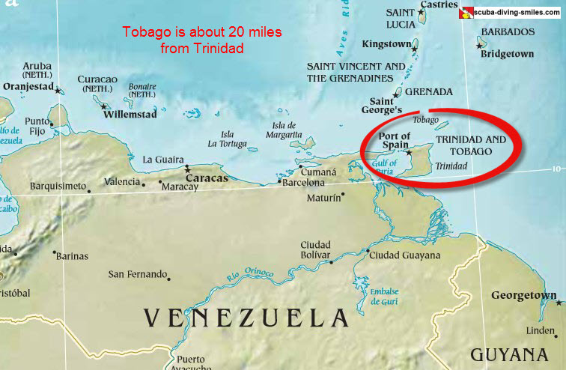
Figure 1.2. Map showing the location of Trinidad and Tobago relative to Venezuela, South America. Accessed from: https://www.scuba-diving-smiles.com/images/map-of-trinidad-and-tobago-7a.jpg 4th April 2019.

Trinidad and Tobago were amalgamated as a single British colony from 1889 until independence in 1962 and became a member state of the PAHO in 1964. Belonging to the PAHO Region of the Americas which includes Canada and The United States of America, the country is designated “TTO”. The population is estimated to be 1, 245 773 persons, with composition Indo-Trinidadian 37.3%, Afro-Trinidadian 36.3%, mixed race 24.2%, White, Chinese, Arab or Lebanese 1.8% and Amerindian 0.1%. The main religious groups are Catholics (26%), followed by Hindus (22%), Anglicans (7.8%), Baptists (7.2%), Pentecostals (6.8%), Muslims (5.8%) and Seventh Day Adventists (4%). Adult literacy rate is 98%. As much as 25% of the population is below age 25 and 50% are female. [12] Gross domestic product per capita of TTO is US$ 15,105.10 (available from http://www.tradingeconomics.com/trinidad-and-tobago/gdp-per-capita, last visited 13th September 2020). This is largely due to its oil resources, and makes it the third richest country in the Region of the Americas after the United States of America and Canada. Its Human Development Index (HDI) of 0.78 places it in the high development category. [13] Primary school attendance is mandatory and the main tertiary education institution is The University of the West Indies (The UWI), St. Augustine, which shares a Faculty of Medical Sciences (FMS) with UWI campuses in the Bahamas, Barbados and Jamaica. The capital city is Port of Spain and there is a Westminster-styled parliamentary system of government, with changes in political administration every five years.
1.7. Arrangement of blood transfusion services in TTO.
The National Blood Transfusion Service (NBTS) is a division of the Ministry of Health (MOH) with headquarters in Port of Spain, six hospital-based satellite donation centres that are managed by Regional Health Authorities (RHAs) and a mobile collection unit (MU) that is operated by a non- governmental organization, the Friends of the Blood Bank Association (FBBA). Most blood is collected from FRDs at the hospital-based donation centres. Most of the remainder is collected from persons who donate for no specific individual but retain the right reclaim their donations at a later date to benefit patients of their choice. This latter group of donors have historically been considered voluntary donors in the local setting although they meet PAHO’s definition of remunerated blood donors. [3]

1.8. Consequences of blood donation arrangements in TTO.
Because most blood donations are made only in response to immediate patient needs and blood components are preferentially distributed to patients linked to donors in either category, the national blood system is challenged by chronic blood shortage and unequal access. The annual blood donation rate is lower than that in countries where regular voluntary non-remunerated blood donation is established. High donor TTI and deferrals remain unchanged despite successive resolutions to increase VNRD percentage as a solution to these problems. [7,8] Furthermore, an attempt to terminate replacement and remunerated blood donation by end 2010 [9] caused an acute fall in already insufficient donations, disruption of clinical services, dissatisfaction among clinicians and donors and adverse media coverage that precipitated an MOH decision to revert to FRD and remunerated donations within four months. In response, the University of the West Indies Blood Donor Foundation (UWIBDF) was founded to promote voluntary non-remunerated blood donation in TTO through research, education and participation.
1.9. Role of the researcher
The researcher has experience of blood transfusion systems in both TTO and Great Britain. Upbringing and early medical education in TTO exposed him to the social and clinical effects of its FRD – based blood transfusion service. Postgraduate training in Great Britain coincided with restructuring of its blood service, heightened haemovigilance and development of policies to improve transfusion practice. He noted tremendous knowledge, pride and recognition of participation in World Wars I and II among the British public and poor participation in blood donation among immigrant ethnic minority populations from the former British Empire. After returning to TTO, he served as a Consultant Haematologist in the public health system subject to a FRD-based blood transfusion service. As Medical Director of the National Blood Transfusion Service between 2005 and 2010 he used guidelines from the British Blood Transfusion Service and PAHO/WHO to facilitate participation by technical and administrative personnel in Action Cycle I to convert the service to exclusive VNRD. After the short-lived success of this initiative, he, as Senior Lecturer in Haematology, facilitated Action Cycle II with undergraduate and postgraduate students of the FMS UWI as participants to investigate the historical, social and psychological contributors to the establishment, survival and resilience of family replacement blood donation while simultaneously establishing a VNRD-based blood donation programme. In Action Cycle III, as Senior Lecturer/ NBTS Director he collected and analyzed data from the National Blood Transfusion Service and the UWIBDF programme to examine the relative sustainability of involuntary and VNRD donations during the COVID-19 pandemic.
1.10. Contribution to current body of knowledge
Although much has been written about the history of blood transfusion in developed countries, the origin of replacement blood donation in developing countries has been less extensively investigated. Most published work on replacement donation in resource-poor countries emanates from Sub-Saharan Africa (SSA), addresses the current status and proposes solutions including retaining repeat FRDs as an alternative to VNRDs on the grounds of accessibility, cost and equivalent safety. [14] Few knowledge, attitudes and practice (KAP) surveys from developing countries with FRD-based systems, have been repeated or used to implement and document corrective action. [15]. This body of work adds to current knowledge by identifying the origins of involuntary blood donation in a former colony, repeating KAP studies, implementing corrective action and monitoring outcomes. It provides a model for overcoming barriers to voluntary non-remunerated blood donation in a former colony.
1.11. Outline summary of chapters
A scoping review of the literature is given in Chapter 2. The results of internet searches using search terms blood donation, blood transfusion, developing countries, world wars, Caribbean, Trinidad and Tobago, colonialism and health systems as well as library searches are summarized. Chapter 3 describes the methodology of Action Research that was used to conduct the work including historical analysis of the problem followed by identification, implementation and monitoring of solutions. Chapters 4 and 5 provide results divided into two sections: Chapter 4: Results Part I: Historical Context – the historical determinants associated with the blood transfusion model in TTO including its population, economy, education, World War experience and post-independence developments and Chapter 5: Results Part II: Action Research – simultaneous data collection, information-sharing and development of a VNRD programme. Chapter 6 examines donations in the VNRD programme during the COVID-19 pandemic compared to FRD and remunerated blood donations in the national system.

CHAPTER 2: LITERATURE REVIEW
2.1. Introduction. The literature review examined the extent to which the problem of blood transfusion services in former colonies has been discussed in the literature. It began by exploring earliest references to blood use in religious and cultural rituals that predated therapeutic use by Europeans by over a thousand years. Articles related to the interlocking history of blood transfusion in Great Britain and her former colonies in the PAHO Region of the Americas, America and Canada, are reviewed to examine technology transfer between metropolis and settler colonies. Relevant literature on blood service and health system development in SSA was examined for the nature of blood transfusion technology transfer to extraction colonies and developments after colonialism. The chapter ends with a review of articles describing strategies employed to reduce reliance on family replacement donors FRDs in SSA.
2.2. Methodology. The strategy described by Arksey and O’Malley [16] was used to examine literature on the subject of blood transfusion in developed and developing countries. However, because of the researcher’s personal interest in history, a narrative review and not a conventional scoping review was undertaken.
Five research questions were identified:
‘What is known from the existing literature about the development of blood services in metropolitan countries and their former colonies?’
‘How did colonialism affect health services in former colonies in the developing world?’
‘What are the origins of replacement blood donation’
‘What are the psychological and social consequences of replacement blood donation?’ and
‘What strategies have been tried to convert from replacement to voluntary non-remunerated blood donation?’
Published articles and reviews suitable for answering the research questions were sought by searching:
Electronic databases - Web of Science, Starplus and PubMed using combinations of search terms such as history, blood donation, transfusion, World Wars, Caribbean, Trinidad and Tobago, voluntary non-remunerated, family replacement, colonialism, health services, psychology and blood safety.

Reference lists – the bibliographies of studies found through electronic database searches.

Key books and journals - hand – searches of materials in libraries in TTO (Port of Spain General Hospital Medical Library, The Alma Jordan Library of the University of the West Indies, St. Augustine and The Eric Williams Medical Sciences Complex Medical Library) and the United Kingdom (Sheffield University Library, the British National Library and the London School of Tropical Medicine and Hygiene Library).

Article selection. Relevant English language articles published between 1815 to the present were selected to include the earliest available records in blood transfusion history. Primary sources were used preferentially but secondary sources were resorted to when they were unavailable. When the only available internet sources were in a foreign language online translation was performed using Google translator.

2.3. Results
2.3.1. Earliest history of blood transfusion

Most accounts of the history of blood transfusion in former colonies begin only after their contact with Europeans. However, recognition of blood as a powerful and symbolic elixir predates European civilization by millennia. The Holy Bible contains accounts of animal blood sacrifices for atonement and kinship from the days of Abraham (1813 – 1644 BC) in Mesopotamia (modern-day Iraq) that culminated in Jesus Christ’s ultimate blood sacrifice to wash away the sins of all men sometime between AD 30 and AD 33. [17] Oral tradition reports the centuries- old practice of drinking cows’ blood to mark ascension to elderhood among the Maasai people of Kenya and Northern Tanzania. [18] In Hindu mythology, goddess Kali, the black magician, derived power to destroy her enemies by continuously drinking their blood. [19] However, the literature contains little evidence of this early fascination being converted to medical application in these non-European cultures.

On the other hand, the transfer of blood between humans for curative purposes was first reported in Europe in the first century AD by Pliny the Elder, the Roman philosopher (Figure 2.1.) as the drinking of blood as a cure for epilepsy. [20, p 276].

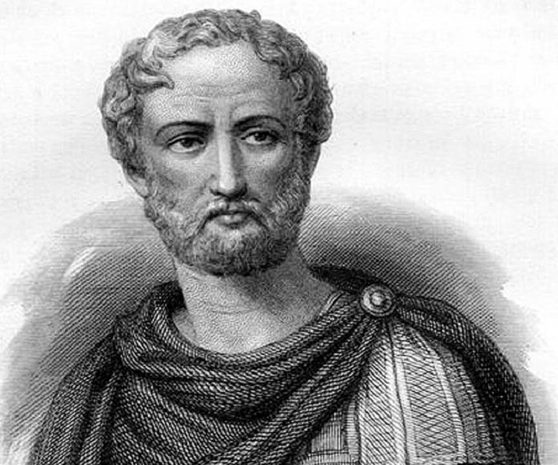
Figure 2.1. Pliny the Elder. Roman philosopher [Internet image] Available from: https :// www.thefamous people.com/profiles/images/pliny-the-elder-1.jpg Accessed 29th August 2018.

For over 1500 years thereafter, Europeans accepted the teachings of Claudius Galus, Greek physiologist, who conducted dissections in animals and humans to conclude that blood ebbed and flowed in blood vessels that terminated in tissues; veins from the liver containing blue blood on the right side of the body and arteries on the left containing red blood from the heart [21]. Although Ibn-al-Nafis, Arabic physician, described the pulmonary circulation as early as 1260 AD [22], actual transfusion was first attempted in Rome in 1498 when Pope Innocent VIII, who lay dying in bed from dementia and a stroke, was injected with blood from three Jewish boys who were each paid three muskrats. The intervention ended tragically as it failed to save the life of the pontiff and resulted in the deaths of all three boys from presumed air embolism – early evidence of the dangers of paid blood donation. [23, 24]

2.3.2. British colonization in the Americas
A striking change in world history occurred after 1501 as European countries laid claim to more than half of the world’s land surface. [25] Beckford describes how, blessed with naval power and technological superiority, Britain established two main types of colonies in the Americas - settler colonies and extraction colonies. To settler colonies in North America she sent populations that established new centres of civilization with British institutions of government, religion and learning. Massive migration of individuals, families and communities was the basis of settlement. Migration was permanent and groups carried with them European ideas and patterns of social organization to develop new societies of their own. The settler colony therefore bore a close resemblance to the ‘mother country’ in terms of population and institutional structure. The new nations of Canada and the United States of America emerged from former British settler colonies in North America. On the other hand, metropolitan migration to extraction colonies such as TTO usually consisted of individuals who viewed the colony as a means of accumulating wealth over a relatively short period with which they returned to the home country to enjoy the good life. The family of the migrant came much later or not at all so the point of reference was always enrichment of the home country and not development in the colony. [26]
2.3.3. Blood transfusion before World War I
Literary accounts of blood transfusion during the colonial period highlighted European knowledge and an attitude to knowledge that differed from other cultures – a willingness to bring it to bear upon practical problems - a technological approach. Gibson describes how the British physician, William Harvey, building on the work of Galus and Ibn-al-Nafis, announced his discovery of the circulation of blood around the body in 1628 [27]. His countryman, Richard Lower, also a physician, described his experimental blood transfusion from the carotid artery of one dog to the jugular vein of another in 1666. [28] According to Keynes [29], animal-animal transfusions in England, France and Germany in the 17th century progressed to transfusions from genteel lambs to pacify aggressive humans with mental illness. Guerrini recounts how these animal to human transfusions came to an abrupt end in 1667 after injection with lamb’s blood by Jean-Baptiste Denys, personal physician to King Louis XIV, resulted in the death of a French patient. Denys was banned and transfusion was outlawed in England and France for 150 years. [30] Transfusion again came to the fore in Europe in 1818 when James Blundell (Figure 2.2), a British obstetrician and physiologist, having witnessed maternal deaths from post- partum haemorrhage, published the results of his experiments with blood transfusion in dogs using a syringe, two-way stop-cock and cup.

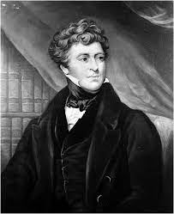
Figure 2.2. James Blundell, British physician. His animal experiments led to the first successful human to human transfusion. Internet image. Available at https://www.google.com/ url?sa=i&url =https%3A%2F%2 Fwww.cambridge.org Accessed 8th July 2021.

These experiments showed that death from haemorrhage could be prevented by transfusion, venous blood was effective for transfusion, blood lost vitality and clotted outside the body and human blood was not suitable for transfusing dogs. In 1818, he reported the first successful human-human transfusion of blood from a husband into a woman dying from post- partum haemorrhage using the syringe cannula apparatus (Figure 2.3). [31]

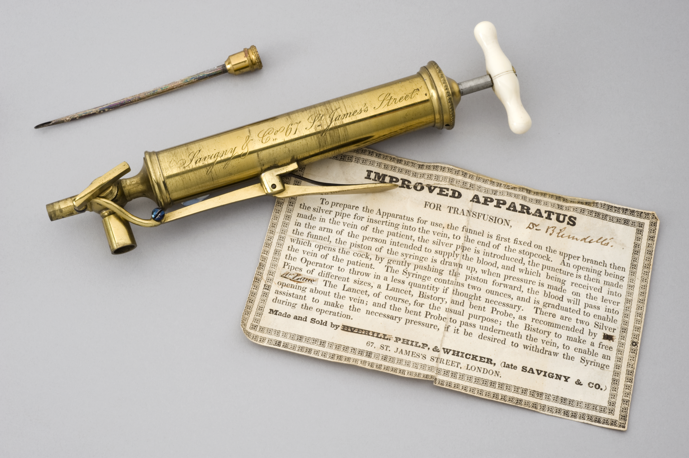
Figure 2.3. Blundell’s syringe cannula [Internet image] Available from: http:// broughttolife .sciencemuseum. org.uk/hommedia.ashx?id=95027&size=Large. Accessed 24th August 2018.
Blundell subsequently devised and described two instruments, the ‘impellor’ through which blood was forced by thrusts from a brass syringe (Figure 2.4) and the later ‘gravitator’ which relied on gravity and the weight of the blood column to carry blood from donor to recipient. [32]

a. b.
Figure 2.4. a. Blundell’s impellor. [Internet image] Available from: http://m2.wyanokecdn.com /64b8 fc2b2e09704acf8c9d5f7e865833.gif. Accessed 23rd August 2018. b. Blundell’s gravitator. [Internet image]. Available from: https://upload.wikimedia.org/ /commons/ thumb /f/f1 /TheLancet1828 .jpg/220px-TheLancet1828.jpg. Accessed 23rd August 2018

For fifty years, British transfusion practitioners followed Blundell’s teaching and used human blood but the practice remained limited to obstetricians treating post- partum haemorrhage. Outside this field, finding blood donors, cumbersome equipment and the problem of blood clotting in equipment led practitioners to seek alternatives. The literature describes several approaches to overcoming clotting. Defibrination of blood was reported in France in the 1820s and practised by some British transfusors. [33] This involved whipping the blood with a stick, fork or rod which collected fibrin and left it fluid for longer. In 1868, the obstetrician, Jason Braxton Hicks, reported a solution of phosphate and soda which, mixed with donor blood, overcame the problem of clotting in instruments. [34] As reported by Hunter, by 1889, the cumbersome requirements for transfusion, mistrust of specialists and a growing body of published research by physiologists led British doctors to believe that blood was not needed to treat haemorrhage and that volume replacement with saline solution was sufficient. [35] In fact by the time Almroth Wright, an Ulsterman and pathologist, described the addition of citrate to blood to inhibit coagulation in 1895 [36], saline infusions had displaced blood as the fluid of choice for replacement of blood loss in Britain and continental Europe.
2.3.4. Advances in America prior to World War I
From the last quarter of the nineteenth century, innovations and advances in transfusion were reported with great frequency from North America. As enthusiasm for blood transfusion waned, Oberman described the use of animal milk for transfusion which was supplanted by physiological saline infusions after frequent adverse reactions to milk. [37] The role of Alexis Carrel in the return of blood transfusion is well described by Starr. In 1894, Marie Francois Carnot, President of France, was stabbed to death by an Italian anarchist. Hearing of how much blood was lost from Carnot’s severed portal vein, 21-year-old Carrel, studying at the University of Lyon, developed a surgical technique to suture arteries to veins. [38] Lambert describes how Carrel, subsequently hired by New York’s Rockefeller Institute for Medical Research to do work on organ transplantation, used this technique to deliver life-saving blood transfusions for pernicious anaemia and haemolytic disease of the newborn, making transfusion a surgical procedure. [39] However, despite the Austrian physicist, Karl Landsteiner, publishing his discovery of the three major blood groups in 1901 [40], Carrel used unmatched blood. Ottenberg at Mount Sinai Hospital in New York first reported cross-matching of donor and recipient blood samples prior to transfusion in 1907 making practical use of Landsteiner’s work for the first time [41] In the same year, George Washington Crile, a surgeon and physiologist from Cleveland, conducted experiments and published results to support the use of blood for transfusion. [42] The same author subsequently described a modification of Carrel’s technique that used a system of interlocking tubes and rings to aid temporary arterio-venous anastomosis for transfusion. [43]
Crile’s work led to a resurgence of interest and a series of new developments in blood transfusion in America. A rapid succession of scientific publications about techniques for storing and administering blood ensued. Because transfusion via arterio-venous anastomosis required great surgical skill and made regulating the volume transfused difficult, several transfusion devices were devised to allow rapid transfer of measured volumes of venous blood before clotting occurred. In 1913, Kimpton and Brown in Boston described a paraffin waxed glass cylinder to delay clotting (Figure 2.5.) which was used extensively in American hospitals. [44]

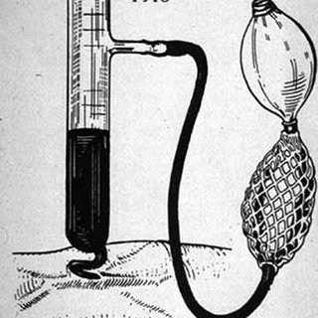
Figure 2.5. The Kimpton Brown Apparatus. It consisted of a gradient paraffin-coated glass cylinder with a horizontal tube for suction. [Internet image] Available from: whttps:// www. Researchgate.net/profile/ Andre _Van_Zundert2/publication/7501846/figure/fig2/AS:339689820180481@1457999772437/. Accessed 23rd August 2018.

Later in that same year, Edward Lindeman of New York described a multiple syringe method for rapid transfer of blood. [45] L. Unger, a haematologist working in New York, developed a 4-way stop-cock connected to a large syringe for rapid vein to vein transfer of blood with saline flushes between transfers. [46] In 1914, twenty years after Wright’s in-vitro demonstration of citrate’s anti-clotting capability, Albert Hustin in Belgium, Luis Agote, physician and researcher in Argentina and Richard Lewisohn in New York independently performed and published transfusion using citrate as anticoagulant. [47, 48, 49] The anticoagulant allowed blood to be stored for a few days without clotting and removed the need for the donor and recipient to be in the same room.
At the Rockefeller Institute in New York, Peyton Rous and J.R. Turner Jr. published the addition of dextrose to citrate to extend the storage time to four weeks. [50] In 1915, Richard Weil, an American pathologist at the German Hospital in New York, demonstrated that citrated blood could be refrigerated for a few days and remain viable for transfusion. [51] Whereas Crile’s work inspired this renewal of blood transfusion interest in America, a preference for saline infusions persisted in Britain and continental Europe through the late 19th and early 20th centuries leading up to World War I of 1914 - 1918.

2.3.5. Blood transfusion during World War I
In his short print history of World War I, the Great War, Hew Strachan describes how Britain, France and Russia, the Allies, fought Germany, Austria-Hungary and Turkey, the Central Axis, for dominance in Europe. The war was fought on two European Fronts. On the Western Front in France, Britain and France fought the Germans (Figure 2.6) while Russia fought the Germans and Austria-Hungary on the Eastern Front.

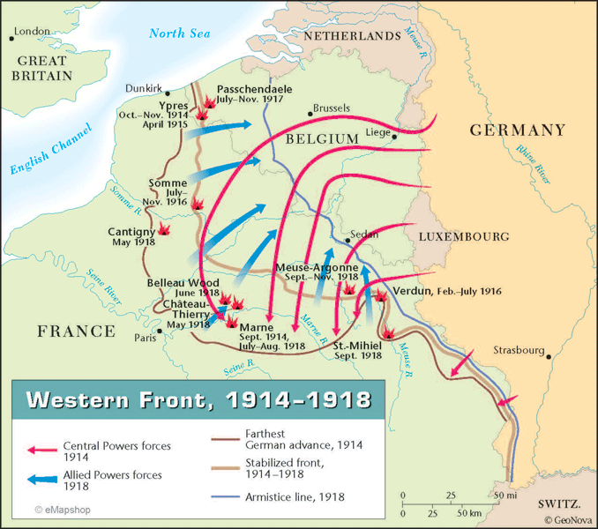
Figure 2.6. The Western Front in World War 1. [Internet image]. Available from: http:// www. wall-maps.com/ classroom/history/world-history/w77_wwi_westernfront.gif. Accessed 24th August 2018.
There were several non-European theatres including the Gallipoli Front in Turkey where Britain and her allies fought the German-affiliated Ottoman Turk Empire. Canada was by this time a British dominion and immediately joined on the side of the Allies. America was now an independent, industrialized country and joined the war later. Although initially a European war, it spread globally to include the colonies of the main belligerents to provide resources, troops and protection of sea routes. [52, p 67 - 94] Many great advances in blood transfusion occurred on the battlefields of Europe as British, Canadian and American soldiers published transfusion experiences in an environment of frequent, massive injuries with a juxtaposed pool of healthy, willing soldiers as donors.
At the war’s onset, few British doctors were practising transfusion and the literature reports only sparing use of direct blood transfusions on both the Western and Eastern Fronts. Blood transfusion was not practised on the Gallipoli Front and saline infusions were used by both sides during the amphibious Dardanelles invasion which claimed tens of thousands of British, French, Australian, New Zealander, German and Ottoman Turk lives between 1915 and 1916. [52 p 112-120, 53] British authorities asked the United States of America to send qualified personnel to the Western Front before they officially joined the war in 1917. The request for American assistance was initially fulfilled by George Washington Crile’s Cleveland hospital and several medical schools including Harvard. Crile led the Lakeside Unit, a hospital contingent that served at military base hospitals on the Western Front between 1915 and 1918. A Canadian surgeon, Edward Archibald, who had visited George Crile in Cleveland to observe his surgical techniques for transfusion, arrived on the Western Front in 1915. He published his experiences using citrated blood with the syringe cannula to treat patients with primary and secondary haemorrhage using medical staff and trivially wounded soldiers as donors. [54] A second Canadian surgeon, Major Laurence Bruce Robertson, who had learnt Lindemann’s syringe cannula method for blood transfusion at New York’s Bellevue Hospital, arrived in France on the Western Front in 1915 (Figure 2.7).

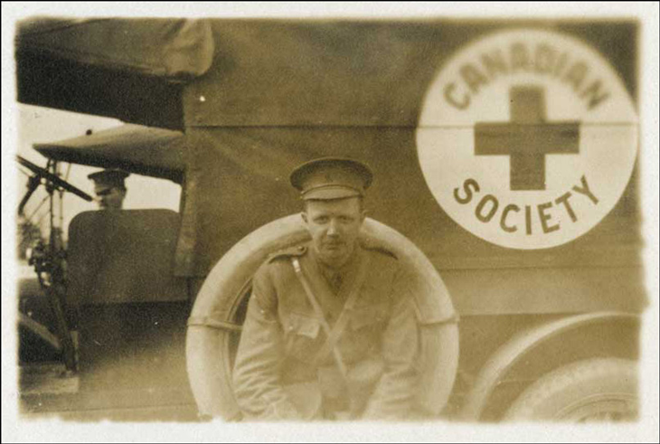
Figure 2.7. Canadian Major Laurence Bruce Robertson. On the Western Front in France 1915-1918. He demonstrated Lindemann’s syringe cannula technique for blood transfusion to British surgeons. [Internet image]. Available from: https://blood.ca/sites/default/files/blog_ images/teasers/ BruceRobertson _be side_Canadian_Red.png. Accessed 30th August 2018.

https://blood.ca/sites/default/files/blog_images/teasers/Bruce_Robertson_beside_Canadian_Red.png
Using off-duty or lightly wounded soldiers as donors he transferred un-crossmatched blood by syringe from donor to recipient to demonstrate the life-saving potential of transfusion and the need to resuscitate the badly injured with something more than normal saline. He, however, had reservations about citrate and relied on saline-flushed syringes and rapid administration to minimize clotting. Laurence Robertson described his experiences injecting blood to treat four cases of secondary haemorrhage in 1915. Donors were selected from soldiers with sprains or other trivial injuries who were in good physical condition but unfit for duty. Enquiries were made regarding previous illness such as syphilis and tuberculosis and, if feasible, a Wasserman reaction was done. His experiences with advocacy for the use of blood over saline to treat haemorrhage were not published in the British Medical Journal until after the Battle of Somme. [55]
On July 1st 1916, the Battle of the Somme brought great devastation to the British Army with the loss of 60,000 lives on its first day. The British, intending to provide a distraction to relieve French troops at Verdun, mounted a week-long bombardment of German trenches followed by an insurgence of ground troops. The Germans survived the bombardment and greeted the advancing troops with machine-gun fire. By the end of the Battle, which waged until mid-November 1916, there were 600,000 Allied (420,000 British) and 450-600,000 German casualties. [52, p 186-189] Ernest Cowell, a Casualty Clearing Station surgeon for the British First Army, witnessed and reported the fruitlessness of saline infusions that were used extensively to treat Somme casualties. [56]
One year after the Somme, Major Lawrence Bruce Robertson wrote a second article describing 36 cases of severe primary haemorrhage with shock that he managed by blood injections between 1916 and 1917, using the Lindemman syringe cannula in 32 and the Unger stop-cock method in four cases. Citrated blood was used in four cases. Blood transfusion was life-saving in 22 cases. Robertson invited British Army officers from nearby Casualty Clearing Stations to observe and learn his technique. Colonel Gordon Watson, Consulting Surgeon to the British Second Army, was openly supportive of blood transfusion in an accompanying note to Robertson’s article. He lamented the transitory benefit of saline infusions and suggested that an alternative was urgently needed. [57]
The United States officially entered World War 1 in April 1917 after a German declaration of unrestricted submarine attacks on allied shipping and intercepted correspondence revealing possible collusion between the Germans and Mexico. The American surgeon, Major Oscar Hope Robertson had trained with Peyton Rous at the Rockefeller Institute at a time when Rous was publishing work on blood typing and red cell storage. He sailed to France with the Harvard Medical Unit in 1917. He performed and described 22 transfusions on 20 patients at casualty clearing stations. Donors were chosen from among soldiers with trivial wounds, excluding those with a history of malaria, trench fever or syphilis. Only group O syphilis-tested blood was used. Five hundred cubic centimetres of blood was collected by venipuncture of the donor into a Winchester bottle containing the Rous-Turner solution of sodium citrate and dextrose, allowed to settle for 4-5 days, stored in ice-boxes separated by saw dust or other non-conducting material for up to 26 days then transported in ambulances to the Casualty Clearing Station. Blood was injected into the recipients’ vein using the syringe - cannula method. Eleven of the transfused patients were discharged to the military base hospital in good condition and nine died, giving a mortality rate of 45%. Eight of the patients who died showed immediate improvement after blood transfusion that was sufficient to facilitate surgery but ultimately succumbed to gas gangrene. One patient had severe anemia, showed no improvement and died soon after transfusion. Robertson concluded that transfusing stored red cells had no apparent harmful effect, preserved red cells could be transported long distances without injury and that it was convenient to have a stock of blood on hand that could be quickly transfused by a single officer in busy times. [58] Oscar Robertson was credited with establishing the world’s first blood depot. His technique was modified by the British surgeon, Lieutenant Geoffrey Keynes who became a keen supporter and advocate for citration and refrigeration. Stansbury acknowledges the contributions of these North American surgeons to transfusion in World War I. [59] For emergency transfusions on the battlefield, Geoffrey Keynes designed a portable kit for use well in advance of Casualty Clearing Stations. [60]. The device did not use citrated or refrigerated blood, but rather, direct transfusions (Figure 2.8). With these advances, blood transfusion became accepted practice by the British Royal Army Medical Corps which later declared it “the greatest medical advance of the war”.

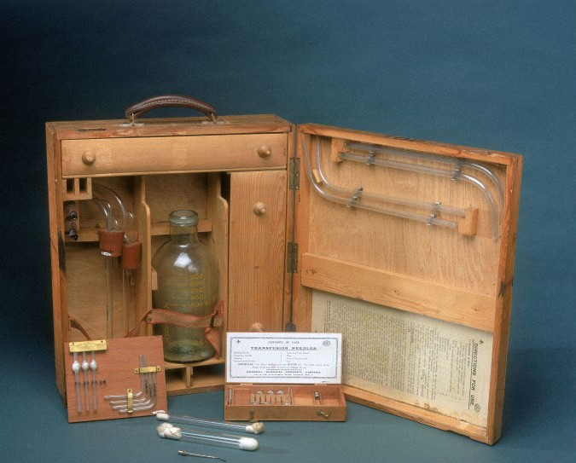
Figure 2.8. Geoffrey Keene’s portable apparatus. For transfusion in the battlefield forward of Casualty Clearing Stations. [Internet image]. Available from: http://blog.nationalarchives .gov. uk/wp-content/ uploads/2015/08/ Keynes-transfusion-equipment-larger-image-size-e14387638 906 15.j pg. Accessed 23rd August 2018.
Although blood transfusion was practised and established on the European fronts, the researcher found no evidence of this advance reaching the Gallipoli front.
2.3.6. The interwar period
After the Great War, returning soldiers and surgeons with experience of blood transfusion introduced it to civilian practice. Schneider examined the introduction of blood transfusion into general practice after the first world war during which advances had been made in techniques to withdraw, store and safely transfuse blood obtained from a readily available pool of military donors. The challenge lay not only in spreading the word about transfusion but shifting the donor base to community members in peacetime and teaching the techniques to new practitioners. Even in countries that had been belligerents, the extent to which the techniques were accepted and disseminated varied with the state of medical practice. Whereas, blood transfusion articles appeared in French and German journals immediately after the war, it was not until 1926 that the British Medical Association held a special conference with several talks about blood transfusion. [61]
2.3.7. The origin of family replacement donations?
Lingering discomfort with the use of citrate as an anticoagulant led to the continued use of direct transfusions in France and Britain using family members as donors. For example, at one Paris hospital, surgeons described arrangements for each patient having an operation likely to require transfusion to bring relatives and friends to serve as donors. [62] Problems associated with this method were reported as it gained traction across European cities. [63] British surgeons also reverted to finding relatives and social contacts to serve as ‘blood sacks’ as the need arose (“blood on the hoof”). In some English cities like Sheffield and Manchester, hospitals organized donor panels and paid donors to provide this service. [61]
2.3.8. The role of Percy Lane Oliver
Bird [64] describes the work of Percy Lane Oliver (Figure 2.9), a Red Cross worker in Camberwell, who in 1921 was asked by to find a blood donor for a patient at King’s College Hospital in London. Finding the process inefficient, he recruited fellow Red Cross worker and nurse, Sister Linstead, to serve as the first voluntary blood donor on record.

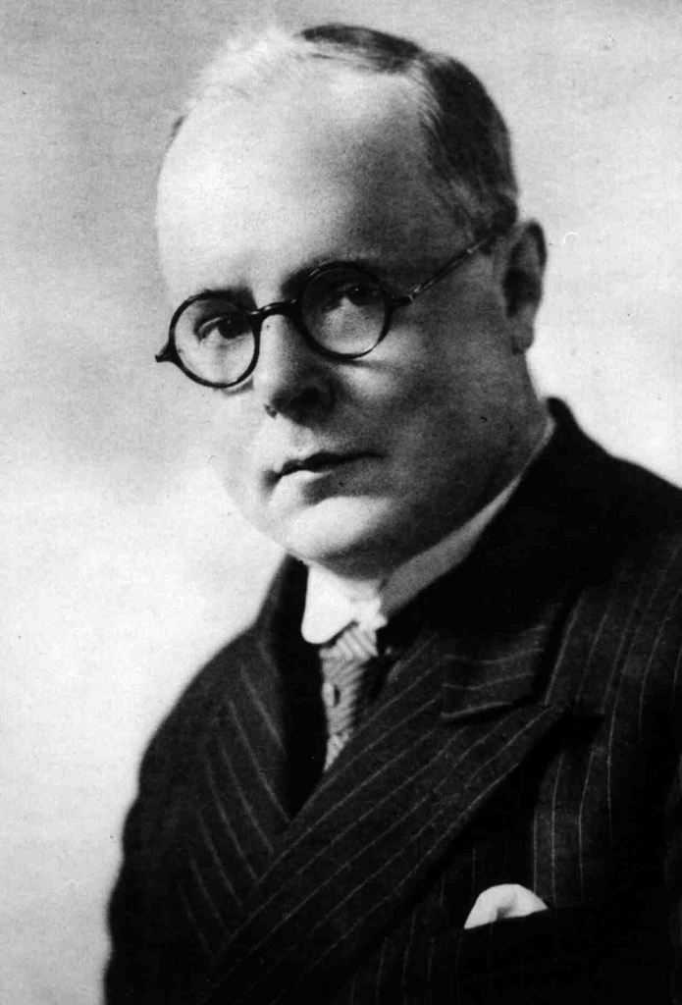
Figure 2.9. Percy Lane Oliver. Established world’s first municipal voluntary blood transfusion service in 1926. [Internet image]. Available from https://c1.staticflickr.com/3/2761/4398158178_a43c3fa15a_b.jpg. Accessed 24th August 2018.

Thereafter, he organized a panel of voluntary blood donors from his home. His wife served as receptionist for calls from hospitals when donors were needed. In the first year, the organization received one call and registered four donors. Five years later it received over 700 calls and had 400 donors on register. A significant number of these requests came from Geoffrey Keynes despite his disappointment in the use of direct, ‘blood on the hoof’ transfusions rather than the citrate technology which he had advocated during World War 1. Lane expanded his donor base to the Young Men’s Christian Association (YMCA) and Rover Scouts to establish the Greater London Blood Transfusion Service. He sought and obtained the support of the Red Cross and his organization became the British Red Cross Transfusion Service, the world’s first municipal voluntary blood transfusion service in 1926 then evolved into the fully voluntary National Blood Transfusion Service.

2.3.9. The Dutch Blood Transfusion Service
Dutch literature credits the internist H.C.S.M. van Dijk with initiating the first Dutch Blood Transfusion service in Rotterdam in 1930. During a stay in London, he investigated how the British Red Cross had organized its blood transfusion service. He encouraged the Dutch Red Cross to organize a blood transfusion service that followed Oliver’s principle of voluntarism using donors who were voluntary and non-remunerated. [65]

2.3.10. Blood transfusion in the Spanish Civil War
During the Spanish Civil War of 1936 to 1938, Dr. Frederico Duran-Jorda, Spanish haematologist (Figure 2.10), and Dr. Norman Bethune, Canadian physician, established the Barcelona and Madrid Blood Transfusion Services respectively. Jorda himself described the organization of the Barcelona service that collected thousands of units of blood from civilians, anticoagulated them and transported them in refrigerated trucks to forward medical installations on the battlefield. [66]

Figure 2.10. Dr. Frederico Duran-Jorda. Founded the Barcelona Blood Transfusion Service during the Spanish Civil War of 1936-8. This was the first time that community donations were used to treat military casualties on the battlefield. Image from: https://encrypted-tbn0. gstatic.com/images? q=tbn:And 9GcR XU bvDE-RZWqz-wEDfH65mxa BBX IiNY Ylmov 0HW8e-nkeVAFZgiA. Accessed 12th April 2019.

Bethune’s contributions are detailed by Pinkerton. [67] This war between royalists and republicans was the first time that community blood donations were used to supply the military.
2.3.11. Blood transfusion in Britain during World War II
During the Munich crisis of 1938, Hitler’s forces invaded Czechoslovakia and threatened war on Britain and France. Schreedar relates how the British government made robust preparations for air strikes on densely populated cities in England. Civilians were mobilized as bomb spotters, air raid wardens and firefighters. Public swimming pools were emptied to store makeshift papier-mâché coffins and large pits were dug to serve as mass graves. However, ‘blood on the hoof’, which had proven barely adequate in peacetime, remained the method of blood collection favoured by the Secretary of War. Dr. Janet Vaughan (Figure 2.11), a trainee pathologist at the Hammersmith Hospital in London, was familiar with the work of Jorda and Hume during the Spanish Civil War and unconvinced of the adequacy of ‘blood on the hoof’ in the event of an air raid. In defiance of her seniors and the status quo, she collected 50 units of blood from volunteers and preserved them in citrate with the help of a colleague from the Hammersmith Hospital. This mini-depot was the largest store of blood in London at the time. After the Munich pact was signed and the crisis averted, the stored blood was safely used for patients, reinforcing Vaughn’s confidence in community collection, citration and storage for later transfusion. [68]

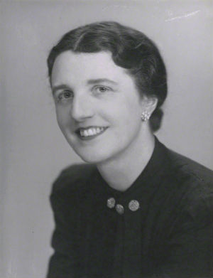
Figure 2.11. Dr Janet Vaughan. Established four depot system in London to aid civilian air raid casualties in 1939. [Internet image]. Available from: https://www.medsci.ox.ac.uk/images/about/dame-janet-vaughan. Accessed 3rd September 2018.

In the succeeding six months, with World War II pending, she established an unofficial committee which included Percy Lane Oliver and convened a series of meetings with young doctors to address appropriate preparedness for air raids in London. These unofficial meetings generated the basis of a blood transfusion scheme for the city that included four blood depots located in towns safely distant from central London and the threat of attack – Luton, Maidstone, Sutton and Slough- at which blood would be collected and stored for distribution to city hospitals during air raids. Each depot would be staffed by a haematologist and use milk bottles and refrigerated ice cream trucks for collection and transport. At the end of the Spanish Civil War, Duran fled to Britain at the invitation of Vaughan on behalf of the British Red Cross. He shared his blood transfusion expertise in developing a proposal which was submitted to the Medical Research Council (MRC). The four-depot scheme was eventually accepted by the MRC and implemented in wartime London to meet civilian needs. [69] Whitfield describes the effectiveness of Vaughan’s approach of local involvement for recruiting blood donors during the London blitz. It favoured personal interaction and communication with donors - house-to-house canvassing, appeals by clergy during church services, local press advertisements and loud speaker vans - over mass national appeals which were impersonal and carried the risk of overwhelming the capacity of collection centres. [70] Vaughn herself described the technical aspects of the wartime operation in three publications. [69, 71, 72]
After Great Britain declared war on Germany on September 1st 1939 in response to the German invasion of Poland, World War II, unlike World War I which was essentially a European war, became global with fighting fronts in Europe (Western and Eastern Fronts), the Mediterranean /North Africa and the Pacific region. Britain and her allies, France and Russia, were pitted against a resurgent Germany, Japan and Italy. Theatres of war developed in the North Atlantic and the Caribbean where German U-boats attacked allied shipping and naval routes to cut off supplies from colonies to the Allies. The British Army, recognizing the need for a separate blood service for the military, established its own blood service to complement the MRC programme. Major Lionel Whitby (Figure 2.12) described the establishment of the British Army Transfusion Service in South East England used community donors to supply blood by airlift to the whole British Army overseas, including the West Indies, and in the United Kingdom. It also supplied blood for civilian needs in the areas of the United Kingdom within which it operated. [73]

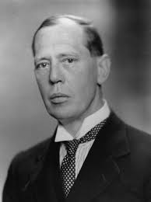
Figure 2.12. Major Lionel Whitby. Established British Army Transfusion Service using community donors in South East England to supply blood and transfusion fluids to the British Army at home and overseas. [Internet image]. Available from: https://encrypted-tbn0.gstatic .com/images?q=tbn: And 9GcSj Avrdq 3n4 eUnQJz 2Q4HTpJLblaUi7AEeS3naaPJTlrI9l9rrAmw. Accessed 21st August 2018.

Like Vaughan, Whitby favoured personal and open communication with donors over mass publicity and relied on posters, flyers and loud speakers to mobilize civilian donors at the Southmead Hospital in Bristol. (Figure 2.13) Blood donors were considered to be Voluntary Members of the Army Blood Transfusion Service and Civil Defence Volunteers.

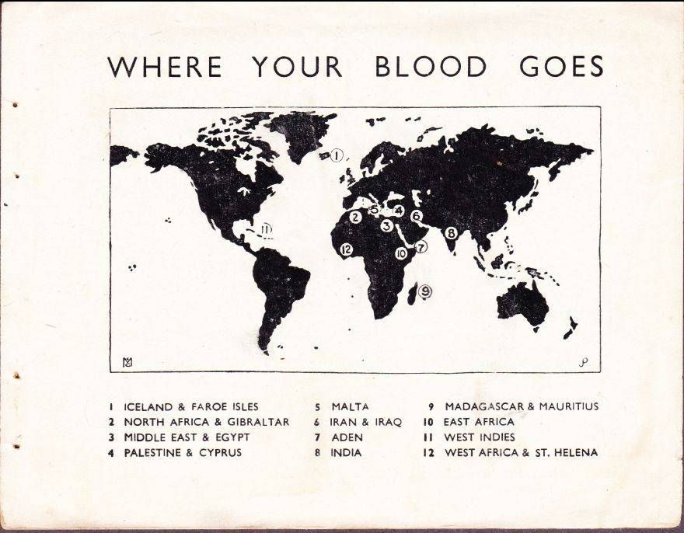

Figure 2.13. Printed material from British Army Blood Transfusion Service booklet given to donors (print date 1942). The posters were used to recruit blood donors and the map shown illustrates all the fronts, including the West Indies, to which donated blood or plasma was shipped or airlifted. Available from: http://www. Stamp boards.com/viewtopic.php?f=17&t=36681&start=400. Accessed 21st April 2019.

2.3.12. Blood collection for Britain in America and Canada during World War II
Kendrick reports that the United States of America had no organized blood transfusion system at the outbreak of the World War II. In 1940, Edwin Cohn, a professor of biochemistry at Harvard Medical School, develops ethanol fractionation to break plasma down into its components and products. Returning from France in 1940, Dr. Alexis Carrel revealed the great need for plasma to treat battle casualties on the European Western Front. Initial planning of a “Blood for Britain” project started in America in June 1940. The project was run between August 15th 1940 and 17th June 1941 at the Presbyterian Hospital in New York with the American Red Cross as its collecting agency and Dr. Charles Drew (Figure 2.14) as its supervisor.

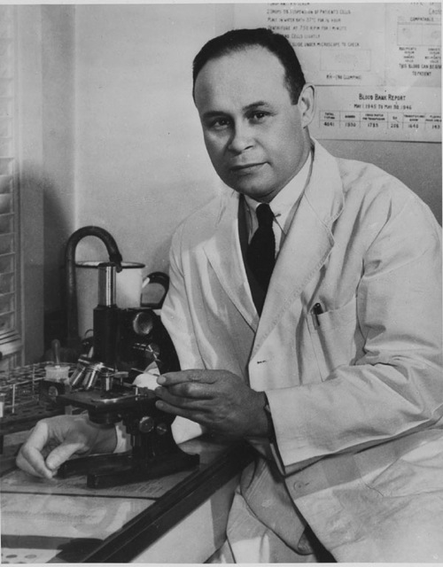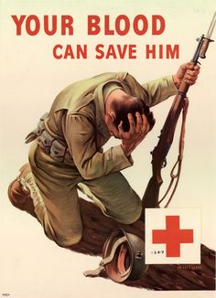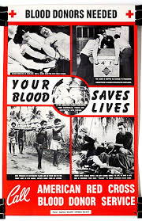
Figure 2. 14. Dr. Charles Drew. He was Supervisor of the Blood for Britain progamme 1940-1941 then Director of the American Red Cross National Blood Donation Programme. Two blood donor recruitment posters are displayed. [Internet images]. Available from: http://www.blackhistorymonth. org. uk/ wp-content/uploads/ 2015/11 /charles drew1jpeg. Accessed 6th September 2018.
Voluntary civilian donors were recruited and a total of 14,466 units of plasma were airlifted to France and Britain. In 1941, concerned about the possibility of German air raids on American soil, the government established a national voluntary blood donor programme run by the American Red Cross Society with Dr. Charles Drew as Director. It collected 13, 326, 242 units of blood from voluntary donors between 1941 and 1945 when it was closed. Apart from mass appeals, the service used local methods such as posters, pamphlets, leaflets, house to house canvassing and personal appeals to attract donors. Over 11 million units were processed into dried plasma and 387,492 units of Group O blood were flown overseas, 205, 907 to Europe. Donors signed a release form declaring that their blood was donated voluntarily for use by the Army or Navy or for civilian protection. American civilian donations were augmented by blood donations from military staff and local civilian populations. Payment of military and civilian donors was allowed by army law. [74]
In the dominion of Canada, there was similar concern that the Germans would bring the war to its shores. Kapp describes how, between 1939 and 1945, Professor Charles Best of the University of Toronto conducted experiments to demonstrate the utility of serum to treat shock resulting from blood loss. With the Canadian Red Cross Society as donor recruitment agency, he initiated a national blood donor programme which wooed community members to donate 2,338,533 units of blood to treat military and civilian casualties using loyalty to king and mother country as the major motivators. These donations were processed into dried serum which was shipped or airlifted to Britain to treat casualties and kept locally to treat civilian casualties. [75]

Developed blood transfusion services conferred an advantage on the Allied Forces over the Germans on the battlefields of Europe in World War II. The Germans suffered a disadvantage of tens of thousands of lives due to their poorly developed transfusion programme. Their supply was limited since they accepted only Aryan donors, did not use plasma and continued to use ‘blood on the hoof’ at fully equipped medical centres at the rear. [38]

At the end of World War II, these community voluntary blood donation programmes that were established to protect armies and civilian populations were terminated then restarted as national blood transfusion services with close community interaction in Great Britain (1946), America and Canada (1947). [76] The American programme continued to accept paid blood donors.

2.3.13. The Japanese wartime experience

When Japan participated in World War I on the side of the Allied Forces, its government sent professors from the universities of Tokyo and Kyusha to the Western Front to observe transfusion technology which they introduced into surgical practice after returning home. However, a system for community blood donation was not established. After World War II, advanced surgical techniques from Europe and the United States were introduced into a devastated post-war Japan. As surgeries increased blood was collected at hospitals from patients’ relatives and friends to transfuse them. Blood banks were only established in 1947 after syphilis was transmitted from blood collected at a hospital. An appeal was made by the Japan Red Cross Society for voluntary non-remunerated donors. However, uptake was poor since poverty and deprivation led Japanese to believe themselves incapable of dispensing charity to others. As medical services advanced and the need for blood increased, the country resorted to paid blood donations. However, health problems in those selling blood and the high occurrence of post-transfusion hepatitis in transfused patients created a social problem. In 1964, the United States ambassador to Japan contracted post-transfusion hepatitis. The Japanese Prime Minister apologized profusely to the United States and committed to establishing a service based on voluntary non-remunerated blood donors. The national and prefectural governments made appeals for voluntary non-remunerated blood donations to the entire nation through newspapers, radio and television and a nationwide campaign to promote blood donation was carried out by student and various volunteer groups. The number of blood donors rose exponentially from one million in 1966 to over eight million in 1985, sufficient to fully meet the demands of the Japanese health system. However, it took another 30 years for Japan to establish legislation to support voluntary non-remunerated blood donation. [77]

2.3.14. Colonialism and health service development in Nigeria

Sub-Saharan Africa (SSA) provides the ideal model for measuring and comparing the impact of European colonialism on blood service and health service development. The continent was divided into colonies of Britain, France, Germany, Belgium, Portugal and Spain at the end of the nineteenth century most of which achieved independence in the 1960s. Rodney [78] lamented that these colonies existed solely for the benefit of colonial powers while little was invested in their technological and social development. Ityavrar examined the effect of colonialism on heath service development in Nigeria, an oil-rich former British colony in SSA. [79] He described how, prior to British colonization, the country was divided into kingdoms and empires run by kings and rulers. Health care was provided by local healers, who, existing in most households, delivered services to all. After Nigeria was colonized by Great Britain in 1861, the colonial state cooperated with Christin missionaries arriving in late 19th century to introduce and establish western medicine to benefit colonial staff, the British Army and Navy, European merchants and travellers and later, the Africans they employed. Hospitals were built in the cities where the missions were established. They linked religion to Western medicine and used British doctors, later sending a few Nigerian nationals for training in Britain to work in these urban centres on their return. The children of kings and rulers were preferentially selected for medical training to ensure their cooperation with the colonial state. All health services provided by the missionaries and the colonial state were located at strategic economic centres with European officials, traders, miners, missionaries and colonial offices. These arrangements continued up to World War I when colonial doctors were sent to the Western Front leaving local facilities understaffed and under-resourced. Most of these doctors died on the front. Following World War I, the Yabu Medical School was started by the missions from which graduates went to England to complete medical training. However, its graduates were not granted the same privileges as British doctors. Many became politicians in the nationalist movement. World War II, by virtue of the nature of British involvement, took less of a toll on the heath system than World War I. In fact, after a brief decline there was rapid expansion in mission and state hospitals in cities to serve Europeans and the Africans who constituted their labour force. These activities were spurred on by demands from nationalists for social, economic and health care reform after the experience of two world wars. While educational and capitalist activities created a stratified society, disparities in health care provision arose between North and South, urban and rural, privileged and poor, European and African. Emphasis was placed on curative Western medicine over the basic needs of the population. Many Nigerians linked Western medicine to the atrocities of colonialism and rejected it but many Nigerian doctors used Western medicine in ‘get-rich-quick’ schemes at private clinics. As a result of colonialism, the Nigerian health care system was centralized around hospitals built by missions and the colonial state in urban centres and hubs of economic activity to meet the needs of European officials. The article ends by pointing out that the nationalists who subsequently secured Nigeria’s independence from Britain became Nigeria’s ruling class that controls the post-colonial state. The author made no reference to blood transfusion but according to Schneider and Drucker, a blood transfusion service in Nigeria was first established in 1952. [80]
2.3.15. Colonialism and blood service development in SSA
Schneider [81] claimed that blood transfusions were first recorded in SSA in the early 1920s after World War I and that organized transfusion practices were established in the interwar period. However, he does not state if African soldiers who served on the Western Front in World War I participated in blood transfusion or brought the practice back to civilians in the interwar period. Schneider concedes that the first recorded transfusions were inspired by metropolitan need as European workers faced severe anaemia from malaria and that progress before World War II relied on European doctors and their links with European institutions such as Belgian universities and the British Red Cross. Before World War II, blood services were centralized around capital cities and varied according to the colonizing power. Thus, blood donation in British colonies followed the Red Cross model of voluntarism whereas French colonies followed their metropolitan model of government- paid donors. However, there were hospitals in British colonies that did not rely on only voluntary donors. In addition, both systems recruited unpaid donors from populations that were vulnerable to coercion such as civil servants, army personnel, factory workers, prisoners and older school children. Schneider reveals that by 1940, the typical practice was asking family members to donate blood.
Blood transfusion services in SSA continued to multiply after independence as financial resources increased and health services expanded. Provincial hospitals were built to meet regional needs. The organization of blood services moved away from urban centralization as smaller hospitals, thwarted by high cost and poor transport, were left to arrange their own services and establish donor supplies. Lack of funding and infrastructure for collection, transport, storage and screening brought a progressive decline in these services after independence. These challenges were amplified during the economic crisis of the 1970s which left SSA countries insufficiently resourced to extend collection, storage and screening to remote regions. This was complicated by the spread of HIV by transfusion in SSA in the 1980s. One response was to obtain financial aid from developed countries in Europe and North America which was conditional on recentralization of services to allow donor countries to better monitor efficiency, safety and how funds were used.
Sunseri dates the first African transfusion to 1892 in German East African colonies when blood transfusions and injection experiments were conducted using humans and animals as subjects. This led to African mistrust of this European innovation and possibly zoonotic transmission of the Simian Immunodeficiency Virus which subsequently mutated to the HIV virus. [82]
2.3.16. The path- dependent model
Path dependency is a term in economics that Wilsford has applied to health policy. [83] In the path-dependent model, decision-makers are restricted by established institutions and structures to follow a historically determined policy path which leads to an outcome which may be suboptimal. The path-dependent sequence is tied to previous decisions and existing institutions. As time goes, the likelihood of deviating from the path decreases even if the initiating decisions were faulty. The path is also mediated by the existing level of technology that fortifies or removes structural impediments to a new path. The path is maintained by inherent protective elements that prevent deviation. Change is difficult but may be achieved by conjunctures or forces that remove these protective elements. Conjunctures may operate endogenously or exogenously to influence change. Big change is more likely in strong, centralized structures than fragmented, diffuse ones which, therefore, favour the status quo. However, it does not occur unless the centralized hierarchy decides to enact it. A propitious conjuncture that deviates the path in a way that is acceptable and beneficial to the central structure is most likely to result in big change. Technological innovation is one conjunctural element that may permit non-incremental change from the path. History is important in path dependency as it determines the initiating decisions that determined the path. Although Wilsford invoked path dependency to examine health policy reform in Germany, France, Great Britain and the Unites States of America, the notion appears applicable to blood service development in SSA which has continued along a path determined by colonial policy despite suboptimal outcomes and several conjunctures which, to date, have not delivered major change. [84]
2.3.17. ‘Nationally - coordinated’ vs ‘centralized’
In 2002, the World Health organization advocated nationally-coordinated blood transfusion services and collection of blood from VNRDs as basic tenets of blood safety. [85] Field and Allain appear to equate ‘nationally coordinated’ with ‘centralized’ in questioning the applicability of these standards to SSA. They compared centralized SSA arrangements in which blood is collected from VNRDs at few centres, screened, separated into components and then distributed to peripheral hospitals to decentralized collection from FRDs at peripheral hospitals. In that situation, VNRD blood is 3-4 times as expensive as FRD blood but poor quality control, inadequate infrastructure and poverty render FRD collection at hospital -based centres inefficient, unsafe and inadequate. The additional cost of donor recruitment, collection, quality assurance and distribution to peripheral hospitals makes such centralized systems unsustainable in a setting where the patient pays for blood. Furthermore, inadequate transport facilities, poor infrastructure and the frequent need for emergency transfusions at distant hospitals mitigate against centralized services. [86] Although the authors recognized the existence of hybrid models that incorporate elements of both systems, the psychological, social and emotional consequences of family replacement donation were not examined with the same thoroughness as its cost-effectiveness. Ala et al and Kanagasabai et al described the unintentional adverse consequences and unsustainability of centralized services supported by external financial aid from Europe and North America. However, they do not explore the feasibility of using aid to improve infrastructure and recruit VNRDs peripherally. [87, 88] Bates et al described the economic and logistic challenges of both utilizing hospital-based FRDs and organizing centralized services using VNRDs in SSA. They acknowledged that evidence for the cost-effectiveness of recruiting VNRDs and improving quality of screening at hospital- based centres is lacking and needs strengthening. [89]
2.3.18. Both FRDs and VNRDs in SSA
Allain used quantitative data from several SSA countries to justify the continued use of FRDs along with VNRDs to achieve blood safety and adequacy. [90, 91] However, these data emphasize the results of microbiological tests and not the impact of family replacement donation on the society or broader health system - stress, unequal access, inappropriate transfusions, shortages, wastage and loss of the opportunity to encourage social cohesion. Furthermore, the logistic and ethical difficulties of collecting blood from both VNRDs and FRDs were not extensively examined.
2.3.19. Psychology of blood donors in SSA
Asamoah-Akuoko et al, in examining motivators and deterrents to blood donation in SSA, discovered high altruism, lack of information, fear and widespread misunderstanding of the concept of voluntary blood donation. [92] Tagny et al included psychological characteristics in describing the typical SSA blood donor. [93] However, neither group examined historical factors that contribute to current beliefs and misperceptions or offered specific recommendations for overcoming them.
2.3.20. Successful strategies for increasing VNRDs in SSA
Allain et al. [94] demonstrated the importance of donor-friendly settings, Owusu-Ofori et al [95] the success of targeting religious groups and Asenso-Mensah K et al. [96] the importance of educating FRDs as strategies to increase VNRDs in SSA. However, in a recent review, Allain disclosed that up to 90% of blood continues to be collected from FRDs in SSA resulting in chronic blood shortage. Among the strategies he proposed for increasing blood donations were targeting of young donors, religious groups and women. [11]
2.4. SUMMARY AND CONCLUSION
A scoping review of the literature revealed that fascination with blood was a feature of pre-European civilizations but Europeans first effected its use for therapeutic purposes. Within European cultures transfusion progressed from animal-animal through animal-human, human- human, direct to indirect, remunerated to non-remunerated and ultimately community to health service. European colonizing powers exchanged transfusion technology with soldiers and medical practitioners from their settler colonies during World War I. They in turn transferred it to civilian practice in the interwar period to form blood donor organizations. These evolved into mass community blood donation programmes to meet the needs of military forces and vulnerable civilians during World War II and eventually national voluntary blood donation programmes. In SSA, which was colonized by several European countries, blood service arrangements evolved from centralized services to meet the needs of European officials to fragmented hospital –based, FRD-reliant services for the general population. Associated problems were indigenous suspicion surrounding an intervention linked to the undesirable elements of colonialism and preferential introduction to areas of interest to the colonial state and a local elite class created by the colonial influence. The review provided no evidence of participation by SSA soldiers in blood donation during World War I, establishment of blood donor organizations during the interwar period, community-based blood donation programmes during World War II or the emergence of national blood programmes based on voluntary non-remunerated blood donation after the wars. Path dependency has ensured infrastructure and processes that perpetuate hospital-based replacement blood donation after independence. SSA countries are trying to emerge from this situation to comply with standards for blood safety and adequacy promulgated by European-based regulatory bodies. Injection of external financial aid has proven insufficient to solve the problem. African and European authors have reported the effectiveness of education, outreach and convenience in recruiting new VNRDs and converting existing FRDs.

2.5. Aims and objectives of the research
The aims and objectives of this research have flowed from gaps identified in this literature review. TTO’s position as a former British colony with close historical, geographical, diplomatic and cultural links to the United Kingdom, the United States of America and Canada leaves several unanswered questions. How was blood transfusion introduced to TTO? What was the composition of the indigenous population to which it was introduced? To what extent did the local population participate in blood donation during World War I, in the interwar period and during World War II? What path did local blood donation and transfusion follow after World War II and following independence from Great Britain? Has it complied with international standards for safety and adequacy? What is the best model for blood safety and adequacy in TTO? Its aim and objectives are therefore:
Aim: To maximize blood safety and adequacy in TTO by devising a model for developing a voluntary non-remunerated blood donor programme.
Objectives:
1. To examine the history the population and blood transfusion in TTO.
- To identify events that prevented uptake of voluntary non-remunerated blood donation in TTO.
- To describe the consequences of replacement blood donation in TTO.
- To analyze attempts to comply with international recommendations for blood safety and adequacy.
- To describe the establishment, development and outcome of a voluntary non-remunerated blood donor programme.
A successful model developed in TTO could be applied elsewhere to improve blood safety and adequacy in other developing countries with FRD- reliant blood transfusion systems and save millions of lives in developing countries.

CHAPTER 3. MATERIALS AND METHODS
This chapter outlines the methodology used to investigate the nature of the research problem then implement and evaluate a solution. Because of the strong contributions of history, sociology, technology, administration and education to the development of blood transfusion services, the method of Action Research was chosen to best incorporate participation from all these domains.
3.1. Introduction
3.1.1 Why Action Research?
Action Research (AR) is systemic approach that allows people to participate in defining and finding solutions to problems they encounter in everyday life. It focuses on issues that are specific to a localized setting and utilizes persons who affect or are affected by them and therefore stand to benefit from their being corrected (stakeholders). AR is essentially a qualitative research method but incorporates quantitative data to help describe a problem and demonstrate the efficacy of corrective measures. It is a complex, dynamic activity in which the researcher facilitates and supports the work of participants from communities and organizations. It combines simultaneous co-generation and analysis of new information with actions aimed at transforming a situation. It is a complex action- knowledge generation process that produces tangible and desired results for the people involved. [97] AR is also an important approach for those seeking social change because of the direct involvement and collaboration of those who stand to benefit. A conventional AR approach examines the nature of the problem, devises an appropriate intervention, trials it and evaluates its impact. [98] In summary, it allows planning, implementation, description and evaluation of a change while learning more about both the problem and research process. [99]
3.1.2. Stakeholders in blood transfusion AR
Because the TTO national blood transfusion service both relies on and provides for the community, facilitates clinical practice and is regulated to international standards, the action research process included participation from international monitoring agencies, local decision-makers, health administrators, community members and health care professionals. To ensure long-term sustainability, young persons, as future leaders, decision-makers and blood donors, comprised a major stake holding group. Because the literature review revealed development of voluntary non-remunerated blood donation services in Great Britain and her former settler colonies centred around World Wars I and II but failure to achieve this in SSA, the situation in TTO was examined for explanations and similarities. Relevant stakeholders and their interests in the TTO blood transfusion service are shown in Table 3.1.
Table 3.1. Stakeholders in TTO NBTS
Stakeholder | Interest
Local office of the Pan American Health Organization | Making recommendations and monitoring standards to improve practice. Reporting to PAHO/WHO.
Ministry of Health | Health and safety of the population
Regional Health Authorities | Delivery of health care services in accordance with MOH policy
National Blood Transfusion Service | Establishing and monitoring blood transfusion standards
Laboratory, nursing, clerical, administrative staff at blood donation centres | Collecting, screening, processing blood. Donor care.
Laboratory staff at blood distribution facilities | Distributing blood components to health care facilities
Community | Blood donation and receipt
Medical students | Future blood donors, doctors, leaders

3.1.3. Methodological framework
The methodological framework for AR described by Stringer [100] was used to gather relevant information, describe the situation, theorize, plan, implement change and evaluate outcomes. It considered that trained professionals applying central policies and scientific expertise could be prevented from achieving their goals if everyday problems affecting the operations of an institution are not resolved. Success is greatest when all parties get involved in recognizing a problem, investigating its origins by a process of inquiry, understanding its nature and participating in action to correct it.

3.1.4. Community-based AR
AR is a participatory process that begins with all stakeholders participating in systemic inquiry into the issue being investigated. A community is a group with an interest (benefit to be derived) in correcting the problem. For this body of work, targeted communities were stakeholders including health care professionals, members of the general public and medical students.
3.1.5. Advantages and disadvantages of AR
Successful AR creates an environment that allows disparate groups of people to work together to enhance the lives of all participants and the people they serve. It therefore improves relationships and cooperation towards greater efficacy within a system. Both the organization and the society benefit. Participants feel a sense of ownership and responsibility having themselves exposed the problem and contributed to planning a solution. Its reach is far more extensive than individual scientific research which, although furnishing theory and technical knowledge, may have minimal impact on practice if it fails to involve the persons it intends to benefit. Its main disadvantage is that, although its findings may be applied to solve a local problem, unlike scientific experimental research, they are not generalizable outside the setting. However, the methodology may be applied to solve similar problems arising elsewhere. If, therefore, a successful model was derived to promote voluntary non-remunerated blood donation in TTO, the methodology could be applied nationally and in other developing countries to escape the negative consequences of family replacement donation.
3.1.6. The Researcher’s contribution
The researcher is a Senior Lecturer in Haematology at The UWI, Honorary Consultant Haematologist in the health care system of TTO and Chairman of The UWIBDF. He received postgraduate training in haematology including blood transfusion at Sheffield Teaching Hospitals in the United Kingdom between 1995 and 2000 and served as Medical Director of the TTO NBTS between 2005 and 2010. He conducted extensive scientific research to generate background material for this project. This included library and internet searches, institutional visits and interviews. He conceptualized studies and projects, assisted in the design of questionnaires, supervised audits and surveys, analyzed data and presented findings locally and internationally. He wrote all articles published from the research and benefitted from insight and knowledge of eminent reviewers. For much of this body of work, the researcher, in different professional leadership positions, assumed the role of facilitator to assist participants in investigating problems and support their work towards effective solutions. In stimulating participation by disparate, sometimes competing interest groups, he was responsible for promoting feelings of equality, maintaining harmony, accepting divergent perspectives with sensitivity to people’s feelings and encouraging teamwork among participants. This required effective communication which listened to people, acted on what they said, could be understood by everyone, was truthful and sincere, was socially and culturally appropriate and incorporated frequent updates. In his latest role as Senior Lecturer/Chairman of UWIBDF he organized voluntary non-remunerated blood donation, collected and analyzed data to compare the contributions of VNRDs and involuntary donors during the COVID-19 pandemic. Finally, he devised an action plan for disseminating the UWIBDF model to achieve exclusive voluntary non-remunerated blood donation in the TTO NBTS.
3.1.7. Ethical considerations
The research conformed to the code of ethics for transfusion medicine produced by the International Society for Blood Transfusion and adopted by WHO in 2000. [101] Specifically, it promoted voluntary non-remunerated blood donation to assure safety, anonymity and unrestricted access to blood and eliminate profiteering in TTO’s blood transfusion service.
A major challenge in the multi-ethnic, multi-religious and multi-racial TTO society was maintaining sensitivity to the beliefs of every community while undertaking research into its history, demographics, major events and developments. Because of the long-standing nature of the problem and sensitive nature of the inquiry, one ethical challenge was allaying feelings of culpability among participants for systemic deficiencies discovered during investigation. This was approached by clear explanations beforehand that the inquiry was novel and intended to examine the situation for the first time. In addition, continuous reassurance was needed to convince participants that the process was intended to evaluate an established way of doing things and not to allot blame to organizations or individuals. Another challenge was including all categories of participant to ensure that no group felt alienated from the process or that its contribution was trivialized. This was approached through personal interaction with all groups and delivering the same message to all parties. The researcher used standard PowerPoint presentations that amended language appropriately and gave clear explanations that recognized the contributions of all participants without alienating any stake holding group. Where AR was conducted in closed settings it was ensured that all relevant individuals and all affected groups were included, all relevant issues were addressed and the benefits for each group explained. At the NBTS, for example, security officers, customer service representatives, cleaners, laboratory technologists were included. Community surveys were done in all regions of the country and were not restricted to any sociodemographic group. Confidentiality and respect for participants was maintained throughout. Blood donors or recipients were identified by numbers only without disclosure of identifying information. All findings were shared with relevant parties and all participants credited for their contributions. All research was approved by the University of the West Indies Ethics Committee and compatible with The University of Sheffield’s Research Policy. In addition, the researcher completed a mandatory research and ethics module at the University of Sheffield. Articles arising from this work were submitted to and published in journals, for example Transfusion Medicine and ISBT Science Series, with high ethical standards. Despite prior involvement and personal interest in the subject, the researcher maintained a position of objectivity and impartiality.
  - Background to the research problem
Background work to the research included historical analysis of the composition of the TTO population, its social structure, its participation in the world wars, post-independence developments and consequences of the current transfusion arrangements.
3.2.1. Historical background
The historical origins and development of the of TTO society were examined to place the arrangement of its current blood transfusion services in context. Concurrent developments while the culture of voluntary non-remunerated blood donation was being established in Great Britain and her settler colonies, with special attention to the World Wars, were critically assessed for comparison of blood transfusion technology transfer. Blood transfusion development after independence including local administration, comparative data from other Caribbean islands and compliance with recommended international standards for safety and adequacy were examined in a historical analysis of events that preceded three cycles of action inquiry.

    - Social background
Social behaviour and attitudes in colonial TTO, though British-determined, were strongly influenced by developments in America. After independence, TTO became a nation of diverse religions, races, political party affiliations and social classes largely following British traditions but adopting American habits. A Westminster – style parliamentary democracy was established in which elections take place at five- year intervals. During each political cycle, each government seeks to leave its mark on governance and development priorities, often abandoning projects initiated by preceding administrations. [102]
Blood transfusion evolved differently in the societies of Great Britain and America, the two major influences on social behaviour in TTO. Richard M. Titmuss, professor of social administration at the London School of Economics, in his 1970 book, “The Gift Relationship”, contrasted the British blood donation system of reliance on voluntary non-remunerated donors to the American model where the blood supply was largely in the hands of for-profit enterprises that paid donors. He demonstrated that the British-type non-market system based on altruism was more effective than the American marketing model that treated human blood as another commodity. Apart from increasing the risk of infections, he concluded that payment ‘crowded out true volunteers, discouraged altruism, impoverished social and moral values and impeded social development. [103] Robert Putnam, prominent American political scientist and educator, proposed that communities with high levels of social development did well in a wide range of other respects, including economic development and overall quality of life. [104] He defined social capital as “features of social organization that improve the efficiency of society by facilitating coordinated action”. In a comparative analysis across American states, Putman showed that social capital was associated with economic prosperity, social equality and social well- being. However, social capital could be beneficial (‘good’) or ‘bad’ with deleterious consequences for the society. [105] Social capital has both cognitive and structural components, resides in individuals or groups and creates human capital in succeeding generations. [106] It is associated with blood donation and the percentage of blood donors is a proxy for social capital. [107] Using the concept of social capital, blood donation is, therefore, a social phenomenon that is embedded in the context of community.
The processes of social capital formation have been successfully tapped to improve blood donation rates and overcome barriers that impede blood donation. [108] Historical perceptions of inequality mitigate against solidarity and commitment towards the common good, undermine social capital and negatively affect blood donation. This effect persists even after the society becomes more equal, suggesting that the effect works through the creation of cultural patterns. [109] Social capital determines the factors that motivate individuals to donate or not donate blood independently of their sociodemographic characteristics. [110, 111] Cognisant of these findings, the WHO promotes voluntary non-remunerated blood donation to encourage group solidarity, community participation and social development. [112] Caribbean countries are urged to adopt voluntary non-remunerated blood donation as one marker of human development. [7]
The Human Development Index (HDI) is a measurement of income and well-being derived from life expectancy, education and living standards. Social capital is a major determinant of HDI. High HDI is associated with high annual blood donation rate, high percentage of VNRD, lower infections in donors and efficient blood utilization. [113] The global distribution of HDI and blood donation demonstrate an association between high HDI and high donation rate. TTO shows the anomaly of high HDI and low blood donation. (Figure 3.1)

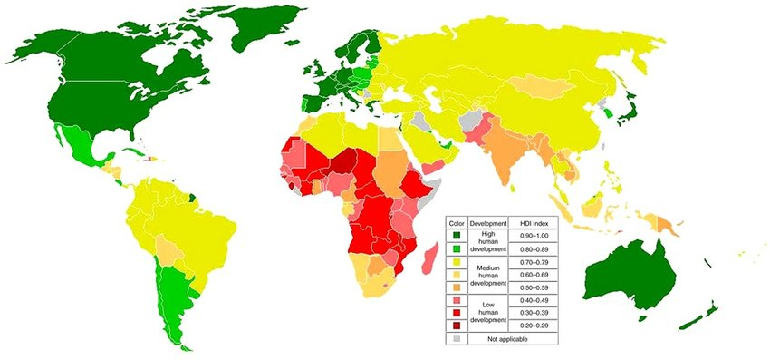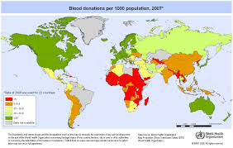
Figure 3.1. Global distribution of development index and blood donation. Left: Countries with high HDI, including TTO are shown in green: Available from https://www.researchgate.net/ profile/ Maria_Gonzalez _Bedat/ publication/322733721/figure/download/fig1/AS:624238117523458@1525841373618/The-World-Map-of-Human-Development-Index-7.png Accessed 12th April, 2019. Right: Countries high annual blood donation rate (> 30 per 1,000 population) are shown in green. TTO has a low donation rate of 17 per 1,000) and is yellow. Available from: www.who.int. Accessed 12th April 2019.

Considering these long-recognized social benefits of voluntary non-remunertaed blood donation and its association with social capital, field data was gathered to investigate and explain the relationship between social capital and blood donation in TTO. The main source of information in this regard was surveys to assess attitudes and blood donation behaviour in different sociodemographic groups. In addition, TTO’s performance indicators were examined in relation to Pan American Health Organization/World Health Organization recommendations for percentage VNRD.
    - Psychological background
The Theory of Planned Behaviour (TPB) is a decision-making model that explains behaviour that is not under the individual’s complete volitional control such as donating blood. It is premised on intention as the proximal determinant of behaviour which is influenced by attitude (positive or negative evaluation of performing the behaviour), subjective norm (perception of social pressure to perform the behaviour) and perceived behavioural control (perception of control over performing the behaviour). [114. Figure 3.2].

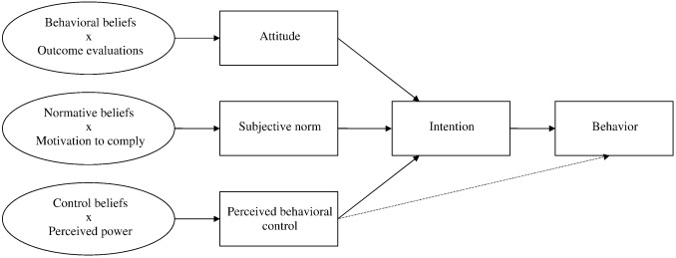

Figure 3.2. Theory of planned behaviour. Attitude, intention and behavioural control determine planned behaviour. Accessed from: Ajzen I: The theory of planned behaviour. Organ Behav Hum 1991; 50:179–211
The TPB has been applied to predict donation behaviour as well as inform recruitment and retention strategies in HDI countries with established voluntary non-remunerated blood donation. [115, 116] Failure to convert positive attitudes to actual blood donation is observed in many developing countries with FRD – based blood donation systems. [15] This research also examined applicability of the TPB to blood donation behaviour in TTO to explain the acceptance and persistence of family replacement blood donation despite overwhelming evidence against it. In addition, psychological research has described the phenomenon of cognitive dissonance in situations where behaviour is inconsistent with known principles and beliefs. Evidence that discloses the disparity provokes dissonance-reduction behaviour such as seeking alternative information to justify the behaviour or discrediting the evidence. [117]
    - Administrative and technical background – path dependency
Administrative, organizational and technical development in blood transfusion services in Great Britain and TTO, have proceeded along non- parallel policy paths. In contrast, the blood service in Curacao, a former Dutch colony in the same PAHO region, has developed in parallel with that of the Netherlands, following Percy Lane Oliver’s principle of voluntary non-remunerated blood donation. The role of organizations and institutions that have interacted historically and currently to determine the path taken in administration and operation of TTO’s blood transfusion service were critically examined. Decision-makers included the British Colonial Government before and during the world wars, The British Army Transfusion Service, the Medical Department of the United States Army, The British, American and TTO Red Cross Societies during the world wars and the Pan American Health Organization/World Health Organization, the Ministry of Health of TTO, the Friends of the Blood Bank Association, The National Blood Transfusion Service of TTO, Regional Health Authorities, local institutions and the general public after independence. This research examines the interaction among these organizations to establish structures and institutions that determined the path of blood service development. It then describes the emergence of a conjuncture to cut a new path and trajectory.

  - Research methods
This research first examined the origins, historical interrelationships and current composition of the TTO population to help place its blood donation behaviour in context. In TTO, as in most of the Caribbean, much knowledge is derived from accumulated experiences and passed down from generation to generation as ‘knowledge by tradition’. Individuals and institutions that are seen as reliable, trustworthy and authoritative constitute another important source of knowledge (‘knowledge by authority’). [118] Discourse (spoken interaction and written texts) and narrative (stories people tell about personal experiences) were examined to indicate persons’ general knowledge, understanding and beliefs about blood donation and transfusion. Theoretical sampling, the process of jointly collecting and analysing data to decide what data to collect next, was used to develop theory as it emerged. [119, 120, 121]
    - Methodology for historical analysis
Historical data was collected from primary sources (original documents as well as oral testimony from actual participants or witnesses to events). Where primary sources were unavailable, reliance was placed on secondary sources of information, transmitted by those who were neither participants nor eye witnesses to the original events. The main sources of information were:
- Internet searches using search terms such as ‘blood donation’, ‘blood transfusion’, ‘world war’, ‘developing countries’, ‘Trinidad and Tobago’, ‘history’ and ‘Caribbean’
- Library searches – hand searches of books, journals, official documents
- Interviews

Historical data was collected at the following sites:

- The Royal Air Force Association, Queen’s Park East, Port of Spain, Trinidad
- The Chaguaramus Military and Aerospace Museum, Trinidad
- The British Museum
- The National Library, Trinidad and Tobago
- The National Archives, Trinidad and Tobago
- The British National Library
- The Medical Library, Port of Spain general Hospital, Trinidad
- The Medical Library, Central Sheffield University Hospital Trust
- Library, London School of Tropical Medicine and Hygiene
- PAHO Library, St. Clair, Trinidad and Tobago

These sources and sites provided qualitative and quantitative data spanning an extensive period that began in the 19th century. The advantages of this approach were accessibility, ease, economy and speed. A large volume of information was quickly and readily available with relatively little effort and at minimal cost. Its disadvantage was that there was no way to confirm the accuracy of all documents or identify ones that were deliberately misleading. Historical accounts were a snapshot of a time and may not have described evolving situations. However, primary or multiply cited sources were used preferentially to maximize validity and reliability of information.
Interviews were used to capture initial qualitative data and to substantiate information obtained from other sources. Each of these was very open-ended, taking the form of a discussion and conducted within the interviewee’s place of comfort eg. home or workplace. Interviews were exploratory and short notes were taken during and after them. Where necessary, subsequent interviews were done to confirm information. A major disadvantage was the diminishing number of persons with reliable first-hand information which sometimes necessitated the use of secondary sources.
3.3.2. Methodology for Action Research
After historical analysis of the situation, AR was performed in three action cycles of looking, thinking and acting, using the basic AR routine described by Stringer. [100, Figure 3.3]:
Look. Gather data. Describe the situation.
Think. Explore and analyze. Interpret and explain (theorize)
Act. Plan, implement, evaluate
.
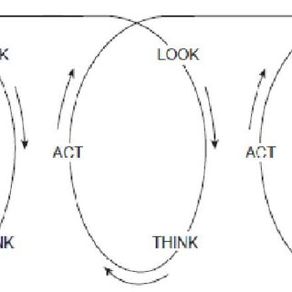
Figure 3.3. Basic Action Research Routine. Stringer, 2014

The look, think and act routine was a continually recycling and interrelated set of activities with temporal overlap. As participants completed activities, they reanalysed and modified actions appropriately, often within the same action cycle.
3.3.2.1 Action Inquiry Cycle I (2005-2010)
This phase of AR began with a MOH decision to reorganize the TTO NBTS to meet the transfusion requirements of its new organ transplant programme. The researcher was Director of the NBTS who acted as facilitator and participants included staff employed at the Headquarters of the NBTS, medical students and blood donors. The outcomes were increased efficiency, development of national transfusion policy and a switch to 100% voluntary non-remunerated blood donation.
      - Action Inquiry Cycle II (2011 – 2019)
This phase of AR began after the switch to VNRD was reversed. It centred around the development of a culture of voluntary non-remunerated blood among students of the FMS and their social contacts. It involved curriculum change, sensitization, outreach and collaboration. The main outcome was the establishment of the University of the West Indies Blood Donor Foundation (UWIBDF) and the first voluntary non-remunerated blood donation programme in the country.

      - Action Inquiry Cycle III (2019 – 2020)
This cycle compared the effect of the COVID-19 pandemic on UWIBDF voluntary non-remunerated, FRD and remunerated blood donations. It also measured the impact of sharing COVID-19 specific information on VNRD donations. The major outcomes were continuation of the UWIBDF programme, its acceptance as the model for achieving exclusive VNRD nationally and appointment of UWIBDF’s Chairman, the researcher, as NBTS Director to implement the change to exclusive VNRD in TTO.
  - Summary and conclusion
Action Research was undertaken as a historical review of the blood service and the people it serves followed by three action inquiry cycles of looking, thinking and acting.

CHAPTER 4. RESULTS I: HISTORICAL CONTEXT
4.1. Introduction. This chapter describes the history of the multi-ethnic, multi-racial, multi-religious population of TTO and major occurrences that shaped its society. The development of blood transfusion services is described in parallel. This helps to contextualize the composition of its blood donor pool, the social interactions related to blood transfusions and the location of blood donation centres. Today, the population of TTO is composed of mainly the descendants of African slaves and Indian indentured labourers. The descendants of European immigrants constitute a powerful minority. Entrepreneurial descendants of immigrants from China and Portugal have settled into business activities of various types.
4.2. A short history of TTO
4.2.1. The origins of the people
The island of Trinidad was claimed for the Spanish Crown by the Italian seaman, Christopher Columbus in 1498. The nearby island of Tobago was also sighted by Columbus in 1498 but had no permanent European occupation until the 18th century. After Columbus’s arrival in Trinidad, the indigenous Arawak and Carib Amerindian population was used as to provide labour before its decline from exposure to European diseases and the rigours of enslavement. Whereas the more peaceful and docile Arawak population succumbed completely, descendants of the more defiant and resilient Caribs survived longer and were concentrated mostly in Arima in North Central Trinidad. Following decline of the native Amerindian population, indentured servants from Europe were imported as a replacement labour force but were unable to cope with the tropical conditions. Between the 16th and 19th centuries, slaves from Africa were brought to the island by the Atlantic slave trade. Spanish management of the colony’s security was poor and there were frequent incursions by English, Dutch, French, Portuguese and other European pirates and merchants. Sugar cane was introduced by the Dutch to Tobago in the 17th century and a century later to Trinidad.
The capital of Trinidad was St. Joseph in the 17th century but was moved to Port of Spain in 1784 by the Spanish governor, Chacon. The Cedula of Population was declared by the King of Spain in 1783 to allow persons, as long as they were Catholic, to settle in Trinidad to assist with administration of the colony. The outbreak of the French Revolution in 1789 sent thousands of French planters and slaves from Martinique, Guadeloupe and Santo Domingo fleeing to Trinidad in this period. When Sir Frank Abercromby, Commander of the British forces in the West Indies, captured the island in 1797, it was predominantly French and Catholic. The Anglican Church and English laws were introduced but, by agreement, Catholicism was retained as the main religion. [122, p 1-10] The slave trade was abolished in 1807 and African slaves were emancipated in 1834. [123] Many of the 24,000 Trinidad slaves who were emancipated settled in Port of Spain and its environs subject to European laws and religious customs.
The labour shortage that followed emancipation precipitated a second experiment with indentured servants from Europe. Those from Madeira, Portugal eventually turned to retail trading in preference to agricultural labour. [124] Beginning in 1806, with African slavery in its decline, indentured labourers were recruited from China and this was followed by a period of controlled Chinese immigration until 1866. Chinese immigrants quickly gravitated from agriculture into small merchant activity. [125] Building on a successful trial in Mauritius, indentured labourers were imported in large numbers through the ports of Madras and Calcutta in India to service the sugar plantations between 1845 and 1917. Most (75%) of the Indian indentured labourers were Hindu and the remainder Muslim. However, many were later recruited into Scottish and Canadian Presbyterianism as a route to education. [126] During the expansion of the Turkish Ottoman empire in the late 19th and early 20th century, displaced Syrian and Lebanese Christians landed in Trinidad and became involved in small merchant activity. [127] The nearby island of Tobago changed hands among the Dutch, French and British for centuries. The two islands were amalgamated as a single British colony in 1889.
4.2.2. History of the oil industry
Oil was discovered in La Brea, South Trinidad in 1857. After 1904, the British began developing the oil industry because of plans to convert their navy from coal to oil-powered ships. An oil refinery was built in Pointe a Pierre, South Trinidad in 1914 and the oil industry was well established by the end of the First World War. Trinidad’s oil was vital to the British War effort in World War II, accounting for 44.2% of British Empire production. To meet the growing demand for aviation fuel, the world’s first iso-octane fuel plant was built at Pointe a Pierre in 1938 to supply the Royal Air Force. [126, p 199-205] As it developed after the war, the oil industry attracted administrative and technical staff from British and American multinational companies and used locals for skilled and semi-skilled labour. In addition to abundant on-shore oil and gas reserves in South and Central Trinidad, large off-shore reserves were discovered off the east coast, attracting large multinational corporations and their workers from the 1960s.
4.2.3. Main towns and villages
Apart from St. Joseph and Port of Spain as administrative and economic capitals, other centres of metropolitan interest emerged. San Fernando in south western Trinidad was first settled by Amerindians and named San Fernando de Naparima by the Spanish governor in 1784. As a result of the Cedula of population, many sugar plantations were established in the surrounding fields. Large sugar factories, including Usine St. Madeline, and nearby oilfields ensured that San Fernando emerged as the industrial capital. In 1898, Sangre Grande in north east Trinidad became the most easterly inland settlement to be reached by the railway network from Port of Spain and, therefore, the pathway to the eastern seaboard. Its population grew during World War II after the Americans built a military base 12 km away in Cumuto. Point Fortin is a borough in the oil producing area that lies 32 km south west of San Fernando. [128] The location of TTO’s blood donation centres therefore coincided with foci of administrative, economic and oil-related activity.
4.3. TTO in World War I
When World War 1 broke out on August 4th 1914, locals were intensely patriotic to Great Britain. They rallied to raise funds, provide the raw materials and establish a local Red Cross office to aid the mother country’s war effort. There were public declarations and demonstrations proclaiming loyalty to the British Empire. [129, p147] It was an opportunity to prove that British subjects in the colony were as important as the British citizens. Locals demanded the right to fight, bleed and die for the mother country in the same way that soldiers in Britain were. After initial and prolonged hesitation by the British War Office and Colonial Office for fear that training in weapons and killing Europeans could inspire future rebellion in the colonies, King George V himself intervened and sanctioned the formation of a British West Indian Regiment (BWIR) from contingents of the inhabitants of the West India islands. TTO was finally allowed to send troops to England as part of the BWIR which also included troops from Jamaica, Barbados, Bahamas, British Honduras, Grenada, British Guiana, Leeward Islands, St. Lucia and St. Vincent. Contingents from TTO were divided into two categories - ‘Public’, derived from descendants of the labouring classes and ‘Merchants and Planters’ from European descendants. (Figure 4.1)

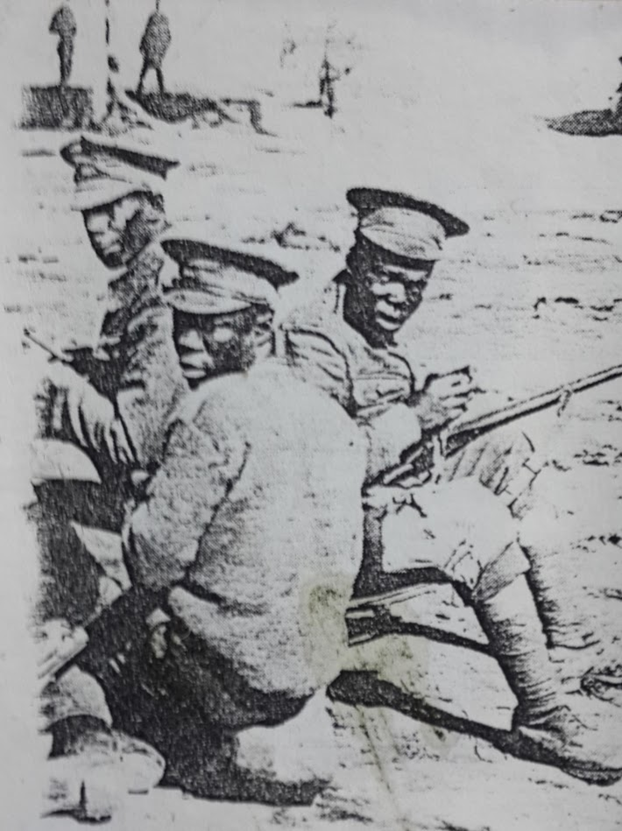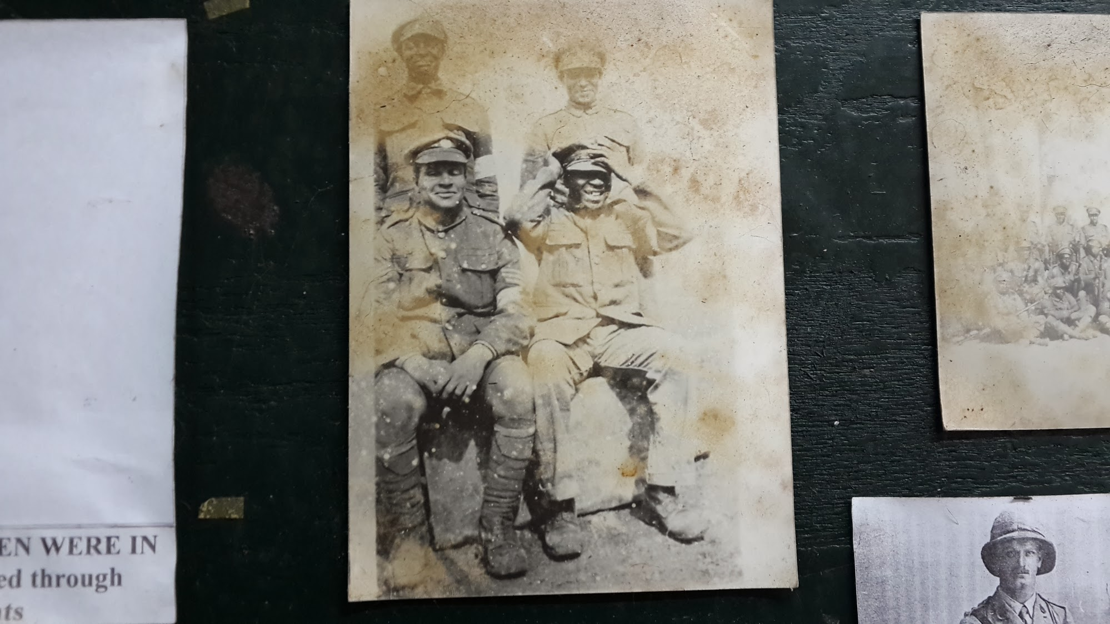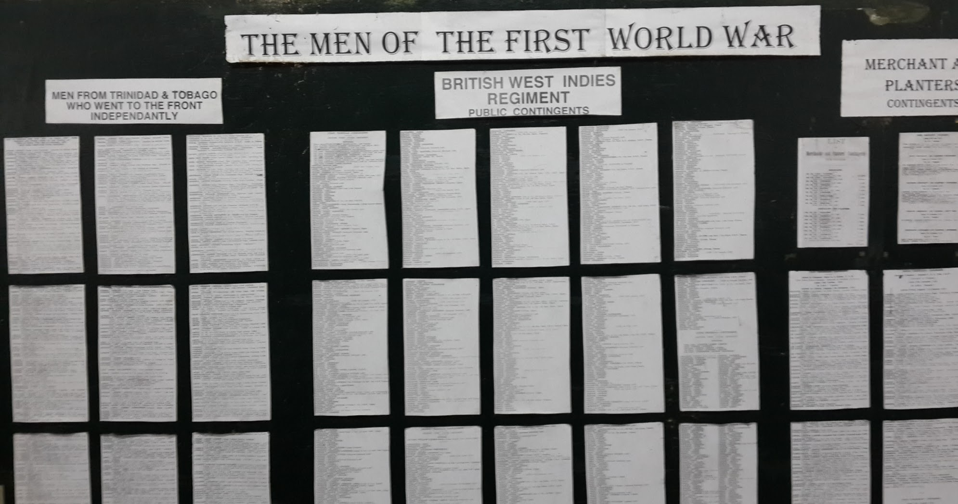
Figure 4.1. TTO soldiers of the British West Indian Regiment, World War 1. Images courtesy the Chaguaramus Military Museum

Military selection criteria for the BWIR were rigid and rejections for venereal diseases like syphilis were high, accounting for 11.6% in Jamaica. [130, p 59-71] Forty- one Indians from Trinidad were repatriated because of their unfamiliarity with the English language and demanding dietary requirements. These War Office restrictions effectively ended recruitment among the large Indian populations in Trinidad and British Guiana. [130, p 91]
The third contingent that left Jamaica in March 1916 was diverted north to Halifax to cross the North Atlantic in an unheated ship. More than 600 men suffered frostbite of whom five died and more than 100 had amputations. The victims of this “Halifax incident” were returned to Jamaica as invalids three months later only to discover that their pensions had been delayed. The event was widely covered in the local press causing a public uproar and a suspension of recruitment. [131, p 87-100]
On arrival in England, BWIR soldiers attended training camp in Manchester. There was a heightened suspicion among British officials that venereal diseases were particularly common among them due to their interaction with local prostitutes. [130, p 140-154] BWIR members were transferred to the Western Front in France but predominantly to the Gallipoli front in Egypt, Mesopotamia, Palestine and East Africa where blood transfusion was less practised. They were used as labourer units on the Western Front. Most TTO soldiers were transferred to the Gallipoli Front to protect British interests in Egypt and help defend the Suez Canal. Here they saw little action but provided mostly labourer and garrison duties. West Indian doctors offering their services to the Royal Army Medical Corps (RAMC) were rejected since such placement required commissions that were granted to only persons of pure European descent. [130, p 52] In all TTO provided 1,478 troops of whom 184 died. [131] Fifty TTO men served in the Gallipoli invasion and 500 at the Battle of the Somme, of whom 20 died and at least a third wounded. [132] Their return home after the war was delayed until 1919. Returning soldiers had bad memories and bitter feelings about the treatment meted out to them as British subjects. These sentiments led many to become involved in local anti-British and labour union activities. There is no available record of TTO soldiers or doctors serving in the British West Indian Regiment in World War 1 participating in blood transfusion or bringing transfusion technology back to civilians on the island. This would have been determined by their role on the Western Front, use of saline on the Gallipoli Front and non-recognition of their doctors.
4.4. The Moyne Commission Report
Social deterioration and unrest followed World War 1 in TTO and the other British West Indian islands. In response to a series of disturbances between 1936 and 1938, King George VI appointed a Commission to investigate and make recommendations on the social and economic conditions in the British West Indian colonies of Barbados, British Guiana, British Honduras, Jamaica, the Leeward Islands and TTO. The Commission was chaired by Lord Moyne (Figure 4.2), Secretary of State for the Colonies and submitted its report at the end of 1939. [133]

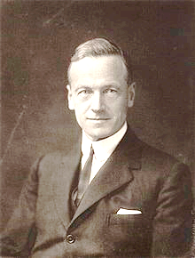
Figure 4.2. Lord Moyne. Chaired the Moyne Commission to investigate social conditions in the British West Indian colonies 1938 – 1939. [Internet image]. Available from: https://upload .wikimedia.org/wikipedia /commons/thumb/2/2f/Lordmoyne.jpg/220px-Lordmoyne.jpg Accessed 9th September 2018.
The commissioners arrived in the West Indies in Jamaica in November 1938 and began the work of taking evidence from witnesses and groups of witnesses in the British West Indian colonies. Formal evidence was heard from 370 witnesses or groups and 769 memoranda of evidence were considered. At the outbreak of World War II, most of the report was already in draft. The commission decided to complete the report on the basis of evidence already in its possession by the summer of 1939 without considering the influence of World War II on the West Indies.
At the time of the report, the majority of the West Indian population comprised emancipated African slaves. The freed slaves had, for the most part, abandoned the sugar plantations and those who were able, bought land to establish small estates that practised other forms of agriculture. Those who could not afford land returned to the plantations to continue providing ‘for wages’ labour as free men on larger estates owned by London companies or smaller estates owned by locally resident planters. The decline in the price of cane sugar occasioned by the rise of beet sugar production in Europe and the importation of indentured labour from India into British Guiana, Jamaica and Trinidad limited the wages they could negotiate.
Trinidad, with its oil and asphalt industries, was the most prosperous of the British West Indian islands and most favourably poised for development. Its population was 448,000 and its health system was relatively well-developed. However, despite its prosperity and advanced surgical services, the Commission reported inadequacies in antenatal care, laboratory services and rural health care. Both maternal and infant mortality rates were high and facilities for surveillance and monitoring of infectious disease like malaria, tuberculosis and venereal diseases were lacking. Socially, there was jealousy and resentment towards the groups, mostly Chinese and Syrians, who had gravitated to retail trading. The island was a crown colony with a royally selected governor representing the king, an executive council nominated by the governor and an elected legislative council. Most senior administrative positions including senior medical positions were held by British citizens. Some locals had obtained medical qualifications in England or Canada but there was a lack of facilities for undergraduate and postgraduate medical training in the West Indies. Access to health services was unequal, favouring the urban population, and regulation of private medical practitioners and hospitals was lacking.

Among the commissioners’ recommendations were greater emphasis on preventative health care, building of hospitals and organization of health care services with emphasis on preventative disease. The Commission recommended the establishment of a regional university with a faculty of medicine. It made no observations or recommendations regarding the establishment of blood transfusion services.
Although it did not consider the impact of World War II, the recommendations of the Moyne Commission Report laid the foundation for the development of social infrastructure in the post- World War II Caribbean. One product of them was The University of the West Indies with its first medical faculty in Jamaica in 1948 followed by medical faculties in St. Augustine, Trinidad, Cave Hill, Barbados and Nassau, Bahamas. Sadly, Lord Moyne was assassinated by Jewish terrorists in Egypt in 1944 where he was serving as Minister of State for the Middle East. He suffered multiple gunshot wounds and died at the British military hospital in Cairo after receiving several blood transfusions.
4.5. TTO’s vulnerability to air raids during World War II
In the battle of the Atlantic, German U-Boats (submarines) sank American and Canadian merchant ships taking supplies to Britain and her allies in Europe. Over 400 vessels were sunk in 1942. When successful anti-U Boat measures were introduced in the North Atlantic, the U-Boats migrated south to the Caribbean zone of conflict to cut off supplies of food and raw materials from British colonies to America and Europe. [131, p 159-206]
Despite the experiences of World War I, patriotic fervour for Great Britain was unabated in TTO during World War II. [134, p 1-7] Locals formed voluntary army and navy defence forces. Pilots and sailors were trained locally and recruited in the Royal Air Forces (RAF) of Britain and Canada. Local volunteer groups trained children (boy scouts and girl guides) and their teachers to assist in the war effort. Women assembled in a Women’s Voluntary Force to raise funds, train other volunteers and provide membership for the Auxiliary Territorial Service (ATS) in Britain and America. The Trinidad and Tobago Red Cross Society (TTRCS) was established as branch of the British Red Cross in 1939. [135, p 363]

There was an early build-up of British and Canadian forces on the island and American troops began arriving there in 1941. Under a lend-lease arrangement, America supplied 50 battleships to Britain in exchange for military bases in British West Indian colonies to defend against attacks on America through the Gulf of Mexico and to protect the Panama Canal. [136] These included two large American military base hospitals in Trinidad - a 500 bed station at Cumuto (Wallerfield) and a 200 bed station at Chaguaramas. (Figure 4.3).

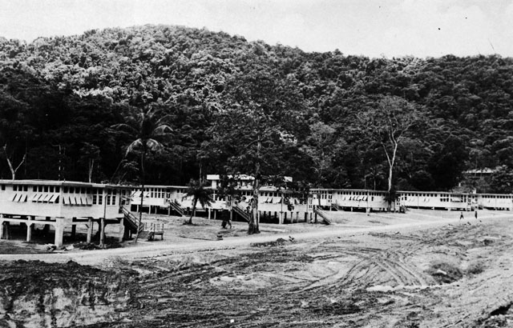
Figure 4.3. Chaguaramus military base hospital, 1943. The base housed 20,000 American troops and was the largest base outside America. [Internet image] Available from:http://www.caribbeanmemoryproject. com/ uploads /3/9/6/8/39688192/693185479_orig.jpg. Accessed 8th September 2018.

TTO became a likely target for a German air raids for several reasons:
1. The oil refinery at Pointe a Pierre supplied 65% of the oil consumed by Britain and her allies.
2. The sheltered Gulf of Paria, the world’s largest natural harbour, served as the convoy assembly
point for the North Atlantic fleet which took food and raw materials to allies in Europe and
North America. This included oil from Trinidad and bauxite from British Guiana for ship and
plane building factories on America’s east coast.
3. Wallerfield air base in Cumuto, East Trinidad had become the busiest airstrip in the world
serving not only as a refueling point but also a base for airplanes engaged in war against German
U-boats.
4. At the height of the war, there were 225 American bases and defended localities with over
130,000 American, British and Canadian troops on the island intermingled with the local
population.

5. Trinidad was the centre of the “Secret War” against the Vichy French in Martinique and
German – loyal South America.
6. The island was providing fighters for the allies with over 5,000 Trinidadians serving in the
armies and navies of Britain, America and Canada.
7. TTO’s forests were used for jungle warfare training schools to prepare allied soldiers for action
in the Pacific theatre.

In 1942, over 200 ships were sunk by German U-Boat attacks in the waters outside Trinidad. Over 7,000 merchantmen of all nationalities were killed and 9,000 were washed ashore or rescued then brought to Trinidad for treatment. [137] However, an air raid remained the most feared form of attack.

The French government, facing imminent German invasion, sent all its gold reserves to Martinique on the cruiser Emile Burtin protected by the airline carrier Bearn, the heavy destroyer Le Terrible, the armed auxiliary vessel Barfleur and several other ships carrying 2,000 French troops. When France fell and the German-affiliated Vichy government was installed, there was fear of this gold and military equipment falling into German hands and being used for an air raid on Trinidad from Martinique. [135, p 154] In preparation, British authorities effected the same precautions, bar transfusion arrangements, used to prepare London for air raids - frequent blackouts and air raid drills using air raid sirens. Basic equipment for use in an air attack – buckets of sand to fill swimming pools, shovels, pumps, stretchers and medical supplies were kept at hand. However, there was intense secrecy and censorship to prevent information getting to Germans on the island. A Civilian Defence Department of 20,000 persons was given the responsibility of keeping the population unaware of the war activity around them. [138] Secrecy surrounded activities at military base hospitals. At the end of the war in 1945, all documents related to the war – war diaries, sector reports, intelligence summaries and history files - were stamped secret. There is, therefore, no available record of transfusion at these military base hospitals. [137]

The military base hospitals, temporary wooden structures, were torn down when the American soldiers left in 1967. The entire base at Chaguaramus had hosted 20,000 American troops, making it the largest military base outside of American soil and the largest of 225 scattered around the island. In total, the Americans stationed 130,000 men in TTO during World War II and after the war up to 1967 when it was decommissioned. Upon their departure in 1967, the Americans handed the entire base, including the 200-bed hospital, to the independent government of TTO. The former base remained inactive until 1971 when it was modified by the government of TTO in preparation for a new function as a hotel school. In 1972, it was re-opened as the Chaguaramus Hotel School and operated as a joint venture with the Canadian government. [139]

4.6. Blood transfusion arrangements in TTO during World War II
Despite the recognized threat of German air raids, only rudimentary blood transfusion services existed at TTO’s Colonial Hospital in Port of Spain between 1939 and 1945. The hospital prepared itself for war work and emergencies in other ways. A 150 – bed temporary military hospital was hastily set up on the compound in anticipation of casualties from an air raid. The hospital had its air-raid wardens, black-out exercises and staff were trained to rapidly empty occupied wards in case of emergency. Its facilities were placed at the disposal of the Royal Navy, the Royal Air Force and survivors from torpedoed merchant ships on their way to the island. Although movement from saline to blood transfusions occurred in this period, there was no blood donor pool and no blood bank. [140] This contrasted with Curacao where a Red Cross Blood Bank following Oliver’s principle were founded by Dutch nuns in 1938 (personal communication, Professor A. Duits). As part of its war effort, the TTO Red Cross Society invited its volunteers to act as blood donors for the Colonial Hospital Blood Transfusion Service if needed. Eleven replied and two were called upon. It later organized a Blood Donor Service with which only 64 donors had registered at the end of 1944. [141]
There is no available record of transfusions at the Chaguaramus military base hospital but blood transfusions using military personnel as donors were routinely performed at American military base hospitals in other theatres of the war. [74] In 1941, the American War Department, having initially disallowed blood collection from blacks, issued a policy of segregating blood by race with which the American Red Cross complied. [142] In 1944, British authorities in TTO asked the American military to manage a campaign to prevent transmission of venereal diseases from locals to military personnel on the island. Posters, flyers and lectures - techniques used to recruit blood donors in Britain, Canada and America - were successfully used to mobilize the local population to access venereal disease testing and treatment. [143, Figure 4.4.]

Figure 4.4. Posters and flyers used to successfully mobilize locals in a campaign to combat the spread of venereal diseases in 1944.

4.7. Blood transfusion services in TTO following World War II
4.7.1. Red Cross mobile collections
In 1951, just six years after the end of the World War II, only 50 – 60 units of blood were transfused in TTO. [144] The TTRCS undertook mobile community voluntary blood collections issuing a donor card that identified only the donor and date of donation. (Figure 4.5)

Figure 4.5. Red Cross Blood Donor Card from 1959.

These were supplemented by donations from patients’ family and friends in the Pathology Departments of General Hospitals. (Figure 4.6.)

Figure 4.6. Blood collection from a relative at Port of Spain General Hospital in the 1960s. Photograph courtesy Nurse Barbara Holder.

The number of units cross matched increased slowly to 1500 in 1962. The small donor base in Port of Spain consisted of mainly expatriates but included locals from groups like the Army, Coast Guard and police and opportunistically recruited individuals. Donor recruitment was much better in San Fernando where there was a large population of foreigners involved in the oil industry and a very active Red Cross group.
4.7.2. Local big business gets involved – blood for family
In 1966, the MOH supported the launch of a National Blood Transfusion Committee which included the Red Cross, St. John’s Ambulance, Village Councils as well as pathologists, surgeons and physicians from general hospitals. Private sector involvement was led by a prominent citizen of blood type O negative who was concerned about his own vulnerability should the need for blood arise. The group visited banks in Port of Spain, the university campus, companies and large industrial complexes. Among committee members, there was significant overlap between membership in voluntary relief organizations such as the Red Cross and charitable fund-raising organizations that interacted with large business organizations. This created a link between blood donor efforts and ‘big business on the spot’. [144] Blood donation became synonymous with wealth and social status. In 1969/70 the group evolved into the Friends of the Blood Bank Association (FBBA). The introduction of banking methods to increase blood collection was proposed in 1978. Assurance of blood for all members of any family from which two members gave two donations annually, similar to the American ‘family credit system’, was introduced by the FBBA.
4.7.3. WHO and FDA recommendations
The local family credit system was introduced after the World Health Assembly had resolved that blood should be collected from voluntary non-remunerated donors in 1975 [5] and the United States Food and Drug Administration (FDA) published a final rule requiring that all blood and blood components intended for transfusion be labelled ‘volunteer’ or ‘paid’. [6] Paid donors included those who received cash or any incentive that was readily converted to cash. The FDA ruling had the effect of ending paid blood donation for transfusion in the United States of America. The FBBA continued to raise funds from sponsors and patrons. It advocated for the establishment of a NBTS within easy access of donors in Port of Spain and San Fernando starting with one in Port of Spain under the dual management of the FBBA and the MOH. [144]
4.7.4. PAHO recommends National Blood Transfusion Service
In 1980, a PAHO Consultant, Dr. J. Brian Mc Sheffery, produced a report on blood banking facilities in TTO. [145] He proposed a NBTS and measures for proceeding to that goal. At that time, institutional care was provided by MOH at two major public hospitals in Port of Spain (POSGH) and San Fernando (SFGH) and smaller district and county hospitals. All of these hospitals collected blood for institutional use to meet the individual requirements of patients who co-opted friends and family as donors. In Port of Spain, the FBBA arranged for non-family donor recruitment with a mobile collecting unit that it had received as a private donation, delivering a service that was originally provided by the TTRCS. The report alluded to private institutions, hospitals and laboratories at which unreported blood collection occurred outside the auspices of the MOH. The total number of blood units collected nationally was unknown but statistics were available for blood collected on the mobile unit, at POSGH and at the SFGH and requests for blood in 1978 and 1979 are shown in Table 4.1.
Table 4.1. From [145] Blood collection and requests in 1978 and 1979. N/A = not available
Institution | Year | Blood donor room collections | Mobile unit  collections | Requests
POSGH  SFGH | 1978  1979  1978  1979 | 4552  4821  2515  2676 | 757  600  -  - | N/A  N/A  7134  7867

No record of blood distribution was kept. POSGH made a limited amount of fresh frozen plasma, cryoprecipitate and platelet concentrate on an ad-hoc basis. A refrigerated centrifuge and adequate deep freeze were available at that site.
The report recommended establishment of a task force to plan policy for a centralized transfusion service and national standards for donor selection, donation, processing, storage, cross-matching and administration of blood. This task force would include representatives from the FBBA, the southern area of the country, the eastern area of the country, Tobago, the Trinidad and Tobago Red Cross Society and other agencies as required. Smaller hospitals would continue to collect their own blood from family members for emergencies. When mobile clinics were held, blood would be first distributed to the area in which it was collected and the excess taken to the central bank at POSGH. [145]
4.7.5. Establishment of the NBTS
In 1986, a time of severe economic hardship for TTO, the NBTS was established. The casualty department of the Colonial Hospital, now the POSGH, was refurbished using funds raised by the FBBA who donated it to the government of TTO to become the headquarters of the NBTS, the office of its Director, central laboratories (CL), a blood donation centre and the headquarters of the FBBA. The Director of the NBTS would establish and monitor standards for blood donation and transfusion services nationally. Satellite centres were retained at public hospitals in San Fernando, Sangre Grande, Scarborough, Point Fortin and established at the new EWMSC in St. Joseph (Figure 4.5). Economic realities dictated that the collection centres remained physically and administratively linked to the public hospitals. The Medical Director, immunologist, laboratory/technical personnel along with administrative and secretarial staff for the NBTS were redeployed from the POSGH. Accounting and communication systems for the NBTS were provided by that institution. The FBBA would be paid an annual government subvention and retain responsibility for donor recruitment, fund-raising and mobile collections.

Figure 4.7. Red dots show the location of donation centres. Port of Spain (Port of Spain General Hospital Central Laboratories, CL), St. Joseph (Eric Williams Medical Sciences Complex, EWMSC), Sangre Grande (County Hospital, SGCH), San Fernando (General Hospital, SFGH), Point Fortin (Area Hospital, AHPF) and Scarborough, Tobago (Regional Hospital, SRH).

4.7.6. Introduction of the ‘chit’ and ‘credit’ systems
By this time, the vast majority of donations to the service came from patients’ family and friends at public and private hospitals. Medical or nursing staff would instruct patients or their contacts to donate units of blood equivalent to that needed to cover a procedure. A ‘chit’ system was introduced in the 1980s whereby the donor would receive a ‘chit’ as proof of donation which bore the patient’s name and location. The chit would then be attached to the blood request form to obtain a unit of blood component from the hospital’s blood stock. The ‘chit’ had to be exchanged within six months of the donation and could not be transferred to any other patient. This meant that if a procedure was delayed beyond six months, the patient had to repeat the process of finding donors. Alternatively, donations made to the FBBA’s mobile unit were considered voluntary because they were not assigned to any specific recipient at the time of donation. However, the donor held an account to which a credit was added for each donation. Unlike a ‘chit’, a credit had no expiry time and could be exchanged for a ‘chit’ for a recipient of the donor’s choice. Credits and debits were recorded and the voluntary donor received interest of one unit for every five credits. (Figure 4.8.)

Figure 4.8. The donor chit and credit card. The donor chit for replacement donors is shown on the left and the pink credit card for voluntary donors on the right.

Contrary to McSheffery’s recommendation, all blood collected on the MU was returned to CL for distribution. FBBA voluntary donors could also donate at CL for ‘credits’ The receptionist at the NBTS Headquarters was provided by the FBBA and registered all donors attending the centre as ‘elective’ (for chits) or ‘voluntary’ (for credits). The FBBA’s receptionist and other on-site staff in the building also conducted ‘transactions’ whereby ‘credits’ were converted to ‘chits’ to secure blood components from the CL for patients specified by the donor. Similarly-modelled voluntary programmes were subsequently adopted at other blood donation centres independently of the FBBA. However, problems arose with converting credits acquired at other centres into chits at CL. There was always a mismatch between chits or credits and available components because of the short life-span of components relative to that of chits (six months) or credits (indefinite). In emergencies, blood components, if available, would be provided from available stock and replacement donations made afterwards. In 1993, a cardiac surgery programme was initiated at the EWMSC which used surgeons from the United Kingdom with local assistants to perform operations and the existing chit and credit system for its blood supply. [146].
4.7.7. Health Sector Reform and Regional Health Authorities
In 1994, Health Sector Reform was undertaken to fulfil the conditions for a government loan from the Inter-American Development Bank. Regional Health Authorities (RHAs) were established in TTO. The MOH placed service delivery including day to day management of health institutions in the hands of five RHAs (Table 4.2) while retaining responsibility for policy, financing, monitoring and evaluation. This meant that blood collection facilities and staff were now managed by five different employers. As the provider of a national service, the NBTS was retained as a vertical organization in the MOH. Its Director and all staff who had been transferred to the NBTS headquarters before 1994 remained employees of the MOH.

Table 4.2. Blood donation centres and Regional Health Authorities
Facility | Management
Central Laboratories, NBTS headquarters | MOH
Port of Spain General Hospital (POSGH) blood transfusion laboratory | North West Regional Health Authority (NWRHA)
Eric Williams Medical Sciences Complex (EWMSC) | North Central Regional Health Authority (NCRHA)
Sangre Grande County Hospital (SGCH) | Eastern Regional Health Authority (ERHA)
San Fernando General Hospital (SFGH), Area Hospital Point Fortin (AHPF) | South West Regional Health Authority (SWRHA)
Scarborough Regional Hospital (SRH) | Tobago Regional Health Authority (TRHA)

The arrangement between the NWRHA and MOH regarding the NBTS was particularly hazy. The NBTS building lay on the property of the NWRHA and operated from 8:00 am to 4:00 pm. Thereafter, requests for components from CL were channelled through the POSGH blood bank laboratory.
All initial screening for transfusion transmissible infections (TTIs) and separation into red cell concentrate, plasma, cryoprecipitate and platelets was performed at CL. Other hospitals produced partially-packed red cells. Syphilis and Hepatitis B virus (HBV) screening were supplemented by screening for HIV in 1981, Hepatitis C virus (HCV) in 1991, Human T Lymphotropic Virus I & II (HTLV I/II) in 1993 and Chagas’ Disease in 1995. Processing of blood components began on a small scale at EWMSC in 1995 to facilitate the cardiac surgery programme.
4.7.8. Industrial dispute
In 1995, a dispute over wage differences between RHA and MOH employees at the NBTS resulted in work stoppage and cessation of blood screening and processing. The MOH removed screening and processing equipment from CL to EWMSC. Even after the dispute was resolved and some of the equipment returned to CL, EWMSC continued to function as a second TTI screening site.

4.7.9. KPMG report
Operations of the NBTS were reviewed by a team of KPMG consultants co-opted by the MOH to review public health care delivery in 2001. The KPMG report identified deficiencies related to the non-existence of specific blood bank legislation, non-availability of blood 24 hours a day and 7 days per week, illegal trading in blood and the existence of unregulated collection centres which constituted a threat to health and safety. It highlighted the lack of accountability that arose from the heads of RHA facilities retaining responsibility for staff at blood banks, facilitation of the practice of donating blood for a fee by the “chit system” and loss of quality assurance by TTI screening at two sites on a small island. [147]
4.8. Pan American Health Organization Resolutions
In 1999, faced with the global Human Immunodeficiency Virus (HIV) threat, evidence that transfusion was responsible for 10-15% of transmission SSA and that the Caribbean had the second highest prevalence of the virus after SSA, PAHO adopted a resolution to make the blood supply safer and more adequate in the region of the Americas. Taking into account the higher risk when blood products come from replacement or remunerated donors rather than volunteer, non-remunerated and repeat donors, it urged member states to promote the development of national blood programmes and transfusion services based on voluntary, non-remunerated and repeated donation of blood as one indicator of the human development of the population. The resolution also included a request from the Ministers of Health for PAHO to document the progress of national blood programmes. [7] In response to this specific request, PAHO developed a standardized form – NATIONAL BLOOD PROGRAM- to collect annual information on matters pertaining to blood banks. This included the number of blood banks, number and type of donors, proportion of blood units screened for infectious markers, prevalence of those markers among blood donors, proportion of units separated into components, proportion of units discarded, participation in external quality assessment, national policy and specific blood bank legislation. PAHO’s action plan included 100% screening for HBV, HCV, HIV, HTLV I/II and 50% collection of blood from VNRDs by the end of 2001. [148] The Human Tissue Transplant Act was proclaimed into TTO law in 2001 to provide a legal framework for the MOH’s organ transplant programme. While not a specific blood bank law, it included legislation for some issues surrounding blood donation and transfusion that were extracted from a PAHO model blood transfusion act from 1996. Clause 21(1) of the Human Tissue Transplant Act makes it an offence ‘to take blood or cause blood to be taken for the purpose of trading that blood for valuable consideration”. Furthermore, clause 21 (2) declares any contract or arrangement under which a person agrees, for valuable consideration .... to the sale or supply of blood … void. [149]
4.8.1. Legislation and PAHO blood bank data 2000 - 2005
Annual reports for 2000-2003 showed predominant replacement blood donors, lower annual donation rates and higher proportions of infected donors in former British West Indian countries including TTO, Jamaica, Barbados and the Bahamas compared to the previous Dutch colonies of Curacao, Aruba and Suriname where 100% of blood donors were VNRD. Whereas the prevalence of all infectious markers in donors was zero in Curacao, the donor prevalence was 0.19%, 0.60%, 0.37%, 0.55% and 0.94% for HIV, HBV, HCV, Syphilis and HTLV I/II respectively in TTO. There was no national blood policy, no specific legislation governing the transfusion service and no specific budget for its operation in TTO. [3] When strategic and programmatic orientations of PAHO for 1999-2002 were declared, annual reports showed annual collection rates in Caribbean countries around 14 units of blood per 1,000 inhabitants, well below the 50 recommended internationally with the majority coming from FRDs. This resulted in a higher risk of transmitting infections by transfusion as well as a higher percentage of discarded blood units. [150]
The goal of 50% VNRD had not been achieved by 2005. The existence of fractured blood transfusion services was identified as the main limiting factor for achieving blood safety and adequacy. Among the important lessons learned were a lack of VNRD was associated with the absence of a permanent stock of blood and countries with at least 98% VNRD had a prevalence of HIV reactive donors of 2 per 100,000 donors compared to 350 for countries with paid donors and 340 for countries with replacement donors. [8]

4.9. Interviews
Captain Neil Alexis and Captain Errol Clarke of the Trinidad and Tobago Cadet Force and Mr. Peter Bacchus, Senior Aircraftman, Canadian Royal Air Force (1963-69). This open-ended interview was conducted at Royal Air Forces Association (RAFA) Headquarters, Queen’s Park East, Port of Spain, Trinidad. (Figure 4.9)

a. 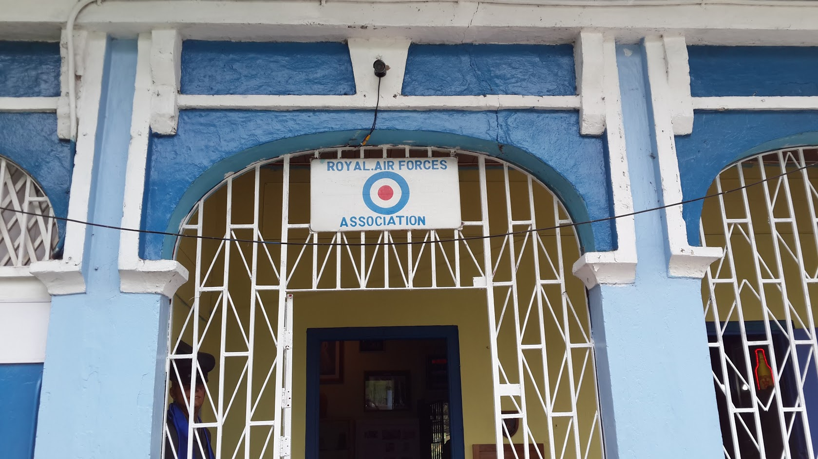 b. 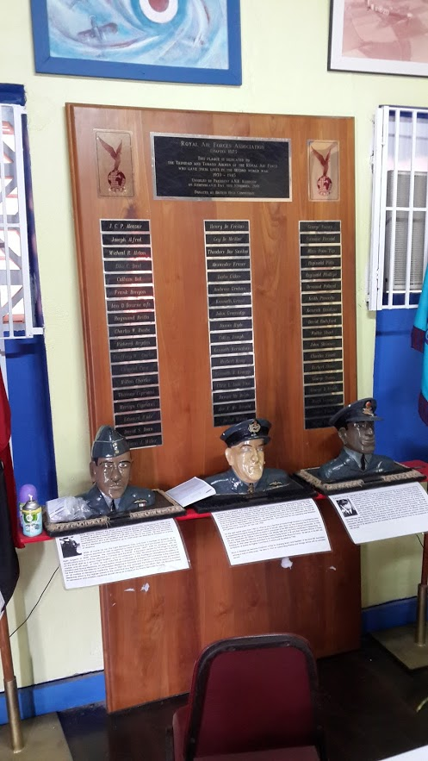
Figure 4.9. Royal Air Force Association Headquarters. Queen’s Park East, Port of Spain. b. Busts of TTO airmen who served in World War II.

RAFA is a charitable welfare organization which was formed in 1953 to support World War veterans and their descendants. It includes serving and non-serving members of the Royal Air Force, The Air Guard of Trinidad and Tobago, Trinidad and Tobago Regiment, Trinidad and Tobago Coast Guard, Trinidad and Tobago Cadet Force, veterans of the West India Regiment, US Armed Forces and their descendants. The open-ended interview was held on 4th September 2013. It was arranged by Mr. Peter Bacchus who served as Senior Aircraftman in the Canadian Royal Air force from 1963 to 1969 and now operates a taxi service in Port of Spain. His father was a taxi driver in Port of Spain at the time of the American military base at Chaguaramus during World War II. Mr. Bacchus recalled his father’s accounts of transporting local workers to the base and the secrecy surrounding its operations. Captain Neil Alexis of the Trinidad and Tobago Cadet Force and a World War researcher recounted the experience of the TTO population and local soldiers in World War I. “People were loyal to the King. They went to the war as volunteers to bleed for the mother country”. Asked if he thought the soldiers would have been willing to donate blood for the cause, he responded “Yes, they would have done anything for England”. He was not aware of any record of TTO soldiers in the BWIR participating in blood donation or bringing the technique back with them after the war. With regard to the current difficulties in encouraging citizens to donate blood, he suggested, “You need to get them to do it for country, for Trinidad and Tobago”. Captain Errol Clarke of the TTO Cadet Force sat quietly, sipping a beer and nodding in agreement. The interviewees were aware of hospital facilities at the Chaguaramus military base during World War II but not of blood transfusion happening there or of blood donation by the local community during this period. All three men confirmed air raid drills that locals rehearsed in anticipation of a German attack. They were all convinced that, had they been asked, patriotism would have driven TTO soldiers to donate blood during World War I. Although all three were knowledgeable about the events of World War II, including the role of TTO citizens in the air forces and navies of England and Canada and activities at the American military base at Chaguaramas, they were not aware of blood donation or transfusion related to that war. For more information, they directed the researcher to Mr. Luis Le Gendre, a surviving veteran of World War II and Mr. Gaylord Kelshall, curator of the Chaguaramus Military and Aerospace Museum.
Captain Luis Le Gendre, Captain, West India Regiment, World War II. An open-ended interview was conducted with Captain Luis Le Gendre (Figure 4.10) at his home in Fort George, St. James, Trinidad on April 4th 2014.

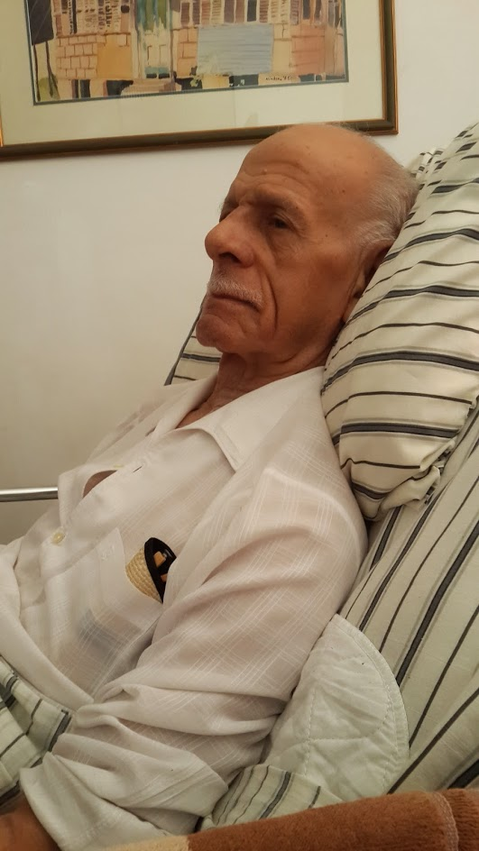
Figure 4.10. Captain Luis Le Gendre. Vivid recall of garrison duties in Egypt and North Africa and on the coast of TTO during World War II but no knowledge of blood donation or transfusion activities

He served as a gunner, protecting the coast of the small islands off the northwest coast of Trinidad from German U-boat attacks and performed garrison duty in Egypt and North Africa as a member of the West India Regiment. At age 92, he was able to recount events from the war in vivid detail. “A lot happened in this god-forsaken part of the world”. “All colonies including Australia, New Zealand, Burma, India were placed on a war footing by the Colonial Office and the War Office”. He articulated with precision the political events in Europe that led to World War II. “Trinidad was the main supplier of oil to Great Britain since the supply from the Middle East was cut off by the war”. He recounted three potential sources of oil for Great Britain - Aruba which refined but did not produce crude oil, Venezuela which produced and refined oil but was heavily populated by Germans and Trinidad which produced and refined oil. Trinidad was therefore the most reliable source of oil and was, in addition, the only country producing high octane fuel for mosquito high speed spitfire aircraft. “Without TTO oil, the British fleet would come to a standstill”. He estimated 60,000 American soldiers on TTO in 1942. His understanding was that, “Hitler, sensing the importance of Trinidad, established the puppet Vichy French regime in Martinique, took over its naval base and installed a German submarine base to cut off the supply of oil from Trinidad to Great Britain”. He described the real threat of the Vichy French in Martinique from whence the Germans could launch naval attacks on TTO. England, in turn, established coastal batteries in TTO to attack U-Boats as they surfaced for air. He thought that U-boats and warships could do severe damage to coastal targets but did not think that an air raid from Germany was possible. He confirmed German U- boat activity in the waters off TTO in 1942 with extensive loss of ships and lives and injured survivors arriving in Trinidad for treatment. He was not aware of blood donation or transfusion occurring in TTO and had little information on the military base hospital at Chaguaramus.
TTO citizens who lived through World War II. The researcher’s parents, Mr. and Mrs. Felix Charles, aged 85 and 80 respectively, were children in Siparia, South Trinidad during World War II. They recounted the heavy presence of American soldiers on the island, the military base at Chaguaramas and food rationing. They recalled sirens, blackouts and frequent air-raid drills. They were not aware of blood collection from the community during the war. Mrs. Catherine Cumberbatch, age 82, who was a child in Port of Spain, recalls sirens, blackouts and instructions to “hide under the bed” at the sound of the sirens. Mrs. Grace Peters, 92, also remembered the sirens as a signal to turn off the lights and stay indoors since “lights would attract the planes”. Eighty- five- year- old Mr. Earle Carter remembers Victory in Europe and Victory in Japan days. He recalled sirens and air raid drills, trenches and muster points during World War II. As far as he was aware, the sirens meant, “get ready, prepare for an air raid, turn the lights off in the house”. None of these witnesses was aware of blood donation on the island in preparation for air raids.
Mr. Michael Anthony, author and historian. Mr. Michael Anthony has written several books about the history of TTO’s society including two about the World Wars. He was a child in Mayaro, South Trinidad during World War II. He corroborated reports of food rationing, sirens and air raid drills. He recounted seeing a German U-Boat surface in the harbour at Rio Claro, Trinidad as a child. He had no knowledge of blood donation or transfusion occurring on TTO during the war nor had he ever come across any references to it in his extensive research. He surmised that that if West Indian soldiers participated, it would have been “for experimentation purposes only”.
Mr. Gaylord Kelshall, War Historian, Curator of Chaguaramas Military History Museum. This open-ended interview was done on January 23rd 2014 at the Chaguaramus Military and Aerospace Museum, displays from which are shown in Figure 4.11)

1. 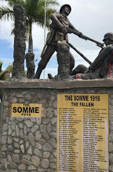 2. 3. 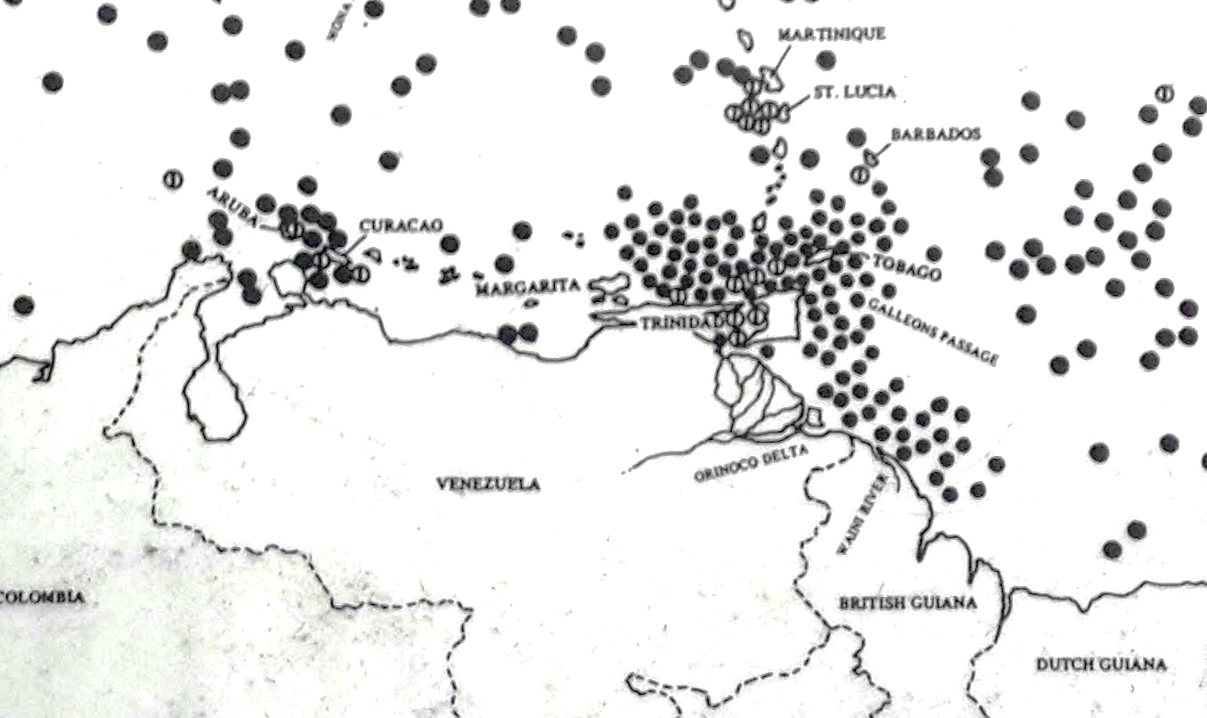 4. 5. 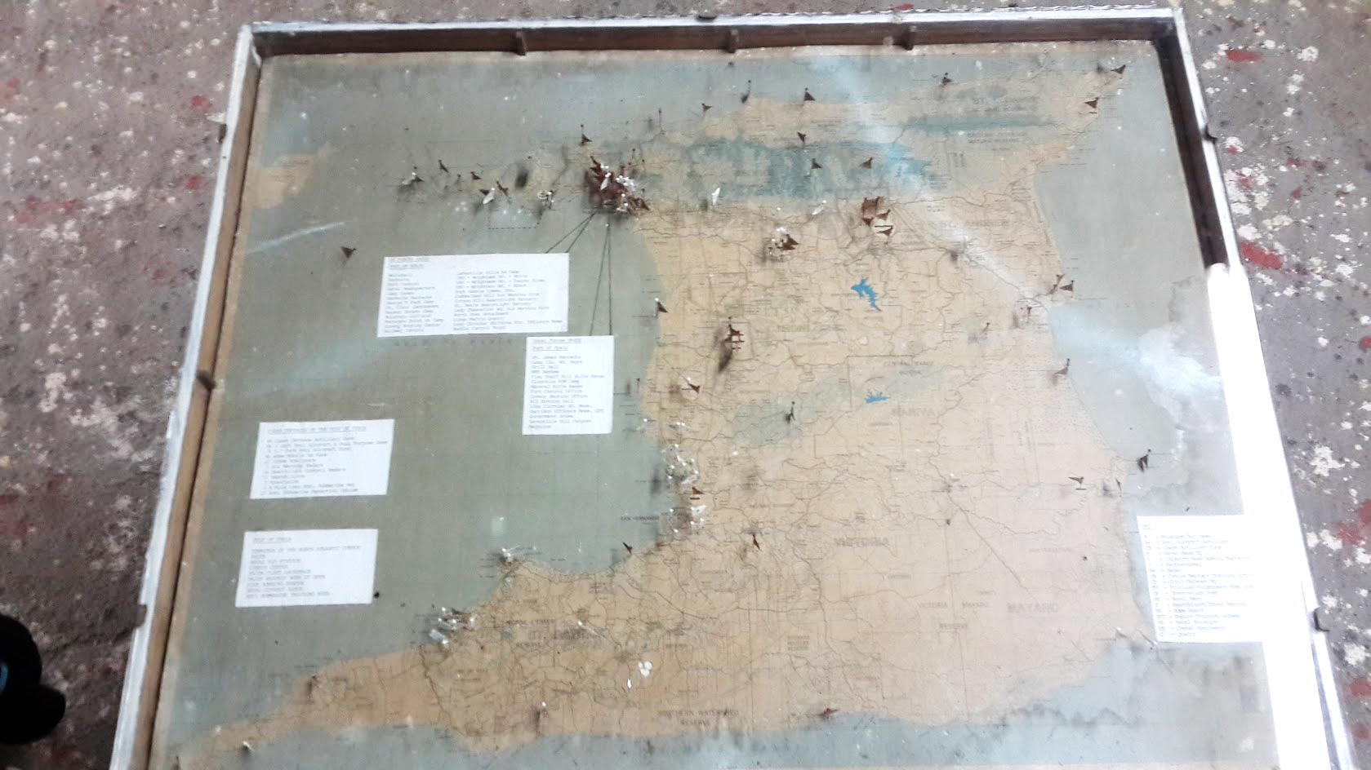
Figure 4.11. World War II participation by TTO. Clockwise 1. Monument to TTO soldiers who died in the Battle of Somme 2. Strategic location of TTO in World War II 3. Each black dot represents a merchant ship sunk by U-Boats in 1942 4. A U-Boat torpedo. 5. Each black flag represents an American military installation on island of Trinidad in 1942

Mr. Kelshall has researched and published on TTO’s role in the World Wars. [62, 67] He spoke of the German cruiser, Karlsruhe, which was dispatched in 1916 to destroy the then fledgling oil industry in Trinidad but was accidentally destroyed before reaching its target. He reported widespread damage inflicted by German U-Boats in the waters surrounding TTO in World War II with survivors reaching the islands for treatment. He was aware of three military base hospitals on the island – a 200-bed facility at Chaguaramus, a 300-bed hospital at Fort Read, Cumuto and the largest, a 500-bed facility, at Cedros. He had no information on blood donation or transfusion in TTO during this period.
Mrs. Georgina Masson, member of the Auxiliary Territorial Service, London, World War II. A TTO citizen who served as an ambulance driver transporting blood to hospitals from the four blood depots that were established during the London blitz. She did not serve in TTO but had no knowledge of blood transfusion in TTO during this period. She served as a public relations officer of the FBBA after her return to TTO.
Dr. Hugh Spicer, founding member of the FBBA. Dr. Spicer continues to work as a general practitioner in Port of Spain. He credits himself with being the first to start blood donation in TTO in 1959. He remembers blood being donated by community members in small numbers. With the formation of the FBBA these increased but there was no place to store blood. The FBBA persisted and lobbied for the establishment of a national blood bank to store blood. He recalls fund-raising activities and the eventual conversion of the emergency department of the old Colonial Hospital into the NBTS Headquarters.
Dr. Neville Jankie, Consultant Pathologist, POSGH. Dr. Jankie recalled the days when blood was donated in the Pathology Departments of general hospitals in the 1960s – 1980s. The blood transfusion department was run by general pathologists until the first haematologist arrived on the island in 1980. There was no blood bank and all blood was collected for institutional use.
Dr. Carl Harnarayn, Retired Consultant Pathologist, SFGH. Dr. Harnarayn was Dr. Jankie’s counterpart in South Trinidad and confirmed similar transfusion practices at the SFGH.
Mr. Justin Sankar, Medical Laboratory Technologist III, NBTS. Mr. Sankar started as a junior medical laboratory technologist in the Haematology Laboratory at the POSGH in the late 1970s as an employee of the MOH. His tenure spanned the establishment of the NBTS in 1986. At its inception, existing laboratory POSGH staff with training in blood banking were technically assigned to the NBTS headquarters but, administratively, remained employees of the POSGH. He recalled the industrial relations problems that arose from dual employment, reporting and remuneration of staff between the NWRHA and MOH that culminated in two TTI testing sites on the island – EWMSC and CL. He noted the significant influence of the FBBA over blood collection, distribution and administration of the NBTS. Mr. Sankar received training at the Curacao Red Cross Blood Bank and was therefore aware of a blood system based on VNRDs.
4.10. Summary and conclusion
Historical analysis reveals that TTO soldiers and doctors did not participate in blood transfusion in World War I. There was no development of blood donor organizations on the islands in the interwar period. Establishing blood transfusion services was not given priority by the Moyne Commission Report. Community blood donation was not established in preparation for air raids during World War II. Progression to a national blood service based on voluntary donations as in Great Britain, America and Canada never occurred after the war. As in SSA, family replacement blood donation which was discarded in Great Britain in the 1920s became established as the main source of blood for transfusion during the 1950s and 1960s. Blood donation facilities were established in the main centres of activity for the colonial government and multinational corporations and initially supported by donations from European officials and foreign workers in the oil industry. Mobile blood collections were initiated by the Red Cross but were continued by the FBBA, a local blood donor organization with strong links to the business community. An American-style “family credit system was established by the FBBA in the 1970s. These two blood donation systems have remained the predominant methods of blood collection to today.

CHAPTER 5. RESULTS II: ACTION RESEARCH
5.1. Introduction. Having examined the historical, social and technical background to the problem, the researcher undertook three cycles of action research to collect field data, analyze them, implement change and monitor outcomes. In Action Cycle I, the researcher, as Director of the NBTS, acted as facilitator and participants included NBTS employees, medical students and blood donors. The outcomes were increased efficiency, development of national transfusion policy and a short-lived switch to 100% voluntary non-remunerated blood donation. In Action Cycle II, the researcher, as Senior Lecturer in Haematology, instituted curriculum changes and facilitated research, sensitization and action to promote voluntary non-remunerated blood donation among medical students. The outcome was a successful VNRD programme in a closed setting. In Action Cycle III, the researcher implemented change to maintain VNRD donations during the COVID-19 pandemic. The outcome was proof of reliability and expansibility of the VNRD programme.
5.2. Action Cycle I: Restructuring the NBTS 2005-2010
Between 2000 and 2005, obtaining blood primarily from FRDs and remunerated (considered voluntary) donors made management of the blood system difficult. Chronic blood shortage existed as annual donations plateaued in the manner typical of FRD-based blood systems. [14]. The demand for blood increased as the economy improved, medical services at public and private institutions expanded, training of local specialists increased and the population grew. To increase the likelihood of obtaining blood in an emergency, FRD recruitment was intensified in excess of anticipated need for surgeries. [146] This had the effects of attracting unsuitable donors, creating a market for professional donors, increasing donor TTIs and increasing donor deferrals. In addition, because collection centres depended on the availability of hospital-based personnel, staff shortages were frequent. This caused prolonged waiting times, donor complaints and negative media publicity. Table 5.1 demonstrates lower donation rate, higher TTI prevalence in donors and higher donor deferrals in TTO compared to the VNRD-based Curacao blood donation system in 2005.

Table 5.1. Annual blood bank data for TTO and Curacao in 2005. Adapted from [151, Annex A]
Country | Annual donations per 10,000 | Voluntary donors (%) | Prevalence TTI (%) | Donor deferral rate (%)
Curacao | 368.6 | 100 | 0.03 | 0.3
TTO | 104.4 | 13 | 4.69 | 38.1

Action Cycle I was conducted at the NBTS Headquarters in Port of Spain, TTO between 2005 and 2010. The researcher, as newly appointed Medical Director of the NBTS, conducted a situational analysis of the service (look), for analysis (think) and implementation of measures (act) to improve its efficiency. Acting as facilitator, he engaged participants from major stake holding groups including the MOH, PAHO, laboratory, nursing and administration, the RHAs, the FBBA and medical students on elective posting.
5.2.1. ‘Look’ – gathering relevant information
The main sources of information were documents, letters, newspaper articles, minutes of meetings, audits and interviews:
Documents. The International Code of Ethics for Blood Donation and Transfusion [101], PAHO’s Plan of Action for 2006-2010 [8], recommendations for improving blood transfusion practice in the British National Health Service [152] and WHO guidelines for formulating national policy [153] were used as reference materials.
Letters. Letters from the public to national newspapers and to official authorities regarding the blood donation system were examined. These drew attention to operational shortcomings in the transfusion service. For example, by letter dated July 17th 2006, Professor Courtenay Bartholomew complained to the Chief Medical Officer about blood or personnel being unavailable to meet the needs of a patient in urgent of blood although there were ‘five relatives waiting outside the ward to donate’. In a letter to the editor of the Daily Express on 21st May, 2007, Mr. VF Nothangel-Gurley complained bitterly about inadequate staffing and long waiting times to donate at the “Port of Spain Blood Bank’ after he had recruited ‘his three’ donors. [154] In a letter dated July 10 2007, Karen George lamented to the Minister of Health the inefficiency and unfriendly service at the ‘Blood Bank in Port of Spain’ where she attended to donate blood ‘for’ a person who was due to have surgery on July 18th 2007. She concluded that ‘THE BLOOD BANK DOES NOT NEED BLOOD’. In a letter to the Trinidad Guardian on October 5th, 2007 entitled “Help, I want to give blood’ the author protested the long wait to donate blood at CL.
Minutes. Table 5.2. shows data extracted from minutes of the Executive Meeting of the FBBA on November 10th 2005:
Table 5.2. Mobile Unit Report for October 2005
Sites visited  Organizations | Units collected  Units collected | Deferrals  Deferrals | New donors  New donors
12  12 | 138  138 | 99  99 | 38  38

A breakdown of the 12 sites visited showed one religious organization, one technical/vocational institution, one government ministry, two state companies, three private companies, three banks and one media house. Table 5.3 depicts voluntary blood donations to the FBBA for the year to October 2005. ‘In-house’ refers to units donated at CL, ‘Debits’ to units reclaimed by donors and ‘Net’ to the difference between the numbers of units donated and the number reclaimed. The number of units reclaimed was almost equivalent to the number of units donated.
Donations  Mobile In-house | Debits | Net
1169 307 | 1258 | 218
Table 5.3. Mobile and in-house transactions_ voluntary donors 2005

Audits. Internal review of the operations of the NBTS and its satellite centres was conducted with Medical Director of the NBTS as facilitator and health care professionals, students and blood donors as participants. Eleven audits, their findings and conclusions are presented in Table 5. 4.

Table 5.4. Audits, findings and conclusions from TTO NBTS 2005 -2010.
Activity | Description
Audit 1. | Title: Correlation between initially reactive and confirmed positive microbiological tests among blood donors at the TTO NBTS  Authors: Tweedle J & Charles KS  Year: 2005  Method: Retrospective review of initially reactive tests at CL and confirmed positive results from Caribbean Epidemiology Centre for 12- month period  Results: Confirmation of initially reactive tests was 77%, 82%, 38%, 70%, 87% and 33% for HIV, HBV, HCV, HTLV I/II, Syphilis and Chagas’ Disease respectively. Delays up to months between initially reactive test and confirmation.  Conclusion: Although sufficiently sensitive to protect the blood supply, screening tests not sufficiently specific as a basis for counselling and referring donors for definitive treatment. Time between screening and confirmation needs to be shortened.
Audit 2. | Title: Demographics of seropositive donors at CL  Authors: Bodkyn S, Biptah K, Bedi S, Shoemwo O, Charles KS  Year: 2005  Method: Retrospective review of donor cards and microbiological test results for January 1st to December 31st, 2004. Chi square analysis to compare proportions. P<0.05 statistically significant  Results: A total of 6690 donations were made over period. 93.2 % FRD and 6.8% voluntary. There was no difference in the proportion of confirmed HIV, HBV and HTLV I/II between FRD and voluntary (p = 0.369, 0.131 and 0.327 respectively) but HCV and Syphilis were higher in voluntary group (p < 0.001 for both). There were demographic variations in the prevalence of infectious markers.  Conclusion: Voluntary donors no safer than FRDs
Audit 3. | Title: Attendance for counselling after notification of a positive microbial test  Authors: Alfred R & Charles KS,  Year: 2007  Method: Retrospective review of NBTS records and donor cards for year 2006  Results: 32% of confirmed HIV, 18% of confirmed HBV, 26% of confirmed HCV, 57% of confirmed HTLV I/II and 72% confirmed Syphilis attended for counselling and referral.  Conclusion: Public Health Surveillance of confirmed positive donors required to protect donors and contacts.
Activity | Description
Audit 4. | Title: Registered nurse assignment to donation centres after phlebotomy training  Author: Charles KS, 2008  Method: Number of registered nurses (RN) assigned to blood donation centres in 2005 compared to 2008 after training course for nurse phlebotomists in 2007.  Results: RN increased from 2 to 5 at CL, 2 to 3 at EWMSC and 3 to 4 at SFGH with no change at SGCH, SRH and AHPF (1 RN).  Conclusion: Employment of nurses under contract to the NBTS at CL was more effective in increasing staff than in centres managed by RHAs.
Audit 5. | Title: Donor satisfaction survey after employment of additional nursing staff and customer service representatives at CL.  Authors: McKenzie A, Shade N & Charles KS  Year: 2009  Method: Questionnaire-based, convenience sampling at end of donation over period February 2nd to April 2nd 2009.  Results: 200 donors, 125 males: 75 females. 74% FRD, 24% Voluntary. 67% had heard about the donation centre from a relative or friend. 63% had donated at least once in the preceding 12 months. 88% were satisfied and willing to return to donate voluntarily.  Conclusion: High donor satisfaction and willingness to repeat as voluntary donors
Audit 6. | Title: Compliance with use of new request forms  Authors: Reyes K & Charles KS  Year: 2009  Method: Review of all request forms submitted to CL for period March 1st-July 31st 2009  Result: A total of 1401 requests submitted from 17 public and private institutions. New request form used in 1332 (95%) cases.  Conclusion: High compliance with new request forms issued by CL. Useful tool for conveying blood transfusion information.
Audit 7. | Title: Autologous Blood Donation at CL, NBTS  Authors: Adams A & Charles KS  Year: 2010  Method: Retrospective review of donor cards and log books for years 2005-2009  Result: Out of 34,091 total donations over the period, 465 (1.4%) were preoperative autologous deposits. The majority (64.4%) were made for scoliosis surgery followed by gynaecological surgery (12.8%)  Conclusion: There has been no increase in the uptake of autologous donation ten years after inception of the programme.
Activity | Description
Audit 8. | Title: Blood conservation in open heart surgery  Authors: Charles KS, Foster E, Casua R, Rawlins R, Henry E  Year: 2010  Method: Review of patient and blood bank records for one cardiac surgery programme.  Results: 227 operations were performed over a 3- year period using intraoperative cell salvage. 81% were CABG and 10% valve surgery. Only 64 units of red cells, 22 units FFP and 17 units platelets used. Mortality was 2.2%.  Conclusion: Blood conservation was safely achieved using an intraoperative cell saver for cardiac surgery. Maximum surgical blood ordering schedule for cardiac surgery needed.
Audit 9. | Title: Crossmatch:Transfusion (C/T) Ratios for vaginal and operative deliveries at a tertiary care centre  Author: Ramsingh J & Charles KS  Year: 2010  Method: Retrospective review of hospital laboratory records for deliveries at a large tertiary public health care institution for period April 1st 2009-March 31st 2010  142 red cell units were cross-matched for 72 vaginal deliveries of which 14 were transfused giving a C/T ratio 10.0. For 586 Caesarian Sections, 1191 units were cross-matched and 199 transfused giving a C/T ratio of 6.0.  Conclusion: Inappropriate crossmatching for deliveries. Maximum Surgical Blood Ordering Schedule for Obstetrics and Gynaecology needed.
Audit 10. | Title: Audit of platelet requests and distribution  Authors: Gabriel A, Scope L, Sankar J & Charles KS  Method: Retrospective review of request forms submitted to CL between Jan 1 and Dec 31, 2009.  Results: 314 request forms from 13 hospitals. 1782 units requested 1468 supplied. 16% requests for Dengue Fever (DF). Platelet count stated on 91% of requests. 52% of requests inappropriate.  Conclusion: Inappropriate requesting of platelets. Physician education on DF guidelines needed.
Audit 11. | Title: Willingness of FRD and voluntary donors to convert to VNRDs  Authors: Poon King A & Charles KS  Method: Questionnaire-based, convenience sampling. PAHO definition of VNRD explained.  Results: Out of 376 donors, 92% were FRD and 8% voluntary. Only 24% were unwilling to convert to VNRD. Reminders (84%) and extended opening hours (73%) would be the main motivators to transmute willingness into actual voluntary non-remunerated blood donation. Conclusion: High willingness to convert to VNRD among existing donors.

5.2.2. Think: Analyze and Theorize
Although most data were collected at CL and POSGH, they were analyzed as reflective of practice at all facilities since this was flagship operation from which policies were set and monitored. The information confirmed direct linking of replacement donation with blood availability for a specific patient in the minds the public and clinicians. Dissatisfaction with donor settings was a common motivator for letters of complaint to the press and health authorities. Most blood donated voluntarily was almost immediately reclaimed to benefit specific individuals in a manner that was indistinguishable from replacement donation. Initially reactive rate for TTIs was high with no appreciable difference between voluntary and replacement donors. Storage of red cells was inadequate and distribution of blood components was not informed by clinical need or guidelines. There was poor correlation between nurse training and assignment to blood donation centres. There was delay between initially reactive tests and confirmation and unsatisfactory responses to recall for counselling and referral, posing a public health risk. Donor satisfaction improved with training, recruitment and deployment of appropriate staff. Willingness to convert to voluntary non-remunerated donors was high but contingent upon information and convenience. Figure 5.1. summarizes the main concepts that emerged from analysis of the data.
Figure 5.1. Concept map of NBTS operations
Donor issues
Governance issues

NBTS inefficiency
Blood management issues
Training and recruitment issues

Variability issues
Media interest

5.2.3. “Act” – implement improvements
Based on this situational analysis, the researcher implemented the following:
1. Establishment of a National Blood Transfusion Committee with the Chief Medical Officer
as Chairman and representatives from the NBTS, RHA administration, FBBA administration
and the PAHO country office.
2. Appointment of persons by MOH to staff to the NBTS to address labour shortages and enhance
donor friendliness. These included nurse phlebotomists, laboratory technologists, stores
managers, clerical assistants and customer service representatives.
3. Training in blood bank phlebotomy for nursing assistants and registered nurses in 2007 and
2009 for employment at the NBTS and satellite centres (59 in total).
4. Establishment of National Blood Transfusion Policy and Technical Guidelines (including donor
care, blood storage, transport and appropriate use of components) which was approved by
Cabinet in 2007. [155] This was the basis for an initial draft Blood Transfusion Bill for
parliamentary debate. A National Blood Transfusion Services Legislative Committee was
appointed by the Permanent Secretary, MOH to work towards finalization of the Bill and attend
meetings of the Legislative Review Committee and Parliament when it was being debated.
National Blood Transfusion Policy and Technical Guidelines envisaged an administrative
National Blood Authority on which the MOH, all RHAs, the FBBA, PAHO, the national
community and private health institutions were represented. Among the goals of National Blood
Transfusion Policy were ensuring a service managed by trained, dedicated personnel and
creating a voluntary non-remunerated service that was easily accessible at all times, reliable,
efficient, equitable and compliant with international best practice standards. It proposed
recruitment and training of dedicated staff, upgrade of infrastructure at donation centres,
laboratories and blood banks, ease of transfer of blood components between blood banks, public
education and a move towards total VNRD. Implementation of the policy was to be piloted at
CL and ‘rolled out’ sequentially to all other blood donation centres.
5. 24-hour opening of the CL laboratory for component distribution was initiated
for the Commonwealth Heads of Government Meeting in Port of Spain 21-29 November 2009
which was attended by the Queen of England.
6. Infrastructural upgrade of facilities at donation centres and blood bank laboratories – buildings,
laboratory equipment, donation chairs, designated blood bank refrigerators for public hospitals.
7. Centralization of initial TTI screening of donations from all centres to CL in 2006 with daily
notification of all distribution centres of results. An independent CL telephone/fax system was
installed to facilitate this.
8. New blood request forms with fields for relevant patient information (Complete blood count,
coagulation profile, actively bleeding yes/no) and guidelines for using blood components on the
reverse.
9. Hospital Transfusion Committees (HTCs) in all RHAs.
10. Policy for transferring components between NBTS and RHA institutions and among RHA
centres was established.
11. National policy for managing seropositive donors including recall, counselling and referral.
12. Annual “Walk for Voluntary Blood Donation” around the Queen’s Park Savannah in Port of
Spain on World Blood Donor Day to raise public awareness about the NBTS and blood
donation.
13. Distribution of PAHO’s model maximum blood ordering schedule (MSBOS) to all RHAs and
private institutions.
14. Introduction of appointment system alongside the walk-in system at CL. All donors were
given appointments to return as VNRDs and contacted with telephone reminders. Prior to this,
voluntary donors were allowed to ‘jump the queue’ in preference to FRD.
15. Saturday morning opening of CL blood donation centre.

5.2.4 Monitoring the outcomes of action
5.2.4.1. Effect of action on donations
These changes resulted in an increase in annual donations at CL which was more marked in voluntary than FRD donors. Data for all collection centres for the years 2006 -2009 showed an
87% increase in voluntary donors compared to a 10% increase in FRDs. (Figure 5.2).
Figure 5.2. National donations by year 2004-2009. EWMSC data was unavailable for 2004 and 2005.

Donor initially reactive tests for all TTIs (Figure 5.3) and deferral rates declined at CL. Adverse media reports about the NBTS abated after 2007.
Figure 5.3. Percentage of initially reactive microbiological tests 2004-2008. A decline in all markers between 2004 and 2008.

Nationally, annual donations increased every year between 2006 and 2009 (Figure 5.4).

Figure 5.4. Increase in annual blood donations 2006 – 2009.

The greater increase was among voluntary donors compared to FRDs (Figure 5.5).

Figure 5.5. Greater proportional increase in voluntary than FRD donations 2006 – 2009.

Thus, actions to improve the efficiency of blood donation had the effect of increasing the proportion of voluntary donors. This was probably due to misunderstanding of ‘voluntary non-remunerated’ and conversion of willing FRDs to the existing category of voluntary donors that had remained unchanged legislatively. Donations, although increased, remained linked to credits, chits and the assurance of blood in return.
5.2.4.2. The effect of discontinuing ‘chits’ and ‘credits’
When blood chits and credits were discontinued in accordance PAHO’s resolution CD 48/11 of 2008 [9] at the end of 2010, miscommunication led members of the public to believe that they no longer needed to donate blood for it to be available. An acute fall in already insufficient donations followed with major disruption of medical services nationally. (Figure 5.6)
Figure 5.6. January donations in 2010 and 2011 after stopping chits and credits
Figure 5.6. Donations for the month of January 2011 showed a marked decrease compared to January 2010 at fixed blood donation centres and on the mobile unit.

Protests by clinicians and existing donors were widely reported in the media. Following a maternal death from post-partum haemorrhage at SFGH and an enquiry which blamed the National Blood Transfusion Policy, a MOH decision was taken to re-introduce chits and credits four months after their discontinuation. Re-introduction of the chit system was welcomed by past donors and the attempt to change this ‘tried and proven’ system vilified. [156]

5.2.5. Evaluation of the outcome of action

1. Administrative and regulatory changes were insufficient to change entrenched practice
2. The general public, junior doctors, nurses, laboratory staff, auxiliary staff, patients, relatives
and existing donors were not included as major stakeholders.
3. Willingness to change donation behavior must be met with information, reassurance, clear
messaging and an enabling environment to result in actual change.
4. Communication must be clear, factual and consistent
5. Popular media must understand and be included in the change process.
6. A pool of truly voluntary non-remunerated blood donors is necessary to buffer any fall in
donations during transitioning.

5.3. Action Cycle II – A VNRD programme
Following the termination of Action Cycle I, the researcher transitioned to Senior Lecturer in Haematology at the Faculty of Medical Sciences at The University of the West Indies, St. Augustine, TTO. Public Service regulations disallowed continued employment as Director of the NBTS. He became Honorary Consultant Haematologist to the NCRHA. Although PAHO data continued to give annual cross-sectional overviews of the end-result of poorly developed national blood systems in the Caribbean, information about their historical development, sociological determinants and impact in the field remained scarce. [157] Local field data from TTO was beginning to emerge. Sampath et al [158] revealed a low rate of previous blood donation (7-29%) in all sociodemographic groups (age, religion, gender, employment status, level of education), majority family replacement (FRD) donation (86.9%), with the lowest rate of previous donation among 18-25 year olds and students (Figure 5.7a). The main demotivators to donation were lack of information, fear and poor access. Willingness to donate was high but a national education campaign and measures to improve access were identified as prerequisites to increased voluntary donation. Subsequently, Charles et al [159], surveying donor deferrals at CL, showed a higher percentage of male than female prospective donors (2.5:1) and a high deferral rate (35.6%), mostly for reasons that would trigger self-deferral if eligibility criteria were known and coercion removed. (Figure 5.7b.). They concluded that lack of awareness was the main reason for high deferrals.
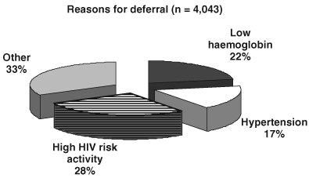
Figure 5.7b. Reasons for donor deferral. The majority were related to lack of awareness of donor eligibility criteria. From [155]

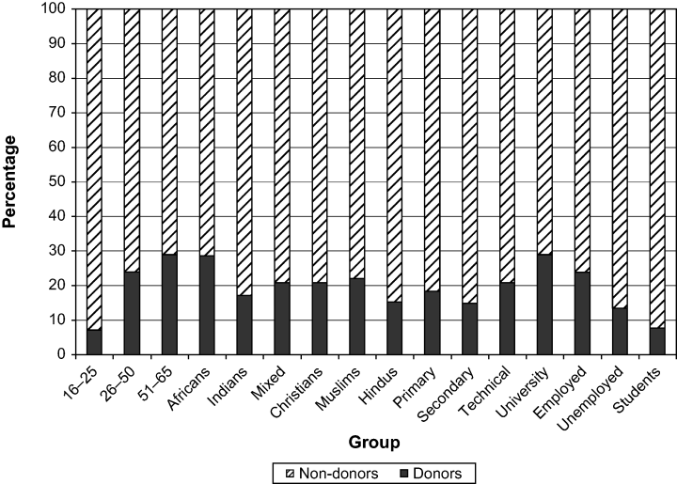
Figure 5.7a. Prevalence of previous blood donation among different sociodemographic groups. From [154]

Following failed transitioning to VNRD in TTO, Allain advocated continued use of repeat FRDs to achieve blood safety in SSA. [91] Charles et al. responded highlighting shortcomings of family replacement donation including discouragement of voluntary non-remunerated blood donation, wastage and unnecessary transfusions. They compared TTI rates in TTO to those in Curacao, a former Dutch colony in the Caribbean, where a VNRD –based blood donation system has been established for decades. [160] International blood transfusion bodies continued to advise that national blood transfusion services collect blood from exclusively VNRDs to enhance safety and adequacy [161] and a model for achieving this in the PAHO region of the Americas was proposed from Nicaragua, the poorest country in Latin America, which moved from 37% to 100% VNRD in a four- year period. [162]
Knowledge, attitudes and practice studies had been used to devise strategies to maintain and diversify already sufficient VNRD pools in developed countries. [163 - 166] In developing countries, where emphasis is on transitioning from FRD and remunerated to VNRD, the common themes of misinformation, fear and failure to convert positive attitudes to actual donation have emerged from these studies. However, reports on corrective interventions or repeat studies are rare. [15]. Examining attitudes to receiving blood is useful for planning communication and recruitment strategies for VNRDs. [167] Despite huge advances made to improve blood safety, the general public still perceives it as risky, even in countries with exclusive VNRDs where the risk of infection is virtually zero. [168, 169] However, attitudes and risk perception studies, which provide further insight into general blood transfusion knowledge, are lacking from countries with FRD-based systems where they may be more relevant.
Whereas the Theory of Planned Behaviour (TPB) has been applied to examine psychological factors that determine blood donation behaviour and to plan strategies for donor recruitment and retention, most related studies evaluate VNRDs in developed societies rather than FRDs in developing countries where the need to change blood donation behaviour is greater. [115, 116].
The maximum surgical surgical blood ordering (MSBOS) has been recommended to limit inappropriate cross-matching, increase availability and reduce costs. [170] Although Monteill & Naraynsingh recommended its establishment in TTO more than 30 years ago [171], the practicality of implementing a MSBOS in an FRD-based system, where the donor influences the transfusion decision, has rarely been assessed.
During the brief respite from FRD and remunerated blood donation in TTO (January to April 2011) there were no initially reactive HIV donor samples at CL. Annual blood donations for 2011 fell but returned to the insufficient plateau of just over 20,000 units. [172] By 2014, media reports of blood shortage, cancelled surgeries and blood unavailability reappeared in the media. (Figure 5.8)

Figure 5.8. The return of adverse media reports. Trinidad Guardian, April 2014.

However, these reports made no connection between the re-institution of collection from FRD and remunerated donors and the recurrence of problems. The need for a revised approach to sensitization that included the media was apparent.
Haematology education in FMS at The UWI-STA is delivered over five years of the medical curriculum including lectures in Years I and 3, a professionalism, ethics and communication (PEC) module in Years 1- 2 and clinical teaching in years 4 and 5. Graduate students undertake research projects in related fields such as surgery, public health and psychology. The FMS provided a self-renewing pool of young persons with strong links to communities, schools and religious organizations, efficient social networks and the potential to become future decision-makers and proponents of voluntary non-remunerated blood donation. Its location facilitated collaboration with other academic departments in The UWI including the Department of History and the Institute of Gender Studies. In this Action Cycle, the researcher modified medical school activities to heighten interest in blood donation research and practice. The methods used for sensitization, outreach, research and action towards promoting voluntary non-remunerated blood donation in TTO are described. This included introducing blood donation in the Year 1 lecture schedule, blood donation practica in the PEC module, supervising research projects and emphasizing blood transfusion in clinical training.
5.3.1. Look – gathering information
Knowledge, attitudes and practice (KAP) studies were conceptualized and supervised by the researcher. Field work was performed by second year medical students as Public Health research projects (14 studies), graduate students pursuing a Master of Sciences (MSc) degree in Psychology (2 studies), a graduate student in Haematology (1 study) and graduate students in surgery (1 study). Information was used for sensitization within and outside The UWI and to help establish a voluntary non-remunerated blood donation programme. The design, main findings and conclusions from 18 studies are presented in Table 5.5.
Table 5.5. KAP studies surrounding blood donation and transfusion
Study | Description
1.  2.  3.  4.  5.  6.  7.  8.  9.  10.  11.  12.  13.  14.  15.  16.  17.  18. | Title: Have attitudes to blood donation in Chaguanas changed between 2003 and 2013?  Chisolm K, Gabourel K, Philip K, Ramdath S, Abdul-Kareem H, Legall G & Charles KS  Year: 2013  Design: Cross sectional. Self-administered questionnaire  Main findings: Despite high willingness (90.3%), low donor % in all groups (10-32), overall % donors (18.8% vs 21%, p=0.337) and % F/R unchanged (86.5 vs 86.9%, p = 0.851) among 816 respondents.  Conclusion: Activities undertaken between 2006 and 2010 were ineffective in changing donation practice.  Title: Attitudes to receiving blood among clinic attendees in 5 RHAs.  Metivier KS, Sammy S, Labban M, Singh S, Rudder M, Reginald A, Ramoutar S, Legall G & Charles KS  Year: 2013  Design: Cross-sectional, questionnaire-based. Non-random sampling.  Results: Of 400 respondents, 38.2% were unaware of inadequate blood bank stock. Only 18.4% correctly identified the method of blood donor recruitment in the country. Only 1.2% able to identify all from a list of six common scenarios in which blood is transfused. Although 84% would accept transfusion, most (84%) of these had fears about hospital transfusion practices and acquiring infections from transfusion. Young persons and females had higher risk perception (p = 0.026 and p = 0.041). There was a positive association between confidence in the safety of blood donation processes and willingness to accept transfusion.  Conclusion: Fear of transfusions high. Information about all processes in blood transfusion should be included in a national blood donation campaign.  Title: Knowledge of Sickle Cell Disease (SCD) and Thalassaemia in South Trinidad.  Ramdial G, Ramrattan K, Sudama S, Ragoobar L, Gopaul-Gosine R, Khan S, Omardeen S, Mungrue K & Charles KS.  Year: 2013  Design: Questionnaire and face to face interview  Main findings: Out of 500 respondents, 19% had never heard of SCD and 75% had never heard of thalassaemia (p < 0.001). Among those who had heard of the diseases, 53% knew that blood transfusion was used for SCD compared to 37% for thalassaemia (p < 0.001).  Conclusion: Awareness of SCD and Thalassaemia and the role of blood transfusion to treat them must be increased. This information should be included in national blood donor education campaign  Title: Blood utilization at a tertiary health care institution  Authors: Charles KS, De Freitas L, Ramoutar R, Goolam R, Juman S, Murray D, Jhingai R & Chantry AD.  Year: 2014  Design: Observational using operating theatre and blood bank laboratory records. C/T ratio, Ti, T% and NUP were retrospectively calculated for elective surgical procedures performed at a tertiary medical institution in a six- month period.  Main findings: For 17 types of surgical procedure, C/T ratio was <2·5 for 10, T%≥30 for 10 and Ti ≥0·5 for 12, suggesting efficiency, significant blood use and a requirement for Group & X Match for  most operations. However, the majority of these procedures qualify for Group & Save when there is reliable access to blood in an emergency. A substantial proportion of issued blood was returned unused to the blood bank, giving a non- use probability (NUP) of 39·7%.  Conclusion:  NUP was the most sensitive measure of efficiency. C/T ratio, T% and Ti must be interpreted in the context of the blood donation system. An internationally accepted value of NUP that equates to efficient blood use should be adopted.  Title: What does the community want to know about blood donation?  Authors: Narine K, Bharath R, Castillo G, Hosein S, Kerr M, Lewis T, Mustapha A, Ramtahal A & Charles KS.  Year: 2014  Design: Cross-sectional. Non-random selection. Questionnaire – based. Mixed random and convenient sampling.  Main findings: 661 participants aged 18-65 in community of Sangre Grande. 21% previous donors, 80% F/R. 31% fear of needles. 78% not educated about blood donation. 84% wanted more information about blood donation. Radio and television most popular means for receiving information (28.5%) and doctors most favoured source (48%). Most common type of information wanted was donor eligibility criteria (39%).  Conclusion: Level of blood donor education poor. Public wants more information, mostly about donor eligibility from a doctor using electronic media  Title: Community perception of blood usage  Authors: Andrews O, Anngard A, Alsuran N, Alves M, Archer D, Armorer D, Arjoonsingh R, Atwaroo S, Austin R, Baboolal A & Charles KS.  Year: 2014  Design: Cross-sectional. Questionnaire– based. Non-random, convenient sampling of 18-65 year olds at public places throughout TTO.  Main findings: 500 participants. 23.6% previous donors, 84% F/R. 87.4% and 30.6% agree or strongly agree that large amount of blood is used to treat surgical patients and criminals respectively. 52.6% not aware that blood separated into components. 56.8% wrong about life-span of red cells. 44.9% unaware of window period for HIV. Knowledge higher among donors and persons with tertiary education.  Conclusion: Blood component use should be part of national donor education campaign.  Title: Attitudes of medical students towards blood donation  Authors: Sookdeo K, Ramgoolam D, Ramlal R, Ramgoolam S, Ramasray A, Maraj R, Moonasar V, Persad V and Charles KS.  Year: 2015  Design: Cross-sectional, questionnaire-based. Medical students at EWMSC.  Main findings: 176 participants. 27.8% had previously donated blood, 41.6% F/R, 47.7% voluntary. 32.5% aware of recommended frequency for blood donation. 43.7% feared contracting HIV or HBV from donating. 82.9% positive attitude to blood donation. 83.5% would donate is asked. Health reasons (28%), fear (22%) and time constraints (20.7%) main deterrents to donation. 35% donor deferrals due to underweight. Most popular method for promoting blood donation was media (29.5%).  Conclusion: Blood donor education and promotion needed in medical school.  Title: Public knowledge of blood donation systems (voluntary or replacement) locally and abroad.  Authors: Ali R, Balgobin S, Gadd S, Maharaj S, Rakhar V, Ramadhar L, Rambert K, Trigg D, Charles KS.  Year: 2015.  Design: Cross-sectional, questionnaire. Community-based  Main findings: 529 participants. 26.7% previously donated blood, 92.5% as F/R. 40% secondary school and 51% tertiary education. 74% wrong about type of blood donation system in TTO. 71% and 84% don’t know about US, UK blood donation systems. 67.3% non-donors willing to donate if given more information and 35% if system were the same as in US or UK.  Conclusion: Information about local and voluntary non-remunerated blood donor systems should be included in national donor education programme.  Title: Public perception of the risk of donating and receiving blood.  Authors: Figaro C, Eligon S, Ellis K, Esack H, Ernest L, Farrow M, Gajadar N, Fyzoudeen D & Charles KS.  Year: 2015  Design: Random, quota sampling. Cross-sectional. Questionnaire-based.  Main findings: 300 participants- 150 male, 150 female. 27% previously donated, 11% previously received blood. 53% aware of blood shortage. 32% perceive infection risk from donating blood, 74.3% perceive risk from receiving blood. For 68%, risk perception affects the decision to donate and for 26% the decision to receive transfusion.  Conclusion: Perception of infection risk affects both blood donation and willingness to receive transfusion. Risk must be included in national education campaign.  Title: Blood donors’ awareness of voluntary non-remunerated blood donation.  Ramai A, Rajnath K, Ramkissoon D, Ramlal C, Ramkissoon S, Ramnarine K, Rampersad K & Charles KS.  Year: 2016  Design: Cross-sectional, observational. Random sampling of blood donors at EWMSC.  Main findings: 551 donors. 63% male. 38% aged 27-36. 42% Indian. 54% tertiary education. 86.3% F/R, 13.7% voluntary. 45% first time donors. 32.3% F/R for a friend. 54% tertiary level and 40% secondary level education, 100% voluntary donors had secondary or tertiary education. 53% unaware of blood shortage. 76% F/R thought health of beneficiary depended on their donation. 70% felt no stress from donation procedure. 9% would never become VNRD. 77% willing to become VNRD if waiting time to donate were shortened, 73% if confident that blood would be properly used, 71% if  extended opening hours, 69% if mobile collections available, 61% if given more information and 60% if given reminders from the donation centre.  Conclusion: High willingness among existing F/R and remunerated blood donors to become VNRD. Appropriate blood use, convenience and information underpin the main motivators to conversion.  Title: Replacement blood donation: the emotions experienced by persons asking another person to donate blood for a family member or friend.  Authors: Harrilal R, Singh S, Gomez K, Hall R, Danielle Z, Gopeesingh S, Gonzales, Guy K & Charles KS.  Year: 2017  Design: Descriptive. Self-administered questionnaire. Face to face and online. Main findings: 247 respondents 190 by questionnaire, 57 online. 73.4% felt adverse emotional reactions to being asked to find a blood donor including anger (12.6%), fear (22.7%), desperation (24.7%) and trauma (13.4%). 35.2% felt angry and 16.6% desperate in actually asking a person to act as a donor. 57.9% asked family members and 32.4% friends. 22.7% asked persons who were indebted to them in some way.  As many as 40.9% offered an incentive (money 50.9%, labour 39.4%) in exchange for the donation. 50.6% found it difficult to find donors and some form of payment was expected of 16.6% (money 53.7%, work or some form of help, 39.6%). Finding a donor took longer than one week for 30%. 71.3% of persons approached donated willingly, the other 28.7% were deterred mostly by fear of contracting a disease (36.6%) and inconvenience (32.4%). After the experience, 82.2% of respondents thought that voluntary blood donation was important and 56.3% were willing to donate blood without being asked.  Seeking blood donors elicited negative emotional consequences, targeting of vulnerable persons and financial transacting. Willingness to become VNRD after the experience was lower than in the general population.  Title: Replacement blood donation: the emotional reaction to being asked to be a donor.  Authors: Mansoor A, Maraj C, Maraj N, McClure K, McIntyre B, Mohammed R, Morain K & Charles KS.  Year: 2017  Design: Questionnaire-based. Cross-sectional. Descriptive. Members of public who have previously been asked to serve as F/R donor.  Main findings: 362 respondents. 144 males, 218 females. 82% willingness to donate blood for a stranger in need. 46% agreed that blood donation should be anonymous. Only 10 (3%) thought that the beneficiary patient owed something in return. 19% would feel obliged to donate if asked by an  employer and 26% believed blood donation to be a civic responsibility. When asked who was responsible for sending persons to solicit blood, the most frequent response was the MOH (45%) followed by hospitals (24%), patients and their families (18%), doctors (15%) and nurses (2%).  Conclusion: High willingness to respond to a direct plea to donate blood, to donate anonymously and without reciprocity. MOH seen as authority responsible for promoting F/R donation practice. A national donor recruitment campaign, led by the MOH, which asks persons to donate for the common good rather than for an individual may be effective in promoting voluntary non-remunerated blood donation.  Title: Comparative knowledge, attitudes and practice surveys of blood donation in two multi-ethnic communities.  Authors: Bhagwandeen S & Charles KS.  Design: Questionnaire-based. Convenience sampling. Public places in London borough and TTO.  Year: 2017  Main findings:  816 respondents in TTO (F/R system) compared to 147 in Leatherhead (exclusive VNRD). Higher blood donation knowledge, altruism (78.0 vs 53.5%, p < 0.001), previous donation (55.4 vs 21.1%, p < 0.001) in Leatherhead with no variation among ethnic groups. Demotivation by poor access higher in TTO (22.5% vs 18.8%, p < 0.001). Family member in need of blood strong motivator to donate  (58.5%) in VNRD system.  Conclusion: VNRD could be recruited as F/R then retained by information and ease of access. Altruism for all more strongly associated with donation than altruism for an individual.  Title: Altruism, self-esteem and self-efficacy among involuntary blood donors in TTO.  Author: Lalla R & Charles KS  Year: 2017  Design: Questionnaire-based. Convenience sampling of 18-65 year olds at blood donation centres and blood drives throughout TTO. Donors and non-donors compared by sociodemographic variables (age, gender, race, education) and using validated scales for altruism, self-esteem and self- efficacy.  Main findings: 102 respondents, 50 males, 52 females. 70% males and 40.3% females were donors. Gender was the only sociodemographic variable that was significantly associated with blood donation  (Wald statistic 8.691, p = 0.003, OR 3.452). Altruism but neither self- esteem nor self-efficacy was a significant psychological determinant significantly associated with blood donation (Wald statistic 5.36, p = 0.021, OR 1.047).  Conclusion: Altruism was the only psychological motivator and gender the only sociodemographic variable associated with blood donation. Females are less likely than males to participate in involuntary blood donation.  Title: Religiosity and blood donation in TTO.  Authors: Sandy A & Charles KS  Year: 2018  Design: Questionnaire-based. Face to face and online. Purposive sampling. Respondents classified by age, gender, race, religion, education, income, previous donation (voluntary or replacement) and religiosity (Centrality of Religiosity Scale).  Main findings: 133 participants, 56 voluntary donors and 75 F/R or non-donors. Religiosity (CRS) and not religion was significantly associated with intention to donate blood (r = .315, p 0.008 and). Weak but significant negative correlation between religiosity and number of voluntary donations (r = - .161, p = 0.034).  Main findings: Practice of religion more important than religion in predicting intention to donate blood.  Conclusion: Targeting places of religious activity may be more effective than targeting persons by religious affiliation for recruiting blood donors. Measures needed to convert intention to actual donation.  Title: Psychology of voluntary non-remunerated blood donors (VNRDs) in TTO.  Authors: Friday M, Choya C, Rojas R, De Four M, Singh A & Charles KS.  Year: 2018  Design: Online questionnaire. A qualitative, cross-sectional survey of persons on UWIBDF donor database. Respondents categorized by age, gender, level of education, attitude (positive or negative), donation history and factors that could discourage future donation.  Main findings: Out of 856 e mails sent there were 164 responses giving a response rate of 19%. Seventy-two percent (72%) of respondents were female, 47.9% less than 25 years old and the majority (72.6 %) had attained university education. As many as 74% were repeat donors and almost all (97.6 %) had a positive attitude towards blood donation. The main potential deterrents to future blood donation were organizational in nature (poor staff attitude 30%, long waiting time 22%).  Conclusion: Positive attitudes have been transmuted into actual and repeated blood donation among a sample of VNRDs in TTO. Factors related to behavioural control are most likely influence donor retention.  Title: Review of knowledge, attitudes and practice of blood donation among medical students of the UWI, St. Augustine campus.  Authors: Belasco A, Bertie L, Bhagwansingh T, Bhagwat M, Bissessar C, Boodram C, Boodram V & Charles KS.  Year: 2018  Design: Observational. Cross-sectional. Questionnaire-based. Open and close-ended questions. Face to face.  Year: 2018  Main findings: 313 participants. 73% female. 62% Indo-Trinidadian, 68% in 18-21 age group. 54% associated blood donation with altruism and 34% with satisfaction. 26% had a history of previous donation. 68% rated the importance of blood donation as 5 on a scale of 1-5. 64% were aware of donor eligibility criteria but 44% of these felt they did not meet the criteria. 90.4% willing to donate for a complete stranger. 34% of non-donors deterred by never having a reason to donate, 26% by fear of needles, 14% by being underweight and 4% by lack of information.  Conclusion. High willingness among medical students could be converted to actual voluntary non-remunerated blood donation with continued donor education.  Title: Blood donation in women: Knowledge and attitudes towards voluntary non-remunerated blood donation.  Authors: Nanlal S, Narine A, Narine V, Ollley J, Parag R, Parboo A, Pariag T, Partap J & Charles KS.  Year: 2018  Design: Observational. Convenience sampling. Self-administered questionnaire. Females aged 18-65.  Main findings: 372 respondents. Positive correlation between age and previous donation (p = 0.028). 30.6% negative attitude to blood donation of whom 50.4% would donate if paid. Of 69.4% with a  positive attitude, 19.9% would accept payment. 67.7% thought women should not donate if menstruating. 43.0% favoured blood donation to save lives of others, 38.7% lives of loved ones and 22.6% self. Time constraints was the main reason for unwillingness to donate.  Conclusion: Severe knowledge deficits including eligibility criteria and benefits of VNRD among sample of women. Positive attitudes countered by structural issues. A national donor education programme and enhanced efficiency needed to increase female VNRD.

5.3.2. Think: Interpreting and analyzing
KAP studies performed in several community settings were largely based on convenience sampling due to the absence of a sampling frame. While this renders their individual findings non-generalizable, several common themes emerged. Blood donation behaviour in the community remained unchanged between 2003 and 2013. There is fear of acquiring infections from both donating and receiving blood. Knowledge deficits exist regarding how blood is used, eligibility criteria for blood donation and the window-period for TTIs. The preferred medium for conveying information to the community is electronic media (radio and television) and the preferred messenger a doctor. Family replacement donation has negative emotional effects and previous blood donors are willing to convert to VNRDs if more information is provided, communication is improved and measures to enhance donor-friendliness implemented. Religious participation is more strongly linked to blood donation than religious designation. Blood donor education and promotion as well as interventions to improve convenience could convert medical students’ willingness into actual blood donation. Figure 5.9. maps the concepts emerging from these KAP studies.

Blood service
organization
International best practice

Blood donation
behaviour
Psychological issues
Social norms

Willingness

Awareness

Convenience

Youth involvement

Knowledge gaps

Figure 5.9. Concept map of themes emerging from KAP studies.
5.3.3. Act: Planning and implementing sustainable solutions
Identifying the central problem as failure of uptake of voluntary non-remunerated blood donation in TTO and medical students as an accessible and willing community through which to initiate sustainable change, the researcher looked to the FMS at the UWI-STA to establish a voluntary non-remunerated blood donation programme and demonstrate the feasibility of this approach in TTO. The Action Plan focussed on raising blood donation awareness among medical students and their peers at The UWI, sensitizing their contacts, establishing a VNRD programme, monitoring its outcomes and influencing administrators to revisit attainment of exclusive VNRD at the national level.
5.3.3.1 Establishment of The University of the West Indies Blood Donor Foundation
The University of the West Indies Blood Donor Foundation (UWIBDF) was conceived during the aftermath of disruption following discontinuation of chits and credits. A group of fourth year medical students volunteered to help. Through the Trinidad and Tobago Medical Students’ Association (TTMSA), they organized a display of medical students’ commitment to voluntary non-remunerated blood donation during students’ week. (Figure 5.10)

Figure 5.10. Students’ week 2011. TTMSA members form a symbolic drop of blood in the courtyard of the EWMSC.

The UWIBDF was established in 2011 as a charitable organization to promote voluntary non-remunerated blood donation through research, education and example. Volunteer and religious organizations to which students of the FMS already belonged formed the initial core membership. These included the Hindu Students’ Council, Share Goodness, the Intervarsity Christian Fellowship, Mount Hope Islamic Students’ Council, the Movement for Empowerment of Dharmic Services, the TTMSA and the Leadership Council. Three-monthly meetings were held at the EWMSC to plan strategies for raising awareness. Through a charitable donation from Novartis pharmaceuticals, the group developed a website and database (www.uwiblood.com) through which individuals could register as donors of time, blood, expertise or material contributions to facilitate the organization’s activities.
The TTMSA first organized blood donor events in collaboration with the mobile unit of the FBBA at the EWMSC. (Figure 5.11.) This arrangement proved challenging since it required a minimum of 20 donors for each event which occurred during school hours. In addition, donors were given reclaimable credits for donations which contravened the UWIBDF’s commitment to voluntary non-remunerated blood donation.

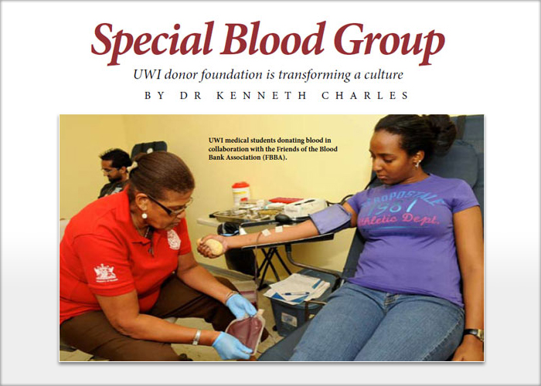
Figure 5.11. UWIBDF blood donation in collaboration with FBBA in 2012. Image from UWI Today, a monthly supplement in the Trinidad Guardian.

Attempts to donate without receiving chits or credits at the EWMSC blood donation centre presented ethical and organizational conflict with walk-in FRDs. UWIBDF members were frequently approached by relatives to direct their donations to specific patients. A protected channel to freely donate VNRD blood was needed. While lobbying for this, the UWIBDF turned its activities towards sensitization of medical students, health professionals and administrators. The UWIBDF was officially launched with commendation from PAHO at the EWMSC in October 2013. (Figure 5.12) Patronage of the organization was accepted by the Chancellor of The UWI who had served as Director of PAHO between 1993 and 2002, during which period he had advocated for a Public Health approach to the promotion of voluntary non-remunerated blood donation in the Caribbean region. [173]

Figure 5.12. Official launch of UWIBDF October 2013. Left to right Dr. Kenneth Charles, Chairman UWIBDF, Professor Sir George Alleyne, Chancellor of The UWI and Professor Samuel Ramsewak, Dean of the FMS, UWI St. Augustine Campus.

5.3.3.2. Sensitization of stakeholders
The researcher sensitized colleagues by sharing the background and aims of The UWIBDF at meetings of the Society of Surgeons, the Obstetric Society of Trinidad and Tobago, the Caribbean Association of Haematologists and Oncologists, the National AIDS Coordinating Committee, the Trinidad and Tobago Medical Association and the Caribbean Association of Medical Technologists. He also introduced voluntary non-remunerated blood donation including its history into year 1 of the medical curriculum and assisted students with blood donation practica during the PEC module. The community surveys helped sensitize the participating students to the extent of the problem and the university community was reached by poster presentations at campus activities (Figure 5.13).

- 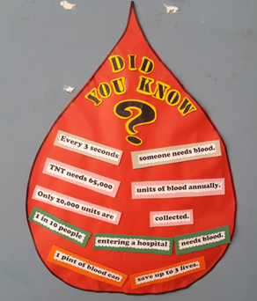 B. 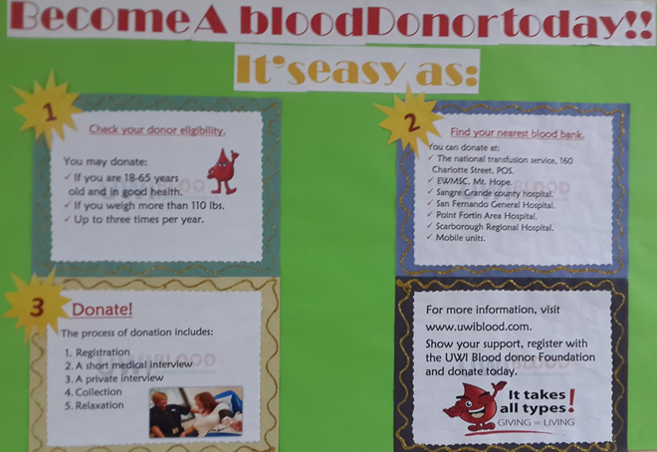 C. 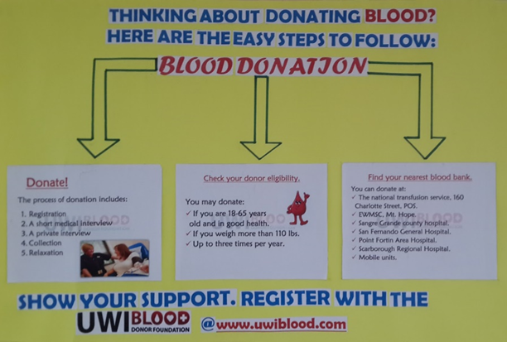
D 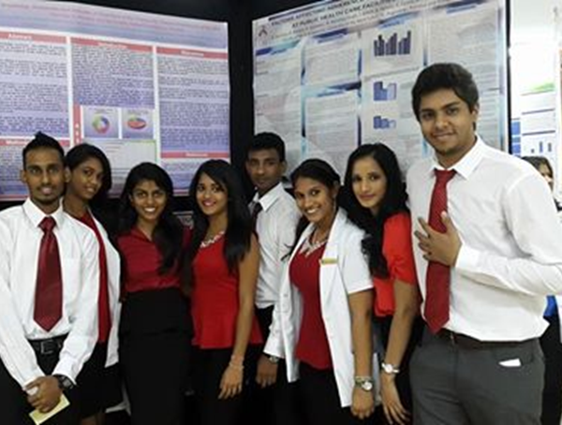 E. 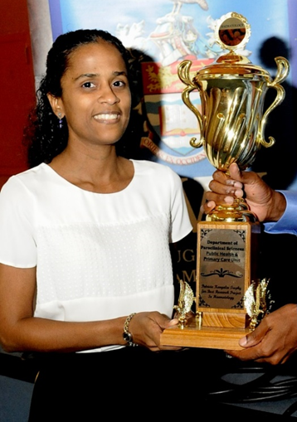 F. 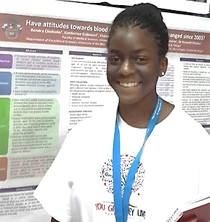
Figure 5.13. Sensitization within The UWI. A, B, C – Posters from Year 1 blood donation practicums. D. Year 2 Community Health research group and poster E. Group leader receiving challenge trophy for best blood donation project. F. Blood donation poster at campus exhibition.

5.3.3.3. Outreach outside The UWI
Through medical students’ contacts, the researcher made sensitization visits to secondary schools, places of worship and a military organization, TTO Coast Guard. (Figure 5.14)

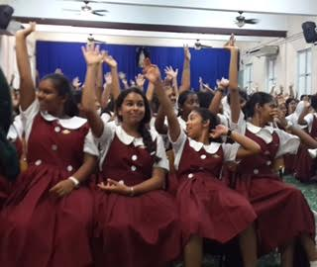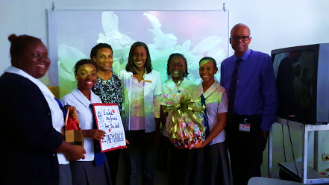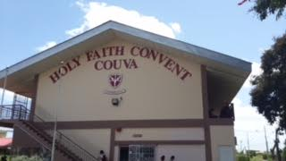
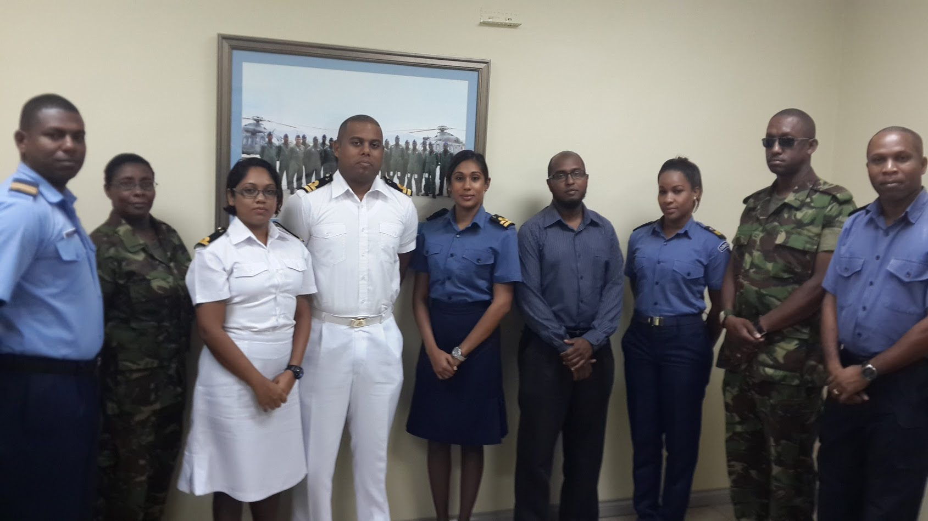
Figure 5.14. Outreach activities - schools, churches and military institutions.

5.3.3.4. Establishing the VNRD programme.
In 2015, UWIBDF collaborated with the NCRHA to establish a separate voluntary non-remunerated blood donation programme at the EWMSC blood donation centre. Blood drives were held every three-months on Saturdays when the centre was closed to the public. The researcher conducted specific training of the centre’s nurse phlebotomists for the project. NCRHA provided nurse phlebotomists from the EWMSC donation centre, security staff and laboratory services. The UWIBDF recruited donors, arranged appointments and issued donor information including eligibility criteria via its website. Pre- event publicity was generated using flyers, posters, social media (Facebook, Instagram, Twitter, WhatsApp) and e mail messages. WhatsApp, text and mobile phone messages were used to coordinate activities on blood drive days. UWIBDF volunteers, including students from secondary schools, university students, patients and well-wishers assisted with data collection, serving refreshments, providing information and general donor hospitality. (Figure 5.15)

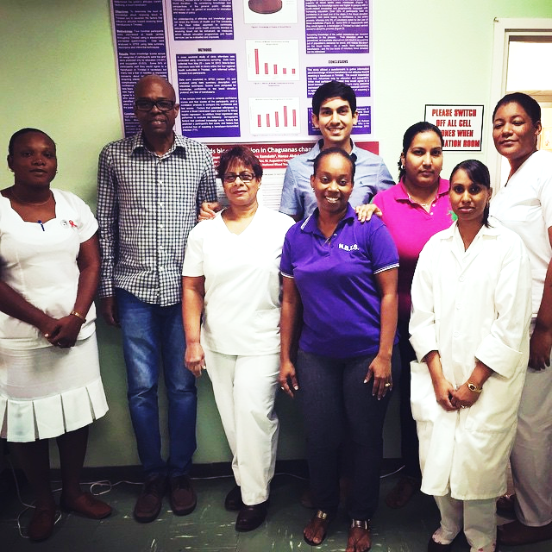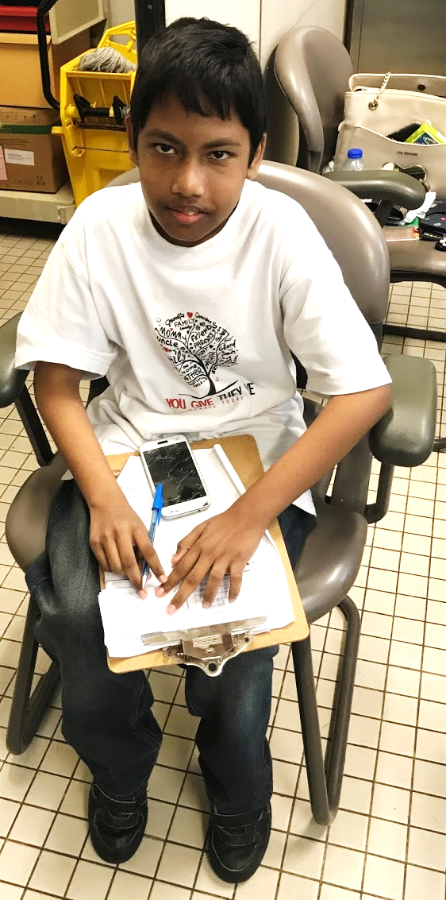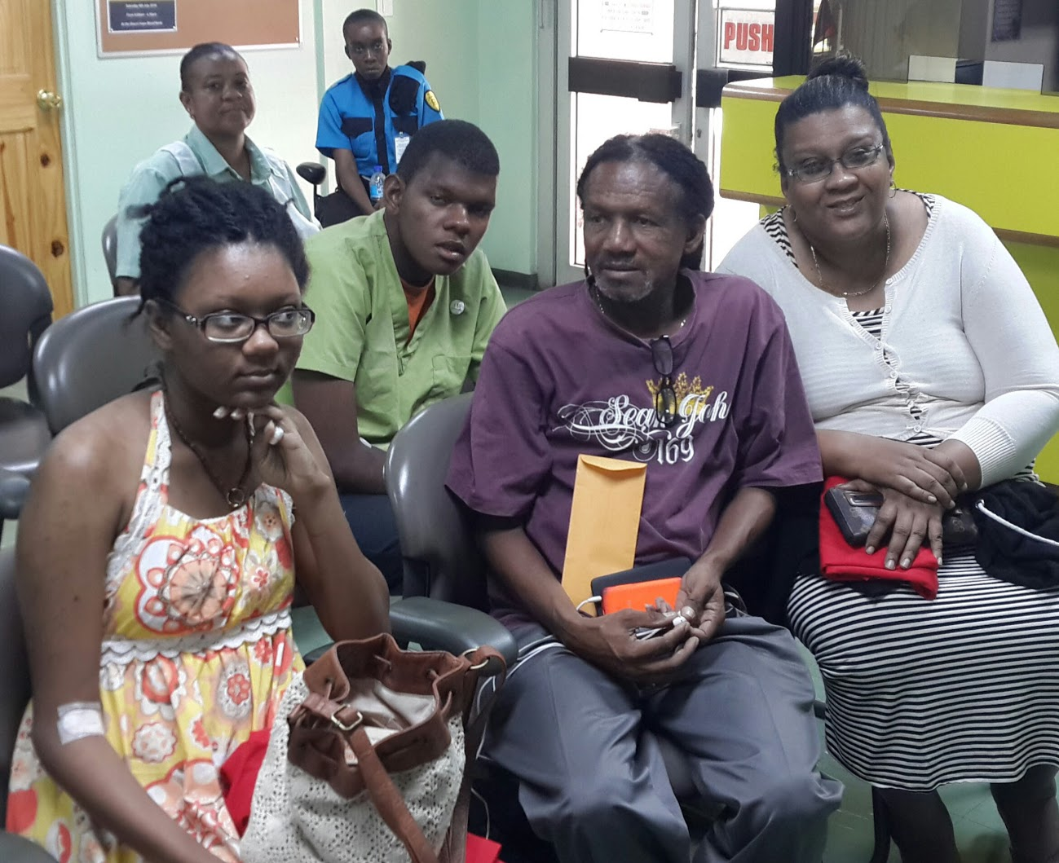
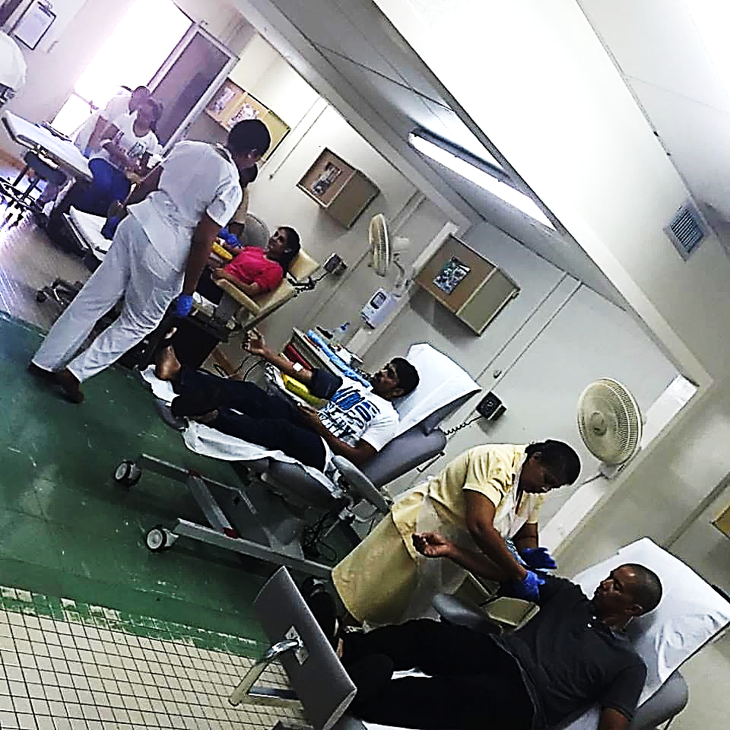
Figure 5.15. Blood drive activity. From left to right: the team of UWIBDF members and nurse phlebotomists, a thalassaemia major patient collecting data, a family of blood donors in waiting area, session in progress and technologist transporting blood to laboratory.

Figure 5.16 and 5.17 show participation by medical students, peers and relatives.

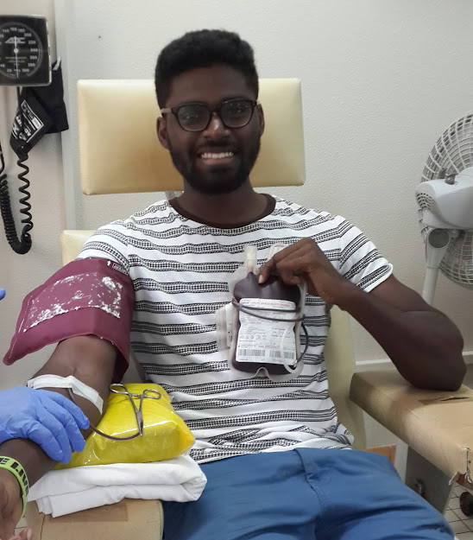
Figure 5.16. Medical students and peers donating at VNRD event #3. The 69 units of blood collected was a new record for the centre. All subsequent events surpassed this number, routinely exceeding 100.

Figure 5.17. Family participation in UWIBDF events. Medical student involvement encouraged participation by siblings, parents and peers. Blood drive paraphernalia by Year 2 medical students doing blood transfusion practicum in Professionalism and Ethics module.
In keeping with UWIBDF policy, blood donors received no chits or credits. All donations were screened for transfusion transmissible infections (Hepatitis B, Hepatitis C, Human Immunodeficiency Virus, Syphilis, Human T Lymphotropic Virus I/II and Chagas’ Disease) by Enzyme Linked Assay (ELISA) at the NBTS Headquarters in Port of Spain. Blood donors’ data and comments were collected manually on the EWMSC centre’s donor card, a UWIBDF donor card and on Microsoft Excel spreadsheets. After – event feedback including number of units collected, satisfaction surveys and a date for the next blood drive was provided online.
5.3.4. Monitoring and Evaluation of Outcomes
In the first four years, 951 units of blood were collected at the 12 VNRD blood drives held between March 2015 and November 2018 (Figure 5.18).
Figure 5.18 Number of units collected at 12 UWIBDF VNRD events

This represented 1.1% of units collected nationally over the period. The largest proportion (476 or 50%) of VNRD donations were made by persons aged 18- 24 and females (518 or 54%) Repeat donors (527 or 55%) outnumbered first time donors (FTD) (Figures 5.19, 5.20 and 5.21).
Figure 5.19. UWIBDF blood donors by age group

Figure 5.20. Gender of UWIBDF VNRDs.

Figure 5.21. Donation history among UWIBDF donors

Donor deferrals and initially reactive tests were lower than for FRD and remunerated donors in the national blood system (8% vs 43.6%, p< 0.0001 and 1.2% vs 3.04%, p < 0.05 respectively). Donor deferrals were mostly due to recent viral infections, antibiotic therapy, recent travel, tattoos and anaemia. Out of 12 initially reactive tests over the first 12 UWIBDF VNRD events, four were for anti-HCV, three for Syphilis, two HTLV I/II and three Chagas’ Disease. The UWIBDF/NCRHA collaboration increased the percentage of VNRD-sourced blood donations in TTO from 0% in 2014 to 1. 4% by 2017. Although the numerical impact of this increase was minimal, its societal and political impact was much greater. VNRD-only blood collection was given a boost in 2017 when three patients received HIV-contaminated blood components from a FRD recruited for cardiac surgery, generating high media publicity. (Figure 5.22)

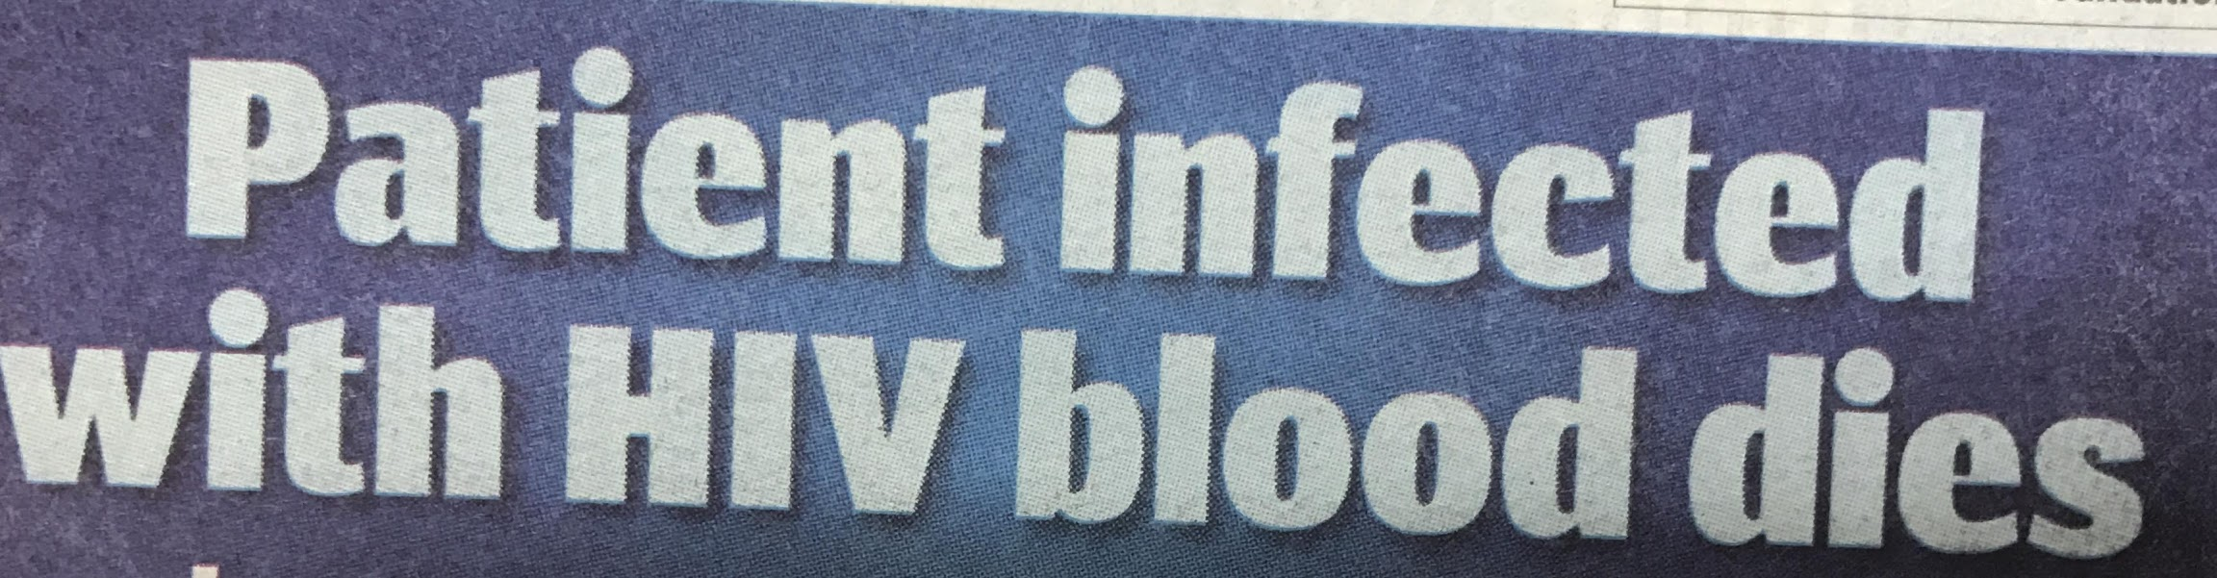
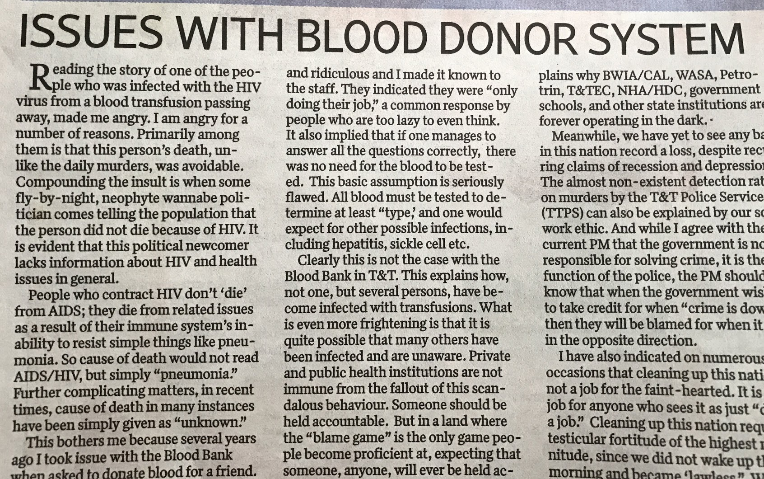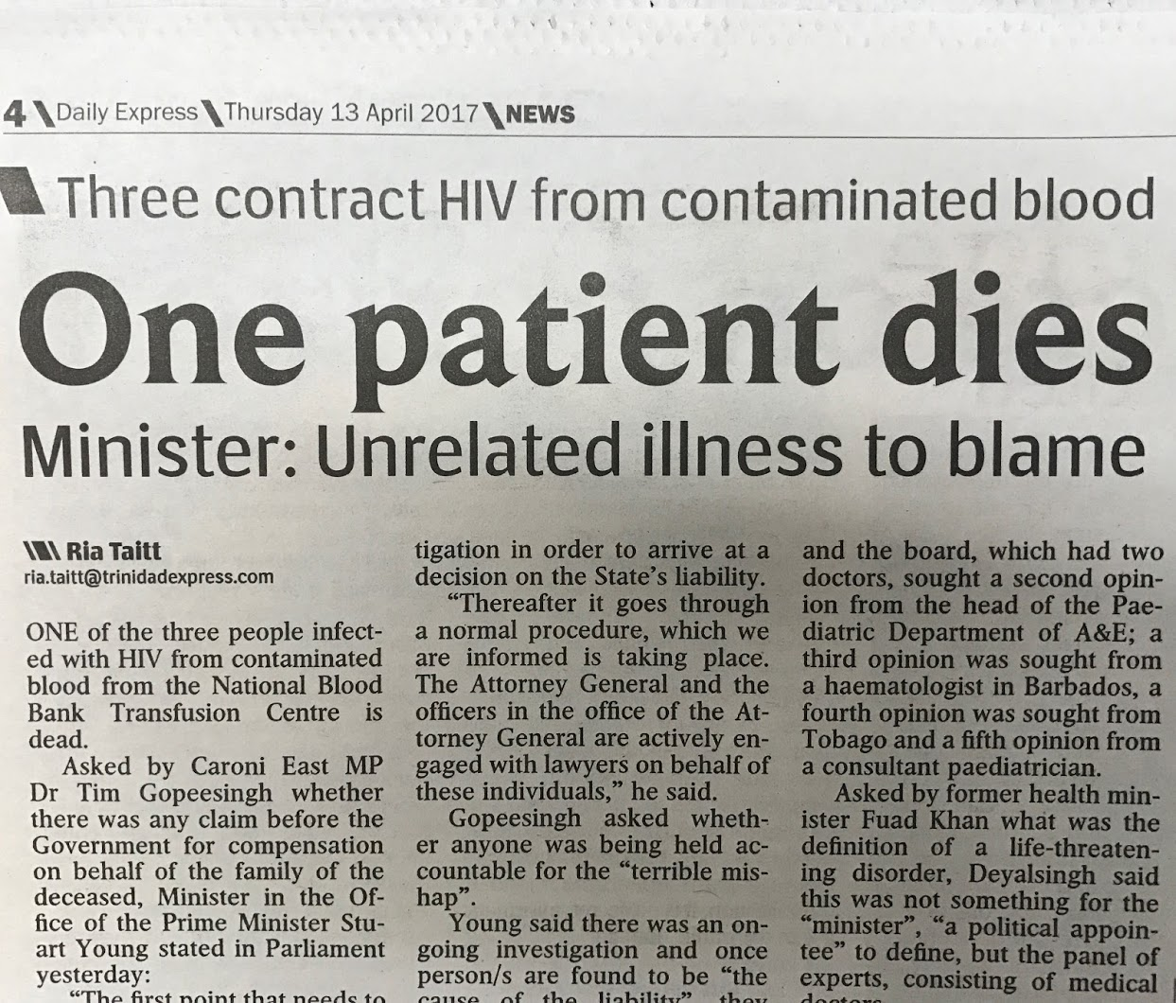

Figure 5.22. Newspaper report following contaminated blood transfusion. The donor was a FRD who received a ‘hidden’ payment.

In October 2018, Guardian Media Limited, one of TTO’s main media houses, declared its commitment to working alongside the UWIBDF in a public awareness campaign to help educate the public on the benefits of a purely VNRD system and the necessity of changing the culture of blood donation using its television, radio, newspaper and social media platforms. By this time, two visiting PAHO missions had examined the UWIBDF/NCRHA model and recommended its adoption at all fixed blood donation centres and use of a newly acquired mobile unit to collect VNRD blood outside the hospital setting. (Figure 5.23)

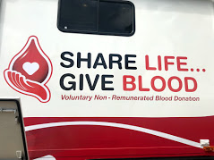
Figure 5.23. New mobile unit for VNRD blood collection in community

At its launch in October 2018, the MOH presented the unit to the FBBA and announced its decision to phase out ‘chits’ and ‘credits’ and achieve 100% VNRD over a 3-5 ear period. A National Blood Transfusion Committee with representatives from the MOH, RHAs, FBBA and UWIBDF was appointed to manage the transitioning process with a Communications Sub-Committee to coordinate messaging with the national media. In 2019, one family, lamenting the death of its matriarch from haemorrhage at a public hospital of the NWRHA, placed blame on the continuing ‘chit’ system and called for its discontinuation in a letter to the Trinidad Guardian (Figure 5.24). To the researcher’s knowledge, this was the first time that the system for blood collection and distribution rather than participating health care professionals and institutions was identified as the root cause of blood unavailability, giving a boost to the drive for 100% VNRD.

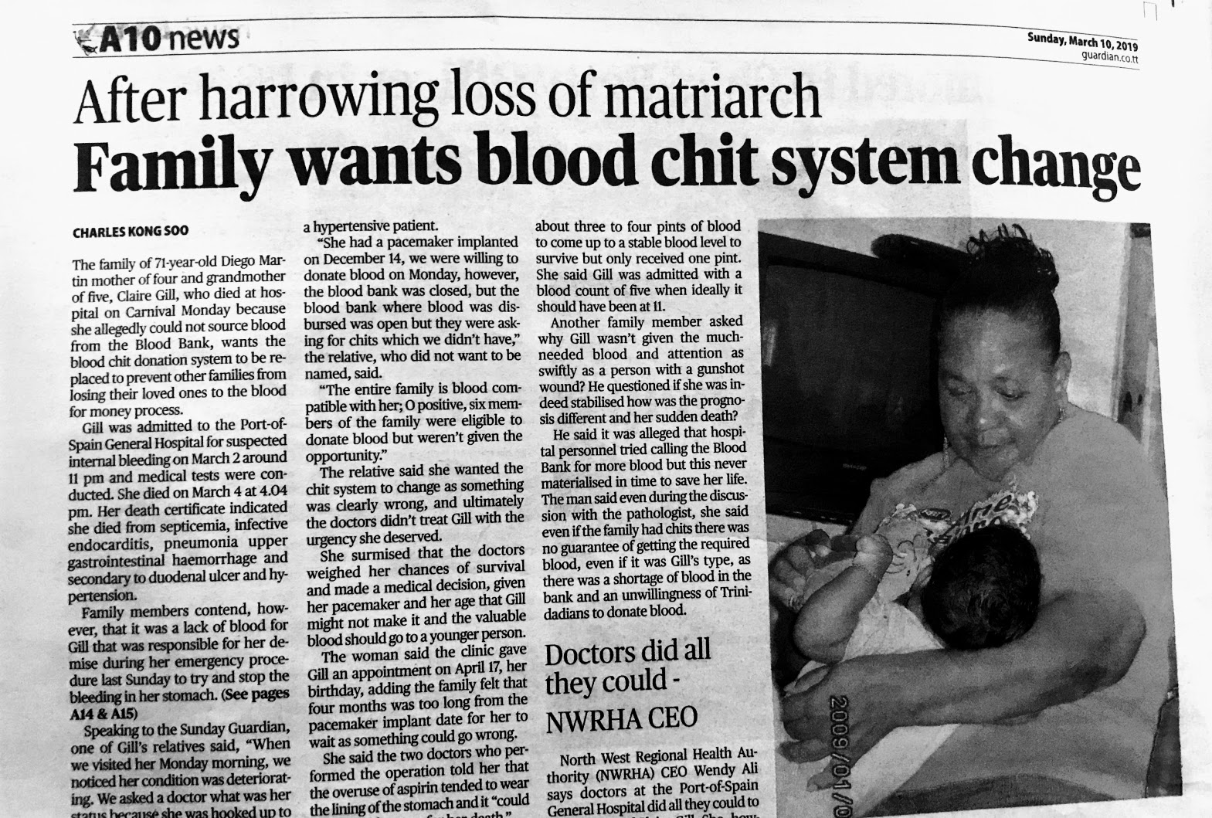
Figure 5.24. A change in the national narrative. Trinidad Guardian, March 2019. A family advocating removal of the ‘chit’ system foloowing MOH declaration of support for VNRD-based system.

In the same year, management of the mobile unit was removed from the FBBA to the NWRHA, essentially from non-governmental to state management. However, it continued to visit the same locations as the FBBA and apply the same system of credits for reclaim by voluntary donors. Two further KAP studies by medical students supervised by the researcher showed acceptability of exclusive VNRD in two generational groups but the need to develop a social interface between the transfusion service and the community to bridge the gap between development index and % VNRD.
Table 5.6. KAP studies after MOH declaration of 100% VNRD
Study | Description
19. | Title: Attitudes and awareness of voluntary non-remunerated blood donation in two generational groups in Trinidad and Tobago.  Authors: Kassie R, Kemp I, Khan T, Kissoon A, Kissoon Q, Kissoon V, Charles KS  Method: A questionnaire-based, cross-sectional, descriptive survey was administered to two conveniently selected samples from two groups, namely 18-30 and 45- 60- year old to assess current knowledge, attitudes and practice and acceptability of voluntary non-remunerated blood donation six months after plan for 100% VNRD was announced.  Main findings: Out of a sample of 600 participants, 38% had previously donated blood 66.5% of whom had served as family replacement donors. The proportion of donors was highest among Afro-Trinidadians (45%), Christians (39%) and persons with tertiary level education (37%). Percentage of donors was higher among employed persons than students (43% vs 27%, p < 0.001). When the 18-30 and 45-60 age groups were compared, the most common reasons for not donating blood in the past were never having thought about it (31% vs 43%, p < 0.001), not meeting the requirements (27% vs 23%, p = 0.258), fear of needles (21% vs 23%, p = 0.554), not having the time (21% vs 8%, p < 0.001) and being unaware of the blood donation centre location (17% vs 7%, p< 0.001). Median knowledge score was unsatisfactory (2/8, satisfactory = 5/8) in both groups and there was no difference in attitude scores (53.3 +/- SD 6.2 vs 51.4 +/- SD 7.2, p = 0.448, positive = 53%) between them. More than half of participants in both groups did not know what type of blood donation system existed at the time of survey (51.3% and 52.0%, p = 0.667). Only 8.7% of participants had heard about the Ministry of Health’s plan but the majority (50.7%) thought it would be successful. In fact, 76% of 18-30 year olds and 53.3% of 45-60 year olds (p < 0.001) intended to donate in the future. The main motivators to encourage future donation by non-donors were information about the blood stock (66.2%), closer blood drives (63%), information about how blood is used (62%) and shorter waiting times to donate (51%).  Conclusion: The survey revealed severe blood donation knowledge deficits but acceptability of voluntary non-remunerated blood donation in both age groups. The national information campaign must sensitize the public to the Ministry of Health’s voluntary non-remunerated blood donation initiative, provide blood donation information, explain the demerits of the current system and highlight the benefits of truly altruistic blood donation. Access to blood donation and efficiency must be improved to recruit new donors.
20. | Title: Follow-up study of knowledge, attitudes and risk perception surrounding blood transfusion in Trinidad and Tobago and de novo study in the Bahamas.  Authors: Bain T, Baksh H, Beharry T, Bernard A, Bernard C, Bhagoutie S & Charles KS.  Method: Online, questionnaire-based. Snowball sampling.  Main findings: Four hundred and fifty- three (453) responses were obtained from Trinidad and Tobago and 101 from the Bahamas. Objective knowledge and positive attitudes were high (75.5% vs 80.2%, p < 0.001 and 96.6% vs 100%, p < 0.001) relative to the percentage of donors (16.1% vs 43.6%, p < 0.001) in both countries). A substantial proportion of respondents held the perception that the local blood donation system was safe or very safe (26.4 and 61.4%, p < 0.001) that was linked to the misconception that the prevalent method of blood donation was voluntary non-remunerated (27.8 and 51.4%, p < 0.001). Concerns about receiving blood were underpinned by mistrust of transfusion-related procedures.  Conclusion. A social interface to transfer information between blood transfusion services and the community could encourage voluntary non-remunerated blood donation and reduce concerns about receiving transfusion.

5.3.5. Summary and conclusion. A university-led collaboration based on research, education, outreach, convenience and a strong interface between donors and the transfusion service generated a pool of predominantly young, female and repeat VNRDs. It utilized existing infrastructure and therefore derived little additional cost to the health system.

5.4. Action Cycle III: Blood donation during the COVID-19 pandemic
5.4.1. Introduction. In late 2019, a coronavirus that caused severe respiratory illness and death was reported in Wuhan, China. It proved highly infectious and in March 2020, the WHO declared the coronavirus 19 (COVID-19) pandemic. [174] By this time, the organization had issued general guidelines for protecting the blood supply during an infectious disease outbreak. [175] Globally, health care systems were impacted by lockdowns, travel restrictions, institutional closures and imposition of mitigating measures to prevent spread of COVID-19. Elective procedures were curtailed and intervention reserved for emergencies only. Considering the theoretical risk of transmission by transfusion and predicting a severe impact on the blood supply due to reduced donations, WHO issued interim guidance advising member countries to augment donations from existing donors by effective communication, convenience (appointment and extramural collections) and institute measures such as social distancing, hand hygiene, protective equipment, avoidance of crowding to reduce transmission at blood donation venues. WHO assumed that although the demand for blood and components for elective surgeries and non-urgent clinical interventions decreased, blood transfusions would still be necessary for emergency situations such as trauma, post-partum haemorrhage, severe infant anaemia, blood dyscrasias, and urgent surgeries. [176]. The anticipated decrease in blood donations was observed in both developed countries with VNRD-based services and developing countries that rely on hospital – linked FRDs. [177 -180]. Apart from physical restrictions, fear of contracting COVID from donating emerged as a major reason for abstention from blood donation during the crisis. [181].
Trinidad and Tobago recorded its first case of COVID-19 in March 2020. Almost immediately, the government implemented lockdowns, social distancing and closure of institutions. The health sector response included cancellation of all but emergency procedures. Blood donation continued as an essential activity. Simultaneously, the MOH, issued a statement to encourage VNRDs and avert blood shortage. [182] FRD and remunerated donor recruitment continued at hospital-based centres and on the mobile unit. The UWIBDF VNRD programme continued at the EWMSC. TTO’s national response led to initial containment of COVID-19 transmission that was commended by international organizations. [183]
This action cycle compared the impact of COVID-19 on VNRD, FRD and remunerated donations at the EWMSC and nationally. Finally, it summarizes the MOH/UWI response to the performance of the UWIVNRD programme during the COVID-19 pandemic.
5.4.2. Look: Gathering data. Data from donor records and statistics from hospital-based blood donation centres and blood bank laboratories, mobile unit and UWIBDF for the periods 1st January 2019 to December 31st 2020 were collected and analyzed by the researcher. Donors were classified as FRD, remunerated or VNRD. VNRDs were further sub-classified by age, gender, donation history (first-time or repeat). Chi square was used to determine significance of associations and logistic regression for inferential and correlation analysis. p < 0.05 was used to define statistical analysis. The researcher also supervised a KAP survey surrounding blood donation during the COVID-19 pandemic and compared data from two VNRD blood drives conducted before and after implementing its recommendations.
Table 5.7. shows the demographics of VNRDs participating in three UWIBDF blood drives at the EWMSC in 2019, immediately preceded the arrival of COVID-19 in TTO. After five years the blood drives had become an extremely efficient with all supporting operations working in tandem. Familiarity between donors and staff increased and the EWMSC centre became the UWIBDF donor home.
Table 5.7. UWIBDF VNRD Blood Drives for 2019
BLOOD DRIVE # 14 15 16

DONATIONS (No.) 118 96 128
GENDER
Male (%) 36 45 35
Female (%) 64 55 65
AGE (%)
18-25 47 42 42
26-40 44 48 43
41-65 9 10 15
DONATION HISTORY
First time (%) 39 34 30
Repeat 61 66 70
DEFERRALS (%) 8 20 7
TTI (%) 0.8 2.0 1.5

5.4.3. Think: Devising strategies to maintain VNRDs. These ensured adherences to WHO recommendations for blood donation during the pandemic, monitoring and comparing outcomes relative to FRD and remunerated donations.
5.4.4. Act: Implementing strategies for VNRD donations. This required providing additional space for conduct of blood drives, assessing its effectiveness and implementing interventions for improvement.
5.4.4.1. Collaboration with the mobile unit. After the first case of COVID-19 was reported in TTO health system changes were almost immediately implemented including closure of educational institutions, restrictions on public gatherings and social distancing. Elective surgeries were cancelled at public hospitals in anticipation of a predicted blood shortage. However, FRD and remunerated donations continued as an essential activity to support emergencies. UWIBDF collaborated with the mobile unit, now operated by the NWRHA, to allow social distancing during its blood drives. WHO guidelines for collecting blood in the pandemic [176] were observed. The mobile unit was parked on the EWMSC compound in close proximity to the donation centre and the blood bank laboratory. All donated blood was processed at the EWMSC laboratory and screened for TTIs at CL. The characteristic of donors at the first two UWIBDF/mobile unit blood drives under COVID-19 restrictions are shown in Table 5.8.
Table 5.8. Donor characteristics at first two COVID blood drives
BLOOD DRIVE # 17 18

DONATIONS (No.) 63 69
GENDER
Male (%) 42 45
Female (%) 58 59
AGE (%)
18-25 33 31
26-40 52 55
41-65 15 14
DONATION HISTORY
First time (%) 43 34
Repeat 57 56
DEFERRALS (%) 8 9
TTI (%) 0.8 0

5.4.4.2. KAP study after two COVID drives. Findings and recommendations from the KAP survey conducted after two blood drives under COVID – 19 restrictions are shown in Table 5.9.
Table 5.9. KAP study of blood donation during COVID-19.
Study | Description
22 | Title: Knowledge, attitudes and practices of medical students surrounding blood donation during the COVID-19 pandemic  Authors: Bhola-Singh J., Bisnath S., Bissoon A., Boodram C., Buckradee A., Budhooram S., Bullock K., Burrows M. & Charles KS.  Method: Online, questionnaire-based survey. Snowball sampling of year 2 medical students and their WhatsApp contacts.  Main findings: Out of 323 participants, 28.5% were blood donors (75% UWIBDF VNRDs). Among donors, 28.5% had donated before and 6.5% during the COVID-19 pandemic period. All donors during COVID had previously donated. Most (93%) expected COVID to reduce blood donations. Fifty- four percent were aware of the first COVID blood drive and 51% of the second. Females and year 3-5 students were more likely to be aware of the drives (p < 0.05 for both). As many as 66.3% were unaware of COVID-mitigating measures employed at UWIBDF blood drives. Awareness of these measures was greater for Year 3-5 than Year1-2 students (43.4% vs 21.3%, p < 0.05). Fifty-seven percent of respondents were willing to donate during COVID-19 pandemic, 18.6% were ‘not sure’ of donating, while 24.5% were unwilling. The main reason for unwillingness was fear of contracting COVID-19 from donating (32.4%). As many as 93% of the unwilling would be encouraged to donate if safety measures were advertised and 89% if given more information about COVID-19. Social media was considered the most effective method for promoting donation during COVID by 96%.  Conclusion: Reassurance about the absent risk of contracting COVID-19 from blood donation delivered using social media could encourage greater participation in UWIBDF blood drives.

5.4.5. Monitoring the outcome of actions. All donations in the national programme, comprising FRD and remunerated donors and the UWIBDF programme with solely VNRDs were assessed for periods preceding and following the first case of COVID-19 in TTO.

5.4.5.1. National blood donations at in the six months following COVID compared to the
same period the year before. During these two periods, national arrangements remained unchanged with six hospital-based donation centres and the mobile unit collecting blood from FRDs and remunerated donors. The country’s first case of COVID-19 was reported on March 20th 2020 and the MOH launched its advertising campaign for VNRDs in the same month. A comparison of national blood donations for the six months following the first COVID to the corresponding period in the preceding year is shown in Figure 5. 25.

Figure 5.25. National blood donations for April – September 2019 and
April-September 2020.

Units

5.4.5.2. National donations six months preceding and succeeding first COVID case. When blood donations at all collection venues for the six months preceding and succeeding the first case of COVID were compared, they showed an initial fall in donations followed by an increase after the MOH’s announcement for increased VNRD then a decline to the pre-COVID levels (Figure 5.26).

Figure 5. 26. Donations for six months before and after first COVID case.
MU = mobile unit, CL = Central Laboratories, Port of Spain, SFGH = San Fernando General
Hospital, EWMSC = Eric Williams Medical Sciences Complex, SGCH = Sangre Grande
County Hospital, AFPF = Area Hospital Point Fortin, SRH = Scarborough Regional Hospital.

Units

Overall, total blood donations at 4/7 venues was higher for the six months following the first case of COVID-19 (Figure 5.27).

Figure 5.27. Total blood donations at seven venues for six-month periods before and after first COVID case. MU = mobile unit, CL = Central Laboratories, Port of Spain, SFGH = San Fernando General Hospital, EWMSC = Eric Williams Medical Sciences Complex, SGCH = Sangre Grande County Hospital, AFPF = Area Hospital Point Fortin, SRH = Scarborough Regional Hospital.

Interestingly, this resulted in a higher number of FRD and remunerated blood donations nationally in the six months after TTO’s first case of COVID-19 than in the six months preceding it. (Figure 5.28).

Figure 5.28. National FRD and remunerated donations for six-month periods before and after the first COVID case. Before = October 2019 – March 2020 After = April 2020-September 2020. More blood was collected after first case.

Units

5.4.5.3. Donor types at EWMSC in six-month periods before and after first COVID case. There was no significant difference for any donor type at the EWMSC centre between the two six-month periods (Table 5.10)
Table 5.10. Types of donation at the EWMSC donation centre for six months preceding and following first COVID case.
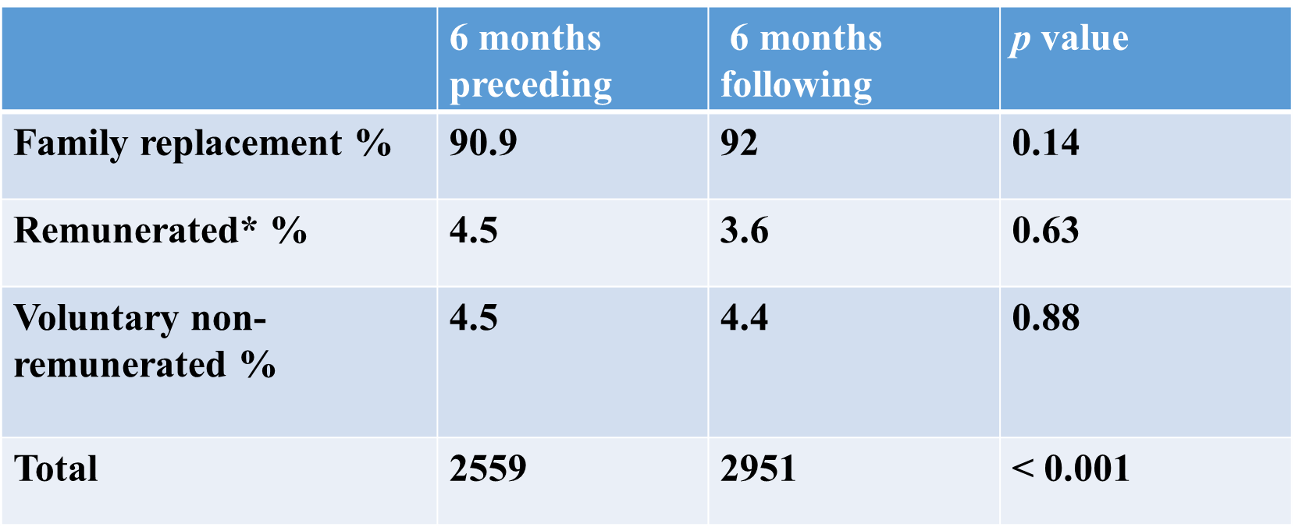
Figure 5.29. shows a reduction in the number of donations at two UWIBDF blood drives in the six months after COVID relative to the single drive held within the preceding six months.

Figure 5.29. UWIBDF blood drives before and during six months after first COVID case

However, the demographics of UWIBDF VNRD donors changed with a reduction in 18-25 year olds and a greater proportion of female and repeat donors (Table 5.11.)
Table 5.11. UWIBDF donor demographics before and during COVID
Variable | Pre - COVID | During COVID | p value
18-25 | 52% | 33% | < 0.05
Female | 54% | 58% | < 0.05
Repeat | 51% | 57% | < 0.05
5.4.5.4. Acting on KAP findings after second COVID blood drive. The KAP survey of FMS year 1-5 medical students after the second blood drive under COVID restrictions revealed the deterrents to donation displayed in Figure 5.30. Community transmission of COVID had not yet occurred when these drives were conducted. For the respondents who did not donate, fear of contracting COVID from the donation process was the main deterrent. Awareness of mitigating measures to reduce COVID transmission was low and most would donate if such information were available to them.

Figure 5.30. Factors that deterred medical students from donating during COVID

In response, reassurance that COVID is not transmitted by blood donation and a summary of mitigating measures to prevent transmission at blood drives were disseminated by social media prior to the third blood drive under COVID restrictions. Specifically, appointments were strictly adhered to and donors notified organizers of their arrival before being directed to either the mobile unit or blood donation centre. Masks, handwashing, temperature checks and avoidance of gathering were implemented at both sites. Donors were reassured that complied with World Health Organization and Ministry of Health policies. The effect of this intervention on two subsequent events is demonstrated in Table 5.12.

Table 5.12. UWIBDF VNRD donations after reassurance
BLOOD DRIVE # 18 19

DONATIONS (No.) 102 118

GENDER
Male (%) 43 38
Female (%) 57 62

AGE (%)
18-25 54 39
26-40 37 44
41-65 9 17

DONATION HISTORY
First time (%) 44 38
Repeat (%) 56 62

DEFERRALS (%) 8 9

TTI (%) 0 0.1

The increase in total VNRD donations following COVID reassurance and information is shown in Figure 5.31.

Figure 5.31. An increase in donations after COVID information and reassurance about mitigating measures at blood drives.
Figure 5.32. illustrates activity at UWIBDF blood drive # 19 at EWMSC blood donor centre and the mobile unit under WHO and MOH-approved conditions.
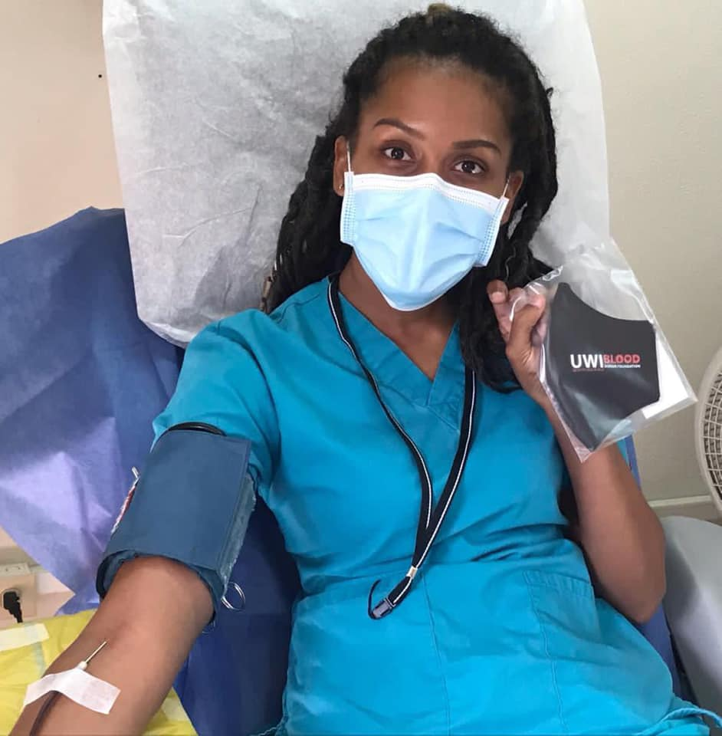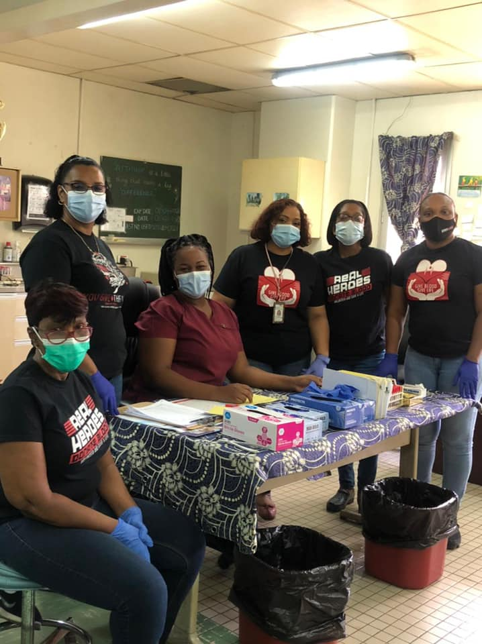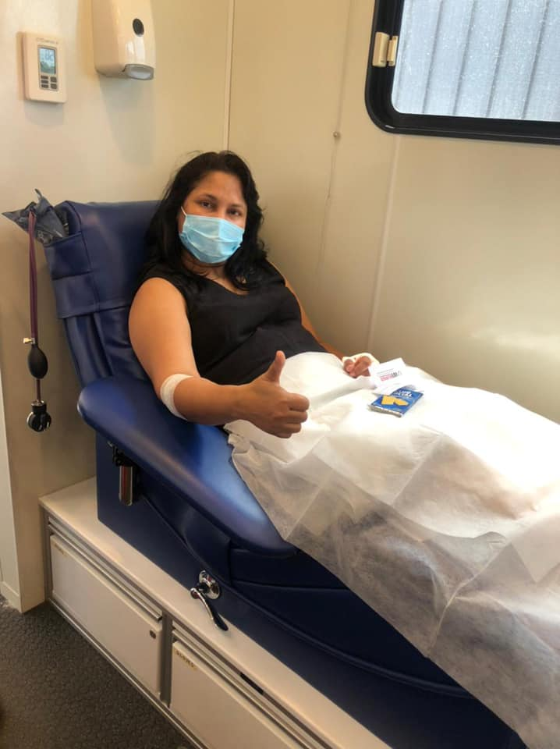
Figure 5.32. Blood donation during COVID pandemic at EWMSC and mobile unit.

Figure 5.33. shows donor feedback (n = 45) from blood drive # 19 regarding COVID-19 information.

Figure 5.33. How satisfied were you by the information you received about COVID before the blood drive? 78% of respondents were satisfied or very satisfied.

The demographics of VNRDs after potential donors were informed of mitigating measures and reassured that COVID is not transmitted by blood donation are compared to those before this intervention in Table 5.13.
Table 5. 13. Demographics of VNRDs before and after COVID reassurance and information.
Before After p value
Total 132 220 < 0.05
18-25 % 33 45 < 0.05
Female % 58 60 0.889
Repeat % 57 55 0.615

5.4.6. Evaluating the outcomes of action: The COVID-19 pandemic did not result in the expected fall in FRD and remunerated blood donations nationally. This suggests that coercion guaranteed a fixed proportion of FRD and remunerated donors that, although inadequate, was not deterred by barriers to donating blood in this setting. It may also reflect differing perceptions of emergency and elective surgeries among the public and health providers. Collaboration with the mobile unit allowed implementation of social distancing without reducing capacity. A reduction in donations in the 18-25 age group was related to closure of educational institutions and fear of contracting COVID from donating blood. Reassurance about the non-transmissibility of COVID by blood donation and mitigating measures to reduce transmission using social media increased donations in this group to pre-COVID numbers.
5.5. Summary and conclusion. With modified arrangements for convenience and information, The UWIBDF programme remained a reliable source of blood during the COVID-19 pandemic.

CHAPTER 6: DISCUSSION
6.1. Introduction. This work contributes to the literature on how to develop blood transfusion services in low and middle income countries by describing historical and social antecedents to a replacement blood donation system, details of its inner workings and a cost effective approach to promoting voluntary non remunerated blood donation. The aim of the project was to devise a model for developing a voluntary non-remunerated blood programme in a former British colony. This was achieved over a long period during which the researcher operated as facilitator of action research in two professional/academic positions – Director of the National Blood Transfusion Service, Senior Lecturer in Haematology - by participants directly affecting or affected by the problem of a FRD-based blood donation system in TTO. The combined approach of research, sensitization and collaboration was used to institute change in a closed setting and monitor its successful outcomes relative to the pre-existing system. The methodology has been accepted by key decision-makers for application throughout the health system to achieve exclusive voluntary non-remunertaed blood donation in TTO.
The aim of the research was achieved by exploring several key objectives:
Objective 1 was to examine the history of the population and blood transfusion in Trinidad and Tobago. This revealed an original Amerindian population that was decimated and replaced by African and Indian labour forces under Spanish then British colonialism. The influence of American, Canadian and British multinational oil companies replaced that of the colonial state after independence. As the society evolved along a class structure determined by colonialism, blood donation centres were placed in urban centres of administration and foci of the oil industry. Blood donation practice followed two pathways – a family replacement system that originated in Europe in the early 1900s and a family credit system that was tried in America in the 1970s. Path dependency has sustained this dual system as structures and processes have become aligned to maintain them.
2. Objective 2 was to identify events that prevented uptake of voluntary non-remunerated blood donation in TTO. This was achieved by examining various historical points of potential transfer of transfusion technology in the colonial period and organization of the blood transfusion service after independence. The basis of extraction colonialism did not favour transfer of technology to TTO when early transfusion experiments were undertaken in Great Britain from the 17th century up to World War I. TTO members of the BWIR did not participate in blood donation during World War I when advances were being shared among British, Canadian and American surgeons and soldiers. There was no wartime transfusion experience to introduce to civilian practice post-war. In the interwar period, the Moyne Commission provided a blueprint for development that did not include blood service development. During World War II, community blood donation was not achieved in preparation for German air raids. TTO therefore lost out on the strong social interface that was created between blood transfusion services and communities in this period.
3. Objective 3 was to describe the consequences of replacement blood donation in TTO. This objective was achieved by analyzing PAHO blood bank data from 2000 to the present. Replacement donors constitute at least 80%. Total donations have remained at an insufficient plateau of 20,000 units per year for the past 20 years demonstrating the impossibility of expansion within this model. Similarly, donor TTIs or deferrals have not changed over the decades demonstrating unsafety and inefficiency. Triangulated information from KAP surveys shows high willingness to donate blood but an established system that mitigates against regular, voluntary donation. Donor ownership combined with clinician fear of non-availability in an emergency facilitate stockpiling, wastage and unnecessary transfusions. FRDs develop a donor role that perpetuates replacement donation.
4. Objective 4 was to analyze attempts to comply with international recommendations for blood safety and adequacy. This was achieved by examining PAHO/WHO resolutions from 1975 which have consistently recommended voluntary non-remunerated blood donation and been co-signed by all member states. Addressing this central recommendation of converting from family and paid to voluntary non-remunerated blood donation was attempted for the first time between 2005 and 2010 in TTO. Despite policies and regulations at the administrative level, that attempt was curtailed by unpreparedness of important stakeholders, miscommunication, media reaction and the absence of a VNRD pool to buffer a fall in donations while transitioning.
5. Objective 5 was to describe the establishment, development and impact of a voluntary non-remunerated blood donor programme. This included processes for heightening the prominence of blood donation and transfusion in the medical curriculum and throughout the university, outreach to accessible institutions and the delivery of a successful VNRD programme in collaboration with a RHA. The programme survived the stress test of the COVID-19 pandemic gaining acceptance as The UWI’s policy and the MOH’s model for national application. One major, impactful outcome was the establishment of a postgraduate programme in Haematology and Blood Transfusion by The UWI at the request of the MOH.
6.2. Discussion of historical background
Nothingness was an important concept for Jean-Paul Sartre, one of the greatest philosophers of our time. He believed things that are absent are as important as those that are present in defining people and how they see the world. [184, p 19] TTO society developed in the absence of blood transfusion experiments in the 17th century leading up to the World Wars, blood donation during World War I, blood donor organizations in the interwar period, community blood donation during World War II or a national blood service based on VNRDs thereafter. Demystification of blood has not occurred. The intimate social interface between blood transfusion services and communities created in Britain, America and Canada in preparation for German air-raids during World War II was sufficient for the British Army Transfusion Service and the American military programme to airlift blood for overseas allied military personnel, obviating the need for community donations in the West Indies. [70-75] These wartime community blood donation programmes became national blood donor programmes in these countries after the war. In contrast, there was no blood donation programme in TTO following this war. Family replacement donation which had been abandoned as ineffective in Europe in the 1920s was introduced and later complemented by a family credit system that was discarded as unsafe in America in the 1970s. [103] This dual pathway for blood donor recruitment, superimposed on a social structure created by colonialism, has persisted and become entrenched, as institutions and processes have developed to maintain it. [83] Historical failure to develop a social interface between blood transfusion services and the community with its blood donors has bred mistrust, misinformation and lack of responsibility that have prevented uptake of voluntary non-remunerated blood donation despite high resources and education. The Moyne Commission’s low prioritization of blood transfusion continues as fragmented, hospital-based arrangements to meet individual needs predominate in TTO and other English Caribbean countries. Today, lingering mystery and unfamiliarity surrounding blood, low prioritization of the transfusion service and a poorly developed social interface between the NBTS and the community manifest as fear, anxiety and mistrust. Unfounded fear about donating blood contributes to blood shortage [158]. Poor knowledge of donor eligibility criteria contributes to unacceptably high deferral rates [159]. Fears about receiving blood concern most recipients. Surgeons’ fear of blood loss encourages stockpiling and wastage. The media reports sensationally on events relating to blood. As a result, governments fear the political consequences of tampering with the blood donation system.
6.3. Discussion of Action Research
Although the first cycle of action research led to changes in policy at the administrative level, success was short-lived as they were not fully understood or accepted by important stakeholders whose everyday lives are directly affected by the problem. Inclusion of medical students, the community and blood donors in the second cycle revealed willingness to be VNRDs but limitation by an established system that allowed only involuntary blood donation. Compliance with the social norm has resulted in predominant replacement donation, infrequent on-demand donations, fear, development of a FRD identity, acceptance of inconvenience and a low demand for information from the transfusion service. Research, sensitization and non-conforming action generated a pool of repeating VNRDs and a propitious conjuncture that emboldened decision-makers to comply with PAHO standards for blood safety and adequacy. The model survived the stress test of the COVID-19 pandemic to demonstrate its robustness and suitability for application elsewhere. Education and quality of life are important variables for calculating social capital and development index both of which are linked to blood donation behaviour. TTO’s adult literacy rate of > 95% reflects mandatory primary school attendance but functional illiteracy is known to be high. Incorporation of blood transfusion into the educational curriculum and at the interface between the transfusion service and a closed community has bridged the disparity between social capital and blood donation in the closed setting. In as far as living standards are concerned, TTO’s high GDP per capita reflects oil and natural gas income but maternal mortality, infant mortality, income inequity, % living below the poverty line and crime are higher than countries with equivalent resources. The action research model used in this research could be applied to bridge the gap between GDP and other social indicators, bringing benefits outside the blood transfusion service.

6.4. Success of the UWIBDF/NCRHA collaboration
Failure of administrative interventions to change the blood transfusion system in 2010 highlighted the role of education in the change process. Success followed transitioning of the researcher from an administrative to an academic role. Students of The UWI were a readily accessible group for assessing blood donation knowledge, attitudes and practice. Their youth, fitness, availability, likelihood to repeat donation and potentially long donation careers made them ideal targets for initiating a voluntary non remunerated blood donor programme. [187] Because selfless giving is a pillar of all major religions - Christian charity, Islamic Sadaqah and Hindu Dharma - targeting them through faith-based organizations proved a useful approach to inspiring voluntary non-remunerated blood donation. Recent emergence from their communities and secondary schools made them highly suitable ambassadors for research and sensitization activities. First-hand knowledge of the need for a reliable blood supply allowed them to derive self-satisfaction from contributing to correction of the research problem. [188] Modification of the curriculum provided continuous reminders of the national need throughout their student careers. However, their superior knowledge may not have borne any relation to donation practice without a separate approach to convert knowledge into actual donation. [189] This was achieved by collaboration, effective communication and provision of donor-friendly settings.
A previous study of students at one Caribbean university showed variation in psychological determinants of blood donation behaviour with the donation culture (FRD or VNRD) to which they had been exposed. [190] Application of the Theory of Planned Behaviour (TPB) in another study showed positive attitudes to blood donation among medical students prior to their first donation even in a predominantly FRD-based system. [191] This research demonstrated that positive attitudes could be channelled into VNRD behaviour even in an FRD-based system and confer a commitment to altruism indistinguishable from VNRDs in developed countries.
The Blood Transfusion Institute of Serbia (BTIS), used education, sensitization and mobilization of medical students at the University of Belgrade (UB) to expand the VNRD pool and improve safety of a city’s blood supply. [192] If the same approach were adopted in TTO, blood donation behaviour among medical students of The UWI could influence practice beyond their area of activity. The UWIBDF programme could be used to expand the VNRD pool outside The UWI. In fact, average donations per UWIBDF blood drive increased more rapidly in its first three years than in the UB voluntary blood donor programme (39, 43 and 46 for UB compared to 35, 87 and 102 for UWIBDF). Compared to Belgrade, where there was a 17.9% increase in donations per drive over the three-year period, the corresponding increase for UWIBDF was 189% showing that it was far more effective in encouraging VNRD behaviour.
Positive attitudes to blood donation among medical students increased after inclusion of specific blood donation education in the medical curriculum. A separate approach of providing information, a donor-friendly environment, personal contact and positive feedback helped to convert pre-existing knowledge to actual voluntary non-remunerated blood donation. Altruism for all is the principal motivator for UWIBDF VNRDs and potential deterrents to future donation are different from FRDs. Practising voluntary non-remunerated blood donation influenced the psychology of UWIBDF donors and their contacts toward regular and repeated donations. Delivering appropriate information and facilitating action motivated two historically poor-donating groups – females and 18-25 year olds. The UWIBDF VNRD programme appealed to women who are more willing to participate in altruistic than transactional blood donation. [193]. The proportion of female donors in the programme more closely resembles that seen in developed countries with 100% VNRD [194, 195] than other developing countries with predominant replacement donation [196, 197].
6.5. Strategic plan for transitioning to 100% VNRD in TTO
Coming out of historical analysis of VNRD-based blood services in developed societies, the challenges facing blood services in SSA and successful approaches for transitioning to exclusive VNRD, the researcher has proposed the following action plan for achieving 100% VNRD in TTO. It is a hybrid of the approaches used in Nicaragua and Ghana and utilizes information gained from 22 KAP studies conducted in this research. It utilizes existing infrastructure and therefore minimizes cost to the health system.
- Governance issues. Review and updating of National Blood Transfusion Policy and Technical Guidelines 2007. Recommencement of process for specific blood bank legislation.
- Estimation of the country’s blood needs.
- Replication of the UWIBDF/NCRHA collaboration at all RHA donation centres. Medical students of the FMS rotate through all RHAs. UWIBDF members will initiate this programmes which will be managed in collaboration with the UWIBDF.
- Separate classification and reporting of VNRDs to PAHO.
- Electronic management system for registering VNRDs linked to NBTS, RHA blood centres to monitor and respond to blood needs. In the transitory period, a VNRD will be any person who donates blood voluntarily without accepting a ‘chit’ or ‘credit’.
- Messaging. This will fill knowledge gaps and correct misconceptions identified in KAP surveys including:
- Explanation of the meaning of a voluntary non-remunerated donor
- Different types of blood donor
- Donation systems and blood supply in different countries
- How much blood is required to meet the needs of TTO
- How much blood is collected annually using the current system?
- How blood is made
- How quickly it is replaced by the body after a donation
- The process of blood donation
- Use of sterile equipment to remove risk of contracting HIV from donating
- Blood donor eligibility criteria
- Explanation of common deferral criteria – tattoos, travel, recent viral infections
- Eligibility of hypertensive, diabetic and menstruating females to donate
- Separation of donated blood into components
- Storage and shelf-life of blood components
- Common situations in which blood is used eg. SCD, thalassaemia, cancer, pregnancy
- Interval between blood donations and possible donation frequency
- The society’s moral responsibility to provide for those in need
- Explanation of the window period and importance of truthfulness at interview
- The risk posed to the whole society by paying blood donors
- COVID-19 information including mitigating measures
To counter the predominantly negative media reports to which the public has been exposed, message framing will be deliberately positive eg. ‘you can give blood if your tattoo is more than one year old’ rather than ‘you should not give blood for a year if you have had a tattoo’ or ‘your donation will save the lives of children with sickle cell disease and thalassaemia’ instead of ‘children with sickle cell disease and thalassaemia are dying because of blood shortage’ and ‘collecting 40,000 units of blood per year will cover all the needs of the population including emergencies’ instead of ‘there is a national shortfall of 20,000 units’. [198] Messaging will be centrally coordinated by MOH Corporate Communication and disseminated through UWI Marketing and Communications Department, UWIBDF website, RHA Corporation Communications Units and media houses. Although early KAP studies suggested preference for a doctor using conventional electronic and print media for messaging, this shifted with the recent explosion of social media. All media - -radio, television, newspapers, posters, flyers, loudspeakers and face to face conversations will be supplemented by social media to reach all sociodemographic groups. Community organizers, religious leaders, blood donors, blood recipients, teachers, popular local personalities will be trained to adapt and spread the message. Doctors and medical students will help in training messengers.
- Target areas and groups. Blood donation activities will be psychologically delinked from the hospital setting and promoted in everyday settings for healthy persons. Community VNRD organizations will be formed in schools, religious organizations, sports clubs and other groups. Through cooperation with the Ministry of Education, blood donor education will be started in pre-schools and primary schools using trained messengers and age-appropriate material such as toys, puzzles, quizzes, drawings and games to introduce the concept. Workplaces will be included through cooperation with the Ministry of Labour, employers and trade unions. Selected employees will be trained as organizers and messengers. In addition, promotional activities, flyers and posters should be used to reach the community at popular places of social gathering such as community centres, churches, mosques, temples, gymnasia, malls, petrol stations, banks, shopping centres, public utilities offices and sporting venues. Information will be shared with prospective donors in the waiting area of blood donation centres using lectures, short videos, posters and flyers. Converting existing FRD and remunerated donors to regular, repeated VNRDs will be done through a separate programme at blood donation facilities that includes reminders, extended opening hours, shortened waiting times and information about how blood is used. Residences and homes will be reached using posters, flyers and door to door interviews to support radio, television, newspapers and social media. Awareness of eligibility criteria will be increased and unnecessary deferrals reduced by making the pre- donation interview form available online. Because of the urban location of donation centres, the large rural population (estimated to be 91.6%) has been less indoctrinated into the local blood donation system and are relatively low-risk for HIV transmission. [198] Such communities will be preferentially targeted for recruiting new VNRDs by increasing mobile collections. Each RHA will establish its own mobile unit to collect VNRD blood.
- Staff training to increase capacity and reduce deferrals. Training of donation centre staff in phlebotomy and donor eligibility criteria will be conducted to reduce unnecessary deferrals. In addition, junior clinicians will be trained and assigned to provide coverage for emergencies and to monitor deferrals at each centre.
- Hospital-related activities. The role of Hospital Transfusion Committees (HTC) to oversee development of Maximum Surgical Blood Ordering Schedules, appropriate blood use, haem vigilance and cold chain maintenance will be increased to include monitoring of donation centres. These will report directly to RHA administration through the NBTS Director to the MOH on number of donations, type of donations and adverse events.
- Care of seropositive donors. Donors confirmed positive for HIV, HBV, HCV or Syphilis will be referred to infectious disease services and HTLV positive donors to haematology services in RHAs.
- Preventing acute blood shortage during transitioning. To prevent an acute fall in donations while transitioning, The Komfo Anokye Teaching Hospital approach of encouraging existing FRDs to donate to maintain the hospitals’ supply rather than benefit a specific beneficiary will be used. [96] However, such converts will be considered VNRDs since they fulfil PAHO requirements for such designation. This will be combined with the Nicaraguan approach of intense donor education and recruitment, training personnel and enhanced extramural collections supported by revision of legal and regulatory pathways to motivate new VNRDs. [162]. A date for discontinuing chits and credits will be announced by the MOH. As in Nicaragua, collection from FRDs will continue as usual while this pool expands. In the four months preceding the date of discontinuation, enough blood will be collected from FRDs and VNRDs equivalent to two weeks’ hospital needs. This will be distributed to prevent acute blood shortage during transitioning. National media will be included in monitoring progress of the plan to prevent sensationalism.
- Introduction of a haemovigilance programme. Similar to the Serious Hazards of Transfusion (SHOT) programme in the United Kingdom [199], a reporting system managed by hospital transfusion committees (HTCs) will be established for reporting adverse events related to transfusion. These will include acute and delayed transfusion reactions such as acute febrile non-haemolytic reactions (AFNHTR), acute haemolytic transfusion reactions (AHTR), bacterial sepsis, transfusion associated cardiac overload (TACO), transfusion related lung injury (TRALI), transfusion transmitted infections, unavailability of blood components and transfusion of the wrong component. This intervention will improve safety of the transfusion process, inform national policy and enhance hospital transfusion practice by aiding production of clinical guidelines for blood component use.
6.6. SWOT analysis of strategic plan.
Strengths, weaknesses, opportunities and threats to the plan are:
Strengths:
• It has succeeded two groups least likely to donate blood i.e. young persons and women
• It uses existing infrastructure and personnel
• It requires little additional expenditure
• It is national in scope
• Young persons’ access to schools, religious groups, social media
• It has the support of The UWI, the MOH and PAHO/WHO
• Its success has been well documented
• It is consistent with WHO/PAHO recommendations for ethics, safety and adequacy
Weaknesses:
• It may be perceived as a plan for the highly educated
• Donations are affected by school closures, examinations, public holidays etc.
• Participants may not continue to donate after graduation
Opportunities:
• MOH – complying with PAHO/WHO resolutions, improved health care
• RHAs – improved health care delivery
• PAHO country office – attaining 100% VNRD in first English Caribbean country
• Population blood safety and availability – no need to find own donors
• State - building social cohesion, reducing crime
• Health professionals – increased blood supply, ready access, expansion of range of service offered
Threats:
• Possible resistance from individuals and organizations who have accepted the current
system for years
• Possible resistance and litigation from donors with indefinite entitlement to reclaim blood
(‘credits’).
• Resistance from professional donors.
• Dissonance reduction behaviour in groups.
• Resistance from private hospitals who have enjoyed preferential access to blood through
credits to companies, offices, institutions from the mobile unit
• Operational, medico legal, ethical and communication challenges of phasing out replacement and remunerated blood donation while building a sufficient VNRD pool.
- Changes in administration during the process

6.7. Ethical and legal issues
Functioning as a haematologist in a setting where blood donation did not subscribe to the ethical principles enunciated by the ISBT and WHO posed the dilemma of encouraging voluntary non-remunerated blood donation in the knowledge that the health system required replacement blood donation. Encouraging UWIBDF members to donate blood without accepting any right to reclaim their donations meant exposing them and their families to vulnerability if the need for FRDs arose during the mandatory interval after donation for a relative or friend in need. This was addressed by informing all donors beforehand and on the day that all donations were truly voluntary and would be added to a national supply for any person in need, including their contacts. Situations where donors were asked for ‘chits’ after donating as VNRD rarely occurred. In the few cases where they did, the UWIBDF policy of no reclaim was adhered to. It was understood that this was a leap of faith and that the UWIBDF would not change the system for the benefit of all by participating in it. The researcher led by example, becoming the leading blood donor in the UWIBDF programme (18/19 sessions), organizing and attending every session, investing personal resources, personally interacting with donors and providing feedback. This bred the trust and cooperation that saw the programme flourish, the concept of voluntary non-remunerated blood donation accepted and a commitment to implement it nationally secured. The challenge of maintaining trust, self-worth and confidence was overcome by meeting with participants at locations frequently at locations convenient to them, highlighting the importance of their contributions and acknowledging them continuously. Medical students’ participating in action research proved to be another ethical dilemma. Could this be considered the researcher’s own work? The intended outcome of action research is change. The researcher’s role in action research is to facilitate inquiry and action by participants to correct a problem that affects their everyday function. The researcher achieved this by conducting background research to conceptualize studies then facilitating participants in defining and solving problems to improve the quality of their professional lives. In the case of medical students, much of the work was in inspiring them to conduct research in the field. This experience brought first-hand knowledge of the societal problems surrounding blood transfusion and inspired the UWIBDF VNRD programme which led to change. The researcher found a major ethical challenge to be reflexivity in recognizing his own contribution to this body of work which was founded on the problems and participation of others. In addition, having worked in United Kingdom’s efficient blood transfusion service, he held pre-assumptions from which he had to protect participants, allowing them to arrive at their own conclusions and solutions. These, of necessity, influenced the background research, the choice of topics for KAP surveys and the decision to promote voluntary non-remunerated blood donation. In truth, the biggest ethical challenge was maintaining impartiality on known unethical blood donation and transfusion practices to maintain participation by health care professionals, local authorities and international regulatory bodies that was essential for investigating and correcting the problem.

6.8. Limitations to the research
Historical research was limited by the unavailability of sources from TTO. There was little published original research on the TTO national blood transfusion service. There were few surviving World War veterans for first-hand accounts and interviews relied on citizens who were young children in World War II. Documents from World War II American military bases were removed after the war and were unavailable. Community-based KAP studies relied on convenience sampling because sampling frames were unavailable and the designated time for data collection for student research projects was short. However, although their individual findings could not be generalized, they were validated by repeat studies in various settings across TTO.
6.9. Personal reflections
The author’s first exposure to replacement blood donation in TTO occurred during his third year as a medical student when a classmate approached him to donate blood ‘for’ her mother who needed surgery for ovarian cancer. He was registered as a voluntary donor with the option to reclaim all subsequent donations for the relative or friend of his choice. His belief that this arrangement was universal led him to enquire of the grand-daughter of a 94-year old patient with a hip fracture in Harrogate, England, whether blood donations had been made on his behalf in preparation for surgery. The bewildered nurse in attendance enquired “Is that what you do where you come from?” This was his introduction to Great Britain’s voluntary non-remunerated system. Subsequent haematology postings in the United Kingdom brought realization of poor donation habits among ethnic minorities from the former British Empire, providing the initial impetus to investigate this difference. Poor blood donation by immigrants was perceived as unwillingness to contribute to the society and remained a source of discomfort during his ten-year stay in England. Further encouragement to inquire into the disparity came when the researcher confirmed similar behaviour in the TTO population after returning home. This propelled the cycles of action research that constitute the core of this body of work. The lowest point was reintroduction of chits and credits in April 2011 after five years of hard work to restructure the NBTS at every level. Published support for FRDs in SSA inspired studies to examine and publish the effects of involuntary blood donation on a developing society and action to show that people anywhere, given the same circumstances, behave in the same manner. As a result, the third VNRD drive which collected more blood than had ever been donated at a centre in one day was a definite high-point for the researcher. Continued success of the programme was as fulfilling as its acceptance by The UWI, the MOH and PAHO. Reporting this phenomenon has been cathartic. Its potential to change blood donation behaviour among the 80% of the global population in developing countries with FRD-based systems brings immeasurable fulfilment.
6.10. Conclusion and recommendations for future work
A hospital-based, replacement blood transfusion service arose in TTO out of historical indifference and followed a path dependent model as structures and processes (conjunctures) developed to support it. A failed social interface between the transfusion service and the community prevented uptake of voluntary non-remunerated blood donation despite high social capital and development index.
Although this research has generated nine (9) original articles and several poster and conference presentations, further research is planned to enrich the literature in the following areas:
1. Estimation of the blood needs of TTO
2. Estimating the risk of TTI transmission by transfusion in TTO
3. Comparing safety of first-time VNRDs and FRD in TTO
4. Challenges in collecting blood from both FRDs and VNRDs while transitioning.

In conclusion, Action Research has produced a model for promoting voluntary non-remunerated blood donation as a propitious conjuncture for national policy change. In addition to fulfilling the aims and objectives of this research, it has exposed prospects for further enhancing the literature in this area.
ACKNOWLEDGEMENTS
The author wishes to thank the numerous people who contributed willingly and often unwittingly to this historical, social and scientific body of work. Preparation began from very early childhood in Siparia, a small town at the junction of the oil and sugar belts in South Trinidad. The author is grateful that his parents, Mr. Felix Leo Charles (1930 – 2016) and Mrs. Sybil Charles (1935 -) instilled social awareness and courage to pursue truth and justice in their children – the author and his siblings Keith, Carol, Cheryl and Selwyn. Their memories of World War II in Trinidad are included in the manuscript. The researcher’s wife, Desiree, tolerated his singularity of purpose in pursuing this research and gave valuable guidance for statistical and social analysis. His daughter, Shani, began promoting voluntary non-remunerated blood donation at the age of six months by participating in “Walks for Voluntary Blood Donation” around the Queen’s Park Savannah, Port of Spain then willingly attending UWIBDF blood drives motivated only by a desire to support her father. The people of Siparia equipped the researcher with a sound appreciation of the different cultures that define TTO which served him well in compiling a history of the people. Mrs. Thelma Searles, primary school teacher at St. Christopher’s Anglican School and daughter of World War I veteran and labour leader, Tubal Uriah Buzz Butler, provided a lucid account of her father’s motivations after returning disenchanted from that war. Secondary school teachers at Presentation College, San Fernando, helped shape a global perspective. Mr. William Joseph taught the importance of finding out about people and allowing them to speak about their origins. Don Ramon Banfield inspired exploration of the “wide world outside of Siparia”. Mr. Cyril Golah and Mr. Cyril Guevera provoked an interest in recording history. Mr. Peter Mungal taught English Language and Literature with passion and flair. Mr. Errol Jaikaransingh taught the necessity of reading widely as a prerequisite to holding and expressing strong opinions. The national pride of the British people was closely linked to intimate knowledge of military history and inspired research into the World Wars. Dr. Virge James shared stories of Lithuania after World War II, predicted the researcher’s interest in transfusion and supplied valuable materials for formulating national blood transfusion policy in TTO. Captain Neil Alexis, Captain Errol Clarke of the Trinidad and Tobago Cadet Force, Mr. Peter Bacchus, Senior Aircraftman, Canadian Royal Air Force, Mr. Gaylord Kelshall, Curator of the Chaguaramus Military Museum and Captain Luis Le Gendre, World War II veteran, brought understanding of the experiences of soldiers serving in the World Wars. Their only request was that the story of the TTO World War soldiers be told. Patients in both Sheffield and TTO allowed observation of the stark difference in transfusion arrangements sufficient to question its origins and ignite this research. Principal supervisors, Dr. Andy Chantry and Dr. Michelle Lawson, showed enormous interest and concern in an area that little affects them. Co-supervisors, Dr. Shalini Pooransingh and Dr. Heather Cateau provided great assistance for research in TTO. Professor Lou Anne Barclay introduced the notion of path dependency which placed this body of work in perspective. Finally, the researcher is grateful to the membership of the UWIBDF for their inspirational courage and to the officials and workers of the NCRHA for supporting their efforts.
REFERENCES

- Cruz JR. Basic components of a national blood system. Rev Panam Salud Publica/ Pan Am/ Public Health. 2003; 13; 79-84.

- Council of Europe. Guide to the Preparation, Use and Quality Assurance of Blood Components. Strasburg: Council of Europe Publishing. 2003. Recommendation: Appendix 2, R. (95) 15.

- Pan American Health Organization WHO. Transfusion Medicine in the Caribbean and Latin American Countries, 2000 – 2003. Washington, DC: PAHO, 2005. ISBN 92 75 12568.

- Pan American Health Organization. Caribbean Regional Standards for Blood Banks and Transfusion Services, 2.ed. PAHO, Washington DC, 2013. Cited 2020 Aug. Available at:
http://iris.paho.org/xmlui/handle/123456789/3196.

- World Health Assembly. Utilization and supply of human blood and blood products. Twenty
eighth World Health Assembly, Resolution 28:72. WHO, Geneva, 1975.

- Food and Drug Administration. Whole blood and components of whole blood intended for
transfusion; Donor classification labelling requirements. Federal Register 1978; 43 (9):
2142-8. Cited 2019 Apr 24. Available from: archives. Federal register. gov /issue _slice/
1978/ 1/13/2127- 2142.pdf#page=16.

- Pan American Health Organization WHO. 41st Directing Council. 51st Session of the Regional Committee. Resolution CD41. R15. Strengthening Blood Banks in the Region of the Americas. Washington, DC: PAHO; 1999.

- Pan American Health Organization WHO. Progress report on the Regional Initiative for
Blood Safety and Plan of Action for 2006-2010. Document CD46/16. Washington, DC,
PAHO, 2005.

- Organization PAH. 48th Directing Council. Improving blood availability and transfusion safety in the Americas. CD 48/11. Washington, DC: PAHO; 2008.

- World Health Organization. Global Status Report on Blood Safety and Availability 2016. WHO, Geneva, 2017. ISBN 978-92-4-156543-1.

- Allain J-P. Current approaches to increase blood donations in resource-limited countries. Transfus Med 2019; 29 (5): 297-310.

- Government of Trinidad and Tobago, Ministry of Planning and Sustainable Development, Central Statistical Office. Trinidad and Tobago 2011 Housing and Population Census Demographic report; Cited 2019 Feb 23. Available from: http://cso.gov.tt/census/2011-census-data/.

- United Nations Development Programme. UNDP Human Development Report 2016:
Human development for everyone. Trinidad and Tobago. Cited 2019 Feb 24. Available from:
http://www.tt.undp.org/content/trinidad_tobago/en/home/library/humandevelopment/human -development-report-2016.html.

- Allain JP. Volunteer safer than replacement donor blood: a myth revealed by evidence. ISBT
Sci Ser. 2010 Jul; 5 (Issue n1): 169-175.

- Lownik E, Riley E, Konstenius T, Riley W, McCullough J. Knowledge, attitudes and
practices surveys of blood donation in developing countries. Vox Sang. 2012 Jul;103(1):
64-74.

- Arksey H & O’Malley L. Scoping Studies: Towards a Methodological Framework. Int J Soc Res Methodol. 2005; 8 (1): 19-32.

- Allison CS. The Significance of Blood Sacrifice in the Old Testament. African Research
Review 2016; 10:46-60. ISSN 1994-9057 (Print) ISSN 2070--0083 (Online)
http://dx.doi.
org/10.4314/afrrev.v10i1.5.

- Sobania NW. Culture and Customs of Kenya. Greenwood Publishing Group, 2003 – Social
Science - 233 p.

- Hague GH. Goddess Kali, the Black Magician. Ghent, Belgium: Skull Press Publication; 2013.

- Bostock J, Riley HT. The natural history of Pliny Volume 5 Book XXVIII Chapter 2 –
Remedies derived from living creatures. Remedies derived from man. London: Bohn; 1856.

- Ares P. Historical Perspective: Harvey's epoch-making discovery of the Circulation, its historical antecedents, and some initial consequences on medical practice. J Appl Physiol. 1985, 114, 1493-1503.

- Aldabbagh SA. Ibn Al-Nafis Ibn and the pulmonary Circulation. Lancet. 1978; 311: p 1148.

- Wood CS. A short history of blood transfusion. Transfusion: 1967; 7(4): 299-303.

- Lindeboom GA. The Story of a Blood Transfusion to a Pope. J Hist Med Allied Sci. 1954;
10(4):455-59.

- Roberts JM & Westad OA. Europe’s assault on the world. In: The Penguin History of the World. 6th Edition. London, England: Penguin Books; 2013. p. 633 – 660.

- Beckford GL. The political economy of change in plantation economy and society: an outline in: Persistent Poverty: Underdevelopment in Plantation Economies of the Third World. 2nd Edition. Kingston, Jamaica: The University of the West Indies Press; 1999. p. 30 -52.

- Gibson JM. William Harvey and the circulation of the blood. J Med Assoc State Ala. 1952;
22(5):141-3.

- Lower R. The Method Observed in Transfusing the Bloud out of One Animal into Another.
Philos Trans R Soc Lond. 1666: 20; 353-58. [cited 2018 Jan 14] Available from
http://www.jstor.org/stable/101528.

- Keynes G. The history of blood transfusion, 1628-1914. Br J Surg. 1943; 31 (12): 38-50.

- Guerrini A. The Ethics of Animal Experimentation in Seventeenth-Century England. J Hist
Ideas 1989, 50 (3): 391–407. JSTOR, JSTOR, www.jstor.org/stable/2709568.

- Blundell J. Experiments on the Transfusion of Blood by the Syringe. Med Chir Surg. 1818;
9 (1): 56-92.

- Blundell J. Observations on the transfusion of blood by Dr. Blundell with a description of his gravitator. Lancet. 1828; ii: 321-324.

- Prevost JL & Andre Dumas JP. Examen du sang et de son action pedant les phenomenes de la vie. Annals Chimique. 1821; 18: p 76.

- Braxton Hicks J. On Transfusion, and New Mode of Management. Br Med J 1868; part 2: p
151.

35. Hunter W. Summary of three lectures on transfusion: its physiology, pathology and practice.
Br Med J. 1889; 116-119: 237-240, 305-309.

- Wright AE. Remarks on methods of increasing and diminishing the coagulability of blood,
with especial reference to their therapeutic employment. Brit Med J. 1894, 2 (1750): 57-61.

- Oberman, HA. Early history of blood substitutes: transfusion of milk. Transfusion. 1969,
9(2):77-79.

- Starr, D. Blood - An Epic History of Medicine and Commerce. London: Little Brown and
Company; 1999.

- Lambert, SW. Melaena neonatorum, with report of a case cured by transfusion. New York
Medical Record. 1908; 73: 15–17.

- Landsteiner K. Ueber Agglutinationserscheinungen normalen menschlichen Blutes. Wien Klin Wchnsch 1901; 14:1132-4.

- Ottenberg, R. Reminiscences of the history of blood transfusion. Mount Sinai Hospital Journal. 1937, 4, 264–271.

- Crile GW. Preliminary note on an experimental research into the means of controlling the
blood pressure. JAMA. 1903; 40: 244-245.

- Crile G. The technique of direct transfusion of blood. Ann Surg. 1907; 46: 329-332.

- Kimpton AR & Brown JH. J Amer Med Ass. 1913, 61, 117.

- Lindeman, E. Simple syringe transfusion with special cannulas. A new method applicable to
infants and adults. Preliminary report. Am J Dis Child. 1913; 6: 28–32.

- Unger LJ: A new method of syringe transfusion. JAMA. 1915; 64:582-584.
- Agote L. Nn. Inst. Clin. med., B. Aires, 1915, Jan.

- Lewisohn R. N . Y. med. Rec 1915, 87, 141.
- Hustin A. Note sur une Nouvelle Methode de Transfusion. Bull. Seanc. Soc. Sci. med. Nat.
Brux. 1914; No. 4.

- Rous P & Turner JR. The preservation of living red blood in vitro. I. Methods of preservation.
J Exp Med. 1916 Feb; 23: 219-238.

- Weil R. Sodium citrate in the transfusion of blood. JAMA. 1915 Jan; 64: 425-426.

- Strachan H. The First World War. 3rd edn. London: Simon & Schuster; 2014.

- Broadbent H. Turkish medical arrangements in the Gallipoli campaign: a general survey.
Available from https://www.mq.edu.au/pubstatic/public/download.jsp?id=195750.

- Archibald E. A note upon the employment of blood transfusion in war surgery. Lancet. 1916
Sep; 2: 429-431.

- Robertson LB The transfusion of whole blood: a suggestion for its more frequent employment
in war surgery. Br Med J. 1916 Jul; 2: 38–40.

- Ernest Cowell, "Wound shock in front line areas", in W. G. Macpherson, A. A. Bowlby,
Cuthbert Wallace, and Crisp English (eds), Official History of the War- Medical Services –
Surgery of the War (2 vols, London, 1922), i, 58-78, p. 59.

- Robertson LB, with a note by C. Gordon Watson, "Further observations on the results of
blood transfusion in war surgery", Br Med J. 1917 Nov; ii, 679-683.

- Robertson OH. Transfusion with preserved red blood cells. Br Med J. 1918 Jun; 1 (2999):
691–695.

- Stansbury LG, Hess JR. Blood Transfusion in World War I: The Roles of Lawrence Bruce
Robertson and Oswald Hope Robertson in the "Most Important Medical Advance of the
War". Transfus Med Rev. 2009 Jul; 23 (3): 232-6.

60. Boulton F, Roberts DJ. Blood transfusion at the time of the First World War - practice and
promise at the birth of transfusion medicine. Transfus Med. 2014 Dec; 24(6):325.

61. Schneider WH. Blood transfusion between the wars. J Hist Med Allied Sci. 2003 Apr;
58(2):187- 224.

62. Honore F, "La transfusion du sang," Illustration, 21 August 1926, p. 172.

63. Tzanck A. Problemes theoriques et pratiques de la transfusion sanguine (Paris: Masson,
1933), p. 125.

64. Bird, G.W. Percy Lane Oliver, OBE (1878 –1944): founder of the first voluntary blood donor
panel. Transfus Med 1992 Jun; 2 (2): 159– 160.

65. van Brummelen SPJ. Bloody Fast Blood Collection. Enschede: Ipskamp Printing, 2017. 226
p. https://doi.org/10.3990/1.9789036544283.

66. Jorda FD. The Barcelona blood-transfusion service. Lancet 1939 Apr;1: 773-5.

67. Pinkerton PH. Norman Bethune, eccentric, man of principle, man of action, surgeon, and
his contribution to blood transfusion in war. Transfus Med Rev. 2007 Jul; 21 (3):255-64.

68. Sreedhar K. How did blood transfusion in Britain work during WWII and its significance.
Archaeology, History and Anthropology. 2008; 2 (1).

69. Vaughan JM. The Medical Research Council blood transfusion outfit - As provided for the
sectors and depots in London and the home counties. Br Med J. 1939 Dec; 2: 1084-5.

70. Whitfield N. Who is My Donor? The Local Propaganda Techniques of London's Emergency
Blood Transfusion Service, 1939-45. Twentieth Century British History. 2013 Dec;24
(4):542- 72.
71. Vaughan JM. Blood transfusion. Br Med J. 1939 May; 1939:933-6.

72. Vaughan JM. The transfusion of blood and blood derivatives under emergency conditions.
JAMA. 1943 Dec; 123: 1020-5.

73. Whitby LEH. The British Army Blood Transfusion Service. JAMA. 1944 Feb;124 (7):421–
424. Doi:10.1001/Jama.1944.02850070023008.

74. Kendrick DB. Blood program in World War II. Office of the surgeon general, Department
of the Army 1964; 112: 139-306.

75. Kapp RW. Charles H. Best, the Canadian Red Cross Society, and Canada's first national
blood donation program. Canadian bulletin of medical history = Bulletin canadien d'histoire
de la medecine. 1995 Spring;12 (1):27-46.

76. Wang JCY. A Call to Arms: Wartime Blood Donor Recruitment. Transfus Med Rev. 2018
Jan; 32 (1):52-7.

77. History of blood program in Japan. Cited 2018 Aug. Available from: https://www.kawasumi
.jp/e/business/pdf/a-01.pdf.

78. Rodney W. "The Colonies Have Been Created for the Metropole By the Metropole". New
African. 2005(444):14-7.

79. Ityavyar DA. Background to the development of health services in Nigeria. Soc Sci Med.
1987;24(6):487-99.

80. Schneider WH, Drucker E. Blood transfusions in the early years of AIDS in Sub-Saharan
Africa. American Journal of Public Health. 2006;96(6):984-94.

81. Schneider WH. History of Blood Transfusion in Sub-Saharan Africa. Transfusion Medicine
Reviews. 2013;27(1):21-8.

82. Sunseri T. Blood Trials: Transfusions, Injections, and Experiments in Africa, 1890-1920.
Journal of the History of Medicine and Allied Sciences. 2016;71(3):293-321.

83. Wilsford D. Path Dependency, or Why History Makes It Difficult but Not Impossible to
Reform Health Care Systems in a Big Way. J Pub Pol. 1994;14(3):251-83.

84. Ahmed SG, Ibrahim UA, Hassan AW. Adequacy and pattern of blood donations in north-
eastern Nigeria: the implications for blood safety. Annals of Tropical Medicine and
Parasitology. 2007;101(8):725-31.

85. World Health Organization Blood Safety. Aide-Memoire for National Health Programmes.
World Health Organization, 2002. All rights reserved. WHO/BCT/02.03.

86. Field SP, Allain J-P. Transfusion in sub-Saharan Africa: does a Western model fit? Journal
of Clinical Pathology. 2007;60(10):1073-5.

87. Ala F, Allain J-P, Bates I, Boukef K, Boulton F, Brandful J, et al. External Financial Aid to
Blood Transfusion Services in Sub-Saharan Africa: A Need for Reflection. PLoS Med.
2012 Sep; 9(9): e1001309.

88. Kanagasabai U, Chevalier MS, Drammeh B, Mili FD, Qualls ML, Bock N, et al. Trends and
Gaps in National Blood Transfusion Services-14 Sub-Saharan African Countries, 2014-2016.
MMWR-Morbidity and Mortality Weekly Report. 2018 Dec;67(50):1392-6.

89. Bates I, Manyasi G, Lara AM. Reducing replacement donors in Sub‐Saharan Africa:
challenges and affordability. Transfus Med. 2007;17(6):434-42.

90. Allain JP. Volunteer safer than replacement donor blood: a myth revealed by evidence. ISBT
Sci Ser. 2010 Jul; 5 (Issue n1): 169-175.

91. Allain J-P. Moving on from voluntary non-remunerated donors: who is the best blood donor?
Br J Haematol. 2011 Sep; 154 (6):763-9.

92. Asamoah-Akuoko L, Hassall OW, Bates I, Ullum H. Blood donors' perceptions, motivators
and deterrents in Sub-Saharan Africa - a scoping review of evidence. British Journal of
Haematology. 2017;177(6):864-77.

93. Tagny CT, Owusu-Ofori S, Mbanya D, Deneys V. The blood donor in sub-Saharan Africa: a
review. Transfusion Medicine. 2010;20(1):1-10.

94. Allain J-P, Sarkodie F, Boateng P, Asenso K, Kyeremateng E, Owusu-Ofori S. A pool of
repeat blood donors can be generated with little expense to the blood center in sub-Saharan
Africa. Transfusion. 2008 Jan; 48 (4):735-41.

95. Owusu-Ofori S, Asenso-Mensah K, Boateng P, Sarkodie F, Allain JP. Fostering repeat
donations in Ghana. Biologicals. 2010;38(1):47-52.

96. Asenso-Mensah K, Achina G, Appiah R, Owusu-Ofori S & Allain JP. Can family or
replacement blood donors become regular volunteer donors? Transfusion 2014 Mar; 54 (3):
797-804.

97. Greenwood DJ & Levin M. Introduction to Action Research: Social Research for social
change. Thousand Oaks, CA: Sage; 2007. 315 p.

98. Rowley J, Ray K, Proud D, Banwell L, Spink S, Thomas R & Urquhart C. Using action
research to investigate the use of digital information resources in further education. Journal of
Further and Higher Education. 2004; 28 (3): 235 -246.

99. Tripp D. Action Research – a methodological introduction. Educacao e pesquisa. 2005; 31
(3), 443-466.

100. Stringer ET. Action Research. SAGE publications. London. Fourth Edition. 2013. 328 p.

101. International Society for Blood Transfusion (2000) A Code of Ethics for Blood Donation
and Transfusion. URL https://www.isbtweb.org/file/user_upload/ISBT. Code of Ethics/
Code_of_ethics_new_logo_-_feb_2011.pdf. (Accessed 23 August 2017).

102. Cambridge I. Social development in an oil and gas economy. In: Hey-Lee A, editor.
Pathways to action: Social policy in the Caribbean. Kingston: Ian Randle Publishers; 2016.
p. 61-85.

103. Titmuss RM. From Human Blood To Social Policy In: The Gift Relationship. London.
Allen & Unwin, 1970: 339 p.

104. Putnam R. The prosperous community: Social capital and public life. American Prospect
1993. 13 (1): p 35-42.

105. Putnam R. Social capital and consequences. Canadian Journal of Policy Research. 2001.
2 (1); p 41-51.

106. Coleman JS. Social Capital in the Creation of Human Capital. AJS. 1988; 94: S95-S120.

107. Alessandrini M, Carr A, Coghlan P. Building social capital through blood donation: the
social futures project. ISBT Sci Ser. 2007; 2 (2): p 46-52.

108. Guiso L, Sapienza P, Zingales L. Civic Capital as the Missing Link: Handbooks in
Economics. In: Benhabib J, Jackson MO, Bisin A, editors, Social Economics, Volume 1A:
Handbooks in Economics. San Diego: North-Holland. 2011. p. 417-480.

109. Oto-Peralias D, Romero-Avila D. The consequences of persistent inequality on social

capital: A municipal-level analysis of blood donation data. Econ Lett. 2017;151: p 53-57.

110. Matthews R. Blood Donation and Community: Exploring the Influence of Social Capital.
International Journal of Social Inquiry. 2011. 4 (1). p 45- 63.

111. Goncalez TT, Oliveira CDL, Carneiro-Proietti ABF, Moreno EC, Miranda C, Larsen N, et
al. Motivation and social capital among prospective blood donors in three large blood
centers in Brazil. Transfusion. 2013 Jun; 53(6):1291-301.

112. Dhingra N, Grp WHOE. Expert Consensus Statement on achieving self-sufficiency in safe
blood and blood products, based on voluntary non-remunerated blood donation (VNRBD).
Vox Sang. 2012 Jun;103 (4):337-42.

113. World Health Organization. Global database on Blood Safety. Report 2004-2005. Cited
2018 Mar. Available at: ttps://www.who.int/bloodsafety/global _database/ GDBSReport
2004-2005.pdf.

114. Ajzen I: The theory of planned behavior. Organ Behav Hum. 1991 Dec; 50:179–211.

115. Masser BM, White KM, Hyde MK, Terry DJ. The psychology of blood donation: Current
research and future directions. Trans Med Rev. 2008 Jul;22(3):215-33.

116. Giles M, McClenahan C, Cairns E, Mallet J. An application of the Theory of Planned
Behaviour to blood donation: the importance of self-efficacy. Health Educ Res. 2004 Aug;
19(4): 380-91.

117. Matz DC, Wood W. Cognitive dissonance in groups: The consequences of disagreement. J
Pers Soc Psychol. 2005 Jan;88 (1):22-37.

118. Boxill I, Chambers C & Wint E. Introduction to social research with applications to the
Caribbean. Kingston: Canoe Press University of the West Indies; 1997. 156 p.

119. Potter J. & Wetherell M. Discourse and Social Psychology: Beyond attitudes and behaviour.
London: Paul Chapman Publishing Ltd; 1987. 216 p.

120. Clandinin DJ & Connelly FM. Narrative Inquiry: Experience and Story in Qualitative
Research. San Francisco: Jossey-Bass; 2000. 211 p.

121. Glaser BG. & Strauss AL. The discovery of Grounded Theory. In: The discovery of Grounded
Theory: Strategies for Qualitative Research. 3rd Ed. New Jersey: Aldine Transaction; 2008.

122. Anthony, M. ‘Port-of-Spain during the First World War’ in The Making of Port of Spain (The
History of Port of Spain I, 1757 – 1939). Port of Spain: Paria Publishing Company Limited;
1978. 298 p.

123.Williams E. History of the people of Trinidad and Tobago. New York: A & B Books
Publishers; 1993, p. 5-50.

124. Williams E. Origin of Negro Slavery. In: Capitalism and Slavery. Chapel Hill: The University
of North Carolina Press; 1944. p. 3-29.

125. Look Lai W. The Chinese in the West Indies 1806-1995 – A documentary history. Kingston,
Jamaica: The Press University of the West Indies; 1998. p. 9 – 11.

126. Brereton B. A history of modern Trinidad 1783-1962. Champs Fleurs, Trinidad: Terra Verde
Resource Centre; 2009. 262 p.

127. Sabga JA. “Land of the Humming Bird” Trinidad, West Indies In: A life worth remembering.
Abdou Joseph Sabga (1989 – 1985). Trinidad: Impact Pre-Press Ltd; 2000. 196 p. ISBN
976 -8180-26-9.

128. Anthony M. Towns and villages of Trinidad and Tobago. Port of Spain: Circle Press; 1988.
342 p. ISBN-13:978-0009768064.

129. Anthony, M. ‘Port-of-Spain during the First World War’ in The Making of Port of Spain (The
History of Port of Spain I, 1757 – 1939). Port of Spain: Paria Publishing Company Limited;
1978. 298 p.

130. Howe G. Race, War and Nationalism – A Social History of West Indians in the First World
War. Oxford: James Curry Publishers; 2002. 270 p.

131. Metzgen M & Graham J. Caribbean Wars Untold: A Salute to the British West Indies.
Kingston; University of the West Indies Press: 2007. 256 p.

132. Kelshall GTM. Trinidad and Tobago in the Great War. Port of Spain: Linda Kelshall
Publishing; 2014. 147p.

133. West India Royal Commission. The Moyne Report. Kingston, Jamaica: Ian Randle
Publishers; 2011, 455 p.

134. Anthony M. Port of Spain in a world at war. The history of Port of Spain Volume 2: 1939 –
1945. Port of Spain, Trinidad: Paria Publishing Company Limited. Second Edition; 2008.
329 p.

135. Eccles KE & McCollin D. World War II and the Caribbean. Kingston, Jamaica: The
University of the West Indies Press; 2017. 416 p.

136. Naval History and Heritage Command [Internet]. Hull C: Destroyers for bases agreement,
1941. Available from:https://www.history.navy.mil/research/library/online-reading-
room/title-list-alphabetically/d/destroyers-for-bases-1941.html. [Accessed Jun 30, 2018].

137. Kelshall GTM. The U-Boat War in the Caribbean. New edition. Carenage: The Chaguaramus
Military History and Aerospace Museum; 2007. 514 p.

138. Freeman R. Trinidad in World War II including testimonials by participants. PhD thesis.
1995.

139. History of Trinidad and Tobago Hospitality Institute. Available at: https://actt.org.tt/ images
/documents/Conferences/2015/History%20of%20TTHTI.pdf. Accessed 28th July 2018.

140. Chan, L.F. (1974). Memoirs of the Port of Spain General Hospital (“That Hospital”)
Caribb Med J, XXXV (1), 7 – 34.

141. Mohammed D (Ed). Trinidad and Tobago Red Cross Society. Milleneum Year Magazine
1939-1999. Port of Spain, Trinidad: 1999. 143p.

142. Schmidt, PJ. Charles Drew, a legend in our time. Transfusion 1997 Feb, 37 (2); 234-236.

143. Mc Collin D. Friend or Foe? Venereal Disease and the American Presence in Trinidad and
Tobago during World War II. History in Action; 1; 1-12.

144. Messiah VH. A National Blood Transfusion Service in Trinidad and Tobago. Caribb Med J.
1978; 39: 35–38.

145. McSheffery JB. Report on consultation to National Committee on Blood Transfusion,
Ministry of Health, Trinidad and Tobago. Pan American Health Organization, 1980.

146. Harrison OJ & Rahaman NC. An Observational Study of Intraoperative Transfusion
Management in a Cardiac Surgical Unit in Trinidad and Tobago. WIMJ 2012 Sep; 61 (6):
587- 591.

147. KPMG Consulting. Audit of National Programmes and Laboratories, Trinidad and Tobago:
National Blood Transfusion Unit Final Report 2001. 61 p.

148. Pan American Health Organization WHO. Action plan for improving the safety of blood for
transfusion in the region of the Americas 1999-2001. Washington, DC: PAHO; 1999.

149. Ministry of Legal Affairs and the Attorney General. Human Tissue Transplant Act. Chapter
28:07. Act 13 of 2000. Available from: www.legalaffairs.gov.tt. Accessed 2018 Aug 2018.

150. Periago MR. Promoting quality blood services in the Region of the Americas. Rev Panam
Salud Publica/Pan Am/Public Health. 2003 Feb; 13 (2/3): 73-74.

151. Pan American Health Organization, World Health Organization. Eligibility for Blood
Donation: Recommendations for Education and Selection of Prospective Blood Donors.
Washington, DC: PAHO; 2009.

152. NHS Executive. Department of Health (1998). Health circular HSC 1998/224. Better blood
transfusion.

153. World Health Organization (1998) Developing a National Policy and Clinical Guidelines for
the Clinical Use of Blood. WHO/BLS/98.2. World Health Organization, Blood Safety Unit,
Geneva.

154. Nothangel-Gurley NF. Frustration blows at blood bank. In: The Daily Express 21st May 2007.

155. Government of Trinidad and Tobago. Ministry of Health. National Blood Transfusion Policy
and Technical Guidelines, 2007.

156. Parmasad V. “She is my blood”. Donation and reciprocity in Trinidad. In: Chardonneau J &
Smith A, editors. Giving blood: The institutional making of altruism. London: Taylor and
Francis Group; 2015. p 199-218. DOI: https://doi.org/10.4324/9781315689579.

157. Pan American Health Organization, World Health Organization. Supply of Blood for
Transfusion in the Caribbean and Latin American Countries 2006, 2007, 2008 and 2009.
Progress since 2005 of the Regional Plan of Action For Transfusion Safety, 2010, PAHO,
Washington, DC.

158. Sampath S, Ramsaran V, Parasram S, Mohammed, S, Latchman S, Khunja R. et al. Attitudes
towards blood donation in Trinidad and Tobago. Transfus Med. 2007 Apr; 17 (2): 83–7.

159. Charles KS, Hughes P, Gadd R, Bodkyn CJ & Rodriguez M. Evaluation of blood donor
deferral causes in the Trinidad and Tobago National Blood Transfusion Service. Transfus
Med. 2010 Feb; 20 (1): 11- 4.

160. Charles KS, Persad R, Ramnarine L, Seepersad S & Ratiram C. Blood transfusion in a
developing society: Who is the best blood donor? Br J Haematol. 2012 Aug; 158 (4): 548–
549.

161. Pan American Health Organization, World Health Organization. 53rd Directing Council.
Resolution CD 63/R6. Plan of action for universal access to safe blood. 2014, Washington,
DC, USA.

162. Berrios R, Gonzalez A & Cruz JR. Achieving self-sufficiency of red blood cells based on
universal voluntary blood donation in Latin America. The case of Nicaragua. Transfus Apher
Sci 2013 Dec; 49 (3): 387-9.

163. Glynn SA, Kleinman SH, Schreiber GB, Zuck T, Mc Combs S, Bethel J, et al. Motivations
to donate blood: demographic comparisons. Transfusion. 2002 Feb;42 (2):216-25.

164. Glynn SA, Schreiber GB, Murphy EL, Kessler D, Higgins M, Wright DJ, et al. Factors
influencing the decision to donate: racial and ethnic comparisons. Transfusion.
2006 Jun; 46(6):980-90.

165. Polonsky MJ, Renzaho AMN, Brijnath B. Barriers to blood donation in African communities
in Australia: the role of home and host country culture and experience. Transfusion.
2011 Aug; 51(8):1809-19.

166. Tran NYL, Charbonneau J, Valderrama-Benitez V. Blood donation practices, motivations
and beliefs in Montreal's Black communities: the modern gift under a new light. Ethn
Health. 2012 Oct; 18 (6):508-29.

167. Ly Thi N, Bruhn R, Custer B. Risk Perception and Its Role in Attitudes Toward Blood
Transfusion: A Qualitative Systematic Review. Transfus Med Rev. 2013 Apr; 27 (2):
119-28.

168. Lee D. Perception of blood transfusion risk. Transfus Med Rev. 2006 Apr ;20(2):141-8.

169. Lowe KC, Ferguson E. Benefit and risk perceptions in transfusion medicine: blood and blood
substitutes. J Intern Med. 2003 May; 253 (5):498-507.

170. Hall TC, Pattenden C, Hollobone C, Pollard C, Dennison AR. Blood Transfusion Policies in
Elective General Surgery: How to Optimise Cross-Match-to-Transfusion Ratios. Transfusion
Medicine and Hemotherapy. 2013;40(1):27-31.

171. Monteil M & Naraynsingh V. Blood utilization for elective general surgery at the Port of
Spain General Hospital. West Indian Med J. 1986 Dec; 35 (4): 293–4.
172. Pan American Health Organization. Supply of Blood for Transfusion in Latin American and
Caribbean Countries 2010 and 2011. Washington, DC: PAHO, 2013.
173. Alleyne, GAO. Ensuring safe blood in the Americas. Rev Panam Salud Publica. 2003 Feb –
Mar; 13 (2/3): 65-7.

174. WHO Director-General's opening remarks at the media briefing on COVID-19 - March 11,
2020. World Health Organization. 2020. Accessed October 1, 2020.https://www.who.int/
dg/speeches/detail/who-director-general-s-opening-remarks-at-the-media-briefing-on-covid-
19-11-march-2020.

175. World Health Organization. Protecting the blood supply during infectious disease outbreaks.
guidance for national blood services. WHO, Geneva, 2019. ISBN 978-92-4-151521-4.

176. World Health Organization. Maintaining a safe and adequate blood supply during the
pandemic outbreak of coronavirus disease (COVID-19). Interim guidance 20 March 2020.
Accessed April 24th 2020: 1- eng%20WHO %20 interim %20guidance%20March.pdf.

177. Mohammadi S, Tabatabaei Yazdi SM, Eshghi P, Norooznezhad AH. Coronavirus disease
2019 (COVID‐19) and decrease in blood donation: experience of Iranian Blood Transfusion
Organization (IBTO). Vox Sang. 2020;115(7):595-6.

178. Sayedahmed AMS, Ali KAM, Ali SBS, Ahmed HSM, Shrif FSM, Ali NAA. Coronavirus
disease (COVID‐19) and decrease in blood donation: A cross‐sectional study from Sudan.
ISBT science series. 2020.

179. Pagano MB, Hess JR, Tsang HC, Staley E, Gernsheimer T, Sen N, et al. Prepare to adapt:
blood supply and transfusion support during the first 2 weeks of the 2019 novel coronavirus
(COVID‐19) pandemic affecting Washington State. Transfusion. 2020;60(5):908-11.

180. Tagny CT, Lendem I, Ngo Sack F, Ngo Balogog P, Ninmou C, Dongmo A, et al. Trends in
blood donations, blood donors' knowledge, practices and expectations during the COVID-19
pandemic in Cameroon. Vox Sang. 2020.

181. Masser BM, Hyde MK, Ferguson E. Exploring predictors of Australian community members'
blood donation intentions and blood donation–related behavior during the COVID‐19
pandemic. Transfusion. 2020;60(12):2907-17.

182. Government of Trinidad and Tobago. Ministry encourages voluntary blood donation.
Available at: http://www.news.gov.tt/content/ministry-encourages-voluntary-blood-
Donation #.YHKNoehKjIU.

183. Hunte SA, Pierre K, St Rose R, Simeon DT. Health Systems' Resilience: COVID-19
Response in Trinidad and Tobago. Am J Trop Med Hyg. 2020;103(2):590-592. doi:10.42 69/
ajtmh.20-0561.

184. Smith JA, Flowers P & Larkin M. Interpretative Phenomenological Analysis. Theory, Method
and Research. SAGE Publications Ltd., London, 2009. ISBN 978-1-4129-0833-7.

185. Farrell T. Development Strategy and Policy over Five Decades in: The Underachieving
Society. Development Strategy and Policy in Trinidad and Tobago 1958-2008. p 223 – 240.

186. Eser B, Kurnaz F, Kaynar L, Yay M, Sivgin S, Unal A, et al. Are university students a
favorable target group for blood donation campaigns? Turk J Haematol. 2010 Dec; 27(4):275-
81.

187. Wiwanitkit V. Knowledge about blood donation among a sample of Thai university students.
Vox Sang. 2002 Aug; 83(2):97-9.

188. Anwer MO, Ul Fawwad SH, Anwer S, Ali A. Attitude toward blood donation among medical
and nonmedical students across Karachi. Asian J Transfus Sci. 2016 Jul-Dec;10 (2):113-7.

189. Dean BW, Hewitt SN, Begos MC, Gomez A, Messam LLM. An analysis of blood donation
barriers experienced by North American and Caribbean university students in Grenada, West
Indies. Transfus Apher Sci. 2018 Feb; 57(1):40-5.

190. Faqah A, Moiz B, Shahid F, Ibrahim M, Raheem A. Assessment of blood donation intention
among medical students in Pakistan - An application of theory of planned behavior.
Transfus Apher Sci. 2015 Dec; 53(3):353-9.

191. Hosain GMM, Anisuzzaman M, Begum A. Knowledge and attitude towards voluntary blood
donation among Dhaka University students in Bangladesh. East Afr Med J. 1997 Sep ;74
(9):549- 53.

192. Srzentic SJ, Rodic I, Knezevic M. The development of the program of voluntary blood
donation promotion in students population of the University of Belgrade. Vojnosanit Pregl.
2015 Jun; 72(6):489-94.

193. Lightman ES. "Women and Voluntary Blood Donation. J Sociol Soc Welf. 1982. Cited 2019
Aug 29. Available from: https://scholarworks.wmich.edu/jssw/vol9/iss4/5.

194. Bani M & Giussani B. Gender differences in giving blood: a review of the literature. Blood
Transfus. 2010 Oct; 8(4):278-87.

195. Shaz BH, James AB, Hillyer KL, Schreiber GB, Hillyer CD. Demographic variations in blood
donor deferrals in a major metropolitan area. Transfusion. 2010 Apr; 50 (4): 881-7.

196. Shahshahani HJ. Why don't women volunteer to give blood? A study of knowledge, attitude
and practice of women about blood donation, Yazd, Iran, 2005. Transfus Med. 2007 Jan;
17 (6): 451- 4.

197. Nwogoh B, Aigberadion U, Nwannadi AI. Knowledge, Attitude, and Practice of Voluntary
Blood Donation among Healthcare Workers at the University of Benin Teaching Hospital,
Benin City, Nigeria. J Blood Transfus 2013 Jul; 2013: Article ID 797830, 6 pages. Volume
2013 doi: 10.1155/2013/797830.

198. Farrell K, Ferguson E, James V, Lowe KC. Confidence in the safety of blood for transfusion:
the effect of message framing. Transfusion. 2001 Nov ;41(11):1335-40.

199. Bolton-Maggs PHB, Cohen H. Serious Hazards of Transfusion (SHOT) haemovigilance and
progress is improving transfusion safety. British Journal of Haematology. 2013;163(3):
303-14.

