

The use of high-resolution eye-tracking to determine the impact of ocular nerve palsy on ocular movements and recovery.

Noor Wafirah Shafee

A thesis submitted in partial fulfilment of the requirements for the degree of
Doctor of Philosophy

The University of Sheffield
Health Sciences School
Division of Ophthalmology and Orthoptics

July 2021

Acknowledgements
First and foremost, I am extremely grateful to my supervisors, Dr. Helen Griffiths, Prof. Helen Davis and my clinical educator, Dr. Simon Hickman for their invaluable advice, continuous support, and patience during my PhD study. Their immense knowledge and plentiful experience have encouraged me in my academic research and daily life.
I would like to thank all the Division of Ophthalmology and Orthoptics members, the University of Sheffield; the Ophthalmology Department, Royal Hallamshire Hospital; and SR Research EyeLink® for their technical support on my study. Their kind help and support have made my study and life in the UK wonderful.
I would particularly like to thank all participants and 10 patients, who agreed to participate in this study.
In addition, I would also like to thank the Ministry of Higher Education, Malaysia and International Islamic University Malaysia for their scholarship that allowed me to pursue this PhD journey.
Finally, I would like to express my utmost gratitude to my parents, siblings, and children. I also appreciate all the support I received from the rest of my closed-family members and friends. Without their tremendous understanding and encouragement in the past few years, it would be impossible for me to complete my PhD journey, especially through the extremely challenging writing process throughout the worldwide spread of the COVID-19 pandemic.

Declaration

I, the author, confirm that the Thesis is my own work. I am aware of the University’s Guidance on the Use of Unfair Means (www.sheffield.ac.uk/ssid/unfair-means). This work has not previously been presented for an award at this, or any other, university.
Abstract
Introduction: Recent technology allows precise eye movement measurement, improving diagnosis, management, and intervention planning. Such programmes are rarely used in clinical practice due to limited programmes and analysis techniques. Aims: To develop testing paradigms and analysis techniques to record eye movements in a clinical setting and to monitor the impact of recently acquired ocular nerve palsies on eye movement systems within four months of onset. Methods: Thirty-five age-matched healthy control participants aged 19-79 years were divided into three age categories; 18-39 years, 40-59 years and >60 years. The fixation, smooth pursuit and saccades were recorded. Ten patients, mean age 72.4 ±10.5 years, who had acquired ocular nerve palsy related to diabetes, hypertension, and high cholesterol were enrolled. They completed five eye movement recording measurements (in weeks 2, 4, 8, 12 and 16 post-onset) of the affected eye using EyeLink 1000 Plus with a 500 Hz sampling rate. Ethical approval was obtained from the Research Ethics Committee NHS, Health Research Approval. Results: An increase in smooth pursuit root means square error and prolonged saccadic latency, tested horizontally and vertically, were identified in the old age healthy volunteers (p<0.05). The saccadic gain of the older age group reduced at larger horizontal amplitude and upward saccades (p<0.05). Conversely, the horizontal and downward saccadic peak velocity increased with ageing. All ten patients with microvascular ocular nerve palsy had impaired smooth pursuit and saccadic performance at baseline, with varying recovery rates over 4 months. These were commensurate with the clinical findings. Conclusion: The EMR technique, programmes, and analysis strategies are simple-to-use technology that generates a permanent record and reproducible results. Additionally, it can assist clinicians in making decisions during the recovery period of patients with acquired ocular nerve palsies. The findings yielded encouraging results which merit further investigation and development.

Table of contents
Chapter 1: Literature review 1
1.1 Introduction and clinical background 1
1.2 Type of eye movements 2
1.2.1 Fixations 2
1.2.1.1 Tremor …………………………………………………………………………..3
1.2.1.2 Microsaccades …………………………………………………………………..4
1.2.1.3 Drift ……………………………………………………………………………..4
1.2.2 SP 5
1.2.3 Saccades 8
1.2.3.1 Saccadic latency ……………………………………………………………….10
1.2.3.2 Saccadic peak velocity ………………………………………………………...12
1.2.3.3 Saccadic gain …………………………………………………………………..13
1.3 Current clinical assessments routine of eye movements and their limitations 15
1.3.1 Testing fixations 15
1.3.2 Testing SP 16
1.3.3 Testing saccades 18
1.4 Future requirements 20
1.5 EMR 21
1.5.1 Review of objective eye recording methods 21
1.5.2 Ageing and EMR 28
1.5.3 Clinical indications for EMRs 36
1.6 Ocular nerve palsies 40
1.7 Types of ocular nerve palsies 41
1.7.1 EMR in ocular nerve palsies 43
1.7.2 Patient care pathway 46
1.7.3 Observational period of recovery 49
1.7.4 Summary 54
Chapter 2: Materials and methods 56
2.1 Equipment and tool 56
2.2 EyeLink 1000 Plus eye tracker 56
2.3 EyeLink® Data Viewer 57
2.3.1 Participant and display set-up 57
2.3.2 Focus set-up 59
2.3.3 Calibration and validation 60
2.3.4 Drift check 61
2.3.5 Target 61
2.4 EMR 62
2.4.1 Fixation 63
2.4.2 SP 64
2.4.3 Saccade 67
2.5 Data analysis 68
2.5.1 Dwell time within three AOIs 69
2.5.2 SP gain, RMSE and durations 70
2.5.3 Saccadic latency, peak velocity and gain 72
Chapter 3: Normative Eye Movements 74
3.1 Experiment 1: To describe normative EMRs in three adult age groups 74
3.1.1 Aims of the study 75
3.1.2 Null hypothesis 76
3.2 Methods 76
3.2.1 Ethics and consent 77
3.2.2 Data Analysis 78
3.2.3 Removing the outliers 79
3.3 Results 80
3.3.1 Effect of ageing on the fixation eye movements. 80
3.3.2 The effect of ageing on horizontal SP 84
3.3.3 The effect of ageing on vertical SP 90
3.3.4 The effect of ageing on horizontal saccadic performance 95
3.3.5 The effect of ageing on vertical saccadic performance 101
3.4 Discussion 105
3.4.1 Fixation 106
3.4.2 Saccade 107
3.4.3 Additional factors affecting EMR performance in the elderly 110
3.5 Conclusion 111
3.5.1 Limitations of the study and future works 112
Chapter 4: Validation of recording techniques 113
4.1 Experiment 2: The effect of target size on eye movements 114
4.1.1 Introduction 114
4.1.1.1 Null hypothesis ……………………………………………………………….114
4.1.2 Method 114
4.1.2.1 Ethical approval ………………………………………………………………114
4.1.2.2 Participants …………………………………………………………………...115
4.1.2.3 EMR procedures ……………………………………………………………...115
4.1.2.4 Data analysis ………………………………………………………………….116
4.1.3 Results……………………………………………………………………………….. .116
4.1.3.1 The effect of target size and fixation position on the fixation eye movements..117
4.1.3.2 The effect of target size on horizontal SP ……………………………………..118
4.1.3.3 The effect of target size on vertical SP ………………………………………..120
4.1.3.4 The effect of target size on horizontal saccades ………………………………123
4.1.3.5 The effect of target size on vertical saccades …………………………………126
4.1.4 Discussion and conclusion 128
4.2 Experiment 3: Binocular versus monocular EMR eye movement characteristics 131
4.2.1 Introduction 131
4.2.1.1 Null hypothesis ……………………………………………………………….132
4.2.2 Method 132
4.2.2.1 Participants …………………………………………………………………...132
4.2.2.2 Procedure ……………………………………………………………………..132
4.2.2.3 Data analysis ………………………………………………………………….133
4.2.2.4 The fixation, SP, and saccadic eye movement behaviours of RE and LE were compared when they were recorded binocularly ……………………………………..134
4.2.3 Discussion and conclusion 136
Chapter 5: Eye movements in recent-onset ONP. 138
5.1 Experiment 4: Monitoring eye movements of recent onset ONP patients using a high-resolution eye movement recorder. 138
5.1.1 Introduction 138
5.1.2 Aims of the study 139
5.2 Method 140
5.2.1 Ethical approval 140
5.2.2 Patients 140
5.2.3 Data analysis 142
5.3 Results and Discussion 145
5.3.1 Fixation eye movements of ONP patients 145
5.3.1.1 Independent samples t-tests comparing affected and unaffected eyes ……….145
5.3.1.2 Linear regression to predict changes of percentage DT across time …………146
5.3.2 Horizontal smooth pursuits of ONP patients 147
5.3.2.1 Independent samples t-tests comparing affected and unaffected eyes ……….147
5.3.2.2 Two factor repeated-measures ANOVA ……………………………………..148
5.3.2.3 Linear regression to predict changes of eye movement with time …………...149
5.3.2.4 One-sample t-test to observe the recovery of eye movements ……………….150
5.3.3 Vertical smooth pursuit of ONP patients 151
5.3.3.1 Independent samples t-tests comparing affected and unaffected eyes ……….151
5.3.3.2 Two factor repeated-measures ANOVA ……………………………………..152
5.3.3.3 Linear regression to predict changes of eye movement with time …………...153
5.3.3.4 One-sample t-test to observe the recovery of eye movements ……………….153
5.3.4 Horizontal saccadic eye movements of ONP patients 154
5.3.4.1 Independent samples t-tests comparing affected and unaffected eyes ……….154
5.3.4.2 Two factor repeated-measures ANOVA ……………………………………..156
5.3.4.3 Linear regression to predict changes of eye movement with time …………...158
5.3.4.4 One-sample t-test to observe the recovery of eye movements ……………….159
5.3.5 Vertical saccadic eye movements of ONP patients 160
5.3.5.1 Independent samples t-tests comparing affected and unaffected eyes ……….160
5.3.5.2 Two factor repeated-measures ANOVA ……………………………………..161
5.3.5.3 Linear regression to predict changes of eye movement with time …………...162
5.3.5.4 One-sample t-test to observe the recovery of eye movements ……………….162
5.4 Discussion 164
5.5 Conclusion 169
Chapter 6: Final discussion and conclusions 170
6.1 Introduction 170
6.2 Assessment of the effect of changing target size and recording method (binocular and monocular) on the eye movement criteria 172
6.3 Assessment of eye movement improvement during the potential recovery period among ocular nerve palsies 174
6.4 Patients' verbal comments about the EMR in monitoring their conditions. 179
6.5 Limitations 179
6.6 Future research 182
6.7 Summary 182
Appendices 183
Abbreviations 254
References 256

List of Figures
Figure 1.1: Result of a subject's eye movement while fixating on a stationary target for three different durations of fixation. a) 10 sec, b) 30 sec, and c) 60 sec of fixation. 3
Figure 1.2: Illustration of ocular drift and microsaccades made by RE and LE while fixating on a stationary target for 15 sec. 4
Figure 1.3: A sample of SP eye recording of a control participant taken at 16°/sec target velocity moving horizontally. The x-axis is the time in ms, while the y-axis is the target position in the degrees. Upward deflections of the curve indicate leftward movements. Data collected from the current study. 6
Figure 1.4: Sample of horizontal SP recording on a control participant taken from the current study. A) Shows the SP movements at low velocity (8°/sec), representing an accurate SP. B) Refers to the SP movements at the higher velocity (36°/sec), leading to several CUS and SWJ nystagmus. 7
Figure 1.5: A sample of horizontal saccadic movements made by a healthy young participant from the current study. 9
Figure 1.6: The main sequence of saccades showing the relationship of peak velocity to the saccadic amplitudes for 26 saccadic movements by a single subject. 13
Figure 1.7: Samples of dysmetric saccadic eye movements among healthy control group from the current study. Figure a) illustrates the hypometric saccadic eye movements and b) illustrates the hypermetric saccadic eye movements. 14
Figure 1.8: The effect of target size on the mean saccadic gain tested on 12 young adults. 15
Figure 1.9: Example of an abnormal ocular motility test with a right CN VI palsy. Figure (a) right esotropia in PP, (b) abduction deficit of the RE and (c) normal adduction of the RE. 17
Figure 1.10: The investigation of the RE ductions, based on observation of the amount of visible sclera. 18
Figure 1.11: Subjective saccadic eye movement testing used in the eye clinic. Figure a) Horizontal leftward saccade and b) vertical upward saccade. Saccades are examined by asking the patient to look from one target to another. 19
Figure 1.12: Experimental set-up for the magnetic search coil 22
Figure 1.13: Scleral search coil in the eye 22
Figure 1.14: Simultaneous EMR using two methods: video (EyeLink) shown as the thick black line versus coil (scleral search coil) shown as the thin grey line 25
Figure 1.15: Comparing the main sequence of amplitude-peak velocity between the magnetic search coil (MSC) and the Orbit infrared (IR) eye recorder. 26
Figure 1.16: Examples of SWJ vs pendular nystagmus waveforms recorded in PP. 36
Figure 1.17: Two graphs showing the saccadic attributes of different neurological disorders 38
Figure 1.18: Comparison of EOG recording of SP eye movements between schizophrenia and healthy controls 39
Figure 1.19: Sample of the velocity traces recorded in a left CN VI palsy patient. 43
Figure 2.1: Schematic diagram of participant's positioning distance relative to a display monitor. 57
Figure 2.2: Participant set-up during eye recording. 58
Figure 2.3: Potential range of pupil threshold for focus setting using the EyeLink 1000 Plus eye movement recorder 59
Figure 2.4: A sample output displayed on the host PC of five-point validation tested binocularly 60
Figure 2.5: Calculation of fixation centre target sizes used in this study. 62
Figure 2.6: The coordinates of each fixation testing position presented in the PPD unit. During the test, only one stationary target was presented at a time for 30 sec. Each recording session started with the fixation target at the PP, left, right, up, and downgaze. 63
Figure 2.7: A sample of complete four cycles sinusoidal waveform for ± 10° horizontal SP EMR moving at 0.2 Hz frequency = 8°/sec mean velocity 65
Figure 2.8: A sample of complete four cycles sinusoidal waveform for ±8° vertical SP EMR moving at 0.25 Hz frequency = 8°/sec mean velocity 66
Figure 2.9: The target arrangement for horizontal and vertical saccade amplitudes. Only one target was presented at a time for the horizontal and vertical saccade tests. 68
Figure 2.10: Illustration of three AOIs created for the fixation analysis for the three target sizes. 69
Figure 2.11: A sample of SP eye movements performed by a healthy control participant from this study. The x-axis shows the time in ms and the y-axis shows the position of the target in PPD. A change towards the smaller numbers on the y-axis indicates the target moving to the left, while a change towards the bigger numbers indicates a target moving to the right. 71
Figure 2.12: A sample of 10° horizontal leftward saccades of the RE from a healthy participant. 72
Figure 3.1: Bar graphs illustrating the group median percentage DT, represented on the y axis, between three age groups shown by the legend within the specific AOI. 82
Figure 3.2: A bar graph displays the median percentage DT of three age groups (young, middle and old age) according to the three AOIs (1°, 2° and >2°). 84
Figure 3.3: The scatterplots showing horizontal SP gain according to trial frequency for three age groups. 87
Figure 3.4: The scatterplots showing horizontal SP RMSE according to trial frequency for three age groups. 88
Figure 3.5: The scatterplots showing horizontal SP duration according to trial frequency for three age groups 89
Figure 3.6: The scatterplots showing horizontal SP gain according to trial frequency for three age groups. 92
Figure 3.7: The scatterplots showing vertical SP RMSE according to trial frequency for three age groups. 93
Figure 3.8: The scatterplots showing vertical SP duration according to trial frequency for three age groups. 94
Figure 3.9: The scatterplots show the horizontal saccadic latency of young, middle, and old age groups with 72 saccadic trials at three pooled saccadic amplitude sizes (±5 = small, ±10 = medium, and ±15 = large). 98
Figure 3.10: The scatterplots show the horizontal saccadic peak velocity of young, middle, and old age groups with 72 saccadic trials at three pooled saccadic amplitude sizes (±5 = small, ±10 = medium, and ±15 = large). 99
Figure 3.11: The scatterplots depict the horizontal saccadic gain of young, middle and old age groups with 72 saccadic trials at three size of pooled saccadic amplitudes (±5 = small, ±10 = medium, and ±15 = large). 100
Figure 3.12: The scatterplots show the vertical saccadic latency of young, middle, and old age groups with 72 saccadic trials at pooled upward and downward saccadic amplitude sizes. Upward amplitude consists of +4, +6 and +8°, while downward amplitude consists of -4, -6 and -8°. 103
Figure 3.13: The scatterplots show the vertical saccadic peak velocity of young, middle, and old age groups with 72 saccadic trials at pooled upward and downward saccadic amplitude sizes. Upward amplitude consists of +4, +6 and +8°, while downward amplitude consists of -4, -6 and -8°. 104
Figure 3.14: The scatterplots show the vertical saccadic gain of young, middle, and old age groups with 72 saccadic trials at pooled upward and downward saccadic amplitude sizes. Upward amplitude consists of +4, +6 and +8°, while downward amplitude consists of -4, -6 and -8°. 105
Figure 4.1: Bar graph illustrating the group median percentage DT recorded using three target sizes (0.5, 1.0 and 2.0°) and analysed at three AOIs. 117
Figure 4.2: The effect of target size (0.5°, 1.0° and 2.0°) and frequency (0.2, 0.4, 0.6 and 0.8 Hz) on the horizontal SP parameters. The group mean values for a) gain, b) RMSE, and c) SP duration is shown. The legend for each graph specifies the target's size (°). The error bars indicate the standard error of ±1 SE. 119
Figure 4.3: The effect of target size (0.5°, and 1.0°) and frequency (0.25, 0.50, 0.75 and 1.00 Hz) on the vertical SP parameters. Group mean data are shown for a) gain, while group median are shown for b) RMSE, and (c) SP duration. Error bars represent ±1 SE. 121
Figure 4.4: Bar graphs illustrate the effect of target size and frequency on the horizontal saccadic a) latency, b) peak velocity, and c) gain. The error bars represent ±1 SE. 124
Figure 4.5: Bar graphs illustrate the effect of target size and frequency on the vertical saccadic a) latency, b) peak velocity, and c) gain. The error bars represent ± 1 SE. 127
Figure 5.1: The line graphs illustrate changes in saccadic a) latency, b) peak velocity, and c) gain in the horizontal direction between saccadic movements to affected and unaffected gazes across the four-month research period. 157
Figure 5.2: Samples of horizontal SP live trace from DV software of a patient who had left CN VI palsy across 4 months of study period. All images show the SP performance at 0.8 Hz frequency. 165
Figure 5.3: LE horizontal SP traces for each target frequency (0.2 to 0.8 Hz) for patient ID = 2 with partial left CN III palsy and a sample of one age-matched control participant. SP was shown throughout the study from visits 1 to 5 of the study. The x-axis showed the time in ms, and the y-axis showed the eye position on the screen in the PPD unit. Upward trace = rightward eye movements and downward trace = leftward eye movements. 167
Figure 6.1: A sample of output in DV software. Patient’s SP performance of all follow-up visits is imported into a single viewing pane and separated according to trial frequency. ………175
Figure 6.2: Example of saccade source data formatted in regular table. 176
Figure 6.3: Example of pivot table fields. The items under the “Filters”, “Columns”, “Rows” and “Values” can be moves freely to get different data representation. 177
Figure 6.4: Pivot table on the left-hand side, displaying the average peak velocity of patient IDs 2 and 4 over five visits. Meanwhile, a collapsing pivot table focusing on all patients' performance is presented on the right. 178
Figure 6.5: The top figure illustrates an example of a pivot chart focused on a single patient. The saccadic velocity was evaluated at four different amplitudes (±10° and ±5° horizontally) during five follow-up visits, using a pivot chart. On the bottom, a pivot chart depicts an example of saccadic peak velocity for all ten patients tested at ±5° amplitudes horizontally throughout five follow-up visits. 178
Figure 6.6: A sample SP traces of a patient with right CN VI palsy who had a defective horizontal SP movement. Despite having inaccurate horizontal SP movement, the software recognised that the patient’s eye was smoothly following the target, marked as the SP fixation duration (turquoise bar). The movement was only recognised as CUS when the jump movements are beyond 30° amplitude, which only denoted as the SP movement was interrupted. 181

List of Tables
Table 1.1: Comparison study on the effect of scleral search coil lens wear on the eye. 23
Table 1.2: Summary of the previous findings on age-related normative data for saccadic eye movements 31
Table 1.3: Summary of the previous findings on age-related normative data for SP movements. 33
Table 1.4: SP eye movements performance recorded in normal and schizophrenia patients. 40
Table 1.5: Summary of the aetiology and potential rate of recovery for CN III, IV, and VI palsies 52
Table 2.1: EMR paradigms designed for horizontal and vertical SP recording. 64
Table 3.1: A one-way ANOVA was used to examine the effects of age on horizontal SP variables at four horizontal SP frequencies. 85
Table 3.2: A one-way ANOVA was used to examine the effects of age on vertical SP variables at four vertical SP frequencies. 90
Table 3.3: Independent samples t-tests evaluating the differences of the mean values by horizontal saccadic directions. 95
Table 3.4: Effects of age on horizontal saccadic variables at three amplitude sizes. 96
Table 3.5: Examine significant differences in the mean values of saccadic parameters between age groups using post hoc analysis. The multiple-correction Bonferroni test was employed. 97
Table 3.6: Effect of ageing on the vertical saccadic parameters. 101
Table 3.7: The summary of normative data for eye movements measured with EyeLink 1000 Plus of the current study. 109
Table 4.1: The results of a repeated-measures ANOVA on horizontal SP characteristics tested on three target sizes. 120
Table 4.2: Paired t-test to investigate the effect of SP parameters when recorded using the two target sizes (0.5° and 1.0°) at four vertical SP frequency (0.25, 0.5, 0.75 and 1.0 Hz). 122
Table 4.3: The results of a repeated-measures ANOVA on horizontal saccadic characteristics tested on three target sizes. 125
Table 4.4: One-way repeated-measures ANOVA showing the effect of changing target size on the vertical saccadic eye movements. 128
Table 4.4: Comparison between the RE and LE parameters during binocular recording method using an independent samples t-test and Mann-Whitney U test. 134
Table 4.5: The independent samples t-test and the Mann-Whitney U test were used to compare two different recording methods (binocular versus monocular EMR). 135
Table 5.1: Comparison of mean percentage DT between affected and unaffected eye of CN III, IV and VI palsy using independent samples t-tests. ………………………………………146
Table 5.2: An independent t-test compares the horizontal SP parameters of the affected and unaffected eyes of acquired onset ONP patients. 147
Table 5.3: Two factors repeated-measures ANOVA investigating the effect of frequency and visit changes on the horizontal SP parameters. 149
Table 5.4: One-sample t-test comparing the affected eyes horizontal SP parameters on the fifth visit with the control group at four frequencies. 150
Table 5.5: An independent samples t-tests compares the vertical SP parameters of the affected and unaffected eyes of acquired onset ONP patients. 151
Table 5.6: Two factors repeated-measures ANOVA investigating the effect of frequency and visit changes on the vertical SP parameters. 153
Table 5.7: One-sample t-test comparing the affected eyes vertical SP parameters on the fifth visit with the control group at four frequencies. 154
Table 5.8: The horizontal saccadic latencies, peak velocity, and gain of the affected and unaffected eyes were compared using an independent samples t-tests. 155
Table 5.9: Two factors repeated-measures ANOVA investigating the effect of saccade directions and visits changes on the horizontal saccadic parameters. 158
Table 5.10: One-sample t-test comparing the affected eyes horizontal saccadic parameters on five visits with the control group. 159
Table 5.11: The vertical saccadic latencies, peak velocity, and gain of the affected and unaffected eyes were compared using an independent samples t-tests. 160
Table 5.12: Two factors repeated-measures ANOVA investigating the effect of saccade directions and visits changes on the vertical saccadic parameters. 162
Table 5.13: One-sample t-test comparing the affected eyes vertical saccadic parameters on five visits with the control group. 163

List of Appendices
Appendix 1.1: The University of Sheffield ethical approval letter for Chapters 3 and 4. 183
Appendix 1.2: Participant information sheet for Chapter 3 and 4. 184
Appendix 1.3: Participant consent form for Chapters 3 and 4. 186
Appendix 1.4: Ethical approval letter from Health Research Authority (HRA) for Chapter 5. 187
Appendix 1.5: Participant information sheet for Chapter 5. 189
Appendix 1.6: Participant consent form for Chapter 5. 191
Appendix 2.1: Fixation data extraction process 192
Appendix 2.2: SP data extraction process 193
Appendix 2.3: Saccade data extraction process 195
Appendix 3.1: The differences between RE and LE are demonstrated by a independent samples t-tests. 198
Appendix 3.2: Mean horizontal SP a) gain, b) RMSE (°), and c) SP duration (ms), of individual participant from three age groups (young, middle and older age) with normal BSV. The result of RE was presented. 199
Appendix 3.3: Mean vertical SP a) gain, b) RMSE (°), and c) SP duration (ms), of individual participant from three age groups (young, middle and older age) with normal BSV. The result of RE was presented. 204
Appendix 3.4: Mean horizontal saccadic a) latency, b) peak velocity and c) gain, of individual participant from three age groups (young, middle and older) with normal BSV. The result of RE was presented. 209
Appendix 3.5: Mean vertical saccadic a) latency, b) peak velocity and c) gain, of individual participant from three age groups (young, middle and older) with normal BSV. The result of RE was presented. 214
Appendix 4.1: The testing sequence to examine the effect of performing EMR using different target size on the normal young adults (n=19) for Experiment 2 …………………………...219

Appendix 5.1: Summary of clinical details of ten patients shown in the order they presented to the clinic. 221
Appendix 5.2: Sample size calculation 222
Appendix 5.3: Post-hoc analysis with Bonferroni corrections reporting the pairwise comparisons of four trial frequencies and five follow-up visits for horizontal SP parameters. 223
Appendix 5.4: Post hoc analysis with Bonferroni corrections reporting the pairwise comparisons of four trial frequencies for vertical SP gain and RMSE. 224
Appendix 6.1: Patient ID: 1 …………………………………………………………………225
Appendix 6.2: Patient ID: 2 228
Appendix 6.3:Patient ID: 3 230
Appendix 6.4: Patient ID: 4 236
Appendix 6.5: Patient ID: 5 237
Appendix 6.6: Patient ID: 6 240
Appendix 6.7: Patient ID: 7 243
Appendix 6.8: Patient ID: 8 246
Appendix 6.9: Patient ID: 9 248
Appendix 6.10: Patient ID: 10 250

Literature review

Introduction and clinical background
Objective eye movement recording (EMR) is currently used in research environments and allows precise eye movements measurement without the need for invasive equipment and head restraints. These accurate, non-invasive recordings enable clinicians to improve clinical diagnosis and management accuracy by looking at specific eye movement parameters such as latency, velocity and gain to generate an accurate record for monitoring and planning interventions. Importantly though, the technique is challenging to use in clinical practice due to a lack of simple, readily available programmes and analysis techniques.
Hence, this PhD aims to develop a set of eye recording programmes and analysis strategies suitable for clinical objective assessment of patients with eye movement anomalies. Recently, a review of the literature related to EMRs' clinical importance suggested consideration of including EMR as a routine assessment in the clinical setting due to a high value in detecting neurodegenerative diseases such as Huntington's, Alzheimer's, Parkinson's and ocular nerve palsies, monitoring the progression of diseases and observing the response to the treatments given (Clark et al., 2019).
For this study, a review of the literature published up to 30th June 2020 was conducted using the Star Plus database from the University of Sheffield, Web of Science, Science Direct and PubMed databases. The keywords used were abducens/sixth (VI) nerve palsy, trochlear/fourth (VI) nerve palsy, oculomotor/third (III) nerve palsy, ocular movements, saccades, smooth pursuits (SP), recovery, and age-related EMR. The combination of keywords used for each search depended on the subtopic explored (i.e.: 'VI nerve palsy and recovery' was only used to identify the articles about recovery among patients with VI nerve palsy). All papers identified from the searches were then checked for appropriate content by title, with irrelevant documents eliminated. The remaining papers were screened by reading the abstracts to determine the inclusion of accurate information. Finally, relevant articles were imported to the online endnote database for further reading. Additionally, textbooks related to the general concepts were included.
This literature review covers types of eye movements, current clinical assessments of eye movements, age-related normative eye movement studies, ocular nerve palsies and evidence of EMR in the investigation and monitoring of ocular nerve palsy (ONP).

Type of eye movements
Eye movements may be driven by blur and/or disparity due to a retinal image being located "off" the fovea. Full, intact eye movement of all eye movement systems are essential in maintaining accurate foveal fixation while viewing objects in visual space. There are several types of eye movement systems, which have different characteristics and purposes. This literature review will focus on visual fixation, SP and saccades as they are the most widely studied in eye-tracking research (Komogortsev & Karpov, 2013).

Fixations
Leigh and Zee (2015) described visual fixation as small eye movements upon an attempt to fixate a stationary target or holding fixation while tracking a smooth moving target. The component of small movements involves tremors, drift and microsaccades. If the movements are of velocities ≥5°/sec or if the retinal image is displaced ≥0.5° from the centre of the fovea, it will cause unstable fixation (Leigh & Zee, 2015). The consequences of unstable fixation are a rapid decline in visual function, producing; reduced vision and/or oscillopsia. A study established that unstable fixation causes degradation of visual acuity (Kosnik et al., 1986) and enlargement of the fixational area (Crossland & Rubin, 2002). The fixational area size has also been shown to increase with increased duration fixating on a stationary target (Ciuffreda & Tannen, 1995), as demonstrated in Figure 1.1.
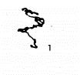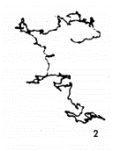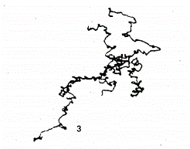
c)
b)
a)
Figure 1.1: Result of a subject's eye movement while fixating on a stationary target for three different durations of fixation. a) 10 sec, b) 30 sec, and c) 60 sec of fixation. From Yarbus A. L: Eye movements and vision, New York, 1967, Plenum, as cited in Ciuffreda and Tannen: Eye movement basics for the clinician, Mosby, 1995.

Tremor
Tremor is the smallest eye movement with an amplitude as small as retinal cone diameters of approximately 20 sec of arc. It is a high-frequency movement, ranging from ≈ 30-100 hertz (Hz), working independently in the two eyes (Ciuffreda & Tannen, 1995; Martinez-Conde et al., 2004). However, the impact of tremors on vision remains unclear (Martinez-Conde et al., 2004), and some have reported that it might not have any adverse effect on vision (Ciuffreda & Tannen, 1995).

Microsaccades
Microsaccades are small involuntary saccadic movements generated while fixating on a stationary target. They have a duration ranging from 10-25 milliseconds (ms) (Ciuffreda & Tannen, 1995; Leigh & Zee, 2015). A study of 10 healthy adults, mean age of 43.4 years, reported that microsaccades are almost identical between the right eye (RE) and left eye (LE), suggesting that conjugate eye movements are produced (Møller et al., 2002).

Drift
Drift refers to the slow eye movements between microsaccades during attempted fixation (Otero-Millan et al., 2014). When attempting visual fixation, drift produces slower and smaller movements than microsaccades (<0.13° amplitude and <0.5°/sec velocity) (Rolfs, 2019 as cited by (Otero-Millan et al., 2014). It also contributes to maintaining accurate fixation or compensating for poor microsaccades (Martinez-Conde et al., 2004). The movements are independent in the two eyes (Ciuffreda & Tannen, 1995). Figure 1.2 illustrates the difference between ocular drift and microsaccades.
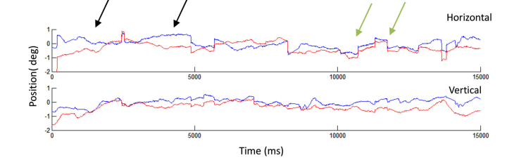
Figure 1.2: Illustration of ocular drift and microsaccades made by RE and LE while fixating on a stationary target for 15 sec. Drifts are not conjugate movements between the two eyes shown by the first black arrow, but microsaccades are conjugate motion. The black arrow on the left shows an ocular drift of the two eyes started with misalignment and finished aligned, whereas the second black arrow shows the two eyes drifted from aligned to misaligned positions. From Otero-Millan et al., 2014.
Note: ocular drift; microsaccade; — RE; — LE.
In conclusion, stable fixation should constitute a small dispersion area of eye position concerning the target point when attempting fixation (Ciuffreda & Tannen, 1995). Fixation stability has been investigated by measuring the bivariate contour ellipse area (BCEA) (Crossland & Rubin, 2002). BCEA refers to eye position measurement in relation to the fixation point measured in the minute arc square unit (Otero-Millan et al., 2014). Crossland and Rubin (2002) investigated the reliability of measuring BCEA using two instruments (scanning laser ophthalmoscope and infrared eye tracker), which revealed no significant difference in test-retest reliability between those instruments. The study was conducted among six healthy young adults less than 40-years-old.

SP
SP is the continuous voluntary eye movement used to maintain foveal fixation on a smooth moving target. SP eye movements require excellent visual attention to track the object of interest. The movements are generated to visually track a smoothly moving object of interest by keeping the object steadily on the fovea so that vision remains clear (Leigh & Zee, 2015). Any mismatch between eye velocity and target velocity results in a lag or lead of the eye with regards to the target position (Ciuffreda & Tannen, 1995), which then stimulates corrective saccade(s). Corrective saccades get the eyes back onto the target. These are also known as catch-up saccades (CUS) (Enderle, 2010), as shown in Figure 1.3.
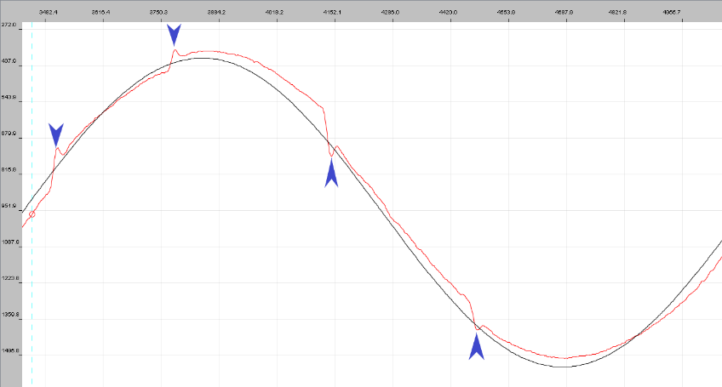
Figure 1.3: A sample of SP eye recording of a control participant taken at 16°/sec target velocity moving horizontally. The x-axis is the time in ms, while the y-axis is the target position in the degrees. Upward deflections of the curve indicate leftward movements. Data collected from the current study.
Note: — target position; — eye position; a lag of the target with a CUS to re-foveate on the target.
Leigh and Zee (2015) discussed quantitative SP assessment in more detail. It is assessed quantitatively using two approaches that evaluate the initiation (onset of SP) and maintenance (the SP behaviour during sustained tracking) of the eye movement. The former measures the time taken for the eye to initiate the SP movement right after the target is shown, known as the SP latency (Morrow & Sharpe, 1993). The latter involves CUS valuation, root-mean-square error (RMSE) and SP gain. CUS is the same direction as target movement (Ross et al., 1999), and RMSE measures the position of the eye (in degrees) to the target position at a particular time point (Friedman et al., 1995).
Figure 1.4 shows an example of an EMR showing normal SP. CUS measurement was thought to produce an error in identifying SP performance, which cannot be used as an alarming clinical sign (Lueck, 2005). It is most likely to include physiological square wave jerks (SWJ) nystagmus, suggesting no SP deficiency, whereby the SP gain may not be impaired (Leigh & Zee, 2015). Many investigators define physiological SWJ as having amplitudes that usually range between 0.5°-3° (or occasionally up to 10°) and durations of about 200 ms. SWJs can be due to stress (physiological) or an affective disorder, such as schizophrenia or dementia (pathological).
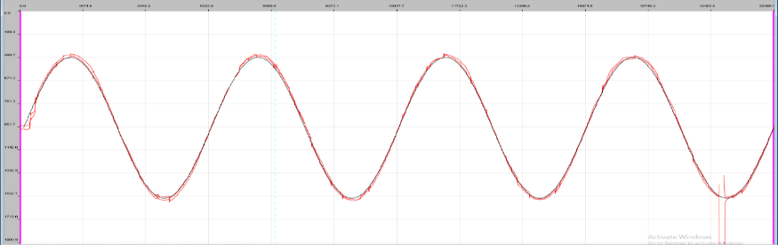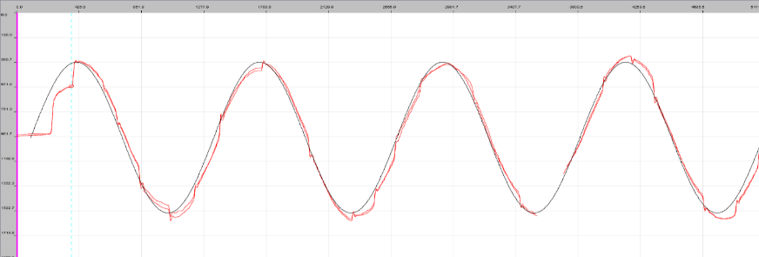
Trial duration = 5117 ms
B) Trial 4
A) Trial 1
Trial duration = 20117 ms
Participant ID: 101101
A) Trial 1 – Velocity = 8°/sec
Mean Gain = 0.956
Mean RMSE = 0.219°
Percentage of SP fixation= Total actual SP fixation / total trial duration
= 17352 ms / 20117 ms
= 0.863 = 86.3%
B) Trial 4 – Velocity = 36°/sec
Mean Gain = 0.974
Mean RMSE = 0.935°
Percentage of SP fixation = Total actual SP fixation / total trial duration = 3960 ms / 5117 ms
= 0.774 = 77.4%
A)
B)
Figure 1.4: Sample of horizontal SP recording on a control participant taken from the current study. A) Shows the SP movements at low velocity (8°/sec), representing an accurate SP. B) Refers to the SP movements at the higher velocity (36°/sec), leading to several CUS and SWJ nystagmus.

Leigh and Zee (2015) concluded that SP performance varies greatly when measurements are repeated on the same participants at different times or on different days. Many factors can influence SP eye movements such as attention; the target being capable of holding the pursuer’s interest (Leigh & Zee, 2015); target directionality, either vertical or horizontal (Rottach et al., 1996); and ageing (Enderle, 2010; Hutton et al., 1983; Knox et al., 2005; Leigh & Zee, 2015; Ross et al., 1999; Sharpe & Sylvester, 1978). Other factors include neuroleptics drugs for treating schizophrenia, which had caused disturbance to the SP system (Friedman et al., 1995). SP eye movements among people with schizophrenia are abnormal, characterised by reduced gain, increased CUS, and shorter pursuing time (Abel et al., 1991; Friedman et al., 1991; Stuve et al., 1997).
In summary, SP assessment depends on the selection of the target waveform, either sinusoidal or ramp (constant velocity triangular wave). Previous studies have explored normative SP among different age groups to investigate the physiological changes due to the ageing process (Morrow & Sharpe, 1993). Studies on the SP system have also been conducted to establish normative data, allowing for the comparison with the pathological groups such as those with schizophrenia (Abel et al., 1991; Friedman et al., 1995), abnormal nystagmus (Papageorgiou et al., 2014) and other neurological disorders (please refer to section 1.5.3).

Saccades
Saccades are generally accurate, ballistic and high-velocity eye movements that occur due to abrupt change of the visual fixation from one fixation object to a new object of interest (Ciuffreda & Tannen, 1995). Saccades of less than 15° amplitudes are reported as the most common eye movements in daily life (A.T. Bahill et al., 1975). A study reported that normative values of saccadic parameters vary depending on age range and testing paradigms (Hopf et al., 2018). They suggested that saccadic latency was reduced with ageing, but the gain and velocity were affected by the degree of target displacement regardless of ageing. There are three saccadic parameters to assess saccadic performance quantitatively: latency, peak velocity and gain (Hain, 1997), as demonstrated in Figure 1.5. This section will introduce the definition and factors affecting each of these parameters.
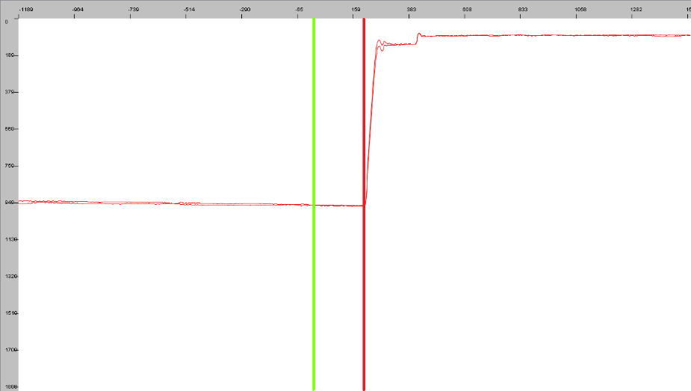
latency
(a)
(d)
(e)
(b)
(c)
Figure 1.5: A sample of horizontal saccadic movements made by a healthy young participant from the current study.
The x-axis represents time in milliseconds (ms) and the y-axis representing the target and eye position in pixel per degree (PPD) units. Point:
(a) Refers to the primary position on the screen; 940 PPD indicates the eye at the screen's centre in the horizontal direction. After 1-2 ms, the target jumped to 15° leftward.
(b) | line marked when the target was presented.
(c) | line marked when the participant initiated a saccadic movement. It is measured by the distance of saccadic movement/time (°/ms). The difference between (c) and (b) is the saccadic latency.
(d) Marks the peak velocity, which was the greatest saccadic movement after the target was presented (b). It denotes the actual saccadic amplitude, which was used to calculate the gain. This actual amplitude is divided with the target amplitude (desired point) to get the saccadic gain.
(e) Indicates the refixation saccades to match the desired target amplitude, where the saccade is aiming for.

Saccadic latency
Saccadic latency is the time difference between the target's appearance at a new point of interest and the eye's onset to initiate the first saccadic movement towards this new target position. A normal range of saccadic latencies has been reported within 100-300 ms (Enderle, 2010). There are various factors known to influence the degree of latency, which will be discussed further.
The fixation task influences the saccadic latency of eye movements; when the fixation stimulus is turned off before the target presentation (gap paradigm), the saccadic latency becomes short and express movements occur. Saccadic latency is longer when the fixation stimulus stays on when the target emerges (overlap paradigm) (Bucci et al., 2005). Reduced saccadic latency occurs as a result of improved sensory processing, oculomotor preparedness, or attentional processes (Reuter-Lorenz et al., 1991). According to one study, the gap paradigm results in shorter latency for all eye movements than the overlap paradigm, but the difference is only significant for saccades at near viewing distances (Bucci et al., 2005).
The participants' motivation and attention during eye-tracking have been suggested could affect saccadic performance (Ciuffreda & Tannen, 1995). Therefore, it is recommended to have repeated encouragement to the participants and implement frequent pauses during the eye recording session (Abel et al., 1983).
Next, the influence of target size on the saccadic latency remains in question. Initially, a study documented no significant difference in the saccadic parameters recorded with different target sizes (Kowler & Blaser, 1995). Later, other researchers found that saccadic latency was significantly prolonged with increasing target size because large targets lead to increased scatter of saccadic amplitudes (Ploner et al., 2004). Consequently, it cannot accurately land on the target centre point, increasing the target centre's undershoot (Ploner et al., 2004). Recently, a study found that latency was longer with decreasing target size (Warren et al., 2013). Those studies contradicting findings could be due to participant selection, the targets used, and the instructions were given to the participants.
Kowler and Blaser (1995) found that target size did not influence the latency, using the authors as the participants, who are very experienced in eye movement research. They set out to prolong latency as much as necessary to achieve the best accuracy possible with only a single saccadic movement. Additionally, they aimed to focus on the form target as a whole without aiming toward a specific place within the form. Then, Ploner et al. (2004) recruited novice participants and found that there were significantly different saccadic latencies with varying target sizes. They instructed the participants to focus quickly and accurately at a small red cross target as soon as it appeared, without further instruction. Warren et al. (2013) tested 20 young and 21 old participants and found latency increased with a smaller target size. They instructed their participants to quickly fixate, without blinking or moving their head, towards any peripheral visual target that was seen.
A large study found that saccadic latency was not affected with a saccadic amplitude of <20° (Wilson et al., 1993), but another recent study found a significant increase of latency as the target amplitude increased (Warren et al., 2013). The differences in the findings could be due to several factors. In the former study, the data were recorded using electrooculography (EOG), an invasive technique, among 122 participants with a mean age of 36.7 years. However, the latter was performed using the non-invasive EyeLink IR video-based eye recording among 20 young (mean age 24 ±3 years) and 21 older (mean age 66 ±5 years) participants. EOG is more uncomfortable. In addition, the former study tested at the bigger amplitude range (15°, 22°, 25°, 30° and 35°) than the latter (±4°, ±12°, ±20° and ±28°).
Next, the saccadic direction was reported to have a significant influence on the mean horizontal saccadic latency (leftward = 173 ms ±30; rightward = 187 ms ±31), but there was no significant difference in the vertical mean saccadic latency (upward = 86 ms ±32; downward = 184 ms ±32) (Bonnet et al., 2013). The study was conducted among 145 participants, mean age of 47.48 ±18.17 years. The result was in agreement with an earlier study by Tzelepi et al. (2009).
A previous study found the average horizontal saccadic latency of 8 young participants (19-26 years old) was 235 ms, while 20 elderly participants had ≈100 ms longer than young participants (Warabi et al., 1984). Another study found that horizontal saccadic latency prolonged among old participants only at the larger saccadic amplitudes, ≥35° (Wilson et al., 1993). Vertical saccades had longer latency than horizontal, but ageing was not influenced it (Irving & Lillakas, 2018). Recent studies also reported that ageing significantly affected the saccadic latency (Hopf et al., 2018; Irving & Lillakas, 2018). The difference could be due to the different number of participants recruited, testing paradigms, education, motivation, and participants' attention level.

Saccadic peak velocity
Saccadic velocity is a linear function to the saccadic amplitude within 5°-15°. It reaches 'soft saturation' as the saccadic amplitude increases beyond 20° (A. Terry Bahill et al., 1975; Enderle, 2010), as shown in Figure 1.6. The peak velocity is described as the relationship of peak velocity to the saccadic amplitude, known as the saccadic main sequence (A. Terry Bahill et al., 1975). The effect of ageing on peak velocity remains debatable (refer to section 1.4.2 for a complete discussion of the effects of ageing).
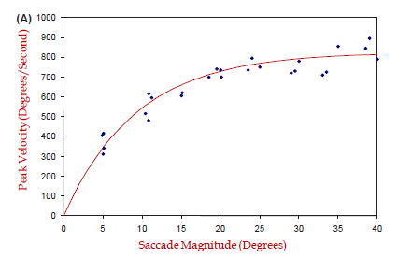
Figure 1.6: The main sequence of saccades showing the relationship of peak velocity to the saccadic amplitudes for 26 saccadic movements by a single subject. From Enderle, J. (1988).

Saccadic gain
Effective saccades are accurate with a high gain, in which the saccadic amplitude matches the target amplitude, producing the saccadic gain of 1. Thus, the saccadic gain can be measured by dividing the actual saccadic amplitude by the target amplitude. Abnormal or dysmetric saccades are inaccurate, either the saccadic amplitude being either too small, <1.0 (hypometric), or too large, >1.0 (hypermetric). Hypometric saccades undershoot the target, are slower movements than expected due to the reduced amplitude and require a second smaller saccade in the same direction to achieve fixation of the target (Figure 1.7-A). Meanwhile, hypermetric refers to saccades that overshoot from the object of interest, which then requires a reversal movement to regain the foveal fixation (Figure 1.7-B).
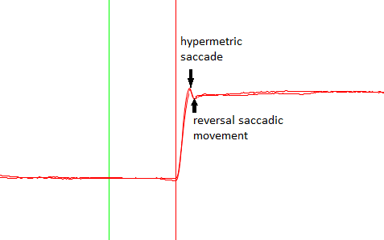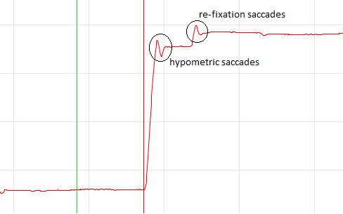
b)
a)
Figure 1.7: Samples of dysmetric saccadic eye movements among healthy control group from the current study. Figure a) illustrates the hypometric saccadic eye movements and b) illustrates the hypermetric saccadic eye movements.
Note: | = Shows the time of the target appeared; | = Shows the initiation of saccadic movements by the participant

Warabi et al. (1984) tested eight young (age range 19-29 years) and 24 older (age range 59-82) participants. They found that the horizontal saccadic gain was not affected by ageing but was affected by increasing target amplitude. They also reported that the gain for 10°, 20° and 30° visual angles was 0.95, 0.78 and 0.61, respectively. Ploner et al. (2004) found that the target size difference influenced saccadic gain. They examined 12 healthy young adults (mean age = 27.2 ±0.9 years) and reported the mean saccadic gains became more hypometric with increasing target size (Ploner et al., 2004), as shown in Figure 1.8.
Figure 1.8: The effect of target size on the mean saccadic gain tested on 12 young adults.
The bars represent ±1 standard error mean (SEM), **p = 0.005. From Ploner et al., 2004.
In conclusion, saccadic parameters in people with no ocular or neurological deficits remain variable depending on different eye movement testing paradigms and participant selection. The former factor refers to the testing paradigms (i.e., size of target amplitudes, target presentation order either random or fixed, the range of testing amplitudes, target to background contrast and room illumination). Meanwhile, the latter factor refers to participant factors (i.e., age-range and highly experienced to the experiment versus naïve participants). All those factors gave rise to the potential variation in eye recording experiments if care is not taken to control these confounding variables. To allow conclusions to be drawn about any abnormality in saccadic eye movements, normative data must be established to be used as the comparison within each different laboratory setting and paradigm used.

Current clinical assessments routine of eye movements and their limitations
The clinical assessment of eye movements is vital to allow differential diagnosis and management of ocular motility disorders (Ansons & Davis, 2014). Diplopia is the most typical subjective complaint associated with a lesion affecting the extraocular muscles, their neuromuscular junctions, the oculomotor nuclei or nerves, or pathways in the brainstem that maintain alignment of the eyes (Wray, 2014).

Testing fixations
Assessment of fixation is conducted in the eye clinic by instructing the patient to fixate a target in primary position (PP), which might be a light or a detailed target with both eyes open. The examiner must observe if any form of instability, such as nystagmus or saccadic intrusions, are present. The same method is repeated with each eye covered to examine if there is any instability when fixating monocularly, indicating the presence of latent nystagmus.
A more precise clinical method to evaluate the fixation stability involves using an ophthalmoscope, known as visuoscopy. The test is performed with one eye occluded. The patient is instructed to look at the ophthalmoscope light. The examiner evaluates whether the fovea is fixating on the target and can detect any eccentricity or fixation instability.
If any form of nystagmus is observed, the test needs to be repeated monocularly by occluding the non-tested eye. Then, the examiner needs to compare whether the nystagmus increases under monocular conditions, indicating latent nystagmus. Due to the qualitative nature of the assessment, a definite value cannot be assigned to the fixation stability. The lack of a recording system makes it is difficult to monitor changes over time. However, this literature review found no studies to evaluate the accuracy of these qualitative clinical methods.

Testing SP
SP are tested routinely in the eye clinic to evaluate the range and the quality of eye movements qualitatively. There are several methods routinely perform in the clinic to evaluate the SP system. Firstly, the ocular motility test (OMT) is performed by holding a penlight in the patient's midline in the PP and instructing them to follow it as it moves smoothly into various positions of gaze, maintaining the penlight at such a distance that the examiner can always observe the corneal reflections in both eyes. At the same time, the examiner carefully watches for overshoot or undershoot movements in either eye in any direction. The examination aims to assess for any imbalance of eye movements in the nine positions of gaze.
Additionally, this examination assesses the eyes' accuracy in following the smooth moving target to various gaze positions and indirectly, its visual fixation performance. When the SP movement does not match the target velocity, a corrective saccade will be observed during the test, indicating imperfect pursuit. In this clinical examination, any eye movement imbalance can be assessed by:
- Grading the abnormality of movements, where (-ve) indicates undershoot and (+ve) indicates overshoot (Ansons & Davis, 2014). In each position, any limitation of duction is recorded using a grading scale of -1 to -4, where -4 indicates no movement beyond the midline, -3 indicates the eye moves about 25%, -2 indicates the eye moves about 50% and -1 indicates the eye moves about 75% of the full expected excursion. Overaction of duction is graded using a scale of +1 to +4.
- Observing the movement's quality and whether the movement matches the target or is limited or excessive (Von Noorden, 2002). Figure 1.9 shows an example of limited RE abduction.
(d) | (h) | (f)
(b) | (a) | (c)
(e) | (i) | (g)
Figure 1.9: Example of an abnormal ocular motility test with a right CN VI palsy. Figure (a) right esotropia in PP, (b) abduction deficit of the RE and (c) normal adduction of the RE.

- Identifying the amount of visible cornea, for example, to grossly judge the normality of adduction and abduction, as shown in Figure 1.10.
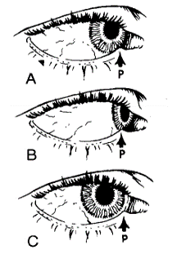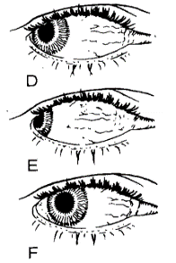
RE Adduction
RE Abduction
Adduction Abduction
Figure 1.10: The investigation of the RE ductions, based on observation of the amount of visible sclera.
The LE is not shown in the above figure. The left-hand side illustrates the RE adduction's investigation. A) Normal. B) Overaction. C) Restriction. The right-hand side shows the RE abduction's assessment. D) Normal. E) Overaction. F) Restriction. 'P' is lacrimal punctum location. From taken Von Noorden (2002) page 200.

Secondly, the Lees screen is used to diagnose the ocular motility defect observed from the OMT testing. It provides a qualitative measurement of the ocular deviation at different gazes and provides a repeatable record for monitoring purposes. However, this method requires good cooperation from the patient and well-trained clinicians to produce a reliable result. This clinical investigation may lead to the miss management if subtle changes of eye movements due to a sinister underlying cause are missed urgent referral.

Testing saccades
Testing saccades is indicated in the clinic when a patient demonstrates or is suspected of having restricted eye movement or presents with ocular symptoms that are thought to be a consequence of a neurological deficit. Saccades are tested by asking the patient to look from one target to another horizontally, followed vertically (Figure 1.11) (Leigh & Zee, 2015). The clinical examination compares the saccadic movements in the right and left gaze and in the upper and downgaze. Leigh and Zee (2015) suggested observing the following criteria during the saccadic test by comparing the RE and LE's performance:
- The reaction time that was initiated
- The symmetrical response of the eye velocity (i.e., equal velocity or not)
- The accuracy of making saccades (i.e., with or without refixation saccades)
a)
b)

Figure 1.11: Subjective saccadic eye movement testing used in the eye clinic. Figure a) Horizontal leftward saccade and b) vertical upward saccade. Saccades are examined by asking the patient to look from one target to another.
Initiating saccadic movements can be assessed by the latency between the instruction given or the appearance of a new target and when the eye started to move. Patients who have difficulty initiating saccades may subtly use blinking or head movements to start the gaze shift. Thus, it is essential to check the quick phase of nystagmus using the optokinetic nystagmus (OKN) drum to determine if the reflexive saccades are normal. Voluntary saccades can be observed by asking the patient to fixate alternately between two targets (Danchaivijitr & Kennard, 2004). The slowing of saccades in one direction can be identified from the test by comparing each eye and each direction of saccadic movements. Furthermore, the accuracy of saccadic movement is demonstrated by the need for corrective saccades.
The finding of abnormal saccadic velocity can help the clinician to make a differential diagnosis between neurogenic and mechanical palsy (Danchaivijitr & Kennard, 2004). If the condition is neurogenic, the affected eye moves smoothly but progressively slower than the unaffected eye as the eyes move to the side of the palsy. However, in mechanical palsies, both affected and unaffected eyes move smoothly and symmetrical towards the side of the palsy, but the affected eye will demonstrate a sudden slowing movement when it reaches the obstruction point. It requires a well-trained examiner to detect the difference in velocity. A more invasive force-duction test might be required to differentiate between these two conditions if it remains uncertain.

Future requirements
The current clinical examination of ocular motility is difficult since it is dependent on the examiner's expertise and the cooperation of the patient, and the assessment is qualitative and subjective. Therefore, they do not assess any subtle changes in eye movements, allowing early identification of more sinister neurological signs. In addition, Jukes et al. (2021) reported that the main problems with these tests are that there is not enough time and there is not a standard way to test. They are looking for a quicker, more portable instrument to aid in the clinical examination of eye movement problems (Jukes et al., 2021). Objective EMR, capable of detecting small changes in the complex eye movement parameters, is needed to assist in making diagnoses.
More detailed measurements are now possible with improved EMR technology. The currently emerging techniques in eye movement studies use the principle of a movement-dependent deficit, which involves continuously recording eye movements using an eye movement video recorder (Tegetmeyer et al., 2002), a non-operator dependent device. It provides an accurate EMR using advanced technology to capture eye movement performance, with a detailed spatial and temporal resolution, including eye position to target position, latency between target motion and eye movement, eye velocity and gain (Bedell & Stevenson, 2013; Wade, 2010). Thus, it improves reliability in documenting eye movement performance and ultimately reduces physician bias and variability. Additionally, it provides a permanent record, which is vital for monitoring disease progression. The potential and significance of objective EMR in the eye clinic are thought to help in various clinical situations (Clark et al., 2019). Hence, it could be established as a routine part of clinical investigation, at least in tertiary centres.

EMR
There is potential in the coming years for rapid growth in the detail of the investigation of ocular motor deficiencies within clinical practice. Previous studies reported the significance of EMR to assist in diagnosing and managing neurodegenerative disorders (Pinkhardt et al., 2008), congenital or childhood nystagmus (Hussain, 2016) and psychiatric disorders (Abel et al., 1991). A wide choice of high-resolution video-based infrared eye-tracking devices is now available and becoming affordable, allowing easy and non-invasive recording (Bonnet et al., 2013). It is crucial to consider the reliability and acceptability of recording devices available in the market. Moreover, the purpose and the likely implementation of eye recording within a clinical setting need to be clarified. The literature on EMR methods will therefore be reviewed here.

Review of objective eye recording methods
Until recently, the gold standard method in research laboratories for recording eye movements was the magnetic scleral search coil, as shown in Figure 1.12 (Collewijn et al., 1975). The system provides high-resolution recordings, can measure horizontal, vertical and cyclo rotations, and has a pre-calibration procedure that requires no complex calibration.
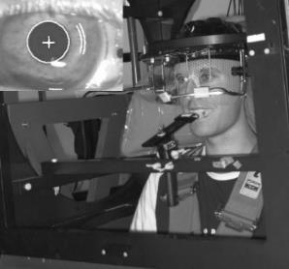

Figure 1.12: Experimental set-up for the magnetic search coil. From Houben et al. (2006).

The scleral search coil uses contact lenses designed with a silicone rubber annulus, an excellent material to ensure the lens's adhesion to the wearer's sclera. Within it is embedded an insulated copper wire induction coil (Figure 1.13), which generates an electrical current when placed within a magnetic field. The coil was designed with very low noise (<0.0002°) and produced a high resolution of 15 min of arc (Collewijn et al., 1975; Kimmel et al., 2012; Murphy et al., 2001). Although it is a gold standard device due to its accuracy, it is an invasive procedure from which difficulties have been documented. These include getting co-operation from children and older patients to insert the contact coils into their eyes (Kimmel et al., 2012; van der Geest & Frens, 2002; Zacher et al., 1998).
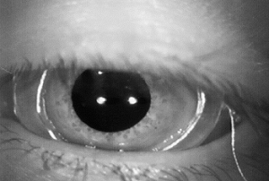

Figure 1.13: Scleral search coil in the eye. From (Imai et al., 2005)

Previous studies have been conducted to explore the effect of wearing the scleral search coil lens on visual function (Irving et al., 2003; Murphy et al., 2001). Both studies recruited six young participants. They measured similar visual function parameters but with slight differences in the measurement interval. The method of measurement is summarised in Table 1.1.
Table 1.1: Comparison study on the effect of scleral search coil lens wear on the eye.
 |  | Murphy et al. (2001) | Irving et al. (2003)
 |  | n = 6 (22.17 years old) | n = 6 (29.5 ±5.2 years old)
Parameters  measured | Before insertion | IOP, K, SLB, VA | IOP, K, SLB, VA
Parameters  measured | 15 minutes after insertion | VA | IOP, K, SLB, VA
Parameters  measured | 30 minutes after insertion | VA | IOP, K, SLB, VA
Parameters  measured | After removal | IOP, K, SLB, VA | IOP, K, SLB, VA
n = number of participants; IOP = intraocular pressure; K = keratometry; SLB = slit-lamp biomicroscopy; VA = visual acuity

Murphy et al. (2001) found that the scleral search coil did not affect the lens wearer's visual function, but Irving et al. (2003) found a significant effect of transient blurring of vision caused by the lens wear. The former found that visual function changed after wearing the lens, but the changes measured were not statistically significant. The latter documented a significant reduction of visual acuity (VA) by one line or more from the baseline after the lens insertion just before removing the search coil lens. However, the study authors did not mention the exact range of visual deterioration. Reduced VA was thought to be due to corneal integrity changes seen during lens wear with different severity for different participants. The condition likely happened due to having a large rigid contact lens and coil in the eye. Initially, Murphy et al. (2001) suggested that corneal integrity changes occurred due to prolonged wearing time, resulting in corneal surface dryness. However, it was refuted by Irving et al. (2003) because they found that corneal staining appeared at the early insertion period, which rejected the theory of corneal dryness.
Another argument was that a high visual demand induced by fixating on the accommodative target caused a reduction of blink rate, which induces corneal staining (Murphy et al., 2001). However, a study refuted that it did not use any form of visual fixation, but corneal staining was still observed at a very early stage of the experiment (Irving et al., 2003). Therefore, these studies demonstrated that the use of scleral coils potentially induces a detrimental effect on the cornea due to being invasive, even before any visual task requiring eye movements. Hence, implementing non-invasive procedures capable of producing a comparable result with the search coil is required for clinical routine testing.
Infrared (IR) eye movement recorders have a relatively high spatial and temporal resolution, allowing good clinical accuracy. Examples include Chronos (Houben et al., 2006), Oculometrics (Schmitt et al., 2007), and EyeLink system (van der Geest & Frens, 2002). Therefore, with advances in technology, a non-invasive video-based eye-tracking system using IR has been used in research settings and has been documented to produce comparable results to the search coil method (Houben et al., 2006; Schmitt et al., 2007; van der Geest & Frens, 2002).
A study conducted to evaluate the two methods of eye recording (i.e., search coil versus EyeLink version 2.04, SR Research Ltd/SMI) among four healthy adults found a high correlation between the methods for the measurement of the horizontal and vertical saccadic parameters, including the amplitude, duration and peak velocities (van der Geest & Frens, 2002). They analysed the main sequence relationships (i.e., amplitude – peak velocity and amplitude – duration). They found that although the video-based eye-tracker produced significantly smaller total values for saccadic parameters than the search coil, it did not affect the saccadic performance. The results demonstrated a good correlation for peak velocity measurements and saccadic duration up to 30° amplitude between the two instruments. The correlation slopes were 1.075 ±0.072 for peak velocity and 1.030 ±0.028 for the saccadic duration, indicating they are comparable in tracking rapid eye movements (Houben et al., 2006; Traisk et al., 2005; van der Geest & Frens, 2002). However, they found a high correlation since they measured from the same subjects. Hence, they were supposed to do a Bland Altman assessment instead of correlation statistics. They also found no significant drift in the video recording, justifying the method's ability to record small or stable fixational eye movements (Figure 1.14).
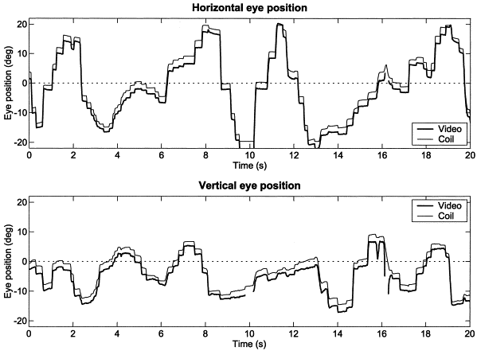
Figure 1.14: Simultaneous EMR using two methods: video (EyeLink) shown as the thick black line versus coil (scleral search coil) shown as the thin grey line. From van der Geest and Frens, (2002).
Another study compared saccadic properties measured using a search coil and IR (Orbit XY-1000; IOTA, Sweden) (Traisk et al., 2005). In this study, 10 healthy adults, mean age 38 years, were recruited. Saccades were measured within the angular range of ±20° horizontally and ±15° vertically. Both methods recorded saccadic eye movements at 500 Hz binocularly. The findings demonstrated that IR produced higher peak velocity and main sequence curves compared with the search coil. They demonstrated that IR's peak velocity was significantly increased at a greater amplitude to the right and left gaze (Figure 1.15). They suggested a possible reason for reduced peak velocity for the search coil method was that the contact lens mounted in the eye induced a low pass filter, slowing down the recording process.
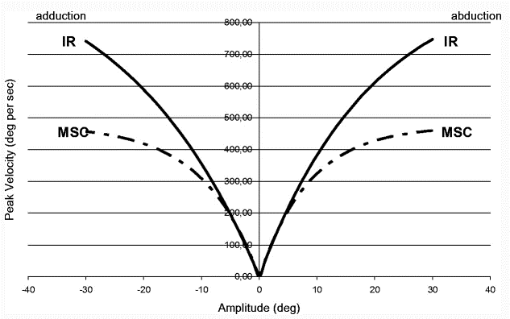
Figure 1.15: Comparing the main sequence of amplitude-peak velocity between the magnetic search coil (MSC) and the Orbit infrared (IR) eye recorder.
On the x-axis, (-ve) amplitudes = leftward saccades, (+ve) amplitude = rightward saccades. From Traisk et al., (2005).

The IR eye tracker increasingly being employed for research is the EyeLink 1000 Plus, version 2.06, produced by SR Research Ltd (Ontario, Canada). The system was designed with a high technical specification to enhance eye tracking accuracy. Based on the manufacturer’s data (SR Research), this machine has a maximum monocular sampling rate up to 1000 Hz, with a binocular sampling rate of 500 Hz, an average accuracy of 0.25° to 0.5° and a spatial resolution of 0.01° root-mean-square (RMS).
Subjective clinical evaluation is the only way to analyse eye movement patterns in individuals with disorder of consciousness (Trojano et al., 2012; Wannez et al., 2017). Trojano et al. (2012) conducted a study to quantify patients' visual tracking behaviour using the alternative objective EMR method. A computerised IR eye-tracker (MyTobii T60, Tobii Technology, Danderyd, Sweden) with a 60 Hz sampling rate was used to quantify participants' eye-tracking patterns. A red circle or a small colour picture slowly moving on a PC monitor served as a stimulus. Trojano et al. (2012) discovered that the proportion of fixations on-target versus off-target differed significantly between the vegetative and semi-conscious groups, with the latter having a significantly higher proportion of on-target than the chance level. Another study explored the usefulness of utilising the IR eye tracker to assess the SP of patients with residual consciousness, which may aid clinicians in detecting visual SP more accurately in clinical settings (Wannez et al., 2017). They found that quantitative visual behavioural analysis using eye trackers can help differentiate disorders of consciousness.
The link between saccadic eye movements and visual pathway function was investigated in 20 insulin-dependent diabetes mellitus patients with no long-term complications and stable metabolic control, as well as 21 age-matched control subjects (Alessandrini et al., 1999). The investigation showed no correlation between the saccadic latency and the patients' visual evoked potentials. The absence of association between the measurements indicates that the patient's saccadic latency delay cannot be attributed primarily to visual pathway dysfunction and may result from broad neuronal involvement.
Using an IR EMR device (AMTech ET4 eye tracking system) with a 200 Hz sampling rate, a study comparing the fixation stability of expert shooters to control subjects was undertaken (Di Russo et al., 2003). In the presence and absence of distracters, participants were instructed to retain their fixation as still as possible on an object for 1 minute. In the distracters condition, time had no influence on fixation stability for shooters, and they had more stable fixation than controls.
The effects of moderate coffee on oculomotor control and visual perception in non-fatigued persons were investigated in a study (Connell et al., 2017). IR oculography measured saccades, SP, and optokinetic nystagmus. Caffeine was observed to increase saccadic peak velocities (472°/s) in comparison to a placebo (455°/s). Additionally, caffeine increased optokinetic nystagmus while having no effect on SP eye movements; caffeine affects oculomotor control in awake people. These effects are present in rapid motions but not in slow ones.
Numerous studies have demonstrated the use of eye movement recording (EMR) technology in assessing the effect of behaviour and attention on fixation stability, saccades, and SP eye movements (Alessandrini et al., 1999; Connell et al., 2017; Di Russo et al., 2003; Trojano et al., 2012; Wannez et al., 2017). Now that EMR can be used in a variety of clinical settings, it may become a standard part of the NHS's clinical investigation repertoire, at least in tertiary care. It is uncertain whether these objective, non-invasive recordings could assist clinicians in improving clinical diagnosis and management by documenting specific eye movement parameters such as gain, peak velocity, and latency for patients with ONP.

Ageing and EMR
Most studies found that older people above 60 years show a general reduction in eye movement performance (Hopf et al., 2018; Knox et al., 2005; Munoz et al., 1998). The researchers suggested that it could be due to neurological changes (Peltsch et al., 2011a), muscular changes (Clark & Demer, 2002), and/or neuronal processing time (Knox et al., 2005) among old adults above 60 years old (Peltsch et al., 2011a).
Previous studies reported that older adults have longer horizontal (Abel et al., 1983; Pitt & Rawles, 1988; Warabi et al., 1984; Wilson et al., 1993) and vertical saccadic latencies (Huaman & Sharpe, 1993; Yang & Kapoula, 2006) than younger adults. However, a recent study reported no association between ageing and saccadic latency (Irving & Lillakas, 2018). The differences in results could be due to participant selection. The study that found ageing deteriorates the latency recruited participants with a greater range of ages. Therefore, it was more sensitive to an age effect. Meanwhile, Irving and Lillakas (2018) recruited participants with an age range from 3 to 86-years-old. Hence, they tried to present the results grouped according to age. However, the youngest participants may have produced non-reliable saccades, since even with practice, the generation of accurate saccades needs excellent attention and understanding. Therefore, the results of this study could be questionable.
The variation in saccadic peak velocity was also reported to be due to an interaction of ageing and retinal eccentricity, whereby they found that the peak velocity of the elderly only reduced when larger saccades were attempted (i.e., >40°) (Warabi et al., 1984). Some researchers found no difference between younger and older adults (Abel et al., 1983; Henriksson et al., 1980; Huaman & Sharpe, 1993). A study also reported that the elderly made faster saccades than young adults (Henriksson et al., 1980). In conclusion, previous studies mostly agreed that saccadic peak velocity did not decline with increasing age, except when it reached a certain amplitude.
Additionally, the SP eye movement system was reported as an age-dependent motor system, characterised by increased SP latency, increased rate of CUS and lower gain score (Moschner & Baloh, 1994; Ross et al., 1999). The differences in SP gain and latency between the young and old age groups increases as the target velocity increases (Moschner & Baloh, 1994). Hence, older people show less tracking ability for faster moving objects. Their eye velocity was slower than target velocity, resulting in low SP gain.
However, Morrow and Sharpe (1993) found that SP did not significantly vary with increasing age and target velocity. The difference in their study was the selection of target velocity. They compared 20 and 40°/s target speeds, which both are already fast. That range of target speed is hard to follow accurately, even by a good eye tracker (Hutton et al., 1983). That might be the reason they could not find any differences between the two age groups of participants. Many researchers used a broader range of target velocity, started from very slow to faster velocities to assess the SP behaviours between their experimental groups, such as between 6 and 12°/s (Sakuma et al., 2000), 5 to 100°/s (Sharpe & Sylvester, 1978), 5 to 40°/s (Terry Bahill & McDonald, 1983) and 10 to 36°/s (Hutton et al., 1998). Studies looking into age-related saccadic eye movements and age-related SP eye movements were summarised in Tables 1.2 and 1.3, respectively.

Table 1.2: Summary of the previous findings on age-related normative data for saccadic eye movements.
Author and Year | Participants | Eye Recording | Stimuli | Saccadic parameters | Findings and conclusion
Henriksson et al. (1980) | 20 healthy subjects, aged 23-72 | EOG | - Different colours of LED located at ±5°, ±10°, ±20°, ±30°, ±40° and ±60° horizontally. | Horizontal peak velocity | - Peak velocity increased as the saccadic amplitudes increased, but it was not significantly affected by ageing.  - The peak velocity in normal room illumination recorded at 20° was 340°/sec increased to 500 °/sec at 60° amplitude
Spooner et al. (1980) | - 25 normal Y adults (mean age = 42 years)  - 14 normal O (mean age = 65 years) | EOG | - A luminous point on the television was presented in random stepwise jumps of 3-36° amplitudes. No further description of the target was given. | Horizontal  - Peak velocity  - Latency | - Performance in the elderly was reduced in comparison with Y adults.  - Mean peak velocity (°/s) and latency between age groups:
  Group | Peak velocity (°/s) | Latency (ms)
  Y | 551 ± 65.0 | 179 ± 27.4
  O | 487 ± 85.5 | 219 ± 32.2
Abel et al. (1983) | - 23 Y, aged 18-37 (mean=25.7 ± 4.7)  - 17 O, aged 59-87 (mean=72.0 ± 7.9) | EOG | - Red light-emitting diodes (LED) target presented at ±1°, 3°, 5°, 10°, 15° and 20°.  - Random order with 3 s inter target interval | Horizontal  - Latency  - Velocity | - Significant longer latency for O compared with Y adults. Mean latency of:  - Y = 229.8 ± 62.5 ms  - O = 275.2 ± 74.7 ms  - Velocity was not affected by ageing.
Warabi et al. (1984) | Compared 2 groups of healthy participants  - 8 Y (19-26 years)  - 24 O (59-82 years) | EOG | - LED presented in random order (within ±20 ° horizontally)  - random inter target interval | Horizontal  - Peak velocity  - Latency  - Gain | - The latency of the Y vs O group was 235 ms vs 335 ms  - Although the velocity was reduced among the O group and the latency was longer, they could program an accurate saccade similar to Y adults.
Huaman & Sharpe (1993) | Compared 3 groups of normal:  - 13 Y (mean age = 28.3 ± 4.6)  - 10 middle-aged (mean age = 49.8 ± 9.0)  - 16 O (mean aged = 71.9 ± 5.5) | Magnetic search coil | - 0.25° laser spot.  - Amplitude: ±10, ±20 and ±30°.  - Target presentation: 3 s interval with predictable amplitude (i.e., the order all started at 10° steps, then 20° and finally 30°. | Vertical  - Peak velocity  - Latency  - Gain | - No significant difference in peak velocity between all three groups.  - Y group had significantly faster upward saccades than downward.  - The saccadic gain was significantly reduced and saccadic latency was significantly prolonged in the O group.
Wilson et al. (1993) | 122 normal adults, aged 16-72 (mean age=36.7) | EOG | - LED presented at 1.5 s intervals starting from the largest amplitude (40°) then gradually reducing amplitudes (35°, 30°, 25°, 20° and 15°). | Horizontal  - Peak velocity  - Latency  - Gain | - Peak velocity significantly increased at larger amplitudes, but accuracy and latency remain consistent.  - The peak velocity of O people was slower at larger saccadic amplitudes.  - Peak velocity for O participants recorded at:  - 15 ° = 300-350 °/sec  - 25 ° = 425-475 °/sec  - 35 ° = 475-525 °/sec
Yang and Kapoula (2006) | - 11 Y, aged 20-28 (mean=23 ± 2)  - 11 O, aged 63-83 (mean=70 ± 8) | Video-based system | - 5 LEDs (centre, ±7.5° and ±15° vertically)  - Random inter-target interval and order | Vertical  - Latency  - Gain | - Vertical latency was significantly longer in O compared with Y adults. However, the gain was not affected by ageing.  - Y = 1.008 ± 0.007  - O = 0.984 ± 0.07  - O can produce accurate saccades with a longer preparation time (latency).
Bonnet et al. (2013) | 145 normal, aged 19-82 (mean age=47.48 ± 18.17).  Further divided into 6 age group by decades  (19-29, 30-39, 40-49, 50-59, 60-69 and 70-82) | Video-based system | - 5 LEDs (centre = green light, ±13° horizontally and vertically = red lights. The peripheral lights were presented in random order. | Horizontal and vertical  - Peak velocity  - Latency  - Gain | - Results were analysed by saccadic direction (i.e., rightward, leftward, upward and downward).  - O participants (≥60 years) showed significantly prolonged leftward saccades, decreased peak velocity of upward and reduced gain of leftward and downward saccades.
Irving and Lillakas (2018) | 131 normal, aged 3-86 | Video-based system |  | Horizontal and vertical  - Peak velocity  - Latency  - Gain | - Vertical latency and peak velocity were not significantly influenced by ageing.  - Age significantly reduced the upward saccadic gain.  - Vertical saccades were more hypometric compared with horizontal saccades.  - Vertical saccades had longer latency than horizontal, but ageing did not influence them.
Y = young; O = old; EOG = electrooculography; LED = light-emitting diodes

Table 1.3: Summary of the previous findings on age-related normative data for SP movements.
Author and Year | Participants | Eye Recording method | Stimuli | SP parameters | Findings and conclusion
Sharpe and Sylvester (1978) | Y (n = 15)  Age range 19 - 32  (mean age 23)  O (n = 10)  Age range 65 - 77  (mean age 72) | EOG | - A laser spot subtended 0.25° of visual angle.  - Triangular wave (Predictable) of ±10° amplitude from the PP, then moving at nine frequencies (5, 10, 20, 30,40, 50, 60, 80, and 100°/sec) | - SP latency  - SP velocity | - Ageing caused a significantly increased SP latency and reduced SP gain with increasing target velocity.  - The number of CUS increased with increasing target velocities and were significantly higher in O than Y adults.  SP latencies (ms):  SP gains:
  Velocity  Age Group | 5°/s | 10°/s | 20°/s
  Y | 131 ± 23 | 138 ± 21 | 134 ± 34
  O | 176 ± 33 | 183 ± 49 | 169 ± 37
  Difference | 45 | 45 | 35
  Velocity  Age Group | 5°/s | 10°/s | 20°/s
  Y | 0.98 | 0.96 | 0.98
  O | 0.94 | 0.78 | 0.70
Hutton et al. (1983) | Total participants, n=52  - O men (n = 17) Age range 56 - 84 years (mean = 68.9)  - O women (n = 16) Age range 58 - 78 years (mean = 66.9)  - Y men (n = 11) Age range 24 - 36 (mean = 29.6)  - Y women (n = 8) Age range 23 - 29 (mean = 26.9) |  | Two frequencies of sinusoidal wave stimuli, 0.2 and 0.4 Hz across 23° visual arc | - CUS index | - Eye-tracking performance could be affected by multiple factors such as age, gender and target velocity.  - The SP system was vulnerable to increasing age.  - Gender was thought to affect eye tracking performance due to poor tracking performance in older women, but the result was not conclusive.  - Poor eye tracking people could follow the target motion at the slowest velocity reasonably well. However, the fastest target velocity of 36°/s appeared to be very hard to follow, even for good eye trackers.
Morrow and Sharpe (1993) | - Y (n = 6): Age range 29 - 35 (mean age 31)  - O (n = 5): Age range 60 - 76 (mean age 67) | Magnetic search coil | - A laser spot which subtended 0.25° of visual angle  - Step-ramp target with two constant velocities (i.e., 20 and 40°/s) | - SP latency (ms) | - SP latency was not significantly affected by increasing age and target velocity.  SP latency (ms):
  Velocity  Age group | 20°/s | 40°/s
  Y | 137 ± 41 | 132 ± 40
  O | 130 ± 35 | 135 ± 37
Rottach et al. (1996) | Y adults (n = 5)  Age range 29 - 48 | Magnetic search coil | - A laser spot subtended a 0.1° visual angle.  - Sinusoidal wave ±20° amplitude with 0.4 Hz frequency.  - Target moved in the horizontal and vertical direction.  - Triangular wave (step-ramp) ±20° amplitude at a constant velocity of 35.5°/sec.  - The direction and time interval (1.0 - 2.25 sec) between the stationary and the onset of the motion were randomised. | - SP gain  - SP latency | - The vertical gain was significantly lower than the horizontal gain for predictable target motions.  - The downward gain was lower than the upward gain.  - Eye movements in the horizontal direction were superior compared with the vertical direction regardless of the target features.  - SP latency showed no significant difference between horizontal and vertical (203 and 207 ms, respectively)  - Abnormal SP initiation and maintenance may suggest a different site of lesions. Some people had better SP initiation but lower maintenance, and some had vice versa.  - Different circuits controlled horizontal and vertical SP.
Ross et al. (1999) | Controls (n = 64)  Age range 18 - 79  Schizophrenic (n = 58) (adults) | Video-based eye recorder | Trapezoidal pattern wave was used (i.e., the target moved back and forth) at a constant velocity of 16.7°/sec, over 30° amplitude and 1.4 sec pause between ramps. | - SP gain  - CUS | - Ageing caused deterioration of SP performance, specifically beyond 55-years-old.  - Schizophrenia patients showed more unsatisfactory SP performance than controls.
Knox et al. (2005) | Y (n = 10)  Age range 19 - 26  (mean age = 21 ± 2)  O (n = 15)  Age range 64 - 81  (mean age = 72 ± 6) | Non-invasive laser-based eye tracker (IRIS, Skalar) | Step ramp target with constant velocity, 14°/sec. | - Qualitative assessment by observing the ability to track the target with/without fatigue and distraction.  - SP latency | - SP performance between Y and O age groups was not different qualitatively.  - The O group took a significant 55 ms longer than the Y group to initiate SP movements.  - SP latency was significantly prolonged in the elderly.

Clinical indications for EMRs
Objective eye-movement recordings are capable of detecting, diagnosing, documenting and managing subtle eye movements disturbance (i.e., slow, inaccurate and imprecise saccades, defective SP and various forms of nystagmus) across a variety of neurological abnormalities, including peripheral and central vestibular imbalances, and brainstem, cerebellar and cortical lesions and malformations (Bedell & Stevenson, 2013).
Nystagmus is one of the oculomotor disorders that can be clinically assessed using EMR to help in diagnosis and management (Rosengren et al., 2020). The technology of EMR is one of the most reliable methods that generate repeatable diagnosis and identifies the exact waveform to assist in the differential diagnosis of acquired and childhood nystagmus (Hertle, 2017; Papageorgiou et al., 2014). For example, identifying the characteristic accelerating waveform of infantile nystagmus syndrome (INS) could avoid the need for the urgent investigations required for acquired nystagmus, as shown in Figure 1.16 A) and B). Hence, it saves time and money for patients and the health service (Clark et al., 2019).
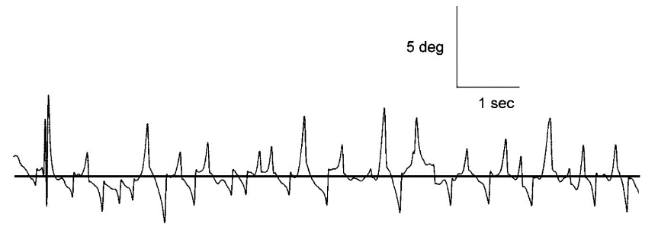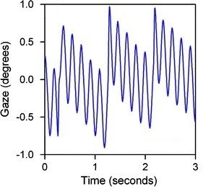
a)
b)
Figure 1.16: Examples of SWJ vs pendular nystagmus waveforms recorded in PP.
a) Example of horizontal SWJ off infantile nystagmus is shown with increasing-velocity waveforms. From Abel and Malesic (2007). b) Shows acquired pendular nystagmus where the velocity tends to remain reasonably constant. Image taken from Strupp et al. (2011).

An objective EMR can also help the clinician differentiate between Parkinson's disease (PD) and progressive supranuclear palsy (PSP) (Marx et al., 2012). Marx et al. (2012) studied the eye movements of 10 possible PSP patients, 11 diagnosed PD patients, and 10 age-matched healthy control participants using the EyeSeeCam. The neurological specialists also evaluated patients. The saccades were tested at five points (i.e., PP and four at ±8.5° horizontally and vertically). They found a significantly slower peak velocity for PSP than PD and healthy controls (Figure 1.17 a), which was similar to an earlier study performed using the magnetic scleral search coil technique (Bhidayasiri et al., 2001). Therefore, the results confirmed that an objective eye recording could produce reliable results to help the clinician make the diagnosis regardless of the device used. Bhidayasiri et al. (2001) investigated a broader spectrum of vertical gaze palsy syndromes, which included multiple system atrophy (MSA) and cortico-basal ganglionic degeneration (CBGD). Anderson et al. (2008) characterised MSA as having gaze-evoked nystagmus, downbeat nystagmus, SWJ, and mild hypometric saccades (Figure 1.17 b). They suggested that careful clinical observation, including objective EMRs, could identify oculomotor features to assist in making the appropriate diagnosis.

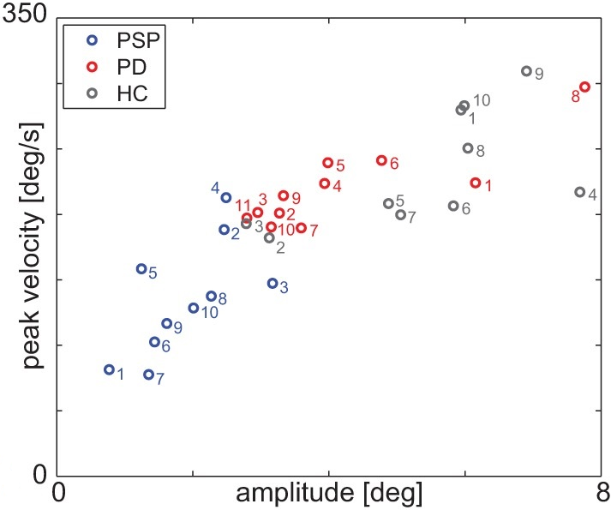
a)
B)
A)
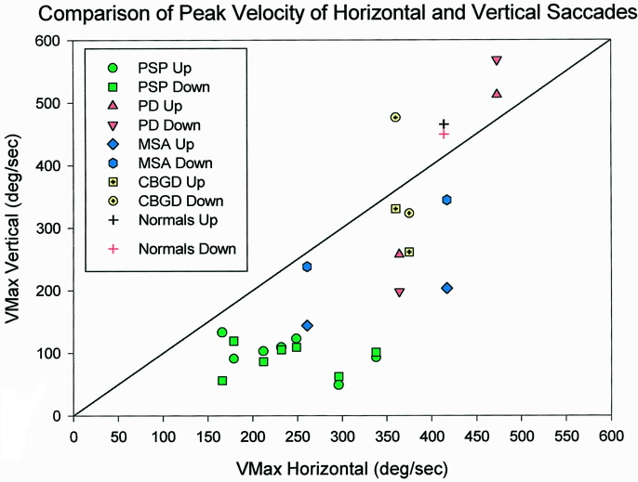
b)
Figure 1.17: Two graphs showing the saccadic attributes of different neurological disorders.
a) A study to evaluate the saccadic performance between Parkinson's disease (PD) and progressive supranuclear palsy (PSP) by comparing them with healthy controls (HC). From Marx et al. (2012). b) A study to assess vertical gaze disorder in PSP, PD, multiple system atrophy (MSA), and cortico-basal ganglionic degeneration (CBGD). From Bhidayasiri et al. (2001).
In addition, EMR has been used to differentiate between Gaucher disease (GD) type 1 and type 3 (Harris et al., 1999). GD is a lysosomal storage disorder consisting of three clinical subtypes: type 1 - chronic non-neuropathic disease; type 2 - an acute infantile disease; and type 3 - a juvenile form (Erikson et al., 2006). They are all autosomal recessive in inheritance. GD2 is a severe neurological condition that generally leads to death (Harris et al., 1999). In the same study by Harris et al. (1999), they reported that GD3 shows saccadic initiation failure, the earliest neurological signs that can be detected. Although this is not universal, children may adopt head thrusts or synkinetic blinks to compensate for the saccadic failure. They also reported the progression of GD3 could be halted with high-dose enzyme replacement therapy (ERT) if the condition is detected at the early stage. Therefore, this could be a reversible neurological condition. Hence, newly diagnosed children with GD should have an objective EMR to decide whether they have saccadic initiation failure (Harris et al., 1999). The significance of differentiating between GD1 and GD3 is that it affects the management of the condition. If GD3 is wrongly treated at the early stage, it might lead to severe, irreversible neurological damage.
In psychiatry, schizophrenia has produced abnormal SP compared with age-matched control groups (Benson et al., 2012). These are characteristically CUS, anticipatory saccades and SWJ, (Sharma et al., 2000), as shown in Figure 1.18.
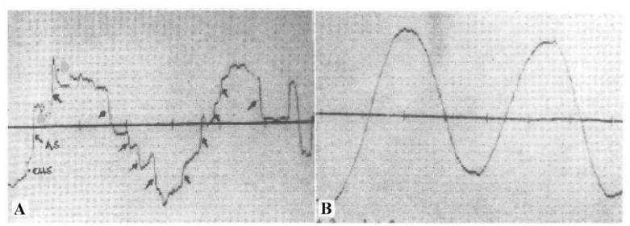
Figure 1.18: Comparison of EOG recording of SP eye movements between schizophrenia and healthy controls. From Sharma et al. (2000).
A) Schizophrenia, illustrating both CUS and anticipatory saccades. B) SP eye recording in healthy control.

Another study reported that schizophrenia patients had defective SP eye movements (Campana et al., 1999). They found a significant slower peak velocity, lower peak gain, and higher CUS among the schizophrenia group than a healthy control group (Table 1.4). They suggested that EMR can differentiate schizophrenia and healthy individuals, allowing for early treatment and support for the patient. Therefore, EMR has been shown to help screen for neurodegenerative diseases, enabling effective management to be given to the patients.
Table 1.4: SP eye movements performance recorded in normal and schizophrenia patients. From Campana et al. (1999).
Target Frequency | Mean (SD) SP eye movement measurements | Normal subjects  (n = 65) | Schizophrenia patients  (n = 65) | p¹
0.4 Hz | PV (40°/sec) | 33.31 (5.00) | 29.55 (8.09) | 0.002*
0.4 Hz | pGA | 0.83 (0.13) | 0.73 (0.20) | 0.002*
0.4 Hz | SACC | 25.63 (14.48) | 41.77 (19.08) | <0.001*
0.2 Hz | PV (20°/sec) | 16.11 (2.74) | 14.66 (3.67) | 0.012*
0.2 Hz | pGA | 0.80 (0.14) | 0.73 (0.18) | 0.012*
0.2 Hz | SACC | 11.72 (13.53) | 22.49 (21.52) | 0.001*
0.1 Hz | PV (10°/sec) | 7.59 (1.51) | 6.90 (2.00) | 0.027*
0.1 Hz | pGA | 0.76 (0.14) | 0.68 (0.20) | 0.014*
0.1 Hz | SACC | 7.18 (10.88) | 17.89 (1.86) | 0.000*
SD = standard deviation, PV = peak velocity, pGA = peak gain, SACC = number of saccades.
¹ = based on t-test;
*Data are significant at p<0.05

Ocular nerve palsies
Three nerves innervate eye movements: cranial nerve three (CN III), four (IV), and six (VI). The clinical presentations of ocular nerve palsies will be reviewed to explore the potential importance of EMR in this particular group of patients. The aetiology of ocular nerve palsies will also be reviewed to explain the PhD’s relevance in detecting eye movement disorders, indicating the specific aetiologies and signals for early intervention.

Types of ocular nerve palsies
CN III consists of somatic and visceral motor components. The somatic component innervates four out of the six extraocular muscles: the medial rectus, superior rectus, inferior oblique, and inferior rectus (Wilson-Pauwels, 2002). They are responsible for the eye's movement into adduction, elevation, depression, and torsional movements. Additionally, it supplies the levator palpebral superioris to elevate the upper eyelid. Meanwhile, the visceral component innervates the constrictor pupillae and ciliary muscles responsible for controlling pupil miosis and accommodation (focusing power of the eye while engaging in near tasks), respectively. A complete CN III palsy causes the affected eye to present with limitation of adduction, elevation, and depression, with complete ptosis and a dilated pupil. Meanwhile, a partial CN III palsy may involve these gaze directions with varying severity, with or without pupillary involvement (Rucker, 2007).
CN IV only has a somatic motor element supplying the superior oblique muscle, which depresses, intorts, and abducts the eye as a prime mover. Thus, a CN IV palsy causes underaction of the superior oblique muscle (Rucker, 2007).
CN VI also innervates somatic motor elements only to the lateral rectus muscle to abduct the eye (Wilson-Pauwels, 2002). Lesions of this nerve causes an abduction deficit and esotropia of the affected eye, worsening with fixation distance.
Ocular misalignment and double vision are the classic presenting sign and symptoms in patients with ONP. Current clinical assessment relies upon subjective examination of eye movements to diagnose and monitor the disease's progression. The recent development of technology in EMR may provide an opportunity to implement more advanced measurements and assess eye movement deficits, which could benefit management strategies for better prognosis and provide more information to patients (Clark et al., 2019).
Various aetiologies cause ocular nerve palsies. Consequently, there are a variety of management strategies for the patients. Tiffin et al. (1996) reported that most ocular nerve palsies, ≈ 67% including CN III, IV, and VI palsies, are caused by either vascular disease or an undetermined aetiology. They concluded that the undetermined aetiology was also presumably from a vascular origin. Their finding was consistent with another large study reporting 54% of ocular nerve palsies had either a vascular or an undetermined origin (Park et al., 2008). This study was conducted in Seoul, Korea, involving a total of 206 patients.
Moreover, when ocular nerve palsies occur in the over 50-year-old age group, they are often presumed to be due to vascular disease (Akagi et al., 2008). Akagi et al. (2008) reported that most of the CN III and IV palsy patients below 49-years-old were affected by head trauma, and most of the sixth nerve palsy patients below 49-years-old were found to be caused either by an organic lesion or a congenital condition. The study reviewed the medical records of 221 patients with isolated CN III, IV and VI palsies.
However, these previous studies were conducted retrospectively by reviewing the medical records of patients presenting with ONP and classifying whether, from clinical observation, the condition recovered or not. They classified the recovery stages by the change of deviation angle compared with the initial measurements (onset), measured using the prism cover test (PCT) technique, at PP fixation. Complete recovery was indicated by complete recovery of the deviation angle measured with the PCT. Partial recovery was defined as the reduction of deviation angle by >10 prism dioptres (∆D) from the initial examination, while lack of recovery indicated the absence of partial or complete recovery.

EMR in ocular nerve palsies
A previous study reported that CN VI palsy leads to defective saccadic velocity (Metz et al., 1970). Metz et al. (1970) studied a 28-year-old patient with a left, recently acquired lateral rectus palsy due to head trauma. The eye movements were recorded once, using EOG, two months after the injury. At that stage, the patient had a left esotropia in PP (30∆D) but binocular single vision (BSV) in dextro-version. The LE could not abduct beyond the midline, and the forced-duction test showed a mild restriction to the horizontal movement. They recorded and compared the unaffected RE and affected LE separately. The result of the unaffected RE revealed equal saccadic velocity to the right and left (Figure 1.19 a). However, the saccadic velocity of the affected LE was slower when the eye moved in abduction (left gaze) compared with the adduction (right gaze) (Figure 1.19 b). This experiment strongly suggests that sixth nerve palsy affects saccadic velocity towards the side of the palsy.
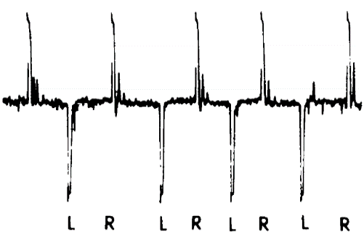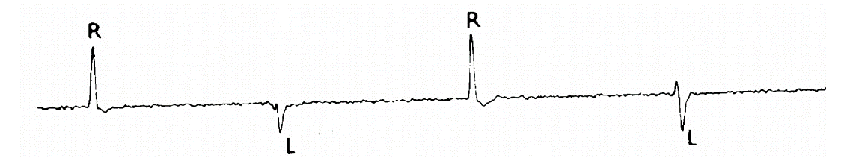
a)
b)
Figure 1.19: Sample of the velocity traces recorded in a left CN VI palsy patient.
The upward tracing represents the leftward saccade in both figures, and the downward tracing represents the rightward saccade. a) Velocity trace for saccades of the unaffected RE, illustrating equal saccadic velocity for RE abduction and adduction. b) Saccadic velocity trace from the affected LE illustrates significant LE abduction deficits. From Metz et al. (1970).

Another study was performed to compare saccadic dynamics according to the site of the lesion: peripheral versus central CN VI palsy (Wong et al., 2006). The peripheral nerve palsy was described as those affected by vascular anomalies or an undetermined cause. Central palsies were caused by brain tumours, cavernomas, or demyelinating diseases. Each of the lesion sites was further divided into acute and chronic conditions. Wong et al. (2006) recruited 19 patients with unilateral CN VI palsy and 10 participants as a healthy control group (mean age of 49 ± 12 years). The patient group was further divided into acute and chronic peripheral nerve palsy (52 ± 18-year-old and 63 ±10-year-old, respectively). All patients received magnetic resonance imaging (MRI) and computerized tomography (CT) scan procedures to confirm the site of the lesion. Patients with normal imaging results were then classified as peripheral CN VI palsy (n=14), and abnormal imaging results were categorised as central CN VI palsy (n=5). Three of the central palsies were caused by cavernomas, while the other two had multiple sclerosis. Patients presenting with diplopia of more than a month’s duration were classified as having a chronic palsy, while those having diplopia of less than a month were classified as having an acute palsy. Eye movements were recorded at both the time of and two months after presentation. They measured centrifugal (from the centre to an abducted position) and centripetal saccades (from the abducted to the centre position). The stimuli were presented with 3 sec intervals ±10° horizontally. They reported that the peripheral nerve palsy group showed an increase in peak velocities after two months from the initial visit, regardless of whether there was an acute or chronic palsy, although the peak velocity did not reach the control group level. For the central nerve palsy group, the result demonstrated a consistent reduction of peak velocities. These deficits were shown only in the centrifugal saccade results, as they reported that centripetal saccades of the paretic eye had normal peak velocities and saccadic durations for both central and peripheral palsies. In conclusion, Wong et al. (2006) suggested that the peripheral sixth nerve palsies would show some improvement within two months from the disease onset.
A preliminary cross-sectional study was performed to examine SP properties among 30 patients diagnosed with unilateral CN III, IV and VI palsies (Tegetmeyer et al., 2002). The study was conducted using a two-dimensional video-oculography (2D-VOG), (SensoMotoric Instrument, Germany). The participants viewed a target presented on a screen with a constant velocity (10°/sec) within a range of ±10° in the horizontal, vertical, and oblique directions. Both the unaffected and affected eyes were tested monocularly. SP gain (the relationship between the target velocity to the eye velocity) was analysed. They found that the SP gain among ocular nerve palsies, regardless of the type of nerve palsy, differed depending on the fixating eye. The affected eye showed minimal movements and reduced SP gain with a series of refixation saccades.
Later, the same authors conducted another study to evaluate the impact of unilateral ocular motor nerve palsies on SP eye movements (Tegetmeyer et al., 2007). The horizontal and vertical SPs of 14 unilateral sixth nerve palsy patients, aged between 25 and 80, were recorded using 2D-VOG. The recording was performed monocularly while the patients were seated with their heads restrained at the chin. A target of 1° diameter size, moved ± 10° horizontally and vertically at A constant velocity of 10°/s. They found that the paretic eyes were far behind the target and there were a significant increase of refixation saccades when moving towards the paretic muscle plane. Their findings suggested that fixing with the paretic eye causes increasing retinal slip and position error. Consequently, it causes an increase of SP gain and CUS to compensate for the palsied muscle.
Whilst deficits in SPs and saccades have been recorded, the value of these measurements in diagnosis and management of patients have not been considered. There has been no study conducted prospectively to evaluate any eye movement changes during the potential recovery period, which could indicate early whether the condition is recovering or otherwise. Therefore, what is needed is a series of repeated EMR within a more extended observational period to detect any subtle eye movement changes during the potential recovery phase so that any investigations can be scheduled efficiently and in a timely manner. Evidence from early observation of EMR could improve management strategies, resulting in better prognosis and outcomes. During the potential recovery period, the monitoring process could identify when full recovery occurs or, if not fully recovered, whether the condition worsens or remains unchanged.

Patient care pathway
Currently, the primary aim for managing ocular nerve palsies in the early stages, following onset is to improve visual function by eliminating diplopia in PP and within a central area of fixation while monitoring the eye movements to look for any sign of spontaneous recovery, stability or worsening of the eye condition (Jivraj & Patel, 2015). Additionally, a provisional diagnosis needs to be considered and a decision taken as to whether further investigation including neuroimaging needs to occur at presentation. The need for urgent neuroimaging in older patients with isolated cranial neuropathies presumably microvascular aetiology is still debated and requires physicians to consider the risks and benefits of careful observation with prompt testing (Pineles & Velez, 2018).
Risk stratification should include patient-specific data such as age, vascular risk factors, duration of symptoms, comorbid medical problems, and the specific type of CN palsy, with CNIII and CNVI palsies generally requiring greater concern than CNIV palsies.
Recently, Jivraj and Patel (2015) outlined the treatment for ocular nerve palsies. At onset, the initial management may be monocular occlusion of the paretic eye to eliminate binocular diplopia if patients could not join the diplopia due to large separation of images (>30 PD) or variable deviation angle. There are several options for occlusion, including a patch or applying tape to one of the lenses of a pair of spectacles.
Alternatively, prismatic correction could eliminate diplopia, improve visual function, and restore binocularity in some patients with temporary or permanent ocular deviations. Options are either prescribing a Fresnel prism or incorporating the prism into the spectacles. Prism correction is usually tolerated in patients with the angle of deviation up to 20 to 25 ∆D horizontally and 10 to 15∆D vertically. The aim is to reduce prism strength until no longer needed or if no further reduction and stable, then possible surgical intervention or prism incorporated if preferred and angle 15∆D or less. Planning the surgical approach is based on residual extraocular muscle function, careful measurements, and an understanding of patient expectations.
For cases of CN III palsy, careful observation is indicated to discriminate between compressive CN III palsy and microvascular CN III palsy. Intracranial aneurysms are the most feared cause of compressive CN III palsy because they can indicate a real neurological emergency due to the risk of subarachnoid haemorrhage (Fang et al., 2016). Fang et al. (2016) reported that 1/3 of cases of CN III palsy caused by aneurysms were from posterior communicating artery aneurysms. The most common misconception is that arterial aneurysms can only occur in cases where there is mydriasis (Pineles & Velez, 2018). Although pupil involvement is more common in compressive lesions, pupil involvement is seen in some cases of microvascular CN III palsy, and pupil sparing is seen in some cases of compressive lesions, including aneurysms (Fang et al., 2016; Radia et al., 2017).
Therefore, it has been proposed all acute CN III palsy must have a CT or magnetic resonance angiography (MRA) on the same day to rule out the possibility of life-threatening aneurysms, regardless of pupil signs (Radia et al., 2017). MRA is an effective non-invasive imaging technique, which has evolved into a potentially useful tool in clinical use, especially for imaging of small vessels without contrast agents (Park et al., 2017). Park and Kang (2017) reported that it provides a better diagnosis of peripheral and/or cerebrovascular diseases such as arterial malformations and aneurysms. Meanwhile, MRI of the brain and orbit with contrast is indicated if the lesion associated with the brainstem stroke or tumour, cavernous sinus or orbital apex lesion. Another study suggested to consider early neuroimaging if the patients are younger than 50 years old, have a history of head trauma, have no history of vascular risk factors, or have poor pupillary reaction (Witthayaweerasak et al., 2020).
For CN IV and VI palsies that are presumed to have a microvascular origin due to age and associated conditions at the onset (e.g., hypertension or diabetes mellitus), it is recommended to schedule a follow-up visit within 6 to 8 weeks after the onset, as the improvement of ocular movements is expected to be observed within that duration (Jivraj & Patel, 2015). An extensive examination of visual function and other relevant neurological testing is indicated at each follow-up visit to evaluate the disease progression. Neuroimaging, therefore, is unnecessary in purely microvascular CN IV and VI palsies since the condition typically will spontaneously recover.

Observational period of recovery
The aetiology of ocular nerve palsies has been reported to influence the potential recovery (Akagi et al., 2008; King et al., 1995; Rush & Younge, 1981). A long prospective cohort study was conducted to observe the spontaneous recovery rate among 213 cases of acute unilateral isolated CN VI palsy (excluding traumatic injury) with a mean age of 56.3 years (age range 5-93 years) (King et al., 1995). The patients were recruited from eye casualties and referrals to the eye departments from general practice. Patients referred from tertiary units and other specialists were excluded to avoid the inclusion of chronic and severe brain pathology, because these are known to have less chance of spontaneous recovery (Rush & Younge, 1981; Wong et al., 2006). The follow-up intervals were scheduled to be after 8, 16, 24, 52 weeks from the initial visit. The definitions to categorise cases as recovered or unrecovered were not stated. They found that 78.4% (167/213) of CN VI palsies recovered after an average of 9.7 weeks. Among the recovered cases, 84.4% (141/167) showed full recovery within 16 weeks. This finding suggested that detailed investigation, including MRI, is warranted if cases had not shown signs of recoveryafter 16 weeks to exclude severe underlying pathology. Their results show a higher recovery percentage than Rush and Younge (1981), which reported only 48.3% (483/1000) recovery rate, but the recovery period was not specified due to the retrospective study design. The results were analysed based on the questionnaires distributed to the patients.
This difference in the results is probably because Rush and Younge (1981) included all ocular nerve palsies regardless of their aetiology, such as vasculopathy, aneurysm, neoplasm, trauma, and other brain pathologies. King et al. (1995), excluded aetiologies of brain pathology and trauma, increased their recovery rate to 59.2%. Therefore, it appears that the aetiology of the ONP influences the rate and number of patients recovering. Besides, the study conducted by Rush and Younge (1981) was a retrospective study while King et al. (1995) carried out a prospective study; the latter could be more reliable in monitoring the disease progression.
A retrospective study conducted to identify factors affecting recovery among 206 patients diagnosed with either acute CN III, IV, or VI palsies (Park et al., 2008) included vascular, trauma, neoplasm, aneurysm, undetermined and 'other' causes. Among those causes, the vascular group had the highest mean age, which was 63.9 years old. This finding was in agreement with (Akagi et al., 2008), which classified the different causes of CN VI palsy to be affected by age, whereby above 50 years the cause was highly likely to be due to a vascular problem, between 20-49 years associated with an organic lesion and below 20 years old normally due to head trauma or congenital disability.
Park et al. (2008) assessed the ocular movements with gross assessment using ocular motility testing. An assessment was completed at the initial visit with follow-up after at least 6 months. However, specific follow-up time intervals were not reported. The results were analysed based on recovery stages, either complete or partial. A complete recovery was defined as a measurement of 0∆D of PCT in PP, no other ocular motor restriction being presented and no diplopia reported. In comparison, a partial recovery was defined as the PCT result showing a reduction by more than 10∆D from onset. Park et al. (2008) found complete recovery within 6 months among 13 of 19 (68%) with CN III palsy, 12 of 23 (52.2%) with CN IV palsy, and 46 of 63 (73%) with CN VI. They also demonstrated that isolated ONP with a deviation angle of ≤30 prism dioptres at onset was likely to undergo complete recovery provided the underlying cause had been treated. However, it should be noted that the mean age of patients was nearly 50-years-old, therefore, most of their patients had a vasculopathic or undetermined aetiology of the nerve palsy. As a result, a high spontaneous recovery rate regardless of CN III, IV, or VI palsies was discovered in the study (Park et al., 2008). Their findings are comparable to previous studies with an average age of 50-years-old and above (Akagi et al., 2008; Berlit, 1991; Tiffin et al., 1996).
Recently, there was a study investigated the clinical outcomes and aetiology of an acute vertical diplopia cases in 80 adults (Oh & Oh, 2020). The overall rate of complete recovery within 1.5 months of onset was 78.8% of the CN IV palsy and most had a vascular aetiology. However, the study emphasised that the prognosis for CN IV palsy varies depending on the aetiology of the palsy.
Those studies mentioned above reported the recovery status by retrospectively reviewing the patients' medical records and relying on the positioned-dependent deficit eye movement test to determine whether the recovery was taken place or not. Previous studies documented changes in eye movements following the onset of ocular nerve palsies, but the limitation was retrospective methodology, making the findings questionable. Other limitations from the previous studies were the lack of detailed analysis of eye movement changes and infrequent reporting following onset. This observation period is poorly documented in the literature, with no studies providing a detailed recording of changes to eye movement systems. Further prospective cohort studies are needed to document subtle eye movement changes, such as after 2 weeks, 4 weeks, 6 weeks, and up to 3 months following onset, to better understand the ‘recovery’ period. Table 1.4 summarised the previous studies concerning aetiology of ocular nerve palsies and their recovery process.

Table 1.5: Summary of the aetiology and potential rate of recovery for CN III, IV, and VI palsies.
Author(s)  Year  (Study location) | Study Design | Participants | Aetiology | Results
Rush and Younge  1981  (Minnesota, USA) | Retrospective (medical records reviewed) | - III = 29% (290/1000)  - IV = 17% (172/1000)  - VI = 42% (419/1000)  - Multiple = 12% (119/1000)  75% >35 years | Vascular & undetermined cases  III = 44% (127/290)  IV = 55% (94/172)  VI = 47% (198/419)  The remaining cases had aetiology of either aneurysm, head trauma, or neoplasm | - Total cases (over 12 year period) including all aetiologies showing recovery: partial or full = 48% (483/1000)  - The recovery for each group of ocular nerve palsies was:  - III=48% (140/290)  - IV=53% (92/172)  - VI=50% (208/419)  - Multiple=36% (43/119)
King et al.  1995  (Liverpool, UK) | Cohort prospective  (medical records reviewed) | Unilateral VI (n = 213)  Mean age = 56.3 years | All recovery cases of VI were vascular and non-recovered had severe pathology such as neoplasm, tumour, brain stem stroke, aneurysm | - 78% recovered up to 10 weeks (mean recovery time);  - 85% total recovery case up to 16 weeks  - 16% non-recovered had severe underlying pathology
Park et al.  2008  (Seoul, Korea) | Retrospective (medical records reviewed) | III = 23% (48/206)  IV = 22% (46/206)  VI = 52% (108/206)  Multiple = 2% (4/206)  Mean age for all patients = 48 years  Mean age for vascular group = 64 years | Vascular & undetermined cases for:  III = 54% (26/48)  IV = 65% (30/46)  VI = 52% (56/108)  The remaining cases had an aetiology of either aneurysm, head trauma, or neoplasm | - 52% of the total cases showing recovery, including partial or complete  - The recovery distribution for each group of ocular nerve palsies was:  - III = 68%  - IV = 52%  - VI = 73%  - Multiple = 67%
Akagi et al.  2008  (Osaka, Japan) | Retrospective (medical records reviewed) | III = 29% (63/221)  IV = 19% (41/221)  VI = 52% (117/221)  Age distribution:  62% ≥50 years  38% ≤49 years | Vascular (III, IV, VI) = 35% (77/221) | - III = 90% completely recovered within 3 months  - IV = 60% complete recovery within 12 months  - VI= 100% complete recovery at 3 months
Oh and Oh (2020) | Retrospective (medical records reviewed) | 80 adults with acute vertical diplopia (CN IV only)  Mean age:  59.96 ± 11.87 years (range: 30–82) | - Vascular = 48 (60%)  - Trauma = 17 (21.25%)  - Brain lesion = 4 (5%)  - Late decompensation = 4 (5%)  - Others = 4 (5%)  - Undetermined = 3 (3.75%) | Recovery rate was observed:
 |  |  |  |  | Complete recovery (1.5 months)  (n = 63) | Partial (4 months) + non-recovery  (n = 17)
 |  |  |  | Vascular | 44 | 4
 |  |  |  | Trauma | 11 | 6
 |  |  |  | Brain lesion | 3 | 1
 |  |  |  | Late decompensation | 0 | 4
 |  |  |  | Others | 3 | 1
 |  |  |  | Undetermined | 2 | 1
 |  |  |  | * late decompensation is categorised as a patient without vascular risk factors or trauma, age younger than 40 years or unilateral visual loss.

Summary
There is evidence documenting the impact of CN VI palsy on saccade dynamics (Wong et al., 2006) but there is a lack of detailed information on the impact of CN III and IV palsies on eye movement dynamics. In particular, there is a lack of studies that carefully evaluate the change of ocular movement parameters, specifically the dynamics of saccadic, SP, and fixation eye movements, during the immediate period after onset using high-resolution eye recording. Previous studies have been conducted using cross-sectional methods observing the saccades and pursuits movements in the horizontal direction only at a single visit (Samadani et al., 2015; Tegetmeyer et al., 2002; Wong et al., 2006). A more detailed investigation of eye movement changes during the potential recovery period has not yet been explored.
With the advancement of the technology, objective eye recording can be introduced, but there is a lack of evidence to determine this new method's accuracy to assess eye movement abnormalities caused by ocular nerve palsies. Additionally, accurate documentation of the condition's stabilisation is needed to determine the correct timing for further treatment, such as ocular muscle surgery, botulinum toxin, or incorporation of prisms into glasses. A method to determine a lack of recovery may help to expedite treatment and reduce the time patients suffer the deliberating symptom of diplopia.
Non-invasive EMR using the EyeLink 1000 Plus have been shown to produce comparable results to the search coil method (Houben et al., 2006; Schmitt et al., 2007). However, those studies were conducted among normal participants. The EyeLink 1000 Plus eye movement recorder's feasibility to be implemented as a standard measure for clinical assessment of ocular nerve palsies patients is yet to be investigated.
Despite many studies reporting the normal values of EMR parameters, the normative database is still not complete due to differences in the testing paradigms and eye trackers used. This database is important to act a control data, allowing comparison with EMRs of ONP patients. Furthermore, objective eye recording methods have not been used widely in clinics to monitor ocular nerve palsies' progression, although the disease is well known to impact the eye movement system. An evaluation of the feasibility and the potential gain is required before such investment in equipment, training, and patient time can be considered.

Materials and methods
This chapter describes the equipment, laboratory set-up, eye movement programmes, and paradigms used in this study to record the specific type of eye movements. Additionally, it outlines and discusses the data extraction process and the analysis techniques used.

Equipment and tool

EyeLink 1000 Plus eye tracker
Eye movements were recorded using an IR video-based eye tracker, EyeLink 1000 Plus, SR Research, Mississauga, Ontario, Canada. It is a high-resolution device with a maximum sampling rate for monocular and binocular recordings of 1000 and 500 Hz, respectively. The reported accuracy is <1° (Barsingerhorn et al., 2018), and the spatial resolution is 0.01° RMS, as specified by the manufacturer. This non-invasive eye movement recorder uses an IR video-oculography system to track eye movements.
There were five types of EMR programmes developed for this study in order to measure fixation, horizontal and vertical SP, as well as horizontal and vertical saccades (see section 2.3). These programmes were developed using the Experiment Builder software by SR Research version 2.2.1. The programmes were set-up using a 60 pixels per degree (PPD) screen for stimuli presentation. Data output and analysis were obtained from the Data Viewer (DV) software.

EyeLink® Data Viewer
All eye movement data files were saved in the EyeLink data files (.edf) format. EyeLink® DV is a specific tool allowing users to display, filter, and create output reports from .edf data files recorded with the EyeLink 1000 Plus eye tracker (SR_Research, 2018). Please refer to Appendix 2.1, 2.2, and 2.3 for the details of DV used in this study to extract data for further statistical analysis.

Participant and display set-up
Participants were seated at 931 mm from the display computer. The resolution of the display computer was 1920 x 1080, as shown in Figure 2.1.
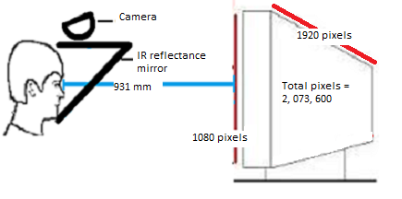
Display monitor
Forehead rest
Built-in tower mount camera
Chin rest
Figure 2.1: Schematic diagram of participant's positioning distance relative to a display monitor.
The EyeLink 1000 Plus comprises two computers: 1) A host personal computer (PC) dedicated for data collection from the EyeLink camera device; and 2) a display PC for presenting stimuli to the participant and saving the data. They are connected through an Ethernet for communicating the information.
Participants sat on an adjustable office chair, with their chin and forehead against the chin rest and forehead rest, respectively, to reduce head movements. There was no other restraint required or contact with the eyes. The chin and forehead rests were cleaned between each participant with anti-bacterial wipes. The table height and chin rest were adjustable to ensure the participant's eye position was level with the display screen's top quarter. The EyeLink tower-mounted camera with an IR video-oculography system was used to track eye movements. The camera was mounted on the chin rest tower as provided and set-up by SR research (Figure 2.2).
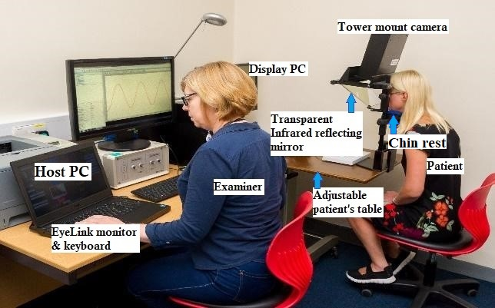
Figure 2.2: Participant set-up during eye recording.

Focus set-up
The pupil and corneal reflection (CR) thresholds were adjusted to optimise data recording quality. An auto-threshold adjustment command was selected by pressing the letter "A" on the host PC keyboard. Manual adjustments were also available, which were especially useful for spectacle wearers because of the reflections from the glasses, causing the equipment difficulty to detect the pupils automatically. Pupil and CR thresholds were grey-scaled values ​​ranging from 0 (black) to 255 (white). Therefore, the values indicated how "black" or "white" something must be considered a pupil or CR. A normal range for pupil (black) threshold is between 70-120, and the CR (white) normal threshold range is between 200-240. Figure 2.3 illustrates examples of excellent and poor focus set-up.
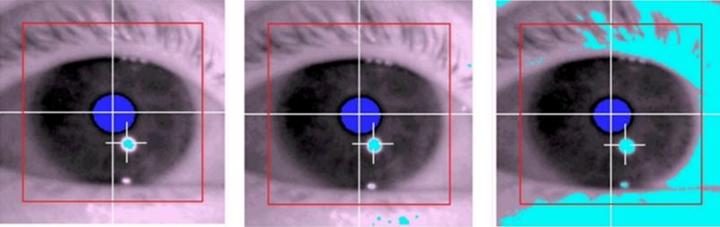
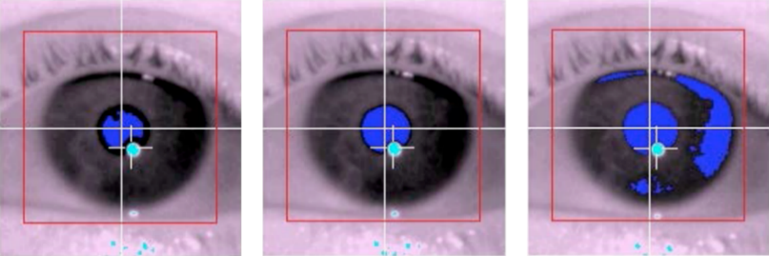
A
B
C
D
E
F
Threshold too low
Good threshold
Threshold too high

Figure 2.3: Potential range of pupil threshold for focus setting using the EyeLink 1000 Plus eye movement recorder. Figure A, B, and C show the pupil threshold setting, and D, E, and F show the CR threshold setting. A and D shows a low pupil and corneal threshold; B and E show an acceptable threshold, and C and F show a high threshold.

Calibration and validation
The eye movement recorder was calibrated by presenting a stationary target on the display monitor. There were five calibration points (PP, ± 15° horizontally, and ± 8° vertically) followed by five validation points in the same position as the calibration points before each actual test run to ensure accuracy of the calibration points. The numerical value presented on the host PC at the end of the validation process indicated the optimum calibration and validation points (Figure 2.4).
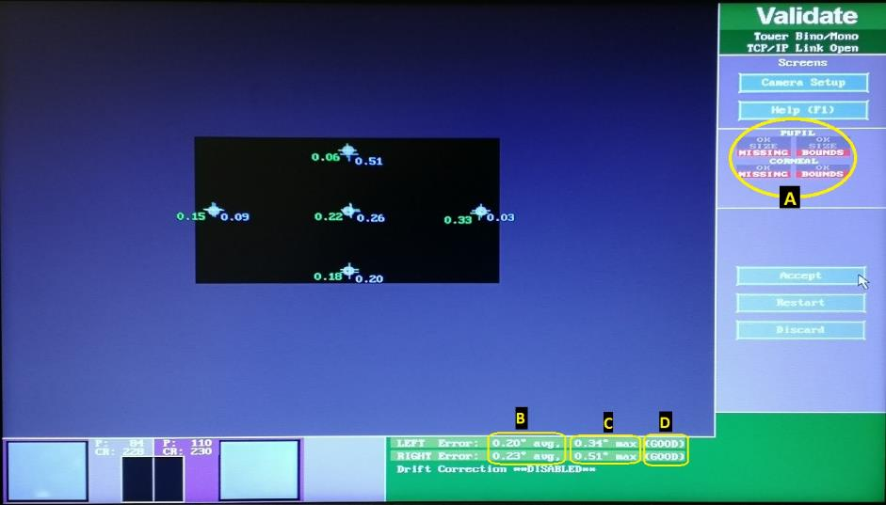
Figure 2.4: A sample output displayed on the host PC of five-point validation tested binocularly. (A) It should be marked as "OK" to ensure an optimum focus was obtained. The numerical values inside the black rectangle in the middle of the screen are the difference between target positions to the eyes at every validation point, measured in degrees. The difference is known as the gaze-position error. The mean acceptable error should be < 0.5°. (B) The maximum acceptable error should be < 1.0°. (C) Indicates successful verification and is marked "OK". (D) If higher than that value, the validation is marked as "POOR", and recalibration is required.

Drift check
Regular drift checks were completed to ensure the calibration was valid throughout each EMR examination. The drift checked whether:
- Fixation occurred before the onset of the target at the PP.
- SP occurred before the target appeared at each trial frequency.
- Saccades occurred following each target presentation.
If the drift checks revealed a significant error for either eye (average error of >0.5° or maximum error of >1.0°), a recalibration process was required to re-track the corneal-pupil location relative to the target position.

Target
The target presented for all experiments within the study was a black cross with a white square in the centre (Figure 2.5). Three sizes were available and selected based on the participant's visual acuity (VA). The participant was required to fixate precisely at the white square in the middle of the black cross throughout the EMR tests. The central fixation white square in the 0.5°, 1.0°, and 2.0° black cross subtended a visual angle of 0.03°, 0.09°, and 0.10°, respectively. The length of the white square sides was manually measured by two examiners using a ruler to avoid measurement errors.

0.5° cross  C₁  D₁  Image magnification  B₁  A₁ | A₁ = B₁ = 8 mm,  C₁ = D₁ = 0.5 mm  ⸫ White square =  C₁/D₁* (cross size in °)  0.5 mm/8 mm x 0.5°cross = 0.031°
  1° cross  C₂  D₂  B₂  A₂ | A₂ = B₂ = 17 mm,  C₂ = D₂ = 1.5 mm  ⸫ White square =  1.5 mm/17 mm x 1° cross = 0.088°
  2° cross  A₃  B₃  C₃  D₃ | A₃ = B₃ = 33 mm,  C₃ = D₃ = 1.6 mm  ⸫ White square =  1.6 mm/3 mm x 2° cross = 0.097°
Figure 2.5: Calculation of fixation centre target sizes used in this study.

EMR
Each EMR session always started with fixation, then SP horizontal, followed by SP vertical, horizontal saccades, and finally vertical saccades. The testing sequences were maintained for all experiments because the fixation and SP EMRs had shorter testing durations, and the tasks were easier to complete by the participants. Saccade EMR took longer, which required demand for attention. However, the saccade programmes were designed by incorporating a drift check for every trial, allowing the participants to have frequent breaks whenever necessary during the test. It was essential to ensure the saccades made by the participants were the true visually triggered saccades, avoiding anticipatory saccades or eye fatigue.

Fixation
The participant was instructed to fixate precisely at the white area at the centre of the black cross target (refer to Figure 2.5) and maintain steady fixation as accurately as possible for the test duration. As described in Chapter 2 - section 2.2.2, calibration and validation procedures were conducted before the fixation recording started. The coordinates for each target fixation point were calculated in the PPD unit (Figure 2.6). Only one target was presented on the display monitor at a time, and the order of the target presentation always started at PP, then 10° leftward, followed by 10° rightward, 8° upward, and finally 8° downward.

(960, 540) PP

(380, 540) 10° left gaze
(1540, 540)
10° right gaze
(960, 940) 8° downgaze
(960, 140) 8° up gaze
Figure 2.6: The coordinates of each fixation testing position presented in the PPD unit. During the test, only one stationary target was presented at a time for 30 sec. Each recording session started with the fixation target at the PP, left, right, up, and downgaze.
The sequence of the presented target was fixed for all participants. Each target position was maintained for 30 sec before it abruptly changed to the next position, known as zero-gap target presentation. The total recording time for the fixation task was approximately 2.5 minutes. Throughout the test, encouragement was given to ensure the patient was consciously fixated at the target position, as shown most effectively by Abel et al. (1983).

SP
The SP programmes were designed by keeping a constant number of cycles (4 cycles per trial) and amplitude (± 10° for horizontal and ± 8° for vertical) but altering the frequencies of target motion, producing shorter SP durations as the frequency increased, as presented in Table 2.1. The total EMR duration was approximately 5 minutes for horizontal and vertical SP, including participant set-up, calibration, and validation.
Table 2.1: EMR paradigms designed for horizontal and vertical SP recording.
- Horizontal SP (± 10° amplitude)
Trial | Frequency (Hz) | Mean velocity (°/sec) | Test duration (sec)
1 | 0.2 | 8 | ≈20
2 | 0.4 | 16 | ≈10
3 | 0.6 | 24 | ≈8
4 | 0.8 | 32 | ≈5
- Vertical SP (± 8° amplitude)
Trial | Frequency (Hz) | Mean velocity (°/sec) | Test duration (sec)
1 | 0.25 | 8 | ≈16
2 | 0.5 | 16 | ≈8
3 | 0.75 | 24 | ≈5
4 | 1.0 | 32 | ≈4
The calibration and validation were conducted before the SP EMR, as described in section 2.2.2. Participants were instructed to fixate accurately at the white area at the centre of a black cross target (Figure 2.4) at all times and follow it as accurately as possible as it moved smoothly across the screen. The EMR began with Trial 1, where the target moved at the lowest frequency and increased to higher frequencies. A drift check was applied at the end of every trial before starting the following trial frequencies. An example of a live trace produced by the DV software for 0.2 Hz horizontal is shown in Figure 2.7, and for 0.25 Hz vertical is shown in Figure 2.8.

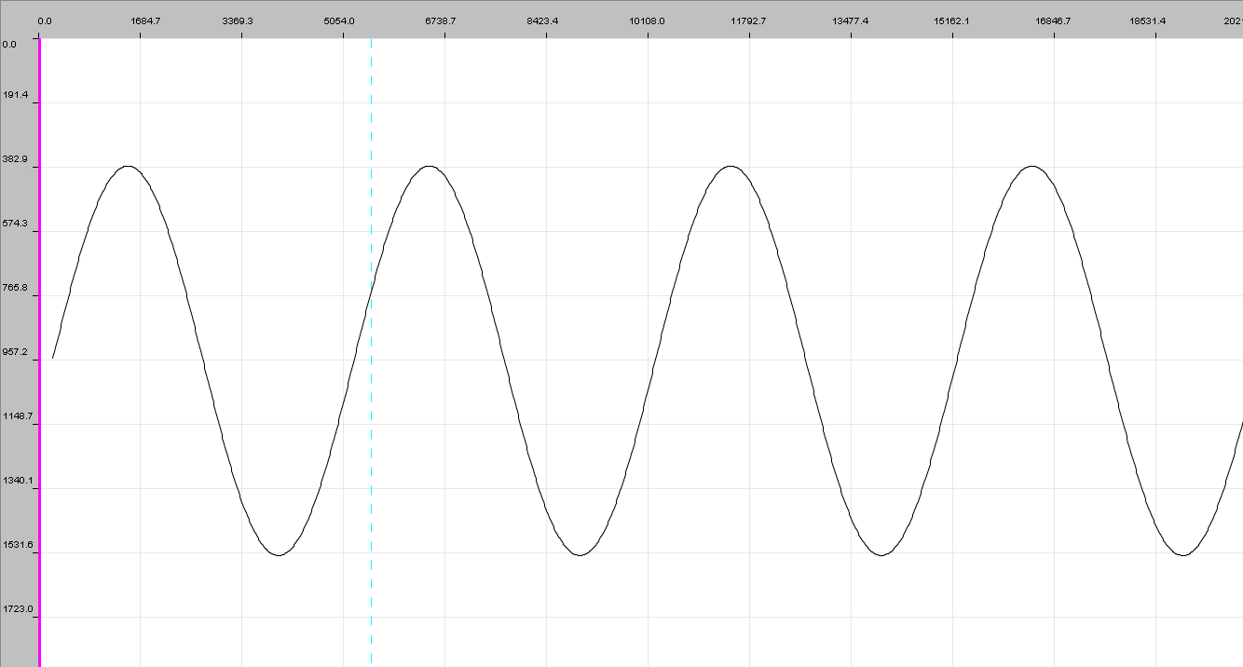
Target moves 10° leftward
Target moves 20° rightward
Target started at ≈958 PPD on the y-axis
Time (ms)
Figure 2.7: A sample of complete four cycles sinusoidal waveform for ± 10° horizontal SP EMR moving at 0.2 Hz frequency = 8°/sec mean velocity. The x-axis shows the time in ms, and the y-axis shows the pixel's target position per degree. The pixels unit was used for programming the target position. Leftward target motion is represented by the upward tracing (i.e., from 957 to 382 PPD on the y-axis), and rightward target motion is represented by the downward tracing (i.e., from 382 to 1531 PPD).

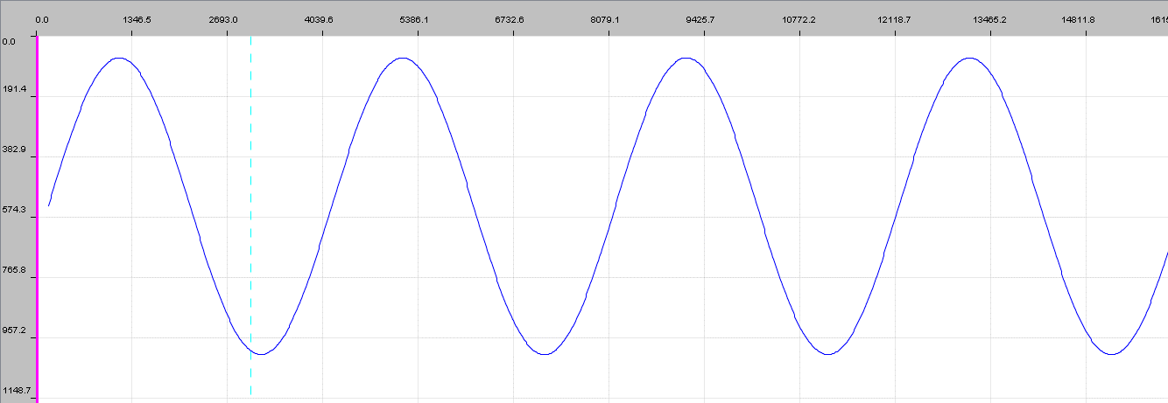
Target started at ≈533 PPD on y-axis

Time (ms)
Target moves 8° downward
Target moves 16° upward
Figure 2.8: A sample of complete four cycles sinusoidal waveform for ±8° vertical SP EMR moving at 0.25 Hz frequency = 8°/sec mean velocity. The x-axis shows the time in ms, and the y-axis shows the pixel's target position per degree. The pixels unit was used for programming the target position. Downward target motion is represented by the upward tracing (i.e., from 574 to 191 PPD on the y-axis), and upward target motion is represented by the downward tracing (i.e., moving from 191 to 957 PPD).

Saccade
The testing paradigm for saccades was developed with six testing amplitudes horizontally (± 5°, ± 10° and ± 15°) and six vertically (± 4°, ± 6° and ± 8°), as shown in Figure 2.9 A and B. For each amplitude, the target was presented repeatedly in a randomised sequence, resulting in a total of 72 saccades (12 trials x 6 amplitudes = 72 trials). The saccadic target was randomised in terms of amplitude orders and duration of time spent at the eccentric point, at intervals ranging from 1 to 2 seconds. A maximum horizontal saccade amplitude of ± 15° was selected to accommodate the display screen size and patient distance, as illustrated in Figure 2.1. It has been reported that the most naturally occurring horizontal saccades occur at an amplitude of 15° (A.T. Bahill et al., 1975).
The EMR started with a calibration and validation test, as described in section 2.2.2. The participants were instructed to look at the white square target in the centre of the black cross (Figure 2.4). The participants had the test procedure explained in detail before the EMR. The participants were informed that this EMR was designed to study the natural fast eye movements. A black cross target appears in the centre of the screen for a random period between 1 to 2 seconds before disappearing and suddenly jumping either left or right (for horizontal testing) or up and down (for vertical testing). It could jump close to the centre position or towards the edge of the screen. The participants were instructed to be aware and stay focused to avoid missing any target presentation at eccentric positions. They had to move their eyes as quickly as possible onto the new target position at the eccentric position on the display monitor and accurately focus on the tiny white box at the centre of the black cross. At the same time, they were reminded to avoid trying to guess where the next target presentation would occur. This was crucial to measure visually triggered saccadic eye movements’ actual performance, avoiding anticipatory saccadic movements.
Figure 2.9: The target arrangement for horizontal and vertical saccade amplitudes. Only one target was presented at a time for the horizontal and vertical saccade tests.
A)
PP

-10°
+10°

-15°
-5°
+15°

+5°

B)
PP

-4°
+8°

-8°
+4°
-6°

+6°

Leftward saccade
Rightward saccade
Downward saccade
Upward saccade

Data analysis
Data were extracted using .edf files from the DV software provided by SR research, installed in the display PC at the laboratory. This process was performed offline. The extracted data were saved as an Excel spreadsheet on an external hard disk for further statistical analysis.
Data analysis was performed using Statistical Package for the Social Sciences (SPSS) statistics for Windows, Version 26.0 (IBM Corp., Armonk, New York). The experimental chapters have included detailed descriptions of the statistical tests applied (Chapters 3, 4 and 5).

Dwell time within three AOIs
Standard circular areas of interests (AOIs) were set-up for the data extraction process and were applied for all experimental studies. AOIs were created to assess the duration participants kept their eyes within the specific area during the recording period (Holmqvist, 2011) or whether the eyes were fixating outside the AOI. Three AOIs were used to analyse fixation eye movement performance for Experiments 1 to 4. The smallest AOI covered a 1.0° radius from the centre of the fixation target cross, the medium AOI covered area > 1° to 2° radius, and the large AOI covered an area beyond 2° radius area, as shown in Figure 2.10.
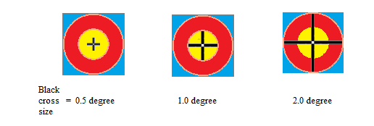
Figure 2.10: Illustration of three AOIs created for the fixation analysis for the three target sizes.
The yellow area represents 1.0° AOI, the red area represents 2.0° AOI and the blue area represents >2° AOI. Fixation data were extracted using the 'interest area report' generated from the DV, as described in Appendix 2.1.
The fixation performance was examined by quantifying the dwell time (DT) percentage. DT refers to the total length of time the eye was fixated in each AOI, excluding the identified saccadic movements. The saccadic movements were identified based on the saccade threshold of motion (≥ 0.3°), velocity (22°/sec), and acceleration (8000°/sec²). Excellent fixation performance requires being able to hold steady fixation very close to the fixation target's centre. Higher percentage DT and smaller AOI indicate better fixation performance.

SP gain, RMSE and durations
Saccades were distinguished from SP movements for any movement of ≥70°/sec velocity throughout the SP eye movement tests. The identified saccades were removed from the analysis automatically by the DV software. There were three parameters used to evaluate SP performance: gain, RMSE, and duration of SP segments (in ms). SP gain refers to the ratio of eye velocity to target velocity during segments of the SP. The most accurate gain score is 1.0 when the eyes move at the same velocity as the target. When the eyes move slower than the target, the gain will be less than 1.0, and when the eyes move quicker than the target, the gain will be greater than 1.0. The parameter analysed to evaluate SP performance was RMSE, which is the average distance between the target and the eyes (in degrees of visual angle) during each SP segment. High values of RMSE are produced when the eyes are further away from the target suggesting poor SP performance. The duration of the SP segment (in ms) refers to the duration the eyes stay pursuing the target without any saccades or blinking. From the SP sinusoidal wave tracing, the eye movements were divided into discrete segments. Next, each segment was graded as saccades, pursuits, or blinks. Figure 2.11 summarises the SP live trace in DV. The methods used to extract the SP data from the DV into an Excel spreadsheet for further statistical analysis are described in Appendix 2.2.
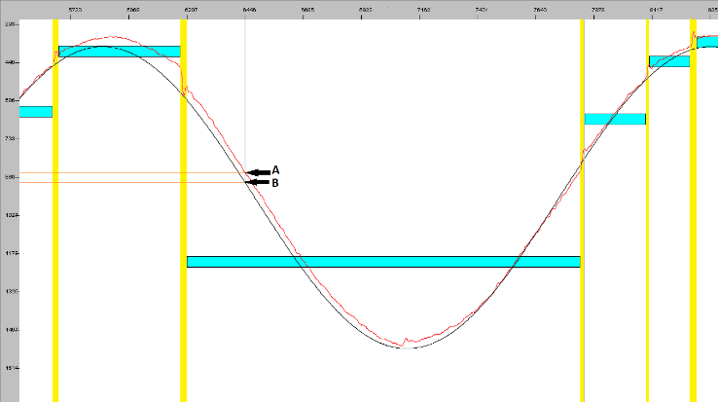
Figure 2.11: A sample of SP eye movements performed by a healthy control participant from this study. The x-axis shows the time in ms and the y-axis shows the position of the target in PPD. A change towards the smaller numbers on the y-axis indicates the target moving to the left, while a change towards the bigger numbers indicates a target moving to the right.
Note: — represents the target position; — represents the eye position
From the graph, at 6466 ms on the x-axis (marked with the blue line), the eye is located more leftward, representing a smaller number on point A than the target position showing a bigger number on point B. The difference between these two points is calculated as the RMSE. The horizontal turquoise bars represent the SP segment's duration without saccades, and the vertical yellow bars indicate the saccadic motion detected during the SP motion.
The SP gain was calculated by taking the ratio of the eye velocity to the target velocity. The gain of 1 indicates that the eye velocity matches the target velocity, <1 indicates that eye velocity is slower than the target velocity, and >1 indicates that the eye velocity is faster than the target velocity. The SP RMSE account for the average distance between the target and eye in degrees of visual angle. An increase of SP RMSE indicates that the eye is further away from the target suggesting poor SP performance. In addition, SP duration demonstrates the SP performance by the length of SP fixations (in ms). Shorter periods of SP fixation indicate interruptions by saccades and weaker SP performance.

Saccadic latency, peak velocity and gain
In the current study, the saccade performance was evaluated by analysis of saccadic latency, peak velocity, and gain for the target amplitudes of ± 5°, ± 10°, ± 5° horizontally and ± 4°, ± 6°, ± 8° vertically. The definition of each parameter was discussed in section 1.2.3. The methods used to extract the saccade data from the DV are described in Appendix 2.3. Figure 2.12 illustrates an example of a horizontal saccade movement made by a healthy participant from the current study.
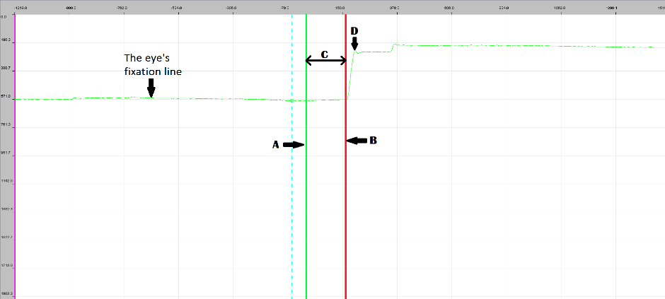
Figure 2.12: A sample of 10° horizontal leftward saccades of the RE from a healthy participant.
The x-axis shows the time in 'ms'; the y-axis shows the eye position in the PPD unit. A) Marks the onset of the target presentation at 0 ms. Therefore, the time before this vertical green line denotes negative values (on the x-axis). B) Indicates when the saccadic movement was initiated. C) refers to the saccadic latency, ≈160 ms shown on the x-axis of this graph. The eye moved to left gaze from 571 PPD (fixation line) to 190 PPD, marked as D. This movement was detected as the first saccade after the target's onset when the eye moved at a 0.3° amplitude with a velocity threshold of 22°/sec (SR_Research, 2018), known as saccadic peak velocity. Saccadic gain is calculated by taking the ratio of saccadic amplitudes to the target amplitude.

Normative Eye Movements

Experiment 1: To describe normative EMRs in three adult age groups
This study was designed to establish normative data for fixation, SP and saccades in three different age groups recorded using the EyeLink 1000 Plus. In addition, the study provided control data for eye movements to enable comparisons with patients with ocular nerve palsies, as discussed in Chapter 5. The study was conducted using the smallest target size visible to the participants.
The effect of ageing on saccadic and SP performance is a mixed picture. Some studies have reported that the saccadic eye movements of healthy participants are influenced by ageing (Abel et al., 1983; Huaman & Sharpe, 1993; Peltsch et al., 2011b), but there was a recent study that reported that ageing did not affect the voluntary saccadic latency, peak velocity and gain (Hopf et al., 2018). On the other hand, Wilson et al. (1993) reported that age influenced saccadic performance at large saccadic amplitudes (≥35°).
Peltsch et al. (2011) investigated the effect of ageing on the horizontal saccadic latency and saccadic direction errors. They recruited older participants between 60 to 85 years old. Participants were grouped into five age groups: (60-64, 65-69, 70-74, 75-79, and 80-85 years old). They found that saccadic latency and the proportion of saccadic errors increased with age. Another study showed that vertical saccadic latency was longer for older participants than younger participants (Yang & Kapoula, 2006). In addition, it has been reported that saccadic peak velocity is reduced in the elderly (Abel et al., 1983), especially at larger saccadic amplitudes (>20°) (Moschner & Baloh, 1994; Warabi et al., 1984). However, another recent study reported that saccadic peak velocity was not affected by ageing (Hopf et al., 2018). In addition, saccadic gains were reported not to differ significantly between young adults and the elderly (Bono et al., 1996; Hopf et al., 2018; Moschner & Baloh, 1994; Warabi et al., 1984).
SP gains decreased significantly in older participants at all velocities, and differences between young and old participants increase with increasing velocity and acceleration of the target (Moschner & Baloh, 1994). Older people have much slower SP velocity than younger people, especially with a target movement of ≥ 10°/sec (Sharpe & Sylvester, 1978).
The differences occur mainly due to the different testing paradigms used in the various studies. Despite there being extensive research on age-related normative data for eye movement performance, using video eye recording methods, different testing paradigms will influence the value of normative data, thus yielding different conclusions. Therefore, normative data consisting of participants from different age groups are required before comparing possible eye movement anomalies for each new test paradigm of EMR (Liversedge et al., 2011).

Aims of the study
This experimental study was designed to:
- Provide normative data for fixation, SP, and saccadic eye movements parameters in three adult age groups; young, middle, and older (19 to 39 years, 40 to 59 years, and ≥ 60 years, respectively).
- Explore any significant changes of eye movement characteristics in healthy participants with increasing age.
- Develop EMR paradigms and analysis methods appropriate for the clinical evaluation of patients with eye movement anomalies.

Null hypothesis
The performance of fixation, SP, and saccadic eye movements will stay unchanged with age.

Methods
Participants aged over 18 years were recruited to complete EMR. Participants were recruited from the undergraduate orthoptic student volunteering scheme by emailing staff and staff friends and relatives. The inclusion criteria for this study included:
- The best-corrected VA for both eyes had to be 0.2 logMAR or better using Early Treatment Diabetic Retinopathy Study (EDTRS) charts.
- Normal ocular motility clinically.
- There is no underlying ocular, neurological or systemic disease that could affect the outcome. Participants with conditions such as ocular HPT and cataracts were included as these are frequently encountered in the general elderly population in the absence of ocular movement abnormalities. Only those with multiple illnesses, ocular and systemic pathology, and/or taking the medications known to cause the eye movements anomalies were excluded from this study (Irving et al., 2006).
Eye movements were recorded binocularly for all participants. All participants in the young and middle age groups were tested using a 0.5° target size. However, participants in the older age group were tested using a 1° target size to ensure they could focus precisely on the small centre of the black cross, without wearing presbyopic correction, throughout the EMRs. The details of the eye recording procedures are described in Chapter 2.

Ethics and consent
This study received ethical approval from the University of Sheffield Medical School Ethics Committee on 18/04/2017, application reference number 013101 (Appendix 1.1). All participants who satisfied the inclusion criteria were given the participant information sheet (Appendix 1.2). Following an opportunity to ask questions, written consent was obtained using the participant consent form (Appendix 1.3) if participants were willing to proceed with the study. All information collected during this study was kept confidential. Participants’ documents and records are stored securely on university computers using a coding format so that they cannot be identified by others. All study data were made anonymous and referred to only by the participants' unique study numbers. The university computer and encrypted memory stick used are both passwords protected and only accessed by authorised personnel. The encrypted memory stick and investigator site file are kept in a locked office behind multiple swipe card access main doors in the Medical School at the University of Sheffield. Any published information would have the participants' details removed to maintain anonymity.
The inclusion criteria were confirmed by performing standard clinical tests involving no direct contact with the eye. As described, the EMR is non-invasive, requiring participants to put their chin onto a chin and forehead rest without other restraints or contact with the eyes. The chin and forehead rest were cleaned between each participant with anti-bacterial wipes.

Data Analysis
Data from DV software for fixation, SP and saccades were extracted and transferred into the Microsoft Excel spreadsheet for analysis (refer to Appendix 2.1, 2.2 and 2.3 for the data extraction process).
Although the viewing was done with both eyes open, only the right eye movements were analysed (Henderson et al., 1999). A separate experiment was conducted to investigate the effect of monocular or binocular tracking. The t-test was used to determine the significance of the differences between monocular and binocular recordings and no differences was found (refer to section 3.3).
Data were arranged according to the age groups, with calculations for the mean of the pooled data for young, middle, and older age groups. Details of the statistical analysis are explained in each section of the eye movement results.
The Shapiro-Wilk test, skewness, P-P plot (probability-probability plot) and histogram have been used to determine if the data were normally distributed (Mishra et al., 2019). The results are consistent with the normal distribution assumption, as demonstrated by the numerical value or by the histogram, which is approximately bell-shaped. As a result, data are compared using parametric testing. In cases when the data did not fulfil the normality distribution requirements, non-parametric statistical analyses were employed.
The one-way ANOVA test was used to determine whether the mean differences in eye movement parameters differed between the different age groups in this study. In order to run a one-way ANOVA, there are six assumptions that must be assessed to ensure the data can be analysed using this type of analysis. Assumption 1: Data consists of one dependent variable that are measured at the continuous level.
Assumption 2: Data consists of one independent variable that consist of two or more categorical, independent groups.
Assumption 3: Data should have independence of observations, which means that there should be no association between the observations in each independent variable group or between the groups themselves.
Assumption 4: According to the dependent variable, there should be no statistically significant outliers in any of the categories of independent variable.
Assumption 5: For each group of the independent variable, the dependent variable should be approximately normally distributed.
Assumption 6: The variances in the data should be homogeneous (i.e., the variance of the dependent variable is equal in each group of the independent variable).
Whenever the data did not conform to the assumptions, a non-parametric independent samples Kruskal-Wallis test was performed.
Further statistical analysis using Pearson correlation was performed to investigate the association of ageing factor with the eye movement parameters. Correlation coefficients of r<0.3 are regarded poor, r = 0.3-0.7 are considered moderate, while r>0.7 are considered strong (Laerd, 2013).

Removing the outliers
All negative gain values and extreme value of RMSE (>5.0) were eliminated from the study, accounting for ≈10% of the horizontal SP and ≈8% of the vertical SP data was discarded. The extreme values were detected using the scatter plot of individual participants.
Any saccadic movements with a latency of less than 80 °/s were excluded from the analysis, as they represent anticipatory saccades rather than visually guided saccades. As a result, 10 % and 13 % of total horizontal and vertical saccadic trials, respectively, were excluded from analysis due to poor latency.

Results
Fifty-seven healthy control participants aged between 19 to 79 years were recruited and received EMRs to establish normal data for eye movements; young (n = 23), middle (n = 18) and older age (n = 16). One participant from the older age group was subsequently excluded because she wore the rigid gas permeable (RGP) contact lenses, which caused abnormal eye recording results, especially towards the eccentric positions of horizontal and vertical gaze directions.
This section describes the performance of fixation, SP and saccadic eye movements of healthy participants classified into the three age groups. Although the recording provides data for each eye separately, the data from the RE only were analysed. This is because t-tests found no statistically significant difference between RE and LE in the mean values of all eye movements measured (Appendix 3.1).

Effect of ageing on the fixation eye movements.
Individual participant median AOIs at five fixation positions was used to calculate the group median, as shown in Figure 3.1. The young and middle age groups maintained fixation within 1° of the fixation target centre nearly 100% of the time, signifying excellent fixation at PP, but the older age group showed nearly 60% DTs within that area. On 10° left gaze, young people had reduced DT (≈65%) within 1° AOI, slightly higher than the older participants (≈60%). The condition changed on 10° right gaze, whereby young people had the highest percentage DT (≈80%) within the smallest AOI among the three groups, and the older age group were ≈10% lower than the middle age (55%). On 8° up gaze, the fixation performance was similar between the three age groups with ≈60 - 70% DT within the smallest AOI. On 8° downgaze, the older group demonstrated a substantial decline of percentage DT, within the smallest AOI, to less than 20%, and increased DT within the 2° AOI to ≈50%. The fixation of >2° AOI was at a small percentage, ≈<5%, for all age groups at all fixation positions.

Figure 3.1: Bar graphs illustrating the group median percentage DT, represented on the y axis, between three age groups shown by the legend within the specific AOI.

A Friedman test was run to determine differences in percentage DT between the age groups within similar AOIs. The null hypothesis was that the percentage DT distribution was similar for all age groups within 1°, 2° and >2° AOI at five fixation positions. The results revealed that the percentage DT was only significantly different between the three age groups at two settings: 1) within the smallest AOI at the PP; and 2) within the largest AOI on downgaze. The post-hoc test showed that the percentage DT of the older age group was significantly lower than the young and middle age groups within 1°AOI at PP (p = 0.028). While on downgaze, the result shows that the young and middle age groups had significantly fewer DTs than the older age group (p = 0.003 and p = 0.002).
The percentage DT based on position of gaze (POG) provided no substantial useful contribution. As a result, it was decided to analyse percentage DT solely based on the area of interest (AOI), without taking POG into account. The median percentage DT within 1° AOI (blue bar) appears to be similar for young and middle-aged adults (65%) (refer to Figure 3.2). However, it decreased to below 50% in old age. The second AOI (shown in the red bar) appears to be half the 1° AOI (blue bar), and they look comparable across all age groups. Beyond 2° AOI, the median percentage DT was less than 10% in young and middle age but increased to 15% in old age.

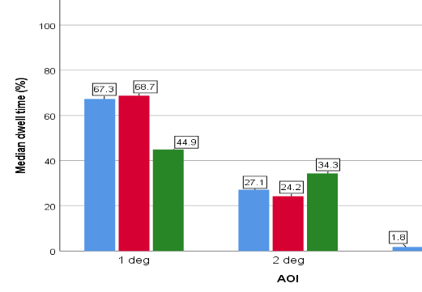
Figure 3.2: A bar graph displays the median percentage DT of three age groups (young, middle and old age) according to the three AOIs (1°, 2° and >2°).

Independent-samples Kruskal-Wallis test reported the distribution of median percentage DT is the same across age categories at 1° AOI and 2° AOI, p = 0.06 and p = 0.30, respectively. However, median percentage distribution was significantly different across ages at >2°AOI, p = 0.02. The significant pairwise were detected between the Young age: 1.8% – Old age: 10.6%, p = 0.010 and Middle age: 2.1% – Old age: 10.6%, p = 0.014. It showed that elderly had increase fixation time spent within the largest AOI compared to the young and middle age adults.
Pearson's correlation coefficients were analysed to determine the relationship between percentage DT and age. It revealed that the percentage DT and ageing were not significantly correlated (1° AOI: r(55) = -0.23, p = 0.10, 2° AOI: r(55) = 0.09, p = 0.52, >2° AOI: r(55) = 0.27, p = 0.051) . This suggests that ageing cannot account for the variability in percentage DT.

The effect of ageing on horizontal SP
Individual participant means for the three age group participants were calculated for SP gain, RMSE, and duration of SP segment (Appendix 3.2). Individual means were then used to calculate the group means of the three age groups: young (n = 23), middle (n = 18), and older age participants (n = 15).
To compare the effects of ageing on horizontal SP parameters, a one-way ANOVA was used. There was a statistically significant difference in SP RMSE and duration between age groups. However, the SP gain was not different amongst the age groups. The one-way ANOVA findings are reported in Table 3.1.
Table 3.1: A one-way ANOVA was used to examine the effects of age on horizontal SP variables at four horizontal SP frequencies.
 | Frequency | SS | df | MS | F | p-value
Horizontal SP gain | 0.2 Hz | 0.01 | 2,54 | 0.00 | 0.96 | 0.39
Horizontal SP gain | 0.4 Hz | 0.01 | 2,54 | 0.00 | 0.59 | 0.56
Horizontal SP gain | 0.6 Hz | 0.05 | 2,54 | 0.02 | 2.97 | 0.06
Horizontal SP gain | 0.8 Hz | 0.04 | 2,54 | 0.02 | 1.49 | 0.24
Horizontal SP RMSE | 0.2 Hz | 0.62 | 2,54 | 0.31 | 4.22 | 0.02*
Horizontal SP RMSE | 0.4 Hz | 0.85 | 2,54 | 0.43 | 4.13 | 0.02*
Horizontal SP RMSE | 0.6 Hz | 0.82 | 2,54 | 0.41 | 4.07 | 0.02*
Horizontal SP RMSE | 0.8 Hz | 0.14 | 2,54 | 0.07 | 0.71 | 0.50
Horizontal SP duration | 0.2 Hz | 388213 | 2,54 | 194107 | 9.639 | <0.01*
Horizontal SP duration | 0.4 Hz | 72704 | 2,54 | 36352 | 2.011 | 0.14
Horizontal SP duration | 0.6 Hz | 4414 | 2,54 | 2207 | 0.526 | 0.59
Horizontal SP duration | 0.8 Hz | 24446 | 2,54 | 12223 | 3.647 | 0.03*
*Data are significant at p<0.05.
Post hoc analysis of the horizontal SP RMSE using the Bonferroni correction revealed that the two age groups that were substantially different at the first three frequencies were young and elderly people. However, no significant pairwise difference in SP durations was discovered.
Pearson's correlations were used to examine the relationship between horizontal SP parameters and ageing. Horizontal SP RMSE had a significant association with age, r(228) = 0.21, p = 0.01, despite the weak correlation strength between the variables (Laerd, 2013). On the other hand, no relationships between horizontal SP gain and durations were seen with age (p>0.05). The results indicated that ageing accounted for 21% of the variability in horizontal SP RMSE.A scatter plot was used for each trial frequency to investigate further the differences in SP parameters between three different age groups. The raw data of 56 people [young (n = 23), middle (n = 18), and old (n = 15)] was used to generate the plot.
The linear slopes of horizontal SP gain appear steady throughout the EMR for all age groups at the first three frequencies. However, at the highest frequency, the old age group has a negative linear slope, representing a lower gain, whereas the younger groups have a positive linear slope, demonstrating an improved gain towards the end of the frequency (Figure 3.3).
Furthermore, the horizontal SP RMSE of the older age group is consistently higher than younger groups across the first three frequencies of the EMR. At the maximum frequency (0.8 Hz), the younger age groups have a negative slope, indicating a decrease in RMSE, whereas the old age group has a positive linear slope indicating an increase in RMSE across the EMR (Figure 3.4).
Furthermore, horizontal SP duration of 0.2 and 0.4 Hz frequencies are having greater variation in range throughout the EMR especially among young and middle age groups, reflecting that longer smooth pursuit movements are demonstrated without CUS. The linear slopes showing that young age is having the longest SP duration, followed by middle and old age groups.

 | 0.2 Hz | 0.4 Hz
Horizontal SP gain  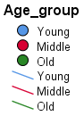 | 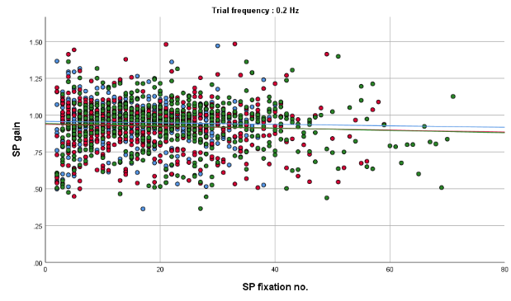 | 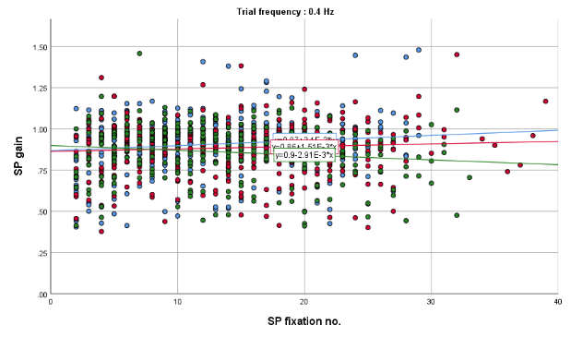
 | 0.6 Hz | 0.8 Hz
 | 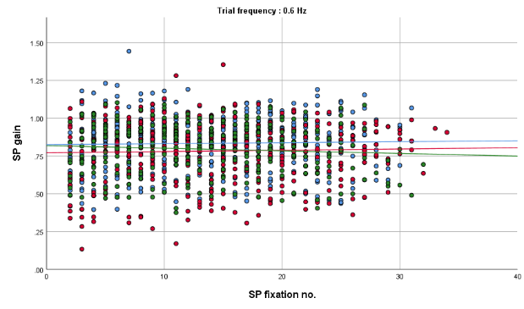 | 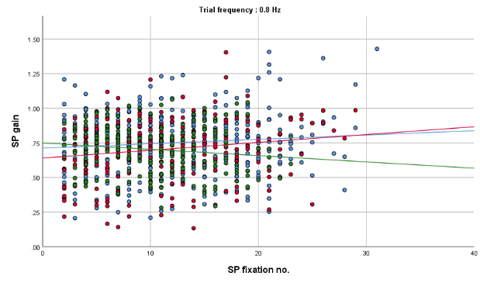
Figure 3.3: The scatterplots showing horizontal SP gain according to trial frequency for three age groups.

 | 0.2 Hz | 0.4 Hz
Horizontal SP RMSE | 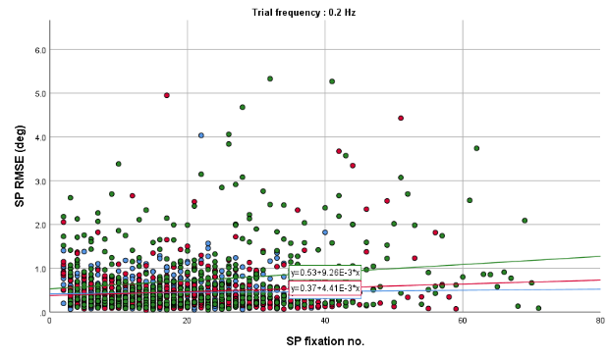 | 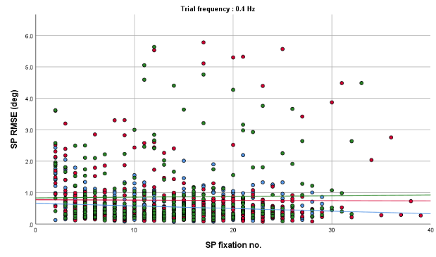
 | 0.6 Hz | 0.8 Hz
 | 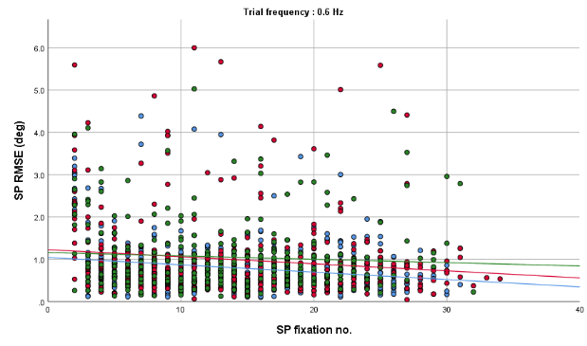 | 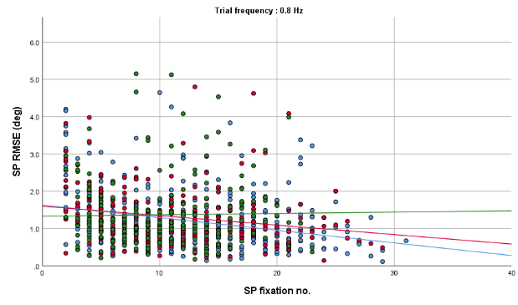
Figure 3.4: The scatterplots showing horizontal SP RMSE according to trial frequency for three age groups.

 | 0.2 Hz | 0.4 Hz
Horizontal SP duration | 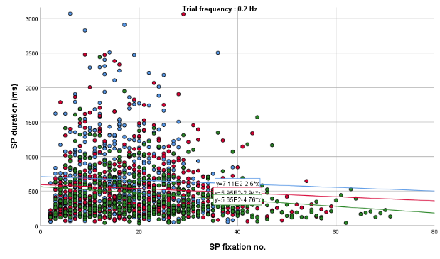 | 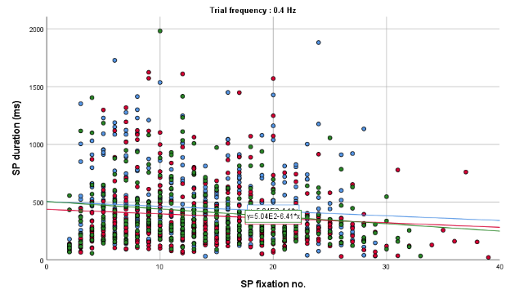
 | 0.6 Hz | 0.8 Hz
 | 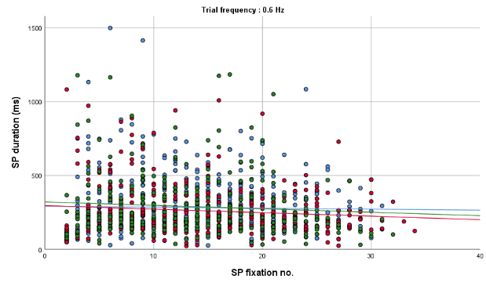 | 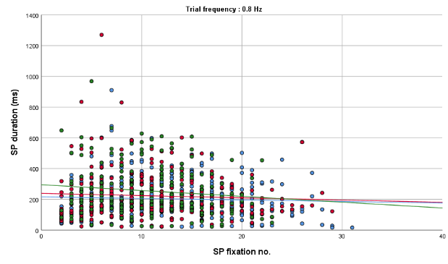
Figure 3.5: The scatterplots showing horizontal SP duration according to trial frequency for three age groups

The effect of ageing on vertical SP
Individual participant means for the three age group participants were calculated for SP gain, RMSE, and duration of SP segment (Appendix 3.3). Individual means were then used to calculate the group means for the three age groups: young (n = 23), middle (n = 18), and older age groups (n = 15).
To compare the effects of ageing on vertical SP parameters, a one-way ANOVA was used. There was a statistically significant difference in SP RMSE at the first three frequencies and SP durations at the third frequency between the age groups. However, the SP gain was not different amongst the age groups for all frequencies. The one-way ANOVA findings are reported in Table 3.2.
Table 3.2: A one-way ANOVA was used to examine the effects of age on vertical SP variables at four vertical SP frequencies.
 | Frequency | SS | df | MS | F | p-value
Vertical SP gain | 0.25 Hz | 0.02 | 2,53 | 0.01 | 1.17 | 0.32
Vertical SP gain | 0.5 Hz | 0.06 | 2,53 | 0.03 | 1.67 | 0.20
Vertical SP gain | 0.75 Hz | 0.03 | 2,53 | 0.01 | 0.44 | 0.64
Vertical SP gain | 1.0 Hz | 0.02 | 2,53 | 0.01 | 0.40 | 0.67
Vertical SP RMSE | 0.25 Hz | 3.15 | 2,53 | 1.58 | 8.89 | <0.01*
Vertical SP RMSE | 0.5 Hz | 3.07 | 2,53 | 1.54 | 3.88 | 0.03*
Vertical SP RMSE | 0.75 Hz | 3.21 | 2,53 | 1.60 | 4.74 | 0.01*
Vertical SP RMSE | 1.0 Hz | 0.82 | 2,53 | 0.41 | 1.69 | 0.19
Vertical SP duration | 0.25 Hz | 8981 | 2,53 | 4490 | 0.25 | 0.78
Vertical SP duration | 0.5 Hz | 18822 | 2,53 | 9411 | 1.43 | 0.25
Vertical SP duration | 0.75 Hz | 24921 | 2,53 | 12460 | 3.38 | 0.04*
Vertical SP duration | 1.0 Hz | 5776 | 2,53 | 2888 | 0.92 | 0.40
The mean value of vertical SP RMSE was significantly different between young and elderly age (p<0.01, 95% CI = -0.93, -0.24) at 0.25 Hz frequency, between young and middle age (p = 0.02, 95% CI = -0.97. -0.07) at 0.75 Hz, according to the Bonferroni test for multiple comparisons. In addition, there was no significant pairwise different for RMSE at the frequency of 0.50 Hz. Other pairwise comparisons revealed no statistically significant differences for vertical SP gain and durations.
Pearson's correlations were used to examine the associations between vertical SP parameters and ageing. Vertical SP RMSE revealed a weak positive correlation with age, r(224) = 0.24, p<0.01 (Laerd, 2013). The findings suggested that ageing accounted for 24% of the variability in vertical SP RMSE. On the other hand, there were no age-related associations between vertical SP gain and durations (p>0.05).
A scatter plot was created for each trial frequency to assess the vertical SP variables between three different age groups. The vertical SP gain of the young and old age groups has a positive slope, indicating that the young and elderly age groups start with lower gain than the middle age group but increase higher than the middle age group at 10-15 SP fixation number till the test is completed (Figure 3.6).
The linear slope of the RMSE at 0.25 Hz frequency is close to zero for all age groups, indicating that there is no trend of increasing or decreasing RMSE throughout the EMR, with young adults consistently exhibiting the smallest RMSE (≈0.6), followed by middle age (≈0.8) and old age (≈1.2). Additionally, at the middle at the middle frequencies, the old age showing with slight increase of the linear slope while young adults show the opposite throughout the EMR. At the highest frequency, young adults had a smaller RMSE than middle and old age groups. However, the discrepancies were not as significant as those observed at lower frequencies (Figure 3.7).
The SP duration of vertical RMSE did not differ significantly between the three age groups, except at the lowest frequency, where the young age group show an increase in their duration score throughout the test (Figure 3.8).

 | 0.25 Hz | 0.5 Hz
Vertical SP gain | 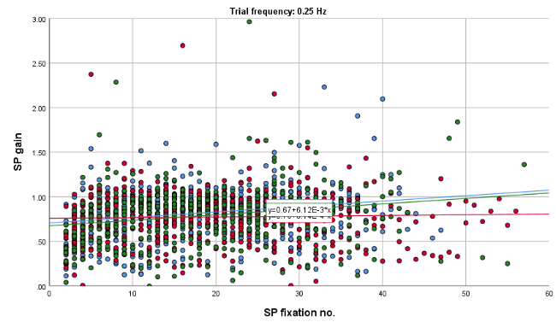 | 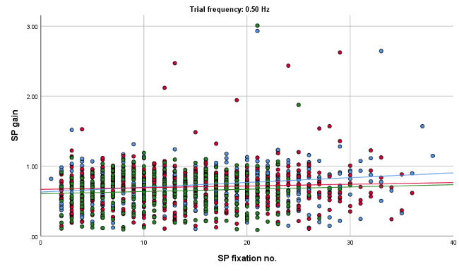
 | 0.75 Hz | 1.0 Hz
 | 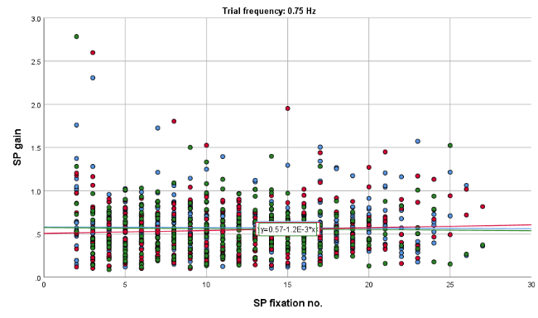 | 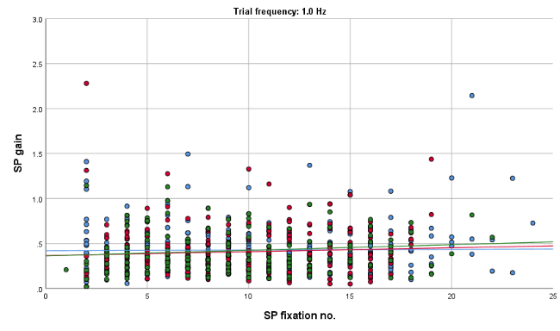
Figure 3.6: The scatterplots showing horizontal SP gain according to trial frequency for three age groups.

 | 0.25 Hz | 0.5 Hz
Vertical SP RMSE | 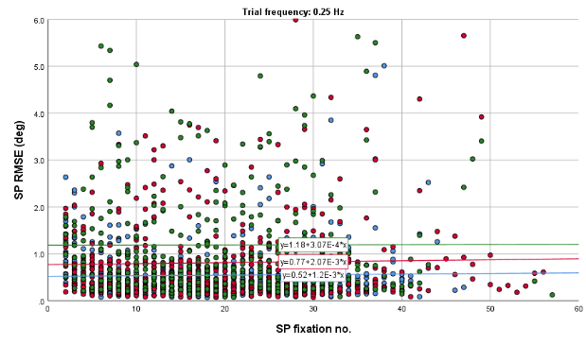 | 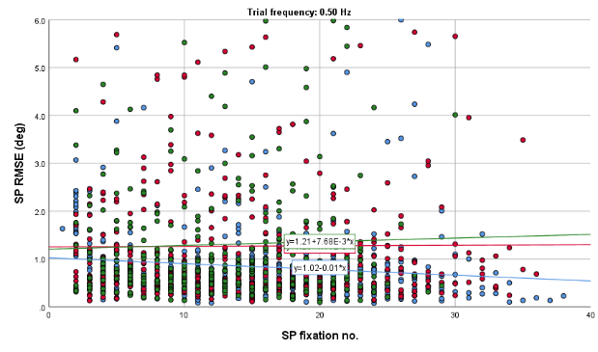
 | 0.75 Hz | 1.0 Hz
 | 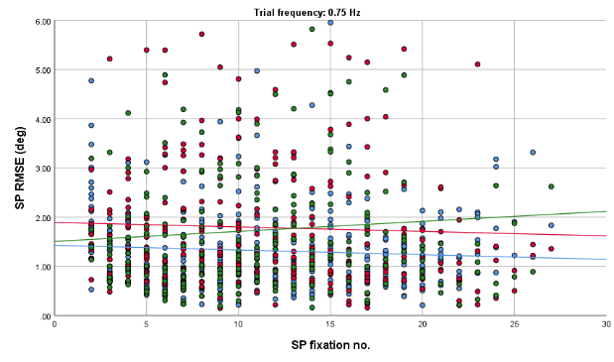 | 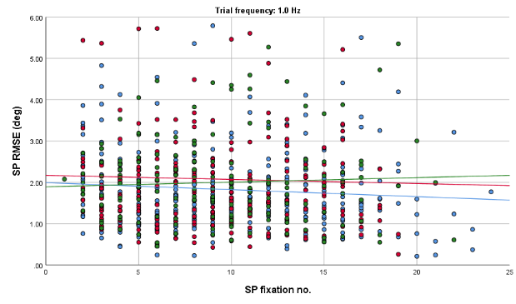
Figure 3.7: The scatterplots showing vertical SP RMSE according to trial frequency for three age groups.

 | 0.25 Hz | 0.5 Hz
Vertical SP duration | 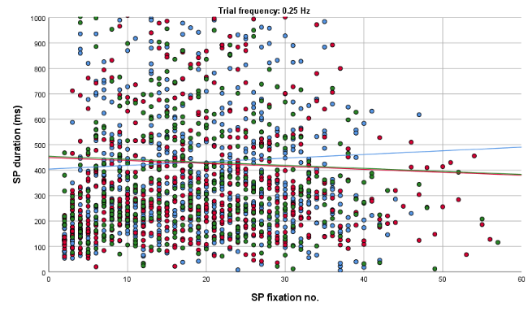 | 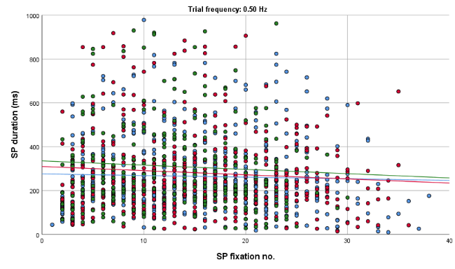
 | 0.75 Hz | 1.0 Hz
 | 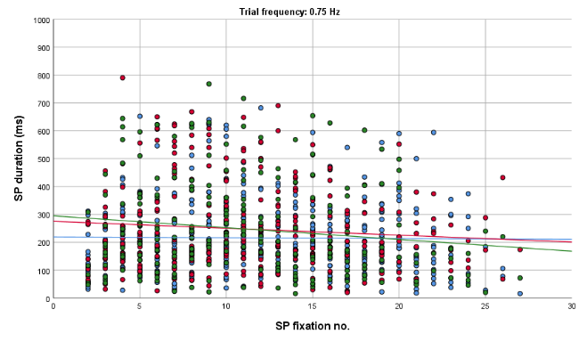 | 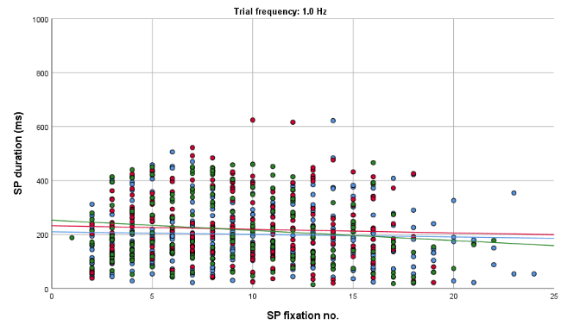
Figure 3.8: The scatterplots showing vertical SP duration according to trial frequency for three age groups.

The effect of ageing on horizontal saccadic performance
Individual participant means for the three age group participants were calculated for saccadic latency, peak velocity, and gain for six horizontal saccadic amplitudes (Appendix 3.4). Independent samples t-tests confirm a symmetrical pattern between the rightward and leftward saccadic amplitudes (Table 3.3). Thus, independent of the direction of saccades, target amplitudes were classified into the largest, middle, and smallest amplitudes (i.e., +15° and -15° for the largest amplitude, +10° and -10° for the middle amplitude, and +5° and -5° for the smallest amplitude).
Table 3.3: Independent samples t-tests evaluating the differences of the mean values by horizontal saccadic directions.
Mean horizontal saccadic parameter | Leftward saccade | Rightward saccade | t | df | p-value
Latency | 191.84 | 193.87 | -0.48 | 268 | 0.63
Peak Velocity | 344.46 | 349.18 | -0.42 | 268 | 0.67
Gain | 0.90 | 0.91 | -0.49 | 268 | 0.62
*Data are significant at p<0.05
One-way ANOVA was carried out to examine the effect of ageing on the horizontal saccadic variables according to different size of saccadic amplitudes. The horizontal saccadic latency differed significantly between age groups for all amplitude sizes. Additionally, the peak velocity was significantly different between age groups at the middle and largest amplitudes, and the gain was significantly different between age groups at the smallest amplitude. Post hoc analysis revealed that there were differences in peak velocity and gain between the young and old age groups. The one-way ANOVA findings are reported in Table 3.4.

Table 3.4: One-way ANOVA was used to assess the effects of age on horizontal saccadic variables at three amplitude sizes.
Horizontal saccadic parameter | Amplitude size | SS | df | MS | F | p-value
Latency | Smallest (±5°) | 13964 | 2,87 | 6982 | 11.24 | <0.01*
Latency | Middle (±10°) | 17667 | 2,87 | 8834 | 12.52 | <0.01*
Latency | Largest (±15°) | 22958 | 2,87 | 11479 | 11.78 | <0.01*
Peak Velocity | Smallest (±5°) | 46619 | 2,87 | 23310 | 7.29 | <0.01*
Peak Velocity | Middle (±10°) | 47199 | 2,87 | 23599 | 6.13 | <0.01*
Peak Velocity | Largest (±15°) | 50639 | 2,87 | 25319 | 3.18 | 0.05
Gain | Smallest (±5°) | 0.004 | 2,87 | 0.002 | 0.22 | 0.81
Gain | Middle (±10°) | 0.007 | 2,87 | 0.003 | 0.52 | 0.60
Gain | Largest (±15°) | 0.089 | 2,87 | 0.045 | 5.51 | 0.01*
*Data are significant at p<0.05
According to the Bonferroni test for multiple comparisons, the mean value of latency was significantly different at the smallest, middle and largest amplitudes between at least two age groups, p<0.05. In addition, the mean peak velocity was also different between the two age groups, with older adults having a faster peak velocity than younger adults, as evidenced by the -ve mean differences. Furthermore, the mean gain was significantly different between the young and old age adults at the largest amplitude size. The post hoc analysis is presented in Table 3.5.Pearson's correlations were used to evaluate the correlation between the horizontal saccadic variables (latency, peak velocity and gain) with age. The saccadic latency and peak velocity were found to be positively correlated with age factor, r = 0.41, p<0.01 and r = 0.22, p<0.01, respectively. The former had a moderate strength of correlations while the latter had poor correlations. There is no statistically significant relationship between horizontal saccadic gain and ageing (p>0.05).

Table 3.5: Examine significant differences in the mean values of saccadic parameters between age groups using post hoc analysis. The multiple-correction Bonferroni test was employed.
Horizontal saccadic variable | Amplitude size | (I) Age Group | (J) Age Group | Mean Difference (I-J) | p-value | 95% CI
 |  |  |  |  |  | Lower Bound | Upper Bound
Latency | smallest | Young | Old | -30.51 | <0.01* | -46.21 | -14.80
Latency | middle | Young | Old | -34.3 | <0.01* | -51.00 | -17.52
Latency | middle | Middle | Old | -18.9 | 0.02* | -35.63 | -2.14
Latency | largest | Young | Middle | -22.9 | 0.02* | -42.57 | -3.21
Latency | largest |  | Old | -38.9 | <0.01* | -58.60 | -19.24
Peak Velocity | smallest | Young | Middle | -48.9 | <0.01* | -84.58 | -13.27
Peak Velocity | smallest |  | Old | -47.6 | 0.01* | -83.26 | -11.96
Peak Velocity | middle | Young | Middle | -46.8 | 0.01* | -85.95 | -7.73
Peak Velocity | middle |  | Old | -50.2 | 0.01* | -89.26 | -11.04
Gain | largest | Young | Old | 0.07 | 0.01* | 0.02 | 0.13
*Data are significant at p<0.05
By pooling the data depending on the degree of target amplitude independent of saccadic directions, a scatter plot was constructed. Thus, amplitudes of ±15° were combined into one group, and so on, resulting in three amplitude sizes (Figure 3.5). This enables investigation of how ageing affects saccadic variables at various degrees saccadic amplitude in healthy individuals.
The scatterplots reveal that young adults had a shorter horizontal saccadic latency than middle-aged and elderly people for all amplitude sizes. The condition remained consistent across 72 trials, as evidenced by no apparent negative or positive slope of linear lines (Figure 3.9).
Furthermore, for all amplitude sizes, young adults exhibit consistently slower peak velocities than middle- and old-aged adults. Old age people show an increase in peak velocity from the middle of the test to the end of the 72 trials, while middle-aged adults show a decrease in peak velocity but are still faster than young people (Figure 3.10).
In addition, the horizontal saccadic gain was not influenced by ageing. The scatterplots demonstrate that the saccadic gain for all age groups is identical to each other at each amplitude size. However, the gain decreases as the amplitudes increases for all participants (Figure 3.11).
Horizontal saccadic latency  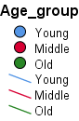 | ±5° | 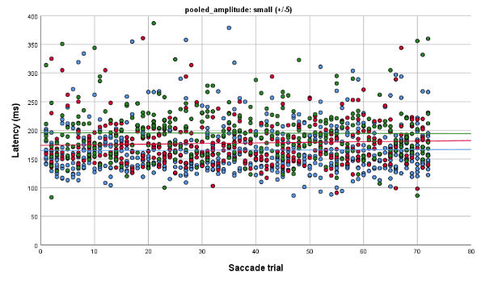
 | ±10° | 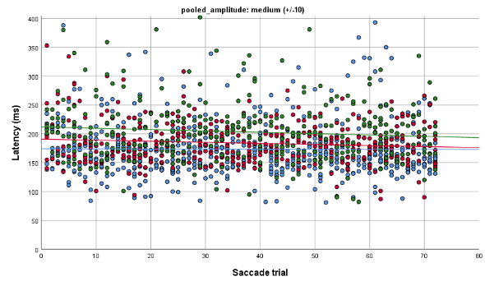
 | ±15° | 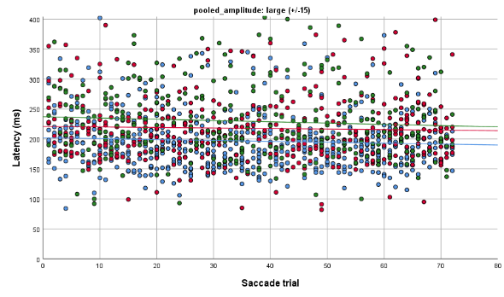
Figure 3.9: The scatterplots show the horizontal saccadic latency of young, middle, and old age groups with 72 saccadic trials at three pooled saccadic amplitude sizes (±5 = small, ±10 = medium, and ±15 = large).

Horizontal saccadic peak velocity | ±5° | 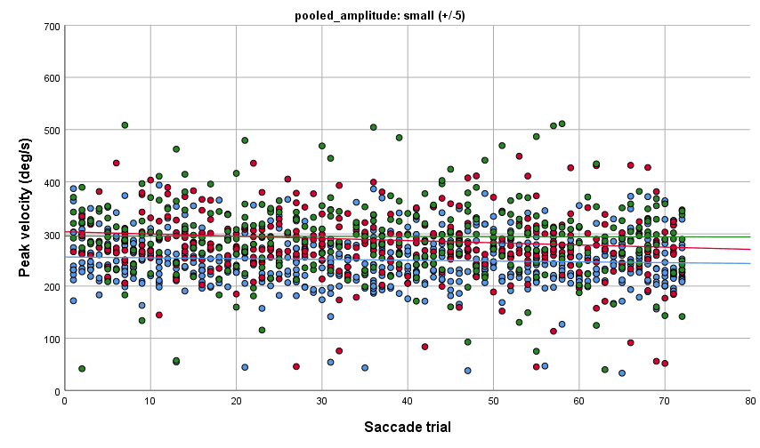
 | ±10° | 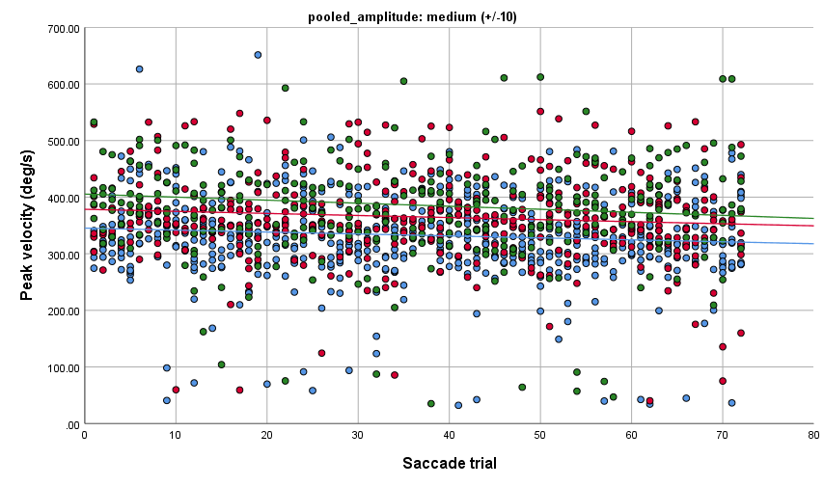
 | ±15° | 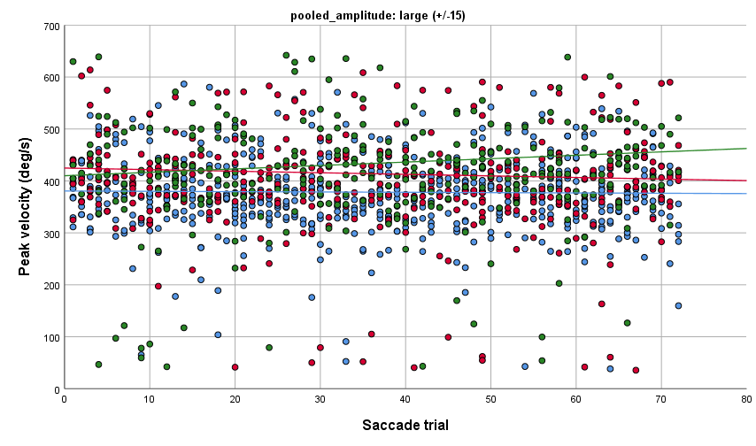
Figure 3.10: The scatterplots show the horizontal saccadic peak velocity of young, middle, and old age groups with 72 saccadic trials at three pooled saccadic amplitude sizes (±5 = small, ±10 = medium, and ±15 = large).

Horizontal saccadic gain | ±5° | 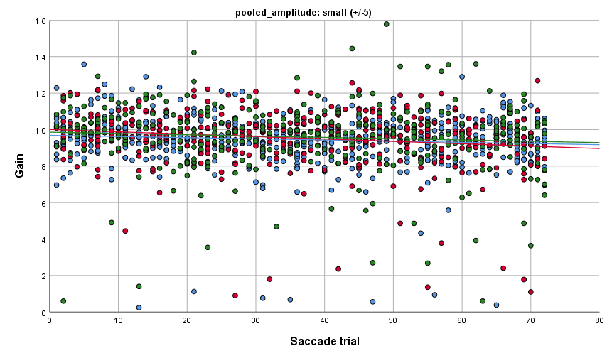
 | ±10° | 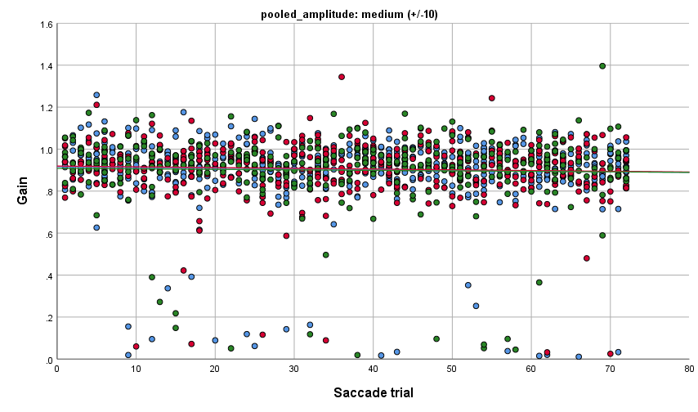
 | ±15° | 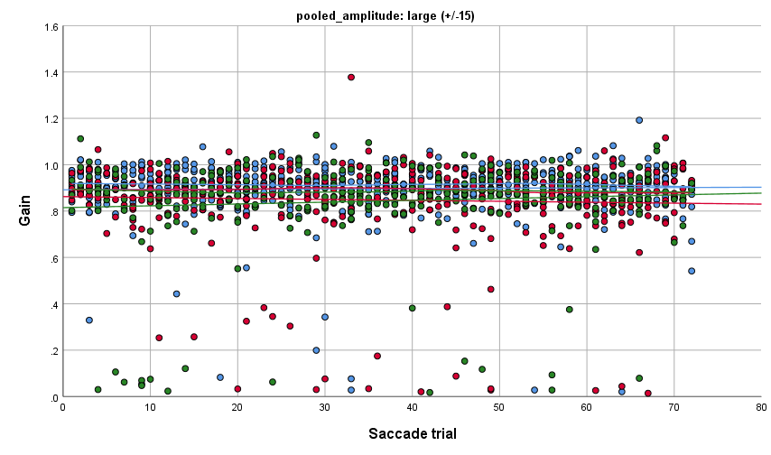
Figure 3.11: The scatterplots depict the horizontal saccadic gain of young, middle and old age groups with 72 saccadic trials at three size of pooled saccadic amplitudes (±5 = small, ±10 = medium, and ±15 = large).

The effect of ageing on vertical saccadic performance
Individual participant means for the three age group participants were calculated for saccadic latency, peak velocity, and gain for six vertical saccadic amplitudes (Appendix 3.5).
One-way ANOVA was carried out to examine the effect of ageing on the vertical saccadic variables at six vertical saccadic amplitudes (±8°, ±6° and ±4°). The mean vertical saccadic latency was significantly different between at least two age groups at all saccadic amplitudes. However, the peak velocity was not significantly different between age groups. Additionally, the saccadic gain was only significantly different between two age groups at 6° and 8° upward saccades. The result of one-way ANOVA for the effect of aging towards the vertical saccadic eye movements are presented in Table 3.6.
Table 3.6: One-way ANOVA was used to assess the effects of age on vertical saccadic variables at six amplitude. (-ve amplitude = downward saccades; +ve amplitudes = upward saccades)
Vertical saccadic variable | Amplitude | SS | df | MS | F | p-value
Latency | -8° | 22323 | 2,52 | 11161 | 13.51 | <0.01*
Latency | -6° | 12507 | 2,52 | 6254 | 5.73 | 0.01*
Latency | -4° | 23629 | 2,52 | 11815 | 12.64 | <0.01*
Latency | 4° | 14398 | 2,52 | 7199 | 14.39 | <0.01*
Latency | 6° | 17809 | 2,52 | 8904 | 18.80 | <0.01*
Latency | 8° | 9509 | 2,52 | 4754 | 7.10 | <0.01*
Peak Velocity | -8° | 18008 | 2,52 | 9004 | 2.32 | 0.11
Peak Velocity | -6° | 15789 | 2,52 | 7894 | 2.40 | 0.10
Peak Velocity | -4° | 9425 | 2,52 | 4713 | 1.86 | 0.17
Peak Velocity | 4° | 1087 | 2,52 | 544 | 0.21 | 0.81
Peak Velocity | 6° | 1411 | 2,52 | 705 | 0.21 | 0.81
Peak Velocity | 8° | 2187 | 2,52 | 1094 | 0.22 | 0.80
Gain | -8° | 0.02 | 2,52 | 0.01 | 0.72 | 0.50
Gain | -6° | 0.04 | 2,52 | 0.02 | 2.52 | 0.09
Gain | -4° | 0.05 | 2,52 | 0.03 | 1.98 | 0.15
Gain | 4° | 0.06 | 2,52 | 0.03 | 1.61 | 0.21
Gain | 6° | 0.11 | 2,52 | 0.06 | 3.39 | 0.04*
Gain | 8° | 0.13 | 2,52 | 0.07 | 3.81 | 0.03*
*Data are significant at p<0.05.
The post hoc analysis was used to investigate the mean differences between the two age groups that were reflected in the ANOVA tables. At all vertical saccadic amplitudes, the vertical saccadic latency of young people was significantly different from that of older adults, p<0.05. The data demonstrates that ageing affects vertical saccadic latency. However, the vertical saccadic gain at the two upward saccadic amplitudes was not showing a significant pairwise comparison.
Using Pearson correlation analysis, further investigation into the association between ageing and vertical saccadic latency was carried out. The findings showed a moderately positive association between ageing and vertical saccadic latency, with r(395) = 0.51 and p<0.05 being significant.
A scatterplot for the vertical saccadic dataset was produced where data were merged according to saccade direction, i.e., upward, or downward gaze. This is because vertical saccades have an asymmetrical saccadic response. It demonstrates that across all ages, the upward saccadic latency was consistently longer than the downward latency, with younger adults having a shorter latency than older adults (Figure 3.12).
Furthermore, the vertical saccadic peak velocity in the upward direction is nearly comparable for all age groups (average peak velocity range 240 – 260°/s) across the saccadic trials, although the old age shows slight declining slope reaching ≈230°/s, towards the end of the trials. For the downward saccadic peak velocity, the young age group demonstrates the slowest peak velocity compared to the middle and old age groups. In fact, the eldest people demonstrate the fastest downward peak velocity (Figure 3.13).
When compared to upward saccades, downward saccades were more accurate across all ages. The old demonstrate more correct downward saccades than the younger participants, whereas the younger people have more accurate upward saccades than the elderly participants. (Figure 3.14).
Vertical saccadic latency | Up | 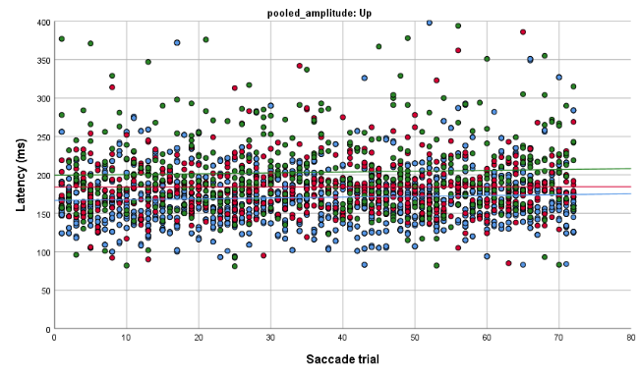
 | Down | 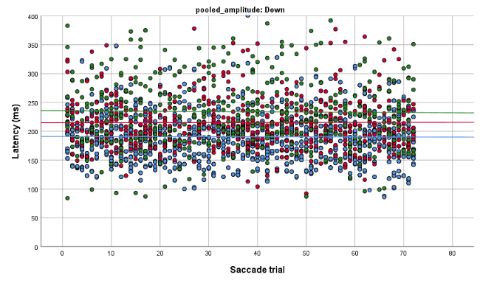
Figure 3.12: The scatterplots show the vertical saccadic latency of young, middle, and old age groups with 72 saccadic trials at pooled upward and downward saccadic amplitude sizes. Upward amplitude consists of 4°, 6° and 8°, while downward amplitude consists of -4°, -6 and -8°.

Vertical saccadic peak velocity | Up | 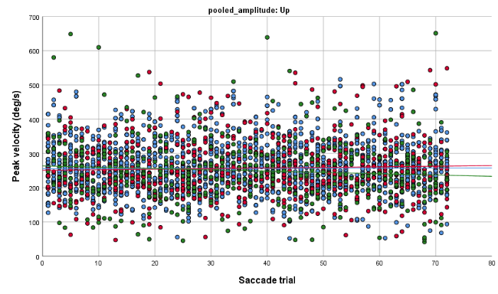
 | Down | 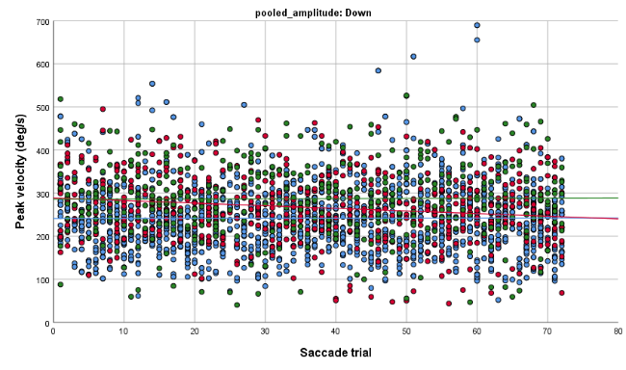
Figure 3.13: The scatterplots show the vertical saccadic peak velocity of young, middle, and old age groups with 72 saccadic trials at pooled upward and downward saccadic amplitude sizes. Upward amplitude consists of 4°, 6° and 8°, while downward amplitude consists of -4°, -6 and -8°.

Vertical saccadic gain | Up | 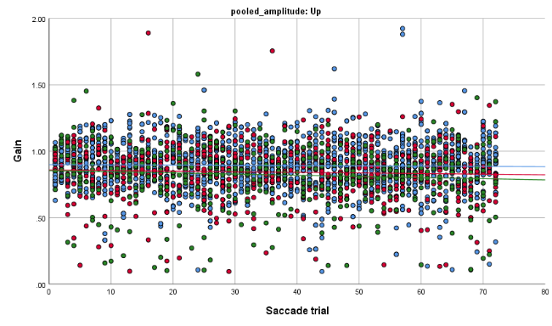
 | Down | 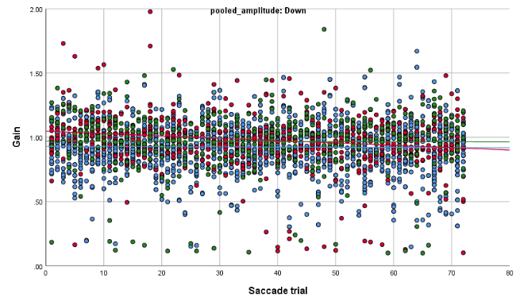
Figure 3.14: The scatterplots show the vertical saccadic gain of young, middle, and old age groups with 72 saccadic trials at pooled upward and downward saccadic amplitude sizes. Upward amplitude consists of 4°, 6° and 8°, while downward amplitude consists of -4°, -6 and -8°.

Discussion
The experiments were completed to allow the following aims of the study to be achieved:
- Provide normative data for fixation, SPs and saccadic eye movement parameters in three adult age groups; young, middle and older (19 to 39 years, 40 to 59 years, 60 years and above, respectively).
- Explore any significant changes of eye movement characteristics in healthy participants with increasing age.
- Propose EMR testing paradigms and methods of analysis suitable for clinical assessment of patients.
The results show that the null hypothesis was rejected due to a statistically significant difference for some specific eye movement parameters between the three age groups recruited for this study.

Fixation
The study discovered that POG provides no useful information on the fixation pattern of healthy adults aged 18 to 79 years. Additionally, age did not have a significant effect on fixation performance across all age groups of participants. Indeed, no correlation was seen between ageing and fixation performance. The result suggested that percentage DT is not susceptible to ageing. A previous study found that fixation stability deteriorated in patients with macula disorders (Crossland et al., 2004) regardless of ageing. The EOM fibres were more affected by ageing. As a result, the degeneration of EOM fibres as a result of ageing should be more apparent in older people' high-velocity type of eye movements referred to as saccades (Kosnik et al., 1986).
It was demonstrated that ageing has an impact on SP RMSE in both the horizontal and vertical directions. The RMSE measures the error between the eye position relative to the target position to ensure the target is perfectly kept in the foveal area during SP movement (Bahill & McDonald, 1983). According to one study, the RMSE appears to be a biologically significant measure of eye-tracking performance with the potential to identify disease vulnerability (Clementz et al., 1996). Apart from that, the findings are very helpful since there was no study presented about the age-related changes to SP maintenance phase (i.e., gain, RMSE and duration). A previous study has documented on the age-related SP initiation phase (i.e., latency) (Knox et al., 2005). Therefore, the finding suggests that SP maintenance is susceptible to ageing, specifically the RMSE parameter.
Bahill and McDonald (1983) reported that the RMSE tested at 0.20 Hz sinusoidal was 0.32° (n = 8; age range 21 to 37) compared with the current study (n = 23; age range 18 to 39), where the RMSE was slightly higher at 0.43°. Differences in testing paradigms were the most likely reason for the differences between the current and previous studies. In the previous study, the SPs were tested in a dark room with participants fixing a bright red LED. Although the testing condition enhanced the previous study's tracking performance, the generated SPs were not equivalent to natural viewing.
The other two parameters that are responsible for the SP maintenance are SP gain and duration of SP fixation. Results demonstrated that they were not significantly affected by ageing, but horizontal SP gain was better than vertical SP gain for all age groups, as reported in a previous study (Rottach et al., 1996). It is hypothesised that horizontal SP is used more extensively in our daily life than vertical SP, which has led to the enhancement of the horizontal SP system (Collewijn & Tamminga, 1984).

Saccade
The current study found that horizontal saccadic parameters are susceptible to advancing age. With increasing age, saccadic latency increased, and saccadic gain decreased (Abel et al., 1983; Hopf et al., 2018; Moschner & Baloh, 1994; Riecker et al., 2006). It was reported that central processing time, which involves several cortical areas, is the main element influencing saccadic latency (Huaman & Sharpe, 1993). A study reported that the ageing brain is characterised by a deterioration in the brain systems responsible for motor function, which results in slower reaction times and increased error rates in older adults (Mattay et al., 2002). A previous study also found an increase in the saccadic latency among patients with lesions at specific cortical areas such as the frontal lobe, posterior parietal lobe, dorsolateral prefrontal cortex, and superior colliculus (Leigh & Kennard, 2004). There is evidence that ageing is associated with loss of parietal cortical neurons (Schuitemaker et al., 2012), contributing to the prolonged saccadic latency.
However, the peak velocity of horizontal saccade movements in older persons was faster than in young adults. It could be due to increased brain activity among the elderly (Nelles et al., 2009). Spooner (1980) found that peak velocity was impaired with ageing due to larger variability in the older group compared with the younger group. However, they were using an invasive eye recorder, which increased the discomfort such that eye movements might have been more affected in the elderly when moving the eye with larger saccadic amplitudes. It is also unclear about the criteria used to select the visually triggered saccadic data and the size of the target. Additionally, vertical saccades affected by aging which caused the longer saccadic latency despite normal peak velocity and gain.
In this study, horizontal saccadic gain was not affected by ageing for smaller amplitudes but older participants showed more hypometric saccades at the largest horizontal amplitude. The finding supports the idea that ​​gain can be independent of age but respects the degree of target displacement (Hopf et al., 2018). The current study also found that upward saccadic gain was less accurate in the older age group at 6° target amplitudes as reported by a previous study (Collewijn et al., 1988), but the downward saccade gain was not affected by age. Our finding is not surprising because many other studies reported restrictions of vertical ductions in the older population (Huaman & Sharpe, 1993; Shechtman et al., 2005) related to mechanical changes (Chamberlain, 1970). Table 3.7 summarises the normative data for fixation, SP and saccades by age groups obtained from the current study.
Table 3.7: The summary of normative data for eye movements measured with EyeLink 1000 Plus of the current study.
 |  | Young | Middle | Older
Fixation | AOI = 1° | 64.8 | 65.5 | 47.8
Fixation | AOI = 2° | 28.9 | 29.6 | 38.0
Fixation | AOI = >2° | 6.3 | 4.8 | 14.2
Horizontal SP | 0.20 Hz = 8°/sec velocity | Gain: 0.95  RMSE: 0.43  Duration: 693 | Gain: 0.93  RMSE: 0.44  Duration: 562 | Gain: 0.94  RMSE: 0.61  Duration: 502
Horizontal SP | 0.40 Hz = 16°/sec velocity | Gain: 0.89  RMSE: 0.56  Duration: 483 | Gain: 0.88  RMSE: 0.73  Duration: 399 | Gain: 0.86  RMSE: 0.83  Duration: 431
Horizontal SP | 0.60 Hz = 24°/sec velocity | Gain: 0.83  RMSE: 0.82  Duration: 292 | Gain: 0.77  RMSE: 1.05  Duration: 278 | Gain: 0.79  RMSE: 1.08  Duration: 293
Horizontal SP | 0.80 Hz = 32°/sec velocity | Gain: 0.73  RMSE: 1.27  Duration: 211 | Gain: 0.68  RMSE: 1.35  Duration: 241 | Gain: 0.67  RMSE: 1.39  Duration: 260
Vertical SP | 0.25 Hz = 8°/sec velocity | Gain: 0.82  RMSE: 0.51  Duration: 446 | Gain: 0.78  RMSE: 0.79  Duration: 474 | Gain: 0.79  RMSE: 1.11  Duration: 467
Vertical SP | 0.50 Hz = 16°/sec velocity | Gain: 0.73  RMSE: 0.83  Duration: 274 | Gain: 0.70  RMSE: 1.32  Duration: 309 | Gain: 0.65  RMSE: 1.33  Duration: 314
Vertical SP | 0.75 Hz = 24°/sec velocity | Gain: 0.56  RMSE: 1.33  Duration: 221 | Gain: 0.51  RMSE: 1.89  Duration: 265 | Gain: 0.55  RMSE: 1.79  Duration: 263
Vertical SP | 1.00 Hz = 32°/sec velocity | Gain: 0.42  RMSE: 1.82  Duration: 201 | Gain: 0.37  RMSE: 2.16  Duration: 231 | Gain: 0.40  RMSE: 2.08  Duration: 231
Horizontal saccade | -15° L | Latency: 193  PV: 370  Gain: 0.89 | Latency: 218  PV: 411  Gain: 0.84 | Latency: 232  PV: 435  Gain: 0.84
Horizontal saccade | -10° L | Latency: 168  PV: 327  Gain: 0.91 | Latency: 186  PV: 361  Gain: 0.91 | Latency: 199  PV: 373  Gain: 0.89
Horizontal saccade | -5° L | Latency: 162  PV: 243  Gain: 0.94 | Latency: 178  PV: 270  Gain: 0.92 | Latency: 192  PV: 287  Gain: 0.95
Horizontal saccade | 5° R | Latency: 169  PV: 252  Gain: 0.94 | Latency: 177  PV: 298  Gain: 0.97 | Latency: 194  PV: 292  Gain: 0.96
Horizontal saccade | 10° R | Latency: 178  PV: 332  Gain: 0.90 | Latency: 181  PV: 365  Gain: 0.89 | Latency: 208  PV: 380  Gain: 0.89
Horizontal saccade | 15° R | Latency: 201  PV: 383  Gain: 0.91 | Latency: 219  PV: 413  Gain: 0.85 | Latency: 234  PV: 417  Gain: 0.82
Vertical saccade  - The mean of saccadic parameters  - Latency (ms) and PV (°/sec).  . | -8° D | Latency: 194  PV: 282  Gain: 0.91 | Latency: 216  PV: 307  Gain: 0.95 | Latency: 244  PV: 326  Gain: 0.94
 | -6° D | Latency: 191  PV: 248  Gain: 0.93 | Latency: 211  PV: 273  Gain: 0.99 | Latency: 228  PV: 288  Gain: 0.94
 | -4° D | Latency: 188  PV: 202  Gain: 0.93 | Latency: 218  PV: 211  Gain: 1.00 | Latency: 237  PV: 234  Gain: 0.99
 | 4° U | Latency: 166  PV: 217  Gain: 0.92 | Latency: 182  PV: 217  Gain: 0.90 | Latency: 200  PV: 206  Gain: 0.86
 | 6° U | Latency: 170  PV: 261  Gain: 0.88 | Latency: 184  PV: 257  Gain: 0.82 | Latency: 209  PV: 248  Gain: 0.79
 | 8° U | Latency: 178  PV: 301  Gain: 0.87 | Latency: 189  PV: 288  Gain: 0.80 | Latency: 206  PV: 285  Gain: 0.78
Note: PV = peak velocity, L = left, R = right, D = down and U = up. Data are shown as the mean, except for the fixation, which shows the median DT.

Additional factors affecting EMR performance in the elderly
Numerous investigations have shown that the rate of dry eye (DE) was higher in elderly people (Schein et al., 1999; Schein et al., 1997). A study showed that patients with DE who had lower blink rates during perimetry may not have been able to maintain a wet ocular surface (Sagara et al., 2019). Their visibility may have diminished following perimetry, and their ocular surface characteristics may have deteriorated (Sagara et al., 2019). As a result, it became difficult to see the perimeter's central fixation light properly.
Aqueous tear insufficiency and evaporative dry eye are more prevalent in the elderly than in younger adults due to a variety of confounding factors (Lemp, 2007). Tear production decreases with age for a variety of reasons, including lid laxity, hormonal changes such as menopause, systemic inflammatory illnesses, and an increasing prevalence of autoimmune diseases (most often Sjogren's syndrome and rheumatoid arthritis) (Hakim & Farooq, 2022). Eyelid positional anomalies (laxity, floppy eyelid syndrome, retraction, and lagophthalmos), meibomian gland dysfunction, rosacea, decreased corneal sensitivity, and impaired blink reflex all are common in elderly adults (Barabino, 2022). All these factors contribute to the tear film break-up more rapidly (Damasceno et al., 2011; Murphy et al., 2004).
The EMR includes concentrating on looking at a target displayed on the screen. As a result, even though the current study indicated that only three parameters (SP RMSE, saccadic latency and saccadic gain) were influenced by ageing, evidence from previous study suggests that it is essential to compare the findings to the age-matched control group to avoid confounding effects of ageing (Barabino, 2022).

Conclusion
The normative data for fixations, SPs, and saccades were established in the currents study to answer the study's first aim. It will serve as the control group for age-matched comparisons with the patients' EMR data in Chapter 5.
The findings suggest that fixation eye movement is maintained over the course of a person's life. However, SP RMSE increased with ageing when tested using horizontal and vertical sinusoidal wave stimuli, but not the SP gain and duration, indicating the SP maintenance phase was affected by ageing. In addition, saccadic latency declines with aging in both horizontal and vertical directions. However, the saccadic gain only decreases with ageing at larger horizontal saccadic amplitudes and upward saccades. The saccadic peak velocity increases with ageing in horizontal directions and downward gaze. Although the findings demonstrated a significant mean difference between age groups for specific types of eye movements, the correlation shows a poor association between ageing and the type of eye movement characteristics. As a result, it is recommended that the EMR result for Chapter 5 be compared to the results of the age-matched groups. The normative results provide a dataset for clinicians who have abnormal eye movements to see how their patients' results differ from the age-matched control data provided here. The null hypothesis is rejected as the age-related effect seen in this study for specific saccadic and SP characteristics. As a result, it emphasises the importance of using age-matched control data to compare to patients with abnormal OMT in EMR investigations. In addition, the EMR paradigms and specific parameters employed in this study are appropriate for use in clinics for patient assessment and consultation.

Limitations of the study and future works
Since this study used different target sizes for the older group, it could be a confounding variable in the results. Some old participants with myopia correction of >2.00 dioptre sphere (DS) and using multifocal (MF) spectacles. It was not possible to proceed with the tracking if the participants wore MFs spectacles due to aberrations from the different viewing parts of the MF spectacles. Therefore, the EMR had to be performed without the spectacles. To compensate for their uncorrected refractive error for the intermediate viewing distance, the target size was increased to enhance at the visibility of the target throughout the EMRs.
It would be worth exploring the different effects of EMR with and without soft contact lenses for future works. If there are no significant differences with or without soft contact lenses, using soft contact lenses could help investigate eye movement behaviour among the elderly.

Validation of recording techniques
This chapter includes two experimental studies (Experiments 2 and 3) to determine differences in EMRs using varied parameters. The aims of these experiments were to:
- Evaluate the effect of altering target size on fixation, SP and saccadic eye movement parameters (Experiment 2).
- Identify any differences in eye movement parameters when tested binocularly versus monocularly (Experiment 3).
The findings from both experiments are summarised at the end of the chapter. The information obtained from these experiments were used to inform the design and interpretation of later experiment in patients with ocular nerve palsies (as discussed in Chapter 5 - Experiment 4).

Experiment 2: The effect of target size on eye movements

Introduction
A small fixation target was considered the most appropriate to determine precise information about eye movement performance of saccades, SPs, and steady fixation. However, it was anticipated that not all patients presenting with ocular nerve palsies would see the 0.5° target size. This experiment compared results of normal participants with different size targets so comparisons could be made with patients who fixated a target commensurate with their VA and this varied between participants. The experiment results will be used to eliminate or identify any potential confounding variables in target size to interpret further experiments.

Null hypothesis
The distributions of eye movement parameters recorded with different target sizes (0.5°, 1° and 2°) are the same.

Method

Ethical approval
This study received ethical approval from The University of Sheffield, Medical School Ethics Committee on 18/04/2017, application reference number 013101 (Appendix 1.1). All participants who satisfied the inclusion criteria were given the Participant Information Sheet (Appendix 1.2), and if they agreed to continue, written consent was obtained using the Participant Consent Form (Appendix 1.3). The files were kept in a securely locked cupboard to ensure the participants' confidentiality, which could only be accessed by the researcher and supervisors. The data files were saved using a coding format not to be identifiable to others.

Participants
Experiment 2 was conducted among a healthy group of undergraduate students (ages 18 to 21 years old) to evaluate the differences in eye movement performance recorded using different target sizes (0.5°, 1.0°, and 2.0°). Participants were recruited from the undergraduate orthoptic student volunteering scheme, who were given tokens for volunteering in this study. These allow the students to recruit participants for their research and achieve recognition for volunteering. For non-orthoptic students, the recruitment was on a volunteer basis with no reward.

EMR procedures
Participants were screened during the history-taking session to ensure they met the participation criteria discussed in Chapter 3 - section 3.2. The best-corrected VA in each eye was measured using an EDTRS chart at a test distance of 4 m. The correct test distance was pre-measured. Participants’ spectacle lenses were wiped before the test. If the participant had VA worse than 0.2 logMAR, testing was discontinued. A near and distance cover test was performed, followed by OMT to eliminate any possibility of strabismus, nystagmus, or ocular motility deficit. If any of those deficits were found, the participants were excluded from the study. Only participants who met the inclusion criteria had their eye movements examined using EMR. Binocular calibration was performed in all participants as they had normal BSV. The experimental room was kept quiet, with normal room illumination. There were three types of eye movements tested using EyeLink 1000 Plus: fixation, SP (horizontal and vertical), and saccades (horizontal and vertical). For each eye movement test, the target size sequence was randomised between participants (Appendix 4.1) to avoid order any practice effects, which may have improved results or led to fatigue effects reducing performance.

Data analysis
All data were checked for normality distribution criteria before conducting the statistical analysis. After ensuring that all data fulfilled the normal distribution assumptions, the data were subsequently analysed using the repeated measure ANOVA test to examine the influence of testing with three different target sizes on eye movement parameters. The assumption of sphericity was assessed by Mauchly's test of sphericity. If the sphericity is violated, Greenhouse and Geisser was used to correct the repeated-measures ANOVA. Finally, if any of the dependent variable's mean values (i.e. percentage DT; SP gain, RMSE, or duration; saccadic latency, peak velocity or gain) were significantly different, a post hoc analysis with the Bonferroni test for multiple comparisons was performed.

Results
Nineteen healthy participants aged 18 to 21 were recruited for this study. Participants gave excellent co-operation during the recording process. However, one person's data was excluded from the study of saccades due to a technical error that occurred during the recording process.
In this section, results begin by illustrating the influence of target size on the eye movement parameters takes from the RE only during binocular viewing as follows:
- Fixation - median percentage DT
- SP - mean gain, RMSE and duration of the SP segment
- Saccades - mean of latency, velocity, and gain

The effect of target size and fixation position on the fixation eye movements.
The percentage DT reflects the fixation performance whereby a larger percentage DT within the smallest AOI indicates the ability to hold steady fixation very close to the fixation target's centre, hence excellent fixation performance. The bar graph demonstrates that there is no substantial distinction between the median percentage DT obtained using three different target sizes within each AOI (Figure 4.1). As both parametric and non-parametric statistical analyses found the same significant level, parametric tests were reported.
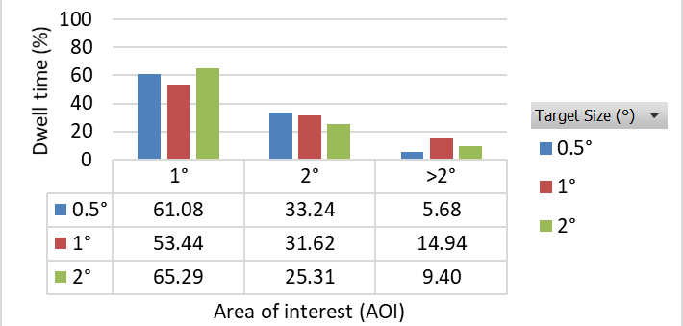
Figure 4.1: Bar graph illustrating the group median percentage DT recorded using three target sizes (0.5, 1.0 and 2.0°) and analysed at three AOIs.
A one-way repeated-measures ANOVA was conducted to determine whether there was a statistically significant difference in percentage DT recorded using three target sizes. The target sizes did not elicit statistically significant changes in percentage DT at 1° and 2° AOIs [F(2,188) = 2.77, p = 0.07 and F(2,188) = 1.48, p = 0.23] with >50% percentage DT at 1° and approximately 30% at 2° AOI. However, at AOI >2°, the percentage DT was higher tested using the medium size target, 1°, than smallest target, 0.5°, F(2,188) = 5.62, p = 0.01. Thus, target sizes exhibit a good performance of fixation with higher percentage within the smallest AOI and very low percentage DT for the largest AOI. The results imply that the ability to maintain fixation close to the central fixation target was not affected by target size.

The effect of target size on horizontal SP
Horizontal individual participant means were calculated for SP gain, RMSE, and SP duration. Individual means were then used to calculate the group mean (Figure 4.2).
At the lowest frequency (0.2 Hz), the mean gain was slightly greater than 1, and at the higher frequencies (0.6 and 0.8 Hz), the mean gain was less than 1.0 and reduced with increased frequency. At 0.4 Hz, the gain was close to 1 for all target sizes. The current study found that SP gain was affected by different frequencies but less affected by the different target sizes (Figure 4.2a). The RMSE is the average distance between the target and eye in degrees of visual angle for each SP segment of recorded data. High values of RMSE are produced when the eye is further away from the target suggesting poor SP performance. The result illustrates that RMSE increased with increasing frequency, but no noticeable change was observed with changing target sizes at every frequency (Figure 4.2b). The results demonstrate that SP duration decreases (interrupted by saccadic movements) at the higher target frequencies (Figure 4.2c). The higher the frequency, the faster it moves, and the shorter the periods of SP fixation, indicating more saccadic interruptions and weaker SP performance.

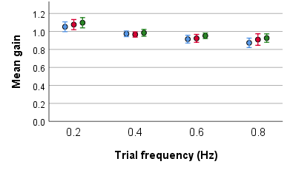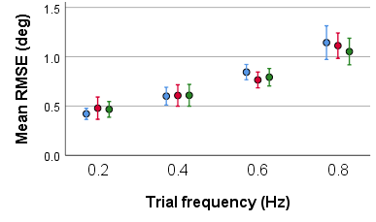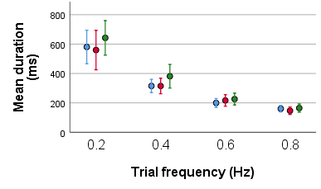
Figure 4.2: The effect of target size (0.5°, 1.0° and 2.0°) and frequency (0.2, 0.4, 0.6 and 0.8 Hz) on the horizontal SP parameters. The group mean values for a) gain, b) RMSE, and c) SP duration is shown. The legend for each graph specifies the target's size (°). The error bars indicate the standard error of ±1 SE.
A repeated-measures ANOVA revealed that there was no statistically significant interaction between target size and frequency on horizontal SP parameters. The main effect of target size demonstrated a statistically significant difference in horizontal SP gain and SP duration, F(2,36) = 9.59, p<0.01 and F(2,36) = 6.20, p = 0.01. The Bonferroni test for multiple comparisons revealed that the mean value of SP gain differed significantly between 0.5° and 2.0° target size (p<0.01, 95% CI = -0.06, -0.01). Despite the statistically significant difference, both mean gains evaluated with 0.5° and 2° target sizes are within the normal saccade range, with gain = 0.95 and 0.99, respectively (Hopf et al., 2018).The differences could be regarded as negligible. Therefore, it indicated that the SP gain was not affected by the different target sizes used in this study.
Additionally, the Bonferroni test found that the SP duration was significantly different between the 1.0° and 2.0° target sizes (p = 0.01, 95 % CI = -74.90, -13.54), increasing from 309 ms for 1.0° to 359 ms for 2.0° size. In summary, modifying the cross-stimulus size from 0.5° to 2° had significantly prolonged the horizontal SP duration. Table 4.1 summarises the effects of changing the target size on horizontal SP parameters, as determined by repeated-measure ANOVA.
Table 4.1: The results of a repeated-measures ANOVA on horizontal SP characteristics tested on three target sizes.
Horizontal SP parameters | SS | df | MS | F | p-value
SP gain | 0.051 | 2,36 | 0.026 | 9.56 | <0.01*
SP RMSE | 0.018 | 2,36 | 0.009 | 0.25 | 0.78
SP duration | 90208 | 2,36 | 45104 | 6.20 | 0.01*
* Data are significant at p<0.05

The effect of target size on vertical SPs
Individual participant means were calculated for vertical SP gain, while medians were used for SP RMSE and duration. Following that, the group mean (SP gain) and medians (SP RMSE and duration) for each target size and at each frequency shown in Figure 4.3. Only two target size choices were used to record the vertical SPs due to insufficient screen height to accommodate the larger targets. When using ±8° amplitude, just the small (0.5°) and medium-size (1.0°) targets were used to avoid reducing SP amplitude.
The result showed that the mean vertical SP gains were consistently <1 for all frequencies. There were no remarkable changes in SP gain with the different target sizes at low frequency. However, SP gain was reduced as the frequency increased when tested using the smaller target. Vertical SP RMSE increased with a smaller target (except at 0.25 Hz) (Figure 4.3b). The vertical SP duration decreased as the frequency increased for all target sizes (Figure 4.3c).
The statistical analysis for the vertical SP dataset was conducted using paired t-test. The test was chosen because the participants were the same individuals tested under two different conditions (using 0.5 and 1° target sizes) on the same dependent variables (Laerd, 2013). The mean difference of SP gain and median difference for SP RMSE were not significantly difference between the two target sizes. However, the median SP duration for the frequency of 0.75 and 1.0 Hz showed longer duration with bigger target size. The result of the paired t-test is reported in Table 4.2.
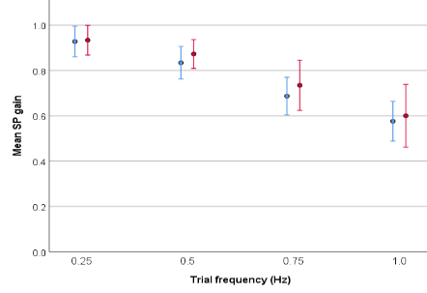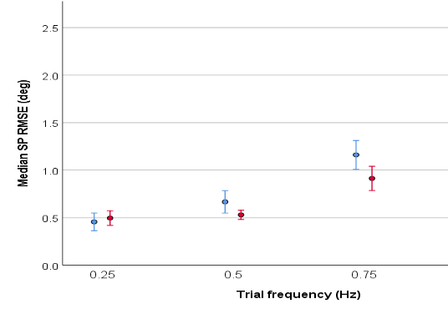
b
a
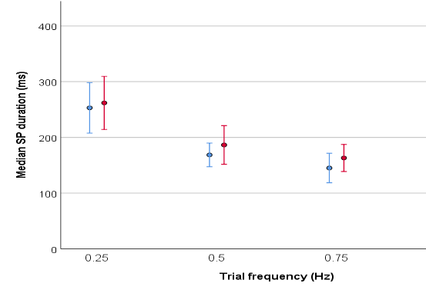
c
Figure 4.3: The effect of target size (0.5°, and 1.0°) and frequency (0.25, 0.50, 0.75 and 1.00 Hz) on the vertical SP parameters. Group mean data are shown for a) gain, while group median is shown for b) RMSE, and (c) SP duration. Error bars represent ±1 SE.

Table 4.2: Paired t-test to investigate the effect of SP parameters when recorded using the two target sizes (0.5° and 1.0°) at four vertical SP frequency (0.25, 0.5, 0.75 and 1.0 Hz).
 |  | Mean SP gain | 95% CI |  | t | df | p-value
 |  |  | Lower | Upper
Pair 1 | F1.S1 | 0.93 | -0.07 | 0.02 | -1.35 | 16 | 0.20
 | F1.S2 | 0.96
Pair 2 | F2.S1 | 0.86 | -0.07 | 0.10 | 0.37 | 16 | 0.72
 | F2.S2 | 0.84
Pair 3 | F3.S1 | 0.74 | -0.03 | 0.15 | 1.50 | 16 | 0.15
 | F3.S2 | 0.68
Pair 4 | F4.S1 | 0.66 | -0.03 | 0.24 | 1.72 | 12 | 0.11
 | F4.S2 | 0.55
 |  | Mean SP RMSE | 95% CI |  | t | df | p-value
 |  |  | Lower | Upper
Pair 1 | F1.S1 | 0.46 | -0.13 | 0.07 | -0.56 | 16 | 0.58
 | F1.S2 | 0.48
Pair 2 | F2.S1 | 0.67 | -0.02 | 0.25 | 1.81 | 16 | 0.09
 | F2.S2 | 0.55
Pair 3 | F3.S1 | 1.04 | -0.19 | 0.29 | 0.44 | 16 | 0.66
 | F3.S2 | 0.99
Pair 4 | F4.S1 | 1.92 | -0.06 | 0.62 | 1.81 | 12 | 0.10
 | F4.S2 | 1.65
 |  | Mean SP duration | 95% CI |  | t | df | p-value
 |  |  | Lower | Upper
Pair 1 | F1.S1 | 253 | -39.17 | 57.11 | 0.40 | 16 | 0.70
 | F1.S2 | 244
Pair 2 | F2.S1 | 183 | -59.84 | 52.43 | -0.14 | 16 | 0.89
 | F2.S2 | 187
Pair 3 | F3.S1 | 143 | -61.87 | -3.72 | -2.39 | 16 | 0.03*
 | F3.S2 | 176
Pair 4 | F4.S1 | 128 | -73.57 | -7.05 | -2.64 | 12 | 0.02*
 | F4.S2 | 168
* Data are significant at p<0.05
Note: F = frequency, F1 = 0.25 Hz, F2 = 0.50 Hz, F3 = 0.75 Hz, F4 = 1.0 Hz.
S = target size, S1 = 0.5°, S2 = 1.0°

The effect of target size on horizontal saccades
Individual participant means were calculated for horizontal saccadic latency, peak velocity, and gain. Individual means were then utilised to compute the group mean, which was then displayed in the bar graphs (Figure 4.4 a-c).
The bar graphs demonstrate no noticeable variation in saccadic latency between the three target sizes when the saccadic amplitude is small. However, saccadic latency improves as target size increases at the moderate and maximum saccadic amplitude (Figure 4.4a). At each saccadic amplitude, the mean saccadic peak velocity and gain appear to be comparable between three target sizes (Figure 4.4b and c). However, the peak velocity increases with greater saccade amplitude for all target sizes.

Figure 4.4: Bar graphs illustrate the effect of target size and frequency on the horizontal saccadic a) latency, b) peak velocity, and c) gain. The error bars represent ±1 SE.
A one-way repeated-measures ANOVA was conducted to determine whether there was a statistically significant difference in saccadic parameters across three target sizes. Target size elicited statistically significant changes in saccadic latency at the moderate and largest saccadic amplitude, F(2,74) = 4.25, p = 0.02 and F(2,62) = 12.40, p<0.01. However, target size did not elicit statistically significant changes to saccadic latency at small amplitude (p = 0.35). Using a Bonferroni adjustment, saccadic latency was significantly decreased from 163 to 152 ms between 0.5° and 1.0° target sizes (p = 0.01), tested at the moderate amplitude. Meanwhile, the saccadic latency decreased from 191 to 168 ms between target sizes of 0.5° and 2.0° (p<0.01), tested at the largest amplitude. The findings suggest that smaller target sizes resulted in longer saccadic latency, particularly at target amplitudes of 10° and more.
In addition, repeated-measures ANOVA confirmed that target size did not elicit statistically significant changes to saccadic peak velocity and gain at all saccadic amplitudes, p>0.05 but it did elicit a significant difference to the saccadic latency at the larger amplitudes. Therefore, it can be concluded that the target eccentricity has more impact on the saccadic latency variation, rather than target size. Table 4.3 summarises the effects of changing the target size on horizontal saccadic parameters, as determined by repeated-measure ANOVA.
Table 4.3: The results of a repeated-measures ANOVA on horizontal saccadic characteristics tested on three target sizes.
 | Target size |  |  | SS | df | MS | F | p-value
 | 0.5° | 1.0° | 2.0°
Saccade latency
±5° | 153.4 | 148.6 | 150.6 | 445.8 | 2,74 | 222.9 | 1.07 | 0.35
±10° | 163.1 | 152.1 | 153.7 | 2663.1 | 2,74 | 1331.6 | 4.25 | 0.02*
±15° | 191.4 | 171.5 | 167.7 | 10344.9 | 2,62 | 5172.4 | 12.40 | <0.01*
Saccade peak velocity
±5° | 275.6 | 276.6 | 289.2 | 4339.2 | 2,74 | 3722.5 | 2.19 | 0.12
±10° | 363.3 | 362.6 | 362.0 | 29.1 | 2,74 | 26.8 | 0.01 | 0.95
±15° | 395.8 | 399.6 | 395.1 | 364.1 | 2,62 | 324.1 | 0.10 | 0.79
Saccade gain
±5° | 0.99 | 1.00 | 1.01 | 0.008 | 2,74 | 0.007 | 0.37 | 0.69
±10° | 0.95 | 0.96 | 0.96 | 0.005 | 2,74 | 0.004 | 0.72 | 0.43
±15° | 0.90 | 0.91 | 0.90 | 0.003 | 2,62 | 0.002 | 0.42 | 0.58
* Data are significant at p<0.05

The effect of target size on vertical saccades
According to the target sizes, the data are pooled from the group mean of eighteen participants at each target amplitude to get the upward and downward saccadic mean parameters as illustrated in Figure 4.5 a-c. The upward saccadic latency was shorter than downward saccadic latency with a noticeable prolonged saccadic latency with the smaller target size at both vertical directions (Figure 4.5a). With the smallest target size, the vertical saccadic peak velocity decreased in both vertical directions (Figure 4.5b). In addition, the upward saccadic gain was more hypometric than the downward (Figure 4.5c). However, vertical saccadic gain appears to be unaffected by target size variations.

Figure 4.5: Bar graphs illustrate the effect of target size and frequency on the vertical saccadic a) latency, b) peak velocity, and c) gain. The error bars represent ± 1 SE.
A one-way repeated-measures ANOVA was used to observe a statistically significant difference in vertical saccadic parameters by changing the target size between 0.5°, 1.0° and 2.0°. The results showed that target size caused statistically significant changes in saccadic latency in both upward and downward directions, with the biggest target size demonstrating improved latency. Post hoc analysis using the Bonferroni correction for multiple adjustments revealed two pairs of target sizes that had a significant effect on saccadic latency: 0.5°—1.0° and 0.5°—2.0°, both with p<0.01. In addition, variations in target size resulted in statistically significant changes in upward saccadic peak velocity, p = 0.01. The peak velocity between the target size pairings of 0.5°—1.0° and 0.5°—2.0° was significantly different, p = 0.04 and p = 0.01, respectively, according to the post hoc analysis. Higher upward saccadic peak velocity is produced by the larger target size. Furthermore, target size difference elicited a statically significant of upward saccadic gain. Post hoc analysis revealed that the pairings that triggered the statistically significant difference were between 0.5°—1.0° and 0.5°—2.0°, with a p-value of 0.01. Despite the statistical significance, a difference of 0.02 of the mean saccadic gain can be deemed too tiny. As a result, is suggests that a difference in target size did not result in a statistically significant change in vertical saccadic gain. The results for one-way repeated-measures ANOVA of vertical saccadic eye movements are reported in Table 4.4.
Table 4.4: One-way repeated-measures ANOVA showing the effect of changing target size on the vertical saccadic eye movements.
 | Target size |  |  | SS | df | MS | F | p-value
Latency | 0.5° | 1.0° | 2.0° | SS
Down | 181 | 171 | 169 | 4422.13 | 2,106 | 2211.06 | 17.67 | <0.01*
Up | 165 | 152 | 155 | 4730.84 | 2,106 | 2365.42 | 19.65 | <0.01*
Peak Velocity
Down | 278 | 283 | 280 | 724.47 | 2,106 | 362.23 | 1.23 | 0.30
Up | 272 | 281 | 281 | 2873.47 | 2,106 | 1436.73 | 5.46 | 0.01*
Gain
Down | 0.96 | 0.98 | 0.97 | 0.01 | 2,106 | 0.004 | 1.23 | 0.30
Up | 0.87 | 0.89 | 0.89 | 0.03 | 2,106 | 0.014 | 5.92 | <0.01*

Discussion and conclusion
The experiment's initial objective was to identify the effect of using different target sizes on fixation, SP, and saccadic eye movement performance. Regardless of the target size, an excellent fixation performance was observed with a greater percentage DT in the smallest AOI and a low percentage DT in the largest AOI. Dwell time was calculated by adding the durations (in ms) of all fixations inside the specified AOI (Walters et al., 2022). The findings, however, contradict a previous study in which it was claimed that fixation behaviour increased as the size of the fixation target increased (Hirasawa et al., 2016). However, different types of targets were used (black dots, rings and cross). The type of target itself could affect the attention to focus (Thaler et al., 2013). Hence, maintaining the target shape while adjusting the size could reduce the ‘confounding’ effect of different shape. For the purpose of determining the stability of the fixation, the cross target was suggested (Thaler et al., 2013).
Furthermore, the horizontal SP performance was also unaffected by increasing the cross-target size. This finding supports earlier studies that suggests SP performance is unaffected by stimulus size unless very large stimuli are used (Irving et al., 2011; Vinuela-Navarro et al., 2017). Vertical SP duration was the only parameter that differed significantly between smaller and bigger target sizes at frequencies greater than 0.75 Hz, whereas the other vertical SP parameters elicit comparable results between different target sizes. The relationship of vertical SP and target sizes has not yet been reported. Indeed, most SP EMR studies of healthy young adults focused on the initiation phase of horizontal SP rather than the maintenance phase (Morrow & Sharpe, 1993; Vinuela-Navarro et al., 2017). Hence, the SP duration has not been reported in any previous literature. The findings suggest that larger target sizes induced longer duration, which could be related to the difficulty level of maintaining foveation for vertically moving stimuli being lesser on larger stimuli than smaller stimuli.
The findings suggest that larger target sizes resulted in shorter horizontal saccadic latency, particularly at target amplitudes of 10° and more. Interestingly, the eccentricity of the target has a greater effect on target latency than the size of the target. The rationale for this was that significant differences in saccade latency with different target sizes were only detected at the larger amplitudes. Therefore, target eccentricity has more impact on the delayed saccades rather than target size (Mazumdar et al., 2019). In addition, there was an asymmetry in the vertical saccadic response between up and down saccades. The upward saccade latency was shorter than downward latency as established in a previous study (Tzelepi et al., 2009). The upward peak velocity was faster with the smallest target size. No study evaluated the effect of altering target size on the vertical saccadic eye movements parameters.
In summary, the findings suggest percentage DT, SP horizontal and vertical performance was unaffected by target size. Only the upward vertical saccadic peak velocity was significantly affected with significant reduction of peak velocity when tested with the smallest target size. In this experiment, the primary objective was to assess if changing the size of the target affected the EMR response. This is because, as explained in Chapter 5, the EMR was done with a range of target sizes based on the patient's ability to see the cross target. The results found that changing the size of the target had little effect on eye movement performance, such as fixation, SP, and saccades and therefore, would enable the use of different size targets in the following experiments.

Experiment 3: Binocular versus monocular EMR eye movement characteristics

Introduction
Experiment 3 was carried out to discover the effect of recording eye movements with both eyes open (binocular) against one eye fixating and the other eye occluded (monocular). The experiment was conducted due to the limitation that binocular recording was not possible for the patients as they would have ocular misalignment of one eye associated with the acquired ocular nerve palsies. Therefore, it is crucial to determine whether the binocular and monocular EMR results are similar or cause changes in the detailed eye movement parameters.
Within eye recording studies, eye movements can be examined either binocularly or monocularly, depending on the study's method and purpose (Hooge et al., 2019). For example, if the study was conducted using invasive methods likes scleral search coil, monocular eye recording technique is preferable to reduce the irritation, which might cause further eye complication (Irving et al., 2003) unless the study aims to observe the binocular function. Therefore, binocular eye recordings should be applied (Ignace Th & Berg, 2000).
It has been documented by some researchers that data was taken only from one eye, although they had recorded data from two eyes when conducting recording among participants with the BSV and some were averaging results from the RE and LE (Houben et al., 2006). Some did not mention which eye the data were analysed (Schmitt et al., 2007). A recent study by Hooge et al. (2019) suggested that averaging the data from the RE and LE should be avoided since it may increase systematic errors for eye movement, particularly when studying saccadic dynamics. Besides, the RE and the LE signals may differ, and averaging may affect, mask, or deform these details. Errors may occur in response to pooling RE and LE eye data, for example rightward movements involve adduction of the LE and abduction of the RE so should be considered individually as they are known to have different characteristics.
It may be anticipated that there is no difference between the RE or LE behaviour, provided the person has normal BSV and no pathology affecting eye movements. Besides, a previous study reported that there was significant differences in the eye movement parameters between the RE or LE among normal participants (Cornsweet et al., 1960).

Null hypothesis
There is no change in the eye movement properties between either eye (i.e., RE and LE) under binocular recordings or between binocular versus monocular recordings.

Method
The ethical approval was outlined in Experiment 2 - section 4.1.2.1.

Participants
The recruitment of the participants and the inclusion criteria were as outlined in Experiment 2 - section 4.1.2.2.

Procedure
Monocular calibration of the RE was performed for monocular recording with the LE covered using an opaque eye patch. For the binocular test, binocular calibration was performed. The monocular and binocular testing sequence was counterbalanced by alternating the order between participants to avoid fatigue or practice effects.
Three types of eye movements were recorded using EyeLink 1000 Plus: 1) fixation, 2) SP (horizontal and vertical) and 3) saccades (horizontal and vertical). All participants completed the test with monocular and binocular viewing for the fixation, SP, and saccadic recordings. For the horizontal saccades, only four target amplitudes were tested, ±5° and ±10°, instead of the six performed in Experiment 2. The largest horizontal target amplitudes, ±15°, were removed for this experiment because the target falls on the blind spot when viewed monocularly. The rest of the testing procedures remain the same, as described in section 4.1.2.3 (Experiment 2). The data extraction process was outlined in Chapter 2 for further statistical analysis of fixation, SP and saccadic eye movement.

Data analysis
First, the data were checked to see if they satisfied the normality distribution requirements. Then, using independent samples t-tests, the results from RE and LE that were compared. Following that, data from the RE obtained through binocular recordings were compared to data obtained from monocular recordings using independent samples t-tests. Finally, if the normality distribution was not satisfied, a non-parametric test was used. Results
Data for eighteen healthy subjects ranging in age from 18 to 21 years were collected and analysed. All participants gave excellent co-operation and completed all EMRs. However, data from a participant was excluded for fixation analysis due to incomplete data recording, which was not detected during the recording session.

The fixation, SP, and saccadic eye movement behaviours of RE and LE were compared when they were recorded binocularly.
Based on the comparison between binocular RE and binocular LE, there were no significant difference. Therefore, it is suggested that there is no difference in using only RE data from control subjects, despite binocular recordings being performed. Data were analysed separately for RE and LE (Table 4.5). As a result, either the RE or LE could be used to analyse the eye movement performance of patients with normal alignment and BSV (Houben et al., 2006).
Table 4.5: Comparison between the RE and LE parameters during binocular recording method using an independent samples t-test and Mann-Whitney U test.
Statistical test | EMR parameters |  | Binocular_RE | Binocular_LE | p-value
Mann-Whitney U test | Fixation: |  | n = 17 | n = 17
Mann-Whitney U test | Dwell time (%) | 1° AOI | mr = 19.71 | mr = 15.29 | 0.21
Mann-Whitney U test | Dwell time (%) | 2° AOI | mr = 16.71 | mr = 18.29 | 0.66
Mann-Whitney U test | Dwell time (%) | >2° AOI | mr = 17.59 | mr = 17.41 | 0.97
Independent-samples t-test | Smooth Pursuit: |  | n = 18 | n = 18
Independent-samples t-test | Horizontal gain | 0.2 Hz | 0.97 | 0.95 | 0.34
Independent-samples t-test | Horizontal gain | 0.4 Hz | 0.93 | 0.94 | 0.51
Independent-samples t-test | Horizontal gain | 0.6 Hz | 0.88 | 0.88 | 0.54
Independent-samples t-test | Horizontal gain | 0.8 Hz | 0.77 | 0.75 | 0.77
Independent-samples t-test | Horizontal RMSE (°) | 0.2 Hz | 0.38 | 0.35 | 0.52
Independent-samples t-test | Horizontal RMSE (°) | 0.4 Hz | 0.39 | 0.44 | 0.05*
Independent-samples t-test | Horizontal RMSE (°) | 0.6 Hz | 0.63 | 0.64 | 0.73
Independent-samples t-test | Horizontal RMSE (°) | 0.8 Hz | 1.13 | 1.06 | 0.55
Independent-samples t-test | Horizontal duration (ms) | 0.2 Hz | 745 | 807 | 0.54
Independent-samples t-test | Horizontal duration (ms) | 0.4 Hz | 499 | 525 | 0.65
Independent-samples t-test | Horizontal duration (ms) | 0.6 Hz | 300 | 302 | 0.96
Independent-samples t-test | Horizontal duration (ms) | 0.8 Hz | 218 | 224 | 0.70
Independent-samples t-test | Vertical gain | 0.25 Hz | 0.83 | 0.82 | 0.85
Independent-samples t-test | Vertical gain | 0.5 Hz | 0.72 | 0.70 | 0.83
Independent-samples t-test | Vertical gain | 0.75 Hz | 0.55 | 0.55 | 0.94
Independent-samples t-test | Vertical gain | 1.0 Hz | 0.36 | 0.39 | 0.64
Independent-samples t-test | Vertical RMSE (°) | 0.25 Hz | 0.58 | 0.50 | 0.45
Independent-samples t-test | Vertical RMSE (°) | 0.5 Hz | 0.95 | 0.70 | 0.19
Independent-samples t-test | Vertical RMSE (°) | 0.75 Hz | 1.47 | 1.10 | 0.07
Independent-samples t-test | Vertical RMSE (°) | 1.0 Hz | 2.14 | 1.70 | 0.02*
Independent-samples t-test | Vertical duration (ms) | 0.25 Hz | 526.9 | 548.6 | 0.77
Independent-samples t-test | Vertical duration (ms) | 0.5 Hz | 290.7 | 302.3 | 0.58
Independent-samples t-test | Vertical duration (ms) | 0.75 Hz | 221.2 | 219.8 | 0.93
Independent-samples t-test | Vertical duration (ms) | 1.0 Hz | 199.0 | 196.3 | 0.85
Independent-samples t-test | Saccade: |  | n = 18 | n = 18
Independent-samples t-test | Horizontal latency (ms) | Rt gaze | 155.0 | 154.9 | 0.99
Independent-samples t-test | Horizontal latency (ms) | Lt gaze | 148.3 | 147.7 | 0.81
Independent-samples t-test | Horizontal peak velocity (°/s) | Rt gaze | 307.3 | 294.6 | 0.41
Independent-samples t-test | Horizontal peak velocity (°/s) | Lt gaze | 295.2 | 319.3 | 0.17
Independent-samples t-test | Horizontal gain | Rt gaze | 0.97 | 0.95 | 0.37
Independent-samples t-test | Horizontal gain | Lt gaze | 0.94 | 0.98 | 0.05
Independent-samples t-test | Vertical latency (ms) | Up gaze | 157.9 | 158.0 | 0.97
Independent-samples t-test | Vertical latency (ms) | Dn gaze | 167.3 | 167.8 | 0.93
Independent-samples t-test | Vertical peak velocity (°/s) | Up gaze | 262.8 | 266.8 | 0.71
Independent-samples t-test | Vertical peak velocity (°/s) | Dn gaze | 261.7 | 262.8 | 0.93
Independent-samples t-test | Vertical gain | Up gaze | 0.90 | 0.90 | 0.98
Independent-samples t-test | Vertical gain | Dn gaze | 0.95 | 0.96 | 0.51
Note: mr = mean rank, Rt = Right, Lt = Left, Dn = Down. *Data are significant at p<0.05.
There was a significant difference when comparing binocular to monocular eye movement recording results (Table 4.6). Binocular recordings, for example, indicated much better SP RMSE, saccadic gain, and saccadic latency than monocular recordings, particularly in the horizontal direction. However, the current study's goal was not to observe the influence on normal BSV because most ocular nerve palsy patients do not have BSV in free space. If the current study is concern with binocularity, then it would have been best to compare the results obtained binocularly (Švede et al., 2015).
Table 4.6: The independent samples t-test and the Mann-Whitney U test were used to compare two different recording methods (binocular versus monocular EMR).
Statistical test | EMR parameters |  | Binocular_RE | Monocular | p-value
Mann-Whitney U test | Fixation: |  | n = 17 | n = 17
Mann-Whitney U test | Dwell time (%) | 1° AOI | mr = 22.76 | mr = 12.24 | <0.01*
Mann-Whitney U test | Dwell time (%) | 2° AOI | mr = 12.71 | mr = 22.29 | 0.01*
Mann-Whitney U test | Dwell time (%) | >2° AOI | mr = 13.21 | mr = 21.79 | 0.01*
Independent-samples t-test | Smooth Pursuit: |  | n = 18 | n = 18
Independent-samples t-test | Horizontal gain | 0.2 Hz | 0.97 | 0.96 | 0.44
Independent-samples t-test | Horizontal gain | 0.4 Hz | 0.93 | 0.94 | 0.51
Independent-samples t-test | Horizontal gain | 0.6 Hz | 0.88 | 0.89 | 0.60
Independent-samples t-test | Horizontal gain | 0.8 Hz | 0.77 | 0.77 | 0.98
Independent-samples t-test | Horizontal RMSE (°) | 0.2 Hz | 0.38 | 0.54 | 0.04*
Independent-samples t-test | Horizontal RMSE (°) | 0.4 Hz | 0.39 | 0.65 | <0.01*
Independent-samples t-test | Horizontal RMSE (°) | 0.6 Hz | 0.63 | 0.79 | 0.03*
Independent-samples t-test | Horizontal RMSE (°) | 0.8 Hz | 1.13 | 1.33 | 0.10
Independent-samples t-test | Horizontal duration (ms) | 0.2 Hz | 745 | 874 | 0.40
Independent-samples t-test | Horizontal duration (ms) | 0.4 Hz | 499 | 546 | 0.41
Independent-samples t-test | Horizontal duration (ms) | 0.6 Hz | 300 | 330 | 0.38
Independent-samples t-test | Horizontal duration (ms) | 0.8 Hz | 218 | 224 | 0.75
Independent-samples t-test | Vertical gain | 0.25 Hz | 0.83 | 0.87 | 0.40
Independent-samples t-test | Vertical gain | 0.5 Hz | 0.72 | 0.71 | 0.90
Independent-samples t-test | Vertical gain | 0.75 Hz | 0.55 | 0.58 | 0.77
Independent-samples t-test | Vertical gain | 1.0 Hz | 0.36 | 0.43 | 0.28
Independent-samples t-test | Vertical RMSE (°) | 0.25 Hz | 0.58 | 0.62 | 0.69
Independent-samples t-test | Vertical RMSE (°) | 0.5 Hz | 0.95 | 1.11 | 0.53
Independent-samples t-test | Vertical RMSE (°) | 0.75 Hz | 1.47 | 1.61 | 0.56
Independent-samples t-test | Vertical RMSE (°) | 1.0 Hz | 2.14 | 2.27 | 0.66
Independent-samples t-test | Vertical duration (ms) | 0.25 Hz | 527 | 979 | <0.01*
Independent-samples t-test | Vertical duration (ms) | 0.5 Hz | 291 | 597 | <0.01*
Independent-samples t-test | Vertical duration (ms) | 0.75 Hz | 221 | 460 | <0.01*
Independent-samples t-test | Vertical duration (ms) | 1.0 Hz | 199 | 395 | <0.01*
Independent-samples t-test | Saccade: |  | n = 18 | n = 18
Independent-samples t-test | Horizontal latency (ms) | Rt gaze | 155.0 | 168.7 | 0.02*
Independent-samples t-test | Horizontal latency (ms) | Lt gaze | 148.3 | 167.1 | <0.01*
Independent-samples t-test | Horizontal peak velocity (°/s) | Rt gaze | 307.2 | 288.1 | 0.40
Independent-samples t-test | Horizontal peak velocity (°/s) | Lt gaze | 295.2 | 282.8 | 0.21
Independent-samples t-test | Horizontal gain | Rt gaze | 0.97 | 0.92 | 0.01*
Independent-samples t-test | Horizontal gain | Lt gaze | 0.94 | 0.90 | 0.04*
Independent-samples t-test | Vertical latency (ms) | Up gaze | 157.9 | 177.5 | <0.01*
Independent-samples t-test | Vertical latency (ms) | Dn gaze | 167.3 | 190.6 | <0.01*
Independent-samples t-test | Vertical peak velocity (°/s) | Up gaze | 262.8 | 254.6 | 0.44
Independent-samples t-test | Vertical peak velocity (°/s) | Dn gaze | 261.7 | 249.1 | 0.29
Independent-samples t-test | Vertical gain | Up gaze | 0.90 | 0.88 | 0.59
Independent-samples t-test | Vertical gain | Dn gaze | 0.95 | 0.92 | 0.27
Note: mr = mean rank, Rt = Right, Lt = Left, Dn = Down. *Data are significant at p<0.05.

Discussion and conclusion
This study aimed to discover the differences between the two eyes when data was recorded binocularly and differences between monocular and binocular performance on fixation, SP, and saccade eye movement performance.
A study examined the effect of eye movement performance recorded using scleral search coil and video-based infrared eye recorder, which was done using the binocular recording for both types of recordings (Houben et al., 2006). They analysed the RE and LE data separately, and they found out that there was no significant difference between both eyes. However, when comparing the eye movements recorded under monocular against binocular viewing of normal BSV individuals, there was discrepancies due to the effect of fixation disparity and vergence error that could have influenced the results (Švede et al., 2015). In conclusion, the findings demonstrate that the eye movements of RE and LE of normal people behave similarly under binocular recording contrary to when binocular EMRs are used against monocular EMRs for some parameters. Binocularity was not an issue in this investigation, as BSV was not present in free space in patients with ocular nerve palsy. Thus, comparing the RE (Chapter 3 - experiment 1) results obtained through binocular recording to the patients' monocular RE and LE EMR findings (Chapter 5 - experiment 4) is sufficient.

Eye movements in recent-onset ONP.

Experiment 4: Monitoring eye movements of recent onset ONP patients using a high-resolution eye movement recorder.

Introduction
Recent onset ocular nerve palsies typically present with sudden onset diplopia. Defective eye movements can be seen on examination. However, most of these patients recover fully within 2 to 6 months (Park et al., 2008). Recovery is most likely when the ONP is caused by microvascular disease, for example, in older patients and those with DM or HPT, but less likely to occur if palsy is caused by trauma or compression by an aneurysm or a tumour (Rush & Younge, 1981). Monitoring recovery is crucial because presumed microvascular ocular nerve palsies that do not show signs of recovery require further investigations to rule out a compressive cause (Richards et al., 1992). In these cases neuroimaging is required (Ayman et al., 2012). However, neuroimaging is expensive. A prospective study of 93 patients over the age of 50 concluded that immediate neuroimaging was not indicated in the elderly, who had acute isolated CN III, CN IV and CN VI paralysis, because it was not cost-effective (Murchison et al., 2011). Murchison and colleagues (2011) further reported that only 1 in 93 patients with a cranial mononeuropathy had a compressive cause, but the total cost of MRI to find the one abnormality among the 93 patients was the US $131,688. In addition, the same study further reported that there was no change to the treatment for this one patient.
Recovery is currently monitored in the clinic by OMT, which is repeated regularly to observe the change in the deviation angle (Park et al., 2008). Those with undetermined aetiology are observed by looking at the change of deviation angle with time, and any deterioration or unrecovered deviation angle within the follow-up period will require further investigation, including neuroimaging. Therefore, careful monitoring during the early period from the onset is vital to detect subtle eye movement changes. Fortunately, a more detailed ocular movement assessment is now possible with the improved EMR technology.
EMR has not been used to document changes following the onset of recently acquired ONP. Furthermore, the method is rarely used in clinical practice due to the lack of simple, readily available EMR programs and analysis methods. This study is expected to add information to the current knowledge by measuring eye movement changes, using a high-resolution video-based EMR system, EyeLink 1000 Plus, from the onset of the palsy and over the potential recovery period.

Aims of the study
This longitudinal cohort study was designed to:
- Develop programmes and analysis strategies suitable for assessing patients with eye movement abnormalities as a diagnostic and management planning tool.
- Investigate the effect of ocular nerve palsies on fixation, SP, and saccadic eye movements by documenting their changes within the potential recovery period (from onset until four months).
- To compare the patients’ eye movements to an age-matched control group during the potential recovery period.
- Determine whether EMR can assist clinical decision-making, especially in indicating those cases that might not be going through a normal recovery process and require further investigation.

Method

Ethical approval
This study has received ethical approval on 19/12/2017 from the Research Ethics Committee (REC) NHS Health Research Approval (HRA) (Appendix 1.4).

Patients
Patients presenting with recent onset acquired CN III, IV and CN VI palsy within 14 days, who attended the Eye Emergency Clinic (EEC), Royal Hallamshire Hospital Sheffield, were approached to participate in the study. Potential patients who agreed to participate in the study were given the participant information sheets explaining the study (Appendix 1.5). The potential participants were then contacted to confirm their participation to inform the first appointment at the University of Sheffield Eye Movement Lab, E Floor, The Medical School, Beech Hill Road, S10 2RX, Sheffield.
Patients had the opportunity to ask anything about the study. After checking that they had read and understood the participant information sheets and were still happy and willing to participate and continue the experiment, written consent was obtained using the Participant Consent Form (Appendix 1.6). They were informed that they could choose to withdraw from the study at any time without the need for clarification or changes to their current clinical care.
The patients had the first EMR taken within 14 days of onset, and this was repeated four more times in the following four months (potential recovery period). Eye recording visits were planned for five specific intervals (in 2 weeks, 4, 8, 12 and 16 post-onset).
The laboratory was set up, as described in detail in Chapter 2. All eye movements were recorded monocularly, i.e., the untested eye was occluded using an opaque occluder. The affected eye was recorded before the unaffected eye to avoid fatigue, which might worsen the EMR. The recorded eye movement data was stored on the encrypted disk and was analysed offline. The coding format was set to allow the identification of four essential pieces of information required for data analysis:
- Type of eye movement: FX=fixation, PH=SP horizontal, PV=SP vertical, SH=saccade horizontal, and SV=saccade vertical
- Participants ID: 001, 002, 003 004, 005, 006, 007, 008, 009, 010
- Visit number: 01, 02, 03, 04, 05
- RE or LE: R or L
e.g., 1) FX00101R fixation, ID 1, Visit 1, RE
2) PH00704L SP horizontal, ID 7, visit 4, LE
Fixation was recorded at five stationary fixation positions: PP, 10° left, 10° right, 8° up and 8° down. Horizontal and vertical SPs were recorded using four target frequencies (0.2, 0.4, 0.6, and 0.8 Hz horizontally, and 0.25, 0.5, 0.75, and 1.0 Hz vertically). Higher frequencies were used for vertical SPs as the amplitude decreased to ±8° due to screen size, while horizontal amplitude was ±10°. It achieved an equal mean velocity of the target for horizontal and vertical SP EMR (refer to Table 2.1 a and b). Horizontal saccades were tested at four target amplitudes, ±5° and ± 10°, and the vertical saccades were tested at six amplitudes, ±4°, ±6°, and ±8°.
During the first visit, the target size selection depended on the patient's focusing ability to comfortably fixate at the centre of the cross, considering their uncorrected presbyopia. Unfortunately, the EyeLink 1000 Plus could not accurately track the pupil with progressive added lenses (PALs) or bifocals due to the different focusing power at different parts of the lenses, which was the commonest encountered habitual correction presbyopia. Therefore, patients were asked if they could comfortably fixate at the centre of the cross target or identified that they were facing fixation difficulties when the validation process was unsuccessful. As a result, some patients required a larger target measurement (2°) for the initial session, while some patients started EMR with a smaller target measurement such as 1°. However, the difference in the dimensions of the white square, which is the focal target location for the intersection of 1° and 2° target size, is not significant (please refer to Figure 2.4 for details).
Decreased fixation ability may have been due to general disorientation due to the recent onset of symptoms. In addition, changes in target measurements between visits may have been a confounding variable. However, in Chapter 4 – Experiment 2, we have reported no significant difference in eye movement performance between 1° or 2° target size, except the smallest target size of 0.5° has significantly reduced saccadic latency and SP RMSE. Therefore, the use of 1° or 2° target size did not affect the results, but the performance of eye movements is more dependent on the patient's ability to fixate and follow the target at the time of recording.
The sample size calculator, which can be found at https://www.surveysystem.com/sscalc.htm>, was used to determine the number of patients needed for the study. The sample size of ten patients was adequate to achieve statistical significance (Appendix 5.1).

Data analysis
Data extraction from DV was performed separately for RE and LE as the EMR was performed monocularly. The details for data extraction processes are outlined in Appendix 2.1 (fixation), 2.2 (SPs), and 2.3 (saccades).
The first step in the analysis is to compare the affected and unaffected eyes EMR results. The analysis used an independent sample t-test. The t-test assumptions were checked to ensure the data met the test conditions:
- Assumption 1: Dependent variable is a continuous level.
- Assumption 2: Independent variable is categorical that has two groups.
- Assumption 3: Independence of observations.
- Assumption 4: There should be no significant outliers in the two groups of independent variables in terms of the dependent variable.
- Assumption 5: Dependent variable should be approximately normally distributed for each group of the independent variable.
The Mann-Whitney U test was employed when the assumptions were not met. Further statistical tests were done on all patients without grouping them according to palsy type. This is due to the study's unequal number of participants for each type of palsy.
A repeated-measures ANOVA is used to investigate if two within-subjects factors (independent variables) have a statistically significant interaction effect on a continuous dependent variable. Assumptions for repeated measures ANOVA were evaluated on the data to ensure they met the criteria for the test:
- Assumption 1: Data consist of one continuous dependent variable.
- Assumption 2: Data have two within-subjects factors, each with two or more categorical levels.
- Assumption 3: No significant within-subjects factor outliers confirmed with studentized residual value (SRE). No outliers if SRE ±3.
- Assumption 4: The dependent variables should be approximately normally distributed.
- Assumption 5: All levels of the within-subject factors must have equal variance (met the assumption of sphericity).

If no significant interaction effect existed between two factors, a simple main effect was examined to see whether a factor had a significant effect on the dependent variable. If there is a significant main effect, post hoc Bonferroni corrections are used to analyse the pairwise comparison that results in a significant simple main effect.
Following that, linear regression analysis was conducted to predict changes of the eye movement parameters with time. Regression analysis has been conducted to predict the performance of the palsied eye's eye movements over time. The data was checked that they met with the following assumptions:
- Establish a linear relationship using the scatter plot
- Testing for independence of observation using Durbin-Watson (DW) test. A good range of DW test is between 1.5 to 2.5 which means that the residuals have relative independence and there is no serial correlation between them (Azami et al., 2020).
- Checking for normality of residual (errors) using histogram or Normal P-P plot.
Finally, one sample t-test was conducted to compare the differences between the palsy eye at the final visit (four months after onset) with the control group. The purpose of the analysis was to evaluate whether the variables which were affected at the onset of the palsy had improved within the 4 months period.
The clinical details of the ten patients who participated in this study are summarised in Appendix 5.2.

Results and Discussion
Ten adult patients, mean age 72.4 ±10.5 years (range from 55 to 87 years), presenting with recent onset CN III, IV and VI nerve palsy, were recruited. The patient's eye movements on the palsy eye were compared to the eye movements on the good eye to see if there were any significant differences for the specific test paradigms. Thus, the testing paradigm that has been identified can be used to monitor on the patient with an ONP during a clinical investigation process.
All ten patients experienced sudden onset binocular diplopia for the first time in their life. Eight of them had a history of systemic problems (i.e., HPT and DM, or high cholesterol), while another two had no known associated systemic conditions.
Four out of the ten patients were diagnosed with CN III palsy, one had CN IV palsy, and five had CN VI palsy. All the clinical reports of the ten patients are attached in Appendix 6.

Fixation eye movements of ONP patients

Independent samples t-tests comparing affected and unaffected eyes
The mean percentage DT was utilised to quantify the performance of fixation eye movements. According to the independent samples t-tests, CN III and CN IV palsy patients had a significantly lower percentage DT at 1° AOI in the affected eye than in the unaffected eye, but the latter had a larger percentage difference (Table 5.1). Meanwhile, there was no significant difference in percentage DT between the two eyes with CN VI palsy at 1° AOI.

Table 5.1: Comparison of mean percentage DT between affected and unaffected eye of CN III, IV and VI palsy using independent samples t-tests.

 |  | Mean DT (%)
Nerve palsy | AOI (°) | Affected | Unaffected | t-value | p-value
CN III | 1 | 39.7 | 52.2 | -2.13 | 0.04*
 | 2 | 27.4 | 27.1 | 0.08 | 0.93
 | >2 | 32.9 | 20.8 | 2.22 | 0.03*
CN IV | 1 | 34.9 | 70.9 | -0.02 | <0.01*
 | 2 | 55.2 | 25.6 | 2.70 | 0.01*
 | >2 | 9.9 | 3.5 | 1.21 | 0.24
CN VI | 1 | 45.9 | 44.6 | 0.25 | 0.80
 | 2 | 30.1 | 33.6 | -0.82 | 0.41
 | >2 | 24.7 | 21.8 | 0.64 | 0.52

Linear regression to predict changes of percentage DT across time
Linear regression reported that the changes of percentage DT could not be significantly predicted across time period, β = -0.01, p = 0.99, R² = <0.01. Therefore, a follow-up visit cannot be used to predict the improvement or deterioration of the percentage DT among acquired onset ONP.One sample t-test
There was no significant different between the percentage DT recorded for the patients at the fifth visit and the control group, within the 1° AOI, suggesting that the patients had equal fixation response with the control group, t(38) = -0.01, p = 0.94, 95% CI = -8.6,8.5.

Horizontal smooth pursuits of ONP patients

Independent samples t-tests comparing affected and unaffected eyes
The independent samples t-tests results showed a statistically significant difference between the unaffected and affected eye for specific ocular nerve palsies (Table 5.2). The horizontal SP gain was significantly reduced in the affected eye of CN III palsy at 0.6 Hz trial frequency. Despite the fact that the affected eye of CN IV palsy demonstrated statistically reduced SP gain, the degree of the reduction can be ignored clinically. The RMSE of the affected eye was significantly ≈0.2° greater than that of the unaffected eye at 0.2 Hz for CN III patients. The horizontal SP RMSE for CN IV was significantly affected in the palsy eye when tested at 0.2 and 0.6 Hz. In addition, there was no significant SP gain and RMSE between the affected and unaffected eyes of CN VI palsy. The horizontal SP duration was not significantly different between the affected and unaffected eyes for all ONP patients. Therefore, testing horizontal SP gain and RMSE at 0.2 and 0.6 Hz frequency is suggested as the best clinical paradigm to assess acquired onset ONP.
Table 5.2: An independent t-test compares the horizontal SP parameters of the affected and unaffected eyes of acquired onset ONP patients.
 | Trial Frequency (Hz) | Affected eye | Unaffected eye | t-value | p-value
 | Horizontal SP gain
CN III | 0.2 | 0.80 (0.13) | 0.88 (0.09) | -1.97 | 0.06
 | 0.4 | 0.67 (0.15) | 0.76 (0.11) | -1.87 | 0.07
 | 0.6 | 0.47 (0.14) | 0.59 (0.15) | -2.49 | 0.00*
 | 0.8 | 0.36 (0.15) | 0.47 (0.19) | -1.94 | 0.06
CN IV | 0.2 | 0.97 (0.02) | 1.03 (0.01) | -6.73 | <0.01*
 | 0.4 | 0.92 (0.05) | 1.02 (0.03) | -3.80 | <0.01*
 | 0.6 | 0.90 (0.05) | 0.97 (0.04) | -2.62 | 0.03*
 | 0.8 | 0.83 (0.03) | 0.90 (0.07) | -2.10 | 0.07
CN VI | 0.2 | 0.89 (0.06) | 0.90 (0.07) | -0.42 | 0.68
 | 0.4 | 0.79 (0.09) | 0.78 (0.14) | 0.11 | 0.92
 | 0.6 | 0.58 (0.14) | 0.60 (0.17) | -0.31 | 0.76
 | 0.8 | 0.40 (0.17) | 0.37 (0.18) | 0.64 | 0.53
Horizontal SP RMSE (°)
CN III | 0.2 | 0.80 (0.36) | 0.59 (0.19) | 2.08 | 0.04*
 | 0.4 | 1.26 (0.72) | 1.05 (0.34) | 1.07 | 0.30
 | 0.6 | 1.91 (0.92) | 1.73 (0.72) | 0.61 | 0.55
 | 0.8 | 2.54 (0.87) | 2.29 (0.98) | 0.78 | 0.44
CN IV | 0.2 | 0.57 (0.17) | 0.31 (0.04) | 3.27 | 0.01*
 | 0.4 | 0.85 (0.34) | 0.47 (0.11) | 2.44 | 0.06
 | 0.6 | 1.02 (0.26) | 0.66 (0.05) | 2.97 | 0.02*
 | 0.8 | 1.04 (0.20) | 1.10 (0.38) | -0.29 | 0.78
CN VI | 0.2 | 0.66 (0.29) | 0.66 (0.28) | 0.02 | 0.98
 | 0.4 | 0.91 (0.33) | 0.89 (0.31) | 0.20 | 0.84
 | 0.6 | 1.67 (0.63) | 1.55 (0.57) | 0.69 | 0.49
 | 0.8 | 3.19 (1.59) | 2.98 (1.65) | 0.46 | 0.65
Horizontal SP duration (ms)
CN III | 0.2 | 389 (121) | 372 (137) | 0.39 | 0.70
 | 0.4 | 303 (106) | 251 (87) | 1.58 | 0.13
 | 0.6 | 217 (88) | 199 (73) | 0.63 | 0.53
 | 0.8 | 207 (117) | 182 (77) | 0.75 | 0.46
CN IV | 0.2 | 482 (70) | 434 (115) | 0.80 | 0.45
 | 0.4 | 293 (134) | 445 (148) | -1.70 | 0.13
 | 0.6 | 252 (119) | 254 (94) | -0.03 | 0.98
 | 0.8 | 240 (89) | 192 (50) | 1.04 | 0.33
CN VI | 0.2 | 419 (139) | 384 (105) | 0.99 | 0.33
 | 0.4 | 277 (67) | 291 (64) | -0.79 | 0.44
 | 0.6 | 212 (50) | 226 (49) | -0.99 | 0.33
 | 0.8 | 200 (39) | 210 (59) | -0.72 | 0.48
* Data are significant at p<0.05

Two factor repeated-measures ANOVA
A two-factor repeated-measures ANOVA showed no significant interaction effects between factors (trial frequency and follow-up visit) on the SP gain, RMSE and duration, p>0.05 (Table 5.3). The simple main effect of trial frequency showed a statistically significant difference of the horizontal SP gain, RMSE and duration indicating the dependent variables were significantly changed between the trial frequency. It was discovered that increasing the trial frequency resulted in a considerable decrease in SP gain, an increase in RMSE, and a shorter period of pursuit fixation. It indicates that the gain went from 0.864 at low frequency to 0.442 at high frequency. The RMSE went from 0.692° at low frequencies to 2.568° at high frequencies. SP fixation durations without any CUS went from 440 ms at low frequencies to 221 ms at high frequencies. In contrast, there was no statistically significant simple main effect of follow-up visits on SP gain, RMSE and duration between visits. Appendix 5.3 shows post hoc with Bonferroni adjustments for the main effect of frequency and follow-up visits on the horizontal SP parameters.
Table 5.3: Two factors repeated-measures ANOVA investigating the effect of frequency and visit changes on the horizontal SP parameters.
 | Source | SS | df | MS | F | p-value
Gain | Frequency | 4.20 | 3 | 2.82 | 34.26 | <0.01*
Gain | Visit | 0.20 | 4 | 0.19 | 3.15 | 0.09
Gain | Frequency*Visit | 0.04 | 12 | <0.01 | 0.80 | 0.65
RMSE | Frequency | 82.68 | 3 | 61.58 | 21.21 | <0.01*
RMSE | Visit | 7.19 | 4 | 4.44 | 3.12 | 0.09
RMSE | Frequency*Visit | 2.65 | 12 | 0.82 | 1.31 | 0.30
Duration | Frequency | 1177560.8 | 3 | 392520.3 | 38.40 | <0.01*
Duration | Visit | 15032.3 | 4 | 3758.1 | 0.37 | 0.83
Duration | Frequency*Visit | 69022.8 | 12 | 5751.9 | 0.81 | 0.64
* Data are significant at p<0.05

Linear regression to predict changes of eye movement with time
Linear regression analysis was performed to predict the variability of horizontal SP parameters across time (follow-up visit). The regression models showed that follow-up visit could not predict the variability in horizontal SP gain (β = 0.002, p = <0.01, R² = 0.06), RMSE (β = -0.007, p = <0.01, R² = 0.05) and duration (β = 0.650, p = <0.01, R² = 0.03) across time.

One-sample t-test to observe the recovery of eye movements
The analysis was then completed with a one-sample t-test. The analysis was conducted to evaluate if recovery had occurred, the last visit of horizontal SP parameters on the affected eyes was compared to the control mean data. One sample t-test indicated that all horizontal SP parameters were comparable to control data for all frequencies, p>0.05, showing that the horizontal SP eye movements improved in the ocular nerve palsy group within 16 weeks of the palsy beginning (Table 5.4). In fact, the patients’ RMSE were significantly better than the control by 0.3°.
Table 5.4: One-sample t-test comparing the affected eyes horizontal SP parameters on the fifth visit with the control group at four frequencies.
 | Test value | t | df | p-value | mean diff.
Gain_0.2 Hz | 0.94 | -1.68 | 7 | 0.14 | -0.06
Gain_0.4 Hz | 0.86 | -0.78 | 7 | 0.46 | -0.04
Gain_0.6 Hz | 0.79 | -2.42 | 7 | 0.05 | -0.18
Gain_0.8 Hz | 0.67 | -2.24 | 7 | 0.06 | -0.17
RMSE_0.2 Hz | 0.61 | -1.31 | 7 | 0.23 | -0.10
RMSE_0.4 Hz | 0.83 | 0.47 | 7 | 0.65 | 0.12
RMSE_0.6 Hz | 1.08 | 1.34 | 7 | 0.22 | 0.27
RMSE_0.8 Hz | 1.39 | 2.16 | 7 | 0.07 | 0.71
Duration_0.2 Hz | 502 | -2.30 | 7 | 0.05 | -96
Duration _0.4 Hz | 431 | -2.29 | 7 | 0.06 | -94
Duration _0.6 Hz | 293 | -1.91 | 7 | 0.09 | -54
Duration _0.8 Hz | 260 | -1.94 | 7 | 0.09 | -42
*Data are significant at p<0.05
Note. Test value = mean of the control group

Vertical smooth pursuit of ONP patients

Independent samples t-tests comparing affected and unaffected eyes
The independent samples t-tests results demonstrated that CN IV palsy has the most significant impaired of the two vertical SP parameters, which are SP gain and RMSE on the effected eye at the highest trial frequency (1.0 Hz). CN III palsy showed a significant difference between the affected and unaffected eye for the RMSE variable at the highest frequency, t(32) = 2.472, p = 0.019). It demonstrated that the affected eye was ≈0.5° distant from the unaffected eye when it followed the target at a frequency of 1.0 Hz. In contrast, there were no significant difference for the vertical SP variables between the affected and unaffected eyes for CN VI palsy patients.
In addition, vertical SP durations show no statistically significant different between the eyes at most trial frequencies. Therefore, it is suggesting that the vertical SP parameters is not a good clinical measure for evaluating the acquired ONP patients. The independent samples t-tests result comparing affected and unaffected eyes for vertical SP variables are presented in Table 5.5.
Table 5.5: An independent samples t-tests compares the vertical SP parameters of the affected and unaffected eyes of acquired onset ONP patients.
Vertical SP gain
 |  | Trial frequency Hz) | Affected eye | Unaffected eye | t-value | p-value
CN III | 0.25 |  | 1.04 (0.23) | 0.84 (0.11) | 0.90 | 0.40
 | 0.5 |  | 0.60 (0.20) | 0.66 (0.14) | -1.19 | 0.24
 | 0.75 |  | 0.42 (0.22) | 0.53 (0.21) | -1.43 | 0.16
 | 1.0 |  | 0.33 (0.16) | 0.35 (0.15) | -0.42 | 0.68
CN IV | 0.25 |  | 0.94 (0.05) | 0.97 (0.05) | 0.88 | 0.40
 | 0.5 |  | 0.85 (0.06) | 0.93 (0.09) | -1.76 | 0.12
 | 0.75 |  | 0.73 (0.05) | 0.75 (0.11) | -0.35 | 0.74
 | 1.0 |  | 0.68 (0.03) | 0.76 (0.04) | 0.85 | 0.01*
CN VI | 0.25 |  | 0.77 (0.13) | 0.77 (0.08) | 0.02 | 0.99
 | 0.5 |  | 0.56 (0.17) | 0.56 (0.16) | 0.09 | 0.93
 | 0.75 |  | 0.39 (0.14) | 0.35 (0.18) | 0.79 | 0.43
 | 1.0 |  | 0.24 (0.12) | 0.22 (0.13) | 0.49 | 0.63
Vertical SP RMSE (°)
CN III | 0.25 |  | 1.19 (0.86) | 0.87 (0.51) | 1.32 | 0.20
 | 0.5 |  | 1.53 (0.59) | 1.19 (0.49) | 1.79 | 0.08
 | 0.75 |  | 2.04 (0.49) | 1.89 (0.50) | 0.81 | 0.42
 | 1.0 |  | 2.75 (0.78) | 2.22 (0.41) | 2.47 | 0.02*
CN IV | 0.25 |  | 0.73 (0.23) | 0.71 (0.23) | 0.12 | 0.91
 | 0.5 |  | 0.77 (0.18) | 0.83 (0.19) | -0.49 | 0.64
 | 0.75 |  | 1.08 (0.20) | 1.10 (0.48) | -0.09 | 0.93
 | 1.0 |  | 1.32 (0.11) | 1.16 (0.09) | 2.56 | 0.03*
CN VI | 0.25 |  | 0.81 (0.35) | 0.72 (0.36) | 0.81 | 0.42
 | 0.5 |  | 1.27 (0.43) | 1.32 (0.46) | -0.40 | 0.69
 | 0.75 |  | 2.32 (0.82) | 2.38 (1.08) | -0.23 | 0.82
 | 1.0 |  | 2.89 (0.90) | 3.20 (1.30) | -0.94 | 0.35
Vertical SP duration (ms)
CN III | 0.25 |  | 452 (133) | 464 (116) | -0.29 | 0.77
 | 0.5 |  | 451 (155) | 412 (128) | 0.81 | 0.43
 | 0.75 |  | 487 (136) | 466 (152) | 0.44 | 0.66
 | 1.0 |  | 482 (157) | 482 (139) | 0.01 | 0.99
CN IV | 0.25 |  | 613 (104) | 531 (89) | 1.35 | 0.21
 | 0.5 |  | 393 (71) | 494 (102) | -1.81 | 0.11
 | 0.75 |  | 511 (104) | 401 (90) | 1.79 | 0.11
 | 1.0 |  | 512 (101) | 319 (35) | 4.04 | <0.05*
CN VI | 0.25 |  | 494 (64) | 485 (77) | 0.45 | 0.65
 | 0.5 |  | 432 (110) | 408 (79) | 0.90 | 0.37
 | 0.75 |  | 393 (134) | 424 (142) | -0.82 | 0.42
 | 1.0 |  | 430 (163) | 417 (147) | 0.28 | 0.78
* Data are significant at p<0.05

Two factor repeated-measures ANOVA
For all vertical SP variables, a repeated-measures ANOVA revealed no significant interaction between the two independent factors (trial frequency and follow-up visit), p>0.05 (Table 5.6). Nonetheless, a simple main effect of the trial frequency with SP gain and RMSE parameters was found to be statistically significant. The post hoc result reporting the pairwise difference according to trial frequencies for vertical SP gain and RMSE are presented in Appendix 5.4. The simple main impact of visits with vertical SP gain was also statistically significant. However, the post hoc analysis found that no pairwise difference between the visits was statistically significant. The follow-up visit, on the other hand, had no significant simple main effect on the vertical SP parameters.
Table 5.6: Two factors repeated-measures ANOVA investigating the effect of frequency and visit changes on the vertical SP parameters.
 | Source | SS | df | MS | F | p-value
Gain | Frequency | 5.21 | 3 | 1.74 | 62.01 | <0.01*
Gain | Visit | 0.16 | 4 | 0.04 | 4.24 | 0.01*
Gain | Frequency*Visit | 0.04 | 12 | 0.01 | 0.54 | 0.88
RMSE | Frequency | 77.00 | 3 | 67.85 | 22.65 | <0.01*
RMSE | Visit | 0.72 | 4 | 0.18 | 0.64 | 0.64
RMSE | Frequency*Visit | 2.48 | 12 | 0.21 | 1.10 | 0.38
Duration | Frequency | 90638.92 | 3 | 30212.97 | 1.60 | 0.22
Duration | Visit | 112201.71 | 4 | 28050.43 | 2.95 | 0.04*
Duration | Frequency*Visit | 150324.99 | 12 | 12527.08 | 1.77 | 0.07
* Data are significant at p<0.05

Linear regression to predict changes of eye movement with time
A linear regression analysis was run to predict the variability of vertical SP parameters (gain, RMSE and durations) across time (follow-up visit). However, the follow-up visit is not a good predictor to predict the change in vertical SP gain (β = 0.003, p = 0.89, R² = 0.001), RMSE (β = -0.072, p = <0.17, R² = 0.01) and duration (β = -5.710, p = 0.40, R² = 0.004) across time.

One-sample t-test to observe the recovery of eye movements
Following that, one-sample t-test was run to compare the patients’ vertical SP variables of the palsy eye at 16 weeks of onset (visit 5) with the control group for every trial frequency. The results revealed that the vertical SP gain and RMSE resembled the control group at 16 weeks of onset for all frequencies. However, the palsy eye had significantly longer duration of pursuit fixation for all trial frequencies (Table 5.7), indicating they had better pursuit maintenance than the control group participants.
Table 5.7: One-sample t-test comparing the affected eyes vertical SP parameters on the fifth visit with the control group at four frequencies.
 | Test value | t | df | p-value | mean diff.
Gain_0.2 Hz | 0.80 | 0.90 | 7 | 0.40 | 0.04
Gain_0.4 Hz | 0.65 | -0.31 | 7 | 0.76 | -0.02
Gain_0.6 Hz | 0.56 | -1.75 | 7 | 0.12 | -0.13
Gain_0.8 Hz | 0.42 | -1.27 | 7 | 0.24 | -0.09
RMSE_0.2 Hz | 1.31 | -4.11 | 7 | 0.01* | -0.52
RMSE_0.4 Hz | 1.42 | -2.20 | 7 | 0.06 | -0.32
RMSE_0.6 Hz | 1.85 | 0.34 | 7 | 0.75 | 0.10
RMSE_0.8 Hz | 2.11 | 1.51 | 7 | 0.17 | 0.41
Duration_0.2 Hz | 453 | 2.59 | 7 | 0.04* | 59.88
Duration _0.4 Hz | 307 | 2.95 | 7 | 0.02* | 162.25
Duration _0.6 Hz | 245 | 3.70 | 7 | <0.05* | 217.88
Duration _0.8 Hz | 215 | 3.52 | 7 | 0.01* | 212.13
*Data are significant at p<0.05
Note. Test value = mean of the control group

Horizontal saccadic eye movements of ONP patients
A patient with CN III or IV palsies has the greatest horizontal deficit in the adducted position. In contrast, CN VI palsy patient has the most severe horizontal deficits in abducted eye posture. The saccadic eye movement behaviours of the affected and unaffected eyes going toward the palsy and unaffected gazes were compared using an independent samples t-tests.

Independent samples t-tests comparing affected and unaffected eyes
Patients with CN III and CN VI palsies had considerably increased horizontal saccadic latency on the affected eye, particularly when the eyes moved rapidly toward the palsy gaze. Conversely, there was no significant change in horizontal saccadic latency between the two eyes in patients with CN IV palsy. Additionally, the data demonstrated a significant drop in peak velocity on the affected eyes when patients with CN III and CN VI palsy moved the eyes quickly to palsy gazes. However, the findings were not statistically significant for a CN IV patient's peak velocity between the two eyes. In addition, in CN III and VI patients, the affected eyes' saccadic gain decreased significantly by ≈0.2 compared to the unaffected eyes when moving towards palsy gaze. Although CN IV palsy was demonstrated with reduced saccadic gain on the affected eye by a smaller amount, the difference between the two eyes was statistically significant. Table 5.8 summarises the results of the independent samples t-tests for horizontal saccadic findings in this study.
Table 5.8: The horizontal saccadic latencies, peak velocity, and gain of the affected and unaffected eyes were compared using an independent samples t-tests.
Horizontal saccadic latency (ms)
 |  | Affected eye | Unaffected eye | t-value | p-value
CN III | Palsy gaze | 245 (34) | 225 (21) | 2.06 | 0.05*
 | Unaffected gaze | 235 (28) | 218 (18) | 2.11 | 0.04*
CN IV | Palsy gaze | 188 (9) | 190 (5) | -0.30 | 0.77
 | Unaffected gaze | 181 (4) | 185 (3) | -1.66 | 0.14
CN VI | Palsy gaze | 245 (61) | 212 (42) | 2.18 | 0.03*
 | Unaffected gaze | 207 (48) | 221 (46) | -1.08 | 0.29
Horizontal peak velocity (°/s)
CN III | Palsy gaze | 215.1 (92.6) | 271.4 (52.3) | -2.18 | 0.04*
 | Unaffected gaze | 268.5 (45.3) | 278.7 (85.1) | -0.44 | 0.67
CN IV | Palsy gaze | 411.8 (24.5) | 439.3 (19.5) | -1.96 | 0.09
 | Unaffected gaze | 382.3 (28.5) | 378.8 (19.9) | 0.22 | 0.83
CN VI | Palsy gaze | 196.1 (78.7) | 239.1 (75.7) | -3.14 | <0.05*
 | Unaffected gaze | 206.6 (71.9) | 232.6 (70.7) | -1.26 | 0.21
Horizontal saccadic gain
CN III | Palsy gaze | 0.67 (0.28) | 0.89 (0.16) | -2.84 | <0.05*
 | Unaffected gaze | 0.84 (0.13) | 0.80 (0.21) | 0.75 | 0.46
CN IV | Palsy gaze | 0.93 (0.04) | 1.01 (0.04) | -3.11 | 0.02*
 | Unaffected gaze | 0.94 (0.05) | 0.95 (0.03) | -0.51 | 0.62
CN VI | Palsy gaze | 0.63 (0.32) | 0.89 (0.29) | -2.71 | <0.05*
 | Unaffected gaze | 0.72 (0.30) | 0.83 (0.23) | -1.50 | 0.14
* Data are significant at p<0.05
Thus, the results suggested that utilising a maximum horizontal testing amplitude of ±10°, assessments of horizontal saccadic latency, peak velocity, and gain were capable of detecting saccadic eye movement abnormalities associated with unilateral acquired ocular nerve palsy especially for CN III and VI palsy. The findings indicate no impairment to CN IV, possibly because neither the medial or lateral rectus is affected in IV palsies.

Two factor repeated-measures ANOVA
A two-factor repeated-measures ANOVA revealed a significant interaction impact between factors (saccadic directions and follow-up visits) on the palsied eyes' horizontal saccadic latency, peak velocity, and gain, p<0.05 (Table 5.9). The longer the follow-up visits, the better the palsy eye's latency towards the affected gaze, achieving better than the unaffected gaze at the final visit (Figure 5.1a). The peak velocity towards the affected gaze increased continuously from the first visit until the final visit, eventually reaching the point better to that of the unaffected gaze, as shown in Figure 5.1b. Initially, the palsy eye's saccadic gain toward the affected gaze was significantly lower than saccades toward the unaffected gaze. However, it improved to better than the unaffected gaze from eight weeks onward (Figure 5.1c).

Figure 5.1: The line graphs illustrate changes in saccadic a) latency, b) peak velocity, and c) gain in the horizontal direction between saccadic movements to affected and unaffected gazes across the four-month research period.
The simple main effect of horizontal saccadic directions showed no significant different on the horizontal saccadic parameters, p>0.05. However, a simple main effect of follow-up visit significantly influenced the horizontal saccadic peak velocity and gain (Table 5.9). Post hoc analysis revealed a 30% increase in peak velocity during the fourth visit compared to the first visit, p = 0.011. Additionally, the saccadic gain increased significantly on the third compared to the first visit, p = 0.039.

Table 5.9: Two factors repeated-measures ANOVA investigating the effect of saccade directions and visits changes on the horizontal saccadic parameters.
 | Source | SS | df | MS | F | p-value
Latency | Sac_direction | 3408.17 | 1 | 3408.17 | 2.34 | 0.15
Latency | Visit | 18686.31 | 4 | 12951.12 | 1.92 | 0.18
Latency | Sac_direction*Visit | 10300.42 | 4 | 4924.41 | 3.33 | 0.04*
Peak velocity | Sac_direction | 5004.10 | 1 | 5004.10 | 0.20 | 0.66
Peak velocity | Visit | 77482.32 | 4 | 35774.80 | 5.96 | <0.01*
Peak velocity | Sac_direction*Visit | 69235.46 | 4 | 41494.91 | 5.08 | 0.02*
Gain | Sac_direction | <0.01 | 1 | <0.01 | <0.01 | 1.00
Gain | Visit | 1.42 | 4 | 0.62 | 11.94 | <0.01*
Gain | Sac_direction*Visit | 0.56 | 4 | 0.38 | 4.73 | 0.03*
* Data are significant at p<0.05

Linear regression to predict changes of eye movement with time
A liner regression analysis established that the follow-up visit was significantly predicted the horizontal saccadic gain, F(1,45) = 11.522, p <0.05, accounting for 20% of the variation in horizontal saccadic gain with adjusted R² = 18.6%, a medium size effect (Cohen, 1988). The prediction equation was: horizontal saccadic gain = 0.46 + (0.03 x visit in weeks). Additionally, the visit also significantly predicted the horizontal saccadic peak velocity, F(1,45) = 5.123, p = 0.03, accounting for 10.2% of the variation in horizontal saccadic peak velocity with adjusted R² = 8.2%. The prediction equation was: horizontal saccadic peak velocity = 157.05 + (6.81 x visit in weeks).
For instance, to predict the saccadic gain at 8 weeks, the calculation would be: Predicted saccadic gain = 0.46 + (0.03 x 8 weeks) = 0.70. To predict the saccadic peak velocity at 12 weeks = 157.05 + (6.81 x 12 weeks) = 238.77 °/s.

One-sample t-test to observe the recovery of eye movements
Then, one-sample t-test analysis was conducted to evaluate if recovery had occurred during the potential recovery period. The horizontal saccadic parameters recorded on the final visit on the affected eyes was compared to the control mean data. The control mean horizontal saccade parameters were obtained by averaging the data recorded at ±10° and ±5°. The results are tabulated in Table 5.10. In general, the horizontal saccades improve with time. The latency was significantly longer than the control group at the first four visits, but resembles the control at the fifth visit. Despite modest improvement, the peak velocity remained significantly lower than the control group until the final visit. Additionally, the gain was reduced during the first three visits but improved to resemble the control group during the final two visits.
Table 5.10: One-sample t-test comparing the affected eyes horizontal saccadic parameters on five visits with the control group.
 | Test value | t | df | p-value | Mean diff.
Latency_V1 | 198 | 4.52 | 19 | <0.01* | 52.20
Latency_V2 | 198 | 3.82 | 19 | <0.01* | 48.13
Latency_V3 | 198 | 3.57 | 19 | <0.01* | 34.63
Latency_V4 | 198 | 3.20 | 17 | <0.01* | 28.17
Latency_V5 | 198 | 1.09 | 15 | 0.30 | 18.78
PeakVelocity_V1 | 338 | -5.78 | 19 | <0.01* | -155.12
PeakVelocity_V2 | 338 | -5.17 | 19 | <0.01* | -134.98
PeakVelocity_V3 | 338 | -5.60 | 19 | <0.01* | -104.03
PeakVelocity_V4 | 338 | -3.01 | 17 | <0.01* | -67.03
PeakVelocity_V5 | 338 | -2.76 | 15 | 0.02* | -79.41
Gain_V1 | 0.93 | -5.82 | 19 | <0.01* | -0.41
Gain_V2 |  | -5.25 | 19 | <0.01* | -0.34
Gain_V3 |  | -4.03 | 19 | <0.01* | -0.15
Gain_V4 |  | -1.24 | 17 | 0.23 | -0.07
Gain_V5 |  | -1.46 | 15 | 0.16 | -0.11
*Data are significant at p<0.05
Note. Test value = mean of the control group, V=visit

Vertical saccadic eye movements of ONP patients

Independent samples t-tests comparing affected and unaffected eyes
According to an independent samples t-test, the affected eyes had significantly longer vertical saccadic latency than the unaffected eyes for all ocular nerve palsies. In CN III palsy, the saccadic latency was significantly prolonged in both vertical directions of the affected eyes; in CN IV palsy, it was significantly prolonged in the upward direction; and in CN VI palsy, it was significantly prolonged in the downward direction.
In addition, the vertical saccadic peak velocity was significantly reduced in the eyes affected by CN III palsy. On the other hand, the peak velocity was not statistically different between the affected and unaffected eyes of CN IV and VI patients.
Additionally, for CN III and CN VI palsies, the affected eyes' vertical saccadic gain was reduced in both vertical directions. On the other hand, the saccadic gain of eyes affected by CN IV palsy was markedly reduced in the upward direction only in the affected eye; the saccadic gain in the downward direction was comparable in both eyes. The independent samples t-tests results for vertical saccadic are reported in Table 5.11.
Table 5.11: The vertical saccadic latencies, peak velocity, and gain of the affected and unaffected eyes were compared using an independent samples t-tests.
Vertical saccadic latency in ms
 |  | Affected eye | Unaffected eye | t-value | p-value
CN III | Up gaze | 249 (35) | 221 (28) | 4.59 | <0.01*
 | Down gaze | 278 (40) | 263 (32) | 2.13 | 0.04*
CN IV | Up gaze | 196 (18) | 185 (9) | 2.17 | 0.04*
 | Down gaze | 205 (11) | 199 (14) | 1.49 | 0.15
CN VI | Up gaze | 240 (55) | 229 (42) | 1.43 | 0.16
 | Down gaze | 277 (66) | 252 (51) | 2.46 | 0.02*
Vertical peak velocity in °/s
CN III | Up gaze | 150.2 (81) | 217.7 (80) | -4.22 | <0.01*
 | Down gaze | 186.1 (89) | 250.2 (107) | -3.29 | <0.01*
CN IV | Up gaze | 292.8 (45) | 305.2 (49) | -0.72 | 0.48
 | Down gaze | 356.6 (38) | 362.9 (42) | -0.44 | 0.67
CN VI | Up gaze | 153.1 (170) | 158.3 (54) | -0.25 | 0.81
 | Down gaze | 216.7 (207) | 198.9 (85) | 0.69 | 0.49
Vertical saccadic gain
CN III | Up gaze | 0.55 (0.31) | 0.72 (0.25) | -2.91 | <0.01*
 | Down gaze | 0.77 (0.32) | 0.96 (0.33) | -3.07 | <0.01*
CN IV | Up gaze | 0.94 (0.08) | 1.01 (0.08) | -2.58 | 0.02*
 | Down gaze | 1.11 (0.11) | 1.10 (0.11) | 0.24 | 0.82
CN VI | Up gaze | 0.47 (0.24) | 0.60 (0.21) | -3.44 | <0.01*
 | Down gaze | 0.68 (0.43) | 0.80 (0.30) | -2.08 | 0.04*
* Data are significant at p<0.05

Two factor repeated-measures ANOVA
The repeated-measure ANOVA revealed that there was no significant interaction between the factors (saccadic directions and visits) that influenced the vertical saccadic parameters in the affected eyes, p>0.05. The simple main effect of saccade directions discovered that there was significant variations of vertical saccadic latency in the patients' affected eyes with changes of saccadic directions. The vertical saccadic latency was statistically significantly longer for the downward saccade (274 ms) compared to upward saccades (239 ms), p = 0.02 (Table 5.12).

Table 5.12: Two factors repeated-measures ANOVA investigating the effect of saccade directions and visits changes on the vertical saccadic parameters.
 | Source | SS | df | MS | F | p-value
Saccadic latency | Sac_direction | 24255.6 | 1 | 24255.6 | 8.53 | 0.02*
Saccadic latency | Visit | 9517.1 | 4 | 2379.3 | 1.93 | 0.13
Saccadic latency | Sac_direction*Visit | 7056.5 | 4 | 1764.1 | 1.85 | 0.15
Saccadic peak velocity | Sac_direction | 17475.9 | 1 | 17475.9 | 1.93 | 0.21
Saccadic peak velocity | Visit | 22797.7 | 4 | 16430.6 | 1.26 | 0.31
Saccadic peak velocity | Sac_direction*Visit | 22480.4 | 4 | 20190.4 | 1.23 | 0.31
Saccadic gain | Sac_direction | 0.74 | 1 | 0.74 | 5.93 | 0.05
Saccadic gain | Visit | 0.21 | 4 | 0.05 | 2.86 | 0.05
Saccadic gain | Sac_direction*Visit | 0.05 | 4 | 0.01 | 1.07 | 0.39
* Data are significant at p<0.05

Linear regression to predict changes of eye movement with time
A linear regression analysis was run to predict the changes of the vertical saccadic parameters (latency, peak velocity and gain) across time (i.e., follow-up visits). The result showed that the follow-up visit is not a strong predictor to predict changes in latency (β = -1.035, p = 0.02, R² = 0.010), peak velocity (β = 1.119, p = 0.31, R² = 0.002) and gain (β = 0.004, p = 0.15, R² = 0.004).

One-sample t-test to observe the recovery of eye movements
Finally, a one-sample t-test was used to compare the patients' vertical saccadic performance throughout five visits to the control group's performance (Table 5.13). The control group's mean vertical saccade parameters were calculated by taking the average of the data acquired at three upward amplitudes and three downward amplitudes in the control group. All vertical saccadic parameters of ONP patients were similar to the control group at 16 weeks of onset, even though there were some fluctuations during the recovery period.
Table 5.13: One-sample t-test comparing the affected eyes vertical saccadic parameters (upward=UP and downward=DN) on five visits (V1-V5) with the control group.
 | Test value | t | df | p-value | Mean diff.
Latency_DN V1 | 231 | 3.50 | 9 | <0.01* | 35.65
Latency_DN V2 | 231 | 2.89 | 9 | 0.02* | 58.75
Latency_DN V3 | 231 | 3.88 | 9 | <0.01* | 53.90
Latency_DN V4 | 231 | 2.60 | 8 | 0.03* | 51.11
Latency_DN V5 | 231 | 0.49 | 7 | 0.64 | 9.44
Latency_UP_V1 | 201 | 4.32 | 9 | <0.01* | 41.80
Latency_UP V2 |  | 1.98 | 9 | 0.08 | 38.55
Latency_UP V3 |  | 3.28 | 9 | 0.01* | 45.35
Latency_UP V4 |  | 2.71 | 8 | 0.03* | 23.44
Latency_UP V5 |  | 1.95 | 7 | 0.09 | 36.00
PeakVelocity_DN V1 | 262 | -2.63 | 9 | 0.03* | -77.11
PeakVelocity_DN V2 | 262 | -1.84 | 9 | 0.10 | -63.98
PeakVelocity_DN V3 | 262 | -2.21 | 9 | 0.06 | -70.82
PeakVelocity_DN V4 | 262 | -1.47 | 8 | 0.18 | -51.52
PeakVelocity_DN V5 | 262 | -2.05 | 7 | 0.08 | -71.54
PeakVelocity_UP V1 | 246 | -4.71 | 9 | <0.01* | -109.91
PeakVelocity_UP V2 |  | -4.32 | 9 | <0.01* | -115.69
PeakVelocity_UP V3 |  | -0.82 | 9 | 0.43 | -43.78
PeakVelocity_UP V4 |  | -3.08 | 8 | 0.02* | -76.58
PeakVelocity_UP V5 |  | -2.50 | 7 | 0.04 | -82.85
Gain_DN V1 | 0.93 | -1.64 | 9 | 0.14 | -0.22
Gain_DN V2 |  | -1.60 | 9 | 0.14 | -0.21
Gain_DN V3 |  | -1.31 | 9 | 0.22 | -0.17
Gain_DN V4 |  | -1.04 | 8 | 0.33 | -0.13
Gain_DN V5 |  | -1.31 | 7 | 0.23 | -0.18
Gain_UP V1 | 0.80 | -3.39 | 9 | <0.01* | -0.32
Gain_UP V2 |  | -3.16 | 9 | 0.01* | -0.33
Gain_UP V3 |  | -2.51 | 9 | 0.03* | -0.24
Gain_UP V4 |  | -1.88 | 8 | 0.10 | -0.15
Gain_UP V5 |  | -1.76 | 7 | 0.12 | -0.20
*Data are significant at p<0.05
Note. Test value = mean of control

Discussion
The most effective approach to define the fixation pattern is to look at the amount of time spent within the specified AOI, referred to as dwell time, rather than determining the exact duration of individual fixations, which would increase the analysis workload (Vansteenkiste et al., 2015). The percentage DT of the palsied eyes was lower than that of the unaffected eyes especially at the smallest AOI. Therefore, the percentage DT within the 1° AOI could be used to assess ONP patients' fixation performance. The longer time spent in the smallest AOI indicates higher accuracy as the eyes stays closer to the target centre, indicating better fixation performance (Di Russo et al., 2003). Our results suggested that ≈50% of the percentage DT reduced in the affected eyes compared to the unaffected eyes, in the CN III and CN IV patients.
It has been established that SP is impaired among the schizophrenia (Knox et al., 2005), INS (Hertle, 2017) and multiple sclerosis (De Santi et al., 2010). However, there was only a study investigate the SP movements of unilateral single muscle palsy (CN IV and CN VI) which suggested the pursuit gain of the paretic eyes were impaired when moving towards the paretic gaze (Tegetmeyer et al., 2007). The SP system includes two phases: initiation and maintenance. (Levy et al., 2010). The maintenance phase will determine the performance of the SP eye movements, which will be explained by the position error and gain (Levy et al., 2010).
The current study demonstrated that 0.6 or 1.0 Hz is the best horizontal SP testing frequency for detecting deficits of SP maintenance in acquired ONP patients. Results showed that the horizontal SP gain was significantly reduced for patients with CN III palsy as shown by the previous study (Tegetmeyer et al., 2002). However, CN VI palsy did not show any significant impact on the affected eyes. The sinusoidal stimulus used in this study does not allow the analysis to differentiate between pursuit movements toward the palsy gaze and the unaffected gaze because the stimulus is a continuously changing sinusoidal wave (Ohashi et al., 1985). As a result, the deficit movement towards the palsy gaze will be cancelled out by the perfect movement towards the unaffected gaze, resulting in no significant deficit as shown by the horizontal SP parameters of CN VI patients. However, it is suggested to evaluate the SP maintenance by observing the SP trace in the DV software at every visit (Figure 5.2). The live trace clearly demonstrated the improvement of SP from visit to visit apart from analysing the numerical values includes gain, RMSE and duration.
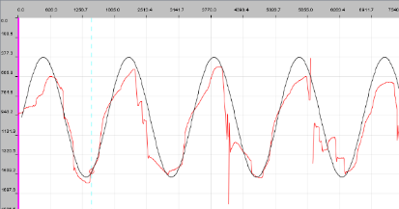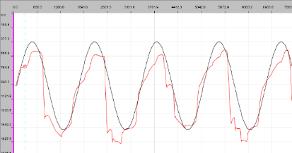
Visit 1
Visit 2
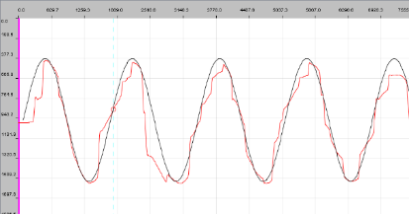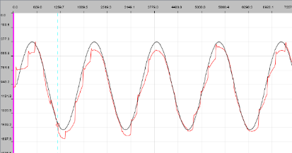
Visit 4
Visit 3
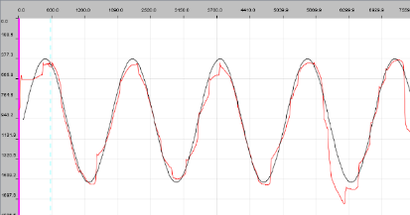
Visit 5
Figure 5.2: Samples of horizontal SP live trace from DV software of a patient who had left CN VI palsy across 4 months of study period. All images show the SP performance at 0.8 Hz frequency.

Thus, horizontal SP eye movements are the suggested method for examining CN III and CN IV palsy using a sinusoidal wave with a frequency of 0.6 to 0.8 Hz by analysing the SP gain and RMSE variables (Clementz et al., 1996). Additionally, observation of the sample traces SP eye movements of a patient exhibited that abnormal horizontal SP could be seen when evaluated at higher frequencies (0.6 and 0.8 Hz) (Figure 5.3).
The vertical SP performance of patients with ONP has never been studied before. The current study reveals that vertical SP anomalies in CN III and CN IV palsy can be detected with the highest vertical frequency of 1.0 Hz. Although the palsy revealed a significant difference between the affected and unaffected eye only for the vertical SP RMSE variable, but the vertical SP gain may provide important information to aid clinical assessment and management options. The reason for this is that both parameters are evaluating the SP's maintenance system (Levy et al., 2010).

V2
V1
0.8 Hz
0.6 Hz
0.2 Hz
0.4 Hz
V3
V4
V5
Control
Figure 5.3: LE horizontal SP traces for each target frequency (0.2 to 0.8 Hz) for patient ID = 2 with partial left CN III palsy and a sample of one age-matched control participant. SP was shown throughout the study from visits 1 to 5 of the study. The x-axis showed the time in ms, and the y-axis showed the eye position on the screen in the PPD unit. Upward trace = rightward eye movements and downward trace = leftward eye movements.
Horizontal saccadic parameters of the affected eyes were impaired towards the palsy gaze characterised by reduced peak velocity (Metz et al., 1970), prolonged latency and decreased gain. Additionally, CN III palsy demonstrated with significant longer latency of the affected eyes in both horizontal directions. It could be due to multiple restricted muscles leading to poor saccadic initiation towards adducted and abducted posture of the palsy eyes.
According to the findings, CN III had a significant effect on all vertical parameters of the saccade, due to the fact that both elevation and depression are variably paralysed in CN III palsy (Sharpe et al., 2008). Furthermore, CN IV palsy had a more substantial impact on the upward saccadic parameters than the downward. Surprisingly, CN VI palsy is associated with significantly reduced vertical saccadic accuracy, but no clear explanation on why a horizontal palsy resulted in reduced vertical saccadic accuracy. It is possible that ageing contributed to vertical gain deterioration, as detailed in Chapter 3 – section 3.3.5.
The saccadic eye movements in CN III are the most affected, including horizontal and vertical saccadic latency, peak velocity, and gain. CN VI palsy affected all the horizontal saccadic parameters as expected, as well as vertical saccadic gain and latency. Upward saccades had longer latency and lower gain than downward saccades in CN IV palsy. In contrast, the reduction in CN IV palsy upward saccadic gain was not clinically significant (mean = 0.94) because the reduction was <0.1.
The result suggested that, the saccadic EMR from the study is reliable of detecting the impact of acquired unilateral ONP. The horizontal saccadic EMR with ±10° target amplitude is highly recommended to be tested on the CN III and VI palsy while the vertical saccadic EMR with ±8° target amplitude should be tested on the CN III and IV palsy.
A previous study suggested performing a full investigation if a CN VI palsy did not recover within 16 weeks (King et al., 1995), but the current study had no evidence to support or refute this. However, patient ID: 10 (CN VI palsy) in the current study showed a complete recovery of the horizontal saccadic parameters, towards the affected gaze position, within 15 weeks. In contrast another patient who was diagnosed with CN VI palsy (ID:7) showed abnormal horizontal saccadic gain 19 weeks post-onset, normal horizontal saccadic peak velocity but the horizontal saccadic latency deteriorated starting from 13 weeks post-onset. Her horizontal SP parameters remained defective throughout the study period.

Conclusion
In conclusion, it is highly recommended to implement the EMR to examine the eye movements of acquired ONP patients. The suggested EMR recordings is performing fixation, horizontal and vertical smooth pursuit as well as horizontal and vertical saccades. The target size used should be between 0.5° and 1.0°, depending on the patient's vision status, as long as the patient can comfortably focus on the target. The following are the suggested EMR testing paradigms based on the findings:
Proposed EMR test: | Proposed parameters to be investigated:
Central fixation with a stationary target between 120 and 180 seconds. | Percentage DT.
SP sinusoidal horizontal wave with a frequency range of 0.4 to 0.6 Hz. | Horizontal SP gain and RMSE.
Vertical sinusoidal wave with a target frequency of 1.0 Hz. | Vertical SP gain and RMSE.
Horizontal saccades with a maximum amplitude of ±10 °. | Horizontal saccadic latency, peak velocity and gain.
Vertical saccades with a maximum amplitude of ±° 8. | Vertical saccadic latency, peak velocity and gain.

Final discussion and conclusions

Introduction
This study set out with the aim of assessing the value of using EMR technique as an objective method to monitor the eye movement anomalies of ONP patients during the potential recovery period. This study is significant in current clinical practice, as clinicians require an objective approach for monitoring eye movements that is both time efficient and worthwhile (Jukes et al., 2021).
105 orthoptists working in the UK and Ireland completed an online survey, in which they were asked questions about the eye measurement methods they used, how often they were assessed, what factors limited their ability to measure, and how important they thought it was to quantify ductions (Jukes et al., 2021). Importantly, the results revealed that while the majority of respondents believed it was critical to monitor ductions (89%), the frequency of performing the tests were significantly low due to several constraints such as insufficient time, no method available, and insufficient space and time (Jukes et al., 2021). The significance of this study is that it may aid in monitoring how well patients perform ductions by utilising the EMR saccades and pursuits analysis. The results can be easily compared across the follow-up visit to track the improvement of eye movements.
In clinical settings, eye movement ductions are frequently measured using the grading scale approach, which rates movements from -4 to +4 (Ansons & Davis, 2014). Inaccurate, inconsistent, and sensitive to inter and intra-observer variance are some of the drawbacks of this method (Dolman et al., 2012). Currently, ocular motor nerve palsies are monitored using the conventional subjective method by assessing the ocular misalignment and PCT measurements (Danchaivijitr & Kennard, 2004).
There are numerous laboratory-based and clinical methods for assessing eye movements using video-based eye movement recorders (Bedell & Stevenson, 2013; Houben et al., 2006; Pinkhardt et al., 2008; van der Geest & Frens, 2002). In 1970, a cross-sectional study showed that the saccadic peak velocity of a patient diagnosed with unilateral CN VI palsy was reduced in the affected eye compared with the non-affected eye (Metz et al., 1970). There has been no published study using the EMR in monitoring the progress of acquired ocular nerve palsies during the potential recovery period.
The advancement in EMR provides a good objective ocular motility assessment to monitor the acquired ONP during the potential recovery period (Clark et al., 2019). This requires permanent, accurate and repeatable recording paradigms, which allows the clinician to derive an accurate clinical diagnosis with details of eye movement properties such as latency, velocity and gain. The feasibility of implementing EMR in this clinical field has yet to be explored and a set of standard eye recording programmes and their analysis is not readily available.
Therefore, a set of eye movement testing paradigms was designed to assess fixations, pursuits and saccadic eye movement performance using the EyeLink 1000 Plus. The main objective of this study was to design, develop and validate the EMR using a non-invasive IR eye tracker. Experiment 1 was conducted to establish the normative data of the eye movement parameters according to age group of participants. Subsequently, the result served as the control group to compare with the age-matched ONP patients.

Assessment of the effect of changing target size and recording method (binocular and monocular) on the eye movement criteria
Concerns have been raised about how the target size or shape used could alter the EMR results (Irving et al., 2011). Thus, the question being addressed is whether utilising cross targets of varying sizes affects the accuracy of EMR measurements. This is because size 0.5° has been used for EMR testing on normal participants, however certain patients, particularly those attending their first EMR session, require a bigger target size to aid fixation. Some of them struggle to fixate on small targets, particularly those positioned in the most affected gaze. The larger the target, the easier it is for some of them to remain fixated. The result from this study determined whether a direct comparison between control and patient groups in later experiments is valid. Experiment 2 evaluated the effect of altering the target size on saccadic, pursuit, and fixational eye movement characteristics. The objective was to assess if the size of the target could be increased for the patient population. Results showed that different target sizes influence the specific eye movement parameters, especially saccadic latency since it involves the higher brain processing centre to initiate the movements (Ploner et al., 2004). Overall results showed target size has little effect on eye movements such as fixation, SP, and saccades. Comparing controls using the smallest target size gives slight variation in the patient data even when patients used different target sizes at follow-up visits based on their ability to see the target on the day of the test. A few participants had illnesses and took medication which could affect fixation.
A previous study found that the LE and the RE behaved equally among healthy participants when they were recorded binocularly, although they were analysed separately (Houben et al., 2006). Experiment 3 reveals that when binocular recording is used, normal people's RE and LE eye movements behave equally. Thus, comparing RE data collected during binocular viewing (Chapter 3 - experiment 1) to patients' monocular EMR data (Chapter 5 - experiment 4) is acceptable, as individuals with ocular nerve palsy do not have BSV in free space. Assessment of eye movement performance of the healthy participants
Previous studies reported that ageing affected the saccadic and SP performance (Hopf et al., 2018; Munoz et al., 1998), while others stated ageing did not affect the eye movement performance (Huaman & Sharpe, 1993; Irving & Lillakas, 2018), as discussed in Chapter 1 (section 1.5.2). Chapter 3 investigated the changes in fixation, SP and saccadic performance in different age groups using the proposed eye movement testing paradigms.
The current study found that fixation eye movement was not affected by age. However, the SP RMSE and saccadic latency deteriorated with increasing age in horizontal and vertical directions. Saccadic peak velocity increased in the older age group in the horizontal and downward saccade directions. Meanwhile, upward saccadic gain reduced with ageing, but saccadic gain reduced for the older age group, only at the greater amplitudes for the horizontal direction. These findings agree with a study that reported that older people had longer latency and hypometric saccades at larger saccade amplitudes (Peltsch et al., 2011b).
The results obtained in this study provide clinicians with normative data which can be compared to the results found in patients. It emphasises the need to compare patients with abnormal OMT to age-matched control data in EMR examinations. Furthermore, the EMR paradigms and specific parameters used in this study are suitable for patient assessment and consultation in clinics.

Assessment of eye movement improvement during the potential recovery period among ocular nerve palsies
The eye movement programmes proposed for this study were deemed feasible to be applied as a clinical paradigm for monitoring patients with an ocular motility defect to evaluate the progression of the disease. Patients had clinically limited ocular motility at the onset of the palsy (see Appendix 6). The condition was reflected with deficiencies in fixation, SP, and saccadic eye movement parameters tested by EMR.
In addition, CN III palsy, for example, was shown clinically by a limitation of ocular movement toward adduction, elevation, and depression. In the EMR, the condition was reflected by reduced percentage DT, impaired SP parameters at the specified frequency, and poor saccadic parameters toward the affected gaze. Patients showed clinical improvement with improved motility on the subsequent visits, suggesting that they were recovering; corresponding to the EMR parameters such as improvement of saccadic latency, peak velocity and gain as well as SP parameters from visit 1 to visit 5 as discussed in detail in Chapter 5, under the result section. Thus, the EMR results were consistent with the clinical picture, with improved ocular motility reflecting the improved response in EMR.
Furthermore, patients with the worst affected ocular motility at the onset of the palsy, showed the most reduced EMR response. For example, Patient ID 2 and 3 (Appendix 6.2 and 6.3) showed the largest ocular motility deficit. He also had the worst EMR responses for most of the saccadic parameters at the first visit (sac_latency_H = 329 ms and V = 331 ms, sac_peak velocity_H = 90.6 °/s and V = 137.5, sac_gain_H = 0.3, and V = 0.6). His SP also showed poor responses indicated with high RMSE_H = 1.2 and V = 0.9, and low gain_H = 0.6 and V = 0.7. Therefore, this supports the premises that EMR responses reflected the ocular motility assessed in the clinic. The recovery rate of patients varies despite experiencing similar types of ONP. For example, patient 10 (left CN VI palsy) had a greater initial PCT than patient 7 (right CN VI palsy). The former showed a faster rate of recovery of ocular motility and a faster improvement in EMR than the latter.
An outstanding feature of this DV software is allowing the examiner to easily compare the patient performance by visit for every trial frequency. Therefore, it provides a good clinical picture for monitoring SP as well as other type of eye movement performance across time (Figure 6.1). This feature is time efficient compared to manually searching for the clinical patient reports and trying to compare them visit by visit.
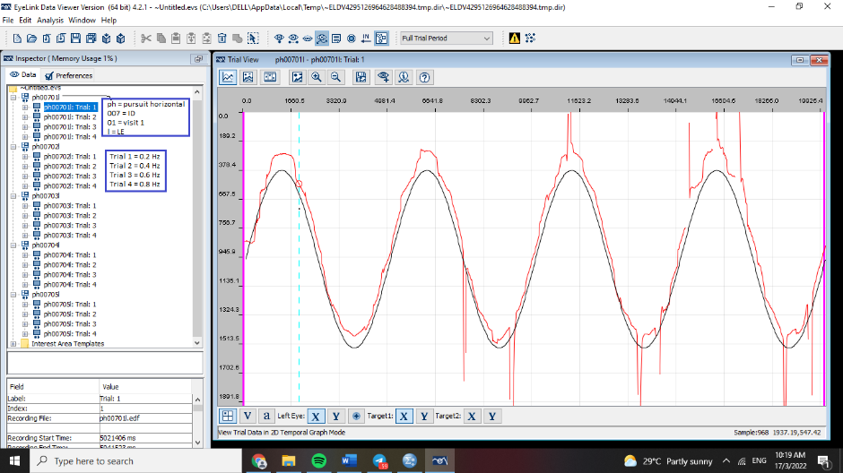
Figure 6.1: A sample of output in DV software. Patient’s SP performance of all follow-up visits is imported into a single viewing pane and separated according to trial frequency.
Additionally, data was extracted into an excel worksheet to analyse saccadic performance. If a patient has multiple visits, this can be identified using the coding established during the EMR assessment, allowing for easy tracing of data. However, rows and rows of raw data in spreadsheets might be difficult to filter through to get the deeper meaning, as shown in Figure 6.2. Datasets can be difficult to interpret, especially as they expand. Numerical summaries can be beneficial but might be confusing if they are large (Miller, 2014). Excel® includes various powerful features that can save users many hours of tiresome and unproductive effort. For example, pivot tables and pivot charts are powerful tools that may significantly speed up the process of evaluating data by making it practically quick, visually pleasing, and efficient (Miller, 2014).
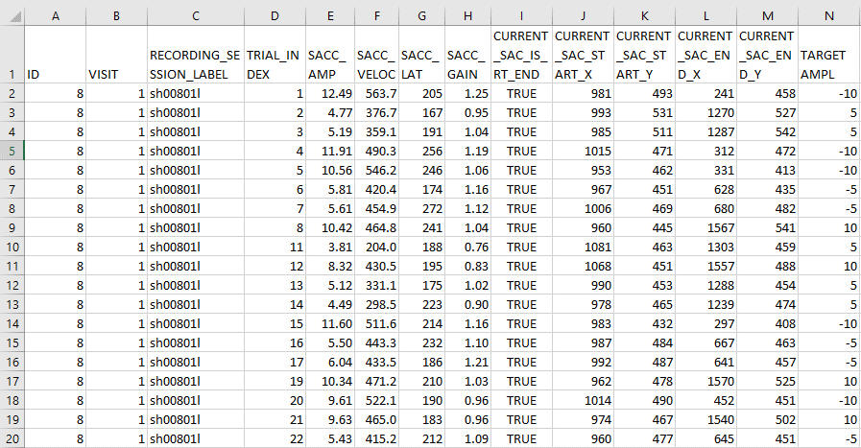
Figure 6. 2: Example of saccade source data formatted in regular table.

To save time and effort, these simple-to-use tools can be applied, eliminating the need to manually build formulas or to manually sort and resort data. It simplifies the process of organising and summarising data, as well as comparing it and identifying patterns. Pivot tables and pivot charts are dynamic and allow their content to be modified instantaneously (Miller, 2014). In contrast, traditional tables may need substantial work to rearrange the data to produce answers. Field variables can also be moved around and filters can be used (Figure 6.3). Therefore, the pivot table is beneficial for efficiently evaluating the EMR's performance at each follow-up appointment. Elements of the pivot table or chart can be collapsed or expanded to focus on specific data points within the broader results set (Figure 6.4 and 6.5). The bar chart produced in the Excel worksheet was very illustrative and impressive, which allows us to convey confirmation of the motility recovery to the patient. Pivot tables and pivot charts can help make complex data more understandable and visually engaging. However, no study has been published on the use of pivot tables to aid in the monitoring of disease progression over time.
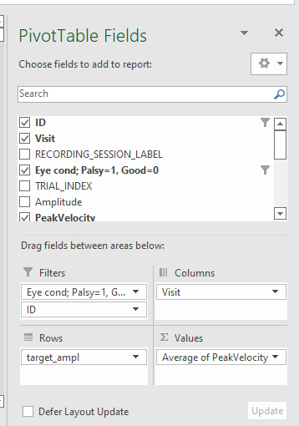
Figure 6.3: Example of pivot table fields. The items under the “Filters”, “Columns”, “Rows” and “Values” can be moves freely to get different data representation.

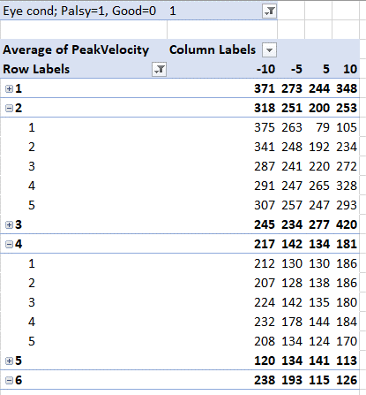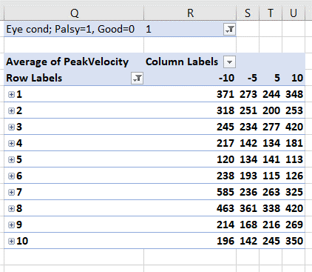
Figure 6.4: Pivot table on the left-hand side, displaying the average peak velocity of patient IDs 2 and 4 over five visits. Meanwhile, a collapsing pivot table focusing on all patients' performance is presented on the right.

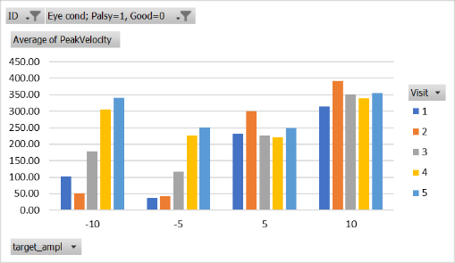
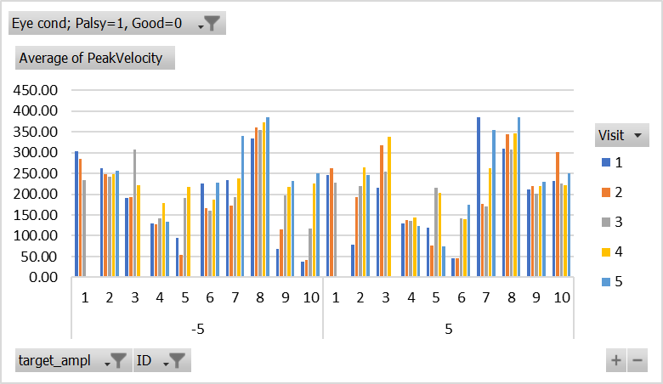
Figure 6.5: The top figure illustrates an example of a pivot chart focused on a single patient. The saccadic velocity was evaluated at four different amplitudes (±10° and ±5° horizontally) during five follow-up visits, using a pivot chart. On the bottom, a pivot chart depicts an example of saccadic peak velocity for all ten patients tested at ±5° amplitudes horizontally throughout five follow-up visits.

Patients' verbal comments about the EMR in monitoring their conditions.
A patient who returned for the follow-up visits expressed satisfaction, stating that they noticed an improvement in their eye movement between visits 1 until and this was reflected in the EMR results. They believed that this EMR technique should be utilised as the clinical standard for explaining the ONP condition to patients during follow-up visits. Thus, EMR analysis may reassure patients about their nerve palsy recovery. Therefore, it is highly recommended to utilise an EMR to monitor eye movement changes in the eye clinic since the recording procedure was user-friendly, produced reproducible results, and data processing is efficient and quick. In addition, it can acquire a complete picture of the patient's condition.
In summary, the objective EMR utilising EyeLink 1000 Plus is simple to operate, rapid, and capable of permanent reproducible records of results instantly. Fixation, saccades, and SP assessments can provide insight into how well ONP patients' eyes can fixate steadily, moving smoothly, accurately, and rapidly toward the affected and unaffected gaze. The study proposed several testing paradigms and analysis strategies that enable clinicians to monitor ONP patients' motility improvement.

Limitations
It was found that EMR cannot be performed while wearing PALs due to the aberrations created by the gradual change of focusing power on the lenses. The problem found with the older age group was that we needed to do the recording using the bigger target size to improve the fixation performance on the target. Similar problems were also found in high myopia, where it is quite hard to obtain a good calibration at the eccentric gaze.
It was hard to organise the same interval of the follow-up EMR for all ONP (ONP) patients due to the ageing population. They were among the fragile group of participants and prone to an unexpected illness, and unable to attend.
In addition, the statistical analysis suggested that some parameters are valid for the clinical assessment while some were ambiguous. The SP gain, SP RMSE, saccadic latency, peak velocity and gain are valid for the clinical analysis. The SP duration analysis does not reflect the actual SP eye movement, especially in people with severely defective SP; the example is explained in the next paragraph. In addition, it was suggested that fixation analysis using the DT parameter was unable to detect any fixation eye movement defect for the ONP, or it could be that their fixation was not affected by the palsy. This research indicates that patients’ fixational eye movements are normal, but future studies are required to investigate this further.
As shown in Figure 6.6, the data had some erroneous responses even though the duration of the pursuit fixation segment was included in the SP maintenance phase. Despite having inaccurate horizontal SP movement, the software recognised that the patient’s eye was smoothly following the target, marked as the SP fixation duration (turquoise bar), resulting in a longer duration which seems like good SP maintenance. The movement was only recognised as CUS when the jump movements were beyond 30° amplitude. Thus, SP duration alone may not be an appropriate clinical assessment for ONP patients' eye movement. It is also not a sensitive metric for detecting eye movement anomalies in ONP patients, as evidenced by no significant differences identified between the affected and unaffected eyes in both horizontal and vertical orientations for all trial frequencies. Furthermore, it has been demonstrated that the frequency of trials has a considerable impact on the variability of SP parameters both horizontally and vertically.
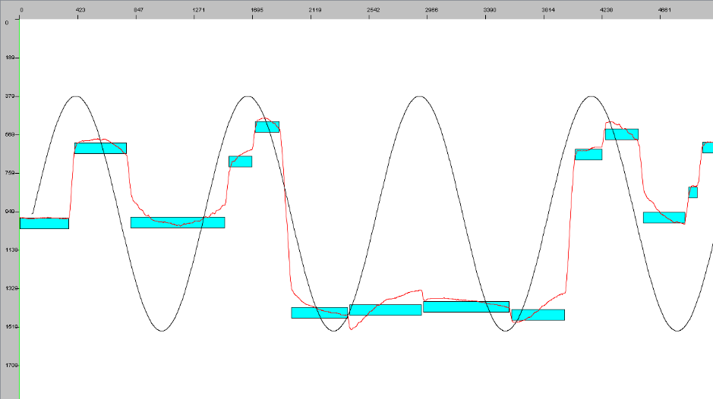
Figure 6.6: A sample SP traces of a patient with right CN VI palsy who had a defective horizontal SP movement. Despite having inaccurate horizontal SP movement, the software recognised that the patient’s eye was smoothly following the target, marked as the SP fixation duration (turquoise bar). The movement was only recognised as CUS when the jump movements are beyond 30° amplitude, which only denoted as the SP movement was interrupted.
— target movement in the horizontal direction
— eye movement following the target movement
SP duration

Future research
A larger study would enable every type of nerve palsy to be studied separately and provide more information on the pattern and recovery rate.
Gain and RMSE are suitable parameters to evaluate SP performance. In addition, saccadic latency, peak velocity and gain are the recommended parameters to assess saccadic performance.
Disposable daily soft contact lenses could also be considered to be fitted on participant’s during testing in an attempt to enhance the eye movement recording process whilst reducing the effect of aberrations in ophthalmic lenses.

Summary
In summary, the objective EMR utilising EyeLink 1000 Plus is simple to operate, rapid, and capable of creating permanent reproducible records of results instantly. Fixation, saccades, and SP assessments can provide insight into how well ONP patients' eyes can fixate steadily, moving smoothly, accurately, and rapidly toward the affected and unaffected gaze. The study proposed several testing paradigms and analysis strategies that enable clinicians to monitor ONP patients' motility improvement.

Appendices
Appendix 1.1: The University of Sheffield ethical approval letter for Chapter 3 and 4.



Appendix 1.2: Participant information sheet for Chapter 3 and 4.

Participant Information
Project Title: A study to measure normal eye movement in different age groups.
You are being invited to take part in a research project. Before you decide whether or not to participate it is important for you to understand why the research is being done and what it will involve. Please take time to read the following information carefully and discuss it with others if you wish. Please ask if there is anything that is not clear or if you would like more information. Thank you for reading this.
What is the project’s purpose?
The research aims to establish normal values for three types of eye movement using a video-based eye movement recorder. The eye movements include fixation of a stationary target; following a target moving smoothly on a screen; and quickly changing fixation from one target to another. Specifically, the aim is to define normal values in adults of different age groups.
Why have I been chosen?
You have been invited to participate because you have no known eye problems and good vision in both eyes.
What will happen to me if I take part?
We will invite you to the Academic Unit of Ophthalmology and Orthoptics within the Medical School at the University of Sheffield. At this visit we will record your eye movements using a camera. To do this you will need to put your head onto a chin rest and look at a target on a computer screen. This will take approximately 20 minutes. The eye movement recording will not cause any discomfort and there will be no contact with your eyes. The recorded data will be saved on a university computer and will not contain any personal information.
We are unfortunately not able to offer payment for taking part. But if you are an undergraduate Orthoptic student, you will receive tokens.
What are the possible benefits of taking part?
Your contribution will be invaluable to establish the normal eye movement responses in various age groups. After establishing this, we are planning to use the same equipment to detect any subtle changes to the eye movements that occur in patients with sudden onset double vision. The comparison with normal values will enable deficiencies to be identified. The aim of this follow-on study is to improve the care of patients with double vision by monitoring progression of the eye movement disorder and assist in development of more precise management planning.
Will my taking part in this project be kept confidential?
Yes, your participation will be anonymised. None of the information collected will contain personal details. Only the research team involved in this study will have access to your data.
What will happen to the results of the research project?
The results will be reported in the researchers PhD thesis. We also aim to present the results at a national conference and/or within a published journal. Participants will remain unidentifiable in any dissemination of results.
Who is organising and funding the research?
This study is part of a PhD study and has received no external funding.
Who has ethically reviewed the project?
This project has been ethically approved by the Medical School Ethics Committee.
Contact for further information
For further information, please contact the research Lead:
Dr Helen Griffiths, Senior Lecturer, Academic Unit of Medical Physics, O Floor, Faculty of Medicine, Dentistry and Health, University of Sheffield, Beech Hill Rd, Sheffield, S10 2RX. h.griffiths@sheffield.ac.uk
Or
Dr Helen Davis, Professor of Orthoptics, Academic Unit of Ophthalmology and Orthoptics, E Floor, Faculty of Medicine, Dentistry and Health, University of Sheffield, Beech Hill Rd, Sheffield, S10 2RX. h.davis@sheffield.ac.uk
Or
Noor Wafirah Shafee, Post-graduate Researcher. nwshafee1@sheffield.ac.uk

You will be given a copy of the information sheet and a signed consent form to keep

Thank you for considering taking part in the project

Appendix 1.3: Participant consent form for Chapters 3 and 4.

Title of Research Project: A study to measure normal eye movement in different age groups.
Name of Researchers: Noor Wafirah Shafee, Dr Helen Griffiths, Professor Helen Davis
Participant Identification Number for this project: Please initial box
- I confirm that I have read and understand the information sheet dated 29/03/17
explaining the above research project and I have had the opportunity to ask
questions about the project.
- I understand that my participation is voluntary and that I am free to withdraw
at any time without giving any reason and without there being any negative
consequences. In addition, should I not wish to answer any particular
question or questions, I am free to decline.
- I understand that my responses will be kept strictly confidential.
I give permission for members of the research team to have access to my
anonymised responses. I understand that my name will not be linked with
the research materials, and I will not be identified or identifiable in the
report or reports that result from the research.
4. I agree for the data collected from me to be used in future research.
I agree to take part in the above research project.

________________________ ________________ ____________________
Name of Participant Date Signature
_________________________ ________________ ____________________
Lead Researcher Date Signature
To be signed and dated in presence of the participant
Copies:
Once this has been signed by all parties the participant should receive a copy of the signed and dated participant consent form, the letter/pre-written script/information sheet and any other written information provided to the participants. A copy of the signed and dated consent form should be placed in the project’s main record (e.g. a site file), which must be kept in a secure location.
Appendix 1.4: Ethical approval letter from Health Research Authority (HRA) for Chapter 5.


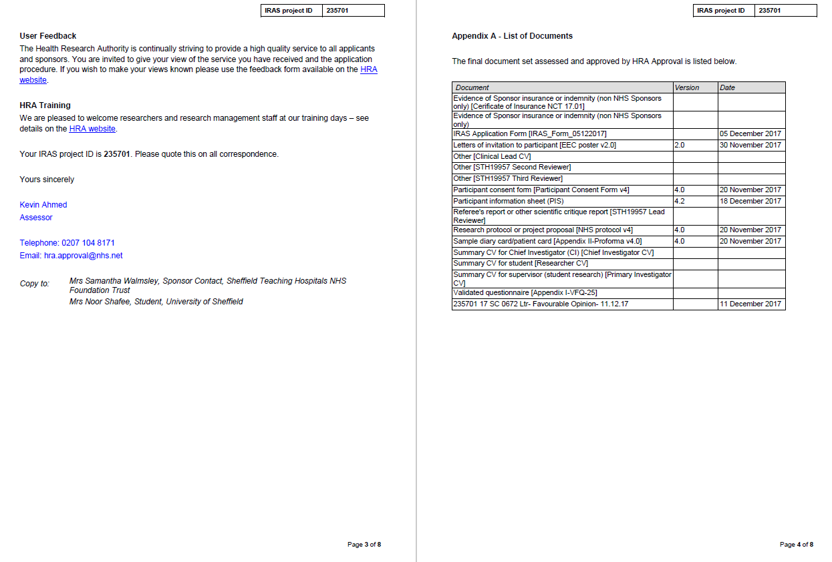
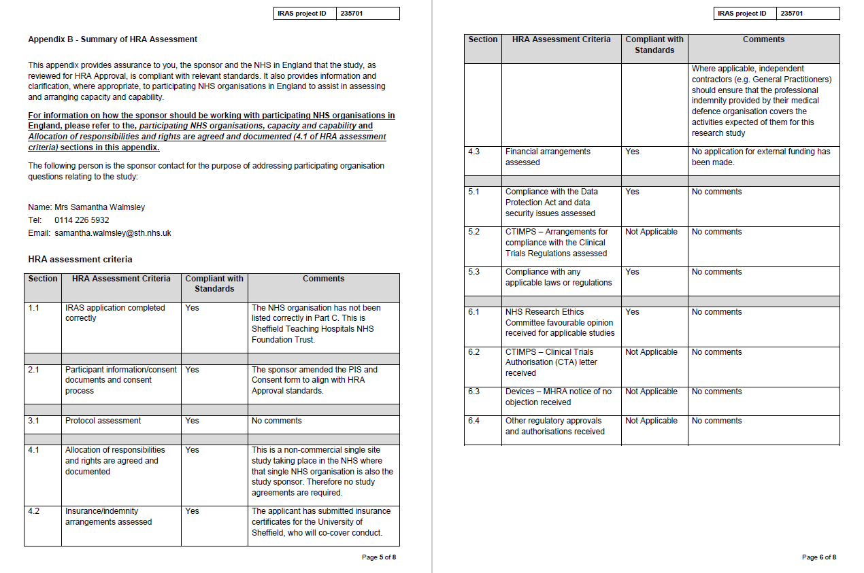
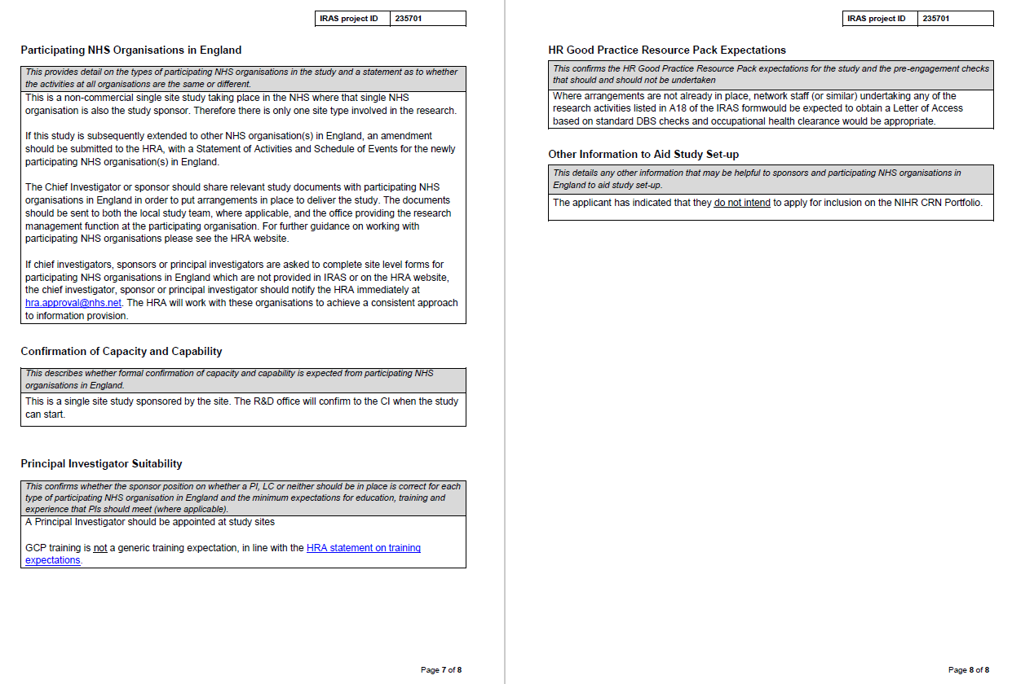

Appendix 1.5: Participant information sheet for Chapter 5.





Appendix 1.6: Participant consent form for Chapter 5.

Appendix 2.1: Fixation data extraction process

- Open the deployed fixation folder.
- Open result folder. Then, select the correct participant folder.
- Open the file generated in the.edf format.
- Import the AOIs for every fixation target target (T1 = PP, T2 = left, T3 = right, T4 = up, T5 = down).

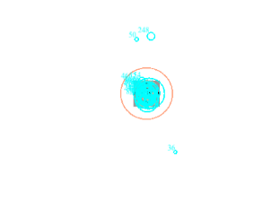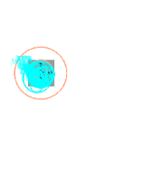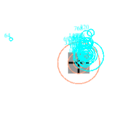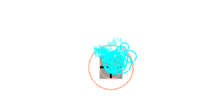

Sample of fixation data with AOI set up at five fixation positions.

- Click on 'Analysis' 'Reports' 'Interest Area Report'. Then, six variables were inserted at the selected variables pane.
- RECORDING_SESSION_LABEL
- TRIAL_INDEX
- EYE_USED
- IA_DWELL_TIME_%
- IA_AREA
- Label

- Finally, click 'Next,' and each participant's report was saved at the dedicated data analysis folder according to the type of study.

Appendix 2.2: SP data extraction process

- How to generate “sample report” from DV

SP data were extracted using the 'sample report' produced from the DV. Steps taken to extract the data were described as follow:

- Open the deployed SP (horizontal or vertical) folder.
- Open result folder. Then, select the correct participant folder.
- Open the file generated using .edf format.
- Click on 'Analysis' 'Reports' 'Sample Report'. Then, the following 12 variables were inserted at the selected variables pane:
- RECORDING_SESSION_LABEL
- TRIAL_INDEX
- RESOLUTION_X
- RIGHT_FIX_INDEX
- RIGHT_GAZE_X
- RIGHT_IN_BLINK
- RIGHT_IN_SACCADE
- RIGHT_SACCADE_INDEX
- RIGHT_VELOCITY_X
- SAMPLE_MESSAGE
- TARGET_VELOCITY_X
- TARGET_X

The example given is used for the horizontal SP of the RE. The RE was automatically set in the software if the data were recorded binocularly, which applies to experiment 1 and 2. However, for the monocular eye recording method, the variables started with "RIGHT" when extracting the data from the RE and it must be changed to “LEFT” when extracting data from the LE. The condition applies to experiment 3 and 4. The variables ended with “_X,” which indicates horizontal SP. Therefore, it must be changed to “_Y” for the vertical SP data.

- Finally, click 'Next,' and a sample report for every participant is saved at the dedicated data analysis folder according to the type of study.

The RIGHT_FIX_INDEX is the key one. It is used to identify portions of "possible SP" (e.g., samples not in a saccade or blink). It flags samples that, according to the parser on the Host PC are "in a fixation" (e.g., not in a saccade or blink). SP is a fixation that has some (sub-saccade threshold) velocity. All the samples in the first fixation (SP segment) have a value of 1, all the samples in the second fixation (SP segment) have a value of 2, and so forth.

- How to compute the SP variables (gain, RMSE and duration) from the sample report using R-statistical software

The “sample report” run in R statistical analysis software, using the following script, to compute the value for gain, RMSE and SP duration.

# Read in Sample Report
SP <- read.table('Pursuit_Sample_reports_uni164.xls', sep = "\t", na.strings = ".", header = TRUE)

# Strip out first trial
pursuit1 <- pursuit[pursuit$TRIAL_INDEX ==2,]
str(pursuit1)

#quick plot of target and gaze
plot(pursuit1$TARGET_X_TARG1, typ='l',col='black')
points(pursuit1$RIGHT_GAZE_X, typ='l',col='blue')

#set up variables
N_Psegs=max(pursuit1$RIGHT_FIX_INDEX,na.rm=TRUE)
vgains <-integer(N_Psegs)
rmses <-integer(N_Psegs)
lengths <-integer(N_Psegs)

Counter =1
while (Counter <=N_Psegs)
{
gaze_v =pursuit1$RIGHT_VELOCITY_X[which(pursuit1$RIGHT_FIX_INDEX==Counter)]
target_v =pursuit1$TARGET_VELOCITY_X_TARG1[which(pursuit1$RIGHT_FIX_INDEX==Counter)]
gain =ifelse(abs(target_v) < 2,NA,gaze_v/target_v)
vgain =mean(gain,na.rm=TRUE)
length =length(gain[!is.na(gain)])*2
temp1 =pursuit1$RIGHT_GAZE_X[which(pursuit1$RIGHT_FIX_INDEX==Counter)]
temp2 =pursuit1$TARGET_X_TARG1[which(pursuit1$RIGHT_FIX_INDEX==Counter)]
e =(temp2-temp1)/pursuit1$RESOLUTION_X[which(pursuit1$RIGHT_FIX_INDEX==Counter)]
se =e^2
mse =mean(se)
rmse =sqrt(mse)
vgains[Counter]=vgain
rmses[Counter]=rmse
lengths[Counter]=length
print(c(Counter,vgain,length,rmse))
Counter=Counter +1
}

output=cbind(vgains,rmses,lengths)
write.table(output,'Output.xls',sep='\t',col.names=NA)

Appendix 2.3: Saccade data extraction process

The data were extracted from the DV for further statistical analysis:

- Open the deployed saccade (horizontal or vertical) folder.
- Open result folder. Then, select the correct participant folder.
- Open the file generated using the .edf format.
- Set the Reaction Time Event, which will mark when the target appeared and when the saccade towards it was made. It is a crucial step to ensure the latency time was extracted correctly.

- Click 'Analysis' ‘Reaction Time Manager’, then click the ‘New RT definition’ button highlighted in yellow.

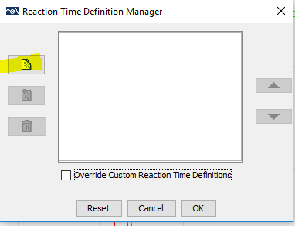
RT manager interface.
- Next, the other RT interface appeared. Under the ‘General’ tab, it has to specify the 'Label' space as 'First_Saccade' and choose the 'Saccade Event' as the End Event Type.
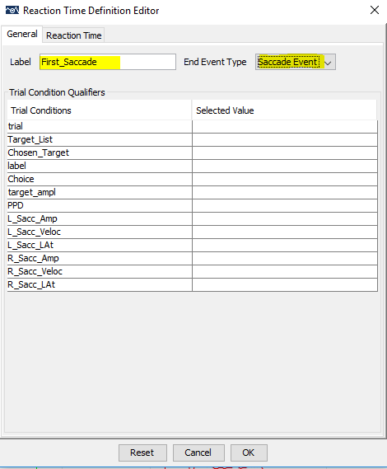
RT definition editor 1.
- Next, click the ‘Reaction Time’ tab and type 'PERIPH_TARGET' at the Start Time Message Text space, which refers to the message sent when the target is drawn. Then click OK.
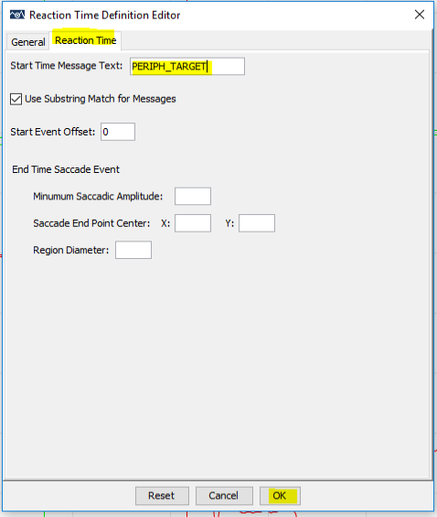
RT definition editor 2.
- Then, click on 'Analysis' 'Reports' 'Saccade Report.'
- Then, the following seven variables were inserted at the selected variables pane:
- RECORDING_SESSION_LABEL
- TRIAL_INDEX
- CURRENT_SAC_AMPLITUDE
- CURRENT_SAC_PEAK_VELOCITY
- CURRENT_SAC_START_TIME
- CURRENT_SAC_IS_RT_END
- target_ampl

- Finally, click 'Next' and saccade report are saved at the dedicated data analysis folder according to the type of study (01 = age group, 02 = target size different, 03 = monocular versus binocular and 04 = ONP) with the assigned coding system. The reports are used for further analysis.

Appendix 3.1: The differences between RE and LE are demonstrated by a independent samples t-tests.

Null Hypothesis = 0

 | Mean diff | t value | p value
Dwell time (RE/LE)  1° AOI  2° AOI  >2° AOI | -0.930  2.437  -1.507 | -0.281  0.857  -0.795 | 0.779  0.392  0.497
Horizontal SP (RE/LE)  Gain  RMSE  Length | 0.004  -0.020  -6.767 | 0.320  -0.429  -0.324 | 0.749  0.668  0.746
Vertical SP (RE/LE)  Gain  RMSE  Length | -0.006  -0.099  0.532 | -0.328  -1.938  0.046 | 0.743  0.053  0.964
Horizontal saccade (RE/LE)  Latency  Peak velocity  Gain | -0.385  -5.847  -0.019 | -0.212  -1.850  -3.420 | 0.766  0.968  0.684
Vertical saccade (RE/LE)  Latency  Peak velocity  Gain | 0.497  -2.584  0.001 | 0.330  -0.700  0.123 | 0.741  0.484  0.902

Appendix 3.2: Mean horizontal SP a) gain, b) RMSE (°), and c) SP duration (ms), of individual participant from three age groups (young, middle and older age) with normal BSV. The result of RE was presented.
- Horizontal SP gain
Young (18-39 years old)
Target frequency  Participant ID | 0.2 Hz | 0.4 Hz | 0.6 Hz | 0.8 Hz
1 | 0.99 | 1.01 | 0.85 | 0.74
2 | 0.92 | 0.85 | 0.73 | 0.64
3 | 0.95 | 0.91 | 0.87 | 0.81
4 | 1.00 | 0.92 | 0.83 | 0.79
5 | 0.90 | 0.43 | 0.62 | 0.35
6 | 0.94 | 0.94 | 0.84 | 0.72
7 | 0.95 | 0.92 | 0.76 | 0.69
8 | 0.92 | 0.87 | 0.80 | 0.64
9 | 0.95 | 0.88 | 0.87 | 0.76
10 | 0.99 | 0.89 | 0.86 | 0.76
11 | 0.97 | 0.97 | 0.90 | 0.86
12 | 0.96 | 0.87 | 0.79 | 0.78
13 | 0.98 | 0.99 | 0.88 | 0.87
14 | 0.94 | 0.91 | 0.79 | 0.76
15 | 0.93 | 0.89 | 0.83 | 0.58
16 | 1.00 | 0.99 | 0.97 | 0.95
17 | 0.93 | 0.93 | 0.93 | 0.77
18 | 0.95 | 0.91 | 0.88 | 0.81
19 | 0.93 | 0.84 | 0.80 | 0.70
20 | 0.90 | 0.93 | 0.81 | 0.74
21 | 0.93 | 0.86 | 0.84 | 0.64
22 | 0.95 | 0.91 | 0.90 | 0.76
23 | 1.00 | 0.92 | 0.83 | 0.75
Middle (40-59 years old)
Target frequency  Participant ID | 0.2 Hz | 0.4 Hz | 0.6 Hz | 0.8 Hz
1 | 0.90 | 0.88 | 0.73 | 0.67
2 | 0.98 | 0.92 | 0.77 | 0.84
3 | 0.79 | 0.68 | 0.35 | 0.24
4 | 0.93 | 0.91 | 0.81 | 0.73
5 | 0.94 | 0.99 | 0.82 | 0.74
6 | 0.93 | 0.96 | 0.82 | 0.63
7 | 1.01 | 0.96 | 0.89 | 0.84
8 | 0.99 | 0.88 | 0.74 | 0.71
9 | 0.94 | 0.86 | 0.82 | 0.76
10 | 0.88 | 0.87 | 0.73 | 0.69
11 | 0.95 | 0.88 | 0.76 | 0.65
12 | 0.99 | 0.84 | 0.85 | 0.73
13 | 0.98 | 0.86 | 0.76 | 0.69
14 | 0.85 | 0.77 | 0.71 | 0.59
15 | 0.95 | 0.91 | 0.89 | 0.70
16 | 0.94 | 0.91 | 0.86 | 0.75
17 | 0.88 | 0.84 | 0.73 | 0.63
18 | 0.94 | 0.90 | 0.74 | 0.59
Older (60-79 years old)
Target frequency  Participant ID | 0.2 Hz | 0.4 Hz | 0.6 Hz | 0.8 Hz
1 | 0.86 | 0.75 | 0.64 | 0.48
2 | 0.91 | 0.75 | 0.71 | 0.63
3 | 1.01 | 0.89 | 0.93 | 0.77
4 | 0.87 | 0.79 | 0.80 | 0.62
5 | 0.86 | 0.85 | 0.72 | 0.60
6 | 0.93 | 0.89 | 0.84 | 0.76
7 | 0.98 | 0.92 | 0.77 | 0.66
8 | 0.87 | 0.84 | 0.80 | 0.68
9 | 0.94 | 0.83 | 0.73 | 0.46
10 | 1.03 | 0.92 | 0.83 | 0.73
11 | 0.89 | 0.89 | 0.78 | 0.65
12 | 0.96 | 0.88 | 0.85 | 0.75
13 | 1.07 | 0.91 | 0.79 | 0.78
14 | 1.01 | 0.95 | 0.92 | 0.84
15 | 0.90 | 0.87 | 0.77 | 0.72
- Horizontal SP RMSE (°)
Young (18-39 years old)
Target frequency  Participant ID | 0.2 Hz | 0.4 Hz | 0.6 Hz | 0.8 Hz
1 | 0.65 | 0.77 | 0.84 | 1.00
2 | 0.24 | 0.46 | 0.73 | 1.27
3 | 0.31 | 0.53 | 0.88 | 1.40
4 | 0.38 | 0.56 | 0.93 | 1.23
5 | 0.46 | 1.01 | 1.73 | 1.86
6 | 0.58 | 0.72 | 0.69 | 1.03
7 | 0.36 | 0.40 | 0.90 | 1.62
8 | 0.22 | 0.39 | 0.68 | 1.34
9 | 0.70 | 0.67 | 0.55 | 1.10
10 | 0.38 | 0.52 | 0.65 | 0.91
11 | 0.17 | 0.35 | 0.72 | 0.93
12 | 0.32 | 0.41 | 0.69 | 1.06
13 | 0.60 | 0.90 | 0.81 | 1.16
14 | 0.52 | 0.75 | 0.91 | 1.30
15 | 0.79 | 0.83 | 1.26 | 1.61
16 | 0.32 | 0.40 | 0.64 | 0.90
17 | 0.33 | 0.43 | 0.73 | 1.13
18 | 0.71 | 0.72 | 0.75 | 1.44
19 | 0.24 | 0.44 | 0.81 | 1.46
20 | 0.25 | 0.28 | 0.68 | 1.10
21 | 0.53 | 0.63 | 0.99 | 1.80
22 | 0.33 | 0.39 | 0.68 | 1.23
23 | 0.40 | 0.42 | 0.65 | 1.25
Middle (40-59 years old)
Target frequency  Participant ID | 0.2 Hz | 0.4 Hz | 0.6 Hz | 0.8 Hz
1 | 0.85 | 1.22 | 1.57 | 1.33
2 | 0.40 | 1.06 | 1.27 | 1.79
3 | 0.44 | 0.88 | 1.69 | 1.98
4 | 0.25 | 0.48 | 0.74 | 1.29
5 | 0.31 | 0.44 | 1.01 | 1.26
6 | 0.36 | 0.48 | 0.65 | 1.36
7 | 0.46 | 0.56 | 0.65 | 0.88
8 | 0.42 | 1.01 | 1.51 | 1.45
9 | 0.37 | 0.56 | 1.20 | 1.22
10 | 0.49 | 0.68 | 0.82 | 1.18
11 | 0.28 | 0.37 | 0.80 | 1.42
12 | 0.39 | 0.60 | 0.68 | 0.91
13 | 0.64 | 1.38 | 1.22 | 1.16
14 | 0.23 | 0.45 | 0.71 | 1.41
15 | 0.49 | 0.66 | 0.71 | 1.46
16 | 0.72 | 1.00 | 1.00 | 1.34
17 | 0.44 | 0.89 | 1.40 | 1.67
18 | 0.33 | 0.45 | 1.18 | 1.20
Grouped mean | 0.44 | 0.73 | 1.05 | 1.35
SD | 0.16 | 0.30 | 0.35 | 0.27
Older (60-79 years old)
Target frequency  Participant ID | 0.2 Hz | 0.4 Hz | 0.6 Hz | 0.8 Hz
1 | 0.85 | 0.88 | 1.49 | 2.01
2 | 1.71 | 1.97 | 1.73 | 1.84
3 | 0.61 | 1.15 | 1.56 | 2.12
4 | 0.23 | 0.48 | 0.86 | 1.08
5 | 0.81 | 0.99 | 1.44 | 1.78
6 | 0.43 | 1.04 | 0.93 | 1.31
7 | 0.49 | 0.63 | 0.67 | 1.62
8 | 0.56 | 0.83 | 1.16 | 1.51
9 | 1.24 | 1.50 | 1.61 | 0.86
10 | 0.52 | 0.79 | 0.95 | 1.08
11 | 0.42 | 0.34 | 0.83 | 1.54
12 | 0.39 | 0.48 | 0.78 | 1.12
13 | 0.29 | 0.42 | 0.74 | 1.01
14 | 0.31 | 0.43 | 0.63 | 0.88
15 | 0.36 | 0.48 | 0.83 | 1.04
Grouped mean | 0.61 | 0.83 | 1.08 | 1.39
SD | 0.40 | 0.45 | 0.38 | 0.42
- Horizontal SP duration (ms)
Young (18-39 years old)
Target frequency  Participant ID | 0.2 Hz | 0.4 Hz | 0.6 Hz | 0.8 Hz
1 | 835 | 458 | 266 | 221
2 | 717 | 393 | 275 | 242
3 | 608 | 555 | 429 | 308
4 | 988 | 704 | 370 | 277
5 | 707 | 532 | 331 | 217
6 | 747 | 410 | 265 | 196
7 | 707 | 665 | 272 | 248
8 | 605 | 347 | 228 | 201
9 | 730 | 475 | 315 | 222
10 | 704 | 359 | 248 | 128
11 | 639 | 400 | 294 | 182
12 | 831 | 410 | 273 | 213
13 | 826 | 578 | 336 | 226
14 | 467 | 332 | 261 | 208
15 | 454 | 315 | 287 | 222
16 | 933 | 676 | 424 | 208
17 | 703 | 380 | 272 | 193
18 | 625 | 431 | 244 | 191
19 | 542 | 336 | 237 | 155
20 | 550 | 509 | 219 | 147
21 | 519 | 366 | 226 | 211
22 | 920 | 693 | 368 | 249
23 | 579 | 432 | 267 | 188
Middle (40-59 years old)
Target frequency  Participant ID | 0.2 Hz | 0.4 Hz | 0.6 Hz | 0.8 Hz
1 | 309 | 232 | 198 | 235
2 | 637 | 300 | 219 | 223
3 | 575 | 363 | 339 | 272
4 | 842 | 318 | 207 | 153
5 | 682 | 471 | 268 | 219
6 | 383 | 438 | 295 | 246
7 | 420 | 379 | 236 | 149
8 | 614 | 356 | 256 | 220
9 | 451 | 441 | 224 | 212
10 | 741 | 649 | 225 | 357
11 | 602 | 336 | 206 | 175
12 | 603 | 398 | 302 | 331
13 | 398 | 364 | 463 | 374
14 | 522 | 373 | 267 | 201
15 | 727 | 432 | 338 | 235
16 | 620 | 497 | 361 | 298
17 | 530 | 347 | 317 | 269
18 | 467 | 480 | 277 | 169
Older (60-79 years old)
Target frequency  Participant ID | 0.2 Hz | 0.4 Hz | 0.6 Hz | 0.8 Hz
1 | 239 | 266 | 222 | 140
2 | 289 | 279 | 195 | 177
3 | 639 | 523 | 338 | 252
4 | 658 | 310 | 222 | 182
5 | 603 | 612 | 386 | 412
6 | 409 | 436 | 284 | 242
7 | 576 | 388 | 303 | 268
8 | 381 | 310 | 242 | 234
9 | 425 | 305 | 301 | 212
10 | 504 | 637 | 260 | 255
11 | 568 | 542 | 407 | 374
12 | 437 | 367 | 270 | 298
13 | 615 | 505 | 256 | 255
14 | 724 | 495 | 368 | 324
15 | 462 | 488 | 338 | 268

Appendix 3.3: Mean vertical SP a) gain, b) RMSE (°), and c) SP duration (ms), of individual participant from three age groups (young, middle and older age) with normal BSV. The result of RE was presented.
- Vertical SP gain
Young (18-39 years old)
Target frequency  Participant ID | 0.25 Hz | 0.50 Hz | 0.75 Hz | 1.00 Hz
1 | 0.82 | 0.79 | 0.58 | 0.38
2 | 0.87 | 0.76 | 0.62 | 0.39
3 | 0.89 | 0.87 | 0.80 | 0.50
4 | 0.66 | 0.62 | 0.39 | 0.31
5 | 0.61 | 0.52 | 0.17 | 0.39
6 | 0.74 | 0.66 | 0.54 | 0.43
7 | 0.78 | 0.69 | 0.57 | 0.34
8 | 0.93 | 0.71 | 0.55 | 0.47
9 | 0.84 | 0.75 | 0.53 | 0.37
10 | 0.82 | 0.70 | 0.51 | 0.33
11 | 1.00 | 0.80 | 0.56 | 0.30
12 | 0.76 | 0.63 | 0.43 | 0.31
13 | 0.83 | 0.77 | 0.73 | 0.46
14 | 0.91 | 0.83 | 0.68 | 0.43
15 | 0.87 | 0.67 | 0.61 | 0.43
16 | 0.97 | 0.88 | 0.88 | 0.71
17 | 0.69 | 0.59 | 0.45 | 0.38
18 | 0.66 | 0.78 | 0.58 | 0.40
19 | 0.84 | 0.66 | 0.56 | 0.44
20 | 0.90 | 0.89 | 0.73 | 0.66
21 | 0.85 | 0.67 | 0.48 | 0.44
22 | 0.87 | 0.72 | 0.47 | 0.26
23 | 0.86 | 0.74 | 0.43 | 0.42
Grouped Mean | 0.82 | 0.73 | 0.56 | 0.42
SD | 0.10 | 0.09 | 0.15 | 0.10
Middle (40-59 years old)
Target frequency  Participant ID | 0.25 Hz | 0.50 Hz | 0.75 Hz | 1.00 Hz
1 | 0.73 | 0.43 | 0.31 | 0.25
2 | 0.76 | 0.71 | 0.43 | 0.19
3 | 0.71 | 0.58 | 0.20 | 0.14
4 | 0.90 | 0.87 | 0.74 | 0.63
5 | 0.76 | 0.63 | 0.35 | 0.26
6 | 0.88 | 0.88 | 0.54 | 0.57
7 | 0.76 | 0.65 | 0.53 | 0.48
8 | 0.82 | 0.71 | 0.71 | 0.61
9 | 0.86 | 0.99 | 0.94 | 0.65
10 | 0.78 | 0.81 | 0.73 | 0.52
11 | 0.78 | 0.63 | 0.40 | 0.24
12 | 0.89 | 0.88 | 0.63 | 0.46
13 | 0.55 | 0.53 | 0.31 | 0.21
14 | 0.70 | 0.62 | 0.45 | 0.29
15 | 0.95 | 0.78 | 0.61 | 0.55
16 | 0.79 | 0.76 | 0.56 | 0.27
17 | 0.68 | 0.36 | 0.37 | 0.15
18 | 0.82 | 0.77 | 0.43 | 0.27
Grouped Mean | 0.78 | 0.70 | 0.51 | 0.37
SD | 0.10 | 0.16 | 0.19 | 0.18
Older (60-79 years old)
Target frequency  Participant ID | 0.25 Hz | 0.50 Hz | 0.75 Hz | 1.00 Hz
1 | 0.80 | 0.50 | 0.32 | 0.20
2 | 0.81 | 0.55 | 0.44 | 0.30
3 | 0.80 | 0.73 | 0.68 | 0.27
4 | 0.77 | 0.65 | 0.58 | 0.31
5 | 0.63 | 0.48 | 0.20 | 0.63
6 | 0.81 | 0.71 | 0.57 | 0.33
7 | 0.72 | 0.44 | 0.70 | 0.24
8 | 0.80 | 0.68 | 0.43 | 0.36
9 | 0.82 | 0.70 | 0.53 | 0.29
10 | 0.68 | 0.49 | 0.42 | 0.35
11 | 0.84 | 0.77 | 0.75 | 0.60
12 | 0.91 | 0.72 | 0.67 | 0.44
13 | 0.88 | 0.74 | 0.63 | 0.41
14 | 0.82 | 0.67 | 0.57 | 0.64
15 | 0.82 | 0.89 | 0.81 | 0.68
Grouped Mean | 0.79 | 0.65 | 0.55 | 0.40
SD | 0.07 | 0.13 | 0.17 | 0.16
- Vertical SP RMSE (°)
Young (18-39 years old)
Target frequency  Participant ID | 0.25 Hz | 0.50 Hz | 0.75 Hz | 1.00 Hz
1 | 0.52 | 0.68 | 0.95 | 1.74
2 | 0.36 | 0.46 | 0.94 | 2.44
3 | 0.35 | 1.17 | 1.01 | 2.03
4 | 0.64 | 1.18 | 1.86 | 2.81
5 | 1.01 | 0.92 | 2.41 | 2.27
6 | 0.36 | 0.65 | 0.96 | 1.53
7 | 0.51 | 0.86 | 1.47 | 2.00
8 | 0.43 | 0.85 | 1.34 | 2.03
9 | 0.75 | 0.85 | 1.25 | 1.78
10 | 0.49 | 0.65 | 1.29 | 1.86
11 | 0.37 | 0.48 | 1.08 | 1.69
12 | 0.71 | 1.13 | 1.48 | 1.79
13 | 0.41 | 0.58 | 1.12 | 1.66
14 | 0.38 | 0.67 | 1.17 | 1.50
15 | 0.48 | 1.16 | 1.54 | 2.63
16 | 0.36 | 0.57 | 1.00 | 1.14
17 | 0.40 | 0.89 | 1.33 | 2.03
18 | 1.00 | 0.80 | 1.25 | 1.68
19 | 0.38 | 0.71 | 1.10 | 1.89
20 | 0.71 | 1.21 | 1.37 | 1.76
21 | 0.81 | 1.81 | 3.19 | 1.99
22 | 0.28 | 0.75 | 1.23 | 1.91
23 | 0.32 | 0.52 | 1.08 | 1.18
Grouped Mean | 0.51 | 0.83 | 1.33 | 1.82
SD | 0.21 | 0.31 | 0.52 | 0.40
Middle (40-59 years old)
Target frequency  Participant ID | 0.25 Hz | 0.50 Hz | 0.75 Hz | 1.00 Hz
1 | 1.13 | 1.62 | 2.07 | 2.59
2 | 1.20 | 1.96 | 2.49 | 2.83
3 | 1.31 | 3.42 | 2.79 | 2.52
4 | 0.37 | 0.44 | 0.72 | 0.96
5 | 0.46 | 0.85 | 1.94 | 2.45
6 | 0.55 | 0.83 | 2.41 | 1.68
7 | 0.73 | 0.89 | 1.60 | 1.85
8 | 0.52 | 1.61 | 1.71 | 1.87
9 | 1.27 | 1.13 | 1.22 | 1.03
10 | 0.79 | 0.87 | 1.16 | 1.81
11 | 0.29 | 0.66 | 1.37 | 2.38
12 | 0.59 | 0.76 | 1.61 | 2.25
13 | 1.18 | 2.83 | 3.40 | 3.05
14 | 0.63 | 0.85 | 1.43 | 2.41
15 | 0.73 | 1.15 | 1.85 | 1.58
16 | 0.53 | 0.91 | 1.83 | 2.57
17 | 1.52 | 2.38 | 2.73 | 2.30
18 | 0.44 | 0.69 | 1.69 | 2.75
Grouped Mean | 0.79 | 1.32 | 1.89 | 2.16
SD | 0.38 | 0.83 | 0.67 | 0.59
Older (60-79 years old)
Target frequency  Participant ID | 0.25 Hz | 0.50 Hz | 0.75 Hz | 1.00 Hz
1 | 2.58 | 2.09 | 2.54 | 2.60
2 | 0.94 | 1.21 | 2.37 | 2.43
3 | 1.23 | 1.44 | 2.46 | 2.61
4 | 0.74 | 0.66 | 1.29 | 1.97
5 | 2.15 | 2.68 | 1.92 | 2.74
6 | 0.73 | 0.91 | 2.10 | 2.42
7 | 1.07 | 1.45 | 1.68 | 1.96
8 | 0.60 | 0.61 | 1.72 | 1.99
9 | 1.69 | 2.00 | 2.74 | 2.27
10 | 1.65 | 2.46 | 2.03 | 2.66
11 | 0.55 | 0.72 | 1.27 | 1.32
12 | 1.33 | 1.68 | 1.41 | 1.60
13 | 0.51 | 0.59 | 1.04 | 1.36
14 | 0.47 | 0.81 | 1.35 | 1.79
15 | 0.47 | 0.59 | 0.99 | 1.44
Grouped Mean | 1.11 | 1.33 | 1.79 | 2.08
SD | 0.65 | 0.72 | 0.57 | 0.50
- Vertical SP duration (ms)
Young (18-39 years old)
Target frequency  Participant ID | 0.25 Hz | 0.50 Hz | 0.75 Hz | 1.00 Hz
1 | 408 | 303 | 265 | 247
2 | 481 | 279 | 273 | 205
3 | 566 | 411 | 287 | 220
4 | 426 | 299 | 285 | 296
5 | 409 | 253 | 279 | 317
6 | 362 | 280 | 215 | 216
7 | 423 | 243 | 201 | 265
8 | 390 | 212 | 181 | 190
9 | 334 | 312 | 200 | 231
10 | 508 | 237 | 221 | 186
11 | 533 | 304 | 224 | 244
12 | 442 | 249 | 187 | 172
13 | 549 | 334 | 216 | 198
14 | 367 | 246 | 200 | 191
15 | 408 | 270 | 214 | 212
16 | 527 | 167 | 196 | 141
17 | 396 | 279 | 228 | 194
18 | 281 | 202 | 158 | 175
19 | 437 | 288 | 229 | 181
20 | 392 | 237 | 177 | 146
21 | 383 | 261 | 254 | 251
22 | 613 | 397 | 216 | 168
23 | 620 | 239 | 190 | 188
Grouped Mean | 446 | 274 | 221 | 210
SD | 89 | 56 | 36 | 44
Middle (40-59 years old)
Target frequency  Participant ID | 0.25 Hz | 0.50 Hz | 0.75 Hz | 1.00 Hz
1 | 254 | 192 | 204 | 193
2 | 333 | 246 | 240 | 229
3 | 372 | 411 | 343 | 401
4 | 503 | 276 | 183 | 171
5 | 459 | 307 | 290 | 259
6 | 491 | 389 | 258 | 202
7 | 375 | 219 | 178 | 160
8 | 373 | 240 | 223 | 187
9 | 798 | 176 | 174 | 175
10 | 895 | 469 | 304 | 268
11 | 389 | 225 | 193 | 190
12 | 745 | 392 | 280 | 212
13 | 278 | 255 | 313 | 209
14 | 419 | 273 | 262 | 187
15 | 522 | 316 | 247 | 214
16 | 451 | 264 | 243 | 287
17 | 414 | 619 | 383 | 351
18 | 464 | 289 | 457 | 260
Grouped Mean | 474 | 309 | 265 | 231
SD | 173 | 111 | 75 | 64
Older (60-79 years old)
Target frequency  Participant ID | 0.25 Hz | 0.50 Hz | 0.75 Hz | 1.00 Hz
1 | 197 | 165 | 257 | 287
2 | 339 | 299 | 164 | 206
3 | 422 | 356 | 336 | 290
4 | 479 | 243 | 179 | 187
5 | 430 | 265 | 388 | 217
6 | 539 | 341 | 372 | 287
7 | 533 | 285 | 306 | 215
8 | 347 | 239 | 170 | 205
9 | 461 | 341 | 260 | 283
10 | 330 | 282 | 265 | 178
11 | 541 | 312 | 178 | 139
12 | 443 | 430 | 302 | 378
13 | 551 | 408 | 268 | 181
14 | 699 | 345 | 233 | 193
15 | 699 | 397 | 269 | 214
Grouped Mean | 467 | 314 | 263 | 231
SD | 135 | 71 | 71 | 62

Appendix 3.4: Mean horizontal saccadic a) latency, b) peak velocity and c) gain, of individual participant from three age groups (young, middle and older) with normal BSV. The result of RE was presented.
- Latency (ms) | Leftward saccades |  |  |  |  |  |  |  | Rightward saccades
Young (18-39 years old)
Target amplitude  Participant ID | -15° |  | -10° |  |  | -5° |  |  | 5° |  |  |  | 10° |  | 15°
1 | 202.3 |  | 204.8 |  |  | 200.7 |  |  | 185.1 |  |  |  | 183.7 |  | 205.7
2 | 254.8 |  | 194.6 |  |  | 147.4 |  |  | 160.5 |  |  |  | 185.5 |  | 239.8
3 | 194.0 |  | 157.5 |  |  | 154.1 |  |  | 140.9 |  |  |  | 178.6 |  | 180.3
4 | 176.8 |  | 175.5 |  |  | 154.5 |  |  | 184.9 |  |  |  | 190.4 |  | 200.7
5 | 202.0 |  | 164.3 |  |  | 181.1 |  |  | 171.7 |  |  |  | 150.8 |  | 218.4
6 | 152.4 |  | 122.5 |  |  | 123.6 |  |  | 152.9 |  |  |  | 155.7 |  | 172.8
7 | 167.5 |  | 146.6 |  |  | 148.6 |  |  | 189.1 |  |  |  | 174.8 |  | 181.8
8 | 178.3 |  | 173.8 |  |  | 148.3 |  |  | 136.0 |  |  |  | 155.3 |  | 223.4
9 | 225.9 |  | 215.7 |  |  | 219.5 |  |  | 220.5 |  |  |  | 232.8 |  | 243.3
10 | 166.9 |  | 154.2 |  |  | 142.3 |  |  | 148.8 |  |  |  | 151.8 |  | 204.1
11 | 146.5 |  | 126.5 |  |  | 128.9 |  |  | 133.1 |  |  |  | 140.1 |  | 162.1
12 | 198.1 |  | 165.8 |  |  | 167.1 |  |  | 161.3 |  |  |  | 166.8 |  | 179.6
13 | 172.4 |  | 148.3 |  |  | 146.3 |  |  | 141.5 |  |  |  | 162.8 |  | 175.5
14 | 186.8 |  | 174.0 |  |  | 156.9 |  |  | 164.2 |  |  |  | 166.6 |  | 183.9
15 | 169.8 |  | 149.4 |  |  | 145.5 |  |  | 181.6 |  |  |  | 188.3 |  | 205.3
16 | 202.2 |  | 172.3 |  |  | 196.0 |  |  | 192.2 |  |  |  | 167.0 |  | 194.2
17 | 232.0 |  | 171.2 |  |  | 167.8 |  |  | 183.9 |  |  |  | 198.6 |  | 266.3
18 | 235.4 |  | 195.8 |  |  | 162.9 |  |  | 201.7 |  |  |  | 217.2 |  | 209.8
19 | 275.7 |  | 241.3 |  |  | 225.5 |  |  | 239.0 |  |  |  | 276.6 |  | 283.9
20 | 159.1 |  | 136.1 |  |  | 128.5 |  |  | 127.6 |  |  |  | 142.8 |  | 145.8
21 | 176.2 |  | 145.5 |  |  | 150.3 |  |  | 124.8 |  |  |  | 147.6 |  | 173.9
22 | 213.8 |  | 179.3 |  |  | 179.2 |  |  | 174.2 |  |  |  | 187.1 |  | 199.0
23 | 159.6 |  | 145.8 |  |  | 141.9 |  |  | 175.9 |  |  |  | 175.5 |  | 175.4
Grouped Mean | 193 |  | 168 |  |  | 162 |  |  | 169 |  |  |  | 178 |  | 201
SD | 34 |  | 29 |  |  | 27 |  |  | 29 |  |  |  | 32 |  | 33
Middle (40-59 years old)
Target amplitude  Participant ID | -15° |  | -10° |  |  | -5° |  |  | 5° |  |  |  | 10° |  | 15°
1 | 188 |  | 156 |  |  | 161 |  |  | 184 |  |  |  | 176 |  | 193
2 | 183 |  | 157 |  |  | 162 |  |  | 153 |  |  |  | 145 |  | 164
3 | 252 |  | 194 |  |  | 225 |  |  | 180 |  |  |  | 188 |  | 258
4 | 191 |  | 170 |  |  | 158 |  |  | 168 |  |  |  | 177 |  | 184
5 | 300 |  | 185 |  |  | 196 |  |  | 153 |  |  |  | 189 |  | 241
6 | 256 |  | 194 |  |  | 188 |  |  | 171 |  |  |  | 174 |  | 234
7 | 209 |  | 171 |  |  | 139 |  |  | 162 |  |  |  | 156 |  | 228
8 | 229 |  | 223 |  |  | 218 |  |  | 195 |  |  |  | 201 |  | 218
9 | 211 |  | 218 |  |  | 198 |  |  | 189 |  |  |  | 191 |  | 190
10 | 247 |  | 210 |  |  | 179 |  |  | 169 |  |  |  | 183 |  | 239
11 | 207 |  | 173 |  |  | 154 |  |  | 160 |  |  |  | 176 |  | 224
12 | 239 |  | 208 |  |  | 162 |  |  | 193 |  |  |  | 191 |  | 202
13 | 187 |  | 169 |  |  | 177 |  |  | 197 |  |  |  | 184 |  | 255
14 | 193 |  | 185 |  |  | 181 |  |  | 169 |  |  |  | 192 |  | 208
15 | 204 |  | 185 |  |  | 165 |  |  | 174 |  |  |  | 184 |  | 194
16 | 185 |  | 184 |  |  | 198 |  |  | 182 |  |  |  | 181 |  | 231
17 | 217 |  | 187 |  |  | 160 |  |  | 210 |  |  |  | 189 |  | 265
Grouped Mean | 218 |  | 186 |  |  | 178 |  |  | 177 |  |  |  | 181 |  | 219
SD | 32 |  | 20 |  |  | 24 |  |  | 16 |  |  |  | 14 |  | 29
Older (≤60 years old)
Target amplitude  Participant ID | -15° |  | -10° |  |  | -5° |  |  | 5° |  |  |  | 10° |  | 15°
1 | 179 |  | 151 |  |  | 157 |  |  | 156 |  |  |  | 172 |  | 185
2 | 304 |  | 249 |  |  | 217 |  |  | 205 |  |  |  | 241 |  | 282
3 | 266 |  | 223 |  |  | 214 |  |  | 214 |  |  |  | 216 |  | 237
4 | 230 |  | 173 |  |  | 199 |  |  | 217 |  |  |  | 224 |  | 263
5 | 279 |  | 235 |  |  | 182 |  |  | 238 |  |  |  | 266 |  | 280
6 | 231 |  | 269 |  |  | 263 |  |  | 242 |  |  |  | 288 |  | 265
7 | 214 |  | 178 |  |  | 172 |  |  | 162 |  |  |  | 177 |  | 210
8 | 179 |  | 151 |  |  | 150 |  |  | 133 |  |  |  | 160 |  | 172
9 | 275 |  | 216 |  |  | 193 |  |  | 194 |  |  |  | 211 |  | 249
10 | 211 |  | 178 |  |  | 189 |  |  | 177 |  |  |  | 180 |  | 210
11 | 225 |  | 227 |  |  | 239 |  |  | 203 |  |  |  | 219 |  | 189
12 | 214 |  | 197 |  |  | 172 |  |  | 207 |  |  |  | 188 |  | 259
13 | 248 |  | 174 |  |  | 183 |  |  | 206 |  |  |  | 187 |  | 258
14 | 185 |  | 180 |  |  | 182 |  |  | 179 |  |  |  | 192 |  | 215
15 | 242 |  | 185 |  |  | 175 |  |  | 183 |  |  |  | 193 |  | 232
Grouped Mean | 232 |  | 199 |  |  | 192 |  |  | 194 |  |  |  | 208 |  | 234
SD | 37 |  | 36 |  |  | 30 |  |  | 30 |  |  |  | 36 |  | 35
- Peak velocity (°/sec) |  | Leftward saccades |  |  |  |  |  |  |  | Rightward saccades
Young (18-39 years old)
Target amplitude  Participant ID |  | -15° |  |  | -10° |  |  | -5° |  | 5° |  | 10° |  |  | 15°
1 |  | 361.3 |  |  | 371.3 |  |  | 196.2 |  | 221.2 |  | 330.8 |  |  | 398.8
2 |  | 329.1 |  |  | 301.1 |  |  | 212.6 |  | 239.4 |  | 316.4 |  |  | 348.6
3 |  | 353.9 |  |  | 308.3 |  |  | 237.7 |  | 255.2 |  | 338.2 |  |  | 370.1
4 |  | 541.3 |  |  | 441.6 |  |  | 328.0 |  | 317.2 |  | 438.8 |  |  | 507.2
5 |  | 411.1 |  |  | 333.1 |  |  | 195.6 |  | 182.5 |  | 302.5 |  |  | 371.8
6 |  | 378.9 |  |  | 304.4 |  |  | 252.4 |  | 237.4 |  | 283.6 |  |  | 400.4
7 |  | 339.4 |  |  | 295.9 |  |  | 224.2 |  | 223.0 |  | 305.9 |  |  | 347.8
8 |  | 295.9 |  |  | 292.2 |  |  | 219.7 |  | 225.4 |  | 281.6 |  |  | 318.0
9 |  | 240.8 |  |  | 231.4 |  |  | 210.8 |  | 267.8 |  | 333.4 |  |  | 356.3
10 |  | 390.7 |  |  | 345.0 |  |  | 228.7 |  | 233.8 |  | 339.3 |  |  | 382.2
11 |  | 357.3 |  |  | 306.0 |  |  | 268.9 |  | 277.3 |  | 341.6 |  |  | 380.8
12 |  | 407.2 |  |  | 343.5 |  |  | 261.5 |  | 254.1 |  | 324.5 |  |  | 380.3
13 |  | 323.3 |  |  | 303.2 |  |  | 212.2 |  | 208.2 |  | 289.8 |  |  | 332.8
14 |  | 283.7 |  |  | 265.3 |  |  | 225.8 |  | 238.7 |  | 264.3 |  |  | 313.6
15 |  | 397.3 |  |  | 378.3 |  |  | 290.2 |  | 324.1 |  | 344.0 |  |  | 430.8
16 |  | 404.9 |  |  | 353.2 |  |  | 220.2 |  | 223.1 |  | 380.2 |  |  | 452.5
17 |  | 389.1 |  |  | 441.4 |  |  | 304.5 |  | 358.1 |  | 435.7 |  |  | 463.6
18 |  | 490.4 |  |  | 288.6 |  |  | 229.4 |  | 211.0 |  | 280.0 |  |  | 288.6
19 |  | 289.1 |  |  | 243.1 |  |  | 216.3 |  | 245.2 |  | 301.4 |  |  | 397.2
20 |  | 326.9 |  |  | 274.6 |  |  | 212.7 |  | 210.6 |  | 265.3 |  |  | 299.2
21 |  | 373.3 |  |  | 343.6 |  |  | 247.3 |  | 269.7 |  | 325.6 |  |  | 369.3
22 |  | 368.1 |  |  | 344.8 |  |  | 275.5 |  | 284.2 |  | 435.2 |  |  | 454.1
23 |  | 447.3 |  |  | 417.0 |  |  | 312.0 |  | 282.9 |  | 386.0 |  |  | 435.2
Grouped Mean |  | 369.6 |  |  | 327.2 |  |  | 242.7 |  | 251.7 |  | 332.4 |  |  | 382.6
SD |  | 67.1 |  |  | 56.3 |  |  | 37.7 |  | 41.7 |  | 52.0 |  |  | 55.9
Middle (40-59 years old)
Target amplitude  Participant ID |  | -15° |  |  | -10° |  |  | -5° |  | 5° |  | 10° |  |  | 15°
1 |  | 323 |  |  | 294 |  |  | 209 |  | 194 |  | 283 |  |  | 287
2 |  | 361 |  |  | 328 |  |  | 256 |  | 269 |  | 324 |  |  | 375
3 |  | 361 |  |  | 319 |  |  | 244 |  | 284 |  | 373 |  |  | 378
4 |  | 590 |  |  | 529 |  |  | 400 |  | 399 |  | 516 |  |  | 571
5 |  | 500 |  |  | 435 |  |  | 326 |  | 282 |  | 390 |  |  | 430
6 |  | 627 |  |  | 446 |  |  | 347 |  | 526 |  | 401 |  |  | 716
7 |  | 259 |  |  | 212 |  |  | 116 |  | 265 |  | 253 |  |  | 285
8 |  | 390 |  |  | 357 |  |  | 287 |  | 269 |  | 331 |  |  | 377
9 |  | 385 |  |  | 328 |  |  | 261 |  | 244 |  | 352 |  |  | 402
10 |  | 372 |  |  | 335 |  |  | 250 |  | 273 |  | 358 |  |  | 393
11 |  | 487 |  |  | 381 |  |  | 288 |  | 275 |  | 357 |  |  | 382
12 |  | 442 |  |  | 371 |  |  | 262 |  | 294 |  | 382 |  |  | 431
13 |  | 396 |  |  | 377 |  |  | 282 |  | 326 |  | 453 |  |  | 405
14 |  | 294 |  |  | 295 |  |  | 233 |  | 230 |  | 300 |  |  | 306
15 |  | 358 |  |  | 367 |  |  | 290 |  | 272 |  | 333 |  |  | 355
16 |  | 460 |  |  | 411 |  |  | 301 |  | 360 |  | 464 |  |  | 524
17 |  | 391 |  |  | 346 |  |  | 243 |  | 298 |  | 337 |  |  | 402
Grouped Mean |  | 411 |  |  | 361 |  |  | 270 |  | 298 |  | 365 |  |  | 413
SD |  | 97 |  |  | 71 |  |  | 61 |  | 75 |  | 67 |  |  | 107
Older (60-79 years old)
Target amplitude  Participant ID |  | -15° |  |  | -10° |  |  | -5° |  | 5° |  | 10° |  |  | 15°
1 |  | 394 |  |  | 344 |  |  | 289 |  | 254 |  | 295 |  |  | 392
2 |  | 285 |  |  | 222 |  |  | 233 |  | 243 |  | 347 |  |  | 267
3 |  | 439 |  |  | 389 |  |  | 289 |  | 279 |  | 381 |  |  | 401
4 |  | 402 |  |  | 367 |  |  | 305 |  | 270 |  | 341 |  |  | 369
5 |  | 339 |  |  | 282 |  |  | 188 |  | 262 |  | 320 |  |  | 340
6 |  | 429 |  |  | 399 |  |  | 307 |  | 309 |  | 422 |  |  | 438
7 |  | 456 |  |  | 337 |  |  | 240 |  | 232 |  | 373 |  |  | 339
8 |  | 379 |  |  | 354 |  |  | 268 |  | 284 |  | 376 |  |  | 381
9 |  | 651 |  |  | 396 |  |  | 285 |  | 223 |  | 341 |  |  | 626
10 |  | 513 |  |  | 478 |  |  | 403 |  | 479 |  | 596 |  |  | 634
11 |  | 317 |  |  | 299 |  |  | 193 |  | 197 |  | 253 |  |  | 288
12 |  | 367 |  |  | 366 |  |  | 302 |  | 310 |  | 406 |  |  | 369
13 |  | 503 |  |  | 443 |  |  | 320 |  | 334 |  | 381 |  |  | 437
14 |  | 558 |  |  | 485 |  |  | 360 |  | 354 |  | 461 |  |  | 508
15 |  | 493 |  |  | 435 |  |  | 326 |  | 357 |  | 402 |  |  | 465
Grouped Mean |  | 435 |  |  | 373 |  |  | 287 |  | 292 |  | 380 |  |  | 417
SD |  | 97 |  |  | 72 |  |  | 58 |  | 70 |  | 79 |  |  | 107
- Gain |  | Leftward saccades |  |  |  |  |  |  |  |  | Rightward saccades
Young (18-39 years old)
Target amplitude  Participant ID |  | -15° |  | -10° |  |  | -5° |  |  |  | 5° |  |  | 10° |  | 15°
1 |  | 0.93 |  | 0.94 |  |  | 0.89 |  |  |  | 1.04 |  |  | 1.00 |  | 0.99
2 |  | 0.94 |  | 0.95 |  |  | 0.97 |  |  |  | 1.02 |  |  | 1.00 |  | 0.90
3 |  | 0.91 |  | 0.87 |  |  | 0.92 |  |  |  | 0.95 |  |  | 0.90 |  | 0.90
4 |  | 0.97 |  | 0.97 |  |  | 1.04 |  |  |  | 1.04 |  |  | 0.99 |  | 0.98
5 |  | 0.97 |  | 0.96 |  |  | 0.94 |  |  |  | 0.84 |  |  | 0.89 |  | 0.88
6 |  | 0.92 |  | 0.87 |  |  | 1.05 |  |  |  | 0.99 |  |  | 0.79 |  | 0.97
7 |  | 0.91 |  | 0.91 |  |  | 0.97 |  |  |  | 0.96 |  |  | 0.97 |  | 0.94
8 |  | 0.87 |  | 0.94 |  |  | 0.96 |  |  |  | 0.91 |  |  | 0.86 |  | 0.91
9 |  | 0.81 |  | 0.82 |  |  | 0.92 |  |  |  | 0.92 |  |  | 0.86 |  | 0.86
10 |  | 0.85 |  | 0.89 |  |  | 0.90 |  |  |  | 0.82 |  |  | 0.86 |  | 0.86
11 |  | 0.89 |  | 0.89 |  |  | 0.95 |  |  |  | 1.01 |  |  | 0.95 |  | 0.91
12 |  | 0.93 |  | 0.92 |  |  | 0.98 |  |  |  | 0.96 |  |  | 0.93 |  | 0.94
13 |  | 0.78 |  | 0.86 |  |  | 0.81 |  |  |  | 0.87 |  |  | 0.83 |  | 0.89
14 |  | 0.86 |  | 0.91 |  |  | 0.94 |  |  |  | 1.01 |  |  | 0.81 |  | 0.92
15 |  | 0.86 |  | 0.92 |  |  | 1.02 |  |  |  | 0.98 |  |  | 0.81 |  | 0.82
16 |  | 0.97 |  | 0.90 |  |  | 0.79 |  |  |  | 0.83 |  |  | 0.90 |  | 0.97
17 |  | 0.75 |  | 0.89 |  |  | 0.86 |  |  |  | 0.90 |  |  | 0.90 |  | 0.89
18 |  | 0.95 |  | 0.97 |  |  | 1.00 |  |  |  | 0.95 |  |  | 0.98 |  | 0.90
19 |  | 0.72 |  | 0.68 |  |  | 0.87 |  |  |  | 0.91 |  |  | 0.76 |  | 0.86
20 |  | 0.95 |  | 0.95 |  |  | 0.96 |  |  |  | 0.86 |  |  | 0.94 |  | 0.95
21 |  | 0.91 |  | 0.91 |  |  | 0.91 |  |  |  | 0.97 |  |  | 0.92 |  | 0.87
22 |  | 0.85 |  | 0.89 |  |  | 0.93 |  |  |  | 0.94 |  |  | 0.97 |  | 0.97
23 |  | 0.88 |  | 1.05 |  |  | 1.14 |  |  |  | 0.99 |  |  | 0.91 |  | 0.83
Grouped Mean |  | 0.89 |  | 0.91 |  |  | 0.94 |  |  |  | 0.94 |  |  | 0.90 |  | 0.91
SD |  | 0.07 |  | 0.07 |  |  | 0.08 |  |  |  | 0.07 |  |  | 0.07 |  | 0.05
Middle (40-59 years old)
Target amplitude  Participant ID |  | -15° |  | -10° |  |  | -5° |  |  |  | 5° |  |  | 10° |  | 15°
1 |  | 0.57 |  | 0.81 |  |  | 0.85 |  |  |  | 0.79 |  |  | 0.87 |  | 0.76
2 |  | 0.94 |  | 1.05 |  |  | 0.96 |  |  |  | 1.05 |  |  | 0.92 |  | 0.95
3 |  | 0.86 |  | 0.92 |  |  | 1.02 |  |  |  | 1.17 |  |  | 1.06 |  | 0.82
4 |  | 0.99 |  | 1.04 |  |  | 0.97 |  |  |  | 1.03 |  |  | 1.04 |  | 0.98
5 |  | 0.97 |  | 0.94 |  |  | 0.95 |  |  |  | 1.01 |  |  | 0.93 |  | 0.92
6 |  | 0.75 |  | 0.99 |  |  | 1.01 |  |  |  | 0.89 |  |  | 0.88 |  | 0.83
7 |  | 0.76 |  | 0.82 |  |  | 0.43 |  |  |  | 1.02 |  |  | 0.62 |  | 0.61
8 |  | 0.82 |  | 0.86 |  |  | 0.82 |  |  |  | 0.89 |  |  | 0.83 |  | 0.82
9 |  | 0.81 |  | 0.78 |  |  | 0.96 |  |  |  | 0.88 |  |  | 0.92 |  | 0.89
10 |  | 0.84 |  | 0.86 |  |  | 0.92 |  |  |  | 0.95 |  |  | 0.89 |  | 0.88
11 |  | 0.84 |  | 0.85 |  |  | 0.97 |  |  |  | 0.89 |  |  | 0.81 |  | 0.81
12 |  | 0.94 |  | 0.97 |  |  | 1.01 |  |  |  | 1.10 |  |  | 0.97 |  | 0.95
13 |  | 0.83 |  | 0.94 |  |  | 0.81 |  |  |  | 0.91 |  |  | 0.88 |  | 0.88
14 |  | 0.65 |  | 0.83 |  |  | 0.97 |  |  |  | 0.90 |  |  | 0.82 |  | 0.74
15 |  | 0.81 |  | 0.93 |  |  | 1.08 |  |  |  | 1.01 |  |  | 0.94 |  | 0.82
16 |  | 0.90 |  | 0.93 |  |  | 0.96 |  |  |  | 1.05 |  |  | 0.96 |  | 0.92
17 |  | 0.96 |  | 1.02 |  |  | 0.93 |  |  |  | 0.96 |  |  | 0.87 |  | 0.93
Grouped Mean |  | 0.84 |  | 0.91 |  |  | 0.92 |  |  |  | 0.97 |  |  | 0.89 |  | 0.85
SD |  | 0.11 |  | 0.08 |  |  | 0.14 |  |  |  | 0.10 |  |  | 0.10 |  | 0.09
Older (60-79 years old)
Target amplitude  Participant ID |  | -15° |  | -10° |  |  | -5° |  |  |  | 5° |  |  | 10° |  | 15°
1 |  | 0.84 |  | 0.83 |  |  | 1.02 |  |  |  | 0.85 |  |  | 0.72 |  | 0.81
2 |  | 0.53 |  | 0.52 |  |  | 0.84 |  |  |  | 0.85 |  |  | 0.80 |  | 0.47
3 |  | 0.83 |  | 0.95 |  |  | 0.96 |  |  |  | 1.00 |  |  | 0.92 |  | 0.87
4 |  | 0.85 |  | 0.93 |  |  | 1.01 |  |  |  | 1.07 |  |  | 0.95 |  | 0.87
5 |  | 0.84 |  | 0.90 |  |  | 0.65 |  |  |  | 0.98 |  |  | 0.86 |  | 0.79
6 |  | 0.90 |  | 0.96 |  |  | 0.87 |  |  |  | 0.86 |  |  | 1.01 |  | 0.91
7 |  | 0.91 |  | 0.95 |  |  | 1.05 |  |  |  | 0.98 |  |  | 0.96 |  | 0.90
8 |  | 0.89 |  | 0.90 |  |  | 0.94 |  |  |  | 0.98 |  |  | 0.93 |  | 0.84
9 |  | 0.86 |  | 0.91 |  |  | 0.91 |  |  |  | 0.77 |  |  | 0.84 |  | 0.84
10 |  | 0.92 |  | 1.02 |  |  | 1.21 |  |  |  | 1.26 |  |  | 1.08 |  | 0.99
11 |  | 0.74 |  | 0.88 |  |  | 0.85 |  |  |  | 0.94 |  |  | 0.80 |  | 0.77
12 |  | 0.71 |  | 0.84 |  |  | 0.84 |  |  |  | 0.92 |  |  | 0.94 |  | 0.73
13 |  | 0.97 |  | 0.97 |  |  | 0.95 |  |  |  | 1.02 |  |  | 0.93 |  | 0.89
14 |  | 0.89 |  | 0.92 |  |  | 0.94 |  |  |  | 0.93 |  |  | 0.89 |  | 0.87
15 |  | 0.89 |  | 0.93 |  |  | 1.13 |  |  |  | 1.03 |  |  | 0.72 |  | 0.78
Grouped Mean |  | 0.84 |  | 0.89 |  |  | 0.95 |  |  |  | 0.96 |  |  | 0.89 |  | 0.82
SD |  | 0.11 |  | 0.11 |  |  | 0.13 |  |  |  | 0.12 |  |  | 0.10 |  | 0.12

Appendix 3.5: Mean vertical saccadic a) latency, b) peak velocity and c) gain, of individual participant from three age groups (young, middle and older) with normal BSV. The result of RE was presented.
- Latency (ms) | Downward saccades |  |  |  |  |  | Upward saccades
Young (18-39 years old)
Target amplitude  Participant ID | -8° |  | -6° |  | -4° |  | 4° | 6° |  | 8°
1 | 202 |  | 223 |  | 208 |  | 188 | 193 |  | 190
2 | 202 |  | 213 |  | 164 |  | 158 | 170 |  | 211
3 | 174 |  | 159 |  | 157 |  | 157 | 163 |  | 169
4 | 213 |  | 201 |  | 192 |  | 179 | 176 |  | 176
5 | 202 |  | 198 |  | 213 |  | 189 | 176 |  | 193
6 | 167 |  | 170 |  | 164 |  | 151 | 141 |  | 149
7 | 188 |  | 204 |  | 182 |  | 167 | 167 |  | 166
8 | 200 |  | 202 |  | 194 |  | 166 | 170 |  | 175
9 | 232 |  | 205 |  | 229 |  | 192 | 182 |  | 180
10 | 187 |  | 174 |  | 184 |  | 164 | 181 |  | 187
11 | 147 |  | 132 |  | 133 |  | 114 | 117 |  | 128
12 | 167 |  | 158 |  | 152 |  | 150 | 164 |  | 153
13 | 189 |  | 184 |  | 213 |  | 149 | 156 |  | 171
14 | 177 |  | 166 |  | 172 |  | 137 | 147 |  | 139
15 | 205 |  | 186 |  | 204 |  | 171 | 173 |  | 178
16 | 187 |  | 199 |  | 191 |  | 190 | 175 |  | 177
17 | 244 |  | 202 |  | 167 |  | 184 | 218 |  | 261
18 | 212 |  | 230 |  | 203 |  | 179 | 184 |  | 192
19 | 245 |  | 258 |  | 270 |  | 188 | 188 |  | 216
20 | 169 |  | 171 |  | 172 |  | 140 | 158 |  | 156
21 | 176 |  | 163 |  | 183 |  | 166 | 174 |  | 184
22 | 191 |  | 182 |  | 188 |  | 163 | 170 |  | 177
23 | 193 |  | 212 |  | 196 |  | 164 | 162 |  | 170
Grouped Mean | 194 |  | 191 |  | 188 |  | 166 | 170 |  | 178
SD | 24 |  | 28 |  | 29 |  | 20 | 20 |  | 27
Middle (40-59 years old)
Target amplitude  Participant ID | -8° |  | -6° |  | -4° |  | 4° | 6° |  | 8°
1 | 244 |  | 301 |  | 255 |  | 175 | 163 |  | 193
2 | 214 |  | 212 |  | 253 |  | 163 | 173 |  | 183
3 | 223 |  | 192 |  | 195 |  | 188 | 223 |  | 193
4 | 184 |  | 182 |  | 195 |  | 162 | 169 |  | 168
5 | 213 |  | 224 |  | 204 |  | 182 | 183 |  | 189
6 | 243 |  | 225 |  | 227 |  | 202 | 179 |  | 188
7 | 200 |  | 192 |  | 213 |  | 165 | 189 |  | 182
8 | 241 |  | 238 |  | 233 |  | 217 | 217 |  | 223
9 | 212 |  | 219 |  | 224 |  | 173 | 188 |  | 181
10 | 204 |  | 218 |  | 201 |  | 186 | 192 |  | 201
11 | 203 |  | 185 |  | 213 |  | 179 | 175 |  | 167
12 | 206 |  | 183 |  | 196 |  | 165 | 173 |  | 177
13 | 194 |  | 173 |  | 196 |  | 176 | 167 |  | 164
14 | 192 |  | 192 |  | 222 |  | 213 | 178 |  | 205
15 | 216 |  | 193 |  | 210 |  | 168 | 178 |  | 169
16 | 235 |  | 193 |  | 244 |  | 168 | 172 |  | 205
17 | 242 |  | 264 |  | 230 |  | 208 | 204 |  | 224
Grouped Mean | 216 |  | 211 |  | 218 |  | 182 | 184 |  | 189
SD | 19 |  | 33 |  | 20 |  | 18 | 17 |  | 18
Older (≤60 years old)
Target amplitude  Participant ID | -8° |  | -6° |  | -4° |  | 4° | 6° |  | 8°
1 | 243 |  | 193 |  | 209 |  | 176 | 198 |  | 194
2 | 296 |  | 218 |  | 239 |  | 267 | 254 |  | 234
3 | 237 |  | 237 |  | 226 |  | 200 | 201 |  | 214
4 | 220 |  | 199 |  | 230 |  | 192 | 213 |  | 237
5 | 316 |  | 289 |  | 260 |  | 263 | 240 |  | 244
6 | 282 |  | 314 |  | 315 |  | 225 | 245 |  | 222
7 | 210 |  | 193 |  | 189 |  | 192 | 173 |  | 171
8 | 180 |  | 166 |  | 183 |  | 173 | 191 |  | 192
9 | 258 |  | 234 |  | 265 |  | 212 | 223 |  | 240
10 | 192 |  | 225 |  | 179 |  | 156 | 174 |  | 184
11 | 284 |  | 255 |  | 299 |  | 206 | 248 |  | 213
12 | 255 |  | 215 |  | 273 |  | 189 | 202 |  | 185
13 | 271 |  | 267 |  | 269 |  | 210 | 238 |  | 240
14 | 191 |  | 199 |  | 210 |  | 177 | 165 |  | 176
15 | 225 |  | 213 |  | 217 |  | 169 | 166 |  | 145
Grouped Mean | 244 |  | 228 |  | 237 |  | 200 | 209 |  | 206
SD | 41 |  | 40 |  | 42 |  | 32 | 31 |  | 30
- Peak velocity (°/sec) | Downward saccades |  |  |  |  | Upward saccades
Young (18-39 years old)
Target amplitude  Participant ID | -8° |  | -6° |  | -4° | 4° |  | 6° |  | 8°
1 | 235 |  | 208 |  | 163 | 231 |  | 281 |  | 372
2 | 244 |  | 206 |  | 170 | 185 |  | 240 |  | 284
3 | 332 |  | 294 |  | 245 | 234 |  | 284 |  | 305
4 | 287 |  | 256 |  | 211 | 205 |  | 285 |  | 338
5 | 193 |  | 150 |  | 120 | 169 |  | 209 |  | 242
6 | 257 |  | 215 |  | 189 | 240 |  | 267 |  | 313
7 | 248 |  | 227 |  | 167 | 186 |  | 230 |  | 262
8 | 221 |  | 201 |  | 193 | 221 |  | 268 |  | 304
9 | 171 |  | 159 |  | 136 | 161 |  | 189 |  | 220
10 | 344 |  | 269 |  | 205 | 255 |  | 282 |  | 319
11 | 267 |  | 261 |  | 216 | 240 |  | 263 |  | 300
12 | 308 |  | 263 |  | 237 | 215 |  | 258 |  | 284
13 | 259 |  | 212 |  | 170 | 241 |  | 309 |  | 387
14 | 254 |  | 244 |  | 218 | 206 |  | 240 |  | 246
15 | 331 |  | 341 |  | 225 | 198 |  | 262 |  | 289
16 | 321 |  | 269 |  | 201 | 238 |  | 278 |  | 341
17 | 359 |  | 284 |  | 242 | 214 |  | 249 |  | 240
18 | 267 |  | 194 |  | 164 | 148 |  | 182 |  | 227
19 | 217 |  | 193 |  | 140 | 174 |  | 239 |  | 251
20 | 224 |  | 216 |  | 194 | 193 |  | 216 |  | 241
21 | 448 |  | 408 |  | 361 | 341 |  | 381 |  | 453
22 | 391 |  | 364 |  | 278 | 285 |  | 334 |  | 400
23 | 300 |  | 272 |  | 202 | 207 |  | 266 |  | 304
Grouped Mean | 282 |  | 248 |  | 202 | 217 |  | 261 |  | 301
SD | 66 |  | 63 |  | 52 | 42 |  | 44 |  | 60
Middle (40-59 years old)
Target amplitude  Participant ID | -8° |  | -6° |  | -4° | 4° |  | 6° |  | 8°
1 | 245 |  | 188 |  | 155 | 183 |  | 210 |  | 241
2 | 291 |  | 237 |  | 157 | 322 |  | 359 |  | 434
3 | 292 |  | 241 |  | 206 | 195 |  | 224 |  | 248
4 | 407 |  | 370 |  | 292 | 365 |  | 443 |  | 500
5 | 294 |  | 268 |  | 210 | 251 |  | 306 |  | 325
6 | 353 |  | 343 |  | 244 | 237 |  | 265 |  | 306
7 | 233 |  | 233 |  | 148 | 187 |  | 264 |  | 170
8 | 268 |  | 231 |  | 197 | 178 |  | 219 |  | 231
9 | 257 |  | 225 |  | 187 | 240 |  | 293 |  | 341
10 | 314 |  | 263 |  | 222 | 186 |  | 218 |  | 275
11 | 352 |  | 303 |  | 243 | 162 |  | 197 |  | 212
12 | 352 |  | 314 |  | 235 | 234 |  | 269 |  | 334
13 | 284 |  | 260 |  | 202 | 245 |  | 317 |  | 355
14 | 337 |  | 333 |  | 273 | 134 |  | 141 |  | 164
15 | 268 |  | 262 |  | 208 | 196 |  | 197 |  | 234
16 | 408 |  | 324 |  | 278 | 212 |  | 251 |  | 274
17 | 255 |  | 240 |  | 137 | 168 |  | 197 |  | 251
Grouped Mean | 307 |  | 273 |  | 211 | 217 |  | 257 |  | 288
SD | 54 |  | 50 |  | 46 | 58 |  | 72 |  | 88
Older (60-79 years old)
Target amplitude  Participant ID | -8° |  | -6° |  | -4° | 4° |  | 6° |  | 8°
1 | 315 |  | 233 |  | 219 | 205 |  | 268 |  | 332
2 | 222 |  | 232 |  | 180 | 101 |  | 164 |  | 213
3 | 391 |  | 327 |  | 239 | 222 |  | 245 |  | 286
4 | 267 |  | 209 |  | 194 | 191 |  | 287 |  | 328
5 | 242 |  | 227 |  | 132 | 162 |  | 163 |  | 215
6 | 273 |  | 273 |  | 221 | 156 |  | 190 |  | 212
7 | 319 |  | 288 |  | 243 | 199 |  | 242 |  | 261
8 | 311 |  | 256 |  | 250 | 198 |  | 253 |  | 283
9 | 322 |  | 305 |  | 288 | 191 |  | 189 |  | 272
10 | 441 |  | 421 |  | 372 | 387 |  | 469 |  | 527
11 | 350 |  | 311 |  | 212 | 122 |  | 197 |  | 198
12 | 272 |  | 245 |  | 224 | 256 |  | 258 |  | 270
13 | 380 |  | 324 |  | 249 | 181 |  | 221 |  | 228
14 | 433 |  | 371 |  | 266 | 257 |  | 265 |  | 323
15 | 346 |  | 296 |  | 219 | 264 |  | 306 |  | 332
Grouped Mean | 326 |  | 288 |  | 234 | 206 |  | 248 |  | 285
SD | 66 |  | 58 |  | 53 | 68 |  | 75 |  | 82
- Gain | Downward saccades |  |  |  |  |  | Upward saccades
Young (18-39 years old)
Target amplitude  Participant ID | -8° | -6° |  | -4° |  |  | 4° |  | 6° |  | 8°
1 | 0.90 | 0.97 |  | 0.85 |  |  | 1.11 |  | 1.12 |  | 1.10
2 | 0.84 | 0.90 |  | 0.91 |  |  | 1.04 |  | 1.02 |  | 1.12
3 | 0.88 | 0.79 |  | 0.77 |  |  | 0.90 |  | 0.85 |  | 0.84
4 | 0.83 | 0.88 |  | 0.94 |  |  | 0.79 |  | 0.81 |  | 0.81
5 | 0.88 | 0.88 |  | 0.83 |  |  | 0.95 |  | 0.89 |  | 0.89
6 | 0.91 | 0.85 |  | 0.81 |  |  | 1.06 |  | 0.89 |  | 0.94
7 | 0.96 | 0.97 |  | 0.80 |  |  | 0.80 |  | 0.82 |  | 0.79
8 | 0.86 | 0.88 |  | 0.97 |  |  | 0.82 |  | 0.80 |  | 0.82
9 | 0.78 | 0.89 |  | 0.85 |  |  | 0.80 |  | 0.72 |  | 0.67
10 | 0.91 | 0.86 |  | 0.86 |  |  | 0.94 |  | 0.90 |  | 0.86
11 | 0.96 | 0.99 |  | 0.93 |  |  | 0.96 |  | 0.84 |  | 0.86
12 | 0.85 | 0.87 |  | 1.00 |  |  | 1.04 |  | 0.91 |  | 0.86
13 | 0.87 | 0.86 |  | 0.95 |  |  | 0.92 |  | 0.88 |  | 0.90
14 | 0.94 | 0.97 |  | 1.01 |  |  | 0.96 |  | 0.91 |  | 0.94
15 | 0.88 | 0.97 |  | 0.92 |  |  | 0.81 |  | 0.98 |  | 0.85
16 | 0.98 | 0.98 |  | 0.99 |  |  | 0.98 |  | 0.92 |  | 0.90
17 | 0.96 | 0.86 |  | 0.91 |  |  | 0.79 |  | 0.71 |  | 0.62
18 | 1.03 | 1.14 |  | 1.06 |  |  | 0.82 |  | 0.76 |  | 0.77
19 | 0.86 | 0.87 |  | 0.85 |  |  | 0.82 |  | 0.80 |  | 0.88
20 | 0.93 | 0.99 |  | 1.12 |  |  | 0.97 |  | 0.88 |  | 0.81
21 | 1.02 | 1.00 |  | 1.10 |  |  | 1.03 |  | 1.00 |  | 0.97
22 | 1.00 | 1.03 |  | 1.00 |  |  | 1.00 |  | 0.96 |  | 0.93
23 | 0.92 | 1.00 |  | 0.93 |  |  | 0.96 |  | 0.91 |  | 0.88
Grouped Mean | 0.91 | 0.93 |  | 0.93 |  |  | 0.92 |  | 0.88 |  | 0.87
SD | 0.06 | 0.08 |  | 0.09 |  |  | 0.10 |  | 0.10 |  | 0.11
Middle (40-59 years old)
Target amplitude  Participant ID | -8° | -6° |  | -4° |  |  | 4° |  | 6° |  | 8°
1 | 1.04 | 0.91 |  | 0.78 |  |  | 0.82 |  | 0.76 |  | 0.70
2 | 0.96 | 1.00 |  | 0.91 |  |  | 1.25 |  | 1.00 |  | 1.11
3 | 0.96 | 1.01 |  | 1.18 |  |  | 0.87 |  | 0.86 |  | 0.83
4 | 0.94 | 0.99 |  | 1.08 |  |  | 1.04 |  | 1.08 |  | 0.96
5 | 0.92 | 0.88 |  | 1.03 |  |  | 0.90 |  | 0.91 |  | 0.85
6 | 0.86 | 1.00 |  | 0.95 |  |  | 0.91 |  | 0.84 |  | 0.83
7 | 0.74 | 1.02 |  | 0.91 |  |  | 0.81 |  | 0.65 |  | 0.50
8 | 0.92 | 0.88 |  | 0.94 |  |  | 0.76 |  | 0.71 |  | 0.67
9 | 1.01 | 0.97 |  | 0.97 |  |  | 0.97 |  | 1.05 |  | 1.01
10 | 0.88 | 0.88 |  | 1.05 |  |  | 0.87 |  | 0.73 |  | 0.77
11 | 1.01 | 1.02 |  | 1.02 |  |  | 0.71 |  | 0.67 |  | 0.69
12 | 1.07 | 1.12 |  | 1.09 |  |  | 1.00 |  | 0.89 |  | 0.88
13 | 0.83 | 0.88 |  | 0.94 |  |  | 0.88 |  | 0.84 |  | 0.83
14 | 1.09 | 1.17 |  | 1.29 |  |  | 0.67 |  | 0.52 |  | 0.59
15 | 0.92 | 1.04 |  | 0.95 |  |  | 1.00 |  | 0.73 |  | 0.78
16 | 1.07 | 0.95 |  | 1.04 |  |  | 0.87 |  | 0.75 |  | 0.65
17 | 0.98 | 1.13 |  | 0.79 |  |  | 0.91 |  | 0.87 |  | 0.90
Grouped Mean | 0.95 | 0.99 |  | 1.00 |  |  | 0.90 |  | 0.82 |  | 0.80
SD | 0.09 | 0.09 |  | 0.13 |  |  | 0.13 |  | 0.15 |  | 0.15
Older (60-79 years old)
Target amplitude  Participant ID | -8° | -6° |  | -4° |  |  | 4° |  | 6° |  | 8°
1 | 0.92 | 0.89 |  | 1.06 |  |  | 0.96 |  | 0.86 |  | 0.95
2 | 0.58 | 0.78 |  | 0.88 |  |  | 0.41 |  | 0.50 |  | 0.60
3 | 1.05 | 1.06 |  | 1.04 |  |  | 0.84 |  | 0.69 |  | 0.69
4 | 1.01 | 0.91 |  | 1.02 |  |  | 0.92 |  | 0.85 |  | 0.90
5 | 0.80 | 0.97 |  | 0.71 |  |  | 0.73 |  | 0.45 |  | 0.49
6 | 0.79 | 1.00 |  | 1.07 |  |  | 0.86 |  | 0.91 |  | 0.94
7 | 0.91 | 0.85 |  | 0.91 |  |  | 0.91 |  | 0.89 |  | 0.83
8 | 0.89 | 0.83 |  | 0.98 |  |  | 1.02 |  | 1.05 |  | 1.06
9 | 0.98 | 0.96 |  | 1.00 |  |  | 0.74 |  | 0.53 |  | 0.66
10 | 0.93 | 1.03 |  | 1.12 |  |  | 1.17 |  | 1.03 |  | 0.91
11 | 1.16 | 1.11 |  | 1.16 |  |  | 0.59 |  | 0.83 |  | 0.81
12 | 0.88 | 0.75 |  | 0.78 |  |  | 0.96 |  | 0.86 |  | 0.70
13 | 1.03 | 0.95 |  | 0.94 |  |  | 0.85 |  | 0.77 |  | 0.63
14 | 1.11 | 1.02 |  | 1.07 |  |  | 1.03 |  | 0.81 |  | 0.81
15 | 1.03 | 0.96 |  | 1.10 |  |  | 0.91 |  | 0.77 |  | 0.73
Grouped Mean | 0.94 | 0.94 |  | 0.99 |  |  | 0.86 |  | 0.79 |  | 0.78
SD | 0.14 | 0.10 |  | 0.13 |  |  | 0.19 |  | 0.18 |  | 0.16

Appendix 4.1: The testing sequence to examine the effect of performing EMR using different target size on the normal young adults (n=19) for Experiment 2.
a) Fixation (FX)
Participant no. | 1 | 2 | 3 | 4 | 5 | 6 | 7 | 8 | 9 | 10
Target size testing order | 0.5 | 0.5 | 1.0 | 1.0 | 2.0 | 2.0 | 0.5 | 0.5 | 1.0 | 1.0
Target size testing order | 1.0 | 2.0 | 2.0 | 0.5 | 1.0 | 0.5 | 1.0 | 2.0 | 2.0 | 0.5
Target size testing order | 2.0 | 1.0 | 0.5 | 2.0 | 0.5 | 1.0 | 2.0 | 1.0 | 0.5 | 2.0
Participant no. | 11 | 12 | 13 | 14 | 15 | 16 | 17 | 18 | 19 | 20
Target size testing order | 0.5 | 0.5 | 1.0 | 1.0 | 2.0 | 2.0 | 0.5 | 0.5 | 1.0 | 1.0
Target size testing order | 1.0 | 2.0 | 2.0 | 0.5 | 1.0 | 0.5 | 1.0 | 2.0 | 2.0 | 0.5
Target size testing order | 2.0 | 1.0 | 0.5 | 2.0 | 0.5 | 1.0 | 2.0 | 1.0 | 0.5 | 2.0
b) SP Horizontal (PH)
Participant no. | 1 | 2 | 3 | 4 | 5 | 6 | 7 | 8 | 9 | 10
Target size testing order | 0.5 | 0.5 | 1.0 | 1.0 | 2.0 | 2.0 | 0.5 | 0.5 | 1.0 | 1.0
Target size testing order | 1.0 | 2.0 | 2.0 | 0.5 | 1.0 | 0.5 | 1.0 | 2.0 | 2.0 | 0.5
Target size testing order | 2.0 | 1.0 | 0.5 | 2.0 | 0.5 | 1.0 | 2.0 | 1.0 | 0.5 | 2.0
Participant no. | 11 | 12 | 13 | 14 | 15 | 16 | 17 | 18 | 19 | 20
Target size testing order | 0.5 | 0.5 | 1.0 | 1.0 | 2.0 | 2.0 | 0.5 | 0.5 | 1.0 | 1.0
Target size testing order | 1.0 | 2.0 | 2.0 | 0.5 | 1.0 | 0.5 | 1.0 | 2.0 | 2.0 | 0.5
Target size testing order | 2.0 | 1.0 | 0.5 | 2.0 | 0.5 | 1.0 | 2.0 | 1.0 | 0.5 | 2.0
c) SP Vertical (PV)
Participant no. | 1 | 2 | 3 | 4 | 5 | 6 | 7 | 8 | 9 | 10
Target size testing order | 0.5 | 0.5 | 1.0 | 1.0 | 2.0 | 2.0 | 0.5 | 0.5 | 1.0 | 1.0
Target size testing order | 1.0 | 2.0 | 2.0 | 0.5 | 1.0 | 0.5 | 1.0 | 2.0 | 2.0 | 0.5
Target size testing order | 2.0 | 1.0 | 0.5 | 2.0 | 0.5 | 1.0 | 2.0 | 1.0 | 0.5 | 2.0
Participant no. | 11 | 12 | 13 | 14 | 15 | 16 | 17 | 18 | 19 | 20
Target size testing order | 0.5 | 0.5 | 1.0 | 1.0 | 2.0 | 2.0 | 0.5 | 0.5 | 1.0 | 1.0
Target size testing order | 1.0 | 2.0 | 2.0 | 0.5 | 1.0 | 0.5 | 1.0 | 2.0 | 2.0 | 0.5
Target size testing order | 2.0 | 1.0 | 0.5 | 2.0 | 0.5 | 1.0 | 2.0 | 1.0 | 0.5 | 2.0
d) Saccades Horizontal (SH)
Participant no. | 1 | 2 | 3 | 4 | 5 | 6 | 7 | 8 | 9 | 10
Target size testing order | 0.5 | 0.5 | 1.0 | 1.0 | 2.0 | 2.0 | 0.5 | 0.5 | 1.0 | 1.0
Target size testing order | 1.0 | 2.0 | 2.0 | 0.5 | 1.0 | 0.5 | 1.0 | 2.0 | 2.0 | 0.5
Target size testing order | 2.0 | 1.0 | 0.5 | 2.0 | 0.5 | 1.0 | 2.0 | 1.0 | 0.5 | 2.0
Participant no. | 11 | 12 | 13 | 14 | 15 | 16 | 17 | 18 | 19 | 20
Target size testing order | 0.5 | 0.5 | 1.0 | 1.0 | 2.0 | 2.0 | 0.5 | 0.5 | 1.0 | 1.0
Target size testing order | 1.0 | 2.0 | 2.0 | 0.5 | 1.0 | 0.5 | 1.0 | 2.0 | 2.0 | 0.5
Target size testing order | 2.0 | 1.0 | 0.5 | 2.0 | 0.5 | 1.0 | 2.0 | 1.0 | 0.5 | 2.0

e) Saccades Vertical (SV)
Participant no. | 1 | 2 | 3 | 4 | 5 | 6 | 7 | 8 | 9 | 10
Target size testing order | 0.5 | 0.5 | 1.0 | 1.0 | 2.0 | 2.0 | 0.5 | 0.5 | 1.0 | 1.0
Target size testing order | 1.0 | 2.0 | 2.0 | 0.5 | 1.0 | 0.5 | 1.0 | 2.0 | 2.0 | 0.5
Target size testing order | 2.0 | 1.0 | 0.5 | 2.0 | 0.5 | 1.0 | 2.0 | 1.0 | 0.5 | 2.0
Participant no. | 11 | 12 | 13 | 14 | 15 | 16 | 17 | 18 | 19 | 20
Target size testing order | 0.5 | 0.5 | 1.0 | 1.0 | 2.0 | 2.0 | 0.5 | 0.5 | 1.0 | 1.0
Target size testing order | 1.0 | 2.0 | 2.0 | 0.5 | 1.0 | 0.5 | 1.0 | 2.0 | 2.0 | 0.5
Target size testing order | 2.0 | 1.0 | 0.5 | 2.0 | 0.5 | 1.0 | 2.0 | 1.0 | 0.5 | 2.0

Appendix 5.1: Summary of clinical details of ten patients shown in the order they presented to the clinic.
Patient  ID | Age (years) | Diplopia Onset (days) | Diagnosis | Presumed Aetiology | PCT (∆) at  N (0.33 m) &  D (6m) | Imaging
1 | 55 | 3 | Partial R CN III  palsy | Unknown | N&D 9^{Δ} LET 12^{Δ} RHT | Normal MRI
2 | 77 | 7 | Partial L CN III palsy | HPT | N 20^{Δ} LXT 10^{Δ} LHT  D 18^{Δ} LXT 2^{Δ} LHT | Normal CT
3 | 72 | 3 | R CN III palsy | DM | N&D 40^{Δ} RXT 16^{Δ} RHT | No
4 | 87 | 5 | R CN VI palsy | DM | N 2^{Δ} E  D 10^{Δ} RET | No
5 | 72 | 7 | R CN VI palsy | DM | N 16^{Δ} RET 2^{Δ} RHoT  D 20^{Δ} RET 2^{Δ} RHoT | No
6 | 68 | 3 | Partial L CN III palsy | High cholesterol  DM | N&D 35^{Δ} LXT 8^{Δ} LHT | Normal CT angiogram
7 | 86 | 4 | R CN VI palsy | DM | N 3^{Δ} RE(T) with good recovery  D 20-25^{Δ} RET | No
8 | 61 | 2 | R CN IV palsy | DM | N&D 2^{Δ} RET 5^{Δ} RHT | No
9 | 81 | 3 | L CN VI palsy | Unknown | N Orthophoric  D 10^{Δ} LET | No
10 | 65 | 7 | L CN VI palsy | DM  Paroxysmal atrial fibrillation | N 5-6^{Δ} LET  D 30-35^{Δ} LET | Normal MRI with contrast and lumbar puncture
R/L = denotes right or left, HPT = hypertension, DM = diabetes mellitus, N = near, D = distance, ET = esotropia, HT = hypertropia, XT = exotropia, HT = hypertropia, HoT = hypotropia, E(T) = intermittent esotropia, E=esophoria, PCT = prism cover test, ^{Δ} = prism dioptre unit, MRI = magnetic resonance imaging, CT = computed tomography.

Appendix 5.2: Sample size calculation
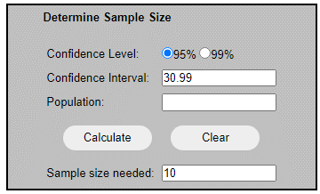
The power calculation online tool was found at <https://www.surveysystem.com/sscalc.htm>

Appendix 5.3: Post-hoc analysis with Bonferroni corrections reporting the pairwise comparisons of four trial frequencies and five follow-up visits for horizontal SP parameters.
(I)  Frequency (Hz) | (J)  Frequency (Hz) | Mean Difference (I-J) | p-value
Horizontal SP gain
0.25 | 0.5 | 0.097 | 0.022*
0.25 | 0.75 | 0.273 | 0.003*
0.25 | 1.0 | 0.421 | 0.002*
0.5 | 0.75 | 0.176 | 0.005*
0.5 | 1.0 | 0.324 | 0.004*
0.75 | 1.0 | 0.148 | 0.036*
Horizontal SP RMSE
0.25 | 0.5 | -0.313 | 0.038*
0.25 | 0.75 | -0.981 | 0.004*
0.25 | 1.0 | -1.876 | 0.005*
0.5 | 0.75 | -0.668 | 0.007*
0.5 | 1.0 | -1.563 | 0.020*
0.75 | 1.0 | -0.895 | 0.133
(I)  Follow-up visit (weeks) | (J)  Follow-up visit (weeks) | Mean Difference (I-J) | p-value
Horizontal SP RMSE
2 | 4 | 0.023 | 1.000
2 | 8 | -0.046 | 1.000
2 | 12 | -0.064 | 0.366
2 | 16 | -0.065 | 0.064
4 | 8 | -0.069 | 0.366
4 | 12 | -0.087 | 0.905
4 | 16 | -0.088 | 1.000
8 | 12 | -0.018 | 1.000
8 | 16 | -0.020 | 1.000
12 | 16 | -0.002 | 1.000
* Data are significant at p<0.05

Appendix 5.4: Post hoc analysis with Bonferroni corrections reporting the pairwise comparisons of four trial frequencies for vertical SP gain and RMSE.
(I)  Frequency (Hz) | (J)  Frequency (Hz) | Mean Difference (I-J) | p-value
Vertical SP gain
0.25 | 0.5 | 0.195 | 0.003*
 | 0.75 | 0.358 | <0.001*
 | 1.0 | 0.481 | <0.001*
0.5 | 0.75 | 0.162 | 0.006*
 | 1.0 | 0.286 | 0.004*
0.75 | 1.0 | 0.124 | 0.012*
Vertical SP RMSE
0.25 | 0.5 | -0.424 | 0.004*
 | 0.75 | -1.247 | 0.018*
 | 1.0 | -1.780 | 0.004*
0.5 | 0.75 | -0.822 | 0.102
 | 1.0 | -1.355 | 0.014*
0.75 | 1.0 | -0.533 | 0.002*
* Data are significant at p<0.05

Appendix 6.1: Patient ID: 1
Birth month/year: 04/1963
Age: 55 at onset

Clinical visit 1: 17/08/2018 (3 days from onset) - Orthoptic assessment

History: Patient c/o vertical diplopia 3/7 ago and no change since onset. He had headache for past 2-3/52 and recent ultrasound test for investigation of kidney failure.

General health: HPT – Aspirin
Heart attack – 2 ½ years ago
No DM and no known allergy

Previous treatment: Nil orthoptic. Had refractive laser surgery for myopia correction 6 years ago.

Visual acuity: unaided RE 0.0 LE 0.18 ETDRS logMAR
6/6 6/9 Snellen equivalent

Cover test: with readers 1/3 m small LET with small LHoT with diplopia
unaided 6 m small AET with small LHoT with diplopia.

PCT/OMT (unaided):
9^{Δ} RET 10^{Δ} RHT
18^{Δ} RET 12^{Δ}RHT

-3
4^{Δ} E 3^{Δ} RHT

2^{Δ} E
8^{Δ} RET 6^{Δ} RHT
+2

+1

-2 ½

-½

-2

-1

+2 ½

+½

-½

PCT: with readers 1/3 m 9^{Δ} BO 12^{Δ} BD RE

Worth lights: 1/3 m & 6 m diplopia

Lids: Right Palpebral Function (RPF) 10 mm
Left Palpebral Function (LPF) 8 mm

Ocular Torsion: 1° incyclotorsion

Assessment & Plan: Diplopia joins with 10∆ BD RE for near Fresnel prism fitted to readers.
RIR weakness. Rule out other signs of third nerve involvement. Has had MRI with no abnormalities detected. ? test for MG.
Review in 2/52.

Clinical visit 2: 31/08/2018 (2 weeks from onset) - Orthoptic assessment

History: Patient feels his problem of vertical diplopia back to normal.

Visual acuity: unaided RE 0.0 LE 0.08 ETDRS logMAR
6/6 6/7.5⁺¹ Snellen equivalent

Cover test: with readers 1/3 m NAD
unaided 6 m NAD

PCT / OMT (unaided):
1^{Δ} E
9^{Δ} RET 2^{Δ} RHT

-3
6^{Δ} RET
1^{Δ} E 1^{Δ} RHT
½

-½

Worth lights: 1/3 m & 6 m BSV

PFR: with readers 1/3 m 45^{Δ} BO - 8^{Δ} BI
unaided 6 m 45^{Δ} BO - 8^{Δ} BI

Frisby: with readers 20”

Assessment & Plan: Recovered RIR weakness.
Still shows minimal underaction RE on R gaze with ET.
Waiting for ophthalmology appointment for result of MG testing.

Clinical visit 3: 10/10/2018 (8 weeks from onset) - Orthoptic assessment

Visual acuity: unaided RE 0.16 LE 0.12 ETDRS logMAR
6/9.5⁺² 6/7.5⁻¹ Snellen equivalent

Cover test: with readers 1/3 m very small E+X with good recovery
unaided 6 m very small E with good recovery

Convergence: with readers binoculars to 6-7 cm and maintained

PFR: with readers 1/3 m 12^{Δ} BI - 45^{Δ} BO
Unaided 6 m 4-6^{Δ} BI - 25^{Δ} BO

Frisby: with readers stereopsis +ve to 20 secs

OMT/PCT: with readers 1/3 m 1-2^{Δ} E
unaided
4^{Δ} E
5-6^{Δ} E
-3
6-7^{Δ} E
4^{Δ} E
-½

1^{Δ} E

° diplopia
° ptosis
° Cogan’s lid twitch
° fatigue

Assessment & Plan: Recovered RIR palsy.
Very good demonstrable BSV asymptomatic
Discharge.

Appendix 6.2: Patient ID: 2
Birth month/year: 10/1941
Age: 77 at onset

Clinical visit 1: 30/10/2018 (1 week from onset) - Orthoptic assessment

History: c/o constant horizontal and vertical diplopia for the past week

Previous treatment: No previous treatment

General health: Taking medication for HPT and high cholesterol

Visual acuity: unaided RE 0.30 LE 0.80 ETDRS logMAR
6/12-1 6/36 Snellen

with pinhole (PH) RE 0.20 LE 0.48 ETDRS logMAR
6/9⁻¹ 6/18 Snellen

Cover test: without glasses 1/3 m & 6 m slight/moderate left exotropia (LXT) with small left hypotropia (LoHT) with diplopia

OMT:
-3
-3
-3
-4
-3½

PCT: with glasses 1/3 m 20^{Δ} XT 10^{Δ} LHT
with glasses 6 m 18^{Δ} XT 2^{Δ} LHT
Lids - slight L Ptosis
11 mm
8 mm

- palpebral apertures:

Pupils: No pupil dilation – both pupils small and react to light

Diagnosis & Plan: Partial L third nerve palsy
Given L occlusive patch to wear over LE as required.

Clinical visit 2: 27/11/2018 (5 weeks from onset) - Orthoptic assessment

Aware of daily improvement in diplopia, much less frequent today.
Using patch at home only when necessary.

Visual acuity: with glasses RE 0.32 LE 0.74 ETDRS logMAR
6/12-1 6/30-2 Snellen equivalent

Cover test: with glasses 1/3 m slight exophoria (X) with good recovery
without glasses 6 m slight L exotropia (XT) with diplopia

OMT:

- ½
- ½
-1½
-1½
-1
-2
-2
- 1
- ½

Convergence: with glasses binocular to 8 cm then LE diverges
Frisby: with glasses +ve
PCT: with glasses 1/3 m 16^{Δ} X 3^{Δ} LH
without glasses 6 m

5^{Δ} XT
0^{Δ}
10^{Δ} XT

Comment & Plan: He is recovering from a left microvascular partial third nerve palsy. He had normal CT scan result, which has ruled out any compressive lesion. He does not have any double vision at PP. He was discharged from the clinic and had been advised to get a proper refraction and updated glasses.

Appendix 6.3:Patient ID: 3
Birth month/year: 05/1946
Age: 72 at onset

Clinical visit 1: 29/10/2018 (1 day from onset) - Orthoptic assessment

History: c/o aware of horizontal and vertical diplopia and droopy RE lid for last day. Associated with headaches and gradually getting worse since onset. Three weeks prior to onset had swelling around RE which spontaneously resolved.

Previous treatment: Recent diabetic eye screening
‘Growth’ removed from RE when in early 20’s

General health: Type II diabetes = insulin controlled, taking aspirin.
Knee replacement 2017, shoulder problems. Always feels tired.

Visual acuity: unaided RE 0.06 LE 0.10 ETDRS logMAR
6/7.5⁺² 6/7.5 Snellen equivalent
with R lid raised

Cover test: with glasses 1/3 m & 6 m moderate right exotropia (LXT) with slight right hypertropia (RHT) with diplopia.
Right partial ptosis – bisects R pupil

OMT:
Diplopia in all positions of gaze
-3 to 3.5
-3 to -3.5
-3
+
+
+
-2

PCT: with glasses 1/3 m 40^{Δ} XT 14-16^{Δ} RHT
with glasses 6 m:
Right gaze PP Left gaze
9^{Δ} XT 2^{Δ} LHT 20Δ XT 10^{Δ} LHT 30^{Δ} XT 10-12^{Δ} LHT
Lids - slight R Ptosis
- palpebral apertures:
4 mm
11mm mm

No Cogan’s lid twitch, slight fatigue on sustained up-gaze

Pupils: No pupil dilation – both pupils small and react to light and accommodation – no RAPD

Assessment & plan: Partial R third nerve palsy with pupil sparing, some functioning, potentially related to diabetes /small vessel disease.
Unable to join diplopia as too incomitant at the moment, given L occlusive blender to R lens of glasses.

Clinical visit 2: 16/11/18 (2 weeks from onset)

Presumed microvascular (Type I diabetic) recent onset R third nerve palsy with pupil sparing. Has blender on R lens of bifocals – feels some improvement over last 2 weeks.

Visual acuity: with glasses RE 0.14 LE 0.04 ETDRS logMAR
6/7.5⁻² 6/7.5 Snellen equivalent

with PH No Improvements on RE and LE

Cover test: with glasses 1/3 m & 6m small right exotropia (LXT) with diplopia.
Right slight partial ptosis

OMT:
-1.5
-3
+
+
+
-1.5

-2

PCT: with glasses 1/3 m 20^{Δ} XT 5^{Δ} RHT
with glasses 6 m (at 5 gazes)

9^{Δ} XT 4^{Δ} RoHT
right gaze: Left gaze:
5^{Δ} XT 1^{Δ} RHT 10^{Δ} XT 1^{Δ} RHT 14-16^{Δ} XT 1^{Δ} RHT

not able to measure

Pupils equal and react to light R&L

Lids - slight R Ptosis
- palpebral apertures:
6 mm
8mm mm

Assessment & Plan: Resolving R 3rd nerve palsy with pupil sparing.
Presumed microvascular – diabetic.
Still incomitant, happy to continue with blender on R lens of bifocal – See Ophthalmologist next week, orthoptics 4 weeks.

Clinical visit 3: 27/11/18 (4 weeks from onset) - Ophthalmologist only appointment

- Starting to improve
- Presumed transient attack
- V Nerve R & L in tact
- Orthoptic review 4/52

Clinical visit 4: 20/12/18 (7 weeks from onset) – Orthoptic assessment

Visual acuity: with glasses RE 0.04 LE 0.00 ETDRS (logMAR)
6/6-2 6/6 Snellen equivalent

Cover test: with glasses 1/3m moderate R XT with slight/mod R HT
6 m slight/moderate alt XT slight R HT with diplopia

OMT:
- ½
+1
+½
-1
+1
- 1
- 1
-1

Convergence: with glasses – nil – diplopia

PCT: with glasses 1/3 m 16^{Δ} XT 6/7 ^{Δ} RHT
with glasses 6 m
4^{Δ} XT 3^{Δ} RHT

12^{Δ} XT
7^{Δ} RHT

Pupils: No pupil dilation – both pupils react to light and accommodation – no RAPD
5 mm
10mmmm mm

Assessment & Plan: Resolving R IIIrd with pupil sparing. Some slight improvement in PCT today but still needs blender on R lens. Review 4 weeks.

Clinical visit 5: 6th February 2019 (13 weeks from onset)
Recovering R 3rd nerve palsy – blenderm on R lens of bifocals.
Residual diplopia with blenderm removed for testing.
Visual acuity: with glasses RE 0.1 LE 0.1 ETDRS (logMAR)
6/7.5 6/7.5 Snellen equivalent

Cover test: with glasses 1/3 m slight exophoria (X) with good recovery
6 m no deviation seen

OMT:
- ½
- 1
-1
- ½
+½
+1
+ ½

PCT: with glasses 1/3 m 10^{Δ} X
with glasses 6 m
0
Right gaze: Left gaze:
1^{Δ} E 2^{Δ} X 3^{Δ} X(T) 1^{Δ} RHo(T)

3^{Δ} X

Bagolini glasses: 1/3 m and 6 m BSV response
Frisby: 340” of arc
Pupils: No RAPD, no anisocoria
Assessment & Plan: No deviation seen, monocular R ghosting
Try without blender
Review 4 weeks

Clinical visit 6: 6th March 2019 (4 months from onset)
Recovering R 3rd nerve palsy with pupil sparing.
Residual diplopia with blenderm removed for testing.
Visual acuity: with glasses RE 0.200 LE 0.140 ETDRS (logMAR)
6/9.5 6/7.5⁻² Snellen equivalent
No improvement with PH R or L

Near VA with bifocals 6/12 6/12 reduced Snellen

Cover test: with glasses 1/3 m slight exophoria (X) with good recovery
6 m very slight X with good recovery

OMT:
- 1
- ½
+ ½
-0.5
- 1
+½
+1
- ½

- ½

- ½

PCT: with glasses 1/3 m 10^{Δ} X
with glasses 6 m 2^{Δ} X
Bagolini glasses: 1/3 m and 6 m BSV response
Pupils: No RAPD
Assessment & Plan: Fully recovered.
C/o continued difficulty reading and knitting.
Low bifocal fitting, difficult to use with arthritis in neck – to get new glasses to improve this reading position.
Review 3/12.

Clinical visit 7: 14th June 2019 (7 months from onset)
Previous R 3rd nerve palsy, subjectively much better.
Update bifocals with segment much higher up. Diplopia noticed 2/3 times a week only now.
Visual acuity: with glasses RE 0.1 LE 0.12 ETDRS (logMAR)
6/7.5 6/7.5⁻¹ Snellen equivalent
No improvement with PH RE or LE

Cover test: with glasses 1/3 m moderate exophoria (X) with good recovery in down
gaze through bifocal
6 m slight X with good recovery

OMT:
- ½
- ½

- ½
+ ½
- ½
- ½

- ½
+½
+1
- ½

PCT: with glasses 1/3 m 12^{Δ} X (down gaze 18-20^{Δ} X)
6 m 1^{Δ} X (no change on R or L gaze)
Assessment & plan: Fully recovered 3rd nerve palsy.
Discussed diabetic/ BP control.
Discharged.

19/11/19 – returned for further assessment due to occasional diplopia for near tasks and struggling with near small print – e.g. knitting patterns
Visual acuity: with glasses RE 0.12 LE 0.12 ETDRS (logMAR)
6/7.5⁻¹ 6/7.5⁻¹ (Snellen equivalent)

BE – v mild non-proliferative diabetic retinopathy
BE – cataract
BE – early AMD

Cover test: with glasses 1/3m slight + LXT with intermittent diplopia - tends to close LE
6 m slight X with good recovery

OMT:
-½
- 1
+1
+½
-½
+1
-½

+½

PCT: with glasses 1/3 m reading position 18-20^{Δ} X
6 m 1^{Δ} X (0^{Δ} R gaze or 2^{Δ} X L gaze)
Lids: mild bilateral R Ptosis
palpebral apertures:
6 mm
6mm mm

Assessment & Plan:
- Previous R 3rd nerve palsy with pupil sparing – largely resolved.
- Now decompensating near exophoria and manifest through bifocal on down gaze – possibly bilateral ptosis contributing to decompensation, also reading add very low set.
- Fitted with blender on reading add – to see consultant re: reducing vision and dissociating factors.
- Returned 23/12/19 – no change, same symptoms: issues with single vision reading glasses, where controlled/ not decompensating with diplopia when avoids down gaze and looking through low bifocal segment.
Appendix 6.4: Patient ID: 4
Birth month/year: 08/1931
Age: 87 at onset

Clinical visit 1: 2/11/2018 (5 days from onset) - Orthoptic assessment

History: Complaint of seeing horizontal diplopia when look at distance. He reported that he never had this problem. No diplopia at near fixation (while reading).

General health: Diabetes Type II – insulin dependant

Visual acuity: unaided RE 0.10 LE 0.10 ETDRS logMAR
6/7.5 6/7.5 Snellen equivalent

Cover test: with readers 1/3 m small E with good recovery
Unaided 6 m small RET with diplopia

PCT: with readers 1/3 m 2^{Δ} BO
unaided 6 m 10^{Δ} BO
OMT:
-0.5
10^{Δ} ET
4^{Δ} E(T)

Assessment & plan: Microvascular R sixth nerve palsy.
Given right occlusive patch to wear over RE as required.
Review in 3-52.

**His medical reports of the following visit were not available at times when the researcher requested. His diplopia problem was resolving and gets better. He was not wearing the eye patch at 5 weeks post-onset.

Appendix 6.5: Patient ID: 5
Birth month/year: 10/1946
Age: 72 at onset

Clinical visit 1: 14/01/2019 (7 days from onset) - Orthoptic assessment

History: Patient reports diplopia at distance for 7 days which is side by side. He using a patch currently to overcome his problem.

General health: Diabetes, heart failure, awaiting new pacemaker, under urology review bladder cancer, had chemotherapy, kidney failure, low BP, no head trauma and no known thyroid problems.
Medication: Taking candesartan, bumetanide, apixaban, gabapentin, bisoprol, nicorandil, omeprazole, atorvastatin, aspirin, amoxicillin
Family history: NIL

Visual acuity: with glasses RE 0.60 LE 0.20 ETDRS logMAR
6/24 6/9⁻¹ Snellen equivalent
with PH No Improvements in RE and LE

Cover test: with glasses 1/3 m moderate L alt. ET with diplopia
6 m moderate RET with diplopia

OMT:

-½
35^{Δ} ET -2
20^{Δ} ET
2^{Δ} RHoT
-½ 6^{Δ} E
20^{Δ} ET
25^{Δ} ET
2^{Δ} RHoT
-½

PCT: with glasses 1/3 m 16^{Δ} ET with 2^{Δ} RHoT
6 m 20^{Δ} ET with 2^{Δ} RHoT
Assessment & plan:
- Sudden onset R sixth nerve palsy with minimal vertical deviation.
- ? diabetic cause
- Patient also under urology for bladder cancer.
- Although R sixth nerve palsy, patient tends to fixate with RE causing large LET noticed at home.
- Gave patch – advised to wear over RE.
- Too incomitant for prism prescription – patient happy with patch.

Clinical visit 2: 30/1/2019 (Ophthalmology visit only)

Assessment and Plan:
- Isolated right sixth nerve palsy. No signs of other cranial nerves involved. It is likely to be microvascular origin.
- He is insulin-requiring diabetic.
- He has currently been managing with a patch.

Clinical visit 3: 27/02/2019 (5 weeks from onset) - Orthoptic assessment

History: No diplopia shortly after the last appointment.

Visual acuity: with glasses RE 0.40 LE 0.18 ETDRS logMAR
6/15 6/9 Snellen equivalent

with PH RE 0.30 LE No Improvement
6/12

Cover test: with glasses 1/3 m very minimal X with good recovery
6 m very minimal E with good recovery

PCT: with glasses 1/3 m 3^{Δ} X
6 m 4^{Δ} 2^{Δ} E 5^{Δ} E
OMT:
-1
-½
End point -1
nystagmus
-1 (moving head +)
-½
-1

Assessment & plan:
- Recovering sixth nerve palsy
- Review in 3-4/52

Clinical visit 4: 28/03/2019 (11 weeks from onset) - Orthoptic assessment

Visual acuity: with glasses RE 0.30 LE 0.30 ETDRS logMAR
6/12 6/12 Snellen equivalent

Cover test: with glasses 1/3 m very smalll X with good recovery
6 m very small E with good recovery

Convergence with glasses binocular to nose

OMT:
D(>6m) = -1
D = -½

PCT: with glasses 1/3 m 1-2^{Δ} X
6 m 5^{Δ} RET 2^{Δ} E 1^{Δ} E
Frisby: with glasses 340”

Assessment & plan:
- R sixth nerve palsy – resolving
- No need for occlusion or ∆
- Discharge
Appendix 6.6: Patient ID: 6
Birth month/year: 08/1950
Age: 68 at onset

Clinical visit 1: 22/11/2018 (3 days post-onset) - Orthoptic assessment
History: c/o constant horizontal diplopia for the past 3/7. Sudden onset, also headache for the same length of time.

Previous treatment: No treatment apart from his distance glasses.

General health: Type II diabetes well- controlled with aspirin.

Visual acuity: with glasses RE -0.10 LE -0.10 ETDRS logMAR
6/5 6/5 Snellen

Cover test: with glasses 1/3 m & 6 m moderate left exotropia (LXT) with small left hypertropia (LHT) with diplopia

OMT:
-2
-2
-2
-3

-2
-1 ½

Prism cover test (PCT): with glasses 1/3 m 30^{Δ} LXT 8^{Δ} LHT
6 m:-
30^{Δ} LXT 6^{Δ} LHT
8^{Δ} LXT12^{Δ} LHT
35^{Δ} LXT
35^{Δ} LXT
25^{Δ} LXT 6^{Δ} LHT

Pupils: Normal reaction to light R&L, no RAPD

Palpebral aperture: No abnormalities detected (NAD)

Assessment & Plan: L partial third nerve palsy (no ptosis or pupil involvement)
Patch LE as necessary
Review in Orthoptics clinic

Clinical visit 2: 07/01/2019 (7 weeks post-onset) - Orthoptic assessment

Visual acuity: with glasses RE 0.06 LE 0.10 ETDRS logMAR
6/6⁻³ LE 6/7.5 Snellen

Cover test: with glasses 1/3 m & 6 m moderate LXT with diplopia

OMT:
-1½
-2
-2
-2

-3

0
0

PCT: with glasses 1/3 m 55^{Δ} LXT 6^{Δ} LHT
6 m 35-40^{Δ} LXT

Assessment and Plan: Continue occlusion on L lens
Review in 1/12

Clinical visit 3: 9/04/2019 (19 weeks from onset) - Orthoptic assessment

Visual acuity:
with glasses RE -0.08 LE -0.08 ETDRS logMAR
6/5 6/5 Snellen equivalent
Cover test:
with glasses 1/3 m small exophoria (X) with good recovery
6 m moderate X with fast recovery

OMT: with glasses

9^{Δ} X
14^{Δ} XT
-½

3^{Δ} X

-½

-½

-½

-½
8^{Δ} X

-½
ortho

PCT: with glasses 1/3 m 14^{Δ} X with good recovery
6 m 9^{Δ} X with good recovery

Convergence: with glasses binocular to 7 cm

Frisby: with glasses 340" arc

Assessment & Plan:
Residual motility restrictions in LE.
No change – asymptomatic
No intervention required

Appendix 6.7: Patient ID: 7
Birth month/year: 01/1932
Age: 86 at onset

Clinical visit 1: 19/12/2018 (4 day from onset) - Orthoptic assessment

History: c/o aware of horizontal diplopia worsened on right gaze and over time. No headache, jaw claudication, scalp tenderness, weight loss or change in appetite. Her BP measured on that day was 194/79. She also diagnosed with RE mild non-proliferative diabetic retinopathy, while LE no sign of diabetic retinopathy. She also had dry eyes.

Previous treatment: LE phaco + IOL (May 2014)

General health: Type II diabetes = insulin controlled, taking asprin.
Poor control HPT, taking candersatan, amiloride, clopidogrel, bisoprolol, amias
High cholesterol, taking azetimibe

Visual acuity: with glasses RE 0.22 LE 0.22 ETDRS logMAR
6/9⁻² 6/9⁻² Snellen equivalent

Cover test: with glasses 1/3 m small right esotropia (RET) with diplopia
6 m moderate RET with diplopia

OMT:
-2 ½

(35-40Δ ET)

20-25^{Δ} ET

12^{Δ} ET

PCT: with glasses 1/3 m 3^{Δ} RE(T)
6 m 20-25^{Δ} RET
Diplopia joined with 25^{Δ} over the RE.
Assessment & Plan:
R sixth nerve palsy presumed microvascular.
Prescribed 25^{Δ}BO over the RE of distance glasses.
To monitor in 2-3/52.

Clinical visit 2: 10/01/19 (4 weeks from onset)

Happy with prism (25^{Δ}BO R lens of distance glasses)

Visual acuity: with glasses+^{Δ} RE 0.36 LE 0.1 ETDRS logMAR
6/15⁺² 6/7.5 Snellen equivalent

Cover test: with readers 1/3 m small esophoria (E) with good recovery
with glasses+^{Δ} 6 m small exophoria (X) with good recovery

OMT/PCT:
20^{Δ}ET -1 ½

-1
16^{Δ} ET

- ½ 8^{Δ}E

Δ ET

-1

with readers 1/3 m 8^{Δ} BO

Worth Lights: BSV at N (with readers) and D (with glasses+^{Δ})
PFR: with readers 1/3m 40^{Δ} BO – 6^{Δ} BI
with glasses+^{Δ} 6 m 12^{Δ} BO – 6^{Δ} BI
Frisby: negative

Assessment & Plan:
Recovering R sixth nerve palsy.
Prism reduced to 12^{Δ} BO over R lens of distance glasses.
Review 3-4/52.

Clinical visit 3: 27/02/19 (8 weeks from onset) – Orthoptic assessment

Only a few BSV tests performed on this follow-up visit
PFR: with readers 1/3m 40^{Δ} BO – 18^{Δ} BI } no appreciation of diplopia
with glasses 6 m 20^{Δ} BI – 20^{Δ} BO } no appreciation of diplopia
Convergence: binocular to 8 cm then each eye diverge without diplopia
Frisby: 340”
Assessment & Plan:
Recovered R sixth nerve palsy.
Appears to be eye-related OM defects.
Patient is asymptomatic. No Δ given this time.
Review once more 4/12 then discharge.
Clinical visit 4: 27/06/19 (27 weeks from onset) – Orthoptic assessment

No diplopia since the last visit (recovered R sixth nerve palsy).

Visual acuity: with glasses RE 0.36 LE 0.18 ETDRS (logMAR)
6/12⁻³ 6/9 Snellen equivalent

Cover test: with glasses 1/3 m no deviation
6 m no deviation

OMT:
-1
- ½ 2Δ E
- 1
2Δ E - ½
-½ -½

PCT: with glasses 1/3 m and 6 m orthophoria

Convergence: binocular to 9 cm
Frisby: 340” of arc
Assessment & Plan:
Recovered R sixth nerve palsy
Discharge

Appendix 6.8: Patient ID: 8
Birth month/year: 04/1957
Age: 61 at onset

Clinical visit 1: 11/01/2019 (2 days from onset) - Orthoptic assessment

History: c/o sudden onset horizontal and vertical diplopia. Associated with headaches and tingling on the L side of the face. He never smoke.

Previous treatment: NIL

General health: Good. No medication and no known allergies.

Visual acuity: unaided RE -0.08 LE 0.0 ETDRS logMAR
(6/5) (6/6) Snellen equivalent

Cover test: without glasses 1/3 m & 6 m small right hypertopia (RHT) with diplopia.

OMT:
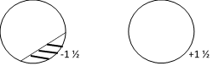

PCT: without glasses at 1/3m 2^{Δ} BO 5^{Δ} RHT
at 6 m,

 | 2^{Δ} RHT
4^{Δ} RHT | 6^{Δ} RHT | 4^{Δ} RHT
 | 6^{Δ} RHT
Diplopia joins with 4^{Δ} BD over the RE.

Bagolini glasses: at 1/3 m and 6 m diplopia

Hess:
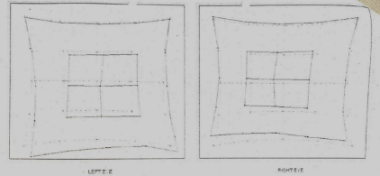
RE
LE

Assessment & Plan: R fourth nerve palsy (unknown cause)
4^{Δ} BD fitted over R lens of plano glasses to help with diplopia.
Review 2-3/52.
Clinical visit 2: 30/01/19 (3 weeks from onset)

Patient happy with distance glasses prism (4^{Δ} BD RE). To review for near prism prescription.

Visual acuity: with glasses+^{Δ} RE 0.24 LE -0.06 ETDRS logMAR
6/9 6/5⁻¹ Snellen equivalent

Cover test: with readers at 1/3 slight + RHT with diplopia

PCT: with readers 4^{Δ} XT with 6^{Δ} RHT

Join diplopia: With readers 1/3 m 4^{Δ} BD RE single and clear – therefore fitted Fresnel to R lens of readers 4^{Δ} BD RE (same as for distance)

Plan: MRI booked 19/02/2019
Review after MRI.

Clinical visit 3: 27/02/19 (7 weeks from onset)

No abnormalities detected from MRI scan.

Visual acuity: with glasses RE -0.02 LE -0.04 ETDRS (logMAR)
6/5⁻³ 6/5⁻² Snellen equivalent

Cover test: with glasses 1/3m small RH
6 m moderate RH

OMT:


PCT: with glasses 1/3 m and 6 m 2^{Δ} RH

2^{Δ} RH(T)
2^{Δ} RH(T)
3-4^{Δ} RH(T)

Assessment & Plan: Small vertical angle is recovering.
Reduced Fresnel to 2^{Δ} BD over R lens.
Review in 2 months.

Appendix 6.9: Patient ID: 9
Birth month/year: 02/1937
Age: 81 at onset

Clinical visit 1: 15/01/2019 (3 days from onset) - Orthoptic assessment

History: Patient reports sudden diplopia 3/7 ago – no change since.

General health: Asthma – inhaler
Not diabetic

Previous treatment: NIL

Visual acuity: unaided RE 0.20 LE 0.34 ETDRS logMAR
6/9⁻¹ 6/12⁻² Snellen equivalent
with PH 0.18 (6/9)

Cover test: with glasses 1/3 m NAD
unaided 6 m small LET with diplopia

OMT/PCT:

10∆ ET
-3 20∆ ET

with glasses 1/3 m

Diplopia joins with 10∆ BO.

Assessment & plan:
- L sixth nerve palsy. ? cause
- 10∆ BO fresnel fitted to L plano lens
- Review 2-3/52

Clinical visit 2: 14/03/2019 (3 days from onset) - Orthoptic assessment

History: L sixth nerve palsy (15/1/2019). Fitted with 10∆ BO LE on plano lens. Very happy now, no diplopia for past 2-3/52. Not wearing glasses with prism as recovered quick. Has old glasses from 10 year ago.

Current medications: Candesartan, Felodipine, Sirdupla + Ventolin

Visual acuity: unaided RE 0.40 LE 0.50 ETDRS logMAR
6/15 6/19 Snellen equivalent
with glasses RE 0.20 LE 0.10 ETDRS logMAR
6/9.5 6/7.5 Snellen equivalent
Cover test: with glasses 1/3 m very small X with good recovery
6 m NAD

PCT: with glasses 1/3 m 2∆ X
6 m

OMT:

-¼
-½

Patient very talkative + laughing throughout OMT measuremets

Assessment & plan:
- L sixth nerve palsy. ? cause
- 10∆ BO fresnel fitted to L plano lens
- Review 2-3/52

Appendix 6.10: Patient ID: 10
Birth month/year: 01/1954
Age: 65 at onset

Clinical visit 1: 14/06/2019 (3 days from onset) - Orthoptic assessment

History: c/o constant horizontal diplopia, worse at distance fixation.

Previous treatment: NIL

General health: Diabetes mellitus and paroxysmal strial fibrillation.

Visual acuity: unaided RE 0.18 LE 0.10 ETDRS logMAR
6/9.5⁻¹ 6/7.5 Snellen equivalent

with PH RE 0.12
6/7.5-1

Cover test: with readers 1/3 m small LET with diplopia
unaided 6 m small to moderate L/A ET with diplopia.

PCT/OMT:
with readers 1/3 m 5-6^{Δ} LET
unaided 6 m 30-35^{Δ} LET

35-40^{Δ} LET
3-4^{Δ} E

-3
(45-50^{Δ} LET)

Bagolini glasses: with readers 1/3 m diplopia
Unaided 6 m diplopia/suppression

Hess:
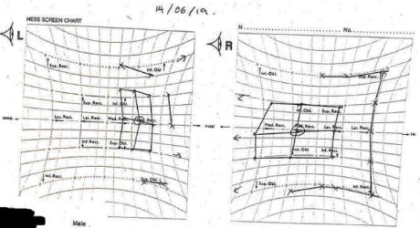
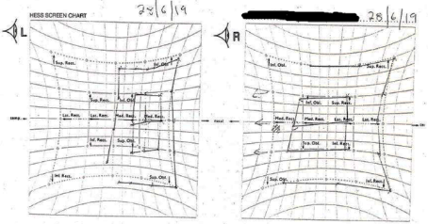
1st attempt: 14/06/2019
2nd attempt: 28/06/2019

Assessment & Plan:
Recent onset L sixth nerve palsy (likely microvascular aetiology)
Huge LLR restriction.
Unable to join diplopia with Δ due to large deviation angle.
Given eye patch to relieve diplopia.
Review 2-4/52 to monitor recovery.

Clinical visit 2: 28/06/19 (2 weeks from onset)

He said that eye patch not helping the double vision, instead giving him headaches.

Visual acuity: unaided RE 0.32 LE 0.22 ETDRS logMAR
6/12⁻¹ 6/9.5⁻¹ Snellen equivalent

with PH RE 0.12 LE 0.1 ETDRS logMAR
6/9⁺³ 6/7.5 Snellen equivalent

Cover test: with readers 1/3 m Mod. L Alt ET
unaided 6 m Mod. L Alt ET

PCT: 6 m very variable angle (20^{Δ} BO >50^{Δ} BO)

Hess:
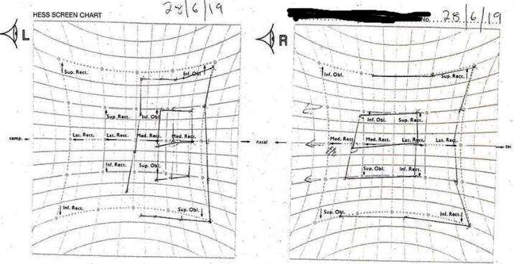

Assessment & Plan:
Left sixth nerve palsy, aetiology is under investigation.
Given fabric patch for glasses to occlude LE and review in Orthoptic clinic 1/12.

Clinical visit 3: 02/07/19 (3 weeks from onset) for Neuro-Ophtahlmology review

He was seen on this day only at Neuro-ophthalmology clinic.

Assessment & Plan:
No abnormalities detected from the MRI with contrast and lumbar puncture.
It is very likely the condition has been a microvascular sixth nerve palsy related to his seniority, diabetes mellitus and paroxysmal atrial fibrillation.
Therefore, continue with patching of his LE.

Clinical visit 4: 05/09/19 (12 weeks from onset)

Pt still using the patch over the L plano lens. Feels there has been a big improvement since last visit.

Visual acuity: unaided RE 0.24 LE 0.22 ETDRS logMAR
6/9.5⁻² 6/9.5 Snellen equivalent

with PH RE 0.12 LE 0.10 ETDRS logMAR
6/7.5⁻¹ 6/7.5 Snellen equivalent

Cover test: with readers 1/3 m Small LET with diplopia
6 m Small LET with diplopia

PCT: with readers 1/3 m 8^{Δ} ET
6 m 14-16^{Δ} ET

OMT:

14-16^{Δ} LET

5Δ LET
-1 (20∆ LET)

Prism measurement:
Seen single at distance with 15^{Δ} BO over the RE. Patient prefers prism over the R lens.

Assessment & Plan: Improving L sixth nerve palsy presumed microvascular.
Good further improvement to smaller deviation angle.
Fitted 15^{Δ} BO Fresnel to R plano lens.
No prism for readers.
Patient also has a patch at home.
Review 4-5/52 to check for further recovery.

Clinical visit 5: 07/10/19 (17 weeks from onset)

Pt broke his plano glasses. Seen slight diplopia at 6 m without prism. Patient feels improvement.

Visual acuity: unaided RE 0.24 LE 0.24 ETDRS logMAR
6/9.5⁻² 6/9.5⁻² Snellen equivalent

with PH RE 0.10 LE 0.12 ETDRS logMAR
6/7.5 6/7.5⁻¹ Snellen equivalent

Cover test: with readers 1/3 m Small E with good recovery
6 m Small LET with diplopia

PCT: with readers 1/3 m 3^{Δ} E
6 m 12^{Δ} LET
Frisby: with readers 110”

Convergence: with readers binocular to 6 cm

OMT:
12^{Δ} ET

0
-1 (14^{Δ} LET)

3^{Δ} ET

10^{Δ} ET

Assessment & Plan:
Diplopia joined with 12^{Δ} BO prism.
Recovering L sixth nerve palsy 2° microvascular cause.
Good further improvement to smaller deviation angle.
Fitted 12^{Δ} BO Fresnel to R plano lens.
Review 4-5/52 to check for further recovery.

* Note: the next follow-up was not included in this study since it was beyond the period of eye movement tracking study. He completed his fifth visit for EMR before the next follow-up at the Orthoptics clinics.

Abbreviations
∆D | prism dioptres
2D-VOG | two-dimensional video-oculography
ANOVA | analysis of variance
AOI | area of interest
BCEA | bivariate contour ellipse area
BSV | binocular single vision
CUS | catch-up saccades
CBGD | cortico-basal ganglionic degeneration
CN III | third cranial nerve
CN IV | fourth cranial nerve
CN VI | sixth cranial nerve
CR | corneal reflection
CT | computerized tomography
DM | diabetes mellitus
DT | dwell time
DW | Durbin-Watson
DV | Data Viewer
E | esophoria
EEC | Eye Emergency Clinic
EMR | eye movement recording
EOG | electrooculography
EOM | extraocular muscles
ERT | enzyme replacement therapy
ETDRS | Early Treatment Diabetic Retinopathy Study
GD | Gaucher disease
HPT | hypertension
HT | hypertropia
Hz | hertz
INS | infantile nystagmus syndrome
IR | infrared
LE | left eye
LED | light-emitting diodes
LMM | linear mixed model
LSD | least significant difference
MF | multifocal
MLF | medial longitudinal fasciculus
MRA | magnetic resonance angiography
MRI | magnetic resonance imaging
ms | milliseconds
MSA | multiple system atrophy
OKN | optokinetic nystagmus
ONP | Ocular nerve palsy
OMT | ocular motility test
PALs | progressive added lenses
PC | personal computer
PCT | prism cover test
PD | Parkinson's disease
POG | Position of gaze
PP | primary position
PPD | pixels per degree
PSP | progressive supranuclear palsy
RE | right eye
RMS | root mean square
RMSE | root mean square error
SD | standard deviation
SE | standard error
SP | smooth pursuits
SWJ | square wave jerk
VA | visual acuity
VIF | variance inflation factor
X | exophoria
XT | exotropia

References
Abel, L. A., Friedman, L., Jesberger, J., Malki, A., & Meltzer, H. Y. (1991). Quantitative assessment of smooth pursuit gain and catch- up saccades in schizophrenia and affective disorders. Biological Psychiatry, 29(11), 1063-1072. https://doi.org/10.1016/0006-3223(91)90248-K
Abel, L. A., Troost, B. T., Dell, amp, Amp, Apos, & Osso, L. F. (1983). The effects of age on normal saccadic characteristics and their variability. Vision Research, 23(1), 33-37. https://doi.org/10.1016/0042-6989(83)90038-X
Akagi, T., Miyamoto, K., Kashii, S., & Yoshimura, N. (2008). Cause and prognosis of neurologically isolated third, fourth, or sixth cranial nerve dysfunction in cases of oculomotor palsy [Article]. Japanese Journal of Ophthalmology, 52(1), 32-35. https://doi.org/10.1007/s10384-007-0489-3
Alessandrini, M., Parisi, V., Bruno, E., & Giacomini, P. G. (1999). Impaired saccadic eye movement in diabetic patients: the relationship with visual pathways function. Doc Ophthalmol, 99(1), 11-20. https://doi.org/10.1023/A:1002464316347
Ansons, A. M., & Davis, H. (2014). Clinical assessment of ocular movement range. In: Diagnosis and management of ocular motility disorders (Fourth ed.). John Wiley & Sons, Ltd.
Ayman, K., Emma, D., & John, L. (2012). Clinical Course and Characteristics of Acute Presentation of Fourth Nerve Paresis. J Pediatr Ophthalmol Strabismus, 49(6), 366-369. https://doi.org/10.3928/01913913-20120710-05
Azami, M., Sharifi, H., & Alvandpur, S. (2020). Evaluating the relationship between information literacy and evidence-based nursing and their impact on knowledge and attitude of nurses working in hospitals affiliated to Kerman University of Medical Sciences on medication errors. Journal of family medicine and primary care, 9(8), 4097-4106. https://doi.org/10.4103/jfmpc.jfmpc_5_20
Bahill, A. T., Adler, D., & Stark, L. (1975). Most naturally occurring human saccades have magnitudes of 15 degrees or less. Investigative Ophthalmology & Visual Science, 14(6), 468-469
Bahill, A. T., Clark, M. R., & Stark, L. (1975). The main sequence, a tool for studying human eye movements. Mathematical Biosciences, 24(3-4), 191-204. https://doi.org/10.1016/0025-5564(75)90075-9
Bahill, A. T., & McDonald, J. D. (1983). Smooth pursuit eye movements in response to predictable target motions. Vision Research, 23(12), 1573-1583. https://doi.org/10.1016/0042-6989(83)90171-2
Barabino, S. (2022). Is dry eye disease the same in young and old patients? A narrative review of the literature. BMC Ophthalmol, 22(1), 85-85. https://doi.org/10.1186/s12886-022-02269-2
Barsingerhorn, A., Boonstra, F., & Goossens, J. (2018). Development and validation of a high-speed stereoscopic eyetracker. Behavior Research Methods, 50(6), 2480-2497. https://doi.org/10.3758/s13428-018-1026-7
Bedell, H. E., & Stevenson, S. B. (2013). Eye movement testing in clinical examination [Article]. Vision Research, 90, 32-37. https://doi.org/10.1016/j.visres.2013.02.001
Benson, P. J., Beedie, S. A., Shephard, E., Giegling, I., Rujescu, D., & St. Clair, D. (2012). Simple Viewing Tests Can Detect Eye Movement Abnormalities That Distinguish Schizophrenia Cases from Controls with Exceptional Accuracy. Biological Psychiatry, 72(9), 716-724. https://doi.org/10.1016/j.biopsych.2012.04.019
Berlit, P. (1991). Isolated and combined pareses of cranial nerve-III, nerve-IV and nerve-VI - A retrospective study of 412 patients [Article]. Journal of the Neurological Sciences, 103(1), 10-15. https://doi.org/10.1016/0022-510x(91)90276-d
Bhidayasiri, R., Riley, D. E., Somers, J. T., Lerner, A. J., Büttner-Ennever, J. A., & Leigh, R. J. (2001). Pathophysiology of slow vertical saccades in progressive supranuclear palsy. Neurology: Journal of the American Heart Association, 57(11), 2070-2077. https://doi.org/10.1212/WNL.57.11.2070
Bonnet, C., Hanuska, J., Rusz, J., Rivaud-Pechoux, S., Sieger, T., Majerova, V., . . . Ruzicka, E. (2013). Horizontal and vertical eye movement metrics: What is important? [Article]. Clinical Neurophysiology, 124(11), 2216-2229. https://doi.org/10.1016/j.clinph.2013.05.002
Bono, F., Oliveri, R. L., Zappia, M., Aguglia, U., Puccio, G., & Quattrone, A. (1996). Computerized analysis of eye movements as a function of age. Archives of Gerontology and Geriatrics, 22(3), 261-269. https://doi.org/10.1016/0167-4943(96)00698-X
Bucci MP, Pouvreau N, Yang Q, Kapoula Z.(2005) Influence of gap and overlap paradigms on saccade latencies and vergence eye movements in seven-year-old children. Exp Brain Res,164(1):48-57. doi: 10.1007/s00221-005-2214-0.
Campana, A., Duci, A., Gambini, O., & Scarone, S. (1999). An Artificial Neural Network That Uses Eye-Tracking Performance to Identify Patients With Schizophrenia. Schizophr Bull, 25(4), 789-799. https://doi.org/10.1093/oxfordjournals.schbul.a033419
Chamberlain, W. (1970). Restriction in upward gaze with advancing age. Transactions of the American Ophthalmological Society, 68, 234-244.
Ciuffreda, K. J., & Tannen, B. (1995). Eye movement basics for the clinician. Mosby.
Clark, R., Blundell, J., Dunn, M., Erichsen, J., Giardini, M., Gottlob, I., . . . Williams, C. (2019). The potential and value of objective eye tracking in the ophthalmology clinic. Eye, 33(8), 1200-1202. https://doi.org/10.1038/s41433-019-0417-z
Clark, R. A., & Demer, J. L. (2002). Effect of aging on human rectus extraocular muscle paths demonstrated by magnetic resonance imaging. Am J Ophthalmol, 134(6), 872-878. https://doi.org/10.1016/S0002-9394(02)01695-1
Clementz, B. A., Iacono, W. G., & Grove, W. M. (1996). The construct validity of root-mean-square error for quantifying smooth-pursuit eye tracking abnormalities in schizophrenia. Biological Psychiatry, 39(6), 448-450. https://doi.org/10.1016/0006-3223(95)00549-8
Cohen, J. (1988). Statistical power analysis for the behavioral sciences. New York: NY: Psychology Press.
Collewijn, H., Erkelens, C. J., & Steinman, R. M. (1988). Binocular co-ordination of human vertical saccadic eye movements. The Journal of physiology., 404(1), 183-197. https://doi.org/10.1113/jphysiol.1988.sp017285
Collewijn, H., & Tamminga, E. P. (1984). Human smooth and saccadic eye movements during voluntary pursuit of different target motions on different backgrounds. J Physiol, 351(1), 217-250. https://doi.org/10.1113/jphysiol.1984.sp015242
Collewijn, H., van Der Mark, F., & Jansen, T. C. (1975). Precise recording of human eye movements. Vision Research, 15(3), 447,IN445-450,IN445. https://doi.org/10.1016/0042-6989(75)90098-X
Connell, C. J. W., Thompson, B., Turuwhenua, J., Hess, R. F., & Gant, N. (2017). Caffeine increases the velocity of rapid eye movements in unfatigued humans. Psychopharmacology (Berl), 234(15), 2311-2323. https://doi.org/10.1007/s00213-017-4638-1
Cornsweet, T. N., Riggs, L. A., & Krauskopf, J. (1960). Analysis of Eye Movements during Monocular and Binocular Fixation*. Journal of the Optical Society of America, 50(6), 572-578. https://doi.org/10.1364/JOSA.50.000572
Crossland, D. M., & Rubin, S. A. G. (2002). The Use of an Infrared Eyetracker to Measure Fixation Stability. Optometry and Vision Science, 79(11), 735-739. https://doi.org/10.1097/00006324-200211000-00011
Crossland, M. D., Culham, L. E., & Rubin, G. S. (2004). Fixation stability and reading speed in patients with newly developed macular disease. Ophthalmic Physiol Opt, 24(4), 327-333. https://doi.org/10.1111/j.1475-1313.2004.00213.x
Damasceno, R., Osaki, M., Dantas, P., & Belfort, R. J. (2011). Involutional entropian and ectropian of the lower eyelid: prevalence and associated risk factors in the elderly population. Ophthalmic Plast Reconstr Surg, 27 (5), 317-320. https://doi.org/https://doi.org/10.1097/IOP.0b013e3182115229
Danchaivijitr, C., & Kennard, C. (2004). Diplopia and eye movement disorders. Neurology in Practice, 75(4), iv24-iv31. https://doi.org/10.1136/jnnp.2004.053413
De Santi, L., Lanzafame, P., Spanò, B., D’Aleo, G., Bramanti, A., Bramanti, P., & Marino, S. (2010). Pursuit ocular movements in multiple sclerosis: a video-based eye-tracking study. Neurol Sci, 32(1), 67-71. https://doi.org/10.1007/s10072-010-0395-1
Di Russo, F., Pitzalis, S., & Spinelli, D. (2003). Fixation stability and saccadic latency in élite shooters. Vision research : an international journal in visual science., 43(17), 1837-1845. https://doi.org/10.1016/s0042-6989(03)00299-2
Dolman, P. J. M. D. F., Cahill, K. M. D., Czyz, C. N. D. O. F., Douglas, R. S. M. D. P., Elner, V. M. M. D. P., Feldon, S. M. D. M. B. A., . . . Uddin, J. M. A. (2012). Reliability of Estimating Ductions in Thyroid Eye Disease. Ophthalmology (Rochester, Minn.), 119(2), 382-389. https://doi.org/10.1016/j.ophtha.2011.07.011
Enderle, J. D. (2010). Models of horizontal eye movements. Part I, Early models of saccades and smooth pursuit [electronic resource]. San Rafael, Calif. 1537 Fourth Street, San Rafael, CA 94901 USA : Morgan & Claypool, c2010.
Erikson, A., Forsberg, H., Nilsson, M., Astrom, M., & Mansson, J.-E. (2006). Ten years' experience of enzyme infusion therapy of Norrbottnian (type 3) Gaucher disease. Acta Paediatr, 95(3), 312-317. https://doi.org/10.1080/08035250500423804
Fang, C., Leavitt, J. A., Hodge, D. O., Holmes, J. M., Mohney, B. G., & Chen, J. J. (2016). Incidence and Etiologies of Acquired Third Nerve Palsy Using a Population-Based Method. JAMA Ophthalmol, 135(1), 23-28. https://doi.org/10.1001/jamaophthalmol.2016.4456
Friedman, L., Jesberger, J. A., & Meltzer, H. Y. (1991). A model of smooth pursuit performance illustrates the relationship between gain catch-up saccade rate and catch-up saccade amplitude in normal controls and patients with schizophrenia. Biological psychiatry., 30, 537-556. https://doi.org/10.1016/0006-3223(91)90024-G
Friedman, L., Jesberger, J. A., Siever, L. J., Thompson, P., Mohs, R., & Meltzer, H. Y. (1995). Smooth pursuit performance in patients with affective disorders or schizophrenia and normal controls: analysis with specific oculomotor measures, RMS error and qualitative ratings. Psychol. Med., 25(2), 387-403. https://doi.org/10.1017/S003329170003628X
Hain, T. C. (1997). Interpretation and usefulness of ocular motility testing. In Handbook of balance function testing (pp. 101-122).
Hakim, F. E., & Farooq, A. V. (2022). Dry Eye Disease: An Update in 2022. JAMA, 327(5), 478-479. https://doi.org/10.1001/jama.2021.19963
Harris, C. M., Taylor, D. S. I., & Vellodi, A. (1999). Ocular Motor Abnormalities in Gaucher Disease. Neuropediatrics, 30(06), 289-293. https://doi.org/10.1055/s-2007-973507
Henderson, J. M., Weeks, P. A., & Hollingworth, A. (1999). The Effects of Semantic Consistency on Eye Movements During Complex Scene Viewing. Journal of experimental psychology. Human perception and performance, 25(1), 210-228. https://doi.org/10.1037/0096-1523.25.1.210
Henriksson, N. G., Pyykko, I., Schalen, L., & Wennmo, C. (1980). Velocity Patterns of Rapid Eye Movements. Acta oto-laryngologica., 89(5-6), 504-512. https://doi.org/10.3109/00016488009127168
Hertle, R. W. (2017). Nystagmus in Infancy and Childhood: Clinical and Eye Movement Characteristics. American Orthoptic Journal, 67(1), 8-21. https://doi.org/10.1080/0065955X.2017.12023626
Hirasawa, K., Okano, K., Koshiji, R., Funaki, W., & Shoji, N. (2016). Smaller fixation target size is associated with more stable fixation and less variance in threshold sensitivity. PLoS One, 11(11), e0165046-e0165046. https://doi.org/10.1371/journal.pone.0165046
Holmqvist, K. (2011). Eye tracking : a comprehensive guide to methods and measures. Oxford : Oxford University Press, 2011.
Hooge, I. T. C., Holleman, G. A., Haukes, N. C., & Hessels, R. S. (2019). Gaze tracking accuracy in humans : One eye is sometimes better than two. Behav Res Methods, 51(6), 2712-2721. https://doi.org/10.3758/s13428-018-1135-3
Hopf, S., Schmidtmann, I., Ashayer, S., & Pitz, S. (2018). Age dependent normative data of vertical and horizontal reflexive saccades. PLoS One, 13(9), e0204008. https://doi.org/10.1371/journal.pone.0204008
Houben, M. M. J., Goumans, J., & van der Steen, J. (2006). Recording three-dimensional eye movements: Scleral search coils versus video oculography [Article]. Investigative Ophthalmology & Visual Science, 47(1), 179-187. https://doi.org/10.1167/iovs.05-0234
Huaman, A. G., & Sharpe, J. A. (1993). Vertical saccades in senescence. Investigative ophthalmology & visual science, 34(8), 2588-2595.
Hussain, N. (2016). Diagnosis, assessment and management of nystagmus in childhood. Paediatrics and Child Health, 26(1), 31-36. https://doi.org/10.1016/j.paed.2015.09.009
Hutton, J. T., Nagel, J. A., & Loewenson, R. B. (1983). Variables affecting eye tracking performance. Electroencephalography and Clinical Neurophysiology, 56(5), 414-419. https://doi.org/10.1016/0013-4694(83)90223-7
Hutton, S. B., Crawford, T. J., Puri, B. K., Duncan, L. J., Chapman, M., Kennard, C., . . . Joyce, E. M. (1998). Smooth pursuit and saccadic abnormalities in first-episode schizophrenia. Psychological Medicine, 28(3), 685-692.
Ignace Th, C. H., & Berg, A. V. v. d. (2000). Visually Evoked Cyclovergence and Extended Listing's Law. J Neurophysiol, 83(5), 2757-2775. https://doi.org/10.1152/jn.2000.83.5.2757
Imai, T., Sekine, K., Hattori, K., Takeda, N., Koizuka, I., Nakamae, K., . . . Kubo, T. (2005). Comparing the accuracy of video-oculography and the scleral search coil system in human eye movement analysis. Auris Nasus Larynx, 32, 3-9. https://doi.org/10.1016/j.anl.2004.11.009
Irving, E. L., González, E. G., Lillakas, L., Wareham, J., & McCarthy, T. (2011). Effect of stimulus type on the eye movements of children. Investigative ophthalmology & visual science, 52(2), 658-664. https://doi.org/10.1167/iovs.10-5480
Irving, E. L., & Lillakas, L. (2018). Difference between vertical and horizontal saccades across the human lifespan. Experimental eye research., 183, 38-45. https://doi.org/10.1016/j.exer.2018.08.020
Irving, E. L., Lillakas, L., Babu, R. J., Hutchings, N., & Steinbach, M. J. (2006). Horizontal saccade dynamics across the human life span. Investigative Ophthalmology and Visual Science, 47(6), 2478-2484. https://doi.org/10.1167/iovs.05-1311
Irving, E. L., Zacher, J. E., Allison, R. S., & Callender, M. G. (2003). Effects of scleral search coil wear on visual function. Investigative Ophthalmology & Visual Science, 44(5), 1933-1938. https://doi.org/10.1167/iovs.01-0926
Jivraj, I., & Patel, V. (2015). Treatment of ocular motor palsies. Current Treatment Options in Neurology, 17(3), 1-15. https://doi.org/10.1007/s11940-015-0338-5
Jukes, C., Bjerre, A., Codina, C., & Griffiths, H. (2021). Measurement of ductions and fields of binocular single vision (BSV): orthoptic practice in the UK and Ireland. Strabismus, 29(2), 95-101. https://doi.org/10.1080/09273972.2021.1914679
Kimmel, D. L., Mammo, D., & Newsome, W. T. (2012). Tracking the eye non-invasively: Simultaneous comparison of the scleral search coil and optical tracking techniques in the macaque monkey [Article]. Frontiers in Behavioral Neuroscience, 6, 17, Article 49. https://doi.org/10.3389/fnbeh.2012.00049
King, A. J., Stacey, E., Stephenson, G., & Trimble, R. B. (1995). Spontaneous recovery rates for unilateral sixth nerve palsies. Eye, 9(4), 476. https://doi.org/10.1038/eye.1995.110
Knox, P., Davidson, J., & Anderson, D. (2005). Age- related changes in smooth pursuit initiation. Experimental Brain Research, 165(1), 1-7. https://doi.org/10.1007/s00221-005-2265-2
Komogortsev, O. V., & Karpov, A. (2013). Automated classification and scoring of smooth pursuit eye movements in the presence of fixations and saccades. Behav Res, 45, 203-215. https://doi.org/10.3758/s13428-012-0234-9
Kosnik, W., Fikre, J., & Sekuler, R. (1986). Visual fixation stability in older adults. Investigative ophthalmology & visual science, 27(12), 1720-1725.
Kowler, E., & Blaser, E. (1995). The accuracy and precision of saccades to small and large targets. Vision Research, 35(12), 1741-1754. https://doi.org/10.1016/0042-6989(94)00255-K
Laerd. (2013). Laerd Statistics. Lund Research Ltd. https://statistics.laerd.com/premium/spss/lr/linear-regression-in-spss.php
Leigh, R. J., & Kennard, C. (2004). Using saccades as a research tool in the clinical neurosciences. Brain, 127(3), 460-477. https://doi.org/10.1093/brain/awh035
Leigh, R. J., & Zee, D. S. (2015). The neurology of eye movements (5th ed.). New York, NY : Oxford University Press, 2015.
Lemp, M. A. (2007). The Definition and Classification of Dry Eye Disease: Report of the Definition and Classification Subcommittee of the International Dry Eye Workshop (2007). Ocul Surf, 5(2), 75-92. https://doi.org/10.1016/S1542-0124(12)70081-2
Levy, D. L., Sereno, A. B., Gooding, D. C., & O'Driscoll, G. A. (2010). Eye tracking dysfunction in schizophrenia: characterization and pathophysiology. . Current topics in behavioral neurosciences, 4, 311–347. https://doi.org/10.1007/7854_2010_60
Liversedge, S. P., Gilchrist, I. D., & Everling, S. (2011). Oxford handbook of eye movements. Oxford : Oxford University Press, 2011.
Lueck, C. J. (2005). Nystagmus. Practical Neurology, 5(5), 288-291. https://doi.org/10.1111/j.1474-7766.2005.00336.x
Martinez-Conde, S., Macknik, S., L., & Hubel, D., H. (2004). The role of fixational eye movements in visual perception. Nature Reviews Neuroscience, 5(3), 229. https://doi.org/10.1038/nrn1348
Marx, S., Respondek, G., Stamelou, M., Dowiasch, S., Stoll, J., Bremmer, F., . . . Einhäuser, W. (2012). Validation of mobile eye-tracking as novel and efficient means for differentiating progressive supranuclear palsy from Parkinson's disease. Front Behav Neurosci, 6, 88-88. https://doi.org/10.3389/fnbeh.2012.00088
Mattay, V. S., Fera, F., Tessitore, A., Hariri, A. R., Das, S., Callicott, J. H., & Weinberger, D. R. (2002). Neurophysiological correlates of age-related changes in human motor function. Neurology, 58(4), 630-635. https://doi.org/10.1212/WNL.58.4.630
Mazumdar, D., Kadavath Meethal, N. S., Panday, M., Asokan, R., Thepass, G., George, R. J., Pel, J. J. M. (2019). Effect of age, sex, stimulus intensity, and eccentricity on saccadic reaction time in eye movement perimetry. Transl Vis Sci Technol, 8(4), 13-13. https://doi.org/10.1167/tvst.8.4.13
Metz, H. S., Scott, A. B., Meara, D., & Stewart, H. L. (1970). Ocular saccades in lateral rectus palsy. Archives of Ophthalmology, 84(4), 453-460. https://doi.org/10.1001/archopht.1970.00990040455010
Miller, A. (2014). Introduction to Using Excel® Pivot Tables and Pivot Charts to Increase Efficiency in Library Data Analysis and Illustration. Journal of library administration, 54(2), 94-106. https://doi.org/10.1080/01930826.2014.903365
Mishra, P., Pandey, C., Singh, U., Gupta, A., Sahu, C., & Keshri, A. (2019). Descriptive statistics and normality tests for statistical data. Annals of cardiac anaesthesia, 22(1), 67-72. https://doi.org/10.4103/aca.ACA_157_18
Morrow, M. J., & Sharpe, J. A. (1993). Smooth pursuit initiation in young and elderly subjects. Vision Research, 33(2), 203-210. https://doi.org/10.1016/0042-6989(93)90158-S
Moschner, & Baloh, R. W. (1994). Age- related changes in visual tracking. Journal of Gerontology, 49(5), M235. https://doi.org/10.1093/geronj/49.5.M235
Munoz, D. P., Broughton, J. R., Goldring, J. E., & Armstrong, I. T. (1998). Age- related performance of human subjects on saccadic eye movement tasks. Experimental brain research, 121(4), 391-400. https://doi.org/10.1007/s002210050473
Murchison, A. P., Gilbert, M. E., & Savino, P. J. (2011). Neuroimaging and acute ocular motor mononeuropathies: A prospective study. Archives of Ophthalmology, 129(3), 301-305. https://doi.org/10.1001/archophthalmol.2011.25
Murphy, P. J., Duncan, A. L., Glennie, A. J., & Knox, P. C. (2001). The effect of scleral search coil lens wear on the eye. British Journal of Ophthalmology, 85(3), 332-335. https://doi.org/10.1136/bjo.85.3.332
Murphy, P. J., Patel, S., Kong, N., Ryder, R. E. J., & Marshall, J. (2004). Noninvasive Assessment of Corneal Sensitivity in Young and Elderly Diabetic and Nondiabetic Subjects. Invest Ophthalmol Vis Sci, 45(6), 1737-1742. https://doi.org/10.1167/iovs.03-0689
Møller, F., Laursen, M., Tygesen, J., & Sjølie, A. (2002). Binocular quantification and characterization of microsaccades. Graefe’s Archive for Clinical and Experimental Ophthalmology, 240(9), 765-770. https://doi.org/10.1007/s00417-002-0519-2
Nelles, G., de Greiff, A., Pscherer, A., & Esser, J. (2009). Age- related differences of saccade induced cortical activation. Neuroscience Letters, 458(1), 15-18. https://doi.org/10.1016/j.neulet.2009.04.026
Oh, S. Y., & Oh, S. Y. (2020). Clinical outcomes and aetiology of fourth cranial nerve palsy with acute vertical diplopia in adults. Eye (Lond), 34(10), 1842-1847. https://doi.org/10.1038/s41433-019-0749-8
Ohashi, N., Watanabe, Y., Kobayashi, H., & Mizukoshi, K. (1985). Quantitative measurement of smooth pursuit using a continuously changing sinusoidal wave in normal subjects. ORL; journal for oto-rhino-laryngology and its related specialties, 47(1), 49-56. https://doi.org/10.1159/000275745
Otero-Millan, J., Macknik, S., & Martinez-Conde, S. (2014). Fixational eye movements and binocular vision. Frontiers in Integrative Neuroscience, 8. https://doi.org/10.3389/fnint.2014.00052
Papageorgiou, E., McLean, R. J., & Gottlob, I. (2014). Nystagmus in Childhood. Pediatrics & Neonatology, 55(5), 341-351. https://doi.org/10.1016/j.pedneo.2014.02.007
Park, J. E., Jung, S. C., Lee, S. H., Jeon, J. Y., Lee, J. Y., Kim, H. S., . . . Kim, J. S. (2017). Comparison of 3D magnetic resonance imaging and digital subtraction angiography for intracranial artery stenosis. Eur Radiol, 27(11), 4737-4746. https://doi.org/10.1007/s00330-017-4860-6
Park, U. C., Kim, S. J., Hwang, J. M., & Yu, Y. S. (2008). Clinical features and natural history of acquired third, fourth, and sixth cranial nerve palsy [Article]. Eye, 22(5), 691-696. https://doi.org/10.1038/sj.eye.6702720
Peltsch, A., Hemraj, A., Garcia, A., & Munoz, D. P. (2011a). Age- related trends in saccade characteristics among the elderly. Neurobiology of Aging, 32(4), 669-679. https://doi.org/10.1016/j.neurobiolaging.2009.04.001
Peltsch, A., Hemraj, A., Garcia, A., & Munoz, D. P. (2011b). Age-related trends in saccade characteristics among the elderly. Neurobiology of Aging, 32(4), 669-679. https://doi.org/10.1016/j.neurobiolaging.2009.04.001
Pineles, S. L., & Velez, F. G. (2018). Isolated Ocular Motor Nerve Palsies. J Binocul Vis Ocul Motil, 68(3), 70-77. https://doi.org/10.1080/2576117X.2018.1481266
Pinkhardt, E. H., Jürgens, R., Becker, W., Valdarno, F., Ludolph, A. C., & Kassubek, J. (2008). Differential diagnostic value of eye movement recording in PSP-parkinsonism, Richardson's syndrome, and idiopathic Parkinson's disease. Journal of neurology, 255(12), 1916-1925. https://doi.org/10.1007/s00415-009-0027-y
Pitt, M. C., & Rawles, J. M. (1988). The effect of age on saccadic latency and velocity. Neuro-Ophthalmology, 8, 123-129.
Ploner, C. J., Ostendorf, F., & Dick, S. (2004). Target size modulates saccadic eye movements in humans. Behavioral Neuroscience, 118(1), 237-242. https://doi.org/10.1037/0735-7044.118.1.237
Radia, M., Stahl, M., Arunakirinathan, M., & Kadhim, M. (2017). Examination of a third nerve palsy. Br J Hosp Med (Lond), 78(12), C188-C192. https://doi.org/10.12968/hmed.2017.78.12.C188
Reuter-Lorenz, P.A., Hughes, H.C. & Fendrich, R. (1991) The reduction of saccadic latency by prior offset of the fixation point: An analysis of the gap effect. Perception & Psychophysics, 49, 167–175. https://doi.org/10.3758/BF03205036
Richards, B. W., Jones, F. R., & Younge, B. R. (1992). Causes and prognosis in 4,278 cases of paralysis of the oculomotor, trochlear, and abducens cranial nerves [Article]. American Journal of Ophthalmology, 113(5), 489-496.
Riecker, A., Gröschel, K., Ackermann, H., Steinbrink, C., Witte, O., & Kastrup, A. (2006). Functional significance of age-related differences in motor activation patterns. Neuroimage, 32(3), 1345-1354. https://doi.org/10.1016/j.neuroimage.2006.05.021
Rosengren, W., Nystrom, M., Hammar, B., & Stridh, M. (2020). A robustmethod for calibration of eye tracking data recorded during nystagmus. Behavior research methods, 52(1), 36-50. https://doi.org/10.3758/s13428-019-01199-0
Ross, R. G., Olincy, A., Harris, J. G., Radant, A., Adler, L. E., Compagnon, N., & Freedman, R. (1999). The effects of age on a smooth pursuit tracking task in adults with schizophrenia and normal subjects. Biological Psychiatry, 46(3), 383-391. https://doi.org/10.1016/S0006-3223(98)00369-2
Rottach, K. G., Zivotofsky, A. Z., Das, V. E., Averbuch-Heller, L., Discenna, A. O., Poonyathalang, A., & Leigh, R. J. (1996). Comparison of Horizontal, Vertical and Diagonal Smooth Pursuit Eye Movements in Normal Human Subjects. Vision Research, 36(14), 2189-2195. https://doi.org/10.1016/0042-6989(95)00302-9
Rucker, J. C. (2007). Oculomotor Disorders. Seminars in Neurology, 27(3), 14, Article 3. https://doi.org/10.1055/s-2007-979682
Rush, J. A., & Younge, B. R. (1981). Paralysis of cranial nerves III, IV, and VI. Cause and prognosis in 1,000 cases. Archives of ophthalmology (Chicago, Ill. : 1960), 99(1), 76. https://doi.org/10.1001/archopht.1981.03930010078006
Sagara, H., Sekiryu, T., Imaizumi, K., Shintake, H., Sugiyama, U., & Maehara, H. (2019). Impact of tear metrics on the reliability of perimetry in patients with dry eye. PloS one, 14(9), e0222467-e0222467. https://doi.org/10.1371/journal.pone.0222467
Sakuma, A., Ogino, S., Takahashi, K., & Kato, I. (2000). Aging effects upon smooth pursuit induced by step–ramp stimulation. Auris Nasus Larynx, 27(3), 195-200. https://doi.org/10.1016/S0385-8146(00)00051-1
Samadani, U., Farooq, S., Ritlop, R., Warren, F., Reyes, M., Lamm, E., Smith, R. T. (2015). Detection of third and sixth cranial nerve palsies with a novel method for eye tracking while watching a short film clip. Journal of neurosurgery, 122(3), 707. https://doi.org/10.3171/2014.10.JNS14762
Schein, O. D., Hochberg, M. C., Muñoz, B., Tielsch, J. M., Bandeen-Roche, K., Provost, T., . . . West, S. (1999). Dry Eye and Dry Mouth in the Elderly: A Population-Based Assessment. Arch Intern Med, 159(12), 1359-1363. https://doi.org/10.1001/archinte.159.12.1359
Schein, O. D., MuÑOz, B., Tielsch, J. M., Bandeen-Roche, K., & West, S. (1997). Prevalence of Dry Eye Among the Elderly. Am J Ophthalmol, 124(6), 723-728. https://doi.org/10.1016/S0002-9394(14)71688-5
Schmitt, K.-U., Muser, M., Lanz, C., Walz, F., & Schwarz, U. (2007). Comparing eye movements recorded by search coil and infrared eye tracking. J Clin Monit Comput, 21(1), 49-53. https://doi.org/10.1007/s10877-006-9057-5
Schuitemaker, A., van der Doef, T. F., Boellaard, R., van der Flier, W. M., Yaqub, M., Windhorst, A. D., van Berckel, B. N. M. (2012). Microglial activation in healthy aging. Neurobiol Aging, 33(6), 1067-1072. https://doi.org/10.1016/j.neurobiolaging.2010.09.016
Sharma, P., Aslam, B. S., & Saxena, S. (2000). Eye tracking disturbances in schizophrenia. Indian J Ophthalmol, 48(1), 15-19.
Sharpe, J. A., & Sylvester, T. O. (1978). EFFECT OF AGING ON HORIZONTAL SMOOTH PURSUIT. Investigative Ophthalmology & Visual Science, 17(5), 465-468.
Sharpe, J. A., Wong, A. M., & Fouladvand, M. (2008). Ocular motor nerve palsies: implications for diagnosis and mechanisms of repair. . Progress in brain research, 171, 59–66 https://doi.org/https://doi.org/10.1016/S0079-6123(08)00609-2
Shechtman, D., Shallo-Hoffmann, J., Rumsey, J., Riordan-Eva, P., & Hardigan, P. (2005). Maximum Angle of Ocular Duction During Visual Fixation as a Function of Age. Strabismus, 13(1), 21-26. https://doi.org/10.1080/09273970590901810
SR_Research. (2018). EyeLink Data Viewer 3.1.246 [Computer software]. In SR Research Ltd.
Stuve, T. A., Friedman, L., Jesberger, J. A., Gilmore, G. C., Strauss, M. E., & Meltzer, H. Y. (1997). The relationship between smooth pursuit performance, motion perception and sustained visual attention in patients with schizophrenia and normal controls. Psychological Medicine, 27(1), 143-152. https://doi.org/10.1017/S0033291796004230
Švede, A., Treija, E., Jaschinski, W., & Krūmiņa, G. (2015). Monocular Versus Binocular Calibrations in Evaluating Fixation Disparity With a Video-Based Eye-Tracker. Perception, 44(8-9), 1110-1128. https://doi.org/10.1177/0301006615596886
Tegetmeyer, H., Blaschke, T., & Sterker, I. (2002). Smooth pursuit eye movements in patients with ocular motor nerve palsies: a preliminary report. Strabismus, 10(2), 75-78.
Tegetmeyer, H., Blaschke, T., & Sterker, I. (2007). Effects of Unilateral Ocular Motor Nerve Palsies on Smooth Pursuit Eye Movements in Adult Patients. Strabismus, 15(1), 55-61. https://doi.org/10.1080/09273970601180289
Terry Bahill, A., & McDonald, J. D. (1983). Smooth pursuit eye movements in response to predictable target motions. Vision Research, 23(12), 1573-1583. https://doi.org/10.1016/0042-6989(83)90171-2
Thaler, L., Schütz, A. C., Goodale, M. A., & Gegenfurtner, K. R. (2013). What is the best fixation target? The effect of target shape on stability of fixational eye movements. Vision Res, 76, 31-42. https://doi.org/10.1016/j.visres.2012.10.012
Tiffin, P. A. C., MacEwen, C. J., Craig, E. A., & Clayton, G. (1996). Acquired palsy of the oculomotor, trochlear and abducens nerves [Article]. Eye, 10, 377-384.
Traisk, F., Bolzani, R., & Ygge, J. (2005). A comparison between the magnetic scleral search coil and infrared reflection methods for saccadic eye movement analysis [Article]. Graefes Archive for Clinical and Experimental Ophthalmology, 243(8), 791-797. https://doi.org/10.1007/s00417-005-1148-3
Trojano, L., Moretta, P., Loreto, V., Cozzolino, A., Santoro, L., & Estraneo, A. (2012). Quantitative assessment of visual behavior in disorders of consciousness. J Neurol, 259(9), 1888-1895. https://doi.org/10.1007/s00415-012-6435-4
Tzelepi, A., Laskaris, N., Amditis, A., & Kapoula, Z. (2009). Cortical activity preceding vertical saccades: A MEG study. Brain Res, 1321, 105-116. https://doi.org/10.1016/j.brainres.2010.01.002
van der Geest, J. N., & Frens, M. A. (2002). Recording eye movements with video-oculography and scleral search coils: A direct comparison of two methods. J Neurosci Methods, 114(2), 185-195. https://doi.org/10.1016/S0165-0270(01)00527-1
Vansteenkiste, P., Cardon, G., Philippaerts, R., & Lenoir, M. (2015). Measuring dwell time percentage from head-mounted eye-tracking data - comparison of a frame-by-frame and a fixation-by-fixation analysis. Ergonomics, 58(5), 712-721. https://doi.org/10.1080/00140139.2014.990524
Vinuela-Navarro, T. V., Erichsen, M. J., Williams, M. C., & Woodhouse, M. J. (2017). Effect of Stimulus Type and Motion on Smooth Pursuit in Adults and Children. Optometry and Vision Science, 94(7), 760-769. https://doi.org/10.1097/OPX.0000000000001090
Von Noorden, G. K. (2002). Binocular vision and ocular motility : theory and management of strabismus (6th ed. ed.). St. Louis, Mo. ; London : Mosby, c2002.
Wade, N. J. (2010). Pioneers of eye movement research [Article]. I-Perception, 1(2), 33-68. https://doi.org/10.1068/i0389
Walters, A. J., Lithopoulos, A., Tennant, E. M., Weissman, S., & Latimer-Cheung, A. E. (2022). Exploring attention to the Canadian 24-Hour Movement Guidelines for Children and Youth using eye-tracking: A randomized control trial. Public Health Nurs. https://doi.org/10.1111/phn.13064
Wannez, S., Hoyoux, T., Langohr, T., Bodart, O., Martial, C., Wertz, J., . . . Laureys, S. (2017). Objective assessment of visual pursuit in patients with disorders of consciousness: an exploratory study. J Neurol, 264(5), 928-937. https://doi.org/10.1007/s00415-017-8469-0
Warabi, T., Kase, M., & Kato, T. (1984). Effect of aging on the accuracy of visually guided saccadic eye movement. Annals of neurology., 16(4), 449-454. https://doi.org/10.1002/ana.410160405
Warren, D. E., Thurtell, M. J., Carroll, J. N., & Wall, M. (2013). Perimetric evaluation of saccadic latency, saccadic accuracy, and visual threshold for peripheral visual stimuli in young compared with older adults. Investigative Ophthalmology and Visual Science, 54(8), 5778-5787. https://doi.org/10.1167/iovs.13-12032
Wilson, S. J., Glue, P., Ball, D., & Nutt, D. J. (1993). Saccadic eye movement parameters in normal subjects. Electroencephalography and Clinical Neurophysiology, 86(1), 69-74. https://doi.org/10.1016/0013-4694(93)90068-7
Wilson-Pauwels, L. (2002) Cranial nerves : in health and disease. 2nd ed. / Linda Wilson-Pauwels ... [et al.]. Hamilton, Ont. ; London: BC Decker.
Witthayaweerasak, J., Tansuebchueasai, N., & Aui-Aree, N. (2020). Clinical prediction score for early neuroimaging in acquired isolated oculomotor nerve palsy. Eye and brain, 12, 89-95. https://doi.org/10.2147/EB.S253305
Wong, A. M. F., McReelis, K., & Sharpe, J. A. (2006). Saccade dynamics in peripheral vs central sixth nerve palsies. NEUROLOGY, 66(9), 1390-1398. https://doi.org/10.1212/01.wnl.0000210448.47652.50
Wray, S. H. (2014). Eye movement disorders in clinical practice. Oxford ; New York : Oxford University Press, c2014.
Yang, Q., & Kapoula, Z. (2006). The control of vertical saccades in aged subjects. Experimental brain research., 171(1), 67-77. https://doi.org/10.1007/s00221-005-0249-x
Zacher, J. E., Irving, E. L., Allison, R. A., & Callender, M. E. (1998). The effects of scleral search coil wear on visual function and acuity. Iovs, 39(4), S767-S767

