A thesis submitted to


Thesis submitted for the degree of Doctor of Philosophy

Department of Chemical and Biological Engineering

Faculty of Engineering

The University of Sheffield

Engineering Synechocystis sp. PCC 6803 using CRISPR/Cas9 for leveraging the stable production of biofuels derived from isoprenoids and methyl-ketones

By:
María Isabel Nares Rodríguez

September 2021

(This page is left blank intentionally)

To my mom and Esther.

Declaration of authenticity

I, Maria Isabel Nares Rodriguez declare that I am the unique author of this work. The work within this document is the product of my achievements and efforts. This thesis contains the results of original research conducted by me at the Department of Chemical and Biological Engineering, at The University of Sheffield. All informational resources cited here have been properly referenced. This work has never been submitted before at this University or any other Institution. Parts of this work may be presented elsewhere in the form of scientific publications.

María Isabel Nares Rodríguez
September 2021

Table of contents

Declaration of authenticity 4
List of figures 10
List of tables 13
List of appendixes 14
Abbreviations 15
Acknowledgements 18
COVID-19 and unforeseen circumstances impact statement 19
Abstract 21
1. Chapter 1. Introduction 23
1.1 Aim and objectives of the presented work 27
1.2 Thesis overview 28
2. Chapter 2. Literature review 30
2.1 Biofuels 30
2.1.1 Cyanobacteria as cell factories for biofuel production 35
2.2 Synechocystis sp. PCC 6803 41
2.2.1 Synthetic biology and Synechocystis 45
2.3 CRISPR/Cas9 50
2.3.1 CRISPR/Cas9 and DSB repair as a genome editing technology 55
2.4 Isoprenoid-derived biofuels 57
2.4.1 Isoprenoid biosynthesis 58
2.4.2 Isoprenoid chemical-richness 62
2.4.3. Current Isoprenoid-biofuel production strategies in Synechocystis 65
2.4.4 Drawbacks of current strategies isoprenoid-biofuel production in Synechocystis and the GGR leverage 68
2.4.4.1 Insufficient yields 68
2.4.4.2 Polyploidy in Synechocystis 69
2.4.4.3 The hydrogenation process 69
2.5. Methyl ketone-derived biofuels 70
2.5.1 Methyl ketone benefits as biofuels 71
2.5.2 Methyl ketone biosynthesis 73
2.5.3 Benefits of methyl ketone-biofuel production in Synechocystis 76
2.6 Harvesting cyanobacteria 77
2.7 Summary 81
3. Chapter 3. Strain engineering: Generation of a squalane producing strain of Synechocystis using CRISPR/Cas9 84
3.1 Introduction 84
3.1.1 Traditional genetic modification in Synechocystis: DHR 84
3.1.2 Full mutant segregation through CRISPR/Cas 9 85
3.1.3 Squalane biofuel in Synechocystis 86
3.2 Chapter aims 88
3.3 Materials and methods 88
3.3.1 Materials 88
3.3.2 Strains, plasmids and constructs implemented 88
3.3.3 Growing conditions of bacteria 90
3.3.3.1 Growing conditions of E. coli strains 90
3.3.3.2 Growing conditions of Synechocystis strains 90
3.3.4 Bacterial transformation 91
3.3.4.1 Bacterial transformation of E. coli 10-Beta 91
3.3.4.2 Bacterial transformation of Synechocystis 92
3.3.4.2.1 Transformation of Synechocystis by conjugation 93
3.3.4.2.2 Transformation of Synechocystis by electroporation 94
3.3.5 DNA preparation 95
3.3.6 Gel electrophoresis 95
3.3.7 Construction of the CRISPR/Cas9 tools for squalane production in Synechocystis 96
3.3.8 Construction of the pEERM4::sgRNA_GGR-dDNA plasmid 97
3.3.9 Generation of Synechocystis::Cas9 99
3.3.10 Generation of Synechocystis::Cas9_sgRNA_GGR-dDNA through CRISPR/Cas9 99
3.3.11 Mutant segregation analysis 100
3.3.12 Gas chromatography analysis 102
3.4 Results and discussion 103
3.4.1 Transformation efficiency of Synechocystis by conjugation versus electroporation 103
3.4.1.1 Generation of Synechocystis::Cas9 106
3.4.2 Construction of CRISPR/Cas9 tools for squalane production in Synechocystis 107
3.4.2.1 Construction of the sgRNA 107
3.4.2.2 Construction of the GGR-dDNA 109
3.4.2.3 Construction of the final GGR-dDNA_sgRNA construct 111
3.4.3 Construction of plasmid pEERM4::sgRNA_GGR-dDNA 114
3.4.4 Generation of Synechocystis::Cas9_sgRNA_GGR -dDNA: mutant segregation analysis 116
3.4.4.1 Growth of Synechocystis::Cas9_sgRNA_GGR-dDNA 116
3.4.4.2 Mutant segregation analysis of Synechocystis::Cas9_sgRNA_GGR -dDNA 117
3.4.5 Gas Chromatography analysis 121
3.5 Conclusions and future work 128
4. Chapter 4. Engineering Synechocystis using CRISPR/Cas 9 to generate Synechocystis: ShMKS for methyl ketone production 130
4.1 Introduction 130
4.2 Chapter aims 135
4.3 Materials and methods 135
4.3.1 Materials 135
4.3.2 Strains, plasmids and constructs implemented 136
4.3.3 Growing conditions of bacteria 137
4.3.3.1 Growth conditions of E. coli strains 137
4.3.3.2 Growth conditions of Synechocystis strains 137
4.3.4 Bacterial transformation 137
4.3.4.1 Transformation of E. coli 10-Beta 137
4.3.4.2 Transformation of Synechocystis 137
4.3.5 DNA preparation 137
4.3.6 Gel electrophoresis 137
4.3.7 Construction of CRISPR/Cas9 tools for methyl ketone production in Synechocystis 138
4.3.7.1 Construction of the sgRNA 138
4.3.7.2 Construction of the ShMKS-dDNA 139
4.3.8 Construction of the pEERM3::sgRNA_ShMKS-dDNA plasmid 139
4.3.9 Generation of Synechocystis::Cas9 141
4.3.10 Generation of Synechocystis::Cas9_sgRNA_ShMKS-dDNA through CRISPR/Cas9 141
4.3.11 Mutant segregation analysis 141
4.3.12 Gas chromatography analysis 142
4.4 Results and discussion 144
4.4.1 Construction of CRISPR/Cas9 tools for methyl production in Synechocystis 144
4.4.1.1 Construction of the sgRNA 144
4.4.1.2 Construction of the ShMKS-dDNA 146
4.4.2 Construction of the pEERM3::sgRNA_ShMKS-dDNA plasmid 149
4.4.3 Generation of Synechocystis::Cas9_sgRNA_ShMKS -dDNA: mutant segregation analysis 152
4.3.3.1 Growth of Synechocystis::Cas9_sgRNA_ShMKS -dDNA 152
4.3.3.2 Mutant segregation analysis of Synechocystis::Cas9_sgRNA_ShMKS -dDNA 153
4.4.4 Gas chromatography analysis 157
4.5 Conclusions and future work 163
5. Chapter 5. Developing a chitosan-based harvesting method for Synechocystis sp. PCC 6803 165
5.1 Introduction 165
5.1.1 Cell-harvesting methods 165
5.2 Chapter aims 167
5.3 Materials and methods 167
5.3.1 Materials 167
5.3.2 Strains implemented 168
5.3.3 Growing conditions of Synechocystis sp. PCC 6803 168
5.3.4 Cell preparation for settling analysis 169
5.3.5 Preparation of a chitosan stock solution 169
5.3.6 Settling assays 169
5.4 Results and discussion 172
5.4.1 Type of chitosan implemented 172
5.4.2 Chitosan settling assay 173
5.4.3 Chitosan settling assay in presence of cell polymers 176
5.4.4 pH settling assay 181
5.4.5 NaCl settling assay 183
5.4.6 Glucosamine settling assay 185
5.5 Conclusions and future work 187
6. Chapter 6. Concluding remarks and future work 191
7. Chapter 7. Bibliography 195
Appendixes 216

List of figures

Figure 1 – Atmospheric concentrations of CO_{2.} 22
Figure 2– Sea height variation. 23
Figure 3 – Average global temperature. 24
Figure 4 – Five sections of the cyanobacterial classification 34
Figure 5 – Taxonomic classification of the phylum cyanobacteria 35
Figure 6 – Microscopic view of Synechocystis sp. PCC 6803. 40
Figure 7 – Double homologous recombination. 47
Figure 8–– Mutation dilution and segregation in Synechocystis. 48
Figure 9 – CRISPR locus. 49
Figure 10 – Types of CRISPR systems. 50
Figure 11 – Cleavage of the viral DNA and integration of it into the CRISPR locus in the bacterial DNA. 51
Figure 12 – Recognition of the previously integrated viral DNA into the CRISPR locus of the bacterial cell, cleavage of the new same viral DNA and prevention of the new infection. 52
Figure 13 – Guide RNA/Cas9 complex. 52
Figure 14 – DSB repair mechanism pathways. 54
Figure 15 – The MEP and MVA pathways for the biosynthesis of isoprenoids. 57
Figure 16 - Basic isoprenoid building-block precursors: IPP and DMAPP. 58
Figure 17 – Properties of fossil-based fuels and isoprenoid-based fuels. 61
Figure 18 – Example of short chain methyl ketone, 2-pentanone. 70
Figure 19 – Example of medium chain methyl ketone, 2-dodecanone. 71
Figure 20 – Summarized engineered (colours) and natural (black) fatty acid β-oxidation pathway for the production of methyl ketones in E. coli. 73
Figure 21 – Presumed fatty acid pathway in Synechocystis. 75
Figure 22 – Chemical structure of chitosan and chitin. 78
Figure 23– Chemical structure of squalane. 85
Figure 24 – The pPMQK1 plasmid. 91
Figure 25 – The pEERM4 plasmid backbone. 97
Figure 26 – Transformation efficiency evaluation of conjugation versus electroporation in Synechocystis. Transformation efficiency evaluation of the pPMQK1 plasmid into the genome of Synechocystis via a) conjugation, presenting a “TMTC” (too many to count) number of colonies, versus b) electroporation, presenting a contrastingly low number of colonies. 104
Figure 27 – Insertion and mutant segregation analysis of Synechocystis::Cas9. 105
Figure 28 – sgRNA construct designed for squalane production in Synechocystis. 107
Figure 29 – GGR-dDNA construct designed for squalane production in Synechocystis. 109
Figure 30 – Final sgRNA_GGR-dDNA construct designed for squalane production in Synechocystis. 111
Figure 31 – Gel electrophoresis after insertion of the sgRNA_GGR-dDNA in the pEEERM4 plasmid backbone. 113
Figure 32 – The pEERM4::sgRNA_GGR-dDNA plasmid. 114
Figure 33 – Growth analysis of Synechocystis WT and Synechocystis::Cas9_sgRNA_GGR-dDNA. 115
Figure 34 – Insertion and mutant segregation analysis of Synechocystis::Cas9_sgRNA_GGR-dDNA. 117
Figure 35 – GC analysis of the calibration curve of squalene. 121
Figure 36 – Regression analysis of the GC analysis of the calibration curve of squalene. 121
Figure 37 – GC analysis of the calibration curve of squalane. 122
Figure 38 – Regression analysis of the GC analysis of the calibration curve of squalane. 123
Figure 39 – GC analysis of Synechocystis and Synechocystis::Cas9_sgRNA_GGR-dDNA. 124
Figure 40 – Chemical structure of 2-dodecanone. 129
Figure 41 – Heterologous engineered pathways for the production of medium chain methyl ketones (A and B) and short chain methyl ketones (C and D) in E. coli. 131
Figure 42 – The pEERM3 plasmid backbone. 139
Figure 43 – sgRNA construct designed for methyl ketones production in Synechocystis. 144
Figure 44 – ShMKS-dDNA construct designed for methyl ketone production in Synechocystis. 146
Figure 45 – Gel electrophoresis after insertion of the sgRNA into pEERM3. 149
Figure 46 – Gel electrophoresis after insertion of the ShMKS-dDNA. 150
Figure 47 – The pEERM3::sgRNA_ShMKS-dDNA plasmid. 151
Figure 48 – Growth analysis of Synechocystis WT and Synechocystis::Cas9_sgRNA_ShMKS-dDNA. 152
Figure 49 – Insertion and mutant segregation analysis of Synechocystis::Cas9_sgRNA_ShMKS-dDNA. 153
Figure 50– GC analysis of the calibration curve of 2-dodecanone. Chromatograms showing the intensity (mV) and retention time (min) of acetone (in between-sample wash), decane (solvent) and the methyl ketone standard, 2-dodecanone in the calibration curve of 2-dodecanone at a concentration of a) 0.0271 mM, b) 0.271 mM, c) 2.71 mM and d) 27.13 mM. 157
Figure 51 – Regression analysis of the GC analysis of the calibration curve of 2-dodecanone. 158
Figure 52 – GC analysis of the partition coefficient experiment of 2-dodecanone. 158
Figure 53 – GC analysis of Synechocystis and Synechocystis::Cas9_sgRNA_ShMKS-dDNA. Chromatograms showing the absence or presence of 2-dodecanone in a) Synechocystis WT and b) Synechocystis::Cas9_sgRNA_ShMKS-dDNA. 159
Figure 54 - Chemical structure of chitosan. 165
Figure 55 -. Flocculation efficiency (recovery efficiency) of Synechocystis (mean, standard deviation) as a function of different chitosan concentrations after removing the culture’s cellular polymers. Abbreviations and symbols: (*) is the degree of statistical significance evaluated by Student’s t test, * - p <= 0.05, ** - p <= 0.01, *** - p <= 0.001, **** - p <= 0.0001 ; (ns), non-significant - p > 0.05. Each point is an independent biological replicate. 173
Figure 56 - Flocculation of Synechocystis in the chitosan settling assay a) before and b) after adding chitosan. 174
Figure 57 - Flocculation efficiency (recovery efficiency) of Synechocystis (mean, SD) as a function of different chitosan concentrations under presence of cellular polymers. Abbreviations and symbols: (*), degree of statistical significance evaluated by Student’s t test , * - p <= 0.05, ** - p <= 0.01, *** - p <= 0.001, **** - p <= 0.0001 ; (ns), non-significant - p > 0.05 (ns), non-significant. 176
Figure 58 - Flocculation of Synechocystis in the cell polymer settling assay a) before adding chitosan and after chitosan addition b) in the presence of cell polymers and c) without cell polymers. 177
Figure 59 - Comparison of the flocculation efficiency (recovery efficiency) of Synechocystis (mean, SD) between cultures in the presence (green) and absence (yellow) of cellular polymers at different chitosan concentrations. Abbreviations and symbols: (*), degree of statistical significance evaluated by Student’s t test, * - p <= 0.05, ** - p <= 0.01, *** - p <= 0.001, **** - p <= 0.0001 ; (ns), non-significant - p > 0.05. 179
Figure 60 - Flocculation efficiency (recovery efficiency) of Synechocystis (mean, SD) at a concentration of 240 mg/L under different pH conditions. Abbreviations and symbols: (*), degree of statistical significance evaluated by Student’s t test, * - p <= 0.05, ** - p <= 0.01, *** - p <= 0.001, **** - p <= 0.0001 ; (ns), non-significant - p > 0.05. 180
Figure 61 - Flocculation of Synechocystis in the pH settling assay a) before adding chitosan and after chitosan addition with a b) pH of 6 and c) with a pH of 9. 181
Figure 62 - Comparison of the flocculation efficiency (recovery efficiency) of Synechocystis (mean, SD) between cultures in standard BG11 media (green) and BG11 supplemented with 0.5M Sodium chloride (NaCl) (yellow) at a chitosan concentration of 240 mg/L. Abbreviations and symbols: (*), degree of statistical significance evaluated by Student’s t test, * - p <= 0.05, ** - p <= 0.01, *** - p <= 0.001, **** - p <= 0.0001 ; (ns), non-significant - p > 0.05. 183
Figure 63 - Flocculation of Synechocystis in the NaCl settling assay a) before adding chitosan and after chitosan addition b) without NaCl and c) with additional NaCl . 183
Figure 64 - Comparison of the flocculation efficiency (recovery efficiency) of Synechocystis with chitosan (yellow) and glucosamine (green) (mean, SD) at concentration of 240 mg/L. Abbreviations and symbols: (*), degree of statistical significance evaluated by Student’s t test, * - p <= 0.05, ** - p <= 0.01, *** - p <= 0.001, **** - p <= 0.0001 ; (ns), non-significant - p > 0.05. 185
Figure 65 - Flocculation of Synechocystis in the glucosamine settling assay a) before adding chitosan b) after chitosan addition and c) after glucosamine addition. 185
Figure 66 - Chemical structures of a) chitosan and b) glucosamine. 186

List of tables

Table 1 – Physicochemical properties of fossil-fuels and 1G, 2G and 3G biofuels. 29
Table 2 – Annotated genome of Synechocystis. 40
Table 3 – Chromosome copy number per cell in different cyanobacteria and E. coli during different growth phases. 42
Table 4– Standardized Biological Parts. 45
Table 5 - Isoprenoid structural diversity classification according to their carbon number on their main skeleton structure. 59
Table 6 – Isoprenoid and fossil fuel carbon number and fossil fuel to substitute. 62
Table 7 – Production of Isoprenoid-based biofuels in Synechocystis. 65
Table 8 – Methyl ketone and fossil fuel physicochemical properties. 69
Table 9 – List of strains, plasmids, constructs and primers implemented in Chapter 3 of the present dissertation. Abbreviations: Km^{R}, kanamycin resistance; Cm^{R}, chloramphenicol resistance; Amp^{R}, ampicillin resistance. 88
Table 10 – Parameters and primers implemented in the GoTaq Green PCR for the Cas9 insertion analysis and the mutant segregation analysis. 100
Table 11 – Nucleic acid sequences of the elements of the sgRNA. 108
Table 12 – Accession numbers and/or sequences of the elements of the GGR-dDNA. 110
Table 13 – Accession numbers, bp position or nucleic acid sequences of the elements of the final sgRNA_GGR-dDNA construct. 112
Table 14 – Production of squalene and squalane in Synechocystis WT and Synechocystis::Cas9_sgRNA_GGR-dDNA. 125
Table 15 – Production of methyl ketones in various organisms. The table illustrates the maximum obtained titers in milligrams per litter (mg/L) or grams per litter (g/L). 133
Table 16 – List of strains, plasmids, constructs and primers implemented in Chapter 4 of the present dissertation. Abbreviations: Km^{R}, kanamycin resistance; Cm^{R}, chloramphenicol resistance; Amp^{R}, ampicillin resistance. 135
Table 17 – Parameters followed for the GoTaq Green PCR mutant segregation analysis. 141
Table 18 – Nucleic acid sequences of the elements of the sgRNA. 145
Table 19 – Accession numbers, bp position or nucleic acid sequences of the elements of the ShMKS-dDNA. 147

List of appendixes

Appendix 1. List of chemicals and restriction enzymes 214
Appendix 2. List of kits 216
Appendix 3. List of equipment and software 217

Abbreviations

ºC Degrees Celsius
µM/L micro Molar per Litter
1G First generation biofuels
2G Second generation biofuels
3G Third generation biofuels
Acetyl-CoA Acetyl-Coenzyme A
AmpR Ampicillin resistance
bp Base pairs
BG-11 Blue-green medium
Cas9 CRISPR associated protein 9
CmR Chloramphenicol resistance
CO₂ Carbon dioxide
CoA Coenzyme A
CRISPR Clustered regularly interspaced short palindromic repeats
CRISPR/Cas9 Clustered regularly interspaced short palindromic repeats coupled with the Cas9 protein
crRNA CRISPR-RNA
dDNA Donor DNA
dH₂O Distilled water
DHR Double homologous recombination
DHS Downstream homologous sequence to neutral site
DMAPP Dimethylallyl pyrophosphate
DNA Deoxyribonucleic acid
DSB Double strand break
DXP 1-deoxy-D-xylulose-5-phosphate pathway
FPP Farnesyl-pyrophosphate
G3P Glyceraldehyde 3 phosphate
GC Gas chromatography
GGR Geranylgeranyl reductase
GGR-dDNA Donor DNA containing the GGR gene
GGPP Geranylgeranyl-pyrophosphate
GPP Geranyl-pyrophosphate
gRNA Guide-RNA
H1 Upstream homologous sequence to neutral site
H2 Downstream homologous sequence to neutral site
HDR Homology directed repair
IDIs Isopentenyl-diphosphate isomerases
Indels Insertion or deletion mutations
IPP Isopentenyl pyrophosphate
Kb Kilo base
Kg Kilograms
KmR Kanamycin resistance
LB Lysogeny broth
MAGE Multiplex automated genome engineering
MCS Multiple cloning site
MEP 2-methyl-D-erythrito-4-phosphate pathway
mg/L milligrams per Litter
mRNA messenger RNA
MVA Mevalonate pathway
NA Not applicable
NADPH Nicotinamide adenine dinucleotide phosphate
ND Not disclosed
NHEJ Non-homologous end joining pathway
NS Non-significant
OD Optical density
OPP Ortho-phenyl-phenol
OPPP Oxidative pentose phosphate pathway
Ori Origin of replication
P450s Cytochrome-monooxygenases
PAM Protospacer adjacent motif
PCR Polymerase chain reaction
RNA Ribonucleic acid
rSAP Recombinant shrimp alkaline phosphatase
SCALE MultiScalar library enrichment
sgRNA Single guide RNA
ShMKS Methyl ketone synthase from Solanum habrochaites
ShMKS1 Methyl ketone synthase 1 from Solanum habrochaites
ShMKS2 Methyl ketone synthase 2 from Solanum habrochaites
ShMKS-dDNA Donor DNA containing the ShMKS genes
T Terminator
TALENs Transcription-activator-like effector nucleases
TRMR Trackable multiplex recombineering
TSs Terpene synthases
UHS Upstream homologous sequence to neutral site
WT Wild type
ZFNs Zinc finger nucleases

Acknowledgements

Firstly, I would like to thank my supervisor Dr. Esther Karunakaran for her guidance, great and invaluable help, patience and will to aid me throughout my whole PhD. This would have never been possible without her.

I would like to thank the rest of the Esther’s lab, especially Kasia, thank you for all your help. It has been a pleasure to work with you as well as the people of the academic department in Chemical and Biological Engineering. Also, I would like to thank my sponsors: CONACYT and SENER of the Government of Mexico for funding my PhD.

I would also like to thank my family and friends, thanks for all the patience, good times, advice and support during this time.

Finally, I would like to thank my mom, I could not have achieved this without your unconditional love, strength, advice, patience and support. This is for you, thank you.

COVID-19 and unforeseen circumstances impact statement

Important as well as unforeseen circumstances affected the present PhD investigation. After 9 months of having initiated my PhD investigation, I underwent a change of supervisor. With such, completely new research topic, aim, objectives had to be generated and outlined. Therefore, I lost those initial 9 months of work from the previous investigation. Moreover, the COVID-19 pandemic and restrictive measures impacted my work during the middle of mutant construction and experimentation. During this period of time, I also lost additional 9 months of work. These circumstances affected my PhD investigation.

Due to forceful circumstances, I changed supervisors 9 months along my project, at the beginning of my PhD. The topic, aims and objectives had to be completely new and what I have worked on regarding the initial research project was lost and could not be utilized in the new investigation led by my new supervisor. Therefore, those initial 9 months of work were lost since I had to restart my PhD. Which impacted the timeframe of my PhD. Furthermore, the COVID-19 pandemic also affected my investigation and its timeframe. COVID-19 restrictions lead to the closure of my laboratory and facilities, which occurred 2.5 years down my PhD project; just during the constructions of my mutant strains. Additional 9 months passed before I could return to my laboratory and facilities. Hence, I lost additional 9 months of work due to COVID related reasons and closure of the facilities. In total, I lost 18 months of work. Which had an impact in my PhD investigation and on its time frame.

These circumstances affected my research given that certain planned work could not be effectuated. This included the full optimization of the conjugation protocol for Synechocystis and CRISPR/Cas9 elements; finding, evaluating and adjusting a proper plasmid backbone in order to have all CRISPR/Cas9 elements in a single, smaller and high copy number plasmid; having all the final mutant construct sequenced in order to evaluate the presence of single nucleotide polymorphisms (SNPs) and effectuate metabolic flux modelling as well as metabolomics in order to optimize the conditions for the best production of precursors of both squalane and methyl ketones.

Moreover, a 12 month extension was granted in 2020. However, I lost 18 months in total, which caused an impact on my PhD project and explains why the previously mentioned work is part of the future work section of this investigation. However, it is important to mention that, in spite of the above-mentioned circumstances, I obtained the necessary, conclusive and robust data and completed the aim and objectives of my investigation.

Abstract

Introduction:

Climate change is a menacing and imminent issue that is endangering our existence in this planet. The accumulation of harmful CO₂ emissions, primarily from the burning of fossil fuels, are aggravating the current situation. As a result, biofuels have emerged as an alternative to fossil-based fuels in order to tackle climate change. However, their elevated production costs and the lower energy per litre they provide when compared to fossil-fuels have significantly commercial realisation of biofuels. Hence, a new biofuel production strategy is necessary. Methyl ketones and terpenoids produced by Synechocystis sp. PCC 6803 are an innovative alternative that may result in low production costs and high energy. Synechocystis sp. PCC 6803 is a cyanobacteria that, recently, has attracted the attention as a biofuel producer as well as for the production of several other valuable compounds. However, hindrances regarding its genetic engineering have hindered its potential as a cell factory, leaving it behind model organisms such as E. coli and S. cerevisiae. Therefore, a new genetic engineering strategy for Synechocystis is needed to leverage the cyanobacterium and generate biofuels with low production costs and high energy. Hence, in this work, the genetic engineering of Synechocystis sp. PCC 6803 via CRISPR/Cas9 is reviewed to produced biofuels derived from methyl ketones and terpenoids. A strategy for harvesting Synechocystis using chitosan has also been optimised to further lower energy input and therefore lower costs associated with production of biofuels using Synechocystis.

Chapter 1
Introduction

1. Chapter 1. Introduction

Fossil-based fuels are non-renewable and unsustainable. Their excessive usage has led to the environmental crisis of climate change (Ritchie, 2020). Burning of fossil fuels has enabled accessible energy which in turn has led to advances in transportation and has resulted in a highly-globalized society. However, these advances have subsequently led to the high accumulation of carbon dioxide (CO₂), more than the natural capacity of the carbon cycle is able to deal with, ultimately leading to climate-change (Davis et al., 2010, Ritchie, 2020).

The connection between global temperature and the concentration of greenhouse gases in the atmosphere, especially CO₂ is notable (Koutsoyiannis and Kundzewicz, 2020, Lacis et al., 2010). Greenhouse gases create a barrier in the atmosphere that prevents excess heat that comes from the sun from escaping out of the planet’s atmosphere into the space, generating a rise in global temperature (Mikhaylov et al., 2020, Wong, 2016, Yoro and Daramola, 2020). As greenhouse gas concentrations increase, this greenhouse effect becomes stronger, increasing the global temperature. This rise in temperature is important because it affects global climate patterns, leading to climate change and having effects such as floods, droughts, rise in sea levels as well as affecting the normal conditions in all ecosystems (Raupach et al., 2014, Upadhyay, 2020). Among all greenhouse gasses, CO₂ is the most dangerous because of how fast it accumulates and because it continues to do so. The burning of fossil-based fuels is one of the highest contributing sources of CO₂ emissions (Davis et al., 2010, Le Quéré et al., 2021, Vera et al., 2020, Wong, 2016). CO₂ emissions from burning fossil-fuels has almost doubled in the last 10 years (Figures 1), significantly increasing sea levels as well as the global temperature (Figures 2 and 3) (Ritchie, 2020).

Furthermore, fossil fuel reserves are about to be depleted (Bebbington et al., 2020, Leitner et al., 2017, Fu et al., 2015). Therefore, finding a substitute is imperative if we want to maintain our comfortable way of living and the highly-globalized society that fossil-fuels have enabled.

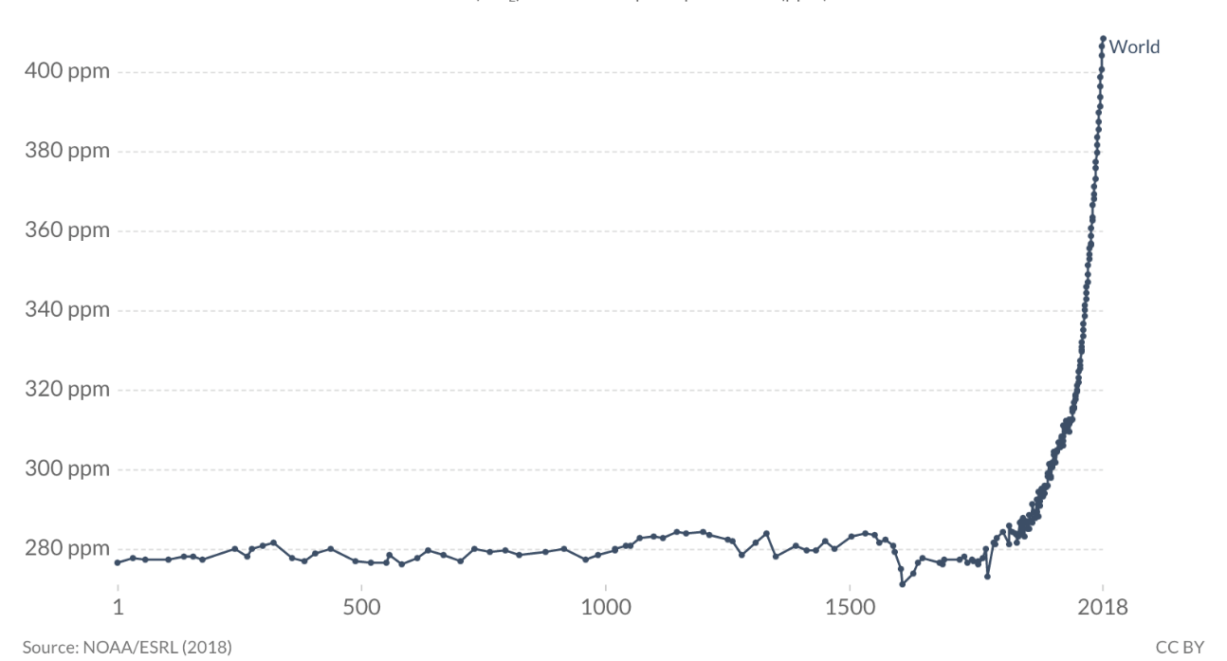
Figure 1 – Atmospheric concentrations of CO_{2.}
The image describes the increase in CO₂ emissions from year 1 AD to 2018 AD, with a drastic rise from 280 ppm to more than 400 ppm starting approximately from 1800, which coincides with the rise of the Industrial Revolution, until 2018.
Abbreviations: ppm: parts per million.
From (Ritchie, 2020).


Figure 2– Sea height variation.
The image describes an increase in sea height variation (in mm) starting from 1995, with a drastic rise of more than 80 mm in 2015.
Abbreviations: mm: millimetres.
From (Levin, 2017).

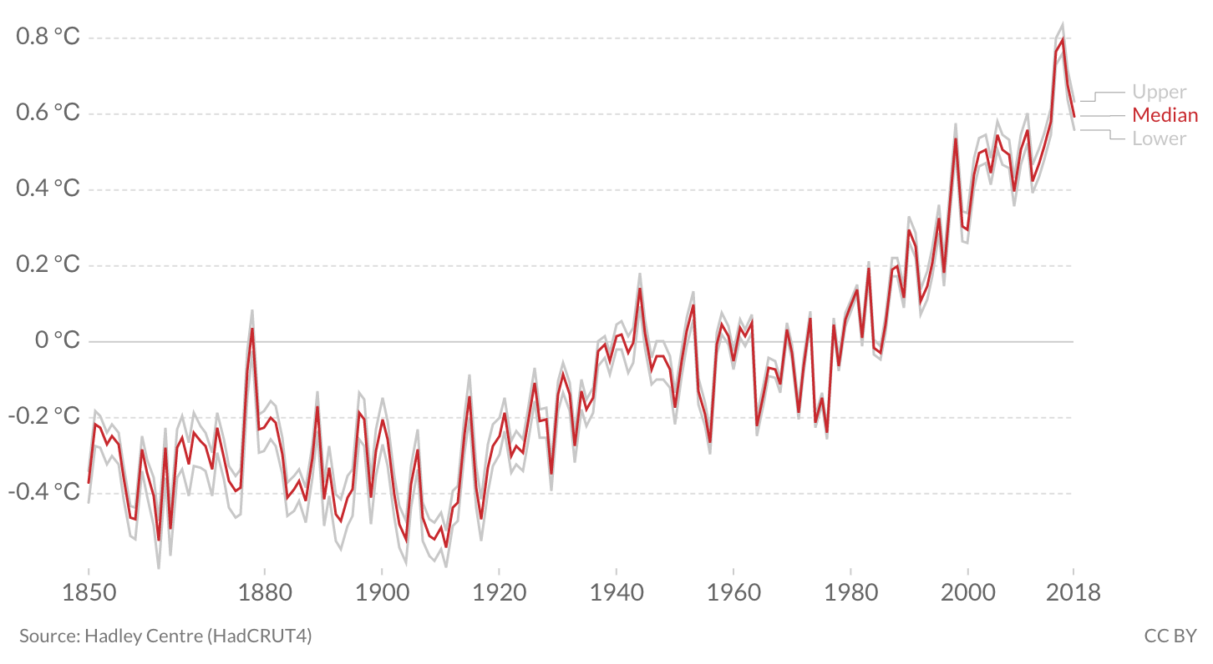
Figure 3 – Average global temperature.
The image describes the median (in red) of global temperature from 1850 to 2018, showing an increasing rise starting in 1920 and coincides with the accumulation and continuous increase in the burning of fossil fuels as a result of the Industrial Revolution.
Abbreviations: °C: degrees Celsius.
From (Ritchie, 2020).

In short, the development of an alternative to fossil fuels that is sustainable and renewable, but specially that which does not increase net atmospheric CO₂ concentrations is crucial. Sustainable biofuel production would be able to maintain the advances brought by fossil-based fuels without contributing to CO₂ emissions given that biofuel production offsets, through photosynthesis, the CO₂ emissions produced by burning the biofuel (Singh et al., 2020).

In this work, the cyanobacterium Synechocystis sp. PCC 6803 (hereafter Synechocystis) will be discussed as a chassis organism to be engineered in order to produce biofuels. Additionally, the present work will as well discuss the most effective way to engineer such chassis, with special focus on CRISPR/Cas 9. Finally, the present dissertation will demonstrate that Synechocystis can be engineered to produce two drop-in biofuel molecules - the isoprenoid-based alkane, squalane and the methyl ketone, 2-dodecanone. A chitosan-based biomass harvesting procedure has also been optimised as the first step in securing a low-cost biofuel production process.

Aim and objectives of the presented work

As a result of the identified research opportunities in the present work, this dissertation bears the novel aim of demonstrating the feasibility of “ready-to-use” biofuels derived from terpenoids and methyl ketones by the production of squalane and 2-dodecanone. Genome engineering of the highly polyploid Synechocystis will be achieved through CRISPR/Cas9 derived tools specially designed for Synechocystis. Since cell-liquid separation is an impediment to realise cost effective biofuel production, this work aims to optimise a chitosan-based harvesting technique for Synechocystis. This main purpose has been subdivided into the following objectives, which encompass the respective “Results-chapters” (Chapters 3, 4 and 5) in the present dissertation.

Objective I:

To improve the in vivo saturation-state of isoprenoid-biofuel precursors to generate the “ready-to-use” biofuel, squalane. This will be accomplished through the insertion of heterologous geranylgeranyl reductase (GGR) in Synechocystis sp. PCC 6803. CRISPR/Cas9 derived tools will be employed to tackle the highly polyploid genome of Synechocystis sp. PCC 6803 in order to improve mutant segregation and potentially increase biofuel titers.

Objective II:

To produce novel “ready-to-use” biofuels derived from methyl ketones by the insertion of the heterologous methyl ketone synthase I (ShMKS1) and methyl ketone synthase II (ShMKS2) into mutants of Synechocystis sp. PCC 6803. CRISPR/Cas9 derived tools will be employed to tackle the highly polyploid genome of Synechocystis sp. PCC 6803 in order to improve mutant segregation and potentially increase biofuel titers.

Objective III:

To optimise a chitosan-based harvesting method for Synechocystis sp. PCC 6803 that allows the energy-effective, efficacious as well as cost-effective separation of cyanobacterial cells from aqueous phase in order to decrease the overall cost of the biofuels produced, increase their feasibility and allow their competition with fossil-derived fuels.

Thesis overview

The content of the present dissertation unfolds as follows. Chapter 2 comprises the literature review elaborated to set up a context for the present work. Chapter 3 comprises the development of CRISPR/Cas 9 tools for the engineering of Synechocystis, presenting the generation of isoprenoid biofuel producing mutants. Chapter 4 encompasses the development of CRISPR/Cas 9 tools for the engineering of Synechocystis in order to generate methyl ketone-based biofuel producing mutants. Chapter 5 comprises the development of a chitosan based flocculation method for harvesting Synechocystis. Chapter 6 includes a general discussion of the findings generated by the present dissertation as well as concluding remarks and future work. Finally, Chapter 7 lists the bibliography implemented in the present investigation.

Chapter 2
Literature review

2. Chapter 2. Literature review

Biofuels

Biofuels are considered renewable fuels given that they are made through biological processes from biomass, such as plants, algae, agricultural residue or domestic waste (Callegari et al., 2020, Lee, 2012, Subramaniam et al., 2020). Biofuels emerged as an alternative to fossil-based fuels and are also considered sustainable due to their carbon neutrality. Biofuels are considered carbon neutral given that “the carbon emitted through burning replaces the carbon absorbed during the growing of the crop” (Mathews, 2008). Biofuels predominantly come from photosynthetic organisms, which utilize CO₂ to grow. Once grown, the organism will be utilized to make biofuels, which will burn and produce CO₂. However, these CO₂ emissions are off-set or can be subtracted from the CO₂ sequestered during photosynthesis, providing a neutral balance between the CO₂ produced and the CO₂ sequestered, hence the term “carbon neutral”. Given their photosynthetic nature, biofuels are considered more carbon neutral than fossil-based fuels. By employing readily available atmospheric CO₂ emissions as feedstock and sunlight as their energy source to generate biofuels, these have not only been labelled cost effective but renewable as well.

The success behind fossil fuels resides in their ideal physico-chemical properties. Therefore, for biofuels to be an adequate substitute, equating the physio-chemical properties of fossil-based biofuels is crucial. How well biofuels equate or better these characteristics will dictate their feasibility as well as their economic competence and reaching industrial scales of production. Some of such properties are shown in table 1 and currently, fossil-derived fuels portray the ideal value for each property.

Table 1: Physicochemical properties of fossil-fuels and biofuels
Fuel | Energy density  (MJ/Kg) | Freezing point  (°C) | Flash point  (°C) | Cetane number | Octane number
Fossil Jet-fuel | 41.6 to 43 | -18.15 to -79.15 | 38 to 43 | 36 to 47 | 15 to 25
Fossil diesel | 42.4 to 43.6 | -6.15 to -12.15 | 58.3 to 80 | 40 to 55 | NA
Fossil gasoline | 43.6 | <-100.5 | 43 | NA | 80 to 100
Biodiesel from soybean | 33.18 to 37 | -20 | >130 | 51.7 | NA
Bioethanol from corn | 25 to 26.70 | -109 | 13 | 5 to 8 | 110
Biodiesel from microalgae | 39.51 | -15 to 5 | 60 to 80 | 47 | NA
Isobutanol from cyanobacteria | 45 | - 114 | 35 | NA | 113

Table 1 – Physicochemical properties of fossil-fuels and 1G, 2G and 3G biofuels.
NA denoting “not available” information.
Adapted from (George et al., 2015, Khuong et al., 2016, Machado and Atsumi, 2012, Meylemans et al., 2012, Peralta-Yahya et al., 2011, Pratas et al., 2011, Tracy et al., 2009, Wahlen et al., 2013, Zaharin et al., 2017).

Energy density is the chemical energy provided by a determined quantity, usually a litre of a fuel (Demirbas, 2011, Douvartzides et al., 2021). Optimal energy density values, such as the ones in fossil fuels (41.6 to 43.6 MJ/Kg) (Table 1), can be found in non-oxygenated compounds (Gong et al., 2020, Raman et al., 2016). Regarding energy density, the presence of oxygen in several biofuels, including esters, methanol and ethanol, diminishes their energy density in contrast with fuels lacking oxygenated structures (Douvartzides et al., 2021, Gong et al., 2020, Naik et al., 2010), which presents a problem related to increased volumetric fuel consumption when burned in internal combustion engines (Likhanov and Lopatin, 2020, Raman et al., 2016). More fuel is needed per kilometre or in order to provide the energy provided by 1 litre of fossil-based fuels in fuels with lower values of energy density. This elevated consumption will have a direct impact on the quantity of the fuel being used, increasing the cost of the fuel given that more is needed in order to equate the energy given by the same quantity of fossil-derived fuels. Furthermore, some biofuels tend to absorb water (Demirbas, 2011). The higher the levels of water in a fuel, the lower the energy density, consequently leading to ignition issues (Gong et al., 2020), diminishing the overall quality of the fuel and decreasing its effectiveness.

Freezing point is the temperature at which a liquid changes its state to solid (George et al., 2015). This property is important, especially regarding aviation fuels conditions, given that, under extreme and very low temperatures, fuels are required to stay liquid in order to be used as a fuel. Low freezing points allow the usage of a fuel in low temperatures. Biofuels have managed to equate this property. optimal freezing point temperatures, set by fossil-derived fuels range from -18° C to less than -100° C. Table 1 shows that biofuels present freezing point temperatures with a similar range, even surpassing -100° C (George et al., 2015, Pratas et al., 2011, Zaharin et al., 2017), which would make them ideal for aviation fuel or their usage under low temperature conditions.

Another important property for biofuels to equate to fossil-derived fuels is flash point. Flash point can be defined as the lowest temperature at which a liquid forms ignitable vapour in the air close to its surface and affects the flammability of the fuel (Conconi et al., 2011, do Nascimento et al., 2020). The lower the flash point value, the more suitable for ignition the vapour will be, lower flash point values promote a better ignition quality in engines. Low flash point values denote a more flammable compound. As shown in table 1, fossil fuel hold flash point values ranging from 38° C to 80° C. While biofuels are able to match this range, however, some of their values are significantly high, such as the flash point for biodiesel, which surpasses 130° C (Khuong et al., 2016, Sathish and Singaravelu, 2020, Wahlen et al., 2013). Such high flash point values can diminish the ignition quality in the engine for these biofuels, decreasing their effectiveness and creating a mechanical stress in the engine, making them less efficacious.

Cetane and octane numbers are as well properties important to achieve. Both refer to ignition characteristics. However, the cetane number is applied to diesel or biodiesel and it is related to the ease of ignition and combustion and quality of a fuel. It indicates the combustion quality of a fuel through ignition. The cetane number is a measurement of the fuel’s ignition delay. In an engine, there is a time-lapse separating the injection of the fuel and the combustion start or ignition, this is called ignition delay, which is measured by the cetane number (Sarkar, 2015, Bemani et al., 2020). The higher values for cetane numbers, the higher combustion quality in a fuel. Fossil-based diesel holds cetane values ranging from 40 to 55, while biodiesel ranges from 47 to 51.7 (Table 1) (Machado and Atsumi, 2012, Peralta-Yahya et al., 2011, Wahlen et al., 2013), managing to equate such property and, hence, holding optimal combustion quality values. Octane numbers are applied to gasoline and biogasoline. “The octane number represents the resistance of gasoline to premature detonation when exposed to heat and pressure” (Viswanathan, 2016) p. 137). Such premature ignition not only wastes energy but also can damage the engine and decreases its efficiency. The higher the octane number, the more resistant the gasoline will be to premature ignition. As shown by table 1, octane numbers for fossil-based gasoline ranges from 80 to 100, while bioethanol reaches 110, surpassing the “optimal” values set by fossil fuels.

First generation (1G), second generation (2G) and third generation (3G) of biofuels have emerged in order to deliver sustainable and renewable substitutes to fossil based fuels. Each generation is made from different types of biomass and holds advantages and benefits of importance.

1G biofuels are made from crops that are used as food, such as sugarcane, soy and corn (Nagler and Gerace, 2020). 1G biofuels have been found effective enough in order to reach commercialization stage. Significant examples include a biodiesel mixes obtained from soybean and bioethanol produced from corn (Callegari et al., 2020, Seraç et al., 2020, Su et al., 2015). These biofuels have been widely commercialized. However, they are mainly commercialized as blends with fossil fuels (Verma et al., 2019a), therefore, they are still depending on fossil fuels and are not tackling climate change in its whole. Furthermore, it is significantly difficult to achieve a 99% purity in ethanol, it commonly contains water, which possess the risk of corrosion in engines and conveys ignition issues (Gong et al., 2020, Verma et al., 2019a), hence, engines will have to be modified and adapted in order to protect them from the corrosion involved with the water in bioethanol. This constitutes a problem given the major economic and engineering investment it would be in order to adapt all existing engines to be used with bioethanol, which would impose an unpractical as well as a major economic bearing. Moreover, the energy density in 1G biofuels has been found too low when compared to fossil fuels (Table 1), highlighting their low energy efficiency (Nogueira et al., 2020). The low energy density in 1G biofuels can be translated into a decreased energy provided. Therefore, more biofuel would have to be used in order to provide the energy delivered by 1 litre of fossil fuel, making them more expensive than fossil fuels and hindering its cost-effectiveness. However, there are also moral obstacles for 1G biofuels. Its main drawback is that they use food crops as feedstock.

By utilizing food crops as feedstock, 1G biofuels fall into the “food versus fuel” dilemma (Hanko et al., 2018, Nazari et al., 2021). In order to produce crops, resources such as fresh water and arable land are needed. The deviation of such resources from food production to biofuel production represents a moral conundrum because it implies favouring biofuel generation over fulfilling people’s most basic needs, food and water, in a world already devastated by water scarcity and hunger (Balat, 2011, Gomez-Zavaglia et al., 2020). Coupled with this, redirecting resources to biofuel production instead of food production would generate a rise in food prices, exacerbating the already existing food and water scarcity. This quandary is aggravated in developing countries, such as Mexico. For example, more than 45% of the Mexican population has insufficient access to basic welfare resources, such as health services, safe residence, drinkable water and essential nutritional requirements, which has led to famine and poor health (INEGI, 2010). In addition, Mexico is overpopulated. The country’s population is estimated to be 63 persons per km² (INEGI, 2010). The allocation of arable land and freshwater for growing crops for biofuel production generates a direct competition between biofuel production and people’s welfare. Considering the deviation of resources to produce 1G biofuels over food production would be highly irresponsible and immoral.

Subsequently, 2G biofuels emerged as an alternative to avoid the usage of food crops for biofuel production. 2G biofuels are obtained from non-food, cellulosic biomass, such as fast-growing trees and perennial grass (Nagler and Gerace, 2020). Hence, their major advantage is that they do not deviate resources from food towards biofuel production. However, their major drawback is the costly necessary treatment of cellulose. Cellulosic biomass is widely available as feedstock. However, due to its polymeric nature, it is not readily available to microbes for fermentation. Therefore, it needs to be subjected to costly enzymatic, chemical and thermal processes in order to convert cellulose into glucose to make it bioavailable and suitable for its conversion into biofuel (Fiorentino et al., 2017, Nagler and Gerace, 2020). Such costly pre-treatments highly increase the overall production cost of 2G biofuels, making then unable to compete with fossil-based fuel prices. Hence, 2G biofuels have not yet reached commercialization stage (Callegari et al., 2020).

Thereafter, 3G biofuels are obtained from algae and cyanobacteria (Nagler and Gerace, 2020, Sadatshojaei et al., 2020), hence, they do not utilize food crops as feedstock either. They gathered attention due to their higher growth rates compared to plants (Bhatia et al., 2020, Sadatshojaei et al., 2020). Although their doubling time is not as rapid as bacteria, some cyanobacteria and algae can duplicate in 6 to 12 hours (Heidorn et al., 2011), which can be seen as an advantage given that higher growth rates can signify greater and quicker yields of biofuel. However, an important drawback in biofuels from algae is that they lack genetic plasticity and genetic engineering tools, which hinders their genetic engineering. Contrastingly, cyanobacteria have more genetic plasticity and their genetic tool repertoire is wider than algae and plants (Huang et al., 2010, Huang et al., 2013, Lam and Lee, 2012, Nagappan et al., 2020, Ng et al., 2020, Sander and Murthy, 2010), which poses an advantage for cyanobacteria over algae as a host for 3G biofuel production.

Cyanobacteria as cell factories for biofuel production

Cyanobacteria, or blue-green algae, are Gram-negative prokaryotic photosynthetic bacteria (Hitchcock et al., 2020). They are a morphologically diverse group with metabolic elasticity that fulfils several significant roles in the environment, including carbon dioxide mitigation (Tiwari, 2018). The diversity of the cyanobacterial phylum has been consolidated in what initially was designated as five sections that illustrated their diversity (Figure 4) (Rippka et al., 1979). Later on, such classification evolved in a more complex taxonomy scheme holding one class, ten orders and more than 90 species (Figure 5) (Walter et al., 2017).

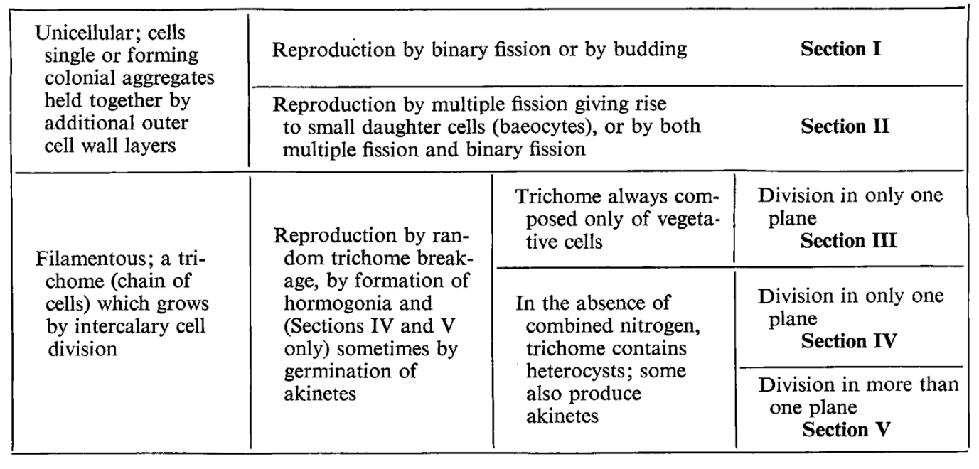
Figure 4 – Five sections of the cyanobacterial classification
From (Rippka et al., 1979).
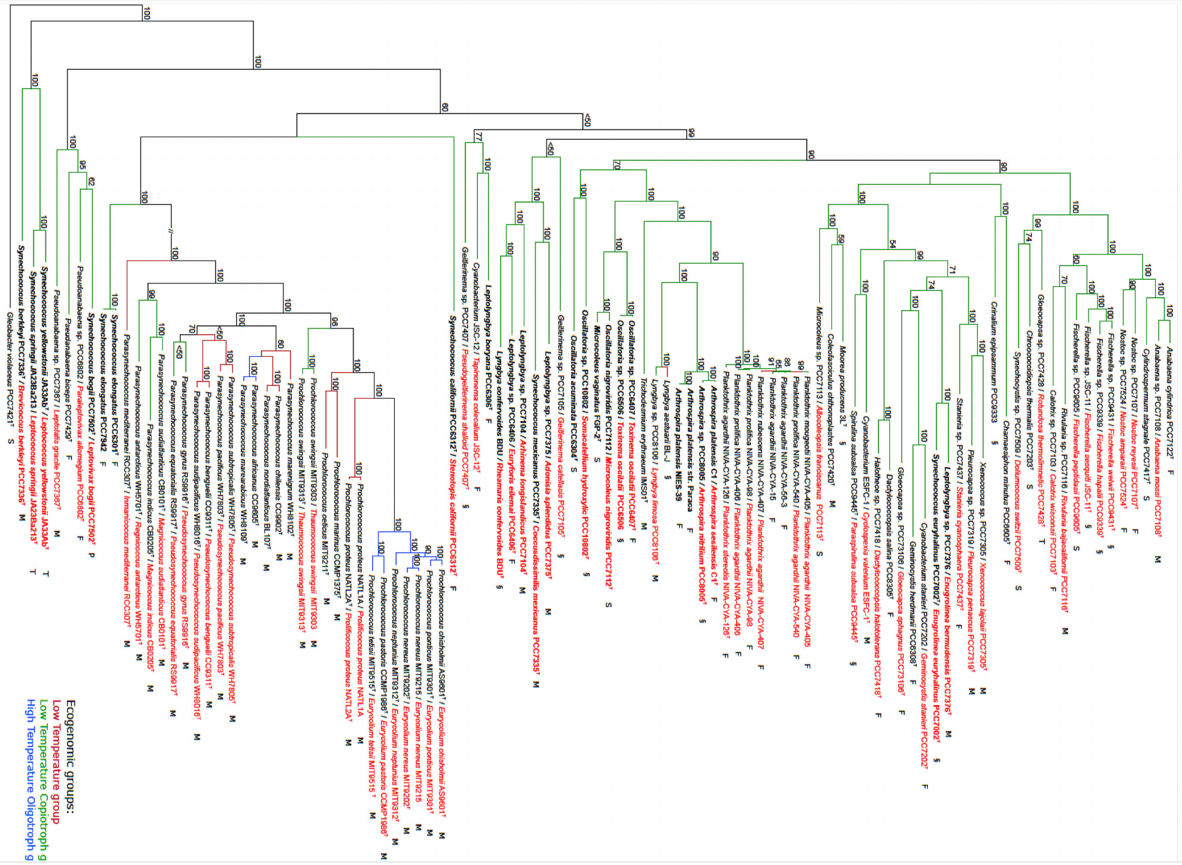
Figure 5 – Taxonomic classification of the phylum cyanobacteria
From (Walter et al., 2017).

Within their diversity, cyanobacteria hold multiple significant advantages. Firstly, cyanobacteria hold higher growth rates than photosynthetic eukaryotes, such as microalgae and plants. Cyanobacteria hold an increased photosynthetic efficiency. Defined as “moles of carbon fixed per mole of photons absorbed” (Bugbee and Monje, 1992), photosynthetic efficiency is the rate of conversion of solar energy into carbohydrates by a photosynthetic organism. The photosynthetic efficiency of cyanobacteria goes up to 10%, which allows them to accumulate biomass faster than microalgae and plants, whose photosynthetic efficiency fluctuates between 3 and 4% (Angermayr et al., 2015, Claassens et al., 2016, Zhu et al., 2020). The higher photosynthetic efficiency of cyanobacteria can be translated into greater productivity i.e. greater yields of products produced by them at a faster rate.

Furthermore, cyanobacteria have been reported to successfully grow and adapt to a broad range of environments, including stressful conditions, such as high salinity concentrations, highly contaminated waste waters as well as arid areas (Cuellar-Bermudez et al., 2017, Cui et al., 2020). This is relevant not only for their bioremediation potential but also for biofuel production. Their remarkable tolerance to such conditions makes them suitable for culture in a wide repertoire of conditions including large scale cultivation on areas of decreased or null productivity, including marginal agricultural areas, deserts, coastal regions and waste water treatment plants.

In addition, cyanobacteria are more suitable for genetic manipulation than microalgae and plants (Heidorn et al., 2011, Huang et al., 2010, Nagappan et al., 2020), endowing them with a valuable advantage in terms of design and production of a wide variety of tailored products. Cyanobacteria are naturally competent, they can effortlessly incorporate foreign DNA into their genome through the processes of natural transformation or homologous recombination (Heidorn et al., 2011, Ramey et al., 2015, Sarsekeyeva et al., 2015). Similarly, their ease of genetic manipulation endows them with the potential of creating more genetic tools, which would allow the production of tailored compounds with useful characteristics for biofuel purposes, such as greater energy densities, optimal carbon lengths as well as ideal melting and freezing points. Therefore, the wide availability of genetic tools in cyanobacteria than in plants and microalgae is an important advantage for cyanobacteria compared to eukaryotic microalgae (Ng et al., 2020). With such a valuable repertoire of advantages, cyanobacteria have gathered the attention of many industries, including biofuel production, and are considered more promising candidates for biofuel production compared to microalgae.

Several studies have targeted cyanobacteria for the production of a variety of biofuels. A study by Lan and Liao, engineered the cyanobacteria Synechococcus elongatus PCC 7942 (hereafter S. elongatus) in order to produce butanol, a candidate for substituting gasoline. The study reported titers of 13.16 mg/L (Lan and Liao, 2011). Similarly, work led by Liu et al. achieved the production of 197 mg/L of fatty acid-derived biofuels by engineering metabolic pathways in Synechocystis sp. PCC 6803 (Liu et al., 2011). Moreover, another study achieved titers of 450 mg/L of the gasoline substitute isobutanol by adding heterologous enzymes to a native pathway in S. elongatus (Atsumi et al., 2009). Isobutyraldehyde has also been produced in cyanobacteria. An yield of 1.1 g/L was achieved by engineering a partial native pathway in S. elongatus (Machado and Atsumi, 2012). Another study managed to produce titers of 4.8 g/litre of 1-butanol in Synechocystis (Liu et al., 2019). A similar work engineered Synechocystis as well and achieved a titer of 1.2g/litre of ethanol (Roussou et al., 2021). The diversity of compounds being produced in cyanobacteria goes even further. Several isoprenoids have as well been produced in such organisms. A study led by Davies et al. produced limonene and bisabolene in S. elongatus by utilizing a partial native pathway in this chassis (Davies et al., 2014). Englund et al. managed the production of the diterpenoid, manoyl oxide, at titers of 0.24 mg per gram of dry cell weight in Synechocystis (Englund et al., 2015). Furthermore, a study by Zhou et al managed to produce titers of 95.4 µg / litre of isoprene in Synechocystis (Zhou et al., 2021).

Despite their many advantages, biofuels from cyanobacteria have not yet achieved industrial scales. This is due to a number of factors of environmental, technical and economic nature (Yadav et al., 2021, Zahra et al., 2020).

In order to produce enough amount of cyanobacterial biofuel to really cause a positive impact on climate change, highly large quantities of cyanobacteria must be produced, such as large blooms. One of the proposals for cultivating cyanobacteria is to grow them on open ponds, water bodies or waste water repositories (Farrokh et al., 2019). This raises concerns given that cyanobacterial blooms are known to generate toxins, which are harmful to the environment and can have a negative impact on the involved ecosystems, including humans (Huisman et al., 2018, Moradinejad et al., 2020). Therefore, it is a more reasonable option to cultivate cyanobacteria in closed bioreactors, where their toxicity can be contained and controlled in order to prevent it to spread on to the ecosystems. Bioreactor cultivation that meets the growing requirements for cyanobacterial growth is highly costly (Cardoso et al., 2020, Grossmann et al., 2020). However, some cyanobacterial strains will not produce toxins, such as Synechocystis, which is an advantage of the strain. Selective growth could be applied for the strain in open ponds against harmful cyanobacteria, such as Microcystis in order to allow the growth of useful and non-toxic Synechocystis to avoid dangerous blooms. Moreover, current technologies in bioreactor design and culturing have delivered more cost-efficient bioreactors, making this culturing strategy more available (Leflay et al., 2020).

Moreover, the lack of large scale harvesting methods also hinders industrial scale production of cyanobacterial biofuels. Current and most common harvesting cyanobacterial techniques, such as centrifugation and filtration, are energy-intensive and not cost effective when implemented at larger scales (Macário et al., 2021, Zahra et al., 2020). Higher production costs consequently render biofuels uncompetitive compared to fossil fuels.

Additionally, and even though cyanobacteria are more amicable for genetic engineering than plants and algae, there is a lack of genetic tools for the phylum. Although better than in plants and microalgae, the development of tools for genetic engineering as well as synthetic biology for cyanobacteria still lags behind organisms such as E. coli and S. cerevisiae (Berla et al., 2013, Lin et al., 2019, Ng et al., 2020). This represents an obstacle for engineering cyanobacteria at the same level as these organisms or increases the time invested to engineer cyanobacteria (Berla et al., 2013, Lin et al., 2019), hindering the achievement of cyanobacterial biofuels at industrial scales.

Therefore, there is a need for addressing these factors in further studies for the production of cyanobacterial biofuels with the intent of reaching industrial scales. Nevertheless, the numerous and significant advantages and wide diversity of compounds able to be produced in cyanobacteria highlights their versatility and potential as biofuel factories. Moreover, within the cyanobacteria phyla, the strain Synechocystis is considered to bear further advantages for biofuel production as outlined in the forthcoming section.

Synechocystis sp. PCC 6803

Within cyanobacteria, the strain Synechocystis sp. PCC 6803 (Figure 6) has been highlighted due to the further highly significant qualities it holds for biofuel production. Genetically, Synechocystis is widely perceived as a model organism within cyanobacteria. Its genome was fully sequenced in 1996, making it the first cyanobacterium to be fully sequenced (Kaneko et al., 1996). Subsequently, it has been extensively utilized for photosynthetic and genomic engineering studies and, as a consequence, it has been well characterized and its genome is annotated to a high degree (Table 2) (Griese et al., 2011, Heidorn et al., 2011, Zhou et al., 2014). The availability of the genome sequence endows Synechocystis with advantageous qualities given that it facilitates and accelerates the design and production of target biofuels. Furthermore, Synechocystis possesses an increased genetic malleability and a high transformation efficiency within the whole cyanobacteria phylum. The genetic transformation of Synechocystis is simple and stable given its inherent tendency to naturally uptake foreign DNA (Heidorn et al., 2011, Sarsekeyeva et al., 2015). In addition, the selection of genetic tools for this cyanobacterium is the largest among all cyanobacteria (Heidorn et al., 2011, Ng et al., 2020, Ramey et al., 2015). This increases the potential of Synechocystis as a host organism for biofuel production.

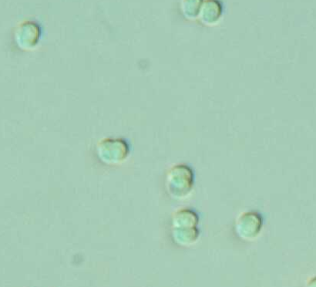

Figure 6 – Microscopic view of Synechocystis sp. PCC 6803.

Table 2: Annotated genome of Synechocystis
Genome size (Mb) | Plasmid size (Kb) | Average doubling-time (hrs) | Chromosome copies per cell | Plasmids | Sequence annotated genome
3.6 | 2.3, 2.4, 5.2, 44, 103, 106, 120 | 6-12 | 57.8-256 | 7 | GCA_000009725.1

Table 2 – Annotated genome of Synechocystis.
Adapted from (Berla and Pakrasi, 2012, Griese et al., 2011, Heidorn et al., 2011, Ramey et al., 2015).

In addition, Synechocystis possesses an increased metabolic flexibility. The carbon flux map of Synechocystis has been fully described. A carbon flux map is a thorough description of the cellular resource distribution of the primary and other existent metabolic pathways in an organism. Such intricate map has been elucidated in this cyanobacterium. As a result, Synechocystis has been found to be able to select its primary pathway dependence depending on the varying environmental and nutritional conditions (Burford et al., 2020, Xiong et al., 2015, Young et al., 2011). Hence, this has shown that Synechocystis is able to successfully grow autotrophically, heterotrophically or mixotrophically. Such attribute is significantly important for biofuel production and its industrial processes given that it provides flexibility when considering culturing conditions. It expands culturing alternatives and strategies and enables the selection of a strategy the best fits a determined industrial strategy. The culturing cycles could be totally light dependant or mixed with dark phases in order to decrease costs without reducing biomass production. In heterotrophic conditions, Synechocystis is strongly dependant of the oxidative pentose phosphate pathway (OPPP) for energy generation. However, under autotrophic conditions, Synechocystis is only partially dependant on the OPPP pathway. The OPPP pathway remains 15% active during autotrophic grow (You et al., 2014, Young et al., 2011, Xiong et al., 2015). Furthermore, according to its carbon flux map, Synechocystis has shown a propensity to redirect over than 50% of resource flux from its main carbon pathways to pathways of relevance for biofuel production without endangering cell viability (Antoni et al., 2007, Knoop et al., 2013, Kopf et al., 2014).

This natural ability of Synechocystis to divert resources towards metabolic routes of interest for biofuels with endangering viability, highly benefits biofuel production. This could signify that less metabolic burden would be generated, reducing the overall stress in the organisms and favouring its operational functioning. Furthermore, the elucidation of the Synechocystis carbon flux map would as well facilitate the identification of competing and non-indispensable pathways in order to deviate resources to maximize the flux to biomass production and biofuel production, endowing the cyanobacterium with the ability to produce high titres of biofuels.

The many benefits of Synechocystis make this cyanobacterium a promising chassis for genetic engineering for the production of biofuels. However, polyploidy is an important drawback that must be considered and addressed in the cyanobacterium. The number of chromosome copies in the genome of an organism is defined as ploidy. In cyanobacteria, especially in Synechocystis, this number is considerably high, therefore, Synechocystis is considered to have a polyploid genome (Caicedo-Burbano et al., 2020). When compared to other model organisms, such as Escherichia coli (hereafter E. coli), the ploidy levels of Synechocystis are significantly high. The average number of chromosome copies per cell in E. coli range from 1.2 to 6.8, depending on the growth phase while in Synechocystis, this number can reach 225 (Table 3) (Watanabe, 2020, Zerulla et al., 2016). Moreover, ploidy levels can be influenced by a number of elements, including the organism’s growth phase, light conditions as well as the composition of the growth medium, which can increase or decrease such levels (Pope, 2020).

Table 3: Chromosome copy number in cyanobacteria and E. coli
Growth phase | Chromosome copies per cell (average)
Growth phase | E.coli | Synechocystis | Anabaena cylindrica | Anabaena viariabilis
Exponential growth | 6.8 | 225 | 25 | 9
Linear phase | 2.0 | 58 | 16.7 | 5.9
Stationary phase | 1.2 | 57.8 | 8.3 | 3.1
Table 3 – Chromosome copy number per cell in different cyanobacteria and E. coli during different growth phases.
Adapted from (Griese et al., 2011, Pecoraro et al., 2011, Zerulla et al., 2016).

High polyploidy is a significant drawback during genetic manipulation because it hampers the full segregation of mutants. The paramount objective of biofuel production through genetic engineering is the expression of introduced attributes that are indispensable for biofuel production in mutant populations. The introduction of such attributes in these mutant populations must be ensured in addition to these attributes being stable and homogenic i.e. all of the mutants must present the introduced attributes in all chromosome copies in the genomes of all individuals and their descendant organisms must carry this trait as well through generations after cell division in order to say that the population has achieved full segregation (Caicedo-Burbano et al., 2020, Pope, 2020, Tan et al., 2013). Without full mutant segregation, Synechocystis mutants are highly prone to dilutions of the introduced mutations which consequently has a negative impact in biofuel yields. Full mutant segregation, stability and homogeneity are crucial for reaching commercialization. In order to do so, it is vital to maintain inserted mutations in all the copies of the chromosomes in the cell.

Current biofuel-producing strategies in Synechocystis do not address this drawback, which can have a negative impact on the titres of the biofuels produced in Synechocystis when compared to other organisms. Thus, a new genetic engineering strategy for biofuel production that addresses the issue of genetic manipulation and the highly polyploid genome in Synechocystis is necessary in order to leverage the strain as a biofuel-producer and enable the harnessing of its numerous advantages as such.

2.2.1 Synthetic biology and Synechocystis

Synthetic biology is a science that has emerged due to the significant progress genetic engineering technology has made in the last couple of decades. The objective of synthetic biology is to design standardised procedures to create cellular machineries able to generate useful products by rewriting the genome of organisms (Meng and Ellis, 2020, Nielsen and Keasling, 2016). Synthetic biology merges the principles of biology with the engineering principles of standardization, modularity and decoupling in order to simplify genome engineering and expression of heterologous or foreign genes in an organism or chassis in order to obtain a desired product (Datsenko and Wanner, 2000, Endy, 2005).

Synthetic biology has had the help of various tools in order to facilitate genome engineering. An example of these tools are standardized biological parts such as promoters, terminators, etc. (Table 4), more specifically, BioBricks. These are well characterized and standardized genetic, synthetic or orthogonal preassembled elements that are introduced into a plasmid and furtherly into a chassis to simplify its genetic editing (Abe et al., 2014, Huang and Lindblad, 2013, Way et al., 2014). Synechocystis holds the largest repertoire of synthetic biology tools within all cyanobacteria (Ng et al., 2020).

Genetic modification in Synechocystis can be done in two ways: via a plasmid insertion, also called in-trans genetic modification, which makes use of the standardized biological parts for plasmid construction, or via chromosomal editing, also known as in-cis genetic modification (Hitchcock et al., 2020). In Synechocystis, in-trans genetic modification is not as frequent when compared to chromosomal editing (in-cis genetic modification). However, it is yet widely practised. In-trans genetic modification is executed through the insertion of a plasmid as well as the synthetic biology parts for a required function (Table 4) into the cytoplasm of an organism (Chen et al., 2016). The number of such parts for Synechocystis is currently not as vast as it is for organisms such as E. coli and Saccharomyces cerevisiae (hereafter S. cerevisiae). E. coli and S. cerevisiae have a wide variety of parts for in-trans genetic modification, the systematic evaluation and organisation of which led to the development of the new concept of the synthetic biology toolbox of parts (Chubukov et al., 2016, Hitchcock et al., 2020). Nevertheless, a number of parts have been developed and characterized for Synechocystis and this cyanobacterium is at the forefront of synthetic biology part toolbox development in the cyanobacterial phylum (Heidorn et al., 2011, Huang and Lindblad, 2013, Landry et al., 2013, Ng et al., 2020).

Table 4: Standardized biological parts
Standardized Biological Parts | Plasmids
Standardized Biological Parts | Promoters
Standardized Biological Parts | Primers
Standardized Biological Parts | Terminators
Standardized Biological Parts | Reporters
Standardized Biological Parts | Ribosomal binding sites
Standardized Biological Parts | Protein coding sequences
Standardized Biological Parts | Translational units
Standardized Biological Parts | Riboregulators
Standardized Biological Parts | Receptors
Standardized Biological Parts | Senders
Standardized Biological Parts | Measurement devices

Table 4– Standardized Biological Parts.
Adapted from (Ramey et al., 2015, Berla et al., 2013).

Aside from in-trans genetic modification, another strategy more commonly used in cyanobacteria is chromosomal editing or in-cis genetic modification. Cyanobacteria, including Synechocystis, are naturally capable of homologous recombination as well as natural transformation, which benefits in-cis genetic modification given that it enables deletions, insertions, replacements as well as targeted mutations in cyanobacteria (Hitchcock et al., 2020). This genetic plasticity is quite advantageous for genetic manipulation with regard to designing strategies for developing effective biofuels in such organisms. The following paragraphs describe the state of art regarding in-cis genetic modification available for cyanobacteria, specifically for Synechocystis.

The generation of high throughput, stable and completely segregated mutants is a common outcome to pursue in in-cis genetic modification. The achievement of completely segregated mutants is directly linked to the chromosome copy number (ploidy) in the genome of the organism in question. Achieving optimal full segregation will become more difficult as the chromosome copy number increases or the genome becomes more polyploid (Caicedo-Burbano et al., 2020, Tan et al., 2013). Cyanobacteria, specially Synechocystis, have highly polyploid genomes (Pope, 2020). Hence, obtaining high throughput, stable and fully segregated mutants in Synechocystis is an important hindrance regarding its genetic manipulation and for developing strategies for designing effective biofuels.

To address this issue, strategies such as use double homologous recombination (DHR) (Figure 7) coupled with selection/counter selection have been implemented in order to achieve fully segregated mutants in cyanobacteria and Synechocystis (Berla et al., 2013, Watanabe, 2020). DHR is widely carried out in cyanobacteria, especially due to the fact that it enables targeted mutations and has been reported to generate highly stable and homogeneous mutants in the phylum (Caicedo-Burbano et al., 2020, Taton et al., 2017). However, it is highly difficult for this strategy to achieve fully segregated mutants given that its effectiveness is linked to the organism’s chromosome copy number. Even though significant success has been obtained for DHR regarding the creation of fully segregated mutants under high levels of ploidy in cyanobacteria, it has been considerably arduous as well as time-consuming (Pope, 2020, Caicedo-Burbano et al., 2020). Synechocystis holds an increasingly high number of chromosome copies, it is significantly polyploid (Hitchcock et al., 2020), therefore, achieving fully segregated mutants of this strain is significantly difficult given that, each introduced mutation has to be maintained in every chromosome copy number in the organism (Hitchcock et al., 2020, Taton et al., 2017). During heterologous expression, incomplete segregation is dangerous as lower metabolic burden is imposed to replicate native chromosomes than modified chromosomes eventually leading to loss of the engineered genotype during repeated rounds of large scale cultivation, eventually leading to mutation dilution. If more copies are present, it will be easier for these mutations to be lost or diluted during successive rounds of DNA replication and cell division given that the introduced mutation must be passed on the new DNA and new cells (Figure 8) i.e. organisms become more prone to the dilution of the introduced mutations as their ploidy levels increase. Therefore, the dilution of introduced mutations is a common outcome described in the cyanobacterium.

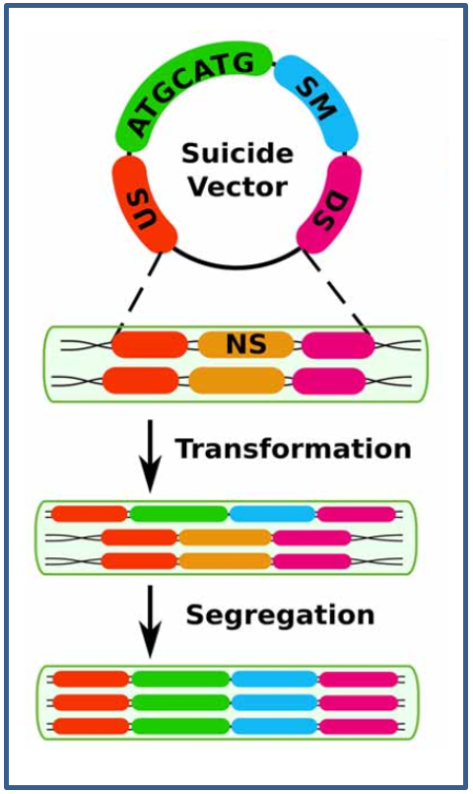

Figure 7 – Double homologous recombination.
The generation of mutants in cyanobacteria is commonly done through double-homologous recombination. A suicide-vector is introduced in a neutral-site (NS) between two flanking or limiting-regions, one upstream (US) and one downstream (DS) from the selectable-marker (SM) and a desired-sequence. Here, the sequence “ATGCATG” is used to illustrate the desired gene-sequence to be introduced. The process continues with the transformation of a copy of the chromosome. Subsequently, multiple copies holding the inserted modification are generated (segregation).
From (Berla et al., 2013).

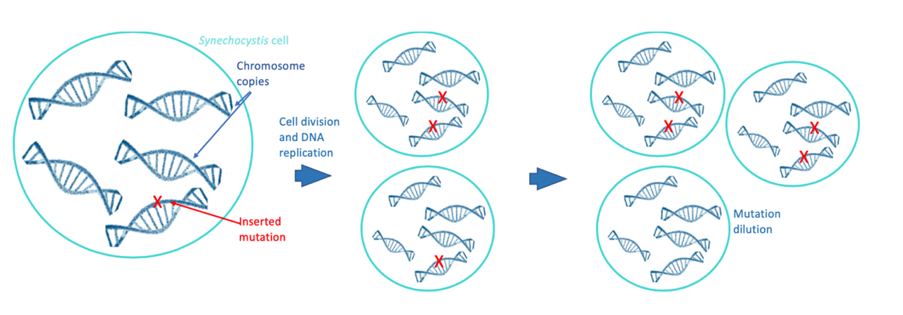
Figure 8–– Mutation dilution and segregation in Synechocystis.

To overcome such drawback, numerous rounds of selective pressure are carried out after implementing DHR in Synechocystis in order to achieve a higher level of mutant segregation. Not only this has been reported to be highly laborious, time-consuming and not cost-effective, but also, this does not secure full mutant segregation (Pope, 2020, Ramey et al., 2015, Watanabe, 2020). Thus, the highly polyploid genome of Synechocystis is a significant drawback for the creation of optimally segregated and homogeneous mutants. Current biofuel-producing strategies in Synechocystis do not address this drawback, which can have a negative impact on the titers of the biofuels produced in Synechocystis when compared to other organisms. Thus, a new genetic engineering strategy for biofuel production that addresses the issue of genetic manipulation and the highly polyploid genome of Synechocystis that enables optimal segregation in the cyanobacterium mutants is highly necessary in order to leverage the strain as a biofuel-producer and harness its numerous advantages. New advancements in technology have given rise to promising strategies that might be able to tackle this issue effectively, which is the case of CRISPR/Cas9.

CRISPR/Cas9

CRISPR/Cas9 is a highly effective, precise and easy to implement genome editing technology that emerged from an adaptive immune system so far identified in archaea and bacteria (Choi and Lee, 2016, Estrela and Cate, 2016, Jinek et al., 2012, Sasano et al., 2016). CRISPR stands for “clustered, regularly interspaced, short, palindromic repeats” (Jinek et al., 2012), which means that within the DNA of archaea and bacteria, there are short sequences, from 20 to 37 base pairs; that are repeated or identical within each other; that are interspaced or separated by a constant number of base pairs and that are palindromic, meaning they read the same backwards and forwards (Figure 9). These repeated sequences or repeats are interspaced by sequences that do vary within each other, which are called spacer DNA (Figure 9) and constitute the adaptive part of the immune system given that they are like a memory. These sequences will be eventually substituted by fragments of viral DNA that has attempted to or infected the cell before (Anzalone et al., 2020, Doudna and Charpentier, 2014).

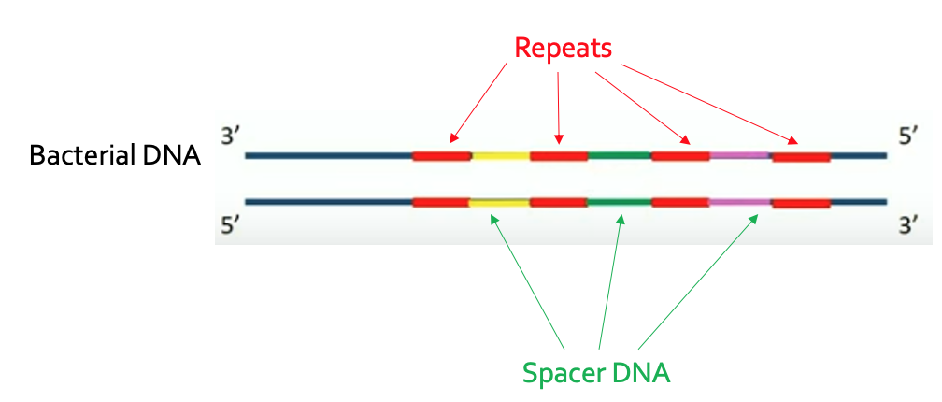

Figure 9 – CRISPR locus.

This cluster of sequences, the repeats and the spacer DNA encompass the CRISPR locus (Figure 9). Cas genes are adjacent to the CRISPR locus and encode for Cas enzymes, which can be nucleases or helicases. Nucleases are able to cleave or cut the DNA backbone, cleaving the phosphodiester bonds between adjacent nucleotides. Helicases unwind the two DNA strands from each other by cutting the hydrogen bonds. Together they encompass the CRISPR adaptive immune system designed to break incoming foreign DNA in order to prevent infections (Doudna and Charpentier, 2014, Jinek et al., 2012, Selle and Barrangou, 2015). There are different types of CRISPR systems. Depending on the organism they are part of and the number and type of enzymes involved, two classes and 6 types of CRISPR systems have been described (Figure 10). Different species bear different types of CRISPR systems. Synechocystis bears a type VI. The type II is the most studied. It uses the enzyme Cas9, an enzyme able to generate double strand breaks (DSB) and cleave the DNA. The implementation of this enzyme gives CRISPR type II its name, CRISPR/Cas9 (Alberts, 2008). The CRISPR/Cas9 system constitutes the basis for gene engineering technology (Anzalone et al., 2020). Moreover, its mechanism of action is quite interesting.

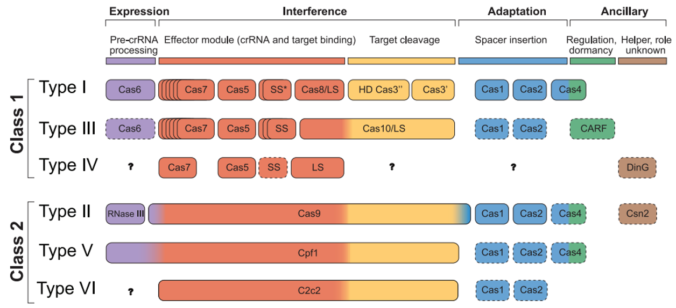
Figure 10 – Types of CRISPR systems.
From (Mohanraju et al., 2016).

Bacteriophages or viruses infect bacteria or archaea by injecting its DNA into the cell, which deploys the CRISPR/Cas9 system. Firstly, a marker sequence in the viral DNA is identified, this section is called a “proto-spacer adjacent motif” (PAM). The PAM indicates the target DNA section is next to it and is needed for the enzyme Cas9 to anchor the viral DNA and perform the cut (Jinek et al., 2012, Jinek et al., 2013). Subsequently, the region adjacent to the PAM is cleaved, this stops the viral infection (Figure 11). But further, this cleaved section is integrated into the bacterial DNA in the spacer DNA of the CRISPR locus in order to continue to stop future infections from the same virus, given that that infection will be now on recognized given that is has been stored in the spacer DNA of the CRPSR locus (Figure 11) (Hsu et al., 2014, Makarova et al., 2011, Jinek et al., 2012, Sternberg et al., 2014). After the integration of the viral DNA into the spacer region of the bacterial DNA, the two strands of the DNA separate and the CRISPR regions as well as the newly integrated viral genetic information are transferred as messenger RNA (mRNA). Afterwards, additional pieces of RNA are bound to the separate CRISPR and viral (spacer) regions, and it is subsequently separated into smaller sections. Each section is a guide RNA and contains a spacer or the viral integrated genetic information and the repeats, which contain CRISPR information, such as the necessary information for the Cas9 enzyme to bind to the viral DNA. Later on, the guide RNA is integrated with Cas9 proteins to form a complex. In this complex, the guide RNA leads the Cas9 proteins to a specific target in the DNA to achieve a targeted cleavage via DSB, destruct the viral DNA and the prevent this and further infections from the same virus (Figure 11, Figure 12 and Figure 13) (Mohanraju et al., 2016, Ran et al., 2013b, Sasano et al., 2016).

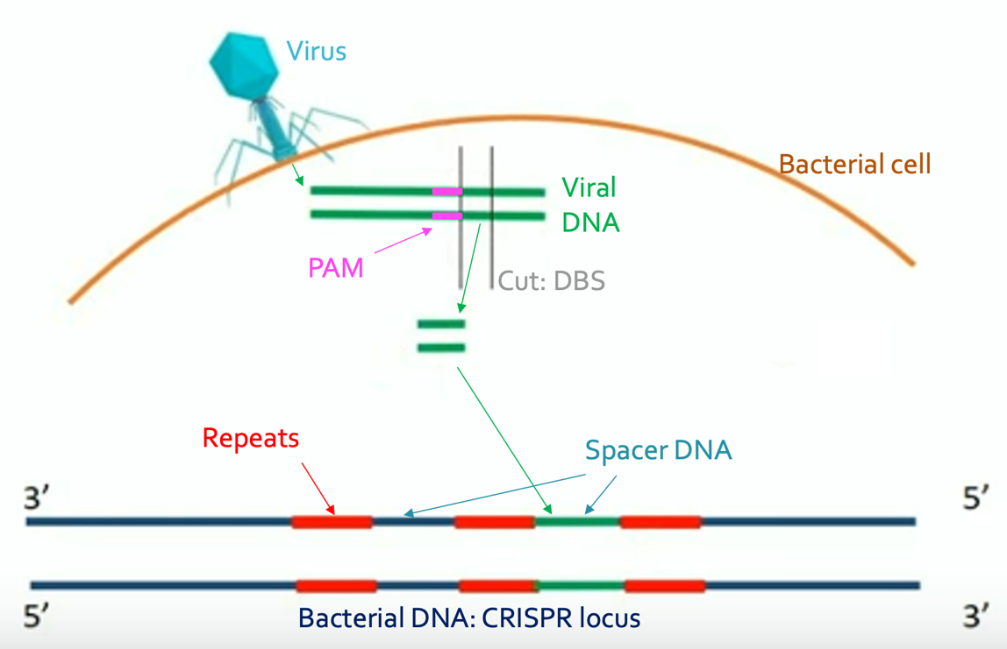

Figure 11 – Cleavage of the viral DNA and integration of it into the CRISPR locus in the bacterial DNA.
Adapted from (Biological, 2017).

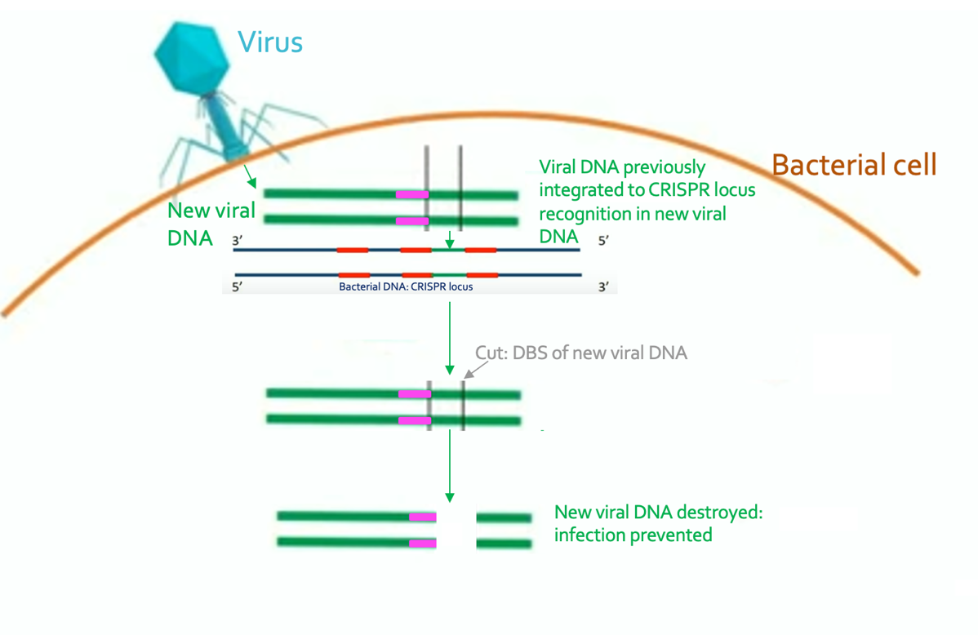

Figure 12 – Recognition of the previously integrated viral DNA into the CRISPR locus of the bacterial cell, cleavage of the new same viral DNA and prevention of the new infection.
Adapted from (Biological, 2017).

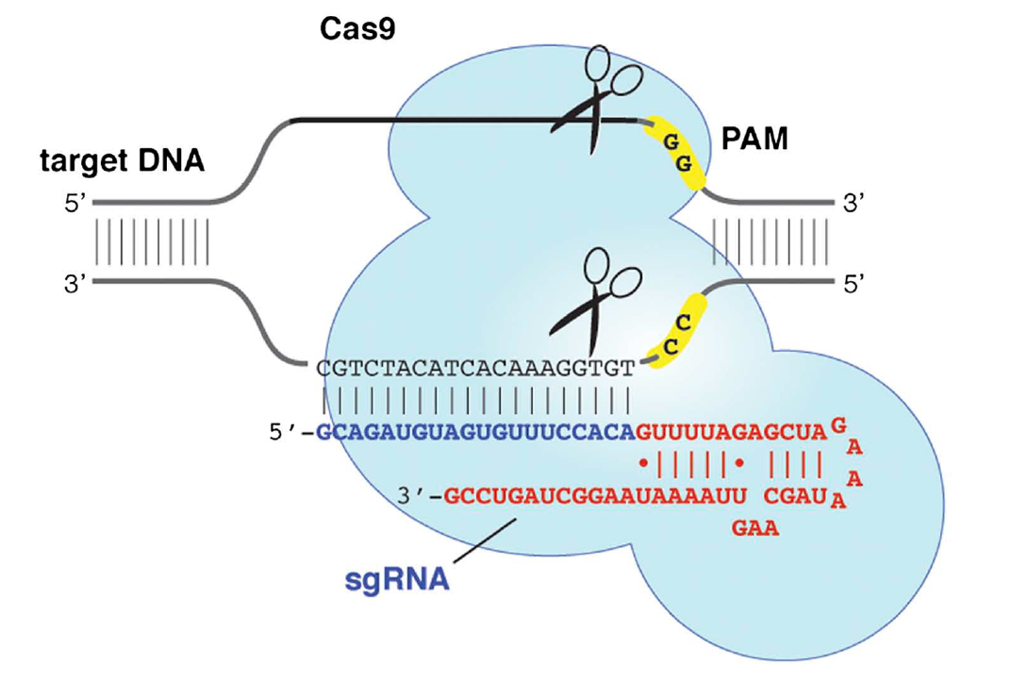

Figure 13 – Guide RNA/Cas9 complex.
From (Jinek et al., 2012).

CRISPR/Cas9 and DSB repair as a genome editing technology

For CRISPR/Cas9 to work, it requires two basic elements: Cas9 enzymes, which allow the creation of a DSB and a guide RNA, which leads the Cas9 enzymes to the target area in the DNA to generate DSB and be cleaved. So, a mechanism able to break both strands of DNA at specific locations using just two simple elements, quickly became exploited to edit the genomes of numerous organisms. In 2012, Jinek et al. realized the potential of this system as a tool and designed a simple single guide RNA (sgRNA) tool containing a spacer, which is the target and can be programmed to reach any section in any DNA only by modifying the spacer region, a section of only 20 nucleotides; and the repeat, which are the same for every CRISPR system and contain control elements, such as the necessary information for the binding of the Cas 9 proteins to the sgRNA (Jinek et al., 2012, Sternberg et al., 2014).

After the sgRNA is guided to the target section and this is cleaved, the DBS will activate the DSB cell’s repair mechanism, which can proceed in 2 ways: through Non-homologous End Joining pathway (NHEJ) or the Homology Directed Repair (HDR) pathway. In the absence of a homologous repair template or a donor DNA (dDNA), the DNA will get repaired through the NHEJ pathway which will disrupt the target gene and deactivate it i.e. create a knock-out mutant. If a dDNA is provided, the high fidelity HDR pathways is followed, which is more precise. In this pathway, the dDNA is used to substitute the target section of DNA that was cleaved to generate specific and precise mutations or knock-ins. So the target gene will not only be deactivated but also, a new sequence or a new desired mutation will be introduced instead (Figure 14) (Alberts, 2008).

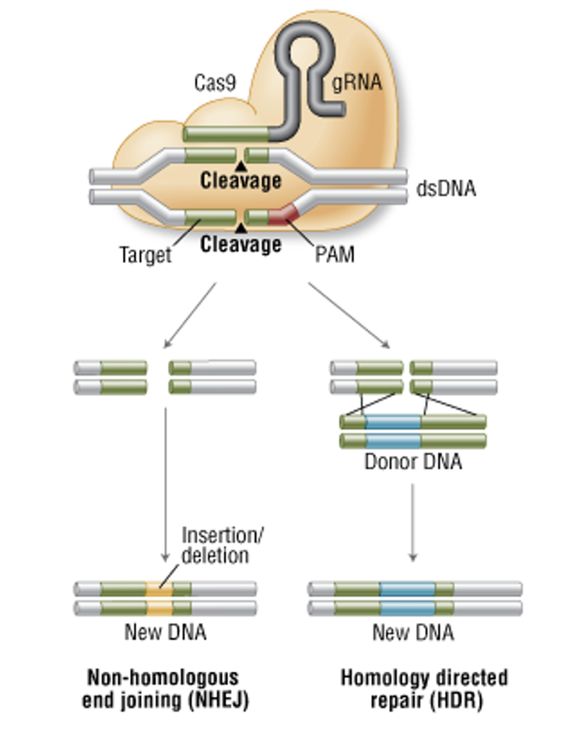

Figure 14 – DSB repair mechanism pathways.
Adapted from (Biolabs, 2016).

Therefore, CRISPR/Cas9 allows the single or multiple deletion of genes as well as the insertion of new mutations at specific locations in any DNA simply by modifying the 20 nucleotides in the sgRNA and adding a Cas9 enzyme, the rest will be done by the already existent cell’s repair machinery. In Synechocystis, the more precise HDR pathway has been reported to be followed after a DSB is performed (Gordon et al., 2016, Yao et al., 2016), which allows more precise genome editing and highlights the potential of using such technology in this chassis.

The design by Jinek et al., 2012 has been found more effective than other gene editing tools, such as Transcription-Activator Like Effector Nucleases (TALENs) and Zinc-Finger Nucleases (ZFNs) and given that it acts upon sequence complementarity rather than protein-DNA interactions, which are much more complex (Yip, 2020). Furthermore, genetic modification tools such as Multiplex Automated Genome Engineering (MAGE), MultiScalar Library Enrichment (SCALE) and Trackable Multiplex Recombineering (TRMR) have achieved the introduction of multiple mutations concomitantly in a time-effective manner in organisms such as E. coli (Kantor et al., 2020). Unfortunately, these cannot be implemented in Synechocystis given its highly polyploid genome (Ng et al., 2020).

CRISPR/Cas9 has been successfully and widely implemented in many organisms such as humans, yeast, plants, monkeys, pigs and mice to name a few. Nevertheless, the CRISPR/Cas9 gene editing technology has not yet been demonstrated in Synechocystis (Asmamaw and Zawdie, 2021, Biot-Pelletier and Martin, 2016, Choi and Lee, 2016, Estrela and Cate, 2016, Gordon et al., 2016, Heidi, 2019, Li et al., 2016, Miura et al., 2018, Sasano et al., 2016), which constitutes the novelty of the present project.

Given that CRISPR/Cas9-based genome editing acts upon DNA sequence complementarity rather than protein-DNA interaction, which are more complex, CRISPR/Cas9 holds a simple effectiveness (Aquino-Jarquin, 2021, Jinek et al., 2012, Ran et al., 2013a). This, aided by the DSB repair machinery that acts after the activity of CRISPR/Cas9 have the potential of overcoming the obstacle of high polyploidy and mutation dilution/deletion and achieving full mutant segregation in highly polyploid genomes and, therefore, leverage Synechocystis as a biofuel-producer strain. Such a promising strategy should be coupled with biofuel candidates of similar promising opportunities, which is the case for isoprenoid and methyl ketone derived biofuels focussed on in this work.

Isoprenoid-derived biofuels

Isoprenoids have been described as highly promising candidates for biofuel substitutes for fossil-based fuels. The following paragraphs describe their advantages for such description.

Isoprenoid biosynthesis

Isoprenoids, also called terpenes or terpenoids are carbon based compounds that belong to a highly diverse classification. They are naturally present in plants and bacteria, to name a few, counting Synechocystis (Daletos et al., 2020, Englund et al., 2015). They are naturally synthesized via two metabolic pathways, the 2-methyl-D-erythrito-4-phosphate (MEP), also known as the 1-deoxy-D-xylulose-5-phosphate (DXP) pathway and also, through the mevalonate pathway (MVA) (Figure 15). Terpenoids are synthesized through the MEP pathway in bacteria and plants, including Synechocystis and through the MVA pathway in eukaryotic organisms, both of them converge in the generation of the isoprenoid-precursors DMAPP and IPP (Figure 16). All terpenoids derive from these two building blocks (Abby et al., 2020). Although highly similar, the MEP pathway has been reported more efficacious given that more important rate-limiting steps have been widely described as well as its carbon efficiency (George et al., 2015, Pérez-Gil and Rodríguez-Concepcíon, 2013).

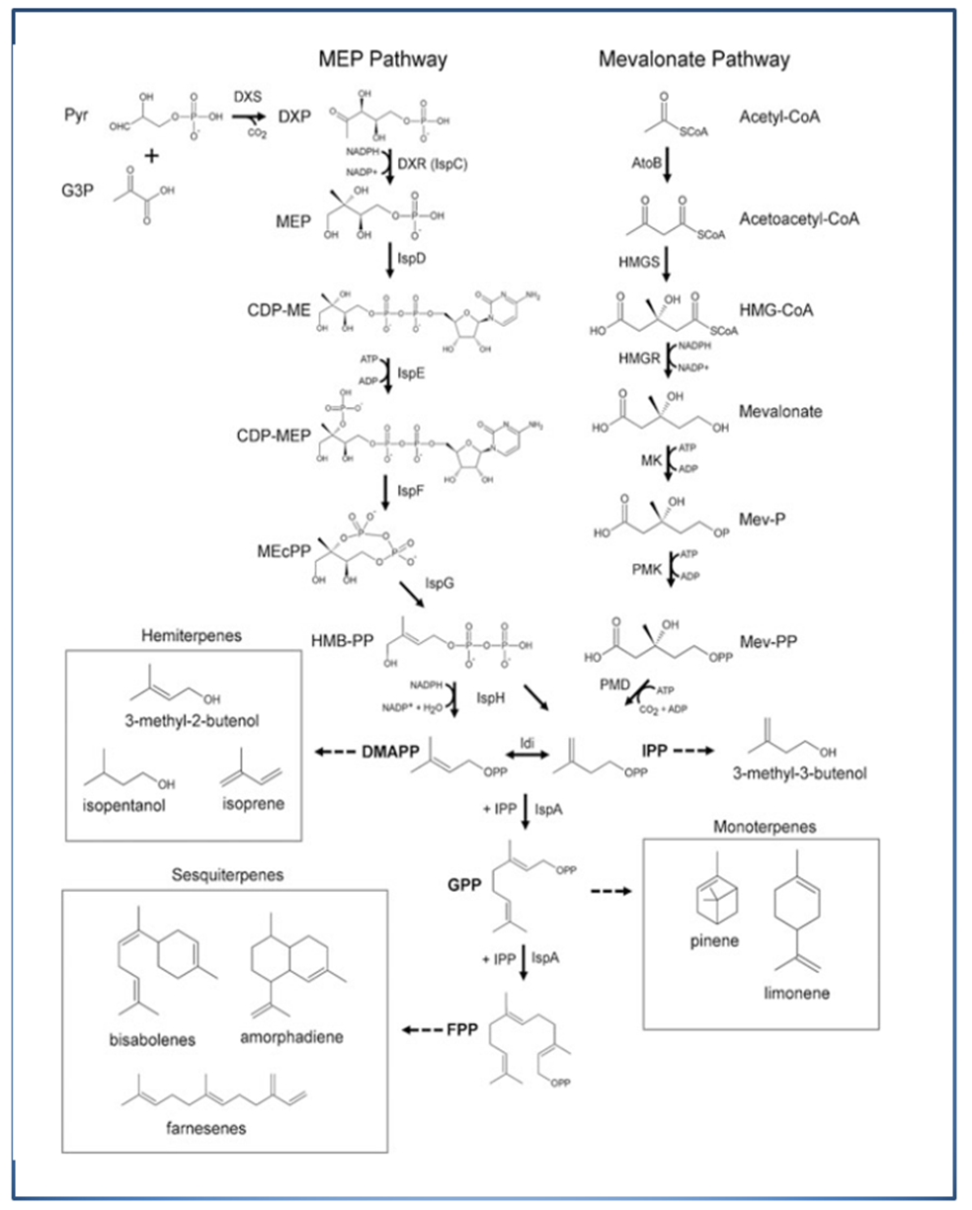
Figure 15 – The MEP and MVA pathways for the biosynthesis of isoprenoids.
Isoprenoids can be synthesized through two pathways: the 2-methyl-D-erythrito-4-phosphate (MEP), also known as the 1-deoxy-D-xylulose-5-phosphate (DXP) pathway and through the mevalonate pathway (MVA). Both pathways generate the isoprenoid precursors IPP and DMAPP. The MEP pathway initiates with the condensation of glyceral-3-aldehyde (G3P) and pyruvate into IPP and DMAPP. The MVA-pathway initiates with the condensation of three molecules of Acetyl-CoA to generate both main-precursors. The production of IPP and DMAPP leads to the production of generate-geranyl-diphosphate (GPP), followed by farnesyl-diphosphate (FPP) and geranylgeranyl-diphosphate (GGPP). To enable the formation of different and more complex terpenoids, diverse routes are followed within the pathways. A series of reactions elongate these precursors through different enzymes, which results in the high-diversity and chemical-richness of these compounds.
From (George et al., 2015).

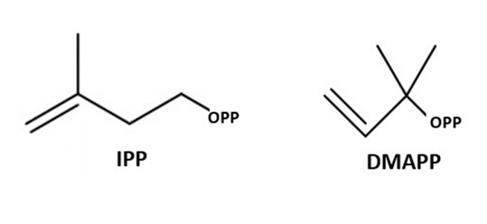
Figure 16 - Basic isoprenoid building-block precursors: IPP and DMAPP.
All isoprenoids are constructed from two basic building-block isomeric precursors: isopentenyl diphosphate (IPP) and dimethylallyl diphosphate (DMAPP). Both have a five-carbon skeleton and react in within each-other to produce the vast diversity of isoprenoids. All isoprenoids derive from these two precursors.

Although they both lead to the generation of DMAPP and IPP, the MVA and the MEP pathways synthetize these molecules slightly different. The MVA pathway constructs these two building blocks starting from three molecules of acetyl-CoA, a carbon loss occurs during the biotransformation of these three molecules. On the other hand, the MEP pathway produces DMAPP and IPP from glyceral-3-aldehyde (G3P) and one of pyruvate; by producing these compounds through the MEP pathway all the carbon available from its precursors is utilized, preventing carbon loss (Daletos et al., 2020, Kirby et al., 2014, Kung et al., 2014), thus, the MEP metabolic pathway is more carbon-efficient. This is particularly relevant given that the more carbon-efficient pathway, the MEP pathway, is the one present in the chassis or relevance, Synechocystis, which is a photosynthetic organism and which metabolism depends on carbon fixation (Bentley and Melis, 2012, Durall and Lindblad, 2015, Oliver and Atsumi, 2015), therefore, harnessing all the available carbon is vital, resulting in the MEP pathway highly crucial to be present in Synechocystis for diverting metabolic resources towards this pathway and utilizing them for biofuel production.

Furthermore, the generation of DMAPP and IPP has been described as a rate determining-step and an important control mechanism for the rest of the pathway. In this step not only does carbon harnessing occur but also, defines the type of terpenoid that will be produced at the end of the pathway, that is, the number of carbons the main skeleton will have as well as their branching (Banerjee et al., 2017, Gao et al., 2016a). Different concentrations of DMAPP and IPP could result in a vast variety of terpenoids, these varying concentrations of these two building blocks give rise to numerous more complex isoprenoids. Different concentrations and combinations of DMAPP and IPP would generate the vast array of isoprenoids at the end of the pathway (Table 5).

Table 5: Isoprenoid classification
Carbon number | Classification | Examples
5 | Hemiterpenes | Isoprene
10 | Monoterpenes | Geraniol
 |  | Pinene
 |  | Limonene
 |  | Sabinene
15 | Sesquiterpenes | Farnesene
 |  | Bisabolene
 |  | Farnesol
20 | Diterpenes | Phytol
30 | Triterpenes | Botryococcene
 |  | Squalene
40 | Tetraterpenes | Lycopadiene
5 | Isopentenols (alcohols) | Isopentenol

Table 5 - Isoprenoid structural diversity classification according to their carbon number on their main skeleton structure.
Adapted from (George et al., 2015, Zhao et al., 2016).

2.4.2 Isoprenoid chemical-richness

Fossil-based fuels are highly effective due to their physicochemical specific properties. Characteristics such as optimal carbon-length, cetane number as well as high energy-content provide fossil-fuels with maximum efficiency per litre of fuel under the required conditions (Choi et al., 2020, Das et al., 2020, Menendez-Bravo et al., 2014), and hence, equivalent physicochemical properties are desirable in any biofuel to substitute fossil-based fuels. Thus, the paramount objective in any biofuel production strategy is to equate to such properties in fossil-based fuels. The physicochemical properties between fossil-based fuels and terpenes are highly similar (Figure 17). Hence, they are considered strong candidates for substituting fossil-based fuels.

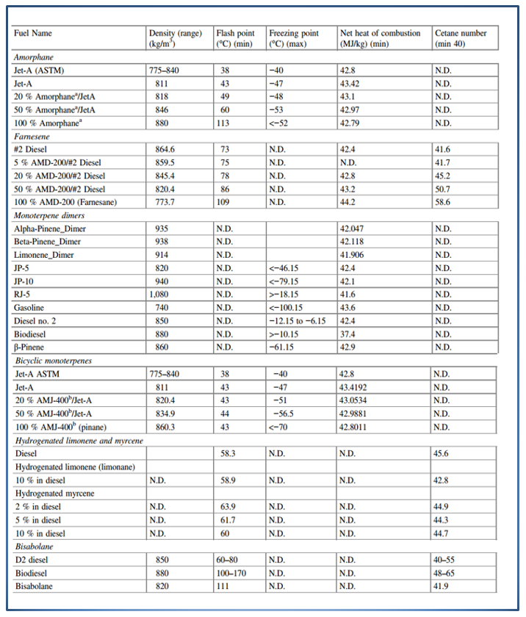
Figure 17 – Properties of fossil-based fuels and isoprenoid-based fuels.
From (George et al., 2015).

The chemical structure of terpenes is highly diverse; they hold a wide range of molecular weights as well as carbon skeletons. Within this variety, numerous isoprenoids can be found to hold similar a similar carbon-number to that in fossil-based fuels (Table 6) (Das et al., 2020, Zhao et al., 2016), optimal for their substitution.

Table 6: Carbon number of isoprenoid and fossil fuels
Terpene carbon number | Classification | Fossil-fuel to replace | Fossil fuel carbon number
5 | Hemiterpenes | Gasoline,  Jet-fuel | 5 to 10  15 to 25
10 | Monoterpenes | Gasoline | 5 to 10
 |  | Jet-fuel | 8 to 17
15 | Sesquiterpenes | Jet-fuel,  diesel | 8 to 17  12 to 30
30 | Triterpenes | Ship fuel  Jet-fuel | 30 to 40
40 | Tetraterpenes | Ship fuel | 30 to 40

Table 6 – Isoprenoid and fossil fuel carbon number and fossil fuel to substitute.
Adapted from (George et al., 2015, Lohr et al., 2012).

Furthermore, isoprenoids hold similar cetane and octane numbers as fossil-based fuels (Table 1, Figure 17), converting them in high quality fuels, able to deliver a high efficiency per litre to an engine. Furthermore, cyclic structures are commonly present in terpenoids. Such structures increase the fuel’s energy density as well as high ignition quality endowing terpenoids with further optimal qualities as fuels (Li et al., 2020). Moreover, methyl-branched structures are another desirable property to be present in a fuel given that they decrease the freezing point of the compound and increase its molecular stability. Such structures are common in terpenoids. Furthermore, the frequent cyclic as well as branched structures in isoprenoids allows them to remain liquid under low temperatures and high pressures through molecular stacking, enabling terpene transportation and implementation as fuels under extreme temperatures and pressures, required for aviation fuels (George et al., 2015b, Zargar et al., 2017). Given their similarities with fossil-based fuels and their properties, isoprenoids are promising candidates for substituting them.

The structural benefits of terpenes are due to terpene-synthases (TSs) and cytochrome-monooxygenases (P450s). Such enzymes generate rings and other cyclic and branched structures in terpenoids as well as enlarge the carbon skeletons, converting the main terpene building blocks into complex structures, which are strenuous and expensive to achieve through chemical routes (Das et al., 2020, Kirby et al., 2016, Zebec et al., 2016, Zhao et al., 2016). This highlights the significance of biological routes for the production of terpenes in Synechocystis. Almost able to equate the physicochemical properties of fossil-based fuels, biologically-produced isoprenoids are highly promising candidates for the production of biofuels.

Current Isoprenoid-biofuel production strategies in Synechocystis

As previously stated, isoprenoids are naturally produced in numerous organisms (Choi et al., 2020). However, the titres of such productions are too low in order to compete with fossil-based fuels and cover the demand (Li et al., 2020). As a consequence, genetic engineering efforts have focused on increasing such titres in Synechocystis. Such production is constituted by a series of processes taking place inside the organism, including pathway engineering and the introduction of heterologous genes. Most isoprenoid production strategies have aimed to increase the yields of the biofuel produced. As a result, yields of biofuels have been produced in high enough concentrations, bringing them closer for commercialisation and numerous terpenoid-derived biofuels and products have been successfully generated in Synechocystis (Table 7) (Bentley et al., 2014, Gao et al., 2016a, Gao et al., 2016b, Nazhand, 2020, Pattanaik and Lindberg, 2015). This not only demonstrates the capacity of Synechocystis to effectively produce isoprenoids that are relevant for biofuel production but also, its ability for up taking and expressing several heterologous genes, effective resource diversion and increase of biofuel-relevant terpene production. Furthermore, the majority of such studies reported no undesired phenotypical changes in Synechocystis (Bentley et al., 2014, Chaves et al., 2015, Pade et al., 2016), which is of benefit regarding cell-viability and the titers to be obtained. However, these results are still unable to compete with fossil-based fuels and cover the demand. Hence, a new strategy is needed in order to achieve such issue.

Table 7: Production of isoprenoid-biofuels in Synechocystis
Isoprenoid | Titers-reported | Heterologous  enzymes | Source
Bisabolene | 0.6 mg/L | Bisabolene synthases | (Reinsvold et al., 2011)
 | 179.4 mg/L | Bisabolene synthase | (Dienst et al., 2020)
Farnesene | 4.8 g/L | Farnesyl diphosphate synthases | (Jiménez-Díaz et al., 2017)
Isoprene | 320 μg/gDW /day  50ug/gDCW | Isoprene synthases | (Angermayr et al., 2015)
Limonene | 56 mg/L/day | Limonene synthases | (Kiyota et al., 2014)
 | 6.7 mg/L | Limonene synthase | (Lin et al., 2017)
Squalene | 670 μg/L  0.7mg/OD750/ L  0.8 mg/gDCW | Squalene synthases  Squalene-hopene synthases | (Englund et al., 2014)  (Choi et al., 2016)
Manoyl-oxide | 0.45 mg/gDCW | Manoyl-oxide synthases | (Englund et al., 2015)
B-Phellandrene | 3.2 mg/gDW | B-Phellandrene synthases | (Peralta-Yahya et al., 2012)
Valencene | 19 mg/g DCW | Valencene synthase | (Dietsch et al., 2021)

Table 7 – Production of Isoprenoid-based biofuels in Synechocystis.
The table illustrates the titers in milligrams per litre (mg/L), grams per litre (g/L), grams per gram of dry cell weight (gDCW), micro-grams per litre (μg/L) and optical-density at a wavelength of 750 (OD₇₅₀). The table also illustrates some of the competing-pathways such as the oxidative pentose phosphate (OPPP) and the hopanoid pathways.

Drawbacks of current strategies isoprenoid-biofuel production in Synechocystis and the GGR leverage

Current strategies for the production of terpene-derived biofuels in Synechocystis have achieved significant progress in such field and can be seen as promising. However, the present review has identified important drawbacks in such strategies. Firstly, the yields produced are not enough in order to compete with fossil-based fuels; additionally, they do not address the highly polyploid genome of Synechocystis; and finally, they also do not address the required hydrogenation process for terpenes in order to make them apt as biofuels. The following sections describe these issues in greater detail.

Insufficient yields
As previously stated, Synechocystis has a natural tendency for producing terpenes (Bentley et al., 2013, Gao et al., 2016b) and several engineering efforts have successfully achieved the production of several biofuel-relevant terpenes in the cyanobacterium (Table 7). Furthermore, most of the produced terpenoids reported no undesired phenotypical changes in Synechocystis (Bentley et al., 2014, Chaves et al., 2015, Pade et al., 2016), hence, the titers were not affected by damages to the cell viability given that none were reported. This is promising and worth of be taken into consideration when designing a strategy to increase the titers obtained. However, the titers of the reported terpenes being produced in Synechocystis are still too low in order to achieve commercialization stage, compete with fossil-based fuels and cover the demand (Hellier et al., 2013, Mewalal et al., 2017). Taking into consideration Synechocystis’ natural tendency to produce terpenes and the lack of reported unwanted phenotypical changes in the cyanobacterium cells, a new genetic modification strategy indicates to be the way to follow in order to increase the titers of isoprenoids produced in Synechocystis.

With a higher efficiency than the current genetic manipulation strategies in Synechocystis, genetic manipulation through CRISPR/Cas 9 indicates a promising strategy to follow in order to address the low titers of isoprenoids in the cyanobacterium. Such genetic manipulation strategy could decrease mutant dilution. With more chromosome copies and mutants carrying the desired mutations, it is more probable that heterologous gene expression would increase and, therefore, increase the yield of the desired terpene product.

Polyploidy in Synechocystis

As long as the high levels of polyploid presented by Synechocystis are not addressed, any biofuel-producing engineering effort will remain to be subjected to mutation dilution and/or deletion, which will generate low or null titers of the desired product and will only make the process less cost-effective and will make isoprenoid-derived biofuels unable to compete with fossil fuel prices, decreasing their feasibility. The current genetic engineering methodologies implemented by such biofuel production strategies must be re-evaluated in order to achieve further progress in the field. Technologies such as CRISPR/Cas 9 might be able to overcome such drawback and leverage the production of terpene-derived biofuels in Synechocystis.

The hydrogenation process

Isoprenoids, terpenoids or terpenes are promising candidates for the production of biofuels given that their physicochemical properties are highly similar (Das et al., 2020, Li et al., 2020). However, current terpenoid-derived biofuel strategies in Synechocystis do not address the need for the hydrogenation process in isoprenoids. The production of terpenes as biofuels in Synechocystis generates a biofuel-precursor (Tracy et al., 2009). Such precursors are not yet fully hydrogenated, that is to say that they cannot act as fuels until they achieve such state. Through the hydrogenation process, precursors are fully reduced (or saturated) and hence, enabled as fuels (Zhang and Zhao, 2015), becoming “ready to use” fuels. Currently, the hydrogenation of isoprenoid biofuel precursors is done following a chemical route and is quite expensive, which is an economic hindrance for these biofuels given that it increases the overall production cost of the biofuel, hindering its feasibility and makes them unable to compete with fossil-fuel costs. Therefore, it is necessary to adopt a strategy that takes into consideration the in vivo saturation state of the terpenoid biofuel precursors to eliminate the costly chemical hydrogenation and decrease the biofuel production cost. This can be achieved with biological routes that substitute the chemical hydrogenation process of isoprenoids in Synechocystis.

Although not in Synechocystis, a few biofuel strategies have focused on the hydrogenation of terpenoids through biological routes. Recent studies have reported the enzyme geranyl-geranyl reductase (GGR) to be able to partially hydrogenate limonene in E. coli (Isobe et al., 2014, Murakami et al., 2007, Sato et al., 2008). Nevertheless, the enzyme is not capable of full reductions in such chassis (Matsuoka et al., 2001). GGR is NADPH-dependent and given the low amount of readily available NADPH in E. coli (Kiyota et al., 2014, Kung et al., 2014), such chassis might be considered not optimal for GGR activity. On the other hand, NADPH are naturally and readily available in Synechocystis through photosynthesis (Choi and Lee, 2013, Zargar et al., 2017). This might contribute to enabling GGR for full-saturations and eliminating the need of chemical-hydrogenation of isoprenoids.

Even though this enzyme is not capable yet of full reductions, it is necessary to redirect genetic engineering efforts in order to endow GGR of full hydrogenating capabilities. A chassis with the proper environment, such as Synechocystis, could be beneficial to such objective as well as to the purpose of reducing the production costs of terpene-derived biofuels to leverage such biofuels, increase their feasibility and to make them able to compete with fossil fuels. At par with isoprenoids, methyl ketone-derived biofuels are as well highly promising candidates for biofuel production.

Methyl ketone-derived biofuels

As in the case for terpenes, methyl ketones-derived biofuels have been described as well as highly promising candidates for substituting fossil-based fuels. The following sections describe their advantages.

Methyl ketone benefits as biofuels

Methyl ketones are promising candidates for fossil fuel substitutes given that they share several physicochemical properties with them (Table 8). Firstly, their main carbon skeleton falls within a range that is ideal for substituting diesel and gasoline (Das et al., 2020).

Table 8: Methyl ketone and fossil fuels physicochemical properties
Fossil-fuel | Energy density  (MJ/Kg) | Freezing point  (°C) | Flash point  (°C) | Carbon length | Cetane number | Octane number
Jet-fuel | 41.6 to 43 | -79.15 to - 18.15 | 38 to 43 | 8 to 17 | 36 to 47 | 15 to 25
Diesel | 42.4 to 43.6 | -12.15 to- 6.15 | 58.3 to 80 | 10 to 20 | 40 to 55 | 25 to 30
Gasoline | 43.6 | <-100.5 | 43 | 5 to 10 | 0 to 17 | 80 to 100
Short chain methyl ketones | 43 | -51 | 39 | 5 to 7 | 57 | 98
Medium chain methyl ketones | 42 | -25 | 30.5 | 11 to 15 | 56.6 to 58.4 | 27
Table 8 – Methyl ketone and fossil fuel physicochemical properties.
Adapted from (Goh et al., 2012, Harrison and Harvey, 2018, Jenkins et al., 2016).

Short chain methyl ketones, such as 2-pentanone (Figure 18), hold a main carbon skeleton that ranges from 5 to 7 carbons, which makes them ideal for gasoline substitutes. On the other hand, medium chain methyl ketones, such as 2-dodecanone (Figure 19), present a main carbon skeleton that bears 11 to 15 carbons (Table 8) (Singhal et al., 2020, Yuzawa et al., 2018), making them ideal for substituting diesel fuels. Moreover, short and medium chain methyl ketones present favourable octane/cetane number for substituting fossil-based gasoline and diesel respectively (Table 8) (Harrison and Harvey, 2018, Jenkins et al., 2016); endowing them with high quality fuel properties able to deliver energy at a high efficiency per litre of fuel and which will also have a positive impact of the carbon emissions of such fuel. Moreover, methyl ketones can present a range regarding their degree of saturation. Saturated methyl ketones tend to present ideal cetane numbers for fuel candidates (Das et al., 2020), therefore, an ideal scenario for methyl ketone biofuels would be that with the production of saturated methyl ketones. Furthermore, they are easy to harvest and blend. Methyl ketone molecules are easily secreted from cells and can be effortlessly englobed or trapped by organic substances and its blending procedures into diesel fuel is less strenuous when compared to other biofuels, such as those derived from free fatty acids, for instance (Dong et al., 2019). With physicochemical characteristics almost equating those in fossil-derived biofuels, methyl ketones are highly promising candidates for the production of biofuels.

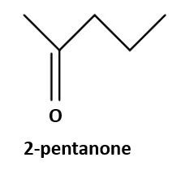

Figure 18 – Example of short chain methyl ketone, 2-pentanone.

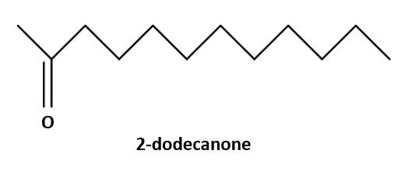

Figure 19 – Example of medium chain methyl ketone, 2-dodecanone.

Methyl ketone biosynthesis

Aliphatic methyl ketones are a group of compounds that can be naturally found in a variety of organisms including bacteria, plants and mammals. They have diverse applications in the dairy, insecticide and fragrance industries (Beller et al., 2015, Dong et al., 2019). Recently they have gathered attention as diesel and gasoline substitutes.

The literature suggests that methyl ketones can be synthesized from diverse metabolic pathways, including the aerobic alkene/alkane degradation pathway, the stigmasterol pathway and the β-oxidation fatty acid pathway (Forney and Markovetz, 1971, Patel et al., 1980, Raczyk et al., 2017, Singhal et al., 2020). Nevertheless, the biosynthesis of methyl ketones has not been as widely studied as the other compounds. However, from all the available pathways, the β-oxidation fatty acid pathway seems to be the most relevant, although the entire set of steps of such pathway regarding the biosynthesis of such compounds has not yet been elucidated in many organisms (Das et al., 2020, Kour et al., 2016). Nevertheless, the β-oxidation fatty acid pathway in E. coli has been partially described and hypothesised to generate methyl ketones in the organism (Figure 20). Such pathway initiates with the transformation of free fatty acids into acyl-Coenzyme A (CoA); the next step is the oxidation of acyl-CoA to 2-enoyl-CoA; afterwards, this compound is then hydrated to β-hydroxyacyl-CoA; which undergoes a subsequent oxidation and is converted into β-ketoacyl-CoA. Consequently, the molecules of ketoacyl-CoA are converted into β-ketoacid and this compound is finally transformed into methyl ketones (Dong et al., 2019, Goh et al., 2012). In this pathway, some key steps have been described. Two genes have been identified as essential for the production of methyl ketones from fatty acids, which are the genes encoding for the enzymes methyl ketone synthase I (ShMKS1) and methyl ketone synthase II (ShMKS2) (Ben-Israel et al., 2009, Fridman et al., 2005, Yu et al., 2010). ShMKS1 and ShMKS2 are naturally occurring in a wild tomato species (Solanum habrochaites) and, in spite of their relevance to the biofuel and other industries, they have not been widely targeted in many engineering strategies (Goh et al., 2014). ShMKS2 carries out the function of hydroxylation over a β-ketoacyl carrier protein (ACP) in order to produce β-keto acid, this reaction can also be carried out by the enzyme FadM when the substrate is β-ketoacyl-CoA (Forney and Markovetz, 1971, Spencer et al., 1978). Subsequently, ShMKS1 executes a decarboxylation over β-ketoacyl-ACP to generate methyl ketone molecules (Park et al., 2012). This last reaction has been described as spontaneous in some organisms (Goh et al., 2012), which only highlights the need for further attention to the production of these compounds and their pathways control steps. Nevertheless, directing research attention towards such key genes might dictate the efficiency of the production of methyl ketones.

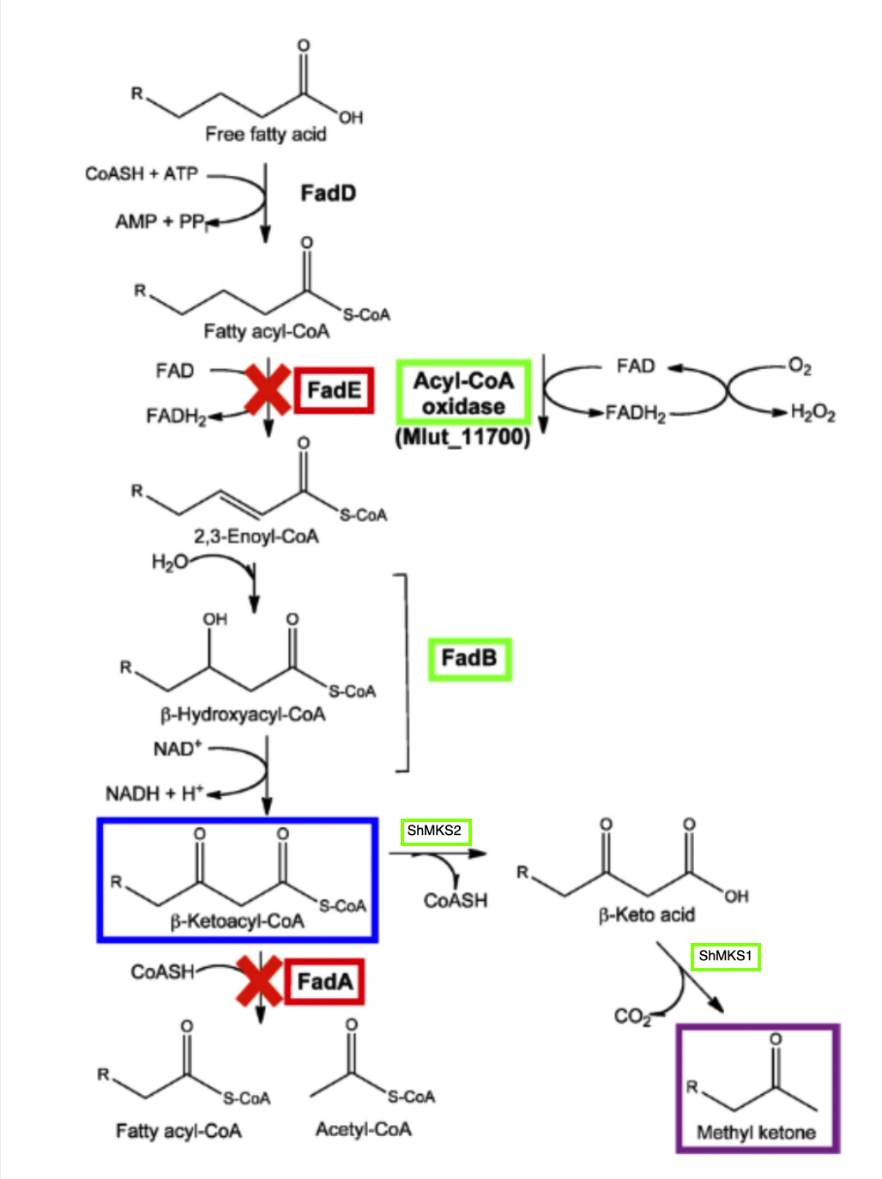
Figure 20 – Summarized engineered (colours) and natural (black) fatty acid β-oxidation pathway for the production of methyl ketones in E. coli.
Adapted from (Goh et al., 2012).

2.5.3 Benefits of methyl ketone-biofuel production in Synechocystis

The production of methyl ketone derived biofuels in several bacteria have achieved significant titers, however, none of these strategies have been implemented in Synechocystis, which might present further advantages for such purpose. For instance, current methyl ketone strategies have had to transfer full pathways and their respective set of enzymes into their selected chassis (Goh et al., 2012, Goh et al., 2014, Lan et al., 2013, Müller et al., 2013a, Nie et al., 2008, Park et al., 2012, Yoneda et al., 2014). The transfer of whole pathways as well as numerous genes can generate significant levels of metabolic burden (Bentley et al., 1990, Brosnan et al., 2011, Wu et al., 2016), which can lead to the an overexploitation of the chassis organism and end up being reflected in decreased titers. Therefore, a strategy where not a full pathway transfer is necessary might be beneficial given that it would imply that less metabolic burden would be generated on the chassis and hence, an increase in the titers of the desired product might be observed, which is the case of the production of methyl ketones in Synechocystis.

Although not fully developed to produce methyl ketones, a fatty acid pathway is presumed to exist in Synechocystis (Figure 21). It is a cyclical pathway that, can be said, initiates with the conversion of acyl-ACP into Manoyl-ACP and furtherly presents a series of reactions that culminate in the production of trans-2-enoyl-ACP, which is cyclically converted again into acyl-ACP to start the pathway again (Kizawa et al., 2017). When compared to the native fatty acid pathway in E. coli for the production of methyl ketones, the pathway in Synechocystis covers up to the production of β-ketoacyl-ACP (Figure 21); in the E. coli pathway, this is subsequently converted into β-ketoacid and then into methyl ketones, so the pathway in Synechocystis covers up to approximately 80% of the native fatty acid pathway in E. coli. Therefore, only a small section of the pathway would have to be transferred into Synechocystis in order to produce methyl ketones, decreasing the metabolic burden imposed in the cyanobacterium and possibly yielding higher titers of the desired compound. This portrays to be a more efficient strategy for the production of methyl ketones than the transfer of a whole pathway from one organism to another and, hence, can be seen a promising strategy for the production of methyl ketone biofuels in Synechocystis.

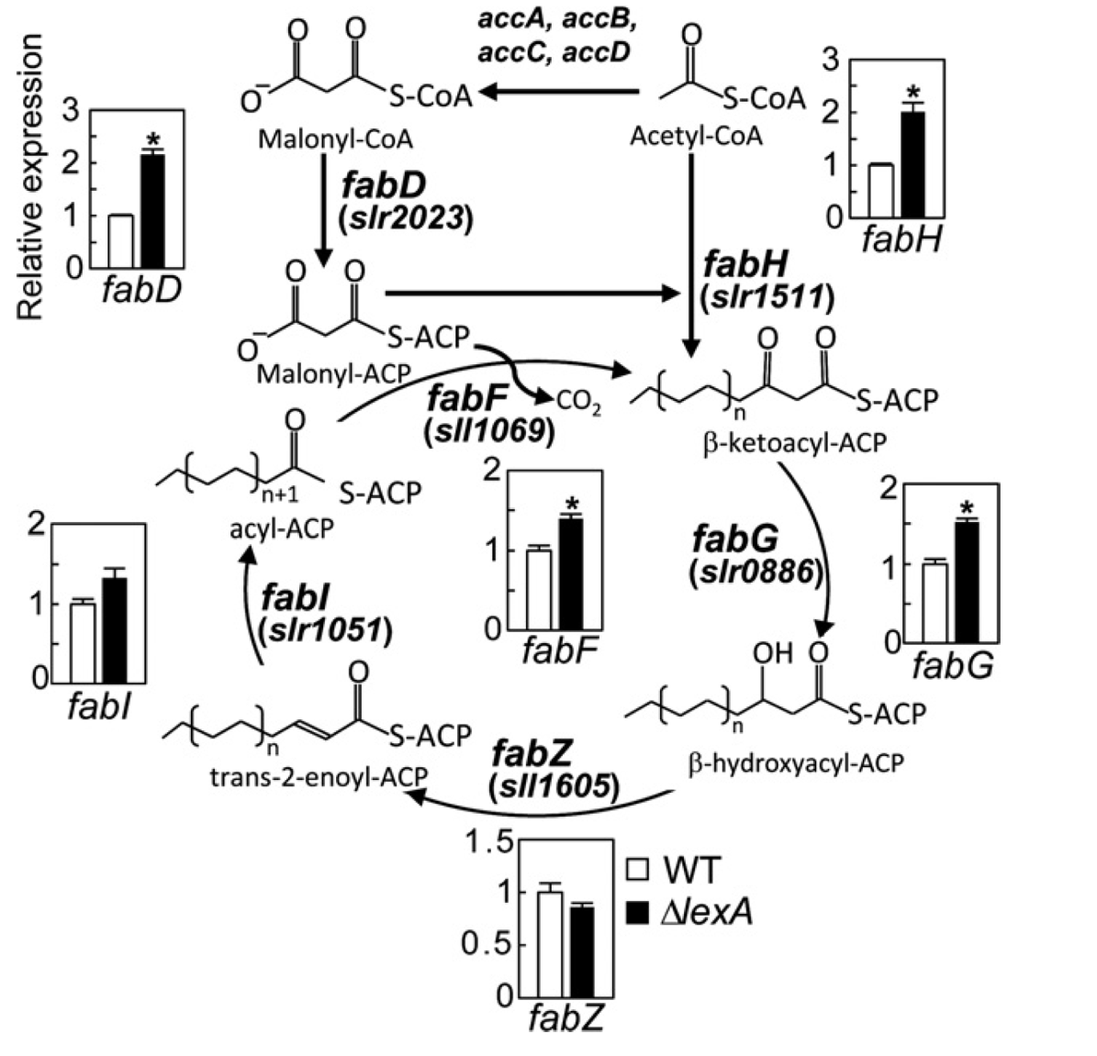

Figure 21 – Presumed fatty acid pathway in Synechocystis.
The red circle indicates where the remaining part of the pathway should be inserted in order to obtain methyl ketone production from this pathway.
From (Kizawa et al., 2017).

Harvesting cyanobacteria

For the cases of methyl ketone biofuels, methyl ketones are secreted by Synechocystis, which makes them easier to harvest once there are secreted into the media. For isoprenoid biofuels, Synechocystis cells must be harvested or separated from the aqueous phase of the media to subsequently extract the desired compounds from the cyanobacterial cells. This cell-liquid separation or dewatering is considered a major drawback in the biofuel production industry, being one of the factor that significantly increases the production costs of biofuels (Brentner et al., 2011, Sharma et al., 2013, Zhang et al., 2021), decreasing their feasibility. Cell-liquid separation must be done in an efficacious, energy-effective as well as a cost-effective manner. Dewatering techniques include centrifugation, filtration, flotation and sedimentation (Gerardo et al., 2015, Mo et al., 2015, Serrà et al., 2021, Sobczuk et al., 2015), however, not all of them signify the most favourable route for harvesting cyanobacteria.

Centrifugation, filtration and flotation are well-established methods for cell-liquid separation that have been proven effective, nevertheless, they are highly expensive, difficult to implement at industrial levels since they require equipment and machinery and are also energy-intensive (Ananthi et al., 2021, Chatsungnoen and Chisti, 2016, Sobczuk et al., 2015). Therefore, a strategy that is more cost-effective would be more adequate since decreasing biofuels production costs is one of the objectives for enabling biofuels to compete with fossil fuels. Hence, other harvesting techniques must be considered.

Flocculation accompanied by sedimentation is another well-established dewatering method. It is the most cost-effective dewatering technique as well as easy to implement since it does not require machinery and equipment (Cheng et al., 2021), so it is not energy-intensive. Furthermore, flocculation has been highlighted as one of the most effective harvesting techniques for microalgae (Sharma et al., 2013). Since single cells would not sink to the bottom by gravity due to their low density, this strategy consists of adding a flocculant to the culture to generate cell aggregates dense enough in order to sink to the bottom just by gravity (Zhao et al., 2021). The flocculant neutralizes the negatively-charged surface of the cells that prevents these to aggregate naturally. This charge neutralization allows cells to aggregate (Henderson et al., 2008, Ndikubwimana et al., 2015). Various types of flocculants are used to achieve these results including salts of metal ions such as ferric chloride and aluminium sulphate (Gorin et al., 2015); cationic polymers, although they are considered not cost-effective when compared to salts (Chen et al., 2015, Gorin et al., 2015, Roselet et al., 2015, Wu et al., 2015); acids, although these are needed in high volumes to reach the desired effect (Pezzolesi et al., 2015) and organic biopolymers, such as chitosan (Rwehumbiza et al., 2012, Şirin et al., 2013) . Inorganic salts have been reported to contaminate the harvested culture (Chua et al., 2019), affecting its purity. Inorganic salts result in cell lysis, affecting the yields obtained. Also the use of inorganic salts adds additional steps during downstream processing to remove metals from the final product (Pezzolesi et al., 2015, Roselet et al., 2015). Organic biopolymers, including chitosan do not lyse the cells during flocculation and therefore greater recovery of the intracellular product is theoretically possible. Also as organic biopolymers are very similar in their properties to cell wall components, they do not need a dedicated downstream processing step to remove them. Furthermore, organic biopolymers are more cost-effective than all the previously mentioned options, such as centrifugation (Roselet et al., 2015).

Chitosan is a natural polymer insoluble in water generated by the deacetylation of chitin, a derivative of glucose commonly found in fungi and exoskeletons of arthropods (Chen et al., 2014, Rashid et al., 2013b). Chitosan can be found in the exoskeletons of crustaceans (Zheng et al., 2012) and has increasingly gattered attention as a flocculant for microalgae and cyanobacteria given that it is non-toxic, biodegradable and biocompatible and renewable (Chen et al., 2014). Furthermore, chitosan is a favoured flocculant due to its structure and its charge interactions with the surface of algal and cyanobacterial cells. Chitosan is formed by peripheral positively charged amino groups (NH₂) and a glucosamine function unit (Figure 22) (Chua et al., 2019).

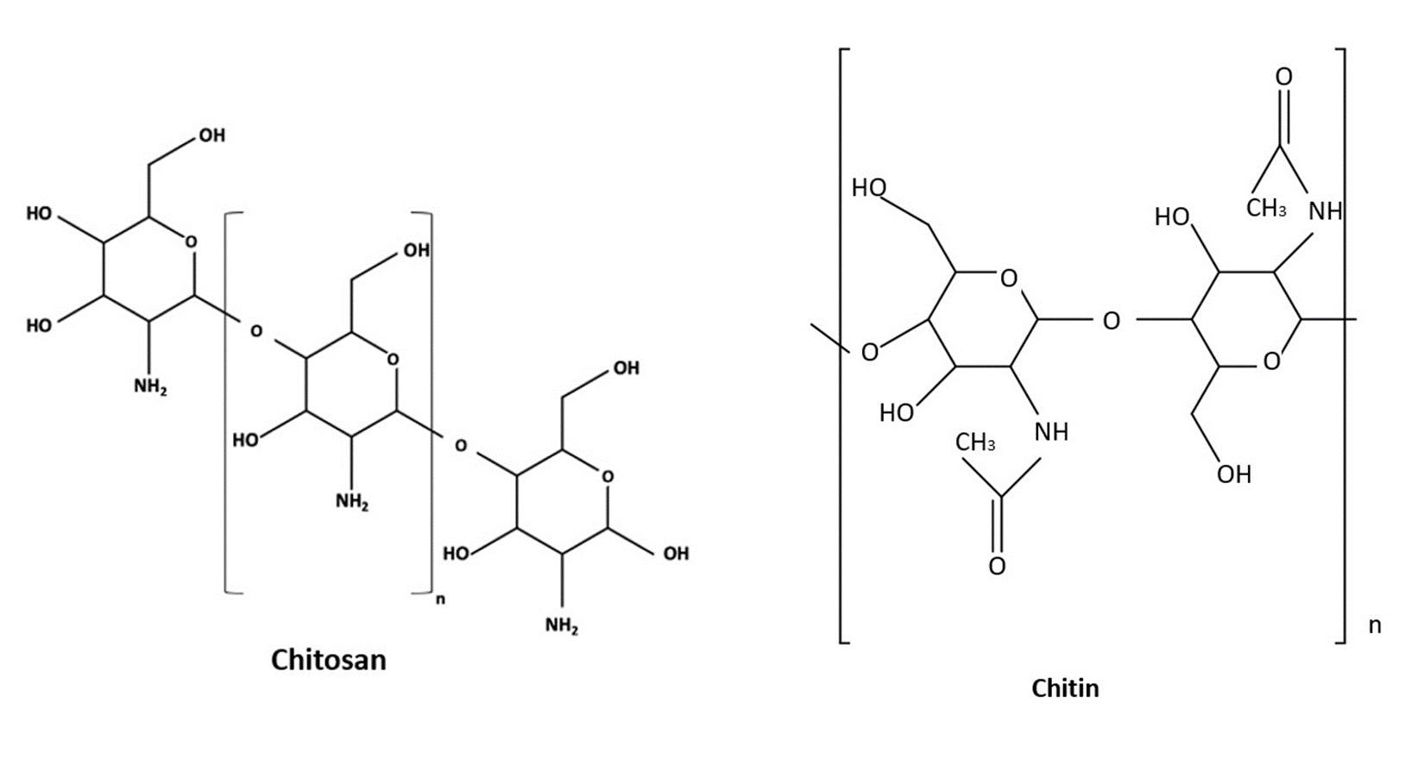
Figure 22 – Chemical structure of chitosan and chitin.

The surface of algal and cyanobacterial cells is negatively charged. The positive charge in the amino groups will neutralize the negative charge of the cells, this will allow the formation of aggregates or flocs among the cells given that their repellent negative charge has been neutralized (Chua et al., 2019). This mechanism of action has been found quite effective. Chitosan has been reported to effectively flocculate 90% of cells at a concentration of 5 mg/L (Divakaran and Pillai, 2002), which is a concentration considered low when compared to the required concentrations of other flocculants, such as acids. Nevertheless, studies have shown that significantly large quantities of chitosan, up to 200 ppm, are required in order to achieve flocculation in microalgae, such as Nannochloropsis sp. (Farid et al., 2013, Şirin et al., 2013). Nevertheless, flocculation/sedimentation using chitosan is the most cost-effective dewatering method without compromising effectiveness. Hence, chitosan is the favoured flocculant to implement in the sedimentation/flocculation technique in Synechocystis.

According to the literature, chitosan can efficaciously flocculate algae at concentrations that range from 5 mg/L to 200 mg/L (Chen et al., 2014). A study by Divakaran and Sivasankara Pillai implemented chitosan to flocculate several microalgae species and Synechocystis. The study reported a percentage of turbidity removed ranging from 48 to 90% when implementing 5 mg/L of chitosan, finding pH as a key element to affect flocculation (Divakaran and Pillai, 2002). Other studies reported a turbidity removal of 100% from Chlorella sp. and Skeletonema costatum at chitosan concentrations of 20 mg/L and 2 mg/L respectively (Ahmad et al., 2011, Morales et al., 1985). Other efforts have obtained a turbidity removal of more than 90% with a chitosan concentration ranging from 5 to 214 mg/L (Beach et al., 2012, Chang and Lee, 2012, Farid et al., 2013, Heasman et al., 2000, Riaño et al., 2012, Xu et al., 2013). Another study reported a turbidity removal of more than 90% with a chitosan concentration of 15 mg/L in Synechocystis (Divakaran and Pillai, 2002). With this into consideration, chitosan can be highlighted as a successful flocculant.

Therefore, there is no doubt that chitosan is effective in flocculating microalgae and cyanobacteria. Nevertheless, given the highly varying concentrations of chitosan required coupled with its price, for achieving industrial and commercial levels, it is imperative to reduce the costs and quantities of chitosan required regarding the overall costs of biofuel production by directing research focus to elucidating the optimal concentrations of chitosan required to flocculate a specific organism, in this case Synechocystis under specific conditions of pH and salinity.

Summary

To summarize, the need to find a biofuel that equates the physicochemical properties of fossil fuels is imperative in order for it to be able to deliver similar amounts of energy per L. 3G biofuels are a promising alternative, although, biofuels derived from microalgae bear an important drawback since their genetic plasticity is reduced and their production rates are lower than, for example, bacteria. On the other hand, cyanobacteria hold an increased genetic malleability and higher production rates than microalgae, advantages that positions cyanobacteria as better candidates to produce biofuels of relevance.

Being the model cyanobacteria, Synechocystis is a highly promising chassis for genetic engineering for the production of biofuels. However, its high polyploidy is an important drawback that must be considered given that it could hinder full mutant segregation and decrease the yields of the desired product. This has been addressed by implementing strategies such as DHR coupled with several rounds of selection and counter selection. However, full mutant segregation still remains difficult to achieve with these strategies are still. To contrast, new technologies have emerged and are promising in regards to addressing this issue. Such is the case of CRISPR/Cas9, which holds the potential of overcoming the obstacle of high polyploidy in Synechocystis and facilitate the achievement of full mutant segregation in the cyanobacterium due to its simplicity and cited effectiveness. With this in mind, it remains to couple this strategy with an equally promising biofuel candidate to engineer.

Isoprenoids and methyl ketones are highly promising biofuel candidates given that they equate the physicochemical properties of biofuels. The energy per L they deliver is comparable to that of fossil-fuels. Therefore, they are optimal biofuel candidates to engineer in Synechocystis using CRISPR/Cas9.

Moreover, cell harvesting has been highlighted as a bottleneck step in biofuel production. Strategies such as centrifugation and filtration have been found effective but highly expensive. On the other hand, flocculation has as well been reported as an effective harvesting strategy, although, more cost-effective than the previously mentioned ones. More specifically, chitosan has been reported as a highly effective bioflocculant that is able to flocculate the cells while maintaining their integrity and without damaging them. Hence, developing a chitosan-based cell harvesting method is highly significant.

Altogether, this strategy results highly promising and holds important attributes that might leverage terpene and methyl ketone-derived biofuels and Synechocystis as a biofuel producer.

Chapter 3
Strain engineering:
Generation of a squalane producing strain of Synechocystis using CRISPR/Cas9

3. Chapter 3. Strain engineering: Generation of a squalane producing strain of Synechocystis using CRISPR/Cas9

3.1 Introduction

3.1.1 Traditional genetic modification in Synechocystis: DHR

One of the main objectives of the present dissertation is to engineer Synechocystis to produce isoprenoid-derived biofuels. However, conventional genetic modification relies on double homologous recombination (DHR), which remains challenging for highly polyploid organisms, such as Synechocystis.

DHR is a naturally occurring mechanism in cyanobacteria, including Synechocystis. Engineering using DHR enables a variety of genetic modification events, from indels to targeted mutations (Trautmann et al., 2012, Wang et al., 2012, Watanabe, 2020), facilitating the genetic modification of the cyanobacteria, increasing their genetic plasticity and ultimately, favouring their selection as host for generating a vast array of products. However, in order to be successful in such strategies, the complete segregation of mutants is crucial (Berla et al., 2013, Pope, 2020), which is challenging for organisms with highly polyploid genomes, such as Synechocystis (Caicedo-Burbano et al., 2020, Zerulla et al., 2016).

To tackle this challenge, DHR conjoined with selective pressure is commonly implemented. Even though significant success has been achieved with this strategy and the fully segregated mutants in highly polyploid organisms has been accomplished, the strategy is extremely arduous, time-consuming and not cost-effective given that, after homologous recombination, numerous rounds of selective pressure have to be carried out and, in spite of this, full mutant segregation is not guaranteed (Hitchcock et al., 2020, Pope, 2020, Taton et al., 2017). Thus, a genetic modification strategy that is not hindered by the highly polyploid genome if Synechocystis is required.

Given these reasons, it became apparent to the present dissertation that a different genetic modification strategy had to be followed. Therefore, it became a pivotal objective for this PhD investigation to implement CRISPR/Cas9 as the means for the genetic modification of Synechocystis.

3.1.2 Full mutant segregation through CRISPR/Cas 9

CRISPR/Cas9 is a highly effective, precise, easy to implement and cost-effective genome editing technology that emerged from an adaptive immune system identified in archaea and bacteria (Anzalone et al., 2020, Jinek et al., 2012, Sasano et al., 2016). Its effectiveness relies on the simplicity of its mechanism of action.

First, a modifiable single guide RNA (sgRNA) guides and attaches itself, along with a nuclease (Cas9) to a target section of the DNA of the host genome. Once attached, Cas9 effectuates a DSB on the target DNA. Unlike other genetic modification tools, the attachment of the CRISPR guide to the target DNA sequence is based on sequence complementarity, which are much less intricate than protein-DNA interactions (Davis and Maizels, 2014, Jinek et al., 2013, Overballe-Petersen et al., 2013, Sternberg et al., 2014, Yip, 2020). Subsequently, the DSB will then be repaired by the cell machinery through the homology directed repair pathway and allow the insertion of an also modifiable donor DNA in the region of the DSB (Anzalone et al., 2020, Barrangou and Marraffini, 2014, Jinek et al., 2012, Jinek et al., 2013). The homology directed repair is highly effective, clean and specific and the insertion of the donor DNA while repairing the cut results in a highly precise and multiple deletion of genes and the insertion of new mutations at specific locations (Alberts, 2008). Given that it accts upon sequence complementarity rather than protein-DNA interactions, CRISPR/Cas9 has the potential of overcoming the obstacle of high polyploidy in the genetic engineering of Synechocystis and constitute a more effective genetic engineering strategy for the cyanobacterium.

Due to these reasons, it became a crucial objective for this dissertation to design and construct CRISPR/Cas9 tools for Synechocystis in order to engineer it under such strategy for the production of biofuels.

3.1.3 Squalane biofuel in Synechocystis

Squalane (Figure 23) is an isoprenoid and being such, it holds highly valuable properties as a biofuel. Characteristics such as optimal carbon-length, cetane number, freezing point as well as high energy-content provide squalene with maximum efficiency per litter of fuel and make it an ideal candidate for substituting fossil-based jet as well as ship fuel (Daletos et al., 2020, Lee et al., 2015, Menendez-Bravo et al., 2014).

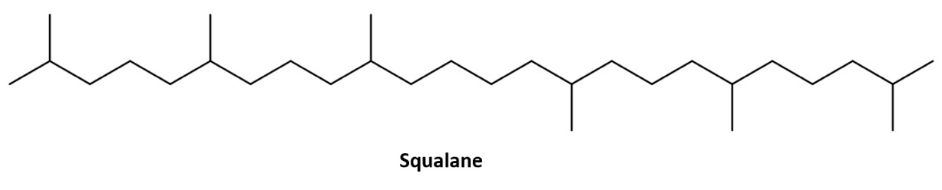
Figure 23– Chemical structure of squalane.

Despite its multiple qualities, the present dissertation found no evidence of squalane being produced in any host organism through genetic engineering. On the other hand, its non-hydrogenated version, squalene, is naturally produced by Synechocystis (Choi et al., 2016, Englund et al., 2014). However, not being fully hydrogenated, squalene is not apt to function as a biofuel. It must be subjected to processes of full hydrogenation to become squalane. These processes are currently chemical and expensive (Das et al., 2020, Zhang and Zhao, 2015), which hinders the economic feasibility of squalane as a biofuel. Hence, alternative strategies must be followed, such as biologic routes.

Recent investigations have found hydrogenating properties in the enzyme geranyl-geranyl-reductase (GGR). GGR has been reported to be able to partially hydrogenate isoprenoids in organisms such as E. coli (Isobe et al., 2014, Murakami et al., 2007, Sato et al., 2008). Possible explanations for the only partial hydrogenating activity of the enzyme include host environment and the availability of enzymatic co-factors. GGR is a NADPH-dependent enzyme and such co-factor is not readily available in organisms where the enzyme has been proven to partially hydrogenate isoprenoids, such as E. coli, which might not be an optimal host for the enzyme’s activity (Kiyota et al., 2014, Kung et al., 2014). On the other hand, NADPH is naturally and readily available in Synechocystis (Choi and Lee, 2013, Zargar et al., 2017). This might position the cyanobacterium as an optimal candidate for the effective functioning of the GGR and allow the fully hydrogenating activity of the GGR to be achieved, conceding the production of squalane in such host organism and leveraging the production of squalane as a biofuel. Hence, following the biological route for the hydrogenation of squalene through the GGR enzyme portrays to be a promising strategy.

For the reasons mentioned above, one of the main objectives of the present dissertation is to engineer Synechocystis to perform the insertion of the GGR enzyme in its genome with an equally promising genetic engineering strategy, CRISPR/Cas9, with the purpose of producing squalane to leverage it as a biofuel substitute for fossil-based jet and ship fuel.

3.2 Chapter aims

The aim of this Chapter 3 is described in the following lines:

- To improve the saturation-state of isoprenoid-biofuel precursors via in vivo production to generate “ready-to-use” biofuels through the insertion of heterologous geranyl-geranyl-reductase (GGR) in mutants of Synechocystis sp. PCC 6803.

- To design and develop two CRISPR/Cas9 tools specific for Synechocystis sp. PCC 6803, an sgRNA and a dDNA, to tackle the highly polyploid genome of the cyanobacterium, achieve full mutant segregation, allow the production of squalane in the cyanobacterium.

3.3 Materials and methods

3.3.1 Materials

A list of the materials, including detailed information regarding the reagents, kits, enzymes, equipment and software used in this chapter can be found in Appendixes 1, 2 and 3. Unless specified otherwise, the solutions in the present section were prepared with distilled water (dH₂O) from a Barnstead Smart 2 Pore 6 water filtration unit. All the solutions that required autoclaving were sterilised with a Priorclave Tactrol 2 autoclave at 121 °C and 1.5 atm for 30 minutes. The reagents implemented in this section as well as the kits and equipment were the highest grade and quality available.

3.3.2 Strains, plasmids and constructs implemented

All the strains, plasmids as well as constructs and primers used in this Chapter 3 are listed in the following Table 9.

Table 9: List of strains, plasmids, constructs and primers used in this chapter
Strain, plasmid, construct or primers | Description | Source
Strains
E. coli 10-Beta | High efficiency cloning strain | New England BioLabs, UK
E. coli pPMQK1 | E. coli copy cutter strain bearing the plasmid pPMQK1::Cas 9, Km^{R} | Dr. Paul Hudson research group, Science for Life Laboratories, Karolinska Institute, Stockholm, Sweden
E. coli MC1061 | Conjugal helper strain carrying the helper mobility plasmids pRK24 and pRL528, Amp^{R} and Cm^{R} | Dr. Alastair McCormick research group, Centre for Synthetic and Systems Biology, University of Edinburgh, UK
∆Synechocystis::Cas 9 | Strain bearing the Cas 9 gene, Km^{R} | This work
∆Synechocystis::Cas 9_sgRNA_GGR-dDNA | Strain bearing the Cas 9 gene and the sgRNA_GGR-dDNA construct, Km^{R} | This work
Synechocystis sp. PCC 6803 (Accession number: GCA_000009725.1) | Wild type | Pasteur Institute, Paris, France
Plasmids backbones
pPMQK1 | Plasmid bearing the Cas 9 gene, Km^{R} | Dr. Paul Hudson research group, Science for Life Laboratories, Karolinska Institute, Stockholm, Sweden
pEERM4 | Plasmid no. 64026 for integration into neutral site slr2030-31 of Synechocystis, Cm^{R} | Addgene, USA
Plasmids constructed
pEERM4::sgRNA_GGR-dDNA | Plasmid bearing the sgRNA construct and the GGR-dDNA construct, Cm^{R} | This work
Constructs
sgRNA | Construct designed to guide Cas 9 and ShMKS-dDNA to the target site | Design: this work, synthesized: Eurofins Genomics, Germany
GGR-dDNA | Donor DNA construct bearing the GGR gene | Design: this work, synthesized: Eurofins Genomics, Germany
Primers (5’ to 3’)
Mutant segregation primers | Forward: gccgaagcaggggaaactccta  Reverse:  tggcttggtcatcagcggc | This work
Cas9 primers | Forward:  ataggcgtatcacgaggcaga  Reverse:  tcattaagcagctctaatgcgc | This work
Table 9 – List of strains, plasmids, constructs and primers implemented in Chapter 3 of the present dissertation. Abbreviations: Km^{R}, kanamycin resistance; Cm^{R}, chloramphenicol resistance; Amp^{R}, ampicillin resistance.

3.3.3 Growing conditions of bacteria

3.3.3.1 Growing conditions of E. coli strains

The high efficiency E. coli 10-Beta strain (NEB) was used for all the molecular cloning experiments, plasmid propagation and maintenance. E. coli 10-Beta cells were cultivated at 37 °C in sterile lysogeny broth (LB) medium at an orbital agitation of 250 rpm. When required, the medium was supplemented with chloramphenicol, at a concentration of 25 µg/mL. E. coli copy cutter pPMQK1 cells were cultivated at 37 °C in sterile LB medium at an orbital agitation of 250 rpm. The medium was supplemented with kanamycin, at a concentration of 50 µg/mL. The strain was used for the propagation of the Cas9 gene. E. coli MC1061 cells were cultivated at 37 °C in sterile LB medium at an orbital agitation of 250 rpm. The medium was supplemented with chloramphenicol at a concentration of 25 µg/mL and ampicillin at a concentration of 100 µg/mL. The strain was used as a helper strain in all conjugation (tri-parental mating) events with Synechocystis.

3.3.3.2 Growing conditions of Synechocystis strains

Synechocystis cells were grown photoautotrophically in sterile Blue-Green liquid medium (BG-11). One litre of BG-11 medium was prepared by adding the following chemicals, in the quantities respectively indicated, to 1 L of distilled water (dH₂O): NaNO₃ 1.5 g; K₂HPO₄ 0.04 g, MgSO₄·7H₂O 0.075 g, CaCl₂·2H₂O 0.036 g, Citric acid 0.006 g, Ammonium ferric citrate green 0.006 g, EDTANa₂ 0.001 g, Na₂CO₃ 0.02 g; trace metals stock solution 1 mL. To prepare 50 mL of the trace metals stock solution, the following chemicals were added to dH₂O in the respectively indicated quantities: H₃BO₃ 2.86 mg, MnCl₂·4H₂O 1.81 mg, ZnSO₄·7H₂O 0.22 mg, Na₂MoO₄·2H₂O 0.39 mg, CuSO₄·5H₂O 0.08 mg, Co(NO₃)₂·6H₂O 0.05 mg. The solution was subsequently autoclaved in a Priorclave Tactrol 2 autoclave at 121 °C and 1.5 atm for 30 minutes. Synechocystis::Cas 9 cells were cultivated in BG-11 medium supplemented with kanamycin at a concentration of 20 µg/mL Synechocystis::Cas 9_sgRNA_GGR-dDNA and Synechocystis::GGR-dDNA cells were as well cultivated in BG-11 medium supplemented with kanamycin, at a concentration of 20 µg/mL.

All Synechocystis strains cells were grown at a temperature of 25°C, under a continuous light intensity of 100 μmol/m²/s and under continuous orbital agitation conditions of 100 rpm for aeration. The optical density was measured using a Jenway 7315 spectrophotometer at a wavelength of 750 nm (OD₇₅₀). All manipulations of the cultures were done under a SAFE 2020 class II microbiology safety cabinet in order to maintain axenic conditions.

3.3.4 Bacterial transformation

3.3.4.1 Bacterial transformation of E. coli 10-Beta

High efficiency 10-Beta competent strain was transformed following the NEB heat-shock 10-Beta high efficiency transformation protocol (NEB, 2021). A tube containing 50 μL of 10-Beta competent cells was thawed on ice for 10 minutes. Subsequently, 1 pg – 100 ng of plasmid DNA were added to the tube and carefully mixed by flicking the tube. The mix was placed on ice for 30 minutes and then heat-shocked at 42°C for 30 seconds and placed again on ice for 5 minutes. Thereafter, 950 μL of room temperature NEB 10-Beta stable outgrowth medium were added to the mix and incubated at 37°C and 260 rpm for 60 minutes. Subsequently, the tube was inverted several times to mix the content and centrifuged at 3,000 x g for 3 minutes. 750 μL of the supernatant was discarded, the pellet was resuspended in the remaining supernatant and then spread on pre-warmed agar plates of the appropriate medium with the pertinent antibiotics. The plates were incubated at 37°C for 18 hours and inspected for transformants the following day.

3.3.4.2 Bacterial transformation of Synechocystis

Given that the transformation efficiency of Synechocystis through natural transformation could be improved through conjugation or electroporation (Ferreira et al., 2018, Gale et al., 2019) and the large size of the plasmids implemented, conjugation and electroporation methods were evaluated in Synechocystis in order to determine which represented the highest transformation efficiency for the cyanobacterium.

To evaluate the transformation efficiency of each method, the number of transformant colonies was enumerated. The transformation for both methods was effectuated implementing the largest plasmid implicated in the present investigation, pPMQK1, which bears the Cas9 gene (Figure 24). The plasmid was displayed using the Benching online software tool.

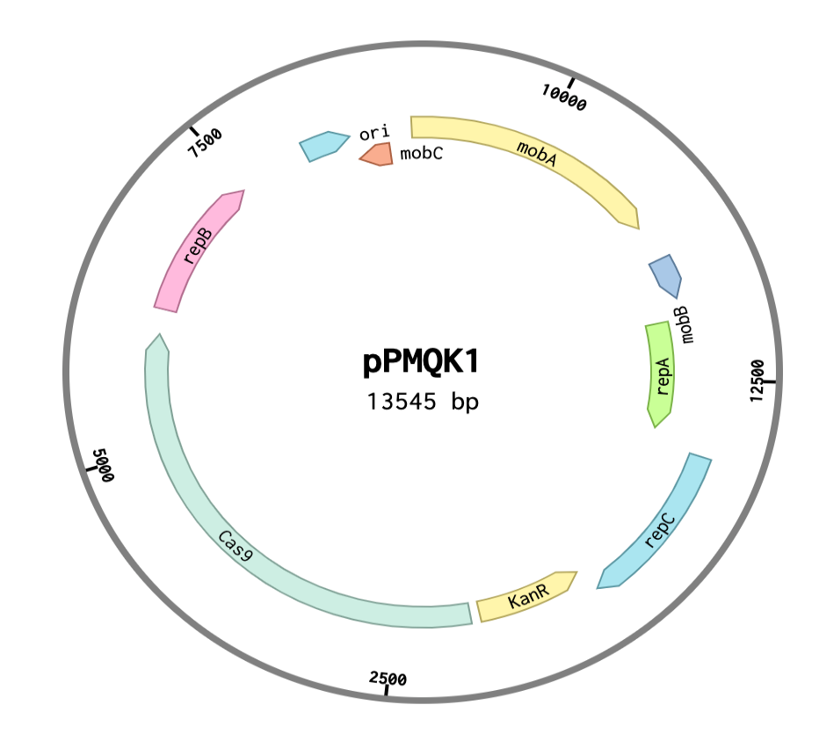

Figure 24 – The pPMQK1 plasmid.
The pPMQK1 plasmid consists of 13,545 bp and displays an origin of replication (ori), mobility proteins to facilitate the insertion of the Cas9 gene into the host organism (mobA, mobB, mobC, repA, repB and repC) and a kanamycin resistance cassette (Kan^{r}).

The pPMQK1 plasmid bears the Cas9 nucelase as well as mobility and regulatory proteins (mobA, mobB, repA, repC, repB and mobC) that facilitate the insertion of pPMQK1 into Synechocystis via conjugation. The plasmid encompases 13,545 bp and is considered a large plasmid.

The following sections provide details for the methods of conjugation as well as electroporation implemented in Synechocystis.

3.3.4.2.1 Transformation of Synechocystis by conjugation

Transformation of Synechocystis was effectuated via conjugation or tri-parental mating according to the protocol for cyanobacteria of Gale et al., 2019. The protocol was optimized in order to increase transformation efficiency with pPMQK1, which is a low copy number plasmid (20 copies per cell) as well as with a highly polyploid organism, such as Synechocystis. Therefore, the protocol was effectuated when Synechocystis was at its lowest polyploidy levels to increase the probabilities of full mutant segregation. This was during the log phase of the cyanobacterial culture, corresponding to an OD₇₅₀ _{nm} equivalent to 1, where the polyploidy levels were at its lowest, 57.8 chromosome copies per cell. The protocol requires an E. coli cargo strain, which carries the plasmid of interest, in this case pPMQK1, and an E. coli helper strain (E. coli MC1061) to facilitate the transfer of the plasmid of interest from the cargo strain into the cyanobacterial strain. Overnight culture of the E. coli helper strain was prepared by adding a single colony of the strain into the 5 mL of medium supplemented with appropriate antibiotics, 18 hours before the conjugal transfer. For the cargo strain, an overnight culture was prepared by adding a single colony of the strain into the 10 mL of medium with appropriate antibiotics, 18 hours before the conjugal transfer. For the cargo strain, 10 mL instead of 5 mL of overnight cultures were used in order to increase the density of cargo cells and the occurrence of them being transformed into the host in order to increase transformation efficiency. Both E. coli strains were centrifuged at 3,000 x g for 10 minutes at room temperature. The pellets were washed with 5 mL of LB medium without antibiotics three times to eliminate antibiotics. After the washing, the pellets were centrifuged a last time, the supernatants were discarded and the pellets resuspended in 2.5 mL of LB medium without antibiotics. Subsequently, both E. coli strains were combined by adding the whole 2.5 mL of each strain. Thereafter, 1 mL of Synechocystis culture, with an OD₇₅₀ _{nm} of 1, was centrifuged at 1,500 x g for 10 minutes at room temperature. The culture was washed three times with BG-11 medium without antibiotics, the pellet was resuspended in 1 mL of BG-11 medium without antibiotics. Subsequently, the Synechocystis culture was combined with the mixed E. coli cultures by adding the whole 5 mL into the 5 mL E. coli mix and incubated for 30 minutes at room temperature. The culture was then centrifuged at 1,500 x g for 10 minutes at room temperature and the pellet resuspended in 200 μL of the remaining supernatant, which was finally spread on 0.45 μm membrane filters on top of BG-11 agar plates without antibiotics and incubated for 24 hours. The filters were then transferred to BG-11 agar plates supplemented with kanamycin, at a concentration of 20 µg/mL, and incubated until colonies appeared.

3.3.4.2.2 Transformation of Synechocystis by electroporation

The transformation of Synechocystis through electroporation was effectuated according to the protocol of Ferreira et al., 2018. The protocol was optimized in order to increase transformation efficiency with pPMQK1, which is a low copy number plasmid (20 copies per cell) as well as with a highly polyploid organism, such as Synechocystis. Therefore, the protocol was effectuated when Synechocystis was at its lowest polyploidy levels to increase the probabilities of full mutant segregation. This was during the log phase of the cyanobacterial culture, corresponding to an OD₇₅₀ _{nm} equivalent to 1, where the polyploidy levels were at its lowest, 57.8 chromosome copies per cell. 1 mL of culture of Synechocystis of OD_{750 nm} equivalent to 1 was centrifuged at 4,190 x g for 10 minutes, at room temperature, and washed three times with 1mM HEPES buffer, at pH 7.5. The supernatant was discarded and the pellet resuspended in 1 mL of HEPES buffer and mixed with 1 μg of the plasmid of interest, in this case, pPMQK1. The pPMQK1 culture (cargo cells) was obtaining by setting up a 10 mL overnight culture with LB medium and the appropriate antibiotics 18 hours before electroporation. The next day, the culture was centrifuged at 4,190 x g for 10 minutes at room temperature. The pellet was resuspended in the remaining 2 mL of supernatant to increase the occurrence of cargo cells to be delivered into the host and favour transformation efficiency. The mix was electroporated in an Eppendorf Eporator electroporator at 25 μF and 400 Ω of resistance with an electric field of 12 kV/cm for an optimized time length of 9 seconds. This exposure time was extended from 2 seconds, stated for organisms with low ploidy levels, such as E. coli, with 2 chromosomes copies per cell to an optimal time length of 9 seconds for Synechocystis, with high ploidy levels, with 57.8 chromosome copies per cell. After electroporation, the mix was spread on 0.45 μm membrane filters on top of BG-11 agar plates without antibiotics and incubated for 24 hours. Subsequently, the filters were transferred to BG-11 agar plates supplemented with kanamycin, at a concentration of 20 µg/mL, and incubated until colonies appeared.

3.3.5 DNA preparation

DNA preparation for this Chapter 3, including plasmid purification, enzymatic restriction digestions, GoTaq Green (Promega) polymerase chain reactions (PCR), electrophoresis gel extractions, PCR purifications and T4 DNA (NEB) ligations were effectuated following standard procedures (Sambrook and Russell, 2011) as well as manufacturers’ recommendations. A list of the materials, including detailed information regarding the reagents, kits, enzymes, equipment and software used in this chapter can be found in Appendixes 1, 2 and 3.

3.3.6 Gel electrophoresis

1% agarose gels were prepared to effectuate electrophoresis and estimate the size of linearized plasmids, DNA fragments and constructs. 1 g of agarose was dissolved in 100 mL of 1x TAE buffer and microwaved for 1.45 minutes. Subsequently, the mix was cooled down at room temperature and 5 μL of ethidium bromide were added to the mix. The gel was then poured in a casting tray with a comb and left at room temperature until the mix solidified. To perform the electrophoresis, 1 μL of 1 kb DNA ladder (BioLine) and the pertinent amount of DNA of interest were loaded into the wells of the gel. Electrophoresis was then run at 150 V for 45 minutes. The images of the DNA samples were captured with a Biospectrum MultiSpecial 410 UV transilluminator.

3.3.7 Construction of the CRISPR/Cas9 tools for squalane production in Synechocystis

For achieving the production of squalane in Synechocystis, the strategy proposed in the present dissertation included the design of two CRISPR/Cas 9 tools for Synechocystis. Firstly, a dDNA that will insert the heterologous GGR enzyme (GGR-dDNA) into the target site in the genome of Synechocystis, and a sgRNA, which will guide the Cas9 nuclease and the dDNA into the selected target site in order to effectuate the insertion; Both, the sgRNA and the dDNA were assembled into the same construct and built into the backbone of the pEERM4 plasmid together to generate the pEERM4::GGR-dDNA_sgRNA plasmid (Figure 32, Section 3.4.3).

The sgRNA was designed and constructed according to the protocols of Larson et al., 2013 and Ran et al., 2013. The sgRNA (Figure 28, Section 3.4.2.1) consisted of three sections: 1) a protospacer, which were 20 bp taken from the target site (slr0168 gene) in the genome of Synechocystis and are complementary to the target site and which were placed after the anhydrotetracycline inducible PL22 promoter, 2) a Cas9-handle sequence, which allowed the binding between the Cas9 nuclease and the sgRNA and 3) a terminator sequence from Streptococcus pyogenes. A total of 51 protospacer regions were evaluated for off-target binding using the CasOT software (Xiao et al., 2014). After the off-target analysis, the final protospacer selected was the one showing less potential off-target binding probabilities. The selected protospacer region was then placed next to the Cas9-handle sequence, to allow the binding between the Cas9 nuclease and the sgRNA, and a terminator sequence. The GGR-dDNA construct followed the sgRNA insert.

The GGR-dDNA (Figure 29, Section 3.4.2.2) was designed and constructed according to the protocols of (Larson et al., 2013, Ran et al., 2013a). The GGR-dDNA contained an insulator, an anhydrotetracycline inducible PL22 promoter, the ribosome binding site (RBS) B0034, the GGR gene from Sulfolobus acidocaldarius which has been hypothesized to saturate the squalane precursor into squalene and a t7 terminator sequence. This whole sequence was flanked by two homology regions taken from the upstream and downstream sequences from the target site in the genome of Synechocystis.

The complete insert, containing the GGR-dDNA followed by the sgRNA (Figure 30, Section 3.4.2.3.), was flanked by the BioBrick prefix and suffix. The insert was designed using the SBOL Designer and diagrams.net software tools and synthesized by Eurofins Genomics as a custom gene.

3.3.8 Construction of the pEERM4::sgRNA_GGR-dDNA plasmid

The GGR-dDNA_sgRNA were inserted into the backbone of pEERM4 (Figure 25), a plasmid designed for the integration into a neutral site srl2030-2031 of Synechocystis. The backbone contained a pMB1 origin of replication (ori), a chloramphenicol resistance cassette (Cm^{R}) as well as a multiple cloning site (MCS) (Englund et al., 2015).

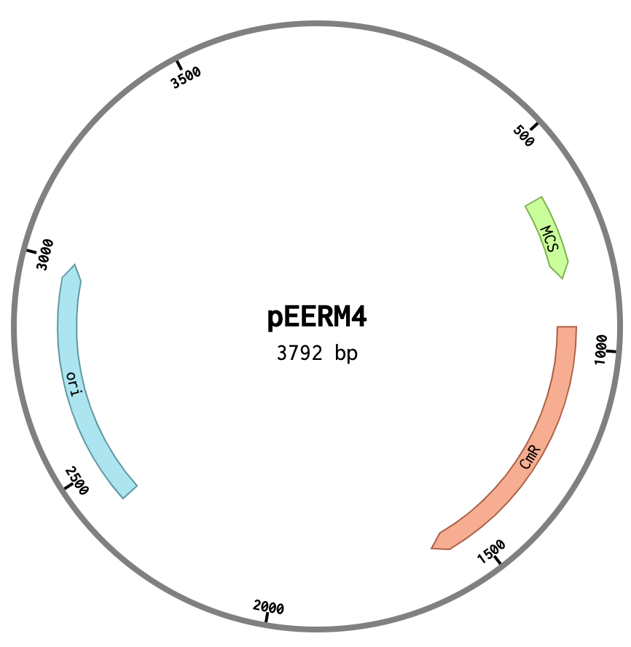

Figure 25 – The pEERM4 plasmid backbone.
The pEERM4 plasmid backbone consists of 3,792 base pairs (bp) and displays an origin of replication (ori), a chloramphenicol resistance cassette (Cm^{R}) and a multiple cloning site (MCS).

The GGR-dDNA and the sgRNA were inserted into the pEERM4 backbone in the same construct. Initially, the construct was delivered as a standard gene in a generic plasmid, which was rehydrated with pertinent volume of distilled water and then transformed into E. coli 10-Beta. Subsequently, a 5 mL overnight culture with LB media and the appropriate antibiotics was made and the respective plasmid was isolated. Subsequently, the purified plasmid was restriction digested using standard procedures (Sambrook and Russell, 2011) with EcoRI and PstI from the BioBrick prefix and suffix for the construct. To insert the construct into pEERM4, the backbone of the plasmid was restriction digested with EcoRI and PstI and treated with shrimp alkaline Phosphatase (rSAP) (NEB) to maximize transformation efficiency. Subsequently, all restriction digests were run on a 1% electrophoresis gel in order to identify the DNA fragments of the respective correct size for the insert and for the backbone. The correct DNA fragments were then gel extracted and PCR purified. The following step was to ligate the digested pEERM4 backbone with the digested construct. The construct was inserted into the pEERM4 backbone by T4DNA ligation (Sambrook and Russel, 2011). The plasmid was then transformed into E. coli 10-Beta, cultured overnight with LB media and the appropriate antibiotics and plasmid purified the next day in order to isolate the newly constructed pEERM4::sgRNA_GGR-dDNA plasmid (Figure 32, Section 3.4.3), which contained both CRISPR/Cas9 tools here-designed for Synechocystis to produce squalane in the cyanobacterium. The plasmid was then transformed into E. coli 10-Beta for maintenance and future work.

3.3.9 Generation of Synechocystis::Cas9

To perform genome editing in Synechocystis using CRISPR/Cas9, a pivotal step was to insert the Cas9 nuclease into the cyanobacterium in order to effectuate the DSB and the subsequent homology-directed double strand break repair mechanism to integrate the dDNA. The plasmid pPMQK1, bearing Cas9, was inserted into Synechocystis through the standard protocol of conjugation in cyanobacteria (Gale et al., 2019).

3.3.10 Generation of Synechocystis::Cas9_sgRNA_GGR-dDNA through CRISPR/Cas9

Once the creation of pEERM4::sgRNA_GGR-dDNA plasmid and Synechocystis::Cas9 were successful, the generation of Synechocystis::Cas9_sgRNA_GGR-dDNA followed. To create the mutants, first, the insertion of the pEERM4::sgRNA_GGR-dDNA plasmid into Synechocystis::Cas9 was effectuated following the standard protocol of conjugation in cyanobacteria (Gale et al., 2019) and, subsequently, the generation of Synechocystis::Cas9_sgRNA_GGR-dDNA using CRISPR/Cas9 was effectuated.

To perform gene editing through CRISPR/Cas9, the pEERM4::sgRNA_GGR-dDNA plasmid was incorporated into Synechocystis::Cas9 by the standard conjugation protocol in cyanobacteria (Gale et al., 2019). Subsequently, the cultures after conjugation were placed on BG-11 agar plates supplemented with kanamycin, at a concentration of [20 μg/mL], chloramphenicol, at a concentration of 12 μg/mL and anhydrotetracycline, at a concentration of 200 ng/mL, in order to induce the anhydrotetracycline sensitive PL22 promoters present on the Cas9 nuclease and the sgRNA to finally obtain Synechocystis::Cas9_sgRNA_GGR-dDNA and generate a squalane producing strain. The cultures were placed on liquid BG-11 media with the previously mentioned antibiotics, including anhydrotetracycline, which activated the PL22 promoter and kick-started the translation of the GGR gene in the GGR-dDNA into protein.

3.3.11 Mutant segregation analysis

The achievement of full mutant segregation is desirable given that it reduces mutation dilution and increases gene expression, which consequently leads to an increase in titters of the desired product. DHR has been known for being difficult and laborious in the achievement of full mutant segregation in Synechocystis (Heidorn et al., 2011, Lartigue et al., 2007, Qi et al., 2013). On the other hand, CRISPR/Cas9 offers an increased potential in the achievement of such (Berla et al., 2013, Carroll, 2004, Ramey et al., 2015). Thus, once the generation of Synechocystis::Cas9_sgRNA_GGR-dDNA was accomplished, an analysis was performed in order to evaluate the mutant segregation achieved in the mutants.

Such mutant segregation analysis was effectuated by performing a GoTaq Green (Promega) PCR on DNA extraction samples of mutants. The primers used were the mutation segregation primers (Table 9), which amplify the sgRNA_GGR-dDNA from the homology regions. Hence, the amplicons resulted from such PCR would determine if the cultures are fully segregated regarding the sgRNA_GGR-dDNA construct, that is, if the insertion of the sgRNA_GGR-dDNA was successful in all the mutants in the culture. The GoTaq Green PCR was performed following the manufacturers recommendations as well as the parameters displayed in Table 10.

Table 10: Parameters of the PCR for Cas9 insertion analysis and the mutant segregation analysis
Stage |  | Time (min.) |  | Temperature (°C)
Denaturation
Initial |  | 2 |  | 95
Subsequent* |  | 1 |  | 95
Annealing*
Annealing* |  | 30 sec. |  | 54.8
Extension
Negative control* |  | 1 |  | 72
Synechocystis WT* |  | 1 |  | 72
Positive control* |  | 3 |  | 72
Synechocystis::Cas9_sgRNA_GGR-dDNA* |  | 3 |  | 72
ΔSynechocystis::Cas9 |  | 1 |  | 72
Final extension |  | 5 |  | 72
Final store
Final store |  | ∞ |  | 25
Cycles: 35

Primers (5’ to 3’)
Mutant segregation primers | Forward: gccgaagcaggggaaactccta  Reverse:  tggcttggtcatcagcggc | Source: this work
Cas9 primers | Forward:  Ataggcgtatcacgaggcaga  Reverse:  tcattaagcagctctaatgcgc | Source: this work
Table 10 – Parameters and primers implemented in the GoTaq Green PCR for the Cas9 insertion analysis and the mutant segregation analysis.
Stages of the GoTaq green PCR mutant analysis for Synechocystis::Cas9_sgRNA_GGR-dDNA, the time, in minutes, and temperature, in °C, for each stage. In the negative control, dH₂O was used as a DNA template instead of a DNA sample and a plasmid purification from the pEERM4::sgRNA_GGR-dDNA plasmid was used as DNA template for the positive control. Symbols: * denotes a stage that is part of the 35 cycles of the PCR process, ∞ denotes indefinite time.

3.3.12 Gas chromatography analysis

Gas chromatography (GC) analysis were performed on the mutant in order to confirm if they were producing squalane. The studies were effectuated following the protocol described by Goh et al., 2012 and performed on Synechocystis WT as well as on the Synechocystis::Cas9_sgRNA_GGR-dDNA mutant.

Isoprenoid generation in Synechocystis occurs intracellularly and after its production, squalane would remain inside the cell (Englund et al., 2014). Therefore, a squalane extraction had to be performed in order to obtain mutant culture samples for the GC analysis. The extraction was effectuated according to the protocol of Englund et al., 2014, where 100 mL cultures of WT and mutants with an OD₇₅₀ value of 1 were centrifuged at 4,000 x g for 10 minutes. The pellets were resuspended with 2 mL of chloroform (Sigma Aldrich) and 4 mL of methanol (Sigma Aldrich) and subsequently vortexed until complete resuspension was achieved. The mix was centrifuged again at 4,000 x g for 5 minutes and 5 mL of the supernatant was collected. Acetonitrile (Fisher Scientific) and heptane (Sigma Aldrich) were added at a ratio of 5:5:10 (supernatant: acetonitrile:heptane) and vortexed for 20 seconds, which generated a phase separation. The top phase, containing heptane, was collected and repeatedly washed with 5 mL of acetonitrile until the mix turned yellow, which indicated the removal of most of the chlorophyll from the mix. Subsequently, the mix was concentrated using a miVac speedvac (GeneVac, LTD) for 5 hours. The residue was resuspended in heptane and acetonitrile in a ratio of 1:20 v/v (heptane:acetonitrile) and sent for GC analysis on the same day.

The gas chromatograph was an Autosystem XL paired with a MS Turbomass mass selective detector (PerkinElmer) with a Phenomenex ZB-5plus capillary column (30 m length, 0.25 mm inner diameter, 0.25 μm film thickness). The injection volume was 0.3 μL. The GC oven was set at 260 °C. The carrier gas implemented was high-purity hydrogen supplied at a constant rate of 1.4 mL/min. The standard implemented was a squalane analytical standard (Sigma Aldrich) and a squalene analytical standard (Sigma Aldrich), heptane (Sigma Aldrich) was used as a solvent and acetone (Fisher Scientific) was used to wash the equipment’s needle in between samples. Squalene and squalane were quantified through independent three-point calibration curves starting from 1 µM, followed by 10 µM and 100 µM.

3.4 Results and discussion

3.4.1 Transformation efficiency of Synechocystis by conjugation versus electroporation

Transformation efficiency and the size of the plasmid in question maintain an inversely proportional relationship. The transformation of large plasmids (more than 12,000 bp) are known to be laborious and often to result in a decreased transformation efficiency (Chan et al., 2002, Szostkova and Horakova, 1998). Larger molecules are more prone to damage and breakage during the movement that involves DNA transfer (Chan et al., 2002, Donahue Jr and Bloom, 1998), which often, result in incomplete plasmids that are discarded by the cell, decreasing the amount of healthy and viable plasmid copies available to be replicated, therefore, having an impact on transformation efficiency. Furthermore, the probabilities of developing secondary structures, such as hair-pins are higher in larger plasmids (Ohse et al., 1995). These secondary structures could hinder the passage of the plasmid through the DNA transfer passageway, having a direct impact in their transformation efficiency. However, conjugation as well as electroporation could increase the transformation efficiency of large plasmids since they generate wider DNA transfer passageways, such as enlarged positively-charged pores and increased sized-channels, which would guide the DNA material through a gentler transfer route (Chan et al., 2002, Donahue Jr and Bloom, 1998, Marcus et al., 1990, Phornphisutthimas et al., 2007). Therefore, we compared the transformation methods of conjugation (Gale et al., 2019) and electroporation (Ferreira et al., 2018) of the pPMQK1 large plasmid (13,545 bp) in Synechocystis in order to determine which represented the highest transformation efficiency in the cyanobacterium.

Electroporation generates an increase the size of this pores present on the cell-membrane, it as well endows them with positive charges that might attract the negativey charged DNA and facilitate its passing through, posibly decreasing their damage and breakage as they pass through (Ohse et al., 1995, Szostkova and Horakova, 1998). On the other hand, helper strains in conjugation develop a pilus, which reach the recipient strain cell-wall and generate a wall-to-wall channel between the helper and the recipient strain, where the genetic material is passed across as single stranded DNA to then be recircularized once it is inside the recipient cell (Dürrenberger et al., 1991, Hobot, 2015, Phornphisutthimas et al., 2007, Tang et al., 2014, Tsinoremas et al., 1994). This way, the plasmid stays protected from damage and breakage.

The positively-charged and enlarged pores generated during electroporation portray a promising strategy for avoiding damage and breakage on the plasmid. However, since the channels produced during conjugation are similar to a continuous protein channel across the periplasmic gel, the channel generated trough conjugation is wider than the positevely-charged, enlarged pores produced in electroporation (Hobot, 2015, Tang et al., 2014). Hence, from the two strategies, the one posed by conjugation suggest to be more effective for a large plasmid, since larger channels would provide a wider protected space and be more pertinent for a plasmid of large size and its safe transfer to the inside of the recipient cell. Moreover, it would posibly allow the passage of plasmids presenting double structures and hair-pins more easily, increasing the number of available plasmid copies in the recipient cell. We therefore hypothesised that conjugation would be more appropriate to transform Synechocystis with the pPMQK1 plasmid.

To evaluate the transformation efficiency of each method, both methods were optimized as stated in Sections 3.3.4.2.1. and 3.3.4.2.2 and the number of transformant colonies was enumerated after each transformation. After transformation, colonies initially appeared after 6 days in cultures transformed by conjugation and after 8 days in electroporated cultures. After 2 weeks, the plates transformed via conjugation presented an elevated number of colonies imposible too count due to its conglomeration, the number of colonies was defined as “too many to count” (TMTC) (Figure 26a). Contrastingly, the plates where Synechocystis was transformed via electroporation presented less than 50 colonies per plate (Figure 26b). It can then be inferred that the wider channels, generated during conjugation, provided a wide-enough protected passage space for the DNA material to be transferred all the way to the inside of the cell. Furthermore, by transferring the plasmid as a single DNA strand dimished even more the probabilities of it being damaged or broken, favouring the plasmid copy number overall. It can be inferred that the two helper strains implemented during conjugation (see Section 3.3.4.2.1) generated enough and pertinent shelter and protection of a plasmid the size of pPMQK1 and its transfer to the Synechocystis. Thus, conjugation was contrastingly more efficient. On the other hand, the plasmid was electroporated at the conditions recommended for cyanobacteria (Ferreira et al., 2018) (see Section 3.3.4.2.2). It remains to be determined if, by altering any of these conditions and/or their exposure time, would increase the membrase size pore any larger, equivalent to the conjugation channel or enough in order to transfer of the pPMQK1 into Synechocystis with equitable transformation efficiency as conjugation, which could constitute part of the future work regarding this dissertation.

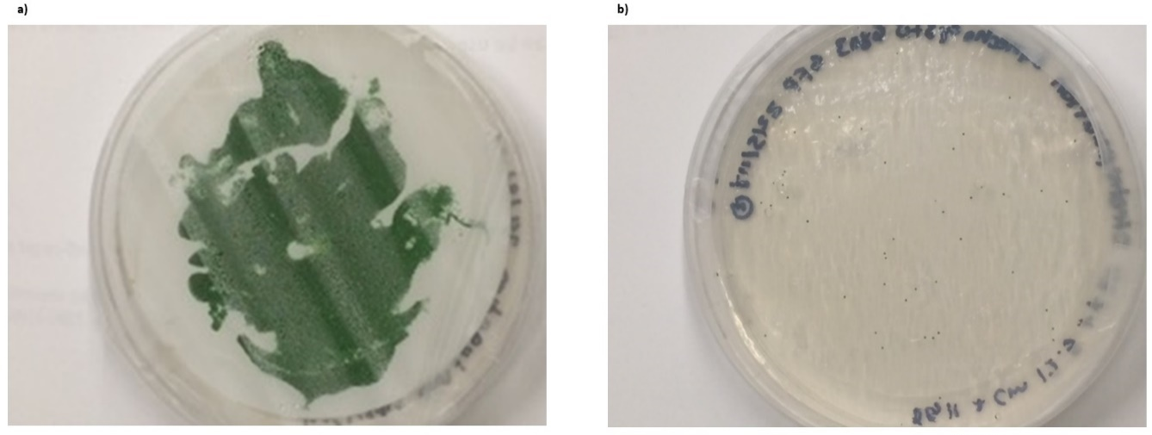
Figure 26 – Transformation efficiency evaluation of conjugation versus electroporation in Synechocystis. Transformation efficiency evaluation of the pPMQK1 plasmid into the genome of Synechocystis via a) conjugation, presenting a “TMTC” (too many to count) number of colonies, versus b) electroporation, presenting a contrastingly low number of colonies.

Moreover, the results indicated that the number of colonies was significantly higher in the plates where Synechocystis was transformed via conjugation as oposed to electroporation, thus, conjugation was the most effective method for the transformation for Synechocystis.Therefore, all transformations events regarding Synechocystis in this investigation were effectuated following the standard protocol of conjugation for cyanobacteria (Gale et al., 2019).

3.4.1.1 Generation of Synechocystis::Cas9

Subsequently, the Cas9 nuclease, in the pPMQK1 plasmid, was inserted into Synechocystis via conjugation in order to generate Synechocystis::Cas9. As pPMQK1 is a low copy number plasmid, the presence of pPMQK1 in the transformants was confirmed by PCR. Figure 27 shows the results of this investigation.

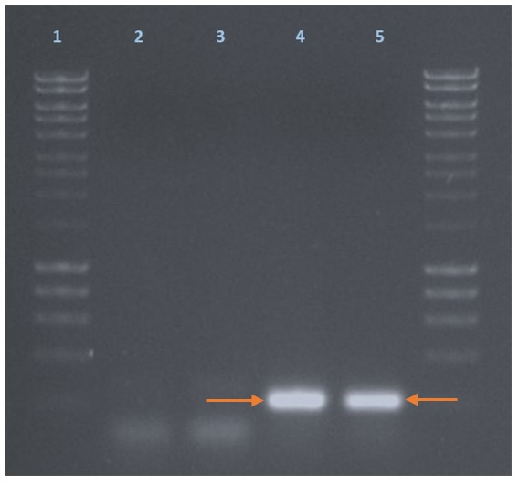

Figure 27 – Insertion and mutant segregation analysis of Synechocystis::Cas9.
Displaying 1) 1KB DNA ladder. 2) PCR of the negative control, where sterile distilled water was used as a DNA template sample and displaying no bands at all. 3) PCR of Synechocystis WT. 4) PCR of the positive control, where the sequence of the Cas9 itself in the pPMQk1 was used as a DNA template sample and showing a band of the desired and expected size (orange arrow, lane 4). 5) PCR of Synechocystis::Cas9, showing only a band of the expected and desired size (orange arrow, lane 5) that coincides to the desired band on the PCR of the positive control and not any other bands of other sizes.

The primers implemented in this analysis (Table 9 and Table 10: Cas 9 primers) flanked the sequence of the Cas9 nuclease in the pPMQK1 plasmid. Therefore, if Cas9 was present in the genomic DNA used as the template for the PCR, then the Cas9 sequence would be amplified in the PCR product and it would be shown as a band of the expected length, which is a single band at approximately 200 bp (Figure 27, lane 4). According to the results of this analysis, neither the negative control (Figure 27, lane 2) nor Synechocystis WT (Figure 27, lane 3) present any bands, including the band of the desired length. This implies that the sequence of Cas9 is not present in any of these samples and is not surprising considering that there was no DNA in the negative control and that, although there are CRISPR systems naturally present in Synechocystis, none of them belongs to the type II, the one that naturally implements the Cas9 nuclease (Barrangou and Marraffini, 2014, Jiang et al., 2013, Mohanraju et al., 2016). Thus other CRISPR nucleases might be present in Synechocystis WT but not Cas9, which explains the absence of the desired band in its PCR results. Furthermore, the positive control displays a band of the desired height (Figure 27, lane 4), which is expected since the DNA sample implemented was the sequence of the Cas9 itself, taken from the plasmid that bears it, the pPMQK1. Therefore, this band was not only expected to appear but to be replicated in the PCR results of ΔSynechocystis::Cas9. On the same token, the PCR results of ΔSynechocystis::Cas9 display a band of the expected and desired height (Figure 27, lane 5). Implying that the plasmid pPMQK1, bearing the Cas9 nuclease sequence was successful and that it is present in all the mutants.

3.4.2 Construction of CRISPR/Cas9 tools for squalane production in Synechocystis

3.4.2.1 Construction of the sgRNA

As mentioned in Section 3.3.7.2, the sgRNA (Figure 28) is an anhydrotetracycline inducible CRISPR/Cas9 tool and was constructed to guide the Cas9 nuclease into the target DNA location in the genome of Synechocystis in order to effectuate the DSB, the respective repair and allow the insertion of the GGR to allow the production of methyl ketones in Synechocystis.

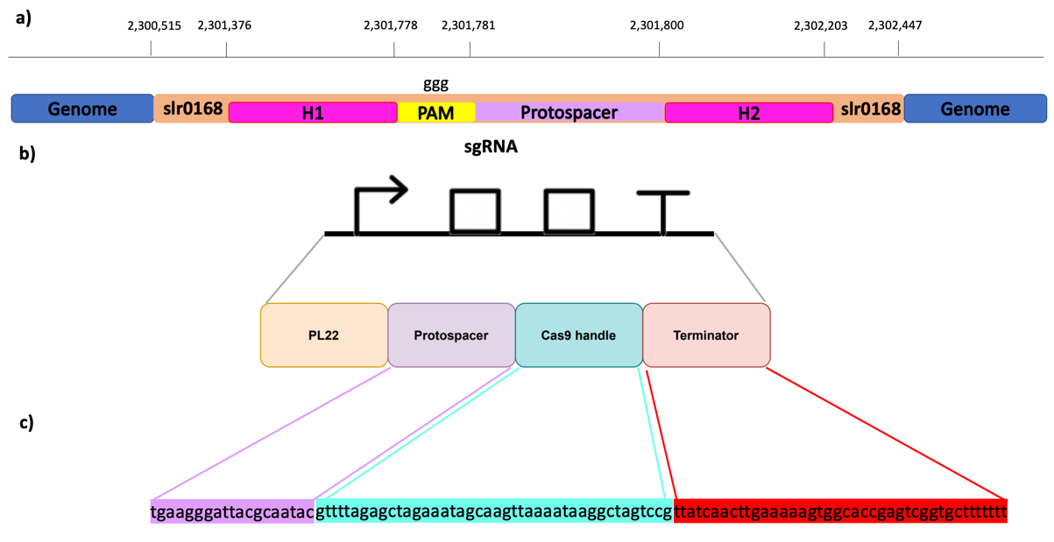

Figure 28 – sgRNA construct designed for squalane production in Synechocystis.
a) Shows the genetic context of the selected protospacer of the sgRNA, showing the base positions of the elements upstream and downstream of the selected protospacer in the genome of Synechocystis where H1 and H2 are the homology regions up and downstream the selected neutral site (slr0168). b) Illustrates the SBOL diagram of the constructed sgRNA (in black) and a schematic description of its elements (in colours), illustrating PL22 as the promoter the sgRNA was put under the control of, as well as the selected protospacer, Cas9 handle and terminator. c) Shows the nucleic acid sequences of the protospacer, Cas9 handle and terminator of the sgRNA.

The sgRNA is comprised by the anhydrotetracycline inducible promoter PL22 (PL22), a protospacer, which was which was taken from the target site in the genome of Synechocystis and selected for presenting the least off-target binding probabilities and constitutes the leading element in the whole sgRNA. The insert comprises as well a Cas9-handle sequence, which allows the binding between the sgRNA and the Cas9 nuclease for it to be guided onto the cleavage target site and a terminator sequence. Since the protospacer is the main leading element of the sgRNA and was taken from the integration target site, it is considered a CRISPR insertion target site, which has been denoted as such by the Synthetic Biology Open Language (SBOL) symbol on top of the protospacer (Figure 28).

To construct the protospacer of the sgRNA, the slr0168 gene was selected given that it has been identified as a neutral site in Synechocystis. A neutral site is a gene in the genome that allows the genetic engineering of its host organism without presenting any phenotypical changes (Pinto et al., 2015). Therefore, all possible protospacers available in slr0168 were evaluated for off-target activity. The selected protospacer in the sgRNA was the one with the least off-target activity. Figure 28 illustrates as well the genetic context of the designed sgRNA within slr0168. Similarly, such Figure shows the beginning and end positions of the slr0168 gene along with the position of the upstream and downstream elements of the sgRNA, such as the homology regions (H1 and H2), to aid in the recognition site and the insertion of the GGR-dDNA and the Protospacer Adjacent Region (PAM), a key element to identify the target binding site in the genome of Synechocystis. Moreover, Table 11 provides further details of the elements of the sgRNA, such as their nucleic acid sequences.

Table 11: Nucleic acid sequences of the elements of the sgRNA
Element | Nucleic acid sequence(5’ to 3’)
PL22 promoter | tccctatcagtgatagagattgacatccctatcagtgatagagatactgggagcta
Cas9 handle | gttttagagctagaaatagcaagttaaaataaggctagtccg
Protospacer | tgaagggattacgcaatac
Terminator from S. pyogenes | ttatcaacttgaaaaagtggcaccgagtcggtgcttttttt
Table 11 – Nucleic acid sequences of the elements of the sgRNA.

3.4.2.2 Construction of the GGR-dDNA

As previously mentioned in Section 3.3.7.2, the GGR-dDNA (Figure 29) is an anhydrotetracycline inducible CRISPR/Cas9 tool and was constructed to be used as a repair template after the generation of the DSB to insert the heterologous GGR gene in the genome of Synechocystis, which encodes for the GGR protein in order to produce the squalane biofuel in the cyanobacteria.

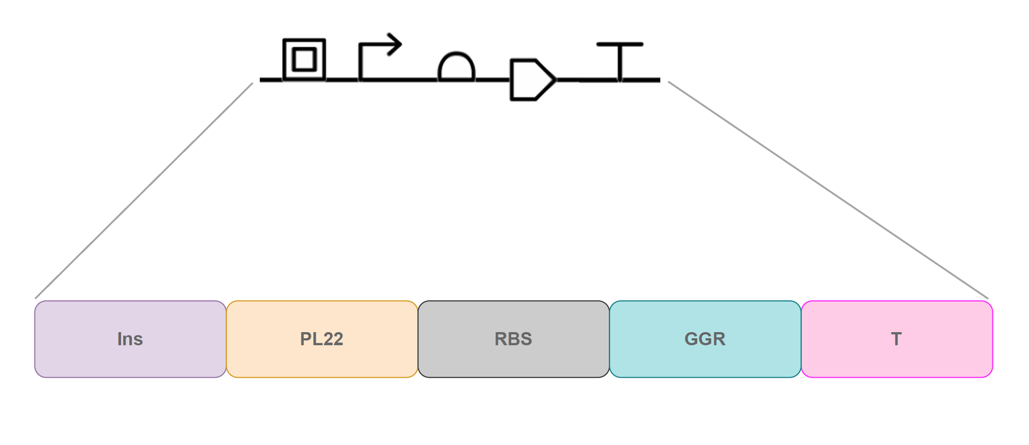
Figure 29 – GGR-dDNA construct designed for squalane production in Synechocystis.
The GGR-dDNA design is displayed, showing in black the design in SBOL and furtherly explained in colours. The GGR-dDNA design comprises an insulator (Ins: in lilac) an inducible PL22 promoter (PL22: in orange), an RBS (RBS: in grey), the squalane producing heterologous gene (GGR: in turquoise) and a terminator sequence (T: in pink).

The GGR-dDNA was constructed using an insulator (Ins), to block interference from upstream sequences, the anhydrotetracycline PL22 promoter (PL22), the ribosome binding site B0044 (RBS), the heterologous GGR from S. acidocaldarius (GGR) and a terminator sequence (T). Table 12 provides accession numbers or the nucleic acid sequences of the elements of the GGR-dDNA.

Table 12: Accession numbers and sequences of the elements of the GGR-dDNA
Element | Accession ID or nucleic acid sequence (5’ to 3’)
PL22 promoter | tccctatcagtgatagagattgacatccctatcagtgatagagatactgggagcta
Insulator | agctgtcaccggatgtgctttccggtctgatgagtccgtgaggacgaaacagcctctacaaataattttgtttaaactaga
Ribosome binding site(RBS) | BBa_B0034 (iGeM ID)
GGR | WP_011277849.1 (GenBank Accession number)
Terminator | agctgtcaccggatgtgctttccggtctgatgagtccgtgaggacgaaacagcctctacaaataattttgtttaaactaga
Table 12 – Accession numbers and/or sequences of the elements of the GGR-dDNA.

3.4.2.3 Construction of the final GGR-dDNA_sgRNA construct

As previously mentioned in Section 3.3.7, the sgRNA and the GGR-dDNA were built into a single construct and subsequently inserted into the backbone of the pEERM4 plasmid. Figure 30 illustrates both constructs built into the GGR-dDNA_sgRNA final insert, which encompasses 2,541 bp. The whole insert was flanked first by upstream and downstream homologous sequences (H1 and H2), taken from the slr0168 gene in the genome of Synechocystis and finally, flanked by the BioBrick prefix and suffix (BBp and BBs) in order to allow the insertion of the construct in pEERM4 plasmid backbone. Table 13 provides further details of the elements of the final construct.

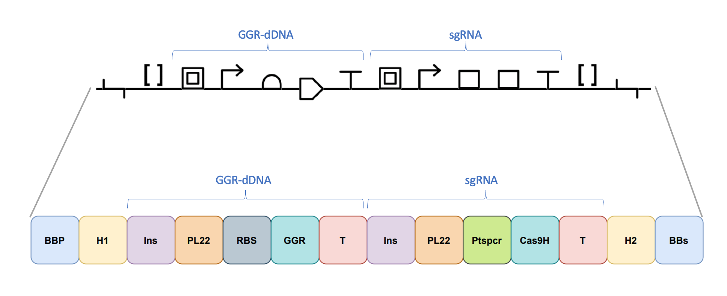
Figure 30 – Final sgRNA_GGR-dDNA construct designed for squalane production in Synechocystis.
The sgRNA_GGR-dDNA design is displayed, showing in black the design in SBOL and furtherly explained in colours. The sgRNA_GGR-dDNA is flanked by the BioBrick prefix and suffix (BBp and BBs: in blue), followed by the upstream and downstream target site homologous region sequences (H1 and H2: in yellow). The GGR-dDNA initiates with an insulator (Ins: in lilac), followed by an inducible PL22 promoter (PL22: in orange), an RBS B0034 (RBS: in grey), the squalane producing heterologous gene (GGR: in turquoise ) and finally a T7 terminator sequence (T: in red). The sgRNA initiates with another insulator (Ins: in lilac), which is followed by an inducible PL22 promoter (PL22: in orange), the Cas9 Handle sequence (Cas9H: in turquoise), and finalises with another terminator sequence from S. pyogenes (T: in red).

Table 13: Accession number, bp position or nucleic acid sequence of the elements of the final sgRNA-GGR-dDNA

Element | Construct | Accession ID, position in the genome or nucleic acid sequence(5’ to 3’)
PL22 promoter | sgRNA | tccctatcagtgatagagattgacatccctatcagtgatagagatactgggagcta
Protospacer | sgRNA | tgaagggattacgcaatac
Cas9 handle | sgRNA | gttttagagctagaaatagcaagttaaaataaggctagtccg
Terminator from S. pyogenes | sgRNA | tttatcaacttgaaaaagtggcaccgagtcggtgcttttttt
Slr0168 gene | Final construct | Start: 2,300,515. End: 2,302,447 (bp end and start position in the genome of Synechocystis)
BioBrick prefix | Final construct | gaattcgcggccgcttctagag
BioBrick suffix | Final construct | tactagtagcggccgctgcag
Insulator | sgRNA, GGR-dDNA | agctgtcaccggatgtgctttccggtctgatgagtccgtgaggacgaaacagcctctacaaataattttgtttaaactaga
PL22 promoter | GGR-dDNA | tccctatcagtgatagagattgacatccctatcagtgatagagatactgggagcta
Ribosome binding site(RBS) | GGR-dDNA | BBa_B0034 (iGeM ID)
GGR | GGR-dDNA | WP_011277849.1 (GenBank Accession number)
H1 | Final construct | Start: 2,301,376. End: 2,301,778 (bp end and start position in the genome of Synechocystis)
H2 | Final construct | Start: 2,301,800. End: 2,302,203 (bp end and start position in the genome of Synechocystis)
Terminator | GGR-dDNA | agctgtcaccggatgtgctttccggtctgatgagtccgtgaggacgaaacagcctctacaaataattttgtttaaactaga
Table 13 – Accession numbers, bp position or nucleic acid sequences of the elements of the final sgRNA_GGR-dDNA construct.

3.4.3 Construction of plasmid pEERM4::sgRNA_GGR-dDNA

As mentioned in Section 3.3.8, the GGR-dDNA_sgRNA construct (2,541 bp) was inserted into pEERM4 via restriction digestion using XbaI and PstI from the BioBrick prefix and suffix to obtain pEERM4::sgRNA_GGR-dDNA, which was transformed with 10-Beta competent cells for future work and maintenance. The plasmid was then restriction digested with the BioBrick prefix and suffix and its digestion product was run on a gel to confirm the presence of the insert in the plasmid. The results show two bands of the expected height corresponding to the remaining plasmid backbone after digestion and to the sgRNA_GGR-dDNA insert (Figure 31), confirming the presence of the insert in the plasmid.

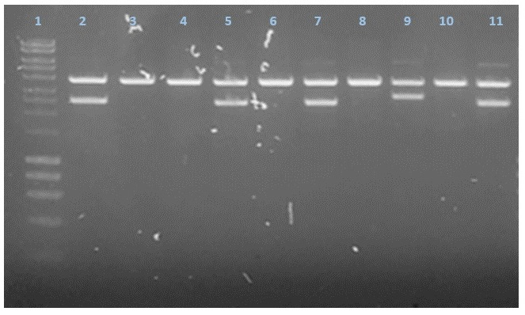

Figure 31 – Gel electrophoresis after insertion of the sgRNA_GGR-dDNA in the pEEERM4 plasmid backbone.
Lane 1 shows the ladder implemented, while lane number 2, 5, 7 and 11 show one higher expected band that corresponds to the remaining digested part of pEERM4 as well as a lower expected band at the height that corresponds to the size of the sgRNA_GGR-dDNA construct, confirming its presence in pEERM4 for the mentioned wells and its respective patches. Lanes number 3, 4, 6, 8 and 10 show a unique expected band that correspond to the remaining digested section of pEERM4 and the absence of the expected lower band, that corresponds to the insert, showing that such patches lack the sgRNA_GGR-dDNA insert.

The gel showed the presence of the two expected bands on four patch samples (Figure 31, lanes 2, 5, 7 and 11) of the digested pEERM4::sgRNA_GGR-dDNA. The presence of the higher expected represents the remaining digested portion of the pEERM4 plasmid while the lower expected band corresponds to the size of the sgRNA_GGR-dDNA insert, confirming the presence and the successful insertion of the construct in such four patches of pEERM4::sgRNA_GGR-dDNA (Figure 32). On the other hand, five patches showed only the band corresponding to the remaining digested section of the pEERM4 and lack the lower expected band that corresponded to the insert (Figure 31, lanes 3, 4, 6, 8 and 10), highlighting the absence of the insert in such patches.

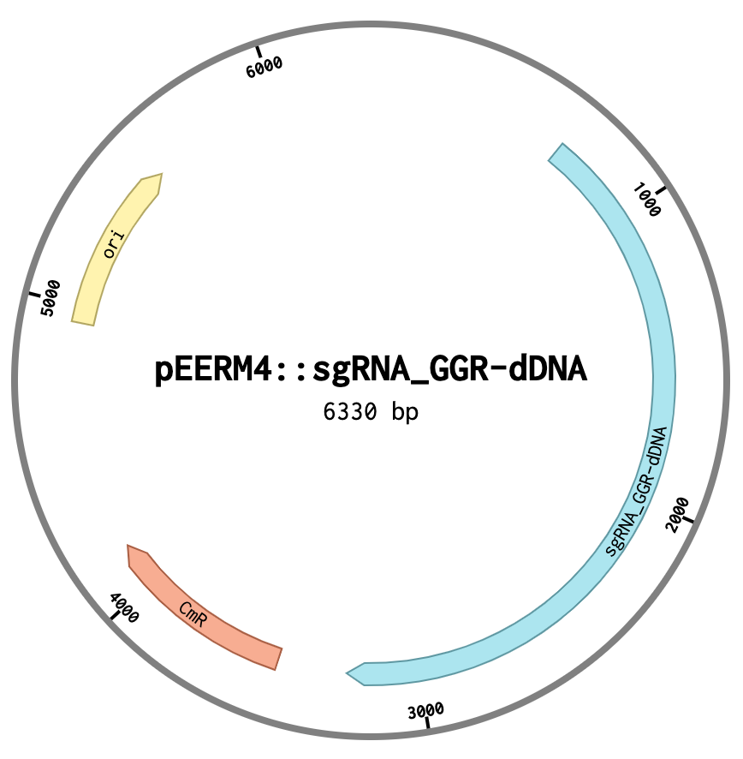

Figure 32 – The pEERM4::sgRNA_GGR-dDNA plasmid.
The image displays the 6,330 bp pEERM4::sgRNA_GGR-dDNA plasmid, containing the basic elements from the pEERM4 plasmid backbone, an origin or replication (ori) and a chloramphenicol resistance cassette (Cm^{R}) as well as the newly inserted CRISPR/Cas9 tools as a single construct, the sgRNA_GGR-dDNA.

3.4.4 Generation of Synechocystis::Cas9_sgRNA_GGR -dDNA: mutant segregation analysis

Once the pEERM4::sgRNA_GGR-dDNA plasmid was constructed, Synechocystis::Cas9, Synechocystis::Cas9_sgRNA_GGR-dDNA was constructed. An analysis of the mutant segregation was carried out by performing a GoTaq Green PCR followed by running an electrophoresis gel of the products in order to determine if the insertion of the constructs and plasmid was successful as well as if full mutant segregation was achieved.

3.4.4.1 Growth of Synechocystis::Cas9_sgRNA_GGR-dDNA

Once the pEERM4::sgRNA_GGR-dDNA plasmid was constructed, Synechocystis::Cas9_sgRNA_GGR-dDNA was constructed by inserting such plasmid into Synechocystis::Cas9 via conjugation, a growth curve analysis was effectuated in order to evaluate in this insertion had negative effects regarding the growth of the mutant compared with Synechocystis WT. The results are shown in Figure 33.

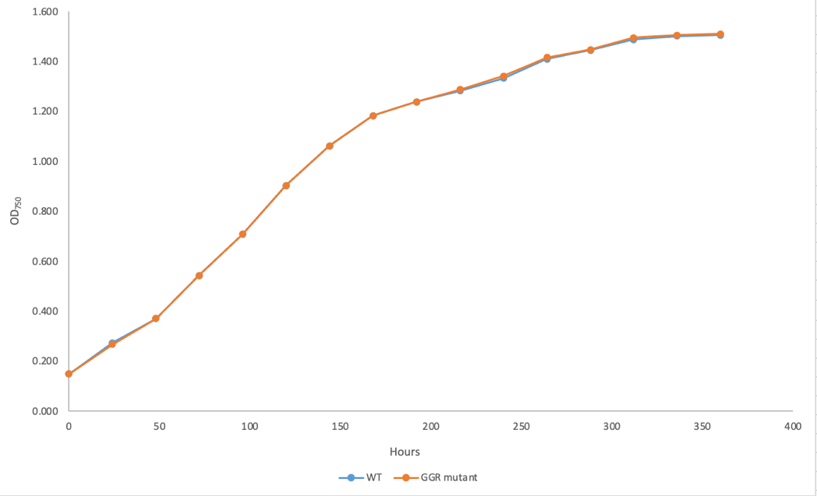

Figure 33 – Growth analysis of Synechocystis WT and Synechocystis::Cas9_sgRNA_GGR-dDNA.

The results show that the insertion of Cas9 as well as the creation of the Synechocystis::Cas9_sgRNA_GGR -dDNA had no effect on the growth patterns. It can be seen from Figure 33 that there are no differences in the growth patterns of Synechocystis WT and Synechocystis::Cas9_sgRNA_GGR -dDNA. Therefore, the insertion of the CRISPR/Cas9 elements had no effect on the growth of Synechocystis. This signifies that the mutant can be expected to grow at the same rate as the normal rate, described for Synechocystis WT and hence, titers of squalane generated by the mutant are not expected to be affected.

3.4.4.2 Mutant segregation analysis of Synechocystis::Cas9_sgRNA_GGR -dDNA

The plasmid pEERM4::sgRNA_GGR-dDNA was introduced into Synechocystis::Cas9 via conjugation to generate Synechocystis::Cas9_sgRNA_GGR-dDNA. The insertion of such plasmid was performed by conjugation. Figure 34 shows the results of the analysis performed on the mutants in order to evaluate the insertion of the construct into right neutral site and subsequently evaluate mutant segregation.

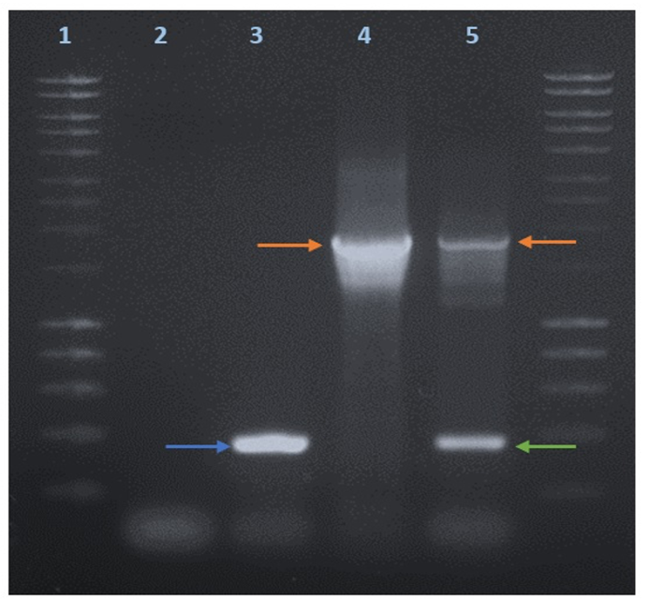

Figure 34 – Insertion and mutant segregation analysis of Synechocystis::Cas9_sgRNA_GGR-dDNA.
PCR showing the integration and segregation analysis of the mutants Synechocystis::Cas9_sgRNA_GGR-dDNA through CRISPR/Cas9 where lane 1 displays the 1KB DNA ladder. Lane 2 shows the PCR of the negative control, where sterile distilled water was used instead of the DNA template sample and displaying a low band which is probably the result of primer dimers. Lane 3 represents the PCR of Synechocystis WT, displaying an expected band (blue arrow) corresponding to the homology regions present in the GGR-dDNA, taken from the target site in the genome of Synechocystis WT and a lower band, which correspond to the formation of primer dimers. Lane 4 illustrates the PCR of the positive control, where the sequence of the GGR-dDNA in the pEERM4 plasmid was used as a DNA template sample. A band of the expected size (orange arrow) is present. Lane 5 displays the PCR of the mutants generated, Synechocystis::Cas9_sgRNA_GGR-dDNA, showing a band of the expected size (orange arrow), that coincides with the desired band of the positive control to the GGR-dDNA as well as a non-expected aditional lower band (green arrow).

The primers implemented in this analysis (Table 9 and Table 10: mutant segregation primers) flanked the sgRNA_GGR-dDNA construct and include its homology regions taken from the upstream and downstream sequences of the target site in the genome of Synechocystis (or Synechocystis WT). Therefore, if the sequence of the sgRNA_GGR-dDNA was present or successfully inserted in the DNA template samples analysed, they would be amplified in the PCR product and would be shown as a band of the expected length (Figure 34, lane 4). Accordingly, the results for Synechocystis:: Cas9_sgRNA_GGR-dDNA displays a band of the expected and desired height (Figure 34, lane 5, orange arrow) implying that the GGR-dDNA sequence is present in the genome of the mutants and, thus, the insertion of the construct was successful. However, the results display as well an additional band of a non-expected size (Figure 34, lane 5, green arrow), implying there are other incomplete sequences of the GGR-dDNA present in the mutants; that is, not all the individuals in the culture bear the complete and functional sequence of the GGR-dDNA in their genome. Therefore, full mutant segregation was not achieved. This is detrimental to the objective of producing and increasing the yields of squalane in Synechocystis given that, as previously mentioned, the lack of full mutant segregation favours mutation loss and dilution, leading to low gene expression. The absence of the GGR-dDNA in all the mutants will eventually lead to the loss of such mutation and, finally, to a decreased or absent expression of the squalane producing protein. Hence, a decreased or no production of squalane can be expected from this mutant population.

These results might be due to a number of reasons that, due to time and COVID constraints, were unable to be implemented and highly possibly might have led to the results obtained. These reasons include unoptimized exposure time and concentration of anhydrotetracycline (aTc), unoptimized conjugation protocol for the helper strain, as well as not having all the CRISPR/Cas9 elements in a single, smaller plasmid.

The concentration and exposure time of the mutant to aTc was determined by the literature, in a study where not CRISPR/Cas9 technology, but similar CRISPR elements are used in cyanobacteria (Yao et al., 2016), This dictated the concentration and exposure time of the mutant to aTc, the inducer of CRISPR/Cas9 elements used in this study. These parameters were optimal for the conditions stablished in such study and followed as such for the present work. However, they were not optimized to our specific conditions and hence, they might not have been the optimal for the present study in order to achieve full mutant segregation. Higher concentrations of aTc as well as longer exposure times of the mutant to this inducer might have led to the achievement of full mutant segregation in this case. The lack of optimization of these parameters to our specific conditions might have been an important factor that hindered the achievement of full mutant segregation in this study.

Furthermore, the optimization of the conjugation protocol implemented for cyanobacteria was effectuated for the cargo and for the host strains but not for the helper strain. The helper strain facilitates the delivery of the cargo strain into the host strain. Therefore, an effective transformation efficiency and the achievement of full mutant segregation depend on the optimization of these three elements (Gale et al., 2019). Increasing the proportions of the helper strain will increase the probabilities of the cargo strain to be delivered into the host strain. Hence, the probabilities of success are higher. One of the bottlenecks in this study could have been the lack of helper strain and hence, low delivery of the cargo strain into the host. So it is possible that the lack of optimization of the helper strain in the tri-parental mating protocol led to an insufficient availability of the helper strain and, therefore, that the cargo strain was not delivered into the host cells as opposed to CRISPR/Cas9 engineering failing.

Finally, another reason leading to the previously presented results might reside in the size of the Cas9 bearing plasmid and the CRISPR/Cas9 elements distributed in a separate plasmid. Having the Cas9 nuclease and all of the CRISPR/Cas9 tools in the same and smaller plasmid might have favoured the achievement of full mutant segregation. When the exposure of the host, bearing all the desired heterologous elements in a single plasmid, to the selective pressure of antibiotics, only the ones that have up taken all the elements simultaneously and in equal measure in the same plasmid will survive and the rest will become diluted and lost, this will increase mutant segregation (Nagy et al., 2021, Taylor et al., 2021). Furthermore, working with large or low copy number plasmids can reduce transformation efficiency and the achievement of the subsequent full mutant segregation due low availability of the desired DNA template, to breakage of the plasmid as well as difficulties to deliver it into the host (Hall et al., 2021, Rodríguez-Beltrán et al., 2021). In this study, the Cas9 nuclease was in the pPMQK1 plasmid, which is a low copy number and large plasmid (more than 13,000 bp), which might have negatively affected the achievement of full mutant segregation. Moreover, the CRISPR/Cas9 elements were put on a different plasmid. The fact that the pPMQK1 is a low copy number as well as a large plasmid and that the CRISPR/Cas9 tools were put in a separate plasmid, given that the pPMQK1 plasmid was already too large, might have led to failing to achieve full mutant segregation.

These factors are highly probable to have hindered the achievement of full mutant segregation, which coupled with the presence of single nucleotide polymorphisms (SNPs) in the final constructs and the lack of metabolic flux modelling are probably due to have caused the lack of generation of the desired product.

3.4.5 Gas Chromatography analysis

After the successful generation of the Synechocystis::Cas9_sgRNA_GGR-dDNA mutant, their cultures were subjected to a gas chromatography (GC) analysis in order to evaluate if they were producing squalane. Isoprenoid generation in Synechocystis occurs intracellularly and after its production, squalane would remain inside the cell (Englund et al., 2014). Therefore, a squalane extraction had to be performed in order to obtain mutant culture samples for the GC analysis. The extraction was effectuated according to the protocol of Englund et al., 2014, where 100 mL cultures of Synechocystis WT as well as the mutant with an OD₇₅₀ value of 1 were used. The standards implemented were squalane analytical standard (Sigma Aldrich) and squalene analytical standard (Sigma Aldrich). Heptane (Sigma Aldrich) was used as a solvent and acetone (Fisher Scientific) was used to wash the equipment’s needle in between samples. As previously mentioned, Section 3.3.3.12 describes further details for the methodology followed for the GC analysis. Similarly, further details of the sampling process of the mutant cultures are described as well in such section.

Since squalene is naturally produced in Synechocystis (Englund et al., 2014), both squalene and squalane were evaluated in the GC analysis of the mutant as well as Synechocystis WT in order to monitor the production of squalene and squalane.

In order to quantify squalene and squalene production in Synechocystis WT strain and in the mutant, three-point calibration curves were performed for both squalene and squalene using their analytical standards (Figure 35 and Figure 37, respectively). Both curves initiated at 1 µM, followed by 10 µM and finalized at 100 µM. The calibration curves are also shown as regression analysis (Figure 36 and Figure 38, respectively).

In the squalene calibration curve, the results indicate that the solvent implemented, heptane, eluted at a retention time of 1 minute in all cases. Moreover, the results indicate that the squalene standard eluted at a retention time of 7.3 minutes for all concentrations (Figure 35).

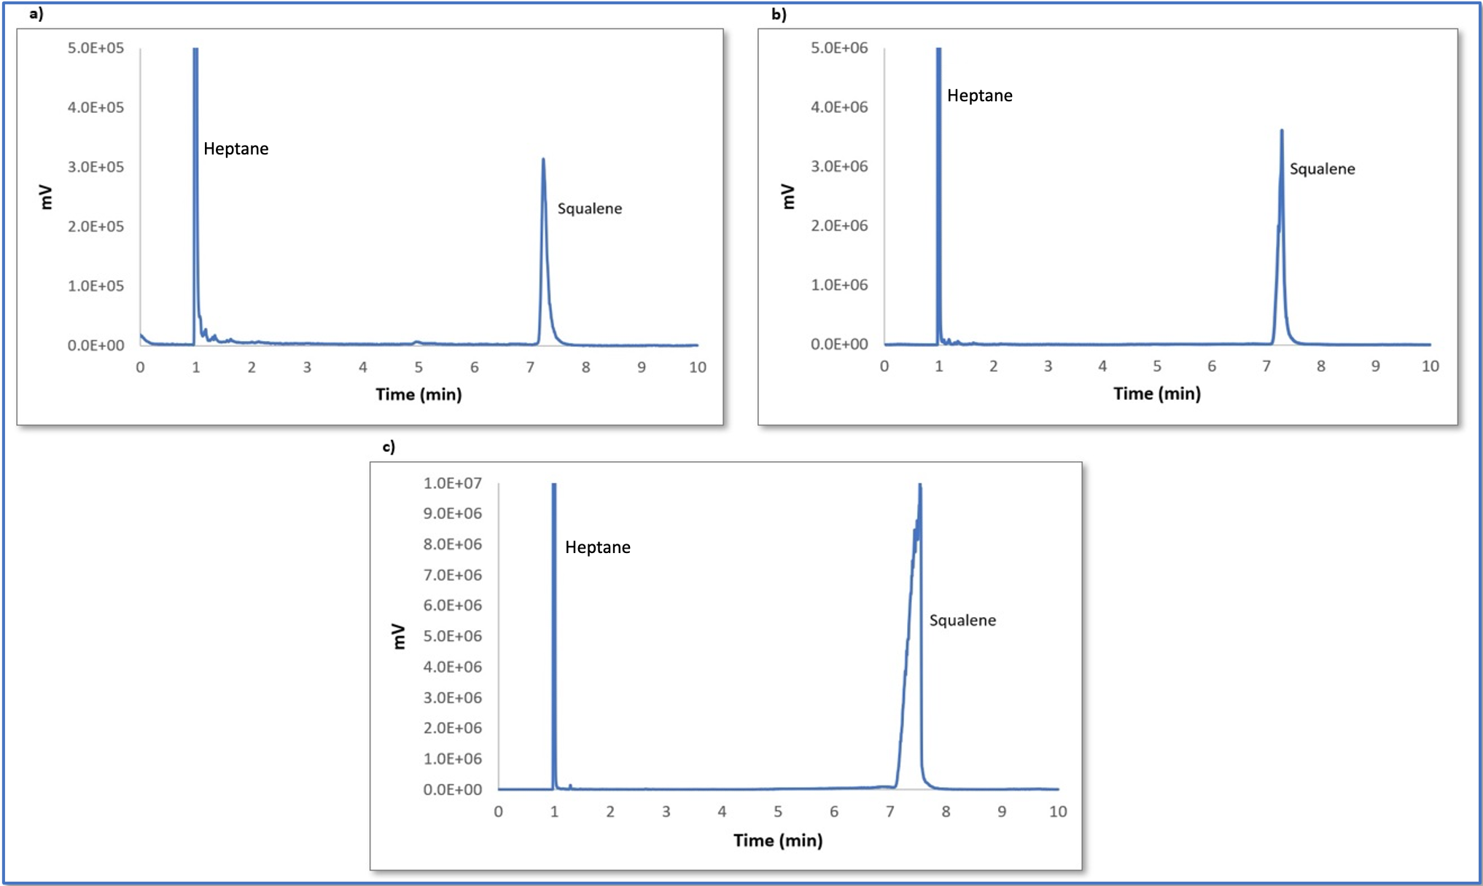
Figure 35 – GC analysis of the calibration curve of squalene.
Chromatograms showing the intensity (mV) and retention times (min) of heptane (solvent) and the squalene standard in the calibration curve at a concentration of a) 1 µM, b) 10 µM and c) 100 µM.

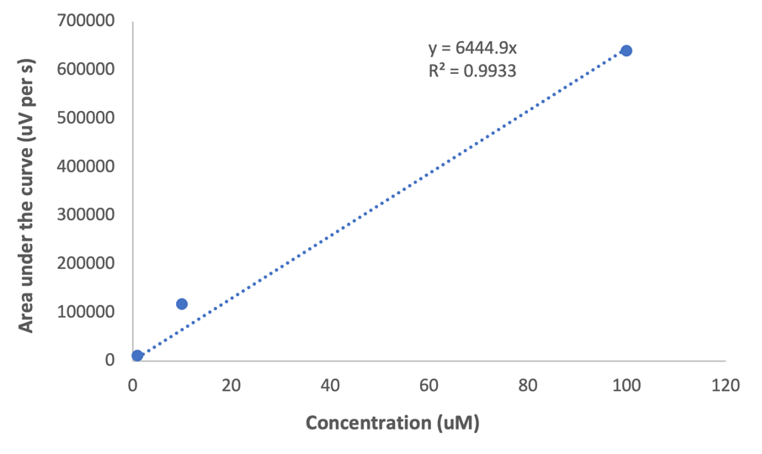

Figure 36 – Regression analysis of the GC analysis of the calibration curve of squalene.

On the other hand, the results of the squalane calibration curve illustrate that heptane eluted as well at a retention time of 1 minute in all cases. Moreover, the results indicate that the squalane standard eluted at a retention time of 5 minutes for all concentrations (Figure 37).

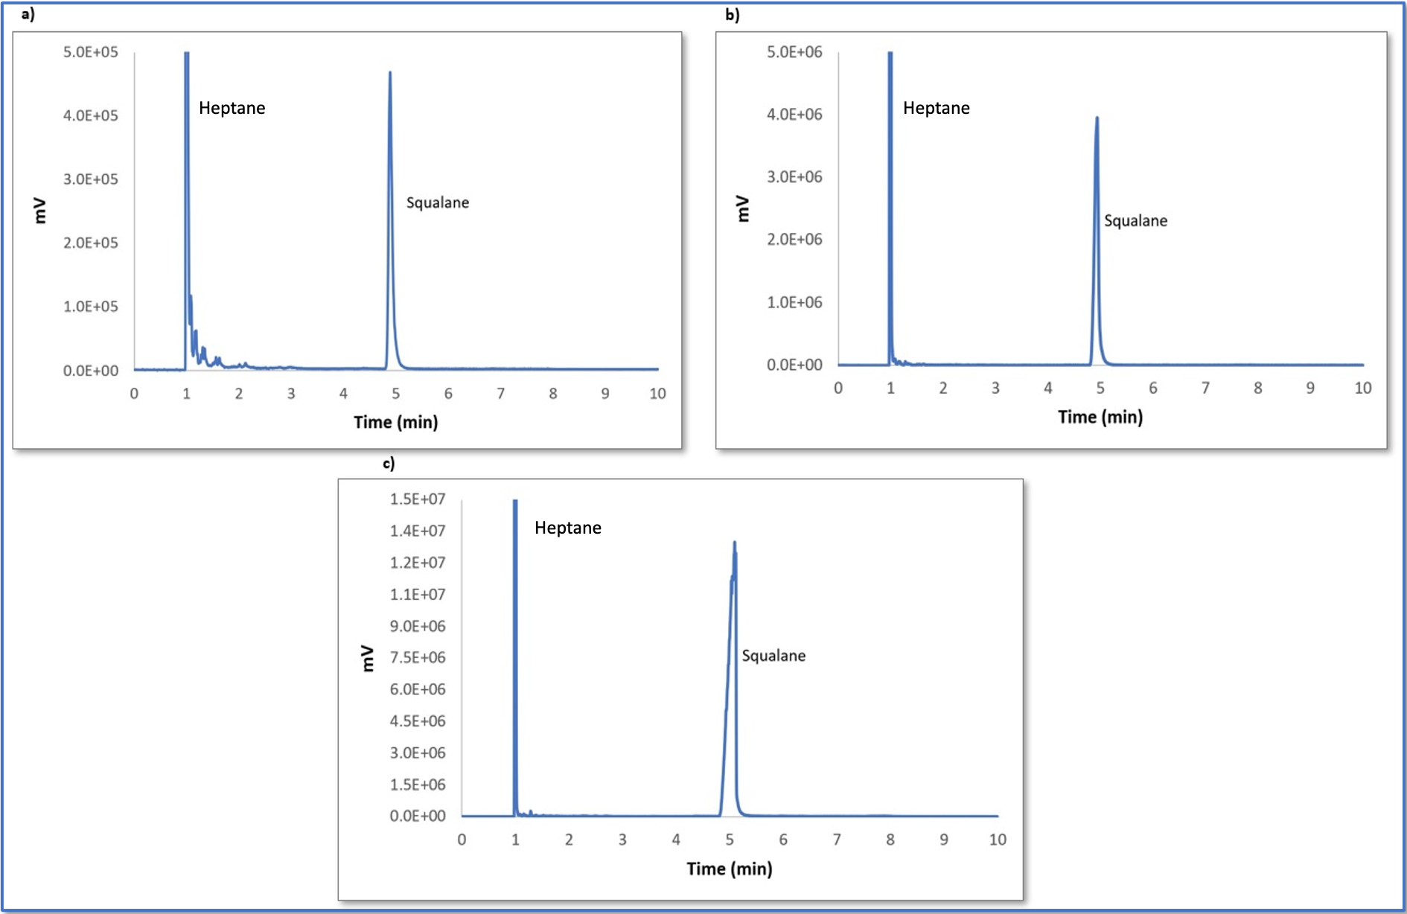
Figure 37 – GC analysis of the calibration curve of squalane.
Chromatograms showing the intensity (mV) and retention times (min) of heptane (solvent) and the squalane standard in the calibration curve at a concentration of a) 1 µM, b) 10 µM and c) 100 µM.

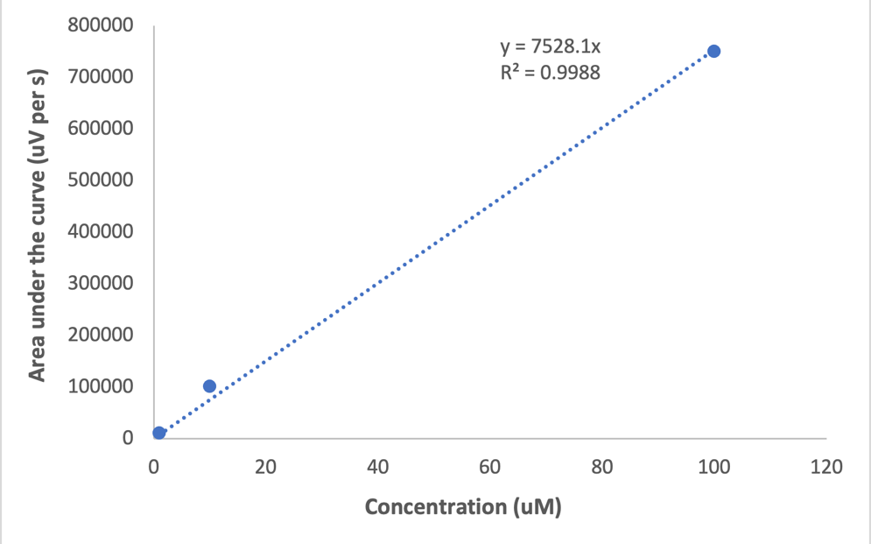

Figure 38 – Regression analysis of the GC analysis of the calibration curve of squalane.

The regression analysis for the calibration curve of squalene shows a regression coefficient of 0.9933 (Figure 36) while a value of 0.9988 is shown for the regression analysis for the calibration curve of squalane (Figure 38), which indicates, in both cases the accuracy in the proportion of variation of both calibration curves.

Furthermore, Synechocystis and Synechocystis::Cas9_sgRNA_GGR-dDNA were subjected to GC analysis in order to evaluate if they were producing squalane. Figure 39 illustrates the results obtained from such analysis.

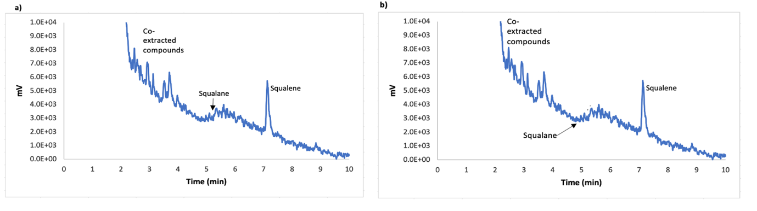
Figure 39 – GC analysis of Synechocystis and Synechocystis::Cas9_sgRNA_GGR-dDNA.
Chromatograms showing the absence or presence as well as retention times of cell polymers in the cultures, squalene and squalane in a) Synechocystis WT and b) Synechocystis::Cas9_sgRNA_GGR-dDNA.

As illustrated by Figure 39a and b, the results of the GC analysis of Synechocystis WT and Synechocystis::Cas9_sgRNA_GGR-dDNA showed the presence of multiple peaks generating interference in the GC readings around its retention time. This was expected due to the remaining intracellular co-extracted compounds that could not be eliminated during the liquid-liquid extraction for the GC sampling process and were still present in the culture samples. In addition, squalene eluted at a retention time of 7.3 minutes for Synechocystis WT and Synechocystis::Cas9_sgRNA_GGR-dDNA, while squalane showed a retention time of 5 minutes in the two instances. Both peaks, for squalene and squalane were expected for the GC analysis of Synechocystis::Cas9_sgRNA_GGR-dDNA.

Furthermore, the results indicate an important production of squalene, which was highly similar for Synechocystis WT and Synechocystis::Cas9_sgRNA_GGR-dDNA (Figure 39a and b). Additionally, the results indicate as well a nearly null production of squalane, which was maintained in the two instances (Figure 38a and b), which was expected for Synechocystis WT but not for Synechocystis::Cas9_sgRNA_GGR-dDNA.

Moreover, the production of the two instances was calculated for by using the regression equations obtained from the regression analysis and the value of the area under the curve of the peak of interest for both squalene (Figure 36) and squalane (Figure 38). The results of such calculations are shown in Table 14.

Table 14: Squalene and squalane production
Organism | Squalene production (µmoles/L) | Squalane production  (µmoles/L)
Synechocystis WT | 0.0850 | 0
Synechocystis::Cas9_sgRNA_GGR-dDNA | 0.0844 | 0
Table 14 – Production of squalene and squalane in Synechocystis WT and Synechocystis::Cas9_sgRNA_GGR-dDNA.

In the case of squalene, the results show that Synechocystis WT reached a production of 0.0850 µmoles/L, while the production of squalene value for Synechocystis::Cas9_sgRNA_GGR-dDNA was 0.0844 µmoles/L. Both values are similar, so it can be assumed that no significant amount of squalene is being converted into squalane. Moreover, the production of squalane for both, Synechocystis WT and for Synechocystis::Cas9_sgRNA_GGR-dDNA is 0 µmoles/L, which supports the theory that no naturally available squalene is being converted into squalane. Therefore, it can be assumed that the insertion of the heterologous GGR via CRISPR/Cas9 can be considered not effective. This is an expected result given that the inserted GGR-dDNA was designed to convert the naturally available squalene into squalane, an event that has been shown not to exist in Synechocystis::Cas9_sgRNA_GGR-dDNA. Additionally, the segregation analysis of such mutants revealed that this population did not achieve full mutant segregation. Hence, low or none squalane production was expected. This is consistent whit the production values of squalane achieved by Synechocystis::Cas9_sgRNA_GGR-dDNA, which were shown to be ⁰ µmoles/L, the same value to that in Synechocystis WT and reinforcing the expected lack of conversion of squalene into squalane.

Therefore, it can be assumed that according to these results, the CRISPR/Cas9 tools developed for Synechocystis and that the CRISPR/Cas9 engineering performed on the cyanobacterium have not effectively worked. Hence, the lack of squalane production. However, other factors, such as the presence of single nucleotide polymorphisms (SNPs) and the lack of metabolic flux modelling might be responsible for the lack of generation of the desired product.

The lack of evaluation of the presence of SNPs in the final mutant constructs might be one cause in failing to generate squalane. SNPs are changes in a single base after transformation events that can lead to a change in an amino acid in the translated protein, causing it to not fold properly and to loose activity, or lead to the generation of a stop codon, truncating the production of the protein and hence, impeding the activity. Either way, SNPs stop the protein from functioning correctly and delivering its activity, such as the generation of a desired product (Figueroa et al., 2019, Overway et al., 2021). After the insertion of the final mutant constructs into Synechocystis, the evaluation of the presence of SNPs in such constructs was not evaluated. Therefore, the heterologous GGR might have not been translated or folded properly, leading it to lose its activity and finally impeding the production of squalane. This could have been prevented by sequencing the final mutant constructs, which was not done due to COVID related reasons. The presence of SNPs in the final mutant constructs could have caused the failure in achieving production of the squalane.

Finally, another reason why this study failed in achieving the production of squalane was the absence of metabolic flux modelling and metabolomics. An important metabolic flux and metabolomics strategy to increase product titers is to measure the precursors of the desired product intracellularly under different growth conditions of the host and utilize and vary those conditions to evaluate the optimal ones to increase the product titers (Boghigian et al., 2010, Brunk et al., 2016, Ku et al., 2020). In this study, such optimal conditions were not evaluated. Hence, the lack of metabolic flux modelling and metabolomics might be another reason why squalane was not produced.

These reasons are possible answers to why squalane was not produced in the mutant, indicating that probably the failure of the CRISPR/Cas9 engineering was not solely responsible for the lack of production of squalane.

3.5 Conclusions and future work

In this Chapter 3 of the present investigation, CRISPR/Cas9 was implemented in Synechocystis in order to overcome the obstacles of traditional gene engineering in the organism and produce increased yields of squalane to be used as biofuel. CRISPR/Cas9 tools were developed specifically for the organism and for the chapter’s aims. The genetic engineering of Synechocystis through CRISPR/Cas9 represents important progress in tackling the obstacles for the future genetic engineering of the cyanobacterium.

In this study, two CRISPR/Cas9 tools were developed and Synechocystis was effectively through CRISPR/Cas9. However, this failed to achieve full mutant segregation. Therefore, squalane production was not achieved. It is possible that the mechanism of action of CRISPR/Cas9 was not enough to overcome the obstacle of high polyploid in the cyanobacterium. However, these results might be due to a number of reasons that, due to time and COVID constraints, were unable to be implemented and highly possibly might have led to the results obtained. These reasons include exposure time and concentration of anhydrotetracycline, optimization of the conjugation protocol for the helper strain, having all the CRISPR/Cas9 elements in a single and smaller plasmid, the presence of single nucleotide polymorphisms and the lack of metabolic flux modelling. Therefore, all of these procedures constitute an important part of the future work of the present investigation.

The objectives of this Chapter were not achieved. It remains to be elucidated if the implementation of the procedures mentioned in the above paragraph are able to overcome the highly polyploid genome of Synechocystis, achieve full mutant segregation and the production of squalane in the cyanobacterium.

Chapter 4
Strain engineering:
Generation of a methyl ketone producing strain of Synechocystis using CRISPR/Cas9

4. Chapter 4. Engineering Synechocystis using CRISPR/Cas 9 to generate Synechocystis: ShMKS for methyl ketone production

4.1 Introduction

Methyl ketones have been described as highly promising candidates to substitute fossil fuels given that they have similar physicochemical properties, including their main carbon skeleton, cetane/octane number and saturation, which makes them ideal to replace fossil-based gasoline and diesel (Beller et al., 2015, Harrison and Harvey, 2018, Knothe, 2008, Yuzawa et al., 2018). Moreover, methyl ketones are easier to harvest than other biofuels, such as the ones derived from fatty acids as they are easily secreted from cells and can be effortlessly trapped and harvested (Dong et al., 2019). Medium chain methyl ketone, 2-dodecanone (Figure 40) for instance, is ideal for substituting fossil-based diesel (Wang et al., 2018).

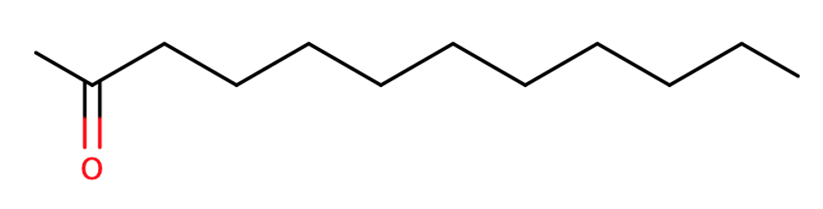

Figure 40 – Chemical structure of 2-dodecanone.

Over the years, several engineering efforts have introduced various orthologue pathways for the production of short and medium chain methyl ketones. Full methyl ketone production pathways are not available in bacteria but pathways such as glucose, fatty acids, H₂ and CO₂ in bacteria have been engineered to produce methyl ketones, particularly in E. coli (Figure 41) (Beller et al., 2015, Dong et al., 2019, Hanko et al., 2018, Müller et al., 2013b, Park et al., 2012, Yuzawa et al., 2018). Heterologous methyl ketone genes from plants, such as MKS1 and 2, fadR and fadD, have been engineered into E. coli’s pathways in order to allow the production of methyl ketones in the bacteria from its existent fatty acid and glycolysis pathways (Beller et al., 2015, Ben-Israel et al., 2009, Fridman et al., 2005, Goh et al., 2012, Goh et al., 2014, Harrison and Harvey, 2018, Lan et al., 2013, Raczyk et al., 2017, Yoneda et al., 2014). Further and as described previously, ShMKS1 and ShMKS2 have been identified as key for the production of methyl ketones from fatty acids (Ben-Israel et al., 2009, Fridman et al., 2005, Park et al., 2012, Yu et al., 2010).

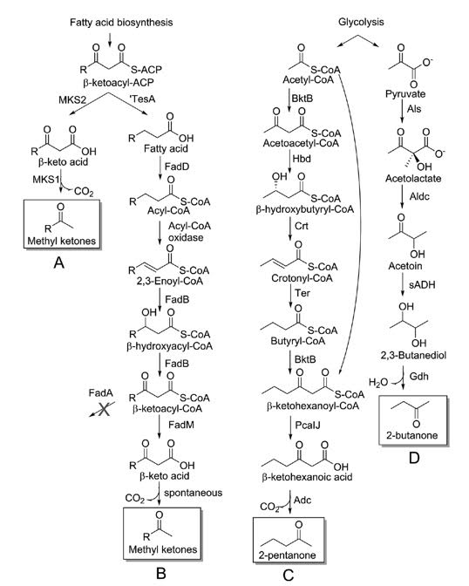
Figure 41 – Heterologous engineered pathways for the production of medium chain methyl ketones (A and B) and short chain methyl ketones (C and D) in E. coli.
Taken from (Beller et al., 2015).

Such engineering efforts have given raise to the production of short and medium chain methyl ketones in several bacteria, such as 2-tridecanone, 2-pentanone and 2-undecanone to name a few (Table 15). Goh et al. achieved the production of methyl ketones in Micrococcus luteus by altering the β-oxidation pathway by overexpressing the native thioesterases FadM and FadB, obtaining 1.4 g/L of medium chain methyl ketones, 700-fold more production of methyl ketones than a similar study in E. coli and the highest reported yields of methyl ketones. The same study reported the production of saturated methyl ketones, favourable for biofuel applications, by implementing ShMKS2 (Goh et al., 2012; Goh et al., 2014), such enzyme, described as key before, might be worth of attention when designing strategies for biofuel production. Muller et al implemented the same pathways as in the previously mentioned study and introduced the ShMKS gene into Ralstonia eutropha and achieved titers of 180 mg/L under chemolithoautotrophic grow conditions (Müller et al., 2013b). Lan et al. generated 2-pentanone in E. coli using the Acetoacetyl-CoA pathway, which does not initiate with fatty acids. The study reported titers of 240 mg/L (Lan et al., 2013). Whilst these studies have contributed important knowledge regarding the production of methyl ketones in bacteria, none of them have been implemented in Synechocystis, which was considered as a research opportunity by the present dissertation.

Table 15: Production of methyl ketones
Methyl ketone | Titers-reported | Organism | Source
Short and medium chain methyl ketones | 380 mg/L | E. coli | (Goh et al., 2012)
Short chain methyl ketones | 180 mg/L | Ralstonia eutropha | (Müller et al., 2013a)
Medium chain methyl ketones | 500 mg/L  1.4 g/L | Pseudomonas putida  E. coli | (Dong et al., 2019)  (Harrison and Harvey, 2018)  (Goh et al., 2014)
Medium chain methyl ketones | 314.8 mg/L | Yarrowia lipolytica | (Hanko et al., 2018)

Table 15 – Production of methyl ketones in various organisms. The table illustrates the maximum obtained titers in milligrams per litter (mg/L) or grams per litter (g/L).
From (Dong et al., 2019; Goh et al., 2012; Goh et al., 2014; Hanko et al., 2018; Müller et al., 2013; Park et al., 2012; Yoneda et al., 2014).

A fatty acid biosynthesis pathway is presumably present in Synechocystis (Kizawa et al., 2017). Where the fatty acid intermediate β-ketoacyl-ACP can be hydrolysed into β-ketoacid and finally decarboxylated into methyl ketones by the action of only two heterologous enzymes (ShMKS1 and ShMKS2) from Solanum habrochaites, a wild tomato species (Goh et al., 2012; Goh et al., 2014). This minimalist strategy would not only imply less metabolic burden in Synechocystis but also when coupled with CRISPR/Cas9 to address the genetic engineering obstacles of the cyanobacterium (see Section 2.2.2), could lead to increased yields of methyl ketones in Synechocystis.

Therefore, the main objective of the present work is to engineer Synechocystis using CRISPR/Cas9 to insert ShMKS1 and ShMKS2 into its genome with the purpose of producing increased yields of methyl ketones in the cyanobacterium and leverage it as a biofuel producing strain.

4.2 Chapter aims

The aim of this Chapter 4 is described in the following lines:

- To produce methyl ketones through the insertion of the heterologous enzymes ShMK1 and ShMKS2 in Synechocystis sp. PCC 6803.

- To design and develop CRISPR/Cas9 tools i.e. an sgRNA and a dDNA, specific for Synechocystis sp. PCC 6803 and methyl ketone production, to tackle the highly polyploid genome of the cyanobacterium and achieve full mutant segregation rapidly.

4.3 Materials and methods

4.3.1 Materials

A list of the materials, including detailed information regarding the reagents, kits, enzymes, equipment and software used in this chapter can be found in Appendixes 1, 2 and 3. Unless specified otherwise, the solutions in the present section were prepared with distilled water (dH₂O) from a Barnstead Smart 2 Pore 6 water filtration unit. All the solutions that required autoclaving were sterilised with a Priorclave Tactrol 2 autoclave at 121 °C and 1.5 atm for 30 minutes. The reagents implemented in this section as well as the kits and equipment were the highest grade and quality available.

4.3.2 Strains, plasmids and constructs implemented

All the strains, plasmids as well as constructs and primers used in this Chapter 4 are listed in the following Table 16.

Table 16: List of strains, plasmids, constructs and primers used in this chapter
Strain, plasmid, construct or primers | Description | Source
Strains
E. coli 10-Beta | High efficiency cloning strain | New England BioLabs, UK
E. coli pPMQK1 | E. coli copy cutter strain bearing the plasmid pPMQK1::Cas 9, Km^{R} | Dr. Paul Hudson research group, Science for Life Laboratories, Karolinska Institute, Stockholm, Sweden
E. coli MC1061 | Conjugal helper strain carrying the helper mobility plasmids pRK24 and pRL528, Amp^{R} and Cm^{R} | Dr. Alastair McCormick research group, Centre for Synthetic and Systems Biology, University of Edinburgh, UK
∆Synechocystis::Cas 9 | Strain bearing the Cas 9 gene, Km^{R} | This work
∆Synechocystis::Cas 9_sgRNA_ShMKS-dDNA | Strain bearing the Cas 9 gene and the sgRNA_ShMKS-dDNA construct, Km^{R} | This work
Synechocystis sp. PCC 6803 (Accession number: GCA_000009725.1) | Wild type | Pasteur Institute, Paris, France
Plasmids backbones
pPMQK1 | Plasmid bearing the Cas 9 gene, Km^{R} | Dr. Paul Hudson research group, Science for Life Laboratories, Karolinska Institute, Stockholm, Sweden
pEERM3 | Plasmid no. 64025 for integration into neutral site slr0168 of Synechocystis, Km^{R} | Addgene, USA
Plasmids constructed
pEERM3::sgRNA_ShMKS-dDNA | Plasmid bearing the sgRNA construct and the ShMKS-dDNA construct, Km^{R}, Cm^{R} | This work
Constructs
sgRNA | Construct designed to guide Cas 9 and ShMKS-dDNA to the target site | Design: this work, synthesized: Eurofins Genomics, Germany
ShMKS-dDNA | Donor DNA construct bearing the ShMKS genes | Design: this work, synthesized: Eurofins Genomics, Germany
Primers (5’ to 3’)
Mutant segregation primers | Forward: gccgaagcaggggaaactccta  Reverse:  tggcttggtcatcagcggc | This work
Cas9 primers | Forward:  ataggcgtatcacgaggcaga  Reverse:  tcattaagcagctctaatgcgc | This work
Table 16 – List of strains, plasmids, constructs and primers implemented in Chapter 4 of the present dissertation. Abbreviations: Km^{R}, kanamycin resistance; Cm^{R}, chloramphenicol resistance; Amp^{R}, ampicillin resistance.

4.3.3 Growing conditions of bacteria

4.3.3.1 Growth conditions of E. coli strains
The growth conditions of the E. coli strains for this Chapter 4 were the same as those implemented in Chapter 3, Section 3.3.3.1.

4.3.3.2 Growth conditions of Synechocystis strains
The growth conditions for the Synechocystis strains for this Chapter 4 were the same as implemented in Chapter 3, Section 3.3.3.2.

4.3.4 Bacterial transformation

4.3.4.1 Transformation of E. coli 10-Beta
The transformation methods for the E. coli strains for this Chapter 4 were the same as those implemented in Chapter 3, Section 3.3.4.1.

4.3.4.2 Transformation of Synechocystis
The transformation methods for the Synechocystis strains for this Chapter 4 were the same as those implemented in Chapter 3, Section 3.3.4.2.

4.3.5 DNA preparation
The DNA preparation methods for this Chapter 4 were the same as those implemented in Chapter 3, Section 3.3.5.

4.3.6 Gel electrophoresis
The gel electrophoresis methods for this Chapter 4 were the same as those implemented in Chapter 3, Section 3.3.6.

4.3.7 Construction of CRISPR/Cas9 tools for methyl ketone production in Synechocystis

In the same fashion as Chapter 3, section 3.3.7, for achieving the production of methyl ketones in Synechocystis, the strategy proposed in the present dissertation includes the design of two CRISPR/Cas 9 tools for Synechocystis. Firstly, a sgRNA, which will guide the Cas9 nuclease and the dDNA into the selected target site in order to effectuate the insertion; and a dDNA that will insert the two necessary heterologous genes encoding enzymes to produce methyl ketones from the fatty acid biosynthesis pathway (ShMKS-dDNA) into the target site in the genome of Synechocystis. The sgRNA as well as the ShMKS-dDNA were synthesized and inserted into the pEERM3 plasmid as two separate constructs to generate the pEERM3:sgRNA-ShMKS-dDNA plasmid.

4.3.7.1 Construction of the sgRNA

The sgRNA was designed and constructed according to the protocols of Larson et al., 2013 and Ran et al., 2013. The sgRNA consisted of three sections: 1) a protospacer, which were 20 bp taken from the target site in the genome of Synechocystis and are complementary to the target site and which were placed after the anhydrotetracycline inducible PL22 promoter, 2) a Cas9-handle sequence, which allowed the binding between the Cas9 nuclease and the sgRNA and 3) a terminator sequence from Streptococcus pyogenes. A total of 51 protospacer regions were evaluated for off-target binding using the CasOT software (Xiao et al., 2014). After the off-target analysis, the final protospacer selected was the one showing least potential off-target binding probabilities. The selected protospacer region was then placed next to the Cas9-handle sequence, to allow the binding between the Cas9 nuclease and the sgRNA, and the terminator sequence. The full sgRNA sequence was flanked by BssHII, designed using the SBOL Designer and diagrams.net software tools and synthesized by Eurofins Genomics as a custom gene.

4.3.7.2 Construction of the ShMKS-dDNA

The ShMKS-dDNA was designed and constructed according to the protocols of Larson et al., 2013 and Ran et al., 2013. The ShMKS-dDNA contained an insulator, an anhydrotetracycline inducible PL22 promoter, the RBS B0034, the ShMK1 and ShMK2 genes from Solanum habrochaites, a wild tomato species, and which encode the two necessary proteins to produce methyl ketones from the fatty acid biosynthesis pathway, and a t7 terminator sequence. A chloramphenicol resistance cassette was as well included, its sequence, along with its control elements (promoter, RBS and terminator) were taken from the chloramphenicol resistance cassette of the pEERM4 plasmid (Addgene plasmid no. 64026, bp start location: 950, bp end location: 1610). This whole sequence was flanked by two 400 bp each homology regions taken from the upstream and downstream sequences from the target site in the genome of Synechocystis, also flanked by the BioBrick prefix and suffix. The insert was designed using the SBOL Designer and diagrams.net software tools and synthesized by Eurofins Genomics as a custom gene.

4.3.8 Construction of the pEERM3::sgRNA_ShMKS-dDNA plasmid

The sgRNA and ShMKS-dDNA were inserted into the backbone of pEERM3 (Figure 42), a plasmid designed for the integration into a neutral site srl0168 of Synechocystis. The backbone contained a pMB1 origin of replication (ori), a kanamycin resistance cassette (kan^{r}) as well as upstream (H1) as well as downstream neutral site homologous sequences (H2) and a multiple cloning site (MCS) (Englund et al., 2015).

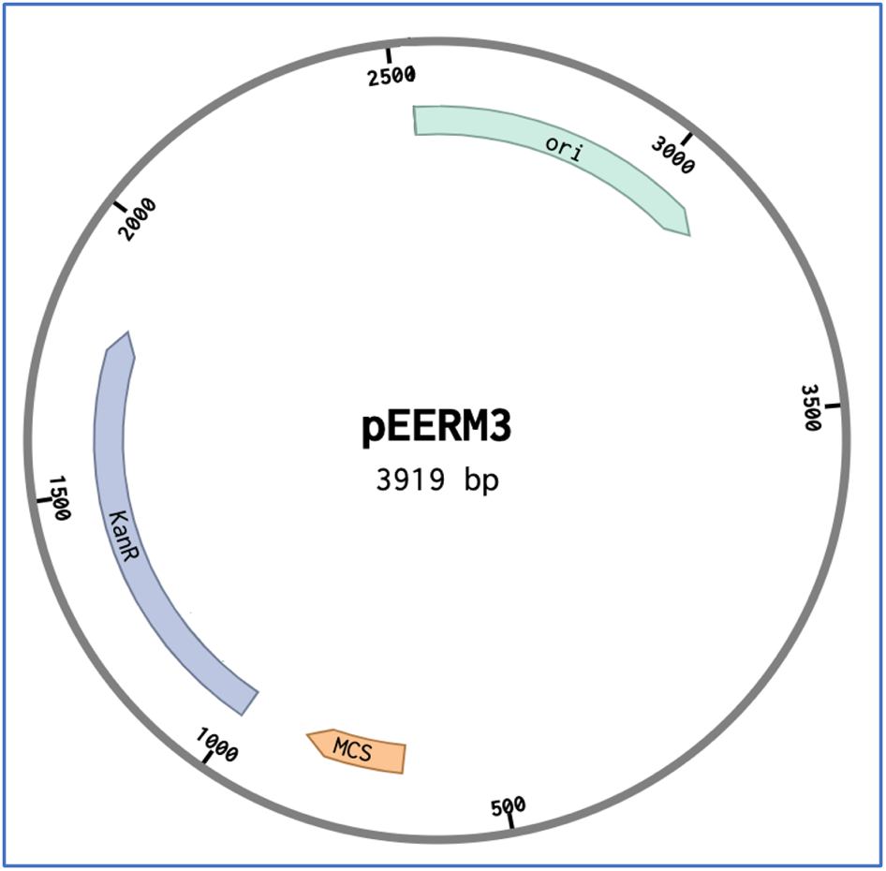

Figure 42 – The pEERM3 plasmid backbone.
The pEERM3 plasmid backbone consists of 3,919 base pairs (bp) and displays an origin of replication (ori), kanamycin resistance cassette (Kan^{r}) and a multiple cloning site (MCS).

The sgRNA and the ShMKS-dDNA were inserted into the backbone independently. Initially, the constructs were delivered as standard genes in a generic plasmid, which were rehydrated with pertinent volumes of distilled water and then transformed into E. coli 10-Beta separately. Subsequently, 5 mL overnight cultures with LB media and the appropriate antibiotics for each construct were made and the respective plasmids were isolated. Subsequently, the purified plasmids were restriction digested using standard procedures (Sambrook and Russell, 2011) with BssHII for the sgRNA and with EcoRI and PstI from the BioBrick prefix and suffix for the ShMKS-dDNA insert. To insert the sgRNA into pEERM3, the backbone of the plasmid was restriction digested with BssHII and treated with shrimp alkaline Phosphatase (rSAP) (NEB) to maximize transformation efficiency. Subsequently, all restriction digests were run on a 1% electrophoresis gel in order to identify the DNA fragments of the respective correct size for all the inserts and for the backbone. The correct DNA fragments were then gel extracted and PCR purified. The following step was to ligate the digested pEERM3 backbone with the digested sgRNA. The sgRNA was inserted into the pEERM3 backbone by T4DNA ligation (Sambrook and Russel, 2011). The plasmid was then transformed into E. coli 10-Beta, cultured overnight with LB media and the appropriate antibiotics and plasmid purified the next day in order to isolate the newly constructed pEERM3::sgRNA plasmid.

The pEERM3::sgRNA plasmid was restriction digested using EcoRI and PstI and run in a 1% electrophoresis gel to identify the plasmid portion with the correct size, which was gel extracted and PCR purified and finally ligated with the previously digested ShMKS-dDNA via T4DNA ligation (Sambrook and Russel, 2011) to generate the pEERM3::sgRNA_ShMKS-dDNA plasmid (Figure 46, see Section 4.4.2), which contained both CRISPR/Cas9 tools here-designed for Synechocystis to produce methyl ketones in the cyanobacterium. The plasmid was then transformed into E. coli 10-Beta for maintenance and future work.

4.3.9 Generation of Synechocystis::Cas9

The methods for the generation of Synechocystis::Cas9 were the same as those implemented in Chapter 3, Section 3.3.9.

4.3.10 Generation of Synechocystis::Cas9_sgRNA_ShMKS-dDNA through CRISPR/Cas9

The methods for the generation of Synechocystis::Cas9_sgRNA_GGR-dDNA were the same as those implemented in Chapter 3, Section 3.3.10.

4.3.11 Mutant segregation analysis

The methods for the mutant segregation analysis were the same implemented as those in Chapter 3, Section 3.3.11. However, the parameters for the PCR implemented are shown in Table 17.

Table 17: Parameters of the PCR of the mutant segregation analysis
Stage |  | Time (min.) |  | Temperature (°C)
Denaturation
Initial |  | 2 |  | 95
Subsequent* |  | 1 |  | 95
Annealing*
Annealing* |  | 30 sec. |  | 54.8
Extension
Negative control* |  | 1 |  | 72
Synechocystis WT* |  | 1 |  | 72
Positive control* |  | 3 |  | 72
ΔSynechocystis::Cas9_sgRNA_ShMKS-dDNA* |  | 3 |  | 72
Final extension |  | 5 |  | 72
Final store
Final store |  | ∞ |  | 25
Cycles: 35
Primers (5’ to 3’)
Mutant segregation primers |  | Forward: gccgaagcaggggaaactccta  Reverse:  tggcttggtcatcagcggc |  | Source: this work
Cas9 primers |  | Forward:  Ataggcgtatcacgaggcaga  Reverse:  tcattaagcagctctaatgcgc |  | Source: this work
Table 17 – Parameters followed for the GoTaq Green PCR mutant segregation analysis.
Stages of the GoTaq green PCR mutant analysis for Synechocystis::Cas9_sgRNA_ShMKS-dDNA, the time, in minutes, and temperature, in °C, for each stage. In the negative control, dH₂O was used as a DNA template instead of a DNA sample and a plasmid purification from the pEERM3::sgRNA_ShMKS-dDNA plasmid was used as DNA template for the positive control. Symbols: * denotes a stage that is part of the 35 cycles of the PCR process, ∞ denotes indefinite time.

4.3.12 Gas chromatography analysis

Gas chromatography (GC) analysis were performed on the culture supernatant extract of mutants in order to confirm if they were producing methyl ketones. The studies were effectuated following the protocol described by Goh et al., 2012 and performed on Synechocystis as well as Synechocystis::Cas9_sgRNA_ShMKS-dDNA.

To obtain samples for GC, 100 mL cultures of WT and mutants were supplemented with a 10 mL of decane overlay in order to trap the methyl ketones produced by the mutants and excreted from the cells, released into the media and, due to their volatility, travel to the top of the culture. To obtain samples for methyl ketones production analysis from liquid mutant cultures, 100 mL of culture were centrifuged at 4,000 x g for 10 min., which resulted in the generation of three layers, pellet (containing Synechocystis cells and was on the bottom layer of the tube), an organic phase (containing the decane and which was the top layer) and an aqueous phase (containing the BG-11 media and was the middle layer); since methyl ketones became trapped in the decane overlay, the organic layer was separated from the other phases and 2 mL samples of it were taken for GC analysis.

The gas chromatograph was a Autosystem XL paired with a MS Turbomass mass selective detector (PerkinElmer) with a Phenomenex ZB-5plus capillary column (30 m length, 0.25 mm inner diameter, 0.25 μm film thickness). The injection volume was 0.3 μL. The GC oven was set at 120 °C isothermal. The carrier gas implemented was high-purity hydrogen supplied at a constant rate of 1.4 mL/min. The methyl ketone standard implemented was a 2-dodecanone analytical standard (Sigma Aldrich), decane (Sigma Aldrich) was used as solvent and acetone was used to wash the equipment’s needle in between samples.

Methyl ketones were quantified through a 2-dodecanone four-point calibration curve starting from 27.10 mM, continuing to 271 mM, 2.71 M and finalizing in 27.13 M. A partition coefficient analysis was performed on the 2-dodecanone standard in order to determine if the affinity of methyl ketones leaned towards either BG-11 media or the decane overlay. A mixture of BG-11, 2-dodecanone standard, at a concentration of 5g/ L, and decane were vortexed for 20 seconds and centrifuged at 4,000 x g for 1 min., which caused a phase separation in the mixture, an aqueous phase (BG-11 media) and a solvent phase (decane), the 2-dodecanone standard was hypothesized to be caught in the solvent phase. The phases were separated by pipetting and sent separately to GC analysis to determine if the 2-dodecanone standard remained either on the aqueous or the solvent phase.

4.4 Results and discussion

4.4.1 Construction of CRISPR/Cas9 tools for methyl production in Synechocystis

4.4.1.1 Construction of the sgRNA

As mentioned in Section 4.3.7.2, the sgRNA (Figure 43) is an anhydrotetracycline inducible CRISPR/Cas9 tool and was constructed to guide the Cas9 nuclease into the target DNA location in the genome of Synechocystis in order to effectuate the DSB, the homology-directed DSB repair mechanism and allow the insertion of the ShMKS-dDNA into the chromosome of Synechocystis.

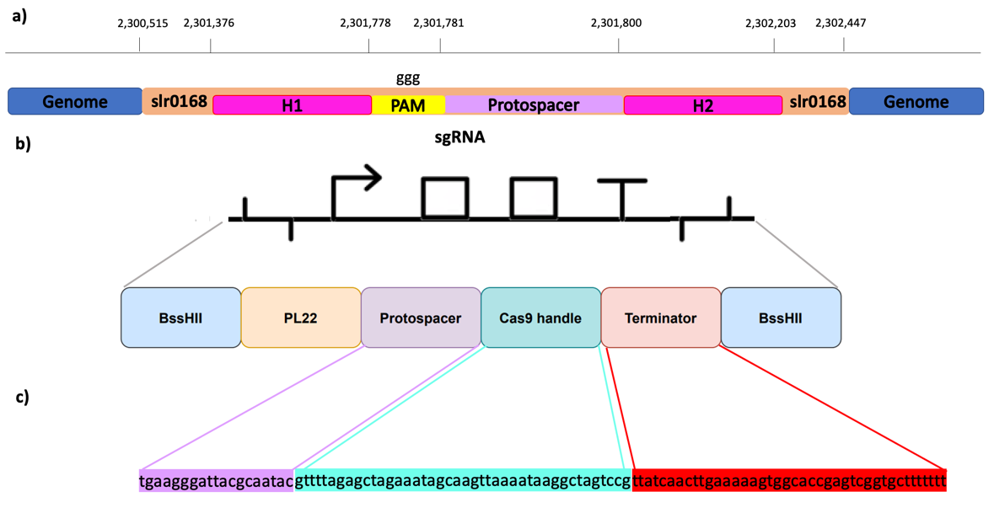
Figure 43 – sgRNA construct designed for methyl ketones production in Synechocystis.
a) Shows the genetic context of the selected protospacer of the sgRNA, showing the base positions of the elements upstream and downstream of the selected protospacer in the genome of Synechocystis where H1 and H2 are the homology regions up and downstream the selected neutral site (slr0168). b) Illustrates the SBOL diagram of the constructed sgRNA (in black) and a graphic description of its elements (in colours), illustrating the PL22 as the promoter the sgRNA was put under the control of, as well as the selected protospacer, Cas9 handle and terminator. c) Shows the amino acid sequences of the protospacer, Cas9 handle and terminator of the sgRNA.

The sgRNA is comprised by the anhydrotetracycline inducible promoter PL22 (PL22), a protospacer, which was which was taken from the target site in the genome of Synechocystis and selected for presenting the least off-target binding probabilities and constitutes the leading element in the whole sgRNA. The insert comprises as well a Cas9-handle sequence, which allows the binding between the sgRNA and the Cas9 nuclease for it to be guided onto the cleavage target site and a terminator sequence. Since the protospacer is the main leading element of the sgRNA and was taken from the integration target site, it is considered a CRISPR insertion target site, which has been denoted as such by the Synthetic Biology Open Language (SBOL) symbol on top of the protospacer (Figure 43).

To construct the protospacer of the sgRNA, the slr0168 gene was selected given that it has been identified as a neutral site in Synechocystis. A neutral site is a gene in the genome that allows the genetic engineering of its host organism without presenting any phenotypical changes (Pinto et al., 2015). Therefore, all possible protospacers available in slr0168 were evaluated for off-target activity. The selected protospacer in the sgRNA was the one with the least off-target activity. Figure 43 illustrates as well the genetic context of the designed sgRNA within slr0168. Similarly, such Figure shows the beginning and end positions of the slr0168 gene along with the position of the upstream and downstream elements of the sgRNA, such as the homology regions (H1 and H2), to aid in the recognition site and the insertion of the GGR-dDNA and the Protospacer Adjacent Region (PAM), a key element to identify the target binding site in the genome of Synechocystis. Moreover, Table 18 provides further details of the elements of the sgRNA, such as their nucleic acid sequences.

Table 18: Nucleic acid sequences of the elements of the sgRNA
Element | Nucleic acid sequence(5’ to 3’)
PL22 promoter | tccctatcagtgatagagattgacatccctatcagtgatagagatactgggagcta
Cas9 handle | gttttagagctagaaatagcaagttaaaataaggctagtccg
Protospacer | tgaagggattacgcaatac
Terminator from S. pyogenes | ttatcaacttgaaaaagtggcaccgagtcggtgcttttttt
Table 18 – Nucleic acid sequences of the elements of the sgRNA.

4.4.1.2 Construction of the ShMKS-dDNA

As previously mentioned in Section 4.3.7.2, the ShMKS-dDNA (Figure 44) is an anhydrotetracycline inducible CRISPR/Cas9 tool and was constructed to be used as a repair template after the generation of the DSB and insert the heterologous methyl ketone producing proteins in the genome of Synechocystis in order to produce the biofuel.

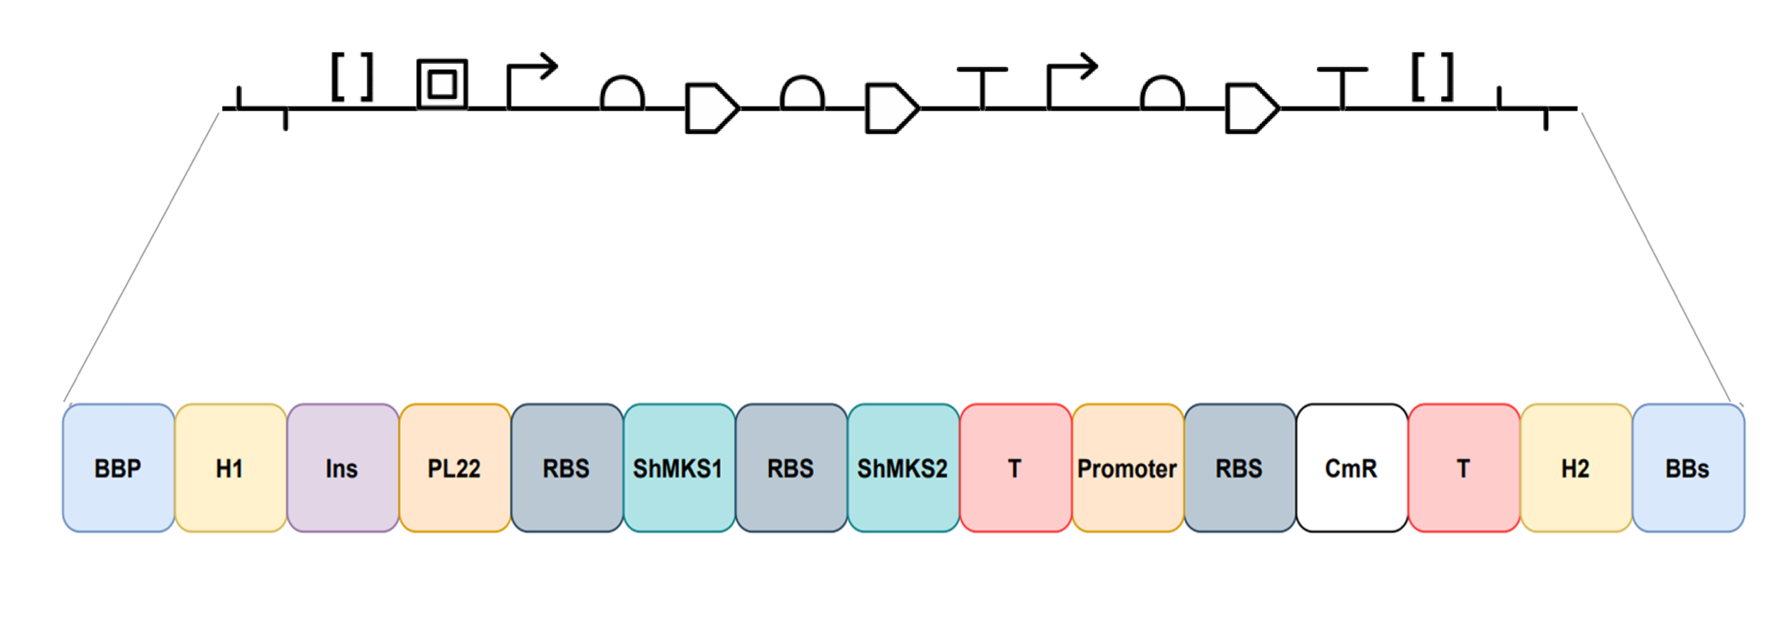
Figure 44 – ShMKS-dDNA construct designed for methyl ketone production in Synechocystis.
The ShMKS-dDNA design is displayed, showing in black the design in SBOL and furtherly explained in colours. The ShMKS-dDNA is flanked by the BioBrick prefix and suffix (BBp and BBs: in blue), followed by an insulator (Ins: in purple), the upstream and downstream homologous sequences to the neutral site (H1 and H2: in yellow), an inducible PL22 promoter (PL22: in orange), an RBS B0034 (in grey), the methyl ketone synthase 1 gene (ShMKS1: in turquoise), another RBS B0034 (in grey) and the methyl ketone synthase 2 gene (ShMKS2: in turquoise), a T7 terminator (T: in red), another promoter (in orange), another RBS (in grey), a chloramphenicol resistance cassette (CmR: in white) and another terminator (T: in red).

The ShMKS-dDNA was formed by an insulator (Ins) to block interference form upstream sequences, the anhydrotetracycline inducible PL22 promoter (PL22), the RBS B0034 (RBS), the heterologous methyl ketone producing genes shMKS1 and shMKS2 from a wild tomato species as well as control elements (a promoter, an RBS and a terminator (T)) for a chloramphenicol resistance cassette (CmR). The whole insert was flanked first by upstream and downstream homologous sequences to the neutral sire (H1 and H2), taken from the insert target site in the genome of Synechocystis and finally, flanked by the BioBrick prefix and suffix (BBp and BBs) in order to allow the insertion of the construct in the pEERM3 plasmid backbone. Table 19 provides accession numbers or nucleic acid sequences of the elements of the ShMKS-dDNA.

Table 19: Accession numbers, bp position or nucleic acid sequences of the elements of the ShMKS-dDNA
Element | Accession ID, bp position or sequence(5’ to 3’)
BioBrick prefix (BBp) | gaattcgcggccgcttctagag
H1 | Start: 2,301,376. End: 2,301,778 (bp end and start position in the genome of Synechocystis)
PL22 promoter | tccctatcagtgatagagattgacatccctatcagtgatagagatactgggagcta
Insulator | agctgtcaccggatgtgctttccggtctgatgagtccgtgaggacgaaacagcctctacaaataattttgtttaaactaga
Ribosome binding site (RBS) | BBa_B0034 (iGeM ID)
ShMKS1 | AAV87156 (GenBank Accession number)
ShMKS2 | ADK38536 (GenBank Accession number)
CmR | Chloramphenicol resistance gene from plasmid pEERM3 (Addgene plasmid no. 64025)
Terminator | agctgtcaccggatgtgctttccggtctgatgagtccgtgaggacgaaacagcctctacaaataattttgtttaaactaga
H2 | Start: 2,301,800. End: 2,302,203 (bp end and start position in the genome of Synechocystis)
BioBrick suffix (BBs) | tactagtagcggccgctgcag
Table 19 – Accession numbers, bp position or nucleic acid sequences of the elements of the ShMKS-dDNA.

4.4.2 Construction of the pEERM3::sgRNA_ShMKS-dDNA plasmid

As mentioned in Section 4.3.8, the sgRNA and ShMKS-dDNA constructs were inserted into the backbone of the pEERM3 plasmid (Figure 42) independently. First, the sgRNA was inserted into the backbone using BssHII. Once the insertion was effectuated, a gel electrophoresis was effectuated in order to confirm the presence of the insert in pEERM3 (Figure 45). The results show a band of the expected height, corresponding to the size of the sgRNA insert in the pEERM3 plasmid (bp), confirming the presence of the insert in the pEERM3 plasmid.

As mentioned in Section 4.3.8, the sgRNA and ShMKS-dDNA constructs were inserted into the backbone of the pEERM3 plasmid independently. First, the sgRNA was inserted into the backbone. Once the insertion was effectuated, a restriction digestion on the plasmid was implemented using BssHII, which flanked the sgRNA, followed by a gel electrophoresis in order to confirm the presence of the insert in pEERM3. The results show two bands of the expected height, corresponding to the backbone of pEERM3 (3,919 bp) and to the size of the sgRNA (171 bp), confirming the presence of the insert in the pEERM3 plasmid.

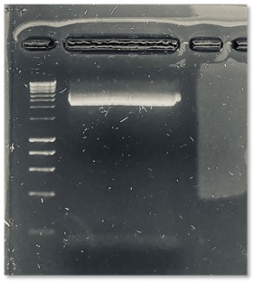

Figure 45 – Gel electrophoresis after insertion of the sgRNA into pEERM3.
Lane 1 shows the ladder implemented, and lane 2 show the expected bands at the height that corresponds to the size of the pEERM3 backbone (higher band) and to the size of the sgRNA construct (lower band), confirming the presence of the sgRNA in pEERM3.

Once the sgRNA was successfully inserted in the pEERM3 plasmid, the insertion of the ShMKS-dDNA was effectuated. Consequently, a restriction digestion on the plasmid was implemented using the BioBrick prefix and suffix, which flanked the ShMKS-dDNA, followed by a gel electrophoresis in order to confirm the presence of the insert in pEERM3::sgRNA (Figure 46).

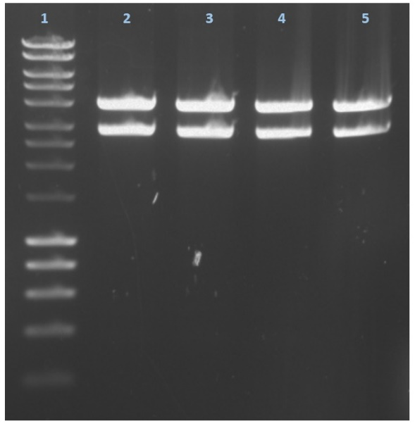

Figure 46 – Gel electrophoresis after insertion of the ShMKS-dDNA.
Lane number 1 shows the ladder implemented, while lanes number 2 to 5 show bands of the expected height, corresponding to the plasmid backbone already containing the sgRNA (higher bands) as well as lower bands that corresponds to the size of the ShMKS-dDNA construct, confirming the presence of the insert in the plasmid and showing the successful construction of pEERM3::sgRNA_ShMKS-dDNA.

The results show bands of the expected height for the plasmid backbone with the sgRNA (4,090 bp) and lower bands, corresponding to the size of the ShMKS-dDNA (3,317 bp), confirming the presence of the insert in the plasmid and demonstrating the successful creation of the pEERM3::sgRNA_ShMKS-dDNA plasmid (Figure 47).

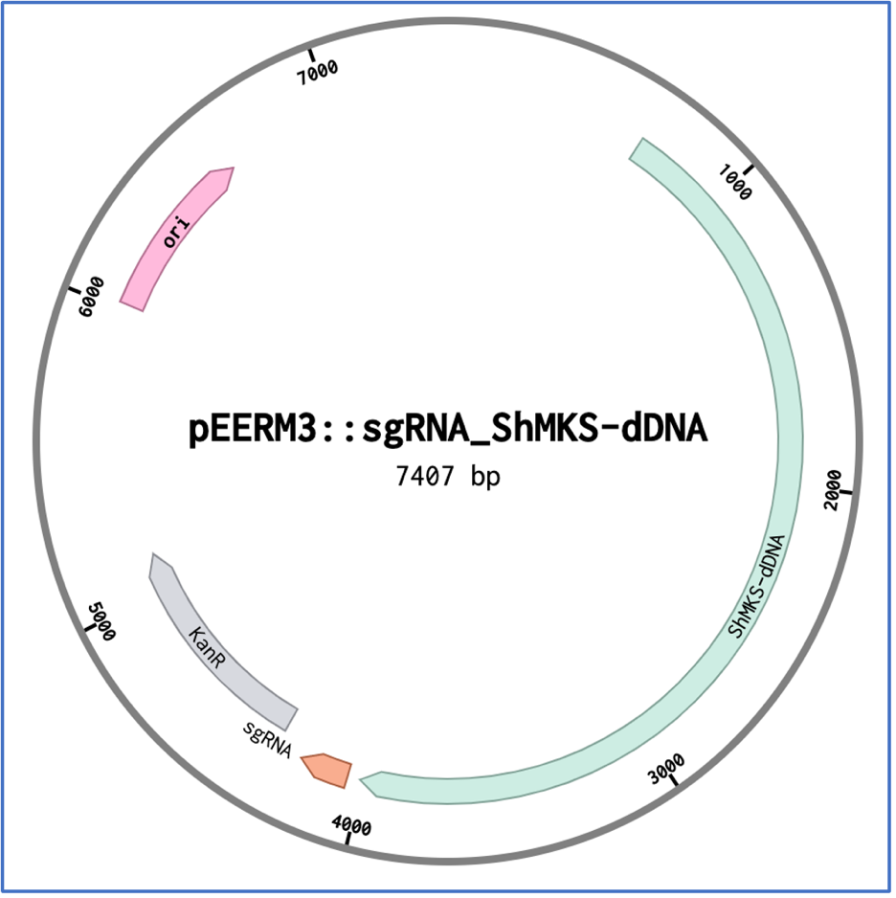

Figure 47 – The pEERM3::sgRNA_ShMKS-dDNA plasmid.
The image displays the 7,407 bp pEERM3::sgRNA_ShMKS-dDNA plasmid, containing the basic elements from the pEERM3 plasmid backbone an origin or replication (ori) and a kanamycin resistance cassette (Kan^{R}) as well as the newly inserted CRISPR/Cas9 tools, the sgRNA and the ShMKS-dDNA.

4.4.3 Generation of Synechocystis::Cas9_sgRNA_ShMKS -dDNA: mutant segregation analysis

4.3.3.1 Growth of Synechocystis::Cas9_sgRNA_ShMKS -dDNA

Once the pEERM3::sgRNA_ShMKS-dDNA plasmid was constructed, Synechocystis::Cas9_sgRNA_ShMKS-dDNA was constructed by inserting such plasmid into Synechocystis::Cas9 via conjugation. A growth curve analysis was effectuated in order to evaluate if this insertion had negative effects regarding the growth of the mutant compared with Synechocystis WT. The results are shown in Figure 48.

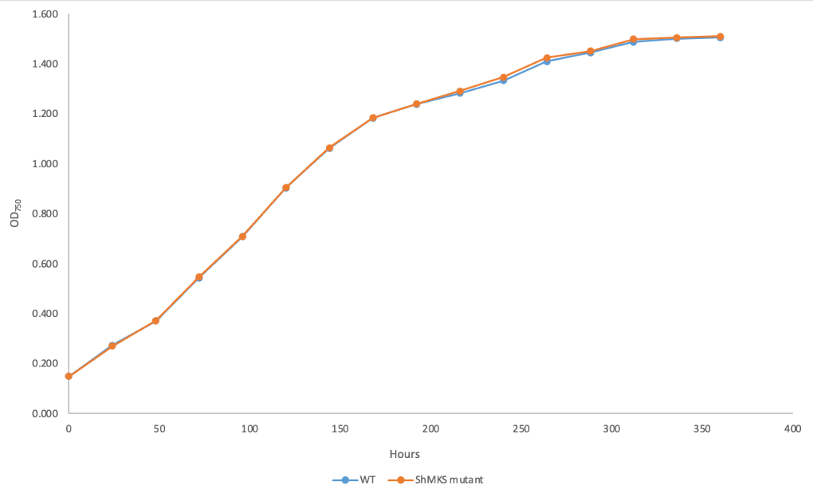

Figure 48 – Growth analysis of Synechocystis WT and Synechocystis::Cas9_sgRNA_ShMKS-dDNA.

The results show that the insertion of Cas9 as well as the creation of the Synechocystis::Cas9_sgRNA_ShMKS -dDNA had no effect on the growth patterns. It can be seen from Figure 48 that there are no differences in the growth patterns of Synechocystis WT and Synechocystis::Cas9_sgRNA_ShMKS-dDNA. Therefore, the insertion of the CRISPR/Cas9 elements had no effect on the growth of Synechocystis. This signifies that the mutant can be expected to grow at the same rate as the normal rate, described for Synechocystis WT and hence, titers of methyl ketones generated by the mutant are not expected to be affected.

4.3.3.2 Mutant segregation analysis of Synechocystis::Cas9_sgRNA_ShMKS -dDNA

Once the pEERM3::sgRNA_ShMKS-dDNA plasmid was constructed, Synechocystis::Cas9_sgRNA_ShMKS-dDNA was constructed and reflected no changes in its growth patterns, an analysis of the mutant segregation in the strain was carried out by performing a GoTaq Green PCR followed by running gel electrophoresis of the products in order to determine if the insertion of the constructs and plasmid was successful as well as whether full mutant segregation was achieved. Figure 49 shows the integration and segregation analysis of such mutants.

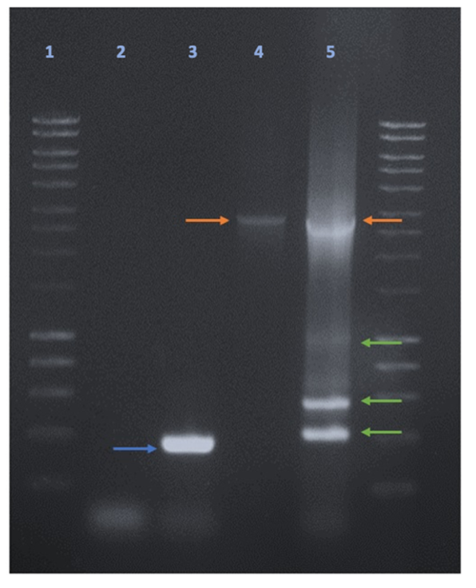

Figure 49 – Insertion and mutant segregation analysis of Synechocystis::Cas9_sgRNA_ShMKS-dDNA.
PCR showing the integration and segregation analysis of the mutants Synechocystis::Cas9_sgRNA_ShMKS-dDNA through CRISPR/Cas9 where lane 1 displays the 1KB DNA ladder. Lane 2 shows the PCR of the negative control, where sterile distilled water was used instead of the DNA template sample and displaying a low band which is probably the result of primer dimers. Lane 3 represents the PCR of Synechocystis WT, displaying an expected band (blue arrow) corresponding to the homology regions present in the ShMKS-dDNA, taken from the target site in the genome of Synechocystis WT and a lower band, which correspond to the formation of primer dimers. Lane 4 illustrates the PCR of the positive control, where the sequence of the ShMKS-dDNA in the pEERM3 plasmid was used as a DNA template sample. A band of the expected size (orange arrow) is present. Lane 5 displays the PCR of the mutants generated, Synechocystis::Cas9_sgRNA_ShMKS-dDNA, showing a band of the expected size (orange arrow), which corresponds to the size of the desired band of the positive control to the ShMKS-dDNA as well as various non-expected aditional lower bands (green arrows).

The primers implemented in this analysis (Tables 16 and 17, segregation primers) flanked the sgRNA_ShMKS-dDNA construct and include its homology regions taken from the upstream and downstream sequences of the target site in the genome of Synechocystis (or Synechocystis WT). Therefore, if the sequence of the sgRNA_ShMKS-dDNA was present or successfully inserted in the DNA template samples analysed, they would be amplified in the PCR product and would be shown as a band of the expected length (Figure 49, lane 4). Accordingly, the results for Synechocystis::Cas9_sgRNA_ShMKS-dDNA display a band of the expected and desired height (Figure 49, lane 5, orange arrow), implying that the ShMKS-dDNA sequence is present in the genome of the mutants and, thus, the insertion of the construct was successful. However, the results display as well additional bands of non-expected sizes (Figure 49, lane 5, green arrows), implying there are other and incomplete sequences of the ShMKS-dDNA present in the mutants; that is, not all the individuals in the culture bear the complete and functional sequence of the ShMKS-dDNA in their genome. Therefore, full mutant segregation was not achieved. This is detrimental to the objective of producing and increasing the yields of methyl ketones in Synechocystis given that, as previously mentioned, the lack of full mutant segregation favours mutation loss and dilution, leading to low gene expression. The absence of the ShMKS-dDNA in all the mutants will eventually lead to the loss of such mutation and, finally, to a decreased or absent expression of the methyl ketones producing protein. Hence, a decreased or no production of methyl ketones can be expected from this mutant population. Therefore, the action mechanism of CRISPR/Cas9 was not enough to overcome the highly polyploid genome of Synechocystis.

These results might be due to a number of reasons that, due to time and COVID related constrains, were unable to be implemented and highly possibly might have led to the results obtained. These reasons include unoptimized exposure time and concentration of anhydrotetracycline (aTc), unoptimized conjugation protocol for the helper strain, as well as not having all the CRISPR/Cas9 elements in a single, smaller plasmid.

The concentration and exposure time of the mutant to aTc was determined by the literature, in a study where not CRISPR/Cas9 technology, but similar CRISPR elements are used in cyanobacteria (Yao et al., 2016), This dictated the concentration and exposure time of the mutant to aTc, the inducer of CRISPR/Cas9 elements used in this study. These parameters were optimal for the conditions stablished in such study and followed as such for the present work. However, they were not optimized to our specific conditions and hence, they might not have been the optimal for the present study in order to achieve full mutant segregation. Higher concentrations of aTc as well as longer exposure times of the mutant to this inducer might have led to the achievement of full mutant segregation in this case. The lack of optimization of these parameters to our specific conditions might have been an important factor that hindered the achievement of full mutant segregation in this study.

Furthermore, the optimization of the conjugation protocol implemented for cyanobacteria was effectuated for the cargo and for the host strains but not for the helper strain. The helper strain facilitates the delivery of the cargo strain into the host strain. Therefore, an effective transformation efficiency and the achievement of full mutant segregation depend on the optimization of these three elements (Gale et al., 2019). Increasing the proportions of the helper strain will increase the probabilities of the cargo strain to be delivered into the host strain. Hence, the probabilities of success are higher. One of the bottlenecks in this study could have been the lack of helper strain and hence, low delivery of the cargo strain into the host. So it is possible that the lack of optimization of the helper strain in the tri-parental mating protocol led to an insufficient availability of the helper strain and, therefore, that the cargo strain was not delivered into the host cells as opposed to CRISPR/Cas9 engineering failing.

Finally, another reason leading to the previously presented results might reside in the size of the Cas9 bearing plasmid and the CRISPR/Cas9 elements distributed in a separate plasmid. Having the Cas9 nuclease and all of the CRISPR/Cas9 tools in the same and smaller plasmid might have favoured the achievement of full mutant segregation. When the exposure of the host, bearing all the desired heterologous elements in a single plasmid, to the selective pressure of antibiotics, only the ones that have up taken all the elements simultaneously and in equal measure in the same plasmid will survive and the rest will become diluted and lost, this will increase mutant segregation (Nagy et al., 2021, Taylor et al., 2021). Furthermore, working with large or low copy number plasmids can reduce transformation efficiency and the achievement of the subsequent full mutant segregation due low availability of the desired DNA template, to breakage of the plasmid as well as difficulties to deliver it into the host (Hall et al., 2021, Rodríguez-Beltrán et al., 2021). In this study, the Cas9 nuclease was in the pPMQK1 plasmid, which is a low copy number and large plasmid (more than 13,000 bp), which might have negatively affected the achievement of full mutant segregation. Moreover, the CRISPR/Cas9 elements were put on a different plasmid. The fact that the pPMQK1 is a low copy number as well as a large plasmid and that the CRISPR/Cas9 tools were put in a separate plasmid, given that the pPMQK1 plasmid was already too large, might have led to failing to achieve full mutant segregation.

These factors are highly probable to have hindered the achievement of full mutant segregation, which coupled with the presence of single nucleotide polymorphisms (SNIPs) in the final constructs and the lack of metabolic flux modelling (described in Section 4.3.12), are probably due to have caused the lack of generation of the desired product.

4.4.4 Gas chromatography analysis

After the generation of the Synechocystis::Cas9_sgRNA_ShMKS-dDNA mutant, extracts from its cultures were subjected to a GC analysis in order to evaluate if the mutants were indeed producing methyl ketones. As previously mentioned, Section 4.3.3.12 describes the details for the methodology followed for the GC analysis. The sampling process of the mutant cultures are described as well in such section, where the cultures contained a decane overlay to capture methyl ketone production, which is evaluated in the GC analysis.

Initially, a four-point calibration curve of the methyl ketone standard 2-dodecanone (Figure 50) was effectuated in order to predict the concentrations of the mutant culture samples. The curve ranged from concentrations of 0.0271 mM to 27.13 mM, were the acetone wash eluted at a retention time of 2 minutes, decane eluted at 3.9 minutes, and an additional peak eluted at 5.8 minutes only when decane was present in the sample. Both lastly-mentioned peaks are likely to be generated by decane, which, after sample-injection, is likely to produce droplets instead of adopting an homogenic distribution. This can generate multiple peaks from the same compound (Erban et al., 2007, Wingert, 1992). Finally, the standard eluted at a retention time of 9 minutes for all concentrations. The calibration curve is also shown as a regression analysis (Figure 51). The regression analysis for the calibration curve of 2-dodecanone shows a regression coefficient of 1, which indicates high accuracy in the proportion of variation of the calibration curve.

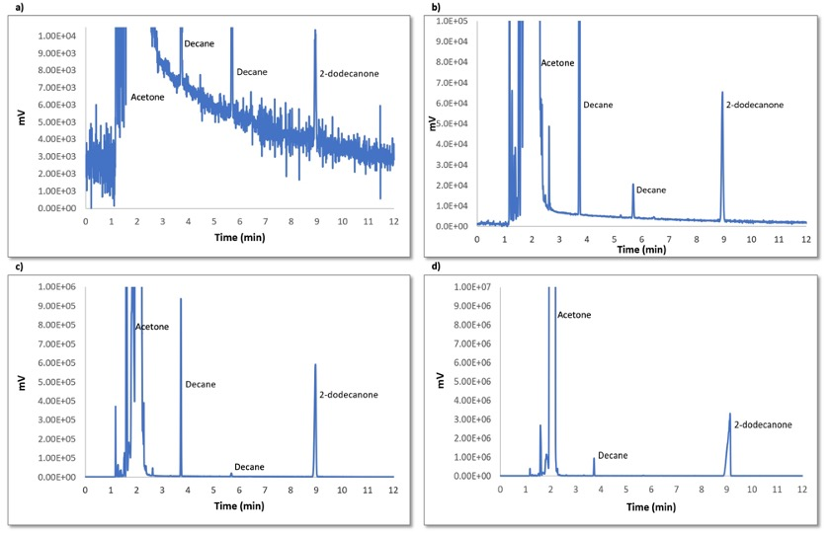
Figure 50– GC analysis of the calibration curve of 2-dodecanone. Chromatograms showing the intensity (mV) and retention time (min) of acetone (in between-sample wash), decane (solvent) and the methyl ketone standard, 2-dodecanone in the calibration curve of 2-dodecanone at a concentration of a) 0.0271 mM, b) 0.271 mM, c) 2.71 mM and d) 27.13 mM.

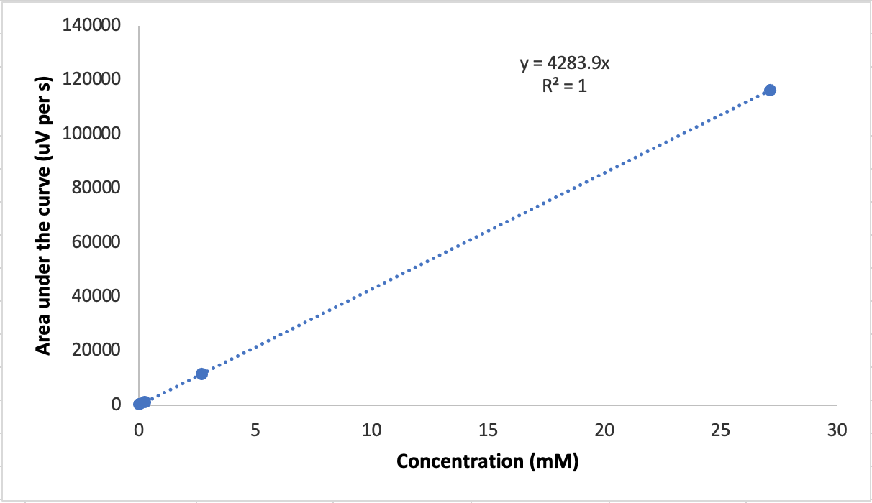

Figure 51 – Regression analysis of the GC analysis of the calibration curve of 2-dodecanone.

A partition coefficient experiment (Figure 52) was performed in order to determine affinity of 2-dodecanone between the aqueous culture medium and the decane phase. This was done to identify whether once released to the media, if a proportion of methyl ketones would remain in the BG-11 media or if all methyl ketones become trapped in the decane overlay.

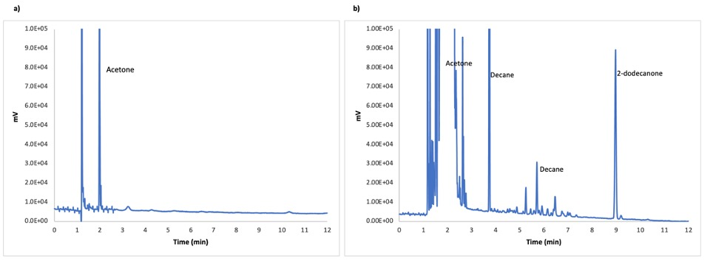
Figure 52 – GC analysis of the partition coefficient experiment of 2-dodecanone.
Chromatograms showing absence or presence as well as retention times of 2-dodecanone as part of a partition coefficient experiment, showing it in a) aqueous phase (BG-11 media) and b) solvent phase (decane).

The results indicate that the presence of 2-dodecanone was not detected in the aqueous phase (BG-11 media). On the other hand, 2-dodecanone was detected in the solvent phase (decane) and eluted at the same retention time as it did in the calibration curve. Therefore, 2-dodecanone presented more affinity towards the solvent phase, in this case, decane, rather than to the aqueous phase, BG-11 medium, the growth media utilized for culturing Synechocystis. This indicates that, after the production of methyl ketones by Synechocystis::Cas9_sgRNA_ShMKS-dDNA, they will be retained and accumulated in the top layer of decane overlay added to the mutant cultures, rather than accumulate in the culture media.

Moreover, we subjected the decane overlay of replicate cultures of Synechocystis WT and Synechocystis::Cas9_sgRNA_ShMKS-dDNA to GC analysis in order to evaluate if the cultures were producing methyl ketones. Figure 53 illustrates the results obtained from such analysis

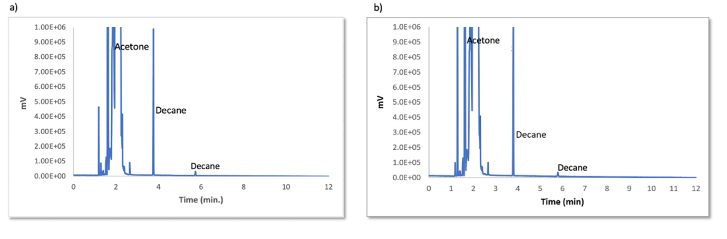
Figure 53 – GC analysis of Synechocystis and Synechocystis::Cas9_sgRNA_ShMKS-dDNA. Chromatograms showing the absence or presence of 2-dodecanone in a) Synechocystis WT and b) Synechocystis::Cas9_sgRNA_ShMKS-dDNA.

The results obtained from the GC analysis performed show no production of methyl ketones from Synechocystis WT or Synechocystis::Cas9_sgRNA_ShMKS-dDNA. As illustrated by Figure 53a, the results of the GC analysis of Synechocystis WT showed the presence of acetone, the in-between sample wash implemented in the analysis aside from the presence of decane deriving from the top layer of the cultures. Acetone eluted at a retention time of 2 minutes, while decane eluted at 3.8 minutes and a derivative peak from decane can also be seen to elute at 5.8 minutes, probably as a results from droplets of the compound. The presence of methyl ketones was not detected in the Synechocystis WT cultures, which was expected since Synechocystis is not capable of producing these compounds and the ShMKS-dDNA was not inserted in these cultures. Furthermore, it can be seen from Figure 53b that the results of the GC analysis of Synechocystis::Cas9_sgRNA_ShMKS-dDNA showed as well the presence of acetone and decane, eluting at 2, 3.8 and 5.8 minutes respectively, the same retention times as for the results for Synechocystis WT. Moreover, the presence of methyl ketone was not detected either. However, these results are unexpected since the ShMKS-dDNA was indeed inserted in some chromosomal copies of these mutant cultures. Nevertheless, the insertion of the ShMKS-dDNA in such mutants did not achieve full mutant segregation. A possible reason for the lack of production of methyl ketones from these mutants despite of the insertion of the ShMKS-dDNA could be mutation dilution. Failing to achieve full mutant segregation can lead to the loss of an introduced mutation (Berla et al., 2013; Lartigue et al., 2007; Nordwald et al., 2013; Ramey et al., 2015). Since not all individuals in the culture presented the ShMKS-dDNA, perpetuating this mutation as cell division cycles progressed became progressively more difficult and eventually the insertion of the ShMKS-dDNA became diluted, deleting the mutation from the mutant culture and explaining the lack of production of methyl ketones despite the insertion of the ShMKS-dDNA.

Therefore, our results indicate that CRISPR/Cas9 did not have a positive effect on achieving full mutant segregation. Therefore, its effects did not lead to the consequential product generation in Synechocystis. The mechanism of action of CRISPR/Cas9 was not enough to overcome the highly polyploid genome of Synechocystis.. However, other factors, such as the presence of single nucleotide polymorphisms (SNPs) and the lack of metabolic flux modelling might be responsible for the lack of generation of the desired product.

The lack of evaluation of the presence of SNPs in the final mutant constructs might be one cause in failing to generate squalane. SNPs are changes in a single base after transformation events that can lead to a change in an amino acid in the translated protein, causing it to not fold properly and to loose activity, or lead to the generation of a stop codon, truncating the production of the protein and hence, impede the its activity. Either way, SNPs stop the protein from functioning correctly and delivering its activity, such as the generation of a desired product (Figueroa et al., 2019, Overway et al., 2021). After the insertion of the final mutant constructs into Synechocystis, the evaluation of the presence of SNPs in such constructs was not evaluated. Therefore, the heterologous ShMKS1 and ShMKS2 might have not been translated or folded properly, leading them to lose their activity and finally impeding the production of methyl ketones. This could have been prevented by sequencing the final mutant constructs, which was not done due to COVID related reasons. The presence of SNPs in the final mutant constructs could have caused the failure in achieving production of methyl ketones.

Finally, another reason why this study failed in achieving the production of methyl ketones was the absence of metabolic flux modelling and metabolomics. An important metabolic flux and metabolomics strategy to increase product titers is to measure the precursors of the desired product intracellularly under different growth conditions of the host and utilize and vary those conditions to evaluate the optimal ones to increase the product titers (Boghigian et al., 2010, Brunk et al., 2016, Ku et al., 2020). In this study, such optimal conditions were not evaluated. Hence, the lack of metabolic flux modelling and metabolomics might be another reason why methyl ketones were not produced.

These reasons are possible answers to why methyl ketones were not produced in the mutant, indicating that probably the failure of the CRISPR/Cas9 engineering was not solely responsible for the lack of production of methyl ketones.

4.5 Conclusions and future work

In this Chapter 4 of the present investigation, CRISPR/Cas9 was implemented in Synechocystis in order to overcome the obstacles of traditional gene engineering in the organism and produce increased yields of 2-dodecanone to be used as biofuel. CRISPR/Cas9 tools were developed specifically for the organism and for the chapter’s aims. The genetic engineering of Synechocystis through CRISPR/Cas9 represents important progress in tackling the obstacles for the future genetic engineering of the cyanobacterium.

In this study, two CRISPR/Cas9 tools were developed and Synechocystis was effectively through CRISPR/Cas9. However, this failed to achieve full mutant segregation. Therefore, 2-dodecanone production was not achieved. It is possible that the mechanism of action of CRISPR/Cas9 was not enough to overcome the obstacle of high polyploid in the cyanobacterium. However, these results might be due to a number of reasons that, due to time and COVID constraints, were unable to be implemented and highly possibly might have led to the results obtained. These reasons include exposure time and concentration of anhydrotetracycline, optimization of the conjugation protocol for the helper strain, having all the CRISPR/Cas9 elements in a single and smaller plasmid, the presence of single nucleotide polymorphisms and the lack of metabolic flux modelling. Therefore, all of these procedures constitute an important part of the future work of the present investigation.

The objectives of this Chapter were not achieved. It remains to be elucidated if the implementation of the procedures mentioned in the above paragraph are able to overcome the highly polyploid genome of Synechocystis, achieve full mutant segregation and the production of 2-dodecanone in the cyanobacterium.

Chapter 5
Harvesting cyanobacteria:
Developing a chitosan-based harvesting method for Synechocystis sp. PCC 6803

5. Chapter 5. Developing a chitosan-based harvesting method for Synechocystis sp. PCC 6803

5.1 Introduction

5.1.1 Cell-harvesting methods

Cell-liquid separation while maintaining the integrity of the cells is a pivotal step for harvesting both, the cells as well as the desired product. However, the cell-liquid separation step has been highlighted as a technical as well as economic bottleneck (Olguin, 2012, Schlesinger et al., 2012). Therefore, several techniques have been implemented to achieve cell-liquid separation while ensuring the quality of the product. For instance, centrifugation and filtration have been employed in situations where maintaining the quality of high-value chemicals is vital (Amezaga et al., 2014). However, they are high-energy consuming and not cost-effective processes and, in some cases, can damage the cells involved (Lam and Lee, 2012, Uduman et al., 2010). On the other hand, the separation of cyanobacterial cells from water through coagulation and flocculation, which is the agglomeration of cyanobacterial cells into clumps that are easier to retrieve from the liquid phase, is considered more energy-efficient, cost-effective and effective as a cell-liquid separation strategy while ensuring cell quality (Amezaga et al., 2014, Lam and Lee, 2012, Uduman et al., 2010). Chitosan (Figure 54) has been established as a promising bioflocculant over conventional chemical flocculants such as alum and ferric chloride, given that chitosan is biodegradable, not toxic and does not lyse the cyanobacterial cells, which is crucial for maximum product recovery (Varma et al., 2004).

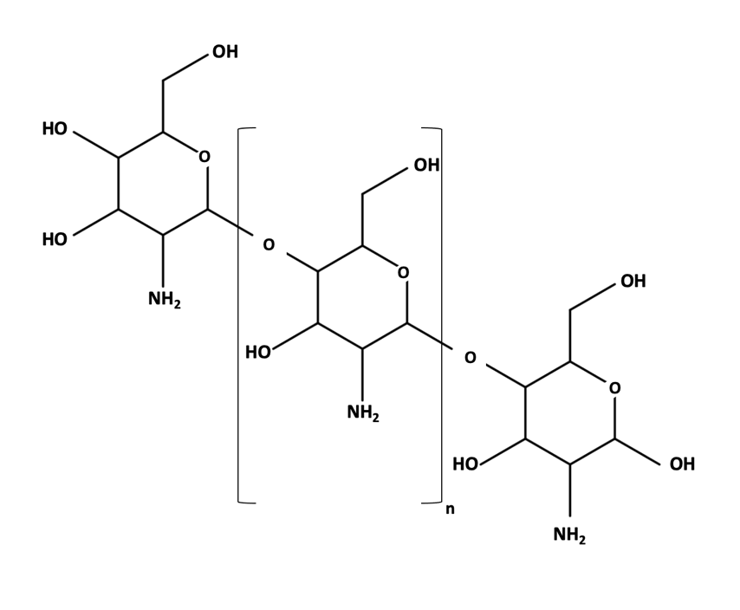

Figure 54 - Chemical structure of chitosan.

Therefore, one of the general aims of this PhD study is to develop a time, energy and cost-effective as well as efficacious cell harvesting method for Synechocystis sp. strain PCC 6803 using chitosan.

Due to its promising characteristics, many studies have implemented chitosan as a flocculant for harvesting microalgae, including cyanobacteria. Several studies have implemented chitosan as flocculant, achieving flocculation efficiencies higher than 90%. However, the effectiveness of chitosan has been found highly variable even in organisms of the same species but different strain. The flocculation efficiency of chitosan is highly variable and dependent of many factors such as pH, cell density, growth media and flocculant concentration but most importantly, it is highly dependent on the species and strain of the organism to be harvested (Ahmad et al., 2011, Beach et al., 2012, Chang and Lee, 2012, Chen et al., 2014, Divakaran and Pillai, 2002, Farid et al., 2013, Heasman et al., 2000, Riaño et al., 2012, Xu et al., 2013). Various authors have reported a flocculation efficiencies higher than 90 % at a chitosan concentration of 100 mg/L for Synechocystis sp. PCC 6803 although other studies indicate that significantly lower concentrations of chitosan, such as 20 mg/L, have achieved the same level of flocculation efficiencies in the same species but different strain and/or substrain (Burut-Archanai et al., 2013, Divakaran and Pillai, 2002, Lama et al., 2016, Rojsitthisak et al., 2017). Therefore, specific conditions found effective for a particular strain or substrain of Synechocystis sp. PCC 6803 are unlikely to be as effective for others. Given these reasons, it was imperative for this PhD dissertation to study different parameters and conditions to evaluate the effectiveness of chitosan in the particular strain of Synechocystis used in this study with the purpose of optimizing the harvesting process for this organism. The optimization of such process would then expose the parameters such as chitosan form and concentration, pH and growth media, to name a few, that are ideal for the particular strain of Synechocystis used in this study in order to achieve the maximum flocculation.

5.2 Chapter aims

The aim of this Chapter 5 is described in the following lines:

- To optimise a chitosan-based harvesting method for Synechocystis that allows the energy-effective, efficacious as well as cost and time-effective separation of cyanobacterial cells from aqueous phase in order to decrease the overall cost of the biofuels produced, increase their feasibility and allow their competition with fossil-derived fuels.

5.3 Materials and methods

5.3.1 Materials

A list of the materials, including reagents, kits, enzymes, equipment and software implemented in this Chapter 5 as well as detailed information about them can be found in Appendixes 1, 2 and 3. Unless specified otherwise, the solutions in the present section were prepared with distilled water (dH₂O) from a Barnstead Smart 2 Pore 6 water filtration unit. All the solutions were sterilised with a Priorclave Tactrol 2 autoclave at 121 °C and 1.5 atm for 30 minutes. The reagents implemented in this section as well as the kits and equipment were the highest grade and quality available.

5.3.2 Strains implemented

The strain used in this Chapter 5 was Synechocystis sp., strain PCC 6803 (GenBank accession number: GCA_000009725.1), obtained from the culture collection of the Pasteur Institute, in Paris, France.

5.3.3 Growing conditions of Synechocystis sp. PCC 6803

Synechocystis cells were grown photoautotrophically in sterile Blue-Green liquid medium (BG-11). One litre of BG-11 medium was prepared by adding the following chemicals, in the quantities respectively indicated, to 1 L of distilled water, NaNO₃ 1.5 g; K₂HPO₄ 0.04 g, MgSO₄·7H₂O 0.075 g, CaCl₂·2H₂O 0.036 g, Citric acid 0.006 g, Ammonium ferric citrate green 0.006 g, EDTANa₂ 0.001 g, Na₂CO₃ 0.02 g; trace metals stock solution 1 mL. To prepare 50 mL of the trace metals stock solution, the following chemicals were added to dH₂O in the respectively indicated quantities: H₃BO₃ 2.86 mg, MnCl₂·4H₂O 1.81 mg, ZnSO₄·7H₂O 0.22 mg, Na₂MoO₄·2H₂O 0.39 mg, CuSO₄·5H₂O 0.08 mg, Co(NO₃)₂·6H₂O 0.05 mg. The solution was subsequently autoclaved in a Priorclave Tactrol 2 autoclave at 121 °C and 1.5 atm for 30 minutes.

In sterile flasks containing 25 mL of sterile BG-11 medium, enough number of Synechocystis cells were inoculated in order to achieve an initial optical density, measured at 750 nm (OD₇₅₀), of 0.1. The cells were grown at a temperature of 25°C, under continuous light with intensity of 100 μmol/m²/s and under continuous orbital agitation conditions of 100 rpm for aeration. All manipulations of the cultures were done under a SAFE 2020 class II microbiology safety cabinet in order to maintain axenic conditions.

5.3.4 Cell preparation for settling analysis

After inoculation, Synechocystis cells were grown until the culture achieved an OD₇₅₀ of 1 and subsequently washed with sterile BG-11 media, at a pH of 7.5. The cells in the 25 mL cultures were harvested using a VWR MegaStar 1.6R centrifuge at 4,000 x g for 15 minutes at room temperature. The supernatant was discarded, taking care of not disturbing the pellets. Subsequently, the remaining pellets were resuspended in 25 mL of sterile BG-11 medium. This washing step was done to remove cell polymers and metabolites naturally present in the cell cultures as they could interfere with flocculation.

5.3.5 Preparation of a chitosan stock solution

A chitosan stock solution was prepared in order to subject cell cultures to the effects of the flocculant. Enough chitosan (Sigma Aldrich) was added to distilled water to make a solution with a chitosan concentration of 2,000 mg/L. Under continuous agitation, 100 mg of chitosan were dissolved in 5 mL of 1M HCl. Subsequently, 40 mL of distilled water were added. Once chitosan had completely dissolved, the solution was neutralized to pH 6 with 1.750 mL of 3M KOH. The solution was mixed thoroughly until it became clear.

5.3.6 Settling assays

After washing the Synechocystis cell culture, the settling assays were carried out. The washed culture was poured into a 50 mL tall form beaker containing a stirring fly (dimensions: 1.60 cm x .50 cm x .50 cm, weight: .79 g) and placed on top of a VWR 7x7 CER Pro magnetic stirrer platform. An Accumet AB150 (Fisher Scientific) pH probe was inserted in the cell culture in order to get pH measurements. A slow mixing phase was initiated at 100 rpm for 1 minute. Subsequently, enough chitosan stock solution was added to the culture in order to reach a desired concentration of chitosan. This was followed by a fast mixing phase at 300 rpm for 1 minute while pH was measured. The speed was then decreased to the slow phase for another minute while the pH of the culture was gradually adjusted to a pH value of 7 with 1M KOH. If after the addition of the chitosan stock solution the pH remained to be 7, the slow mixing phase was increased to two minutes. Once the pH was adjusted, the mixing was ceased, and the culture was set aside at room temperature for 30 minutes to allow flocculation and settling. After sedimentation under gravity, 1 mL of culture supernatant was carefully taken from the top of the cell culture at 1 cm of depth. The OD₇₅₀ of the sample was measured in order to evaluate the flocculation efficiency.

The flocculation efficiency (recovery efficiency) was evaluated with the following formula:
$Recovery efficiency (\%)= \frac{{OD}_{0}-{OD}_{t}}{{OD}_{0}}×100$

In which OD₀ is the initial OD₇₅₀ of the Synechocystis culture before the addition of the chitosan solution, OD_{t} is the OD₇₅₀ after a specific settling time (t) (Rashid et al., 2013a).

The experimental conditions described above were conjointly emulated and selected from the protocols described in 3 studies (Ahmad et al., 2011, Beach et al., 2012, Rashid et al., 2013b). These conditions were selected given that the conditions in the studies were as close as possible to the ones in the present work, such as the strain of Synechocystis used, type of chitosan implemented and growth conditions of the cyanobacterial culture to name a few, and given that they reported the most efficient outcomes under similar conditions to the present work. Such conditions provide seminal information that, conjoined with the results obtained in the present work, give detailed guidelines onto how to translate the laboratory work into industrial scales. The industrial significance of the previously mentioned studies relies on the seminal information they provide regarding how to prepare for translating laboratory conditions into industrial scales and what can be modified and planned ahead in order to facilitate rapid translation of results. For example, such protocols involve culture mixing phases, which can be easily done with a stirring fly and a magnetic plate in the laboratory. However, this might represent a challenge for industrial scales, where significantly larger volumes of cultures are handled. An option could be adapting a bioreactor with mixing mechanisms. Another example includes the type of chitosan implemented. A biodegradable chitosan in used in order to avoid its purification step in the downstream processing. Thus, it can be planned ahead that no extra purification step must be added so eliminate chitosan and this can be factored in when estimating production costs when preparing to translate observations from present work to the industrial scale.

In total, five settling assays were carried out in triplicate: chitosan settling assay, settling assay in the presence of cell polymers, pH settling assay, NaCl settling assay and glucosamine settling assay. All followed the protocol described above, although, some conditions in each were slightly varied in order to evaluate flocculation efficiency under a specific variable for each assay. For the chitosan settling assay, enough chitosan stock solution was added in order to make nine final chitosan concentrations and evaluate at which concentration the flocculation was most effective. The concentrations used were 20 mg/L, 60 mg/L, 100 mg/L, 140 mg/L, 200 mg/L, 240 mg/L, 280 mg/L, 300 mg/L and 400 mg/L. The rest of the protocol was kept as described in the lines above. For the cell polymers settling assay, the Synechocystis cells were not washed as described in Section 5.4.4. Instead, the original media with the naturally occurring cell polymers was kept. The rest of the protocol was followed as described before. Regarding the pH settling assay, the pH of the cell culture was adjusted to three different values: 6, 7, 8 and 9 in order to evaluate the effect of different pH on the flocculation efficiency of chitosan. The rest of the protocol was kept as originally described. In the case of the NaCl settling assay, the composition of the media was changed. The BG-11 media of the cultures was supplemented with 0.5M NaCl. The rest of the protocol was kept as originally described above. Regarding the glucosamine settling assay, the monomeric form of chitosan, glucosamine, was used instead of chitosan to prepare the stock solution to be added to the cultures. The rest of the protocol was kept as described in the lines above.

5.4 Results and discussion

5.4.1 Type of chitosan implemented

The chitosan implemented in the present study (Catalogue no. 50494, Sigma Aldrich. See Appendix 1) is obtained from shrimp shells and it has been highlighted as “green” and a more cost-effective alternative compared to other flocculants.

This chitosan is extracted from waste shrimp shells through four steps, deproteination, demineralization, decolorization and deacetylation. Initially, in the deproteination step, the protein levels in the raw shrimp shells are reduced using an aqueous alkaline solution. Heat is applied in order to facilitate deproteination. Subsequently, calcite levels of the raw materials are decreased by the action of a low concentration acid. These steps produce chitin. Consequently, chitin is decolorized by bleaching it. Finally, bleached chitin undergoes a process of deacetylation, where acetyl groups are eliminated through the application of heat coupled with the application of strong concentrations of alkaline solutions (Aldila et al., 2020, Eddya et al., 2020). This process produces “green” chitosan as it is produced from a sustainable source i.e. a waste product - shrimp shells - from the seafood industry.

This type of chitosan has been highlighted as non-toxic, biodegradable and biocompatible. In other words, the use of this chitosan is safe. Other flocculants, such as
ferric chloride and aluminium sulphate are harmful to the environment, having negative effects on the organisms’ and ecosystem’s health (Zhao et al., 2021). However, when this type of chitosan degrades after use, its resulting compounds will not cause harm to the environment and organisms (Verma et al., 2019b). Furthermore, its biodegradability allows it to decay naturally, without the need of additional chemical processes, into substances that are not pollutants (He et al., 2020, Ma et al., 2021). Moreover, it is also biocompatible. Therefore, its use bears no harm or risk when interacting with living tissue (He et al., 2020). Given these reasons and the chemical similarities between chitosan and the cell wall of cyanobacteria, it does not need a dedicated downstream processing step to remove it from the culture. These properties make chitosan a suitable molecule for use as a flocculant at an industrial scale.

5.4.2 Chitosan settling assay

Figure 55 and Figure 56 show the results obtained for this assay. Flocculation efficiency (recovery efficiency) in the chitosan settling assay was found to be dependent on the chitosan concentration. A trend in the flocculation efficiency was observed where an increase in chitosan concentration generated an increase in flocculation efficiency. However, this trend was observed until a certain chitosan concentration where the maximum flocculation efficiency was achieved, subsequently, the efficiency decreased even though chitosan concentrations continued to increase.

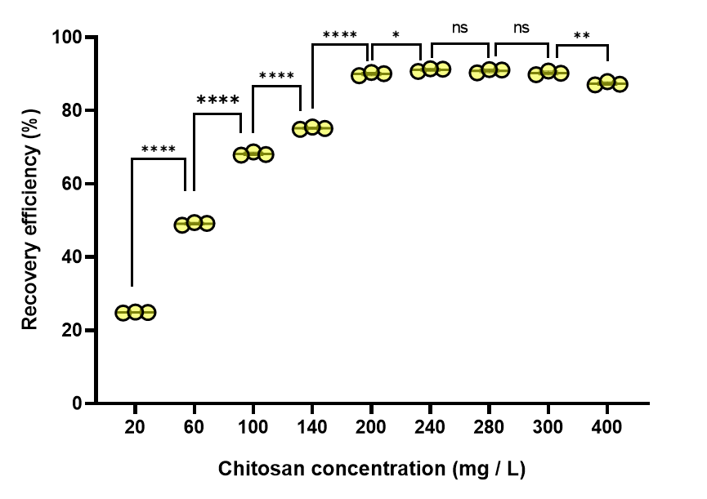

Figure 55 -. Flocculation efficiency (recovery efficiency) of Synechocystis (mean, standard deviation) as a function of different chitosan concentrations after removing the culture’s cellular polymers. Abbreviations and symbols: (*) is the degree of statistical significance evaluated by Student’s t test, * - p <= 0.05, ** - p <= 0.01, *** - p <= 0.001, **** - p <= 0.0001; (ns), non-significant - p > 0.05. Each point is an independent biological replicate.

Such increasing trend in flocculation efficiency initiates with a chitosan concentration of 20 mg/L, where the lowest efficiency of 24.87%$±$ 0.15% is achieved. From this point onwards, flocculation efficiency continues to steadily increase until a chitosan concentration of 240 mg/L. The highest flocculation efficiency of 91.13%$±$ 0.38% is achieved at a chitosan concentration of 240 mg/L. Increase in chitosan concentration beyond 240 mg/L did not result in an increase in flocculation efficiency. When the chitosan concentration was increased to 400 mg/L, the flocculation efficiency decreased to 87.37%$±$ 0.47%.Therefore, for this strain of Synechocystis, the maximum flocculation efficiency achieved was 91.13%$±$ 0.38%, at a chitosan concentration of 240 mg/L.

Initially, the trend in the chitosan settling assays indicate that the flocculation efficiency is dependant of the chitosan concentration and that a higher concentration of chitosan would signify a higher flocculation efficiency. However, the trend continues to show that the highest flocculation efficiency is reached at a chitosan concentration of 240 mg/L to subsequently decrease after this concentration. This signifies that an optimal chitosan concentration is reached at which the flocculation efficiency is at its highest and after which, the increase of chitosan concentration will not increase flocculation efficiency, actually, it has a negative impact on it. Possibly, this might be due to cell surface charge stabilisation generated by the high concentrations of chitosan in the cell culture (Misra et al., 2015, Zhou et al., 2016). At the optimal chitosan concentration, the functional groups bearing negative charges on the cyanobacterial cell surface are completely neutralised by the positively charged chitosan and maximal flocculation efficiency is achieved. Therefore, adding more chitosan would not be beneficial for flocculation. Addition of further surplus chitosan would lend a positive charge to the cell surface leading to stabilisation of the cell suspension and a decrease in flocculation efficiency.

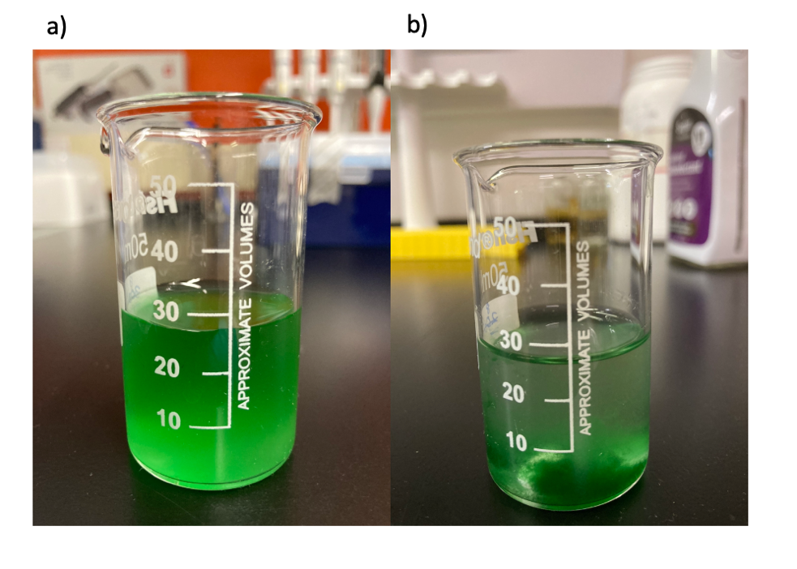

Figure 56 - Flocculation of Synechocystis in the chitosan settling assay a) before and b) after adding chitosan.
The image corresponds to a flocculation efficiency of 91.13% at a chitosan concentration of 240 mg/L.

Figure 56 shows the Synechocystis culture before (Figure 56a) and after (Figure 56b) adding the chitosan treatment. It can be seen from the picture that after the chitosan was added, flocs of the cyanobacterium formed in the bottom, clearing the surface, corresponding to a flocculation efficiency of 91.13$±$ 0.38% at a chitosan concentration of 240 mg/L. It can be seen that before adding the treatment, the culture was denser and not clear and that adding the chitosan treatment cleared the surface of the culture significantly and a clear formation of flocs can be seen.

In this study, the optimal chitosan concentration required to achieve a maximum flocculation efficiency of 91.13$±$ 0.38% was 240 mg/L. However, comparing this result with published data was difficult as there were only a few studies on chitosan-based harvesting methods on Synechocystis sp. PCC 6803, which highlights the importance of this study. Such studies enabled a partially efficacious comparison with published data. In this study, a maximum chitosan flocculation efficiency of 91.13$±$ 0.38% was achieved at chitosan concentration of 240 mg/L. However, other chitosan-harvesting studies on Synechocystis sp. PCC 6803 show different results. Studies by Burut et al., 2013 and Rojsitthisak et al., 2017 show that >90% of flocculation efficiency was achieved at a chitosan concentration of 100 mg/L and 2.5 mg/L respectively, which is significantly lower than the 240 mg/L observed in this study. Nevertheless, different Synechocystis strains and substrains were implemented in such investigations. Moreover, other factors were found to vary, which might be the cause of such discrepancies between results. Such factors include cell density, growth-phase of the culture, the nature of the chitosan implemented as well as protocol conditions, such as pH adjustments after the addition of chitosan, chitosan-culture mixing time-length and the time the mix was allowed to settle after adding the bioflocculant. The optimal conditions for a maximum flocculation efficiency in chitosan harvesting are highly variable and depend on the conditions of these factors. Significantly high discrepancies in these optimal conditions have been found depending on cell morphology, cell charge distribution, cell polymer composition and secretion, medium composition and growing conditions but more importantly, organism species, strain, substrain as well as the above-mentioned factor conditions. These ideal conditions are so sensitive that are highly variable even at a substrain level (Burut-Archanai et al., 2013, Lama et al., 2016, Zhou et al., 2016). This implies that what has been found optimal and effective for a specific species or even a particular substrain of Synechocystis under specific conditions and factors will probably not be the same for other Synechocystis strains, which then makes this research crucial. The results obtained in the present study significantly contribute to elucidate such harvesting method for the particular strain implemented in this study.

5.4.3 Chitosan settling assay in presence of cell polymers

Synechocystis cells secrete cellular polymers such as proteins, polysaccharides and uronic acids during growth (Pereira et al., 2009). It is not known in the literature whether these polymers either aid or preclude flocculation. Therefore, the chitosan settling assays carried out on washed cells in the previous section was repeated with cells not subjected to the washing steps and not transferred to fresh growth medium i.e. in the presence of cell polymers. The results for this assay are shown in Figure 57 and Figure 58, which show that the flocculation efficiency follows a similar trend as in the one in the previous section and that clear formation of flocs can be seen as well as an evident clear surface of the culture. The flocculation efficiency increases as the chitosan concentration does. And, as in the chitosan flocculation assays, this increment continues until it reaches a maximum flocculation efficiency, after which a decrease is observed even though chitosan concentrations continue to increase.

Figure 57 - Flocculation efficiency (recovery efficiency) of Synechocystis (mean, SD) as a function of different chitosan concentrations under presence of cellular polymers. Abbreviations and symbols: (*), degree of statistical significance evaluated by Student’s t test, * - p <= 0.05, ** - p <= 0.01, *** - p <= 0.001, **** - p <= 0.0001 ; (ns), non-significant - p > 0.05 (ns), non-significant.

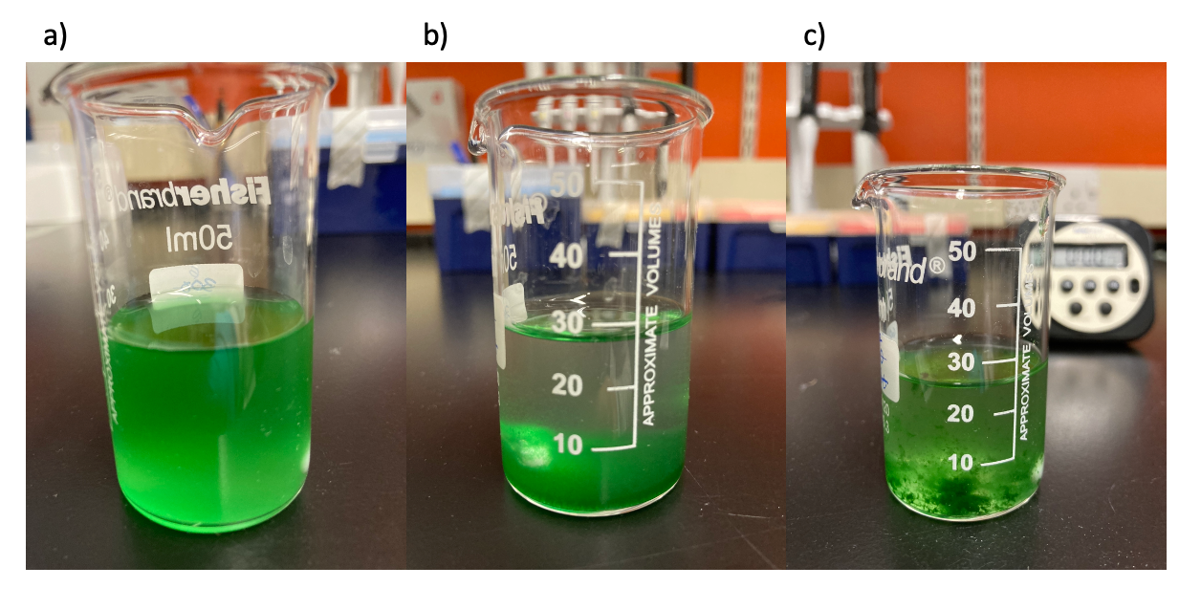
Figure 58 - Flocculation of Synechocystis in the cell polymer settling assay a) before adding chitosan and after chitosan addition b) in the presence of cell polymers and c) without cell polymers.

An initial flocculation efficiency of 29.97$±$ 0.17% is achieved at a chitosan concentration of 20 mg/L. Subsequently, the flocculation efficiency follows an increasing trend, showing significant increase in flocculation efficiency until chitosan concentrations reach 200 mg/L. After this point, there is no significant increase in flocculation. Flocculation efficiency reaches the highest percentage of 91.87 $±$ 0.088 at a chitosan concentration of 200 mg/L. Once the maximum efficiency is reached, the trend in flocculation efficiency proceeded to decrease, even though the concentration of chitosan continued to increase to 300 mg/L and 400 mg/L.

The results obtained from the chitosan settling assays in the presence of cell polymers were slightly different when compared to the ones obtained from the chitosan settling assays with no cell polymers. Although in both settling assays the flocculation efficiencies were found to be dependent of the chitosan concentration and follow a highly similar trend, the flocculation efficiency was always higher for each chitosan concentration in conditions where cell polymers were present (CP) when compared to conditions where they were absent (ACP) (Figure 59). Initial flocculation efficiencies of 24.87$±$ 0.153% and 29.97 $±$ 0.289% were achieved at 20 mg/L for ACP and CP conditions respectively. The higher flocculation efficiency in the presence of cell polymers was statistically significant. Subsequently, flocculation efficiencies in both CP and ACP conditions increase with increase in chitosan concentrations. Up to 200 mg/L chitosan concentration, the trend persists where the flocculation efficiency in CP was higher and statistically significant compared to ACP condition. To contrast, the maximum flocculation efficiency of 91.87$±$ 0.153% was reached at 200 mg/L under CP conditions while under ACP conditions the maximum reached value was 91.13$±$ 0.379% at a concentration of 240 mg/L. These results indicate that the presence of the polymers secreted by the Synechocystis cells had a positive impact in flocculation efficiency. This was probably due to the favourable electro-chemical interaction between chitosan, the negatively charged cells and cell polymers secreted by the cyanobacterial cells (Henderson et al., 2008, Kim et al., 2012, Misra et al., 2015, Rojsitthisak et al., 2017, Vandamme et al., 2013), leading to formation of denser flocs in the CP condition. These favourable electro-chemical interactions were obscured at the higher chitosan concentrations.

Figure 59 - Comparison of the flocculation efficiency (recovery efficiency) of Synechocystis (mean, SD) between cultures in the presence (green) and absence (yellow) of cellular polymers at different chitosan concentrations. Abbreviations and symbols: (*), degree of statistical significance evaluated by Student’s t test, * - p <= 0.05, ** - p <= 0.01, *** - p <= 0.001, **** - p <= 0.0001; (ns), non-significant - p > 0.05.

5.4.4 pH settling assay

Apart from chitosan concentration, the pH of the aqueous suspension may also affect the flocculation efficiency. Therefore, using a stable chitosan concentration of 240 mg/L, the pH of the cell culture was variated, ranging from 6 (acidic) to 9 (basic) in the settling assays. It can be observed in Figure 60 that there is an increasing trend in flocculation efficiency generated by an increase in pH. A direct relation between the increment of pH and flocculation efficiency was observed.

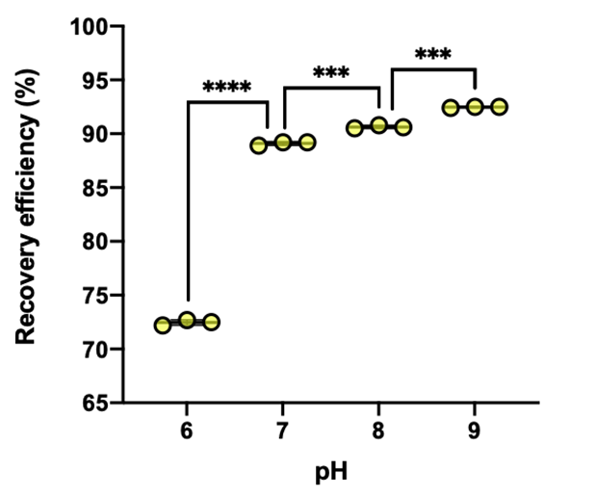

Figure 60 - Flocculation efficiency (recovery efficiency) of Synechocystis (mean, SD) at a concentration of 240 mg/L under different pH conditions. Abbreviations and symbols: (*), degree of statistical significance evaluated by Student’s t test, * - p <= 0.05, ** - p <= 0.01, *** - p <= 0.001, **** - p <= 0.0001; (ns), non-significant - p > 0.05.

The lowest flocculation efficiency was 72.47%$±$0.13%, observed at pH 6. From that value, flocculation efficiency increased to 89.10% $±$0.17% at pH 7. At pH 9, the highest flocculation efficiency of 92.47 $±$0.06% was achieved.

Figure 61 illustrates the flocculation achieved in this assay. It can be seen from the image that a more basic pH produced a clearer culture, showing that the flocculation efficiency was higher.

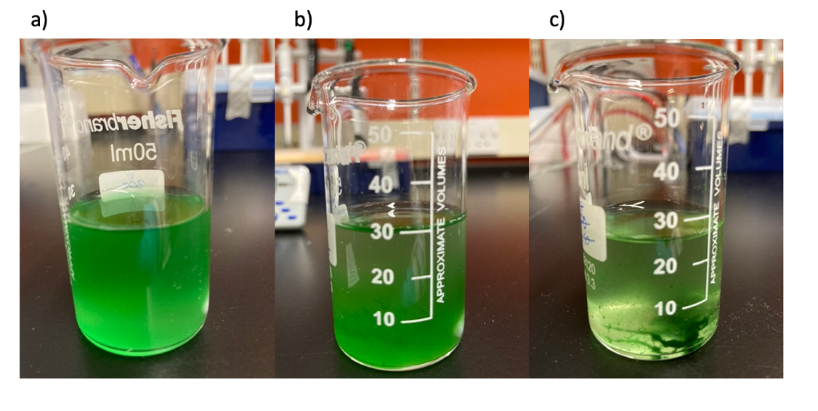

Figure 61 - Flocculation of Synechocystis in the pH settling assay a) before adding chitosan and after chitosan addition with a b) pH of 6 and c) with a pH of 9.

In this study, the flocculation efficiency increased as the pH of the culture became more basic. However, similar studies in other microalgae showed different results. In studies with organisms such as Chlorella sorokiniana, Phaeodactylum
tricornutum and other microalgae the flocculation efficiency was found to be the highest in acidic cultures with lower chitosan concentrations. In these investigations, a chitosan concentration ranging from 2.5 to 20 mg/L sufficed to achieve a flocculation efficiency of 90% or more in a culture with pH values ranging from 5 to 7. Flocculation efficiency decreased when the media became more basic (pH 8 to 10) (Burut-Archanai et al., 2013, Divakaran and Pillai, 2002, Rojsitthisak et al., 2017, Sirin et al., 2012, Xu et al., 2013, Zhou et al., 2016). To contrast, the highest flocculation efficiency (higher than 90%) was achieved under a chitosan concentration of 240 mg/L in this study. This could be due to discrepancies in factors such as cyanobacterial strain, absence of cellular polymers, as well as mixing and settling times, in addition to the type of chitosan implemented where factors such as molecular weight and degree of deacetylation might have had an impact on these results. These factors might have influenced the flocculation properties of chitosan and increase its efficiency at a basic pH.

5.4.5 NaCl settling assay

In the case of the NaCl settling assay, there was no significant difference found in flocculation efficiency between normal chitosan conditions and the media supplemented with additional NaCl (Figure 62). The highest flocculation efficiency in normal conditions was 90.00%$±$0.180% and 90.03%$±$0.310% for NaCl conditions. Both efficiencies were highly similar and the variation between each other was found to be not significant. This was probably due to the lack of interaction between the additional NaCl (additional to the NaCl already commonly present in BG-11 medium) in the culture and Synechocystis cells.

The presence of NaCl to the culture media could be favourable to flocculation efficiency (Garzon-Sanabria et al., 2013). Adding this element to the culture increases the amount of positive charges in the media, neutralizing the negative charges from the cell surface, allowing the formation of flocs and increasing flocculation efficiency. In the case of this research, in environments such as CP conditions and varying pH, the elements in the cell culture had high affinity, chemical or bioelectrical, within each other, which had an impact on flocculation efficiency. However, in this assay, the addition of extra NaCl had no effect over the flocculation efficiency of chitosan. As a living material, Synechocystis cells may have adapted to the presence of NaCl by changing the cell surface properties, which make it amenable to settling with chitosan. Therefore, the mechanism of molecular interaction might have been different although it seems to generate the same net effect. Hence, further work is necessary in order to elucidate this instance.

Figure 62 - Comparison of the flocculation efficiency (recovery efficiency) of Synechocystis (mean, SD) between cultures in standard BG11 media (green) and BG11 supplemented with 0.5M Sodium chloride (NaCl) (yellow) at a chitosan concentration of 240 mg/L. Abbreviations and symbols: (*), degree of statistical significance evaluated by Student’s t test, * - p <= 0.05, ** - p <= 0.01, *** - p <= 0.001, **** - p <= 0.0001 ; (ns), non-significant - p > 0.05.

Figure 63 shows as well the flocculation obtained with normal chitosan conditions and with additional NaCl conditions. It can be seen from the image that there are no significant differences in the cultures’ density between the two treatments. Therefore, additional NaCl has no impact on flocculation efficiency.

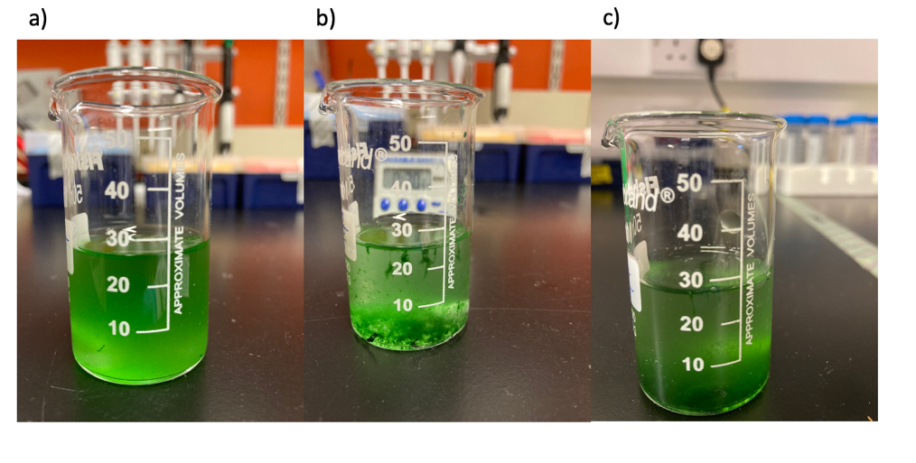

Figure 63 - Flocculation of Synechocystis in the NaCl settling assay a) before adding chitosan and after chitosan addition b) without NaCl and c) with additional NaCl .

5.4.6 Glucosamine settling assay

Given the effective properties of chitosan in microalgal flocculation, the present study considered important to evaluate if chitosan’s monomeric form, glucosamine (Bhattacharya et al., 2019, Nilsen-Nygaard et al., 2015), had equal flocculation benefits. However, the results indicate that glucosamine’s flocculation properties are significantly lower than those of chitosan.

The flocculation efficiency in the glucosamine settling assay was found to be negatively affected by glucosamine (Figure 64). At 240 mg/L of chitosan concentration, the highest flocculation efficiencies achieved were 90.00%$±$0.264% under normal chitosan conditions and 37.20$±$0.00% for glucosamine conditions. The maximum flocculation efficiency achieved under glucosamine conditions is considerably lower than the maximum efficiency achieved under normal chitosan conditions. No other studies were found where they compare the flocculation efficiency between chitosan and glucosamine on the same organism. However, the present assay found a higher flocculation efficiency in the presence of chitosan rather than glucosamine. Therefore, chitosan is a significantly better flocculant for this strain of Synechocystis compared to glucosamine.

Figure 64 - Comparison of the flocculation efficiency (recovery efficiency) of Synechocystis with chitosan (yellow) and glucosamine (green) (mean, SD) at concentration of 240 mg/L. Abbreviations and symbols: (*), degree of statistical significance evaluated by Student’s t test, * - p <= 0.05, ** - p <= 0.01, *** - p <= 0.001, **** - p <= 0.0001 ; (ns), non-significant - p > 0.05.

Figure 65 illustrates the flocculation achieved in the present assay showing that chitosan (Figure 65b) is clearly a better bioflocculant than glucosamine (Figure 65c).

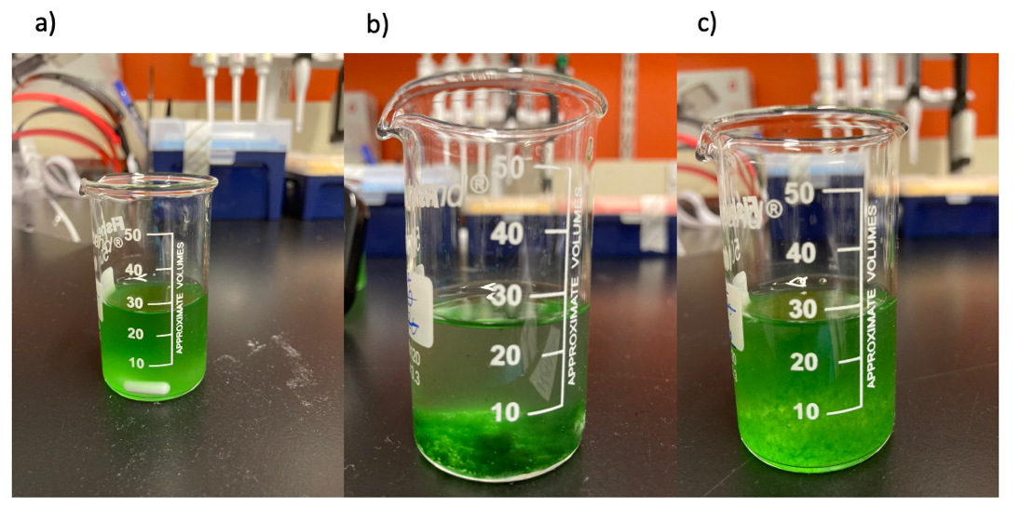

Figure 65 - Flocculation of Synechocystis in the glucosamine settling assay a) before adding chitosan b) after chitosan addition and c) after glucosamine addition.

The higher flocculation efficiency of chitosan compared to that of glucosamine could be attributed to the polymeric nature of chitosan given that the monomeric form of chitosan, glucosamine, presents a similar yet a slightly different electro-chemical structure (Figure 66) (Bhattacharya et al., 2019, Kadouche et al., 2017, Nilsen-Nygaard et al., 2015). This might be a reason why, in this case, chitosan presented a higher flocculation efficiency. However, further work is needed in order to elucidate if, indeed, this is the reason between the significant difference in the flocculation efficiencies of both components.

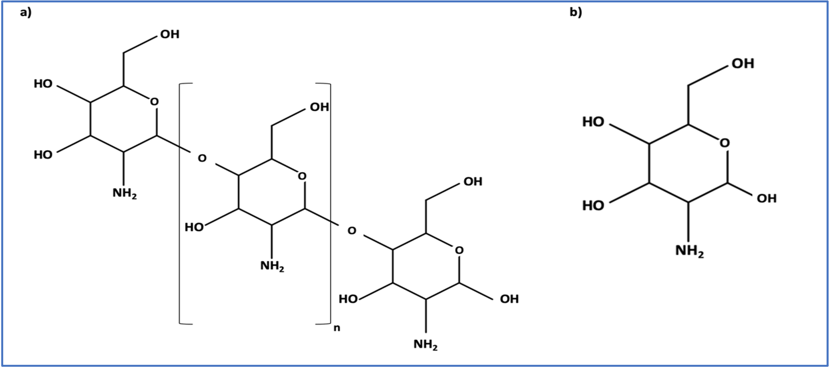
Figure 66 - Chemical structures of a) chitosan and b) glucosamine.

5.5 Conclusions and future work

The optimal conditions to achieve a high flocculation efficiency in Synechocystis for a chitosan harvesting method depend on many factors and are highly sensitive and variable. Therefore, significant discrepancies have been found among these optimal conditions among different Synechocystis sp. PCC 6803 strains and substrains. Therefore, the elucidation of such optimal conditions for the particular strain of Synechocystis used in this study became crucial.

In this study, it was found that a maximum flocculation efficiency for Synechocystis was 91.13$±$ 0.38%, at a chitosan concentration of 200 mg/L in the presence of cellular polymers. Beyond this point, such efficiency was not observed to increase even if the chitosan concentration was increased. Furthermore, the cell polymers secreted by the Synechocystis cells were found to increase flocculation efficiency. Chitosan’s flocculation efficiency was found to be higher in the presence of cell polymers that in the absence of them. Moreover, pH was found to play a crucial role in flocculation efficiency. A higher efficiency was achieved under basic conditions rather than acidic ones, demonstrating that the manipulation of elements such as pH could have a positive impact in decreasing the costs of harvesting Synechocystis using chitosan. Additionally, the presence of excess sodium chloride levels in the culture media did not enhance flocculation. The results also indicate that the polymeric nature of chitosan enhances the flocculation efficiency particularly because the monomeric variant of chitosan, glucosamine, was found to hold significantly lesser flocculation efficiency properties.

Moreover, this method could be adapted for industrial scales. Initially, Synechocystis cultures could be cultivated in large bioreactors adapted with mixing additaments, pH and temperature probes, lighting and exit valves to dewater the cultures and take samples. Cultures can then be grown until reaching the optimized optical density. Subsequently, the required quantities of chitosan can be poured in the bioreactor in order to reach the optimized concentration. Mixing phases can then be initialized by the mixing additaments oh the bioreactor, while optimized pH is obtained. Then, a settling phase can be implemented by stopping the mixing, letting the chitosan act for the indicated time for the culture to settle and allow the formation of cyanobacterial flocks. Once flocks have appeared, the next step would be harvesting such flocks; this could be done by dewatering the culture and gathering the flocks. A filter can be placed before the exit valves of the bioreactor, which can then be opened to let the water drain and leave the flocks in the bioreactor. A removable cast could be placed inside the bioreactor before the inoculation of the culture and be removed once the water has been drained in order to collect and retrieve the cyanobacterial flocks out of the bioreactor. Since the chitosan used is non-toxic, biodegradable, biocompatible, renewable as well as similar in composition to the cells implemented, a removal step to eliminate it from the flocks is not necessary. Therefore, the drained cyanobacterial flocks can undergo a product extraction process right after the dewatering phase and collection from the bioreactor to subsequently obtain the desired product after its extraction from the cyanobacterial cells and the subsequent separation steps for eliminating unwanted cellular components and achieving the desired product purity.

Accordingly, the present investigation provides valuable knowledge by elucidating the optimal conditions to achieve maximum flocculation efficiency for Synechocystis and its harvesting process using chitosan. Such conditions can now be harnessed by future investigations with the purpose of achieving maximum flocculation efficiency for Synechocystis with the lower possible cost at an industrial scale.

Chapter 6

Concluding remarks and future work

6. Chapter 6. Concluding remarks and future work

It was discussed in Chapter 1 how the burning of fossil-based fuels has led to the high accumulation of CO₂, resulting in the environmental crisis of climate-change and with this, a rise in global temperature and consequential catastrophic events such as floods, droughts, sea level rising as well as affecting the normal conditions from all ecosystems; endangering the availability of basic needs such as food and water security. Moreover, fossil-fuels are non-renewable and nearly depleted, endangering as well the commodities they have enabled and the current accessible life style. The literature compilation in such chapter contributed to understand that it is imperative to decrease CO₂ emissions to tackle climate change. Hence, the experiments in this investigation were designed to potentially produce two Synechocystis strains, through CRISPR/Cas9, capable of generating biofuels to substitute the harmful fossil-based fuels and directly tackle climate change.

The literature compilation in Chapter 2 contributed to understand that Synechocystis holds significant benefits that convert it into a promising genetic engineering host and biofuel producer. Moreover, the above-mentioned chapter also provided insight regarding how the current engineering strategies fail to address the drawbacks of the cyanobacterium, such as its highly polyploid genome and the failure in the achievement of full mutant segregation. Hence, the current work proposed to engineer such organism through CRISPR/Cas9, which holds the potential of overcoming such drawbacks. Furthermore, two biofuels were selected to be produced in the cyanobacterium, squalane and 2-dodecanone, which are promising candidates for substituting fossil-based biofuels. Additionally, a chitosan-based harvesting method specific for this strain is presented in order to optimize the collection of the produced biofuels.

The initial step to this strategy was to elucidate the most efficient transformation technique for large plasmids in Synechocystis, such as the one bearing the Cas9 nuclease, which was then found to be conjugation and which was implemented in all transformation events in this investigation. The following steps were to develop two CRISPR/Cas9 tools, specific for enabling Synechocystis to generate squalane and 2-dodecanone as well as a Synechocystis strain bearing the Cas9 nuclease. Subsequently, these elements were implemented to engineer the cyanobacterium through CRISPR/Cas9. Such steps are described in Chapter 3 and Chapter 4. Accordingly, an sgRNA, a GGR-dDNA and a ShMKS-dDNA were developed and inserted into Synechocystis::Cas9 to allow the CRISPR/Cas9 machinery to function. The CRISPR/Cas9 mutants did not achieve full mutant segregation.
Therefore, squalane and 2-dodecanone production was not achieved. It is possible that the mechanism of action of CRISPR/Cas9 was not enough to overcome the obstacle of high polyploid in the cyanobacterium. However, these results might be due to a number of reasons that, due to time and COVID constraints, were unable to be implemented and highly possibly might have led to the results obtained. These reasons include exposure time and concentration of anhydrotetracycline, optimization of the conjugation protocol for the helper strain, having all the CRISPR/Cas9 elements in a single and smaller plasmid, the presence of single nucleotide polymorphisms and the lack of metabolic flux modelling. Therefore, all of these procedures constitute an important part of the future work of the present investigation for these two Chapters in order to elucidate is their implementation can improve the effectiveness of CRISPR/Cas9, achieve full mutant segregation and the production of squalane and 2-dodecanone in the cyanobacterium. Therefore, the future work regarding Chapter 3 and Chapter 4 of this investigation includes the following in order to elucidate if they improve the efficiency of CRISPR/Cas9, if full mutant segregation is achieved and allow the obtention of squalane and 2-dodecanone production in Synechocystis:

- To increase anhydrotetracycline concentration and exposure time.

- To optimize the conjugation protocol for the helper strain.

- To insert all the CRISPR/Cas9 elements in a single and smaller plasmid.

- To discard the presence of single nucleotide polymorphisms in the final mutant constructs.

- To implement metabolic flux modelling and metabolomics to elucidate the optimal conditions for highest squalane and 2-dodecanone precursor production.

The final step of this strategy was to develop a harvesting method for Synechocystis in order to facilitate the collection of the produced biofuels. Such is described in Chapter 5 of the present investigation. A maximum flocculation efficiency of 91.13$±$ 0.38% was achieved for Synechocystis at a chitosan concentration of 200 mg/L. Such results are considered promising although similar flocculation efficiencies have been achieved with lower concentrations of chitosan in other strains of Synechocystis. This is consistent with the fact that flocculation efficiency is highly sensitive and variable and depends on many factors, including strain type and stirring/settling conditions. The present investigation provides valuable knowledge on elucidating the optimal conditions to achieve maximum flocculation efficiency for specific strains and substrains of Synechocystis as well as its harvesting process using chitosan. Such conditions can now be harnessed by future investigations with the purpose of achieving maximum flocculation efficiency for these Synechocystis mutants with the lowest chitosan concentration possible as well as lowest possible cost of such method with the purpose of taking this optimized method to a magnitude of greater scale, such as industrial levels. Therefore, the future work regarding the present chapter of this investigation includes:

- To follow the proposed measures detailed in Section 5.5 and adapt the here optimized conditions of the chitosan harvesting method to upscale it to industrial levels.

Chapter 7
Bibliography

7. Chapter 7. Bibliography

ABBY, S. S., KAZEMZADEH, K., VRAGNIAU, C., PELOSI, L. & PIERREL, F. 2020. Advances in bacterial pathways for the biosynthesis of ubiquinone. Biochimica et Biophysica Acta (BBA)-Bioenergetics, 1861, 148259.
ABE, K., SAKAI, Y., NAKASHIMA, S., ARAKI, M., YOSHIDA, W., SODE, K. & IKEBUKURO, K. 2014. Design of riboregulators for control of cyanobacterial (Synechocystis) protein expression. Biotechnology Letters, 36, 287-294.
AHMAD, A., YASIN, N. M., DEREK, C. & LIM, J. 2011. Optimization of microalgae coagulation process using chitosan. Chemical Engineering Journal, 173, 879-882.
ALBERTS, B. 2008. Molecular biology of the cell, New York, New York : Garland Science, c2008.
ALDILA, H., ASMAR, FABIANI, V. A., DALIMUNTHE, D. Y. & IRWANTO, R. 2020. The effect of deproteinization temperature and NaOH concentration on deacetylation step in optimizing extraction of chitosan from shrimp shells waste. IOP Conf. Ser.: Earth Environ. Sci, 2020 2020 Bristol. Bristol: IOP Publishing, 12003.
AMEZAGA, J. M., AMTMANN, A., BIGGS, C. A., BOND, T., GANDY, C. J., HONSBEIN, A., KARUNAKARAN, E., LAWTON, L., MADSEN, M. A., MINAS, K. & TEMPLETON, M. R. 2014. Biodesalination: A Case Study for Applications of Photosynthetic Bacteria in Water Treatment. Plant Physiol, 164, 1661-1676.
ANANTHI, V., BALAJI, P., SINDHU, R., KIM, S.-H., PUGAZHENDHI, A. & ARUN, A. 2021. A critical review on different harvesting techniques for algal based biodiesel production. Science of the Total Environment, 780, 146467.
ANGERMAYR, S. A., GORCHS ROVIRA, A. & HELLINGWERF, K. J. 2015. Metabolic engineering of cyanobacteria for the synthesis of commodity products. Trends in Biotechnology, 33, 352-361.
ANTONI, D., ZVERLOV, V. V. & SCHWARZ, W. H. 2007. Biofuels from microbes. Applied Microbiology and Biotechnology, 77, 23-35.
ANZALONE, A. V., KOBLAN, L. W. & LIU, D. R. 2020. Genome editing with CRISPR–Cas nucleases, base editors, transposases and prime editors. Nature biotechnology, 38, 824-844.
AQUINO-JARQUIN, G. 2021. Current advances in overcoming obstacles of CRISPR/Cas9 off-target genome editing. Molecular Genetics and Metabolism, 134, 77-86.
ASMAMAW, M. & ZAWDIE, B. 2021. Mechanism and applications of CRISPR/Cas-9-mediated genome editing. Biologics: Targets & Therapy, 15, 353.
ATSUMI, S., HIGASHIDE, W. & LIAO, J. C. 2009. Direct photosynthetic recycling of carbon dioxide to isobutyraldehyde. Nature biotechnology, 27, 1177.
BALAT, M. 2011. Production of bioethanol from lignocellulosic materials via the biochemical pathway: A review. Energy Conversion and Management, 52, 858-875.
BANERJEE, A., MAITI, S. K., GURIA, C. & BANERJEE, C. 2017. Metabolic pathways for lipid synthesis under nitrogen stress in Chlamydomonas and Nannochloropsis. Biotechnology Letters, 39, 1-11.
BARRANGOU, R. & MARRAFFINI, L. A. 2014. CRISPR-cas systems: Prokaryotes upgrade to adaptive immunity. Molecular Cell, 54, 234-244.
BEACH, E. S., ECKELMAN, M. J., CUI, Z., BRENTNER, L. & ZIMMERMAN, J. B. 2012. Preferential technological and life cycle environmental performance of chitosan flocculation for harvesting of the green algae Neochloris oleoabundans. Bioresource Technology, 121, 445-449.
BEBBINGTON, J., SCHNEIDER, T., STEVENSON, L. & FOX, A. 2020. Fossil fuel reserves and resources reporting and unburnable carbon: Investigating conflicting accounts. Critical Perspectives on Accounting, 66, 102083.
BELLER, H. R., LEE, T. S. & KATZ, L. 2015. Natural products as biofuels and bio-based chemicals: Fatty acids and isoprenoids. Natural Product Reports, 32, 1508-1526.
BEMANI, A., XIONG, Q., BAGHBAN, A., HABIBZADEH, S., MOHAMMADI, A. H. & DORANEHGARD, M. H. 2020. Modeling of cetane number of biodiesel from fatty acid methyl ester (FAME) information using GA-, PSO-, and HGAPSO-LSSVM models. Renewable Energy, 150, 924-934.
BEN-ISRAEL, I., YU, G., AUSTIN, M. B., BHUIYAN, N., AULDRIDGE, M., NGUYEN, T., SCHAUVINHOLD, I., NOEL, J. P., PICHERSKY, E. & FRIDMAN, E. 2009. Multiple biochemical and morphological factors underlie the production of methylketones in tomato trichomes. Plant Physiology, 151, 1952-1964.
BENTLEY, F. K., GARCÍA-CERDÁN, J. G., CHEN, H. C. & MELIS, A. 2013. Paradigm of Monoterpene (β-phellandrene) Hydrocarbons Production via Photosynthesis in Cyanobacteria. Bioenergy Research, 6, 917-929.
BENTLEY, F. K. & MELIS, A. 2012. Diffusion-based process for carbon dioxide uptake and isoprene emission in gaseous/aqueous two-phase photobioreactors by photosynthetic microorganisms. Biotechnology and Bioengineering, 109, 100-109.
BENTLEY, F. K., ZURBRIGGEN, A. & MELIS, A. 2014. Heterologous expression of the mevalonic acid pathway in cyanobacteria enhances endogenous carbon partitioning to isoprene. Molecular Plant, 7, 71-86.
BENTLEY, W. E., MIRJALILI, N., ANDERSEN, D. C., DAVIS, R. H. & KOMPALA, D. S. 1990. Plasmid‐encoded protein: the principal factor in the “metabolic burden” associated with recombinant bacteria. Biotechnology and bioengineering, 35, 668-681.
BERLA, B. M. & PAKRASI, H. B. 2012. Upregulation of plasmid genes during stationary phase in Synechocystis sp. strain PCC 6803, a cyanobacterium. Applied and environmental microbiology, 78, 5448-5451.
BERLA, B. M., SAHA, R., IMMETHUN, C. M., MARANAS, C. D., MOON, T. S. & PAKRASI, H. B. 2013. Synthetic biology of cyanobacteria: Unique challenges and opportunities. Frontiers in Microbiology, 4, 1-14.
BHATIA, L., BACHHETI, R. K., GARLAPATI, V. K. & CHANDEL, A. K. 2020. Third-generation biorefineries: a sustainable platform for food, clean energy, and nutraceuticals production. Biomass Conversion and Biorefinery, 1-16.
BHATTACHARYA, A., MATHUR, M., KUMAR, P. & MALIK, A. 2019. Potential role of N-acetyl glucosamine in Aspergillus fumigatus-assisted Chlorella pyrenoidosa harvesting. Biotechnol Biofuels, 12, 178-178.
BIOLABS, N. E. 2016. CRISPR [Online]. New England Biolabs Retrieved from: <https://www.neb.com/-/media/nebus/files/feature-articles/images/fa_cas9_fig2_cas9forgenomeediting.png?la=en&device=modal>. [Online Resource]. New England Biolabs. [Accessed Viewed 12 Feb 2017. ].
BIOLOGICAL, S. B. A. 2017. The principle of CRISPR System and CRISPR-Cas9 technique (Part 1). Biomedical and Biological Sciences, Viewed 5 Feb 2018. Retrieved from: < https://www.youtube.com/watch?v=VtOZdThI6dM&t=5s>. [Online Resource].
BIOT-PELLETIER, D. & MARTIN, V. J. J. 2016. Seamless site-directed mutagenesis of the Saccharomyces cerevisiae genome using CRISPR-Cas9. Journal of Biological Engineering, 10, 1-5.
BOGHIGIAN, B. A., SETH, G., KISS, R. & PFEIFER, B. A. 2010. Metabolic flux analysis and pharmaceutical production. Metabolic engineering, 12, 81-95.
BRENTNER, L. B., ECKELMAN, M. J. & ZIMMERMAN, J. B. 2011. Combinatorial life cycle assessment to inform process design of industrial production of algal biodiesel. Environmental science & technology, 45, 7060-7067.
BROSNAN, J. T., DA SILVA, R. P. & BROSNAN, M. E. 2011. The metabolic burden of creatine synthesis. Amino acids, 40, 1325-1331.
BRUNK, E., GEORGE, K. W., ALONSO-GUTIERREZ, J., THOMPSON, M., BAIDOO, E., WANG, G., PETZOLD, C. J., MCCLOSKEY, D., MONK, J., YANG, L., O'BRIEN, E. J., BATTH, T. S., MARTIN, H. G., FEIST, A., ADAMS, P. D., KEASLING, J. D., PALSSON, B. O. & LEE, T. S. 2016. Characterizing Strain Variation in Engineered E. coli Using a Multi-Omics-Based Workflow. Cell Systems, 2, 335-346.
BUGBEE, B. & MONJE, O. 1992. The limits of crop productivity. BioScience, 42, 494-502.
BURFORD, M., CAREY, C., HAMILTON, D., HUISMAN, J., PAERL, H., WOOD, S. & WULFF, A. 2020. Perspective: Advancing the research agenda for improving understanding of cyanobacteria in a future of global change. Harmful Algae, 91, 101601.
BURUT-ARCHANAI, S., EATON-RYE, J. J., INCHAROENSAKDI, A. & POWTONGSOOK, S. 2013. Phosphorus removal in a closed recirculating aquaculture system using the cyanobacterium Synechocystis sp. PCC 6803 strain lacking the SphU regulator of the Pho regulon. Biochemical engineering journal, 74, 69-75.
CAICEDO-BURBANO, P., SMIT, T., PINEDA HERNÁNDEZ, H., DU, W. & BRANCO DOS SANTOS, F. 2020. Construction of fully segregated genomic libraries in polyploid organisms such as Synechocystis sp. PCC 6803. ACS synthetic biology, 9, 2632-2638.
CALLEGARI, A., BOLOGNESI, S., CECCONET, D. & CAPODAGLIO, A. G. 2020. Production technologies, current role, and future prospects of biofuels feedstocks: A state-of-the-art review. Critical Reviews in Environmental Science and Technology, 50, 384-436.
CARDOSO, V. M., CAMPANI, G., SANTOS, M. P., SILVA, G. G., PIRES, M. C., GONÇALVES, V. M., GIORDANO, R. D. C., SARGO, C. R., HORTA, A. C. & ZANGIROLAMI, T. C. 2020. Cost analysis based on bioreactor cultivation conditions: production of a soluble recombinant protein using Escherichia coli BL21 (DE3). Biotechnology Reports, 26, e00441.
CARROLL, D. 2004. Using nucleases to stimulate homologous recombination. Methods Mol Biol, 262, 195-207.
CHAN, V., DREOLINI, L. F., FLINTOFF, K. A., LLOYD, S. J. & MATTENLEY, A. A. 2002. The effect of increasing plasmid size on transformation efficiency in Escherichia coli. Journal of Experimental Microbiology and Immunology, 2, 207-223.
CHANG, Y.-R. & LEE, D.-J. 2012. Coagulation–membrane filtration of Chlorella vulgaris at different growth phases. Drying Technology, 30, 1317-1322.
CHATSUNGNOEN, T. & CHISTI, Y. 2016. Harvesting microalgae by flocculation–sedimentation. Algal Research, 13, 271-283.
CHAVES, J. E., KIRST, H. & MELIS, A. 2015. Isoprene production in Synechocystis under alkaline and saline growth conditions. Journal of Applied Phycology, 27, 1089-1097.
CHEN, C.-L., CHANG, J.-S. & LEE, D.-J. 2015. Dewatering and drying methods for microalgae. Drying technology, 33, 443-454.
CHEN, G., LIU, Z., QI, Y. & YUAN-LU, C. 2014. Chitosan and Its Derivatives Applied in Harvesting Microalgae for Biodiesel Production: An Outlook. Journal of Nanomaterials, 2014.
CHEN, Y., TATON, A., GO, M., LONDON, R. E., PIEPER, L. M., GOLDEN, S. S. & GOLDEN, J. W. 2016. Self-replicating shuttle vectors based on pANS, a small endogenous plasmid of the unicellular cyanobacterium Synechococcus elongatus PCC 7942. Microbiology (United Kingdom), 162, 2029-2041.
CHENG, S. Y., SHOW, P.-L., JUAN, J. C., CHANG, J.-S., LAU, B. F., LAI, S. H., NG, E. P., YIAN, H. C. & LING, T. C. 2021. Landfill leachate wastewater treatment to facilitate resource recovery by a coagulation-flocculation process via hydrogen bond. Chemosphere, 262, 127829.
CHOI, K. R., JIAO, S. & LEE, S. Y. 2020. Metabolic engineering strategies toward production of biofuels. Current opinion in chemical biology, 59, 1-14.
CHOI, K. R. & LEE, S. Y. 2016. CRISPR technologies for bacterial systems: Current achievements and future directions. Biotechnology Advances, 34, 1180-1209.
CHOI, S. Y., LEE, H. J., CHOI, J., KIM, J., SIM, S. J., UM, Y., KIM, Y., LEE, T. S., KEASLING, J. D. & WOO, H. M. 2016. Photosynthetic conversion of CO2 to farnesyl diphosphate-derived phytochemicals (amorpha-4,11-diene and squalene) by engineered cyanobacteria. Biotechnology for Biofuels, 9, 1-12.
CHOI, Y. J. & LEE, S. Y. 2013. Microbial production of short-chain alkanes. Nature, 502, 571-574.
CHUA, E., ELTANAHY, E., JUNG, H., UY, M. & SCHENK, P. 2019. Efficient Harvesting of Nannochloropsis Microalgae via Optimized Chitosan���Mediated Flocculation. Global Challenges, 3.
CHUBUKOV, V., MUKHOPADHYAY, A., PETZOLD, C. J., KEASLING, J. D. & MARTÍN, H. G. 2016. Synthetic and systems biology for microbial production of commodity chemicals. NPJ Systems Biology and Applications, 2, 16009-16009.
CLAASSENS, N. J., SOUSA, D. Z., DOS SANTOS, V. A. P. M., DE VOS, W. M. & VAN DER OOST, J. 2016. Harnessing the power of microbial autotrophy. Nature Reviews Microbiology, 14, 692-706.
CONCONI, C., HONARY, L. A. T. & PROVIDER, A. I. C. 2011. Biofuels, Place of publication not identified, Place of publication not identified ASTM International, 2011.
CUELLAR-BERMUDEZ, S. P., ALEMAN-NAVA, G. S., CHANDRA, R., GARCIA-PEREZ, J. S., CONTRERAS-ANGULO, J. R., MARKOU, G., MUYLAERT, K., RITTMANN, B. E. & PARRA-SALDIVAR, R. 2017. Nutrients utilization and contaminants removal. A review of two approaches of algae and cyanobacteria in wastewater. Algal Research, 24, 438-449.
CUI, J., SUN, T., CHEN, L. & ZHANG, W. 2020. Engineering salt tolerance of photosynthetic cyanobacteria for seawater utilization. Biotechnology advances, 43, 107578.
DALETOS, G., KATSIMPOURAS, C. & STEPHANOPOULOS, G. 2020. Novel strategies and platforms for industrial isoprenoid engineering. Trends in biotechnology, 38, 811-822.
DAS, M., PATRA, P. & GHOSH, A. 2020. Metabolic engineering for enhancing microbial biosynthesis of advanced biofuels. Renewable and Sustainable Energy Reviews, 119, 109562.
DATSENKO, K. A. & WANNER, B. L. 2000. One-step inactivation of chromosomal genes in Escherichia coli K-12 using PCR products. Proceedings of the National Academy of Sciences of the United States of America, 97, 6640-6645.
DAVIES, F. K., WORK, V. H., BELIAEV, A. S. & POSEWITZ, M. C. 2014. Engineering limonene and bisabolene production in wild type and a glycogen-deficient mutant of Synechococcus sp. PCC 7002. Frontiers in Bioengineering and Biotechnology, 2, 1-11.
DAVIS, L. & MAIZELS, N. 2014. Homology-directed repair of DNA nicks via pathways distinct from canonical double-strand break repair. Proceedings of the National Academy of Sciences of the United States of America, 111, 1-9.
DAVIS, S. J., CALDEIRA, K. & MATTHEWS, H. D. 2010. Future CO2 emissions and climate change from existing energy infrastructure. Science (New York, N.Y.), 329, 1330-1333.
DEMIRBAS, A. 2011. Competitive liquid biofuels from biomass. Applied Energy, 88, 17-28.
DIENST, D., WICHMANN, J., MANTOVANI, O., RODRIGUES, J. S. & LINDBERG, P. 2020. High density cultivation for efficient sesquiterpenoid biosynthesis in Synechocystis sp. PCC 6803. Scientific reports, 10, 1-16.
DIETSCH, M., BEHLE, A., WESTHOFF, P. & AXMANN, I. M. 2021. Metabolic engineering of Synechocystis sp. PCC 6803 for the photoproduction of the sesquiterpene valencene. Metabolic engineering communications, 13, e00178.
DIVAKARAN, R. & PILLAI, V. S. 2002. Flocculation of algae using chitosan. Journal of Applied Phycology, 14, 419-422.
DO NASCIMENTO, D. C., DA COSTA, M. C. & NETO, A. M. B. 2020. Flamma: A flash point prediction tool for biofuels.
DONAHUE JR, A. & BLOOM, F. R. 1998. Transformation efficiency of E. coli electroporated with large plasmid DNA. Focus, 20, 77-78.
DONG, J., CHEN, Y., BENITES, V. T., BAIDOO, E. E. K., PETZOLD, C. J., BELLER, H. R., EUDES, A., SCHELLER, H. V., ADAMS, P. D., MUKHOPADHYAY, A., SIMMONS, B. A. & SINGER, S. W. 2019. Methyl ketone production by Pseudomonas putida is enhanced by plant-derived amino acids. Biotechnology and Bioengineering, 116, 1909-1922.
DOUDNA, J. A. & CHARPENTIER, E. 2014. The new frontier of genome engineering with CRISPR-Cas9. Science, 346.
DOUVARTZIDES, S., CHARISIOU, N. D., WANG, W., PAPADAKIS, V. G., POLYCHRONOPOULOU, K. & GOULA, M. A. 2021. Catalytic fast pyrolysis of agricultural residues and dedicated energy crops for the production of high energy density transportation biofuels. Part I: Chemical pathways and bio-oil upgrading. Renewable Energy.
DURALL, C. & LINDBLAD, P. 2015. Mechanisms of carbon fixation and engineering for increased carbon fixation in cyanobacteria. Algal Research, 11, 263-270.
DÜRRENBERGER, M. B., VILLIGER, W. & BÄCHI, T. 1991. Conjugational junctions: Morphology of specific contacts in conjugating Escherichia coli bacteria. J Struct Biol, 107, 146-156.
EDDYA, M., TBIB, B. & EL-HAMI, K. 2020. A comparison of chitosan properties after extraction from shrimp shells by diluted and concentrated acids. Heliyon, 6, e03486-e03486.
ENDY, D. 2005. Foundations for engineering biology. Nature, 438, 449-453.
ENGLUND, E., ANDERSEN-RANBERG, J., MIAO, R., HAMBERGER, B. & LINDBERG, P. 2015. Metabolic Engineering of Synechocystis sp. PCC 6803 for Production of the Plant Diterpenoid Manoyl Oxide. ACS Synthetic Biology, 4, 1270-1278.
ENGLUND, E., PATTANAIK, B., UBHAYASEKERA, S. J. K., STENSJÖ, K., BERGQUIST, J. & LINDBERG, P. 2014. Production of squalene in Synechocystis sp. PCC 6803. PLoS ONE, 9, 1-8.
ERBAN, A., SCHAUER, N., FERNIE, A. R. & KOPKA, J. 2007. Nonsupervised construction and application of mass spectral and retention time index libraries from time-of-flight gas chromatography-mass spectrometry metabolite profiles. Metabolomics. Springer.
ESTRELA, R. & CATE, J. H. D. 2016. Energy biotechnology in the CRISPR-Cas9 era. Current Opinion in Biotechnology, 38, 79-84.
FARID, M. S., SHARIATI, A., BADAKHSHAN, A. & ANVARIPOUR, B. 2013. Using nano-chitosan for harvesting microalga Nannochloropsis sp. Bioresource Technology, 131, 555-559.
FARROKH, P., SHEIKHPOUR, M., KASAEIAN, A., ASADI, H. & BAVANDI, R. 2019. Cyanobacteria as an eco���friendly resource for biofuel production: A critical review. Biotechnol Prog, 35, e2835-n/a.
FERREIRA, E. A., PACHECO, C. C., PINTO, F., PEREIRA, J., LAMOSA, P., OLIVEIRA, P., KIROV, B., JARAMILLO, A. & TAMAGNINI, P. 2018. Expanding the toolbox for Synechocystis sp. PCC 6803: validation of replicative vectors and characterization of a novel set of promoters. Synthetic Biology, 3, ysy014.
FIGUEROA, J., CASTRO, D., LAGOS, F., CARTES, C., ISLA, A., YÁÑEZ, A. J., AVENDAÑO‐HERRERA, R. & HAUSSMANN, D. 2019. Analysis of single nucleotide polymorphisms (SNPs) associated with antibiotic resistance genes in Chilean Piscirickettsia salmonis strains. Journal of fish diseases, 42, 1645-1655.
FIORENTINO, G., RIPA, M. & ULGIATI, S. 2017. Chemicals from biomass: technological versus environmental feasibility. A review. Biofuels, Bioproducts and Biorefining, 11, 195-214.
FORNEY, F. W. & MARKOVETZ, A. J. 1971. The biolow of methvl ketones. 12, 383-395.
FRIDMAN, E., WANG, J., IIJIMA, Y., FROEHLICH, J. E., GANG, D. R., OHLROGGE, J. & PICHERSKY, E. 2005. Metabolic, genomic, and biochemical analyses of glandular trichomes from the wild tomato species Lycopersicon hirsutum identify a key enzyme in the biosynthesis of methylketones. Plant Cell, 17, 1252-1267.
FU, W.-J. J., CHI, Z.-M. M., MA, Z.-C. C., ZHOU, H.-X. X., LIU, G.-L. L., LEE, C.-F. F. & CHI, Z.-M. M. 2015. Hydrocarbons, the advanced biofuels produced by different organisms, the evidence that alkanes in petroleum can be renewable. Applied Microbiology and Biotechnology, 99, 7481-7494.
GALE, G. A., OSORIO, A. A. S., PUZORJOV, A., WANG, B. & MCCORMICK, A. J. 2019. Genetic Modification of Cyanobacteria by Conjugation Using the CyanoGate Modular Cloning Toolkit. JoVE (Journal of Visualized Experiments), e60451.
GAO, X., GAO, F., LIU, D., ZHANG, H., NIE, X. & YANG, C. 2016a. Engineering the methylerythritol phosphate pathway in cyanobacteria for photosynthetic isoprene production from CO2. Energy and Environmental Science, 9, 1400-1411.
GAO, X., SUN, T., PEI, G., CHEN, L. & ZHANG, W. 2016b. Cyanobacterial chassis engineering for enhancing production of biofuels and chemicals. Applied Microbiology and Biotechnology, 100, 3401-3413.
GARZON-SANABRIA, A. J., RAMIREZ-CABALLERO, S. S., MOSS, F. E. P. & NIKOLOV, Z. L. 2013. Effect of algogenic organic matter (AOM) and sodium chloride on Nannochloropsis salina flocculation efficiency. Bioresour Technol, 143, 231-237.
GEORGE, K. W., ALONSO-GUTIERREZ, J., KEASLING, J. D. & LEE, T. S. 2015. Isoprenoid drugs, biofuels, and chemicals—artemisinin, farnesene, and beyond. Biotechnology of isoprenoids. Springer.
GERARDO, M. L., VAN DEN HENDE, S., VERVAEREN, H., COWARD, T. & SKILL, S. C. 2015. Harvesting of microalgae within a biorefinery approach: A review of the developments and case studies from pilot-plants. Algal Research, 11, 248-262.
GOH, E.-B., BAIDOO, E. E., BURD, H., LEE, T. S., KEASLING, J. D. & BELLER, H. R. 2014. Substantial improvements in methyl ketone production in E. coli and insights on the pathway from in vitro studies. Metabolic engineering, 26, 67-76.
GOH, E.-B. B., BAIDOO, E. E. K. K., KEASLING, J. D. & BELLER, H. R. 2012. Engineering of bacterial methyl ketone synthesis for biofuels. Applied and Environmental Microbiology, 78, 70-80.
GOMEZ-ZAVAGLIA, A., MEJUTO, J. C. & SIMAL-GANDARA, J. 2020. Corrigendum to ���Mitigation of emerging implications of climate change on food production systems��� [Food Res. Int. 134 (2020) 109256]. Food Res Int, 137, 109554.
GONG, Y., WANG, P., WU, C., WANG, J. & SHEN, C. 2020. Are fermentation products promising feedstock for high-density bio-fuel? domino reactions for upgrading aqueous acetone–butanol–ethanol mixtures. Green Chemistry, 22, 6137-6147.
GORDON, G. C., KOROSH, T. C., CAMERON, J. C., MARKLEY, A. L., BEGEMANN, M. B. & PFLEGER, B. F. 2016. CRISPR interference as a titratable, trans-acting regulatory tool for metabolic engineering in the cyanobacterium Synechococcus sp. strain PCC 7002. Metabolic Engineering, 38, 170-179.
GORIN, K. V., SERGEEVA, Y. E., BUTYLIN, V. V., KOMOVA, A. V., POJIDAEV, V. M., BADRANOVA, G. U., SHAPOVALOVA, A. A., KONOVA, I. A. & GOTOVTSEV, P. M. 2015. Methods coagulation/flocculation and flocculation with ballast agent for effective harvesting of microalgae. Bioresource Technology, 193, 178-184.
GRIESE, M., LANGE, C. & SOPPA, J. 2011. Ploidy in cyanobacteria. FEMS Microbiology Letters, 323, 124-131.
GROSSMANN, L., HINRICHS, J. & WEISS, J. 2020. Cultivation and downstream processing of microalgae and cyanobacteria to generate protein-based technofunctional food ingredients. Critical reviews in food science and nutrition, 60, 2961-2989.
HALL, J. P., WRIGHT, R. C., HARRISON, E., MUDDIMAN, K. J., WOOD, A. J., PATERSON, S. & BROCKHURST, M. A. 2021. Plasmid fitness costs are caused by specific genetic conflicts enabling resolution by compensatory mutation. PLoS biology, 19, e3001225.
HANKO, E. K., DENBY, C. M., I NOGUÉ, V. S., LIN, W., RAMIREZ, K. J., SINGER, C. A., BECKHAM, G. T. & KEASLING, J. D. 2018. Engineering β-oxidation in Yarrowia lipolytica for methyl ketone production. Metabolic engineering, 48, 52-62.
HARRISON, K. W. & HARVEY, B. G. 2018. High cetane renewable diesel fuels prepared from bio-based methyl ketones and diols. Sustainable Energy and Fuels, 2, 367-371.
HE, M., SHI, L., WANG, G., CHENG, Z., HAN, L., ZHANG, X., WANG, C., WANG, J., ZHOU, P. & WANG, G. 2020. Biocompatible and biodegradable chitosan/sodium polyacrylate polyelectrolyte complex hydrogels with smart responsiveness. Int J Biol Macromol, 155, 1245-1251.
HEASMAN, M., DIEMAR, J., O'CONNOR, W., SUSHAMES, T. & FOULKES, L. 2000. Development of extended shelf‐life microalgae concentrate diets harvested by centrifugation for bivalve molluscs–a summary. Aquaculture Research, 31, 637-659.
HEIDI, L. 2019. CRISPR BABIES. Nature (London), 570, 293-296.
HEIDORN, T., CAMSUND, D., HUANG, H.-H., LINDBERG, P., OLIVEIRA, P., STENSJÖ, K. & LINDBLAD, P. 2011. Synthetic Biology in Cyanobacteria.
HELLIER, P., AL-HAJ, L., TALIBI, M., PURTON, S. & LADOMMATOS, N. 2013. Combustion and emissions characterization of terpenes with a view to their biological production in cyanobacteria. Fuel, 111, 670-688.
HENDERSON, R., PARSONS, S. & JEFFERSON, B. 2008. Successful removal of algae through the control of zeta potential. Separation Science and Technology, 43, 1653-1666.
HITCHCOCK, A., HUNTER, C. N. & CANNIFFE, D. P. 2020. Progress and challenges in engineering cyanobacteria as chassis for light‐driven biotechnology. Microbial biotechnology, 13, 363-367.
HOBOT, J. A. 2015. Chapter 2 - Bacterial Ultrastructure. In: TANG, Y.-W., SUSSMAN, M., LIU, D., POXTON, I. & SCHWARTZMAN, J. (eds.) Molecular Medical Microbiology (Second Edition). Boston: Academic Press.
HSU, P. D., LANDER, E. S. & ZHANG, F. 2014. Development and applications of CRISPR-Cas9 for genome engineering. Cell, 157, 1262-1278.
HUANG, B., GUO, J., SUN, L. & CHEN, W. 2013. ERG9 and COQ1 disruption reveals isoprenoids biosynthesis is closely related to mitochondrial function in Saccharomyces cerevisiae. Integrative Biology (United Kingdom), 5, 1282-1296.
HUANG, H. H., CAMSUND, D., LINDBLAD, P. & HEIDORN, T. 2010. Design and characterization of molecular tools for a synthetic biology approach towards developing cyanobacterial biotechnology. Nucleic Acids Research, 38, 2577-2593.
HUANG, H. H. & LINDBLAD, P. 2013. Wide-dynamic-range promoters engineered for cyanobacteria. Journal of Biological Engineering, 7, 1-11.
HUISMAN, J., CODD, G. A., PAERL, H. W., IBELINGS, B. W., VERSPAGEN, J. M. H. & VISSER, P. M. 2018. Cyanobacterial blooms. Nat Rev Microbiol, 16, 471-483.
INEGI 2010. Censo de poblacion y vivenda. INEGI, Viewed 15 March 2020. Retrieved from: < http://www3.inegi.org.mx/rnm/index.php/catalog/71>.
ISOBE, K., OGAWA, T., HIROSE, K., YOKOI, T., YOSHIMURA, T. & HEMMI, H. 2014. Geranylgeranyl reductase and ferredoxin from methanosarcina acetivorans are required for the synthesis of fully reduced archaeal membrane lipid in escherichia coli cells. Journal of Bacteriology, 196, 417-423.
JENKINS, R. W., MOORE, C. M., SEMELSBERGER, T. A., CHUCK, C. J., GORDON, J. C. & SUTTON, A. D. 2016. The Effect of Functional Groups in Bio-Derived Fuel Candidates. ChemSusChem, 9, 922-931.
JIANG, W., BIKARD, D., COX, D., ZHANG, F. & MARRAFFINI, L. A. 2013. RNA-guided editing of bacterial genomes using CRISPR-Cas systems. Nature Biotechnology, 31, 233-239.
JIMÉNEZ-DÍAZ, L., CABALLERO, A., PÉREZ-HERNÁNDEZ, N. & SEGURA, A. 2017. Microbial alkane production for jet fuel industry: motivation, state of the art and perspectives. Microbial Biotechnology, 10, 103-124.
JINEK, M., CHYLINSKI, K., FONFARA, I., HAUER, M., DOUDNA, J. A. & CHARPENTIER, E. 2012. A Programmable Dual-RNA – Guided. Science, 337, 816-822.
JINEK, M., EAST, A., CHENG, A., LIN, S., MA, E. & DOUDNA, J. 2013. RNA-programmed genome editing in human cells. eLife, 2013, 1-9.
KADOUCHE, S., KADOUCHE, S., FARHAT, M., FARHAT, M., LOUNICI, H., LOUNICI, H., FIALLO, M., FIALLO, M., SHARROCK, P., SHARROCK, P., MECHERRI, M., MECHERRI, M., HADIOUI, M. & HADIOUI, M. 2017. Low Cost Chitosan Biopolymer for Environmental Use Made from Abundant Shrimp Wastes. Waste and biomass valorization, 8, 401-406.
KANEKO, T., SATO, S., KOTANI, H., TANAKA, A., ASAMIZU, E., NAKAMURA, Y., MIYAJIMA, N., HIROSAWA, M., SUGIURA, M., SASAMOTO, S., KIMURA, T., HOSOUCHI, T., MATSUNO, A., MURAKI, A., NAKAZAKI, N., NARUO, K., OKUMURA, S., SHIMPO, S., TAKEUCHI, C., WADA, T., WATANABE, A., YAMADA, M., YASUDA, M. & TABATA, S. 1996. Sequence analysis of the genome of the unicellular cyanobacterium synechocystis sp. strain PCC6803. II. Sequence determination of the entire genome and assignment of potential protein-coding regions (supplement). DNA Research, 3, 185-209.
KANTOR, A., MCCLEMENTS, M. E. & MACLAREN, R. E. 2020. CRISPR-Cas9 DNA base-editing and prime-editing. International Journal of Molecular Sciences, 21, 6240.
KHUONG, L. S., ZULKIFLI, N. W. M., MASJUKI, H. H., MOHAMAD, E. N., ARSLAN, A., MOSAROF, M. H. & AZHAM, A. 2016. A review on the effect of bioethanol dilution on the properties and performance of automotive lubricants in gasoline engines. RSC Adv., 6, 66847-66869.
KIM, J., RYU, B.-G., KIM, K., KIM, B.-K., HAN, J.-I. & YANG, J.-W. 2012. Continuous microalgae recovery using electrolysis: Effect of different electrode pairs and timing of polarity exchange. Bioresource Technology, 123, 164-170.
KIRBY, J., DIETZEL, K. L., WICHMANN, G., CHAN, R., ANTIPOV, E., MOSS, N., BAIDOO, E. E. K., JACKSON, P., GAUCHER, S. P., GOTTLIEB, S., LABARGE, J., MAHATDEJKUL, T., HAWKINS, K. M., MULEY, S., NEWMAN, J. D., LIU, P., KEASLING, J. D. & ZHAO, L. 2016. Engineering a functional 1-deoxy-D-xylulose 5-phosphate (DXP) pathway in Saccharomyces cerevisiae. Metabolic Engineering, 38, 494-503.
KIRBY, J., NISHIMOTO, M., CHOW, R. R. W. N., PASUMARTHI, V. N. V., CHAN, R., CHAN, L. J. G. L., PETZOLD, C. J. & KEASLING, J. D. 2014. Use of Nonionic Surfactants for Improvement of Terpene Production in Saccharomyces cerevisiae. Applied and Environmental Microbiology, 80, 6685-6693.
KIYOTA, H., OKUDA, Y., ITO, M., HIRAI, M. Y. & IKEUCHI, M. 2014. Engineering of cyanobacteria for the photosynthetic production of limonene from CO2. Journal of Biotechnology, 185, 1-7.
KIZAWA, A., KAWAHARA, A., TAKASHIMA, K., TAKIMURA, Y., NISHIYAMA, Y. & HIHARA, Y. 2017. The LexA transcription factor regulates fatty acid biosynthetic genes in the cyanobacterium Synechocystis sp. PCC 6803. Plant Journal, 92, 189-198.
KNOOP, H., GRÜNDEL, M., ZILLIGES, Y., LEHMANN, R., HOFFMANN, S., LOCKAU, W. & STEUER, R. 2013. Flux Balance Analysis of Cyanobacterial Metabolism: The Metabolic Network of Synechocystis sp. PCC 6803. PLoS Computational Biology, 9.
KNOTHE, G. 2008. “Designer” biodiesel: optimizing fatty ester composition to improve fuel properties. Energy & Fuels, 22, 1358-1364.
KOPF, M., KLÄHN, S., PADE, N., WEINGÄRTNER, C., HAGEMANN, M., VOS, B. & HESS, W. R. 2014. Comparative genome analysis of the closely related synechocystis strains PCC 6714 and PCC 6803. DNA Research, 21, 255-266.
KOUR, D., KHAJURIA, R. & KAPOOR, K. K. 2016. Iodine–ammonium acetate promoted reaction between 2-aminopyridine and aryl methyl ketones: a novel approach towards the synthesis of 2-arylimidazo[1,2-a]pyridines. Tetrahedron Letters, 57, 4464-4467.
KOUTSOYIANNIS, D. & KUNDZEWICZ, Z. W. 2020. Atmospheric Temperature and CO2: Hen-Or-Egg Causality? Sci, 2, 83.
KU, J. T., CHEN, A. Y. & LAN, E. I. 2020. Metabolic engineering design strategies for increasing acetyl-CoA flux. Metabolites, 10, 166.
KUNG, Y., MCANDREW, R. P., XIE, X., LIU, C. C., PEREIRA, J. H., ADAMS, P. D. & KEASLING, J. D. 2014. Constructing tailored isoprenoid products by structure-guided modification of geranylgeranyl reductase. Structure, 22, 1028-1036.
LACIS, A. A., SCHMIDT, G. A., RIND, D. & RUEDY, R. A. 2010. Atmospheric CO2: Principal Control Knob Governing Earth's Temperature. Science, 330, 356-359.
LAM, M. K. & LEE, K. T. 2012. Microalgae biofuels: a critical review of issues, problems and the way forward. Biotechnology advances, 30, 673-690.
LAMA, S., MUYLAERT, K., KARKI, T. B., FOUBERT, I., HENDERSON, R. K. & VANDAMME, D. 2016. Flocculation properties of several microalgae and a cyanobacterium species during ferric chloride, chitosan and alkaline flocculation. Bioresour Technol, 220, 464-470.
LAN, E. I., DEKISHIMA, Y., CHUANG, D. S. & LIAO, J. C. 2013. Metabolic engineering of 2‐pentanone synthesis in Escherichia coli. AIChE Journal, 59, 3167-3175.
LAN, E. I. & LIAO, J. C. 2011. Metabolic engineering of cyanobacteria for 1-butanol production from carbon dioxide. Metabolic engineering, 13, 353-363.
LANDRY, B. P., STÖCKEL, J. & PAKRASI, H. B. 2013. Use of degradation tags to control protein levels in the cyanobacterium Synechocystis sp. strain PCC 6803. Applied and Environmental Microbiology, 79, 2833-2835.
LARSON, M. H., GILBERT, L. A., WANG, X., LIM, W. A., WEISSMAN, J. S. & QI, L. S. 2013. CRISPR interference (CRISPRi) for sequence-specific control of gene expression. Nature Protocols, 8, 2180-2196.
LARTIGUE, C., GLASS, J. I., ALPEROVICH, N., PIEPER, R., PARMAR, P. P., HUTCHISON, C. A., SMITH, H. O. & VENTER, J. C. 2007. Genome transplantation in bacteria: changing one species to another. Science (New York, N.Y.), 317, 632-632.
LE QUÉRÉ, C., PETERS, G. P., FRIEDLINGSTEIN, P., ANDREW, R. M., CANADELL, J. G., DAVIS, S. J., JACKSON, R. B. & JONES, M. W. 2021. Fossil CO 2 emissions in the post-COVID-19 era. Nature Climate Change, 11, 197-199.
LEE, J. W. 2012. Advanced biofuels and bioproducts.
LEE, S. Y., KIM, H. M. & CHEON, S. 2015. Metabolic engineering for the production of hydrocarbon fuels. Current Opinion in Biotechnology, 33, 15-22.
LEITNER, W., KLANKERMAYER, J., PISCHINGER, S., PITSCH, H., KOHSE‐HÖINGHAUS, K. & KOHSE-HÖINGHAUS, K. 2017. Advanced Biofuels and Beyond: Chemistry Solutions for Propulsion and Production. Angewandte Chemie - International Edition, 56, 5412-5452.
LEVIN, K. 2017. Climate sicence, explained in 10 graphics. World Resources Institute, Viewed 1 March 2020, Retrieved from: < https://www.wri.org/blog/2017/04/climate-science-explained-10-graphics> [Online Resource].
LI, H., SHEN, C. R., HUANG, C. H., SUNG, L. Y., WU, M. Y. & HU, Y. C. 2016. CRISPR-Cas9 for the genome engineering of cyanobacteria and succinate production. Metabolic Engineering, 38, 293-302.
LI, M., HOU, F., WU, T., JIANG, X., LI, F., LIU, H., XIAN, M. & ZHANG, H. 2020. Recent advances of metabolic engineering strategies in natural isoprenoid production using cell factories. Natural product reports, 37, 80-99.
LIKHANOV, V. & LOPATIN, O. Alcohol biofuels for internal combustion engine. IOP Conference Series: Earth and Environmental Science, 2020. IOP Publishing, 062041.
LIN, P.-C., SAHA, R., ZHANG, F. & PAKRASI, H. B. 2017. Metabolic engineering of the pentose phosphate pathway for enhanced limonene production in the cyanobacterium Synechocysti s sp. PCC 6803. Scientific reports, 7, 1-10.
LIN, W.-R., TAN, S.-I., HSIANG, C.-C., SUNG, P.-K. & NG, I.-S. 2019. Challenges and opportunity of recent genome editing and multi-omics in cyanobacteria and microalgae for biorefinery. Bioresource technology, 291, 121932.
LIU, X., MIAO, R., LINDBERG, P. & LINDBLAD, P. 2019. Modular engineering for efficient photosynthetic biosynthesis of 1-butanol from CO 2 in cyanobacteria. Energy & Environmental Science, 12, 2765-2777.
LIU, X., SHENG, J. & CURTISS III, R. 2011. Fatty acid production in genetically modified cyanobacteria. Proceedings of the National Academy of Sciences, 108, 6899-6904.
LOHR, M., SCHWENDER, J. & POLLE, J. E. W. 2012. Isoprenoid biosynthesis in eukaryotic phototrophs: A spotlight on algae. Plant Science, 185-186, 9-22.
MA, G., MU, R., CAPAREDA, S. C. & QI, F. 2021. Use of ultrasound for aiding lipid extraction and biodiesel production of microalgae harvested by chitosan. Environ Technol, 42, 4064-4071.
MACÁRIO, I. S. P., VENTURA, S. P., GONÇALVES, F. J., TORRES-ACOSTA, M. A. & PEREIRA, J. L. 2021. The “Bright Side” of Cyanobacteria: Revising the Nuisance Potential and Prospecting Innovative Biotechnology-Based Solutions to Integrate Water Management Programs. ACS Sustainable Chemistry & Engineering.
MACHADO, I. M. P. & ATSUMI, S. 2012. Cyanobacterial biofuel production. Journal of Biotechnology, 162, 50-56.
MAKAROVA, K. S., HAFT, D. H., BARRANGOU, R., BROUNS, S. J. J., CHARPENTIER, E., HORVATH, P., MOINEAU, S., MOJICA, F. J. M., WOLF, Y. I., YAKUNIN, A. F., VAN DER OOST, J. & KOONIN, E. V. 2011. Evolution and classification of the CRISPR-Cas systems. Nature Reviews Microbiology, 9, 467-477.
MARCUS, H., KETLEY, J. M., KAPER, J. B. & HOLMES, R. K. 1990. Effects of DNase production, plasmid size, and restriction barriers on transformation of Vibrio cholerae by electroporation and osmotic shock. FEMS Microbiol Lett, 68, 149-154.
MATHEWS, J. A. 2008. Carbon-negative biofuels. Energy policy, 36, 940-945.
MATSUOKA, M., TAKAHAMA, K. & OGAWA, T. 2001. Gene replacement in cyanobacteria mediated by a dominant streptomycin-sensitive rps12 gene that allows selection of mutants free from drug resistance markers. Microbiology, 147, 2077-2087.
MENENDEZ-BRAVO, S., COMBA, S., SABATINI, M., ARABOLAZA, A. & GRAMAJO, H. 2014. Expanding the chemical diversity of natural esters by engineering a polyketide-derived pathway into Escherichia coli. Metabolic Engineering, 24, 97-106.
MENG, F. & ELLIS, T. 2020. The second decade of synthetic biology: 2010–2020. Nature Communications, 11, 1-4.
MEWALAL, R., RAI, D. K., KAINER, D., CHEN, F., KÜLHEIM, C., PETER, G. F. & TUSKAN, G. A. 2017. Plant-Derived Terpenes: A Feedstock for Specialty Biofuels. Trends in Biotechnology, 35, 227-240.
MEYLEMANS, H. A., QUINTANA, R. L. & HARVEY, B. G. 2012. Efficient conversion of pure and mixed terpene feedstocks to high density fuels. Fuel, 97, 560-568.
MIKHAYLOV, A., MOISEEV, N., ALESHIN, K. & BURKHARDT, T. 2020. Global climate change and greenhouse effect. Entrepreneurship and Sustainability Issues, 7, 2897.
MISRA, R., GULDHE, A., SINGH, P., RAWAT, I., STENSTR��M, T. A. & BUX, F. 2015. Evaluation of operating conditions for sustainable harvesting of microalgal biomass applying electrochemical method using non sacrificial electrodes. Bioresour Technol, 176, 1-7.
MIURA, H., QUADROS, R. M., GURUMURTHY, C. B. & OHTSUKA, M. 2018. Easi-CRISPR for creating knock-in and conditional knockout mouse models using long ssDNA donors. Nature Protocols, 13, 195-215.
MO, W., SOH, L., WERBER, J. R., ELIMELECH, M. & ZIMMERMAN, J. B. 2015. Application of membrane dewatering for algal biofuel. Algal research, 11, 1-12.
MOHANRAJU, P., MAKAROVA, K. S., ZETSCHE, B., ZHANG, F., KOONIN, E. V. & VAN DER OOST, J. 2016. Diverse evolutionary roots and mechanistic variations of the CRISPR-Cas systems. Science, 353.
MORADINEJAD, S., TRIGUI, H., GUERRA MALDONADO, J. F., SHAPIRO, J., TERRAT, Y., ZAMYADI, A., DORNER, S. & PRÉVOST, M. 2020. Diversity Assessment of Toxic Cyanobacterial Blooms during Oxidation. Toxins, 12, 728.
MORALES, J., DE LA NOÜE, J. & PICARD, G. 1985. Harvesting marine microalgae species by chitosan flocculation. Aquacultural Engineering, 4, 257-270.
MÜLLER, J., MACEACHRAN, D., BURD, H., SATHITSUKSANOH, N., BI, C., YEH, Y.-C., LEE, T. S., HILLSON, N. J., CHHABRA, S. R. & SINGER, S. W. 2013a. Engineering of Ralstonia eutropha H16 for autotrophic and heterotrophic production of methyl ketones. Appl. Environ. Microbiol., 79, 4433-4439.
MÜLLER, J., MACEACHRAN, D., BURD, H., SATHITSUKSANOH, N., BI, C., YEH, Y.-C., LEE, T. S., HILLSON, N. J., CHHABRA, S. R. & SINGER, S. W. 2013b. Engineering of Ralstonia eutropha H16 for autotrophic and heterotrophic production of methyl ketones. Applied and environmental microbiology, 79, 4433-4439.
MURAKAMI, M., SHIBUYA, K., NAKAYAMA, T., NISHINO, T., YOSHIMURA, T. & HEMMI, H. 2007. Geranylgeranyl reductase involved in the biosynthesis of archaeal membrane lipids in the hyperthermophilic archaeon Archaeoglobus fulgidus. FEBS Journal, 274, 805-814.
NAGAPPAN, S., BHOSALE, R., NGUYEN, D. D., PUGAZHENDHI, A., TSAI, P.-C., CHANG, S. W., PONNUSAMY, V. K. & KUMAR, G. 2020. Nitrogen-fixing cyanobacteria as a potential resource for efficient biodiesel production. Fuel, 279, 118440.
NAGLER, A. & GERACE, S. 2020. First and second generation biofuels. Fuel, 6, 12.
NAGY, C., THIEL, K., MULAKU, E., MUSTILA, H., TAMAGNINI, P., ARO, E.-M., PACHECO, C. C. & KALLIO, P. 2021. Comparison of alternative integration sites in the chromosome and the native plasmids of the cyanobacterium Synechocystis sp. PCC 6803 in respect to expression efficiency and copy number. Microbial Cell Factories, 20, 1-18.
NAIK, S. N., GOUD, V. V., ROUT, P. K. & DALAI, A. K. 2010. Production of first and second generation biofuels: A comprehensive review. Renewable and Sustainable Energy Reviews, 14, 578-597.
NAZARI, M. T., MAZUTTI, J., BASSO, L. G., COLLA, L. M. & BRANDLI, L. 2021. Biofuels and their connections with the sustainable development goals: a bibliometric and systematic review. Environment, Development and Sustainability, 23, 11139-11156.
NAZHAND, A. 2020. Application of metabolic engineering for biofuel production in microorganisms. Substrate Analysis for Effective Biofuels Production, 243-261.
NDIKUBWIMANA, T., ZENG, X., HE, N., XIAO, Z., XIE, Y., CHANG, J.-S., LIN, L. & LU, Y. 2015. Microalgae biomass harvesting by bioflocculation-interpretation by classical DLVO theory. Biochemical Engineering Journal, 101, 160-167.
NG, I. S., KESKIN, B. B. & TAN, S. I. 2020. A critical review of genome editing and synthetic biology applications in metabolic engineering of microalgae and cyanobacteria. Biotechnology journal, 15, 1900228.
NIE, L., REN, Y. & SCHULZ, H. 2008. Identification and characterization of Escherichia coli thioesterase III that functions in fatty acid β-oxidation. Biochemistry, 47, 7744-7751.
NIELSEN, J. & KEASLING, J. D. 2016. Engineering Cellular Metabolism. Cell, 164, 1185-1197.
NILSEN-NYGAARD, J., STRAND, S. P., VÅRUM, K. M., DRAGET, K. I. & NORDGÅRD, C. T. 2015. Chitosan: Gels and interfacial properties. Polymers, 7, 552-579.
NOGUEIRA, L. A. H., SOUZA, G. M., CORTEZ, L. A. B. & DE BRITO CRUZ, C. H. 2020. Biofuels for transport. Future Energy. Elsevier.
OHSE, M., TAKAHASHI, K., KADOWAKI, Y. & KUSAOKE, H. 1995. Effects of plasmid DNA sizes and several other factors on transformation of Bacillus subtilis ISW1214 with plasmid DNA by electroporation. Biosci Biotechnol Biochem, 59, 1433-7.
OLGUIN, E. J. 2012. Dual purpose microalgae���bacteria-based systems that treat wastewater and produce biodiesel and chemical products within a Biorefinery. Biotechnol Adv, 30, 1031-1046.
OLIVER, J. W. K. & ATSUMI, S. 2015. A carbon sink pathway increases carbon productivity in cyanobacteria. Metabolic Engineering, 29, 106-112.
OVERBALLE-PETERSEN, S., HARMS, K., ORLANDO, L. A. A., MORENO MAYAR, J. V., RASMUSSEN, S., DAHL, T. W., ROSING, M. T., POOLE, A. M., SICHERITZ-PONTEN, T., BRUNAK, S., INSELMANN, S., DE VRIES, J., WACKERNAGEL, W., PYBUS, O. G., NIELSEN, R., JOHNSEN, P. J., NIELSEN, K. M. & WILLERSLEV, E. 2013. Bacterial natural transformation by highly fragmented and damaged DNA. Proceedings of the National Academy of Sciences of the United States of America, 110, 19860-19865.
OVERWAY, E. M., BOSMA, K. J., CLAXTON, D. P., OESER, J. K., SINGH, K., BREIDENBACH, L. B., MCHAOURAB, H. S., DAVIS, L. K. & O’BRIEN, R. M. 2021. Non-synonymous single nucleotide polymorphisms in the G6PC2 gene affect protein expression, enzyme activity and fasting blood glucose. Journal of Biological Chemistry, 101534.
PADE, N., ERDMANN, S., ENKE, H., DETHLOFF, F., DÜHRING, U., GEORG, J., WAMBUTT, J., KOPKA, J., HESS, W. R., ZIMMERMANN, R., KRAMER, D. & HAGEMANN, M. 2016. Insights into isoprene production using the cyanobacterium Synechocystis sp. PCC 6803. Biotechnology for Biofuels, 9, 1-16.
PARK, J., RODRÍGUEZ-MOYÁ, M., LI, M., PICHERSKY, E., SAN, K.-Y. & GONZALEZ, R. 2012. Synthesis of methyl ketones by metabolically engineered Escherichia coli. Journal of industrial microbiology & biotechnology, 39, 1703-1712.
PATEL, R. N., HOU, C. T. & LASKIN, A. I. 1980. Microbial oxidation of gaseous hydrocarbons: Production of methylketones from corresponding n-alkanes by methane-utilizing bacteria. Applied and Environmental Microbiology, 39, 727-733.
PATTANAIK, B. & LINDBERG, P. 2015. Terpenoids and Their Biosynthesis in Cyanobacteria. Life, 5, 269-293.
PECORARO, V., ZERULLA, K., LANGE, C. & SOPPA, J. 2011. Quantification of ploidy in proteobacteria revealed the existence of monoploid, (mero-)oligoploid and polyploid species. PLoS ONE, 6.
PERALTA-YAHYA, P. P., OUELLET, M., CHAN, R., MUKHOPADHYAY, A., KEASLING, J. D. & LEE, T. S. 2011. Identification and microbial production of a terpene-based advanced biofuel. Nature Communications, 2, 483-488.
PERALTA-YAHYA, P. P., ZHANG, F., DEL CARDAYRE, S. B. & KEASLING, J. D. 2012. Microbial engineering for the production of advanced biofuels. Nature, 488, 320-328.
PEREIRA, S., ZILLE, A., MICHELETTI, E., MORADAS-FERREIRA, P., DE PHILIPPIS, R. & TAMAGNINI, P. 2009. Complexity of cyanobacterial exopolysaccharides: composition, structures, inducing factors and putative genes involved in their biosynthesis and assembly. FEMS Microbiol Rev, 33, 917-941.
PÉREZ-GIL, J. & RODRÍGUEZ-CONCEPCÍON, M. 2013. Metabolic plasticity for isoprenoid biosynthesis in bacteria. Biochemical Journal, 452, 19-25.
PEZZOLESI, L., SAMORÌ, C. & PISTOCCHI, R. 2015. Flocculation induced by homogeneous and heterogeneous acid treatments in Desmodesmus communis. Algal research, 10, 145-151.
PHORNPHISUTTHIMAS, S., THAMCHAIPENET, A. & PANIJPAN, B. 2007. Conjugation in Escherichia coli: A laboratory exercise. Biochemistry and molecular biology education, 35, 440-445.
PINTO, F., PACHECO, C. C., OLIVEIRA, P., MONTAGUD, A., LANDELS, A., COUTO, N., WRIGHT, P. C., URCHUEGUÍA, J. F. & TAMAGNINI, P. 2015. Improving a Synechocystis-based photoautotrophic chassis through systematic genome mapping and validation of neutral sites. DNA Research, 22, 425-437.
POPE, M. A. 2020. Improving Synechocystis sp. PCC 6803 as a model organism.
PRATAS, M. J., FREITAS, S. V., OLIVEIRA, M. B., MONTEIRO, S. C., LIMA, Á. S. & COUTINHO, J. A. 2011. Biodiesel density: Experimental measurements and prediction models. Energy & Fuels, 25, 2333-2340.
QI, F., YAO, L., TAN, X. & LU, X. 2013. Construction, characterization and application of molecular tools for metabolic engineering of Synechocystis sp. Biotechnology Letters, 35, 1655-1661.
RACZYK, M., KMIECIK, D., SCHIEBERLE, P., PRZYBYLSKI, R., JELEŃ, H. & RUDZIŃSKA, M. 2017. Model studies on the formation of volatile compounds generated by a thermal treatment of steryl esters with different fatty acid moieties. Food Research International, 97, 87-94.
RAMAN, V., SIVASANKARALINGAM, V., DIBBLE, R. & SARATHY, S. M. 2016. a-Pinene - A High Energy Density Biofuel for SI Engine Applications.
RAMEY, C. J., BARÓN-SOLA, Á., AUCOIN, H. R. & BOYLE, N. R. 2015. Genome Engineering in Cyanobacteria: Where We Are and Where We Need to Go. ACS Synthetic Biology, 4, 1186-1196.
RAN, F. A., HSU, P. D., WRIGHT, J., AGARWALA, V., SCOTT, D. A. & ZHANG, F. 2013a. Genome engineering using the CRISPR-Cas9 system. Nature Protocols, 8, 2281-2308.
RAN, F. A., PATRICK, D. H., JASON, W., VINEETA, A., DAVID, A. S. & FENG, Z. 2013b. Genome engineering using the CRISPR- Cas9 system. Nature Protocols, 8, 2281-2281.
RASHID, N., REHMAN, M. S. U. & HAN, J.-I. 2013a. Use of chitosan acid solutions to improve separation efficiency for harvesting of the microalga Chlorella vulgaris. Chemical Engineering Journal, 226, 238-242.
RASHID, N., REHMAN, S. U. & HAN, J.-I. 2013b. Rapid harvesting of freshwater microalgae using chitosan. Process Biochemistry, 48, 1107-1110.
RAUPACH, M., DAVIS, S., PETERS, G., ANDREW, R., CANADELL, J., CIAIS, P., FRIEDLINGSTEIN, P., JOTZO, F., VAN VUUREN, D. & LE QU��R��, C. 2014. Sharing a quota on cumulative carbon emissions. Nature Climate Change, 4, 873-879.
REINSVOLD, R. E., JINKERSON, R. E., RADAKOVITS, R., POSEWITZ, M. C. & BASU, C. 2011. The production of the sesquiterpene β-caryophyllene in a transgenic strain of the cyanobacterium Synechocystis. Journal of Plant Physiology, 168, 848-852.
RIAÑO, B., MOLINUEVO, B. & GARCÍA-GONZÁLEZ, M. 2012. Optimization of chitosan flocculation for microalgal-bacterial biomass harvesting via response surface methodology. Ecological Engineering, 38, 110-113.
RIPPKA, R., DERUELLES, J., WATERBURY, J. B., HERDMAN, M. & STANIER, R. Y. 1979. Generic assignments, strain histories and properties of pure cultures of cyanobacteria. Microbiology, 111, 1-61.
RITCHIE, H. R., MAX 2020. CO2 and Greenhouse gas emissions. Our world in data, Viewed 20 April 2020. Available at: <https://ourworldindata.org/co2-and-other-greenhouse-gas-emissions>.
RODRÍGUEZ-BELTRÁN, J., DELAFUENTE, J., LEÓN-SAMPEDRO, R., MACLEAN, R. C. & SAN MILLÁN, Á. 2021. Beyond horizontal gene transfer: the role of plasmids in bacterial evolution. Nature Reviews Microbiology, 1-13.
ROJSITTHISAK, P., BURUT-ARCHANAI, S., POTHIPONGSA, A. & POWTONGSOOK, S. 2017. Repeated phosphate removal from recirculating aquaculture system using cyanobacterium remediation and chitosan flocculation. Water and Environment Journal, 31, 598-602.
ROSELET, F., VANDAMME, D., ROSELET, M., MUYLAERT, K. & ABREU, P. C. 2015. Screening of commercial natural and synthetic cationic polymers for flocculation of freshwater and marine microalgae and effects of molecular weight and charge density. Algal research, 10, 183-188.
ROUSSOU, S., ALBERGATI, A., LIANG, F. & LINDBLAD, P. 2021. Engineered cyanobacteria with additional overexpression of selected Calvin-Benson-Bassham enzymes show further increased ethanol production. Metabolic Engineering Communications, 12, e00161.
RWEHUMBIZA, V. M., HARRISON, R. & THOMSEN, L. 2012. Alum-induced flocculation of preconcentrated Nannochloropsis salina: Residual aluminium in the biomass, FAMEs and its effects on microalgae growth upon media recycling. Chemical Engineering Journal, 200-202, 168-175.
SADATSHOJAEI, E., WOOD, D. A. & MOWLA, D. 2020. Third generation of biofuels exploiting microalgae. Sustainable Green Chemical Processes and their Allied Applications. Springer.
SAMBROOK, J. & RUSSELL, D. 2011. Molecular Cloning: A Laboratory Manual. 137-450. Cold Spring Harbor Laboratory Press, Cold Spring Harbor, New York.
SANDER, K. & MURTHY, G. S. 2010. Life cycle analysis of algae biodiesel. International Journal of Life Cycle Assessment, 15, 704-714.
SARKAR, D. 2015. Thermal power plant: design and operation, Elsevier.
SARSEKEYEVA, F., ZAYADAN, B. K., USSERBAEVA, A., BEDBENOV, V. S., SINETOVA, M. A. & LOS, D. A. 2015. Cyanofuels: Biofuels from cyanobacteria. Reality and perspectives. Photosynth Res, 125, 329-340.
SASANO, Y., NAGASAWA, K., KABOLI, S., SUGIYAMA, M. & HARASHIMA, S. 2016. CRISPR-PCS: A powerful new approach to inducing multiple chromosome splitting in Saccharomyces cerevisiae. Scientific Reports, 6, 1-11.
SATHISH, T. & SINGARAVELU, D. K. 2020. Combustion Analysis using Third Generation Biofuels in Diesel Engine.
SATO, S., MURAKAMI, M., YOSHIMURA, T. & HEMMI, H. 2008. Specific partial reduction of geranylgeranyl diphosphate by an enzyme from the thermoacidophilic archaeon Sulfolobus acidocaldarius yields a reactive prenyl donor, not a dead-end product. Journal of Bacteriology, 190, 3923-3929.
SCHLESINGER, A., EISENSTADT, D., BAR-GIL, A., CARMELY, H., EINBINDER, S. & GRESSEL, J. 2012. Inexpensive non-toxic flocculation of microalgae contradicts theories
overcoming a major hurdle to bulk algal production. Biotechnol Adv, 30, 1023-1030.
SELLE, K. & BARRANGOU, R. 2015. Harnessing CRISPR-Cas systems for bacterial genome editing. Trends in Microbiology, 23, 225-232.
SERAÇ, M. R., AYDIN, S., YILMAZ, A. & ŞEVIK, S. 2020. Evaluation of comparative combustion, performance, and emission of soybean-based alternative biodiesel fuel blends in a CI engine. Renewable Energy, 148, 1065-1073.
SERRÀ, A., PHILIPPE, L. & GÓMEZ, E. 2021. Removal of Cyanobacteria and Cyanotoxins in Waters. Multidisciplinary Digital Publishing Institute.
SHARMA, K. K., GARG, S., LI, Y., MALEKIZADEH, A. & SCHENK, P. M. 2013. Critical analysis of current microalgae dewatering techniques. Biofuels, 4, 397-407.
SINGH, D., SHARMA, D., SONI, S., SHARMA, S., SHARMA, P. K. & JHALANI, A. 2020. A review on feedstocks, production processes, and yield for different generations of biodiesel. Fuel, 262, 116553.
SINGHAL, G., VERMA, V., BHAGYAWANT, S. S. & SRIVASTAVA, N. 2020. Production of biofuel through metabolic engineering: processing, types, and applications. Genetic and Metabolic Engineering for Improved Biofuel Production from Lignocellulosic Biomass. Elsevier.
ŞIRIN, S., CLAVERO, E. & SALVADÓ, J. 2013. Potential pre-concentration methods for Nannochloropsis gaditana and a comparative study of pre-concentrated sample properties. Bioresource technology, 132, 293-304.
SIRIN, S., TROBAJO, R., IBANEZ, C. & SALVADO, J. 2012. Harvesting the microalgae Phaeodactylum tricornutum with polyaluminum chloride, aluminium sulphate, chitosan and alkalinity-induced flocculation. Journal of Applied Phycology, 24, 1067-1080.
SOBCZUK, T. M., GONZÁLEZ, M. I., GRIMA, E. M. & CHISTI, Y. 2015. Forward osmosis with waste glycerol for concentrating microalgae slurries. Algal research, 8, 168-173.
SPENCER, A., GREENSPAN, A. & CRONAN, J. E. 1978. Thioesterases I and II of Escherichia coli. Hydrolysis of native acyl-acyl carrier protein thioesters. Journal of Biological Chemistry, 253, 5922-5926.
STERNBERG, S. H., REDDING, S., JINEK, M., GREENE, E. C. & DOUDNA, J. A. 2014. DNA interrogation by the CRISPR RNA-guided endonuclease Cas9. Nature, 507, 62-67.
SU, H., LIU, G., HE, M. & TAN, F. 2015. A biorefining process: Sequential, combinational lignocellulose pretreatment procedure for improving biobutanol production from sugarcane bagasse. Bioresource Technology, 187, 149-160.
SUBRAMANIAM, Y., MASRON, T. A. & AZMAN, N. H. N. 2020. Biofuels, environmental sustainability, and food security: A review of 51 countries. Energy Research & Social Science, 68, 101549.
SZOSTKOVA, M. & HORAKOVA, D. 1998. The effect of plasmid DNA sizes and other factors on electrotransformation of Escherichia coli JM109. Bioelectrochemistry and Bioenergetics, 47, 319-323.
TAN, X., LIANG, F., CAI, K. & LU, X. 2013. Application of the FLP/FRT recombination system in cyanobacteria for construction of markerless mutants. Applied Microbiology and Biotechnology, 97, 6373-6382.
TANG, Y.-W., SAILS, A., POXTON, I., LIU, D., SCHWARTZMAN, J. D. & TANG, Y.-W. 2014. Molecular Medical Microbiology, San Diego, UNITED KINGDOM, Elsevier Science & Technology.
TATON, A., MA, A. T., OTA, M., GOLDEN, S. S. & GOLDEN, J. W. 2017. NOT Gate Genetic Circuits to Control Gene Expression in Cyanobacteria. ACS Synthetic Biology, 6, 2175-2182.
TAYLOR, G. M., HITCHCOCK, A. & HEAP, J. T. 2021. Combinatorial assembly platform enabling engineering of genetically stable metabolic pathways in cyanobacteria. Nucleic acids research, 49, e123-e123.
TIWARI, A. 2018. Cyanobacteria.
TRACY, N. I., CHEN, D., CRUNKLETON, D. W. & PRICE, G. L. 2009. Hydrogenated monoterpenes as diesel fuel additives. Fuel, 88, 2238-2240.
TRAUTMANN, D., VOS, B., WILDE, A., AL-BABILI, S. & HESS, W. R. 2012. Microevolution in cyanobacteria: Re-sequencing a motile substrain of synechocystis sp. PCC 6803. DNA Research, 19, 435-448.
TSINOREMAS, N. F., KUTACH, A. K., STRAYER, C. A. & GOLDEN, S. S. 1994. Efficient gene transfer in Synechococcus sp. strains PCC 7942 and PCC 6301 by interspecies conjugation and chromosomal recombination. Journal of bacteriology, 176, 6764-6768.
UDUMAN, N., QI, Y., DANQUAH, M. K. & HOADLEY, A. F. A. 2010. Marine microalgae flocculation and focused beam reflectance measurement. Chemical engineering journal (Lausanne, Switzerland : 1996), 162, 935-940.
UPADHYAY, R. K. 2020. Markers for global climate change and its impact on social, biological and ecological systems: A review. American Journal of Climate Change, 9, 159.
VANDAMME, D., FOUBERT, I. & MUYLAERT, K. 2013. Flocculation as a low-cost method for harvesting microalgae for bulk biomass production. Trends in biotechnology, 31, 233-239.
VARMA, A., DESHPANDE, S. & KENNEDY, J. 2004. Metal complexation by chitosan and its derivatives: a review. Carbohydrate Polymers, 55, 77-93.
VERA, I., HOEFNAGELS, R., VAN DER KOOIJ, A., MORETTI, C. & JUNGINGER, M. 2020. A carbon footprint assessment of multi‐output biorefineries with international biomass supply: a case study for the Netherlands. Biofuels, Bioproducts and Biorefining, 14, 198-224.
VERMA, D., FORTUNATI, E., JAIN, S. & ZHANG, X. 2019a. Biomass, Biopolymer-based Materials, and Bioenergy: Construction, Biomedical, and Other Industrial Applications, Woodhead Publishing.
VERMA, M. L., KUMAR, S., DAS, A., RANDHAWA, J. S. & CHAMUNDEESWARI, M. 2019b. Chitin and chitosan-based support materials for enzyme immobilization and biotechnological applications. Environmental chemistry letters, 18, 315-323.
VISWANATHAN, B. 2016. Energy sources: fundamentals of chemical conversion processes and applications, Newnes.
WAHLEN, B. D., MORGAN, M. R., MCCURDY, A. T., WILLIS, R. M., MORGAN, M. D., DYE, D. J., BUGBEE, B., WOOD, B. D. & SEEFELDT, L. C. 2013. Biodiesel from microalgae, yeast, and bacteria: engine performance and exhaust emissions. Energy & Fuels, 27, 220-228.
WALTER, J. M., COUTINHO, F. H., DUTILH, B. E., SWINGS, J., THOMPSON, F. L. & THOMPSON, C. C. 2017. Ecogenomics and taxonomy of Cyanobacteria phylum. Frontiers in microbiology, 8, 2132.
WANG, B., WANG, J. & MELDRUM, D. R. 2012. Application of synthetic biology in cyanobacteria and algae. Frontiers in Microbiology, 3, 1-15.
WANG, X., GOH, E. B. & BELLER, H. R. 2018. Engineering E. coli for simultaneous glucose-xylose utilization during methyl ketone production. Microbial Cell Factories, 17, 1-11.
WATANABE, S. 2020. Cyanobacterial multi-copy chromosomes and their replication. Bioscience, biotechnology, and biochemistry, 84, 1309-1321.
WAY, JEFFREY C. C., COLLINS, JAMES J. J., KEASLING, JAY D. D. & SILVER, PAMELA A. A. 2014. Integrating biological redesign: Where synthetic biology came from and where it needs to go. Cell, 157, 151-161.
WINGERT, W. S. 1992. GC-MS analysis of diamondoid hydrocarbons in Smackover petroleums. Fuel, 71, 37-43.
WONG, K.-F. V. 2016. Climate change, New York, [New York] (222 East 46th Street, New York, NY 10017), New York, New York 222 East 46th Street, New York, NY 10017 : Momentum Press, 2016.
WU, G., YAN, Q., JONES, J. A., TANG, Y. J., FONG, S. S. & KOFFAS, M. A. 2016. Metabolic burden: cornerstones in synthetic biology and metabolic engineering applications. Trends in biotechnology, 34, 652-664.
WU, J., LIU, J., LIN, L., ZHANG, C., LI, A., ZHU, Y. & ZHANG, Y. 2015. Evaluation of several flocculants for flocculating microalgae. Bioresource technology, 197, 495-501.
XIAO, A., CHENG, Z., KONG, L., ZHU, Z., LIN, S., GAO, G. & ZHANG, B. 2014. CasOT: A genome-wide Cas9/gRNA off-target searching tool. Bioinformatics, 30, 1180-1182.
XIONG, W., MORGAN, J. A., UNGERER, J., WANG, B., MANESS, P. C. & YU, J. 2015. The plasticity of cyanobacterial metabolism supports direct CO2 conversion to ethylene. Nature Plants, 1.
XU, Y., PURTON, S. & BAGANZ, F. 2013. Chitosan flocculation to aid the harvesting of the microalga Chlorella sorokiniana. Bioresource technology, 129, 296-301.
YADAV, I., RAUTELA, A. & KUMAR, S. 2021. Approaches in the photosynthetic production of sustainable fuels by cyanobacteria using tools of synthetic biology. World J Microbiol Biotechnol, 37, 201-201.
YAO, L., CENGIC, I., ANFELT, J. & HUDSON, E. P. 2016. Multiple Gene Repression in Cyanobacteria Using CRISPRi. ACS Synthetic Biology, 5, 207-212.
YIP, B. H. 2020. Recent advances in CRISPR/Cas9 delivery strategies. Biomolecules, 10, 839.
YONEDA, H., TANTILLO, D. J. & ATSUMI, S. 2014. Biological Production of 2‐Butanone in Escherichia coli. ChemSusChem, 7, 92-95.
YORO, K. O. & DARAMOLA, M. O. 2020. CO2 emission sources, greenhouse gases, and the global warming effect. Advances in carbon capture. Elsevier.
YOU, L., BERLA, B., HE, L., PAKRASI, H. B. & TANG, Y. J. 2014. 13C-MFA delineates the photomixotrophic metabolism of Synechocystis sp. PCC 6803 under light- and carbon-sufficient conditions. Biotechnology Journal, 9, 684-692.
YOUNG, J. D., SHASTRI, A. A., STEPHANOPOULOS, G. & MORGAN, J. A. 2011. Mapping photoautotrophic metabolism with isotopically nonstationary 13C flux analysis. Metabolic Engineering, 13, 656-665.
YU, G., NGUYEN, T. T. H., GUO, Y., SCHAUVINHOLD, I., AULDRIDGE, M. E., BHUIYAN, N., BEN-ISRAEL, I., IIJIMA, Y., FRIDMAN, E., NOEL, J. P. & PICHERSKY, E. 2010. Enzymatic functions of wild tomato methylketone synthases 1 and 2. Plant Physiology, 154, 67-77.
YUZAWA, S., MIRSIAGHI, M., JOCIC, R., FUJII, T., MASSON, F., BENITES, V. T., BAIDOO, E. E. K., SUNDSTROM, E., TANJORE, D., PRAY, T. R., GEORGE, A., DAVIS, R. W., GLADDEN, J. M., SIMMONS, B. A., KATZ, L. & KEASLING, J. D. 2018. Short-chain ketone production by engineered polyketide synthases in Streptomyces albus. Nature communications, 9, 4569-4569.
ZAHARIN, M. S. M., ABDULLAH, N. R., NAJAFI, G., SHARUDIN, H. & YUSAF, T. 2017. Effects of physicochemical properties of biodiesel fuel blends with alcohol on diesel engine performance and exhaust emissions: A review. Renewable and Sustainable Energy Reviews, 79, 475-493.
ZAHRA, Z., CHOO, D. H., LEE, H. & PARVEEN, A. 2020. Cyanobacteria: Review of current potentials and applications. Environments (Basel, Switzerland), 7, 13.
ZARGAR, A., BAILEY, C. B., HAUSHALTER, R. W., EIBEN, C. B., KATZ, L. & KEASLING, J. D. 2017. Leveraging microbial biosynthetic pathways for the generation of ‘drop-in’ biofuels. Current Opinion in Biotechnology, 45, 156-163.
ZEBEC, Z., WILKES, J., JERVIS, A. J., SCRUTTON, N. S., TAKANO, E. & BREITLING, R. 2016. Towards synthesis of monoterpenes and derivatives using synthetic biology. Current Opinion in Chemical Biology, 34, 37-43.
ZERULLA, K., LUDT, K. & SOPPA, J. 2016. The ploidy level of synechocystis sp. PCC 6803 is highly variable and is influenced by growth phase and by chemical and physical external parameters. Microbiology (United Kingdom), 162, 730-739.
ZHANG, H., CHEN, P., RUSSEL, M., TANG, J., JIN, P. & DAROCH, M. 2021. Debottlenecking Thermophilic Cyanobacteria Cultivation and Harvesting through the Application of Inner-Light Photobioreactor and Chitosan. Plants, 10, 1540.
ZHANG, J. & ZHAO, C. 2015. A new approach for bio-jet fuel generation from palm oil and limonene in the absence of hydrogen. Chemical Communications, 51, 17249-17252.
ZHAO, C., ZHOU, J., YAN, Y., YANG, L., XING, G., LI, H., WU, P., WANG, M. & ZHENG, H. 2021. Application of coagulation/flocculation in oily wastewater treatment: A review. science of the total environment, 765, 142795.
ZHAO, J., BAO, X., LI, C., SHEN, Y. & HOU, J. 2016. Improving monoterpene geraniol production through geranyl diphosphate synthesis regulation in Saccharomyces cerevisiae. Applied Microbiology and Biotechnology, 100, 4561-4571.
ZHENG, H., GAO, Z., YIN, J., TANG, X., JI, X. & HUANG, H. 2012. Harvesting of microalgae by flocculation with poly (γ-glutamic acid). Bioresource technology, 112, 212-220.
ZHOU, J., YANG, F., ZHANG, F., MENG, H., ZHANG, Y. & LI, Y. 2021. Impairing photorespiration increases photosynthetic conversion of CO2 to isoprene in engineered cyanobacteria. Bioresources and Bioprocessing, 8, 1-13.
ZHOU, J., ZHANG, H., MENG, H., ZHU, Y., BAO, G., ZHANG, Y., LI, Y. & MA, Y. 2014. Discovery of a super-strong promoter enables efficient production of heterologous proteins in cyanobacteria. Scientific Reports, 4, 1-6.
ZHOU, W., GAO, L., CHENG, W., CHEN, L., WANG, J., WANG, H., ZHANG, W. & LIU, T. 2016. Electro-flotation of Chlorella sp. assisted with flocculation by chitosan. Algal research (Amsterdam), 18, 7-14.
ZHU, Z., JIANG, J. & FA, Y. 2020. Overcoming the biological contamination in microalgae and cyanobacteria mass cultivations for photosynthetic biofuel production. Molecules, 25, 5220.

Appendixes

Appendix 1. List of chemicals and restriction enzymes
Chemical | Catalogue number | Manufacturer
Antibiotics
Ampicillin | A5354 | Sigma-Aldrich, Dorset, UK
Anhydrotetracycline | 2-0401-002 | IBA Lifesciences GmbH, Göttingen, Germany
Chloramphenicol | R4408 | Sigma-Aldrich, Dorset, UK
Kanamycin | 60615 | Sigma-Aldrich, Dorset, UK
Media elements
BG11 broth and agar
Ammonium ferric citrate green | 09713 | Honeywell, North Carolina, USA
Bacteriological agar | 443570010 | Acros Organics, New Jersey, USA
Boric acid | B/3760/53 | Fisher Scientific, Loughborough, UK
Calcium chloride dihydrate | 3881 | Sigma-Aldrich, Dorset, UK
Citric acid | 2404 | Sigma-Aldrich, Dorset, UK
Cobalt (II) nitrate hexahydrate | 239-267 | Honeywell, North Carolina, USA
Copper sulfate pentahydrate | 209-198 | Honeywell, North Carolina, USA
Ethylene diamine tetra acetic acid disodium | E5134 | Sigma-Aldrich, Dorset, UK
HEPES | H3375 | Sigma-Aldrich, Dorset, UK
Magnesium sulfate heptahydrate | M/1050/53 | Fisher Scientific, Loughborough, UK
Manganese (II) chloride tetrahydrate | M2393 | Sigma-Aldrich, Dorset, UK
Potassium phosphate dibasic | 1551128 | Sigma-Aldrich, Dorset, UK
Sodium carbonate | 5/4240/53 | Fisher Scientific, Loughborough, UK
Sodium molybdate dihydrate | 331058 | Sigma-Aldrich, Dorset, UK
Sodium nitrate | 5/5560/53 | Fisher Scientific, Loughborough, UK
Zinc sulfate heptahydrate | Z/1600/53 | Fisher Scientific, Loughborough, UK
Lysogeny broth (LB) and agar
LB broth | L3022 | Sigma-Aldrich, Dorset, UK
LB broth with agar | L2897 | Sigma-Aldrich, Dorset, UK
Miscellaneous
Acetone | A/0560/17 | Fisher Scientific, Loughborough, UK
Acetonitrile | A/0626/17 | Fisher Scientific, Loughborough, UK
Agarose | 438792U | VWR BDH Chemicals, Poole, UK
Bisabolene standard analytical grade | A18724 | Fisher Scientific, Loughborough, UK
Chitosan | 50494 | Sigma-Aldrich, Dorset, UK
Chloroform | 34854 | Sigma-Aldrich, Dorset, UK
D-(+)-Glucosamine hydrochloride | G4875 | Sigma-Aldrich, Dorset, UK
Decane | D901 | Honeywell, North Carolina, USA
DNA 1kb ladder | BIO-33053 | Bioline, Colchester, UK
EB buffer | 1014608 | Qiagen, Manchester, UK
Ethanol | E/0665DF/17 | Fisher Scientific, Loughborough, UK
Ethidium bromide | 443922U | VWR BDH Chemicals, Poole, UK
Farnesene standard analytical grade | W383902 | Sigma-Aldrich, Dorset, UK
Gel electrophoresis 6x purple loading dye | B70245 | New England Biolabs, Herts, UK
Heptane | 27051-2 | Sigma-Aldrich, Dorset, UK
Isopropanol | 59300 | Sigma-Aldrich, Dorset, UK
Methanol | 34885 | Sigma-Aldrich, Dorset, UK
Shrimp alkaline phosphatase (rSAP) | M0371S | New England Biolabs, Herts, UK
Sodium chloride | S/3161/60 | Fisher Scientific, Loughborough, UK
Squalane standard analytical grade | 442784 | Sigma-Aldrich, Dorset, UK
TRIS-Acetate-EDTA (TAE) buffer | BP1332-1 | Fisher Scientific, Loughborough, UK
T4 DNA ligase | M020S | New England Biolabs, Herts, UK
T4 DNA ligase 10x buffer | B020SA | New England Biolabs, Herts, UK
10-Beta stable outgrowth medium | B9035S | New England Biolabs, Herts, UK
10-Beta competent cells | C3019H | New England Biolabs, Herts, UK
2-dodecanone standard analytical grade | 03411 | Sigma-Aldrich, Dorset, UK
Restriction enzymes and buffers
10x CutSmart buffer | B7204S | New England Biolabs, Herts, UK
3.1 buffer | B7203S | New England Biolabs, Herts, UK
BssHII | R0199S | New England Biolabs, Herts, UK
EcoRI-HF | R3101S | New England Biolabs, Herts, UK
PstI-HF | R3140S | New England Biolabs, Herts, UK
SpeI-HF | R3133S | New England Biolabs, Herts, UK
XbaI | R0145S | New England Biolabs, Herts, UK
PCR
GoTaq green Master mix 2x | M7121 | Promega, USA

Appendix 2. List of kits
Kit | Catalogue number | Manufacturer
Gen elute bacterial genomic DNA kit | NA2110 | Sigma-Aldrich, Dorset, UK
QIAprep Spin Miniprep kit | 27106 | Qiagen, Manchester, UK
QIAquick Gel Extraction kit | 28704 | Qiagen, Manchester, UK
QIAquick PCR Purification kit | 28106 | Qiagen, Manchester, UK

Appendix 3. List of equipment and software
Equipment | Model | Manufacturer
Autoclave | Tactrol 2 | Priorclave TLD, London, UK
Centrifuge | MegaStar 1.6R | VWR BDH Chemicals, Poole, UK
Cyanobacterial light set | DayLight lamps E33040/E33041; Bulbs 11 watt, 6500 k, white light | Heamar, Congleton, UK
Distilled water supplier | Barnstead Smart2Pure 6 | Fisher Scientific, Loughborough, UK
Electroporator | Eporator | Eppendorf, Hamburg, Germany
Gel electroporator | PowerPac Basic | BioRad, California, USA
Incubator with shaker | HT Multitron Pro | Infors HT, Surrey, UK
Microbiology safety cabinet class II | SAFE 2020 | Fisher Scientific, Loughborough, UK
Microcentrifuge | MicroStar 17 | VWR BDH Chemicals, Poole, UK
NanoDrop | NanoDrop 2000 | Fisher Scientific, Loughborough, UK
pH meter/pH probe | Accumet AB150/LE438 | Fisher Scientific, Loughborough, UK/Mettler Toledo, Leicester, UK
UV transilluminator/Software | BioSpectrum 410, MultiSpecial Imaging System/VisionWorks | Ultra Violet Products, California, USA
PCR Thermocycler | Veriti Thermal Cycler 9902 | AB Applied Biosystems, Massachusetts, USA
Spectrophotometer | 7315 | Jenway, Staffordshire, UK
SpeedVac | MiVac DNA concentrator 2350-A00 | GeneVac LTD, Ipswich, UK
Benchling (plasmid generation online software) | http://benchling.com | http://benchling.com
SBOL designer | https://sboldesigner.github.io/ | https://sboldesigner.github.io/
CasOT (sgRNA off target analysis) | Xiao et al., 2014 | Xiao et al., 2014

