Beyond Nationalism
The Progression of Modernity in British and French propaganda posters 1914-1918

Cherie Prosser

March 2022
A thesis submitted for the degree of Doctor of Philosophy
at the University of Sheffield, UK

Thesis Certification

I declare that this thesis, submitted in fulfilment of the requirements of the award of Doctor of Philosophy, in the Department of History at the University of Sheffield, is wholly my own original work (unless otherwise referenced or acknowledged) and has not been submitted for assessment at any other academic institution.

Cherie Prosser
March 2022
This page is intentionally blank.

Abstract

The propaganda posters of war have been subject to substantial and significant history scholarship. In the case of the First World War, this has expanded further around the centenary of its cessation. This scholarship on war propaganda has largely focused on their ‘propaganda’, rather than ‘poster’ components. History has primarily seen them as didactic responses to the events of war as they unfolded, which has obscured their contributions as cultural products and social records. Further, the emphasis on nationalist similarities across European nations in this literature also limits in-depth comparison of the differences between British and French posters during this period. Specifically, it is the thesis of this study, that the emphasis on nationalism within the conventions of historical analysis, has frequently obscured the ability to appreciate these posters as a record of developing ideas and social attitudes throughout the War.

The approach taken is to apply aesthetic, symbolic and cultural lenses to these ephemera to gain new insights into the complex, inconsistent and contradictory nature of transition from traditional to modernist forms, as well as the social insights that these tensions reveal. It is an approach that affirms posters not just as an historical artefact of arguments and events, but (because they were constructed to communicate, advertise, catch attention and appeal), they are just as much snapshots of evolving social attitudes in the First World War. Viewed in this way, the propaganda poster of the period might contribute as much to changing social perceptions as it does reflect them. Such perspectives of social attitudes, anxieties and tensions have only recently begun to be examined extensively in the historiographic literature surrounding these posters.

In terms of scope, this study considers First World War propaganda posters that have been sourced from the collections of major British, French, Australian and American cultural institutions. Of the over six hundred posters selected for consideration, it was possible to narrow down the number of relevant posters to this thesis in only four collections (Imperial War Museum, Australian War Memorial, La Contemporaine, and The British Library) to 600 posters. As a result, this study considers some posters that are rarely seen, but more importantly, this collection of posters is rarely brought together. I have also drawn further afield to include selected other examples of lithographic prints where appropriate. Further, because until recently many collections have been publicly unavailable and their works largely unknown to scholars, consistent and coherent analyses such as this study have been difficult.

The analyses within this study speak to two main groups of scholars. For art scholars, it reinforces that the technology of poster making drew its workers from the existing pool of trained artists. For this reason, these posters are a record of the application, translation, and evolution of aesthetic and symbolic practice, while they also represent an ongoing engagement with many topics that would remain influential throughout the twentieth century. Meanwhile, for historians, these posters add to the body of existing primary sources that assist us in developing a greater understanding of the process of social change during the First World War. Where convention amongst historical scholarship focuses on the collapse of empires through the First World War and locates social change around gender, immigration and nationalism in the Second World War (and its aftermath), this analysis sees the years 1914 to 1919 as providing more than the seeds of change.

Instead, this study focuses on the way that posters demonstrate that the exchange between artists and their public was much more complex than the often espoused traditional-modern dichotomy. It examines the social content, namely the salient aspects of the British and French war experience, to reveal the complex problems of modernity during wartime and how they shaped the social experience for populations in Britain and France. It also suggests that the First World War was less a seismic disruption of the old world and more a catalyst and carriage for social evolution into the modern world. In doing so, this thesis adds new knowledge around the relationships before and between the World Wars, as well as the immense change that was to follow.

Acknowledgments
The following thesis, while grounded in formative experiences working with the Australian War Memorial collection, it has also become a truly international venture with an array of European adventures.

Thanks to my supervisor Dr Timothy Baycroft who initially directed my research and generously supported and encouraged me as I found my way to a topic. Thanks to Professor Julie V. Gottlieb and Professor Adrian Bingham who supported this research and took on additional responsibilities when the thesis journey took unexpected turns. I particularly thank them for patiently giving me guidance and insightful suggestions nearing completion. Thank you to the University of Sheffield for the opportunity to be a part of the very generous collegiality and opportunities offered by the scholars in the Department of History. I appreciated every moment!

Thanks to the network of First World War scholars who have generously contributed their knowledge and patiently listened to me as I dealt with the complexity inherent to this conflict. I would particularly like to thank Emeritus Professor John Horne and Emeritus Professor Jay Winter for their particular passion for the First World War, for the way that they make history accessible and for their timely advice at key points over the years.

Thanks to The British Library for hosting me on a number of occasions and the opportunity to present in their ‘Feed the Mind’ seminar series. Thank you also to the Victoria & Albert Museum where colleagues Dr Sarah Grant, Catherine Flood and Margaret Timmers were always helpful, supportive and encouraging in allowing access and invited scholarship.

I wish to acknowledge those who have contributed to the growth and development of emerging academics. This was the best training I could have desired. Thank you most specifically to my academic mentor Professor Bruno Cabanes who has unfailingly provided comment and feedback on chapters of my thesis and for which I am eternally grateful. Thank you also to Professor Alice Conklin who returned a visit to Canberra. Thanks to the staff at collection institutions including La Musée des Arts Décoratifs, Caroline at La Contemporaine, Richard Slocombe and Alex Walton at the Imperial War Museum, the very kind staff at La Contemporaine (formerly the BDIC) and the National Archives at Kew.

Thanks to my personal academic support network – Professor Gerry Stoker (Southampton), Professor David Marsh, Professor Alastair Greig (ANU), A/Professor Shanti Sumartojo (Monash), Dr. Ben Wellings (Monash), A/Professor Matthew Graves (Marseilles), Professor Benjamin Ziemann (Sheffield), Professor Noreen Garman (Pittsburgh) - thank you for the coffee, discussion, and wisdom along the way.

Thanks to the precious international friends that have emerged through this project and will be with me forever. These include Jane and Phil Bunting, whose generous friendship and welcome has made their beautiful home a home to me. Thanks to Kate and James Hunt, whose dedication went to carrying heavy luggage through snow filled Sheffield streets to get me to the train station.

To my mother, thank you for you always seemed to understand that I needed to do this!

To my darling Charlotte, thank you for your compassion, for your love and for sharing years of your life with my PhD.

Thanks to Brenton for his endless patience, wisdom and unfailing encouragement as I moved toward completion and beyond!

In Memorium to my Dad -David Milton Emery (1942 -2015) who always believed in me.

Contents
Abstract 6
Acknowledgments 8
Contents 10
List of Illustrations 12
Introduction 17
Propaganda posters as historical record 17
A summary of the scope and relevance to this thesis 23
Key contributions of this thesis 27
Methodology 29
Rationale and process for selection of posters from the collections 31
The scope of potential works for analysis 32
Chapter 1- The First World War poster as propaganda 37
The poster and political mobilization for war in France and Britain 39
Posters had multiple meanings-and it depended on who was looking at them 40
Marianne and Britannia- traditional political symbols, new conflict 42
The First World War poster -Art form or propaganda 46
The organisation of the British and French poster as propaganda 51
Post-war understanding of the poster as propaganda 53
Theoretical contribution of the research 57
The contribution to the research within selected themes 58
Chapter 2 - Remember Belgium 61
Britain and France in 1914-1915 63
British responses to the Belgian crisis of 1914-1915 73
French responses to the Belgian experience, 1914-1915 86
Comparison of Britain and France 1914-1915 99
Developments in Britain and France 1915-1916 101
Competing ideologies 112
Return of Belgian soldiers from the front line in 1917-1919 115
Summary 126
Chapter 3 -Colonial perspectives on the First World War and Empire 130
The construction of imperialism around Indian and French North African troops 132
The arrival of French colonial troops 137
Understanding how war culture was used to reflect the French and British Empires 140
Social Darwinism and the application of martial race theory in Britain 142
French posters and the construction of orientalism in war culture 170
The presence of imperial colonial troops in Europe 185
The legacy of French and British colonial posters in the aftermath of war 189
Summary 199
Chapter 4 – Being seen: women and the First World War 203
Women’s work, understanding change – Gender historians in perspective 205
Marianne and Britannia as traditional symbols during conflict 211
Images of Marianne, 1915- 1916 213
Images of women in France from 1917 to 1918 225
Liberty and Marianne merge into the modern woman 229
Britannia and gendered representation during the First World War 246
The mobilisation of women in Britain through the ‘modern’ woman 261
How more working women elevated tensions for domestic working women 273
A comparison between the gender tensions in France and Britain 276
Summary 279
Conclusion 284
The potential for future scholarship 291
Concluding remarks 292
Bibliography 293
Appendices 306

List of Illustrations

Introduction
Figure 1: De Rozyail, The devastation of Senlis, the Railway Station, black and white photograph, printed in L’Illustration, 26 September 1914, p.227.

Belgium
Figure 2: Charles Jouas, Souvenez-Vous! Senlis incendie en Sept 1914, watercolour on paper, onto a poster by Lucien Jonas, Souvenez-Vous! chromolithograph on paper, 117 x 77 cm, Private collection.
Figure 3: Charles Jouas, Souvenez-Vous, Cathedrale de Reims, watercolour on paper onto a
poster by Lucien Jonas, Souvenez-Vous ! chromolithgograph on paper, c. 1914-
1918, 117 x 77cm, Private collection.

Figure 4: John Hassall (1868-1948), 1,500,000 Belgians are Destitute in Belgium, they must not starve, support the local fund, c1915, chromolithograph on paper, printed by Crowther & Goodman in London,97.5 x 62.2 cm, IWM PST10917
Figure 5: Unknown artist, Remember Belgium, Enlist to-day, chromolithograph on paper, published in London by the Parliamentary Recruiting Committee, December 1914, printed by Henry Jenkinson Ltd. Kirkstall, Leeds, 49.1 x 52.1 cm, Imperial War Museum Collection, IWM PST0562
Figure 6: Unknown, Remember Scarborough, Great Britons, German Barbarians, Enlist Now!, Chromolithograph on paper, Published by the Parliamentary Recruiting Committee, printed in London in December 1914, Printed by Harrison and Sons, Ltd, 76 cm x 50.7 cm, Imperial War Museum collection IWM PST11471.
Figure 7: Gerald Spencer Pryse, Belgian Red Cross Fund, chromolithograph on paper, 1915, published by the Belgian Red Cross Fund, printed by Johnson, Riddle & Co. in London, 91.7cm x 75.3cm, Imperial War Museum collection, IWM. PST 0361.
Figure 8: Théophile-Alexandre Steinlen, En Belgique, les Belges ont faim [In Belgium, the Belgians are hungry], Chromolithograph on paper, 1915, printed in Paris by I. Lapina, 129.6 cm x 93.9 cm, Australian War Memorial Art Collection, ARTV01184
Figure 9: Théophile-Alexandre Steinlen, La République s’éclançant au devante d’une foule [The Republic is coming before the crowd], lithograph on paper, c.1914-1915, dimensions unknown, collection Musée d’Orsay, RF34119
Figure10: Théophile-Alexandre Steinlen, l’Aisne Dévastée, oeuvre de guerre pour la reconstitution des foyers détruits [The Devastation of Aisne, war charity for the reconstruction of destroyed homes], Chromolithograph on paper, printed by Imp. H. Chachoin, printed in Paris, c.1915, 14 cm x 79.2 cm, Imperial War Museum IWM PST 3517.
Figure 11: Théophile-Alexandre Steinlen, [Untitled], black chalk drawing on paper, c1914, 39.5 x 24.5 cm, The British Museum 1943,1211.612, donated by Sir Frank Brangwyn in 1943.
Figure 12: Louis Raemaekers (1869-1956), In Belgium, Help, chromolithograph on paper, 1915, 99.7cm x 60.3 cm, Peoples collection Wales.
Figure 13: Théophile-Alexandre Steinlen, [Woman running holding a baby in her arms], black chalk on buff paper, c1914-15, 43.3 x 30.8 cm, The British Museum, 1943 1211.61, Donated by Sir Frank Brangwyn in 1943.
Figure 14: Théophile-Alexandre Steinlen, Program for the Matinée Extraordinaire, Casino de Paris, 1915. Lithograph on paper, printed by 38 cm x 28cm, The Metropolitan Museum of Art, New York, Gift of Mrs. Bella C. Landauer, 1926 (26.28.83).
Figure 15: Théophile- Alexandre Steinlen, “La Trienniale”, chromolithograph on paper,
1916, 130 x 98 cm, Australian War Memorial Art Collection, ARTV07348.
Figure 16: [Affiche sur mur de Paris], black and white photograph of a poster designed by Francisque Poulbot, Exposition de Tableaux de Maîtres Contemporains, 1916, chromolithograph on paper, Source gallica.bnf.fr / BnF, 48.353.
Figure 17: Bernard Partridge, Star and Garter Home for totally disabled soldiers and sailors, Black lithograph on paper, 1916, printed by WHS, London, 76.5 x 50.6 cm, Imperial War Museum, PST 10815.
Figure 18: Leon de Smet, California House for disabled Belgian soldiers, lithograph on paper, 1916, 76.1 x 55.3 cm, Imperial War Museum collection PST10908
Figure 19: Armand Massonet, California House for Disabled Belgian soldiers, lithograph on paper, 1916, 88.8 x 57cm, Imperial War Museum collection, PST10913
Figure 20: Stan Van Offel, California House for Disabled Belgian Soldiers, chromolithograph on paper, 1916, 83.6 x 56.3cm, Imperial War Museum collection, PST 10912

Colonial
Figure 21: Les Contingents Indiens de L’Angleterre (The Indian contingents of Britain), Black and White photograph appears in L’illustration, 10 October 1914, dimensions unknown.
Figure 22: Unknown artist, L’Empire Britannique en guerre, Les soldats de l’empire: leurs homes et leurs champs de bataille [The British Empire in war, The soldiers of the empire, their men and their battlefields], typography on paper, Printed by Roberts and Leete, in 1916 39.5 cm x 52 cm, Australian War Memorial collection, ARTV05515 (detail of the poster).
Figure 23: Unknown artist [Untitled], c.1914-18, printed by The Bombay Times in Bombay, chromolithograph on paper, Imperial War Museum Collection, @ IWM (Art. IWM. PST 12580).
Figure 24: Justy A. F. Boys, Now it’s time to join the army, chromolithograph on paper, printed by the Art lithographic press in Bangalore in 1916, 76.5 x 50.7 cm, Imperial War Museum IWM PST12586.
Figure 25: Unknown artist, [Untitled], lithograph on paper, printed by Supt. Govt Press U.P., Allahabad, Australian War Memorial collection, ARTV06598
Figure 26: Unknown artist, printed by Supt. Govt Press U.P., Allahabad, lithograph on paper, AWM collection, ARTV06598 (Detail of poster in Figure 17)
Figure 27: Unknown artist, [Untitled], chromolithograph on paper, printed in India, undated, 81.3cm x 55.9 cm Imperial War Museum collection, PST12583
Figure 28: Edgar Wright, India Day, Sept.20th, chromolithograph on paper, printed by Graham Wright & Co. London, 75.9 x 50 cm Imperial War Museum Collection, PST.12587.
Figure 29: Thomas Johnson, ‘Our Day’ Celebration in India, chromolithograph on paper, 1917, printed in India 135.6 cm x 91.7 cm, Imperial War Museum collection, PST12592.
Figure 30: Unknown artist, [Les Versements d’or Bondoukou], black and white photograph 1915, published in L’Illustration, 3 June 1916.
Figure 31: Design by Abel Faivre, Pour La France Versez Votre Or, L’or Combat Pour La Victoire, made of Faïence, dimensions unknown.
Figure 32: Unknown photographer, [Children posing in front of a Poster] Poster designed by Francisque Poulbot, Journée de Poilu, Pour la France, Black and White photograph, Bondoukou, Central Africa, dimensions unknown, L’Illustration, 3 June 1916, p.526.
Figure 33: Victor Prouvé, Ce que nous devons à nos colonies [What we owe to our colonies], printed by Berger-Levrault in Paris-Nancy, 1918, chromolithograph on paper, 65 x 50 cm, Australian War Memorial Art collection ARTV04866.
Figure 34: Maurice Romberg, Compagnie Algérienne, 50 Rue d’Anjou Paris –Souscrivez, Emprunt de la Libération [The Algerian army, subscribe to the liberation war loan] printed by Devambez, Paris, 1918, 119.8 x 79.8 cm, chromolithograph on paper, Imperial War Museum Collection, IWM. PST04336
Figure 35: Charles Fouqueray, Journée de l’Armée d’Afrique et des troupes coloniales [African Army and Colonial Troops Day], printed by Lapina in 1917, chromolithograph on paper, 79cm x 55.8cm (Art.IWM.PST.11182)
Figure 36: Unknown artist, Untitled, c.1914-1918. Printed in Bombay. Screen-print on paper, Imperial War Museum (Unfortunately the poster has not yet been photographed at high resolution).
Figure 37: Lucien Jonas (1880-1947), Compagnie Algeriénne, 3me Emprunt de la Défense Nationale [Algerian army, 3rd war loan], chromolithograph on paper, printed by Devambez in 1918, 119.7 x 79.5 cm, Australian War Memorial collection, @Jacques Jonas (ARTV06333).

Gender
Figure 38: Alcide Theophile Robaudi, 2nd Emprunt de la Defense Nationale, [Second National Defence loan], printed by Devambez 1916, 199.6 x 80.6 cm, Australian War Memorial, ARTV06340.
Figure 39: Georges Picard, Journée de Paris 14 Juillet 1915, au profit des oeuvres de guerre de l’hôtel de ville (Paris’ Day, 14 July 1915, the profits of war work by the Hotel de ville), chromolithograph on paper, 120 x 79.8 cm, printed by Devambez in Paris, Imperial War Museum collection, IWM PST 11235.
Figure 40: Henri Rachou, Semaine de la Haute-Garonne (Week for the Haute-Garonne, 5-12 March 1916, for the injured, the mutilated, orphans, prisoners and those with tuberculosis from the Haute-Garonne) 1916, chromolithograph on paper, printed by B.Sirven Imp. Toulouse-Paris, 120.1 x 79.8 cm, Australian War Memorial, ARTV01166.
Figure 41: David Burnand Chavannaz, Emprunt National 1918, Société Générale, Pour nous rendre entière, La Douce Terre de France, [National War Loan 1918, to make us whole, the sweet soil of France], chromolithograph on paper, printed in Paris by Imprimerie Crété, 1918, 79.7 x 119.3 cm, collection la musée d’histoire contemporaine, Paris (used with permission).
Figure 42: Orsi, A nous la belle! (to us, beautiful!), revue grand spectacle, théâtre des arts, [To us, Beautiful! Grand spectacle review at the arts theatre], chromolithograph on paper, printed by Atelier Orsi, 55 Bld Pereire, Tel W.49-99, not dated (c.1914-1918), dimensions unknown, La Contemporaine (Used with permission).
Figure 43:David Burnand Chavannaz, Emprunt de la Liberation 1918, Souscrivez! [Liberation war loan 1918, Subscribe], chromolithograph on paper, printed by Imp. Crété in Paris 1918, 111.3 x 79.6 cm, La Contemporaine (used with Permission).
Figure 44: Lucien Jonas, Four years in the fight. The women of France, we owe them houses
of cheer. United War Work Campaign. Y.W.C.A. printed by Stobridge Lithographic
company in New York in 1918, 108.5 cm x 68.6cm, Library of Congress Collection.
Figure 45: Henry Gazan, Emprunt Nationale, Souscrivez tous! [National War loan 1920, all subscribe!], 1920, chromolithograph on paper, printed by Cox & Co.(France)Ltd. 1920, 120.2 x 80.3 cm, Australian War Memorial, ARTV10341.
Figure 46: Neysa McMein, For victory, Allied women on war service conference and Mass Meeting, lithograph on paper, printed by Devambez, Paris, 1918, 119.8 cm x 80.2 cm, La Contemporaine (used with permission).
Figure 47: RBP (Lieutenant General Sir Robert Baden Powell), Are you in this?, chromolithograph on paper, 1915, 75.6 x 49.6 cm, Imperial War Museum, IWM PST 4899.
Figure 48: Edith Kemp-Welch, Remember Scarborough! Enlist Now!,chromolithograph on paper, printed in London by David Allen &Sons, chromolithograph on paper, c.1915, 149.5 x 98.9cm, Imperial War Museum, IWM PST 5109.
Figure 49: Bernard Partridge, The nation is fighting for its life. All men should enrol for national service, lithograph printed by Agnew & Co., Ltd., London, 1915, 75 x 51 cm, Imperial War Museum, IWM PST10815.
Figure 50: Septimus E. Scott, National Service…Defend your island from the grimmest menace that ever threatened it, chromolithograph on paper, 1917, 102 cm x 77cm, The British Library collection, Library Tab 11748.a.
Figure 51:Unknown artist, Buy National War Bonds regularly week by week, chromolithograph on paper, printed by Weiner & Co. in London in 1917,151.8 x 100.6 cm, Imperial War Museum collection, IWM PST 10475.
Figure 52: W.M [in monograph], Patriotic Service for British Women, Women’ wanted urgently, chromolithograph on paper, printed by Dangerfield Printing Co. London, c.1916-17, 74.1 x 50.1 cm, Imperial War Museum, IWM PST13195.
Figure 53: Septimus E. Scott, These women are doing their bit, learn to make munitions, chromolithograph on paper, printed by Johnson, Riddle and Co. Ltd in 1916, 76.6 x 51 cm, Library Tab 11748.a.(505) copyright of The British Library board.
Figure 54:Dorothy Daisy Cottington Taylor (1891-1943), Royal Arsenal Woolwich, Munitioneers’ open air fête, 1917, chromolithograph on paper, printed by Sanders and Philips & Co., 1917, 75.5 x 50.4 cm, Imperial War Museum, IWM PST13169.
Figure 55: Dorothy Joyce Dennys (1893-1990) Women’s Royal Naval Service, apply to the nearest employment exchange, chromolithograph on paper, printed in London by Dangerfield Printing Co. Ltd London, 75.6 x 49.3 cm, Imperial War Museum, IWM ART PST.2766.
Figure 56: George P. Lewis, [WRNS office London], black and white photograph, c1917-18, dimensions unknown, Imperial War Museum Q19701.

Introduction

The walls over the last 15 months of war are where we get a glimpse of a new tradition. Established in response to the tragic events that we have all lived, and the many emotions that have shaken us. The art in the streets, not for the exhilarating fantasies, and the graphic whims destined to amuse our spirits with their fanfare of colour- it is the increase in expression of a more serious nature that is most tender.

This quote (translated from French), which describes the experience of encountering the poster and its evolution during the First World War, also captures the very essence of this thesis.

Conventional historical analyses focus on the changing emphasis in posters from presenting to persuading, from entertaining to enlisting, and from the theatrical to threat. But these words and this thesis also point to another narrative. It is one of posters capturing the salient and lived aspects of the First World War experience, including changing public attitudes, cultural anxieties, and social tensions.

Propaganda posters as historical record
In the century since the Great War ended, a multitude of books, articles and manuscripts have been written on the events of those four long years. Much of this work has adopted a military perspective on key events, battles, and victories. Scholarly convention sees a strong emphasis on the rise of nationalism and nation states, particularly their contribution to the catalysts and conditions of the War. However, new analyses and perspectives have emerged over the last twenty-thirty years.

More recently, scholars have revisited the collective memory of the First World War. Perhaps spurred on by the passing of the last surviving participants or preparations for the centennial commemoration, this renewed scholarship has opened new considerations of this War’s complexities over the last ten years. Within History scholarship, it has raised awareness of the role of economic, political, cultural, and other previously marginalised histories. Today, history scholars see the First World War as both a disruptive historical event that destroyed the old order and a new intersection of multiple socio-historical trajectories.

This change in perspective has been reflected by an evolution in the study of posters. This is seen most pertinently in new consideration of the historical significance of propaganda posters from the War. After decades of these posters being understood as a record of ‘the theatre of war’, as the ‘favoured propaganda medium’ and as manifestations of ‘coercion and manipulation’, historians have recognised the importance of posters as a social and cultural lens on the period. As leading scholar in this field, Jay Winter, has argued, greater emphasis is needed on the study of ephemera as part of richer understandings of the myriad of cultural artefacts that survived this conflict. As a result, History now accommodates a greater appreciation of ephemera (including propaganda posters) and their contribution to understanding social meaning because they sought to represent and resonate with contemporary audiences.

This affirmation of the artistic elements of the ‘poster’ emphasises that they were intended to advertise and catch attention, as well as persuade and dictate. It means that within their composition reside images and symbols that capture social insights and connect with popular or problematic perspectives of the time. It is often the case that posters are defined by national culture, by which I mean the expression of a nation’s language, cultural affiliation, customs and traditions. Through the comparison of these aspects of national culture, the poster has been studied over the course of the twentieth century. With the rise of scholarly interest in global and transnational trends, there is an increasing interest in studying the poster within war related themes, rather than only as an expression of national culture. Therefore, historians understand that national culture was a very important aspect of the poster in unifying a diverse audience, there is the potential now to examine the poster within other salient contexts.

Hence, it is possible to reread outside of the conventions for new scholarship that moves beyond stereotypes or categories and towards a more nuanced understanding of these posters. What emerges from this renewed understanding is evidence of the breaking down of social boundaries and the interplay of the micro politics of power in this period over four years. As this thesis will argue, by raising the profile of the social, cultural and public elements of propaganda posters within scholarship, we can see the attitudes and tensions associated with the progress of modernity and its clash with the use of traditional symbols of unity that emerged throughout the War.

By modernity, I mean a distinct form of social life and that is characterised by ‘complexity, multiplicity and diversity,’ as well as the proliferation of consumer products. This differs from the more common term, modernism, which I see as a movement that ‘rejected the legacy of the past in the enthusiasm for progress.’ This is an important distinction because this thesis seeks not to assume a dichotomy between old and new and a rupture between them. Rather, it explores the complex and simultaneous continuity and clash between the traditional and modern in the ongoing dialogue between artists and public in these posters.

Posters too are a product of modernity, and they reflected societies that were increasingly defined by the internal struggles between groups over power, and responded to new structures, policies, and responses by the political state. Increasingly, modern societies are also faced with the social, economic, political and population challenges of globalisation. Identifying the traces of the origins of these modern internal and external struggles through First World War propaganda posters is a major objective of this study. In doing so, this study provides more nuanced understandings of the propaganda posters, beyond the view that they were simply the tools of nationalism used by governments to coerce, manipulate, or persuade.

For almost a century, war posters were understood primarily as a repository of historical events or ideological tools of authority or power structures. Predominantly, war posters have been understood as having a central role in the didactic communication between governments, individuals, organisations and the public. Since the 1990s, scholarship has broadened this understanding of posters as part of a range of cultural materials produced during the War.

This research has challenged the idea that war created a ‘rupture’ in the production of cultural materials. This theory of ‘rupture’ between old and new, as comprehensively described by Samuel Hynes, has argued that the War ‘virtually stopped the English Modern movement.’ Consequently, the War has been viewed as an ‘anti-modern’ cultural development. This challenge to the dominant view was reflected even during the War itself as scholars at the time questioned the claims of a break in culture and the end of European civilisation. However, within the prominent convention of scholarship typified by Hynes, there has been little consideration of other historical lenses until recently on the pre and post war periods.

The burgeoning body of new scholarship has recently challenged the convention. Championed throughout the 1990s by scholars Jay Winter, John Horne, Annette Becker and Stéphane Audoin-Rouzeau, their work has argued that the meanings within these posters reflected much more than nationalism. This recent work has built upon the work of George Mosse in the 1970s and his analysis of war ephemera who concluded that nationalism, as a dominant narrative of the War, served only to mask important existing social anxieties and tensions. In this nationalism which was a focus of the scholarship throughout the twentieth century was shifting the ‘burden off individuals and placing them onto nation’, and consequently had the effect of obscuring fundamental social change.

More recently, John Horne argues that the conflicting ideologies that appeared during the War were expressed as a product of the complex transition from an old to a new world. Further, the work of Winter, Becker and Audoin-Rouzeau have adopted the lens of historical continuity, which provides the opportunity to ‘reconsider’ this concept through the lens of the war poster. The thesis that follows has been inspired by this new scholarship and aligns itself with such a renewed view of the contribution of ephemera to understanding conflict and continuity during the War years.

For instance, Stéphane Audoin-Rouzeau in the 1993 publication, La Guerre des Enfants 1914-1918 (the war of children 1914-1918), argued that in France there was less a cultural disruption and more continuity through his analysis of the representation of children. His research cites the use of historical symbols reinterpreted for the War, as modern symbols of empathy. He saw that children were used as symbols of contrast to remind the public in 1914 of the barbarity in the Prussian War in 1870. This is significant because the drawings of children drew on war culture, symbolically connecting children in past conflicts with German atrocity and the continuity of images of children during the First World War.

This scholarship around continuity can also be seen in Horne and Kramer’s analysis of German atrocity 1914, A History of Denial. Here, the authors have analysed the representation of German atrocities in 1870 and their reference in 1914-15. Contained within this body of research was an examination of the way that images were constructed to play a pivotal role in ‘stimulating war cultures in order to consolidate national unity’. Horne and Kramer attest that ‘perhaps the most important function of the war cultures was to polarize collective identities between the positive, communal identity of each nation (and its allies) and the demonized enemy.’ Through their continuity, war cultures are narratives that thread their way through the cultural products of the War.

The poster, as a cultural product of the War reflected the vernacular language of the nation which in which they were produced. Although posters have been discussed in general terms and have been understood to reflect ‘British national culture’ or ‘French national culture’ there are ways in which the national symbols function to support the identity of the nation both internally and externally. National symbols are commonly used to progress the idea of nation and particularly this has been articulated through the narrative of national unity. Beyond this, there has been very little analysis of how the poster was a form of expression of national culture that was the result of nations forging political and social identity through national identities. The individual artistic expression and communication varied in the way nations sought to interact with their public. As Michael Geisler articulated, ‘national symbols are charged with the difficult task of creating a nation’. However not all national narratives used symbols in the same way, and this is particularly evident in First World War posters.

As the scholarship moves beyond an understanding of national symbols, the value of posters is that they respond to the changing context of the War. Increasingly, war posters are seen as a valuable source of evidence that not only provided an important social and cultural lens on the war period, but they also contribute to today’s growing evidence of ephemeral products reflect both modern and traditional cultural references. This is foundational to the argument proposed in this thesis - namely that the presence of continuity through reference to the past, present and future contributes to an understanding of political and social changes throughout the War.

Therefore, it is through continuity with the pre-war period that we begin to understand how posters were similar in their reflection of national culture, but also how they differed in the way they captured a series of attitudes about the specific context of the war. In this way, a key research question is then to ask how the artists who created the posters responded and reflected on the difficult social conditions of 1914-1918. Beyond the expression of national culture, the urgency of war meant that decisions were made to craft the poster in a way that would irrevocably change the way the French and British public understood the social impact of the war.

The challenge for this study of the poster is to reveal these social and political nuances during the crisis of war. It examines how the poster reflected common themes including the Belgian experience, French North African and British Indian experience and the gender narrative to appeal to a diversity of audiences during the War. This research articulates for the first time how artists contributed to the design of the poster to appeal to multiple audiences. Propaganda from France and Britain will be compared to show how poster artists nuanced familiar stereotypes but went beyond identifying with nationalism with the aim of trying to reconcile competing ideologies within one image. A comparison of these themes will demonstrate that the poster was more than just the propaganda of governments and organisations, but that individual artists also contributed from their own histories and experiences of the War. This research will ultimately contribute to the understanding that posters were often more spontaneous and a response by artists than wholly the control of governments through persuasive or coercive propaganda campaigns.

A summary of the scope and relevance to this thesis
The centenary of the end of the First World War has just passed and there has been a proliferation of publications contesting previous historical conjectures and conventions. In the case of this thesis, I question the historical convention that views First World War propaganda posters solely or primarily as artefacts of nationalism. I do this by considering rare and recently released works that have been housed in the British Library and Victoria and Albert museums for almost one hundred years. These collections were originally part of one collection at the British Museum and contain around 400-500 propaganda posters. The support for my cataloguing and review of these posters on behalf of these museums, formed the basis of the scholarship for this doctoral work, and represented the timeliness of this renewed interest in First World War historical materials.

This doctoral work is historically significant because it demonstrates how posters provide a new window into the social, cultural and political history of the First World War. As Winter argued, ‘the rupture of 1914-1918 was much less complete and more continuous than previous scholars have suggested’. Hence, this period was as much an evolution as a disruption. This is a view reiterated by Margaret MacMillan in her hundred-year retrospective entitled, The War that Ended Peace. MacMillan argued that adopting an alternative perspective allows us to see the overlap of aesthetic languages from old to new and this applies to the synergy that made posters both traditional and modern. This also points to why these posters are important historical sources as they capture the genesis and catalysts for the change that would occur throughout the rest of the century.

Inspired by this scholarship, this study analyses the social meaning embedded within the posters selected from the collections. The cultural content of the poster reveals the priorities, values and social anxieties that are presented by the artists, printers and officials who created or commissioned the posters, as well as the decisions they made to appeal to the diverse audiences to which they were communicating. As Winter argues in Sites of Memory, Sites of Mourning, cultural history contains both elite and popular artistic expressions, which allow the researcher to go beyond the conventional history of the First World War in order to see it as part of the broader context of the way artists used posters to contribute to the modern war.

Winter postulates that ‘posters were, I believe, a reflection rather than a cause of national unity in the First World War.’ This statement will be explored in this study by going beyond the national stereotypes that have been used to understand these posters in their social contexts. Once the analyst moves beyond nationalist symbols and looks for commonality in the experiences that are being communicated in the posters, it is possible to identify important differences between them. For this reason, the methods in this study will also use comparison between Britain and France to identify differences between these two very different socio-political and cultural landscapes during the War. While it is beyond the ambition of this study to attempt to rework the established historical paradigm, it is within its scope to create new space within History scholarship for the different, divergent and less dominant perspectives that emerge from considering these selected works.

The thesis uses as its source material a body of rare First World War propaganda posters from the collections of major British collections, as well as works from French, Australian and American cultural institutions. Of the four collections considered for analysis, they contained 600 posters that related to the fields of my research, as indicated in Appendix 1. The British Library collection, The Australian War Memorial collection and La Contemporaine have not (until recently) been widely known to poster scholars. Hence, a key contribution of this thesis has been being part of the foundation of disseminating this collection through participation in the cataloguing, digitisation, and analysis of these posters for institutions who have housed these collections for almost one hundred years.

While many of the collections are still not completely digitised, the individual works are not entirely new to scholars (reproductions are available through other collections). It will not be until the digitisation of every collection is completed that each collection will be able to be examined together, side by side. Where possible, posters were selected from across the War in three distinct time periods, 1914-15, 1916-1917 and toward the end of the War in 1918. The result is a thesis based on comprehensive scoping across over 600 posters from rare or rarely amassed collections, from which specific works were selected from each theme for analysis.

Appendix 1 includes a list of posters and the frequency with which the poster is represented in the final four collections to give an indication of their rarity. Arranged by themes, and by collection, the rationale for the table enables the reader to identify how many posters are included for analysis. The table also enables a comparison of the poster themes and the frequency with which they are held in these major collections. In some cases, as in the posters of North Africans, there are few posters, however there are many reproductions that exist in collections. Does this make them rare? I would argue yes, in this, these posters are ‘iconic images on which we hang our vision of war.’ This vision is explored through three thematic chapters in which the posters are grouped into case studies. These themes were selected because they exhibited a history prior to, during, and after the War. The War posters are an exclusive group to explore:
- The first of these chapters examines representations of the Belgians and their experiences of atrocity, forced migration and potential starvation in occupied Belgium. These atrocity narratives had a remarkable impact on the French and British national consciousness, even though the campaign to ‘Remember Belgium’ would not last. Belgian artists sought to readdress the Belgian experience by the end of War.
- This is followed by analysis through the lens of race and colonial experiences of the War. North African and British Indian troops were subject to seeing posters that depicted them as subjects of imperial superiority and while these images were celebratory, they also underscored difference in a way that may have influenced the colonial desire for equality during and after the War.
- In the third chapter, I explore how the representation of women contributed differently in France than in Britain, as the artists approached posters reflected the broadening of women’s public and social role across the War.
The rationale for selecting these themes was that they provided enough posters from which to select. The selected themes demonstrated continuity of existence before the war and also after the war. This way when comparison is made, it is within a historical context and one that is augmented by the war. While there was potential for a range of other themes to be explored in this thesis including; medical, nursing, rationing, hygiene, and also a range of colonial themes, this was not possible within the current scope. The number of posters examined within each of the themes considered was narrowed to those that developed across the War. They were examples that reflected the changing political and social context. Further, there had to be a consistent publication of these themes during the War to generate a significant body of posters from which to select. This was achieved in the majority of these cases studies and where there were posters lacking, there was a rationale for this occurrence which may be substantiated in the literature.

Lastly, these themes have seen varied amounts of historical research, but none of them have been subject to substantive research on posters and their representation across the entire war period. For example, although Belgians have received lots of attention, their representation has primarily been examined and researched in the representation of 1914-1915 but not throughout the War. In the case of North Africa and British India, while West Africa has received a lot of attention, the representation of North Africans has been limited. The representation of British Indian troops has been examined primarily through the lens of empire, but here it is possible to see how posters changed and to examine the lens of recruitment through the eyes of the British Indian recruits. Lastly, although studies of the First World War usually differentiate studies of symbols such as Marianne and Britannia independently from studies of women’s war work, here I have combined the two because there are connections to draw between the use of Marianne to expand public ideas of women’s work in France, and in Britain, the ordinary working woman herself became this symbol.

Hence, I argue in the pages that follow that these propaganda posters capture a series of attitudes about the difficult social conditions during the First World War. It was these negotiations that became key, but often overlooked, catalysts to Britain and France becoming modern nations as part of the broader international shift toward modernity.

Key contributions of this thesis
The thesis uses as its source material a body of considerably rare and some not so rare, but insightful First World War propaganda posters from the collections of major British collections, as well as works from French, Australian and American cultural institutions. Of the over a thousand posters considered for analysis, approximately three hundred posters from The British Library collection that was not (until recently) widely known to scholars. Hence, a key contribution of this thesis is its foundation in the cataloguing, digitisation and analysis of these works that had been in storage for almost one hundred years.

The other posters analysed in this study were sourced from the Australian War Memorial, Musée D’Histoire Contemporaine and the Metropolitan Museum Collection in New York and the Imperial War Museum in London. While some of these individual works are not new to scholars (reproductions are available through other collections), until recent digitisation it was not possible to examine the collections together as one corpus of posters. The result is a thesis based on comprehensive scoping across over a thousand posters from rare or rarely assembled collections.

The scholarly contribution of this thesis also involves a new methodological approach to support it. In contrast to the usual focus on the traditional aesthetic in art, the emergence of modernism prior to the First World War saw new approaches, styles and technologies used in posters. However, the wartime posters produced by Britain and France were distinctly conservative in their approach to design. Just to be clear, this thesis examines how even though the posters were expressly conservative, this does not mean that they did not communicate modernity. Posters reflected a series of attitudes which are often overlooked as catalysts to Britain and France becoming modern nations and they are part of a broader shift toward modernity. It is this dualism between the communication of the progress of ideas about modernity and the use of traditional symbols that I will be exploring here.
For historians, the analysis of these posters also adds to the body of primary sources about the process of social change during the First World War. As James Aulich observed, propaganda posters played an important role in ‘selling the war.’ As with all communication and advertising, it is important to present images in terms that connect with or appeal to audiences. For this reason, propaganda posters needed to contain messages in forms that resonated with the social attitudes, issues and audiences of the time. This provides the opportunity to use such posters as additional sources of socio-historical analysis. Importantly, this analysis of these posters will contribute new knowledge about the popular aspects of social change at this time in a way that traditional and more formal historical records of war do not.

Hence, a major contribution of this analysis for historical scholarship is the potential to explore important new ideas thematically. Once the analyst moves beyond the dominance of a nationalist lens that looks for commonality in the experiences of European nations, it is possible to identify important differences between them. For this reason, the methods in this study will set up a comparison between Britain and France to identify similarities and differences between these two socio-political and cultural landscapes. While it is beyond the ambition of this study to attempt to rework the established historical paradigm, it is within its scope to create new space within scholarship for the different, divergent, and less dominant perspectives that emerge from considering these selected posters.

In summary, this thesis proposes that First World War propaganda posters are important records of evolving and intersecting public attitudes, cultural anxieties, and social tensions throughout the War period. It applies aesthetic, and symbolic interpretations to draw out the embedded meaning in these historical ephemeral artefacts. More specifically, it identifies issues and anxieties of the war, many of which have been obscured by the emphasis on nationalism in the historical analyses of the last century. It concludes that this renewed examination of posters can support the progression toward a more nuanced understanding of the early transitions into modernity in the twentieth century. In doing so, it provides an assessment of the propaganda posters that captured the salient aspects of the War experience, which as they did, depicted, translated and transformed the changing lives of British and French publics throughout the First World War. Hence, this thesis proposes a comparison of French and British First World War propaganda posters as they are important historical records of evolving and intersecting social attitudes and tensions during that period.

Methodology
While comparative methodology is not new, it is infrequently used to analyse the First World War posters. Comparative studies are largely absent in the current research into the role of poster beyond the limiting twentieth century definitions of propaganda during the First World War. Comparisons between the structure and function of posters as propaganda and also how the way that ‘national identities’ are sometimes in conflict, are especially lacking. This comparative study allows us to examine the differences and similarities between the management and the creation of poster content.

The comparative-historical method that I use is a ‘Within Case’ methodology in which posters are compared for the way in which they impact prevalent political and social factors or historical narratives. To examine social change across the War we need to examine examples across the whole period of the War, 1914-1918. The comparative method is a common analytic tool in the discipline of History and as has been identified, comparative analysis is lacking in poster research.

Stephen Badsey’s publication Propaganda: Media in War Politics has highlighted the importance of comparative research for propaganda, and I have, in many ways, been inspired by the expanding and growing publications on material culture in general. This thesis uses comparison to identify the similarities and differences in the French and British posters during the First World War. However, the comparison of the posters produced by both nations during the tumultuous time of the War provide unique insight into how each nation responded similarly or differently to the War. Although there are many histories of comparison of these two nations, there are none that use the poster to unearth new narratives to look beyond the dominance of national cultural history. More broadly, this study will help us to understand some of the nuances in the representation of social, cultural and political history in the First World War poster.

Recent examples of the use of material cultural analysis include an edited volume of essays using a liberal approach to the use of New Cultural History, including The Untold War: New Perspectives in First World Studies. This collection of essays demonstrate the variety of ways in which historians use NCH and the way that they use them fluidly to shed new light on different aspects of cultural history.

Pearl James in Picture This! World War 1 Posters and Visual Culture collected essays on First World War posters on eleven themes that related to First World War posters. The book provides evidence that the poster was part of a dialogue or a conversation during the war. The aim of bringing together this edited volume is to see how different uses of cultural history and its analysis may be used to understand how different cultural discourses were present during the war. Although edited collections do not overtly use comparison, the presence of analysis side by side in one volume not only underscores the comparative internationality of the War, but also highlights how reflective posters were of their political and social environment. Edited volumes contribute to research through incidental comparison.

Amongst this type of publication is the 2021 volume by David Welch and Jo Fox titled Justifying war: Propaganda, politics, and the Modern age. This publication offers a new assessment of the debates around the continuity of war and its justification throughout the twentieth century. The lens of the moral questions and how propaganda worked to rationalise many twentieth century wars with significant complexity in cultural climate. The First World War reignites the unanswered question that has predominated in British scholarship recently; why did the propaganda persuade people to go to war? Welch and Fox have focused this collection of essays around the propaganda and its communication of legitimacy of the War. However, there remains evidence in the poster for scholars to piece together the unique histories of the poster and their contribution to cultural expression during the War.
In addition, recent publications which compare Britain and France during the War for example Jay Winter and Jean-Louis Robert, Capital Cities at War: Paris, London, Berlin 1914-1919, illustrate an ambitious approach to the collective comparison of social history of the three capital cities during the First World War. Winter and Roberts detail that the ‘history of war has been told time and again within a national framework’ but this unity of experience of war is a false preconception that prevails within the retelling of the history of war and also within propaganda history. It is the structure of their research which has been influential in my approach to go beyond this history of national culture by uncovering posters which presented new voices to nuance this overarching dominance of national history.

It is Aulich’s claim that there was also an aspect of war posters that pursued the ideals of social well-being. Only recently have the themes of social change begun to be explored within traditional and modern narratives and some of them touch on inequality that existed within the framework of nationalism in some posters during the War. It is why this thesis has the title ‘Beyond nationalism’, because posters explored many themes of social struggle during the War, and often these themes are enabled using national symbols – even if these themes transcended national borders.

Rationale and process for selection of posters from the collections
In order to do this, the First World War propaganda poster sources are drawn from several international collections. The posters in each collection are the product of artists working in Britain and France during the War for a diverse audience. Many of the artists were born in France or England and yet they worked producing posters for the nation in which they were located, and this is what makes them most interesting during this period of 1914-1918. The distribution of posters to the outer reaches of the Empire also contributed to fostering narratives surrounding the war as the posters reach America and many other allied countries. Posters were a lot more international than probably has been identified in the current literature.

In addition to the representation of government propaganda, there is a select number of posters which have not been written about before, or very little analysed, because they represented a minority voice during the First World War. These voices included the posters which represented the Belgian experience- by Belgian artists, the experience of women- in posters created by women, and the colonial experience through the eyes of Indian artists and their representation of British recruitment in India. These three themes make up individual chapters and examples were selected because of the predominance of these themes in the poster collections. Some posters were more prevalent in the collections and others rarer and their representation is detailed in the appendix of this thesis which captures the location of the collection and also whether it is represented in any of the other collections.

Each chapter follows a similar structure, an introduction to each theme includes a survey of the major research and publications. This followed by a discussion of how each theme was represented across the war by French and British governments. Through this lens, comparison of French and British posters reveal similarities and differences in representation as shaped by each political context. The addition of this knowledge indicates how a diversity of posters were produced to represent the war and how they communicated different perspectives, sometimes the result of a spontaneous response to an event during the War, and sometimes thematically more enduring.

The scope of potential works for analysis

A significant part of the scholarship in preparing this thesis was direct engagement in cataloguing and digitising the British Library collection of over three hundred French posters that had up until now only had skeletal cataloguing. This involved digitising and documenting the collection for the public to enable greater access this collection. This work was supplemented with an assessment of several hundred other works from other international collections. This provided context and potential for comparison with the works within the British Library collection. As a result, the following collections provide the scope of the number of works that were available for analysis.

Initial Scope for the Analysis included the collections below:
- Britain
  - The British Library (BL) - 300 works
  - The Victoria and Albert Museum (V&A) – 100 works
  - The Imperial War Museum (IWM) - 1000 works
- France
  - BnF and La Musée contemporaine de la guerre (BDIC) - 150 works
- Australia
  - Australian War Memorial (AWM) - 200 works
- United States
  - Library of Congress (LC) - 200 works
Total: 1950 posters
The Refined scope included 4 collections;
- Imperial War Museum- 300 posters
- Australian War Memorial-100 posters
- La Contemporaine-100 posters
- The British Library -100 posters
Total: 600 posters

The nature of my doctoral scholarship was to examine a very specific collection with the support of The British Library. Since studying the collection, I now understand that the British Library collection was originally joined with the V&A’s poster collection and together they were once and entire collection held at the British Museum until 1920. The poster collection was originally ‘derived from the collection at Watergate House for the purpose of compiling the Daily Review of Foreign Press during the war and was presented to The British Museum when this Department of the War office closed down’ in 1918.

By 1920, it was decided that the French poster collection did not belong in The British Museum and it was divided into two parts between The British Library and the V&A museum. A.W. Pollard of the V&A museum mentioned the ‘fine collection of French posters acquired as a transfer on account of his artistic interest.’ The V&A initially collected some posters of their own and allied posters, but the effort was abandoned in order not to duplicate work which was being done by the Imperial War Museum.’ Neither institution has a record of the reason for the collection being split, but it would be likely that this was determined by the specialisation of each institution at the time. In 1920, the V&A collected posters that demonstrated the technical advancement of printmaking of the period and therefore the posters were selected to illustrate advancing chromolithography techniques. The V&A collection was largely uncatalogued and provided an important opportunity to identify the lack of documentation of this collection for the future. Meanwhile, the British Library acquired a larger proportion of public notices along with some illustrated posters, which aligned with its archival interest. Both collections had remained in storage in these institutions until the commencement of cataloguing and conservation with this project in 2015.

The scope of the consideration in this study was enhanced by the collection at the Imperial War Museum (IWM). The IWM collection is possibly one of the most comprehensive collections of posters in the world, with over 10,000 posters housed in the collection. Importantly, a significant proportion of the collection were catalogued in anticipation of their availability for online access as part of a project prior to the centenary of the First World War. This meant the availability of the IWM collection online, which broadened the scope of the thesis significantly. However, a proportion of the collection remains uncatalogued. These are largely Indian and African posters, which require language translation. This part of the poster collection is housed off site and in storage and was not available for analysis in this study.

Several French collections have also been made accessible online. The Biblioteque National de France (BnF) which is now held in La Contemporaine collection is accessible via Gallica and features the collection of Louise and Henri Le Blanc. Henri Le Blanc was an industrialist and prolific collector from the First World War who donated his collection of French First World War posters to the state in 1924 and initiated the first national collection of First World War ephemera. The strength of la Contemporaine collection is therefore primarily French. The focus of this collection is on the many posters produced by the well-known French poster designers of the First World War (including Steinlen, SEM, Abel-Faivre, Truchet and Jonas). Thanks to four weeks of scholarship support in Paris, this work was able to be included in this study.

During this Paris research visit, it was also possible to visit the Musée d’Arts Décoratifs, which has a poster department initially opened by Genevieve Picon in 1972 and revamped in 1978. When the Musée de la publicité opened in 1981, the collection was housed here under the administration of Alain Weill. Although this collection is currently inaccessible, except via exhibition, during my scholarship I was able to view one such exhibition of posters at the La Musée d’Arts Décoratifs. In the exhibition and publication by the same title, De la Caricature à l’affiche 1850-1918, a history of illustration for the poster and press demonstrated the breadth of the collection which contained many significant French poster artists. Each of the works seen within these collections were included within the scoping for this study.

Further, at the Musée D’Histoire Contemporaine, as part of the Biblioteque Documentation Internationale Contemporaine, I was able to view around one hundred and fifty First World War posters. Although it is a relatively rich collection of French posters from 1914-1920, this collection also contains an international presence with sixteen British, six American and two Australian posters. This enabled the identification of rare posters that I have not seen in other collections and which I have subsequently included in scoping for this thesis.

In my previous role as Art Curator at the Australian War Memorial (AWM), I was responsible for cataloguing over two hundred French First World War posters. This opportunity gave me a familiarity with many of the well-known posters in collections around the world and also with some that are unique to this collection. While undertaking this work, I was able to make a case for the acquisition of important posters to enhance this collection. As part of this research, I was able to identify gaps in the Australian War Memorial (AWM) collection, which facilitated my scoping of other international poster collections from this period.

I have also scoped North American collections including The Library of Congress and the New York State Library collections which are as remarkable as they are comprehensive in their collections of French posters from the First World War. They exist as useful online resources, and this level of access negated the need to travel to view these collections in person. I have also identified French poster collections in at the University of Nebraska in Lincoln, and at the Illinois State University. These collections provide an important perspective on the spread of propaganda posters across the United States of America during and after the War.

In summary, this thesis proposes that First World War propaganda posters are important records of evolving and intersecting public attitudes throughout the War period. Specifically, this research identifies how artists responded to events and social anxieties during the war, many of which have been obscured by the emphasis on nationalism in the historical analyses of the last century. This examination of French and British posters supports the progression toward a more nuanced understanding of the War through transitions into themes that have continuity into the twentieth century. In doing so, this thesis provides an assessment of the propaganda posters that capture some of the salient themes of the War experience and examine the way they contributed ideas beyond those of nationalism.

Chapter 1- The First World War poster as propaganda

The First World War poster has been a frequent topic of study within national histories, they have lacked comparison beyond that of national symbols. This thesis will contribute to knowledge of the way poster artists perceived three major themes in the context of the war effort in France and Britain.

This chapter will outline what we know of the poster and the way it was defined during the war as propaganda, and then through a series of selected examples, it will also challenge the way we think about the poster and its narrow definition as a reflection of government ideas. There is a question amongst First World War scholars, including Jay Winter, John Horne, James Aulich, Annette Becker and Stéphane Audoin-Rouzeau, that First World War poster might be understood to not only partake in a multi-faceted mass propaganda campaign produced by governments to influence public opinion, but they might also offer more spontaneity or reflect feeling in response to the war than has previously been considered. There is growing evidence that in addition to the propaganda campaigns controlled by the French and British governments, there were also artists, organisations and printers who contributed from their own experience to the design and printing of the propaganda poster. The posters were produced early in the war to initiate the recruitment of volunteers in Britain, and to mobilise money and conscripts in France. However, what remains to be understood is the role that the individual artists played and the social and political conditions of the war.

Therefore, many of the narratives in the posters of the First World War need to be reassessed to include the individual artists and their approach in a broader picture of the poster and its history of communication. Beyond the existing knowledge of the poster as a significant contributor to the propaganda campaigns, posters also offer new understanding on the significance of alternative perspectives of the War. Frequently, these are from individual’s own experience and contribute as Gail Braybon proposed over ten years ago, to broadening the historical analysis to include more voices of the war.

As Jay Winter has most recently proposed after the initial entry to the War in 1914, individual voices are significant because the war ‘moved out of the battlefield and into the civilian realm’. While the majority of the twentieth century has framed the poster as part of war propaganda, it is more complex than this definition entails. Therefore, the contribution of this thesis explores the aim to broaden the historical understanding of how posters were created and how they appealed to multiple audiences. They were as Stéphane Audoin-Rouzeau and Annette Becker propose, more spontaneous in the way that artists responded to the events of the war than historians have previously conceived. In contrast to the dominance of government campaigns and unification of the people through nationalist symbols, Winter concedes that ‘posters and other wartime images are windows into this world of thinking about war: they are signs of solidarity, not carriers of compulsion.’ It is this invitation to examine the evidence for how the artists of the posters communicated beyond ideas of nationalism that are examined here and how the poster was truly transformed by the war that is most relevant.

The artists, many whom are unknown, provide social and political perspectives on the war that add depth to the dominant messages of nationalism in the propaganda. This analysis of artists and their influences and most significantly the posters they created reveal lesser-known narratives of this turbulent time. The significance of this research is in the way it analyses the purpose of the poster within the context of what we know about the history of the War, without judging the poster by today’s standards. This enables the viewer to contemplate the way individual artists described their own reality of war.

In this way, posters become more than ‘only’ propaganda; they are also evidence of how artists responded reflexively to the event of the war and often through their own personal experiences. Therefore, through this thesis and research on who created the First World War posters, the artists and those who commissioned them, including charities and independent organisations, will nuance an understanding of how the war poster functioned.

This chapter sets out to outline French and British political and social perspectives, as each nation went into war with very different approaches. Posters were defined by nationalism throughout the twentieth century and writing on the poster has primarly been shaped by the ideas of national culture, including Marianne and Britannia. In order to understand how the poster itself was transformed by this period of war, it is important to understand how it became defined by propaganda. This point is key to understanding how the war poster was defined, but also how it has limited the further analysis of the poster. This will facilitate an understanding of the contribution of this thesis to advancing knowledge about the function of each poster within each of the three selected themes. The later part of the chapter will outline the methodology and the rationale for the selection and comparison of the three significant themes: the Belgian experience; the colonial experience of North African and British India on the Western Front; and the visual representation of women in French and British posters of the First World War.

The poster and political mobilization for war in France and Britain

France and Britain have been the subject of a vast number of histories of the First World War. In the past twenty years the study of the First World War has been about counting the cost of the War on both sides of the conflict. Accordingly, scholarship and its focus on victory in France ‘amounted to a transnational process of reconciling a positive outcome to the war with the human price paid.’ An awareness of the Great War has been most consistent in its focus on the ‘Western front’, especially in Britain and France.As a consequence, the focus of the memory of the war has also been shaped as a ‘national affair’ within the evolution of each nation’s commemorative history.

The First World War categorically redefined the purpose and practices of the illustrated poster as it came to plaster the walls in the streets of France and Britain. Posters were also sent to the British and French colonies and to America where they appealed to international audiences for financial aid and volunteers. This transnational perspective saw posters appeal to international audiences and is discussed within each chapter and will be the subject of future publication and research. The poster was evidence of the way the War captured, translated and transformed the changing lives of unprepared British and French publics as they prepared for and endured war.

The symbols of France and Britain have long dominated the history of the war as products of nationalism. The poster was for a time the centre of political mobilisation of France and Britain, and, yet, they had very different perspectives of the War. The posters were not only used to communicate the war to the mass public in order to mobilise and ready their citizens for war, and they also invited the support of international audiences to form alliances between allied nations and their colonies.

Posters had multiple meanings-and it depended on who was looking at them

Between 1914 and 1918 posters were used to appeal for recruits, secure funding for war loans, to urge conservation of resources, and announce national policies and the enemy. The impact of these images and their public dissemination is important. Prior to the advent of film, posters were the quickest form of mass communication. Amongst the many wartime causes, mobilisation of the public for war was probably one of the earliest uses for the poster in 1914. In France, conscription of all men of military age was advertised by the poster titled Ordre de mobilisation generale (The order of general mobilisation) poster remains displayed on the platform of the railway station in the photograph below.

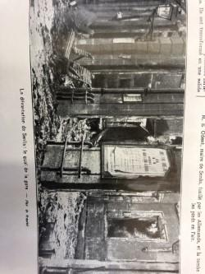
Figure 1: De Rozyail, The devastation of Senlis, the Railway Station, black and white photograph, printed in L’Illustration, 26 September 1914.

Dated 2 August 1914, the poster instructs all men under military obligations to present themselves either to the land or sea army as seen in the poster below. The image of the surviving mobilisation poster in De Rozyail’s photograph is a potent reminder of the mobilisation of all men of military age and their absence in the towns and villages in the Northern France under German attack. Only 40 km North of Paris, the wartime population of Senlis was 14,891 and many men of military age would have travelled through the railway station to obey the announcement of the mobilisation poster.

After a few weeks of War, on 2nd September 1914, Senlis survived a rapid and advancing German army on the main road from Compiègne to Paris. Several significant buildings in Senlis were incinerated, with German troops evacuating a week later. The invasion of Senlis became well-known for the war crimes committed, including the use of French civilians as human shields. Although photographers such as De Rozyail remain relatively unknown today, photographs of this nature were common. They were characterised as stadium and recorded places like Senlis which were often reprinted as postcards. What remains extraordinary was how the photographic image of Senlis Railway Station charred and ruined was interrupted by the unexpected survival of a paper poster, a representation of the punctum of war. With titles such as “1914 War damage” and “September 1914, Senlis, première tragédie de la Grande Guerre” (September 1914, Senlis, first tragedy of the Great War) photographs that became postcards were an important part of the early war propaganda. It was not unusual to use these images as evidence of cultural atrocity and implied German brutality, and their distribution was a potent reminder not only for the French people about the devastation of the war in the North of France, and also the proximity of the German army to Paris.

The significance of the burning of Senlis not only referred to cultural atrocity, but it was also a reminder of human suffering following the German execution of civilians and their use as human shields. Photography and postcards promoted cultural tourism, and many photographers were drawn to sell postcards of Senlis and other war towns impacted by the war. In French and English, the photographs showed the reality of the German invasion was brought into homes through the visualisation of the damaged buildings, which spoke a language in which fear and war were rationalised.

The British responded by producing poster images of atrocity to imbue their own fear of German attack. The way that artists used national symbols early in the war are evidence of the significance that governments placed on national unification. The use of national symbols in France and Britain offer insight into the rationale for understanding the war.

Marianne and Britannia- traditional political symbols, new conflict

Marianne and Britannia were enduring symbols of unification during conflict, and they help us to understand how Britain and France entered the First World War in very different political contexts. As France entered the War as a nation the symbol of Marianne was used to mobilise French troops by reminding of French revolutionary history when political power was taken from the monarchy and issued to the French people. The rising up of the French people-- sometimes called the levée en masse -- was used to justify symbolically and politically the raising of French armies through conscription. This is an essential point of difference in the comparison with Britain who relied on voluntarism in this early part of the war.

Although both Marianne and Britannia have been in use in Britain and France since at least 100BC, this does not mean that their representation has been consistent or unchanging. As national symbols, they were frequently used to mobilise in times of war or to celebrate significant victories. The First World War was no exception, Marianne and Britannia were both used, but different political aims saw them used differently.

Marianne reached the height of her popularity during the French Revolution of 1789 when artisans searched for a new national figure to represent the Republic. Significantly, when Marianne was chosen to represent the new Republican values (of Liberté-Fraternité-Egalité) and replace the Royal symbol, she was selected to represent the people of France. Marianne was selected by the Republican archivist from among the many modern French symbols (including the tricolour, the bonnet rouge, the coq, the pré-carré or the foursquare map of France). Marianne became known as the fusion of ‘Liberty and Reason’, a female allegory whose usage began to dominate the visual imagery of Republicanism from 1914. This is demonstrated in her use throughout the war in posters and the imagery of her leading the French troops into battle during the First World War.

Marianne was a traditional female allegorical form used during times of conflict from the French Revolution and typically her use is a significant symbol in times of crisis. During the First World War, Marianne represented the French Third Republic and the political alliance between the left and right political spheres in the Union sacrée de la nation. As Peter Burke contends, eighteenth century France ‘reached into the twentieth century’ through the ongoing representation and continuity of Marianne’s image. However, what is less studied is the way that artists combined the symbols of Marianne with female Greek goddess of war, Athena (in Greece) and also Victory in Rome (Nike in Greece). In comparison with France, neither Britain nor Germany saw the same frequency in use of their national symbols Britannia and Germania. As Mosse reasoned, during the war Britannia followed the classical aesthetic form of Athena, the Greek goddess of war and may explain why there is often a merger between the representation of Victory, Athena and Britannia throughout the twentieth century.

The first known record of Britannia was in a low relief sculpture of the Emperor Claudius holding Britannia by the hair as she struggles bare breasted on the ground with her right arm raised in defiant protest. This image was part of a larger bas-relief frieze in Asia Minor and was believed to be part of the processional building constructed during the rule of Emperor Claudius (AD 41-54). Since her very inception as a Roman symbol of defeat, generations of Britons would attribute the symbolic representation of Britannia with ‘loss’ not victory until she became repopularised as the voice of the people during the political crisis of the Restoration period, in 1660.

Under the rule of King Charles II (1630-1685), the image of Britannia appeared on copper coins (replacing her image on Roman silver) to reinforce the monarch’s popular image of negotiating freedom with the British Parliament. An ‘important art-historical actor,’ Britannia mediated the distribution of power between the monarch and the people. However, by 1914, the presence and power of Britannia entered the twentieth century with an association with Britain’s domination in sea warfare. Given that the First World War was primarily a land war, she was used rather infrequently, unlike Marianne in terms of significance for the French experience of the First World War.

Industrial unrest, Irish Home Rule and constitutional trouble were all a challenge to unify around ‘one’ concept of national identity. This is in part the reason that British posters ‘required a delicate handling in its dissemination of material that did not appear to be propaganda’. Traditional British symbols became complex because of the political disruption in Britain. Where France was a Republic, Britain and Ireland were united through an Act of Union (1800), however, not all were unified in support of the war. In July 1914, just prior to the outbreak of war, internal tensions challenged political stability in the management of Home Rule in Ireland.

In response to external threat and internal fear, on 8 August 1914, the British House of Commons enacted the Defence of the Realm Act (DORA) which gave the government executive powers to protect British shores as published in The Gazette on 11 August 1914. DORA envisaged building public morale with an emphasis on maintaining the freedoms of domestic life. It was initiated by government fears of insubordination and disorder, and public concern particularly in the context of a potential German invasion. There may have been greater international appeal by merging Greek classical symbols during the war.

In Britain, politically, there were difficulties in using nationalist symbols that represented unification to international audiences during the War. French and British political and social perspectives as represented through national symbols had a past, they did not occur in isolation of this past. As such, variations of old symbols emerged as new symbols, to connect with internal and international audiences.

Britain and France, along with many other countries, embraced the poster as a communication method during the war. Benedict Anderson reported that it was the communication by the burgeoning print media that enhanced national consciousness and gave rise to a new politics defined around competition between nations. The First World War was the first extended global conflict to use the products of the industrial revolutions; steel, chemicals, high explosives, and the internal combustion engine. It was also the first global conflict to translate the war through print media on a mass scale.

The spread of mass literacy via the technological development of printing drew a closer bond between international communities. During the war, the poster enabled a coexistence of the past and the present, embracing cultural differences by allowing the coexistence of complexity, multiplicity and diversity in the representation of everyday social life. The poster, for example, characterised many issues that affected many modern societies, not only Britain and France. During the War, the success of nationalism to unite socialist and liberal political parties for example, resulted in a collective understanding of the war and the requirements for everyone to contribute to the war effort. Poster artists frequently reflected this capacity to produce works of national and international appeal.

The First World War poster -Art form or propaganda

In many ways this culture of comparison of posters and poster artist existed well before the war. Posters were the focus of national comparison as they were discussed in the poster journals. In Das Plakat (1910-1924), editor Hans Sachs advocated for good poster design over advertising techniques in order to ‘preserve spiritual values.’ Charles Hiatt, publisher of Picture Posters: A short history of the Illustrated placard (1895) wrote: ‘while in France in the hands of the artist, the poster becomes a beautiful thing, in the hands of the colour-printer’s hack in England, it rarely succeeds in being other than abominable.’

In France, Ernest Maindron published three journals which were devoted to publishing the work of French and international poster artists in Les Affiches Étrangers, Le Courrier Français and La Plume. Roger Marx produced Cocorico and L’Estampe et l’Affiche from 1896-1900, during the period which was termed ‘the art poster movement.’ Sachs, Marx, Hiatt, and Maindron described the challenges for the poster in this period as there was increasing demand for their use in advertising rather than their existence purely as an art form. The art poster publications ended in 1900 and many artists moved away from the artistic production of the poster because it became subsumed by advertising. Certainly, this separation of the poster from the ‘art form’ was impacted by the technical capacity for mass printing the poster. Instead the poster became the primary form of mass communication during the First World War.

Although propaganda had also been used in the Crimean War (1853-1856), the Prussian War (1870-71) and during the Boer War (1899-1902), it grew in sophistication to inform, instruct, and appeal throughout each War. Although propaganda itself has a history that is characteristically opaque, its original purpose was to establish ‘a systemic or organised movement to propagate a particular doctrine or practice’ as established by Pope Gregory XV in the seventeenth century. Over subsequent centuries, the term came to refer to ‘propagandists’ who undertook the production of materials to support political or revolutionary causes. During the nineteenth century and in the lead up to the First World War, the term ‘official propaganda’ emerged to refer to government activity that ‘put to the population of neutral countries and British dominions, statements and arguments in support of the policy of Great Britain and her allies in the European crisis.’

The content of propaganda posters during the First World War was driven as much by personalities as by military plans. Officials were quick to identify the value of the poster for war efforts. The first artists were employed during the early days of the declaration of war in Britain in 1914 as part of an early recruiting campaign. Initial assessment of the British posters identified a ‘poor degree of artistic perception’ and that they suggested a ‘very low notion of the mentality of the British public.’ Hardie and Sabin observed, ‘hardly one of the early posters had the slightest claim to recognition as a product of fine art; most of them were examples of what any art school would teach should be avoided in crude design and atrocious lettering.’

These limitations in poster design were observed in 1914 when Frank Pick, a corporate employee of the London Underground, refused to display the recruitment posters commissioned by the Parliamentary Recruiting Committee (PRC). He explained simply that they were ‘too bad to be hung.’ Protests such as Pick’s were not made in isolation. In 1915, the PRC and later in 1918, the Ministry of Information responded to the growing critique by commissioning some well-designed posters by selecting artists with an established reputation in poster design. As would be expected, the history and content of the propaganda poster were also shaped by the events of the War.

An interest in realism emerged in the early twentieth century and reflected a time of transition from the traditional to the modern world. The new realities of war appeared to be in tension with the ‘slick, artificial and indulgent’ appearance of the posters from the pre-war period. In London, Curators Hardie and Sabin described ‘The earliest days of the War saw available spaces everywhere covered with posters cheap in sentiment and conveying childish and vulgar appeals to patriotism.’

Significantly, the French posters with their attention to detail, hand-drawn and containing minimal colour, were completely opposite to the bright and brash German posters which were championed throughout the War by German artists. In a rejection of pre-war modernism, ‘French poster artists abandoned their quasi-modernist pre-war styles and instead adopted a lexicon that was overloaded both stylistically and iconographically…the posters would be construed as appropriate to, but supportive of, the nation fighting for its very survival.’ In contrast, Levitch has described French war posters as ‘monotonously monochromatic,’ while the British illustrative approach is often described as being characterised by ‘undistinguished designs’. That British and French poster designs have long been understood as appearing ‘hand drawn’ provided a direct contrast to the bold and colourful sophistication of the German war posters.

Although this view of the conservative nature of French and British posters is widely accepted both immediately after the war and by historians today, there has been little regard for why this might have been the case. Many poster artists in France and Britain were also producing illustrations for newspapers, journals, and periodicals. Printed illustration was a means to provide a mass audience a much more intimate experience, drawing the viewer closer to the work. Primarily the illustrations for posters were produced for a political purpose. Therefore, the monochromatic drawings that were popularised in Britain and France prior to the War were unsurprisingly also political satire, newspaper content and book illustration.

Many of these illustrators were also employed as poster artists during the War. Théophile-Alexandre Steinlen, Bernard Naudin, Jean Louis Forain, Lucien Jonas and Adolphe Willette all chose illustration to underpin poster design during the War. Each of these artists drew on their experience in drawing of French social satire and criticism and frequently published in politically left journals and newspapers prior to the War. Steinlen was known to make illustrations for free to contribute to the left satirical magazine Le Rire, the Marxist periodical, Le Chambard Socialist and the anarchist paper, La feuille. In Britain, the poster artists Gerald Spencer Pryse, John Hassall and Bert Thomas were also working in newspaper publication producing illustrations for The Graphic, Punch and the Strand magazine. They were realist artists who were familiar with the depiction of social injustice, protest, poverty and war for newspapers and magazines.

Although drawing was an important step in the print making process, ‘the artist drew the illustration on the printing stone, however this was not normal practice’ during the War. The reliance on non-traditional printmaking techniques enabled greater volumes to be produced. In the first recruitment campaign for example, 5,727,000 posters were printed at a cost of £17,855. The numbers of posters of each design were printed in the thousands and some even reached the millions. The war saw the poster being printed by the first offset lithographic process which sped up the rate of production to 5,000 impressions per hour. There were consequences though, the rapidity meant the absence of colour, and the low quality of paper meant that the offset lithographic technique was also a product of war.

The first publication on the subject of the War posters was published after the War in 1920 by British poster curators Martin Hardie and Arthur K.Sabin, was entitled War Posters Issued by Belligerent and Neutral nations 1914-1919. Hardie and Sabin provided commentary on the comparison of British, French and German War posters.
Hardie and Sabin compared French and British war posters with German war posters by observing that:
We have much to learn from the concentrated power, the force of design, the economy of means, which made German posters sing out from a wall like a defiant blare of trumpets. Their posters issued during the war are even more aggressive…[and] have a force of character that make most of our own seem insipid.

The French lithographic posters were influential, but their styles were never fully endorsed by the British artists who preferred a narrative style that reflected contemporary book illustration in order to ‘tell a story as completely and unambiguously as possible.’ This supports the idea that the content of the British poster although embedded in the history of book illustration, was seen to have appealed through ‘cheap sentiment’ or jingoism.

Pick’s criticism was not in isolation, and in response the Ministry of Information responded by commissioning some well-designed posters. Posters designed for the PRC were generally unsigned as a demonstration that they were produced in service of the nation, not for profit by the artist. Pick by contrast was a patron of the artists and ensured that each artist that he commissioned received financial return for designing posters that were not only of artistic merit but also had meaning and purpose. Pick’s formation of the DIA (Design Industries Association) in 1915 was to address the pre-war competition with Germany, by bringing industry closer to the design process. However, this neglects to mention the inception of the struggle in 1900 between the poster as an art form and a commercial product which continued during the war as is evident in Hardie and Sabin’s criticism. This lack of aesthetic interest was not only a British criticism.

In 1915, the French newspaper L’Illustration called public attention to the images on the posters. Although they were not very attractive, they achieved the communication of authority, explained the context of legislative messages, decrees, the ordinances and defence orders. The artists, their subjects and their audience reflected the significance of patriotic narratives and as such ‘when they decide on posters, they chose a glorious episode of our life at war.' Over time, the connection between the poster and delivering the necessities of the War, including financing the War, became evident, with most French posters produced to raise funds for war charities. The constraints of the war saw a shift from aesthetic concern for the artistic qualities of the poster to the power of this new form of political weaponry, in the form of propaganda.

The organisation of the British and French poster as propaganda

These arguments were pervasive and shaped the public belief that propaganda was borne out as a product of a War which was prolonged and entrenched. As it became clear that the War would extend beyond Christmas 1914, it had widespread implications as people struggled to come to terms with an ongoing rationale for the War. Then in 1915, after the large loss of men in the 1914 battles of Ypres and Pozieres were publicised, British propaganda increasingly targeted morale, which became recognised as a military strategy. It is in these terms that propaganda constituted an ‘essential weapon in the national armoury.’ At the start of the War, British propaganda posters had been organised by the PRC from Wellington House and this was a largely political (rather than military) role. It sought to be responsive and to manage public opinion. However, as the War dragged on and the losses mounted, the official strategy changed to one of more overt persuasion (and potential deception).

By 1917, a War Propaganda Bureau (WPB) and Neutral Press Committee had developed and merged to form a new Department of Information (DOI), which had clear military intent. This was important for the development of propaganda posters in Britain. The new DOI managed text propaganda, while posters continued to be managed out of Wellington House where the designs for the propaganda posters were considered and commissioning took place. Although there was always some overlap in the production of propaganda materials, posters and poster artists had more freedom. As Lord Onslow explained: ‘we have not done very much with them (posters); we really leave that to Wellington House, but we have two artists Bairnsfather and [illeg.].’ In March 1918, the DOI became the Ministry of Information (MOI) at Crewe House and reported to the War Office. The MOI took over responsibility for the distribution of all official propaganda materials, but it left the production of posters to a sub-department aligned to Wellington House.

The history of propaganda posters in France was quite different. Centralised control of information was overseen by the Press Bureau under the Ministry of War a relationship which was formalised in January 1915. However, it was not until January 1916 that Aristide Briand created the Maison de la presse which handled both censorship and propaganda.In France, propaganda had not been a common term applied to posters prior to 1916. Scholars have found that public perceptions of posters at the time were much more in line with advertising. In other words, they understood ‘propaganda’ as a means to sell an idea rather than having any association with a ‘deliberate falsification of the facts.’ It was in 1916 that ‘we can truly talk about the construction of propaganda aimed at the general public based on greater conniving between the press and the government.’ Importantly, this reinforces the view that propaganda potentially had a different meaning than it does today. This is a point worthy of further exploration, however, it is outside the scope of this thesis. While propaganda may have been present in France, it was not understood and instituted in the way that it was in Britain until later in the war.

Censorship operated through the Maison de la presse, which was established by the French Ministry of Foreign Affairs in 1916. Based on records in the archives of the BDIC I found at Nanterre, there were articles, posters and placards that were not authorised by the censors for publication from 1916. Frequently the censors’ comments included suggested modifications to images to avoid representations of death, artistic incompetence or images that satirised politicians, prostitutes or significant military figures. This approach would appear to reinforce the attitudes of the French government to all forms of propaganda including the poster, at this crucial point in the War. However, by 1917, France and Britain were threatened by war weariness.

In France, ‘three years of inconclusive fighting…of fear and discomfort, and death and mutilation’ consequently saw low morale and depression amongst French troops. The initial idealism for self-mobilization during the early war period waned, Horne identified two major new threats, ‘a privatized disengagement of soldiers and civilians from the war with morale and opinion weakening and the mobilization toward peace. This enthusiasm would have an impact on the production of posters in the latter part of the War and it tells us that propaganda was far from uniform within or between nations across the War.

Post-war understanding of the poster as propaganda

Therefore, the public conceptualisation of propaganda as a negative, divisive, or coercive product was not pejorative or pervasive across many nations until after the War. As John Horne has explained, the post-war period was a time for reflection on the Great War with its violent impact on the soldier and civilian populations. It was at this time that the public began to analyse the messaging of the War more closely, which of course involved asking why the propaganda that had been produced.

In Britain, the reaction of returning soldiers was so strong that British government officials considered banning the use of the term propaganda in official speeches and in the diplomatic vocabulary. The way that posters have been understood as sources of manipulation reflected post-war politics and it would have an impact on how posters were treated historically throughout the ensuring years.

In 1938, Harold Lasswell defined propaganda as the ‘communization of warfare [that] necessitated the mobilization of the civilian mind’, and this definition has resonated throughout the twentieth century. I draw your attention to this definition because it describes how propaganda was understood immediately following the War, and how it continued to be understood in the political theory throughout the twentieth century.

Harold Lasswell was an American political scientist and communication theorist who published The propaganda technique in the First World War (1927) and then subsequently British politician and social activist Arthur Ponsonby published on propaganda in Falsehood in Wartime, containing an assortment of lies circulated (1928). Lasswell intended to produce a survey of the intent of propaganda to influence international attitudes demonstrating a clear ideology of guilt being used in propaganda to mobilise the public. He concluded that propaganda was a ‘passive and contributory weapon, whose chief function is to demolish the enemy’s will to fight.’ In this, Lasswell contributed the idea that a propaganda war was a prominent part of the allied arsenal. Ponsonby agreed that the term propaganda became associated with public deception, or a falsity of information during the war. This proved difficult for the British government at the time which ‘aimed to stimulate not depress!’ This tension led to a creative solution as the War progressed, where the manufacture of propaganda and its support by government was hidden behind the charitable organization of sponsorship. This allowed the government to explain propaganda as sensationalism and as an extension of the style of journalism or the passion of charities at the time.

Ponsonby and Lasswell independently argue that institutional lying was prevalent during the War. They claimed that governments overtly and subtly reinforced the narratives of speculation and falsification during the War. The nature of propaganda, according to Lasswell, had ‘all the symbols and forms of pseudo-rational appeal - the wolf of propaganda does not hesitate to masquerade in the sheepskin.’ Consequently, propaganda posters were labelled as an inherent part of this communication language of deception and manipulation. This was despite the British government espousing high moral standards and claiming to always tell the truth.

When propaganda and its definition has shifted with every war, the definition of propaganda posters as one part of the First World War propaganda campaign that has remained relatively fixed over time. Lasswell’s definition of propaganda as a weapon of the masses lay unquestioned until the 1960s. Historians such as Paul Fussell, with a cultural interest in the poets and writers who were being discovered anew, began to acknowledge that many of them were also the voices of the war. This cultural interest in the 1960s were predisposed to attempt to use the war as ‘representative of a new kind of evil.’ Braybon details that this implied assumption that ‘the First World War was worse than any other conflict in history’ was an inevitable product of a decadent society.

The discovery of new voices in the war was evident in the cultural production of artists, writers and poets exemplified by Samuel Hynes who promoted the view that the war was an interruption. This perspective encouraged the assumption that all posters produced during the war were weapons used to prop up a propaganda war, rather than cultural expressions. In James Aulich’s 2007 history of War poster propaganda, he argued that posters played a combatant public war in 1914-1918. Enabled by advanced print technologies, the poster as a propaganda weapon in Britain and France continued evolve throughout the post-war period and this was maintained as the dominant perspective on the role of the poster until the 1970s. Maurice Rickards and Michael Moody’s exhibition left a lasting impression through the publication The First World War: Ephemera, Mementoes and Documents (London, 1975) drawing attention to the IWM’s poster collection and their role in War to play on public fears of death and disaster.

The association of propaganda with the trauma of the war meant that it remained a relatively understudied aspect of the war. And when it began to be studied in the 1980s, scholars reassumed this definition of propaganda as a product of governments who wanted to sway the opinion of the masses. Exhibitions of posters and their publications frequently reignited the persuasive influence of poster collections. In 1992, Beth Irwin Lewis, Peter Paret and Paul Paret’s Persuasive Images: Posters of war and revolution from the Hoover Institution Archives and also Margaret Timmers’ publication The Power of the Poster (1998) were characteristically ambitious in their scope. Recent reappraisal of the First World War since the 1990s has brought with it a renewal of interest in how different groups of people experienced the conflict.

In comparison, the exhibitions also broadly followed the function of war posters including; charity, agriculture, patriotism and le Poilu who became an enigmatic presence in French war posters and illustration. Remy Paillard’s publication Affiches 14-18 (1986) was drawn from his own poster collection and would be emulated later by Alain Weill who drew on Hans Sachs’ (editor of Das Plakat (The poster)) collection in The Art Nouveau Poster, which was sold and distributed at auction in 2015. in France relayed a different message, one of patriotism which was the intent of the 1987 exhibition Affiche, Agriculture, Patrie (Posters, Agriculture and Patriotism) held at the l’Écomusée de la Bresse Bourgiognonne. In contrast to these publications which brought attention to the poster images rather than the political or social illumination, Laurent Gervereau and Christopher Prochasson’s publication Images de 1917 suggested that French war posters adapted to changing political circumstance and to public opinion and therefore supposing a far more didactic and responsive role for the War poster.

As a result, there has been an increase in understanding more diversity within the dominant definitions and overarching theories of the war including those of propaganda. John Horne identified that propaganda was legitimated by a war that drew on values of nation and regime. Horne claims that it was ‘only in the last eighteen months of the war that the importance of a co-ordinated propaganda effort for the home front about the meaning and significance of the war was understood.’ This is in comparison with Britain who instigated a fully-fledged propaganda campaign in 1914 with the aim of the recruitment of volunteers.

In 1917-1918 the state became involved in campaigns to sustain the morale of the population in the ‘advance of outright military victory.’ This contrasted with propaganda from early in the war which was ‘widespread and diffuse’ and ‘often directed at foreign, especially neutral, opinion.’ The exception of course was early in the war when the state had focused on voluntary recruitment in Britain in 1914 and fundraising through war loans in France which began in 1915 and then proceeded throughout the war.

Theoretical contribution of the research

Until recently, this overarching definition of propaganda and its role in the coercion and manipulation of the public had remained unexamined. Horne states that while ‘coercion was restricted (in practice more than principle), persuasion was not’ and while the propaganda could not practically coerce, it could sustain civilian morale. This was similar in aim in both French and British propaganda. Stéphane Audoin-Rouzeau and Annette Becker call for reassessment of the prevailing definition of propaganda during the war. As Audoin-Rouzeau and Becker claim, ‘the word propaganda seems inadequate and perhaps should be used in quotation marks’ because instead, Audoin-Rouzeau and Becker theorise that propaganda during the First World War had very little to do with the coercive mobilisation of public opinion. They propose that propaganda reflected a more spontaneous discourse of the events of War.

The definitions of propaganda by Harold Lasswell and Arthur Ponsonby have dominated a twentieth century understanding of propaganda. This rationale for the production and use of propaganda during the war meant that there has not been a sustained interest in questioning this dominant view and as a result there was a lack of interest in the First World War poster as it was understood to champion government or at least the authoritarian imposition of certain ways of thinking during the War.

Therefore, the dominance of the definitions of propaganda and their pursuit of government ambitions to coerce and manipulate the public-to prepare the public for war are not disputed in this thesis. Rather, what is being questioned is the narrowness of the definition and the prescription of all propaganda including the poster being incorporated into the propaganda which primarily aimed to coerce and persuade. Horne argued in 1997 that it is imperative that scholars understand that ‘support for the national war effort, especially in the liberal democracies, came from persuasion- and self-persuasion- much more than coercion.’ It is important to distinguish that for different parts of the war propaganda played a different role. Perhaps this was a stimulus for Audoin-Rouzeau and Becker to suggest in 2002 that definitions of propaganda might sometimes be less about government control and more ‘spontaneous’ than previous scholars have considered. This opens the door to embrace more opportunities for propaganda to engage in varied forms of communication, including the opportunity to consider varied roles of the poster outside the dominant national history narrative.

The contribution to the research within selected themes

The contribution of this thesis will be to examine French and British posters beyond national identity and see them as more than just a reflection of government messages; instead, they enable us to understand a diversity of views of the War. This means expanding our definitions of posters beyond tools of nationalism or of government direction.

Not only does this research delve into the influence of the French and British governments on poster production, but this thesis gives weight to the understudied contribution by individuals, charities, and organizations who were also part of the commissioning process. Through the study of the artists and the purpose for which the posters were created, this thesis adds to the complexity and nuances in which the war poster may also be understood as a reflection of the war and the contribution of individuals to the communication of French and British social and political nexus of War.

It is anticipated that in furthering an understanding of how individuals have contributed posters that offer unique contributions to the debates of the First World War. With greater knowledge of the artists who produced the posters, and why they were produced, we begin to comprehend the nuances within the design of each poster. Each of the chapters of this thesis is devoted to revealing recent publications and research might be attenuated and also augmented by the posters under consideration in this thesis.

The three themes were selected because they represent an ongoing cultural discourse both prior to the war and also for a long time after it. They include French and British posters that describe the Belgian experience, the representation of French North African and British Indian colonial soldiers, and the visualization of working women. It is unknown for such a study to examine evidence within each theme across the entire war to examine the nuances of change and the spontaneity of poster production.

The aim of this research is to firstly set up the social and political debates of national identity during the First World War and then to offer a more nuanced understanding of how posters contributed to the spread of ideas that might sit outside national identity. Significantly, within these three themes, it is often the lesser-known posters, often by relatively unknown artists that provide a perspective which is less examined in the current poster literature. The contributions of each chapter to the current research are outlined below.

Chapter 2: Remember Belgium
Already, there is an extensive contribution by historians who over the past 30 years have researched the Belgian experience during the First World War. This literature has established that the propaganda surrounding the Belgian experience was paramount to the recruitment of allied troops. While a large component of this historical narrative has centred around the propaganda, recently there have been several analyses that have shown that there was truth in the representation of the experience of Belgian atrocity.

Recent literature in France and also Britain has examined the down-turn in popularity of the Belgian refugees in host nations Britain and France. What is less well known, and the subject of chapter 2, are the ways in which Belgians were represented in France as compared with Britain. Belgian artists also attempted to use the poster to counter negative public opinion in Britain. This chapter adds new social perspectives from the War, from the communication of German atrocity to the representation of the Belgian experience by Belgian artists.

Chapter 3: Colonial perspectives on the First World War and Empire
In current literature there is a lack of research around the understanding of the colonial experience of North Africans and British Indians and there has not been any comparison between colonial groups and their experience. This comparison contributes to the examination of imperial propaganda, but it also begins to understand the British Indian and French North African colonial perspectives. This analysis adds knowledge by offering new perspectives which arise through French and British comparison. This chapter examines how Britain placated colonial service from India, while France appeals for money to support the conscripts from North Africa. These differences are also reflected in the posters created by colonial artists many of which have not been analysed before. These posters offer new insights because they were created by unknown artists and unsigned posters we begin to understand how colonial artists envisaged the war and how their communication offer a different lens than the dominant imperial one.

Chapter 4: Being seen: women and the First World War
It is widely accepted now that too much has been made of the gender crisis during the War. Historians James McMillen, Gail Braybon, Nicoletta Gullace, Laura Doan and Susan Grayzel have challenged -that the focus on ‘change’ has also limited the diversity of analyses within the gender construct. Notably absent from this debate, until now, are the views of the female poster artists and how they contributed to the representation of working women during the war. How did female poster artists speak to women during the war? This analysis facilitates for the first time a perspective on the way artists in France and Britain, many of them female and not professional artists, created posters to appeal and encourage women’s service during the war.

This conclusion examines any commonality between the three themes as they relate aspects of the War and the responses by artists and how their own experiences contributed to the representation of the War. The contribution of the thesis to each of the themes, beyond ideas of national culture, is through the representation of new voices who contribute new ideas and the articulation of different perspectives of the war through the poster. In this way, we understand more about the role of the poster and its response to the events of war, the poster as an ephemeral communication method. This thesis adds further evidence to the existence of propaganda which was less about the mass propaganda and more spontaneous in its creation.

Chapter 2 - Remember Belgium

The call to ‘Remember Belgium’ appeared in allied propaganda posters across the globe throughout the First World War. Sparked by the invasion of the neutral country of Belgium by Germany on 4 August 1914, France immediately declared war on Germany. The assault on ‘poor little Belgium’ drew international attention because the German invasion brought war into the consciousness of leaders and citizenry alike. Throughout the War, to ‘Remember Belgium’ was to be reminded of the threat to one’s family, people and nation. By 1917-18, ‘Remembering Belgium’ was re-directed to international recruiting, in particular, in America. The invasion of Belgium was a catalysing event for the political and social construction of the First World War.

However, ‘Remembering Belgium’ was not always easy, politically, or socially, especially when other atrocities, such as the sinking of the Lusitania and the execution of nurse Edith Cavell, meant that there were competing demands for sympathy. Meanwhile the social relationships between refugees and their host populations were sites of tension, and enquiries into the reported atrocities, such as the Bryce Report, detailed the Belgian narratives of atrocity. While it identified evidence of the cruelty against women and children, there was no measure of validation to ensure that the stories were checked for accuracy. Belgian atrocity remained a background for the early war period, and it was heavily promoted internationally in America and Australia. Returning Belgian soldiers also reminded the British public that they had fought valiantly and deserved to be remembered as the War drew to a close. At times, the call to remember received some scepticism.

This chapter begins by examining the origins of the theme of ‘Remembering Belgium’ in 1914, particularly focusing on how significant this narrative was as a stimulus for the mobilization of the allied countries. The analysis then considers the changes and challenges for those who sought refuge in Britain, France, and The Netherlands from later that year until the end of the War. For instance, by mid-1915, the international welcome had waned in many countries and local communities faced increased internal conflict with refugees who vied for scarce resources and employment. Moving forward to the end of the War, the latter part of the chapter explores the call to remember an international responsibility to repatriate Belgians, while facing the demands of rebuilding at home.

The chapter is divided into three time periods across the War:
- 1914 – May 1915 when the fear of German invasion was used to mobilize troops toward protecting France and Britain.
- June 1915-1916 saw a downturn in focus on Belgium, and antagonism toward refugees with increasing competition for resources, employment and sympathies.
- 1917-1918 with the focus toward the end of the War, when the British government saw an advantage in petitioning public support toward German retribution.

In doing so, the chapter will contribute knowledge about how ‘Remembering Belgium’ through propaganda posters would shape how the public viewed the War. The impact of images of the Belgians threatened by starvation in Belgium, the treatment of Belgian refugees in France and Britain, and the return of Belgian soldiers a case for human rights would contribute to the conceptualisation of Belgium into the next century.

Britain and France in 1914-1915
The invasion of Belgium was a constant image in the early days of the war, and although it fluctuated throughout the war, its presence was persistent in 1914-mid 1915. Surprisingly, the posters depicting the resultant atrocity and the narratives that defined the enemy were forgotten throughout the twentieth century. It is only since the 1990s that historians have confirmed the presence of both allied and German atrocities in this early part of the war. Through the War’s surviving visual images, including posters, this chapter will examine the way that the invasion of Belgium was constructed in 1914-1915, how posters became unpopular around mid-1915, and how the public needed to be reminded of the Belgium experience at the end of the War. The significance of this revisionist research by scholars, in terms of continuity between the War and its immediate past, has been significant in its reversal of Lasswell and Ponsonby’s claims that Belgian narratives of atrocity were lies and falsehood. While Ruth Harris, John Horne, Alan Kramer, Annette Becker, Jeff Lipkes and Larry Zuckerman all re-evaluate the ‘rape of Belgium’, each has individually and collectively brought to light the history surrounding the maltreatment of the Belgian people, which had long been denied. Recent historical research of the British and French press has revealed the fractured relationships between Belgian refugees and their host countries as exemplified in research by Peter Gatrell, Philippe Nivet, Alexander Dowdall, Stéphane Gerson, Pierre Purseigle and Livbov Zhavanko whose scholarship has contributed greater depth to the Belgian experience from international perspectives. The dominance of this research on Belgium as a fragmented nation has enabled renewal of understanding of Belgium experience in terms of its multifaceted transnational relations. These perspectives also contribute to the public presentation of the Belgian experience in the First World War posters as they reflected political and social changes throughout the War.

Together these avenues of research counter the post-war history of ‘denial and forgetting’ of atrocity. The history of denial of Belgium narratives throughout the twentieth century has meant that there has been very little critical analysis of the French and British posters. This has opened the door to the re-examination of the political and social complexities of the representation of Belgian experience through its negotiation of transnational relations surrounding the atrocities carried out in Belgium.

As Horne identifies, in 1870-71 Germans’ internalised fear of the francs-tireurs saw that any ‘hostile action by the inhabitants, would be met with death.’ This historic fear of violence also impacted the way artists interpreted the German invasion of France in 1914 and the subsequent occupation of Belgium and northern France as characterised by enhanced German brutality. It was the innocent Belgian and the brutal German soldier who would capture the imagination of the media, and that would prevail throughout the war in cartoons, postcards with the iconography of the infant with the cut hands.

The use of past symbols drew on pre-First World War conflicts, including the Prussian war (1880-1881). The visualisation of war is imbued with greater meaning through the idea of continuity between the present and the past. Horne and Kramer identify this reference to the past as ‘war culture’ in their chapter ‘Representing German atrocities’. The iconography of atrocity from the 1870-71 Prussian War with France was repeated and re-imagined through other subject matter — including rape, mutilation, starvation, and refugees — along with newspaper stories and visual images, and exhibitions of posters, the narratives of atrocity spread around the world.

The construction of this duality between victim and enemy was best served through monochromatic illustration. However, there were limits to the graphic nature of what was communicated in the poster, primarily because of sensitivity to recruitment numbers in Britain. France also had strict censorship rules around the images that were circulated in newspapers, journals, magazines, postcards and posters. First World War posters were widely circulated and there were many exhibitions of French war posters including at the Gallerie Colonna in Rome, that opened on the 11 May 1916. Organised by the Prince Colonna of Parmano, the exhibition of French posters, illustrations, and paintings were displayed in the famous terraces of his palace. One of the highlights from the exhibition was the contrasts between the Italian renaissance frescos on the ceiling and the Venetian mirrors reflecting the subjects of war. The Maison de la Presse in Paris, rue Francois 1er, included a display of French war posters produced by the Salon des Armées, and this was held in November 1916.

A selection of Henri and Louise Leblanc’s private collection was displayed at the Galerié Petit, Rue de Sèze in Paris October to November 1916, and the exhibition was titled ‘Souvenez-vous’ (Do you remember?). The exhibition included a whole room devoted to posters and photographs that related the German crimes. The Leblanc’s recognised the value of First World War ephemera and they donated their entire War collection, including 22,000 items, to the French State on 4 August 1917. The public was already ‘remembering’ Belgian atrocity by encouraging the visibility of posters through exhibitions.

The impact of the circulation of images of burnt buildings and the visualisation of atrocity in posters is unknown in the early part of the war. This is because there were no measures of the impact of the distribution of images like this and their use as propaganda, and the situation is similar with posters. For example, Lucien Jonas (1880-1947) the French official war artist created the poster Souvenez-Vous! (Remember this!) which was widely distributed and featured a burning building and a German soldier carrying a burning torch and a bloodied knife. The faience that frames the composition contains burning gas and flames as the wooden crucifix fall into a river below. There are several variations on Jonas’ poster by another artist by the name of Charles Jouas that make them unique. Charles Jouas (1866-1942), painted onto Lucien Jonas’ poster in watercolour to make reference to specific incidents of German atrocity, for instance the poster titled Souvenez-Vous! Senlis incendie en Sept 1914 is translated as Remember this! Senlis burned in September 1914. In each poster, Jouas makes a little painting or illustration in the lower right to give the poster meaning by referring to a specific German crime.

“This image has been removed by the author of this thesis for copyright reasons”.

Figure 2 : Charles Jouas, Souvenez-Vous! Senlis incendie en Sept 1914, watercolour on paper, onto a poster by Lucien Jonas, Souvenez-Vous! chromolithograph on paper, 117 x 77 cm, private collection.

“This image has been removed by the author of this thesis for copyright reasons”.

Figure 3 : Charles Jouas, Souvenez-Vous, Cathedrale de Reims, pen and ink on paper. 1914-1918, onto a poster by Lucien Jonas, Souvenez-Vous ! chromolithograph on paper, not dated, 177cm x 77cm, private collection.

It is not known for what purpose Jouas made these original watercolour paintings, however he did create a second poster in which he painted a reference to the destruction of one of the angels from the Cathedral of Reims. The smiling angel was beheaded following a fire caused by a German shell on 19th September 1914. These two posters may have been personal expressions since they remained together. Posters by Lucien Jonas and other artists remained typically blank at the bottom to enable their use at different times of the war for different purposes.

The visibility of the atrocity imagery contributed to the construction of new war culture. As Horne suggested, the construction of cultural atrocity took many forms and it included the destruction of the ancient university library at Louvain, and the bombardment of historic Rheims Cathedral. In this chapter, themes of atrocity will be expanded through the way in which artists represented human atrocity, including the narrative of Belgian starvation in occupied Belgium and Belgian refugees. The posters reinforced a multitude of stories of German inhumanity that reached the ears of the sympathetic French and British public. It is the dualism between the old and new symbolism, often through reinvention that lends gravitas to the First World War imagery. As the War transpired, these images never lost their potency.

Throughout the War, over one million Belgians had fled their homeland either voluntarily or by forced deportation. Approximately 200,000 Belgian refugees settled in France and a similar number arrived by boat to Britain. It is estimated that over 200,000 refugees found a temporary home in Britain, arriving by boat between August 1914 and May 1915. They arrived through a number of British ports; reportedly in October 1914 an estimated 16,000 Belgians arrived in a single day in Kent in Britain’s South East. As more and more Belgians arrived via France, the full impact of the German invasion became real to those who met the refugees and heard the stories of the German atrocities.

Although Britain was as equally unprepared as France for the influx of refugees, the initial response to Belgian refugees was one of welcome. A spate of public statements in response to the arrival were made in the newspapers. Tunbridge Wells Mayor, Mr Charles Embon welcomed the new arrivals, he claimed that ‘these brave Belgian people have nobly done their share of opposing the German aggression and let us do our best to show gratitude’.

Initially, the men, women and children were welcomed as a ‘manifestation of German barbarism’ and the sympathetic treatment of refugees was deemed appropriate given Germany’s direct violation of international public law. Refugee communities were not treated in accord with a single approach, although initially unexpected and they were treated differently in France because they came under the auspices of French citizens, while in Britain they were met with an abundance of generosity and charitable hospitality. In Britain, the neutrality and impartiality that emerged from the 1864 Geneva Convention was instrumental in the Red Cross movement and by 1914 were highly contested because there were many disagreements about who and how to help. The politics of relief efforts were initially diffused through the circumstances of the arrival of refugees in Britain and France, which aligned the refugees with their host nations. This was evident in the successful display of initial solidarity by both refugees and their hosts toward the war effort.

This solidarity was due to the stigmatization of the Belgian atrocities that aroused sympathy for the refugees and recruits amongst sympathetic Allied nations. The narratives were a combination of fact and fiction and were circulated in the newspapers, in the posters, and in the rumour, which spread on the home front and the front line. The refugees related personal narratives of their engagement that reinforced the newspaper reports of German cruelties, including massacre, mutilation, the maltreatment of civilians and prisoners. As the two communities merged, there was a natural curiosity about the Belgians and the narration of the experiences with invading German armies.

The refugees only reinforced what was spread in the news, that Germany had no respect for international law. The German contravention of the law and the consequent invasion of Belgian neutrality was directly evident in the narratives of the Belgians and through the international press. Accounts by the survivors reported descriptions that not only served to reinforce the rationale for war, but also their own harrowing experience. Accounts were shared with one another and the press, for example ‘one had a bullet pass through his shoulder making two jagged holes in his overcoat’ as ‘the wounded men proudly show their torn clothing as trophies of battle honours.’ In 1914, when the idea of war was still shocking, atrocity was a successful impetus for mobilization on the home front.

The communications were aimed at the justification of enlistment and the collection of money through war loans to aid Belgium, and they highlighted the German breaches of international law. The perception of the invasion of Belgian neutrality created a polarisation between victim and enemy which was fundamental to the reception of the Belgian refugees by the Allies during the first months of war. The mutual fear of the enemy was a key factor in generating the emotional connection between the refugees and the civilians. And as a result, atrocity became the impetus for the support for the Belgian people.

The media reinforced the idea of ‘Remember Belgium’ and implied ‘German atrocity’ which reminded the French and British public of the mounting German crimes. Despite the apparent truths of these atrocity reports, the real and lesser-known cost to the Belgian and French inhabitants was in occupation. The harrowing experience of ‘the fifty months under occupation that kept seven million people in fear of their lives, liberty and property’ was often implied through the representation of German atrocity. Subject to ‘routine terror,’ when the German soldiers shot thousands of Belgian civilians, looted and burned buildings, they challenged the very core of European cultural civilisation. The German treatment of the Belgian people fundamentally shocked ‘civilized’ Europe. The immorality of systemic pillaging and harsh treatment of those who remained in occupied territory, including Northern France, are reported in the diaries of those who lived this experience of German occupation.

Sedan, an occupied commune in the Ardennes Department, 200 km North of Paris on the bend of the River Meuse, a young man by the name of Yves Congar related an experience of terror in relation to the family pet. The German occupation authorities introduced many restrictions in occupied Belgium including a ‘pet tax’ which the Congar family were unable to afford. Yves Congar related in his diary, ‘this is a bad and mournful day. My dog is killed. Today, May 15th came the martyrdom of a hero who died for his homeland’. This extraordinary act of the sacrifice of a pet in 1914 was just the beginning of many sacrifices that the civilians of Belgium and France living under German occupation experienced on a daily basis. Perhaps more difficult, beyond the requisition of pets or food, was the deportation of human life.

The women, children and elderly who were deported from the occupied territories to Germany made weapons and contributed to the support of the German army. Yves’ father, Georges Congar, was taken hostage to work for the German war effort and ‘instead of doing 12 hours during the day or 12 hours during the night, he does 4 hours at night and 10 in the day.’ Men like Georges Congar became just another item requisitioned by Germany.

The belief that Germany had broken the law concerned all nations. Germany would be held accountable for contravening the Fourth Hague convention (1907), through the illegal ‘usage of civilized nations and the laws of humanity’, and by treating the Belgian people as ‘moveable property that could be seized and put to military use’. Germany had directly contravened the right for Belgium to remain neutral, and as a consequence of German occupation, lack of food because of requisition meant that the threat of starvation was common.

The lack of food was a constant concern for the occupied departments in Northern France and Belgium. Yves Congar related from French occupied territory that on 17th April 1915: ‘The Boches take away the pigs, horses, cows…they are barbarians using their advantage to feed greed and cruelty, and severe food shortages were commonplace’. The requisition of food and resources by the Germans was in part drive by necessity and in part by opportunism.

British responses to the Belgian crisis of 1914-1915

The shortage of food because of German requisitions in occupied territory reportedly affected ‘two million Belgians [who] were said to be on the soup lines in early 1915’. Winston Churchill, Lord Kitchener, Sir Reginald McKenna and Chancellor of the Exchequer David Lloyd George were concerned that in supplementing the Belgian food shortage that this would indirectly ‘feed’ the German army. But Herbert Hoover, then Director of the Commission for Relief in Belgium (CRB), an American relief agency, arranged regular monthly shipments of food. Germany and Britain allowed the CRB to continue this supply of food, even though on the one hand, it was a political compromise and on the other American intervention was also politically expedient. This tension for the British government was further exacerbated when German soldiers requisitioned the CRB supplies and announced, ‘unrestricted submarine warfare, permitting U-Boats to sink any target on site’.

The growing awareness of the Belgian experience of atrocity was imperative to its legitimisation, not only explaining the emergence of the Belgian refugee, but for the war itself. Increasingly, the image of Belgium was constructed as the bearer of the allies’ burden of conflict. In Britain, it was important that the public saw their ‘duty’ to help the Belgians through relief efforts. This was reflected in the posters of these years, where the Belgian refugees became a motif for lost innocence and suffering. Death and loss were purposely communicated through the posters to evoke empathy, to unify difference and to focus on the allied commonality of purpose. The representation of Belgium also underlined and reinforced the importance of Britain and, by extension, to her Empire, the public duty and sacrifice required during war. Artists responded to the Belgian sacrifice because it also reinforced Britain’s own contribution the war effort.

The poster, 1,500,000 Belgians are destitute in Belgium, they must not starve, support the local fund (below) was produced for the National Committee for the relief of Belgium by prominent British poster artist John Hassall RI (1868-1948). The mother depicted in Hassall’s poster, is a reference to the starvation in Belgium due to the occupation, and also touched on the living sacrifice made by Belgium as a neutral country.

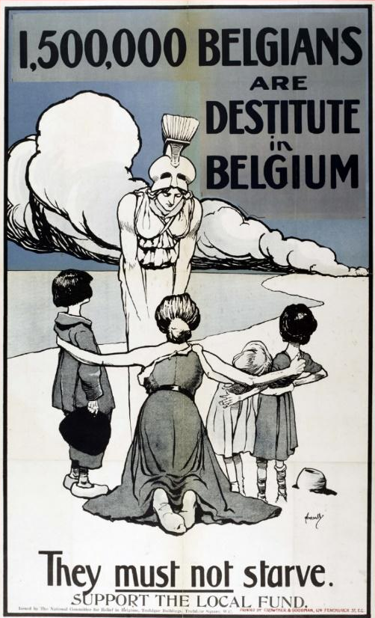
Figure 4: John Hassall, 1,500,000 Belgians are Destitute in Belgium, they must not starve, support the local fund, 1916, chromolithograph on paper, printed by Crowther & Goodman in London, 97.5 x 62.2 cm, Imperial War Museum, IWM PST109917.

The British poster artist John Hassall was also an illustrator of children’s books, postcards and posters produced many posters during the First World War, including 1,500,000 Belgians are Destitute in Belgium. Hassall’s poster featured a woman wearing a torn dress who kneeled on the beach with her arms outstretched, her body forming the sign of a cross. She embraces three young children who stand by her side. A Greek goddess who could be Britannia or Athena is dressed in flowing white robes of antiquity and on her head she wears a Greek military helmet surmounted by a ‘panach’, or brush top, as she reaches both her arms down toward the kneeling woman. It is a scene of domestic protest against the starvation of Belgian people and Hassall calls on British citizens to donate money in support of the charity, National Committee for the Relief of Belgium.

Hassall produced this poster as a commission for the National Committee for the Relief of Belgium, just one of 2,000 charity organisations in Britain that distributed food, clothing and necessities to Belgians. Hassall was known for his use of minimal line to produce the overall image, and bold areas of colour used to frame and integrate the text. He frequently used a black outline in his posters to clearly define a powerful visual polarity between a civilised Europe and the unseen enemy.

The function of the poster was to promote the cause and sympathy in local communities. Notably, 185,000 of Hassall’s posters were printed in 1915. Hassall, known as the ‘Poster King’ having trained in Antwerp and Paris, ran his own school of design from Kensington, London including courses by correspondence. It can be anticipated that newspaper articles often inspired artists like Hassall in their response to the crisis of the War in ways that communicated current information. Although newspaper sources were often difficult to verify, other than ‘expressed opinion’, it is often this unverifiable interpretation of the conflict that the artist relied on. In the absence of direct information, artists, just like the public, were influenced by the narratives of atrocity in the press. Although many charity and relief organisations operated independently of government control, and it was important that they were seen to be community led initiatives, many were supplemented by the government across the war.

The poster invited the public to ‘support your local fund’ and may have appealed to Britain to get behind the support of the Belgians in occupied Belgium, but it could also refer the public to support the local charities who provided food and shelter. Hassall’s poster proclaimed ‘They must not starve’ to align with the narratives in the newspapers. With the help of British propaganda, more and more Americans viewed the Belgians as the ‘brave little martyred people with nothing to eat, nothing to wear, and nowhere to live who would die without American charity.’ The posters brought the narratives in the press to life.

Posters were designed to influence, educate and persuade the British public, as evident in the poster Remember Belgium, Enlist to-day (below), which was printed between December 1914 and March 1915 by the Parliamentary Recruiting Committee (PRC).
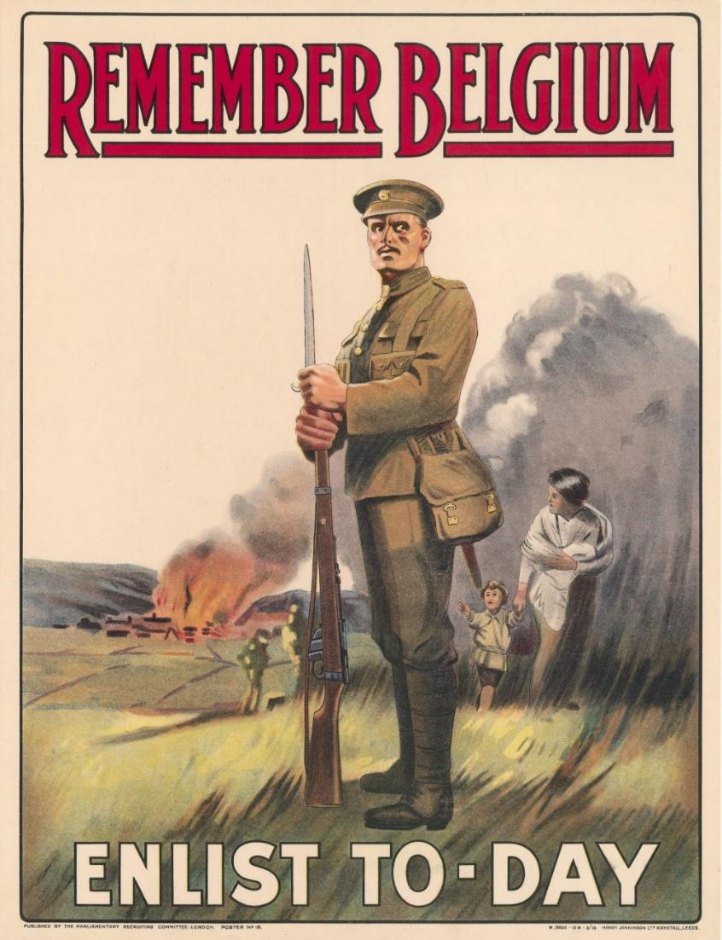
Figure 5: Unknown artist, Remember Belgium, Enlist to-day, chromolithograph on paper, published in 1914 by the Parliamentary Recruiting Committee, London, printed by Henry Jenkinson Ltd. Kirkstall, Leeds, 52.1cm x 38.2cm, Imperial War Museum collection, IWM PST0562.

Remember Belgium is an unattributed poster depicting a moment of impact, the imminent ‘threat’ of invasion by an unseen enemy. The British soldier’s face is turned in the viewer’s direction. He wears an expression of tension, as he stands guard while a woman and child evacuate their burned village. The absence of a firm identification for the village or a national allegiance for the woman and child meant that the semiotic signs are ambiguous. In the context of 1914, it may be that the village was in Belgium, but equally, it could be in Britain.

The polarisation of the innocent victim and the atrocities committed by the enemy suggested that the language of duality already existed within European society prior to the war. The ambiguity of the context of the poster was that it addressed the British fear of the enemy, but also acknowledged that the allied forces and Belgian refugees provided strong resistance; their courageous stories are used as a counterpoint to fear. Therefore, the poster functioned to justify the war and to consolidate public courage through retelling a narrative of action and responsibility in the face of fear, whether they be Belgian or British.

According to David Bownes and Robert Fleming, this was the second most popular poster image published by the PRC, with over 140,000 copies in circulation. From a cultural history perspective, this is relevant because it was through popularity that the British government used the PRC to stimulate its recruitment campaign; while from an artistic point of view, there are a few visual anomalies. These inconsistencies illustrated how an artist manipulated the image to suit his or her purpose. For example, the soldier is larger than life when compared with the size of the other human figures and the background. The smoke behind the mother and child is unlikely to hover over the ground, smoke rises. This is characteristic of propaganda where juxtaposition is used to create ambiguity or duality in possible meaning British or Belgian fear of invasion.

During this campaign, Remember Belgium, Enlist To-Day was just one of many slogans to remind the public about Belgium and implicit in this was protecting Britain from invasion by appealing to recruits. While the allies had survived the first battle of Ypres, and the highly trained British Expeditionary Force suppressed the German drive to reach the channel ports, the BEF had suffered 58,000 killed in action between the months of 14 October and 30 November 1914. The ensuing battles at Ypres were characterised by a trench stalemate and with the fall of the snow across the battlefield, the ‘grandiose plans of the belligerents lay in ruins’.

At the time, the British War Cabinet was concerned that the rising death rates could potentially affect British voluntary recruitment numbers, especially as the war looked to extend beyond Christmas 1914. Kitchener evidently saw the potential for a prolonged and entrenched war and began to campaign for the expansion of Britain’s military forces. Remarkably, he realised the formation of a series of new armies and had amassed a volunteer army of 1,186,000 in the first five months of the war. There were very few representations of death and injury to British soldiers through this early period.

This is in part because there was little public awareness of the large numbers who were dead and wounded. The BEF ‘might not have withstood further heavy blows during the winter’ and the brief respite granted by the Germans enabled the troops to reorganise. The army was situated on the battlefield with no advance of the front line until early 1915. The suppression of the communication of this information to the British public early in the war has led David Monger to argue that voluntary enlistment remained strong in Britain from 1914 to 1916. By 1916, when the shock of the massive loss of troops was made public, conscription had been introduced and therefore the focus of the posters shifted away from recruitment in Britain.

Hence, Remember Belgium takes on a new context when considering the number of British soldiers who died in the defence of Belgium in just a few months of 1914. Overshadowed by the emphasis on the defence of Belgium, it is easy to miss the dire circumstances that Britain faced within a conventional historical analysis. Despite Kitchener’s recruitment campaign to strengthen the BEF with additional territorial and dominion contingents there was a very real threat of invasion of Britain. It is easy to miss the significance of the communication of the serious threat Germany posed to Britain; beyond Belgian suffering, the poster’s ambiguity alluded to Britain’s own coastal threat.

This threat was highlighted by the Remember Scarborough posters which were produced in response to the attack on the British coastline by German battleships, Derfflinger and Von der Tann, which bombed the British seaside town Scarborough for approximately half an hour, killing 17 people and injuring 80 on 16 December 1914. The attack then moved on to Whitby and a second German naval force attacked the port of Hartlepool where over one hundred people were killed. There is still debate about the motive which may have been to intercept the signalling stations along the coast, but the public response was panic. Mrs George Rowntree observed that ‘one of the soldiers wounded is the first man to be wounded on English soil since the days of Charles II’. From her high vantage point on the hill she saw the explosions with over three hundred houses shelled, no district of Scarborough escaped the attack. Rowntree described many people evacuated fearing a German invasion.

The Remember Belgium poster was produced to echo the fear aroused in the press reports. The Daily Sketch, Monday December 21, 1914 ran with the headline ‘The stigma of baby killers will stick to them,’ a paraphrase of Winston Churchill. The function of the repetition of the message in Remember Belgium was to raise public concern and to stimulate sympathy which now transferred from Belgium to Scarborough. The Daily Sketch featured photographs of many of the victims of the Scarborough, Whitby and Hartlepool bombings. Implicit is the demand for Britain to ‘Remember Scarborough just as they ‘Remember Belgium,’ through repetition the message is powerful (see below).
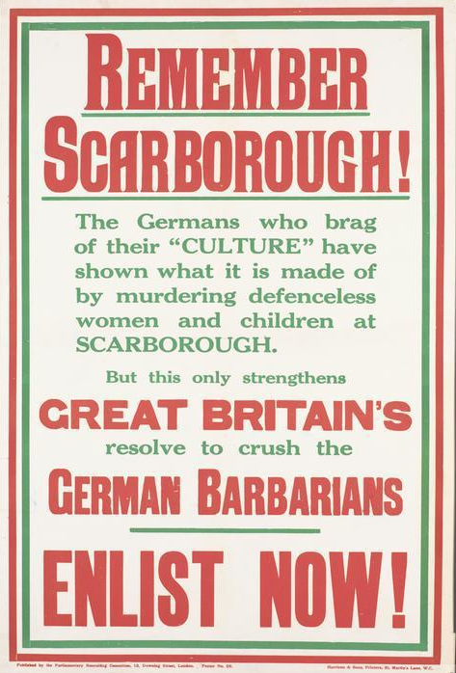
Figure 6: Unknown artist, Remember Scarborough, Great Britons, German Barbarians, Enlist Now!, chromolithograph on paper, published by the Parliamentary Recruiting Committee, printed by Henry Jenkinson Ltd. Kirkstall, Leeds in 1914, 76 cm x 50.7 cm, Imperial War Museum collection IWM PST11471.
Clearly, the British people, who were initially denied accurate reports of the BEF losses until February 1915, were subsequently shocked and alarmed by reports of defeats and a lack of munitions. Britain at this time was vulnerable to the internalisation of loss. Once the extent of the losses of 1914 became widely known, conscription of British troops was introduced in March 1915 to alleviate concerns about recruitment.

Despite the strength of the British maritime presence, the perception was one of fear, that ‘no longer could Britain rely on its own resources to protect its shores’. Prior to the outbreak of war Britain had relied on a spread of British vessels along the 150 miles of sea in close proximity to enemy shores, yet the ‘traditional blockade was inconsistent with the country’s safety’. The use of landmines reduced two gaps to a few miles and a patrolling force was implemented to maintain a blockade that prevented German naval forces from making an inroad through the North Sea. Mainly through the occurrence of several minor setbacks in the early period of war, including ‘the loss of three cruisers to a single U-boat and to the successful return to Germany of the enemy squadron that bombarded British coastal towns’ including Scarborough. This insecurity meant that ‘Britain was constantly trying to preserve superiority in numbers, size, and speed to take the offensive in battle and blockade. ’ Sympathies with loss began to be paralleled in the posters. Remember Scarborough by Lucy Kemp-Welch was created to connect German atrocities in Belgium with the naval attacks on the British coastline on Scarborough and nearby towns. Britain was able to maintain trade with other nations at this time, but the threat of submarines and mines provided a restriction on both sides.

Naval vulnerability was a challenge to British confidence, particularly during the First World War, however it was only one aspect of the vulnerability felt by Britain. The fear also engendered generosity of spirit toward the refugees who had experienced the fear of invasion first hand as expressed in the poster below.
The exodus of Belgian refugees was observed in 1914 by Gerald Spencer Pryce, who made this lithograph in Antwerp, which was later printed as the poster, Belgian Red Cross Fund, in 1915 (as below).
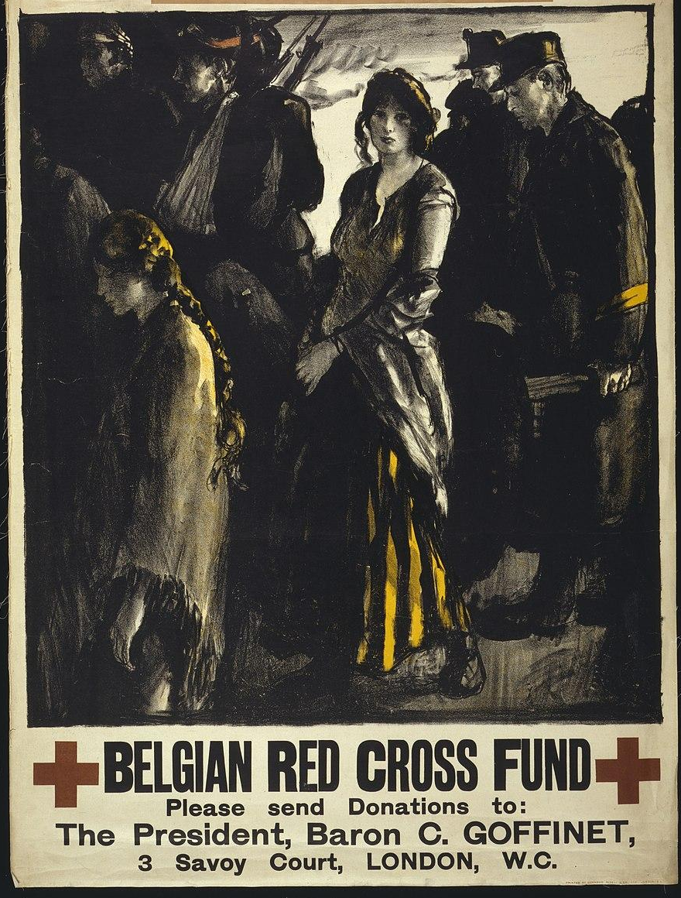
Figure 7: Gerald Spencer Pryse, Belgian Red Cross Fund, chromolithograph on paper, published by the Belgian Red Cross Fund in 1915, printed by Johnson, Riddle & Co. in London. 91.7cm x 75.3cm, Imperial War Museum collection, IWM. PST 0361.
The image drawn by Gerald Spencer Pryse which appears on the Belgian Red Cross Fund poster is dominated by a group of Belgian refugees, a small group of both soldiers and civilians who are walking. A wounded man lays on a stretcher and another wears his arm in a sling, and the group is poised as a young woman turns directly to look out to the viewer and another with her eyes down walks almost as if asleep. They are caught by the Welsh artist Gerald Spencer Pryse as he observed the Belgian refugees as they journeyed toward the border with The Netherlands, their title changed from fugitive to refugee.

At the outbreak of war, Gerald Spencer Pryse (1880-1956) worked as a dispatch rider with the Belgian government where he witnessed the fall of Antwerp to German occupation producing a series of lithographs as he observed first-hand the 4-5 September 1914 Siege of Antwerp and the exodus of the Belgian refugees. Spencer Pryse kept a journal during this period and in this he highlighted the emergence of the Belgians from the darkness, describing that ‘by degrees individuals could be distinguished-old men and women, young women and children, mothers nursing babies, a boy who sustained a crippled woman leaning’. The emergence of the figures who transitioned from the dark into the light were the inspiration for his lithographs and the illustrated transition from one life to another.

It is poignant that Gerald Spencer Pryce elected to highlight the woman’s gold and black striped dress, plaited hair and the yellow arm bands of the ambulance corps. The significance of the yellow and black and the red of the cross is in reference to the colours of the Belgian flag. It appears to be a statement of nationalism, a statement of Belgian neutrality.

Spencer Pryse was able to travel in Belgium due to his war dispatch role and although he applied to be an official war artist on several occasions throughout the war, like many artists, he was rejected because of his politically socialist leanings. He produced a series of lithographs between 28 and 31 August, 1914 titled ‘The Autumn Campaign.’ The design of the poster Belgian Red Cross Fund, and The only road for an Englishman; another example from this period were not part of the Autumn Campaign but they are characterised by a similar combination of traditional rich tonal illustration with bright colour highlights. Gerald Spencer Pryse used this motif of darkness and light to illuminate an emerging social problem — the growing number of displaced people as a consequence of German invasion and subsequent occupation.

It has been estimated by some historians that the exodus of volunteers from Britain to France to fight was met equally by the evacuation of refugees from Belgium in response to the conflict. This was a view that is further substantiated by Edward Eyre Hunt, an American Delegate for the Relief of Belgium who described the refugees ‘their eyes glassy…often they were breathless and staggered as they walked.’ The aim of the poster was to be as true to life as possible so as to appeal to an audience for the collection of public funds to support the Belgian Red Cross Fund directed by Baron C. Goffinet who commissioned the poster in 1915.

French responses to the Belgian experience, 1914-1915

French officials were concerned about the impact that promoting German atrocity in this way would have on public opinion. On 15 Sept 1914, Alexandre Millerand (1859-1943), then French Minister of War, made a formal request that the censor refrain from publishing any German atrocity stories because they risked terrorising populations in occupied areas of France. In part, an official campaign was not necessary, because the illustrations and photographs (chapter 1) showed the impact of German atrocity first-hand. These images introduced questions around the morality of war and in particular the treatment of civilians and refugees who fled or stayed in occupied Belgium and France during the War.

While born in Lausanne, Switzerland, like many artists of his time, Thèophile Alexandre Steinlen gravitated toward the French capital Paris as he became interested in pursuing an artistic career. Settling in the artistic area of Montmartre, Steinlen drew inspiration from the life on the streets. Like his mentor, Henri de Toulouse Lautrec, Steinlen observed in the street life of Montmartre a source of reality from which he drew abstract form. Steinlen lived and worked with close access to the street urchins and prostitutes of Montmartre who became symbols of suffering in his work. It was the street figures which he drew upon to inform his representation of Belgian and French refugees in the First World War.

Social inequality was a radical theme at this time, and he produced illustrations and posters which were distributed in French socialist and left-wing newspapers. He promoted a socially compassionate response to poverty through publications such as Le Petit Parisian, and Le Journal. Steinlen published illustrations in these newspapers and moved quickly to embrace the propaganda. Steinlen’s posters of 'thin and pale Faubourg lasses, flowers of the street’ easily transposed into the hungry Belgian, as they echoed a similar struggle for existence. Steinlen’s subjects were humans in distress, civil as with military, while they escape the heavy sentiment of nationalism.

Consistent with Steinlen’s work, the evocation of empathy around poverty is an essential part of the communication during war. This can be seen in his poster, In Belgium, the Belgians are Hungry (below).

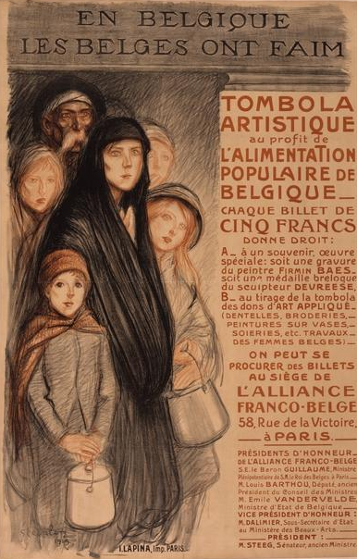
Figure 8: Théophile-Alexandre Steinlen, En Belgique, les Belges ont Faim [In Belgium, the Belgians are Hungry], chromolithograph on paper, 1915, printed in Paris by I. Lapina, 129.6 cm x 93.9 cm, Australian War Memorial Art Collection, ARTV01184.

In Belgium, the Belgians are hungry, 1915, the female figure is central to the creation of each idea. The looseness of the drawing and the incompleteness of the sketch suggests a mood of movement, of alienation and melancholy. The pronounced cheekbones and deep-set eyes gave his figures a heightened feeling of desperation and alienation. The figures are victims to be pitied, their plight is not of their own creation. The artist depicts the basic requirement for food as a shared experience of humanity and so he makes the need a common link between the viewer and the hungry Belgians.

Steinlen sustained his interest in drawing by translating it expertly into the luscious deep tonal contrasts of lithographic printmaking. He was influenced by Hassell's flat areas of colour and the use of green lines, instead of black, to soften the overall effect. Many of his posters embodied a desire for a life of class equality. Steinlen’s own response was not to use nationalism, but rather to maintenance a critique of the Third French Republic throughout the War.

Analysis of this poster reveals that starvation was twofold, because of the inherent dislocation of the Belgians from their normal lives and livelihoods. The genuine shortage of food was a direct impact of German occupation in Belgium. This was primarily because of the limited supply and the German requisition of food at will. On 27th June 1915, Yves Congar lists the items taken from his home for use by the German army and these included; ‘Money, wool, bedding, men, home-made food, cabbages, leeks, wood, flour, coffee, chicory, sugar, chocolate’. The profits being collected for the war effort were to encourage the supply of food to prevent the Belgian’s from starvation. For example, In Belgium the Belgians are Hungry contains a direct criticism of German occupation and brutality which led to the food shortage and the suffering.

What distinguished Steinlen's work from that of his contemporaries was the absence of an anti-German theme. In his work, he does not draw a caricature or demean the German ‘race’, an approach that was so prevalent during this period. In this, he contradicts the assumptions made within much of the conventional historical analysis about nationalism and propaganda. In his role as an official illustrator during the war, despite his association with the political left and socialist and anarchist politics, Steinlen’s War work was abundant and drew international acceptance. As an artist, Steinlen diametrically opposed his own ideological views as he sought to produce drawings for posters and prints that supported Republicanism, as illustrated below.

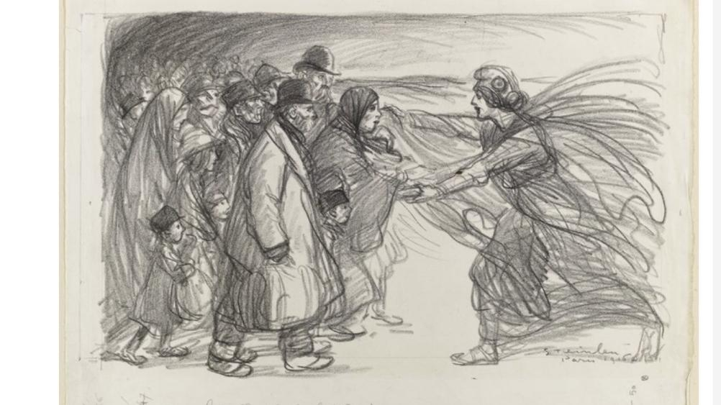
Figure 9: Théophile-Alexandre Steinlen, La République s’éclançant au devant d’une foule [The Republic is coming before the crowd], lithograph on paper, c.1914-1915, dimensions unknown, collection Musée d’Orsay, RF34119.

The illustration that he titled La République s’éclançant au devant d’une foule [The Republic is coming before the crowd], has written in his own hand ‘Pour les réfugiés de la Meuse’ [For the refugees of Meuse], a department on the border of Northern France and Belgium which was one of the first communities to respond to the German hostilities. According to Horne and Kramer, it was in border populations such as Meuse (now Verdun) that the memories of ‘Prussian’ invasion and tales of German cruelty haunted the villagers as the German army advanced. It was German behaviour, the pillaging of homes, the damage and destruction to historic monuments that demonstrated ‘clear evidence of a punitive war’. In his depiction of the civilians of Meuse affected by war Steinlen reinforced the presence of the French republic and the importance of the identification of French and Belgian refugees as citizens and belonging to the French nation.

The strength of Steinlen’s illustration of refugees is that he makes no distinction between French and Belgian refugees. Although, over 200,000 Belgian refugees were relocated to southern France and 450,000 French refugees moved south, over the coming months, these numbers more than doubled in late 1914 and early 1915. The total number of refugees in France would increase to 1.53 million by July 1918. France had to manage its own refugees from the North in addition to those migrating from other countries throughout the War and Steinlen shows the equality of their treatment in the face of German hostility.

The French government had from the outset a social policy which made no distinction between the French and Belgian refugees and this financial support was maintained throughout the War. This chapter compares the similarity in the representation of French and Belgian refugees as an integral part of égalité or equality and French republican values. The refugees were represented as not only victims, but they were also heroic figures. They symbolised a new value of the civilian and their role in the War. As the posters displayed, the columns of refugees on foot was an image that was widely used, and also reflected the familiar Christian iconography of ‘The Exodus’ of the Israelite people from Egypt in 6 BC. At the same time, the Belgian experience brought this into the modern context.

The presence of enemy atrocity was envisaged by the public as part of the culture of war and from the outset, French authorities assisted the refugees. With information about the conflict being so scarce, it was left to the rumours and myths to explain and circulate the crisis that had developed. As Horne demonstrates, the German invasion was in part a violation of space and can also can be conceptualised as a series of attacks on the nation. The public heard and responded to the events of war which were amplified by journalists and governments in response to the German invasion of Belgium and then France. As the conflict continued, the discourses moved from a local engagement to a national and international focus on the war effort. In this way, the soldier’s defence of their family and homes translated to ‘strong motivations for their continued support of the war’ particularly in the refugee.

The refugee community in France expressed many forms of ‘local solidarity’ with which they identified including support for France’s national mobilization efforts. The French refugees who had migrated south were keen to demonstrate their French allegiance and responded to war as ‘active citizens rather than passive victims’. In France, the result of the early migration experience were responses which were not primarily defined by nationality. In effect, the distinction between French and Belgian fell away, leaving ‘refugee’ as the primary identity category for those who had been displaced.

By December 1914, the Ministry for the Interior in France decreed that the military could outsource the care of refugees to the protection of the State, ‘who must supply with the aid of the people, their accommodation, their subsistence and their upkeep’. Hence, there was no distinction made between Belgian and French refugees who received equivalent medical, housing and financial assistance. Further, that all refugees were given the rights of ‘citizenship’ (even if only temporary), blurred strict notions of nationalism and national identity. Such developments potentially challenge the historical convention around the primacy of nationalism across European nations during the First World War.

As Peter Gatrell argues, the posters reinforced a ‘single category of difference’ in order to maximise the support and mobilization of aid. That is not to say that relief did not occasionally follow national identity lines, just that the collective representation of refugee supported the politics for relief in France. Steinlen’s portrait of the French refugees in l’Aisne Dévastée [The Devastation of L’Aisne], as illustrated below, indicates the synergy in depiction of refugee status.
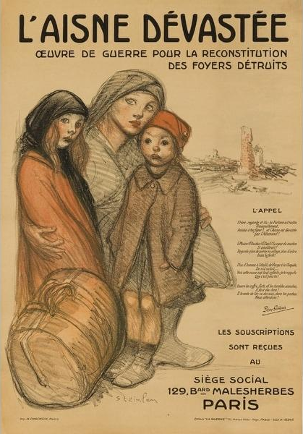
Figure 10: Théophile-Alexandre Steinlen, l’Aisne Dévastée, oeuvre de guerre pour la reconstitution des foyers détruits (The Devastation of Aisne, war charity for the reconstruction of destroyed homes), Chromolithograph on paper, printed by Imp. H. Chachoin, printed in Paris, c.1915-1918, 114 cm x 79.2 cm, Imperial War Museum collection, IWM PST 3517.

The images produced followed a certain stereotype — the grouping of three figures, a mother holding her arms around two children. An overnight bag is tossed at their feet. The woman wears a black travelling cloak which may imply that she is a war widow. She looks out at the viewer disconsolately as to her right stands a chimney and the remains of a house that has presumably been destroyed by the bombing.

The poster functioned to remind the public of the devastation of many towns and villages in the north as the German army sought to outflank the French; these movements between German and France were known as the ‘Race to the Sea’. The race proceeded through September 1914. Germany, halted in Aisne by British Expeditionary Forces, were ensconced in the department of Aisne where attacks and counterattacks prevailed. Steinlen’s poster l’Aisne Dévastée [The devastation of Aisne], was a reminder of the domestic population who were caught in the stalemate, with neither side winning. Purely by circumstance, the civilians became refugees, as houses and lives were destroyed. The images of civilians drawn by Steinlen fundamentally influenced other artists and in doing so, shaped how the War was represented and perceived.

To the right of the image there is also a poem by Pierre Frondaie (1884-1948), a pseudonym for Albert René Fraud, a young poet and playwright whose who wrote an ‘Appeal’ for money to support the reconstruction of homes. Frondaie was a romantic poet and his focus on the devastation of Aisne was to appeal to his audience and to his artistic style.
The poem that Frondaie wrote for Steinlen’s poster begins:
Brother look and read: fortune has remained peacefully seated at your hearth!...and Aisne has been devastated by the Germans! Oh Poverty! Oh Grief! Oh Mourning! A heart of marble would be softened!...Open your safes and your humble purses, donations are needed!

Steinlen invited the French public to participate in the experience of suffering as a common one during the War. He chose to depict his working-class characters without glamour but with dignity. He used a pictorial structure to give a poise and strength to his depictions of refugees. The compositional trio in the foreground enabled Steinlen to develop the idea of a crowd, but also to recognise absence of the male adult in the traditional family construct. The absence of the male figure leads to unknown answers; was it through absence, through death, through service or through capture? In depicting his figures with limited background, he isolated them and thus reinforced the vulnerability of the refugee families as they travelled.

The gendered aspect of visual representation was one way in which Steinlen reinforced the absence of men at war. Through absence, he endeavours to gain sympathy for the refugees, just as he used to draw attention to the lone street women and children of Montmartre. If we contrast the lone images of women and children below with his homecoming scenes with families embracing as a unit, the exclusion of the male in this representation adds a level of implied meaning of absence and even of suffering and the common experience of displacement during the war. A sketch was a rapid way of rendering the real experience of War, and Steinlen borrowed many motifs that were familiar to him and reflected his deep interest in humanity. Steinlen already had a language to express the sorrow of war in his huddled figures, his refugees for the posters and lithographs produced during the War.
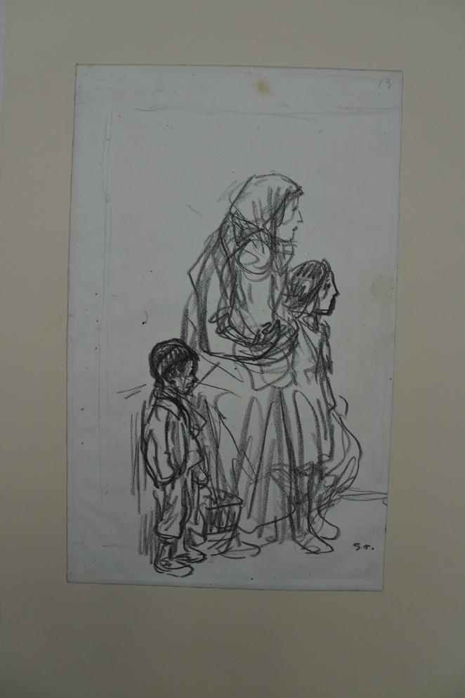
Figure 11: Théophile-Alexandre Steinlen, [Untitled], black chalk drawing on paper, c1914-1915, 39.5 x 24.5 cm, The British Museum 1943,1211.612, donated by Sir Frank Brangwyn in 1943.

In this sketch above, Steinlen’s female wears draped clothing, its flow is suggestive of movement and unrest. The figures, transported in their grief, bear witness to the fear and animosity of the enemy. Framed by the cloth with her head turned away, Steinlen attempts to hide the emotion on her face as the mother holds her baby close, as she meanders through this world flanked by two more children at her side.

The family unit of three is travelling, holding a suitcase, the family are wrapped in war cloaks and the boy wears a knitted cap. Steinlen’s work is possibly a preparatory drawing for the poster l’Aisne Devastée, the children are dressed similarly, and they are one of a series of works held in the collection of The British Museum. The drawings were donated by First World War artist Frank Brangwyn in 1943. They were produced at a time when Steinlen’s reputation was at its peak, as the catalogue to Steinlen’s 1914 exhibition in London was prefaced by the notable Anatole France (1844-1924), French poet and journalist attests. This exhibition held just prior to the War set the benchmark for French illustration styles during the War. Steinlen also held exhibitions of his work throughout the War, he produced a vast number of prints from his travels to the front. As a response to the War he was anti-militarist; he wanted to circulate his work widely. On 20 February to 11 March 1917, there was an exhibition of Steinlen’s war work at la Galerie a la Boëtie. A poster was printed by H. Chachoin in Paris to draw attention to the exhibition.

On 16 January 1915, Steinlen dined with the artist Félix Vallotton (1865-1925) at a restaurant with Hermann-Paul to discuss drawing. Vallotton described his dinner with an elderly Steinlen, who calmly expressed the view that his humanitarian pacifism was revolted by the idea of German atrocities. It confirmed Vallotton’s opinion that French people rarely hate. Steinlen used the neutral phrases in his conversation with Vallotton, ‘never would have believed that’…and ‘the German scoundrels’, that’s all, there was nothing extreme or peculiarly derogatory. The purpose of Steinlen’s posters and depictions of Belgian and French refugees, and also in occupied Belgium, was to elicit sympathy from the public, an empathy that he obviously felt. Jacques Christophe described Steinlen as capable of seeing with his heart.

Comparison of Britain and France 1914-1915
Purseigle claimed that the presence of refugees ‘led to an unprecedented encounter between civilians in exile and host communities in the allied states, mainly France and Britain’. French and British home fronts found that they had to commit to the supply of material and ideological support in response to the refugees and also the demands of supporting the conflict on the Western front. The opportunity provided by the arrival of Belgian refugees (who had experienced the devastation of loss first-hand) to justify, motivate and reconcile local audiences was instrumental in their mobilization. French and British propaganda posters of 1914 to 1915 reflect the plight of the innocent Belgians which was used as a dichotomy with the German enemy. Often unseen, the enemy was present through the ‘fear’ that was generated by the frailty and the humanity of the depiction of refugees. Artists such as Pryse and Steinlen, through their own direct experience and the use of drawing to reinforce the feeling that war was close rather than abstract. This stimulus generated fear of invasion in many allied nations.

British and French artists generated a response by establishing a trope of Belgians’ suffering in order to persuade the allied audience to contribute financial aid as a source of patriotism. France accepted the Belgian refugees, much like their own refugees from the North, as citizens with their own rights to support, homes and food. In fact, as many historians have claimed, they were soon embraced by local communities, and found work in factories that supported the war effort.

The German invasion of neutral Belgium was a sign of force by Germany that indicated to many Britons that Germany would not stop until it also dominated Britain. The depiction of German atrocity in the French and British media from the early days of the War was more than a propagandist approach to highlighting German transgression. It was also about securing a public political support which relied on the coalescing of complex political and moral issues, and which gave a coherent rationale to the conflict.

Therefore, because of their physical location and proximity to the front line, the British and the French had very different perspectives. The French were implicated by the direct invasion of their borders, and their approach to the organisation of war was one of trying to unify and to draw on past conflicts. The levée en masse helped French military to organise the defence of France through conscription of men in rapid time.

In addition, each nation’s military history lent a differing context to the war. For example, the context of the 1870-71 German invasion of France saw the representation of atrocity reinforce the nature of civilian invasion. This context reinforced the German military history of the franc-tireur and civilian reprisal. The representation of enemy atrocity thus had the dual effect of shocking the allied audience, but also instilling fear of civilian reprisal into the German soldier as examined by Horne and Kramer. The German occupation of France during the War has been broadly explored in Philippe Nivet’s publication La France Occupé, 1914-1918, as he researched records of the isolation of occupied towns and responses to the fear of occupation through community resistance. Occupation was also a relatively forgotten War experience because the departments were cut off from communication.

The images of atrocity as we saw in Chapter 1 in the postcards of Senlis were sent abroad to ‘domesticate’ or internalise the experience of war. While the strength of the traditional naval blockade was a public concern over the potential for starvation in Britain the reality was, in the first six months of war, the submarine assault on its trade and merchant vessels ‘rapidly developed into a serious menace’. The German U-boat force, originally anticipated to reduce the British fleet, was side tracked into a ‘campaign against merchant shipping’. Britain’s dependence on merchant shipping for the provision of supplies and war materials meant that merchant vessels were potentially a more valuable target. By 1915, Britain’s battle fleet rarely made the newspapers. A more insidious side to U-boat attack and public fear, was the incidence of civilians and non-combat seamen who were not legitimate targets of war.

In both French and British posters, it was this incidence of civilian target which aroused fear. The artists chose to depict their subjects, from starving Belgians to refugees, in a way that used small groupings of waif like figures that were emblematic of a larger of starvation, homelessness and drifting figures without a social purpose. Steinlen, Raemaekers and Spencer Pryse appealed through black and white illustration with touches of colour to highlight the severity of the civilian suffering during this conflict. The artists chose a similar method of illustration which derived from a practiced acuity for political insight.

The artists represented the social discourse around the problems (starvation and homelessness) and their resolution (monetary giving) for French and British communities. With the wide-eyed innocence of youth emulating nineteenth century stories of poverty, class and homelessness by Hans Christian Andersen and Charles Dickens, they were reminders of the classical paintings that reinforced morality. The poor were offered as an imaginary link for the middle class to understand the institution of War. The tropes of atrocity and suffering women and children were repeatedly used to underscore the involvement of everyone in the conflict.

Developments in Britain and France 1915-1916

In an effort to counter dwindling recruitment in Britain, the British War office commissioned the international artist, Louis Raemaekers. Raemaekers had a story to tell as he had experienced the direct threat of Germany to own life. There were press reports that a large bounty had been offered for his capture by the German military because of his critique of the German military. In London, somewhat protected, he continued to produce illustrations for the Dutch, French and British newspapers and ‘throughout the war he worked with unfailing energy and unfailing enthusiasm for the Allied cause’.

Raemaekers travelled to the United States in 1916 as part of his commission to meet with President Roosevelt and Woodrow Wilson to appeal to them directly. Raemaekers had seen first-hand the Belgian evacuation sought to persuade the Americans of their vital assistance. Raemaekers’ track record in the production of biting satirical cartoons, drawings and illustrations. Raemaekers was introduced to Britain’s propaganda arsenal to directly target and appeal to international audiences, particularly the US.

Artists like Raemaekers were able to exhibit internationally mostly through the newspapers as this medium readily suited their illustrative black and white drawing. Steinlen and Raemaekers worked prolifically to receive this wider audience and they sought through their popular appeal to draw an international audience. In neutral Switzerland, where Raemaekers exhibited, the German Emperor demanded that fifty-five pictures were seized, and the manager was charged with violating the law of prohibiting the debasement of the German people. Raemaekers delved into the macabre and the German Kaiser was frequently represented as a figure of death, although it is worth noting that this is something that Steinlen resists.
An example of Raemaekers’ work is below, In Belgium, Help was privately commissioned in 1915 for The National Committee for Relief in Belgium.

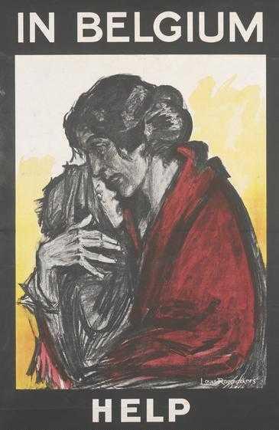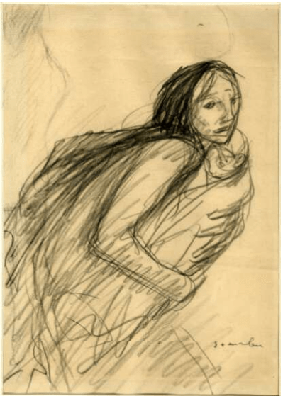
Figure12: Louis Raemaekers, In Belgium, Help, chromolithograph on paper, 1915, 99.7 x 60.3 cm, Peoples collection Wales.
Figure 13: Théophile-Alexandre Steinlen, [Woman running holding a baby in her arms], black chalk on buff paper, c1914, 43.3 x 30.8 cm, The British Museum, 1943 1211.61, Donated by Sir Frank Brangwyn in 1943.

In Belgium, Help, a little girl sheltered in an embrace from a woman cloaked in red drapery looks out with fear. As a point of comparison of the influence of Steinlen on Raemaekers, Steinlen’s Woman holding a baby in her arms is a trope used repeatedly by Steinlen to portray the innocence and the idea of fleeting security in the face of fear. In comparison to Steinlen, Raemaekers ladens his image with heavy emotion. He takes his influence from Steinlen in that he does not shy away from overt emotional content in his propaganda. Raemaekers is also influenced by Steinlen in his use of charcoal and conté to provide tonal contrast between light and dark. In this symbolic reference of the Pièta, a mother cradling a dead child in her arms became a symbol of cruelty, sacrifice and the hope of resurrection. Ultimately both artists were motivated by social compassion.

The poster In Belgium, Help, places an emphasis on the expression of discomfort and pain of the experience of fear of death as it came in many forms to those who remained in occupied Belgium. The text that accompanies the poster makes it immediately apparent that the woman and child remain in Belgium and they need help to resist the fear of death that plagues them on a daily basis, as embodied by the woman’s red cloak, which is potentially a symbol of blood. This trope of victimisation was constructed in the posters to communicate a ‘violated Belgium’ as an image heavy in sentiment and was intended to appeal to neutral countries, the United States.

The poster was designed to use fear to appeal to public patriotism, and to elicit public donation as a form of progress toward victory. The idea of death and encroaching violence sought to arouse the conscience of those in Britain, France and internationally. This fear was relatable among the British and French populations who felt it themselves; it was a vehicle for humanity to communicate, a shared experience.

The commission of posters such as In Belgium, Help represented an important shift in the balance of government and private sponsorship in Britain. In 1916, Raemaekers was commissioned by the National War Committee (NWC) in Wellington House in London to make an ‘impressive number of drawings for posters free of charge and for the charitable purposes connected with the war effort’. In Britain, the role of the government PRC and the NWC had been central in Britain since the start of the War. In France, private commissioning of the poster had been prominent from 1915 and this is possibly why Raemaekers simultaneously continued to work internationally for the British and the French Red Cross in addition to private and public charities throughout the War.

Raemaekers continued to be influenced by a comparison between the French and British responses to Germany’s invasion of Belgium. The cultural significance of Raemaeker’s poster In Belgium, Help is in the way it underscores the complex process of victimisation which operated within the belligerent societies. Beyond the construction of enemy and victim and the implication of coercion and persuasion, which is the most obvious or simplistic interpretation of propaganda, there is also a more persuasive cry for help in both Raemaekers and Steinlen’s approach that touched on the humanity of the subject of woman and child that goes beyond that of the Belgian experience.

Although the woman holding a child is a common motif throughout art history and throughout time, these images of suffering are made potent by their context and by the brevity of their loose sketchiness. Raemaekers, like Steinlen believed that his ‘cartoons’, as he called them, had the most impact through their ‘truth and authenticity’ as an unbiased observer of the War. Although Raemakers was not religious, he was clearly influenced by Catholic or religious iconography and there was often a cross-over between religious symbolism of Mary and Jesus and the theme of suffering. In this way, these two artists lend an interpretation that takes the war beyond individual loss and instead examines the transnational identity of the war with victimisation. At their heart, there is a call for an international humanity for relief.

Therefore ‘Remember Belgium’ takes on a duality of meaning, it could mean remembering atrocity in the literal sense, but also in the metaphorical sense that ‘remembering’ could be attributed to recalling the imminent threat to civilisation in a broader sense — a global sense.
The difference between a local and a global response to the Belgians is manifest, but often not differentiated in the historiography of the refugee crisis in Britain and France.

Stéphane Gerson spoke of local Belgian refugee communities who held fast to a strong force of identity, which resolutely unified those in exile. The Belgian refugee experience was not, as it was portrayed in the posters, defined by victimhood or disempowerment, but rather by affiliation with local Belgian community. For example, it has been shown recently that local identities in Northern France and the Alsace-Lorraine remained strong in the face of consolidation of the nation state. The experience of local identity was maintained through cultural affiliation and was a characteristic of modernity.

As Eugen Weber argues, the defining forces of modernity ‘affected different areas in different ways at different times’. In the face of local affiliation, Belgian refugees gradually became unpopular and were sometimes called ‘Boches du Nord’ because of their suspected allegiance with Germany. There are many posters that address the willing and loyal sacrifice of men and women in Alsace-Lorraine. The posters underlined the loyalty of the region to France and also the hopes of its return from German occupation to France, (since the department had been under German occupation since the Franco-Prussian conflict 1870-71). By 1917, add to these suspicions the social pressure of food restrictions and mourning for the loss of individual young men from local communities, and the result was that local refugee aid became undermined.

Peter Gatrell argues that these views of a downturn in popularity are substantiated largely through the narratives of social difference evidenced in newspapers. Once the refugees had arrived, the common outcome of their presence was to promote ‘tensions inherent in the process of social mobilisation that [are] inseparable from total war’. Pierre Purseigle has argued that communities were initially inclusive of Belgian refugees and then became exclusive, as the relationships between the Belgian refugees and their host nations progressed from solidarity to confrontation. This is evident in the early news reports of the welcoming of refugees in France and Britain, but this was not to last. And when tensions did break out into conflict, even minor skirmishes or misdemeanours were reported prominently in the newspapers. While relationships soured, there were also the additional pressures of the release of information about the state of the War.

Meanwhile, Belgian refugees complained about the Alien Restriction Act of 1914, which meant that they were unable to move freely in Britain without prior official permission. By 1916, the number of Belgian refugees in Britain and the Netherlands had stabilised, in France they steadily increased throughout the conflict, reaching a maximum of 325,000 toward the end of war. Tension between British residents and refugees similarly occurred in Britain as it did in France. The relationship was not helped by prominent public statements in newspapers that described Belgian refugees as a burden on the taxpayer. As resources were stretched on the home front, the refugees were viewed as having 'excessive comforts and opportunities for idleness', at a time when the British public were increasingly seeing themselves as victims of war.

As Annette Becker suggests in Oubliés de la Grande Guerre (the Forgotten Ones of the Great War), the Belgian refugees were forgotten in the oblivion that embodied the collective loss and suffering of War. No longer could the idea of individual nations be supported when the global community was in mourning for the loss of its men. Significantly, Becker identified the refugee experience as isolated from the complex processes of victimisation that operated within belligerent societies.

The 1916-17 period she said, may be characterised by a trend toward ‘perceived victimisation’ that was invoked by grief and which became collectively internalised over the period of the War. This internalisation was also a development of the early ‘fears,’ as a broader symbol of France as an invaded nation, in what she identified as the ‘interior front’ of the war and the normalisation of loss. This was a personal response to the loss and bereavement experienced by many and required a human face or figure on which to reflect. As a proponent in this experience of suffering, the poster offered a visualisation of what is not seen, through humanising the War.

Becker identifies several familial experiences of the commemoration of death in occupied France during the War. She described how the deaths were commemorated, but were they victims or heroes? She concluded that the idea of the North of France where many French in occupied territory along with Belgians experienced a long and successive suite of violations and compromises of the Geneva Convention. Through the experiences of pillage, violence and murder, the consequent grief that eclipsed the independent needs of the occupied or those who were refugees. Through her analysis of remembering the victims of war, Becker alluded to the complexity of victimisation and the absence of the representation of refugees as a consequence of their 'temporary histories.' She noted that their presence was one part of a complex network of forgotten aspects of war. Forgetting Belgium was part of a change in the commemoration of loss across the period of war. The French public shifted from an individual to a collective or communal form of commemoration of their dead. This is also represented in Britain with the daily ritual of reading out the names of the dead published in the newspapers. In this way, known individuals replaced the imagined or perceived suffering of the Belgians. The press and posters participated actively in forgetting the Belgian experience and they were replaced with individual commemoration of suffering and loss during the War.

Instead of forgetting Belgium as a fading memory as some historians argue, others propose a far more complex political history in which the refugees themselves were active participants. However, as Alexander Dowdell concludes in his analysis of the historiography of the Belgians during the First World War, ‘there is little attention devoted to the actions, expectations and experiences of the refugees themselves’. There is further research to be undertaken in the complex area of the activity of Belgians in occupation or within other nations.

For example, there is evidence that groups were able, despite their displacement, to retain common identity within communities through national belonging, even where the population was a lot more diverse in terms of nationality than portrayed. I question to what extent the attitudes of the state and host communities isolated the Belgian refugee community as ‘other’ because it suited the local French and British grieving populations. It is not known for example, how refugees or those groups living under German occupation were able to bypass the state in terms of belonging.

The argument can be made that the failure to provide ongoing assistance actually produced situations in which communities were competing for money, housing and food. The promotion of the Belgian experience as the poster subject for atrocity also potentially undermined the Belgian experience abroad. The complexity of the local history of settlement of Belgian refugees in France and Britain were juxtaposed with global history of reporting of the atrocity and as a result, there was growing resentment in local populations who ‘cared’ for them. As governments were increasingly financially stretched, and local populations increasingly commemorated deaths and the loss of those they knew intimately, it became more difficult to co-exist.

Cultural differences reinforced the differential treatment of refugees on the basis of ‘linguistic or legal marks of otherness’. For example, Belgian and French refugees in France were identified by their differences in language and cultural practices. According to press reports from the French Midi, these differences were also identified by many Belgians who despised eating the local French dish ratatouille and the vegetable oils from this area of France and this distaste extended beyond the local food to farming practices. This trend in public criticism resulted in the exacerbation of difference between Belgians and their French hosts.
As a result of the internal difficulties, Belgians were often left out of the posters produced after mid-1915. It is also telling that after Steinlen’s extensive body of work that referenced Belgian experience, in this later 1915 poster, Matinée Extraordinaire (below), that ambiguity of the refugee presence is now evident.

“This image has been removed by the author of this thesis for copyright reasons”.

Figure 14: Théophile-Alexandre Steinlen, Program for the Matinée Extraordinaire, Casino de Paris, 1915, Lithograph on paper, 38 cm x 28cm, Published by the Members of the Belgian Committee and printed in Paris in 1915, The Metropolitan Museum of Art, New York, Gift of Mrs. Bella C. Landauer, 1926 (26.28.83).

An analysis of this poster revealed that a German soldier rests his boot and the butt of his gun on a bare breasted youthful female figure whose identity is unknown. A baby who lays beside her could refer to the Belgian claims of German atrocity. The figure represents Belgian victimhood— this is a familiar trope which is used throughout 1914-1915.

Horne and Kramer cite examples from the Triumph of Culture drawn by Bernard Partridge for Punch (August 1914, London) and Their Way of Waging War drawn by Georges Scott for L’illustration (August 1914, Paris) where the German soldier places his boot upon a woman and child. The repetition of such images was intentional in reinforcing the horror of atrocity, their meaning laden with gratuitous violence. Their ‘potency’ originated from the impact of the violence on everyday people; civilians. Innocence was reinforced, but also questionable given the invasion and retaliation of Belgians to German attack.

The German soldier in Steinlen’s poster dominated his innocent victims; a sinister presence with his spiked helmet, square jaw; deep-set eyes contain the soldier’s focus on the gun, with the bayonet extended. The gaze of the soldier is uniformly unemotional as he looks off into the distance, as though removed from the lives he is apparently crushing underneath his boot. The impassivity with which he took life is the point that underlines the poignancy of the request for support.

Extrapolated, this one death was symbolic of the thousands of deaths at the hands of German soldiers in France. The image may have appealed to nationalist sentiment of loss, but it was also used to appeal to the international allied community's knowledge of Germany as a 'brutal enemy'. Sous la botte which translated literally as ‘under the boot’ was the colloquial reference to the German occupation of Belgium and Northern France during the First World War, and it became a popular reference to the silent suffering during occupation.

Steinlen’s poster, Matinée extraordinaire was commissioned by the Belgian Committee for War Relief, with all profits from attendance going to support war efforts being undertaken at the Saint Sulpice church in the 6th arrondissement in Paris. The Matinée Extraordinaire was an event held to raise funds to support the Belgian and Russian refugees (although there were no Russian refugees in Paris) in addition to the memorialisation of the executed British nurse Edith Cavell.

His depictions of refugees were not the only motifs of ‘loss’ used by French artists, and were influential on British artists to represent implied German brutality. The sinking of the British ocean liner, the Lusitania on 7 May 1915 and the death of British nurse Edith Cavell at the hands of the Germans on 12 October 1915 were two such incidents that caused an international outrage for their contravention of the international human rights laws. From a cultural history perspective, the most insightful observation to be drawn from Matinée Extraordinaire is in the brutality of the treatment of women and babies who were innocent victims. In this image, Steinlen arouses anxieties around death and the growing presence of public grief.

In many ways, Steinlen’s artistic practice was different to other artists of his time. He was at the forefront as a socialist, he was able to oppose violence and war, but through his subject selection still be lauded for his patriotism. He was able to produce ‘propaganda’ posters, but not in a way that promoted nationalism and militarism. Steinlen’s illustrations contrasted with other French artists, including notable poster designers like ‘Scott and Jonas [who] ‘brainwashed’ the home front, … Steinlen, like Naudin, who like Gustave Pierre, and like Georges Hugo, observed the infinite miseries of a never ending campaign with a poignancy which was always truthful’. Throughout the War, Steinlen remained flexible and responsive to the changing currents of popular opinion, which saw him capture the raw humanity of his subjects in ways that many of his contemporaries did not.

Competing ideologies
Political views were discarded by many artists within the political climate of rising nationalism, and it is this history of difference of national culture which is often used to describe the downturn of Belgian popularity in French and British historiography. The decline occurred from mid-1915 through to the end of the War and is frequently attributed to language, dietary and other cultural differences. As the War progressed, cultural differences often complicated relationships that were already stressed through the rising costs of food, resources and the gradual decay in living conditions which emerged due to the failure of the relationship between the Belgian refugees and their host nations. While linguistic differences proved to result in a failure in comprehension of refugees in France, with many Belgians only speaking Flemish, they communed with other Belgians and failed to connect with local communities. Discrimination saw the return home or enlistment in the armed forces to escape this unwarranted critical attention.

As with the British government, the French political situation was particularly responsive to changing public attitudes. The French government was very concerned with morale. Censorship was instituted from 1916-17, and artistic representations in postcards and posters became monitored through the actions of the government censors. In the French archives at the BDIC in Nantes, I located records where the censor related their reason for censorship of postcards in 1916. The rationale for the censor to assess illustrated designs was of course ultimately subjective, however the reasons for rejection ranged from artistic competence, images already published, the exclusion of images that represented death, exaggerated caricatures of politicians, or morally loose women. The press were heavily scrutinised for bad news, critical comment, references to French prisoners of war and French politicians, but in Paris very few articles were removed prior to publication. Perhaps it is not surprising, as a result of turning public opinion, that Belgian refugees became less visible in ‘propaganda’ posters after May 1915.

And critically, these other reasons relate to the fact that the ‘refugee was relegated to the status of just one group of victims among many’. Although the management of refugees and returning Belgian soldiers slowly moved throughout the war from being supported by charity to the early implementation of legislation for human rights. Early examples of charity were demonstrated by Hoover and the National Committee for the Relief of Belgium which provided food to prevent Belgian starvation in 1915. This legacy also saw the emergence of individuals within the collective memory of War who contributed to humanitarianism, and this work was important in the historical legacy of the First World War.

Sympathies were also directed internally and in 1916 this poster by Steinlen not only advertised the 1916 “La Triennale” Exposition d’Art Français au profit de la Fraternité des Artistes (The triennial exhibition of French art to profit the brotherhood of artists), but many of the artists who were listed participants had also been to war. The exhibition was held at the Salle du Jeu de Paume Terrasse des Tuileries from 2 March to 15 April 1916. Steinlen’s poster design created for the exhibition featured a French soldier standing in uniform, his gun braced across his chest as he surveys an agricultural scene in which two oxen pull a hand operated plough. Marianne holds a spear in her left hand and in her right hand she raises a laurel branch as a symbol of peace. The image appears to celebrate French traditions as Marianne calls to the soldier to fight for those values of subsistence culture that symbolise the unity of French conscription during the First World War.

During the war, many artists were also called by Marianne as the personification of liberty, equality and fraternity to exhibit these values during the war. In addition to the compulsory participation in the War, many artists produced artwork throughout the war period and participated in exhibitions of artist’s posters and drawings that they produced during the war. These exhibitions did more than raise money for fellow artists; they raised the awareness of the political context of war into which many artists were drawn. Artists often produced exhibitions for charitable causes including injured soldiers, orphans and refugees.
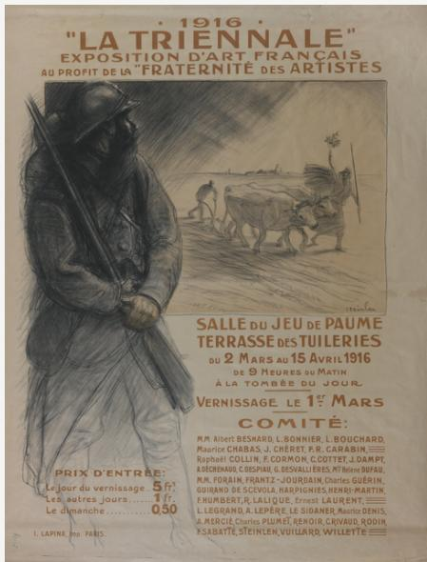
Figure 15: Théophile- Alexandre Steinlen, “La Trienniale”, chromolithograph on paper, 1916, 130 x 98 cm, Australian War Memorial Art Collection, ARTV07348.

Return of Belgian soldiers from the front line in 1917-1919

From 1917 in Britain and France, there is a marked shift in the depiction of refugees. Part of this coincided with a time that saw an increase in violence against all civilian populations, which brought renewed empathy for Belgian refugees. Another part of this related to the growing number of Belgian soldiers returned with injuries akin to that of their French and British counterparts. A third element was the consistent use of narratives of atrocity, in particular the Belgian refugee experience, as a means to persuade the United States to join the War.

Throughout the War, growing numbers of injured British and French soldiers who had been at the front for the duration of the War were returning from war. Lists of Belgian soldiers convalescing in Britain were published in Belgian newspapers printed in Britain for example, Christophe Declercq identified L’Independence Belge. The return home to communities was fraught with difficulty and struggle with injuries and disabilities which shed light on the stark realities of the impact of war for individuals, families, communities, and nations. These developments led one commentator to observe that ‘every placard on the street is something about the War. Soldiers everywhere ̶ wounded soldiers, poor creatures without limbs, jar on one at every turn’.

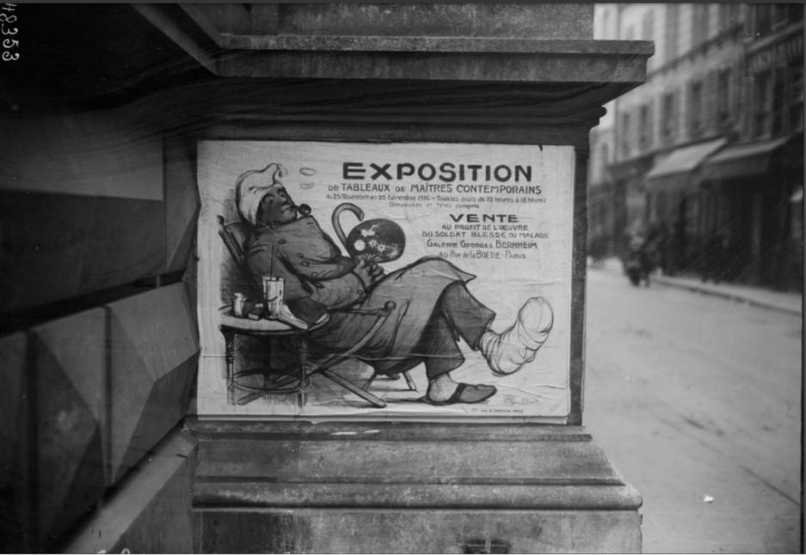
Figure 16: [Affiche sur mur de Paris], Poster on a Parisian wall, black and white photograph of a poster designed by Francisque Poulbot, Exposition de Tableaux de Maîtres Contemporains, 25 Novembre au 30 Décembre 1916 (Exhibition of paintings by contemporary masters, 25 November to 30 December 1916), chromolithograph on paper, Source gallica.bnf.fr / BnF, 48.353.

Poulbot’s poster represents a light-hearted illustration of the new life of repatriation awaiting soldiers who were used to being active during the War. The almost innocent and comical nature of this French soldier smoking a pipe, laying back on a deck chair and sipping drinks with a Japanese fan in one hand and a walking stick in the other begs us to contrast this image with the photographs from the front. The exhibition of paintings at Galerie Bernheim, rue de la Boetie, were being sold to fund the returning soldiers who were injured and unwell.

The British soldiers returning home injured were welcomed at ‘the Star and Garter’ from 14 January 1916. The British Red Cross found a permanent home for injured war veterans through the purchase of the Star and Garter Hotel in Richmond. In both Poulbot and Partridge’s posters, there is evidence that new evocations of sympathy began to take place as men returned home from the War. As discussed above, refugees became ‘less’ of a public crisis in comparison to that of the return of injured soldiers.

As evidence, the Bernard Partridge poster The Star and Garter home for totally disabled soldiers and sailors, 1916 advertised homes for soldiers returning from active military service.
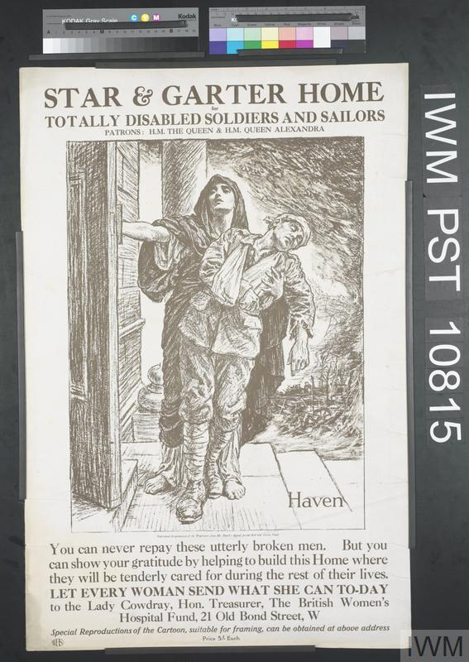
Figure 17: Bernard Partridge, Star and Garter Home for totally disabled soldiers and sailors, black lithograph on paper, 1916, printed by WHS, London, 76.5 x 50.6 cm, Imperial War Museum, PST 10815.
The Star and Garter home was established in 1916 by H.M. Queen Mary and H.M. Queen Alexandra and the average age of their patients was 22 years of age. The inscription on the poster reads:
You can never repay these utterly broken men. But you can show your gratitude by helping to build this Home where they will be tenderly cared for during the rest of their lives. Let every woman send what she can today to the Lady Cowdray, Hon. Treasurer, The British Women’s Hospital Fund, 21 Old Bond Street, W.

In the poster image, which was also published in British magazine Punch (1841-1992), a cloaked female figure supports an injured soldier with his arm in a sling and his head drooping toward his left shoulder as she opens the door to a building with a porteco and stairs. Meanwhile the presence of injured ‘Belgian’ soldiers also received sympathy amongst the returning wounded and perhaps tempered previous claims of shirking their responsibility in the War. Belgians who restrained from enlistment ‘were more numerous than French or British ‘shirkers’’. It is this latter development and its representation in posters that is considered here.

In Britain, the Imperial War Museum holds three posters that represent the return of injured Belgians soldiers from the front. One of these is Leon de Smet’s California House for disabled Belgian Soldiers (below).

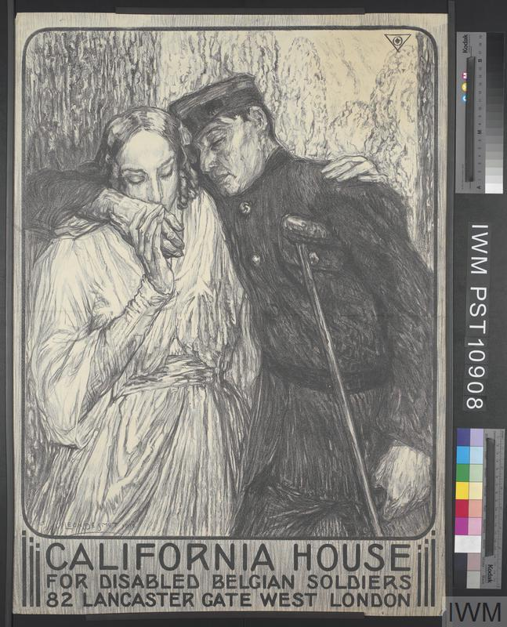
Figure 18: Leon de Smet, California House for disabled Belgian soldiers, lithograph on paper, 1916, 76.1 x 55.3 cm IWM PST10908

A sentimental image of a female figure draped in white cloth who could represent a nurse, mother, or angel supports a blind Belgian soldier. The ambiguity of the female figure gave the public multiple entry points to relate to this image. The soldier holds a crutch under one arm and with eyes closed, he relies on his guide toward safety and security at California House.

The image depicts the return of Belgian soldiers to a London social club named ‘California House’. The club was named after a group of Californians, initiated by Julie Helen Heyneman (1871-1943), a London based writer who transformed her private residence at 82 Lancaster Gate, West London for the rehabilitation of over 500 Belgian injured soldiers who had returned from the War in 1916. Each of these soldiers was released for the day from London hospitals and were transported to California House by omnibus. Here, they participated in short language courses, and learned skills such as woodwork and weaving which would assist them in returning to work. The emphasis was also on socialising as well as rehabilitatio

The Belgian artist, Leon de Smet (1881-1966) was educated in Ghent and established an international artistic reputation exhibiting as the representative for Belgium at the Venice Biennale in 1909. Stylistically he was known as a follower of the luminescent school. In 1915, he was firmly settled in Tavistock Square in London where he exhibited regularly at the Royal Academy and moved amongst artistic and literary circles. It is likely that he met Heyneman through mixing in this circle and who may have commissioned these four renowned Belgian artists: Leon de Smet, Armand Massonet, Alphone Proost and Stan Van Offal; to produce a poster to advertise California House.

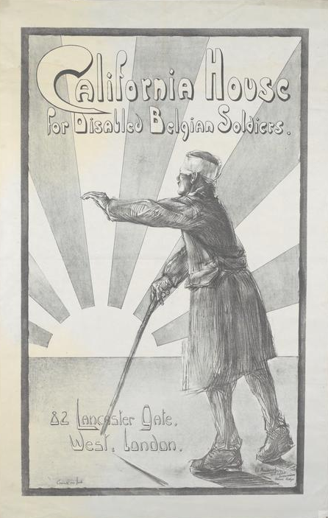
Figure 19: Armand Massonet, California House for Disabled Belgian Soldiers, lithograph on paper, 1916, 88.8 x 57cm, IWM PST10913
Armand Massonet (1892-1979) was a Belgian painter who studied at the École Nationale des Beaux-Arts in Paris and was like fellow artists Vincent Van Gogh and Henri de Toulouse Lautrec, both students of Fernand Cormon (1845-1924). Massonet produced a monochrome poster of a blinded Belgian soldier with a bandage across his eyes. The injured soldier attempted to walk forward with a walking stick in his right hand and his left hand outstretched as though feeling his way forward.

In the distance is the rising sun, a symbol that is used in France to represent regeneration. It is also used to represent the rebirth of a nation in France and during the First World war it came to symbolise the celebration of new life. In the context of the injured soldier, the rising sun offered a new day for the soldier to recover from his war injuries. Since 1870, the rising sun appeared on the flag of the Japanese army and the Australian Armed Forces service badge.
There were four posters of The California House, and this is another by Van Offal (below).

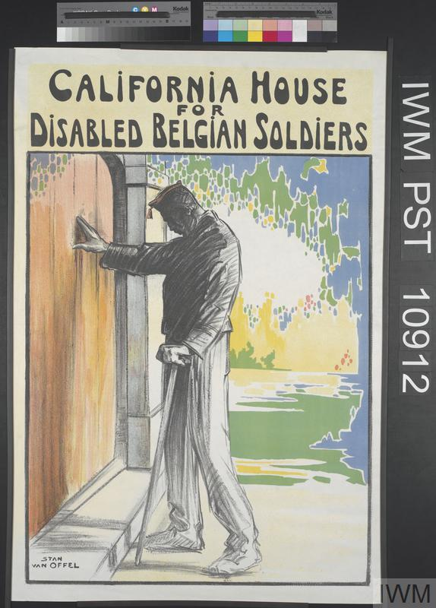
Figure 20: Stan Van Offel, California House for Disabled Belgian Soldiers, chromolithograph on paper, 1916, 83.6 x 56.3cm, IWM PST 10912

A blind soldier stands in his hospital uniform pushing on a large wooden door. His walking stick is poised ready to approach a step immediately in front of him, and his head hangs down as though he is listening. His figure is monotone black and white although the background is brightly coloured garden and the door is also in colour, the combination of the black and white interior gives the idea that soldier cannot appreciate the garden which is the setting for the house.

Stan (Constant) Van Offel (1885-1924) was a theatre set and costume designer who served in the Belgian army as a stretcher-bearer and also worked as an artist producing a series of works on the devastation of war. This is the only known poster produced by him during the First World War but there are other watercolours that exist, mostly in private collections. The combination of traditional illustrative techniques with the vibrancy of the modern background technique of colour blocking are evidence of the continuity between traditional and modern methods.

The California House posters depicted the return of the Belgian soldiers as blind and injured; they are depicted as dutiful, befitting the idea of national sacrifice. The symbolism of the closed door is also referencing imprisonment, of not being able to get in. The design of the poster symbolised the return soldiers who desired validation of their war service. Belgian artists desired recognition that Belgian war service was equal to British sacrifice, in circumstances where the British public no longer had empathy. These posters were above all responses that countered the narrative of Belgians as non-participants or objectors to a war which many believed eventuated because Belgians did not resist the invading German army. The posters of The California House reinforced the dignity of the Belgian soldier who suffered through permanent disability.

In summary, an important precedent was set by the representation of Belgium in posters of the First World War. As cultural products of war, they played an important daily role in the organisation of the War. They brought national and international attention to the inequality of human lives during the early part of the War. They also set the stage for the establishment of more formal humanitarian responses during circumstances of conflict, even prior to the end of the War.

A demand for an international approach to humanitarianism was growing, which in turn led to a new discourse on victims of maltreatment. As Bruno Cabanes explains: ‘The western world had to confront global problems on a scale and of a violence unprecedented in the history of the modern world’. As evident in the posters, the representation of Belgian refugees was an important catalyst to the expansion of humanitarian and political messages across international shores.

Concerns for Belgians in Belgium and their refugees became dominated by their economic and material needs as early as 1915 when the barges carrying food were provided by the CRB. Refugees who began to evacuate Belgium joined the military and worked in factories, but perhaps what is less known is the repatriation of returning injured soldiers in France and Britain. Throughout the War, there was a consistent appeal for Belgian support, but at the turning point of mid-1915, the refugees never regained their local popularity. They were returned to Belgium at the end of the war, and subsequently blamed for the economic struggle that ensued in the rebuilding of the French and British nations in 1918. At the conclusion of the War, only 166,000 Belgians remained in Britain. The British government repatriated the majority of the Belgian refugee population at its own expense.

The Belgian artists in London tried to counter this view with posters that addressed the repatriation of injured returning Belgian soldiers. In their representations they advertise the home for repatriation, but they also counter many of the narratives around the Belgian reluctance to participate in the War. For the first time in posters, the allied propaganda of victims produced by Belgian artists Van Offel, Massonet and de Smet, attempted to give integrity back to the Belgians who served in the military. The posters would promote loyalty to the allied cause and distance them from the ‘victim’ narrative.

Summary

Pillage, murder and rape became commonplace in the German occupied regions of Belgium and France. From the earliest days of war, a form of humanitarianism which evolved from local collection of funds to international support within months and would endure as a lasting legacy of war. The visual representation of the Belgians experience of atrocity, the potential of starvation, homelessness and occupation all have an important part to play in understanding the War, even today.

Part of the ‘Remember Belgium’ campaign was to stimulate recruitment of volunteers in Britain (Figure 5) in 1914. When compared with France, which did not produce posters until May 1915, the images of ‘Souvenez- Vous’ or ‘Remember us’, (Figures 2 and 3) the Belgian refugees were by comparison appealing for financial donations. Both French and British propagandist approaches were driven by governments to secure public political support. The motivation was to mobilise against German invasion through highlighting German transgression and eliciting fear amongst French and British populations.

The exile of Belgians and those suffering in German occupation also became a relatively forgotten War experience because the departments were cut off from communication and the relationship with refugees in exile and host countries soon deteriorated. Also, in France, refugees were treated like one of their own and this would have also meant that refugees were just one of a number.

In Britain, while the welcome was at first empathetic, competition for resources, employment and for sympathy would not be long lasting. There are no French or British posters depicting Belgian refugees from 1916 onwards. I have demonstrated the relationship between refugees and their hosts and the unknown extent of German atrocity in occupied territories quickly resulted in the forgetting of Belgium and the relationship of support and empathy deteriorated. From May 1915, the Belgian experience was replaced by other atrocities and personal grief and loss. Remembering the Belgian experience had temporarily been replaced by the significance of more urgent local losses and more recent atrocities in the Lusitania and the nurse and martyr, Edith Cavell. In some posters, the appeal for sympathy from multiple sources (Figure 14) was even made into a composite content. Did forgetting Belgium during the War, also implicate Britain and the later denial of atrocity? Ongoing research will reveal how deeply problematic the downturn in relationships with the refugees in Britain was and if indeed the relationship with Belgians was fraught because of the progression toward a personal reflection of loss and sacrifice.

In the Spring of 1916, news headlines in Britain proclaimed that Belgian refugees should ‘fight or go’. While local struggles continued to agitate, France and Britain continued to circulate posters of the Belgian refugees internationally, but there were fewer examples at home. France and Britain similarly sought sympathy and financial support for the allied cause, and in doing so, they facilitated an international awareness of the rising human cost of the War. The First World War changed the nature of the relationship of war for civilians.

The rising human costs of the War meant that there was an increased need for the public to understand loss and suffering as a personal reflection, which required a human face. They invite some kind of response or interaction. The individual and collective mourning of the rising deaths and disablement of soldiers indicated that the perception of victimisation was more prevalent and complex. Throughout the latter part of 1915-16 the ongoing anxiety created, and the perceived threat to social order by the presence of the Belgian refugees in Britain and France, demonstrated that refugees could not be successfully managed on a local level. Although posters of Belgians continued to circulate internationally, it is telling that politicians had to remind Britain and France similarly about the Belgian case at the end of the War. Belgium was first on Britain’s agenda for the Paris Peace talks in 1919 because of the potential to further incriminate Germany and to build toward Belgian retribution at the end of war.

The international community identified the need for human rights to be managed not locally but globally after the war. Although the protection of prisoners of war was addressed at the congress of the Universal alliance in 1872, building upon the first Geneva convention of 1864 which was a law that saw the equal treatment of wounded in armies in the field. Henry Durand proposed the foundation of a Swiss League of Human rights because he saw that the French League of Human and Civil rights had drafted a protection for citizens’ rights as early as 4 June 1898. The espousal of human rights was a core function of the Red Cross, however it has not been since 1945 that international human rights offered a model of universal human rights beyond the nation-state. The First World War saw the evolution of sympathies and demands for human rights as an increasing awareness as an international issue.

War itself with its steady stream of refugees, the treatment of returning soldiers with injury and permanent disablement and the social and political challenges. The treatment of refugees brought attention to the need for international protection for citizens including the mass mourning and memorialisation of civilian deaths. Meanwhile, refugees in France seemed to ‘disappear’ because of equal treatment with French refugees, this allowance sparked jealousy because of increasing competition for employment (see Figures 8 & 10). Comparatively, in Britain, the mobilisation of antipathy toward the Belgian refugees was because they were replaced in British sympathies by more personal grief, loss and other atrocities.

Finally, artists emerged within the context of war to create posters that responded to social change and also gave a human face to the War (Figure 11 and 12). This is the first time that they have been examined comparatively across the entire War. The images of German atrocity in Belgium and the subsequent reality of Belgian refugees in France and Britain was a shock and would deeply impact the social inequalities on the British and French home fronts. This chapter contributes not only to showing the polarisation of ‘forgetting Belgium’ in France and Britain, but also to providing evidence to demonstrate how Belgian artists responded to the social exclusion that resulted from public criticism of Belgian refugees during the War (Figures 18-20). Artists took their part to remind the public of the Belgian war contributions and to demand that their returning disabled soldiers be given the same human rights as the British soldiers who returned injured, (Figure 17). Above all, these artists sought to create equality for the treatment of Belgians during the war.

The following chapter will examine the visual representation of French North African and British Indian colonial soldiers by poster artists during the war. The lens of imperialism and cultural difference prescribed a very different role for colonial soldiers, one that was imbued in each nation’s colonial history. The next chapter will examine the way that these cultural differences were manifested in posters throughout the War.

Chapter 3 -Colonial perspectives on the First World War and Empire

The expansion of participants in the First World War to include those from the colonies brought new challenges for their representation in poster propaganda. Colonial troops had been used in conflict by both Empires previously, so the importance of colonial troops in sustaining the war effort is not in question here. However, their expanded colonial presence on the Western Front had implications for how posters depicted colonial troops.

Never had colonial troops been involved in a conflict of such size and scale. Colonies, cultures, and past conflicts were pressed together in unprecedented ways that triggered a range of real, imagined, or created colonial tensions, which will be explored in this chapter. In particular, if images presented troops of colour as equal, or essential to success, what would be the impact on deeply-held views that had traditionally justified colonial supremacy? Potential tensions had to be managed in cultural and logistical terms on both the war and home fronts. Generally speaking, such issues of social conflict were negotiated through representation in French and British propaganda posters as part of seeking to embrace the necessary participation and support of colonial troops.

During the War, the propaganda posters that represented colonial nations were deeply influenced by each nation’s history of colonization. Reliance on a traditional narrative of the French and British Empires was continued during the War, just as these Empires were most under threat. French and British posters were rooted in a history of difference marked by racism. In France, this tension was negotiated through an emphasis on ‘assimilation’ of those from the French colonies into what was idealised as truly French. This was pursued through an education that proselytised the French language, history, and culture. In Britain, leaders looked to a history of trade and commerce in a pluralistic approach to establishing patriotism amongst all colonial peoples in support of a once-dominant Empire. However, of specific interest to the discussion here was the way colonial soldiers were represented. This chapter explores how the ‘types’ of representation often favoured the continuation of nineteenth century narratives of orientalism and the prevalent theory of martial race through ‘war culture’ (even though these did not align well with the realities of experience for colonial forces that were brought about by the War). The theory of martial races formed the ‘backbone of British army recruitment in India based on indigenous notions of caste and imported social Darwinism’ where certain ethnic and religious groups were preferentially recruited over others.

This chapter presents an examination of French and British propaganda posters through a selection of British Indian and French North African colonial troops printed between 1914 and 1918. This chapter considers the representation of these soldiers for three reasons. Firstly, there is a lack of comprehensive analysis within this corpus of posters as the primary source material. Secondly, and not surprisingly, there is also a small body of scholarly literature on the representation of North African and British Indian troops. Thirdly, and practically, the subjects in these posters are consistently soldiers of colour and therefore this analysis takes into account the differing imperialist attitudes associated with race at that time. Further, the aspirations for colonial troops fighting for the Empire were present from 1915 and continued to be created throughout the War. Finally, we compare the similarities in the construction of the poster images and importantly consider their audience. Colonial participation meant that there were multiple home fronts that artists needed to consider when designing posters to communicate to diverse language groups with cultural differences to consider.

The French Republic was characterised by the colonial doctrine of assimilation and included the influence of Revolutionary philosophy on colonial thought. Even though it is likely that the majority of French people never reflected on colonial theory, the connection between assimilation, scientific thought, and nationality was a logical one within Revolutionary philosophy. While British colonialism was much more pluralistic in its approach and accepting of cultural differences by popularising them. In contrast to the French, British imperial rule was characterised by ‘aloofness in place of fraternity with regard to the natives’. Betts makes a comparison between British Imperial structure which is varied in its organisation and structure in comparison with the more ‘universal’ French doctrine which he suggests has one way of organising colonial rule. While France favoured the recruitment of colonial soldiers by conscription, Britain continued to rely on colonial volunteers throughout the War. This difference is an important one when it comes to the analysis of the war colonial troops were represented.

The comparison of British and French representation of colonial troops proceeds through three sections in this chapter; Firstly, we consider how the imperial context shaped the way posters represented British Indian and French North African colonial troops. Secondly, our analysis and comparison of British and French approaches include important differences in the way that imperial nations reinforced the loyalty and commitment of colonial troops to war. Thirdly, in a comparison between Britain and France, beyond differences between nations, this chapter will examine some of the challenges of the European presence of colonial troops in Europe. Therefore, the question is how imperial nations overcame or managed challenges on the home front and continued recruitment in India and fundraising in the colonies. And finally, a brief discussion of the legacy of the British and French colonial poster propaganda as a reflection of how First World War representation impacted the post-war experience.

Hence, the following analyses will examine how artists incorporated the use of traditional and modern symbols in the construction of the posters by French and British artists featuring colonial soldiers during the First World War. This will include the extent to which political and social decisions resulted in differing representations across the war period. These analyses will increase our understanding of how the two empires shifted their preconceptions of race during the War, particularly considering the ‘complexities and hypocrisies that surrounded race and colonialism in the early twentieth century’.

The construction of imperialism around Indian and French North African troops

Britain and France were allies under the 1904 Entente Cordiale. Although not direct partners in this agreement, British and French colonies had close legal and financial links, as well as strong ties of allegiance to their respecting metropole. France immediately introduced the conscription of troops under the auspices of the levée en masse. In the case of Algeria, as Fogarty claims, colonial soldiers were defending not only their adopted patrie but also the patrimony of liberty that they won nearly a century ago’ in 1830 when France conquered Algeria. Colonial attitudes saw the ‘defense of France as a way to repay the debt that they owed to France for the benefits of French rule’. Hence, colonial soldiers frequently saw their War service as ‘a way of protecting their own immediate interests’, and many saw their embrace of French Republican ideals as an expression of desire for French citizenship.

In comparison, Britain drew on its domestic army and local volunteers to contribute both human and financial resources. The British soon realised that it would not have the capacity to sustain a fighting force and very rapidly appealed to India for trained forces. The experienced commanders, Lord Kitchener and Douglas Haig, who had served in the Boer War, envisaged a war of ‘several years’ and they were able to persuade an emergency War Council held on 6 August 1914 to release the 3rd and 7th divisions (Lahore and the Meerut divisions), the Indian Army of around 24,000 men. Hence, the recruitment of Indian volunteers for the army and for general labour continued throughout the war.

The arrival of the columns of colonial troops in France was received with great excitement and anticipation as they paraded in the main streets of Marseille from the port to the railway line. The first colonial troops travelled by ship to Marseille and arrived at the Western front within three to four weeks. Rather ill-equipped, they went into the lines outside Ypres.

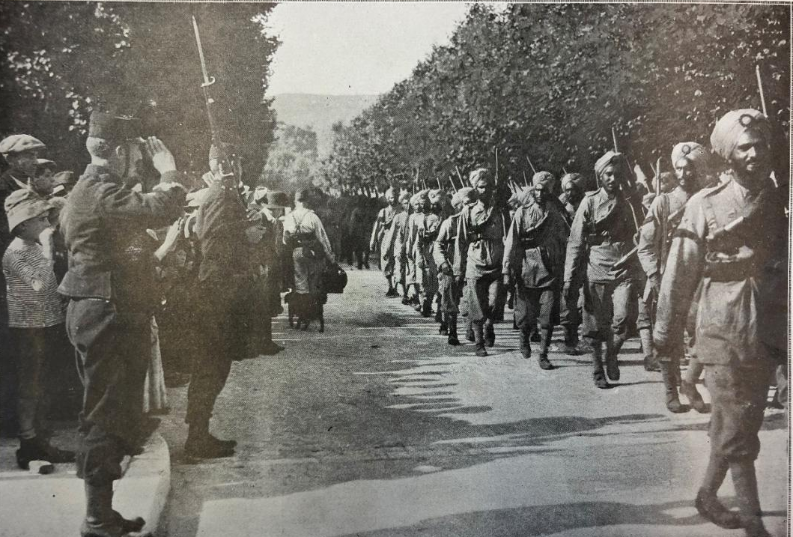
Figure 21: Unknown photographer, Les Contingents Indiens de L’Angleterre (The Indian contingents of Britain), Black and White photograph appears in L’Illustration, 10 October 1914.

India, of all the colonies of the British Empire, supplied the highest number of men; in total 1.4 million. This total number included 877,068 Indian combatants and 474,789 labourers or non-combatants who served with British forces in Europe, Africa, the Middle East and South East Asia during the War. The British secured troops and political advantage in India during the First World War and had swept away any doubt that colonial troops would not ‘stand by England in her hour of danger’. In spite of the Indian rebellion against the British occupying forces in 1857, by 1914 previous acts of aggression had been suppressed but not forgotten. The British colonial government remained vigilantly concerned about the potential for colonial uprising by the martial races and the potential for mutiny. This heightened awareness also informed the construction of all propaganda, including poster production.

The British government promised India ‘the progressive realisation of responsible government,’ a rather non-committal statement about legislative freedoms. This meant increased political rights and freedoms would come with increased patriotic duty to the British Empire and the war. Mohandas ‘Mahatma’ Gandhi proceeded to travel throughout India from 1915 to 1917 ‘disseminating the principles of non-violent resistance, passive civil disobedience and a rejection of Western values’. His influential political perspectives caused people to question the imposition of rule by the British Empire.

While India was the largest contributor from the British colony to the war effort in terms of troops and support personnel, the posters were almost entirely seeking voluntary recruitment by appealing to potential recruits for loyalty and financial aid. Amidst the promises of pay and uniform — and occasional coercion — the enlistment of Indian recruits demonstrated initial enthusiasm. The posters, which emulated Indian submission to the British Empire through the waving of flags and uniform and weaponry, soon became juxtaposed with the desire and hopes for Indian political freedoms, including political autonomy.

Maps like the one below were used to assist in educating and promoting an understanding of the British colonial contribution in France (See figure 22 below).
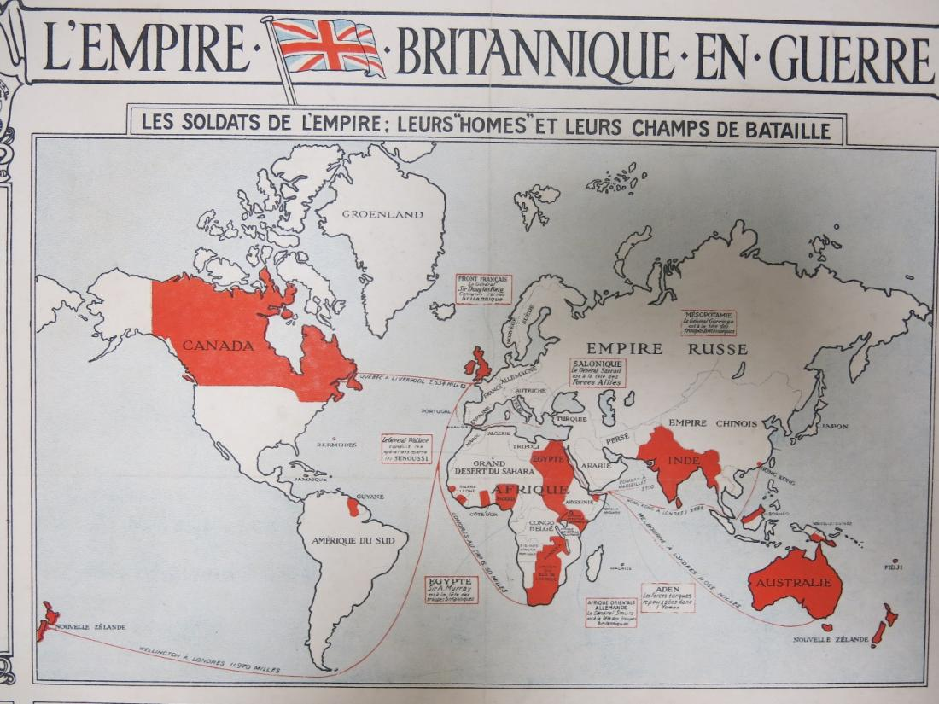
Figure 22: Unknown artist, L’Empire Britannique en Guerre, Les soldats de l’empire: leurs homes et leurs champs de bataille (The British Empire in war, The soldiers of the empire, their men and their battlefields), typography on paper, detail of poster printed by Roberts and Leete, 39.5 cm x 52 cm, Australian War Memorial collection, ARTV05515.

Posters of maps were frequently used throughout the late nineteenth century and early twentieth century in which the territories conquered by Britain are coloured in red. The poster above frames the context as the ‘British colonies who participated in the First World War’, but the map also served to underscore that Britain was the largest colonial empire in the world. The poster served as an educative and propaganda tool to communicate the extensive access to troops from colonies across the globe defining the First World War as a global war. Given there was widespread destabilisation of the British Empire in terms of imperial tensions, propaganda was essential to bolster the British war effort. Newspapers took the lead in publicising the celebration of colonial involvement.

It was not all celebration; the British government also had concerns about India’s growing independence and their loyalty during the War. As Philippa Levine identified, when war broke out, India was already pursuing with some momentum the idea of independence. In the years prior to the War, nationalist challenges to Imperial rule were a regular occurrence. Britain was acutely aware that the War created an opportunity for a challenge by anti-colonialist militancy. The British government tended to dismiss nineteenth century colonial resistance as ‘local and tribal’ and yet during the War, unrest became a lot more centralised and less localised within the Indian National Congress, which had existed since 1885. Importantly this research looks beyond the politics to begin to piece together the history of the poster during this potentially turbulent time for Britain making demands in India. The presence of the colonies on the Western Front in the armies of all the major powers meant there can be ‘little surprise that colonial subjects became the subject of propaganda’.

The arrival of French colonial troops

In 1914, the appearance of French colonial regiments in Marseilles was fêted with widespread excitement as the French and British press celebrated the arrival of the ‘famous French colonial troops’. The arrival of the Senegalese colonial troops in Marseille was sensationalised by the press and every aspect of their ‘difference’ from French and British troops was detailed. Particular attention was drawn to the Senegalese uniform or its lack. For example, the sandal wearing Tirailleurs Sénégalais (Senegalese) troops, the preparation of food in French camps, and the regiments of North African Turcos passing through towns and villages on their way to the front line. As Jarboe argues, these reports were ‘not the product of any co-ordinated effort directed by the British and French governments; they were intended to fortify domestic resolve, to maintain the public favour and of course to sell newspapers in a time of great uncertainty.

The propaganda and its reinforcement through publication in the newspapers attempted to help build the loyalty of colonial soldiers in the face of crushing defeats early in the conflict. At the declaration of war between France and Germany, ten West African battalions were deployed to France, of which many Tirailleurs, Senegalese riflemen, participated in a disastrous attack on 21 August 1914 on the German occupied Alsace-Lorraine. Although, as Killingray argues, France initially only intended to use North African garrison troops to relieve French metropolitan troops; they extended the role of colonial troops who had formerly been trained in guarding the colonial frontiers and inland security to the Western front line. The capacity to implement the use of colonial troops at the outset of the War was a key power advantage for the French and British Empires, and was also felt by Germany. In total, there were between 60-70,000 men who arrived in Marseille in the Autumn of 1914.

This was not the first time that France had conscripted colonial troops, as they were used in various overseas campaigns from the mid-nineteenth century onwards. Charles Mangin, Commandant Supérieur des troupes du Groupe de l'Afrique Occidentale Française [Superior commander of the Group of French African Occidentale troops between 1907 and 1911] wrote that 'once Africans were made aware of the benefits of French military service, recruits would be plentiful'. While Mangin’s words may sound overly optimistic, in addition to some 90,000 troupes indigènes already committed to participation even before the War began, some further 500,000 French colonial soldiers were recruited. In total there were 134,300 from West Africa, 172,800 from Algeria, 60,000 from Tunisia, 37,300 from Morocco, 34,400 from Madagascar, 2,100 from Somalia and further recruits from Indochina and other colonies. In the face of lowered birth rates in France, Mangin promoted ‘la Force Noire’ and the conscription of troops in West Africa began in 1912 primarily to supplement the lack of conscription-age men in France with troops from the colonies. The Spahis, from Morocco, Algeria and Tunisia were specialist trained cavalry, there were many untrained participants and it is likely that many recruiting agents were paid a bonus for each ‘volunteer’ or conscript who was enlisted.

Propaganda was also used to ‘cultivate a broad commitment to imperialism and imperial policy’ especially where there were challenges introduced by the presence of colonial troops. Amongst the moral challenges on the British and French domestic front was the question of colonial policy in Europe. Even if colonial participants were willing to sacrifice their lives for the Imperial cause, could it be justified? Certainly, the physical presence of non-European troops fighting in Europe prompted public debate about the legitimacy of their deployment. As citizens of Empire ̶ but not of France or Britain, should these individuals be sharing the burdens and duties of war?

There were also grave concerns in France in response to the potential threat of colonial reaction to conscription in a European war. However, the French reasoned that the benefits in having colonial troops participate far outweighed the possibility of a reaction and argued that ‘they could be dealt with later if they could not be avoided completely’. After all, French military authorities believed that the North African commitment to fighting for France was tied more to the ‘hope of reward or a desire to retain privileges than to a genuine French patriotism’. In contrast to this view, North African Spahis who arrived in France in 1915 were recruited primarily among the indigenous elite and may have been ‘co-opted by French power because of their social positions rather than promises of Republican equality’.

In the light of reliance on colonial troops, how did France and Britain begin a prominent propaganda poster campaign as a key means for sourcing money and men? Although the impact of propaganda is unknown, it was used to encourage voluntarism in India where persuasion and coercion to enlist were common. Britain’s concern for a repeat of the 1857-58 Indian rebellion, probably ensured that conscription was not introduced in India. The influence of racist views during the First World War were reinforced by the military, politicians and the public. Richard Fogarty claimed that ‘French officials viewed the colonies through a prism of racial stereotypes’. These attitudes are reflected in the poster propaganda designed by artists to celebrate the patrie of French North Africans and the loyalty of British Indians in France.

Understanding how war culture was used to reflect the French and British Empires

As has been discussed in previous chapters, First World War propaganda posters are most associated with the promotion of government messages, but they also were an aesthetic means to negotiate social, political, and cultural change or tensions. How did they respond to the negotiation of complex issues that arose because of the presence of colonial troops in the War? Politically, the way that artists represented colonial troops was a potential site of internal conflict between the colonial and imperial home fronts.

This subsection will argue that posters were crucial in relation to publicly advocating for the participation of colonial troops. The approaches that the artists took to colonial representation in First World War posters established how each empire wanted to communicate to its colonial subjects about War. In the representation of colonial troops in this early period of the War, there was continuity with previous war culture seen in books, paintings, and illustrations; heard in music; and found in the cultural material produced in Europe throughout the nineteenth and early twentieth centuries. Consistent with the representation of ‘war culture’ was the recognition of the importance of the ‘colonized’ people and the great benefit to the allied war effort in their participation, but also significant value for colonial people in belonging to empire.

The posters helped the European public rationalise the connection between the presence of colonial troops in the metropole by helping them to imagine the colonies and colonial life. The images were stereotyped according to popular images of empire. The colonial relationship was therefore complex as it involved a duality between colonial affiliation and also being imperial subjects during the War, and their meanings were not the same.

The representation of colonial soldiers as ‘subjects’ of the Empire reinforced racial difference and it did this by enhancing visual difference; through uniform, skin colour or the use of text in multiple languages. Although Indian troops had been deployed in ‘trouble spots around the empire,’ this was the first time that Indian soldiers had been called to fight in Europe. It was also the first time that North African troops were involved in French conflict in France, although many of the professional troops had been trained in border protection.

The artists emphasised the pre-existence of warring culture, which was reinforced through reference to martial race and orientalism as constructs that pre-dated the First World War. The consistency in the use of orientalism and martial race reinforced ‘difference’ between the colonized and the colonizer. The posters promoted continuity with past warring behaviour from colonial conflicts which served to reinforce the often conflicted image of colonial soldiers as violent but loyal. Ensuring that the loyalties of colonial soldiers lie with the empire.

One approach to understanding the complexity of the imperial context and colonial representation in the First World War is firstly to understand the construction of colonial imperialism itself. Britain and France were the largest colonial Empires in the world in 1914. Their rapid growth in the nineteenth century and the spirit of nationalist competition at the time meant that comparisons between colonial powers were inevitable. In her studies of nineteenth century constructions of the British and French Empires, Nicola Frith observes that ‘key differences existed between French and British colonial practices and ideologies which…were often positioned in opposition to each other discursively’. These differences are relevant during the First World War because they underpin the cultural influences used in the construction of each empire and their uniqueness. The influence of colonial practice during and after the War would be long lasting.

Within the construct of each empire, the colonies were viewed as ‘alien’ and 'the other'. As Betts explained, the relationship between the empire and its colonies was understood primarily through the lens of difference. For example, French and British colonies were often understood and represented as a desirable alternative to mainstream European culture throughout the nineteenth century. As Mackenzie observes, the ideal of European-ness envisaged the ‘orient,’ as an ideal that fantasised the fears of the West and reinforced the exotic appeal of the East. In this way, the lens of difference was romanticised.

Social Darwinism and the application of martial race theory in Britain

Another important expression of war culture within the military context was ‘martial race’ theory. This view typically championed ‘inherent natural qualities’ that predisposed some races to display war-like behaviours or temperaments and enhanced their suitability as soldiers. For instance, in India, British recruitment had been established in the mid-eighteenth century, with the East India Company raising ‘native infantry regiments’ using martial race theory to preference soldiers from Bombay, Madras and Bengal. The Indian army, colloquially known as the ‘Jewel of Empire’ primarily recruited men from the Gurkha, Punjabi and Sikh populations because of their strengths in battle. As Das rightly points out, out of all the French, British and German colonies, ‘British India (comprising India, Pakistan, Bangladesh and Burma) contributed the highest number of men’. Around the same size as the British Army, the Indian Army had ‘frequently deployed in trouble spots around the Empire, but this was the first time they had been called upon to fight in Europe.’ Colonial troops were crucial in the First World War, a war which required a labour corps as well as fighting men.

When the First World War broke out, British recruiters preferred the martial races. One method they used was to target disenfranchised farm workers who could be trained in modern weaponry and tactics to form a ‘reservoir of cheap military labour’ to serve the British troops. Throughout the War, Indian soldiers and labourers from exemplars of the ‘martial races’ participated and contributed in a visible way both in Europe and also in the defence of India. The representation of a diversity of colonial soldiers ‘reinforced racial stereotypes in some cases, but also enhancing the awareness of the conflict as a world war.’
In this recruitment poster below, the unknown artist re-interpreted the call to war, not as a defence of Britain, but the 1915 Defence of India Act;
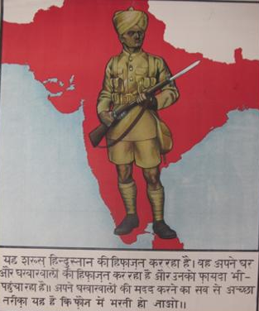
Figure 23: Unknown artist [Untitled], c.1915, printed by The Bombay Times in Bombay, chromolithograph on paper, Imperial War Museum Collection, @ IWM (Art. IWM. PST 12580).

The translation of this Urdu text on the poster (below the image) into English is as follows: ‘This soldier is defending India. He is protecting his home and family. The best way to help your family is to join the army’. This text reveals a duality of purpose, of fighting for Britain was also protecting India. Its meaning relates to the Defence of India Act 1915 (also called the Defence of India Regulations Act), which referred to an emergency criminal law enacted by the Governor-General of India on 19 March 1915 to curb the nationalist and revolutionary activities in India during the First World War. The activity was in the Punjab, Bengal and Maharashtra where a number of attacks on prominent administrative figures and police were linked to revolutionary groups. The act enabled the British to contain nationalism and it could be discriminately applied to anyone in India. Although there was no immediate external military threat to India during the war, protecting India’s internal stability was also key to the military contribution during the War.

The analysis of this war poster also points to the differences between European and Indian soldiers. The Indian soldier is wearing a khaki turban and shorts and carrying a rifle with the bayonet extended. This suggests that he is standing ‘ready to do his duty’ or izzat. Notably, his physical posture suggests responsibility, rather than aggression. Further, underneath the image, in a separate box are some lines of Urdu text, which appealed to Sikhs to enlist to join the army. However, the poster was also published both in Hindustani (Hindi) and with a blank space so that any language could be inserted. Hindi appealed most broadly, as it was the dominant language spoken in India at this time. Notably, this noble and singular image of an Indian soldier relates to a particular ‘type’ of poster used in Britain and in the British dominions.

The prominence of a single Indian soldier superimposed onto a red map reinforced that India belonged to the ‘British’ Empire as seen in the poster above. In this way, the poster draws on two motifs that were widely-used in British posters; a map showing British territory, and an image of the ‘ideal’ soldier. The representation of imperial masculine values brought together soldiers from all over the world. According to Heather Streets, these gendered constructions of masculine soldier types forged a reconciliation between British and Indian ideologies which were being renegotiated at this time, through war. Instead of heroism, many colonial soldiers experienced war histories of ‘trauma and bloodshed’ and many joined the army to escape debt or starvation. There are apparent contradictions between visual images and the reality of the experience.

A few contemporary historians have begun to address these issues and their potential contradictions, for example those who argue that, prior to the War, 'the deployment of Indian troops in Europe had been avoided because the British were concerned about upholding 'white prestige’. Omissi refuted the view that Indian troops were removed from the Western front because of concerns about conflict between white and black although two Indian infantry divisions served in France until the close of 1915, and two Indian cavalry divisions stayed on in France until March 1918, when they were transferred to the Middle East. Attitudes around the separation of black from white communities during the War have, quite rightly, come under fire with scholarship providing a more balanced and nuanced understanding about the War. They enable historians to begin to deconstruct the ideas about ‘racial difference’ which are prevalent throughout the War and underlay European fears and concerns about soldiers’ skin colour, culture and religious differences.

The representation of colonial troops in First World War propaganda posters has been the focus of only a handful of works. Richard Fogarty’s Race and Empire in French posters of the First World War presents a comprehensive study of the representation of French African soldiers. In terms of British Indians, there is Santanu Das’ 1914-1918 Indian troops in Europe (2015) and Vedica Kant’s If I Die Here, Who Will Remember Me? India and The First World War (2014). Both of these recent publications critically examine the representation of British Indian troops through visual imagery, novels, poetry, posters and photographs. There is no comparative work on the differences in visual representation of colonial soldiers in Britain and France, although there have been individual studies as identified above.

More recently, there have been comparisons of how French Algerian and British Indian soldiers and labourers were influenced by shifting Imperial-colonial relationships. In particular, comparative studies made independently by David Olusoga, Andrew Jarboe and Richard Fogarty argue that propaganda in the French and British press made significant contributions to the understanding the way in which celebration of heroism and race interact. It is the dualism of this relationship dominated the posters and influences how colonial troops are understood during the First World War. Racism and the European idealism of colonial troops existed in parallel. This is an opportunity for further study of the visual representation of colonial troops in propaganda posters, especially when compared to press coverage. The responses by European governments to the inclusion of colonial soldiers in the First World War would have a lasting impact and help shape future immigration policies.

The potential for misinformation and misinterpretation stemming from the application of nineteenth century theories around race are significant. For example, it was widely believed in Europe that colonial troops were characterised by an ‘innate enthusiasm of the martial races for war’, and yet there was nothing natural about the willingness of colonial subjects to participate in war. In France, martial race theory was applied to Algerian troops who gained public renown for their ‘warlike spirit’ and for fighting valiantly, and yet French military leaders believed that they lacked the ‘cold stoicism’ and French patriotic sense of ‘calm self-sacrifice’. The presence of colonial troops in Europe effectively resulted in the crossing of cultural boundaries. This was reflected in the prominence of racial distinction through dress, language, and religion served to reinforce individual identity, sometimes by promoting inequality and at other times by celebrating their patriotic service. North Africans for example were ‘mainly Muslim and as such, race was a strong determining factor which required different treatment’. The visual similarities served to unify the colonial troops who served the Empire, while cultural difference was also effectively maintained between colonial and European troops. The dichotomy that this produced effectively supported, but at the same time also undermined the boundaries in the racial hierarchy between the colonized and colonizer.

Posters took a lead role in the representation of colonial soldiers for French and British audiences and borrowed an illustrative style developed for the newspapers. While French posters were still produced by official lithographic houses as an art form they were in decline in contrast to British posters whose design began to take off and indeed ‘set an example to the rest of the world’. Other lesser known artists, such as Justy A.F.Boys and J.L. Herbert Dobson who are lost or forgotten in art history today, were located in India during the War and created posters in Roorkee, Bangalore, Bombay and elsewhere using an illustrative style with minimal colour to identify with potential Indian recruits. In this vein, historians have more recently placed an emphasis on the appeal of the poster to a multilingual audience representing the diversity of the Empire.

One of the prevalent themes across the British recruitment posters is the portrayal of colonial troops who served under the banner of a common imperial loyalty. India joined the War as the largest voluntary contingent in Britain and in the world. Amending the statutes underpinning India’s relationship to Britain meant India could share the ‘heavy financial burden’ of war. India’s contribution in terms of men and money is clear in the propaganda posters of the First World War. For example, this 1916 poster designed by Justy A.F.Boys was printed in India by the Art Lithographic press in Bangalore and its title is translated into English; ‘Now it’s Time to Join the Army’ (as below).
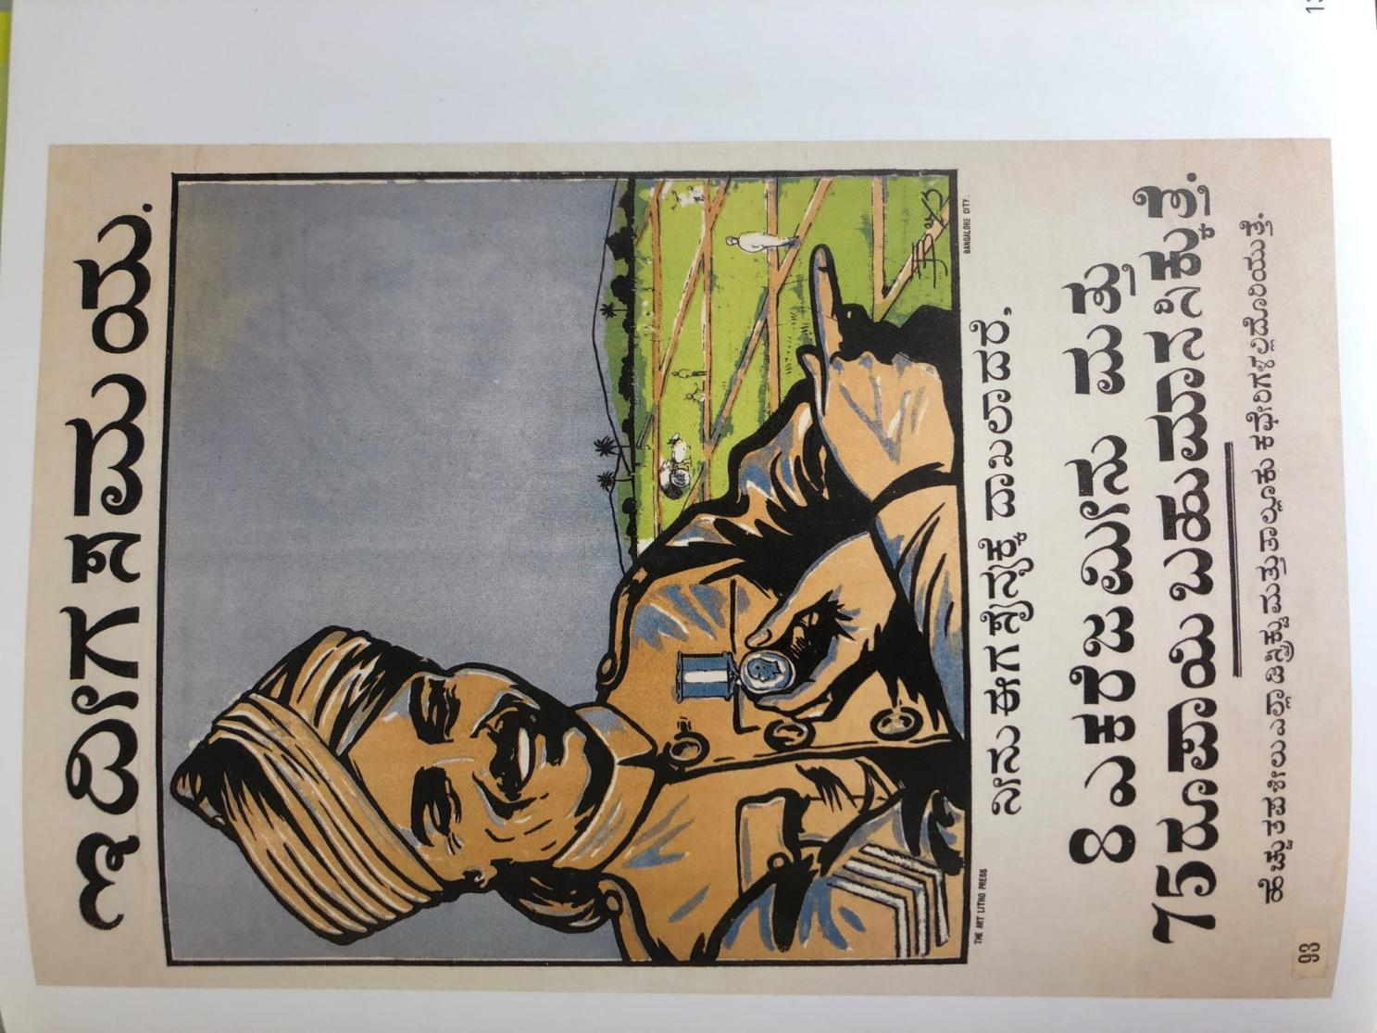
Figure 24: Justy A.F.Boys, Now it’s Time to Join the Army, chromolithograph on paper, printed by the Art lithographic press in Bangalore in 1916, 76.5 x 50.7 cm, Imperial War Museum IWM PST12586.
The poster depicts a three-quarter portrait of a smiling soldier who wears a military uniform and points to green fields with his right index finger, while and holding a medal featuring a likeness of King George in his left hand. He wears the full military uniform of an Indian havildar (equivalent in rank to a Sergeant) and wears a Sikh turban.

The poster is printed in the state of Karnataka’s Kannada language and a translation of the text reads, ‘Now it’s time to join the army. Get 8 acres of land and 75 rupees as prize money’. The purpose of Boys’ poster, together with a related poster which features the same model pointing to the rank chevron on his left arm and holds a stack of silver coins in his left palm. In the distance is an idyllic setting of a palm tree and beach and water. The poster is written in the Tamil language and makes promises of financial gain to the potential recruit. The annual intake of soldiers in India up until 1916 had been around 15,000, but, the promises of land and money, of uniforms and masculine pride meant that recruiting numbers were much larger. Das has also indicated that from 1917, there was a quota system on recruitment and each province had to provide a fixed number of recruits. Consequently this opened the recruitment process to more coercion and political involvement.

Politicians who campaigned for self-government under the Empire advocated that when the War was over, India would be rewarded for 'her glorious defence of the Empire'. This debate between increased loyalty bringing enhanced political freedoms is outlined further below in the Montagu-Chelmsford agreement in 1918. Perhaps these alignments were forged too late, as political parties such as the Indian National Congress, who had pledged their initial support to the allied cause throughout the War, eventually withdrew their support. In this context, the importance of the soldier standing in front of the map reinforced Indian independence and the thrust toward nationalism can be seen in the poster above with the single soldier standing on the map of India. This was a view that saw increasing numbers of individuals recruited in the belief that it was part of a larger unification of India.

Although there were Indian officials and Indian nationalists who increasingly opposed the use of Indian soldiers in Britain’s Imperial wars, many were also supportive, including the National Congress and the ‘All India Muslim League’. However, this did not stop the nationalist movement from flourishing during the War. As Das emphasised, ‘by 1916, Bal Gangadhar Tilak and Annie Besant formed the Home Rule League and, in 1917 Gandhi tried out his strategy of non-violent non-cooperation in Gujarat and Bihar’. By 1916, the upsurge in Indian nationalism and the commitment of so many troops saw growing independence and a rise in the number of posters designed by Indian artists. The posters may relate a major step in the promotion and acknowledgment of growing colonial independence from imperialism.

Throughout the war, for example, the colonies began to re-design British posters to make them more ‘locally’ appealing. It was no longer enough to use the colonial image shrouded in the symbols of Empire to appeal to voluntary recruits. New posters were designed to appeal to the Indian volunteers who were illiterate, and they used photographic images to emphasise individual choice rather than the lure of the appeal of belonging to the imperial power. This is clear in the following poster published by the Government Superintendent, which while it is undated, is likely to date from later in the War — 1917-18, when British recruitment became more urgent (Figure 22).
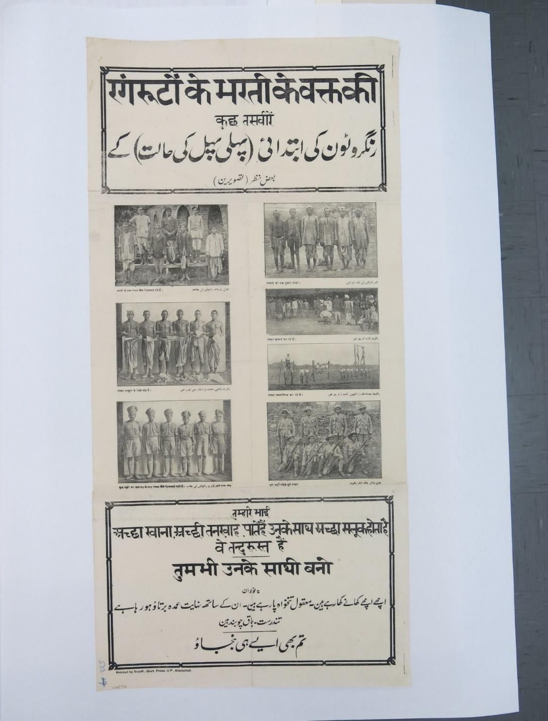

Fig.25:Unknown artist, printed by Supt. Govt Press U.P., Allahabad, lithograph on paper,
Australian War Memorial Art collection, ARTV06598

The poster is comprised of a number of small photographs of different Indian ethnic groups, including Sikhs and Punjabi men. This poster illustrated the process of peasants or labourers becoming soldiers, showing them undertaking physical training, and then posing in full military uniform. The photographs also show how the military uniform was adapted to meet traditional dress standards. For example, the Sikh men are shown in the photograph wearing short trousers, long socks, and a khaki turban. The Punjabi recruits wear full military uniform and imitate warring postures with four men kneeling in the front with rifles held across their body, and four men standing at the back with guns resting on their right side.
The translation of the poster from Urdu and Punjabi into English is as follows;

A few pictures of new Cadets / new recruits (How they look like when they first joined)
A few glimpses (pictures)

First picture on the right (row one)
A group of new recruits.

First picture on the left (row one)
The condition of the recruits at the time of recruitment.

Second picture on the right (row two)
New recruits involved in some physical exercises.

Second picture on the left (row two)
New recruits, waiting to get their legal agreement.

Third picture on the right (row three)
New recruits performing gymnastics.

Fourth picture on the right (row four)
New recruits in full uniform.

Third picture on the left (row three)
New recruits after getting trained for a few weeks.

The note on the bottom on the page:
“These young men are eating good food, they are getting good treatment, and they are strong and active.”

You should also become like one of them.
When one looks in closer detail at the components of the above poster, it is clear that the image has been constructed to appeal to the ambitions and needs of a particular colonial audience (Figure 23).
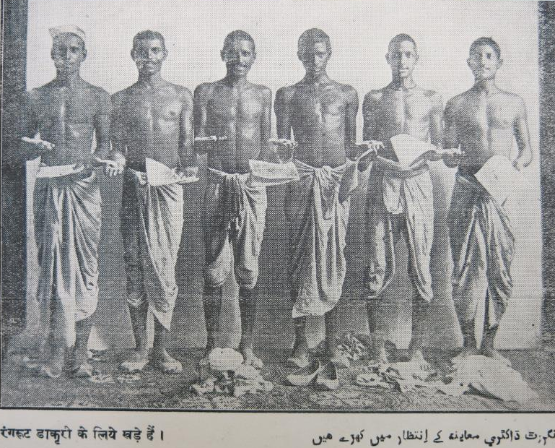
Figure 26: Unknown artist, printed by Supt. Govt Press U.P., Allahabad, lithograph on paper, Australian War Memorial Art collection, ARTV06598 (Detail of poster in Figure 22)

The image detail above shows a line of Indian men with a coin in their right hand, while they hold a piece of paper in their left hand. They have removed their turbans and cut their hair. This poster is intended to explain pictorially the transformative stages through which the recruit had to proceed to earn money. Beyond the politics of imperialism, this image indicated that there was a strong financial reason for military service.

As this poster indicated, the recruitment transformed individuals into soldiers through training, food, and uniform. Hence, this poster appealed to the Indian underclasses who had limited education and capacity to earn money or travel. The poster also appealed to potential recruits because it contained narratives that were not wholly concerned with fighting overseas in a war. The poster addressed a personal need for payment and uniform which formed a part of earning community respect. The note on the bottom of the poster read “These young men are eating good food, they are getting good treatment, and they are strong and active.” This is in comparison with the earlier posters in this chapter which depicted legitimation of recruitment through the context of belonging to the British Empire. It may be speculative to claim that the government discovered that framing military service under the British Empire did not really have an impact on young people; we just don’t know. We can confirm that there is a diversity of representation of Indian recruiting appeals.

Further, the poster offers an acknowledgement of the kinship groupings, suggesting that the recruits may have known each other, but we do not know the length of time. This poster implied that they would also be fighting together. However, this rarely occurred, as soldiers were often separated, filling gaps in the ranks of the British front line. The reality of Indian soldiers’ experience in the First World War was very different from their expectations. As Das relates, the experience often involved ongoing ‘frustration and resentment at the racist ideology of the British army’. It was this realisation, in the early part of the conflict, that convinced Indian soldiers to write back home to express their concern about the inequality of their treatment.

The experience of racism motivated them to dictate letters home to dissuade other recruits from participation. This disenchantment is most effectively related in David Omissi’s publication, Indian Voices of the Great War. Soldiers’ Letters 1914–18 (1999) which reports hospitalised Indian soldiers musing about the comparison between their own treatment and that of French colonial soldiers. Hilary Boxton identified that some sepoys ‘refused to sanitize their experiences for their correspondents back home’ and in some instances they rejected the encouragement of friends and family to stay positive. However, overall, the key point here is the inconsistency between the colonial soldier’s actual experience and the posters that represented them.

The recruitment posters also targeted specific ethnic groups and this poster below depicts the Punjabi Hindu and the language is Hindi (as below).
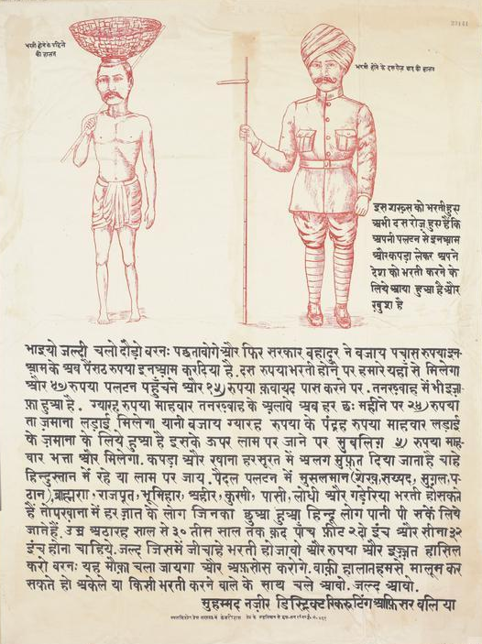
Figure 27: Unknown artist, [Hindi Text poster], chromolithograph on paper, 81.3cm x 55.9 cm, printed in India, undated, Imperial War Museum collection, IWM PST12583

This Hindustani poster is a simple appeal to recruits on the basis of the promise of better nutrition and physical condition and better pay. A full translation of the text from Hindi into English is provided below:

Left image: Condition before Joining (recruitment)
Right image: Condition after 10 days of joining (recruitment)
At the bottom of the right image: It’s been 10 days for this person since he joined and after receiving money and clothes from his team, he came to his own country to Recruit (joining) and he is happy.

Brothers quickly go, run otherwise: Regret and then Government Bahadur has made the prize from 50 rupees to 65 rupees.10 rupees on joining from us and 40 rupees on reaching team and 15 rupees on passing the drill. Salary has also increased. Other than 11 rupees monthly salary, now every 6 months, 25 rupees for war will be given for life long means instead of 11 rupees 15 rupees monthly.

5 rupees every month allowance will also be given. Clothes and food will be given free in every condition in case you stay in India (Hindustan) or go out. In walking team Muslims (Sheikh, Syed, Mugal, Pathan), Brahmin, Rajput, Bhumihar, Ahir, Kureshi, Parsi, Lodhi and Gaderiya can join. In artillery people of any cast whose water Hindus can drink are recruited. Minimum age from 18 to 30 years, height 5 feet 2 inch and chest 32 inch is acceptable. Quickly in whichever you want join and earn the money and respect otherwise: this chance will go away and you will regret it. Rest condition you can inquire from us, come alone or with someone who wants to be recruited. Come quickly.

Muhamad Nazir District Recruiting Officer Baliya

This recruiting poster provides an image of transformation for the recruit, you currently look like this (First image) but in uniform you could look like this (Second image). A simple line drawing can convey to the potential recruit the aspirations of family for food and money, clothes and family prestige. The poster served to highlight the benefits of being recruited and uses an individual fictional or otherwise from their own region to illustrate the physical benefits of recruiting. The purpose was to demonstrate the transformation of the peasant farmer into a professional soldier, and this is most humorously performed through the moustache which becomes fashionably curled in the image of the soldier. The childlike naivety of the simple transformative sketch is one that could communicate to those who were illiterate as well as those who were not.

It is likely that the poster was produced by a local Indian artist for the district recruiting office in Baliya to promote recruitment in the local area. The poster specifies that the recruit must be between 18 and 30 years of age and have a height of at least 5 feet, 2 inches and a chest size of 32 inches. This poster opened recruitment beyond the preferential recruitment of the martial races. The text invites all individuals to join the walking team, Muslims (Sheikh, Syed, Mugal, Pathan), Brahmin, Rajput, Bhumihar, Ahir, Kureshi, Parsi, Lodhi and Gaderiya can join. It is not specified what the walking team does, however these individuals are also being recruited for artillery support, but it is not clear how these decisions are being made. However, it does stress that recruitment of individuals is a lot more open than it had been previously and this did occur toward the later part of the War.

This theory is also supported by increases in pay; the poster mentions recruit payments including 65 Rupees for joining, 5 rupees for clothing, and a raise from 11 rupees a month in pay to 15 rupees per month, and an additional 25 Rupees bonus for every 6 months service (long service). This might suggest that these positions were not occupied for a long time.

In summary, these analyses of Indian posters across the War show the changing standards and strategy for recruitment of Indian soldiers after 1915. Contrary to the prevalence of martial races ideals, Britain sought and accepted an increasingly diverse ethnic contingent of Indian soldiers and this was reflected in the poster designs from this period. There was a clear shift from posters that communicated heavy in imperialist overtones, to those which were lighter, naively styled and even jovial and directly targeted potential recruits’ need for food, money and esteem. In later posters, we see depictions of entry into military service which provide a remarkable contrast with the earlier, idealised views of Indian soldiers serving the British Empire.

The Indian recruitment posters were not simply a version of British recruitment posters; rather, they were designed to appeal specifically to their unique and diverse ethnic audience. The reasons given as to why recruits should enlist go well beyond loyalty to Empire. Perhaps the most striking aspect of the posters is that they embrace many emotions, including duty, excitement, and anticipation. As Indian recruits became fewer, and less educated, it was necessary to appeal more directly, so, the photographs and illustrations were aimed at those who valued food, income, and clothing. The potential recruit was invited to critique their lives and compare the advantages of enlistment to their current situation. The celebratory aspect of recruitment is downplayed in the later posters, instead the posters strongly focus on the ‘role’ of the transformation from peasant labourer to soldier. However, it is the absence of any consideration of the reality of war which clear, and potentially contradictory when volunteer recruits were exposed to these realities.

In many ways, the aesthetic changes in the posters toward the end of the War represent a change in mood of the War, and this began to be reflected in the aesthetic approach to poster design. Importantly, the posters give us insight into the broadening diaspora of communities and multi-lingual communities to which they appealed. The posters reveal a diversity of constructions around what subjects appealed to recruits during the War. While it is essential to reflect the diversity of Indian perspectives of the War, the challenge is to adequately represent that diversity in the posters. Obviously, the surviving posters on this theme are only part of the recruitment narrative for the 1.4 million Indians who voluntarily left homes and livelihoods in the service of the Empire.

The distinction between the way artists represented Indian recruits was not only changing in India, it was also an important development in Britain. Especially as the War progressed, India was on a precipice between war enthusiasm and divided loyalty to the anti-colonial movement. Therefore, the following poster is important for the demonstration of fundraising in Britain for Indian troops, and in comparison with the same campaign in India. British posters promoted the service of Indian soldiers in multiple locations abroad as it is seen in this poster printed in London to advertise India Day by Edgar Wright (as below).
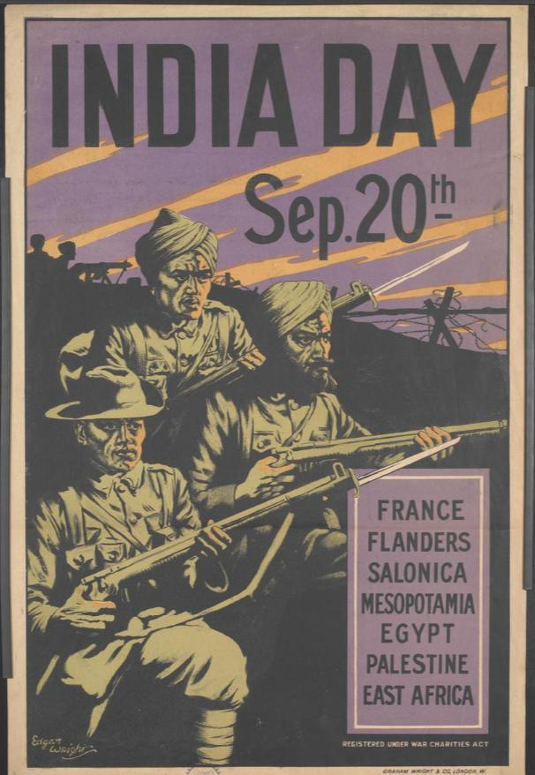
Figure 28: Edgar Wright, India Day, Sept.20th, chromolithograph on paper, printed by Graham Wright & Co. London, 75.9 x 50 cm, Imperial War Museum Collection, IWM PST.12587
Three Indian soldiers, a Gurkha, a Sikh and a Punjabi soldier crouch in the lower left foreground with their rifles ready for action. Two more Indian soldiers are silhouetted in the background and operate a heavy machine gun. The poster aimed to attract money for the Indian men who were serving in France, Flanders, Salonica, Mesopotamia, Egypt, Palestine and East Africa, in total seven theatres of war.

The Gurkha, the Sikh and the Punjabi soldier group is alert and focused, a familiar grouping of three soldiers displaying preferential recruitment by the British under martial race in the First World War. The figures are heavy and weighted as though carved out of the black background, a memorial to those who served and as a reference to the loyalty demonstrated by India during the War. The striated purple sky in the poster highlighted the khaki green uniform and the dark outlining of the figures appears as though the Indian troops are wearing a mask on the left half of their face. The heightened drama is created using colour and lends a gravity to the expectation of impending battle.

This poster image is unlike the earlier illustrative groupings of soldiers which usually feature the British flag. Wright’s poster is a dramatic reference to the growing independence of India as a nation in its own right. Gone are the Union Jack, the globe; the image is denuded of any reference to British national symbols. The contribution of Indian soldiers was given heightened seriousness and political resonance as the voluntary contribution of Indian troops was promoted in Britain, and it was not without political purpose.

Edgar Wright’s poster, India Day was advertising an event that celebrated the loyalty and patriotism of India. Held in London on 20th September 1917, India Day raised a total of £1,098,000, of which overseas dominions contributed £713,000. The 20th September was a special day of celebration in England; it was known as Punch Day (from the Hindustani word Panch) and it celebrated the introduction of the drink Punch from India to England in the seventeenth century by employees of the East India Company. According to James Willcocks in 1917, the average Briton knew very little about the Indian army. Perhaps this date was chosen to a remind the British people of their long term connection with India through the East India Company, and now through the connection with the Indian army and Indian voluntary service during the War.

The purpose of the poster was to celebrate the contribution of Indian soldiers to the British war effort, but it also highlighted the changing political landscape between India and Britain. Despite political tensions in India, Indians remained loyal to British recruitment drives throughout the War and they contributed towards war expenses, partly raised through war bonds. Overall, India’s financial contribution to the War amounted to 121.5 million pounds. If we compare ‘India Day’ with a poster produced nearly three months later advertising a national holiday, ‘Our Day’ which was celebrated in India on 19 October 1916, the poster is now lost, however it is photographed displayed alongside ladies, including the daughter of Maharajak Duleep Singh and well known suffragette, Princess Sophia Duleep Singh, and Mrs P.Roy, mother of the flying ace Indra Lal Roy, collecting funds to help soldiers at the front. In the following year, the poster below also titled ‘Our Day’, which was held on 12 December 1917, is preserved in the Imperial War Museum collection (as below).
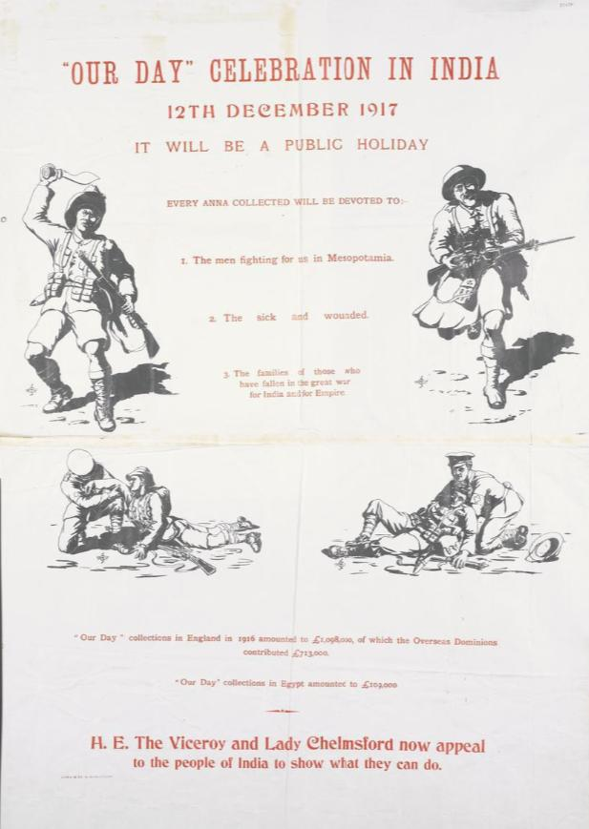
Figure 29: Thomas Johnson, ‘Our Day’ Celebration in India, chromolithograph on paper, 1917, printed in India Imperial War Museum Collection, PST12592
The poster by Thomas Johnson, an unknown artist, is very simple in composition and contains four vignettes of soldiers influenced by the ideas of ‘martial race’ which was a combination of ‘shrewd political calculation, indigenous notions of case and imported social Darwinism’, it clearly separated colonial soldiers from their European counterparts. In the top left there is a Gurkha holding a traditional battle kukri (Kookri) or curved bladed knife; at the top right a Scottish highlander wearing a kilt and sporran charges carrying a rifle; at the lower left there is a British soldier helping a dominion soldier, and lower right a Punjabi soldier is supported by a British medical officer. While English language was used on the poster text to appeal to a broad audience, soldiers and labourers loyal to the British Empire would have been able to understand Johnson’s use of all of the soldiers preferably recruited according to martial race by the British Empire. The relationship between soldier and medical officer is an interesting example of how the strength of Britain has supported India and the dominions, who were critical of the way Britain mismanaged the War.

A comparison of Thomas Johnson’s poster with the Edgar Wright poster — the aesthetic differences underscore the different approaches to the representation of professional Indian troops. The representation of soldiers contrasted with both artists placing an emphasis on the preferred recruitment of soldiers from warring regions according to ideas of Martial race, reveals the important role of the poster in the communication of visual politics. In Johnson’s poster, the soldiers of the British Empire are dependent on Britain for support, whereas in Wright’s poster, primarily for a British audience, the Indian soldiers are wholly independent and willing to serve the British Empire as an independent nation. These posters postdate an important event in development of independence for India from Britain.

An important alliance was formed between Edwin Montagu and then Viceroy of India, 1st Viscount Chelmsford. H.E. the Viceroy and Lady Chelmsford and contained within Johnson’s poster was now an appeal to the people of India to show what they can do in terms of financial donation to the war effort. On the 20 August 1917, then Viceroy of India, 1st Viscount Chelmsford and Edwin Montagu introduced a policy to the British House of Commons — a promise to India of political reward of increased freedoms for its wartime support. These promises then became the basis for the Montagu-Chelmsford Report of 1918 and the Government of India act in 1919. They offered Indian messages of freedom, but they never became a fully-fledged reality.

In summary, the construction of Johnson’s poster in 1917 contained the introduction of new promises of freedom. These little sketches on the poster revealed an acute awareness of the audiences to whom they addressed — British home front and the Indian voluntary recruit — primarily within the context of these promises. The posters so far examine the way that Indian recruitment posters became less demonstrative about the place of India within Empire and more about meeting the direct needs of the recruit for food, clothing, regular wages, and community respect. As we now turn to the French context, in French colonies including North Africa, the poster was less concerned about recruitment because of conscription, and instead the appeals were aimed at the public financial contribution to war loans.

That said, conscription from the colonial territories produced moral, racial, and logistical issues, all of which had to be carefully handled if these posters were to be effective tools in sourcing financial aid. The sphere of influence is also relatively under-studied, however, we know that both British and French posters were sent to their relative colonies to appeal for support. For example, in Bondoukou, a small territory in Africa, part of the Côte d’Ivoire, a local land-owner is shown making a donation to the war effort (as below).
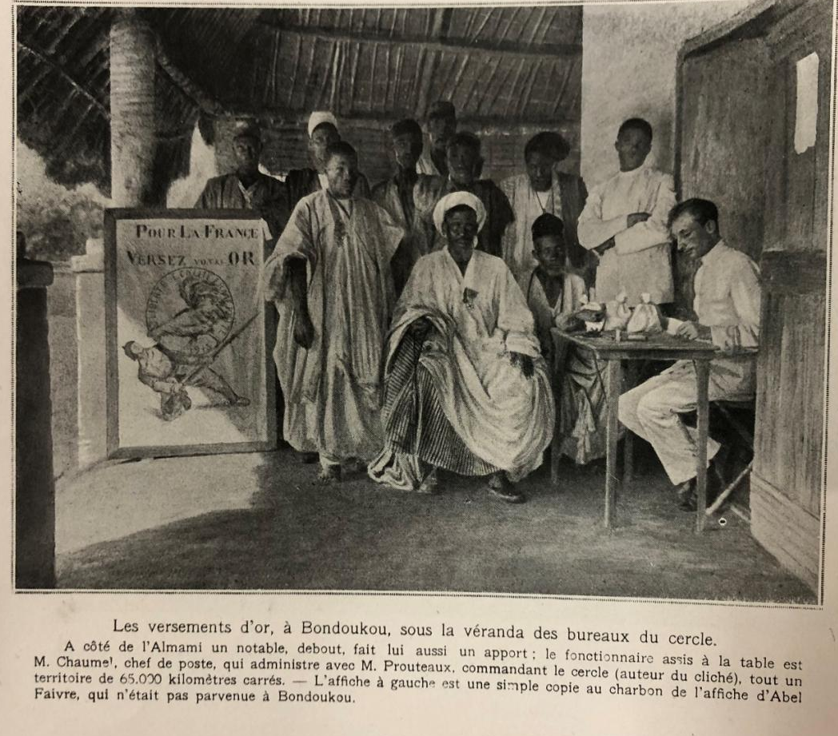
Figure 30: Unknown artist, black and white photograph, published in L’Illustration, 3 June 1916.

This photograph, extracted from a wartime issue of l’Illustration, shows the use of French artist Abel Faivre’s (1867-1945) 1915 poster Pour la France Versez votre Or, L’Or combat pour la victoire [Deposit your gold for France. Gold fights for victory]. The image of a gigantic gold coin, which is embellished with the French symbol, the ‘Coq’ is rolling toward a German soldier crushing him beneath its weight. A simply framed carbon copy of the poster which is displayed in the round meeting place where people are gathered to give money to France to support the war effort.

The men who are gathered in the circular shaped meeting place belong to the Bondoukou community, which is now a city, but then was a village in the Northeast of the Ivory Coast. Two white sacks, potentially containing gold coins rest on the notary’s table. The main protagonists are identified in the text below the image as Monsieur Chaumel, the post-master, who is seated at the desk entering the donation into his journal, and Monsieur Prouteaux, the commander of the circle and 65,000 kilometres of territory nearby.

The photograph that appeared in L’Illustration, one of the most widely read daily illustrated newspapers in France was used to demonstrate the donation of funds from the African colonies, who were raising funds to support the French government in its 1915 Emprunt nationale (war loan). The aim of the poster was to reinforce to the French public that everyone’s contribution is valued, and the poster reinforces the aim of the War loan to procure victory through securing donations, which was rationalised as a contribution to defeat the Germans. The poster was also popularised in the form of ceramic (as below):

“This image has been removed by the author of this thesis for copyright reasons”.

Figure 31: Design was copied from the poster by Abel Faivre, Pour La France Versez Votre Or, L’or Combat Pour La Victoire, made of Faïence, dimensions unknown 1915-1918.

The humble objects that were used daily often boosted the morale of populations. In this derivation of Abel Faivre’s popular poster, a German soldier kneels beneath the crushing weight of the gold coin and he is hen-pecked by the Coq, a symbol of France. The poster assumed many functions; to invite the representation of colonial troops, to broaden community support for the War in Europe — and also in the colonies. Donations were procured internationally and the celebration of the donation of money to British or French governments, the goal was the same- to unify each imperial nation with their colonies. In this way, Africans were encouraged and reminded that they were French, as these children indicate in the assumption of costume and play-acting, the roles of ‘children’ of France drawn from Françisque Poulbot’s poster (as below).

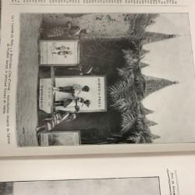
Figure 32: Unknown photographer, [Children posing in front of a Poster] Poster designed by Francisque Poulbot, Journée de Poilu, Pour la France, Black and White photograph, Bondoukou, Central Africa, dimensions unknown, L’Illustration, 3 June 1916.
In this adaptation of Poulbot’s poster, the African children are seen to assume the role of French children depicted in the poster. In this way, by extension of the war poster, the children were participants in a war many hundreds of miles away. They were collecting funds in their village to support the war effort. There is a less innocent interpretation of this photograph which interprets the indigene as ‘the new patrie or ‘children’’ as an emotive connection between a nation and its children.
Poulbot’s poster is dated 25-26 December 1915 and the date of the appearance of this photograph in L’Illustration is 3 June 1916, therefore the time between the original collection in France and French people seeing these photographs of Africa is around 6 months. The children seen in the posters are possibly connected with the photograph above of the men of the village making a donation of gold to support the war effort. The construction of the poster is indicative of the significant role of children in the war, and in addition it may also reference the contribution of African soldiers who were often referred to in terms of ‘children’ of France.

French posters and the construction of orientalism in war culture
Regardless of conscription in the case of French North African troops or volunteers from British India, there is a consistent approach to the idealisation of colonial troops. While British posters later in the War shift toward more realistic range of Indian recruitment posters, French posters retain an idealised distance from European soldiers. If we compare the highly structured and deliberately pared down approach in Britain to the representation of Indian troops, we see a marked difference in the French artists’ depiction of North African troops. While British posters underscored their difference through uniform, skin colour and religious affiliation, these were idealised identifiers of belonging to the martial races. In France, difference is exemplified as a demonstration of their approach to colonialism, namely assimilation through the adoption of French language and culture, as expressed through Orientalism. Therefore, if we understand that the artist’s depictions of difference, either as exemplars of the ideals of martial race or as subjects of orientalism, both had their origins in nineteenth century theories. They constructed images depicting colonial soldiers so that the broader public understood that ‘difference’ played such a significant role in the First World War.

French painters, such as Maurice Romberg, Lucien Jonas, Charles Fouqueray, and Victor Prouvé, all seized the opportunity during the War to reach a broader public through illustration and they all drew for various French newspapers, including L’Illustration. We also know that Romberg, Fouqueray and Prouvé had all travelled either under the Prix de Rome art scholarship or by independent means because they sought to experience and to paint the life and culture in North Africa in the late nineteenth century. Therefore, each artist had direct experiences of imperialism in North Africa prior to the War.

The importance of this travel to the East prior to the war was to expose artists to Eastern culture and the art movement Orientalism. It was primarily a romantic painting movement developed in the West in response to this curiosity about the regions that had been colonized through imperialism. Hence, Orientalism was a genre of painting developed by European artists who frequently travelled to the Middle East and to North Africa to depict the inhabitants and the way of life in the East as their primary subjects. Founded in 1895, the society of French Orientalist Painters established a sympathetic view of the French African colonies which sought to connect France culturally with its colonial nations. Scholarships were available to enable the very best artists to experience Northern Africa and bring it back through images of painted colonial life. These images focused upon the many customs, traditions, dress and architectural styles which became an integral part of the aesthetic language of Orientalism was difference. The interest in Africa was not only colonial, but there was also the influence of over three hundred years of the Ottoman Empire on this region which not only reflected the cultural differences observed between East and West, but they remind us of important ‘divisions in the hierarchy of colonialism’.

The orientalist style of which North Africans became a prominent model in the First World War posters in France. This style, although not new, was used in the war context to promote patriotic or military orientated display of colonial belonging to France. Many of the poster artists, the many of whom had attended the École des Beaux-Arts in Paris, were familiar with Prix de Rome and the funded opportunity to travel and practice the orientalist painting style. Poster design offered an alternative to painting for many of these artists as a new way to condense history painting and to present multiple narratives within one striking illustration. Posters were produced in France with the intention to have an impact on a mass audience.

The popularity of posters ensured that they were viewed and distributed throughout Paris. There was an interested public in France and beyond with many posters highly sought after by collectors and many were sold internationally to raise money for the war effort. We know that many posters were sent to remote parts of Africa to incentivize financial support for the War. Victor Prouvé was an important artist from Nancy in the North of France who was commissioned to produce a series of posters in 1918 to celebrate French participation, and the many sacrifices made by the French during the war.

Victor Prouvé studied to be an artist from the age of 15 at the École Municipal de Dessin in Nancy, alongside another poster artist Emile Friant, and he was tutored by Orientalist painter Louis-Théodore Devilly. In 1888, and again in 1889-90, Prouvé travelled to Tunisia and in this poster dated just thirty years later (Figure 30), Prouvé encapsulates a ‘type’ of image which not only represented the historical style of orientalist French traditions, but also the French presence of the North African soldier on the Western Front. In the poster Ce Que Nous Devons à Nos Colonies [What we owe to our colonies], Prouvé reminded his viewers of the struggle for France to comprehend the vision of North Africans on the Western Front, whom they saw as heroes and also as representatives of a past history (see below).

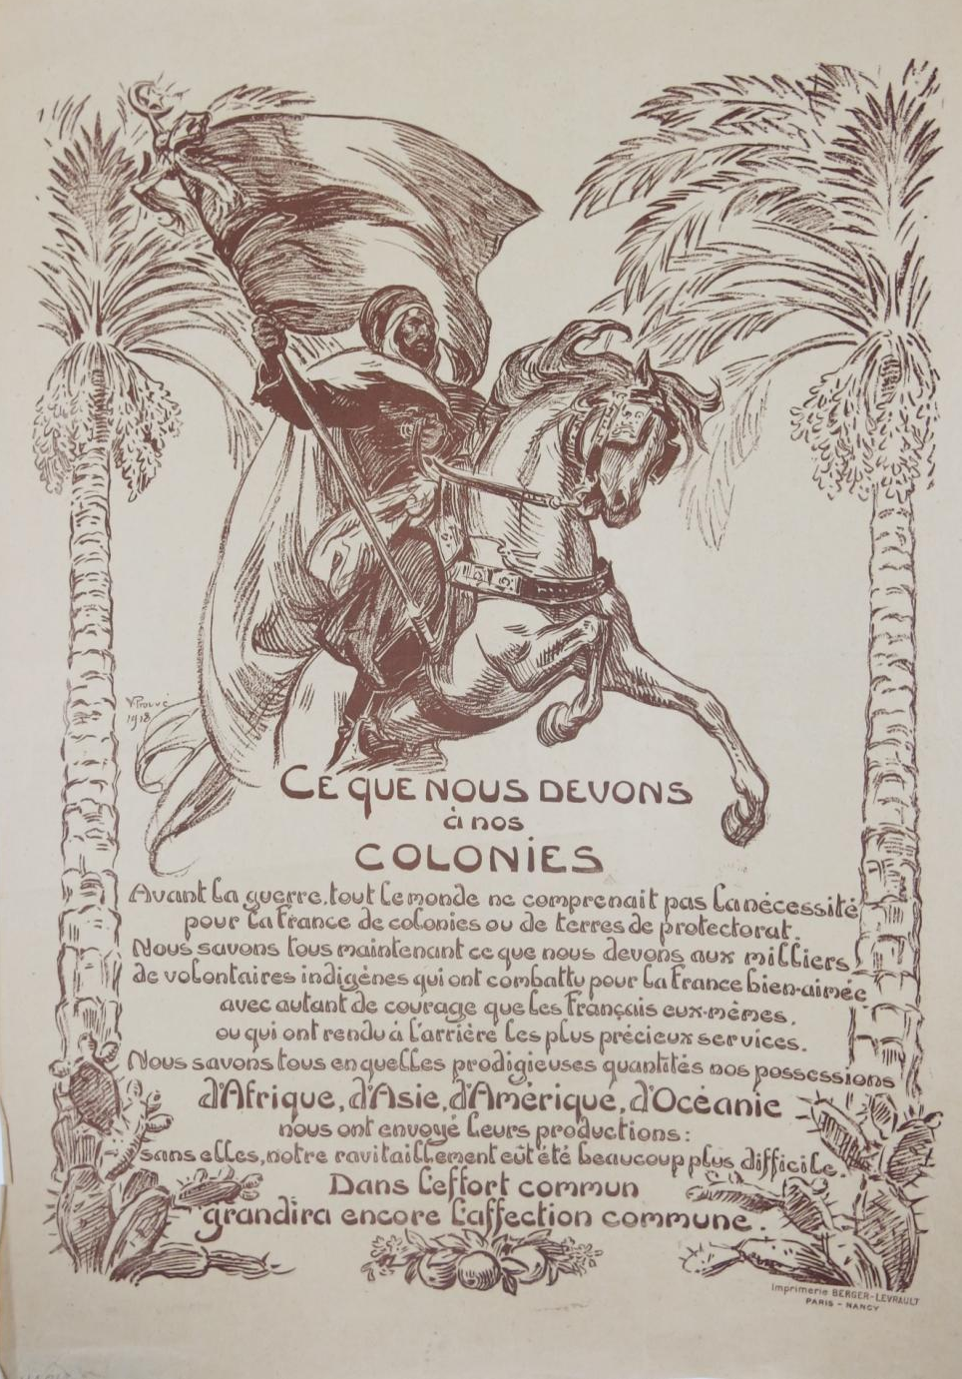
Figure 33: Victor Prouvé (1858-1943), Ce Que Nous Devons à Nos Colonies [What we owe to our colonies], printed by Berger-Levrault in Paris-Nancy, 1918, chromolithograph on paper, 65cm x 50cm, Australian War Memorial Art collection ARTV04866.

In the poster, two palm trees frame the text and the figure. The central figure is a North African cavalryman is depicted in a moment where the halter and bit inside the mouth of the horse is pulled tightly and the protesting head of the horse faces the viewer. This is a romanticised view of the North African, a Spahi who was part of the mounted cavalry (Moroccan, Algerian or Tunisian). In this image, Fogarty suggests that the representation of the North African spahi framed by palm trees and cacti championed the view that the soldier, like the landscape were like ‘wild territories brought under French control’. The soldier carries a French flag on a standard bearing the circular crescent moon as an emblem of Islam that demonstrated that the Spahi fought in the name of humanity and justice.
The text beneath the image is translated in part below:
Before the War, not everyone understood France’s need for colonies or protectorates. We all know now what we owe to the thousands of indigenous volunteers who fought for beloved France...
The poster comments on the bravery of the indigenous volunteers, but also maps them with the significance of ancient history. At first sight they appear to be far removed from the politics of the Western Front, and on the contrary maybe they are there to fight. In recognition of colonial expansion that it is necessary to contribute to war with France, to obtain potentially richer relationships with imperial expansion. Prouvé’s experience in Tunisia and his drawings of the North African give the artist insight into the political nature of colonial service during the First World War.

Printed in 1918, Prouvé’s poster not only justified the participation of colonial soldiers in victory, but also reassured the doubts and insecurities about colonial participation. Although popular, colonialist venture was current in European imperialist literature between 1880 and 1914, it was a stereotype. The ambivalence of many in France toward the colonies touched on an ideological conundrum faced by many of the troupes indigènes (indigenous troops) who volunteered to fight for France in the First World War.

The image of the professionally trained North African Spahi is forceful, loyal. The poster highlighted specific racial characteristics as Fogarty suggests, that of all the troupes indigènes, the French people ‘felt a closer affinity with generally lighter skinned Arabs and Berbers than they did with black Africans.’ This is reflected in Prouvé’s poster of the soldier who may be Tunisian or Moroccan — as a representative of France he was a necessary aspect of the War.

If we examine the other posters in Prouvé’s 1918 poster series, they all depict the aspects of war which were necessary, from saving food, to hygiene or wine for the returning soldier, they all relied entirely on the strength of the line drawing and were printed in singular colours, brown, blue or black ink. The lithographic series was printed by Berger-Levrault, a well-known Nancy philatelic printer and its composition does evoke a postage stamp, given its small size (65cm x 50 cm). For large public spaces, such as railway stations and streets, there needed to be flourish of colour to grab the viewer’s attention. It is likely that this smaller series of posters on War themes were displayed in schools and used for the purposes of community education in France. Prouvé is both celebrating the presence of the Spahi and also addressing public criticisms around colonialism; Prouvé draws attention to the idea that the War ‘proved’ that the colonies were valuable. The heavy reliance on conscription of African troops reminded the French people of the importance of continuing imperialism.

One of the most striking examples of confidence is in the French war loan posters such as Maurice Romberg’s Companie Algérienne-Emprunt de la Libération (Figure 31).

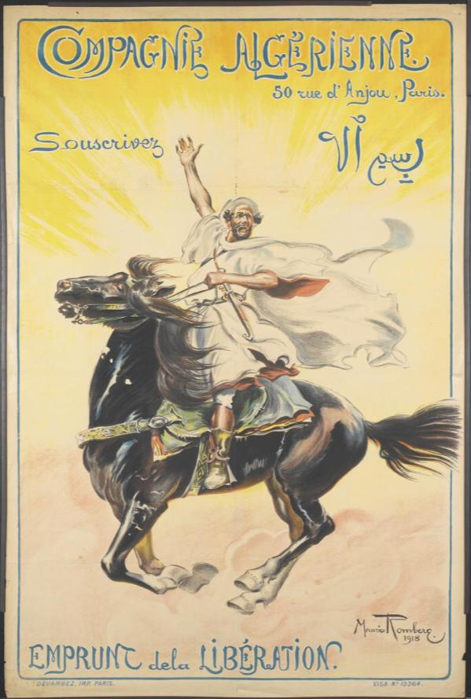
Figure 34: Maurice Romberg (1862-1943). Compagnie Algérienne, 50 Rue d’Anjou Paris –Souscrivez, Emprunt de la Libération [The Algerian army, subscribe to the liberation war loan] printed by Devambez, Paris, 1918, Imperial War Museum Collection, @IWM (Art. IWM. PST04336)

In the centre of the poster, against a bright yellow background, a North African man stands on horseback in his stirrups. He raises his right arm with the hand extended, and the palm facing the viewer, his posture is one of joy, triumph, and defiance. The single palm raised in the air was a symbol that communicated openness and the willingness to sacrifice. The billowing robes in the image reinforced classical imagery of the Greek Gods and the epic battles of history. This was an image that captured the imagination; the romance of North African culture was embraced through orientalist depictions of North Africa by French artists and writers.

Many artists throughout the nineteenth century experienced North Africa where they lived for periods of time in Tunisia, Morocco, Algiers, and other parts of North Africa. Maurice Romberg initially trained as a marine painter, but after spending 15 years in Morocco from 1887 he almost exclusively painted in the Orientalist manner on this return to France. During the War he produced several posters and following the War he created a series of travel posters encouraging French to travel from Marseille to Morocco. This confidence in the depiction of familiarity with North Africa gave Romberg a reason to address the criticisms held by the French military in respect to colonial participation.

Romberg drew his Spahi in an aggressive stance — raised in his stirrups, the colonial soldier appears to be calling on Allah to help win the War. His single figure on horseback raises his arm with palm extended in a salute, it is reminiscent of past representations of military leaders, including Napoleon Bonaparte. The crossover of symbols does not end there. In the triumphant facial expression of the Spahi, there is a synergy of emotion and elation, almost of religious fervour, and an anticipation of the excitement of war. There was a theatricality in the participation of North African Spahi (recruited and trained from Algeria, Tunisia, and Morocco) that aimed to capture the imagination of the French public.

The text in the upper right in Arabic calligraphy reads ‘In the name of God… Subscribe’. It is a poster that seeks to proclaim that the North African Spahi and all Algerians fought in the name of Allah for the liberty of France. This introduces the idea of unity between Muslim and Christian; France was a traditionally Catholic nation. Hence, Compagnie Algérienne suggests the possible reconciliation of religious difference, essentially not privileging one religion’s culture over another, in the service of a common cause of the War. Richard Fogarty argues that colonial images in First World War propaganda posters attempted to address the ambiguity in the social and political position of French colonial participants.

Religion was sometimes seen as a divisive during the First World War. Compagnie Algérienne could also be threatening to Christians if the symbols of the crescent moon were read in terms of Jihad or a move against allegiance to France. Tinged with an edge of fear, the differentiation on the basis of religion could have caused public anxiety. There were half a million colonial soldiers on the Western Front and many of them were Muslim. Religious difference was also a marker of difference in British Indian troops.

Religious symbols were commonly used to differentiate the British Indian troops and the posters identify affiliation with Punjabi, Sikh or Gurkha through the uniform and in particular the head ware. Indian troops were encouraged by ministers and priests to continue their routine religious observance on the Western Front, sometimes even more than usual. More than half of the West African troops, and a majority of the North African troops (Algerians, Tunisians, and Moroccans) were Muslim. The lack of burial rights and procedures for the celebration of holidays and feasts such as the fast of Ramadan created tensions. More broadly, French officials considered religious fanaticism to be inherent in any Muslim identity and a significant weakness in the commitment of the colonial subjects. This also led to French officials suspecting that ‘Frenchness’ was an impossible aspiration for Muslims.The presence of the colonial soldiers caused many Europeans to deliberate over issues such as racial hierarchy and colonial control.

Consequently, many colonial soldiers recognised the ‘hollowness of French claims of solidarity within the interests of Islam and worse, that colonial subjects and French citizens were involved equally in a common struggle in the name of civilization’. Paradoxically, in the first few months of the War, when there were no religious accommodations in place, the French authorities encouraged the North African soldiers to become more faithful in their religious observance through ongoing prayer and fasting. This tells us that despite religious difference, the military tried to accommodate cultural difference. Rather than see difference as substantive or divisive, there were clearly aspects of the War where it was celebrated and encouraged for the benefit of all.

From a cultural history perspective, Compagnie Algérienne served, not only to celebrate the participation of the colonial soldier and to claim success for the French civilization of Africa, but also to underscore difference. In this context, Storm and Tuma remarked that ‘the majority of colonial soldiers felt that Europe was ‘alien’ to them, just as they were alien to it.’ However, this relationship was not static, it was constantly negotiated throughout the War. According to Fogarty, ‘Army officials noted that propaganda in the press, designed to fill the Algerians with pride, actually frightened them and discouraged enlistment’. Clearly, the celebration of participation could also result in cultural misunderstanding and misrepresentation and could sometimes be counterproductive.

We have already observed in Prouvé’s and Romberg’s posters above that the African experience of the First World War was examined through the lens of French insecurity about colonization. In the following poster by Charles Fouqueray, the artist demonstrated the different uniforms of the North African colonial troops and behavioural differences indicated hierarchy and distinctive differences in colonial groups as a rationale for inclusion of the diverse colonial army (Figure 32).

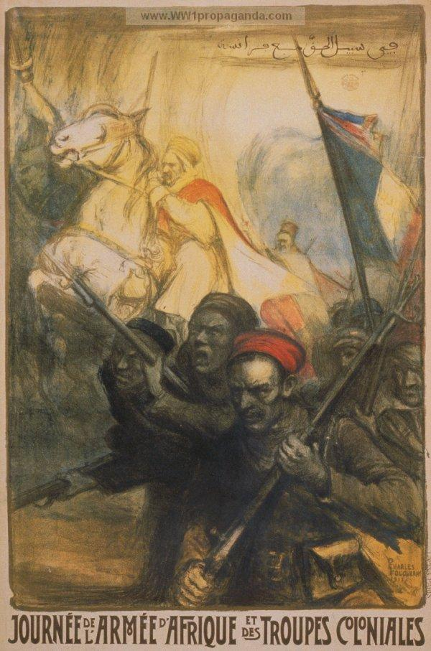
Figure 35: Charles Fouqueray, Journée de l’Armée d’Afrique et des Troupes Coloniales [Army Corps and Colonial Army Troops Day] in 1917 (Art.IWM.PST.11182)

This poster depicts a group of foot soldiers carrying rifles and preparing to charge in the foreground, while a rearing white horse carrying a Spahi (Moroccan, Algerian or Tunisian) with a distinctive white turban and flowing white robes dominates the mid-ground. A tricolour occupies the right of the composition and the troops of the African Corps and Colonial Army march under the French flag.

The Arabic text along the top of the poster in translation reads, ‘for the sake of truth and justice with France’ as it calls for money to support the Armée D’Afrique (19th French military district and Army Corps) and Troupes Coloniales (native Algerians and Tunisians, Moroccans and West Africans). Fogarty described this poster as ‘a sweeping scope of dramatic action which sought to remind viewers of the past support and martial exploits of native Algerians who aided in the conquest of their own land’. The ‘lone, courageous and proud Algerian warrior on horseback was a popular motif in many posters’. Here again, it was a powerful symbol of the troupes indigènes in French society. It is important to note that despite the power of the French nation, when threatened by Germany, it required the assistance of the troupes indigènes to be ‘on the side of civilisation…a partner in her defense and demands sacrifices that she also imposes upon herself, France, in return, must take care to prove to them her spirit of justice and her recognition.’ This is the underpinning rationale of the poster for the artists in making the diversity and force of colonial participants more visible to the French public.

This powerful depiction of colonial soldiers, united amid conflict, dominates Fouqueray’s image and specifically addresses the diversity of soldiers, their appearance and also their roles. At the front are the foot soldiers or shock troops, the artist drew on the idea of the troupes indigènes as aggressive participants at the front of offensive military attacks. Europeans clearly distinguished between the different colonial groups, and the North Africans (as pictured in white) were singled out as more ‘fanatical than the religiously less strict Central and West Africans’. Although the French tried to consider the religious and physical differences in colonial soldiers, they were inherently afraid of North African soldier because of their religious fervour. These perceptions reinforced differences in representation and the creation of distance from the colonial soldier and their European counterpart.

The way that these biases were experienced by colonial soldiers was also highly varied. The colonial experience recalled by colonial soldiers looking back on their European experience ‘varied enormously and depended on the recognition they received through public esteem, commemoration, and receipt of pensions’. The posters were no doubt intended to empower the North African colonial soldiers by recognising their rich history and diversity.

It served to do the same in British Indian posters, where difference served both the public understanding of recruitment of colonial troops and their imperial allegiance and loyalty under the Empire. The images of British and French colonial troops attempted to reconcile the differences in fighting capability for ‘fury’ and ‘internal fierceness’ as prescribed by the ideals of martial race and the civilizing effect of empire. These traits are exemplified through difference in uniform, but also implied are differences of culture, and this is where cultural difference intersects with the celebration of their participation in war. It is these contradictions that are most interesting because they reveal a collision between the old and the new— the old way of war and this new type of trench warfare.

Compared to Fouqueray’s poster, this British poster ——another untitled poster from the Imperial War Museum collection — similarly depicts a collective soldier image with powerful symbolic meaning (Figure 29).

“This image has been removed by the author of this thesis because the work has not been photographed at high resolution”.

Figure 36: Unknown artist, Untitled c.1914-1918. Printed in Bombay. Screen-print on paper, Imperial War Museum (Unfortunately the poster has not yet been photographed at high resolution).

The three Indian Army soldiers stand in front of a British flag — a Gurkha flanked by a Sikh on his left and a Punjabi soldier on his right. The poster brings to the fore the imperial context of service and patriotism. The uniforms, essentially Khaki, were differentiated by the turbans and hat worn by the soldiers which identify each participant by region. Of course, each representative was desired because of their innate fighting abilities which were attributed according to the martial race law. Throughout the War, uniforms became identifiers of specific ethnic groups, serving together. Volunteers from the Punjab region (now spread across India and Pakistan) were a high percentage of the total British Indian contingent, and this region was also the site of the most intensive recruitment campaigns. Collectively, the most common language groups amongst the volunteers were Hindi, Sikh and Punjabi.

An English translation of the text is ‘The Profession of the soldier, enough comfort, enough respect, less danger, good wages, look at these three people’. This image of three Indian soldiers standing on a globe would directly appeal to Indian recruits by offering food and wages. They were professional soldiers, and this was an expectation cultivated in India by the colonial authorities who negotiated and maintained an active defence status through the Colonial Defence Committee. The artist recognised that the target audience, Sikh, Punjabi, and Gurkha were amongst the martial races which were identified as the more ‘warlike’ amongst the Indian ethnic groups. Fouqueray recognised the martial races too, but he emphasised this difference in the North African uniforms and placed an emphasis on the warlike and aggressive behaviours of the North African Spahi and the foot soldiers of the African army.

In summary, difference was a key progenitor of the way war was constructed in French and British posters that depicted North African soldiers and British Indian troops. There was a reliance on the presentation of familiar constructions of the Empire and the use of orientalist tropes. This occurred despite the artists, Prouvé and Romberg both having experience living and working in North Africa and also with the British artists who lived and worked in India. The use of Orientalist and martial race stereotypes resulted in the promotion of visual differences pertaining to uniform, religious affiliation, and language, and this existed throughout the War. Therefore, in France and Britain, difference was the basis for the continuation of racism during the War and it was allowed to exist in parallel with traditional imperial values.

As Muslim and Christian fought side by side, religion also became an important site of difference for both Indian and African colonial troops. The war was characterised by juxtaposition in the representation of colonial soldiers, wearing different uniforms and from different ethnic groups fighting side by side. The posters sought to identify cultural differences within the colonial troops to reinforce the unification of these differences through imperial belonging. The contradictions in the distinction of racial difference, based on religion and communicated through the poster, was framed as celebration and national pride. Equally, there were also irreconcilable cultural differences drawn through social and political prescriptions for colonial soldiers including Muslim and Islam because Christianity was part of French identity.

Unsurprisingly, these constructions of racial distinction reinforced ‘the unmistakable and relentless division by skin colour which was common throughout the empire’. Therefore, it is no surprise that the use of physical and religious difference reinforced colonial behaviours around martial race which would introduce a range of consequences throughout the War. The posters displayed very publicly how difference could have been interpreted as a potential motivator for the observed anti-colonial nationalism in the post-war period, but further study of colonial reception transnationally would be required to make this claim.

The presence of imperial colonial troops in Europe

Beyond the idea of national culture, the colonial soldiers may have understood the War as a transnational experience. It was an existence in which they transitioned for a period of time, maybe for the duration of the War, or maybe longer, into a very unique social and political context because they belonged to the empire. It was an existence in which contradiction between belonging to France and the experience of being a French North African soldier were not quite the same. Indian soldiers also experienced fighting for the British Empire, and yet not being treated the same as their counterparts in Britain or even in the dominions.

The presence of the colonial soldiers posed many issues for Europeans ranging from racial hierarchies and colonial control to linguistic and cultural differences, racial mixing and national identity. In response to uncertainty or challenge, a social distance was maintained between French society and black African troops throughout the War. For instance, North African soldiers recovering in the hospital were not allowed to leave unless chaperoned by a French soldier. Many practical issues on the construction of rules around the admission of colonial soldiers to French hospitals and their treatment became an unpredicted point of contention.

Fogarty identified that photographs were visual proof of the willingness of French women to have relationships with colonial men, but the censors were unambivalent about the social consequences for public order and French rule in the colonies. The potential threat was for these relationships to subjugate white superiority which ‘justified and maintained colonial rule’. By May 1915 all-female medical staff were removed from hospitals treating Indian soldiers because of concerns about inter-racial mixing and the potential for rape. This was in contrast to French public opinion on racial equality which was supportive of French black African troops fighting on the Western Front. At the same time however, African soldiers on leave were housed in 'dirty brick or wooden cattle sheds' to dissuade inter-relational mixing with white French women. Hence, the challenge for the French was how they could balance the national acceptance of racial equality and practical racism within the military within the context of the War.

Although, in theory it was plausible for Africans to become equal citizens in the French Republic, this was unlikely given the racial divide in customs and language which made ‘becoming French’ a remote prospect. Behind this was a complex interplay of social and cultural attitudes. A relatively small number of Senegalese were able to obtain citizenship, but for the majority of Africans, French citizenship presented a major difficulty because of religion and racism.

Meanwhile, the deployment of mixed units in the French Army saw a growing presence of French African troops in European battles which also challenged traditional attitudes toward race throughout the War. Further, it was argued that Africans would not be able to stand the climatic conditions of a European campaign. Depictions of racial difference brought generalisations that were unsubstantiated in the flesh, and instead the distance placed between the colonial Africans and the French metropole meant that the poster reinforced these construction of differences that prevailed throughout the War.

This discrepancy between Republican ideals and the merit-based system of the French army where it was possible for promotion based on achievement was exclusive of colonial soldiers. There was a firm belief that the military should reflect a racial hierarchy with white people at the top. For colonial soldiers, there was a desire to reconcile the liberal naturalization policies of Republican France with their military service. The two were often in conflict because of racial differences.

The racial questions in Britain were equally challenging. The idea of primarily recruiting from the martial races and their involvement in the European conflict unsettled assumptions of superiority. Even though over 100,000 represented a significant fighting force on the Western Front, it was the first time India had been called to Europe. These troops suffered many casualties, early in the war they were initially taken to French hospitals temporarily and then either to hospital in Britain or from Mesopotamia returned to Bombay. In British hospitals, the sepoys wrote letters home detailing their injuries to family at home, aggrieved that they had sacrificed life and limb for eleven rupees.

British military concerns also involved the concern about contact between the nursing staff and Indian soldiers. British women could develop ‘potential liaisons’ and female hospital visits by local women were banned, creating speculative interest from tourists and local women. In late May 1915, The Daily Mail published a photograph of a white nurse standing at the bed of a wounded Indian soldier caused a public outcry in Britain and was also reported in L’Illustration in France, and resulted in white female nurses being removed from three Indian military hospitals. By June, all British women were removed from the Indian hospitals in Britain, excepting ‘the Lady Hardinge Hospital for the protection of women and the empire’. British officials were fearful that the local presence of Indian troops may threaten ‘white prestige’ particularly through liaisons with local women, fanning paranoid fantasies of sexual miscegenation’ including the fear of rape.

Sir Walter Lawrence as the commissioner of Indian hospitals was appointed to find a bed for the injured Indian soldiers. Lawrence wrote to Lord Kitchener in 1915, that ‘because of their special requirements Indians soldiers must remain together’ to receive care and at the same time he wrote of how racism did not make good propaganda. At the instigation of segregation of Indian troops for their treatment, doctors, dressers and nurses were brought over from India to treat the wounded, which was quite the reverse of the propaganda of unification under the British Empire. The India Office carefully designed the medical facilities to ‘accommodate soldiers of numerous faiths and medical needs’.

Inherent in the construction of their representation was that their uniform, religion and language were the ‘differences’ from Britain. Preferentially recruited by the British military because of their inherent fighting ability, their ‘difference’ was used to address any public threat to European imperial superiority. As in France, Orientalism and martial race ideas combined to exemplify the physical and cultural differences between France and its colonies, despite the view on assimilation that the colonies were by extension ‘French’. In the same way, martial race tropes through the orientalist style left its mark and the corpus of First World War posters. Today they are just one part of the lasting evidence of the way colonial troops were rationalised in the European theatre of the First World War. The resonance of these posters after the War would ultimately present plenty of questions.

The legacy of French and British colonial posters in the aftermath of war

Further analysis of the Orientalist style in the 1970s brought forth a range of political and social issues showing that it encompassed more than just an aesthetic trope. In his influential book, Orientalism, Edward Said labelled it as an expression of intellectual supremacy. He concluded that the function of Orientalism was to ‘understand, in some cases to control, manipulate, even incorporate, what is manifestly a different world’. The cultural works in the Orientalist style were criticised for appearing to celebrate difference when they reinforced European political domination and influence. Above all, Said highlighted the construction of an image of the ‘Orient’ as a way of undermining Eastern religious, moral, and political traditions. Hence, he emphasised that Orientalism became a means to subjugate the East and, in so doing, to reassert European dominance.

This work sent a ripple effect throughout cultural and historical analysis in the 1980s and 1990s, which changed the understanding of Orientalism from an aesthetic appreciation of difference to a negative stereotype of power, undermining difference, rather than elevating it. This resulted in the view that Orientalism was a naïve representation of colonial relations, where the reification of difference glossed over the failure of assimilation, which 'fared poorly as a colonial theory in the age of intensive Imperialism'. In this view, the presence of Orientalism in propaganda posters of the First World War served primarily to strengthen the place of Empire and obscure colonial differences and tensions.

Orientalism was a familiar literary and visual trope that suppressed a range of national issues, one of which was the rationalisation of the presence of colonial troops on the Western Front. It was a straightforward dichotomy that failed to recognise the colonial realties which emerged over time. The dilemma that faced colonial administrators after the War were the promises of French citizenship which were made to African soldiers, but were problematic because ‘too many Africans were not yet culturally French’ and ‘aspired to obtain citizenship for the wrong reasons’.The racial and political structures of Imperialism instituted that Africans were ‘ethnically too different ever to become French’. It is quite likely that French Republicanism was a motivation for some colonial troops, particularly the professional soldiers; they existed, however, in parallel with racism.

There is no doubt that Said’s critique of Imperialism has contributed to the modern and postmodern conceptualisation of cultural oppression. Said’s contribution significantly expanded our understanding of the ways in which Orientalism dominated twentieth century representation of European colonization and ‘otherness’. Said provided a searing critique of the European construction of the Orient through its representation in high art. His discourse of knowledge and power crossed traditional boundaries between politics, history and society. At the heart of his work lies a tension between ‘cultural heterogeneity and the political need for solidarity.’ It is this that also drew his view of artistic expression, which encompassed the poster as a product of political and social consequence.

The main failing in Said’s Orientalist critique is a failure to recognise the complexity of the cultural product under examination. In his conceptualisation, Said only examined elite texts and high art. This exacerbated the problems of a binary and exclusive approach to a broad cultural and the colonial narrative. Posters provide a more reactive and didactic medium, which constantly evolved throughout the War. It is through them that the viewer encounters the romance of the colonial world, as well as understanding how the real experiences of war run counter to the hegemony created over colonial soldiers. It is when ‘the strains and dilemmas of the colonial connection’ are most clear.

The dominance of the binary approach to the critique of Orientalism continued until the 1990s, when Benedict Anderson identified the limitations of the approach in his significant publication Imagined Communities. He emphasised the impossibility of a singular imperial narrative, stressing the need for the simultaneous experience of multiple discourses. Anderson examined the legacy of colonialism through multiple lenses; he saw that in the construction of the Empire, the inequality of colonialism co-existed. And both were indeed necessary to tell the narrative of colonial people’s experience, and especially their experience of the War.

Lisa Lowe's publication Critical Terrains: French and British Orientalisms (1991) also identified the limitations of binary focus in Orientalism in the study of social difference. In her identification of the Orientalist motif as a figure of sentimental and romantic desire, she also identified the emerging challenges to the formation of this image, meaning that it exists perpetually in tension. Lowe locates this tension in resistance to the dominant political power; in this case imperialism.

Lowe, like Foucault, oriented the power struggle in ‘the networks of texts, documents, practices…that function together as matrixes in the production of certain objects and forms of knowledge’. In this way, posters and the promotion of racial difference stand alongside the heroism of the celebration of the participation of the colonial soldier in the War. The representation of Indians and Africans in the propaganda was never simply a binary between the colonizer and the colonized ‘other,’ but was shaped by the international politics of imperialism, as such they are a reflection of the contradictions proposed by modernity.

Among the propaganda posters considered within this study there are examples that do question the Orientalist gaze. An example can be found in the work of Lucien Jonas, who was one of the most prolific poster artists during the First World War. In works such as Compagnie Algérienne, 3me Emprunt de la Défense Nationale [Algerian Army, 3rd War Loan] (Figure 34), there is a French Algerian soldier returning from the War (as below).
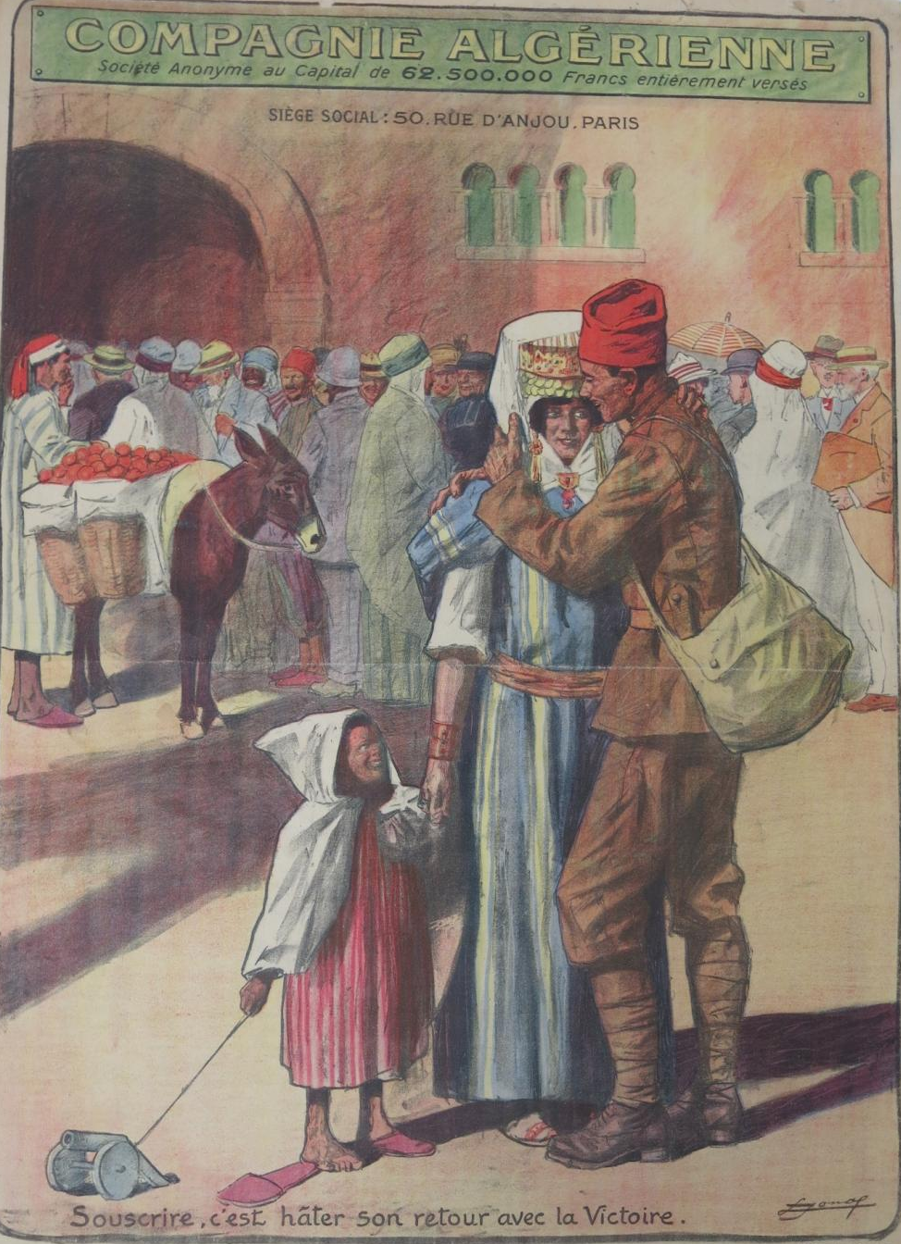
Figure 37: Lucien Jonas (1880-1947), Compagnie Algeriénne, 3me Emprunt de la Défense Nationale [Algerian Army, 3rd War Loan], printed by Devambez in Paris, 1918, chromolithograph on paper, Australian War Memorial collection, @Jacques Jonas (ARTV06333).

In this poster, a colonial soldier is depicted on his return from the War. He stands in a public marketplace and embraces a woman who holds the hand of a small boy. In the background, a crowd gathers, a mixture of European men and women mingling with African men and a donkey stands nearby laden with fruit. It is a reified and sanitized image of domestic life in North Africa. The little boy holds a string that pulls a toy gun, which ostensibly makes a link between France and North Africa. The reference to the gun is both contemporary as is the slipper that the boy has removed showing that he desires to emulate this soldier in war as in domestic life. This image reminded the French metropole of the service of North Africans and their settlers, appealing for subscription to the national war loan, so hastening all soldiers’ victorious return.

This poster emphasises the similarity between the Algerian and French poilu, in the experience of homecomings as well departures and reunions among families during the War. The poster exemplified a historical rationale for sacrifice to achieve the common aims of the French people. These aims are united within the classical oriental grandeur, as exemplified by the arches and windows in the surrounding building architecture. They both frame the temporality of the War and contextualise this experience within a longer history of the Western world. In this way, Jonas both confirms and challenges the expectations of the French viewer.

This poster, produced at the end of the War, reminded the public, both in France and also in North Africa, not to forget the sacrifice that families made to secure victory. It was certain that some families suffered as a result, children were born as a result of infidelity which brought deeper social implications because it threatened the rights of property and children. The absence also saw many men not want to return to their wives after such a life-changing experience. New experiences and the learning of new skills saw the wife rejected as ‘uneducated’ or unable to share in the new experiences and changes. The break-up of families was not in the interests of colonial authorities and they sought to prevent it. The welcome home was a point at which the sacrifice and distance from family was resolved, and it was presented by Jonas as a time of celebration. However, his image is also ambiguous, and it raises more questions than it answers. There is uncertainty about how the narrative ends. It questions the issue of national service in the First World War and the deeper questions about loyalty and sacrifice to a distant nation.

On the surface, the representation of colonial soldiers in posters inevitably called into question the legitimation of colonization itself. The individual and collective sacrifice by colonial soldiers rendered each one as a heroic act, but also inevitably a contribution to imperialism during the War. While the posters represented colonial soldiers as a coherent group under the auspices of Empire, during the temporary state of war, the power imbalance between the colonies and their Empire was not static. The dominant power relationship of the Imperial ‘colonizer’ over the colonial ‘colonized’ was no longer appropriate, given the extraordinary sacrifice of colonial soldiers. The French and British posters indicated that beneath these stereotypes, there was tension between British and French racism and the role of colonial troops on the Western Front. There could not be cultural homogenization as was attempted in the posters produced for metropolitan audiences.

Toward the end of the War when Britain was recruiting more broadly, Indian printers began designing recruitment posters around the theme of transformation of the individual for war, this approach was devoid of the trappings of the British Empire. Photographic lithography, a relatively new printing technique added some realism to the transformation of the recruits, accompanied by multilingual explanatory text to demonstrate the transformation of the illiterate farm labourer into a military recruit, as illustrated in Figure 25. In addition, the promises of land, money and social prestige for recruits grew with time and many recruits and their families benefited from the raise in income (see Figure 24).

In France, the use of orientalist aesthetic was drawn upon to stress the difference between the types of North African colonial soldiers, and the way they were ‘different’ from mainstream French soldiers is starkly apparent in the posters (as in Figure 35). Victor Prouvé acknowledged ‘the debt we owe to our colonies’ and Lucien Jonas understood that the experience of absence and return home from war was experienced by colonial soldiers. The soldiers themselves probably contested the content of many of the posters and the generalisations of their appearance; they saw through the ‘affinities and manipulations of their actions.’ Both soldiers and artists identified Orientalism as a categorisation, but they walked a fine line between keeping the colonies at arm’s length because they were not ‘French’ and at the same time embracing their heroic sacrifices.

In France, the officials took very seriously the way in which French Republican ideals of assimilation were represented during the War, and the posters demonstrate this. The posters demonstrate the conflict around the belief that military service could make one French because this was not evident in the reality of their war experience. With the military heroism of the colonial African forces displayed so vividly, this confusion about race and belonging also served to compound the difference between colonial and French metropole forces. While posters informed and mirrored history, they also had the potential to propel the public toward a stereotyped understanding of race. The limitations of understanding posters as 'simply propaganda' can undermine our capacity to understand the contradictions between traditional understandings of race, and the more modern understandings that emerged in the War, and were, increasingly, reflected in some of the posters (by Prouvé and Jonas).

The poster artists saw the importance of recognising orientalism as an ideal, and, by doing so they identified the participation of colonial troops as a modern experience of war. They tried to capture the realism of the War, indicating that they may have understood the conflicting ideals of an ancient traditional culture in the circumstance of advancing technologies of war on the Western front. While in contrast to the idea of modern war, views of colonial soldiers were not so contemporary. French officials saw the colonial soldiers fighting underneath the French flag as loyal and grateful for the opportunity to fight for France and demonstrate their patriotism, the colonial soldiers resisted this monolithic identity.

This confusion was the experience of the troupes indigènes who tried to rationalise military service and colonial subservience by desiring French naturalization. This struggle is evident in the posters as North African soldiers upheld the imperial ideal, which was so different from the reality of their experience. The obvious question was how could France conscript colonial troops without offering them full French citizenship? In reality, there were few who could make the difficult sacrifice that French authorities require for naturalization; to give up any claim to marriage or property and to reject the Koranic Law. Many colonials were wary because ultimately, naturalization would enable France to make them undertake obligatory military service more easily.

In summary, ideological structures (including Orientalism and martial race theory) ensured that the emphasis remained upon colonial control. This was important, given colonial fighting forces were integrated into existing troops on the Western Front and beyond. Ultimately, the posters presented an illusion of cohesion and colonial understanding to the French and British metropole, and even to the colonies themselves. On the surface, these posters appear dominated by stereotypical types of soldier representations, but, as this analysis suggests, there was a dualism in the use of old nineteenth century aesthetic constructs, like Orientalism, within the new context of the War. The complexity of the interaction between symbols and context countered the simplified national and imperialistic interpretation of colonial posters of the First World War.

It is these nuances that are of particular interest in the communication of difference; what do they say about a richer and more complex understanding of the First World War? The analyses in this chapter reveal a variety of representations of colonial soldiers during the First World War. In doing so, they reveal how artists used ideas about Orientalism and martial races to construct the representation of the colonial soldier through limited representation of North African Spahi, North African colonial and troupes indigènes. Just as Indian soldiers were reduced to just three types of soldier, the Punjabi, the Sikh and the Gurkha and the labourers were not depicted at all.

In France, the French artists maintained their constructions of orientalism, with the North African Spahis being a popular visually dramatic element to the posters. There was no opportunity to respond to the inequality or the experience of War into which they were conscripted. This dualism between colonial heroism and racism remains an aspect of the War that has only recently been discovered in the First World War posters. Although the treatment of the colonial soldiers during the war has been of long-term interest, it only now that we are able to interpret the visual contribution of the poster to these debates.

The contribution of the Indian designed recruitment posters provides a valuable side to the debates about the British Indian experience and is also relevant here. There has been very little to no previous examination of these posters by Indian artists, perhaps because of their naive appearance. They do lend an exciting addition to help the viewer understand why British Indians volunteered in such high numbers; that contribution of money, food and uniform to enhance the individual’s social standing in the community was perhaps of far greater value than fighting for the Empire, as has been the British claim.

There are no known North African posters that similarly address the experience of North Africans and this could be explained by the policy for conscription in France. Therefore, the representation of North Africans in the First World War is currently one-sided; a French perspective on their incredible value to France. The impact of this narrow representation of French North African troops may have effectively disenfranchised French colonial soldiers. Their daily experience of inequality through the lack of freedoms, their inability to be treated the same as European soldiers, and this experience of dualism between heroism and racism no doubt affected their participation on the Western Front. Their views on conscription to France and how they rationalised this to family and to themselves is vital information that is currently absent from this debate on the comparison of colonial experience. However, this chapter shows that the Indian artists made the experience of military service more real. It seems unlikely that the soldiers conscripted from North Africa would have been given the same opportunity, because of how they were engaged as conscripts in the War.

During the War, the simplification of colonial participation in the poster images obscured the growing complexities of the colonial, social, and political context. The representation of colonial soldiers as sharing French and British culture and ‘sameness’ was directly contradicted by the exemplification of their difference. The War experience was full of incongruities between the representation and the reality of the war service for the diversity of Indian recruits and the conscripts from North African colonial and troupes indigènes. The posters in effect contributed to the promotion of changes in the construction of Imperial international political structure.

Summary

Colonial troops were a vital subject matter — one that could not be ignored in the propaganda posters from the War period. Both nations relied heavily on the participation of colonial troops, not only to increase the numbers deployed, but also to boost morale on the home front. Hence, this chapter has explored how the representation of colonial forces to the colonies for recruitment, and to the metropole for funding, sought to balance a range of colonial tensions. Not the least of which were long and strong histories of racism in both Empires.

There was a dualism in the representation of colonial soldiers because the lens of difference kept them at arms-length from anticipating full French and British citizenship, but at the same time, the focus was upon the French North African’s glorious contribution and India’s loyalty in service of the Empire. This distinction or incongruity between ‘celebration’ and ‘difference’ is not only unique to Britain and France but also happened with other colonial contingents. The consequences of which meant that the colonial soldiers’ experience of the War dramatically contrasted with the representations of them through these propaganda posters.

Certainly, the promises of the social and economic advantage of joining a unified Empire were appealing, even if the reality of their War experience was very different. However, as the War progressed, the propaganda posters in Britain maintained their appeal by becoming more real in appealing to the needs of the recruit and less idealised by symbols of Empire. The French posters maintained their celebratory narrative throughout the War with lively illustration and colour, they held the colonial soldiers at a firm distance, always the emphasis was on difference from the French conscripted army.

Yet, despite these commonalities between the appeals for money for colonial soldiers, one of the main differences that would impact French and British posters was that enlistment continued to be voluntary in India, and it continued to be by conscription in North Africa. Consequently, there are significantly different aesthetic and historical elements included the French and British posters. The French posters appealed for money and consistently favoured the Spahis probably because of their romantic appeal, the horse and rider in the open space accentuated differences in their fighting abilities from the foot soldier (Figures 33, 34 & 35) They were almost always depicted on their own in isolation and this is to accentuate their uniqueness and consequently their value in the context of the War.

In Britain, throughout the period of the First World War, the British Indian posters which idealised forms of imperialism coexisted with more ‘real’ poster images which focused upon the transformation of farmworkers who were concerned about uniform, wage and food into effective and efficient soldiers and labourers. The posters demonstrated a divide between the British who envisaged the loyalty to empire through ‘treasure and manpower’ and the way in which Indian recruits understood loyalty through service to Britain as an extension of their community. The British appealed to the loyalty within its colonies from all over the globe, uniting them under the flag, (Figure 27). The construction of the British Empire in these terms was challenged by the ‘reality’ experienced by Indian troops. The posters examined in this chapter indicate that this prior and simple construction of ‘Empire’ was gradually replaced by different approaches that challenged the Imperial narrative.

In France, Fogarty stresses that the participation of the North African colonies had a dual purpose — to embrace the colonial fighting forces and to legitimise their participation as French citizens. Initially, stereotypes promoted the difference of North African recruits, but also aimed to keep a distance between the colonial troops and the French soldiers. Later, artists began to explore some of the challenges in representing North African troops, moving beyond the stereotypes to explore other aspects of the North African troops, including their religion, their fanaticism, and their welcome home after serving. French artists were careful to celebrate participation, but also to reinforce difference (Figure 35).

Further, as Jarboe and Fogarty make clear, it is important not to lose sight of the way in which imperial peripheries, not just for France and Britain, helped to shape the War and the way in which the negotiation between the metropole and the colonies inextricably shaped the imperial relationship. Resistance by colonial troops coexisted with the quest for loyalty and it is through the further exploration of this symbiosis that we will deepen our understanding of the nuances of the representation of the colonial/imperial relationship.

As demonstrated in this chapter, the role of poster propaganda provided a means to communicate a rationale for war with the knowledge that messages were received, interpreted and understood. However, while images of race and racism influenced these posters, associated moral questions that predated or arose during the War were not specifically addressed. Neither did the posters address the significant differences in the behaviour of the allied nations towards non-white peoples as a consequence of the War itself. The posters continued to legitimise traditional ‘past political practice’ (as in Figure 28), while, at the same time, increasingly, but usually indirectly, questioning it. By anticipating a more modern future, the posters questioned ideas of ‘imperial France’ (Figure 33) and the British Empire (Figure 24), and prompted changes in the international political structure.

In summary, when Britain asked Indians to be ‘loyal’ to the British Empire and volunteer to protect ‘Britain,’ France largely conscripted the troupes indigènes and colonial troops, suggesting that via assimilation they ‘belonged’ to France. These perspectives were constructed around physical differences between the troops of the empire and subsequently, this division had an impact on future conceptions of ‘belonging’ to the empire and questioning colonialism. While ‘difference’ has been the focus of the analysis in this chapter, what we have also discovered is the importance of understanding that the posters were not just a record of changes in view across the war as in the Indian posters which promoted recruitment by focusing on the individual needs of the recruit (Figures 25). In this view, we see them as documents that carry with them the past, present, and future history of the colonial and imperial relationship. Overall, this chapter finds juxtapositions at work in these propaganda posters, which paint a picture of unity while glossing over the inherent tensions around the colonial experience of the First World War.

Chapter 4 – Being seen: women and the First World War

Women have long been represented in the form of nationalist icons — through Marianne and Britannia-- both of whom have been present in France and Britain for centuries. Such is their cultural presence, they would always endure, but they did not do so unchanged or as immutable. As symbols of nation, Marianne and Britannia find new relevance in the political and social change turmoil of 1914-1918. Further, despite the central role that the images of Marianne and Britannia had in depicting the identity of each nation during the First World War, their use in propaganda posters remains a relatively unstudied area. This chapter aims to fill just that gap.

This chapter explores the shifting attitudes to gender and nationalism throughout the First World War. It does so by examining the changing representation of women in the propaganda posters of the First World War. The appearance of women more women in the public sphere has been the object of much debate over the past 40 years. In this chapter, I argue that while journalists paid attention to women workers and promoted them through the public press, in Britain it was often unknown women who designed posters to draw attention to their contribution. This new contribution to the research and representation of women by women highlights the comparative differences between British and French posters and the rationale for these observed differences on the basis of different social and political contexts within the war.

Scholars have argued that ‘gender both constructed and concealed change’ as gender itself became a way of talking subjectively about broader changes that were wrought by War.’ The question remains whether the War produced a crisis in gender relations. Roberts hypothesises that the war shattered the pre-war gender order which then had to be rebuilt in the post-war period. Susan Grayzel argues that the war actually forged deeper and more ingrained gender differences rather than transform them. She defends this argument by using the centrality of motherhood to the War. Supported by James McMillan and Alison S.Fell who have recently argued that far too much attention has been paid to the way the War “changed” circumstances for women. In the current chapter, I will analyse how traditional symbols merge with contemporary symbols in the posters and their representation of women. I will examine the extent to which political decisions and social change were a necessary part of the War, and how this was represented very differently in French and British posters.

The aim is to understand more about the representation of women, and to reveal how the use of national symbols or their absence may in posters contribute further to understanding the gender debate. I commence the chapter with a brief overview of the perspectives of scholarly research by Gender historians on the First World War. It introduces historians who have studied Liberty and Marianne in the context of the French Revolution and then follows with an analysis of Marianne in a selection of posters that feature women’s working roles during the War.

The representation of women is traditionally undertaken in two large research categories, either in women’s service for the war effort, or as essential national symbols. Traditionally these two categories of research have been studied independently, rather than together and as related. As the two are also not mutually exclusive, this is a forward direction for gender research. The context around nationalism has been to focus on symbols that have the capacity to ‘evoke positive emotional responses necessary to achieve continued support for the war’. Further research on the use of symbolic figures such as Marianne and Britannia might open the debate around consolidation versus transformation and ‘the richest and most interesting questions about the war’s impact on women’s lives’.

French women in the First World War were viewing Marianne in terms of the Levée en masse and the mobilization of French citizens for the War. How did artists then begin to hybridise images of Marianne with Greek Athena, (the goddess of war) and Nike (goddess of Victory), and also with the ordinary working woman, and for what purpose? During the First World War, the iconography of Marianne no longer mirrors the French Revolution, however, she does represent activism of Republican politics. The representation and interpretation of Marianne becomes diversified and complex. Guillaume Doizy proposed that Marianne is the prime communicator of ‘Liberty,’ the allegorical ideal of freedom, and this is the main reason a wartime Marianne was promoted heavily in visual propaganda. She represents Republicanism as she blends her political role with that of the ideological role in mobilizing women for war work.

In France, Marianne introduced political complexities of Republican iconography and in Britain, Britannia produced complexity of unifying the British government and its public during the War. I will also examine the changing political climate in Britain, why Britannia lacked popularity and how ordinary working women were instead promoted by the poster artists, many of them women. This was achieved by making ordinary women more visible and more real across three periods of the War; 1914-15, 1916-1917 and 1918-1919. Finally, what do the posters tell us about the dualism between traditional forms of representation and the progression of modern social and political ideas around women’s work? Were the posters necessary vectors in the translation of both traditional and modern roles for women?

Women’s work, understanding change – Gender historians in perspective

The persistent approach to the study of women’s lives during the First World War is through a viewpoint of change. Early and especially British research from the 1960s and 1970s recognised the rise in women working during the War period. Research by David J. Mitchell (1966) and Arthur Marwick (1965) drew attention to the expanded roles adopted by women, including their contribution to industrial labour, munitions factories, agricultural labour and the transport system. Assessing the War’s impact by what was achieved as a consequence is a very narrow and limiting view of the experiences of gender during the War.

Historians of the 1970s and 1980s looked back at the war and saw that in terms of equality women’s participation in the war women never achieved including equal pay and the expectation that they were expected to give up their new employment when peace ensued. Margaret Higgonet and Patrice L.R. Higgonet published their article in 1987 entitled The Double Helix, exploring the progress and regress of women’s status during the war, and concluding that gender equality was never a realistic aim because women always assumed the subordinate roles even in wartime. Stephen C. Hause understood that many of the changes were temporary and that it is more ‘accurate to see the war as only one factor in a longer and slower evolution of attitudes than a momentous change’.

Joan Scott began to see that understanding the war as a lens for change was problematic; how does one measure change? Laura Doan has argued persuasively that a preoccupation by historians with ‘change’ has limited the understanding of how women experienced the War. Women’s experiences of taking on new roles during the War lead to the examination of how change became a compelling but limited argument for the gains women’s suffrage made during the First World War. Since the 1990s, historians have reviewed the idea of the expansion of women’s roles in wartime as a watershed and instead have expanded the subjects of study beneath the broad category of gender, through its deconstruction.

The communication of women’s participation needed to rationalise many new roles for women and reconcile it within the history of suffrage. Susan Kent in Making Peace: The reconstruction of gender in interwar Britain (1993) saw that ‘what was missing is an analysis of precisely how war contributed to the shift in the ideologies and attitudes of post-war feminists’. Kent’s seminal research examined the way gender was used to construct war because she wanted to acknowledge that war was conceived in gendered terms and also then shaped understandings of gender. For example she says that by the 1920s feminism no longer existed as a distinct social movement. It was because of the impact of cultural perceptions of gender during the war that transformed political views so that they were almost indistinguishable from anti-feminists.

In France, the order of gender was soon silenced by the War. The glorification of feminine and masculine roles during the war contributed to this. Perrot claimed that ‘far from liberating women, contributed to putting them back in their place and putting men back in theirs’. War effectively reinforced traditional values and consolidated gender relationships.

Susan R. Grayzel, Janet S.K. Watson and Nicolette Gullace have more recently sought to interrogate the construction of the gender system itself. They do this through the use of visual images, posters in particular, which they use to examine the way in which constructions of women to convey social and cultural ideologies. Although recently it is claimed that ‘war had a lasting impact on gender [and] was more conservative than innovative’ this statement is dissected here as we compare Britain and France. Grayzel’s work has influenced my thesis because she makes this comment within the context of comparison between France and Britain, which lends weight to understanding how traditional symbols interacted but did not necessarily replace progressive political and social ideas throughout the War.

Susan Grayzel’s comparative research identified motherhood as a theme which was ‘replete with contradiction’, as she has explored the maternal body as an instrument of war. In her book Liberating women? Examining Gender, Morality and Sexuality in First World War Britain and France, she questions the ways in which women were perceived during the war. While cultural norms and anxieties about women’s participation might have been similar in France and Britain, women could not and did not behave like men. The physical lives of women were distinct from men and uniforms did not do anything to reconcile this gap.

Janet Watson nuances this debate, stressing that there are inherent differences between the construction of women’s experience of war and their memory of it. She concludes that men and women’s experiences of the war differed because of the gendered nature of the way ‘war experience’ as a construction. Watson’s research offers, through the analysis of posters, an opportunity to deconstruct women’s war experience and instead she directs her readers to look at women’s experience of war. If we consider in response to this how women might have participated in viewing the war uniquely from men we can begin to understand that the poster, which was ‘highly nuanced and open to interpretation’ gives us an opportunity to begin to understand women’s unique experience of the war.
.
Alison S. Fell notably examines the representation of women in France and she identified that ‘women have frequently been political or military actors in conflicts’ and the First World War was no exception. Fell argues that ‘not all women transgressed traditional wartime roles in order to take up arms for their country’ and their representation remains conservative throughout the war. She argued that despite the changes to women’s roles that they are to be perceived as expressions of “patrie” (patriotism) rather than advancing the feminist cause.

James McMillan tests Mary Louise Robert’s theory that the War accommodated women’s roles, rather than advancing them the war increasingly blurred the public and private roles for women. McMillen approached this subject by examining some of the challenges to the prevailing belief that women’s roles were primarily maternal. In his assessment, McMillan found that ‘traditional views of men and women’s place in society remained as strong as ever’. He concluded that ‘the experience of war probably reinforced a conservative agenda after 1918.’ In addition to traditional roles, increasingly there were also new representations of women.

Clearly, posters had a didactic role to communicate about mobilisation — the collection of funds and boosting morale — but were they also communicating about the progress of France and Britain as modern nations? Posters communicated new opportunities to participate, and ‘to diversify and upgrade their work opportunities’. During the War, women assumed a variety of roles, from the collection of money on the street corner, to that of the peasant, the prostitute, and the nurse. From the perspective of the French state, these were consistently limited to a number of stereotypical roles. However, French and British artists began to challenge old values and create new collective identities. To do this they displaced the traditional female figures of Marianne and Britannia, alongside new representations, which effectively transposed new ideas, fictions, and realities onto the construction of women’s roles during the War.

The post-war analysis of French and British posters has been to identify their response as conservative. Instead of the debate over the impact of women’s work, ‘the debate has shifted toward issues of psychology and perception’. Gullace has made a major contribution in understanding how perception of the ‘cultural construction of gender actually shaped the law’. What is absent from these discussions around perception are how the influences of the political climate vacillated during the War and influenced the cultural construction of the way women were represented throughout the War.

Fell argues that throughout the war in France, journalists, artists and writers sought to represent women as heroic. Posters were included as purveyors of this popular fiction. Gender was either used to embody idealised role models or they were used to underscore the barbarianism of the enemy. Although she argued few female heroines are remembered today, during the war they were household names and were spoken of in terms normally reserved for male counterparts. In this way, ‘propaganda and the cultural representation of war tried to re-define the dividing lines between front and rear, male and female version of heroism’. She argues that they were temporary transgressions of gender stereotypes. Fell discovered that ‘some women were able successfully to use their heroine status to intervene in public debate in various ways’ but for others there was a great deal of nostalgia for the war experience.The idea of temporary states of transition can also be applied to the national cultural symbols. Marianne for example yelling assault at the enemy forms a focal point for many images throughout the war. It could be argued that Marianne was a role model for many women and this was fundamental to the construction and expansion of women’s perceptions and understanding of their roles during the War. Although the expansion of women’s roles during the war was seen by everyone as temporary, these images of women had a long-term impact on cultural identity in the post-war period.

In Britain, the context of Britannia was more fraught with political complication and her appearance in the poster was infrequent compared with the ‘new’ representation of everyday women. In British posters, the new woman was used to construct and to illustrate the progression of women’s part in the cultural politics of the period. James Aulich argued that the promotion of war aims on the home front in Britain led to the use of images that elicited female ‘self-recognition’ as a form of agency for citizens who had ‘previously been excluded from any form of public discourse’. Posters included images of ‘everyday’ women who suddenly found themselves as the subject of posters from 1916-17. Although women were working in a diversity of traditional male roles prior to the War, it will be argued that their visual representation in the war poster spread the psychological, the social and the political necessity of women’s contribution to the war effort.

British women were willing to participate in a wide range of productive roles during the War and their visibility in posters made a progressive connection between the politics of representation and the mediation of liberal ideas. James Aulich wrote in 2012 that wartime ‘posters reveal a democratic impulse in the cultural representation of otherwise disenfranchised sections of society.’ The posters of the First World War envisioned a world of increased political power and public agency for women within a broader section of the community. Ordinary women encompassed message which communicated more than national cultural symbols, through their participation across the First World War.

Therefore, looking at the temporary transition toward greater social liberty for women, it is important to analyse the representation of women across the War. It is particularly significant that artists continued to use traditional symbols like Britannia, only more infrequently as they combined new ideas, new concepts which pushed conservative, ideological and social boundaries. The way women were represented in posters had an impact on how working women were perceived. While there is a history for Marianne and Britannia as exemplars of progressive social ideas, their presence or absence also played a significant wartime role.

Marianne and Britannia as traditional symbols during conflict

Over the last thirty years, the attitudes of historians to the representation of Marianne and Britannia have undergone significant research. In 1985, prominent scholar George Mosse wrote that nationalist symbols had a history through the War that ‘helped fix a woman in her place’, and further connected women with their domestic role. Since this time, the emergence of new historical analysis of women’s roles during the First World War have challenged this view. In broadening of the understanding of women’s work during the War, thesis provides new scope to explore how the image of Marianne and Britannia adapted during the War to embody and challenge assumptions about gendered representations of women throughout the War.

Recent research also suggest that Britain and France managed the transition to war work differently. In Britain, the roles that were considered suitable for women were widely debated. This rise in working women did not take place immediately. It was in 1916 that the rise in women’s employment is seen.

The reaction to hiring more women, it has been suggested, was a challenge to male rights and privileges which were usually only afforded to men. According to Downs these privileges were carefully managed in Britain. She studied the nature of workplaces during the First World War to find that although they offered more roles, they still reflected entrenched inequality for women. The consensus in the literature would seem to suggest that the social advances for women were real, roles were soon reversed or reconstructed ‘gender in the interwar period’. According to Martin Pugh, the figures released by the Board of Trade in 1918 indicate that up to 50,000 women lost their jobs, and there were less women working than the usual 4.9 million, not including domestic service.

By contrast in France around 120,000 French women were working as office staff, telephone operators, drivers, carpenters, kitchen staff and laundry workers by 1917. In addition, more women also worked in factory and munitions work, driving trucks and taking on other new roles. The fact that women assumed roles outside of the domestic sphere is not disputed here, however what is open to further analysis is how they were represented.

French journalists found the images of working women amusing because their representations bore little resemblance to reality, and praise was ultimately superficial and insulting. The reversal of roles at the end of the war was assumed, ‘neither government or employers regarded women’s war work as laying the foundation for any permanent transformation in the sexual division of labour.’ With employers preferring unskilled female labour with male supervision, how did France achieve success in attracting women workers?

Images of Marianne, 1915- 1916

The attraction of female workers was partly the preserve of Marianne, the instrument for remembering French Republican values, but much more complex than that. Marianne provided continuity in the representation of a female allegorical image as a way of regulating or containing the fear of the immediacy of War. Ute Frevert claimed that 'the imagery did not significantly alter between 1792 and 1918’ and the use of the terms ‘patriotism and nationalism’ gained currency during and after the French Revolution, just as they did in the First World War. In 1915, France depended on Marianne, but she was still an allegorical symbol who drew a connection with French Revolutionary past and French Republican present to mobilize men for the current War, and women for domestic duties.

In 1915, the artists who chose to represent Marianne more frequently than other national symbols also chose to design posters that were in keeping with traditional bourgeois values. Consequently, because of their conservatism, many of the works they produced would be harshly critiqued as they ‘tended toward noncritical, non-participatory and non-regenerative banality'. But not all critics are as brutal about the poster, and as James Aulich argued, the French posters were ‘remarkably consistent in their lithographic realism and allegorical symbolism.’ The representation of Marianne could be argued to reinforce the dominant 'elitist male bourgeois conservatism' that did not challenge the viewer, but rather ensconced them in familiarity. The poster images of Marianne, while abstract, remained relatable to audiences in 1914.

The study of the construction of French posters during the War reveals the ongoing relevance of the ritual, myth and symbols in times of War. It is very much as Merriman explained, that successful propaganda had both elements of ‘myth and truth, a potent concoction’. These were all qualities that Marianne possessed during the War — the combination of illusion within the reality of the War. Just as Maurice Agulhon also observed, Marianne communicated ‘one great truth’; it was through her that France was able to unify, and the French Third Republic became ‘collective and anonymous'. This was 1914, when the popular use of Marianne sought to promote French unity and negate the political differences in other social mediators because ‘it ignores borrowing and exchanges… it masks the multiplicity of differences’. She was able to represent French Republican value ‘liberty’ throughout the War, but not necessarily mirror the republican debate.

In Alcide Theophile Robaudi’s poster, Liberty appeals to a diverse French public to contribute funds toward the second Emprunt or war loan held in 1916. This is demonstrated in the poster (below).
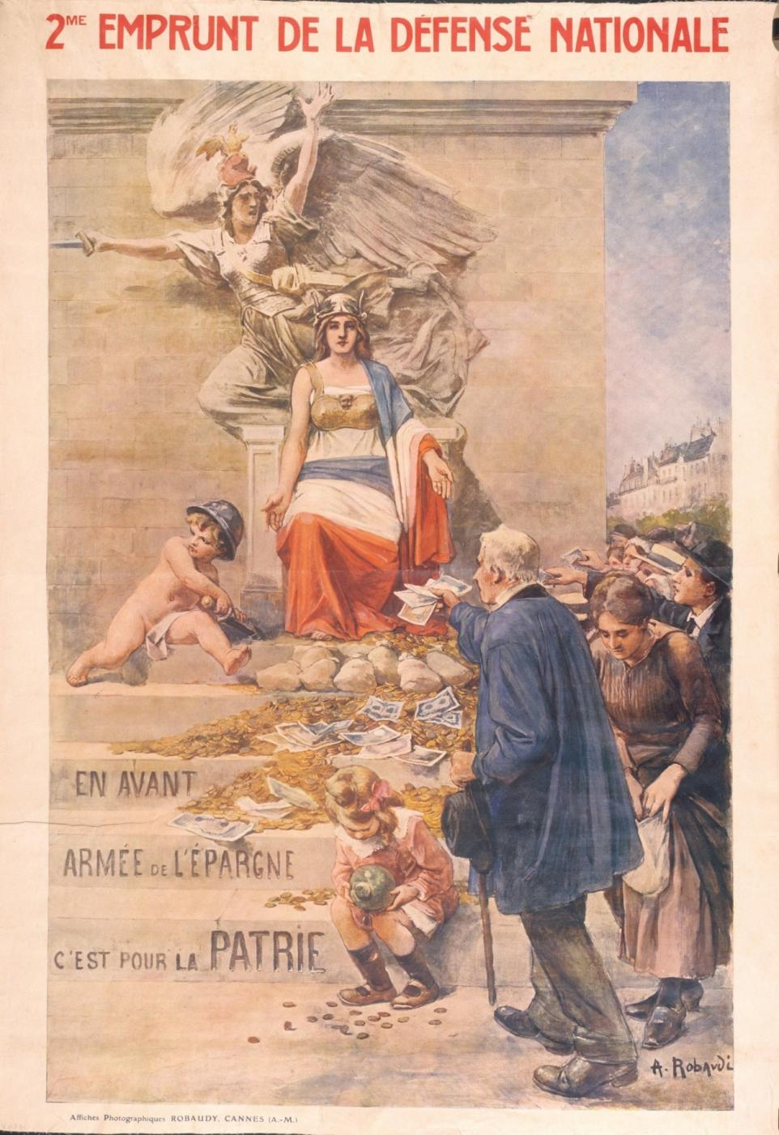
Figure 38: Alcide Theophile Robaudi’s poster, 2^{ieme} Emprunt de la Defense Nationale, was created for the Second National Defence loan, printed by Devambez 1916, Australian War Memorial, ARTV06340.

Robaudi transforms Marianne from a pagan idol enthroned on a gold chair, wrapped in the French flag, with a cherub drawing a sword at her feet to a contemporary collector of war funds. Marianne is seated with her arms at her side, her palms open- ‘likened to the Madonna’ who is the central focus of the composition as she brings to life the reality of the conflict and the expense of the war. Conventionally, the cherub is angelic is playfully depicted with weaponry, symbolising the victory of love over war.

This symbolism evokes youthfulness and passionate love for one’s nation, which is reinforced by another representation of the La Marseillaise, this time taken from François Rude’s low relief sculpture of her on the right column of the Arc de Triomphe in Paris. Marianne soars to victory with sword outstretched against an unseen enemy. This could be a double use of Marianne here or it could illustrate how Marianne during the First World War was sometimes compressed with other symbols like Victory, Athena or one of the Saints. Significantly it demonstrates the way posters were able to communicate from the past and find relevance in the present.

The coins and notes that are strewn down the steps of the Arc de Triomphe to symbolise that victory comes at a cost to the citizens of France. The inscription on the stairs is translated as ‘Forward, army of savings, it is for patriotism’. An abstract arrangement of people at the base of the steps suggested a diversity of class and gender, from peasant to bourgeois, old men and young children were expected to contribute. It is also an attempt to introduce an aspect of modernity to the image of the strongly classical image of Liberty. The inclusion of a contemporary audience underscored the importance of contribution to the war effort. An elderly and more affluent man confidently held out a handful of bank notes, while a young girl seated on the stairs shook coins from her piggy bank. A male worker holds out bank notes, while a woman looks down at her cloth bag searching for money. The importance of the individual roles in the War was still relatively new, but a powerful way of shifting attitudes toward modernism.

In doing so, the Robaudi evoked a powerful message of past loyalty and sacrifice and the importance of the French Republic in providing the foundation for past victories and present freedoms. This included the volunteers from 1792-3 and the start of the Levée en masse which relied on myths to celebrate popular involvement in the armed forces which were central to the presentation of military recruitment and service; ‘an international act of the individual and collective will’. Images of Marianne as muse and warrior drew on ‘idealised military expressions’ which were part of legitimation of state intervention in terms of conscription, and these images also represented the ‘product of more than forty years of Republican schooling’, namely the notion of the citizen soldier. This idea of the citizen soldier also found political significance in the close symbolic link between political freedom and the cost of military service in both human lives and financial terms.

This poster is important because it demonstrates the valuable contributions of those at home beyond the idea of mobilization for the War. Marianne is frequently used to appeal for national war loans, and in them she appears to unite the military past with the present. As a symbol of Republicanism in France, she contributed to temporal shifts between the past and the present as she herself, in war-like guise was a potent reminder of the struggle to become modern.

On a technical note, this poster was produced by layering a photograph of the Arc de triomphe, which was printed first, and then the colour print was overlaid across the image. The artist sought the accuracy and the realism of the photograph, and in the depiction of the people, he used hand drawn methods. Robaudi was using a new technique which he announces at the lower left of this poster, “affiche photographiques, Robaudi, Cannes”. A painter located in Cannes composed his posters with a background using a classical scene, and then he superimposed a colourful scene with people overlaying the classical image. His posters were very popular with his audience, however the backgrounds appear slightly disconnected from the lives taking place in front of them. In this way he was able to combine historical and modern images in a way that merged the present with the past.

Georges Picard also captured Marianne trying to merge herself into the world of the present through the female domestic sphere of collecting money for the War in his 1915 poster, Journée de Paris 14 Juillet 1915, au profit des oeuvres de guerre de l’hôtel de ville, (see below).
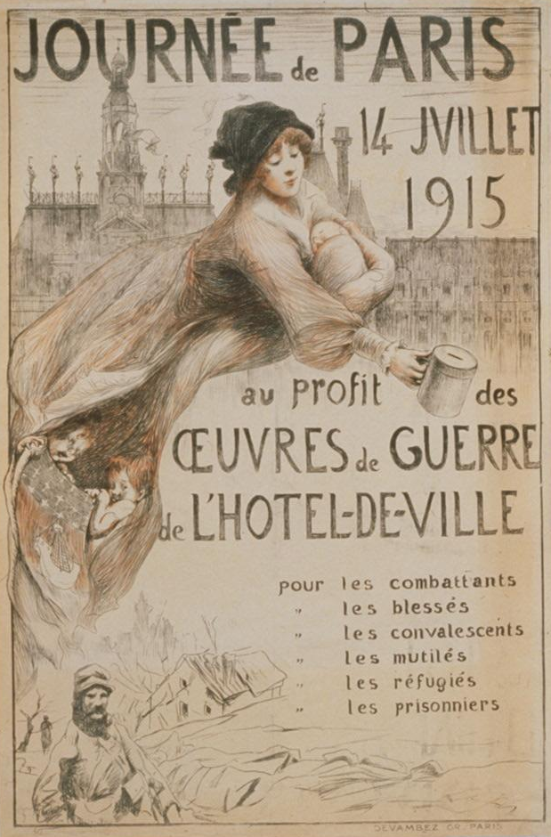
Figure 39: Chavannaz (David Burnand Chavannaz 1888-1975), Journée de Paris 14 Juillet 1915, au profit des oeuvres de guerre de l’hôtel- de-ville (Paris’ Day, 14 July 1915, the profits of war work by the Town Hall), chromolithograph on paper, 120 x 79.8 cm, printed by Devambez in Paris.

Picard drew a mother cradling her sleeping baby in her left arm and held out a collection cup in her right hand. Rather unusually, she is superimposed on the roof top. The woman wears a soft cap, reminiscent of the Phrygian cap worn by Liberty which identified the subject in the poster with the centuries old link with Liberty and her role in the freedom of slaves. The poster text ‘oeuvres de guerre’ which literally translated as ‘war work’ meant that funds would be directed toward the listed patrons who included; The soldiers, the injured, the convalescents, the mutilated, the refugees and the prisoners of war. Marianne was the translator between the present and the past; she connected the soldiers with the funding, the front line with the home front.

In this way, the poster merges powerful symbols of Marianne with a call for local war service from women. The poster combines a historical reference to the French Revolution, through a direct connection between the 14th of July, France’s day of celebration of the storming of the Bastille during the French Revolution, and this collection day. It remains a day that is celebrated nationally once a year in remembrance of the sacrifice for freedom. It demonstrates the growing acceptance that the circumstances of war effort were such that the ‘French government and the military became more willing to concede that women’s active support was sometimes necessary’. This was a direct political and circumstantial legitimation of women’s war service.

The function of the poster was to appeal to women to give money to the war fund. Many women were earning a wage or had the potential to contribute their time in collection of funds for the War. The female figure and mother, Picard depicts his favourite muse Marie Krysinska (a symbolist poet from Montmartre) who is dressed in work wear, her billowing cloak either for domestic duties or employment and she collected money for the war effort. Beneath this cloak a shield contains the crest for the city of Paris, a silver sailing boat on the blue sea with a red sky and golden moon. The upper section contains a repeated pattern of the Royal emblem, a gold fleur-de-lis on a blue background. The shield is held by two infants and conveys the message that she (Paris), is tossed by the waves but does not sink. The coat of arms is also a motif that features on the Hôtel de Ville, (Paris’ administration building), with the roof outlined on the skyline. A drawing of a soldier walking along a road is shown at the lower left; a survivor of the War that devastated the landscape, as illustrated by burnt trees and a deserted house in the distance. The prevailing government called for women to emulate traditional references Marianne through this consistent message, which was in this instance championed by the artist Georges Picard in 1915.

The role of women was also accompanied by broadened political participation, which included the work of women. Therefore, the poster is a direct appeal for women to combine motherhood with the duty of charitable collection for war work. Picard used the significance of the mother and her children in Journée de Paris 14 Juillet 1915, au profit des oeuvres de guerre de l’hôtel-de-ville to promote the idea of the future of France. It is an early development of the impossible position faced by women and the difficulties in undertaking factory work that often compromised the role of motherhood. War and its particular challenges was the discourse that defined their traditional role and the boundaries of home and war. Recently, the examination of the political independence of women who explored beyond traditional social boundaries, and the evidence that plenty of women operated around them. For example, Grayzel describes how the traditional role of ‘motherhood’ became an ‘instrument of war’. Gullace further developed this argument by recognising that, although governments were protecting women, their bodies were also instrumentally restricted and controlled by how the government ‘allowed’ them to participate.

As Marie-Noëlle Bonnes suggested, the War was a moment when the dichotomy between public and private became disrupted. With the industrial demands of modern war, British and French Governments began to create a reserve of working women for industry. As Michelle Riot-Sarcey identified, Libertarian values prevailed over normative values during the War. Female representations in the form of dream or spiritual allegories were favoured over their domestic representation. With the necessity of the war, when everything was laid bare, women got to see into a world that exposed the fiction of gender division. Women from all classes were mobilized, and little by little, they assumed the broadest functions through more activity and responsibility than they had ever held in civilian life.

While not all women were Marianne, they espoused her values as they imitated what she was seen doing in the posters — now they were ordinary girls holding out bowls or shaking canisters, selling cockades, pins, and miniature flags. From the most menial jobs such as collecting money on the street corner, women were presented with the idea of expanding their war service through Marianne who made the service of everyday women visible. This may well have been a new role for middle-class women who participated in the ‘twenty nation-wide collections, each raising several million francs for charity’. Women who worked voluntarily did so for very different reasons and consequently, it would be a gross over-simplification to state that their embrace of the war effort was only a demonstration of their patriotic service. The artist used the archetype of Marianne to illustrate the progression of women’s roles beyond the domestic; a modern interpretation of women’s roles. If we take one step beyond the iconographic symbolism, we see artist demonstrated that ordinary women could adopt these new roles and this is evident in Henri Rachou’s poster, Semaine de la Haute-Garonne (below).
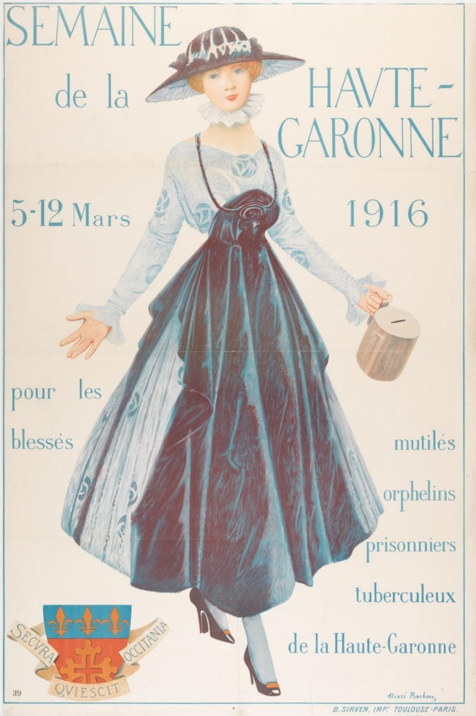
Figure 40: Henri Rachou, Semaine de la Haute-Garonne (Week for the Haute-Garonne, 5-12 March 1916, for the injured, the mutilated, orphans, prisoners and those with tuberculosis from the Haute-Garonne) 1916, chromolithograph on paper, printed by B.Sirven Imp. Toulouse-Paris, 120.1 x 79.8 cm, Australian War Memorial, ARTV01166.

A young woman is the dominant subject of Henri Rachou’s poster Semaine de la Haute- Garonne [Week for the Haute-Garonne], she is standing with her arms outstretched in a blue dress with a frilled neck and sleeves. Roses adorn her dress, and the shortened hemline revealed her high heeled court shoes and stockings. She carries in her left hand a collection tin as she looks directly at the viewer appealing to the public to make a donation to the following charitable causes; the injured, the mutilated, the orphaned, prisoners and those with tuberculosis. The Haute-Garonne in the South of France, whose crest is included in the lower left, are having their own collection week from 5-12 March 1916 and this poster appeals to the community to support the local war effort.

If we look at the distinction between ‘service’ and ‘work’ it is possible to pursue the idea of class difference. Margaret Darrow described the range of charitable works in which women were involved, such as knitting and sewing for the soldiers, sending food treats to the front line, and the marraines de guerre scheme (in which letter-writing to an adopted soldier was turned into an act of patriotism). In this way, women’s roles were seen to expand out of the home and across social stratification through these charitable acts of patriotism. To undertake any activity outside of the domestic role was an abnormal expression according to bourgeois society at the start of the war. However, the contribution to charity work was less controversial as the war went on because it was easily portrayed as an extension of the domestic femininity and duty in the home.

The viewer is to believe that the girl decided to dress in fashionable attire as she saw collection of funds for the war effort as her patriotic duty. She appears modern and pristinely clean, although she adorns her dress with an apron to protect its delicate fabric. Interwoven in this image is the sacrifice of time; that she is working for no wage. She is still working — the apron was a symbol of working women — and here it is demonstrated to have become a fashionable item during the war, when women’s work became visible and valuable.

However, it would be illusory to suggest that ‘overnight’ the experience of war radically altered civilian life for women. They are better understood through a range of cultural ideas about gender. Although Doan suggested that, as historians, we move away from an interpretation of women’s history as a construction of ‘change’, we might better understand the nuances in women’s representation, particularly as they were required to drive mobilization rather than just reflect it. This research has also revealed the lack of recognition given to women’s work prior to the war when women were also actively involved in charity, nursing, factory work, and domestic work. The idea of domestic service before the war was often shaded by the greater activity of women and their mobilization during the War.

In summary, there is evidence that many First World War posters of 1915-1916 use the image of Marianne to encourage, to buoy morale in France for women’s work outside the solely domestic sphere. To do this, poster artists began to merge Marianne with everyday women’s work which included collection days. The symbol of Marianne began to shift from being unreachable and allegorical to more real as she explored the roles of women, as the war drove them to embrace new roles as an expression that justified women’s mobilization into the public from the private domestic world.

Images of women in France from 1917 to 1918

By 1917, there was a shortage of able men on and off the war front. This required women to take on new roles from which they had traditionally been precluded. The emergence of women into these new roles has been extensively examined by gender historians over the past twenty years. This research revealed that the French government never moved to embrace women’s volunteer efforts or to include women prominently in government commissions to the extent that this occurred in Germany or in Great Britain. In France, they did this work as civilians, not as militarised women.

Recognition of the contribution of French women to the First World War had an impact on the way that tensions around gender would be managed. Gullace identified that ‘women’s suffrage was not a purely political event, but emerged from the cultural environment created by the War’. Darrow observed that traditionally, male soldiers in France were given full rights as citizens, including the right to vote, but women were not given the right to vote until 1945, after the Second World War. By mobilizing volunteer women or hiring women as civilians, not soldiers, during the First World War, the French Ministry of War negated the need for the rights of citizenship to be fully given. This avoided the practical complexities of women participating in the military and masked the resulting anxieties. For example, women could vote in local elections, but not national elections. Ironically, the use of Marianne as a strategy to address wartime labour shortages by appealing to women to participate in war work, without threatening the gender order, would only serve as an early catalyst for further development of women’s roles in subsequent decades.

If the period of 1917 was one of lowered morale in France, it was also one of greater public resistance to imposed military service. A difficult and cold winter resulted in food shortages, and when compounded with rationing, there were protests held in the city streets. This created new challenges for poster artists whose role it was to boost public morale. From this time, there are more instances of expanding beyond Marianne to offer images of women in other central roles, however, these are almost always traditional or agricultural. There were also posters that expanded beyond the traditional boundaries of gender, in particular addressing the lack of food, with the demonstration that women are taking responsibility of the farms. This can be seen in the poster by B.Chavannaz (David Burnand Chavannaz), Emprunt National 1918, pour nous rendre entière la Douce Terre de France (see below).

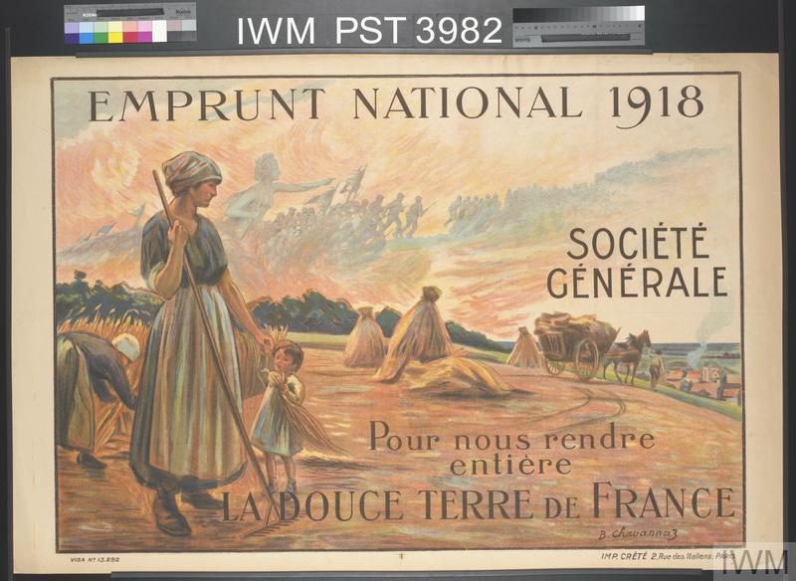
Figure 41: David Burnand Chavannaz, Emprunt National 1918, Société Générale, Pour nous rendre entière, La Douce Terre de France, [National War Loan 1918, to make us whole, the sweet soil of France], chromolithograph on paper, printed in Paris by Imprimerie Crété, 1918, 79.7 x 119.3 cm, collection la musée d’histoire contemporaine, Paris (used with permission).

Clearly, in this 1918 poster there is an idealised and romantic reference to the French nation’s dependence on agricultural sustainability as it calls for financial contributions to support the War. Presented in a bountiful and golden past, at first the image seems very far away from the rigours of war. A female labourer working on a family farm is depicted holding a rake in her right hand as she took a sheaf of wheat from a child who helped in the field. Her oversize boots or clogs suggested that they might be borrowed from a male worker. This is an image which drew a longevity from the past to the present by illustrating the female role of the peasant continuing to harvest and work the land to provide a harvest and food for France in this climate of shortage.

The poster’s function was to communicate the urgent need for the sustainable food cycle to continue, and the urgency of preserving traditions for future generations and their inheritance. The absence of male workers in the scene also reinforced that the current livelihood of the nation was sustained by women. Grayzel identified this poster as an example of the 'idealised women at work in the fields' which combined 'agricultural and maternal' themes in a new way. In Chavannaz’s poster, here is an example of an image that expands beyond the traditional boundaries of gender (in particular beyond the place of women in the home), and instead uses a genre of traditional imagery, as seen in Jean-François Millet’s (1814-1875) Barbizon school paintings of peasant farmers. As in Millet’s female peasant subject, Chavannaz retains an anonymity, a distant ‘realism’ so that his portrayal is not recognisable, very much as Liberty herself is drawn, and this is also because of contemporary sensitivities that could potentially emerge if women were depicted doing hard labour.

There are also echoes of Liberty within this image of the female agricultural labourer. Reaching back to the 1880s, there are associations with the ‘agricultural’ form of Liberty, which merged the relaxed pose of Marianne with the patriotism of Liberty into a new national symbol, la Semeuse (the sower) — a natural, barefoot, young woman distributing seeds in the field, mid stride with long hair, her upper body contorting to face the viewer. The emergence of this symbol drew on the youthful, active female image of Liberty or Marianne that was popularised by Oscar Roty’s (1880) design for the one-franc coin and she was also used in the First World War. Lucien Jonas’ print of two French soldiers in a trench watch La Semeuse and say to each other; ‘This is the French woman, the mother of the poilu, who in courageously taking up the tools left by the husband or father, continues his task untiringly…’. In a similar way, Chavannaz’s poster, Emprunt National 1918, pour nous rendre entière la douce terre de France (to make us whole, the sweet soil of France) is emblematic of how women contributed voluntarily to preserve the continuity between the pre-war and post-war France in the absence of men.

The soldiers advancing to war are seen in an apparition in the sky with Marianne, merging with Athena the goddess of war. This is an allegory of success — the women who continue to operate the farm, harvest the crops, and retain a sense of normality throughout the War —demonstrate an extension of their domestic work. The women replace men, and this is a contemporary development on a traditional agricultural scene. In 1914, France was still largely an agrarian and peasant society. The census in 1911 revealed that 56% of the population lived in the countryside. Women had always been assisting on farms, but they had not been running them, and this poster represents a modern development on a traditional culture. Women’s place in the agricultural world was still work combined with motherhood. As demonstrated, this kind of representation was not likely to challenge the conservative balance with any dramatic change in roles; it was the subtlety with which women assumed these more modern responsibilities which is evident in Chavannaz’s poster.

Liberty and Marianne merge into the modern woman

As our earlier historical review has shown, Marianne was a malleable image. Her deity, her demeanour, her dress and even her name became modified across the centuries. By placing Liberty/Marianne in contemporary settings and foregrounding her interaction with contemporary actors, she became further detached from the allegorical and abstract. Over time, the ideal of the goddess Liberty was collapsed into the more relaxed figure of the sister or familiar mother Marianne. During the War, this allowed her to exist in the symbolic and belong to the everyday.

Meanwhile, the image of the everyday woman increasingly became central to the propaganda posters of the First World War. Roberts describes this as a shift in cultural presence towards the modern woman through the changing relationships of cultural power. She explains that it was through the War that new social relationships could be ‘safely’ explored by women of the time. This was a shift from a domestically confined and marginalised figure to a central component of the post-war cultural landscape.

One area where this was demonstrated in the French context was through posters for wartime theatre, such as Orsi’s, A nous la belle (see below).

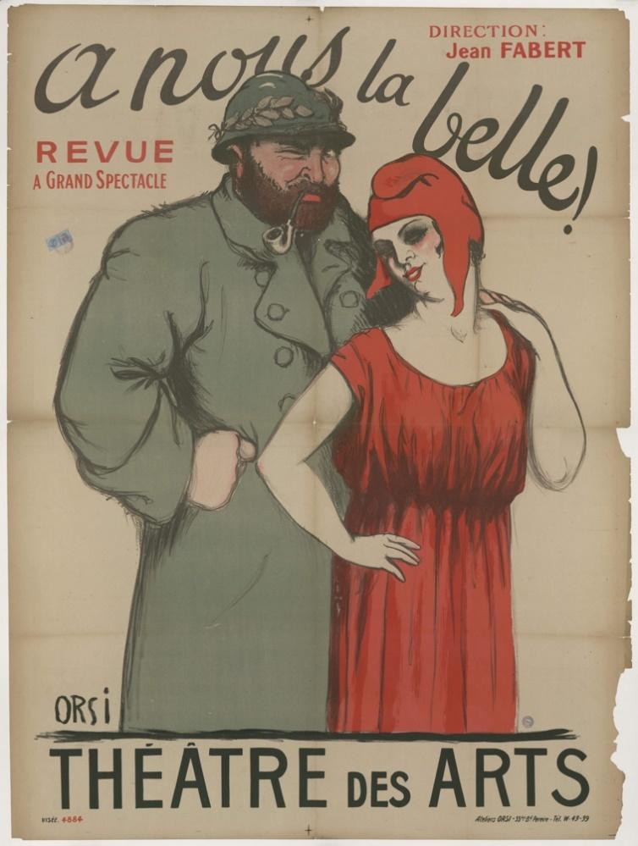
Figure 42: Orsi, A nous la belle! (to us, beautiful!), revue grand spectacle, théâtre des arts, chromolithograph on paper, printed by Atelier Orsi, 55 Bld Pereire, Tel W.49-99, not dated (c.1914-1918), collection la Musée D’Histoire Contemporaine

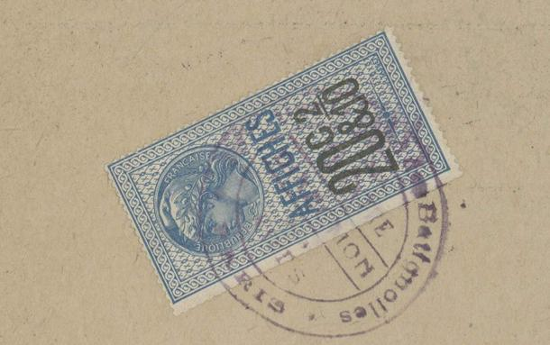
(detail of the stamp affixed to the poster in the upper left)

The theatre poster A nous la belle! features Liberty/Marianne in a very contemporary form, as a modern woman. She wears a Phrygian cap, loose flowing robes, and arms are bare, while she has heavily applied make up. She holds a soldier’s hand on her shoulder as he stands behind her to wink at the viewer. The soldier wears a heavy double-breasted drape coat and laurel leaves adorn his steel helmet. The poster has explicit sexual symbolism, but this may well be permissible because of its association with the theatre. The theatre was a context in which the modern Marianne presents an interpretation of female theme of freedom. In Orsi’s poster the artists suggested the independent desire for her own life, which may be 'sexually promiscuous, loose in her morals, free in her clothes'. These images reference emergence of ideas that women could increasingly explore from a relative distance, through the poster, the theatre and increasingly through the cinema.

Although we cannot find reference to à nous la belle, the Director Jean Fabert, who is identified in the poster was the director who also worked at the Moulin Rouge in Paris. There he is known to have produced Honi Soit in 1916 which ran at the London Pavilion from September 6th-April 15th, 1916. The type of review is described in the reviews for Honi Soit and is perhaps typical of the format Fabert produced because the content is made up of short comedic sketches;
This was produced in association with M. Jean Fabert of the Paris Moulin Rouge. Sketches included a modern version of the Judgement of Paris; the Censor being invited to tea by the chorus ladies; a scene at Madame Tout-Chauds (sic), where waxworks of Henry VIII, his wives, Guy Fawkes, the Crown Prince of Germany and Charlie Chaplin all come to life; a highly respectable waiter trying to separate a man and woman in a private room at a restaurant (it turns out, of course, that they were married after all!)
The function of Orsi’s poster was to attract people to the theatre production. Marianne appealed to men and women for different reasons, and these were ones which began to merge the aspirations of freedom and the value of Marianne above egalite and fraternity during a war. In contrast to the many posters that depicted Marianne as the goddess who guided the French people to victory, we see the humanity of the War through the eyes of the soldier and the girl who is dressed as Marianne. The humanity of Liberty/Marianne was a representation of the ideal goddess and the real political ambition of the Republic. Together they merged as a trope which was repeated throughout the war in French illustration, whether through the goodbyes of soldiers heading off to war, or their welcome home.

In contrast to the more formal image of Liberty/Marianne is present on the official stamp affixed to the upper left-hand corner of the poster. This more traditional and demure representation of Liberty as the goddess is characteristic of the official images of Liberty/Marianne used on stamps and coins and indicated that the printer had paid the tax to enable the public display of the poster. There was a juxtaposition of contrasting representations of Liberty/Marianne at the time. Although traditional Libertarian values of freedom were espoused, the context of Marianne enmeshed French Republican values.

As can be seen, this poster suggested that images of Marianne increasingly began to be merged with those of the modern woman, but did she still uphold the values of Republicanism? She did so by repeating well-established cultural expressions, such as the dichotomy between perfect mother and perfect woman in the Catholic tradition of the revered Madonna or Joan of Arc. As Roberts explored, a nineteenth century split between the image of women as ‘good’ or ‘bad’ became immortalised in the split between virtuous mother and unvirtuous prostitute. As illustrated in Orsi’s poster, we see both the unvirtuous Marianne in the poster and the virtuous and official Liberty depicted on the stamp. Women and men were transported by Marianne, elevated by Liberty from the mundane of the everyday as she offered freedoms that were attractive especially given the constraints of the war.
The poster titled the Emprunt de la Liberation, 1918 was a celebration of Victory for France (as below),
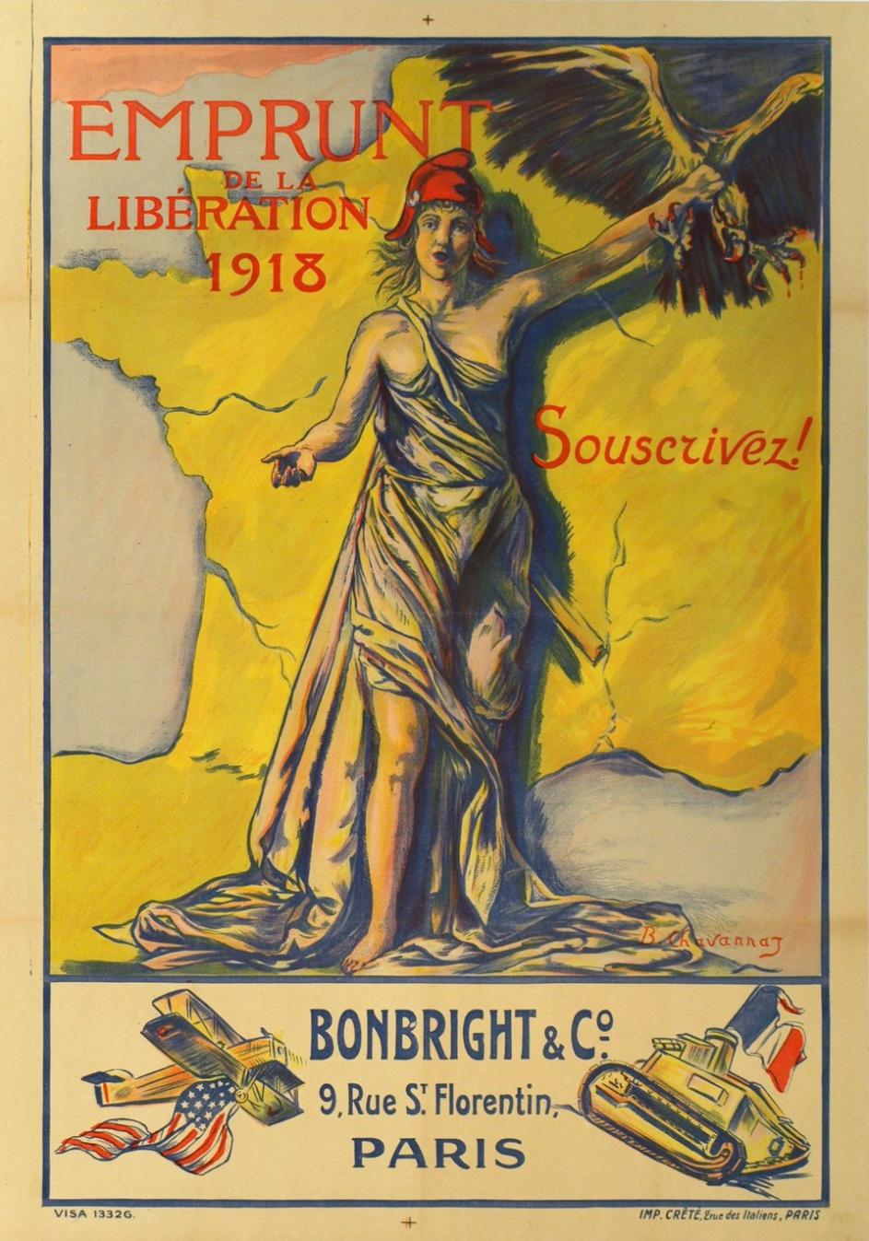
Figure 43: David Burnand Chavannaz, Emprunt de la Libération 1918, Souscrivez! (Liberation war loan 1918, Subscribe!), chromolithograph on paper, printed by Imp. Crété in Paris 1918, 111.3 x 79.6 cm, Collection of La Contemporaine (used with Permission).

While the arrival of American troops all but secured the Victory over Germany, this poster of the Emprunt de la Libération 1918 by Chavannaz is one of the more colourful. It is a return to the loud, brash pre-war posters that shouted out their message. A woman identified as Marianne because she wears a red Phrygian hat stands in loose robes of antiquity with her left hand elevated above her head she clutches a black eagle, symbol of the Prussian monarchy with blood dripping from its open claws. Her right arm is lowered with the palm open as her figure casts a dark shadow across a yellow map of France and across the poster are the words Emprunt de la Libération 1918, Souscrivez! [Liberation War loan 1918, Subscribe!].

Below the image are a biplane carrying the American Flag and a French tank carrying the French flag. The image suggests that it was the technology and the assistance of America and above all the actions of Liberty that secured Victory for France in the War against Germany. The poster is requesting donations of money to assist what would be the final war loan before the Peace loan in 1920; reminding the public of American assistance in the defeat of Germany. The poster below by a French artist and produced in New York is also a reminder to Americans of their allied assistance of French women ‘Four years in the fight’ which led to final victory in 1918.
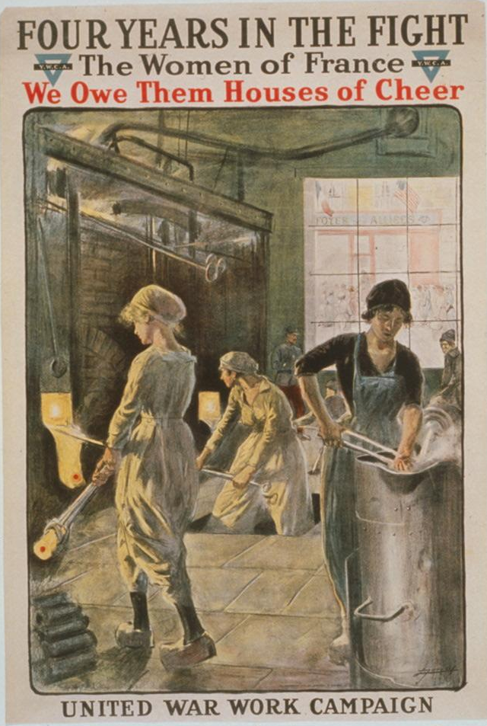
Figure 44- Lucien Jonas, Four years in the fight. The women of France, we owe them houses of cheer. United War Work Campaign. Y.W.C.A. printed by Stobridge Lithographic company in New York in 1918, 108.5 cm x 68.6 cm, Library of Congress Collection

This poster by Lucien Jonas was used to promote the United War Work Campaign, a week long campaign held 11-18 November, 1918 to fundraise for American soldiers during the demobilisation following the First World War. Significantly it shows French women working in front of a furnace possibly they are making ammunition casings. Behind them through the glass window ‘Foyer aux Alliees’ (Lodgement for the allies), a building or lodgement for American participants in the war carries the French and American flags.

This poster is advertising an American fundraising campaign for American soldiers at the end of the War. It was a join effort undertaken by seven voluntary organisations and raised more than USD$170,500,000. Jonas’ poster of French women working in front of a large furnace and handling hot molten materials showed ordinary women participating in the war effort. Although images of women working were not unusual in American posters, it is less common in French posters. This poster is an example of an international collaboration between the French artist and the American lithographic company who produced this poster. This poster spoke to women about the alliance between France and America and their united contributions to the War effort. There was enormous power in the depiction of the ordinary woman.

Although artists used the construction of female representation in posters to unite men and women in their contribution to the War, they were also cognisant of the potential for the posters to issue power struggles with competing interests, however these differences were unified through the symbol of Marianne in war. They used aesthetic means to appeal to men through the ideal of Marianne and for women there was significance in their work being elevated and increasingly valued by a broader audience. The First World War was characterised by the ‘selective’ use of images of the representation of working women. Any potential power struggle was addressed by limiting the representation of women’s contribution to ‘types’ of service and also Marianne moderated any challenge to masculinity.

More often, Marianne is used as a substitute, as she was often used to represent females within the masculinised context of war. Her timelessness amplified belonging to France during this time of turmoil. Pearl James argued that despite the power Marianne wielded, she did not necessarily offer women self-powering images. While Marianne was inspirational to many men facing conscription during wartime, ultimately James argued that Marianne did not provide agency to female viewers because the connections between themselves and Marianne are too abstract. Through dual classicism and masculinity Marianne was able to ‘establish her distance from actual women and thus limit the extent to which female viewers should see her power as something they might themselves wield’. This masculine all-powerful presence of the warrior-goddess figure was a confident, sometimes eroticised, and dispassionate presence, but she did not provide a point of identification of vulnerability with her audience.

The context of war envisaged Marianne as a masculine female figure which was a strong contrast to the late Victorian norms of femininity characterised by passivity, physical frailty, and lack of muscular development. Pearl James draws a stark contrast of impossible ideals. Certainly, this juxtaposition is present throughout the War as Liberty/Marianne duality vacillates between human and goddess. However, instead of a lack of relevance, the representation of Marianne is a lot more diverse than James accords. Her depiction as an ordinary woman also became a powerful transition for Marianne during the War. As argued here, it was because she was a transitional figure that merged old and new images of Marianne as well as everyday working women, that she emulated Republican values of freedom, but also politically she identified with working women.

This can be seen here in Henry Gazan’s 1920 poster Emprunt Nationale (The national loan of 1920), where Marianne stands amongst the debris of war and proclaiming rebirth of the French nation (as below).
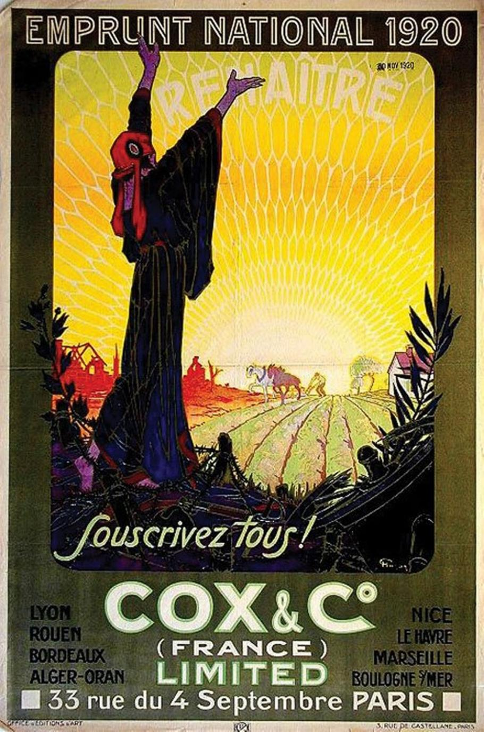
Figure 45: Henry Gazan, Emprunt Nationale, Souscrivez tous! (War loan 1920, all subscribe!), 1920, chromolithograph on paper, printed by Cox & Co.(France) Ltd. 1920, Australian War Memorial Art Collection, ARTV10341.

This is a poster that I proposed for acquisition for the Australian War Memorial’s poster collection. It is rare, and I have not seen it in any other poster collection. It was sold to the AWM from the collection of Hans Sachs, a Berlin Dentist whose passion for collection saw him found the poster magazine Das Plakat, (the poster) with Sachs as both editor and publisher. This poster is significant because Gazan (1887-1960) illustrated a woman in Art Deco or period clothing who also wears the Phrygian cap. She is standing amidst the detritus of war with barbed wire and empty ammunition casing at her bare feet. She raises her arms toward the sun calling for ‘Renaitre’ or rebirth of the French nation. She is the contemporary Marianne or female figure who is emblematic of survival and yet she also epitomises the cost of the war. She also communicates the increasing liberty for women in the post-war period when many widows inherited farms and continued the agricultural dependence of France.

Therefore, I contribute to this theoretical space by demonstrating that the merging of iconography enables Marianne to be more relatable to a diverse audience. In this chapter I have argued that it is possible through the diversity of Marianne’s image, that she contributed beyond the image of the female goddess on the high alter and provided an avenue for women to relate to different aspects of the War. Through a combination of representations of the goddess Marianne in her seated, standing, and military guises, the ‘ordinary woman’ appeared through the lens of Marianne and appeared to borrow legitimacy from her.

The presence of women embodied the idea of a progressive modern nation that was no longer represented ‘only’ by an abstract figure of Marianne who helped the French people to understand women’s work during the War, but she also enabled the greater visibility of all women. Arguably, the War also reinforced the belief in sexual difference, a view which ‘permeated the whole of French society’ because it was held as one of the fundamentals of the Enlightenment. Some scholars argue that a more militant strategy may have helped the feminist movement transcend these ideological and traditional views which had been abandoned in Britain. Ultimately, although women’s war service has been viewed as evidence of female emancipation, it was not to be fully realised in France. The War was intent on delivering Republican ideology and it would not undermine these tenants necessary for War.

American artist Neysa McMein recognised the potential to connect allied women through a representation of this female figure of Victory with the increased feminist momentum toward the end of the War, and she created this poster titled For Victory, allied women on war service conference and mass meeting (See below).
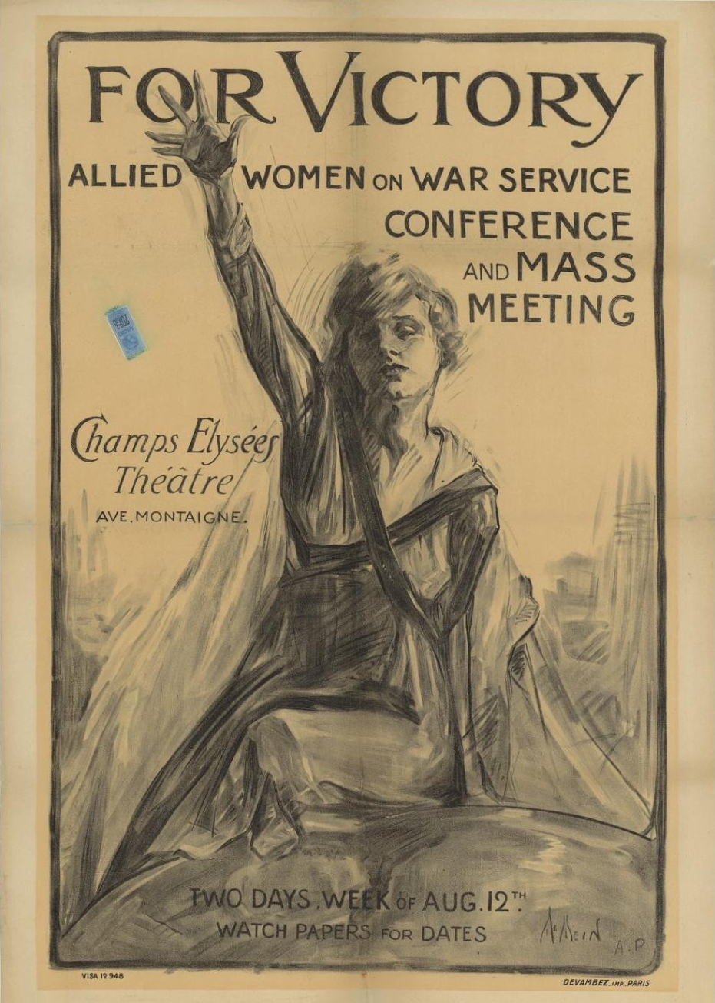
Figure 46: Neysa McMein, For victory, Allied women on war service conference and Mass Meeting, lithograph on paper, printed by Devambez, Paris, 1918, Collection of La Contemporaine (used with permission).

The poster advertised the event and depicted a female wearing a cloak, which was typical of that worn by French working women. This is important because it disguised her class. Across her chest she wears a sash that forms a ‘V’ across her dress which is disclosed by her cloak. The political image is closely connected with the ordinary working woman who has replaced Marianne in this poster. She proposes the idea of coming together to discuss the idea of ending the War and achieving victory.

The poster was most likely a self-portrait of McMein herself, who was photographed soon after parading with a US flag on Fifth Avenue, New York in 1917. McMein joined the YMCA in France as a canteen girl to entertain the hospitalised troops by screening comic movies; she also gave lectures and designed posters. She became a prolific poster artist creating strong images of women throughout the 1920s and 1930s for magazines and she was in every way a countertype to the pale women in the recruitment posters.

McMein thrust her right hand into the air, (as in Chavannaz’s poster) as though to rally the working women. Her cropped hair and her working clothes echoed the representation of ordinary women who were desperate to end the war. In the face of war many women gave up suffragette activism, however by the end of the war there was increased pressure to ‘act’ in order to end the war. The cross-fertilisation of political ideas and the international exchange of ideas saw increased spontaneous political activity amongst women.

It is likely that McMein drew this poster while she was located in Paris to promote a conference to women from all the allied nations involved in war service. They were invited to a conference at the Champs Elysée Theatre on 22 August 1918, which was a discussion on ending the war. Women worked for many reasons during the War; patriotism mainly, but by 1918, and with the arrival of American troops, women sought to end the suffering by ending the war. It is important to note that this action by American women, as depicted in McMein’s poster, reflected the surge of momentum to end the War. The purpose of this poster was to bring women together to vote to end the war. At the time, French women were able to vote in local elections, but not in national elections. The poster contained a persuasive message to indicate that women were taking decisions into their own hands when repeatedly failed by the male political world. At the time, French women were able to vote in local elections, but not in national elections. The poster revealed the initiatives of international women in Paris at the end of the War which were operating in a context in which there was a dominance of traditional attitudes in France.

But just as many of the French artists before McMein, the idea of liberty, reason and the new woman was slowly evolving in the public eye throughout the War on the home front, but may not necessarily have been seen at the front line. To educate soldiers, films were shown at the Foyer du Soldat (Lodgement for soldiers) in Paris; they were produced as much for the education as the entertainment of soldiers on leave. The Frenchwoman in Wartime poster by Georges Capon (1890-1980) was made to advertise a film produced by the Section Cinématographique de l’Armée Française (French Army Cinema Section) to show French women’s patriotism through work in 1917. The well-known film poster was widely distributed with the three female working figures grouped and coloured in red, white and blue; a farm labourer, a factory worker and a mother. In the background was Victory, a helmeted female figure larger than life, symbolic of a war won through ordinary women’s hard work.

The ideals of giving women the freedom to vote were aggressively defended by some British and American women in France, whose presence confronted the French ‘softly-softly’ approach to Republican synthesis with feminism. Ultimately engaging in rational discussion was the preferred method of political persuasion in France during the War, so that emancipation was an unrealistic achievement by the end of the War. The use of Marianne both anticipated greater public roles for women, but she also placed clear limitations on the expansion of those roles. For example, Marianne was shown supporting fundraising through the collection days, agricultural work, nursing, mothering and factory work.

The juxtapositions, contradictions and the differences in the representation of Marianne, and the expansion of women’s work as claimed here, made sense in a time when women’s work was threatening to men and many women. Difference is what held women apart from men. Prior to the War, McMillan argued that the primary consideration for women voting was to ‘lend a feminine contribution to the handling of public affairs.’ There was a failure to comprehend fundamental similarities when difference of the sexes was loudly proclaimed.

Therefore, the politically active life that women experienced during the War, with many actively involved in their municipalities as delegates, secretaries in the town halls, deputy mayors and even as mayors, were couched as traditional roles. In 1919, although a large majority of deputies in the lower house (Chamber of Deputies) approved female suffrage, French women failed to obtain the vote from the new parliament on the basis of war work. The French Senate rejected the approval because it was dominated by the ‘Parti Radical’ (centre-left) whose anti-clerical views meant they thought that in giving women the vote, they would augment the influence of the Catholic church. The centre-left had no great desire to change a society that was founded on the Civil code, and they reasoned that not all French women were suffragettes. In opposing the introduction of the vote for women and men who returned home from the War, France did not follow the trend in Britain or the United States of America. Again, this was to reinforce that despite the women’s efforts in France during the War, there was a reluctance to radically change the French nation. It was not until 1945 — after the Second World War — that French women achieved voting rights.

Independent of the debate around voting rights is the social agitation and visibility of women’s participation evident in the posters from the First World War. The rationale was to reflect a gendered war, where ultimately difference was what mattered; no amount of uniform wearing and war effort would divorce women from their traditional roles, and differences were explained by the disordered gender system during the War. Rather than focus on the similarities between men on the front line and women on the home front, the construction of difference in women’s representation was accorded by their selective depiction in limited roles.

Fundamentally, the posters sought to communicate a dualism. On the one hand, posters encouraged women to participate in new roles and to see in their work similarities with men’s roles, but they also reinforced the ‘difference’ between male and female war work. The posters communicated this difference through fashion, clothing, Marianne, and duties undertaken. Women were shown to combine maternal work with new roles that expanded beyond the domestic environment, and yet they were still bound to domestic boundaries in many ways. There were limits on how they could appear and how much labour they did on the farm. Detached in this way from domestic surroundings, women’s war work would be preserved forever through the ephemeral poster which was not made to last, not meant to last, but did.

Britannia and gendered representation during the First World War

1914-15
While the changing representation of women in Britain and France during the First World War indicated that patriotism was constructed very differently for men and women. Although ‘both French and British governments drew upon traditional notions of gender to exclude women from combat, they were willing to enlist women’s support for other aspects of the war effort.’ As women took on new roles and these were represented publicly (to varying extents), it became more possible to envisage women playing a greater social role outside the domestic sphere in the future. The image of women capably undertaking men’s work challenged the traditional domestic sphere occupied by women in a way that did not happen in France. The British government used contemporary images of women to position itself to mobilize a new work force, the ‘new woman’ who, forged through war, became ‘the modern woman’; the strongest advocate for women’s service. These images progressed the identity of the ‘real’ modern woman with the War and consequently the ‘mythological’ identity of Britannia was tarnished. The First World War allowed governments to take advantage of the mass media, and Britannia became a liability because she was associated with masculine war, not a feminine one. However, the British government was still concerned with regulating women’s behaviour in wartime.

Initially, the role of women was around encouraging their men to go to war. It was a duty for young women to encourage their men to enlist, as illustrated in Edgar James Kealey’s “Women of Britain say-Go!” as it was for older women in Go! It’s your duty lad, join to-day, both published by the PRC in 1915. There was also an impatience for the new woman to do her duty. As Mary Louise Roberts noted, ‘wartime displacement would soon exert its influence on women’s lives.’ Many historians have viewed the War’s confusion of gender roles as a moral and gender tussle over the expansion of women’s roles. The early phase of the War saw that women were not content to take such a passive role during the war. Many of the ideas that circulated in Britannia attempted to bring women together to unity them through the discussion of the democratic control of the government for the good of the community and its influence on industry, maternity and childcare, and children’s right to an education. What underlined these ‘discussions’ was the general fear of German intention to take control of British industry and democracy.

Enormous causalities swelled anxieties about national and imperial future leading women to seek to contribute to the war effort by participating beyond that circumscribed by traditional domesticity. The following analysis of posters shows us that the British government also actively sought to represent the participation of women in the workforce as part of expanding gender boundaries, and they began in 1914 by acknowledging the roles as nurses and working in munitions factories.

Sir Robert Baden-Powell’s 1915 poster, Are you in this? included men and women and children (as below) in defined roles of war service.
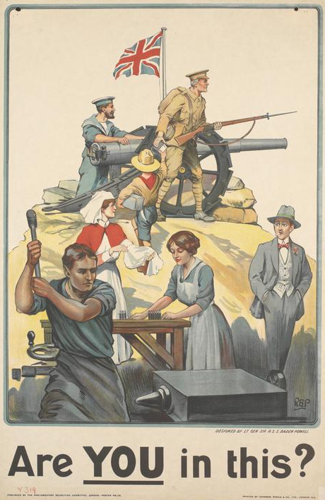
Figure 47: RBP (Lieutenant General Sir Robert Baden Powell), Are you in this?, chromolithograph on paper, 1915, 75.6 x 49.6 cm, Imperial War Museum collection, IWM PST4899
This poster depicts the summit of a hill in the background on which a soldier stands with his gun at the ready and his bayonet extended; the sailor kneels holding on to the barrel of a field gun as they both anticipate battle under the Union Jack flag. Beneath the hill, several civilians are engaged in various work activities including a boy scout distributing cartridges, a nurse folding cloth, a woman preparing to load explosives into ammunition cartridges on a table and a man hammering metal on a blacksmith’s anvil. To the right a man in casual attire strolls with his hands in his pockets as he is perhaps a shirker or just oblivious to the toil around him.

Although conscription had not yet been introduced, this poster identifies the deep concern that the rising generation of social ‘loafers.’ Baden-Powell began the Scouting movement prior to the war in an attempt to address ‘a serious breach in the nation’s defence system’. The values that scouting taught were borrowed directly from Baden-Powell’s own experiences in British public-school education, and also in his military experience during the Boer War. The significance of this poster was descriptive of this period in which volunteers were increasingly difficult to obtain. This poster gives recognition to the men and women who sought to participate in the War in defined roles of service. As Baden-Powell identified, there were also many roles beyond defined roles of the army or the navy in which men and women could imagine their participation.

Women, children, and men Are you in this? called everyone to be involved in the War. Perhaps because of his experience with the effects of propaganda, Baden-Powell saw a direct relationship between the British people and their wartime occupations and patriotism. Baden-Powell sought to identify the ‘wishy washy slackers’ without any ‘go’ as lacking patriotism. He linked patriotism with ‘manliness’, and he believed lack of patriotism was essential to counteract. The inclusion of women both making munitions and working as nurses was instrumental because he was concerned that every individual participated or they ‘will lose the Empire for Britain.’ These examples of service also underlined the defined perspectives on gender roles within war service from 1914-1915. The poster sent strong messages of behavioural discipline which aligned with Baden-Powell’s experience during the Boer War and skills he learned from professional scout Frederick Burnham in one of the farthest parts of the British Empire, Rhodesia. Baden-Powell sought above all to communicate in his poster propaganda the value of modelling discipline, service and model citizenship which are emulated in Are you in this? to foster an unwavering commitment to the British Empire. Women were also encouraged to participate in the war through the depiction of Britannia, although this was rarer than Marianne.

As Britannia merges with an early form of Athena, war goddess, a classic figure takes form here as a female defender of contemporary British freedoms. Latent with symbolic authority and legitimacy, her billowing flag, and with her sweeping arm gesture, she turns to call all British civilians to follow her to avenge the 1914 German bombing of Scarborough. In the distance, the burning castle on the Scarborough coastline emits heavy clouds of smoke into the sky.

One of the only times that we see Britannia appear in a poster during this period is in the Edith Kemp-Welch poster Remember Scarborough! Enlist Now (as below).
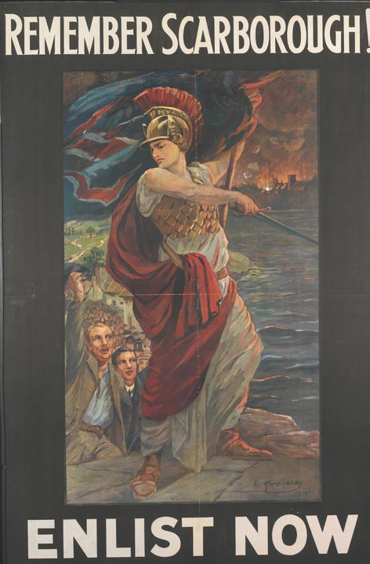
Figure 48: Edith Kemp-Welch, Remember Scarborough! Enlist Now, chromolithograph on paper, printed in London by David Allen &Sons, chromolithograph on paper, c.1915, 149.5 x 98.9cm, Imperial War Museum, PST 5109.

Edith and her older sister Lucy Kemp-Welch were both engaged by the PRC to paint the artwork for First World War posters in 1914. Both sisters were renowned for painting horses and in this poster Remember Scarborough! Enlist Now! Britannia is presented in her warlike visage. She wears a plumed helmet, fish scale armour, a toga and sandals as she stands on a flag stone path, gesturing with a sword toward the sea.

The nature of the German naval attack at Scarborough, Hartlepool and Whitby on 16 December 1914 by three German warships was a complete surprise and it revealed Britain’s coastal vulnerability. Kemp-Welch recognised that by 1915, the struggle of war would be a ‘long and strenuous’ one and the ‘aim of the [Parliamentary War] department was to stimulate not depress!’ Kemp-Welch identified Britain’s own internalised perception of the threat of Naval attack from German U-boats. In a complete turn-around, the poster that reminds Britain to ‘Remember Belgium’ reflects a mirror image of internal fear.

Kemp-Welch may have been influenced by this 1915 poster by Bernard Partridge (below) which first appeared in the magazine The Punch, and then it became a poster. It demonstrates how transferrable illustrations were in this period. Britannia is posed in her billowing cape, breastplate and plumed helmet waving the Union Jack in place of her sword. In Partridge’s illustration, Britannia is standing before a city with a smokestack as she calls for men to enlist. Britannia is clearly used to initiate feelings of patriotism from British cities. As a war goddess, Athena and Britannia fight for just causes. However, what is outstanding about Kemp-Welch’s image is that Britannia adopts a masculinised female figure as she is used to speak to women and to men. As a female artist, Kemp-Welch called for men and women to volunteer, her poster sought a diverse audience.
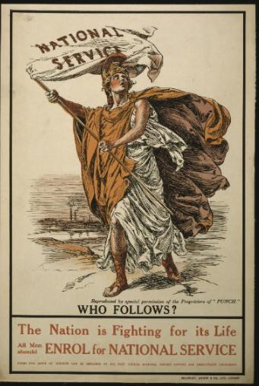
Figure 49: Bernard Partridge, The nation is fighting for its life. All men should Enrol for National Service, lithograph printed by Agnew & Co., Ltd., London, 1915, 75 x 51 cm, Imperial War Museum, PST 10815
Kemp-Welch opted not to depict the ‘gruesome character’ of the scene, and instead she portrayed Britannia stimulating recruitment of volunteers as a way to resolve Britain’s threat. Commended by the British War office for her painterly approach in Remember Scarborough! Its purpose was to bolster recruitment in Britain, but it also sent a public message about Britain’s coastal vulnerability to attack, reinforcing British confidence in its maritime history through Britannia.

In this way Kemp-Welch and Partridge utilised Britannia’s association with British naval military history to stimulate recruitment of military and non-military volunteers. While many men and women saw the War as a temporary state, and their fear of invasion is difficult to ascertain from these posters, the influence of fear as a motivation for recruitment should not be understated. The security in Britannia belonged to a different generation of men and women of the Victorian period. Kemp-Welch attempted to merge the past with the present. These images suggest a strong drive for women to lead by Britannia’s example; to encourage men to go to war and participate themselves. Britannia was used in this period to clearly articulate the need for men to voluntarily enlist in the patriotic service of Britain both prior to conscription in 1916, and after this to recruit the service of those too old for military service.

1917
Britannia is used again, this time to promote the National Service Scheme introduced by David Lloyd George in 1917 to encourage all men who are not in the forces (including those who are older than 61) to volunteer for home economic service wherever the state might require them. This was a theme that was to be continued in Scott's 1917 poster, National Service…Defend your island from the grimmest menace that ever threatened it (see below).
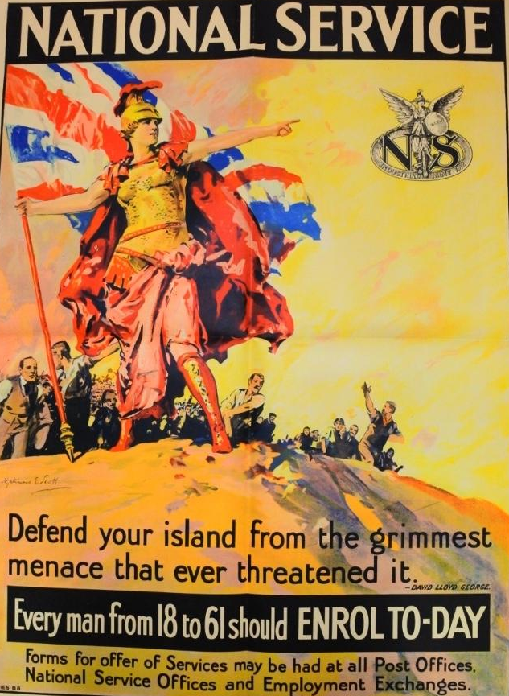
Figure 50: Septimus E. Scott, National Service…Defend your island from the grimmest menace that ever threatened it, chromolithograph on paper, 1917, 102 x 77cm, The British Library collection. Library Tab 11748.a

It was the Ministry of Munitions that commissioned this poster to communicate the premise of Lloyd George’s statement that ‘there is something infinitely greater and more enduring which is emerging already out of this great conflict –a new patriotism, richer, nobler, and more exalted than the old.’ In the service of the Defence of the Realm Act, Lloyd George sought to renew and revise symbols of Britain’s past. Above all he was concerned by ‘Britain’s complete dependence on the sea for our very existence’ and the growing strength of the German naval force. He aspired to attract the service of those he was unable to conscript into the army.

This poster shows a group of men rushing up a hill toward a woman who is standing resplendent wearing a golden breastplate and helmet. Her right-hand points outward, attracting attention away from herself as the focal point in the composition, and toward the National Service emblem. Sketched from below, Britannia is elevated, as soldiers rush up the hill to her aid. Recognisable in her Greek armour and headdress, she is sometimes confused with Athena. In her right hand she holds a standard on which another British national symbol, the Union Jack, billows behind her. Importantly, the Union Jack is held on a pointed standard, as though the territory on which it is placed, presumably Britain, is not fixed. The symbolism in this poster reminded the British people of its naval strength. In this context, Britannia symbolised the German announcement of ‘unrestricted submarine warfare, permitting U-Boats to sink any target on site’. In this way, Britannia echoed the words of Lloyd George on the poster, ‘Defend your island from the grimmest menace that ever threatened it’, derived from his public concern for restriction of supplies to Britain, and consequent starvation.

These alarming headlines fostered public insecurity, especially in the light of the Scarborough coastal attack in 1914 and the sinking of the Lusitania in 1915. This meant that ‘Britain was constantly trying to preserve superiority in numbers, size, and speed to take the offensive in battle and blockade’. Britannia is seen here in 1917, reinforcing the vulnerability of Britain’s shores to attack.

The introduction of National Service or conscription for men in January 1916, with the passing of the Military Service Act, was imposed on all men aged 18 to 41 except the medically unfit, clergymen, teachers and certain classes of industrial worker. A second amendment to the Act passed in May 1916 extended conscription to married men, but never to men aged above 41 until 1918 when the age was extended to 51. These amendments were in response to Britain’s critical undersupply of men to the front even though conscription was not met with universal approval. Septimus Scott recommended that everyone sign up for the war, even those who were advanced in age could assist by volunteering for home service.

Britain’s military strength in naval operation was not entirely irrelevant to a land war; as the British army was expanded (and marketed to) the working class, a new political democracy was being reinforced. It is to this evolution that Scott’s recruitment poster speaks. In this poster, the men Britannia was encouraging to enlist were rolling up their sleeves and coming to Britannia's aid were blue collar workers; it was appealing to a new market of conscripts. The poster was constantly responding to changes in policy for the National Service, in this instance to attract conscripts, but also to educate the mass audience.

Scott painted this poster image before it was printed, having graduated from the Royal College of Art in London as a painter. By 1903, he regularly exhibited landscape and portraiture at the Royal Academy in London, and he worked as an illustrator for The Graphic and as a book illustrator. During the War he produced posters such as this one for the National Service for the Ministry of Information and he was adept at turning paintings into posters. In his work he embedded a rich understanding of cultural symbols and their interpretation.

Britannia had become unfashionable during the War, but only temporarily due to an uncomfortable association with the political division during the War. The sculpture of Britannia facing the River Thames in Millbank, London was installed as recently as 1897, just seventeen years prior to the First World War. The presence of Britannia on the One penny coin throughout the war perhaps identified that this was a temporary change. In fact, the MI7 department at the War Office, which was responsible for all material circulated in the military zones, had restricted the use of Britannia’s image. In Britain and other representations of empire including the Union Jack flag, the lion and maps were preferred to Britannia at least until 1917-18.

Britannia was not meant to be imaginative or creative, but her consistency in the posters identified her militancy in encouraging Britain’s defence to counter the fear of invasion. She is predominantly a military figure, but after 1917, Britannia is set on her return of soldiers from France to England. This image reconciled the active campaigning for enlistment early in the war and the justification of British participation in protecting its shores from invasion. Another poster that contributed to this renewal was the unsigned painterly poster National War Bonds, Regularly Week by Week (see below).
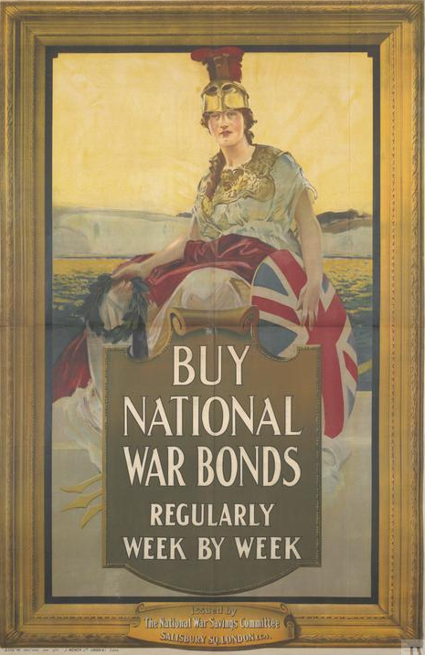
Figure 51: Unknown artist, Buy National War Bonds Regularly Week by Week, chromolithograph on paper, printed by Weiner & Co. in London in 1917, 151.8 x 100.6 cm, Imperial War Museum collection IWM ART.PST 10475.

Commissioned on behalf of the national war loans committee, Britannia is shown seated holding a laurel wreath in her right hand, she is heralding victory to the British people. Here she takes the classical image of a female wearing breastplate and plumed helmet, seated at the prow of a ship sailing toward a green pastoral land flanked with white cliffs. A gold frame ensconces the figure of Britannia framing her position at the bow of a ship as it nears the White Cliffs of Dover on her return to England from Northern France.

The function of this poster is twofold. It was, likely, used in France to motivate the conscripted troops, and more importantly families, with a promise of soldiers returning home. The purpose was to turn thoughts to home and to raise the prospect of fund raising through investment in National War Bonds. Importantly throughout 1917 to 1919, as more British soldiers were returning to Britain, posters were commissioned by the government through commercial publishers to ‘give the impression that the works were produced independently of state direction’. If this impression was successful, families who long desired the return of British soldiers would also be influenced by the opportunity to invest in the security of war bonds. The choice of Britannia, an ancient symbol and servant of the people, was assuring men of Victory during the War and their safe passage home. Posters also drew public attention.

When a question arose in the House of Commons around the choice of a ‘German’ printing firm, Weiner & Co, ‘a naturalised enemy firm’ who were based in London and selected to print the poster above, Buy National War Loans Week by Week, this is how the response was reported in The Daily Mail.
Mr Stanley Baldwin replied for the treasury that ‘tenders were invited’. The placing of the contract with F.Weiner Ltd. merely indicated that no competing firm would at that time give the same service as regards price, quality and delivery. It did not indicate that there were no other British firms capable of producing colour posters. The amount payable was £745.

Demonstrating the intense competition between printers, the government attempted to distribute printing jobs so that they were seen to be fair and inclusive. These were stringent times and so often work was won by the company who could offer the best price. This demonstrated the interest that people took in posters and the intense competition and rivalry that existed with German companies and their citizens in Britain during the War.

In summary, the relatively dormant Britannia, symbol of past victories and intermediary for the people, was revitalised and reconceptualised through the British posters of the First World War. But her image was full of contradictions. Britannia was rejected as a symbol of English nationalism by parts of the Empire, but she was still able to be used to recruit across class divides. She adorned neoclassical buildings with references that tied her closely to distant naval victories, but she was still able to be used as the guardian against land invasion. Unlike French poster composition, where classical Marianne’s was juxtaposed with the contemporary, in Britain she was able to remain classical and relevant. However, the significance of this evolution and contradiction should not be overstated. As Mosse identified, Britannia’s role in Britain was much less important than Liberty’s significance in France, especially during the context of the war but she still played a further part in the mobilisation and modernisation of women in Britain. Britannia was able to continue the narrative of past British victories into the First World War and this is perhaps why in Victory, she became a lot more visible in the posters. In a way she was an active translator of contemporary conflict including changes the National Service and investment in war bonds for the benefit of Britain.

The mobilisation of women in Britain through the ‘modern’ woman

In Britain, the division between home front and front line became less rigid, as historians have recently suggested. Women not only embraced new roles, such as the female munitioneers, bus conductors and drivers, there was an ongoing expansion of other roles throughout the War. In 1918, the British Board of Agriculture recruited around 23,000 young women to the British Women’s land army who gave assistance to agricultural workers in bringing in two harvests. Laura Lee Downs concluded that the massive recruitment of women workers during the war was made possible with a significant re-organisation in the work environment from artisanal modes of production to mass production. It also provided the opportunity for re-examination of roles that were traditionally performed by men, and these were challenged as we observe in the newspaper article from the Daily Mail 12 June 1916:

Boys, come over here with its picture of blazing villages could be altered to “Girls come over here” with a picture of a smoking factory.
Have you a daughter going to revues who should be going to work?
Have you a wife trimming hats who should be trimming aircraft parts?
Have you a daughter taking motor drives who should be standing by a driving belt?
Have you an aunt filling up her time who should be filling up shells?

Women readily saw themselves participating in the war effort, but many men and women saw it as a temporary state. Despite this, it was ‘seeing’ women undertaking new roles that is claimed to have expanded female patriotism, and this is reflected in the mass media and forged mass cultural change despite some resistance, as we will explore. The dualism in images between traditionalism and modernity easily translated for modern women who saw themselves playing a greater social and political role in the future, one that saw more women outside the domestic sphere.

As Doan argued, the process of visualizing women in new contexts, in part through posters, had the effect of rapidly expanding the evidence of the new social and cultural structure of war work for women. The new gendered category of the modern woman, sometimes called the ‘new woman’, was also highly didactic. In fact, part of this effect was that women in uniform received visibility and this helped to grow their ‘actual numbers in service at home and near the zones of conflict.’ So, while the extent of the role of the poster in recruitment of women will not likely be ever fully known, one can be confident that it had an influence. This view is confirmed by reports that, after a brief hiatus in poster production, the women’s recruitment campaigns were reinvigorated throughout 1918 as it was realised that they ‘had a highly beneficial influence’. Hence, through the cultural analysis of the poster, it is possible to begin to identify in them, ways in which they brought traditional and modern symbols together and as a result, they offer new nuances and directions for analysis beyond the national cultural ones such as Britannia.

Gullace has recently disputed the long-held claims that suffrage in Britain was abandoned through the War. Instead, she determined that it was through this crucible of war that citizenship was redefined, and new habits of political and cultural practice were determined. The expansion of roles by women during the War were a motivator for their participation as reflected in the posters; they combined traditional illustration with the ‘modern woman’ during the war, bringing her legitimacy. This is similar to the French use of illustration to expand the legitimacy of women’s work as was demonstrated in the first part of this chapter. In Britain, posters such as Women Wanted Urgently (see below), show women in military uniform being presented by Britannia to the public.
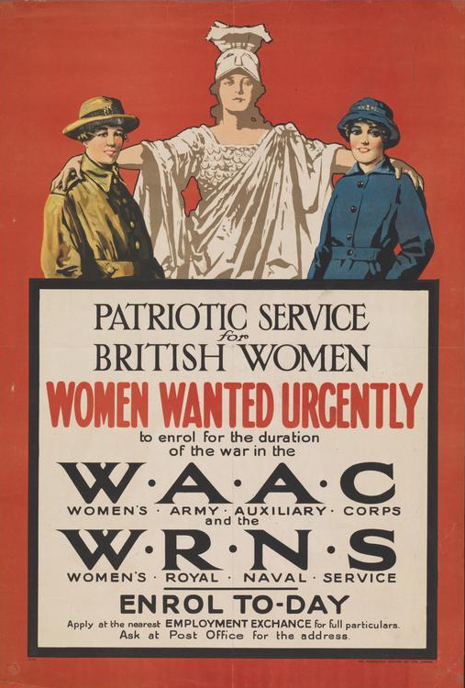
Figure 52:W.M. [in monogram], Patriotic Service for British Women, Women Wanted Urgently, printed in London by Dangerfield Printing Co. London, c.1916-17, 74.1 x 50.1 cm, Imperial War Museum PST13195.
The poster shows Britannia standing with her arms around the shoulders of a member of the Women’s Army Auxiliary Corps (left) and a member of the Women’s Royal Naval Service (right). The text announces the call for female recruits to enrol for the WAAC and the WRNS which were both formed in 1917. The WAAC offered jobs as chauffeurs, clerks, telephonists, cooks and instructors, and the WRNS offered women suitable domestic work to replace sailors who would then take on combat duties. Britannia wearing all white offers a contrast to highlight the women’s uniform as she facilitates their introduction into a new social era.

Although uniformed women only represented a small part of the workforce of women who mobilized to assist the war effort, they are visible. However, it is the representation of women dressed in uniform that she argues is a rich terrain through which to examine ‘permutations in the gender system’. Doan indicates that the imaging of women in uniform through the war would be an important precursor to imagining modern Britain. Not only are women seen to boldly step out of the domestic realm, but by wearing a uniform her unity, strength and ‘patriotism was marked on her body and in her clothing, [and] actions'. This new presentation allowed women to imagine and explore what it meant to be modern, and for this reason, it is a progressive step toward modernity during the War.

The political decision to extend the limited military roles to women in Britain through the WAAC, the WRNS and later the WRAF meant that, as shown above, women could be actively involved in military service and they appeared in uniform. This was a significant step in British history and one that was not initiated in France because, politically, it would have also meant extending citizenship to women, and this was problematic because it would have changed the civil code. Therefore, in Britain, the War did, through necessity, open doors for women into the military, and the uniforms were a significant step in the visibility of women taking on these new roles.

Their presence in posters signified a social and political development which has been claimed to further the role of the poster in the representation of gender as a progression towards modernity. The following posters of women wearing uniform represented not only a symbol of their temporary militarisation, but it also symbolised a merging between the old and the new. In this way, women could take on new roles under the guise of the military uniform or the factory workers coat, and they were legitimised through this process. The adaptation of women through military-type uniforms has been published, however the use of uniform to achieve this idea of ‘similarity’ to men, but also ‘difference’ is important. This was one way that women sought to engage with a gendered war and through the promotion of women’s work in a highly visible way.

Analysis of how posters achieved this offers insight into the social agency of women during the war, as active and willing participants in a war that needed them. The poster These Women are Doing Their Bit, Learn to Make Munitions (see below) was part of the drive to recruit more munitioneers in 1916.
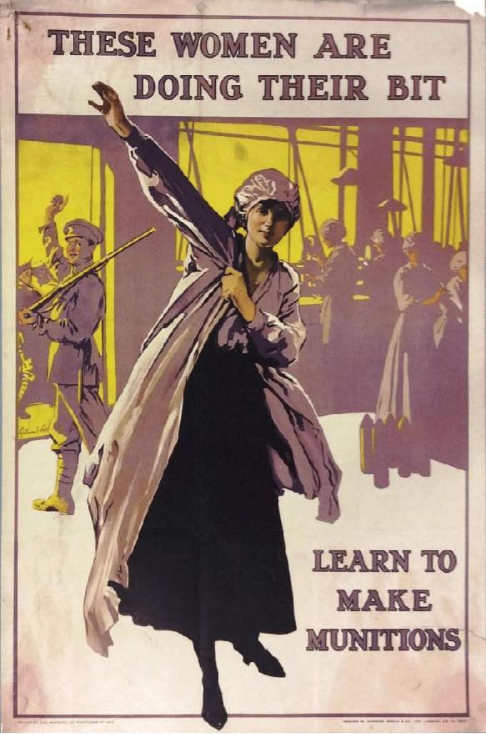
Figure 53: Septimus E. Scott, These Women are Doing Their Bit, Learn to Make Munitions, chromolithograph on paper, printed by Johnson, Riddle and Co.Ltd in 1916, 76.6 x 51 cm, Library Tab 11748.a.(505) copyright of The British Library board.

In Septimus E Scott’s poster, a woman is seen putting on the white coat and hat, the 'uniform' of female munitions worker. A young male soldier wearing military uniform waves as he heads off to war; she is taking his place in the factory. The importance of women taking on these factory roles should not be underestimated. Prior to the War, factory work had been occupied by 95 percent male labour. Women were key to meeting government munitions production goals and in 1916, as ‘the British ministry has nothing like the number of workers required’. Alarmingly for the government, by 1915 almost all the ammunition shells produced had been used and there was a push to address this deficiency with greater workloads. Many women were working in factories up to 90 hours per week. Although the posters were not heavy handed in their recruitment for the British war effort, they used colour and they were visually appealing.

The women who responded to the call in these posters sought the opportunity to attain low level manufacturing skills through the production of shells, guns and other weapons of war. An article in the Daily Mail titled ‘Single Girls First; Mother what did you do in the war?’ was a gender reversal of Augustus Savile Lumley’s famous poster, Daddy, what did you do in the Great war?, 1915 and its purpose was to re-affirm women’s contribution to the War effort by re-imagining women into male roles in ‘well-known’ war recruitment posters. The article attempts to insert women’s perspectives into assumed male recruitment campaign posters, for example, Does the Cap Fit?, could be revised with the soldier’s cap being replaced by a munitionette’s linen cap. This was the challenge — to bring the ‘new’ women into existing male power structures — and the military is just one of many.

Posters made visible the forms of work available and made women more visible within the community. It is also relatively unknown that many of the poster artists were also women. The poster advertising the Royal Arsenal Woolwich, Munitioneers’ Open Air Fête (see below) was created by the artist Dorothy Daisy Cottington Taylor.
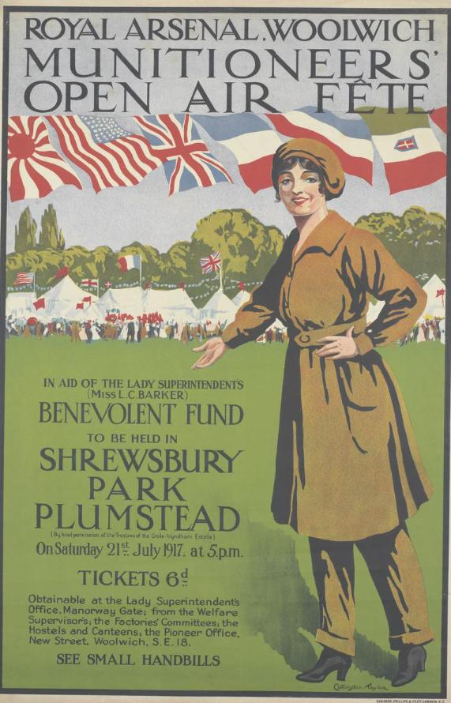
Figure 54: Dorothy Daisy Cottington Taylor (1891-1943), Royal Arsenal Woolwich, Munitioneers’ Open Air Fête, 1917, chromolithograph on paper, printed by Sanders and Philips & Co., 1917, 75.5 x 50.4 cm, Imperial War Museum PST13169.
Cottington Taylor depicts a female munitioneer, wearing a long khaki jacket, pants and a floppy hat as she stands on the lawns of the venue, Shrewsbury Park, Plumstead inviting the viewer to attend the Munitioneers’ open air fête on Saturday 21st July 1917. There are white tents in the background carrying British, French, American and allied flags as a crowd of nurses and muntioneers gather around the tents. All funds raised from the fête support the Lady Superintendent’s Benevolent Fund.

Cottington Taylor (nee Gale) was at this time newly married to T.H. Cottington Taylor, and she worked during the war as a welfare supervisor at the Royal Woolwich Arsenal and at an aeroplane factory. At this time, the arsenal was the largest gun and ammunitions factory in Britain, there were 74,000 employees. Fundraising for the war effort and supporting local workers was part of Cottington Taylor’s role as welfare supervisor, and there is the possibility that she saw a lot of people who worked in the factory who were in financial need. It was while she was working there that she designed this poster in 1917, and this fête was held to raise money through the sale of tickets (6d) for the sick and poor who worked at the Woolwich arsenal factory.

In 1917, Military service was also extended to women, who worked to support the Royal Navy in Dorothy Joyce Dennys’ poster, Women’s Royal Naval Service, Apply to the Nearest Employment Exchange (as below).

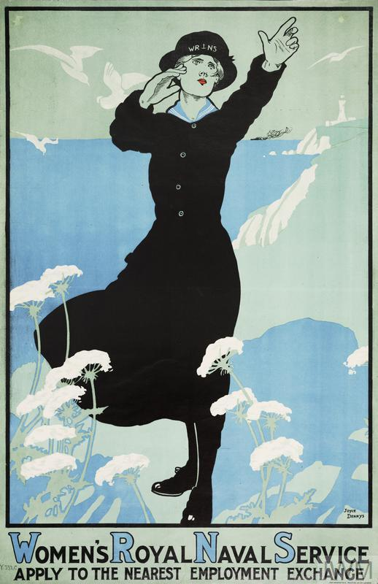
Figure 55: Dorothy Joyce Dennys, (1893-1990) Women’s Royal Naval Service, Apply to the Nearest Employment Exchange, chromolithograph on paper, printed in London by Dangerfield Printing Co. Ltd London, 75.6 x 49.3 cm, Imperial War Museum collection, PST.2766.
Dorothy Joyce Dennys’ depiction of a member of the Women’s Royal Naval Service (WRNS) is arresting given the darkness of the silhouette against a green and blue background. The WRNS wears a long black button up jacket and a long skirt, thick black tights, shiny black shoes and a hat as she stands on top of a green land mass with chalk cliffs above the sea with her arms raised dramatically.

This is a female version of the recruitment posters of soldiers who stand in uniform positioned standing on a map. As a direct appeal to women, the white flowers populate the foreground, and in the background are four white seagulls, a light house and a steamship on the horizon. Dennys was an artist who was known for her sensitive drawings and there is evidence here on the face of the woman of the emotion; of surrendering. The purpose of the poster was to create a connection with the viewer around women’s Naval service. She combined aspects of the sea and the female WRNS willing the sailors success at war while she takes care of things on land.

This photograph by George P. Lewis shows Dennys’ poster on display on the wall of the London office of the WRNS. The clerks are busy at work with their heads down in Lewis’ photograph. There is another poster above the fireplace, a British recruitment poster evoking the memory of another naval figure, Vice Admiral Horatio Nelson (1758-1805). The office is a temporary working arrangement with desks and chairs dominating the space and the ladies working in very close quarters. Working women did experience tension from male colleagues and also from other women.
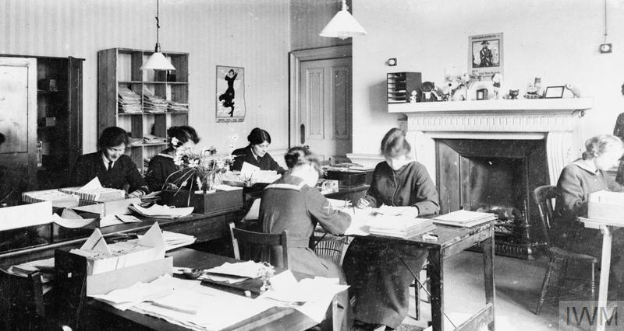
Figure 56: George P. Lewis, [WRNS office London], black and white photograph, c1917-18, dimensions unknown,Imperial War Museum collection, Q19701.

How more working women elevated tensions for domestic working women
An anonymous letter to The Daily Mail revealed some of the daily frustration felt by the traditional home makers, where change also occurred. They wrote, ‘we are advised to set free our young servants to take the places of men called to the colours, leaving the older women to cope with the domestic work, thus saving maintenance and it follows simplifying the standard of living’. This meant a total revolution for the household, where traditional ideas of patriotism and duty were readily transformed across the War.

Women who earned money from the munitions work, from driving or conducting trams, were seen to contravene not only gender boundaries, but also those of class. Women in the domestic sphere discovered that there were inequalities in rationing. For example, they differed between the women who saved rations and those who spent them frivolously. The women who belonged to the domestic sphere clearly belonged to the savers of rations and they felt that while this inequality persisted, the British nation would not curb its extravagance. In the domestic world of the middle to lower class, ‘there are only two classes of persons where savings are concerned – those with imagination and those without.’ This demonstrated that there were clear divisions between the way women spoke about each other during the War. There were resultant tensions on the domestic front also, which continued to exist because of the mass recruitment of women for war work.

The criticism between women who participated in munitions work for the war and those who maintained the domestic front at home is evident in the newspapers. Housewives wrote into The Daily Mail about war rations in which they claimed that ‘every time a new poster appears telling us what is bad form in dress…the average woman is inspired to rush off to her dressmaker’, a challenge to even the most patriotic woman. This criticism was targeting the independently wealthy and also working women who spent their savings ‘frivolously.’ Even though women were not paid as much as men for factory work, they still had some freedom that came with earning an income. The criticism ‘by’ women ‘of’ women was important for it reveals some of the social and class complexities during the War.

The war heightened the social anxieties that resulted from this dichotomy between work and home. Embedded within this tension was also a comparison or competition for patriotism that could not be avoided. At home, the conservation of food is frequently attributed to a demonstration of patriotic behaviour. In letters to the editor in The Daily Mail, for example, ‘the imaginative among us’, found ways to serve in their thrift with domestic requirements for food, fuel and resources. British housewives in 1916 were apt to undermine working women, and men expressed fear over their new liberated ways. The decision to work, for women — as depicted in the posters — also reflected an ongoing debate about the merging of gender boundaries.

The necessity of women to undertake these new roles to free up men to fight at the front is, as we have seen above in the posters by Cottington Taylor and Dennys, a topic of great consternation for many men as well as women. It was largely tolerated because of the necessity of the war and the idea that the mobilisation would be temporary. It is not to say that many women took advantage of the circumstances of the War to advance their suffrage campaign, despite the criticism issued from many women at home. The significance is that the suffragette activity might have officially ceased, but women were still seen to be agitating to expand their public role. Many attributed increased visibilities of women in the service of their country with a distant hope to be rewarded with the right to vote. Essentially this is an old debate around whether women’s participation in the War created a cultural epistemology in which notions of duty, loyalty and Britishness gained them ‘an authority that undercut the hegemony of sex in defining the rights of citizenship’. Recently, as mentioned above, historians have identified that the contribution by women to the War may have consolidated gendered roles instead of creating more fluid boundaries as many gender theorists have proposed.

In France, it has been revealed that women’s experience in the First World War was far from a liberating experience. Instead, Michele Perrot argued that the extreme effects of the moral impact of war on women served to ‘put them back in their place’. The moral struggle of war in effect ‘helped to consolidate traditional values’ and in doing so strengthened the maternal role for women. Ultimately the poster is constructed so that there is not only one way of seeing or viewing and therefore it was difficult for all people to understand women’s experience and perspectives of the War.

It is through comparison within Britain and France, that we see politically how different the two nations interacted within the prescriptions of gendered roles. The visibility of women and their expanded working roles during the War was a modern progression in both countries, but it would not last. Ultimately, the influence of the poster cannot be measured, however the reaction of women on the domestic front to those working women as described above indicated that what happened during the war was unlikely to be forgotten. The legacy of working women in Britain and France, through their representation in posters, would survive the War in the imagination. Similarities and differences in the way these images were crafted would have a lasting legacy on each nation, beyond the War.

A comparison between the gender tensions in France and Britain

In representational terms, the public image of female national icons was shifting from the ethereal figures of allegorical, classical goddesses toward a much more realistic representation of the ordinary woman. Following the introduction of conscription of men in January 1916 in Britain, there was an increased appeal to women to undertake new roles and for many women this produced a moral dilemma. The consequence, the continuation of the public debate surrounding the modern working woman and the domestic mother throughout the war, and into the post-war era.

In France, during the War, nationalism increased in visibility through the representation of Marianne. In practice, Marianne showed great flexibility to provide a continuity between the past and the present; she remained popular. Originally a Roman goddess of freedom, later a symbol of male French monarchy, and then Liberty became Marianne, as she was popularised as a symbol of Republican patriotism during the French Revolution from 1793. At the start of the First World War, Marianne was called on again as the warlike defender from invasion and guarantor of victory. But as the War went on, Marianne increasingly took on more contemporary and modern form to remain relevant. She remained a consistent presence throughout the War, as she forged a connection between old French Republican ideals and the ideals of the Third French Republic which dominated French politics from 1870 to 1940.

In France, the depiction of images of Marianne alongside working women facilitated French women to radically expand their public contributions to the war effort. As part of this, Marianne and her gender played an important intermediary role in change because it provided a measure of equality through citizenship. This happened in spite of the widely debated conflict for working women that Grayzel problematised the idea of motherhood in the working woman’s progress in the development of new roles. But this was always thought of as a temporary state and after the war these developments struggled to gain mainstream traction. The tension between munitions and motherhood captured not only a female to female competition, but also a male to female employment tension. This alludes to the sex wars in the post-war period, analysed by Mary Louise Roberts and Susan Kent in the interwar period, with an emphasis on reconstruction of relationships between men and women.

Britain had a very different history for her national symbol Britannia. Always a figure of English national culture, when placed into the tension of British unification, she was politically problematic and prone to her own internal contradictions of representation. Who did she represent other than British naval history? As a result, Britannia’s use was far less prominent during the War. While used on occasions to fortify a nation under attack by U-boats or threatened by German invasion or to recruit across the British class system. She was much less prominent in the poster than Marianne was in France. Instead, Britain looked to its contemporary working women in uniform to promote female patriotism through their recruitment. Posters depicting women in uniform were similar to men, but not the same, and as I have highlighted, many of these posters were created by female artists.

After the War, as Britons were encouraged to return to the ‘traditional’ order of the pre-war world, gender and its representation proved problematic. Attempts were made by feminists to re-establish the new pre-war gender boundaries after the war, while the presence of the suffragette movement meant that Britain could not easily revoke its evolved gender boundaries. In this blurring of gender boundaries, Kent suggested that the conflict between the sexes was used to explain and negotiate the wartime political, economic, and social upheaval. Sexual difference was used to underscore the violence of the conflict and the aftermath of trauma. Meanwhile, the reassertion of gender boundaries put pressure on women to leave their jobs as a form of reconciliation; a legitimation of the war itself. There was an expectation of a return to a pre-war social construct that was seared in the collective British memory.

This chapter has provided some insights into a highly gendered world for women. Despite the participation in new roles and the wearing of uniforms, women still experienced exclusion from military roles because they were women. Dennys’ poster, Women’s Royal Naval Service, Apply to the Nearest Employment Exchange depicts a working woman who adopted a similar uniform to male naval cadets, but with a long skirt instead of trousers. While women’s participation was broadly medical work, nursing, farm labour and driving ambulances, in the WRNS it was limited to cleaning and clerical work. While it could be argued that female artists produced these posters for women, the depiction of ‘similarities’ of uniform to those of male military service assisted both men and women understand the greater visibility of women in new roles. Women in uniform blurred the lines between the war front and the home front for many during the War.

For both countries, the challenge in the interwar period was what to do for men without jobs. As author George Bernard Shaw wrote for the Daily Mail in December 1918:

On every hoarding in Manchester, the same sort of poster four years ago asked heroes to come forward and assured them that a grateful country would never forget them. Now that grateful country is asking employers to give a disabled soldier the first opportunity of any vacancy that might occur. The way the country is paying its debt to him is to ask somebody else to give him a job!

In these words, Bernard Shaw assumed returning soldiers would find a grateful country who would treat soldiers with kindness. On the other hand, it also implied that women would give up their independence and return home to support their families. Many, of course, did this. After the War, the real challenge to finally ending the war was the reconciliation of the domestic sphere. As the visibility of women during the war began to dissipate, the visibility of working women were replaced with posters that promoted employment for returning service men. Inevitably the post-war period brought change and the ephemeral nature of the poster meant that with its temporary life of days or weeks, posters were pulled down as new ones were pasted up along the street hoardings and inside railway stations.

People were moving on from war, but the failure to comprehend fundamental struggles and compromises in wartime were intriguingly similar between Britain and France. The reassertion of women’s traditional roles was almost immediate and images of women assuming maternal responsibilities meant that France clearly demarcated the post-war period as a rebirth and reconstruction of the nation. The hopes for French women were subject to a conservative transition through the War with Liberty to assist them in returning back to the domestic, maternal and caring role while men rebuilt the homes destroyed in the war. The world was attempting to reverse any change.

Summary

The First World War was a turning point in the expression of many social anxieties and tensions around Gender. As Mary Louise Roberts argued, gender was a vehicle for the renegotiation of social structure during this period. This disjuncture in relationships between the past and the present and the future characterised the ‘anguished struggle between the old and the new [which] lay at the very heart of the post-war decade’. It is a vehicle through which to debate the representation of working women during the War and to make sense of these changes. It is such consideration that I have attempted in this chapter.

This chapter provides a more nuanced understanding of the construction and function of differing views of women in French and British posters, particularly the continued evolution of the representation of women throughout the War. In addition, this chapter has added greater understanding of the visibility and expansion of women’s roles along with the debates that surely resulted from the promotion of women and their patriotism in First World War posters, (Figure 53). A few of the posters were designed by women to represent ordinary women by granting them greater visibility, (Figures 46, 54 & 55). The analysis of these posters and including them in the debate lends weight to the argument that women sought opportunities to be politically persuasive during the First World War.

Conversely, French posters frequently relied on Marianne to convey the legitimation of new roles for women, from collecting money on the street corner, to keeping the farm and collecting harvest, (Figures 39, 40 &41). Posters promoted the ways in which women operated to assist in the war effort as extensions of domestic patriotism. Though women participated in munitions work as drivers and conductors in Britain, women in France were rarely represented in the posters as taking on these roles. Throughout the War, Marianne remained a popular figure, although she also, like Britannia, began to merge with Athena (Victory). As in Alcide Theophile Robaudi’s l’Émprunt de la Nation (Figure 38), and even as Marianne merged with ordinary women such as in Picard’s Journée de la Paris (Figure 39), the posters reminded the French people, and the international audience, that it was unity which would bring the promise of victory. Women’s roles naturally assumed greater visibility in a war where it was necessary for them to contribute in extraordinary ways.

The use of Marianne elevated ordinary women’s roles into idealised form in French posters. French posters were aspirational, in terms of elevating heroic women by depicting them as Marianne, (as in Figure 42). In contrast, British illustrators like Dennys sought to demonstrate to ordinary women how they could reach out and contribute in very significant ways by contributing to the clerical work of the WRNS (Figure 55). The photograph of the poster on the office wall contributed to an understanding that ordinary women were made heroes through ordinary efforts (Figure 56). The posters achieved the same thing, but in slightly different ways. I wonder if the more real women depicted in British posters, in comparison, also made it more difficult to return to a profoundly conservative social role after the war, perhaps there was greater resistance.

We know that British posters were much more targeted toward local and community fundraising efforts. Dorothy Cottington Taylor’s poster Royal Arsenal Woolwich, Munitioneers’ Open-Air Fête, 1917 (Figure 54) is a self-portrait inviting people to attend a fundraising charity fete to raise money for munitioneers and their families. Cottington Taylor depicts herself as a modern woman taking on work in munitions, the Royal Women’s Air Force, the Women’s Royal Naval Service or the Women’s Auxiliary Army Corps (WAAC) or the National Women’s Land Army, for example, who began to recruit women to undertake new roles. In Britain, several of the posters that I have introduced in this research were created by women for women and this is a new perspective that has not been analysed previously.

In France, for mobilization Marianne provided a ‘protective divinity to the soldier fathers’, to avenge with fury by attacking the Prussian eagle. for the expansion of women’s roles in many instances. While Britannia and Marianne were often malleable during the war and rather than represent their traditional forms, both began to merge with Athena the Goddess of War enabling the cross pollination of politics and war (Figures 50 & 51). In Edith Kemp-Welch’s poster Remember Scarborough! (Figure 48) as Britannia holds her sword and points toward an image of a burning Scarborough castle is compared with David Chavannaz’s Emprunt de la Liberation 1918, (Figure 43) in which Marianne clutches the Prussian Eagle representing the German army in her fist. These two images bookend the war in terms of their messages. Both contain solidarity in their use of the female icons to counter initial British fears (Kemp-Welch) and then crushing victory against the German enemy (Chavannaz). They show how female icons were used to communicate to men and women.

The visibility of Marianne and Britannia also facilitated, in some instances, the visibility of the new woman in posters. Ordinary women began to appear, initially as images that merged ordinary women with Marianne, and in Britain the posters were real women drawn by female artists. Both had the same purpose, to attract more women to undertake volunteer services. Despite their reference to fashions, uniforms and aspiration, the posters could not step outside the ideological parameters that were set by pre-war ideals for women, to ensure the smooth running of the domestic sphere. Women balanced maternal care with running farms and collecting funds for the war effort and these jobs were in addition to running the family home and caring for the elderly. These additional roles were naturally undertaken in challenging times, above all it was significant that their representation emulated sacrifice, and patriotism level with Marianne herself. Posters as sources are important because they demonstrate not only the changing social and cultural environment of War, but they fluctuated between the real and the ideal forms of women.

Female artists began to show women taking on new roles. While they may not have instigated immediate change following the war, at the very least women were more visible in a diversity of working roles. And women created posters to encourage the participation of other women in a diversity of roles. But these new roles, while demonstrating new opportunities for women, were also circumscribed by the French and British governments. The representation of the everyday woman through the image of Marianne enabled and encouraged ordinary women. Therefore, the depiction of ordinary women both diversified the visible roles for women, and also consolidated gender differences during the war. These two ideas have often been presented in opposition, but they offer different theoretical approaches.

This chapter contributes the idea that both may co-exist during a time of turmoil, such as the First World War. In bringing together these two fields of independent research, it is possible to understand why for so long gender historians sought to understand how women’s roles were advanced during the war, however, this is only part of the narrative. The relatively recent conceptualisation that gender roles were in fact consolidated during the war, has meant that the differences between men and women were exacerbated. By placing limits on women’s work and clear definitions and boundaries for their rights and liberties, these new roles were envisaged as temporary, and this is evident in the way poster artists structured the War poster. In reality, there was likely to have been both containment and expansion in opposition, and it was only in the aftermath of war that these were often in conflict with each other.

In conclusion, a conservative aesthetic in posters of the First World War in Britain and France has long been assumed to speak to a lack of sophistication or the influence of traditional illustrative styles, and therefore a step back into tradition in both form and content. However, more subtly, posters were navigating some significant political boundaries for working women, while remaining aesthetically conservative. Male and female artists both considered their content, namely the representation of women during the War, as a model for change. Artists saw the potential for the advance of women’s public role in the future, but the images they created were clearly meant to be temporary and controlled by the caveat of a defined time limit of the war itself. However, the posters survived and they went on to communicate to future generations. In this sense, with regard to gender, there are many nuances that emerged and evolved in the representation of women during the First World War. It is entirely possible that the posters were not meant to last, but in many forms they have transgressed through time to have an ongoing impact at different times in history. In unique ways the posters provided evidence of the contradiction that they lived between the expansion of their roles and their containment. Further retraction of these roles after the war also caused a similar social and cultural contraction of the public sphere for women. The longevity of their greater visibility in the First World War posters has unquestionably had an impact on the representation of women in the Second World War and beyond throughout the twentieth century.

Conclusion

The centenary of the First World War saw renewed interest and significant new scholarship on the events of the period. Amongst this has been research considering a broad range of historical sources, including war ephemera. This scholarship has identified the potential to analyse the social, cultural and economic insights within these ephemera. In the case of the propaganda posters of the Great War, this is possible because the artists, printers and commissioners of these works made choices about content to maximise their appeal to contemporary audiences. Hence, it is possible to examine the social ideals, values and tensions that are embedded in these works.

This study has sought to identify and analyse the social, cultural and economic meanings within a rarely assembled sample derived from several collections of First World War propaganda posters. Such analysis runs contrary to the dominant convention within the long history in which these posters were seen primarily as tools of propaganda and national cultural interests. These additional perspectives to the creation of the war poster have been provided using well-established techniques from within an international comparison of France and Britain in this study. While these analytic methods may not be new, their synthesis and use on a collection of propaganda posters to elucidate the input of artists to their creation is an important new contribution.

When this close analysis was applied to the posters from a variety of collections, it offered insight into the social, cultural, and political events as they unfolded during the War. In moving beyond dominant nationalist interpretations, certain themes have emerged to progress and to reinforce what we already know about war posters as propaganda. In this chapter, I conclude by summarising each of the chapters as they have revealed additional insights.

Chapter One set out to outline French and British political and social perspectives, as each nation went into war with very different approaches. It examined how the posters were understood in the literature and how they were defined by nationalism and then by propaganda throughout the twentieth century. The contribution of this thesis was outlined as an advance in knowledge about the creation and function of each poster within each of the three selected themes. The rationale for this thesis is to contribute to each theme through a comparative study of French and British posters produced across the war.

In Chapter Two, the representation of Belgians challenged cultural norms and national identity, while changes in their representation reflected changes in social attitudes towards refugees. The posters of Belgians were used to promote German atrocity at the start of the War, to address public anxieties surrounding the War and to justify the ensuing action on the Western Front. This demonstrated the persuasive power of the poster, but also those artists whose work was shaped by trends in the popular press. This contributed to images of Belgian refugees disappearing and then reappearing at different times and for different reasons during the War. It also opened up a range of social tensions, around the costs and consequences of the War effort on the home fronts, for closer examination. Further, the British and French posters are compared the similarity in the lens on the Belgian experience becomes apparent, and insight from their intimate portrayal in the illustrations by Steinlen and Raemaekers. Through these posters, important differences in social disparity in the treatment of refugees which set in chain responses to this crisis and its representation according to social attitudes around class, culture and identity across the War. The decisions around the representation of Belgium using a combination of old and new symbols would leave a lasting impression on the international audience and their understanding of the conflict. Decisions made during the War around the fundraising and support for refugees as reflected in the posters would be instrumental in shaping the global response to the humanitarianism crisis, including refugees and their experience. Clearly, posters played a part as construction of ‘war culture’ in the propaganda to have lasting social influence during the War.

In Chapter Three, evidence of how the first truly global war embraced and challenged cultural and racial stereotypes. Driven by the necessity to recruit or conscript colonial forces, there was no longer the option to treat the other as though they were invisible. Increasingly, this resulted in the realisation that the traditional boundaries of Imperial nations would be blurred and changed irrevocably. We saw how Britain and France presented their colonies through orientalism and reference to the ‘martial races’. Britain emphasised similarity with her colonies, while France embraced all its colonies within the French Republic. We also saw how the necessity of managing racial anxieties and colonial tensions (at home, on the battlefield and in the colonies) saw British posters become less about the glorification of the empire and more geared toward meeting an individual recruit’s biological and material needs for food, clothing and pay.

In the Chapter Four, we saw how changing attitudes toward gender were negotiated through evolving representations of women. In particular, the icons of Marianne and Britannia were used to mobilize the contribution of women to the war effort. My path to this topic was derived from the broader debate around the continuity of the suffragette movement during the War, and its post-war deconstruction into many topics. In national culture, symbols like Marianne and Britannia at different times during the war motivated women to leave the domestic sphere, to participate in fundraising, charity work or filling the roles left vacant by men at the front. Meanwhile, although the more historically problematic figure of Britannia was not frequently used during the War, she was given new life by the propaganda poster as war progressed and victory seemed more likely. The result was a new Britannia that retained its classical allegory, while evoking unity and spanning classes, but also supporting a ‘new culture’ with scope for the female worker or soldier outside of domestic life. Although their paths would be different, an important development in France and Britain that is demonstrated by these posters is the emerging place of the ‘modern woman’ in the interwar period.

Hence, in each of the chapters throughout this thesis, the analysis of posters has provided new understanding of some of the social undercurrents that were present during the War and in the years immediately after. While this has been presented thematically around the content within the posters, there are also important themes across the chapters when exploring the comparison in French and British approaches. It is in drawing together these insights across the chapters that is the focus of the next section of this concluding chapter.

In this thesis, modernity during the War as represented in the poster, has heralded more complex, diverse and contested lives for individuals. It also resulted in greater political tensions between groups, as modern societies increasingly encountered the challenges of globalisation. In the preceding chapters, the analysis of the selected collection of propaganda posters suggests that these factors were in the minds of their creators and on the minds of their intended audiences. Emerging from this analysis are several themes about a shift to modern lived realities, a negotiation of emerging democratic energies and an engagement with new global complexities.

The shift in representation from old ideals to contemporary realities is evident through changes in these propaganda posters over the course of the War. In British posters, this is evident in a shift of focus from reinforcing Imperial ideals to appealing to colonial needs. This can be seen in the representation of Indian recruits, where the posters became increasingly concerned about their place and responsibility in the British Empire and more reflective of their actual experience. This new realism included photographs that depicted the diversity of languages and cultures of Indian recruits as it aimed to attract them with promises of money, clothes, progress and family prestige (see Figure 23). This is also shown in the posters about Belgian refugees where idyllic figures with cherubic faces, but tattered clothes showing the ravages of war (see Figure 8), are replaced with more realistic representations of injured and maimed Belgian solders returning from the front (see Figures 18-20). This shift can be seen in France also through the evolution of the icon Marianne and her fusion with ordinary women. By the end of the War, French posters envisage Marianne in contemporary guise as she attends the theatre with a French soldier (see Figure 42). As she does so, she merges with the identity of the Garçonne (the new woman). What is evident here is the prominent French symbol Marianne steps down from the pedestal to become an ever more contemporary to connect with the people. As this occurred, the posters reveal attempts to manage deep tensions between traditional domestic expectations and new ambitions during and after the War.

A second change that the analysis of these propaganda posters has shown is their role as intermediaries between the government, its citizens and different communities at a time of significant change. During the First World War, French and British artists created propaganda posters that were part of the mass communication of political messages, providing a vital link between the government and its people. Not only did the display of posters provide a visual interruption on the street, but they also sought to link aesthetic form with political function (see Figure 6). From the outbreak of War, the British citizenry held deep concerns about the manipulation and falsification of information through propaganda. Over the course of the War, the British government sought to distance itself from these concerns by outsourcing its more provocative posters, such as those around the Belgians (see Figure 4), through charity organisations. In doing so, it sought to both convey its persuasive intent but maintain its objective and truthful reputation. The French experience was significantly different to that of the British. For much of the War, the French public saw posters as advertising and did not assume truthfulness. However, as the War progressed, its gravity became apparent and the need for Victory more urgent, they also came to understand the potential for posters to be propaganda in the sense described by Laswell. This realisation was tempered, in part, by the production of hand-drawn and aesthetically soft posters that took the hard edge off political messaging (see Figures 39-40). Not only did this negate the potential tensions between the needs of government and citizenry, but it also contributed to an international reputation of French artistic talent after the War.

A third theme that runs across the chapters in this thesis is the way that the content of the posters revealed complexities and juxtapositions within each poster. A comparison of Britain and France maintained that despite their differences in approach to recruitment, with France introducing conscription immediately in 1914 and Britain relying initially on voluntarism, there were many similarities in the way artists emphasised national identity. It is where they differ which is of most interest because this reveals the way the public were responding to and reflecting the social and political differences between these two nations.

In the lead up to the First World War, the higher levels of literacy and visual awareness made posters an effective medium of public communication. Many of these posters were placed in railway stations, restaurants, post offices and schools. Due to this accessibility, the posters of the early twentieth century were a persuasive form of communication. France negotiated many complex issues including the Belgian experience, the conscription of colonials and the participation of women through its cultural legacy. In these posters, the agrarian (ideal) past, the difficult present and the industrial (idyllic) future was combined in imagery to lessen the tension around change (see Figure 41). Comparatively in Britain, there was use of national symbols in addition to the championing of everyday men and women during the conflict. There was a great disparity between the use of stereotyped images and the ordinariness that characterised a war which involved everyone.

Meanwhile, these propaganda posters also portrayed, over the course of the War, a greater appeal to individualism. It can be seen in greater appeals to individual audiences (and their needs) through the representation of ‘difference’ in the colonial soldiers who participated in the War (see Figure 35). As posters began to be produced in India, they became less obtusely saturated by Imperial representation and more real (Figure 25). Another feature of the war posters was the negotiation of complex tensions that emerged in modern life. French poster artists sought to examine the juxtaposition of Orientalist representations in the modern context of the War as discovered by Prouvé, (see Figure 33), while Jonas also sought to reconcile domestic tensions in the aftermath of war (see Figure 37). Differences were sought to keep colonial soldiers at arm’s length from European populations, so that race became celebrated as difference, a distinguishing factor (as in Figures 28 and Figure 36). This participation in the war was a contradiction for many colonial participants between the messages of unity and belonging and yet their distinction from Europeans.

In France, the war loan poster appeals 1915-1920 saw the French government-sponsored posters that evoked images of Marianne to call on women’s loyalty and turn a blind eye to their rights being curtailed. Comparatively in Britain, posters heralded a new professional role for women, even if the returning soldiers had first preference for employment.

Other acknowledgments of diversity emerged across the duration of the War and after. These posters advertised both war and peace loans, which evoke different images from a diverse range of groups in society, including women, children, and the elderly. This is demonstrated in posters that presented girls surrendering the contents of their piggy banks, elderly men handing out bank notes freely and workers preparing to step forward in the war effort (see Figure 38). All were equally immersed in the Great War. Further, the movement between nations, such as with the Belgians in France and Britain, pointed to a new era of global migration. It was one where diversity and mobility would become the norm. Due to the changing technologies that underpinned the distribution and prominence of posters, it is also important to consider these posters as part of a greater democratization, both through and beyond the years of the Great War.

With greater advances in the technology of printmaking, there was a direct use of posters to appeal to an international global audience as well as a local one. Increasingly, French posters were produced by Americans (see Figure 46) or with Americans equally in mind (see Figure 8). A world altered by War tried to justify their participation because of atrocity, the treatment of Belgians in occupation and their resultant migration. Posters were used to articulate this. Meanwhile, responsibility for humanitarian aid in the posters shifted across the War from local aid through nation-wide charity to international activity.

This thesis contributes to furthering an understanding of the way artists contributed spontaneously to the war which nuances how we have previously understood governments as heavily prescribing national campaigns. The comparison of social change across themes such as gender, race, and the Belgian experience, are usually studied independently and in isolation. It is because they are large topics in themselves, but so far, they have eluded the potential to draw connections between several themes of war. I have intentionally selected themes in which there are instances of political juxtaposition because of physical, gender or cultural differences that emerged as social complexity during the war. These experiences were prolonged after the war by the experience itself and the presence of cultural reminders.

Remembering Belgium was a familiar slogan that characterised the early part of the War in Britain and France and was primarily a response to German atrocity. French and British governments waged war to preserve Belgian rights as a neutral country to be free from invasion and subsequent occupation. The Belgian experience throughout the war effectively changed the way the public thought about preserving the rights of humanitarianism, which went from a local issue of charitable fundraising to a global issue for considerable legislative change after the War.

There is a connection between the women’s campaigning for greater visibility and profile, and hope that through demonstration of patriotic service during the War that society would grant them greater civil respect or reward. Women in Britain were categorically different from men, they may have also worn uniform, but they were not admitted into the regular Army, Navy or Airforce. In France, women’s work was legitimised often by the presence of Marianne herself who encouraged maternal care in combination with an extension of the domestic sphere of charitable collection, farm labour and factory work. Throughout the War, women were taking on new roles, however they continued to be treated differently from men.

For colonial soldiers too, their representation as imperial subjects also brought about the juxtaposition of the colonial world with the world of War and it did not rest easily. The ambiguity of the representation of colonial soldiers is in their categorisation as ‘different’ from European soldiers was maintained throughout the War in the analysis of the representation of French North African and British Indian soldiers. As British India began to produce posters that drew less on the auspices of Empire and more on individual needs through the provision of an income, clothing, and food, it is possible to see poster design changing as Britain relaxed its recruitment preferences for only the ‘martial races’.

Beyond national identity, there are the social and political fermentation of the ideas about inequality, reminding us that the relationships are not static, especially during the War. Inequality was experienced through the lens of gender, race and migration and the difficulties that resulted from the lack of understanding of difference is not unique to this period, it is just has a marked presence in the posters as these issues, as sites of contention, fluctuated during the War. Rather than ignore them, the similarities in the way artists chose to feature ‘difference’ as the subject of social contention or inequality in the posters were they attempting to shift public views toward greater acceptance of difference and tolerance? In this way, social reform is reimagined during the context of the war when advocacy for civil rights and inequality were not high on the political agenda, but the decisions of war necessarily affected these issues without a doubt.

After the War, we see that the Belgian experience resulted in greater agitation internationally for humanitarian laws to improve the treatment of refugees and those experiencing occupation. While during the War, difference continued to shape the way, colonial troops were represented throughout the War. The war did nothing to abate the continuation of nineteenth-century ideals promoted about ‘martial races’ and orientalism as these types of images progressed unabated throughout the War. We see women in Britain over thirty being granted the vote in 1919 while in France the focus for women returned to the domestic and maternal rebirth of France. The posters in Britain promoted the visibility of modern women actively demonstrating their patriotism by assuming greater participation in public roles. By contrast, in France, the opportunities to exhibit greater public participation in the war were less public and on many occasions was premised by Marianne and the aspiration of Liberty.

The potential for future scholarship

As can be seen in the summaries above, this analysis of posters has made a significant contribution to the expanded understanding of social attitudes and tensions associated with the early roots of modernism that emerged throughout the War. Clearly, this and similar forms of analysis on First World War posters is an important area for future scholarship. This highlights that, despite the broad nature and scope of this study, there remains significant potential for studies on the many other poster works and collections that fall outside its scope. Importantly, the ever-increasing digitisation of poster collections is a positive trend, which will expand the scope for such scholarship as it also reduces the risk of handling the now fragile paper on which these posters are printed. Further, through greater cataloguing and digitisation of these works, which was an important contribution of this project, it will be possible to bring more and wider collections together. This will both enhance the wider knowledge of the body of surviving posters from this period and the specific knowledge of particular collection strengths (also highlighted in the appendix 1). It will also expand our understanding of the First World War through this growing body of historical sources.

Concluding remarks

The study of propaganda will bring into the open much that is obscure. (Lasswell)

In many ways, the essence of this thesis is encapsulated in this short phrase. Based on its analysis of collections of First World War propaganda posters, it is a rare opportunity to argue for greater understanding of the social tensions around race, gender, and Belgian occupation and migration embedded within these posters. It also argued that what has been obscured in the past, the under-currents of the social challenges that were influential to Europeans and across their colonies during the War is receiving growing research attention. The cause of this obfuscation in the past is due to the convention amongst historical scholarship to focus on the collapse of empires, rise of nationalism and emergence of national states across the two world wars. The selected means to redress these oversights was to apply comparison between France and Britain in order to place the posters in their historical context which enabled the analysis of the way artists responded in the selected ephemera.

However, while this thesis maintains that the emphasis on nationalism in conventional scholarship has obscured insights such as those provided in the previous chapters, it does not aim to contest the importance of such scholarship. Rather, it seeks to complement this body of work by creating space for different and nuanced perspectives that analysis can provide to these important posters as artefacts from a war over one hundred years ago. In doing so, this thesis hopes to broaden, and deepen, the evolution in understanding of the conflict that continues to occur, beyond the centenary of the end of the First World War.

Bibliography
Archives consulted
Archives in the Bibliothèque Internationale de Documentation Contemporaine, F270 Res/S.P.C. and F270 Res/AVIS

Australian War Memorial Archives, correspondence File No.7/4/296

Australian War Memorial Art Collection
Australian War Memorial Archive, File No. 7/4/296, Correspondence no. C.29/71
David Lloyd George archive online; https: archive.org/stream/warmemoirsofdavidoololoy/; [accessed 17 July 2019]
Imperial War Museum Archive, The Bute Collection (French prints and posters) donated by 4th Marquess of Bute, John Crichton-Stewart (London)
National Archives London, WO 106/367
National Archives London, File CAB 27/17, War Cabinet Secret OPC-1, memoir by the Department of Information 31 October 1917
National Library of Australia, L’Illustration, 1914-1920
Musée des Arts Decoratifs, Paris, extensive holdings of poster publications
La Contemporaine Archive, Nanterre, F270 RES/S.P.C, 1916 Cartes Postales, Service des Périodiques
La Contemporaine Archive; exhibition photographs; 124030, 124031 and 124032

The University of Sheffield, Archives, rare book collection
Correspondence of Anatole France
The British Library 74/Tab.11748.a
The Imperial War Museum
The Metropolitan Museum, New York; https://images.metmuseum.org/CRDImages/dp/web-large/DP863513.jpg

Online digital databases
D.M., ‘Britannia by Weiner’, The Daily Mail, Tuesday 30 July 1918
Dictionary of Australian Artists Online; https://www.daao.org.au/bio/isobel-dorothy-joyce-dennys/biography/ [accessed 16 December 2021]
Embon, Charles, Royal Tunbridge Wells Courier, 14 October 1914
National Archives; https://www.nationalarchives.gov.uk/womeninuniform/wwii_intro.htm [accessed 19 December 2021]
National Army Museum; http://www.collection.nam.ac.uk, [accessed 20 November 2018].
Imperial War Museum; IWM PST12563, www.iwm.org.uk/collections [accessed 16 December 2020]
La Contemporaine;http://www.lacontemporaine.fr/the-history-of-the-bdic; [accessed 21 December 2021]
A housewife, ‘War Rations, the only fair economy’ The Daily Mail, Friday 9th June 1916
Shaw, George Bernard, The Daily Mail, Wednesday 11 December 1918
Unknown, ‘Single Girls First,“Mother, what did you do in the war?”’ The Daily Mail, Monday 12th June 1916
The Daily Sketch, 21 December 1914, (London,1914)
The Gazette, https://www.thegazette.co.uk/all-notices/content/217; accessed 4/01/2021.
The Kent and Sussex Courier, 23 October 1914
The Times, ‘Obituary, Mr. Louis Raemaekers, A fierce satirist’, Friday July 27, 1956
https://www.britannica.com/place/India/Reforms-of-the-British-Liberals#ref486378
http://www.apfelbauminc.com/library/death-of-oscar-berger-levrault [accessed 28 January 2015]

http://overthefootlights.co.uk/London%20Revues%201915-1919.pdf; [accessed 28 December 2020].

‘United War Work Campaign’, Committee on Public Information, Bulletin 42, 1918; https://americanhistory.si.edu/collections/search/object/nmah_1317534.

Articles and books published online
Aslmakis, Magdalyn, ‘War, Socialism, and Cats: Theophile-Alexandre Steinlen’s Political Artistic Practice’, 2 November 2017; https://www.metmuseum.org/blogs/now-at-the-met/2017/theophile-alexandre-steinlen-cats-socialism-world-war-i [accessed 6 January 2022]

Badsey, Stephen, ‘Propaganda: Media in War Politics’, International Encyclopaedia of the First World War, (2014); https://encyclopedia, 1914-1918online.net/article/propaganda_media_in_war_politics, [accessed 10 January 2020]
Beurier, Joëlle, ‘Press/Journalism (France)’, Transl. by Jocelyne Serveau. In Ute Daniel, Peter Gatrell, Oliver Janz, Heather Jones, Jennifer Keene, Alan Kramer, and Bill Nasson (eds) 1914-1918-online. International Encyclopedia of the First World War, 1008, (Berlin 2014); DOI: 10.15463/ie1418.10445 [accessed 4 June 2021]
Bihl, Laurent, ‘Marianne in the Trenches: Typology and iconographic Polysemy of Marianne between 1914 and 1918’, in Tholas-Disset, Clementine. and Ritzenhoff Karen.A. (eds) Humor, Entertainment, and popular Culture during World War 1, pp 151-166, translated by Claire Conilleau, (New York, 2015), p. 151-162; https://doi.org/10.1057/9781137436436_10 [accessed 10 December 2021]
Buxton, Hilary, ‘Imperial Amnesia: Race, Trauma and Indian Troops in the First World War’, Past & Present, 241.1 (2018), pp.221-258; https://doi.org/10.1093/pastj.gty023 [accessed 20 January 2022]

Clarke, Gill, ‘The Women’s Land Army, a portrait’; https://www.womenslandarmy.co.uk/world-war-one/formation/ [accessed 2 December 2019]

Das, Santanu, ‘Race, empire and colonial troops’, (London, 2014), https://www.bl.uk/world-war-one/articles/colonial-troops [accessed 2 March /2016]

Declercq, Christophe, ‘Belgian Exile Press in Britain’ in Rash F., Declercq C. (eds) The Great War in Belgium and the Netherlands (2018) https://doi.org/10.1007/978-3-319-73108-7_7 [accessed 20 January 2022]

Durand, André, ‘Human rights as perceived by the founders of the Red Cross’, International Review of the Red Cross, (Geneva, 1988), pp.439-440; https://internationalreview.icrc.org/sites/default/files/S0020860400074301a.pdf [accessed 5 January 2022]

Eustace, Katharine, ‘Britannia: some high points in the history of the iconography on British coinage, British Numismatic Society Conference, Canterbury, 3 July 2004, p.334; published online http://www.britnumsoc.org/publications/Digital%20BNJ/pdfs/2006_BNJ_76_2_6.pdf/ [accessed 10 August 2019]
Fell, Alison S., ‘The afterlives of First World War Heroines’, In Alison S. Fell, Women as veterans in Britain and France after the First World War, (Cambridge, 2018), p.52-90; https://doi.org/10.1017/9781108348935.003 [accessed 10 December 2021]
Fogarty, Richard S., ‘Race, Racism and Military Strategy’, 23 August 2017,http://www.bl.uk/world-war-one/articles/race-racism-and-military-strategy; [accessed 9 April 2016]
Gatrell, Peter, ‘Europe on the move: Refugees and World War one’, 29 January 2014, https://www.bl.uk/world-war-one; [accessed 10 April 2018]
Gullace, Nicoletta F., Citizenship (Great Britain), in Ute Daniel, Peter Gatrell, Oliver Janz, Heather Jones, Jennifer Keene, Alan Kramer and Bill Basson (eds.) 1914-1918 online. International Encyclopedia of the First World War, (Berlin, 2015); DOI 10.15463/ie1418.10783
Haugaard, Mark, ‘Nationalism and Modernity’, in Mark Haugaard and Sinisa Malesevic (eds), Making Sense of Collectivity, Ethnicity, Nationalism and Globalization, (2002); DOI 10.2307/j.ctt18fs3xd.7
Lange, Matthew, Comparative-Historical Methods: An introduction, (2012); https:www.sagepub.com/sites/default/files/upm-binaries/50317_Lange_Chapter_1.pdf [accessed 10 October 2020]
'Lost Hospitals of London'; https://ezitis.myzen.co.uk/californiahouse.html [accessed 8 April 2019]
Passmore, Kevin, ‘The right in France from the Third republic to Vichy’, (Oxford Scholarship online, 2013) DOI 10.1093/acprof:oso/9780199658206.003.0008; [accessed 9 June 2019]
Perrot, Michelle, ‘The New Eve and the Old Adam: Changes in French Women's Condition at the Turn of the Century’, in Margaret R. Higgonet, Jane Jenson, Sonya Michel and Margaret Collins Weitz (eds), Behind the Lines, trans. Helen Harden-Chenut, (Yale, 2008): https://doi.org/10.12987/9780300157499-005 [accessed 24 January 2022]

Riot-Sarcey, Michèle, ‘Le Féminin, un genre très singulier’, in Michèle Riot-Sarcey, Le genre, face aux mutations, Masculin et Feminin, du Moyen Âge, à Nos Jours, (Rennes, 2021). https://doi.org/10.4000/books.pur.15886.[accessed 2 May 2021]

Rowntree, Mrs George, ‘The bombardment of Scarborough 1914’, in George Rowntree, The Reminiscences of George Rowntree 1855-36, http://www.guise.me.uk/rowntree/george/reminiscences/chapter13.htm, [accessed 13 November 2020]
Shaw, George Bernard, The Daily Mail, 11 December 1918
Toler, Pamela D. Artists, Propaganda with a Passion, 2018; http://www.historynet.com/artists-propaganda-passion.htm; [accessed 21 December 2021]
Unknown author, ‘Biography, Gerald Spencer Pryse’,www.modernbritishartgallery.com, [accessed 15/11/2020].
Vernon, Teresa, ‘Algerian Company Liberation Loan Poster’, www.bl.uk/collection-items/algerian-company- liberation-loan [accessed 4 March 2016]
Winterman, Denise, Belgian Refugees, www.bbc.news/magazine-28857709, 15 September 2014; [accessed 20 February 2018]
http://historyofwar.org; [accessed 3 January 2021]
https://en.wikipedia.org/wiki/Coat_of_arms_of_Paris; [accessed 19 January 2019]
https://www.thegazette.co.uk/all-notices/content/217; [accessed 4 January 2021]
https://www.nationalarchives.gov.uk/womeninuniform/wwii_intro.htm [accessed

https://www.wdl.org/en/item/4593/ [accessed 10 September 2019]

Articles and books

Agulhon, Maurice, Marianne au combat (Paris, 1981)
Allison, J.Murray, 'Forward’ in Raemaekers Cartoons of the Great War Vol.2 (London, 2014)
Amara, Michael, 'Belgian Refugees during the First World War', in Peter Gatrell and Livbov Zhanko, Europe on the move, Refugees in the era of the Great War (Manchester, 2017
Anderson, Benedict, Imagined Communities, Reflections on the Origin and Spread of Nationalism (2nd Edition, London and New York, 2006)
Antier, Chantal, La Grande Guerre: Un Arret a l’Emancipation politique des Françaises?, Guerres Mondiales et Conflits Contemporains (Paris, 2000)
Antier-Renaud, Chantal, Les Soldats des Colonies dans la Première Guerre Mondiale (Rennes, 2014)
Audoin-Rouzeau, Stéphane, La Guerre des Enfants, 1914-1918, Essai d’Histoire Culturelle (Paris, 1993)
Audoin-Rouzeau, Stéphane and Annette Becker, 1914-1918 Understanding the Great War, trans. Catherine Tennerson (London, 2002)
Aulich, James, War Posters: Weapons of Mass Communication (London, 2007)
Aulich, James, ‘Advertising and the Public in Britain during the First World War’, in David Welch and Jo Fox, Justifying War Propaganda and the Modern age (London, 2012)
Beurier, Joëlle,’ Information, Censorship or Propaganda? The Illustrated French Press in the First World War’, In Heather Jones, Jennifer O’Brien, and Christoph Schmidt-Supprian (eds) Untold War, New Perspectives in First World War Studies (Leiden and Boston, 2008)
De Baecque, Antoine ‘The Allegorical image of France 1750-1800: A Political Crisis of Representation’, Representations, 47 (1994)
Bailey, Chris, Reassessing Nationalism and the Building of Nation-states in Europe: Applying a New Theoretical Synthesis (London, 2000)
Baker, Steve, ‘Describing Images of the National Self: Popular Accounts of the Construction of Pictorial Identity of the First World War Poster’, The Oxford Art Journal, 13.2, (1990)
Baycroft, Timothy, France: Inventing the Nation (London, 2008)
Becker, Jean-Jacques, Jay M. Winter, Gerd Krumeich, Annette, Stéphane Audoin-Rouzeau, Guerre et Cultures, 1914-1918 (Paris, 1994)
Becker, Annette, Les Monument aux Morts, France de la Grande Guerre (Paris, 1989)
Becker, Annette, War and Faith, The Religious Imagination in France 1914-1930, trans. Helen McPhail (Oxford, New York, 1998)
Becker, Annette, Oubliés de la Grande Guerre : Humanitaire et Culture de Guerre, 1914-1918 : Populations Occupées, Deportes Civils, Prisonniers de Guerre (New York, 2004)
Becker, Jean Jacques, The Great War and the French people (Leamington Spa, 1982)
Becker, Jean-Jacques, Jay M. Winter, Gerd Krumeich, Annette Becker, Stéphane Audoin-Rouzeau, Guerre et cultures 1914-1918 (Paris, 1994)
Benezit, Dictionary of Artists (Paris, 2006)
Betts, Raymond, Assimilation and Association in French Colonial Theory, 1890-1914 (Nebraska, 2005)
Beurier, Joëlle, ‘Information, censorship or propaganda? The illustrated French press in the First World War’, in Heather Jones (Ed), Untold War: New Perspectives in First World War Studies (London, 2008)
Beurier, Joëlle ‘Steinlen et Grandjouan, Peut-on rester de Gauche dans la Grande Guerre ?’, in Jules Grandjouan, Créateur de l’Affiche Politique Illustrée en France, exhibition catalogue (Paris, 2001)
Boehmer, Elleke (ed.), Robert Baden-Powell, Scouting for Boys (Kent, 2004)
Bonnes, Marie-Noëlle, ‘Les Anglaises et l’Effort de Guerre de 1914 à 1918’, Guerres Mondiales et Conflits Contemporaines, no.198 (Paris, 2000)
Bownes, David and Fleming, Robert, Posters of the First World War (London, 2014)
Brandon, Laura, Art and War, (London, 2007)
Braybon, Gail, Women workers in the First World War, The British Experience (London, 1981)
Braybon, Gail, Evidence, History and the Great War, Historians and the Impact of 1914-1918 (New York, Oxford, UK, 2003)
Burbank, Jane and Frederick Cooper, Empires in World History, Power and the Politics of Difference (New Jersey, 2010)
Burke, Peter, The Fabrication of Louis XIV (New Haven, London, 1992)
Cabanes, Bruno, The Great War and the Origins of Humanitarianism 1918-1924 (Cambridge, 2014)
Calahan, Peter, Belgian Refugee Relief in England during the Great War (New York, 1982)
Chaline, Jean Pierre, Grand Guerre en Assiettes (Oxford, 2016)
Charman, Terry, The First World War on the Home Front, (London, 2014)
Chartier, Roger, ‘Six Texts, Printing, Readings’ in Lyn Hunt, The New Cultural History (California, 1989)
Christophe, Jacques, Théophile-Alexandre Steinlen, l’France de Guerre (France graphique de 1914 à 1920) (Lyon, 2002)
Clair, Sylvie, 14-18 Marseille dans la Grande Guerre, (Marseille,2014) Coetzee, Frans, ‘English Nationalism and the First World War’, History of European ideas, 15 (1-3), (1992)
Congar, Yves, ‘Diary’, in Svetlana Palmer and Sarah Wallis (eds.), Intimate Voices from the First World War (London, 2003)
Conklin, Alice, ‘“Redefining Frenchness”, Citizenship, Race Regeneration and Imperial Motherhood in France and West Africa 1914-40’, in Julia Clancy-Smith and Frances Gouda (eds) Domesticating the Empire, race, gender and family life in French and Dutch colonialism (Charlottesville, 1998)
Cook, Ian, Propaganda as a weapon? Influencing international opinion (London, 2014); http://www.bl.uk/world-war-one/articles/propaganda-as-a-weapon, accessed 10/12/2014.
Crow, Thomas E., Painters and public life in eighteenth century Paris (Yale, 1985)
Darby, Phillip, The Fiction of Imperialism, reading between International Relations and Postcolonialism (Virginia, 1998)
Darrow, Margaret H., French Women in the First World War (Oxford, New York, 2000).
Dowdall, Alex, ‘Refugee Communities and the State in France’ in Peter Gatrell and Liubov Zhanko (eds), Europe on the Move, refugees in the era of the Great War (Manchester, 2017
Das, Santanu, Race, Empire and First World War Writing (Cambridge, 2011)
Das, Santanu, 1914-1918 Indian Troops in Europe (Ahmedabad, 2015)
Darby, Phillip, The Fiction of Imperialism, Reading between International Relations and Postcolonialism (London, 1998)
Demartial, Georges, La Guerre de 1914. La Mobilization des Consciences (Paris, 1922)
Doan, Laura, ‘A Challenge to ‘Change’? New Perspectives on Women and the Great War’, Women’s History Review, 15.2, (2006)
Doan, Laura, ‘Topsy-Turvidom, Gender, Sexuality and the Problem of Characterisation’, in Laura Doan (ed.), Disturbing Practices: History, Sexuality, and Women’s Experience of Modern War (Chicago, 2013)
Doan, Laura, Writing Gender History (2nd Edition, New York, 2010)
Dowdall, Alexander, ‘Refugee Communities and the State in France’ in Peter Gatrell and Livbov Zhanko (eds), Europe on the Move, Refugees in the Era of the Great War (Manchester, 2017)
Downs, Laura Lee, ‘War work’, in Jay Winter (ed.), Cambridge History of the First World War, Volume III, Civil Society (Cambridge, 2014)
Duverney, Paul, ‘A Chat with Steinlen’, The Poster and Art Collector, 1.6 (December 1898)
Everton, Elizabeth, ‘Scenes of Perception and Revelation: Gender and Truth in Anti-Dreyfusard Caricature’, French Historical Studies, 35.2 (2012), pp.396-98
Farrar, J.J. Jr. ‘Nationalism in Wartime, Critiquing the Conventional Wisdom, in Frans Coetzee and Marilyn Shevin-Coetzee, Authority, Identity and the Social History of the Great War (New York, Oxford, 1995)
Fell, Alison S., ‘Gendering the War Story’, Journal of war and cultural studies, volume 1.1 (2013)
Fell, Alison S. 'Remembering French and British First World War heroines’, in Hämmerle C., Überegger O., Zaar, B.B. (eds) Gender and the First World War (London, 2014)
Fogarty, Richard S., Race and War in France, Colonial Subjects in the French Army, 1914- 1915 (Baltimore, MD, 2008)
Fogarty, Richard S., ‘Race and Empire in French posters of the Great War’, in Pearl James (ed.), Picture This, World War 1 Posters and Visual Culture (Nebraska, 2009)
Fogarty, Richard S., ‘Out of Africa: Contested visions of French Muslim soldiers during World War 1’, In Andrew Taite Jarboe and Richard S. Fogarty, Empires in World War 1, shifting Frontiers and imperial dynamics in a global conflict, (London, New York, 2014)
Frith, Nicola, The French Colonial Imagination, Writing the Indian Uprisings, 1857-1858, from Second World War to Third Republic (Plymouth, UK, 2014)
Fyfe, Hamilton, ‘Sins against Civilisation’, The Times, 21 August 1914
Gatrell, Peter ‘Refugees and Forced Migrants during the First World War’, Immigrants & Minorities, 26 (1-2), pp.82-110 (2008)
Gatrell, Peter and Philippe Nivet, Refugees and Exiles, in Jay Winter (ed.), The Cambridge History of the First World War, Volume III, Civil Society (2014)
Gatrell, Peter and Livbov Zhavanko, Europe on the Move, Refugees in the Era of the Great War (Manchester, 2017)
Geisler, Michael E., National, Symbols, Fractured Identities Contesting the National Narrative (Lebanon, 2005)
Gellner, Ernest, Nations and Nationalism (Oxford UK, Malden USA, 2006)
Gerson, Stéphane, Pride of Place: Local Memories and Political Culture in 19th Century France (London, 2003)
Gill, Rebecca, Calculating Compassion: Humanity and Relief in War, Britain 1870-1914 (Manchester, 2013)
Grayzel, Susan, Women’s Identities at War: gender, motherhood and politics in Britain and France during the First World War (North Carolina, 2014)
Green, Oliver, Frank Pick’s London, Art, Design and the Modern City (London, 2013)
Guisan, Gilbert and Doris Jakubec, ‘Félix Vallotton, Documents pour une Biographie et pour L’histoire d’une France, La Grande Guerre par les Artistes’, III Journal 1914-1921, (Paris, 1970)
Gullace, Nicoletta, The Blood of Our Sons, Men, Women and the Renegotiation of British Citizenship During the Great War (New York, 2002)
Gullace, Nicoletta, ‘Allied Propaganda and World War 1: Interwar Legacies, Media Studies and the Politics of War Guilt’, History Compass, 9/9 (2001)
Hackforth-Jones, Jocelyn and Mary Roberts, Edges of Empire, Orientalism and Visual Culture (Malden, MA, 2005)

Hall, James, Hall’s Dictionary of Subjects and Symbols in Art (London, 1974)
Hall, Stuart, David Held, and Tony McGrew, Modernity and its Futures (Cambridge, 1992)
Hardie, Martin, and Arthur K. Sabin, War Posters: The Historical Role of Wartime Poster Art, 1914-1918 (London, 1920)
Hardie, Martin and Arthur K. Sabin, War Posters Issued by Belligerent and Neutral Nations 1914-1919 (London, 1920)
Ruth Harris, ‘“Child of the Barbarian”: Rape, Race, and Nationalism in France during the First World War’, Past & Present, vol.141.1 (November 1993)
Harvey, Tim, Vive la Nation ! French Revolutionary Themes in the Posters, Prints and Drawings of the First World War, exhibition catalogue, no date.
Hiatt, Charles, Picture Posters: A short history of the Illustrated placard (London, 1895).
Higgonet, Margaret, Jane Jenson, Sonya Michel and Margaret Collins Weitz, Behind the Lines: Gender and the Two World Wars (New Haven, 1987)
Holy Bible, New International Version, Exodus
Horne, John, ‘Les Valeurs Traditionnelles à l’Épreuve de la Guerre, Les Mains Coupées: ‘Atrocities Allemandes’ et Opinion Française en 1914’ in Jean-Jacques Becker, Jay M. Winter, Gerd Krumeich, Annette Becker, Stéphane Audoin-Rouzeau, Guerre et cultures 1914-1918 (Paris, 1994)
Horne, John, State, Society and Mobilization in Europe during the First World War (Cambridge, 1997)
Horne, John, ‘Corps, Lieux et Nation, la France et l’Invasion de 1914’, Annales, 55.1, (2000)
Horne, John and Alan Kramer, German Atrocities 1914, A History of Denial (New Haven and London, 2001)
Horne, John, ‘Defining the Enemy: War, Law, the Levée en Masse from 1870-1945’, in Daniel Moran and Arthur Walchon (eds), The People in Arms, Military Myth and National Mobilization since the French Revolution (Cambridge, 2003)
Horne, John, ‘The Great War at its centenary’, in Jay Winter (ed.) The Cambridge History of the First World War, Vol.III, Civil Society (Cambridge, 2014)
Hunt, Edward Eyre, War Bread: A Personal Narrative of War and Relief in Belgium (New York, 1916
Hynes, Samuel, A War Imagined, the First World War and English Culture (New York,1990)
James, Pearl (ed.), Picture This, World War 1 Posters and Visual Culture (Nebraska, 2009)
Jarboe, Andrew, ‘Indian and African soldiers in British, French and German Propaganda during the First World War’, in Troy R.E. Paddock (ed.) World War 1 and Propaganda (Leiden, 2015)
Jarboe, Andrew Tait and Richard S. Fogarty (eds), Empires in World War 1, Shifting Frontiers and Imperial Dynamics in a Global Conflict (London, New York, 2014)
Jelavich, Peter, ‘Popular dimensions of Modernist Elite Culture’ in LaCapra, Dominick and Kaplan, Steven L., Modern European and Intellectual History: Reappraisals and New Perspective (New York, 1982)
Jones, Heather, Jennifer O’Brien, and Christoph Schmidt-Supprian, (eds), Untold War: New Perspectives in First World War Studies (Leiden, Boston, 2008)
Kant, Vedica, If I die here, who will remember me? India and the First World War (India, 2014)
Kent, Susan Kingsley, ‘The politics of Sexual Difference: World War 1 and the Demise of British Feminism’, Journal of British Studies, Vol. 27.3 (Cambridge, 1988)
Kent, Susan Kingsley, Making Peace: The Reconstruction of Gender in Interwar Britain (Princeton, NJ, 1993)
Kent, Susan Kingsley, ‘Writing gender history: war and feminism in Britain, 1914-1930’, in Susan Kingsley Kent (ed.), Gender and History (London, 2011)
Killingray, David and David Omissi, Guardians of Empire: The Armed Forces of the Colonial Powers c1700-1964 (Manchester, NY, 1999)
Killingray, David, ‘Gender Issues and African Colonial Armies’, in David Omissi and David Killingray (eds), Guardians of Empire, The Armed Forces of the Colonial Powers c.1700-1964 (Manchester, NY, 1999)
Killingray, David, ‘British racial attitudes towards black people during two world wars 1914-1945’, in Eric Storm and Ali Al Tuma (eds), Colonial Soldiers in Europe 1914-1945 “aliens in uniform” in wartime society (Baltimore, 2008)
LaCapra, Dominick and Steven L.Kaplan, Modern European and Intellectual History: Reappraisals and New Perspectives (New York, 1982)
Landes, Joan B., Visualising the nation: Gender, Representation and Revolution in Eighteenth Century France (New York, 2001)
Lasswell, Harold D., The Propaganda Technique in the First World War (London, 1928).
Last, Dick van Galen with Ralf Futselaar, Black Shame. African Soldiers in Europe, 1914- 1922 (London, 2015)
Levitch, Mark, ‘Young Blood: Parisian Schoolgirls’ Transformation of France’s Great War Poster Aesthetic’, in Pearl James (ed.), Picture This! World War 1 Posters and Visual Culture (Nebraska, 2009)
Levine, Philippa, Gender and Empire (Oxford, 2004)
Levine, Philippa, The British Empire: Sunrise to Sunset (Oxford, 2013)
Lewis, Martin Deming, ‘One Hundred Million Frenchmen: The “Assimilation” theory in French Colonial Policy’, Comparative Studies in Society and History, 4.2 (1962.
Lewis, Beth Irwin, Peter Paret, and Paul Paret, Persuasive Images: Posters of War and Revolution from the Hoover Institution archives (New Jersey,1992)
Lipkes, Jeff, Rehearsals: The German Army in Belgium, August 1914 (Leuven, 2007)
Lowe, Lisa, Critical Terrains: French and British Orientalisms (New York,1991)
Lubin, David M. Grand Illusions, American and the First World War (Oxford, 2016)
Lunn, Joe, ‘Races Guerrières: Racial Preconceptions in the French military about West African Soldiers during the First World War’, Journal of Contemporary History, 34.4, (1999)
MacKenzie, John M., Orientalism: History, Theory and the Arts (Manchester, 1995)
MacMillan, Margaret, The War that Ended Peace (London, 2014)
Maingon, Claire, L’Art Face à la Guerre (Paris, 2015)
Mangan, J.A., ‘Duty unto Death: English Masculinity and Militarism in the Age of the New Imperialism’, The International Journal of the History of Sport, 12.2, (1995), pp.124-149
Marwick, Arthur, The Deluge. British society and the First World War (London, 1965).
McMillan, James, France and Women 1789-1914, Gender, Society and Politics (London and New York, 2000)
Merriman, John, A History of Modern Europe: From the Renaissance to the Present (London, 1996)
Mitchell, David J. Women on the Warpath. The Story of the Women of the First World War (London, 1966)
Monger, David, Patriotism and Propaganda in First World War Britain (London, 2012)
Morton-Jack, George, The Indian army on the Western Front: India’s Expeditionary Force to France and Belgium in the First World War (Cambridge, 2014)
Mosse, George L., Nationalism and Sexuality (New York, 1985)
Mosse, George L., Fallen Soldiers, Reshaping the Memory of the World Wars (Oxford, 1990)
Nivet, Philippe, La France Occupé, 1914-1918 (Paris, 2011)
Olusoga, David, The World’s War, Forgotten Soldiers of Empire (London, 2014).
Omissi, David, Indian Voices of the Great War. Soldiers’ Letters 1914–18 (London,1999)
Omissi, David, The Sepoy and the Raj, The Indian Army, 1860-1940 (London, 1998)
Omissi, David, ‘The Indian Army in Europe 1914-1918’, in Eric Storm and Ali Al Tuma (eds), Colonial soldiers in Europe 1914-1945 “Aliens in Uniform” In Wartime Society (Baltimore, 2008)
Paillard, Remy, Affiches 14-18 (Reims, 1986)
Parry, Benita, ‘Overlapping Territories, Intertwined Histories’, in Michael Sprinker (ed.) Edward Said, A Critical Reader (Oxford UK, Cambridge USA, 1992)
Pichon, S., ‘Soldats de l’Europe’, Le Petit Journal Parti Sociale, 24th August 1914
Pollard, A.W., Subject index of the books relating to the European war 1914-1918, Acquired by The British Museum, 1914-1920 (London, 1922)
Ponsonby, Arthur, Falsehood in Wartime, Containing an Assortment of Lies Circulated (London, 1928)
Prochasson, Christophe, Les Intellectuels, le Socialisme et la Guerre, 1900-1938 (Paris, 1993)
Prosser, Cherie, ‘Aesthetic form and political function, representations of French Algerian and British Indian Troops in First World War Recruiting posters’, In Ben Wellings and Shanti Sumartojo (eds), Commemorating Race and Empire in The First World War Centenary (Liverpool and Marseille, 2018
Pryse, Gerald Spencer, Four Days: An Account of a Journey in France Made between August 28th and 31st 1914 (London, 1932)
Pugh, Martin, Women and the women’s movement in Britain, 1914-1999 (2nd Edition, New York, 1992)
Purseigle, Pierre, ‘‘A Wave on to Our Shores’: The Exile and Resettlement of Refugees from the Western Front,1914-1918’, Contemporary European History, 16.4 (2007)
Purseigle, Pierre, ‘Espace Public, Local et Propaganda de Guerre’ in Purseigle, Pierre (ed.), Mobilisation, Sacrifice et Citoyenneté, Angleterre-France, 1900-1918 (Paris, 2013)
Read, James Morgan, Atrocity Propaganda 1914-1919 (Leamington Spa, 1972)
Rechniewski, Elizabeth, ‘Resenegalisation and the Representation of Black African Troops during World War One’, in Ben Wellings and Shanti Sumartojo (eds), Commemorating Race and Empire in The First World War Centenary (Liverpool and Marseille, 2018)
Reynolds, David, Britannia overruled, British Policy and World Power in the Twentieth Century (London, New York, 1991)
Rickards, Maurice, and Michael Moody, The First World War: Ephemera, Mementoes and Documents (London,1975)
Riot-Sarcey, Michèle, Du Genre au Singulier dans l’Histoire, Sexe et Genre (Paris, 1991)
Roberts, Mary Louise, Civilisation without Sexes, Reconstructing Gender in Post War France 1917-1927 (Chicago and London, 1994)
Roberts, Mary Louise, Disruptive Acts, The New Woman in Fin-de-siecle France (Chicago and London, 2002)
Said, Edward, Orientalism (New York, 1978)
Sanders, M.L. and P. Taylor, British Propaganda during the First World War (London, 1982)
Shover, Michele J., ‘Roles and Images of Omen in World War 1 Propaganda’, Politics and Society, (1975), pp.460-486.
Simkins, Peter, Geoffrey Jukes, and Michael Hickey, The First World war, The War to End all Wars (Oxford, UK, New York, 2013)
Smith, Angela K., ‘The Pankhursts and the War: Suffragette Magazines and First World War propaganda’, Women’s History Review, Vol.12 (1), (2003)
Smith, Leonard V., ‘Remobilizing the Citizen Soldier through the French Army Mutinies of 1917’, in John Horne, State, Society and Mobilization in Europe during the First World War (Cambridge, 1997)
Sontag, Susan, ‘Posters: Advertising, Art, Political Artefact, Commodity’ in Michael Bierut (ed.) Looking Closer 3 (New York, 1999)
Spiering, Menno and Michael Wintle, Ideas of Europe since 1914, the Legacy of the First World War (New York, 2002)
Storm, Eric and Ali Al Tuma, (eds) Colonial Soldiers in Europe, 1914-1945, “Aliens in Uniform” in Wartime Societies (Oxford, UK, 2017)
Strachan, Hew, The Origins of the First World War, (Cambridge, 2014)
Streets, Heather, Martial Races: The Military Race and Masculinity in British Imperial Culture (Manchester and NY, 2004)
Timmers, Margaret, (ed.), The Power of the Poster (London, 1998)
Twyman, Michael, Printing 1770-1970, An Illustrated History of its Development and Uses in England (London, 1998)
Twyman, Michael, The History of Chromolithography, Printed Colour for All (London, 2013)
Unknown author, Das Plakat (Berlin, 1913)
Unknown author, ‘Les Affiches de l’Emprunt’, L’Illustration, 27 November 1915
Unknown author, ‘L’Art Français en Rome’, L’Illustration, 13 May 1916
Unknown author, L’Illustration, 3 June 1916
Warner, Marina, Monuments and Maidens, the Allegory of the Female Form (London, 1995)
Watson, Janet K., Fighting Different Wars: Experience, Memory and the First World War (Cambridge, 2004)
Weber, Eugen, Peasants into Frenchmen (California, 1971)
Weill, Alain, The Art Nouveau poster (Paris, 2015)
Weitz, Eric D. A World Divided, The Global Struggle for Human rights in the Age of Nation-States (New Jersey, 2019)
Welch, David, Propaganda, Power and Persuasion, from World War 1 to Wikileaks (London, 2013)
Welch, David and Jo Fox, Justifying war: propaganda, politics and the Modern age (London, 2012)
Wilson, Trevor, The Myriad faces of war, Britain and the Great War, 1914-1918 (Cambridge, 1986)
Winter, Jay, and Jean-Louis Robert, Capital cities at war: Paris, London and Berlin 1914-1919 (Cambridge, 2007)
Winter, Jay, ‘Imaginings of War: Posters and the Shadow of the Lost Generation’, in Pearl James (ed.), Picture This!,World War 1 Posters and Visual Language (Nebraska, 2009)
Winter, Jay, Sites of Memory, Sites of Mourning, The Great War in European Cultural History (Cambridge, 2014)
Winter, Jay (ed.) The Cambridge History of the First World War, Vol. III, Civil Society (Cambridge, 2014)
Winter, Jay, War Beyond Words, Languages of Remembrance from the Great War to the Present (Cambridge, 2017)
Zuckerman, Larry, The Rape of Belgium, The untold story of World War 1 (New York, London, 2004)

Appendices
Posters | IWM | AWM | Contemporaine | BL | Other
Belgians
Figure 2: Charles Jouas, Souvenez-Vous! Senlis incendie en Sept 1914, watercolour on paper, onto a poster by Lucien Jonas, Souvenez-Vous! chromolithograph on paper, 117 x 77 cm, Private collection. |  |  |  |  | Private Collection
Figure 3 : Charles Jouas, Souvenez-Vous, Cathedrale de Reims, watercolour on  paper onto a poster by Lucien Jonas, Souvenez-Vous !  chromolithgograph on paper, c. 1914-1918, 117 x 77cm,  Private collection. |  |  |  |  | Private Collection
Figure 4: John Hassall (1868-1948), 1,500,000 Belgians are Destitute in Belgium, they must not starve, support the local fund, c1915, chromolithograph on paper, printed by Crowther & Goodman in London, 97.5 x 62.2 cm, Imperial War Museum, IWM PST10917.
Figure 5: Unknown artist, Remember Belgium, Enlist to-day, chromolithograph on paper, published in London by the Parliamentary Recruiting Committee, December 1914, printed by Henry Jenkinson Ltd. Kirkstall, Leeds, 49.1 x 52.1 cm, Imperial War Museum Collection, IWM PST0562
Figure 6: Unknown, Remember Scarborough, Great Britons, German Barbarians, Enlist Now!, Chromolithograph on paper, Published by the Parliamentary Recruiting Committee, printed in London in December 1914, Printed by Harrison and Sons, Ltd, 76 cm x 50.7 cm, Imperial War Museum collection IWM PST11471.
Figure 7: Gerald Spencer Pryse, Belgian Red Cross Fund, chromolithograph on paper, 1915, published by the Belgian Red Cross Fund, printed by Johnson, Riddle & Co. in London, 91.7cm x 75.3cm, Imperial War Museum collection, IWM. PST 0361.
Figure 8: Théophile-Alexandre Steinlen, En Belgique, les Belges ont faim [In Belgium, the Belgians are hungry], Chromolithograph on paper, 1915, printed in Paris by I. Lapina, 129.6 cm x 93.9 cm, Australian War Memorial Art Collection, ARTV01184
Figure 9: Théophile-Alexandre Steinlen, La République s’éclançant au devante d’une foule [The Republic is coming before the crowd], lithograph on paper, c.1914-1915, dimensions unknown, collection Musée d’Orsay, RF34119 |  |  |  |  | Musée d’Orsay
Figure 10: Théophile-Alexandre Steinlen, l’Aisne Dévastée, oeuvre de guerre pour la reconstitution des foyers détruits [The Devastation of Aisne, war charity for the reconstruction of destroyed homes], Chromolithograph on paper, printed by Imp. H. Chachoin, printed in Paris, c.1915, 14 cm x 79.2 cm, Imperial War Museum IWM PST 3517.
Figure 11: Théophile-Alexandre Steinlen, [Untitled], black chalk drawing on paper, c1914, 39.5 x 24.5 cm, The British Museum 1943,1211.612, donated by Sir Frank Brangwyn in 1943. |  |  |  |  | The British Museum
Figure 12: Louis Raemaekers (1869-1956), In Belgium, Help, chromolithograph on paper, 1915, 99.7cm x 60.3 cm, Peoples collection Wales. |  |  |  |  | People’s Collection Wales
Figure 14: Théophile-Alexandre Steinlen, Program for the Matinée Extraordinaire, Casino de Paris, 1915.[Program for the Extraordinary Matinee at the Casino of Paris],lithograph on paper, printed by 38 cm x 28cm, The Metropolitan Museum of Art, New York, Gift of Mrs. Bella C. Landauer, 1926 (26.28.83). |  |  |  |  | Metropolitan Museum collection
Figure 15; Théophile- Alexandre Steinlen, “La Trienniale”, chromolithograph on paper, 1916, 130 x 98 cm, Australian War Memorial Art Collection, ARTV07348.
Figure 16: Françisque Poulbot, Exposition de Tableaux de Maîtres Contemporains, 1916, chromolithograph on paper, 76.1 x 107.8 cm, BnF 48.353
Figure 17: Bernard Partridge, Star and Garter Home for totally disabled soldiers and sailors, Black lithograph on paper, 1916, printed by WHS, London, 76.5 x 50.6 cm, Imperial War Museum, PST 10815.
Figure 18: Leon de Smet, California House for disabled Belgian soldiers, lithograph on paper, 1916, 76.1 x 55.3 cm, Imperial War Museum collection PST10908
Figure 19: Armand Massonet, California House for Disabled Belgian soldiers, lithograph on paper, 1916, 88.8 x 57cm, Imperial War Museum collection, PST10913
Figure 20: Stan Van Offel, California House for Disabled Belgian Soldiers, chromolithograph on paper, 1916, 83.6 x 56.3cm, Imperial War Museum collection, PST 10912

Colonial
Figure 22: Unknown artist, L’Empire Britannique en guerre, Les soldats de l’empire: leurs homes et leurs champs de bataille [The British Empire in war, The soldiers of the empire, their men and their battlefields], typography on paper, Printed by Roberts and Leete, in 1916 39.5 cm x 52 cm, Australian War Memorial collection, ARTV05515.(detail of the poster).
Figure 23: Unknown artist [Untitled], c.1914-18, printed by The Bombay Times in Bombay, chromolithograph on paper, Imperial War Museum Collection, @ IWM (Art. IWM. PST 12580).
Figure 24: Justy A. F. Boys, Now it’s time to join the army, chromolithograph on paper, printed by the Art lithographic press in Bangalore in 1916, 76.5 x 50.7 cm, Imperial War Museum IWM PST12586.
Figure 25: Unknown artist, [Untitled], lithograph on paper, printed by Supt. Govt Press U.P., Allahabad, Australian War Memorial collection, ARTV06598
Figure 27: Unknown artist, Untitled, chromolithograph on paper, printed in India, undated, 81.3cm x 55.9 cm Imperial War Museum collection, PST12583
Figure 28: Edgar Wright, India Day, Sept.20th, chromolithograph on paper, printed by Graham Wright & Co. London, 75.9 x 50 cm Imperial War Museum Collection, PST.12587.
Figure 29: Thomas Johnson, ‘Our Day’ Celebration in India, chromolithograph on paper, 1917, printed in India 135.6 cm x 91.7 cm, Imperial War Museum collection, PST12592.
Figure 33: Victor Prouvé, Ce que nous devons à nos colonies [What we owe to our colonies], printed by Berger-Levrault in Paris-Nancy, 1918, chromolithograph on paper, 65 x 50 cm, Australian War Memorial Art collection ARTV04866.
Figure 34: Maurice Romberg (1862-1943). Compagnie Algérienne, 50 Rue d’Anjou Paris –Souscrivez, Emprunt de la Libération [The Algerian army, subscribe to the liberation war loan], chromolithograph on paper, printed by Devambez, Paris, 1918, 119.8 x 79.8 cm, Imperial War Museum Collection, IWM. PST04336
Figure 35: Charles Fouqueray, Journée de l’Armée d’Afrique et des troupes coloniales [African Army and Colonial Troops Day], printed by Lapina in 1917, chromolithograph on paper, 79cm x 55.8cm (Art.IWM.PST.11182)
Figure 36: Unknown artist, Untitled, c.1914-1918. Printed in Bombay. Screen-print on paper, Imperial War Museum (Unfortunately the poster has not yet been photographed at high resolution).
Figure 37: Lucien Jonas, Compagnie Algeriénne, 3me Emprunt de la Défense Nationale [Algerian army, 3rd war loan], chromolithograph on paper, printed by Devambez in 1918, 119.7 x 79.5 cm, Australian War Memorial collection, ARTV06333 @Jacques Jonas.
Gender
Figure 38: Alcide Theophile Robaudi, 2nd Emprunt de la Defense Nationale,[Second National Defence loan], printed by Devambez 1916, 199.6 x 80.6 cm, Australian War Memorial, ARTV06340.
Figure 39: Chavannaz (David Burnand Chavannaz), Journée de Paris 14 Juillet 1915, au profit des oeuvres de guerre de l’hôtel de ville [Paris’ Day, 14 July 1915, the profits of war work by the Hotel de ville], chromolithograph on paper, 120 x 79.8 cm, printed by Devambez in Paris, collection.
Figure 40: Henri Rachou, Semaine de la Haute-Garonne (Week for the Haute-Garonne, 5-12 March 1916, for the injured, the mutilated, orphans, prisoners and those with tuberculosis from the Haute-Garonne) 1916, chromolithograph on paper, printed by B.Sirven Imp. Toulouse-Paris, 120.1 x 79.8 cm, Australian War Memorial, ARTV01166.
Figure 41: David Burnand Chavannaz, Emprunt National 1918, Société Générale, Pour nous rendre entière, La Douce Terre de France, [National War Loan 1918, to make us whole, the sweet soil of France], chromolithograph on paper, printed in Paris by Imprimerie Crété, 1918, 79.7 x 119.3 cm, collection la contemporaine, Paris (used with permission).
Figure 42 : Orsi, A nous la belle! (to us, beautiful!), revue grand spectacle, théâtre des arts, chromolithograph on paper, printed by Atelier Orsi, 55 Bld Pereire, Tel W.49-99, not dated (c.1914-1918), collection la Contemporaine, (used with permission).
Figure 43: David Burnand Chavannaz, Emprunt de la Liberation 1918, Souscrivez! chromolithograph on paper, printed by Imp. Crété in Paris 1918, 111.3 x 79.6 cm, La Contemporaine
Figure 44: Lucien Jonas, Four years in the fight. The women of France, we owe them houses of cheer. United War Work Campaign. Y.W.C.A. printed by Stobridge Lithographic company in New York in 1918, 108.5 cm x 68.6 cm, Library of Congress Collection |  |  |  |  | Library of Congress collection
Figure 45: Henry Gazan, Emprunt Nationale, Souscrivez tous ![National War Loan 1920, all subscribe!], chromolithograph on paper, printed by Cox & Co. (France) Ltd.120.2cm x 80.3cm, Australian War Memorial Art Collection, ARTV10341.
Figure 46: Neysa McMein, For victory, Allied women on war service conference and Mass Meeting, lithograph on paper, printed by Devambez, Paris, 1918, 119.8 cm x 80.2 cm, Collection of La Contemporaine (used with permission).
Figure 47: RBP (Lieutenant-General Sir Robert Baden Powell), Are you in this?, chromolithograph on paper, Published by the Parliamentary Recruiting Committee, printed by Johnson, Riddle and Company in 1915, 75.6 x 49.6 cm, Imperial War Museum collection, IWM PST4899
Figure 48: Edith Kemp-Welch, Remember Scarborough! Enlist Now!, chromolithograph on paper, printed in London by David Allen &Sons, chromolithograph on paper, c.1915, 149.5 x 98.9cm, IWM PST 5109.
Figure 49: Bernard Partridge, The nation is fighting for its life. All men should enrol for national service, lithograph printed by Agnew & Co., Ltd., London, 1915, 75 x 51 cm.
Figure 50: Septimus E. Scott, National Service…Defend your island from the grimmest menace that ever threatened it, chromolithograph on paper, 1917, 102 cm x 77cm, The British Library collection.
Figure 51: Unknown artist, Buy National War Bonds regularly week by week, chromolithograph on paper, printed by Weiner & Co. in London in 1917,151.8 x 100.6 cm, Imperial War Museum collection, IWM, ART.PST 10475
Figure 52: W.M [in monograph], Patriotic Service for British Women, Women’ wanted urgently, chromolithograph on paper, printed by Dangerfield Printing Co. London, c.1916-17, 74.1 x 50.1 cm, Imperial War Museum PST13195.
Figure 53: Septimus E. Scott, These women are doing their bit, learn to make munitions, chromolithograph on paper, printed by Johnson, Riddle, and Co. Ltd in 1916, 76.6 x 51 cm, Library Tab 11748.a.(505) copyright of The British Library board.
Figure 54: Dorothy Daisy Cottington-Taylor (1891-1943), Royal Arsenal Woolwich, Munitioneers’ open-air fête, 1917, chromolithograph on paper, printed by Sanders and Philips & Co., 1917, 75.5 x 50.4 cm, Imperial War Museum PST13169.
Figure 55: Dorothy Joyce Dennys (1893-1990) Women’s Royal Naval Service, apply to the nearest employment exchange, chromolithograph on paper, printed in London by Dangerfield Printing Co. Ltd London, 75.6 x 49.3 cm, IWM ART PST.2766.

‘Les Affiches de l’Emprunt’, L’Illustration, 27 November 1915, p.558.
Jay Winter, ‘Imaginings of war: Posters and the Shadow of the Lost Generation’, in Pearl James, Picture This! World War 1 posters and visual culture (Nebraska, 2009); John Horne, ‘Propagande et vérité dans la Grande Guerre’, in Christopher Prochasson and Anne Rasmussen, Vrai et Faux dans la Grande Guerre, (Paris, 2004). James Aulich, War posters: weapons of mass communication (London, 2007).
Jay Winter, ‘Imaginings of War: Posters and the Shadow of the Lost Generation’, in Pearl James, Picture This! World War 1 posters and visual culture (Nebraska, 2009), p.22.
Stuart Hall, David Held, and Tony McGrew, Modernity and its futures, (Cambridge, 1992), p.3.
Hall, Held and McGrew, Modernity and its futures, p.222.
Jay Winter, Sites of Memory, Sites of Mourning, The Great War in European Cultural History (Cambridge, 2014), p.3.
Hall, Held and McGrew, Modernity and its futures, p.3.
Michael Twyman, The Cambridge History of the Book in Britain, (Cambridge, 2009), p.7-8.
Samuel Hynes, A War Imagined, the First World War and English Culture, (New York, 1991), p.65.
George L.Mosse, Fallen Soldiers, Reshaping the memory of the World Wars, (Oxford, 1990), p.7.
Ibid, p.7.
Horne, ‘Propagande et Vérité dans la Grande Guerre’, pp.94-95.
Audoin-Rouzeau, La Guerre des Enfants 1914-1918, Essai d’Histoire Culturelle (Paris, 1993), p.12.
John Horne and Alan Kramer, German Atrocities, 1914, A History of Denial, (New Haven and London, 2001).
Horne and Kramer, German Atrocities, 1914, p.291.
Ibid., p.291.
Hall, Held, and McGrew, Modernity and its futures, p.292.
Winter, Sites of Memory, Sites of Mourning, p.3.
Winter, Sites of Memory, Sites of Mourning, p.3.
Margaret MacMillan, The War that Ended Peace, (London, 2014).
Winter, Sites of Memory, Sites of Mourning, p.3.
Winter, ‘Imaginings of War’, p.38.
Winter, ‘Imaginings of War’, p.37
James Aulich, War Posters: Weapons of Mass Communication (London, 2007).
Jay Winter, ’Nationalism, the Visual Arts and War Enthusiasm in 1914’, History of European Ideas 15 (1992), p.361.
Stephen Badsey, Propaganda: Media in War Politics, International Encyclopaedia of the First World War, (2014).
Matthew Lange, Comparative-Historical Methods, An introduction, https:www.sagepub.com/sites/default/files/upm-binaries/50317_Lange_Chapter_1.pdf [accessed 10/10/2020], pp.4-5
Heather Jones, Jennifer O’Brien and Christoph Schmidt-Supprian (eds) The Untold War: New Perspectives in First World Studies (Leiden, Boston, 2008).
Pearl James (ed.), Picture This! World War 1 Posters and Visual Culture (Nebraska, 2009).
David Welch and Jo Fox, Justifying War: Propaganda, Politics and the Modern age, (London, 2021).
Jay M. Winter and Jean-Louis Robert, Capital cities at war: Paris, London and Berlin 1914-1919, (Cambridge, 2007).
Ibid., p.3.
James Aulich, ‘Advertising and the public domain in Britain during the First World War’, in David Welch and Jo Fox, Justifying war: propaganda, politics and the Modern age, (London, 2012), p.
A.W. Pollard, Subject index of the books relating to the European war 1914-1918, Acquired by The British Museum, 1914-1920. (London, 1922).
Pollard, Subject index of the books relating to the European war 1914-1918,
Jay Winter, ’Nationalism, the Visual Arts and War Enthusiasm in 1914’, History of European Ideas 15 (1992), p.361.
Annette Becker and Stéphane Audoin-Rouzeau, 1914-1918 Understanding the Great War; Winter, ‘Imaginings of war’, p.50-51; John Horne, State, Society and Mobilization in Europe during the First World War, (Cambridge, 1997), p.5; James Aulich, ‘Advertising and the public domain in Britain during the First World War’, in David Welch and Jo Fox, Justifying war: Propaganda, politics and the Modern Age (London, 2012), p.109.
Gail Braybon, Evidence History and the Great War, Historians and the impact of 1914-18, (New York, Oxford, 3rd Edition, 2008), p.22.
Braybon, Evidence, History and the Great War, p.23.
Jay Winter, War Beyond Words, (Cambridge, 2017), p.65.
Stéphane Audoin-Rouzeau and Annette Becker, 1914-1918 Understanding the Great War, (London, 2002) p.110.
Winter, ‘Imaginings of War’, p.43.
Jay Winter (ed.), Cambridge history of the First World War, (Cambridge, 2014); Jay Winter, Jean-Louis Robert, Paul Kennedy and Antoine Prost and Emmanuel Sivan (eds), Capital cities at War: Paris, London, Berlin 1914-1919, (Cambridge,1999); Hew Strachan, The Origins of the First World War, (Cambridge, 2014).
John Horne, ‘The Great War at its Centenary’, in Jay Winter (ed.) The Cambridge History of the First World War, Vol.III, Civil Society (Cambridge, 2014), p.622.
Ibid., p.622
Laura Brandon, Art and War (London, 2007), p.113.
Claire Mangon, L’Art Face à la Guerre (Paris 2015), p.73
Jay Winter, War Beyond Words, Languages of Remembrance from the Great War to the Present, (Cambridge, 2017), p.65.
Winter, War Beyond Words, p.65.
Maurice Agulhon, Marianne au combat, (Paris, 1981), p.15.
Ibid, p.15; Lynn Hunt, The Politics of Culture and Class in the French Revolution, (Berkley, 1984), p.93.
Ibid, p.93.
Peter Burke, The Fabrication of Louis XIV, (New Haven, London, 1992), pp.198-199.
George L. Mosse, Nationalism and Sexuality, (New York, 1985), pp.18-20.
Mosse, Nationalism and Sexuality, p.93.
Ibid., p.93.
Marina Warner, Monuments and Maidens, the Allegory of the Female Form, (London, 1995), p.23.
Thomas E. Crow, Painters and Public Life in Eighteenth Century Paris, (Yale, 1985), p.5.
Mosse, Nationalism and Sexuality, p.93.
Ibid., p.93.
Aulich, ‘War Posters’, p. 37.
https://www.thegazette.co.uk/all-notices/content/217; accessed 4/01/2021.
Mosse, Nationalism and Sexuality, pp.18-20.
Hall, Held, and McGrew, Modernity and its Futures, p.2.
Benedict Anderson, Imagined Communities, Reflections on the Origin and Spread of Nationalism, (2nd Edition, London and New York, 2006), p.46.
Horne, ‘The Great War at its Centenary’, p.626.
Anderson, Imagined Communities, p.
Hall, Held, and McGrew, Modernity and its futures, p.3.
Mark Haugaard, Nationalism and Modernity, (London, 2002), p.122.
Charles Hiatt, Picture Posters: A short history of the Illustrated placard (London, 1895). Hiatt also edited The Studio, an illustrated magazine of Fine and Applied Art (1893-1964) and The poster and collector (1898-1900).
Susan Sontag, ‘Posters: Advertising, Art, Political Artefact, Commodity’, in Michael Bierut, (ed.) Looking Closer 3 (New York, 1999), p.197.
Ibid., p.197.
M.L. Sanders and P.Taylor, British propaganda during the First World War, (London,1982), p.9.
Martin Hardie and Arthur K. Sabin, War Posters: The historical role of wartime poster art, 1914-1918, (London, 1920), p.27.
Hardie and Sabin, ‘War Posters’, p.27.
National Army Museum; http://www.collection.nam.ac.uk, [accessed 20 November 2018].
Hardie and Sabin, War Posters: The historical role of wartime poster art, 1914-1918, p.27.
Eugen Weber, Peasants into Frenchmen, (California 1971), p.493.
Mark Levitch, ‘Young Blood: Parisian Schoolgirls’ Transformation of France’s Great War Poster Aesthetic,’ in Pearl James (ed.), Picture This, World War 1 Posters and Visual Culture, (Nebraska, 2009), p.151.
Hardie and Sabin, War Posters issued by Belligerent and Neutral nations 1914-1919, p.3.
German poster artists Hans Rudi Erde (1883-1918) who worked for Hollerbaum and Schmidt art printing company and Ludwig Hohlwein (1874-1949) produced some of the most forceful German posters of the First World War.
Levitch, ‘Young Blood’,p.151.
Ibid, p.157; Twyman, A History of Chromolithography, p.278.
Ibid, p.278.
Magdalyn Aslmakis, ‘War, Socialism, and Cats: Theophile-Alexandre Steinlen’s Political Artistic Practice’2 November 2017, https://www.metmuseum.org/blogs/now-at-the-met/2017/theophile-alexandre-steinlen-cats-socialism-world-war-i; accessed 6 January 2022.
Twyman, A History of Chromolithography, p.278.
National Archives WO 106/367
Ibid., 106/367
Michael Twyman, Printing 1770-1970, An Illustrated History of its Development and Uses in England, (London, 1998), pp.104-110.
Hardie and Sabin, War Posters Issued by Belligerent and Neutral Nations 1914-1919, p.1.
Twyman, Printing 1770-1970, p.85.
Hardie and Sabin, War Posters: The Historical Role of Wartime Poster Art, 1914-1918, p.27.
Oliver Green, Frank Pick’s London, Art, Design and the Modern City (London, 2013), p.47.
This struggle is evident in Charles Hiatt’s writing in The poster, (1900).
L’Illustration, 27 November 1915, p.558.
Ibid., p.558.
Sanders and Taylor, British propaganda during the First World War, p.11
Ibid., p.2.
Ibid., p.11.
National Archives, File INF4
NA CAB 27/17
NA, File INF4
Joëlle Beurier, ‘Press/Journalism (France)’, Transl. by Jocelyne Serveau. In Ute Daniel, Peter Gatrell, Oliver Janz, Heather Jones, Jennifer Keene, Alan Kramer, and Bill Nasson (eds) 1914-1918-online. International Encyclopedia of the First World War, 1008, (Berlin 2014); DOI: 10.15463/ie1418.10445.
Joëlle Beurier, ‘Information, Censorship or Propaganda? The Illustrated French Press in the First World War’, In Heather Jones, Jennifer O’Brien, and Christoph Schmidt-Supprian (eds) Untold War, New Perspectives in First World War Studies (Leiden and Boston, 2008), pp.321-22
Beurier, ‘Information, Censorship or Propaganda?’, pp.321-22
Beurier,’Press/Journalism (France)’
Ibid., pp.321-22
Archives BDIC (Nanterre), series F270 Res/sp
John Horne, State, Society and Mobilization in Europe during the First World War, (Cambridge, 1997), p.139.
Horne, State, Society and Mobilization in Europe, p.14.
Horne, ‘Propagande et Vérité dans la Grande Guerre’, p.82.
Georges Demartial, La Guerre de 1914. La mobilization des consciences, (Paris, 1922); Horne, ‘Propagande et Vérité dans la Grande Guerre’, p.80.
David Welch, Propaganda, Power and Persuasion, from World War 1 to Wikileaks (London, 2013) p.33.
Harold D. Lasswell, Propaganda Technique in the World War (2nd Edition, New York, 1938), p.10.
Arthur Ponsonby, Falsehood in wartime, containing an assortment of lies circulated, (London, 1928).
Ibid., p.42.
Ibid., p.214.
Ibid., p.214.
NA WO 106/367.
Ponsonby, Falsehood in wartime; Lasswell, Propaganda Technique in the First World War
Lasswell, Propaganda Technique in the First World War, p.221.
Sanders and Taylor, British propaganda during the First World War, p.108.
Braybon, Evidence, History and the Great War, p.3.
Ibid, p.3.
Ibid, p.3
Samuel Hynes, A War Imagined, The First World War and English Culture (New York, 1990)
James Aulich, War posters: Weapons of Mass Communication (London, 2007), p.46.
Maurice Rickards and Michael Moody, The First World War: Ephemera, Mementoes and Documents (London, 1975), p.7.
Margaret Timmers (ed.) The Power of the Poster (London, 1988).
Remy Paillard, Affiches 14-18, (Reims, 1986); Alain Weill, The Art Nouveau Poster (Paris 2015).
Laurent Gervereau and Christopher Prochasson, Images de 1917, (Paris, 1987)
Horne, State, society and mobilization in Europe, p.198.
Ibid., p.198
Ibid., p.198
Ibid., p.198
Horne, State, society and mobilization in Europe, p.198
Audoin-Rouzeau and Becker, 1914-1918 Understanding the Great War, p.110.
Horne, State, society and Mobilization, p.195
Audoin-Rouzeau and Becker, 1914-1918 Understanding the Great War, p.109.
The Belgian narratives of atrocity included executions and violent mutilations, the destruction of buildings, the burning of villages, the use of civilians as human shields, the taking of hostages and the systematic pillage of invaded Belgian territories.
Harold Lasswell, Propaganda Technique in the World War (1927); Arthur Ponsonby Falsehood in Wartime (1928)
John Horne and Alan Kramer, German Atrocities, 1914: A History of Denial (New Haven, 2001); Ruth Harris, ‘“Child of the Barbarian”: Rape, Race, and Nationalism in France during the First World War’, Past & Present, vol.11.1 (November 1993), p.170-206; Jeff Lipkes, Rehearsals: The German Army in Belgium, August 1914 (Leuven, 2007) and Larry Zuckerman, The rape of Belgium: The Untold Story of World War 1, (New York and London, 2004)
Gatrell, Peter, ‘Europe on the move: Refugees and World War one’, (2014); Philippe Nivet, Les réfugiés français de la Grande Guerre, 1914-1920 -Les “Boches du Nord” (2004) ; Alex Dowdall, ‘Refugee communities and the state in France’ in Peter Gatrell and Liubov Zhanko (eds), Europe on the Move, refugees in the era of the Great War (Manchester, 2017); Stéphane Gerson, Pride of Place: local memories and political culture in Nineteenth century France (London, 2003), Pierre Purseigle, ''A wave on to Our Shores': The exile and resettlement of refugees from the Western Front,1914-1918', Contemporary European History, 16, 4 (2007); Peter Gatrell and Livbov Zhanko (eds.), Europe on the move, Refugees in the era of the Great War, (Manchester, 2017).
Christophe Declercq, ‘Belgian Exile press in Britain’. In Rash f., Declercq, C. (eds) The Great War in Belgium and the Netherlands, (2018), p.12.
Horne and Kramer, German Atrocities 1914, p.20.
Horne, John, ‘Les valeurs traditionnelles à l’épreuve de la guerre, Les mains coupées: ‘atrocities allemandes’ et opinion française en 1914’ in Jean-Jacques Becker, Jay M. Winter, Gerd Krumeich, Annette Becker, Stéphane Audoin-Rouzeau, Guerre et cultures 1914-1918 (Paris, 1994), p.135.
Horne and Kramer, German Atrocities 1914, pp.204-211.
‘L’Art Français en Rome’, L’Illustration, 13 May 1916, p.476.
La Contemporaine Archive; exhibition photographs; 124030, 124031 and 124032
Henri and Louise Leblanc’s collection contained all type of documents relating to war including books, reviews, press, correspondence, paintings, drawings, posters, photographs and objects of French and International origin, which make it one of the largest and most diverse collections of First World War materials and became the official Bibliotèque-Musee de la Guerre. http://www.lacontemporaine.fr/the-history-of-the-bdic; Accessed 21/12/2021.
Horne and Kramer, German Atrocities 1914, pp.38-42.
John Horne, ‘Corps, Lieux et Nation, la France et l’Invasion de 1914’, Annales, 55.1, (2000), pp.73-109.
Peter Gatrell, ‘Refugees and Forced Migrants during the First World War’, Immigrants and Minorities, 26;1-2, p.83.
Pierre Purseigle, ''A wave on to Our Shores': The exile and resettlement of refugees from the Western Front,1914-1918', Contemporary European History, 16, 4 (2007), p.431.
Denise Winterman, ‘Belgian Refugees’, www.bbc.news/magazine-28857709, 15 September 2014 [accessed 20 February 2018].
Charles Embon, Royal Tunbridge Wells Courier, 14 October 1914, p.1.
Alex Dowdall, ‘Refugee communities and the state in France’ in Peter Gatrell and Liubov Zhanko (eds), Europe on the Move, refugees in the era of the Great War (Manchester, 2017), p.216.
Rebecca Gill, Calculating Compassion: Humanity and Relief in War, Britain 1870-1914 (Manchester, 2013).
James Morgan Read, Atrocity Propaganda 1914-1919 (New York, 1972), p.3.
The Kent and Sussex Courier, 23 October 1914
Read, Atrocity propaganda 1914-1919, p.5.
Horne and Kramer, German Atrocities 1914, p.92
Larry Zuckerman, The Rape of Belgium, The untold story of World War 1, (New York, London, 2004), p.1
Zuckerman, The Rape of Belgium, p.1
Yves Congar, ‘Diary’, in Svetlana Palmer and Sarah Wallis (eds.), Intimate voices from the First World War, 2003, 15th May 1915, p.66.
Ibid., p.57.
Zuckerman, The rape of Belgium, p.175.
Congar, ‘Diary’, 17 April 1915, p.66.
Zuckerman, The Rape of Belgium, p.107.
Ibid., p.95.
Ibid., p.95.
Ibid., p.95.
Ibid., p.107.
Peter Gatrell, 'Refugees and Forced Migrants during the First World War', p.106; Michael Amara, 'Belgian Refugees during the First World War', in Peter Gatrell and Livbov Zhanko (eds.), Europe on the move, Refugees in the era of the Great War, (Manchester, 2017) p.200.
Peter Calahan, Belgian Refugee Relief in England during the Great War, (New York, 1982).
Ibid., p.65
Alain Weill, The Art Nouveau poster, (Paris, 2015), p.189.
Horne, 'Propagande et vérité dans la grand guerre', p.87.
David Bownes and Robert Fleming, Posters of the First World War, (Oxford, 2014), p.120.
Zuckerman, The rape of Belgium, p.192.
Bownes and Fleming, Posters of the First World War, p.36.
Horne, 'Propagande et Vérité dans le Grande Guerre', p.87.
Bownes and Fleming, Posters of the First World War, p.36.
Simkins, Jukes and Hickey, The First World War the war to end all wars, p.61.
Ibid., P.61.
David Monger, Patriotism and Propaganda in First World War Britain, (London, 2012), p.17.
Simkins, Jukes and Hickey, The First World War, the war to end all wars, (Oxford, 2003), p.62.
Monger, Patriotism and Propagand, pp.20-25.
Simkins, Jukes and Hickey, The First World War the war to end all wars, P.63.
Monger, Patriotism and Propaganda, p.20.
Ibid., p.18.
Mrs George Rowntree, ‘The bombardment of Scarborough 1914’, in George Rowntree, The Reminiscences of George Rowntree 1855-36, http://www.guise.me.uk/rowntree/george/reminiscences/chapter13.htm, [accessed 13 November 2020].
Ibid. 1914, [accessed 13 November 2020].
The Daily Sketch, 21 December 1914, (London,1914), p.1.
Welch, Propaganda, Power and Persuasion, p.84.
Ibid., p.84.
Trevor Wilson, The Myriad faces of war, Britain and the Great War, 1914-1918, (Cambridge, 1986), p.83.
Wilson, The Myriad faces of war, p.84.
Ibid., p.85.
Ibid., p.85.
Gerald Spencer Pryse, Four days: An account of a journey in France made between August 28th and 31st 1914, (London, 1932), p.119.
Unknown author, ‘Biography, Gerald Spencer Pryse’,www.modernbritishartgallery.com, [accessed 15/11/2020].
Ibid., [accessed 15/11/2020].
Pierre Purseigle, 'A Wave on to Our Shores': The exile and resettlement of refugees from the Western Front,1914-1918', Contemporary European History, 16, 4 (2007), p.428.
Edward Eyre Hunt, War bread: a personal narrative of war and relief in Belgium, (New York, 1916), p.89
Horne, ‘Les Valeurs Traditionnelles à l’Épreuve de la Guerre, Les Mains Coupées: ‘Atrocities Allemandes’ et Opinion Française en 1914’, p.136.
Paul Duverney, 'A Chat with Steinlen', The Poster and Art Collector,1.6, (December 1898), p.250.
Framed in a religious context, Christians are reminded about the symbolism in which the giving and receiving of bread during communion are symbols of their own redemption from sin and their own humanity.
Unknown author, Das Plakat, (Berlin, 1913), p.128
Yves Congar, ‘Diary’, in Svetlana Palmer and Sarah Wallis (eds.) Intimate Voices from the First World War, 27 June 1915, p.67
Christophe Prochasson, Les Intellectuels le socialism et la guerre (Paris, 1993), p.115.
Ibid., p.115
Horne and Kramer, German Atrocities, 1914, p.180.
Ibid., 1914, p.192.
Philippe Nivet, Les réfugiés français de la Grande Guerre, 1914-1920 -Les “Boches du Nord”, (2004) pp.71-2, quoted in Peter Gatrell, ‘Refugees and Forced Migrants during the First World War’, p.84.
The Holy Bible, Exodus 12:31.
John Horne, ‘Corps, lieux et nation, la France et l’invasion de 1914’, Annales Histoire, sciences sociales, 55 (1), p.1.
Dowdall, ‘Refugee communities and the state in France’, p.230.
Ibid., p.230.
Ibid., p.230.
Gatrell, ‘Refugees and Forced Migrants during the First World War’, p.106
Ibid., p.94.
Peter Gatrell and Phillippe Nivet, ‘Refugees and Exiles’, p.192-3.
Dowdall, ‘Refugee Communities and the state in France’, p.216.
Gatrell, ‘Refugees and Forced Migrants during the First World War’, p.106.
Ibid., p.94.
Wilson, The Myriad Faces of War, p.47.
Ibid., p.47.
Author’s translation
Duverney, 'A Chat with Steinlen', p.250.
The British Museum catalogue refers to the work being a study for the 1914 lithograph which was later published in 1916, and I suggest that the models for the drawing were also used for the refugees in the poster l’Aisne Devastée, oeuvre de guerre pour la reconstitution des foyers détruits? https://www.britishmuseum.org/collection/object/P_1943-1211-612
Gilbert Guisan and Doris Jakubec, ‘t Vallotton, Documents pour une biographie et pour l’histoire d’une oeuvre, La Grande Guerre par les artistes’, III Journal 1914-1921, (Paris, 1970), p.52.
Jacques Christophe, Théophile-Alexandre Steinlen, l’oeuvre de guerre (France Graphique de 1914 à 1920), (Lyon, 2002), p.52.
Purseigle, ‘A wave on to Our shores’, p.428.
Ibid., p.428.
Philippe Nivet, La France occupé, 1914-1918, (Paris, 2011).
Wilson, The Myriad Faces of War, p.87.
Ibid., p.87.
Ibid., p.89.
J.Murray Allison, 'Forward’ in Raemaekers Cartoons of the Great War Vol.2 (London, 2014)
The Times, ‘Obituary, Mr. Louis Raemaekers, A fierce satirist’, Friday July 27, 1956.
Read, Atrocity Propaganda, p.16.
In some versions, (e.g., Imperial War Museum IWM PST2490) this poster has additional text below the image which reads “The National Committee for Relief in Belgium, Trafalgar Buildings, Trafalgar Square, London”.
Pamela D. Toler, Artists, Propaganda with a Passion, 2018; http://www.historynet.com/artists-propaganda-passion.htm
Aulich, ‘War Posters’, p.40.
‘Obituary, Mr. Louis Raemaekers, A fierce satirist’, The Times, Friday July 27, 1956.
Stéphane Gerson, Pride of Place: local memories and political culture in Nineteenth century France (London, 2003), p.2.
Ibid., p.3.
Eugen Weber, Peasants into Frenchmen, (California, 1971), p.494.
Pierre Purseigle, 'A wave to Our Shores': The exile and resettlement of refugees from the Western Front, 1914-1918, Contemporary European History, 16, 4, (Cambridge, 2007), p.428.
Ibid., p.444.
Ibid., p.444.
Peter Gatrell, ‘Refugees and Forced Migrants during the First World War’, p.92.
Peter Gatrell and Livbov Zhavanko, Europe on the move, refugees in the era of the Great War, (Manchester, 2017), p.204.
Ibid., p.204.
Annette Becker, Oubliés de la Grande Guerre, Humanitaire et culture de guerre, 1914-1918: Populations occupées, deportes civils, prisonniers de guerre (Paris, 1998).
Ibid., pp.364-5
Ibid., p.365.
Since Becker’s publication, many other prominent historians including Jay Winter have examined in depth the use of sites of mourning to exemplify this shift from private to public mourning at the end of the war.
Becker, Oubliés de la grande guerre, p.364.
Becker, Oubliés de la grande guerre., p.271.
Ibid., p.271.
Ibid., p.365.
Alexander Dowdall, ‘Refugee communities and the state in France’ in Peter Gatrell and Liubov Zhanko (eds), Europe on the Move, refugees in the era of the Great War (Manchester, 2017), p.216.
Purseigle, ‘A wave upon our shores’, p.442.
Gatrell and Nivet, ‘Refugees and Exiles’, p.199.
The Metropolitan Museum, New York; https://images.metmuseum.org/CRDImages/dp/web-large/DP863513.jpg
Horne and Kramer, German Atrocities, 1914, p.179
Ibid, p.178.
Joëlle Beurier, ‘Steinlen et Grandjouan, peut-on rester de gauche dans la grande guerre?’, in Jules Grandjouan creater de l’affiche (exhibition catalogue), (Paris, 2001), p.164.
Jacques Christophe, ‘T.A. Steinlen, l’oeuvre de guerre graphique de 1914 a 1920, (Lyon, 1999).
Joëlle Beurier, ‘Steinlen et Grandjouan, peut-on rester de gauche dans la grande guerre?’, in Jules Grandjouan creater de l’affiche, exhibition catalogue, (Paris, 2001), p.164.
Peter Gatrell and Philippe Nivet, ‘Refugees and Exiles’, in Jay Winter (ed), A Cambridge History of the First World War, (Cambridge, 2014), p.199.
Purseigle, ''A Wave on to Our Shores', p.441.
Gatrell and Nivet, ‘Refugees and Exiles’, p.198.
Archives in the Biblioteque Internationale de Documentation Contemporaine, F270 Res/S.P.C. and F270 Res/AVIS
Archives in the Biblioteque Internationale de Documentation Contemporaine, F.Res/AFS
Jean-Jacques Becker, The Great War and the French People, (Leamington Spa, 1986), pp.58-59
Peter Gatrell and Livbov Zhavanko, Europe on the Move, Refugees in the Era of the Great War, (Manchester, 2017), p.204.
Bruno Cabanes, 'Introduction: Human Disasters: Humanitarianism and the Transnational Turn in the Wake of World War I', in Bruno Cabanes (ed.) The Great War and the Origins of Humanitarianism, 1918-1921, (Cambridge, 2011), p.1.
Declercq, ‘Belgian Exile Press in Britain’, p.12.
Henry Peerless '1916, Unpublished Diary', in Terry Charman, The First World War on the Home Front, (London, 2014), p.xi.
Gatrell and Nivet, ‘Refugees and Exiles’, p.200.
'Lost Hospitals of London', https://ezitis.myzen.co.uk/californiahouse.htm
There was a casualty clearing station for Belgian refugees at the Aldwych Roller skating rink, California House, a Home for disabled Belgian soldiers, a Hospital for Belgian soldiers in Kensington and King Albert's five hospitals for convalescent Belgian soldiers.
Stan Van Offal also published a trench journal during the War.
Pierre Purseigle, ‘Espace Public, Local et Propagande de Guerre’, in Pierre Purseigle, Mobilisation, Sacrifice, et Citoyenneté, Angleterre-France, 1900-1918, (Paris, 2013), p.161.
Bruno Cabanes, 'Introduction: Human disasters: Humanitarianism and the transnational turn in the wake of World War 1', in Bruno Cabanes (ed) The Great War and the origins of Humanitarianism 1918-1924, (Cambridge, 2014), p.6.
Ibid., p.5.
Zuckerman, The Rape of Belgium, p.95.
Peter Gatrell, 'Refugees and forced migrants during the First World War', Immigrants & Minorities, 26, 1-2, (2008), p.84.
Gatrell and Nivet, ‘Refugees and Exiles’, p.211.
Ibid., p.209.
André Durand, ‘Human rights as perceived by the founders of the Red Cross’, International Review of the Red Cross, (Geneva, 1988), pp.439-440; https://internationalreview.icrc.org/sites/default/files/S0020860400074301a.pdf
Durand, ‘Human rights as perceived by the founders of the Red Cross’, p. 441; Eric D. Weitz A World Divided, The Global Struggle for Human rights in the Age of Nation-States (New Jersey, 2019), p.3.
Amara, ‘Belgian Refugees during the First World War’, p.204.
Ibid.,p.200.
Santanu Das, 1914-1918, Indian troops in Europe, (Ahmedabad, 2015), p.12
Raymond Betts, Assimilation and association in French colonial theory, 1890-1914, (Lincoln, Nebrasaka, 2005), p.23
Ibid., p.31
Ibid., p.45.
David Olusoga, The World’s war, (London, 2014), p.24.
Richard S. Fogarty, Race and War in France: Colonial subjects in the French Army 1914-1918, (Baltimore, 2008), p.237.
Fogarty, Race and War in France, pp.237-8.
Ibid, pp.236-8.
Das, 1914-1918 Indian troops in Europe, p.15.
Andrew Jarboe, ‘Indian and African soldiers in British, French and German Propaganda during the First World War’, in Troy R.E. Paddock (ed.) World War 1 and Propaganda, (Leiden, 2015), p.182
L’Illustration, 10 October 1914, p.262.
Das, 1914-1918 Indian Troops in Europe, p.8.
Ibid., p.8.
Jarboe, ‘Indian and African soldiers in British, French and German Propaganda,’p.184.
Nicola Frith, The French colonial imagination, writing the Indian Uprisings, 1857-1858, from Second World War to Third Republic, (Plymouth, UK, 2014), p.13.
Jane Burbank and Frederick Cooper, Empires in World History, power and the politics of difference, (New Jersey, 2010), p.375.
Philippa Levine, Gender and Empire, (Oxford, 2004), p.189.
Das, 1914-1918 Indian Troops in Europe, p.11.
Levine Gender and Empire, p.188.
Ibid., p.189.
Ibid., p.188.
Jarboe, ‘Indian and African soldiers in British, French and German Propaganda’, p.182
Ibid., p.183.
Ibid., p.183.
Ibid., pp.183-184.
Jarboe, ‘Indian and African soldiers in British, French and German Propaganda’, p.182.
David Killingray and David Omissi, Guardians of Empire: The Armed Forces of Colonial Powers, C.1700-1964, (Manchester, 1999), p.10.
Olusoga, The World’s War, p. 29.
Sylvie Clair, 14-18 Marseille dans la Grande Guerre, (Marseille,2014) p.73.
Joe Lunn, ‘Races Guerrières: Racial Preconceptions in the French military about West African Soldiers during the First World War’, Journal of Contemporary History, Vol.34, no.4 (1999), p.521.
Santanu Das, ‘Race, empire and colonial troops’, (London, 2014), https://www.bl.uk/world-war-one/articles/colonial-troops
https://www.wdl.org/en/item/4593/
David Killingray, ‘British racial attitudes towards black people during two world wars 1914-1945’, in Eric Storm and Ali Al Tuma (Eds) Colonial soldiers in Europe 1914-1945 “aliens in uniform” in wartime society, (Baltimore, 2008), p.99.
Fogarty, Race and War in France, p.32.
Dick van Galen Last with Ralf Futselaar, Black Shame. African Soldiers in Europe, 1914-1922 (London, 2015), p.6.
Olusoga, The World’s War, p.24.
Ibid., p.24.
Fogarty, Race and War in France, p.32.
Richard S.Fogarty, ‘Out of Africa: Contested visions of French Muslim soldiers during World War 1’, In Andrew Taite Jarboe and Richard S. Fogarty, Empires in World War 1, Shifting Frontiers and Imperial Dynamics in a Global Conflict, (London, New York, 2014), p.148.
Jarboe, ‘Indian and African soldiers in British, French and German Propaganda during the First World War’, p.187.
Fogarty, Race and War in France, p.274.
Colonial life was represented in the Exposition Universelle held in Paris in 1900 and again in 1934.
Levine, Gender and Empire, p.184
Frith, The French Colonial Imagination, p.5.
Betts, Assimilation and Association in French Colonial Theory, p.59.
Ibid., p.59.
John Mackenzie, Orientalism, history, theory and the arts, (Manchester, 1995), p.55.
Amitav Ghosh, ‘Introduction’ in Vedica Kant (ed), ‘If I Die Here Who Will Remember Me?’ India and the First World War, (New Dehli, 2014), p.9.
Das, 1914-1918 Indian Troops in Europe, p.8.
Philippa Levine, The British Empire: Sunrise to Sunset, (Oxford, 2013), p.184.
Ibid., p.183
Vedica Kant, If I die here who will remember me? India and the First World War (India, 2014), p.19.
David Omissi, The Sepoy and the Raj, The Indian Army, 1860-1940 (London, 1998), p. 44. Das, 1914-1918 Indian Troops in Europe, p.12.
Richard Fogarty, World War One, Race, racism and military strategy, http://www.bl.uk/world-war-one/articles/race-racism-and-miilitary-strategy, p.4.
Das, 1914-1918 Indian Troops in Europe, p.12.
J.A. Mangan, ‘Duty unto Death: English Masculinity and Militarism in the Age of the New Imperialism’ The International Journal of the History of Sport, 12.2 (1995), pp.124-149.
Heather Streets, Martial races: The military race and masculinity in British Imperial culture (Manchester and NY, 2004), p.11.
Das, 1914-1918, p.149.
Kant, If I die here, who will remember me?, p.20.
David Omissi, ‘The Indian Army in Europe 1914-1918’, In Eric Storm and Ali Al Tuma (Eds) Colonial soldiers in Europe 1914-1945 “Aliens in Uniform” in Wartime Society (Baltimore, 2008).
Richard S. Fogarty, ‘Race and Empire in French posters of the Great War’, in Pearl James (ed.), Picture This, World War 1 posters and visual culture (Nebraska, 2009), p.172-206.
Santanu Das 1914-1918 Indian troops in Europe (Ahmedabad, 2015) and Vedica Kant, If I Die Here, Who Will Remember Me? India and The First World War (India, 2014).
Cherie Prosser, 'Aesthetic form and political function, representations of French Algerian and British Indian Troops in First World War Recruiting posters', In Ben Wellings and Shanti Sumartojo (eds), Commemorating race and Empire in The First World War Centenary (Liverpool and Marseille, 2018), pp.131-147.
Olusoga, The World’s War; Andrew Tait Jarboe, ‘Indian and African soldiers in British, French and German Propaganda during the First World War.’; Richard S.Fogarty, Race and War in France.
Fogarty, ‘Race and Empire in French Posters of the Great War’p.174; and Das, 1914-1918 Indian Troops in Europe, p.22.
Fogarty, Race and War in France, p.56.
Storm and Tuma, Colonial soldiers in Europe, p.2.
Storm and Tuma, Colonial Soldiers in Europe, p.7.
Storm and Tuma, Colonial Soldiers in Europe, p.2.
Benezit, Dictionary of artists, volume 10, (Paris, 2006), p.945.
Alain Weill, Art Nouveau poster, (Paris, 2015), p.191.
These artists are worthy of bringing out of obscurity through further collection research.
Das, 1914-1918 Indian Troops in Europe, p.10
Printmaking had been established in five major cities in India where lithography was taught in the art schools. The Bangalore Press was not established until 5 August 1916.
Bownes and Fleming, Posters of the First World War, p.132
IWM PST12563, www.iwm.org.uk/collections.
Das, 1914-1918 Indian Troops in Britain, p.23.
Kant, If I die here who will remember me, p.23.
Killingray and Omissi, Guardians of Empire, p.4; Das, 1914-1918 Indian Troops in Europe, p.11.
Das, 1914-1918 Indian Troops in Europe, p.18.
Santanu Das, Race, Empire and First World War Writing (Cambridge, 2011), p.77.
David Omissi, Indian Voices of the Great War, Soldiers’ Letters 1914–18, (New York, 1999).
Hilary Buxton, Imperial amnesia: Race, Trauma and Indian troops in the aftermath of war, Past & Present, Vol. 241.1 (2018), pp.234-235.
Das, 1914-1918 Indian Troops in Europe, p.11
Unknown author; https://www.daysoftheyear.com/days/punch-day/ [accessed 13 February 2021)
George Morton-Jack, The Indian army on the Western Front: India’s Expeditionary Force to France and Belgium in the First World War (Cambridge, 2014) p.28.
Das, 1914-1918 Indian Troops in Europe, p.10.
Ibid., p.34.
Das, 1914-1918 Indian troops in Europe, p.12.
Ibid, p.15.
https://www.britannica.com/place/India/Reforms-of-the-British-Liberals#ref486378
L’Illustration, 3 June 1916, p.526.
Jean Pierre Chaline, Grand Guerre en Assiettes, (Oxford, 2016); https://www.centenaire.org/fr/espace-scientifique/arts/objets/la-grande-guerre-des-assiettes-en-1917
Fogarty, Race and War in France, p.237.
John M. MacKenzie, Orientalism: History, Theory and the Arts (Manchester, 1995), p.xiii.
Roger Benjamin, ‘Andalusia in the Time of the Moors’, in Jocelyn Hackforth-Jones and Mary Roberts, Edges of Empire, Orientalism and Visual Culture, (Malden, MA, 2005) p.198.
Levine, Gender and Empire, p.2
Two prominent poster artists, Victor Prouvé (1858-1943) travelled to Tunisia in 1886, and North Africa in 1888 and Maurice Romberg de Vaucorbeil (1861-1943) spent 15 years in Morocco — both spent time developing their artistic skills in Africa during the latter part of the nineteenth century. It was a world that these two artists were privileged to know, and lent them insight into colonial life in Africa. Despite their experiences, however, they depicted stereotyped views of North African soldiers that were both persistent and typical in French propaganda during the First World War.
The French poster collection at the Australian War Memorial was donated in 1920 as it was sent to Australia to be sold to raise money for the reconstruction of homes in France after the war; Australian War Memorial Archive, File No. 7/4/296, Correspondence no. C.29/71.
Fogarty, ‘Race and Empire in French Posters of the Great War’, p.187.
Fogarty, ‘Out of Africa’, p.145
Author’s translation.
Fogarty, ‘Race and Empire in French posters of the great war’, p.194
http://www.apfelbauminc.com/library/death-of-oscar-berger-levrault [accessed 28 January 2015].
The other topics that Prouvé included in the series covered aspects of the war from the restriction of the consumption of particular foods, oil for lamps and the importance of hygiene.
John MacKenzie, Orientalism, pp.53-54.
Teresa Vernon, ‘Algerian Company Liberation Loan Poster’, www.bl.uk/collection-items/algerian-company- liberation-loan [accessed 4 March 2016].
Phillip Darby, The Fiction of Imperialism, reading between International Relations and Postcolonialism, (London, 1998), p.55.
Storm and Tuma, Colonial soldiers in Europe 1914-1945, p.11.
Richard S. Fogarty, ‘Islam in the French army during the Great war, between accommodation and suspicion’, in David Killingray and David Omissi, Guardians of Empire, The armed forces of the colonial powers c.1700-1964 (Manchester and NY, 1999), p.34
Ibid., p.145
Fogarty, ‘Islam in the French army during the Great War’, p.35
Storm and Tuma, Colonial soldiers in Europe 1914-1945, p.11.
Killingray and Omissi, Guardians of Empire, p.10
Richard Fogarty, ‘Race and Empire in French Posters of the Great War’ in Pearl James (ed.) Picture This. World War 1 Posters and Visual Culture (Nebraska, 2009), p.33.
Fogarty, ‘Race and Empire in French Posters of the Great War,’pp.172-206.
Ibid., p.191.
Ibid., p.236.
Storm and Tuma, Colonial soldiers in Europe 1914-1945, p.7.
Ibid., p.7.
Das, 1914-1918 Indian Troops in Europe, p.12.
Imperial War Museum; www.iwm.org.uk/collections/item/object/22896 accessed on 19 May 2015.
Omissi and Killingray, Guardians of Empire, p.3
Fogarty, Race and World War 1, p.274.
Fogarty, ‘Islam in the French Army during the Great War,’ p.34.
Philippa Levine, ‘Contesting Empire’, in Philippa Levine, The British Empire: Sunrise to Sunset (2013), p.201.
Elizabeth Rechniewski, 'Resenegalisation and the Representation of Black African Troops during World War One', in Ben Wellings and Shanti Sumartojo (eds), Commemorating Race and Empire in The First World War Centenary (Liverpool, 2018), p.91.
Jarboe, Indian and African soldiers in British, French and German Propaganda, p.187
Fogarty, Race and war in France, p.222
Ibid., p.222.
Martin Deming Lewis, ‘One hundred million Frenchmen: The “Assimilation” theory in French Colonial Policy’, Comparative Studies in Society and History, Volume 4, no.2 (Jan.1962), pp.129-153.
Rechniewski, ‘Resenegalisation and the Representation of Black African Troops during World War One’, p.88.
Ibid., p.151.
Fogarty, Race and War in World War 1, p.238.
Chantal Antier-Renaud, Les Soldats des Colonies dans la Première Guerre Mondiale (Rennes, 2014), p.1.
Killingray, ‘British racial attitudes towards black people during the two world wars 1914-1945’, p.99.
Fogarty, Race and War in World War 1, p.272.
Levine, ‘Contesting Empire’, p.184.
Das, 1914-1918, Indian troops in Europe, p.113.
Ibid., p.113
Olusoga, The World’s war, p.89.
Jarboe and Fogarty, Empires in World War 1, p.116
Das, 14-18 Indian troops in Europe, p113.
Jarboe and Fogarty, Empires in World War 1, p.115-116.
Das, 1914-1918 Indian troops in Europe, p.112.
Buxton, ‘Imperial Amnesia’, p.234.
Edward Said, Orientalism, (New York, 1978).
Said, Orientalism, p.12
Betts, Assimilation and Association in French Colonial Theory, p.58.
Alice Conklin, ‘‘Redefining Frenchness’, Citizenship, Race Regeneration and Imperial Motherhood in France and West Africa 1914-40’, In Julia Clancy-Smith and Frances Gouda (eds.) Domesticating the Empire, race, gender and family life in French and Dutch colonialism, (Charlottesville, 1998), p.72.
Ibid., p.75.
Lisa Lowe, Critical Terrains: French and British orientalisms, (1991), pp.9-12.
Benita Parry, ‘Overlapping territories, intertwined histories’, In Michael Sprinker (ed.) Edward Said, A critical reader, (Oxford UK, Cambridge USA, 1992), p.20.
Darby, The Fiction of Imperialism, the focus of postcolonial discourse, p.117.
Benedict Anderson, Imagined Communities, Reflections on the Origin and Spread of Nationalism (2nd Edition, London and New York, 2006).
Anderson, Imagined Communities, p.109.
Ibid., p.122.
Lowe, Critical Terrains, p.9.
Ibid., p.12.
David Killingray, ‘Gender issues and African colonial armies’, in David Omissi and David Killingray, Guardians of Empire, The armed forces of the colonial powers c.1700-1964 (Manchester and NY, 1999), p.240.
Ibid., p.240.
Richard Fogarty, ‘Race and Empire in French Posters of the Great War’ in Pearl James (ed.) Picture This. World War 1 Posters and Visual Culture (Nebraska, 2009), p.174.
Lowe, Critical Terrains, p.12.
Fogarty, ‘Out of Africa’, p. 141.
Jarboe and Fogarty, Empires in World War 1, p.7.
Fogarty, ‘Out of Africa’, p.141.
Fogarty, Race and World War 1, p.244.
Ibid., p.245.
David Omissi, Sepoy and the Raj, The politics of the Indian Army 1790-1940, (London, 1994), p.29.
Jarboe and Fogarty, Empires in World War 1, p.11
David Welch and Jo Fox, Justifying war: propaganda, politics and the Modern age, (London, 2012), p.7-8.
Olusoga, The World’s war, p.24.
Gail Braybon, Women workers in the First World War, The British Experience, (London, 1981), p.154.
Mary Louise Roberts, Civilization without Sexes, Reconstructing Gender in Post War France 1917-1927, (Chicago and London, 1994), p.6.
Doan, Laura, ‘A challenge to ‘Change’? New Perspectives on Women and the Great War’, Women’s History Review, 15.2, (2006); James McMillan, Gender Relations: French women and the First World War, p.136.
Michele J. Shover, Roles and images of women in World War 1 Propaganda, Politics and Society, (New York, 1975), p.473.
Ibid., p.473.
Roberts, Civilization without sexes, p.6.
Laurent Bihl, ‘Marianne in the Trenches: Typology and iconographic Polysemy of Marianne between 1914 and 1918’, in Tholas-Disset, Clementine. and Ritzenhoff Karen.A. (eds) Humor, Entertainment, and popular Culture during World War 1, pp 151-166, translated by Claire Conilleau, (New York, 2015), p. 151-162, https://doi.org/10.1057/9781137436436_10
Ibid., p.151.
David J. Mitchell, Women on the Warpath. The Story of the Women of the First World War (London, 1966); Arthur Marwick, The Deluge. British society and the First World War (London, 1965).
Margaret Higgonet, Jane Jenson, Sonya Michel and Margaret Collins Weitz, Behind the Lines: Gender and the Two World Wars (New Haven, 1987).
Steven C. Hause, ‘Gender and the two world wars’, in Margaret R. Higgonet, Jane Jenson, Sonya Michel and Margaret Collins Weitz (eds), Behind the Lines, trans. Helen Harden-Chenut, (Yale, 2008), p.102
Laura Doan, ‘A challenge to ‘Change’? New Perspectives on Women and the Great War’, Women’s History Review, 15.2, (2006), p.338.
Susan Kingsley Kent, Making Peace: the Reconstruction of Gender in Interwar Britain (Princeton, NJ, 1993) p.5.
Ibid, p.5.
Susan Kingsley Kent, ‘The politics of Sexual Difference: World War 1 and the Demise of British Feminism’, Journal of British Studies, Vol. 27.3 (Cambridge, 1988), p.232.
Kent, Making Peace, p.5.
Michelle Perrot, ‘The New Eve and the Old Adam: Changes in French Women’s condition at the Turn of the Century’ (translated by Helen Harden_Chenut) in Margaret Higgonet, Jane Jenson, Sonya Michel and Margaret Collins Weitz (eds) Behind the Lines: Gender and the Two World Wars, p.51.
Ibid, p.51.
Susan R. Grayzel, Women’s Identities at War: gender, motherhood and politics in Britain and France during the First World War, (North Carolina, 1999); Nicoletta Gullace, The Blood of our Sons, Men, Women and the Renegotiation of Citizenship during the Great War, (New York, 2002); Janet S.K. Watson, Fighting Different Wars: Experience, Memory and the First World War, (Cambridge, 2004).
Ibid, p.5.
Ibid, p. 85.
Susan Grayzel, ‘Liberating Women, Examining Gender, Morality and Sexuality in the First World War Britain and France’, in Gail Braybon (ed.) Evidence, History and the Great War, Historians and the impact of 1914-1918, (New York, Oxford (UK) 2003), pp.113-134.
Watson, Fighting Different Wars: experience, memory and the First World War, p.8.
Ibid., p.8.
Alison S. Fell, ‘Gendering the War Story’, Journal of war and cultural studies, volume 1.1 (2013), p.53-58.
Fell, ‘Gendering the War Story’, p.53-58.
James McMillan, ‘The Great War and Gender Relations: The Case of French Women and the First World War Revisited,’ in Gail Braybon (ed.) Evidence, History and the Great War, Historians and the Impact of 1914-1918 (New York, Oxford (UK), 2003).
Ibid., pp.135-153.
Ibid., pp.135-153.
Shover, ‘Roles and Images of Women in World War 1 propaganda’, p.473.
Alison S. Fell, French and Francophone women facing war/Les Femmes face à la guerre, (Bern, 2009), p.2.
Braybon, Evidence, History and the Great War, p.14.
Ibid., p.10
Alison S. Fell, 'Remembering French and British First World War heroines’, in Hämmerle C., Überegger O., Zaar, B.B. (eds) Gender and the First World War (London, 2014), p.108-109.
Ibid., p.109.
Fell, ‘Remembering French and British First World War heroines’, p.108.
Alison S.Fell, ‘The afterlives of First World War Heroines’, In Alison S. Fell, Women as veterans in Britain and France after the First World War, (Cambridge, 2018), p.52-90; https://doi.org/10.1017/9781108348935.003
Bihl, ‘Marianne in the Trenches’, p.162.
James Aulich, ‘Advertising and the public in Britain during the First World War’, in David Welch and Jo Fox, Justifying war propaganda and the Modern age, (London, 2012), p.109.
Ibid., p.109.
Ibid., p.109
George L. Mosse, Nationalism and Sexuality, (New York, 1985), p.97.
Ibid., p.19.
Laure Lee Downs, ‘War Work’, in Jay Winter (ed.) The Cambridge History of the First World War, Volume III, Civilization and Society (Cambridge, 2014), p.73.
Grayzel, Women’s identities at war, p.6
Ibid., p.5
Martin Pugh, Women and the women’s movement in Britain, 1914-1999, (Second Edition, New York, 1992), p.19.
Ibid., p.5
Braybon, Women Workers in the First World War, p.168.
James McMillan, ‘The Great War and Gender relations: The Case of French Women and the First World revisited’, in Gail Braybon, Evidence, History and the Great War: Historians and the Impact of 1914-1918 (New York, Oxford, 2003), p.148.
Bihl, ‘Marianne in the Trenches’, p.151.
Antoine de Baecque, ‘The Allegorical image of France 1750-1800: A Political Crisis of Representation’, Representations, 47 (1994), p.137.
Ute Frevert, ‘Honor, Gender and Power’, in Holgar Affenbach and David Stevenson (eds) “An Improbable War”: The Outbreak of World War 1 and European political culture before 1914’ (New York, 2012), p.23.
Peter Jelavich, ‘Popular dimensions of Modernist Elite Culture’, in Dominick LaCapra and Steven L.Kaplan, Modern European and Intellectual History: Reappraisals and New Perspectives (New York, 1982), p.225.
James Aulich, War Posters: Weapons of Mass Communication, (London, 2007).
Kevin Passmore, ‘The right in France from the Third republic to Vichy’, (Oxford Scholarship online, 2013) Doi:10.1093/acprof:oso/9780199658206.003.0008; [accessed 9 June 2019].
Burke, The Fabrication of Louis XIV, p.200.
John Merriman, A history of modern Europe, from the Renaissance to the present, p.983.
Landes, Visualizing the nation, p.80; Agulhon, Marianne into battle, p.30.
Roger Chartier, ‘Six texts, Printing, Readings’ in Lynn Hunt, The New Cultural History, (California, 1989), p.170.
Bihl, ‘Marianne in the Trenches’, p.151.
Bihl, ‘Marianne in the Trenches’, p.161.
James Hall, Dictionary of Subjects and Symbols, (London,1974), pp.16-17.
John Horne, ‘Defining the Enemy: War, Law, the Levée en Masse from 1870-1945’, in Daniel Moran and Arthur Walchon (eds) The People in Arms, Military Myth and National Mobilization since the French Revolution, (Cambridge, 2003), p.100.
Leonard V. Smith, ‘Remobilizing the citizen soldier through the French army mutinies of 1917’, in John Horne, State, society and mobilization in Europe during the First World War, (Cambridge, 1997), p.159.
Margaret H. Darrow, French women in the First World War, (Oxford, New York: 2000), p.74.
https://en.wikipedia.org/wiki/Coat_of_arms_of_Paris
Marie-Noëlle Bonnes, ‘Les Anglaises et l’Effort de Guerre de 1914 à 1918’, Guerres mondiales et conflits contemporaines, no.198 (Paris, 2000), p.79.
Michèle Riot-Sarcey, Du genre au singulier dans l’Histoire, Sexe et genre, (Paris,1991), p.184.
Michèle Riot-Sarcey, ‘Le Féminin, un genre tres singulier’, in Michèle Riot-Sarcey, Le genre, face aux mutations, Masculin et Feminin, du Moyen Âge, à nos jours (Rennes, 2021); https://doi.org/10.4000/books.pur.15886.
Marie-Noëlle Bonnes, ‘Les Anglaises et l’Effort de Guerre de 1914 à 1918’, Guerres mondiales et conflits contemporaines, no.198 (Paris, 2000), p.79.
Chantal Antier, ‘La Grande Guerre: Un Arrêt à l’Émancipation Politique des Françaises?’ Guerres Mondiales et conflits contemporains, no.198 (June 2000), p.67.
Darrow, French women in the First World War, p.75.
Doan, ‘A challenge to ‘change’? New Perspectives on Women and the Great War’, p.340.
Darrow, French women in the First World War, p.79.
Peter Jelavich, ‘Popular dimensions of Modernist Elite Culture’ in Dominick LaCapra, and Steven L. Kaplan, Modern European and Intellectual History: Reappraisals and New Perspective (New York, 1982), p.226.
Doan ‘A challenge to ‘change’? New Perspectives on Women and the Great War’, p.340.
Ibid., p.338.
Downs, ‘War work’, pp.72-3.
Darrow, French women in the First World War, p.232.
Ibid., p.232.
Gullace, The blood of our sons, p.2.
Darrow, French women in the First World War, p.232.
Ibid., p.254.
Horne, State, society and mobilization in Europe, p.195.
Grayzel, Women’s identities at war, p.132.
The use of the agricultural image dated back to the eighteenth century in painting by the artist Jean-François Millet (1814-1875).
Tim Harvey, Vive la Nation!, French Revolutionary themes in the posters, prints and drawings of the First World War, exhibition catalogue, p.4.
Ibid., p.4.
James F. McMillan, France and women 1789-1914, gender, society and politics, (London and New York, 2000), p.218.
Elizabeth Everton, ‘Scenes of Perception and Revelation: Gender and Truth in Anti-Dreyfusard Caricature’, French Historical Studies, 35.2, (2012), pp.396-398.
Mary Louise Roberts, Disruptive Acts, the new woman in Fin-de-siecle France, (Chicago & London, 2002), p.249.
Roberts, Disruptive Acts, the new woman in Fin-de-siecle France, p.249.
Roberts, Civilisation without sexes, p.216
http://overthefootlights.co.uk/London%20Revues%201915-1919.pdf
Roberts, Civilisation without Sexes, p.31.
‘United War Work Campaign’, Committee on Public Information, Bulletin 42, 1918; https://americanhistory.si.edu/collections/search/object/nmah_1317534.
Shover, ‘Roles and Images of women in World War 1 Propaganda’, p.486.
James, Picture This, p.281.
Ibid., p.279.
Ibid., p.278.
James, Picture This, p.222.
James, Picture This, p.224.
This poster is incorrectly attributed in the Gallica online catalogue to ‘A.P.’, which is a print term which means artists’ proof, which was the first print produced from the lithographic stone for the artist to check and make changes. The artists’ signature is also present above A.P. as ‘McMein’, and the M’s are in symbols, which was characteristic of the Art Nouveau.
David M. Lubin, Grand Illusions, American Art & the First World War, (New York, 2016), p.47.
Ibid., p.50.
Shover, ‘Roles and Images of women in World War 1 Propaganda,’ p.473.
McMillan, France and women 1789-1914, p.224.
Antier, La Grande Guerre: Un Arret a l’Émancipation Politique des Françaises? p.67; James, Picture This, p.224.
McMillan, France and Women 1789-1914, p.224.
Antier, La Grande Guerre: Un Arrêt a l’Émancipation politique des Françaises?, p.67.
Ibid., p.67.
Grayzel, Women’s Identities at War, p.243.
Grayzel, Women’s Identities at War, p.89.
Roberts, Disruptive Acts, p.32
Angela K.Smith, ‘The Pankhursts and the War: Suffragette magazines and First World War propaganda’, Women’s History Review, Vol.12 (1), 2003, p.114.
Smith, ‘The Pankhursts and the War’, p.113.
Roberts, Disruptive Acts, p.21; Grayzel, Women’s Identities at War, p.243.
Elleke Boehmer (ed.) Robert Baden-Powell, Scouting for Boys, (Kent, 2004), p.xx.
Ibid., p.xx
Ibid., p.xxiv
National Archives London, WO 106/367
National Archives London, WO 106/367, p.4
Lloyd George’s speech of 19 September 1914 at the Queen’s Hall, London, as quoted in Martin Pugh, Lloyd George (London, 1988), p.79; also quoted in Frans Coetzee, ‘English Nationalism and the First World War’, History of European Ideas 15.1-3 (1992), p.363.
David Lloyd George archive online; https: archive.org/stream/warmemoirsofdavidoololoy/; accessed 17 July 2019.
Zuckerman, The rape of Belgium, p.107.
Wilson, The Myriad Faces of War, p.85; This history of Britain’s naval role in the First World War is related comprehensively by Trevor Wilson within the scope of the publication The Myriad Faces of War.
David Reynolds, Britannia overruled, British policy and world power in the twentieth century (London, New York, 1991), p.96.
National Archives London, File CAB 27/17, War Cabinet Secret OPC-1, memoir by the Department of Information 31 October 1917.
Ian Cook, Propaganda as a Weapon? Influencing International Opinion, (London, 2014).
D.M., ‘Britannia by Weiner’, The Daily Mail, Tuesday 30 July 1918, p.4.
Mosse, Nationalism and Sexuality, p.101.
Doan, ‘Topsy-Turvidom’; Heather Jones, Jennifer O’Brien, and Christoph Schmidt-Supprian, (eds), Untold War: New Perspectives in First World War Studies (London, 2008).
Gill Clarke, ‘The Women’s Land Army, A Portrait’; https://www.womenslandarmy.co.uk/world-war-one/formation/ [Accessed 2/12/2019].
Downs, ‘War Work’, in Jay Winter (ed.), Cambridge History of the First World War, p.80.
Daily Mail, Monday 12 June 1916, p.3.
Doan, ‘Topsy-Turvidom’, p.108.
Ibid., p.108.
National Archives London, WO 106/367, p.2.
Nicoletta F. Gullace, Citizenship (Great Britain), in Ute Daniel, Peter Gatrell, Oliver Janz, Heather Jones, Jennifer Keene, Alan Kramer and Bill Basson (Eds.) 1914-1918 online. International Encyclopedia of the First World War, (Berlin, 2015), DOI 10.15463/ie1418.10783.
https://www.nationalarchives.gov.uk/womeninuniform/wwii_intro.htm
Doan, ‘Topsy-Turvidom’ p.104.
Ibid., p.104.
Downs, ‘War Work’, in Jay Winter (ed.), The Cambridge History of the First World War, p.80.
‘Single Girls First,“Mother, what did you do in the war?”’ Daily Mail, Monday 12 June 1916, p.3.
Ibid., p.3.
https://www.iwm.org.uk/collections/item/object/5150; accessed 5/01/2021; Cottington Taylor went on to have a career in publishing: she worked as an editor for the Home and Garden, she was a food columnist, and she was the Director of the Good Housekeeping institute from 1924 to 1940. Cottington Taylor also published at least three books ——Practical Homemaking, Beautiful Homemaking and Chocolate Cookery — and she taught domestic home economics and was also qualified as a sanitary inspector.
Imperial War Museum IWM PST2766
https://www.daao.org.au/bio/isobel-dorothy-joyce-dennys/biography/; As the second daughter of Colonel Charles Dennys, Dorothy Joyce Dennys spent her childhood in India, she returned to England to study at Exeter and then the London School of Art. During the First World War, she served as a VAD (Voluntary Aid Detachment) where she nursed returning servicemen in Exeter. There she met and married Medical Doctor Thomas Cann Evans in January 1919 who was born in Devon, but at the time of his enlistment he was working in Australia, and therefore joined the Australian Army Medical Corps. accessed 4/1/2021.
A housewife, ‘War Rations, the only fair economy’ The Daily Mail, Friday 9th June 1916, p.4.
Ibid., p.4.
Ibid., p.4.
Ibid., p.4.
Ibid., p.4
Roberts, Civilization without sexes, p.45.
Gullace, The Blood of Our Sons, p.53.
Perrot, ‘The New Eve and the Old Adam’, p.51.
Ibid., p.60.
Roberts, Civilization without Sexes, p.45.
Grayzel, Women’s Identities in Wartime, p.245.
Susan Kingsley Kent, Writing gender history: War and Feminism in Britain, 1914-1930 in Susan Kingsley Kent (ed.), Gender and History (London, 2011), p.93.
Ibid, p.109.
Ibid., p.111.
Ibid., pp.92-93.
George Bernard Shaw, The Daily Mail, Wednesday 11 December 1918, p.6.
Roberts, Civilization without Sexes, p.216.
Ibid, p.5.
Bihl, ‘Marianne in the Trenches’, p.151.
Lasswell, Propaganda Technique in the First World War, p.222.

