

Staphylococcus aureus ultrastructure and the action of bactericidal antibiotics.

By

Lucía Lafage, Lic. MRes.
(Universidad Maimónides, Newcastle University)

A thesis submitted for the degree of Doctor of Philosophy
August 2021

Department of Molecular Biology and Biotechnology, University of Sheffield, Firth Court, Western Bank, Sheffield, S10 2TN

Summary
The bacterial envelope of Staphylococcus aureus consists of the plasma membrane and a multi-layered peptidoglycan cell wall with the exoplasm between them. This structure is essential for growth, division, protection and turgor maintenance. The cell wall is also of clinical importance as its synthesis is the target of various antibiotics. The aim of this study was to investigate the maintenance of S. aureus viability, focusing on the roles of the exoplasm, cell wall dynamics and the action of bactericidal antibiotics.
I optimised the electron microscopy techniques for a thorough analysis of the bacterial envelope with focus on the exoplasmic space, and present results that establish the basis for further research into the maintenance of this compartment and its importance for cell viability.
My analysis of the morphological changes observed during the action of bactericidal antibiotics was performed as part of a collaborative interdisciplinary investigation into cell wall peptidoglycan homeostasis. I tested a simple predictive model for bacterial life and death based on cell wall homeostasis, and present evidence which stresses the essentiality of peptidoglycan synthesis and hydrolysis for growth; as interruption of either leads to cell death while loss of both leads to stasis. The bactericidal mechanisms that lead to cell death, due to β-lactams and vancomycin, involve a complex process of multiple highly-regulated hydrolases with redundancy in function. The major peptidoglycan hydrolase SagB is a growth-associated hydrolase and is implicated in an increase in size and number of cell wall perforating holes that lead to antibiotic-induced lysis. β-lactam antibiotics also have an additional mode of cell killing that culminates in plasmolysis. This β-lactam-induced death derives from the continued action of various hydrolases involved in cell separation, such as Atl, provoking large cell wall perforating holes and the early septal scission of incomplete septa that lead to plasmolysis and lysis.
My project has set the bactericidal activity of antibiotics within a simple, overarching model for cell viability, growth and division. This sets a framework for the development of new control regimes for important pathogens.
Publications
- Salamaga, B., Kong, L., Pasquina-Lemonche, L., Lafage, L., von und zur Muhlen, M., Gibson, J.F., Grybchuk, D., Tooke. A., Panchal, V., Culp, E.J., Tatham, E., O’Kane, M.E., Catley, T.E., Renshaw, S.A., Wright, G.D., Plevka, P., Bullough, P.A., Han, A., Hobbs, J.K., Foster, S.J. (2021). Demonstration of the role of cell wall homeostasis in Staphylococcus aureus growth and the action of bactericidal antibiotics. PNAS, 118 (44) e2106022118.
- Tank R., Lund V., Kumar S., Turner R., Lafage L., Pasquina-Lemonche L., Bullough, P., Cadby, A., Foster SJ., Hobbs JA. Correlative Super-Resolution Optical and Atomic Force Microscopy Reveals the Relationship Between Bacterial Cell Wall Architecture and Synthesis in Bacillus subtilis. Manuscript submitted for publication. ACS nano, 15(10), 16011-16018.
- Sutton JAF, Carnell OT, Lafage L, Gray J, Biboy J, Gibson JF, Pollitt EJG, Tazoll SC, Turnbull W, Hajdamowicz NH, Salamaga B, Pidwill GR, Condliffe AM, Renshaw SA, Vollmer W, Foster SJ. Staphylococcus aureus cell wall structure and dynamics during host-pathogen interaction. PLoS Pathog. 2021 Mar 31;17(3):e1009468.
- Wacnik K., Rao V., Chen X., Lafage L., Pazos M., Booth S., Vollmer W., Hobbs JK., Lewis R., Foster SJ. PBP1 of Staphylococcus aureus has multiple essential functions in cell division. Manuscript submitted for publication.

Acknowledgments
I would like to start by thanking the University of Sheffield and my supervisors Prof. Simon Foster and Prof. Per Bullough for giving me the opportunity to carry out my PhD. Simon, thank you for your continued support, your patience and for all the meetings and discussions that guided me through this investigation. I am forever grateful.
This project gave me the fantastic opportunity to collaborate with researchers from all scientific backgrounds and to be a part of an interdisciplinary group. I want to thank Prof. Jamie Hobbs and Dr. Laia Pasquina Lemonche for their invaluable help with atomic force microscopy and the physics behind my research. I also want to extend my gratitude to Dr. Christa Walther for her help and training in structured-illumination microscopy. I would also like to acknowledge Dr. Danyil Grybchuk and Dr. Pavel Plevka (Masaryk University) for your collaboration with cryo-FIB and cryo-ET.
I spent the majority of my time at the Electron Microscopy Facility at the University of Sheffield, and my research would not have been possible without the continued support from the EM group. I want to give a special mention to Dr. Svetomir Tzokov and Chris Hill, who taught me everything I needed to know about electron microscopy. Chris, thank you for going along with my endless tests and method development, and for encouraging me to achieve the best results possible. Svet, thank you for going out of your way to help me on endless occasions. It has been a pleasure working with you both.
To all members of the Foster Lab and the EM Group, thank you for both the group meetings and the casual discussions over coffee. A special thank you to Drs. Joshua Sutton, Laia Pasquina Lemonche, Bartlomiej Salamaga, Katarzyna Wacnik, Victoria Lund, and Mariana Tinajero-Trejo for the one-on-one teachings and for being there to answer my questions at all hours. Working alongside you all has been an absolute pleasure.
On a personal note, I want to thank the wonderful Laia Pasquina, Danielle Soulsby, Josh Sutton, Ainhoa Dafis-Sagarmendi, Alex Parker, Mina Mohaghegh, Amy Tooke, Mariana Tinajero, Alejandra López and Julia D’Angelo for your friendship and support throughout these four years. To my sister María Lafage and my cousin María Inés Fernández Peychaux, thank you for the countless phone calls, advise and encouragement. To my parents, I wouldn’t be here if it wasn’t for your unconditional love and support. Thank you for all the sacrifices you have made to provide opportunities such as this one. I am eternally grateful. To my husband, Sean, thank you for caring for me and being there through the highs and lows. You deserve a PhD just for that.
Finally, I would like to dedicate this thesis to my grandmother María Angélica Cottini. Meme, sos un gran ejemplo de fortaleza y perseverancia que me impulsa a perseguir los siguientes pasos de mi vida.
¡Muchísimas Gracias!

List of Abbreviations
% | Percentage
° | Degree
°C | Degree Celsius
< | Less than
> | More than
~ | Approximately
3D | Three dimensional
AFM | Atomic force microscopy
atm | Standard atmosphere
ATP | Adenosine triphosphate
Au | Gold
BDMA | Benzyl dimethylamine
bp | Base pair
BSA | Bovine serum albumin
CEMOVIS | Cryo-electron microscopy of vitreous sections
CFU | Colony forming unit
cm | Centimetres
Cm | Chloramphenicol
cryo-EM | Cryo electron microscopy
cryo-ET | Cryo electron tomography
cryo-FIB | FIB-milling at cryogenic temperatures
cryo-TEM | Cryo transmission electron microscopy
Cu | Copper
CW | Cell wall
D-Ala | D-alanine
D-iGln | D-isoglutamine
DAG | Diacylglycerol
DDSA | Dodecenylsuccinic anhydride
DER | Diglycidyl ether of polypropylene glycol
dH₂O | Distilled water
DMAE | Dimethylaminoethanol
DMSO | Dimethyl sulfoxide
DNA | Deoxyribonucleic acid
EDTA | Ethylenediamine tetra-acetic acid
EM | Electron microscopy
Ery | Erythromycin
ES | Exoplasmic space
EtBr | Ethidium bromide
FH | Frozen-hydration
FIB | Focused ion beam
FS | Freeze-substitution
FSH | Frozen hydrated sectioning
g | Grams
Glc₂ | Diglucosyl
Glc₂-DAG | Diglucosyl diacylglycerol
GlcNac | N-acetylglucosamine
Gly | Glycine
Gro-P | Glycerol phosphate
h | Hours
HEPES | 4-(2-hydroxyethyl)-1-piperazineethanesulfonic acid
HEX | Hexamethyldisilazane
HMM | High molecular mass
HPF | High pressure freezing
IPTG | Isopropyl β-D-1-thiogalactopyranoside
K | Kelvin
Kan | Kanamycin
kb | Kilobase pair
kDa | Kilodalton
KeV | Kilo electron volt
kV | Kilovolt
l | Litre
L-Ala | L-Alanine
L-Lys | L-Lysine
LC | Lead citrate
Lin | Lincomycin
LKA | LK agar
LKB | LK broth
LMM | Low molecular mass
LN₂ | Liquid nitrogen
Lpp | Lipoprotein
LPS | Lipopolysaccharide
LTA | Lipoteichoic acids
M | Molar
MDOs | Membrane derived oligosaccharides
mg | Milligram
MIC | Minimum inhibitory concentration
min | Minute
ml | Millilitre
mM | Millimolar
mm | Millimetre
MmA | Moenomycin
MNA | Methyl nadic anhydride
MRSA | Methicillin resistant Staphylococcus aureus
ms | Millisecond
MSSA | Methicillin sensitive Staphylococcus aureus
MurNac | N-acetylmuramic acid
mW | Milliwatt
n | Sample number
Neo | Neomycin
ng | Nanogram
nM | Nanomolar
nm | Nanometre
NSA | Nonenyl succinic anhydride
ºC | Degree Celsius
OD | Optical density
OD₆₀₀ | Optical density measured at 600 nm
OM | Outer membrane
OPGs | Osmo-regulated Periplasmic Glucans
pApA | 5’-phosphadenylyl-adenosine
PBP | Penicillin binding protein
PBS | Phosphate buffered saline
PCR | Polymerase chain reaction
PG | Peptidoglycan
PGH | Peptidoglycan hydrolase
PM | Plasma membrane
Rbo-P | Ribitol phosphate
rcf | Relative centrifugal force
rpm | Revolutions per minute
s | Seconds
SEDS | Shape, elongation, division and sporulation (family of proteins)
SEM | Scanning electron microscopy
SIM | Structured illumination microscopy
TA | Teichoic acids
TAE | Tris-acetate EDTA
TCS | Two-component system
TEM | Transmission electron microscopy
Tet | Tetracycline
TG | Transglycosylase
TP | Transpeptidase
Tris | Tris (hydroxymethyl) aminomethane
Tris-HCl | Tris hydrochloride
TSA | Tryptic soy agar
TSB | Tryptic soy broth
UA | Uranyl acetate
UV | Ultraviolet
v/v | Volume per volume
VISA | Vancomycin intermediate S. aureus
VRSA | Vancomycin resistant S. aureus
w/v | Weight per volume
WTA | Wall teichoic acids
x | Times
µg | Microgram
µl | Microlitre
µm | micrometre
µM | Micromolar
Φ | Phage

Table of Contents

Summary I

Publications II

Acknowledgments III

List of Abbreviations V

Table of Contents IX

Table of Figures XV

List of Tables XIX

Table of Supplementary Figures XIX

Chapter 1 1

Introduction 1

1.1 Staphylococcus aureus. 1

1.2 The bacterial envelope. 2

1.3 The peptidoglycan cell wall of Gram-positives. 2

1.4 Peptidoglycan homeostasis. 5

1.4.1 Peptidoglycan biosynthesis in S. aureus. 5

1.4.2 Peptidoglycan synthases of S. aureus. 5

1.4.3 Peptidoglycan hydrolases of S. aureus. 9

1.5 Teichoic acids. 12

1.5.1 Wall teichoic acid biosynthesis in S. aureus. 15

1.5.2 Lipoteichoic acid biosynthesis in S. aureus. 20

1.6 The exoplasmic space of Gram-positives. 23

1.6.1 Maintenance of the exoplasmic space. 23

1.7 Antibiotics. 24

1.7.1 β-lactam antibiotics. 26

1.7.2 Glycopeptide antibiotics. 26

1.8 Light and fluorescence microscopy for studying bacteria. 27

1.9 Atomic force microscopy for studying bacteria. 28

1.10 Electron microscopy. 28

1.10.1 Transmission electron microscopy methods for imaging bacteria. 29

1.11 Project aims. 32

Chapter 2 33

Materials and Methods 33

2.1 Chemicals and enzymes. 33

2.2 Growth media. 33

2.2.1 Tryptic soy broth (TSB). 33

2.2.2 Tryptic soy broth – 10 % (v/v) glycerol. 33

2.2.3 Tryptic soy agar (TSA). 34

2.2.4 LK broth (LKB). 34

2.2.5 LK agar (LKA) – 0.05 % (w/v) sodium citrate. 34

2.3 Buffers and reagents. 34

2.3.1 Phage buffer. 34

2.3.2 Phosphate buffered saline (PBS). 34

2.3.3 PBS – 10 % (w/v) glycerol. 35

2.3.4 PBS – 20 % (w/v) BSA. 35

2.3.5 HEPES. 35

2.3.6 HEPES – 10 % (v/v) glycerol. 35

2.3.7 HEPES – 20 % (w/v) BSA. 35

2.3.8 HEPES – 2 % (w/v) low melting-point agarose. 35

2.3.9 20 % (w/v) uranyl acetate (UA) in methanol. 35

2.3.10 1 % (w/v) uranyl acetate (UA) in acetone. 36

2.3.11 0.05 – 0.1 % (w/v) egg lecithin in chloroform. 36

2.3.12 Sodium Citrate. 36

2.3.13 Calcium chloride (CaCl₂). 36

2.3.14 Tris-acetate EDTA (TAE) – 50X. 36

2.3.15 Agarose Gel. 36

2.3.16 100 mM sodium phosphate buffer. 37

2.4 Fixatives. 37

2.4.1 Paraformaldehyde (PFA). 37

2.4.1.1 16 % (w/v) paraformaldehyde stock solution. 37

2.4.1.2 3.2 % (w/v) paraformaldehyde fixing solution. 37

2.4.2 2.5 % (v/v) glutaraldehyde. 37

2.4.3 2 % (w/v) aqueous osmium tetroxide (OsO₄). 37

2.5 Freeze-substitution medium for TEM. 38

2.5.1 1 % (w/v) OsO₄ in dried ethanol. 38

2.5.2 2 % (w/v) OsO₄ in dried ethanol. 38

2.5.3 2 % (w/v) OsO₄ + 2 % (w/v) uranyl acetate (UA) in dried ethanol. 38

2.5.4 1 % (w/v) OsO₄ in dried acetone. 38

2.5.5 2 % (w/v) OsO₄ in dried acetone. 39

2.5.6 1 % (w/v) OsO₄ + 0.5 % (v/v) glutaraldehyde in dried acetone. 39

2.5.7 1 % (w/v) OsO₄ + 0.5 % (v/v) glutaraldehyde + 3 % (w/v) UA in dried acetone. 39

2.6 Resins for TEM. 39

2.6.1 Epon. 39

2.6.2 Epon/propylene oxide. 39

2.6.3 Spurr. 40

2.6.4 30, 60 and 90 % (v/v) Spurr in acetone. 40

2.7 Stains for TEM. 40

2.7.1 Reynold’s lead citrate. 40

2.7.2 3 % (w/v) aqueous uranyl acetate. 41

2.8 Antibiotics. 41

2.9 Primers. 42

2.10 Bacterial strains and storage. 42

2.10.1 Storage of bacterial strains. 42

2.10.2 Bacterial strains. 42

2.11 Growth conditions. 44

2.11.1 Standard growth conditions. 44

2.11.2 Growth conditions of IPTG-dependant strains. 44

2.11.3 Growth conditions for cryo-fixation methods. 44

2.11.4 Growth conditions and harvest for microscopy of antibiotic experiments. 45

2.12 Harvesting cells by centrifugation. 45

2.13 Determination of bacterial density. 45

2.13.1 Optical density (OD₆₀₀). 45

2.13.2 Colony-forming units (CFU). 45

2.14 Growth curves. 46

2.15 Survival curves. 46

2.16 Phage transduction. 46

2.16.1 Bacteriophage. 46

2.16.2 Preparation of phage lysate. 47

2.16.3 Phage transduction. 47

2.17 DNA techniques. 47

2.17.1 Genomic DNA extraction. 47

2.17.2 Primer design. 48

2.17.3 Phusion polymerase – PCR amplification. 48

2.17.4 Agarose gel electrophoresis. 49

2.18 Super resolution light microscopy. 50

2.18.1 Coverslip preparation. 50

2.18.2 Sample preparation for structured Illumination microscopy (SIM). 50

2.18.2.1 Labelling the cell surface with NHS-ester. 50

2.18.2.2 Fixation. 50

2.18.2.3 Sample and microscope slide preparation. 50

2.18.3 SIM microscopy. 51

2.18.4 SIM image processing. 51

2.18.5 Cell volume estimation. 51

2.19 Scanning electron microscopy (SEM). 52

2.19.1 Sample preparation for SEM. 52

2.19.2 Au sputter coating. 52

2.19.3 SEM microscopy. 52

2.20 Transmission-electron microscopy (TEM). 53

2.20.1 Chemical fixation TEM. 53

2.20.1.1 Chemical fixation. 53

2.20.1.2 Epon resin embedding and polymerisation. 53

2.20.2 Freeze-substitution TEM. 54

2.20.2.1 Sample preparation for freeze-substitution. 54

2.20.2.2 High-pressure freezing (HPF) flat carrier system. 54

2.20.2.3 Freeze-substitution (FS). 54

2.20.2.4 Super quick freeze-substitution (SQFS). 55

2.20.2.5 Room temperature processing of FS cells. 55

2.20.2.6 Spurr resin embedding and polymerisation. 55

2.20.2.7 Rapid infiltration and polymerisation. 56

2.20.3 TEM grid preparation. 56

2.20.4 Glass knifemaking. 56

2.20.5 Thin-sectioning at room temperature. 56

2.20.6 TEM grid staining. 57

2.20.7 TEM microscopy. 57

2.20.8 Measuring cell wall thickness from TEM micrographs. 57

2.20.9 Phenotype analysis and morphological quantification from TEM micrographs. 58

2.21 Cryo-transmission electron microscopy (cryo-TEM). 59

2.21.1 Cryo-TEM grid preparation. 59

2.21.2 Cryo-electron microscopy of vitreous sections (CEMOVIS). 59

2.21.2.1 High-pressure freezing (HPF) copper tube system. 59

2.21.2.2 Cryo-sectioning of frozen-hydrated samples. 60

2.21.3 Cryo-TEM microscopy. 60

2.21.4 Cell envelope measurements from cryo-TEM. 61

2.22 Whole cell cryo-TEM and cryo-electron tomography (cryo-ET). 61

2.23 Statistics. 61

2.24 Collaborative work. 62

Chapter 3 63

Method Development for Studying the Bacterial Envelope using Electron Microscopy 63

3.1 Introduction. 63

3.1.1 Aims of this chapter. 71

3.2 Cross-sectioning for detailed analysis of the bacterial envelope. 72

3.3 Chemical fixation TEM for bacterial morphology visualisation. 74

3.4 Freeze-substitution TEM for detailed morphological analysis. 79

3.4.1 Testing the best methodology and cryoprotectant for HPF. 79

3.4.2 Choosing the best FS medium. 86

3.4.3 Embedding, thin-sectioning and staining. 90

3.4.4 A quicker freeze-substitution for faster processing (SQFS). 97

3.4.5 Rapid infiltration and polymerisation for FS. 101

3.4.6 Freeze-substitution provides better structural preservation than chemical fixation. 101

3.5 Cryo-electron microscopy of vitreous sections (CEMOVIS) for observing the exoplasm. 104

3.5.1 HPF – specimen tube system for CEMOVIS. 104

3.5.2 Cryo-sectioning for CEMOVIS. 105

3.5.3 Best structural preservation and detail with CEMOVIS. 110

3.6 Discussion. 112

Chapter 4 118

Analysis of the S. aureus Exoplasm 118

4.1 Introduction. 118

4.1.1 Aims of this chapter. 122

4.2 The exoplasm as seen by electron microscopy. 123

4.2.1 The bacterial envelope of SH1000 analysed by chemical fixation TEM. 123

4.2.2 The bacterial envelope of SH1000 analysed by freeze-substitution TEM. 125

4.2.3 The bacterial envelope of SH1000 analysed by CEMOVIS. 129

4.3 The exoplasm and the lack of teichoic acids. 133

4.3.1 Lack of WTA: survival and morphological effects. 133

4.3.2 Lack of LTA: survival and morphological effects. 139

4.3.2.1 Transduction of LTA mutations into the S. aureus SH1000 background. 139

4.3.2.2 Effect of the loss of LTA on S. aureus SH1000. 142

4.3.2.3 Analysis of S. aureus SH1000 ltaS gdpP::kan. 146

4.3.3 Effect of the lack of LTA on the bacterial envelope and exoplasmic space. 151

4.3.4 Analysis of the lack of WTA and LTA: survival and morphological effects. 155

4.4 Discussion. 160

4.4.1 Analysis of the bacterial envelope and the exoplasm by freeze substitution. 160

4.4.2 Effects of the lack of WTA on the bacterial envelope and exoplasm. 161

4.4.3 Effects of the lack of LTA on the bacterial envelope and exoplasm. 162

4.4.4 Effects of a simultaneous reduction in WTA and LTA biosynthesis. 163

Chapter 5 164

Use of Electron Microscopy to Investigate Morphological Dynamics During the Bactericidal Action of Cell Wall Antibiotics. 164

5.1 Introduction. 164

5.1.1 Aims of this chapter. 171

5.2 Antibiotic effect on cell morphology as seen by TEM. 172

5.3 Observation of a methicillin-specific morphological phenotype. 182

5.4 Morphological effects of oxacillin treatment. 193

5.5 Effect of cell wall antibiotics on the morphology of S. aureus NewHG and COL. 198

5.6 What is causing the expansion of the exoplasm? 203

5.6.1 Are uncrosslinked PG or lipid precursors causing this phenotype? 203

5.6.2 Are teichoic acids precursors causing the expansion of the exoplasm? 208

5.6.3 Methicillin treatment leads to plasmolysis. 217

5.7 Are PGH responsible for the bactericidal activity of cell wall antibiotics? 221

5.7.1 The role of SagB in the bactericidal activity of cell wall antibiotics. 221

5.7.2 The role of Atl in the bactericidal effect of antibiotics. 226

5.8 The role of cell wall homeostasis in life and death. 231

5.9 Discussion. 237

Chapter 6 246

General Discussion 246

6.1 Study of the architecture of the bacterial envelope. 246

6.1.1 CEMOVIS for hydrated analysis of the exoplasm. 246

6.1.2 Discovery of previously unidentified layers in the bacterial envelope: where are WTA and LTA? 247

6.2 Dynamics of the bacterial envelope. 251

6.2.1 How is the exoplasmic space maintained? 251

6.2.2 The balance between bacterial life and death. 255

6.3 Intervention for treatment of antibiotic-resistant S. aureus. 255

References 257

Appendix: Supplementary Figures 281

Table of Figures
Figure 1.1 Cell envelope structure of Gram-negative and Gram-positive bacteria. 3
Figure 1.2 Peptidoglycan structure of S. aureus. 4
Figure 1.3 Peptidoglycan biosynthesis pathway in S. aureus. 6
Figure 1.4 Cleavage sites for peptidoglycan hydrolases (PGH). 10
Figure 1.5 Localisation and structure of teichoic acids in S. aureus. 13
Figure 1.6 Classification of teichoic acids. 14
Figure 1.7 Biosynthesis pathways of teichoic acids in S. aureus 19
Figure 1.8 GdpP involvement in c-di-AMP degradation and LTA-depletion compensation. 22
Figure 1.9 Structure and targets of CW antibiotics. 25
Figure 2.1 Standard morphological quantification criteria. 58
Figure 3.1 Popular TEM methods for imaging bacterial samples. 64
Figure 3.2 Common artefacts of thin-sectioning process. 70
Figure 3.3 Phenotype analysis comparison between SIM, SEM and TEM. 73
Figure 3.4 TEM micrographs of chemically fixed thin-sections of S. aureus and B. subtilis. 75
Figure 3.5 TEM micrographs of the cell envelope of chemically fixed S. aureus. 76
Figure 3.6 The use of an additional PFA step in standard chemical fixation TEM with S. aureus. 78
Figure 3.7 Methodology for loading the flat specimen carrier for HPF of S. aureus. 81
Figure 3.8 Effect of different cryo-protectants and fillers for HPF of S. aureus. 83
Figure 3.9 Representative outputs for an optimal pressure vs. failed pressure during HPF. 85
Figure 3.10 Osmium tetroxide reacting with the FS medium. 88
Figure 3.11 Optimising freeze-substitution media for S. aureus. 89
Figure 3.12 Epon vs. Spurr, and the best technique for preparing resin blocks. 92
Figure 3.13 TEM micrographs showing different infiltration and embedding protocols for FS. 93
Figure 3.14 Post-stain selection. 95
Figure 3.15 Post staining of TEM grids. 96
Figure 3.16 Leica AFS 2 programmes. 99
Figure 3.17 Super quick freeze-substitution setup and test runs. 100
Figure 3.18 Freeze-substitution for better structural preservation of S. aureus. 102
Figure 3.19 HPF-FS structural preservation in Clostridium sporogenes. 103
Figure 3.20 Cryo-microtome setup for cryo-sectioning of frozen-hydrated samples. 107
Figure 3.21 Tools for aiding serial cryo-sectioning. 109
Figure 3.22 CEMOVIS of S. aureus. 111
Figure 3.23 TEM selection criteria of individual cells for morphological analysis. 113
Figure 3.24 Comparison between different cross-sectioning imaging EM techniques. 117
Figure 4.1 Gram-positive cell envelope. 119
Figure 4.2 Cell envelope of chemically fixed S. aureus cells. 124
Figure 4.3 TEM micrograph of freeze-substituted S. aureus cells. 126
Figure 4.4 Cell envelope of freeze-substituted S. aureus cells. 127
Figure 4.5 Preservation of the cell envelope structure of freeze-substituted S. aureus cells. 128
Figure 4.6 Representative cryo-TEM micrographs of frozen-hydrated S. aureus. 130
Figure 4.7 Density tracings for the cell envelope and septa of S. aureus. 131
Figure 4.8 Measurements of the components of S. aureus cell envelope. 132
Figure 4.9 Analysis of the lack of WTA on S. aureus growth. 135
Figure 4.10 Analysis of the lack of WTA on S. aureus division. 136
Figure 4.11 Role of WTA in cell volume and CW thickness. 137
Figure 4.12 TEM micrographs of S. aureus tarO and septa comparison with SH1000. 138
Figure 4.13 PCR verification of SH1000 gdpP::kan (SJF 5158) and SH1000 ltaS gdpP::kan (SJF 5159). 141
Figure 4.14 Lack of LTA effect on bacterial growth and cell size of S. aureus SH1000. 143
Figure 4.15 Division stages and morphology quantification of LTA-depleted S. aureus. 144
Figure 4.16 TEM of S. aureus iltaS. 145
Figure 4.17 Bacterial growth and cell volume of S. aureus SH1000 ltaS gdpP::kan. 147
Figure 4.18 TEM and SEM micrographs of chemically fixed ltaS gdpP::kan. 148
Figure 4.19 Morphological quantification of S. aureus SH1000 ltaS gdpP::kan. 149
Figure 4.20 High magnification TEM micrographs of chemically fixed S. aureus ltaS gdpP::kan. 150
Figure 4.21 Low and mid-magnification TEM micrographs of freeze-substituted S. aureus ltaS gdpP::kan 152
Figure 4.22 High magnification TEM micrographs of freeze-substituted S. aureus ltaS gdpP::kan. 153
Figure 4.23 Cell envelope comparison of freeze-substituted SH1000 and LTA-depleted strains. 154
Figure 4.24 Effects of tarocin and Congo red on bacterial growth and its comparison to WTA and LTA mutants. 157
Figure 4.25 Effect of the chemical interruption of WTA and LTA biosynthesis on SH1000 growth. 158
Figure 4.26 Survival analysis of SH1000 lacking WTA and LTA. 159
Figure 5.1 Predictive model of bacterial life and death based on cell wall peptidoglycan homeostasis. 165
Figure 5.2 Giesbrecht’s penicillin-induced phenotype of S. aureus. 169
Figure 5.3 Giesbrecht’s proposed model for penicillin induced death. 170
Figure 5.4 Effect of methicillin and/or vancomycin on S. aureus survival. 174
Figure 5.5 Effect of methicillin and/or vancomycin on S. aureus division. 175
Figure 5.6 Effect of methicillin or vancomycin on S. aureus cell volume. 176
Figure 5.7 Effect of methicillin and/or vancomycin on S. aureus morphology. 178
Figure 5.8 The effect of methicillin and/or vancomycin on S. aureus cell wall morphology analysed by TEM. 179
Figure 5.9 Effect of methicillin or vancomycin on S. aureus cell wall thickness. 180
Figure 5.10 Effect of methicillin and/or vancomycin on the cell wall of separating cells of S. aureus. 181
Figure 5.11 TEM micrographs of methicillin treated S. aureus reveals apparent “plasmolysis”. 183
Figure 5.12 Effect of methicillin on S. aureus cells with no septum. 184
Figure 5.13 Effect of methicillin on S. aureus cells with incomplete septum. 185
Figure 5.14 Effect of methicillin on S. aureus cells with complete septum. 186
Figure 5.15 Morphology of methicillin and vancomycin combined treatment of S. aureus. 187
Figure 5.16 Morphological quantification of the effect of methicillin and/or vancomycin on S. aureus. 188
Figure 5.17 TEM micrographs of S. aureus treated with methicillin and/or vancomycin for 2 and 3 h. 189
Figure 5.18 Morphological quantification after 2 and 3 h of methicillin and/or vancomycin treatment on S. aureus SH1000. 190
Figure 5.19 Cell lysis and sacculi observed during methicillin treatment of S. aureus SH1000. 192
Figure 5.20 Effect of 10 x MIC oxacillin on S. aureus morphology, survival and division. 194
Figure 5.21 TEM micrographs of the effect of oxacillin on S. aureus morphology. 195
Figure 5.22 Effect of oxacillin and/or vancomycin in S. aureus morphology, survival and division. 196
Figure 5.23 TEM micrographs of oxacillin and/or vancomycin treatment of S. aureus. 197
Figure 5.24 Effect of methicillin and/or vancomycin on S. aureus NewHG morphology, survival and division. 199
Figure 5.25 TEM micrographs of methicillin and/or vancomycin treatment of S. aureus NewHG. 200
Figure 5.26 Effect of vancomycin and vancomycin plus methicillin on S. aureus COL morphology, survival and division. 201
Figure 5.27 TEM micrographs of vancomycin and vancomycin plus methicillin treatment of S. aureus COL. 202
Figure 5.28 Effect of cerulenin with and without methicillin on S. aureus morphology, survival and division. 204
Figure 5.29 TEM micrographs of cerulenin treatment with /without methicillin on S. aureus. 205
Figure 5.30 Effect of moenomycin with and without methicillin on S. aureus morphology, survival and division. 206
Figure 5.31 TEM micrographs of moenomycin treatment with /without methicillin on S. aureus. 207
Figure 5.32 Effect of vancomycin and/or methicillin on S. aureus SH1000 tarO survival. 209
Figure 5.33 Effect of vancomycin and/or methicillin on S. aureus SH1000 tarO morphology. 210
Figure 5.34 Effect of oxacillin and oxacillin plus vancomycin on S. aureus SH1000 tarO morphology. 211
Figure 5.35 Effect of methicillin or oxacillin on S. aureus SH1000 tarO morphology and division. 212
Figure 5.36 Effect of vancomycin and/or methicillin on S. aureus ltaS gdpP::kan survival. 214
Figure 5.37 Effect of vancomycin and/or methicillin on S. aureus ltaS gdpP::kan morphology and division. 215
Figure 5.38 Effect of vancomycin and/or methicillin on S. aureus ltaS gdpP::kan morphology. 216
Figure 5.39 Cryo-EM, cryo-ET and TEM comparative electron microscopy analysis of the effect of methicillin on S. aureus SH1000. 218
Figure 5.40 TEM micrographs of ruptured cells of S. aureus treated with methicillin. 219
Figure 5.41 Detailed cryo-ET and TEM micrographs showing plasmolysis in methicillin treated S. aureus SH1000. 220
Figure 5.42 Effect of vancomycin and/or methicillin on S. aureus sagB survival. 223
Figure 5.43 Effect of vancomycin and/or methicillin on S. aureus sagB survival morphology and division. 224
Figure 5.44 Effect of vancomycin and/or methicillin on S. aureus sagB phenotype. 225
Figure 5.45 Effect of vancomycin and/or methicillin on S. aureus SH1000 atl survival. 227
Figure 5.46 Effect of vancomycin and/or methicillin on S. aureus atl morphology. 228
Figure 5.47 Effect of oxacillin and vancomycin on S. aureus atl morphology. 229
Figure 5.48 Effect of vancomycin, oxacillin and methicillin on S. aureus atl survival and morphology. 230
Figure 5.49 Effect of the depletion of WalKR on S. aureus survival and morphology. 233
Figure 5.50 Effect of vancomycin and/or methicillin on S. aureus walKR survival. 234
Figure 5.51 Effect of vancomycin and/or methicillin on S. aureus walKR morphology. 235
Figure 5.52 Effect of vancomycin and/or methicillin on S. aureus walKR mutant phenotype. 236
Figure 5.53 Schematic representation of S. aureus growth, division and the effect of cell wall antibiotics on its morphology. 238
Figure 5.54 Comparison of EM studies on the action of β-lactam antibiotics. 241
Figure 5.55 The effect of methicillin or vancomycin on peptidoglycan architecture. 243
Figure 6.1 Possible explanation for the bacterial envelope structure of freeze-substituted S. aureus cells. 250
Figure 6.2 Maintenance of the exoplasmic space of Gram-positives. 254

List of Tables
Table 1.1 List of Staphylococcus aureus PBPs. 8
Table 1.2 List of known Staphylococcus aureus hydrolases. 11
Table 1.3 Proposed function of S. aureus teichoic acids. 16
Table 1.4 Comparison of the characteristics of SEM and TEM. 30
Table 2.1 List of chemical stock solutions used in this study. 33
Table 2.2 List of antibiotics used in this study. 41
Table 2.3. List of primers used in this study. 42
Table 2.4. List of bacterial strains used in this study. 43
Table 2.5 DNA fragments used as size markers for agarose gel electrophoresis. 49
Table 3.1 Resin infiltration protocol for freeze-substitution. 91

Table of Supplementary Figures
Supplementary Figure 1 Morphological quantification of aberrant cells of iltaS. 281
Supplementary Figure 2 Dual ltaS gdpP::kan population according to cell size. 283
Supplementary Figure 3 Effects of Congo red on bacterial growth and its comparison iltaS. 284
Supplementary Figure 4 Effect of the chemical interruption of WTA and LTA biosynthesis on bacterial growth and its comparison to iltaS treated with tarocin. 285
Supplementary Figure 5 Morphological effect of tarocin on S. aureus SH1000. 286
Supplementary Figure 6 TEM comparison of the effect of tarocin treatment with tarO 287
Supplementary Figure 7 Morphological effect of tarocin treatment on gdpP::kan. 288
Supplementary Figure 8 Overview of S. aureus ltaS gdpP::kan treated with tarocin. 289
Supplementary Figure 9 Morphological effect of tarocin on S. aureus ltaS gdpP::kan. 290
Supplementary Figure 10 Morphological effect of Congo red on S. aureus tarO. 291
Supplementary Figure 11 Phenotype comparison between LTA-depletion and tarO treated with Congo red. 292
Supplementary Figure 12 Effect of high osmolarity on S. aureus SH1000 growth and morphology 293
Supplementary Figure 13 Instant reaction and signs of plasmolysis observed in S. aureus SH1000 treated with high concentrations of NaCl. 294

Chapter 1
Introduction

Staphylococcus aureus.
While studying human abscesses in the late 1800s, Alexander Ogston found a spherically-shaped microorganism that resembled a cluster of grapes ^{[1–3]}. He later named these bacteria Staphylococcus in 1882, however, the genus was accredited to Rosenbach in 1884 after being the first to isolate and grow them in pure culture ^{[1–4]}. Staphylococcus are spheroid bacteria of about 0.5 – 1.5 µm with a multiple-plane division, classified as Gram-positive, non-sporulating, non-motile and facultative anaerobic microorganisms with high salt tolerance ^{[4–6]}. Staphylococcus aureus (S. aureus) is one of the two most important species of this genus, together with S. epidermidis, that infect humans ^{[4,5]}.
S. aureus is a golden-coloured commensal organism that colonises the human skin surface and upper respiratory tract, especially the anterior nares ^{[7]}. As an opportunist pathogen, it can be highly infectious causing food poisoning, skin infections, bacteraemia, osteomyelitis, endocarditis, pneumonia and toxic shock syndrome ^{[7,8]}. In the 1940s, S. aureus became a major healthcare concern when penicillin-resistant strains were naturally selected after extensive use of antibiotics ^{[9,10]}. Subsequent resistance to alternative antibiotics later emerged, such as tetracycline and methicillin ^{[9,11]}. The latter is probably the reason S. aureus is so widely known outside of the scientific world, as methicillin-resistant S. aureus (MRSA) is one of the most common nosocomial infections ^{[8,9,12]}. These S. aureus multidrug-resistant strains, as with most antimicrobial resistance, have originated in hospitals and later spread into the community ^{[9,13]}. Thus, they can be categorised as being community-acquired (CA) or hospital-acquired (HA). Screenings for methicillin-resistant and sensitive strains (MRSA and MSSA) have become a successful and standard protocol in hospitals nowadays, as a way to prevent and control intrahospital-infections.

The bacterial envelope.
The bacterial envelope is a complex multi-layered structure that surrounds and protects the protoplasm. This structure serves as the main classification criteria for bacterial species: Gram-positives and Gram-negatives. Christian Gram’s stain, developed in 1884, is retained by the former group, therefore receiving their name ^{[14]}. Both groups have a bacterial envelope consisting of the plasma membrane (PM) and a cell wall (CW). However, Gram-positives have a thick multi-layered CW while Gram-negatives have a thin CW surrounded by an additional outer-membrane (OM) ^{[14,15]} (Figure 1.1). The space between the CW and the PM is known as the periplasmic space. As Gram-positives do not have an OM, it is suggested in this study that this space in Gram-positives should be referred to as the exoplasmic space (ES).

The peptidoglycan cell wall of Gram-positives.
The main constituent of the bacterial envelope of Gram-positive bacteria is the thick multi-layered cell wall (CW), where the load bearing molecule is peptidoglycan (PG). Studies of frozen-hydrated samples of S. aureus have shown that the CW of this bacterium is 19 ± 4.2 nm thick ^{[16]}.
PG is a polymer that gives structural strength, shape and protection to the cell ^{[15,17]}. Alternating repeats of two modified glucose residues, N-acetylglucosamine (GlcNAc) and N-acetylmuramic acid (MurNAc), form the glycan backbone of PG ^{[15,17]} (Figure 1.2). These residues are linked by β1,4-glycosidic bonds, a link sensitive to cleavage by lysozymes ^{[15,17]}. In S. aureus, these PG strands are shorter than most Gram-positives and consist of ~ 3 to 10 disaccharide units, with only 10 -15 % of the glycan strands > 26 units ^{[17–20]}.
The MurNAc residues have a pentapeptide side chain linked where the lactyl group would be, and in the case of S. aureus this peptide chain consists of L-alanine, D-isoglutamine (produced from the amidation of D-isoglutamate), L-lysine, and two D-alanine amino acids ^{[17]}. These components together form the glycan pentapeptide of PG (Figure 1.2a). This basic repeating unit composes the chains of PG that are interconnected by a peptide cross-link that, in S. aureus, includes five glycines. This short penta-glycine crossbridge connects the amino group of the third amino acid (L-lysine) to the carboxyl group of the fourth amino acid (D-alanine) (Figure 1.2b). Together, the glycosidic bonds between GlcNAc and MurNAc and the interpeptide bridge allows for a stress-bearing polymer reinforced in 3-dimensions ^{[15,17]} (Figure 1.2b).

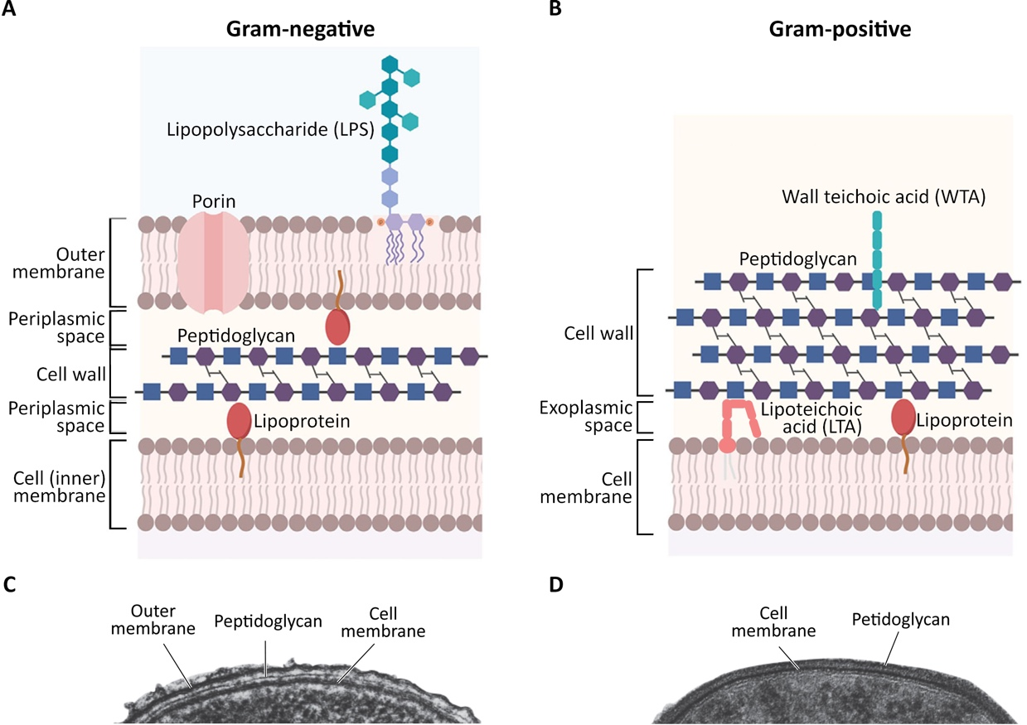
Figure 1.1 Cell envelope structure of Gram-negative and Gram-positive bacteria.
Simplified schema of the (A) Gram-negative and (B) Gram-positive bacterial envelope. Modified from Porfírio et al., (2019) ^{[21]}.(C-D) Transmission electron micrographs of a representative bacterial envelope of (C) Gram-negative and (D) Gram-positive bacteria. Obtained and modified from Madigan et al., (2019) ^{[15]}.
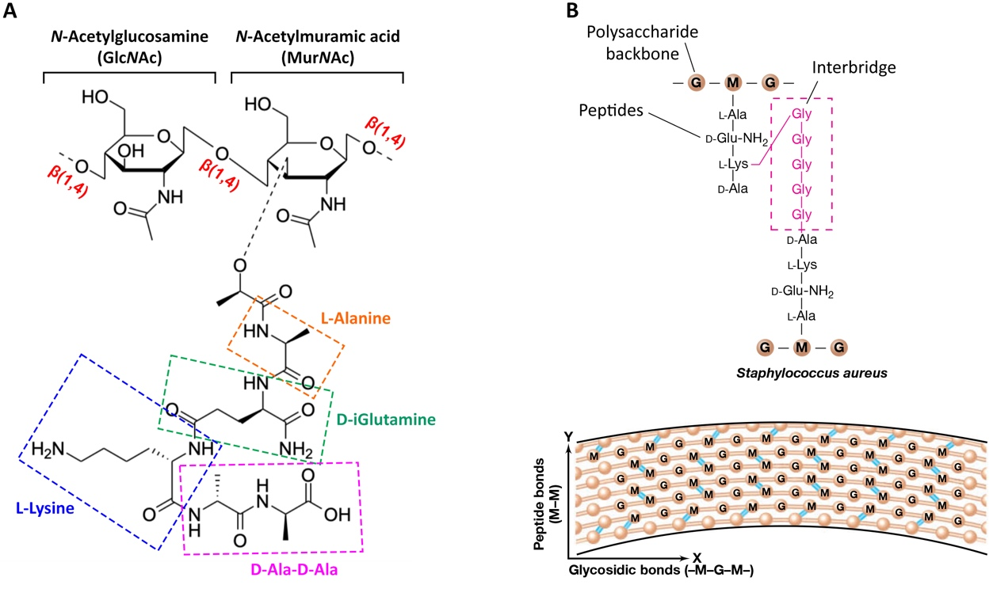
Figure 1.2 Peptidoglycan structure of S. aureus.
(A) Chemical structure of the glycan pentapeptide. (B) Diagram of the PG polymer showing the polysaccharide backbone made up of N-Acetylglucosamine (G) and N-Acetylmuramic acid (M), the peptide side chain and the penta-glycine crossbridge that connects the PG strands. Image modified from Madigan et al., (2019) ^{[15]}.

Peptidoglycan homeostasis.
PG homeostasis is of outmost importance for bacterial growth, division, cell separation and CW turnover ^{[17,22]}. Thus, bacterial viability requires a balance between PG synthesis and hydrolysis.

Peptidoglycan biosynthesis in S. aureus.
PG precursors (GlcNAc–MurNAc–L-Ala–D-iGln–L-Lys–D-Ala–D-Ala) are synthesised inside the cytoplasm (Figure 1.3). MurA and MurB are the first steps, whereby an enolpyruvyl moiety is transferred to diphosphate-GlcNAc which is thereafter converted into uridine diphosphate-MurNAc ^{[23,24]}. The following steps are the addition of the peptide side chains by MurC, MurD, MurE and MurF ^{[23,24]}. Then, MraY binds the resulting diphosphate-MurNAc-pentapeptide to undecaprenol phosphate (C₅₅-P), a hydrophobic lipid carrier, forming Lipid I. The subsequent addition of GlcNAc by MurG leads to the formation of Lipid II ^{[23,25,26]}. Lastly, FemX, FemA and FemB incorporate the pentaglycine bridge to Lipid II ^{[26,27]}.
Lipid II, together with a flippase transporter (MurJ), facilitates the translocation of the disaccharide-pentapeptide monomer across the membrane and into the cell wall (Figure 1.3) ^{[25,27]}. This newly synthesised monomer is subsequently incorporated by the action of transglycosylases into the existing glycan strands ^{[24,28]}. Finally, the cross-linking between PG strands is carried out by transpeptidase enzymes (Figure 1.3) ^{[23,24]}.

Peptidoglycan synthases of S. aureus.
Penicillin binding proteins (PBPs) are PG synthases that carry out these last stages of PG synthesis with their transglycosylase (TG) and transpeptidase (TP) activity ^{[29]}. They are categorised into high molecular mass (HMM) and low molecular mass (LMM) ^{[30]}. HMM PBPs consist of a cytoplasmic tail, a transmembrane anchor and two outer membrane domains that act at the periplasmic/exoplasmic space ^{[29,30]}. The TP activity that catalyses the cross-linking between PG strands corresponds to their C-terminal penicillin binding domain. On the other hand, the N-terminal domain varies and sub-classifies HMM PBPs into class A or class B ^{[29,30]}. The former has a TG activity that elongates uncrosslinked glycan strands, while the latter is thought to interact with other proteins involved in morphogenesis ^{[30]}. S. aureus has three HMM

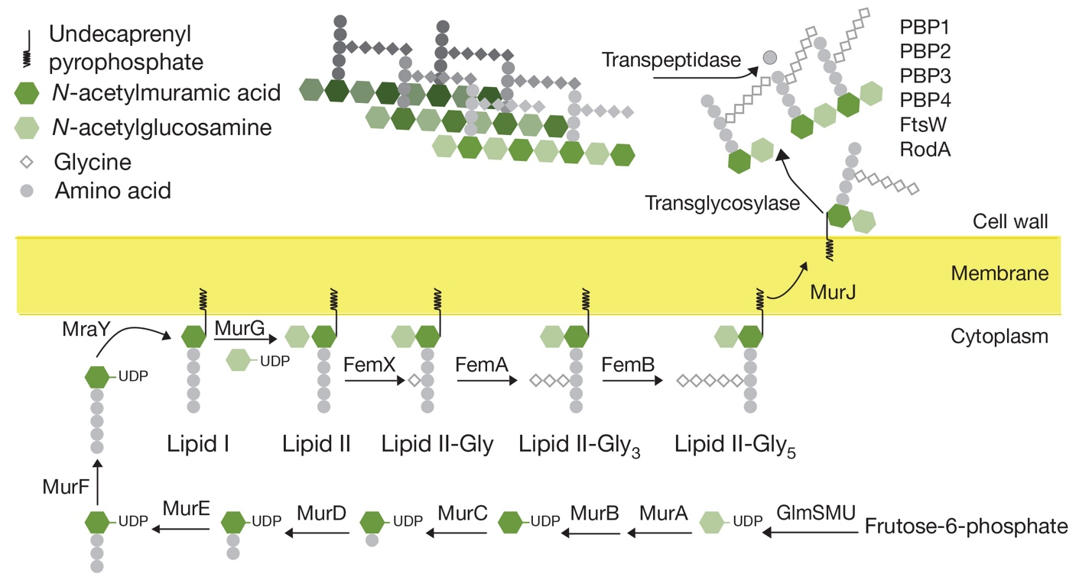
Figure 1.3 Peptidoglycan biosynthesis pathway in S. aureus.
Peptidoglycan precursor Lipid II, made up of N-acetylglucosamine (GlcNAc) and N-acetylmuramic acid (MurNAc) and a peptide side chain linked to the latter, is synthesised in the cytoplasm. Once translocated across the membrane, transglycosylases incorporate the disaccharide-pentapeptide monomer into the existing PG strands. These are finally cross-linked by transpeptidases. Obtained from Monteiro et al., (2018) ^{[31]}.
PBPs, class A PBP2 and class B PBP1 and PBP3 (Table 1.1), of which only PBP1 (TP) and PBP2 (TG/TP) are essential ^{[32,33]}. PBP1 is vital for cell division, however its TP activity is not essential ^{[34–36]}. PBP2 localises at the septum and is essential for both its TG and TP activity ^{[33,37]}. The non-essential PBP3 has an unknown N-terminus and a TP at the C-terminus, involved in PG cross-linking ^{[38]}. MRSA strains have an additional low-affinity class B PBP that confers β-lactam resistance: PBP2a ^{[39]}. PBP2a lacks TG activity, but its TP domain is able to support all the interrupted TP activity of the native PBPs in MRSA strains treated with antibiotics. Nevertheless, the TG domain of PBP2 is still required ^{[33,39,40]}, and so is the TP activity of PBP1 ^{[34,39]}.
LMM PBPs have either carboxypeptidase or endopeptidase activity, and cleave the peptide side chains of glycan strands to control their cross-linking ^{[30]}. These are also sub-categorised in various types, and sometimes referred to as class C PBPs. However, although some bacteria like E. coli have several LMM PBPs, S. aureus only has one: PBP4 (Table 1.1). This TP enzyme is involved in the high-degree crosslinking of PG in S. aureus ^{[41]}.
In addition to PBPs, two members of the SEDS (shape, elongation, division and sporulation) family of proteins have also been found to have TG activity in S. aureus ^{[36,42–44]}. RodA has been shown to interact with PBP3 and FtsW with PBP1, leading to the regulation of sidewall and septal PG incorporation respectively ^{[36]}. Absence of a RodA-PBP3 interaction results in rounder cells, while the lack of FtsW-PBP1 lead to lateral PG incorporation and subsequent cell elongation ^{[36]}. These interactions explain why S. aureus, a slightly prolate spherical bacteria, needs the balance between these two SEDS to maintain its shape ^{[36]}.
Another two non-essential monofunctional TG found in S. aureus, are SgtB (also known as Mgt) and SgtA. The former resembles the TG domains of PBP2 and becomes essential in its absence ^{[30,45,46]}. Both SgtB and SgtA interact with themselves, with each other and with PBP2 and PBP1, supporting the hypothesis that S. aureus PG synthases may act as a complex ^{[46,47]}. Finally, FmtA and FmtB are auxiliary dispensable proteins homologous to TP domains found in S. aureus and therefore have a role in CW synthesis ^{[48–50]}.
Synthase (gene) | Classification | Known activity | Description | References
PBP1  (pbp1) | HMM class B | TP | Essential for growth and division. Interacts with FtsW for septal PG incorporation. | Pereira et al., (2009) ^{[35]}
PBP2  (pbp2) | HMM class A | TG/TP | Essential for division | Pinho et al., (2001) ^{[33]}
PBP3  (pbp3) | HMM class B | TP | Interacts with RodA for off septal PG incorporation | Reichmann et al., (2019) ^{[36]}
PBP4  (pbp4) | LMM | TP | Required for high levels of PG cross-linking | Wyke et al., (1981) ^{[41]}
PBP2a  (mecA) | HMM class B | TP | Non-native PBP required for PG synthesis. Provides β-lactam resistance | Pinho et al., (2001) ^{[40]}
Table 1.1 List of Staphylococcus aureus PBPs.
PBPs found in S. aureus, with transglycosylase (TG) and/or transpeptidase (TP) activity. Modified from Panchal (2018) ^{[51]} and Sutton (2020) ^{[52]}.

Peptidoglycan hydrolases of S. aureus.
In order to make space for newly synthesised PG, autolysins carry out a controlled hydrolysis of pre-existing PG by breaking its bonds. PG hydrolases (PGH) can be divided into amidases (PGAs), glycosidases (PGGs) and peptidases (PGPs) ^{[22,44]}. PGAs hydrolyse the amide bond between MurNAc–L-alanine; PGPs cleave the amide bond between amino acids of the peptide side chain; while PGGs hydrolyse the glycosidic bond between MurNAc and GlucNAc (Figure 1.4) ^{[22,44]}. PGPs can be classified as carboxypeptidases and endopeptidases, with the former attacking the peptide side chain terminus and the latter the crossbridge ^{[22,44]}. PGGs can further be categorised into N-acetylglucosaminidases, N-acetylmuramidases and lytic transglycosylases, which are responsible for cleaving the β1,4-glycosidic bonds that bind MurNAc and GlucNAc ^{[22,44]}.
Given the importance and complexity of PGH, it is not surprising that there is a high level of redundancy in function. At present there are nineteen putative PGH in S. aureus (Table 1.2). Atl, SagA, ScaH and SagB have been identified as four major PGH involved in cell growth ^{[53]}.
Atl, also known as AtlA in S. aureus, is a major bifunctional PGH composed of an N-terminal domain with amidase activity (AmiA) and a C-terminal domain with glucosaminidase activity (GlcA) ^{[54–56]}. Studies with atl mutants show that it is involved in biofilm formation and cell separation ^{[53,54,57]}. Cells lacking this major PGH present a fuzzy surface appearance and are seen in big cell clusters, consistent with the release of PG at the cell surface and Atl’s role in cell separation respectively ^{[54,57]}. Despite these extreme morphological faults, cell growth is not affected and it is believed that Aaa, another PGH, could be compensating for the lack of Atl to some extent ^{[57,58]}. As expected for their role in cell separation, Atl is located at the equatorial ring of the division site, and it has been hypothesised that this location might be dictated by the lack of wall teichoic acids (WTA) ^{[59,60]}. However, further studies have shown that the absence of WTA at the septal plate might have been the result of the labelling lectin being unable to access the site ^{[61]}. Nevertheless, Atl is delocalised in WTA lacking strains ^{[59,61]}. Later studies have also shown its ability to bind to both lipoteichoic acids (LTA) and PG, with the former allowing this enzyme to rebind and change conformation to facilitate PG cleavage ^{[62]}. This coincides with LTA being involved in regulating autolysin levels ^{[63]}.
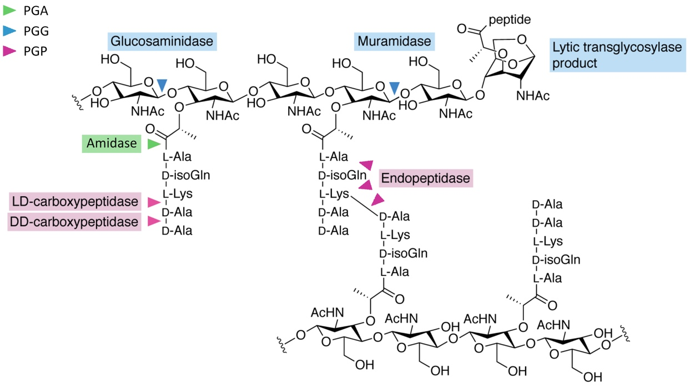
Figure 1.4 Cleavage sites for peptidoglycan hydrolases (PGH).
PGH can be categorised as amidases (PGA– green), glycosidases (PGG– blue) and peptidases (PGP– pink). PGA hydrolyse the bond between the L-Ala and MurNAc. PGG cleave the glycosidic bond between MurNAc and GlcNAc. PGP cleave the peptide crosslinks and side chain. Figure modified from Do et al., (2020) ^{[44]}
Name | Hydrolase activity | References
Atl | Amidase (PGA), glucosaminidase (PGG) | Foster (1995) ^{[54]}, Wheeler et al., (2015) ^{[53]}, Oshid et al., (1995) ^{[55]}
SagA | Glucosaminidase (PGG) | Wheeler et al., (2015) ^{[53]} Chan et al., (2016) ^{[64]}
SagB | Glucosaminidase (PGG) | Wheeler et al., (2015) ^{[53]}, Chan et al., (2016) ^{[64]}
ScaA/Sle1/Aaa | Amidase (PGA), CHAP domain (PGP) | Heilmann et al., (2005) ^{[58]}, Pourmand et al., (2006) ^{[65]}
ScaB | CHAP domain (PGP) | Pourmand et al., (2006) ^{[65]}
ScaC | CHAP domain (PGP) | Pourmand et al., (2006) ^{[65]}
ScaD | CHAP domain (PGP) | Pourmand et al., (2006) ^{[65]}
ScaE | CHAP domain, LysM domain (PGP) | Pourmand et al., (2006) ^{[65]}
ScaF | CHAP domain (PGP) | Pourmand et al., (2006) ^{[65]}
ScaG | CHAP domain (PGP) | Pourmand et al., (2006) ^{[65]}
ScaH | Glucosaminidase (PGG), CHAP domain (PGP) | Wheeler et al., (2015) ^{[53]}, Pourmand et al., (2006) ^{[65]}
ScaI | Unknown | Pourmand et al., (2006) ^{[65]}
ScaJ | CHAP domain (PGP) | Pourmand et al., (2006) ^{[65]}
IsaA | Lytic transglycosylase (LTG) (PGG) | Stapleton et al., (2007) ^{[66]}
LytM | Lysostaphin (PGP) | Lioliou et al., (2016) ^{[67]},
LytN | Amidase (PGA), endopeptidase (PGP) | Sugai et al., (1998) ^{[68]}
SceD | Lytic transglycosylase (LTG) (PGG) | Stapleton et al., (2007) ^{[66]}
SA0191 | Lysostaphin (PGP) | Wheeler, (2012) ^{[69]}
LytH | Amidase (PGA) | Do et al., (2020) ^{[70]}, Wheeler, (2012) ^{[69]}
SA2195 | Lysostaphin (PGP) | Wheeler, (2012) ^{[69]}
SA1687 | Amidase (PGA) | Wheeler, (2012) ^{[69]}
Table 1.2 List of known Staphylococcus aureus hydrolases.
Modified from Wheeler et al., (2015).
S. aureus glucosaminidase B, better known as SagB, is the second major PGH in this species ^{[53]}. The lack of SagB is manifested by very long strands of PG and increased cell surface stiffness, that cause both growth and morphological defects ^{[53]}. It has also been suggested that SagB might play an important role in the cell size increase associated with methicillin treatment ^{[71]}. This correlates with glycan strand length and number of crosslinks affecting the CW stiffness and the ability to grow or increase in size ^{[53]}. SagB is localised in a punctate pattern across the cell surface, and, similarly to Atl, its localisation seems to be dependent on WTA ^{[61]}.
PGH are highly regulated and an essential controlling mechanism in S. aureus is WalKR. Also known as YycFG ^{[72,73]}, WalKR is a two-component signal transduction system (TCS) which regulates nine putative PGH: ScaB, ScaC, ScaD (SsaA), ScaE, ScaJ, SceD, Atl, IsaA, and LytM (Table 1.2) ^{[74,75]}. Originally described in B. subtilis, this TCS has been shown to be essential for CW homoeostasis, and in some species also for membrane and exopolysaccharide synthesis, division and oxidative stress ^{[76]}. S. aureus walKR is a 5-cistron operon consisting of walR, walK, yycH, yycI, and yycJ. WalK is a membrane-bound histidine kinase, WalR is its response regulator, and the remaining genes code for three accessory proteins ^{[76]}. Activated WalK leads to phosphorylation of the WalR response regulator, which thereafter binds to the promoters and positively regulates the expression of multiple autolysins ^{[75,77]}. WalKR-lacking cells have diminished hydrolase activity and present a number of growth defects that include thicker cell walls, division aberrations, cell aggregates and an increased resistance to cell lysis ^{[75,78]}. WalKR has proven to be involved in both PG synthesis and degradation ^{[75]}.

Teichoic acids.
Another key component of the Gram-positive bacterial envelope are teichoic acids (TA). These anionic glycopolymers are classified into wall teichoic acids (WTA) or lipoteichoic acids (LTA). The former are covalently bound to the CW, while the latter are anchored to the plasma membrane and extend into the exoplasm (Figure 1.5a) ^{[14,79,80]}. WTA can be categorised into four structural groups depending, on the composition of the main chain, and LTA into five types (Figure 1.6) ^{[81–83]}. S. aureus has type I WTA and type I LTA, comprised of subunits of poly glycerol phosphate (Gro-P) and/or ribitol phosphate (Rbo-P) decorated with alanine and carbohydrate residues (Figure 1.5b) ^{[79,80,83,84]}.
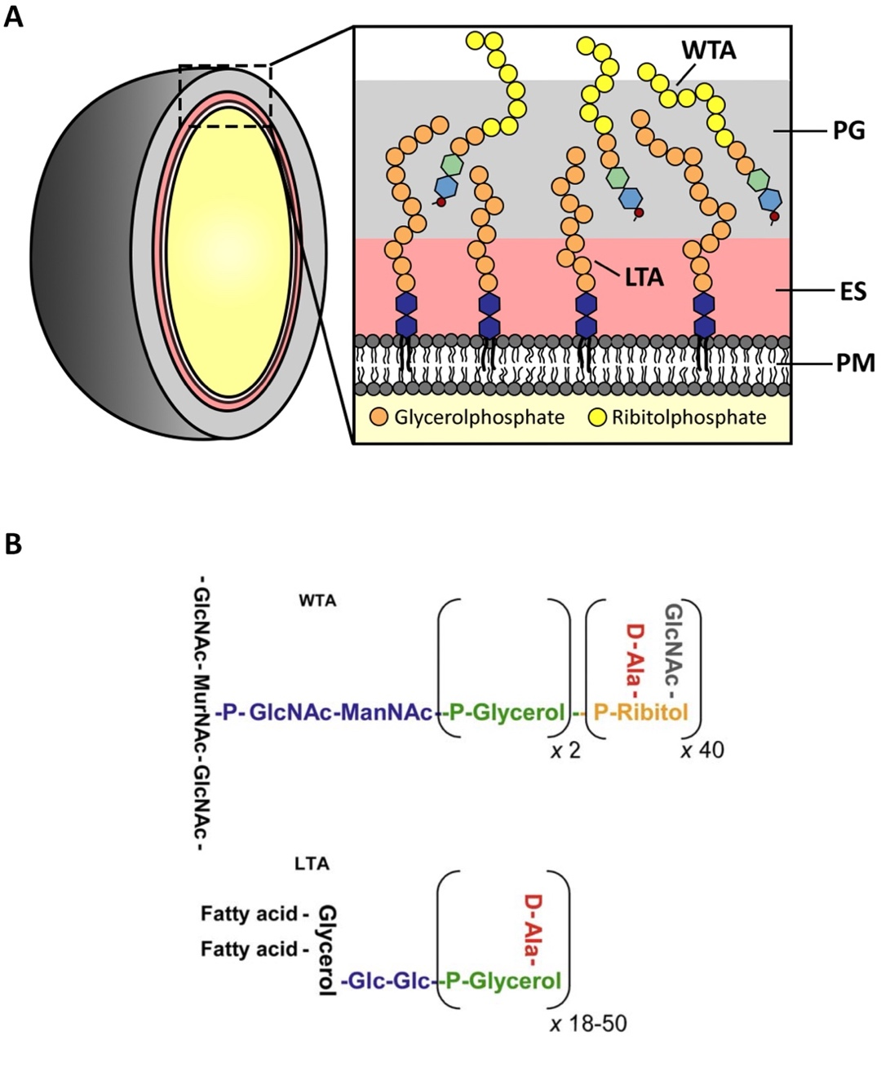
Figure 1.5 Localisation and structure of teichoic acids in S. aureus.
(A) Schematic representation of the localisation of lipoteichoic acids (LTA) and wall teichoic acids (WTA). Modified from van der Es et al., (2017) ^{[80]}. (B) Simplified structure of WTA (top) and LTA (bottom) of S. aureus. P-Ribitol– ribitolphosphate, P-Glycerol– glycerolphosphate, ManNAc– N-acetylmannosamine, GlcNAc– N-acetylglucosamine, MurNAc– N-acetylmuramic acid, Glc– glucosyl, D-Ala– D-Alanine. Obtained from Xia et al., (2010) ^{[79]}.

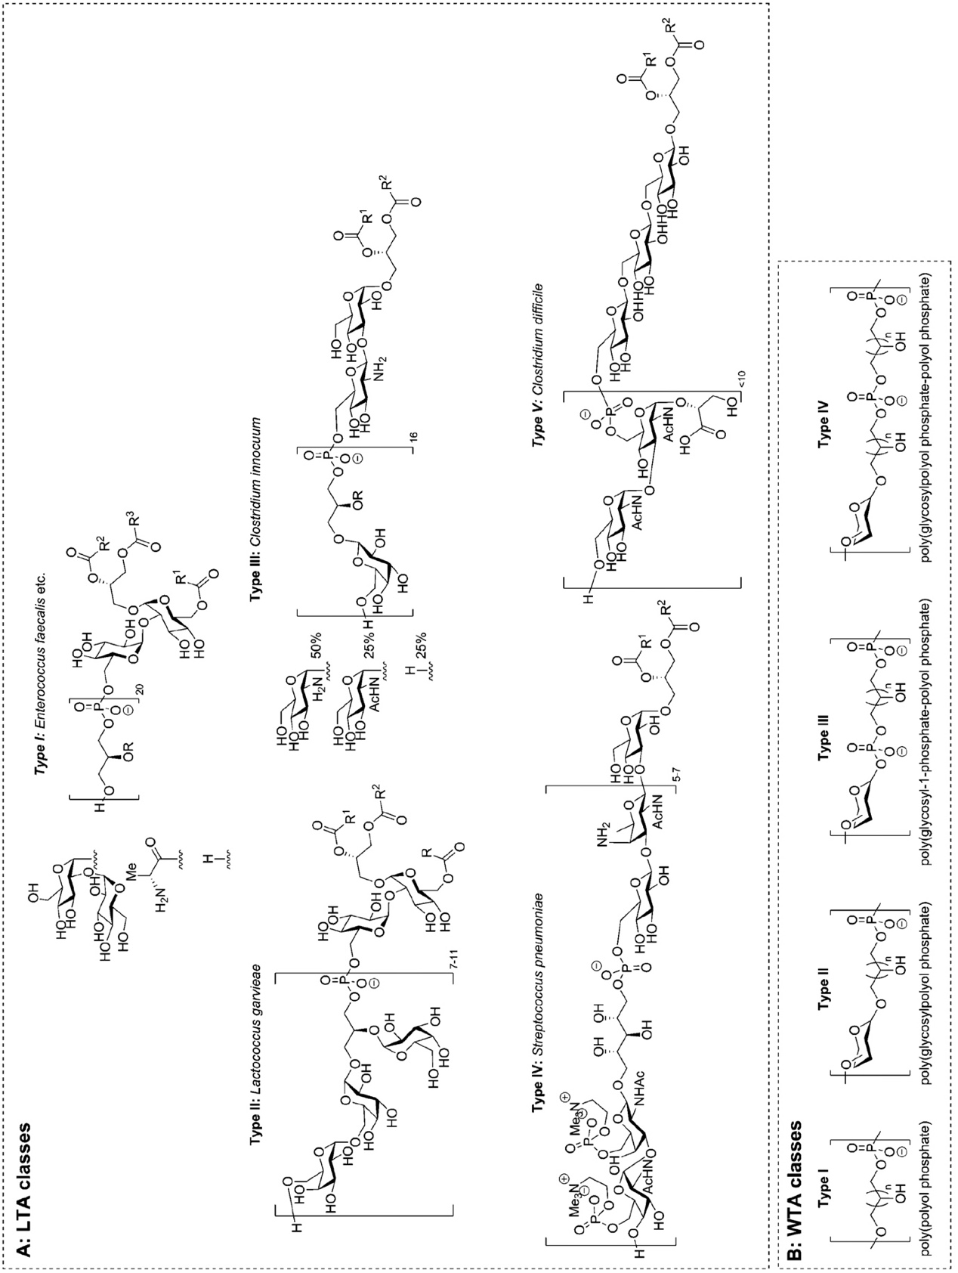
Figure 1.6 Classification of teichoic acids.
(A) Proposed classes of lipoteichoic acids (LTA), according to Fischer ^{[82]}. (B) Wall teichoic acids (WTA) classification proposed by Stackebrandt ^{[83]}. S. aureus has type I WTA and LTA. Obtained from van der Es et al., (2017) ^{[80]} .
TA are required for various cellular processes such as regulation of ion homeostasis, cell division, protection, receptor interaction and biofilm formation (Table 1.3) ^{[79,80,85,89,90]}.They can modify the CW morphology and therefore provide protection against antimicrobial agents. This occurs by modifying the rigidity and porosity of the CW, thus regulating the passage of metal cations, nutrients, proteins and antibiotics. Additionally, TA act as receptors for bacteriophages and mediate interaction and attachment to biomaterials (i.e., epithelial or endothelial cells and biofilm formation) (Table 1.3) ^{[79,80,85,86,89]}.
D-alanylation, addition of protonated D-alanine ester residues covalently bound to TA, provides counter ions to the negatively charged phosphate groups. Thus, modifying the surface charge of TA and affecting the binding capabilities of TA to external molecules, like divalent cations ^{[85,86]}. For example, various studies have shown a negative correlation between the D-alanine ester content and the binding capability of the CW to Mg^{2+ [85,87]}. D-alanylation has also been shown to be affected by pH, whereby lower pH levels lead to an increase in D-alanine ester substituents and, thereafter, less binding to Mg^{2+ [85,87]}. Divalent cation binding to both TA and to PG, is important for cell defence and ion homeostasis ^{[85,86,88]}.
While mutants lacking either WTA or LTA have been achieved, a deletion mutant lacking all TA is non-viable ^{[79,91,92]}.

Wall teichoic acid biosynthesis in S. aureus.
Some Staphylococcus species have WTA made of repeating units of Gro-P, however, S. aureus type I WTA is made up of ~ 40 repeating Rbo-P and/or Gro-P, depending on the strain ^{[93–95]}. WTA is linked to PG through 2 subunits of Gro-P followed by a disaccharide, acetylmannosamine (ManNAc) and GlcNAc-1-P. The latter covalently binds to the 6-hydroxyl group of every ninth PG MurNAc (Figure 1.5b) ^{[79,86,96–98]}. In addition to D-alanylation, WTA can be modified with mono or oligosaccharides such as glucose or GlcNAc ^{[86]}.

Function | TA | References
Regulation of ion homeostasis
Creation of localised pH changes | WT | Brown et al., (2013)^{[86]}
Prevention of osmotic pressure fluctuations | WT, LTA | Brown et al., (2013)^{[86]}, Oku et al. (2009) ^{[91]}, Gründling & Schneewind (2007)^{[99]}, Corrigan et al., (2011) ^{[63]}
Protection against cell damage
Resistance to antimicrobial peptides (CAMPs) | D-ala of TA | Peschel et al., (1999)^{[100]}; Collins et al., (2002)^{[101]}; Koprivnjak et al., (2002)^{[102]}; Weidenmaier et ai., (2005)^{[103]}
Resistance to cationic antibiotics (e.g., vancomycin) | D-ala of TA | Peschel et al., (2000)^{[104]}
Resistance to lysozyme | WTA | Bera et al., (2007)^{[105]}
Resistance to antimicrobial fatty acids | WTA | Kohler et al., (2009)^{[106]}
Resistance to heat stress | WTA, LTA | Hoover & Grey (1977)^{[107]}; Vergara et al., (2008)^{[108]}; Oku et al., (2009)^{[91]}
Resistance to low osmolarity | LTA | Oku et al., (2009)^{[91]}
Controlling protein machineries in the cell envelope
Cell division site placement Autolysin | LTA | Oku et al., (2009)^{[91]}; Gründling & Schneewind (2007)^{[99]}
Autolysin activity | WTA, LTA | Vergara et al., (2008)^{[108]}; Bierbaum & Sahl (1985)^{[109]}; Fedtke et al., (2007)^{[110]}; Qamar & Golemi-Kotran (2012)^{[111]}
Peptidoglycan machinery | WTA | Brown et al., (2013)^{[86]}; Qamar & Golemi-Kotran (2012)^{[111]}
Mediating interaction with receptors and biomaterials adherence
Adherence to epithelial and endothelial cells; | WTA | Weidenmaier et al., (2005)^{[103]}, (2004)^{[112]}, (2008)^{[113]}
Binding to scavenger receptors (SrA, SREC-1) | LTA, WTA | Greenberg et al., (1996)^{[114]}; Dunne et al., (1994)^{[115]}; Baur et al., (2014)^{[116]}
Activation of the complement system via MBL and ficolin | LTA | Polotsky et al., (1996)^{[117]}; Lynch et al., (2004)^{[118]}; Nahid & Sugii (2006)^{[119]} ; Park et al., (2010)^{[120]}
Induction of inflammation via TLR2, CD36, CD14, LBP | LTA | Morath (2001)^{[121]}, Morath et al., (2002)^{[122]}; Hermann et al., (2002)^{[123]}; Hoebe et al., (2005)^{[124]}; Draing et al., (2008)^{[125]}
Adherence to C-type lectin receptors (CLRs) langerin (CD207) and macrophage galactose‐type lectin (MGL, CD301) | WTA | van Dalen et al., (2019)^{[126]}; Mnich et al., (2019)^{[127]}
Serving as phage receptor | WTA | Chatterjee (1969)^{[128]}; Park et al., (1974)^{[129]}; Chapot-Chartier (2014)^{[130]}
Mediating attachment to biomaterials and biofilm formation TA | LTA, WTA | Febretti et al., (2006)^{[90]}; Vergara et al., (2008)^{[108]}; Fedtke et al., (2007)^{[110]}; Qamar & Golemi-Kotran (2012)^{[111]}; Gross et al., (2001)^{[131]}
Table 1.3 Proposed function of S. aureus teichoic acids.

Table 1.3 Proposed function of S. aureus teichoic acids.
Proposed function of teichoic acids (TA) in S. aureus. WTA- wall teichoic acids. LTA– lipoteichoic acids. Modified from Xia et al., (2010) ^{[79]} and van der Es et al., (2017) ^{[80]}.
S. aureus WTA biosynthesis occurs mostly in the cytoplasm and is carried out by the Tar proteins (Figure 1.7b). The linkage unit β-ManNAc-(1,4)-α-GlcNAc-1-P is synthesised by TarO and TarA, adding the GlcNAc and ManNAc, respectively, to a lipid carrier (undecaprenyl phosphate). This lipid transporter is shared with the PG biosynthesis pathway. Subsequently, TarB and TarF transfer the two glycerol phosphate moieties and TarL assemblies the poly-Gro-P or Rbo-P from CDP-ribitol. ^{[80,86,132,133]}.
Glycosylation of WTA occur via TarM and TarS, whereby GlcNAc residues are added ^{[80,134,135]}. This decorated polymer is then transported across the PM by TarG and TarH, a hetero-tetrameric complex. Finally, it is transferred from the lipid carrier and ligated to the MurNAc of uncrosslinked PG, by the LytR-CpsA-Psr (LCP) enzymes ^{[86,136–140]}.
D-alanylation is the last step of WTA modification, and although not fully comprehended, it is believed to be carried out by the DltABCD proteins and that D-alanyl is transferred from LTA to WTA (more on this in section 1.5.2) ^{[80,100,141]}.
A paradox over the essentiality of the biosynthetic pathway of WTA was discussed in the late 2000s. Weidenmaier et al., (2004) showed that WTA are not essential in S. aureus, as inactivation of the tarO gene had a similar growth to the wild type at 30 °C and reduced growth at 37 °C ^{[142]}. Later, D’Elia et al., (2006) confirmed these results and showed that while the WTA-depleted tarO mutant was viable, any deletion on the late-acting genes tarB, tarD, tarF, tarIJ and tarH were impossible ^{[143]}. Interestingly, these late-acting gene deletions became dispensable in a tarO mutant ^{[143]}. The reason behind this enigma lies on the lipid carrier shared between the biosynthesis pathway of PG and WTA ^{[133]}. When tarO is inactivated, undecaprenol is free to be used in PG biosynthesis. However, when tarO is active but the following steps of WTA synthesis are interrupted, this lipid transported remains sequestered by TarO and cannot therefore be recycled for use in the PG biosynthesis pathway ^{[133,143,144]}.
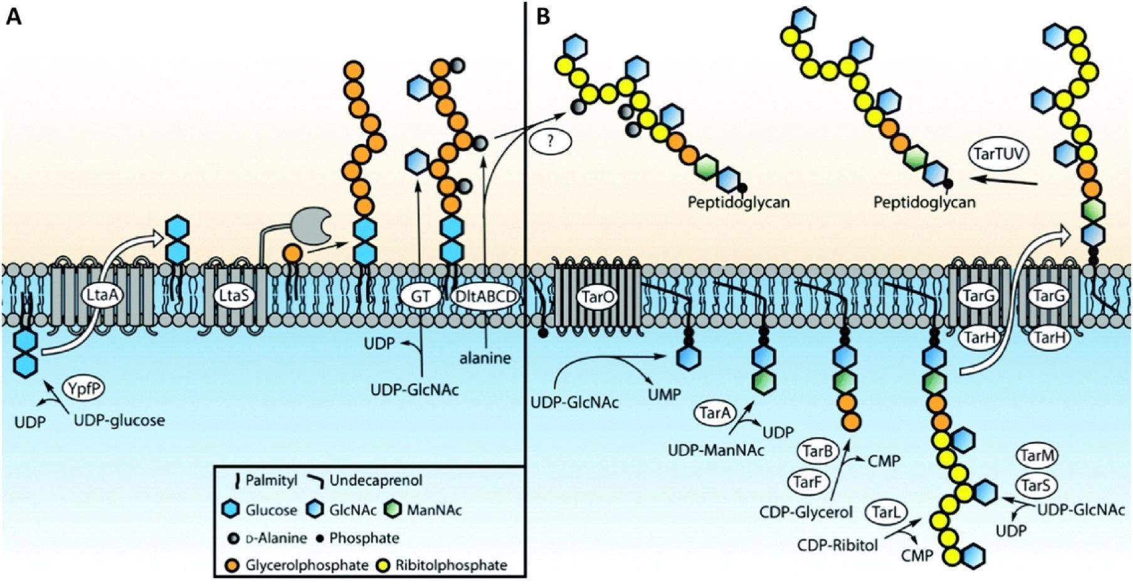
Figure 1.7 Biosynthesis pathways of teichoic acids in S. aureus
Biosynthesis pathway for (A) lipoteichoic acids (LTA) and (B) wall teichoic acids (WTA) in S. aureus. Obtained from van der Es et al., (2017) ^{[80]}.

Lipoteichoic acid biosynthesis in S. aureus.
S. aureus has type I LTA often made up of ~ 25 repeating units of poly glycerol phosphate (Gro-P), with D-alanine ester or α-GlcNAc substitutions at the 2-hydroxyl group of glycerol ^{[79,145,146]}. LTA attaches to the PM through a glycolipid anchor consisting of diglucosyl diacylglycerol (Glc₂-DAG) (Figure 1.5b) ^{[145,147]}.
Biosynthesis of LTA in S. aureus (Figure 1.7a) commences at the cytoplasm with glycosyltransferase YpfP generating the glycolipid anchor from UDP-glucose. The flippase LtaA then transfers the Glc₂-DAG into the exoplasmic space. The Gro-P chain is then extended by the LTA synthase, LtaS. This membrane-bound polymerase has five transmembrane domains and a soluble extracellular catalytic domain with a type I peptidase (SpsB). The latter hydrolyses phosphatidylglycerol to obtain Gro-P, and releasing DAG, which is later recycled in the cytoplasm back into phosphatidylglycerol. The Gro-P used in LTA biosynthesis differs from the stereochemistry of the Gro-P used in WTA. ^{[80,84,99,141,148]}
D-alanylation of LTA is carried out by enzymes DltA, B, C and D, encoded by the dltABCD operon^{[84,85,149]}. The Fischer model, supported by later studies, proposes that DltA activates D-ala at the cytoplasm, using ATP. The resulting D-alanyl-AMP is carried by DltC and transferred onto undecaprenyl phosphate (C55-P). Then, DltB transports the D-ala across the PM into the exoplasmic space, where finally DltD aids the addition of this residue onto LTA. ^{[84,85,150–152]}
Glycosylation of LTA occurs in some type I LTA, with some S. aureus strain having incorporation of GlcNAc ^{[84,153]}. Although the enzymes involved have not been identified yet, it is proposed that it requires two separate glycosyltransferases, one that forms the sugar-C55-P intermediate in the cytoplasm and another that links it to LTA ^{[84,151]}.
Interruption of the LTA biosynthetic pathway by inactivation of ltaS leads to growth arrest, reduced PG cross-linking (~ 30 %), difficulty coping with cell wall stresses, division aberrations (numerous and misplaced septa), and morphological defects such as thickened CW, increased cell size and cell clumping ^{[91,99,154]}. LTA-depleted S. aureus strains can only survive when either grown under osmotically stabilising conditions (high NaCl or sucrose concentrations), lower temperatures, or after acquiring compensatory mutations ^{[63,84,91,99]}.
Corrigan et al., (2011) has shown that one suppressor mutation capable of rescuing LTA-depleted cells is gdpP ^{[63]}. GdpP is a membrane phosphodiesterase that hydrolyses the essential signalling molecule c-di-AMP into 5’-phosphadenylyl-adenosine (5’-pApA) (Figure 1.8a) ^{[63]}. This cyclic dinucleotide is found in the S. aureus cytoplasm and synthesised by the essential membrane diadenylate cyclase DacA from 2 ATP molecules (Figure 1.8a) ^{[63,155]}. Inactivation of gdpP leads to an ~ 10-fold increase in the intracellular levels of c-di-AMP, reduced bacterial cell size, increased PG cross-linking and decreased susceptibility to β-lactam antibiotics ^{[63,155–157]}. Additionally, it rescues ltaS-depleted strains by restoring parental bacterial growth, size, and morphology (Figure 1.8b) ^{[63]}. C-di-AMP has also been shown to enable growth in low potassium (K⁺) conditions as it binds to the potassium transporter-gating component KtrA ^{[158]}. This second messenger also binds to CpaA, a predicted proton/cation antiporter, and to two more additional c-di-AMP proteins: PstA and the histidine kinase KdpD involved in potassium transport ^{[158]}. These discoveries showed the importance of c-di-AMP in ion transport in S. aureus, and thus how increased levels due to inactivation of gdpP compensate for the disruption in ion homoeostasis caused by LTA depletion.
The following additional compensatory mutations have also been found to bypass the requirement for LTA: clpX, sgtB, and mazE ^{[154,159]}. ClpX is a highly conserved chaperone involved in protein degradation, and its inactivation allows S. aureus to grow without LTA ^{[159]}. Unlike GdpP, ClpX compensates for the absence of LTA by a c-di-AMP independent pathway most likely associated with cell division ^{[159]}.
LTA-lacking S. aureus strains have also shown to survive with a mutation in sgtB ^{[154]}. SgtB is a dispensable monofunctional transglycosylase that can support bacterial growth in the absence of the essential PBP2 ^{[46]}. Similarly to the above described mutation, the sgtB transposon mutant showed a 4-fold increase in the MIC for oxacillin, suggesting that alterations in the PG structure could be involved in compensating the absence of LTA ^{[154]}. This was further confirmed by showing that double ltaS sgtB mutants rescued the levels of PG cross-linking, which might indicate that LTA compensation occurs by strengthening the CW to withstand the high internal turgor pressure ^{[154]}.
MazE, as part of the MazEF type II toxin-antitoxin system, is involved in the full activity of the alternative sigma factor SigB (σ^{B}) ^{[160]}. Over expression of this factor results in a 20 % thicker CW and increased resistance to CW antibiotic ^{[161]}. Inactivation of mazE leads to viable ltaS mutant

Figure 1.8 GdpP involvement in c-di-AMP degradation and LTA-depletion compensation.
(A) c-di-AMP (dark blue circles) is synthesised by DacA (grey) from two ATP molecules (pale blue circles). GdpP (red) hydrolyses c-di-AMP into 5’-pApA (purple circles). (B) LTA-depleted cells surviving with a suppressor mutation in gdpP, lead to an increase in intracellular levels of c-di-AMP. It is suggested that these later bind to other target proteins (bright orange) and affect their activity or the expression of additional proteins. Yellow– cell wall, Peach– lipoteichoic acids (LTA), Green– cytoplasm. Obtained from Corrigan et al., (2011) ^{[63]}.
strains, and its compensatory mechanism could involve the CW homeostasis as a result of its effect on σ^{B} ^{[154]}.

The exoplasmic space of Gram-positives.
Gram-positives have a single phospholipid bilayer which is of great importance, as it is where a lot of bacterial functions are carried out ^{[14]}. As described above, some key membrane-associated processes include energy production, lipid biosynthesis, PG biosynthesis, and teichoic acids biosynthesis. Later stages of these processes are carried out on the outside, in the region between the membrane and the CW. The periplasmic space of Gram-negative bacteria has been thoroughly described ^{[14,162]}. However, it was only when Matias & Beveridge analysed vitreous thin-sections from samples of B. subtilis and S. aureus by cryo electron microscopy (cryo-EM) that the equivalent space in Gram-positives was described ^{[16,163,164]}.
The space between the PM and the CW has been referred to by Matias & Beveridge as the periplasmic space of Gram-positives ^{[16]}. However, as previously explained, with the absence of an outer membrane this space should more appropriately be called the exoplasmic space (ES). Thus, it will be referred to in this study as the exoplasmic space, and its contents as the exoplasm.
The exoplasmic space is a ~ 16 nm thick “aqueous compartment” filled with a low-density substance ^{[16,164,165]}. The exoplasm is made up mostly of exoplasmic proteins, including hydrolytic enzymes and synthetases, and LTA ^{[16,163,166]}.

Maintenance of the exoplasmic space.
S. aureus is able to withstand high internal turgor pressure of ~ 20 – 30 atm because of its major stress-bearing polymer, PG ^{[16]}. This high cellular pressure means that the ES is maintained by being in an isosmotic condition to the cytoplasm.
Recent studies have proposed that LTA and WTA could be responsible for the maintenance of the ES ^{[16,88,91,99,166]}. Some propose that LTA and other membrane-bound polymers could play this role in a similar way to the osmo-regulated periplasmic glucans (OPGs) found in Gram-negative bacteria ^{[16,88,91,166]}. OPGs are negatively charged anionic glucose oligomers that are just too big to escape the OM-CW barrier, and thus stay trapped in the periplasmic space ^{[88,166–170]}. Their synthesis can be regulated according to any osmotic changes in the medium, and together with neutralising cations, help maintain the periplasmic space ^{[88,167,169]}. Studies showing that LTA-depleted strains are only able to survive in high osmolarity medium, suggested that LTA play an equivalent role in Gram-positives ^{[63,91,99]}. More precisely, neutralising cations like Mg⁺² and the positively charged amino groups from the D-alanine ester residues bound to LTA could be involved in maintaining the ES.
Another alternative theory involves the anionic electrostatic repulsion between WTA and LTA, generating a balance between the cellular turgor pressure and the forces resulting from the WTA-LTA interaction ^{[166]}.

Antibiotics.
CW homeostasis is essential for bacterial viability and it requires a continued turnover of PG ^{[17,22]}. Thus, the balance between PG synthases and hydrolases consequently plays a main role throughout the cell cycle ^{[53]} and is therefore the main target of CW antibiotics.
Antibiotics are produced naturally by mostly bacteria and fungi, and they can inhibit growth or kill bacteria ^{[15]}. The former, known as bacteriostatic antibiotics, usually target major molecular processes like DNA replication, RNA synthesis and translation ^{[15]}. An example of a bacteriostatic antibiotic is cerulenin, an inhibitor of fatty acid synthetase discovered by Hata et al. in 1960 as an antifungal antibiotic ^{[171–173]}. Later studies have shown that it not only inhibits fatty acid synthesis, but also other related processes like sterol synthesis and protein acylation, to name a few, by blocking the activity of β-ketoacyl acyl carrier proteins (ACP) synthetases ^{[174]}.
Bactericidal antibiotics kill bacteria by often targeting bacterial CW synthesis ^{[15]}. An example is moenomycin, a phosphoglycolipid CW antibiotic that inhibits transglycosylases (TGs) PBP2 and SgtB in S. aureus (Figure 1.9d-e) ^{[175]}. Moenomycin is able to mimic lipid II and is an analogous substrate that binds to the active site of PBPs ^{[176–178]}. However, the best-known bactericidal antibiotics are β-lactams (penicillin, methicillin) and glycopeptides (vancomycin), described below.
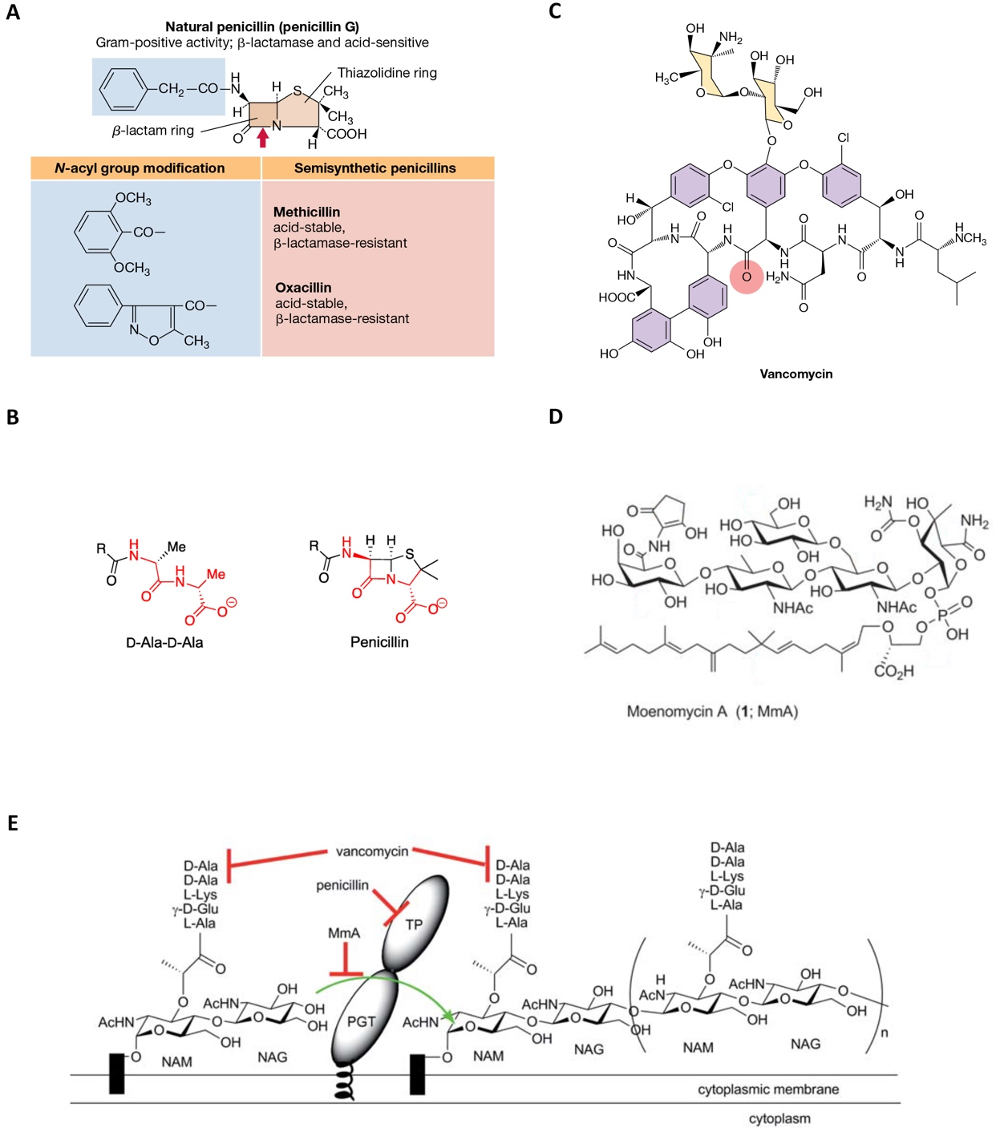
Figure 1.9 Structure and targets of CW antibiotics.
(A) Chemical structure of penicillin, methicillin and oxacillin, showing the shared β-lactam ring (blue). (B) Similarity between penicillin and the D-Ala-D-Ala of the PG tetrapeptide. (C) Chemical structure of vancomycin. (D) Chemical structure of moenomycin. (E) Last extracellular steps of PG biosynthesis and target site for vancomycin, penicillin and moenomycin (MmA). Figure modified from Fisher and Mobashery (2021), Madigan et al., (2019), Ostash and Walker (2010).

β-lactam antibiotics.
β-lactams are bactericidal antibiotics characterised by a β-lactam ring (Figure 1.9a).This group of antibiotics originates from the discovery of penicillin by Alexander Fleming in 1928, however, it was not until 1965 that penicillin’s target was first identified ^{[180–182]}. With penicillin structurally resembling the D-ala-D-ala terminal group of the PG pentapeptide (Figure 1.9b), it was suggested to act as an alternative target for the transpeptidase responsible for PG cross-linking (penicillin binding protein – PBP) (Figure 1.9e). Penicillin was therefore found to inhibit PG cross-linking ^{[181,182]}.
Penicillin-resistant strains were reported in the 1940s shortly after its introduction ^{[9,10]}. The mechanisms of resistance involved the enzyme β-lactamase, encoded by the gene blaZ, able to degrade the antibiotic by cleaving the β-lactam ring of penicillin ^{[11,39,183,184]}. To tackle this problem, penicillin derivatives were synthesised and in 1959 methicillin was introduced.
Methicillin has the phenol group of penicillin disubstituted with methoxy groups (Figure 1.9a). This seemingly small difference between these two antibiotics meant that methicillin had a lower affinity for β-lactamase ^{[7]}. Unfortunately, in a similar fashion to penicillin, methicillin-resistant S. aureus (MRSA) were soon after reported in 1961 ^{[185–187]}. MRSA are not only resistant to methicillin, but to all β-lactam antibiotics due to an acquired gene: mecA ^{[188–191]}.
The acquisition of the mecA gene, through a DNA cassette that inserts into the chromosome (staphylococcal cassette chromosome mec – SCCmec), leads to resistance to β-lactam antibiotics ^{[188,192]}. This gene encodes for PBP2a (described in section 1.4.2) which has low affinity to β-lactam antibiotics ^{[39,192]}. PBP2a, initially described as PBP2’, is a monofunctional transpeptidase (TP) able to bypass these antibiotics and continue the cross-linking of PG while all other native PBPs cannot. However, as it lacks a transglycosylase (TG) domain, it still requires the TG activity of PBP2 ^{[33,39,40]}. The action of PBP2a results in viable bacteria with a less cross-linked PG ^{[193]}.

Glycopeptide antibiotics.
Vancomycin was the first identified glycopeptide CW antibiotic (Figure 1.9c), discovered by Eli Lilly and Company in 1956. However, this bactericidal antibiotic did not gain its popularity until after 1970, upon beginning to be used clinically to treat MRSA ^{[194]}. It binds to the D-Ala-D-Ala terminus of the PG pentapeptide of lipid II and of nascent PG (Figure 1.9e), inhibiting the incorporation of GlcNAc–MurNac into the CW, thus disrupting PG synthesis ^{[178,195–198]}. More recently, additional target interactions have been uncovered; these include binding to the autolysin Atl and the bifunctional PBP2 ^{[199,200]}. With PG and WTA biosynthesis both sharing the lipid transporter bactoprenol and both requiring D-Ala ^{[133]}, Singh et al., (2017) ^{[201]} studied the relationship between glycopeptide antibiotics and WTA. They have shown that the binding of vancomycin to lipid II, leads to bactoprenol being unavailable for recycling into both the PG and WTA biosynthetic pathways. Their study also suggests that S. aureus subsequently reroutes remaining D-Ala and prioritises their use for PG synthesis, thereafter, decreasing WTA production. Finally, this study implies that despite WTA’s inessentiality for viability, the inhibition of both WTA and PG synthesis might be involved in vancomycin’s bactericidal action ^{[201]}.
Vancomycin resistant S. aureus (VRSA) have acquired the vanA gene from Enterococci. The van genes encode inducible enzymes that interfere in PG synthesis leading to a modified Lipid II with a D-lactate instead of a D-ala. While this modification does not impact the subsequent action of PBPs, it results in a reduction of its affinity for vancomycin. ^{[11,202,203]}
Vancomycin intermediate S. aureus (VISA) are not resistant to this antibiotic but require a higher minimum inhibitory concentration (MIC) than sensitive strains. The increasing insensitivity is attributed to a thickened CW and reduced PG cross-linking. The former culminates in an additional obstacle for vancomycin to reach its target, while the latter results in vancomycin molecules being sequestered by false D-Ala-D-Ala targets and diminishing its diffusion to the PM. ^{[11,204,205]}

Light and fluorescence microscopy for studying bacteria.
Light microscopy utilised visible light to image bacteria with a limited resolution of ~ 250 nm in the lateral dimension (x, y) and ~ 500 nm in the axial dimension (z) due to the wavelength and diffraction of light ^{[206]}. Fluorescence microscopy, a subcategory of light microscopy, utilises a higher intensity light source which provides the opportunity to localise cellular components attached to a fluorescent label. As many subcellular components are smaller than the diffraction limit, their fluorescence appears blurred and it is impossible to identify their precise localisation ^{[206]}. Alternative light microscopy techniques, such as super resolution microscopy, have been developed to increase said resolution and provide the means to visualise fluorescent probes that reveal a more precise localisation within cell ^{[206–208]}. An example of this improved microscopy technique is structured illumination microscopy (SIM), which can achieve sub-diffraction limit resolution of ~ 100 and 300 nm in the lateral and axial dimensions, respectively ^{[206–208]}. SIM utilises a positive patterned illumination that results from the diffraction of a laser beam into 2-3 beams. The diffracted beams are combined to produce an interference pattern on the sample, which is then shifted and rotated while multiple images are captured. These images are finally reconstructed to obtain a super-resolution image.

Atomic force microscopy for studying bacteria.
Atomic force microscopy (AFM) is a type of scanning probe microscopy, whereby a sharp tip attached to a flexible cantilever (probe) physically interacts with the surface of the sample. The movement of the probe is detected with the help of a laser beam that bounces off the back of the cantilever and into a photodetector ^{[209]}. AFM can achieve molecular and atomic resolution in the order of a few nanometres, and it can be used for the analysis of bacterial samples ^{[210]}. The obtained images provide a 3-dimensional topographic landscape of the bacterial surface. High resolution AFM has pushed the boundaries further, delivering ~ 1 nm resolution capable of identifying the architecture of peptidoglycan ^{[211]}.

Electron microscopy.
In the late 1920s and early 1930s, electron microscope (EM) technology was being developed simultaneously in the United States of America and in Germany ^{[212,213]}. The EM provided a new world of imaging possibilities by undertaking the biggest limitation of conventional light microscopy: long wavelengths of ~ 400 nm ^{[214]}. Electrons have a much shorter wavelength (~ pm) and therefore deliver the highest resolving power available yet ^{[215]}.
The workings of an EM consist of an accelerated electron beam that travels through a vacuumed column. The electron beam is transmitted under vacuum to obtain a controlled and coherent beam and avoid unnecessary electron scattering. This beam of electrons is controlled by a series of electromagnetic lenses. Modifying the magnetic fields, results in changes to the strength of these lenses; and this in turn controls the focus, intensity of illumination, and magnification ^{[214,216]}.
EM can be divided into two main categories: scanning electron microscopy (SEM) and transmission electron microscopy (TEM). The former provides images of the external morphology of bacteria with a resolution limited to ~ 0.5 nm , while the latter captures the internal structure from cross-sections with micro or ultrastructural detail with a resolution < 50 pm (Table 1.4) ^{[217]}. The way that the electrons provide information differs according to these two types of EM. In SEM the electrons cannot traverse the thick sample unabsorbed, thus they lose energy into heat, light, secondary electrons and backscattered electrons depending on the level of penetration ^{[216,218,219]}. These particles that emerge from the surface of the sample provide the information of the topography and surface composition of the specimen ^{[216,218,219]}. TEM, however, requires electron-transparent samples for these to be transmitted through it unabsorbed and used to form the image.
Both SEM and TEM provide important information on the exterior and interior of the bacterial cell, however, the latter is the best choice for higher resolving power and detailed analysis of the infrastructure of the cell.

Transmission electron microscopy methods for imaging bacteria.
Sample preparation for TEM is of upmost importance. Traditional techniques involve negative staining and chemical fixation. Negative stain is usually used for particles, macromolecules, organelles or small whole cells that are loaded onto a prepared TEM grid and stained with heavy atom compounds such as uranyl acetate, uranyl formate or phosphotungstic acid ^{[220,221]}. The staining process dehydrates the sample. This is a widely used technique for visualising small structures such as flagella, pili, fimbriae or particles such as DNA and proteins ^{[221]}. However, the biggest limitation is the size, as samples thicker than 500 nm, such as the majority of whole cell bacteria, are not electron-transparent and would not provide discernible detail ^{[215]}. The way around this is the analysis of thin-sections.

 | SEM | TEM
Type of electrons | Scattered, scanning electrons | Transmitted electrons
Electron stream | Fine, focused beam | Broad beam
High tension | ~ 1 - 30 kV | ~ 60 - 300 kV
Specimen thickness | Any | Ideally < 150 nm (500 nm max)
Field of view | Large | limited
Optimal spatial resolution | ~ 0.5 nm (low resolution) | < 50 pm (high resolution)
Type of image | 3D | 2D
Image taken | Topographical/surface | Internal structure
Image formation | Detectors capture and count the electrons, image on PC screen | Direct imaging on fluorescent screen or PC screen with CCD
Operation | Little or no sample preparation, easy to use | Laborious sample preparation, training required to use
Table 1.4 Comparison of the characteristics of SEM and TEM.
Modified from Thermo Fischer Scientific ^{[222]}.
Chemical fixation is the traditional technique used for the analysis of bacterial thin-sections. It involves fixation by chemicals such as glutaraldehyde and osmium tetroxide, followed by dehydration with increasing concentrations of solvents, infiltration with resin, embedding and curing of the resin block, thin-sectioning, mounting onto TEM grids and post-staining with heavy metal stains ^{[221,223,224]}. Best results are obtained with ultra-thin sections of < 150 nm ^{[221,223,224]}. The main disadvantages of this technique are the irregular chemical cross-linking, dehydration and heavy metal staining that damages the specimen by disturbing the cellular ultrastructure and introducing misleading artefacts ^{[16,221,223]}.
Cryo-fixation methods, such as plunge-freezing and high-pressure freezing, were introduced as a way to bypass the issues encountered with chemical fixation at room temperature. By instantly cooling down the sample, macromolecules are fixed in place before forming crystalline ice. The resulting amorphous ice is called “vitreous ice”. Unlike conventional fixation, all components of the cell are vitrified at the same time in its natural position and artefacts and aggregations are mostly avoided ^{[215,221,225]}. High-pressure freezing combines a 21000 bar pressure to the specimen right before vitrifying the sample with a jet of liquid nitrogen. The high pressure acts as a physical cryo-protectant and helps reduce crystalline ice formation ^{[215]}. Different types of specimens can be vitrified, with a thickness of up to 200 µm. This cryo-fixation method is usually paired with freeze-substitution as a better alternative to chemical fixation. Freeze-substitution combines further fixation and dehydration steps at low temperatures, yielding better structural preservation and more detailed results ^{[16,215,221]}. The final steps require resin infiltration, embedding, thin-sectioning and post staining in the same way as the standard protocol described above. Therefore, despite the improved sample preparation, there are still damaging chemicals and dehydration involved.
Technological advances pushed the limits of EM even further, by permitting the imaging of fully-hydrated samples at cryogenic temperatures by cryo-EM. This involves maintaining the sample below devitrification temperatures (< - 137 °C) to avoid ice formation ^{[215,226]}. This allowed for, not only cryo-fixing biological specimens, but also imaging and analysing directly with the cryo-EM and avoiding chemicals and dehydration artefacts. A popular technique includes cryo-fixation by plunge freezing followed by cryo-EM. Plunge-freezing is commonly used for analysis of whole cells or particles, whereby suspensions are thinly spread onto a TEM grid and plunge-frozen into a cryogen such as liquid ethane. The limiting factor of this technique is that samples should be < 1 µm thick in order to be electron-transparent ^{[215,221,225]}. Therefore, for the analysis of most bacterial samples such as S. aureus, cryo-EM of vitreous sections (CEMOVIS) is preferred.
CEMOVIS involves cryo-fixation by high-pressure-freezing and cryo-sectioning before analysis with cryo-EM. The cryo-sectioning step occurs below vitrification temperatures with a cryo-ultramicrotome. This method provides the best structural preservation and the accessibility to the inner-structure of frozen-hydrated bacterial cells. Its major disadvantage are the cutting artefacts obtained from cryo-sectioning.
Recent technological advances in focused ion beam milling (FIB) have led to cryo-FIB, a technique that produces thin sections with a gallium ion beam without any knife or mechanical imperfections, and that can be obtained at cryogenic temperatures and transferred to a cryo-EM for analysis. This technique has provided fantastic results with a higher level of detail. Unfortunately, it is technically a difficult method, very time-consuming and of low-throughput. ^{[225,227,228]}

Project aims.
Countless research has been carried out on the growth, pathogenesis and ways to kill S. aureus. Therefore, the aim of this investigation was to put together the accumulated knowledge of bacterial growth and the action of bactericidal cell wall antibiotics to analyse in depth the viability of S. aureus.
To do this, I tested and optimised the best electron microscopy techniques for studying the bacterial envelope, and examined the maintenance of the exoplasm and peptidoglycan cell wall homeostasis. Finally, I tested our hypothesis for bacterial life and death as a facet of cell wall homeostasis, and developed a model for bactericidal antibiotic action that leads to cell death.

Chapter 2
Materials and Methods

Chemicals and enzymes.
All chemicals and enzymes used in this study were of analytical grade and were purchased from Merck (Sigma-Aldrich), Fisher Scientific or MP Biomedicals, unless stated otherwise. Stock solution concentrations, solvents used, and the storage conditions can be found in Table 2.1.
Solution | Stock Concentration | Solvent | Storage
Lysostaphin (Sigma) | 5 mg/ml | 20 mM sodium acetate pH 5.2 | – 20 °C
IPTG (Isopropyl-ᴅ-1- thiogalactopyranoside) | 1 M and 10 µM | dH₂O | – 20 °C
NHS-ester Alexa Fluor™ 555 (Molecular Probes) | 0.5 mg/ml | DMSO | – 20 °C, covered from the light.
Table 2.1 List of chemical stock solutions used in this study.

Growth media.
The following bacterial growth media was prepared with ultra-distilled water (dH₂O), obtained from Millipore’s Milli-Q® Integral Water Purification System. Once prepared, all media was sterilised by autoclaving at 121 °C and 15 psi for 20 minutes (min) with either a Prestige Medical© Classic 12L autoclave or a Rodwell Phoenix 60 autoclave.

Tryptic soy broth (TSB).
Tryptic soy broth (Oxoid) | 30 g/L

Tryptic soy broth – 10 % (v/v) glycerol.
Tryptic soy broth (Oxoid) | 30 g/L
Glycerol (Fisher Scientific) | 10 % (v/v)

Tryptic soy agar (TSA).
Tryptic soy broth (Oxoid) | 30 g/L
Bacteriological agar (VWR Chemicals) | 1.5 % (w/v)

LK broth (LKB).
Tryptone (Oxoid) | 10 g/L
KCl | 7 g/L
Yeast extract (Oxoid) | 5 g/L

LK agar (LKA) – 0.05 % (w/v) sodium citrate.
Tryptone (Oxoid) | 10 g/L
KCl | 7 g/L
Yeast extract (Oxoid) | 5 g/L
Sodium citrate | 0.05 % (v/v)
Bacteriological agar (VWR Chemicals) | 1.5 % (w/v)

Buffers and reagents.
All buffers and solutions were prepared using dH₂O and sterilised by autoclaving at 121 °C for 20 min, unless otherwise stated. They were either stored at room temperature or at 4 °C as required.

Phage buffer.
MgSO₄ | 1 mM
CaCl₂ | 4 mM
Tris-HCl pH 7.8 | 50 mM
NaCl | 0.6 % (w/v)
Gelatin | 0.1 % (w/v)

Phosphate buffered saline (PBS).
Phosphate buffered saline tablets (Sigma) | 2 tablets/L

PBS – 10 % (w/v) glycerol.
Phosphate buffered saline tablets (Sigma) | 2 tablets/L
Glycerol (Fisher Scientific) | 10 % (v/v)

PBS – 20 % (w/v) BSA.
Phosphate buffered saline tablets (Sigma) | 2 tablets/L
Bovine serum albumin, BSA (Sigma) | 20 % (w/v)

HEPES.
HEPES (Bio Basic Inc.) | 10 mM
The pH was adjusted with NaOH to 7.0. Stored at 4 °C.

HEPES – 10 % (v/v) glycerol.
HEPES (Bio Basic Inc.) | 10 mM
Glycerol (Fisher Scientific) | 10 % (v/v)
The pH was adjusted with NaOH to 7.0. Stored at 4 °C.

HEPES – 20 % (w/v) BSA.
HEPES (Bio Basic Inc.) | 10 mM
BSA (Sigma) | 20 % (w/v)

HEPES – 2 % (w/v) low melting-point agarose.
HEPES (Bio Basic Inc.) | 10 mM
Agarose, low gelling temperature (Sigma) | 2 % (w/v)

20 % (w/v) uranyl acetate (UA) in methanol.
Uranyl acetate (Polysciences, Inc.) | 1 g
Dried methanol | 5 ml
This stock solution was prepared using glassware and it was stored at – 20 °C.

1 % (w/v) uranyl acetate (UA) in acetone.
20 % (w/v) UA in methanol | 1 ml
Dried acetone (– 20 °C) | 19 ml
This working solution was prepared using glassware and it was stored at 4 °C in the dark. The dried acetone used had been kept at – 20 °C.

0.05 – 0.1 % (w/v) egg lecithin in chloroform.
Chloroform | 10 ml
Egg lecithin (– 20 °C) | 0.01 g
Prepared with glassware and stored at room temperature.

Sodium Citrate.
Sodium citrate (Fisher Scientific) | 0.02 M

Calcium chloride (CaCl₂).
CaCl₂ | 1 M

Tris-acetate EDTA (TAE) – 50X.
Tris base | 242 g/L
Glacial acetic acid | 5.7 % (v/v)
Na₂EDTA pH 8.0 | 0.05 M
1X TAE working solution was made by a 1:50 dilution of 50X TAE stock solution with dH₂O.

Agarose Gel.
Agarose | 2.5 % (w/v)
Ethidium bromide (EtBr) | 0.5 µl/ml
In TAE (1X) buffer.

100 mM sodium phosphate buffer.
1 M NaH₂PO₄ | 42.3 ml
1 M Na₂HPO₄ | 57.7 ml
The final volume was adjusted to 1 L and to a pH of 7.0.

Fixatives.

Paraformaldehyde (PFA).

16 % (w/v) paraformaldehyde stock solution.
Paraformaldehyde (PFA) | 8 g
100 mM sodium phosphate buffer pH 7.0 | 50 ml
To aid the dilution of the paraformaldehyde (PFA), the solution was heated to 60 °C and shaken vigorously. The resulting solution was cloudy and white, a characteristic that disappeared by carefully adding drops of 1 M NaOH while mixing the solution. Sterilisation was achieved with a 0.22 µm pore filter (Merck). Stored at 4 °C for up to 3 months.

3.2 % (w/v) paraformaldehyde fixing solution.
16 % (w/v) PFA | 0.5 ml
PBS | 2 ml
A paraformaldehyde (PFA) fixing solution stock was freshly made by a 1:5 dilution of the 16 % (w/v) PFA in PBS.

2.5 % (v/v) glutaraldehyde.
2.5 % (v/v) glutaraldehyde was made by a 1:10 dilution of 25 % (v/v) glutaraldehyde EM grade (Agar Scientific) in PBS. Stored at 4 °C.

2 % (w/v) aqueous osmium tetroxide (OsO₄).
4 % (w/v) OsO₄ (AGR1024, Agar Scientific) | 5 ml
dH₂O | 5 ml
5 ml of 4 % (w/v) OsO₄ (AGR1024, Agar Scientific) in an ampoule was diluted 1:2 in dH₂O and was filtered, using glass pipettes and glass containers.

Freeze-substitution medium for TEM.

1 % (w/v) OsO₄ in dried ethanol.
OsO₄ (AGR1015, Agar Scientific) | 0.1 g
Dried ethanol | 10 ml
0.1 g of OsO₄ (AGR1015, Agar Scientific) in an ampoule was dissolved in 10 ml of dried ethanol and was filtered, using glass pipettes and glass containers.

2 % (w/v) OsO₄ in dried ethanol.
OsO₄ (AGR1015, Agar Scientific) | 0.1 g
Dried ethanol | 5 ml
0.1 g of OsO₄ (AGR1015, Agar Scientific) in an ampoule was dissolved in 5 ml of dried ethanol and was filtered, using glass pipettes and glass containers.

2 % (w/v) OsO₄ + 2 % (w/v) uranyl acetate (UA) in dried ethanol.
OsO₄ (AGR1015, Agar Scientific) | 0.1 g
Uranyl Acetate (Polysciences inc.) | 0.1 g
Dried ethanol | 5 ml
Diluted in anhydrous ethanol and filtered, using glass pipettes and glass containers.

1 % (w/v) OsO₄ in dried acetone.
OsO₄ (AGR1015, Agar Scientific) | 0.1 g
Dried acetone | 10 ml
0.1 g of OsO₄ (AGR1015, Agar Scientific) in an ampoule was dissolved in 10 ml of dried acetone and was filtered, using glass pipettes and glass containers.

2 % (w/v) OsO₄ in dried acetone.
OsO₄ (AGR1015, Agar Scientific) | 0.1 g
Dried acetone | 5 ml
0.1 g of OsO₄ (AGR1015, Agar Scientific) in an ampoule was dissolved in 5 ml of dried acetone and was filtered, using glass pipettes and glass containers.

1 % (w/v) OsO₄ + 0.5 % (v/v) glutaraldehyde in dried acetone.
OsO₄ (AGR1015, Agar Scientific) | 0.1 g
25 % (v/v) glutaraldehyde EM grade (R1010, Agar Scientific) | 200 µl
Dried acetone | 9.8 ml
Diluted in anhydrous acetone and filtered using glass pipettes and glass containers.

1 % (w/v) OsO₄ + 0.5 % (v/v) glutaraldehyde + 3 % (w/v) UA in dried acetone.
OsO₄ (AGR1015, Agar Scientific) | 0.1 g
25 % (v/v) glutaraldehyde EM grade (R1010, Agar Scientific) | 200 µl
Uranyl Acetate (Polysciences inc.) | 0.3 g
Dried acetone | 9.8 ml
Diluted in anhydrous acetone and filtered using glass pipettes and glass containers.

Resins for TEM.

Epon.
Agar 100 (R1044, Agar Scientific) | 10.16 g
MNA (R1081, Agar Scientific) | 7.5 g
DDSA (R1051, Agar Scientific) | 6.25 g
BDMA (R1062, Agar Scientific) | 0.72 g
Freshly made at the time of use, mixing agar 100, methyl nadic anhydride (MNA), dodecenyl succinic anhydride (DDSA) and benzyl dimethylamine (BDMA).

Epon/propylene oxide.
Propylene oxide (R1080, Agar Scientific) was used to obtain a 1:1 mixture with Epon resin.

Spurr.
Cycloaliphatic epoxide resin ERL 4221D (E208, TAAB Laboratories) | 10 g
DER 736 (R1072, Agar Scientific) | 6 g
NSA (R1054, Agar Scientific) | 26 g
S-1 (DMAE) (R1067, Agar Scientific) | 0.4 g
Freshly made at the time of use, mixing cycloaliphatic epoxide resin ERL 4221D, diglycidylether of polypropylene glycol (DER 736) nonenyl succinic anhydride (NSA), and dimethylaminoethanol (DMAE). Protocol as previously described ^{[229]}.

30, 60 and 90 % (v/v) Spurr in acetone.
Freshly made Spurr resin was mixed appropriately to obtain 30, 60 and 90 % (v/v) in dried acetone.

Stains for TEM.

Reynold’s lead citrate.
Lead nitrate [Pb(NO₃)₂] | 2.66 % (w/v)
Sodium citrate [Na₃(C₆H₅O₇).2H₂O] | 3.52 % (w/v)
Preparation of Reynold’s lead citrate^{[230]} is very delicate as it can easily precipitate in the presence of carbon dioxide (CO₂). It is therefore necessary to diminish contact with the CO₂ from both the air and the dH₂O used. CO₂-free water was made by either degassing dH₂O with a vacuum or by boiling. If the latter was used, it was left to cool down to room temperature in an air-tight container^{[231]}.
Both chemicals were combined in 2/3 of the volume of CO₂-free dH₂O and shaken vigorously for 1-2 min., and then intermittently for 30 min. The resulting cloudy solution clears after adding ~5-7 drops of freshly prepared 1 M sodium hydroxide (NaOH) made with CO₂-free water; inverted slowly. Finally, the pH was adjusted to 12.0 with the same carbonated-free NaOH. This was done with extreme care, as this stain can easily precipitate with a variation in the pH of more than 0.1. The solution was taken to its final volume by adding the remaining CO₂-free dH₂O. Stored in the dark at 4 °C for about 1 month or until precipitation appeared.

3 % (w/v) aqueous uranyl acetate.
Uranyl acetate (Polysciences inc.) | 3 % (w/v)
Aqueous uranyl acetate (UA) was made with CO₂-free dH₂O. UA is radioactive and toxic, therefore, all glassware or plasticware was decontaminated before disposal. A dilution of 3 % (w/v) UA has a pH > 4.9, and it is very sensitive to light. If not careful, exposure to light and an old stain can result in precipitation of uranium hydroxide and tetravalent uranium hydroxide^{[231]}. Stored in the dark at 4 °C and replaced every 4-6 months, or at the earliest signs of precipitation.

Antibiotics.
Table 2.2 shows the list of antibiotics used in this study. All stock concentrations were sterilised with a 0.2 µm pore filter (Merck) and stored at – 20 °C. Antibiotics were thawed and added to agar plates when needed, once the autoclaved media cooled down below 55 °C. For liquid, they were added at the time of use to pre-warmed growth media at 37 °C.
Antibiotic | Stock Concentration (mg/ml) | Working Concentration (µg/ml) | Solvent
Erythromycin (Ery) | 5 | 5 | ethanol
Lincomycin (Lin) | 25 | 25 | 50 % (v/v) ethanol
Chloramphenicol (Cm) | 10 | 5 | ethanol
Neomycin (Neo) | 50 | 25 | dH₂O
Kanamycin (Kan) | 50 | 50 | dH₂O
Tetracycline (Tet) | 5 | 5 | 50 % (v/v) ethanol
Methicillin | 10 | 40 (10X MIC) | dH₂O
Oxacillin | 1 | 10 (10X MIC) | dH₂O
Vancomycin | 10 | 40 (40X MIC)
Moenomycin | 1 | 2 (10X MIC) | DMSO
Cerulenin | 20 | 100 (1.3X MIC) | ethanol
Tarocin | 5 | 2.5 | DMSO
Tunicamycin | 1 | 2 | dH₂O
Table 2.2 List of antibiotics used in this study.

Primers.
A list of all the primers used in this study can be found in Table 2.3.
Primer | Description | Sequence | Source
VP58_SeqF1 | gdpP | ATGAATCGGCAGTCCACTAAG | Panchal (2018) ^{[51]}
VP59_SeqR1 | gdpP | TCATGCATCTTCACTCCTACTTAATTG | Panchal (2018) ^{[51]}
VP60_SeqF2 | gdpP | GTCAATTAGTCGATGGGCAACTG | Panchal (2018) ^{[51]}
VP61_SeqR2 | gdpP | CACCACGTCTATGATGATCGATAAC | Panchal (2018) ^{[51]}
VP62_F3 | gdpP | CTATTGGTTATCGGTACAATACTGAC | Panchal (2018) ^{[51]}
VP63_R3 | gdpP | GTTGCTTCTACAGCATAATTCTTTTTC | Panchal (2018) ^{[51]}
LtaS_Forward | ltaS | TAAAGAAACTTACACAAGCAAA | This study
LtaS_Reverse | ltaS | CCATACCCATCTTCCTTCTTC | This study
KanR_FW_For | kanR | GTTCCAAAGGTCCTGCACTTTG | Panchal (2018) ^{[51]}
KanR_FW_Rev | kanR | CTTACTTTGCCATCTTTCACAAAGATG | Panchal (2018) ^{[51]}
Table 2.3. List of primers used in this study.

Bacterial strains and storage.

Storage of bacterial strains.
All strains were stored as Microbank bead frozen stocks at – 80 °C. A single bead was used to streak each strain onto a TSA plate containing the appropriate concentration of antibiotics, if required (see Table 2.4).

Bacterial strains.
A list of all the bacterial strains used in this study can be found in Table 2.4.

Strain | Genotype/markers | Growth conditions | Source
SH1000 (SJF 682) | Functional rsbU⁺ derivative of S. aureus 8324–5 | TSB | Horsbourgh et al., (2002)^{[232]}.
ΔtarO (SJF 5289) | S. aureus SH1000ΔtarO::erm; Ery^{R} | TSB, ery 1 µl/ml, Lin 5 µl/ml | Constructed by Dr. B. Salamaga (University of Sheffield).
RN4220 (ANG113, SJF 4962) | RN4220 | TSB | Kreiswirth et al., (1983)^{[233]}. Provided by Angelika Gründling.
ANG499 (SJF 4963) | RN4220iltaS; Ery^{R} | TSB, ery 10 µl/ml, 1 mM IPTG | Gründling and Schneewind (2007)^{[99]}. Provided by Angelika Gründling.
AH1263 (ANG1575, SFJ 4964) | LAC* | TSB | Boles et al., (2010)^{[234]}. Provided by Angelika Gründling.
ANG1961 (SJF 4965) | LAC*ΔgdpP::kan; Kan^{R} | TSB, kan 90 µl/ml | Corrigan et al., (2011)^{[63]}. Provided by Angelika Gründling.
ANG2430 (SJF 4967) | LAC*ΔltaS::erm with a suppressor mutation in gdpP(V425F); Ery^{R} | TSB, ery 10 µl/ml | Corrigan et al., (2011)^{[63]}. Provided by Angelika Gründling.
gdpP::kan (SJF 5158) | S. aureus SH1000ΔgdpP::kan; Kan^{R} | TSB, kan 50 µl/ml | This study.
iltaS (SJF 5157) | S. aureus SH1000iltaS; Ery^{R} | TSB, ery 5 µl/ml, 1 mM IPTG | This study.
ΔltaS gdpP::kan (SJF 5159) | S. aureus SH1000ΔltaS::erm ΔgdpP::kan; Kan^{R} | TSB, ery 5 µl/ml, kan 50 µl/ml | This study.
walKR (SJF 5356) | S. aureus SH1000 P_{Spac}-walR-walK, lacI, Cm^{R}, Tet^{R} | TSB, tet 5 µl/ml, Cm 5 µl/ml,  1 mM IPTG | Constructed by Lingyuan Kong (University of Sheffield and Xiamen University).
atl (SJF 5255) | S. aureus SH1000 atl::kan, Kan^{R}, Neo^{R} | TSB, kan 50 µl/ml, neo 25 µl/ml | Constructed by Dr. B. Salamaga (University of Sheffield).
COL (SJF 4183) | Methicillin resistant S. aureus | TSB | Dyke et al., (1966)^{[235]}.
NewHG (SJF 3663) | S. aureus Newman with sae^{L} allele from S. aureus RN1 | TSB | Duthie and Lorenz (1952)^{[236]}.
sagB (SJF 4167) | S. aureus SH1000 sagB::kan; Kan^{R} | TSB, kan 50 µl/ml,  neo 50 µl/ml | Wheeler et al., (2015)^{[53]}.
Table 2.4. List of bacterial strains used in this study.
Cm^{R}, chloramphenicol resistant; Ery^{R}, erythromycin resistant; Kan^{R}, kanamycin resistant; Lin^{R}, lincomycin resistant; Tet^{R}, tetracycline resistant; Neo^{R} , neomycin resistant.

Growth conditions.

Standard growth conditions.
Bacterial cultures were grown overnight from a single colony in 10 ml TSB using a 50 ml Falcon tube, incubated at 37 °C and shaking at 200 rpm in a water bath (Julabo®). This culture was used to inoculate 50 ml of TSB in a 250 ml conical flask with a starting optical density (OD₆₀₀) of 0.05. OD₆₀₀ was measured as explained in section 2.13.1.
Unless otherwise stated, standard growth conditions were carried out in TSB at 37 °C and shaking at 200 rpm in a water bath until reaching mid-exponential phase (OD₆₀₀ 0.4-0.8).

Growth conditions of IPTG-dependant strains.
For those strains that have a gene of interest under an IPTG-inducible P_{spac} promoter, an initial growing step was put in place to deplete the concentration of IPTG before each experiment.
Bacterial cultures were grown overnight as described above (2.11.1), with 1 mM IPTG, and used the next day to inoculate 50 ml of TSB in a 250 ml conical flask with 10 µM IPTG. After reaching mid exponential phase (OD₆₀₀ 0.5-1), the culture was transferred to a 50 ml Falcon tube and washed three times with TSB to remove any remaining IPTG. The IPTG-depleted cells were harvested by centrifugation (section 2.12) and used to inoculate and grow a bacterial culture without the inducer (standard growth conditions, section 2.11.1).

Growth conditions for cryo-fixation methods.
For electron microscopy involving cryo-fixation methods, such as freeze-substitution TEM (section 2.20.2) and CEMOVIS cryo-EM (section 2.21), bacterial cultures were grown with cryoprotectants.
Bacterial cultures were grown overnight as described above (section 2.11.1) with the addition of 10 % (v/v) glycerol to the TSB media (section 2.2.2). This overnight culture was used to inoculate 50 ml of TSB with 10 % (v/v) glycerol with a starting optical density (OD₆₀₀) of 0.05. Bacteria were incubated at 37 °C and shaking at 200 rpm in a water bath (Julabo®), and grown until reaching mid-exponential phase (OD₆₀₀ 0.4-0.8).

Growth conditions and harvest for microscopy of antibiotic experiments.
Bacterial cultures were grown as described above (section 2.11.1). Once an OD₆₀₀ of 0.2-0.4 was reached, the desired amount of antibiotic (as stated in Table 2.2 and Chapter 5 and 4) was added and growth continued at 37 °C shaking at 200 rpm. Cells were harvested at the necessary time post-antibiotic treatment by centrifugation for 3 min at the highest speed (see section 2.12). Cells were washed once with PBS buffer, centrifuged again and fixed in PFA, by re-suspending in a 1:1 mix of PBS and freshly prepared PFA fixative (section 2.4.1.2). Cells were incubated with the fixative for 30 min on a rotary shaker in the dark. The fixative was removed by centrifugation and washed off twice with PBS buffer, before harvesting cells (section 2.12).

Harvesting cells by centrifugation.
The following centrifuges were used to harvest bacterial samples:
- Eppendorf microcentrifuge 5424: capacity of 24 x 1.5-2.0 ml microfuge tubes, maximum speed of 21130 x g / 14800 rpm.
- Sigma centrifuge 4K15C: rotor 11150, capacity of 16 x 50 ml Falcon tubes, maximum speed of 5525 x g / 5100 rpm.
- Thermo Scientific™ Heraeus Multifuge™ X3R: rotor TX-750, capacity of 28 50 ml Falcon tubes, maximum speed of 4816 x g / 4700 rpm

Determination of bacterial density.

Optical density (OD₆₀₀).
Samples of 1 ml were analysed using a Biochrom WPA Biowave Spectrophotometer (Biochrom©) at 600 nm (OD₆₀₀) to the determine the bacterial yield of the culture. Those samples with an OD₆₀₀ > 2.5 were diluted 1:10 with growth media. Measurements were obtained for three biological repeats, unless stated otherwise.

Colony-forming units (CFU).
Serial dilutions of bacterial culture samples were carried out with 1:10 sterile PBS using ELISA plates and a multichannel pipette. Three technical replicates of 10 µl of the desired dilutions were spot–plated on TSA plates with the corresponding antibiotics. Plates were gently swirled around to disperse the droplets. After drying, they were incubated overnight at 37 °C. Unless otherwise stated, three biological repeats were carried out.
Colony-forming units (CFU) were counted the next day with the help of a Leica KL300 stereo microscope. The total number of CFU/ml was calculated as follows:
$$\frac{CFU}{ml}=\frac{number of colonies}{0.01 x {10}^{-a}}$$
…where 10^{–a} corresponds to the dilution plated (e.g., 10⁻⁶).

Growth curves.
A bacterial overnight growth was made as explained in section 2.11, and was used to inoculated 50 ml of pre-warmed TSB in a 250 ml conical flask to a starting OD₆₀₀ of 0.05. Cultures were grown in a water bath (Julabo®) at 37 °C and shaking at 200 rpm. The growth profile of each strain was established by measuring its OD₆₀₀ and CFU/ml as explained in sections 2.13.1 and 2.13.2 respectively. OD₆₀₀ was measured every 30 or 60 min, whereas samples for CFU counting were taken every hour, for a total of 6 or 8 hours (i.e., stationary phase). All strains had at least 3 biological repeats, and the results were averaged, graphed and analysed for statistical differences using Prism v.9.1 (GraphPad Software, Inc.)

Survival curves.
For antibiotic survival curves, bacterial cultures were grown as described above (section 2.11.1). Once an OD₆₀₀ of 0.2-0.4 was reached, the desired amount of antibiotic (as stated in Table 2.2 and Chapter 5) was added and incubation continued at 37 °C shaking at 200 rpm. Samples were taken at hourly timepoints for a total of 6 – 8 hours, centrifuged at a maximum speed for 3 min (see section 2.12), and resuspended in TSB to wash out any remains of the antibiotic. OD₆₀₀ and CFU/ml measurements were carried out as described in sections 2.13.1 and 2.13.2.

Phage transduction.

Bacteriophage.
For the transduction of S. aureus, bacteriophage φ11 was used ^{[237]}.

Preparation of phage lysate.
A bacterial overnight culture of the donor strain was grown as described in section 2.11.1, and 150-200 µl were taken and mixed with 5 ml of TSB, 5 ml of phage buffer (section 2.3.1) and 100 µl of a phage φ11 lysate stock. The mixture was incubated at 25 °C overnight, until it appeared clear. The lysate was sterilised with a 0.2 µm pore filter (Merck) and stored at 4 °C.

Phage transduction.
The recipient strain was grown overnight in 50 ml of LK broth (LKB, section 2.2.4) from a single colony. Growth conditions were set at 37 °C with shaking at 200 rpm in a water bath (Julabo®). Recipient cells were harvested by centrifugation at maximum speed (5000 rpm) for 10 min at room temperature, and resuspended in 3 ml of fresh LKB. 500 µl of the resuspension was combined with 1 ml of fresh LKB, 10 µl 1 M CaCl₂ and 500 µl of phage lysate from the donor strain (section 2.16.2). A control without the donor lysate was prepared using 500 µl of the recipient strain, 1.5 ml of LKB and 15 µl 1M CaCl₂. The mixtures were incubated at 37 °C for 25 min, followed by an additional 15 min shaking at 250 rpm at the same temperature. A 0.02 M solution of sodium citrate was prepared from the 0.1 M stock solution, and it was pre-cooled on ice. 1 ml of the solution was added to each mixture and left incubating on ice for 5 min. Cells were harvested by centrifugation at maximum speed for 10 min at 4 °C, and supernatants were discarded. Pellets were resuspended in another 1 ml of ice-cold 0.02 M sodium citrate and left incubating for 45-90 min on ice. Aliquots of 200 µl were spread onto LKA plates containing 0.05 % (w/v) sodium citrate and any antibiotics needed for selection (section 2.2.5). At least 3-5 plates were made for the transduced strain and the control. Plates were incubated at 37 °C for 24-48 hours, until single colonies were apparent. These were picked and streaked onto TSA plates containing the respective antibiotics needed for selection.

DNA techniques.

Genomic DNA extraction.
A bacterial overnight culture was grown as described in section 2.11.1, and 1 ml was taken and centrifuged at maximum speed for 5 min (speeds stated in section 2.12). The pellet was resuspended in 190 µl of dH₂O and 10 µl of lysostaphin stock (5 mg/ml), and incubated at 37 °C until clear (~ 1 hour). Genomic DNA was purified with the Qiagen DNeasy Blood and Tissue kit following the manufacturer’s protocol.

Primer design.
The primers for PCR amplification, of 20 – 30 nucleotides long, were designed based on the genomic DNA sequence of S. aureus 8325 and synthesised by Eurofins MWG Operon. Primers were resuspended in sterile dH₂O for preparation of 100 µM and 10 µM stock and working solutions, respectively, and stored at – 20 °C. The primers used in this study can be found in Table 2.3.

Phusion polymerase – PCR amplification.
The Phusion High Fidelity Master Mix (Thermo Scientific) was used for PCR amplification. The primers used in this study can be found in Table 2.3. Individual reaction volumes contained the following:
2X Phusion High Fidelity Master Mix | 25 µl
Forward primer (10 µM) | 1 µl
Reverse primer (10 µM) | 1 µl
Template DNA | 50-100 ng
Sterile dH₂O | up to 50 µl

PCR amplification was carried out in the Veriti Thermal Cycler (Applied Biosynthesis) with its lid pre-heated to 105 °C. Cycling conditions were set as follows:
1x | Initial denaturation | 98 °C | 30 x
30x | Denaturation | 98 °C | 10 s
 | Annealing | 55-62 °C | 10 s
 | Extension | 72 °C | 30 s/kb
1x | Final extension | 72 °C | 5 min

Agarose gel electrophoresis.
A 2.5 % (w/v) agarose gel in 1x TAE was prepared to separate DNA fragments. Staining was achieved by the addition of 0.5 µg/ml ethidium bromide. Before loading, DNA samples were mixed with 6x DNA Loading Dye (Thermo Scientific). Electrophoresis ran at 125 V for ~ 30 min at room temperature. DNA bands were visualised using a UV transilluminator and a photograph was taken using a UVi Tec Digital camera and UVi Doc Gel documentation system. Amplified PCR products were compared to one of two DNA ladders (Table 2.5) for an estimation of the DNA fragment size.

Marker | DNA fragment size (kb)
Quick-Load® 1 kb DNA Ladder (New England BioLabs) | 10.0
Quick-Load® 1 kb DNA Ladder (New England BioLabs) | 8.0
Quick-Load® 1 kb DNA Ladder (New England BioLabs) | 6.0
Quick-Load® 1 kb DNA Ladder (New England BioLabs) | 5.0
Quick-Load® 1 kb DNA Ladder (New England BioLabs) | 4.0
Quick-Load® 1 kb DNA Ladder (New England BioLabs) | 3.0
Quick-Load® 1 kb DNA Ladder (New England BioLabs) | 2.0
Quick-Load® 1 kb DNA Ladder (New England BioLabs) | 1.5
Quick-Load® 1 kb DNA Ladder (New England BioLabs) | 1.0
Quick-Load® 1 kb DNA Ladder (New England BioLabs) | 0.5
Quick-Load® Purple 100 bp DNA Ladder (New England BioLabs) | 1.5
Quick-Load® Purple 100 bp DNA Ladder (New England BioLabs) | 1.2
Quick-Load® Purple 100 bp DNA Ladder (New England BioLabs) | 1.0
Quick-Load® Purple 100 bp DNA Ladder (New England BioLabs) | 0.9
Quick-Load® Purple 100 bp DNA Ladder (New England BioLabs) | 0.8
Quick-Load® Purple 100 bp DNA Ladder (New England BioLabs) | 0.7
Quick-Load® Purple 100 bp DNA Ladder (New England BioLabs) | 0.6
Quick-Load® Purple 100 bp DNA Ladder (New England BioLabs) | 0.5
Quick-Load® Purple 100 bp DNA Ladder (New England BioLabs) | 0.4
Quick-Load® Purple 100 bp DNA Ladder (New England BioLabs) | 0.3
Quick-Load® Purple 100 bp DNA Ladder (New England BioLabs) | 0.2
Quick-Load® Purple 100 bp DNA Ladder (New England BioLabs) | 0.1
Table 2.5 DNA fragments used as size markers for agarose gel electrophoresis.

Super resolution light microscopy.

Coverslip preparation.
High precision coverslips (CG15CH2, 1.5H, 22 x 22 nm, 170±5 μm, Marienfeld) were submerged in 1 M KOH and cleaned by sonication for 15 min using a VWR ultrasonic cleaner. After removal of the 1 M KOH solution, the coverslips were rinsed with dH₂O, covered in 0.1 % (w/v) poly-L-lysine solution in H₂O (Sigma) and incubated for 30 min at room temperature. Finally, the coverslips were washed with dH₂O and dried with nitrogen gas.

Sample preparation for structured Illumination microscopy (SIM).

Labelling the cell surface with NHS-ester.
Bacterial cultures were grown as previously described (section 2.11.1), 1-2 ml of sample was taken and cells were harvested by centrifugation at maximum speed. The pellet was washed in PBS, centrifuged again, and resuspended in 300 µl of PBS and 20 µl of 0.5 mg/ml NHS-ester stock solution (Table 2.1). The samples were covered from the light with foil and incubated for 5 min at room temperature on a rotary shaker. Labelled cells were collected by centrifugation and washed with PBS before fixing.

Fixation.
Cells were harvested by centrifugation and resuspended in 500 µl of PBS and 500 µl of PFA fixing solution (2.4.1.2). Cells were incubated with the fixative for 30 min on rotary shaker in the dark (Stuart rotator SB2). The fixative was washed off twice with dH₂O and harvested by centrifugation.

Sample and microscope slide preparation.
The fixed cells were resuspended in ~ 50-100 µl of dH₂O, depending on the size of the pellet, and 5 µl was applied onto a poly-L-lysine coated coverslip (section 2.18.1). The droplet of sample was dispersed and dried using nitrogen gas. The coverslip was washed once with dH₂O and thoroughly dried with nitrogen gas. A drop of SlowFadeTM Gold Antifade Mountant (Invitrogen S36937, Thermo Scientific) was added to the centre of the coverslip (sample side), and the coverslip was mounted on the centre of a poly-L-lysine coated glass microscope slide (P0425-72EA, Poly-prep slides, Sigma). Clear nail polish was used to seal the sides of the coverslip.

SIM microscopy.
Structured illumination microscopy (SIM) was carried out using a GE Healthcare Life Sciences DeltaVision OMX Blaze microscope in the Wolfson Light Microscopy Facility at the University of Sheffield. This microscope is fitted with four laser lines (405 nm, 488 nm, 568 nm and 642 nm) and four filter sets (436/31, 528/48, 609/37, 683/40) for SIM. Images were acquired using the 1.516 RI oil and a 60x 1.42 oil plan apochromat lens, using channel A568. The Z steps between slices were 0.125 nm. Images were reconstructed using the SoftWorX (v6.1.3) software and OTFs made according to GE recommendations.

SIM image processing.
SIM images were processed using Fiji (v2.1.0) ^{[238]}. Average intensity z-projections were carried out, and a threshold and 16-bit conversion was performed with SIMCheck plugin.

Cell volume estimation.
Cell volume was estimated from SIM images of NHS-ester labelled cells processed as described in section 2.18.4. This methodology was adapted from Zhou et al., (2015) ^{[239]}.
Only cells in clusters of 4 or less were selected, and bigger clusters were ignored. Measurements were taken using the software Fiji (v2.1.0) ^{[238]}. For each cell, measurements were taken by drawing a line across the long axis of the cell, generating a fluorescence plot profile, and calculating the distance between the fluorescent peaks. This measurement corresponds to the polar diameter of S. aureus prolate spheroid. The same method was repeated for the short axis (equatorial diameter), situated at a 90 ° angle from the polar diameter. These measurements were divided by two in order to calculate the radii, and finally the cell volume was estimated as follows:
$$cell volume= \frac{3}{4} x π x R_{1} x {{(R}_{2})}^{2}$$
…where R₁ and R₂ corresponds to the polar and equatorial radius, respectively. A total of > 100 cells were measured to obtain a mean value for cell volume.

Scanning electron microscopy (SEM).

Sample preparation for SEM.
Bacterial cultures were grown as previously described (section 2.11.1) and harvested by centrifugation. Pellets were fixed in 2.5 % (v/v) glutaraldehyde (section 2.4.2) and left overnight at 4 °C. The fixative was washed out twice with PBS buffer, and left for 30 min at 4 °C each time. Secondary fixation was carried out by incubation with 2 % (w/v) aqueous OsO₄ (section 2.4.3) for 2 hours at room temperature. The fixative was washed twice for 30 min at 4 °C with PBS buffer. Dehydration was carried out at room temperature through 15 min incubations with a graded series of ethanol solutions: 75, 95, 100 and 100 % (v/v) ethanol, and twice in 100 % ethanol dried over anhydrous Copper sulphate.
Specimens were placed in an intermediate solvent, Hexamethyldisilazane (HEX, Merck), diluted 1:1 in absolute ethanol for 30 min at room temperature. An incubation in 100 % full HEX followed for another 30 min. Most of the solvent was removed, the pellet was loosened with a toothpick and it was decanted into glass vials (AGG284 or AGB793, Agar Scientific) and left uncovered overnight in the fume hood to dry-out. Fully dried specimens were spread over a filter paper and ground into a fine power. A fine layer was mounted onto Leit Adhesive Carbon Tabs (AGG3347N, Agar Scientific) attached to 0.5 inch aluminium pin stubs (G301P, Agar Scientific).

Au sputter coating.
Edwards S150B Sputter Coater was used to coat the specimen with approximately 25 nm of gold (Au).

SEM microscopy.
Specimens were examined with the Tescan Vega3 LMU scanning electron microscope (EM Facility – The University of Sheffield) at a 30 kV operating voltage and micrographs were captured with the SE (Secondary Electron) detector.

Transmission-electron microscopy (TEM).

Chemical fixation TEM.

Chemical fixation.
Bacterial cultures were grown as previously described (section 2.11.1), and cells were harvested by centrifugation at the desired time point. The obtained pellets were fixed overnight at 4 °C with 2.5 % (v/v) glutaraldehyde (section 2.4.2). After a wash with PBS, two additional incubations with this buffer for 20 min each at 4 °C were carried out. A secondary fixation was executed with 2 % (w/v) aqueous OsO₄ (section 2.4.3) for 2 hours at room temperature. The fixative was washed twice with PBS buffer for 10 min each time. The dehydration process consisted of 15 min incubations with increasing graded solvent solutions: 75, 95, 100 and 100 % (v/v) ethanol followed, by two incubations with 100 % ethanol dried over anhydrous Copper sulphate. The dehydrated specimens were washed twice with an intermediate solvent, propylene oxide, for 15 min. At this point specimens were transferred into glass vials (AGG284 or AGB793, Agar Scientific), and the solvent was replaced by a 50:50 mixture of propylene oxide and Epon resin (2.6.2). Infiltration occurred overnight at room temperature on an R050 2 rpm TAAB Rotator with an R072 head.

Epon resin embedding and polymerisation.
The majority of the 50:50 mixture was removed, and the glass vials were left unopened for 1 hour in the fume hood to allow for the propylene oxide to evaporate. Any remaining mixture was discarded and replaced by full Epon resin (section 2.6.1). For full resin embedding, the glass vials were left on the 2 rpm spinning wheel for 3-4 hours, time after which a change of resin was carried out and the specimens were left for the same amount of time spinning at 2 rpm.
BEEM® capsules (size-00, AGG360-1, Agar Scientific) were used for resin block preparation. Freshly made Epon resin was added to the moulds and the specimens were carefully positioned at the bottom of the capsule with the help of a toothpick. Polymerisation occurred at 60 °C for 48-72 hours in a TAAB Embedding Oven MKII.

Freeze-substitution TEM.

Sample preparation for freeze-substitution.
Bacterial cultures were grown in TSB with 10 % (v/v) glycerol, as previously described (section 2.11.3). Cells spun down at maximum speed and resuspended in 10 mM HEPES buffer with 10 % (v/v) glycerol (section 2.3.6) for 10 min at 4 °C. This wash and incubation in buffer with cryoprotectant were repeated three times.
Finally, cells were harvested by centrifugation at maximum speed for 10 min and the supernatant was discarded. An additional two centrifugations at full speed for 5 and 2 min respectively was carried out, and any excess supernatant was removed with a strip of filter paper.

High-pressure freezing (HPF) flat carrier system.
High-pressure freezing (HPF) was carried out with Leica EM PACT2 RTS (Leica Microsystems). The flat specimen carrier system was chosen for loading samples. The gold-plated copper carriers were coated with 0.05-0.1 % (w/v) egg lecithin in chloroform (section 2.3.11) for later facilitating specimen removal.
The pellet of cells was mixed with 10 mM HEPES buffer with 20 % (w/v) BSA (section 2.3.7), as required to obtain the best consistency for loading. The sample was carefully loaded into the flat carrier and vitrification was carried out following the manufacturer’s instructions.

Freeze-substitution (FS).
Vitrified samples obtained by HPF (section 2.20.2.2) were swiftly transferred into pre-cooled cryo-tubes containing 1 ml of 1 % (w/v) OsO₄ with 2 % (w/v) uranyl acetate in dried ethanol (section 2.5.3). This step was carried out in the liquid nitrogen bath of the Leica EM PACT2 RTS to avoid devitrification. The cryo-tubes with the freeze-substitution (FS) cocktail and samples were then transferred into the FS instrument (pre-cooled at – 90 °C).
Freeze-substitution was carried out using the Leica EM AFS2 (Leica Microsystems). The FS programme consisted of: 12 h at – 90 °C, and 8 h slow increment from – 90 °C to – 60 °C, 5 h at – 60 °C, a 7 h increment from – 60 °C to – 30 °C, 5 h at – 30 °C, and finally 5 h to reach 0 °C. This programme was modified from Matias & Beveridge (2006) ^{[16]} with the help from Dr. Frédéric Leroux (Leica Microsystems). The samples then slowly reached room temperature before continuing processing (see section 2.20.2.5).

Super quick freeze-substitution (SQFS).
An alternative to the conventional freeze-substitution (section 2.20.2.3), that does not require the use of a FS instrument, is the super quick freeze-substitution (SQFS) developed by Dr. Kent McDonald ^{[240]}. This faster processing technique was carried out by taking the vitrified samples from HPF (section 2.20.2.2) and transferring them to a pre-cooled heat block in a Styrofoam® box filled with liquid nitrogen (LN₂). The heat block was pre-cooled by submerging it in the LN₂ for 5-10 min. The box was placed on a mini orbital shaker (Stuart, SSM1) set at 100 rpm. The temperature was recorded with a dummy tube with a Type T thermocouple and temperature datalogger. Once at 0 °C, the cryo-tubes were removed from the foam box and placed directly on the shaker until reaching room temperature. A detailed protocol can be found in McDonald & Webb (2011) ^{[240]}.

Room temperature processing of FS cells.
Once reaching room temperature, the FS cocktail from freeze-substitution (section 2.20.2.3) or SQFS (section 2.20.2.4) samples was discarded and a quick wash with acetone was carried out. The specimens were then left for 1 h in 1 % (w/v) uranyl acetate in dried acetone (section 2.3.10). Three further washes with 100 % dried acetone for 30 min each were performed while decanting the contents into a glass vial (AGG284 or AGB793, Agar Scientific) and removing the specimen from the flat carriers.

Spurr resin embedding and polymerisation.
The loose specimen particles were washed once with dried acetone before infiltration with 30 % (v/v) Spurr resin in acetone for 4 h (section 2.6.4). The glass vials were incubated on a 2 rpm TAAB Rotator (R050 with an R072 head). The resin was then replaced by a 60 % (v/v) Spurr mixture in acetone and left overnight spinning at 2 rpm. The following day, a 90 % (v/v) Spurr in acetone resin change was made and left incubating at 2 rpm for 4 h. For full resin embedding, two changes of 100 % Spurr resin (section 2.6.3) left for 2 h each at 2 rpm were carried out.
Resin blocks were prepared in BEEM® capsules (size-00, AGG360-1, Agar Scientific), with freshly made Spurr resin. Specimens were carefully positioned at the bottom of the mould with the help of a toothpick. Polymerisation occurred at 60 °C for 16 h in a TAAB Embedding Oven MKII.

Rapid infiltration and polymerisation.
The rapid infiltration and polymerisation method was adapted from Dr. Kent McDonald’s protocol (2014) ^{[241]}. For a faster infiltration, increasing concentrations of resin in acetone of 25, 50, 75 and 100 % (v/v) were successively added to the specimen. For each incubation, the sample was re-suspended in the resin/acetone mixture and spun down at 6000 rpm (~ 2000 g) for 30-60 s. Embedding with 100 % full resin was repeated three times before final polymerisation at 100 °C for 2 h.

TEM grid preparation.
A glass container was filled with dH₂O and PELCO® Optical Lens Tissue (TED PELLA, Inc) was carefully placed and tapped on top of the water surface to drag out any dust particles. 10 µl of 1.5 % (w/v) pyroxylin in amyl acetate was dropped from ~ 10 cm high to form a film over the surface of the water. TEM 200-mesh copper grids (AGG2200C, 3.05mm, 200-square mesh, Agar Scientific) were carefully placed on top of the Pyroxylin film. The plastic-coated side of a Bench Guard paper was submerged into the container to lift the grids out. The grids on the Bench Guard paper were weighed down and left to dry overnight at 20-25 °C.

Glass knifemaking.
Glass knives were made using the LKB2178 KnifeMaker II following the manufacturer’s instructions.

Thin-sectioning at room temperature.
TEM resin blocks from both chemically fixed and freeze-substituted samples were thin-sectioned using the Ultracut E Ultramicrotome (Reichert-Jung).
The section of the resin block holding the sample was cut into a trapezoid shape using a razor blade, and excess resin was trimmed down until the specimen was exposed. Once mounted onto the cantilever arm of the ultramicrotome, a glass knife (section 2.20.4) was used to face the surface of the block and obtain a smooth and reflective surface. Ultra-thin sections of 70-85 nm with a cutting speed of 0.8-1.1 mm/s were obtained using an ultra 45 ° diamond knife with standard boat (DiATOME). Sections were floated onto dH₂O, flattened with chloroform vapour and mounted onto 200-mesh copper TEM grids (AGG2200C, 3.05mm, 200-square mesh, Agar Scientific) with a nitrocellulose support film (section 2.20.3).

TEM grid staining.
Specimen TEM grids (section 2.20.5) were post-stained with 3 % (w/v) uranyl acetate (section 2.7.2) for 25 min. Grids were blotted on filter paper, submerged in dH₂O, and left for 25 min with dH₂O. After 5 min staining with Reynold’s lead citrate ^{[230]} (section 2.7.1), the grids were blotted and submerged in dH₂O before a final 10 min rinse with dH₂O. Stained specimen grids were left to dry and stored in TEM grid storage boxes (TSB100, EM Resolutions).
All staining steps were carried out by placing drops of water/stain onto a silicone rubber staining disc inside a blacked out petri dish. Pellets of NaOH were added to the corners of the staining dish to exclude atmospheric CO₂, and the water used for rinsing and stain preparation was CO₂-free dH₂O. Shelter from light and CO₂ exposure helped avoid stain precipitation.

TEM microscopy.
TEM micrographs were obtained using the FEI Tecnai T12 Spirit TEM (EM Facility – The University of Sheffield) operating at 80 kV, and captured on a GATAN ORIUSTM SC1000B bottom-mounted CCD camera.

Measuring cell wall thickness from TEM micrographs.
Cell wall measurements from TEM micrographs were taken using Fiji (v2.1.0) ^{[238]}. For each cell, > 4 equidistant measurements of the cell wall were acquired. If a mutant presented a visible variation of the cell wall thickness, additional measurements per cell were taken. All measurements for each cell were averaged to obtain only one final mean cell wall value per cell. Over 100 cells per strain, across at least two biological repeats were measured.

Phenotype analysis and morphological quantification from TEM micrographs.
Over 300 cells from TEM micrographs were counted and analysed using the software Fiji (v2.1.0) ^{[238]}. Most samples and treatments had over three independent biological repeats, unless otherwise stated. Cells were categorised for their division stage under “no septum” (non-dividing), “incomplete septum” (dividing) and “complete septum” (final stage of division). Aberrant cells were classified as “growth defects”. Whenever a specific phenotype was of interest, for example “plasmolysis”, it was quantified separately and characterised as stated. This standard quantification criteria are shown in Figure 2.1.
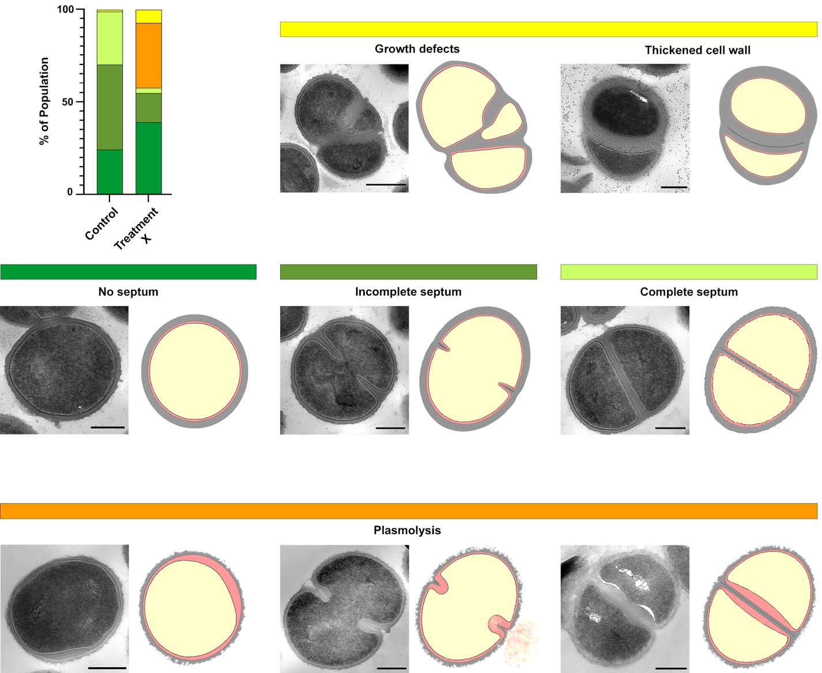
Figure 2.1 Standard morphological quantification criteria.
Schema showing the standard criteria for quantifying bacterial the division stages and morphologies of interest for each strain. Dark green– no septum; Mid-green– incomplete septum; Light green– complete septum; Yellow– growth defects; Orange– any specific morphology of interest, for example in this case we are showing plasmolysed cells regardless of their division stage.

Cryo-transmission electron microscopy (cryo-TEM).

Cryo-TEM grid preparation.
For cryo-TEM of vitrified sections, fine 1500-mesh copper grids were selected (G1500HH-C3, Gilder Grids). Grids were carbon-coated using the Quorum Q150T ES and following the protocol described by Harris (2007) ^{[242]}.
High purity carbon rods (Agar Scientific) were evaporated onto a freshly exposed sheet of mica (Agar Scientific) on filter paper, using the Quorum Q150T ES under high vacuum (~ 10⁻⁵ mbar and lower).
The copper grids were then placed onto filter paper submerged under a dH₂O bath. The carbon layer was then floated onto the surface of dH₂O, over the EM grids, and the water was slowly drained until the carbon layer was lowered and deposited onto the EM grids. Grids were left to dry overnight before use.

Cryo-electron microscopy of vitreous sections (CEMOVIS).
Bacterial cultures were grown in TSB with 10 % (v/v) glycerol and harvested as previously described (section 2.11.3 and 2.20.2.1).

High-pressure freezing (HPF) copper tube system.
High-pressure freezing (HPF) was performed with Leica EM PACT2 RTS (Leica Microsystems) using the specimen copper (Cu) tube system.
The sample was re-suspended in 2.3 M sucrose solution to help reach the ideal density for loading into the specimen tube. The amount added depended on the size of the pellet. The end of a 200 µl pipette tip was cut using a razor blade so as to fit the 650 µm diameter of the specimen tube. The cut pipette tip was then attached to a 1 ml syringe and was used to collect the sample suspension. The specimen tube, already fixed in the tube holder, was attached to the cut pipette tip and the sample was pushed through until sample came out the other end of the tube. Vitrification was carried out following the manufacturer’s instructions. Once frozen, the tubes were quickly transferred to an insulated container filled with liquid nitrogen (LN₂), where they were punched-out of the tube holder with the punching tool provided (Leica). The cut vitrified tubes were then stored in cryo-tubes with LN₂ in a LN₂ Dewar.

Cryo-sectioning of frozen-hydrated samples.
Cryo-sectioning was carried out using the Leica EM UC6/FC6 cryo- ultramicrotome (Leica Microsystems) in a humidity controlled room. The temperature of the knife, specimen and cryo- chamber was set to – 120 °C. The diamond knives cryotrim 45 ° (CT600, DiATOME) and cryo 25 ° (MT16094, DiATOME) were chosen for trimming the Cu tube and sectioning the sample, respectively. An ioniser antistatic device was setup and used both for trimming and sectioning.
The cryo-sectioning protocol was modified from Ng et al., (2020) ^{[243]}. The face of the Cu tube was trimmed to expose the sample. Trimming was carried out with the cryotrim 45 ° diamond knife with a speed of 50 mm/s and a 500 nm feed with medium return speed. The last 1 µm trim was done at 25 mm/s speed and 200 nm feed with medium return speed. The tube was then trimmed at the sides to expose the specimen from the sides and create a square mesa. This mesa was trimmed with the cryotrim 45 ° knife at a 25-50 nm/s cutting speed and a 200 nm feed with medium return speed.
Sectioning of the vitrified specimen was carried out with the cryo 25 ° diamond knife at a 1 mm/s speed and a 50 nm feed with a slow return speed. An eyelash was used to extend the obtained ribbon of sections. The grid holder provided with the FC6 was used to place a 1500-mesh carbon-coated copper grid (section 2.21.1) underneath the ribbon. The sections were mounted onto the grid, and the grid press was used to flatten the sections. The obtained grid was stored in a cryo grid box in the LN₂ Dewar.

Cryo-TEM microscopy.
Cryo-EM of vitrified sections was carried out with the FEI Tecnai Arctica cryo-EM microscope situated at the EM Facility in the University of Sheffield. The field emission gun operated at 200 kV and TEM micrographs were captured with a Falcon III direct electron detector (Thermo Fisher Scientific). CEMOVIS images were collected by Dr. Svetomir Tzokov.

Cell envelope measurements from cryo-TEM.
Cryo-TEM micrographs were analysed using the software Fiji (v2.1.0) ^{[238]}. Measurements were taken on the least-deformed regions of the cell, as described by Matias et al., (2003) and Matias & Beveridge (2005) ^{[164,244]}. Density traces were obtained by drawing a rectangle across the bacterial envelope and analysing the intensity plot profile of that area. The distance between peaks was used for obtaining length measurements of the different components of the bacterial envelope. At least 28 cells were analysed, with various measurements taken per cell.

Whole cell cryo-TEM and cryo-electron tomography (cryo-ET).
Cryo-transmission electron microscopy (cryo-TEM) of whole cells and cryo-electron tomography (cryo-ET) were carried out by Dr. Danyil Grybchuk from Dr. Pavel Plevka’s laboratory at the Central European Institute of Technology, Masaryk University, Brno, Czech Republic.
Bacterial cultures were grown as previously described (section 2.11.1), harvested by centrifugation and washed with PBS buffer. Cells were then concentrated by centrifugation and resuspended in ice-cold PBS to an OD₆₀₀ = 10 and stored at 4 °C. 4 µl of the cell suspension was loaded onto a 200-mesh copper grid (R1/2, QUANTIFOIL™), blotted with filter paper and vitrified in a liquid ethane-propane mixture using the FEI Vitrobot™ (Thermo Fischer Scientific) with a 0 blot force, 8 s blot time and 10 s wait time.
Cryo-TEM and Cryo-ET were carried out with a FEI Titan Krios TEM operating at 300 kV with in-column energy filter, and micrographs were captured with a GATAN K2 Summit camera in counting mode at 33000x nominal magnification (angpix = 4.23 Å), at a – 8 µm defocus. A dose-symmetric tilt scheme was employed to acquire the tomographic tilt-series, with a range from – 60° to 60 ° and a 3 ° step (41 images). For each image, a 5-frames movie was recorded and corrected for drift and beam-induced motion with the MotionCor2 ^{[245]} software. The total dose was of ~ 75-80 electrons per tomogram. Tilt series alignment and tomogram calculation were performed using IMOD (v4.1.10) ^{[246]} software.

Statistics.
All statistical analysis was performed using Prism version 9.1.0 (GraphPad). Gaussian distribution was analysed by histogram plotting and by running the Shapiro-Wilks / Kolmogorov-Smirnov test. For comparative statistic between two groups Student t-test with Welch’s correction was carried out, taking into consideration a non-equal standard deviation. For comparisons of more than two groups, a two-way ANOVA was carried out with Tukey’s multiple comparisons test, with individual variances computed for each comparison.

Collaborative work.
– Chapter 3 and 5 –
Cryo-EM micrographs of vitrified sections (CEMOVIS) were acquired by Dr. Svetomir Tzokov (EM Facility, The University of Sheffield).
– Chapter 4 –
Some additional structured illumination microscopy (OMX SIM) images from my prepared samples were acquired by Dr. Mariana Tinajero-Trejo and Dr. Joshua A. F. Sutton (The University of Sheffield).
Survival curve experiments with tunicamycin and Congo red were carried out by Dr. Oliver Carnell (The University of Sheffield).
– Chapter 5 –
Survival curve experiments with antibiotics were carried out by Dr. Bartlomiej Salamaga (The University of Sheffield) as part of a collaborative project ^{[247]}.
Similarly, structured illumination microscopy (OMX SIM) images and cell volume estimation of methicillin and vancomycin treated cells for this chapter were carried out in totality by Dr. Milena von und zur Mühlen as part of her PhD thesis ^{[71]} and a collaborative project ^{[247]}.
Atomic force microscopy (AFM) images and analysis was carried out in totality by Dr. Laia Pasquina-Lemonche as part of a her PhD thesis ^{[248]} and a collaborative project ^{[247]}.
Finally, cryo-electron transmission microscopy of whole cells (cryo-TEM) and cryo-electron tomography (cryo-ET) was carried out by Dr. Danyil Grybchuk from Dr. Pavel Plevka’s laboratory at the Central European Institute of Technology (Masaryk University, Brno, Czech Republic) as part of a collaborative project ^{[247]}.

Chapter 3
Method Development for Studying the Bacterial Envelope using Electron Microscopy

Introduction.
A detailed analysis of bacterial samples requires the use of high resolution microscopy. Light microscopy’s biggest limitation for resolution is the long wavelength of visible light (400-700 nm). Transmission electron microscopy (TEM), however, uses an accelerated electron beam with a much smaller wavelength. For example, at 100 keV and 200 keV the wavelength is of 3.7 and 2.51 pm, respectively. This shorter wavelength provides the highest resolving power available ^{[215]}. Electrons travel micrometre (µm) distances in biological materials, but centimetres in air (scattering), and therefore the whole EM system must be contained at a very high vacuum to avoid high electron scattering ^{[214]}. This high vacuum provides an obstacle for the high water content of biological samples, and therefore sample dehydration is a vital step for room temperature EM. Nonetheless, technological advances finally permitted imaging of fully hydrated samples at cryogenic temperatures, also known as cryo-electron microscopy (cryo-EM or cryo-TEM) ^{[226,249–252]}.This involves keeping the sample constantly frozen below devitrification temperatures (< – 137 °C) to avoid ice formation ^{[215,226]}. In addition to the amazing resolving power provided by TEM and cryo-TEM, there is another benefit to these microscopy techniques: the possibility to analyse cross-sections. TEM requires electron-transparent samples, which means that in most cases bacterial samples need to be thin-sectioned. This opens the possibility to obtain detailed structural information from the bacterial envelope and inside the cell.
There are a wide variety of TEM techniques for bacterial analysis, and some of the most popular are shown in Figure 3.1. All of these have their own advantages and disadvantages, and all sample preparation and processes will affect the structure and chemistry of the specimen to some extent ^{[214,223,252]}.

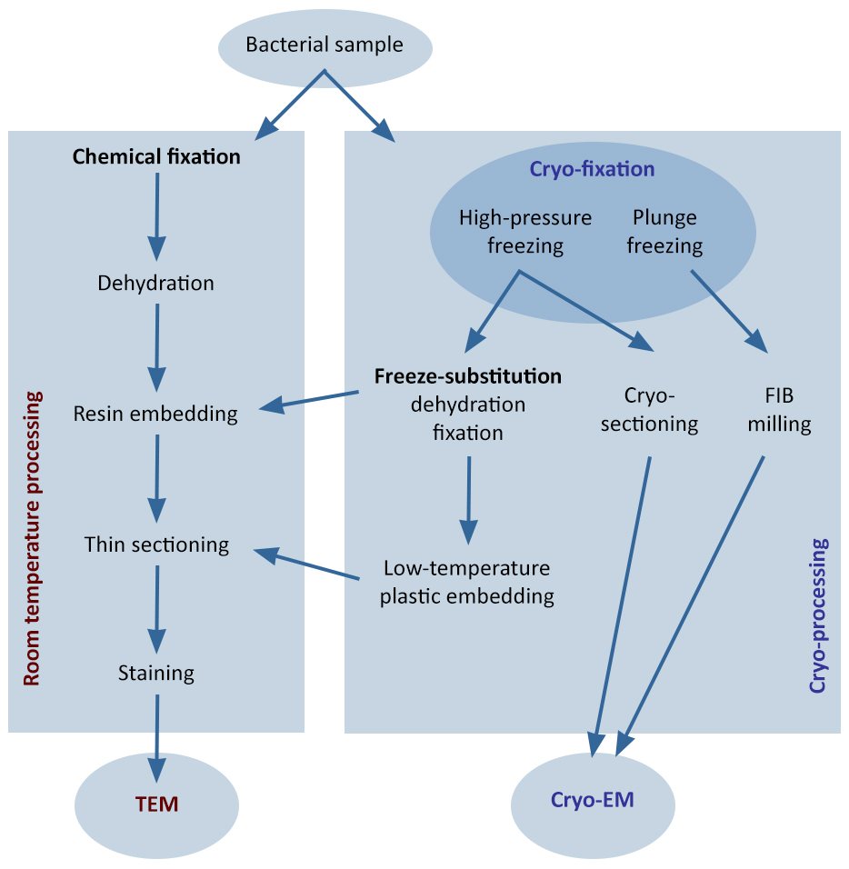
Figure 3.1 Popular TEM methods for imaging bacterial samples.
Popular transmission electron microscopy (TEM) and cryo-electron microscopy (cryo-EM) methods for cross-section analysis of bacterial samples. Image modified from Pilhofer et al., (2010) ^{[221]}
Chemical fixation TEM (Figure 3.1) is still the most popular choice over the alternative cryo-techniques, due to its high throughput, low-cost, and ease-of use. To summarise, sample preparation consists of the following steps: chemical fixation, dehydration, resin infiltration and embedding, thin-sectioning and heavy metal staining ^{[223]}. The most widely employed fixatives are glutaraldehyde and osmium tetroxide (OsO₄), and dehydration is usually carried out by a series of increasing concentrations of ethanol. For a successful resin infiltration, sequential changes of increasing gradients of resin in propylene oxide are used. Some widely used resins are Epon 812, LR White and Spurr ^{[223,229]}. The final step consists of sectioning the cured resin block to obtain electron-transparent thin sections, which are mounted on TEM grids and post-stained with heavy metals to increase contrast. Popular stains include uranyl acetate (UA) and lead citrate (LC) ^{[223]}. The main disadvantage of this technique is the introduction of artefacts from the use of chemical fixatives and the dehydration process ^{[223]}. A modification of this technique, referred to as freeze substitution (FS) (Figure 3.1), involves the combination of a physical cryo-fixation method, followed by a secondary chemical fixation and dehydration at low temperatures ^{[16,223]}. FS was first described by Simpson in 1941, and after further development and improvement, it became a standard technique for EM analysis of biological samples ^{[215,253–256]}. High pressure freezing (HPF) is the initial rapid freezing method used in FS and, as the name suggests, it combines the application of pressure with vitrification. Water constitutes ~ 80 % of biological samples, which means that these aqueous specimens would be heavily affected by ice crystal formations when frozen. Thus, a successful vitrification involves the rapid freezing of the liquid medium in the sample, with water solidifying while keeping its amorphous state and avoiding ice crystal formation. Three main parameters determine the success of cryo-fixation/vitrification: (1) pressure, (2) cooling rate and (3) cryoprotection. (1) HPF instruments apply a 2100 bar pressure to the specimen prior to freezing, which in turn allows water to be supercooled to – 90 °C, turning water into a viscous liquid. Therefore, high pressure (2100 bar) acts as a physical cryoprotectant by lowering the freezing point of water, helping reduce ice crystal formation and improve fixation before cooling. Once the pressure is applied, the specimen is further cooled down to temperatures below – 140 °C where vitreous ice is stable ^{[215]}. This last freezing step is usually obtained with liquid nitrogen (LN₂). The whole freezing process needs to be as fast as possible, particularly the time between applying the pressure and follow-up freezing, as any pressure changes can lead to changes in the physical and chemical equilibrium of the specimen. Henceforth, a slow pressure build-up or delay of the freezing step should be avoided. (2) The cooling rate at which the specimen is frozen is of key importance, as it is inversely proportional to the thickness of the sample. HPF works best with specimens of up to 200 µm thickness with an applied pressure of 2048 bar quickly followed by > 10,000 K/s cooling rates. Thinner samples will require a higher cooling rate, for example 50,000 K/s for a 100 µm thick sample ^{[215]}. (3) The third parameter to take into consideration for a successful HPF is the use of cryoprotectants. Ice formation decreases with solute concentration, therefore, most solutes act as cryoprotectant. While biological samples could naturally be cryoprotected, their extracellular medium is not. Crystallisation in the cell’s surroundings can lead to osmotic injuries and that is why high solute solutions are added to the medium to act as cryoprotectants and provide a uniform vitrification. Some common cryoprotectants include 2.4 M sucrose and 10 % (v/v) glycerol. Overall, a successful HPF provides vitreous biological samples with improved ultrastructural preservation ^{[215]}. Once the specimen is vitrified, FS follows (Figure 3.1). Firstly, the ice is slowly dissolved with an organic solvent, thus dehydrating the sample. The most commonly used solvents are acetone, ethanol and methanol. The FS medium can sometimes combine chemical fixatives to improved contrast, such as OsO₄, UA and glutaraldehyde. The substitution of the sample’s water content for the chosen FS medium happens very slowly and at very low temperature. Most FS programmes start at – 90 °C, temperature at which the ice will be dissolved by the organic solvent. A slow dehydration allows for a better preservation of the natural ion distribution and a reduction of artefacts. The length of the programme will depend on the thickness of the sample. After dehydration, the temperature is slowly raised and the chemicals start to react. Unlike conventional chemical fixation, the dehydration and chemical fixation steps are inverted, with the former occurring first at – 90 °C, while OsO₄ and glutaraldehyde start their reactions at – 70 °C and – 40 °C, respectively ^{[215]}. At – 30 °C all chemicals will have reacted and low concentration resin solutions can be added (Figure 3.1). Raising the temperature to 0 °C for 1 h helps improve membrane contrast and further warming up to room temperature is standard for embedding with LR White and Epoxy resins ^{[215,257]}. The final room-temperature steps are similar to those described in standard chemical fixation TEM: resin infiltration, polymerisation, sectioning and post-staining when needed (Figure 3.1).

Regardless of the improved and kinder sample preparation of FS, both conventional fixation and FS employ chemical fixatives and organic solvents. This results in the addition of various artefacts, the modification of the bacterial architecture, and structural detail loss ^{[215,252]}. The dehydration process, even when done slowly and at low temperatures during FS, is the most damaging step. As mentioned above, advances in the late 1970s and early 1980s provided the necessary means to image frozen-hydrated samples ^{[258]}. Frozen samples embedded in a thin layer of vitreous water have delivered the best structural preservation and detail since it was developed by Jacques Dubochet’s group ^{[259]}. The specimen is vitrified in its native environment and state, maintaining a preserved 3D structure ^{[215,259]}. Frozen hydration (FH) and cryo-electron microscopy of vitreous sections (CEMOVIS) is a three step process consisting of vitrification, cryo-sectioning and cryo-EM (Figure 3.1). Vitrification occurs by HPF as described above. However, unlike FS, the vitrified samples are transferred directly to the sectioning step without going through any chemical fixation or dehydration. With the importance of keeping the samples vitrified, thin-sectioning is performed at cryogenic temperatures ^{[215]}. Unlike chemical fixation or FS, CEMOVIS does not rely on heavy metal staining for contrast. With stained sections, the electrons of a TEM are scattered by the heavy atoms of the stain, causing an amplitude or area contrast ^{[214]}. As the density of unstained biological material is very constant, amplitude contrast does not provide much information. Therefore, CEMOVIS uses phase contrast imaging, where the scattered electrons suffer a phase shift induced by a short distance density difference ^{[215]}. Overall, CEMOVIS provides the best imaging of unstained hydrated cells, showing their whole volume and native state, without being limited by the lack of contrast.
All the above mentioned techniques have in common the need of electron-transparent samples, which are required to be < 500 nm. Ultra-thin sections of < 100 nm provide the best electron transparency and more detailed structural information of the bacterial envelope ^{[214,223]}. Ultramicrotomy or thin-sectioning is the most common sectioning method used for TEM sample preparation and is usually performed on chemically fixed samples embedded in plastic (Figure 3.1). The initial step in thin-sectioning is the removal of excess resin to expose the sample. The block is then shaped with a razor blade to a square or trapezoidal shape that will help obtain a ribbon of sections while cutting. The surface of the block is then polished with a trimming diamond knife or, most commonly, a glass knife. During sectioning, a diamond knife pre-mounted with a boat filled with water is used, so as to float the sections and reduce specimen damage. Conventional chemical fixation and FS protocols are both thin-sectioned this way, at room temperature using an ultramicrotome. However, this technique is not suitable for cryo-EM, where samples are required to be processed below devitrification temperatures. Therefore, frozen hydrated sectioning (FHS) or cryo-sectioning is an essential step of CEMOVIS. This ultramicrotomy adaptation is carried out with a cryo-ultramicrotome that consists of a thermally isolated chamber that keeps the specimen and the knife at cryo-temperatures with a frost-repelling laminar flow of cold gas ^{[215]}. The LN₂ gas flow is perturbated by the user while manipulating the thin-sections, and this in turn leads to the undesirable formation of ice ^{[252]}. Thus, cryo-sectioning is a technically difficult methodology that requires not only the control of the humidity and temperature to avoid ice formation, but also experience, precision and swiftness from the operator ^{[215,223,252]}. Aside from the difference in temperature, FHS differs from conventional ultramicrotomy in the picking up of the sections. During room temperature ultramicrotomy, the sections are floated on water and a TEM grid is then submerged at a 90° into the boat and is then placed under the floating sections to pull them up on its way out of the water. During cryo-ultramicrotomy, however, the sections gather at the knife edge and the user collects them with the help of an eyelash, slowly unfolding and stretching the ribbon of sections away from the knife, with caution to avoid its breakage. Preferably, the knife has to allow the sections to glide on its surface and a small angle knife should be considered ^{[215]}. Once this is achieved, a TEM grid handled with the opposite hand is placed under the ribbon to mount the sections on it ^{[252]}. This is another determining step in FHS that requires a highly skilled and experienced operator. However, many technological advances have produced new cryo-ultramicrotomes with micromanipulators and antistatic devices to help the user. The latter are of key importance as cutting dry means the sections are sensitive to electrostatic charges, which makes them either fly away or stick to the knife ^{[215]}.
Both ultramicrotomy and cryo-ultramicrotomy use glass and diamond knives for the trimming, polishing and sectioning of the sample. These knives produce a number of structural disturbances on the sample such as knife marks, crevasses, specimen deformation and compression marks ^{[252]} (Figure 3.2a-d). Sample deformations occur in the cutting direction, as a 30-60 % dimension reduction. While the dimensions perpendicular to the cutting plane and the volume of hydrated samples are conserved, the described reduction corresponds to an increase in the sample’s thickness ^{[252]} (Figure 3.2b). Therefore, this compression should be taken into consideration if measurements are taken. This aberration is mostly dependent on the type of sample and the thickness of the section, with ultra-thin sections being most affected. Sectioning speed and temperature parameters do not have a significant effect on compression, however the section feed (thickness) can help ^{[252,260]}. Crevasses are sample fissures that appear as breaks perpendicular to the edge of the knife, regardless of the cutting direction. These are very commonly found on conventional ultramicrotomy, but also in FHS. Their appearance is also dependent on the sample material and the thickness of the section, with them being more frequent on thicker sections ^{[252,260]}. Lowering the cutting speed and using a small angle knife can help reduce their appearance ^{[215]}. Han et al., (2008) ^{[260]} analysed the impact on the sectioning feed and concluded that while crevasses where non-existent below 50 nm sections, the compression deformation was severe. In contrast, sections over 100 nm resulted in less compression but with an increase of crevasses. This conversely proportional relationship establishes an overall optimal feed of 50-80 nm for vitreous sections ^{[260]}. Chatter is another cutting artefact that appears as regular wavy variation in the section’s thickness (Figure 3.2d). It is associated with irregular compression due to the gliding properties of the knife, or with high vibrations caused by the specimen not being tightly mounted in the holder. Chatter can be reduced by tightening the specimen holder and with higher cutting speeds ^{[215,252]}. Surface deformations on the sections and on the surface of the block can result from the cutting process, and appear as a shadowed section ^{[252,261]}. Knife marks are a common artifact mostly seen in standard sections. These are knife traces that run in the same direction as the cutting plane, usually as a result of particles adhering to the surface of the knife or irregularities at the knife edge ^{[215,261]}. Cutting artifacts are sometimes more noticeable in vitrified samples, as the flotation on water of room temperature sections improves a lot of these structural disturbances ^{[252]}. Both room temperature or cryo sections need flattening to help reduce surface deformation and to improve EM imaging. The former can be stretched with a heat pen or chloroform vapour while floating on the water boat, while the latter can be flattened with a grid press.
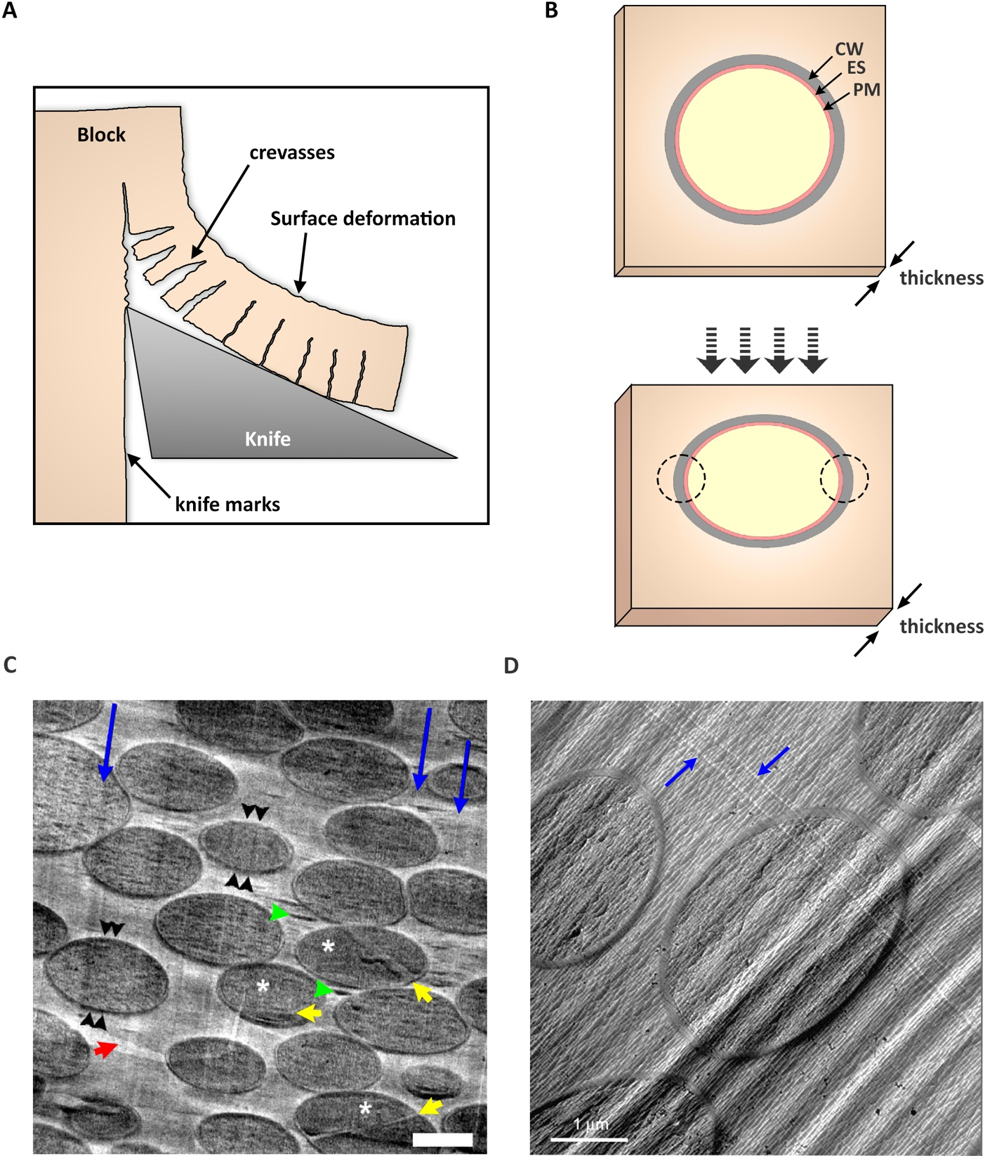
Figure 3.2 Common artefacts of thin-sectioning process.
(A) Schematic representation of ultra-microtomy emphasising come common sectioning artefacts. Image modified from Dubochet et al., (1988) ^{[252]}. (B) Schematic representation of the effect of compression caused by thin-sectioning. Bold black arrows– cutting direction. CW– cell wall, PM– plasma membrane, ES– exoplasmic space. Dashed circle– areas of least deformation. Image modified from Matias & Beveridge (2005) ^{[164]}. (C) TEM micrograph of frozen-hydrated S. aureus showing common cutting artefacts: knife marks (long blue arrows), crevasses (green arrowheads), compression in the cutting direction (double black arrowheads), crack in the support film (short red arrow). White asterisk and short yellow arrows indicate incomplete and complete septa, respectively. Scale bar 500 nm. Image obtained from Matias & Beveridge (2006) ^{[16]}. (D) TEM micrograph of frozen-hydrated yeast cells showing compression in the cutting direction (top left to bottom right), knife marks (blue arrows), crevasses and chatter (undulating shadows). Scale bar 1 µm. Image obtained from Spenher et al., (2008) ^{[215]}.
An alternative technique that bypasses these common knife artefacts of the sectioning process is focused ion beam milling (FIB milling) (Figure 3.1). FIB instruments have been used in material science for their capacity to produce thin sections, in the form of wedges or lamellae, as they lack mechanical imperfections ^{[227,228,262]}. FIB has a built-in gallium ion gun, and its ions collide with the atoms of the surface of the sample, causing the sputtering of those atoms and leaving a thin lamella or wedge as a result ^{[227]}. An attached scanning electron microscope (SEM) provides a non-destructive imaging guide to help monitor and control the milling. FIB can produce electron-transparent thin-sections from vitrified cells by FIB-milling at cryogenic temperatures (cryo-FIB) ^{[214,227,228]}. These advances have generated amazing results proving that FIB-milling can be used on frozen-hydrated bacterial samples for further analysis with cryo-TEM and cryo-electron tomography (cryo-ET) ^{[263]}. However, this technique is a technically difficult manual technique that is very time-consuming and of very low-throughput ^{[264]}. In addition, lamella transfer from the cryo-FIB to the cryo-EM often results in contamination and devitrification of the amorphous ice, which further reduced the throughput ^{[265]}. Luckily, new fully-automated cryo-FIB methods and transfer solutions adaptations are starting to be put into practise and will change the way that frozen-hydrated samples are analysed ^{[264,265]}.

Aims of this chapter.
The aim of this chapter was to test and develop the best electron microscopy methods for imaging and studying the bacterial envelope. A breakdown of the aims were as follows:
- Select the best technique for morphological quantification.

- Try different EM techniques for a detailed studying the cell envelope, with focus on the exoplasm.

- Optimise and troubleshoot for best results.

Cross-sectioning for detailed analysis of the bacterial envelope.
A microscopy technique that provides structural detail is necessary for categorisation and morphological quantification of bacterial samples. Fluorescence structured illumination microscopy (SIM), is widely used for the localisation of labelled-subcellular components, phenotype analysis and characterisation of septa formation ^{[266,267]}. Nevertheless, as shown in Figure 3.3a, SIM images can sometimes be difficult to discern and analyse individual cells that clump together, or mutants with a particular phenotype. In addition to this, the obtained information from SIM is limited to the availability, specificity and accessibility of fluorescent labels; and most importantly, the image resolution is then limited by the label density and the size of the fluorescent labels ^{[206]}. On the other hand, electron microscopy has a higher resolving power and provides more information. Scanning electron microscopy (SEM) shows an overall picture of the cell surface (Figure 3.3b) while bacterial cross-sections from transmission electron microscopy (TEM) delivers a more detailed picture of the structure of the cell envelope (Figure 3.3c). Both SEM and TEM together can help identify and describe different bacterial phenotypes, and where therefore chosen for this investigation.
TEM delivers the most suitable imaging technique for this study, as the area of interest is the bacterial envelope with a focus on the exoplasmic space. As explained in section 3.1, there are a variety of EM techniques that can provide cross-section imaging. The main categorisation being room temperature TEM or cryo-TEM. The former usually involves chemical fixation, dehydration and staining, all of which affects the molecular structure of the cell; whereas the latter images a hydrated samples without any interfering agent, apart from potential ice crystals obscuring the captured image. There are various methodologies and adaptations within these two microscopy techniques, and in general cryo-EM provides overall better results. Nonetheless, TEM is an easier and more accessible methodology and was therefore chosen for the majority of the experiments of this thesis (Chapter 4 and 5).

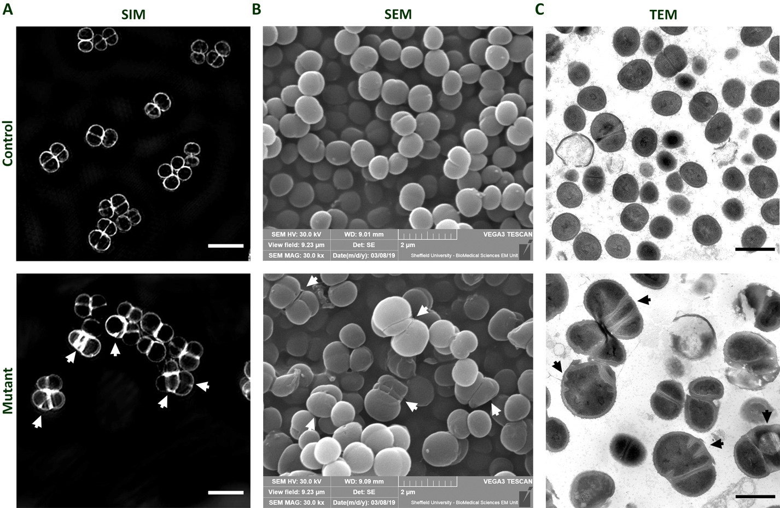
Figure 3.3 Phenotype analysis comparison between SIM, SEM and TEM.
Phenotype comparison of S. aureus SH1000 (wild type) (SJF 682 – control) and ΔltaS gdpP::kan (SJF 5159 – mutant) lacking LTA and showing a characteristic phenotype. (A) SIM images of bacterial samples as indicated, labelled with NHS-ester AlexaFluor™ 555, scale bar 3 µm. (B) SEM micrographs, scale bar 2 µm. (C) TEM micrographs cropped from mid magnification (2900x), scale bar 1 µm. (A-C) Arrow heads point the mutant’s particular cell division phenotype which is better understood with a bacterial cross section.

Chemical fixation TEM for bacterial morphology visualisation.
Standard chemical fixation sample preparation involves an overnight fixation using glutaraldehyde, followed by a secondary fixation with osmium tetroxide (OsO₄). The next step is dehydration with a series of increasing concentrations of ethanol, followed by propylene oxide. Lastly, infiltration occurs by the incubation with a 50:50 mix of propylene oxide and the resin of choice, before a few full resin changes and resin polymerisation. For this study, the standard protocol described in detail in section 2.20.1 was used. TEM micrographs were obtained using the FEI Tecnai T12 Spirit TEM operating at 80 kV, and captured on a GATAN ORIUSTM SC1000B bottom-mounted CCD camera.
Figure 3.4 presents confirmation that this selected standard protocol delivers suitable fixation and sufficient detail for the identification of all the main components of Gram-positive bacteria, such as S aureus and B. subtilis. A closer comparison of the cell envelope of S. aureus to a micrograph obtained from Matias & Beveridge (2006) ^{[16]} shows that this technique is not only reproducible but also producing clearer results, with a well-defined identification of the cell wall (cw), the plasma membrane (pm) and the space between them (es– exoplasmic space) (Figure 3.5).
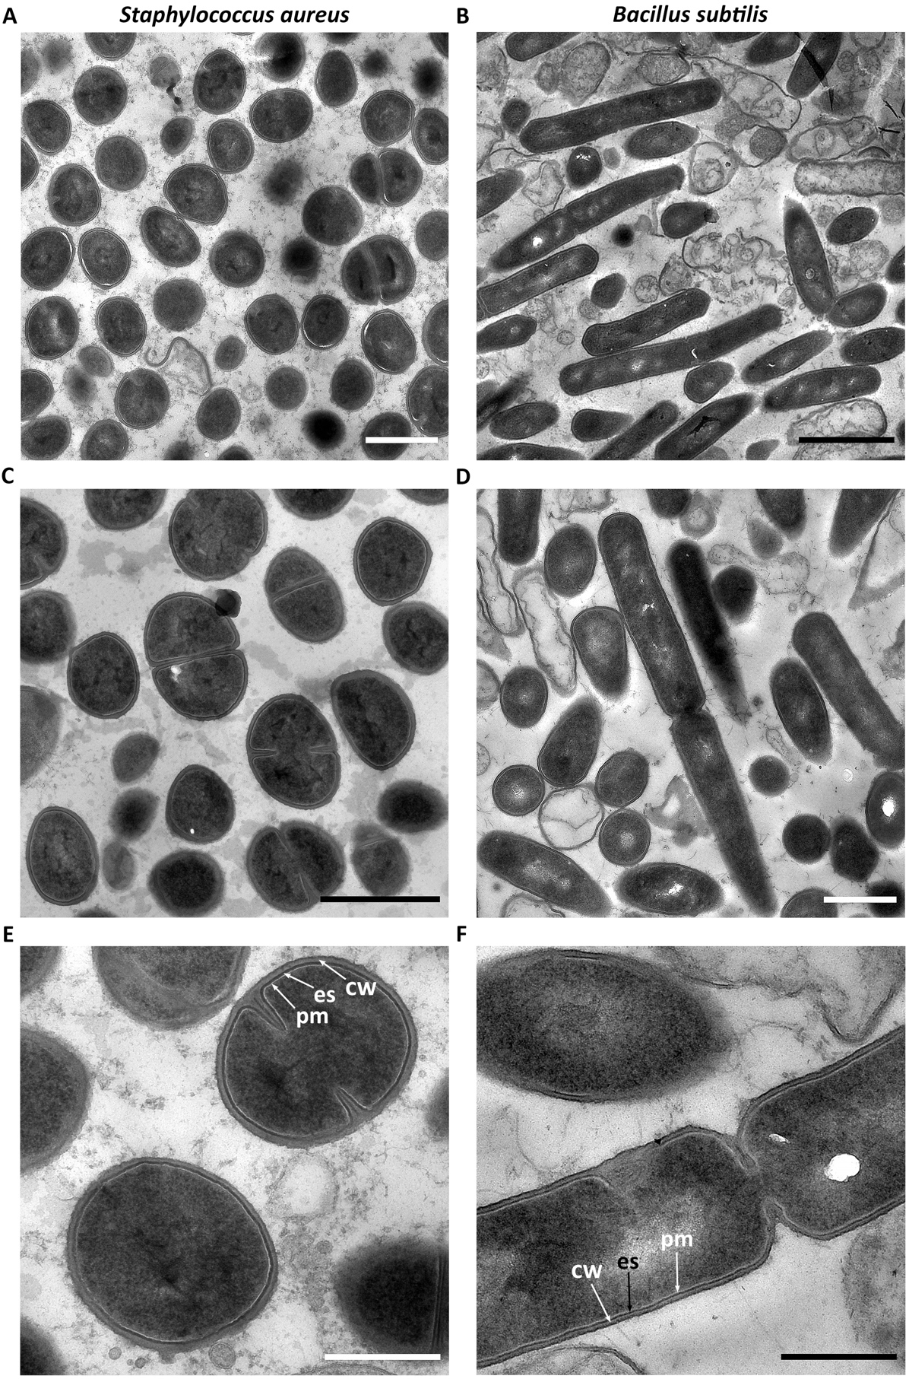
Figure 3.4 TEM micrographs of chemically fixed thin-sections of S. aureus and B. subtilis.
TEM micrographs of S. aureus and B. subtilis as indicated. (A,D) Low magnification (2900x), (B) Low magnification (1900x), (C) High magnification (4800x), (A-D) scale bar 1 µm, (E-F) High magnification (9300x), scale bar 500 nm. cw– cell wall, es– exoplasmic space, pm–plasma membrane.
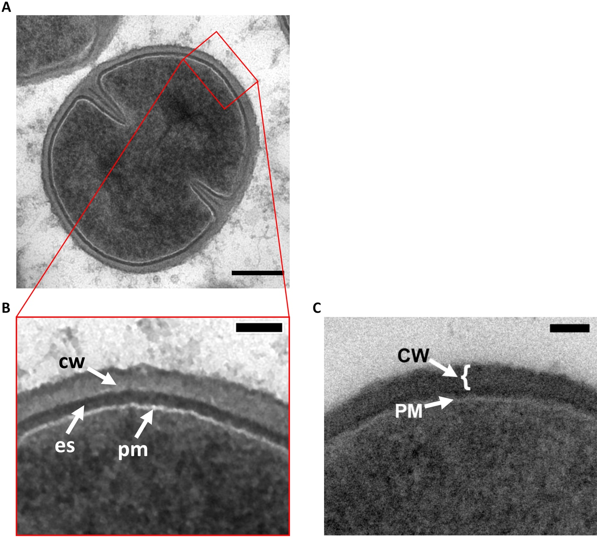
Figure 3.5 TEM micrographs of the cell envelope of chemically fixed S. aureus.
TEM micrographs of chemically fixed thin-sections of S. aureus. (A) Cropped from high magnification (9300x), scale bar 200 nm. (B) Zoomed area from (A), scale bar 50 nm. (C) Micrograph obtained from Matias & Beveridge (2006) ^{[16]}, scale bar 50 nm.
Chapter 5 of this study required instant fixation of samples treated with antibiotics at a certain time point. Samples were grown with antibiotics for a desired period of time, then quickly recovered by centrifugation, washed and fixed with paraformaldehyde (PFA). This fast acting fixative was chosen to stop further action of the antibiotics. The fixed samples were then used for SIM preparation. After observing a particular phenotype with methicillin in those SIM images ^{[71]}, a decision was made to obtain a more detailed TEM analysis of the cell envelope. It was therefore important to use PFA to compare the obtained phenotype with the initial SIM results obtained by Dr. von und zur Mühlen, for consistency. With standard chemical fixation involving OsO₄ and glutaraldehyde as fixatives, it was imperative to check if the use of PFA affected the cell structure or modified the results obtained by the standard TEM protocol. Figure 3.6 suggests that neither antibiotic-treated nor untreated samples (control) had any considerable phenotypic differences with the additional use of PFA.
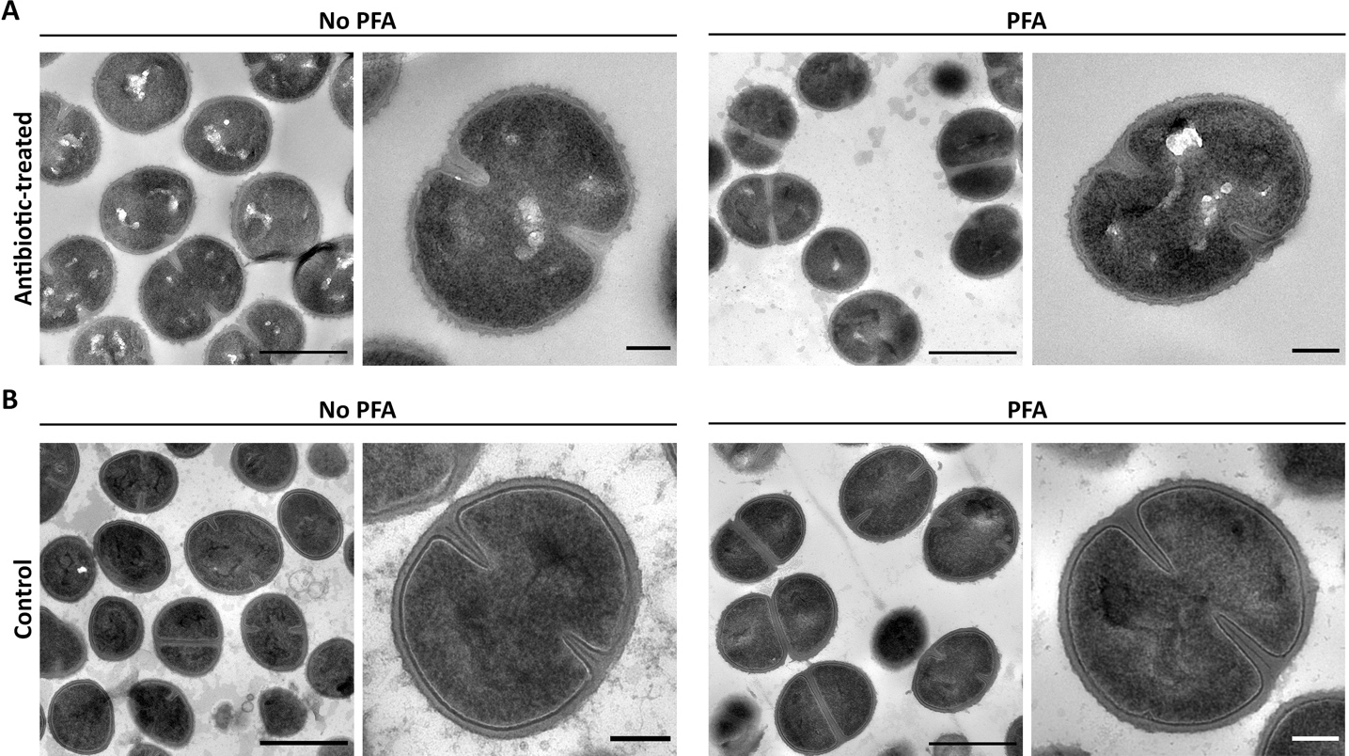
Figure 3.6 The use of an additional PFA step in standard chemical fixation TEM with S. aureus.
TEM micrographs of chemically fixed thin-sections of S. aureus showing the difference between using 1.6 % (w/v) paraformaldehyde (PFA) for 30 min as an additional fixative in the standard chemical fixation protocol. (A) A sample treated with 10 x MIC vancomycin for 1 h and fixed with and without PFA, as indicated. (B) Untreated control sample with and without PFA, as indicated. High magnification (4800x), scale bars 1 µm. Zoomed cropped images from high magnification (6800x), scale bars 200 nm.

Freeze-substitution TEM for detailed morphological analysis.
Various factors will have a differential effect on bacterial structure, with the chosen fixation method and fixatives being the most impactful. The focus on the exoplasm in Chapter 4, dictated the need for a more in-depth phenotypic analysis and a better sample preparation than chemical fixation. As shown by Matias & Beveridge (2006), freeze-substitution (FS) provides much better structural preservation than standard chemical fixation ^{[16]} due to the use of a cryo-fixation method and the slow dehydration and permeation of the chosen fixative at below-zero temperatures ^{[215]}. I therefore tried to replicate, troubleshoot and further develop the FS methodology to obtain the best possible results for this study.

Testing the best methodology and cryoprotectant for HPF.
High pressure freezing (HPF) is the initial cryo-fixation step of FS, and the instrument used was the Leica EM PACT2 RTS (rapid transfer system). The best carrier for HPF of bacterial pellets is the flat specimen carrier. This round copper carrier is gold plated and comes in three available sizes. The carriers are attached to a rapid loader, and then loaded with the bacterial sample. In the meantime, the HPF instrument is prepared by attaching a bayonet pod into the RTS bayonet loading device. A correct alignment of the pod and the bayonet loading device is key for its subsequent insertion into the EM PACT2. The “preload” step consists of the automated unlocking of the diamond screw in the pod, to its open position. To carry out the fixation, the rapid loader with the loaded carrier is inserted into the instrument, and this action activates the bayonet loading device. The flat carrier with the specimen is locked in the bayonet pod and the diamond screw is automatically closed, securing the specimen in place. The locked specimen is propelled into the EM PACT2, where a double jet of liquid nitrogen (LN₂) at – 196 °C goes through it and vitrifies the specimen. After 600 ms, the bayonet pod is ejected into a LN₂ bath. This is a complex instrument where many factors can affect the outcome. The two most determining steps are the correct loading of the specimen and the instrument’s high pressure.
Loading of the flat carrier system with S. aureus sample was not a simple task. The chosen carriers have an inner diameter of 1.5 mm with a recess of 200 µm, so the use of a stereoscope is highly recommended (Figure 3.7a). To avoid the pellet from drying out, this step was carried out in a petri dish with a damp filter paper inside (Figure 3.7a). The biggest obstacle was the viscous and sticky consistency of the pellet (Figure 3.7b). Using a pipette tip for loading was not feasible, and cutting a 200 µl tip to get a bigger opening did not work either as the sample stuck to the walls of the plastic tip. The way around it was to cut a pipette tip diagonally with a razor blade, and use it to scoop some of the pellet out (Figure 3.7c). Then, with the help of a toothpick or metal pick, the sample was loaded into the carrier. The use of a metal pick is not recommended as it could easily damage the gold plated carrier, while the toothpick can leave some wooden residues in the sample. Another alternative is to have a second pipette tip cut diagonally to a sharp point and use it to cut the specimen into place. This is not a straightforward process and different samples, including different mutants, might have a more or less viscous consistency that will require an adaptation of the loading technique. For example, a mutant lacking WTA seemed to stick even more to the pipette tips and a diagonally cut pipette tip was not enough for separating a small sample piece to put into the carrier. The way forward was to place the pellet onto a piece of Parafilm®, kept inside a Petri dish with a damp filter paper to avoid the pellet from drying out; next, cut the desired size of sample with a razor blade, pick it up with a toothpick and place it into the carrier. In addition to this, the gooey consistency of the pellet makes it almost impossible to fill in the carrier properly. It is of greatest importance to fill in the whole area, making sure that it is not overfilled, and that it is flat and levelled with the edge of the carrier (Figure 3.7d). It is also imperative to leave the edge free from any sample and avoid air bubbles for correct cryo-fixation (Figure 3.7d).

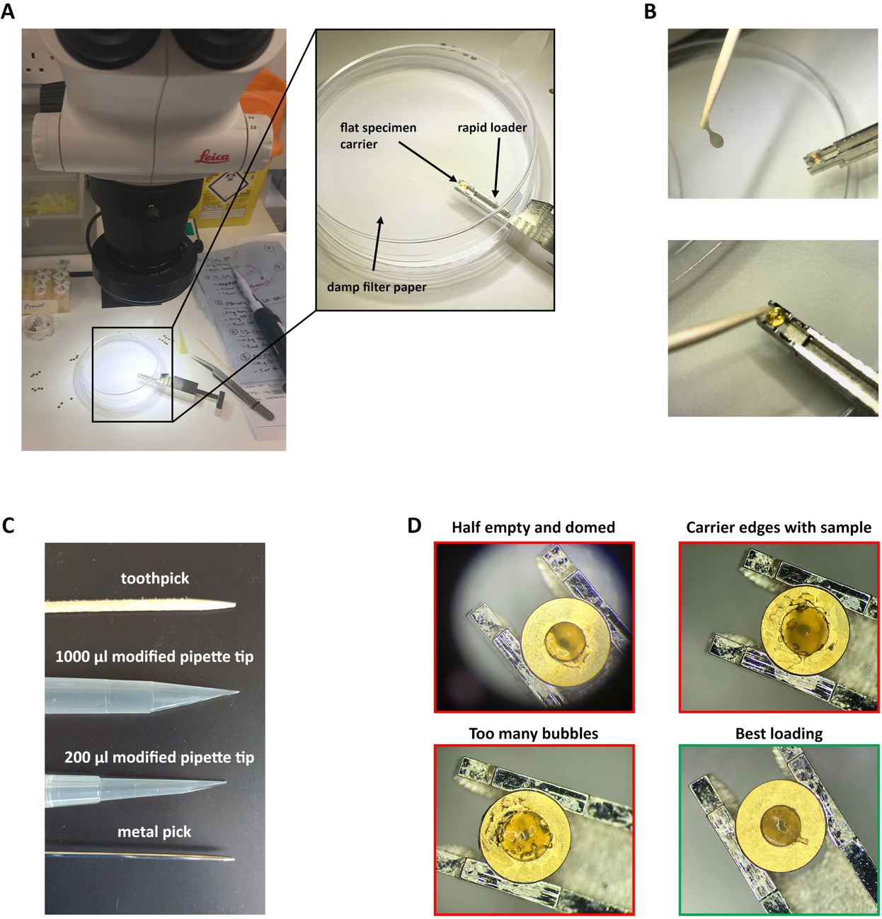
Figure 3.7 Methodology for loading the flat specimen carrier for HPF of S. aureus.
(A) Setup for HPF of S. aureus for freeze-substitution using a stereoscope. Flat specimen carriers are attached onto the rapid loader. Sample loading is carried out over a petri dish with a damp filter paper inside to keep moisture. (B) Viscous and sticky consistency of S. aureus and its loading into the carriers. (C) Various tools used for collecting and loading the sample into the carriers. (D) Examples of loaded carriers showing common mistakes to avoid (red frames) and the correct loading to aim for (green frame).
In an attempt to improve the sample’s consistency and facilitate its loading into the HPF carriers, I tried the addition of different cryoprotectants fillers. First, baker’s yeast paste and polyvinylpyrrolidone (PVP) were tested. Immediate results showed that the use of 20 % (w/v) PVP in buffer made the sample more liquid and it was therefore easier to load with a 10 µl pipette tip directly into the carrier, while the yeast paste provided the best consistency for loading without becoming too liquid. Nevertheless, both tests still resulted in a somewhat gooey, although improved, consistency. Unfortunately, 8/10 of the HPF runs showed pressure failure and the TEM micrographs confirmed that many of the cells were not properly vitrified. As a results, the micrographs obtained could not be analysed properly to see if these fillers are affecting the vitrification of S. aureus. The micrographs showed a lot of background material that reacted to the OsO₄ and post stain (Figure 3.8a). This interfered with the contrast and identification of the bacterial samples. This could have been the result of leaked cytoplasmic material from burst cells that were not properly vitrified. Similar results were obtained when trying two other cryoprotectants, 20 % (w/v) BSA in buffer and 2 % (w/v) low-melting point agarose (Figure 3.8b). Although both showed signs of HPF failure, with a high number of burst cells, an improvement was perceived. This led us to put the 20 % (w/v) BSA to the test against the 10 % (v/v) glycerol from the standard protocol (Figure 3.8c). Both seem to have similar results, with more background material present with BSA. Once again, this could be either from the BSA itself and/or from those samples bursting due to a failed cryo-fixation, leaving cytoplasmic material in between the cells. The final test involved the use of glycerol as a cryoprotectant together with TSB during cell growth, instead of only using it with the buffer during sample wash before HPF. The former, regardless of the vitrification issues, provided better results when growing cells with TSB + 10 % (v/v) glycerol (Figure 3.8d).
These tests should be repeated, as no certain conclusions can be reached from the obtained results because of the HPF failure experienced during this time.
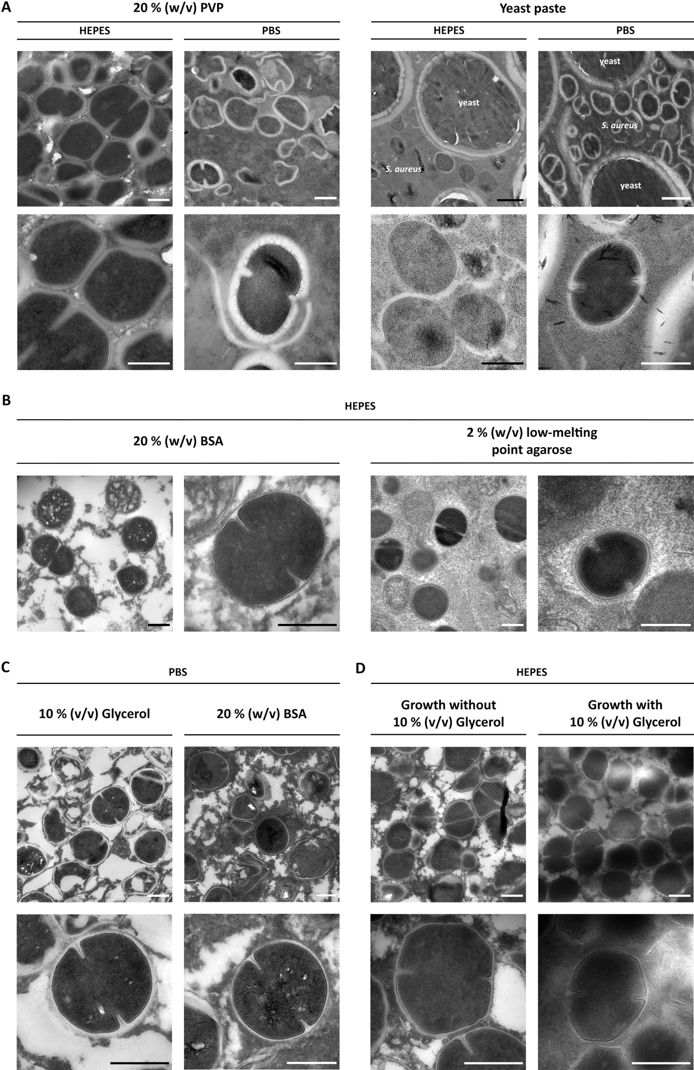
Figure 3.8 Effect of different cryo-protectants and fillers for HPF of S. aureus.
(A) Comparison between the use of 20 % (w/v) PVP or baker’s yeast paste as fillers and (B) 20 % (w/v) BSA and 2 % (w/v) low-melting point agarose to improve sample consistency and cryoprotection. (C) Comparison between the use of 10 % (v/v) glycerol (left) and 20 % (w/v) BSA (right) as cryoprotectants. (D) Comparison of using 10 % (v/v) glycerol in the growth medium. (A-B, D) Scale bars 500 nm. (C) Mid magnification scale bar 1 µm, high magnification scale bar 500 nm.
Further along the sample preparation process, after the HPF and FS steps were completed, it was noticed that getting the fixed sample out of the carrier was quite difficult and it required the use of the tools shown in Figure 3.7c. To aid this process, a drop of 0.05–0.1 % (w/v) egg lecithin in chloroform was applied to the flat carriers beforehand, making sure they were all fully coated. These were left to dry and after the chloroform evaporated, they were used as usual. This coating did allow for an easier specimen removal and helped to avoid the specimen from breaking into minute pieces.
The Leica EM PACT2 was very inconsistent throughout this optimisation, resulting in badly vitrified samples. A high pressure of > 2000 bar is provided by the hydraulic system, with pressures < 1950 bar or > 2150 bar being unsuitable for good results. Figure 3.9 shows representative outputs for optimal and incorrect pressure profiles obtained from the instrument during this optimisation. As seen from the micrographs presented (Figure 3.9c), lower pressure levels result in burst cells and subsequent cytoplasmic material leakage (Figure 3.9d). Even though all the cooling cycles obtained from the EM PACT2 had cooling rates of > 24,000 K/s (dT/dt), it is clearly seen that the pressure did not reach the necessary 2000 bar and was not maintained long enough, dropping considerably after a few milliseconds (red graph line in Figure 3.9d). In an attempt to obtain reproducible and consistent good results, it was made sure that the liquid nitrogen (LN₂) levels and the hydraulic fluid methylcyclohexane (MCH) levels were kept at the maximum. It was also critical to check that the compressor was always at 12 bar before shooting the rapid loader into the instrument. Whenever a drop to 11 bar was seen, an empty bayonet pod was shot to make the automatic compressor kick-in and increase the pressure to 12 bar. This did seem to make a difference, but the number of pressure failures was unfortunately still high. The instrument was serviced twice during this optimisation, but further testing had to be done by the engineers.

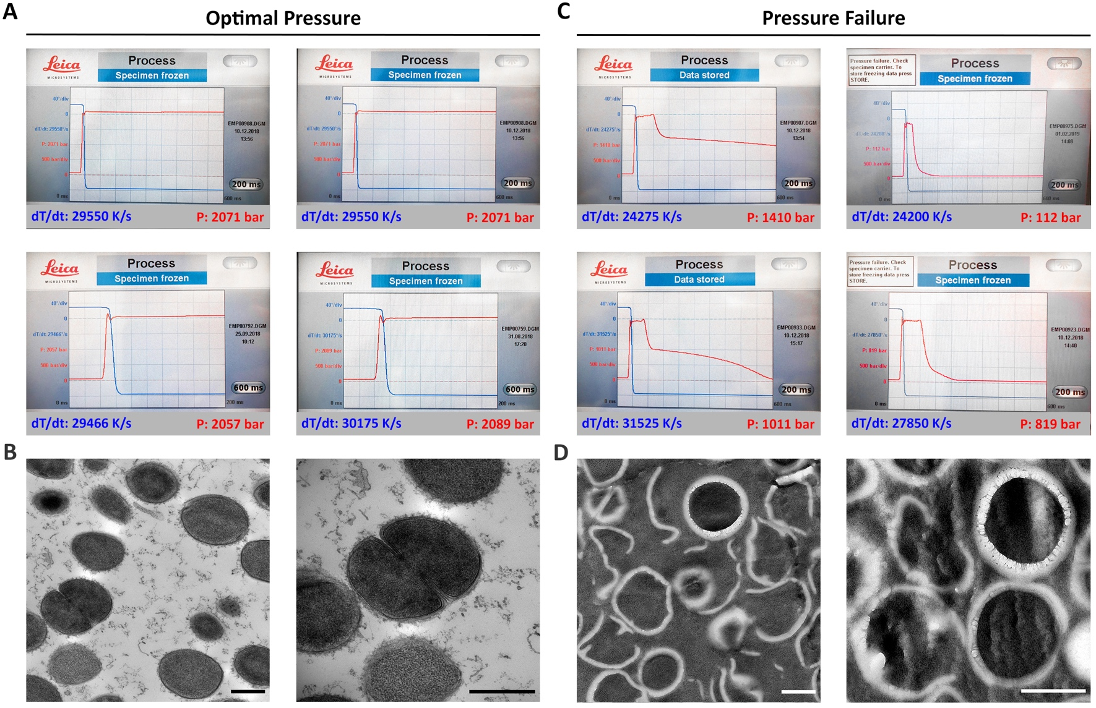
Figure 3.9 Representative outputs for an optimal pressure vs. failed pressure during HPF.
(A) Optimal pressure outputs from the Leica EM PACT2 HPF instrument, and (B) representative TEM micrographs obtained from an optimal vitrification run. (C) Pressure failure outputs from Leica EM PACT2, and (D) representative TEM micrographs from a failed vitrification run. Each graph indicates the cooling rate (blue, dT/dt = K/s) and pressure output (red, P = bar). Mid and high magnification micrographs (4800x, 9300x), scale bars 50 nm.

Choosing the best FS medium.
After HPF, the vitrified specimen carriers were swiftly transferred to a cryotube containing FS medium, and they were inserted into the Leica AFS2 instrument. The FS medium used by Matias & Beveridge ^{[16]}, composed of 2 % (w/v) OsO₄ and 2 % (w/v) uranyl acetate (UA) in anhydrous ethanol, was tested first. This medium turned black in some of the cryotubes of this initial attempt. OsO₄ is expected to react with fats while staining the sample black, however, turning the solution itself black was unexpected and it interfered with visibility. Difficulty to discern the minute particles that pop-out of the carriers from the solution they are in, could result in the disposing of sample while washing out the FS medium (Figure 3.10b-c). Therefore, a test was performed trying a new batch of freshly prepared OsO₄ medium, and to compare both ethanol and acetone as potential solvents (Figure 3.10a). The results showed that the issue did not rely on the batch of osmium tetroxide but on the use of ethanol as a solvent. Although acetone proved to be a good option, additional tests were carried out to explain why ethanol sometimes reacted and sometimes it did not. The use of glass pipettes with rubber bulbs and glass Duran® jars for preparing FS medium was tested against their frequently used plastic alternatives (i.e., Falcon or universal tubes and polyethylene Pasteur pipettes). The results showed that OsO₄ dissolved in ethanol reacts with plastic materials and should therefore be avoided (Figure 3.10b). It is advised to use all glassware for any ethanol-based FS medium preparation. Ethanol is faster-reacting for FS than acetone, but it also reacts faster to osmium tetroxide ^{[215]}. If acetone is chosen, it is recommended to keep it at – 20 °C before preparing the FS medium.
Unlike the OsO₄ solution ampoules used for the chemical fixation protocol (Agar Scientific, AGR1024 5 ml), FS medium was prepared from ampoules with OsO₄ crystals (Agar Scientific, AGR1015). These crystals were usually stuck to the inner glass walls of the ampoules and in order to accumulate them at the bottom, it was necessary to give them tap. If this did not work, its temperature was lowered by putting them on ice or in the freezer for a few minutes before tapping them again. Another alternative was to put them under hot running water, and after the crystals melted, place the ampoules upright and wait for it to cool down until the crystals reformed at the bottom. Extreme caution should be taken when scoring and breaking the glass ampoules containing OsO₄. Even when these ampoules are pre-scored, it is still recommended to use a glass scorer again over the scoring line. Once it snapped open, one of two methods were used: (1) adding some of the chosen solvent into the ampoule to dissolve the crystals, and then transferring the solution to a flask or beaker; or (2) adding the snapped ampoule into a glass flask with the desired solvent, and removing the ampoule once the solution had been made. Both methodologies work well but there is a higher risk of tiny fragments of shattered glass remaining in the solution with the second one. Filtering the solution using a glass pipette and filter paper resolves this issue. Failure to do this step could result in those fragments of glass being polymerised with the sample, and its subsequent ultra-thin sectioning could damage the edge of the diamond knife.
To decide which FS medium was best for purpose, the following mixtures were tested: (A) 1 % (w/v) OsO₄ in ethanol, (B) 2 % (w/v) OsO₄ in ethanol, (C) 2 % (w/v) OsO₄ + 2 % (w/v) UA in ethanol, (D) 1 % (w/v) OsO₄ in acetone, (E) 2 % (w/v) OsO₄ in acetone, (F) 1 % (w/v) OsO₄ + 0.5 % (v/v) glutaraldehyde in acetone, (G) 1 % (w/v) OsO₄ + 0.5 % (v/v) glutaraldehyde + 3 % (w/v) UA in acetone (Figure 3.11). Micrographs for (B), (F) and (G) resulted in cells that seem to be lacking a CW. It is believed that this is the result of bad vitrification due to the inconsistencies encountered with HPF during this study. A closer look shows that micrographs (F) and (G) present cells with an oscillating membrane (pm). This might be the result of a higher sensitivity to the failed cryo-fixation (high pressure and temperature change exposure) due to lack of their protective CW. All micrographs present an electrodense material surrounding the cells, which probably corresponds to cytoplasmic material from burst cells that results from failed HPF. Overall, there is no apparent difference between 1 % and 2 % (w/v) of OsO₄ in either solvent (Figure 3.11A-B,D-E). More detailed structural information is seen on the acetone FS medium acetone (Figure 3.11D,E), but this could have resulted from one of the lucky HPF runs. The addition of UA and glutaraldehyde seems to provide further contrast in the ethanol mixture (Figure 3.11C,F,G). Unfortunately, due to the issues with HPF, this test should be repeated for a more in depth analysis.

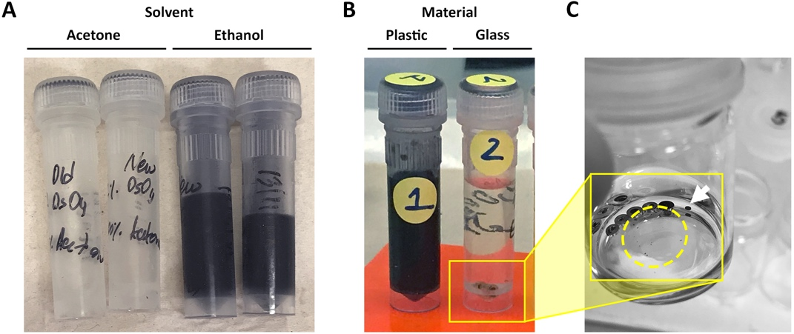
Figure 3.10 Osmium tetroxide reacting with the FS medium.
(A) Test between acetone and ethanol as the solvent for osmium tetroxide (OsO₄). (B) Difference between the use of plasticware or glassware for the preparation of ethanol-based FS medium. (C) Freeze-substituted samples that popped out of the carriers on their own either intact (arrowhead) or by breaking into minute pieces (dashed circle).
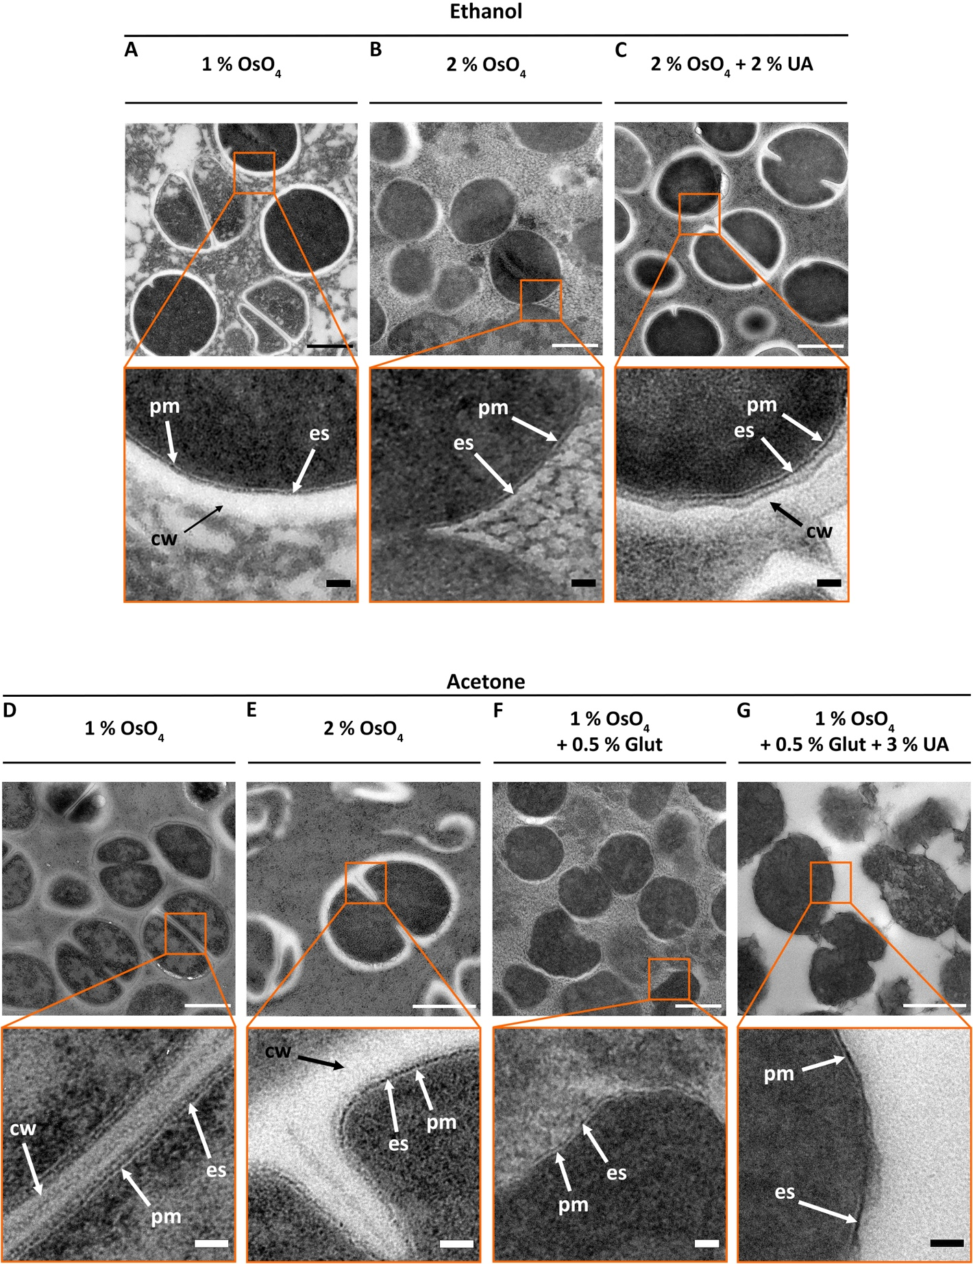
Figure 3.11 Optimising freeze-substitution media for S. aureus.
(A-C) Comparison of ethanol based FS media with (A) 1 % (w/v) OsO₄, (B) 2 % (w/v) OsO₄, and (C) 2 % (w/v) OsO₄ + 2 % (w/v) uranyl acetate (UA). (D-G) Comparison of acetone based FS medium containing (D) 1 % (w/v) OsO₄, (E) 2 % (w/v) OsO₄, (F) 1 % (w/v) OsO₄ + 0.5 % (v/v) glutaraldehyde, and (G) 1 % (w/v) OsO₄ + 0.5 % (v/v) glutaraldehyde + 3 % (w/v) UA. PM– plasma membrane, cw–cell wall, es–exoplasmic space. Mid magnification scale bar 500 nm. High magnification scale bar 50 nm.

Embedding, thin-sectioning and staining.
After HPF and FS, the specimens sometimes pop out of the flat carriers (Figure 3.10c), especially if these have been treated with egg lecithin as described in section 3.4.1. Those specimens still attached were forced out of the carriers with the help of a pipette tip cut diagonally to a sharp end with a razor blade (Figure 3.7c). Changing resins during the embedding process needs to be done carefully, as miniscule broken pieces of specimens could unintentionally be disposed of. This is particularly easy when dealing with viscous resins such as Epon (Figure 3.12a insert). Therefore, the less viscous Spurr resin was tested. Most specimen fragments in Spurr sunk and were not as suspended in the resin as with Epon (Figure 3.12a insert). The low viscosity of Spurr also allows for a better infiltration into the sample, while Epon provided better overall contrast (Figure 3.12a).
The initial protocol followed was adapted from Beveridge’s work ^{[16,268]}, which consisted of washing out any remaining FS medium three times with either acetone or ethanol (depending on the chosen solvent for FS), each for a 30 min duration. This was followed by two 15 min washes with propylene oxide. This transitional solvent was used to help resin infiltration, and therefore a 50/50 mix of propylene oxide/Epon resin was added and left overnight. The next day, the majority of the 50/50 mix was removed, leaving a thin layer covering the sample. The containers were left open to allow the propylene oxide to evaporate and avoid its interference during polymerisation. Afterwards, two changes of fresh full resin were added, for 3-4 hours each, before preparing the final resin blocks to polymerise. This initial protocol gave good results, although sometimes some poor resin infiltration was apparent as electron-transparent areas inside the cell (yellow stars, Figure 3.13a). Although infrequently, some cells appeared to be cut-out or breaking apart from the resin at their cell wall (orange arrow heads, Figure 3.13a). It is difficult to discern if this last described characteristic arises from a faulty HFP, a poor resin embedding or both. It was therefore decided to optimise the infiltration and embedding process, and Dr. Frédéric Leroux (Leica Microsystems) provided advice for a modified version of this protocol (Table 3.1). This adjustment provided slightly better infiltration but did not solve the problem of cells breaking away from the resin at the cell wall (Figure 3.13b). This issue was not consistent, as it appeared with both Epon and Spurr, and with both the initial and the adapted protocol. This supports the theory that it is the results of poorly vitrified cells due to the irregularities encountered with HPF during this study.

Initial Infiltration Protocol | Modified Infiltration Protocol
- Quick wash with acetone/ethanol  - 100 % Acetone/ethanol – 30 min (x3)  - 100 % propylene oxide – 15 min (x2)  - 50:50 propylene oxide/resin – overnight  - 100 % fresh resin – 3-4 h (x2) | - Quick wash with acetone/ethanol  - 1 % (w/v) UA in acetone/ethanol – 1 h  - 100 % acetone/ethanol – 30 min (x3)  - Quick wash with acetone/ethanol  - 30 % (v/v) resin in acetone – 4 h  - 60 % (v/v) resin in acetone – overnight  - 90 % (v/v) resin in acetone – 4 h  - 100 % resin – 2 h (x2)
Table 3.1 Resin infiltration protocol for freeze-substitution.
Appropriate preparation of the resin blocks for polymerisation can facilitate the sectioning step. It is recommended that the specimen is not added after the mould has already been filled with fresh resin. This could result in the sample being dispersed and suspended all over the mould, and this would make the sectioning process more time-consuming. The suggested method is to add one initial drop of freshly made resin to the mould and then add the specimen before filling it up completely. In this case, the use of BEEM® capsules for easier sectioning is recommended, as they provide a pointed tip. Then, utilise a toothpick to fish out each piece of specimen and place it into the drop of fresh resin at the bottom of the mould. The specimen piece selected should stick to the drop of resin. This is quite laborious, but it allows for all specimen pieces to be concentrated in one area instead of being suspended throughout the whole mould (Figure 3.12b). To finalise, fresh resin is added to fill in the remainder of the capsule and it is placed at 60°C for polymerisation for 2–3 days in the case of Epon or 16 h for Spurr. Thin-sectioning of the cured blocks is recommended between 70 and 90 nm, with the former being more stable and easier to work with. Overall, between 75-80 nm sections were chosen for this study, to obtain the best stability of the sections and best image contrast. Freshly cut sections floating on the knife boat, were then picked up onto TEM grids. These grids were previously prepared by adding a support film of 1.5 % (w/v) pyroxylin in amyl acetate (section 2.20.3). The grids were originally left under a lamp overnight to dry before use; however, some issues were encountered with the support film lifting away while plunging the grid into the water of the knife boat. Drying TEM grids in an incubator set at 20-25 °C overnight solved this matter. The results were successful and consistent.

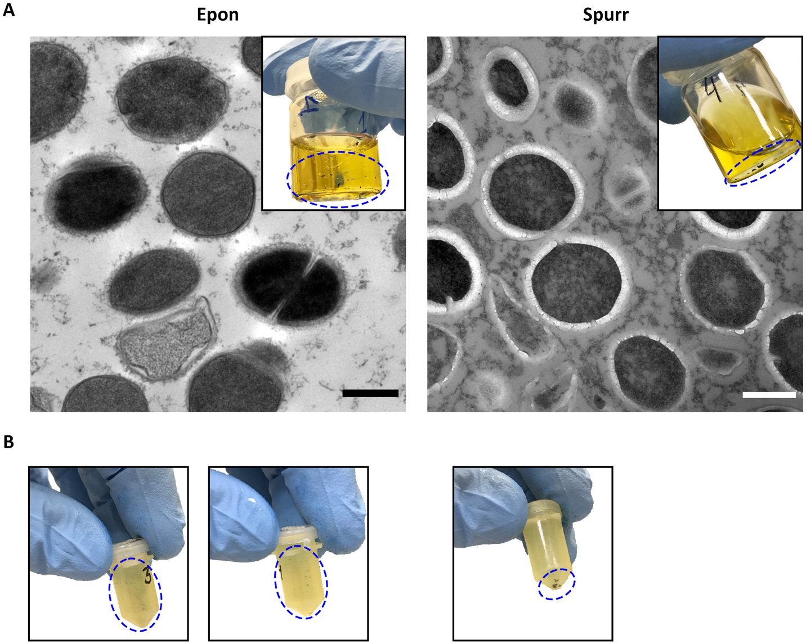
Figure 3.12 Epon vs. Spurr, and the best technique for preparing resin blocks.
(A) Difference in working with resins of high (Epon) or low viscosity (Spurr). Mid magnification (2900x), scale bar 500 nm. (B) Specimen suspended in the resin mould (left images) or carefully concentrated at the bottom (right image).
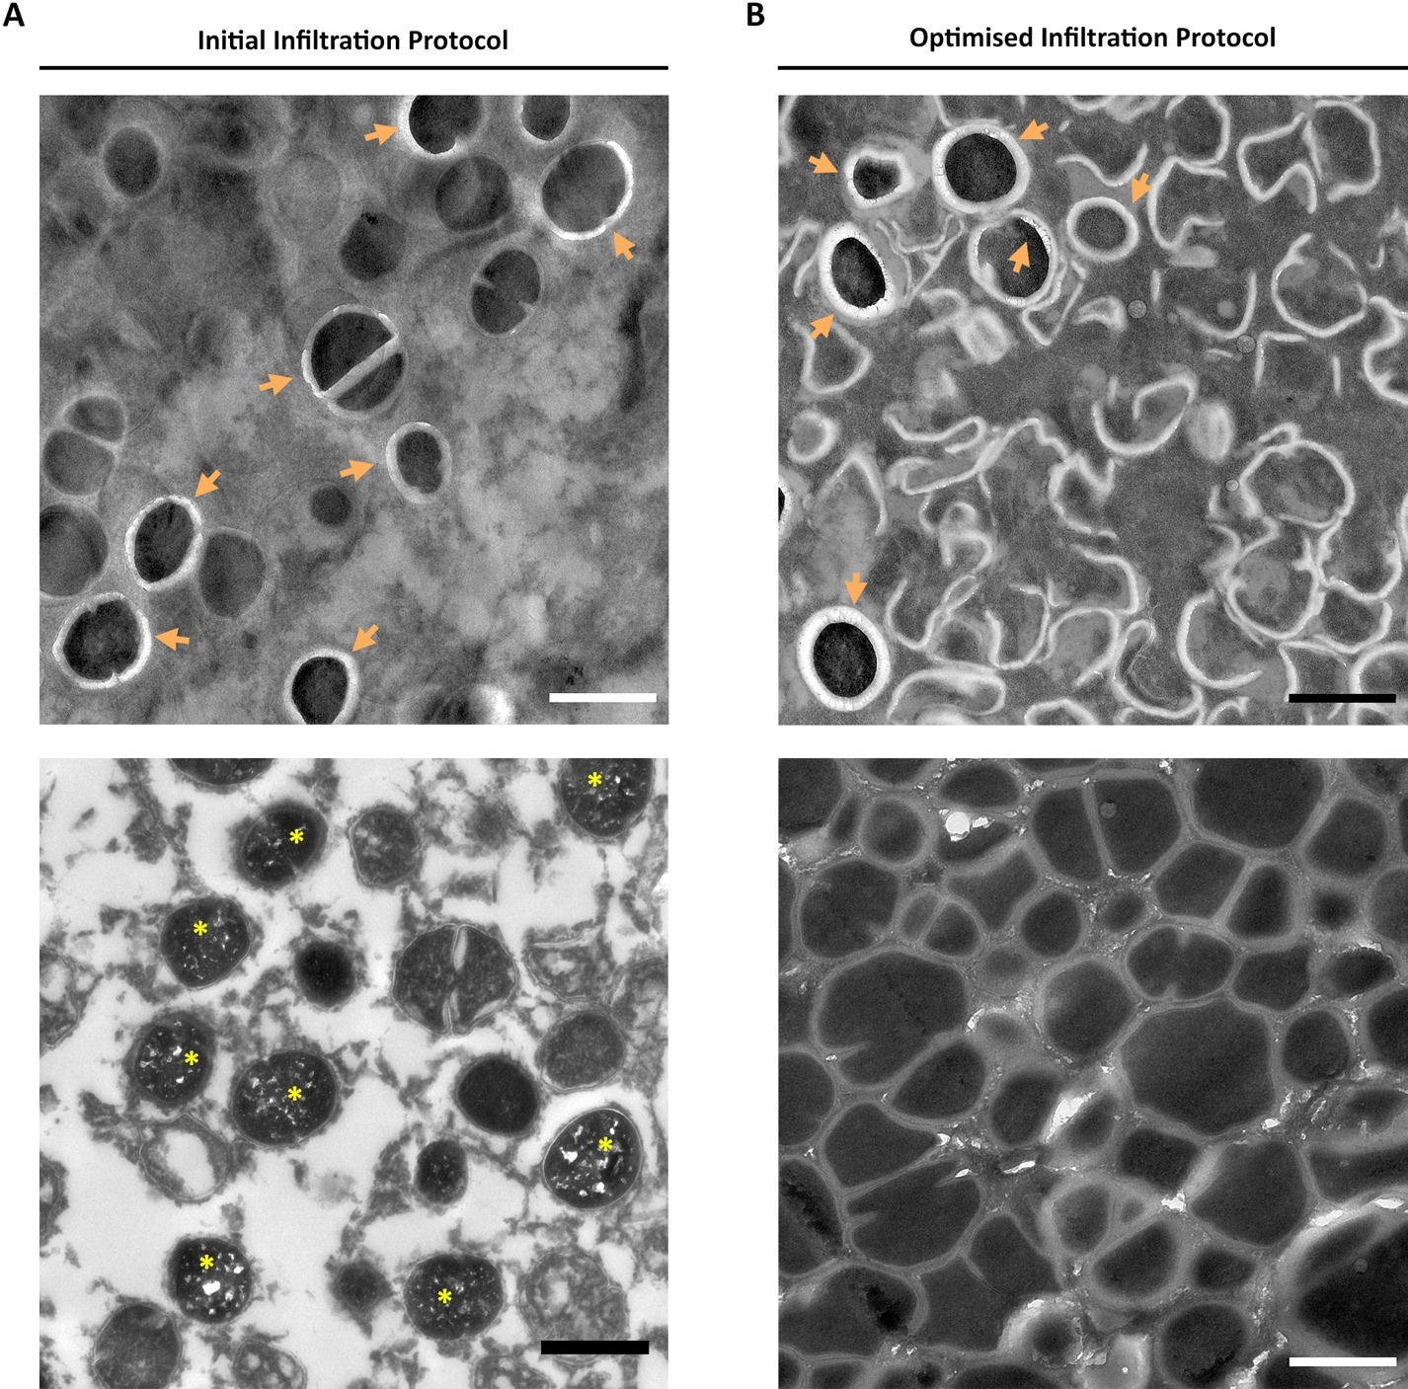
Figure 3.13 TEM micrographs showing different infiltration and embedding protocols for FS.
TEM micrographs of HPF-FS thin sections of S. aureus showing the results of the (A) initial infiltration protocol and the (B) modified protocols described in Table 3.1. Magnification 2800x, scale bars 1 µm. Yellow stars– poor resin infiltration. Orange arrow heads– cells cut-out from the resin.
The sections mounted on the TEM grids where post stained with 3 % (w/v) uranyl acetate (UA) and Reynold’s lead citrate (LC) ^{[230]}. A test was performed to analyse if the use of post-stain was necessary (Figure 3.14a), or if UA was enough on its own (Figure 3.14b) compared to the use of both UA and LC (Figure 3.14c). The lack of any post-stain shows that OsO₄ provides enough contrast to the sample. However, this is highly improved by the use of both UA and LC. During staining, stain droplets were added onto a silicon mat, and the TEM grids were suspended onto the surface (Figure 3.15a). UA stain is sensitive to light, and it can precipitate in the form of needles, and those crystals or aggregates impair visualisation of the sample (Figure 3.15b). Therefore, the post-staining processed was carried out in a blacked out petri dish (Figure 3.15a). As LC precipitates when exposed to CO₂ in the form of round black aggregates, which then also affects the visualisation of the sample (Figure 3.15b), it was of high importance to use degassed dH₂O for washing the grids between stains. As an extra precaution, pellets of NaOH were added to the petri dish to capture any ambient CO₂ (Figure 3.15a). For best results and longer shelf-life, both stains were prepared with CO₂-free water, both were filtered regularly and kept in a blackout Falcon tube at 4 °C. These were replaced with freshly made stains every few months (refer to section 2.7 and 2.20.6 for a detailed description of stain preparation and staining process).
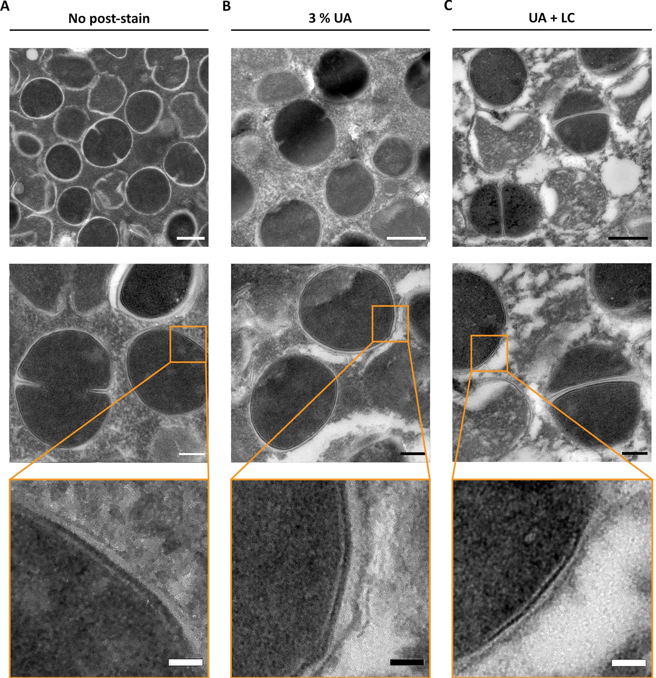
Figure 3.14 Post-stain selection.
TEM micrographs of HPF-FS S. aureus showing the difference between (A) no post-stain, (B) 3 % (w/v) uranyl acetate (UA), or (C) 3 % (w/v) UA plus Reynold’s lead citrate (LC). Mid magnification (A) 4800x, (B-C) 6800x, scale bar 500 nm. (A-C) High magnification, 11000x scale bar 200 nm. Orange inserts cropped from 11000x micrographs, scale bar 50 nm.
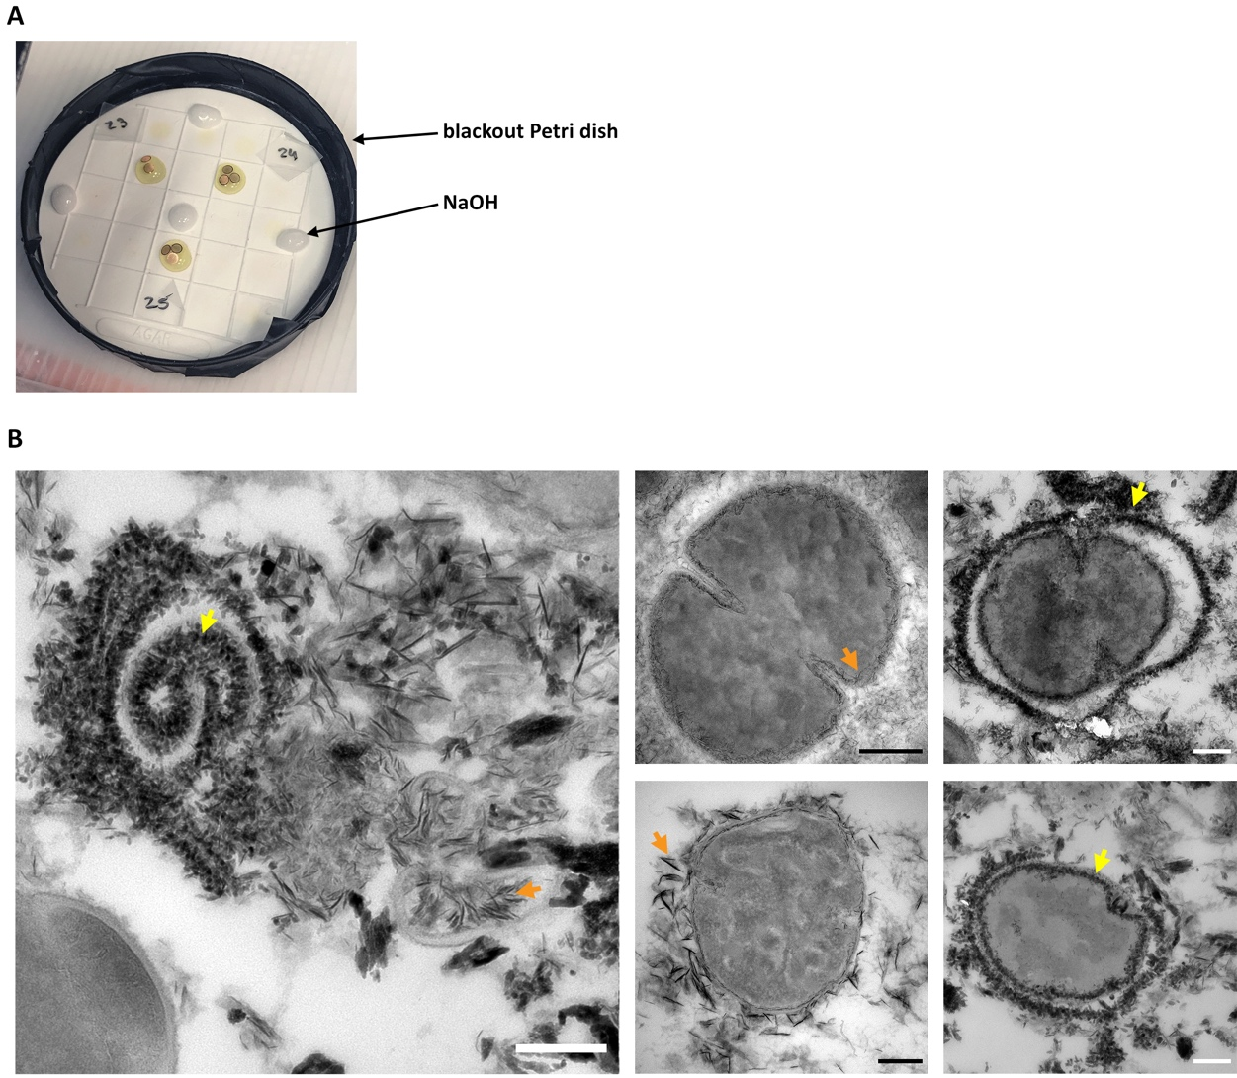
Figure 3.15 Post staining of TEM grids.
(A) Post staining set-up for TEM grids using a blackout Petri dish, a silicone mat and NaOH pellets to capture CO₂. (B) TEM micrographs of FS thin-sections of samples stained with UA and LC. Samples were exposed to light and CO₂ to exaggerate the results of the precipitation of UA (orange arrowhead) and LC (yellow arrowhead), that manifest in the form of needles or round aggregates respectively. High magnification 18500x, 13000x and 1100x, scale bars 200 nm.

A quicker freeze-substitution for faster processing (SQFS).
Conventional FS with the Leica AFS2 takes around 3 days, followed by 5 days of infiltration, embedding and polymerisation. In an attempt to shorten this 8-day lengthy process, a quicker FS programme was tested. The standard protocol used up to this point, obtained from Matias & Beveridge (2006) ^{[16]}, consisted of 18 h at – 90 °C, 15 h at – 60 °C, 12 h at – 30 °C, with the temperature slowly incremented to room temperature during a period of 18 h. This whole process lasts around 65 h (Figure 3.16a). An optimisation suggested by Dr. Frédéric Leroux (Leica Microsystems) involved the following steps: 12 h at – 90 °C, 8 h from – 90 °C to – 60 °C, 5 h at – 60 °C, 7 h from – 60 °C to – 30 °C, 5 h at – 30 °C, and finally 5 h to reach 0 °C (Figure 3.16b). Dr. Laroux’s suggested programme helped cut down ~ 18 h of the FS process.
Another attempt to speed up this process was to follow Dr. Kent McDonald’s quick freeze-substitution (QFS) or super quick freeze-substitution (SQFS) ^{[240]}. These protocols were expected to deliver similar results as the 3-day standard FS in just 1.5 or 3 h respectively. Another advantage is that these protocols do not require the use of the Leica AFS2 instrument. QFS is done with LN₂ and dry ice, whereas SQFS only uses LN₂. The latter was chosen due to its faster processing and convenience. The protocol described by McDonald & Webb (2011) ^{[240]} for SQFS involves the precooling of a heat block for 13 mm tubes, by covering it with LN₂ for 5-10 min inside a Styrofoam® box. Meanwhile, the frozen samples are inserted into cryotubes with the chosen fixative at LN₂ temperatures. The lid is kept at room temperature to ensure that the O-ring is pliable and provides a tight seal. In order to record the temperature in real time, a dummy tube with a thermocouple is added. This is constructed by perforating a small hole in the cap of a cryotube, inserting a temperature probe, and sealing the hole with epoxy resin to avoid leakage. The set up recommended is a Type T thermocouple attached to a temperature datalogger. This dummy tube is then filled with the same solvent used in the FS medium and placed in the heat block together with the samples. The LN₂ is then poured out from the foam box and the holes of the block. The block with the samples is turned on its side, and the box is placed on a shaker running at 100 rpm until the temperature reaches 0 °C; time after which they are removed from the foam box and placed on the shaker until they reach room temperature.
Dr. McDonald suggested to use a box with the interior dimensions of 8 x 11 x 15 cm (H x D x W), with 2.5 cm wall thickness ^{[240]}. Unfortunately, a similar box was not found and a bigger one (17.5 x 19 x 19 cm) with the same 2.5 cm wall thickness was used instead (Figure 3.17a). The modular heating block with the cryotubes was cooled down with LN₂ and inserted into the foam box. The block rested on its side to allow a thorough mix of the FS medium and the flat carriers. Paper roll was added around the heating block to make sure that the cryotubes did not fall out with the movement of the shaker (Figure 3.17a). Two different types of self-standing cryotubes with an O-ring seal where tested. As one of them leaked, it is recommended to run a test in LN₂ beforehand. McDonald & Webb indicate that the temperature should reach 0 °C at approximately 80-85 min, however when tested, this point was reached after ~ 222 min (Figure 3.17b). This showed a delay of 137 min indicating that this attempt was not successful. Overall, the standard FS process that lasts 65 or 47 h, was reduced to 5 h. This is definitely an improvement, but it was decided to push further and try to reduce it to the 1.5 h achieved by McDonald & Webb.
For the second attempt, a narrower box with thinner walls was chosen. This time it was also decided not to use paper to hold the block in place, to speed up the increase in temperature. The box was placed on its side with the opening right next to the wall of the box (Figure 3.17c). Because of the weight of the block and the opening facing the wall, any movement did not result in the cryotubes falling out. These changes resulted in the SQFS 2nd test being 100 min faster than test 1 (Figure 3.17d). This modified setup achieved a SQFS of 3:20 hours, closer to Dr. Kent McDonald’s 3 h QFS attempt, but far from the 90 min SQFS protocol. Finding a foam box closer to the dimensions used by him could help reduce the overall timing.
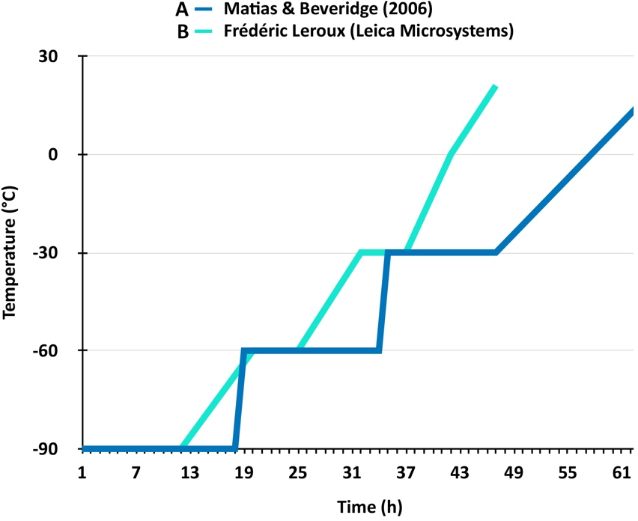
Figure 3.16 Leica AFS 2 programmes.
(A) FS programme obtained from Matias & Beveridge (2006) ^{[16]} lasting ~ 65 h. (B) FS programme suggested by Dr. Frédéric Laroux from Leica Microsystems, lasting ~ 47 h.
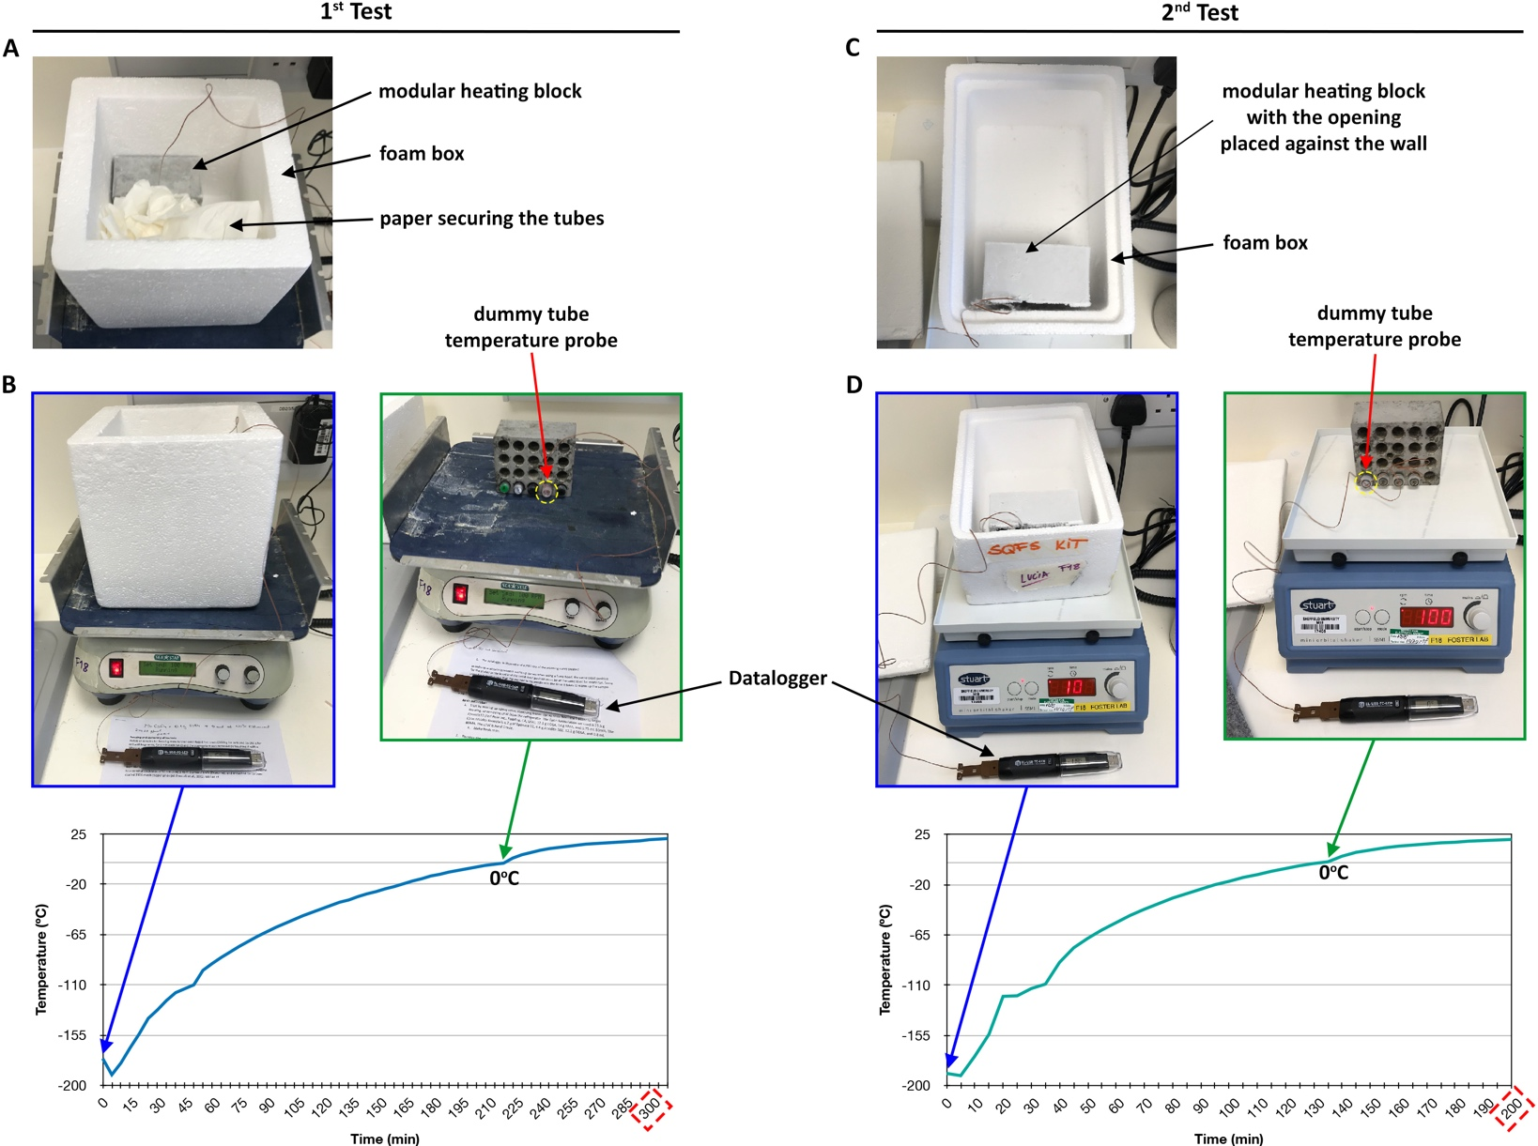
Figure 3.17 Super quick freeze-substitution setup and test runs.
Set up and test runs for super quick freeze-substitution (SQFS) for (A-B) test 1 and (C-D) test 2. Set up obtained from McDonald & Webb (2011) ^{[240]}.

Rapid infiltration and polymerisation for FS.
Conventional infiltration and polymerisation lasts 2 days and 2-3 days respectively. In an attempt to speed up this process, a protocol of rapid infiltration and rapid embedding of 3 h each was tested ^{[241]}.
After FS, the medium was rinsed with pure acetone, followed by another 3 washes of 10 min each. Samples were removed from the flat carriers with the help of a cut pipette tip, as shown in Figure 3.7c. Increasing resin/acetone mixtures were used for infiltration, starting with a 25 % (v/v) resin in acetone, followed by 50, 75, and 100 % (v/v). This last pure resin step was repeated three times. Re-suspension and mixing are critical for a rapid infiltration. Therefore, the samples with the resin/acetone mixture were spun for 30-60 s at 6000 rpm (~ 2000 g). Rapid polymerisation occurred at 100 °C, instead of the standard 60 °C, and it lasted for 2 h for epoxy resins or 90 min of LR white resin. These results suggested that Dr. McDonald’s rapid protocol ^{[241]} can replace the standard protocol. Yet, some of the samples presented the already described issues seen in Figure 3.13, which again could be the consequence of poorly vitrified cells. Hence, it is recommended to repeat this test on chemically fixed samples to remove the HPF factor.

Freeze-substitution provides better structural preservation than chemical fixation.
Regardless of the issues encountered with HPF, some successful results with good vitrification were attained (Figure 3.18a). The FS protocol is described in section 2.20.2. TEM micrographs were obtained using the FEI Tecnai T12 Spirit TEM operating at 80 kV, and captured on a GATAN ORIUSTM SC1000B bottom-mounted CCD camera. These results provide proof that FS has the power to produce better structural preservation for detailed morphological analysis (Figure 3.18b). A parallel collaboration and optimisation of the HPF-FS protocol with Dr. Ainhoa Dafis-Sagarmendi (University of Sheffield) ^{[269]} provided further confirmation that FS delivers more structural detail and contrast than standard chemical fixation TEM (Figure 3.19).
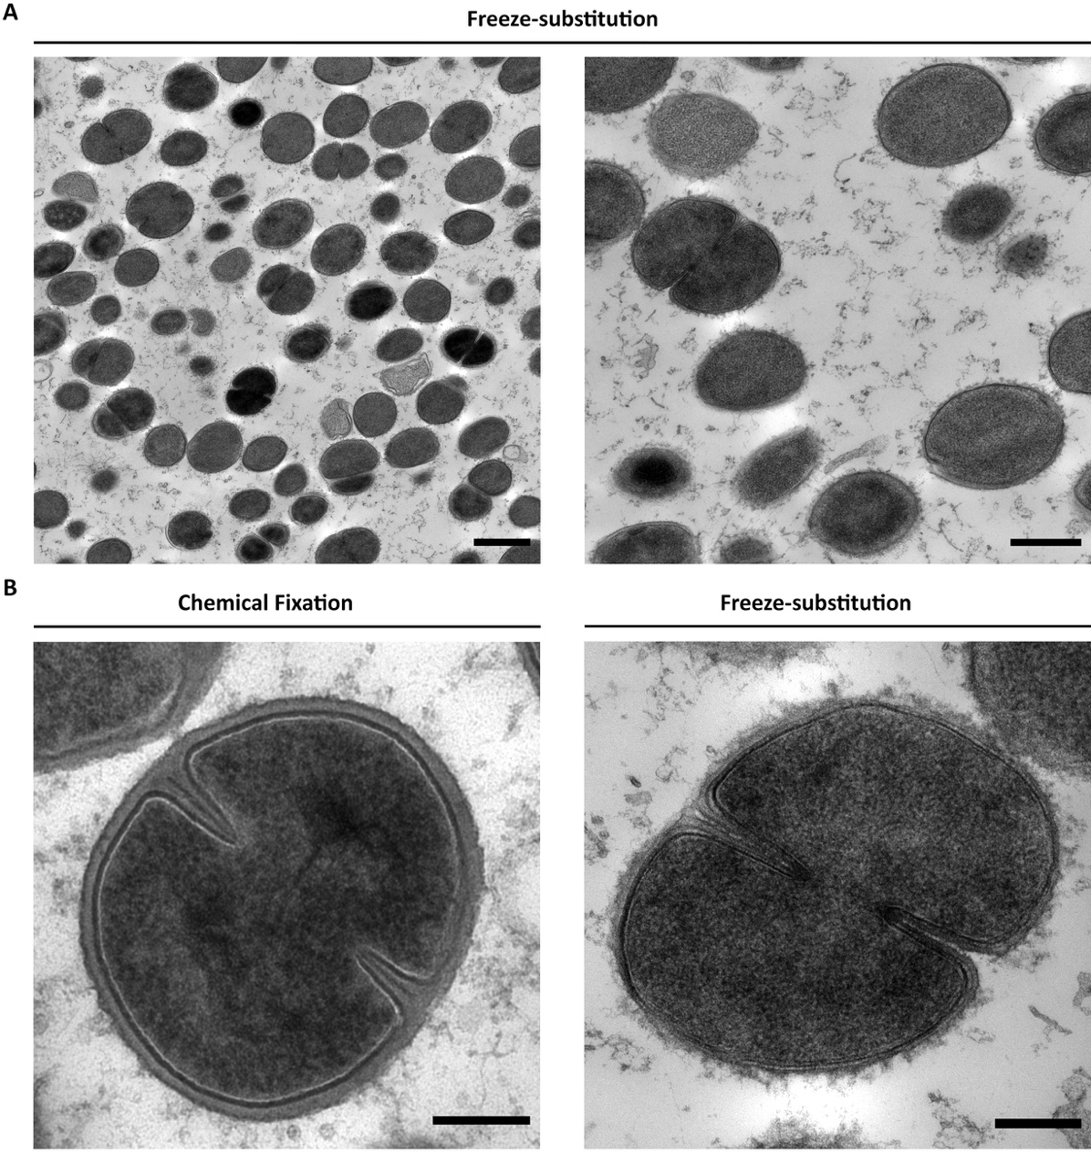
Figure 3.18 Freeze-substitution for better structural preservation of S. aureus.
(A) Example of good results from TEM FS micrographs of S. aureus. Low and high magnification (1900x and 4800x). Scale bars 1 µm and 500 nm, respectively. (B) Comparison between the structural preservation between standard chemical fixation and HPF-FS as indicated. Cropped from 9300x and 11000x, respectively. Scale bars 200 nm.

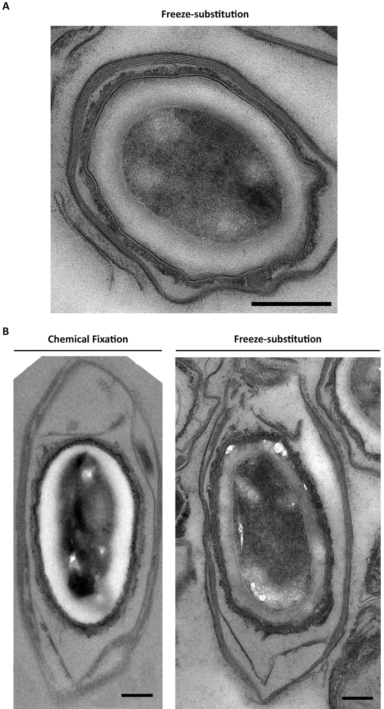
Figure 3.19 HPF-FS structural preservation in Clostridium sporogenes.
TEM micrograph of C. sporogenes spores. (A) HPF-FS representative spore, scale bars 500 nm. (B) Comparison between the detailed obtained with chemical fixation and FS, as indicated. Scale bars 200 nm. Micrographs obtained with permission of Dr. Ainhoa Dafis-Sagarmendi ^{[269]}.

Cryo-electron microscopy of vitreous sections (CEMOVIS) for observing the exoplasm.
Chapter 4 of this study focuses on the exoplasmic space between the cell membrane and the cell wall (CW). This space was never fully studied until Matias and Beveridge (2006) ^{[16]} analysed cryo-EM micrographs of frozen-hydrated S. aureus samples. The idea of analysing cells in a hydrated states allows to study the exoplasmic space that otherwise would be dehydrated and would be more difficult to recognize. In this section I followed and optimised the frozen-hydration protocol described by Matias & Beveridge ^{[16]}.

HPF – specimen tube system for CEMOVIS.
Sample preparation for CEMOVIS was identical to freeze-substitution, with cells grown in TSB + 10 % (v/v) glycerol as a cryoprotectant (section 2.11.3). The cryo-fixation step is similar to the one described in section 3.4.1, with the difference that HPF is carried out with Leica’s specimen tube system instead of the flat carriers. This system comprises of 16.3 mm long copper tubes with an outer diameter of 650 µm and an inner diameter of 350 µm. Unlike the flat carrier system, the sample is loaded directly into the copper (Cu) tube, which is in turn inserted into a 16 mm tube holder and attached to the loading device that goes into the Leica EM PACT2. There are many ways to load the sample into the Cu tubes. To load a suspension made from the sample, wire needles with a 250 µm diameter inserted into the Cu tube can be used to pull the suspension through them. Alternatively, cellulose capillaries with 200 µm in diameter than can be inserted into the tube and draw the suspension in. These capillaries are then cut with a razor blade at each end. A third option is to cut a 200 µl pipette tip to fit the Cu tube in, and a 1 ml syringe with the suspension can be used to fill the tube. Matias & Beveridge suggested to use this last method.
The bacterial pellets were very difficult to inject with the syringe, so a 2.3 M sucrose solution was added to make a suspension and improve its density. The first loading attempt was carried out by lifting the sample/sucrose suspension with a pipette and inserting it into the 200 µl cut pipette tip attached to a Cu tube. A 1 ml syringe was then attached to the other end of the tip, and air was pushed-in to force the sample into the Cu tube until some sample came out the other side. The loaded tube was then inserted into the tube holder, and by using the recycling tool provided by Leica, a flange was made on both sides so that it connects to the loading device. The second loading attempt consisted on having the Cu tube already fixed and ready inside the tube holder. A 200 µl pipette tip was cut to fit the 1 ml syringe on one end and the tube on the other. Before attaching the Cu tube to it, the tip attached to the syringe was used to pick up the suspension. Then, the Cu tube was attached, and the suspension was transferred into the tube until sample started to come out the other end. This second attempt seemed to deliver better and more consistent results, and was faster, as the tubes could be prepared in the tube holders beforehand.
Unfortunately, as explained before, the HPF encountered some consistency issues and many pressure failures during this cryo-fixation. After vitrification, each tube holder was quickly transferred from the LN₂ bath in the EM PACT2 to an insulated cryo container filled with LN₂. This container was then placed under the stereoscope with all the necessary tools to remove the tube from the holder. Each vitrified specimen tube had to be punched out of its tube holder using the punching tool provided by Leica. This step cuts out the middle section of the vitrified Cu tube. All the cut vitrified tubes were then inserted into cryotubes with LN₂ and kept in a LN₂ Dewar until it was time to cryo-section the samples.

Cryo-sectioning for CEMOVIS.
Cryo-sectioning was carried out by using the Leica EM UC6/FC6 cryo-ultramicrotome in a humidity controlled room. LN₂ was pumped from the Dewar to the cryochamber FC6 attached to the UC6 ultramicrotome. The specimen, knife and chamber temperature were set to – 120 °C. While waiting for the temperature to drop down, the specimen holder, knife holder, and selected knives were fixed and set into the cryochamber (Figure 3.20a). Two knives were chosen: the DiATOME cryotrim 45° (CT600) for trimming the copper tube, and the DiATOME cryo 25° (MT16094) for sectioning frozen hydrated specimens. The cryotubes containing the vitrified specimen tubes were quickly moved with precooled forceps from the LN₂ storage Dewar into an insulated container with LN₂. This container was then placed next to the FC6 chamber, and the cryotubes were swiftly moved into the cryochamber. All transfer movements were done quickly and with precooled forceps to maintain cold temperatures and avoid ice formation. The specimen Cu tubes were then removed from the cryotubes and placed in a storage box for punched-out Cu tubes, and left in the cryochamber (Figure 3.20a – red selection). The first tube was then inserted and secured into the specimen holder at the back of the UC6 and the cryotrim knife place in position (Figure 3.20a). The ioniser antistatic device was situated on the front of the chamber, pointing at the specimen (Figure 3.20b).
The cryo-sectioning protocol was modified from Ng et al., (2020) ^{[243]}. The initial step of cryo-sectioning involves exposing the sample inside the Cu tube. To do so, the cryotrim 45° was used to shave the face of the tube until the sample was visible (Figure 3.20c). The vitrified sample appeared smooth and dark as expected. Trimming was carried out at a 50 mm/s speed and 500 nm feed with a medium return speed. The last 1 µm trim was done at 25 mm/s speed and 200 nm feed.
The following step was to trim away the sides of the Cu tube to expose the specimen further and be able to section it without Cu surrounding it (Figure 3.20d); this creates a square mesa (Figure 3.20e). First, the cryotrim knife was moved to one side, and positioned so that the corner closest to the Cu tube was ~ 0.1 mm away from its inner wall (Figure 3.20d). Roughly 40-50 µm of the tube were trimmed away, followed by moving the knife to the opposite side to repeat the process. Secondly, the specimen holder was turned 90 ° and this process was repeated on each side to trim what initially was the top and bottom of the tube before rotation. This square mesa trimming was performed at 25-50 mm/s and 200 nm feed with medium return speed. During the trimming of the Cu tube, the ioniser was set to high to make sure that the Cu shavings did not stick to the knife edge. Sometimes, drop amounts of LN₂ had to be added to help remove Cu debris.
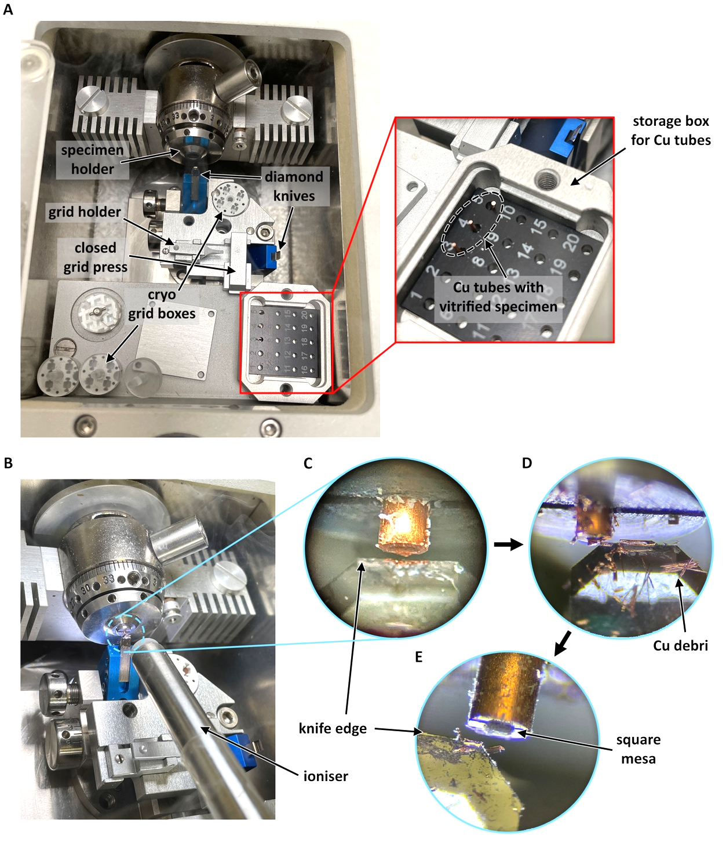
Figure 3.20 Cryo-microtome setup for cryo-sectioning of frozen-hydrated samples.
(A) Cryo-chamber showing the setup of all components for cryo-sectioning. (B) Positioning of the antistatic device during sectioning. (C) Trimming of the copper (Cu) tube with the vitrified sample and polishing of the face of the specimen. (D) Trimming of the sides of the Cu tube to form a (E) square mesa.
Once the specimen was exposed, the cryotrim knife was moved out of the way and the cryo 25° knife was set in place to start sectioning the frozen hydrated sample. Sections were obtained with a 1 mm/s cutting speed and 50 nm feed with a slow return speed. The ioniser’s intensity and position were constantly modified according to what was needed. If the ribbon of sections stuck to the knife, the intensity was increased or the ioniser was slightly moved forward. If the ribbon started to lift away, the opposite action was taken. This is the most difficult and crucial step of cryo-sectioning. The use of clothing with natural fabrics is highly recommended to avoid affecting the static of the sections. Obtaining a ribbon of sections requires a lot of practice and patience. Caution should be taken, especially to avoid burning of the fingers during long manipulations near the cryochamber. An eyelash glued to a wooden stick was used to manipulate the ribbon of the obtained sections. The angle at which this manipulation occurs makes it very difficult to be precise. Ng et al., (2020) ^{[243]} described the use of a custom-made fibre tool paired up with a commercial micromanipulator adapted for cryo-microtomy (Figure 3.21a). Such a tool would provide a more precise manoeuvring of the ribbon and adapting a similar setting for this technique should be considered.
The process of pulling the ribbon towards the user is a delicate balance between extending the ribbon onto an EM grid while avoiding breakage. Ng et al., (2020) ^{[243]} described a technique where the ribbon is looped over the eyelash, which in turn makes pulling the ribbon easier as it is more secured around the eyelash. Unfortunately, I failed to achieve a successful loop with the current set up. Having the custom-made fibre tool and micromanipulator described in Ng’s protocol would probably allow for better control of the ribbon and its looping around the eyelash. Hence, the ribbon was controlled by placing the eyelash underneath it. A steady hand was essential.
Once a long enough ribbon was obtained, a carbon-coated fine-mesh grid was placed beneath it. Manipulating the grid with one hand while controlling the eyelash and the ribbon with the other is extremely difficult, especially when an extra hand is needed to constantly modify the controls of the FC6 and the ioniser. Therefore, the grid holder provided in the FC6 was used (Figure 3.21b). Extra caution should be taken not to push the grid too close to the diamond knife, as the grid holder or the grid itself could easily crash into the knife and damage it.
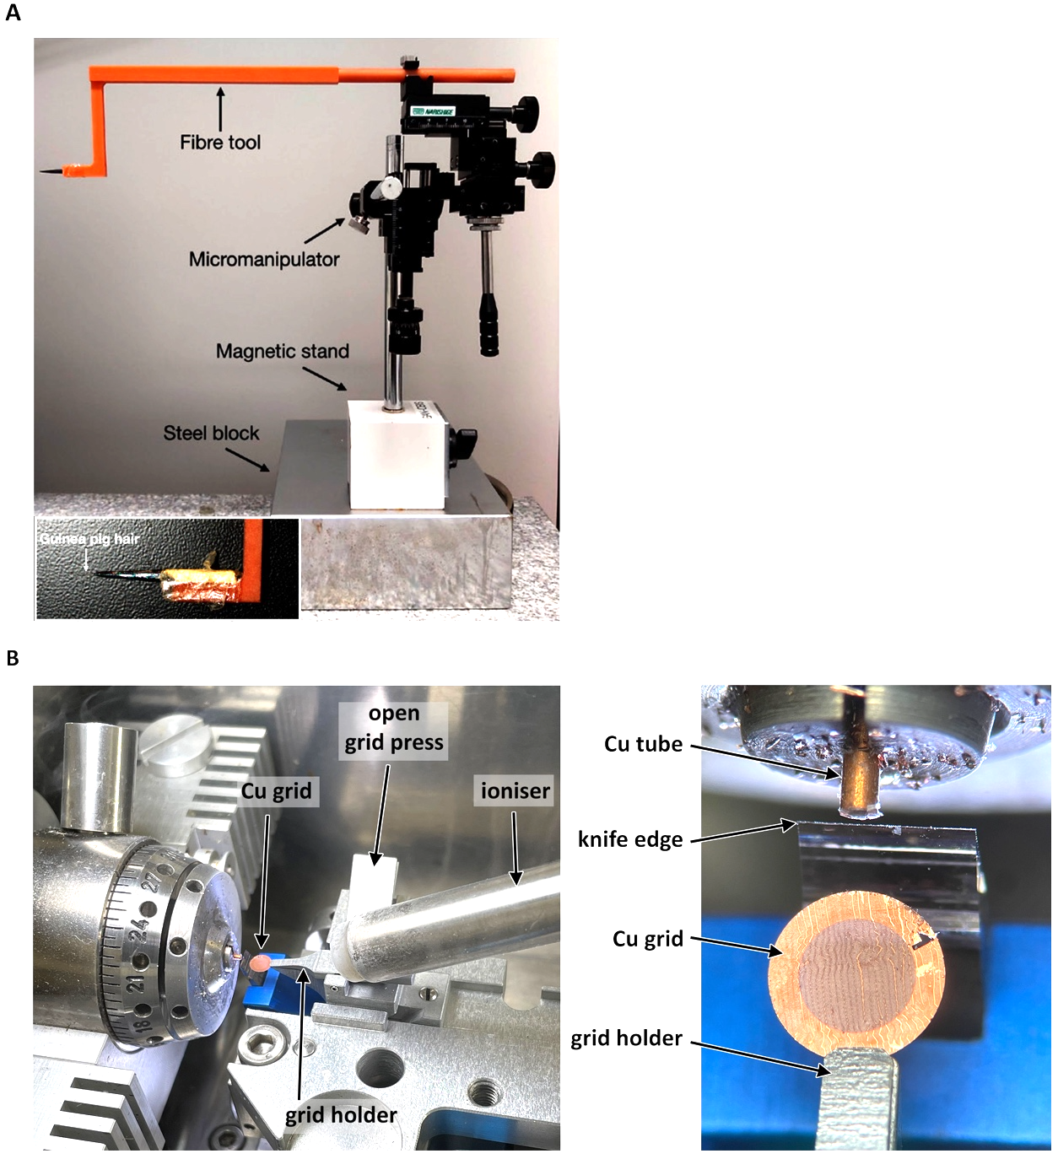
Figure 3.21 Tools for aiding serial cryo-sectioning.
(A) Custom-made fibre tool for facilitating the manipulation of the ribbon attached to a custom micromanipulator for fine control; designed by Ng et al., (2020). Image obtained from Ng et al., (2020) ^{[243]}. (B) Placement of the grid holder provided in the Leica EM PACT2.
Once the ribbon is collected onto the grid, the grid holder was pushed back with precooled forceps until the grid was on the bridge of the grid press. The press was then flipped over the grid to flatten the sections. The section press is then flipped opened and the grid removed from the grid holder. The grid was then moved to a cryo grid box and stored back in the LN₂ Dewar until imaging with the cryo electron microscope.

Best structural preservation and detail with CEMOVIS.
Dr. Svetomir Tzokov (EM Facility – The University of Sheffield) completed the CEMOVIS protocol by analysing the first attempt at this technically difficult approach. Cryo-EM was conducted on the FEI Tecnai Arctica with field emission gun operated at 200 kV. Micrographs were captured with a Falcon III direct electron detector (Thermo Fisher Scientific).
Figure 3.22a shows two different areas of the same EM grid, emphasising the difficulty of cryo-sectioning. On the left, an area of the grid presenting a broken and folded section (yellow arrows) with ice contamination (*). Bacterial cells are still visible in between the damaged areas of this section. On the right, an intact section showing quite a few frozen-hydrated S. aureus cells. Unfortunately, even on the intact section a lot of ice contamination is present. On closer inspection, whole cells in various stages of division can be found (Figure 3.22b). A magnified view of the bacterial envelope confirms the successful vitrification of the sample, showing a much more detailed plasma membrane with a clear phospholipid bilayer (Figure 3.22c). Densitometry plots provide further analysis of the mass of the bacterial envelope at two different points of Figure 3.22c (I, II). The two phospholipid layers of the plasma membrane (pm) can easily be identified, and a hydrated exoplasmic space (es) appears closer in size to the cell wall (cw) (Figure 3.22I, II). The obtained results are similar to those seen by Matias & Beveridge (Figure 3.22d) ^{[16]}.
This first attempt at CEMOVIS, although far from perfect, confirm that frozen-hydrated samples can provide the detail information needed for studying the exoplasmic space. Further training and optimising would reduce ice contamination and improve imaging.
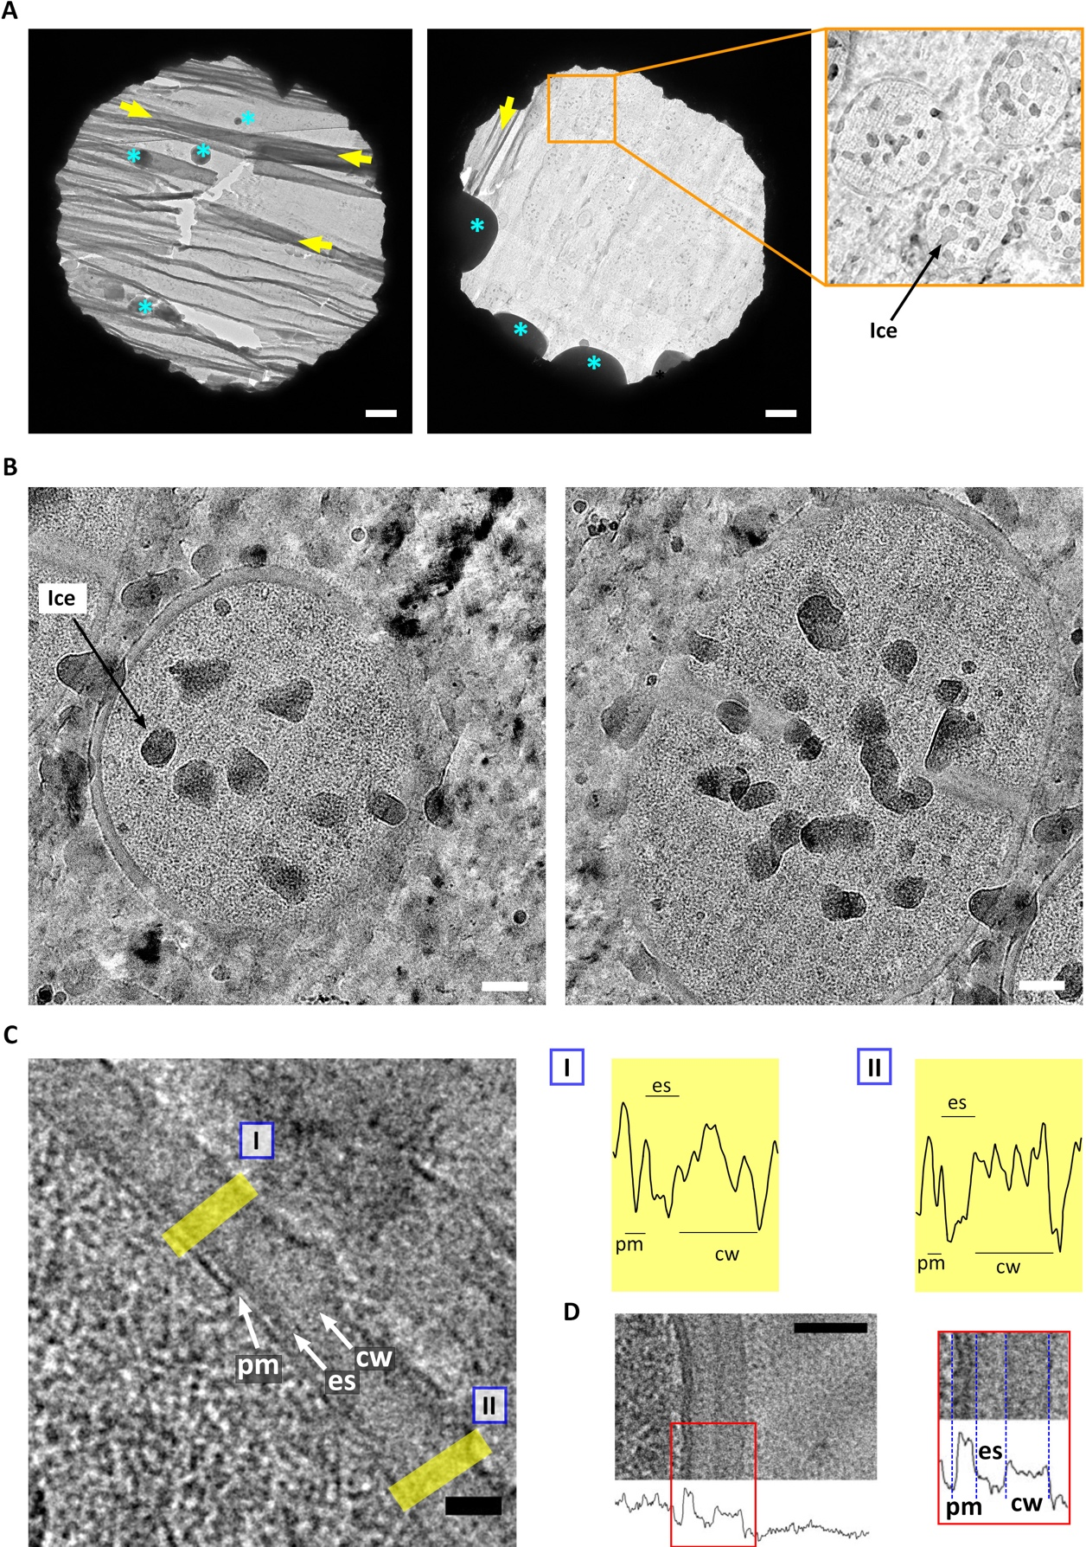
Figure 3.22 CEMOVIS of S. aureus.
Cryo-EM micrographs of frozen-hydrated sections of S. aureus. (A) Areas of the same grid showing damaged (left) and intact (right) thin-sections. Yellow arrows– folded section, blue *– ice contamination. Scale bar 1 µm. (B) Representative frozen-hydrated cells. Scale bar 100 nm. (C) High magnification of the cell envelope showing the plasma membrane (pm), exoplasmic space (es) and cell wall (cw). Scale bar 20 nm. I and II show density traces for two sections (yellow rectangles) of the cell envelope of (C). (D) High magnification image of the cell envelope of a frozen-hydrated S. aureus cell, with the corresponding density traces, obtained from Matias & Beveridge (2006) ^{[16]}.

Discussion.
Cross-section imaging is needed to obtain detailed information on the cell envelope (section 3.2), and it is important to consider the level at which the cross-section occurs (Z-level). A cross-section of a 1 µm spheroid bacteria like S. aureus, will look different in size and proportion if the 90 nm thin-cut occurs near the periphery of the cell (Figure 3.23a). Therefore, the best representative sections from which any measurements could be performed would be a central cross-section of the coccus, as anything far from the middle will present a smaller area and thicker CW (Figure 3.23b). This arbitrary and imprecise selection of cells means that cross-sections cannot be used for a representative cell volume estimation of the population. The chosen technique for cell volume is thus structural illumination microscopy (SIM), as labelling the bacterial CW provides whole cell imaging (see section 2.18.5 for details). However, for choosing the best methodology for morphological quantification, with focus on the bacterial envelope (Chapter 5), a technique that provides the best ratio between high throughput and detailed cross-section imaging is needed. Transmission electron microscopy (TEM) delivers the best resolution on detailed thin-sections. It is still recommended to disregard any bacterial cross-sections further from the centre and closer to the periphery of the cell, as they will lose structural information and should not be analysed. Therefore, for significant morphological quantifications, it is necessary to count and analyse a higher number of cells than usual to reduce this error. For each strain and sample, I would recommend a selection of over 300 cells. It is also of great importance to avoid areas where the sample might be obscured or affected by stain precipitation, knife marks, crevasses, and compression (as described in section 3.1).
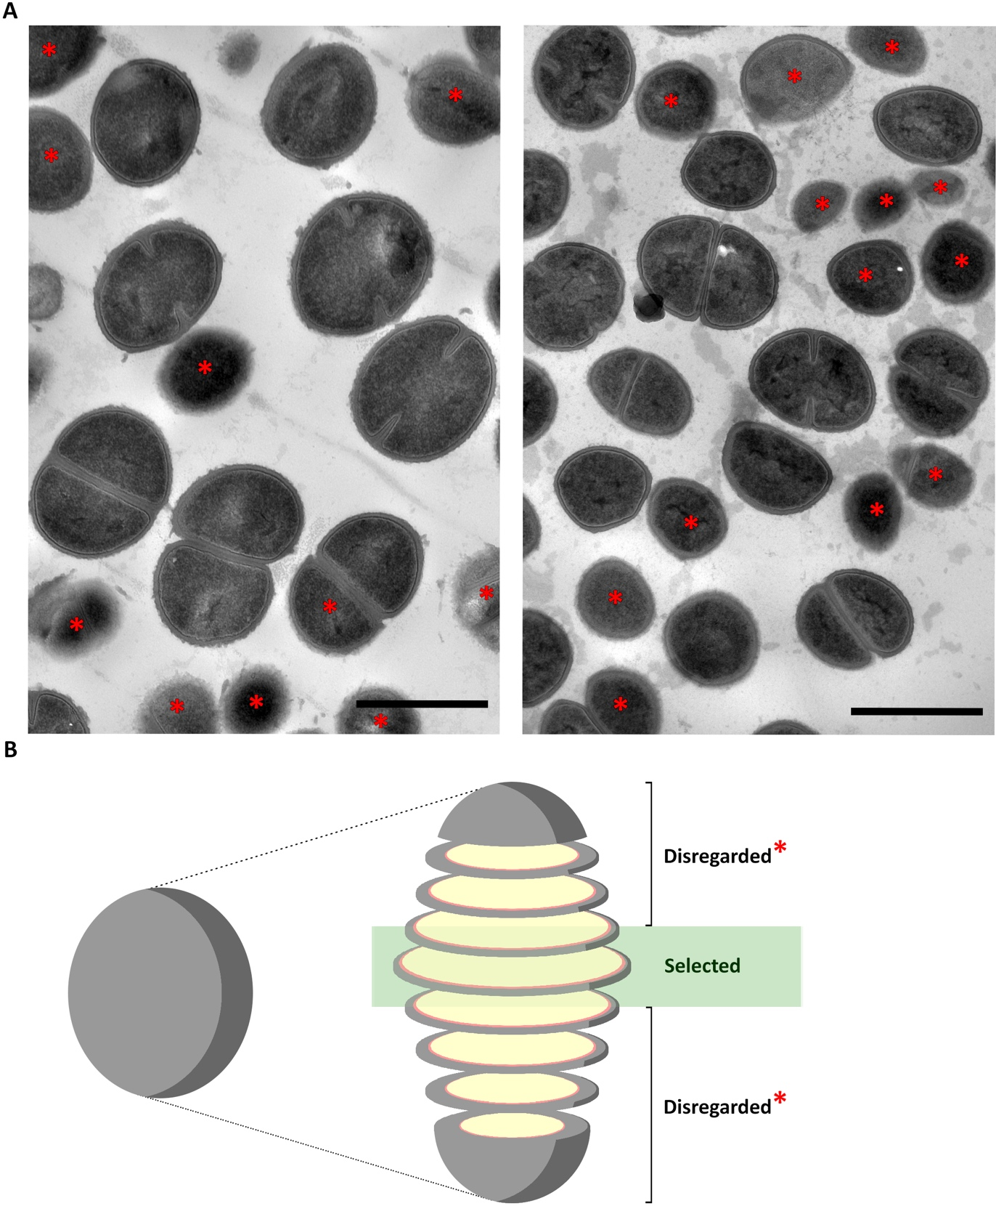
Figure 3.23 TEM selection criteria of individual cells for morphological analysis.
(A) TEM micrographs of ultra-thin sections of chemically fixed S. aureus. Red stars– cells that have been cross-sectioned near their surface and that should be disregarded. (B) Schematic representation of a coccal cell and its possible cross-sections.
The next step was to choose which TEM technique was more suitable for the morphological analysis and quantification carried out during Chapter 5 of this study. Cross-sectioning EM techniques are standard chemical fixation TEM (section 3.3), freeze-substitution TEM (section 3.4), CEMOVIS (section 3.5) and cryo-FIB. Both CEMOVIS and cryo-FIB would present the best possible image for analysis, because of the lack of chemical fixatives and heavy metal staining, and the maintenance of the cell’s hydrated state. Unfortunately, they are technically difficult and do not have a high throughput. Both have a very lengthy process that would make it impossible to obtain analysis of > 300 cells for each mutant and treatment. Freeze-substitution TEM (section 3.4) provides better structural information than chemical fixation. However, it is also a lengthy process with variable results that depends on correct cryo-fixation using HPF. Given the unreliable results obtained with the Leica EM PACT2, this technique was not chosen. Finally, standard chemical fixation-TEM (section 3.2) was the most reliable technique with detailed enough results (Figure 3.24a) and the highest throughput; and was therefore the chosen methodology for the studies in Chapter 5.
Chapter 4 studies the bacterial envelope with particular focus on the exoplasmic space. As explained by Matias & Beveridge (2006) ^{[16]}, conventional chemical fixation does not provide enough structural differentiation. Hence, the alternatives for FS and CEMOVIS where explored. Although sharing similar steps to chemical fixation, FS involves a physical cryo-fixation method, with subsequent chemical fixation and dehydration steps performed at below-zero temperatures and over a long period of time. This distinction provides optimal preservation of the cell envelope combined with the easy-sectioning of resin blocks and the stability and support of resin sections under the electron beam of TEM. It is also worth mentioning that FS is suitable for immunolabelling, which opens up numerous options for bacterial molecular analysis. FS optimisation tests showed great discrepancies in the cryo-fixation using the Leica EM PACT2. This HPF process resulted in various runs of pressure failure. The pressure failed to reach the expected 2000 bar, and it was not maintained for the necessary 600 ms during LN₂ cooling. Subsequent optimisations of the cryoprotectants, fillers, FS media and choice of resin where all affected by unsuccessful vitrification. Nevertheless, analysis of these results suggest that the following optimisations would be the best starting point: (1) bacterial growth with TSB + 10 % (v/v) glycerol for cryoprotection; (2) the addition of 20 % (w/v) BSA for improving consistency and adding extra cryo-protection; (3) coating of the flat carriers with 0.05–0.1 % (w/v) egg lecithin in chloroform for better specimen removal; (4) the use of an acetone-based FS medium, or alternatively, the use of ethanol with caution of utilising glassware during preparation; (5) a FS medium with 1 % (w/v) OsO₄ with 2 % (w/v) UA for added 3D structural contrast; (6) the use of the low-viscosity Spurr resin for better handling of the specimens during infiltration and embedding; and (7) post-stain with both UA and LC for better contrast.
A big disadvantage of FS is its long processing time. Chemically fixed samples are ready to be infiltrated in less than one day, while the FS step alone lasts 2.7 days. Fortunately, Dr. Frédéric Leroux (Leica Microsystems) suggested a modified FS programme for Leica AFS2. The obtained results were not only successful, but also showed a reduction of 18 h in the FS protocol. The initial attempt to reproduce the SQFS described by Dr. Kent McDonald resulted in a 300 min long process. This protocol therefore reduced the FS processing time further, from 47 h to 5 h. A second attempt using a different foam box showed successful freeze-substitution in 3:20 h. Further optimisation of the SQFS setup, by modifying the temperature of the room or utilising a different sized foam box, could help us achieve the 90 min FS described by McDonald ^{[240]}. His rapid embedding protocol ^{[241]} was also put into practice, with successful results obtained in just a few hours, instead of 4 days. Focusing on the time-optimisation of FS means that optimal structural preservation can potentially be obtain in one day, making SQFS as the best replacement of chemical fixation, as the go-to TEM technique for detailed phenotype analysis (Figure 3.24b).
The contraindications of FS is the employment of chemical fixatives, heavy metals and, most importantly, solvents which dehydrate the sample and modify the cell architecture. Matias & Beveridge showed that the exoplasmic space of S. aureus can better be distinguished and analysed in a hydrated state ^{[16]}, therefore, CEMOVIS was attempted to recreate their results ^{[16]}. Cryo-sectioning of the vitrified HPF samples was the most technically challenging step of this methodology. Mastering frozen-hydrated sectioning below devitrification temperatures requires extra caution to avoid ice contamination, a steady hand to manipulate the ribbon of sections, and a lot of experience to reduce cutting artefacts. The addition of an adapted micromanipulator and a custom-made fibre tool, like the one described by Ng et al., (2020) ^{[243]}, could improve control, precision and manipulation time. In addition to being technically demanding, beam damage can easily be encountered with CEMOVIS as vitreous sections are highly sensitive to the electron beam. It should be noted that due to the low-processing temperatures, CEMOVIS is unsuitable for immunolabelling as antibodies require to be added at room temperatures. Thus, FS should be selected for immunolabelling assays. Cryo-FIB, although not available at this university, is another technique able to produce thin-sections of frozen-hydrated cells for cryo-EM. This method can tackle some of the obstacles encountered with CEMOVIS, as FIB-milling does not leave knife artefacts that affect image analysis. Yet, its methodology is more time-consuming and it has a lower throughput than CEMOVIS. A collaboration with Dr. Danyil Grybchuk and Dr. Pavel Plevka (Masaryk University), showed how FIB milling is pushing the boundaries of cryo-ET for bacterial analysis (Figure 3.24d).
Despite all the mentioned caveats, the first attempt at CEMOVIS showed some successful vitrified cells, with ice contamination being the main issue (Figure 3.24c and Figure 3.22). A closeup micrograph showing the cell envelope noticeably shows the membrane bilayer, the cell wall, and the space between them (Figure 3.22c). Matias & Beveridge’s frozen-hydrated micrographs identified a two density area in the cell wall, which they referred to as the outer and inner wall zones (Figure 3.22d) ^{[16]}. The inner wall zone was then described to correspond to the exoplasmic space. Results in this study show a faint electron-density difference between the exoplasm and the CW, however, it is not as clear as the one seen by Matias & Beveridge (Figure 3.22c-d). A fully optimised protocol and technical experience, together with the use of an energy-filtered cryo-TEM, could be some of the factors affecting this difference in contrast seen across their results and the ones presented in this study. Nonetheless, the density traces of the micrographs obtained were similar to those of Matias & Beveridge, showing a differential density between the exoplasm and the CW (Figure 3.22cI,II-d). These micrographs show that additional optimisation and experience could turn this technique into the highest resolution for structural analysis of whole bacterial, and could become the best TEM technique for the study of the exoplasm.
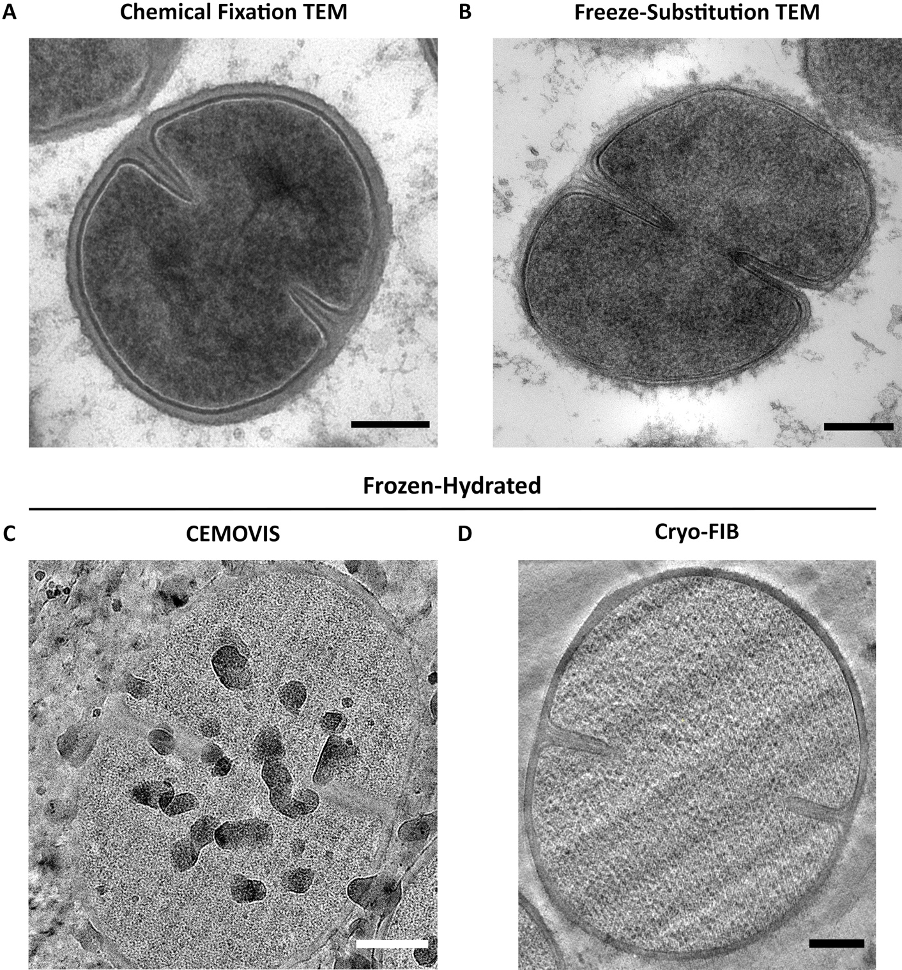
Figure 3.24 Comparison between different cross-sectioning imaging EM techniques.
S. aureus cross-sections seen by TEM and cryo-EM. (A) Conventional chemical fixation TEM and (B) freeze-substitution (FS) TEM, both employing the use of chemical fixatives, dehydration and heavy metal stains. FS provides better structural preservation by having an initial physical cryo-fixation, followed by a slow dehydration and secondary chemical fixation at low-temperatures. (C) Cryo-electron microscopy of vitrified sections (CEMOVIS) fixed by cryo-fixation HPF and cryo-sectioned below vitrification temperatures. (D) Cryo-FIB milling of vitrified samples obtained by Dr. Danyil Grybchuk (Masaryk University). All scale bars: 200 nm. (C-D) were sectioned from frozen-hydrated samples.

Chapter 4
Analysis of the S. aureus Exoplasm

Introduction.
The bacterial cell envelope is essential for viability, as it surrounds and protects the protoplasm. Its composition divides most bacteria species into two groups: Gram-negatives and Gram-positives ^{[14,15]}. The former has a peptidoglycan cell wall (CW) in between the inner plasma membrane (PM) and the outer membrane (OM); while the latter has a thick multi-layered peptidoglycan cell wall (PG-CW) that protects the PM, without the need of an OM ^{[14,15]}. The OM of Gram-negatives is a second phospholipid membrane with embedded proteins and lipopolysaccharides (LPS), which provides the first protective barrier against external antimicrobial agents ^{[14]}. The OM is covalently bound to the thin PG-CW by a lipoprotein (Lpp). The space between the PM and the OM in Gram-negatives is known as the periplasmic space, which includes the CW. It is densely packed with different periplasmic hydrolytic enzymes, Lpps, chemoreceptors and binding proteins ^{[14]}.
Matias & Beveridge confirmed the existence of a periplasmic space in Gram-positive bacteria (B. subtilis and S. aureus) after analysing frozen-hydrated bacterial samples with cryo-EM (Figure 4.1) ^{[16,163,164]}. As Gram-positive bacteria do not have an outer membrane, I will refer to this space as the exoplasmic space instead of the periplasmic space. Results from Matias & Beveridge showed that hydrated bacterial samples of B. subtilis and S. aureus had an “aqueous compartment” between the CW and the PM filled with a low-density substance (Figure 4.1b,d) ^{[16,164,270]}. Comparison to freeze-substituted TEM samples, also revealed that the exoplasm contents are highly reactive to stain (Figure 4.1a) ^{[164]}. The difference between these two techniques showed that the hydrated exoplasmic space is almost as thick as the CW, with a thickness of 16 nm and 19 nm, respectively (Figure 4.1c-d) ^{[16]}. This compartment is densely packed with proteins and lipoteichoic acids (LTA), and is essential for exoplasmic proteins to function ^{[166,271]}.
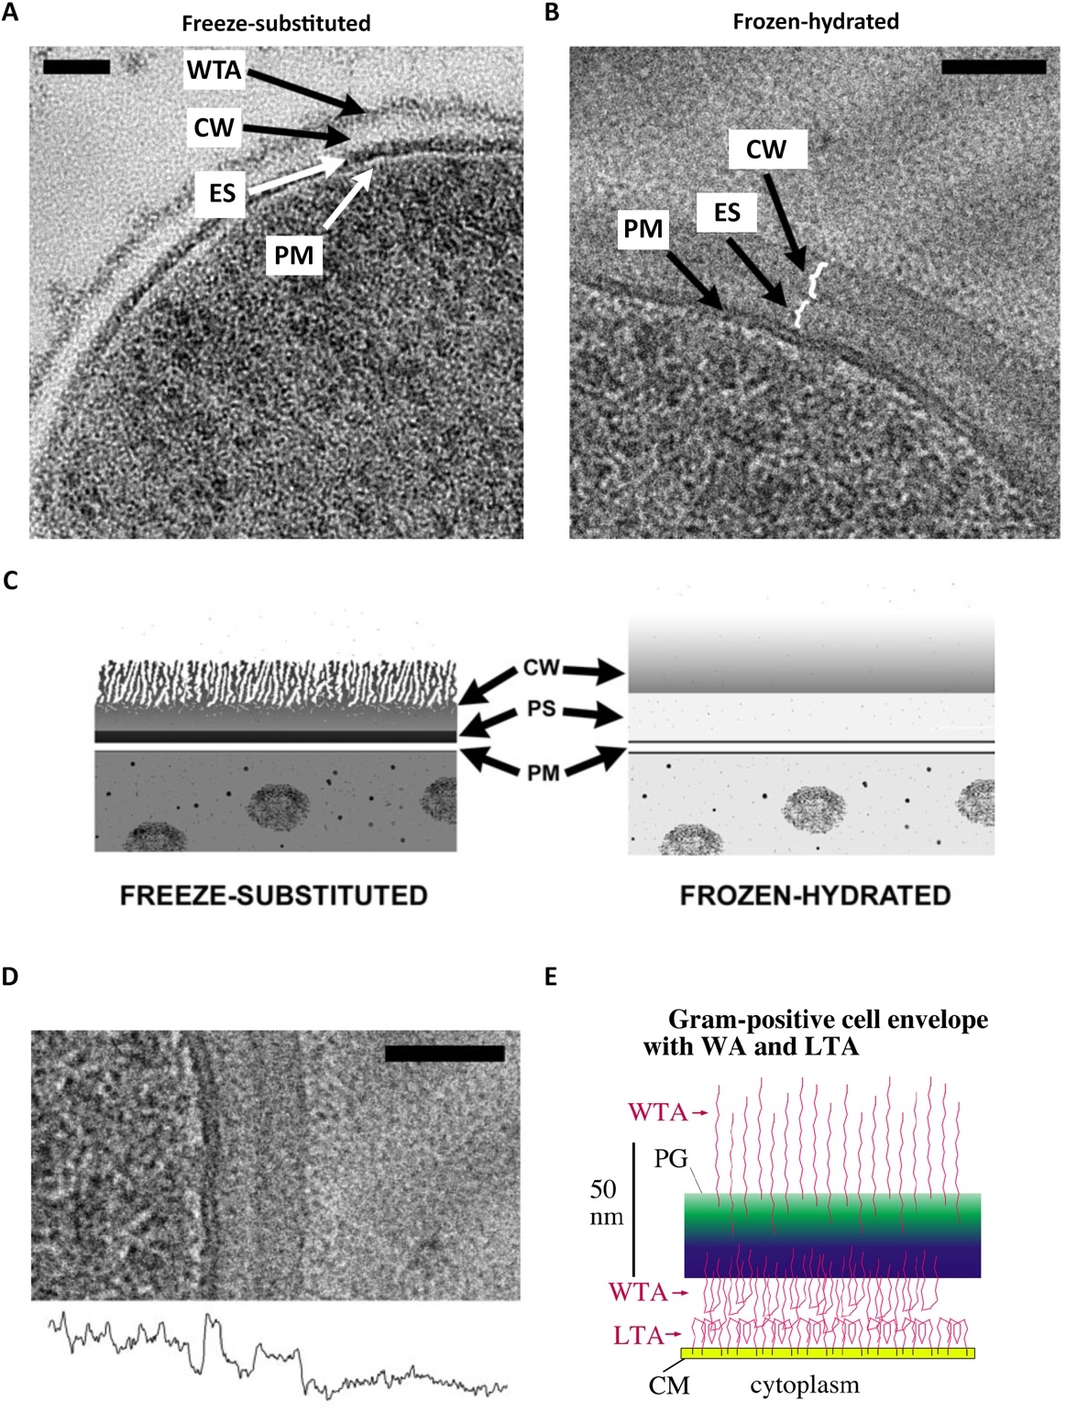
Figure 4.1 Gram-positive cell envelope.
TEM micrographs of (A) freeze-substituted and (B) frozen-hydrated S. aureus cells, showing the plasma membrane (PM), the exoplasmic space (ES), and the cell wall (CW). Freeze-substituted cells show an external fuzzy layer that consists mostly of wall teichoic acids (WTA). (C) Schematic comparison of the cell envelope between freeze-substituted and frozen-hydrated cells showing the cell wall (CW) the exoplasmic/periplasmic space (PS) and the plasma membrane (PM). The exoplasm can be highly reactive to stains, as seen by freeze-substituted bacterial cells, and is made-up of low density components, as seen by frozen-hydrated bacterial cells. (D) High magnification of a frozen-hydrated cell envelope with its corresponding density tracing underneath. Scale bars 50 nm. (A-D) Images obtained from Matias & Beveridge 2005 and 2006 ^{[16,164]} (E) Schema showing how WTA and LTA polymer brushes can maintain the exoplasmic space of Gram-positive bacteria. Obtained from Erickson (2021) ^{[166]}.
S. aureus is a Gram-positive bacteria able to withstand high internal cellular turgor pressure of about 20 – 30 atm, contained by the major stress-bearing polymer PG that forms the CW ^{[16]}. This raises the following questions: how is the exoplasmic space maintained and how does the PM not collapse against the CW?
The periplasmic space of Gram-negative bacteria is maintained by a Donnan equilibrium generated by membrane-derived oligosaccharides (MDOs), recently renamed osmo-regulated periplasmic glucans (OPGs) ^{[88,166–168]}. OPGs are negatively-charged anionic glucose oligomers of ~2,300 Da, too large to escape the small pores of the OM-CW barrier ^{[88,167,169,170]}. Therefore, their presence in the periplasmic space, together with neutralising cations, help achieve an isosmotic condition with the cytoplasm ^{[88,167,169]}. Studies have shown that cells exposed to an osmotic shock show an expanded periplasm for > 30 min, but when grown in a high osmolarity medium they respond by downregulating the synthesis of OPGs which leads to a reduction of the periplasmic space and an expansion of the protoplasm ^{[88,167,169]}.
Gram-positive bacteria do not have OPGs or an OM-CW barrier, but have teichoic acids (TA), which are not present in Gram-negatives. TA are glycopolymers with ﻿phosphodiester-linked polyol repeat units found in the bacterial envelope ^{[86,272]}. Those covalently attached to the PG CW are known as wall teichoic acids (WTA), while those anchored to the PM are referred to as lipoteichoic acids (LTA). TA have negatively charged phosphate groups and positively charged amino groups from covalently-linked D-alanine ester residues. The latter modify the surface charge of TA, and this in turn affects its binding to external molecules such as divalent cations (e.g., Mg²⁺) ^{[85,87]}. Studies have shown that the ability to bind to Mg²⁺ is reduced in the presence of D-alanine ester substituents, while D-alanylation is also affected by other factors such as pH ^{[85,87]}. Overall, lower pH levels result in more alanine ester substituents and less binding of Mg²⁺. Charge modulation of TA by D-alanylation is essential for cell defence and ion homeostasis ^{[88]}. TA are also thought to be responsible for the maintenance of the exoplasmic space in the following ways:

(1) TA– the OPGs of Gram-positive bacteria.
Studies have suggested that membrane-bound polymers, including LTA, could be responsible for the maintenance of the exoplasmic space, playing the equivalent role to OPGs in Gram-negatives ^{[16,88,91,166]}. The polyanionic chains of glycerol phosphate and their binding capabilities to neutralising cations such as Mg²⁺ could maintain the osmolality of the exoplasm to match that of the cytoplasm. This theory is supported by previous work showing that LTA-depleted mutants are only viable in media with high concentrations of sucrose or salts, confirming that LTA are necessary for growth in low-osmolarity conditions ^{[63,91,99]}. At the time of writing this thesis, Erickson (2021) ^{[166]} published a detailed model for the maintenance of the exoplasmic space which coincides with this theory. This published work gives a quantitative example describing the net concentration of negatively charged phosphate groups present in both WTA and LTA in the exoplasm (~ 0.5 M), and how that can attract a sufficient concentration of cations able to neutralise TA and anionic membrane proteins, to balance the excess osmolality of the cytoplasm. However, Erickson proposes that, especially for growth in high salt media, an additional force is necessary to maintain the exoplasmic space.
(2) TA electrostatic repulsion maintains the exoplasmic space.
LTA in S. aureus typically consists of an average of 22 nm long chain of 25 polyglycerol phosphate (Gro-P) units anchored to the PM and spaced 2 nm apart ^{[166,272]}. Electrostatic repulsion within and between each chain, the lack of space between each other, and the reduced entropy of the chains and the counterions forces LTA to extend into a polymer brush conformation ^{[166]}. A similar polymer brush occurs with WTA that extend inwards into the exoplasm, from the CW ^{[166]}. The physical chemical force of the LTA brush generates pressure when pushed against a surface of the CW, where it encounters the WTA brush, generating an electrostatic repulsion between each other (Figure 4.1e) ^{[166,273]}. This theory, described by Erickson (2021) ^{[166]}, assumes that WTA are present in the exoplasm. It is believed that these anionic polymers covalently-bound to PG, repulse themselves and protrude outwards on both sides of the CW. This is consistent with studies that showed WTA poking out of the cell surface in EM micrographs (Figure 4.1a) ^{[16]}. This means that those WTA chains that face the inside of the cell can interact with LTA at the exoplasm, and both polyanionic brushes would repel each other forcing a physical space between the PM and the CW. In an ideal condition, without outside pressure, this space would be equal to the sum of the lengths of both WTA and LTA. However, bacterial cells have high cytoplasmic turgor which means that WTA and LTA are pushed towards each other until each polymer interacts with their charges or are forced to fold back on themselves (Figure 4.1e). The exoplasm would thus be maintained by balancing the pressure applied by the cytoplasmic turgor and the forces resulting from the electrostatic repulsion of the interaction between WTA and LTA polymer brushes. The exoplasm may be considered as a malleable but rigid enough gel, compressed between the CW and the PM, while allowing diffusion of enzymes, ions, and substrates ^{[16,166]}.

Aims of this chapter.
The aim of this chapter is to study the role of teichoic acids in the maintenance of the exoplasmic space in S. aureus in the SH1000 background, by employing different microscopy techniques coupled with genetic and biochemical approaches.

The exoplasm as seen by electron microscopy.
Electron microscopy provides the best resolving power to image bacteria, with transmission electron microscopy (TEM) delivering micrographs of electron-transparent cross-sections (refer to Chapter 3 for details). TEM cross-sections are therefore the best microscopy technique to study the bacterial envelope.

The bacterial envelope of SH1000 analysed by chemical fixation TEM.
S. aureus SH1000 was grown and harvested as described in section 2.11.1, and after chemical fixation (section 2.20.1), analysed with the TEM (Figure 4.2a). Figure 4.2b shows the cell wall (CW), plasma membrane (PM), and the space between them (exoplasmic space, ES). The plasma membrane appears as a low-density band under the heavily stained exoplasm. This results from the incubation with osmium tetroxide (OsO₄), a secondary fixative that also stains biological samples by binding and reacting to lipids. It provides contrast by binding to the phospholipid heads in the cell membrane and any unsaturated bonds of lipids. Therefore, the phospholipid bilayer would be heavily stained at the head region, but not at the phospholipid tails. The stained inner heads delimit the cytoplasm, while the heads of the outer layer are impossible to discern due to the heavy staining density of the ES (Figure 4.2b). This high electron density and contrast is enhanced with post-stains containing heavy metals, such as uranyl acetate (UA) and lead citrate (LC). LC enhances the contrasting effect by interacting with osmium. Uranyl ions, on the other hand, bind to nucleic acids, ribosomes, and to glycoproteins and glycolipids, enhancing contrast in cellular membranes and heavily staining lipoteichoic acids (LTA). Thus, the LTA located in the exoplasmic space appears as a high-density band underneath the CW (Figure 4.2b).
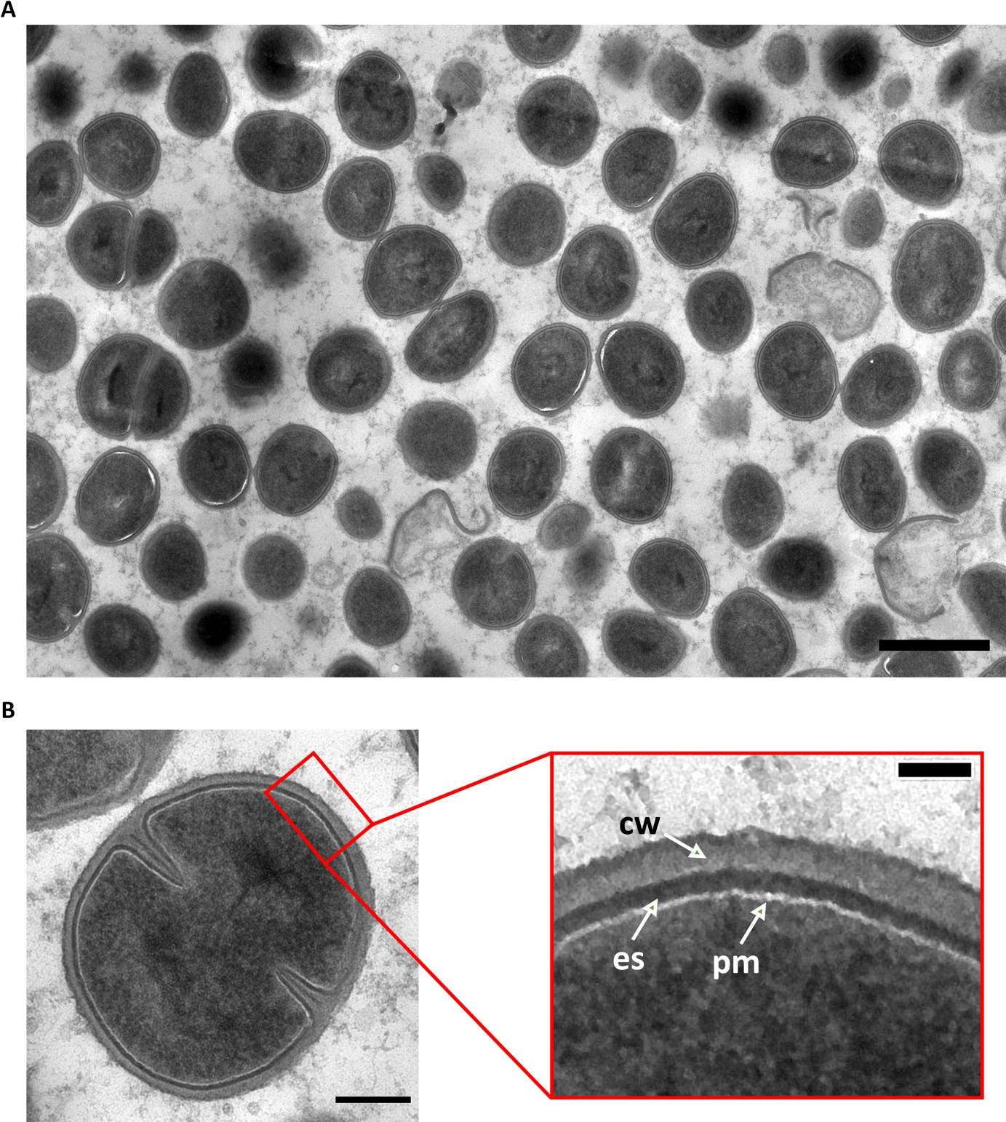
Figure 4.2 Cell envelope of chemically fixed S. aureus cells.
TEM micrographs of chemically fixed S. aureus SH1000 cells. (A) Low magnification (2900x), scale bar 1 µm. (B) High magnification (9300x), scale bar 200 nm. Red rectangle– scale bar 50 nm. CW– cell wall, ES– exoplasmic space, PM– plasma membrane.

The bacterial envelope of SH1000 analysed by freeze-substitution TEM.
For better structural preservation, S. aureus SH1000 cells were cryo-fixed by high pressure freezing and freeze-substituted (FS), as described in section 2.20.2. TEM micrographs showed that some cells were more heavily stained than others (Figure 4.3a). Those with less contrast appeared to have better preserved structural detail than highly stained cells (Figure 4.3b-c).
Comparison to a FS cell obtained by Matias & Beveridge (2006) ^{[16]} shows a similarity to the highly stained cells (Figure 4.4a-b). As seen in the micrographs and schematic representations (Figure 4.4a-b, d-e), the plasma membrane (PM) appears as an electron-transparent band beneath the heavily stained exoplasmic space (ES). As described above, the binding of OsO₄ to the phospholipid heads in the bilayer leaves a clear region in between, corresponding to the phospholipid tails. The inner stained phospholipid heads provide contrast against the cytoplasm, while the outer stained heads provide contrast with the ES. The ES appears as a thick heavily stained band due to the high amount of LTA present in the exoplasm ^{[166,271]}, which is highly reactive to OsO₄. The ES provides high contrast against a lesser stained CW. Yet, the outer CW presents a more stained surface, which corresponds to WTA ^{[16]}.
The less contrasted cells found in this study showed more architectural detail in the cell envelope with two additional and undefined layers, referred to as layer I and II (Figure 4.4c,f). Contrast from layer I is similar to that of the CW, while layer II is highly reactive to OsO₄ and post-stains (Figure 4.4c, f). As seen in Figure 4.5, these envelope structures appear consistently in the sample population and are also maintained at the septal plate.

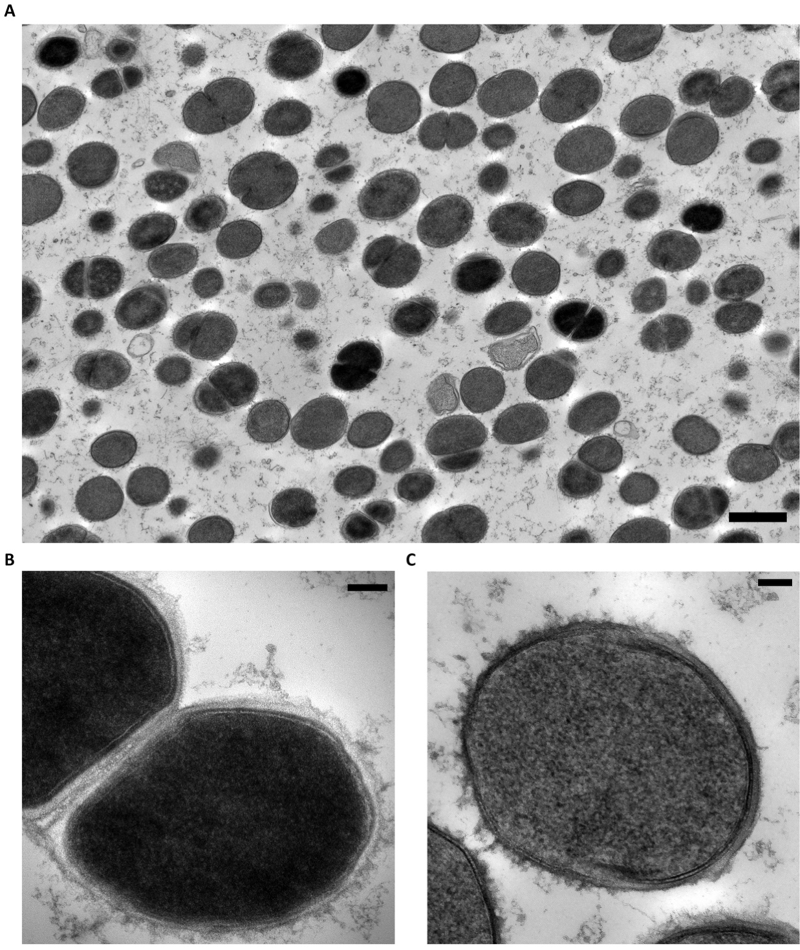
Figure 4.3 TEM micrograph of freeze-substituted S. aureus cells.
TEM micrograph of freeze-substituted S. aureus SH1000 cells. (A) Representative population shows cells with a differential staining level. Low magnification (1900x), scale bar 1 µm. Closer look at representative cells with (B) more contrast and (C) less contrast. Cropped from high magnification (6800x), scale bar 50 nm.
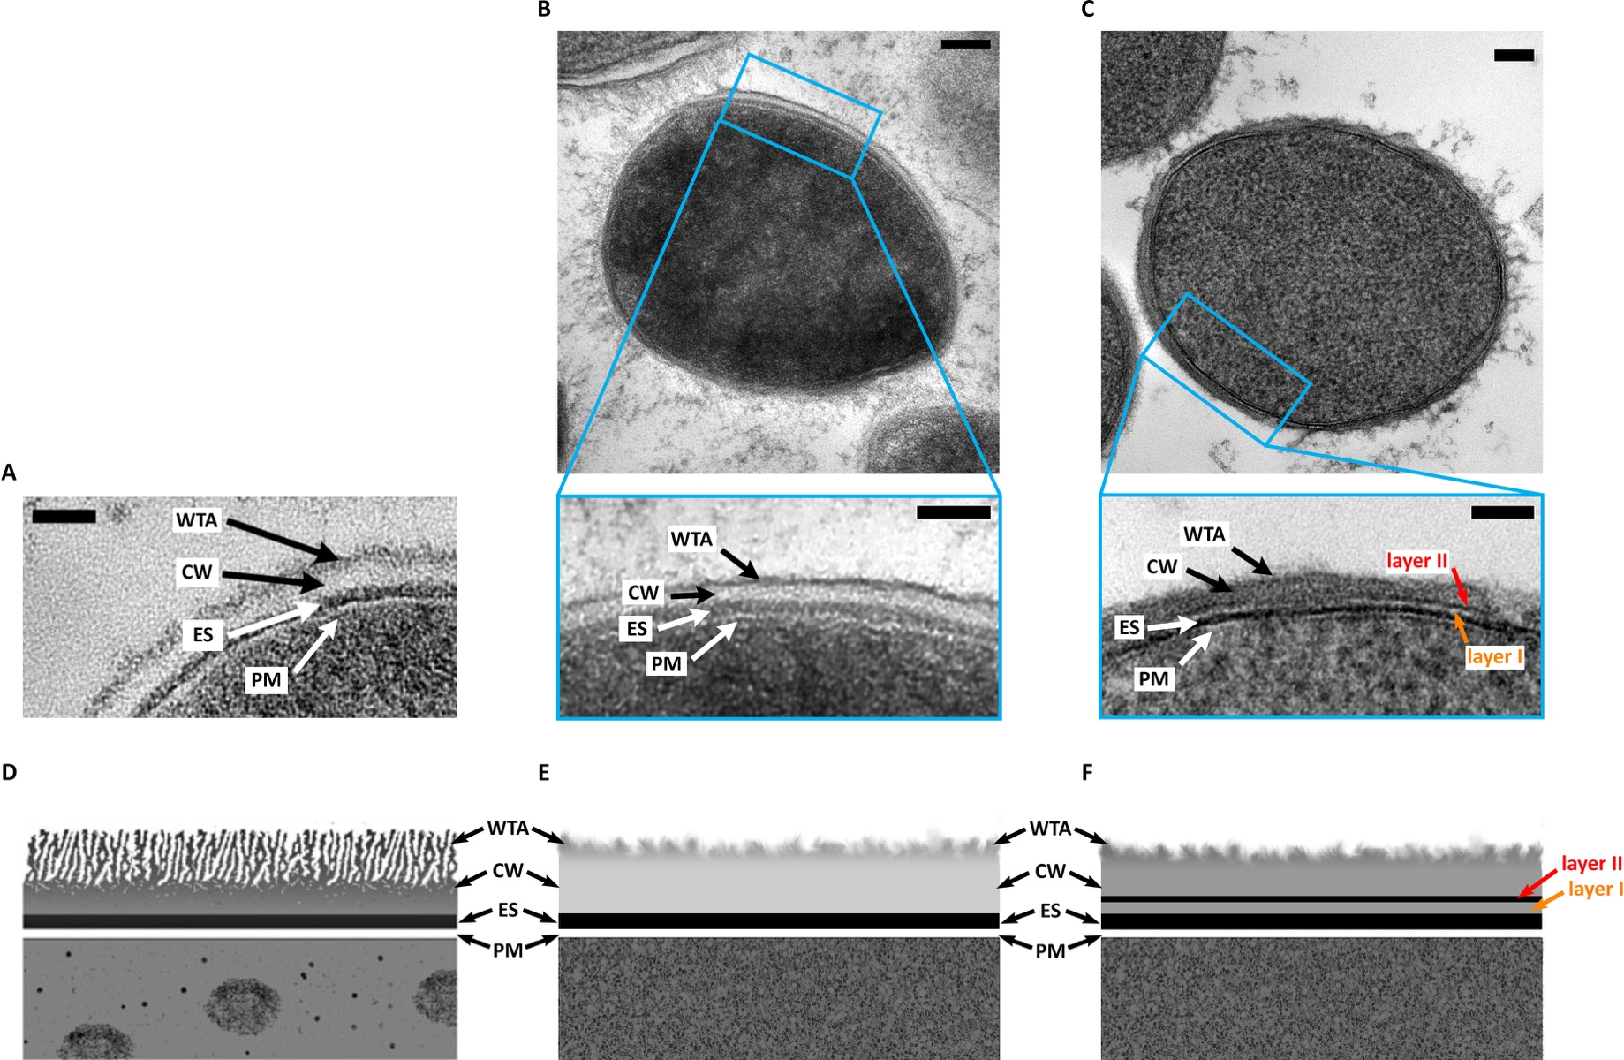
Figure 4.4 Cell envelope of freeze-substituted S. aureus cells.
(A-C) TEM micrographs of freeze-substituted (FS) S. aureus SH1000 cells. (A) Image obtained from Matias & Beveridge (2006) ^{[16]}. (B-C) Representative FS cells from this study showing (B) high and (C) low levels of staining. The former (B) resembles that in (A). (D) Schema obtained from Matias & Beveridge (2005) ^{[164]}. (E-F) Schematic representations of images in (B-C) respectively. WTA– wall teichoic acids, CW– cell wall, ES– exoplasmic space, PM– plasma membrane. Layers I and II are two undefined layers. Scale bars 100 nm and 50 nm.
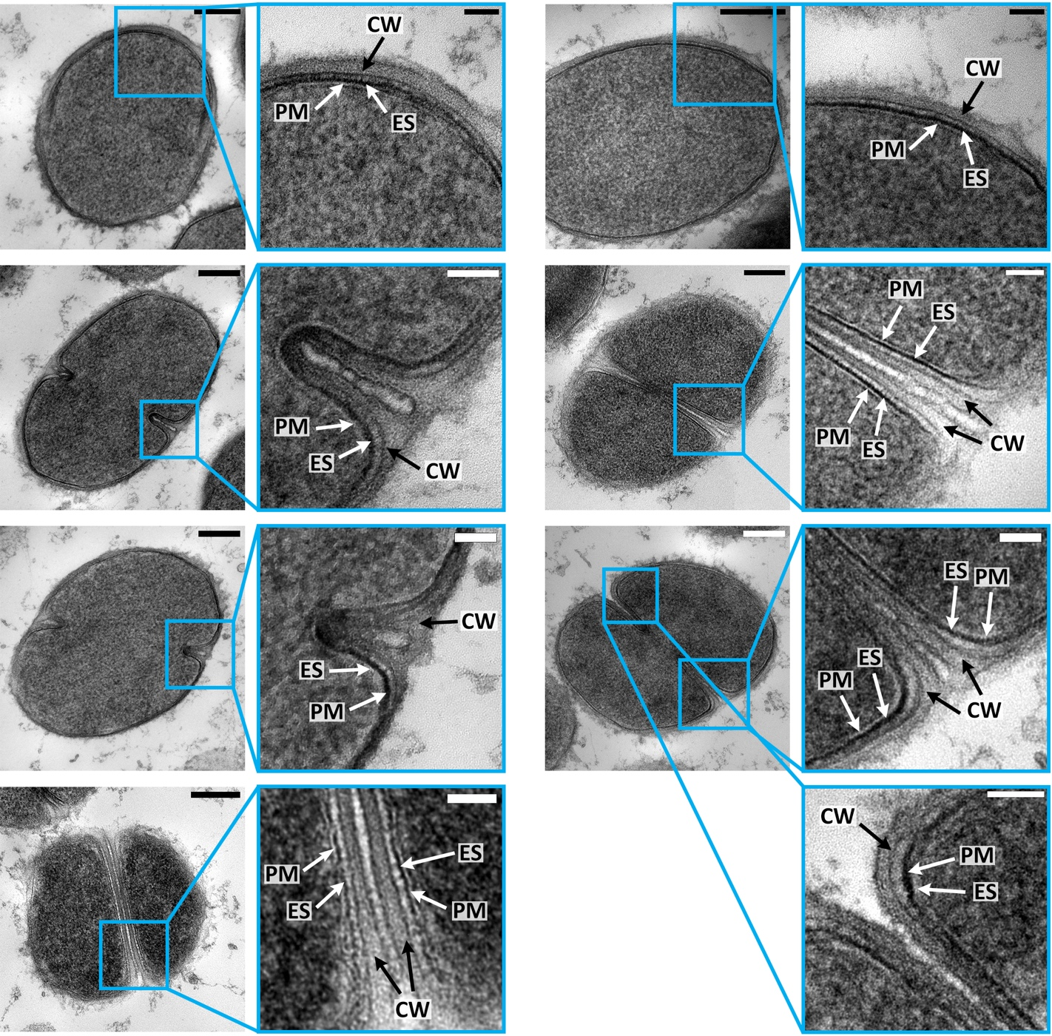
Figure 4.5 Preservation of the cell envelope structure of freeze-substituted S. aureus cells.
TEM micrographs of freeze-substituted S. aureus cells. The multilayer structures are consistent in different stages of division. CW– cell wall, ES– exoplasmic space, PM– plasma membrane. High magnification (11000x and 23000x) scale bar 200 nm. Blue regions cropped from high magnification (30000x and 49000x), scale bar 50 nm.

The bacterial envelope of SH1000 analysed by CEMOVIS.
For a more detailed analysis of the exoplasmic space in a hydrated state, CEMOVIS was carried out. Samples were prepared as described in section 2.21. This first and only attempt at this technique provided vitrified sections with ice contamination which diminished visibility and affected the analysis of the cryo-TEM micrographs (Figure 4.6).
The different components of the cell envelope and septum were analysed by comparing the density tracings of cryo-TEM micrographs to those obtained by Matias & Beveridge (2006) ^{[16]} (Figure 4.7). Density tracings were taken with Fiji ^{[238]}, as described in section 2.21.4. The results from this study resemble those already published ^{[16]}. Ice contamination and inferior quality of the sample due to inexperience resulted in micrographs with a lot of background noise. Although the ES cannot be distinguished in the septum, it was somewhat differentiated in the cell periphery. However, the dual density regions at the bacterial envelope were not as defined as those published ^{[16]}. It was also apparent that the bacterial envelope was thinner than that published by Matias & Beveridge (2006) ^{[16]}, so measurements were carried out. Comparison of these measurements are shown in Figure 4.8a. Measurements were taken for each envelope component per cell, with a total of 28 cells analysed (Figure 4.8b). Both the mean values and the standard deviation for the ES and CW, measuring 12.1 ± 2.2 nm and 16.7 ± 2.8 nm respectively, were smaller than those obtained by Matias & Beveridge (2006) ^{[16]}. On the other hand, the mean thickness value for the plasma membrane was of 6.4 ± 1.4 nm, that is 1 nm thicker than the literature.
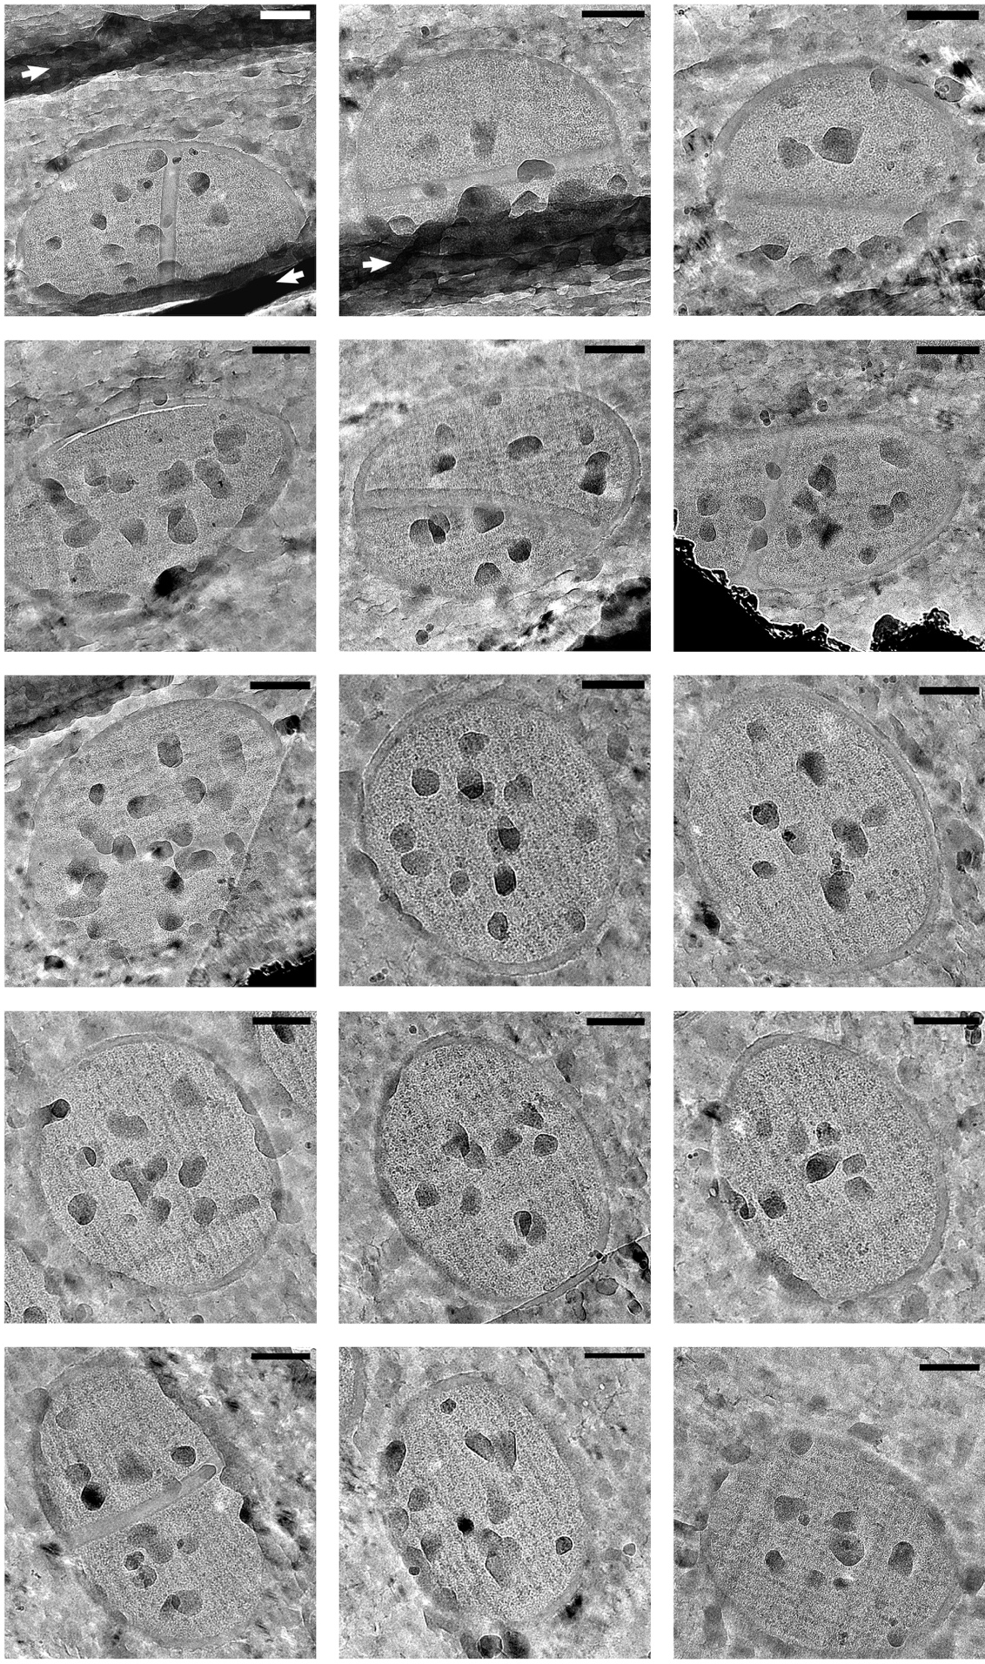
Figure 4.6 Representative cryo-TEM micrographs of frozen-hydrated S. aureus.
CEMOVIS micrographs of S. aureus SH1000. White arrows show regions of folded sections. All cells present ice contamination (dark spots). Scale bars 200 nm.
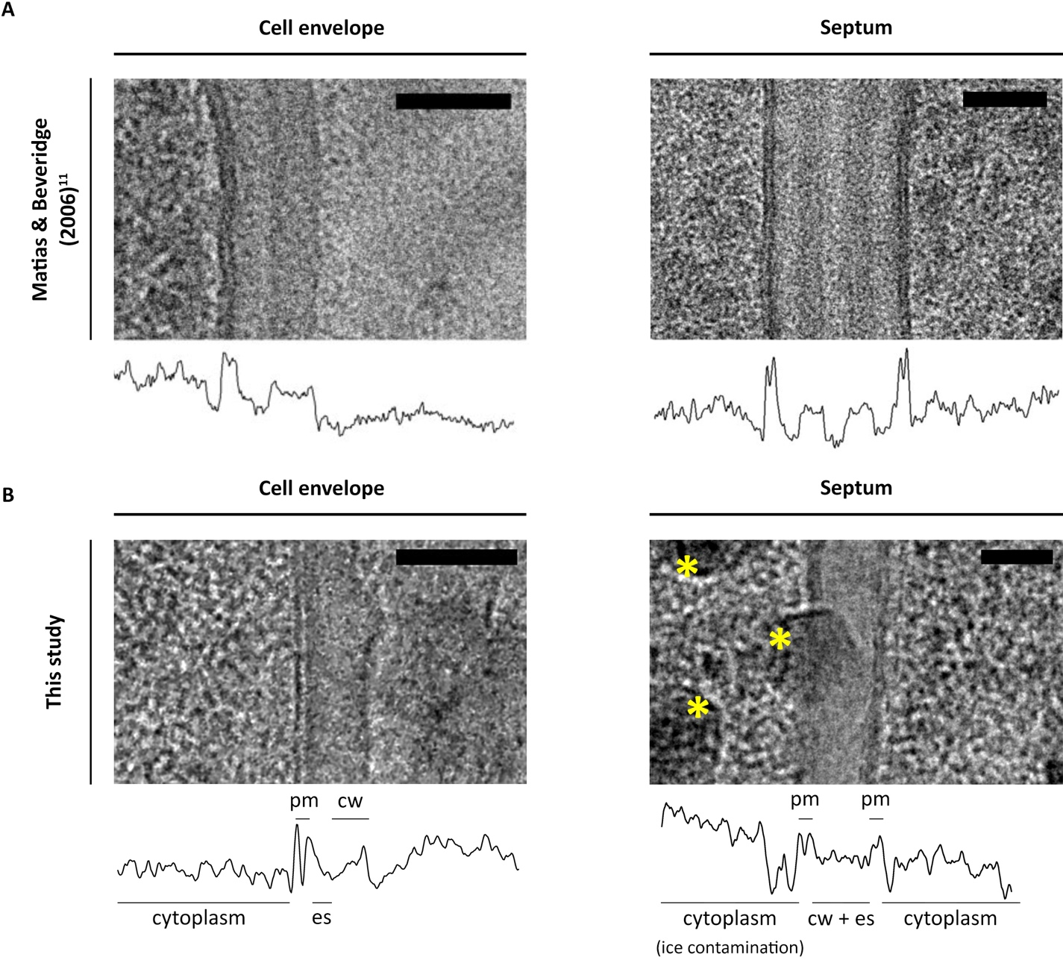
Figure 4.7 Density tracings for the cell envelope and septa of S. aureus.
Representative density tracings from cryo-TEM micrographs of vitrified S. aureus SH1000 cells showing the bacterial envelope and the septum. Comparison of the (A) results obtained from Matias & Beveridge (2006) ^{[16]} and those (B) obtained in this study. The micrographs from this study present visible ice contamination (yellow stars). Different density levels differentiate the plasma membrane (pm) from the exoplasmic space (es) and the cell wall (cw). Scale bars 50 nm.
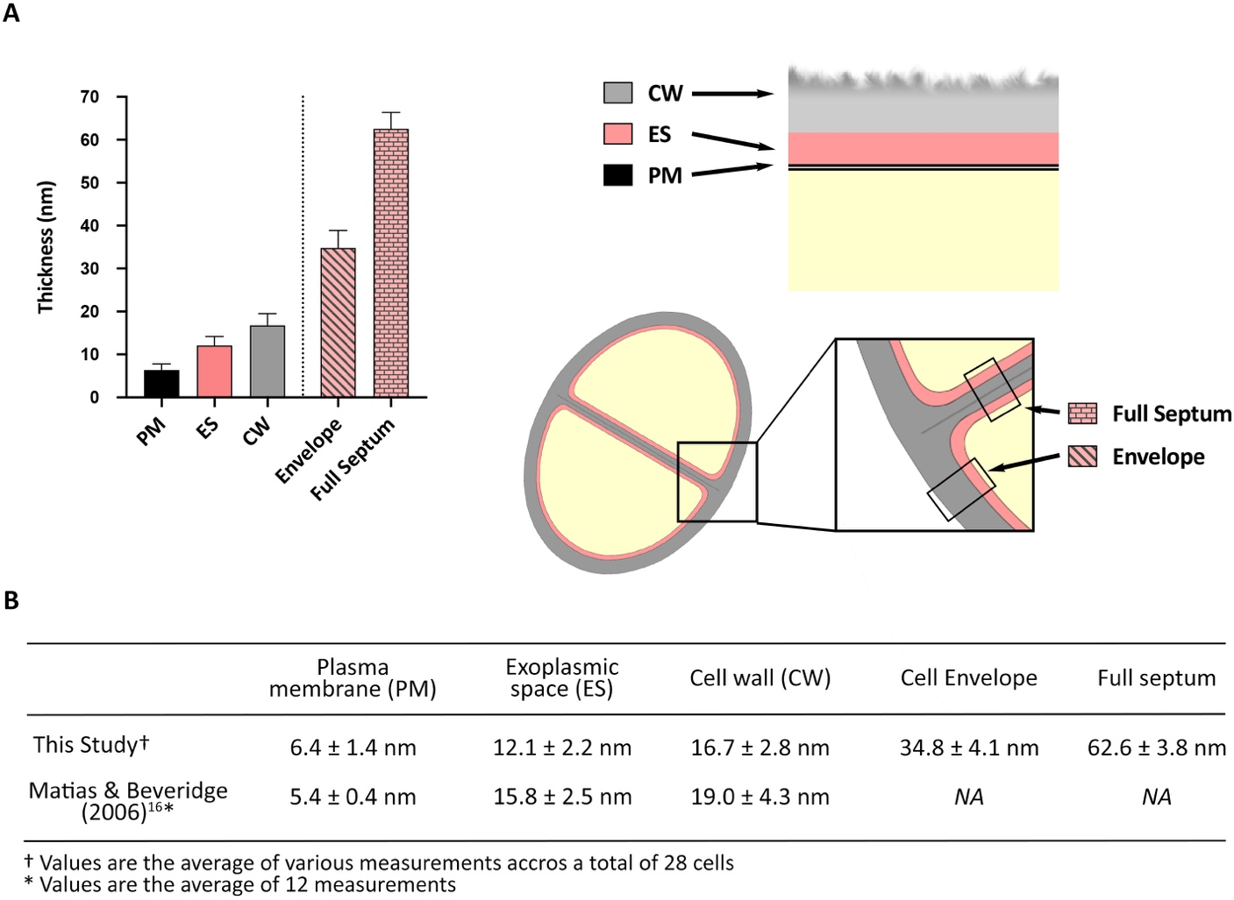
Figure 4.8 Measurements of the components of S. aureus cell envelope.
Thickness measurements from vitrified S. aureus SH1000 cells (CEMOVIS) of the plasma membrane (PM– n = 116), exoplasmic space (ES– n = 86), cell wall (CW– n = 85), cell envelope (n = 113) and full septum (n = 19). (A) Thickness comparison between the different envelope components. (B) Comparison between the mean values ± standard deviation from this study and those obtained from Matias & Beveridge (2006) ^{[16]}. Measurements were taken from cryo-TEM micrographs of frozen-hydrated samples (cells n = 28). Analysis carried out with Fiji and Prism.

The exoplasm and the lack of teichoic acids.
Teichoic acids (TAs) are a major component of the cell envelope, with lipoteichoic acids (LTA) being the main constituent of the exoplasm and wall teichoic acids (WTA) being the second most important element after PG of the CW. Therefore, this study continues by analysing the role and morphological effect of these polymers. SIM images were used for volume estimation as described in section 2.18.5. TEM micrographs of chemically fixed thin-sections were used for phenotype analysis, CW thickness measurements, division characterisation and phenotype quantification (methodology described in sections 2.20.8 and 2.20.9).

Lack of WTA: survival and morphological effects.
Unlike LTA, WTA are not fully located in the exoplasm but there are indications that these wall polymers can extend into the exoplasmic space ^{[166]}. Hence, they remain of great significance for they have a close relationship to LTA and their interaction could be responsible for the maintenance of the ES ^{[166]}. WTA are not essential and therefore a tarO mutant lacking these wall polymers can be used to investigate the effect of WTA on bacterial growth, division and morphology ^{[112]}.
The lack of WTA does not affect bacterial growth (Figure 4.9). Yet, there is a differential percentage of dividing cells at early exponential phase. tarO shows more cells with no septum (32.6 %) and complete septum (39.0 %) than SH1000 (24.8 % and 28.7 %, respectively), while presenting a smaller percentage of cells with incomplete septum (27.5 % against 45.8 % of SH1000) (Figure 4.10). Volume estimation from SIM images showed that tarO is significantly bigger than the wildtype, with a volume of ~ 0.8 and ~ 0.6 µm³ respectively (p > 0.0001) (Figure 4.11a-b,f). Contrarily, CW thickness comparison to the wildtype, measured from chemically fixed thin-sections, revealed a significantly thinner CW of 27.7 ± 8.1 nm in the WTA-depleted strain (Figure 4.11c,f; p > 0.0001). TEM micrographs show that tarO cell surface has an inconsistent fuzzy appearance , which correlated with the high standard deviation obtained in the CW thickness measurements (Figure 4.11d-f). In addition to a differential surface, tarO presents a rounder– almost square–shaped septum, instead of the V-shaped septa observed in the wildtype, and it lacks the heavily stained septal mid-line that may corresponds to WTA (Figure 4.12, the red arrow indicates the WTA mid-line) ^{[274,275]}.
Unfortunately, tarO could not be analysed by neither FS TEM or CEMOVIS cryo-TEM as planned, due to limited accessibility to the microscopy facility during 2020.
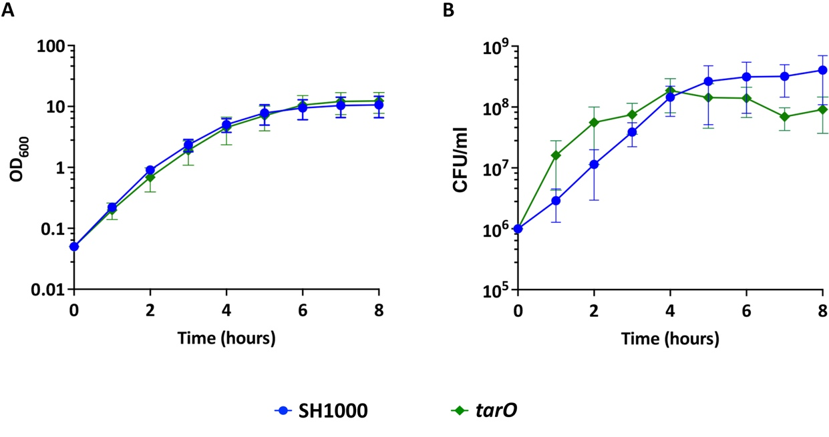
Figure 4.9 Analysis of the lack of WTA on S. aureus growth.
(A) Absorbance and (B) CFU/ml measurements for the compared growth of S. aureus SH1000 (blue– 6 biological repeats) and tarO (green– 3 biological repeats).
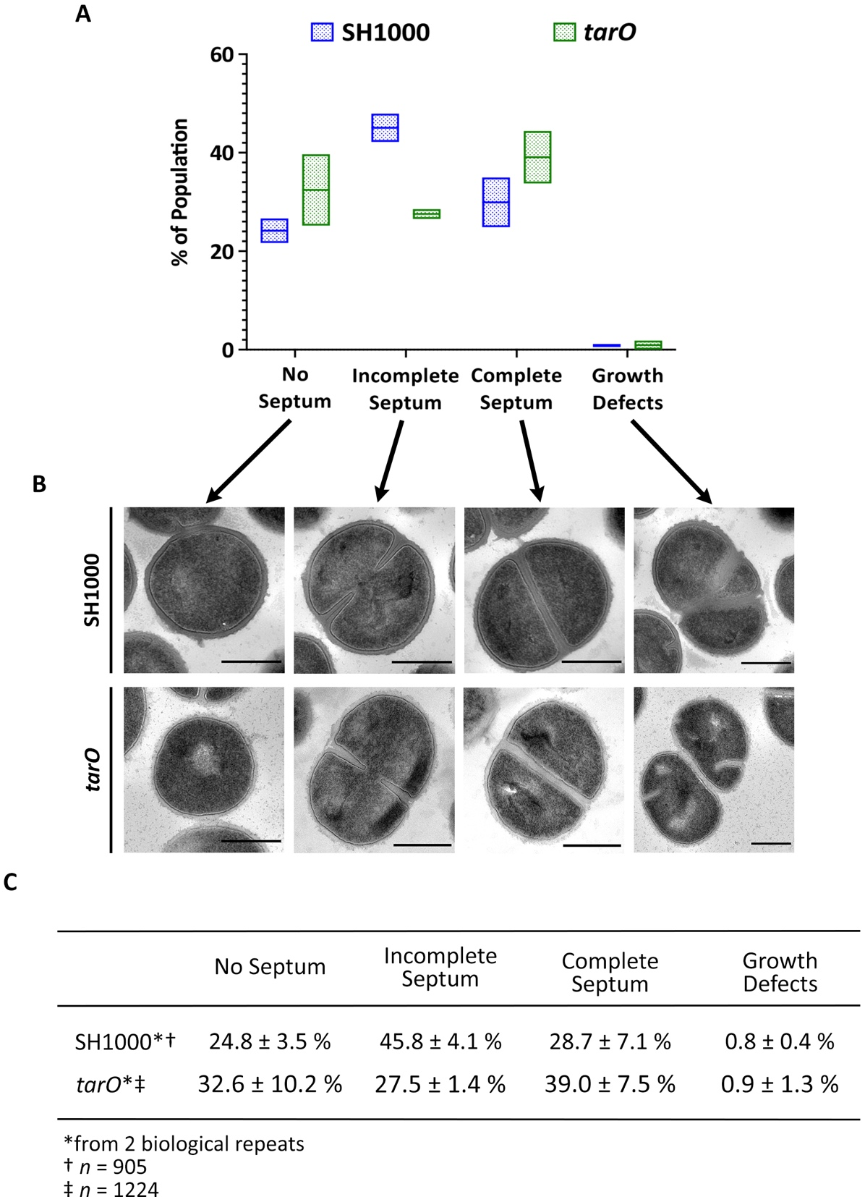
Figure 4.10 Analysis of the lack of WTA on S. aureus division.
(A) Normalised quantification of the percentage of SH1000 (blue) and tarO (green) with no septum, incomplete septum, complete septum and growth defects during early exponential phase. Floating bars represent the minimum, mean and maximum value. (B) Representative TEM micrographs cropped from high magnification (4800x), scale bars 500 nm. (C) Mean value ± standard deviation (SD) for each category. Two biological repeats for each, with a total of n = 905 and n = 1224 cells analysed for SH1000 and tarO, respectively.

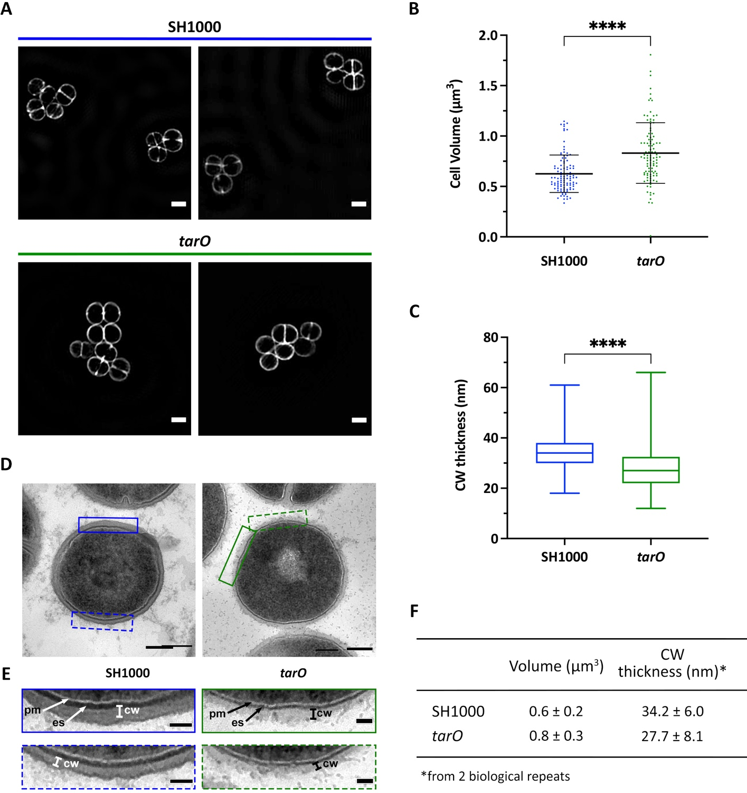
Figure 4.11 Role of WTA in cell volume and CW thickness.
(A) Representative OMX SIM images of NHS-ester Alexa Fluor™555 labelled cells for SH1000 (blue) and tarO (green). Scale bar 1 µm. (B) Cell volume estimation from SIM images. Statistical analysis: t-test with Welch’s correction (**** p < 0.0001, n > 100). (C) Average cell wall thickness from TEM micrographs of chemically fixed SH1000 (blue) and tarO (green) cells. Two biological repeats for each, n > 400. Statistical analysis: t-test with Welch’s correction (**** p < 0.0001). The box plot represents the minimum, first quartile, median, third quartile and maximum. (D) Representative cell for SH1000 and tarO, as indicated. High magnification (6800x and 4800x), scale bar 200 nm. (E) Zoomed sections of the micrographs shown in (D) for SH1000 (blue rectangles) and tarO (green rectangles), showing the natural variation of the cell wall thickness: thicker (upper solid rectangles), thinner (lower dashed rectangles). Scale bar 50 nm, pm– plasma membrane, cw– cell wall, es– exoplasmic space. (F) Mean value ± standard deviation for volume estimation and CW thickness from (B) and (C).
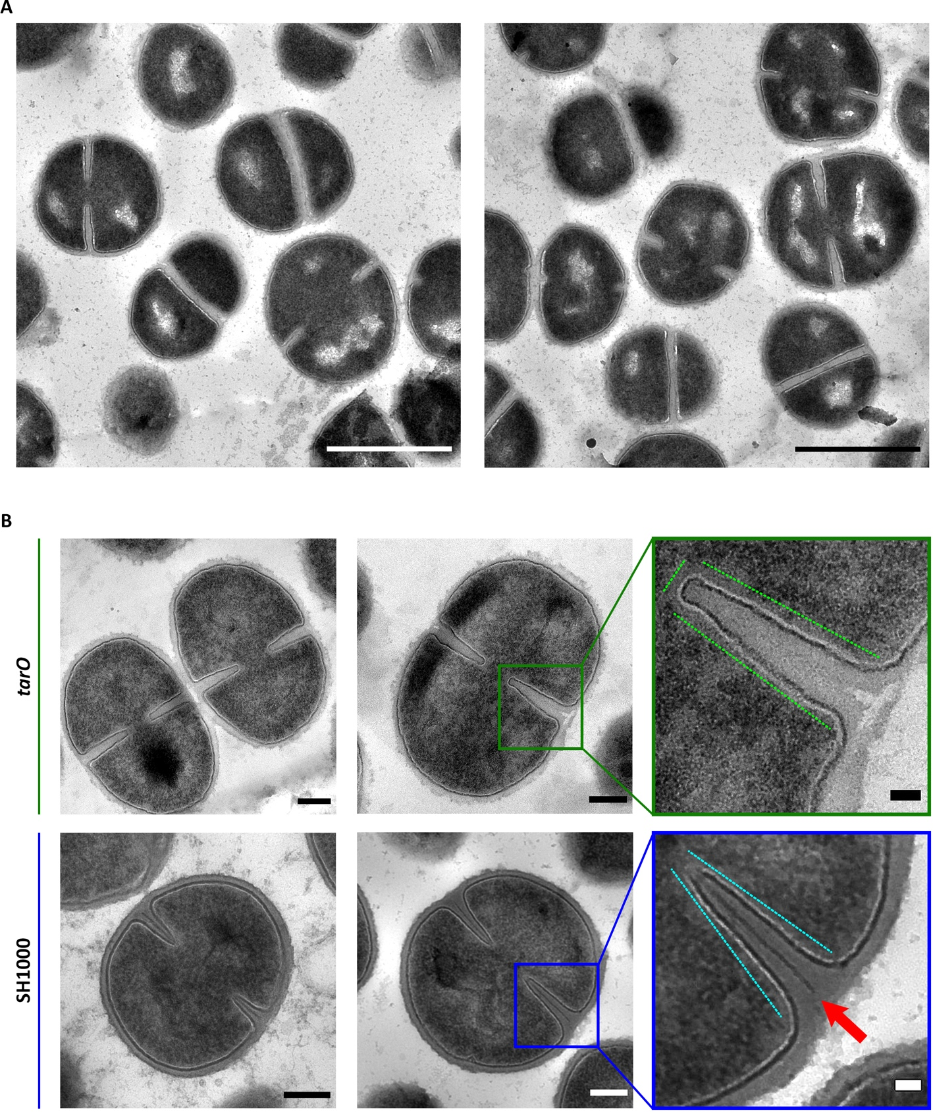
Figure 4.12 TEM micrographs of S. aureus tarO and septa comparison with SH1000.
(A) TEM micrographs of chemically fixed S. aureus tarO (high magnification, 4800x), scale bar 1 µm. (B) Septal shape comparison between tarO (green) and its parental strain (SH1000, blue). Representative dividing cells with an incomplete septum, scale bar 200 nm. Zoomed coloured squares show a differential septal shape: SH1000 (blue)–V-shape and tarO (green)– aberrantly-shaped. Scale bar 50 nm. The red arrow indicates a heavily stained septal mid-zone present in the wildtype alone.

Lack of LTA: survival and morphological effects.
Past publications have described the essentiality of LTA, documenting various morphological aberrations including thickened CW, increased size, clumping, and division alterations associated with its loss ^{[99]}. Yet, at a later date Corrigan et al., (2011) showed that a suppressor mutation in the gdpP gene led to an ltaS mutant that was able to grow and have the same morphology as its parental strain ^{[63]}. This investigation provides quantitative data for the morphological changes caused by the lack of this membrane-attached polymer in the S. aureus SH1000 background.

Transduction of LTA mutations into the S. aureus SH1000 background.
Angelika Gründling kindly provided us with the corresponding LTA mutants used in her research: (1) an IPTG-inducible P_{spac} LTA mutant (RN4220 iltaS: ermR – ANG499) and (2) a complemented ltaS deletion with a point mutation in the gdpP gene (LAC* ΔltaS::erm gdpP(V425F) – ANG2430) ^{[63,99]} (Table 2.4). These were used to construct S. aureus SH1000 LTA mutants and verify if the changes in bacterial growth and morphology were consistent with those recorded for their RN4220 and LAC* parental strains.
(1) ANG499 strain has a pMutin-HA-ltaS plasmid with ltaS (first 471 nucleotides and preceding ribosome binding sites) placed under the P_{spac} promoter ^{[99]}. This IPTG-inducible construct was transduced into the SH1000 parental strain (SJF 682) using the φ11 bacteriophage, following the transduction protocol described in section 2.16. The S. aureus SH1000 iltaS (SJF 5157) was obtained.
(2) A two-step transduction was carried out to obtain the ltaS-depleted strain with the complementary mutation in gdpP. First, LAC* ΔgdpP::kan (ANG1961) strain was transduced into the SH1000 parental strain (SJF 682). Secondly, the resulting SH1000 Δ gdpP::kan strain (SJF 5158) was used as a recipient strain for the transduction of the ltaS deletion from ANG2430. This resulted in S. aureus SH1000 ΔltaS::erm ΔgdpP::kan (SJF 5159).

The resulting SH1000 mutant strains, gdpP::kan and ltaS gdpP::kan (SJF 5158 and SJF 5159), were analysed by PCR using the primers listed on Table 2.3 (protocol described in section 2.17). Transductions were verified by amplifying their respective antibiotic markers and the existence, disruption or deletion of the gene of interest. Parental and donor strains were used as positive and negative controls (Figure 4.13).
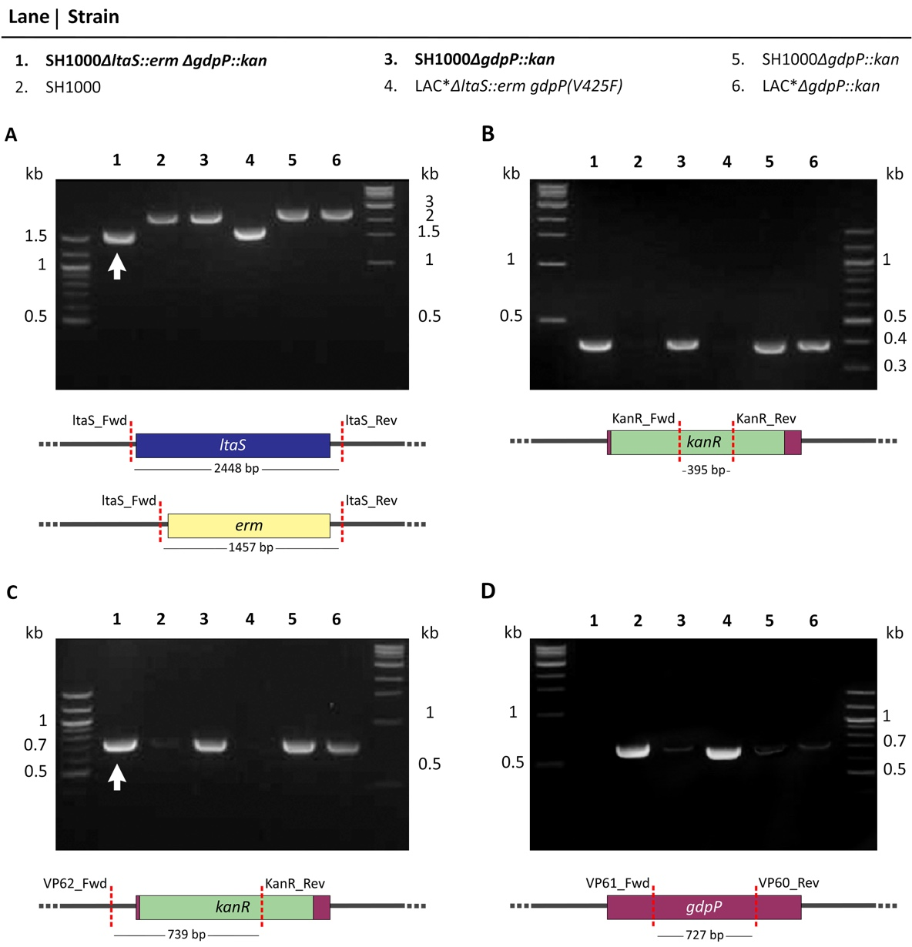
Figure 4.13 PCR verification of SH1000 gdpP::kan (SJF 5158) and SH1000 ltaS gdpP::kan (SJF 5159).
2.5 % (w/v) TAE agarose gels showing PCR amplifications for the verification of SH1000ΔltaS::erm ΔgdpP::kan (lane 1) and SH1000ΔgdpP::kan (lane 3 and lane 5) strains constructed for this study. Underneath each picture, are the physical maps of the region of interest showing the expected band sizes. (A) Verification of ltaS deletion using primers ltaS_Fwd and ltaS_Rev. (B) Verification of kanR insertion using primers KanR_Fwd and KanR_Rev. (C) Verification of kanR insertion in gdpP using primers VP62_Fwd and KanR_Rev. (D) Verification of gdpP deletion using primers VP61_Fwd and VP60_Rev. Controls: SH1000 (lane 2), LAC* ΔltaS::erm gdpP(V425F) (lane 4), and LAC* ΔgdpP::kan (lane 6). Quick-Load® DNA ladders of 100 bp and 1 kb to the right and left of each gel, respectively. White arrows– ltaS deletion band (~ 1457 bp) and kanR insertion in gdpP (~ 739 bp) of SH1000ΔltaS::erm ΔgdpP::kan. The primers used are described in Table 2.3.

Effect of the loss of LTA on S. aureus SH1000.
Gründling & Schneewind (2007) ^{[99]} described S. aureus RNA4220 iltaS, a strain with ltaS under a P_{spac} IPTG-inducible promoter. Their research showed that depletion of LTA in RN4220 cells caused growth arrest, increased cell size and aberrant division. Data for iltaS in S. aureus SH1000 background also confirms all of the above. Both optical density (OD₆₀₀) and colony forming units (CFU/ml) measurements showed growth cessation after 3–4 h of growth without the inducer (Figure 4.14a-b). Cell volume of iltaS after removal of the IPTG inducer, also showed an increase of ~ 42.9 % in respect to iltaS with 1 mM IPTG, and ~ 57.1 % in comparison to the wildtype (Figure 4.14d-e). Cell volume was estimated from SIM images of labelled cells as described in section 2.18.5
Quantification of the different phenotypes observed (Figure 4.15a) was difficult as many of these can occur at the same time. Figure 4.15b explains the criteria used to quantify division stages and morphological defects observed in SH1000 iltaS. Removal of the IPTG inducer leads to an increase in the percentage of cells with morphological defects: ~ 45.3 % of affected cells at 2 h of growth, ~ 69.9 % at 4 h and ~ 64.4 % at 6 h (Figure 4.15). A closer look at each sample population by TEM confirms that the effects of the lack of LTA worsens after 4 h of growth, with visible aberrations including thickened cell walls, multiple septation events in the same division plane, and clumping (Figure 4.16). A detailed categorisation of aberrant cells can be found in Supplementary Figure 1. In accordance with the growth arrest observed with iltaS after 3-4 h (Figure 4.14a-b), the biggest increase in morphological defects is noted after this time (Figure 4.15 and Figure 4.16).
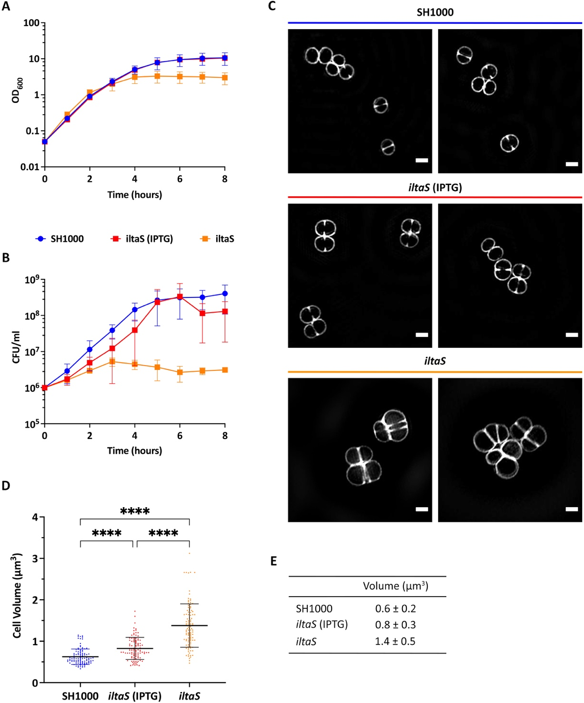
Figure 4.14 Lack of LTA effect on bacterial growth and cell size of S. aureus SH1000.
(A) Absorbance and (B) CFU/ml measurements for the compared growth of S. aureus SH1000 (blue– 6 biological repeats) and iltaS with 1 mM IPTG (red– 3 biological repeats) and without the inducer (orange– 5 biological repeats). (C) Representative OMX SIM images of NHS-ester Alexa Fluor™555 labelled cells for SH1000 (blue), iltaS with 1 mM IPTG (red) and iltaS without the inducer (orange). Scale bar 1 µm. (D) Cell volume estimation from SIM images. Statistical analysis: t- test with Welch’s correction (**** p < 0.0001, n > 100). (E) Mean value ± standard deviation for volume estimation from (D).
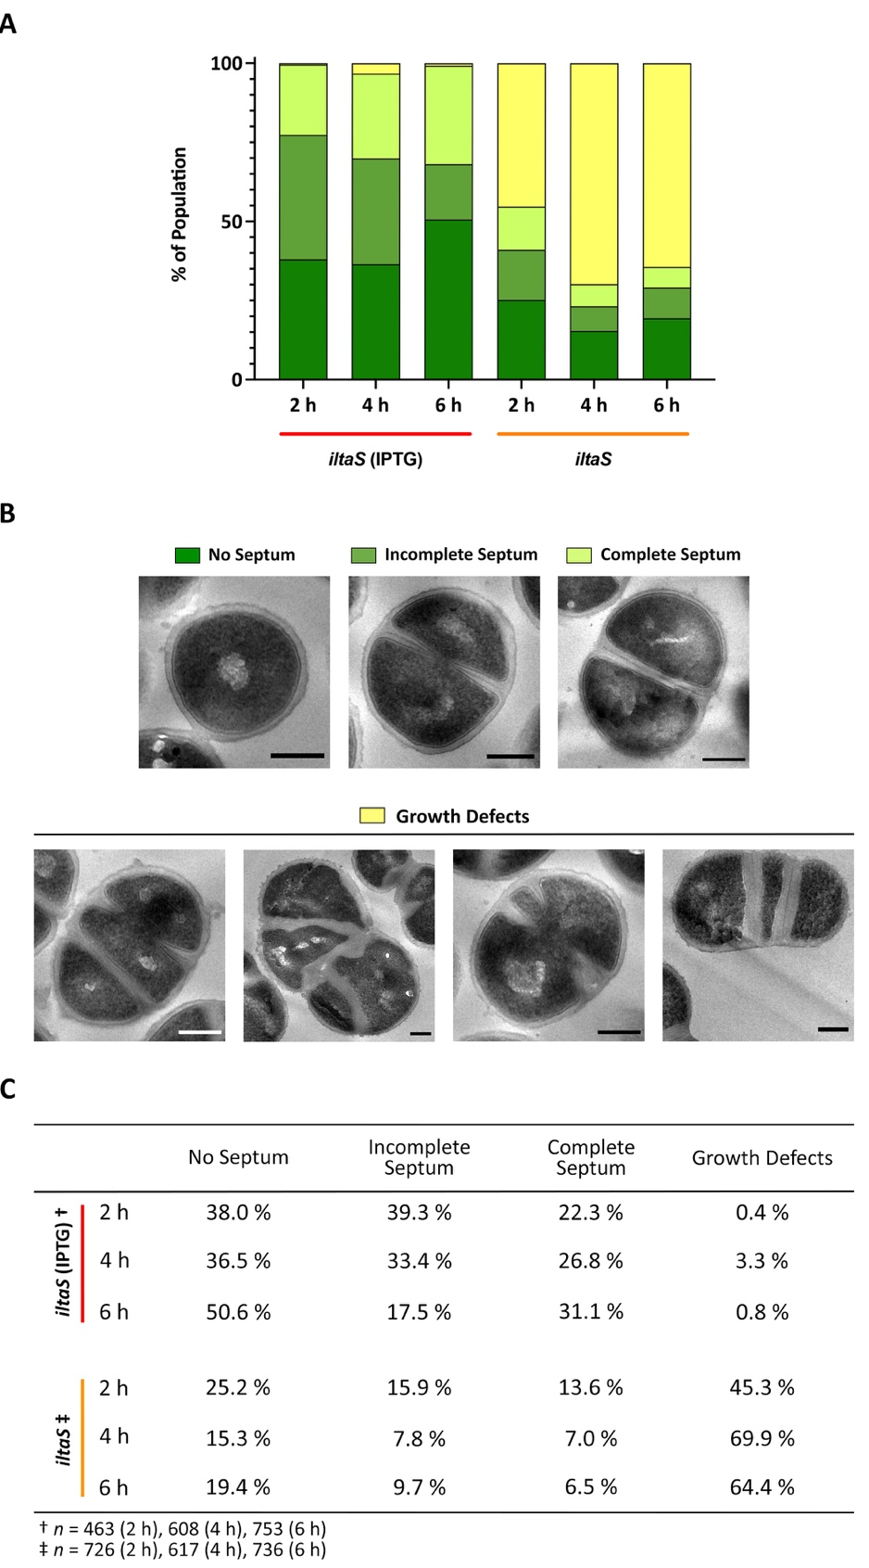
Figure 4.15 Division stages and morphology quantification of LTA-depleted S. aureus.
(A) Normalised quantification of iltaS with 1 mM IPTG (red) and without the inducer (orange) after 2, 4 and 6 h of growth. Quantification criteria: no septum (dark green), incomplete septum (medium green), complete septum (light green) and growth defects (yellow). (B) Representative TEM micrographs for each quantification category. Cropped from high magnification (2900x), scale bars 300 nm. (C) Mean value for each category representing the percentage of the sample population. One biological repeat. Total number of cells analysed for iltaS (IPTG): n = 463 (2 h), n = 608 (4 h), and n = 753 (6 h). Total number of cells analysed for iltaS: n = 726 (2 h), n = 617 (4 h) and n = 736 (6 h).

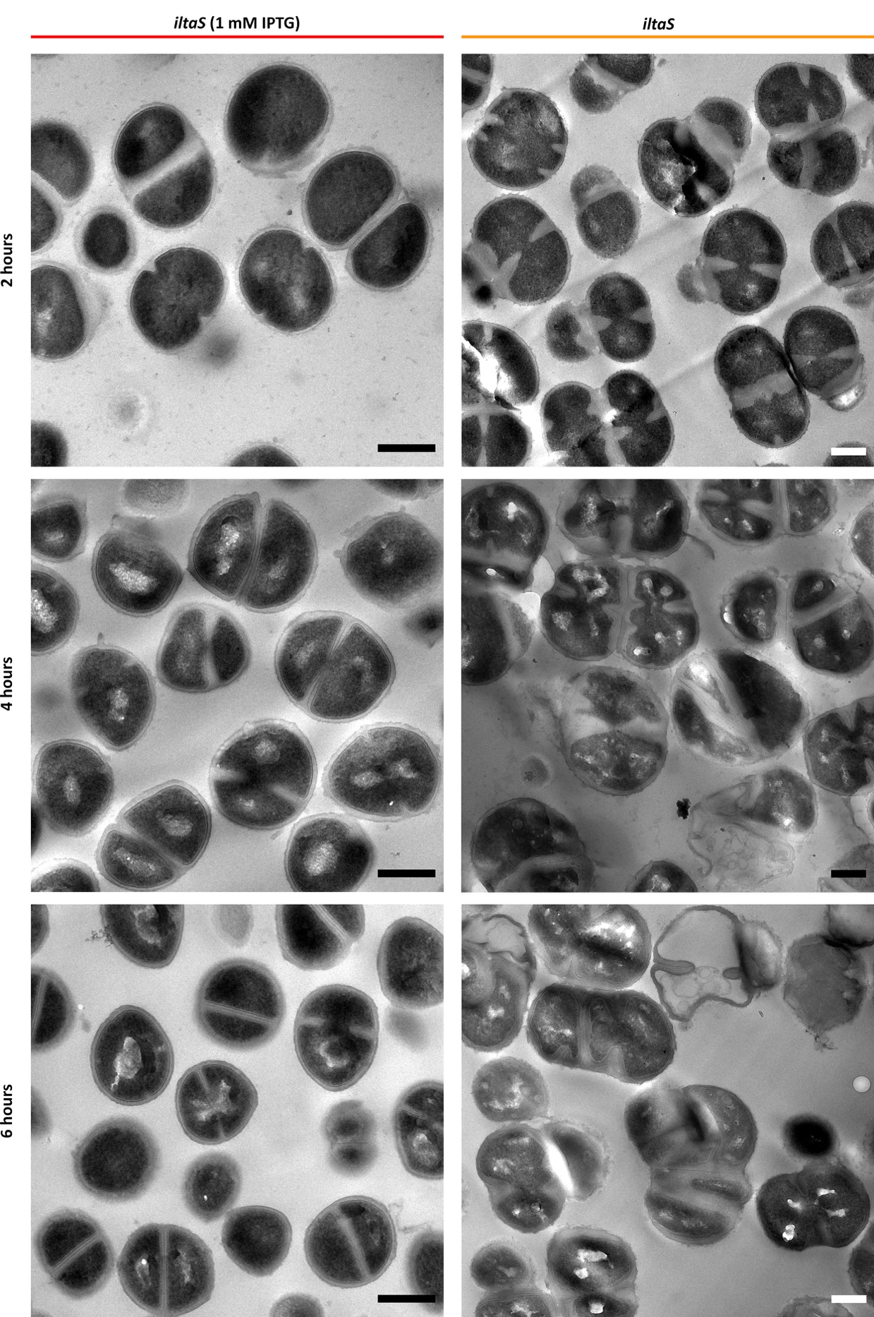
Figure 4.16 TEM of S. aureus iltaS.
TEM micrographs of chemically fixed S. aureus iltaS with 1 mM IPTG (left, red) and without the inducer (orange, right). Samples fixed at 2 (top), 4 (middle), and 6 h (bottom) of growth. Cropped from high magnification (Left– 4800x, Right– 2900x), scale bars 300 nm.

Analysis of S. aureus SH1000 ltaS gdpP::kan.
The previous section proved that studying the effects of the lack of LTA is difficult due to growth arrest and a high concentration of aberrant cells. Corrigan at al., (2011) ^{[63]} showed that a suppressor mutation in the gdpP gene restores normal growth. Loss of GdpP, a phosphodiesterase protein that uses c-di-AMP as a substrate, leads to increased intracellular levels of this cyclic dinucleotide. The nucleotide c-di-AMP is produced by DacA and acts as a secondary messenger that helps control cell size and cope with extreme membrane and CW stress ^{[63]}. A mutation in gdpP compensated for the phenotypes of LTA-depleted mutants, resulting in a reduction in cell size and morphological defects, and restored growth in S. aureus RN4200 and LAC* ^{[63]}. Therefore, SH1000 ltaS gdpP::kan was analysed.
Both optical density and CFU/ml measurements demonstrated that the deletion of gdpP allows bacterial growth of the SH1000 LTA-depleted strain (Figure 4.17a-b). However, this suppressor mutation did not restore all the aberrant morphological characteristics of LTA-depletion. Corrigan et al., (2011) ^{[63]} showed that gdpP mutations lead to a reduction in cell size, and this remains true in the SH1000 background, with a 50 % reduction in size (0.3 ± 0.1 µm³) (Figure 4.17c-e). However, ltaS gdpP::kan had an average increase of 2.67x in size (1.6 ± 0.9 µm³) in comparison to the wildtype. TEM and SEM images showed that this was only true for some cells (53 % of the population), while others had a restored cell size similar to its parental strain as expected with the gdpP mutation (Figure 4.18, Supplementary Figure 2).
ltaS gdpP::kan has 24.5 % of aberrant cells, higher than the wildtype (0.8 %) (Figure 4.19a,c). Various division aberrations were observed, including multiple septa and misplacement of septa (Figure 4.18, Figure 4.19b, and Figure 4.20). These aberrations are very much like the ones described for iltaS (Figure 4.15 and Figure 4.16). Regardless of their size, many cells have developed the division anomalies, with 76.4 % of these having a bigger size and only 26.1 % having a “wildtype-normal” size (Supplementary Figure 2).

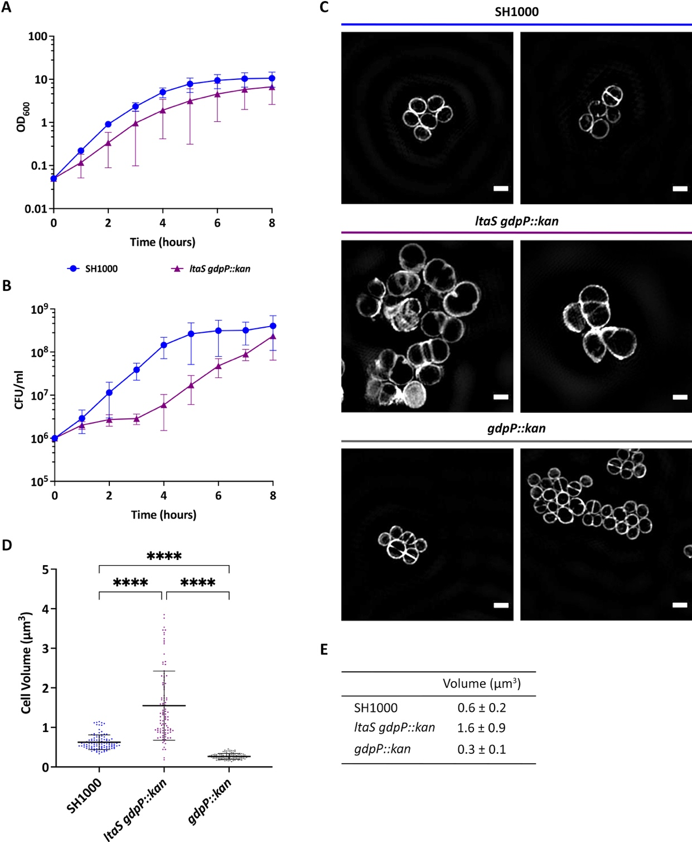
Figure 4.17 Bacterial growth and cell volume of S. aureus SH1000 ltaS gdpP::kan.
(A) Absorbance and (B) CFU/ml measurements for the compared growth of S. aureus SH1000 (blue– 6 biological repeats) and ltaS gdpP::kan (purple– 3 biological repeats). (C) Representative OMX SIM images of NHS-ester Alexa Fluor™555 labelled cells for SH1000 (blue), ltaS gdpP::kan (purple) and control strain gdpP::kan (grey). Scale bar 1 µm. (D) Cell volume estimation from SIM images. Statistical analysis: t- test with Welch’s correction (**** p < 0.0001, n > 100). (E) Mean value ± standard deviation for volume estimation from (D).
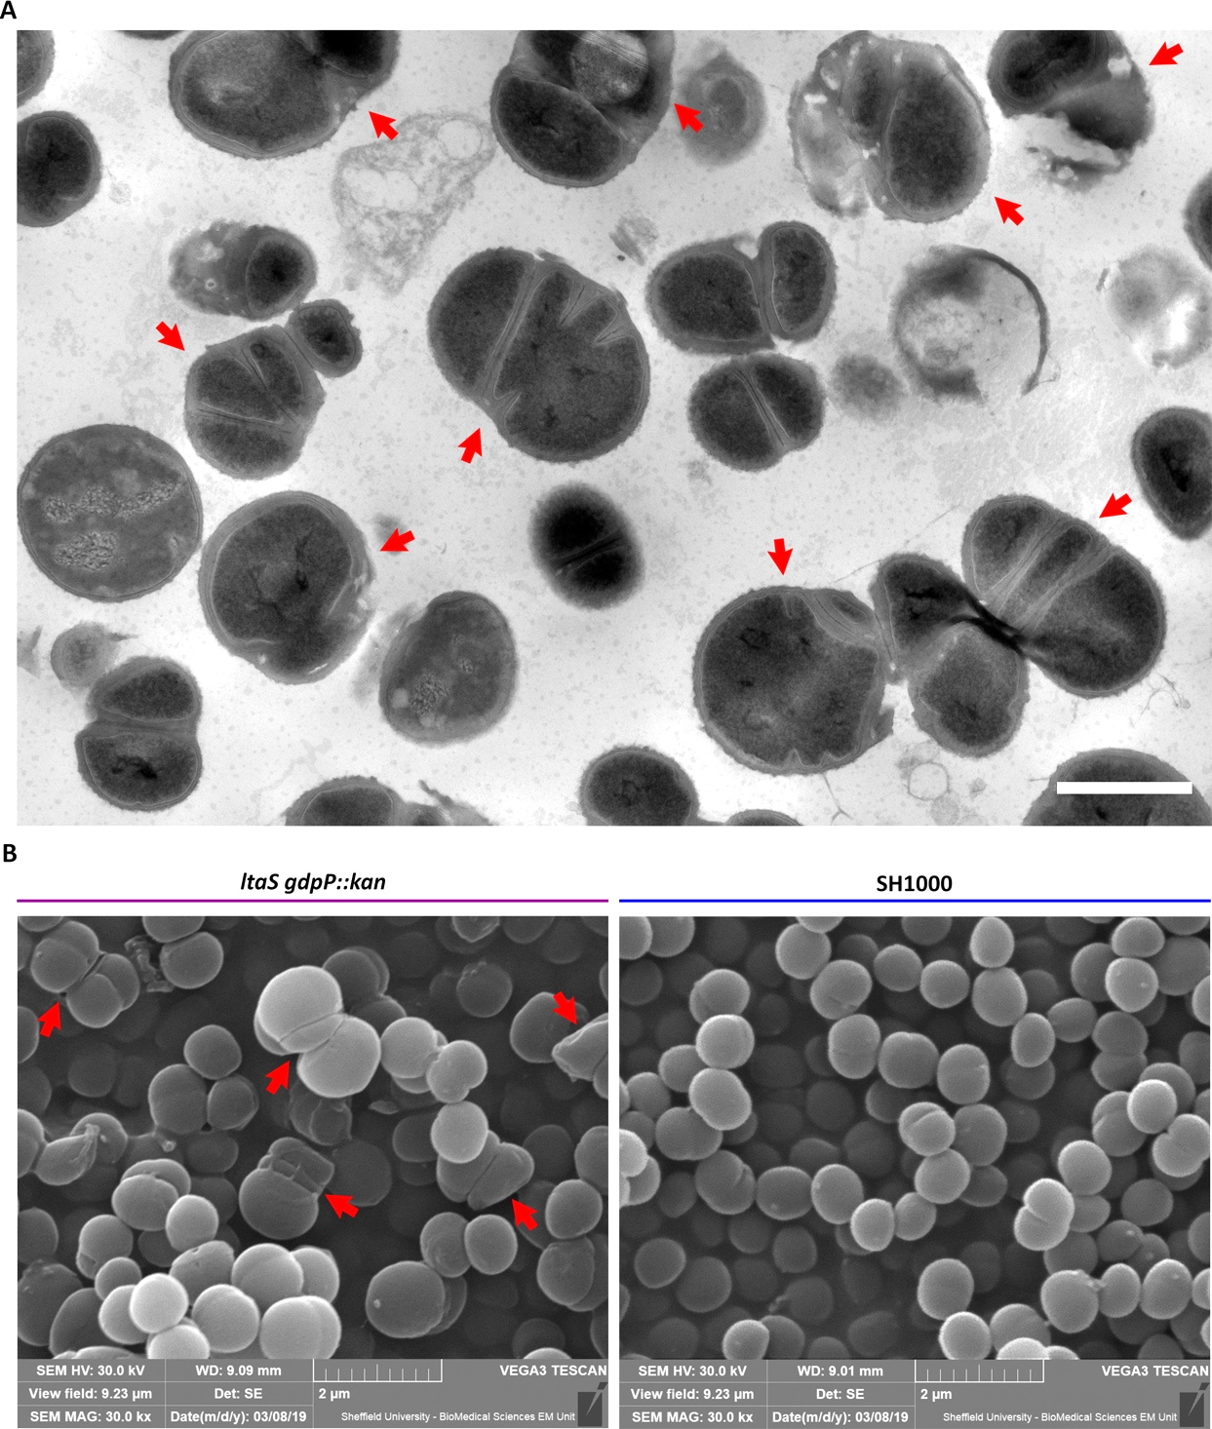
Figure 4.18 TEM and SEM micrographs of chemically fixed ltaS gdpP::kan.
(A) TEM micrograph of chemically fixed S. aureus ltaS gdpP::kan. Magnification of 2900x. Scale bar 1 µm. (B) SEM micrographs of chemically fixed ltaS gdpP::kan and its comparison to SH1000. Magnification 30000x. Scale bar 2 µm. Red arrow indicate morphological defects typical of the lack of lipoteichoic acids.

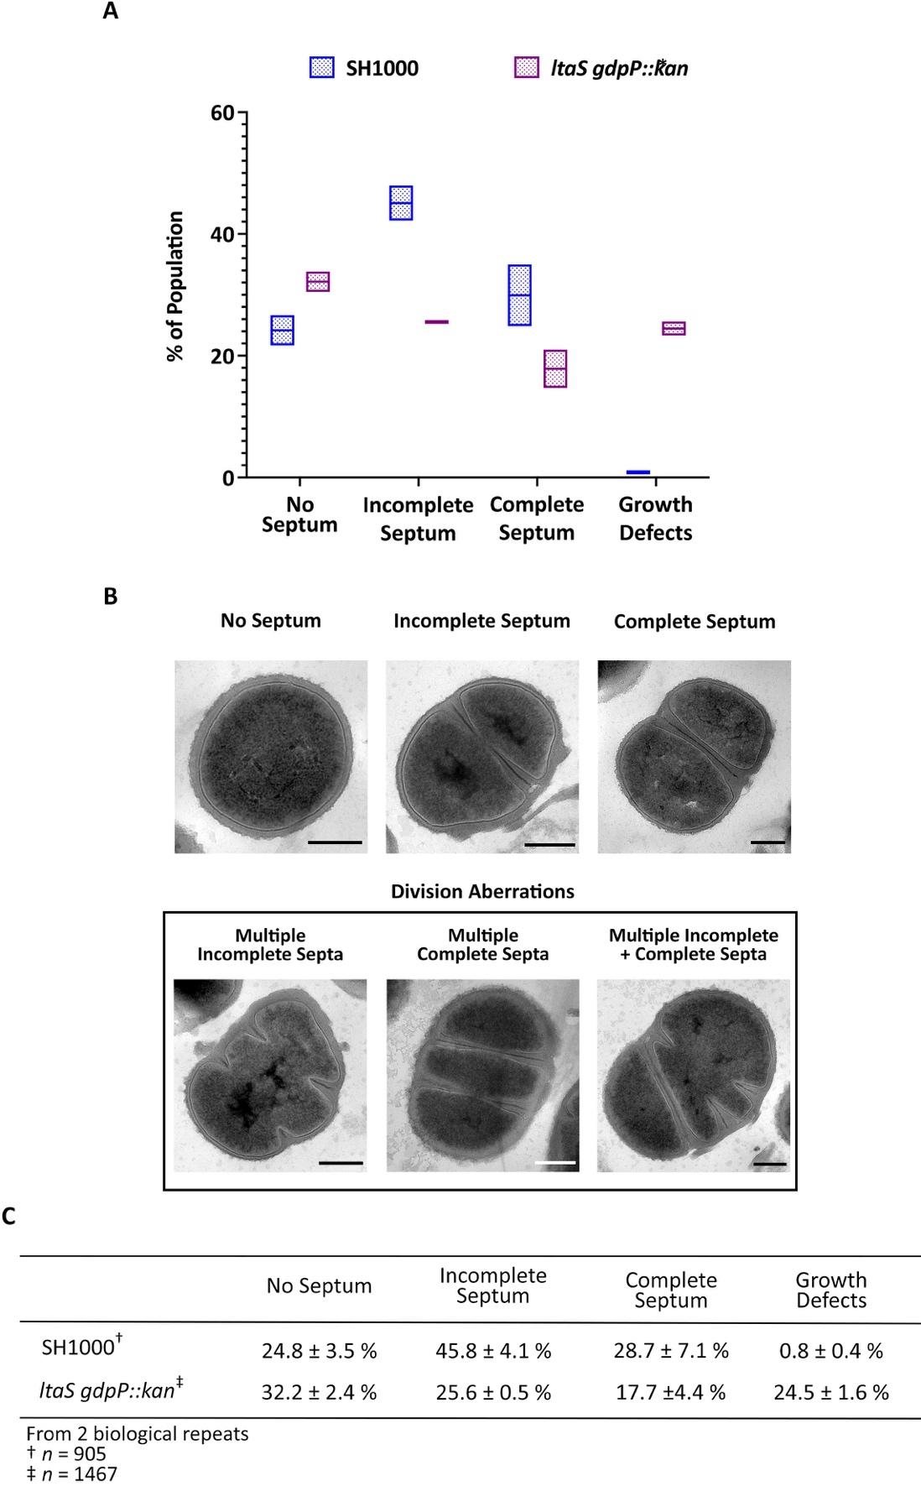
Figure 4.19 Morphological quantification of S. aureus SH1000 ltaS gdpP::kan.
(A) Normalised quantification of the percentage of SH1000 (blue) and ltaS gdpP::kan (purple) with no septum, incomplete septum, complete septum and growth defects during early exponential phase. Floating bars represent the minimum, mean and maximum value. (B) Representative TEM micrographs of the categories in (A) for ltaS gdpP::kan. Cropped from high magnification (4800x and 2900x), scale bars 300 nm. (C) Mean value ± standard deviation (SD) for each quantification category. Two biological repeats for each, with a total of n = 905 and n = 1467 cells analysed for SH1000 and ltaS gdpP::kan, respectively.
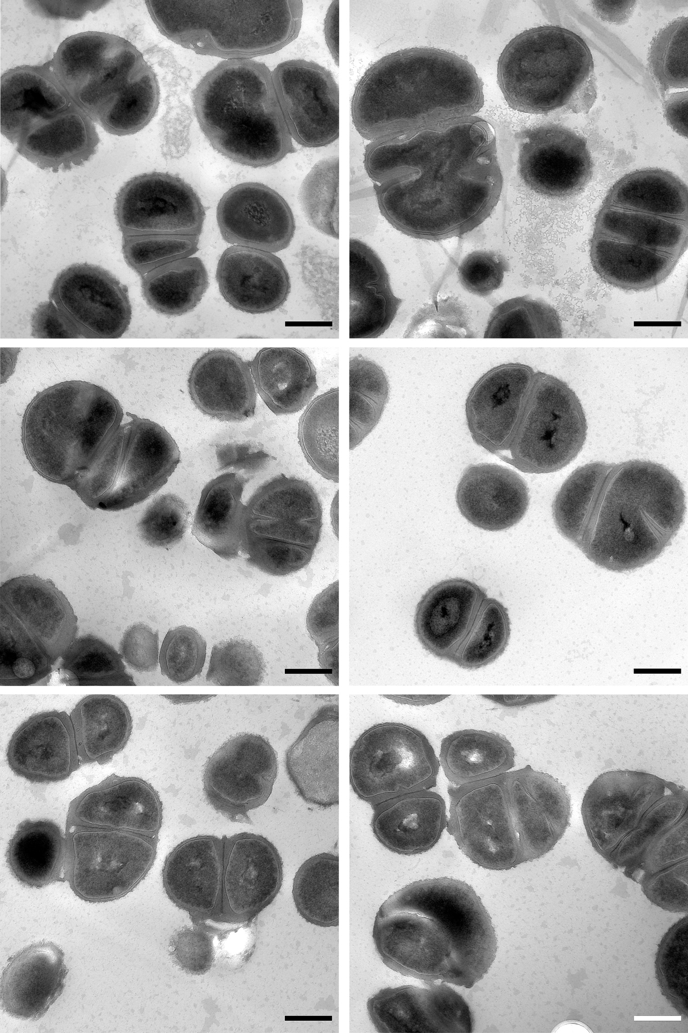
Figure 4.20 High magnification TEM micrographs of chemically fixed S. aureus ltaS gdpP::kan.
Chemically fixed S. aureus ltaS gdpP::kan at 4800x magnification. Scale bar 500 nm.

Effect of the lack of LTA on the bacterial envelope and exoplasmic space.
Despite a large percentage of the sample population showing LTA-characteristic defects, this study shows that ~ 41.2 % have a normal cell size and morphology (Supplementary Figure 2) and restored cell growth (Figure 4.17). This makes ltaS gdpP::kan a more suitable strain than iltaS for the study of LTA and its role in exoplasm maintenance. The next step was to determine if there were any visible differences in morphology with freeze-substitution (FS) TEM, as this technique provides better structural preservation for bacterial envelope analysis.
Only a handful of FS-TEM micrographs were acquired, and the majority presented badly vitrified samples. Figure 4.21 and Figure 4.22 show a selection of these micrographs with the least burst cells, although there are still signs of cell damage. Similarly to SH1000, the images showed a heavily stained population and a lesser stained one with more structural detail at the bacterial envelope. A closeup look at the envelope of FS iltaS and ltaS gdpP::kan showed the same visible structure as SH1000, with two additional and unidentified layers (Figure 4.23, layer I and II).
Unfortunately, time and accessibility restraints meant that neither iltaS nor ltaS gdpP::kan could be analysed by CEMOVIS for a detailed study of its effect on the exoplasmic space.
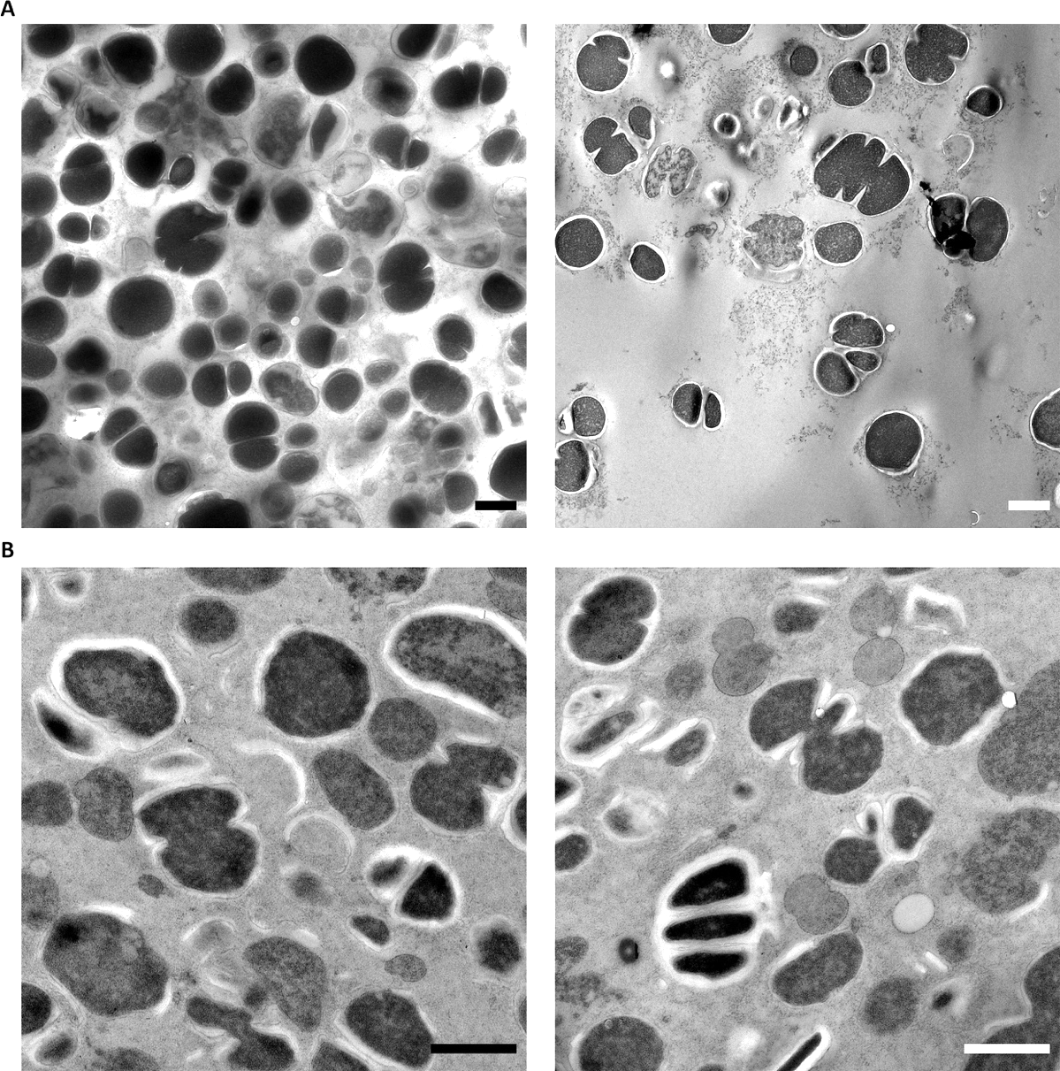
Figure 4.21 Low and mid-magnification TEM micrographs of freeze-substituted S. aureus ltaS gdpP::kan
TEM micrographs of freeze-substituted S. aureus ltaS gdpP::kan at (A) 1400x and (B) 2900x. Scale bars 1 µm.
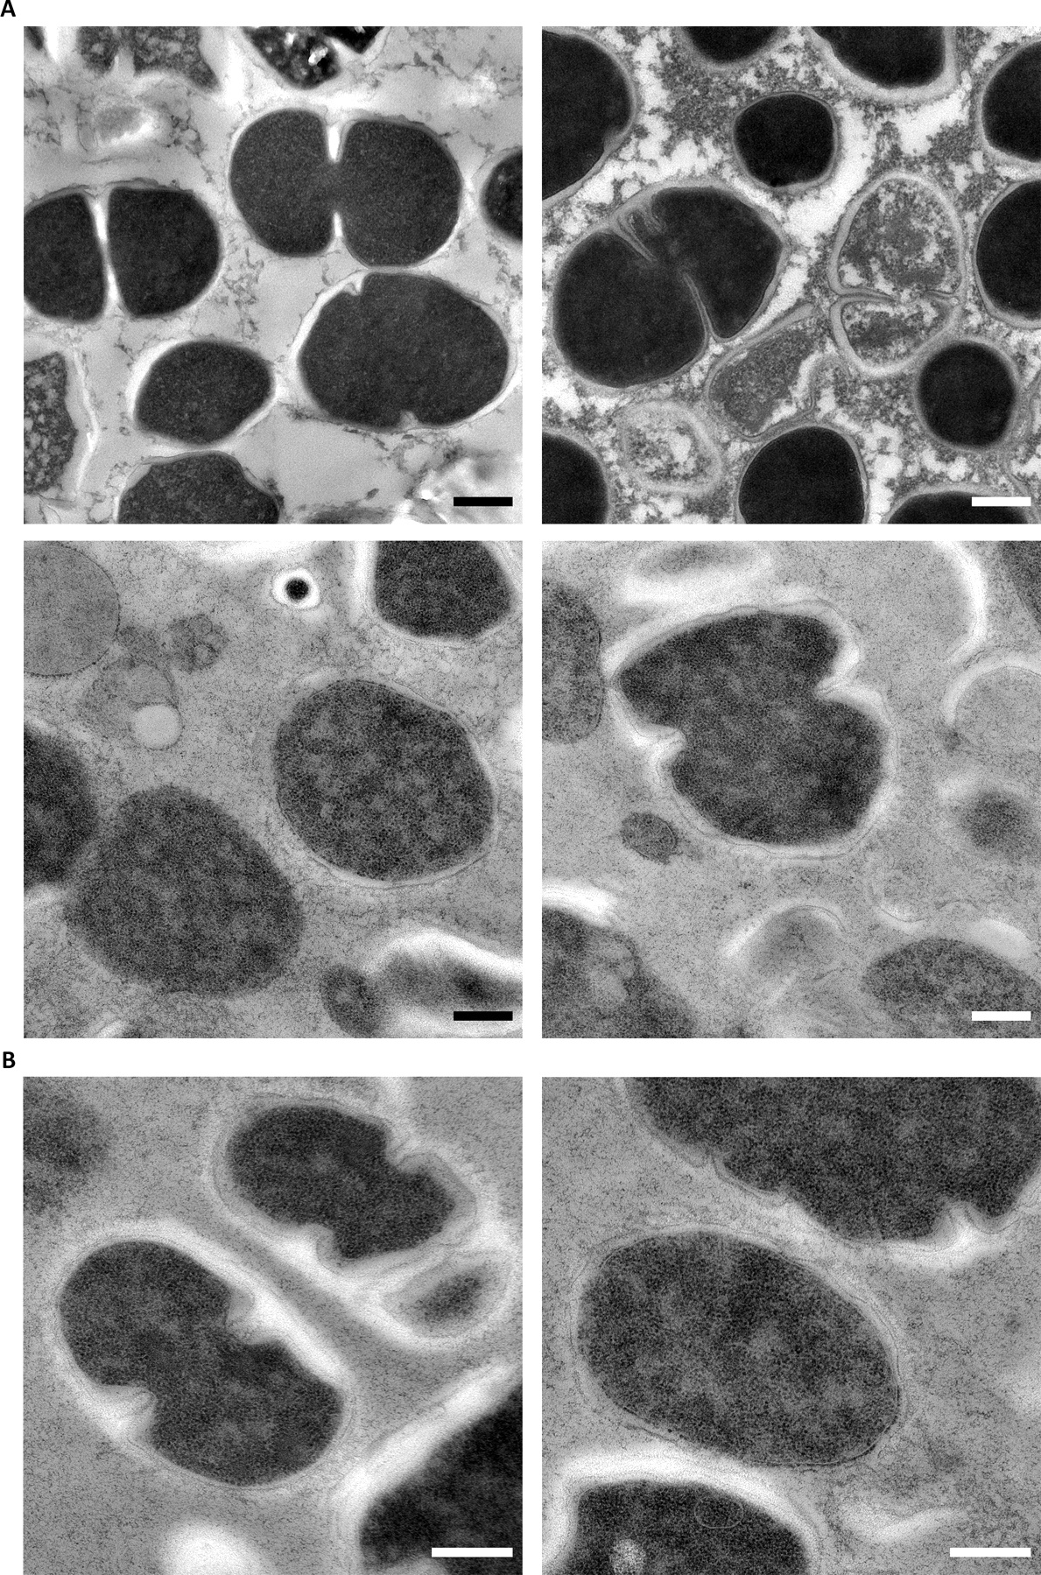
Figure 4.22 High magnification TEM micrographs of freeze-substituted S. aureus ltaS gdpP::kan.
TEM micrographs of freeze-substituted S. aureus ltaS gdpP::kan at (A) 6800x and (B) 9300x. Scale bars 300 nm.

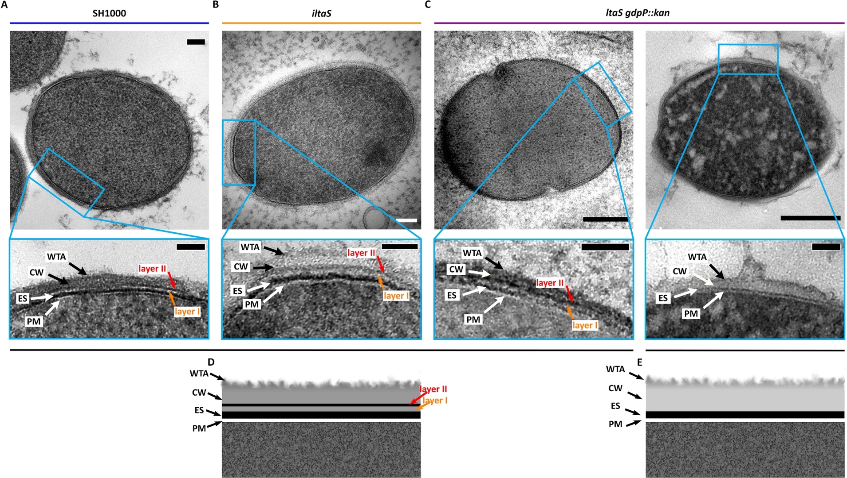
Figure 4.23 Cell envelope comparison of freeze-substituted SH1000 and LTA-depleted strains.
Representative FS (A) SH1000 cell, (B) iltaS and (C) ltaS gdpP::kan. (D-E) Schematic representations of the bacterial envelope. (D) represents the envelope of (A), (B) and (C- left), while (E) represents the envelope of (C- right). WTA– wall teichoic acids, CW– cell wall, ES– exoplasmic space, PM– plasma membrane. Layers I and II are two undefined layers. Scale bars 100 nm and 50 nm.

Analysis of the lack of WTA and LTA: survival and morphological effects.
Teichoic acids are vital for bacterial growth, and although WTA loss is not lethal, all attempts to produce strains lacking WTA and LTA have been unsuccessful ^{[91]}. Yet, knowing that LTA’s essentiality can by bypassed by a suppressor mutations in gdpP ^{[63]} raises the question of whether a potential triple mutant, lacking both types of TA and gdpP, could be viable. Unfortunately, due to time and laboratory access constraints, said mutant could not be constructed.
A pharmacological simulation was carried out to determine the combined roles of WTA and LTA, using the following chemical compounds: tarocin, tunicamycin, and Congo red. The first two inhibit the first stages of WTA biosynthesis by targeting the catalytic action of TarO. Tunicamycin is a natural product inhibitor of TarO, analogue to its substrate UDP-GlcNAc ^{[274]}, while Tarocin is an allosteric inhibitor that obstructs binding to its co-substrate, bactoprenol ^{[276]}. Congo red is a dye that inhibits the first stages of LTA biosynthesis by interrupting LtaS activity ^{[277,278]}. Research has already been done (I) on tarO treated with Congo red and (II) on the ltaS mutant with the suppressor mutation in gdpP and the effect of tunicamycin on bacterial growth ^{[278,279]}. However, these were done in different S. aureus backgrounds (I– Newman, RN4220, RN6390, II– LAC*) and using Congo red and tunicamycin only. Hence, it was decided to test this in the SH1000 background for consistency with this investigation, and also test the use of tarocin for reducing WTA synthesis– as it is a more specific inhibitor than tunicamycin ^{[276]}.
SH1000 treated with tarocin had a similar growth to that of tarO (Figure 4.24a). Addition of Congo red to SH1000 did not present a difference in optical density to untreated SH1000, but had a similar growth to the LTA mutants when analysing CFU/ml (Figure 4.24b, Supplementary Figure 3).
The pharmacological inhibition of both WTA and LTA in SH1000, with tunicamycin and Congo red respectively, showed that there is growth arrest after ~ 2 h of treatment (Figure 4.25a). The addition of tarocin to iltaS or ltaS gdpP::kan and the addition of Congo red to tarO showed a more severe outcome with 100 % death after 4 and 99.99 % after 3 h, respectively (Figure 4.25b-c, Figure 4.26, Supplementary Figure 4). The lethal results confirm the essentiality of both WTA and LTA in SH1000.

TEM morphological analyses showed that SH1000 treated with tarocin resembles the phenotype observed in the WTA-depleted mutant, tarO (Supplementary Figure 5 and Supplementary Figure 6). ltaS gdpP::kan treated with tarocin showed similar results to those previously described ^{[279]} (Supplementary Figure 7, Supplementary Figure 8, and Supplementary Figure 9). tarO with Congo red presented a phenotype similar to that of iltaS and ltaS gdpP::kan (Supplementary Figure 10 and Supplementary Figure 11).

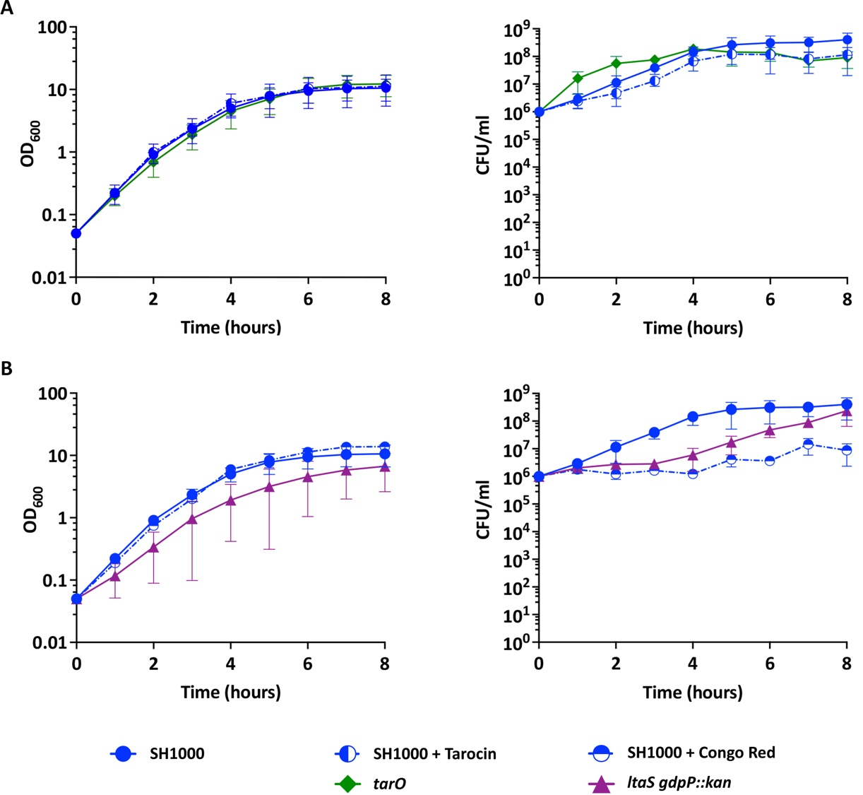
Figure 4.24 Effects of tarocin and Congo red on bacterial growth and its comparison to WTA and LTA mutants.
Normalised absorbance and CFU/ml measurements for of S. aureus SH1000 (blue circles), tarO (green rhombus), and ltaS gdpP::kan (purple triangle). (A) Comparison of SH1000 treated with 2.5 µg/ml of tarocin (blue half vertical circle) to tarO (green rhombus). (B) Comparison of SH1000 treated with 10 µg/ml of Congo red (blue half horizontal circle) to ltaS gdpP::kan. Average of > 3 biological repeats. SH1000 + Congo red was carried out by Dr. Oliver Carnell.
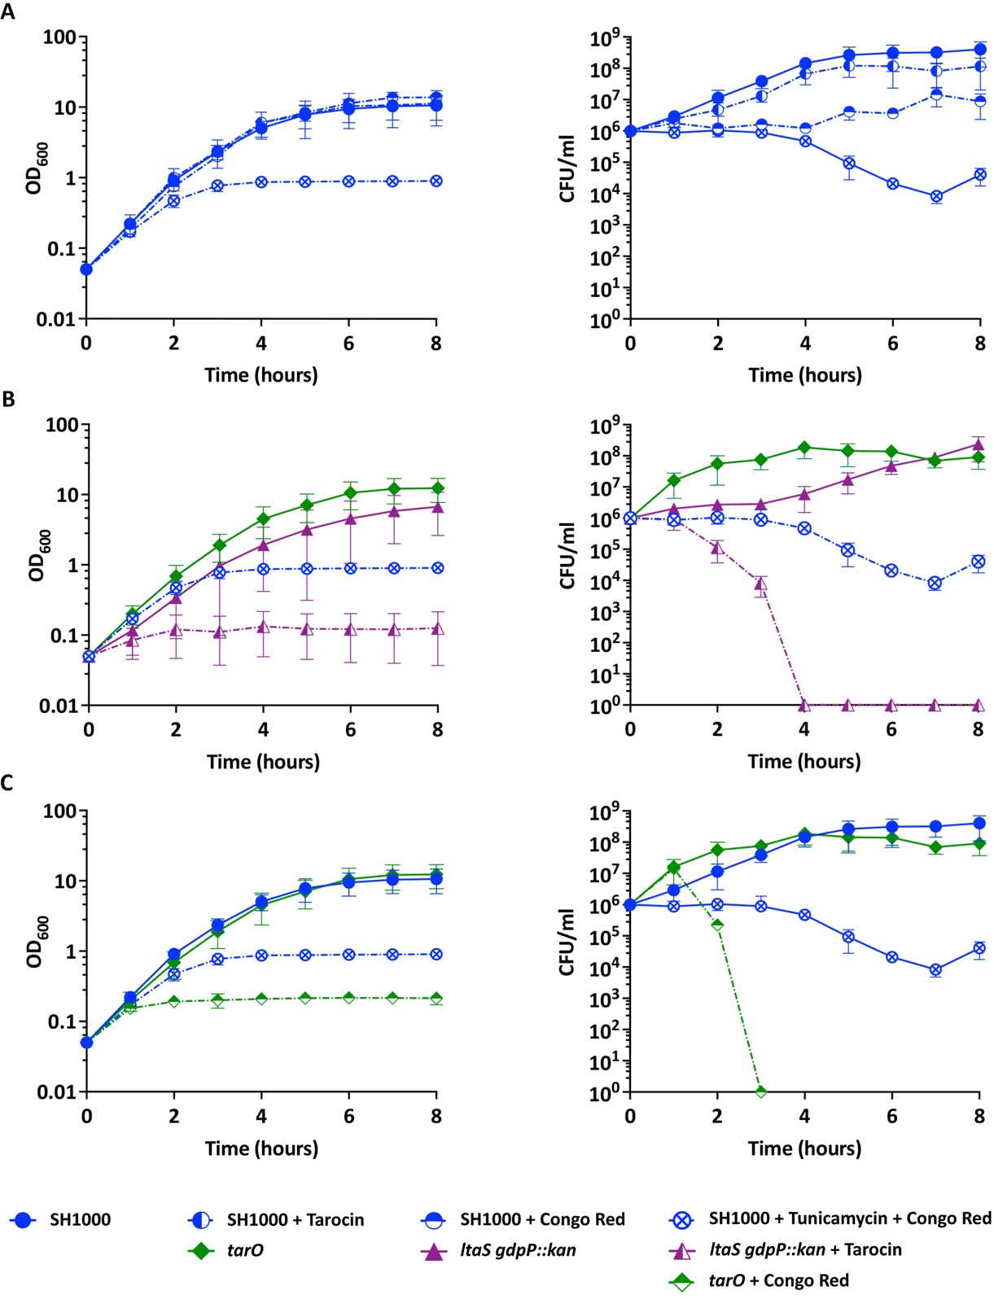
Figure 4.25 Effect of the chemical interruption of WTA and LTA biosynthesis on SH1000 growth.
Normalised absorbance and CFU/ml measurements for S. aureus SH1000 (blue circle), tarO (green rhombus) and ltaS gdpP::kan (purple triangle). (A) Comparison of SH1000 treated with tarocin (blue half vertical circle) to its treatment with Congo red (blue half horizontal circle) and treatment with both tunicamycin and Congo red together (blue circle with a cross). (B) Comparison of SH1000 + tunicamycin + Congo red to ltaS gdpP::kan treated with tarocin (purple half triangle). (C) Comparison of SH1000 + tunicamycin + Congo red to tarO treated with Congo red (green half rhombus). Tarocin and tunicamycin– 2.5 µg/ml. Congo red– 10 µg/ml. All values are the average of > 3 biological repeats. Congo red experiment was carried out by Dr. Oliver Carnell.
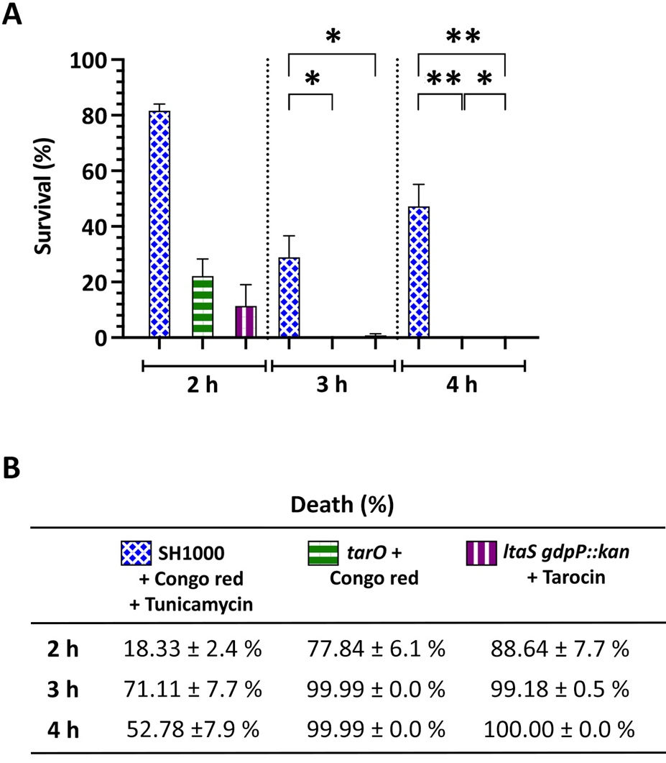
Figure 4.26 Survival analysis of SH1000 lacking WTA and LTA.
Normalised (A) survival percentage and (B) death percentage taken from CFU/ml of S. aureus SH1000 treated with tunicamycin and Congo red together (blue circle with a cross), tarO treated with Congo red (green half rhombus), and ltaS gdpP::kan treated with tarocin (purple half triangle). Measurements taken at 2, 3 and 4 h of treatment, as stated. Statistical analysis: t-test with Welch’s correction (3 h SH1000 vs. tarO * p = 0.0229; 3 h SH1000 vs. ltaS gdpP * p = 0.0237; 4 h SH1000 vs. tarO ** p = 0.0091; 4 h SH1000 vs. ltaS gdpP::kan ** p = 0.0091; 4 h tarO vs. ltaS gdpP::kan ** p = 0.0307). Tarocin and tunicamycin– 2.5 µg/ml. Congo red– 10 µg/ml. All values are the average of 3 biological repeats. Congo red experiment was carried out by Dr. Oliver Carnell.

Discussion.
The exoplasmic space is a malleable compartment that, as such, is difficult to examine when dehydrated by conventional microscopy techniques such as chemical fixation and freeze-substitution. Cryo-electron microscopy of vitreous sections (CEMOVIS) offers the opportunity to study the exoplasm in its frozen hydrated state. This first attempt at CEMOVIS has proven that this technique can provide the necessary data to study the bacterial envelope, with particular focus on the exoplasm. However, due to time constraints, the aims of studying the exoplasm with this cryo-EM technique could not be achieved. Thus, this discussion is focused on the preliminary data obtained from conventional TEM techniques.

Analysis of the bacterial envelope and the exoplasm by freeze substitution.
As explained in chapter 3, freeze-substitution (FS) provides better structural preservation than conventional chemical fixation at room temperature. Here I have shown two differential sample populations of freeze-substituted SH1000 cells, one more heavily stained than the other. The former resembles images of freeze-substituted cells obtained by Matias & Beveridge (2006) ^{[16]}, while the latter appears to present more structural detail (Figure 4.4). The reason behind these two sample populations is yet unknown. Usually, differential contrast and staining depends on the reactivity of the cell components to OsO₄ and heavy-metal stains (UA and LC), and the mass available for staining. The latter explains why thicker sections are more heavily stained than thin sections, and why thinner sections provide TEM micrographs that are easier to analyse. Similarly, burst or damaged cells have a reduced contrast as a result of leaked cytoplasmic material. With this in mind, the sample population observed here with less staining and more structural detail could result from either: (1) damaged cells during HPF that have less cellular material for staining, or (2) highly preserved cells due to a better HPF. I believe the latter is more likely, as the loss of cytoplasmic content from a broken cell should not affect the visibility of any CW-bound components. Although more experiments are required to reach a robust conclusion, one thing is certain: the detailed structures of the bacterial envelope from these lesser stained population should not be ignored, as they are very frequent (Figure 4.3a) and consistent throughout the cell envelope of that subpopulation (Figure 4.5).

Overall, FS did not show any additional information on the exoplasm but did however provide more detail on the bacterial cell wall. These highly preserved cells showed two additional and previously unidentified layers, I and II (Figure 4.4c,f). Layer II is heavily stained which could indicate its correspondence to teichoic acids (TA) (for further discussion on these layers, refer to section 6.1.2).

Effects of the lack of WTA on the bacterial envelope and exoplasm.
Analysis of the tarO mutant lacking WTA confirmed that these polymers are not essential for cell growth. However, unlike previous reports ^{[129,274]}, tarO in the SH1000 background did not have a slower growth than the wildtype and the incidence of division aberrations was considerably low (< 1 %) (Figure 4.9, Figure 4.10). The obtained data did coincide with other studies, showing that WTA-depleted cells have a larger cell size, an uneven CW thickness and fuzzy-appearance of its surface, and an aberrantly-shaped septum lacking a mid-line (Figure 4.11 and Figure 4.12) ^{[59,86,112,129,274]}. This mid-line is a heavily stained line in the midzone of the septal wall that has been said to correspond to WTA ^{[274,275]}. WTA chains extend outwards of the surface of the CW and at the nascent CW at the septum ^{[16,166,275]}. When dehydrated, the protruding WTA polymers could collapse and fold back, producing a concentrated WTA mass from both sides of the septum that provides enough contrast when stained with conventional TEM. Thus, the disappearance of the mid-line in both tarO cells (Figure 4.12) and in SH1000 treated with tarocin (Supplementary Figure 5) supports the evidence that the mid-line observed at the crosswall and septum is made-up of WTA.
This investigation showed that chemically fixed CW measurements of tarO resulted in a statistically thinner CW (Figure 4.11c-f), suggesting that without these polymers, the CW is either naturally thinner or narrower due to a more extended dehydration. The latter seems a more likely scenario, as a dehydrated CW without WTA would have a reduced mass and would therefore be narrower. Yet, measurements from frozen-hydrated samples are needed to support this theory.
The fuzzy-appearance of the surface of the CW could result from a more hydrolysed CW. After all, Schlag et al., (2010) showed that tarO mutants have higher binding and susceptibility to autolysins ^{[59]}. WTA binds to the PG MurNAc unit, and its presence interferes with the major autolysin Atl involved in cell separation. The three repeat motifs that separate the amidase and glucosaminidase domains of Atl, are repelled by this CW polymer ^{[59]}, thus, a CW-depleted of WTA presents more available binding sites for hydrolases such as Atl. This in turn could result in a more rapid hydrolysis of newly synthesised CW. This suggestion is supported by preliminary atomic force microscopy (AFM) results carried out by Dr. Pasquina Lemonche, whereby images of live tarO cells showed a CW made mostly of a matured PG composition that could indicate a higher hydrolysis rate. Future work is necessary to test this hypothesis. AFM of tarO purified PG (sacculi) could provide in-depth analysis of the length of perforating CW holes and quantitively confirm if there is a significant difference to the wildtype, while cryo-TEM of vitrified sections of tarO would give a better look and CW measurement closer to the cell native state.

Effects of the lack of LTA on the bacterial envelope and exoplasm.
Study of the iltaS IPTG-inducible mutant has provided confirmation that the previously described phenotype resulting from LTA-depletion in RN4200 ^{[99]} is also found in the SH1000 background. Comprehensive studies showed growth arrest and increased morphological defects after 3-4 h of growth. Additionally, a 2.3x increase in cell volume and > 65 % of cells with morphological defects were observed, including multiple and misplaced of septa (mostly on the same division plane), clumped cells and thickened cell walls (Figure 4.14and Figure 4.15). Given the difficulty of working with a strain that suffers growth arrest and a high percentage of aberrant cells, this study was continued with an LTA mutant with a suppressor mutation in gdpP that restores growth ^{[63]}.
ltaS gdpP::kan was able to grow and a large number of cells had a reduction in size, as expected with the compensatory mutation in gdpP (Figure 4.17). However, various microscopy techniques (SEM, TEM, SIM) and morphological quantification confirmed that the majority of cells (~ 53 % of the population) maintained the increased cell size typical of LTA depletion (Figure 4.18, Supplementary Figure 2). The suppressor mutation reduced the number of aberrant cells in comparison to iltaS, although many were still present and were mostly associated to those with an increased cell size (Figure 4.19 and Figure 4.20, and Supplementary Figure 2). It is unclear why such a big portion of cells still retain the LTA-depleted phenotype in this background. Nonetheless, the reinstatement of cell growth makes this mutant the best candidate for studying the role of LTA in the maintenance of the exoplasm in S. aureus SH1000.

Effects of a simultaneous reduction in WTA and LTA biosynthesis.
A pharmacological approach was used to analyse the role of both WTA and LTA in growth and morphology, and evaluate the viability of a triple mutant with a suppressor mutation in gdpP for future studies of the exoplasm ^{[63]}. This preliminary data adds to that already published ^{[278,279]}, providing quantifiable CFU survival results and a qualitative phenotype analysis on > 300 cells per strain / treatment in the S. aureus SH1000 background. Differences in phenotype to those already published ^{[278,279]} could be due to the difference in S. aureus background or the use of a more specific WTA inhibitor, tarocin^{[276]}. The lethality observed in ltaS gdpP::kan treated with 2.5 µg/ml of tarocin after 4 h, and in tarO treated with 10 µg/ml of Congo red after 3 h, confirms the essentiality of both types of TAs in SH1000 (Figure 4.25, Figure 4.26). These results, together with the preliminary morphological changes observed with ltaS gdpP::kan with tarocin (Supplementary Figure 8 and Supplementary Figure 9), suggest that a triple mutant lacking LTA and WTA, accompanied by the suppressor mutation in gdpP, might not be viable. Future experiment testing other compensatory mutations such as clpX, sgtB and mazE can be explored ^{[154,159]}.

Chapter 5
Use of Electron Microscopy to Investigate Morphological Dynamics During the Bactericidal Action of Cell Wall Antibiotics.

Introduction.
Cell wall (CW) homeostasis is of the upmost importance for bacterial growth, division and CW turnover ^{[17,22]}. Thus, the balance between peptidoglycan (PG) synthesis and degradation is highly regulated, and any disruption can lead to cell lysis ^{[22]}. Antibiotics interfere with these integrated cellular processes leading to cell death, and have been a reliable mainstay in human healthcare.
Bacteriostatic antibiotics, such as chloramphenicol and tetracycline, slow down or inhibit bacterial growth, usually by targeting major molecular processes including DNA replication, RNA synthesis, and translation ^{[15]}. Conversely, bactericidal antibiotics, such as vancomycin and β-lactams, generally kill bacteria by targeting the bacterial CW and the plasma membrane (PM) ^{[15]}. Despite our knowledge of the chemical structure and targets of antibiotics (discussed in section 1.7), it is not fully understood how bactericidal antibiotics lead to cell death. To address this from the most fundamental perspective, we have created a predictive model of bacterial life and death based on CW PG homeostasis (Figure 5.1) ^{[247]}. This simplified model stresses the importance of both PG synthesis and hydrolysis for bacterial growth and division, and predicts that bactericidal antibiotics kill bacteria by inhibiting PG synthesis only when the activity of growth-associated PG hydrolases (PGH) remains present (Figure 5.1). On the other hand, the second prediction suggests that loss of PGH activity would also lead to cell death only when PG synthesis remains un-interrupted. Lastly, loss or interruption of both PG synthesis and hydrolysis leads to cell stasis. To test these predictions, the impact of CW antibiotics could be studied in detail together with the analysis of PGH-lacking strains.
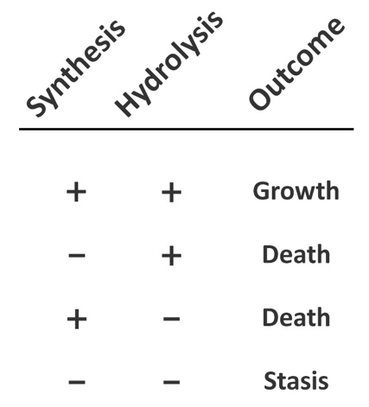
Figure 5.1 Predictive model of bacterial life and death based on cell wall peptidoglycan homeostasis.
Simple predictive model of bacterial life and death stating the importance of PG homeostasis for growth and division. Both synthesis and hydrolysis of cell wall peptidoglycan (CW PG) are required for cell growth. Inhibition or loss of either leads to cell death, while the interruption of both results in stasis.
Vancomycin and Methicillin were chosen to test the physiological and morphological impact of bactericidal antibiotics. Vancomycin, a glycopeptide CW antibiotic, binds to the D-Ala-D-Ala terminus of the PG pentapeptide disrupting the transpeptidase action of PBPs ^{[178,195–198]}. Methicillin, a β-lactam antibiotic that structurally resembles the D-ala-D-ala terminal group of the PG pentapeptide, binds to PBPs and inhibits PG cross-linking ^{[181,182]}. A detailed description of the mode of action for vancomycin and β-lactams can be found in section 1.7 of this thesis.
Historically, there has been an ongoing debate as to how CW antibiotics lead to cell death. The original model of penicillin-induced death proposed that death derived from a weakened uncrosslinked CW, which eventually ruptured because of mechanical and osmotic pressure from within the cell ^{[181,182,280]}. This was challenged in 1970, when Tomasz et al. showed that an autolysin-defective pneumococcus did not lyse when treated with penicillin ^{[281]}. These findings were later supported with a lysis-defective Bacillus licheniformis and autolysin-defective Bacillus subtilis, confirming that penicillin-induced lysis was not mechanical, but enzymatic ^{[282,283]}. Other studies later helped reveal that penicillin was able to bind to several bacterial targets and that different enzymes could have multiple molecular forms and catalytic activities, which explained differential phenotypes related to division, enlargement, morphology, etc ^{[280]}. More studies challenged the weakened CW model, by explaining that the uncrosslinked PG cannot be incorporated into the pre-existent wall ^{[280]}. The model eventually took another turn by suggesting that penicillin only causes bacterial growth arrest, but that the subsequent lytic processes was a separated event that required hydrolase activity ^{[280]}.
Kohanski et al., (2007) proposed a common mechanism of death for all bactericidal antibiotics focused around the induction of oxidative stress ^{[284]}. It was suggested that lethal concentrations of hydroxyl radicals, the most powerful oxidant among reactive oxygen species (ROS), arise from bactericidal drugs and induce DNA and protein damage. A hydroxyphenyl fluorescein (HPF) dye, which is oxidised by hydroxyl radicals, was used as a reliable measure of hydroxyl radical formation. The study, performed in E. coli and S. aureus, tested bactericidal antibiotics, including β-lactams, against bacteriostatic antibiotics ^{[284]}. The results showed that only bactericidal antibiotics produced lethal doses of hydroxyl radicals in both Gram-positive and Gram-negative bacteria ^{[284]}. Further tests with an iron chelator and hydroxyl radical quencher showed attenuated lethality with bactericidal antibiotics, emphasizing the importance of hydroxyl radicals in the molecular mechanism of death of these bactericidal drugs ^{[284,285]}. However, later studies contradicted the β-lactam mechanism of killing bacteria by oxidative stress ^{[286,287]}. Liu & Imlay’s (2013) studies in E. coli showed that bactericidal antibiotics were just as lethal in an anaerobic chamber as in aerobic conditions, suggesting that ROS are not required for cell death ^{[286]}. There was also no sign of increase in hydrogen peroxide production after treatment with bactericidal antibiotics, nor signs of symptoms of oxidative damage ^{[286]}. Consistently, Keren at al. (2013), found no correlation between bacterial survival with bactericidal antibiotics and the level of ROS production ^{[287]}. Additionally, there was no significant protective effect produced by ROS quenchers and no difference in survival under aerobic or anaerobic conditions ^{[287]}. These studies together do not support a common mode of action for bactericidal antibiotics based on oxidative stress.
The Bernhardt group later developed their own model for β-lactam induced death and suggested that on top of inhibiting PBPs, β-lactams lead to a futile PG cycle of synthesis and hydrolysis that results in depletion of cellular resources ^{[288]}. However, this study was carried out in E. coli treated with mecillinam, a Gram-negative antibiotic not effective against Gram-positive bacteria. Therefore, conclusions taken from a rod-shaped bacterium with a differential PG synthesis machinery cannot be extrapolated to S. aureus.
A specific publication of interest for this investigation, that also challenged the original mechanism of action of penicillin, is Giesbrecht et al., (1998). Their comprehensive alternative β-lactam’s pathway to cell death focuses in S. aureus and presents mostly electron microscopy evidence ^{[289]}. The study described a penicillin-dependent phenotype where the inner CW, referred to as the secondary wall (scW), is converted into a fibrillar wall material that is stained more intensively than the peripheral cell wall (Figure 5.2a). This morphological defect was mostly seen in dividing cells with bulbous shaped septa (Figure 5.2b), and was attributed to newly synthesised PG that could not be cross-linked due to penicillin’s binding to PBPs. Their proposed mechanism for subsequent cell death involves “murosomes”, described as small vesicular organelles that are involved in cell separation (Figure 5.2a). These are suggested to be periodically anchored above the site of the future septum, and the authors suggested that once the septum is completed, they induce the lytic cutting processes of the CW (Figure 5.3). Giesbrecht et al. proposed that these perforations are the initial event of daughter cell separation, and that when treated with penicillin, they become the defining step that triggers the pathway to bacterial death. Their model involves the murosomes located at a 90° angle from the first division plane after adding penicillin, and following the arrest of that first division due to lack of PG synthesis, the murosomes perforate the cell wall in the second division plane, while the division machinery and PG synthesis is absent. This leads to cytoplasmic leakage through murosome-created pores (Figure 5.3). A second model for higher concentrations of penicillin was also suggested, where cells die from attempting to split along the incomplete septum, and leading to cytoplasm leakage through the septum.
As explained above, the debate on the pathway that leads to cell death is still a controversial topic that has not been agreed upon yet. Therefore, this investigation analyses the basic physiological and morphological effects of bactericidal antibiotics to understand the fundamental processes that occur during the action of these antibiotics in the context of CW PG homeostasis.
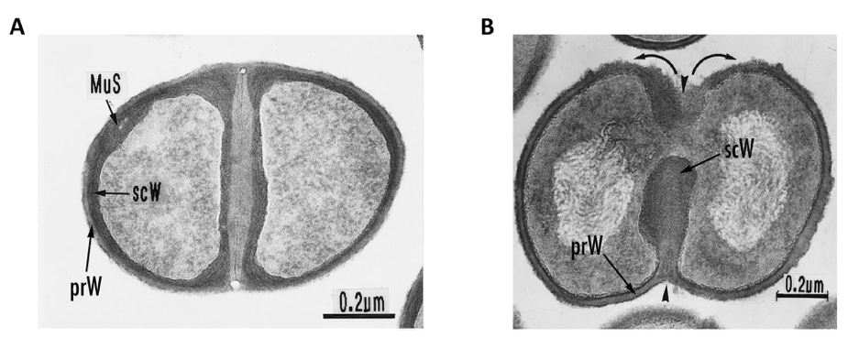
Figure 5.2 Giesbrecht’s penicillin-induced phenotype of S. aureus.
Interpretation of Giesbrecht et al., (1998) of TEM of chemically fixed thin sections treated with (A) 0.1 µg/ml or (B) 0.05 µg/ml of penicillin on S. aureus. MuS– murosomes, prW– primary wall, scW– secondary wall. Scale bar 200 nm. Figures obtained from Giesbrecht et al., (1998).
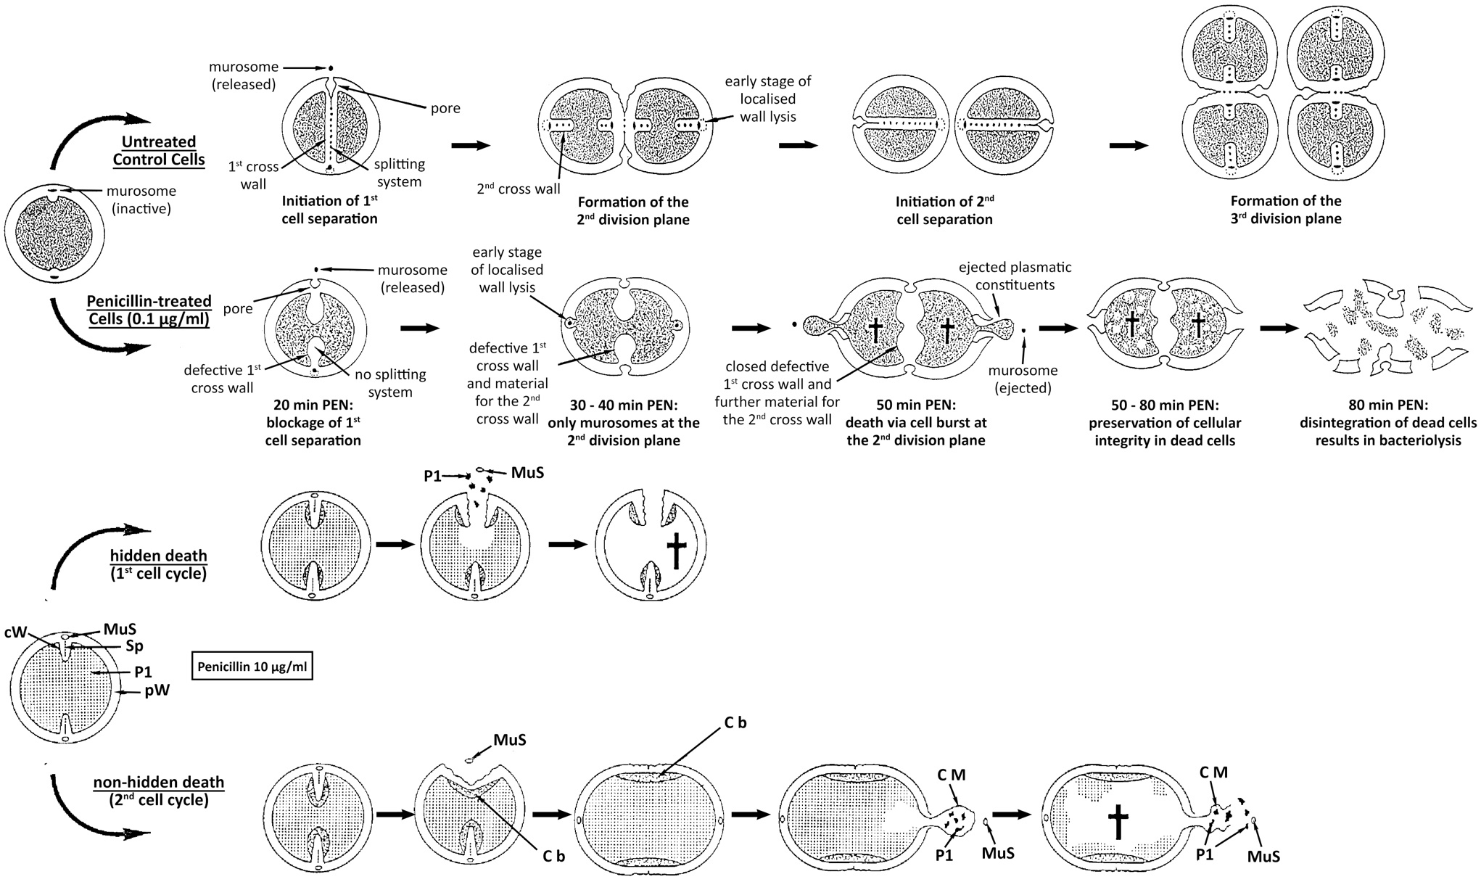
Figure 5.3 Giesbrecht’s proposed model for penicillin induced death.
The top schema shows a control cell cycle and the effect of low concentrations of penicillin (PEN) (0.1 µg/ml). The bottom schema represents the effect of high concentrations of penicillin (10 µg/ml). MuS– murosomes, Cb– connecting bridge, CM– cytoplasmic membrane, P1– cytoplasm, Sp– splitting system, cW– cross wall, pW– peripheral wall. Figure modified and simplified from Giesbrecht et al., 1998.

Aims of this chapter.
The aim of this chapter was to test our model of bacterial life and death based on cell wall peptidoglycan homeostasis. In particular, the versatility offered by electron microscopy to further study the morphological changes caused by the actions of bactericidal cell wall antibiotics was investigated.
Specific aims:
- Describe morphological dynamics as a result of vancomycin and methicillin treatment.

- Elucidate cell wall changes during the bactericidal action of antibiotics.

- Develop a model for how cell wall antibiotics kill S. aureus.

- Establish the molecular basis for our model of life and death due to peptidoglycan homeostasis.

Antibiotic effect on cell morphology as seen by TEM.
Methicillin and vancomycin were the CW antibiotics chosen for this study, a representative β-lactam and glycopeptide, respectively. Initially, S. aureus SH1000 (SJF 682) was used as this is a well characterised, genetically amenable strain.
S. aureus SH1000 was grown to an early-exponential phase (OD₆₀₀ ~0.2-0.4) using standard growth conditions (section 2.11.1), after which 40 µg/ml (10 x MIC) methicillin and/or vancomycin were added (section 2.8). Survival curves were used to analyse the killing dynamics of these antibiotics, via quantification of colony forming units (CFU) at hourly timepoints after addition of antibiotics (sections 2.15 and 2.13.2).
The addition of the bactericidal antibiotics methicillin and vancomycin results in 97 ± 2 % and 93 ± 5 % death after 6 h, respectively, and the former presents an overall higher mortality rate (Figure 5.4; methicillin vs. vancomycin p = 0.0032) ^{[247]}. The addition of both antibiotics simultaneously caused a 92 ± 4 % death after 6 h, closer to the bactericidal effect of vancomycin alone. It was decided to use the 1 h timepoint after addition of antibiotics for the subsequent analysis of the morphological impact of these drugs. This reduced the loss of dead cells at this early timepoint whilst maximising the observation of differential morphological changes of antibiotic-treated cells.
To determine the morphological effect of antibiotics, SIM and TEM was used so as to obtain cell volume and a detailed analysis of the bacterial cell envelope respectively. Given the large number of samples and treatments planned, chemical fixation was chosen as the fastest and most efficient TEM technique for this purpose (as described in sections 3.3 and 3.6). After 1 h in the presence of antibiotics, cells were harvested by centrifugation, washed and fixed with PFA (section 2.11.4) before carrying out SIM preparation (section 2.18.2) or standard chemical fixation for TEM (section 2.11.4 and 2.20.1). Ultra-thin sections were obtained for the latter, and these were post-stained and imaged as previously described (section 2.20.5, 2.20.6 and 2.20.7). Cell volume estimation and morphological quantification is described in detail in sections 2.18.5 and 2.20.9.
Quantification of the division state of the population 1 h after treatment, presented a significant increase of cells without a septum in all antibiotic groups (methicillin *** p = 0.0002; vancomycin: *** p = 0.0003; vancomycin + methicillin: *** p = 0.0005). This was correlated with a decrease of complete and incomplete septa (Figure 5.5). This analysis coincides with the expected lack of PG synthesis and arrest of further division ^{[71,247]}. As with the survival analysis described above (Figure 5.4), a similar pattern is found in the quantification of the division stages between the use of both antibiotics simultaneously and vancomycin alone (Figure 5.5).
Cell volume estimation from SIM images showed that methicillin and vancomycin were significantly bigger than the control (Figure 5.6, p < 0.0001), with each being 2.5X and 1.9X bigger. A parallel study has shown that this increase is not cause by residual PG synthesis, as the incorporation of D-amino acids into PG strands has been proven to drop to basal levels within 15 min after the addition of antibiotics ^{[71,247]}.

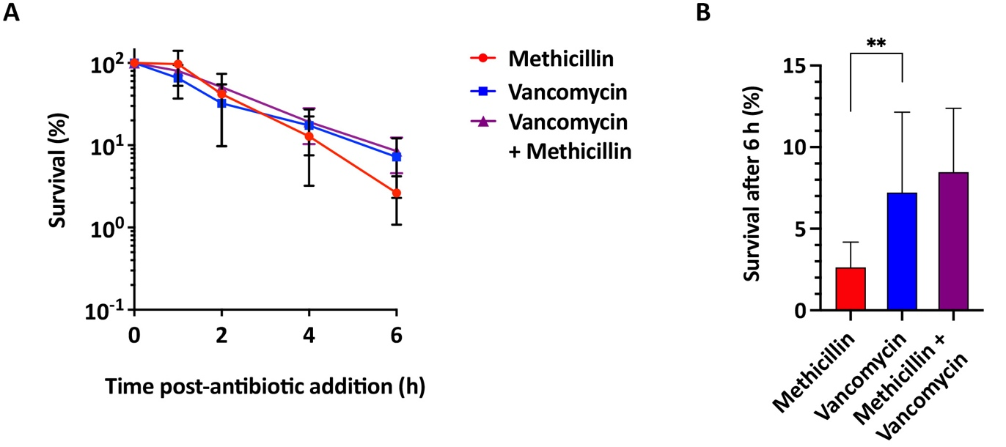
Figure 5.4 Effect of methicillin and/or vancomycin on S. aureus survival.
Effect of 10 x MIC methicillin and/or vancomycin after 1 h on S. aureus SH1000 (SJF 682). (A) Normalised percentage survival of bacterial cells (>3 biological repeats). Experiment carried out by Dr. Bartlomiej Salamaga. (B) Normalised percentage of survival after 6 h from the data in (A). Statistical analysis: t-test with Welch’s correction (methicillin vs. vancomycin ** p = 0.0032; vancomycin vs. methicillin + vancomycin non-significant p ≥ 0.05).
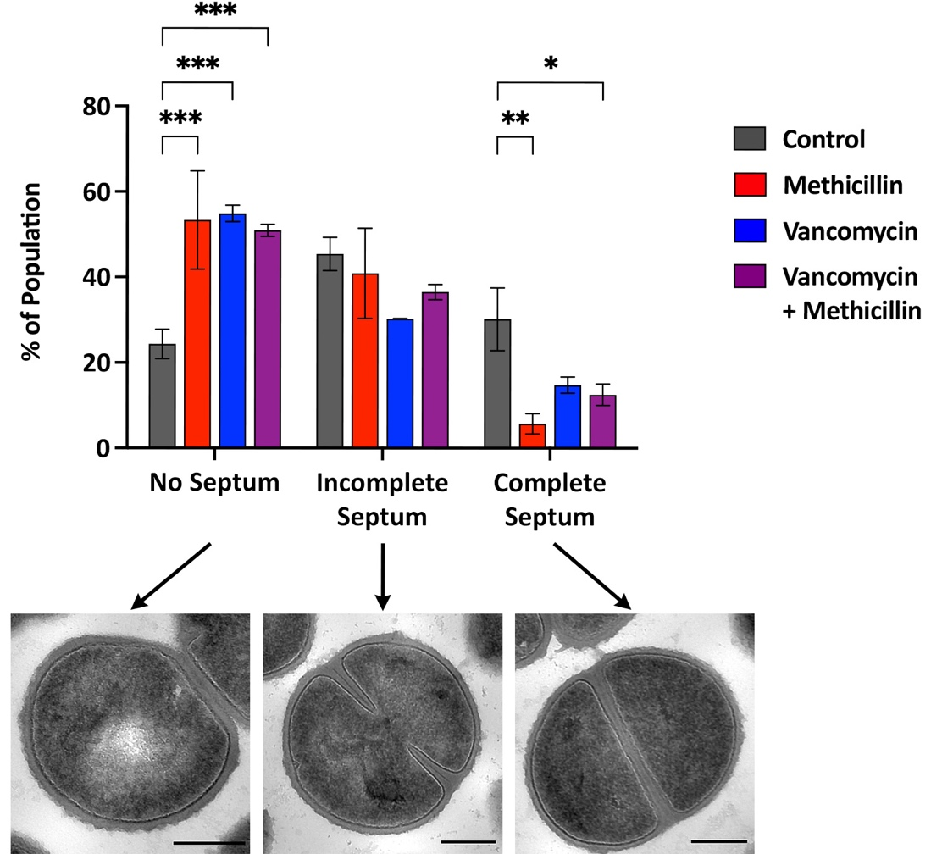
Figure 5.5 Effect of methicillin and/or vancomycin on S. aureus division.
Quantification of the effect of 10 x MIC methicillin and/or vancomycin after 1 h on S. aureus SH1000 division stages. Normalised percentage of population and representative TEM micrographs of chemically fixed thin sections, showing cells with no septum, incomplete septum or completed septum. Untreated (grey: 2 biological repeats, n = 898), vancomycin (blue: 2 biological repeats, n = 729), methicillin (red: 3 biological repeats, n = 907), and both vancomycin plus methicillin (purple: 3 biological repeats, n = 449). Statistical analysis: two-way ANOVA with multiple comparisons with Tukey’s correction (no septum control vs. methicillin *** p = 0.0002; no septum control vs. vancomycin *** p = 0.0003; no septum control vs. vancomycin + methicillin *** p = 0.0005; complete septum control vs. methicillin ** p = 0.0011; complete septum control vs. vancomycin + methicillin * p = 0.0180; all others non-significant p ≥ 0.05). Error bars represent standard deviation of the mean.
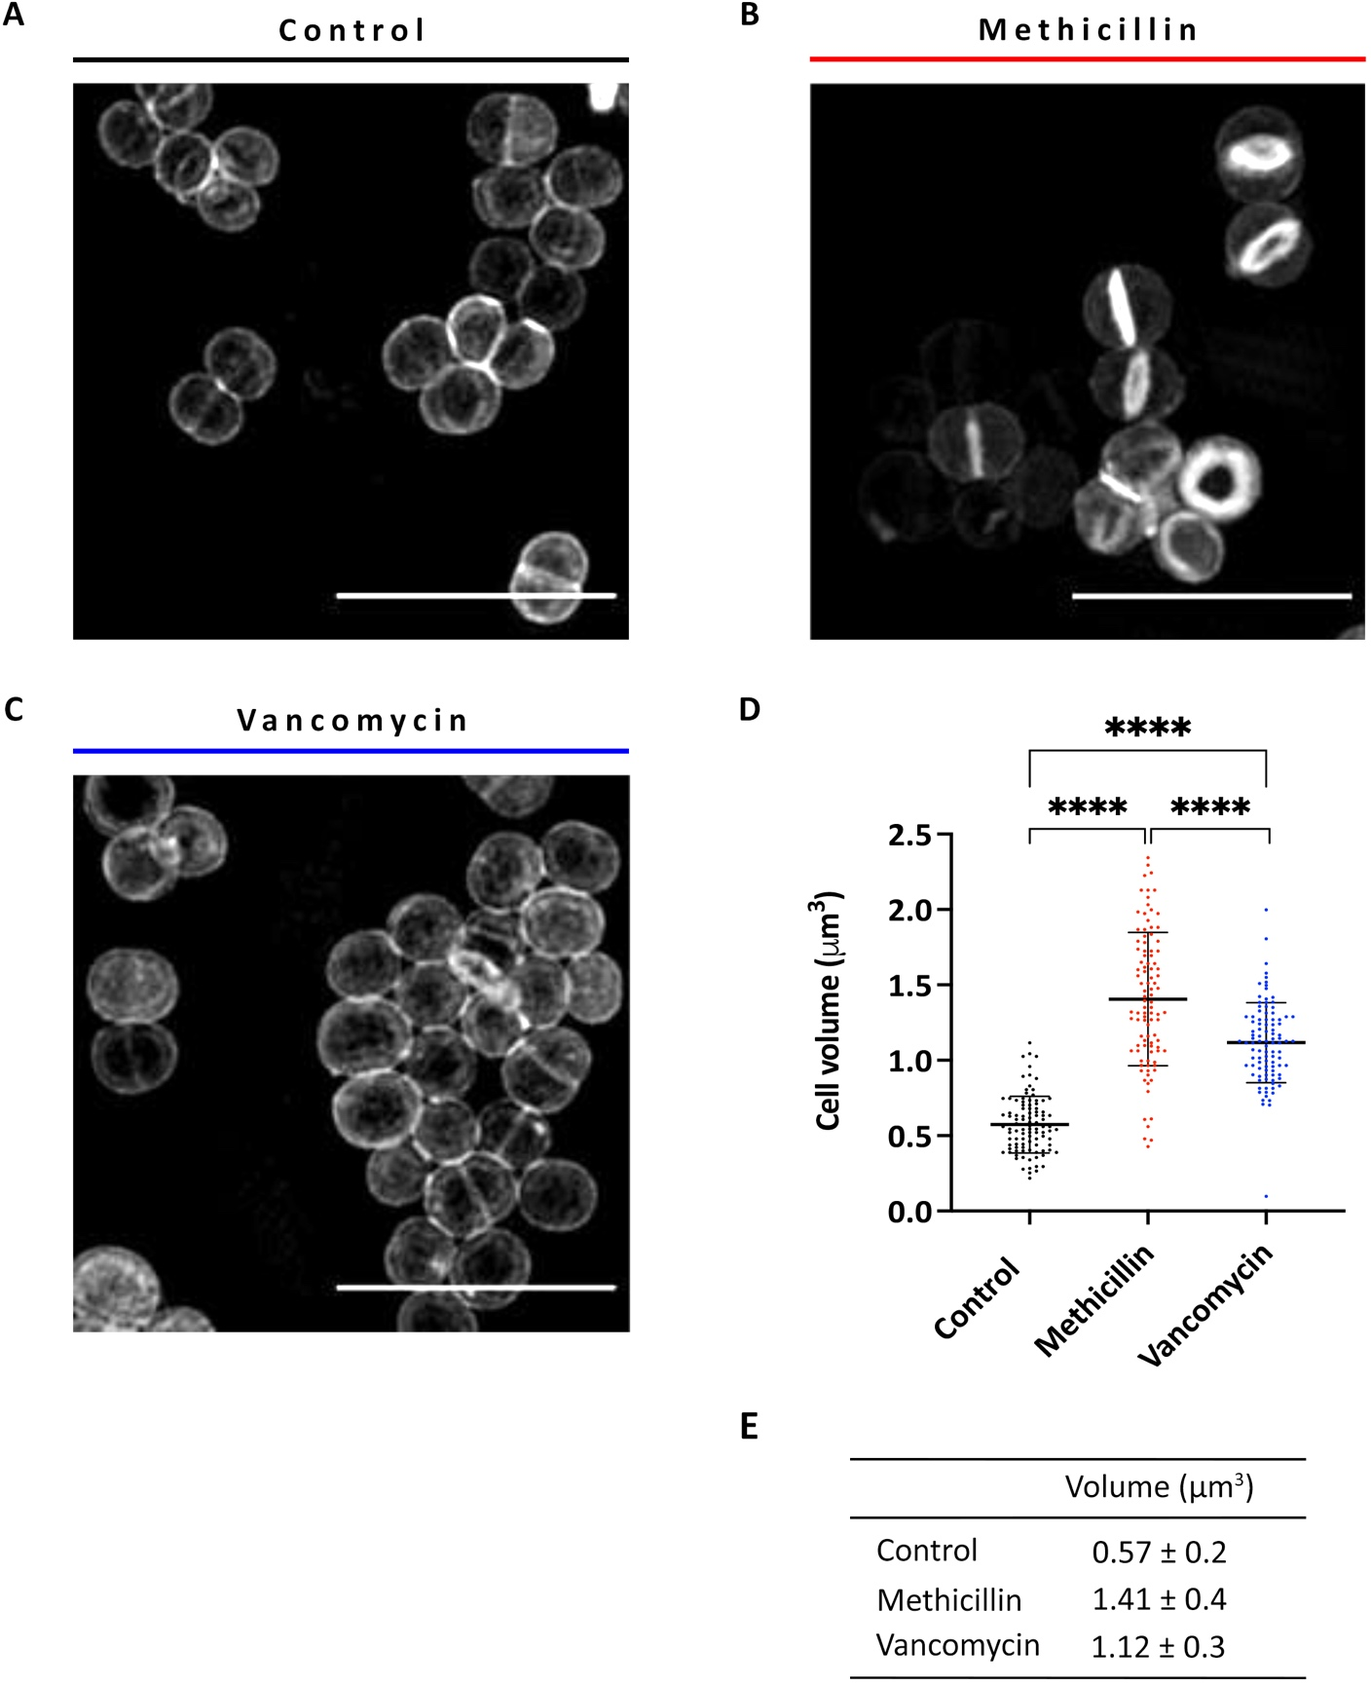
Figure 5.6 Effect of methicillin or vancomycin on S. aureus cell volume.
Comparison of untreated cells (black– control) with the effect of 10 x MIC methicillin (red) or vancomycin (blue) after 1 h on S. aureus SH1000. (A-C) Representative OMX SIM images of (A) untreated, (B) methicillin-treated, and (C) vancomycin-treated cells labelled with NHS-ester Alexa Fluor™ 555. Scale bars 5 µm. Images obtained by Dr. Milena von und zur Mühlen ^{[71]}. (D) Cell volume estimation from OMX SIM images of NHS-ester Alexa Fluor™555 labelled cells. Statistical analysis: t-test with Welch’s correction (**** p < 0.0001, n > 100). This scatter dot plot represents the mean and the standard deviation of the mean. (E) Descriptive statistics showing the mean volume estimation value and the standard deviation for each category. Data was collected by Dr. Milena von und zur Mühlen.
Representative TEM images showing the overall phenotype for the control, and for treatment with methicillin, vancomycin, or both are shown in Figure 5.7. TEM micrographs present further differences in phenotype between treated and untreated S. aureus SH1000. The stall of PG synthesis caused by the addition of bactericidal cell wall antibiotics coincides with a thinner and fuzzier appearance of cell wall morphology (Figure 5.8). Vancomycin appears to have a slightly more damaged or fuzzier looking cell wall (Figure 5.8c).
A closeup look at a representative cell for each category (Figure 5.9a) shows an ill-defined outer edge and a cell wall that becomes more variable in thickness throughout the cell periphery, when treated with antibiotics (Figure 5.9b). This led us to measure the relative CW thickness using TEM micrographs analysed with Fiji ^{[238]} (section 2.20.8). Average cell wall thickness of cross-section measurements shows a significantly thinner bacterial wall in both methicillin and/or vancomycin treated cells (Figure 5.9c-d, p < 0.0001). The newly exposed cell wall from recently separated daughter cells, although thinner, has a defined outer edge similar to that of untreated cells (Figure 5.10).
In summary, these results demonstrate that:
- Methicillin has a higher mortality rate than vancomycin, while addition of both has a similar result to that of vancomycin alone.

- Morphologically, bactericidal antibiotics cause a thinner and fuzzier appearance of the peripheral CW and lead to an increase in cell size.

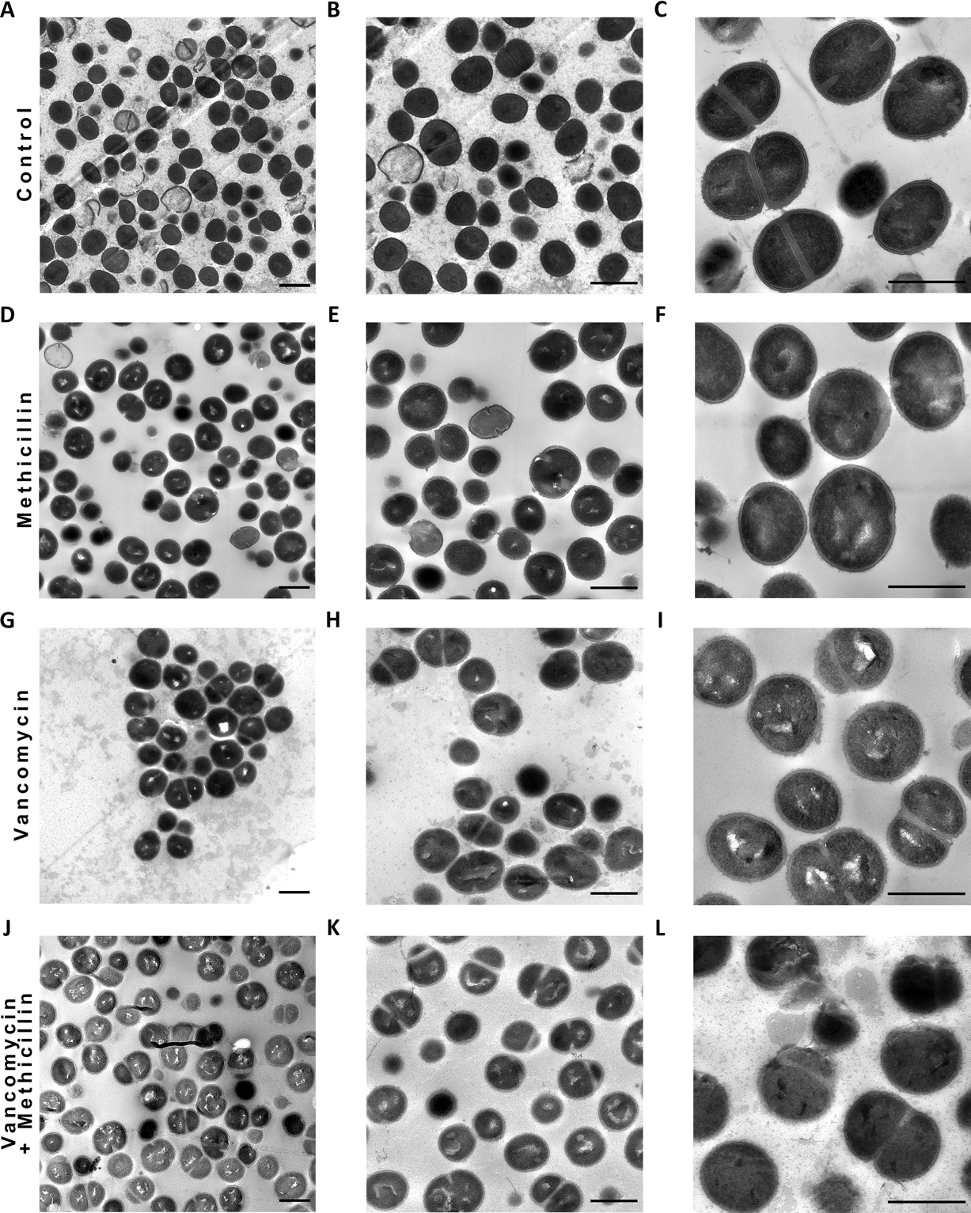
Figure 5.7 Effect of methicillin and/or vancomycin on S. aureus morphology.
TEM micrographs from chemically fixed thin-sections of S. aureus SH1000 treated with 10 x MIC methicillin and/or vancomycin for 1 h. (A-C) Untreated, (D, F) methicillin, (G, I) vancomycin, and (J-L) methicillin plus vancomycin. (A, D, G, J) Low magnification (1900x), scale bar: 1 µm. (B, E, H, K) Mid magnification (2900x), scale bar 1 µm. (C, F, I, L) High magnification (4800x), scale bar 1 µm.
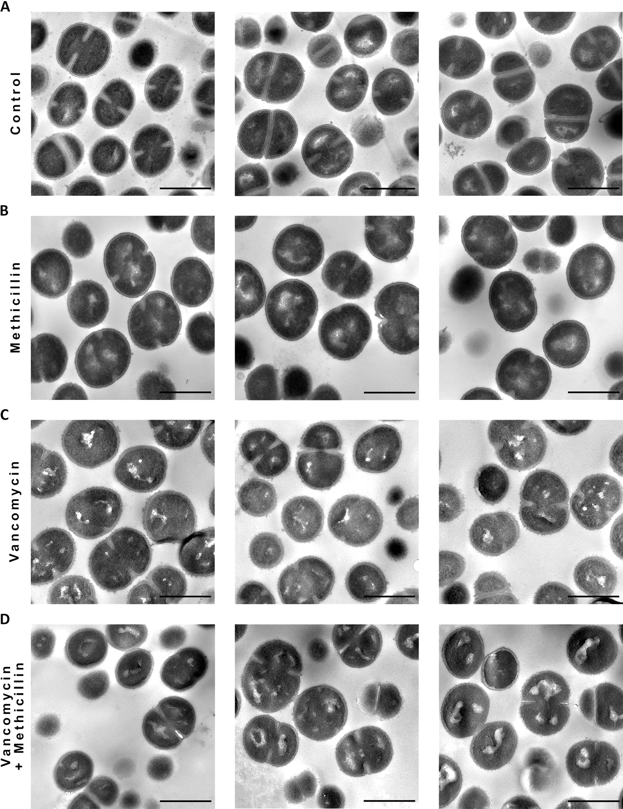
Figure 5.8 The effect of methicillin and/or vancomycin on S. aureus cell wall morphology analysed by TEM.
TEM micrographs of chemically fixed thin sections of S. aureus SH1000 (A) untreated and treated for 1 h with 10 x MIC of (B) methicillin, (C) vancomycin and (D) vancomycin plus methicillin. High magnification (4800x), scale bar 1 µm.

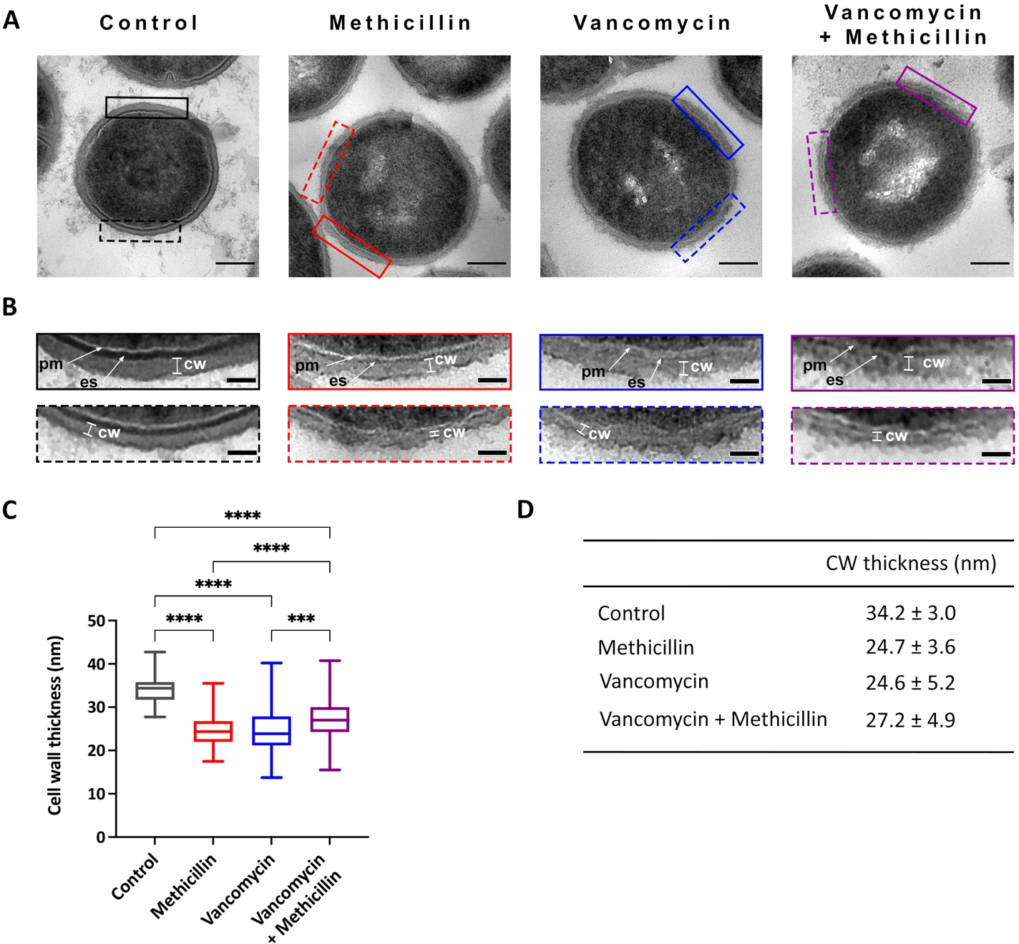
Figure 5.9 Effect of methicillin or vancomycin on S. aureus cell wall thickness.
Effect of 10 x MIC methicillin and/or vancomycin after 1 h on S. aureus SH1000. (A) Representative cell for the control, methicillin-treated and vancomycin-treated samples (as indicated). Cropped from high magnification (6800x) TEM micrographs of chemically fixed cells, scale bar 200 nm. (B) Zoomed sections of the micrographs shown in (A) for the control (black rectangles), methicillin (red rectangles) and vancomycin (blue rectangles), showing the natural variation of the cell wall thickness: thicker (upper solid rectangles), thinner (lower dashed rectangles). Cropped from high magnification (6800x), scale bar 50 nm, pm– plasma membrane, cw– cell wall, es– exoplasmic space. (C) Average cell wall thickness for untreated (grey: n = 102), methicillin (red: 2 biological repeats, n = 104), vancomycin (blue: 4 biological repeats, n = 100), and vancomycin plus methicillin (purple:3 biological repeats, n = 101). Statistical analysis: t-test with Welch’s correction (**** p < 0.0001, *** p = 0.0003, n > 100). The box plot represents the minimum, first quartile, median, third quartile and maximum. (D) Descriptive statistics showing the mean CW thickness value and standard deviation for each treatment.

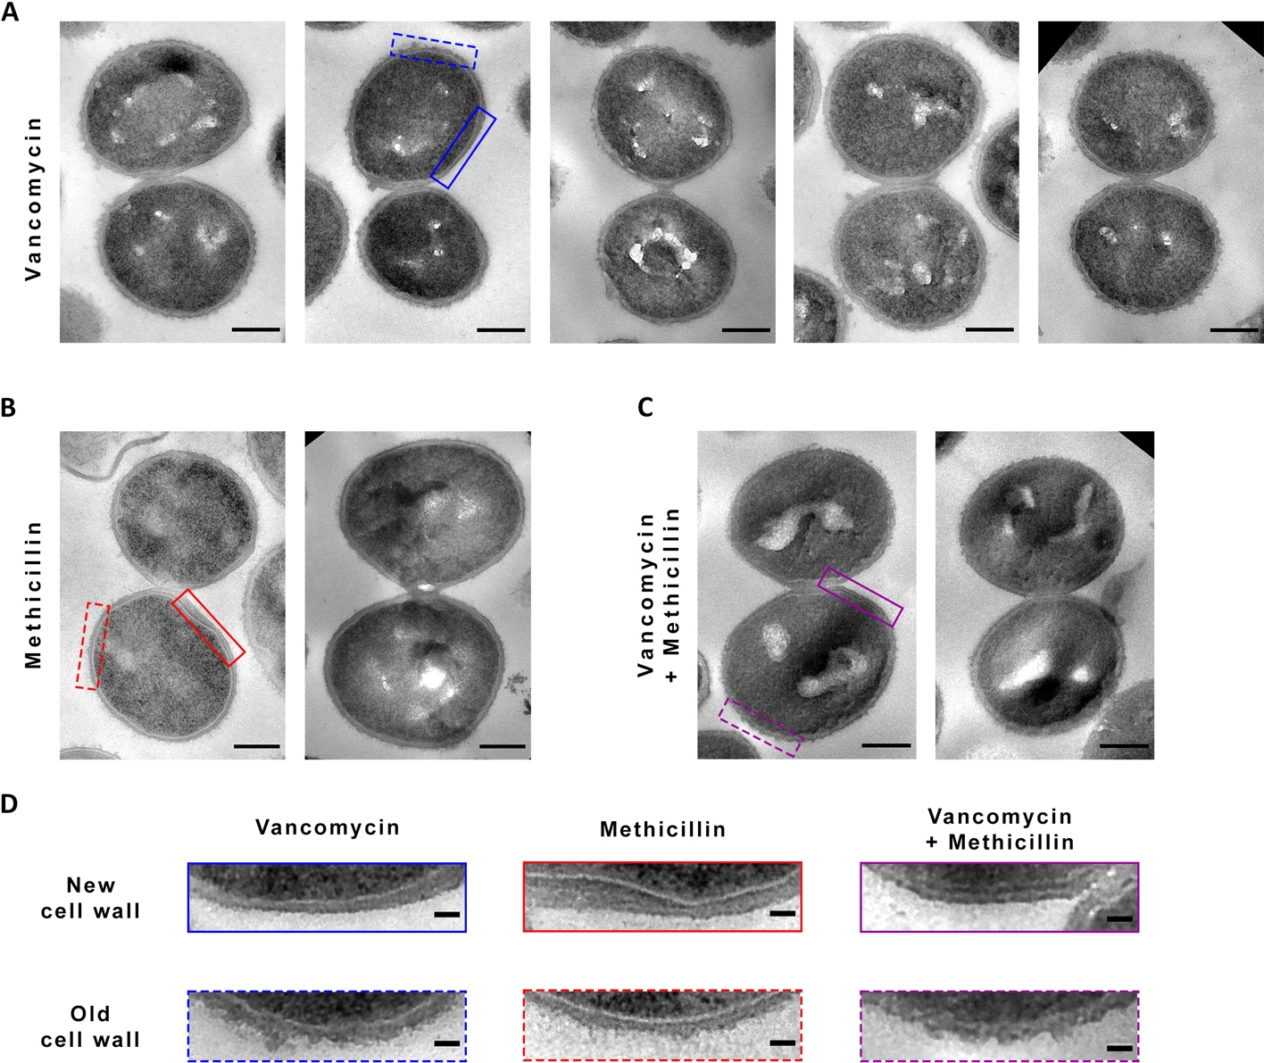
Figure 5.10 Effect of methicillin and/or vancomycin on the cell wall of separating cells of S. aureus.
TEM micrographs of chemically fixed thin sections of S. aureus SH1000 showing representative newly separated daughter cells treated with 10 x MIC (A) vancomycin, (B) methicillin, or (C) vancomycin plus methicillin after 1 h. Cropped images from high magnification (4800x), scale bar 300 nm. (D) Zoomed sections of micrographs shown in (A-C). Vancomycin (blue rectangles), methicillin (red rectangles), and vancomycin plus methicillin (purple rectangles), showing the newly synthesised cell wall (upper solid rectangles) and the old cell wall (lower dashed rectangles). Cropped from high magnification (4800x), scale bar 50 nm.

Observation of a methicillin-specific morphological phenotype.
In addition to the fuzzy surface appearance seen with vancomycin and/or methicillin treated cells (section 5.2), the latter shows a particular morphology associated with the cell envelope (Figure 5.11). This observation is consistent with previous published records ^{[289]}. Giesbrecht et al., (1998) suggested the inner CW (or secondary CW) reacted differently to the heavy metals in post-stains when treated with penicillin ^{[289]}. However, this phenotype is similar to that of chemically fixed S. aureus treated with NaCl during this investigation (Supplementary Figure 12 and Supplementary Figure 13), with an apparent expansion of the exoplasmic space and a retraction of the plasma membrane found in all division stages, i.e. no septum (Figure 5.12), incomplete septum (Figure 5.13), and complete septum (Figure 5.14). Therefore, this phenotype is reminiscent of plasmolysis and will be referred to as such, while this theory is tested.
For a more detailed morphological analysis, a quantification was carried out for all bacterial groups. Hundreds of cells of each group were categorised into no septum, incomplete septum, complete septum, growth defects and “plasmolysis”. The last category included all those cells with visible signs of alterations of the exoplasm, regardless of their division state. A thorough description of the quantification methodology and criteria can be found in section 2.20.9). The addition of both vancomycin and methicillin simultaneously does not lead to visible signs of “plasmolysis” (Figure 5.15 and Figure 5.16a). Exposure of 1 h to methicillin alone, however, culminates with ~42% of cells showing an apparent expanded exoplasm (Figure 5.16a), of which the majority corresponds to cells with an incomplete septum (Figure 5.16b). This is a methicillin-specific phenotype that is not present after vancomycin treatment– alone nor in conjunction with methicillin (Figure 5.16a).
Given the slower mortality rate of vancomycin treated cells (Figure 5.4a), additional TEM micrographs and morphological quantification of samples treated with this antibiotic for 2 and 3 h of exposure was carried out. No substantial evidence of “plasmolysis”: was observed under vancomycin nor vancomycin plus methicillin at these later timepoints (Figure 5.17 and Figure 5.18).
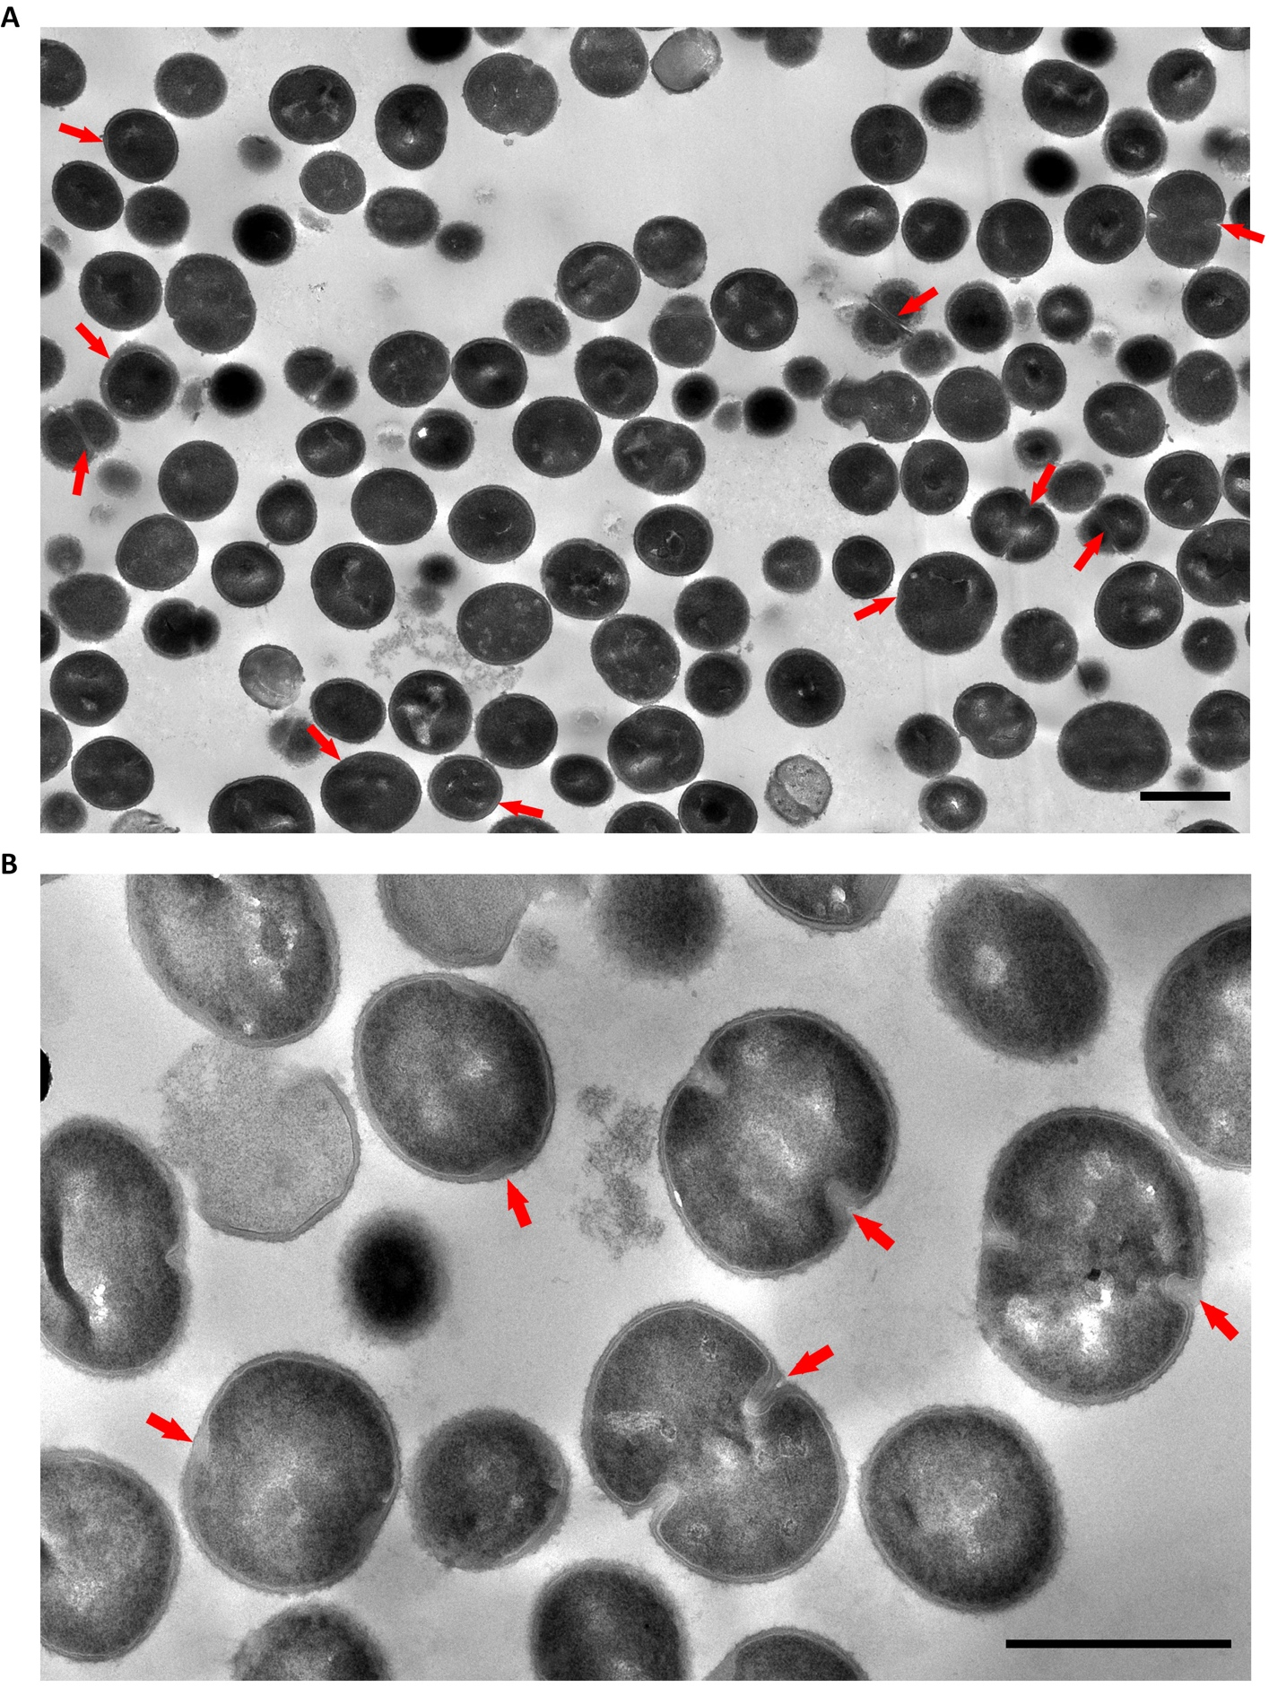
Figure 5.11 TEM micrographs of methicillin treated S. aureus reveals apparent “plasmolysis”.
TEM micrographs of chemically fixed thin sections of S. aureus SH1000 treated with 10 X MIC methicillin for 1 h. (A) Low magnification (1900x), scale bar 1 µm. (B) High magnification (4800x), scale bar 1 µm. Red arrows indicate areas where the exoplasmic space is expanded.
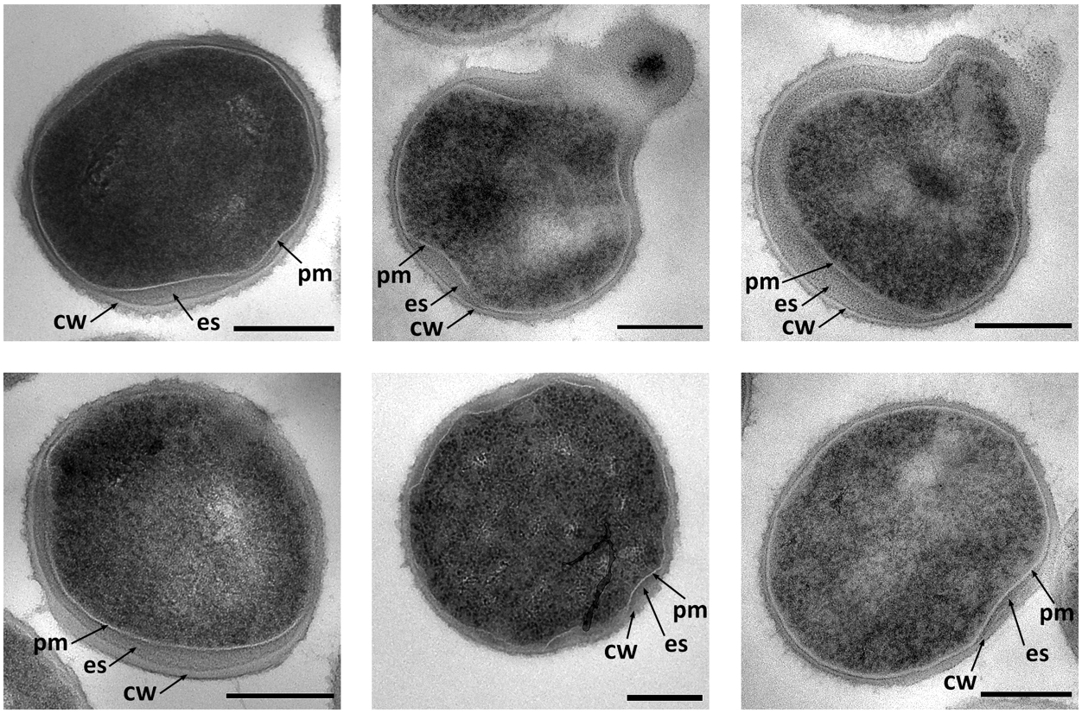
Figure 5.12 Effect of methicillin on S. aureus cells with no septum.
TEM micrographs of chemically fixed thin sections of S. aureus SH1000 treated with 10 X MIC methicillin for 1 h. Representative cells with no septum cropped from high magnification (4800x), scale bar 300 nm, pm– plasma membrane, cw– cell wall, ex– exoplasmic space.
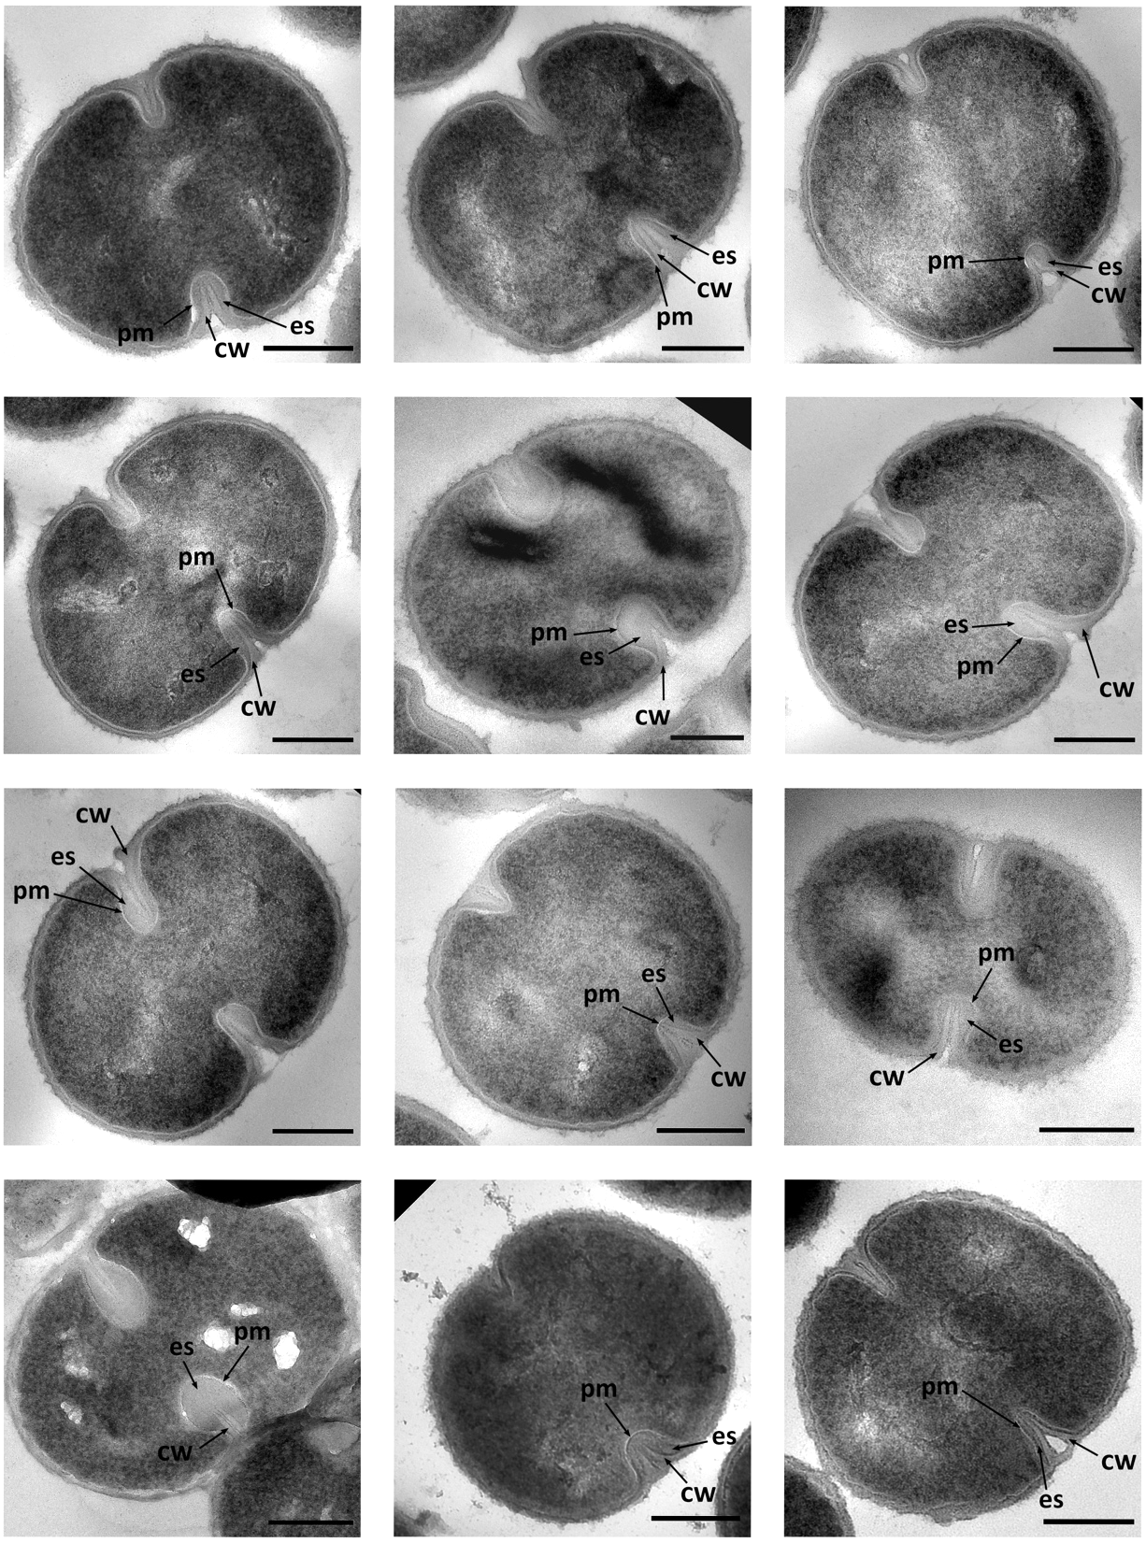
Figure 5.13 Effect of methicillin on S. aureus cells with incomplete septum.
TEM micrographs of chemically fixed thin sections of S. aureus SH1000 treated with 10 X MIC methicillin for 1 h. Representative cells with incomplete septum cropped from high magnification (4800x), scale bar 300 nm, pm– plasma membrane, cw– cell wall, ex– exoplasmic space.
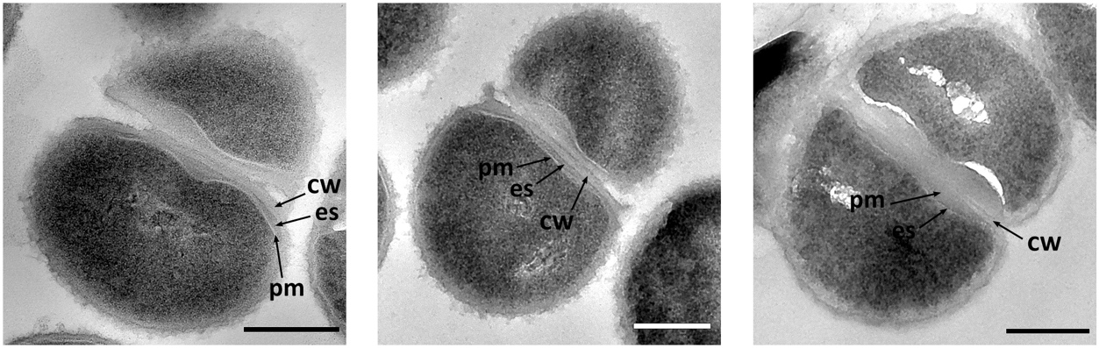
Figure 5.14 Effect of methicillin on S. aureus cells with complete septum.
TEM micrographs of chemically fixed thin sections of S. aureus SH1000 treated with 10 X MIC methicillin for 1 h. Representative cells with complete septum cropped from high magnification (4800x), scale bar 300 nm, pm– plasma membrane, cw– cell wall, ex– exoplasmic space.
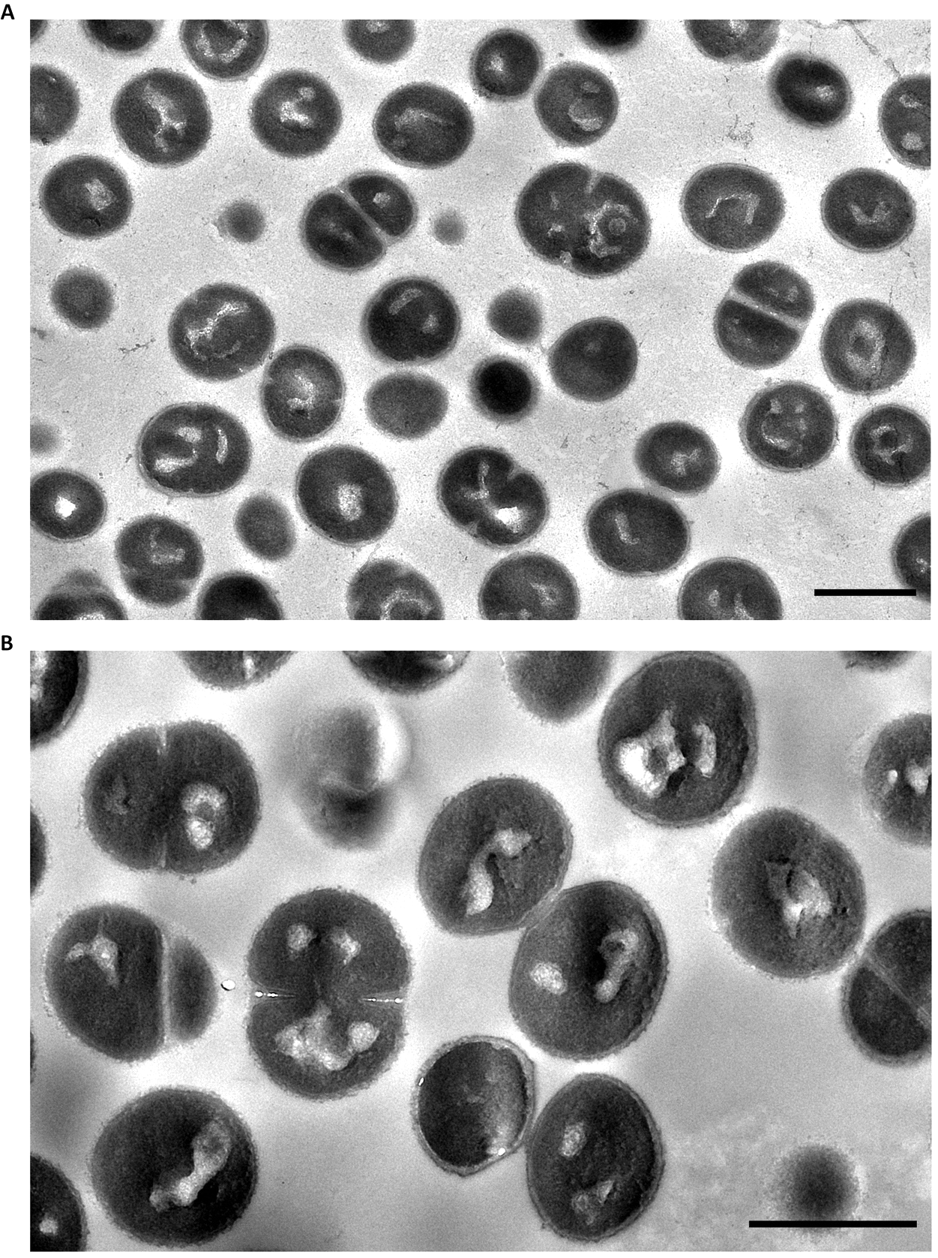
Figure 5.15 Morphology of methicillin and vancomycin combined treatment of S. aureus.
TEM micrographs of chemically fixed thin sections of S. aureus SH1000 treated with 10 X MIC methicillin plus vancomycin for 1 h. (A) Mid magnification (2900x), scale bar 1 µm. (B) High magnification (4800x), scale bar 1 µm.
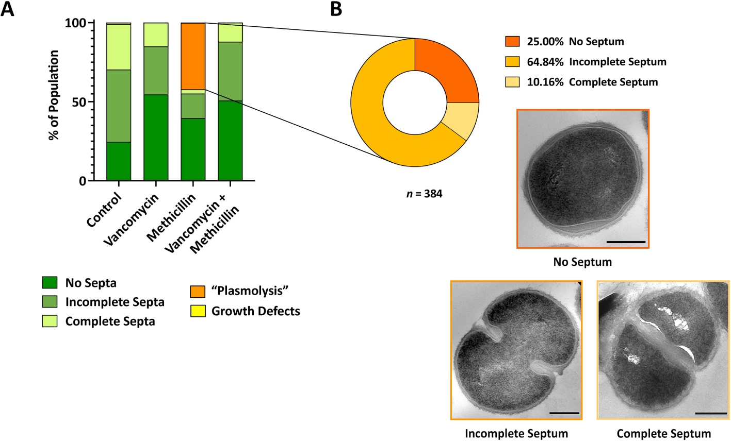
Figure 5.16 Morphological quantification of the effect of methicillin and/or vancomycin on S. aureus.
(A) Morphological quantification of 10 x MIC of methicillin and/or vancomycin after 1 h of treatment on S. aureus. Control (2 biological repeats, n = 905), methicillin (3 biological repeat, n = 913), vancomycin (2 biological repeats, n = 730), and vancomycin plus methicillin (3 biological repeats, n = 451), as indicated. No septum– dark green, incomplete septum– medium green, complete septum– light green, “plasmolysis”– orange, and growth defects– yellow. (B) Compositional analysis of methicillin treated cells in (A) showing signs of “plasmolysis”. No septum– dark orange, incomplete septum– medium orange, complete septum– light orange (n = 384).
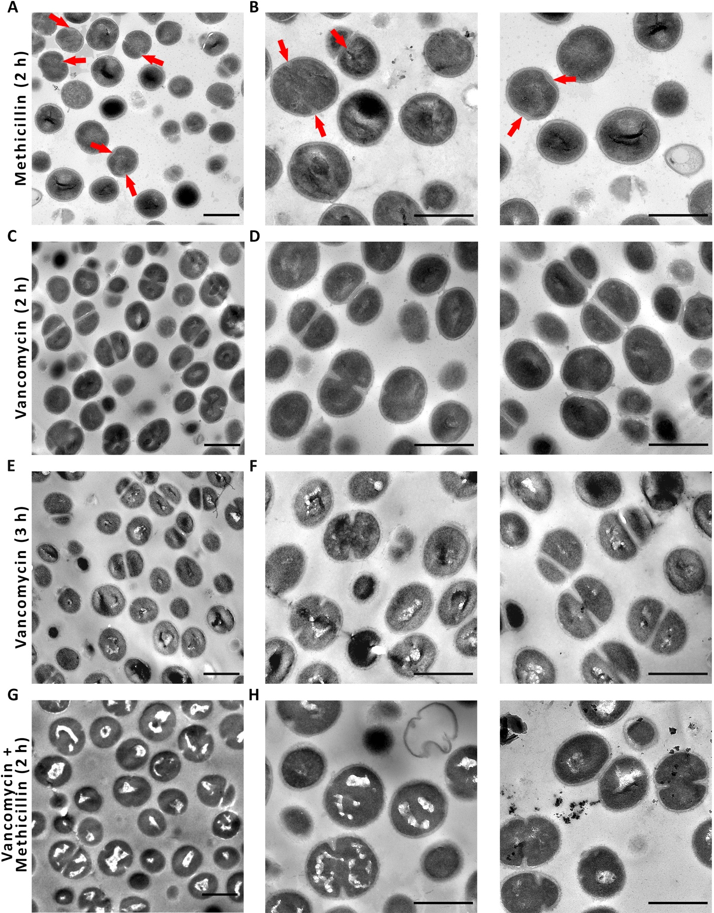
Figure 5.17 TEM micrographs of S. aureus treated with methicillin and/or vancomycin for 2 and 3 h.
TEM micrographs of chemically fixed thin sections of S. aureus SH1000 treated with 10 X MIC (A-B) methicillin for 2 h, (C-D) vancomycin for 2 h, (E-F) vancomycin for 3 h, and (G-H) vancomycin plus methicillin for 2 h. (A, C, E, G) Mid magnification (2900x), scale bar 1 µm. (B, D, F, H) High magnification (4800x), scale bar 1 µm. Red arrows indicate areas where the exoplasmic space is expanded (“plasmolysis”).

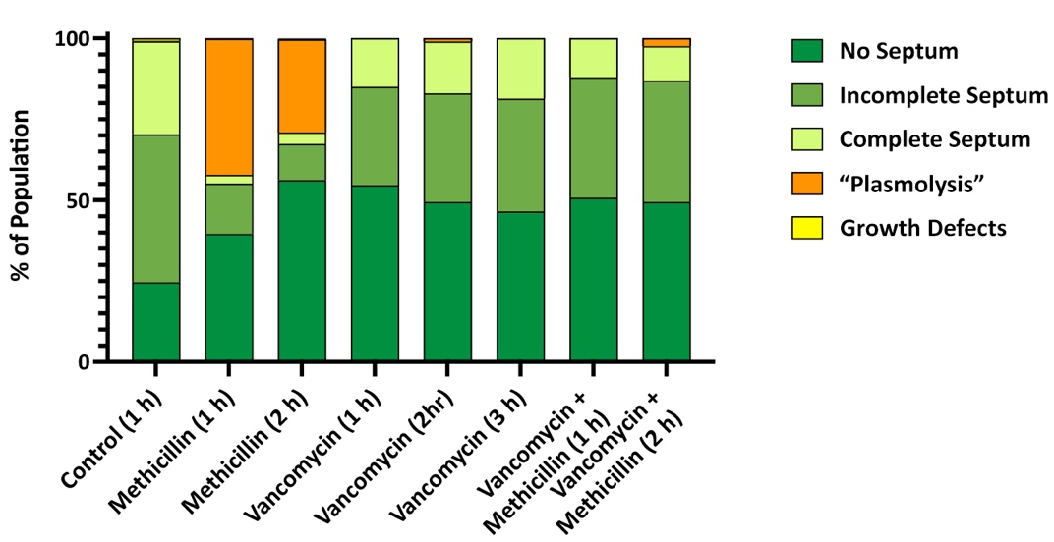
Figure 5.18 Morphological quantification after 2 and 3 h of methicillin and/or vancomycin treatment on S. aureus SH1000.
Morphological quantification of chemically fixed thin sections of S. aureus SH1000 treated with 10 X MIC methicillin and/or vancomycin. Control 1 h (2 biological repeats, n = 905), methicillin 1 h (3 biological repeat, n = 913), methicillin 2 h (n = 313), vancomycin 1 h (2 biological repeats, n = 730), vancomycin 2 h (n = 301), vancomycin 3 h (n = 402), and vancomycin plus methicillin 2 h (n = 416), as indicated. No septum– dark green, incomplete septum– medium green, complete septum– light green, “plasmolysis”– orange, and growth defects– yellow.
Finally, TEM micrographs of methicillin treated cells showed large areas of lysed cells, loose cytoplasmic material and sacculi (Figure 5.19a-b). It is impossible to tell with certainty if cells in a TEM micrograph are dead, dying or alive when they look intact, electron-dense, and fully stained. The thin section obtained could be a cross section at any Z-level of the cell, and a CW rupture or cytoplasmic leakage could easily be missed. Nonetheless, we can certainly assume cells are dead when the section captures a clear break in the cell envelope, cytoplasmic leakage and/or a discernible decrease in cell staining due to lack of cytoplasmic content (Figure 5.19c). Morphological quantification percentages were adjusted to include any visible lysed cell or sacculi, and detected a higher percentage of these cells after 1 h of incubation with methicillin (~ 20.5 %) than with vancomycin (~ 2.4 %) (Figure 5.19d). This is consistent with methicillin’s higher mortality rate. Once again, despite vancomycin’s slower mortality rate, no increase in cell lysis after 2 or 3 h of incubation was detected by TEM.

These results demonstrate that:
- Methicillin-treated cells present a specific phenotype that includes a retraction of the plasma membrane and expansion of the exoplasm, especially around the septum (bulbous shaped septa).

- This phenotype is reminiscent of plasmolysis, as seen by experiments with high concentration of NaCl.

- Methicillin leads to a larger number of lysed cells with loss of cytoplasmic material than vancomycin.

- Vancomycin inhibits the “plasmolysis” seen with methicillin when added jointly.

- Despite vancomycin’s slower mortality rate, no evidence of “plasmolysis”: was observed with this antibiotic at later timepoints.

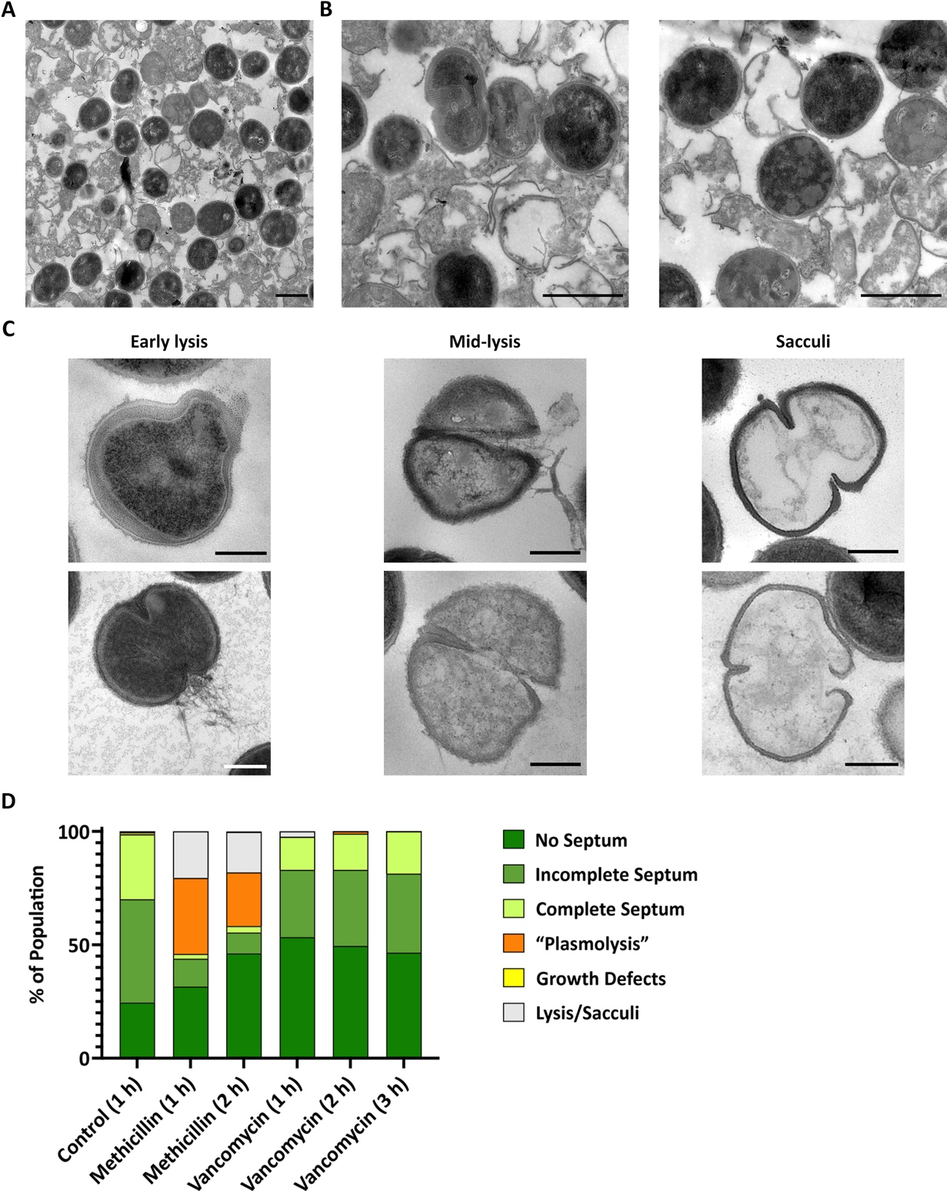
Figure 5.19 Cell lysis and sacculi observed during methicillin treatment of S. aureus SH1000.
TEM micrographs of chemically fixed thin sections of S. aureus SH1000 treated with 10 X MIC methicillin for 1 h. (A) Low magnification (1900x), scale bar 1 µm. (B) High magnification (4800x), scale bar 1 µm. (C) Representative TEM micrographs showing different stages of lysis and sacculi, as indicated. Cropped from high magnification (4800x), scale bar 300 nm. (D) Morphological quantification of Control 1 h (2 biological repeats, n = 909), methicillin 1 h (3 biological repeat, n = 1148), methicillin 2 h (n = 381), vancomycin 1 h (2 biological repeats, n = 748), vancomycin 2 h (n = 301), and vancomycin 3 h (n = 402), as indicated. No septum– dark green, incomplete septum– medium green, complete septum– light green, “plasmolysis”– orange, growth defects– yellow, and ruptured cells or sacculi- light grey.

Morphological effects of oxacillin treatment.
To determine whether the morphological changes (“plasmolysis”) observed with methicillin are specific, an alternative β-lactam, oxacillin, was used. Cells treated with 10X MIC oxacillin gave a higher mortality rate than methicillin after 6 h (Figure 5.20a-b, 99 ± 0.1 %, p = 0.0002). This was consistent with a higher percentage of cells affected by “plasmolysis” after 1 h of treatment, with ~ 88.4 % of cells showing signs of this phenotype (Figure 5.20c), of which ~ 45.5 % of them were dividing cells with an incomplete septum (Figure 5.20d).
Even though the post-staining of the thin sections was quite dark, TEM micrographs showed a pronounced retraction of the plasma membrane and expansion of the exoplasm after 1 h treatment with oxacillin (Figure 5.21).
Just as with methicillin (Figure 5.4 and Figure 5.5), oxacillin in addition to vancomycin resulted in a similar rate of death (Figure 5.22a-b, 94 ± 1.5 %), division arrest (Figure 5.22c) and morphology (Figure 5.23) to that of vancomycin alone.
These results indicate that:
- These results are consistent with other β-lactams, as both methicillin and oxacillin lead to an expansion of the exoplasm (“plasmolysis”).

- Addition of vancomycin to either of these antibiotics inhibits “plasmolysis”, suggesting an additional β-lactam-specific mode of death on top the common mechanism of death of bactericidal antibiotics.
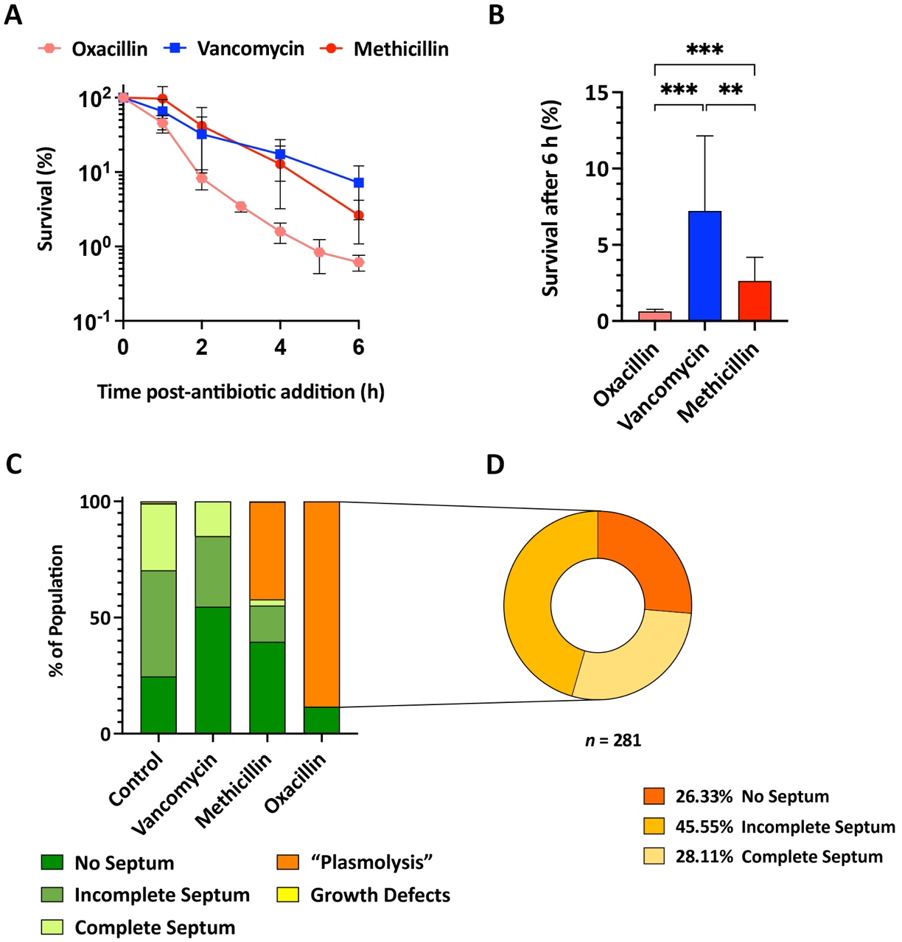
Figure 5.20 Effect of 10 x MIC oxacillin on S. aureus morphology, survival and division.
(A) Normalised percentage survival of S. aureus SH1000 treated with 10 µg/ml (10X MIC) oxacillin (pink) and its comparison to 10X MIC methicillin (red) and vancomycin (blue) (>3 biological repeats). Experiment carried out by Dr. Bartlomiej Salamaga. (B) Normalised percentage of survival after 6 h from the data in (A). Statistical analysis: t-test with Welch’s correction (methicillin vs. vancomycin ** p = 0.0032; oxacillin vs. methicillin *** p = 0.0002; oxacillin vs. vancomycin *** p = 0.0001). (C) Morphological quantification of chemically fixed thin sections of S. aureus SH1000 untreated (2 biological repeats, n = 905), and after 1 h of treatment with methicillin (3 biological repeat, n = 913), oxacillin (n = 318) and vancomycin (2 biological repeats, n = 730), as indicated. No septum– dark green, incomplete septum– medium green, complete septum– light green, “plasmolysis”– orange, and growth defects– yellow. (D) Compositional analysis of oxacillin treated cells in (C) presenting signs of “plasmolysis”. No septum– dark orange, incomplete septum– medium orange, complete septum– light orange (n = 281).
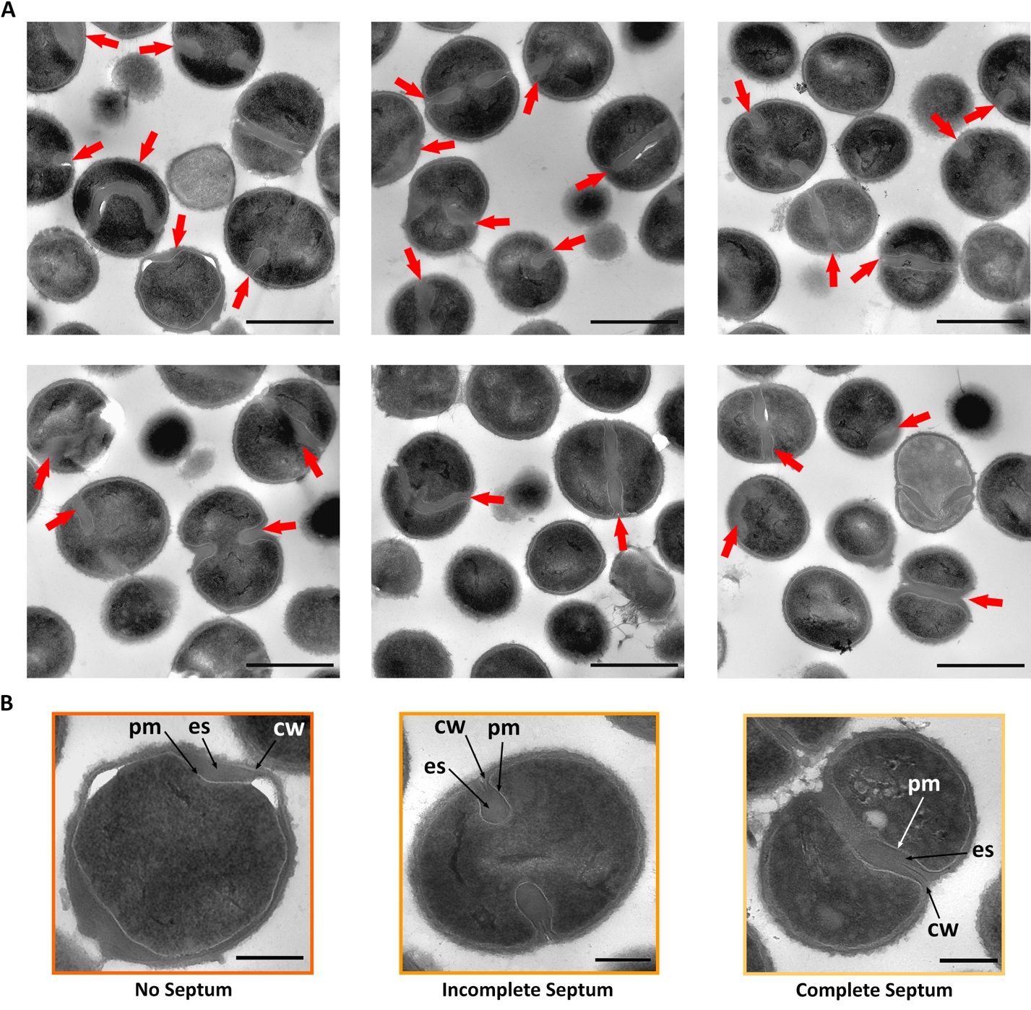
Figure 5.21 TEM micrographs of the effect of oxacillin on S. aureus morphology.
TEM micrographs of chemically fixed thin sections of S. aureus SH1000 treated with 10 µg/ml (10 X MIC) oxacillin for 1 h. (A) High magnification (4800x), scale bar 1 µm. Red arrows indicate areas where the exoplasmic space is expanded (“plasmolysis”). (B) Representative cells cropped from high magnification (6800x), scale bar 300 nm. pm– plasma membrane, cw– cell wall, ex– exoplasmic space. No septum– dark orange, incomplete septum– medium orange, and complete septum– light orange.
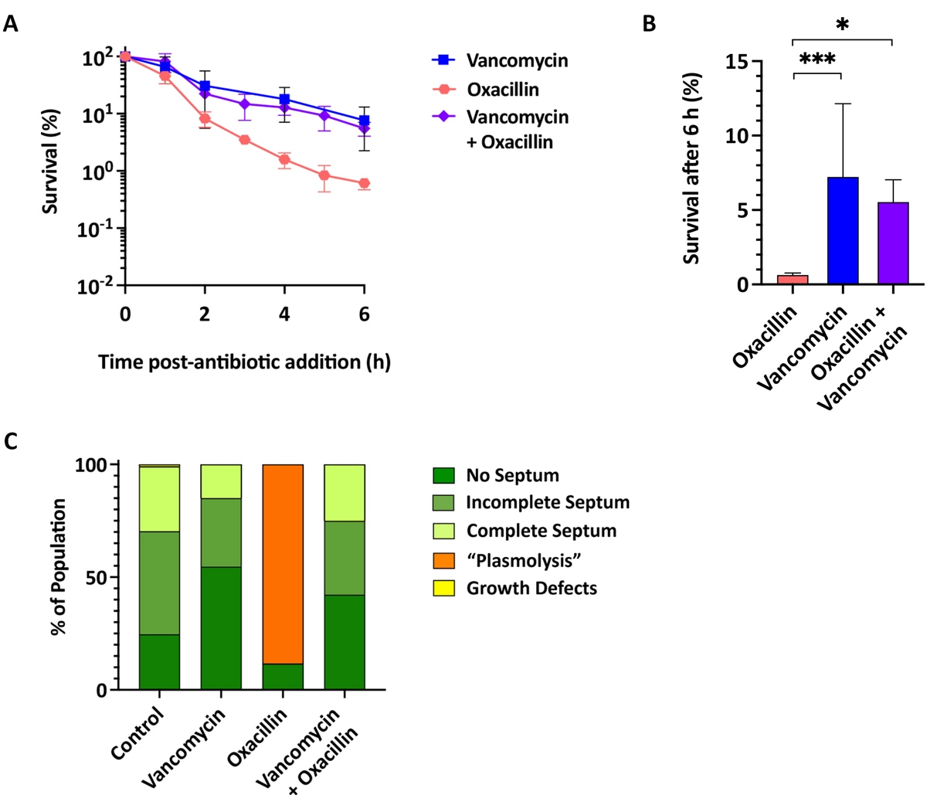
Figure 5.22 Effect of oxacillin and/or vancomycin in S. aureus morphology, survival and division.
(A) Normalised percentage survival of S. aureus SH1000 treated with 10X MIC oxacillin (pink), vancomycin (blue), and both (violet) (>3 biological repeats). Experiment carried out by Dr. Bartlomiej Salamaga. (B) Normalised percentage of survival after 6 h from the data in (A). Statistical analysis: t-test with Welch’s correction (oxacillin vs. vancomycin *** p = 0.0001; oxacillin vs. oxacillin + vancomycin * p = 0.0287; vancomycin vs. oxacillin + vancomycin non-significant p ≥ 0.05). (C) Morphological quantification after 1 h of treatment of the control (2 biological repeats, n = 905), vancomycin (2 biological repeats, n = 730), oxacillin (n = 318) and vancomycin plus oxacillin (n = 384), as indicated. No septum– dark green, incomplete septum– medium green, complete septum– light green, “plasmolysis”– orange, and growth defects– yellow.
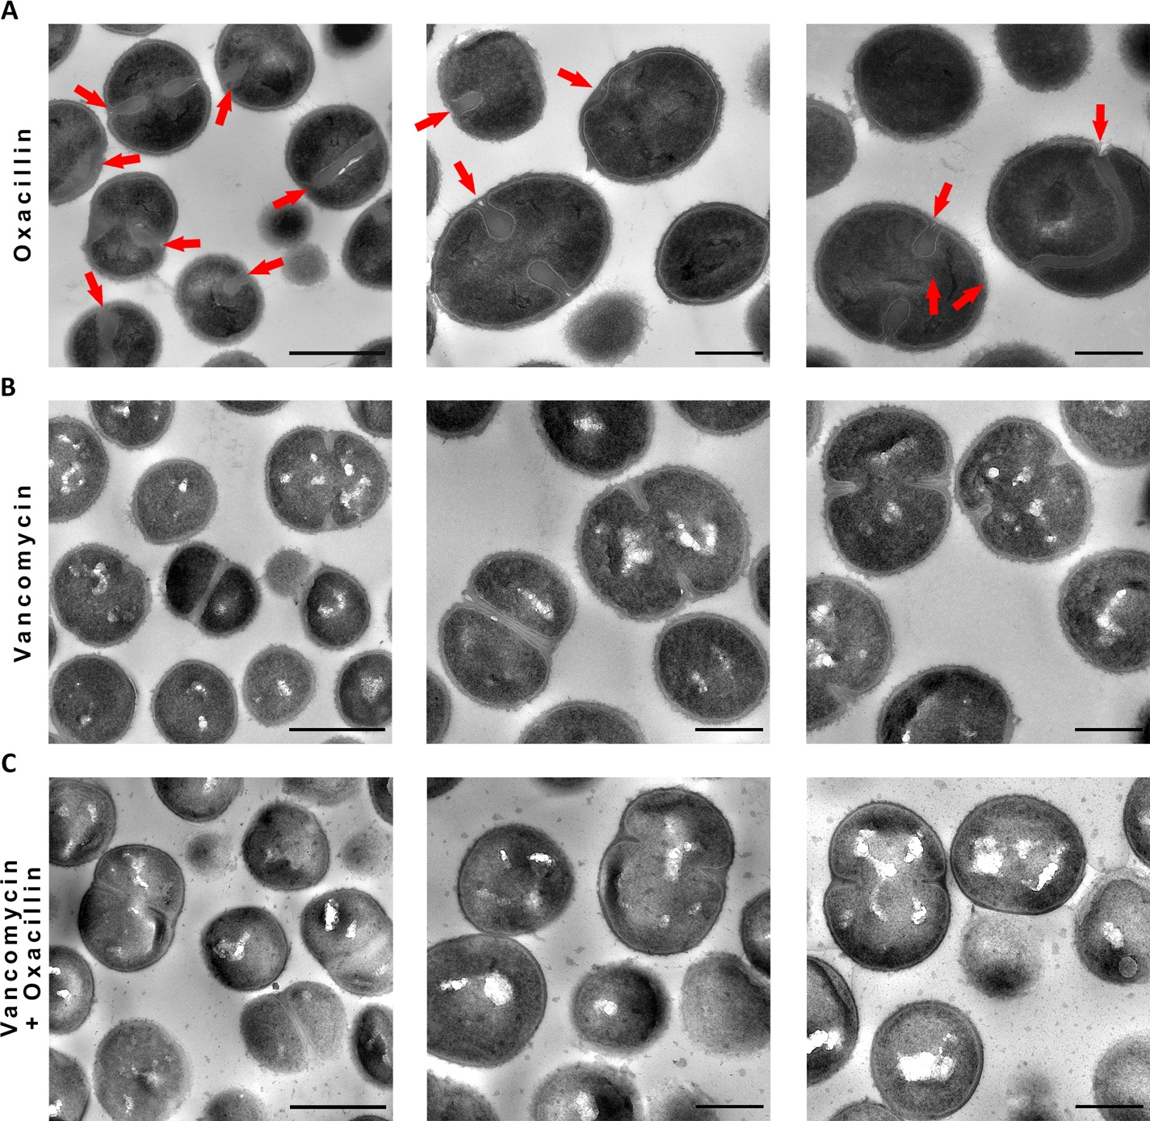
Figure 5.23 TEM micrographs of oxacillin and/or vancomycin treatment of S. aureus.
TEM micrographs of chemically fixed thin sections of S. aureus SH1000 treated for 1 h with 10 X MIC (A) oxacillin, (B) vancomycin, and (C) oxacillin plus vancomycin. High magnification (4800x), scale bar 1 µm. Red arrows indicate areas where the exoplasmic space is expanded (“plasmolysis”). Higher magnification (6800x), scale bar 500nm.

Effect of cell wall antibiotics on the morphology of S. aureus NewHG and COL.
To determine the general effect of cell wall antibiotics and rule out strain specificity, the MSSA strain NewHG (SJF 3663) ^{[236]} and the MRSA strain COL (SJF 4183) ^{[235]} were compared.
S. aureus NewHG has a 99.9 ± 0.1 % mortality rate with methicillin, 99 ± 0.2 % with vancomycin and 99.4 ± 0.3 % with both after 6 h of treatment (Figure 5.24a-b). The expansion of the exoplasm seen with β-lactams (methicillin, oxacillin) also occurs in NewHG (Figure 5.25). Morphological quantification showed ~ 42.6 % of cells with “plasmolysis”, with the majority of them being dividing cells (Figure 5.24c-d). These results revealed a similar pattern to that of SH1000.
The MRSA clinical strain COL has a 93.9 ± 0.8 % mortality rate with vancomycin and 93.8 ± 1.5 % with both after 6 h of treatment (Figure 5.26a-b).Testing for the effect of methicillin on this strain survival and morphology is not possible due its high resistance to methicillin, however, TEM micrographs and morphological quantification show that neither vancomycin nor vancomycin plus methicillin present signs of “plasmolysis” (Figure 5.26c and Figure 5.27).
For both NewHG and COL, vancomycin or vancomycin plus methicillin have the same response as SH1000.
These results imply that:
- Vancomycin does not cause an expansion of the exoplasm (“plasmolysis”) in either NewHG or COL.

- The methicillin-specific phenotype is consistent with other S. aureus backgrounds.

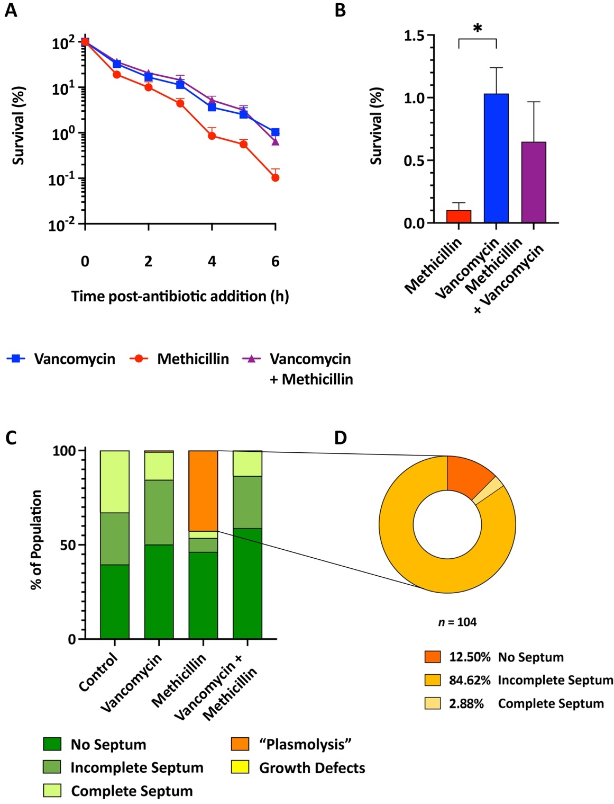
Figure 5.24 Effect of methicillin and/or vancomycin on S. aureus NewHG morphology, survival and division.
(A) Normalised percentage survival of S. aureus NewHG treated with 10X MIC methicillin (red), vancomycin (blue) and both (purple) (3 biological repeats). Experiment carried out by Dr. Bartlomiej Salamaga. (B) Normalised percentage of survival after 6 h from the data in (A). Statistical analysis: t-test with Welch’s correction (methicillin vs. vancomycin * p = 0.0111; vancomycin vs. methicillin + vancomycin non-significant p ≥ 0.05). (C) Morphological quantification after 1 h of treatment of the control (n = 366), methicillin (n = 244), vancomycin (n = 285), and vancomycin plus methicillin (n = 358) as indicated. No septum– dark green, incomplete septum– medium green, complete septum– light green, “plasmolysis”– orange, and growth defects– yellow. (D) Compositional analysis of methicillin treated cells in (C) presenting signs of “plasmolysis”. No septum– dark orange, incomplete septum– medium orange, complete septum– light orange (n = 104).
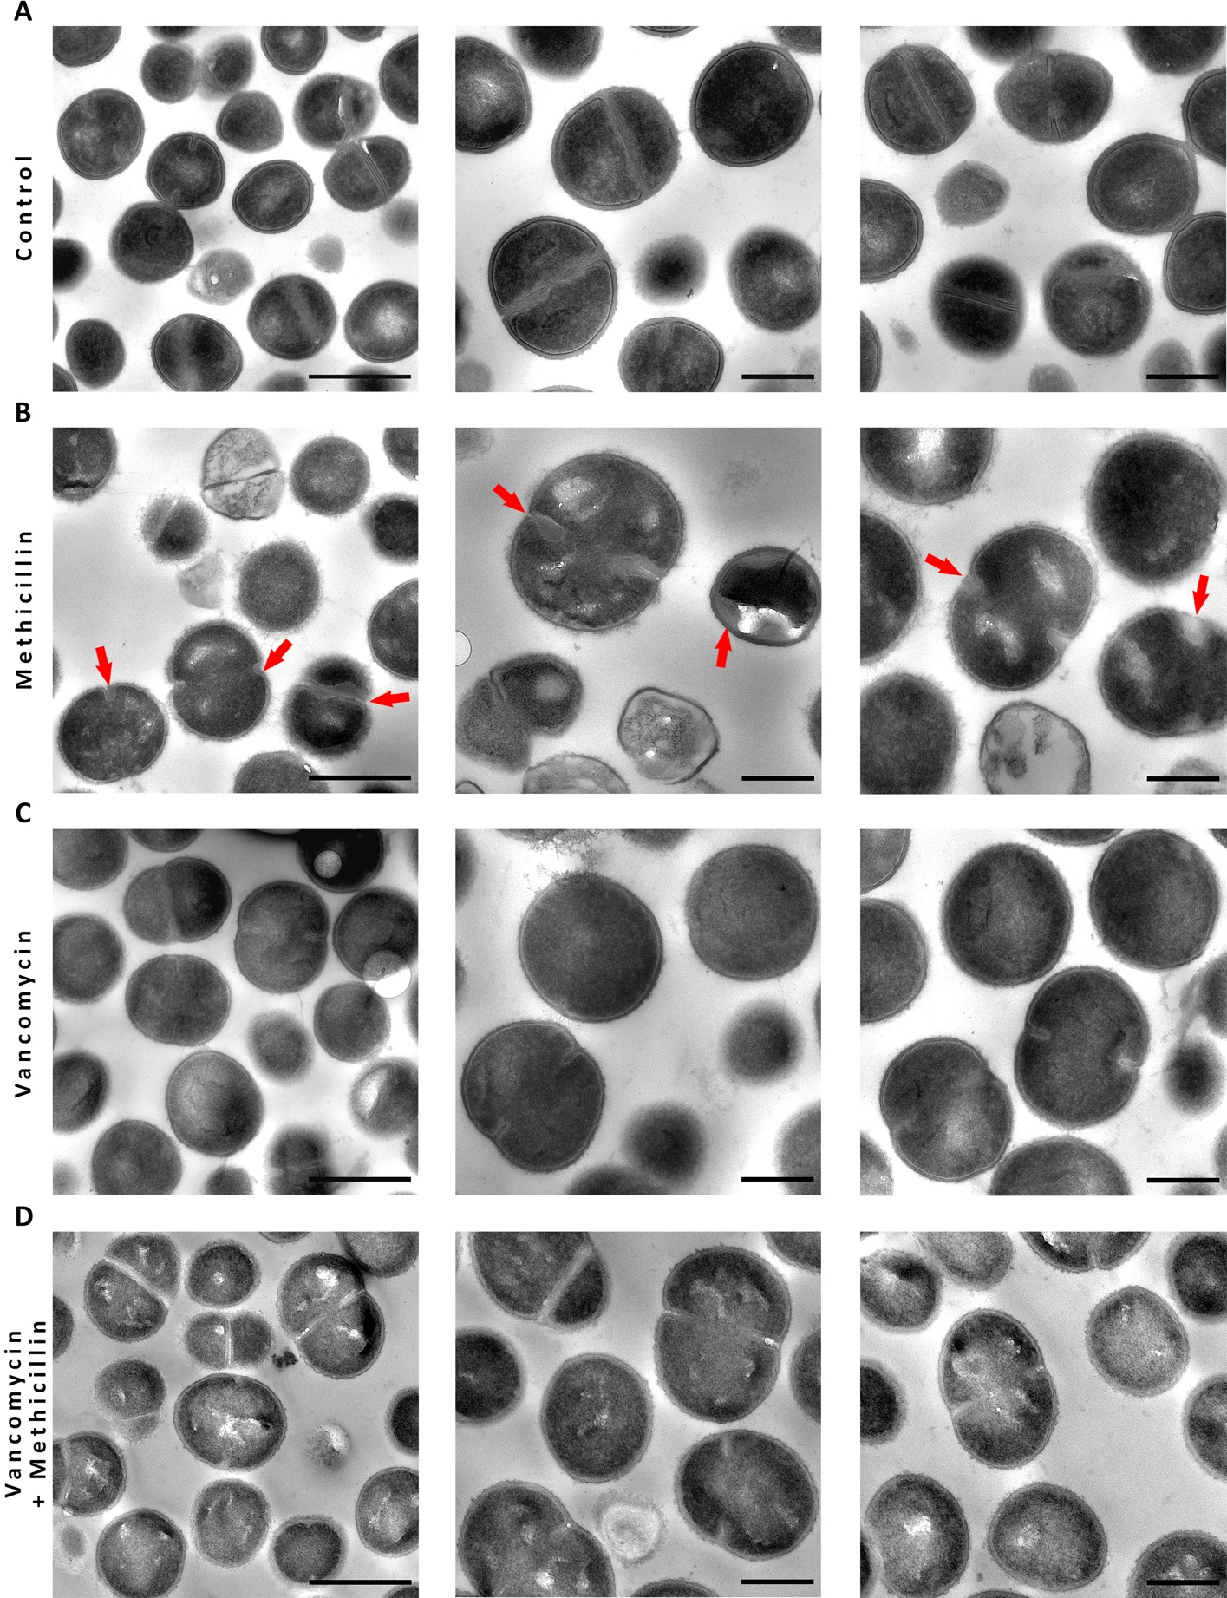
Figure 5.25 TEM micrographs of methicillin and/or vancomycin treatment of S. aureus NewHG.
TEM micrographs of chemically fixed thin sections S. aureus NewHG (A) untreated, treated for 1 h with 10 X MIC (B) methicillin, (C) vancomycin, or (D) vancomycin plus methicillin. High magnification 4800x, scale bar 1 µm; and 6800x, scale bar 500 nm. Red arrows indicate areas where the exoplasmic space is expanded.
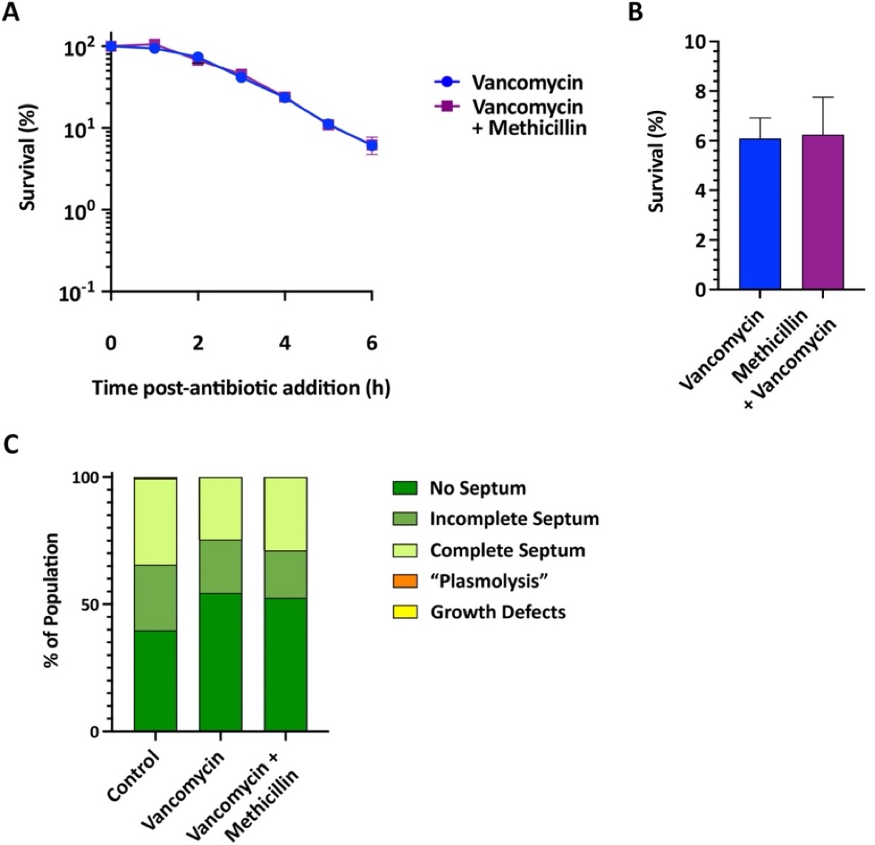
Figure 5.26 Effect of vancomycin and vancomycin plus methicillin on S. aureus COL morphology, survival and division.
(A) Normalised percentage survival of S. aureus COL treated with 10X MIC vancomycin (blue) or vancomycin plus methicillin (purple) (3 biological repeats). Experiment carried out by Dr. Bartlomiej Salamaga. (B) Normalised percentage of survival after 6 h from the data in (A). Statistical analysis: t-test with Welch’s correction (non-significant p ≥ 0.05). (C) Morphological quantification after 1 h of the control (n = 582), vancomycin (n = 404), and vancomycin plus methicillin (n = 215) as indicated. No septum– dark green, incomplete septum– medium green, complete septum– light green, “plasmolysis”– orange, and growth defects– yellow.
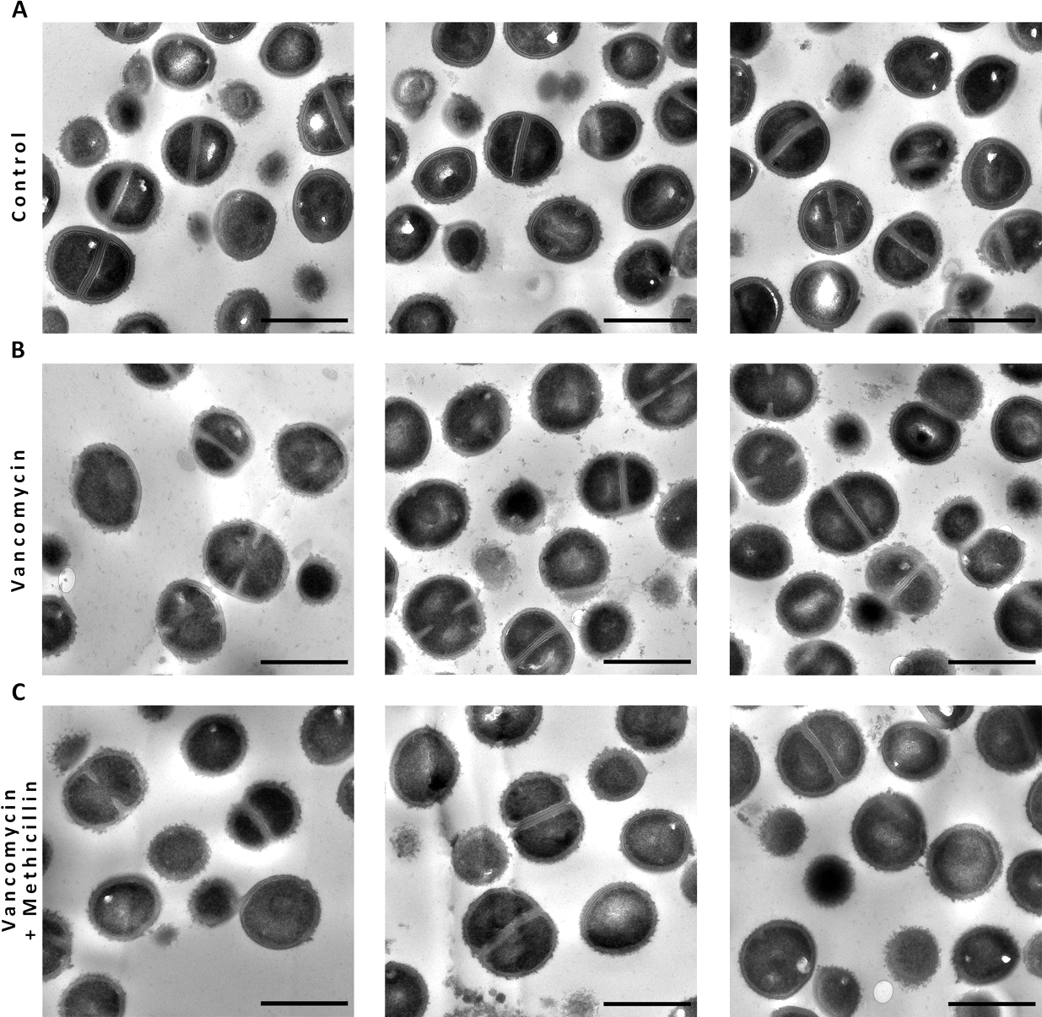
Figure 5.27 TEM micrographs of vancomycin and vancomycin plus methicillin treatment of S. aureus COL.
TEM micrographs of chemically fixed thin sections S. aureus COL (A) untreated, treated for 1 h with 10 X MIC (B) vancomycin, and (C) vancomycin plus methicillin. High magnification (4800x), scale bar 1 µm.

What is causing the expansion of the exoplasm?

Are uncrosslinked PG or lipid precursors causing this phenotype?
Giesbrecht et al., (1998) published one of the most comprehensive studies on morphology of S. aureus after penicillin treatment using EM techniques, and it is naturally a good source of comparison for the data obtain in this investigation. Giesbrecht suggested that the phenotype observed corresponded to a fibrillar cell wall material. Therefore, it was natural to continue our study and uncover if the expansion of the exoplasm was caused by an accumulation of polymers. To test this premise, we first treated SH1000 with methicillin and cerulenin, an antifungal antibiotic that blocks the activity of β-ketoacyl acyl carrier proteins (ACP) synthetases and inhibits lipid synthesis ^{[171–174]}. Thereafter, methicillin was co-administrated together with moenomycin, a phosphoglycolipid CW antibiotic that inhibits the transglycosylases PBP2, SgtB (Mgt) and SgtA in S. aureus ^{[175,177]}. Moenomycin therefore stops PG synthesis before the production of its uncrosslinked PG strands. For a detailed description of the mechanism of action of these antibiotics, refer to section 1.7.
The bacteriostatic effect of cerulenin is shown in Figure 5.28a. Its co-administration with methicillin results in a reduction of the bactericidal effect of this β-lactam antibiotic. Morphologically, the addition of cerulenin does not cause an expansion of the exoplasmic space except when added jointly with methicillin, where ~51.3 % of the population presents the phenotype in question (Figure 5.28b, Figure 5.29).
The bactericidal effect of moenomycin is shown in Figure 5.30a. As with vancomycin or cerulenin, its co-administration with methicillin results in a reduction of the bactericidal effect of this β-lactam antibiotic. TEM control micrographs of moenomycin treated cells show a particular phenotype that corresponds to a thinner CW and rounded-shaped septa (Figure 5.31), however, they do not include the expansion of the exoplasmic space seen with methicillin-treated cells (Figure 5.30b). Importantly, 37 % of cells incubated with both moenomycin and methicillin show clear signs of “plasmolysis” (Figure 5.30b, Figure 5.31).
These results show that:
- Neither lipid or uncrosslinked PG precursors are accumulating in the exoplasmic space to a degree capable of causing the separation of the plasma membrane from the cell wall.
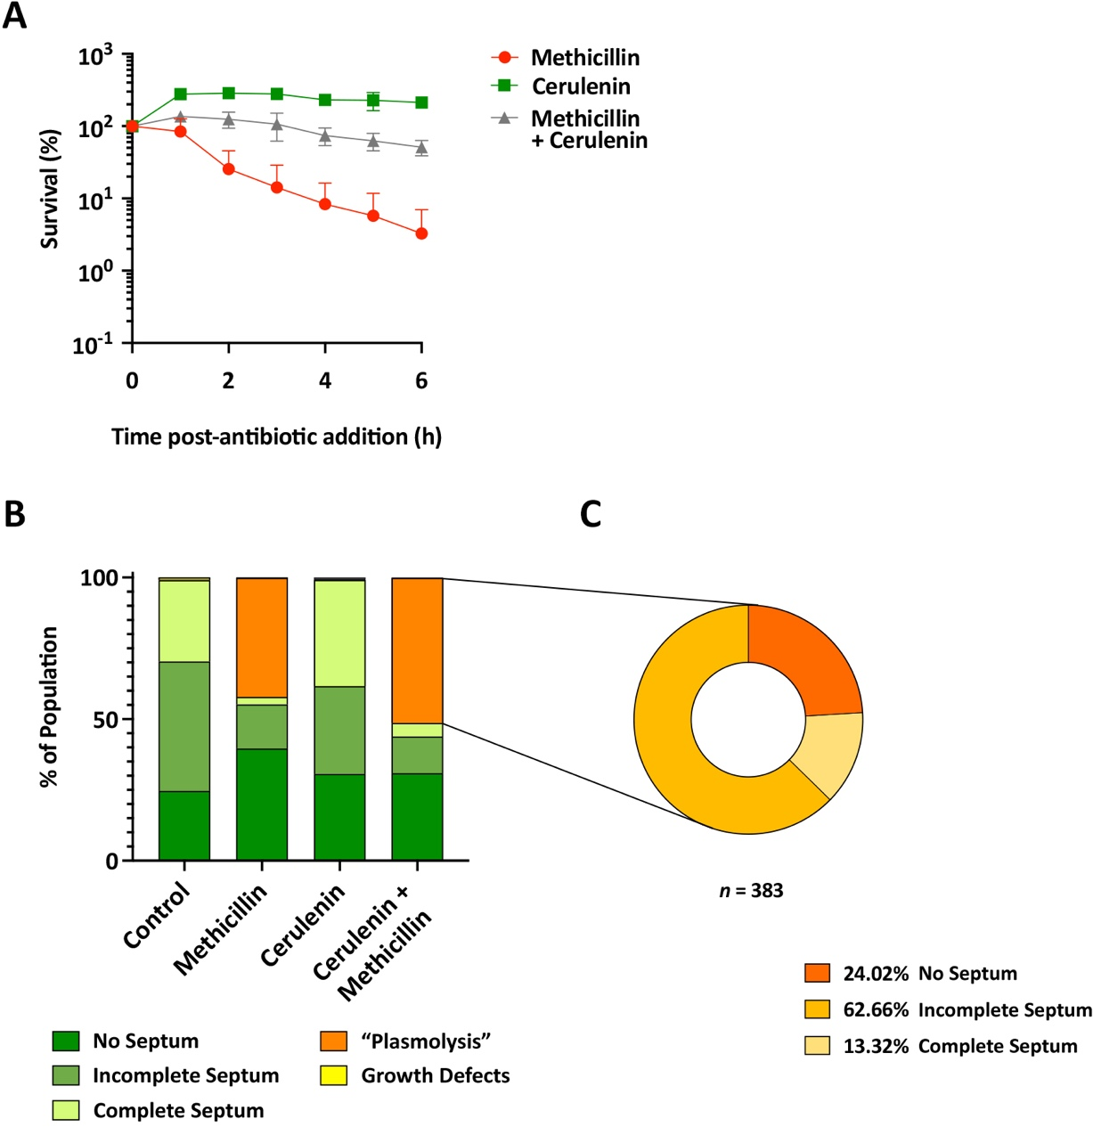
Figure 5.28 Effect of cerulenin with and without methicillin on S. aureus morphology, survival and division.
(A) Normalised percentage survival of S. aureus SH1000 treated with 100 µg/ml (1.3X MIC) cerulenin (green), 10X MIC methicillin (red), and both (grey) (3 biological repeats). Experiment carried out by Dr. Bartlomiej Salamaga. (B) Morphological quantification of the control (2 biological repeats, n = 905), methicillin (3 biological repeat, n = 913), cerulenin (2 biological repeats, n = 1061), and cerulenin plus methicillin (2 biological repeats, n = 747) as indicated. No septum– dark green, incomplete septum– medium green, complete septum– light green, “plasmolysis”– orange, and growth defects– yellow. (C) Compositional analysis of cerulenin plus methicillin treated cells in (B) presenting signs of “plasmolysis”. No septum– dark orange, incomplete septum– medium orange, complete septum– light orange (n = 383).
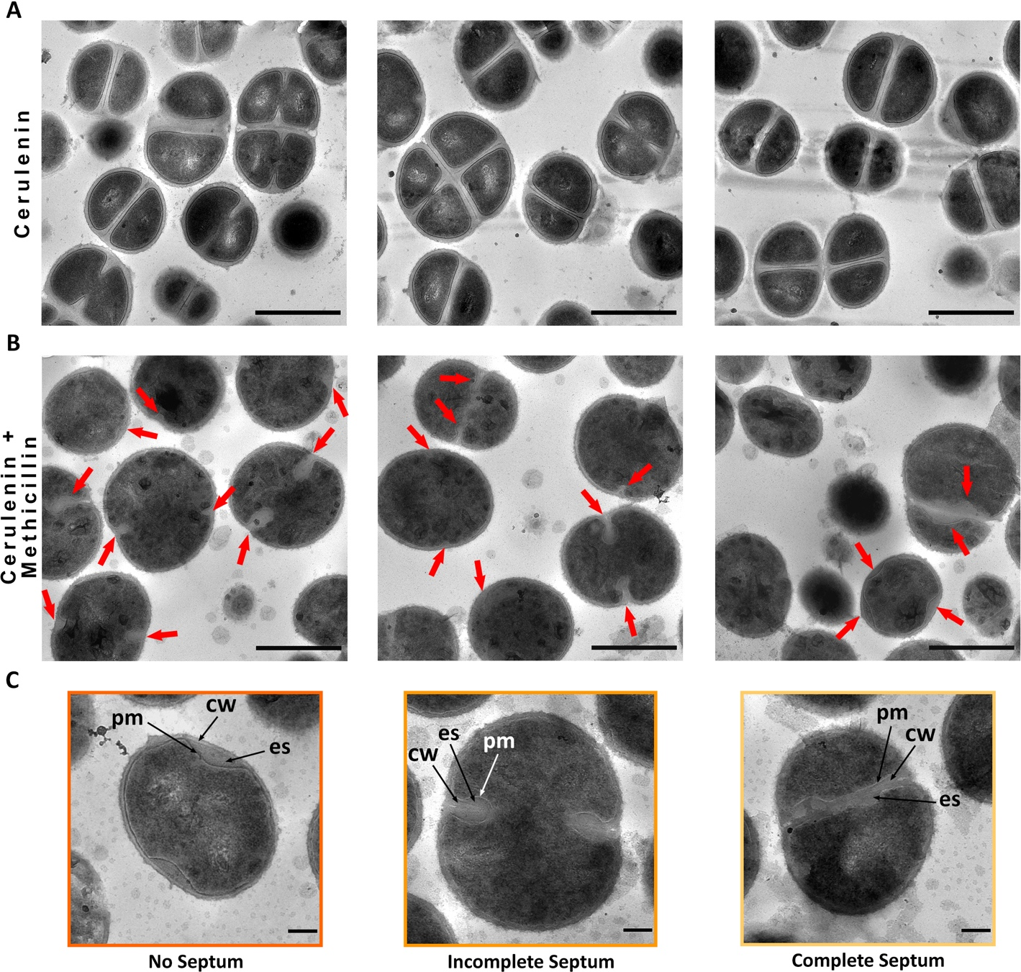
Figure 5.29 TEM micrographs of cerulenin treatment with /without methicillin on S. aureus.
TEM micrographs of chemically fixed thin sections S. aureus SH100 treated for 1 h with (A) 100 µg/ml (1.3X MIC) cerulenin and (B) cerulenin plus methicillin. High magnification (4800x), scale bar 1 µm. (C) Representative cells from (B) cropped from high magnification (4800x), scale bar 200 nm. pm– plasma membrane, cw– cell wall, ex– exoplasmic space. No septum– dark orange, incomplete septum– medium orange, and complete septum– light orange. Red arrows indicate areas where the exoplasmic space is expanded.
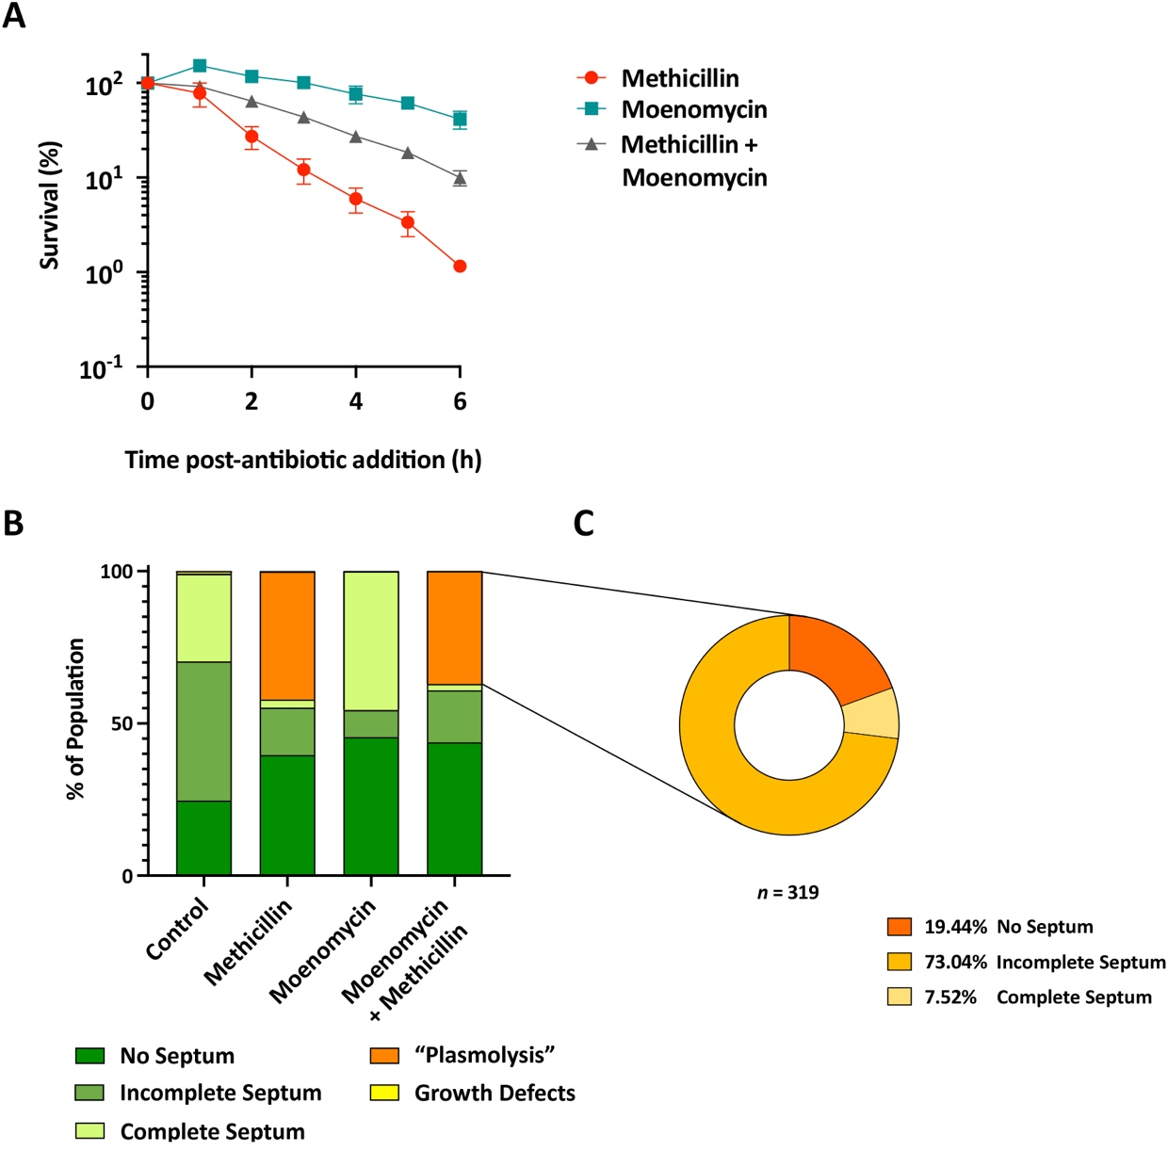
Figure 5.30 Effect of moenomycin with and without methicillin on S. aureus morphology, survival and division.
(A) Normalised percentage survival of S. aureus SH1000 treated with 2 µg/ml (10X MIC) moenomycin (teal), 10X MIC methicillin (red), and both (grey) cells (3 biological repeats). Experiment carried out by Dr. Bartlomiej Salamaga. (B) Morphological quantification of the control (2 biological repeats, n = 905), methicillin (3 biological repeat, n = 913), moenomycin (2 biological repeats, n = 1222), and moenomycin plus methicillin (2 biological repeats, n = 861) as indicated. No septum– dark green, incomplete septum– medium green, complete septum– light green, “plasmolysis”– orange, and growth defects– yellow. (C) Compositional analysis of moenomycin plus methicillin treated cells in (B) presenting signs of “plasmolysis”. No septum– dark orange, incomplete septum– medium orange, complete septum– light orange (n = 319).
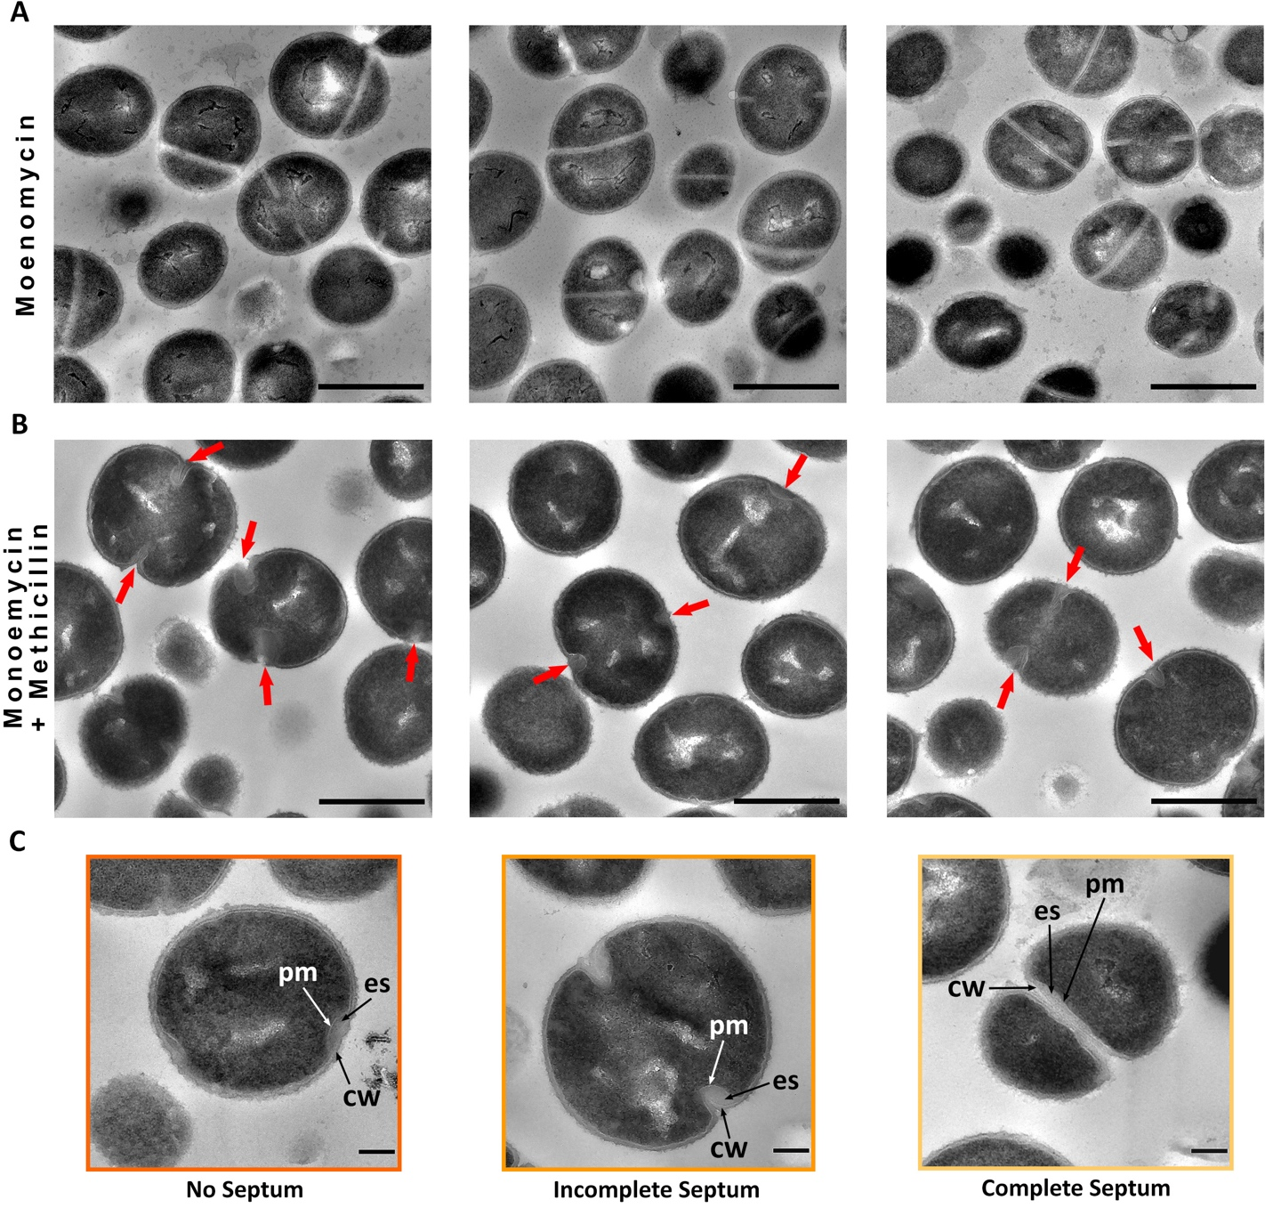
Figure 5.31 TEM micrographs of moenomycin treatment with /without methicillin on S. aureus.
TEM micrographs of chemically fixed thin sections S. aureus SH100 treated for 1 h with (A) 2µg/ml (10X MIC) moenomycin and (B) moenomycin plus methicillin. High magnification (4800x), scale bar 1 µm. (C) Representative cells from (B) cropped from high magnification (4800x), scale bar 200 nm. pm– plasma membrane, cw– cell wall, ex– exoplasmic space. No septum– dark orange, incomplete septum– medium orange, and complete septum– light orange. Red arrows indicate areas where the exoplasmic space is expanded.

Are teichoic acids precursors causing the expansion of the exoplasm?
Teichoic acids are present in the exoplasmic space and in the CW ^{[14]}, thus we tested if an unusual accumulation of these anionic polymers in the ES could account for the morphological changes observed with β-lactam antibiotics. Mutant strains lacking either wall teichoic acids (WTA) or lipoteichoic acids (LTA) were analysed.
The WTA-depleted SH1000 tarO (SJF 5289) has a higher mortality rate after treatment with bactericidal antibiotics in comparison to its parental wildtype strain, with a significant difference in survival after 4 h (99.5 ± 0.5 % death with methicillin *** p = 0.0001; 99.3 ± 0.4 % death with vancomycin **** p < 0.0001; and 99.6 ± 0.1 % death with vancomycin plus methicillin ** p = 0.0021) (Figure 5.32).
TEM and morphological analysis of tarO showed a similar response to SH1000. TEM micrographs show signs of “plasmolysis” only when treated with methicillin (Figure 5.33) or with oxacillin (Figure 5.34), with around ~50.1 % and ~73.4 % of their respective population presenting visible signs (Figure 5.35). Vancomycin treated cells present blebs and “lipid spirals” (arrow heads in Figure 5.33b,d and Figure 5.34b), and these appear to be more frequent when either methicillin or oxacillin are added jointly with vancomycin. Comparison between the effect of methicillin and oxacillin on this strain shows that the latter results in a more exaggerated phenotype with misplacement of septa and deviating and curving septa (Figure 5.34a). The septal wall is not as easy to differentiate in oxacillin treated tarO as it is with methicillin.
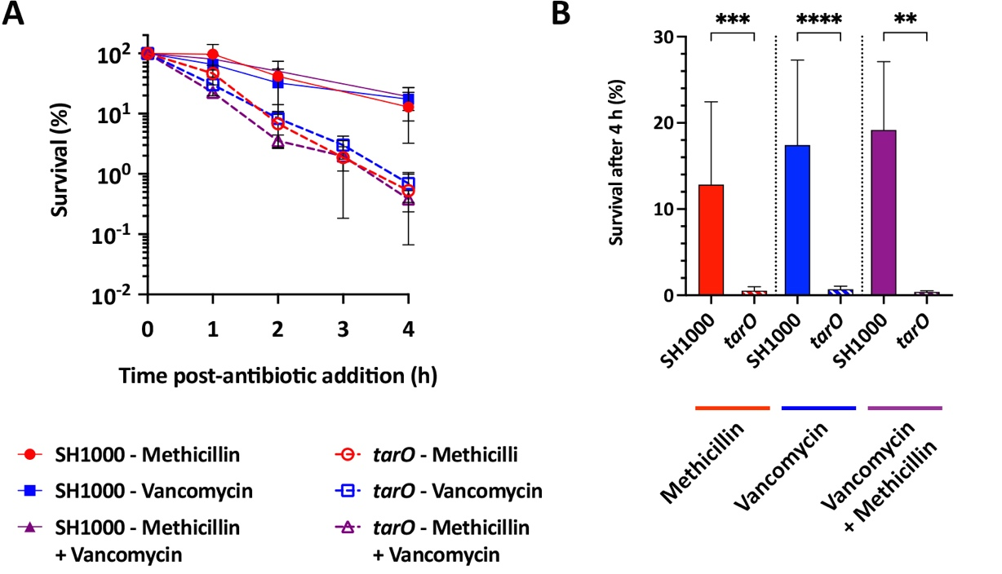
Figure 5.32 Effect of vancomycin and/or methicillin on S. aureus SH1000 tarO survival.
(A) Normalised percentage survival of S. aureus tarO treated for 1 h with 10 X MIC of methicillin and/or vancomycin (3 biological repeats). Experiment carried out by Dr. Bartlomiej Salamaga. (B) Normalised percentage of survival after 4 h from the data in (A). Statistical analysis: t-test with Welch’s correction (SH1000 vs. tarO: methicillin *** p = 0.0001, vancomycin **** p < 0.0001, vancomycin plus methicillin ** p = 0.0021) (> 3 biological repeats).
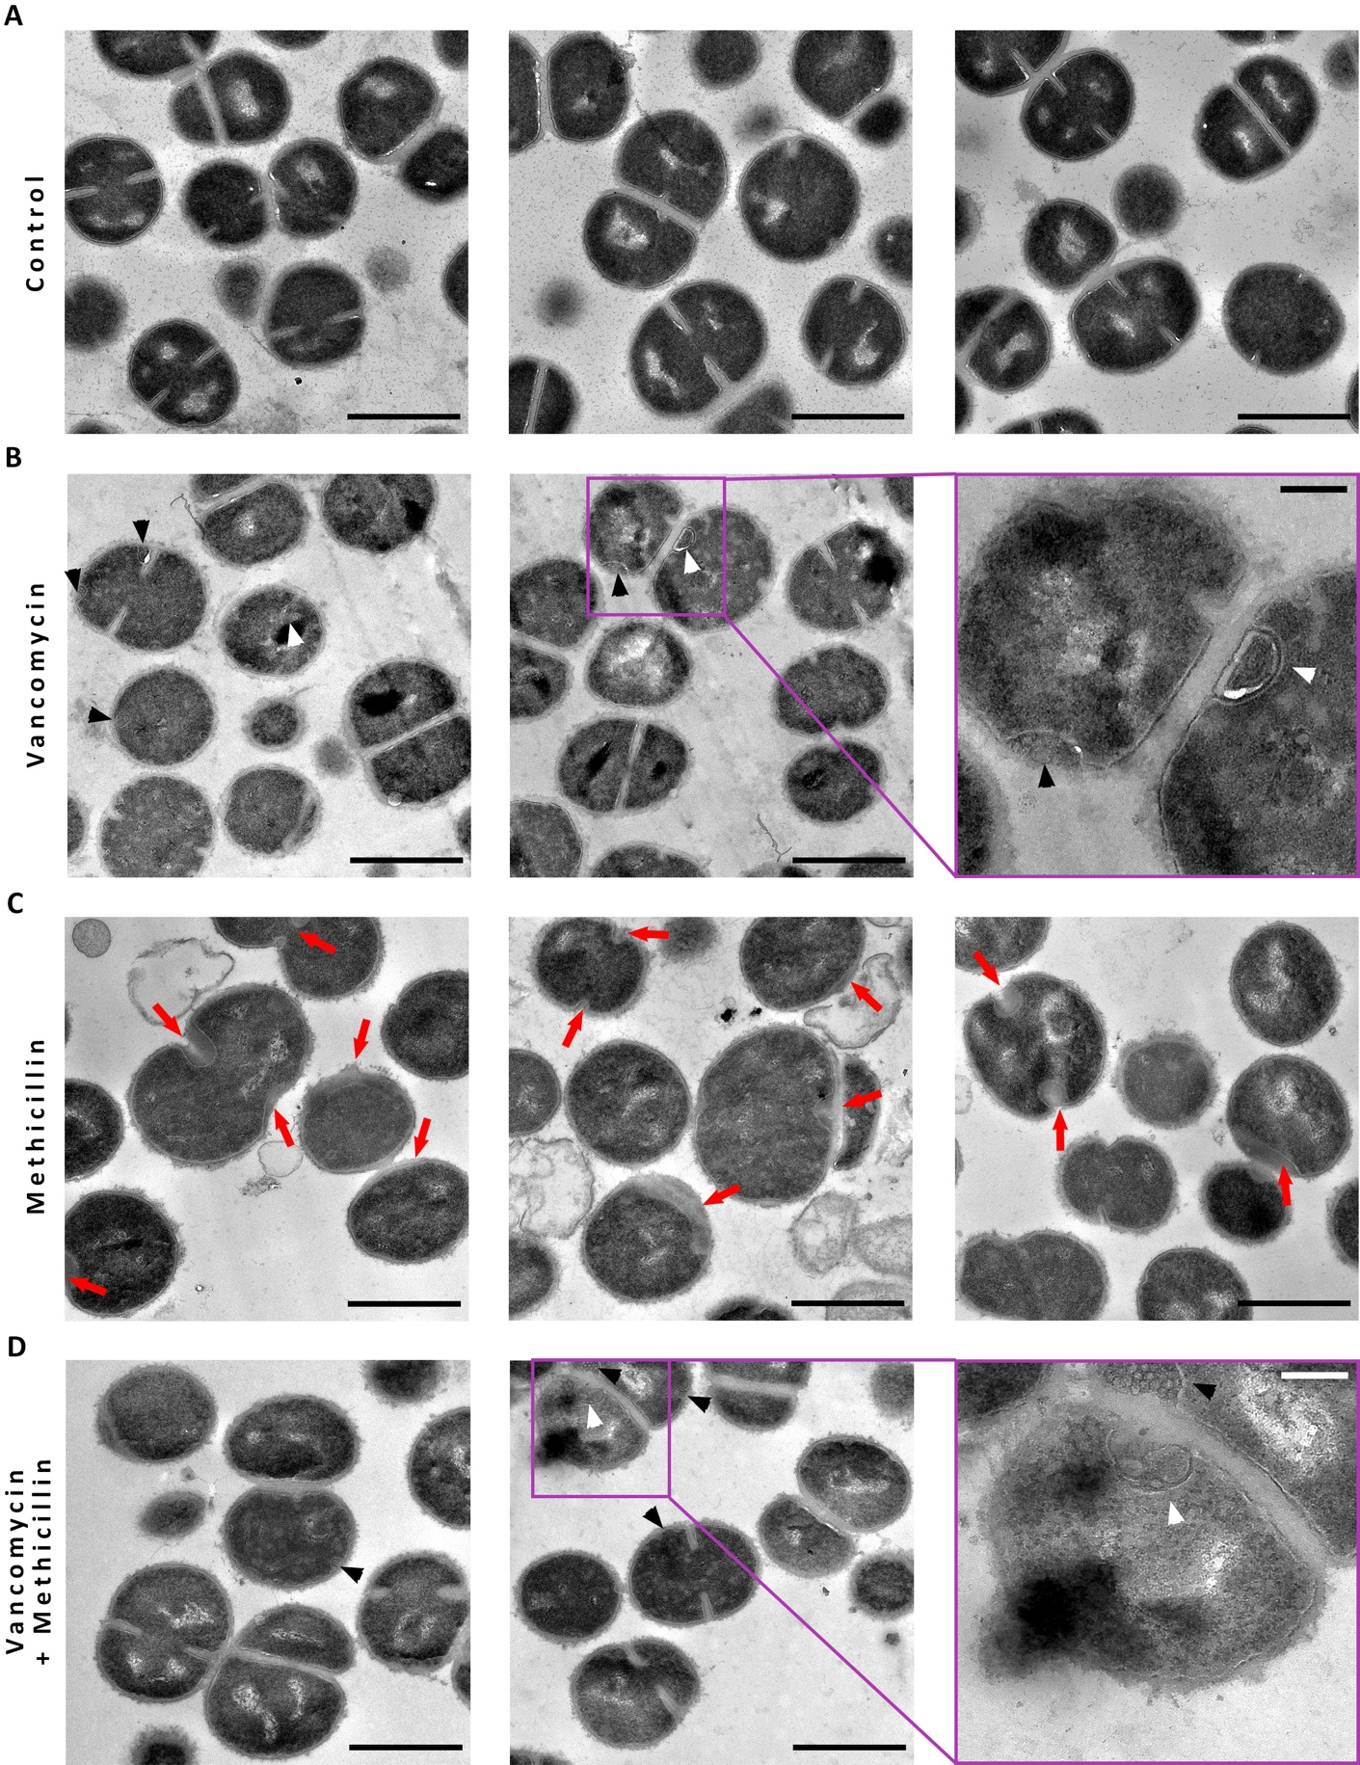
Figure 5.33 Effect of vancomycin and/or methicillin on S. aureus SH1000 tarO morphology.
TEM micrographs of chemically fixed thin sections S. aureus tarO (A) untreated, treated for 1 h with 10 X MIC (B) methicillin, (C) vancomycin, or (D) vancomycin plus methicillin. High magnification (4800x), scale bar 1 µm. Purple panels represent a zoomed sections with a scale bar of 200 nm. Red arrows indicate areas where the exoplasmic space is expanded. Black arrow heads– blebs. White arrow heads– “lipid spirals”.
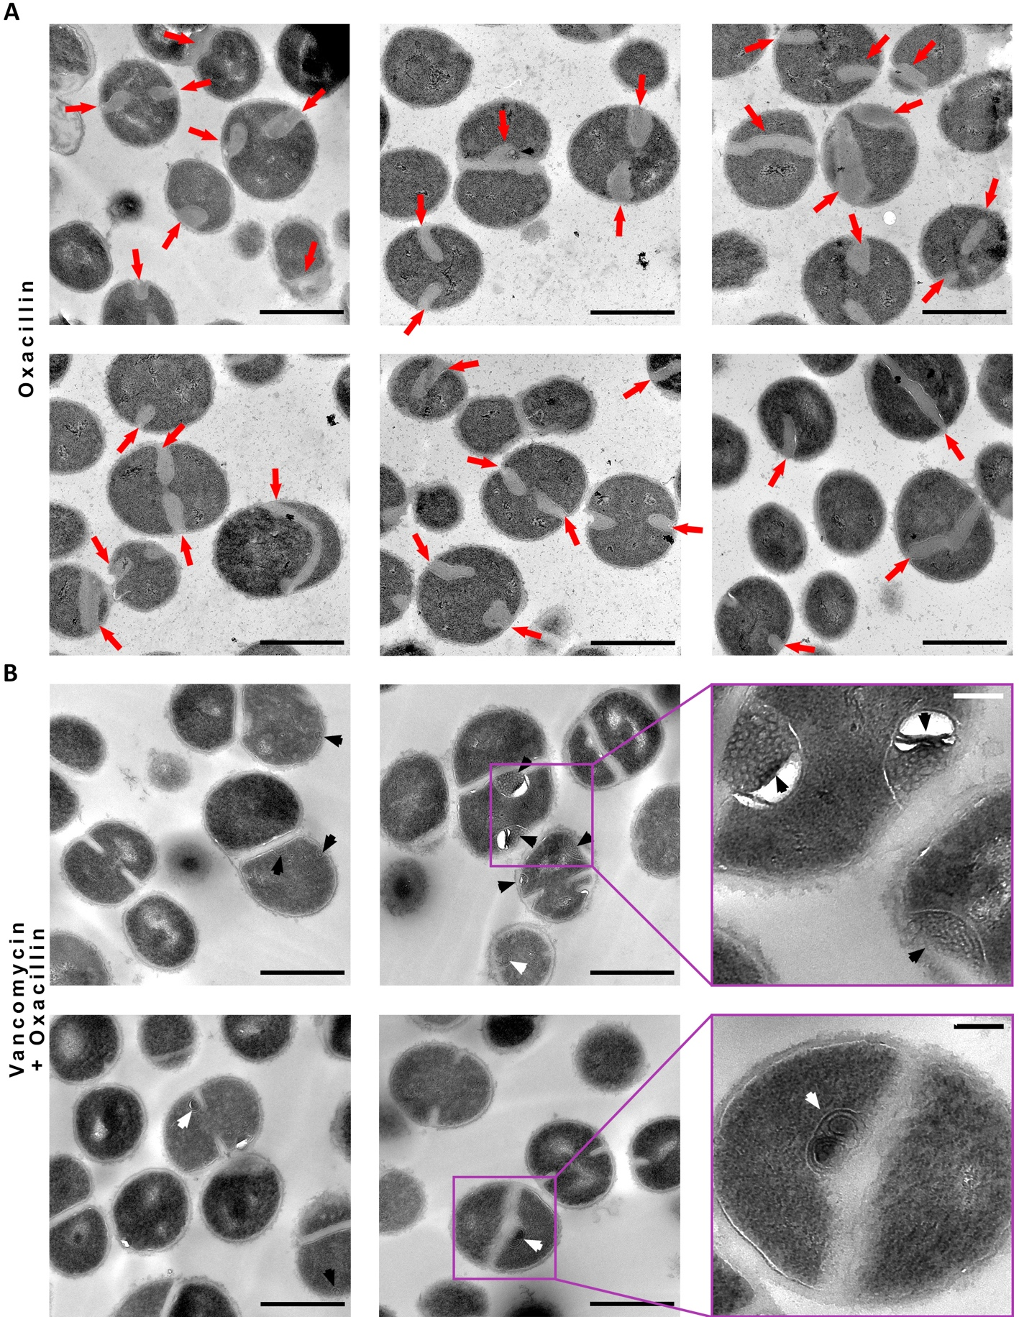
Figure 5.34 Effect of oxacillin and oxacillin plus vancomycin on S. aureus SH1000 tarO morphology.
TEM micrographs of chemically fixed thin sections S. aureus tarO treated for 1 h with 10 X MIC (A) oxacillin or (B) vancomycin plus oxacillin. High magnification (4800x), scale bar 1 µm. Purple panels represent a zoomed sections with a scale bar of 200 nm. Red arrows indicate areas where the exoplasmic space is expanded. Black arrow heads– blebs. White arrow heads– “lipid spirals”.
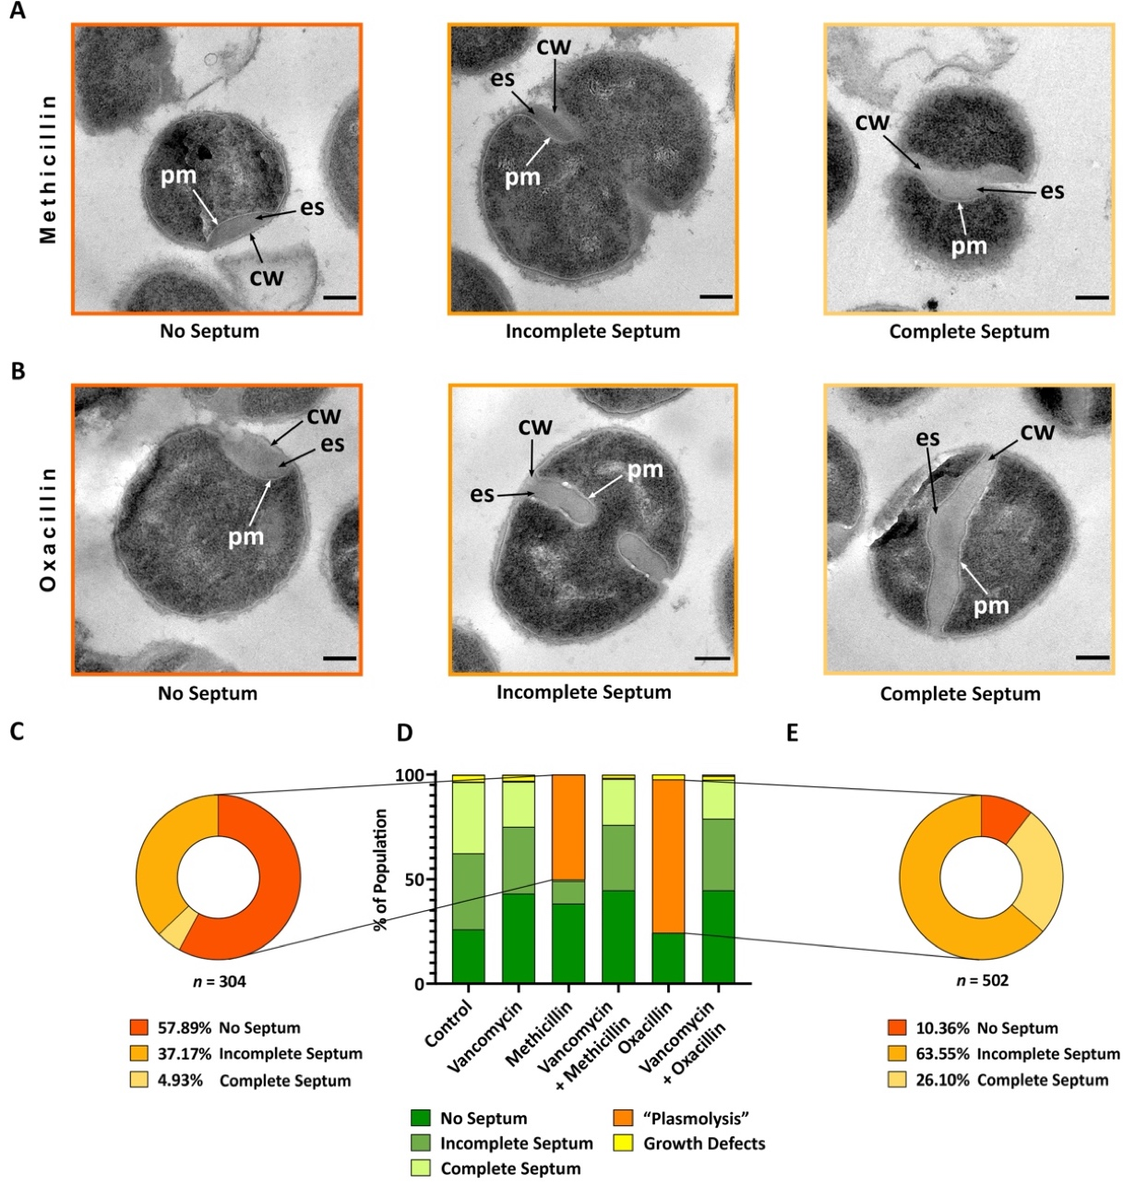
Figure 5.35 Effect of methicillin or oxacillin on S. aureus SH1000 tarO morphology and division.
Representative cells from TEM micrographs of chemically fixed thin sections S. aureus tarO treated for 1 h with 10 X MIC (A) methicillin or (B) oxacillin. Cropped from high magnification (4800x), scale bar 200 nm. pm– plasma membrane, cw– cell wall, ex– exoplasmic space. No septum– dark orange, incomplete septum– medium orange, and complete septum– light orange. (C) Compositional analysis of methicillin treated cells in (D) presenting signs of “plasmolysis”. No septum– dark orange, incomplete septum– medium orange, complete septum– light orange (n = 304). (D) Morphological quantification of the control (2 biological repeats, n = 1034), methicillin (2 biological repeat, n = 607), vancomycin (2 biological repeats, n = 1008), vancomycin plus methicillin (2 biological repeats, n = 692), oxacillin (2 biological repeats, n = 684), and vancomycin plus oxacillin (2 biological repeats, n = 433), as indicated. No septum– dark green, incomplete septum– medium green, complete septum– light green, “plasmolysis”– orange, and growth defects– yellow. (E) Compositional analysis of oxacillin treated cells in (D) presenting signs of “plasmolysis”. No septum– dark orange, incomplete septum– medium orange, complete septum– light orange (n = 502).
To determine if the methicillin-associated phenotype is caused by an accumulation of lipoteichoic acid (LTA) precursors, further analysis was carried out on SH1000 ltaS gdpP::kan (SJF 5159), which lacks LTA ^{[63]}. This strain has a decreased susceptibility to β-lactam antibiotics in comparison to SH1000 (* p = 0.0146, Figure 5.36a,c). Methicillin’s mortality after 6 h is of 90.1 ± 5 %, significantly lower than vancomycin’s 97.5 ± 1 % (* p = 0.0134, Figure 5.36a-b). There is no significant difference between treatment with both antibiotics simultaneously and vancomycin alone.
Morphological quantification showed that on top of the growth defects expected for this strain (thickened cell walls, multiple septation events in the same division plane, and clumping– detailed description found in section 4.3.2.2), the further impaired antibiotic-induced phenotype is observed. ~ 79.1 % of the methicillin treated population presents signs of “plasmolysis” (Figure 5.37). TEM micrographs of ltaS gdpP::kan therefore reveal the same response as those seen with other strains; no expansion of the exoplasm unless treated solely with methicillin (Figure 5.37, Figure 5.38).
Thus, these analysis on both tarO and ltaS gdpP::kan show that:
- Neither WTA or LTA are responsible for the expansion of the exoplasm.

- Teichoic acids do not affect the methicillin- or oxacillin-specific phenotype.
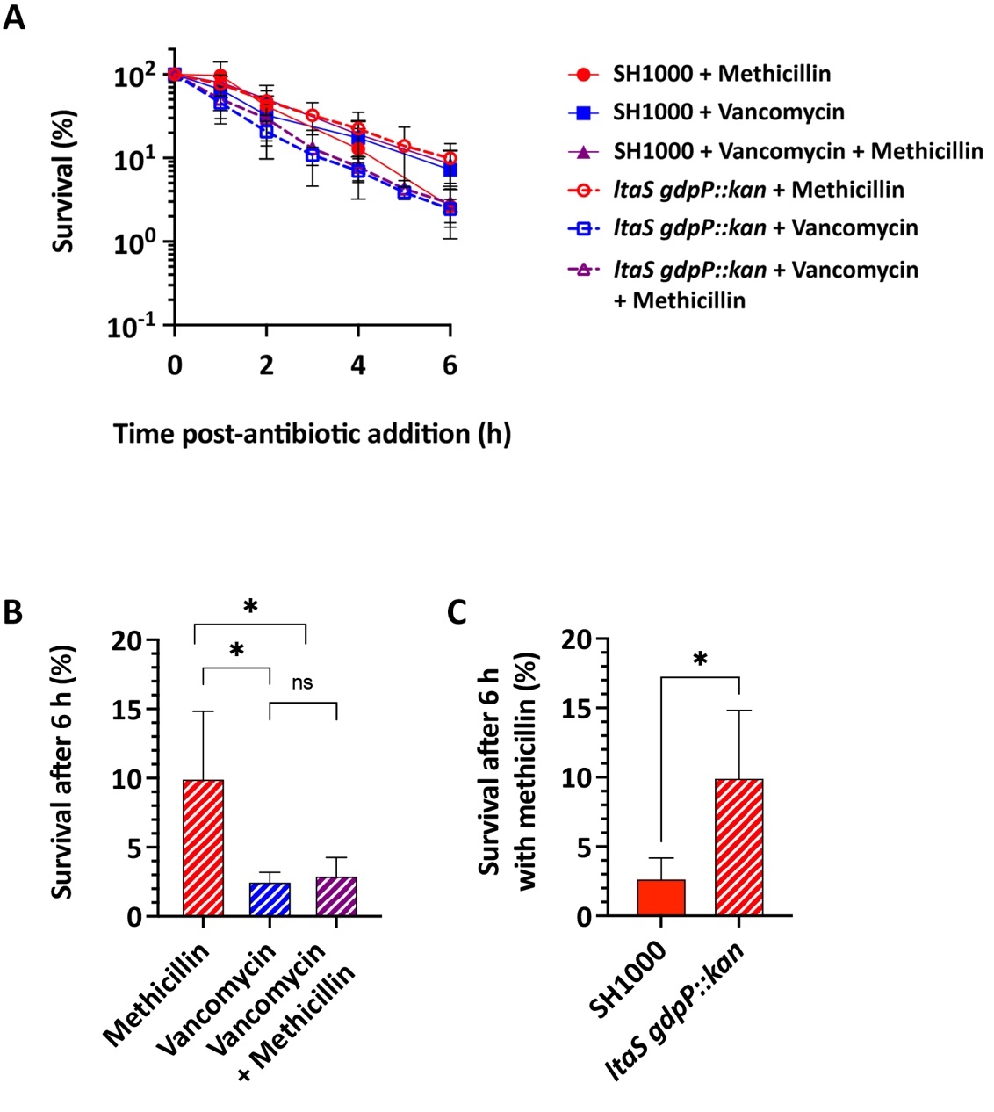
Figure 5.36 Effect of vancomycin and/or methicillin on S. aureus ltaS gdpP::kan survival.
S. aureus ltaS gdpP::kan treated for 1 h with 10 X MIC of methicillin and/or vancomycin and its comparison to its parental strain SH1000. (A) Normalised percentage survival of ltaS gdpP::kan cells. Experiment carried out by Dr. Bartlomiej Salamaga. (B) Normalised percentage of survival after 6 h from the data in (A). Statistical analysis: t-test with Welch’s correction (methicillin vs. vancomycin * p = 0.0134, methicillin vs. vancomycin + methicillin * p = 0.0161, vancomycin vs. vancomycin + methicillin ns– non-significant p ≥ 0.05). (C) Percentage of survival after 6 h treatment with methicillin and its comparison to its parental strain SH1000. Statistical analysis: t-test with Welch’s correction (SH1000 vs. ltaS gdpP::kan * p = 0.0146). Over 6 biological repeats.
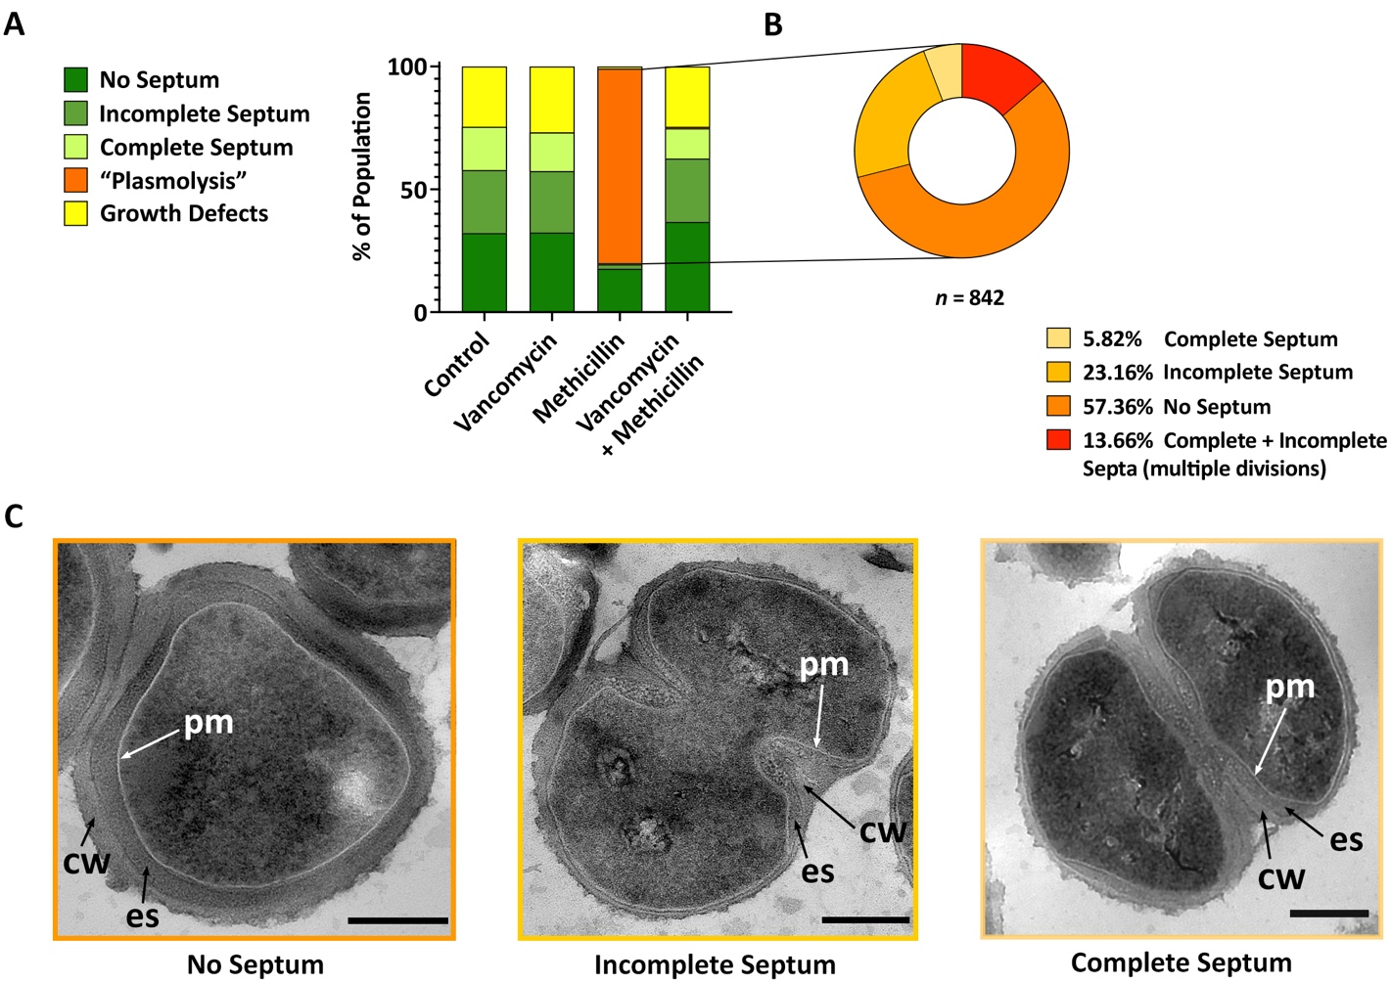
Figure 5.37 Effect of vancomycin and/or methicillin on S. aureus ltaS gdpP::kan morphology and division.
S. aureus ltaS gdpP::kan treated for 1 h with 10 X MIC of methicillin and/or vancomycin. (A) Morphological quantification of the control (2 biological repeats, n = 1467), vancomycin (2 biological repeats, n = 1555), methicillin (2 biological repeat, n = 1063), and vancomycin plus methicillin (2 biological repeats, n = 1116) as indicated. No septum– dark green, incomplete septum– medium green, complete septum– light green, “plasmolysis”– orange, and growth defects– yellow. (B) Compositional analysis of methicillin treated cells in (A) presenting signs of “plasmolysis”. No septum– dark orange; incomplete septum– medium orange; complete septum– light orange; complete + incomplete septa (multiple divisions)– red (n = 842). (C) Representative cells from TEM micrographs of chemically fixed thin sections showing the expansion of the exoplasm in detail (“plasmolysis”). Cropped from high magnification (4800x), scale bar 300 nm. pm– plasma membrane, cw– cell wall, ex– exoplasmic space. No septum– dark orange, incomplete septum– medium orange, and complete septum– light orange.
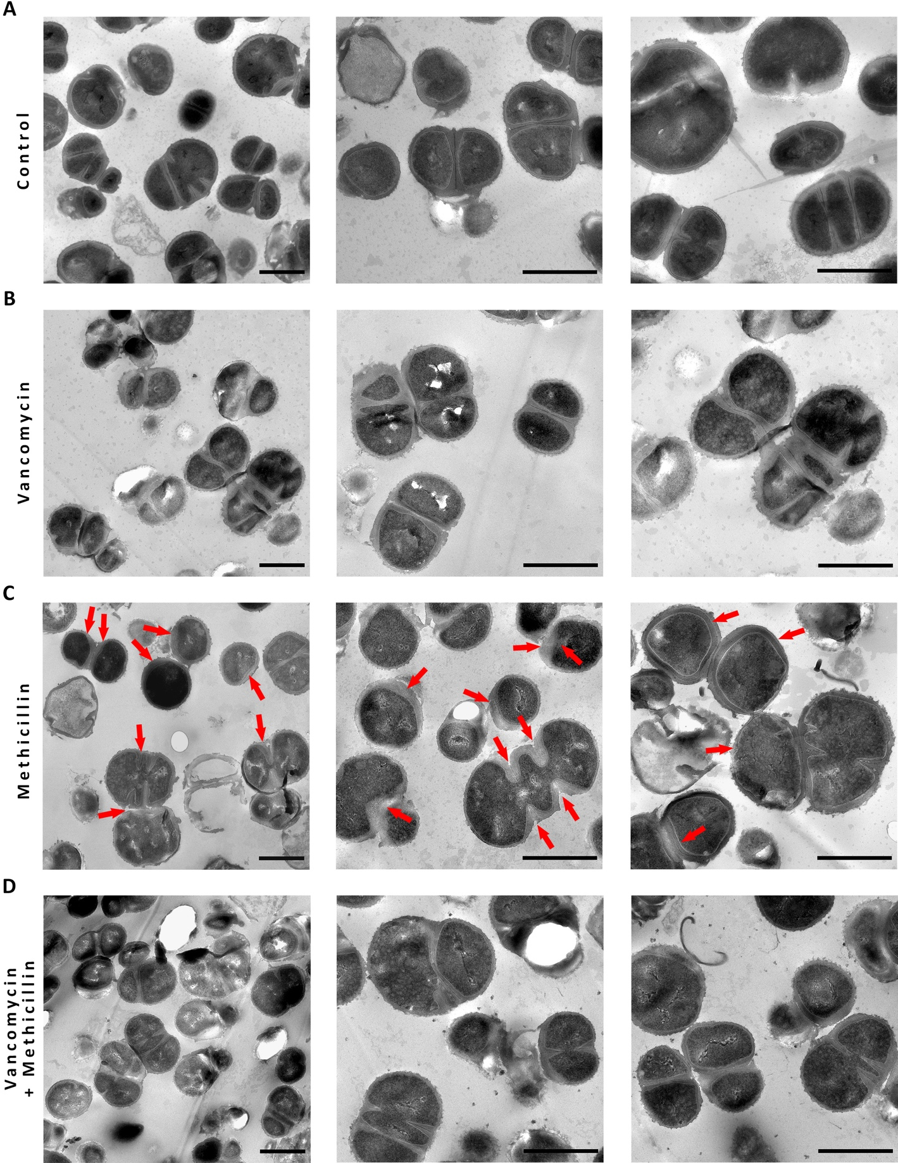
Figure 5.38 Effect of vancomycin and/or methicillin on S. aureus ltaS gdpP::kan morphology.
TEM micrographs of chemically fixed thin sections of S. aureus ltaS gdpP::kan (A) untreated and treated for 1 h with 10 X MIC (B) vancomycin, (C) methicillin, or (D) vancomycin plus methicillin. Mid magnification (2900x), scale bar 1 µm. High magnification (4800x), scale bar 1 µm. Red arrows indicate areas where the exoplasmic space is expanded.

Methicillin treatment leads to plasmolysis.
The expansion of the exoplasm seen with methicillin or oxacillin, is not caused by the physical accumulation of lipid, PG, LTA or WTA precursors. Comparative analysis of methicillin-treated cells using cryo-EM, cryo-ET and TEM indicates that this is the result of plasmolysis (Figure 5.39). Both cryo-EM micrographs of whole cells (Figure 5.39a) and cryo-EM tomograms (Figure 5.39b) demonstrate that cells treated with methicillin become electron-transparent implying that they have ruptured and lost their cytoplasmic content resulting in plasmolysis. As seen on Figure 5.40, many of the cells ruptured at the septum.
A detailed analysis of the cryo-EM tomogram tilt series shows not only the bulbus septa and expansion of the exoplasm seen with this phenotype in TEM micrographs, but also other membrane invaginations and blebs (Figure 5.41a). Despite blebs being harder to spot in chemically fixed thin sections because of heavily stained samples and the Z-location of the cross section, they are visible in some cells that have lost cytoplasmic contents (Figure 5.41b). These blebs are located under the cell wall in the expanded exoplasmic space and are another sign of plasmolysis.
These results indicate that:
- The phenotype observed with methicillin or oxacillin-treated cells corresponds to plasmolysis.

- The expansion of the exoplasm results from an influx of liquid.

- Plasmolysis frequently leads to lysis at the septum.
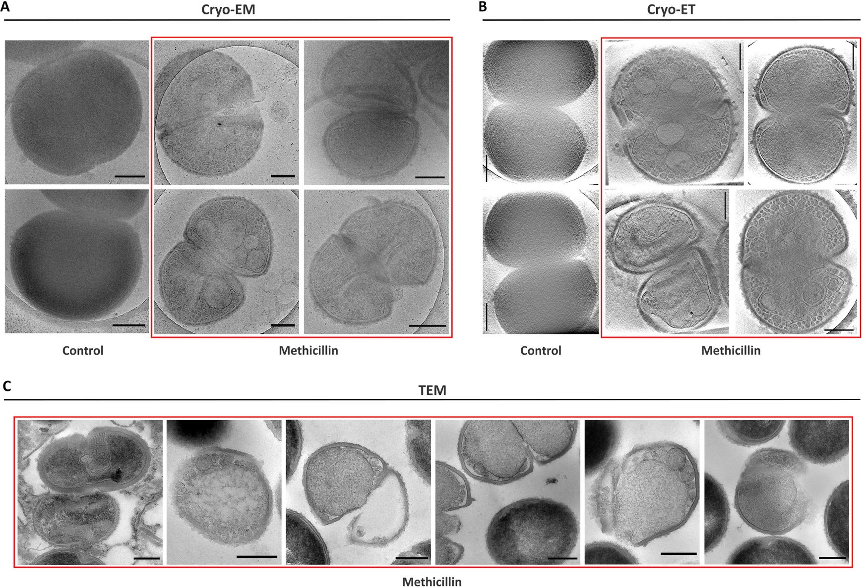
Figure 5.39 Cryo-EM, cryo-ET and TEM comparative electron microscopy analysis of the effect of methicillin on S. aureus SH1000.
S. aureus SH1000 treated for 1 h with 10 X MIC methicillin and analysed by different EM techniques. (A) Cryo-EM micrographs of vitrified whole cells. Scale bar 300 nm. (B) cryo-EM tomography (cryo-ET) images obtained from the tomogram tilt series. Scale bar 300 nm. (A-B) Raw data obtained‹ by Dr. Danyil Grybchuk. (C) Representative ruptured cells from TEM micrographs of chemically fixed thin sections. Scale bar 300 nm.
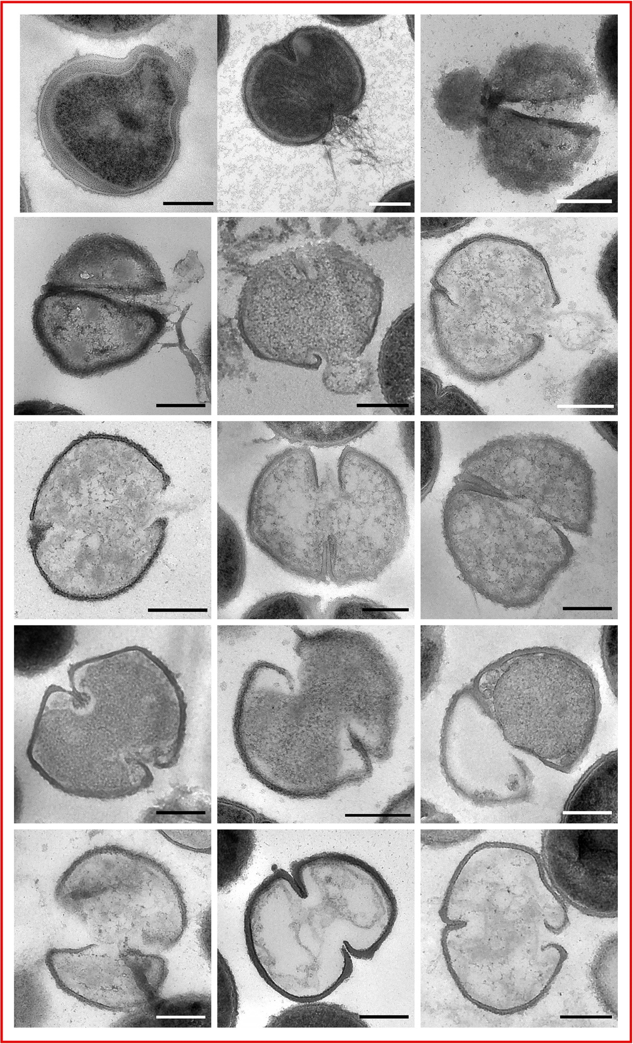
Figure 5.40 TEM micrographs of ruptured cells of S. aureus treated with methicillin.
Representative ruptured cells from TEM micrographs of chemically fixed thin sections of S. aureus SH1000. Scale bar 300 nm.
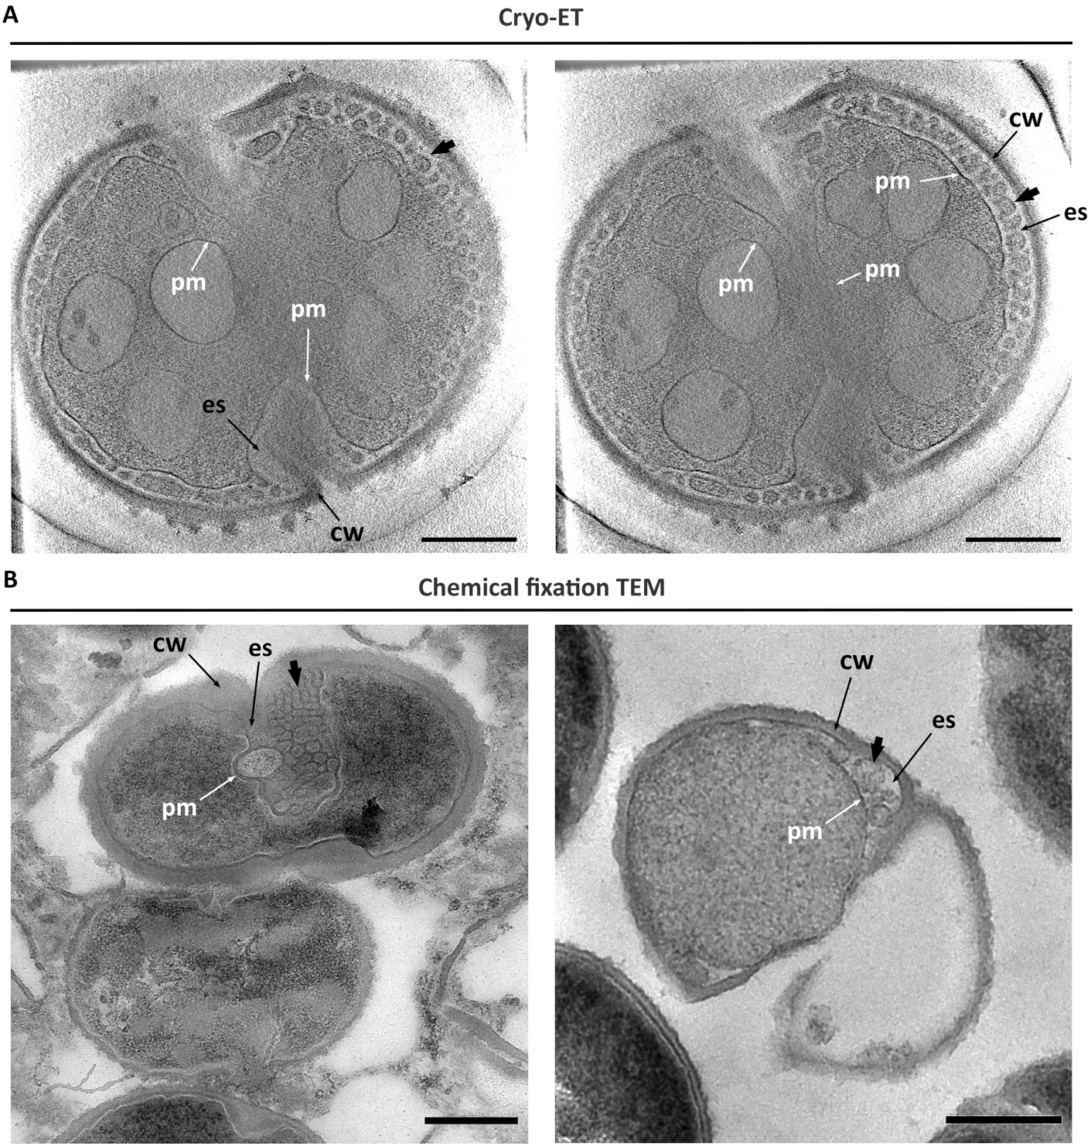
Figure 5.41 Detailed cryo-ET and TEM micrographs showing plasmolysis in methicillin treated S. aureus SH1000.
Detailed plasmolysis in ruptured S. aureus SH1000 cells treated for 1 h with 10 X MIC methicillin. (A) Cryo-EM tomography (cryo-ET) images obtained from the same tomogram tilt series. Raw data obtained by Dr. Danyil Grybchuk. (B) TEM micrographs of chemically fixed thin sections. Scale bar 300 nm. pm– plasma membrane, cw– cell wall, ex– exoplasmic space. Black arrow heads – blebs.

Are PGH responsible for the bactericidal activity of cell wall antibiotics?
This study has begun to elucidate the bactericidal mechanism for CW antibiotics. It has shown differential morphological changes after methicillin or vancomycin treatment. The plasmolysis observed with methicillin is inhibited by vancomycin, suggesting an additional β-lactam-specific mode of death on top the common mechanism of killing bacteria of bactericidal antibiotics. Our model for cell growth (Figure 5.1) suggests that bactericidal antibiotics will lead to cell death by continued PGH activity in the absence of synthesis. Thus, stressing the importance of both PG synthesis and hydrolysis for balanced growth, and the continued role played by PGH in killing in the absence of PG synthesis. As described in Chapter 1, there are multiple hydrolases, of which two major enzymes are SagB and Atl, involved in cell growth and scission, respectively ^{[53]}. Therefore, their involvement in the bactericidal effect of CW antibiotics was tested further.

The role of SagB in the bactericidal activity of cell wall antibiotics.
SagB is major membrane glucosaminidase involved in cell physiology and growth. Seeing as it is responsible for glycan chain length and cell wall stiffness ^{[53]}, together with its suggested involvement in cell size increase in methicillin-treated cells ^{[71]}, the role of this PGH in the common bactericidal activity of CW antibiotics was further investigated.
No significant difference in the rate or extent of killing with methicillin was observed when comparing sagB (SJF 4146) to SH1000 (Figure 5.42) ^{[247]}. However, when treated with vancomycin or vancomycin plus methicillin, sagB increased its survival compared to its parental strain (* p = 0.0158) (Figure 5.42) ^{[247]}. Furthermore, the overall mortality of methicillin is still higher on its own (98.6 ± 1.6 % after 6 h), whilst vancomycin has a similar response to the use of both antibiotics concomitantly (74.7 ± 13.27 % and 69.5 ± 12.2 % after 6 h, respectively) (Figure 5.42).
Morphologically, the sagB mutant showed a response equal to that of SH1000 when treated with methicillin or vancomycin. Even though both antibiotics demonstrate a reduction of dividing cells (incomplete and complete septum; Figure 5.43), only methicillin presented signs of plasmolysis (Figure 5.43 and Figure 5.44). The percentage of affected cells was similar to that of the wildtype SH1000 (~ 45.4 %) and once again, the majority of these corresponded to dividing cells (Figure 5.43b-c). No difference was observed when sagB was compared to SH1000 when treated with both methicillin and vancomycin simultaneously (Figure 5.44).
These results indicate that:
- Morphologically, sagB resembles SH1000 when treated with CW antibiotics.

- SagB is not responsible for causing plasmolysis in methicillin-treated cells.

- SagB has a major role in the bactericidal mechanism of vancomycin but does not have a major role in that of methicillin, as seen by an increased survival of sagB treated with vancomycin when compared to SH1000.

- SagB appears to be involved in the bactericidal mechanism common to both vancomycin and methicillin.

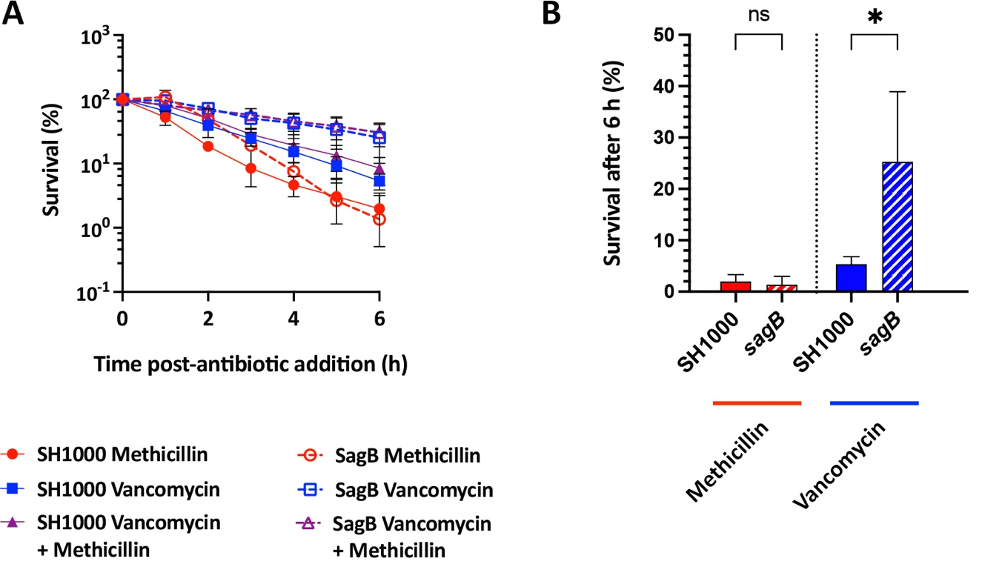
Figure 5.42 Effect of vancomycin and/or methicillin on S. aureus sagB survival.
S. aureus sagB treated with 10 X MIC of methicillin and/or vancomycin and its comparison to its parental strain SH1000. (A) Normalised percentage survival of bacterial cells (3 biological repeats). Experiment carried out by Dr. Bartlomiej Salamaga. (B) Normalised percentage of survival after 6 h. Statistical analysis: t-test with Welch’s correction (SH1000 vs. sagB – vancomycin * p = 0.0158; methicillin ns– non-significant p ≥ 0.05) (6 biological repeats).
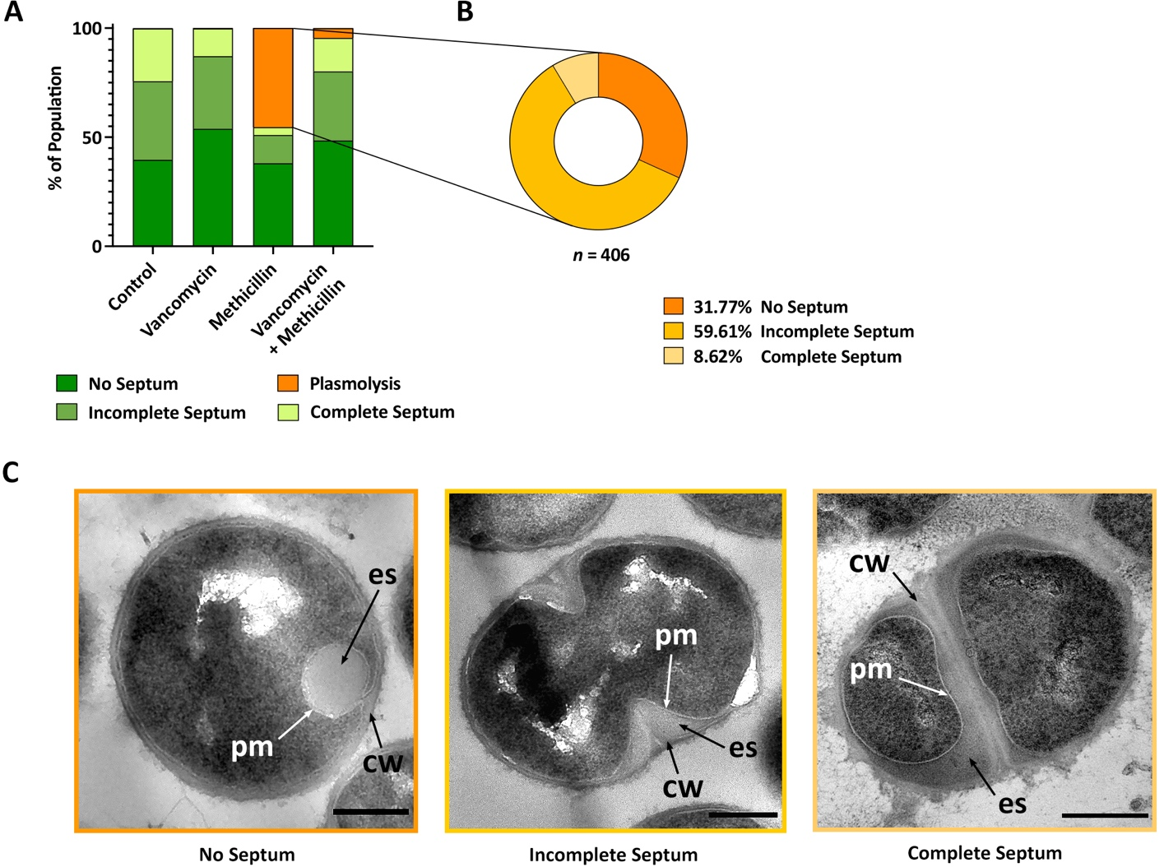
Figure 5.43 Effect of vancomycin and/or methicillin on S. aureus sagB survival morphology and division.
S. aureus sagB treated for 1 h with 10 X MIC of methicillin and/or vancomycin. (A) Morphological quantification of the control (2 biological repeats, n = 1113), methicillin (2 biological repeat, n = 894), vancomycin (2 biological repeats, n = 1214), vancomycin plus methicillin (2 biological repeats, n = 1934), as indicated. No septum– dark green, incomplete septum– medium green, complete septum– light green, and plasmolysis– orange. (B) Compositional analysis methicillin treated cells in (A) showing signs of plasmolysis. No septum– dark orange, incomplete septum– medium orange, complete septum– light orange (n = 489). (C) Representative cells from TEM micrographs of chemically fixed thin sections for treatments with methicillin. Cropped from high magnification (4800x), scale bar 300 nm. pm– plasma membrane, cw– cell wall, ex– exoplasmic space. No septum– dark orange, incomplete septum– medium orange, and complete septum– light orange
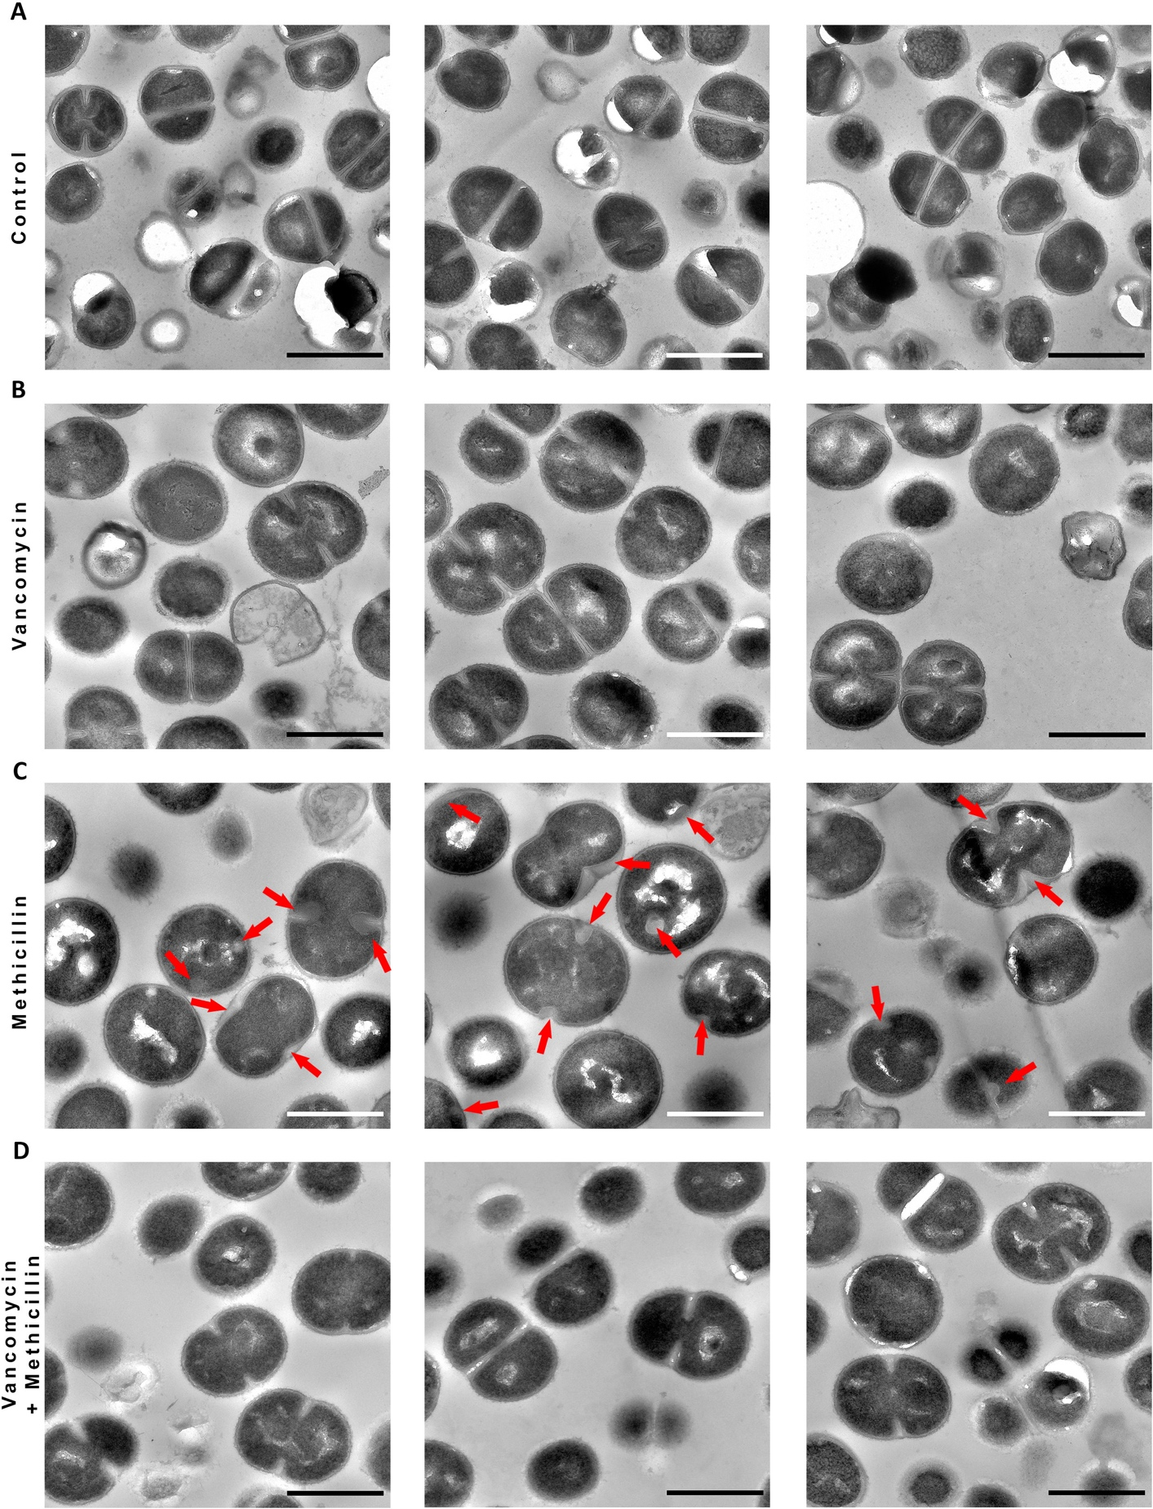
Figure 5.44 Effect of vancomycin and/or methicillin on S. aureus sagB phenotype.
TEM micrographs of chemically fixed thin sections of S. aureus sagB (A) untreated and treated for 1 h with 10 X MIC (B) vancomycin, (C) methicillin, or (D) vancomycin plus methicillin. High magnification (4800x), scale bar 1 µm. Red arrows indicate signs of plasmolysis.

The role of Atl in the bactericidal effect of antibiotics.
The major S. aureus PGH Atl is involved in general lysis and septal separation, also its activity has been shown to be directly inhibited by vancomycin ^{[55,57,199]}. The role of Atl in the bactericidal mechanism of cell wall antibiotics was therefore tested with the mutant strain atl (SJF 5255).
After 6 h of treatment, atl treated with methicillin or vancomycin presents 90.5 ± 4.4 % and 89.4 ± 6.8 % of cell death, respectively (Figure 5.45). Although atl had increased survival following all antibiotic treatments when compared to the wildtype, only treatment with methicillin showed a significant improvement (** p = 0.007) (Figure 5.45) ^{[247]}.
TEM micrographs of atl (Figure 5.46a) showed the already described fuzzy appearance of the cell wall surface^{[54]}, which results from lack of PG hydrolysis and release. This surface appearance is more aggravated when treated with vancomycin, methicillin, oxacillin or either β-lactam combined with vancomycin (Figure 5.46b-d, Figure 5.47). The atl mutant also showed a reduction of dividing cells when treated with these antibiotics (incomplete and complete septum; Figure 5.48c-e).
TEM micrographs of atl treated with methicillin or oxacillin show signs of plasmolysis (Figure 5.46, Figure 5.47, and Figure 5.48). Similarly to its parental strain, atl has a higher percentage of its population with visible signs of plasmolysis when treated with oxacillin (~ 67 %) than with methicillin (~ 64.1 %) (Figure 5.48c-e). Both populations represent most of its affected cells in a dividing stage with incomplete septum (Figure 5.48c, e).
These results indicate that:
- Atl plays an important role in the bactericidal mechanism of β-lactam antibiotics, as seen by the reduction in the rate of killing with methicillin compared to the wild type.

- Atl is not responsible for causing plasmolysis in methicillin- or oxacillin-treated cells.
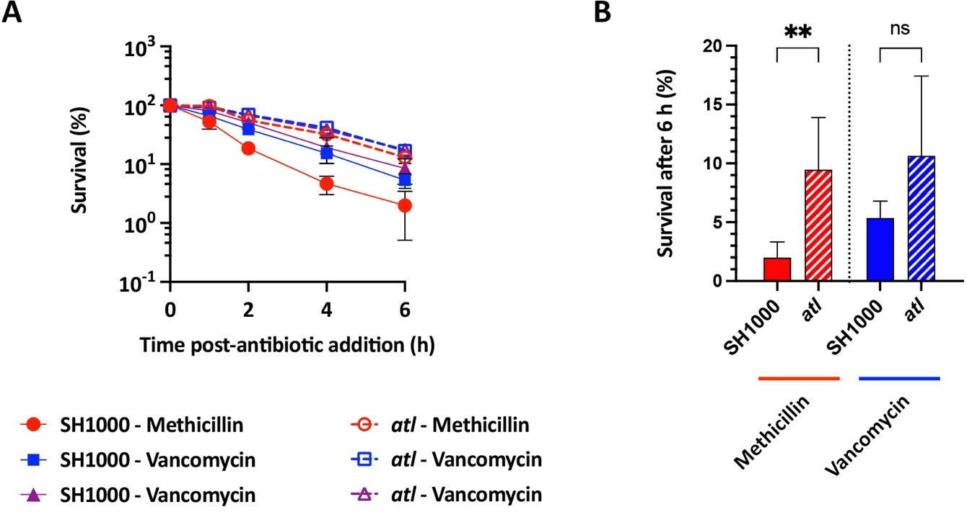
Figure 5.45 Effect of vancomycin and/or methicillin on S. aureus SH1000 atl survival.
S. aureus atl treated with 10 X MIC of methicillin and/or vancomycin and its comparison to its parental strain SH1000. (A) Normalised percentage survival of bacterial cells (3 biological repeats). Experiment carried out by Dr. Bartlomiej Salamaga. (B) Normalised percentage of survival after 6 h. Statistical analysis: t-test with Welch’s correction (SH1000 vs. atl – methicillin ** p = 0.0077, – vancomycin ns, non-significant p ≥ 0.05) (6 biological repeats).
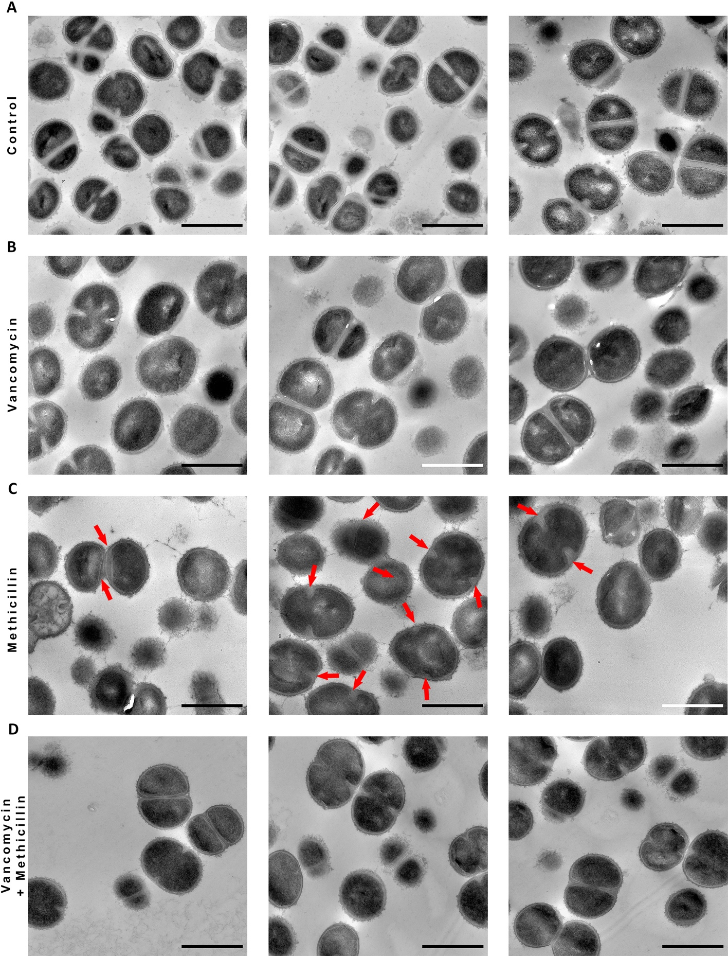
Figure 5.46 Effect of vancomycin and/or methicillin on S. aureus atl morphology.
TEM micrographs of chemically fixed thin sections of S. aureus atl (A) untreated and treated for 1 h with 10 X MIC (B) vancomycin, (C) methicillin, or (D) vancomycin plus methicillin. High magnification (4800x), scale bar 1 µm. Red arrows indicate areas where the exoplasmic space is expanded (plasmolysis).
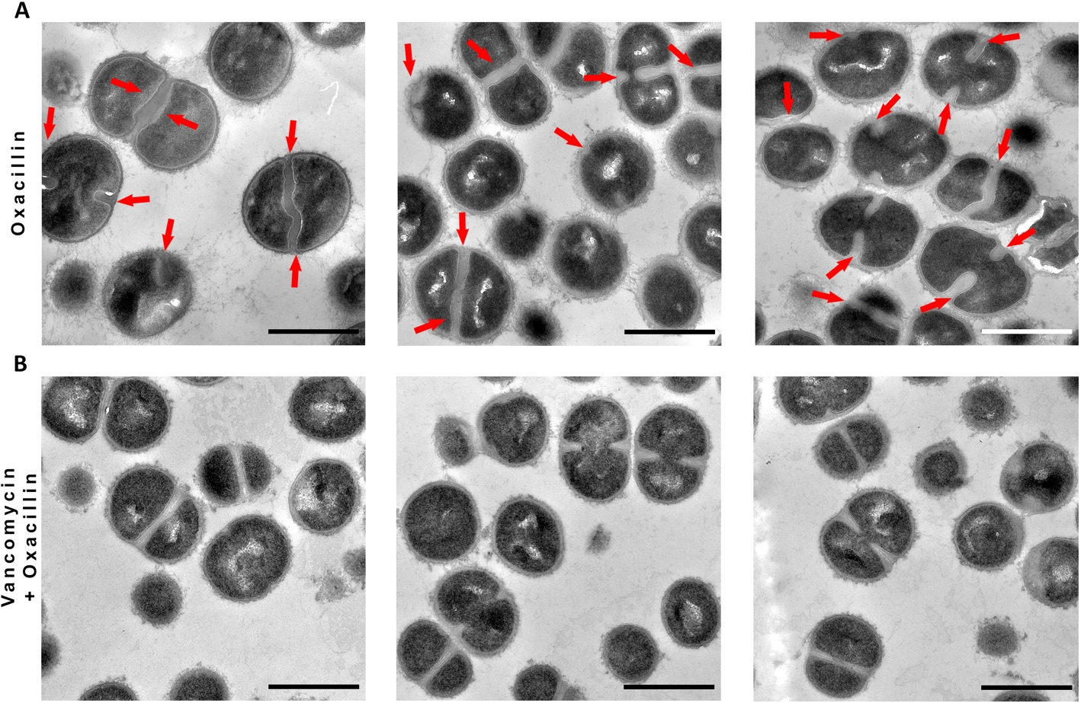
Figure 5.47 Effect of oxacillin and vancomycin on S. aureus atl morphology.
TEM micrographs of chemically fixed thin sections of S. aureus atl treated for 1 h with 10 X MIC (A) oxacillin or (B) vancomycin plus oxacillin. High magnification (4800x), scale bar 1 µm. Red arrows indicate areas where the exoplasmic space is expanded (plasmolysis).
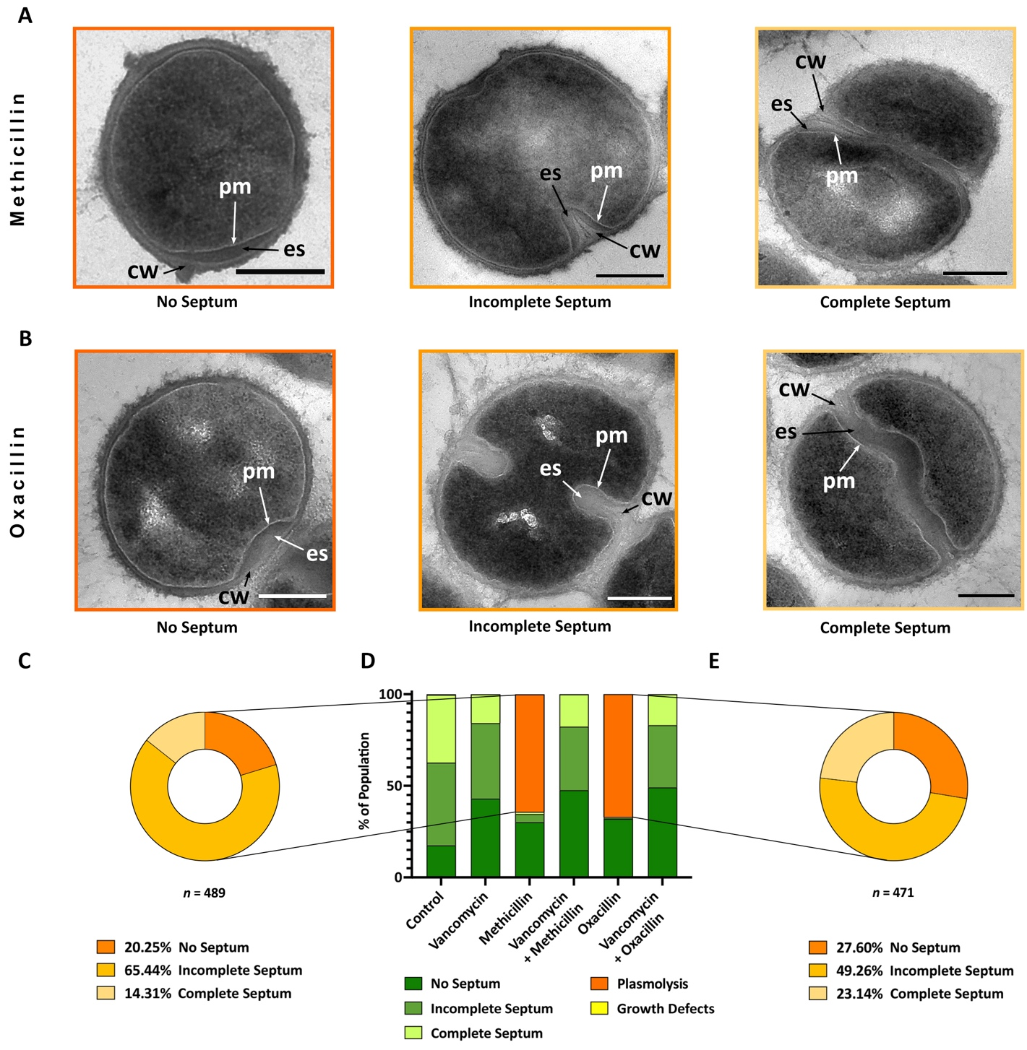
Figure 5.48 Effect of vancomycin, oxacillin and methicillin on S. aureus atl survival and morphology.
S. aureus atl was treated for 1 h with 10 X MIC of the indicated antibiotics. (A-B) Representative cells from TEM micrographs of chemically fixed thin sections for treatments with (A) methicillin or (B) oxacillin. Cropped from high magnification (4800x), scale bar 300 nm. pm– plasma membrane, cw– cell wall, ex– exoplasmic space. No septum– dark orange, incomplete septum– medium orange, and complete septum– light orange. (C) Compositional analysis of methicillin treated cells in (D) showing signs of plasmolysis. No septum– dark orange, incomplete septum– medium orange, complete septum– light orange (n = 489). (D) Morphological quantification of the control (3 biological repeats, n = 1498), methicillin (2 biological repeat, n = 763), vancomycin (2 biological repeats, n = 909), vancomycin plus methicillin (2 biological repeats, n = 910), oxacillin (2 biological repeats, n = 703), and vancomycin plus oxacillin (2 biological repeats, n = 704), as indicated. No septum– dark green, incomplete septum– medium green, complete septum– light green, plasmolysis– orange, and growth defects– yellow. (E) Compositional analysis oxacillin treated cells in (D) showing signs of plasmolysis. No septum– dark orange, incomplete septum– medium orange, complete septum– light orange (n = 471).

The role of cell wall homeostasis in life and death.
Our model for cell wall homeostasis (Figure 5.1) proposes that loss of PG synthesis with continued hydrolysis will lead to death and is supported by our cell wall antibiotic data. The paradox of this is that loss of PG hydrolysis with continued synthesis will also result in death and that loss of both phenomena will lead to stasis. Thus, we sought to test this hypothesis with a WalKR-depleted strain. WalKR is a two-component signal transduction system that has previously been shown to be an essential positive regulator of nine putative PGH: ScaB, ScaC, ScaD (SsaA), ScaE, ScaJ, SceD, Atl, IsaA, and LytM (for detail on hydrolases, see section 1.4.3) ^{[74,75]}. Therefore, it provides a possible approach to address the combined role of PG synthesis and hydrolysis in cellular physiology. The chosen walKR (SJF 5356) mutant has a conditional lethal construct under the control of the IPTG-inducible promoter (P_{spac}). Thus, in the presence of IPTG the cells are able to grow and divide, while, given the essentiality of WalKR, in the absence of IPTG they are not.
As previously described ^{[78]}, WalKR is essential and its depletion by the absence of IPTG leads to a > 99 % death within 3 h (** p = 0.0031 )(Figure 5.49a-b) ^{[247]}. Transmission electron micrographs showed growth defects, such as thicker cell walls, cell aggregated and aberrant cell division (Figure 5.49c), in ~ 57.6 % of the population (Figure 5.49d).
When treated with vancomycin or methicillin, walKR depleted cells show a significant reduction in cell death after 3 h (vancomycin ** p = 0.0069, methicillin ** p = 0.0063) (Figure 5.50a-b) ^{[247]}. Moreover, it shows a considerable decrease in the percentage of the population presenting growth defects (Figure 5.51); with ~ 57.6 % of the control group reduced to ~ 2.2 % and ~ 2.8 % for vancomycin and methicillin respectively. Once more, clear signs of plasmolysis were observed solely with methicillin and addition of both antibiotics together showed a similar morphology to that of vancomycin alone (Figure 5.51, Figure 5.52).

These results demonstrate that:
- PGH are needed for growth, as shown by the survival curves and the percentage of growth defects in walKR OFF.

- Lack of both PG synthesis and hydrolysis leads to stasis, as seen by the survival curves and phenotype recovery in walKR OFF treated with vancomycin.

- Methicillin still leads to plasmolysis in walKR OFF cells.

- Our model for cell wall homeostasis in life and death (Figure 5.1) is further confirmed.

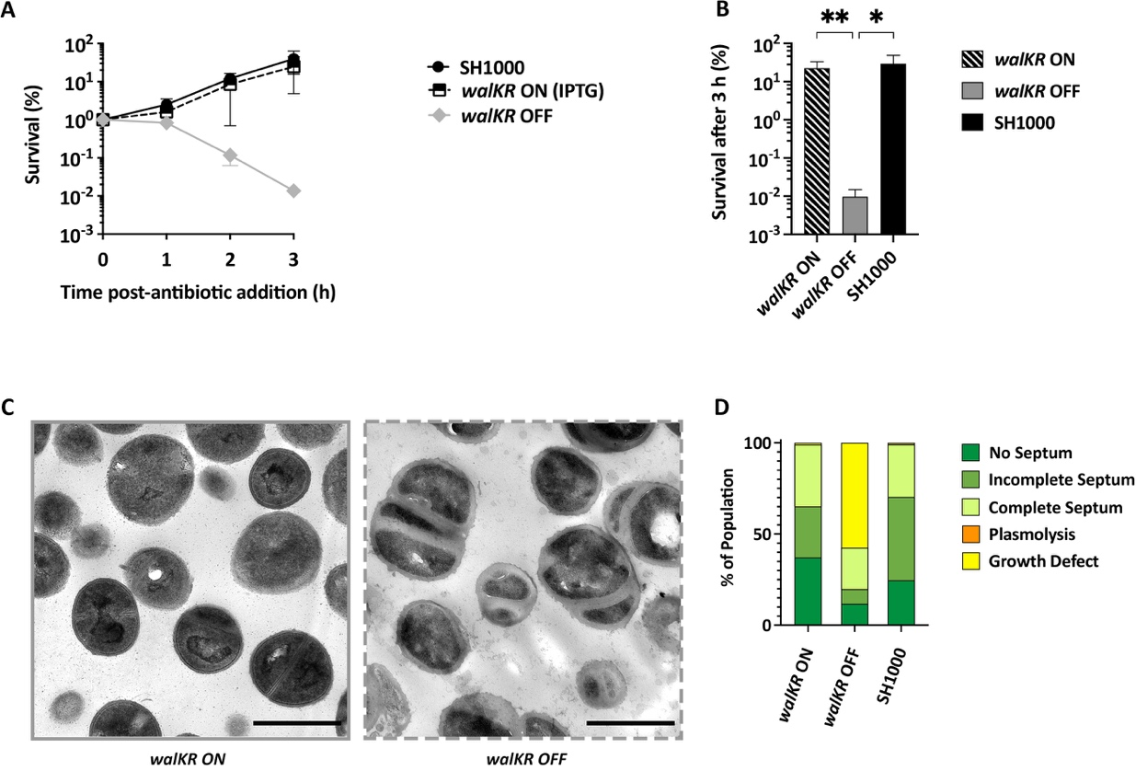
Figure 5.49 Effect of the depletion of WalKR on S. aureus survival and morphology.
(A) Normalised percentage survival of S. aureus walKR cells with and without the IPTG inducer, and its comparison to the SH1000 parental strain (6 biological repeats). Experiment carried out by Dr. Bartlomiej Salamaga. (B) Normalised percentage of survival after 3 h of growth, from the data in (A). Statistical analysis: t-test with Welch’s correction (SH1000 vs. walKR OFF * p = 0.0129; walKR ON vs. OFF ** p = 0.0031; walKR ON vs. SH1000 non-significant p ≥ 0.05 ). (C) Representative TEM micrographs of walKR with and without IPTG. High magnification (4800x), scale bar 1 µm. (D) Morphological quantification of walKR ON– with IPTG (2 biological repeats, n = 824), walKR OFF– without IPTG (2 biological repeats, n = 856), and its comparison to SH1000 (2 biological repeats, n = 905). No septum– dark green, incomplete septum– medium green, complete septum– light green, plasmolysis– orange, and growth defects– yellow.
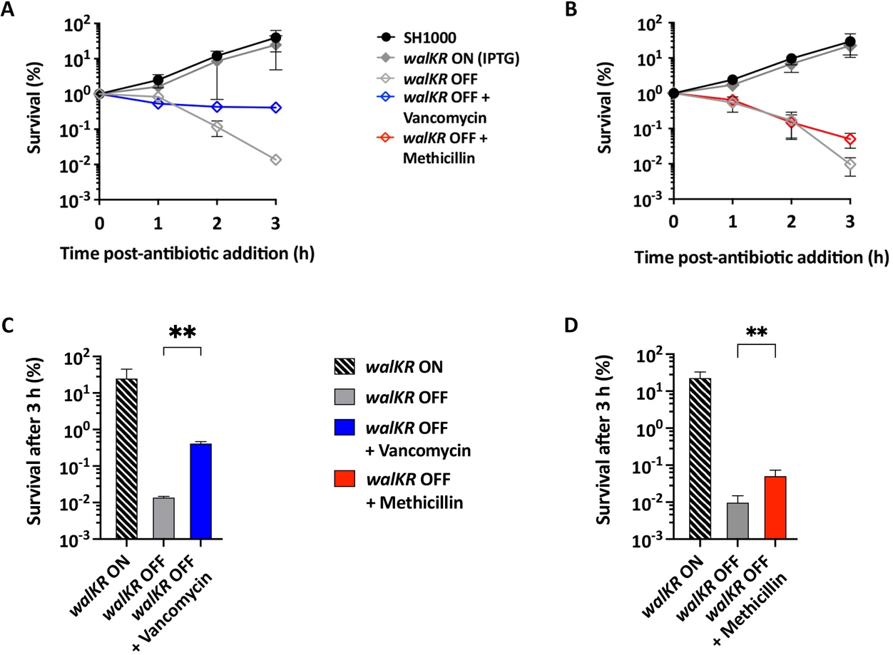
Figure 5.50 Effect of vancomycin and/or methicillin on S. aureus walKR survival.
S. aureus walKR treated with 10 X MIC of methicillin and/or vancomycin. The walKR OFF corresponds to the removal of the inducer (IPTG) for this conditional lethal strain. Normalised percentage survival of bacterial cells with (A) vancomycin (3 biological repeats) or (B) methicillin (6 biological repeats). Experiment carried out by Dr. Bartlomiej Salamaga. (C-D) Normalised percentage of survival after 3 h of treatment with (C) vancomycin and (B) methicillin, from the data in (A) and (B), respectively. (C-D) Statistical analysis: t-test with Welch’s correction (walKR OFF vs. walKR OFF vancomycin ** p = 0.0069; walKR OFF vs. walKR OFF methicillin ** p = 0.0063; walKR ON vs. walKR OFF vancomycin non-significant p ≥ 0.05; walKR ON vs. walKR OFF methicillin non-significant p ≥ 0.05).
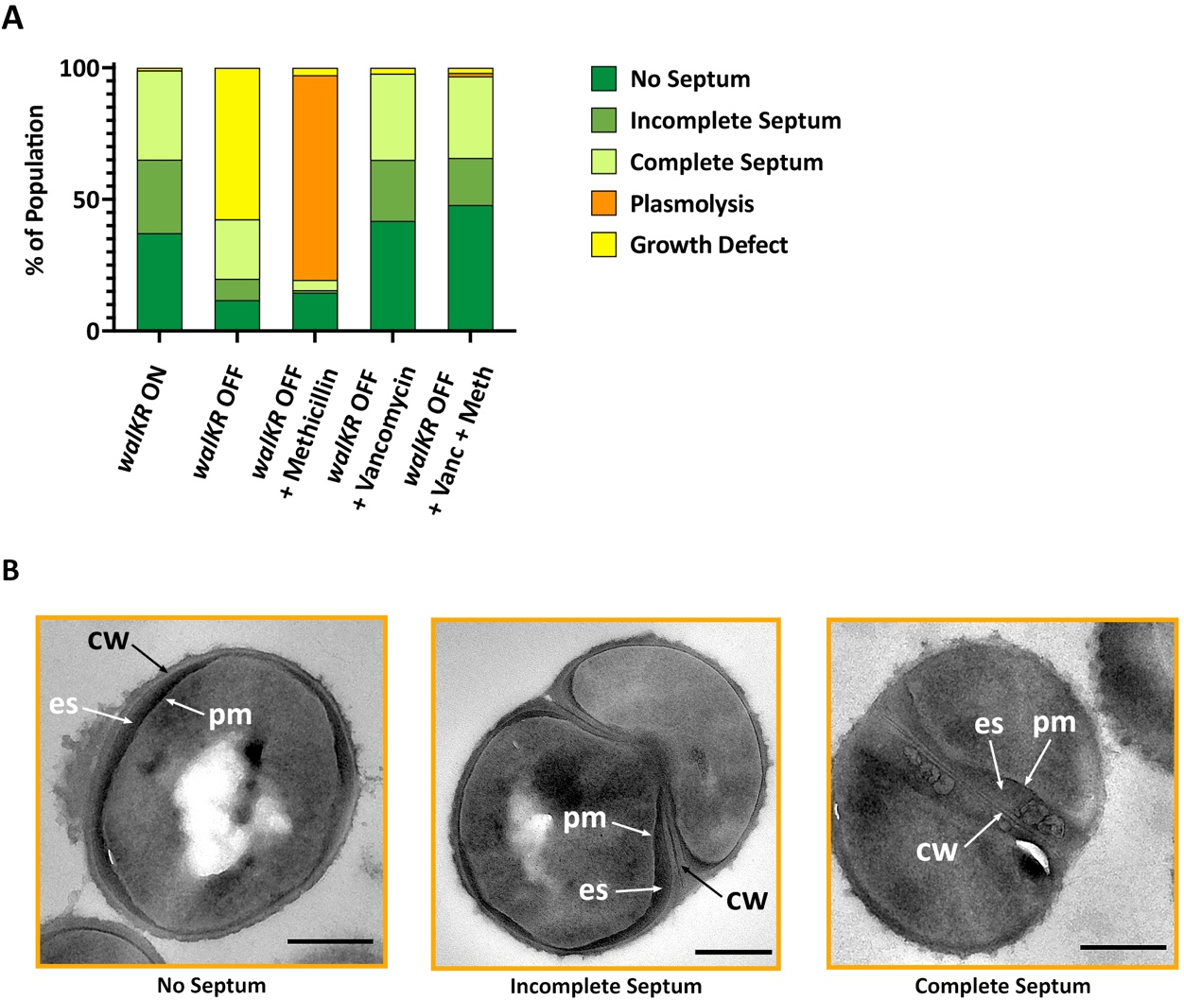
Figure 5.51 Effect of vancomycin and/or methicillin on S. aureus walKR morphology.
S. aureus walKR treated for 3 h with 10 X MIC of methicillin and/or vancomycin. WalKR OFF corresponds to the removal of the inducer IPTG on this conditional lethal strain. (A) Morphological quantification of the control walKR ON with IPTG (2 biological repeats, n = 824), control walKR OFF without IPTG (2 biological repeats, n = 856), walKR OFF with vancomycin (2 biological repeats, n = 826), walKR OFF with methicillin (2 biological repeat, n = 1063), and walKR OFF with vancomycin plus methicillin (2 biological repeats, n = 470) as indicated. No septum– dark green, incomplete septum– medium green, complete septum– light green, plasmolysis– orange, and growth defects– yellow. (B) Representative cells from TEM micrographs of chemically fixed thin sections showing signs of plasmolysis. Cropped from high magnification (4800x), scale bar 300 nm. pm– plasma membrane, cw– cell wall, ex– exoplasmic space.
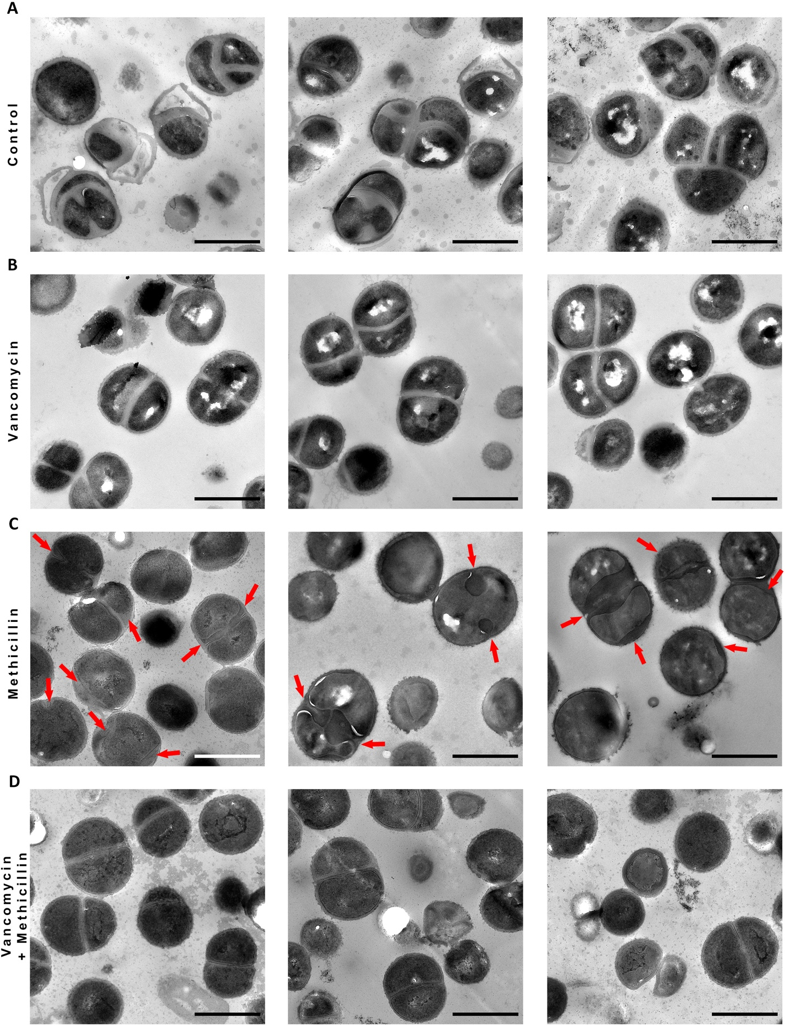
Figure 5.52 Effect of vancomycin and/or methicillin on S. aureus walKR mutant phenotype.
TEM micrographs of chemically fixed thin sections of S. aureus walKR without the inducer IPTG. (A) untreated and treated for 3 h with 10 X MIC (B) vancomycin, (C) methicillin, or (D) vancomycin plus methicillin. High magnification (4800x), scale bar 1 µm. Black arrows indicate areas where the exoplasmic space is expanded.

Discussion.
The natural progression of the cell cycle for S. aureus can be seen in the schematic Figure 5.53 (black arrows), together with the effect of the addition of supra-MIC levels of the cell wall antibiotics β-lactam (red arrows) or vancomycin (alone or combined with β-lactams, blue arrows). This model summarises the morphological changes observed when treating S. aureus with these bactericidal antibiotics. Below we discuss these changes, the disruption caused to PG homeostasis, and how it leads to antibiotic-induced death.
Cell wall antibiotics inhibit PG synthesis and result in a decrease of dividing cells and increase of cells without septum (Figure 5.5). One hour after the addition of antibiotics, the number of methicillin-treated cells with a complete septum falls significantly (Figure 5.5), which could be explained by the autolysin Atl continuing cell separation, and thus leading to an increase of cells with no septum. Vancomycin’s inhibition of Atl ^{[199]} and potentially other PGH demonstrates why cells treated with this antibiotic do not follow the same profile as methicillin-treated cells.
All antibiotics led to a significant increase in cell volume (Figure 5.6) and CW morphological changes. These comprised a reduction in cell wall thickness (Figure 5.9) paired with a fuzzy appearance of surface of the cell wall (Figure 5.10) (grey in Figure 5.53). This is characteristic of the continued action of PGH affecting the cell wall architecture, appearance, and eventually leading to cell death (Figure 5.1). Vancomycin does not show any further morphological changes before general lysis and cell death, however methicillin and oxacillin showed an expansion of the exoplasm and the appearance of bulbous septa (section 5.3 and 5.4, pink in Figure 5.53). The micrographs obtained from methicillin-treated cells were reminiscent of plasmolysis, as observed in SH1000 cells treated with high concentration of NaCl presenting blebs in the exoplasm and expansion of the exoplasmic space (Supplementary Figure 12 and Supplementary Figure 13). Therefore, it was suspected that methicillin and oxacillin were plasmolysing cells. Vancomycin’s slower mortality rate (Figure 5.4) does not seem to be correlated with a delay in showing signs of plasmolysis, as no significant signs of an expanded exoplasm were found after 1, 2, nor 3 h of exposure (Figure 5.17 and Figure 5.18). This indicates that only β-lactams lead to plasmolysis.
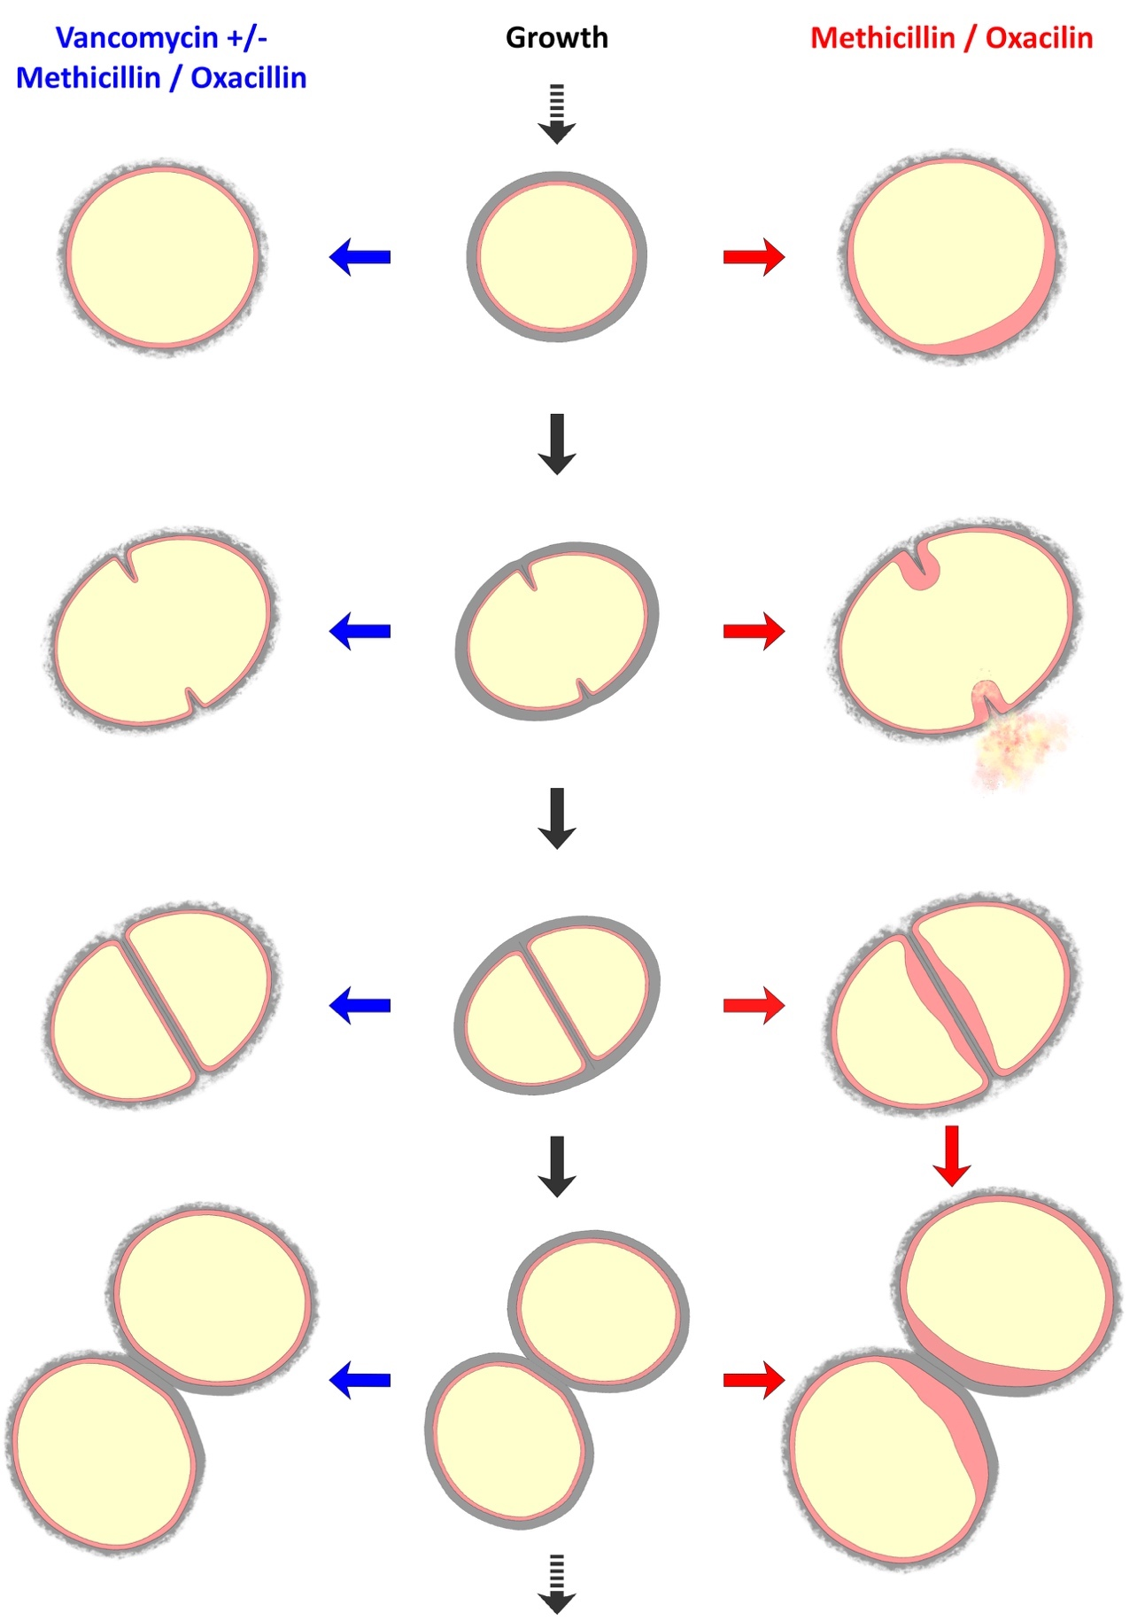
Figure 5.53 Schematic representation of S. aureus growth, division and the effect of cell wall antibiotics on its morphology.
Black arrows– cell cycle of S. aureus with normal growth and division (top to bottom). Red arrows– effect of the addition of supra-MIC levels of methicillin or oxacillin on the morphology of S. aureus. Blue arrows– effect of the addition of supra-MIC levels of vancomycin alone or combined with β-lactams (methicillin or oxacillin) on the morphology of S. aureus. Yellow– cytoplasm, Pink– exoplasm, Grey– cell wall.
WTA and LTA lacking strains showed a higher percentage of plasmolysed cells and an increased death rate in the presence of antibiotics than the wildtype (Figure 5.16, Figure 5.35 and Figure 5.37), with the exception of the ltaS gdpP::kan mutant’s diminished susceptibility to β-lactams, most likely due to the suppressor mutation in gdpP (Figure 5.32 and Figure 5.36) ^{[63,155–157,247]}. This gene codes for a membrane phosphodiesterase, GdpP, that hydrolyses the essential signalling molecule cyclic di-AMP (c-di-AMP) ^{[63]}. Inactivation of gdpP leads to a ~ 10-fold increase of c-di-AMP in S. aureus ^{[63]}. Previous studies have shown a positive correlation between c-di-AMP levels and β-lactam tolerance, whereby high or low signalling levels lead to an increase or decrease resistance to these antibiotics, respectively ^{[63,155–157]}. Therefore, it is not surprising so see a diminished susceptibility of ltaS gdpP::kan to methicillin in comparison to its parental strain (Figure 5.36a,c). The increased death rate and percentage of plasmolysed cells observed with tarO corroborate previous studies where the loss of WTA led to a deregulation of PGH and increased cell lysis ^{[59,290]}. This was further supported by AFM analysis of untreated sacculi samples of WTA lacking strains, which showed size deformations and division aberrations, with a less uniform and looser PG mesh than the wild type SH1000 ^{[248]}. Areas where PG ring structures should be present (newly exposed septa) ^{[211]}, showed a looser mesh-like structure with almost no signs of rings, which might imply that they are easily degraded by PGH, or that they never formed fully to begin with because of the lack of WTA ^{[248]}. AFM analysis of LTA lacking strains, however, showed a similar PG structure to that of the wild type, presenting the expected PG mesh and rings ^{[248]}. Further AFM analysis is needed to provide some more information on PG structural changes of methicillin-treated sacculi from WTA and LTA lacking strains.
Our plasmolysis theory contradicts the model of β-lactam killing of S. aureus proposed by Giesbrecht and the explanation for the morphological changes seen in penicillin-treated cells ^{[289]}. Giesbrecht’s study proposed that it was an inner fibrillar cell wall material in the bulbous septa, and that this “secondary wall” reacted differently when chemically fixed ^{[289]}. This assumption was therefore tested, to uncover if the expansion of the exoplasm was caused by an accumulation of polymers. Our results showed that there is no apparent physical accumulation of either PG, lipid, or teichoic acids precursors (Figure 5.28, Figure 5.30, Figure 5.35, Figure 5.37), thus, supporting our theory that these do not cause the phenotype observed with β-lactams.
Unlike standard chemical fixation TEM, cryo-EM provides the opportunity to study the cell in a hydrated state and without any chemicals or heavy stains that could interfere with cellular structure. Cryo-EM of whole cells and cryo-ET showed that methicillin treated cells become electron-transparent in comparison to the electron-dense control (Figure 5.39), meaning that the structural integrity of the CW has been compromised and its subsequent rupture led to the loss of cytoplasmic content. This result corroborates that the phenotype observed with methicillin is consistent through different electron microscopy techniques (Figure 5.39), and we can conclude that the retraction of the plasma membrane, the expansion of the exoplasmic space, and the presence of blebs are due to plasmolysis.
Giesbrecht also focused on murosomes, described as “minute, vesicular, extra plasmatic wall organelles” involved in the lytic process of septa formation and cell separation, as the main pathway through which β-lactams kill S. aureus ^{[289]}. This study proposed that these murosomes, located in what they refer to as the secondary wall, are involved in normal septation, put can also lead to the perforation of the CW and subsequent cytoplasmic leakage and cell death in the presence of penicillin. The model of death therefore starts with the arrest of the first division after the addition of the antibiotic, followed by the initiation of the second division at a 90° angle, where the murosomes induce a centripetal lytic process ^{[289]}. It is our belief that the murosomes seen in this study were blebs caused by plasmolysis, and that the secondary wall is the exoplasm. Giesbrecht described this secondary wall as having differential staining when penicillin was present, but we understand that they were looking at the exoplasm which was now expanded as a result of plasmolysis (Figure 5.54). The expanded exoplasmic space is easier to detect and identify, especially in dehydrated samples. Blebs can also easily be confused, especially when analysing samples treated with various chemicals and heavy stains such as chemical fixation TEM. However, cryo-EM (Figure 5.41) together with experiments with high salt concentration (Supplementary Figure 12 and Supplementary Figure 13) confirms that those small vesicles are characteristic of plasmolysis, and they can be found anywhere in the expanded exoplasm. They do not seem to be specifically located or restricted to the division site.
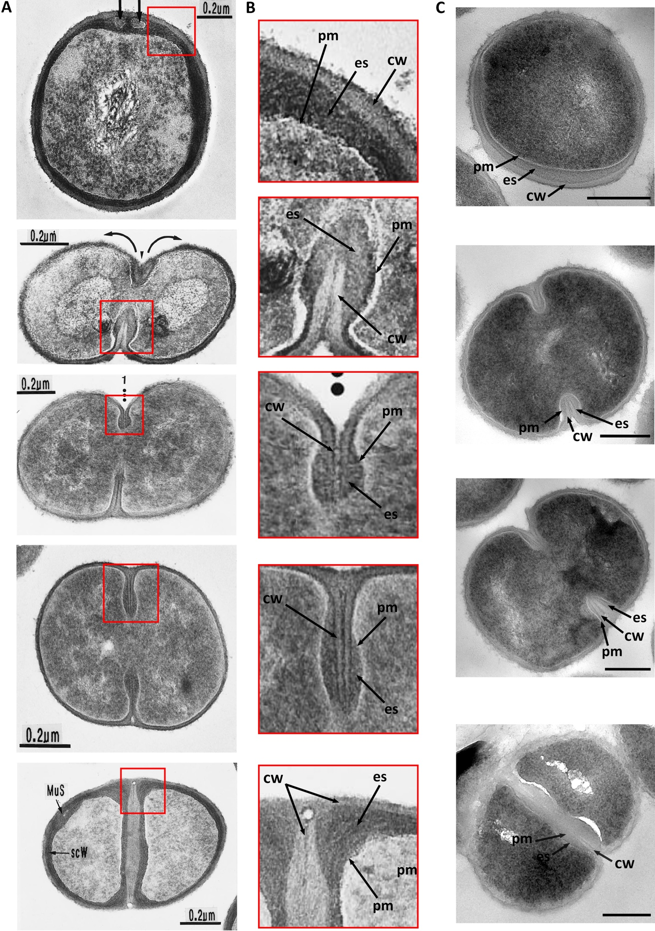
Figure 5.54 Comparison of EM studies on the action of β-lactam antibiotics.
(A) Thin sections of penicillin treated cells, obtained from Giesbrecht et al., (1998). (B) Our interpretation of Giesbrecht’s images. Magnified areas from the red square in images (A). (C) Comparable TEM micrographs from thin sections of cells treated with 10X MIC methicillin from this study. CW– cell wall, pm– plasma membrane, es– exoplasmic space. Cropped from high magnification (4800X), scale bar 300 nm.
Another contradiction with Giesbrecht’s study lies in the breaking point of the cell wall. It was stated that the CW rupture happened at the second division, at a 90° angle from the visible septa (first division) (Figure 5.3). However, the majority of the population affected by plasmolysis in this study are dividing cells with an incomplete septum (Figure 5.16), and it was noticed that a typical breaking point appears to be the septum (Figure 5.40). This contradicts Giesbrecht’s model and suggests that the new septal wall could be the weakest point of the cell. The peripheral cell wall would be weakened by the halt of PG synthesis; however, the septal wall might be the most affected as it is a wall that is not yet fully formed. This hypothesis would need further study, as our recent investigation with AFM did not find any septa in a suitable condition for analysis after treatment with methicillin ^{[247]}. This could be due to the septal wall being too damaged or the low-throughput of this microscopy technique. The septal plate has been documented to have a differential organisation of PG (concentric rings) in comparison to a dense mesh seen on the old surface wall^{[211]}. The concentric rings are stiffer than the mesh^{[53,211]}, but the organisation of PG might not be the only factor affecting the strength of the cell wall. The presence and location of WTA on the septal plate could also be affecting the susceptibility of the septum to hydrolysis. It has been proposed that the septum is devoid of WTA and this polymer affects the activity of PGH ^{[59,291]}. In fact, Atl is localised at the septum as its binding to PG containing WTA is impaired ^{[59,61]}.
The plasmolysis theory is not only confirmed by the electron-transparent cryo-EM micrographs, but also by the supporting data obtained from atomic force microscopy (Figure 5.55) ^{[247]}. AFM analysis has shown that sacculi of methicillin or vancomycin-treated cells develop perforating holes spanning the CW, with methicillin treatment leading to bigger holes than vancomycin (Figure 5.55) ^{[247,248]}. This could imply that the continued action of PGH without the counterbalance of PG synthesis could be compromising the structural integrity of the cell wall, impeding ability of the cell to withstand turgor.
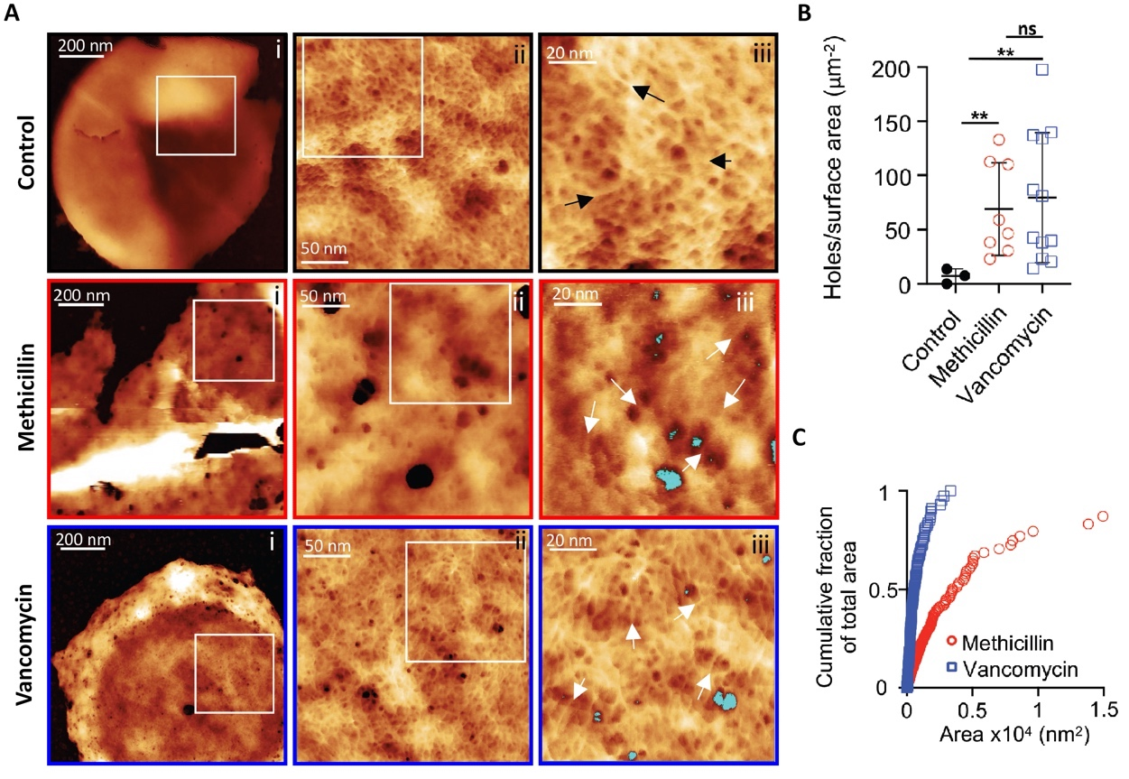
Figure 5.55 The effect of methicillin or vancomycin on peptidoglycan architecture.
(A) AFM images of the internal surface of isolated sacculi of S. aureus untreated (black panels) and treated for 1 h with methicillin (red panels) or vancomycin (blue panels): (i) height channel of individual sacculus with the internal surface facing upwards; (ii) Zoomed image from the squared white area marked in (i); (iii) Zoomed image from the squared white area marked in (ii).The control shows a finer internal peptidoglycan (PG) architecture consisting of a randomly oriented glycan fibrous mesh (black arrows) with small pores between the fibres. Methicillin and vancomycin show an internal coarse PG architecture with perforating holes that span all the way on the cell wall. Randomly oriented glycan fibrous mesh (white arrows) can be identified, with small pores between the fibres next to some of the perforating holes (traced in cyan). (B) Holes per surface area of sacculus (μm2) for the control (n = 3), methicillin-treated (n = 8) and vancomycin-treated (n = 12). Scatter plot shows the mean value and standard deviation. Statistical analysis: t-test with Welch’s correction (control vs. methicillin ** p = 4.3·10-3; control vs. vancomycin ** p = 1.5·10-3). (C) Cumulative fraction of total area of perforating holes for vancomycin (n = 899) and methicillin (n = 678). All images and analysis carried out by Dr. Pasquina Lemonche ^{[247,248]}.
The thorough analysis of bacterial strains under the effect of bactericidal antibiotics carried out in this chapter, lead us to believe that vancomycin inhibits the plasmolysis seen with methicillin or oxacillin. When added together, vancomycin with either of these β-lactams responds in a similar way to vancomycin alone in respects to its survival, phenotype, and division profile. These results suggest that in addition to a common bactericidal mechanism between these antibiotics, β-lactams have a second mode of death that takes the form of plasmolysis and lysis; and that vancomycin can hinder this. An additional study with Triton X-100 carried out by Dr. Salamaga showed that vancomycin inhibits general lysis with or without methicillin ^{[247]}, suggesting once more that vancomycin can interrupt methicillin’s specific method of death and that one or more PG hydrolases involved in lysis could be responsible.
Our model for bacterial life and death predicts that CW antibiotics lead to death as a result of the continued action of PG hydrolases (PGH) (Figure 5.1). This naturally made us turn our attention towards the major PGH SagB, a glucosaminidase involved in the cleavage of PG strands and general cell growth and division ^{[53,64]}. TEM micrographs confirmed that sagB reacted similarly to SH1000 when treated with these antibiotics, including the observed plasmolysis with β-lactams (Figure 5.44 and Figure 5.43). However, the significant increase in survival observed in vancomycin-treated cells and not with methicillin, suggests that SagB plays an important role in the mode of killing of this antibiotic (Figure 5.42). This was corroborated by a parallel AFM experiment performed by Dr. Pasquina Lemonche, whereby sagB cells treated with vancomycin showed fewer and smaller CW spanning holes than SH1000. These results indicate a common killing mechanism associated with growth, that involves cell wall perforating holes caused by SagB and others PGH.
In an attempt to further understand the β-lactam-specific mode of death, Atl a major PGH involved in lysis and scission and a target for vancomycin, was tested ^{[55,57,199]}. Our results show that while the atl mutant shows a significant increase in survival when treated with methicillin (Figure 5.45), it still presents clear signs of plasmolysis (Figure 5.48). Parallel AFM analysis carried by Dr. Pasquina Lemonche showed that atl treated with methicillin has smaller, although just as frequent, CW spanning holes in comparison to the wild type ^{[247]}. Together, these results indicate that Atl is greatly involved in the specific mode of killing of β-lactam antibiotics associated with lysis and division, although it is not solely liable for bacterial death. Therefore, some other PGH or groups of PGH must be involved in causing the perforating holes that extent across the cell wall and lead to the cell’s inability to maintain its high internal turgor pressure.
Our in depth study on bactericidal antibiotics and their role in bacterial death, has confirmed the importance of the highly regulated balance between synthesis and hydrolysis, as loss of either of them leads to death (Figure 5.1). To prove the paradoxical prediction that loss of both synthesis and hydrolysis leads to stasis, we focused on the main PGH regulator WalKR. This two-component system controls the expression of multiple hydrolases which are essential for cell wall metabolism and cell division^{[78]}. The increased survival rate of the walKR-depleted mutant with either vancomycin or methicillin confirms the predictive model for bacterial life and death, whereby a reduction of PGH activity alone can lead to cell death (Figure 5.49) while inhibiting PG synthesis as well leads to stasis (Figure 5.50, Figure 5.1) ^{[247]}. Additionally, TEM micrographs showed that these bactericidal antibiotics rescue walKR’s aberrant phenotype, stressing how a halt in PG synthesis together with a depletion in hydrolase activity helps escape a lethal fate (Figure 5.50, Figure 5.52).
Overall, this study has played a crucial part in a multidisciplinary approach to not only elucidate the basic mechanism of bacterial growth and division, but also how cell wall antibiotics exert their bactericidal effect.

Chapter 6
General Discussion
Staphylococcus aureus has become a major healthcare concern after the emergence of strains resistant to multiple antibiotics, such as MRSA ^{[9,10]}. Thus, scientists have been focusing on the development of new antimicrobial agents that could treat these human pathogens. Many current treatments target the bacterial envelope, as this complex and dynamic component protects the protoplasm and mediates interactions with the environment ^{[14,292]}. S. aureus bacterial envelope consists of the plasma membrane (PM), the exoplasmic space (ES), and the peptidoglycan cell wall (CW). Although the structure of the bacterial envelope of S. aureus is well studied ^{[14,292]}, there is still a lot to uncover. It was not until 2006 that the analysis of frozen-hydrated S. aureus samples showed the existence of an exoplasmic space ^{[16]}. Yet, few studies have been published on the matter since then. This investigation intended to find the best electron microscopy techniques to study the bacterial envelope (chapter 3), and carry out a detailed analysis of the ES and its maintenance (chapter 4). Finally, this study also investigated CW dynamics and the morphological changes observed during the action of bactericidal antibiotics (chapter 5).

Study of the architecture of the bacterial envelope.

CEMOVIS for hydrated analysis of the exoplasm.
Chapter 3 has shown the importance of selecting the right microscopy technique for bacterial analysis. I have optimised freeze-substitution and showed how it can provide more structural information than conventional chemical fixation TEM for an in depth analysis of the bacterial envelope. However, a more comprehensive study of the bacterial envelope, with focus on the exoplasm, requires the analysis of frozen-hydrated samples.
Cryo-electron microscopy of vitreous sections (CEMOVIS) does not employ any structurally damaging fixatives or heavy metals, and most importantly, it does not use any solvents which dehydrate and modify the cell architecture. Thus, as supported by the literature, it provides the best approach for analysing the bacterial envelope and distinguish the ES in its hydrated native state ^{[16,163–165,275]}. The ice contamination observed in this investigation made the analysis difficult and might have affected the resulting density traces used for measurements (Figure 4.6, Figure 4.7). Nevertheless, this first attempt at CEMOVIS has proven that this technique is capable of providing the necessary data to study the exoplasm in detail. Additional repeats and experience from the researcher performing the experiments could result in better quality samples. This will improve data analysis by providing better differentiation of all components of the bacterial envelope.

Discovery of previously unidentified layers in the bacterial envelope: where are WTA and LTA?
During my study of the exoplasmic space (chapter 4), initial tests using freeze-substitution showed highly preserved cells with two unidentified layers in the bacterial envelope (Figure 4.4c,f). Layer I, similar to the contrast observed from the CW, and Layer II, a heavily stained band similar to the highly-reactive LTA band of the exoplasm. These layers put into question the current accepted structure of the cell envelope ^{[16]} and could provide some input into the location of teichoic acids. Here I discuss 2 possible scenarios to explain the nature of these layers:
– Scenario 1 – The first scenario proposes that layer I is part of the ES and layer II corresponds to WTA in the CW. This initial theory comes from the suggestion that WTA repulse themselves and protrude outwards and inwards from the CW ^{[16,166]} (Figure 6.1b). This scenario raises the following questions: why would the exoplasm consist of two differential stain-reactive regions? Why would the exoplasm be similar in thickness to the CW in dehydrated samples, if it has been proven to be of a similar thickness to the CW only when hydrated? ^{[16]}.Therefore, I propose that both layers I and II are more likely part of the CW (scenario 2).
– Scenario 2 – The second theory suggests that both layers are part of the CW (Figure 6.1b). This makes the width of the CW and the ES comparable to other results (Figure 4.4). In this scenario, layer I is made up of PG, as it has a similar contrast to the rest of the CW. I further theorise that layer I is the inner CW and that the heavily-stained layer II corresponds to TA, as they are highly reactive to OsO₄ and post-stains. A recent study performed with atomic force microscopy (AFM) has shown that S. aureus has a differential PG structure depending on its location (Figure 6.1a) ^{[211]}. The inner CW is composed of a (i) dense mesh of randomly oriented PG strands. The outer CW is either (ii) an open textured porous gel, corresponding to the more matured CW, or (iii) dense concentric rings from newly synthesised PG that originates from the septal plate. These three PG conformations would have a similar reaction to chemical fixation and staining, however the presence or absence of a dehydrated mass of TA would not. Hence, I propose that layer I corresponds to the dense mesh of the internal CW, and Layer II is either WTA or LTA delimiting the start of the external CW (concentric rings at the septum or a matured loose mesh at the periphery of the cell) (Figure 6.1a).
Is it possible that layer II is made-up of LTA? It is unlikely that LTA would branch out so far into the CW, as the average length of LTA chains in S. aureus (~ 22 nm) is closer to the width of the hydrated exoplasm (~ 15.8 nm ± 2.5 nm) ^{[84,166]}. In dehydrated cells, LTA collapses in the ES, which leads to the heavily stained band observed in both chemical fixation and FS samples. This idea is consistent with Erickson (2021) ^{[166]}, who proposes that LTA molecules are present in such high numbers, that they are unable to penetrated the infrequent pores present in the dense mesh of the inner CW. Although further studies are necessary, preliminary data from this study also shows that layer II is present in LTA-lacking strains, iltaS and ltaS gdpP::kan (Figure 4.23, Figure 6.1c). This might indicate that layer II is therefore made of WTA instead. Yet, a higher number of cells and biological repeats are needed to confirm the existence of this layer throughout a bigger sample population before dismissing this completely.
The hypothesis that layer II is made of WTA could suggest that these polymers are not present in the inner CW (dense mesh). This suggestions seems unlikely given that WTA are coupled to uncrosslinked PG by membrane-associated LCP enzymes ^{[139,140]}. Nevertheless, it is worth investigating and confirm if these polymers are able or not to be anchored to the dense mesh of the inner wall. Although all three PG structures are chemically similar (Figure 6.1a) ^{[211]}, the level of crosslinking or unlinked glycan ends could differ, and this would factor in the localisation of WTA ^{[140]}. There is still a lot of debate on the location of these polymers, particularly at the septum, and the recent publication of the three differential PG structures (described above) means that further tests are needed to uncover the level of PG crosslinking and specify the exact location of WTA in the new framework ^{[211]}. Preliminary AFM studies (Dr. Pasquina Lemonche), have shown that the outer CW of tarO has less concentric rings and a more open and porous mesh than the wild type. The bigger holes between PG strands in tarO coincides with our understanding that lack of WTA increases susceptibility to PGH ^{[59]}. Unfortunately, AFM analysis of the inner CW from purified PG of tarO has not yet been analysed. Future work could show if there is a comparable difference in the internal PG structure, between tarO and SH1000. A similar internal PG disposition between the WTA-lacking mutant and its parental strain, would support the theory that WTA are not present in the inner CW. Conversely, a more opened (more hydrolysed) dense mesh in tarO cells in comparison to SH1000 could be indicative of the presence of WTA in the inner CW. If WTA are present in both the inner and outer CW, it would be necessary to investigate why TA accumulate in the middle of the CW (layer II) in a dehydrated sample. A combination of HPLC and AFM techniques could help understand the level of crosslinking of PG across the CW. These experiments would have to be correlated with other microscopy techniques, using WTA-specific labels for precise localisation of these polymers. Correlative light electron microscopy (CLEM) or the use of nano-gold particles, could provide the means to localise WTA in bacterial cross sections. Future TEM of freeze-substituted tarO cells could show if this mutant presents the heavily stained layer II, and its absence could be indicative of its correspondence to WTA.
Finally, a third possibility is that layer I belongs the CW while layer II is an artefact of this technique. The consistent location and pattern of these layers observed at various division stages and strains, make this an unlikely possibility. Further FS tests of WTA and LTA-depleted mutants, together with the use of specific label for each type of TA, could help identify the nature of these layers.

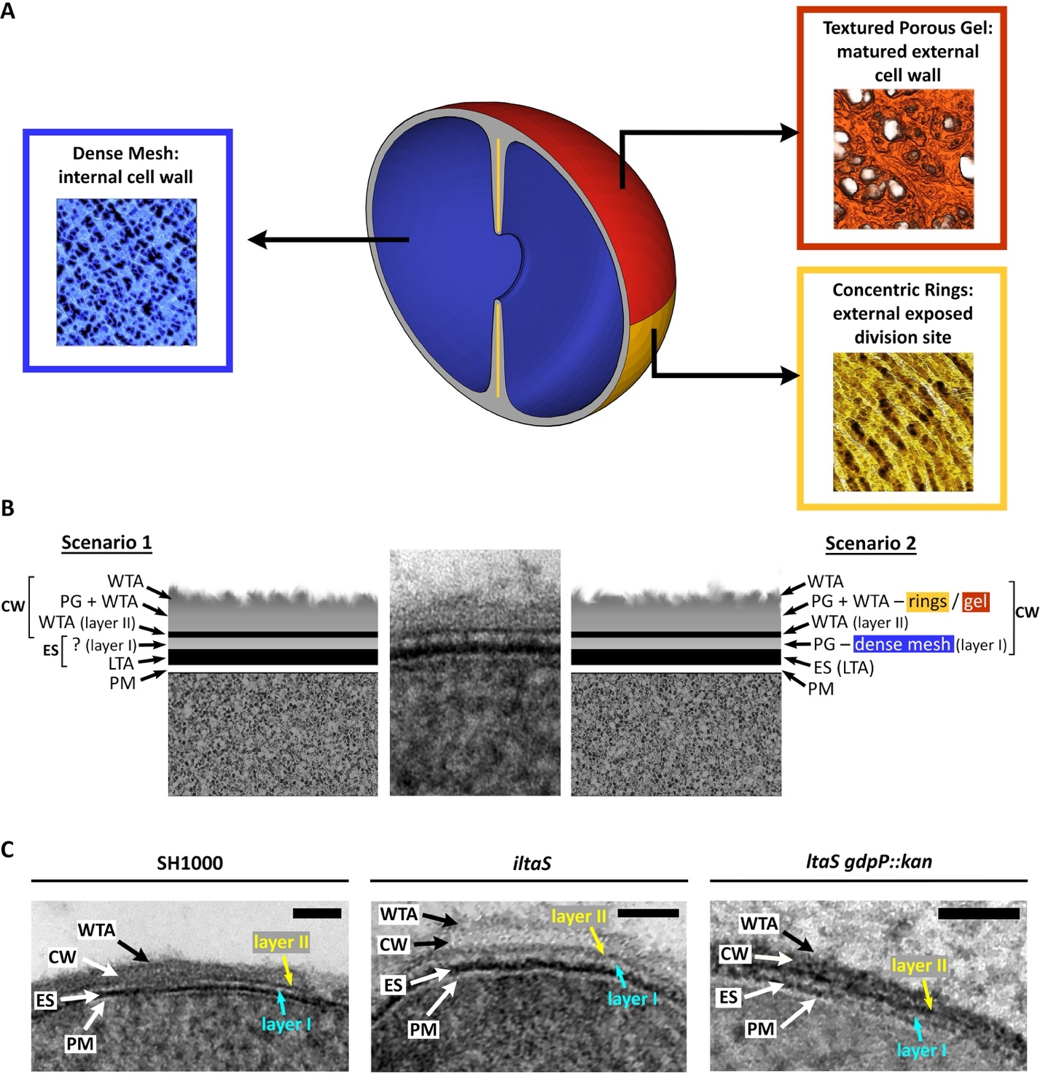
Figure 6.1 Possible explanation for the bacterial envelope structure of freeze-substituted S. aureus cells.
(A) Schematic representation of the molecular arrangement of PG in S. aureus cells. Adapted from Pasquina-Lemonche et al., (2020) ^{[211]}. (B) Schema of two possible explanations for the structural information obtained from freeze-substituted S. aureus cells. In scenario 1, the CW is limited by stain-reactive WTA that protrude from the outer and inner sides of the CW. Layer I could be a part of the ES or an unidentified region. In scenario 2, the CW corresponds to either the newly synthesised dense concentric rings (yellow in (A)) or the matured porous gel of the older CW (orange in (A)). Layer I corresponds to the dense mesh of the internal CW (blue in (A)). Layer II could be made-up of (a) WTA or (b) LTA that delimit the outer and inner CW. The former theory (scenario 2a) assumes WTA are absent from the inner dense mesh of PG while the latter (scenario 2b) assumes that LTA branch outwards from the plasma membrane and the exoplasm, into the CW. (C) Representative FS micrographs of SH1000, iltaS and ltaS gdpP::kan, as indicated. Layer I (cyan) and layer II (yellow) are two undefined layers. Scale bars 50 nm. CW– cell wall, ES– exoplasmic space, PM– plasma membrane, WTA– wall teichoic acids, LTA– lipoteichoic acids.

Dynamics of the bacterial envelope.

How is the exoplasmic space maintained?
Unfortunately, due to time and laboratory access restrictions during the last year of research, planned cryo-EM analysis on vitrified thin sections of tarO and ltaS gdpP::kan could not be carried out. These experiments would have been critical to further study the proposed theories for the maintenance of the exoplasmic space (ES) ^{[166]}. At the time of writing this thesis, Erickson (2021) ^{[166]} published a study that coincides with our theories on how the ES is maintained. Here we discuss said theories, compare them with our preliminary data on the role of teichoic acids (TA), and mention planned experiments that could have helped further understand the ES maintenance.
TA act as the OPGs of Gram-positive bacteria.
Erickson (2021) ^{[166]} published a quantitative calculation of the net concentration of negatively charged phosphate groups present in both types of TA in the exoplasm, and he suggested that this together with the additional anionic membrane proteins, was enough to attract a sufficient concentration of cations able to neutralise those negative charges, and balance the excess osmolality of the cytoplasm. This means that TA in the exoplasm are acting like the osmo-regulated periplasmic glucans (OPGs, section 1.6.1 and 4.1) of Gram-negative bacteria that help maintain the periplasmic space.
To test this further, ltaS gdpP::kan should also have been analysed by CEMOVIS. If LTA were acting as the OPGs of Gram-negatives, the lack of LTA would mean that an isosmotic equilibrium would not be achieved and the exoplasm would collapse. This would also result in a narrower ES measurement of vitrified thin-sections in ltaS gdpP::kan. Analysis of the tarO mutant could also give indication if both WTA and LTA are needed for attracting sufficient neutralising cations, or if only one type of TA is enough. An additional crucial experiment would involve modifying S. aureus SH1000 growing conditions by increasing and reducing the concentration of divalent cations, such as Mg^{2+,} and slightly modifying the pH of the growing medium to modify the available D-alanine ester residues in TA ^{[85,87]}. This would affect the binding of said cations and could in turn result in differential ES measurement from frozen-hydrated thin-sections.

TA generate an electrostatic repulsion in the ES.
Figure 6.2a is a schematic representation of Erickson’s model, where the interaction of WTA and LTA in the exoplasm leads to an electrostatic repulsion force that helps maintain the ES. Erickson also proposes that in an ideal space without turgor, WTA and LTA are long enough to be extended in the exoplasmic space, and LTA with its 25 Gro-P units measuring ~ 22 nm would fit perfectly in the exoplasm of B. subtills of the same width ^{[84,164,166]}. However, S. aureus has an exoplasmic space of 16 nm ^{[16]}, indicating that LTA chains could be slightly compressed or could extend into the CW. Erickson suggests that LTA would not be able to penetrate the inner dense mesh of the CW ^{[166,211]}, and therefore would fold backwards. Thus, in a WTA-depleted cell, LTA would push against the CW and would be able to maintain the exoplasmic space (Figure 6.2c). This would also explain why tarO mutants are still viable. Analysis of tarO by CEMOVIS would help test this assumption. If this theory is correct, the WTA-depleted mutant would have a narrower, although viable, ES than the wildtype due to the lack of repulsion/interaction between LTA and WTA. The same experiment should be carried out with LTA-depleted mutants. Erickson proposes that in the absence of LTA, WTA chains that extend into the exoplasm would end-up folding backwards as they cannot penetrate the PM (Figure 6.2b). In both cases, either lacking WTA or LTA, there would still be some electrostatic repulsion within the chains of the remaining polymer, as there would be enough density of negative charges. Consequently, that density would be higher if both types of polymers were present and interacting with each other.
This electrostatic repulsion theory raises some questions: why would LTA not be able to penetrate the CW, if they are structurally similar to WTA? Erickson took the AFM analysis of the inner CW of S. aureus published by Dr. Pasquina Lemonche (2020) ^{[211]}, and counted 30 pores over the 60 nm² surface area of the published AFM image. Erickson suggests that in the same surface area there would be 667 LTA molecules, and that with 1 pore per 20 LTA it would be difficult for LTA to penetrate the CW as one LTA would result in loss of entropy and 2 LTA would encounter electrostatic repulsion ^{[166]}. As WTA are structurally similar to LTA, it could be argued that WTA might not be present in the inner CW either. I have proposed above (section 6.1.2, scenario 2) that the inner dense mesh of the CW might not have WTA, after observing a heavily stained layer present in the CW of freeze-substituted cells (layer II). If this were true, it would imply that neither LTA or WTA are able to penetrate the inner CW because of its PG distribution (dense mesh). Thus, maintenance of the exoplasmic space would not be achieved by a close interaction of these two polymers at the exoplasm. Further studies would be required to analyse if the WTA from the external CW would still generate an electrostatic repulsion with the LTA in the ES. Alternatively, the capability of LTA to bind to divalent cations and reach an isosmotic condition with the cytoplasm, in addition to the pressure generated by LTA against the CW might be enough to maintain the ES. LTA would then be mostly responsible for the ES, which supports the difference in viability between tarO and iltaS. These assumptions could be investigated by various microscopy techniques including specific-teichoic acid labelling, CLEM, and AFM of TA-lacking mutants. For instance, a collapsed ES of frozen hydrated samples of iltaS or a narrower ES in ltaS gdpP::kan in comparison to the wildtype could indicate that it is LTA alone maintaining this space. Equally, a similar ES between tarO and SH1000 would suggest that there is no repulsion between WTA and LTA affecting the ES and would support the idea that LTA is mainly responsible for the maintenance of the exoplasm.
Overall, Chapter 4 has generated more questions than answers over the maintenance of the exoplasmic space. Nonetheless, it presents a good basis together with the recently optimised freeze-substitution technique and the newly CEMOVIS cryo-EM described in Chapter 3, for future detailed study of LTA and WTA-depleted cells.

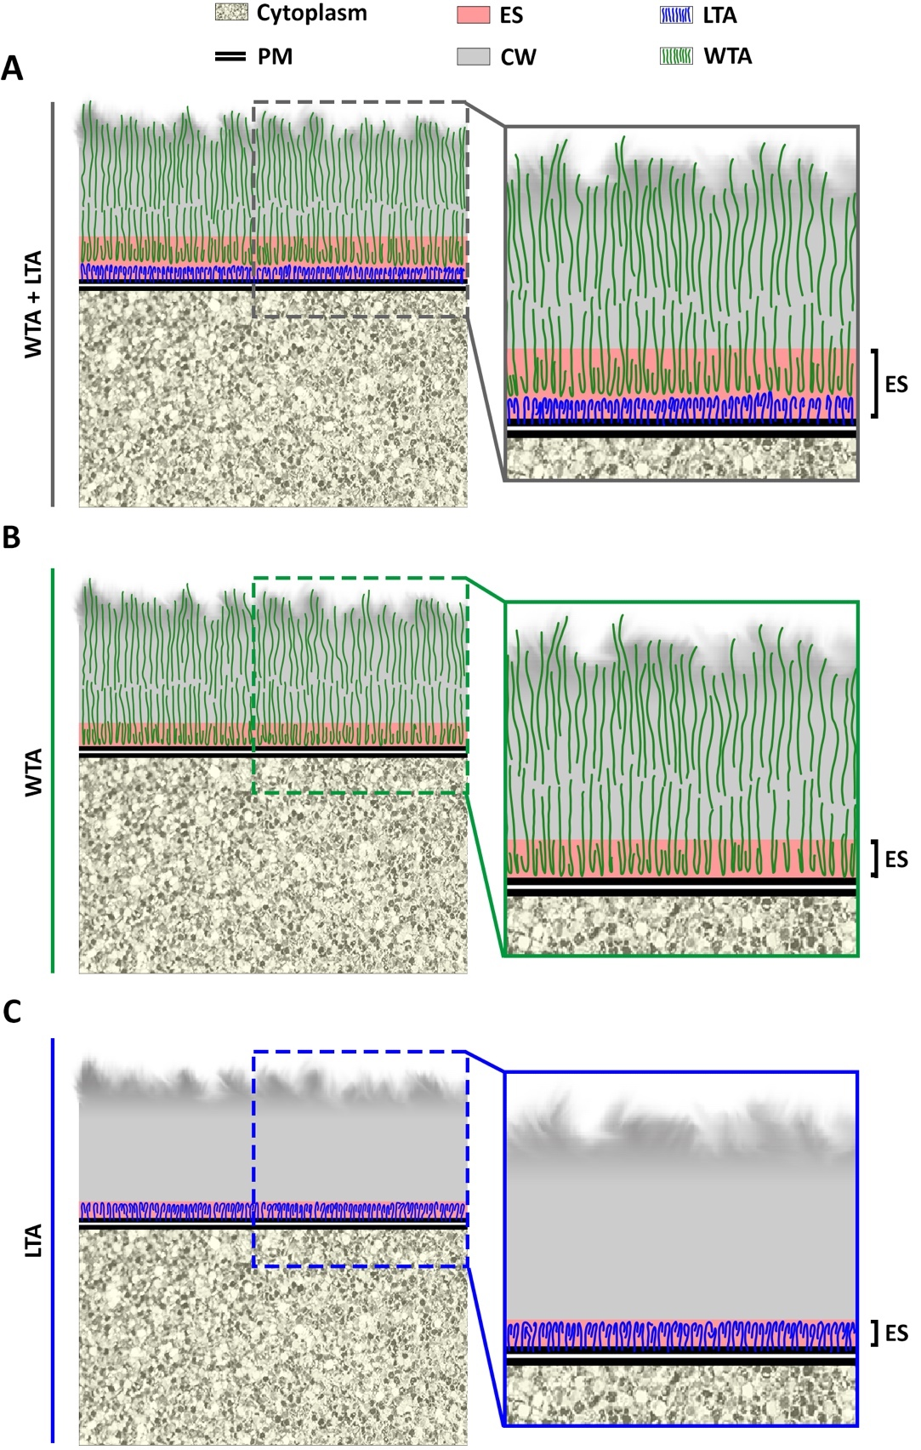
Figure 6.2 Maintenance of the exoplasmic space of Gram-positives.
Schema showing the theoretical maintenance of the exoplasmic space in the presence of (A) both WTA and LTA, (B) WTA alone, or (C) LTA alone. This theory assumes that LTA are not able to penetrate the inner CW, and that WTA and LTA polymer brushes generate enough electrostatic repulsion to maintain the exoplasm. Cytoplasm (yellow), PM– plasma membrane (two parallel black lines), ES– exoplasmic space (pink), CW– cell wall (grey), LTA– lipoteichoic acids (blue lines), WTA– wall teichoic acids (green lines). Based on Erickson (2021) ^{[166]}.

The balance between bacterial life and death.
Chapter 5 emphasized the intricate processes that regulate the balance between bacterial life and death. Our research with bactericidal antibiotics has shown that a halt in peptidoglycan (PG) synthesis in the presence of ongoing hydrolysis results in the unbalanced continuation of growth-associated processes until reaching lysis. Similarly, a reduction in PG hydrolysis, as seen in genetically modified S. aureus, increases survival when treated with bactericidal antibiotics. These results have shown the importance of both PG synthesis and hydrolysis for bacterial growth, as loss of either leads to cell death. Paradoxically, loss of both of these processes leads to stasis, as seen by the treatment of WalKR-depleted cells treated with CW antibiotics.
We have therefore presented a predictive model for cell wall homeostasis (Figure 5.1) and successfully established the molecular basis explaining why PG synthesis and hydrolysis are both required for bacterial growth, and how interruption of either leads to death, while lack of both results in stasis. This information is of great importance as it provides the basis for future research focused on alternative treatment of antibiotic-resistant S. aureus.

Intervention for treatment of antibiotic-resistant S. aureus.
Chapter 5 has established the action of bactericidal antibiotics in S. aureus, and their role in the highly regulated balance between life and death. The exact molecular mechanism that leads to cell death is still unknown, as the ongoing PG hydrolysis implicates multiple highly regulated hydrolases with redundancy in function. Although none of the hydrolases studied here are solely responsible for vancomycin or methicillin induced death, we have shown that SagB is a key component in the molecular killing mode of bactericidal antibiotics. This major growth-associated hydrolase can lead to an increase in size and number of CW perforating holes that eventually lead to cell lysis. We have also demonstrated that β-lactam antibiotics have an additional killing mode which leads to plasmolysis and a faster death. We have identified Atl as a major hydrolase involved in this β-lactam-induced death, as it plays a part, together with other hydrolases involved in cell separation, in early septal scission of incomplete septa and plasmolysis.
Our research has provided further evidence of what started as the original model for β-lactam killing in the 1960s ^{[181,182,280]}. The penicillin-induced death model mentioned a weaker cell wall of uncrosslinked PG, which eventually ruptures because of the high osmotic pressure within the cell ^{[181,182,280]}. Further studies showed this rupture was not mechanical but enzymatic ^{[281–283]}, and in this investigation we have provided evidence that both theories are correct. There is a weaker cell wall that results not only from uncrosslinked PG, but mostly from the ongoing action of PGH. However, the former might still be capable of withstanding high cellular turgor pressure, if it was not for the continued action of these hydrolases that weaken the CW structural integrity to a point where mechanical rupture occurs, leading to cell lysis. This results from the imbalance between synthesis and hydrolysis, as predicted by our bacterial model of life and death (Figure 5.1).
This collaborative investigation has provided further understanding on the action of bactericidal antibiotics and bacterial life and death in S. aureus. Further studies are necessary to identify the specific enzymatic players that lead to β-lactam induced death. This will be a difficult task, as there are multiple and essential PGH involved in cell growth; albeit an important one given that it could help uncover new pathways of treatment for antibiotic-resistant pathogens.

References
1. Ogston A. “On Abscesses.” Clinical Infectious Diseases. 1984;6(1):122–8.
2. Smith G, Macdonald A. The staphylococci : proceedings of the Alexander Ogston Centennial Conference. Rotterdam EMUMC, editor. 1981. viii, 288 p., [1] folded leaf of plates.
3. Newsom SWB. Ogston’s coccus. Journal of Hospital Infection. 2008;70(4):369–72.
4. Baird-Parker A.C. Staphylococci and their classification. Annals of the New York Academy of Sciences. 1965;128(1):4–25.
5. Baird-Parker AC. the Basis for the Present Classification of Staphylococci and Micrococci. Annals of the New York Academy of Sciences. 1974;236(1):7–14.
6. Tzagoloff H, Novick RP. Geometry of cell division in Staphylococcus aureus. Journal of Bacteriology. 1977;129(1):343–50.
7. Stapleton PD, Taylor PW. Methicillin Resistance in Staphylococcus aureus: mechanisms and modulation. Science Progress (1916). 2002;85(1):57–72.
8. Lowy F. Staphylococcus aureus infections. New England Journal of Medicine. 1998;339:520–32.
9. Lowy F. Antimicrobial resistance: the example of Staphylococcus aureus. Journal of Clinical Investigation. 2003;111(9):1265–73.
10. Kirby WMM. Extraction of a highly potent penicillin inactivator from penicillin resistant staphylococci. Science. 1944;99(2579):452–3.
11. Foster TJ. Antibiotic resistance in Staphylococcus aureus. Current status and future prospects. FEMS Microbiology Reviews. 2017;41(3):430–49.
12. Gould IM. The clinical significance of methicillin-resistant Staphylococcus aureus. Journal of Hospital Infection. 2005;61(4):277–82.
13. Chambers HF. The changing epidemiology of staphylococcus aureus? In: Emerging Infectious Diseases. Centers for Disease Control and Prevention; 2001. p. 178–82.
14. Silhavy T, Kahne D, Walker S. The bacterial cell envelope. Cold Spring Harbor perspectives in biology. 2010;2(5):1–16.
15. Madigan MT, Bender KS, Buckley DH, Stahl DA. Brock Biology of Microorganisms. 15th ed. New York: Pearson Education; 2019.
16. Matias VRF, Beveridge TJ. Native cell wall organization shown by cryo-electron microscopy confirms the existence of a periplasmic space in Staphylococcus aureus. Journal of Bacteriology. 2006;188(3):1011–21.
17. Vollmer W, Blanot D, De Pedro MA. Peptidoglycan structure and architecture. FEMS Microbiology Reviews. 2008;32(2):149–67.
18. Tipper DJ, Strominger JL, Ensign JC. Structure of the Cell Wall of Staphylococcus aureus, Strain Copenhagen. VII. Mode of Action of the Bacteriolytic Peptidase from Myxobacter and the Isolation of Intact Cell Wall Polysaccharides. Biochemistry. 1967;6(3):906–20.
19. Ward BJ. The chain length of the glycans in bacterial cell walls. Biochemical Journal. 1973;133(2):395–8.
20. Boneca IG, Huang ZH, Gage DA, Tomasz A. Characterization of Staphylococcus aureus cell wall glycan strands, evidence for a new β-N-acetylglucosaminidase activity. Journal of Biological Chemistry. 2000;275(14):9910–8.
21. Porfírio S, Carlson RW, Azadi P. Elucidating Peptidoglycan Structure: An Analytical Toolset. Vol. 27, Trends in Microbiology. 2019. p. 607–22.
22. Vermassen A, Leroy S, Talon R, Provot C, Popowska M, Desvaux M. Cell wall hydrolases in bacteria: Insight on the diversity of cell wall amidases, glycosidases and peptidases toward peptidoglycan. Frontiers in Microbiology. 2019;10(FEB).
23. Typas A, Banzhaf M, Gross CA, Vollmer W. From the regulation of peptidoglycan synthesis to bacterial growth and morphology. Nature Reviews Microbiology. 2012;10(2):123–36.
24. Egan AJF, Errington J, Vollmer W. Regulation of peptidoglycan synthesis and remodelling. Nature Reviews Microbiology. 2020;18(8):446–60.
25. Scheffers DJ, Tol MB. LipidII: Just Another Brick in the Wall? Vol. 11, PLoS Pathogens. 2015.
26. Bouhss A, Trunkfield AE, Bugg TDH, Mengin-Lecreulx D. The biosynthesis of peptidoglycan lipid-linked intermediates. Vol. 32, FEMS Microbiology Reviews. 2008. p. 208–33.
27. Lovering AL, Safadi SS, Strynadka NCJ. Structural Perspective of Peptidoglycan Biosynthesis and Assembly. Annual Review of Biochemistry. 2012;81:451–78.
28. Ward JB, Perkins HR. The direction of glycan synthesis in a bacterial peptidoglycan. Biochemical Journal. 1973;135(4):721–8.
29. Goffin C, Ghuysen J-M. Multimodular Penicillin-Binding Proteins: An Enigmatic Family of Orthologs and Paralogs. Microbiology and Molecular Biology Reviews. 1998 Dec 1;62(4):1079–93.
30. Sauvage E, Kerff F, Terrak M, Ayala JA, Charlier P. The penicillin-binding proteins: Structure and role in peptidoglycan biosynthesis. Vol. 32, FEMS Microbiology Reviews. John Wiley & Sons, Ltd; 2008. p. 234–58.
31. Monteiro JM, Pereira AR, Reichmann NT, Saraiva BM, Fernandes PB, Veiga H, et al. Peptidoglycan synthesis drives an FtsZ-treadmilling-independent step of cytokinesis. Nature. 2018;554(7693):528–32.
32. Wada A, Watanabe H. Penicillin-binding protein 1 of Staphylococcus aureus is essential for growth. Journal of Bacteriology. 1998;180(10):2759–65.
33. Pinho MG, Filipe SR, De Lencastre H, Tomasz A. Complementation of the essential peptidoglycan transpeptidase function of penicillin-binding protein 2 (PBP2) by the drug resistance protein PBP2A in Staphylococcus aureus. Journal of Bacteriology. 2001;183(22):6525–31.
34. Pereira SFF, Henriques AO, Pinho MG, De Lencastre H, Tomasz A. Role of PBP1 in cell division of Staphylococcus aureus. Journal of Bacteriology. 2007;189(9):3525–31.
35. Pereira SFF, Henriques AO, Pinho MG, De Lencastre H, Tomasz A. Evidence for a dual role of PBP1 in the cell division and cell separation of Staphylococcus aureus. Molecular Microbiology. 2009 May;72(4):895–904.
36. Reichmann NT, Tavares AC, Saraiva BM, Jousselin A, Reed P, Pereira AR, et al. SEDS–bPBP pairs direct lateral and septal peptidoglycan synthesis in Staphylococcus aureus. Nature Microbiology. 2019;4(8):1368–77.
37. Pinho MG, Errington J. Dispersed mode of Staphylococcus aureus cell wall synthesis in the absence of the division machinery. Molecular Microbiology. 2003;50(3):871–81.
38. Pinho MG, De Lencastre H, Tomasz A. Cloning, characterization, and inactivation of the gene pbpC, encoding penicillin-binding protein 3 of Staphylococcus aureus. Journal of Bacteriology. 2000;182(4):1074–9.
39. Zapun A, Contreras-Martel C, Vernet T. Penicillin-binding proteins and β-lactam resistance. Vol. 32, FEMS Microbiology Reviews. 2008. p. 361–85.
40. Pinho MG, De Lencastre H, Tomasz A. An acquired and a native penicillin-binding protein cooperate in building the cell wall of drug-resistant staphylococci. Proceedings of the National Academy of Sciences of the United States of America. 2001;98(19):10886–91.
41. Wyke AW, Ward JB, Hayes M V., Curtis NAC. A Role in vivo for Penicillin‐Binding Protein‐4 of Staphylococcus aureus. European Journal of Biochemistry. 1981;119(2):389–93.
42. Taguchi A, Welsh MA, Marmont LS, Lee W, Sjodt M, Kruse AC, et al. FtsW is a peptidoglycan polymerase that is functional only in complex with its cognate penicillin-binding protein. Nature Microbiology. 2019;4(4):587–94.
43. Meeske AJ, Riley EP, Robins WP, Uehara T, Mekalanos JJ, Kahne D, et al. SEDS proteins are a widespread family of bacterial cell wall polymerases. Nature. 2016;537(7622):634–8.
44. Do T, Page JE, Walker S. Uncovering the activities, biological roles, and regulation of bacterial cell wall hydrolases and tailoring enzymes. Vol. 295, Journal of Biological Chemistry. American Society for Biochemistry and Molecular Biology Inc.; 2020. p. 3347–61.
45. Spratt BG, Zhou J, Taylor M, Merrick MJ. Monofunctional biosynthetic peptidoglycan transglycosylases [1]. Molecular Microbiology. 1996;19(3):639–40.
46. Reed P, Veiga H, Jorge AM, Terrak M, Pinho MG. Monofunctional transglycosylases are not essential for Staphylococcus aureus cell wall synthesis. Journal of Bacteriology. 2011 May;193(10):2549–56.
47. Pazos M, Peters K, Vollmer W. Robust peptidoglycan growth by dynamic and variable multi-protein complexes. Vol. 36, Current Opinion in Microbiology. 2017. p. 55–61.
48. Komatsuzawa H, Ohta K, Labischinski H, Sugai M, Suginaka H. Characterization of fmtA, a gene that modulates the expression of methicillin resistance in Staphylococcus aureus. Antimicrobial Agents and Chemotherapy. 1999;43(9):2121–5.
49. Komatsuzawa H, Ohta K, Sugai M, Fujiwara T, Glanzmann P, Berger-Bächi B, et al. Tn551-mediated insertional inactivation of the fmtB gene encoding a cell wall-associated protein abolishes methicillin resistance in Staphylococcus aureus. Journal of Antimicrobial Chemotherapy. 2000;45(4):421–31.
50. Reed P, Atilano ML, Alves R, Hoiczyk E, Sher X, Reichmann NT, et al. Staphylococcus aureus Survives with a Minimal Peptidoglycan Synthesis Machine but Sacrifices Virulence and Antibiotic Resistance. PLoS Pathogens. 2015 May 1;11(5):e1004891.
51. Panchal VV. The molecular basis of high-level methicillin resistance in Staphylococcus aureus. The University of Sheffield; 2018.
52. Sutton J. Murine murein: The role of Staphylococcus aureus cell wall structure during host-pathogen interaction. The University of Sheffield; 2020.
53. Wheeler R, Turner RD, Bailey RG, Salamaga B, Mesnage S, Mohamad SAS, et al. Bacterial cell enlargement requires control of cell wall stiffness mediated by peptidoglycan hydrolases. mBio. 2015;6(4):1–10.
54. Foster SJ. Molecular characterization and functional analysis of the major autolysin of Staphylococcus aureus 8325/4. Journal of Bacteriology. 1995;177(19):5723–5.
55. Oshida T, Sugai M, Komatsuzawa H, Hong YM, Suginaka H, Tomasz A. A Staphylococcus aureus autolysin that has an N-acetylmuramoyl-L-alanine amidase domain and an endo-β-N-acetylglucosaminidase domain: Cloning, sequence analysis, and characterization. Proceedings of the National Academy of Sciences of the United States of America. 1995;92(1):285–9.
56. Nega M, Tribelli PM, Hipp K, Stahl M, Götz F. New insights in the coordinated amidase and glucosaminidase activity of the major autolysin (Atl) in Staphylococcus aureus. Communications Biology. 2020;3(1):1–10.
57. Biswas R, Voggu L, Simon UK, Hentschel P, Thumm G, Götz F. Activity of the major staphylococcal autolysin Atl. FEMS Microbiology Letters. 2006;259(2):260–8.
58. Heilmann C, Hartleib J, Hussain MS, Peters G. The multifunctional Staphylococcus aureus autolysin Aaa mediates adherence to immobilized fibrinogen and fibronectin. Infection and Immunity. 2005;73(8):4793–802.
59. Schlag M, Biswas R, Krismer B, Kohler T, Zoll S, Yu W, et al. Role of staphylococcal wall teichoic acid in targeting the major autolysin Atl. Molecular Microbiology. 2010;75(4):864–73.
60. Yamada S, Sugai M, Komatsuzawa H, Nakashima S, Oshida T, Matsumoto A, et al. An autolysin ring associated with cell separation of Staphylococcus aureus. Journal of Bacteriology. 1996;178(6):1565–71.
61. Kent VL. Cell wall architecture and the role of wall teichoic acid in Staphylococcus aureus By. 2013.
62. Zoll S, Schlag M, Shkumatov A V., Rautenberg M, Svergun DI, Götz F, et al. Ligand-binding properties and conformational dynamics of autolysin repeat domains in staphylococcal cell wall recognition. Journal of Bacteriology. 2012;194(15):3789–802.
63. Corrigan RM, Abbott JC, Burhenne H, Kaever V, Gründling A. C-di-amp is a new second messenger in staphylococcus aureus with a role in controlling cell size and envelope stress. PLoS Pathogens. 2011;7(9).
64. Chan YGY, Frankel MB, Missiakas D, Schneewind O. SagB glucosaminidase is a determinant of Staphylococcus aureus glycan chain length, antibiotic susceptibility, and protein secretion. Journal of Bacteriology. 2016;198(7):1123–36.
65. Pourmand MR, Clarke SR, Schuman RF, Mond JJ, Foster SJ. Identification of antigenic components of Staphylococcus epidermidis expressed during human infection. Infection and Immunity. 2006 Aug;74(8):4644–54.
66. Stapleton MR, Horsburgh MJ, Hayhurst EJ, Wright L, Jonsson IM, Tarkowski A, et al. Characterization of IsaA and SceD, two putative lytic transglycosylases of Staphylococcus aureus. Journal of Bacteriology. 2007 Oct;189(20):7316–25.
67. Lioliou E, Fechter P, Caldelari I, Jester BC, Dubrac S, Helfer AC, et al. Various checkpoints prevent the synthesis of Staphylococcus aureus peptidoglycan hydrolase LytM in the stationary growth phase. RNA Biology. 2016 Apr 2;13(4):427–40.
68. Sugai M, Fujiwara T, Komatsuzawa H, Hidekazu Suginaka. Identification and molecular characterization of a gene homologous to epr (endopeptidase resistance gene) in Staphylococcus aureus. Gene. 1998 Dec 11;224(1–2):67–75.
69. Wheeler R. Peptidoglycan architecture and dynamics in Gram-positive bacteria [Internet]. The University of Sheffield; 2012. Available from: http://etheses.whiterose.ac.uk/2741/1/Peptidoglycan_architecture_and_dynamics_in_Gram-positive_bacteria_thesis.docx
70. Do T, Schaefer K, Santiago AG, Coe KA, Fernandes PB, Kahne D, et al. Staphylococcus aureus cell growth and division are regulated by an amidase that trims peptides from uncrosslinked peptidoglycan. Nature Microbiology. 2020;5(2):291–303.
71. von und zur Mühlen ML. Life and Death: Cell Wall Antibiotic killing of Staphylococcus aureus [Internet]. The University of Sheffield; 2019. Available from: http://etheses.whiterose.ac.uk/26028/
72. Fabret C, Hoch JA. A two-component signal transduction system essential for growth of Bacillus subtilis: Implications for anti-infective therapy. Journal of Bacteriology. 1998;180(23):6375–83.
73. Fabret C, Feher VA, Hoch JA. Two-component signal transduction in Bacillus subtilis: How one organism sees its world. Journal of Bacteriology. 1999;181(7):1975–83.
74. Dubrac S, Msadek T. Identification of Genes Controlled by the Essential YycG/YycF Two-Component System of Staphylococcus aureus. Journal of Bacteriology. 2004;186(4):1175–81.
75. Dubrac S, Boneca IG, Poupel O, Msadek T. New insights into the WalK/WalR (YycG/YycF) essential signal transduction pathway reveal a major role in controlling cell wall metabolism and biofilm formation in Staphylococcus aureus. Journal of Bacteriology. 2007;189(22):8257–69.
76. Dubrac S, Bisicchia P, Devine KM, Msadek T. A matter of life and death: Cell wall homeostasis and the WalKR (YycGF) essential signal transduction pathway. Molecular Microbiology. 2008;70(6):1307–22.
77. Delauné A, Dubrac S, Blanchet C, Poupel O, Mäder U, Hiron A, et al. The WalKR system controls major staphylococcal virulence genes and is involved in triggering the host inflammatory response. Infection and Immunity. 2012;80(10):3438–53.
78. Delaune A, Poupel O, Mallet A, Coic YM, Msadek T, Dubrac S. Peptidoglycan crosslinking relaxation plays an important role in staphylococcus aureus walkr-dependent cell viability. PLoS ONE. 2011;6(2).
79. Xia G, Kohler T, Peschel A. The wall teichoic acid and lipoteichoic acid polymers of Staphylococcus aureus. International Journal of Medical Microbiology. 2010;300(2–3):148–54.
80. van der Es D, Hogendorf WFJ, Overkleeft HS, van der Marel GA, Codée JDC. Teichoic acids: synthesis and applications. Chem Soc Rev. 2017;46(5):1464–82.
81. Fischer W, Mannsfeld T, Hagen G. On the basic structure of poly(glycerophosphate) lipoteichoic acids. Biochemistry and Cell Biology. 1990;68(1):33–43.
82. Fischer W. Bacterial Phosphoglycolipids and Lipoteichoic Acids. In: Kates M, editor. Handbook of Lipid Research. Boston, MA: Springer US; 1990. p. 123–234.
83. Naumova IB, Shashkov AS, Tul’skaya EM, Streshinskaya GM, Kozlova YI, Potekhina N V, et al. Cell wall teichoic acids : structural diversity , species speci ¢ city in the genus Nocardiopsis , and chemotaxonomic perspective. FEMS Microbiology Reviews. 2001;25(April):269–83.
84. Percy MG, Grundling A. Lipoteichoic Acid Synthesis and Function in Gram-Positive Bacteria. Annual Review of Microbiology. 2014;68:81–100.
85. Neuhaus FC, Baddiley J. A Continuum of Anionic Charge: Structures and Functions of D- Alanyl- Teichoic Acids in Gram- Positive Bacteria. Microbiology and Molecular Biology Reviews. 2003;67(4):686.
86. Brown S, Santa Maria JP, Walker S. Wall Teichoic Acids of Gram-Positive Bacteria. Annual Review of Microbiology. 2013;67(1):313–36.
87. Lambert PA, Hancock IC, Baddiley J. The interaction of magnesium ions with teichoic acid. Biochemical Journal. 1975;149(3):519–24.
88. Erickson HP. How bacterial cell division might cheat turgor pressure – a unified mechanism of septal division in Gram-positive and Gram-negative bacteria. Vol. 39, BioEssays. 2017. p. 1–10.
89. Weidenmaier C, Peschel A. Teichoic acids and related cell-wall glycopolymers in Gram-positive physiology and host interactions. Nature Reviews Microbiology. 2008;6(4):276–87.
90. Fabretti F, Theilacker C, Baldassarri L, Kaczynski Z, Kropec A, Holst O, et al. Alanine esters of enterococcal lipoteichoic acid play a role in biofilm formation and resistance to antimicrobial peptides. Infection and Immunity. 2006;74(7):4164–71.
91. Oku Y, Kurokawa K, Matsuo M, Yamada S, Lee BL, Sekimizu K. Pleiotropic roles of polyglycerolphosphate synthase of lipoteichoic acid in growth of Staphylococcus aureus cells. Journal of Bacteriology. 2009;91(1):141–51.
92. Schirner K, Marles-Wright J, Lewis RJ, Errington J. Distinct and essential morphogenic functions for wall- and lipo-teichoic acids in Bacillus subtilis. EMBO Journal. 2009;28(7):830–42.
93. Endl J, Seidl HP, Fiedler F, Schleider KH. Chemical composition and structure of cell wall teichoic acids of staphylococci. Archives of Microbiology. 1983;135(3):215–23.
94. Vinogradov E, Sadovskaya I, Li J, Jabbouri S. Structural elucidation of the extracellular and cell-wall teichoic acids of Staphylococcus aureus MN8m, a biofilm forming strain. Carbohydrate Research. 2006;341(6):738–43.
95. Sanderson AR, Strominger JL, NAathenson SG. Chemical structure of teichoic acid from Staphylococcus aureus, strain Copenhagen. The Journal of biological chemistry. 1962 Dec 1;237(12):3603–13.
96. Brown S, Zhang YH, Walker S. A Revised Pathway Proposed for Staphylococcus aureus Wall Teichoic Acid Biosynthesis Based on In Vitro Reconstitution of the Intracellular Steps. Chemistry and Biology. 2008;15(1):12–21.
97. Araki Y, Ito E. Linkage units in cell walls of gram-positive bacteria. Critical Reviews in Microbiology. 1989;17(2):121–35.
98. Schade J, Weidenmaier C. Cell wall glycopolymers of Firmicutes and their role as nonprotein adhesins. FEBS Letters. 2016;590(21):3758–71.
99. Grundling A, Schneewind O. Synthesis of glycerol phosphate lipoteichoic acid in Staphylococcus aureus. Proceedings of the National Academy of Sciences. 2007;104(20):8478–83.
100. Peschel A, Otto M, Jack RW, Kalbacher H, Jung G, Götz F. Inactivation of the dlt operon in Staphylococcus aureus confers sensitivity to defensins, protegrins, and other antimicrobial peptides. The Journal of Biological Chemistry. 1999;274(13):8405–10.
101. Collins LV, Kristian SA, Weidenmaier C, Faigle M, van Kessel KPM, van Strijp JAG, et al. Staphylococcus aureus Strains Lacking D‐Alanine Modifications of Teichoic Acids Are Highly Susceptible to Human Neutrophil Killing and Are Virulence Attenuated in Mice. The Journal of Infectious Diseases. 2002;186(2):214–9.
102. Koprivnjak T, Peschel A, Gelb MH, Liang NS, Weiss JP. Role of charge properties of bacterial envelope in bactericidal action of human Group IIA phospholipase A2 against Staphylococcus aureus. Journal of Biological Chemistry. 2002;277(49):47636–44.
103. Weidenmaier C, Peschel A, Xiong Y, Kristian SA, Dietz K, Yeaman MR, et al. Lack of Wall Teichoic Acids in Staphylococcus aureus Leads to Reduced Interactions with Endothelial Cells and to Attenuated Virulence in a Rabbit Model of Endocarditis. The Journal of Infectious Diseases. 2005;191(10):1771–7.
104. Peschel A, Vuong C, Otto M, Genetics M. The D -Alanine Residues of Staphylococcus aureus Teichoic Acids Alter the Susceptibility to Vancomycin and the Activity of Autolytic Enzymes. 2000;44(10):2845–7.
105. Bera A, Biswas R, Herbert S, Kulauzovic E, Weidenmaier C, Peschel A, et al. Influence of wall teichoic acid on lysozyme resistance in Staphylococcus aureus. Journal of Bacteriology. 2007;189(1):280–3.
106. Kohler T, Weidenmaier C, Peschel A. Wall teichoic acid protects Staphylococcus aureus against antimicrobial fatty acids from human skin. Journal of Bacteriology. 2009;191(13):4482–4.
107. Hoover DG, Gray RJ. Function of cell wall teichoic acid in thermally injured Staphylococcus aureus. Journal of Bacteriology. 1977;
108. Vergara-Irigaray M, Maira-Litrán T, Merino N, Pier GB, Penadés JR, Lasa I. Wall teichoic acids are dispensable for anchoring the PNAG exopolysaccharide to the Staphylococcus aureus cell surface. Microbiology. 2008;154(3):865–77.
109. Bierbaum G, Sahl HG. Induction of autolysis of staphylococci by the basic peptide antibiotics Pep 5 and nisin and their influence on the activity of autolytic enzymes. Archives of Microbiology. 1985;141(3):249–54.
110. Fedtke I, Mader D, Kohler T, Moll H, Nicholson G, Biswas R, et al. A Staphylococcus aureus ypfP mutant with strongly reduced lipoteichoic acid (LTA) content: LTA governs bacterial surface properties and autolysin activity. Molecular Microbiology. 2007;65(4):1078–91.
111. Qamar A, Golemi-Kotra D. Dual roles of FmtA in Staphylococcus aureus cell wall biosynthesis and autolysis. Antimicrobial Agents and Chemotherapy. 2012;56(7):3797–805.
112. Weidenmaier C, Kokai-Kun JF, Kristian SA, Chanturiya T, Kalbacher H, Gross M, et al. Role of teichoic acids in Staphylococcus aureus nasal colonization, a major risk factor in nosocomial infections. Nature Medicine. 2004;10(3):243–5.
113. Weidenmaier C, Kokai-Kun JF, Kulauzovic E, Kohler T, Thumm G, Stoll H, et al. Differential roles of sortase-anchored surface proteins and wall teichoic acid in Staphylococcus aureus nasal colonization. International Journal of Medical Microbiology. 2008;298(5–6):505–13.
114. Greenberg JW, Fischer W, Joiner KA. Influence of Lipoteichoic Acid Structure on Recognition by the Macrophage Scavenger Receptor. Microbiology. 1996;64(8):3318–25.
115. Dunne DW, Resnick D, Greenberg J, Krieger M, Joiner KA. The type I macrophage scavenger receptor binds to gram-positive bacteria and recognizes lipoteichoic acid. Proceedings of the National Academy of Sciences of the United States of America. 1994;91(5):1863–7.
116. Baur S, Rautenberg M, Faulstich M, Grau T, Severin Y, Unger C, et al. A Nasal Epithelial Receptor for Staphylococcus aureus WTA Governs Adhesion to Epithelial Cells and Modulates Nasal Colonization. PLoS Pathogens. 2014;10(5):1–13.
117. Polotsky VY, Fischer W, Ezekowitz RAB, Joiner KA. Interactions of human mannose-binding protein with lipoteichoic acids. Infection and Immunity. 1996;64(1):380–3.
118. Lynch NJ, Roscher S, Hartung T, Morath S, Matsushita M, Maennel DN, et al. L-Ficolin Specifically Binds to Lipoteichoic Acid, a Cell Wall Constituent of Gram-Positive Bacteria, and Activates the Lectin Pathway of Complement. The Journal of Immunology. 2004;172(2):1198–202.
119. Nahid AM, Sugii S. Binding of porcine ficolin-α to lipopolysaccharides from Gram-negative bacteria and lipoteichoic acids from Gram-positive bacteria. Developmental and Comparative Immunology. 2006;30(3):335–43.
120. Park KH, Kurokawa K, Zheng L, Jung DJ, Tateishi K, Jin JO, et al. Human serum mannose-binding lectin senses wall teichoic acid glycopolymer of Staphylococcus aureus, which is restricted in infancy. Journal of Biological Chemistry. 2010;285(35):27167–75.
121. Morath S. Structure-Function Relationship of Cytokine Induction by Lipoteichoic Acid from Staphylococcus aureus. Journal of Experimental Medicine. 2001;193(3):393–8.
122. Morath S, Stadelmaier A, Geyer A, Schmidt RR, Hartung T. Synthetic Lipoteichoic Acid from Staphylococcus aureus Is a Potent Stimulus of Cytokine Release. The Journal of Experimental Medicine. 2002;195(12):1635–40.
123. Hermann C, Spreitzer I, Schröder NWJ, Morath S, Lehner MD, Fischer W, et al. Cytokine induction by purified lipoteichoic acids from various bacterial species - Role of LBP, sCD14, CD14 and failure to induce IL-12 and subsequent IFN-γ release. European Journal of Immunology. 2002;32(2):541–51.
124. Hoebe K, Georgel P, Rutschmann S, Du X, Mudd S, Crozat K, et al. CD36 is a sensor of diacylglycerides. Nature. 2005;433(7025):523–7.
125. Draing C, Sigel S, Deininger S, Traub S, Munke R, Mayer C, et al. Cytokine induction by Gram-positive bacteria. Immunobiology. 2008;213(3–4):285–96.
126. van Dalen R, Diaz JS d. la C, Rumpret M, Fuchsberger FF, van Teijlingen NH, Hanske J, et al. Langerhans cells sense Staphylococcus aureus wall teichoic acid through langerin to induce inflammatory responses. Gründling A, Msadek T, editors. mBio. 2019 Jun 25;10(3).
127. Mnich ME, van Dalen R, Gerlach D, Hendriks A, Xia G, Peschel A, et al. The C-type lectin receptor MGL senses N-acetylgalactosamine on the unique Staphylococcus aureus ST395 wall teichoic acid. Cellular Microbiology. 2019;21(10):13072.
128. Chatterjee AN. Use of Bacteriophage-resistant Mutants to Study the Nature of the Bacteriophage Receptor Site of Staphylococcus aureus Use of Bacteriophage-resistant Mutants to Study the Nature of the Bacteriophage Receptor Site of Staphylococcus aureus. 1969;98(2):519–27.
129. Park JT, Shaw DRD, Chatterjee AN, Mirelman D, Wu T. Mutants of Staphylococci With Altered Cell Walls. Annals of the New York Academy of Sciences. 1974;236(1):54–62.
130. Chapot-Chartier MP. Interactions of the cell-wall glycopolymers of lactic acid bacteria with their bacteriophages. Frontiers in Microbiology. 2014;5(MAY):1–10.
131. Gross M, Cramton SE, Götz F, Peschel A. Key Role of Teichoic Acid Net Charge in Staphylococcus aureus Colonization of Artificial Surfaces Key Role of Teichoic Acid Net Charge in Staphylococcus aureus Colonization of Artificial Surfaces. Infection and Immunity. 2001;69(5):3423–2426.
132. Soldo B, Lazarevic V, Karamata D. tagO is involved in the synthesis of all anionic cell-wall polymers in Bacillus subtilis 168. Microbiology (Reading, England). 2002;148(Pt 7):2079–87.
133. Watkinson RJ, Hussey H, Baddiley J. Shared lipid phosphate carrier in the biosynthesis of teichoic acid and peptidoglycan. Nature New Biology. 1971 Jan 13;229(2):57–9.
134. Winstel V, Xia G, Peschel A. Pathways and roles of wall teichoic acid glycosylation in Staphylococcus aureus. International Journal of Medical Microbiology. 2014;304(3–4):215–21.
135. Mistretta N, Brossaud M, Telles F, Sanchez V, Talaga P, Rokbi B. Glycosylation of Staphylococcus aureus cell wall teichoic acid is influenced by environmental conditions. Scientific Reports. 2019 Mar 1;9(1):1–11.
136. Dengler V, Meier PS, Heusser R, Kupferschmied P, Fazekas J, Friebe S, et al. Deletion of hypothetical wall teichoic acid ligases in Staphylococcus aureus activates the cell wall stress response. FEMS Microbiology Letters. 2012;333(2):109–20.
137. Hübscher J, McCallum N, Sifri CD, Majcherczyk PA, Entenza JM, Heusser R, et al. MsrR contributes to cell surface characteristics and virulence in Staphylococcus aureus. FEMS Microbiology Letters. 2009;295(2):251–60.
138. Over B, Heusser R, Mccallum N, Schulthess B, Kupferschmied P, Gaiani JM, et al. LytR-CpsA-Psr proteins in Staphylococcus aureus display partial functional redundancy and the deletion of all three severely impairs septum placement and cell separation. FEMS Microbiology Letters. 2011;320(2):142–51.
139. Stefanović C, Hager FF, Schäffer C. Lytr-cpsa-psr glycopolymer transferases: Essential bricks in gram-positive bacterial cell wall assembly. International Journal of Molecular Sciences. 2021 Jan 18;22(2):1–34.
140. Schaefer K, Owens TW, Kahne D, Walker S. Substrate Preferences Establish the Order of Cell Wall Assembly in Staphylococcus aureus. Journal of the American Chemical Society. 2018;140(7):2442–5.
141. Schneewind O, Missiakas D. Lipoteichoic acids, phosphate-containing polymers in the envelope of gram-positive bacteria. Journal of Bacteriology. 2014;196(6):1133–42.
142. Weidenmaier C, Kokai-Kun JF, Kristian SA, Chanturiya T, Kalbacher H, Gross M, et al. Role of teichoic acids in Staphylococcus aureus nasal colonization, a major risk factor in nosocomial infections. Nature Medicine. 2004;10(3):243–5.
143. D’Elia MA, Pereira MP, Chung YS, Zhao W, Chau A, Kenney TJ, et al. Lesions in teichoic acid biosynthesis in Staphylococcus aureus lead to a lethal gain of function in the otherwise dispensable pathway. Journal of Bacteriology. 2006;188(12):4183–9.
144. Campbell J, Singh AK, Swoboda JG, Gilmore MS, Wilkinson BJ, Walker S. An antibiotic that inhibits a late step in wall teichoic acid biosynthesis induces the cell wall stress stimulon in Staphylococcus aureus. Antimicrobial Agents and Chemotherapy. 2012;56(4):1810–20.
145. Fischer W. Physiology of Lipoteichoic Acids in Bacteria. Advances in Microbial Physiology. 1988 Jan 1;29(C):233–302.
146. Koch HU, Haas R, Fischer W. The role of lipoteichoic acid biosynthesis in membrane lipid metabolism of growing Staphylococcus aureus. European Journal of Biochemistry. 1984;138(2):357–63.
147. Wicken AJ, Knox KW. Lipoteichoic acids: A new class of bacterial antigen. Science. 1975;187(4182):1161–7.
148. Reichmann NT, Gründling A. Location, synthesis and function of glycolipids and polyglycerolphosphate lipoteichoic acid in Gram-positive bacteria of the phylum Firmicutes. FEMS Microbiology Letters. 2011;319(2):97–105.
149. Heaton MP, Neuhaus FC. Biosynthesis of D-alanyl-lipoteichoic acid: Cloning, nucleotide sequence, and expression of the Lactobacillus casei gene for the D-alanine-activating enzyme. Journal of Bacteriology. 1992;174(14):4707–17.
150. Perego M, Glaser P, Minutello A, Strauch MA, Leopold K, Fischer W. Incorporation of D-alanine into lipoteichoic acid and wall teichoic acid in Bacillus subtilis: Identification of genes and regulation. Journal of Biological Chemistry. 1995 Jun 30;270(26):15598–606.
151. Fischer W. Lipoteichoic acid and lipids in the membrane of Staphylococcus aureus. Medical Microbiology and Immunology. 1994;183(2):61–76.
152. Reichmann NT, Cassona CP, Gründling A. Revised mechanism of D-alanine incorporation into cell wall polymers in Gram-positive bacteria. Microbiology (United Kingdom). 2013 Sep;159(PART 9):1868–77.
153. Ronald Archibald A, Baddiley J, Heptinstall S. The alanine ester content and magnesium binding capacity of walls of Staphylococcus aureus H grown at different pH values. BBA - Biomembranes. 1973;
154. Karinou E, Schuster CF, Pazos M, Vollmer W, Gründling A. Inactivation of the monofunctional peptidoglycan glycosyltransferase sgtb allows staphylococcus aureus to survive in the absence of lipoteichoic acid. Journal of Bacteriology. 2019;201(1):e00574-18.
155. Bowman L, Zeden MS, Schuster CF, Kaever V, Gründling A. New insights into the cyclic di-adenosine monophosphate (c-di-AMP) degradation pathway and the requirement of the cyclic dinucleotide for acid stress resistance in Staphylococcus aureu. Journal of Biological Chemistry. 2016;291(53):26970–86.
156. Griffiths JM, O’Neill AJ. Loss of function of the GdpP protein leads to joint β-lactam/ glycopeptide tolerance in Staphylococcus aureus. Antimicrobial Agents and Chemotherapy. 2012 Jan;56(1):579–81.
157. Dengler V, McCallum N, Kiefer P, Christen P, Patrignani A, Vorholt JA, et al. Mutation in the C-Di-AMP Cyclase dacA Affects Fitness and Resistance of Methicillin Resistant Staphylococcus aureus. PLoS ONE. 2013 Aug 27;8(8):e73512.
158. Corrigan RM, Campeotto I, Jeganathan T, Roelofs KG, Lee VT, Gründling A. Systematic identifi cation of conserved bacterial c-di-AMP receptor proteins. PNAS. 2013;110(22):9084–9.
159. Bæk KT, Bowman L, Millership C, Søgaard D, Kaever V, Siljamäki P, et al. The Cell Wall Polymer Lipoteichoic Acid Becomes Nonessential in Staphylococcus aureus Cells Lacking the ClpX Chaperone Kristoffer. mBio. 2016;7(4):1–11.
160. Donegan NP, Cheung AL. Regulation of the mazEF toxin-antitoxin module in Staphylococcus aureus and its impact on sigB expression. Journal of Bacteriology. 2009 Apr;191(8):2795–805.
161. Morikawa K, Maruyama A, Inose Y, Higashide M, Hayashi H, Ohta T. Overexpression of sigma factor, σB, urges Staphylococcus aureus to thicken the cell wall and to resist β-lactams. Biochemical and Biophysical Research Communications. 2001 Oct 26;288(2):385–9.
162. Koch AL. The Biophysics of the Gram-Negative Periplasmic Space. Critical Reviews in Microbiology. 1998;24(1):23–59.
163. Matias VRF, Beveridge TJ. Cryo-Transmission Electron Microscopy of Vitreous Sections of Gram-Positive Bacteria. Microscopy and Microanalysis. 2004;10(Supplementary Information 2):2003–5.
164. Matias VRF, Beveridge TJ. Cryo-electron microscopy reveals native polymeric cell wall structure in Bacillus subtilis 168 and the existence of a periplasmic space. Molecular Microbiology. 2005;56(1):240–51.
165. Matias VRF, Al-amoudi A, Dubochet J, Beveridge TJ. Cryo-Transmission Electron Microscopy of Frozen-Hydrated Sections of Escherichia coli and Pseudomonas aeruginosa Cryo-Transmission Electron Microscopy of Frozen-Hydrated Sections of Escherichia coli and Pseudomonas aeruginosa. Journal of Bacteriology. 2003;185(20):6112–8.
166. Erickson HP. How Teichoic Acids Could Support a Periplasm in Gram-Positive Bacteria, and Let Cell Division Cheat Turgor Pressure. Frontiers in Microbiology. 2021;12(May):1–11.
167. Kennedy EP. Osmotic regulation and the biosynthesis of membrane derived oligosaccharides in Escherichia coli. Proceedings of the National Academy of Sciences of the United States of America. 1982;79(4 I):1092–5.
168. Bontemps-Gallo S, Bohin J-P, Lacroix J-M. Osmoregulated Periplasmic Glucans. EcoSal Plus. 2017 Apr 25;7(2).
169. Cayley DS, Guttman HJ, Record MT. Biophysical characterization of changes in amounts and activity of Escherichia coli cell and compartment water and turgor pressure in response to osmotic stress. Biophysical Journal. 2000;78(4):1748–64.
170. Osawa M, Erickson HP. Turgor pressure and possible constriction mechanisms in bacterial division. Vol. 9, Frontiers in Microbiology. Frontiers Media S.A.; 2018. p. 111.
171. Hata T, Matsumae A, Nomura S, Kim T, Ryan K. Study of new antifungal antibiotic. Japanese Journal of Bacteriology. 1960;15:1075–6.
172. Vance D, Goldberg I, Mitsuhashi O, Bloch K, Omura S, Nomura S. Inhibition of fatty acid synthetases by the antibiotic cerulenin. Biochemical and Biophysical Research Communications. 1972 Aug 7;48(3):649–56.
173. Omura S. The antibiotic cerulenin, a novel tool for biochemistry as an inhibitor of fatty acid synthesis. Vol. 40, Bacteriological Reviews. American Society for Microbiology (ASM); 1976. p. 681–97.
174. Adhikari RP, Novick RP. Subinhibitory cerulenin inhibits staphylococcal exoprotein production by blocking transcription rather than by blocking secretion. Microbiology. 2005;151(9):3059–69.
175. Rebets Y, Lupoli T, Qiao Y, Schirner K, Villet R, Hooper D, et al. Moenomycin resistance mutations in Staphylococcus aureus reduce peptidoglycan chain length and cause aberrant cell division. ACS Chemical Biology. 2014;9(2):459–67.
176. Ostash B, Walker S. Moenomycin family antibiotics: chemical synthesis, biosynthesis, and biological activity. Natural Products Reports. 2010;27(11):1594–617.
177. Lovering AL, De Castro LH, Lim D, Strynadka NCJ. Structural insight into the transglycosylation step of bacterial cell-wall biosynthesis. Science. 2007 Mar 9;315(5817):1402–5.
178. Schneider T, Sahl HG. An oldie but a goodie - cell wall biosynthesis as antibiotic target pathway. International Journal of Medical Microbiology. 2010;300(2–3):161–9.
179. Fisher JF, Mobashery S. β-Lactams against the Fortress of the Gram-Positive Staphylococcus aureus Bacterium. Chemical Reviews. 2021;
180. Fleming A. On the antibacterial action of cultures of a penicillium, with special reference to their use in the isolation of B. influenzae. British journal of experimental pathology. 1929;10(3):226–36.
181. Tipper DJ, Strominger JL. Mechanism of action of penicillins: a proposal based on their structural similarity to acyl-D-alanyl-D-alanine. Proceedings of the National Academy of Sciences of the United States of America. 1965;54(4):1133–41.
182. Wise EM, Park JT. Penicillin: its basic site of action as an inhibitor of a peptide cross-linking reaction in cell wall mucopeptide synthesis. Proceedings of the National Academy of Sciences of the United States of America. 1965;54(1):75–81.
183. Rammelkamp CH, Maxon T. Resistance of Staphylococcus aureus> to the Action of Penicillin. Proceedings of the Society for Experimental Biology and Medicine. 1942 Nov 9;51(3):386–9.
184. Sabath LD. Mechanisms of resistance to beta-lactam antibiotics in strains of Staphylococcus aureus. Annals of Internal Medicine. 1982;97(3):339–44.
185. Barber M. Methicillin-resistant staphylococci. Journal of clinical pathology. 1961;14:385–93.
186. Jevons MP. “Celbenin” - resistant Staphylococci. British Medical Journal. 1961;1:124–5.
187. Rolinson GN. “Celbenin” - resistant Staphylococci. British Medical Journal. 1961;1:125.
188. Katayama Y, Ito T, Hiramatsu K. A new class of genetic element, staphylococcus cassette chromosome mec, encodes methicillin resistance in Staphylococcus aureus. Antimicrobial Agents and Chemotherapy. 2000;44(6):1549–55.
189. Hiramatsu K, Kondo N, Ito T. Genetic basis for molecular epidemiology of MRSA. Vol. 2, Journal of Infection and Chemotherapy. Elsevier; 1996. p. 117–29.
190. Berger-Bächi B, Rohrer S. Factors influencing methicillin resistance in staphylococci. Vol. 178, Archives of Microbiology. Arch Microbiol; 2002. p. 165–71.
191. Stryjewski ME, Corey GR. Methicillin-resistant staphylococcus aureus: An evolving pathogen. Clinical Infectious Diseases. 2014 Jan 1;58(SUPPL. 1):S10–9.
192. Matsuhashi M, Song MD, Ishino F, Wachi M, Doi M, Inoue M, et al. Molecular cloning of the gene of a penicillin-binding protein supposed to cause high resistance to β-lactam antibiotics in Staphylococcus aureus. Journal of Bacteriology. 1986;167(3):975–80.
193. Müller S, Wolf AJ, Iliev ID, Berg BL, Underhill DM, Liu GY. Poorly cross-linked peptidoglycan in MRSA due to mecA induction activates the inflammasome and exacerbates immunopathology. Cell Host and Microbe. 2015 Nov 11;18(5):604–12.
194. Levine DP. Vancomycin: A History. Clinical Infectious Diseases. 2006;42(Suppl 1):5–12.
195. Perkins HR. Specificity of combination between mucopeptide precursors and vancomycin or ristocetin. The Biochemical journal. 1969 Jan 1;111(2):195–205.
196. Watanakunakorn C. Mode of action and in-vitro activity of vancomycin. Vol. 14, Journal of Antimicrobial Chemotherapy. Oxford Academic; 1984. p. 7–18.
197. Anderson JS, Matsuhashi M, Haskin MA, Strominger JL. Lipid-Phosphoacetylmuramyl- Pentapeptide and Lipid-Phosphodisaccharide-Pentapeptide: Presumed Membrane Transport Intermediates in Cell Wall Synthesis. Proceedings of the National Academy of Sciences of the United States of. 1965;53(4):881–9.
198. Reynolds PE. Studies on the mode of action of vancomycin. Biochimica et Biophysica Acta. 1961 Sep 16;52(2):403–5.
199. Eirich J, Orth R, Sieber SA. Unraveling the protein targets of vancomycin in living S. aureus and E. faecalis cells. Journal of the American Chemical Society. 2011;133(31):12144–53.
200. Leimkuhler C, Chen L, Barrett D, Panzone G, Sun B, Falcone B, et al. Differential inhibition of Staphylococcus aureus PBP2 by glycopeptide antibiotics. Journal of the American Chemical Society. 2005 Mar 16;127(10):3250–1.
201. Singh M, Chang J, Coffman L, Kim SJ. Hidden Mode of Action of Glycopeptide Antibiotics: Inhibition of Wall Teichoic Acid Biosynthesis. Journal of Physical Chemistry B. 2017 Apr 27;121(16):3925–32.
202. Courvalin P. Vancomycin resistance in gram-positive cocci. Vol. 42, Clinical Infectious Diseases. 2006. p. 25–34.
203. Zeng D, Debabov D, Hartsell TL, Cano RJ, Adams S, Schuyler JA, et al. Approved glycopeptide antibacterial drugs: Mechanism of action and resistance. Cold Spring Harbor Perspectives in Medicine. 2016;6(12):1–16.
204. Gardete S, Tomasz A. Mechanisms of vancomycin resistance in Staphylococcus aureus. Vol. 124, Journal of Clinical Investigation. American Society for Clinical Investigation; 2014. p. 2836–40.
205. Howden BP, Davies JK, Johnson PDR, Stinear TP, Grayson ML. Reduced vancomycin susceptibility in Staphylococcus aureus, including vancomycin-intermediate and heterogeneous vancomycin-intermediate strains: Resistance mechanisms, laboratory detection, and clinical implications. Vol. 23, Clinical Microbiology Reviews. 2010. p. 99–139.
206. Huang B, Babcock H, Zhuang X. Breaking the diffraction barrier: Super-resolution imaging of cells. Vol. 143, Cell. Elsevier B.V.; 2010. p. 1047–58.
207. Schmidt R, Wurm CA, Punge A, Egner A, Jakobs S, Hell SW. Mitochondrial cristae revealed with focused light. Nano Letters. 2009;9(6):2508–10.
208. Wu Y, Shroff H. Faster, sharper, and deeper: structured illumination microscopy for biological imaging. Vol. 15, Nature Methods. 2018. p. 1011–9.
209. Vahabi S, Nazemi Salman B, Javanmard A. Atomic force microscopy application in biological research: A review study. Iranian Journal of Medical Sciences. 2013 Jun;38(2):76–83.
210. Parot P, Dufrêne YF, Hinterdorfer P, Le Grimellec C, Navajas D, Pellequer JL, et al. Past, present and future of atomic force microscopy in life sciences and medicine. In: Journal of Molecular Recognition. 2007. p. 418–31.
211. Pasquina-Lemonche L, Burns J, Turner RD, Kumar S, Tank R, Mullin N, et al. The architecture of the Gram-positive bacterial cell wall. Nature. 2020;582(7811):294–7.
212. Marton L. Early history of the electron microscope. San Francisco: San Francisco Press, Inc.; 1968.
213. Hawkes PW. The beginnings of electron microscopy. 1st ed. Orlando, FL: Academic Press; 1985. 654 p.
214. Williams DB, Carter CB. Transmission Electron Microscopy a Textbook for Material Science. 2nd ed. New York: Springer; 2009.
215. Spenher D, Cavalier A, Humbel B, editors. Handbook of Cryopreparation Methods for Electron Microscopy. Vol. 79, Cellular Electron Microscopy. Boca Raton: CRC Publisher; 2008.
216. Mohammed A, Abdullah A. Scanning Electron Microscopy (SEM): A Review. International Conference on Hydraulics and Pneumatics. 2018;7(January):1–9.
217. Goodhew PJ, Humphreys J, Beanland R. Electron Microscopy and Analysis. CRC Press; 2000. 254 p.
218. Vernon-Parry KD. Scanning electron microscopy: an introduction. III-Vs Review. 2000 Jul 1;13(4):40–4.
219. Schatten H, editor. Scanning electron microscopy for the life sciences. Cambridge University Press; 2012.
220. Amos LA, Henderson R, Unwin PNT. Three-dimensional structure determination by electron microscopy of two-dimensional crystals. Progress in Biophysics and Molecular Biology. 1982;39(C):183–231.
221. Pilhofer M, Ladinsky MS, McDowall AW, Jensen GJ. Bacterial TEM. New insights from cryo-microscopy. In: Methods in Cell Biology. Academic Press; 2010. p. 21–45.
222. ThermoFisher. Electron Microscopy | TEM vs SEM | Thermo Fisher Scientific - EC [Internet]. 2019. Available from: https://www.thermofisher.com/uk/en/home/materials-science/learning-center/applications/sem-tem-difference.html
223. Reddy CA, Beveridge TJ, Breznak JA, Marzluf G. Methods for general and molecular microbiology. American Society for Microbiology Press; 2007.
224. Bozzola JJ, Russell LD. Electron Microscopy: Principles and Techniques for Biologists . John J. Bozzola , Lonnie D. Russell. The Quarterly Review of Biology. Boston: Jones and Bartlett Publishers; 1992.
225. Thompson RF, Walker M, Siebert CA, Muench SP, Ranson NA. An introduction to sample preparation and imaging by cryo-electron microscopy for structural biology. Methods. 2016;100:3–15.
226. Egelman EH. The Current Revolution in Cryo-EM. Vol. 110, Biophysical Journal. Biophysical Society; 2016. p. 1008–12.
227. Rigort A, Plitzko JM. Cryo-focused-ion-beam applications in structural biology. Archives of Biochemistry and Biophysics. 2015;581:122–30.
228. Villa E, Schaffer M, Plitzko JM, Baumeister W. Opening windows into the cell: Focused-ion-beam milling for cryo-electron tomography. Vol. 23, Current Opinion in Structural Biology. 2013. p. 771–7.
229. Spurr AR. A low-viscosity epoxy resin embedding medium for electron microscopy. Journal of Ultrastructure Research. 1969;26(1–2):31–43.
230. Reynolds ES. The use of lead citrate at high pH as an electron-opaque stain in electron microscopy. The Journal of cell biology. 1963;17(1):208–12.
231. Pandithage R. Brief Introduction to Contrasting for EM Sample Preparation. 2013; Available from: https://www.leica-microsystems.com/science-lab/brief-introduction-to-contrasting-for-em-sample-preparation/
232. Horsburgh MJ, Aish JL, White IJ, Shaw L, Lithgow JK, Foster SJ. δb modulates virulence determinant expression and stress resistance: Characterization of a functional rsbU strain derived from Staphylococcus aureus 8325-4. Journal of Bacteriology. 2002;184(19):5457–67.
233. Kreiswirth BN, Löfdahl S, Betley MJ, O’reilly M, Schlievert PM, Bergdoll MS, et al. The toxic shock syndrome exotoxin structural gene is not detectably transmitted by a prophage. Nature. 1983;305(5936):709–12.
234. Boles BR, Thoende M, Roth AJ, Horswill AR. Identification of genes involved in polysaccharide- independent Staphylococcus aureus biofilm formation. PLoS ONE. 2010;5(4).
235. K.G.H. Dyke PDC, M.Patricia Jevons, M.D. Lond., M.C.Path. DB, M.T. Parker, M.D. Cantab., F.C.Path. DB. Penicillinase production and intrinsic resistance to penicillins in Staphylococcus aures. The Lancet. 1966;287(7442):835–8.
236. Duthie ES, Lorenz LL. Staphylococcal coagulase; mode of action and antigenicity. Journal of general microbiology. 1952;6(1–2):95–107.
237. Mani N, Tobin P, Jayaswal RK. Isolation and characterization of autolysis-defective mutants of Staphylococcus aureus created by Tn917-lacZ mutagenesis. Journal of Bacteriology. 1993 Mar;175(5):1493–9.
238. Schindelin J, Arganda-Carreras I, Frise E, Kaynig V, Longair M, Pietzsch T, et al. Fiji: An open-source platform for biological-image analysis. Vol. 9, Nature Methods. Nature Publishing Group; 2012. p. 676–82.
239. Zhou X, Halladin DK, Rojas ER, Koslover EF, Lee TK, Huang KC, et al. Bacterial division. Mechanical crack propagation drives millisecond daughter cell separation in Staphylococcus aureus. Science. 2015;348(6234):574–8.
240. Mcdonald KL, Webb RI. Freeze substitution in 3 hours or less. Journal of Microscopy. 2011;243(March):227–33.
241. McDonald KL. Rapid embedding methods into epoxy and LR white resins for morphological and immunological analysis of cryofixed biological specimens. Microscopy and Microanalysis. 2014;20(1):152–63.
242. Harris JR. Negative Staining of Thinly Spread Biological Samples. In: Kuo J, editor. Electron Microscopy Methods in Molecular BiologyTM. 369th ed. Humana Press; 2007. p. 107–42.
243. Ng CT, Ladinsky M, Gan L. Serial Cryomicrotomy of Saccharomyces cerevisiae for Serial Electron Cryotomography. Bio-Protocol. 2020;10(22):1–15.
244. Matias VRF, Al-Amoudi A, Dubochet J, Beveridge TJ. Cryo-transmission electron microscopy of frozen-hydrated sections of Escherichia coli and Pseudomonas aeruginosa. Journal of Bacteriology. 2003;185(20):6112–8.
245. Zheng SQ, Palovcak E, Armache JP, Verba KA, Cheng Y, Agard DA. MotionCor2: Anisotropic correction of beam-induced motion for improved cryo-electron microscopy. Vol. 14, Nature Methods. Nature Publishing Group; 2017. p. 331–2.
246. Kremer JR, Mastronarde DN, McIntosh JR. Computer visualization of three-dimensional image data using IMOD. Journal of Structural Biology. 1996;116(1):71–6.
247. Salamaga B, Kong L, Pasquina-Lemonche L, Lafage L, von Und Zur Muhlen M, Gibson JF, et al. Demonstration of the role of cell wall homeostasis in Staphylococcus aureus growth and the action of bactericidal antibiotics. Proceedings of the National Academy of Sciences of the United States of America. 2021 Nov 2;118(44):1–8.
248. Pasquina Lemonche L. The molecular architecture of the Gram-positive bacterial cell wall and how it is disrupted by antibiotics. The University of Sheffield; 2020.
249. Henderson R, Unwin PNT. Three-dimensional model of purple membrane obtained by electron microscopy. Nature. 1975;257(5521):28–32.
250. Taylor KA, Glaeser RM. Electron diffraction of frozen, hydrated protein crystals. Science. 1974;186(4168):1036–7.
251. Brüggeller P, Mayer E. Complete vitrification in pure liquid water and dilute aqueous solutions. Nature. 1980;288(5791):569–71.
252. Dubochet J, Adrian M, Chan J, Lepault J, Mcdowall AW. Chapter 5 Cryoelectron Microscopy of Vitrified Specimens. 1988;2(1988):129–228.
253. Simpson WL. An experimental analysis of the Altmann technic of freezing-drying. The Anatomical Record. 1941 Jun 1;80(2):173–89.
254. Müller M, Marti T, Kriz S. Improve structural preservation by freeze substitution. Electron Microscopy. 1980;2:720–1.
255. Humbel B, Müller M. Freeze Substitution and Low Temperature Embedding. Scanning Electron Microscopy. 1985 Jan 1;4(1).
256. Fernández‐Morán H. Low‐Temperature Preparation Techniques for Electron Microscopy of Biological Specimens Based on Rapid Freezing With Liquid Helium Ii. Annals of the New York Academy of Sciences [Internet]. 1960 Apr 1;85(2):689–713. Available from: https://nyaspubs-onlinelibrary-wiley-com.sheffield.idm.oclc.org/doi/full/10.1111/j.1749-6632.1960.tb49990.x
257. Wild P, Schraner EM, Adler H, Humbel BM. Enhanced resolution of membranes in cultured cells by cryoimmobilization and freeze-substitution. Microscopy Research and Technique. 2001 May 15;53(4):313–21.
258. McDowall AW, Chang J ‐J, Freeman R, Lepault J, Walter CA, Dubochet J. Electron microscopy of frozen hydrated sections of vitreous ice and vitrified biological samples. Journal of Microscopy. 1983;131(1):1–9.
259. Adrian M, Dubochet J, Lepault J, McDowall AW. Cryo-electron microscopy of viruses. Nature. 1984;308(5954):32–6.
260. Han HM, Zuber B, Dubochet J. Compression and crevasses in vitreous sections under different cutting conditions. Journal of Microscopy. 2008;230(2):167–71.
261. Richter K, Gnägi H, Dubochet J. A model for cryosectioning based on the morphology of vitrified ultrathin sections. Journal of Microscopy. 1991;163(1):19–28.
262. Rigort A, Bauerlein FJB, Villa E, Eibauer M, Laugks T, Baumeister W, et al. Focused ion beam micromachining of eukaryotic cells for cryoelectron tomography. Proceedings of the National Academy of Sciences. 2012;109(12):4449–54.
263. Marko M, Hsieh C, Schalek R, Frank J, Mannella C. Focused-ion-beam thinning of frozen-hydrated biological specimens for cryo-electron microscopy. Nature Methods. 2007;4(3):215–7.
264. Zachs T, Schertel A, Medeiros J, Weiss GL, Hugener J, Matos J, et al. Fully automated, sequential focused ion beam milling for cryo-electron tomography. eLife. 2020 Mar 1;9(e52286):1–14.
265. Strunk KM, Wang K, Ke D, Gray JL, Zhang P. Thinning of large mammalian cells for cryo-tem characterization by cryo-fib milling. Journal of Microscopy. 2012 Sep;247(3):220–7.
266. Monteiro JM, Fernandes PB, Vaz F, Pereira AR, Tavares AC, Ferreira MT, et al. Cell shape dynamics during the staphylococcal cell cycle. Nature Communications. 2015;6:8055.
267. Lund VA. Peptidoglycan Dynamics in Staphylococcus aureus using Super-Resolution Microscopy. The University of Sheffield; 2016.
268. Graham LL, Beveridge TJ. Structural differentiation of the Bacillus subtilis 168 cell wall. Journal of Bacteriology. 1994;176(5):1413–21.
269. Dafis-sagarmendi BA. Ultrastructure of Clostridial endospores. The University of Sheffield; 2021.
270. Matias VRF, Al-amoudi A, Dubochet J, Beveridge TJ. Cryo-Transmission Electron Microscopy of Frozen-Hydrated Sections of Escherichia coli and Pseudomonas aeruginosa Cryo-Transmission Electron Microscopy of Frozen-Hydrated Sections of Escherichia coli and Pseudomonas aeruginosa. Journal of Bacteriology. 2003;185(20):6112–8.
271. Matias VRF, Beveridge TJ. Lipoteichoic acid is a major component of the Bacillus subtilis periplasm. Journal of Bacteriology. 2008;190(22):7414–8.
272. Percy MG, Gründling A. Lipoteichoic Acid Synthesis and Function in Gram-Positive Bacteria. Annual Review of Microbiology. 2014;68(1):81–100.
273. Zhulina EB, Rubinstein M. Ionic strength dependence of polyelectrolyte brush thickness. Soft Matter. 2012;8(36):9376–83.
274. Campbell J, Singh AK, Santa Maria JP, Kim Y, Brown S, Swoboda JG, et al. Synthetic lethal compound combinations reveal a fundamental connection between wall teichoic acid and peptidoglycan biosyntheses in staphylococcus aureus. ACS Chemical Biology. 2011;6(1):106–16.
275. Matias VRF, Beveridge TJ. Cryo-electron microscopy of cell division in Staphylococcus aureus reveals a mid-zone between nascent cross walls. Molecular Microbiology. 2007;64(1):195–206.
276. Lee SH, Wang H, Labroli M, Koseoglu S, Zuck P, Mayhood T, et al. TarO-specific inhibitors of wall teichoic acid biosynthesis restore β-lactam efficacy against methicillin-resistant staphylococci. Science Translational Medicine. 2016;8(329).
277. Frid P, Anisimov S V., Popovic N. Congo red and protein aggregation in neurodegenerative diseases. Vol. 53, Brain Research Reviews. Elsevier; 2007. p. 135–60.
278. Suzuki T, Campbell J, Kim Y, Swoboda JG, Mylonakis E, Walker S, et al. Wall teichoic acid protects Staphylococcus aureus from inhibition by Congo red and other dyes. Journal of Antimicrobial Chemotherapy. 2012;67(9):2143–51.
279. Santa Maria JP, Sadaka A, Moussa SH, Brown S, Zhang YJ, Rubin EJ, et al. Compound-gene interaction mapping reveals distinct roles for Staphylococcus aureus teichoic acids. Proceedings of the National Academy of Sciences. 2014;
280. Tomasz A. The mechanism of the irreversible antimicrobial effects of penicillins: how the beta-lactam antibiotics kill and lyse bacteria. Annual review of microbiology. 1979;33:113–37.
281. Tomasz A, Albino A, Zanati E. Multiple antibiotic resistance in a Bacterium with suppressed autolytic System. Nature. 1970;227(5254):138–40.
282. Rogers HJ, Forsberg CW. Role of autolysins in the killing of bacteria by some bactericidal antibiotics. Journal of Bacteriology. 1971;108(3):1235–43.
283. Ayusawa D, Yoneda Y, Yamane K, Maruo B. Pleiotropic phenomena in autolytic enzyme(s) content, flagellation, and simultaneous hyperproduction of extracellular α amylase and protease in a Bacillus subtilis mutant. Journal of Bacteriology. 1975;124(1):459–69.
284. Kohanski MA, Dwyer DJ, Hayete B, Lawrence CA, Collins JJ. A Common Mechanism of Cellular Death Induced by Bactericidal Antibiotics. Cell. 2007;130(5):797–810.
285. Wang X, Zhao X. Contribution of oxidative damage to antimicrobial lethality. Antimicrobial Agents and Chemotherapy. 2009;53(4):1395–402.
286. Liu Y, Imlay JA. Cell death from antibiotics without the involvement of reactive oxygen species. Science. 2013;339(6124):1210–3.
287. Keren I, Wu Y, Inocencio J, Mulcahy LR, Lewis K. Killing by bactericidal antibiotics does not depend on reactive oxigen species. Science. 2013;339(March):1213–6.
288. Cho H, Uehara T, Bernhardt TG. Beta-lactam antibiotics induce a lethal malfunctioning of the bacterial cell wall synthesis machinery. Cell. 2014;159(6):1300–11.
289. Giesbrecht P, Kersten T, Maidhof H, Wecke J. Staphylococcal cell wall: morphogenesis and fatal variations in the presence of penicillin. Microbiology and molecular biology reviews : MMBR. 1998;62(4):1371–414.
290. Biswas R, Martinez RE, Göhring N, Schlag M, Josten M, Xia G, et al. Proton-binding capacity of staphylococcus aureus wall teichoic acid and its role in controlling autolysin activity. PLoS ONE [Internet]. 2012 Jul 23;7(7). Available from: /pmc/articles/PMC3402425/
291. Atilano ML, Pereira PM, Yates J, Reed P, Veiga H, Pinho MG, et al. Teichoic acids are temporal and spatial regulators of peptidoglycan cross-linking in Staphylococcus aureus. Proceedings of the National Academy of Sciences. 2010;107(44):18991–6.
292. Rajagopal M, Walker S. Envelope Structures of Gram-Positive Bacteria. In: Bagnoli F, Rappuoli R, editors. Protein and Sugar Export and Assembly in Gram-positive Bacteria [Internet]. Cham: Springer International Publishing; 2017. p. 1–44. Available from: https://doi.org/10.1007/82_2015_5021

Appendix: Supplementary Figures
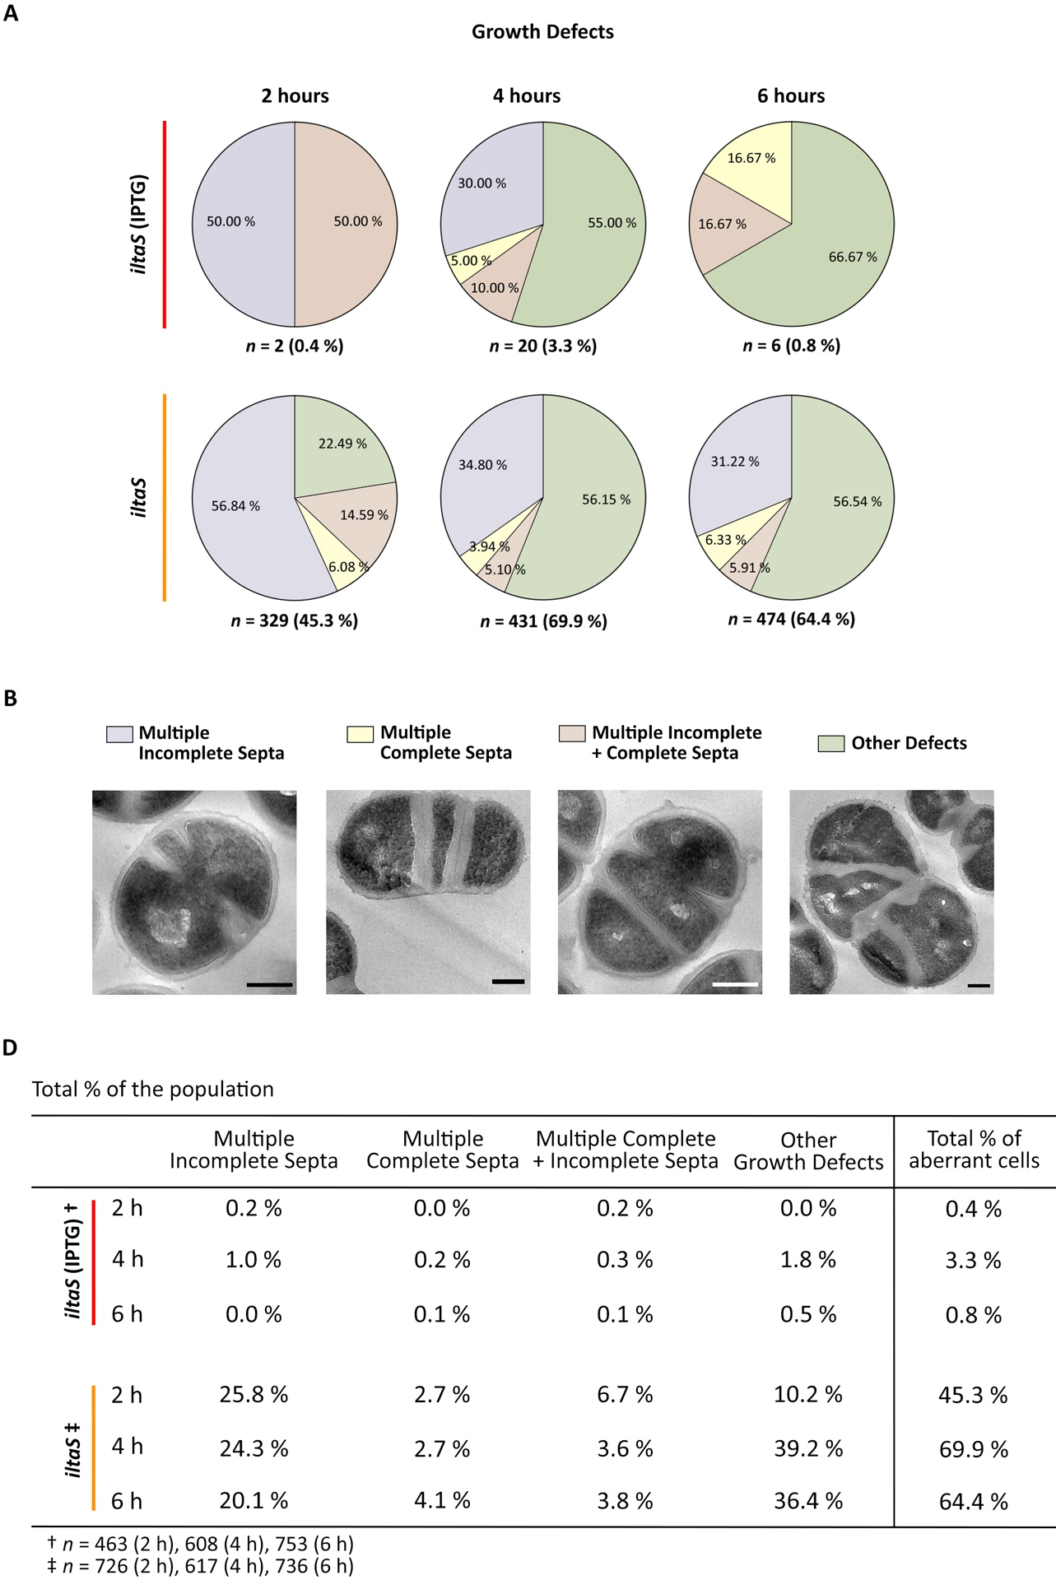
Supplementary Figure 1 Morphological quantification of aberrant cells of iltaS.
Supplementary Figure 1 Morphological quantification of aberrant cells of iltaS.
(A) Categorisation of aberrant cells of iltaS with 1 mM IPTG (red– control) and without the inducer (orange) after 2, 4 and 6 h of growth. Growth defects are categorised into: multiple complete septa (pale blue), multiple incomplete septa (pale yellow), multiple complete + incomplete septa (pale pink) and other defects (pale green) (B) Representative TEM micrographs for each quantification category. Cropped from high magnification (2900x), scale bars 300 nm. (C) Mean value for each category representing the percentage of the total sample population. One biological repeat. Total number of cells analysed for iltaS (IPTG): n = 463 (2 h), n = 608 (4 h), and n = 753 (6 h). Total number of cells analysed for iltaS: n = 726 (2 h), n = 617 (4 h) and n = 736 (6 h).
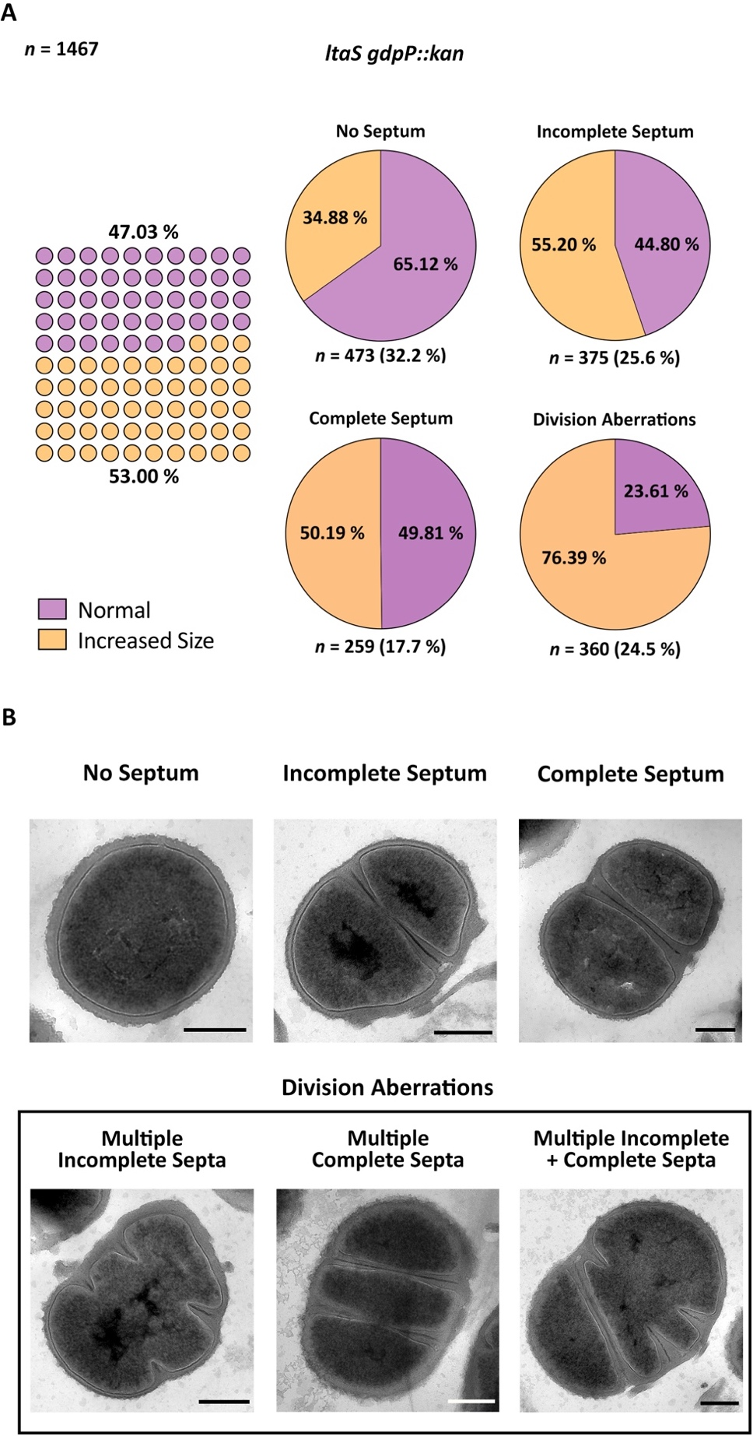
Supplementary Figure 2 Dual ltaS gdpP::kan population according to cell size.
(A) In depth categorization of ltaS gdpP::kan sample population (n = 1467), where 53 % of the cells have an increased cell size characteristic of the lack of lipoteichoic acids (LTA) and 47.03 % have a normal size. Pie charts represent the percentage of cells with bigger size within each quantification category. Overall, ~ 41.2 % of the population have both a normal cell size and morphology. This mutant’s growth defects consist of various division aberrations. (B) Representative TEM micrographs of the categories in (A) for ltaS gdpP::kan. Cropped from high magnification (4800x and 2900x), scale bars 300 nm.
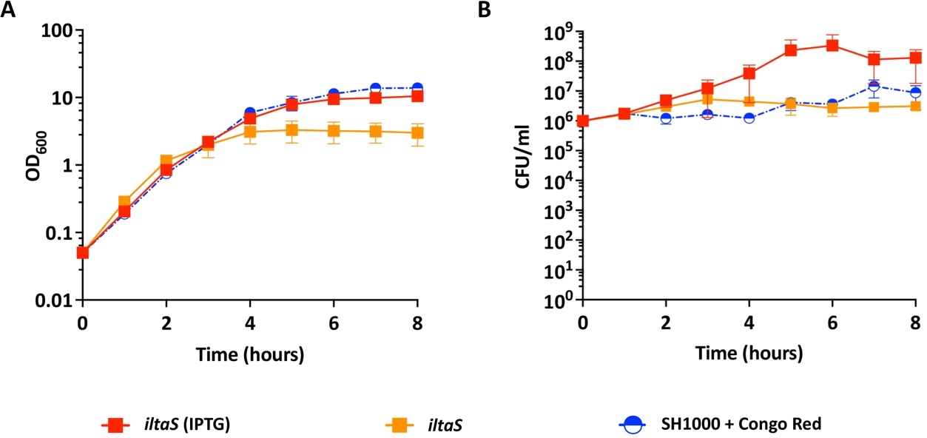
Supplementary Figure 3 Effects of Congo red on bacterial growth and its comparison iltaS.
Comparison of SH1000 plus 10 µg/ml of Congo red (blue half horizontal circle) to iltaS with 1 mM of IPTG (red square) and iltaS without the inducer (orange square), as measured by (A) Normalised absorbance and (B) CFU/ml. Average of > 3 biological repeats. SH1000 + Congo red was carried out by Dr. Oliver Carnell.
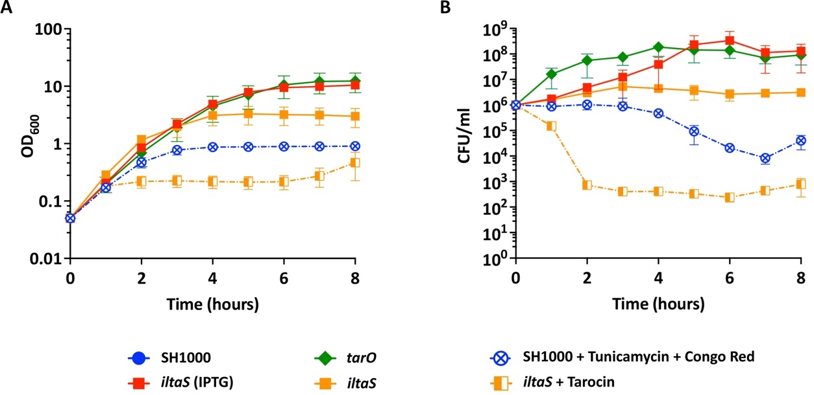
Supplementary Figure 4 Effect of the chemical interruption of WTA and LTA biosynthesis on bacterial growth and its comparison to iltaS treated with tarocin.
Comparison of S. aureus SH1000 treated with tunicamycin and Congo red (blue circle with a cross) to iltaS treated with tarocin (orange half square), as measured by (A) normalised absorbance and (B) CFU/ml. The controls include tarO (green rhombus), iltaS with 1 mM IPTG (red square) and iltaS without the inducer (orange square). Tarocin and tunicamycin– 2.5 µg/ml. Congo red– 10 µg/ml. All values are the average of > 3 biological repeats. Congo red experiment was carried out by Dr. Oliver Carnell.
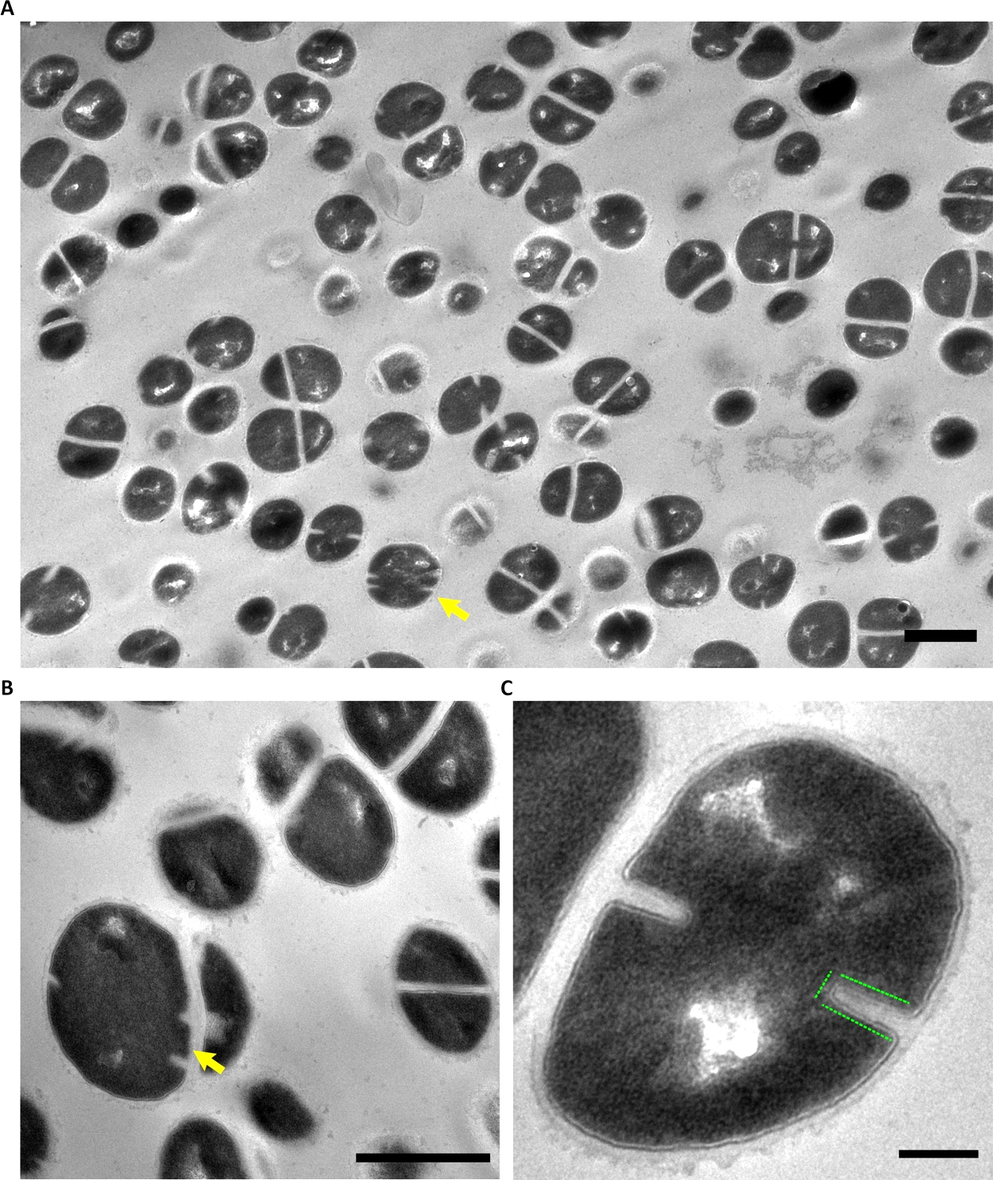
Supplementary Figure 5 Morphological effect of tarocin on S. aureus SH1000.
Representative TEM micrograph of chemically fixed S. aureus SH1000 treated with 2.5 µg/ml of tarocin and grown for 2 h. Unlike the results already published by Santa Maria et al., (2014) ^{[279]} in another S. aureus background, SH1000 showed no issues in daughter cell separation, no obvious division aberrations, and no evidence of a thickened crosswall. Yet, the peripheral CW presented a fuzzy-like appearance, aberrant-shaped septa, and the disappearance of the heavily stained mid-line, a phenotype similar to that of tarO. CW thickness measurements and morphological quantification is needed for a detailed comparison. (A) Low magnification (1900x). Scale bar 1 µm. (B) High magnification (4800x) showing an aberrant cell (yellow arrow). Scale bar 1 µm. (C) Zoomed image showing the square-shaped septa and loss of the mid-line. Scale bar 200 nm.

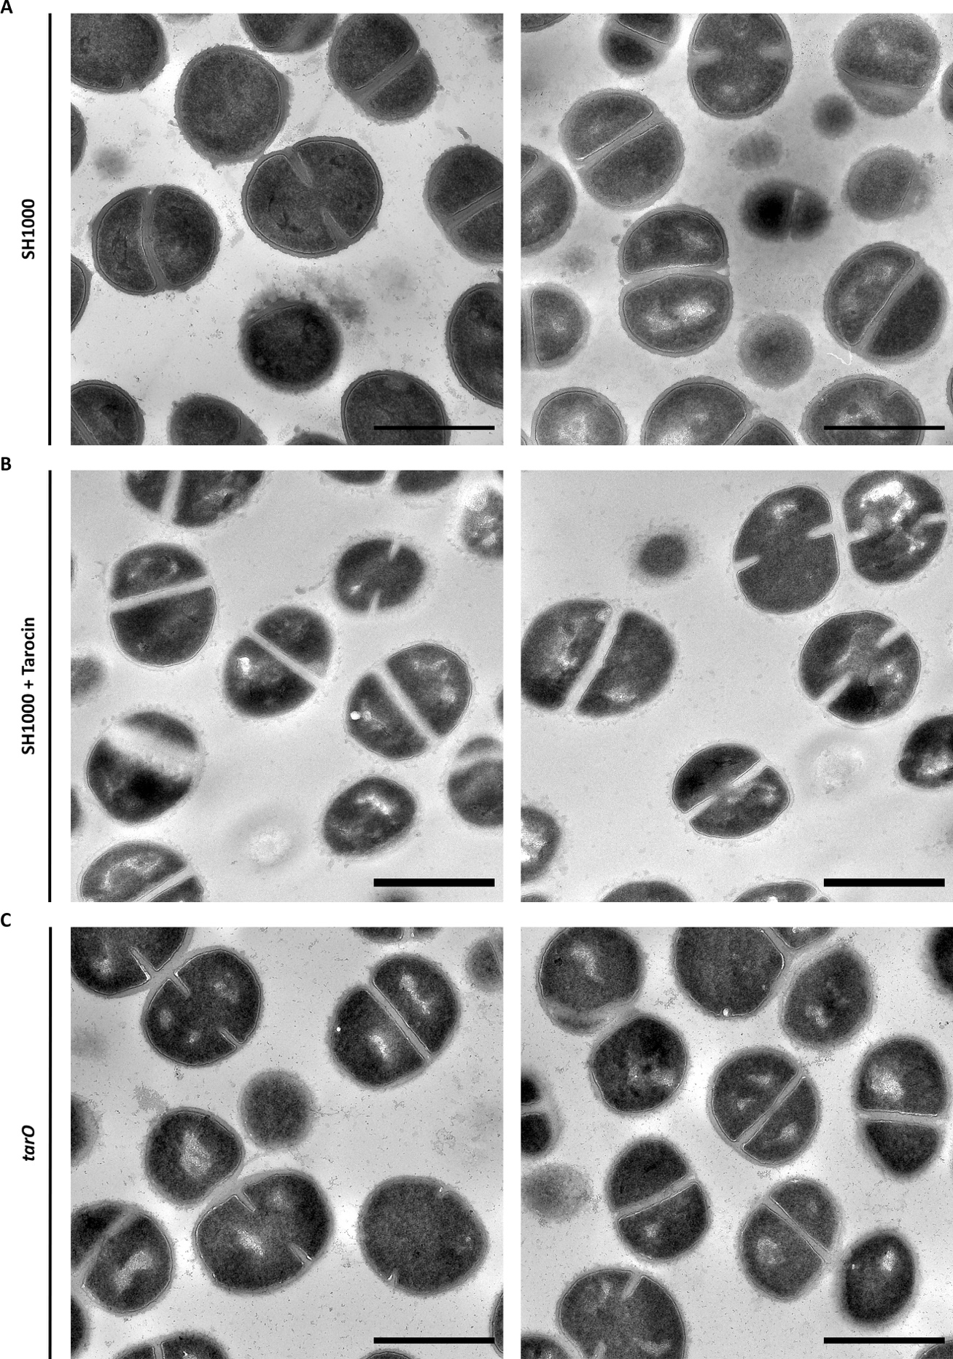
Supplementary Figure 6 TEM comparison of the effect of tarocin treatment with tarO
Representative TEM micrographs of chemically fixed (A) SH1000, (B) SH1000 treated with 2.5 µg/ml of tarocin and (C) tarO. Bacterial cultures grown for 2 h. High magnification (4800x). Scale bars 1 µm. Unlike the results already published by Santa Maria et al., (2014) ^{[279]} in another S. aureus background, SH1000 showed no visible increase in cell size. Structure illumination microscopy and cell volume estimation is needed for a detailed comparison.
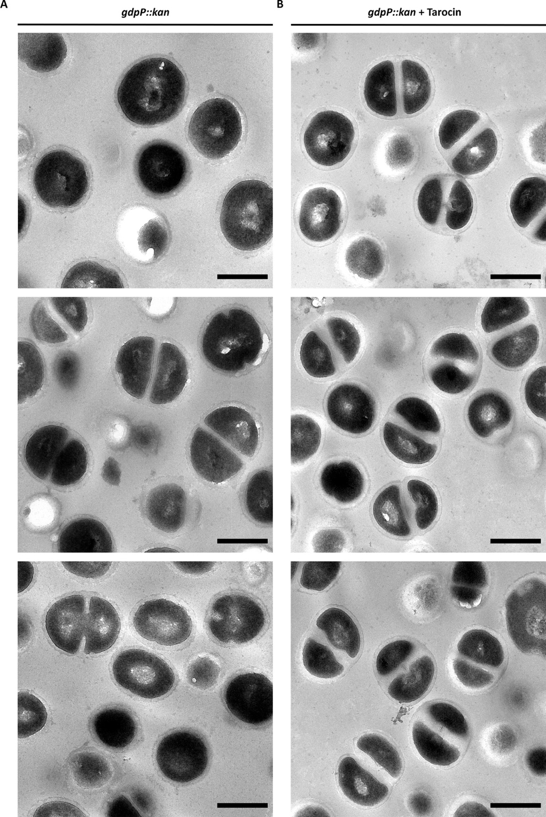
Supplementary Figure 7 Morphological effect of tarocin treatment on gdpP::kan.
Representative TEM micrographs of chemically fixed gdpP::kan (A) untreated and (B) treated with 2.5 µg/ml of tarocin for 2 h. gdpP::kan was chosen as a control for further analysis on ltaS gdpP::kan. In accordance to a study by Santa Maria et al., (2014) ^{[279]} in another S. aureus background, gdpP::kan treated with tarocin shows a thicker crosswall. Yet, it also shows a thicker peripheral wall and no visible difference in cell size is observed. Structured illumination microscopy and cell volume estimation should be carried out for a thorough comparison. High magnification 6800x. Scale bars 500 nm.
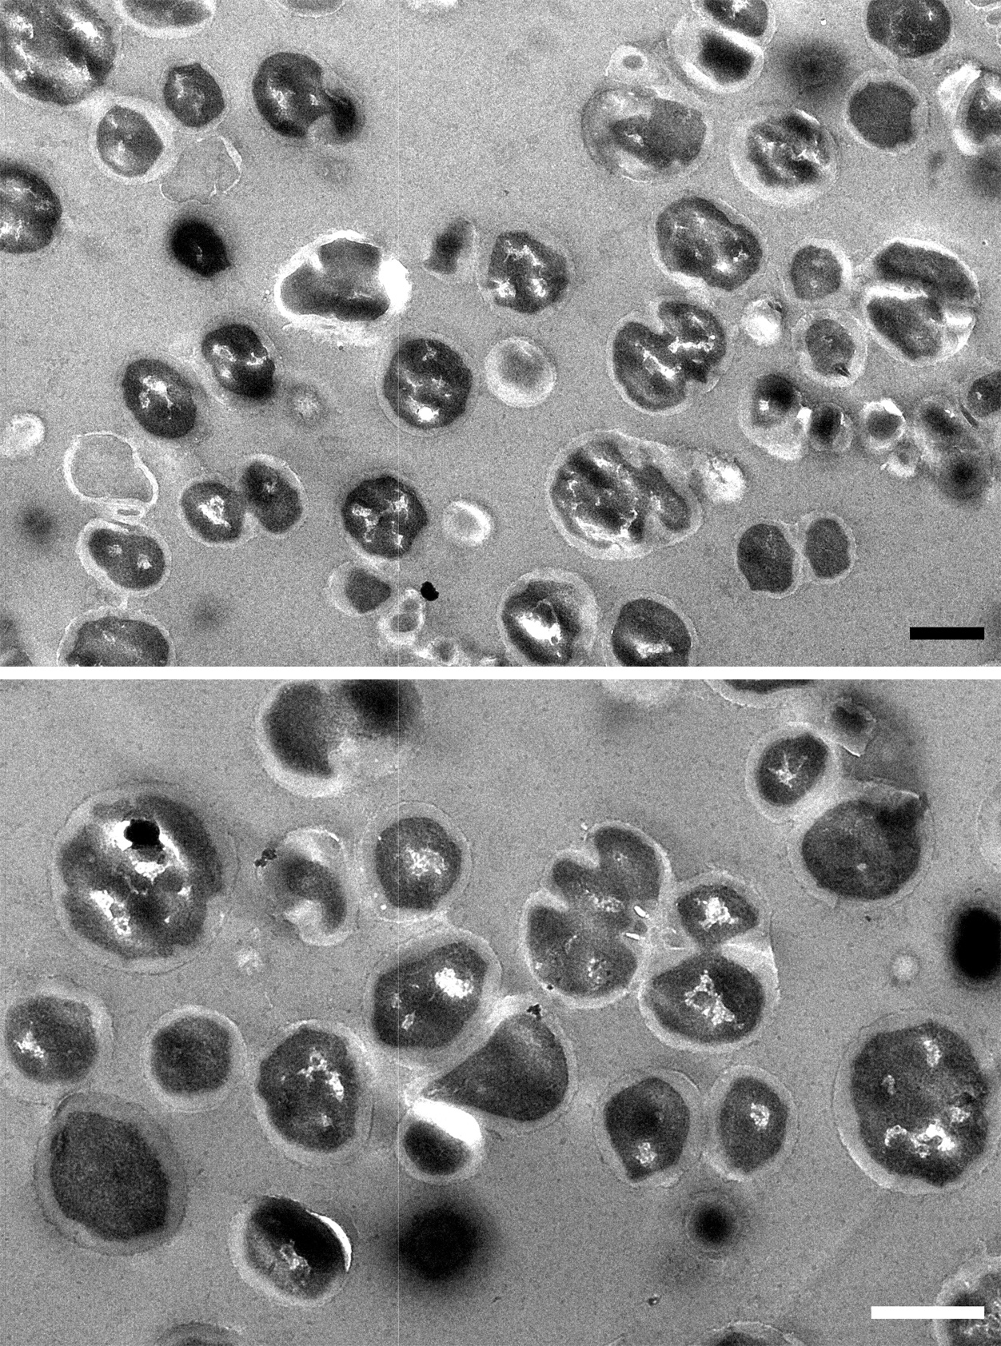
Supplementary Figure 8 Overview of S. aureus ltaS gdpP::kan treated with tarocin.
Representative TEM micrograph of chemically fixed S. aureus ltaS gdpP::kan treated with 2.5 µg/ml of tarocin and grown for 2 h. The reduction of WTA synthesis in this LTA-depleted mutant lead to a visible reduction of complete septa, as previously described ^{[279]}. Morphological quantification is needed for a thorough comparison. Low and mid-magnification (1900x–top and 2900x–bottom). Scale bar 1 µm.
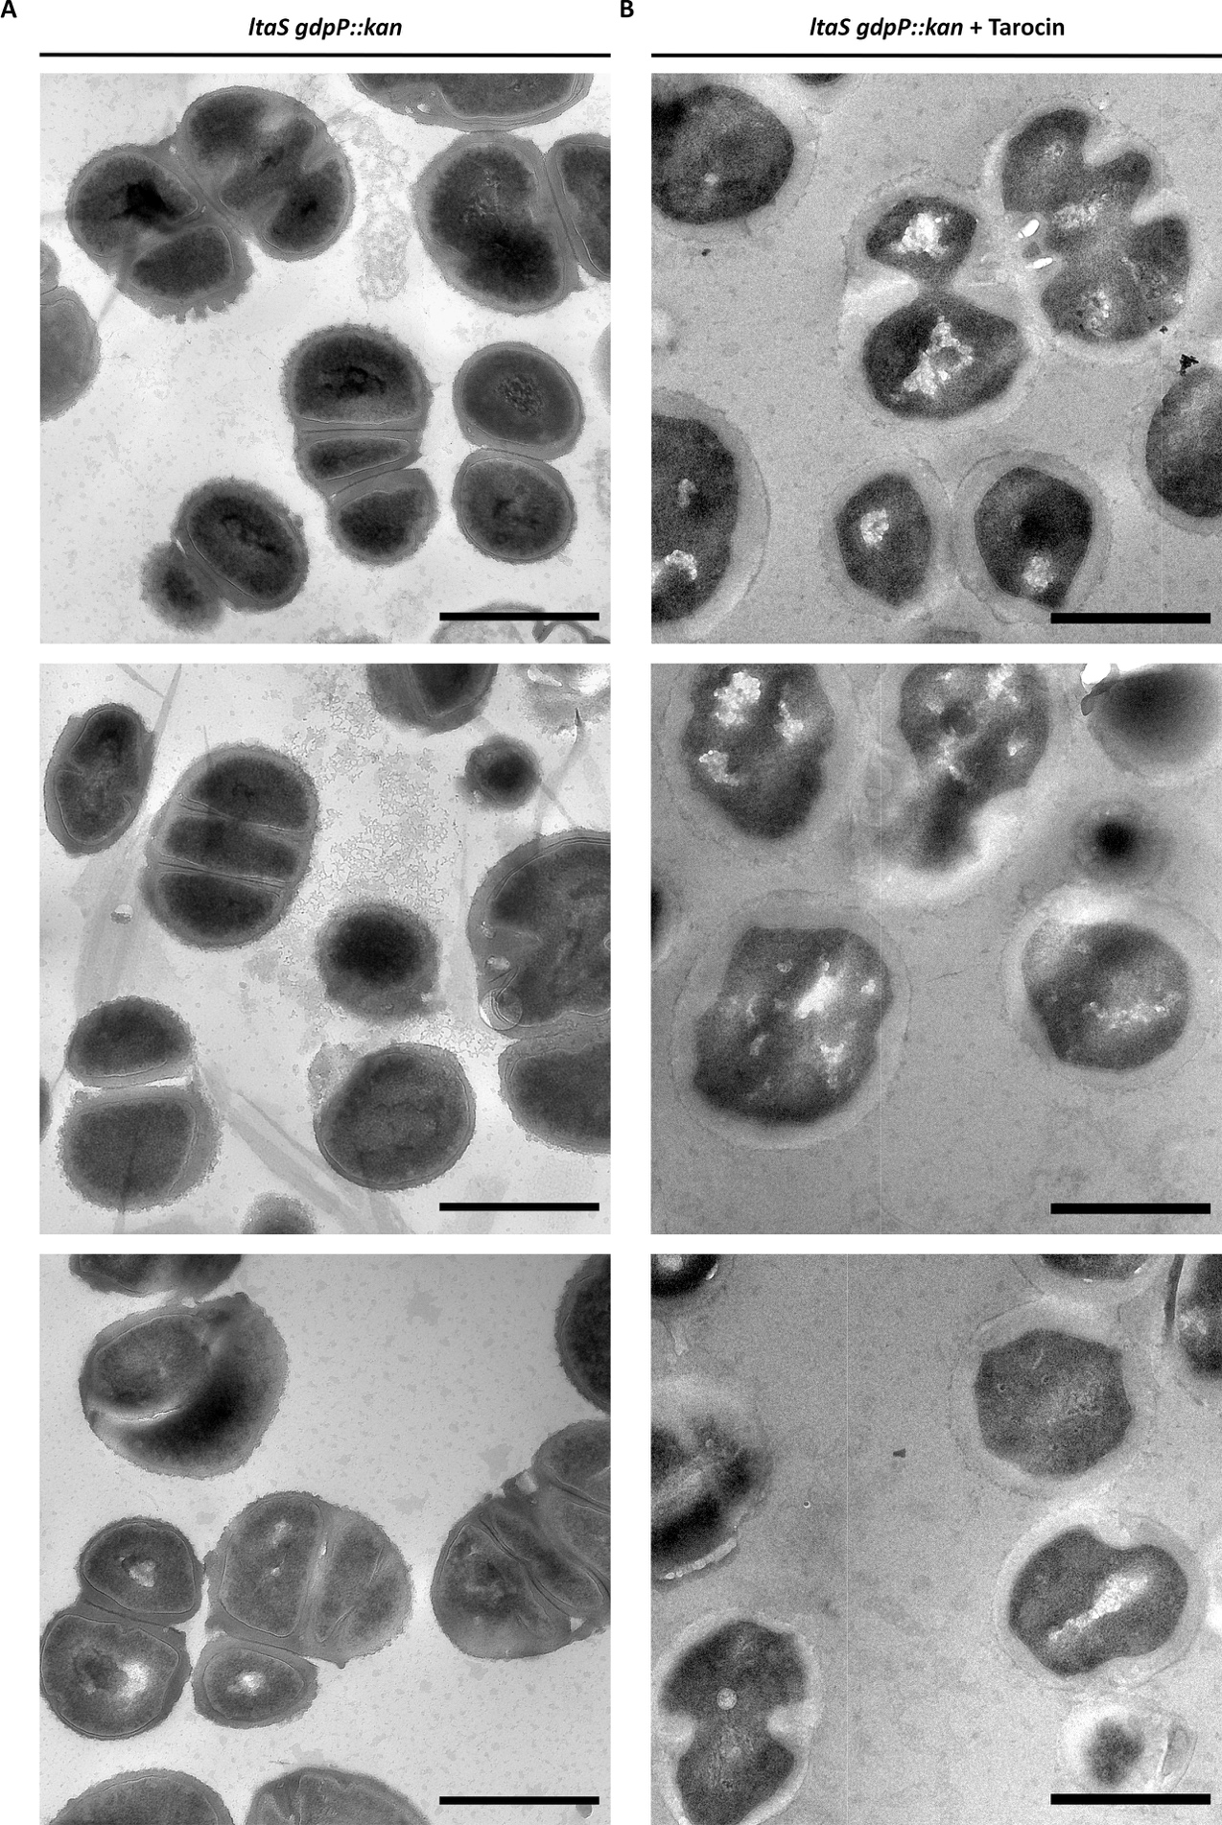
Supplementary Figure 9 Morphological effect of tarocin on S. aureus ltaS gdpP::kan.
Representative TEM micrographs of chemically fixed ltaS gdpP::kan (A) untreated and (B) treated with 2.5 µg/ml of tarocin for 2 h. A thicker septal wall is observed, as previously described ^{[279]}, but also a thickened peripheral CW. Thickness measurements should be taken for better analysis. High magnification (4800x). Scale bars 1 µm.
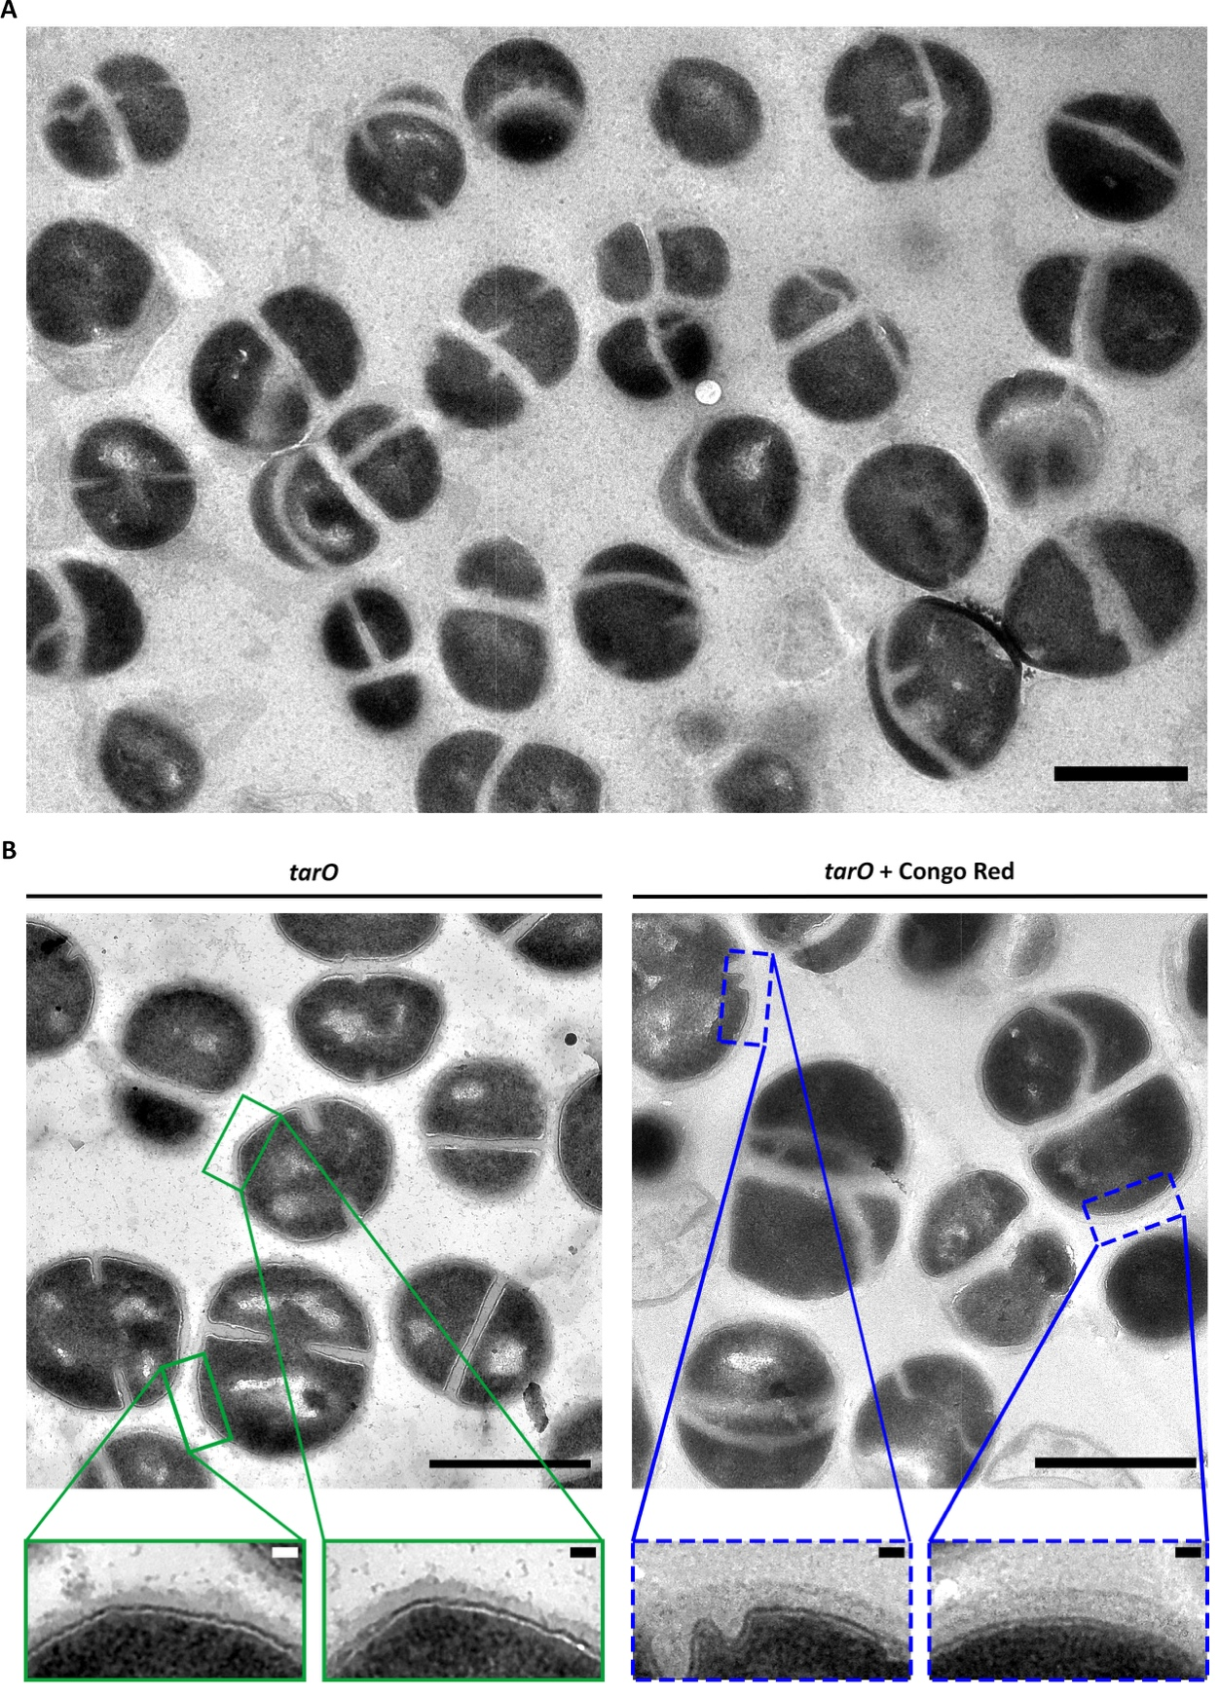
Supplementary Figure 10 Morphological effect of Congo red on S. aureus tarO.
(A) Representative TEM micrograph of chemically fixed S. aureus tarO treated with 10 µg/ml of Congo red and grown for 2 h. This phenotype is reminiscent of that of iltaS and ltaS gdpP::kan, with division aberrations (multiple and misplaced septa) and cells clumping together. Low magnification (1900x). Scale bar 1 µm. (B) Comparison of treated and untreated tarO shows no visible difference in cell size, as suggested by the literature ^{[279]}. However, depletion of LTA with Congo red shows a smoother appearance of the peripheral cell wall (CW). High magnification (4800x), Scale bars 1 µm. Zoomed squares show the CW of untreated tarO cells (solid green) and of those treated with Congo red (dashed blue), scale bars 50 nm.
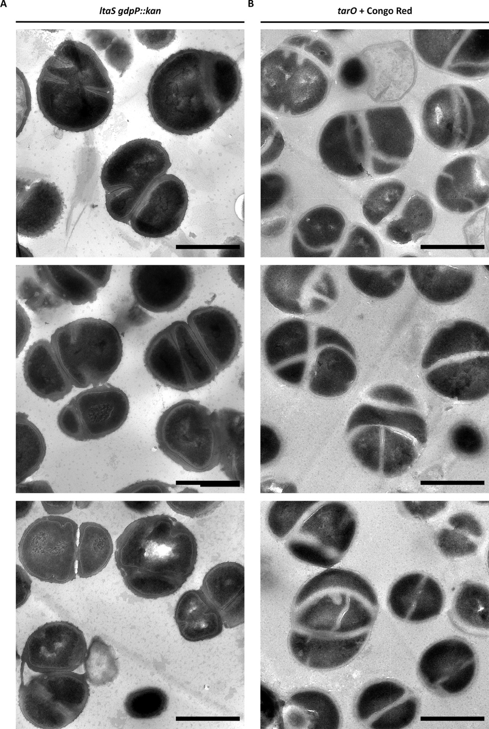
Supplementary Figure 11 Phenotype comparison between LTA-depletion and tarO treated with Congo red.
Representative TEM micrographs of chemically fixed (A) ltaS gdpP::kan and (B) tarO treated with 10 µg/ml of Congo red for 2 h. Pharmacological depletion of LTA in tarO leads to a similar phenotype to that of ltaS gdpP::kan. Morphological quantification is required for better analysis. High magnification (4800x). Scale bars 1 µm.
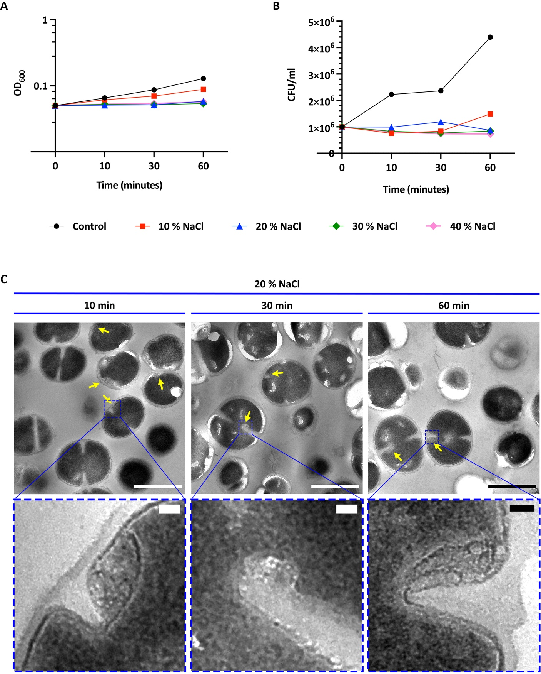
Supplementary Figure 12 Effect of high osmolarity on S. aureus SH1000 growth and morphology
NaCl was added to the bacterial medium to analyse the effect of high osmolarity. Here we present the normalised bacterial growth of S. aureus SH1000 with 0 (black), 10 (red), 20 (blue), 30 (green) and 40 % (w/v) NaCl (pink) measured by (A) absorbance (OD₆₀₀) and (B) CFU/ml. (C) TEM micrographs of chemically fixed SH1000 samples with 2.67 % (w/v) PFA, before the standard chemical fixation protocol. Samples were collected after 10, 30 and 60 min of exposure to 20 % (w/v) NaCl. Mid magnification (4800x) scale bars 1 µm. Yellow arrows represent signs of plasmolysis. Blue squares scale bars 50 nm.
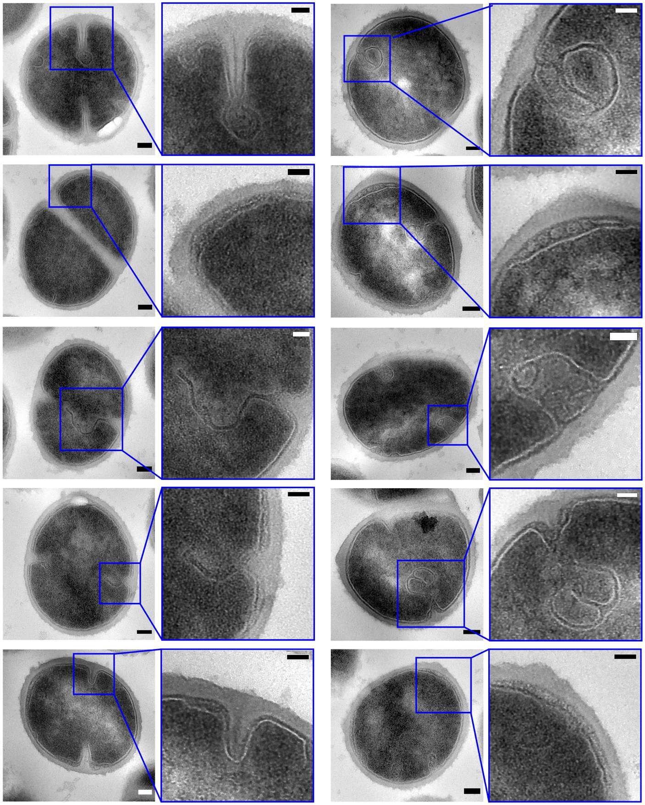
Supplementary Figure 13 Instant reaction and signs of plasmolysis observed in S. aureus SH1000 treated with high concentrations of NaCl.
TEM micrographs of S. aureus SH1000 chemically fixed after 2 min of exposure to 4 M NaCl. Samples were fixed with paraformaldehyde before continuing with the standard chemical fixation protocol. Cropped from 9300x and 13000x magnification. Scale bars 100 nm. Blue squares show magnified sections emphasizing signs of plasmolysis: membrane detachment from the cell wall, expansion of the exoplasm, vesicles/blebs in the exoplasmic space, “spiral”-like invaginations of the membrane (particularly at the septum). Scale bars 50 nm.

