Improving the Solid Electrolyte Interphase using Pre-Lithiation



Department of Chemical and Biological Engineering
The University of Sheffield
Daniel Atkinson
Supervisor: Dr. Jonathan Howse
19th March 2021

Contents
Abbreviation table vi
Acknowledgments vii
Abstract viii
Chapter 1: Literature review 3
1.1 Introduction 4
1.2 Li-ion battery fundamentals 4
1.2.1 The Anode 5
1.2.2 The Cathode 7
1.2.3 The Electrolyte 8
1.2.4 The Separator 11
1.2.5 Current Collectors 11
1.3 Introduction To Electrochemistry 12
1.4 The use of the SEI in Li-ion batteries 13
1.5 How the SEI is formed 14
1.6 SEI structure 21
1.7 Composition of the SEI 22
1.8 The role of the electrolyte in SEI formation 23
1.9 Electrolyte additives and their influence on the SEI 24
1.9.1 EC-based additives 24
1.9.2 Sulphites 26
1.9.3 Other additives 27
1.10 Formation cycling 29
1.11 Pre-lithiation techniques 35
1.12 Other artificial SEI’s 39
1.13 Sodium-ion batteries 41
1.14 Na-ion SEI 42
1.15 Conclusion 43
Chapter 2: Experimental techniques 44
2.1 Material synthesis 45
2.1.1 Hard carbon 45
2.1.2 SiO_{X} 45
2.2 Cell preparation 45
2.2.1 Slurry mixing and coating 45
2.2.2 Calendering and drying 46
2.2.3 Cell assembly 46
2.3 Pre-lithiation 47
2.3.1 Mechanical pre-lithiation 47
2.3.2 Electrochemical pre-lithiation 47
2.4 Electrochemical analysis 48
2.4.1 Electrochemical impedance spectroscopy (EIS) 49
2.4.2 Cell Cycling (Chronopotentiometry) 53
2.4.3 Differential capacity 54
2.4.4 Galvanostatic & potentiostatic intermittent titration technique 56
2.5 Physical analysis 58
2.5.1 Atomic force microscopy (AFM) 58
2.5.2 Differential scanning calorimetry 60
2.5.3 X-ray photoelectron spectroscopy 61
Chapter 3: Pre-lithiation of graphite 65
3.1 Introduction 66
3.2 The effects of electrolyte additives on pre-lithiation 66
3.2.1 Experimental 67
3.2.2 Results 67
3.3 The importance of fluorine in FEC for the pre-lithiation process 77
3.3.1 Experimental 77
3.3.2 Results 78
3.3.3 Discussion 84
3.4 The importance of time as a variable for Lithiation 84
3.5 Mechanical pre-lithiation of graphite 84
3.5.1 Experimental 84
3.5.2 Results 85
3.5.3 Conclusion 91
3.6 Electrochemical pre-lithiation of graphite 91
3.6.1 Experimental 91
3.6.2 Results 91
3.6.3 Conclusion 101
3.7 Comparing mechanical and electrochemical pre-lithiation 102
3.7.1 Performance 102
3.7.2 Time 102
3.7.3 Input 102
3.7.4 Setup 102
3.7.5 Summary 103
3.8 Conclusion 103
Chapter 4: Pre-lithiation of Si anodes 104
4.1 Si Anodes 105
4.1.1 1st problem: Expanding into the unexpandable 105
4.1.2 2nd problem: anode pulverisation 107
4.1.3 3rd problem: SEI destruction 108
4.2 Si pre-lithiation 108
4.3 Electrolyte optimisation for pre-lithiation 108
4.3.1 Experimental 109
4.3.2 Results 109
4.3.3 Conclusion 110
4.4 Electrochemical pre-lithiation of silicon 111
4.4.1 Experimental 111
4.4.2 Results 111
4.4.3 Conclusion 115
4.5 Mechanical pre-lithiation of silicon 115
4.5.1 Experimental 115
4.5.2 Results 116
4.5.3 Conclusion 119
4.6 The choice of Si used for cycling 119
4.6.1 Experimental 119
4.6.2 Results 120
4.6.3 Conclusion 122
Chapter 5: Observing the dynamic exchange of the SEI using EIS 123
5.1 Introduction 124
5.2 Using EIS to observe the exchange process 124
5.2.1 Experimental 124
5.2.2 Results 125
5.2.3 Conclusions 131
Chapter 6: Pre-lithiation of hard carbon anodes for Na-ion batteries 133
6.1 Introduction 134
6.2 How Na-ion batteries work 134
6.3 Pre-lithiation of hard carbon 134
6.3.1 Electrochemical experimental 135
6.3.2 Results 135
6.3.3 Conclusion 139
6.4 SEI dissolution 139
6.4.1 Experimental 139
6.4.2 Results 140
6.4.3 Conclusion 145
6.5 Lithiation vs. sodiation 145
6.5.1 Experimental 146
6.5.2 Results 146
6.5.3 Conclusion 151
Chapter 7: Conclusion & Future work 152
7.1 Conclusion 153
7.2 Future work 154
7.3 Elucidating SEI exchange mechanisms 154
7.3.1 Understanding the interface of pre-lithiated Na-ion batteries 154
7.3.2 Further understanding the exchange process 154
7.3.3 Neutron reflectometry 154
7.4 Further improvements for pre-lithiated SEIs 155
7.4.1 New additive avenues 155
7.4.2 Polymer SEIs 155
7.4.3 Creating insoluble Na-SEIs to extend battery life 156
References 157

Abbreviation | Meaning
AFM | Atomic force microscopy
ATR | Attenuated total reflection
b.p. | Boiling point
C  SBR | Capacitor  Styrene butadiene rubber
CEI | Cathode electrolyte interphase
CMC | Carboxymethyl cellulose
CPEx-P | The power component of a constant phase element
CPEx-T | The capacitance value for a constant phase element
DEC | Diethyl carbonate
DMC | Dimethyl carbonate
EC | Ethylene carbonate
EIS | Electrochemical impedance spectroscopy
EPR | Electron paramagnetic resonance
FEC | Fluoroethylene carbonate
FRA | Frequency response analyser
FTIR | Fourier transform infrared spectroscopy
h | Planck’s constant
Li | Lithium
LiB | Lithium-ion battery
LP30 | 1.0M LiPF₆ in EC/DMC=50/50 (v/v)
LUMO  ICE | Lowest unoccupied molecular orbital  Initial coulombic efficiency
m.p. | Melting point
MW | Molecular weight
PC | Propylene carbonate
PTFE | Polytetrafluoroethylene (Teflon®)
Q_{irr} | Irreversible capacity loss
R | Resistor
SEI | Solid electrolyte interphase
SHE | Standard hydrogen electrode
SOC | State of charge
SOH | State of health
XPS | X-ray photoelectron spectroscopy

Abbreviation table

Acknowledgments

I would like to thank Vitor Martins for helping me to produce the hard carbon as well as Practical tips for cell assembly and cycling.
I would like to thank Jake Entwistle for providing the Si electrodes for testing and characterisation.
I would Like to thank Mark Issacs for giving me access to the HarwellXPS service and his help with interpreting the results.
A big thank to my Fiancé Meghna, my family, my supervisors as well as my colleagues in the battery lab. Without their contributions it would not have been possible to complete this thesis.

Abstract
This Thesis focuses on the use of pre-lithiation to influence properties of the solid electrolyte interphase (SEI) and it’s effects on the cycle life of the cells under investigation.
Chapter 3 was the result of several experiments investigating the pre-lithiation of graphite. This work demonstrated that the material used for pre-lithiation could be different to the electrolyte and deliver the improved performance over simple pre-lithiation in the electrolyte. This opens the possibility for new pre-lithiation routes of electrodes that result in a lower resistance, longer lasting SEI than can be achieved with solely the electrolyte.
Chapter 4 applies the same principles to Si based anodes. This found that whilst the initial capacity of these cells could be increased but the cells suffered from excessive capacity fade. This was found to be a result of SEI cracking/ reformation removing the benefits of a pre-lithiated SEI.
Chapter 5 uses the information from chapter 4 to track the SEI reformation process using electrochemical impedance spectroscopy (EIS). This experiment found that the presence of FEC in the electrolyte lowered the resistance of the SEI, even when they were not pre-lithiated in their presence. The reverse was true when it was in the pre-lithiated SEI but not the electrolyte.
Chapter 6 looked at pre-lithiated hard carbon electrodes as Na-ion anodes. It was found that pre-lithiated hard carbon anodes had a lower capacity as pre-lithiation time increased. The pre-lithiated electrodes had much greater capacity than the un-lithiated hard carbon which suffered from rapid capacity fade. The solubility of the pre-lithiated SEI was investigated, and it was found that allowing the cell to rest for extended periods increased the capacity of the anode with lower SEI resistance.

Literature review
This chapter introduces Li-ion batteries chemistry and the fundamental components that they contain. It then delves into the issue of solid electrolyte interphase formation and the impact that it has on the cell from both an electrochemical and a safety aspect. It discusses common strategies for reducing SEI growth, typically by using electrolyte additives. It finishes with techniques to direct SEI growth such as formation cycling.

Chapter 1

Introduction
When the electrolyte encounters the anode at low voltages in a Li-ion battery it degrades leaving behind reaction products that form a thin film on the anode surface [1]. This is known as the solid electrolyte interphase (SEI) and is a vital component to a safe, functional Li-ion battery. The SEI acts as a barrier between the electrode and electrolyte, limiting degradation and extending the cycle life and coulombic efficiency of the cell. Forming the SEI requires the consumption of lithium that could otherwise be used for extra capacity in the cell. It also requires a complex formation process that can require multiple temperatures and a significant amount of time to last for the thousands of cycles required by commercial cells [2].
The aim of this thesis was to investigate the effects of pre-lithiating negative electrodes on the SEI and how to optimise the process for improved capacity retention and higher initial capacity.
Chapter 1 looks at the current state of the literature to see where pre-lithiation is currently being used and looks at what can be achieved using pre-lithiation. Chapter 3 used this knowledge to pre-lithiate cells with different electrolyte components to see their individual impact on the SEI formed with them and how the SEI affected cell performance. This work led to chapter 4 with FEC, as the most beneficial electrolyte component being used to lithiate Si electrodes. This work found that the pre-lithiated SEI was being destroyed by the large volume change seen in the Si electrodes. This information led to chapter 5 where the destruction and reformation of the SEI was investigated in graphite where the volume change is much smaller and can be monitored over a longer period. Graphite electrodes are also less likely to suffer from mechanical failures so the small changes in performance can be more readily attributed to the impact of the SEI. Chapter 6 looks at using the prior work in this thesis and applying it to hard carbon electrodes for sodium-ion applications as they suffer from a highly resistive SEI that is more soluble in the electrolyte than Li-based ones. This is all summed up in chapter 7 which also looks at how this work can be built upon to make pre-lithiation a viable technique for increasing the capacity in Li-ion batteries.

Li-ion battery fundamentals
Lithium (Li) is a popular material for electrochemical energy storage due to its low voltage (-3.04 V Vs. SHE) and low density (0.534 g/cm³). Research for Li-ion batteries commenced in earnest during the 1970s oil crisis and Akira Yoshino, M. Stanley Whittingham and John B. Goodenough recently won the 2019 Nobel prize in Chemistry for their pioneering research into Li-ion electrochemistry [3]. Sony used this previous research and manufactured the first commercial battery in 1991, paving the way for the current wave of interest in the field [4].
A Li-ion battery operates via the rocking chair mechanism where Li⁺ is ejected from the anode diffuses through the separator via the electrolyte before entering the cathode during discharge, with the corresponding electrons forced through an external circuit producing electrical current. A schematic of a Li-ion battery can be seen in Figure 1-1. The opposite process happens when the cell is charged, and this process can be repeated 1000’s of times and potentially power an automotive vehicle over 1000000 miles (1.6 million km) before the cell degrades and becomes unusable [5].
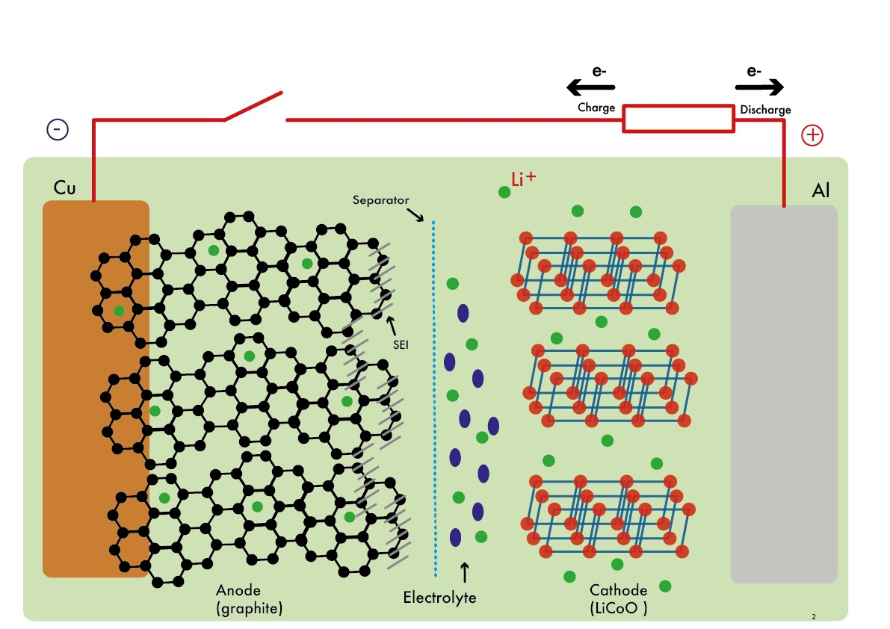Figure 1-1: Schematic of a typical Li-ion battery.
It is important to breakdown the main components of a Li-ion battery to understand the current state of the science for each part and the current barriers to improving performance. There are 7 main internal components to a cell: the anode active material, the cathode active material, the binder, the conductive carbon, the electrolyte, the separator and current collectors. Below is an outline of the internal components of a cell, how each one functions, the state-of-the-art materials for each role, as well as a basic outline of some of the degradation processes that occur.

The Anode
The anode is the negative electrode where the electrons flow from when a cell is discharging. Pure Li metal would seem to be the most obvious choice due to its high capacity (3860 mAhg⁻¹) but it cannot be used for long term cycling due to the risk of dendrite formation [6]. Dendrites are growths that can emanate from the Li surface and they will keep growing until they pierce through the separator leading to a short circuit which is a major safety hazard. As a result, graphite is the most commonly used anode for Li-ion batteries. Li can intercalate in between the graphite planes at a low potential (0.1 V vs Li/Li⁺) maximising the energy output of the cell. The biggest issue with graphite is its low capacity when compared with Li metal (372 mAhg⁻¹ Vs. 3860 mAhg⁻¹) as seen in Figure 1-2. Anodes also undergo a process known as solid electrolyte interphase (SEI) formation. This is where electrolyte degrades at the low potential of the anode forming a layer on the surface. Li metal anodes are stripped and replated during cycling and this leads to the already formed SEI later to migrate back into the electrolyte and a fresh layer is deposited during plating. This results in electrolyte depletion and low coulombic efficiency. This doesn’t occur with graphite as it is stays in places during cycling that the SEI adheres to, although smaller quantities of fresh SEI are formed during cycling. More information can be found on the SEI in Section 1.3 The use of the SEI in Li-ion batteries.
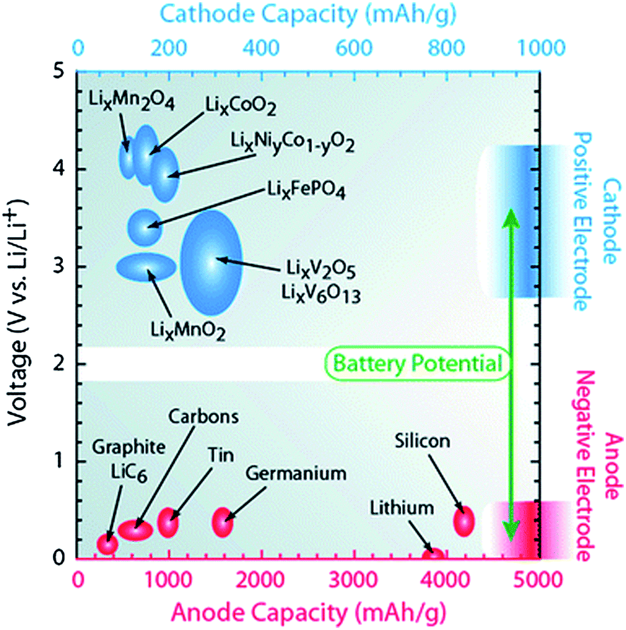
Figure 1-2: Graph showing the theoretical capacities of common anode and cathode materials [7].
The limited capacity of graphite has meant that researchers have been looking at alternatives to graphite to try to improve the energy density of commercial cells [8]. The main candidate to replace graphite has been silicon as it has a high theoretical capacity (4200mAhg⁻¹) and a low potential as seen in Figure 1-2. It should be noted that this theoretical value can’t be achieved at room temperature due to the unfavourable thermodynamic state and 3579mAhg⁻¹ is a more appropriate value [9]. It is currently blended with graphite anodes in commercial cell in small quantities often in the form of SiO_{X} but is not the major electrode component [10]. This is because Si undergoes a large increase in volume when it alloys with Li (≈400% or 280% at room temperature) [9, 11]. This increase can place a large strain on the active particles, pulverising it and resulting in rapid capacity fade. To mitigate this expansion low loadings of silicon are used but new mitigation strategies are being developed constantly to increase the wt.% [12]. Si anodes are discussed further in Section 4.1 Si Anodes.

The Cathode
The cathode is the positive electrode where the electrons flow into when a cell is discharging. Most cathode materials are layered transition metal oxide materials. These transition metal oxides can accommodate Li⁺ in spaces in the crystal lattice with the transition metal being reduced to balance the charge. The first cathodes used were based on LiCoO₂ which has a high capacity retention but a low capacity [13]. Since the initial development a range of new cathode materials have been developed. The main cathode material family of interest are known as NMCs with the N standing for nickel, M for manganese and C for cobalt [14]. The ratios of these elements can be altered depending upon the properties sought for in the cathode. Recently there has been a trend to limit the use of cobalt if not eliminate it entirely due to worries about mining practices in the democratic republic of Congo where most of it is currently mined [15]. This has proved difficult as the use of cobalt is known to support the structure of the cathode and its removal can lead to lower capacity retention [16]. Cobalt is also more expensive than nickel so despite its attractive properties much active research is being undertaken to eliminate cobalt from cells [17].
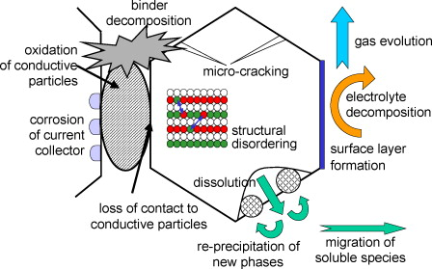
Figure 1-3: Overview of the mechanisms for capacity fade in cathodes [7].
Cathodes can undergo reactions that reduce their capacity. As there are a range of materials to choose from when making cathodes there are at least as many degradation pathways. Hausbrand et al. in their review highlighted 3 major degradation pathways: Degradation as a result of overcharge, formation of a cathode electrolyte interphase (CEI), which is analogous to SEI formation on the anode and loss of free lithium [7]. All of these degradation mechanisms are linked, with the formation of the CEI increasing the total resistance of the cell and an overview of these pathways as well as some more minor degradation options can be seen in Figure 1-3. This increase in resistance leads to overcharging of the cathode. This overcharging then causes crystal defects in the lattice, which prevents lithium uptake in the cathode causing capacity fade. In most cases, these issues aren’t as severe as anode degradation mechanisms and occur over much longer timescales in comparison.

The Electrolyte
The electrolyte enables the transport of ions between the anode and cathode. In other common battery chemistries such as lead acid an aqueous salt solution is used due to its abundance, reasonable conductivity and the simplicity of manufacturing with aqueous solutions. Aqueous solutions are unsuitable for Li-ion batteries as their operating voltage is outside of the voltage window of water [18]. The voltage window is the voltage range within which the electrolyte is stable and will not break down. Water has a stable voltage window of 1.23V between 2.63V and 3.86V vs. Li/Li⁺ [19]. One of the benefits of Li-ion batteries is their large voltage range, which gives the battery a larger energy density (E = QV) and as a result an electrolyte with a wide voltage window is required to take advantage of the extra energy available in the system. Due to the unsuitability of aqueous solutions other electrolytes are required. The most commonly used are organic carbonates with a dissolved weakly-coordinating lithium salt. A weakly-coordinating salt has limited interaction with the lithium cation allowing it to easily solvate/desolvate into the electrodes [20]. Carbonates are used as they have a wider voltage window than water whilst still being polar solvents that can dissolve the Li salts. Most electrolytes contain more than one carbonate as a single carbonate would not match all of the criteria for a good electrolyte. A good electrolyte for Li-ion batteries requires it to be polar enough to be able to dissolve the Li salt. It also needs to have a low viscosity to be able to effectively wet the electrode surfaces. As the viscosity of a liquid is closely related to its polarity it means that the polarity of the electrolyte needs to be carefully tuned to achieve both aims.
Most electrolytes contain a cyclic and a linear carbonate. These cyclic carbonates are highly polar molecules that ensure that the electrolyte can solvate a sufficient concentration of Li salt. The two most common cyclic carbonates are Propylene carbonate (PC) and ethylene carbonate (EC) seen in Figure 1-4.
Figure 1-4: Chemical structure of PC (left) and EC (right).

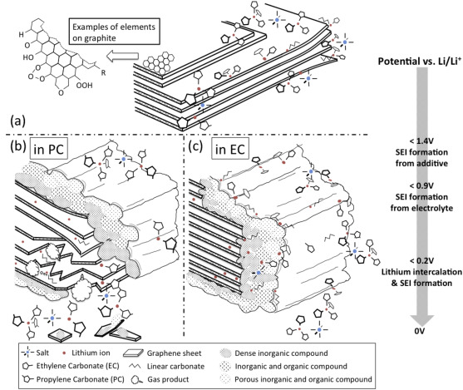
Figure 1-5: Schematic of the effects of EC and PC based electrolytes on graphite [21].
PC is a liquid at room temperature, and this makes it easier to use when manufacturing electrolytes. The use of PC can be problematic as it is prone to co-intercalate into graphite with Li [21]. This PC can then degrade leading to a pressure build up that causes the graphite to exfoliate, which can be seen in Figure 1-5. This exfoliation can lead to excessive early capacity fade. This issue can be avoided by using ethylene carbonate (EC) based electrolytes. Whilst EC can mitigate the issue of graphite exfoliation it is a solid at room temperature and this poses difficulties when manufacturing the electrolyte, hence the need for linear carbonates to make a liquid solution at room temperature.
The linear carbonates are typically small molecules that are less polar than the cyclic carbonates. The three most commonly seen are diethyl carbonate (DEC), dimethyl carbonate (DMC) and ethyl methyl carbonate (EMC) with their chemical structures shown in Figure 1-6. These two types of carbonates can then be combined to give an electrolyte with the physical characteristics that are ideal for the electrolyte. For a list of common electrolyte materials and their properties see Table 1-1 on page 16.
Figure 1-6: Chemical structures from left to right of DMC, EMC and DEC.
The Li salts are typically weakly coordinating. The most common ones encountered in research are LiPF₆, LiBF₄, LiClO₄, LiAsF₆, LiN(SO₂F)₂ (LiFSI) and LiN(SO₂CF₃)₂ (LiTFSI). LiClO₄ is not used commercially due to its explosive characteristics [22]. LiAsF₆ cannot be used commercially due to the high toxicity of As [22]. LiBF₄ is not often used due to its poor ionic conductivity. This only leaves the two salts that are used commercially: LiPF₆ and LiFSI. LiPF₆ is used routinely as it doesn’t suffer from the same problems as the previously mentioned salts. LiFSI is becoming more popular for its higher thermal stability although it can cause corrosion issues with Al current collectors. This has not stopped commercialisation with Nippon Shokubai producing LiFSI on the tonne scale annually [23]. LiTFSI is predominately used for “water-in-salt” electrolytes and are still at the research level [24].
These electrolytes may have good physical characteristics, but they degrade at the anode due to the low voltages encountered, forming a solid electrolyte interphase (SEI). This layer uses Li that would otherwise be used for cycling, reducing the capacity of the cell. It should be noted that full cells have their electrode’s capacities carefully balanced to reduce the weight of the cells and increase its energy density. The balancing results in limited quantity of Li in the cell which is known as the lithium inventory. For further information about the SEI see section 1.3 The use of the SEI in Li-ion batteries.
To reduce the lost capacity from cells additives are normally added to the electrolyte. They can help to form a stable SEI that retards the electrolyte degradation process. The different additives available are discussed in more detail in section 1.8 Electrolyte additives and their influence on the SEI.
To try to overcome the issues seen with SEI formation extensive research has been conducted into solid state electrolytes [25]. Solid state electrolytes are solids that can conduct Li-ions. Solid state electrolytes mitigate the need for a separator in a cell as it is itself an electrical insulator which reduces the space taken up by the cell. Despite the positive benefits they still suffer from a few issues that prevent their use commercially. The first is their poor conductivity which even for the best solid state electrolyte is lower than carbonate-based electrolytes and the values for common solid conductive materials can be seen in Figure 1-7. In comparison liquid electrolytes have a conductivity around 100 mS cm⁻¹ [26]. This poor conductivity hampers the rate capability of solid state batteries [27]. The second significant issue is translating the successes seen in small lab scale trials to the large scale manufacture of batteries [28]. Until these issues are rectified carbonate-based electrolyte will be the first choice.
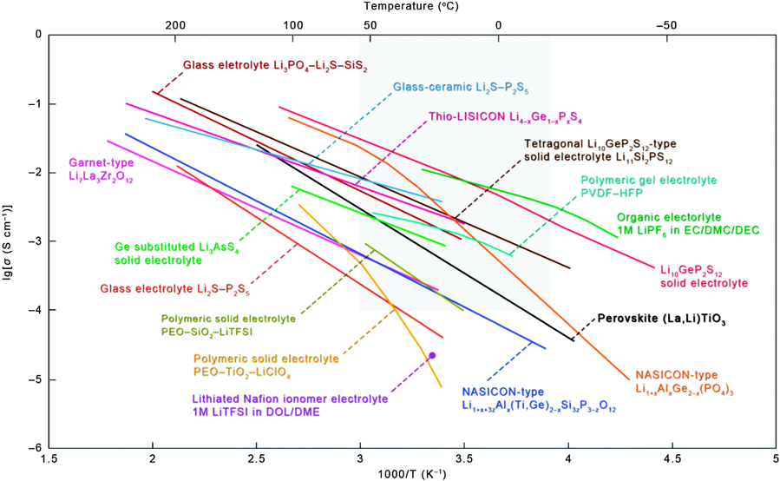
Figure 1-7: Conductivities of common solid state electrolytes as a function of temperature [29].

The Separator
The Separator is an electrical insulator that ensures that the anode and cathode aren’t in electrical contact. This forces the electrons to flow through the external circuit, generating electric current. This makes the separator vital for the cell as a non-functioning separator could result in a short circuit. Short circuits in Li-ion batteries are a serious safety issue and can start a process known as thermal runaway. Thermal runaway is where exothermic reactions in a cell lead to an increase in cell temperature, this then causes more exothermic reactions to occur causing the temperature to rise further still. This often cause a fire which can spread to other cells if nearby.
The separator still needs to have pores that the electrolyte can pass through and exchange Li ions between the anode and cathode. It also needs to have some mechanical strength to not be pierced by dendrites on first contact.
In commercial batteries microporous polymer membranes are the most commonly used material family for separators [30]. These polymers are usually either polyethylene, polypropylene or a trilayer with polypropylene either side of polyethylene. This is due to their low cost and strong performance.
In most research environments glass fibre separators are used as the provide easy wettability, good ionic conductivity and there isn’t a space constraint unlike commercial cells. Due to these reasons they have been used in all of the cells produced for this thesis.

Current Collectors
The current collectors are a conducting material that take the electrons outside of the cell to perform useful work. In a Li ion cell, copper is used as the current collector for the anode and aluminium is used as the current collector for the cathode. Both electrodes use different current collecting material because aluminium is a more affordable material, but it can alloy with Li at low voltage seen at the anode and so copper is used instead. Copper can’t be used at the cathode because it Is prone to oxidation at the high voltage of the cathode material.

Introduction To Electrochemistry
Several electrochemical terms are used throughout this thesis and it is important to discuss these terms to fully appreciate its findings. The first one to mention is the voltage scale used. When considering Li-ion batteries it is convenient to set the ionisation of Li as 0V (-3.04 V vs SHE, Equation 1-1). For consistency in this thesis when voltage is shown for Li cells the scale is set against Li/Li⁺. Similarly, for Na cells the scale is set against Na/Na⁺ (-2.71V vs SHE) unless stated otherwise.
$Li⇌{Li}^{+}+e^{-}$ E = 0 V
Equation 1: Half equation for Li ion ionisation.
The “capacity” of the cell can be assessed using several different standards. The specific capacity is the amount of charge that a cell/ electrode can store/release and is measured in mAhg⁻¹. This is a useful measurement as this value can be used to balance cells and is voltage independent. As the value is dependent upon the direction of the flow of ions this is subdivided into 2: the charge capacity and the discharge capacity. As the focus of this thesis is on the capacity of anodes then the charge capacity is the best parameter for measuring capacity in half cells as it demonstrates the amount of charge that the anode can release. It should be noted that this would be reversed in full cells where the discharge capacity would give information about the anode. The reason for this reversal is that Li metal is the anode in a half cell, with the graphite acting as the cathode.
During the first cycle of Li-ion batteries the capacity of the cell is higher than is seen during subsequent cycles. This capacity lost can be divided into two components: reversible and irreversible capacity loss. The reversible capacity loss is the self-discharge of the cell and as the name implies this isn’t a permanent loss of capacity. The irreversible capacity loss (Q_{irr}) is due to SEI formation and this can’t be recovered in full cells where only a limited amount of lithium is available (Li inventory). A robust SEI will limit Q_{irr} and its effect on total cell capacity.
When a cell is cycling the charge and discharge capacities aren’t the same. The differences between the charge and discharge capacity gives information about the efficiency of the cell. The ratio of the charge and discharge capacity gives us the coulombic efficiency (also known as Faraday efficiency, Equation 1-2) of the cell. A cell’s coulombic efficiency is typically >99.9% after the initial SEI formation. When it is lower than this it typically means a parasitic reaction is occurring in the cell. The most common of these is SEI formation, although other reactions take place such as co-intercalation and current collector corrosion.
Coulombic efficiency $=\frac{Q_{out}}{Q_{in}}×100\%$
Equation 2: Coulombic efficiency.
The capacity retention of the cell is also important as a cell loses capacity over time and is described by Equation 1-3 with i being the initial capacity and f being the final capacity . This loss affects the useable life of the cell and so needs to be kept to a minimum. The capacity retention is expressed as a percentage of the initial capacity of the cell. Different applications have different limits for the amount of capacity fade that a cell can have before it becomes unsuitable for the role. In the automotive industry this value is typical 80% of the cell’s initial capacity [31]. The capacity retention can be plotted against cycle number and this is useful when comparing different cell chemistries [32].
$$Capacity retention=\frac{{capacity}_{f}-{capacity}_{i}}{{capacity}_{i}}×100\%$$
Equation 3: Calculation for capacity retention of a cell. Capacity_{f} is the final capacity and capacity_{i} is the initial capacity
To understand cell cycling and the associated terminology please refer to Section 2.3 Cell Cycling (Chronopotentiometry). This should give an overview of the electrochemical terms used throughout this thesis.

The use of the SEI in Li-ion batteries
The Solid Electrolyte Interphase (SEI) is a vital component of batteries and its presence has allowed the use of high capacity Li-ion cells safely and reliably [1]. Without the SEI, Li-ion batteries wouldn’t work with a very real risk of it a fire or even exploding. The SEI is able to do this by forming a physical barrier between the anode and the electrolyte, hence the name. This barrier is formed from breakdown products of the electrolyte and it is electrically insulating and ionically conducting. This allows Li ions to flow through and react with the graphite whilst stopping further breakdown of the electrolyte.
The SEI has also been described as the least understood and most important part of the battery [33]. It is therefore vitally important to understand the SEI considering how integral it is to the cell.
Further understanding the SEI could potentially lead to the development of batteries that are safer through SEIs that can supress dendrite growth more effectively and eliminate the need for flammable solvents, with cells able to have a higher capacity though either the replacement of graphite with lithium metal or a smaller cathode loading with a smaller inventory required [34].
All of these factors could impact the growth of Li-ion batteries into nascent fields such as transport and grid energy storage.

How the SEI is formed
SEI formation starts as soon as the electrolyte begins to breakdown and a range of the breakdown pathways can be seen in Figure 1-8: Proposed mechanistic pathways for SEI formation [35]. This breakdown is due to the chemical potential of the anode surface being higher than the lowest unoccupied molecular orbital (LUMO) of the electrolyte. This leads to the LUMO becoming partially filled, creating radicals such as EC⁻ which has been observed experimentally [36]. The partially filled LUMO is unstable and starts a chain of radical reactions. These reactions lead to the stable products that are found in the SEI. It should be noted that the LUMO of the species involved is calculated in the gas phase. In real life the electrolyte is a liquid and the LUMO is affected by factors such as salt concentration, total solvent polarity and ion-solvent interactions [37, 38]. The differences mean that computational methods may give an approximation of the processes occurring during SEI formation but they are not a perfect model of the system. The complexity of the SEI means that LUMO values have only been calculated for a small portion of SEI components and further work is required for a complete set.
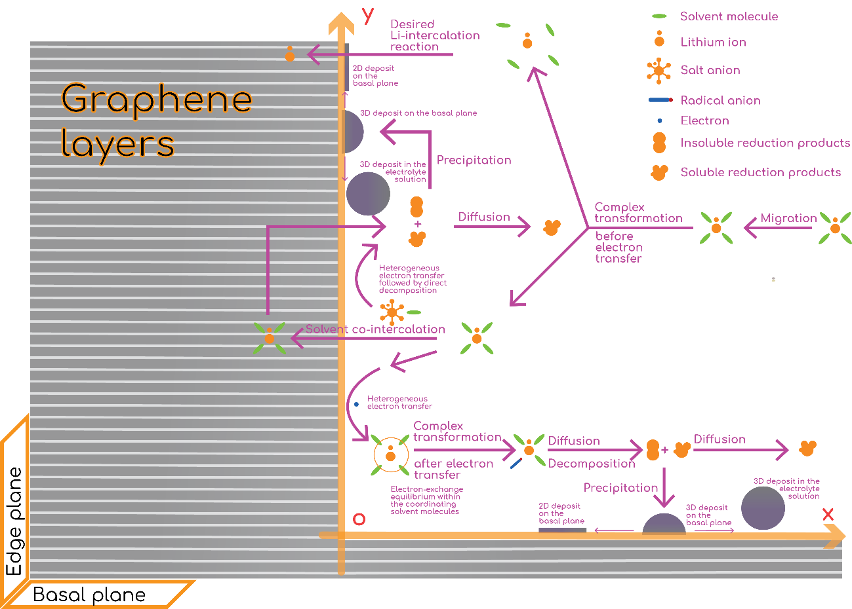
Figure 1-8: Proposed mechanistic pathways for SEI formation [35].
The SEI is what is known as a buried interface due to its location within the cell. This makes it difficult to monitor in-situ during formation and as a result most of the understanding of SEI formation is derived from computational studies. There have been many computational studies of the mechanisms that underpin these reactions [39]. There are several different types of computational techniques that all have different benefits and constraints. The main 4 for probing the SEI are: molecular dynamics, Monte Carlo simulations, density functional theory and ab initio methods. Here is a brief background will help to justify their use to model different aspects of the SEI formation process. Monte Carlo simulations uses a random (there are constraints on this to save time) approach where the system tests multiple scenarios to find the scenario with the lowest energy. Monte Carlo simulations are relatively quick and this makes them appealing for large systems [40]. Ab initio methods use quantum mechanics to find the energy of systems by solving the Schrödinger equation. Due to the complex nature of the Schrödinger equation ab initio methods are very time consuming and are often only performed on systems with small length scales. Density functional theory is based on the simple idea that the energy of the system is derived from its electron density. This allows for calculations that are less intensive than ab initio methods. In some cases, its accuracy can become questionable, when compared with ab initio methods. Molecular dynamics (MD) uses classical mechanics, as opposed to quantum calculations to determine the thermodynamic properties of the system. Molecular dynamic algorithms are easier for computers to solve and so this means that the systems tested can be larger and observed over a longer period of time.
Both 1 and 2 electron reduction mechanisms have been proposed for carbonate-based electrolyte reduction process [41]. Li and Balbuena found that the 1 electron transfer is the rate limiting step with the 2 electron transfer being approximately 10 times faster [42]. Also of note is the fact that SEI reactions are both thermodynamically and kinetically limited. Several species are found in the SEI that have the potential to be reduced further, showing that the SEI can be formed before all reactions go to completion due to the kinetic barriers. The most researched element of SEI formation is the reduction pathway of EC. Wang et al. found that EC was unlikely to be reduced by itself due to the negative electron affinity of EC under adiabatic conditions [43]. This changes when the presence of coordinated Li is considered with Li⁺(EC)_{n} (n = 1–5) facilitating Li⁺ transport. They found that the reduction process starts with the EC accepting an electron, which causes a C-O bond to undergo homolytic fission. They found that the breakdown led to the formation of many different products. The most thermodynamically favoured was dilithium butylene dicarbonate (Li₂BDC), but this is soluble in the electrolyte and so the SEI is dominated by the other products.
Since Wang et al.’s work in 2001 computational power has increased massively. This allowed for ab initio molecular dynamics experiments of SEI formation. Budizen and Leung used molecular dynamics to probe how different graphite termination moieties affect EC breakdown [44]. They found that depending upon the C-O bond that is cleaved at the start either CO or C₂H₄ can be formed. Both CO and C₂H₄ have been found experimentally in the SEI given credence to the models [45]. Leung found that CO is the kinetically favoured product and C₂H₄ is the thermodynamically favoured product [46]. The products aren’t affected by the Curtin-Hammett principle because the radicals don’t interconvert once the ring is open.
Several voltages have been postulated for the onset of SEI formation but the one most commonly mentioned is 0.8V vs. Li/Li⁺ [34]. This value has been hard to confirm computationally using either QM or MD [47, 48]. Wang used a Hess cycle and found a value of 0.84 V vs. Li/Li⁺ which is comparable to the experimentally derived value of 0.68V vs. Li/Li⁺ ,although this value has been disputed [34, 43]. Leung and Tenney mad a model half-cell system with an LiC₆-EC interface [47]. They found that below 1.24V Vs. Li/Li⁺ the anode surface starts accumulating a negative charge. This negative charge can be used to start the radical SEI reactions. Once the cell reaches the breakdown voltage then SEI formation will begin. The value of 0.8V is electrolyte dependant is seen later in 1.9. Borodin et al. found that the onset potential also depends on what stage of SEI formation is occurring [49, 50]. They screened a range of carbonates and phosphates and found that the second reduction potential is higher than the first in most cases. This demonstrates how both the kinetics and thermodynamics of the system is important.
Most of the above examples have focused on EC as it is known to be important for forming the SEI [51]. It is wrong to focus on one component of the electrolyte, considering that the SEI forms as a result of the decomposition of all of the different components of the SEI and the interactions between them. Considering this, Tasaki looked at the reduction kinetics of different electrolytes and found that for the first electron reduction the least likely to undergo reduction was DEC with them following the order EC > PC > VC > DMC > EMC > DEC. For the second electron reduction the order is slightly different with VC becoming the easiest to reduce VC > EC > PC. This matches well with that work by Wang and Balbuena that showed that cyclic carbonates have a higher electron affinity than linear ones [43]. Okamoto found that the presence of LiPF₆ helps to facilitate EC ring opening, demonstrating the importance of the other electrolyte components [52].
The vast majority of SEI formation occurs during the initial cycling of a cell. This is when it is at its thinnest and so the SEI reactions can still occur. As the SEI grows these reactions slow down due to the increasing thickness. This is analogous to the formation of Al₂O₃ on Aluminium. A reaction between O₂ and Al takes place on the surface forming Al₂O₃. This surface layer is impermeable to oxygen, stopping further oxidation from occurring. This reduction in the rate of SEI formation is vital as it ensures that the SEI’s role in depleting a cells Li inventory is minimised. To maintain the optimal electrochemical performance of a cell the thickness of the SEI needs be as thin as possible without leading to further SEI formation.
The initial SEI formation changes the SEI that is subsequentially formed. This change is due to the catalytic effect of graphite on SEI formation [53]. Once the electrolyte gets further away from graphite active sites (due to previous SEI formation) then the reactions available are limited. The surface also becomes electrically insulating, limiting the fresh SEI’s access to electrons. This build-up of insulating SEI also results in changes to the electrolyte double layer [54]. This is especially important when it is considered that the reaction pathway of EC decomposition is dependent on its concentration [55]. The formation of the SEI effectively widens the voltage window of the cell by shielding the electrolyte from the anode surface, as seen in Figure 1-9. This shielding means that Li-ion cells can function whereas in any other scenario they would fail, with constant electrolyte degradation wasting lithium.
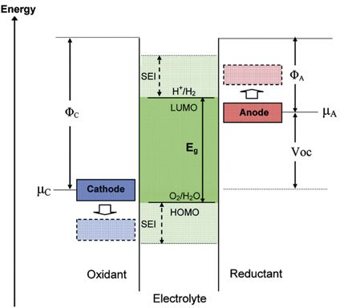
Figure 1-9: Open circuit energy diagram of the electrolyte with the voltage window extensions that the SEI provide [39].
At this stage it is important to differentiate between SEI formation and electrolyte decomposition. The electrolyte can decompose and not lead to an SEI or an unstable one as in the case of PC based electrolytes [56, 57]. One of the differences is that the SEI is insoluble, but the same is not true for all degradation products. To try and account for this Ushirogata et al. performed two calculations [58]. The first of these was a traditional MD study of the decomposition of the electrolyte with the second calculation observing the solubility of these products in EC and their interactions with a graphite surface. Due to the low concentration of initial degradation products they dissolve back into the electrolyte. They then suggested a “near shore aggregation” mechanism for SEI formation whereby the SEI forms in solution until it agglomerates to a sufficient stage and then adheres back to the surface, forming the SEI, a diagram of which can be seen in Figure 1-10. Whilst the aggregation is taking place then electrolyte decomposition can still occur on the graphite. This “solution mediated” mechanism could explain why the SEI can exceed the thickness of electron tunnelling.

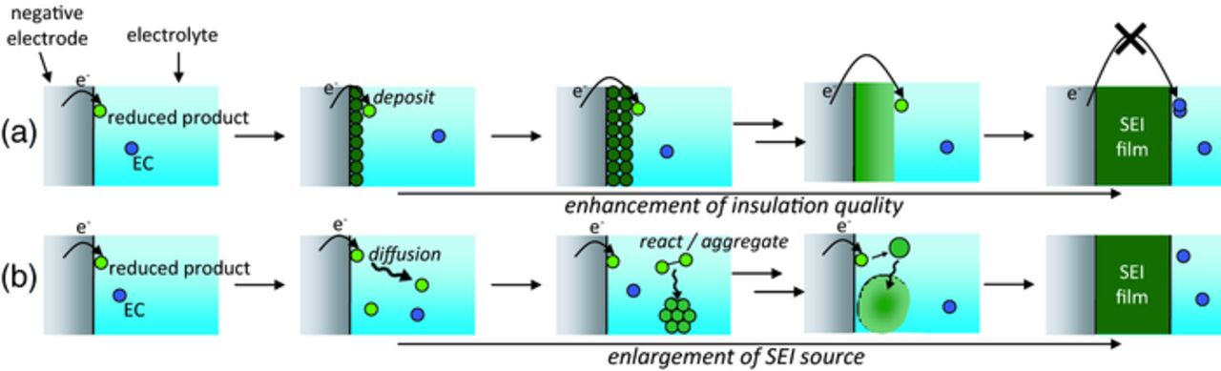
Figure 1-10: Schematic of SEI formation happening via surface growth mechanism and near-shore aggregation mechanism [58].

Table 1-1: Table of common electrolyte components and select physical properties.
Name (Abbreviation) | MW/gmol⁻¹ | M.P. (°C) | B.P. (°C) | ε [59] | Viscosity at room  Temp/cP | Viscosity at melting/cP | Structure | Purpose | Typical loading | Breakdown voltage/ V
Ethylene carbonate  (EC) | 88.062 | 34 | 243 | 89.78 |  | 1.93  (34°C) |  | High dielectric solvent | 50%V | 0.9[60]
Propylene carbonate  (PC) | 102.089 | -48 | 242 | 64.92 | 2.5157 | - |  | High dielectric solvent | 50%V | 1-1.6[60]
Dimethyl carbonate  (DMC) | 90.078 | 2 | 90 | 3.107 | 0.5889 | - |  | Low dielectric solvent | 50%V | 1.32[60]
Ethyl methyl carbonate  (EMC) | 104.10 | -55 | 107 | 2.958 | 0.6478 | - |  | Low dielectric solvent | 50%V | unknown
Diethyl carbonate  (DEC) | 118.132 | -74 | 126 | 2.805 | 0.7534 | - |  | Low dielectric solvent | 50%V | 1.32[60]
Lithium hexafluorophosphate (LiPF₆) | 151.905 | 200  (Decomposes) | - | - | - | - |  | Non-coordinating salt | 1mol/dm³ | 2.1[49]
Lithium hexafluoroborate (LiBF₄) | 93.746 | 296 | decomposes | - | - | - |  | Non-coordinating salt | 1mol/dm³ | 0.2-0.3[49]
Lithium perchlorate (LiClO₄) | 106.390 | 236 | 430  (partially decomposes at 400) | - | - | - |  | Non-coordinating salt | 1mol/dm³ | unknown
Lithium di(fluorosulfonyl)imide (LiFSI) | 187.07 | 140 | - | - | - | - |  | Non-coordinating salt | 1mol/dm³ | 1.6-2.3[61]
Lithium  bis(trifluoromethanesulfonyl)imide (LiTFSI) | 287.075 | 236 | - | - | - | - |  | Non-coordinating salt | 1mol/dm³ | 2.1-2.9[49]

SEI structure
The SEI model has undergone a number of revisions since it was first postulated by Peled in 1979 [1]. The original description by Peled simply describes the SEI as a mixture of insoluble reaction products between the anode and electrolyte, stating that it is at least 15 Å thick.
Peled later went on to suggest that the SEI actually consists of two layers [62]. The initial layer that is formed is a thin compact film. As the SEI grows a secondary layer starts to form, although this layer is thicker and is porous. This dual layer model has formed the basis of discussion about the SEI since its inception.
In 1997 Peled et al. used Electrochemical impedance spectroscopy (EIS) to suggest that the two SEI layers were further divided into “microphases” with an accompanying equivalent circuit. In this model the separate components of the SEI are compartmentalised into small polyhetero microphases, with the inorganic microphases closer to the anode surface and the organic microphases layered on the top and can be seen in Figure 1-11. This SEI was dominated by Li₂O, forming the vast majority of the inorganic layer.

Figure 1-11: Schematic of the microphase model of the SEI.
Since the initial work that suggested the presence of two separate layers numerous studies have been conducted to probe the differences, chemically and morphologically. Edström et al. used XPS with Ar⁺ etching to probe the SEI at varying depths and compared it with results from synchrotron XPS [63]. They found that the dense, initial layer is dominated by LiF with a range of crystal sizes that extend beyond the initial layer and can be found throughout the SEI. They also showed the importance of sample preparation with samples measured with synchrotron XPS not showing any Li₂O in their samples even though it had often been cited as a key SEI component [64]. This lack of Li₂O suggests that it is mainly formed by Ar⁺ etching or in other cases oxygen exposure and isn’t a natural component of the SEI. They used this information to update the model of the SEI and this can be seen in Figure 1-12.
Zheng et al. used atomic force microscopy (AFM) to study the SEI on Si anodes at differing phases of development [65]. They found that on Si anodes the SEI can be formed of either single, double or multiple phases regardless upon the stage of total SEI growth with some areas containing a thick, multilayer SEI and others showing no SEI or thin single layers. The outer layers were also softer with a lower young’s modulus than the early layers. The team found that the SEI coverage was not universal and was concentrated on small sections of the surface. This may be due to the different catalytic effects of a flat surface when compared with rough graphite anodes. The catalytic effect of the surface, especially edge sites is known to play an important role in SEI formation so this may go some way to explain the low coverage.
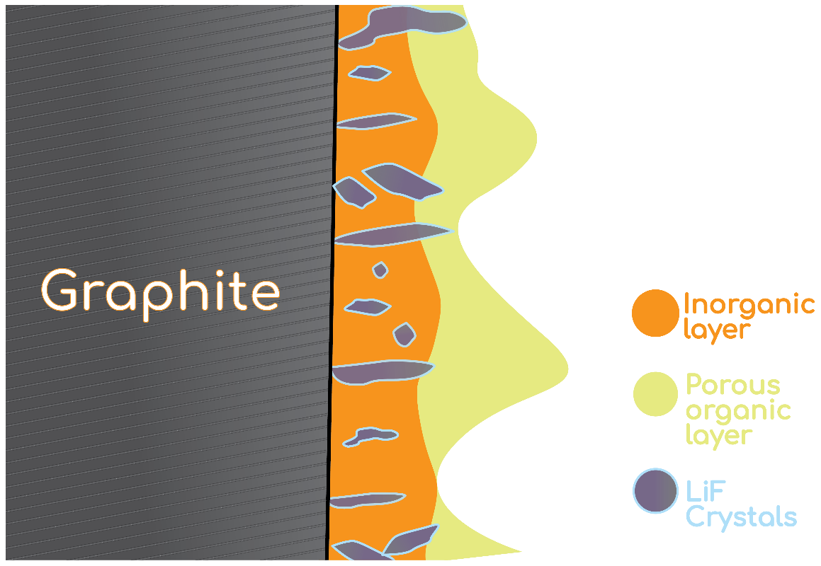
Figure 1-12: schematic of a double layer SEI [63].

Composition of the SEI
Due to the heterogeneous nature of the SEI and the variety of electrolytes that have been tested a number of different components have been reported. The dense, first layer mainly contains inorganic components. The main inorganic components are Li₂CO₃ and LiF [66, 67]. Computational studies by Shi et al. found that the Li⁺ can travel through Li₂CO₃ via a “knock-off” mechanism where excess interstitial Li⁺ displaces Li from the lattice, repeating until it reaches the graphite [68]. For LiF it has been found that that Li diffusion primarily occurs along the grain boundaries [69]. Both LiF/ Li₂O and LiF/LiF grain boundary interactions had lower activation energy than Li₂O/Li₂O grain boundary interactions. This is the main reason for the lower resistance seen with SEI layers containing large amounts of LiF.
This second layer mainly consists of oligomeric, organic components. Examples of these are (CH₂OCO₂Li)₂, polycarbonates & Semi carbonates with organic side chains of varying lengths (ROCO₂Li). These components help to give the SEI flexibility to withstand the small volume changes that graphite undergoes upon intercalation (≈4%) [34]. This is important as other anode materials such as Si (see section 4.1 for more information about Si anodes) that have larger volume changes (≈400%) can destroy the SEI leading to rapid capacity fade, showing that the flexibility is important to the structural integrity of the SEI.
Shi found that the porosity of the organic layer means that Li can diffuse quickly through it [68]. This means that much of the resistance attributed to the SEI is a result of the inorganic layer as we saw earlier with the slow diffusion through the salt structures.

The role of the electrolyte in SEI formation
There are 3 main electrolyte components in most Li-ion batteries: a low dielectric constant solvent, a high dielectric constant solvent and a non-coordinating salt. These three components all have different roles to play to optimise cell performance. The high dielectric constant solvent main role is to dissolve the salt. The low dielectric constant solvent helps to lower the total viscosity of the electrolyte, and if ethylene carbonate (EC) is the high electric constant solvent component then it also helps to ensure that the electrolyte is a liquid at room temperature. The salt transports Li between the anode and cathode.
As the electrolyte is source for the SEI its composition is vital for the structure and performance of the SEI. This is similar to corrosion processes seen with metals such as steel [70]. The resultant corrosion products are heavily influenced by the material itself and the media surrounding the material such as CO₂. This is analogous to the SEI with both the anode itself and the electrolyte surrounding it affect SEI formation and performance.
Many of the first electrolytes were based on propylene carbonate (PC) as it is a liquid at room temperature and has a high dielectric constant which helps to dissolve the Li salts used with a hard carbon anode[71]. Propylene carbonate suffers from poor cyclability. One of the reasons for this poor cyclability is due to co-intercalation into the graphite [56, 57]. Co-intercalation is where the solvent intercalates along with the Li as opposed to intercalation where only the Li moves between the graphite sheets. The presence of the solvent between the graphite sheets leads to the graphite sheets moving further apart until they exfoliate from each other, lowering capacity. Co-intercalation occurs due to PC’s poor SEI formation meaning there isn’t any physical barrier to stop the intercalation process.
Ethylene carbonate doesn’t suffer from the same issues with solvent co-intercalation due the more robust SEI that it forms. EC is a solid at room temperature though and this makes it harder to utilise in the battery manufacturing process.
Several salts have been used for battery electrolytes. In all cases weakly-coordinating salts have been used. This is due to their resistance to decomposition on the cathode as well as their high solubility in organic solvents [72]. Aurbach found that in EC: DEC mixtures LiAsF₆ was the best performing salt with the greatest capacity retention. This was attributed to the inertness of AsF₆⁻ when compared with PF₆⁻. They claimed that this led to lower HF production, which couldn’t in turn degrade the electrolyte. They admit however that some of this may have due to the presence of PF₅ as an impurity which is far more reactive. This shows how sensitive the cell performance can be to the electrolyte composition and why choosing the correct one is vital for having a stable SEI that ensure the cell retains its capacity.

Electrolyte additives and their influence on the SEI
Even with an ethylene carbonate containing electrolyte the initial coulombic efficiency and capacity retention of the cell are low. The low initial coulombic efficiency is due to SEI formation and currently the main way to combat this is through the use of electrolyte additives. These additives have a higher breakdown voltage than the electrolyte. This means that the additive will preferentially decompose instead of the electrolyte, allowing the electrolyte to transport the Li unimpeded. This is analogous to galvanisation of steel with the additive reacting with Li to keep the underlying electrolyte protected instead of zinc reacting with air to keep the steel protected. There are other electrolyte additives that have other functions such as flame retardants but these aren’t covered here [73].
Most additives are designed to form one of the two SEI layers, although this isn’t to say that they don’t contribute to both layers. For example, vinylene carbonate (VC) is easily polymerised. This polymer then forms the uppermost layer of the SEI. CO₂ was one of the first electrolyte additives used as it was thought to form Li₂CO₃ [57].
The current range of additives can be organised into several Sub-categories of additives:

EC-based additives
These are functionalised ethylene carbonates that typically have been either halogenated or have an unsaturated C=C bond. EC already forms a solid SEI with a higher LUMO than linear carbonates due to the ring strain present. Functionalisation of the EC lowers the energy of the LUMO even further, making it susceptible to nucleophilic attack, with a resulting higher breakdown voltage. These nucleophilic attacks lead to the opening of the 5 member rings. Once the ring is opened a number of breakdown reactions can occur.
The most commonly seen additives in this category are Vinylene carbonate and Fluoroethylene carbonate (FEC). VC is an unsaturated analogue of EC. This C=C bond is vulnerable to nucleophilic attack by Li. Li gives its electron to VC creating a carbon radical carbanion that then reacts with other VC monomers. This process is similar to the Atom transfer radical polymerization process used to create polymers industrially although this uses Cu(I) as the radical source instead of Li [74]. VC has been shown to reduce the irreversible capacity loss of the cell (Q_{irr}), improve the cycling capacity, with a more pronounced increase at higher temperatures and supress excessive salt formation [75-77]. Aurbach et al. found that the use of VC reduced the resistance of the SEI (R_{SEI}) [77]. They attributed this to the formation of polymeric SEI coatings. These factors have made it a popular choice in research. It is extensively used in Si anode research as VC’s polymeric SEI helps to reduce the pulverisation of lithiated particles, instead keeping them bound together by absorbing some of the mechanical strain.
FEC is another additive that has been used frequently. In initial papers it was used as an major electrolyte component as opposed to most additives that are used to less than 10% volume of the electrolyte [78]. The group had initially tried chloroethylene carbonate, but this suffered from poor coulombic efficiency [79]. They Showed that FEC result in a cell with high capacity retention and coulombic efficiency, overcoming the issue they had with chloroethylene carbonate.
Other studies have shown that FEC can be used in far lower quantities, comparable with other additive loadings and still show improvements to performance [80]. Work by Kubota et al. used XPS and TOF-SIMS to probe the SEI formed by FEC based electrolyte [81]. The found that the FEC based SEI contained LiF and was thinner than the SEI from an EC based SEI. The FEC based SEI contained less oxygen and more carbon and fluorine than the EC based SEI. This more robust SEI helped to reduce the oxidation of Si. These factors ultimately led to an improvement in capacity retention and coulombic efficiency as seen in Figure 1-13. The blue lines are the cells containing FEC and the red lines are cells without FEC.
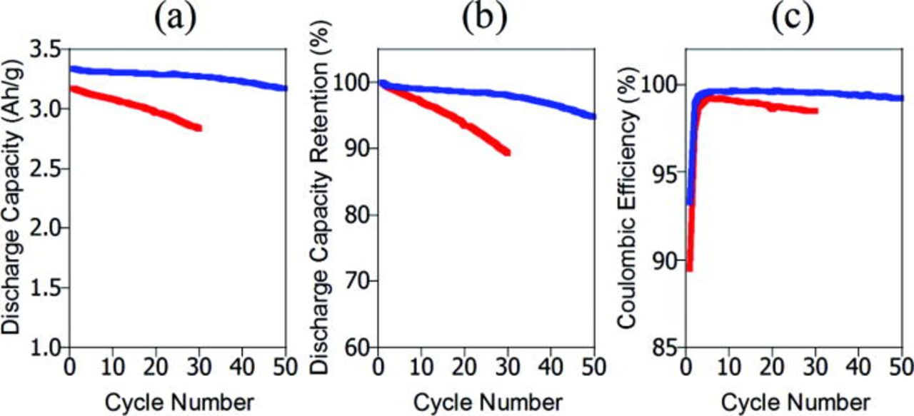
Figure 1-13: graphs showing the improved electrochemical performance of an FEC based SEI Vs. an EC based one [81].
Due to the popularity of both VC and FEC there has been a debate as to which is more effective at forming a robust SEI. Giebeler and co-workers tried to answer this question with regards to Si anodes, as additives are essential for Si to cycle effectively [82]. They found that for Si anodes VC was a more effective additive. They claimed that this was due to the inflexibility of the FEC based SEI with its LiF nanocrystals cracking during the lithiation process. However, the presence of the LiF reduced the resistance of the SEI (R_{SEI}) which the authors suggested would help for high power applications. The composition of both polymeric, upper layers was comparable with both consisting of polycarbonates. In graphite anodes the volume change for lithiation is far smaller than it is for Si (≈9% vs. 400%) which means that the issue of LiF cracking isn’t a factor. With this in mind for graphite anodes FEC will most likely be the better performer, due to its highly conductive LiF initial layer and polycarbonate top layer [5].

Sulphites
These compounds all contain SO₃ groups. Most sulphites additives are analogues of the organic electrolyte components. Ethylene sulphite was first shown to improve the performance of LiMn₂O₄ which is a cathode material, which was attributed to their high oxidation stability [83]. They also found that they can help to supress PC co-intercalation in graphite anodes. This was only an initial finding and they didn’t elaborate on these results or suggest a mechanism. Yu et al. recorded the physical properties of the four carbonate analogues: Ethylene sulphite (ES), propylene sulphite (PS), dimethyl sulphite (DMS) and diethylene sulphite (DES) [84]. They found that they had wider liquid ranges and higher flash points than their carbonate analogues. This gave them good potential as electrolytes because the high melting point of EC (36°C) limits the low temperature window for current batteries. The high flash point improves the safety of the cell, which is especially important given the recent spate of electric car fires that have affected the industry [85]. As well as recording the physical properties of the sulphites they also tested them electrochemically. They showed that the presence of as little as 0.3% of ethylene sulphite could improve coulombic efficiency of full cells [84]. Using CV, they identified two peaks at 0.6 and 1.5 volts during the first discharge that they attributed to ethylene sulphite decomposition.
The main sulphite SEI components are Li₂SO₃ and (RSO₃Li)₂, analogous to the Li₂CO₃ and (ROCO₂Li)₂ formed in organic electrolytes [86]. Computational investigations were conducted by Leggesse and Jiang on PS. They found that the breakdown voltage of PS is higher than that of PC highlighting its potential as an additive. The breakdown happens in a similar manner to PC with the PS becoming reduced leading to ring opening. This radical can then either dimerise or decompose further into Li₂SO₃. This is important as these are the products that have been found experimentally. Zhang et al. compared the SEI formation process of PS with VC [87]. They found that the PS film had a lower impedance than that of the VC based one. This could be attributed to the presence of RSO₃Li that can help to conduct Li ions in a similar manner to Li₂CO₃ [68]. They found that combining both VC and PS results in the good conductivity of the SEI associated with PS coupled with the durability of a VC based SEI. They also found that both additives reduce ethylene evolution significantly which ties in with the reduction pathways seen in Figure 1-14.
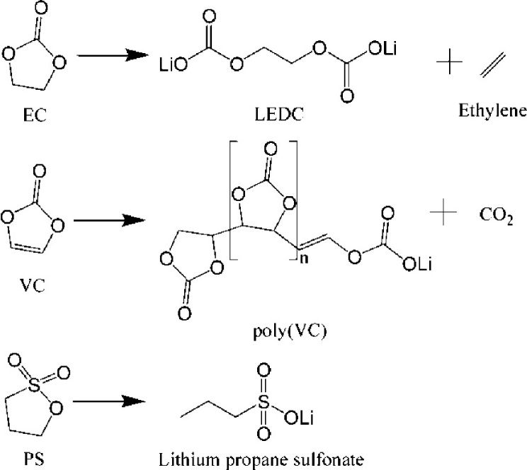
Figure 1-14: Comparison between the reduction pathways of different additives [87].

Other additives
A wide range of boron compounds such as B₂O₃ have been utilised as additives from inorganic boron trioxide to organic Lithium boro-organic salts [88, 89]. Boron compounds have been found to increase the rate capabilities of cells as well as improve their performance in low temperatures [90]. XPS data has shown the presence of O-B-O bonds in the SEI when boron compounds were used as an additive [91]. This was attributed to the boron reacting with the lithium salts to further oligomerisation. Boron compounds, whilst useful stabilising the SEI on the anode can also help cathode performance by suppressing metal dissolution [92].
Maleimide, the structure of which can be seen in Figure 1-15 and its derivatives form thin polymeric films as an SEI in a similar manner to VC. Most additives are highly delocalised systems that make them ideal for atom transfer radical polymerisation. Wang et al. reported that these films improved the reversible capacity of the graphite [93, 94].
Figure 1-15: Maleimide structure.
Glycolide is a commonly used monomer unit for ring opening copolymerisation with other common monomers such as lactic acid to form (poly(lactic-co-glycolic acid) which is used in the biomedical field [95]. Polyglycolide aren’t used frequently due to its tendency to hydrolyse. In a LIB this isn’t an issue however due the lack of water. Gylcolide and several of its derivatives were used in cells and their performance compared against VC [96]. It was found that increasing methylation of the glycoside improves the heat tolerance of the cells. Their lower capacity when compared with VC means that they have not become popular additives.
Pyridine is an aromatic compound with a nitrogen atom that can be used to form an adduct with Lewis acids. The two most common adducts for use as battery additives are pyridine boron trifluoride (PBF) and pyridine phosphorus pentafluoride (PPF). These adducts have been shown to improve the charge retention at both higher temperatures and higher cell voltages [97]. Increasing the temperature window for cells will be important going forward as electric vehicles are subjected to harsh weather conditions over longer periods of time. The higher voltage tolerance is vital for developing new cathode materials, such as LiCoPO₄, as raising the cell voltage is currently one of the most promising routes to increasing energy density [98, 99].
An extensive study was conducted by Hall et al. into the decomposition of these pyridine adducts as they are very different to the EC-based electrolytes [100]. Using a combination of computational and experimental techniques they found that Li causes the pyridine to dimerise to 4,4’ -[Li₂(PBF)₂] and 4,4’-[Li₂(PPF)₂]. The decomposition reactions of PBF and PPF begin at 1.3 and 1.4 V Vs. Li/Li⁺ respectively, which is significantly higher than EC (≈0.8 V), making them ideal as an additive. This decomposition also doesn’t release any gaseous products as confirmed by GC-MS which is ideal as the need to de-gas the batteries is diminished.
There are many other classes, but these are the most frequently used in the literature. In Theory any molecule with a breakdown voltage higher than the electrolyte could be used although whether this would improve the performance of the cell would be questionable [73]. The most commonly used additives for SEI formation are still VC and FEC academically, despite being some of the earliest additives. This is most likely due to their predictable results and well-known dosages for improving performance.

Formation cycling
As the SEI is so vital to cell performance and safety it is vital that this process is carried out in the factory before they reach consumers hands to remove the excess gas formed and ensure that it has be performed correctly. The SEI is created industrially using a process known as formation cycling. Formation cycling involves cycling the cell at a low C-rate (for more information on C-rates see section 2.3) for a few cycles, typically between 3 and 5. The formation cycle ensures that a stable SEI has been created so that the cell is safe and can be sent to customers. This process is one of the most expensive and time consuming steps during the battery manufacturing process as can be seen in Figure 1-16, costing up to $7.5/ kWh and requiring up to 3 weeks [101]. Such an added expense makes it harder to increase production of cells and lower the energy requirements. Some attempts have been made to try to reduce the time required but these still require several days to complete [2]. Any reductions beyond this will help to further reduce costs and improve output but these aren’t forthcoming without a move to new SEI formation strategies.
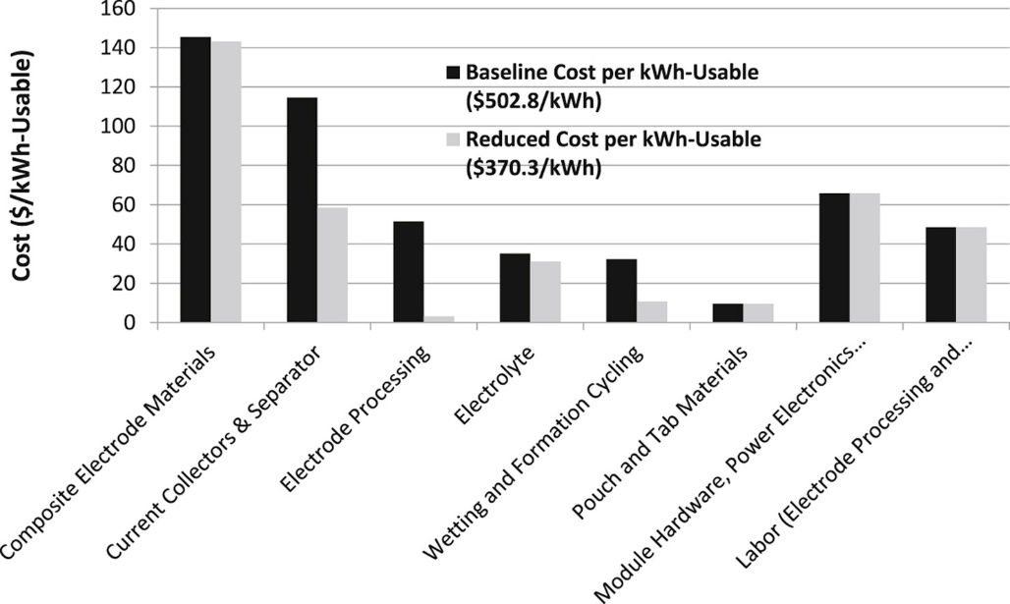
Figure 1-16: A breakdown of associated costs for batteries with the wetting and formation cycling process costing almost as much as the electrolyte [101].
As formation cycling is an industrial process that is taken as a standard process during cell cycling there is a dearth of literature on this important topic. A reason for this may be due to research being directed at proprietary formation cycling techniques instead of for publication. One publication of note is the work by An et al. who found that as the main role of formation cycling is to form the SEI then the battery doesn’t need to cycle through its whole voltage range [2]. Instead it just needs to change a few hundred mV to facilitate further SEI formation and the new cycling profiles are seen in Figure 1-17. This also reduces the stress on the cathode. By using this new regime, the time required for formation cycling at C/10 reduces from 107 to 42 hrs which is a substantial reduction. This process also requires less electricity due to comparatively limited amount of charging required.
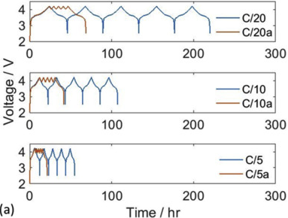
Figure 1-17: Formation cycling profiles showing the reduction in time required with the new regime [2].
Table 1-2: List of common electrolyte additives and some of their select chemical properties.
Name  (abbreviations) | Structure | MW | m.p. (°C) | b.p. (°C) | ε | Breakdown voltage/ V | Typical loading
EC-based additives
Fluoroethylene carbonate (FEC) |  | 106.05 | 18-23 | 212 | 107[102] | 0.9-2.25[49] | 2-10%
Vinylene carbonate (VC) |  | 86.05 | 22 | 178 | 126[103] | 1.4[60] | 2-10%
Vinyl ethylene carbonate (VEC) |  | 114.10 | - | 237 | - | 2.2[104] | 1%[105]
1, 3-benzodioxol-2-one (BO) |  | 136.11 | 116 | 180.8 | - | > PC[106] | 2wt.%[107]
Sulphites
Ethylene sulphite (ES) |  | 108.12 | -17  [108] | 159.1 | - | 1.8-2[83] | 25%[108]
Vinyl ethylene sulphite (VES) |  | 114.10 |  | 237 | - | ES>VES>VC[109] | 20%[110]
Butylene sulphite (BS) |  | 122.14 | 79  [108] | 174 | - | > PC [111] | 25%[108]
Pyridine complexes
Pyridine boron trifluoride (PBF) |  | 147.05 | - | - | - | 1.3[100] | >2%[97]
Pyridine phosphorous pentafluoride (PPF) |  | 205.01 | - | - | - | 1.4[100] | 2% [112]
Boron compounds
Boron Trioxide | B₂O₃ | 69.62 | 450 | 1860 | -
Lithium difluoro(oxalate)borate  (LIDFOB) |  | 143.77 | 265 |  |  | 1.57[49] | 5%[113]
Lithium bis(oxalate)borate  (LIBOB) |  | 193.79 | >300 | - | - | 1.5-1.8[114] | 1moldm⁻³ [91]
Li bis(salicylate)borate |  | 258.07 | - | - | - | - | 1mol kg⁻¹ [115]
Maleimide derivatives
Meta-phenyl-  enedimaleimide |  | 268.05 | >300 | - | - | - | 0.1wt%[93]
Ortho-phenyl-  enedimaleimide |  | 268.05 | >300 | - | - | - | 0.1wt%
Para-phenyl-  enedimaleimide |  | 268.05 | >300 | - | - | - | 0.1wt%
Glycolide derivatives
Glycolide |  | 116.07 | 82-86 | 141.55 | - | - | 2%[96]
3-methyl glycolide |  | 130.03 | 61.8 [116] | 159.76 | - | - | 2%
3,6 dimethyl glycolide (Lactide) |  | 144.13 | 116 | 177.97 | - | - | 2%

Pre-lithiation techniques
One way of forming an SEI before cycling is to pre-lithiate the anode. This is where lithium is added to the electrode before cycling, helping to make up for the lithium inventory loss during SEI formation. This process is visualised in Figure 1-18. Pre-lithiation therefore increases the initial coulombic efficiency of the cell as less lithium is diverted to SEI formation. Pre-lithiating the anode also means that unlithiated cathodes such as V₂O₅ can be used which can have higher capacities than current cathode materials, although these anodes have other unrelated issues limiting their use [117].
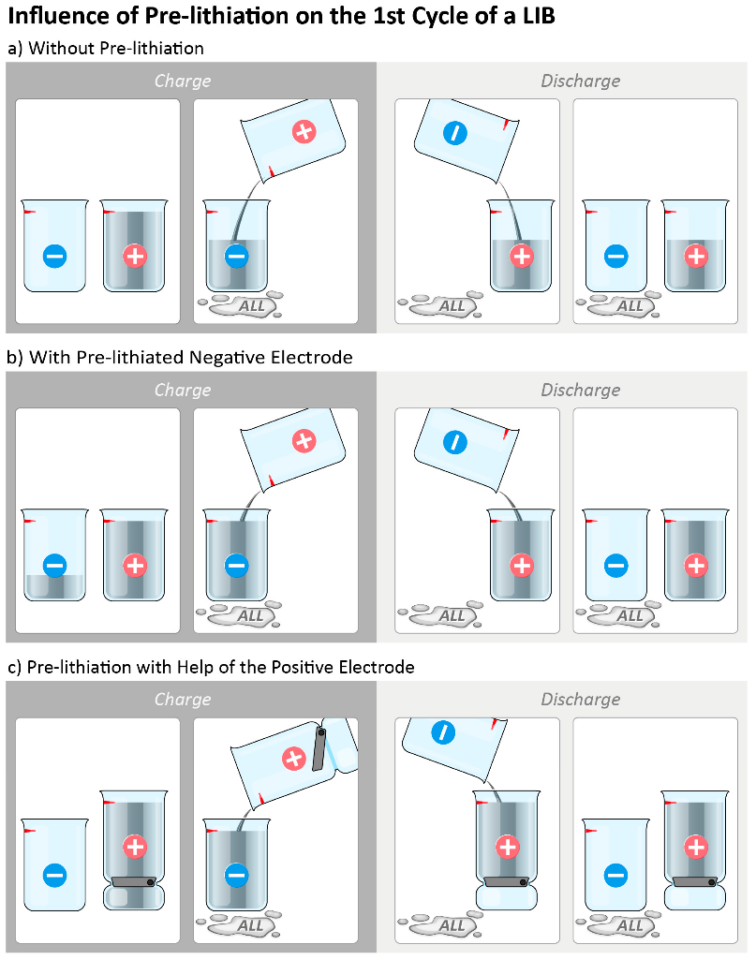
Figure 1-18: Schematic illustration of (a) active lithium loss (ALL) in the 1st charge/discharge cycle in a lithium ion cell and concepts for reducing the active lithium loss by pre-lithiation, i.e., (b) by pre-lithiation of the negative electrode (−) or (c) by pre-lithiation with help of the positive electrode (+) [118].
The cathode can also be pre-lithiated although this is slightly different to the anode pre-lithiation process. The pre-lithiation is typically handled by imbedded particles with Li rich compounds such as Li₂S and Li₃N [119, 120]. Li₃N has the highest gravimetric capacity of these additives (≈1400 mAhg⁻¹) but it suffers from a poor electronic conductivity and it reacts with NMP, which is the traditional solvent for cathode production. It also created N2 gas which may be an issue for some cell types. Sun et al. coated the Li₃N in a combination of Li₂O and Li₂CO₃ to try and overcome some of these issues. The coating allowed for the additive to be used in ambient condition in exchange for a small amount of capacity [121].
Ternary metal oxides have also been trialled as cathode additives. Li₂NiO₂ is one of the materials that has been looked at due to several favourable properties [122]. As well as having a high storage capacity of 340 mAhg⁻¹ it has a reversible capacity of 76 mAhg⁻¹ meaning that it can be used as additional active material, rather than being dead weight. As little as 5 wt.% has been shown to mitigate Q_{irr} in a graphite/CoO₂ cell. Like many other additives Li₂NiO₂ is sensitive in ambient conditions. Kim & Cho coated it in Al₂O₃ to stabilise it in air [123]. An overview of these pre-lithiation additives capacities are found in Figure 1-19.
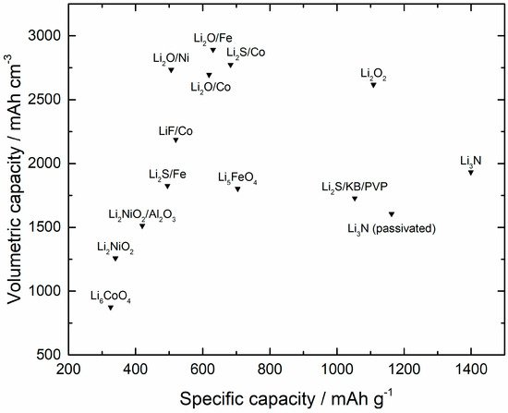
Figure 1-19: Capacity of common additives for pre-lithiation [118].
Cathodes can also be made to have an excess of lithium before cycling. Whilst it isn’t a pre-lithiation technique it is still used to negate the Q_{irr} loss and is still worth noting. Some cathodes can inherently have a higher lithium content than they are able to cycle. Examples of this phenomena are LiNiCoMnO₂ and LiNiCoAlO₂ which can be attributed to irreversible structural changes that limit lithium re-uptake [124, 125]. Certain cathodes can also be “stuffed” with extra lithium in vacant sites in the crystal lattice. Li_{1+x}Mn₂O₄ is one example where extra Li is added to vacant tetrahedral sites [126]. This excess Li can be extracted at 2.7 V Vs. Li/Li⁺. This is not a suitable voltage for Li ion batteries due to the low energy output and fast capacity fade, but it can be used as the pre-lithiation source. Once the Excess Li has been used to negate the initial lithium inventory loss the cathode can the cycle normally [127].
There are several methods for pre-lithiating the anode. Many of these techniques were originally developed for producing lithiated graphite capacitors [128]. A schematic for the commercial pre-lithiation of Li-ion can be seen Figure 1-20. In comparison to batteries pre-lithiation has a much larger effect on the energy density of capacitors [129]. Capacitor pre-lithiation needs to be closely monitored to ensure that the SEI layer doesn’t become excessively thick [130]. This keeps the resistance low for optimal high rate performance.
The first pre-lithiation experiment was conducted in 1998 by Scott et al. using n-butyl lithium (n-BuLi), a common alkylating agent [131]. By treating the anode with BuLi before cycling the Q_{irr} of the cell was reduced. They found that the SEI formed was brittle and much thicker than that which is formed electrochemically.
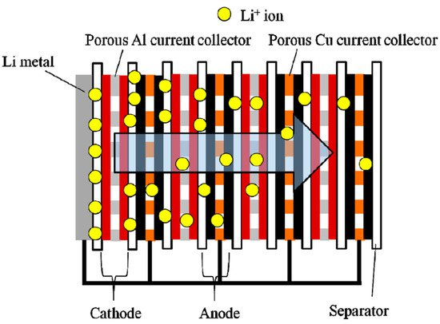
Figure 1-20: Fabrication scheme for commercial Li-ion capacitors with porous electrodes allowing Li to migrate through the entire cell during the pre-lithiation process [132].
One of the most common techniques is the electrochemical pre-lithiation of the electrode [133-136]. This is analogous to completing a partial 1st charge of the anode. This is the method for pre-lithiation that take the least amount of time with the process taking under an hour [137]. This process at lab scale typically involves pre-lithiating as a half cell, disassembly and then reassembled as a full cell. This process would be costly to scale up and manufacture commercially though. Some techniques have been suggested to circumvent this such as the work by Kim et al. where the pre-lithiation is carried out as a roll to roll process, although this is just a proposal and has not been realised commercially [137]. Pre-lithiation is done commercially by JMEnergy but this is for the capacitor market, using porous electrodes [132].
Lithium metal is difficult to handle and expensive to produce so Zhou et al. invented a novel dual electrolyte system [138]. On one side is the electrode being pre-lithiated in LP30 with Li_{2+2x}Zn_{1−x}GeO₄ (−0.36 < x < 0.87) (LISICON) as the separator which was created as a solid electrolyte [139]. As LISICON is selective to Li⁺ transport it excludes water which is the electrolyte on the other side. In the water is 0.5 M Li₂SO₄ which is the lithium and a copper pit corrosion counter electrode. This process produces Cu₂SO₄ which is easily reused and has the potential to require a less controlled environment than other pre-lithiation methods. This process could potentially make the pre-lithiation viable commercially.
Another method is to place the lithium and anode into direct contact with each other [140]. This process has been applied to range of different anode types including graphite, Si and hard carbon [140, 141]. This is a slower process than electrochemical pre-lithiation due to the kinetics of the reaction. Pre-lithiation performed using this method can be produced with both Li foil and a product known as stabilised Li metal powder (SLMP) [142]. Wang et al developed a dual binder slurry that contained SLMP so that the pre-lithiation process could take place within it [143]. Unfortunately, the SLMP had a low density which caused it to rise to the surface of the slurry, undermining its homogeneity. It also requires a dry room and toluene as a solvent which add significantly to the production expense.
Zheng et al. tested how different types of Li impacted the pre-lithiation process [144, 145]. They found that the type and amount of Li used had a major impact on the kinetics of pre-lithiation. They found that by placing holes in the Li foil electrolyte could reach the anode surface more easily, which allowed for faster pre-lithiation time. They also found that thin Li foil (≈20 µm) led to faster pre-lithiation than thick Li foil (≈45 µm), as a result of the smaller travel pathway. When thin foil is used the pre-lithiation process can be completed in under 2 hours.
As seen pure Li metal isn’t the only pre-lithiation material available and there are several other routes. One example is Li_{x}Si-Li₂O nanoparticles with the lithiated Si surrounding the Li₂O [146]. The presence of oxygen was attributed to SiO species present during processing. Pre-lithiation using these nanoparticles resulted in increases in initial columbic efficiencies to 94% and even higher in some samples. Due to the presence of Li₂O the capacity of the particles was limited to ≈1300 mAhg⁻¹ instead of Si theoretical capacity of 3579 mAhg⁻¹ [147]. These particles were resilient after exposure to dry air retaining 91% capacity after 24hrs of exposure. This resilience was lost in the presence of moisture retaining only 5% of capacity after 6 hours. To try and overcome these deficiencies Zhao et al. created an artificial SEI around the nanoparticles using 1-fluorodecane, where they had improved the silicon purity to lower the amount of oxygen present [148]. This method significantly increased capacity of the nanoparticles to ≈2100 mAhg⁻¹ and it also retained ≈1600 mAhg⁻¹ after 6hrs in an environment with 10% relative humidity. This shows that the SEI at least partially shields the lithium from external reactants.
With these encapsulated particles the main issue is that encapsulation must be flawless, or the Li can leave the particle rendering it unusable. One attempt to circumvent this was again by Zhao et al. who used SiO_{x} particles [149]. Using SiO_{x} as the starting reagent led to the formation of dispersed Li_{x}Si in a Li₂O matrix. This more robust system again held up well to dry air retaining 91% capacity after 5 days of exposure. These samples were created by stirring the SiO_{x} particles in molten Li metal for 5 days and this energy intensive process is not an appealing process for manufacturing at scale. Other group IV elements have been used more recently [150]. These elements suffered from lower capacity than the Si based option but due to their higher potentials they withstood ambient conditions for longer with higher capacity retention.
A cell can also be pre-lithiated by providing an additive that is lithium rich, imbedded into the anode. Li_{2.6}Co_{0.4}N, with a capacity of 760 mAhg⁻¹ has been used to pre-lithiate a range of anode materials including hard carbon, graphite, LiTi₂O₄ and Si [151-154]. These electrodes had to be created in an argon glovebox without any solvent due to the high reactivity of Li_{2.6}Co_{0.4}N which limits the viability of this method.
There are several other methods such as using a sacrificial Li electrode, using a cathode with excess Li or using a highly concentrated electrolyte [155]. These are less common though and have seen little use.
While all of these systems helped to improve the coulombic efficiency of the battery, they also added extra mass to the system. This is important to consider when one of the main promises of pre-lithiation is to increase the gravimetric capacity of the system. This is why more cathode mass isn’t simply added to the battery. Pre-lithiation has been shown to increase the rate capabilities of cells, which has been attributed to the lower impedance that a robust SEI provides [130, 156, 157]. It has also been suggested that Pre-lithiation of Si anodes can cause a volume expansion, which reduces the volume expansion during cycling [158].

Other artificial SEI’s
Anode pre-lithiation isn’t the only way that researchers have used to form an SEI before cycling. The earliest methods involved forming the SEI anode using thin layer coatings [159]. These were commonly used techniques in manufacturing such as electrodeposition and vacuum insertion. This idea of using a thin layer SEI has led to a variety of single layer inorganic salts being applied such as TiO₂ & Al₂O₃ to both graphite and Li [51, 160, 161].
As the SEI became better understood the artificial SEI became more complex to be more accomplished at fulfilling the role of the SEI. Wu and co-workers showed how knowledge of natural SEI systems could be used to direct development of artificial ones [162]. They used a polymer backbone that directed Li ions down dedicated channels. These channels help to ensure fast Li diffusion. This faster diffusion meant that even at high C-rates (25 C) they retained most of their capacity (80%). They used a polymer with an aromatic group that undergoes π stacking with the graphite, ensuring that the polymer adheres to it. An extensive hydrogen bonding network ensures that the two polymers used bind to each other. The main issue with this technique is that to ensure that the SEI doesn’t dissolve during the tape casting process N-methyl-2-pyrrolidine (NMP) was used as a solvent. This is more expensive, toxic and requires more energy to remove than water.
Figure 1-21: Structure of polydially dimethyl-ammonium chloride (PDDA, left) and polysodium 4-styrenesulfonate (PSS, right) used for the water insoluble artificial SEI [163].
This work was further improved by Wu et al. [163]. To overcome the issue of water solubility the group used a ternary polymer solution. 2 of these were polyelectrolytes that together formed a water insoluble blend and these are shown in Figure 1-21. The third polymer is a binder that helped to ensure that the carbon black was distributed evenly through the slurry. This water-soluble blend displayed improved retention at high C-rates as well as better coulombic efficiency.
Another study of note is that by Li et al. [164]. They demonstrated the importance of optimising the thickness of the artificial SEI to ensure that it has the desired properties. They used lithium phosphorus oxynitride (LIPON) which has frequently been touted as a solid electrolyte [165]. They found that when the SEI layer was thinner that 40 nm it wasn’t effective with low coulombic efficiency and capacity degradation at higher cycle number. As soon as LIPON thickness reaches 50 nm both of these outputs improve making them comparable to graphite. They used EIS to probe these different films and found that at 50 nm the electronic conductivity of the LIPON dropped significantly as can be seen in Figure 1-22. It is therefore preferable to have the Lipon as a homogenous layer at least 50nm thick to ensure that the SEI isn’t an electronic conductor, limiting degradation of the electrolyte. The demonstrates how important it is that the SEI is electrically insulating as otherwise the electrolyte degrades. The LIPON thickness required to inhibit electron conduction is far greater than has been seen with natural SEIs [62]. The group attributed this to heterojunctions in the structure but they stressed that further study was required [166].

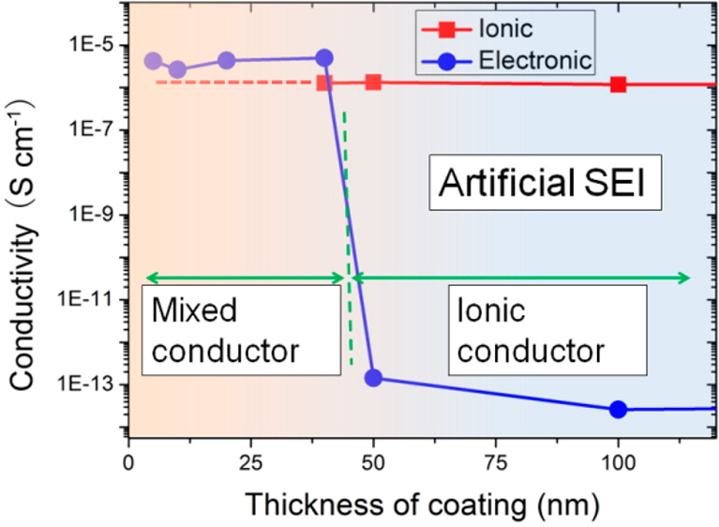
Figure 1-22: How conductivity of an artificial SEI varies with increasing film thickness [164].

Sodium-ion batteries
Sodium-ion batteries are seeing as massive surge in interest due to worries about the sustainability of some part of the Li-ion battery supply chain
Na-ion cells are based upon a rocking chair mechanism with Na replacing Li as the charge carrier. As Na⁺ has a larger ionic radius than Li⁺ it can’t intercalate into graphite. This means that hard carbon is the most common anode material [167]. Hard carbon can also intercalate Li although it has a lower specific capacity than graphite. It is believed that the hard carbon stores the Na in a ‘house of cards’ formation where disorganised carbon sheets envelop the Na and this is visualised in Figure 6-1. Due to this there isn’t a well-defined stoichiometry for the Na-hard carbon complex and so as a result of this there isn’t a defined theoretical capacity, although the realised capacity is typically 200-300 mAhg⁻¹.
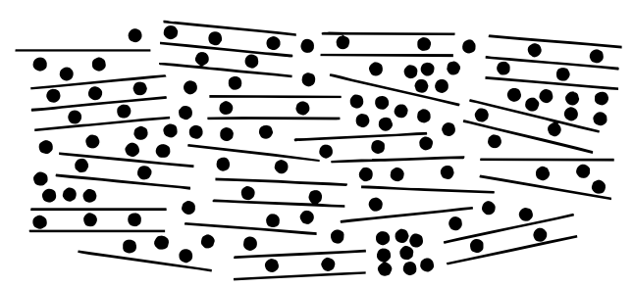
Figure 1-23: House of cards formation with hard carbon sheets surrounding the sodium [167].
For the cathode there are again similarities with Li-ion cells. The cathode is typically based on a transition metal oxide such as NaNi_{0.25}Mn_{0.75}O₂ [168]. Again, Na’s larger ionic radius means that the cathodes typically used in Li-ion batteries are generally unsuitable. With the example used there is a similar Li Cathode LiMnO₂ [169]. By partially replacing manganese with nickel the inter-spacing distance increases to better accommodate the Na insertion.
Currently the electrolytes used for Na-ion batteries are similar to those in Li-ion batteries with NaPF₆ being used instead of LiPF₆ with the same carbonate solvent components being used. The current collectors are typically both aluminium as it is cheaper than copper and there isn’t a concern with Na-ion cells of intercalation [101].

Na-ion SEI
The SEI formed Na-ion anodes are rather different to that formed on Li-ion anodes. Work by Ponrouch et al. compared the SEI formed on Na and Li symmetrical cells [170]. They found that Na-based SEI has a much higher impedance than a Li-based SEI. This higher impedance led to larger IR drops which has been to adversely affect the performance of hard carbon [171]. They attributed the poor performance of the SEI to its higher solubility, suggesting that it partially dissolves back into the electrolyte. This team proceeded to use FEC, the common electrolyte additive to see if it also improved the SEI performance. They found that FEC actually increased the impedance of the cell, which led to large overpotentials upon cycling. This overpotential meant that 3-electrode cells had to be used to ensure full sodiation, where the reference electrode would stop the hard carbon from falling below 0 V Vs. Na/ Na⁺.
Work by Komaba used TOF-SIMS to look at the hard carbon surface and found that Na-based SEI had a much lower organic content than Li-based SEIs [172]. This was affirmed by Edstrom et al. who found that the SEI was predominantly based on carbonates instead of polymers [173]. This information suggests that Na is fully oxidising the electrolyte whereas Li only partially oxidises the electrolyte leading to polymerisation. This is expected considering that Na is more reactive (kinetically) than Li [174]. The literature suggests that current carbonate electrolytes lead to poorly performing SEIs due to excessive carbonate formation, limiting the potential of Na-ion batteries.
Na-based SEIs are also known to suffer from high solubility. The dissolution of the SEI is believed to be one of the main reasons for the capacity fade seen in current Na-ion batteries. This was studied by Mogensen et al. who found that the longer a cell is left to rest the more capacity is lost [175]. This increased dissolution could be attributed to the lower polymer content of Na-based SEIs.

Conclusion
The SEI is vital for ensuring that Li-ion cells can maintain a high coulombic efficiency and capacity retention. The use of additives can improve the cyclability of the cell and improve other properties such as non-ambient temperature performance. Formation cycling is both expensive and time consuming, driving up the cost of batteries and undermining their competitiveness with hydrocarbons for powering cars.
Pre-lithiating the anode and artificial SEIs are both viable techniques that could be used to improve the natural SEI ensuring that it prevents electrolyte degradation. Further work is required with pre-lithiation to achieve higher coulombic efficiency and long-term capacity retention than can currently be achieved. Work will also be required to lower the costs of pre-lithiation although recent press reports have suggested that the pre-lithiation process is becoming a commercially viable process [176].

Experimental techniques
This thesis utilises a range of techniques to help further understand the SEI and the relationship between its structure and performance. This section outlines some of the theoretical basis for these techniques and how the information they give can be used to derive information about the SEI.

Material synthesis
Due to the novelty of some new battery component and the current commercial restrictions on their sale it is necessary to test the

Hard carbon
As Na-ion cells aren’t yet commercially available many of the materials used are difficult or unavailable to purchase. This means that the materials need to be produced in house to be able to test them.
Hard carbon was prepared by first caramelising glucose at 180°C in an oven for 24 hours. The caramel was broken up using a pestle and mortar. The caramel was then heated in a tube furnace at 1000°C under flowing argon with a heating and cooling ramp of 1°C/min. The resulting material was crushed again with a pestle and mortar to reduce the particle size. This experimental was based on the one described by Dahn et al. in their paper on hard carbon anodes for sodium[167].

SiO_{X}
Oxygenated Si species are of great interest to anode research due to their high capacities of ≈1200mAhg⁻¹ and wide natural abundance. One of the big reasons for interest in these cells is the first lithiation step which produces Li₄SiO₄ which helps to buffer the volume change of Si expansion in the cell [177].
$$17.2Li+4SiO→{Li}_{4}SO_{4}+3{Li}_{4.4}Si$$
Equation 4: initial reaction between SiO species and Li [177]
SiO_{X} electrodes used in this thesis were kindly provided by Dr. Entwistle. The electrodes were produced via magnesiothermic reduction. This is done by taking quartz and grinding it with Mg to create a well dispersed mixture. The powder was then placed in a tube furnace that was purged with Ar. The tube furnace was heated at 5°C/min until 400°C and then 1°C/min until it reached the desired temperature. This was then held at temperature for 1hour before being allowed to cool overnight. The product was then slowly mixed with 1M HCL and reacted for 48hrs. This was then filtered with a Buchner funnel and washed with water. The SiOx material was then dried overnight at 120°C under vacuum to remove any moisture.

Cell preparation
There are several stages to prepare electrochemical cell from the active material of interest. These are divided into 3 stages: Mixing and coating, calendaring and cell assembly

Slurry mixing and coating
There are 3 common components for Li-ion electrodes: the active material that undergoes the electrochemical reaction, the carbon additive that forms a conductive pathway between the active material and the binder that adheres the materials together and to the current collector.
Anode slurries are typically made with water due to the abundant availability of water and its non-toxicity. In this case a low surface area carbon such as C45 is used as the conductive additive as its low surface area makes it easier to disperse in water. Water based slurries use 2 binders: Carboxymethyl cellulose (CMC) is used to bind the materials together as well help to disperse the second binder, styrene-butadiene rubber (SBR). SBR helps adhere the other components of the electrode to the copper current collector.
In this thesis the slurry was prepared by dissolving CMC in water using a Thinky mixer. Whilst this was happening the active material and carbon black were ground together in a pestle and mortar. The ground materials were then added to the CMC solution using a thinky mixer. To this the SBR solution was added. This slurry was coated onto copper foil using a doctor blade set at 250µm and dried at 50°C on a vacuum bed. All electrodes in this thesis were made with a 90:5:2.5:2.5 percentage of active material:C45:CMC:SBR respectively, unless stated otherwise.

Calendering and drying
Once the slurry has dried it can be calendered. Calendering is a process where the electrode is pressed between 2 chrome rollers. This helps to reduce the thickness of the material, increasing the volumetric density of the cell. It can also help to improve the electronic conductivity of the electrode, this is especially important for cathode materials. For these reasons there have been numerous studies on the effect that slurry formulations have on the achievable electrode density.
The target density for the graphite electrodes in this thesis is 1.5 gcm⁻³.

Cell assembly
Cell assembly is conducted in a low moisture environment to ensure that Li doesn’t degrade. This can be either a dry room that is specially designed to have a relative humidity of <0.5% or an argon filled glovebox. In this thesis all cells we produced in an Ar filled glovebox with both O₂ and H₂O <0.1ppm.
The cell building process starts with the case. A 2032 cell format was chosen as it has good electrical contact with the cell holders. In the bottom of the cell a wave spring and 1mm spacer were placed. These help to ensure that the electrode is effectively wetted and in good contact with the separator. On top of the spacer Li metal was placed. This has be cleaned with a wire brush to remove any surface impurities. The next layer is the separator for which glass fibre was chosen due to easy wettability and thickness which limits the likelihood of a short circuit via dendrite formation. The electrolyte (100µl) was added to the separator using a micropipette. The electrode was placed on top of the wetted separator and finally the top of the case was placed on top. This completed cell is sealed using a crimping machine. diagram of this setup can be seen in Figure 2-1.
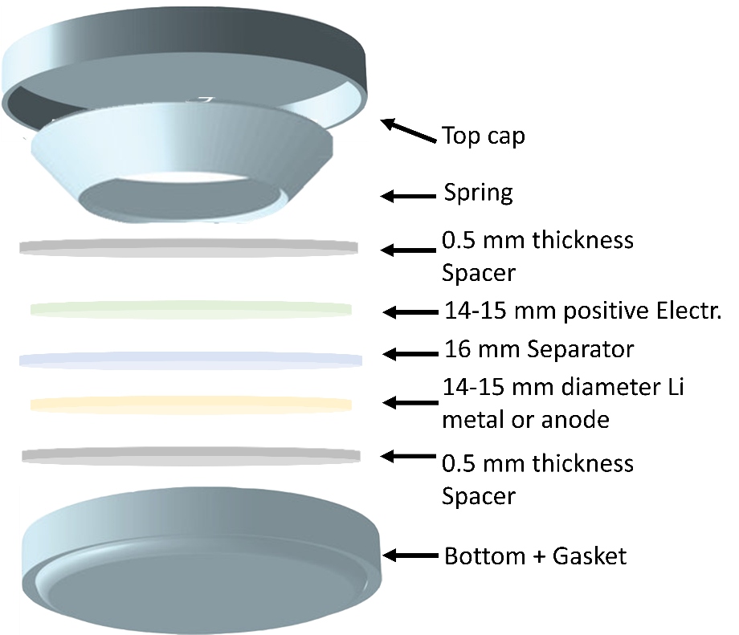
Figure 2-1: coin cell breakdown

Pre-lithiation
Pre-lithiation is a major part of the experimental work in this thesis and so is outlined here to avoid the need for repetition. There are two types of pre-lithiation used in this thesis which are outlined below. For details on the theoretical underpinnings on these techniques, please see 1.11.

Mechanical pre-lithiation
Mechanical pre-lithiation was performed by placing the electrode next to a disk of Li in a PTFE container. Electrolyte was placed on top (100µl) and the container was sealed to minimise electrolyte evaporation. Once the electrode had been pre-lithiated for the desired time it was washed with DMC to remove unreacted electrolyte before being left to dry under vacuum overnight. The dry electrode was then assembled into a new cell with the desired electrolyte and a fresh Li disk. This was conducted in an Ar filled glovebox with both O₂ and H₂O <0.1ppm.

Electrochemical pre-lithiation
Electrochemical pre-lithiation was performed by making a coin cell with the material to be pre-lithiated as described in 2.2.3. Once the cell was assembled, the cells are placed on a Maccor series 4000M to discharge at C/10 for the time required by the experiment.
Electrochemical pre-lithiation can be Once the cell had finished discharging the cell was disassembled and the pre-lithiated electrode was removed. This was washed with DMC to remove unreacted electrolyte before being left to dry under vacuum overnight. The dry electrode was then assembled into a new cell with the desired electrolyte and a fresh Li disk.

Electrochemical analysis
Electrochemical analysis is vital to understand the formation of the SEI and the effect that SEI formation has on the long-term cycling of the cell. Outlined here are the electrochemical techniques used in this thesis and aims to give a basic understanding for the reader.

Electrochemical impedance spectroscopy (EIS)
The first part, of what is now Electrochemical impedance spectroscopy (EIS) was discovered by Warburg in 1899 when he published a paper on the impedance of diffusional transport in an electrochemical system [178]. This was built upon by Randles with his model that combined Warburg impedance with a fast charge transfer reaction at a flat interface [179]. This paved the way for more complex systems being described using EIS eventually leading to its use to describe the SEI [180, 181].
EIS is an important technique for looking at cells in situ as it is a non-invasive technique. This is important as few techniques allow for such an in-depth insight into the cell. EIS takes advantage of the fact that alternating current (AC) can travel through capacitors. Direct current (DC) is unable to travel through capacitors, and this limits its ability to probe electrochemical systems as they often incorporate capacitive features. Alternating currents can access the lowest resistance pathways in a cell, giving insight into its structure.
The input is an AC single phase pulse with an example in Figure 2-1, with the example having an amplitude of 10mV which was used throughout this thesis. The frequency of this wave starts high (typically 100 kHz) and then it is reduced, typically logarithmically to be able to sweep through a large frequency range quickly, until it reaches the lowest frequency, whilst staying AC (typically 0.1 or 0.01 Hz). The highest frequencies have the lowest impedance and vice versa.
Figure 2-2: An example of an input AC wave going from high to low frequency.
3 parameters are measured as the output: real and imaginary Impedance as well as the phase change
The phase change is the delay between the input and output sine wave. An ideal capacitor causes a phase change of 90°.
Impedance has two parts: real and imaginary. The real impedance is equal to the resistance in a direct current measurement. The imaginary impedance is only seen in AC systems and is dependent on the capacitance in the system. As AC can pass through a capacitor it can avoid the resistor in the equivalent circuit. This reduces the resistance of the system and so the imaginary impedance has a negative value.
Typically, the imaginary impedance is plotted against the real impedance and this is known as a Nyquist plot. It is possible to plot the phase change or impedance against log(f) and this is known as a Bode plot.
In Li-ion cells there are several components that contribute to the impedance of the system:
- The resistance in the electrolyte (R_{el}). This is the inherent resistance of the system that happens as the electrolyte is not an ideal conductor. This is the most common feature seen in EIS spectra and as it is a resistive element it cannot be removed by high frequencies and is seen at the offset at the start of a Nyquist plot.
- The resistance & capacitance of the SEI-graphite interface (R_{SEI} & C_{SEI}). The SEI is the next highest after electrolyte resistance as it is the first interface involved in electron transfer. As it has a Resistive and Capacitive component they can be considered in parallel (known as an RC circuit for short, a circuit diagram of which can be seen in Figure 2-2), which compete for the current to flow through each. This results in a semicircle in the results with the maxima at the resonance frequency of the capacitor. This applies to all Resistors and capacitors if they are in parallel, as a result of Kirchhoff’s circuit laws.
Figure 2-3: SEI equivalent circuit.
- Charge transfer (R_{CT}) resistance/ double layer (C_{dl}) capacitance. The charge transfer reaction is next on the list and this is the most common circuit component seen in EIS throughout the field. This also acts as an RC circuit with the double layer acting as a capacitor. This is known as a Randles circuit after it was first described by him in 1947 with a circuit diagram of this displayed in Figure 2-3.
Figure 2-4: Randles circuit.
- Warburg impedance (W) As mentioned earlier Warburg element described electrolyte diffusion in a cell [178]. It has a constant phase change of 45° and is seen as a straight line on a Nyquist plot. Warburg impedance has no electrical circuit equivalent as it is an electrochemical phenomenon that isn’t seen in electronics circuits and as a result it is typically displayed as a W like in Figure 2-4.
Figure 2-5: Warburg element.
All of these circuit components combine to give a complete circuit for a Li/graphite half-cell displayed in Figure 2-5.
Figure 2-6: Graphite equivalent circuit.
For silicon there is an extra RC circuit seen due to the interfacial between Si and carbon black which is the conductive additive used and this modified equivalent circuit is found in Figure 2-6 [182].
Figure 2-7: Si equivalent circuit.
In many systems the electrodes don’t act ideally. This could be due to a number of factors such as surfaces not being ideally parallel, but it results in these models not accurately depicting the system. To rectify this the Capacitor if often replaced with a constant phase element with the equivalent circuit element shown in Figure 2-7. This adds a power term to the capacitance with a power of 1 describing an ideal capacitor and 0 an ideal resistor.
Figure 2-8: Constant phase element.
All of these elements allow you to model anodes found in LIBs. This can give real world values to the SEI that are easy to compare to the literature.
How to assign values to circuit components:
An example Nyquist plot is displayed in Figure 2-8 with the most common components visible. As R_{el} is the inherent resistance in the system it is the resistance value seen at the highest frequency. Seeing a semicircle lets you know that you have an RC circuit in your results. The resistance for the RC circuit is where the semicircle ends or reaches its minima. The capacitance value isn’t readable from the graph directly in the same way as the resistance is. Using the relation $C= - \frac{1}{ωZ_{cap}}$ where omega is the angular frequency and can be determined using $ω=2πf$ where f is the frequency of the current. These techniques can be repeated to ascertain these values for any RC circuit.
W
R_{CT}
R_{SEI}

i)
R_{el}
R_{el}+ R_{SEI}
ii)
Z_{cap}
Figure 2-9: Example Nyquist plot i) with all of the circuit components visible with a cropped annotated portion below showing equivalent circuit values ii).
From this circuit $R_{el} ≈8Ω$, $Rx≈170Ω$ and $Z_{cap}≈-45Ω$ Knowing that this maximum occurs at 316.23Hz then $C=1.118{×10}^{-5}F$
These values are just roughly taken by eye from the plot but can be ascertained properly by looking at the values. ZView software by Scribner Associates was used throughout this thesis to obtain equivalent circuit values. ZView uses computational modelling to extract these values from the EIS data and can provide higher accuracy over simple graphical methods.
Not all of these elements are seen in a cell and this gives information on the system. If a charge transfer element isn’t seen, then this demonstrates that the voltage of the cell is too high or low for the reaction to happen. The Warburg reaction isn’t always seen depending on the frequencies range applied.

Cell Cycling (Chronopotentiometry)
The most common method to test the performance of a battery is to measure its capacity and observe the amount of energy it can store as the number of cycles increases. This is known as chronopotentiometry and is most commonly done by charging and discharging the cell at a constant current, (CC) described in C-rates. This C rate describes how long it theoretically takes to charge or discharge a cell. The C rate is inversely proportional to the charge time. For example, a charge rate of 1C means that it takes 1 hour to charge and 2C means that it takes 30 minutes to charge.
There is another cycling method known as constant current constant voltage (CCCV) where within a half-cell the charge process is the same but during discharge the current is kept constant until the cut-off voltage is reached. The voltage is then kept constant whilst the current reduces. This helps to prevent overcharging and ensure that the reaction has gone to completion. An example can be found in Figure 2-11. This technique is useful for half cells when you are mainly interested in only one of the reactions. For example, in graphite half cells the charge capacity is of interest as it reveals how much Li the graphite was able to maintain. CCCV is therefore used on the discharge to ensure that the maximum amount of Li can intercalate into the graphite, ready to be released.
Here cells are usually cycled at C/10 (0.1C) =36mA/g, unless stated otherwise, which means that it takes 10 hours to charge/discharge. This is typically used as it maximises the output of a cell. A faster C-rate can potentially lower the capacity of the cell. This is due to factors such as charge screening, overpotential and an increase in temperature from the higher current. The longer a cell takes to charge/ discharge at the same C-rate means that the cell is closer to its theoretical capacity. Knowing the voltage allows us to create differential plots as seen below. The Voltage is primarily recorded so that the cell can be cycled within its electrochemically active window. Outside this window the electrodes can degrade rapidly. For example, if a cell reached 0V Vs. Li/Li⁺ then Li will start to plate on the graphite. Graphite half cells in this thesis are cycled between 2.5 and 0.01V.
An important note is that the temperature of the battery has a big impact on the degradation and cycling performance of a cell [183]. For this reason all cells were cycled at 25°C in an environmental chamber to ensure that temperature wasn’t a variable during cycling.
Figure 2-10: 1st cycle of a cell using a CCCV profile.

Differential capacity
A galvanostat records both the total charge that leave a cell as well as the voltage of the battery when the charge moves between the cycler and the battery. Manipulating this data gives the differential of the capacity of the cell with respect to voltage (dQ/dV) and is known as a differential capacity plot. This process can also be reversed (dV/dQ) and this yields different information about a cell. dQ/dV tells us where phases reach their equilibria with each other and dV/dQ informs us about the locations of the phase transitions themselves. Information derived from dQ/dV plots have been used to successfully understand phase changes and they can be used to see electrode degradation in Li-ion cells [184].
Differential capacity plots give information that is analogous to that found in cyclic voltammetry (CV) [185]. This similarity means that the nomenclature for differential capacity matches that of CV. CV sweeps a voltage through a cell at a constant value per unit time (usually V/s) and the resultant current is measured. The cyclic part of the name derives from the fact that the voltage sweep is conducted in both directions. The current output will peak at the voltage where the electrochemical reaction(s) of the cell occur in a fully reversible cell. This peak is labelled $i_{\frac{pa}{c}}$ with the direction of the voltage determining if the reaction is cathodic or anodic (a/c). In a fully reversible cell $\frac{i_{pa}}{i_{pc}}=1$ due to the principle of microscopic reversibility. The peak current can also be derived from the Randles-Sevcik equation. The Randles-Sevcik equation (Equation 2-1) shows that $i_{p}∝ \sqrt{v}$. This relationship arises from the increasing concentration gradient that arises the faster the voltage is wept. The concentration gradient is the reason for the current so the larger gradient results in the larger current.
$$i_{p}=268,600n^{\frac{3}{2}}A\sqrt{D}C\sqrt{v}$$
Equation 5: Randles-Sevcik equation at STP.
Whilst the peak current is important the voltage where the current peak occurs ($E_{p}$) and the difference between $E_{pa}$ and $E_{pc}$ also gives us information about the system. The 2 peaks together are known as a couple. In an ideal system the difference between the peaks in a couple $is\frac{57mV}{n}$ where n is the number of electrons in the reaction. In real systems resistance means that this value is closer to 70 mV. Values that stray significantly from this suggest that the reaction isn’t fully reversible.
Differential capacity is slightly different to CV as it is the charge is used for the sweep as opposed to the voltage. The charge is the differentiated against voltage as the voltage change is greatest where $i_{p}$ would be on the corresponding voltammogram.
Differential capacity is commonly used as it doesn’t require any extra procedures in the cycling process which could possibly alter the capacity of the cell. It also gives the flexibility to look at any cycle and its performance. An example set of differential capacity plots are displayed in Figure 2-12 demonstrating how the technique can differentiate between cells that otherwise have similar initial electrochemical properties.
Some points need to be kept in mind when looking at differential capacity plots. CV is a highly accurate technique whereas differential capacity plots isn’t a technique but a manipulation of the existing capacity data.
$$Li+3C_{6}→LiC_{18} Li+2LiC_{18}→3LiC_{12} Li+LiC_{12}→2LiC_{6}$$
Equation 6: Chemical reaction for the lithiation of graphite
CV itself is frequently used for observing the cyclability of graphite [181]. The Lithium-graphite reaction is far from the idealised equations discussed. Li intercalation into graphite actually consists of 3 separate reactions (Equation 6) that combine into the overall reaction $Li+C_{6}→LiC_{6}$. Each separate reaction has a different couple at slightly different voltages. Due to the small differences between these 3 couples slow scan rate cyclic voltammetry (SSCV) is typically used to ensure that they can be separated from each other. This means that a single voltammogram could take over 20 hours to complete. This SSCV technique has been used to show the SEI growth in the first cycle [105].

Figure 2-11: Differential capacity plot of a cell with and without pre-lithiation. The well-defined peaks and smaller difference between $E_{pa}$ and $E_{pc}$ suggest that the cell is cycling more efficiently.
Electrochemical voltage spectroscopy has also been used to observe changes in Li-ion cells [186, 187]. EVS was used by Lucht et al. to understand electrolyte breakdown at high voltages and its effect on cell performance [188]. They found that larger ΔV occurred after cycling at higher voltages which they attributed to cathode degradation.

Galvanostatic & potentiostatic intermittent titration technique
The galvanostatic intermittent titration technique (GITT) was invented by Weppner and Huggins in 1977 to obtain the Li diffusion coefficient of a Li₃Sb system [189]. Obtaining the diffusion coefficient of ions is extremely important for many electrochemical systems as it gives information about the transport properties of the system. GITT works by pulsing current through the system for a set period of time. This gives us ΔE_{t.} Once the pulse is stopped the voltage drops instantly due to the resistance of the cell (IR drop). The system is then left to rest until the voltage plateaus. Once the voltage has reached a minimum the process is repeated. The difference between the two voltage minima gives us ΔE_{s}. This process can then be repeated over the whole voltage range of the cell (or less as desired). An overview of this process can be seen in Figure 2-14.
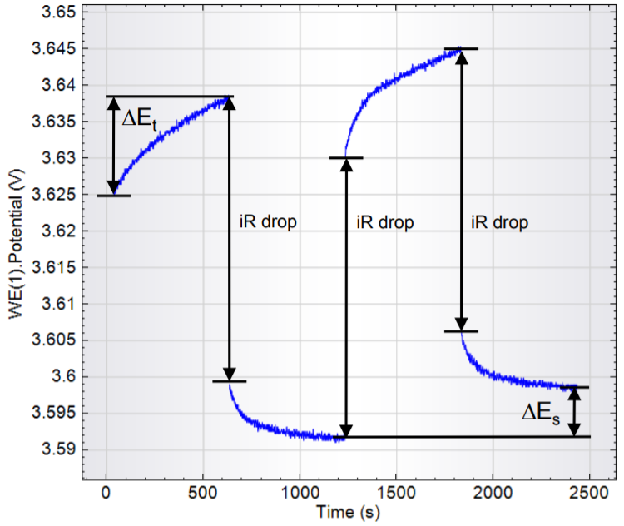
Figure 2-12: Diagram demonstrating how ΔE_{t} and ΔE_{s} are derived [190].
These values can be placed into Equation 2-2 to obtain the diffusion coefficient of the cell. In Equation 2-2 τ is the duration of the current pulse (s), n_{m} is the number of moles (mol), V_{m} is the molar volume of the electrode (cm³mol⁻¹) and S is the surface are of the electrode (cm²). The diffusion coefficient can then be plotted as a function of the cell voltage to see where the changes occur.
$$D = \frac{4 }{πτ} {\left(\frac{n_{m}V_{m}}{S}\right)}^{2}{ \left(\frac{ΔEs}{ΔEt} \right)}^{2}$$
Equation 7: Equation for obtaining the diffusion coefficient from GITT data.
In relation to Li ion batteries GITT has been used extensively to understand Li -ion batteries with the initial GITT paper probing a potential LiB material [189]. GITT has been used to measure the diffusion coefficient of LiNi_{0.8}Co_{0.15}Al_{0.05}O₂, a cathode material [191]. They found that GITT could give results that were comparable to those found using EIS data.
GITT has a sister technique known as the potentiostatic intermittent titration technique (PITT). This was invented by Weppner and Huggins once again with help from Boukamp and Wen in 1979 [192]. This technique uses many of the same principles that form the basis of GITT. With PITT the cell is pulsed at a certain voltage before being allowed to rest. During the pulse the current increases to accommodate this voltage change before decreasing exponentially. The gradient of the logarithm of the decay $∝\frac{Dπ^{2}}{4L^{2}}$ , Where L is the characteristic length of the electrochemical active material. This relationship can be used to determine D. This is then repeated with the pulse voltage increased (or decreased depending on the direction) in increments until the voltage limit of interest is reached. PITT has several advantages over GITT that mean that it has been frequently used as a means of discovering the diffusion coefficient in graphite in Li-ion cells [180, 181, 193]. The main reason that PITT is used is the fact that PITT can be performed in a smaller time frame than GITT. This is because there is no need for a length rest step Whereas GITT’s accuracy is related to the length of its rest step.
$$D=\frac{\operatorname{dln}\left(i\right)}{dt} \frac{4L^{2}}{π^{2}}$$
Equation 8: Equation for obtaining the diffusion coefficient from PITT data.
PITT does suffer from some downsides, however. One is the number of assumptions made to form the central equations (Equation 2-3) that govern the relationship between the current decay and the diffusion coefficient i.e. assuming that the surface reaction rate is infinitely fast [194]. Several amendments have been added to the PITT theory and shown to be more helpful for certain systems, but these are bespoke answers that typically only consider one of the theory’s limiting factors [193, 195, 196]. PITT has also been shown to be less accurate when determining the diffusion coefficient than GITT [197].

Physical analysis
Whilst electrochemical analysis is vital to understand the SEI, It doesn’t provide information on the changes taking place on the electrode itself. Physical analysis can help to link the physical changes that take place with the electrochemical impact that hose changes have. In this section the physical techniques used in this thesis are described and their use for understanding the SEI is highlighted.

Atomic force microscopy (AFM)
AFM measures the height of surfaces and plots the topography as a colour-coded image. It measures these changes by keeping a tip, as seen in Figure 2-9, close to the surface of the sample in question. As the tip moves across the surface van der Waals forces will interact with it causing it to move in response. These changes are detected by using a laser whose beam reflects off the top of the tip and is collected by a split photodetector. AFM has been widely used to look at surfaces and the growth of thin films.
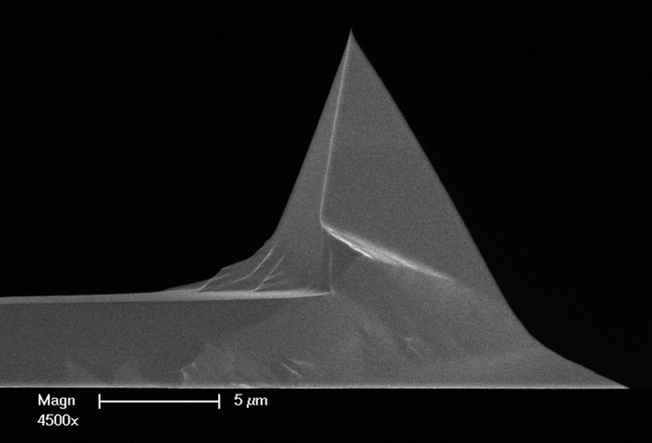
Figure 2-13: SEM image of an AFM tip [198].
There are several types modes with which an AFM tip can interact with the sample. The three most common are contact, non-contact and tapping mode. In contact mode the tip is in contact with the surface and the tip moves up or down as it is dragged along the surface. As the height of the surface changes the tip moves to avoid dragging and this change is picked up by the photodiode and used to make the AFM image, a schematic of which can be seen in Figure 2-10.
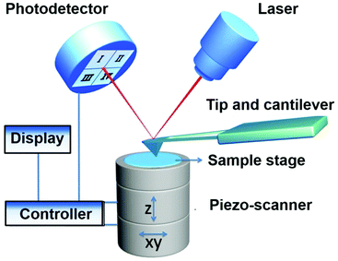
Figure 2-14: Schematic of a typical AFM setup [199].
In tapping mode, the tip is kept close to its resonance frequency (within 10%). As the tip approaches the surface this frequency is altered. This causes a servomechanism to move the tip to return it to the resonance frequency. This feedback loop keeps the tip at the correct distance from the surface to maintain its maximum oscillation. Keeping the tip just off its resonance frequency maximises its sensitivity to changes in height of the sample.
In non-contact mode the tip is also kept close to its resonance frequency. The tip is kept just above the surface and the interactions between the tip and the surface act to lower the frequency of the tip. There is a feedback mechanism that acts to return the tip to its resonance frequency. The amount of force required to return to the resonance frequency is used to determine the distance from the surface, with this information a 3d map of the surface is created. The difference between tapping mode and non-contact is the fact that in tapping mode the tip touches the surface and in non-contact mode it doesn’t. This difference is due to the different oscillations of the tip with tapping mode having a larger oscillation than that seen in non-contact mode.
Our AFM machine is a Bruker dimension icon. It is used in ScanAsyst mode. This is a propriety solution that mixes tapping mode with a closed loop system designed to reduce the force used [200]. This mechanism causes less damage to both the surface and the tip. This mode also allows for a more streamlined setup procedure with the computer algorithm handling the setting of several parameters that have to be dealt with manually when using tapping mode.
The topographical information gleaned from AFM images helps us to better understand electrode surfaces. As the SEI grows it alters the topography and this change can be seen using AFM. AFM can even measure SEI growth in situ although this is rare due to the difficulties of fitting an AFM inside a glovebox [201, 202]. Most AFM studies are conducted ex situ though and they still provide important information about the SEI and its formation [203].
This is only a brief overview of AFM’s uses and background and how it can be used to probe the SEI. Limited theoretical knowledge is required for interpreting AFM images but for more information scanning probe microscopy by Bert Voigtländer is a comprehensive source giving an overview from first principles to practical experimental issues such as artefacts [204].

Differential scanning calorimetry
Differential scanning calorimetry (DSC) measures the heat flow between a sample and its environment as the temperature of the sample is increased relative to a reference. This technique was first developed by Watson and O’Neil in 1962 [205]. When an endothermic reaction occurs within the sample the heat flow turns negative as more energy is required to keep the sample at the same temperature as the reference. Conversely when an exothermic reaction occurs within the sample the heat flow becomes positive as the sample is partially heating itself. DSC can show both chemical and physical changes within a sample. An example of a physical change is a glass transition. Glass transitions are often seen in polymers and DSC is frequently used a quality control measure in polymer manufacturing[206]. An example of an exothermic chemical change is the oxidation of carboxymethyl cellulose (CMC). CMC is a common binder in Li-ion cells and its thermal stability has been well researched [207, 208]. As can be seen in Figure 2-13 there is a large exothermic (≈300 °C) peak as a result of this oxidation reaction. CMC is a hydroscopic material that readily absorbs moisture from the air. This results in an endothermic physical change where the water evaporates from the sample, which is also seen as the depression in Figure 2-13.
Figure 2-15: A DSC curve showing the oxidation of CMC.
When the SEI is heated several of these transitions can be seen and these are reported in the literature [209, 210]. These reactions are charge dependant as charged anodes contain high energy Li that change the reaction that can occur within the cell. This provides a good indication of the state of charge of the electrode with the total heat flux into the cell being lower the more it is charged. The literature highlights two main reactions that occur on anodes. These are the decomposition of the SEI and the reaction between lithiated anode material and the SEI. The reactions are heavily anode dependant as well as charge dependant. The decomposition of the SEI can occur anywhere between 100-150 °C depending upon its composition [211]. The reaction between the lithiated anode and the SEI takes place at far higher temperature typically around 300 °C. This can lead to overlap with CMC oxidation and this highlights the importance of comparing the amplitude of the heat flow as well as the temperature where the change occurs.

X-ray photoelectron spectroscopy
X-ray photoelectron spectroscopy (XPS) uses X-rays for elemental analysis and for his reason it is occasionally called electron spectroscopy for chemical analysis (ESCA). The technique is based upon the photoelectric effect first described by Hertz in 1887 [212]. The effect was explained by Einstein in 1905, winning the Nobel prize for his work in 1921 [213, 214]. The Photoelectric effect is the phenomena where light is shined upon a material and electrons are emitted from the material. It was found that the intensity of the light had no bearing on the photons emitted from the material if the frequency of the light was high enough. Once the frequency was increased to a certain point then electrons started to be released. This dependency was described mathematically by Equation 2-4 where E_{max} is the maximum energy that the electron can have in joules, h is Planck’s constant, f is the frequency of the photon, in Hz and ϕ is the work function of the material in question, in joules.
$$E_{max}=hf-φ$$
Equation 9: The photoelectric effect.
The work function is the energy required to eject an electron and it is linked to the binding energy of the electron, but it is dependent on the surface of the material whereas the binding energy is dependent upon the bulk material. XPS uses the photoelectric effect to bombard a sample with X-rays of a fixed wavelength, from a single source (typically Al or Mg). The electrons are then ejected, and their energies measured. This is all conducted in an ultra-high vacuum (≈1x10⁻⁶ mbar) to minimise the kinetic energy lost. This information is then used to calculate the binding energy of the electrons and this is plotted on the X axis with the electron count plotted on the Y-axis. The binding energy not only gives information on the element that the electron is sourced from but also the electron environment. This can give the researcher information about the oxidation state of the atom as well as the chemical environment, although this change isn’t as easy to resolve when compared with other techniques such as nuclear magnetic resonance (NMR).
XPS is a quantitative technique and this allows for the relative elemental composition of the sample to be measured. This is useful and can be combined with etching to see how the composition of the sample changes at different depths.
XPS has been used frequently to analyse the SEI. This has led to the most common SEI components being recorded and these results have been compiled into a table by Verma et al. and seen in Table 2-1 [34]. It has several properties that have made it useful for studying the SEI. The first one of these is depth. XPS has a poor penetrating depth (≈50 Å), Although this can be extended if needed using angular dependant XPS or ion etching [215]. This in turn makes it a surface sensitive technique which is ideal for observing the SEI by being able to cut out the signal from the graphite and copper current collector that would otherwise dominate the signal.
Table 2-1: Common SEI elements and their XPS peak positions [34].
Peak position (eV) | Assignment
C 1s peaks
282.5 | Li₂C₂
283.7, 284, 284.3, 284.4, 284.8, 285 | C-H, sp² carbon
285.5, 286, 286.1, 287 | C-OH
285.5 | Polymeric carbon in the SEI
286.5 | (-CH₂CH₂O-)_{n}
285, 285.5, 286, 286.5 | C-O-C
287-288, 287, 289.1 | Ether carbons
287, 287.3 | C=O
287.6, 289-290, 289.1 | C-(OR)(CO₂Li) or COOR
288-291, 290, 290.6 | RO-CO₂Li
O 1s peaks
532.4, 533.8, 534.5 | RO-CO₂Li
532.5, 533, 534 | C-O-C or C-O-H
531 | C=O
530.8 | C-O-Li
Li 1s peaks
54 | Li-O
55.5 | Li-CO₃
55 | Li-O-C
F 1s peaks
688.8 | P-F
685-686.5, 648.8 | Li-F
683.5 | Na-F

Some systems also allow the samples to be loaded in an oxygen free environment, helping to ensure that the SEI is stable. XPS is not a perfect technique however and there are several factors that need to taken into consideration, the main one is the high energy X-rays used and its effect on the sample. The high energy X-rays used mean that there is a real risk of radiation damage to the SEI, causing chemical change. Another issue is deconvoluting the spectra of the sample. The SEI components peaks overlap with each other (and other complicated systems) and this means that they need to be separated to properly understand the system. This is not an easy procedure, and this can be seen in the variation in reported values within the literature [34]. These variations in values make it even harder to assign the peaks as there is significant overlap between the values reported for different chemical species and this could change the interpretations of the results.

Pre-lithiation of graphite
It was seen in the literature review that pre-lithiation can be used as an effective method to increase the coulombic efficiency of the anode, but little work has been performed to understand the processes that occur during pre-lithiation. Outlined here is how the pre-lithiation time and the electrolyte employed can affect the SEI and its effect of the capacity retention of the anode.

Introduction
There are two main anode materials used in li-ion cells: graphite and silicon. Li can’t be used as an anode by itself as there is a real risk of dendrite formation on the anode [216]. These dendrites can grow to such an extent that it pierces the separator and touches the cathode. This is a short circuit and leads to a process known as thermal runaway. Thermal runaway is such an issue that Li-anodes can’t be used reliably for more than 100 cycles. This leaves behind the two main anode materials used in commercial cells: graphite and silicon. Graphite is ubiquitous in commercial cells although it suffers from a significantly lower capacity than Si [217]. Graphite has become popular due to its low potential Vs. Li/Li⁺ and it’s stable SEI that gives it high cyclability. In industry the SEI is formed in cells using a process known as formation cycling [2, 21]. This formation cycling step is one of the most expensive stages of battery production [101]. This makes it vital to develop novel formation strategies to lower costs and improve coulombic efficiency.
One option for forming the SEI is pre-lithiation. Anodes have two main pre-lithiation options [118]. There is the mechanical method where the anode and lithium are physically placed together and the electrochemical method where the anode is partially cycled. Both of these techniques have a number of advantages and disadvantages. The differences between the two techniques are discussed in detail further on.

The effects of electrolyte additives on pre-lithiation
We have seen that the traditional carbonate-based electrolytes are inadequate for long term cell cycling, due to poor SEI formation. Additives are often used to increase the performance of Li-ion cells and there are a number available [73]. These are wide ranging and are used to improve many facets of LIB performance including performance and environmental performance such as increasing the temperature range. One of the most common is fluoroethylene carbonate (FEC), which is known to improve capacity [80]. FEC does this by having a higher breakdown voltage that leads to the formation of several SEI components including LiF, with the mechanistic scheme highlighted in Figure 3-1. The presence of LiF increases the ionic conduction through the SEI [218]. These properties are vital for peak cell performance and have led to FEC becoming the most common additive used in literature alongside vinylene carbonate [219].

Figure 3-1: Potential reaction scheme for FEC [218].
These additives aren’t a panacea and they cannot be used to solve every issue with Li-ion cells. One issue is that these additives must be added to the cell purely to be consumed for SEI formation. This is extremely wasteful considering the limited space and weight that is available within the cell. By creating a SEI outside of the cell this step of additive can be removed leaving more space for either electrolyte or even excluded to increase the energy density of the cell.
Here, we see the benefits of using additives could be applied to a graphite electrode before cycling occurs. Mechanical pre-lithiation has been used previously to improve the coulombic efficiency of the cell [118, 144, 158]. By combining mechanical pre-lithiation with FEC can the performance of the cell be increased, when compared with cells pre-lithiated using a traditional electrolyte, in this case LP30.

Experimental
Graphite electrodes were made as described in 2.2.1. The electrodes were then pre-lithiated for 24 hours with either LP30 (1.0M LiPF₆ in EC/DMC=50/50 (v/v), battery grade, Sigma Aldrich) or FEC (98%, Alfa Aesar) as outlined in 2.3.1. These electrodes were then assembled into coin cells and cycled at C/10 between 0.1 and 2.5 V for 100 cycles using CC/CV cycling for the charge on a Maccor series 4000M at 25°C. An electrode the hadn’t been pre-lithiated was also cycled as a reference.

Results
Figure 3-2 reveals that both cells that have been pre-lithiated show far higher capacity retention than the reference cell. This higher capacity retention shows that pre-lithiation has created a stable SEI on the cell, allowing the graphite to cycle consistently. Whilst Pre-lithiation has a noticeable benefit to the capacity retention and performance of the cell the addition of FEC gives it an additional increase. These results help to reaffirm that pre-lithiation forms an SEI layer. This experiment also demonstrates that the additive use can be separated from the cell and still give its desired benefits using this technique. This experiment also demonstrates what happens to a cell without formation cycling and how vital a robust SEI is to ensure that the cells have a high capacity and that degradation is minimised.
Figure 3-2: Performance of cell pre-lithiated with and without additives.

Figure 3-3: Voltage Vs. capacity plot highlighting the pre-lithiated cells keeping a higher voltage for longer.
The voltage Vs. capacity plot Figure 3-3 shows that the pre-lithiated cell kept a higher voltage for longer. The voltage for the reference cell is lower as the parasitic reactions that occur during SEI formation is offsetting the start of the intercalation process. This higher voltage is useful as it reduces the risk of the cell reaching its cut-off voltage prematurely in high rate situations.
1
3
2
Figure 3-4: Differential capacity plot of the cells 1st cycle.
Differential capacity plots in Figure 3-4 highlight the difference between the reference cell and the pre-lithiated cells. In the anodic direction the reference peaks are severely depressed and shifted towards lower voltages. This correlates with the low voltage of the reference voltage of the cell in Figure 3-3 the second peak has also merged with the third peak distorting the ΔE_{p} calculation. These changes are due to SEI formation taking current and causing graphite intercalation to be delayed. The Pre-lithiated cells both show cells without the anodic depression and instead they have peaks seen when a cell is cycling with a well formed SEI.
The different peaks are labelled 1-3 in Figure 3-4 for ease with 1 being the first peak in the anodic direction and 3 the last. The FEC pre-lithiated cell also has a slightly smaller difference between E_{pa} & E_{pc} suggesting that the cell is cycling almost ideally reversibly (83.8mV). Overall, the better the SEI is before cycling the smaller ΔE_{p} values obtained.
Table 3-1: Values derived from differential capacity plots for the 1st cycle.
Cell | ΔE_{p} 1 (mV) | ΔE_{p} 2 (mV) | ΔE_{p} 3 (mV)
Reference | 120.8 | - | 95.2
LP30 | 100.1 | 94.3 | 94.3
FEC | 84.7 | 83.8 | 88.5
Figure 3-5: Differential capacity plot of the cells 30th cycle.
After 30 cycles all 3 cell types have much smaller ΔE_{p} suggesting that all of the cells are cycling with limited current leakage. The coulombic efficiencies for all of these cells are greater than 99% after the 10th cycle due to effective SEI coverage limiting parasitic reactions between the electrolyte and Li.
Table 3-2: Values derived from differential capacity plots for the 30th cycle.
Cell | ΔE_{p} 1 (mV) | ΔE_{p} 2 (mV) | ΔE_{p} 3 (mV)
Reference | 65.9 | 80.4 | 85.3
LP30 | 71.6 | 75.1 | 80.0
FEC | 68.0 | 77.1 | 76.9
Figure 3-6: Differential capacity plot of the reference cell at different cycle numbers.
Figure 3-7: Differential capacity plot of the FEC pre-lithiated cell at different cycle numbers.

ΔE_{p} vs cycle number for the untreated and FEC cell are displayed in Figure 3-8 and Figure 3-9 respectively. With this data there are two distinct phases with both cells. Until the 10th cycle ΔE_{p} decreases. This is due to the formation of the SEI layer, lowering parasitic currents. After 10 cycles ΔE_{p} increases as the SEI keeps growing. The gradient is far shallower in the FEC pre-lithiated cell. This is because the SEI is already formed on the pre-lithiated cell. The ΔE_{p} growth in the later stages is also much reduced as the more stable SEI grows more slowly.
Figure 3-8: Graph showing the increase in ΔE_{p} of the untreated cell with increasing cycle number.
Table 3-3: Change to differential capacity properties of the reference cell with increasing cycle number.
Cycle | ΔE_{p} 1(mV) | ΔE_{p} 2(mV) | ΔE_{p} 3(mV)
1 | 120.8 | - | 95.2
5 | 62.3 | 71.9 | 61.8
10 | 60.9 | 70.0 | 74.9
20 | 60.3 | 74.2 | 84.4
30 | 65.9 | 80.4 | 85.3
50 | 79.8 | 99.0 | 104.0

Figure 3-9 also reveals that as the transition number increases so too does ΔE_{p}. This is due to the different types of transitions that are occurring within the cell. As transition 3 corresponds with the chemical reaction $2LiC_{6}⇌LiC_{12}+Li$ it is the final transition and either starts or ends with (depending on the direction of the reaction) LiC₆. This is the lowest energy state for the lithium and the principle of microscopic reversibility means that this state has the highest activation energy, meaning that the extra voltage is to traverse the activation energy barrier. Similar results have been seen in traditional SSCV scans of the lithium-graphite couple suggesting that these results are accurate [181].
Table 3-4: Change to differential capacity properties of the FEC pre-lithiated cell with increasing cycle number.
Cycle | ΔE_{p} 1(mV) | ΔE_{p} 2(mV) | ΔE_{p} 3(mV)
1 | 84.7 | 83.8 | 88.5
5 | 57.9 | 60.7 | 70.7
10 | 58.6 | 67.7 | 72.5
20 | 61.1 | 69.9 | 74.6
30 | 68.0 | 77.1 | 76.9
50 | 69.1 | 77.6 | 82.7

Figure 3-9: The ΔE_{p} of the FEC pre-lithiated cell as a function of cycle number.
The galvanostatic intermittent titration technique (GITT) was used to affirm the accuracy of the differential capacity plots with an overlay of the two in Figure 3-10. The 1st peak has the largest gap between the diffusion coefficient and the differential capacity maxima. This is due to SEI formation causing the capacity increase without any lithium diffusing into the graphite, causing the divergence between the peaks. The gap narrows for the second peak and disappears by the third peak as the amount of current diverted to SEI formation is severely reduced at lower voltages. The values are also in good agreement with those seen in the literature using CV and GITT’s sister technique PITT [220]. Part of the small difference between the due can be attributed to the small rest time used (10 minutes).
Figure 3-10: Relationship between the differential capacity and the diffusion coefficient of the cell pre-lithiated in LP30. The arrows show the slight shifts between the maxima in capacity and diffusion coefficient.
0nm
0nm
Figure 3-12: AFM images of uncycled graphite anode (left) and an anode after pre-lithiation in the presence of FEC (right).
Atomic force microscopy (AFM) was performed using a Bruker dimension icon in ScanAsyst mode. The pre-lithiated cells were washed gently using DMC to remove LiPF₆ from the sample. The electrodes were then dried under vacuum overnight. AFM images were concentrated on areas containing graphite steps. Graphite steps are known to affect the catalytic activity of the electrode surface [221]. This is important as the SEI formation is highly dependent on the steps due to their higher work function [222]. The graphite anodes have a large number of steps at the edges of individual particles.
AFM images show the presence of the SEI visibly on the surface of the pre-lithiated electrodes. The uncycled electrode in Figure 3-12 showed no noticeable surface film. The step sites appear to be extremely rough on the untreated electrode and then they appear to be much smoother in the pre-lithiated electrodes also seen in Figure 3-12. This is due to the higher work function of the edge sites which leads to enhanced SEI formation, which subsequently fills those edge sites smoothening the resulting AFM image. This effect is also confirmed with the height distributions of the AFM images recorded in Figure 3-13. The Untreated cell has a histogram with distinct peaks due to the differing heights of the step sites. As the step sites are filled with SEI then they become flatter increasing their frequency within the height distribution.
Figure 3-13: Height distribution of AFM images.

The importance of fluorine in FEC for the pre-lithiation process
As seen above, FEC has been shown to increase the capacity and capacity retention of the cell. This has been attributed to the C-F bond and the resultant fluorine based chemistry [80]. To test the role of fluorine we created an SEI with ethylene carbonate to compare against FEC. This should show us how the C-F bond affects the pre-lithiation process and subsequently the electrochemical performance of the cell. DMC was also tested for completeness.

Experimental
Graphite electrodes were made as described in 2.2.1. The electrodes were then pre-lithiated for 24 hours with either EC (99%, Sigma Aldrich), DMC (99%, Sigma Aldrich) or FEC (98%, Alfa Aesar) as outlined in 2.3.1. This was done at room temperature for FEC and DMC but had to be done at 40°C due to the high melting point of EC (M.P. 34°C) when compared to DMC and FEC that are liquid at room temperature (M.P. 2 and 18°C respectively). These electrodes were then assembled into coin cells and cycled at C/10 for 100 cycles using CC/CV cycling for the charge on a Maccor series 4000M at 25°C. An electrode the hadn’t been pre-lithiated was also cycled as a reference.

Results
Differential capacity plots of the first cycle of the cells in Figure 3-14 show that the material choice is important when pre-lithiating graphite. The cell pre-lithiated in EC suffered from a large overpotential on the cathodic sweep. This overpotential demonstrates that the EC-based SEI is inadequate and the resulting interphase impedes Li⁺ from leaving the graphite. In the anodic sweep the peaks were either severely depressed or non-existent suggesting that the EC coating is not enough to inhibit electron migration and further SEI formation is taking place.
The cell that was pre-lithiated in DMC cycled reasonably well with only a slight overpotential in the anodic direction. This is most likely due to a small amount of SEI formation in thinner areas of the SEI. The cell with the smallest overpotential was the one pre-lithiated in FEC as seen earlier. This is due to it forming an SEI that facilitated Li-ion flow whilst still being a good electronic insulator.
Figure 3-14: Differential capacity plots of cells after pre-lithiation in different solutions.
Figure 3-15: Effect of pre-lithiation solution on charge capacity and retention.
The charge capacity data in Figure 3-15 shows us that the pre-lithiated cells all show better capacity retention than the reference, regardless of the electrolyte used. This once again demonstrates the importance of a stable initial SEI has on the capacity retention even the initial capacity of the cell seems comparable to the pre-lithiated cells. Both the reference cell and the cell pre-lithiated in EC suffer from a low initial charge capacity and this is a result of SEI formation, causing a large overpotential in the cell. The poor capacity retention of the reference cell shows that the SEI formed was inadequate.
The good capacity retention of the cell pre-lithiated in EC comes despite the low initial capacity of the cell. This suggest that whilst the EC based-SEI was present in the cell, it was too resistive and this corresponds well with the differential capacity plot seen. The EC based cell’s capacity increases rapidly after the 1st cycle, reaching a steady capacity by the 4th cycle but it is still lower than the other pre-lithiated cells and this is due to the high SEI resistance limiting the amount of Li that can enter the anode. The capacity of the other pre-lithiated cells is much higher and this suggests that the SEI is less resistive than the EC based one although they fade more rapidly the EC treated cell.
Figure 3-16: Effect of pre-lithiation electrolyte on the coulombic efficiency.

The ICE values in Figure 3-16 highlight the poor quality of the EC based SEI with its ICE value being significantly lower than the others showing that a significant amount of energy was wasted on extra SEI formation. It also takes longer to reach 99.9% than the other cells suggesting that the SEI formation process is more prolonged with this cell. The cell pre-lithiated in DMC also suffered from a low ICE value but quickly increased suggesting that its SEI was more robust. The reference cell has a surprisingly high and this demonstrates that although the coulombic efficiency can inform you of the amount of energy being diverted to form the SEI it doesn’t say anything about the nature of the SEI formed.
Electrochemical impedance spectroscopy (EIS) also gives us information about the SEI. EIS was recorded between 100 kHz and 0.01 Hz using a Solartron Modulab 2010A before cycling began at open circuit voltage (OCV). The cell pre-lithiated in FEC has the lowest SEI resistance of any of the cells as noted in Table 3-5. This shows that ionic conductivity is higher through the FEC-based SEI. This can be attributed to the formation of LiF which facilitates Li diffusion [223]. Once the F is eliminated from FEC leaving vinylene carbonate that then polymerises leaving a thin film [224]. Conversely the EC derived SEI has the highest SEI resistance. This high resistance explains the high overpotential seen in the differential capacity plot (Figure 3-14). The high resistance is due to the SEI reactions that EC undergoes and the differing reaction pathways to FEC. EC typically undergoes a ring opening reaction to form (CH₂OCO₂Li)₂ [21]. This material isn’t as ionically conductive as LiF, meaning that the SEI resistance is higher. The vast differences in the charge transfer semicircles/RC circuits is due to the differences in the cell’s voltages and cell’s SoC. Their voltages are different at this point due to the different rates of reaction of each electrolyte.
The high resistance of the SEI has an impact on the cell with the high resistance of the SEI Li diffusion to the anode. This slow current flow leads to the anode voltage being higher over the same voltage period, which in turn leads to the larger CT/dl resistance seen in Figure 3-17, even though both cells have been pre-lithiated for identical amounts of time.
Figure 3-17: Nyquist plots of cells pre-lithiated in different electrolytes.
Table 3-5: R_{SEI} values derived from EIS data.
Material | R_{SEI} (Ω)
Reference | 136.1
FEC | 60.7
EC | 299.5
DMC | 72.6

Ex-situ XPS was performed on the anodes to compare their SEI chemistry. All spectra were recorded on a Thermo Scientific NEXSA with samples loaded using a vacuum transfer module from a glovebox to ensure that the electrodes weren’t exposed to air. The C1s spectra of the electrodes in Figure 3-18 show several differences between the two SEIs. The spectrum of the EC based SEI shows a shoulder at 291 eV this corresponds to the formation of Lithium alkyl carbonates [171]. The FEC based SEI has a shoulder at 285 eV and this peak has been linked to long chain polymers [67]. No C-F peak is visible in the C-1S spectra for the cell pre-lithiated with FEC suggesting that the C-F bonds have been broken down by the pre-lithiation process to form LiF.
Figure 3-18: C1s spectra of graphite pre-lithiated in different electrolytes.
The O1s spectra in Figure 3-19 show that the EC based SEI contains 2 oxygen components with C-O and C=O bonds being present. The lack of a linear C-O-C peak suggest that the SEI at this point mainly consists of unreacted EC as this only contains cyclical C-O-C bonds or at the least the oligomerisation process hasn’t yet begun. This inorganic based SEI may suggest the reason for its high resistance with the polymer component being postulated as directing Li⁺ ions to the graphite [225].
The FEC based SEI on the other hand shows more peaks with a lower concentration of C-O bonds. This suggests that the C-O bonds in the FEC have been broken due to ring opening polymerisation leading to the presence of the C-O-C peak at 537 eV. It also contains a small shoulder at 531 eV that has been attributed to C-O-Li complexes [226]. These complexes suggest that the SEI was formed at a low potential. The presence of these Lithium salts helps to contribute to the high ionic conductivity (low impedance) of the SEI.
Figure 3-19: Deconvoluted O1s spectra of graphite pre-lithiated in FEC (top) &EC (bottom).

Discussion
This work has shown how important the choice of material is to the pre-lithiation process is. The role of the fluorine is clear with the graphite pre-lithiated in FEC demonstrating higher capacity as well as a higher ICE and a smaller R_{SEI} than the cell pre-lithiated in EC. XPS data shows the presence of linear C-O-C bonds in the FEC based anode which suggests that it has started to polymerise which has been shown to be key to SEI stability [81]. This isn’t present on the EC anode suggest that its reactions were more limited, possibly due to the poor Li diffusion of Li in E that results in the highly resistive SEI seen.
Figure 3-20: Example reaction leading to the formation of linear C-O-C bonds

The importance of time as a variable for lithiation
All of the cells shown so far have been pre-lithiated for 24 hours. This was to ensure that the pre-lithiation was the only variable in this experiment. Time is very important for the pre-lithiation process. It determines how much SEI is formed and consequently how the cell performs.
To determine the importance that time has in the pre-lithiation process cells were mechanically lithiated as described earlier, for a length of time between 1 and 48 hrs. a rival batch of Cells were electrochemically, rather than mechanically pre-lithiated for between 10 and 50 minutes.
Cells were pre-lithiated using both techniques to compare and contrast them. Both operate over different timescales and so choosing the correct time will help to make these techniques more competitive with each other.

Mechanical pre-lithiation of graphite

Experimental
Graphite electrodes were made as described in 2.2.1. The electrodes were then pre-lithiated with either LP30 (1.0M LiPF6 in EC/DMC=50/50 (v/v), battery grade, Sigma Aldrich) or FEC (98%, Alfa Aesar) as outlined in 2.3.1. This process was conducted between 1 and 48hrs. These electrodes were then assembled into coin cells and cycled at C/10 for 100 cycles using CC/CV cycling for the charge on a Maccor series 4000M at 25°C. An electrode the hadn’t been pre-lithiated was also cycled as a reference.

Results
The first item to check is how pre-lithiation affects the capacity of the cell. As seen in Figure 3-20 initially the cell capacity dips before rising and then decreasing again. This may look confusing but there are several competing factors that lead to these results. Initially the SEI formed after a short pre-lithiation time is too thin and, in some areas, non-existent. This incomplete SEI is actually worse for the cell. It is unstable and this leads to poor cell performance. The maximum is reached when the SEI formation has reached its peak thickness before graphite intercalation. After Li intercalation has started the capacity of the cell starts to reduce again. This is where the line between pre-lithiation and the first discharge of the cell occurs. At this stage the benefits of pre-lithiation of the cell is lost to the Li that is intercalated within the graphite, partially immobilised, reducing the graphite’s capacity.
Figure 3-21: Graph demonstrating cell capacity with changing pre-lithiation time.
Figure 3-22: Pre-lithiated cell performance.
When observing the change in cell capacity with respect to time in Figure 3-21 the poor capacity retention of the reference cell is clearly visible with the cell losing over 50 mAhg⁻¹ of capacity over 100 cycles. The pre lithiated cells show much better retention with only the cell pre-lithiated for 10 minutes demonstrating any significant fade. This was most likely due the thin, initial SEI layer formed that wasn’t robust enough for long term cycling. Pre-lithiation causes the voltage of the anode to reduce as pre-lithiation time increases. As the voltage decreases the coulombic efficiency of the anode increases as seen in Figure 3-22. The relationship between these two can be seen in Figure 3-23 with the inversely proportional relationship. This means that the open circuit voltage of a pre-lithiated cell can be used to predict its performance.
Figure 3-23: Graph highlighting the relationship between voltage and coulombic efficiency as a function of pre-lithiation time.
Figure 3-24: Graph highlighting the relationship between coulombic efficiency and capacity as a function of pre-lithiation time.
The capacity of the cell also increases with increasing pre-lithiation time, up until a limit as shown in Figure 3-24. This limit coincides with the coulombic efficiency rising above 100%. This suggests that the Li has completed the SEI formation stage and has started to intercalate into the graphite. This intercalated graphite can no longer participate in cycling, reducing the capacity. The presence of the Li-is the reason for the coulombic efficiency to exceed 100% and so arises from this Li not being included with the calculation.
Figure 3-25: Relationship between pre-lithiation time and the initial coulombic efficiency of the cell.
Figure 3-26: Changes in the SEI resistance with changing pre-lithiation time.
EIS results in Figure 3-25 paint a similar picture to that seen with the capacity of the cell. The initial SEI resistance is low, increasing with increasing pre-lithiation time. This then start to decrease again once the li intercalation begins.
Figure 3-27: Differential capacity plots for mechanically pre-lithiated cells.
Figure 3-26 highlights the difference that pre-lithiation makes to the 1st cycle of the cell with the reference cell showing limited capacity changes in comparison to the pre-lithiated cells. In the reference cell ΔE_{p} 2 has been shifted so far from its reference position that it is now indistinguishable from ΔE_{p} 3 [220].
Table 3-6 show an initial contraction in ΔE_{p} for small pre-lithiation times before increasing again with increasing pre-lithiation time. The initial decrease can be attributed to SEI formation as seen earlier. This increase for longer pre-lithiation times suggests that the SEI is becoming too resistive, driving the redox couple apart.
Table 3-6: ΔE_{p} values for mechanically pre-lithiated cells.
Pre-lithiation time (h) | ΔE_{p} 1(mV) | ΔE_{p} 2(mV) | ΔE_{p} 3(mV)
0 | 120.8 | - | 95.2
1 | 82.7 | 80.6 | 80.2
6 | 92.8 | 86.6 | 86.8
18 | 111.7 | 103.2 | 93.2
24 | 137.8 | - | 96.6
48 | 128.4 | 108.2 | 102.7

Ex situ XPS was performed on samples after pre-lithiation. All spectra were recorded on a Thermo Scientific NEXSA using a monochromatic Al kα source. The samples were loaded using a vacuum transfer module from a glovebox to ensure that the electrodes weren’t exposed to air. The spectra were deconvoluted using casaXPS.
Figure 3-28: Deconvoluted P2p spectra of cells after 1hr of pre-lithiation (top) and 24hrs (bottom).
The P2p spectra in Figure 3-27 are slightly different to the other spectra seen so far as they were all s orbital emissions. Being a p orbital means that it has angular momentum which s orbitals don’t have. The electron also has an angular momentum, and this interacts with the angular momentum of the orbital. This phenomenon is known as spin-orbit coupling. Spin orbit coupling means that phosphorous peaks are seen as a doublet, offset by 0.87 eV in XPS spectra. These spectra show that more Li_{x}PO_{Y}F_{z} is being formed as pre-lithiation time increases. This is due to the reaction between alcohols and LiPF6. The alcohols are themselves a product of SEI formation. This oxidation process frees up F for use as LiF. The presence of PF6⁻ is due to some of the anion that wasn’t effectively removed during the DMC wash.

Conclusion
These results show that pre-lithiation can have a positive impact on several key markers of cell performance such as capacity and initial coulombic efficiency. They also show that the pre-lithiation process should be closely monitored to ensure that the desired outcomes are achieved. If the pre-lithiation is allowed to continue for too long, then it benefits can be negated and even start to impede cell performance. This data suggests that the optimal time to mechanically pre-lithiate a cell 18 hours with the current setup. This maximises the cell capacity with an initial coulombic efficiency approaching 100%.

Electrochemical pre-lithiation of graphite

Experimental
Graphite electrodes were made as described in 2.2.1. The electrodes were then pre-lithiated electrochemically with LP30 (1.0M LiPF₆ in EC/DMC=50/50 (v/v), battery grade, Sigma Aldrich) as outlined in 2.3.2. This process was conducted between 10 and 50mins. These electrodes were then assembled into coin cells and cycled at C/10 for 100 cycles using CC/CV cycling for the charge on a Maccor series 4000M at 25°C. An electrode the hadn’t been pre-lithiated was also cycled as a reference.

Results
Figure 3-29: Changes to cell voltage with increasing pre-lithiation time.
In Figure 3-28 it is shown that increasing the pre-lithiation time causes the voltage to decrease significantly. As the voltage decreases the initial coulombic efficiency increases. This suggests that the SEI has successfully formed during the pre-lithiation stage. After 40 minutes the coulombic efficiency decreases slightly. This coincides with a plateau in the voltage. This combination can be attributed to graphite intercalation starting. This would cause some of the lithium to stay in the graphite once it started cycling.
From Figure 3-29 we can see that pre-lithiating cells results in an improved capacity retention with all pre-lithiated cells losing less than 10 mAhg⁻¹ over 100 cycles.
Figure 3-30: Cell performance after different pre-lithiation times.
EIS corroborates SEI formation with an increase in R_{SEI} with increasing pre-lithiation time in Figure 3-30. SEI thickness has been previously linked to R_{SEI} [227]. This suggest that the SEI is getting thicker, increasing the coulombic efficiency. Again, as with the mechanical pre-lithiation once Li intercalation starts R_{SEI} starts to decrease slightly.
Figure 3-31: Changes to SEI resistance as a function of pre-lithiation time.
The results in Figure 3-31 demonstrate the highest initial coulombic efficiency of the cell occurs when it has been pre-lithiated for 40 minutes. This also coincides with the maxima in R_{SEI} which demonstrates that the SEI formed during pre-lithiation limits further SEI formation and results in this ICE increase. This is especially important in full cells where balancing the anode and cathode is required with the cathode required to be larger than the anode to compensate for the Li lost during SEI formation [228]. By increasing the ICE the cathode weight can be reduced, increasing the total cell density.
Figure 3-32: Graph demonstrating the improvement in efficiency with increasing time.
The interaction between cell capacity and time is very different to that seen with mechanical pre-lithiation, most likely due to the different rates of lithiation that each undergo. From Figure 3-32 it can be seen that an Initial pre-lithiation time of 10 minutes results in a major increase in cell capacity (≈60 mAhg⁻¹). The capacity then stays relatively stable before dropping dramatically after 30 minutes. This may be due to electrochemical pre-lithiation resulting in a more even (although still inhomogeneous) SEI. This extensive covering helps to minimise Li inventory loss and facilitate Li intercalation. The capacity drop can be attributed to partial intercalation of the graphite anode. The Li in the partially lithiated graphite then becomes electrochemically inactive, lowering the capacity.
Figure 3-33: Graph demonstrating the cell capacity with increasing pre-lithiation time.
Figure 3-34: Differential capacity plots of electrochemical pre-lithiated cells.
In Figure 3-33 the differences between the cells that are pre-lithiated and those that aren’t is clear with the pre-lithiated cells having sharp, well defined peaks whereas the reference cell has depressed peaks that are deviated with from their equilibrium with ΔE_{p} 2 missing entirely. These values were then tabulated in Table 3-7.
Table 3-7: ΔE_{p} values from the 1st cycle of electrochemically pre-lithiated cells.
Pre-lithiation time (mins) | ΔE_{p} 1 (mV) | ΔE_{p} 2 (mV) | ΔE_{p} 3 (mV)
0 | 120.8 | - | 95.2
10 | 89.3 | 73.5 | 68.6
20 | 87.4 | 71.8 | 66.7
30 | 88.0 | 72.6 | 67.6
40 | 105.3 | 79.8 | 74.8
50 | 76.9 | 61.2 | 55.9

Figure 3-34 shows a consistent decrease in ΔE_{p} with increasing pre-lithiation time, except at 40 minutes. This outlier may be due the SEI growing thicker than the corresponding lithiation of the graphite, lowering the conductivity of the anode. This decrease is a result of the combination of a conductive SEI and partial lithiation of the graphite improving its conductivity.
Figure 3-35: ΔE_{p} values as a function of pre-lithiation time.
To understand the chemical changes that were taking place during the pre-lithiation process ex situ XPS was performed. All spectra were recorded on a Thermo Scientific NEXSA using a monochromatic Al kα source. The samples were loaded using a vacuum transfer module from a glovebox to ensure that the electrodes weren’t exposed to air. The spectra were deconvoluted using casaXPS.
Figure 3-36: F concentration as a function of pre-lithiation time.
As XPS is a quantitative technique a survey scan can be taken to give us the atomic composition of the electrode surface. By concentrating on the fluorine concentration ([F]) in Figure 3-35 it is revealed that as pre-lithiation time increases [F] decreases, except at 40 minutes once again. This suggest that the lower layers of the SEI are F dense i.e. LiF and the upper layers contain little, if any F. This matches well with previous XPS experiments that monitor SEI growth, demonstrating that Pre-lithiated SEI grows in a similar manner to that formed during natural SEI growth [229].
The carbon spectra in Figure 3-36 reveal several insights into the system. After 10 minutes of pre-lithiation the C1s spectrum shows the presence from sp² carbon from the graphite under the SEI. The presence of the graphite signal shows that at this stage the SEI is extremely thin, which corroborates with the OCV which is above the normal onset of SEI formation. This aligns well with the low R_{SEI} seen in EIS. The large number of components shows that as well as the SEI there is still some unreacted electrolyte, even after being washed with DMC. After 50 minutes of pre-lithiation the spectrum becomes a lot less busy. The C-F peak disappears which arose from intermediate products between LiPF₆ and EC/DMC. There is also a lack of a sp² carbon peak suggests that the SEI has become much thicker, preventing the x-rays from reaching the graphite underneath. It should be noted that there is a shift in the peaks between 10 and 50 minutes and this can be seen in all of the spectra. This is a result of charging as the SEI has gotten thicker with increasing pre-lithiation time and this is frequently seen when comparing battery samples [230].
The P2p spectra in Figure 3-37 both contain a peak around 138 eV which corresponds to LiPF₆ [66]. As the pre-lithiation time increases a new peak starts to emerge at 136 eV. This new peak corresponds to the formation of Li_{X}PO_{y}F_{z} [188]. This is the result of LiPF₆ degrading during the pre-lithiation process. This is confirmed with the F1s spectra in Figure 3-38. The F1s spectra shows a reduction in the P-F content of the SEI and an increase in LiF with increasing pre-lithiation time. After 10 minutes of pre-lithiation there is also a small peak at 139 eV which corresponds to PF₅. This is another electrolyte breakdown product and its disappearance is due to further reaction form Li_{X}PO_{y}F_{z} species.
Figure 3-37: Deconvoluted C1s spectra after 10 minutes of pre-lithiation (top) and 50 minutes (bottom).
Figure 3-38: Deconvoluted P2p spectra after 10 minutes of pre-lithiation (top) and 50 minutes (bottom).
Figure 3-39: F1s spectra of electrochemically pre-lithiated cells.
The O1s spectrum after 10 minutes of pre-lithiation in Figure 3-39 shows that there has been limited electrolyte decomposition at this stage. After 50 minutes there is a drastic change, with a more prominent C=O peak. This suggests that the electrolyte decomposition results in ring opening reactions forming aldehydes such as d_{f}-FEC [224]. This data aligns with the XPS taken by Veith et al. when they looked at SEI formation on Si [229]. The presence of Li-O bonds shows that the electrode is at a low potential. The O1s spectrum after 50 minutes of pre-lithiation also displays an upwards shift in binding energy from surface charging due to the SEI thickness.
Figure 3-40: Deconvoluted O1s spectra after 10 minutes of pre-lithiation (top) and 50 minutes (bottom).
Differential scanning calorimetry (DSC) was performed using a Mettler Toledo Star1 system on pre-lithiated cells that had been opened, washed with DMC and dried under vacuum overnight. The reference was an uncycled graphite anode that had been covered in electrolyte and washed with DMC. The large endothermic peak seen in Figure 3-11 at 220 °C on the reference cell is due to solvent evaporation. The electrolyte may still remain after drying under vacuum due to the low vapour pressure of ethylene carbonate and LiPF₆. The lack of this peak in the pre-lithiated cells suggested that the electrodes were solvent free and only the SEI remained. With the pre-lithiated cells at ≈110 °C SEI decomposition can be seen. This matches well with what is seen in the literature [209, 210]. The glass transition seen isn’t mentioned in the literature but the SEI is at least partially based on oligomers. Polymers are known to have glass transition temperature and they have been well documented [206]. The electrolyte also contained FEC which is used as a plasticiser and so it could be related to its presence [73, 86]. The last 2 major features are due to CMC oxidation [207, 208]. As a cellulose derivative it burns easily. These results suggest that the pre-lithiated cells have formed an SEI layer, but that Li intercalation has not yet started. These results are in good agreement with the other techniques used.
Figure 3-11: DSC curves of pre-lithiated cells.

Conclusion
Electrochemical pre-lithiation can result in a cell with improved capacity, thicker SEI and higher initial coulombic efficiency. Our results suggest that 20 minutes of pre-lithiation is the optimal time as this maximises capacity whilst maintaining a high initial coulombic efficiency. This amount of pre -lithiation also give a cell a solid R_{SEI} value and small ΔE_{p} which are also important performance indicators. The quick time to form the SEI makes sense when you consider that the SEI is voltage dependant and these cells start below the widely considered SEI onset voltage of 0.8 V Vs. Li/Li⁺ [63, 215].

Comparing mechanical and electrochemical pre-lithiation
Both mechanical and electrochemical pre-lithiation have been shown to improve the performance of cells when used correctly. This section will provide an overview on the two techniques and how they compare against each other.

Performance
There is an appreciable upwards trend in coulombic efficiency with increasing pre-lithiation time seen in both techniques. As mentioned previously the coulombic efficiency is extremely important for full cells as they only have a limited Li supply. This isn’t seen in the half cells as the lithium supply is near limitless from a Li anode. In full cells the cathode is the only Li source and it contains a finite amount of Li. Both techniques result in an increase in R_{SEI} with increasing pre-lithiation time as it forms a thicker SEI. This also leads to a decrease in ΔE_{p}. Both also show an upwards trend in cell capacity with increasing pre-lithiation time until the reach a peak. After the peak cell performance starts to decrease rapidly. The point occurs at different times with both techniques, but it does occur in both. The capacity retention of the cells also improves with increasing pre-lithiation time. This is due to the SEI formed beforehand being far more robust than that seen with a fresh cell.

Time
As has been seen pre-lithiation time impacts the thickness of SEI formed on the cell and hence their performance. This is true for both techniques but what separates them is the timescales over which pre-lithiation occurs. Mechanical pre-lithiation take place over a far longer timescale than electrochemical (galvanostatic) pre-lithiation. This is due to the Galvanostatic technique removing current from the cell, driving SEI formation. In mechanical pre-lithiation the charge has to spend much longer to convert the excess energy into heat.

Input
With electrochemical pre-lithiation the cells need to be able to cycle and this limits the inputs available for the cell. With mechanical pre-lithiation there is much more freedom with what can be used as the SEI ‘source’. For example, when mechanically pre-lithiating 100% FEC was used. This wouldn’t be possible in a cell as it would be ionically insulating.

Setup
The Setup is what differentiates the two techniques the most. Electrochemical pre-lithiation relies on a galvanostat to control the power output of the cell. It also needs to be conducted in a cell (at lab scale at least) and this requires the cell to manufactured before pre-lithiation. Mechanical pre-lithiation requires neither of these to work and that helps to make the setup easier. The main requirement for mechanical pre-lithiation is an airtight container to prevent solvent evaporation.

Summary
In summary we can see that both mechanical and electrochemical pre-lithiation have advantages and disadvantages. Mechanical pre-lithiation is far easier to conduct with no need for cell disassembly at the lab scale. As there are no electrochemical processes occurring it is possible to make an SEI from starting materials that wouldn’t be compatible in a battery due to side reactions on the cathode side etc. mechanical pre-lithiation is most effective at a time-scale of one day which makes it unappealing to manufacture due to the bottleneck this would create. As it is mechanical process there is also a risk of uneven SEI coatings in inhomogeneous anodes degrading performance.
Electrochemical pre-lithiation is a faster process giving a robust SEI in hours rather than minutes, which is ideal when considering manufacturing implications. It can also be controlled by monitoring the voltage of the cell to ensure that pre-lithiation results in a robust SEI. As it is performed electrochemically the reagents used to form the SEI are more limited and have to be compatible with the electrolyte. In a laboratory it is a time-consuming process as it involves the disassembly and reassembly of the cell.

Conclusion
Pre-lithiation can have a major impact on cell performance. This work has shown that choosing the correct parameters is vital to ensure that the cell performs optimally. Pre-lithiation has just as much a chance to reduce cell performance as increase it.
Pre-lithiation need to be performed to the stage where the SEI has become sufficiently thick whilst not starting the intercalation process. As seen in my results the best way to monitor this is by looking at the voltage of the cell. Closely monitoring the voltage of the pre-lithiation process means that the performance of the resulting batteries can be maximised. Maximising the gains from pre-lithiation helps to make the technique more viable for future use in industrial battery processing.
We show that the material used as the SEI reagent has an important impact on the performance of the cell and it can be decoupled from the electrolyte used. This is important as it gives the potential to use custom sacrificial reagents for SEI formation and then use an electrolyte without the need for additives.

Pre-lithiation of Si anodes
This chapter extends the work performed in chapter 3 and applies the same principles to Si anodes. It details the differences that are encountered with respect to graphite and the chemical underpinnings for those changes. It also leaves a framework for how to optimise pre-lithiation of both high and low Si content electrodes.

Si Anodes
Si anodes have been the subject of intense research due to their high theoretical capacity (3579 mAhg⁻¹) and low potential Vs. Li/Li⁺ [9]. Si has been used as an additive to current graphite anodes to increase capacity although currently it is only a small part of the total anode active material (<5%) [10]. Si-based electrodes with higher Si content still aren’t commercially available due to the large volume change that accompanies Si lithiation [231, 232]. This volume change causes several problems when creating an electrode. The first of these is the space required to accommodate this change. Batteries are typically tightly packed to maximise the energy density, and this limits the space available for electrode expansion. The second problem is the physical stress that this stress has upon the system. The third is due to the volume change destroying the SEI. This leads to constant SEI formation.

1st problem: Expanding into the unexpandable
Current commercial Li ion cells are based upon thin electrodes applied to both sides of the current collector. These electrodes are separated by thin polymer sheets with the minimum amount of electrolyte required being used. This is all to maximise the energy density of the cell. This also leaves little space in modern cells for electrode expansion. This poses a problem for Si based anodes due to the large expansion they suffer from during lithiation. This means that either the amount of the lithiation has to be reduced or novel ways have to be created that limit the volume change. Currently the economies of scale that have been achieved with modern battery cell design mean that there is a significant barrier to changing it [233].
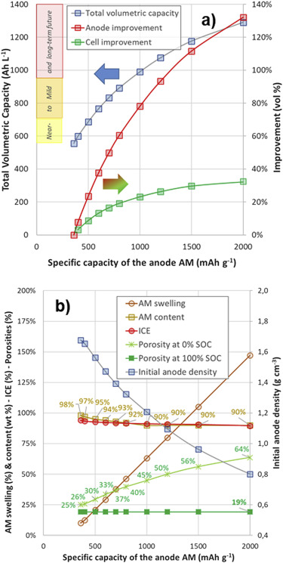
Figure 4-1: (a) increase in volumetric density for both the anode and total cell with increasing gravimetric content and (b) The impact of increasing Si content on anode density
Work by Copley and co-workers found that the correlation between gravimetric and volumetric density is not linear due to the increased porosity required with Si anodes [234]. This limits the total volumetric capacity of the cell to less than 40%, mainly as a result of non-anode components taking up the rest of the cell.

2nd problem: anode pulverisation
Arguably the biggest issue with Si anodes is the pulverisation of the active material as it expands/ contracts. This process results in parts of the anode that split off from the main part of the anode, as well as the anode partially delaminating from the current collector. This renders them electrochemically inactive, rapidly reducing the capacity of the anode. This problem is exacerbated by limited ion inventory of the cell. As the peripheral Si pieces break away during the expansion so too does some of the Li in the system. This in turn depletes the already low Li inventory, resulting in excess capacity loss.
To overcome this several researchers have created novel techniques to reduce or even completely eliminate the pulverisation effect. One of the most common methods to reduce the effect of anode pulverisation is the use of nanotubes, both carbon and silicon to improve the performance. The use of carbon nanotubes has mainly been as a framework for absorbing the Si expansion and conducting electricity in the anode [235]. With Si nanotubes the mechanism is very different. The basic premise is that the hole in the tube acts as a pore that the Si is allowed to expand into.
One of these was devised by Choi et al. in 2017 [236]. They used the polymer polyrotaxane that was chemically linked to the binder, polyacrylic acid. Polyrotaxane contains several polymer rings that surround a central polymer chain that has chemically capped ends meaning that that rings cannot leave. When Si is lithiated the polymer stretches keeping the Li particles together, as seen in Figure 4-2. This limits distance that the particles separate from each other during pulverisation. As soon as the lithiation strain stops, entropy causes the rings to separate, drawing the particles together. Because the particles were closer together no bare surface was exposed to the electrolyte, reducing SEI formation. By keeping the Si particles bound together this way the capacity of the call was far more stable and higher than one without.
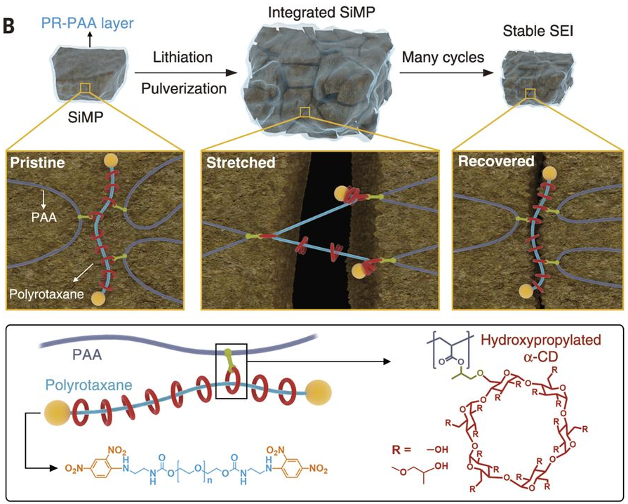
Figure 4-2: Structure of polyrotaxane and the structural rigidity it provides [236].

3rd problem: SEI destruction
The SEI is generally an inflexible layer on the surface on the anode. This poses a problem with Si systems as the anode expansion causes the SEI to crack. This cracking process exposes Fresh Si surface causing further SEI formation. This extra SEI formation leads to a further decrease in the Li inventory of the cell as well as removing vital electrolyte, both reducing the capacity of the cell.
The work by Choi et al. also lead to less SEI formation [236]. By keeping the particles close together, the Si surface between them isn’t exposed to the electrolyte. This prevents excess SEI formation, saving both lithium inventory and electrolyte.
The issues surround Si as an anode choice means that more work is still required to see higher content Si anodes in commercial cells.

Si pre-lithiation
Pre-lithiation is a technique that has been shown to increase the capacity of Si electrodes as well as carbon electrodes. In 2017 Domi et al. mechanically lithiated silicon, although in a different way to that seen in the previous chapter [158]. They used a process known as mechanical alloying to make their electrodes, effectively by using a ball mill to force the Li and Si to alloy together [237]. This method did nothing to form an SEI for the electrode however, and the SEI was not mentioned at all in the paper. They found that this pre-lithiation process had a positive effect on the performance of the cell although this was limited. The lack of SEI optimisation meant that they limited the capacity of the cell to 500 mAhg⁻¹ and even then the cell could not reach 500 cycles. This paper shows that the whilst the process of lithiating the anode itself may have benefits for the cell it isn’t enough to make the cell a viable replacement for graphite. To replace graphite the cells would require further pre-lithiation to further the cell performance. Some SiO_{x} species have also been pre-lithiated and this has shown to improve the performance [137].

Electrolyte optimisation for pre-lithiation
Due to the issues with Si anodes as seen above it is even more vital that the electrolyte facilitates SEI creation and maintains the cell conductivity. FEC has frequently been used along with another additive, Vinylene carbonate (VC), to increase the capacity and cycle life of Si-based anodes. This is a wasteful process though with the additives being entirely sacrificial for SEI formation and doesn’t go towards optimising other facets of electrolyte performance such as conduction.
The work here determines if pre-lithiation of the electrode using a traditional electrolyte additive could replace the need for additives in the cell. This would be advantageous as it would reduce the need for electrolyte additives, increasing the energy density of the cell. Having a Si anode with comparable or greater capacity retention than a graphite anode would be an ideal goal to achieve with pre-lithiation.

Experimental
Si electrodes were kindly provided by Dr. Entwistle with the material prepared as described in 2.1.2. They were produced using the same method as that outlined in 2.2.1. Electrodes were then pre-lithiated for 24 hours with either LP30 (1.0M LiPF₆ in EC/DMC=50/50 (v/v), battery grade, Sigma Aldrich) or FEC (98%, Alfa Aesar) as outlined in 2.3.1. These electrodes were then assembled into coin cells using either LP30 or LP30 + 10wt.% FEC as the electrolyte. The coin cells were cycled at C/10 for 100 cycles using CC/CV cycling for the charge on a Maccor series 4000M at 25°C. For reference fresh electrodes were cycled in either LP30 or LP30 + 10wt.% FEC.

Results
The cycling data in Figure 4-3 shows that pre-lithiation can lead to a large increase in the initial capacity of the cells. The pre-lithiated electrodes with LP30 electrolyte suffer from rapid capacity fade, only retaining ≈50% capacity after 100 cycles. For all cells where FEC was present in the electrolyte the capacity fade was reduced dramatically. This suggests that whilst pre-lithiation helps to improve the initial charge capacity FEC is still required in the electrolyte for longer term cycling. It should be noted that even with the presence of FEC the capacity fade is unacceptably high and still higher in pre-lithiated cells than it is in the reference. This difference is most likely due to the destruction of the original SEI and the replacement that require Li. Such regimes have been mention previously in the literature the SEI not being robust after the strains of multiple lithiation-delithiation reactions [224, 229].
Figure 4-3: The effect of electrolyte choice on cell capacity.
Differential capacity plots seen in Figure 4-4 show that the choice of electrolyte for pre-lithiation affects the Si alloying. Using FEC further reduced the voltage gap between E_{pa} & E_{pc}, helping to keep the lithiation reaction quasi-reversible. The number of peaks seen suggest that the Si is already amorphous. The gap is much larger than is seen in graphite electrodes but this is typical and has been attributed to the high internal resistance of Si [238].
Figure 4-4: Differential capacity plot comparing cells pre-lithiated in LP30 & FEC.

Conclusion
Using FEC is vital to ensure that pre-lithiated cells have the lowest amount of capacity fade possible. Pre-lithiation on its own increases the initial capacities improves capacity in the early stages but quickly falls behind dropping below the reference cell. This is most likely due to Si expansion destroying some of the pre-lithiated SEI. Combining FEC based electrolyte and pre-lithiating the electrode in FEC give the cell much higher capacity and a smaller capacity fade than the cells pre-lithiated in LP30. This combination gives the cell a substantial performance improvement over the reference cell.

Electrochemical pre-lithiation of silicon
Si/SiO_{x} composites have previously been electrochemically pre-lithiated over a range of times to demonstrates the effectiveness of this method for Si electrodes [137]. This research was only focused on a single type of Si based anode and exclusively used electrochemical pre-lithiation. Due to the range of different Si materials under investigation it is important to observe if this technique is transferable to other Si anode types.

Experimental
Si electrodes were kindly provided by Dr. Entwistle with the material made as described in 2.1.2. They were produced using the same method as that outlined in 2.2.1. More about the production of the Si active material can be found in Entwistle et al. paper [239]. Electrodes were then made into coin cells and pre-lithiated electrochemically as described in 2.3.2 using LP30 + 10wt.% FEC as the electrolyte. These electrodes were then assembled into coin cells using either LP30 + 10wt.% FEC as the electrolyte. The coin cells were cycled at C/10 for 100 cycles using CC/CV cycling for the charge on a Maccor series 4000M at 25°C. For reference fresh electrodes were cycled in LP30 + 10wt.% FEC.

Results
Figure 4-5 demonstrates the effect that pre-lithiating the silicon has on the charge capacity with most of the pre-lithiated cells having a higher initial capacity than the cell without pre-lithiation. It also reveals that despite the promising initial results the capacity fade is greater in the pre-lithiated cells and only one has a greater capacity after 100 cycles. This suggests that whilst pre-lithiation facilitates the alloying/dealloying couple, the volume changes breaks the otherwise stable SEI and results in lithium being trapped and unusable for further cycling, leading to the faster capacity fade seen.
Figure 4-5: Cell capacity with increasing cycle number.
In Figure 4-6 the charge capacity of the half cells can be seen to increase with increasing pre-lithiation time until 30 minutes when it reaches its peak. After 30 minutes the cell capacity starts to decrease dramatically. This decrease occurs at a similar time to the graphite systems seen earlier. This suggests that the SEI is facilitating further lithiation-delithiation of the graphite and not using it for excessive SEI formation.
Figure 4-6: Charge capacity as a function of pre-lithiation time.
Despite improving the initial charge capacity, the pre-lithiated cells also show a lower capacity retention than the reference cell. This was the opposite to what was seen in graphite based systems. Several of the cells that initially had higher capacity than the reference cell finished below it. This suggests that the SEI isn’t as effective as the references. The most likely cause for this is the volume expansion of the Si cracks the SEI and it is replaced with LP30 electrolyte degradation products which are more resistive [224, 229].
Figure 4-7: Graph demonstrating the correlation between pre-lithiation and ICE.
Figure 4-7 shows the increasing initial coulombic efficiency as the pre-lithiation time is increased. This increase show that the pre-lithiation process is helping to form an SEI that better facilitates Li intercalation. The values seen are still far lower than those seen in graphite-based systems (chapter 3.3.2) which suggest that substantial SEI formation is still occurring. This could be due to the large expansion that happens during Li intercalation exposing some fresh Si surface to SEI formation. This increase is still important, reducing Q_{irr} although it will be necessary to increase it further to compete with graphite-based cells.
Figure 4-8: Differential capacity plots of the first cycle.
Figure 4-9 shows that as pre-lithiation time increases so too does ΔE_{p}. This increase suggests that pre-lithiation is increasing the resistance of the cell. This is expected as the influence of SEI formation on ΔE_{p} is small when compared to the resistance of the Si. This resistance increases the voltage drop seen. ΔE_{p} has been shown to decrease once Si alloying has begun due to the higher conductivity of the Li_{x}Si phases [158]. The fact that this hasn’t occurred suggests that alloying hasn’t started and the Li used in SEI formation purely goes towards SEI formation.
Figure 4-9: ΔE_{p} as a function of pre-lithiation time.

Conclusion
Electrochemical pre-lithiation of silicon improved the initial charge capacity of the cell. The rapid capacity fade seen in the cells means that the technique could not be used commercially and that improvements are required to provide a stable capacity over 1000 cycles as required. This will also be influenced by the choice of Si material used with the magnesiothermically reduced Si still causing enough strain to the material to break the SEI.

Mechanical pre-lithiation of silicon
Whilst the paper above and my own research has shown the benefits of electrochemical pre-lithiation but nothing about mechanical pre-lithiation. Observing the effect of mechanical pre-lithiation and its effects on cell cycle life is important to compare its effectiveness with electrochemical pre-lithiation.

Experimental
Si electrodes were kindly provided by Dr. Entwistle with the material made as described in 2.1.2. They were produced using the same method as that outlined in 2.2.1. More about the production of the Si active material can be found in Entwistle et al. paper. Electrodes were then pre-lithiated with FEC (98%, Alfa Aesar) as outlined in 2.3.1 between 1 and 48hrs. These electrodes were then assembled into coin cells using either LP30 + 10wt.% FEC as the electrolyte. The coin cells were cycled at C/10 for 100 cycles using CC/CV cycling for the charge on a Maccor series 4000M at 25°C. For reference fresh electrodes were cycled in LP30 + 10wt.% FEC.

Results
Figure 4-10: Electrochemical performance of pre-lithiated Si cells.
Pre-lithiation increased cell capacity before starting to decrease after 24 hrs resulting in the plot shown in Figure 4-11. This shows how important the SEI is to cell cycling. Picking the maxima is going to be vital for industry to ensure that the cells are of the highest capacity and performance.
Figure 4-11: Volcano plot showing the maxima for cell capacity.
Capacity retention on the other hand was seen to keep rising in Figure 4-12. Capacity retention is of vital importance for Si cells as their low capacity retention has prevented them from being used commercially. At 48 hrs the silicon has become partially lithiated with an initial coulombic efficiency of 492%. Whilst the headline value is above 100% this doesn’t reflect the fact that extra charge has already been put into the cell via the pre-lithiation process.
The pre-lithiation process has caused some pulverisation of the Si that would have occurred during cycling. This helps to give a more even profile to the anode making it more suitable for further development. This “premature aging” may be required in the future to ensure that an Si anode can have the stability required for an anode.
Figure 4-12: Capacity retention as a function of pre-lithiation time.
As discussed previously the initial coulombic efficiency (ICE) of a cell determines is viability and a high coulombic efficiency is required to keep a cell cycling at close to its maximum capacity. In Figure 4-13 it can be observed that as pre-lithiation time increases so too does the ICE. This allows the cell to deliver extra capacity, cycling for longer. It should be noted that the after 24hrs of pre-lithiation the coulombic efficiency is greater than 100%. This is because the Li has started to alloy with the Si creating Li_{X}Si. This means that more Li is released from the Si than it took in during the first discharge of the cell. The actual coulombic efficiency is less than 100% when excluding the Li from the pre-lithiation step.
Figure 4-13: Initial coulombic efficiency as a function of pre-lithiation time.
Figure 4-14: DSC curves of Si anodes after pre-lithiation.
DSC was performed on pre-lithiated electrodes and the results are shown in Figure 4-14. These results are in good agreement with those seen in literature [240]. This initial change seen is a glass transition. This is where some components of the SEI deform as they are oligomers. Polymers often have glass transitions and these are well recorded [206]. The next feature seen is an exothermic peak at ≈140 °C. This is due to some SEI components starting to decompose [211].
The small exothermic peak ≈280 °C seen in the reference electrode is due to CMC oxidation [207, 208]. As soon as pre-lithiation begins the exothermic peak shifts to ≈300 °C and it can be seen to increase with increasing pre-lithiation time. This is due reactions between Lithiated Si and the remaining SEI material. once pre-lithiation causes the anode voltage to drop low enough Si starts to alloy with Li and this high energy material readily reacts with the SEI. As pre lithiation time increases more Li_{x}Si is formed and this increases the heat flux seen emanating from the cell. This also causes the reaction to shift to slightly higher temperatures with an additional peak just before 400 °C being seen.

Conclusion
Pre-lithiating Si has shown to help improve the initial coulombic efficiency of cells drastically. This will be important as state-of-the-art Si/ NMC 811 full cells require multiple electrolyte additives to minimise capacity fade [241]. This work has shown that the performance of the cell can be improved without additives in the final cell, although they would still be beneficial at this stage.
By comparing mechanical and electrochemical pre-lithiation we can see the differences between both techniques. Both methods result in an increased initial capacity for a cell. As the capacity is similar from both techniques it suggests that the SEI that they form is similar. The time saving aspect of electrochemical lithiation is a big advantage. Electrochemical lithiation also gives more control and easier monitoring of the pre-lithiation process.

The choice of Si used for cycling
The previous examples all used a low Si content electrode for the experiments. These have a far lower capacity than what Si is theoretically capable of [231]. Increasing the Si content higher can improve the gravimetric density of the electrodes but it also exacerbates the issues described earlier with electrode pulverisation. This makes robust SEI formation more important to ensure reasonable cell cycling.

Experimental
Si electrodes were kindly provided by Dr. Entwistle with the material made as detailed in 2.1.2. The electrodes were produced using the same method as that outlined in 2.2.1. More about the production of the Si active material can be found in Entwistle et al. paper [239]. Electrodes were then pre-lithiated with FEC (98%, Alfa Aesar) as outlined in 2.3.1 between 1 and 48hrs. These electrodes were then assembled into coin cells using LP30 + 10wt.% FEC as the electrolyte. The coin cells were cycled at C/10 for 100 cycles using CC/CV cycling for the charge step on a Maccor series 4000M at 25°C. For reference fresh electrodes were cycled in LP30 + 10wt.% FEC.

Results
Pre-lithiation improves the initial capacity of the cells dramatically, up to 300 mAhg⁻¹ more than the reference cell’s capacity in the initial cycle as seen in Figure 4-15. This is a substantial increase that demonstrates the potential of pre-lithiation to improve Si performance. By looking at Figure 4-16 we can see that unfortunately, the capacity advantage of the pre-lithiated cells is eroded after the first few cycles with capacity fade being much higher in the pre-lithiated cells. This capacity fade means that the reference cell has the best capacity retention of any of the cells.
Figure 4-15: Charge capacity for varying pre-lithiation times.
Figure 4-16: Differences between capacity at the first and 10th cycle.
Pre-lithiating these high capacity Si cells is slightly different to the low capacity ones. The largest gain is only after 1 hour of pre-lithiation and the capacity increases diminish as pre-lithiation time increases. The capacity fade is worst for the cell that was only pre-lithiated for 1 hour. It starts with the highest charge capacity and has the lowest before the 50th cycle. These contrasting properties suggest that whilst the thin SEI provides an effective barrier that can facilitate the alloying process it is too small and breaks during the Si expansion process, necessitating further SEI formation reducing the capacity.
Figure 4-17: Initial coulombic efficiency as a function of pre-lithiation time.
It can be seen in Figure 4-17 that increasing the pre-lithiation time improves the initial coulombic efficiency of the cell. Similar trends were also seen in graphite based anodes where the increase was due to less Li having to be redirected to SEI formation. This demonstrates that a similar process is happening in the silicon which is especially important for Si anodes as their low ICE prevents their use in full cells where there is a limited lithium inventory.
Figure 4-18: Evolution of coulombic efficiency with increasing cycle number.
Figure 4-18 demonstrates that with Si cells it is important to look beyond the ICE. Once cycling starts the reference cell maintains a steady coulombic efficiency of ≈97%. The pre-lithiated cells on the other hand see a localised minimum around the 7-8 cycle mark. This decrease suggests that Li is being diverted from cycling to other uses, predominantly SEI formation. The increased SEI formation suggests that the pre-formed SEI has been at least partially destroyed at this stage due Si expansion, resulting in the need for the replacement SEI. The largest drop in coulombic efficiency is seen in the cell pre-lithiated for 1 hour which ties in with the high capacity fade seen in that cell. This suggests that the Pre-lithiated SEI is not as resilient to Si expansion as that formed naturally by the cell. The differences between the two need to be understood to see how this difference can be mitigated but is outside the scope of this chapter.

Conclusion
Pre-lithiating Si can lead to big gains in cell capacity although unfortunately this increase is short lived and more study is required to see if these gains can be extended, possibly through the use of more robust SEI materials or additive modification. This suggests that the Pre-lithiated SEI isn’t as robust as that formed naturally. Understanding the causes for this will be key to make pre-lithiation more effective for Si based cells.

Observing the dynamic exchange of the SEI using EIS
Earlier it was seen that the electrolyte used for the pre-lithiation phase can be decoupled from that used to cycle the electrode. This was exploited by monitoring the SEI using EIS to observe the changes occurring and linking those processes to the chemical composition of the initial SEI. This gives us information about the durability of different SEI components.

Introduction
The SEI is not a static component of the cell and its structure and decomposition depend upon both the voltage of the cell and the age of the cell. These changes make the SEI harder to probe with ex-situ only showing a picture of the SEI and not cover the whole exchange process. Currently most studies of the SEI focus on the initial performance of the SEI and spend less attention to the later stages [21]. This may be due to the extensive time scales required for these experiments or it may be that the charge capacity isn’t affected by this exchange and so is ignored.
EIS has been shown to be an effective tool for tracking the growth of the SEI [227]. EIS is useful as it is a non-invasive technique that can give us information about the SEI without impacting cell performance or its operation.
As we have shown pre-lithiation produces an SEI that improves the coulombic efficiency and the charge capacity of the cell. One question that has been raised by this is if the SEI that is pre-lithiated is the same SEI after several cycles, in a similar manner to the ship of Theseus. This change between the initial pre-lithiated SEI and cycled SEI needs to be understood to determine the longevity of the SEI and if additives are required to maintain the structure and benefits of the SEI.

Using EIS to observe the exchange process
One way to see this dynamic change is to first pre-lithiate the electrode to create the SEI of choice. This SEI would then be cycled in the same electrolyte (identical) and a different electrolyte (contrasting). The SEI should change depending on the electrolyte used and this change should become more prominent as the cell ages. For the dynamic cells the one pre-lithiated in FEC and cycled in LP30 should change at the slowest rate due to the stability of the SEI that is formed with FEC. Conversely the LP30 pre-lithiated cell, cycled in FEC should show a larger change due to the good SEI forming properties of FEC.

Experimental
Cells were pre-lithiated electrochemically for 40 minutes with both LP30 and 90:10 v/v LP30: FEC as described earlier in section 3.3.1. 40 minutes was chosen as the pre-lithiation time as we saw that it resulted in the best electrochemical performance in chapter 3. Both variants were cycled in LP30 and 10% LP30: FEC V/V. To measure these dynamic conditions EIS was recorded before cycling, after 2, 5, 20, 50 and 100 cycles between 100 kHz and 0.01 Hz with 12 steps per decade. EIS was taken in both the fully charged and fully discharged states as the SEI composition and thickness is voltage dependant [227].
EIS was also performed on cells that had not been pre-lithiated for comparison. One used LP30 as the electrolyte. The other used LP30 +10wt.% FEC. These would give baseline readings for the impedance data. This would help to account for SEI growth normally seen during cycling so that the study can concentrate on the changes that happen to the SEI as a result of the exchange process. For brevity the cells will be described as the pre-lithiated electrolyte first and the cell electrolyte second e.g. FEC LP30 for the electrode that is pre-lithiated in FEC and cycled in LP30.

Results

Figure 5-1: Charge capacity of FEC containing cells with increasing cycle number.
Concentrating on the FEC containing cells allows us to see the differences between the static and dynamic cells. Starting with the capacity of the cells in Figure 5-1 the positive effects of pre-lithiation can be seen again with the FEC FEC cells maintaining a higher capacity retention. Both of the dynamic cells show a lower capacity than the static cells. The cell pre-lithiated in LP30 will have a naturally lower capacity than the cells pre lithiated in FEC as seen in
Pre-lithiation of graphite. This similarity in charge capacity of the LP30 FEC and FEC LP30 cells suggests that both SEIs have a predominant LP30 content from the outset. The capacity retention of the cell with LP30 electrolyte drops dramatically after the 70th cycle. This decrease is most likely due to the exchange process resulting in an SEI that is ineffective for Li transport. The fact that this decrease is only noticeable after 70 cycles suggests that the exchange process is extremely slow.
For the cells that contain LP30 in Figure 5-2 there are several differences in both their capacities and retention. All of the pre-lithiated cells in this section have similar initial capacities. The capacity retention is what sets these cells apart from one another. Both pre-lithiated cells that use LP30 as the electrolyte suffered from a poor capacity retention. The cell pre-lithiated in FEC does take longer before significant capacity loss occurs. This longevity suggests that a significant portion of FEC based SEI remains on the anode late into cycling which demonstrates its importance as an electrolyte additive. The LP30 FEC cell didn’t suffer from any capacity fade in comparison. This lack of a capacity fade suggests that the FEC was repairing any deficiencies in the LP30 based SEI allowing the Li to be used for intercalation.
Figure 5-2: Charge capacity of LP30 containing cells with increasing cycle number.
The initial coulombic of the cell varies widely and have once again been separated into FEC containing cells (Figure 5-3) and LP30 containing cells (Figure 5-4) to facilitate discussion about the trends seen in this data. Both dynamic cells have a much lower coulombic efficiency despite being pre-lithiated. This is most likely due to the exchange process using current to form the new SEI products. The cell Pre-lithiated in FEC has a higher initial coulombic efficiency than the cell pre-lithiated in LP30. This shows the higher stability of FEC based SEIs. Still this low a coulombic efficiency would be unsuitable for commercial applications. The fact that the coulombic efficiencies are lower from the initial cycle and lag behind the static cells suggests that the exchange process is a small constant change taking place every cycle.
The static cells once again show the benefits of pre-lithiation with the pre-lithiated cell showing a higher initial coulombic efficiency. This is due to the lower number of SEI formation reactions to consume current as seen in Chapter 2.
Figure 5-3: Coulombic efficiency of FEC containing cells.
Figure 5-4: Coulombic efficiency of LP30 containing cells.
When comparing the LP30 containing cells the one with the highest coulombic efficiency is the one that was pre-lithiated in FEC, which is expected considering the superior film forming capabilities of FEC [80]. The reference cell has the second highest ICE. For the second cycle the reference cell falls below the pre-lithiated ones, before recovering again. This shows the strength of pre-lithiation where the reference still large gaps in its SEI that needs filling whereas with the pre-lithiated cells this isn’t as big due to the pre-formed SEI. After this all the cells trend towards 99+% which is expected for Li-ion cells that have fully formed, functioning SEI.
The cell with the lowest coulombic efficiency was the LP30 FEC cell and this could be a result of the FEC decomposing over the LP30 based SEI. The LP30 LP30 cell has a higher coulombic efficiency as the LP30 is more resistant to decomposition over the already formed SEI.
To understand the changes to the charge capacity and retention that we saw we need to look at the EIS results shown in Figure 5-5. The initial resistances seen are high as the SEI isn’t yet formed and so the Li is lost to SEI formation. For all cells the resistance of the SEI was lowest after the second cycle. This is when a thin SEI layer has been formed that facilitates rapid Li transport. After this the impedances slowly increase due to increasing SEI thickness. These are general trends and are expected to be seen in Li-ion cells but what is interesting about these cells is where they differ from these trends.
Starting with the EIS of the cells in the charged state shows us the SEI at its thinnest. The dynamic cells have a different impedance growth pattern to the reference cells, especially after the 50th cycle. The cell with the lowest resistance after 100 cycles was the LP30 cell. This may be due to the natural growth of the SEI being slower than with the pre-lithiated cells. For the cell that is cycled in LP30 after being pre-lithiated in FEC the impedance starts to increase more rapidly after the 50th cycles. For the cell that is cycled in FEC after being pre-lithiated in LP30 the impedance growth was arrested gradually before actually decreasing after the 50th cycle. These changes aren’t seen in any of the static cells suggesting that these changes are a result of the dynamic change. The decrease in impedance is unprecedented and to the best of my knowledge hasn’t been seen anywhere else in the literature. The decrease in resistance suggests that the FEC decomposed to form LiF crystals facilitating increasing Li transport through the SEI. This helps to explain the consistent cell performance with any Li loss being compensated for by the reduced resistance.
The acceleration in resistance seen with the FEC LP30 cell shows that the SEI exchange is creating an SEI that isn’t as efficient at Li ion transport. This acceleration therefore explains the capacity fade seen where the previously stable, thin, conductive FEC based SEI is replaced with a thicker, more resistive SEI. This can be compared to the cell that wasn’t pre-lithiated but cycled in electrolyte containing FEC whose resistance didn’t grow after the 50th cycle.
Figure 5-5: Changes to the SEI resistance with increasing cycle number for graphite cells in the charged state.
Differential capacity plots of the cells also display important differences between the reference and pre-lithiated cells. Note that ΔV₁ ≠ΔV₂ ≠ΔV₃ and so each value needs to be looked at individually. Figure 5-6 shows how ΔV₁ values are affected by the pre-lithiation techniques employed. ΔV₁ is the first transition that occurs during graphite intercalation and is therefore most likely to be affected by SEI formation. During the early cycles the LP30 reference cell has the lowest ΔV₁ values out of any of the cells but it rises rapidly as the cycle number increases.
Figure 5-6: The impact of increasing cycle number on ΔV₁ values.

This increase ties in with the capacity fade seen in the cell and suggests that the SEI is starting to impede the cell’s functioning. The increases for the FEC+FEC cell are much smaller and ties after 100 cycles it is still below 60 mV which is close to fully reversible (56.5 mV for an ideal 1 electron couple). The LP30 +FEC cell ΔV₁ values decrease after the 50th cycle just as is seen in the EIS data. This is further evidence that the FEC is strengthening the SEI, reducing its impedance and allowing the cell to cycle closer to full reversibility. The largest divergence from the EIS data is that of the LP30 +LP30 cell. ΔV₁ shoots past the LP30+ FEC cell to over 100 mV which shows that the cell is far from fully reversible although this is consistent with the capacity fade seen. This just shows that whilst EIS and differential capacity frequently show the same trends they are different techniques and there are different factors that influence them.
For ΔV₂ (Figure 5-7) the trends seen in ΔV₁ largely remain unchanged. The biggest change is the increase seen in the FEC + LP30 cell. This increase can again be linked to the capacity fade seen in this cell. The differences between ΔV₁ and ΔV₂ are due to the insensitivity of ΔV₂ to the SEI and it instead is more affected by other factors such as the such as graphite integrity and co-intercalation as it is the transition from LiC₁₈ to LiC₁₂ which is more reliant on a structural change (affected by co-intercalation) than lithium flow (which is affected by the SEI).
ΔV_{3,} shown in Figure 5-8 best shows the contrast between cells with and without FEC in the electrolyte. The rapid increase in ΔV₃ values after the 50th cycle for the LP30 based cells coincides with the capacity fade seen in these cells.
Figure 5-7: The impact of increasing cycle number on ΔV₂ values.
Figure 5-8: The impact of increasing cycle number on ΔV₃ values.

Conclusions
It is clear from this data that the dynamic exchange process can be good or bad for the long-term health of the cell depending upon the electrolyte choice, FEC improving the capacity retention of the cell. The FEC+FEC static cell had the highest capacity and retention of all of the cells, reinforcing the benefits of pre-lithiation with it having a higher capacity retention that the corresponding cell. The aim of this study was about understanding the kinetics of this process and we saw from the coulombic efficiency that the dynamic exchange starts as soon as the cell is cycled.
The impedance data gave some unique information that hasn’t been seen anywhere else in the literature. The cell with the lowest resistance at the end of cycling was the cell cycled in LP30 without any pre-lithiation. The cell with the highest resistance was the LP30 FEC cell but the resistance at the end of cycling was much lower than at 50 cycles. This may be due to the formation of LiF nano crystals from the decomposition of FEC. This suggests that the exchange accelerates in the later stages of cell cycling as the SEI ages. This is also seen in the charge cycling data with the FEC LP30 cell maintaining a steady capacity until the 70th cycle when it starts to drop dramatically. These differences are consistent with a pre-lithiated SEI that degrades over time is partially replaced by degradation products from the electrolyte. The LP30 LP30 demonstrated stable R_{SEI} values after the 50th cycle suggest that the pre-lithiation helped to arrest further SEI growth.
It should be noted that the FEC+LP30 suffered from lower capacity retention than seen earlier in chapter 3 despite having the same chemistry. The difference may be due to the need to stop the cell from cycling and run the EIS measurement and so shouldn’t be directly compared.

Pre-lithiation of hard carbon anodes for Na-ion batteries
In this chapter hard carbon was pre-lithiated to see the effect that this had on its cycling ability in a Na-ion half-cell. It was found that pre-lithiating the hard carbon can drastically improve the capacity retention of the hard carbon, although this was at the expense of capacity. A dissolution test was also performed on pre-lithiated hard carbon and compared with hard carbon. The effects of pre-sodiation are also compared to the pre-lithiated cells and their performance checked.

Introduction
Na-ion batteries are a major focus of research due to the possible costs savings that could be had over Li-ion cells whilst maintaining reasonable energy densities. These include the fact that aluminium can be used instead of copper for the current collector. Copper has to be used in Li-ion batteries because alloying can occur between lithium and Aluminium [242]. This is beneficial as copper is a more expensive metal compared to aluminium. Aluminium is also less dense than copper helping to reduce the weight of the cell. This and other benefits could help to make Na-ion storage more competitive with other electrical storage and as a power source in automotive applications [243].
One of the issues facing Na-ion cells is the weak performance of the SEI, in particular its tendency to dissolve back into the electrolyte when the cell is resting [175]. This isn’t an issue with Li-ion anodes. This chapter aims to create a Li based SEI on a Na-ion anode (hard carbon) using pre-lithiation and study its effect on the capacity retention and solubility when compared to the standard Na based SEI.
Hard carbon’s ability to intercalate both Li and Na was utilised to make an anode with a Li based SEI that could still be cycled with Na. Forming a Li-based SEI could give the cell the sort of robustness that would be expected in commercial operation. We needed to design an SEI layer that was able to still facilitate Na-ion transport. As the SEI is a based upon a mixture of oligomers and inorganic salts then the amount of Li in the SEI needs to be minimised. This is because high Li concentration could lead to mixed ion conduction. This would have a negative performance impact when the cell design is optimised around a single ion species (either Na or Li). Most of my work thus far has used FEC to help improve the capacity of the cell. As FEC is known to facilitate LiF formation gives rise to the possibility of mixed ion formation.

How Na-ion batteries work

Pre-lithiation of hard carbon
As we have seen, Li based cells have a robust SEI that gives a cell strong capacity retention over the first 100 cycles. By pre-lithiating the hard carbon a Li-based SEI should be formed upon the hard carbon. This should give the Na-ion half-cell a robust SEI with a higher oligomer content that allows the cell to cycle longer with a greater capacity retention. We tried electrochemical pre-lithiation to see if similar trends were apparent as seen with the pre-lithiation of graphite. We saw in the pre-lithiation of graphite that the use of additive was important in maximising performance. As a result we used FEC for the pre-lithiation process. This is also important as FEC is known to form polymeric species, something that is otherwise lacking in most Na-ion batteries.

Electrochemical experimental
Hard carbon was produced using the method outlined in 2. electrodes were made as described in 2.1. The electrodes were then pre-lithiated electrochemically with LP30 (1.0M LiPF₆ in EC/DMC=50/50 (v/v), battery grade, Sigma Aldrich) as outlined in 2.3.2. This process was conducted between 10 and 40mins. These electrodes were then assembled into half cells with Na as the counter electrode and 0.5M NaPF₆ in EC: DMC (50:50V/V) was used as the electrolyte. The cells were cycled at C/10 for 100 cycles using CC/CV cycling for the charge on a Maccor series 4000M at 25°C. Two reference cells were made with hard carbon electrodes that hadn’t been pre-lithiated. One used Na as the counter electrode and the other used Li.

Results
Figure 6-1: Changes to charge capacity with increasing cycle number.
The charge capacity of the cells as a function of cycle number was plotted in Figure 6-2. The initial cell performance is worse for electrochemically pre-lithiated cells when compared to the reference. This could be due to several factors. The first one is that as Na-hard carbon interaction are postulated to be based on adsorption the Li-based SEI could be making some adsorption sites inaccessible. These inaccessible sites then can no longer participate in the reaction. As the pre-lithiation time is increased the capacity decreases. This is most likely due to more sodium sites becoming inaccessible as the SEI grows. Despite this low initial capacity, the cells show excellent capacity retention which is comparable to Li ion anodes. This suggests that the SEI formed is working well and retarding further electrolyte degradation.
The capacity retention of the Na reference cell is very poor with the charge capacity falling below that of the cell lithiated for 10 minutes after 45 cycles. The cell went on to completely fail after 68 cycles.
As it is shown in Figure 6-5 50 minutes of pre-lithiation only reduces the voltage of the cell to 1.2 V Vs. Li/Li⁺. This voltage is much higher than that seen in graphite electrodes. This difference is due to the different intercalation mechanisms between Lithium and hard carbon compared to graphite. Graphite has well-defined intercalation potentials between 0.3 & 0.01 volts. Hard carbon has more than one mechanism at different stages of charging. The first stage is believed to be adsorption with the alkaline metal staying on the surface of the hard carbon [244].
Figure 6-3: Nyquist plots of cells before cycling.
EIS data show that these cells are much more complicated than typical Li-graphite half cells. As seen in Figure 6-4 the pre-lithiation time increases so too does the resistance of the SEI (R_{SEI}). This suggest that the SEI formation process is similar to that seen on traditional graphite anodes [227]. The reference cell has a higher R_{SEI} than the cell that had been pre-lithiated for 10minutes. This can be attributed to the thinness of the Li-based SEI is and the different conduction pathways that are available to the Li-based electrode. Whilst the cells show a traditional RC arc for the solid electrolyte interphase, the other processes are much more complicated and are far devoid of the idealised conduction pathways. The shape of the Nyquist plots in Figure 6-3 suggests that the pre-lithiated electrodes Na-ion conduction pathways being partially blocked [245]. This partial blocking tallies well with what was seen in the cell’s capacities. The cell’s initial capacity is lower than hard carbon that hasn’t been pre-lithiated as a result of the Li-based SEI blocking some of the sites available on the hard carbon. It should be noted that even when the electrode is partially blocked the total impedance is lower than that of the reference cell.
Figure 6-4: Effect of pre-lithiation time on R_{SEI}.
In Figure 6-6 it can be seen that as the pre-lithiation time increases the capacity retention of the cell also increases. This suggests that as the SEI grows thicker it better protects the electrolyte. The value exceeds 100% after 10 minutes of pre-lithiation. This is due to the low initial capacity of the cell. This low initial capacity is possibly due to fresh SEI formation lowering the resistance of the cell.
Figure 6-5: Pre-lithiation's impact on charge capacity.
It can be noted from the graph in Figure 6-5 that as the pre-lithiation time increases the capacity of the cell decreases. This also coincides with an increase of impedance of the cell. This suggests that the increasing impedance of the Li-based SEI is resulting in less Na being able to reach the hard carbon as there are less Na conduction channels. This may be due to an ohmic drop that causes the cell cut-off voltage to be reached before sodiation could be completed. It could also be to due the SEI blocking Na-binding sites on hard carbon, so they are inaccessible. Either way it suggests that the pre-lithiation beyond the minimum time isn’t recommended.
Figure 6-6: Pre-lithiation's impact on capacity retention.

Conclusion
The capacity retention is significantly higher for the pre-lithiated cells suggesting that the Li-based SEI is more robust and better at shielding Na from the electrolyte. Unfortunately, Pre-lithiation lowers the charge capacity of the cells significantly, which is exacerbated with increasing pre-lithiation times. These conflicting results means that the pre-lithiation time needs to be carefully considered. It is best to reduce pre-lithiation to a minimum level where the cell still has a thin, polymer rich, stable SEI. At this stage the SEI will block as few Na conduction pathways as possible. Making the SEI any thicker starts to constrict the conduction pathways through the SEI, resulting in a quadrupling of the impedance of the cell. This impedance is still far lower than that of the un-lithiated cell. The pre-lithiation process, when managed properly can ensure that hard carbon cycles well with high capacity retention, low impedance and respectable capacity.

SEI dissolution
As mentioned previously one of the main issues attributed to the poor SEI performance in Na-ion batteries is the high solubility of the SEI [175]. Li-based SEIs in Li-ion cells don’t suffer from the same issue and so an investigation was conducted to see if the Li-based SEI I created on hard carbon anodes would show a reduced solubility compared with traditional Na-based SEI’s. If it reduced the dissolution, then it could potentially make Na-ion cells more competitive with their Li-ion counterparts.

Experimental
Hard carbon was produced using the method outlined in 2. electrodes were made as described in 2.1. The electrodes were then pre-lithiated electrochemically with LP30 (1.0M LiPF₆ in EC/DMC=50/50 (v/v), battery grade, Sigma Aldrich) as outlined in 2.3.2. This process was conducted between 10 and 40mins. These electrodes were then assembled into half cells with Na as the counter electrode and 0.5M NaPF₆ in EC: DMC (50:50V/V) was used as the electrolyte.
Rather than traditional cycling at a constant C-rate we used the same cycle-rest pattern as used by Mogensen et al. in their research in Na based SEI dissolution [175]. This pattern is visualised in Figure 6-8 and consists of 10 initial cycles to form a consistent SEI. Once the SEI has been formed then the cell is left to rest for 100 hours. The cell is then cycled for 5 cycles to test the subsequent performance of the cell. Then the cell is rested for a further 50 hrs before undergoing another 5 cycles. Then the cell is rested for 25 hrs and the regime is then reversed. This cycling profile allows a range of different dissolution times to be tested. For reference a Na half cell with a fresh hard carbon electrode was used.
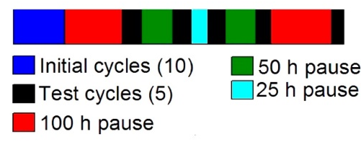
Figure 6-7: Schematic for testing SEI dissolution [175].

Results
The reference cell (0 mins of pre-lithiation) has a consistent capacity with drops occurring in the cycles that are immediately after a rest step. The magnitude of these drops in capacity rises consistently with increasing rest time and this trend is demonstrated in Figure 6-9. This suggests that the cell is working as expected and a portion of the SEI dissolves during the rest step. The capacity loss depends on the time of the rest step with a large initial increase, and then a much more gradual rise seen between 50 and 100 hours. This is expected and matches the trends found in the literature, although the capacity lost is lower suggesting that our SEI has lower solubility [175].
Figure 6-8: Effect of rest time on capacity loss for a Na-HC half-cell.
With the pre-lithiated cells there was a steady increase in cell capacity for the first 10 cycles shown in Figure 6-10 with the reference cell for comparison. This increase has also been seen in pre-sodiated cells although the reason for these phenomena wasn’t addressed directly in the paper [246]. There is reduction in capacity after being rested in a similar manner to the reference cell. This decrease was decoupled from the rest time though. This suggests that in the pre-lithiated cells SEI dissolution doesn’t have as large of an effect on capacity, most likely due to the lower solubility of the Li-based SEI.
Figure 6-9: A charge capacity Vs. cycle number plot with the increase in capacity after resting being visible.
After the initial decrease in performance seen there was an immediate increase in capacity exceeding the capacity of the cell preceding the rest step. With each additional rest step however, this increase in capacity reduced but it did not reach 0 during the length of the experiment. This exponential decay suggests that the dissolution process is removing less SEI each time, possibly due to lower residual SEI as it becomes dominated by the underlying insoluble Li-based SEI.
The capacity increase is dependent upon the pre-lithiation time of the cell. The cell that is pre-lithiated for 20 minutes shows a much lower increase in capacity than the cell only pre-lithiated for 10 minutes. The values start to converge as the rest steps increase, although the increase is trending towards zero. The smaller increases are most likely due to the thicker Li-based SEI that is difficult to dissolve, reducing Na conduction pathways. As the 10 minute cell has an SEI with a higher Na content the new Na salt growth can more easily provide extra Na-ion conduction pathways through the SEI.
Figure 6-10: Graph showing that the capacity increase bears no relation to the rest time.
In Figure 6-11 it can be seen that the capacity increase of the pre-lithiated cells decreases for each subsequent rest step, regardless of the length of the rest step. This suggests that the process takes place in less than 25 hours (the shortest rest step). As Li based SEIs don’t dissolve in the electrolyte to the same extent as Na-based ones then there must be another reason for the change.
Figure 6-11: Nyquist plots of reference cells before and after rest steps.
With the reference cell (Figure 6-12) the impedance decreases drastically when the cell is left to rest for 100 hrs with smaller changes for smaller rest periods. This suggests that the longer rest periods result in the largest changes to the SEI with the smaller rest steps have a much more limited impact upon the cell. This conflicts with the capacity loss profile so the largest drop in SEI resistance coincides with the smallest capacity drop. This suggests that whilst the SEI may play a role in the decrease in capacity there are other factors involved. This may be affected by the Na counter electrode which is known to be less robust than an Li one [247].
Figure 6-11: Nyquist plots of cell pre-lithiated for 10 minutes.
With the cell that has been pre-lithiated for 10 minutes the impedance profile is very different to the reference cell, with far higher initial resistances as can be seen in Figure 6-11. For the initial Nyquist plot a second RC circuit is visible. The second RC starts to overlap with the first in the subsequent steps due to the fact that the initial EIS is taken at open circuit and the others are taken after discharge. The resistance of the SEI increases dramatically after the rest step. The initial small SEI can be attributed to the thin Li-based SEI and the large increase in impedance after this is due to the formation of Na-based SEI on top of the initial SEI. The Na-based SEI in the reference cell doesn’t have such high impedance values on its own so the combination of both types reduces Na-ion conduction pathways. The rest steps cause the impedance of the pre-lithiated electrode to decrease substantially in a similar manner to the reference cell.
Figure 6-12: Nyquist plots of cell pre-lithiated for 20 minutes.
The charge transfer resistance (second semicircle) also decreases with an increasing number of rest steps that isn’t seen in charge transfer circuits in Li-ion batteries at constant voltages. This suggests that the changes to the SEI that occur during the rest steps are also helping to facilitate the charge transfer reaction. In Li batteries the main cause for the charge resistance is graphite intercalation-deintercalation but these results suggest that the main cause of charge transfer resistance is the hard carbon SEI interface.
Note that the SEI resistance of the cell after the dissolution process matches the value of the initial cycle before dissolution. This suggests that the dissolution process has selectively stripped the excess Na based SEI off of the hard carbon, leaving behind the core that was formed during the pre-lithiation process. This rapid decrease in impedance is the main driver for the increase in cell capacity.
The cell that has been pre-lithiated for 20 minutes, shown in Figure 6-12 follows many of the same trends that are seen in the cell that was pre-lithiated for 10 minutes. The resistances were much lower than those seen in the 10 minute cell apart from the value taken before cycling. This suggest that the Sodium SEI growth has been smaller on the cell that has been pre-lithiated for 20 minutes. This makes sense when you consider that the thicker Li-based SEI would keep the sodium better shielded from the electrolyte result in less excess Na-SEI formation. As a result, the decrease in impedance isn’t as rapid in the cell that has only been pre-lithiated for 10 minutes, converging after the final rest.

Conclusion
Dissolution causes the Li-based SEI performance to increase substantially. This coincides with a substantial decrease in the impedance of the cell. This suggests that a thinner SEI results in a cell with a higher capacity, due to a smaller IR drop and more Na conduction channels being open. This matched well with what was found during pre-lithiation that the lower pre-lithiation time had a higher capacity. This means that further work needs to be conducted to reduce the thickness of the Li-based SEI to ensure that the maximum number of Na conduction channels are accessible whilst maintaining its superior performance.
It was found that the pre-lithiated cells demonstrated a lower initial capacity, but they had a capacity retention comparable to Li-ion anodes. This experiment demonstrates the benefits of pre-treating a cell as lithium couldn’t be placed into a commercial cell, but it can be used in the manufacturing process to improve the performance beforehand.

Lithiation vs. sodiation
We have seen that pre-lithiation of hard carbon provides a significant capacity retention increase that is comparable with that seen in traditional Li-ion batteries. We also saw that the capacity of the hard carbon suffered as a result of the pre-lithiation process, and this would have to be increased to make the cells more viable as a Li-ion battery replacement. The increased capacity retention is promising, and this would be key to create a long-lasting Na-ion full cell. We saw that the presence of FEC was beneficial when pre-lithiating hard carbon. Further additive work could increase capacity whilst maintaining high capacity retention.
Pre-sodiation has also been shown to improve the performance of Na-ion batteries with an increase in both the initial coulombic efficiency and charge capacity [134, 248]. Most pre-sodiation experiments have only been conducted over short cycle lengths (less than 100 cycles) and it needs to be conducted over longer length scales to understand if it is a short-term phenomenon or it lasts as long as the results we reported with pre-lithiation and/or if it’s as effective.
It is important to compare both types of pre-metalation on hard carbon electrodes as both have been shown to improve the electrochemical performance in different ways. Pre-lithiation improves the capacity retention of the cell and pre-sodiation improves the charge capacity. The question is does sodiation limit the capacity decay seen in normal cells. I hypothesise that pre-sodiation may make the SEI more stable as it is already formed before cycling but it will still be subject to dissolution, but the process will take longer to begin.

Experimental
Hard carbon was produced using the method outlined in 2. The hard carbon electrodes were made as described in 2.2.1. The electrodes were then either pre-lithiated or pre-sodiated electrochemically with as outlined in 2.3.2. Cells that were pre-lithiated used LP30 + 10wt.% FEC as the electrolyte. Cells that were pre-sodiated used 0.5M NaPF₆ in EC: DMC (50:50V/V) as the electrolyte. This process was conducted between 10 and 50mins. These electrodes were then assembled into half cells with Na as the counter electrode and 0.5M NaPF₆ in EC: DMC (50:50V/V) was used as the electrolyte. The coin cells were cycled at C/10 for 100 cycles using CC/CV cycling for the charge on a Maccor series 4000M at 25°C All impedance measurements were taken between 100 kHz and 0.01 Hz with 11 steps per decade using a Solartron Modulab 2101A. For reference a cell was pre-lithiated in a 90%LP30:10%FEC V/V solution for 10 minutes before being reassembled into a Na-half cell.

Results
Pre-lithiating in both electrolytes allows us to compare their effectiveness for the role as FEC isn’t known to be as reliable for improving the charge capacity of sodium cells, unlike its strong track record with most Li cell chemistries [249].
The charge capacity plots of the cells pre-lithiated in 10% FEC are erratic with large variations in their capacity suggesting FEC isn’t a suitable additive when pre-sodiating hard carbon. Despite this several trends can be seen in this data. It is clear that pre-lithiation can improve both the initial capacity and the capacity retention of the cells. Despite this improvement the best performing cells that were pre-lithiated in FEC (Figure 6-13) still have a lower charge capacity and retention than the LP30 variant seen in Figure 6-15. This shows that pre-sodiating cells can be beneficial even in non-ideal situations.
Figure 6-13: Capacity retention of cells pre-lithiated in FEC.
The cells pre-sodiated in LP30 have a more stable profile than that of their FEC counterparts. The trends seen again suggests that capacity retention increases with increasing pre-lithiation time, similarly to our earlier work with pre-lithiating graphite. This trend peaks after 30 minutes of pre-lithiation before cycling. After this point the capacity fade starts to increase again although it is still superior to the cell that hasn’t been pre-lithiated.
Figure 6-14: Voltage Vs. pre-lithiation time demonstrating a voltage plateau around 1.3 V.

Figure 6-14 shows pre-lithiation causing a large a decrease in the voltage of the cell with a plateau visible around 1.3V. After 30 minutes of pre-lithiation there is a visible increase in the OCV of the cell. We know that the resistance of the pre-lithiated cells increased substantially after longer periods of pre-lithiation, which raises the OCV of the cell at rest due to the overpotential.
Whilst the improvements to capacity retention are substantial there is still some capacity fade that puts these cells at a disadvantage to the cells that have been pre-lithiated which show almost no capacity fade.
Figure 6-15: Capacity retention of cells pre-sodiated in electrolyte not containing FEC.
Figure 6-16: Cell voltage with increasing pre-sodiation time.
The decrease in charge capacity seen after the sharp maxima in Figure 6-19 is a result of the sodium starting to react with the hard carbon. This is confirmed with the plateau in the pre-sodiation voltage, shown in Figure 6-16. This plateau is much higher than that seen in graphite pre-lithiation. This is due to the different reaction mechanisms between hard carbon and graphite.
EIS can give us an insight into how the Na-SEI develops over the cycle life of the cell and how pre-lithiation affects this process. As can be seen in Figure 6-17 the resistance of the SEI increases more rapidly than it does for similar Li-graphite half cells. This increase is dependent upon the pre-lithiation time.
Figure 6-17: Nyquist plots of the cell lithiated in LP30 for 10 minutes with increasing cycle number.
Figure 6-18: The effect of pre-sodiation time on R_{SEI} at the 10th cycle.
By looking at the impact of pre-lithiation time on R_{SEI} in Figure 6-18 we can see that initially R_{SEI} decreases at small pre-sodiation times before increasing again. The initial decrease is due to the ultra-thin SEI that is formed at low pre-lithiation times. This was also seen in our pre-lithiation work so that demonstrates the similarities between the two techniques. The cell pre-lithiated cell performs poorly compared to the reference cell and this suggest that the SEI formed is too thin and therefore inadequate for cycling. When R_{SEI} reaches its maxima so too does its charge capacity, further reinforcing the link between the two.
Figure 6-19: Charge capacity as a function of pre-lithiation time.

Conclusion
Pre-sodiation can drastically improve the capacity retention of hard carbon although the retention still doesn’t match that seen in either Li-graphite anodes or pre-lithiated hard carbon anodes. This demonstrates that the issues with hard carbon SEI extend beyond Q_{irr} and its solubility limits capacity retention in even the best-case scenario. Both Pre-sodiation and pre-lithiation have advantages and disadvantages that need to be carefully weighed when deciding manufacturing strategies and these are summarised in Table 6-1.
The inclusion of FEC into the electrolyte results in cells with erratic performance which correlate well with other reports of mixed performance in hard carbon anodes [171]. This demonstrates the lack of understanding of we currently have about additives and their effect on the SEI in Na-ion systems. To move towards commercial Na-ion batteries further work is required to create a stable SEI that has lower solubility than current ones.
Table 6-1: Outline of differences between pre-lithiation and pre-sodiation.
Technique | Pros | Cons
Pre-lithiation | High capacity retention  Robust SEI | Poor specific capacity  High resistance SEI
Pre-sodiation | High specific capacity  Low resistance SEI | Poor capacity retention  SEI prone to dissolution

Conclusion & Future work
This chapter shows the outcome of the work carried out within this thesis and how it impacts the wider scientific body of knowledge. It also outlines new potential avenues of work to be conducted outside the scope of this thesis and how these would benefit from the work begun in this thesis.

Conclusion
This thesis has demonstrated that the SEI can be formed before cycling and can have long lasting effects on the performance of the cell. We saw that altering the material used for pe-lithiation could increase the initial coulombic efficiency and charge capacity of the cell. Using EIS showed us that altering the electrolyte would impact the SEI even when the same material had been used for pre-lithiation.
Altogether this work has shown that pre-lithiation is a resilient technique that can be used to improve cell performance and can survive moving across different cell chemistries. We also saw that the techniques we used to optimise the capacity retention of the cell could be applied in a systematic manner between the different anode materials.
This is not the end of this research though and there is a range of work that could be completed in the future to further the understanding about the effects of pre-lithiation and its longevity. This would be vital to ensure that pre-lithiation becomes a viable technique in Li-ion battery manufacturing.
Chapter 3 demonstrated that the SEI formed using pre-lithiation can improve the coulombic efficiency of the cell and capacity retention. This chapter looked at the different Solvent components of the electrolyte and used them as the pre-lithiation media for the cells. It was found that the capacity of the cells was very sensitive to the pre-lithiation media used and went in the order FEC>DMC>>EC. A similar trend was also seen with the coulombic efficiency of the cells with FEC>>DMC>EC.
Chapter 4 applied the knowledge gained during chapter 3 and applied it to Si electrodes. The cells that were pre-lithiated demonstrated a higher capacity than those that weren’t pre-lithiated, just as was seen with graphite electrodes in chapter 3. The cells that were pre-lithiated had lower capacity retention than the reference cell. This was attributed to a local minimum in the coulombic efficiency seen between the 5th and 10th cycles. This was the result of SEI cracking during the expansion of the Si active material. This finding reinforces the fact that SEI formation is dynamic process.
Chapter 5 was an experiment made to probe the dynamism of SEI formation as cells cycled in different environments. EIS was used to probe the transformation of the SEI during cycling. In the
Chapter 6 demonstrated that a Li-ion based SEI could be used to improve the capacity retention of a hard carbon anode for Na-ion electrochemistry (. This makes the capacity retention comparable between pre-sodiated hard carbon and pre-lithiated graphite. This increase came at the cost of lower initial capacity More work should be done to understand these degradation products and the impact they have on Na⁺ transport to the hard carbon.

Future work

Elucidating SEI exchange mechanisms
To make further improvements to the SEI more understanding is required of the SEI itself. Outlined here are some proposed experiments that could be conducted to discover more about the degradation methods of the SEI and how the process occurs.

Understanding the interface of pre-lithiated Na-ion batteries
During my work on Na-ion cells I found that the composite of the Na and Li SEIs resulted in unusual behaviour that isn’t seen in either traditional Li or Na cells. The main suggestion for this is due to the interface between these two materials give rise to these irregularities. Whilst EIS gave us some understanding about this interface it is an area ripe for more research. Muon spectroscopy is a useful technique used for determining ion conduction pathways in solids [250]. It could help by revealing the Na conduction pathway through this composite. If the Na-Li boundary is disrupting ion conduction, then this could be observed using muon spectroscopy with the ions coalescing at the interface.
Computational studies would also compliment this work with and could give further insights into the differences between both types of the SEI and how interface with each other in the composite. It could also help to understand the ion conduction pathway. This is an incredibly complex system though and this may only paint a limited picture of what is occurring.

Further understanding the exchange process
Whilst I have already said that NR could reveal more insight into the exchange process there are other techniques that could help us gain more insight into the process. XPS would help by giving an elemental analysis of the SEI layer as this couldn’t be done during the PhD due to limited availability at the Harwell XPS service. Cells could be cycled and then disassembled after different cycle numbers to build up snapshots of the changes taking place in the SEI. Whilst this process would be ex-situ it would still give us more information about the composition about the SEI. The Fluorine content would give a key indication as to the substitution taking place with the SEI. This contrast using this technique could be enhanced by using a fluorine free salt in the electrolyte such as LiClO₄.

Neutron reflectometry
We saw earlier how dynamic the SEI process was using EIS. Whilst this helped to shed light on the process our knowledge of the exchange process. A useful experiment for furthering our understanding would be to observe the SEI exchange process using neutron reflectometry (NR). Neutron reflectometry is an analogous and complimentary technique to ellipsometry that is used for observing thin film growth. It has been used previously by other researchers to observe the initial formation of the SEI on both Si and carbon [251-253]. NR is useful for this process as it is sensitive to both the element and isotope present. Of importance for the planned experiment is the hydrogen deuterium isotope sensitivity differential. The experiment would involve a Pre-formed SEI on the anode with an electrolyte based on a contrasting hydrogen isotope to the SEI. As the SEI exchanges with the electrolyte the Scattering length density of the SEI will change. This change can be tracked using NR and plotted as a function of cycle number, helping us to understand the speed of the exchange process and where in the cycling process it occurs.

Further improvements for pre-lithiated SEIs

New additive avenues
As we showed the SEI doesn’t have to be based on the electrolyte the possibilities for the SEI composition are endless. The SEI still needs to fulfil the properties of a traditional SEI and this means that even if the choice of material doesn’t rely on electrolyte and or additives it still needs to provide the same function. A possible candidate for a new solid electrolyte interphase additive could be cysteine. Amino acids aren’t traditional monomers, but they are still polymerizable. Cysteine, seen in Figure 7-1 contains a thiol group that would ensure that the breakdown voltage is higher than VC and could help like the polymer chains together through disulphide bonds. By using amino acids, the feedstock and manufacture can be conducted in a low energy and sustainable fashion. This is an important advantage over traditional polymers that require high temperatures and metal catalysts during the production process [254].
Figure 7-1: Cysteine molecule.

Polymer SEIs
Another avenue for creating the SEI before full cell cycling is using polymer SEI’s. Polymer SEI already been shown to be successful at preventing electrolyte degradation and even besting traditional SEI’s capacity retention at high C-rates due to their high ionic conductivity [163]. Polymer based SEI’s have several properties that make them attractive for cell manufacturing including inertness in air and their low ionic impedance. Making an affordable polymer based SEI would help to reduce battery costs and improve cycle life. A potential route for producing polymer SEI’s is by using proteins. Amino acids can be both positive and negative polyelectrolytes and the neutral forms of two potential options are in Figure 7-2. They can also contain aromatic groups that are useful for adhering to graphite through π-stacking. Based on the criteria outlined by Wu et al. poly-tyrosine could be used as the negative polyelectrolyte. This also serves a dual role with the phenyl group helping the SEI to anchor to the graphite. For the positive polyelectrolyte Histidine could be used as it can accept a proton easily with a pK_{a} of 6.04. Methylation of this side chain could also be performed to negate the risk of deprotonation, and this can be done enzymatically [255]. In a similar manner to cysteine the amino acids can be manufactured and polymerised cheaply and easily.
Figure 7-2: Tyrosine (left) and Histidine (right) neutral chemical structures.
The amino acids suggested aren’t the only options though and high throughput screening techniques typically employed for drug discovery could help in optimising the protein structure [256]. Using amino acids means that a range of combinations could be tested to optimise SEI properties such as graphite binding affinity and ionic conduction.

Creating insoluble Na-SEIs to extend battery life
One of the main reasons for capacity fade in Na-ion anodes is the high solubility of the Na salts that it contains. This issue will need to be rectified for the commercialisation of Na-ion batteries. To change this the SEI must contain more polymeric species which are known to make a much smaller proportion of Na based SEIs when compared to Li ones. This could be achieved by additive choices with species that result in less salt formation such as glycolide and its derivatives which we encountered earlier as an additive for Li-ion cells. It could also be achieved through polymer SEIs. Considering that many of the polymer SEIs that have already been tested are insoluble sodium salts they could be ideal for this situation and reduce the Q_{irr} seen.

References

1. Peled, E., The Electrochemical Behavior of Alkali and Alkaline Earth Metals in Nonaqueous Battery Systems—The Solid Electrolyte Interphase Model. Journal of The Electrochemical Society, 1979. 126(12): p. 2047-2051.
2. An, S.J., et al., Fast formation cycling for lithium ion batteries. Journal of Power Sources, 2017. 342: p. 846-852.
3. Press release: The Nobel Prize in Chemistry 2019. 2019 [cited 2020 19/01/2020]; Available from: https://www.nobelprize.org/prizes/chemistry/2019/press-release/.
4. Blomgren, G.E., The Development and Future of Lithium Ion Batteries. Journal of The Electrochemical Society, 2017. 164(1): p. A5019-A5025.
5. Harlow, J.E., et al., A Wide Range of Testing Results on an Excellent Lithium-Ion Cell Chemistry to be used as Benchmarks for New Battery Technologies. Journal of The Electrochemical Society, 2019. 166(13): p. A3031-A3044.
6. Love, C.T., O.A. Baturina, and K.E. Swider-Lyons, Observation of Lithium Dendrites at Ambient Temperature and Below. ECS Electrochemistry Letters, 2014. 4(2): p. A24-A27.
7. Hausbrand, R., et al., Fundamental degradation mechanisms of layered oxide Li-ion battery cathode materials: Methodology, insights and novel approaches. Materials Science and Engineering: B, 2015. 192: p. 3-25.
8. Vaughey, J.T., et al., Alternative anode materials for lithium-ion batteries: a study of Ag3Sb. Journal of Power Sources, 2003. 119-121: p. 64-68.
9. Obrovac, M.N. and L.J. Krause, Reversible Cycling of Crystalline Silicon Powder. Journal of The Electrochemical Society, 2007. 154(2): p. A103.
10. Wang, U. Why Tesla Rolls Out Better EV Batteries. 2015 [cited 2019 13/03/19]; Available from: https://www.forbes.com/sites/uciliawang/2015/07/17/why-tesla-rolls-out-better-ev-batteries/#65d09e981dca.
11. Ko, M., S. Chae, and J. Cho, Challenges in Accommodating Volume Change of Si Anodes for Li-Ion Batteries. ChemElectroChem, 2015. 2(11): p. 1645-1651.
12. Kim, H., E.-J. Lee, and Y.-K. Sun, Recent advances in the Si-based nanocomposite materials as high capacity anode materials for lithium ion batteries. Materials Today, 2014. 17(6): p. 285-297.
13. Ozawa, K., Lithium-ion rechargeable batteries with LiCoO2 and carbon electrodes: the LiCoO2/C system. Solid State Ionics, 1994. 69(3-4): p. 212-221.
14. Xu, J., et al., A review of Ni-based layered oxides for rechargeable Li-ion batteries. Journal of Materials Chemistry A, 2017. 5(3): p. 874-901.
15. Banza, C.L.N., et al., High human exposure to cobalt and other metals in Katanga, a mining area of the Democratic Republic of Congo. Environmental Research, 2009. 109(6): p. 745-752.
16. Li, X., et al., Degradation mechanisms of high capacity 18650 cells containing Si-graphite anode and nickel-rich NMC cathode. Electrochimica Acta, 2019. 297: p. 1109-1120.
17. Li, W., S. Lee, and A. Manthiram, High-Nickel NMA: A Cobalt-Free Alternative to NMC and NCA Cathodes for Lithium-Ion Batteries. Advanced Materials, 2020. 32(33): p. 2002718.
18. Ruffo, R., et al., Electrochemical behavior of LiCoO2 as aqueous lithium-ion battery electrodes. Electrochemistry Communications, 2009. 11(2): p. 247-249.
19. Xu, K. and C. Wang, Batteries: Widening voltage windows. Nature Energy, 2016. 1(10): p. 16161.
20. Bayley, P.M., et al., The effect of coordinating and non-coordinating additives on the transport properties in ionic liquid electrolytes for lithium batteries. Physical Chemistry Chemical Physics, 2011. 13(10): p. 4632-4640.
21. An, S.J., et al., The state of understanding of the lithium-ion-battery graphite solid electrolyte interphase (SEI) and its relationship to formation cycling. Carbon, 2016. 105: p. 52-76.
22. Xu, K., Nonaqueous Liquid Electrolytes for Lithium-Based Rechargeable Batteries. Chemical Reviews, 2004. 104(10): p. 4303-4418.
23. Nippon Shokubai develops process for LiFSI electrolyte for Li-ion batteries. 2012 [cited 2021 04/09/21]; Available from: https://www.greencarcongress.com/2012/03/lifsi-20120321.html.
24. Shen, Y., et al., Water-in-salt electrolyte for safe and high-energy aqueous battery. Energy Storage Materials, 2021. 34: p. 461-474.
25. Zheng, F., et al., Review on solid electrolytes for all-solid-state lithium-ion batteries. Journal of Power Sources, 2018. 389: p. 198-213.
26. Yuqin, C., et al., Irreversible capacity loss of graphite electrode in lithium-ion batteries. Journal of Power Sources, 1997. 68(2): p. 187-190.
27. Ohta, N., et al., Enhancement of the High-Rate Capability of Solid-State Lithium Batteries by Nanoscale Interfacial Modification. Advanced Materials, 2006. 18(17): p. 2226-2229.
28. Hatzell, K.B. and Y. Zheng, Prospects on large-scale manufacturing of solid state batteries. MRS Energy & Sustainability, 2021. 8(1): p. 33-39.
29. Gao, J., et al., Lithium-ion transport in inorganic solid state electrolyte. Chinese Physics B, 2016. 25(1): p. 018211.
30. Zhang, S.S., A review on the separators of liquid electrolyte Li-ion batteries. Journal of Power Sources, 2007. 164(1): p. 351-364.
31. Arcus, C. Battery Lifetime: How Long Can Electric Vehicle Batteries Last? 2016 [cited 2020 21/01/20]; Available from: https://cleantechnica.com/2016/05/31/battery-lifetime-long-can-electric-vehicle-batteries-last/.
32. Wu, F., et al., The positive role of (NH4)3AlF6 coating on Li[Li0.2Ni0.2Mn0.6]O2 oxide as the cathode material for lithium-ion batteries. RSC Advances, 2017. 7(2): p. 1191-1199.
33. Winter, M., The Solid Electrolyte Interphase – The Most Important and the Least Understood Solid Electrolyte in Rechargeable Li Batteries, in Zeitschrift für Physikalische Chemie. 2009. p. 1395.
34. Verma, P., P. Maire, and P. Novak, A review of the features and analyses of the solid electrolyte interphase in Li-ion batteries. Electrochimica Acta, 2010. 55(22): p. 6332-6341.
35. Yan, J., et al., A novel perspective on the formation of the solid electrolyte interphase on the graphite electrode for lithium-ion batteries. 2010. 55(5): p. 1785-1794.
36. Hammer, N.I., et al., Dipole-bound anions of highly polar molecules: Ethylene carbonate and vinylene carbonate. The Journal of Chemical Physics, 2004. 120(2): p. 685-690.
37. Camacho-Forero, L.E., T.W. Smith, and P.B. Balbuena, Effects of High and Low Salt Concentration in Electrolytes at Lithium–Metal Anode Surfaces. The Journal of Physical Chemistry C, 2017. 121(1): p. 182-194.
38. Martinez de la Hoz, J.M., F.A. Soto, and P.B. Balbuena, Effect of the Electrolyte Composition on SEI Reactions at Si Anodes of Li-Ion Batteries. The Journal of Physical Chemistry C, 2015. 119(13): p. 7060-7068.
39. Wang, A., et al., Review on modeling of the anode solid electrolyte interphase (SEI) for lithium-ion batteries. npj Computational Materials, 2018. 4(1): p. 15.
40. Soto, F.A. and P.B. Balbuena, Elucidating Oligomer-Surface and Oligomer-Oligomer Interactions at a Lithiated Silicon Surface. Electrochimica Acta, 2016. 220: p. 312-321.
41. Aurbach, D., et al., Identification of Surface Films Formed on Lithium in Propylene Carbonate Solutions. Journal of The Electrochemical Society, 1987. 134(7): p. 1611-1620.
42. Li, T. and P.B. Balbuena, Theoretical studies of the reduction of ethylene carbonate. Chemical Physics Letters, 2000. 317(3): p. 421-429.
43. Wang, Y., et al., Theoretical Studies To Understand Surface Chemistry on Carbon Anodes for Lithium-Ion Batteries: Reduction Mechanisms of Ethylene Carbonate. Journal of the American Chemical Society, 2001. 123(47): p. 11708-11718.
44. Leung, K. and J.L. Budzien, Ab initio molecular dynamics simulations of the initial stages of solid–electrolyte interphase formation on lithium ion battery graphitic anodes. Physical Chemistry Chemical Physics, 2010. 12(25): p. 6583-6586.
45. Onuki, M., et al., Identification of the Source of Evolved Gas in Li-Ion Batteries Using #2#1 -labeled Solvents. Journal of The Electrochemical Society, 2008. 155(11): p. A794-A797.
46. Leung, K., Two-electron reduction of ethylene carbonate: A quantum chemistry re-examination of mechanisms. Chemical Physics Letters, 2013. 568-569: p. 1-8.
47. Leung, K. and C.M. Tenney, Toward First Principles Prediction of Voltage Dependences of Electrolyte/Electrolyte Interfacial Processes in Lithium Ion Batteries. The Journal of Physical Chemistry C, 2013. 117(46): p. 24224-24235.
48. Leung, K., Predicting the voltage dependence of interfacial electrochemical processes at lithium-intercalated graphite edge planes. Physical Chemistry Chemical Physics, 2015. 17(3): p. 1637-1643.
49. Delp, S.A., et al., Importance of reduction and oxidation stability of high voltage electrolytes and additives. Electrochimica Acta, 2016. 209: p. 498-510.
50. Borodin, O., et al., Towards high throughput screening of electrochemical stability of battery electrolytes. Nanotechnology, 2015. 26(35): p. 354003.
51. Peled, E. and S. Menkin, Review—SEI: Past, Present and Future. Journal of The Electrochemical Society, 2017. 164(7): p. A1703-A1719.
52. Okamoto, Y., Ab Initio Calculations of Thermal Decomposition Mechanism of LiPF6-Based Electrolytes for Lithium-Ion Batteries. Journal of The Electrochemical Society, 2013. 160(2): p. A404-A409.
53. Peled, E., et al., Effect of carbon substrate on SEI composition and morphology. Electrochimica Acta, 2004. 50(2): p. 391-395.
54. Leung, K. and A. Leenheer, How Voltage Drops Are Manifested by Lithium Ion Configurations at Interfaces and in Thin Films on Battery Electrodes. The Journal of Physical Chemistry C, 2015. 119(19): p. 10234-10246.
55. Ma, Y. and P.B. Balbuena, DFT Study of Reduction Mechanisms of Ethylene Carbonate and Fluoroethylene Carbonate on Li+-Adsorbed Si Clusters. Journal of The Electrochemical Society, 2014. 161(8): p. E3097-E3109.
56. Aurbach, D., Electrode–solution interactions in Li-ion batteries: a short summary and new insights. Journal of power sources, 2003. 119: p. 497-503.
57. Aurbach, D., et al., The study of electrolyte solutions based on ethylene and diethyl carbonates for rechargeable Li batteries II. Graphite electrodes. Journal of The Electrochemical Society, 1995. 142(9): p. 2882-2890.
58. Ushirogata, K., et al., Near-Shore Aggregation Mechanism of Electrolyte Decomposition Products to Explain Solid Electrolyte Interphase Formation. Journal of The Electrochemical Society, 2015. 162(14): p. A2670-A2678.
59. Ding, M.S., et al., Liquid/Solid Phase Diagrams of Binary Carbonates for Lithium Batteries Part II. Journal of The Electrochemical Society, 2001. 148(4): p. A299-A304.
60. Zhang, X., et al., Electrochemical and Infrared Studies of the Reduction of Organic Carbonates. Journal of The Electrochemical Society, 2001. 148(12): p. A1341-A1345.
61. Kim, H., et al., In Situ Formation of Protective Coatings on Sulfur Cathodes in Lithium Batteries with LiFSI‐Based Organic Electrolytes. Advanced Energy Materials, 2015. 5(6): p. 1401792.
62. Peled, E., Film forming reaction at the lithium/electrolyte interface. Journal of Power Sources, 1983. 9(3): p. 253-266.
63. Edstrom, K., M. Herstedt, and D.P. Abraham, A new look at the solid electrolyte interphase on graphite anodes in Li-ion batteries. Journal of Power Sources, 2006. 153(2): p. 380-384.
64. Peled, E., et al., Composition, depth profiles and lateral distribution of materials in the SEI built on HOPG-TOF SIMS and XPS studies. Journal of power sources, 2001. 97: p. 52-57.
65. Zheng, J., et al., 3D visualization of inhomogeneous multi-layered structure and Young's modulus of the solid electrolyte interphase (SEI) on silicon anodes for lithium ion batteries. Physical Chemistry Chemical Physics, 2014. 16(26): p. 13229-13238.
66. Andersson, A.M. and K. Edström, Chemical Composition and Morphology of the Elevated Temperature SEI on Graphite. Journal of The Electrochemical Society, 2001. 148(10): p. A1100-A1109.
67. Aurbach, D., et al., X-ray Photoelectron Spectroscopy Studies of Lithium Surfaces Prepared in Several Important Electrolyte Solutions. A Comparison with Previous Studies by Fourier Transform Infrared Spectroscopy. Langmuir, 1996. 12(16): p. 3991-4007.
68. Shi, S., et al., Direct Calculation of Li-Ion Transport in the Solid Electrolyte Interphase. Journal of the American Chemical Society, 2012. 134(37): p. 15476-15487.
69. Ramasubramanian, A., et al., Lithium Diffusion Mechanism through Solid–Electrolyte Interphase in Rechargeable Lithium Batteries. The Journal of Physical Chemistry C, 2019. 123(16): p. 10237-10245.
70. Dwivedi, D., K. Lepková, and T. Becker, Carbon steel corrosion: a review of key surface properties and characterization methods. RSC Advances, 2017. 7(8): p. 4580-4610.
71. Matsumura, Y., S. Wang, and J. Mondori, Interactions between disordered carbon and lithium in lithium ion rechargeable batteries. Carbon, 1995. 33(10): p. 1457-1462.
72. Goodenough, J.B. and Y. Kim, Challenges for Rechargeable Li Batteries. Chemistry of Materials, 2010. 22(3): p. 587-603.
73. Zhang, S.S., A review on electrolyte additives for lithium-ion batteries. Journal of Power Sources, 2006. 162(2): p. 1379-1394.
74. Jenkins, A.D., R.G. Jones, and G. Moad, Terminology for reversible-deactivation radical polymerization previously called "controlled" radical or "living" radical polymerization (IUPAC Recommendations 2010). Pure and Applied Chemistry, 2009. 82(2): p. 483-491.
75. Holmes, C.F., et al., Proceedings of the Symposium on Batteries for Portable Applications and Electric Vehicles. 1997: Electrochemical Society, Incorporated.
76. Fujimoto, M., et al., Charge-Discharge Characteristics of Natural Graphite Electrode in Some Cyclic Carbonates. Denki Kagaku, 1997. 65: p. 949-953.
77. Aurbach, D., et al., On the use of vinylene carbonate (VC) as an additive to electrolyte solutions for Li-ion batteries. Electrochimica Acta, 2002. 47(9): p. 1423-1439.
78. McMillan, R., et al., Fluoroethylene carbonate electrolyte and its use in lithium ion batteries with graphite anodes. Journal of Power Sources, 1999. 81-82: p. 20-26.
79. Shu, Z.X., et al., Use of Chloroethylene Carbonate as an Electrolyte Solvent for a Lithium Ion Battery Containing a Graphitic Anode. Journal of The Electrochemical Society, 1995. 142(9): p. L161-L162.
80. Markevich, E., G. Salitra, and D. Aurbach, Fluoroethylene Carbonate as an Important Component for the Formation of an Effective Solid Electrolyte Interphase on Anodes and Cathodes for Advanced Li-Ion Batteries. Acs Energy Letters, 2017. 2(6): p. 1337-1345.
81. Nakai, H., et al., Investigation of the Solid Electrolyte Interphase Formed by Fluoroethylene Carbonate on Si Electrodes. Journal of The Electrochemical Society, 2011. 158(7): p. A798-A801.
82. Jaumann, T., et al., Lifetime vs. rate capability: Understanding the role of FEC and VC in high-energy Li-ion batteries with nano-silicon anodes. Energy Storage Materials, 2017. 6: p. 26-35.
83. Wrodnigg, G.H., J.O. Besenhard, and M. Winter, Ethylene Sulfite as Electrolyte Additive for Lithium‐Ion Cells with Graphitic Anodes. Journal of The Electrochemical Society, 1999. 146(2): p. 470-472.
84. Yu, B.T., et al., A study on sulfites for lithium-ion battery electrolytes. Journal of Power Sources, 2006. 158(2): p. 1373-1378.
85. David Stringer , J.M., and Jinshan Hong. Tesla Fires Sound Alarms About Electric-Car Battery Safety. 2019 [cited 2019 24/05/19]; Available from: https://www.bloomberg.com/news/articles/2019-05-16/tesla-fires-sound-alarms-about-safety-of-electric-car-batteries.
86. Haregewoin, A.M., A.S. Wotango, and B.-J. Hwang, Electrolyte additives for lithium ion battery electrodes: progress and perspectives. Energy Environ. Sci., 2016. 9(6): p. 1955-1988.
87. Zhang, B., et al., Role of 1,3-Propane Sultone and Vinylene Carbonate in Solid Electrolyte Interface Formation and Gas Generation. The Journal of Physical Chemistry C, 2015. 119(21): p. 11337-11348.
88. Mao, H. and J.N. Reimers, Use of B2 O3 additive in non-aqueous rechargeable lithium batteries. 1999, Google Patents.
89. Aurbach, D., et al., Vinylene Carbonate and Li Salicylatoborate as Additives in LiPF3 ( CF 2 CF 3 ) 3 Solutions for Rechargeable Li-Ion Batteries. Journal of The Electrochemical Society, 2004. 151(1): p. A23-A30.
90. Contestabile, M., et al., A comparative study on the effect of electrolyte/additives on the performance of ICP383562 Li-ion polymer (soft-pack) cells. Journal of Power Sources, 2003. 119-121: p. 943-947.
91. Xu, K., et al., Chemical Analysis of Graphite/Electrolyte Interface Formed in LiBOB-Based Electrolytes. Electrochemical and Solid-State Letters, 2003. 6(7): p. A144-A148.
92. Abeywardana, M.Y., et al., Increased Cycling Performance of Li-Ion Batteries by Phosphoric Acid Modified LiNi<sub>0.5</sub>Mn<sub>1.5</sub>O<sub>4</sub> Cathodes in the Presence of LiBOB. International Journal of Electrochemistry, 2019. 2019: p. 8636540.
93. Wang, F.-M., et al., Phenylenedimaleimide positional isomers used as lithium ion battery electrolyte additives: Relating physical and electrochemical characterization to battery performance. Journal of Power Sources, 2013. 231: p. 18-22.
94. Wang, F.-M., et al., Novel SEI formation of maleimide-based additives and its improvement of capability and cyclicability in lithium ion batteries. Electrochimica Acta, 2009. 54(12): p. 3344-3351.
95. Pavot, V., et al., Poly(lactic acid) and poly(lactic-co-glycolic acid) particles as versatile carrier platforms for vaccine delivery. Nanomedicine, 2014. 9(17): p. 2703-2718.
96. Jeon, J., et al., Tuning glycolide as an SEI-forming additive for thermally robust Li-ion batteries. 2012. 22(39): p. 21003.
97. Nie, M., J. Xia, and J.R. Dahn, Development of Pyridine-Boron Trifluoride Electrolyte Additives for Lithium-Ion Batteries. Journal of The Electrochemical Society, 2015. 162(7): p. A1186-A1195.
98. Amine, K., H. Yasuda, and M. Yamachi, Olivine LiCoPO4 as 4.8 V Electrode Material for Lithium Batteries. Electrochemical and Solid-State Letters, 2000. 3(4): p. 178-179.
99. Zhang, M., N. Garcia-Araez, and A.L. Hector, Understanding and development of olivine LiCoPO4 cathode materials for lithium-ion batteries. Journal of Materials Chemistry A, 2018. 6(30): p. 14483-14517.
100. Hall, D.S., et al., Surface-Electrolyte Interphase Formation in Lithium-Ion Cells Containing Pyridine Adduct Additives. Journal of The Electrochemical Society, 2016. 163(5): p. A773-A780.
101. Wood, D.L., J. Li, and C. Daniel, Prospects for reducing the processing cost of lithium ion batteries. Journal of Power Sources, 2015. 275: p. 234-242.
102. Ohtake, M., et al. Physical properties of fluorinated cyclic carbonates for secondary lithium batteries. in 214th ECS Meeting. 2008. Citeseer.
103. Väli, R., A. Jänes, and E. Lust, Vinylene Carbonate as Co-Solvent for Low-Temperature Mixed Electrolyte Based Supercapacitors. Journal of The Electrochemical Society, 2016. 163(6): p. A851-A857.
104. Vollmer, J.M., et al., Reduction mechanisms of ethylene, propylene, and vinylethylene carbonates a quantum chemical study. Journal of The Electrochemical Society, 2004. 151(1): p. A178-A183.
105. Shim, E.-G., et al., Effect of vinyl acetate plus vinylene carbonate and vinyl ethylene carbonate plus biphenyl as electrolyte additives on the electrochemical performance of Li-ion batteries. Electrochimica Acta, 2007. 53(2): p. 650-656.
106. Xing, L., et al., Theoretical study on reduction mechanism of 1, 3-benzodioxol-2-one for the formation of solid electrolyte interface on anode of lithium ion battery. Journal of Power Sources, 2009. 189(1): p. 689-692.
107. Wang, C., et al., Electrochemical behaviour of a graphite electrode in propylene carbonate and 1,3-benzodioxol-2-one based electrolyte system. Journal of Power Sources, 1998. 74(1): p. 142-145.
108. Ping, P., et al., Effect of sulfites on the performance of LiBOB/γ-butyrolactone electrolytes. Journal of Power Sources, 2011. 196(2): p. 776-783.
109. Bhatt, M.D. and C. O’Dwyer, The Role of Carbonate and Sulfite Additives in Propylene Carbonate-Based Electrolytes on the Formation of SEI Layers at Graphitic Li-Ion Battery Anodes. Journal of The Electrochemical Society, 2014. 161(9): p. A1415-A1421.
110. Yao, W., et al., Vinyl ethylene sulfite as a new additive in propylene carbonate-based electrolyte for lithium ion batteries. Energy & Environmental Science, 2009. 2(10): p. 1102-1108.
111. Xu, M., et al., Effect of Butyl Sultone on the Li-ion Battery Performance and Interface of Graphite Electrode. Acta Physico-Chimica Sinica, 2006. 22(3): p. 335-340.
112. Nie, M., et al., A Comparative Study of Pyridine Containing Lewis Acid-Base Adducts as Additives for Li[Ni0.5Mn0.3Co0.2]O2/graphite Pouch Cells. Journal of The Electrochemical Society, 2016. 163(9): p. A2124-A2130.
113. Xu, M., et al., Investigation and application of lithium difluoro(oxalate)borate (LiDFOB) as additive to improve the thermal stability of electrolyte for lithium-ion batteries. Journal of Power Sources, 2011. 196(16): p. 6794-6801.
114. Kaymaksiz, S., et al., Electrochemical stability of lithium salicylato-borates as electrolyte additives in Li-ion batteries. Journal of Power Sources, 2013. 239: p. 659-669.
115. Shah, F.U., et al., Transport and Association of Ions in Lithium Battery Electrolytes Based on Glycol Ether Mixed with Halogen-Free Orthoborate Ionic Liquid. Scientific Reports, 2017. 7(1): p. 16340.
116. Zhong, Z., et al., Synthesis and aqueous phase behavior of thermoresponsive biodegradable poly(D,L-3-methylglycolide)-block-poly(ethylene glycol)-block-poly(D,L-3-methylglycolide) triblock copolymers. 2002. 203(12): p. 1797-1803.
117. Lee, J.H., et al., Toward Ultrahigh-Capacity V2O5 Lithium-Ion Battery Cathodes via One-Pot Synthetic Route from Precursors to Electrode Sheets. Advanced Materials Interfaces, 2016. 3(14): p. 1600173.
118. Holtstiege, F., et al., Pre-Lithiation Strategies for Rechargeable Energy Storage Technologies: Concepts, Promises and Challenges. Batteries, 2018. 4(1): p. 4.
119. Sun, Y., et al., Lithium Sulfide/Metal Nanocomposite as a High-Capacity Cathode Prelithiation Material. Advanced Energy Materials, 2016. 6(12): p. 1600154.
120. Park, K., B.-C. Yu, and J.B. Goodenough, Li3N as a Cathode Additive for High-Energy-Density Lithium-Ion Batteries. Advanced Energy Materials, 2016. 6(10): p. 1502534.
121. Sun, Y., et al., Stabilized Li3N for efficient battery cathode prelithiation. Energy Storage Materials, 2017. 6: p. 119-124.
122. Park, H., et al., Li2NiO2 as a sacrificing positive additive for lithium-ion batteries. Electrochimica Acta, 2013. 108: p. 591-595.
123. Kim, M.G. and J. Cho, Air stable Al2O3-coated Li2NiO2 cathode additive as a surplus current consumer in a Li-ion cell. Journal of Materials Chemistry, 2008. 18(48): p. 5880-5887.
124. Kasnatscheew, J., et al., The truth about the 1st cycle Coulombic efficiency of LiNi1/3Co1/3Mn1/3O2 (NCM) cathodes. Physical Chemistry Chemical Physics, 2016. 18(5): p. 3956-3965.
125. Kasnatscheew, J., et al., Improving cycle life of layered lithium transition metal oxide (LiMO2) based positive electrodes for Li ion batteries by smart selection of the electrochemical charge conditions. Journal of Power Sources, 2017. 359: p. 458-467.
126. Aravindan, V., et al., Pre-lithiated LixMn2O4: A new approach to mitigate the irreversible capacity loss in negative electrodes for Li-ion battery. Electrochimica Acta, 2016. 208: p. 225-230.
127. Moorhead-Rosenberg, Z., E. Allcorn, and A. Manthiram, In Situ Mitigation of First-Cycle Anode Irreversibility in a New Spinel/FeSb Lithium-Ion Cell Enabled via a Microwave-Assisted Chemical Lithiation Process. Chemistry of Materials, 2014. 26(20): p. 5905-5913.
128. Gourdin, G., et al., Lithiation of amorphous carbon negative electrode for Li ion capacitor. Journal of Electroanalytical Chemistry, 2013. 688: p. 103-112.
129. Aida, T., K. Yamada, and M. Morita, An Advanced Hybrid Electrochemical Capacitor That Uses a Wide Potential Range at the Positive Electrode. Electrochemical and Solid-State Letters, 2006. 9(12): p. A534-A536.
130. Zhang, J., Z. Shi, and C. Wang, Effect of pre-lithiation degrees of mesocarbon microbeads anode on the electrochemical performance of lithium-ion capacitors. Electrochimica Acta, 2014. 125: p. 22-28.
131. Scott, M.G., A.H. Whitehead, and J.R. Owen, Chemical Formation of a Solid Electrolyte Interface on the Carbon Electrode of a Li‐Ion Cell. Journal of The Electrochemical Society, 1998. 145(5): p. 1506-1510.
132. Tsuda, T., et al., Fabrication of Porous Graphite Anodes with Pico-Second Pulse Laser and Enhancement of Pre-Doping of Li+ Ions to Laminated Graphite Anodes with Micrometre-Sized Holes Formed on the Porous Graphite Anodes. ECS Transactions, 2017. 77(11): p. 1897-1903.
133. Ando, N., et al., Organic electrolyte capacitor. 2005, Google Patents.
134. de la Llave, E., et al., Comparison between Na-Ion and Li-Ion Cells: Understanding the Critical Role of the Cathodes Stability and the Anodes Pretreatment on the Cells Behavior. ACS Applied Materials & Interfaces, 2016. 8(3): p. 1867-1875.
135. Nayak, P.K., et al., Electrochemical Performance of Li- and Mn-Rich Cathodes in Full Cells with Prelithiated Graphite Negative Electrodes. ACS Energy Letters, 2017. 2(3): p. 544-548.
136. Sun, Y., et al., Hybrid lithium-ion capacitors with asymmetric graphene electrodes. Journal of Materials Chemistry A, 2017. 5(26): p. 13601-13609.
137. Kim, H.J., et al., Controlled Prelithiation of Silicon Monoxide for High Performance Lithium-Ion Rechargeable Full Cells. Nano Letters, 2016. 16(1): p. 282-288.
138. Zhou, H., X. Wang, and D. Chen, Li-Metal-Free Prelithiation of Si-Based Negative Electrodes for Full Li-Ion Batteries. ChemSusChem, 2015. 8(16): p. 2737-2744.
139. Bruce, P.G. and A.R. West, Ionic conductivity of LISICON solid solutions, Li2+2xZn1−xGeO4. Journal of Solid State Chemistry, 1982. 44(3): p. 354-365.
140. Sun, H., et al., Hard carbon/lithium composite anode materials for Li-ion batteries. Electrochimica Acta, 2007. 52(13): p. 4312-4316.
141. Fei, L., et al., Graphene Oxide Involved Air-Controlled Electrospray for Uniform, Fast, Instantly Dry, and Binder-Free Electrode Fabrication. ACS Applied Materials & Interfaces, 2017. 9(11): p. 9738-9746.
142. Jarvis, C.R., et al., A prelithiated carbon anode for lithium-ion battery applications. Journal of Power Sources, 2006. 162(2): p. 800-802.
143. Wang, L., et al., SBR–PVDF based binder for the application of SLMP in graphite anodes. RSC Advances, 2013. 3(35): p. 15022-15027.
144. Shellikeri, A., et al., Investigation of Pre-lithiation in Graphite and Hard-Carbon Anodes Using Different Lithium Source Structures. Journal of The Electrochemical Society, 2017. 164(14): p. A3914-A3924.
145. Shellikeri, A., et al., Pre-Lithiation of Carbon Anodes Using Different Lithium - Sources. ECS Transactions, 2017. 77(11): p. 293-303.
146. Zhao, J., et al., Dry-air-stable lithium silicide–lithium oxide core–shell nanoparticles as high-capacity prelithiation reagents. Nature Communications, 2014. 5: p. 5088.
147. Loveridge, M.J., et al., Towards High Capacity Li-ion Batteries Based on Silicon-Graphene Composite Anodes and Sub-micron V-doped LiFePO4 Cathodes. Scientific Reports, 2016. 6: p. 37787.
148. Zhao, J., et al., Artificial Solid Electrolyte Interphase-Protected LixSi Nanoparticles: An Efficient and Stable Prelithiation Reagent for Lithium-Ion Batteries. Journal of the American Chemical Society, 2015. 137(26): p. 8372-8375.
149. Zhao, J., et al., Metallurgically lithiated SiO<sub>x</sub> anode with high capacity and ambient air compatibility. Proceedings of the National Academy of Sciences, 2016. 113(27): p. 7408-7413.
150. Zhao, J., et al., A general prelithiation approach for group IV elements and corresponding oxides. Energy Storage Materials, 2018. 10: p. 275-281.
151. Liu, D., et al., Electrochemical characterizations of Li2.6Co0.4N/Graphite anodes for lithium ion batteries. Materials Letters, 2009. 63(3): p. 504-506.
152. Sun, H., et al., Hard carbon/Li2.6Co0.4N composite anode materials for Li-ion batteries. Solid State Ionics, 2006. 177(15): p. 1331-1334.
153. Liu, Y., et al., Electrochemical characterization of a novel Si–graphite–Li2.6Co0.4N composite as anode material for lithium secondary batteries. Materials Chemistry and Physics, 2005. 89(1): p. 80-84.
154. Liu, Y., et al., Novel composite anodes based on layered lithium transition metal nitrides for lithium secondary batteries. Solid State Ionics, 2004. 172(1): p. 69-72.
155. Sun, Y., et al., High-capacity battery cathode prelithiation to offset initial lithium loss. Nature Energy, 2016. 1: p. 15008.
156. Marinaro, M., M. Weinberger, and M. Wohlfahrt-Mehrens, Toward pre-lithiatied high areal capacity silicon anodes for Lithium-ion batteries. Electrochimica Acta, 2016. 206: p. 99-107.
157. Cai, M., et al., Electrochemical Performance of Lithium-Ion Capacitors Using Pre-Lithiated Multiwalled Carbon Nanotubes as Anode. Nano, 2017. 12(04): p. 1750051.
158. Domi, Y., et al., Effect of Mechanical Pre-Lithiation on Electrochemical Performance of Silicon Negative Electrode for Lithium-Ion Batteries. Journal of The Electrochemical Society, 2017. 164(7): p. A1651-A1654.
159. Menkin, S., D. Golodnitsky, and E. Peled, Artificial solid-electrolyte interphase (SEI) for improved cycleability and safety of lithium–ion cells for EV applications. Electrochemistry Communications, 2009. 11(9): p. 1789-1791.
160. Jung, Y.S., et al., Ultrathin direct atomic layer deposition on composite electrodes for highly durable and safe Li‐ion batteries. Advanced Materials, 2010. 22(19): p. 2172-2176.
161. Kozen, A.C., et al., Next-generation lithium metal anode engineering via atomic layer deposition. ACS nano, 2015. 9(6): p. 5884-5892.
162. Li, F.-S., et al., A Mechanically Robust and Highly Ion-Conductive Polymer-Blend Coating for High-Power and Long-Life Lithium-Ion Battery Anodes. Advanced Materials, 2015. 27(1): p. 130-137.
163. Wu, N.-L., et al., Polymeric artificial solid/electrolyte interphases for Li-ion batteries. Progress in Natural Science: Materials International, 2015. 25(6): p. 563-571.
164. Li, J., et al., Artificial Solid Electrolyte Interphase To Address the Electrochemical Degradation of Silicon Electrodes. ACS Applied Materials & Interfaces, 2014. 6(13): p. 10083-10088.
165. Yu, X., et al., A Stable Thin‐Film Lithium Electrolyte: Lithium Phosphorus Oxynitride. Journal of The Electrochemical Society, 1997. 144(2): p. 524-532.
166. Sata, N., et al., Mesoscopic fast ion conduction in nanometre-scale planar heterostructures. Nature, 2000. 408(6815): p. 946-949.
167. Stevens, D.A. and J.R. Dahn, High Capacity Anode Materials for Rechargeable Sodium‐Ion Batteries. Journal of The Electrochemical Society, 2000. 147(4): p. 1271-1273.
168. Palanisamy, M., et al., Insights into the Dual-Electrode Characteristics of Layered Na0.5Ni0.25Mn0.75O2 Materials for Sodium-Ion Batteries. ACS Applied Materials & Interfaces, 2017. 9(12): p. 10618-10625.
169. Pistoia, G., A. Antonini, and D. Zane, Synthesis of LiMnO2 and its characterization as a cathode for rechargeable Li cells. Solid State Ionics, 1995. 78(1): p. 115-122.
170. Ponrouch, A. and M.R. Palacín, On the high and low temperature performances of Na-ion battery materials: Hard carbon as a case study. Electrochemistry Communications, 2015. 54: p. 51-54.
171. !!! INVALID CITATION !!! {}.
172. Komaba, S., et al., Electrochemical Na Insertion and Solid Electrolyte Interphase for Hard-Carbon Electrodes and Application to Na-Ion Batteries. Advanced Functional Materials, 2011. 21(20): p. 3859-3867.
173. Philippe, B., et al., Investigation of the Electrode/Electrolyte Interface of Fe2O3 Composite Electrodes: Li vs Na Batteries. Chemistry of Materials, 2014. 26(17): p. 5028-5041.
174. Pyykkö, P., A note on nodal structures, partial screening, and periodic trends among alkali metals and alkaline earths. International Journal of Quantum Chemistry, 2001. 85(1): p. 18-21.
175. Mogensen, R., D. Brandell, and R. Younesi, Solubility of the Solid Electrolyte Interphase (SEI) in Sodium Ion Batteries. ACS Energy Letters, 2016. 1(6): p. 1173-1178.
176. Hampel, C. Gotion High-Tech presents LFP new battery cell. 2021 [cited 2021 14/09/21]; Available from: https://www.electrive.com/2021/01/25/guoxuan-high-tech-presents-lfp-new-battery-cell/.
177. Chen, T., et al., Recent advancement of SiOx based anodes for lithium-ion batteries. Journal of Power Sources, 2017. 363: p. 126-144.
178. Warburg, E., Ueber das Verhalten sogenannter unpolarisirbarer Elektroden gegen Wechselstrom. Annalen der Physik, 1899. 303(3): p. 493-499.
179. Randles, J.E.B., Kinetics of rapid electrode reactions. Discussions of the Faraday Society, 1947. 1(0): p. 11-19.
180. Levi, M.D. and D. Aurbach, Simultaneous Measurements and Modeling of the Electrochemical Impedance and the Cyclic Voltammetric Characteristics of Graphite Electrodes Doped with Lithium. The Journal of Physical Chemistry B, 1997. 101(23): p. 4630-4640.
181. Aurbach, D., et al., Common Electroanalytical Behavior of Li Intercalation Processes into Graphite and Transition Metal Oxides. Journal of The Electrochemical Society, 1998. 145(9): p. 3024-3034.
182. Guo, J., et al., Cyclability study of silicon–carbon composite anodes for lithium-ion batteries using electrochemical impedance spectroscopy. Electrochimica Acta, 2011. 56(11): p. 3981-3987.
183. Ma, S., et al., Temperature effect and thermal impact in lithium-ion batteries: A review. Progress in Natural Science: Materials International, 2018. 28(6): p. 653-666.
184. Bloom, I., et al., Differential voltage analyses of high-power, lithium-ion cells. Journal of Power Sources, 2005. 139(1-2): p. 295-303.
185. Thaller, L.H., A.H. Zimmerman, and G.A. To. Electrochemical voltage spectroscopy for analysis of nickel electrodes. in Fifteenth Annual Battery Conference on Applications and Advances (Cat. No.00TH8490). 2000.
186. Yang, L., B. Ravdel, and B.L. Lucht, Electrolyte Reactions with the Surface of High Voltage LiNi0.5Mn1.5O4 Cathodes for Lithium-Ion Batteries. Electrochemical and Solid-State Letters, 2010. 13(8): p. A95-A97.
187. Xu, M., et al., Development of novel lithium borate additives for designed surface modification of high voltage LiNi 0.5 Mn 1.5 O 4 cathodes. 2016.
188. Parimalam, B.S. and B.L. Lucht, Reduction Reactions of Electrolyte Salts for Lithium Ion Batteries: LiPF6, LiBF4, LiDFOB, LiBOB, and LiTFSI. Journal of The Electrochemical Society, 2018. 165(2): p. A251-A255.
189. Weppner, W. and R.A. Huggins, Determination of the Kinetic Parameters of Mixed‐Conducting Electrodes and Application to the System Li3Sb. Journal of The Electrochemical Society, 1977. 124(10): p. 1569-1578.
190. Metrohm, Galvanostatic Intermittent Titration Technique. Application note, 2018: p. 3.
191. Dees, D.W., et al., Analysis of the Galvanostatic Intermittent Titration Technique (GITT) as applied to a lithium-ion porous electrode. Journal of Power Sources, 2009. 189(1): p. 263-268.
192. Wen, C.J., et al., Thermodynamic and Mass Transport Properties of “ LiAl ” Journal of The Electrochemical Society, 1979. 126(12): p. 2258-2266.
193. Levi, M.D., C. Wang, and D. Aurbach, Two parallel diffusion paths model for interpretation of PITT and EIS responses from non-uniform intercalation electrodes. Journal of Electroanalytical Chemistry, 2004. 561: p. 1-11.
194. Li, J., et al., Potentiostatic Intermittent Titration Technique for Electrodes Governed by Diffusion and Interfacial Reaction. The Journal of Physical Chemistry C, 2012. 116(1): p. 1472-1478.
195. Montella, C., Discussion of the potential step method for the determination of the diffusion coefficients of guest species in host materials: Part I. Influence of charge transfer kinetics and ohmic potential drop. Journal of Electroanalytical Chemistry, 2002. 518(2): p. 61-83.
196. Levi, M.D., et al., Application of a Novel Refinement Method for Accurate Determination of Chemical Diffusion Coefficients in Electroactive Materials by Potential Step Technique. Journal of The Electrochemical Society, 2005. 152(2): p. E61-E67.
197. Markevich, E., M.D. Levi, and D. Aurbach, Comparison between potentiostatic and galvanostatic intermittent titration techniques for determination of chemical diffusion coefficients in ion-insertion electrodes. Journal of Electroanalytical Chemistry, 2005. 580(2): p. 231-237.
198. https://www.brukerafmprobes.com/p-3365-nchv.aspx. [cited 2019 13/02/19].
199. Shan, Y. and H. Wang, The structure and function of cell membranes examined by atomic force microscopy and single-molecule force spectroscopy. Chemical Society Reviews, 2015. 44(11): p. 3617-3638.
200. Stefan B. Kaemmer, P.D., Introduction to Bruker’s ScanAsyst and PeakForce Tapping AFM Technology. 2011(Application Note #133).
201. Breitung, B., et al., In situ and operando atomic force microscopy of high-capacity nano-silicon based electrodes for lithium-ion batteries. Nanoscale, 2016. 8(29): p. 14048-14056.
202. Deng, X., et al., Morphology and modulus evolution of graphite anode in lithium ion battery: An in situ AFM investigation. Science China Chemistry, 2014. 57(1): p. 178-183.
203. Leroy, S., et al., Surface film formation on a graphite electrode in Li-ion batteries: AFM and XPS study. Surface and Interface Analysis, 2005. 37(10): p. 773-781.
204. Voigtländer, B., Scanning Probe Microscopy: Atomic Force Microscopy and Scanning Tunneling Microscopy. 2015: Springer Berlin Heidelberg.
205. Watson, E.S. and M.J. O'neill, Differential microcalorimeter. 1966, Google Patents.
206. Ebnesajjad, S., Introduction to Plastics, in Chemical Resistance of Commodity Thermoplastics, E. Baur, K. Ruhrberg, and W. Woishnis, Editors. 2016, William Andrew Publishing. p. xiii-xxv.
207. El-Sayed, S., et al., DSC, TGA and dielectric properties of carboxymethyl cellulose/polyvinyl alcohol blends. Physica B: Condensed Matter, 2011. 406(21): p. 4068-4076.
208. de Britto, D. and O.B.G. Assis, Thermal degradation of carboxymethylcellulose in different salty forms. Thermochimica Acta, 2009. 494(1): p. 115-122.
209. Zhang, Z., D. Fouchard, and J.R. Rea, Differential scanning calorimetry material studies: implications for the safety of lithium-ion cells. Journal of Power Sources, 1998. 70(1): p. 16-20.
210. Pasquier, A.D., et al., Differential Scanning Calorimetry Study of the Reactivity of Carbon Anodes in Plastic Li‐Ion Batteries. Journal of The Electrochemical Society, 1998. 145(2): p. 472-477.
211. Son, K., et al., Thermal and chemical characterization of the solid-electrolyte interphase in Li-ion batteries using a novel separator sampling method. Journal of Power Sources, 2019. 440: p. 227083.
212. Hertz, H., Ueber einen Einfluss des ultravioletten Lichtes auf die electrische Entladung. Annalen der Physik, 1887. 267(8): p. 983-1000.
213. Einstein, A., Über einen die Erzeugung und Verwandlung des Lichtes betreffenden heuristischen Gesichtspunkt. Annalen der Physik, 1905. 322(6): p. 132-148.
214. Stachel, J.J., Einstein's miraculous year: five papers that changed the face of physics. 2005.
215. Bryngelsson, H., et al., How dynamic is the SEI? Journal of Power Sources, 2007. 174(2): p. 970-975.
216. Xu, W., et al., Lithium metal anodes for rechargeable batteries. Energy Environ. Sci., 2014. 7(2): p. 513-537.
217. Aurbach, D., et al., A Comparative Study of Synthetic Graphite and Li Electrodes in Electrolyte Solutions Based on Ethylene Carbonate‐Dimethyl Carbonate Mixtures. Journal of The Electrochemical Society, 1996. 143(12): p. 3809-3820.
218. Markevich, E., et al., Amorphous Columnar Silicon Anodes for Advanced High Voltage Lithium Ion Full Cells: Dominant Factors Governing Cycling Performance. Journal of The Electrochemical Society, 2013. 160(10): p. A1824-A1833.
219. Jaumann, T., et al., Lifetime vs. rate capability: understanding the role of FEC and VC in high-energy Li-ion batteries with nano-silicon anodes. Energy Storage Materials, 2017. 6: p. 26-35.
220. Levi, M.D., et al., Solid‐State Electrochemical Kinetics of Li‐Ion Intercalation into Li1 − x CoO2: Simultaneous Application of Electroanalytical Techniques SSCV, PITT, and EIS. Journal of The Electrochemical Society, 1999. 146(4): p. 1279-1289.
221. Lee, H., et al., Internal and External Atomic Steps in Graphite Exhibit Dramatically Different Physical and Chemical Properties. ACS Nano, 2015. 9(4): p. 3814-3819.
222. Tran, T. and K. Kinoshita, Lithium intercalation/deintercalation behavior of basal and edge planes of highly oriented pyrolytic graphite and graphite powder. Journal of Electroanalytical Chemistry, 1995. 386(1): p. 221-224.
223. Zhu, Z., et al., Fluoroethylene Carbonate Enabling a Robust LiF-rich Solid Electrolyte Interphase to Enhance the Stability of the MoS2 Anode for Lithium-Ion Storage. Angewandte Chemie International Edition, 2018. 57(14): p. 3656-3660.
224. Okuno, Y., et al., Decomposition of the fluoroethylene carbonate additive and the glue effect of lithium fluoride products for the solid electrolyte interphase: an ab initio study. Physical Chemistry Chemical Physics, 2016. 18(12): p. 8643-8653.
225. Lu, P. and S.J. Harris, Lithium transport within the solid electrolyte interphase. Electrochemistry Communications, 2011. 13(10): p. 1035-1037.
226. Kanamura, K., et al., Morphology and chemical compositions of surface films of lithium deposited on a Ni substrate in nonaqueous electrolytes. Journal of Electroanalytical Chemistry, 1995. 394(1): p. 49-62.
227. Zhang, S.S., K. Xu, and T.R. Jow, EIS study on the formation of solid electrolyte interface in Li-ion battery. Electrochimica Acta, 2006. 51(8): p. 1636-1640.
228. Kleiner, K., et al., Changes of the balancing between anode and cathode due to fatigue in commercial lithium-ion cells. Journal of Power Sources, 2016. 317: p. 25-34.
229. Veith, G.M., et al., Determination of the Solid Electrolyte Interphase Structure Grown on a Silicon Electrode Using a Fluoroethylene Carbonate Additive. Scientific Reports, 2017. 7(1): p. 6326.
230. Wood, K.N. and G. Teeter, XPS on Li-Battery-Related Compounds: Analysis of Inorganic SEI Phases and a Methodology for Charge Correction. ACS Applied Energy Materials, 2018. 1(9): p. 4493-4504.
231. Zhang, W.-J., A review of the electrochemical performance of alloy anodes for lithium-ion batteries. Journal of Power Sources, 2011. 196(1): p. 13-24.
232. Wu, H. and Y. Cui, Designing nanostructured Si anodes for high energy lithium ion batteries. Nano Today, 2012. 7(5): p. 414-429.
233. Curry, C., Lithium-ion battery costs and market. Bloomberg New Energy Finance, June, 2017.
234. Armand, M., et al., Lithium-ion batteries – Current state of the art and anticipated developments. Journal of Power Sources, 2020. 479: p. 228708.
235. Kim, T., et al., Carbon nanotubes (CNTs) as a buffer layer in silicon/CNTs composite electrodes for lithium secondary batteries. Journal of Power Sources, 2006. 162(2): p. 1275-1281.
236. Choi, S., et al., Highly elastic binders integrating polyrotaxanes for silicon microparticle anodes in lithium ion batteries. Science, 2017. 357(6348): p. 279-283.
237. Sakaguchi, H., et al., Anode properties of LaSi2/Si composite thick-film electrodes for lithium secondary batteries. IOP Conference Series: Materials Science and Engineering, 2009. 1: p. 012030.
238. Baranchugov, V., et al., Amorphous silicon thin films as a high capacity anodes for Li-ion batteries in ionic liquid electrolytes. Electrochemistry Communications, 2007. 9(4): p. 796-800.
239. Entwistle, J., A. Rennie, and S. Patwardhan, A review of magnesiothermic reduction of silica to porous silicon for lithium-ion battery applications and beyond. Journal of Materials Chemistry A, 2018. 6(38): p. 18344-18356.
240. Lv, Q., et al., Hollow Structured Silicon Anodes with Stabilized Solid Electrolyte Interphase Film for Lithium-Ion Batteries. ACS Applied Materials & Interfaces, 2015. 7(42): p. 23501-23506.
241. An, F., et al., S-containing and Si-containing compounds as highly effective electrolyte additives for SiOx -based anodes/NCM 811 cathodes in lithium ion cells. Scientific Reports, 2019. 9(1).
242. Myung, S.-T., Y. Hitoshi, and Y.-K. Sun, Electrochemical behavior and passivation of current collectors in lithium-ion batteries. Journal of Materials Chemistry, 2011. 21(27): p. 9891-9911.
243. Kubota, K. and S. Komaba, Review—Practical Issues and Future Perspective for Na-Ion Batteries. Journal of The Electrochemical Society, 2015. 162(14): p. A2538-A2550.
244. Ding, J., et al., Carbon Nanosheet Frameworks Derived from Peat Moss as High Performance Sodium Ion Battery Anodes. ACS Nano, 2013. 7(12): p. 11004-11015.
245. Devos, O., C. Gabrielli, and B. Tribollet, Simultaneous EIS and in situ microscope observation on a partially blocked electrode application to scale electrodeposition. Electrochimica Acta, 2006. 51(8): p. 1413-1422.
246. Ma, R., et al., Offset Initial Sodium Loss To Improve Coulombic Efficiency and Stability of Sodium Dual-Ion Batteries. ACS Applied Materials & Interfaces, 2018. 10(18): p. 15751-15759.
247. Bommier, C., et al., New Paradigms on the Nature of Solid Electrolyte Interphase Formation and Capacity Fading of Hard Carbon Anodes in Na‐Ion Batteries. Advanced Materials Interfaces, 2016. 3(19): p. 1600449.
248. Tang, J., D.K. Kye, and V.G. Pol, Ultrasound-assisted synthesis of sodium powder as electrode additive to improve cycling performance of sodium-ion batteries. Journal of Power Sources, 2018. 396: p. 476-482.
249. Ponrouch, A., A.R. Goñi, and M.R. Palacín, High capacity hard carbon anodes for sodium ion batteries in additive free electrolyte. Electrochemistry Communications, 2013. 27: p. 85-88.
250. Amores, M., et al., Fast microwave-assisted synthesis of Li-stuffed garnets and insights into Li diffusion from muon spin spectroscopy. 2016. 4(5): p. 1729-1736.
251. Fears, T.M., et al., Evaluating the solid electrolyte interphase formed on silicon electrodes: a comparison of ex situ X-ray photoelectron spectroscopy and in situ neutron reflectometry. Physical Chemistry Chemical Physics, 2016. 18(20): p. 13927-13940.
252. Kawaura, H., et al., Operando Measurement of Solid Electrolyte Interphase Formation at Working Electrode of Li-Ion Battery by Time-Slicing Neutron Reflectometry. ACS Applied Materials & Interfaces, 2016. 8(15): p. 9540-9544.
253. Steinhauer, M., et al., In Situ Studies of Solid Electrolyte Interphase (SEI) Formation on Crystalline Carbon Surfaces by Neutron Reflectometry and Atomic Force Microscopy. Acs Applied Materials & Interfaces, 2017. 9(41): p. 35794-35801.
254. Appleyard, G.D., et al., Olefine polymerisation process and catalyst. 1979, Google Patents.
255. Cao, R., et al., Molecular basis for histidine N1 position-specific methylation by CARNMT1. Cell Research, 2018. 28(4): p. 494-496.
256. Macarron, R., et al., Impact of high-throughput screening in biomedical research. Nature Reviews Drug Discovery, 2011. 10: p. 188.

The ship of Theseus is a thought experiment where the components of the ship are gradually replaced as they age and asks the question if the ship is the same despite having all of its parts replaced.

