APPENDIX B.
Programme notes for an improvised recital

1. Improvised Suite in French Baroque style
- Offertoire pour le jour de Pâques sur le chant O Filii et Filiae
- Fugue
- Duo sur les Flûtes
- Plein jeu
- Basse de Trompète
- Puer Natus Est en Taille, à 5

The Suite, characteristic of the French school of organ playing, arose during the late 17th century after it was officially decreed (Caeremoniale Parisiense 1662) that the large organs commonly situated in the west gallery should participate in the liturgy. Organists of principal city churches and catherdrals, such as Clérambault (1676-1749), Dandrieu (1682-1738), de Grigny (1672-1703) and others, thus published music which they used for this liturgical purpose, indicate the kind of musical function expected of the organ and the organist. The principal role was in accompanying or responding to the plainsong melodies (alternating organ settings with sung versions), which were usually set as a cantus firmus in the pedals surrounded by rich counterpoint played on the manuals. Smaller pieces of great variety in timbre, rhythm, texture and mood make up the rest of the Suite by which the ceremonial functions of the Mass were accompanied and enhanced. This emphasis on colour and registration is an attractive aspect of the French organ suite, and while it is not always possible to perform on a dedicated Baroque organ, the challenge of recreating the effect of each movement (the titles often indicate featured instrumentation) encourages one to feature solo stops and seek for unusual, piquant combinations of registration typical of this genre. The Suite I am proposing to improvise encompasses the Christian calendar, as the first movement is a set of variations on the traditional Easter hymn, O Filii et Filiae, while the last movement is a cantus firmus setting of the Christmas plainchant Puer Natus Est.

2. Fantasia and Fugue (improvised) in C Minor, BWV 562, J.S.Bach (1685-1750)
The Fantasia and Fugue in C minor provides a rather unusual opportunity for improvisation as part of the piece is already written (the Fantasia) while the later addition of a Fugue is only a fragment; thus, to complete this work I will switch from interpreting to improvising. The Fantasia is a large-scale work, featuring frequent appoggiaturas and exploratory, chromatic harmonic motion, which together give a feeling of lament and tragedy. The Fugue theme I include here:
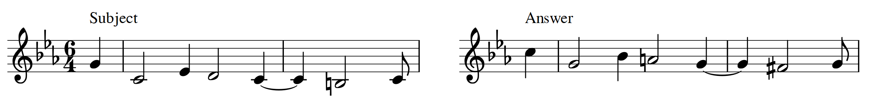

3. Chorale Partita in German Baroque style (theme to be selected by examiners one week before recital)
Just as the Catholic organists of France focused upon the Gregorian melodies of the Roman church, the German organists of the 17th and 18th centuries spent much time in harmonising and elaborating the Lutheran melodies of the Protestant church. Composing or improvising variations (known as Partitas) on these Chorale melodies appealed to organists throughout the Baroque era, and early models by composers such as Samuel Scheidt (1587-1654) and Heinrich Scheidemann (c.1596-1663) were considerably developed by later composers such as Pachelbel (1653-1706), Georg Böhm (1661-1733) and J.S. Bach (1685-1750). The genre of the Chorale Partita thus offers an opportunity for the improviser to fully exploit the available registrational resources of the organ and also to imaginatively recompose the theme in various different tempi, textures, voicings and styles. There are certain similarities amongst the models from the composers I have mentioned, which give a loose structural plan, as follows: (i) the theme appears in its original form, with a simple harmonisation; (ii) the variations proceed from simple settings (i.e., two voices) to more complex variations (added diminutions, contrapuntal devices, chromaticism etc.,); (iii) the final statement of the theme is in its original form but performed on full organ (organo pleno).

Owen, B. (1997). The registration of baroque organ music. Bloomington, IN: Indiana University Press.

