Appendix

Appendix One - Child’s weight chart developed in 1926 (Turmel, 2008).
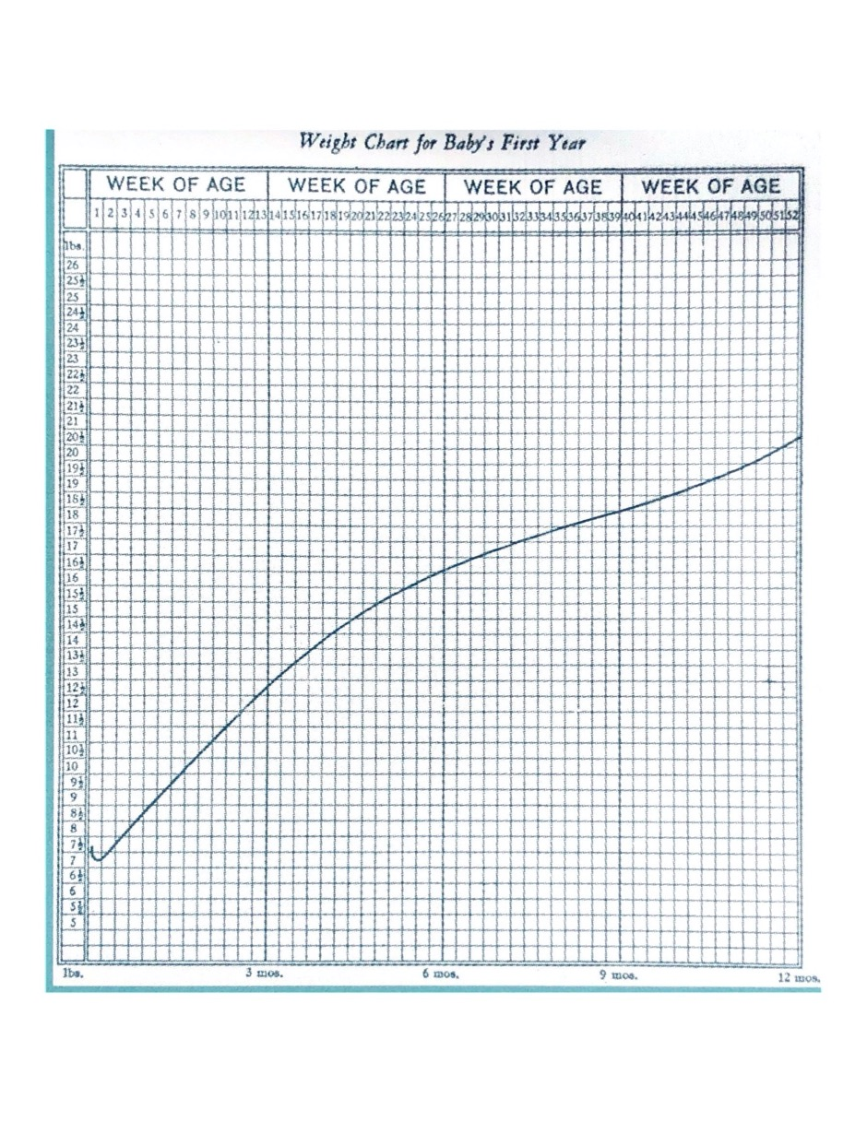

Appendix Two - The “normal” child (Gesell and Thompson, 1934).

Appendix Three - Looked after children who were adopted annotated to show significant events: England 1994 to 2019. (ONS, 2019).
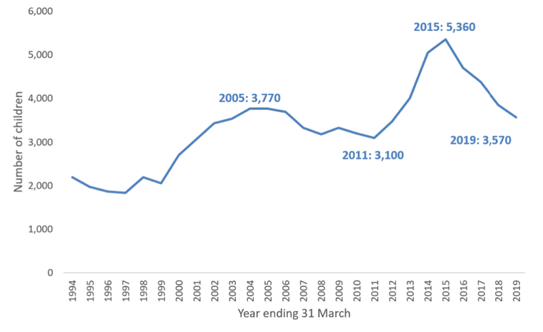
Adoption White Paper and adoption targets
Family Justice Review and adoption agenda
Lady Hale’s comments
Re: B-S

Appendix Four – Fieldwork drawing of ruling relations across Middleshire.

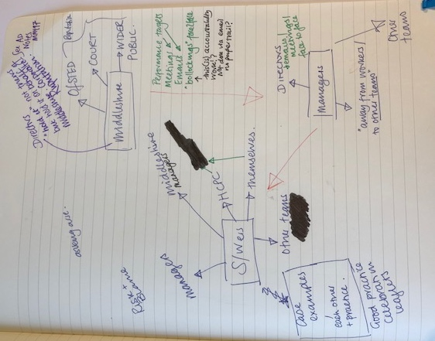

Appendix Five – Fieldwork drawing of parking ticket activity.

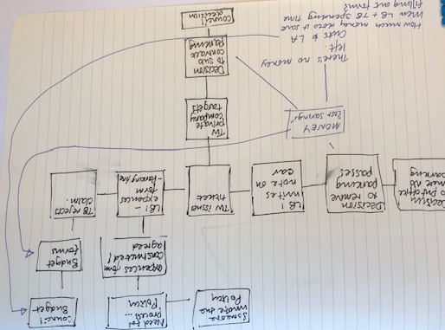

Appendix Six – Example of fieldnotes.

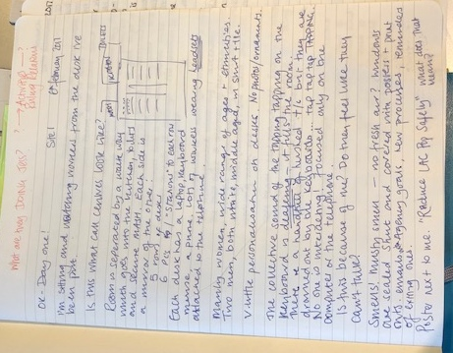

Appendix Seven – Fieldwork process drawings.

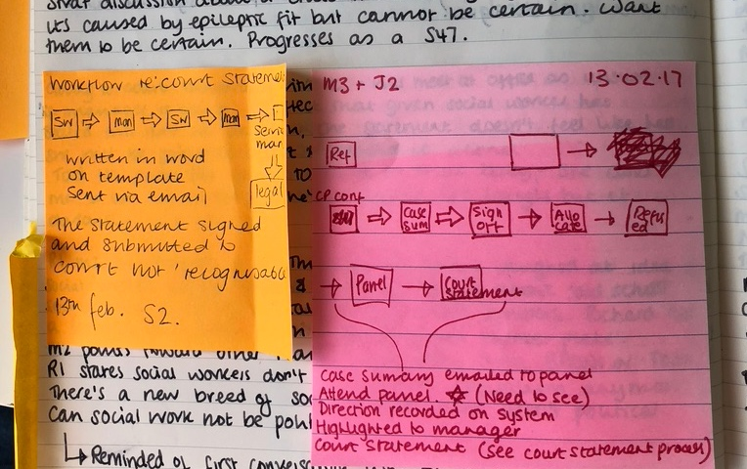

Appendix Eight – Middleshire computer home screen.

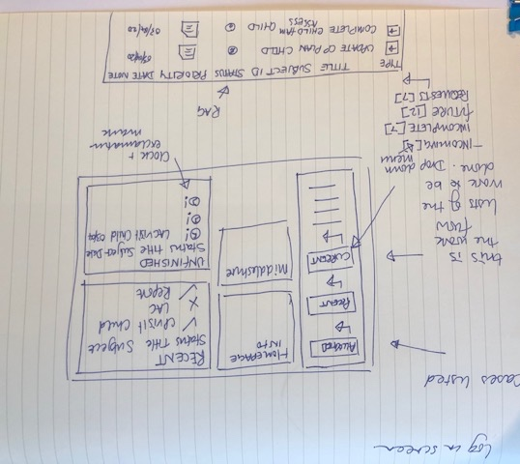

Appendix Nine – Direct work, children’s story book.

Appendix Ten – Disguised compliance poster.

Appendix Eleven – Photograph of performance ratings of teams.

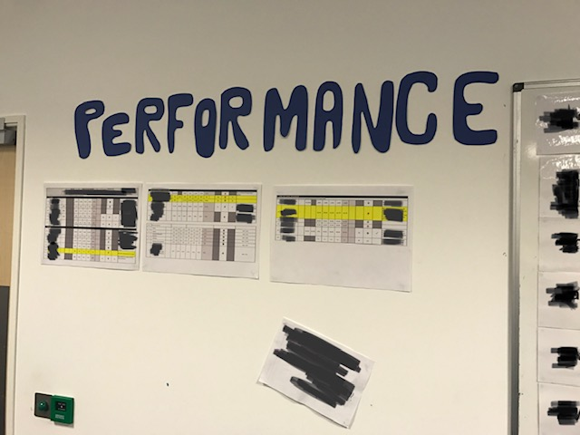

Appendix Twelve – Johnston case review, learning required.

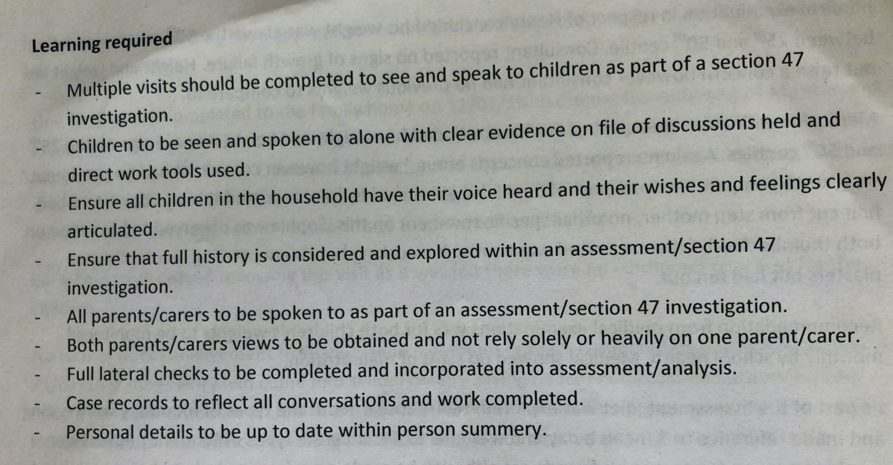

Appendix Thirteen - Record with care poster.

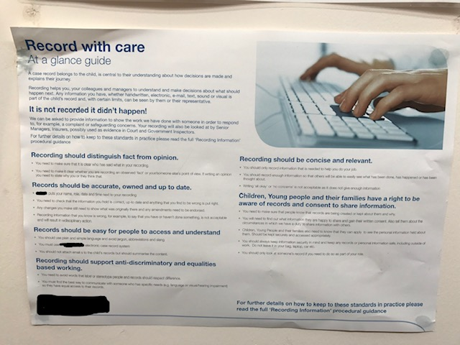

Appendix Fourteen – Ethical approval, participant information sheet, and consent form.

