The Clinical Utility of Bone Turnover Markers in Postmenopausal Women with Osteoporosis

Fatma Gossiel

Thesis submitted in partial fulfilment of the requirements for the degree of:

Doctor of Philosophy

Department of Human Metabolism
July 2017

Contents
Acknowledgements 5
Contributions 6
Publication and Presented abstracts 7
Thesis Overview 8
List of figures 9
List of tables 12
Abbreviations 14
Chapter one: Introduction to the thesis 17
Background 17
Postmenopausal osteoporosis 17
Normal bone physiology 18
Pathophysiology of postmenopausal osteoporosis 29
Secondary osteoporosis 32
Bone Turnover Markers 32
Treatments for Postmenopausal Osteoporosis 38
Clinical utility of bone turnover markers in postmenopausal osteoporosis 45
Clinical utility of sclerostin 47
Justifications of the research 49
Thesis aims 51
Chapter 2: Methods 53
Study participants and patients 53
Biochemical methods 53
Sample collection, handling and storage 53
Statistical analysis: Method comparison 54
Assays measuring bone turnover markers 54
ChemiLuminescence Immunoassays (CLIA) 54
Competitive immunoassay: NTX 67
Dry slide method: Creatinine 69
Enzyme immunoassay: Sclerostin 71
Reducing the variability associated with BTMs 76
Chapter 3: Normative data for biochemical markers of bone turnover 79
Introduction 79
Subjects and Methods 80
Subjects 80
Laboratory methods 81
Medical conditions and treatments 81
Statistical analyses 82
Results 82
Subject characteristics 82
Effects of diseases and treatments on bone turnover markers 83
Healthy reference intervals 84
Determinants of BTMs in healthy postmenopausal women 86
Discussions 88
Chapter 4: Clinical utility of bone balance and bone turnover in postmenopausal women 90
Introduction 90
Subjects and methods 91
Subjects 91
Laboratory methods 92
Statistical analyses 92
Results 94
Bone balance and bone turnover in postmenopausal and premenopausal women 94
Bone balance, bone turnover and total hip BMD assessment 95
Bone balance, bone turnover and fracture risk assessment 96
Discussions 97
Conclusions 98
Chapter 5: The effect of antiresorptive treatments on biochemical markers of bone turnover 100
Introduction 100
Study participants 101
Laboratory methods 102
Statistical analyses 103
Results 104
The response of bone turnover markers to antiresorptive treatments 104
Healthy premenopausal reference intervals 105
The response of bone turnover markers to antiresorptive treatments relative to healthy premenopausal women 106
Discussion 112
Conclusion 114
Chapter 6: The mechanisms of action of bisphosphonates on bone turnover and bone balance in postmenopausal women with osteoporosis 115
Introduction 115
Osteoclast precursor cells 115
Circulating cytokines 115
Bone turnover and bone balance 116
The role of sclerostin 117
Study participants 119
Laboratory methods 120
Preparation and staining of peripheral blood mononuclear cells (PBMCs) 120
Flow cytometry 121
Biochemistry methods 124
Statistical analysis 124
Results 125
The effect of bisphosphonates on osteoclast precursor cells and circulating cytokines 125
The effect of bisphosphonates on CTX and PINP 128
The effect of bisphosphonates on bone turnover and bone balance (the T-score bone marker method/plot) 128
The effect of bisphosphonates on levels of circulating sclerostin 138
Discussions 140
Conclusion 145
Chapter 7: mechanisms of action of raloxifene on bone turnover and bone balance in postmenopausal women with osteoporosis 146
Introduction 146
Study participants 148
Laboratory methods 148
Statistical analysis 148
Results 149
The effect of raloxifene on bone turnover and bone balance (the T-score bone marker plot/method) 149
The effect of raloxifene on levels of circulating sclerostin 155
Discussion 158
Conclusion 159
Chapter 8: Overall discussions and conclusions 160
Key findings 160
What is new? 160
Overall strengths of the thesis 165
Overall weaknesses of the thesis 166
Future work 167
REFERENCES 170
Appendices 198

Acknowledgements
Throughout my PhD I have had valuable support from several people who I would like to acknowledge.
Firstly, I wish to express my thanks and appreciation to my Supervisor, Professor Richard Eastell. Over the years, Professor Eastell has guided and encouraged me in a way that has helped me progress and grow in confidence as a research scientist. His enthusiasm and sea of knowledge in this area has been truly inspiring. I am grateful for the opportunity to be working with him and very proud to be his student. Thank you for all your time, patience, advice, guidance and teaching and for having me as your student.
My next thank you goes to all of my colleagues at the Academic Unit of Bone Metabolism. You have been a solid support and I have learnt a great deal from you over my PhD years. A special thank you to my second supervisor, Dr Kim Naylor who has given me some excellent advice and support and has been there for me through thick and thin. There have been several technicians who have worked with me in the lab, I am grateful for their help and companionship. Particularly to Alexandria Kilvington and Jane Goben who have been working in the lab so that I could write up my thesis.
As part of my PhD I published a paper and I wish to thank my co-authors for their contributions and support they gave me during this process.
Finally, thank you to;
- The sponsors of the two clinical trials: Warner Chilcott and Eli Lilly and Company
- The sponsors of the OPUS study: Eli Lilly, Sanofi-aventis, Procter & Gamble Pharmaceuticals, Hoffman-La Roche, Pfizer, and Novartis
- Immunodiagnostics Systems and TECOmedical Group for funding the iSYS-IDS bone turnover markers and sclerostin tests
- The Sheffield Musculoskeletal Biobank committee for allowing me to have access to the research samples.

Contributions
The study protocols were previously written by the principal investigator, Professor Richard Eastell. The clinical work was performed by the doctors and the nurses of the Academic Unit of Bone Metabolism, Sheffield, UK.
I performed the majority of the BTM and sclerostin measurements with the assistance from some technical staff.
I performed all of the preparation, staining and FACS analyses for quantifying the circulating osteoclast precursor cells. Mr Christopher Hoyle assisted in collating the data.
I performed much of the statistical analyses and interpretation. Statistical support and advice for the multiple linear regression analysis and the T-score bone marker method was obtained from Dr Richard Jacques, University of Sheffield School of Health
and Related Research

Publication and Presented abstracts

Published paper:
Gossiel F, Finigan J, Jacques R, Reid D, Felsenberg D, Roux C, Glueer C, Eastell R. Establishing reference intervals for bone turnover markers in healthy postmenopausal women in a nonfasting state, Bonekey Rep. 2014 Sep 3;3:573. (September 2014 Featured Article)
Oral communications:
Gossiel F, Hoyle C, McCloskey E.V, Walsh J.S, Peel N, Eastell R. The Effect of Bisphosphonate Treatment on Osteoclast Precursor Cells in Postmenopausal Osteoporosis: The TRIO study. European Calcified Tissue Society Meeting 2014; Prague, Czech Republic

Gossiel F, Finigan J, Jacques R, Reid D, Felsenberg D, Roux C, Glueer C, Eastell R. Bone Turnover and Bone Balance: Association with Fracture Risk in the OPUS Study. American Society for Bone and Mineral Research 2012 conference, Minneapolis, US

Gossiel F, Finigan J, Jacques R, Reid D, Felsenberg D, Roux C, Glueer C, Eastell R. Establishing Reference Intervals for Bone Turnover Markers in Healthy Postmenopausal Women. Osteoporosis and Bone Conference 2012; Manchester UK.
Gossiel F, Lane N.E, Eastell R. The Effect of Glucocorticoid Therapy on Regulators of Bone Formation in Postmenopausal Women Treated with Teriparatide or Alendronate. American Society for Bone and Mineral Research 2011; San Diego, US.
Gossiel F, Jacques R.M, McCloskey E.V, Peel N, Walsh J.S, Eastell R. Regulators of bone formation in postmenopausal osteoporosis: Effect of bisphosphonate treatment. American Society for Bone and Mineral Research 2010, Toronto, Canada.
Poster communications:
Gossiel F, Jacques R.M, Naylor K.E, McCloskey E.V, Peel N, Walsh J.S, Eastell R. The Effect of Bisphosphonate Treatment on Bone Turnover and Bone Balance in Postmenopausal Women with Osteoporosis: The TRIO Study. European Calcified Tissue Society Meeting 2015; Rotterdam, Holland.
Gossiel F, Jacques R.M, Naylor K.E, McCloskey E.V, Peel N, Walsh J.S, Eastell R. The Effect of Raloxifene on Sclerostin, Bone Turnover and Bone Balance in Postmenopausal Women with Osteopenia. American Society for Bone and Mineral Research 2014; Texas, US and The Mellanby Centre for Bone Research, Reasearch Day, University of Sheffield, Sheffield, UK
Gossiel F, Finigan J, Jacques R, Reid D, Felsenberg D, Roux C, Glueer C, Eastell R.
Reference Intervals for Bone Turnover Markers in Premenopausal and Postmenopausal Women: The OPUS Study. American Society for Bone and Mineral Research 2012 conference, Minneapolis, US

Gossiel F, Finigan J, Jacques R, Reid D, Felsenberg D, Roux C, Glueer C, Eastell R.
Relationship between Serum IGF-I and Fracture Types in Postmenopausal Women. Osteoporosis and Bone Conference 2012; Manchester UK.

Thesis Overview

Postmenopausal osteoporosis is characterised by increased bone turnover, a negative balance (where bone resorption exceeds bone formation), reduced BMD and increased fracture risk. Diagnosis is based on assessment of BMD measured by DXA. The development of specific and sensitive bone turnover markers such as PINP and CTX are widely used in clinical studies. The overall aim of this thesis was to investigate the clinical utility of BTMs in a population based study and in clinical trials of licenced antiresorptive treatments. Postmenopausal and premenopausal women were recruited and whole blood, serum and urine samples were collected.
Several diseases and treatments were identified that influenced bone turnover markers in older women and these needed to be excluded for establishing healthy reference intervals. In postmenopausal osteoporosis the negative balance between bone resorption and formation may be associated with the low BMD, bone loss and increased vertebral and non-vertebral fracture risk. Antiresorptive treatments inhibit bone resorption in the short-term by having direct action on mature osteoclasts. There was also a later effect mediated by a reduction in the population of circulating osteoclast precursors. With bisphosphonate treatments bone balance is positive relative to healthy premenopausal women. The clinical utility of sclerostin remains unclear but it does appear to be related to bone resorption and bone formation and levels of which are reduced with raloxifene treatment.
Bone turnover markers provide additional information to BMD assessments about bone remodelling. The combined assessment of bone turnover and bone balance may help identify patients at risk of bone loss and fracture. These findings can be used to investigate the mechanisms of actions of current and future treatments that are being developed in order to identify the most suitable for patients with postmenopausal osteoporosis.

List of figures

Figure 1: Normal and osteoporotic BMD at the total hip: DXA analysis 17
Figure 2: Human osteoclast cells on the eroded surface of a bone 19
Figure 3: The process of osteoclast differentiation and formation: 20
Figure 4: The mechanism of bone resorption by the osteoclast cells 21
Figure 5: Human osteoblast cells stacked on the osteoid of a bone biopsy 22
Figure 6: The process of osteoblast differentiation and formation 23
Figure 7: Human osteocytes embedded in the lacunae of a bone biopsy. 24
Figure 8: The process of osteocyte differentiation and formation. 24
Figure 9: The Wnt signalling pathway: Role in the regulation of bone formation. 27
Figure 10: The bone remodelling process in normal bone physiology 28
Figure 11: The local regulation of bone turnover in normal bone physiology and with antiresorptive treatment 29
Figure 12: The bone remodelling process in osteoporotic bone physiology 31
Figure 13: HR-pQCT images of a normal radius and tibia and an osteoporotic radius and an osteoporotic tibia 31
Figure 14: The formation of type I collagen 34
Figure 15: The synthesis of bone resorption markers from type I collagen 35
Figure 16: Timeline showing the development of licenced osteoporosis treatments in the United Kingdom 39
Figure 17: the general molecular structure of bisphosphonates 40
Figure 18: The binding of SERMs to ERα and ERβ and gene transcription. 43
Figure 19: An overview of chemiluminescence methodology 54
Figure 20: IDS-iSYS PINP calibration curve 55
Figure 21: The long term stability of PINP. 56
Figure 22: PINP method comparison analyses 57
Figure 23: IDS-iSYS CTX-1 calibration curve 58
Figure 24 : The long term stability of CTX 60
Figure 25: CTX method comparison analyses 60
Figure 26: IDS-iSYS N-Mid® osteocalcin calibration curve 62
Figure 27: The long term storage at on osteocalcin 63
Figure 28: Osteocalcin method comparison analyses 64
Figure 29: IDS-Isys Ostase® BAP calibration curve 65
Figure 30: The long term stability of bone ALP 66
Figure 31: Bone ALP method comparison analyses 67
Figure 32: The long term stability of NTX 69
Figure 33: The long term stability of creatinine 71
Figure 34: An overview of the direct-capture ELISA 72
Figure 35: An example of a 96-well plate ELISA set up 72
Figure 36: An example of a 4-parametre logistic standard curve 73
Figure 37: Sclerostin method comparision analyses) 76
Figure 38: Healthy reference intervals for older and younger women for bone turnover markers 85
Figure 39: the effect of age on bone turnover markers. 87
Figure 40: The clinical features of postmenopausal osteoporosis. 90
Figure 41: An illustration of the T-score bone marker plot 94
Figure 42: T-score bone marker plots for postmenopausal and premenopausal women 95
Figure 43: The effects of ibandronate, alendronate and risedronate on CTX in postmenopausal women with osteoporosis. 107
Figure 44: The effects of ibandronate, alendronate and risedronate on NTX/Cr in postmenopausal women with osteoporosis. 108
Figure 45: The effects of ibandronate, alendronate and risedronate treatment on PINP in postmenopausal women with osteoporosis. 108
Figure 46: The effects of ibandronate, alendronate and risedronate on bone ALP in postmenopausal women with osteoporosis. 109
Figure 47: The effects of ibandronate, alendronate and risedronate on osteocalcin in postmenopausal women with osteoporosis 109
Figure 48: The effects of raloxifene treatment on bone turnover markers in postmenopausal women with osteopenia 110
Figure 49: Bisphosphonates and osteoclast precursor cells. 116
Figure 50: Sclerostin inhibits bone formation via the Wnt signalling pathway 117
Figure 51: A possible mechanism of the action of nitrogen containing bisphosphonates on bone formation 118
Figure 52: PBMCs identified using flow cytometry and histograms 122
Figure 53: Dot plots: unstained, antibody and isotype control stained PBMCs 123
Figure 54: The affects of bisphosphonates on osteoclast precursor cells. 126
Figure 55: The affects of Ibandronate, alendronate and risedronate on osteoclast precursor cells. 127
Figure 56: The affects of bisphosphonates on RANKL and OPG. 128
Figure 57: The affects of ibandronate, alendronate and risedronate on PINP and CTX 128
Figure 58: The T-scores calculated for PINP and CTX in postmenopausal women treated with bisphosphonates 129
Figure 59: Bone turnover and bone balance in postmenopausal women receiving bisphosphonate treatme 130
Figure 60: T-score bone marker plots for postmenopausal women receiving bisphosphonate treatment 132
Figure 61: The mean T-scores calculated for PINP and CTX for postmenopausal women receiving ibandronate, alendronate and risedronate 134
Figure 62: Bone turnover in postmenopausal women receiving ibandronate alendronate and risedronate 134
Figure 63: Bone balance in postmenopausal women receiving ibandronate, alendronate and risedronate. 136
Figure 64: The T-score bone marker plots for postmenopausal women receiving Ibandronate, alendronate and risedronate 138
Figure 65: Levels of circulating sclerostin in postmenopausal women with osteoporosis compared to healthy premenopausal women 139
Figure 66: The effects of ibandronate, alendronate and risedronate on levels of circulating sclersotin. 140
Figure 67: The correlation between serum sclerostin with PINP and CTX in women with postmenopausal osteoporosis. 140
Figure 68: DXA of total BMD in postmenopausal women receiving Ibandronate, alendronate and risedronate and premenopausal women.. 143
Figure 69: The mechanism of action of estrogen and the possible mechanism of action of raloxifene on osteocytes.. 147
Figure 70: The effect of raloxifene treatment on levels of CTX in postmenopausal women with osteopenia.. 150
Figure 71: The effect of raloxifene treatment on levels of PINP in postmenopausal women with osteopenia 151
Figure 72: Bone turnover and bone balance in postmenopausal women with osteopenia receiving raloxifene treatment 153
Figure 73: The T-score bone marker plots for postmenopausal women receiving raloxifene 154
Figure 74: Levels of circulating sclerostin in postmenopausal women with osteopenia compared with healthy premenopausal women 155
Figure 75: The affect of raloxifene on circulating levels of sclerostin 156
Figure 76: The mean T-scores calculated for sclerostin in postmenopausal women treated with raloxifene 157
Figure 77: The correlation between serum sclerostin with PINP and CTX in women with postmenopausal osteopenia. 157
Figure 78: The correlation between the change in sclerostin levels and bone balance and bone turnover 158
Figure 79: Postmenopausal reference intervals compared to previous studies 161
Figure 80: Premenopausal reference intervals compared to previous studies. 162
Figure 81: The T-score bone marker plot showing for ibandronate, alendronate and risedronate 163

List of tables
Table 1: Antiresorptives: Name, structures and current clinical findings 45
Table 2: The precision data of the IDS-iSYS PINP 56
Table 3: The precision data of the IDS-iSYS CTX-1 59
Table 4: The precision data of the IDS-iSYS N-Mid osteocalcin 62
Table 5: The precision data of the IDS-iSYS Ostase® BAP 65
Table 6: The precision data of the OCD Vitros NTX 68
Table 7: The precision data of the OCD Vitros creatinine 70
Table 8: Sclerostin standard curve data 72
Table 9: Sclerostin study data. 73
Table 10: The precision data for sclerostin 75
Table 11: Controlling sources of variability on BTMs 77
Table 12: Baseline characteristics of the older and younger women in the OPUS study 83
Table 13: The effects of diseases and treatments on BTMs older women. 84
Table 14: Reference intervals for BTMs for healthy postmenopausal women. 84
Table 15: Reference intervals for BTMs for healthy premenopausal women 85
Table 16: Factors that influence BTMs in healthy postmenopausal women. 87
Table 17: The effect of geographical location on BTMs in healthy postmenopausal women 87
Table 18: The relationship between bone balance, bone turnover and BTMs with BMD at the total hip in postmenopausal women. 96
Table 19: The relationship between each; bone balance, bone turnover and levels of PINP and CTX at baseline with the change in BMD at the total hip in postmenopausal women. 96
Table 20: The relationship between bone balance and bone turnover and the relative risk of vertebral and non-vertebral fracture in postmenopausal women 96
Table 21: The baseline characteristics of the postmenopausal women with osteoporosis and osteopenia 104
Table 22: Geometric mean and intervals for BTMs for healthy premenopausal women. 106
Table 23:The change in BTMs throughout the treatment periods in postmenopausal women receiving antiresorptive treatments. 111
Table 24: The change in osteoclast precursor cell population with bisphosphonate treatement. 127
Table 25: The mean bone balance and bone turnover in postmenopausal women receiving bisphosphonate treatment 131
Table 26: The mean change in bone balance and bone turnover in postmenopausal women receiving bisphosphonate treatment 131
Table 27: The mean bone balance and bone turnover in postmenopausal women receiving ibandronate, alendronate and risedronate 136
Table 28: The mean change in bone balance and bone turnover in postmenopausal women receiving ibandronate, alendronate and risedronatet. 137
Table 29: The levels circulating serum sclerostin in postmenopausal women receiving either ibandronate, alendronate or risedronate 139
Table 30: The effect of raloxifene on CTX is postmenopausal women compared to no treatment 150
Table 31: The effect of raloxifene on CTX is postmenopausal women compared to no treatment 151
Table 32: The mean bone balance and bone turnover in postmenopausal women receiving raloxifene. 153
Table 33: The mean change in bone balance and bone turnover in postmenopausal women receiving ibandronate, alendronate and risedronatet.. 154
Table 34: The effect of raloxifene on circulating sclerostin is postmenopausal women compared to no treatment 155
Table 35: The key findings from the TRIO and Raloxifene clinical trials described in the thesis 165

Abbreviations
Bone ALP  BCE | Bone alkaline phosphatase  Bone collagen equivalent
BMD | Bone mineral density
BMI | Body mass index
BMP | Bone morphogenetic protein
BRU | Bone remodelling unit
BTM | Bone turnover marker
CI  CKD | Confidence interval  Chronic kidney disease
CLIA | Chemiluminescent immunoassay
CTX  CV  DPD | Carboxy-terminal cross-linking telopeptides of type I collagen  Coefficient of variation  Deoxypyridinoline
DXA | Dual energy x-ray absorptiometry
E2 | Estradiol
ECLIA | Electrochemiluminescent immunoassay
eGFR  ELISA  EPIDOS  ERKs  EVOS | Estimated glomerular filtration rate  Enzyme linked immunoassay  Epidemiologie de l’Osteoporose study  Extracellular signal-regulated kinases  European vertebral osteoporosis study
FGF23  FIT  FLEX | Fibroblast growth factor 23  Fracture Intervention Trial  Fracture Long Term Extension
FN  FPP  FPPS | Femoral neck  Farnesyl pyrophosphate  Farnesyl pyrophosphate synthase
FRAX  GGPP  GSK3β  HORIZON PFT | WHO Fracture Risk Assessment Tool  Geranylgeranyl pyrophosphate  Glycogen synthase kinase 3 beta  Health Outcomes and Reduced Incidence with Zoledronic acid ONce yearly Pivotal Fracture Trial
HRP | Horseradish peroxidase
HRT  IDS | Hormone replacement therapy  Immunodiagnostics Systems
IGF-1 | Insulin-like growth factor-1
IL-  IOF  IFCC  KDIGO | Interleukin-  International Osteoporosis Foundation (IOF)  International Federation of Clinical Chemistry and Laboratory Medicine  Kidney disease improving global outcome
LDL | Low density lipoprotein cholesterol
LS  M-CSF  MDRD  MESD  Mi-RNA  MMP  MOBILE  MORE  MOTION | Lumbar spine  Macrophage colony-stimulating factor  Modification of diet and renal disease  Mesoderm development  Micro-ribonucleic acid  Matrix-metalloprotease  Monthly Oral iBandronate In LadiEs  Multiple outcomes of raloxifene evaluation  Monthly oral therapy with ibandronate for osteoporosis intervention
MSC  MTHFR  NTX | Mesenchymal stem cell  Methylenetetrahydrofolate reductase  N-terminal crosslinking telopeptides of type I collagen
OA | Osteoarthritis
OC | Osteocalcin
OCP  OCD  OFLEY  OPG  OPUS | Osteoclast precursors  Ortho Clinical Diagnostics  Os des Femmes de Lyon  Osteoprotegerin  Osteoporosis and Ultrasound
PINP | Procollagen I N-terminal peptide
pQCT | Peripheral quantitative computed tomography
PTH  iPTH  PYD | Parathyroid hormone  Intact parathyroid hormone  pyridinoline
QC | Quality control
QCT | Quantitative computed tomography
RANK | Receptor activator of nuclear factor κB
RANKL  RLU  SERM  SFRP | Receptor activator of nuclear factor κB ligand  Relative light units  Selective estrogen receptor modulator  Secreted frizzled related protein
SHBG  SNP  TGF | Sex hormone binding globulin  Single nucleotide polymorphisms  Transforming growth factor
TNF  TRACP | Tumor necrosis factor  Tartrate resistant acid phosphatase
TSH | Thyroid stimulating hormone
uOC  VDR  VERT-MN | Undercarboxylated osteocalcin  Vitamin D receptor  Vertebral Efficacy with Risedronate Therapy Multinational
WHO | World Health organisation

Chapter one: Introduction to the thesis

Background

Postmenopausal osteoporosis
Osteoporosis is a progressive, age-related skeletal disease caused by the accumulation of micro-architectural damage to the bone (1). It is characterised by reduced bone mineral density (BMD), increased bone remodelling and increased bone loss leading to increased fracture risk. It is a highly prevalent disease (2). In the United Kingdom it affects about 3 million people with 53% of women over the age of 50 years being at risk from an osteoporotic fracture (3, 4). In particular it is the vertebral and hip fractures that are associated with an increase in morbidity (pain, fatigue, height loss, loss of function, disability and physical impairment (5, 6) and mortality rates and a reduced quality of life (7). There is also a financial burden imposed on the health care systems worldwide. In recent years osteoporotic fractures at the wrist, spine and hip cost the National Health Service £1.7 billion per year to treat and manage (8).
The World Health Organisation (WHO) have established some guidelines for the clinical diagnosis of postmenopausal osteoporosis relative to younger healthy premenopausal women: i) normal is a BMD T-score of +2.5 to -1, ii) osteopenia is a BMD T-score between -1 and -2.5 iii) osteoporosis is a BMD T-score of ≤ -2.5 iv) the presence of a fragility fracture independent of a BMD T-score (9), (Figure 1).

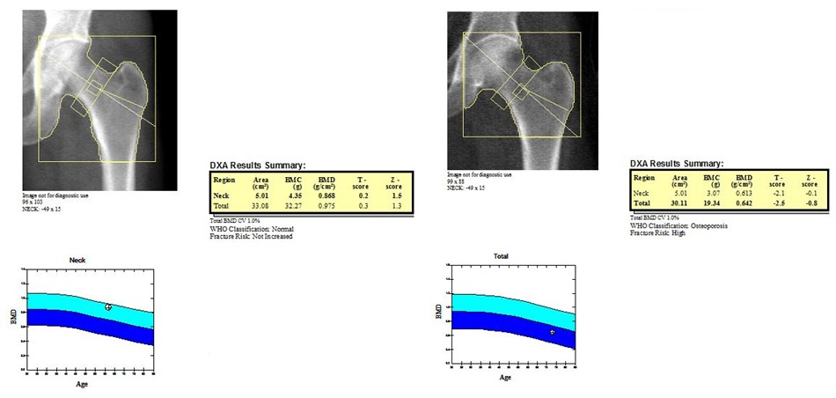
Figure 1: Dual energy x-ray absorptiometry (DXA) results for: (left) normal BMD at the total hip and b) (right) osteoporotic BMD at the total hip. Images obtained from the Metabolic Bone Centre, Sheffield, UK.

In order to understand the pathophysiology of postmenopausal osteoporosis and investigate the effects of its treatments on bone, it is important to understand normal bone physiology, cellular activity and bone remodelling

Normal bone physiology
The average adult human skeleton is comprised of about 206 bones and it has a variety of vital roles to the body. It i) provides structural support ii) allows movement iii) protects organs and structures iv) maintains mineral homeostasis v) produces and stores blood cells, cytokines, hormones and growth factors and vi) creates a hematopoietic stem cell niche within the bone marrow (10, 11). The total skeleton is composed from the appendicular (limbs, pelvic and pectoral girdles) and the axial (skull, spinal column, sacrum, ribs and sternum) sub-skeletons. It is highly metabolically active and continually undergoes dynamic modelling and remodelling processes in order to adapt to biomechanical forces and to remove old micro-damaged bone and replace it with new bone to restore strength (12)
Bone is composed of an organic fibrous collagen matrix and an inorganic alkaline mineral matrix (13). The organic collagen matrix consists of large structural proteins and smaller non-structural proteins (14). Type I collagen is the structural component and it makes up 90% of the total protein in bone. The remaining 10% are the smaller non-collagenous, non-structural proteins. These are classified in to groups, namely: i) proteoglycans ii) glycosylated proteins and iii) γ-carboxylated (gla) proteins. They control the metabolic activity of the bone cells and regulate the mineralisation process (15).
The inorganic mineral matrix is made up from mainly calcium and phosphorus deposited as tricalcium phosphate salts, ((Ca₃(PO₄)₂) which is hydroxylised to hydroxyapatite, (Ca₁₀(PO₄)₆(OH)₂) crystals as the bone mineralises (16, 17) . The hydroxyapatite mineral surrounds the collagen fibre composite and provides strength and resistance and is a source of calcium, phosphorus and magnesium ions that are required for homeostasis
There are other important components in bone including; matrix enzymes (18, 19), water which helps to maintain the structure of type I collagen and controls ion intake, growth factors and lipids (20).
The skeleton is made up from two structural bone types; 80% cortical and 20% trabecular (21). Cortical bone originates from central lamellae of bone tissue called Haversian systems. These surround the central blood vessels and form a branched network within the bone. The formed bone is dense with a low surface area and surrounds the marrow cavity. Normal cortical bone porosity is about less than 5% but during ageing there is increased metabolic activity causing increased porosity and thinning. In contrast, trabecular bone is spongy, less dense and has a higher surface area. It is a network of trabeculae separated by bone marrow filled spaces and occupies the centre of long bones, flat bones and the vertebra (21).
The distribution of cortical to trabecular bone varies at different skeletal sites. For example, the vertebra is 25:75 and the femoral head is 50:50 cortical to trabecular bone (10). Clinically, these differences are relevant because bone remodelling occurs more rapidly in trabecular bone. Therefore in disease states such as osteoporosis there is increased bone loss and fracture risk at sites where there is more trabecular bone.

Osteoclasts and bone resorption
Osteoclasts are multinuclear tissue specific specialised polykaryon cells, making up 1-2% of all bone cells (22). They are responsible for the resorption of mineralised bone, (Figure 2). They originate from the myeloid progenitor cell population which is common to the monocyte/macrophage lineages, (Figure 3). Once the hematopoietic stem cells in the bone marrow commit to the myeloid lineage, the progenitors proliferate and differentiate into the osteoclast precursor lineage and other cell lineages (23). Human studies have shown that osteoclast precursor cells are present in the CD14+ monocyte cell population (24, 25). Osteoclast precursor cells enter the circulation as quiescent cells and migrate to the site of bone resorption where they differentiate in to mature, active and multinucleated osteoclasts (26, 27).
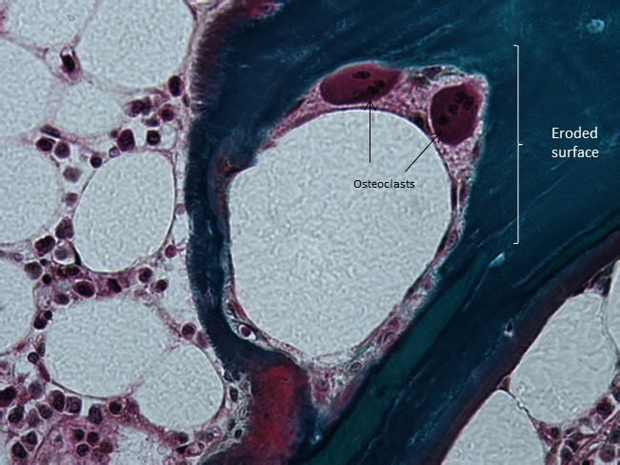
Figure 2: Human multinucleated mature osteoclasts on the eroded surface of a bone pore. Goldner’s trichrome, 40x magnification. Image obtained from the Bone Analysis Laboratory, University of Sheffield, UK
The formation of active resorbing osteoclasts involves a series of processes: i) the proliferation of osteoclast progenitors; ii) the differentiation of progenitors in to osteoclast precursor cells and iii) the fusion osteoclast precursor cells into multinucleated mature osteoclasts (28), (Figure 3). Several cytokines, steroids, hormones and prostaglandins are involved in regulating the differentiation, proliferation, activation and survival of osteoclasts (22, 29). These include macrophage colony-stimulating factor (M-CSF), receptor activator of nuclear factor-ƙB ligand (RANKL), tumour necrosis factor-α (TNF-α) (30-33). Osteoclast precursor cells express cell surface receptors which are specific for these. In-vitro studies have demonstrated that M-CSF binds to the M-CSF (c-fms) receptor and induces the expression of genes in the osteoclast lineage leading to the differentiation and development of mature osteoclasts (20-22) and cell survival (23). TNF-α is an inflammatory cytokine that binds to the TNF receptors-1 and -2, stimulates osteoclastogenesis and regulates cell apoptosis (24). In addition osteoclast precursor cells express β2 integrins such as CD11b/Cd18 (also known as αMβ2, CR3 or Mac 1). These adhesion molecules are necessary for cell trafficking and differentiation. This functional role has previously been demonstrated in CD11b-deficient mice where there was a decrease in bone mass and increase in osteoclast number (25, 26).
There are also several micro-RNAs (miRNAs) that are involved in osteoclast and osteoblast proliferation and differentiation (34-39). These are short, non-coding regions that regulate gene expression by destabilising mRNAs or inhibiting translation (40). Micro-array techniques have previously shown that miR-146a reduced (41) and miR-148a increased osteoclast precursor cells in circulating human monocytes (42). These potentially may be used as biomarkers for assessing postmenopausal osteoporosis and fracture risk (43-46).
Osteoclast precursor cells migrate in the peripheral blood to the micro-damaged skeletal site that is to be resorbed (22). This attraction is triggered by chemotactic factors released from this site.
Figure 3: The process of osteoclast differentiation and formation:
At the site of resorption the osteoclast attaches to the bone matrix forming a tight seal and a compartment directly beneath it. The seal is formed through interactions with the integrin receptor αvβ3 which subsequently binds to arginine, glycine and asparagine-containing matrix proteins (such osteopontin and bone sialoprotein) (47). Like other α/β integrins, αvβ3 is a heterodimer with a long extracellular and a single transmembrane domain. In normal physiological conditions its distribution is in the osteoclasts and placenta (47). Its importance in mediating the adhesion of the osteoclast to the cell membrane and thus initiating the signals necessary for the resorption process has been described in mouse models (48, 49). The osteoclast then secretes hydrogen ions via the H⁺-ATPase pump and chloride ions via the chloride bicarobonate channel, (Figure 4). The generated hydrochloric acid and proteases such as cathepsin K, matrix metalloproteases (MMPs) -9 and 13, gelatinase and tartrate resistant acid phosphatase are transported in vesicles down microtubules to the plasma membrane adjacent to the bone surface. These fuse with the plasma membrane causing the osteoclast to become polarised and forms a ruffled border, (Figure 4). An additional sealing zone is created by the formation of an actin ring to ensure that the acidified resorption compartment is isolated and adjacent sites are protected (50). The secretion of H⁺ and cathepsin K by exocytosis creates a highly acidic environment, pH 4.5 (51). Once secreted the acid dissolves the hydroxyapatite on the bone surface, the proteolytic enzymes degrades the bone matrix and cathepsin K degrades type I collagen (22, 52)
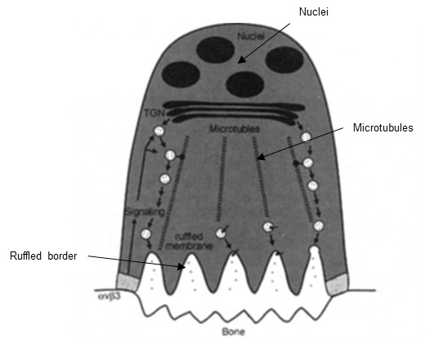
Figure 4: The mechanism of bone resorption by the osteoclasts (52). Formation of the sealing zone via integrin αvβ3 and the creation of an acidic environment (left). Vesicles containing MMPs and cathepsin K fuse with the plasma membrane, leading to the formation of the ruffled border and a polarised, mature resorbing cell (right). Copyright (2015) with permission from John Wiley and Sons

Regulators of bone resorption
The formation and activation of the osteoclast and the process of bone resorption is regulated by RANKL, osteoprotegerin (OPG), interleukin-1 (IL-1), IL-6, PTH, 1, 25 hydroxyvitamin D and calcitonin (53). RANKL and OPG are cytokines from the TNF superfamily (54). OPG is a secreted glycoprotein that is produced by the osteoblasts and stromal cells. It acts as a decoy receptor by binding RANK and preventing RANKL binding and thus inhibiting osteoclast proliferation, differentiation and preventing bone resorption (55). Thus, the ratio of RANKL and OPG in the bone marrow regulates the amount of bone resorbed and has a main role in determining bone mass and strength (56-58). The RANKL/OPG system has led to the development of therapies aimed to reduce bone resorption in disease states such as postmenopausal osteoporosis (59), for example Denosumab (60).

Osteoblasts and bone formation
Osteoblasts are specialised mononuclear cells derived from mesenchymal progenitors in the bone marrow stroma, making up 4-6% of all bone cells, (Figure 5). They are responsible for the formation and deposition of newly mineralised bone collagen matrix (61). They originate from the osteochondrial progenitor cell lineage, which is common to the osteoblasts and chondrocytes, (Figure 6). These cell lineages are determined and regulated by several cytokines and transcription factors that mediate signalling pathways required for cell proliferation, maturation and survival. The ones that are responsible for osteoblast differentiation include as runx2 (core-binding factor α subunit Cbfa1), bone morphogenetic proteins (BMPs), Hedgehogs, transforming growth factor β (TGF-β), Wnts and parathyroid hormone (PTH) (62). Once the progenitor commits to the osteoblast lineage, it expresses runx2 and collagen type I. It proliferates in to osteoblast precursor cells and becomes a larger cuboidal cell with a high activity of alkaline phosphatase. The Sox transcription factors regulate chondrocyte differentiation and cartilage formation (63, 64).
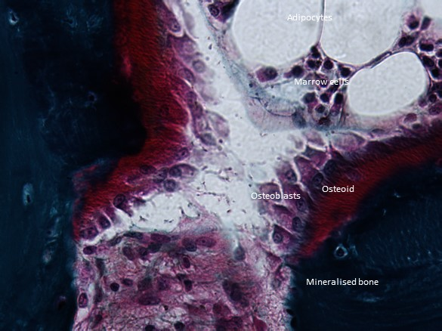
Figure 5: Cuboidal shaped osteoblasts stacked on the red osteoid unmineralised human bone. Goldner’s trichrome, 40x magnification. Image obtained from the Bone Analysis Laboratory, University of Sheffield,
During the later stages of osteoblast formation runx2 binds to the promoter of several osteoblast-specific genes and is the main switch for the differentiation of osteoblast precursor into mature osteoblasts. The genes that are expressed include osteocalcin, alkaline phosphatase, type I collagen, osteopontin, osteonectin and proteoglycans (such as decorin and biglycan). This process either positively or negatively promotes the osteoblast-like phenotype (65, 66). The absence of mineralised bone in runx2 deficient mice has previously been demonstrated (67).
The BMP and TGF-β signalling pathways involve the binding of BMPs to type-1 and type-2 serine/threonine receptor kinases and other specific receptors. The complexes which are formed interact with other transcription factors such as runx2 and stimulate gene transcription (68). These interactions mediate the development and maintenance of bone homeostasis, cartilage and bone metabolism and overall skeletal development (69-71).
Once the resorption process is complete the osteoclast undergoes apoptosis and mature osteoblasts migrate to the site that has been resorbed and lays down un-calcified bone matrix, namely the osteoid (72, 73). Alkaline phosphate then degrades pyrophosphate and proteoglycans (74). The osteoid calcifies and the bone is mineralised approximately 10 days later. The osteoblast then has 3 possible fates: i) 50 to 70% of them undergo apoptosis or ii) it becomes a bone-lining cell or iii) it embeds in to the bone matrix and becomes an osteocyte (73), (Figure 8).

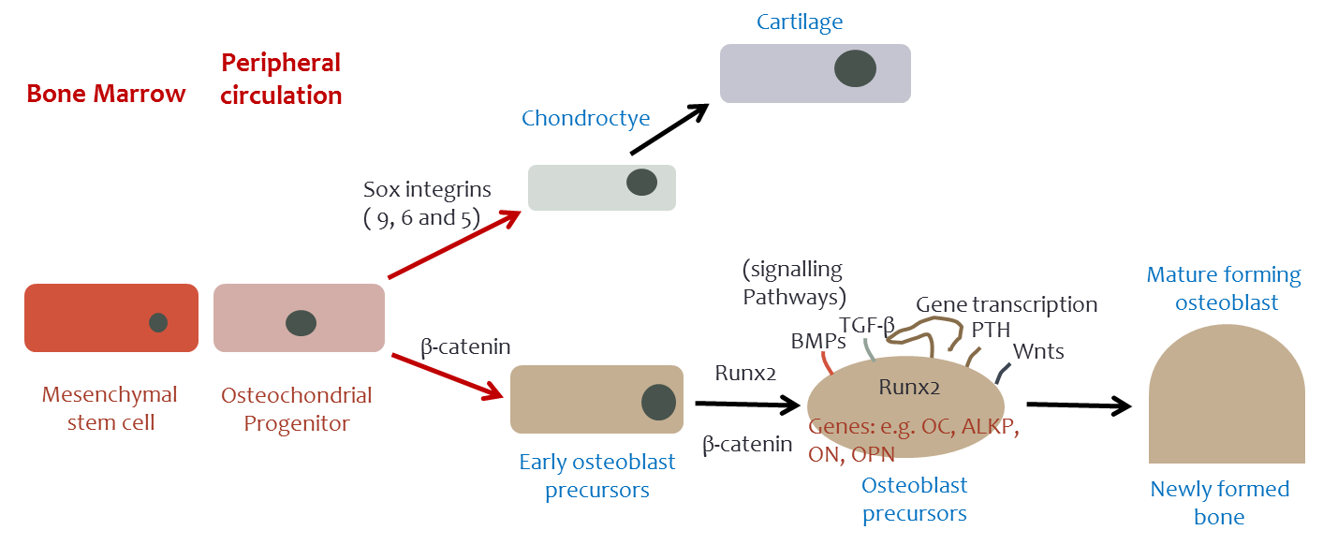
Newly synthesised bone

Figure 6: The process of osteoblast differentiation and formation

Osteocytes
Osteocytes are terminally differentiated osteoblasts, originating from the mesenchymal stem cell lineage (75, 76), (Figure 7). They make up 90 to 95% of all bone cells and have a life span of up to 25 years. It has been previously demonstrated that it takes three days for an osteoblast to become an osteocyte (77). Once the osteoblast differentiates in to a preosteocyte then a mature osteocyte the expression of osteoblast markers (osteocalcin, type I collagen, alkaline phosphatase etc.) is switched off and osteocyte markers such as sclerostin, dentine matrix protein 1 (DMP1) are highly expressed (78, 79), (Figure 8).
Osteocytes are deeply embedded in the mineralised bone matrix and possess up to 50 long, branched dendrites (80). This dendritic network extends throughout the bone matrix and connects the osteocytes with other cells in the osteoid nearer to the bone surface and the lining cells (81, 82). This forms gap junctions and allows cell-cell communication via an interstitial fluid that flows inside the interconnecting canaliculi each of which is 250-300nm in length and the osteocyte cell body itself is 15-20nm diameter (83).
Figure 7: Osteocytes embedded in the lacunae from a human bone biopsy. Goldner’s trichrome, 40x magnification. Image obtained from the Bone Analysis Laboratory, University of Sheffield, UK.
Increased osteoblast activity and bone formation
Preosteocyte
i) Cell apoptosis
Bone marrow
Osteoid
ii) Osteocyte lineage
Mineralised bone

Bone matrix

CV
Mature osteoblast
CV
Peripheral circulation
iii) Bone lining cell
CV
Osteocalcin, ALKP, type I collagen, osteopontin, osteonectin
Sclerostin, DMP1, FGF-23, RANKL
X

Mechanical loading

CV
CV
Mature osteocyte

Figure 8: The process of osteocyte differentiation and formation.

Osteocytes are able to sense mechanical loading, from the stress created by the extra cellular fluid flowing along the lacuna-canalicular network. This stimulus is applied to the skeleton and translated into biochemical signals (84). The primary cilia of the osteocyte act as mechanosensors and detect the stimulus. The response of the osteocytes to skeletal loading remains unclear but has been previously studied. Possible responses include the expression of mechanosensitive transcripts and the secretion of nitric oxide (85-87). More importantly in regulating bone formation, sclerostin secreted by the osteocytes is inhibited by mechanical loading leading to increased Wnt signalling, osteoblast activity and bone formation. In contrast, as a result of mechanical unloading higher sclerostin levels are secreted, inhibiting Wnt signalling, osteoblast activity and bone formation, (Figure 8) (88-90).
Osteocytes express and secrete other molecules that regulate the activity of osteoclasts and osteoblasts by paracrine or autocrine mechanisms, and hormones that affect other tissues by endocrine mechanisms (91). Osteocytes isolated from mice models have shown that they express high levels of RANKL, OPG, interleukin-1 and 6 (IL-1 and IL-6) and TNFα, required for osteoclast differentiation and activity (92, 93). In addition, there has also been some evidence that osteocytes are another source of M-CSF in bone and mice deficient in the CSF-1 gene expressed an osteopetrotic phenotype (94) . Osteocytes also secrete fibroblast growth factor 23 (FGF23), a hormone that regulates phosphate metabolism and bone mineralisation (95, 96). In vitro, FGF23 binds to the FGFR1/KLOTHO receptors and activates intracellular signalling in the osteocytes. High levels of circulating FGF23 (such as in renal impairment) have been shown to inhibit osteoblast differentiation and causing impaired mineralisation which can lead to rickets and osteomalacia (97, 98).
In skeletal disorders such as postmenopausal osteoporosis, increased osteocyte apoptosis occurs causing increased bone resorption and fragility (99). This may be related to the inability of the osteocyte to sense mechanical stimulus and micro-damage and initiating the repair processes required. Low oxygen levels (as in immobilisation), low estrogen levels (as in postmenopausal osteoporosis) and glucocorticoid treatments are all related to osteocyte apoptosis (90, 100, 101). By increasing oxygen levels (by improved mobilisation i.e. applying physical loading) and replacing estrogen levels it may be possible to alter the survival of the osteocyte.

Regulators of bone formation
There are several signalling pathways responsible for the regulation of bone formation. One of the most studied is the Wnt pathway and it regulates osteoblast differentiation from the osteochondrial progenitor through the osteoblast lineage. Wnts are a family of about 19 glycoproteins that secrete their signals via 7-transmembrane frizzled receptors and co-receptors low density lipoprotein receptor-related protein (LRP-5 and LRP-6) to the β-catenin canonical pathway (102-106). Wnt proteins such as Wnt3a, Wnt10b and Wnt5a bind to the frizzled and to LRP5/6 receptors. A signal is turned on to inhibit the activity of glycogen synthase kinase 3 beta (GSK3β) preventing the phosphorylation of β-catenin. This means that β-catenin remains active and stable (102). There are increased levels of β-catenin in the cytoplasm causing it to translocate to the nucleus. In the nucleus β-catenin binds to the DNA binding proteins leading to the transcription of Wnt regulated genes, stimulating the activity of alkaline phosphatase and bone formation can occur.
The importance of this signalling pathway in regulating normal bone formation and homeostasis has previously been demonstrated. Loss and gain of function mutations in the LRP-5 gene has been linked to skeletal disorders characterised by low bone mass/decreased bone formation or high bone mass/increased bone formation, respectively (107, 108). Also Wnt10b and β-catenin deficient mice had increased bone loss and over expression of Wnt10b promoted osteoblast activity (93, 109).
There are several extracellular and intracellular proteins that can interfere with and inhibit the Wnt signalling pathway. These include secreted frizzled related proteins (SFRPs), dikkopf-related protein 1 (DKK1), sclerostin, mesoderm development (MESD) and GSK-3β (110, 111). More recently some of these proteins have been identified as possible pharmacological targets for interventions, with the aims being to increase Wnt canonical signalling and increasing bone mass. For example, in mouse models the deletion of the sfrp-1 gene leads to increased osteoblast differentiation, proliferation and function, and decreased apoptosis (112).
In particular sclerostin and DKK1 are two Wnt signalling antagonists that continue to be extensively studied as possible therapeutic targets in postmenopausal osteoporosis (113). They are circulating molecules that bind to frizzled, LRP-5 and -6 and hence preventing the Wnt proteins from binding and therefore inhibiting the pathway, and bone formation, (Figure 9). DKK1 is an endogenous soluble inhibitor that regulates Wnt signalling. It binds with high affinity to its co-receptors LRP5 and -6, causing an interaction with the transmembrane proteins Kremen 1 and 2 which are also receptors for DKK1. In mouse models it has been shown that the complex that is formed rapidly internalises and inactivates LRP5 and inhibits its function in Wnt signalling (114).
Sclerostin is a glycoprotein made up from 213 amino acids and is produced by the osteocytes in response to mechanical and hormonal stimuli (115). It is encoded for by the SOST gene located on chromosome 17q12-q21. It binds to and inactivates LRP5 and LRP6 and inhibits Wnt signalling and bone formation. A loss-of-function mutation in the coding region of the SOST gene inhibits sclerostin production, leading to increased Wnt signalling, increased osteoblast activity, bone formation and bone mass. This is associated with sclerosteosis, an autosomal recessive disorder characterised by high bone mass (116). Similarly, a 52-kilobase deletion downstream of the SOST gene results in decreased sclerostin expression and is linked to Van Buchem disease (117, 118). 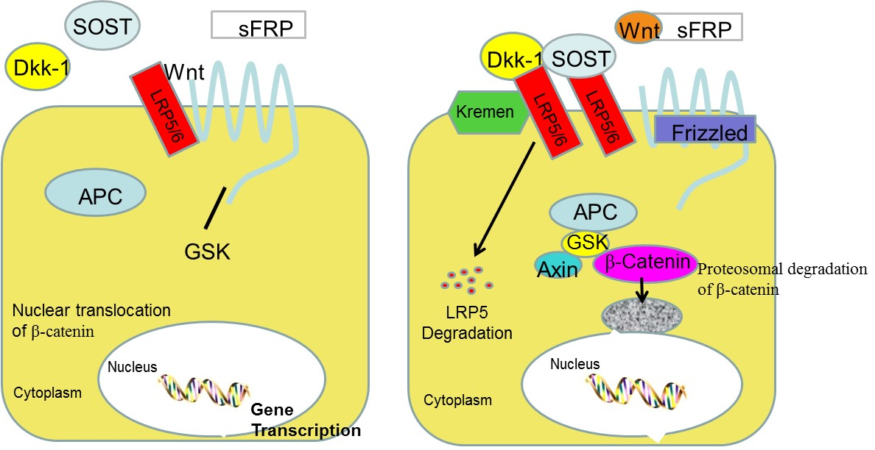
Figure 9: The Wnt signalling pathway is essential for the regulation of bone formation. Dickkopf-1 and sclerostin are two key inhibitors of Wnt signalling. Adapted from (119) with permission from Springer.
Sclerostin can also activate osteoclast activity and bone resorption by stimulating the secretion of RANKL by the osteocytes (120).
In osteoporosis a monoclonal anti-DKK1 antibody, BHQ-880 and an anti-sclerostin antibody, romosozumab (AMG-785) (121) are potential therapeutics that may increase bone formation without affecting bone resorption. These are currently undergoing clinical studies.

Bone Remodelling
The skeleton is metabolically active and is continuously undergoing longitudinal and radial growth, modelling and remodelling. The normal adult skeleton is continuously undergoing a highly regulated remodelling process at a rate of approximately 5 to 10% per year, taking 10 years to be fully replaced (122) and was first described in the 1960s (123). This is a process where old mineralised bone is resorbed by the osteoclasts and new mineralised bone matrix is formed by the osteoblast. It is supposed to be triggered by the formation of microdamage and osteocyte apoptosis (72, 124). It ensures that bone strength, structure and mineral homeostasis is maintained, and old damaged bone is repaired (125, 126). It occurs asynchronously throughout the skeleton and at damaged areas that require repair, at the basic multicellular units (BMUs).
Generally, the remodelling process consists of four highly regulated phases: 1) activation 2) resorption 3) reversal and 4) formation, (Figure 10). The microdamage in the bone may first be detected by the osteocytes (127) they may then send the signals to the lining cells causing them to retract from the bone surface and create the BMU (128), (Figure 10). Activation is the recruitment of the osteoclast precursor cells from the monocyte/macrophage cell lineage in the peripheral circulation to the site requiring resorption. Chemotactic factors are released from this damaged site and this may be the trigger that attracts the osteoclasts to it. In response to RANKL, M-CSF and other essential molecules the osteoclast precursor cells proliferate and differentiate in to mature osteoclasts. They remove the quiescent lining cells (129) and attach to the bone surface via sealing zones. Bone resorption then follows and once completed the osteoclasts undergo apoptosis. The reversal phase is the transition from bone resorption to formation. The formed resorbed cavity contains monocytes, osteocytes and osteoblast precursor cells in preparation for new bone formation. Osteoclasts and osteoblasts are activated in sequence and this may be mediated by a strain gradient being formed during the reversal phase (130). Bone formation by osteoblasts then follows. The osteoblasts synthesise and regulate new bone matrix, by producing enzymes which degrade the mineralisation inhibitors such as pyrophosphates or proteoglycans. The new osteoid is then formed and bone remodelling cycle is complete.

Bone remodelling process: Normal
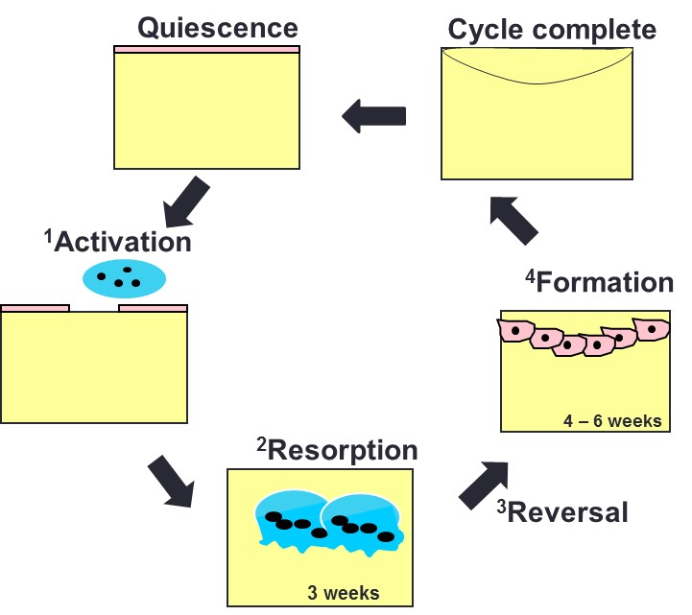
Figure 10: The bone remodelling process in normal bone physiology; illustrating each stage (1 – 4) and the duration of bone resorption and formation

In trabecular bone the rate of bone turnover is high because it is mainly required for mineral metabolism and lower in cortical bone which is necessary to maintain bone strength.

The coupling process
In normal bone physiology bone resorption and formation are coupled at each BMU within the sealed canopy. This occurs at the transition phase when bone formation follows bone resorption. In normal bone remodelling the volume of bone resorbed is equal to the volume of bone formed. In order for this to occur there are regulated communication signals between the osteoclasts and the osteoblasts. These signals are communicated through direct contact and interaction of the cell surface receptors, via gap junctions and by the cells secreting growth factor, chemokines and cytokines (131). There are several signalling molecules which mediate this process: i) matrix derived signals such as transforming growth factor-β and insulin-like growth factors (132-134) ii) secreted factors such as BMP-6, Wnt10b, S1P, afamin and semaphorins (135-138) and iii) bone marrow secreted factors such as the macrophage derived oncostatin M (139), T-cell derived interleukins (140), RANKL and Wnt1 which is highly expressed by the B-lymphocytes (141), (Figure 11a). In postmenopausal osteoporosis the coupling process is altered due to increased osteoclast activity. An aim of antiresorptive treatments is to reduce the signalling process from the osteoclasts to the osteoblasts and thus reducing the rate of bone turnover, (Figure 11b) (128).
In addition inhibitors of bone formation and stimulators of bone resorption are produced by the osteocytes suggesting that these cells also have a role in the coupling process. For example sclerostin and DKK-1 may act as possible mediators in normal and impaired bone remodelling and during/after treatment.

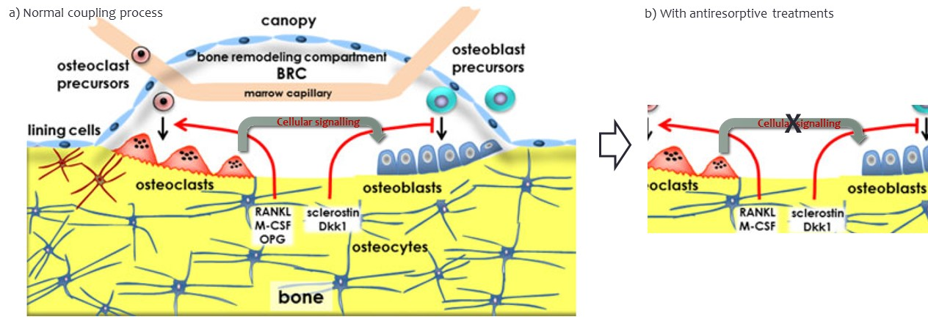
Figure 11: a) Local regulation of bone turnover: signalling molecules produced by the osteoclasts modulate the activity of the osteoblasts and b) with antiresorptives there are reduced signals from the osteoclasts to the osteoblasts. Copyright (2015) with permission from Springer. (128).

Pathophysiology of postmenopausal osteoporosis
The low BMD characteristic associated with postmenopausal osteoporosis is a highly heritable trait being genetically controlled in approximately 80% of the cases (142-144). Single nucleotide polymorphisms (SNPs) associated with low BMD have been identified by candidate gene approach and GWAS studies (145).
Genetic screening of the estrogen receptor genes have revealed correlations between the TA variable number tandem repeats in the promoter region and BMD (146). Evidence from genetic studies have also identified inactivating and activating mutations in the LRPS 5 gene impairing the Wnt signalling pathway and bone format (147, 148). A functional polymorphism in exon 4 of the methylenetetrahydrofolate reductase (MTHFR) gene has been identified which alters the enzymes activity in the methionine cycle (149). This results in an alanine to valine change at codon 677 causing reduced MTHFR activity and is associated with increased homocysteine levels (150) and osteoporotic fracture risk (151-153). Novel SNPs continue to be identified as new methods and technologies become available.
In postmenopausal osteoporosis estrogen deficiency is a major risk factor that is related to impaired microarchitecture and increased fracture risk. At a cellular level estrogen deficiency alters the normal cellular activity (154). The production of TNF is increased, stimulating the stromal cells and preosteoblasts to release several cytokines such as IL-1, IL-6, TGF, MCSF and RANKL. OPG secretion is reduced and M-CSF and RANK secretion is increased. These changes lead to an increase in the population size of the osteoclast precursor cells in the bone marrow and bone resorption (155, 156).
As a result of the cellular alterations, several factors contribute to the alteration in the remodelling process, (Figure 12) and have a causative role in osteoporosis:
- There is increased bone resorption causing an imbalance (negative balance) in bone turnover.
- There is an accumulation of micro damage
- There is a loss of trabecular bone architecture and thinner cortical bone
- There is accelerated bone loss
- There is increased fragility and fracture risk.
(Figure 13)
The imbalance at the BMU between bone resorption and bone formation results in a change in the initiation of new remodelling cycles. The magnitude of the imbalance determines the amount of bone loss at the BMU (157). There is also an increase in the activation frequency which represents the average time taken between the initiation of two successive remodelling cycles at the same skeletal site (158).

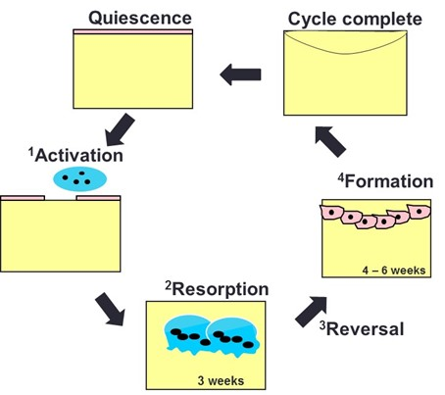
Bone remodelling process: Osteoporosis

Figure 12: The bone remodelling process in osteoporotic bone physiology; illustrating a negative balance (bone resorption exceeding bone formation) causing disruption in the microarchitecture and accelerated bone loss.

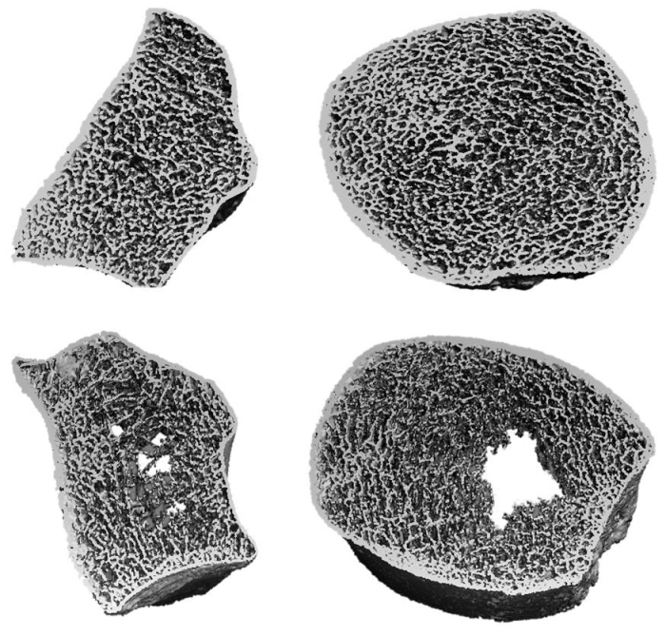
Figure 13: HR-pQCT images of a) normal radius and b) normal tibia showing intact cortex, small pores and thick uniform trabeculae and c) osteoporotic radius and d) osteoporotic tibia showing a thin cortex, a break down in its structure and thin sparse trabeculae.
Postmenopausal osteoporosis also related to a decrease in calcium absorption, vitamin D deficiency, decreased production of 1,25-dihydroxyvitamin D production and impaired kidney function. These factors may cause secondary hyperparathyroidism and contribute to a further increase in bone resorption and bone loss. Bone loss starts the year prior to the menopause and continues rapidly for a further 3 years (159). BMD decreases at a rate of 10% at the 5 to 6 years around the menopause and if untreated the 15 to 20% of women in their early 60’s will experience a vertebral fracture (160, 161).

Secondary osteoporosis
Osteoporosis can also be caused as a consequence of diseases and this is known as secondary osteoporosis. Generally, secondary osteoporosis is characterised by low BMD or increased risk of fracture caused by a disease or treatment and not directly related to age or postmenopausal status (162). Some of the most common causes of secondary osteoporosis include: hyperparathyroidism, diabetes, rheumatoid arthritis, inflammatory bowel disease, glucocorticoids, aromatase inhibitors etc. (162, 163). With the increasing burden on the public health services caused by postmenopausal osteoporosis it is useful for clinicians to identify and understand how such factors contribute. One possible way that may help to identify secondary osteoporosis is to compare levels of bone turnover to that of a heathy postmenopausal population. Once identified treatments may be administered to reduce fracture risk.

Bone Turnover Markers
Assessment of the bone mineral by measuring bone mineral density using dual X-ray absorptiometry (DXA) is the gold standard for the diagnosis of postmenopausal osteoporosis (100, 101). However, there are other factors that contribute to bone fragility and fracture, these can be measured to assess the alterations in the morphology and architecture of bone. These alterations are related to the abnormalities of bone turnover in postmenopausal osteoporosis. Bone turnover markers (BTMs) are products derived during the degradation and formation of the bone matrix, (164). BTMs are secreted in to the circulation during bone resorption and formation. They reflect the activity of the bone cells and hence, provide us with an overall quantitative assessment of skeletal turnover, (165). They may help in the investigation and management of the pathophysiological processes of metabolic bone disease such as postmenopausal osteoporosis (102), where high levels of BTMs are associated with increased osteoblast and osteoclast activity and increased bone loss and fracture risk (103). In addition, their rapid pharmacodynamics responses to treatments also make them a valuable tool in monitoring such diseases in a clinical setting.

Type I collagen
Type I collagen is makes up 95% of the total collagen content and 85% of the total proteins in the bone matrix, (166). It belongs to the fibrillar class of collagens and it is the most abundant and widespread in tissues such as the skin, tendons, ligament sclera, cornea and blood vessel. It contains peptide repeats of Gly-Xaa-Yaa-n where X and Y are usually a proline and a hydroxyproline, respectively (167). Glycine is the smallest amino acid and is present at every third position in order to fit in the centre of the triple helix. At either ends of these peptides are short terminal globular domains, which do not contain Gly-Xaa-Yaa-n, the N- and C-propeptides. The C-propeptide keeps the procollagens soluble and the N-propeptide influences the fibril shape. Type I collagen is synthesised and secreted in to the extracellular matrix in the form of soluble procollagens, (Figure 14). This process involves two enzymes, galactosyltransferase and galactosylhydroxylysyl-glucosyltransferase and trimerisation (168), forming a defined, aligned and thermally stable right-handed triple helix. Each of the three chains of the helix is made up approximately of 1000 amino acids. Two of the chains are identical to each other α1 (2) and one different α2 (1). They are of about 300nm in length and 1.5nm in diameter (169, 170). The α1 and the α2 chains are coded for by the genes located on 17q21.23 and 7q21.3-22 respectively. Human mutations in these proteins are associated with osteogenesis imperfecta (171). The procollagen chains are held together by disulphide bonds at the C-propeptide, formed by protein disulphide isomerase (172). Proteolytic cleavage by procollagens N and C proteinases of the N- and C- terminal propeptides results in a shorter triple helix, the telopeptides, that can align into fibrils (173) in the extracellular matrix. These processes involve several posttranslational modifications to stabilise the helix including: i) hydroxylation of lysyl and prolyl residue, ii) glycosylation of the hydroxlysine and iii) formation of inter- and intramolecular covalent crosslinks. It is this structure that is responsible for the biomechanical properties of bone and has specific roles in the pathology of osteoporosis. Collagen types III and V are also present in low levels in bone, these have a role in fibril diameter regulation (174).

Triple helix formation in the endoplasmic reticulum
Extracellular Matrix
Plasma membrane

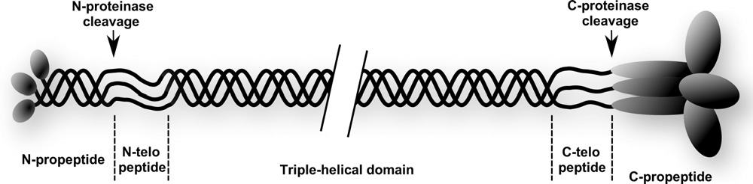
α1 chain and α2 chains
Procollagen
NTX epitope: JYDGKGVG
CTX epitope: ¹²⁰⁷EKAHDGGR¹²¹⁴
Type I collagen
Crosslinked Fibrils

Collagen crosslinks: Lysylpyridinoline (DPD) and hydroxylysylpyridinoline (PYD)

Figure 14: The formation of type I collagen

Bone resorption markers
Bone resorption markers are detected in urine or serum and reflect the degradation of type I collagen, which makes up the majority of the bone matrix. They are either i) proteolytic peptide fragments derived from type I collagen degradation in the bone matrix and the crosslinks: pyridinoline (PYD) and deoxypyridinoline (DPD) (175, 176), ii), the cathepsin K derived markers: N-terminal crosslinking telopeptides of type I collagen (NTX) and C-terminal crosslinking telopeptides of type I collagen (CTX) or reflect osteoclast enzyme activity i) tartrate resistant acid phosphatase (TRACP), ii) cathpsin K and iii) the matrix-metalloprotease (MMP) derived telopeptide (ICTP), (Figure 15).

C-terminal cross-linking telopeptides of type I collagen (CTX)
The α1 chain of type I collagen contains the CTX epitope which is a peptide of eight amino acid residues, ¹²⁰⁷EKAHDGGR¹²¹⁴, (Figure 15). This undergoes further non-enzymatic posttranslational modification, racemisation and isomerisation (177). When type I collagen molecules are newly synthesised, the aspartic acid residue, localised in the core of the CTX epitope (D1211) is in the native L-enantiomeric form (178) . Racemisation at the aspartic acid residue, converts this to the D-form which accumulates in tissues that are in a state of low bone turnover such as cartilage and skin. Isomerisation at the aspartic acid residue transfers the peptide backbone from the carboxyl group from position α, to the side chain carboxyl group in position β, (Figure 15)(178). This β-isomerisation forms a kink in the peptide backbone and thus altering the conformation and in particular the mechanical properties of type I collagen. For example it has been demonstrated the isomerisation alters the activity of cathepsin K (179) and the formation of crosslinks and hence its mechanical properties (180). Studies of the β-isomerisation of the CTX peptide using foetal bovine have shown that at equilibrium 20% remains in the native α-form and 80% is isomerised to the β-form (177). In healthy children equilibrium is not achieved and the α/β ratio is high (greater native than isomerised CTX), (Gossiel et al ASBMR 2008). In healthy adults equilibrium is also achieved and the α/β ratio remains unchanged (178). In states of increased bone turnover such as Paget’s disease (181), bone metastases (182) and possibly osteoporosis equilibrium is not achieved

α1 chain and α2 chains
Type I collagen

α2 chain
α1 chain

JYDGKGVGG
Cathepsin K
MMP
Cathepsin K
Cathepsin K
Cathepsin K
GPP SAGFDFS FLPQPPQ EKAHDGGR
NTX
ICTP

Postranslational modifications: β-isomerisation of aspartic acid AGE’s (plus sugar): Pentosidine and pentosine

Figure 15: The synthesis of bone resorption markers from type I collagen

N-terminal crosslinking telopeptides of type I collagen (NTX)
NTX is an 8 amino acid epitope JYDGKGVG, derived from the α2(I) chain of type I collagen. This fragment is cleaved by cathepsin K and is released in the urine as a stable end product of collagen degradation. During ageing the aspartyl-glycine motif also undergoes β-isomerisation at the N-terminal (183).

Tartrate resistant acid phosphatase (TRACP)
TRACP is an enzyme mainly expressed by the osteoclasts and also by activated macrophage, such as in the lung alveoli (184). It circulates in serum as two isoforms namely, 5a and 5b (185). The isoforms are genetically identical and therefore have the same protein structure. They differ by their carbohydrate content with isoform 5a containing sialic acid not present in isoform 5b (186), the optimum pH for isoform 5a is lower (pH4.9) than isoform 5b (pH 5.5 to 6.0) (185). In addition isoform 5b is expressed solely by the osteoclasts whereas isoform 5a may be expressed by macrophages and dendritic cells (186). Isoform type 5a is monomeric and type b consists of two subunits. TRACP is secreted in circulation as an active enzyme that becomes inactivated by losing its iron content. About 90% of the molecule circulates in fragments and is metabolised by the liver and kidneys. Assays are available which are capable of detecting the active isoform 5b, which is not metabolised before being removed from circulation. It can provide information specific to bone resorption, reflecting osteoclast number and activity.

Cathepsin K
Cathepsin K is a catalytic lysosomal enzyme expressed by the osteoclast and contained in transcytotic vesicles, along with TRAP type 5. It cleaves and activates isoform type 5b. It is a member of the cysteine protease family of which 11 have been identified in humans (187). It is monomeric endopeptidase secreted predominantly by the osteoclasts and may be present the synovial fluid (188). Initially, it is synthesised as a 329 amino acid proenzyme, which is subsequently catalytically cleaved into its active form of 215 amino acids. Cathepsin K and TRAP 5b are releases in the resorption lacunae and in circulation where levels can be used to detect osteoclast activity (189, 190). It has a unique and critical role in degradation of type I collagen at both helical and telopeptide regions, (Figure 15). Current assays are available for measuring levels cathepsin K in circulation, these may detect the proenzyme, the active form or both. Levels of cathepsin K are increased in postmenopausal osteoporosis (191), where they are associated with an increase in bone loss and are decreased with alendronate treatment (192). Peptide inhibitors may inhibit cysteine proteases such as cathepsin K by binding the substrate and mimicking the cathepsin K-substrate complex and inhibit bone resorption. These compounds are currently being developed as antiresorptives as a possible treatment for postmenopausal osteoporosis.

Bone formation markers
Bone formation markers are the products synthesised by the osteoblasts during any stage of their development and the enzymes involved in their synthesis. They include the bone matrix protein markers osteocalcin and procollagen type I C- and N- terminal propeptides (PICP and PINP), osteocalcin and the bone specific isoform of alkaline phosphatase (165, 193).

N-terminal propeptide of type I procollagen
At either ends of type I procollagen are two different large propeptide domains that are produced in equal amounts (194), (Figure 14). The domain at the amino terminal (PINP) is less globular than the domain at the carboxy terminal (PICP). It is cleaved from the propeptide by proteolytic enzymes and released into circulation as the fibril increases in thickness. PINP is made up from three subunits, two from the procollagen α1 chain and one from the procollogen α2 chain bonded together non-covalently (193). PINP has a molecular mass of approximately 35,000 (14,250 is from α1 and 5500 from α2) (193). During bone formation PINP is released in to the blood as the osteoid is being deposited into the resorption cavity and is thus a good measure of the rate of synthesis of type I collagen. Once in circulation PINP is rapidly bound and internalised by the endothelial cells of the liver (195). The main PINP antigen in serum corresponds to the domain that has been cleaved and released from procollagen (196). There is also a smaller antigen that appears to correspond to the monomer (from a single α1 chain) from the trimeric PINP (196). It is has been demonstrated that this smaller monomer may be a product of the trimer as a result of heat denaturation (197). This monomer is more evident in some diseases such as renal failure and metastatic bone disease compared to the trimer (198-200).

Osteocalcin
Osteocalcin is a non-collagenous protein synthesised by osteoblasts and secreted by mature osteoblasts during bone formation (201), (Figure 6) and excreted by the kidneys. The genes encode a non-collagenous protein of the bone matrix, with a molecular weight of 5800 Daltons, comprising of a 49 amino acid peptide with a short half-life (minutes) (202). Once synthesised osteocalcin undergoes vitamin-K-dependent posttranslational modification where three glutamic acid residues are gamma-carboxylated (Gla) (203) and secreted in serum (204). The carboxylated osteocalcin has a negatively charged gamma-carboxyglutamic acid group allowing it to bind to the positively charged mineral ions such as calcium. This property allows it to therefore to bind to the hydroxyapatite in the mineralised bone, with high affinity. This process alters the structure of the peptide by forming a compact α-helical globular conformation (205).
Undercarboxylated osteocalcin has a role in energy metabolism, in particular it appears to act as a hormone in regulating such pathways (206). This may be due to a defect in the gammacarboxylation of pro-osteocalcin during its synthesis (207) In vitro studies for example have demonstrated a negative association between leptin and bone mass (208, 209). In humans levels of circulating osteocalcin are negatively correlated with BMI, fat mass, glucose levels, insulin and insulin resistance (210-212).

Bone alkaline phosphatase (bone ALP)
Alkaline phosphatase (ALP) is a group of membrane-bound glycoprotein enzymes expressed by most organisms. Their function is to catalyse the hydrolysis of monophosphate esters. In humans there are four forms of this enzyme each having similar catalytic properties (213). These four isoenzymes of total alkaline phosphatase are encoded by four different genes, in different tissues types each with specific physiological functions. Three of the isoenzymes are tissues specific and are expressed in the intestines (ALPP gene), placenta (ALPP gene) and germ cells (ALPPL2 gene) (214). These tissue specific ALP genes are located on chromosome 1 and are about 90% homologous to each other. The fourth is ubiquitous and tissue non-specific, encoded by the ALPL gene on chromosome 2 and is about 50% identical to the tissue-specific gene cluster. It exists in several isoforms differing mainly in the type of glycosylation they undertake (215, 216). These can be identified by HPLC and three of the isoform peaks produced are bone specific, i.e. (B/I, B1 and B/2) (217) (a fourth bone isoform, B1x appears in patients with CKD (218). Approximately 95% of the total ALP activity that circulates in serum and can be detected is bone and liver-specific.
Bone ALP is synthesised by the osteoblasts and is attached to the surface of the osteoblasts via glycosylphosphatidylinositol as an insoluble enzyme (219). It is cleaved by phospholipase-D and is released in to circulation as a soluble homodimeric glycoprotein (220) with a molecular weight of 126-141 kDa (221) and a half-life of 1-2 days (222). It has an essential role in the mineralisation process of the bone matrix which follows the formation of the osteoid, (223). A bone ALP knock-out mouse has impaired mineralisation (224). Immunoassays, electrophoresis, isoelectric focusing are techniques available to measure the enzyme activity bone ALP (225, 226). Immunoassays are regularly used in clinical setting in particular in diseases that have a dramatic change in bone turnover such as osteoporosis, Paget’s disease, primary hyperparathyroidism and chronic kidney disease (227-231). In order to obtain specific information regarding bone status (bone formation and overall bone turnover) it is important to measure the activity of the bone ALP enzyme rather than just total ALP because the latter includes activities relating to the other ALP isoenzymes.

Treatments for Postmenopausal Osteoporosis
The treatment of postmenopausal osteoporosis generally involves a combination of pharmacological agents with non-pharmacological options. The non-pharmacological options are mainly related to changes in lifestyle changes such as improved dietary intake (in particular calcium and vitamin D), exercise and reduced alcohol consumption and stop smoking (232-234). The pharmacological interventions are recommended for all postmenopausal women i) who have had a previous osteoporotic vertebral or hip fracture ii) who have a BMD T-score of ≤ -2.5 at the lumbar spine, femoral neck or total hip iii) who have a BMD T-score from -1.0 to -2.5 and a 20% risk of fracture based on the FRAX calculation (WHO FRAX website).
Over the past 25 years several effective and safe therapeutic targets have been identified, developed and subsequently approved by the Food and Drug Administration (FDA) and the European Medicines Agency to improve bone health and reduce the risk of fracture (Figure 16). The aims of these were to either inhibit bone resorption i.e. antiresorptives or to enhance bone formation i.e. anabolic. The assessment and monitoring of these using novel tests and methods continues to be a research area of great interest. In addition, by applying these methods to some of the currently licenced treatments will help us to understand the effect and mechanism of action of possible future treatments.

Strontium ranelate
Denosumab
Abaloparatide
Odanacatib (Phase III)
Etidronate
Risedronate Raloxifene
The past 25 years
The Future
2010
2020
1990 (Year)
2000
Ibandronate Teriparatide
Alendronate

Romosozumab Blosozumab (Phase II)
Zoledronate iPTH

Figure 16: Timeline showing the development of licenced antiresorptives and anabolic osteoporosis treatments in the United Kingdom and possible future treatments. iPTH (intact parathyroid hormone)

Antiresorptive Treatments
Understanding the mechanisms and functions of the osteoclasts, osteoblasts and osteocytes has allowed scientists to develop (and continually develop) antiresorptive therapies with the aim of inhibiting bone resorption in postmenopausal osteoporosis. Antiresorptives minimise further deterioration of both the cancellous and cortical bone (235). In addition, they increase in BMD by 2-10% by reducing the remodelling space and increasing the mineralisation of the bone matrix, hence reducing the porosity of cortical and cancellous bone compartments. Osteoporotic fracture risk is reduced by 30 to 50% (236)

Bisphosphonates
Bisphosphonates are inhibitors of osteoclast function and subsequently bone resorption and are the drug of choice for preventing and treating postmenopausal osteoporosis. They are administered either orally or by intravenous infusion with the overall aim to reduce osteoporotic fracture risk (237-239).

The structure of bisphosphonates
Bisphosphonates are synthetic analogues of inorganic pyrophosphate where the oxygen is replaced with a carbon, (Figure 17). This geminal substitution produces a compound that has a central molecular structure of phosphate-carbon-phosphate (P - C - P). This structure makes bisphosphonates chemically and enzymatically stable and resistant to biological degradation. It is responsible for their strong binding affinity to the hydroxyapatite in bone. They have two amino side chains (R₁ and R₂) attached to the germinal carbon atom. The variations in these has allowed for the synthesis of several analogues with differing pharmacological properties and mechanisms of action. The entire molecular structure of a bisphosphonate determines its mechanism of action on mature osteoclast cells and its ability to inhibit bone resorption. These features of the molecule makes bisphosphonates a suitable treatment of choice in a clinical setting.
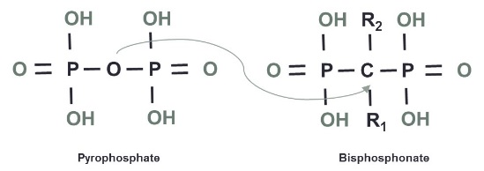
Figure 17: the general molecular structure of bisphosphonates. Inorganic pyrophosphate (left) and the synthetic compound (right) showing the carbon atom substitution and the R side chains.

The mechanism of action of bisphosphonates on bone
Bisphosphonates have different binding affinities for hydroxyapatite and bone mineral, inhibiting the precipitation of calcium phosphate and crystal dissolution (240). The R₁ side chain contributes to these differences in binding affinities with the presence of a hydroxyl group or a NH₂ enhancing it (241). Furthermore, kinetic studies have established a rank order for binding affinity of risedronate< ibandronate < alendronate < zoledronate, (242). For example alendronate has a stronger binding affinity for hydroxyapatite than risedronate. In contrast bisphosphonates with a stronger binding affinity have lower 24 hour excretion (i.e. greater retention time) following the administration of the initial dose.
The preferential uptake and adsorption of bisphosphonates by the bone mineral brings them in close contact with the osteoclasts. In vivo studies have shown that during the bone resorption process alendronate was internalised by the osteoclasts via endocytosis(243). This alters bone resorption through inhibiting the osteoclasts activity and inducing cell death (244, 245), but not always the latter. For example bone biopsies from osteoporotic patients treated with alendronate have shown that the osteoclast was still present but is in the form of a giant hypernucleated that is possibly inactive with an unknown function (246). This feature has also been observed more recently following treatment with cathepsin K inhibitors such as odanacatib (247). Other features observed following uptake were a lack of the ruffled border and the disruption of the cell’s cytoskeleton as a result of the inhibition of intracellular signalling (248). It is widely accepted that these effects are exerted on mature, multinucleated and actively resorbing osteoclasts. However since these differentiate from mononuclear precursor cells originating from the haematopoietic stem cells, bisphosphonates may also have an effect on these, but this possible mechanism of action has not yet been widely researched.
Preclinical research has attempted to show the actions of bisphosphonates once inside the osteoclast, (249). These actions mainly involve their inhibitory effects on enzymes which include; i) glycolytic enzymes and glycolysis (250), ii) the proton pump producing H⁺ ATPase (251), iii) tyrosine phosphatases (252) iv) acid phosphohyrdolases and lysosomal enzymes (253) and v) inducing the osteoblast to secrete an osteoclast inhibitory factor (254). Bisphosphonates are therefore divided in to two groups generally based on their mechanisms and modes of actions on the osteoclasts, namely non-nitrogen containing and nitrogen containing.

Non-nitrogen containing bisphosphonates
The non-nitrogen containing bisphosphonate have simple R₁ and R₂ side chains. For example these side chains in clodronate are substituted with chlorine and in etidronate it is a hydroxyl group. These bisphosphonates are metabolised in the osteoclast where they generate toxic non-hydrolysable, β, γ-methylene analogues of adenosine triphosphate (ATP). The accumulation of ATP is toxic to the cell inhibits their function and induces premature osteoclast cell death via apoptosis (255, 256). Osteoclast apoptosis may occur by inactivating the adenine translocase enzyme in the mitochondrial membrane as shown with clodronate treatment (257). This may alter the permeability of the mitochondria by activating caspase leading to apoptotic cell death (258).

Nitrogen containing bisphosphonates
The second group of bisphosphonates contain a nitrogen atom in the compound at the R₂ side chain, (Table 1). These bisphosphonates are more potent and are not metabolised in the same way as non-nitrogen containing bisphosphonates. They inactivate the osteoclasts via the inhibition of the metabolic reactions in the mevalonate biosynthetic pathway that synthesises cholesterol and other sterols. They inhibit several enzymes in this pathway that bind to the substrate isoprenoid diphosphates i.e. isopentenylpyrophosphate isomerase, farnesyl pyrophosphate synthase (FPPS), geranylgeranyl pyrophosphate (GGPP) synthase and squalene synthase (241, 259, 260). FPPS is a peroxisomal enzyme and its activity is inhibited by bisphosphonates. Inactive FPPS causes a reduction in the synthesis of farnesyl pyrophosphate (FPP) substrate which is required for the synthesis of GGPP by GGPP synthase. FPP and GGPP are isoprenoid metabolites necessary for the prenylation of the signalling proteins GTPases. GTPases signal important processes required for cell normal morphology (including maintenance of the actin cytoskeleton, membrane ruffling and trafikking vesicles) and apoptosis (261-263). Inhibition of FPP and GGPP leads to unprenylated GTPases and this impairs these osteoclast functions and activity. Therefore the effect of bisphosphonates on osteoclast activity may be due to the accumulation of active and unprenylated GTPases (264-266). This effect on protein prenylation by bisphosphates is similar to that of statins or prenyltransferase inhibitors (260, 267). In contrast, non-nitrogen containing bisphosphonates do not inhibit FPPS and hence the prenylation of GTPases occurs (256), therefore their cellular mechanism of action is different.

Effects on osteocytes
In contrast to their ability to induce osteoclast opoptosis, bisphosphonates appear to inhibit osteocyte apoptosis caused by mechanical loading for example (268, 269). The signalling pathway that mediates this is unknown but may be related to the activation of extracellular signal regulated kinases (270). Bisphosphonates may gain access to the osteocytes via the interconnecting canaliculi network and uptake may be dependent on their specific affinity to bone (those with lower affinity able to penetrate further in to the matrix and get closer to the osteocyte) (241). If this is indeed the case, then risedronate (which has a lower binding affinity than alendronate) penetrates further in to the canaliculi network. In my thesis I aimed to investigate whether there is an indirect effect of bisphosphonates on osteocytes. I aimed to do this by measuring the levels of circulating sclerostin that the osteocytes produce after treatment with ibandronate, alendronate and risedronate in women with postmenopausal osteoporosis. The hypothesis being that risedronate increases levels of circulating sclerostin by inhibiting osteocyte apoptosis more than alendronate.

The clinical utility of bisphosphonates
The effects of bisphosphonates on osteoclasts in particular and overall skeletal health have allowed them to be widely used in clinical diseases where bone resorption is increased such as Paget’s disease, osteogenesis imperfecta, some multiple myelomas related to the skeleton, metastatic breast/prostate/lung cancers and osteoporosis (271-277).
The most common bisphosphonates licenced to treat osteoporosis worldwide are the nitrogen-containing ibandronate, alendronate, risedronate and zoledronate, (Table 1). In randomised controlled clinical trials these have been shown to reduce the risk of vertebral fractures by 39 to 70% (278-280), non-vertebral fractures by 20% and hip fractures by 40% (281, 282). The differences of the effects of bisphosphonates on bone turnover and fracture risk are difficult to investigate in great detail due to the lack of head-to-head randomised clinical trials being performed. Such trials would need to be extremely large, however different approaches can be made in order to investigate this. Large population-based observational studies can help identify the determinants and how these may be related to the risk of fracture (for example changes in bone turnover, bone balance, BMD and bone loss) and contribute to the evidence base (283). In addition the different changes in bone turnover markers observed with the licenced bisphosphonates need to be further investigated in a head-to-head randomised controlled trial. The differences in these changes may be due to the bisphosphonates mechanisms of actions that have not yet been investigated in postmenopausal osteoporosis. Findings from these may help us understand the clinical relevance in these differences.

Selective estrogen receptor modulators (SERMs)
SERMs are synthetic non-steroidal compounds which exert estrogen-like agonist and antagonist properties on tissues that express the estrogen receptor, such as bone, heart, breast and endometrium(284, 285). They are used to treat osteoporosis, breast cancer, dyspareunia and menopausal symptoms, with endometrial safety being a key factor in their use (286). Their mode of action is varied; they bind to the estrogen receptors either ERα and/or ERβ, regulating gene transcription and exerting specific physiological effects (287) related to pathological and therapeutic processes (288), (Figure 18). This mechanism varies according to the type and expression of receptor on the tissue, the complex it forms with the co-regulators and the cellular environment of the target tissue (289, 290). SERMs either activate or inhibit the effects of estrogen, and these effects can vary between the compounds. For example raloxifene and bazedoxifene have neutral effects on the uterus whereas tamoxifen is an estrogen agonist, causing endometrial hyperplasia and malignancy. These SERMs have an estrogen agonist effect in bone and an antagonist effect in the breast (291-294).
Figure 18: The binding of SERMs to ERα and ERβ and gene transcription. Copyright (2015) permission from American Society of Clinical Oncology (287)
Several SERMs have been developed, evaluated and approved for the management and treatment of several diseases including breast cancer and osteoporosis. Their estrogen agonist effect on bone improves BMD by reducing bone loss and fracture risk (295-297). Their effect on bone balance has yet to be fully investigated.

The clinical utility of raloxifene
Raloxifene was the first SERM to be developed to prevent invasive breast cancer and vertebral fractures in postmenopausal women with osteoporosis and osteopenia. It is a second generation benzothiophene compound SERM that is approved for use in many countries. It is an estrogen agonist on bone and lipid profile and an estrogen antagonist on the uterus and breast tissue (298). It binds to ERα with high affinity and up regulates the expression of transforming growth factor-β3 (TGF-β3), inhibiting the differentiation and proliferation of osteoclasts (299). Preclinical data has shown that 3.0mg/kg/day of raloxifene administered for 6 months to ovariectomised rats increased BMD at the lumbar spine and tibia compared to controls (300). Clinical data from the Multiple Outcomes of Raloxifene Evaluation (MORE) study, has demonstrated the use of raloxifene in reducing breast cancer risk in postmenopausal women with osteoporosis (293). This was a 3 year randomised controlled clinical trial of 7705 women receiving 60mg/day of raloxifene. At 3 years BMD at the lumbar spine and femoral neck increased by 2.6% and 2.1% respectively and the risk of vertebral fracture was decreased by 68% in the overall population at 1 year and by 55% in in women at high risk at 3 years and no effect on hip or non-vertebral fracture risk compared to controls (301-303), (Table 1). With regards to the safety of raloxifene it was shown that is does not increase the risk of uterine or endometrial cancers (286, 293, 304). However, in the Raloxifene Use for the Heart (RUTH) study, raloxifene did not treat coronary heart disease in postmenopausal women (305) and there was an increased risk of venous thromboembolism and fatal stroke (306).
Table 1 summarises some of the current clinical findings from the studies that have investigated the licenced/most commonly used antiresorptive treatments for postmenopausal osteoporosis in the United Kingdom. My thesis aims to contribute further to these findings and investigate/highlight possible mechanisms of actions in which antiresorptives reduce bone turnover and fracture risk.

Table 1: The name and structure of some antiresorptive treatments and their effects of fracture risk and bone turnover markers from clinical trials
Compound name/description | Chemical structure | Findings from clinical trials (add references)
Ibandronate  Nitrogen containing bisphosphonate |  | BONE (280) and MOBILE  Significant reduction in vertebral fracture but not non-vertebral or hip fractures.
Alendronate  Nitrogen containing bisphosphonate |  | FIT (307, 308), FLEX (309):  Significant reduction in vertebral and hip fractures but not non-vertebral fractures.  CTX: -59% (SD: 31)  PINP: -51% (SD: 31)
Risedronate  Nitrogen containing heterocyclic bisphosphonate |  | VERT-MN (279, 310) , VERT-NA(311), HIP Intervention Program Study Group (312):  Significant reduction in vertebral and non-vertebral fractures but not hip fractures.  CTX (urine): -60%
Zoledronate  Nitrogen containing heterocyclic bisphosphonate |  | HORIZON PFT (278, 313): A significant reduction in vertebral, non-vertebral and hip fractures  PINP: -56%  CTX: -58%
Raloxifene  Second generation SERM: Benzothiophene | 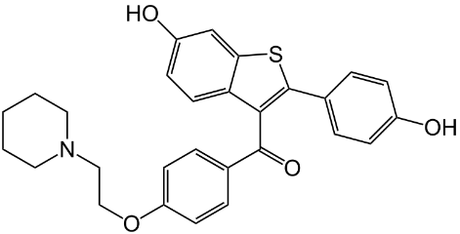 | MORE (302, 314): A significant reduction in vertebral fractures but not non-vertebral and hip fractures.  CTX (urine): -47%  PINP: -41%

Clinical utility of bone turnover markers in postmenopausal osteoporosis
There is a strong emphasis on being able to identify patients who are at a high risk of fracture and administer the most suitable treatment i.e. to increase BMD and reduce fracture risk (307, 308). A useful indicator of fracture risk in non-treated and treated individuals is low BMD (309-311) and increased bone loss (313). This impairment in the structural properties of bone may be i) related to bone loss and low BMD or ii) independent of BMD for example stress created on either side of the resorption cavity resulting in weakening of the trabeculum and reduced mechanical resistance or iii) increased bone turnover may result in less mineralisation of newly synthesised bone compared to mature bone, reducing the time available for post-translational modifications of the bone matrix proteins.
There are several original studies that have assessed the association of change in BTM levels in response to osteoporosis treatments with BMD and fracture risk. Bauer DC et al assessed levels of CTX and PINP with fracture risk reduction in The Fracture Intervention Trial (FIT) (315). They used 562 postmenopausal osteoporotic women receiving alendronate to demonstrate that CTX levels prior to treatment were not correlated with a reduction of vertebral and nonvertebral fractures after treatment. There was however an association between high PINP levels and a reduction of nonvertebral fracture (316). Delmas PD et al assessed levels of BTMs prior to treatment with the risk of fracture using patients from the Fracture Prevention Trial (317). Their findings demonstrated that in a subset 520 patients, teriparatide significantly reduced the risk of fracture and this was independent of BTM levels prior to treatment. They showed that high levels of bone ALP, PINP and PICP prior to treatment were associated with increased fracture risk. Other studies have demonstrated that an early decrease in CTX and NTX, 60% and 51% respectively at 3 to 6 month, were significantly associated with a 50% reduction in vertebral fracture risk in patients receiving risedronate after 3 years (311). More recently, data from the Health Outcomes and Reduced Incidence with Zoledronic acid ONce yearly Pivotal Fracture Trial (HORIZON-PFT) demonstrated that a change in PINP explained 58% of the fracture reduction observed with zoledronic acid treatment in 1132 postmenopausal women (313, 318). Fracture risk has also been assessed with raloxifene treatment using the multiple outcomes of raloxifene evaluation (MORE) study. In this study it was shown that reduced levels of bone alp, osteocalcin and PINP in the first year were shown to be a predictor of reduced vertebral fracture risk at 2 and 3 years (314).
The findings from these clinical trials have supported the rationale for using BTMs in monitoring patients with postmenopausal osteoporosis; the change in BTMs occurs early, the change is large despite considerable variability and the change appears to be a better surrogate for fracture risk reduction than the change in BMD. Subsequently, the International Osteoporosis Federation (IOF/International Federation of Clinical Chemistry and Laboratory Medicine (IFCC) Bone Marker Working Group have made several recommendations for the use of BTMs in assessing fracture risk and treatment monitoring (319). One particular recommendation stated that serum CTX and PINP need to be measured in order to assess bone resorption and formation, respectively in studies that aim to investigate fracture risk and treatment monitoring.

Clinical utility of sclerostin
In recent years there has been a strong emphasis on investigating the ways in which sclerostin can be used in a clinical setting. However the findings from these studies have proved to be inconclusive and its specific role remains largely unanswered. A study investigating sclerostin levels and growth in children has identified that serum sclerostin levels are significantly higher in boys than in girls (320). Prior to the onset of puberty sclerostin levels were positively associated with bone age and negatively after puberty. In adults sclerostin levels remained significantly higher in men compared to premenopausal women and were positively associated with age (321). In postmenopausal women and aged men, Mödder et al also demonstrated that it was the reduced estrogen that was associated with increasing levels of sclerostin and therefore the possible reduction in bone formation (322).
In addition, there are several clinical states in which serum sclerostin has been measured in an attempt to identify its role. In a cross-sectional study Costa et al demonstrated that sclerostin was significantly higher in 20 patients with hypoparathyroidism compared to a control group (323) and was not correlated with BMD and positively correlated with CTX only. Treatment of hypoparathyroidism with intermittent or continuous PTH 1-34 increased levels of sclerostin, suggesting a relationship with PTH and a clinical usefulness in parathyroid disease. Another two studies have demonstrated its possible role in renal impairment, with reduced levels in patients with chronic kidney disease (CKD) stages 3B and 5 (324, 325). This may be caused by a change in the handling/clearance of sclerostin due to the renal impairment. Several other studies have also demonstrated that along with BTMs, sclerostin was significantly increased in patients with type II diabetes compared to controls (326-328). In 46 patients with ankylosing spondylitis sclerostin was significantly lower compared to controls (329) and hence increased bone formation which is a characteristic of this disease. Sclerostin levels are higher in immobilised patients, for example as a result of spinal cord injury (330-332) and decreased in patients with hypercortisolism (as a result of Cushing’s syndrome or therapeutic intervention) (333). I have previously shown that the latter is subsequently increased with glucocorticoid therapy (Gossiel F et al, 2011, abstract: 1252, ASBMR).
With regards to BMD and fracture risk in postmenopausal osteoporosis, sclerostin continues to be of great interest and continuous research. Using the previous in vitro findings that sclerostin is an inhibitor of Wnt and bone formation it is plausible to hypothesise that increased levels of circulating serum sclerostin is related to increased BMD and a reduction in fracture risk and vica versa. However to date, studies have shown inconsistent finding based on this hypothesis. Two studies have demonstrated that increased sclerostin levels were related to a reduction in BMD and increased fracture risk at the total hip and were therefore predictive of BMD and fracture (334, 335). The first of these by Arasu A et al 2012, showed that Caucasian osteoporotic postmenopausal women with sclerostin levels in the highest quartile and lowest BMD were 22.3 ( 95% CI 5.8-86.3) times more likely to fracture compared to women in the lowest quartile. Similarly Ardawi MS et al 2012, showed that Saudi Arabian osteoporotic postmenopausal women with sclerostin levels in the highest quartile and lowest BMD were 15 times more likely to fracture. In contrast to these findings, Garnero P et al demonstrated that from the OFELY cohort of smaller number postmenopausal women sclerostin levels were positively correlated with BMD at the spine and total hip but no relationship with fracture risk (336). In addition, Garnero P et al 2013, found that there was no relationship with estrogen levels, in contrast to Mödder’s findings previously (322). Further inconsistent findings were demonstrated in a study using men where fracture risk was reduced in men with sclerostin levels in the highest quintiles compared to those in the lowest (337).
These findings highlight a possible role for sclerostin in secondary and/or postmenopausal osteoporosis and it may be plausible to use it in a clinical setting. However the significant inconsistencies between these studies cannot currently justify its use. There are several reasons that may contribute to these inconsistencies. In particular and the most probable is the differences between the methods used to measure sclerostin in these studies. This means that fair comparisons cannot be made. I aimed to investigate and highlight some of these differences between methods and as a result used one method throughout my thesis in order to make fair and direct comparisons and conclusions. Once the method had been established and technically verified, I investigated other possible roles. Firstly by determining i) whether it can be used as a marker in postmenopausal osteoporosis, ii) its relation to bone turnover and bone balance and iii) its role in the mechanism of action of antiresorptive treatments.

Justifications of the research
In order to identify patients who may suffer from secondary osteoporosis and who have responded to antiresorptive treatments, clinicians need to use established reference intervals for BTMs for both healthy premenopausal and postmenopausal women respectively. For these to be established, two large populations of women need to be identified who are healthy i.e. not osteoporotic, not vitamin D deficient, not receiving and medications or have other disease that may affect bone metabolism etc. Previously, reference intervals for healthy postmenopausal women have not been established because the number of subjects in such a population was too small. Firstly, my research aimed to identify suitable population size and establish reference intervals for BTMs by identifying and investigating the effect of diseases, treatments and lifestyle factors (such as smoking, alcohol intake, geographic locations etc.). These can then be used in clinical setting.
Although a high bone turnover state may be related to increased osteoporotic fracture risk (319, 338) not all of the current data supports this, the evidence for this remains inconclusive. Currently BTMs alone cannot be used to predict bone loss and fracture risk (339, 340). However their potential use in postmenopausal osteoporosis bone loss and fracture risk need to be further explored in a manner that can then be used to help understand the mechanism of action of current and future treatments. The effect of antiresorptive treatments on bone turnover is complex. The current research demonstrates that bisphosphonates and raloxifene therapies reduce osteoclast and osteoblast activity differently. To gain a better understanding of the magnitude and duration of the effects it is important to investigate these two factors using several BTMs in a patient population from a randomised controlled head-to-head trial of the licenced bisphosphonates in the United Kingdom. In addition we need to know whether osteoporosis affects bone balance (as well as bone turnover) and if bone turnover and/or bone balance is/are associated with fracture risk. By using a mathematical model (the T-score bone marker plot), I aimed to demonstrate this effect and then determine whether antiresorptive treatments restore/improve bone turnover and bone balance.
Furthermore, it is important to understand the regulatory mechanisms involved in osteoclast formation and activity. The effect of bisphosphonates on the population of osteoclast precursor cells had not yet been fully investigated. As part of my research I aimed to investigate this by firstly, identifying the osteoclast precursor cells and then examine how the bisphosphonates affect this. This mechanism can be investigated further by measuring the circulating levels of RANKL and OPG to see if this is also related to the effect on osteoclast precursor cells. Antiresorptive therapies may use another mechanism of action that needs to be investigated further. The effect of antiresorptive therapies on the Wnt signalling pathway is still unclear, in particular in large randomised controlled clinical trials. I aimed to determine whether the effect of such treatments on bone formation is mediated by sclerostin, an inhibitor of the Wnt signalling pathway. By understanding these mechanisms, we will understand how these treatments work and identify and develop other possible treatment targets for metabolic bone diseases, such as osteoporosis.

Thesis aims
The overall aim of the thesis is to establish the clinical utility of bone turnover markers in postmenopausal osteoporosis.
- Chapter 3: To establish normative data for biochemical markers of bone turnover in postmenopausal and premenopausal women
- To identify diseases and drugs that have a significant effect on BTMs so that they can be used as valid exclusion criteria.
- To establish healthy reference intervals for BTMs in postmenopausal and premenopausal women.
- To examine the effects of life style and geographical differences on bone turnover markers in healthy postmenopausal women.

- Chapter 4: To assess fracture prediction and bone loss using bone turnover and bone balance in postmenopausal women
- To compare bone turnover and bone balance between healthy premenopausal women and postmenopausal women with osteoporosis using the T-score bone marker plot.
- To assess BMD using bone balance and bone turnover in postmenopausal women.
- To assess the risk of fracture using bone balance and bone turnover in postmenopausal women

- Chapter 5: To determine the effect of antiresorptive treatments on biochemical markers of bone turnover
- To determine the effects of alendronate, ibandronate and risedronate treatments on BTMs in postmenopausal women with osteoporosis.
- To assess the response to each bisphosphonate treatment using the healthy BTMs reference interval.
- To determine the effects of raloxifene treatment on BTMs in postmenopausal women with osteopenia.
  - To assess the response to raloxifene treatment using the healthy BTMs reference intervals.

- Chapter 6: To investigate the potential mechanisms of action of bisphosphonates on bone turnover
- To investigate the effect of alendronate, ibandronate and risedronate on osteoclast precursor cells in postmenopausal women with osteoporosis and healthy premenopausal women.
- To investigate the effects of bisphosphonates on bone turnover and bone balance using the T-score bone marker plot.
- To determine the effects of alendronate, ibandronate and risedronate on regulators of bone formation.

- Chapter 7: To investigate the potential mechanisms of action of raloxifene on bone turnover
- To investigate the effects of raloxifene on bone turnover and bone balance using the T-score bone marker plot.
- To determine the effects of raloxifene on regulators of bone formation.

Chapter 2: Methods

Study participants and patients
For the research in this thesis I used samples obtained from three studies retrospectively;
- Osteoporosis and Ultrasound (the OPUS study): details of the study design, protocol and recruitment criteria are in chapter 3 and have been described by Gluer C.C et al 2004, (341).
- A randomised controlled clinical trial of 3 oral nitrogen-containing bisphosphonates (the TRIO study): details of the study design, protocol and recruitment criteria are in chapter 5 and have been described by Paggiosi M.A et al 2014 (342).
- An open-label randomised controlled clinical trial of raloxifene: details of the study design, protocol and recruitment criteria are in chapter 5 and have been described by Clowes J.A et al 2004 (343).

Biochemical methods

Sample collection, handling and storage

Serum
5 to 7 ml of venous whole blood was collected from each of the participants in vacutainers containing serum separating gel and no anticoagulants (e.g. Vacutainer® SST TM). Blood was collected between 08:00 and 10:00 following an overnight fast (with the exception of the participants from the OPUS study. The blood was left to clot for 30 minutes at room temperature and the centrifuged at 1500 to 2000g for 10 minutes at 4°C. The serum was then extracted and 0.5 ml was pipetted out in to labelled 2ml tubes. Samples were stored at -80°C in the Sheffield Biorepository and/or adopted by the Sheffield Musculoskeletal Biobank (SMB) until the time of analyses.

Urine
A second morning void urine sample was collected from each participant between 08:00 and 10:00 following an overnight fast (OPUS study participants were non-fasting). 0.5 ml of urine was pipetted out in to labelled 2ml tubes and stored at -20°C and/or -80°C until the time of analyses.

Whole blood
20ml of venous whole blood was collected from each of the participants in EDTA vacutainers from a subset of participants from the TRIO-bisphosphonates study. Blood was collected between 08:00 and 10:00 following an overnight fast. This sample was used for cell staining in real time.

Statistical analysis: Method comparison
Bland-Altman plots and Passing-Bablok regression were performed to test the agreement between the BTM methods and stability using MedCalc for Windows version 12.2.1.0.

Assays measuring bone turnover markers
Several assays are currently available and continue to be developed by companies with the aim to measure the rates of bone resorption and formation. The IOF and IFCC Bone Marker Working Group have emphasised the need to standardise and harmonise such assay in order to minimise differences between methods (319). This will allow comparisons and meta-analyses to be performed with the aim of establishing the clinical utility of BTMs.

ChemiLuminescence Immunoassays (CLIA)
The IDS-iSYS Multi-Disciplined automated immunoassay analyser (IDS, Boldon, UK) was mainly used to measure the majority of the BTMs and hormones discussed in my thesis. It uses a CLIA detection methodology, (Figure 19). Generally, in a chemical reaction the substance is oxidised and stabilised and a tracer converts a substrate in to a reactive product capable of emitting light photons. The photons are detected by a luminometer with wavelengths from 300 to 500 nm. The reaction is measured and expressed as relative light units (RLUs) (linearity of up to 10 million RLUs). RLUs are proportional to the concentration of the analyte present in the serum. The reaction takes place in disposable cuvettes loaded on to the analyser prior.
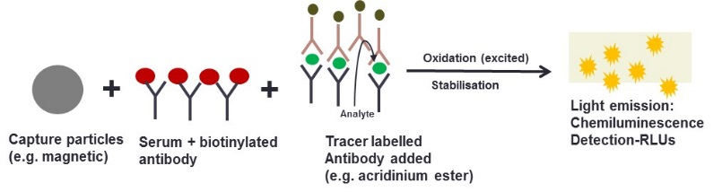
Figure 19: An overview of chemiluminescence methodology

PINP assay procedure
The intact trimeric PINP was measured in serum using the IDS-iSYS CLIA technology, (appendices 1.0: PINP kit insert). All reagents, calibrators and quality control material are supplied by the manufacturer and ready to use. The PINP reagent cartridge is mixed in order to homogenise the streptavidin labelled magnetic particles, before loading on to the analyser where mixing will continue. Once loaded all of the reagents are thermo-regulated between 12 to 15°C.
- 200µl of each calibrators, quality control samples and serum were loaded on to the analyser and diluted using a specific assay diluent (containing a preservative <1% sodium azide).
- These samples were incubated with:
  - An anti-PINP monoclonal antibody labelled with biotin in a buffer containing mouse and bovine proteins
  - An anti-PINP monoclonal antibody labelled with an acridinium ester derivative in buffer containing bovine and mouse proteins.
- A magnet captures the bound streptavidin coated magnetic particles and following a wash step Trigger reagents are added
  - Trigger A (H₂O₂) oxides the reagent and Trigger B (NaOH) stabilises it, causing photons to be released by the acridinium label.
  - The resulting light emitted and detected by the luminometer is directly proportional to the concentration of PINP in the control materials and the participants’ serum.
Prior to analysis of the test samples the two PINP calibrators were measured in triplicate and used to adjust the master standard curve. This was required to produce a 4-parameter logistic curve fit (y = (A-D)/(1+(x/C)^{B})+D) from which the PINP concentration was calculated, (Figure 20). Three quality control samples of different PINP concentrations (low, medium and high) were then each measured in duplicate and plotted on the standard curve to ensure accuracy (Figure 20).
Figure 20: IDS-iSYS PINP calibration curve (left) and with the addition of the values of the quality control materials shown in pink shapes and the acceptable RLU range for each (right)

PINP assay performance and validation
The performance of the PINP assay using the iSYS-IDS analyser has previously been validated by IDS and Koivula et al after it was launched in 2010 (196). The detection range was 2 to 230ng/ml, the limit of detection was 2.0 ng/ml and it is specific only to the trimeric form of PINP with no hook effect observed. In order to confirm that the performance of the assay is satisfactory in our laboratory environment additional validations were carried out for my thesis:

PINP assay precision:
I assessed the precision of the PINP assay in accordance with the Clinical and Laboratory Standards Institute (CLSI) guidelines (344): Evaluation of precision performance of quantitative measurement methods. I used four quality control (QC) materials of different concentrations and measured these once per day over a period of 20 days. The coefficient of variation (CV) was calculated and expressed as a percentage, (Table 2). A CV of less than or equal to 10% was acceptable.
Table 2: The inter assay precision of the IDS-iSYS PINP (ng/ml) using four different levels of QC material measured (N = 20 each)
Quality control level | Mean concentration, ng/ml/ (standard deviation) | Inter-assay CV (%)
QC 1 (low) | 18.4 (1.0) | 5.5
QC 2 (medium) | 46.8 (1.8) | 3.8
QC 3 (high) | 127.2 (8.7) | 6.8
QC 4 (In-house plasma) | 141.3 (10.2) | 7.2

PINP method comparison:
The IDS-iSYS intact PINP assay was directly compared to the total PINP assay, Elecsys 2010, Roche Diagnostics (Pensberg, Germany) in accordance with CLSI guidelines. 514 serum samples from premenopausal and postmenopausal women were used to represent a range of PINP concentrations. Intact and total PINP were measured using the IDS-iSYS and Elecsys 2010 analysers. There has been no previous data directly comparing these two methods.
Bland-Altman plot and Passing and Bablok regression analyses were used to compare the data, (Figure 21). The mean difference between the IDS-iSYS and the Elecsys 2010 was –9.6 ng/ml, p<0.001 (Mann Whitney test). The median (and standard deviation) were 39.7 (22.4) and 49.1 (22.1) ng/ml, respectively. The mean difference between the two methods was greater at high PINP concentration, greater than 100 ng/ml. The regression equation was y = -6.1 + 1.0x.
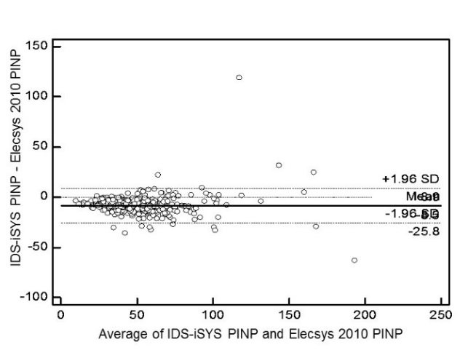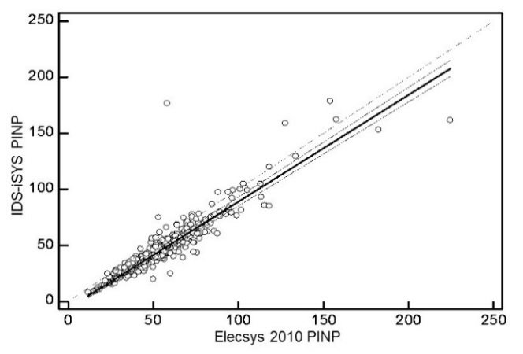
Figure 21: PINP (ng/ml) method comparison analyses using Bland-Altman (left) and Passing and Bablok regression (right)

PINP measured by the IDS-iSYS was significantly lower compared to the PINP measured by the Elecsys 2010 autoimmunassay analysers. This may be due to the difference in the methodology used i.e. sandwich CLIA using an acridinium labelled monoclonal antibody compared the two-step sandwich Electrochemical CLIA using a ruthenium labelled monoclonal antibody. The IDS-iSYS detects the trimeric fragments only of PINP whereas the Elecsys 2010 detects the trimeric and the monomeric fragments (total) of PINP. In addition renal impairment was later observed in some of these participants. Clearance of the monomeric fragment is dependent on renal function and thus making the interpretation of the total PINP difficult in this patient group because there is a non-linear effect (345)
For the remainder of my thesis I have measured the intact trimeric form of PINP using the IDS-iSYS autoimmunoassay analyser.

CTX assay procedure
CTX-I (CrossLaps®) was measured in serum using the IDS-iSYS CLIA technology, (appendices 1.1: kit insert). All reagents, calibrators and quality control material are supplied by the manufacturer and ready to use. The CTX-I reagent cartridge is mixed in order to homogenise the streptavidin labelled magnetic particles, before loading on to the analyser where mixing will continue.
- 400µl of each calibrators, quality control samples and serum were loaded on to the analyser.
- These samples were incubated with:
  - An anti-CTX monoclonal antibody labelled with biotin containing bovine and mouse proteins.
  - An anti-CTX monoclonal antibody labelled with an acridinium ester derivative in buffer containing bovine and mouse proteins.
  - Both of these antibodies are highly specific to the β conformation of the CTX fragment EKAHDGGR amino acid sequence (Figure 11).
- A magnet captures the bound streptavidin coated magnetic particles and following a wash step Trigger reagents are added
  - Trigger A (H₂O₂) oxides the reagents and Trigger B (NaOH) stabilises it, causing photons to be released by the acridinium label.
  - The resulting light emitted and detected by the luminometer is directly proportional to the concentration of osteocalcin in the control materials and the participants’ serum.
Prior to the analysis of the human serum test samples the two CTX calibrators were measured in triplicate and used to adjust the master standard curve. This was required to produce a 4-parameter logistic curve fit (y = (A-D)/(1+(x/C)^{B})+D) from which the CTX concentration was calculated, (Figure 22). Three quality control samples of different CTX concentrations (low, medium and high) were then each measured in duplicate and plotted on the standard curve to ensure accuracy, (Figure 22).
Figure 22: IDS-iSYS CTX-1 calibration curve (left) and with the addition of the values of the quality control materials shown in pink shapes and the acceptable RLU range for each (right)

CTX assay performance and validation

The performance of the CTX-I assay using the iSYS-IDS analyser has previously been validated by IDS. The detection range was 0.033 to 6.000 ng/ml, the detection limit was <0.23 and there was no hook effect observed. In order for this assay to give a signal two CTX peptides in the β conformation are required to be cross-linked. This means that newly synthesised collagen that is in the αCTX form is not detected by this assay and thus it was designed to be specific for mature type I collagen.
In order to confirm that the performance of the assay is satisfactory in our laboratory environment additional validations were carried out:

CTX assay precision
I assessed the precision of the CTX-I assay in accordance with the CLSI guidelines: Evaluation of precision performance of quantitative measurement methods, (344). I used four quality control materials of different concentrations were measured once per day over a period of 20 days. The CV was calculated and expressed as a percentage, (Table 3). A CV of less than 10% was termed acceptable.
Table 3: The inter assay precision of the IDS-iSYS CTX-1 (ng/ml) using four different levels of QC material measured (N = 20 each)
Quality control level | Mean concentration, ng/ml/ (standard deviation) | Inter-assay CV (%)
QC 1 (low) | 0.215 (0.009) | 4.2
QC 2 (medium) | 0.844 (0.038) | 4.5
QC 3 (high) | 2.132 (0.125) | 5.9
QC 4 (In-house plasma) | 0.265 (0.163) | 6.2

CTX method comparison
The IDS-iSYS CTX-1 assay was directly compared to the CTX assay, Elecsys 2010, Roche Diagnostics (Pensberg, Germany) in accordance with ‘CLSI guidelines: Method comparison and bias estimation using patient samples’, (344). 511 serum samples from premenopausal and postmenopausal women were used to represent a range of CTX concentrations. CTX was measured using the IDS-iSYS and Elecsys 2010 analysers. There has been no previous data directly comparing these two methods.
Bland-Altman plot and Passing and Bablok regression analyses were used to compare the data, (Figure 23). The mean difference between the IDS-iSYS and the Elecsys 2010 was 0.130 ng/ml. The median (and standard deviation) were 0.320 (0.305) and 0.210 (0.212) ng/ml, respectively (p<0.001). The regression equation was y = 0.040 + 1.307x.
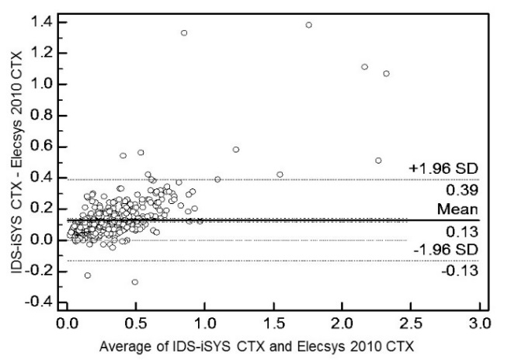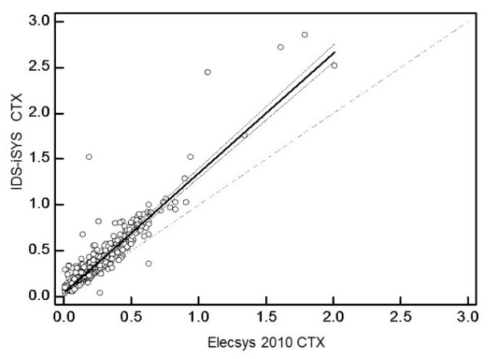
Figure 23: CTX method comparison analyses using Bland-Altman (left) and Passing and Bablok regression (right)

CTX measured by the IDS-iSYS gave a significantly higher results compared to the Elecsys 2010 Roche method. Similar findings were demonstrated by Eastell R et al 2012, when CTX measured by a manual assay was compared to the Elecsys 2010 Roche method (346). These findings will contribute to the harmonisation of these methods.
For the remainder of my thesis I have measured the CTX-I using the IDS-iSYS autoimmunoassay analyser.

Osteocalcin assay procedure
N-Mid osteocalcin was measured in serum using the IDS-iSYS CLIA technology, (appendices 1.2: kit insert). All reagents, calibrators and quality control material are supplied by the manufacturer and ready to use. The osteocalcin reagent cartridge is mixed in order to homogenise the streptavidin labelled magnetic particles, before loading on to the analyser where mixing will continue.
- 300µl of each calibrators, quality control samples and serum were loaded on to the analyser.
- These samples were incubated with:
  - An anti-osteocalcin monoclonal capture antibody in buffer containing bovine and mouse serum, this recognises and binds to the mid-region (amino acids 20 to 29)
  - An anti-osteocalcin labelled with an acridium ester derivative detection antibody, this recognises the N-terminal region (amino acids 10 to 16).
- A magnet captures the bound streptavidin coated magnetic particles and following a wash step Trigger reagents are added
  - Trigger A (H₂O₂) oxides the reaction and Trigger B (NaOH) stabilises it, causing photons to be released by the acridinium label.
  - The resulting light emitted and detected by the luminometer is directly proportional to the concentration of osteocalcin in the control materials and the participants’ serum.
Prior to the analysis of the human serum test samples the two osteocalcin calibrators were measured in triplicate and used to adjust the master standard curve. This was required to produce a 4-parameter logistic curve fit (y = (A-D)/(1+(x/C)^{B})+D) from which the osteocalcin concentration was calculated, (Figure 26). Three quality control samples of different osteocalcin concentrations (low, medium and high) were then each measured in duplicate and plotted on the standard curve to ensure accuracy (Figure 24).
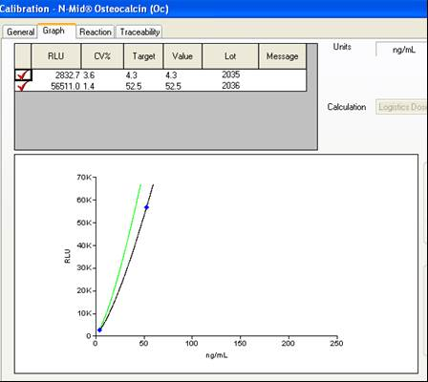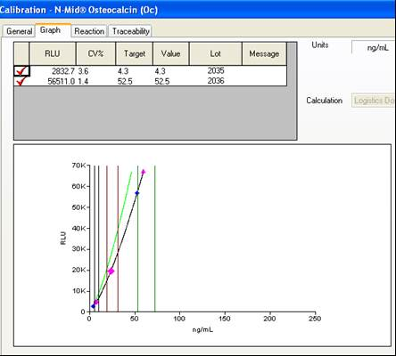
Figure 24: IDS-iSYS N-Mid® osteocalcin calibration curve (left) and with the addition of the values of the quality control materials shown in pink shapes and the acceptable RLU range for each (right)

Osteocalcin assay performance and validation
The performance of the N-Mid osteocalcin assay using the iSYS-IDS analyser has previously been validated by IDS. The detection range was between 2.0 to 200 ng/ml, the lower limit of detection was 0.27 ng/m.
In order to confirm that the performance of the assay is satisfactory in our laboratory environment, additional validations were carried out:

Osteocalcin assay precision
The precision of the N-Mid osteocalcin assay was assessed in accordance with the CLSI: Evaluation of precision performance of quantitative measurement methods. Four quality control materials of different concentrations were measured once per day over a period of 20 days. The CV was calculated and expressed as a percentage, (Table 4). A CV of less than 10% was termed acceptable.
Table 4: The inter assay precision of the IDS-iSYS N-Mid osteocalcin (ng/ml) using four different levels of QC material measured (N = 20 each).
Quality control level | Mean concentration, ng/ml/ (standard deviation) | Inter-assay CV (%)
QC 1 (low) | 7.60 (0.34) | 4.4
QC 2 (medium) | 23.96 (1.05) | 4.4
QC 3 (high) | 59.86 (3.11) | 5.2
QC 4 (In-house plasma) | 18.5 (0.3) | 1.6

Osteocalcin method comparison
The IDS-iSYS osteocalcin assay was directly compared to the osteocalcin assay, Elecsys 2010, Roche Diagnostics (Pensberg, Germany in accordance with ‘CLSI guidelines: Method comparison and bias estimation using patient samples’, (344). 110 serum samples from premenopausal and postmenopausal women with osteoporosis were used to represent a range of osteocalcin concentrations. Osteocalcin was measured using the IDS-iSYS and Elecsys 2010 analysers. There has been no previous data directly comparing these two methods.
Bland-Altman plot and Passing and Bablok regression analyses were used to compare the data, (Figure 25). The mean difference between the IDS-iSYS and the Elecsys 2010 was 1.7 ng/ml. The median (and standard deviation) were 24.4 (10.2) and 23.4 (8.0) ng/ml, respectively. The regression equation was y = -3.8 + 1.2x.
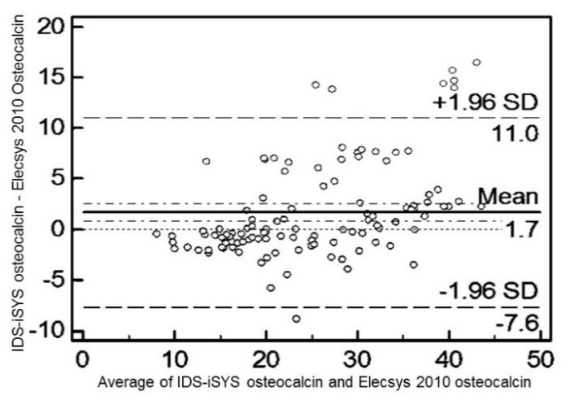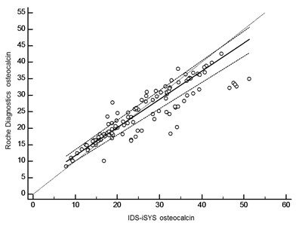
Figure 25: Osteocalcin method comparison analyses using Bland-Altman (left) and Passing and Bablok regression (right)

There was no significant difference between the values of osteocalcin measured by the IDS-iSYS gave compared to the Elecsys 2010 Roche Diagnostics method.
With the exception of the samples from the OPUS study (measured using ECLIA technology), for the remainder of my thesis I have measured the osteocalcin using the IDS-iSYS autoimmunoassay analyser.

Bone ALP assay procedure
Bone alp (Ostase® BAP) activity was measured in serum using the IDS-iSYS spectrophotometric technology, (appendices 1.3: kit insert). All reagents, calibrators and quality control material are supplied by the manufacturer and ready to use. The Ostase® BAP reagent cartridge was mixed in order to homogenise the streptavidin labelled magnetic particles, before loading on to the analyser where mixing will continue.
- 325 µl of each calibrators, quality control samples and serum were loaded on to the analyser.
- These samples were firstly incubated with a biotin labelled bone alp-specific monoclonal antibody in buffer containing horse serum and bovine and mouse proteins.
- Then secondly incubated with the streptavidin labelled magnetic particles and washed to remove the unbound bone alp.
- A p-nitrophenyl enzyme labelled substrate was then added.
- The absorbance of substrate bound was measured by the spectrophotometer. The absorbance signal is proportional to the concentration of bone alp present in the serum.
Prior to the analysis of the human serum test samples the two bone alp calibrators were measured in triplicate and used to adjust the master standard curve. This was required to produce a 4-parameter logistic curve fit (y = (A-D)/(1+(x/C)^{B})+D) from which the bone alp concentration was calculated, (Figure 26). Three quality control samples of different bone alp concentrations (low, medium and high) were then each measured in duplicate and plotted on the standard curve to ensure accuracy, (Figure 29).
Figure 26: IDS-Isys Ostase® BAP calibration curve (left) and with the addition of the values of the quality control materials shown in pink shapes and the acceptable absorbance range for each (right)

Bone ALP assay performance and validation
The performance of the Ostase® BAP assay using the iSYS-IDS analyser has previously been validated by IDS. The detection range was 1.0 to 75.0 ng/ml, the detection limit was 0.4 ng/m. The assay is specific for bone but there is approximately 20% cross-reactivity with the liver isoform, (347).
In order to confirm that the performance of the assay is satisfactory in our laboratory environment, additional validations were carried out:

Bone ALP assay precision
The precision of the Ostase® BAP assay was assessed in accordance with the CLSI guidelines: Evaluation of precision performance of quantitative measurement methods, (344). Four quality control materials of different concentrations were measured once per day over a period of 20 days. The CV was calculated and expressed as a percentage, (Table 5). A CV of less than 10% was termed acceptable.
Table 5: The inter assay precision of the IDS-iSYS Ostase® BAP using four different levels of QC material measured (N = 20 each)
Quality control level | Mean concentration, ng/ml/ (standard deviation) | Inter-assay CV (%)
QC 1 (low) | 4.14 (0.15) | 3.6
QC 2 (medium) | 13.03 (0.37) | 2.8
QC 3 (high) | 43.2 (1.31) | 3.1
QC 4 (In-house plasma) | 21.2 (1.23) | 5.9

Bone ALP method comparison
The IDS-iSYS Ostase® BAP assay was directly compared to the Access Ostase® assay, Beckman Coulter (High Wycombe, UK) in accordance with ‘CLSI EP-9A2: Method comparison and bias estimation using patient samples’, (344). 45 serum samples from premenopausal and postmenopausal women were used to represent a range of bone ALP concentrations. Bone ALP was measured using the IDS-iSYS and the Access immunoassay analysers.
Bland-Altman plot and Passing and Bablok regression analyses were used to compare the data, (Figure 27). The mean difference between the IDS-iSYS and the Access® was 2.1 ng/ml. The median (and standard deviation) were 14.6 (4.5) and 12.8 (4.3) ng/ml, respectively (p<0.05). The regression equation was y = 0.50 + 0.88x.
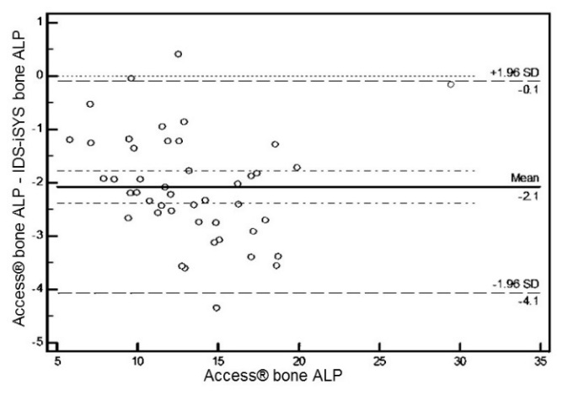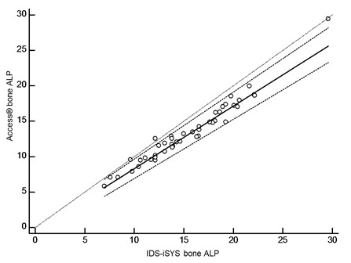
Figure 27: Bone ALP method comparison analyses using Bland-Altman (left) and Passing and Bablok regression (right)

Bone ALP measured by the IDS-iSYS gave a significantly higher results compared to the Access® Beckman Coulter method. Although these two assays use the same anti-BAP monoclonal antibody in their respective reactions, there is a difference in the methodology used. The Access® uses CLIA technology and the IDS-iSYS uses spectrophotometric technology and this may contribute to the difference in the results.
For the remainder of my thesis I have measured bone ALP using the IDS-iSYS autoimmunoassay analyser.

Competitive immunoassay: NTX
NTX was measured in urine using the Vitros ECi automated immunoassay assay analyser (Ortho Clinical Diagnositics (OCD), High Wycombe, UK) (appendices 1.5: kit insert). All reagents, calibrators and quality control material are supplied by the manufacturer and ready to use. The reagent pack consists of 100 wells each coated with a synthetic NTX peptide. It uses the principles of a competitive immunoassay. The NTX present in the urine sample competes for binding sites on the anti-NTX monoclonal antibody. All of the reagents, calibrators and QC materials are provided by the manufacturer ready for and are loaded on the analyser.
- 250 µl of each calibrators, quality control samples and second morning void urine sample were pipetted in to the sample cups, placed in the sample trays and loaded on to the analyser.
- These samples were firstly incubated in reaction vessels coated with a synthetic NTX peptide. These compete for binding sites on a horse-radish peroxidase (HRP)-labelled mouse monoclonal anti-NTX antibody conjugate.
- The NTX-bound HRP conjugate is captured by the by the synthetic NTX peptide bound to the wells.
- A reagent containing luminogenic substrates and an agent capable of electron transfer was added.
- The HRP in the NTX-bound conjugate catalyses the oxidation reaction of the luminol derivative. Light was emitted and measured by the luminometer on the analyser.
- A 4-parameter logistic curve fit (y = (A-D)/(1+(x/C)^{B})+D) master curve was re-scaled using the calibrators and stored on the analysers software.
- The amount of NTX-bound HRP conjugate was inversely proportional to the concentration of the NTX in the urine sample.

NTX assay performance and validation
The technical performance of the Vitros NTX assay using the Vitros ECi analyser has previously been validated by OCD. The detection range was 0 to 3000 nM BCE (bone collagen equivalents), the sensitivity was less than 10nM BCE. The specificity of the HRP-labelled mouse monoclonal anti-NTX antibody conjugate to collagen has previously been reported, (348). This is the only method of measuring NTX in urine I investigated and therefore did not perform method comparison analysis. However OCD have previously reported that the correlation coefficient between their NTX assay and the Osteomark® NTX assay was 0.977.
In order to confirm that the performance of the assay is satisfactory in our laboratory environment, additional validations were carried out:

NTX assay precision
The precision of the Vitros NTX assay was assessed in accordance with the CLSI EP-5A2: Evaluation of precision performance of quantitative measurement methods. Three quality control materials of different concentrations were measured once per day over a period of 20 days. The CV was calculated and expressed as a percentage, Table 6. A CV of less than 10% was termed acceptable.
Table 6: The inter assay precision of the OCD Vitros NTX assay using three different levels of QC material measured (N = 20 each)
Quality control level | Mean concentration nM BCE (standard deviation) | Inter-assay CV (%)
QC 1 (low) | 100.4 (5.3) | 5.3
QC 2 (medium) | 383.9 (16.1) | 4.2
QC 3 (high) | 1166.8 (52.8) | 4.5
QC 4 (In-house urine) | 106.5 (6.1) | 5.7

Dry slide method: Creatinine
Creatinine is a molecule made up from arginine, glycine and methionine synthesised by the kidneys and transported to the liver (349). Creatinine is a product of creatine phosphate degradation. It is excreted via glomerular filtration by the kidney and is detected in the urine. NTX was expressed as a ratio to creatinine.
Creatinine was measure in urine using using the Vitros 250 automated immunoassay assay analyser (Ortho Clinical Diagnositics (OCD), High Wycombe, UK) (appendix 1.6: kit insert). This method uses layered dry slides each coated with an element which allows the concentration of creatinine to be quantitatively determined:
- 20µl of urine is placed on the slide and is evenly distributed to each layer. The slide is incubated for 5 minutes.
- The reaction takes place in the middle reagent layer:
  - The creatinine is firstly hydrolysed in the presence of creatinine amidohydrolase
  - Creatinine is converted in to sarcosine and urea in the presence of creatinine amidohydrolase
  - Sacrosine is converted in to glycine, formaldehyde and hydrogen peroxide in the presence of sarcosine oxidase
  - Hydrogen peroxidase catalyses the oxidation of a leuco dye producing a coloured product that is proportional to the creatinine concentration in the urine sample.

Creatinine assay performance and validation
The technical performance of the Vitros Creatinine assay using the Vitros 250 analyser has previously been validated by OCD. The detection range was 107 to 30639µmol/L. This is the only method of measuring creatinine in urine I have investigated and therefore did not perform method comparison analysis. However OCD have previously reported that the correlation coefficient between their creatinine assay and a HPLC method was 1.0 (350) .
In order to confirm that the performance of the assay is satisfactory in our laboratory environment, additional validations were carried out:

Creatinine assay precision
The precision of the Vitros creatinine assay was assessed in accordance with the CLSI EP-5A2: Evaluation of precision performance of quantitative measurement methods, (344). Two quality control materials of different concentrations were measured once per day over a period of 20 days. The CV was calculated and expressed as a percentage, Table 7. A CV of less than 10% was termed acceptable
Table 7: The inter assay precision of the OCD Vitros creatinine assay using three different levels of QC material measured (N = 20 each)
Quality control level | Mean concentration µmol/L (standard deviation) | Inter-assay CV (%)
QC 1 (low) | 85.9 (6.6) | 7.7
QC 2 (high) | 491.8 (13.5) | 2.8
QC 3 (In-house urine) | 2787.2 (85.3) | 3.1

Enzyme immunoassay: Sclerostin
Sclerostin was measured in serum using a 96-well plate direct-capture enzyme immunoassay from TECOmedical Group (Sissach, Switzerland), (Figure 29), (appendices 1.4: kit insert).
- 400µl of wash solution (phosphate buffered saline, 1.0% Tween-20 and 0,035 % proclin 300) was added to each of the 96-wells of the microsassay plate. The wells were precoated with streptavidin and a biotin-conjugated primary polyclonal anti-human sclerostin antibody.
- Following a 2 minute incubation and a second wash with the wash solution, 25µl of standards, controls or serum were added to each well. Each of these were added in duplicate wells to assess precision and accuracy.
- 50µl of matrix solution containing protein stabilisers and 50µl of horseradish peroxidase (HRP)-conjugated monoclonal anit-humna sclerostin antibody were added to each well.
- Following a four hour incubation at room temperature, 100µl of substrate containing tetramethylbenzidine and hydrogen peroxidase was added.
- 100µl of 4% hydrochloric acid was added to each well to stop the reaction.
- The optical density was measured using (name of plate reader) at 450nm, (Figure 35).
- A 4-parameter logistic curve fit (y = (A-D)/(1+(x/C)^{B})+D) was drawn using the standards (Table 8 and Figure 30 ) and the concentration of sclerostin in the serum was calculated, (Table 9).

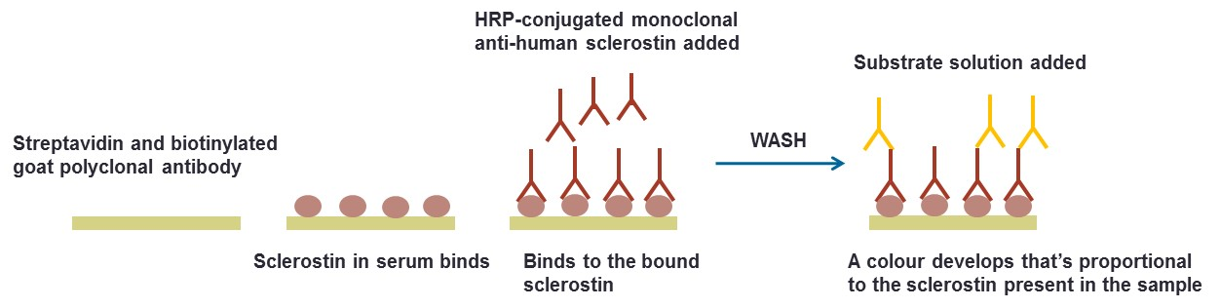
Figure 28: An overview of the direct-capture ELISA used to quantify levels of circulating sclerostin
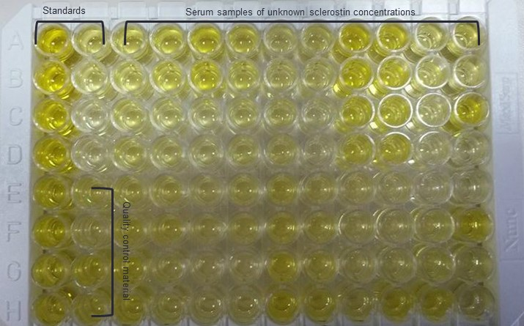
Figure 29: An example of a 96-well plate ELISA set up showing the colour develpoment of the standards, QC material and subject samples

Table 8: The absorbance value and sclerostin concentration of the standards. Each standard was measured in duplicate allowing precision to be assessed using the coefficient of variation ((CV (%)).
Well ID | Well | Expected sclerostin conc, ng/ml | Absorbance, 450nm | Sclerostin conc, ng/ml | Mean conc, ng/ml | Standard devaiation | CV (%)
STD1 | A1 | 0 | 0.016 | 0 | 0 | 0 | ?????
 | B1 | 0 | 0.015 | 0
STD2 | C1 | 0.05 | 0.049 | 0.056 | 0.058 | 0.003 | 5.074
 | D1 | 0.05 | 0.051 | 0.061
STD3 | E1 | 0.2 | 0.166 | 0.228 | 0.23 | 0.002 | 0.741
 | F1 | 0.2 | 0.168 | 0.231
STD4 | G1 | 0.5 | 0.41 | 0.487 | 0.484 | 0.005 | 1.008
 | H1 | 0.5 | 0.403 | 0.481
STD5 | A2 | 1.5 | 1.396 | 1.493 | 1.506 | 0.018 | 1.227
 | B2 | 1.5 | 1.418 | 1.519
STD6 | C2 | 3 | 2.311 | 2.959 | 2.997 | 0.054 | 1.796
 | D2 | 3 | 2.344 | 3.035

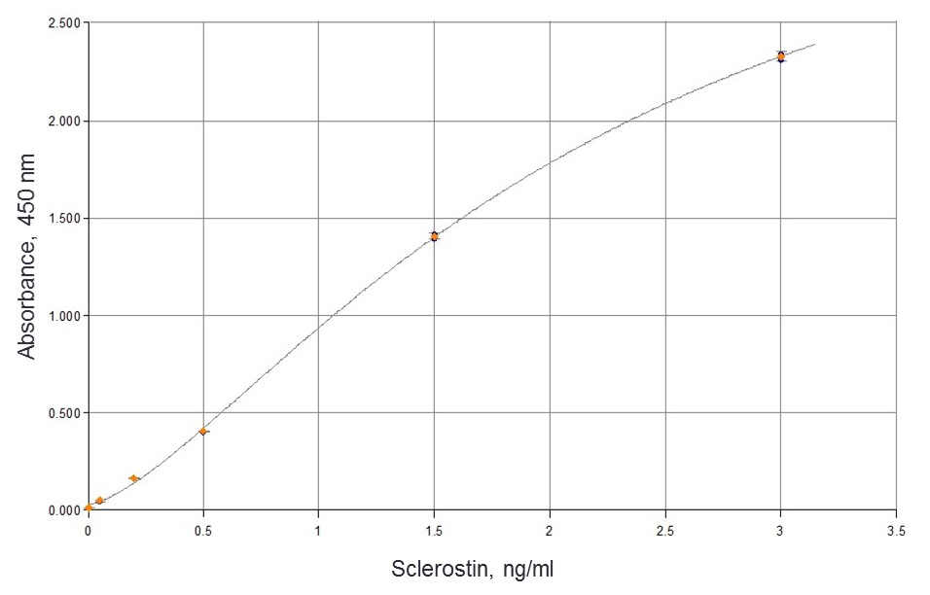
Figure 30: An example of a 4-parametre logistic standard curve produced from the data in table 6

Table 9: The absorbance values and sclerostin concentrations in subjects (SPL1-SPL36) from one 96-well plae ELISA. Serum from each subject was measured in duplicate allowing precision to be assessed using the CV (%).
Sample ID | Well | Absorbance, 450 nm | Sclerostin conc, ng/ml | Mean sclerosin conc, ng/ml | Standard devaiation | CV (%)
SPL1 | C3 | 0.402 | 0.467 | 0.467 | 0.001 | 0.289
 | D3 | 0.404 | 0.468
SPL2 | E3 | 0.421 | 0.485 | 0.483 | 0.002 | 0.417
 | F3 | 0.418 | 0.482
SPL3 | G3 | 0.442 | 0.505 | 0.506 | 0.003 | 0.527
 | H3 | 0.446 | 0.508
SPL4 | A4 | 0.385 | 0.45 | 0.446 | 0.005 | 1.222
 | B4 | 0.377 | 0.443
SPL5 | C4 | 0.395 | 0.46 | 0.457 | 0.004 | 0.891
 | D4 | 0.389 | 0.454
SPL6 | E4 | 0.412 | 0.476 | 0.475 | 0.002 | 0.426
 | F4 | 0.409 | 0.473
SPL7 | G4 | 0.435 | 0.498 | 0.494 | 0.005 | 1.085
 | H4 | 0.427 | 0.49
SPL8 | A5 | 0.405 | 0.469 | 0.465 | 0.006 | 1.309
 | B5 | 0.396 | 0.461
SPL9 | C5 | 0.429 | 0.492 | 0.491 | 0.002 | 0.41
 | D5 | 0.426 | 0.489
SPL10 | E5 | 0.385 | 0.45 | 0.452 | 0.003 | 0.602
 | F5 | 0.389 | 0.454
SPL11 | G5 | 0.376 | 0.442 | 0.446 | 0.006 | 1.376
 | H5 | 0.385 | 0.45
SPL12 | A6 | 0.451 | 0.513 | 0.518 | 0.007 | 1.413
 | B6 | 0.462 | 0.523
SPL13 | C6 | 0.402 | 0.467 | 0.464 | 0.003 | 0.729
 | D6 | 0.397 | 0.462
SPL14 | E6 | 0.47 | 0.531 | 0.53 | 0.001 | 0.125
 | F6 | 0.469 | 0.53
SPL15 | G6 | 0.393 | 0.458 | 0.462 | 0.005 | 1.174
 | H6 | 0.401 | 0.466
SPL16 | A7 | 0.451 | 0.513 | 0.513 | 0.001 | 0.13
 | B7 | 0.45 | 0.512
SPL17 | C7 | 0.473 | 0.534 | 0.53 | 0.006 | 1.128
 | D7 | 0.464 | 0.525
SPL18 | E7 | 0.414 | 0.478 | 0.476 | 0.003 | 0.709
 | F7 | 0.409 | 0.473
SPL19 | G7 | 0.445 | 0.507 | 0.509 | 0.002 | 0.393
 | H7 | 0.448 | 0.51
SPL20 | A8 | 0.502 | 0.561 | 0.561 | 0 | 0
 | B8 | 0.502 | 0.561
SPL21 | C8 | 0.468 | 0.529 | 0.522 | 0.009 | 1.782
 | D8 | 0.454 | 0.516
SPL22 | E8 | 0.462 | 0.523 | 0.519 | 0.006 | 1.154
 | F8 | 0.453 | 0.515
SPL23 | G8 | 0.495 | 0.554 | 0.562 | 0.011 | 1.879
 | H8 | 0.511 | 0.569
SPL24 | A9 | 0.462 | 0.523 | 0.524 | 0.001 | 0.127
 | B9 | 0.463 | 0.524
SPL25 | C9 | 0.433 | 0.496 | 0.495 | 0.002 | 0.406
 | D9 | 0.43 | 0.493
SPL26 | E9 | 0.507 | 0.566 | 0.561 | 0.006 | 1.058
 | F9 | 0.498 | 0.557
SPL27 | G9 | 0.479 | 0.539 | 0.54 | 0.001 | 0.245
 | H9 | 0.481 | 0.541
SPL28 | A10 | 0.741 | 0.783 | 0.778 | 0.007 | 0.847
 | B10 | 0.731 | 0.773
SPL29 | C10 | 0.639 | 0.688 | 0.685 | 0.004 | 0.573
 | D10 | 0.633 | 0.682
SPL30 | E10 | 0.749 | 0.79 | 0.792 | 0.003 | 0.333
 | F10 | 0.753 | 0.794
SPL31 | G10 | 0.648 | 0.696 | 0.695 | 0.002 | 0.283
 | H10 | 0.645 | 0.693
SPL32 | A11 | 0.647 | 0.695 | 0.69 | 0.007 | 1.043
 | B11 | 0.636 | 0.685
SPL33 | C11 | 0.63 | 0.68 | 0.679 | 0.001 | 0.193
 | D11 | 0.628 | 0.678
SPL34 | E11 | 0.644 | 0.693 | 0.694 | 0.003 | 0.377
 | F11 | 0.648 | 0.696
SPL35 | G11 | 0.717 | 0.76 | 0.757 | 0.005 | 0.695
 | H11 | 0.709 | 0.753
SPL36 | A12 | 0.635 | 0.684 | 0.688 | 0.005 | 0.761
 | B12 | 0.643 | 0.692

Sclerostin assay performance and validation
The performance of the sclerostin TECO® ELISA has previously been validated by TECOmedical Group and more recently by Costa AG et al, (351). The detection range was 0.008 to 3.34 ng/ml and the lower limit of detection was 0.008 ng/ml. With regards to the stability of sclerostin TECOmedical Group reported that it was stable in serum stored at -80°C for greater than 2 years. However, I was unable to assess this myself (as for the BTMs) because I measured sclerostin at one time over a period three months only.
In order to confirm that the performance of the satisfactory in our laboratory environment I carried out additional validations:

Sclerostin assay precision
I assessed the precision of the sclerostin assay in accordance with the CLSI EP-5A2: Evaluation of precision performance of quantitative measurement methods, (344). I used three quality control materials of different concentrations and measured these once per day over a period of 20 days. The CV (%) was calculated and expressed as a percentage, (Table 10). A CV of less than or equal to 10% was acceptable.
Table 10: The inter assay precision of the TECOmedical Group sclerostin assay using three different levels of QC material measured (N = 20 each)
Quality control level | Mean concentration, ng/ml/ (standard deviation) | Inter-assay CV (%)
QC 1 (low) | 0.21 (0.00) | 3.4
QC 2 (medium) | 1.90 (0.04) | 2.0
QC 3 (In-house plasma) | 0.22 (0.02) | 7.0

Sclerostin method comparison:
The TECOmedical sclerostin assay was directly compared to the Biomedica Gruppe sclerostin assay in accordance with ‘CLSI EP-9A2: Method comparison and bias estimation using patient samples’, (344). 128 serum samples obtained from postmenopausal women were used to represent a range of sclerostin concentrations. Sclerostin was measured using the TECOmedical and the Biomedica ELISAs.
The results for all of the sclerostin measured were reported as ng/ml. Biomedica sclerostin was initially measured in pmol/L which was then converted to ng/ml by dividing by the conversion factor, 44 (molecular weight of sclerostin is 22.5 kD). Bland-Altman plot and Passing and Bablok regression analyses were used to compare the data, (Figure 31). The mean difference between the TECOmedical and Biomedica sclerostin was 0.11 ng/ml and this was significant, p<0.001 (Mann Whitney test). The median (and standard deviation) were 0.546 (0.105) and 0.459 (0.121) ng/ml, respectively. The regression equation was y = 0.176 + 0.833x.
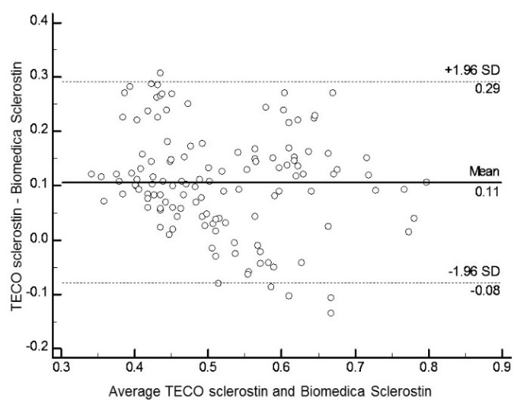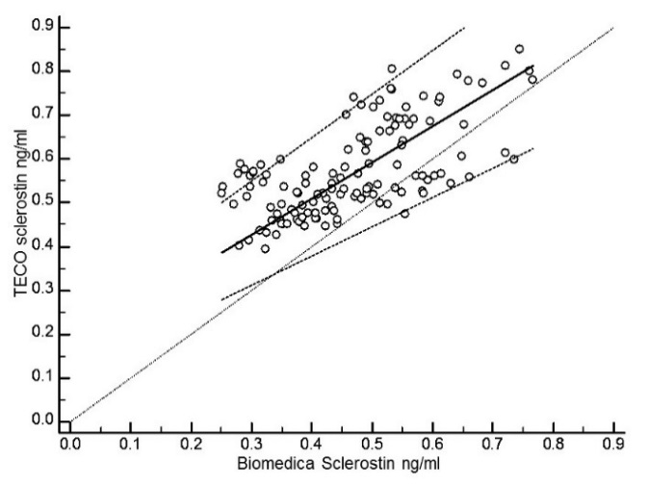
Figure 31: Sclerostin method comparision analyses using Bland-Altman (left) and Passing and Bablok regression (right)

Sclerostin measured by the TECOmedical Group ELISA was significant higher than that measured by the Biomedica Gruppe ELISA. This difference was comparable Costa AG et al 2014 (351) but different to others (352, 353). The differences between the two assays may be attributable to the differences in the assay procedure, different molecular forms of the assay and cross reactivity.
For the remainder of my thesis I have measured sclerostin using the TECOmedical Group ELISA.

Reducing the variability associated with BTMs

Sources of preanalytical and analytical variability
Several biological factors coexist and contribute to the preanalytical variability of BTMs (354). Some of these were controlled and modified to reduce variability observed particularly in one person over a period of time. Factors such as age, gender, ethnicity, menopausal status, circadian rhythm, food intake, menstruation and physical activity can be a source of biological variability. A large circadian rhythm has been related with bone turnover and has a significant impact particularly on bone resorption markers (355, 356). All of the BTMs in my research are significantly reduced following food intake (with the possible exception of bone ALP) (357, 358). In order to minimise the effect this variability has on BTMs, samples from the two clinical trials used in my thesis were collected following an overnight fast.
For each BTM measurement, analytical variability was assessed by the inter-assay coefficient of variation (359) and were considered and controlled throughout my research, (Table 11). With the exception of sclerostin all other biochemical tests were measured using fully automated immunoassay analysers. Trained technical experts using these analysers ensured precise measurements of the BTMs throughout the thesis. The sclerostin manual assays were subject to greater variability than the BTMs due to operator error.
Table 11: Sources of variability and how their effects on BTMs were controlled/monitored in the thesis
Sources of variability | How variability was controlled/effect minimised
Preanalytical variability  Circadian rhythm  Food intake  Gender  Ethnicity  Menopausal status  Recent fractures (clinical trials only)  Diseases characterised by altered bone turnover (clinical trials only)  Medications known to effect bone remodelling (clinical trials only) | Samples taken between 0800 to 1000 (exception OPUS)  Samples taken following an overnight fast (OPUS non-fasting  All subjects were postmenopausal or premenopausal  All subjects were Caucasian  Older women were ≥ 5 years postmenopausal  Subjects who fractured within 12 months prior to recruitment were not included  e.g. Primary hyperparathyroidism, Cushing’s disease and hypoparathyroidism were not included  Subjects who were receiving these were not included
Analytical variability  Sample storage  BTM and sclerostin measurements  BTM Quality Control (QC) | Stored at -80°C until time of measurement  Each analyte within a study was measured using assays from the same lot number.  The analyte for each study were measured over the same time period  All analytes were measured using automated immunoassay analysers in the same laboratory  Sclerostin was measured in duplicates to monitor precision  QC assessment was performed and monitored for each analyte each day of measurements  PINP, CTX, bone ALP and NTX/Cr were measured and monitored as part of the UK NEQAS quality control scheme.

Conclusion for BTMs assays
All of the BTMs and other biochemical tests described in my thesis were collected, handled, stored and measured in the serum and in this manner. It has previously been recommended that, in particular CTX should be measured in EDTA plasma after rapid centrifugation and immediate analysis or freezing, in order to avoid degradation (360). However these and previous stability studies performed by Rosenquist et al 1998 and Okabe et al 2001, have demonstrated that there was a 14% decrease in serum CTX when stored at room temperature for 24 hours but remains stable after long term storage at -80°C and after several free-thaw cycles(361, 362). This is an important observation for the studies and clinical trials I have used in my thesis because the BTMs were measured in serum retrospectively following long term storage at -80°C
Differences in methodologies used for measuring PINP and CTX (and other BTMs and hormones) necessitates the need for method-specific premenopausal and postmenopausal reference intervals to accurately interpret clinical trial and clinical data sets. These methodological findings may contribute to the standardisation and harmonisation of these methods in observation and intervention studies, as proposed by the IOF and IFCC (319). The difference between methods for measuring BTMs may be the reason why there are some differences in the reference intervals previously determined.

Chapter 3: Normative data for biochemical markers of bone turnover

PUBLISHED PAPER: Ownership of copyrights with the authors
Bonekey Rep. 2014 Sep 3;3:573. doi: 10.1038/bonekey.2014.68. eCollection 2014. Establishing reference intervals for bone turnover markers in healthy postmenopausal women in a non-fasting state.
Gossiel F, Finigan J, Jacques R, Reid D, Felsenberg D, Roux C, Glueer C, Eastell R.

Introduction
Bone remodelling can be assessed non-invasively by the measurement of serum and urinary BTMs. BTMs may be increased in metabolic bone diseases such as osteoporosis where there is accelerated bone loss (363). In some studies, high BTMs are associated with major osteoporotic fractures, for example bone resorption markers were predictive of hip fracture ((Epidemiologie de l’Osteoporose (EPIDOS study)) (364) and with bone loss (340, 365).
Several BTM reference intervals for healthy premenopausal women have previously been established (346, 366-368). It has been proposed that the purpose of these is to monitor the response of osteoporotic patients to treatments. The proposed goal of anti-resorptive treatments is to reduce BTMs to the lower part of the healthy premenopausal reference interval (310). It is therefore essential to have a valid and robust reference interval.
BTM reference intervals for healthy postmenopausal women would also be useful. They may help clinicians to identify patients who may have secondary osteoporosis. There are increased levels of BTMs in osteomalacia, Paget’s disease, primary hyperparathyroidism, thyrotoxicosis and multiple myeloma and low levels of osteocalcin in glucocorticoid-induced osteoporosis. However, healthy levels of BTMs are difficult to establish because older women commonly suffer from disease or take medications that are known to affect bone metabolism and therefore there are limited data (369). It has been demonstrated that severe vitamin D deficiency as defined by 25 hydroxy vitamin D (25(OH)D) serum levels below 12.5 nmol/L causes osteomalacia in adults (370-372). This is associated with hypocalcaemia, impaired mineralisation of bone, accelerated bone loss, lower BMD and increased bone turnover (373). Vitamin D insufficiency as defined by 25 (OH) D levels between 30 and 50 nmol/L is associated with an increase in parathyroid hormone (PTH) levels which is attributed to the decreased calcium absorption. This may indicate secondary hyperparathyroidism in postmenopausal women (374, 375)
Chronic kidney disease is also associated with abnormal bone remodelling causing disorders such as osteitis fibrosa cystica characterised by high bone turnover. Previous studies have reported elevated bone turnover markers in patients with renal failure, due to high bone turnover and reduced rate of excretion of BTMs (376, 377).
Osteoporotic postmenopausal women may be treated with antiresorptive therapies and these have a significant reduction on bone remodelling and impaired catabolism. The reduction in bone turnover markers can be used to assess their bone effect. These reductions are associated with increased bone mass and fracture risk reduction. For example, a 3-year trial of risedronate demonstrated a significant association between a reduction in vertebral fracture risk and decreased levels of bone resorption markers, and increased BMD (310). Several other studies have shown that a greater short-term decrease in BTMs is associated with a higher increase in BMD long term, and a greater reduction in fracture risk (278, 316, 378)
The usual approach to establish reference intervals is to define exclusion criteria. We have taken a different approach; we have measured BTMs in the whole population and examined whether the exclusion criteria are valid.
Comparisons between BTM reference intervals for healthy postmenopausal and premenopausal women can also be performed. This has previously been done in a fasting state. However patients are usually in a non-fasting state at the time of their clinical visit. Therefore non-fasting BTM reference intervals may be more relevant in a clinical practice.
The aims of this work were 1) to identify diseases and drugs that have a substantial effect on bone turnover markers so that they can be used as exclusion criteria; 2) to establish reference intervals for premenopausal and postmenopausal women, in a non-fasting state and determine whether they are different; 3) examine the effects of life style and geographical differences on bone turnover markers in healthy postmenopausal women.

Subjects and Methods

Subjects
For this analysis the subjects studied were from the Osteoporosis and Ultrasound (OPUS) study. The OPUS was a population based study involving five European centres namely Aberdeen (UK), Berlin (Germany), Kiel (Germany), Paris (France) and Sheffield (UK). During April 1999 and April 2001 subjects were randomly selected from government provided registers, population health registers and general practices. The overall aim of the study was to assess quantitative ultrasound methods and their association with prevalent vertebral fractures and compare these to bone mineral density. The baseline visit involved several examinations including ultrasound measurements, blood and urine collections, bone mineral density using DXA, radiography assessments and questionnaires (341). The study was co-ordinated by the “Medizinische Physik” in Kiel. All investigations were conducted in accordance with the Declaration of Helsinki and ethical approval was obtained from the local ethics committees and written informed consent was obtained from each subject.
For this work I used 2419 which was the entire population of older women aged 55 to 80 years and 258 younger women aged 30 to 39 years from the OPUS study population. A modified version of the European Vertebral Osteoporosis Study (EVOS) risk factor questionnaire (379) was administered to each subject at baseline and 6 years later. The questionnaire collected information on possible confounding factors. From this I was able to use the medical history of diseases and treatments, subjects were classified as smokers if they were current smokers and alcohol intake was recorded as number of units per week. BMD was measured at the spine and total hip using DXA. Further details regarding clinical features of the subjects have been published, (Appendices 2), (380).

Laboratory methods
From the non-fasting venous blood samples collected at baseline, CTX, intact PINP, bone ALP and 25 OH D were measured in serum using the IDS-iSYS automated immunoassays (Immunodiagnostic Systems, Boldon, United Kingdom). The inter assay coefficients of variation (CV) were 6.5%, 7.2%, 3.5% and 6.7% respectively. N-Mid osteocalcin was measured in serum using the Elecsys 2010 automated immunoassay (Roche Diagnostics, Germany). The inter assay CV was 6.3%. NTX was measured using the Ortho Clinical Diagnostics automated immunoassay (High Wycombe, United Kingdom). The inter assay CV was 6.4%. NTX was expressed as a ratio to creatinine and the inter assay CV for creatinine was 1.8%. These methods have been described in more detail in chapter 2.
Serum creatinine was measured using the Cobas c 311 automated analyser (Roche Diagnostics, Germany). This was used to calculate the estimated glomerular filtration rate (eGFR) using the formula based on the modification of diet and renal disease (MDRD) (381).

Medical conditions and treatments
From previous publications I identified several diseases and treatments that may have an effect on bone remodeling. These were i) vitamin D deficiency if 25 (OH)D < 30 nmol/L as defined by the Institute of Medicine, ii) renal impairment if eGFR < 30 mL/minute/1.73m² (CKD stages 4 and 5) as categorised by guideline set by; Kidney disease improving global outcome (KDIGO) (382, 383), iii) osteoporosis at the spine or total hip if the BMD T-score ≤ -2.5, iv) other adverse conditions identified in the questionnaire: inflammatory bowel disease, rheumatoid arthritis, bone diseases other than osteoporosis, gastric surgery, hyperthyroidism, diabetes, liver disease, glucocorticoids (≥ 7.5 mg prednisolone equivalent, ≥ 6 months) or alcohol intake > 14 units/week and v) estrogen replete i.e. still premenopausal, or current/recent antiresorptive treatments.

Statistical analyses
The data for CTX, NTX, bone ALP and osteocalcin had a skewed distribution and were therefore log₁₀ transformed to achieve normality. Multiple linear regression coefficients were used to determine the association between BTMs and diseases and treatments. Subjects were categorized by the absence (0) or presence (1) of disease or treatment. The coefficients were the percentage difference in the geometric mean of the BTM associated with the presence of disease.
A 95% reference interval was calculated for each BTM as a mean ± 1.96 SD. The confidence intervals for the upper and lower bounds of the reference interval were calculated as boundary ± 1.96 SE where:
$$SE=\sqrt{\frac{{SD}^{2}}{N}+\frac{{1.96}^{2}{SD}^{2}}{2\left(N-1\right)}}$$
SD = Standard deviation
SE = Standard error of the estimate of the boundaries
N = Number of subjects
M Bland (2000) an introduction to medical statistics (third edition) Oxford University Press, Oxford
PINP was not normally distributed after log₁₀ transformation. Therefore, the non-parametric reference interval was calculated and the median and 95% bootstrap confidence intervals were reported.
An independent sample t-test was used to determine the statistical difference between the BTM reference intervals for postmenopausal and premenopausal women. A Mann-Whitney U-test was used to determine the statistical difference between the PINP reference interval for postmenopausal and premenopausal women.
Healthy postmenopausal women were used for further analysis to investigate other determinants of BTMs. Univariate analysis was performed to determine the effects of age, height, weight, BMI, alcohol consumption and smoking on BTMs.

Results

Subject characteristics
The subject characteristics for the older and younger women in the OPUS study population are shown in table 12. Overall, the mean BMD T-scores at the spine and total hip were lower, and mean levels of BTMs were higher in older women compared to the younger women.
Table 12: Baseline Characteristics of the older (55 to 79 years) and younger (30 to 39 years) women in the OPUS study
Variable | Older women ( N = 2419) | Younger women ( N = 258)
Age, years | 67.1 (7.1) | 35.5 (2.9)
Height, cm | 160.3 (6.3) | 165.5 (6.8)
Weight, kg | 68.7 (12.3) | 66.5 (13.2)
BMI, kg/m² | 26.7 (4.5) | 24.3 (4.5)
Lumbar spine BMD T-score | -0.94 (1.5) | 0.23 (1.14)
Total hip BMD T-score | -0.64 (1.2) | 0.30 (1.02)
Serum CTX, ng/mL | 0.36 (0.27) | 0.22 (0.14)
Urine NTX nmol BCE/mmol Cr | 51.1 (39.8) | 41.68 (17.9)
Serum PINP, ng/mL | 42.5 (22.0) | 35.7 (18.0)
Serum bone ALP, ng/mL | 15.1 (6.4) | 10.9 (4.2)
Serum Osteocalcin ng/mL | 23.4 (14.5) | 19.1 (6.5)
25 (OH) D nmol/L | 21.4 (10.3) | 24.4 (12.1)
eGFR mL/minute/1.73m² | 57.5 (13.4) | 68.1 (12.1)
Serum calcium | 2.39 (0.15) | 2.37 (0.13)
N = Number of subjects. Values are Mean (SD)

Effects of diseases and treatments on bone turnover markers
Multiple linear regression analysis was performed to assess the disease and treatments thought to influence bone turnover levels in older women, (Table 13). Levels of CTX, PINP and bone ALP were significantly higher by 7% to 10% (p<0.05) in subjects who were vitamin D deficient compared to those who had normal levels. Levels of urinary NTX were significantly lower by 22% (p<0.05) and serum osteocalcin higher by 28% (p<0.01) in subjects who were stage 4 or 5 CKD compared to those with a normal eGFR. All of the bone turnover markers were significantly higher in subjects who were osteoporotic at the spine by 11 to 27% (p<0.001) compared to those with a normal BMD T-score. All of the bone turnover markers were significantly lower by 20 to 35% (p<0.0001) in patients who were taking antiresorptive treatments or who were estrogen replete compared to those who were not. Levels of CTX, NTX and bone ALP were significantly higher by 5 to 7% (p<0.05) in subjects who had a history of an adverse condition (such as hyperthyroidism) compared to those who did not.
Overall at least two BTMs were affected by each of the diseases or treatments that we investigated. Hence, it was therefore valid to use these as exclusion criteria for identifying a healthy set of subjects from whom we can determine BTM reference intervals for postmenopausal and premenopausal women.
Table 13: Percentage differences (95% confidence intervals) in the geometric means of BTMs from multiple linear regression coefficients: the effects of diseases and treatments on BTMs in all of the older women (55 to 79 years) (n = 2419).

Healthy reference intervals
There were 343 healthy postmenopausal women who had a BMD T-score > -2.5 at the lumbar spine and/or total hip, a 25 (OH) D > 30nmol/L, an eGFR > 30 mL/minute/1.73m2, did not have a history of any adverse conditions that influence bone, did not take antiresorptive treatments within a year of starting the study and were not estrogen replete. These were used to calculate the 95% reference intervals for each BTM, (Table 14). The same inclusion criteria were applied to the younger women and 158 women were used to calculate the healthy premenopausal reference interval, (Table 14). Mean levels for postmenopausal women were significantly higher than those for premenopausal women for all BTMs, p<0.001 independent sample t-test (non-parametric Mann-Whitney U-test for PINP), (Figure 32).
Table 14: Geometric mean (95% confidence intervals) for the lower and upper limits of the reference intervals for BTMs for healthy postmenopausal women (n = 343). Numbers in square brackets are anti-logs giving the BTM geometric mean.
Table 15: Geometric mean (95% confidence intervals) for the lower and upper limits of the reference intervals for BTMs for healthy premenopausal women (n = 158). ). Numbers in square brackets are anti-logs giving the BTM geometric mean.
CTX ng/ml
PINP ng/ml
Osteocalcin ng/ml
Bone ALP ng/ml
NTX nmol BCE/mmol Cr
***
***
***
***
***
Figure 32: Healthy reference intervals for older and younger women for bone resorption markers: CTX and NTX/Cr and bone formation markers: PINP, bone ALP and osteocalcin. Independent sample t-test, ***p<0.001
The lower part of the premenopausal reference intervals have been previously proposed as a target for treatment. This range was 0.05 – 0.19 ng/ml for CTX, 15.0 – 38.1 nmol BCE/mmol Cr for NTX/Cr, 4.2 – 30.1 ng/ml for PINP, 5.2 – 9.8 ng/ml for bone ALP and 8.8 – 17.9 for osteocalcin.

Determinants of BTMs in healthy postmenopausal women
Univariate analyses were performed to study determinants thought to influence BTMs in healthy postmenopausal women, (Table 16). All of the BTMs increased significantly by an average of 6.5% for each standard deviation (6.6) increase in age, p<0.001. Figure 33 shows the effect of age group on CTX, NTX/Cr, PINP, bone ALP and osteocalcin in all of the older and younger women used for this analysis. Osteocalcin decreased significantly by 25% for each standard deviation (4.1) increase in BMI, p<0.05. There was no significant association between any of the BTMs with weight and height, with the exception of osteocalcin, p<0.05. There was no significant difference in mean values of BTMs between women who drank alcohol and those who did not. Women who were current smokers had higher CTX (20%, p< 0.001), NTX (8%, p<0.05), PINP (8%, p<0.05) and bone ALP (7%, p<0.01) compared to non-smokers. There was no significant difference in any of the BTMs between countries, (Table 16).
Figure 33: the effect of age on a) CTX, b) NTX, c) PINP, d) bone ALP and e) osteocalcin in all of the older and younger women in the OPUS population. The solid black lines represent the upper limit, lower limit and geometric mean of the 95% reference intervals for healthy postmenopausal women. The dashed black lines represent the upper limit, lower limit and geometric mean of the 95% reference intervals for healthy premenopausal women.

Table 16: Univariate analyses assessing the factors that influence BTMs in healthy postmenopausal women. The coefficients for age, height, weight and BMI show the percentage change in the geometric mean of the BTM for one unit increase in standard deviation and the p value. For PINP the percentage change in the median is shown. The standard deviations are shown in brackets.
 | Age (7.2) | Height (6.5) | Weight (67.2) | BMI (25.9) | Alcohol* | Smoking†
Serum CTX, ng/ml | 11.7  (8.1, 15.1)  P<0.001 | -7.1  (-22.7, 11.9)  P=0.445 | 15.1  (-24.7, 75.8)  P=0.515 | -16.4  (-43.8, 24.2)  P=0.374) | 3.3  (-13.5, 23.3)  P=0.726 | 19.7  (9.6, 30.3)  P<0.001
Urine NTX, nmol BCE/mmol Cr | 6.7  (4.2, 9.1)  P<0.001 | 0.5  (-12.3, 15.1)  P=0.952 | 0.2  (-26.4, 36.5)  P=0.990 | -3.2  (-27.6, 29.4)  P=0.829 | 2.6  (-9.8, 16.9)  P=0.695 | 7.6  (1.2, 14.8)  P=0.022
Serum PINP, ng/ml | 1.4  (-1.1, 4.2)  P=0.273 | -14.1  (-26.0, 0.0)  P=0.050 | 30.0  (-7.7, 83.2)  P=0.132 | -24.0  (-44.9, 4.7)  P=0.094 | 0.0  (-13.3, 15.6)  P=0.989 | 7.6  (0.2, 15.6)  P=0.046
Serum bone ALP, ng/ml | 4.7  (3.0, 6.7)  P<0.001 | -6.7  (-15.7, 3.0)  P=0.168 | 19.1  (-4.9, 49.3)  P=0.131 | -10.9  (-27.9, 1.0)  P=0.287 | -5.4  (-13.9, 4.0)  P0.252 | 6.9  (2.1, 12.2)  P=0.004
Serum osteocalcin, ng/ml | 7.9  (5.9, 9.9)  P<0.001 | -11.1  (-20.6, -0.7)  P=0.038 | 30.3  (1.2, 68.3)  P=0.040 | -25.0  (-40.8, -4.7)  P=0.018 | -10.5  (-19.3, -0.5)  P=0.040 | -2.7  (-7.5, 2.6)  P=0.315
* For alcohol consumption the values show the percentage change in the geometric mean of the BTM of those who consume <14 units compared to those who consume ≥14 units per week. A positive value shows an increase in the geometric mean of the BTM for those who consume ≥14 units.
† For smoking the values show the percentage change in the geometric mean of those women who do not currently smoke compared to those who do currently smoke. A positive value shows an increase in the geometric mean of the BTM for those who currently smoke.
Table 17: Univariate analyses analyses for assessing the effect of geographical location on BTMs in healthy postmenopausal women. The geometric mean and 95% confidence intervals for each BTM by centre is shown. For PINP the median and approximate 95% confidence intervals are shown.
 | Sheffield | Aberdeen | Berlin | Kiel | Paris
Serum CTX, ng/ml | 0.33  (0.30, 0.36) | 0.29  (0.25, 0.34) | 0.35  (0.29, 0.42) | 0.29  (0.25, 0.33) | 0.32  (0.27, 0.39)
Urine NTX, nmol BCE/mmol Cr | 49.85  (45.90, 54.14) | 48.93  (43.54, 54.98) | 49.52  (43.48, 56.40) | 52.52  (47.89, 57.60) | 44.95  (38.74, 52.14)
Serum PINP, ng/ml | 40.20  (37.04, 42.89) | 44.33  (37.04, 42.89) | 36.95  (32.27, 44.54) | 41.94  (36.67, 49.76) | 50.34,  (33.89, 55.53)
Serum bone ALP, ng/ml | 13.75  (12.90, 14.66) | 13.73  (12.53, 15.03) | 14.34  (12.29, 15.47) | 14.35  (13.31, 15.48) | 15.55  (13.76, 17.58)
Serum osteocalcin, ng/ml | 24.36  (22.97, 25.84) | 27.11  (24.81, 29.63) | 24.47  (22.04, 27.18) | 22.58  (20.99, 24.31) | 24.29  (21.95, 26.88)

Discussions
Reference intervals have been established for several clinically relevant bone resorption and formation markers in healthy postmenopausal women. Here I have identified and used a large well-characterized healthy population that will be useful to clinicians to help identify patients who may have secondary osteoporosis. In a previous study based on a cohort of Spanish postmenopausal women reference intervals for CTX and PINP have been established (369) and these are comparable to the OPUS cohort.
Several diseases and treatments influence BTMs in older women. Osteoporosis was associated with higher BTMs and antiresorptive treatments with lower BTMs. The decrease in BTMs following antiresorptive treatments has been well documented, reflecting the inhibition of osteoclasts activity (310, 316, 384). There is a decrease in CTX and NTX within weeks after bisphosphonate treatment and is followed by a decrease in bone formation markers.
Bone turnover markers are high in patients with vitamin D deficiency, mainly as a result of high PTH levels (374). Osteocalcin levels are high in patients with CKD, this is consistent with previous work and may be related to decreased renal clearance and increased bone metabolism (30). Magnusson et al 2007, have also shown elevated levels of other BTMs cleared by renal filtration i.e. CTX and ICTP in patients with chronic renal failure, (376).
My findings demonstrate that there are several adverse conditions and treatments that affect BTMs in older women. These are therefore valid exclusion criteria and must be applied when establishing healthy postmenopausal reference intervals for BTMs.
It is important to establish BTM reference intervals for healthy premenopausal women using newer, automated immunoassays and compare them to other immunoassays. Comparison of the results in this study with those of De Papp et al 2007 (385) and Glover et al 2008 (367) show consistent data for the BTMs using different assays. This provides strong supportive evidence that the levels of BTMs observed in this study accurately reflect bone turnover in healthy premenopausal women. Levels of bone turnover markers in postmenopausal women above the upper limit of the premenopausal reference interval are associated with an increase in the risk of fracture. Therefore these reference intervals can also be used as a clinical tool to identify postmenopausal women who have high levels of bone turnover and increased risk of fracture (338).
Several lifestyle factors are significantly associated with bone turnover in postmenopausal women. This study has shown that postmenopausal women with a high BMI have lower levels of circulating osteocalcin. This may be related to increased hormone secretion from adipocytes which influence osteoblast and osteoclasts activity (386) and is supported further by Di Carlo et al, 2007 who demonstrated that leptin is significantly negatively correlated with osteocalcin in postmenopausal women receiving estrogen-progestin therapy (387) and by Glover et al, 2008 (367).
I have also demonstrated that postmenopausal women who were current smokers had higher levels of circulating CTX, NTX, PINP and bone ALP compared to non-smokers. This finding is consistent with previous studies based on premenopausal women: Glover et al (367) demonstrated higher levels of NTX and bone ALP compared to non-smokers in women based in Sheffield. In another study, Glover et al 2009, (366) also demonstrated higher levels of CTX and PINP compared to non-smokers in women based in the United Kingdom, France, Belgium and the United States. A possible mechanism for the increase in BTMs in this study comes from work by Bjarnason and Christiansen, 2000 (388), where they demonstrated that women who smoked have increased degradation of estradiol and experience menopause at an earlier age than non-smokers. These factors should therefore be considered when reporting BTM data in clinical studies.
In conclusion, this study presents healthy postmenopausal reference intervals for clinically useful BTMs, using valid exclusion criteria. These differ from premenopausal reference intervals and therefore need to be determined separately.
The main limitation in this study was that the blood was taken during a non-fasting state. The subsequent chapters investigating antiresorptives treatments and their mechanisms of actions, fasting premenopausal reference intervals were established and used. This meant that food intake was not contributing to the data obtained.

Chapter 4: Clinical utility of bone balance and bone turnover in postmenopausal women

Introduction
Postmenopausal osteoporosis is a skeletal disorder characterised by high bone turnover, and as a result of estrogen deficiency there is an imbalance between bone resorption and bone formation, (157). This is associated with bone loss, predisposing to an increased risk of fracture, (Figure 34). A high bone turnover state as assessed by BTMs is associated with lower BMD, accelerated bone loss and impaired bone architecture in both trabeculae and cortical bone compartments. However, increased levels of BTMs predict major osteoporotic fractures of the vertebra, hip and multiple fractures independently of age, BMD and previous fractures (319, 389).
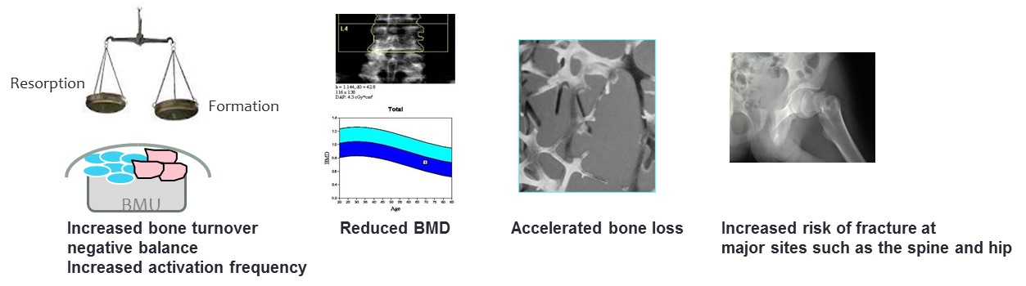
Figure 34: The clinical features of postmenopausal osteoporosis.

Several clinical studies have proposed that BTMs could be used as diagnostics tools for estimating the risk of fracture in a clinical setting. The Os des Femmes de Lyon (OFELY) and EPIDOS demonstrated that increase levels of bone resorption markers, but not bone formation markers, increased the risk of hip fracture by twofold independently of BMD (338, 364). Also the Rotterdam study demonstrated the high levels of bone resorption markers were associated with increased risk of hip fracture after adjustment for BMD (390). Generally these studies have shown that it is bone resorption markers that are associated with fracture risk.
Some have proposed that BTMs could be used as a diagnostic tool for estimating bone loss. Initially it was considered for identifying women who would benefit from HRT administration (391) but since then studies have demonstrated associations between increased levels of BTMs and bone loss at the distal forearm, total hip and the lumbar spine (392). However it have been demonstrated that BTMs cannot be used for predicting bone loss at the individual level (393) There may be a potential utility of bone markers for fracture prediction (394).
The research in this area has used bone turnover as assessed by BTMs as a tool for assessing bone loss and fracture risk and the findings are inconclusive. However, in postmenopausal osteoporosis there is also a negative balance between bone resorption and formation, it may be this that is associated with BMD, bone loss and fracture risk and this has yet to be investigated.
Methods have previously been described for calculating bone balance from bone turnover; i) calculating the ratio between bone resorption and formation ii) calculating the Z-scores for postmenopausal women relative to an age-matched group. Then subtracting them for resorption and formation (395) and iii) using the multiple of the medians to calculate bone turnover and bone balance (396). However, each method has its limitations. Methods i) and iii) assume that BTMs are specific to bone and that all BTMs have the same relative distribution. Method ii) only evaluates bone balance and not the overall bone turnover. Thus, in this chapter, I describe a method that evaluates both bone balance and bone turnover together by combining methods i) and ii). This method used healthy premenopausal women as the control group and hence it is called the T-score bone marker plot.
The aims of this study were to:
- Compare bone balance and bone turnover between healthy premenopausal women and postmenopausal women with osteoporosis, using the t-score bone marker plot
- Determine the relationship between bone balance, bone turnover and bone turnover markers with BMD (and change in BMD) at total hip in postmenopausal women and
- Determine the relationship between bone balance, bone turnover and bone turnover markers with fracture risk in postmenopausal women.

Subjects and methods

Subjects
A main outcome from the OPUS study is vertebral and non-vertebral fracture risk and femoral neck BMD at the 6 year follow up visit. In order to investigate this further I used subjects from this study population (described in chapter 3). Subjects were included in this data analysis if they were postmenopausal and had a complete data set of interest (BTMs, BMD at the total hip and fracture data at baseline and 6 years) and were not suffering from any disease or taking any medications known to affect bone metabolism. From the 2419 postmenopausal who attended both visits 745 aged between 55 to 79 years at baseline remained that fitted these criteria, 24 of whom had vertebral fractures and 94 had non-vertebral fractures. The comparator group were 213 premenopausal women aged between 30 and 39 and had a complete data of interest. I did not exclude women who were vitamin d deficient from either age group so the numbers were more for this analysis than in chapter 1. Further details regarding clinical features of the subjects have been published, (Appendices 2), (397).
Vertebral and non-vertebral fractures were identified from the 6 year EVOS risk factor study questionnaire and from spine radiographs.

Laboratory methods
From the non-fasting venous blood samples collected at baseline, CTX and PINP were measured in serum using the IDS-iSYS automated immunoassays (Immunodiagnostic Systems, Boldon, United Kingdom). The inter assay CV were below 10% for each BTM using each of the quality control materials described in chapter 2.

Statistical analyses

The T-score bone marker plot
This method uses the T-scores for each of the bone resorption and bone formation marker to calculate bone turnover and bone balance (398). This allows bone turnover and bone balance to be examined in the same model.

Logarithmic transformation
The bone resorption and formation markers are log₁₀-transformed and normalised.

Calculation of the T-scores for PINP and CTX:
The T-scores for each BTM value from the postmenopausal women were calculated from the mean and standard deviation of the results in the premenopausal women (controls):
T-score = BTM – mean BTM / standard deviation BTM

Calculation of bone turnover from the t-scores for bone resorption and bone formation:
Bone turnover = T–score bone resorption + T-score bone formation / 2

Calculation on bone balance from the t-scores for bone resorption and bone formation:
Bone balance = T-score bone formation – T-score bone resorption

Presentation of the data by 95% confidence ellipse
Bone balance and bone turnover obtained after log transformation of the bone turnover markers were plotted against each other, (Figure 41). This produced a four-quadrant graph. A bivariate 95% confidence ellipse was drawn to surround the data for postmenopausal women and for premenopausal women. The Mahalanobis distance between the centres of the 2 ellipses was calculated (Mahalanobis, Prasanta Chandra (1936). "On the generalised distance in statistics". Proceedings of the National Institute of Sciences of India 2 (1): 49–55. Retrieved 2012-05-03). This is a multi-dimensional measurement of the number of standard deviations from the centre of the premenopausal ellipse to the centre of the postmenopausal ellipse, taking in to account the covariance between bone balance and bone turnover. This distance is zero if the centre of the premenopausal ellipse is at the mean of the postmenopausal ellipse and increases as this centre moves away from the mean.
Given samples of sizes n₁ and n₂, means ${\overline{x}}_{1}$ and ${\overline{x}}_{2}$, and variances $S_{1}$ and $S_{2}$ then the Mahalanobis distance is defined as:

$${\text{D}}^{\text{2}}\text{=}\left({\overline{\text{x}}}_{\text{1}}\text{-}{\overline{\text{x}}}_{\text{2}}\right){\text{S}}^{\text{-1}}{\left({\overline{\text{x}}}_{\text{1}}\text{-}{\overline{\text{x}}}_{\text{2}}\right)}^{\text{T}}$$
where S is the pooled variance-covariance matrix.
The two-sample Hotelling T² test is used to test for a difference in means. The test statistic is given by:
$$\frac{n_{1}n_{2}\left(n-p-1\right)}{n\left(n-2\right)p}D^{2}$$
where n = n₁ + n₂. The null hypothesis is rejected that there is no difference between the means when the test statistic is improbably large when compared with an F-distribution with p, n-p-1 degrees of freedom (i.e. F_{p,n-p-1}).
These analyses were performed using programme R: R Core Team (2013). R: A language and environment for statistical computing. R Foundation for Statistical Computing, Vienna, Austria. URL: http://www.R-project.org/
The 95% confidence ellipses were plotted using the car library: J Fox, S Weisberg (2011) An R Companion to Applied Regression, Second Edition. Thousand Oaks CA: Sage
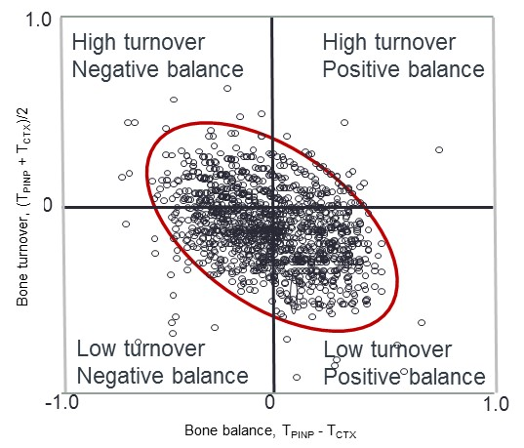
Figure 35: An illustration of the T-score bone marker plot: Bone turnover and bone balance calculated from the T-scores for PINP and CTX were plotted against each other for each individual and a bivariate 95% confidence surrounds the data

Assessing total hip BMD and change in total hip BMD in postmenopausal women
The variables of interest, i.e. bone turnover and bone balance and levels of PINP and CTX were used to assess BMD at the total hip using a multivariable model.

Calculating the relative risk of vertebral and non-vertebral fractures in postmenopausal women
The variables of interest, i.e. bone turnover and bone balance were used to investigate the relative risk of fracture using a multivariable model. The non-vertebral fractures were modelled using Cox regression and the vertebral fractures were modelled using Poisson regression and the significance was tested. The reason for using these different time series models is that we do not know when the vertebral fracture had occurred, as they occurred at a certain rate therefore a Poisson regression is suitable. For non-vertebral fracture, we do know when they occurred and therefore a Cox regression is suitable.

Results

Bone balance and bone turnover in postmenopausal and premenopausal women
Bone balance and bone turnover were calculated from the levels of bone resorption and bone formation markers in postmenopausal and premenopausal women. The graph is divided in to 4 equal quadrants with the centre being the mean of the premenopausal women. The quadrants represents different states of turnover and balance; the upper left quadrant high turnover and negative balance, the upper right quadrant high turnover and positive balance, the lower left quadrant low turnover and negative balance and the lower right quadrant low turnover and positive balance. A 95% bivariate confidence ellipse surrounds the data from postmenopausal and premenopausal women. Figure 42 shows the T-score bone marker plots for PINP and CTX in postmenopausal women relative to premenopausal women. For PINP and CTX there is high bone turnover and a more negative balance in postmenopausal women from the shift of the ellipse (in blue) towards the upper left quadrant. The shift was measured using the Mahalanobis distance calculation and this was significant (P<0.001).
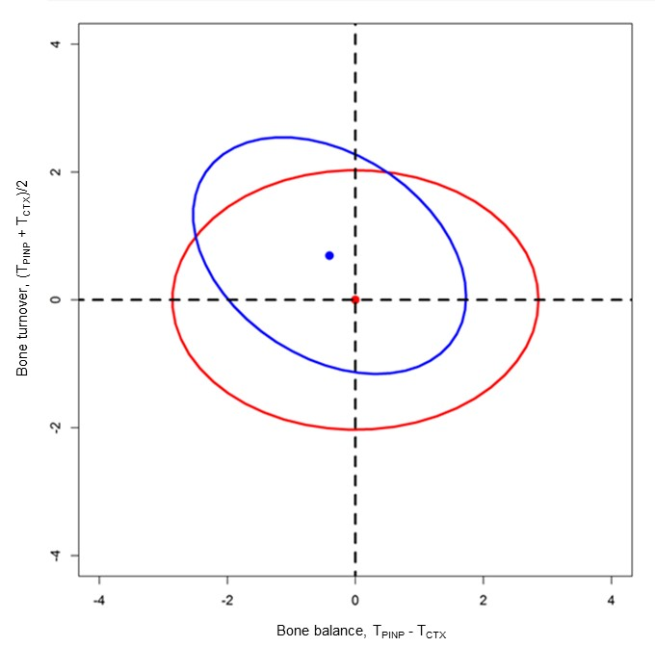
Low turnover
Positive balance
Low turnover
Negative balance
High turnover
Negative balance
High turnover
Positive balance
Figure 36: T-score bone marker plots for postmenopausal (blue ellipse) and premenopausal (red ellipse) women for PINP and CTX. The black solid arrow represents the Mahalanobis distance. Mahalanobis distance = 0.93, P<0.001

Bone balance, bone turnover and total hip BMD assessment
A multivariable analysis was performed to assess the relationship between bone turnover, bone balance, PINP and CTX with BMD, (Table 18) and the change in BMD at 6 years in postmenopausal women, (Table 19). This showed that high bone turnover and high levels of PINP and CTX were significantly related to decreased BMD per standard deviation change at the femoral neck and total hip p<0.001. For example table 18 showed that for a 1 standard deviation increase in bone turnover there is a 36.41 mg/cm² decrease in BMD at the total hip. A positive bone balance between PINP and CTX was significantly related to an increased BMD (per standard deviation change) at the total hip. A positive bone balance was significantly related to a positive change in BMD (per standard deviation change), at the total hip, p<0.05, (Table 19). A high level of CTX was significantly related to a negative change in BMD per standard deviation change at the total hip, p<0.05. There was no relationship between bone turnover and levels of PINP with a change in BMD at the total hip.
Table 18: Multivariable analysis showing the relationship between each; bone balance, bone turnover and levels of PINP and CTX at baseline with BMD at the total hip in 745 postmenopausal women.
Total hip BMD mg/cm²
 | BMD | 95% confidence interval
Bone balance** | 15.60 | 5.41 to 25.79
Bone turnover*** | -36.41 | -46.30 to -26.51
PINP ng/ml*** | -27.39 | -37.29 to -17.48
CTX ng/ml*** | -35.10 | -45.10 to -25.09
Significance *P<0.5, **P<0.01 and ***P<0.001
Table 19: Multivariable analysis showing the relationship between each; bone balance, bone turnover and levels of PINP and CTX at baseline with the average yearly change in BMD at the total hip, over 6 years in 745 postmenopausal women.
Change in total hip BMD mg/cm²
 | BMD | 95% confidence interval
Bone balance* | 3.78 | 0.11 to 7.44
Bone turnover | -2.73 | -6.42 to 0.97
PINP ng/ml | -0.53 | -4.17 to 3.11
CTX ng/ml* | -3.80 | -7.51 to -0.09
Significance *P<0.5, **P<0.01 and ***P<0.001

Bone balance, bone turnover and fracture risk assessment
A multivariable analysis was performed in order to assess whether it is balance and/or turnover that are more related to vertebral and non- vertebral fractures, (Table 20). This showed that in postmenopausal women a positive balance between PINP and CTX is significantly related to a decreased risk of vertebral fracture (0.79) and non-vertebral fracture (0.80) per unit increase, (p<0.05). However, a high turnover was not significantly related to the risk of vertebral and non-vertebral fracture. High levels of PINP were significantly related with a decreased risk of non-vertebral (p<0.01) and vertebral fracture, (p<0.05).
Table 20: Multivariable analyses showing the relationship between bone balance and bone turnover in the same model and the relative risk of vertebral and non-vertebral fracture in 745 postmenopausal women
 | Non vertebral fractures (N=92)
 | Relative risk | 95% confidence interval
Bone balance* | 0.80 | 0.67 to 0.97
Bone turnover | 0.86 | 0.70 to 1.06
PINP ng/ml** | 0.77 | 0.64 to 0.93
CTX ng/ml | 1.17 | 0.92 to 1.48
 | Vertebral fractures (N=23)
 | Relative risk | 95% confidence interval
Bone balance* | 0.79 | 0.63 to 0.98
Bone turnover | 0.85 | 0.64 to 1.13
PINP ng/ml* | 0.76 | 0.60 to 0.96
CTX ng/ml | 1.18 | 0.87 to 1.58
Significance *P<0.05, **P<0.01 and ***P<0.001. Cox regression was used to assess non-vertebral fracture and Poisson regression was used to assess vertebral fractures.

Discussions
The T-score bone marker plot is a novel method that can be used to assess the state bone turnover and bone balance (at the same time). Here, I have used it to demonstrate that in postmenopausal women there is a high bone turnover state (as assessed by relating resorption to formation) and a negative balance relative to premenopausal women. The state of high bone turnover alone (as assessed by individual BTMs) is consistent with others and has been well established (399) but not in relation to bone balance. The negative bone balance is a result of the imbalance between bone resorption and bone formation i.e. the coupling process is disrupted (400). Beiglemayer C et al reported similar findings investigating bone turnover and bone balance in 44 postmenopausal by using the median of the BTMs in premenopausal women to normalise the distribution of the data (396). However their method does not take in to account the skewed distribution of the BTM data and assumes normality prior to the calculation, which is unlikely to be the case. They demonstrated a shift in the postmenopausal ellipse but this was based on a visual observation and not defined statistically.
In relation to BMD at the total hip, the T-score bone marker method showed that a positive bone balance was related to increased BMD and a high bone turnover state to lower BMD. Furthermore increased bone resorption and bone formation were related to a decreased BMD. This was consistent with several findings investigating BTMs and BMD in osteoporosis prior to treatment (401). In particular BTMs were correlated with BMD the total hip more than at the femoral neck (402). More importantly, at the total hip it was bone balance and not bone turnover that appeared to be significantly related to bone loss over six years. A positive balance was related to a reduction in bone loss at the hip. This finding has not been previously reported and adds to our current understanding about how bone remodelling is associated with bone loss. Previous studies have investigated individual BTMs, rather than a combination of bone turnover and bone balance. Furthermore, identified from this method it appeared to be that high CTX levels and not PINP were significantly related to bone loss. This is supported by findings from three other large studies; i) in the Study of Osteoporotic Fractures higher levels of the bone resorption markers (including CTX and NTX) but not bone ALP were associated with increased bone loss at the total hip (315), ii) in the OFELY study high levels of BTMs (including CTX and PINP) were correlated with increased bone loss at the distal forearm (161) and iii) also from the OPUS cohort high levels of CTX were associated with increased bone loss at the femoral neck (Finigan J et al 2008, Relationship between baseline bone turnover, subsequent vertebral fracture and bone loss unpublished). From my findings it may therefore be plausible to suggest that it is high resorption rate and not high turnover that is related to increased bone loss. In addition it is resorption that appears to be dominating/contributing significantly to the positive bone balance that is related to a reduction in bone loss (i.e. as shown by the positive change in BMD).

This led on to the final and probably most important finding in this chapter with regards to the management of postmenopausal osteoporosis. The data suggests that it is a positive balance and not a low state of turnover that maybe related to a reduction in vertebral and non-vertebral fracture risk. Interestingly, in this instance it was high levels of PINP and not CTX that were significantly related to the reduction in fracture risk. In comparison to the latter point, other retrospective studies have demonstrated similar findings but assessing each BTM individually and not in relation to each other. Melton LJ et al, 1997 and Akesson K et al, 1995 reported decreased levels of osteocalcin only, were associated with all types of fracture (402, 403). In contrast, in the EPIDOS study, a prospective study demonstrated there was no association between bone formation markers and the risk of fracture (364). However, PINP was not investigated in these and to my knowledge, until now has not been investigated in any other study that aimed to establish its utility prior to the occurrence of fracture. This may be because the studies were performed about 20 years ago and immunoassays were technically limited. This highlights the need to re-assess the BTMs association with fracture risk using newer/improved methods that are currently available. With regards to the bone resorption markers what we currently know from the Rotterdam and EPIDOS studies is that high levels of uCTX, NTX, PYD were associated with increased risk of hip fracture (364, 390). Possibly for similar reasons to PINP, these studies did not assess CTX in serum, I have used this in my investigation as it is now considered as the most sensitive of the resorption markers (319).
A notable limitation was the low number of vertebral fracture cases presented in this study population (more on this in the overall discussions). However the total number of fractures were comparable to the N=116 women who presented with incident fractures in the follow-up OFELY study (404).
By investigating the two main components of bone remodelling i.e. turnover state and balance using this method, allows each to be investigated quantitatively and in relation to each other.

Conclusions
Postmenopausal women have high bone turnover and an imbalance between bone resorption and bone formation. The T-score bone marker plot described here may enable researchers (and possibly clinicians) to quantitatively and qualitatively determine the state of bone turnover and bone balance in postmenopausal women and possibly other diseases characterised by an increased state of bone remodelling.
The potential utility of the T-score bone marker plot must be further validated in other cohorts. It may be possible to use bone balance as a predictor of bone loss and fracture risk. In addition it may be that CTX is the better predictor of bone loss and PINP of fracture risk. These findings have not been previously reported and adds to our current understanding of how fracture risk can be identified/predictive from BTM measurements and therefore possibly prevented.
The findings from this chapter will allow me to investigate this imbalance further by establishing how it is effected with antiresorptive treatments. In order to do this fully it is necessary to establish the effects of some antiresorptive treatments on BTMs with regards to duration of action and magnitude (subsequent chapters).

Chapter 5: The effect of antiresorptive treatments on biochemical markers of bone turnover

Introduction
Antiresorptive treatments used in postmenopausal osteoporosis have shown to reduce bone turnover and the activation frequency, increase BMD and reduce bone loss and fracture risk, (235, 239). Bisphosphonates bind to the hydroxyapatite on the bone surface and reduce osteoclast activity and raloxifene acts as an estrogen agonist on bone reducing osteoclast proliferation and differentiation. It has previously been shown that levels of BTMs decrease in response to antiresorptive treatments in postmenopausal women with osteoporosis, (405). This is a larger and more rapid response compared to the modest change in BMD which occurs after months/years. These features make BTMs attractive and provide a rationale for them to be used as a treatment monitoring tool in a clinical setting.
Several clinical trials have been carried out to investigate the response of BTMs to bisphosphonate and raloxifene treatments. A trial of risedronate demonstrated a significant reduction in NTX/Cr and CTX levels; in addition this was associated with a reduced risk of fracture (310). Risedronate therapy results in a 40 to 55% reduction in bone resorption markers and 15% reduction in bone ALP (311, 406). These findings are supported by other trials. Ibandronate therapy results in decreased levels of CTX significantly by 60% after 3 months (378). Delmas et al demonstrated a 63% decrease in CTX and 31% in NTX/Cr with alendronate treatment in the BONE study (407) compared to a 76% decrease in levels of CTX with ibandronate treatment by Emkey R et al in the MOTION study (408). Similar trials have been carried out using alendronate that have demonstrated a decrease in levels bone resorption markers by 53% and 71 to 74% in NTX/Cr and CTX respectively and bone formation markers by 64 to 70% (406, 409, 410).
Clinical trials investigating the effects of raloxifene have demonstrated significant but a less of a decrease in levels of some BTMs (compared to bisphosphonates) and an increase in BMD compared to baseline. The data from these studies have demonstrated that the reduction in PINP and osteocalcin ranged from 20 to 30% and the reduction in CTX and NTX/Cr ranged from 25 to 28% (302, 411).
The findings from such clinical trials have suggested that BTMs may be used as a tool for assessing and monitoring therapeutic efficacy in a clinical setting. They have demonstrated a varying magnitude of response by some BTMs and they do not always capture the response at early and regular time points, i.e. within 1, 2 and 4 weeks after drug administration. In addition the responses in BTMs were compared to baseline levels and not also to healthy premenopausal reference intervals. Improved adherence during antiresorptive treatments is associated with a greater decrease in the levels of bone turnover and a reduced risk of fracture (277, 343, 412, 413). A goal of monitoring antiresorptive treatments in postmenopausal women with osteoporosis or osteopenia is to assess the magnitude of the decrease in bone turnover.
A head-to-head randomised controlled trial will allow me to directly assess and compare the magnitude of effect and duration of action of bisphosphonates on BTMs in postmenopausal women with osteoporosis. In a clinical setting these findings will help identify patients who have responded to antiresorptive treatments. There are two approaches that have been described to assess response to antiresorptive treatment, i) calculating the T-scores of the BTMs i.e. in relation to BTMs in healthy premenopausal women and ii) calculating the least significant change i.e. the minimum change in BTMs that can be attributed to the effect of treatment and not to random variation (414-416). In this chapter I will use another approach which assessed response using the lower part of the healthy premenopausal reference interval of the BTMs as the treatment goal (319, 417). This is based on the level of bone turnover in healthy premenopausal women being associated with long-term overall skeletal stability and bone mass.
In addition, by firstly assessing the response of BTMs to such antiresorptive treatments it may help us to hypothesise and establish and their mechanism of action (subsequent chapters).
Therefore the aims of this chapter were to i) determine the effects of ibandronate, alendronate, risedronate and raloxifene on BTMs in postmenopausal women with osteoporosis and osteopenia and ii) assess the response to each treatment using healthy reference intervals for BTMs.

Study participants
In order to investigate these aims I used participants from two randomised control single centre trials. The first one was an open-label, parallel control trial of three UK licenced orally administered nitrogen-containing bisphosphonates was conducted between 2007 and 2012. This study was called the TRIO study. The protocol, the study design and inclusion/exclusion criteria have recently been reported in detail (342). Generally, a total of 180 postmenopausal women were recruited through the Metabolic Bone Clinic, Northern General Hospital and general practice registers in Sheffield. They had osteoporosis defined by DXA BMD T-score ≤-2.5 at the lumbar spine or proximal femur or a BMD T-score ≤-1.0 plus a previous low trauma fracture (from standing height). Subjects were randomised to receive either: i) ibandronate (Roche, Bonviva), 150mg tablet once a month, ii) alendronate (Merck, Fosamax) 70mg tablet once a week or iii) risedronate (Warner Chilcott, Actonel) 35mg tablet once a week. At the time of recruitment the treatments were prescribed under a coding system (A, B or C) by the study nurse. These participants also received calcium carbonate 2 tablets per day to provide 1200mg of calcium and vitamin D₃: 800 IU two tablets per day, Adcal D₃, ProStrakan). During the BTM analysis and data collection I remained blinded to the assigned study medication in order to eliminate bias. The reference group were 200 healthy premenopausal women aged between 35 to 40 years old, experiencing regular menstrual cycles and not using hormonal contraception or receiving any medications know to effect bone metabolism. Prior to recruitment, the Sheffield Research Ethics
Committee and the Medicines and Healthcare Products Regulatory
Agency (MHRA) granted ethical approval and informed consent was obtained from each participant.
The second was an open-label clinical trial, originally performed to assess monitoring, adherence and cessation of raloxifene treatment (343, 411). Postmenopausal women were recruited through the bone densitometry clinic at the Osteoporosis Centre, Northern General Hospital and general practice surgeries, Sheffield, UK. In order to investigate the effect of treatment on BTMs I used 44 postmenopausal women from the study. This was a subset from the entire study and were the per protocol population, each having a complete set of serum samples for the 48 weeks. They had osteopenia as assessed by a DXA BMD T-score between -1.0 and -2.5 at the lumbar spine or proximal femur. 21 of these women were randomised to receive 60mg of raloxifene per day (Evista, Eli Lilly and Company) and 23 received no treatment. All of the participants received calcium carbonate to provide 500mg of calcium per day. Prior to recruitment, the North Sheffield Local Research Committee granted ethical approval and informed consent was obtained from each participant.

Laboratory methods
From the participants receiving bisphosphonate treatment, a fasting serum and second void morning urine sample were collected from each of the postmenopausal women at baseline 1 (week -1) and baseline 2 (week 0) and then at weeks 1, 2, 4, 12, 13, 34 and 96. Calcium, vitamin D₃ were administered after baseline 1 and the bisphosphonates were administered after baseline 2 and through to 96 weeks. Samples were also collected from the premenopausal women at baseline and 96 weeks.
From the participants receiving raloxifene treatment, a fasting serum and second void morning urine sample were collected at baseline then at weeks 1, 2, 4, 8, 12, 13, 24, 25, 36, 47 and 48. From the participants receiving no treatment a fasting serum and second void morning urine sample were collected at baseline then at weeks 12, 24, 25, 36 and 48. Blood and urine were collected, handled and stored according to the methods in chapter two.
CTX, PINP, osteocalcin and bone ALP were measured in serum using the IDS-iSYS CLIA (bone ALP used ECLIA) technology automated immunoassay. NTX/Cr was measured using the Ortho Clinical Diagnostics automated immunoassay (High Wycombe, United Kingdom). The inter-assay CV’s were below 10% for each BTM using each of the quality control materials (chapter two).

Statistical analyses
All of the analyses for the TRIO study were in the intention to treat population, the participants who were randomised received at least one treatment dose and had BTM data at baseline and at least one other time point were included. All of the analyses for the participants receiving raloxifene were from the per protocol population. The baseline characteristics were reported as a mean and standard deviation for each variable. The data for CTX, NTX/Cr, PINP, bone ALP and osteocalcin had a positive skewed distribution and were therefore log₁₀ transformed to achieve approximate normality.
An independent sample t-test was used to determine the statistical difference between the mean BTM levels for i) postmenopausal with osteoporosis at baseline and premenopausal women and ii) postmenopausal women with osteoporosis and with osteopenia at baseline.
A 95% reference interval was calculated for each BTM using the healthy premenopausal control group and expressed as a mean ± 1.96 SD (as in chapter four), using MedCalc Statistical Software version 14.10.2 (MedCalc Software bvba, Ostend, Belgium; http://www.medcalc.org;2014). The BTM reference intervals will be used to assess and describe the response to the treatments qualitatively i.e. high, upper and lower parts, normal and low.
Box and whisker plots representing the upper and lower quartiles and 5 – 95 percentiles were calculated for each BTM using GraphPad Prism 6, version 6.05, 2014 (http://www.graphpad.com/ref this).
The mean percentage change in BTMs from baseline 1 (week -1) was calculated for each of the subsequent time points for ibandronate, alendronate, risedronate and raloxifene treatments. The non-parametric Wilcoxon signed test was used to assess the significance from baseline. The BTM levels were compared to the premenopausal reference intervals. The responders to the treatments were calculated as the percentage of participants whom had a BTM result less The baseline characteristics for the i) postmenopausal women with osteoporosis receiving ibandronate, alendronate and risedronate ii) postmenopausal women with osteopenia receiving raloxifene and no treatment and iii) premenopausal comparator groups are shown in (Table 21).

Results
Postmenopausal women with osteoporosis have significantly higher mean levels of BTMs at baseline compared to healthy premenopausal women, p<0.001. Postmenopausal women with osteopenia have significantly higher levels of CTX, NTX/Cr, bone ALP and osteocalcin, p<0.001.
Table 21: The baseline characteristics of the postmenopausal women with osteoporosis receiving ibandronate, alendronate and risedronate and with osteopenia receiving raloxifene or no treatment and healthy premenopausal women. Data shown are means and (standard deviations)
Variable | Ibandronate (N = 57) | Alendronate (N = 57) | Risedronate (N = 58) | Raloxifene (N = 21) | No treatments (n = 23) | Premenopausal (N = 226)
Age, years | 66.9 (7.2) | 67.8 (7.8) | 66.8 (6.7) | 64.0 (6.3) | 63.8 (6.3) | 37.9 (1.7)
Height, cm | 159.8 (6.9) | 160.1 (5.3) | 160.7 (6.0) | 158 (6.0) | 161.7 (4.6) | 165.2 (6.4)
Weight, kg | 66.2 (10.8) | 64.4 (10.2) | 69.9 (9.4) | 65.0 (9.8) | 70.2 (10.9) | 67.4 (10.7)
BMI, kg/m² | 26.4 (4.0) | 25.9 (3.7) | 26.8 (3.8) | 26.3 (3.9) | 26.8 (3.2) | 25.1 (3.8)
Lumbar spine BMD T-score | -2.21 (1.06) | -2.30 (0.96) | -2.18 (0.82) | -1.585 (0.66) | 0.842 (1.32) | 0.25 (1.10)
Total hip BMD T-score | -1.29 (0.79) | -1.59 (0.75) | -1.15 (0.82) | - 1.08 (0.74) | 0.800 (1.01) | 0.26 (0.90)
Serum CTX, ng/mL | 0.704 (0.334) | 0.661 (0.308) | 0.612 (0.223) | 0.617 (0.255) | 0.548 (0.262) | 0.366 (0.184)
Urine NTX nmol BCE/mmol Cr | 55.4 (37.0) | 43.0 (21.2) | 39.2 (17.3) | 58.1 (22.2) | 58.2 (30.3) | 39.5 (17.2)
Serum PINP, ng/mL | 51.9 (17.1) | 45.8 (16.3) | 44.5 (12.5) | 42.7 (15.0) | 49.6 (20.2) | 30.0 (10.7)
Serum bone ALP, ng/mL | 20.4 (8.7) | 19.1 (8.0) | 20.0 (8.1) | 13.3 (3.8) | 16.5 (4.5) | 8.8 (3.8)
Serum Osteocalcin ng/mL | 26.3 (9.6) | 25.1 (10.1) | 23.4 (9.0) | 17.1 (4.6) | 17.3 (6.6) | 19.4 (6.3)
25 (OH) D ng/mL | 24.0 (10.3) | 22.9 (10.1) | 25.1 (9.9) | 20.1 (11.1) | 22.3 (11.5) | 19.4 (8.6)
PTH pg/ml | 37.2 (20.0) | 36.3 (9.7) | 36.3 (19.3) | 35.4 (20.2) | 30.5 (20.4) | 33.3 (13.6)

The response of bone turnover markers to antiresorptive treatments
There were significant decreases from baseline in the mean levels of CTX and NTX/Cr at all of the subsequent time points in the postmenopausal receiving bisphosphonates and raloxifene, p<0.001. There were significant decreases from baseline in the mean levels of PINP, bone ALP and osteocalcin at weeks 12, 13, 48 and 96 in the postmenopausal women receiving bisphosphonates, p<0.001. There were significant decreases from baseline in the mean levels of PINP and osteocalcin at week 4 and all subsequent time points in the postmenopausal women receiving raloxifene, p<0.001 but not bone ALP.
Changes in CTX and NTX/Cr over the 96 treatment period with ibandronate, alendronate and risedronate are shown as box and whisker plots in figures 43 and 44. In the women receiving ibandronate, there was an initial decrease after 1 week of a large magnitude and was similar in CTX and NTX/Cr levels by 80% and 73% respectively. After 1 week the decrease was of a lesser magnitude with alendronate and risedronate treatments in both of these BTMs. After 96 weeks of treatment the decrease in the levels of CTX and NTX/Cr was of greater magnitude in women receiving alendronate and ibandronate (between 69 to 86%) than those receiving risedronate (by 45 to 68%), (Table 23).
There was a greater earlier decrease from baseline in these bone resorption markers compared to the bone formation markers. There was a significant decrease in PINP, bone ALP and osteocalcin later at weeks 12 and 13, in women receiving ibandronate, alendronate and risedronate, p<0.001, (Figures 45, 46 and 47). The largest decrease was in PINP levels and this was comparable between the women receiving ibandronate and alendronate, by 65% and 60%, respectively and a lesser decrease with risedronate, by 52%. The decrease in bone ALP and osteocalcin at weeks 12 and 13 were comparable between the three bisphosphonates. A similar magnitude of change was observed after 96 weeks of bisphosphonate treatment. The decrease in PINP levels was of greatest magnitude in the women receiving ibandronate and alendronate (by 74% and 71%) and of a lesser magnitude with risedronate. The decrease in bone ALP and osteocalcin was of a lesser magnitude, (Table 23).
In the postmenopausal women receiving raloxifene treatment the magnitude of change observed in all of the BTMs, (Figure 48) was less than all of the bisphosphonates. After 48 weeks of raloxifene treatment levels of CTX, PINP and osteocalcin significantly decreased by 48%, 34% and 33%, respectively, (Table 23).

Healthy premenopausal reference intervals
In table 8 chapter three, vitamin D deficiency was related to an increase in BTMs. This finding was used to identify and exclude premenopausal women with a 25 (OH) D of less than 25nmol/l in order to establish a healthy premenopausal BTM reference range. Out of the 200 premenopausal women 87 had a 25 (OH) D of greater than 25ng/ml and were therefore included in this calculation, (Table 22). These reference intervals were used to identify the percentage of women who responded to the different antiresorptive treatments throughout the study periods.
Table 22: Geometric mean 95% reference intervals for BTMs for healthy premenopausal women (n = 87).
Bone turnover marker | Geometric mean | 95% reference interval
Serum CTX, ng/ml | 0.32 | 0.13 – 0.81
Urine NTX, nmol BCE/mmol Cr | 36.1 | 16 – 78
Serum PINP, ng/ml | 28.3 | 15 – 54
Serum bone ALP, ng/ml | 9.5 | 5 – 18
Serum osteocalcin, ng/ml | 18.1 | 10 – 34

The response of bone turnover markers to antiresorptive treatments relative to healthy premenopausal women
For each individual antiresorptive treatment levels of CTX, NTX/Cr, PINP, bone ALP and osteocalcin are shown as box and whisker plots graphed relative to the upper and lower limits and the geometric mean of the healthy premenopausal reference intervals for each BTM, (Figures 43, 44, 45, 46, 47 and 48). At baseline 1 less than 10% of the study population receiving bisphosphonates had CTX, PINP and bone ALP concentrations in the lower part of the healthy premenopausal reference intervals. This was higher for NTX/Cr (34%) and osteocalcin (21%). After 1 week of treatment with ibandronate, alendronate and risedronate, 90%, 57% and 43%, respectively of the study population had a CTX level in the lower part of or below the healthy premenopausal reference intervals. At week 96 this increased to 92%, 100% and 87%, respectively. After 1 week of treatment with ibandronate, alendronate and risedronate, 94%, 75% and 74%, respectively of the study population had a NTX/Cr level in the lower part of or below the healthy premenopausal reference intervals. At week 96 this increased to 96%, 100% and 94%, respectively.
There were no significant decreases in levels of PINP, bone ALP and osteocalcin from baseline until 12 weeks of treatment with any of the bisphosphonates. After 12 weeks of treatment with ibandronate, alendronate and risedronate, 97%, 82% and 73%, respectively of the study population had a PINP level in the lower part of or below the healthy premenopausal reference intervals. At week 96 this increased to 100%, 100% and 83%, respectively. After 12 weeks of treatment with ibandronate, alendronate and risedronate 17%, 20% and 12%, respectively of the study population had a bone ALP level in the lower part of or below the healthy premenopausal reference intervals. At week 96 this increased to 26% and 52% with ibandronate and alendronate respectively and decreased to 4% with risedronate. After 12 weeks of treatment with ibandronate, alendronate and risedronate, 60%, 58% and 80%, respectively of the study population had an osteocalcin level in the lower part of or below the healthy premenopausal reference intervals. At week 96 this increased to 85%, 94% and 92%, respectively.
At baseline 1 less than 10% of the study population receiving raloxifene had CTX, NTX/Cr, PINP and bone ALP concentrations in the lower part of the healthy premenopausal reference intervals. This was higher for osteocalcin (50%). At the end of the treatment period, at week 48 the portion of the study population that had levels of CTX, NTX/Cr, PINP, bone alp and osteocalcin in the lower part or below the healthy premenopausal reference intervals were 40%, 20%, 40%, 15% and 85%, respectively.
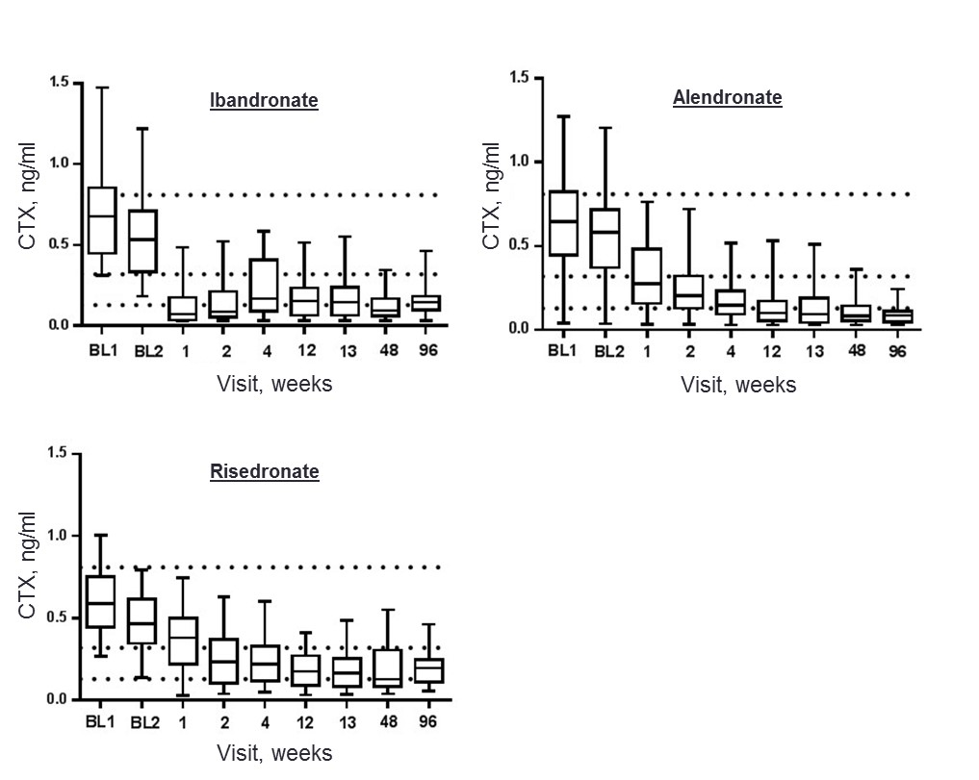
Figure 37: Box and whisker plots showing the effects of ibandronate, alendronate and risedronate on CTX in postmenopausal women with osteoporosis over the 96 weeks study period. The dotted lines represent the geometric mean, upper and lower part of the healthy premenopausal reference interval for CTX.
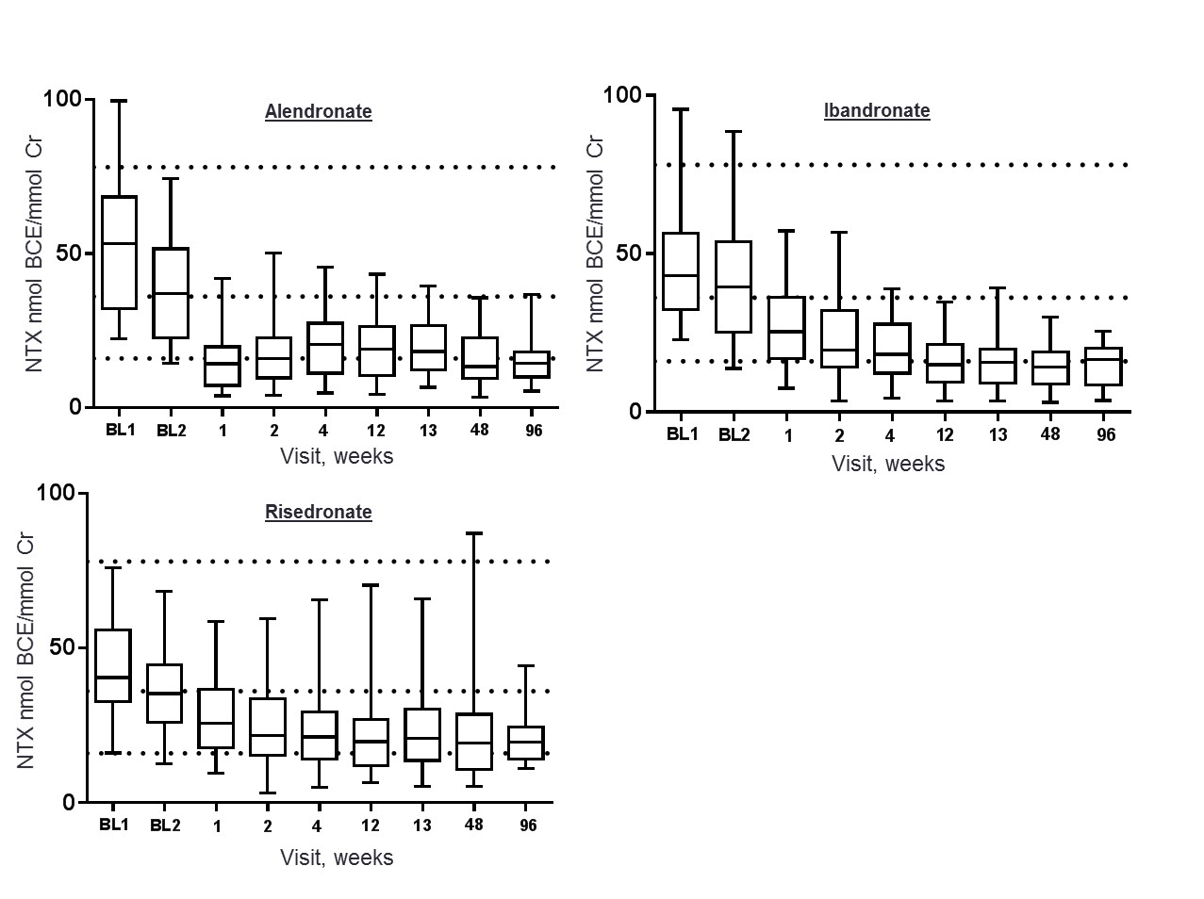
Figure 38: Box and whisker plots showing the effects of ibandronate, alendronate and risedronate on NTX/Cr in postmenopausal women with osteoporosis over the 96 weeks study period. The dotted lines represent the geometric mean, upper and lower part of the healthy premenopausal reference interval for NTX/Cr.
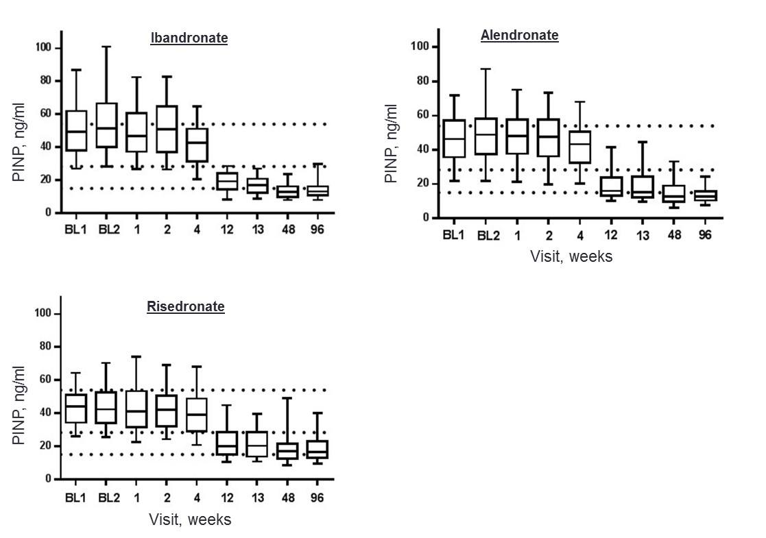
Figure 39: Box and whisker plots showing the effects of ibandronate, alendronate and risedronate treatment on PINP in postmenopausal women with osteoporosis over the 96 weeks study period. The dotted lines represent the geometric mean, upper and lower part of the healthy premenopausal reference interval for PINP.
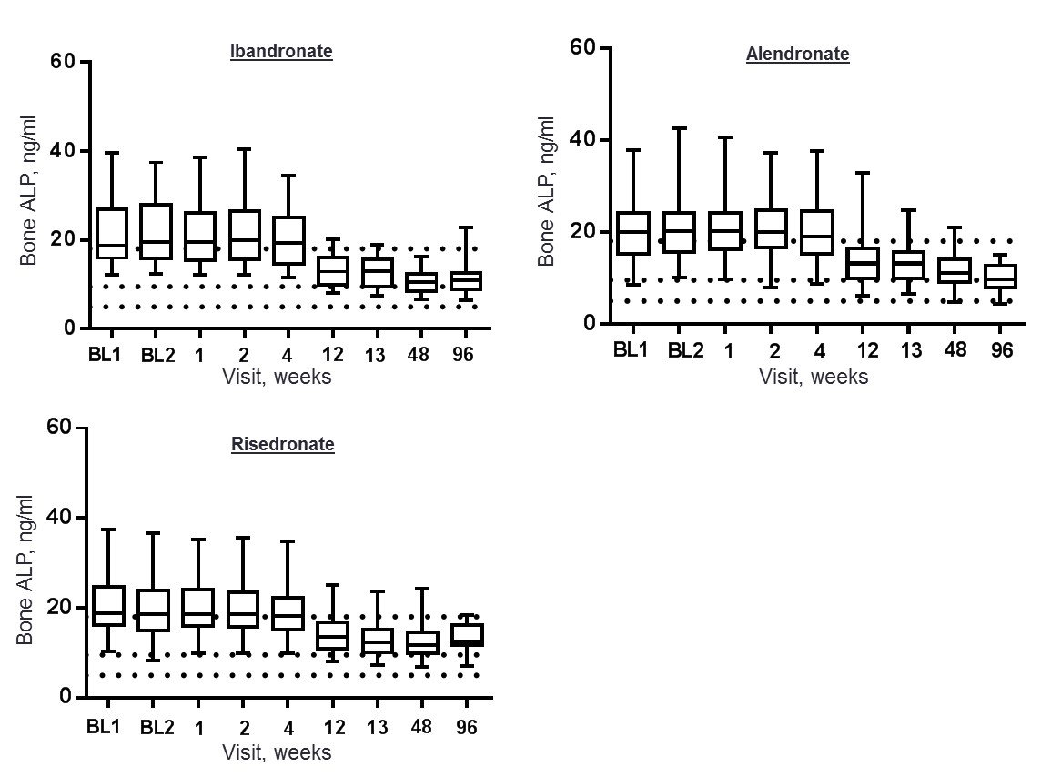
Figure 40: Box and whisker plots showing the effects of ibandronate, alendronate and risedronate on bone ALP in postmenopausal women with osteoporosis over the 96 weeks study period. The dotted lines represent the geometric mean, upper and lower part of the healthy premenopausal reference interval for bone ALP.
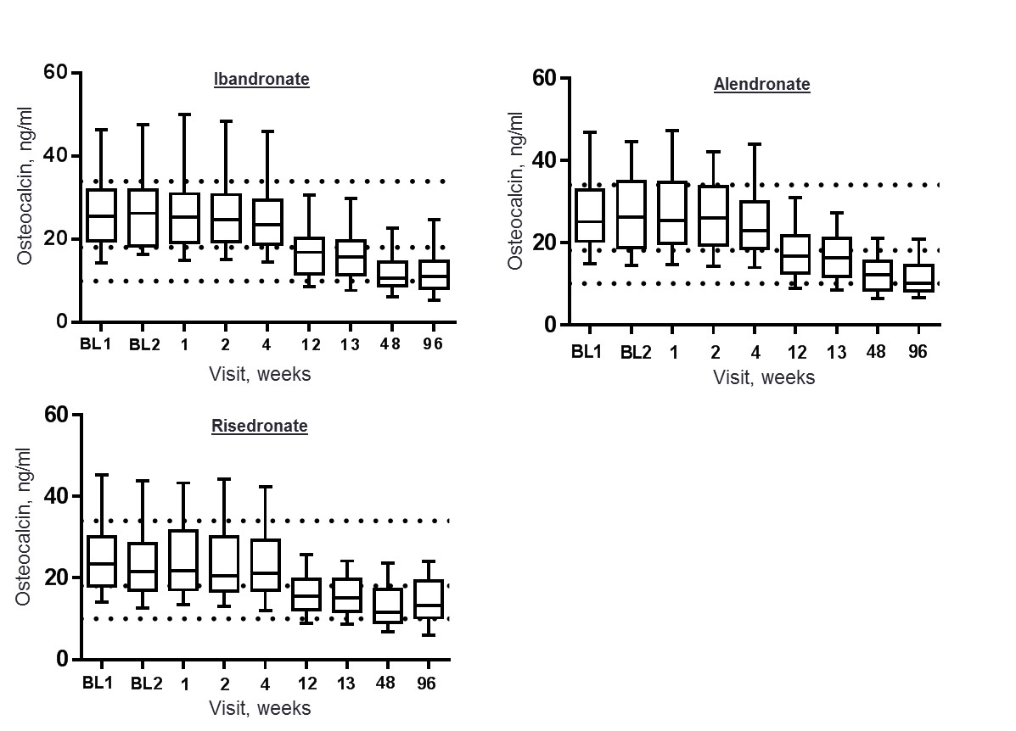
Figure 41: Box and whisker plots showing the effects of ibandronate, alendronate and risedronate on osteocalcin in postmenopausal women with osteoporosis over the 96 weeks study period. The dotted lines represent the geometric mean, upper and lower part of the healthy premenopausal reference interval for osteocalcin.
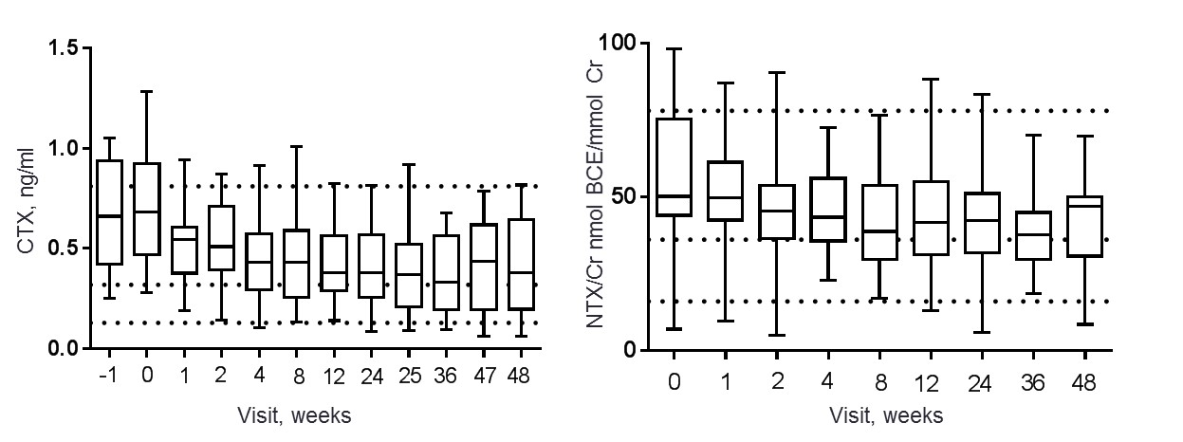
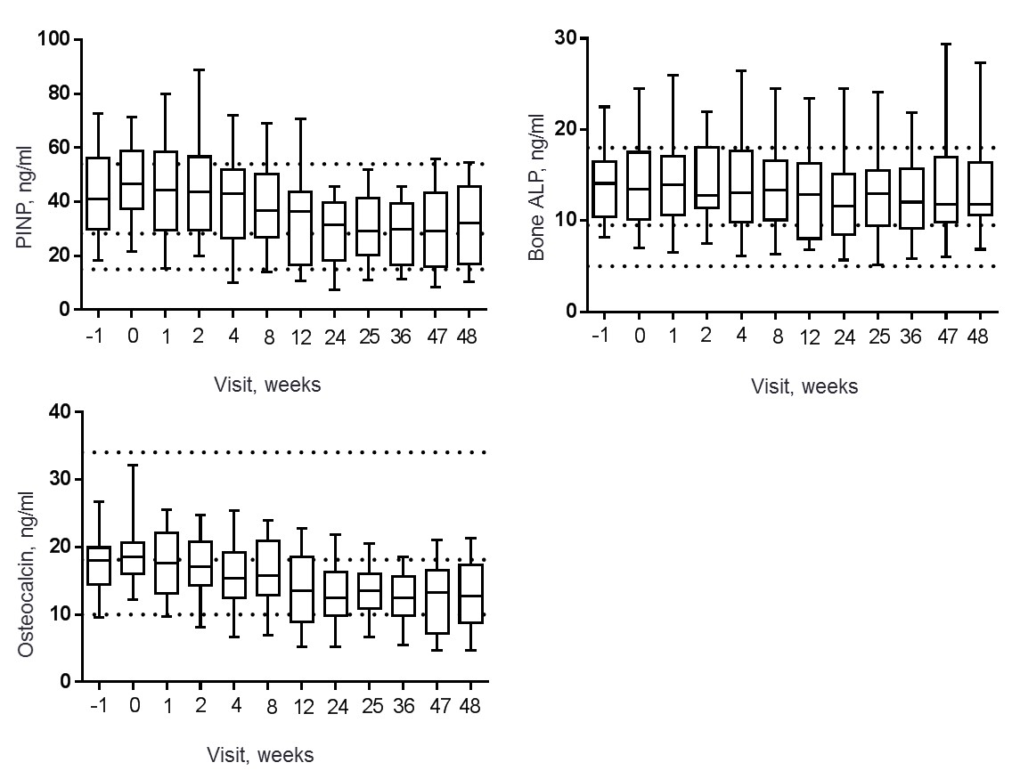
Figure 42: Box and whisker plots showing the effects of raloxifene treatment on CTX, NTX, PINP, bone ALP and osteocalcin in postmenopausal women with osteopenia over the 48 week study period. The dotted line represents the geometric means, upper and lower part of the healthy premenopausal reference intervals for each of the BTMs.

Table 23: Mean percentage change and (standard deviations) from baseline for each BTM throughout the treatment periods in postmenopausal women receiving antiresorptive treatments.
 | Treatment: Ibandronate (150mg/month) and N = 57
BTM | Baseline2 | Week 1 | Week 2 | Week 4 | Week12/13 | Week 48 | Week 96
Serum CTX, ng/ml | -18(30.1) | -80(13.3) | -78(16.5) | -66(18.3) | -73(15.5) | -78(10.3) | -77(10.5)
Urine NTX, nmol BCE/mmol Cr | -30(52.2) | -73(59.3) | -69(75.3) | -66(53.7) | -66(60.1) | -74(76.4) | -69(35.4)
Serum PINP, ng/ml | 5(9.9) | -6(9.7) | 0(1.3) | -20(11.8) | -65(22.6) | -73.0(25.0) | -74(25.0)
Serum bone ALP, ng/ml | 2(12.6) | 2(13.1) | 3(11.2) | -4(13.4) | -38(18.1) | -48(19.8) | -49(23.3)
Serum osteocalcin, ng/ml | 1(6.0) | -1(8.1) | -2(7.5) | -8(7.6) | -38(18.1) | -48(19.8) | -49(23.3)
 | Treatment: Alendronate (70mg/week) and N = 57
Serum CTX, ng/ml | -15(30.0) | -49(20.0) | -62(20.0) | -70(20.0) | -78(20.0) | -79(10.0) | -86(10.0)
Urine NTX, nmol BCE/mmol Cr | -16(25.7) | -42(35.8) | -56(49.7) | -59(44.6) | -67(45.8) | -72(46.9) | -71(54.5)
Serum PINP, ng/ml | 5(16.5) | 4(14.5) | 1(16.6) | -9(22.1) | -60(29.9) | -70(34.7) | -71(28.4)
Serum bone ALP, ng/ml | 2(12.9) | 2(12.2) | 2(15.7) | -1(13.4) | -33(19.2) | -44(17.8) | -45(15.2)
Serum osteocalcin, ng/ml | 1(12.1) | 1(10.5) | -2(13.0) | -8(13.9) | -38(15.6) | -55(20.7) | -58(21.5)
 | Treatment: Risedronate (35mg/week) and N = 57
Serum CTX, ng/ml | -22(20.0) | -39(20.0) | -58(20.0) | -60.1(20.0) | -68.8(10.0) | -66.7(20) | -67.6(10.0)
Urine NTX, nmol BCE/mmol Cr | -15(27.0) | -34(39.6) | -47(56.1) | -45.6(54.4) | -50.4(40.6) | -51.6(53.7) | -44.7(40.1)
Serum PINP, ng/ml | -1(11.8) | -2(11.9) | -3(10.1) | -9.2(12.2) | -51.8(25.4) | -57.5(34.9) | -57.0(26.3)
Serum bone ALP, ng/ml | -5(13.4) | -5(13.0) | -4(12.1) | -5.4(10.9) | -31.4(18.9) | -37.9(19.4) | -33.4(18.0)
Serum osteocalcin, ng/ml | -3(12.1) | -1(10.5) | -4(9.1) | -5.9(9.6) | -33.1(13.6) | -46.0(23.7) | -46.8(17.8)
 | Raloxifene (60mg/day) and N = 92
Visit | Week 1 | Week 2 | Week 4 | Week 8 | Week 12 | Week 24 | Week 48
Serum CTX, ng/ml | -24(19.3) | -28(21.3) | -37(20.3) | -37(20.3) | -39(20.6) | -44(21.3) | -48(23.3)
Urine NTX, nmol BCE/mmol Cr | -6(18.5) | -23(18.0) | -15(13.1) | -23(16.5) | -16(18.5) | -26(17.6) | -30(16.0)
Serum PINP, ng/ml | -5(18.6) | -1(17.7) | -13(17.1) | -18(16.1) | -29(1.7) | -40(12.4) | -34(14.1)
Serum bone ALP, ng/ml | -2(3.8) | 2(4.3) | -3(4.4) | -2(5.1) | -3(5.1) | -9(4.8) | -6(5.0)
Serum osteocalcin, ng/ml | -4(5.0) | -8(4.8) | -16(5.1) | -16(5.3) | -29(5.3) | -32(4.4) | -33(5.3)

Discussion
Postmenopausal women with osteoporosis and osteopenia have a higher bone turnover compared to healthy premenopausal women. Treatment with antiresorptives reduces bone turnover markers by varying magnitudes and durations. There is an initial reduction in bone resorption, after 1 week of treatment. In contrast, there is a later reduction in bone formation i.e. after 12 weeks with bisphosphonates and after 4 weeks with raloxifene treatments. This later reduction in bone formation is due to the coupling process, bone resorption followed by bone formation. Bone formation remains at baseline levels because it continues to occur at the same rate in the BMUs that have already been activated prior to treatment, (418, 419). It begins to decrease after the osteoblasts fill in the lower number resorption pits in the BMUs as a result of the treatments. Levels of bone formation markers may therefore begin to decrease earlier in women with osteopenia than women with osteoporosis as a result of lower bone resorption rates and lower activated BMUs. In this study, this is supported by the significantly lower levels of CTX and NTX/Cr in women with osteopenia at baseline compared to those with osteoporosis at baseline of the same age.
This overall reduction in bone turnover is sustained over all of the treatment periods with antiresorptives and this may be associated with the reduction in bone loss and fracture risk (319, 364, 390).
Furthermore these reductions in bone turnover with these antiresorptives are more rapid than changes in BMD and have been shown to be related to vertebral fracture risk reductions similar to changes in BMD (310, 420-422).
The effects of antiresorptives on BTMs is dependent on the potency, binding affinity to the hydroxyapatite (in the case of nitrogen-containing bisphosphonates), route of administration and the dosing regimens. This was the first head-to-head clinical trial to examine the effects of orally-administered ibandronate, alendronate and risedronate on bone turnover markers in postmenopausal women with osteoporosis relative to healthy premenopausal women. This allows direct fair comparisons to be made with regards to the magnitude of change they exert and duration of effect.
The magnitude of change in bone resorption within the first week of ibandronate treatment was significantly greater than that observed with alendronate or risedronate. In addition, with ibandronate treatment a rapid and maximal suppression occurred in bone resorption i.e. after only one week of the first administration. This rapid and large suppression was comparable to others (423, 424) and is partly due to the once-monthly high-oral dose administered as demonstrated in the Monthly Oral Pilot Study (MOPS) which was an ibandronate dose-ranging trial in postmenopausal women (425). Significant reductions in bone resorption was also observed after one week of treatment with alendronate, risedronate and raloxifene but this was a more gradual decline rather than maximal suppression. For all of the 5 BTMs measured, the overall reduction in bone turnover was greater with ibandronate and alendronate than risedronate and least with raloxifene. This may be because ibandronate and alendronate have a higher uptake and binding affinity to the bone mineral than risedronate and thus greater reductions in bone turnover are observed. Preclinical date supports the lesser binding affinity (242) and this may explain the lesser reduction in bone turnover, but it remains to be as effective in reducing the risk of fracture. The magnitude of change I observed in bone resorption with alendronate and risedronate treatments after 12 months was greater than previously reported in the FACT clinical trial by Rosen CJ et al, 2005 (406). In contrast, the magnitude of change in PINP was comparable with the findings in FACT.
Raloxifene treatment significantly reduced bone resorption and this was sustained throughout the 48 weeks period. This may be due to raloxifene stimulating the production of OPG by the pre-osteoblast and inhibiting the production of IL-6 as demonstrated by previous in vitro and in vivo studies. The action of OPG may mediate the inhibition of osteoclastogenesis and suppression of bone resorption (426) and increased osteoclast apoptosis (427, 428). The reduction in CTX (-44%) observed after 6 months of treatment was greater than was previously reported by Messalli EM et al 2007, (-13%) in healthy postmenopausal women i.e. with a BMD T-score greater than -1, (427). Overall, the magnitude of change in the BTMs was less in the postmenopausal women receiving raloxifene treatment than those receiving bisphosphonates.
In a clinical setting, the change in BTMs with antiresorptive treatments from baseline levels prior to treatment can be used to monitor and assess the response to treatments (429). Here I have used a method which assesses the BTMs response to treatment relative to healthy premenopausal women. Generally, BTM levels were significantly higher in the majority of postmenopausal with osteoporosis or osteopenia than the mean levels of healthy premenopausal women. After one week of treatment, the majority of these women had a CTX and NTX/Cr concentration below the mean levels. This portion was greater in the women treated with the bisphosphonates than those receiving raloxifene and is consistent with other findings (277). With regards to the bone formation markers it was after 12 weeks of bisphosphonate treatment that the majority of women had a PINP and osteocalcin but not bone ALP concentrations below the mean levels of healthy premenopausal women. In the women receiving raloxifene treatment the concentration of bone formation markers remained above the premenopausal reference mean is a high portion.
There are a couple of other important findings in this chapter. Firstly, at baseline BTM levels were higher than the premenopausal reference range in only about 20% of the postmenopausal women with osteoporosis. The clinical significance of this is that BTMs cannot be used to diagnose osteoporosis because a large portion of osteoporotic patients would be within the levels of premenopausal women. Secondly, BTMs were lower than the premenopausal reference in about 50% of patients who received ibandronate and alendronate. The possible clinical significance of this was first described in the Marx report in 2003 (and others since) demonstrating that low bone resorption indicates a high risk of developing osteonecrosis of the jaw (430, 431). However there is currently limited evidence that there is a causal link between low dose bisphosphonates in patients with osteoporosis but rather in oncology patients receiving a high dose (432). The finding that raloxifene and risedronate suppress bone turnover by a lesser magnitude in comparison to ibandronate and alendronate may help clinicians in deciding which antiresorptive would be most suitable for their patients.

Conclusion
Treatment of postmenopausal osteoporosis and osteopenia with antiresorptives rapidly reduces bone turnover resorption later followed by formation and slowing down micro-architectural damage. The effects of antiresorptive treatments are greater and more rapid on the bone resorption markers than on the bone formation markers. PINP and CTX are the two BTMs that are particularly responsive to ibandronate, alendronate, risedronate and raloxifene. These effects are of varying magnitude and duration depending on the dose, route of administration and potency of the treatment. An approach was used to identify the portion of responders which can prove to be clinically useful for the management and monitoring of postmenopausal women with a low BMD.
Investigating these effects of antiresorptives allowed me to then explore their mechanisms of action further. This will help understand how novel therapeutic targets may effect levels of bone turnover or identify other therapeutic targets that may be more effective.

Chapter 6: The mechanisms of action of bisphosphonates on bone turnover and bone balance in postmenopausal women with osteoporosis

Introduction

Osteoclast precursor cells
In postmenopausal osteoporosis accelerated bone loss is mainly due to an increase in the activation frequency i.e. the remodelling rate at BMU level (126, 157). In the previous chapter I have shown that treatment with bisphosphonates reduces bone resorption by large magnitudes. Assessments of histomorphometry parameters on bone biopsies from postmenopausal women with osteoporosis receiving bisphosphonates have shown that the reduction in turnover is associated with a reduction in the activation frequency (433). Ibandronate, alendronate and risedronate do this by binding to the hydroxyapatite on the bone surface (242, 256, 260, 264, 277, 434, 435). However it is not clear how they reduce the activation frequency. In vitro studies have suggested that a possible mechanism is that they do this by reducing the population of osteoclast precursor cells, (Figure 49). The antiresorptive action of bisphosphonates occurs by inhibiting the formation of mature osteoclasts by acting on osteoclast precursor cells (436, 437). Others have suggested that bisphosphonates act solely and directly on the mature osteoclasts themselves (438) and reduce their ability to bind to the hydroxyapatite (439). A previous study has shown that alendronate reduced the population of osteoclast precursor cells from peripheral blood. These were identified by their expression of CD14/CD11b and were decreased after 12 months of treatment in osteoporotic women (440). A further two studies investigating the effect of zoledronate on osteoclast precursor cells have shown differing findings (441, 442). There is limited in vivo and clinical trial data investigating the action of bisphosphonates on osteoclast precursor cells in postmenopausal osteoporosis. These effects may differ between bisphosphonates and their effects on other cell surface markers have not previously been investigated in postmenopausal women with osteoporosis and healthy premenopausal women.

Circulating cytokines
There are also conflicting in vitro data regarding the effect of bisphosphonates on osteoclastogenic cytokines such as IL-1, TNFα and circulating levels of RANKL and OPG (443-446)). RANKL is produced by the osteoblasts and binds to the receptor RANK which is located on the osteoclast precursor cells as well as the mature osteoclast (59). This process stimulates the activation of the osteoclast and it may be that high circulating levels of RANKL may lead to the increased bone resorption (447) we see in postmenopausal osteoporosis. Therefore a possible mechanism of action for bisphosphonates may be to directly reduce circulating levels of RANKL and/or increase levels of OPG, its soluble decoy receptor. Thus, reducing the population of osteoclast precursor cells, the activity of mature osteoclasts and hence bone resorption. There are a few clinical studies demonstrating the effects of nitrogen-containing bisphosphonates on RANKL and OPG and their findings are inconsistent. Dundar U et al 2009 demonstrated that in postmenopausal women with osteoporosis receiving 35mg/week of risedronate orally there was a significant decrease in levels of RANKL and an increase in levels of OPG after 3 and 6 months of treatment (448). In contrast and in a similar study design, Dobnig H et al 2006 demonstrated that women receiving either 10mg of alendronate or 5mg of risedronate daily, decreased levels of RANKL but OPG increased after 6 and 12 months of treatment, (449). The last was a clinical trial in which postmenopausal women with osteoporosis were receiving 35mg or risedronate. They demonstrated that there was no effect on OPG but a gradual decrease in RANKL, the latter also occurring in the osteopenic controls with no treatment, (450). In addition the effect of ibandronate on RANKL and OPG has not previously been investigated.
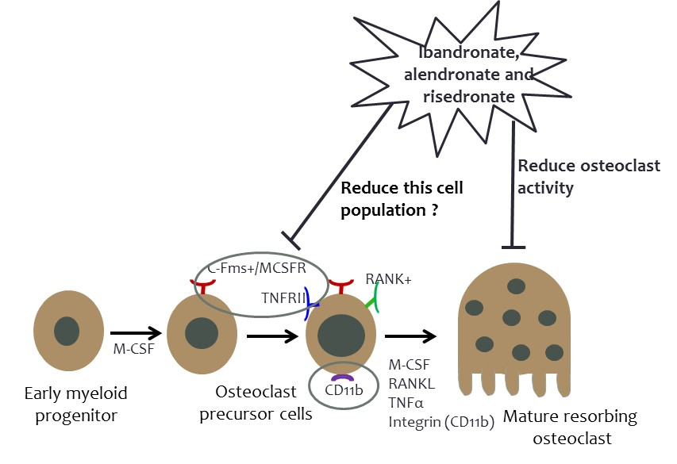
Figure 43: A possible mechanism of action of bisphosphonates is to reduce the population of osteoclast precursor cells and activation frequency.

Bone turnover and bone balance
Bisphosphonates are used to treat postmenopausal osteoporosis and it is widely accepted that they reduce bone turnover, increase BMD and reduce fracture risk. These effects and the differences in the degree in which bisphosphonates reduce bone turnover as assessed by BTMs have been previously been described in chapter 5 and in several clinical trials. FACT showed that alendronate reduced bone turnover markers and increased BMD more than risedronate (406, 451). The fracture intervention trial (FIT) of alendronate demonstrated and reduction in bone ALP and vertebral fracture risk (316) and data from the HORIZON study showed a reduction in PINP and fracture risk (313). However, in postmenopausal osteoporosis there is also a negative balance where bone resorption exceeds bone formation, (Figure 42, chapter 4). Also in chapter 4 I have demonstrated that a positive balance rather than the reduction of bone turnover that was related to a reduction in vertebral and non-vertebral fracture risk. It may therefore be that bisphosphonates reduce fracture risk by maintaining or improving bone balance in addition to reducing bone turnover. Their effect on bone balance was yet to be investigated fully.

The role of sclerostin
In the previous chapter I have demonstrated that antiresorptives reduce bone resorption followed by a later reduction in bone formation of a lesser magnitude. Bisphosphonates induce osteoclast apoptosis and increase their resorbing activity. In contrast animal experiments have demonstrated that they inhibit osteocyte apoptosis through the activation of extracellular signal-regulated kinases (ERKs), (270). Bone formation is regulated by the osteocytes through direct communication with the osteoblasts and this involves gap junctions, (452). These varying effects on bone resorption and bone formation may therefore be regulated by Wnt signalling pathway. More specifically by the production of the Wnt antagonists sclerostin and DKK1. Increased circulating levels of these inhibit bone formation by binding to the LRP5, LRP6 and frizzled receptors expressed on the surface of preosteoblast, Figure 50. A plausible mechanistic hypothesis could therefore be that bisphosphonates mediate the synthesis of sclerostin by the osteocytes and reduce bone formation.
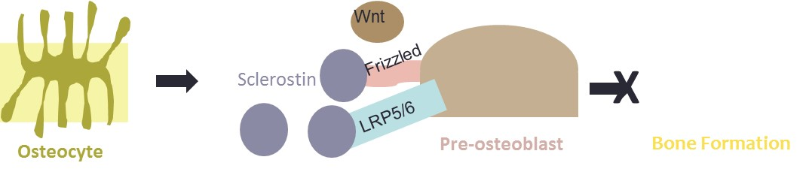
Figure 44: Increased sclerostin production by the osteocytes inhibits bone formation via the Wnt signalling pathway.
The effects of some bisphosphonates on circulating levels of sclerostin and DKK1 have previously been investigated and the data has been inconclusive, (Figure 51) and clinical data is limited. Gatti D et al have demonstrated that a monthly injection of neridronate used to treat women with postmenopausal osteoporosis increased circulating levels of sclerostin, (453). The same group also demonstrated that postmenopausal women treated with a weekly injection of 100mg clodronate (a non-nitrogen containing bisphosphonate) significantly reduced BTMs and increased circulating levels of sclerostin after 12 months compared to placebo and baseline, (454). In contrast (and from a separate clinical trial) those women who received a yearly injection of 5mg of zoledronate (a nitrogen containing bisphosphonate) had no effect on circulating levels of sclerostin after one month and at any time point over 2 years, (454) compared to placebo and baseline. Furthermore another study has demonstrated that there was a short term increase (within 30 days) of circulating levels of sclerostin after zoledronate treatment, (455). This may suggest that nitrogen containing bisphosphonates have a short term rather than a long term effect on sclerostin levels. In contrast again, another study demonstrated a decrease in circulating levels of sclerostin after a zoledronate infusion, (456). Apart from one study that demonstrated a significant increase in circulating levels of sclerostin after 6 months of risedronate treatment (457). Head-to-head clinical data investigating the mechanism of action of the licenced nitrogen containing bisphosphonates on sclerostin is limited. I proposed to investigate whether these treatments have an effect on the osteocytes and circulating levels of sclerostin and whether it is this mechanism that mediates bone formation.

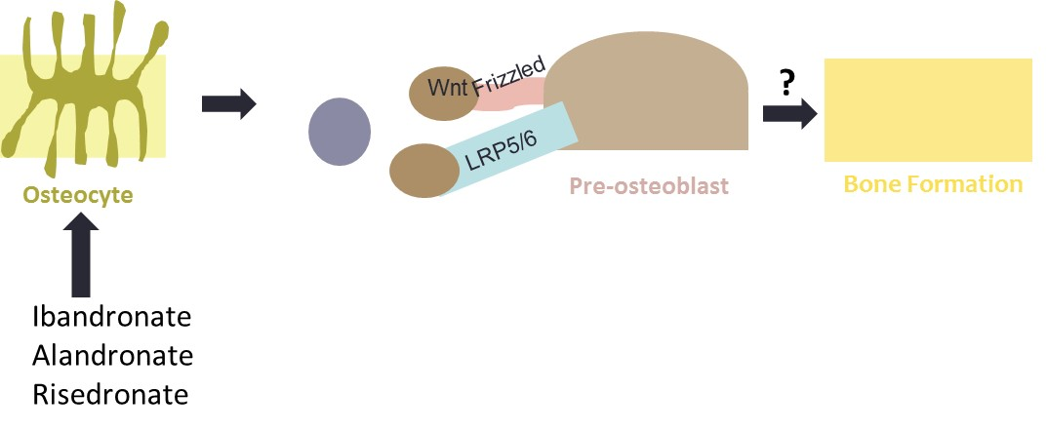
Figure 45: A possible mechanism of the action of nitrogen containing bisphosphonates on bone formation. Bisphosphonates may affect sclerostin production by the osteocytes and thus mediating the lesser suppression of bone formation compared to bone resorption.
-

The aims of this study were to investigate the effect of ibandronate, alendronate and risedronate on i) osteoclast precursor cells and circulating cytokines ii) bone balance and bone turnover using the T-score bone marker method and plot and iii) levels of circulating sclerostin in postmenopausal women with osteoporosis and premenopausal women.

The hypotheses were:
  - Ibandronate, alendronate and risedronate reduce the population of osteoclast precursor cells and circulating levels of RANKL.
  - Ibandronate, alendronate and risedronate reduce bone turnover and make bone balance more positive at the end of treatment compared to baseline and premenopausal women receiving no treatment.
  - The reduction in bone formation by ibandronate, alendronate and risedronate and their effects on bone balance are mediated by circulating levels of sclerostin.

Study participants
The participants used for these analyses were from the TRIO study population, described in chapter 5.
A subset of 62 postmenopausal women with osteoporosis were used to evaluate the effect of bisphosphonate on osteoclast precursor cells. 22 participants received ibandronate (Roche, Bonviva), 150mg tablet once a month. 20 participants received alendronate (Merck, Fosamax) 70mg tablet once a week. 20 participants received risedronate (Warner Chilcott, Actonel) 35mg tablet once a week. The sample size for this analyses was predefined in the study protocol. These were all patients who had a whole blood collected and serum collection. Fasting whole blood was collected form each participant in pyrogen-free EDTA-K₃ containing tubes at BL1 then at weeks 1 and 48. 25 premenopausal women (aged 35 to 40 years) receiving no treatment were also used from the TRIO study population to act at the comparator group. Fasting whole blood and was also collected from 25 premenopausal women. Further details regarding the clinical features of these subjects have been published, (Appendices 2), (458).
The participants who were in the intention to treat population from the TRIO population were used to investigate the effect of bisphosphonates on bone turnover and bone balance, (Table 18). 57 participants were randomised to receive ibandronate (Roche, Bonviva), 150mg tablet once a month, 57 alendronate (Merck, Fosamax) 70mg tablet once a week and 58 risedronate (Warner Chilcott, Actonel) 35mg tablet once a week. 226 premenopausal women (aged 35 to 40 years) receiving no treatment were also used from the TRIO study population to act at the comparator group. Fasting serum samples were collected at on one occasion. Further details regarding the clinical features of these subjects have been published, (Appendices 2), (459).
A subset of 92 postmenopausal women with osteoporosis were used to evaluate the effect of bisphosphonate on circulating levels of sclerostin. This analysis were in the per protocol population, the participants who were randomised received all of the treatment doses and had PINP and CTX data at all of the time points were included. 28 participants were randomised to receive ibandronate (Roche, Bonviva), 150mg tablet once a month, 33 alendronate (Merck, Fosamax) 70mg tablet once a week and 31 risedronate (Warner Chilcott, Actonel) 35mg tablet once a week. 57 premenopausal women (aged 35 to 40 years) receiving no treatment were also used from the TRIO study population to act at the comparator group. Fasting serum samples were collected at on one occasion.

Laboratory methods

Preparation and staining of peripheral blood mononuclear cells (PBMCs)
Whole blood was used in real time. It was directly stained using antibodies and corresponding isotype controls using a method optimised by Glover SJ 2008 PhD thesis and similar methods described by others, (440, 442).
      - 100µl of blood was added to Eppendorf tubes and dual stained for each CD14/M-CSFR, CD14/CD11b and CD14/TNFRII using the following antibodies:
- 4µl of anti-CD14 flouroesceinisothiocynate (FITC) and 10µl of phycoerythrin (PE)-conjugated anti-MCSFR
- 4µl of anti-CD14 FITC and 10µl of allophycocyanin (APC)-conjugated anti-CD11b
- 4µl of anti-CD14 FITC and 20µl PE-conjugated anti-TNFRII
      - 100µl of blood was left unstained and 100 µl of blood was dual stained using a corresponding isotype control in order to eliminate non-specific binding:
- 4µl of CD14 FITC isotype and 10µl of PE-conjugated MCSFR isotype
- 4µl of CD14 FITC and 10µl of APC-conjugated CD11b isotype
- 4µl of CD14 FITC and 20µl of PE-conjugated TNFRII isotype
      - The tubes were incubated for 45 minutes at 4°C in order to allow the antibodies to interact with the cells.
      - 1ml of was buffer containing phosphate buffered saline (PBS) and 1% foetal bovine serum (FBS) was added to each tube and centrifuged at 4000rpm for 3 minutes, the supernatant was removed. This step removed the unbound antibody for the cells. This washing step was repeated twice.
      - 1ml of working strength H-Lyse buffer was added to the cells and mixed vigorously. These were incubated for 20 minutes at room temperature until the red cell lysis process was complete. This was determined following the colour change from turbid/opaque to darker fluid. This step removes the red blood cells, leaving the white nucleated cells
      - The cells were centrifuge at 1500rpm for 5 minutes and the supernatant was removed. The cells were washed using 1ml working strength red cell lysis buffer and mixed. This process was repeated once.
      - The remaining supernatant was removed and the cells re-suspended in 500µl of PBS wash buffer and immediately analysed.

Flow cytometry
Flow cytometry was performed to sort the cells using fluorescent activated cells sorting (FACS) FACSCalibur flow cytometer and analysed with CellQuest software (Becton Dickinson & Co). This method uses fluorescent probes that specifically bind to cell surface proteins. The antibody stained cells were passed through a laser in the flow cytometer and the fluorochrome absorbs the energy and releases this as photons. This process emits light and the wavelength was detected and measured by detectors. This is translated into electrical pulses which are proportional to the intensity of the fluorescence. The characteristics of a cell population can be determined by their forward scatter (FSC) i.e. relative size and side scatter (SSC) i.e. relative granularity. The results were displayed as histograms and bivariate dot plots. The PBMCs were identified according to their size and granularity from their forward scatter and side scatter and gated as viable cells, (Figure 52). Unstained, isotype control and dual stained cells were identified from 10,000 PBMCs. The cells expressing CD14 were described as being CD14⁺ and were identified as being monocytes, (Figure 52). The histograms show the peaks for unstained and isotype control stained cells lay on top of each other indicating non-specific binding. There is a shift in the fluorescent intensity in antibody stained cells as shown by the clear peaks.

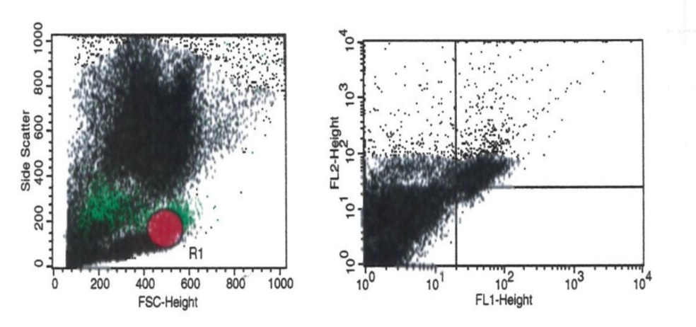

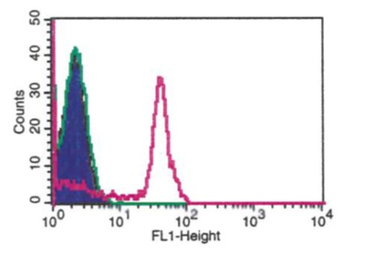
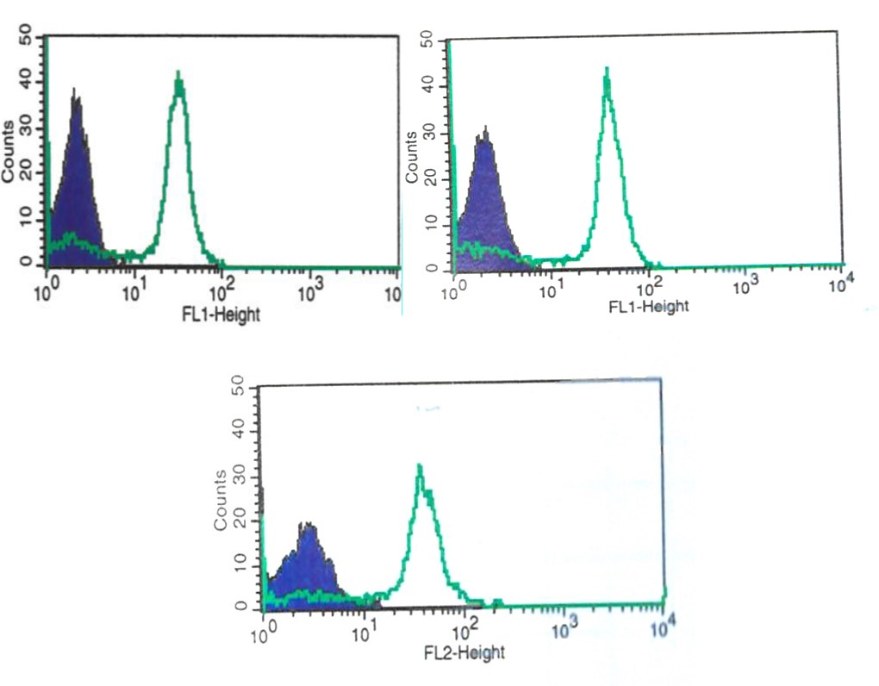
Figure 46: Top panel: PBMCs identified using flow cytometry according to their forward and side scatter. Second panel: Unstained, CD14 isotype control and CD14+ monocytes. Bottom panel: Dual staining CD14/MCSFR isotype control (blue peak) and antibody (clear peak), CD14/CD11b isotype control (blue peak) and antibody (clear peak) and CD14/TNFRII isotype control (blue peak) and antibody (clear peak)

Following cell separation and sorting according to their expression of these cell surface receptors the numbers were captured on dot plots from 10,000 events that represented the viable cells gated. The percentage of monocytes (CD14+) also expressing MCSFR, CD11b and TNFRII were calculated, (Figure 53). The number of positively stained cells are located in the upper right quadrant of each dot plot. This analysis was performed for each study participant at baseline and following 1 and 48 weeks ibandronate, alendronate and risedronate treatment as well as in the subset of 25 premenopausal controls receiving no treatments.
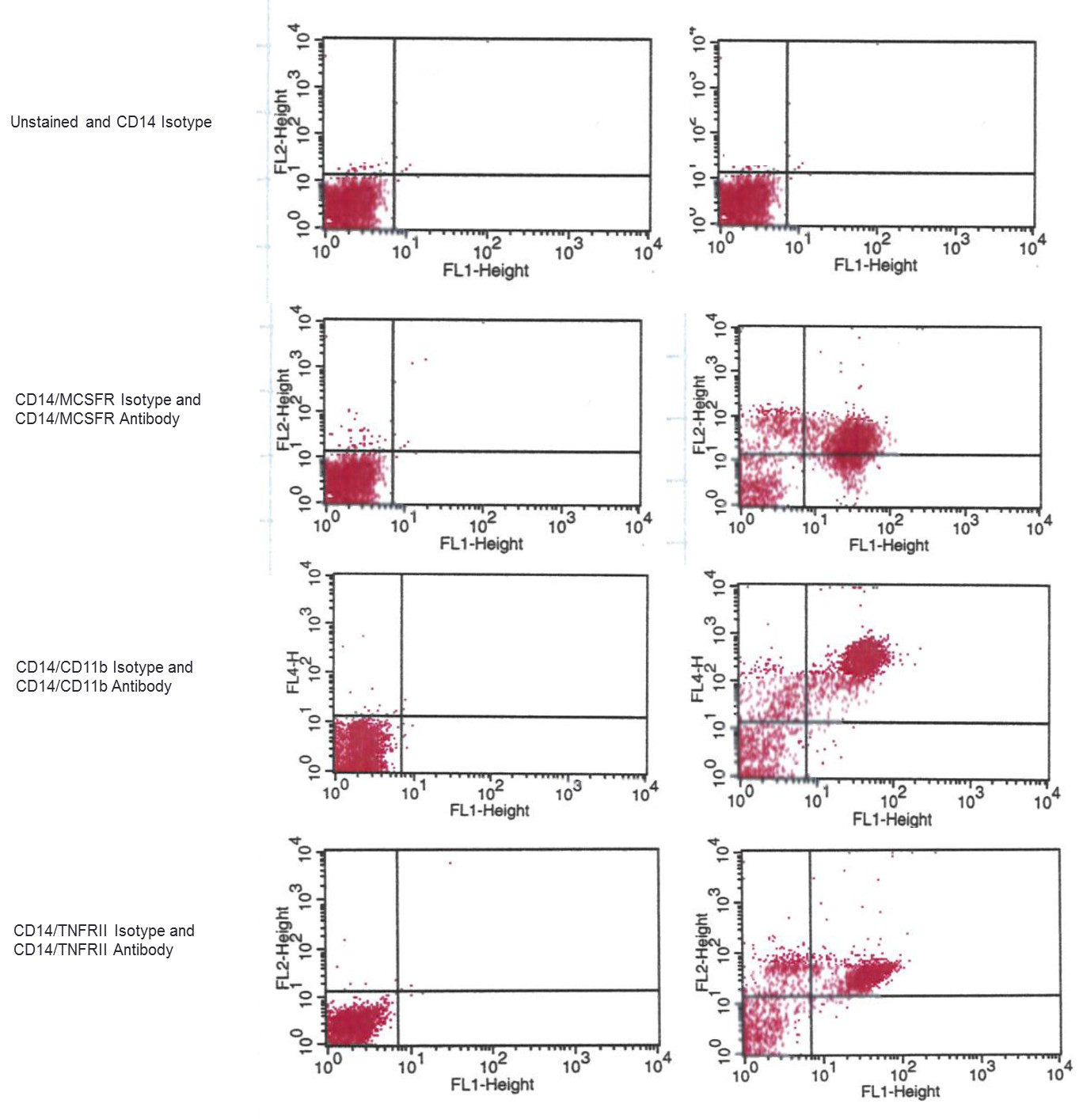
Figure 47: Unstained (top panel), antibody (right) and isotype controls (left) stained PBMCs. The number of PBMCs that are positive for and express CD14/MCSFR, CD14/MCSFR and CD14/TNFRII on their cell surface are shown in the upper right of each quadrant of each dot plot

Biochemistry methods
The CTX and PINP date from the subset of participants who were used for FACS analysis were used. These were previously measured using the IDS-iSYS CLIA technology automated immunoassay, in chapter 5. Circulating levels of RANKL and OPG were also measured in these participants using manual sandwich enzyme immunoassays from Biomedica Gruppe (Vienna, Austria) and Biovendor (Czech Republic), respectively. The inter-assay CV’s were 4% and 5.2% respectively.
The CTX and PINP data from all of the TRIO study participants were used to investigate the effects of bisphosphonates on bone turnover and bone balance i.e. the intention to treat population.
A subset of 92 postmenopausal women with osteoporosis from the TRIO study were used to investigate the effects of bisphosphonates of circulating levels of sclerostin, i.e. per protocol population. Circulating levels of sclerostin were measured in fasting serum samples at baseline 1 and 2 then at weeks 1, 2, 4, 12, 13, 48 and 96 after treatment commenced. A 96-well plate direct-capture enzyme immunoassay from TECOmedical Group (Sissach, Switzerland), (described in chapter 2) was used. The inter assay CV for sclerostin was less than 10% for each three quality control material used.

Statistical analysis
A non-parametric Wilcoxon’s signed test was used to compare the percentage of circulating osteoclast precursor cells, CTX and PINP at baseline and after 1 and 48 weeks of treatment.
A one-way analysis of variance (ANOVA) was used to compare the percentage from baseline of circulating osteoclast precursor cells, CTX and PINP between each treatment group after 48 weeks of treatment. A Kruskal-Wallis test was used to determine significance.
The values for PINP and CTX were log₁₀-transformed and normalised. At each visit the T-scores for PINP and CTX value were calculated for each postmenopausal woman using the mean and standard deviation of the results for the premenopausal women. Bone turnover was the average of the two T-scores and bone balance was the difference between the two T-scores (as described in chapter 4). ANOVA was used to compare the bone turnover and bone balance between each treatment group after 96 weeks of treatment. A Kruskal-Wallis test was used to determine significance.
The values for sclerostin were log₁₀-transformed and normalised. The Wilcoxon signed ranked test was used to determine the statistical difference between the median sclerostin levels for postmenopausal women with osteoporosis and premenopausal women. The overall change from baseline was assessed between the postmenopausal women receiving bisphosphonates and premenopausal women and within each of the treatment groups using mixed model repeated measures. This model contains both fixed (the measurement at baseline) and random effects (the repeated measures of the same individual) and calculates maximum likelihood estimates of these effects. The sclerostin value at baseline 1 was fitted as the covariate. The results for each sclerostin measurements and the p-value to assess significance from baseline was calculated using Dunns post hoc test. For the categorical variables i.e. the treatment group and visit an overall p-value for the significance of differences across all categories was also calculated using the Friedman test. The main reason for using this model and not repeated measures ANOVA is that it has the advantage to deal with missing values in longitudinal studies. If there was an overall difference between the premenopausal and postmenopausal women receiving bisphosphonates then the effect of treatments at each time point was assessed. Changes from baseline were back transformed and expressed as a percentage change.
The Spearman rank correlation was used in order to assess the relationship between the change in CTX levels and the population of osteoclast precursor cells after 48 weeks of treatment.
The Spearman rank correlation was used in order to assess the relationship between levels of circulating sclerostin and PINP and CTX.
For each statistical analyses p<0.05 was used as the significance cut-off point.

Results

The effect of bisphosphonates on osteoclast precursor cells and circulating cytokines
Figure 54 shows the effects of bisphosphonates on the population of osteoclast precursor cell at baseline, 1 and 48 weeks after treatment. At baseline there was no significant difference in the median percentage of osteoclast precursor cells expressing CD14⁺/M-CSFR⁺, CD14⁺/CD11b⁺ and CD14⁺/TNFRII between postmenopausal women with osteoporosis and premenopausal women. The percentage of these osteoclast precursor cells were therefore within that of the premenopausal women reference intervals for each. After 1 week of treatment there was no significant change in the percentage of CD14⁺ cells (monocyte population) expressing M-SCFR, CD11b or TNFRII. 48 weeks after treatment there was a significant reduction in the percentage of CD14⁺/M-CSFR⁺ and CD14⁺/CD11b⁺ osteoclast precursor cells, p<0.001. As a result at week 48 the percentage of the osteoclast precursor cells were reduced to the lower part or lower than the premenopausal reference intervals. There was no difference in the percentage of CD14⁺/TNFRII⁺ osteoclast precursor cells.
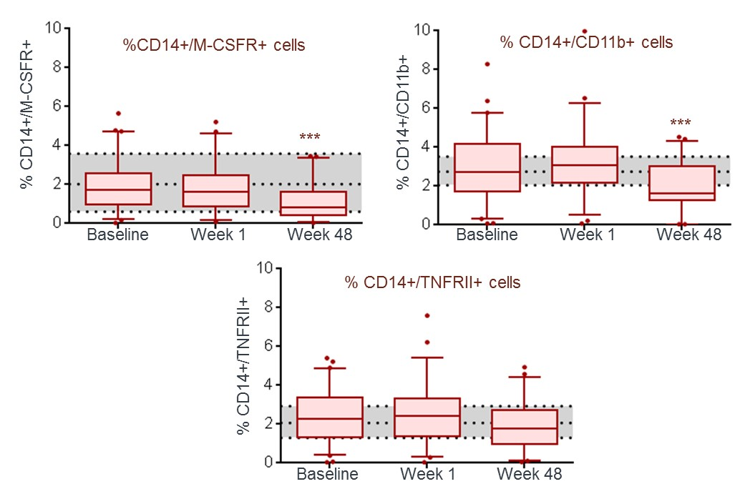
Figure 48: Box and whisker plots representing the percentage of CD14+ cells which are positive for M-CSFR, CD11b and TNFRII before and after 48 weeks of bisphosphonate treatment in postmenopausal women ( N= 62) . Upper and lower quartiles (box), 5 – 95 percentiles (whiskers). The shaded area represents the median value and 25% and 75% percentiles of the premenopausal women (N = 25).

Figure 55 shows the effects of ibandronate, alendronate and risedronate on the population of osteoclast precursor cell at baseline, 1 and 48 weeks after treatment. After 1 week there was no significant change in the percentage CD14⁺/M-CSFR⁺, CD14⁺/CD11b⁺ and CD14⁺/TNFRII⁺ cells with either of the bisphosphonates. After 48 weeks of treatment with ibandronate there was a significant decrease from baseline in the population of cells expressing CD14⁺/M-CSFR⁺ by 65%, p<0.05. There was a decrease in the population of cells expressing CD14⁺/CD11b⁺ by 40% but this was not statistically significant. After 48 weeks of treatment with risedronate there was a significant reduction from baseline in the population of cells expressing CD14⁺/M-CSFR⁺ and CD14⁺/CD11b⁺ by 61% and 54%, p<0.01, respectively. These decreases resulted in a high portion of participants having a percentage of osteoclast precursor cells lower than the median percentage in premenopausal women. Treatment with alendronate did not significantly affect the population of these osteoclast precursor cells and neither treatment effected the population of CD14⁺/TNFRII⁺ cells, (Table 24).
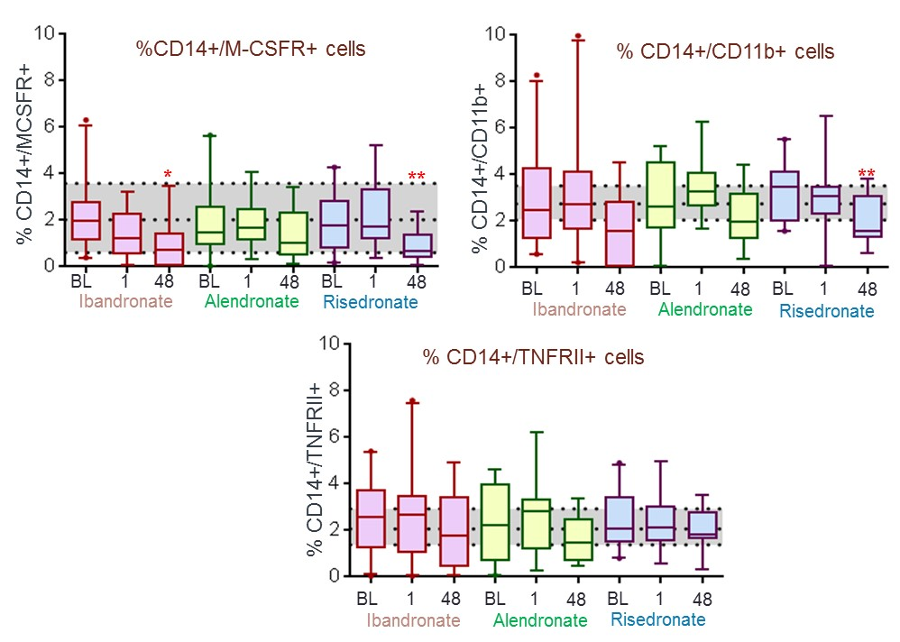
Figure 49: Box and whisker plots representing the percentage of CD14+ cells which are positive for M-CSFR, CD11b and TNFRII in postmenopausal women taking ibandronate ( N = 22), alendronate ( N = 19) and risedronate (N = 21) over 48 weeks. ). The shaded area represents the median value and 25% and 75% percentiles of the premenopausal women (N = 25).

Table 24: Percentage of CD14+ cells from the PBMC cell population which are positive MSCF-R, CD11b and TNFRII and median levels of bone turnover markers at baseline and 48 weeks after treatment (percentage decrease from baseline shown). Significance compared to baseline was tested using non-parametric Wilcoxon signed test, *p<0.05, **p<0.01 and ***p<0.001.
At baseline 1 median levels of circulating serum RANKL and OPG were 0.07 pmol/l and 5.2pmol/l respectively. There were no significant changes in RANKL and OPG after 48 weeks of bisphosphonate treatment, (Figure 56).
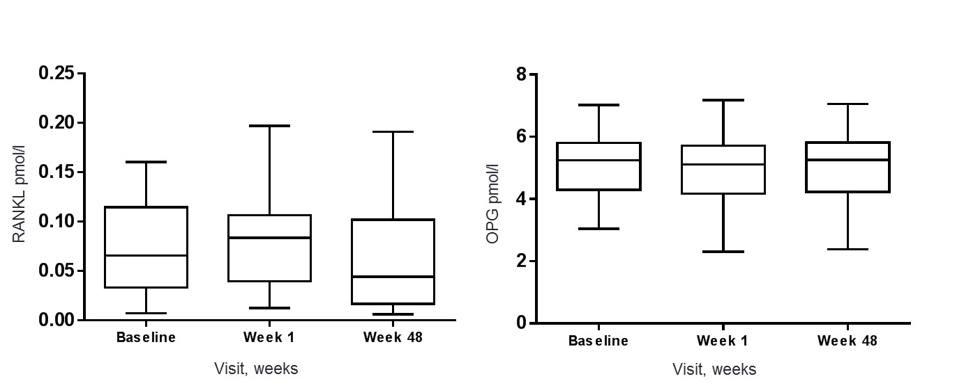
Figure 50: Box and whisker plots representing circulating levels of RANKL and OPG in postmenopausal women with osteoporosis receiving bisphosphonate treatments (N = 62) over 48 weeks.

The effect of bisphosphonates on CTX and PINP
Figure 57 shows the effects of ibandronate, alendronate and risedronate on CTX and PINP at baseline 1, 1 and 48 weeks after treatment. Similar effects were seen in this subset of participants as in the intention to treat study population described in chapter 5. These graphs show that there were significant decreases in CTX after one week of treatment with each of the bisphosphates, p<0.001. There were significant decreases in PINP at week 48 with each of the bisphosphonates, p<0.001. Spearman’s correlation analysis showed that these changes in CTX after ibandronate, alendronate and risedronate were not correlated with the changes in the CD14⁺/M-CSFR⁺ and CD14⁺/CD11b⁺ osteoclast precursor cell populations.
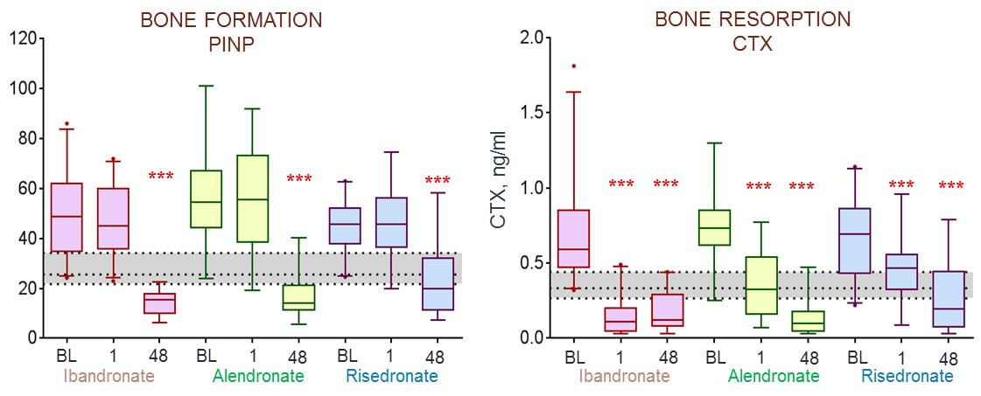
Figure 51: Box and whisker plots representing levels of PINP and in postmenopausal women taking ibandronate (N = 22), alendronate (N = 19) and risedronate (N = 21) over 48 weeks. ). The shaded area represents the median value and 25% and 75% percentiles of the premenopausal women (N = 25).

The effect of bisphosphonates on bone turnover and bone balance (the T-score bone marker method/plot)
The baseline characteristics of the postmenopausal women receiving bisphosphonate treatment and the healthy premenopausal women are shown in tables 22 and 23 respectively.
The T-scores for PINP and CTX were calculated and plotted at each visit, (Figure 58). This graph shows that the T-score for PINP (in red) remained between 1 and 1.5 SD units above the mean of the healthy premenopausal women (y = 0) from baseline until week 4. This value decreased at week 4 and continued to do so for the remainder of the treatment period to -1.8 SD units below the mean value for premenopausal women. In comparison the T-scores for CTX decreased from baseline to -2 SD units below the premenopausal mean at week 96.
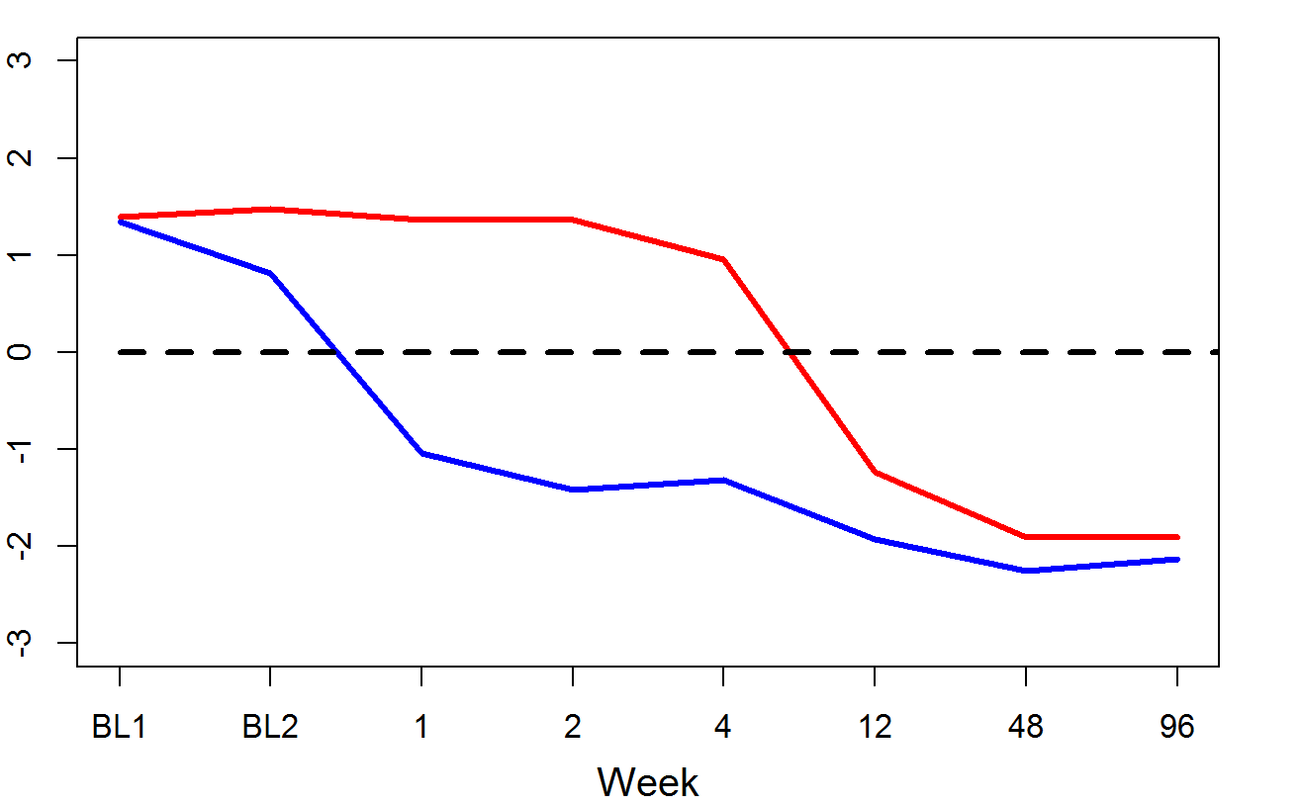
Mean T-score
Figure 52: The mean T-scores calculated for PINP (red line) and CTX (blue line) for postmenopausal women treated with bisphosphonates (combined) over 96 weeks. The dashed line at Y = 0 represents the mean T-score for healthy premenopausal women.
The combined effect of bisphosphonates on bone turnover and bone balance (as calculated from the T-scores of the BTMs) are shown in figure 59. The mean levels of bone balance and bone turnover and change in these from baseline 1 are shown in tables 25 and 26, respectively.
At baseline 1 prior to treatment, mean levels of bone turnover and bone balance were 1.379 and 0.047 SD units above the premenopausal mean, respectively. After 1 week of treatment bone turnover significantly decreased from baseline 1 by -1.403 to 0.160 SD and bone balance increased by 2.350 to 2.397 SD units above the premenopausal mean, p<0.001. After week 4 levels of turnover continued to decrease to below the premenopausal mean to -2.023 SD units by week 96, p<0.001. At week 48 bone balance had decreased to 0.228 SD units above the premenopausal mean and this change was significant from baseline 1, p<0.05, however this was not significant at week 96. Mean levels of bone turnover were significantly higher than the control group at baselines 1 and 2 p<0.001 and lower at weeks 12, 48 and 96 p<0.001. Mean levels of bone balance were significantly more positive than the control group at baseline 2 and weeks 1, 2, 4, 12/13 p<0.001 and 48 p = 0.003.
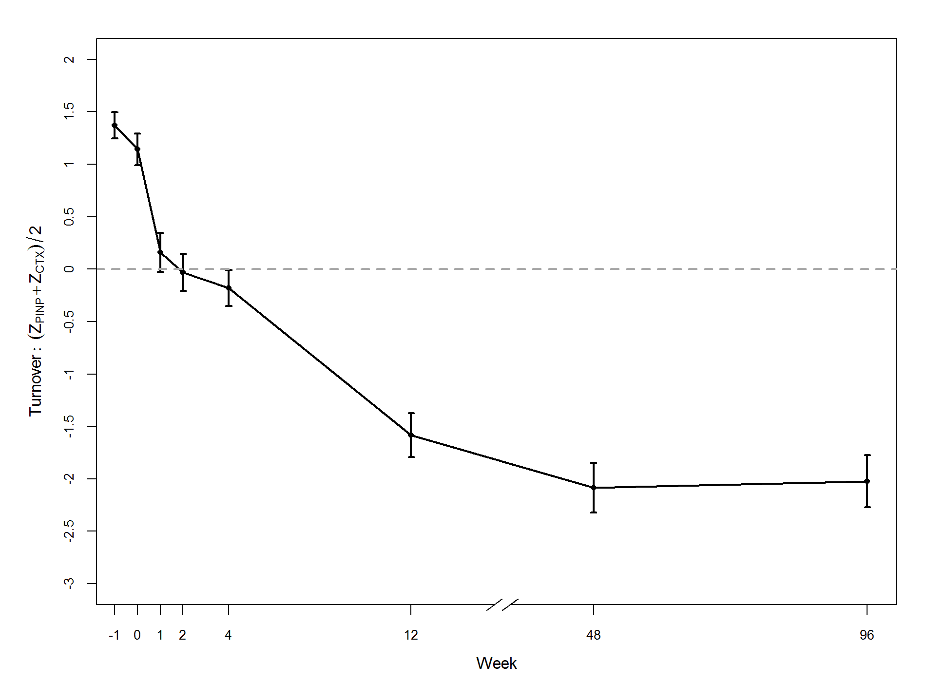
Bone turnover, (T_{PINP} + T_{CTX})/2
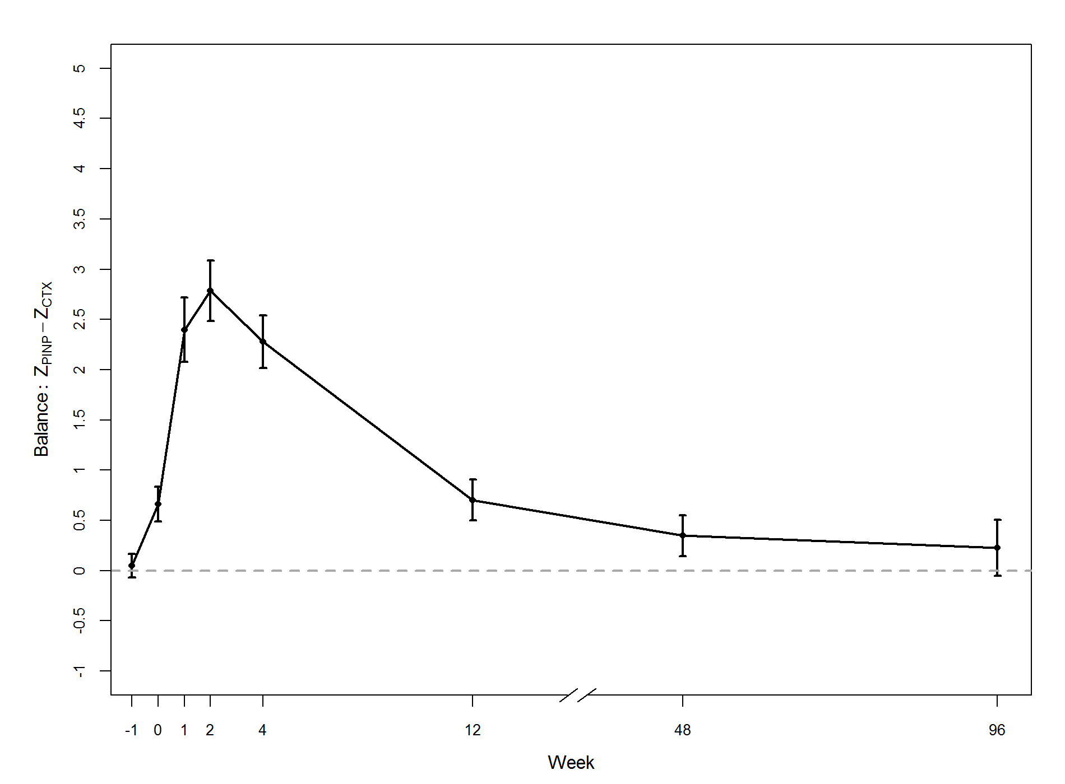
Bone balance, T_{PINP} - T_{CTX}
Figure 53: Graphs showing the mean and 95% confidence intervals of bone turnover (top) and bone balance (bottom) (calculated using the T-scores of PINP and CTX) in postmenopausal women receiving bisphosphonate treatment (groups combined) over 96 weeks, (-1 = baseline 1 and 0 = baseline 2). The dashed line at Y = 0 represents the mean of the healthy premenopausal women.
Table 25: The mean values and 95% confidence intervals of bone balance and bone turnover in postmenopausal women receiving bisphosphonate treatment (groups combined) over 96 weeks. N is the number of women at each visit.
 | N | Bone balance |  | Bone turnover
 | N | Mean | 95% CI | Mean | 95% CI
Baseline 1 | 165 | 0.047 | (-0.069, 0.163) | 1.370 | (1.244, 1.497)
Baseline 2 | 165 | 0.661 | (0.489, 0.832) | 1.143 | (0.992, 1.294)
Week 1 | 165 | 2.397 | (2.076, 2.719) | 0.160 | (-0.028, 0.347)
Week 2 | 157 | 2.785 | (2.482, 3.087) | -0.033 | (-0.210, 0.145)
Week 4 | 155 | 2.277 | (2.016, 2.538) | -0.181 | (-0.354, -0.009)
Week 12 | 147 | 0.701 | (0.498, 0.905) | -1.582 | (-1.793, -1.372)
Week 48 | 136 | 0.347 | (0.145, 0.559) | -2.085 | (-2.322, -1.848)
Week 96 | 86 | 0.228 | (-0.051, 0.507) | -2.023 | (-2.272, -1.774)

Table 26: The mean change and 95% confidence intervals in bone balance and bone turnover in postmenopausal women receiving bisphosphonate treatment (groups combined) over 96 weeks.
 | Bone balance |  |  | Bone turnover
 | Mean | 95% CI | P-Value | Mean | 95% CI | P-Value
Baseline 2 | 0.614 | (0.407, 0.820) | <0.001 | -0.228 | (-0.424, -0.031) | 0.023
Week 1 | 2.350 | (2.009, 2.691) | <0.001 | -1.211 | (-1.436, -0.985) | <0.001
Week 2 | 2.738 | (2.414, 3.061) | <0.001 | -1.403 | (-1.620, -1.186) | <0.001
Week 4 | 2.230 | (1.945, 2.515) | <0.001 | -1.552 | (-1.765, -1.338) | <0.001
Week 12 | 0.654 | (0.421, 0.888) | <0.001 | -2.953 | (-3.197, -2.706) | <0.001
Week 48 | 0.300 | (0.068, 0.532) | 0.012 | -3.455 | (-3.723, 3.188) | <0.001
Week 96 | 0.181 | (-0.120, 0.482) | 0.237 | -3.393 | (-3.672, -3.115) | <0.001

The T-score bone marker plot in figure 60 shows how bone turnover and bone balance (in the same plot) changes over 96 weeks of bisphosphonate treatment relative to healthy premenopausal women. Prior to treatment (at baseline 1) postmenopausal women with osteoporosis have a high bone turnover and a normal bone balance relative to healthy premenopausal women. After 4 weeks of bisphosphonate treatment the women are in a state of normal bone turnover and a positive balance. After 96 weeks of treatment the women are in a state of low bone turnover and positive balance.
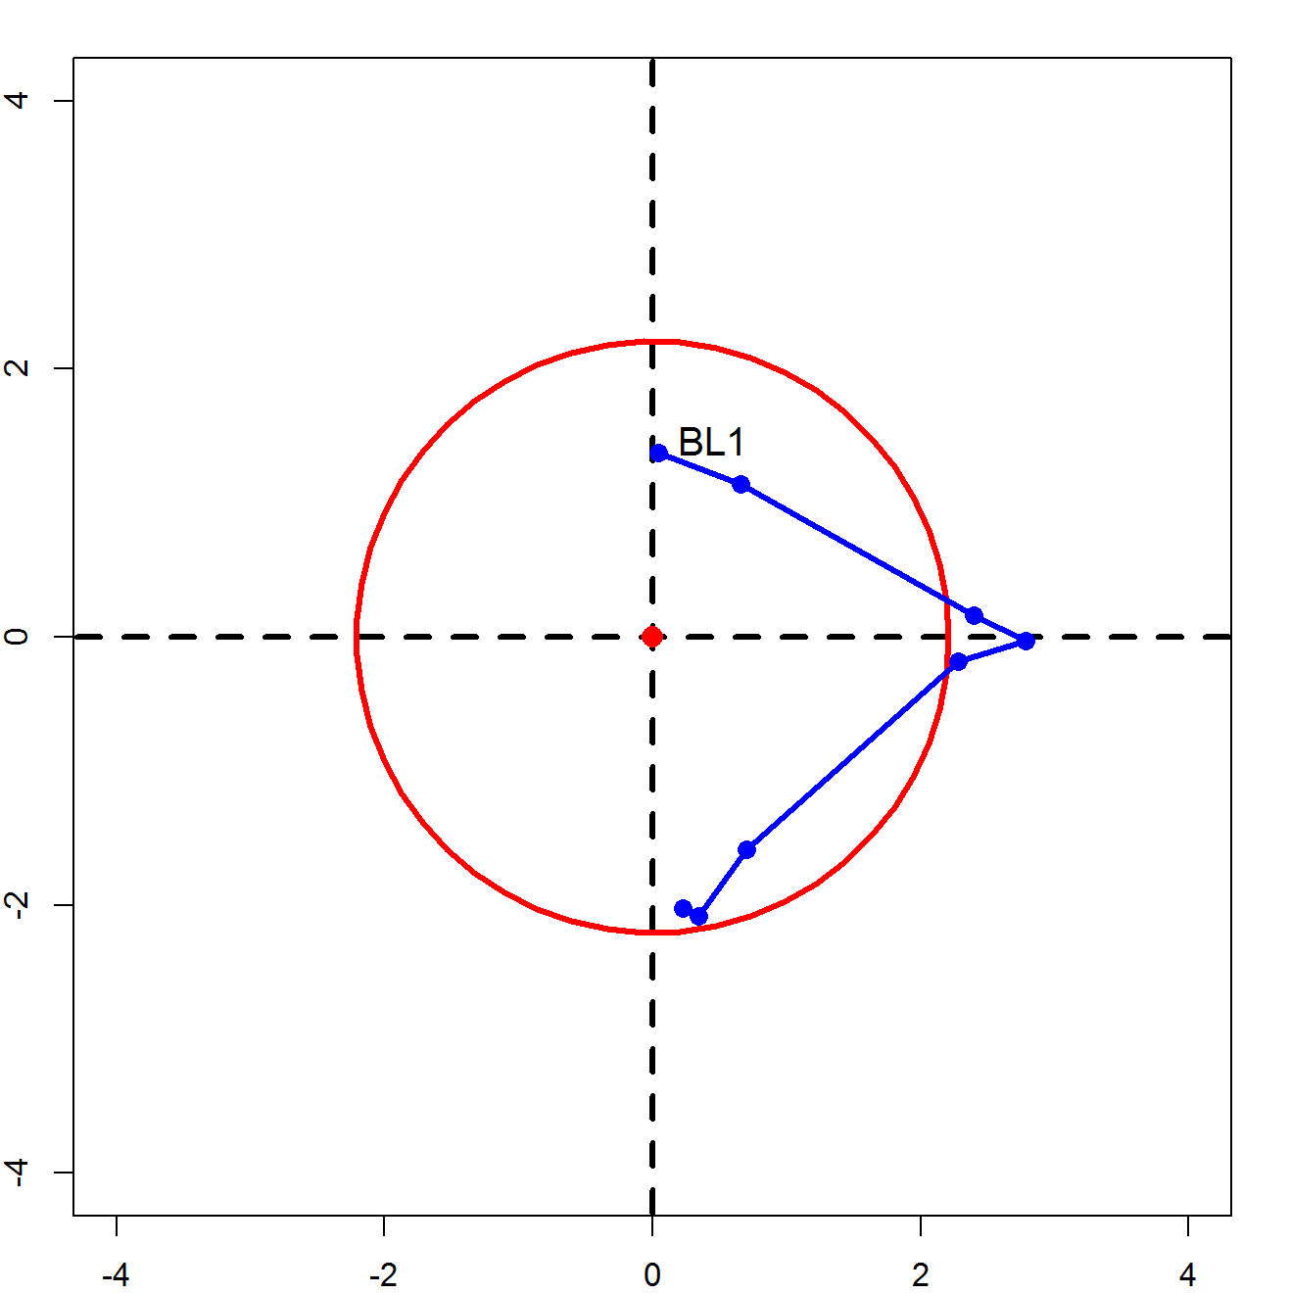
Week 2
Week 96
Week 48
Week 12/13
Week 4
Week 1
BL2
Bone turnover, (T_{PINP} + T_{CTX})/2
Low turnover
Negative balance
Low turnover
Positive balance
High turnover
Positive balance
High turnover
Negative balance
Bone balance, T_{PINP} - T_{CTX}

Figure 54: T-score bone marker plots for postmenopausal women receiving bisphosphonate treatment (groups combined) represented by the blue line. The blue circles represent the centre of the ellipses for each visit starting from baseline. The red ellipse represents premenopausal women.
The T-scores for PINP and CTX were calculated and plotted for ibandronate, alendronate and risedronate at each visit, (Figure 61). The graphs show that T-scores for PINP with each bisphosphonate (in red) remained between 1 and 1.5 SD units above the mean of the healthy premenopausal women from baseline until week 4 on treatment. This value decreased at week 4 and continued to do so for the remainder of the treatment period to -2.0 SD units in the women treated with ibandronate and alendronate and -1.5 SD units with risedronate, below the mean value for premenopausal women. In comparison the T-scores for CTX decreased from baseline to below the premenopausal mean at week 1 with each bisphosphonate. At week 1 the T-score was lowest in the women treated with ibandronate -3.0 SD units, compared to -0.5 and 0.0 SD units with alendronate and risedronate respectively. At week 96 the T-scores for CTX were -2, -3 and -1.5 SD units below the mean of the premenopausal women with ibandronate, alendronate and risedronate treatments, respectively.
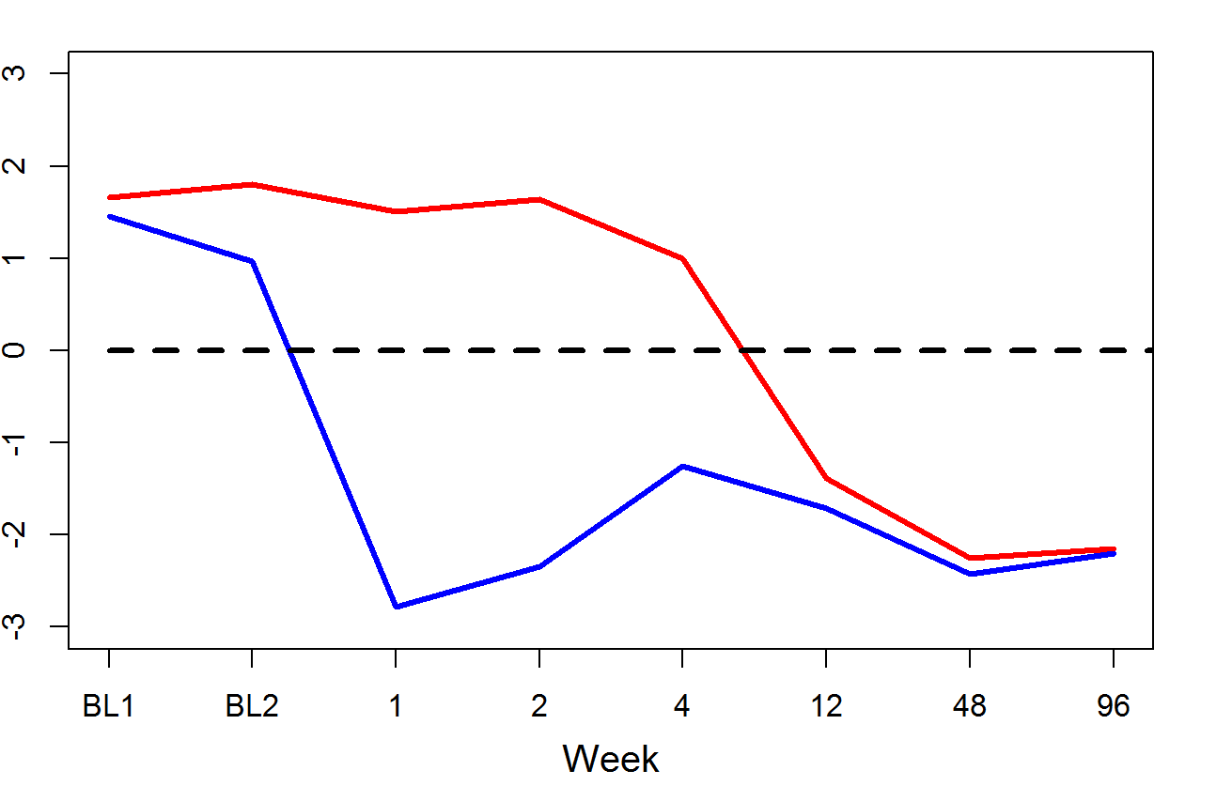
Mean T-score
Ibandronate
Alendronate
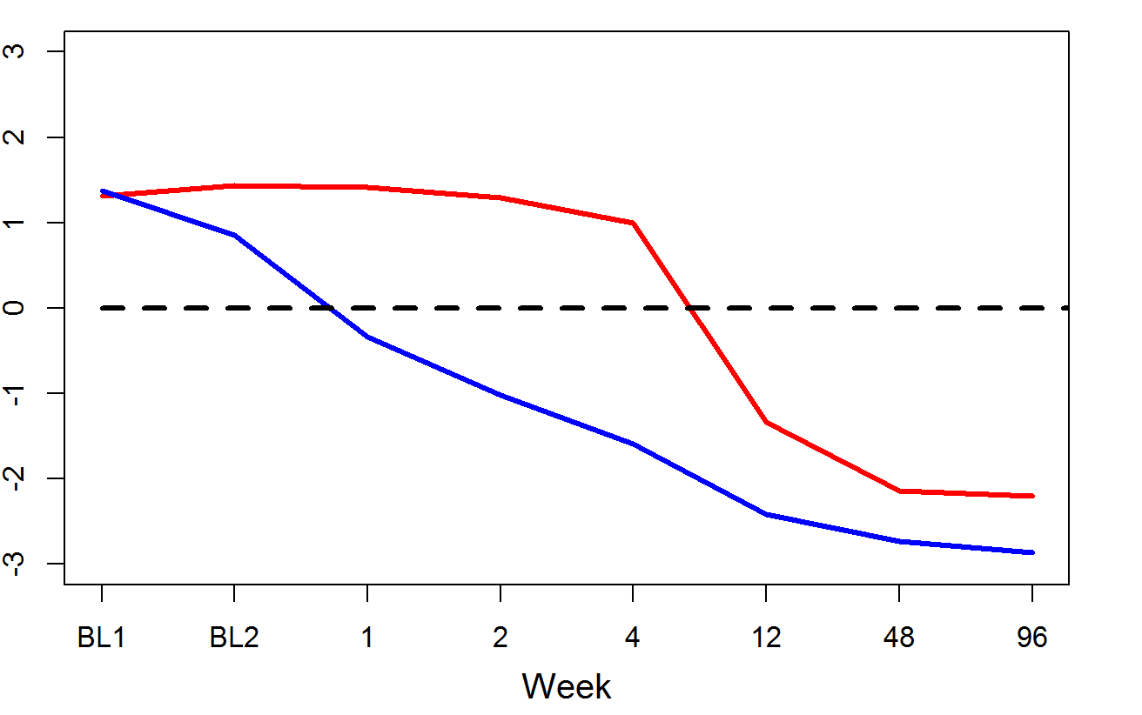
Mean T-score

Risedronate
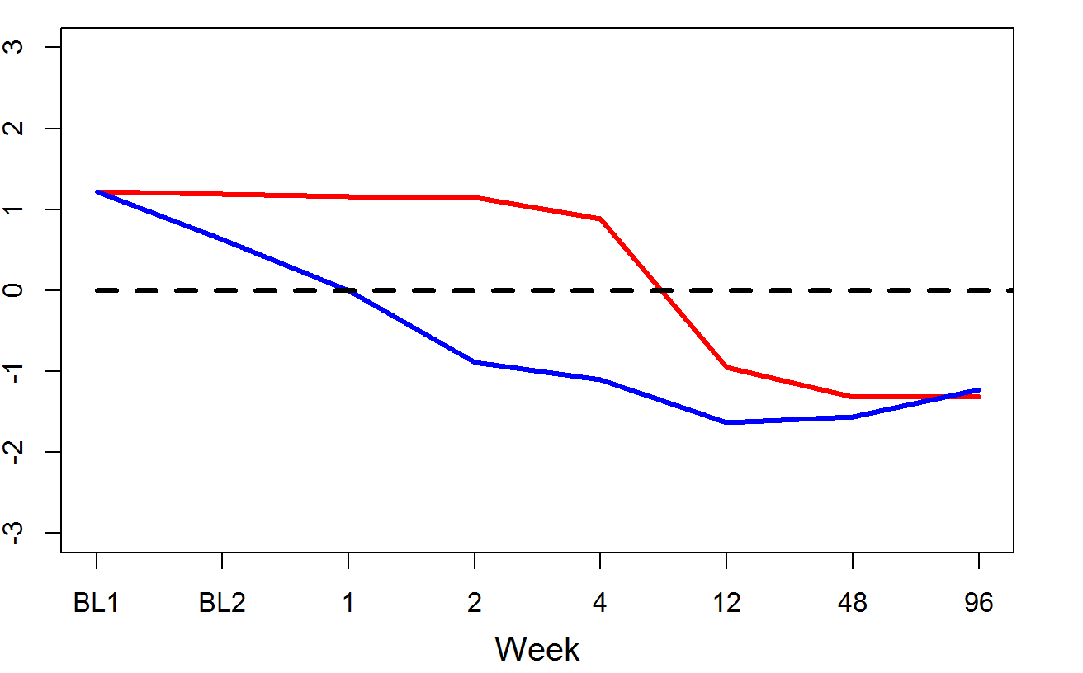
Mean T-score
Figure 55: The mean T-scores calculated for PINP (red line) and CTX (blue line) for postmenopausal women treated with ibandronate (top graph), alendronate (middle graph) and risedronate (bottom graph) over 96 weeks. The dashed line at Y = 0 represents the mean of the healthy premenopausal women.
The effects of ibandronate, alendronate and risedronate on bone turnover and bone balance (as calculated by using the T-scores of the BTMs) are shown in figures 62 and 63. For each bisphosphonate, the mean levels of bone balance and bone turnover and change in these from baseline 1 are shown in tables 27 and 28.
After one week of mean levels of bone turnover decreased to -0.640, 0.538 and 0.581 SD units different from the mean of premenopausal women in postmenopausal women receiving ibandronate, alendronate and risedronate, respectively p<0.001. This decrease was significant from baseline, p<0.001 with each bisphosphonate and it was greatest in women receiving ibandronate, -2.193 SD units. At week 1 mean levels of bone turnover were significantly lower in postmenopausal women receiving ibandronate compared to alendronate p<0.001, ibandronate compared to risedronate p<0.001 but not alendronate compared to risedronate. Bone turnover continued to decrease significantly from baseline 1 until week 96, p<0.001. At week 96 bone turnover was -2.178, -2.534 and -1.275 SD units below the mean of premenopausal women in postmenopausal women receiving ibandronate, alendronate and risedronate respectively. These were significantly lower in women receiving ibandronate compared to risedronate and alendronate compared to risedronate, p<0.001 but not ibandronate compared to alendronate.
After one week of treatment bone balance increased to 4.285, 1.758 and 1.160 SD units from the mean of the premenopausal women in postmenopausal women receiving ibandronate, alendronate and risedronate, respectively p<0.001. This increase was significant from baseline, p<0.001 with each bisphosphonate and it was greatest in women receiving ibandronate, 4.285 SD units. At week 1 mean levels of bone balance were significantly more positive in women receiving ibandronate compared to alendronate p<0.001, ibandronate compared to risedronate p<0.001 and alendronate compared to risedronate p<0.05. Bone balance remained significantly more positive than baseline and compared to healthy premenopausal women with each bisphosphonate until week 4, p<0.001. By weeks 48 and 96 bone balance was significantly more positive than baseline in women receiving alendronate, p<0.01 and not ibandronate and risedronate. Bone balance was more positive in women receiving alendronate compared to ibandronate, p=0.01 but not alendronate compared to risedronate, p=0.06 or ibandronate compared to risedronate. 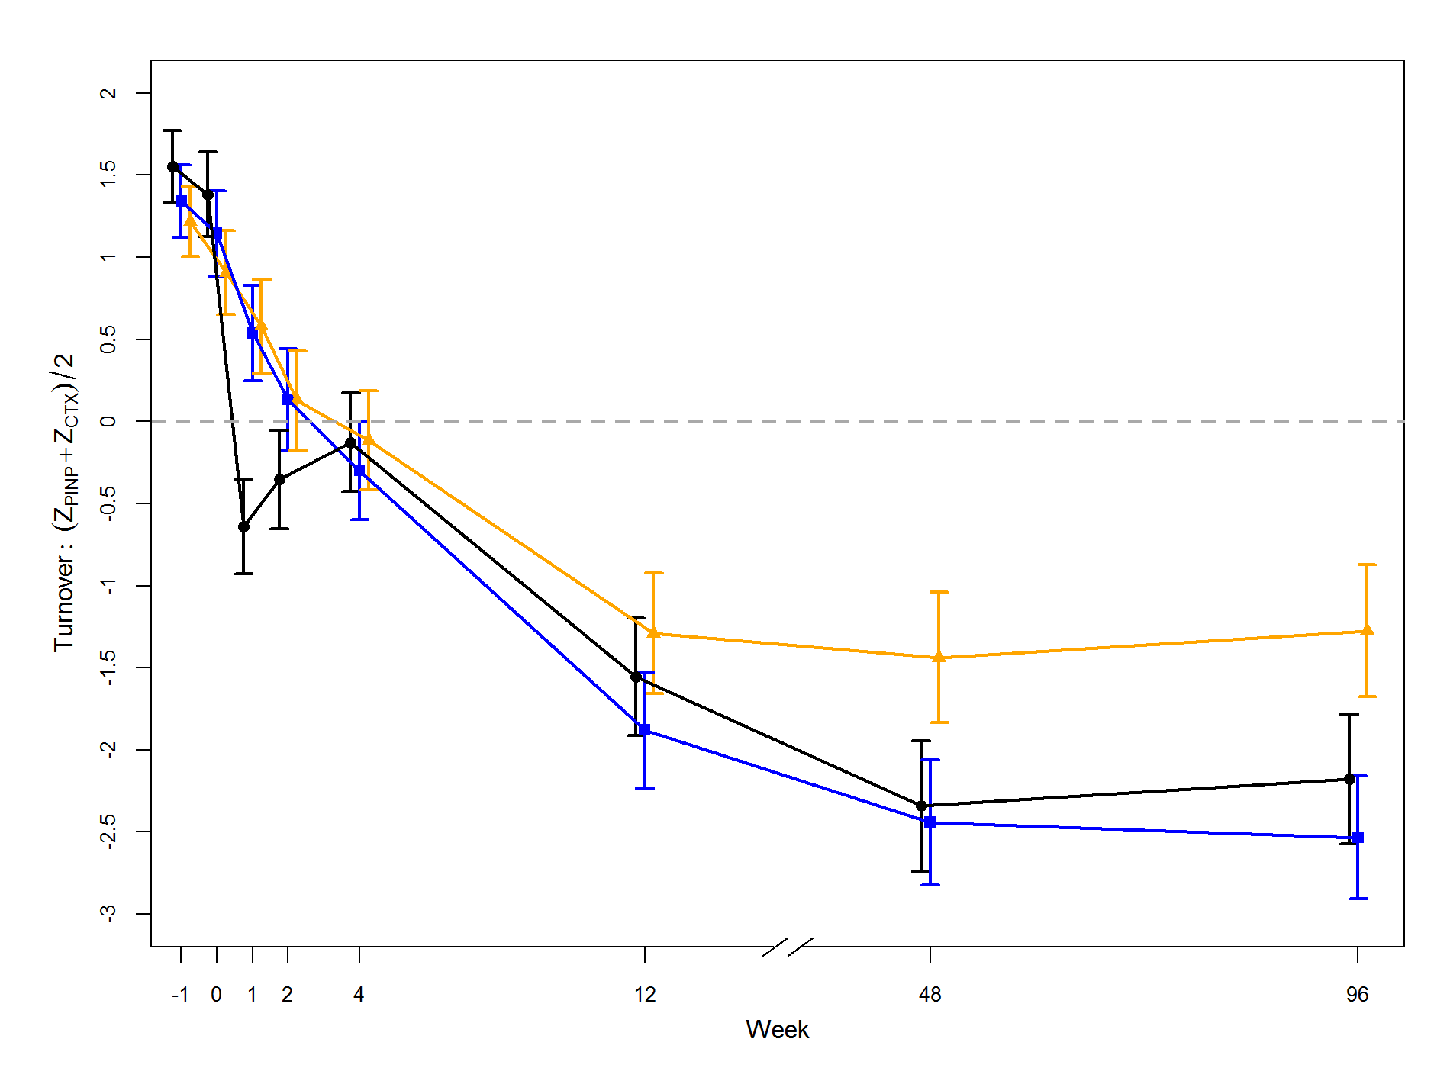Figure 56: Graphs showing the mean and 95% confidence intervals of bone turnover (calculated using the T-scores of PINP and CTX) in postmenopausal women receiving ibandronate (black), alendronate (blue) and risedronate (orange) over 96 weeks, (-1 = baseline 1 and 0 = baseline 2). The dashed line at Y = 0 represents the mean of the healthy premenopausal women.
Bone turnover, (T_{PINP} + T_{CTX})/2
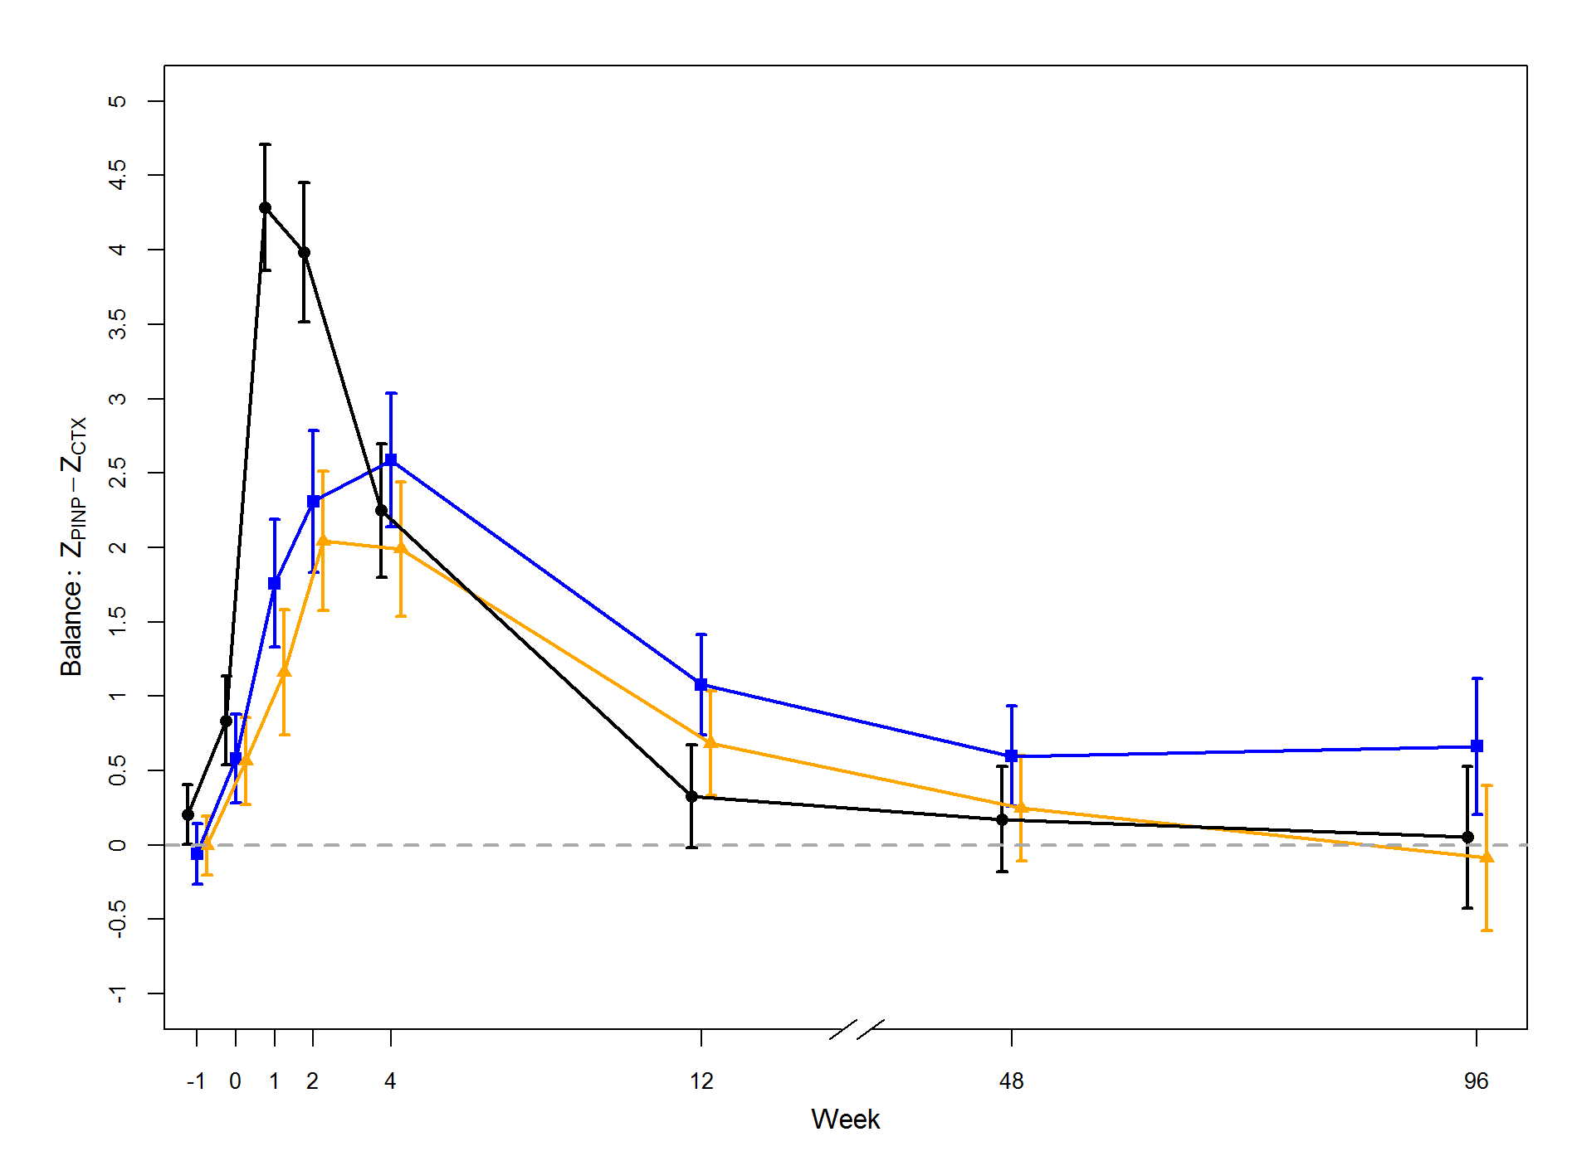
Bone balance, T_{PINP} - T_{CTX}
Figure 57: Graphs showing the mean and 95% confidence intervals of bone balance (calculated using the T-scores of PINP and CTX) in postmenopausal women receiving ibandronate (black), alendronate (blue) and risedronate (orange) over 96 weeks, (-1 = baseline 1 and 0 = baseline 2). The dashed line at Y = 0 represents the mean of the healthy premenopausal women.
Table 27: The mean values and 95% confidence intervals of bone balance and bone turnover in postmenopausal women receiving ibandronate, alendronate and risedronate over 96 weeks. N is the number of women at each visit.
Bone balance
 | Ibandronate |  |  | Alendronate |  |  | Risedronate
 | N | Mean | 95% CI | N | Mean | 95% CI | N | Mean | 95% CI
Baseline 1 | 55 | 0.205 | (0.005, 0.405) | 54 | -0.060 | (-0.262, 0.141) | 56 | -0.004 | (-0.202,0.194)
Baseline 2 | 55 | 0.837 | (0.540, 1.134) | 54 | 0.582 | (0.282, 0.881) | 56 | 0.564 | (0.269, 0.858)
Week 1 | 55 | 4.285 | (3.860, 4.710) | 54 | 1.758 | (1.329, 2.187) | 56 | 1.160 | (0.738, 1.581)
Week 2 | 53 | 3.984 | (3.516, 4.452) | 51 | 2.309 | (1.833, 2.786) | 53 | 2.043 | (1.575, 2.510)
Week 4 | 52 | 2.249 | (1.801, 2.697) | 52 | 2.587 | (2.139, 3.035) | 51 | 1.990 | (1.537, 2.442)
Week 12 | 49 | 0.326 | (-0.018, 0.670) | 51 | 1.077 | (0.740, 1.414) | 47 | 0.685 | (0.334, 1.036)
Week 48 | 44 | 0.173 | (-0.180, 0.527) | 48 | 0.597 | (0.259, 0.935) | 44 | 0.248 | (-0.106, 0.601)
Week 96 | 28 | 0.052 | (-0.426, 0.530) | 31 | 0.662 | (0.207, 1.116) | 27 | -0.088 | (-0.575, 0.399)
Bone turnover
 | Ibandronate |  |  | Alendronate |  |  | Risedronate
 | N | Mean | 95% CI | N | Mean | 95% CI | N | Mean | 95% CI
Baseline 1 | 55 | 1.553 | (1.336, 1.770) | 54 | 1.342 | (1.123, 1.562) | 56 | 1.218 | (1.003, 1.433)
Baseline 2 | 55 | 1.382 | (1.124, 1.640) | 54 | 1.145 | (0.884, 1.405) | 56 | 0.906 | (0.650, 1.161)
Week 1 | 55 | -0.640 | (-0.929, -0.350) | 54 | 0.538 | (0.246, 0.830) | 56 | 0.581 | (0.294, 0.867)
Week 2 | 53 | -0.354 | (-0.656, -0.053) | 51 | 0.135 | (-0.173, 0.442) | 53 | 0.128 | (-0.173, 0.429)
Week 4 | 52 | -0.128 | (-0.427, 0.171) | 52 | -0.300 | (-0.599, -0.001) | 51 | -0.114 | (-0.416, 0.188)
Week 12 | 49 | -1.555 | (-1.915, -1.195) | 51 | -1.879 | (-2.232, -1.526) | 47 | -1.289 | (-1.657, -0.921)
Week 48 | 44 | -2.342 | (-2.740, -1.945) | 48 | -2.441 | (-2.822, -2.061) | 44 | -1.439 | (-1.836, -1.041)
Week 96 | 28 | -2.178 | (-2.571, -1.784) | 31 | -2.534 | (-2.908, -2.160) | 27 | -1.275 | (-1.676, -0.874)

Table 28: The mean change and 95% confidence intervals in bone balance and bone turnover in postmenopausal women receiving ibandronate, alendronate and risedronate over 96 weeks. Significance from baseline was tested using Dunn’s post hoc test.
Bone balance
 | Ibandronate |  |  | Alendronate |  |  | Risedronate
 | Mean | 95% CI | P-Value | Mean | 95% CI | P-Value | Mean | 95% CI | P-Value
Baseline 2 | 0.632 | (0.254, 1.010) | 0.001 | 0.642 | (0.260, 1.024) | 0.001 | 0.568 | (0.250, 0.886) | 0.001
Week 1 | 4.080 | (3.550, 4.610) | <0.001 | 1.818 | (1.350, 2.287) | <0.001 | 1.164 | (0.746, 1.582) | <0.001
Week 2 | 3.779 | (3.252, 4.306) | <0.001 | 2.370 | (1.821, 2.918) | <0.001 | 2.047 | (1.574, 2.520) | <0.001
Week 4 | 2.044 | (1.543, 2.546) | <0.001 | 2.647 | (2.119, 3.175) | <0.001 | 1.994 | (1.537, 2.451) | <0.001
Week 12 | 0.121 | (-0.339, 0.582) | 0.600 | 1.138 | (0.766, 1.509) | <0.001 | 0.689 | (0.324, 1.054) | <0.001
Week 48 | -0.031 | (-0.492, 0.430) | 0.893 | 0.658 | (0.257, 1.058) | 0.002 | 0.252 | (-0.095, 0.599) | 0.151
Week 96 | -0.153 | (-0.776, 0.471) | 0.622 | 0.722 | (0.230, 1.215) | 0.005 | -0.084 | (-5.20, 0.353) | 0.700
Bone turnover
 | Ibandronate |  |  | Alendronate |  |  | Risedronate
 | Mean | 95% CI | P-Value | Mean | 95% CI | P-Value | Mean | 95% CI | P-Value
Baseline 2 | -0.171 | (-0.531, 0.189) | 0.348 | -0.198 | (-0.547, 0.152) | 0.265 | -0.312 | (-0.618, -0.007) | 0.045
Week 1 | -2.193 | (-2.583, -1.804) | <0.001 | -0.805 | (-1.164, -0.446) | <0.001 | -0.637 | (-0.979, -0.296) | <0.001
Week 2 | -1.907 | (-2.306, -1.508) | <0.001 | -1.208 | (-1.573, -0.842) | <0.001 | -1.090 | (-1.449, -0.731) | <0.001
Week 4 | -1.681 | (-2.074, -1.288) | <0.001 | -1.642 | (-2.010, -1.275) | <0.001 | -1.332 | (-1.688, -0.977) | <0.001
Week 12 | -3.108 | (-3.535, -2.681) | <0.001 | -3.221 | (-3,649, -2.793) | <0.001 | -2.507 | (-2.922, -2.092) | <0.001
Week 48 | -3.895 | (-4.318, -3.473) | <0.001 | -3.784 | (-4.227, -3.340) | <0.001 | -2.657 | (-3.144, -2.169) | <0.001
Week 96 | -3.731 | (-4.189, -3.272) | <0.001 | -3.877 | (-4.294, -3.459) | <0.001 | -2.493 | (-2.980, -2.006) | <0.001

The T-score bone marker plot in figure 64 shows how bone turnover and bone balance (in the same plot) changes over 96 weeks of treatment with ibandronate, alendronate and risedronate relative to healthy premenopausal women. Within 4 weeks of treatment with ibandronate, alendronate and risedronate postmenopausal women are in a state of normal bone turnover and a positive bone balance compared to baseline and premenopausal women (p<0.001). During this time bone balance is more positive in women receiving ibandronate. After 96 weeks of treatment postmenopausal women receiving ibandronate and risedronate were in a state of low turnover compared to baseline and premenopausal women (p<0.001) and normal bone balance. Postmenopausal women receiving alendronate were in a state of low bone turnover and a positive bone balance.
ANOVA was used to compare the bone turnover and bone balance between each treatment group after 96 weeks of treatment. There was an overall significant difference in bone balance and bone turnover between the treatment groups, (p<0.001). There was no significant difference in bone turnover between ibandronate and alendronate, (p>0.05). There was a significant difference in bone turnover between ibandronate and risedronate, -1.296 SD units (p<0.001) and alendronate and risedronate, -1.480 SD units (p<0.001). There was a significant difference in bone balance between ibandronate and alendronate, -0.792 SD units, (p = 0.01) and a difference between alendronate and risedronate, 0.600 SD units but this was not statistically significant (p = 0.06). There was no difference between ibandronate and risedronate, (p>0.05).
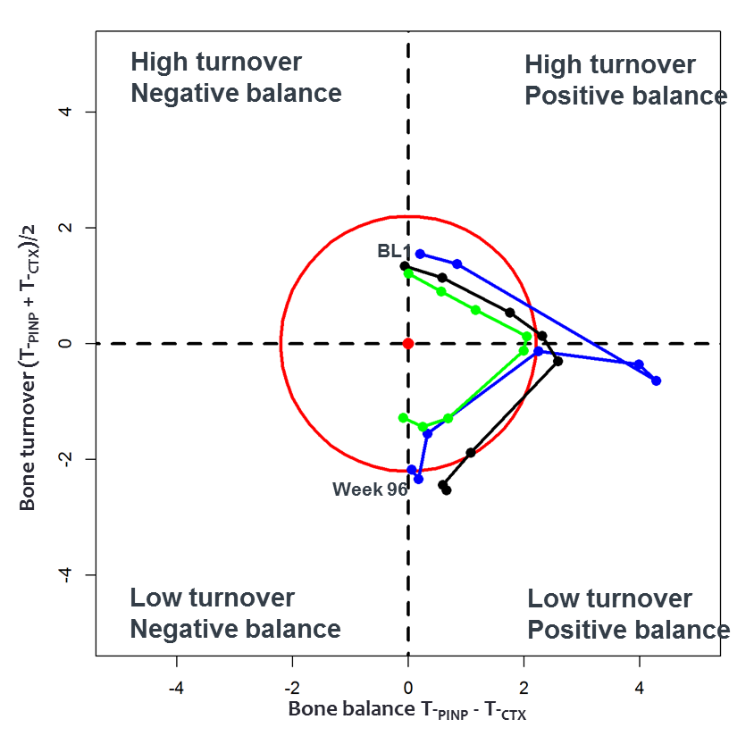
Figure 58: The T-score bone marker plots for postmenopausal women receiving Ibandronate (blue line), alendronate (black line) and risedronate (green line) through the 96 week study period. The circles represent the centre of the ellipses for visit starting from baseline 1. The red ellipse represents premenopausal women.

The effect of bisphosphonates on levels of circulating sclerostin
The baseline characteristics for the postmenopausal women with osteoporosis receiving ibandronate, alendronate and risedronate and the premenopausal comparator groups are shown in table 11 chapter 5.
The median levels of circulating sclerostin were significantly higher in postmenopausal women with osteoporosis prior to treatment compared to healthy premenopausal women, 0.49 ng/ml and 0.38 ng/ml respectively (p<0.001), (Figure 65).
Figure 59: Levels of circulating sclerostin (showing the median and 95% CIs) in postmenopausal women with osteoporosis and healthy premenopausal women. Significance between the medians was tested using the Wilcoxon signed ranked test.
Mean serum sclerostin levels over 96 weeks of treatment with ibandronate, alendronate and risedronate are shown in table 29 and the percentage change from baseline in figure 66. There was no overall statistical significant difference from baseline, (P = 0.879). There was no significant change in sclerostin levels from baseline with ibandronate, alendronate and risedronate, (P>0.05). There was no overall statistical significant difference between the bisphosphonates, (P = 0.061).
Table 29: The mean (standard deviation) of circulating serum sclerostin in postmenopausal women receiving either ibandronate, alendronate or risedronate over 96 weeks of treatment.
Bisphosphonate | Baseline | Week 1 | Week 4 | Week 12 | Week 48 | Week 96
Ibandronate (150mg/month, N = 28) | 0.51 (0.13) | 0.50 (0.11) | 0.52 (0.12) | 0.53 (0.13) | 0.51 (0.14) | 0.51 (0.13)
Alendronate (70mg/week, N = 33) | 0.48 (0.13) | 0.48 (0.13) | 0.47 (0.12) | 0.48 (0.13) | 0.47 (0.12) | 0.50 (0.13)
Risedronate (35mg/week, N = 31) | 0.51 (0.10) | 0.51 (0.11) | 0.52 (0.10) | 0.51 (0.11) | 0.51 (0.11) | 0.52 (0.14)
Overall significance assessed using the Friedman test: ibandronate = 0.08, alendronate = 0.11 and risedronate = 0.88
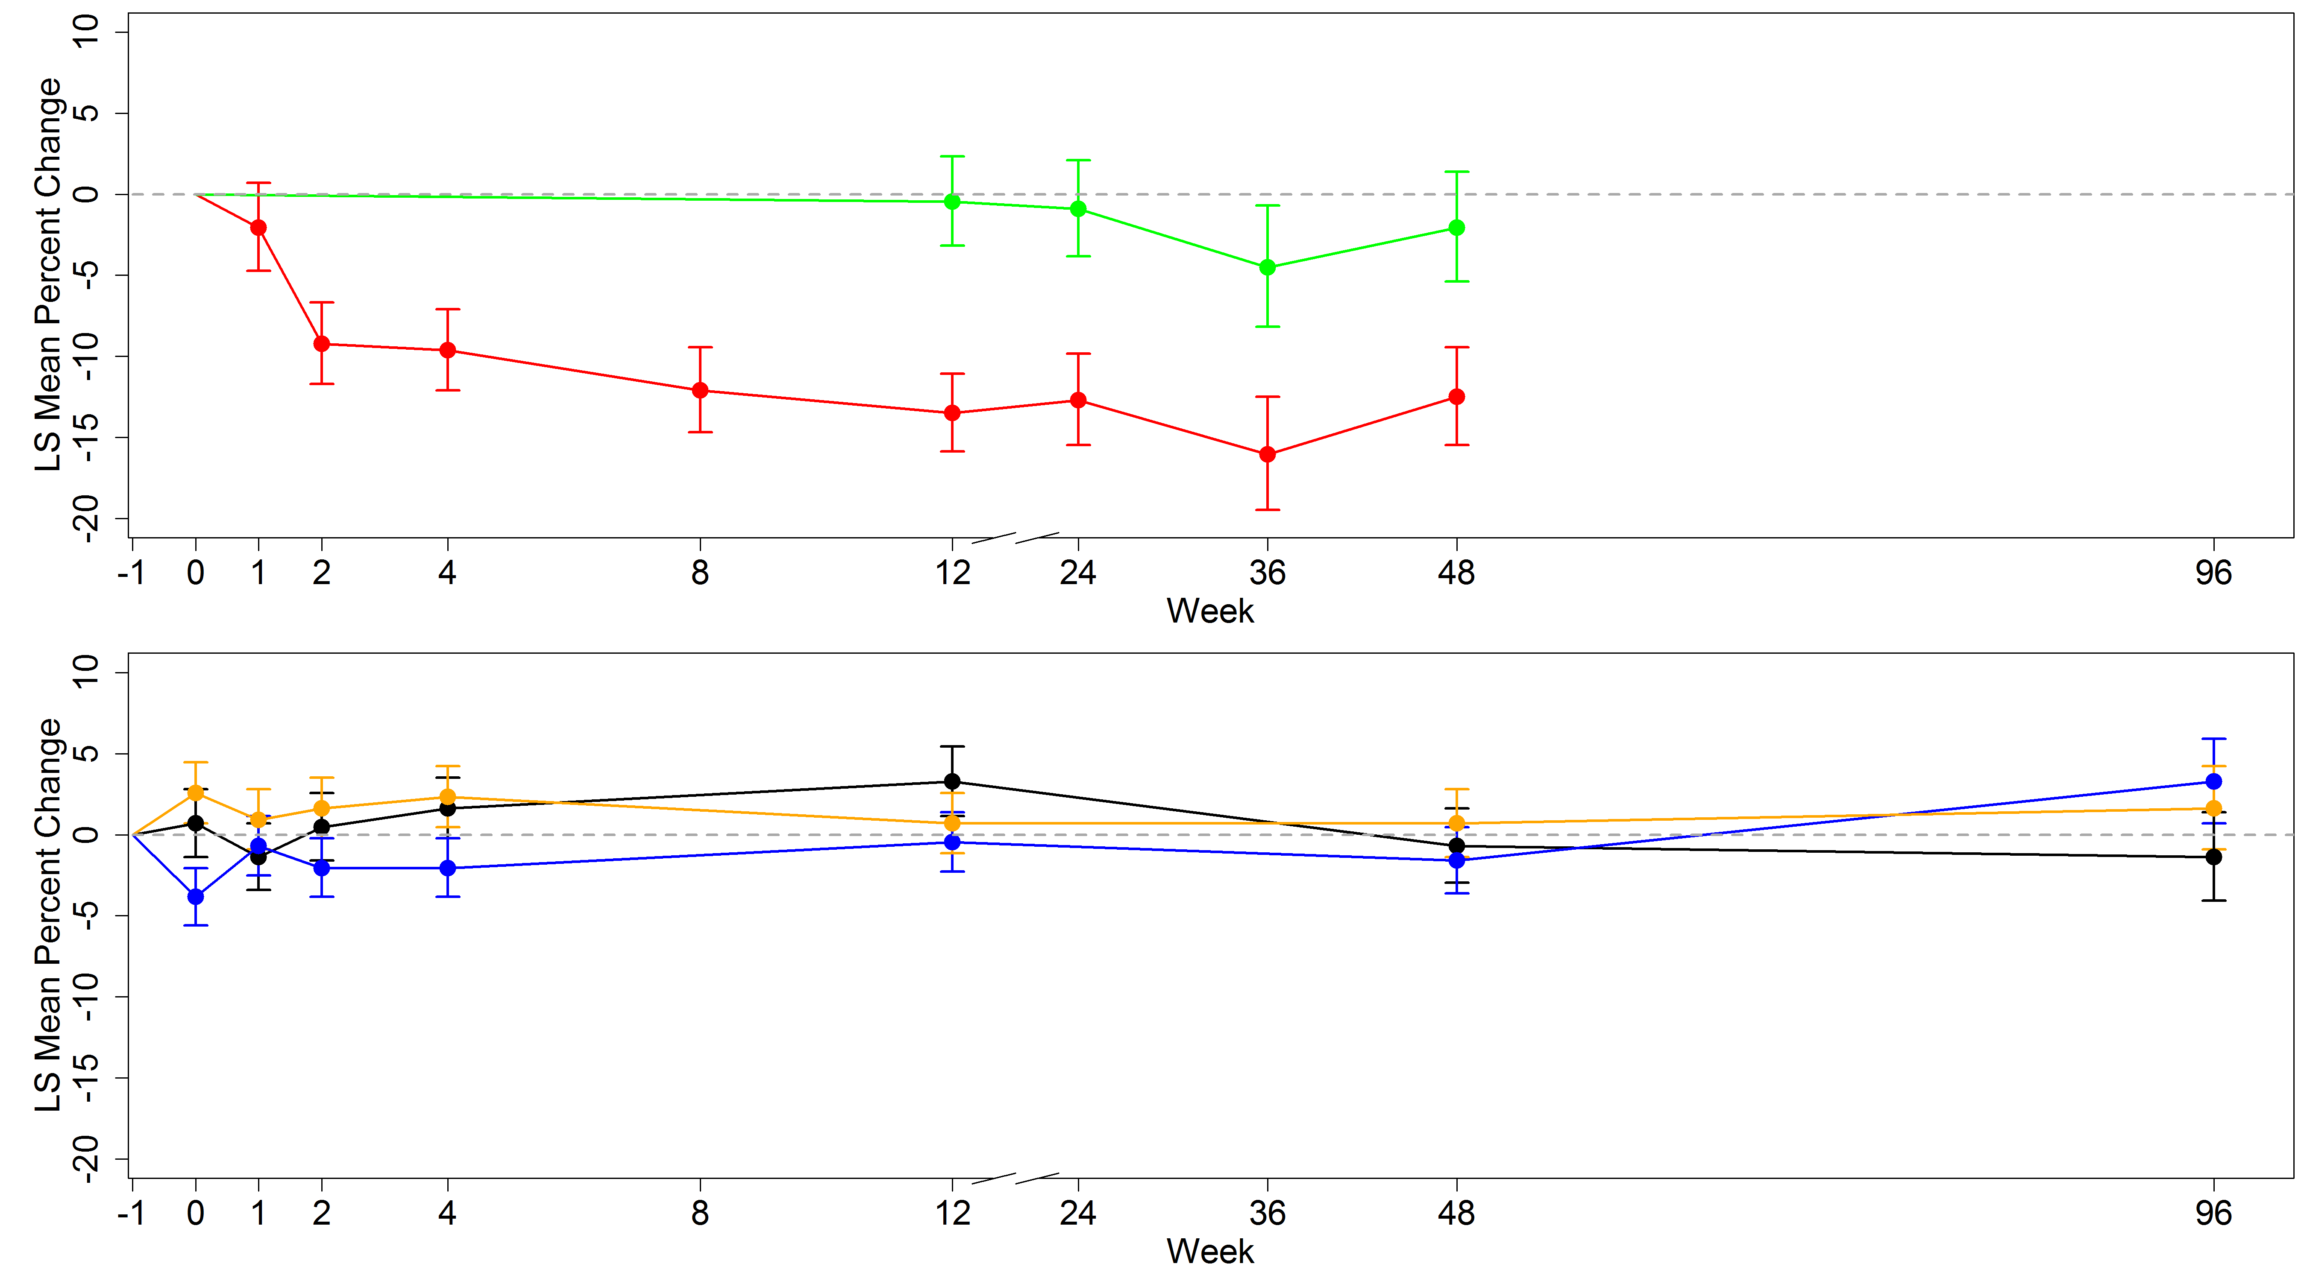
Figure 60: Percentage change from baseline in circulating serum sclerostin level in postmenopausal women receiving either ibandronate (black), alendronate (blue) or risedronate (orange) over 96 weeks of treatment.

Circulating levels of sclerostin was negatively correlated with PINP in postmenopausal women with osteoporosis at baseline, (r = -0.2, p<0.05). There was no significant correlation with CTX (r = -0.1, p>0.05), (Figure 67).
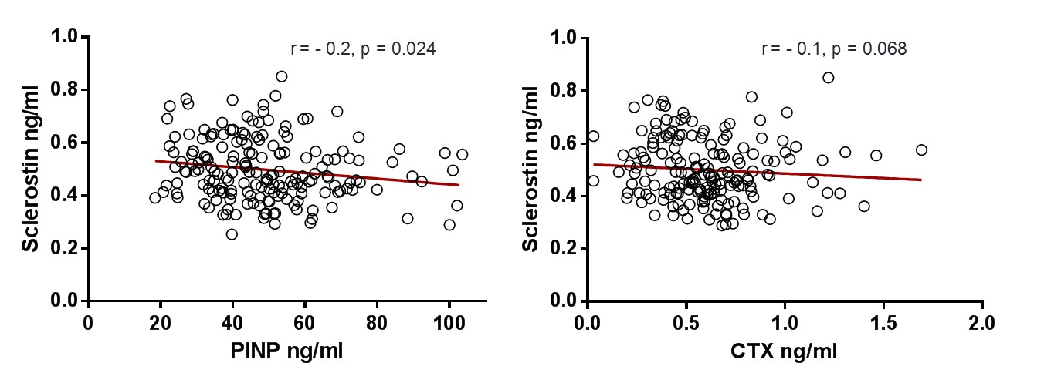
Figure 61: Scatter plot showing the correlation between serum sclerostin and PINP (left) and CTX (right) in postmenopausal women with osteoporosis at baseline prior to bisphosphonate treatment (N = 92).

Discussions
Bisphosphonates are widely used to treat postmenopausal osteoporosis and some studies suggest that their effects are exerted only on mature and active osteoclasts, (436, 437). However, my data have confirmed that nitrogen containing bisphosphonates, in particular ibandronate and risedronate significantly reduced the population of osteoclast precursor cells as assessed by their expression of cell surface markers. The hypothesis is therefore supported. The difference in effect between bisphosphonates may be due to their variable distribution within and affinity to the bone, (241, 460), with risedronate and ibandronate preferentially targeting osteoclast precursor cells. The higher affinity of alendronate for hydroxyapaptite may mean that it has lower availability for the osteoclast precursors. The mechanism of action is targeting mature osteoclasts and this is supported by a greater suppression in BTMS compared to risedronate.
In addition this research has demonstrated that this effect is long term seen at week 48 of treatment. This is in contrast to the effect we see on bone resorption as demonstrated by the reduction in CTX after 1 week of treatment. There is no short term effect of bisphosphonates on osteoclast precursor cells. This finding suggests that the initial short term reduction in bone resorption is a result of the bisphosphonates exerting their effect on mature, resorbing osteoclasts rather than the osteoclast precursor cells. The long term sustained reduction in bone resorption may be due to the bisphosphonates exerting their effect on both the osteoclast precursor cells and the mature osteoclasts. However in this subset of participants the only long term time point I have is at week 48. Therefore one particular limitation is not knowing exactly when the bisphosphonates begin exerting their effect on the osteoclast precursor cell population. None the less this data is supported by others (440), who also demonstrated that alendronate significantly reduced CTX after 3 months of treatment but the reduction in osteoclast precursor cells occurred after 12 months. It may be therefore that the effect on osteoclast precursor cells occurs somewhere between 3 and 12 of treatment and this needs to be investigated.
There is no significant difference in the population of osteoclast precursor cells in postmenopausal osteoporosis before treatment and premenopausal women. This is in contrast to what we see with levels of bone turnover markers which are significantly higher. This supports that postmenopausal osteoporosis is a disease characterised by increased mature osteoclast activity, and suggests that there is no increased pre-osteoclast activity.
In vitro models RANKL and OPG have been shown to regulate osteoclastogenesis. The reduction in the population of osteoclast precursor cells with bisphosphonate treatment may be mediated by circulating levels of RANKL. Previously, treatment with alendronate has demonstrated a decrease in RANKL and an increase in OPG expressions in marrow stromal cells. However, my data demonstrated that bisphosphonate treatments had no direct effect on circulating levels of RANKL and OPG. These findings are comparable to other clinical studies (450, 461-463) and inconsistent with others (448, 464). Furthermore and compared to this study at baseline, the latter reported higher levels of RANKL (1.7 pmol/l versus 0.07 pmol/l), this was using different ELISA’s and of OPG (8.1 pmol/l versus 5.2 pmol/l), this was using the same ELISA. The discrepancies may be due to the different populations and diseases studied and to the limitations of the ELISA’s themselves. Also, it may be that the RANKL ELISA needs to be more sensitive in order to detect levels of circulating RANKL in postmenopausal women accurately.
In chapter 5 I have demonstrated that postmenopausal osteoporosis is characterised by increased bone turnover and a negative bone balance compared to healthy premenopausal women. Importantly, I have suggested that this negative balance is related to increased bone loss and fracture risk. Using the T-score bone marker method/plot I have shown that treatment with bisphosphonates reduces bone turnover after 1 week. In contrast, bone balance is increased, this is expected and is caused by bone formation remaining consistently higher compared to bone resorption in the first 4 weeks of treatment. However, between weeks 48 and 96 levels of bone turnover remains constant/steady (maximum suppression has be achieved) and bone balance remains more positive compared to baseline. This suggests that bisphosphonates maintains bone balance (i.e. making it more positive). Therefore it may be this positive balance that is related to the reduction in fracture risk we observe with bisphosphonate treatments. This is a novel finding and adds to the current literature which is focused mainly on bone turnover and fracture risk (ref these).
Bisphosphonates have differing effects on turnover and balance. At the ‘steady state’ of bone turnover, treatment with alendronate makes bone balance more positive compared to prior to treatment and to premenopausal women, whereas it remains unchanged with ibandronate and risedronate. This in itself an interesting finding but in support of this is another finding from TRIO study which demonstrated that with alendronate treatment BMD at the total hip is increased by the highest magnitude from baseline compared to ibandronate and risedronate (2.6%, 2.1% and 1.2% respectively), (342) (Figure 68). This finding is consistent with another finding. In the FACT study, which compared the effects of alendronate and risedronate on BMD at the total hip, the response was greater at 1 year with alendronate (2.2% versus 1.2%). Using this information and along with my findings from chapter 5 and 6 it is conceivable to conclude that treatment with alendronate reduces bone turnover and also improves bone balance. The latter may be related to the reduced bone loss at the total hip and the reduction in fracture risk.
Figure 62 DXA of total BMD measured using a Discovery A densitometer (Hologic Inc, Waltham, MA): Mean percentage change and standard error of the mean from baseline in postmenopausal women receiving Ibandronate, alendronate and risedronate and premenopausal women. Copy right (2015), with permission from Springer.
Also, the data in this chapter shows that circulating levels of sclerostin are lower in women with postmenopausal osteoporosis compared to premenopausal women. This finding is comparable with others (457) and it is associated with the reduction in estrogen (322)
Treatment of postmenopausal osteoporosis with antiresorptives reduces bone resorption and a later suppression of bone formation as a result of the coupling process. Bone formation is regulated by the Wnt signalling pathway. This suggests that the reduction in bone formation markers after 12 weeks of antiresorptive treatments may therefore be associated with (in part at least) with changes in the Wnt signalling pathway and in particular mediated by circulating levels of sclerostin. However my findings suggest that the hypothesis stating that circulating sclerostin mediates the reduction in bone formation with bisphosphonate treatment is not supported. Levels of sclerostin remained unchanged with ibandronate, alendronate and risedronate treatment in women with postmenopausal osteoporosis. This is inconsistent with the finding by Polyzos AD et al 2012 who demonstrated that sclerostin levels increased after 6 months of treatment with risedronate in postmenopausal women with osteoporosis (457) and others (454, 455). This would mean that increased sclerostin binding to LRP5 and LRP6, inhibiting osteoblast activity and mediating the reduction in bone formation. However the same group also demonstrated that sclerostin levels were positively correlated with BMD at the lumbar spine, which is an unexpected and unclear/unexplained finding. My findings are however comparable with Chung YE et al 2012 (465). A possible limitation could be that I have not measured DKK1, however previously it was shown that levels of DKK1 remained unchanged in patients receiving clodronate and increased significantly after one month of a yearly zoledronate intravenous infusion (454).
Sclerostin is negatively correlated with bone formation and not correlated with bone resorption in women with postmenopausal osteoporosis. This seems to be rational since increased levels of sclerostin reduces osteoblast activity and bone formation. This is both consistent and inconsistent with Polyzos SA et al 2012, who demonstrated that sclerostin was negatively correlated with bone ALP but positively correlated with CTX, (457).
In addition, because neither ibandronate, alendronate nor risedronate altered levels of circulating sclerostin then it supports and suggests that these compounds have a similar mechanism of action on bone formation that may not alter Wnt signalling. At least with these treatments sclerostin does not appear to be a coupling protein between resorption and formation. This does support the notion the osteocyte apoptosis is inhibited (270) because levels of sclerostin remained unchanged and not reduced. It has also been suggested that the bisphosphonates that suppress bone resorption by a lesser magnitude than others may gain better access to the osteocytes via the canaliculi network and inhibits their apoptosis (466). This was previously demonstrated in an animal study with a bisphosphonate analogue called olpadronate which has little effect on the osteoclasts but inhibits osteocyte activity and increased bone formation and bone strength, (270) and may therefore reduce sclerostin production. Out of the three bisphosphonates in the TRIO study, I concluded that the suppression of bone turnover was less with risedronate but its distribution within the canalicular network needs to be determined because it had no effect of sclerostin production by the osteocytes. Using these findings and information about the mechanism of action of bisphosphonates on osteocytes it is plausible to hypothesise that a compound with a lower antiresorptive effect may have a more direct effect on osteocytes and sclerostin production. My findings from the previous chapter (chapter 5) have demonstrated and I concluded that raloxifene suppressed bone resorption by a lesser magnitude compared to bisphosphonates. Therefore I can hypothesise that raloxifene effects levels of circulating sclerostin and along with the coupling process this mediates the lesser reduction I observed in bone formation (subsequent chapter).
Furthermore, Wnt signalling is implicated in also regulating bone resorption through down-regulation of RANKL expression in the osteoblasts. It is therefore conceivable that no changes in sclerostin would imply and explain the no effect on RANKL levels I observed in this research. Therefore, these signalling proteins may not contribute to the mechanisms of action of bisphosphonates on bone resorption.

Conclusion
Nitrogen-containing bisphosphonate reduce the population of osteoclast precursor cells in the long term and bone turnover in the short term. Both of these mechanisms may reduce the activation frequency of bone remodelling by having a direct and indirect effect on mature osteoclasts. These findings further suggest that ibandronate and risedronate act selectively and directly on the osteoclast precursor cells to reduce their population without influencing levels of circulating cytokines. The differences between bisphosphonates targeting osteoclast precursors may help explain and be related to their magnitude of effect on bone turnover demonstrated in chapter 5.
Treatment of postmenopausal osteoporosis with bisphosphonates, in particular alendronate also improves bone balance. This finding may be used to explain the reduction in bone loss and fracture risk we observe at the total hip with alendronate treatment, more so than with ibandronate and risedronate.
The clinical relevance and the explanation of the observation regarding sclerostin levels remaining unchanged with bisphosphonate treatment is unclear to me. The mechanism of action of bisphosphonates on the osteocytes is in contrast to the reduction of the antiresorptive activity of the osteoclasts. It may be that this is related to the potency or the distribution of the compound in the bone and perhaps other antiresorptives such as raloxifene or denosumab have a stronger effect on Wnt signalling and a mechanism of action that is different to bisphosphonates (chapter 7).

Chapter 7: mechanisms of action of raloxifene on bone turnover and bone balance in postmenopausal women with osteoporosis

Introduction
Estrogen is a key hormone that has an important role in maintaining bone homeostasis and structural integrity. In normal bone pathophysiology this involves the balanced activities of the osteoclasts and osteoblast and the sensory abilities of osteocyte (467). In postmenopausal women estrogen deficiency results in osteoporosis due to changes in cellular activity because it i) increases the activities of the osteoclasts and their survival and ii) increases osteocyte apoptosis (468, 469). This causes increased bone turnover, an imbalance where bone resorption exceeds bone formation resulting in reduced BMD, accelerated bone loss and an increased fracture risk.
Raloxifene (a SERM) is an estrogen like non-steroidal synthetic treatment that binds to the receptors ERα and ERβ and regulates gene transcription in bone. It is an estrogen agonist on bone and an estrogen antagonist on the endometrium and breast, (422, 470). This treatment decreases bone turnover and through several cellular mechanisms increases BMD (411) reducing bone loss and fracture risk, (302, 317). The effects of raloxifene on bone turnover as assessed by BTMs and how they differ to bisphosphonates has been previously described in chapter 5 and in other clinical trials. In the MORE trial, a 60mg/day dose of raloxifene resulted in a decrease in bone resorption and a reduced risk of vertebral fractures, (302). Similarly, data from the RUTH trial, a 60mg/day dose of raloxifene resulted in a decrease in bone resorption and a reduced risk of vertebral fractures, (471). It may be that raloxifene reduces bone loss and the risk of vertebral fractures by maintaining or improving the negative balance previously identified in chapter 4 between bone resorption and bone formation in postmenopausal women. The effect of raloxifene on bone balance is yet to be investigated.
Raloxifene is an antiresorptive agent that inhibits bone resorption and reduces levels of BTMs. Similar to estrogen, in vitro studies using bone marrow cultures have been demonstrated that it inhibits the formation of the osteoclasts, (426, 472). In vitro and clinical data have demonstrated that raloxifene stimulates the production of OPG by the osteoblast, (427, 428). Therefore, the inhibition of osteoclast activity and the reduction in BTMs may be partly through the RANKL/OPG bone resorption system in postmenopausal women (473). But in vitro data has also demonstrated that this may in fact be independent of OPG (474).
Another possible mechanism of action of raloxifene could be related to its effect on osteocytes and sclerostin production. Raloxifene is an estrogen agonist on bone and therefore may have similar mechanism of action to estrogen in regulating bone formation via the Wnt signalling pathway. Modder UIL et al 2011 has previously demonstrated that increased estrogen reduces levels of circulating sclerostin in men and women and is increased with age. It is therefore plausible to hypothesise that raloxifene reduces the levels of sclerostin production by the osteocytes in postmenopausal women with low BMD. In addition, with raloxifene treatment there is a greater decrease in bone resorption compared to bone formation (approximately by 50% versus 35%) and data from histomorphometric studies has shown that osteoblast activity is increased with estrogen treatment, (475, 476). This means that in addition to the reduction in the activation frequency, raloxifene treatment may cause a relative increase (to bone resorption) in bone formation and therefore the net gain in BMD. Along with the coupling process this may be a reason why bone formation markers are not suppressed to similar levels of bone resorption markers. I therefore further hypothesised that sclerostin mediates the net gain in bone formation and the overall bone balance.
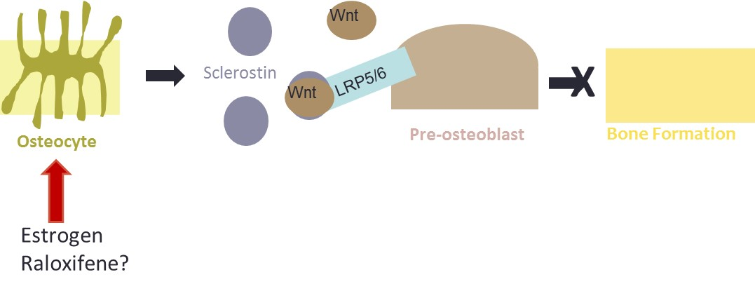
Figure 63: The mechanism of action of estrogen and the possible mechanism of action of raloxifene on osteocytes and the regulation of bone formation via the Wnt signalling pathway.
The aims of this study were to investigate the effects of raloxifene on i) bone balance and bone turnover and bone balance using the T-score bone marker method and plot and ii) levels of circulating sclerostin in postmenopausal women with osteopenia and premenopausal women.
The hypotheses were:
- Raloxifene reduces bone turnover and makes balance more positive at the end of treatment compared to baseline and premenopausal women.
- The reduction in bone formation relative to bone resorption by raloxifene is mediated by circulating levels of sclerostin.
- Sclerostin is a biochemical marker that is related to bone formation, bone resorption and bone balance.

Study participants
The participants used for these analyses were from the clinical trial investigating the use of raloxifene treatment in in postmenopausal women with osteopenia, mean age 64 years (described in chapter 5). 21 were randomised to receive 60mg of raloxifene per day (Evista, Eli Lilly and Co) and 23 received no treatment, the latter was the comparator group. All of the participants received calcium carbonate to provide 500mg of calcium per day.

Laboratory methods
From the 21 participants receiving raloxifene a fasting serum sample was collected at baseline then at weeks 1, 2, 4, 8, 12, 13, 24, 25, 36, 47 and 48. From the 23 participants receiving no treatment a fasting serum sample was collected at baseline then at weeks 12, 24, 25, 36 and 48.Blood and urine were collected, handled and stored according to the methods in chapter two.
CTX and PINP were measured in serum using the IDS-iSYS CLIA technology automated immunoassay. The inter-assay CV’s were below 10% for each BTM using each of the quality control materials (chapter two).
Circulating levels of sclerostin were measured in serum using a 96-well plate direct-capture enzyme immunoassay from TECOmedical Group (Sissach, Switzerland), (described in chapter 2). The inter assay CV for sclerostin was less than 10% for each three quality control material used.

Statistical analysis
These analyses were in the per protocol population, the participants who were randomised received all of the treatment doses and had PINP, CTX and sclerostin data at all of the time points were included
The values for CTX and PINP were log₁₀-transformed and normalised. The Wilcoxon signed ranked test was used to determine the statistical difference between the median sclerostin levels for postmenopausal women with osteopenia receiving raloxifene and the comparator group (not receiving raloxifene treatment). The overall change from baseline was assessed between the women receiving raloxifene and the comparator group using mixed model repeated measures (described in chapter 6).
The PINP and CTX data for the healthy premenopausal women described in chapters 5 and 6 were used to calculate the T-scores for these participants receiving raloxifene treatment. At each visit the T-scores for PINP and CTX value were calculated for each postmenopausal woman using the mean and standard deviation of the results for the premenopausal women. Bone turnover was the average of the two T-scores and bone balance was the difference between the two T-scores (as described in chapter 4).
The Wilcoxon signed ranked test was used to determine the statistical difference between the median sclerostin levels for postmenopausal women with osteopenia receiving raloxifene and the comparator group. The overall change from baseline was assessed between the women receiving raloxifene and the comparator group using mixed model repeated measures.
The sclerostin data for the healthy premenopausal women described in chapters 5 and 6 were used to calculate the sclerostin T-scores for participants receiving raloxifene treatment. The values for sclerostin were log₁₀-transformed and normalised. At each visit the T-scores were calculated for each postmenopausal woman using the mean and standard deviation of the results for the premenopausal women.
The Spearman rank correlation was used in order to assess the correlation between the change in i) sclerostin levels and bone turnover after 48 weeks, ii) the change in sclerostin levels and bone balance after 48 weeks.

Results
The baseline characteristics for the postmenopausal women with osteopenia receiving raloxifene and no treatment are shown in table 18.

The effect of raloxifene on bone turnover and bone balance (the T-score bone marker plot/method)
Figure 70 shows the percentage change from baseline of CTX in postmenopausal women receiving raloxifene and those not receiving treatment and table 30 shows the mean values for each, over the 48 week study period. Mixed model repeated measures analysis showed that there was a decrease in CTX after 2 weeks of raloxifene treatment and this was significantly different from baseline, (p<0.001). The decrease in CTX remained significant at each subsequent time point until 48 weeks, (p<0.001). There was no significant change in CTX in the women not receiving treatment over 48 weeks. Mean levels of CTX were significantly lower in the participants receiving raloxifene compared to those not receiving raloxifene at week 2 and at every subsequent time point. (p<0.001).
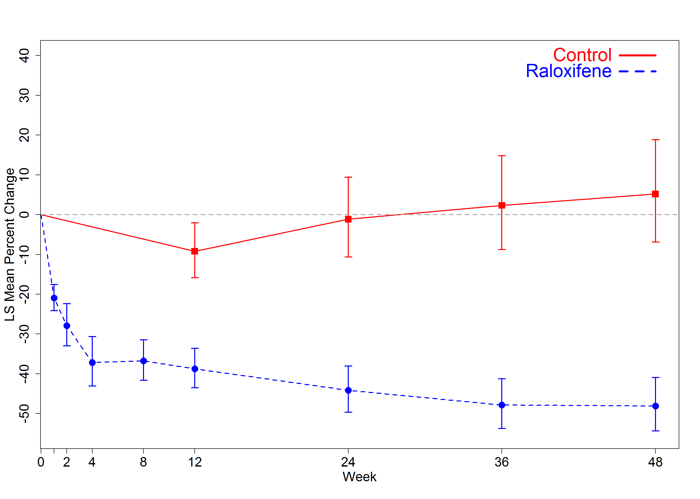
Figure 64: The effect of raloxifene treatment on levels of CTX in postmenopausal women with osteopenia (blue line) compared to those receiving no treatment (controls). The percentage change from baseline is shown for each visit.
Table 30: The geometric mean and (95% confidence intervals) of CTX in postmenopausal women with osteopenia receiving raloxifene treatment (21) and those receiving no treatment (controls) (N = 23).
 | Week 0 | Week 1 | Week 2 | Week 4 | Week 8 | Week 12 | Week 24 | Week 36 | Week 48
Osteopenic  (Raloxifene) | 0.63  (0.51,0.77) | 0.49  (0.40,0.60) | 0.45  (0.35,0.57) | 0.39  (0.30,0.50) | 0.39  (0.30,0.50) | 0.38  (0.30,0.48) | 0.35  (0.26,0.46) | 0.32  (0.25,0.42) | 0.32  (0.23,0.44)
Osteopenic  (No treatment) | 0.47  (0.35,0.63) |  |  |  |  | 0.44  (0.31,0.61) | 0.48  (0.36,0.68) | 0.50  (0.36,0.68) | 0.51  (0.38,0.69)

Figure 71 shows the percentage change from baseline of PINP in postmenopausal women receiving raloxifene and those not receiving treatment and table 31 shows the mean values for each, over the 48 week study period. There was a decrease in PINP after 4 weeks of raloxifene treatment and this was significantly different from baseline, (p<0.001). The decrease in PINP remained significant at each subsequent time point until 48 weeks, (p<0.001). There was no significant change in PINP in the women not receiving raloxifene, over 48 weeks. Mean levels of PINP were significantly lower in the participants receiving raloxifene compared to those not receiving raloxifene at week 4 and at every subsequent time point, (p<0.001).

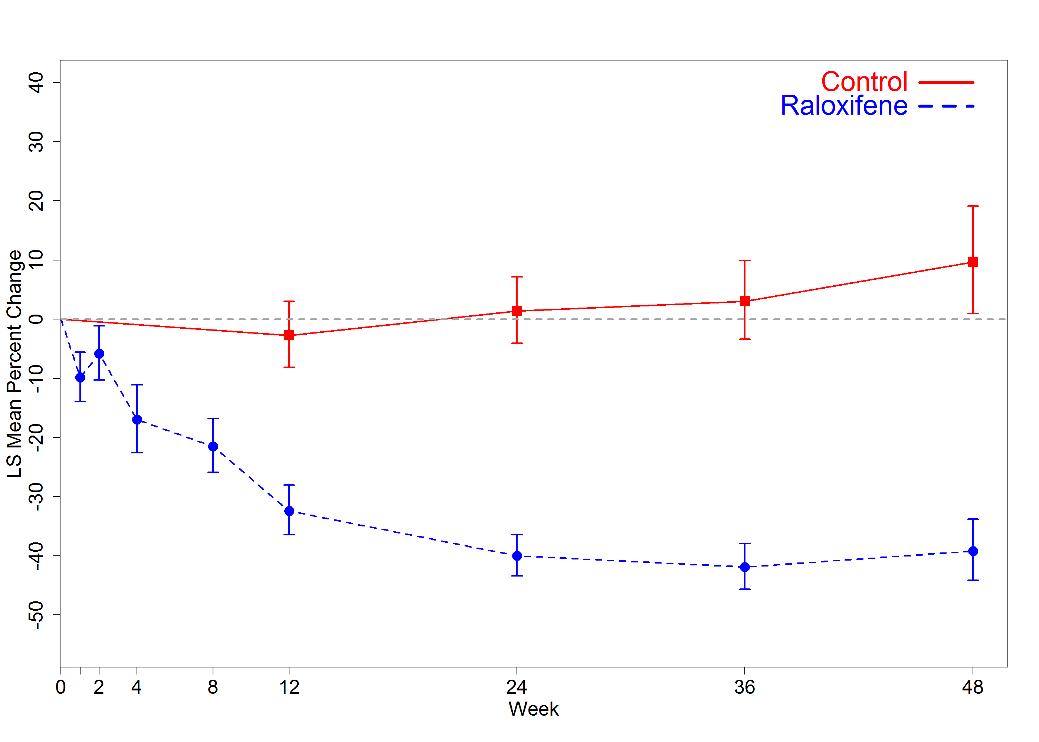
Figure 65: The effect of raloxifene treatment on levels of PINP in postmenopausal women with osteopenia (blue line) compared to those receiving no treatment (controls). The percentage change from baseline is shown for each visit.
Table 31: The geometric mean and (95% confidence intervals) of PINP in women with osteopenia receiving no treatment (N = 23) and those receiving raloxifene treatment (N = 21)
 | Week 0 | Week 1 | Week 2 | Week 4 | Week 8 | Week 12 | Week 24 | Week 36 | Week 48
Osteopenic  (Raloxifene) | 44.2  (38.0, 51.5) | 39.9  (32.2,49.5) | 41.7  (34.7,50.1) | 36.8  (29.2,46.3) | 34.8  (28.1,43.0) | 30.0  (23.2,38.7) | 26.6  (21.2,33.4) | 25.7  (20.8,31.8) | 26.9  (21.2,34.3)
Osteopenic  (No treatment) | 42.0  (34.8,50.7) |  |  |  |  | 40.8  (34.1,48.8) | 42.5  (35.3,51.1) | 43.2  (34.5,54.1) | 46.0  (37.1,56.9)

The T-score for CTX and PINP were used to calculate and plot the bone turnover and bone balance for the postmenopausal women receiving raloxifene, (Figure 72). The mean levels of bone balance and bone turnover and change in these from baseline are shown in tables 32 and 33, respectively.
At baseline prior to raloxifene treatment, mean levels of bone turnover and bone balance were 1.344 and -0.045 SD units above and below the premenopausal mean, respectively. Mean levels of bone turnover were significantly greater that the premenopausal mean, (p<0.001) but not bone balance. After 1 week of treatment with raloxifene bone turnover decreased from baseline by -0.413 to 0.931 SD unit and bone balance increased by 0.218 to 0.172 SD units above the premenopausal mean, these changes were not significant, (p>0.05). After week 4 levels of bone turnover decreased from baseline significantly to 0.568 SD units but this remained above the premenopausal mean (p<0.05). At the subsequent time points until week 48 bone turnover continued to decrease significantly from baseline to -0.092 SD units below the premenopausal mean (p<0.001). At baseline mean levels of bone turnover were significantly higher than the premenopausal control group, (p<0.001) and remained so until week 8 of treatment, (p<0.05). After 8 weeks mean levels of bone turnover were not significantly different from those in the premenopausal control group, (p>0.05). Mean levels of bone balance were significantly more positive compared to the premenopausal control group only at week 2 (p<0.01) and not at any other time points.
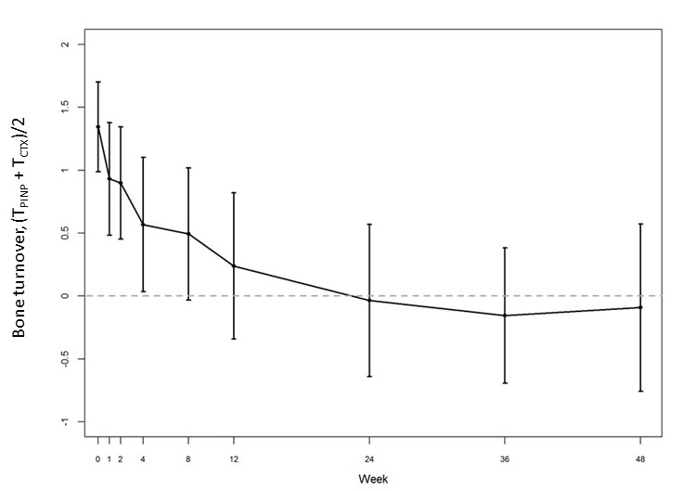
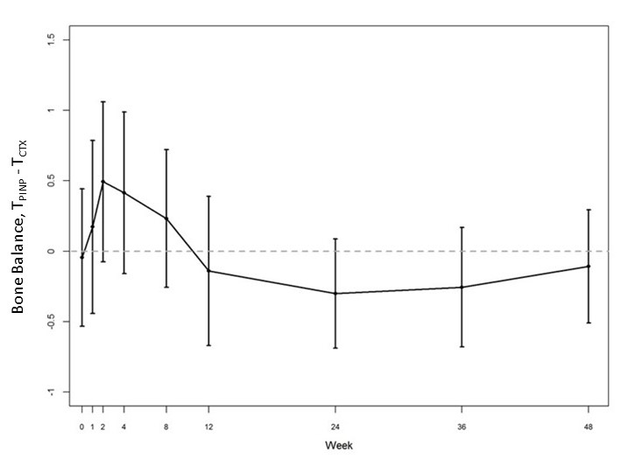
Figure 66: The mean and 95% confidence intervals of bone turnover (top) and bone balance (bottom) (calculated using the T-scores of PINP and CTX) in postmenopausal women with osteopenia receiving raloxifene treatment over 48 weeks. The dashed line at Y = 0 represents the mean of the healthy premenopausal women.
Table 32: The mean values and 95% confidence intervals of bone turnover and bone balance in postmenopausal women with osteopenia receiving raloxifene treatment over 48 weeks. N is the number of women at each visit.
 | N | Balance |  | Turnover
 | N | Mean | 95% CI | Mean | 95% CI
Baseline | 21 | -0.045 | (-0.534, 0.443) | 1.344 | (0.987, 1.701)
Week 1 | 21 | 0.172 | (-0.443, 0.787) | 0.931 | (0.483, 1.379)
Week 2 | 21 | 0.493 | (-0.075, 1.061) | 0.899 | (0.452, 1.345)
Week 4 | 21 | 0.414 | (-0.160, 0.989) | 0.568 | (0.033, 1.103)
Week 8 | 21 | 0.232 | (-0.257, 0.722) | 0.4932 | (-0.033, 1.019)
Week 12 | 21 | -0.140 | (-0.669, 0.388) | 0.239 | (-0.343, 0.820)
Week 24 | 21 | -0.301 | (-0.689, 0.087) | -0.035 | (-0.639, 0.569)
Week 36 | 21 | -0.256 | (-0.679, 0.168) | -0.156 | (-0.694, 0.383)
Week 48 | 21 | -0.108 | (-0.510, 0.294) | -0.092 | (-0.756, 0.571)

Table 33: The mean change and 95% confidence intervals in bone turnover and bone balance in postmenopausal women receiving raloxifene treatment. Significance from baseline was tested using Dunn’s post hoc test.
 | Balance |  |  | Turnover
 | Mean | 95% CI | P-Value | Mean | 95% CI | P-Value
Week 1 | 0.218 | (-0.544, 0.980) | 0.566 | -0.413 | (-0.969, 0.142) | 0.140
Week 2 | 0.538 | (-0.188, 1.265) | 0.142 | -0.445 | (-1.000, 0.109) | 0.112
Week 4 | 0.460 | (-0.271, 1.191) | 0.211 | -0.776 | (-1.402, -0.150) | 0.017
Week 8 | 0.278 | (-0.392, 0.948) | 0.407 | -0.851 | (-1.470, -0.232) | 0.008
Week 12 | -0.095 | (-0.792, 0.603) | 0.785 | -1.106 | (-1.771, -0.440) | 0.002
Week 24 | -0.255 | (-0.861, 0.350) | 0.393 | -1.379 | (-2.064, -0.694) | <0.001
Week 36 | -0.210 | (-0.837, 0.416) | 0.501 | -1.500 | (-2.129, -0.871) | <0.001
Week 48 | -0.062 | (-0.676, 0.551) | 0.838 | -1.436 | (-2.173, -0.699) | <0.001

The T-score bone marker plot in figure 73 shows how bone turnover and bone balance changes over 48 weeks of raloxifene treatment relative to premenopausal women. Prior to treatment (at baseline) postmenopausal women with osteopenia have a high bone turnover and a normal bone balance relative to healthy premenopausal women. After 48 weeks of treatment the women are in a state of low bone turnover and bone balance remained unchanged.
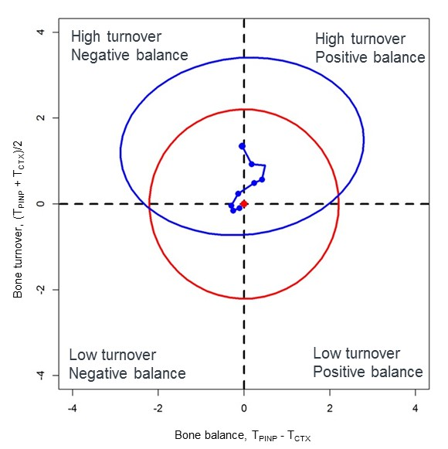
Week 48
Week 36
Week 24
Week 12
Week 8
Week 4
Week 2
Week 1
BL1

Figure 67: The T-score bone marker plots for postmenopausal women receiving raloxifene throughout the 48 week study period. The blue line represents the change in bone balance and bone turnover from baseline through to 48 weeks. The red ellipse represents premenopausal women.

The effect of raloxifene on levels of circulating sclerostin
The median levels of circulating sclerostin were significantly higher in postmenopausal women with osteopenia compared to healthy premenopausal, 0.64 ng/ml and 0.48 ng/ml respectively (p<0.001), (Figure 74).
Figure 68: Levels of circulating sclerostin (showing the median and 95% CI) in postmenopausal women with osteopenia and healthy premenopausal women. Significance between the medians were tested using the Wilcoxon signed ranked test.

Mean serum sclerostin levels over 48 weeks of treatment with raloxifene compared to osteopenic and no treatment are shown in table 33 and the percentage change from baseline in figure 75. In the women receiving raloxifene sclerostin levels were overall significantly lower compared to those not receiving treatment, (p<0.001). Within one week of treatment the difference in sclerostin levels between the groups was significant at every subsequent time point (p<0.001). After 2 weeks of treatment sclerostin levels significantly decreased from baseline by -9%, (p<0.01). Levels of sclerostin continued to decrease significantly throughout the treatment period and by 13% at week 48, (p<0.001).
Table 34: The geometric mean and (95% confidence intervals) of circulating sclerostin (ng/ml) in women with osteopenia receiving no treatment (N = 23) and receiving raloxifene (N = 21)
 | Week 0 | Week 1 | Week 2 | Week 4 | Week 8 | Week 12 | Week 24 | Week 36 | Week 48
Osteopenic)  (Raloxifene | 0.58  (0.51,0.65) | 0.57  (0.51,0.65) | 0.53  (0.47,0.60) | 0.53  (0.47,0.60) | 0.51  (0.45,0.59) | 0.506  (0.45,0.57) | 0.51  (0.45,0.56) | 0.49  (0.43,0.56) | 0.51  (0.45,0.59)
Osteopenic  (no treatment) | 0.72  (0.60,0.86) |  |  |  |  | 0.70  (0.59,0.84) | 0.70  (0.59,0.82) | 0.67  (0.58,0.77) | 0.69  (0.60,0.79)

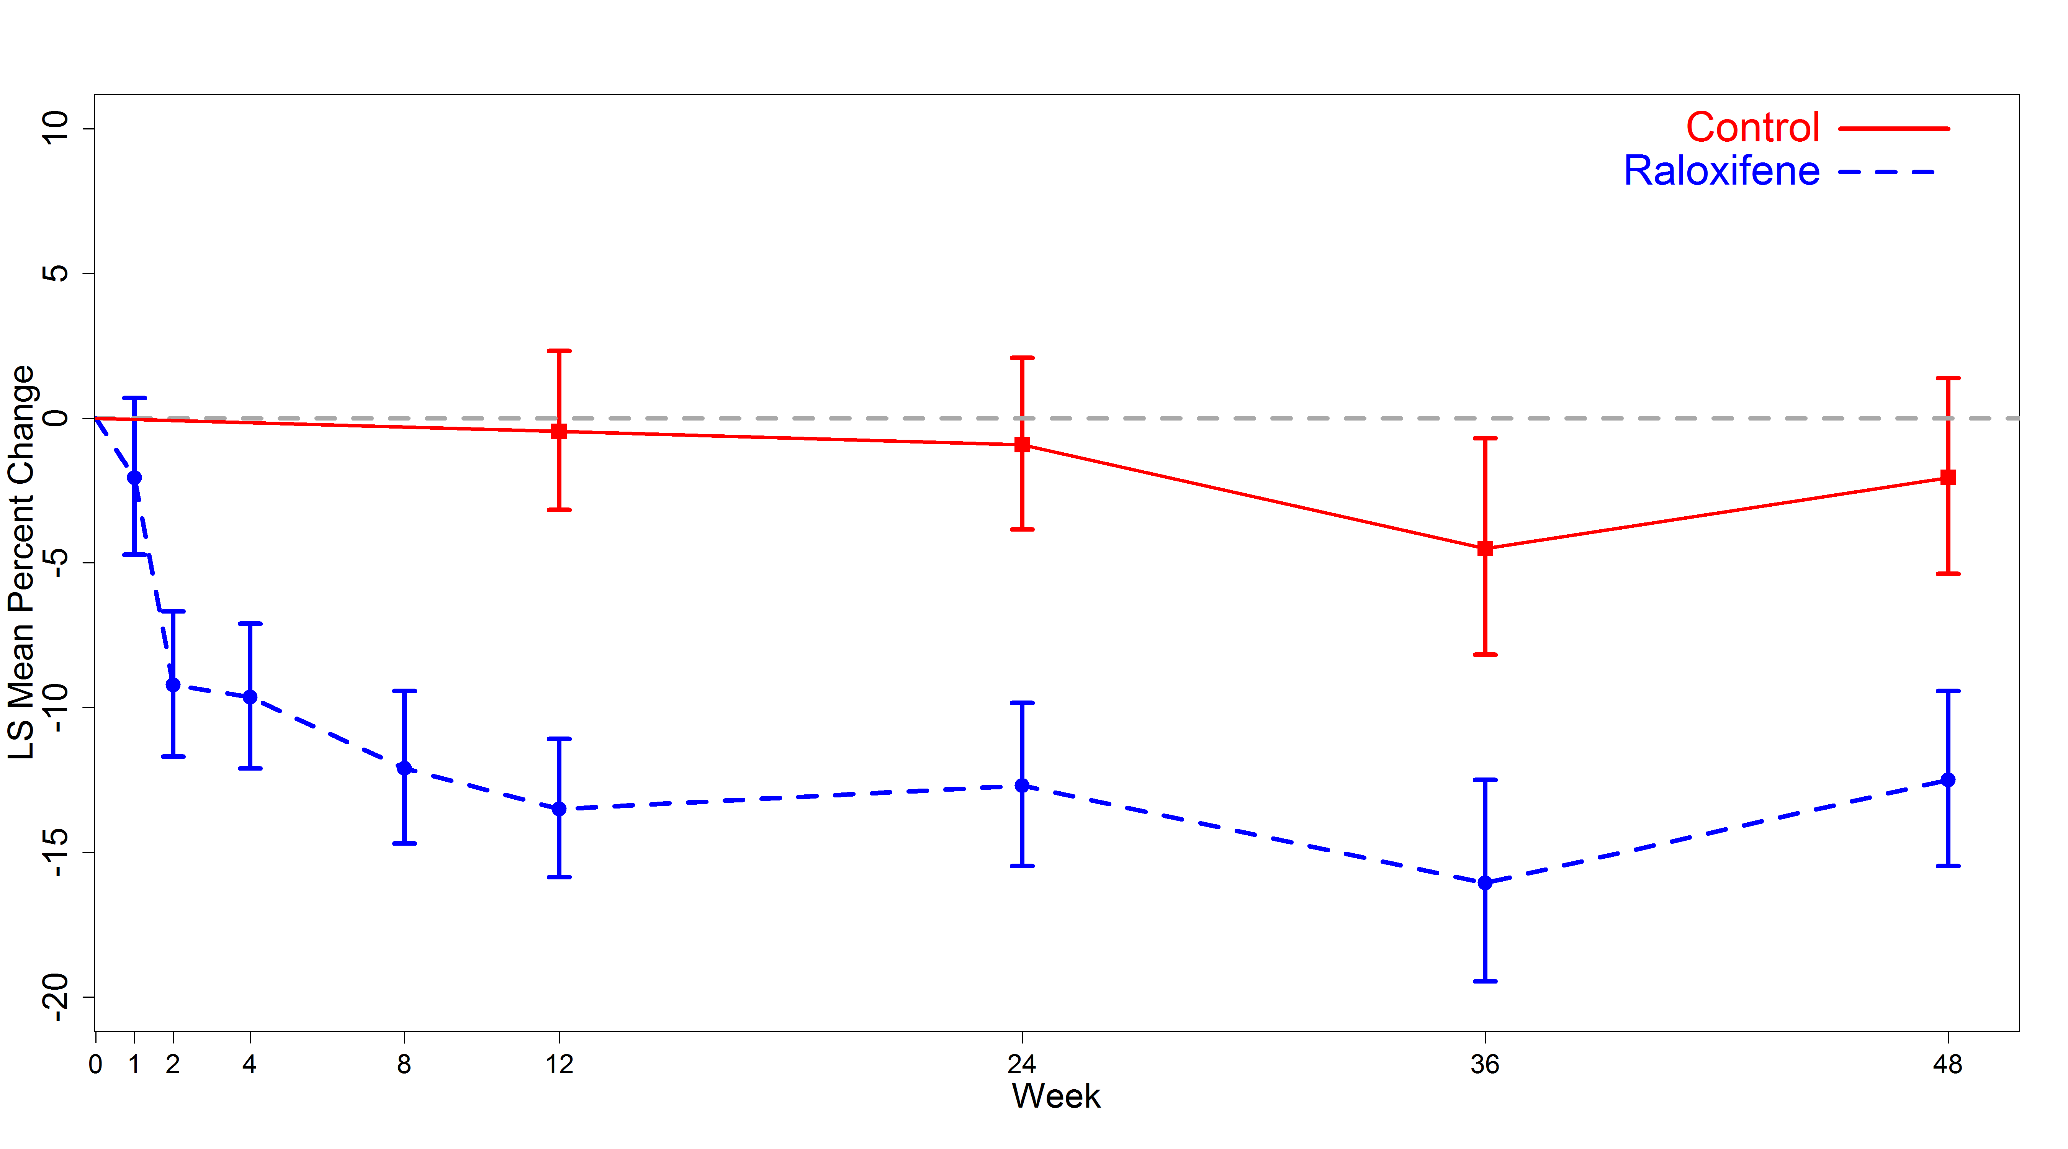
Figure 69: The effect of raloxifene treatment on levels of sclerostin in osteopenic women (blue line) compared to those receiving no treatment (red). The percentage change from baseline is shown for each visit.
The T-scores for sclerostin were calculated and plotted for osteopenic women receiving raloxifene and no treatments, (Figure 76). At baseline the T-scores for sclerostin in the osteopenic women receiving raloxifene (in red) and not treatment (green) were 1.95 (95% CI: 1.19, 2.72) and 3.02 (95% CI: 2.29, 3.75) SD units above the mean of the premenopausal women. The mean for the premenopausal women was 0 (SD: 1) .This was significantly different for the two groups (sclerostin levels combined at baseline) from premenopausal women by a mean of 2.5 (95% CI: 1.9, to 3.1), p<0.001. In the group receiving raloxifene the sclerostin T-score decreased to 1.37 (95% 0.70 to 2.04) SD units and this remained significantly higher than the mean for premenopausal women, the difference was 1.37 (95% CI: 0.75 to 1.98), p<0.001)

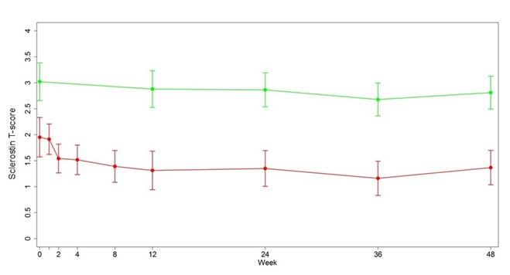
Figure 70: The mean T-scores calculated for sclerostin for postmenopausal women treated with raloxifene (red line) and without treatment (green line) over 48 weeks.

Circulating levels of sclerostin were negatively correlated with PINP and CTX in postmenopausal women with osteopenia at baseline, (r = -0.2, p<0.05 and r = -0.4, p<0.001), (Figure 77).
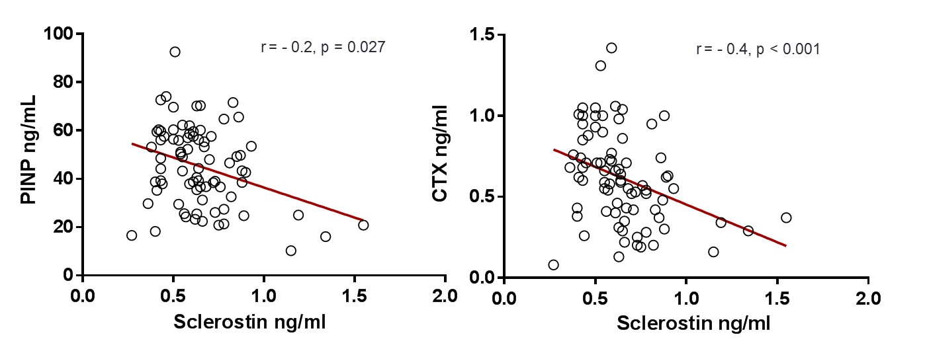
Figure 71: Scatter plot showing the correlation between serum sclerostin and PINP (left) and CTX (right) in postmenopausal women with osteopenia at baseline prior to raloxifene treatment (N = 44).
There was no correlation between the change in sclerostin levels after 48 weeks of treatment and the change in bone balance and bone turnover, (Figure 78). The Spearman rank correlation coefficient with bone balance was 0.25 (95% CI: -0.11 to 0.55, p>0.05) and bone turnover was -0.14 (95% CI: -0.52 to 0.38, p>0.05).
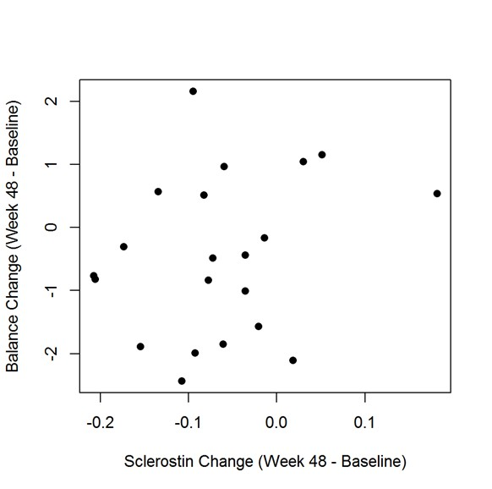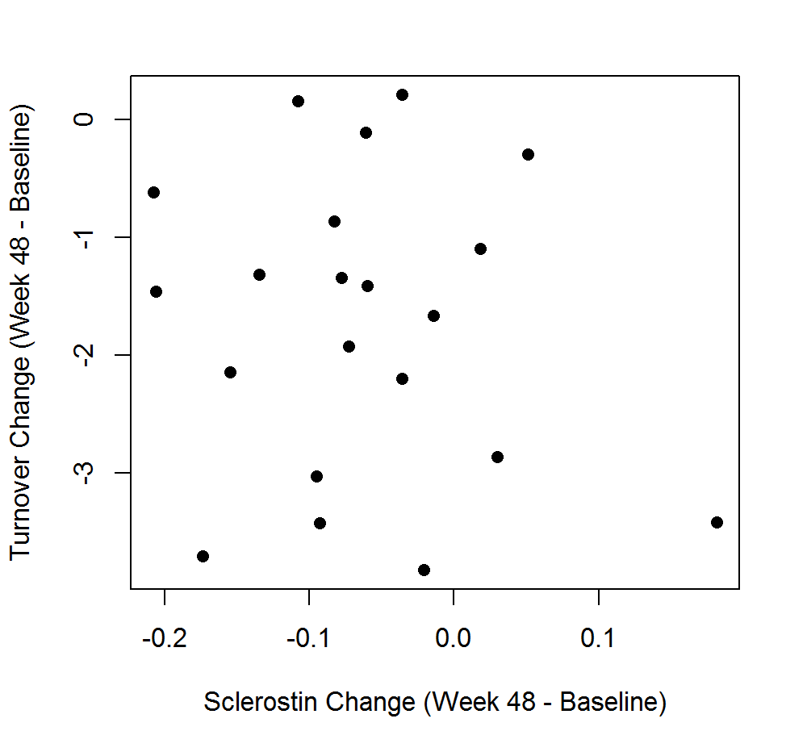
Figure 72: Scatter plot showing the correlation between the change in sclerostin levels and bone balance (left) and bone turnover (right) in postmenopausal women with osteopenia 48 weeks after treatment (N = 23).

Discussion
In postmenopausal women estrogen deficiency results in increased osteoclast and osteoblast recruitment and activity (477). Raloxifene is an established and approved treatment for postmenopausal women with osteopenia and is commonly used to for the prevention of osteoporosis. It suppresses bone resorption and bone formation to levels observed in premenopausal women. Other studies have shown that it reduces the risk of vertebral fractures (302). Using the T-score bone marker plot I have shown that postmenopausal women with osteopenia have a high bone turnover and a normal bone balance compared to healthy premenopausal women. Raloxifene significantly reduced bone turnover but does not improve balance but rather maintains it at normal levels. The latter does not therefore support the hypothesis that bone balance is improved. This suggests that the reduction in vertebral fracture risk with raloxifene treatment is not as a result of a positive balance. It may be related to a lower number of resorption cavities bu this requires further investigation.
As in the previous chapter postmenopausal women have a higher level of circulating sclerostin compared to premenopausal women. These supports the suggestions made by others that sclerostin mediates the bone loss we see as a result of estrogen deficiency (322). Using the T-score bone marker method I have shown that raloxifene treatment did not reduce sclerostin levels to the premenopausal levels.
The main finding from this chapter is that raloxifene treatment significantly reduced levels of circulating sclerostin in postmenopausal women with osteopenia. This is comparable to the findings from Chung YE et al, 2012 (465). Increased sclerostin may be one of the mechanisms mediating the effects of estrogen deficiency or raloxifene. Sclerostin is produced exclusively by the osteocytes it may be therefore be that raloxifene has a direct or indirect effect on these cells. As well as having an effect on the osteoclasts and osteoblasts, in vivo and in vitro studies have shown that estrogen deficiency also leads to increased osteocyte apoptosis and therefore decreased osteocyte number (468, 469). Following these, participants from the MORE clinical trial were used to assess whether raloxifene treatment effected osteocyte apoptosis (478). Bone biopsies were obtained from a subset of these participants, tetracycline administration followed by immunohistochemical methods were used to identify the positively stained osteocytes. The findings were that there were no significant difference in the population of osteocytes at baseline and two years after treatment. This suggests the reduction in sclerostin I observed is not due to an effect on osteocyte number but perhaps on their activity or ability to produce sclerostin. The latter was investigated by Poole K.E.S et al 2005 and they demonstrated that sclerostin is produced by mature osteocytes after they have been embedded in the mineralised matrix (78).
In this study population, sclerostin was negatively correlated with bone resorption and formation. This supports and is consistent with the finding from the previous chapter and with (457) that increased sclerostin production does reduce osteoblast activity. However Polyzos SA et al 2012, demonstrated a positive rather than a negative correlation with CTX. There was no correlation between the changes in sclerostin levels and bone balance with raloxifene treatment. The limitations of this study are a small number of participants, which makes it more difficult to obtain an accurate estimation of bone balance and no data on compliance was collected.

Conclusion
Treatment of postmenopausal osteopenia with raloxifene reduced bone turnover but had no effect of bone balance. There was no relationship between the change in sclerostin levels and the change in bone balance with raloxifene treatment, therefore sclerostin has no influence on bone balance. Sclerostin is a biochemical marker that is related to bone resorption and bone formation but this is most likely not to be causal because there was no relationship with bone balance and bone turnover.
These findings can help in further understanding the role of sclerostin and quantify its overall effect on bone formation and bone resorption in postmenopausal women receiving antiresorptive treatments.

Chapter 8: Overall discussions and conclusions
The research in this thesis aimed to investigate and understand the clinical utility of bone turnover markers in women with postmenopausal osteoporosis. The key findings below may be used to identify patients with secondary osteoporosis and low BMD, bone loss and fracture risk. In addition I have explored several mechanisms and described a novel approach that could further explain the mode of action of antiresorptive treatments.

Key findings
- Method specific reference ranges are required in order to interpret clinical studies accurately.
- There are several disease states (such as CKD, osteoporosis), treatments and lifestyle determinants that effect bone turnover. These must be considered when establishing healthy BTM reference ranges.
- The findings obtained in postmenopausal osteoporosis encourage similar studies in secondary osteoporosis.
- The T-score bone marker plot demonstrated that a positive bone balance is related to a reduction in bone and fracture risk at the total hip.
- In postmenopausal osteoporosis antiresorptive treatments have varying effects on BTMS with regards to magnitude and duration and these need to be considered by clinicians prior to administration.
- Bisphosphonates reduce the population of osteoclast precursor cells as after 48 weeks of treatment.
- Alendronate improves bone balance and this may be related to its reduction in bone loss and fracture risk previously observed.
- Levels of circulating sclerostin mediate the effect of raloxifene on bone turnover but not bisphosphonates.
- Raloxifene has no effect on bone balance.

What is new?
Method specific postmenopausal and premenopausal robust reference ranges for BTMs have been established.
These are the first reference ranges to be established using the iSYS-IDS auto-immunoassays. The OPUS postmenopausal reference intervals for PINP and CTX compared to those previously established by Martinez J et al 2009, using the Camargo cohort (369) are shown in figure 79. The OPUS and TRIO premenopausal reference intervals for PINP and CTX compared to those previously established in several studies are shown in figure 80. Although direct statistical comparisons cannot be made, the graphs show that there possible significant differences between the reference ranges. Several factors may have contributed to these differences; number of participants, selection of participants (inclusion/exclusion criteria), and geographical region of participants, BTM measurement methods, laboratory quality assurance and statistical approach. Such variations highlight the need to harmonise the methods before BTM values can be used and interpreted in a clinical setting.
Figure 73: PINP (top) and CTX (bottom) postmenopausal reference intervals from one previous study (black) and the OPUS study (red) described in chapter 3.
Figure 74: PINP (top) and CTX (bottom) premenopausal reference intervals from previous studies (black) and the OPUS and TRIO studies (red) described in chapters 3 and 5.
The T-score bone marker method/plot is a novel method that has been described here for the first time.
It can be used to identify the state of bone remodelling by combining both bone turnover and bone balance in women with postmenopausal osteoporosis in relation to healthy premenopausal women. Using this method I have identified that postmenopausal women from a population-based study have a high bone turnover and a negative balance. Furthermore the T-score bone marker plot can be now be applied to other disease states that are characterised by impaired bone remodelling to establish the state to bone turnover and balance quantitatively and qualitatively.
The T-score bone marker approach is also a novel method for assessing bone loss and fracture risk. Although there is some evidence that high turnover is associated with increased risk of fracture, currently the use of BTMs has not be verified and they are not included in the fracture risk assessment algorithms. The T-score bone marker approach can be applied as a method of assessing bone loss and fracture risk and this is supported by findings from other major studies i.e. SOF and OFELY. By using BTMs in this approach I have been able to strengthen and update their clinical utility.
Finally, I have used the T-score bone marker plot to demonstrate that licenced antiresorptive treatments in the UK all reduced bone turnover and only alendronate improved bone balance, (Figure 81). Along with BMD and other assessments, this may help clinicians identify the most suitable compound with regards to suppression of bone turnover and improvement of bone balance.

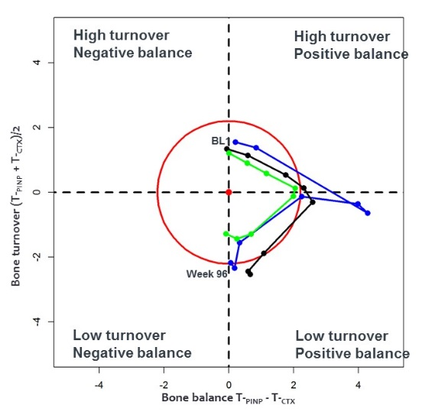
Figure 75: The T-score bone marker plot showing the effects of ibandronate (blue), alendronate (black) and risedronate (green) on bone turnover and bone balance

Bisphosphonates reduce BTMs and the population of osteoclast precursor cells in postmenopausal women with osteoporosis
The findings in chapter 6 are the first to describe the effects of ibandronate, alendronate and risedronate on BTMs and osteoclast precursor cells in a head-to-head manner. They inhibit bone resorption in the short-term by direct action on mature osteoclasts. There is also a later effect mediated by a reduction in the population of circulating osteoclast precursors. I observed no reduction in circulating cytokines. In addition to this I have been able to establish a reference range using the premenopausal women for each of these markers, these have not been established previously.
The role of sclerostin
The clinical utility of sclerostin has not been fully established in this thesis, this remains to be unclear. I have shown that ibandronate, alendronate and risedronate do not affect the levels of circulating sclerostin and raloxifene decreases it. It may be that sclerostin can be used for treatment monitoring with some lesser potent agents than bisphosphonates. My findings also suggest that sclerostin may be related to bone turnover and is a marker of bone turnover. With further investigations and a larger sample size it may be that it is also related to bone balance.
The overall findings and clinical utility of BTMs in postmenopausal osteoporosis
The changes in BTMS with antiresorptive treatments are rapid and large. Table 35 compares the change in PINP and CTX in the clinical trials described in the thesis with those previously reported. Generally the findings are comparable with the exception that I have demonstrated with alendronate there was a greater magnitude of suppression compared to the FIT and FLEX trials. The changes in BTMs highlight that they are a valuable tool because they may provide clinicians with earlier and additional information to BMD regarding response and level of suppression. These findings support the current rational for the use of BTMs to monitor such treatments.
There is also evidence supporting that BTMs can be used to calculate and assess bone turnover and bone balance combined in postmenopausal women prior to and during treatment. Furthermore I have shown that bone balance is related to fracture risk and this may help explain the improved bone microarchitecture and strength with antiresorptive treatments. This concept has not been previously described and cannot be captured by BMD (479). This can be investigated further as part of a clinical trial where the reduction in fracture risk before and after treatment is also assessed. This will allow us to establish the clinical utility of BTMS in relation to fracture and investigate further the role of bone balance.

Table 35: The key findings from the TRIO and Raloxifene clinical trials described in the thesis (highlighted in red). Showing the change from baseline, (bone balance shown as SD). CTX and PINP are compared to other clinical trials. OCP (osteoclast precursor cell population)
Antiresorptive name/description | Findings from previous clinical trials | Findings from the TRIO Study | Findings from the Raloxifene Study
Ibandronate  Nitrogen containing bisphosphonate | BONE, MOBILE and MOTION (Miller P 2005, Emkey R 2009)  CTX: -76%  PINP: N/A | CTX: -77%,  PINP: -74%,  OCP: -65%,  Bone Balance: 0.1 (T-score)  Sclerostin: No change | N/A
Alendronate  Nitrogen containing bisphosphonate | FIT (307, 308), FLEX (309):  CTX: -59% (SD: 31)  PINP: -51% (SD: 31) | CTX: -86%  PINP:-71%  OCP: -33%  Bone Balance: 0.7 (T-score)  Sclerostin: No change | N/A
Risedronate  Nitrogen containing heterocyclic bisphosphonate | VERT-MN (279, 310) , VERT-NA(311), HIP Intervention Program Study Group (312):  CTX (urine): -60% | CTX: -67%  PINP:-57%  OCP: -61%  Bone Balance: -0.1 (SD)  Sclerostin: No change | N/A
Raloxifene  Second generation SERM: Benzothiophene | MORE (302, 314):  CTX (urine): -47%  PINP: -41% |  | CTX: -48%  PINP: -34%  OCP: N/A  Bone Balance: No change  Sclerostin: -13%, 1.37 (T-score)

Overall strengths of the thesis
Throughout the thesis there were several strengths that contributed to the findings.
With regards to the actual measurements of the BTMs, throughout the entire thesis assay consistency was maximised by using a central specialised laboratory with automated immunoassays for measuring the BTMs and thus minimising human error.
Subjects from a large population based study cohort (n = 2419) were used in establishing the postmenopausal and premenopausal reference intervals for BTMs. I identified the healthy population from their detailed assessments and excluded all factors known to affect bone metabolism. This allowed me to identify a well characterized population of a large sample size to reliably calculate the reference intervals. A large subset of 745 postmenopausal women from this study population were included in the analyses of the subsequent chapter to develop the T-score bone marker plot/method. By having such a large study size to develop a novel method ensures accuracy and reliability of the method. In particular all of the 754 were used to assess the relationship between bone turnover, bone balance and bone loss. With regards to fracture risk assessment in this study cohort, there were a large number of non-vertebral fracture cases (N = 92) but a small number of vertebral fracture cases (N = 23).
There were several strengths which also came from the TRIO study investigating. It allowed me to compare the effects of bisphosphonates on bone turnover markers in a head-to-head manner using a large study population. Unlike the OPUS study samples were taken following an overnight fast which removes the effects of feeding of BTMs. Laboratory and non-laboratory sources of variability were minimised; the recruitment method of the subjects (inclusion and exclusion criteria), the measurements of the BTMs were performed and the statistical analyses were performed according to set protocols in one department. A major strength of the TRIO study is the addition of a premenopausal control group, unlike other treatment trials where this is lacking. This allowed for direct comparisons and conclusions to be made. Subsets from the TRIO population were also used to explore the effects of bisphosphonates on the osteoclast precursor cells and circulating levels of sclerostin. In addition a large enough number of the subjects (N = 180) were included in the T-score bone marker plot allowing for an accurate assessment of bone balance.

Overall weaknesses of the thesis
There were also some limitations that affected the findings presented in the thesis.
The first limitation identified was in the normative data chapter. The serum used to establish the postmenopausal and premenopausal reference ranges in this chapter was taken non-fasting. Food intake leads to a decrease in levels of bone resorption markers (480). This may be the reason why the premenopausal reference interval for CTX appears to be significantly lower than all of the others. In addition, because samples were taken at different times of the day then this could be the reason why a greater variation in PINP was observed in comparison to others, (Figure 80). Due to this limitation for the subsequent chapters that investigated the effects of treatments on BTMs, fasting premenopausal reference ranges were re-established.

The second limitation identified was in chapter 4 which investigated the clinical utility of bone turnover and bone balance in postmenopausal women in the OPUS study. There were only 24 women who presented with a vertebral fracture over the 6 year study period. This number is too small to allow any definite conclusions to be made that relate bone turnover and bone balance with fracture risk. However the number of vertebral fractures I have described here are comparable with other population-based studies (404). None-the-less even in a small number of cases, the T-score bone marker approach does give us a strong indication that bone balance is related to vertebral fracture risk.

There were also some limitations in the TRIO study in particular relating to the osteoclast precursor cell population investigations. Osteoclast precursor cells express the receptors RANK and c-Fms and differentiate in to mature osteoclasts in the presence of RANKL and M-CSF. It may have been necessary to test whether the cells from the monocyte/macrophage lineage in the bone marrow did indeed differentiate into osteoclasts in vivo in cultures treated with RANKL and M-CSF. This may have been possible to perform using immunohistochemical techniques and flow cytometry to identify RANK and c-Fms double positive cells as described by Muto A et al 2011, (27). However these techniques have only been demonstrated in mice studies and have not been established in humans so would need further investigation. The other notable limitation was the number of subjects in this sub-study. Each of the treatments and control groups had an N of ~22-25 subject, although this number is comparable with others (440, 441) and provides a strong indication of these effects a bigger sample size is necessary to confirm these findings.

Future work
The T-score bone marker plot has now been established and can be used to i) assess bone loss and fracture risk and ii) monitor the effects of other treatments on both bone turnover and bone balance. It can be applied to other antiresorptive treatments such a denosumab, a monoclonal antibody against RANKL is pharmacologically different to bisphosphonates (147). It binds to RANK and inhibits the production of mature osteoclasts reducing bone resorption and increasing BMD more than bisphosphonates (481). A future hypothesis could therefore be that denosumab reduces bone turnover and makes bone balance more positive compared to baseline and healthy premenopausal women.
In addition the T-score bone marker plot can be used to investigate the effect of discontinuation of treatments on bone turnover and bone balance. There are differences between and within treatment groups following discontinuation on BTMs, BMD and fracture risk (482). In the FLEX trial, discontinuation of alendronate was associated to a gradual increase in BTMs and by 5 years levels were below that of baseline (318). In contrast in the phase II multi-dose trial, discontinuation of denosumab was associates with an increase in BTMs and by 1 year level were above that of baseline (483). By investigating the effect of these treatments on bone remodelling as a state of turnover and balance it can give an insight on the clinical implications of this rise in BTMs once treatments have stopped, which is currently unclear. It may be that the effect on bone balance may be related to the change in BMD and fracture risk. Initial investigations can now be carried out using the T-score bone marker plot be within our Unit as part of the TRIO offset study. Here, a subset of patients (N = 60) were followed up for 2 years after bisphosphonate treatment stopped. Serum samples were collected at regular intervals throughout and BTM measurements have been performed. The aim would be to determine the effects of the discontinuation of bisphosphonate treatment on bone turnover and bone balance in postmenopausal women with osteoporosis.
Another research goal is to explore further the native α- and isomerised age-related β-forms of type I collagen in postmenopausal women. Garnero et al has previously demonstrated that in patients with Paget’s disease the α/β CTX ratio was significantly increased and this was possibly due to there being a lower portion of βCTX in this disease, (181) and was restored with zoledronate treatment (484). I aim to investigate the effects of ibandronate, alendronate and risedronate on the α/β CTX ratio in postmenopausal women with osteoporosis. It may be that each bisphosphonate decreases α and β CTX by a different magnitude hence having different effects on the ratio. This may help further understand the mechanism of action of bisphosphonates.
The method used to stain, identify and quantify osteoclast precursor cells in PBMCs in postmenopausal and premenopausal women has been established. It is straight forward to perform and can be used to assess the effects of antiresorptives and anabolic treatments on this cell population. Bisphosphonates, denosumab and cathepsin K inhibitors reduce BTMs by different magnitudes and have varied effects on BMD and fracture risk reduction. This may partly be due to the effects they have on a cellular level, in particular on osteoclast precursor cells as well as on mature osteoclast (485). The data and findings from this thesis can be used as a basis for investigating these effects further.
Another potential area of interest that can be further explored relates to the role of miRNAs in osteoclast and osteoblast differentiation. In vitro studies have demonstrated that several miRNAs have been identified to either inhibit or enhance bone resorption and formation (486). Five miRNAs have so far be identified and are highly expressed in patients with osteoporosis, namely: miR-21, miR-23a, miR-24, miR-25, miR-100, and miR-125b (44). Further investigations are required on miRNAs to; i) determine levels of expression in postmenopausal women with osteoporosis compared to premenopausal women, ii) establish the effects of antiresorptive treatments, iii) assess the relationship with bone loss and fracture risk and iv) identify possible treatment targets. The designs of the studies and some of the methodologies/data described in this thesis may be able to partly contribute to these investigations.
Treatments for postmenopausal osteoporosis are continually being developed and investigated in order to identify the ‘perfect’ treatment. Ideally this would reduce bone resorption, increases bone formation and BMD and reduce fracture risk. The methods in this thesis have investigated the clinical utility of bone turnover markers and these can be adapted to be used in ongoing and future clinical trials.

REFERENCES
1. Osteoporosis prevention, diagnosis, and therapy. NIH Consens Statement. 2000;17(1):1-45.
2. Prevention and management of osteoporosis. World Health Organ Tech Rep Ser. 2003;921:1-164, back cover.
3. Dennison E, Cole Z, Cooper C. Diagnosis and epidemiology of osteoporosis. Current opinion in rheumatology. 2005;17(4):456-61.
4. Kanis JA, Johnell O, Oden A, Jonsson B, De Laet C, Dawson A. Risk of hip fracture according to the World Health Organization criteria for osteopenia and osteoporosis. Bone. 2000;27(5):585-90.
5. Silverman SL. Quality-of-life issues in osteoporosis. Current rheumatology reports. 2005;7(1):39-45.
6. Geusens P. Osteoporosis: clinical features. Minerva medica. 2008;99(2):167-75.
7. Borgstrom F, Lekander I, Ivergard M, Strom O, Svedbom A, Alekna V, et al. The International Costs and Utilities Related to Osteoporotic Fractures Study (ICUROS)--quality of life during the first 4 months after fracture. Osteoporosis international : a journal established as result of cooperation between the European Foundation for Osteoporosis and the National Osteoporosis Foundation of the USA. 2013;24(3):811-23.
8. Harvey N, Dennison E, Cooper C. Osteoporosis: impact on health and economics. Nat Rev Rheumatol. 2010;6(2):99-105.
9. Assessment of fracture risk and its application to screening for postmenopausal osteoporosis. Report of a WHO Study Group. World Health Organ Tech Rep Ser. 1994;843:1-129.
10. Clarke B. Normal bone anatomy and physiology. Clinical journal of the American Society of Nephrology : CJASN. 2008;3 Suppl 3:S131-9.
11. Taichman RS. Blood and bone: two tissues whose fates are intertwined to create the hematopoietic stem-cell niche. Blood. 2005;105(7):2631-9.
12. Datta HK, Ng WF, Walker JA, Tuck SP, Varanasi SS. The cell biology of bone metabolism. Journal of clinical pathology. 2008;61(5):577-87.
13. Boskey AL. Assessment of bone mineral and matrix using backscatter electron imaging and FTIR imaging. Current osteoporosis reports. 2006;4(2):71-5.
14. Boskey AL, Robey PG. The Composition of Bone. Primer on the Metabolic Bone Diseases and Disorders of Mineral Metabolism: John Wiley & Sons, Inc.; 2013. p. 49-58.
15. Bilezikian JP, Raisz LG, Rodan GA. Principles of Bone Biology: Harcourt Academic; 2001.
16. Grynpas MD, Omelon S. Transient precursor strategy or very small biological apatite crystals? Bone. 2007;41(2):162-4.
17. Dorozhkin SV. Amorphous calcium (ortho)phosphates. Acta biomaterialia. 2010;6(12):4457-75.
18. Trackman PC. Diverse biological functions of extracellular collagen processing enzymes. Journal of cellular biochemistry. 2005;96(5):927-37.
19. Ge G, Greenspan DS. Developmental roles of the BMP1/TLD metalloproteinases. Birth defects research Part C, Embryo today : reviews. 2006;78(1):47-68.
20. Goldberg M, Boskey AL. Lipids and Biomineralizations. Progress in Histochemistry and Cytochemistry. 1996;31(2):III-187.
21. Seeman E. Age- and menopause-related bone loss compromise cortical and trabecular microstructure. J Gerontol A Biol Sci Med Sci. 2013;68(10):1218-25.
22. Boyle WJ, Simonet WS, Lacey DL. Osteoclast differentiation and activation. Nature. 2003;423(6937):337-42.
23. Akashi K, Traver D, Miyamoto T, Weissman IL. A clonogenic common myeloid progenitor that gives rise to all myeloid lineages. Nature. 2000;404(6774):193-7.
24. Clanchy FI, Holloway AC, Lari R, Cameron PU, Hamilton JA. Detection and properties of the human proliferative monocyte subpopulation. J Leukoc Biol. 2006;79(4):757-66.
25. Passlick B, Flieger D, Ziegler-Heitbrock HW. Identification and characterization of a novel monocyte subpopulation in human peripheral blood. Blood. 1989;74(7):2527-34.
26. Khosla S, Westendorf JJ, Oursler MJ. Building bone to reverse osteoporosis and repair fractures. The Journal of clinical investigation. 2008;118(2):421-8.
27. Muto A, Mizoguchi T, Udagawa N, Ito S, Kawahara I, Abiko Y, et al. Lineage-committed osteoclast precursors circulate in blood and settle down into bone. Journal of bone and mineral research : the official journal of the American Society for Bone and Mineral Research. 2011;26(12):2978-90.
28. Asagiri M, Takayanagi H. The molecular understanding of osteoclast differentiation. Bone. 2007;40(2):251-64.
29. Nakamura I, Takahashi N, Jimi E, Udagawa N, Suda T. Regulation of osteoclast function. Modern rheumatology / the Japan Rheumatism Association. 2012;22(2):167-77.
30. Fuller K, Owens JM, Jagger CJ, Wilson A, Moss R, Chambers TJ. Macrophage colony-stimulating factor stimulates survival and chemotactic behavior in isolated osteoclasts. The Journal of experimental medicine. 1993;178(5):1733-44.
31. Lacey DL, Timms E, Tan HL, Kelley MJ, Dunstan CR, Burgess T, et al. Osteoprotegerin ligand is a cytokine that regulates osteoclast differentiation and activation. Cell. 1998;93(2):165-76.
32. Kobayashi K, Takahashi N, Jimi E, Udagawa N, Takami M, Kotake S, et al. Tumor necrosis factor alpha stimulates osteoclast differentiation by a mechanism independent of the ODF/RANKL-RANK interaction. The Journal of experimental medicine. 2000;191(2):275-86.
33. Thomson BM, Mundy GR, Chambers TJ. Tumor necrosis factors alpha and beta induce osteoblastic cells to stimulate osteoclastic bone resorption. Journal of immunology (Baltimore, Md : 1950). 1987;138(3):775-9.
34. Li Z, Hassan MQ, Volinia S, van Wijnen AJ, Stein JL, Croce CM, et al. A microRNA signature for a BMP2-induced osteoblast lineage commitment program. Proceedings of the National Academy of Sciences of the United States of America. 2008;105(37):13906-11.
35. Inose H, Ochi H, Kimura A, Fujita K, Xu R, Sato S, et al. A microRNA regulatory mechanism of osteoblast differentiation. Proceedings of the National Academy of Sciences of the United States of America. 2009;106(49):20794-9.
36. Liu T, Qin AP, Liao B, Shao HG, Guo LJ, Xie GQ, et al. A novel microRNA regulates osteoclast differentiation via targeting protein inhibitor of activated STAT3 (PIAS3). Bone. 2014;67:156-65.
37. Papaioannou G, Mirzamohammadi F, Kobayashi T. MicroRNAs involved in bone formation. Cellular and molecular life sciences : CMLS. 2014.
38. Wu Z, Yin H, Liu T, Yan W, Li Z, Chen J, et al. MiR-126-5p regulates osteoclast differentiation and bone resorption in giant cell tumor through inhibition of MMP-13. Biochemical and biophysical research communications. 2014;443(3):944-9.
39. Xia Z, Chen C, Chen P, Xie H, Luo X. MicroRNAs and their roles in osteoclast differentiation. Frontiers of medicine. 2011;5(4):414-9.
40. Ebert MS, Sharp PA. Roles for microRNAs in conferring robustness to biological processes. Cell. 2012;149(3):515-24.
41. Nakasa T, Shibuya H, Nagata Y, Niimoto T, Ochi M. The inhibitory effect of microRNA-146a expression on bone destruction in collagen-induced arthritis. Arthritis and rheumatism. 2011;63(6):1582-90.
42. Cheng P, Chen C, He HB, Hu R, Zhou HD, Xie H, et al. miR-148a regulates osteoclastogenesis by targeting V-maf musculoaponeurotic fibrosarcoma oncogene homolog B. Journal of bone and mineral research : the official journal of the American Society for Bone and Mineral Research. 2013;28(5):1180-90.
43. Li H, Wang Z, Fu Q, Zhang J. Plasma miRNA levels correlate with sensitivity to bone mineral density in postmenopausal osteoporosis patients. Biomarkers : biochemical indicators of exposure, response, and susceptibility to chemicals. 2014;19(7):553-6.
44. Seeliger C, Karpinski K, Haug AT, Vester H, Schmitt A, Bauer JS, et al. Five freely circulating miRNAs and bone tissue miRNAs are associated with osteoporotic fractures. Journal of bone and mineral research : the official journal of the American Society for Bone and Mineral Research. 2014;29(8):1718-28.
45. Zhao X, Xu D, Li Y, Zhang J, Liu T, Ji Y, et al. MicroRNAs regulate bone metabolism. Journal of bone and mineral metabolism. 2014;32(3):221-31.
46. Cao Z, Moore BT, Wang Y, Peng XH, Lappe JM, Recker RR, et al. MiR-422a as a potential cellular microRNA biomarker for postmenopausal osteoporosis. PloS one. 2014;9(5):e97098.
47. Ross FP, Teitelbaum SL. alphavbeta3 and macrophage colony-stimulating factor: partners in osteoclast biology. Immunological reviews. 2005;208:88-105.
48. McHugh KP, Hodivala-Dilke K, Zheng MH, Namba N, Lam J, Novack D, et al. Mice lacking beta3 integrins are osteosclerotic because of dysfunctional osteoclasts. The Journal of clinical investigation. 2000;105(4):433-40.
49. Teitelbaum SL. Osteoporosis and integrins. The Journal of clinical endocrinology and metabolism. 2005;90(4):2466-8.
50. Vaananen HK, Zhao H, Mulari M, Halleen JM. The cell biology of osteoclast function. J Cell Sci. 2000;113 ( Pt 3):377-81.
51. Teitelbaum SL, Cao X, Mimura H, Chiba M, Ross FP. Cellular and molecular mechanisms of bone resorption. Mineral and electrolyte metabolism. 1995;21(1-3):193-6.
52. Ross FP. Osteoclast Biology and Bone Resorption. Primer on the Metabolic Bone Diseases and Disorders of Mineral Metabolism: John Wiley & Sons, Inc.; 2013. p. 25-33.
53. Zhao B, Ivashkiv LB. Negative regulation of osteoclastogenesis and bone resorption by cytokines and transcriptional repressors. Arthritis Res Ther. 2011;13(4):234.
54. Hofbauer LC, Khosla S, Dunstan CR, Lacey DL, Boyle WJ, Riggs BL. The roles of osteoprotegerin and osteoprotegerin ligand in the paracrine regulation of bone resorption. Journal of bone and mineral research : the official journal of the American Society for Bone and Mineral Research. 2000;15(1):2-12.
55. Eriksen EF. Cellular mechanisms of bone remodeling. Reviews in endocrine & metabolic disorders. 2010;11(4):219-27.
56. Stuss M, Rieske P, Ceglowska A, Stepien-Klos W, Liberski PP, Brzezianska E, et al. Assessment of OPG/RANK/RANKL gene expression levels in peripheral blood mononuclear cells (PBMC) after treatment with strontium ranelate and ibandronate in patients with postmenopausal osteoporosis. The Journal of clinical endocrinology and metabolism. 2013;98(5):E1007-11.
57. LaCroix AZ, Jackson RD, Aragaki A, Kooperberg C, Cauley JA, Chen Z, et al. OPG and sRANKL serum levels and incident hip fracture in postmenopausal Caucasian women in the Women's Health Initiative Observational Study. Bone. 2013;56(2):474-81.
58. Tu P, Duan P, Zhang RS, Xu DB, Wang Y, Wu HP, et al. Polymorphisms in genes in the RANKL/RANK/OPG pathway are associated with bone mineral density at different skeletal sites in post-menopausal women. Osteoporosis international : a journal established as result of cooperation between the European Foundation for Osteoporosis and the National Osteoporosis Foundation of the USA. 2014.
59. Eghbali-Fatourechi G, Khosla S, Sanyal A, Boyle WJ, Lacey DL, Riggs BL. Role of RANK ligand in mediating increased bone resorption in early postmenopausal women. The Journal of clinical investigation. 2003;111(8):1221-30.
60. Schieferdecker A, Voigt M, Riecken K, Braig F, Schinke T, Loges S, et al. Denosumab mimics the natural decoy receptor osteoprotegerin by interacting with its major binding site on RANKL. Oncotarget. 2014.
61. Mackie EJ. Osteoblasts: novel roles in orchestration of skeletal architecture. The international journal of biochemistry & cell biology. 2003;35(9):1301-5.
62. Hesse E, Saito H, Kiviranta R, Correa D, Yamana K, Neff L, et al. Zfp521 controls bone mass by HDAC3-dependent attenuation of Runx2 activity. The Journal of cell biology. 2010;191(7):1271-83.
63. Bi W, Deng JM, Zhang Z, Behringer RR, de Crombrugghe B. Sox9 is required for cartilage formation. Nature genetics. 1999;22(1):85-9.
64. Akiyama H, Chaboissier MC, Martin JF, Schedl A, de Crombrugghe B. The transcription factor Sox9 has essential roles in successive steps of the chondrocyte differentiation pathway and is required for expression of Sox5 and Sox6. Genes & development. 2002;16(21):2813-28.
65. Harada H, Tagashira S, Fujiwara M, Ogawa S, Katsumata T, Yamaguchi A, et al. Cbfa1 isoforms exert functional differences in osteoblast differentiation. The Journal of biological chemistry. 1999;274(11):6972-8.
66. Kern B, Shen J, Starbuck M, Karsenty G. Cbfa1 contributes to the osteoblast-specific expression of type I collagen genes. The Journal of biological chemistry. 2001;276(10):7101-7.
67. Otto F, Thornell AP, Crompton T, Denzel A, Gilmour KC, Rosewell IR, et al. Cbfa1, a candidate gene for cleidocranial dysplasia syndrome, is essential for osteoblast differentiation and bone development. Cell. 1997;89(5):765-71.
68. Nakashima K, Zhou X, Kunkel G, Zhang Z, Deng JM, Behringer RR, et al. The novel zinc finger-containing transcription factor osterix is required for osteoblast differentiation and bone formation. Cell. 2002;108(1):17-29.
69. Chen D, Zhao M, Mundy GR. Bone morphogenetic proteins. Growth factors (Chur, Switzerland). 2004;22(4):233-41.
70. Gazzerro E, Canalis E. Bone morphogenetic proteins and their antagonists. Reviews in endocrine & metabolic disorders. 2006;7(1-2):51-65.
71. Janssens K, ten Dijke P, Janssens S, Van Hul W. Transforming growth factor-beta1 to the bone. Endocrine reviews. 2005;26(6):743-74.
72. Sims NA, Martin TJ. Coupling the activities of bone formation and resorption: a multitude of signals within the basic multicellular unit. Bonekey Rep. 2014;3:481.
73. Capulli M, Paone R, Rucci N. Osteoblast and osteocyte: games without frontiers. Archives of biochemistry and biophysics. 2014;561:3-12.
74. Russell RG, Fleisch H. Pyrophosphate and diphosphonates in skeletal metabolism. Physiological, clinical and therapeutic aspects. Clin Orthop Relat Res. 1975(108):241-63.
75. Noble BS. The osteocyte lineage. Archives of biochemistry and biophysics. 2008;473(2):106-11.
76. Bonewald LF, Kneissel M, Johnson M. Preface: The Osteocyte. Bone. 2013;54(2):181.
77. Owen M. Uptake of [3H] uridine into precursor pools and RNA in osteogenic cells. Journal of cell science. 1967;2(1):39-56.
78. Poole KE, van Bezooijen RL, Loveridge N, Hamersma H, Papapoulos SE, Lowik CW, et al. Sclerostin is a delayed secreted product of osteocytes that inhibits bone formation. FASEB journal : official publication of the Federation of American Societies for Experimental Biology. 2005;19(13):1842-4.
79. Toyosawa S, Shintani S, Fujiwara T, Ooshima T, Sato A, Ijuhin N, et al. Dentin matrix protein 1 is predominantly expressed in chicken and rat osteocytes but not in osteoblasts. Journal of bone and mineral research : the official journal of the American Society for Bone and Mineral Research. 2001;16(11):2017-26.
80. Burra S, Nicolella DP, Jiang JX. Dark horse in osteocyte biology: Glycocalyx around the dendrites is critical for osteocyte mechanosensing. Commun Integr Biol. 2011;4(1):48-50.
81. Buenzli PR, Sims NA. Quantifying the osteocyte network in the human skeleton. Bone. 2015;75:144-50.
82. Civitelli R. Cell-cell communication in the osteoblast/osteocyte lineage. Archives of biochemistry and biophysics. 2008;473(2):188-92.
83. Knothe Tate ML, Adamson JR, Tami AE, Bauer TW. The osteocyte. The international journal of biochemistry & cell biology. 2004;36(1):1-8.
84. Price C, Zhou X, Li W, Wang L. Real-time measurement of solute transport within the lacunar-canalicular system of mechanically loaded bone: direct evidence for load-induced fluid flow. Journal of bone and mineral research : the official journal of the American Society for Bone and Mineral Research. 2011;26(2):277-85.
85. Harris SE, Gluhak-Heinrich J, Harris MA, Yang W, Bonewald LF, Riha D, et al. DMP1 and MEPE expression are elevated in osteocytes after mechanical loading in vivo: theoretical role in controlling mineral quality in the perilacunar matrix. Journal of musculoskeletal & neuronal interactions. 2007;7(4):313-5.
86. Xiao Z, Dallas M, Qiu N, Nicolella D, Cao L, Johnson M, et al. Conditional deletion of Pkd1 in osteocytes disrupts skeletal mechanosensing in mice. FASEB journal : official publication of the Federation of American Societies for Experimental Biology. 2011;25(7):2418-32.
87. Spatz JM, Ellman R, Cloutier AM, Louis L, van Vliet M, Suva LJ, et al. Sclerostin antibody inhibits skeletal deterioration due to reduced mechanical loading. Journal of bone and mineral research : the official journal of the American Society for Bone and Mineral Research. 2013;28(4):865-74.
88. Sakai A. [Mechanical stress and Wnt signal]. Clinical calcium. 2013;23(6):839-45.
89. Tu X, Rhee Y, Condon KW, Bivi N, Allen MR, Dwyer D, et al. Sost downregulation and local Wnt signaling are required for the osteogenic response to mechanical loading. Bone. 2012;50(1):209-17.
90. Kido R, Matsumoto T. [Space flight/bedrest immobilization and bone. Signaling cascade induced by mechanical stress]. Clinical calcium. 2012;22(12):1837-43.
91. Rodan GA. Introduction to bone biology. Bone. 1992;13 Suppl 1:S3-6.
92. Nakashima T, Hayashi M, Fukunaga T, Kurata K, Oh-Hora M, Feng JQ, et al. Evidence for osteocyte regulation of bone homeostasis through RANKL expression. Nature medicine. 2011;17(10):1231-4.
93. Kramer I, Halleux C, Keller H, Pegurri M, Gooi JH, Weber PB, et al. Osteocyte Wnt/beta-catenin signaling is required for normal bone homeostasis. Molecular and cellular biology. 2010;30(12):3071-85.
94. Harris SE, MacDougall M, Horn D, Woodruff K, Zimmer SN, Rebel VI, et al. Meox2Cre-mediated disruption of CSF-1 leads to osteopetrosis and osteocyte defects. Bone. 2012;50(1):42-53.
95. Yoshiko Y, Wang H, Minamizaki T, Ijuin C, Yamamoto R, Suemune S, et al. Mineralized tissue cells are a principal source of FGF23. Bone. 2007;40(6):1565-73.
96. Feng JQ, Ward LM, Liu S, Lu Y, Xie Y, Yuan B, et al. Loss of DMP1 causes rickets and osteomalacia and identifies a role for osteocytes in mineral metabolism. Nature genetics. 2006;38(11):1310-5.
97. Wang H, Yoshiko Y, Yamamoto R, Minamizaki T, Kozai K, Tanne K, et al. Overexpression of fibroblast growth factor 23 suppresses osteoblast differentiation and matrix mineralization in vitro. Journal of bone and mineral research : the official journal of the American Society for Bone and Mineral Research. 2008;23(6):939-48.
98. Quarles LD. Endocrine functions of bone in mineral metabolism regulation. The Journal of clinical investigation. 2008;118(12):3820-8.
99. Jilka RL, Noble B, Weinstein RS. Osteocyte apoptosis. Bone. 2013;54(2):264-71.
100. Weinstein RS, Nicholas RW, Manolagas SC. Apoptosis of osteocytes in glucocorticoid-induced osteonecrosis of the hip. The Journal of clinical endocrinology and metabolism. 2000;85(8):2907-12.
101. Brennan MA, Haugh MG, O'Brien FJ, McNamara LM. Estrogen withdrawal from osteoblasts and osteocytes causes increased mineralization and apoptosis. Hormone and metabolic research = Hormon- und Stoffwechselforschung = Hormones et metabolisme. 2014;46(8):537-45.
102. Clevers H. Wnt/beta-catenin signaling in development and disease. Cell. 2006;127(3):469-80.
103. Hill TP, Spater D, Taketo MM, Birchmeier W, Hartmann C. Canonical Wnt/beta-catenin signaling prevents osteoblasts from differentiating into chondrocytes. Developmental cell. 2005;8(5):727-38.
104. Kobayashi Y. [Roles of Wnt signaling in bone metabolism]. Clinical calcium. 2012;22(11):1701-6.
105. Williams BO, Insogna KL. Where Wnts went: the exploding field of Lrp5 and Lrp6 signaling in bone. Journal of bone and mineral research : the official journal of the American Society for Bone and Mineral Research. 2009;24(2):171-8.
106. Joiner DM, Ke J, Zhong Z, Xu HE, Williams BO. LRP5 and LRP6 in development and disease. Trends in endocrinology and metabolism: TEM. 2013;24(1):31-9.
107. Boyden LM, Mao J, Belsky J, Mitzner L, Farhi A, Mitnick MA, et al. High bone density due to a mutation in LDL-receptor-related protein 5. The New England journal of medicine. 2002;346(20):1513-21.
108. Van Wesenbeeck L, Cleiren E, Gram J, Beals RK, Benichou O, Scopelliti D, et al. Six novel missense mutations in the LDL receptor-related protein 5 (LRP5) gene in different conditions with an increased bone density. American journal of human genetics. 2003;72(3):763-71.
109. Bennett CN, Longo KA, Wright WS, Suva LJ, Lane TF, Hankenson KD, et al. Regulation of osteoblastogenesis and bone mass by Wnt10b. Proceedings of the National Academy of Sciences of the United States of America. 2005;102(9):3324-9.
110. Zhang Y, Wang Y, Li X, Zhang J, Mao J, Li Z, et al. The LRP5 high-bone-mass G171V mutation disrupts LRP5 interaction with Mesd. Molecular and cellular biology. 2004;24(11):4677-84.
111. Ellies DL, Viviano B, McCarthy J, Rey JP, Itasaki N, Saunders S, et al. Bone density ligand, Sclerostin, directly interacts with LRP5 but not LRP5G171V to modulate Wnt activity. Journal of bone and mineral research : the official journal of the American Society for Bone and Mineral Research. 2006;21(11):1738-49.
112. Bodine PV, Zhao W, Kharode YP, Bex FJ, Lambert AJ, Goad MB, et al. The Wnt antagonist secreted frizzled-related protein-1 is a negative regulator of trabecular bone formation in adult mice. Molecular endocrinology (Baltimore, Md). 2004;18(5):1222-37.
113. Zhang W, Drake MT. Potential role for therapies targeting DKK1, LRP5, and serotonin in the treatment of osteoporosis. Current osteoporosis reports. 2012;10(1):93-100.
114. Cui Y, Niziolek PJ, MacDonald BT, Zylstra CR, Alenina N, Robinson DR, et al. Lrp5 functions in bone to regulate bone mass. Nature medicine. 2011;17(6):684-91.
115. Weidauer SE, Schmieder P, Beerbaum M, Schmitz W, Oschkinat H, Mueller TD. NMR structure of the Wnt modulator protein Sclerostin. Biochemical and biophysical research communications. 2009;380(1):160-5.
116. He J, Zhang H, Wang C, Zhang Z, Yue H, Hu W, et al. Associations of serum sclerostin and polymorphisms in the SOST gene with bone mineral density and markers of bone metabolism in postmenopausal Chinese women. The Journal of clinical endocrinology and metabolism. 2014;99(4):E665-73.
117. Balemans W, Patel N, Ebeling M, Van Hul E, Wuyts W, Lacza C, et al. Identification of a 52 kb deletion downstream of the SOST gene in patients with van Buchem disease. Journal of medical genetics. 2002;39(2):91-7.
118. Sharifi M, Ereifej L, Lewiecki EM. Sclerostin and skeletal health. Reviews in endocrine & metabolic disorders. 2015.
119. Martin TJ, Sims NA, Ng KW. Regulatory pathways revealing new approaches to the development of anabolic drugs for osteoporosis. Osteoporosis international : a journal established as result of cooperation between the European Foundation for Osteoporosis and the National Osteoporosis Foundation of the USA. 2008;19(8):1125-38.
120. Wijenayaka AR, Kogawa M, Lim HP, Bonewald LF, Findlay DM, Atkins GJ. Sclerostin stimulates osteocyte support of osteoclast activity by a RANKL-dependent pathway. PloS one. 2011;6(10):e25900.
121. Padhi D, Jang G, Stouch B, Fang L, Posvar E. Single-dose, placebo-controlled, randomized study of AMG 785, a sclerostin monoclonal antibody. Journal of bone and mineral research : the official journal of the American Society for Bone and Mineral Research. 2011;26(1):19-26.
122. Parfitt AM. Primary osteoporosis. Lancet. 1980;1(8171):773-4.
123. Takahashi H, Epker B, Frost HM. RESORPTION PRECEDES FORMATIVE ACTIVITY. Surg Forum. 1964;15:437-8.
124. Liu C, Zhang X, Wu M, You L. Mechanical loading up-regulates early remodeling signals from osteocytes subjected to physical damage. Journal of biomechanics. 2015;48(16):4221-8.
125. Parfitt AM. The coupling of bone formation to bone resorption: a critical analysis of the concept and of its relevance to the pathogenesis of osteoporosis. Metab Bone Dis Relat Res. 1982;4(1):1-6.
126. Eriksen EF. Normal and pathological remodeling of human trabecular bone: three dimensional reconstruction of the remodeling sequence in normals and in metabolic bone disease. Endocrine reviews. 1986;7(4):379-408.
127. Verborgt O, Gibson GJ, Schaffler MB. Loss of osteocyte integrity in association with microdamage and bone remodeling after fatigue in vivo. Journal of bone and mineral research : the official journal of the American Society for Bone and Mineral Research. 2000;15(1):60-7.
128. Bellido T. Osteocyte-driven bone remodeling. Calcified tissue international. 2014;94(1):25-34.
129. Hauge EM, Qvesel D, Eriksen EF, Mosekilde L, Melsen F. Cancellous bone remodeling occurs in specialized compartments lined by cells expressing osteoblastic markers. Journal of bone and mineral research : the official journal of the American Society for Bone and Mineral Research. 2001;16(9):1575-82.
130. Smit TH, Burger EH, Huyghe JM. A case for strain-induced fluid flow as a regulator of BMU-coupling and osteonal alignment. Journal of bone and mineral research : the official journal of the American Society for Bone and Mineral Research. 2002;17(11):2021-9.
131. Matsuo K, Irie N. Osteoclast-osteoblast communication. Archives of biochemistry and biophysics. 2008;473(2):201-9.
132. Tang Y, Wu X, Lei W, Pang L, Wan C, Shi Z, et al. TGF-beta1-induced migration of bone mesenchymal stem cells couples bone resorption with formation. Nature medicine. 2009;15(7):757-65.
133. Howard GA, Bottemiller BL, Turner RT, Rader JI, Baylink DJ. Parathyroid hormone stimulates bone formation and resorption in organ culture: evidence for a coupling mechanism. Proceedings of the National Academy of Sciences of the United States of America. 1981;78(5):3204-8.
134. Xian L, Wu X, Pang L, Lou M, Rosen CJ, Qiu T, et al. Matrix IGF-1 maintains bone mass by activation of mTOR in mesenchymal stem cells. Nature medicine. 2012;18(7):1095-101.
135. Baron R, Rawadi G. Targeting the Wnt/beta-catenin pathway to regulate bone formation in the adult skeleton. Endocrinology. 2007;148(6):2635-43.
136. Pederson L, Ruan M, Westendorf JJ, Khosla S, Oursler MJ. Regulation of bone formation by osteoclasts involves Wnt/BMP signaling and the chemokine sphingosine-1-phosphate. Proceedings of the National Academy of Sciences of the United States of America. 2008;105(52):20764-9.
137. Kim BJ, Lee YS, Lee SY, Park SY, Dieplinger H, Ryu SH, et al. Afamin secreted from nonresorbing osteoclasts acts as a chemokine for preosteoblasts via the Akt-signaling pathway. Bone. 2012;51(3):431-40.
138. Negishi-Koga T, Shinohara M, Komatsu N, Bito H, Kodama T, Friedel RH, et al. Suppression of bone formation by osteoclastic expression of semaphorin 4D. Nature medicine. 2011;17(11):1473-80.
139. Walker EC, McGregor NE, Poulton IJ, Solano M, Pompolo S, Fernandes TJ, et al. Oncostatin M promotes bone formation independently of resorption when signaling through leukemia inhibitory factor receptor in mice. The Journal of clinical investigation. 2010;120(2):582-92.
140. Mirosavljevic D, Quinn JM, Elliott J, Horwood NJ, Martin TJ, Gillespie MT. T-cells mediate an inhibitory effect of interleukin-4 on osteoclastogenesis. Journal of bone and mineral research : the official journal of the American Society for Bone and Mineral Research. 2003;18(6):984-93.
141. Raggatt LJ, Alexander KA, Kaur S, Wu AC, MacDonald KP, Pettit AR. Absence of B cells does not compromise intramembranous bone formation during healing in a tibial injury model. The American journal of pathology. 2013;182(5):1501-8.
142. Xu XH, Dong SS, Guo Y, Yang TL, Lei SF, Papasian CJ, et al. Molecular genetic studies of gene identification for osteoporosis: the 2009 update. Endocrine reviews. 2010;31(4):447-505.
143. Livshits G, Deng HW, Nguyen TV, Yakovenko K, Recker RR, Eisman JA. Genetics of bone mineral density: evidence for a major pleiotropic effect from an intercontinental study. Journal of bone and mineral research : the official journal of the American Society for Bone and Mineral Research. 2004;19(6):914-23.
144. Ralston SH. Genetics of osteoporosis. Reviews in endocrine & metabolic disorders. 2001;2(1):13-21.
145. Urano T, Inoue S. Genetics of osteoporosis. Biochemical and biophysical research communications. 2014;452(2):287-93.
146. Gennari L, Merlotti D, De Paola V, Calabro A, Becherini L, Martini G, et al. Estrogen receptor gene polymorphisms and the genetics of osteoporosis: a HuGE review. Am J Epidemiol. 2005;161(4):307-20.
147. Baron R, Ferrari S, Russell RG. Denosumab and bisphosphonates: different mechanisms of action and effects. Bone. 2011;48(4):677-92.
148. Ferrari SL, Deutsch S, Antonarakis SE. Pathogenic mutations and polymorphisms in the lipoprotein receptor-related protein 5 reveal a new biological pathway for the control of bone mass. Curr Opin Lipidol. 2005;16(2):207-14.
149. Spotila LD, Rodriguez H, Koch M, Tenenhouse HS, Tenenhouse A, Li H, et al. Association analysis of bone mineral density and single nucleotide polymorphisms in two candidate genes on chromosome 1p36. Calcified tissue international. 2003;73(2):140-6.
150. Reilly R, McNulty H, Pentieva K, Strain JJ, Ward M. MTHFR 677TT genotype and disease risk: is there a modulating role for B-vitamins? The Proceedings of the Nutrition Society. 2014;73(1):47-56.
151. McLean RR, Jacques PF, Selhub J, Tucker KL, Samelson EJ, Broe KE, et al. Homocysteine as a predictive factor for hip fracture in older persons. The New England journal of medicine. 2004;350(20):2042-9.
152. van Meurs JB, Dhonukshe-Rutten RA, Pluijm SM, van der Klift M, de Jonge R, Lindemans J, et al. Homocysteine levels and the risk of osteoporotic fracture. The New England journal of medicine. 2004;350(20):2033-41.
153. Gjesdal CG, Vollset SE, Ueland PM, Refsum H, Meyer HE, Tell GS. Plasma homocysteine, folate, and vitamin B 12 and the risk of hip fracture: the hordaland homocysteine study. Journal of bone and mineral research : the official journal of the American Society for Bone and Mineral Research. 2007;22(5):747-56.
154. Khosla S, Oursler MJ, Monroe DG. Estrogen and the skeleton. Trends in endocrinology and metabolism: TEM. 2012;23(11):576-81.
155. Pacifici R. Estrogen, cytokines, and pathogenesis of postmenopausal osteoporosis. Journal of bone and mineral research : the official journal of the American Society for Bone and Mineral Research. 1996;11(8):1043-51.
156. Hofbauer LC, Heufelder AE. Clinical review 114: hot topic. The role of receptor activator of nuclear factor-kappaB ligand and osteoprotegerin in the pathogenesis and treatment of metabolic bone diseases. The Journal of clinical endocrinology and metabolism. 2000;85(7):2355-63.
157. Compston JE, Vedi S, Kaptoge S, Seeman E. Bone remodeling rate and remodeling balance are not co-regulated in adulthood: implications for the use of activation frequency as an index of remodeling rate. Journal of bone and mineral research : the official journal of the American Society for Bone and Mineral Research. 2007;22(7):1031-6.
158. Parfitt AM, Drezner MK, Glorieux FH, Kanis JA, Malluche H, Meunier PJ, et al. Bone histomorphometry: standardization of nomenclature, symbols, and units. Report of the ASBMR Histomorphometry Nomenclature Committee. Journal of bone and mineral research : the official journal of the American Society for Bone and Mineral Research. 1987;2(6):595-610.
159. Greendale GA, Sowers M, Han W, Huang MH, Finkelstein JS, Crandall CJ, et al. Bone mineral density loss in relation to the final menstrual period in a multiethnic cohort: results from the Study of Women's Health Across the Nation (SWAN). Journal of bone and mineral research : the official journal of the American Society for Bone and Mineral Research. 2012;27(1):111-8.
160. Tella SH, Gallagher JC. Prevention and treatment of postmenopausal osteoporosis. The Journal of steroid biochemistry and molecular biology. 2014;142:155-70.
161. Garnero P, Sornay-Rendu E, Duboeuf F, Delmas PD. Markers of bone turnover predict postmenopausal forearm bone loss over 4 years: the OFELY study. Journal of bone and mineral research : the official journal of the American Society for Bone and Mineral Research. 1999;14(9):1614-21.
162. Emkey GR, Epstein S. Secondary osteoporosis: pathophysiology & diagnosis. Best Pract Res Clin Endocrinol Metab. 2014;28(6):911-35.
163. Soriano R, Herrera S, Nogues X, Diez-Perez A. Current and future treatments of secondary osteoporosis. Best Pract Res Clin Endocrinol Metab. 2014;28(6):885-94.
164. Guañabens N, Peris P, Monegal A. Bone Turnover Markers: A Clinical Review. Clinic Rev Bone Miner Metab. 2015;13(2):83-97.
165. Garnero P. New developments in biological markers of bone metabolism in osteoporosis. Bone. 2014;66:46-55.
166. Garnero P. The Role of Collagen Organization on the Properties of Bone. Calcified tissue international. 2015.
167. van der Rest M, Garrone R. Collagen family of proteins. FASEB journal : official publication of the Federation of American Societies for Experimental Biology. 1991;5(13):2814-23.
168. Harwood R, Grant ME, Jackson DS. Studies on the glycosylation of hydroxylysine residues during collagen biosynthesis and the subcellular localization of collagen galactosyltransferase and collagen glucosyltransferase in tendon and cartilage cells. The Biochemical journal. 1975;152(2):291-302.
169. Brodsky B, Thiagarajan G, Madhan B, Kar K. Triple-helical peptides: an approach to collagen conformation, stability, and self-association. Biopolymers. 2008;89(5):345-53.
170. Boudko SP, Engel J, Bachinger HP. The crucial role of trimerization domains in collagen folding. The international journal of biochemistry & cell biology. 2012;44(1):21-32.
171. Garnero P, Schott AM, Prockop D, Chevrel G. Bone turnover and type I collagen C-telopeptide isomerization in adult osteogenesis imperfecta: associations with collagen gene mutations. Bone. 2009;44(3):461-6.
172. Bulleid NJ, Dalley JA, Lees JF. The C-propeptide domain of procollagen can be replaced with a transmembrane domain without affecting trimer formation or collagen triple helix folding during biosynthesis. The EMBO journal. 1997;16(22):6694-701.
173. Kuznetsova N, Leikin S. Does the triple helical domain of type I collagen encode molecular recognition and fiber assembly while telopeptides serve as catalytic domains? Effect of proteolytic cleavage on fibrillogenesis and on collagen-collagen interaction in fibers. The Journal of biological chemistry. 1999;274(51):36083-8.
174. Niyibizi C, Eyre DR. Bone type V collagen: chain composition and location of a trypsin cleavage site. Connective tissue research. 1989;20(1-4):247-50.
175. Black D, Duncan A, Robins SP. Quantitative analysis of the pyridinium crosslinks of collagen in urine using ion-paired reversed-phase high-performance liquid chromatography. Analytical biochemistry. 1988;169(1):197-203.
176. Pratt DA, Daniloff Y, Duncan A, Robins SP. Automated analysis of the pyridinium crosslinks of collagen in tissue and urine using solid-phase extraction and reversed-phase high-performance liquid chromatography. Analytical biochemistry. 1992;207(1):168-75.
177. Fledelius C, Johnsen AH, Cloos PA, Bonde M, Qvist P. Characterization of urinary degradation products derived from type I collagen. Identification of a beta-isomerized Asp-Gly sequence within the C-terminal telopeptide (alpha1) region. The Journal of biological chemistry. 1997;272(15):9755-63.
178. Cloos PA, Fledelius C. Collagen fragments in urine derived from bone resorption are highly racemized and isomerized: a biological clock of protein aging with clinical potential. The Biochemical journal. 2000;345 Pt 3:473-80.
179. Borel O, Gineyts E, Bertholon C, Garnero P. Cathepsin K preferentially solubilizes matured bone matrix. Calcified tissue international. 2012;91(1):32-9.
180. Garnero P, Borel O, Gineyts E, Duboeuf F, Solberg H, Bouxsein ML, et al. Extracellular post-translational modifications of collagen are major determinants of biomechanical properties of fetal bovine cortical bone. Bone. 2006;38(3):300-9.
181. Garnero P, Fledelius C, Gineyts E, Serre CM, Vignot E, Delmas PD. Decreased beta-isomerization of the C-terminal telopeptide of type I collagen alpha 1 chain in Paget's disease of bone. Journal of bone and mineral research : the official journal of the American Society for Bone and Mineral Research. 1997;12(9):1407-15.
182. Leeming DJ, Delling G, Koizumi M, Henriksen K, Karsdal MA, Li B, et al. Alpha CTX as a biomarker of skeletal invasion of breast cancer: immunolocalization and the load dependency of urinary excretion. Cancer epidemiology, biomarkers & prevention : a publication of the American Association for Cancer Research, cosponsored by the American Society of Preventive Oncology. 2006;15(7):1392-5.
183. Brady JD, Ju J, Robins SP. Isoaspartyl bond formation within N-terminal sequences of collagen type I: implications for their use as markers of collagen degradation. Clinical science (London, England : 1979). 1999;96(2):209-15.
184. Yaziji H, Janckila AJ, Lear SC, Martin AW, Yam LT. Immunohistochemical detection of tartrate-resistant acid phosphatase in non-hematopoietic human tissues. American journal of clinical pathology. 1995;104(4):397-402.
185. Lam WK, Eastlund DT, Li CY, Yam LT. Biochemical properties of tartrate-resistant acid phosphatase in serum of adults and children. Clinical chemistry. 1978;24(7):1105-8.
186. Lam KW, Li CY, Yam LT, Desnick RJ. Comparison of the tartrate-resistant acid phosphatase in Gaucher's disease and leukemic reticuloendotheliosis. Clinical biochemistry. 1981;14(4):177-81.
187. Rossi A, Deveraux Q, Turk B, Sali A. Comprehensive search for cysteine cathepsins in the human genome. Biological chemistry. 2004;385(5):363-72.
188. Turk V, Stoka V, Vasiljeva O, Renko M, Sun T, Turk B, et al. Cysteine cathepsins: from structure, function and regulation to new frontiers. Biochimica et biophysica acta. 2012;1824(1):68-88.
189. Dodds RA, James IE, Rieman D, Ahern R, Hwang SM, Connor JR, et al. Human osteoclast cathepsin K is processed intracellularly prior to attachment and bone resorption. Journal of bone and mineral research : the official journal of the American Society for Bone and Mineral Research. 2001;16(3):478-86.
190. Bossard MJ, Tomaszek TA, Thompson SK, Amegadzie BY, Hanning CR, Jones C, et al. Proteolytic activity of human osteoclast cathepsin K. Expression, purification, activation, and substrate identification. The Journal of biological chemistry. 1996;271(21):12517-24.
191. Meier C, Meinhardt U, Greenfield JR, De Winter J, Nguyen TV, Dunstan CR, et al. Serum cathepsin K concentrations reflect osteoclastic activity in women with postmenopausal osteoporosis and patients with Paget's disease. Clinical laboratory. 2006;52(1-2):1-10.
192. Munoz-Torres M, Reyes-Garcia R, Mezquita-Raya P, Fernandez-Garcia D, Alonso G, Luna Jde D, et al. Serum cathepsin K as a marker of bone metabolism in postmenopausal women treated with alendronate. Maturitas. 2009;64(3):188-92.
193. Koivula MK, Risteli L, Risteli J. Measurement of aminoterminal propeptide of type I procollagen (PINP) in serum. Clinical biochemistry. 2012;45(12):920-7.
194. Melkko J, Kauppila S, Niemi S, Risteli L, Haukipuro K, Jukkola A, et al. Immunoassay for intact amino-terminal propeptide of human type I procollagen. Clinical chemistry. 1996;42(6 Pt 1):947-54.
195. Melkko J, Hellevik T, Risteli L, Risteli J, Smedsrod B. Clearance of NH2-terminal propeptides of types I and III procollagen is a physiological function of the scavenger receptor in liver endothelial cells. The Journal of experimental medicine. 1994;179(2):405-12.
196. Koivula MK, Richardson J, Leino A, Valleala H, Griffiths K, Barnes A, et al. Validation of an automated intact N-terminal propeptide of type I procollagen (PINP) assay. Clinical biochemistry. 2010;43(18):1453-7.
197. Brandt J, Krogh TN, Jensen CH, Frederiksen JK, Teisner B. Thermal instability of the trimeric structure of the N-terminal propeptide of human procollagen type I in relation to assay technology. Clinical chemistry. 1999;45(1):47-53.
198. Jensen PB, Rasmussen HB, Pedersen FB. Serum concentration of the aminopropeptide of type I procollagen in patients on haemo- and peritoneal dialysis. APMIS. 1997;105(5):371-7.
199. Marin L, Koivula MK, Jukkola-Vuorinen A, Leino A, Risteli J. Comparison of total and intact aminoterminal propeptide of type I procollagen assays in patients with breast cancer with or without bone metastases. Ann Clin Biochem. 2011;48(Pt 5):447-51.
200. Ueda M, Inaba M, Okuno S, Nagasue K, Kitatani K, Ishimura E, et al. Clinical usefulness of the serum N-terminal propeptide of type I collagen as a marker of bone formation in hemodialysis patients. American journal of kidney diseases : the official journal of the National Kidney Foundation. 2002;40(4):802-9.
201. Zoch ML, Clemens TL, Riddle RC. New insights into the biology of osteocalcin. Bone. 2015.
202. Hauschka PV, Lian JB, Cole DE, Gundberg CM. Osteocalcin and matrix Gla protein: vitamin K-dependent proteins in bone. Physiol Rev. 1989;69(3):990-1047.
203. Price PA, Otsuka AA, Poser JW, Kristaponis J, Raman N. Characterization of a gamma-carboxyglutamic acid-containing protein from bone. Proceedings of the National Academy of Sciences of the United States of America. 1976;73(5):1447-51.
204. Hauschka PV, Wians FH, Jr. Osteocalcin-hydroxyapatite interaction in the extracellular organic matrix of bone. Anat Rec. 1989;224(2):180-8.
205. Lombardi G, Perego S, Luzi L, Banfi G. A four-season molecule: osteocalcin. Updates in its physiological roles. Endocrine. 2015;48(2):394-404.
206. Vella A, Kumar R. Osteocalcin and the Regulation of Glucose Metabolism. Clin Rev Bone Miner Metab. 2013;11(1):11-6.
207. Price PA, Williamson MK, Lothringer JW. Origin of the vitamin K-dependent bone protein found in plasma and its clearance by kidney and bone. The Journal of biological chemistry. 1981;256(24):12760-6.
208. Centi AJ, Booth SL, Gundberg CM, Saltzman E, Nicklas B, Shea MK. Osteocalcin carboxylation is not associated with body weight or percent fat changes during weight loss in post-menopausal women. Endocrine. 2015.
209. Yadav VK, Karsenty G. Leptin-dependent co-regulation of bone and energy metabolism. Aging (Albany NY). 2009;1(11):954-6.
210. Pittas AG, Harris SS, Eliades M, Stark P, Dawson-Hughes B. Association between serum osteocalcin and markers of metabolic phenotype. The Journal of clinical endocrinology and metabolism. 2009;94(3):827-32.
211. Im JA, Yu BP, Jeon JY, Kim SH. Relationship between osteocalcin and glucose metabolism in postmenopausal women. Clinica chimica acta; international journal of clinical chemistry. 2008;396(1-2):66-9.
212. Saleem U, Mosley TH, Jr., Kullo IJ. Serum osteocalcin is associated with measures of insulin resistance, adipokine levels, and the presence of metabolic syndrome. Arterioscler Thromb Vasc Biol. 2010;30(7):1474-8.
213. Le Du MH, Stigbrand T, Taussig MJ, Menez A, Stura EA. Crystal structure of alkaline phosphatase from human placenta at 1.8 A resolution. Implication for a substrate specificity. The Journal of biological chemistry. 2001;276(12):9158-65.
214. Stefkova K, Prochazkova J, Pachernik J. Alkaline phosphatase in stem cells. Stem cells international. 2015;2015:628368.
215. Halling Linder C, Narisawa S, Millan JL, Magnusson P. Glycosylation differences contribute to distinct catalytic properties among bone alkaline phosphatase isoforms. Bone. 2009;45(5):987-93.
216. Nosjean O, Koyama I, Goseki M, Roux B, Komoda T. Human tissue non-specific alkaline phosphatases: sugar-moiety-induced enzymic and antigenic modulations and genetic aspects. The Biochemical journal. 1997;321 ( Pt 2):297-303.
217. Magnusson P, Lofman O, Larsson L. Methodological aspects on separation and reaction conditions of bone and liver alkaline phosphatase isoform analysis by high-performance liquid chromatography. Analytical biochemistry. 1993;211(1):156-63.
218. Haarhaus M, Fernstrom A, Magnusson M, Magnusson P. Clinical significance of bone alkaline phosphatase isoforms, including the novel B1x isoform, in mild to moderate chronic kidney disease. Nephrology, dialysis, transplantation : official publication of the European Dialysis and Transplant Association - European Renal Association. 2009;24(11):3382-9.
219. Hooper NM. Glycosyl-phosphatidylinositol anchored membrane enzymes. Clinica chimica acta; international journal of clinical chemistry. 1997;266(1):3-12.
220. Anh DJ, Eden A, Farley JR. Quantitation of soluble and skeletal alkaline phosphatase, and insoluble alkaline phosphatase anchor-hydrolase activities in human serum. Clinica chimica acta; international journal of clinical chemistry. 2001;311(2):137-48.
221. Magnusson P, Sharp CA, Farley JR. Different distributions of human bone alkaline phosphatase isoforms in serum and bone tissue extracts. Clinica chimica acta; international journal of clinical chemistry. 2002;325(1-2):59-70.
222. Posen S, Grunstein HS. Turnover rate of skeletal alkaline phosphatase in humans. Clinical chemistry. 1982;28(1):153-4.
223. Calvo MS, Eyre DR, Gundberg CM. Molecular basis and clinical application of biological markers of bone turnover. Endocrine reviews. 1996;17(4):333-68.
224. Hessle L, Johnson KA, Anderson HC, Narisawa S, Sali A, Goding JW, et al. Tissue-nonspecific alkaline phosphatase and plasma cell membrane glycoprotein-1 are central antagonistic regulators of bone mineralization. Proceedings of the National Academy of Sciences of the United States of America. 2002;99(14):9445-9.
225. Rosalki SB, Foo AY. Two new methods for separating and quantifying bone and liver alkaline phosphatase isoenzymes in plasma. Clinical chemistry. 1984;30(7):1182-6.
226. Griffiths J, Black J. Separation and identification of alkaline phosphatase isoenzymes and isoforms in serum of healthy persons by isoelectric focusing. Clinical chemistry. 1987;33(12):2171-7.
227. van Straalen JP, Sanders E, Prummel MF, Sanders GT. Bone-alkaline phosphatase as indicator of bone formation. Clinica chimica acta; international journal of clinical chemistry. 1991;201(1-2):27-33.
228. Garnero P, Delmas PD. Assessment of the serum levels of bone alkaline phosphatase with a new immunoradiometric assay in patients with metabolic bone disease. The Journal of clinical endocrinology and metabolism. 1993;77(4):1046-53.
229. Sardiwal S, Magnusson P, Goldsmith DJ, Lamb EJ. Bone alkaline phosphatase in CKD-mineral bone disorder. American journal of kidney diseases : the official journal of the National Kidney Foundation. 2013;62(4):810-22.
230. Ahmed F, Gibbons SM. Bone-specific alkaline phosphatase by immunoassay or electrophoresis: their use in clinical practice. Journal of clinical pathology. 2015;68(3):246-8.
231. Avbersek-Luznik I, Gmeiner Stopar T, Marc J. Activity or mass concentration of bone-specific alkaline phosphatase as a marker of bone formation. Clinical chemistry and laboratory medicine : CCLM / FESCC. 2007;45(8):1014-8.
232. Jackson RD, LaCroix AZ, Gass M, Wallace RB, Robbins J, Lewis CE, et al. Calcium plus vitamin D supplementation and the risk of fractures. The New England journal of medicine. 2006;354(7):669-83.
233. Nieves JW, Barrett-Connor E, Siris ES, Zion M, Barlas S, Chen YT. Calcium and vitamin D intake influence bone mass, but not short-term fracture risk, in Caucasian postmenopausal women from the National Osteoporosis Risk Assessment (NORA) study. Osteoporosis international : a journal established as result of cooperation between the European Foundation for Osteoporosis and the National Osteoporosis Foundation of the USA. 2008;19(5):673-9.
234. Boonen S, Lips P, Bouillon R, Bischoff-Ferrari HA, Vanderschueren D, Haentjens P. Need for additional calcium to reduce the risk of hip fracture with vitamin d supplementation: evidence from a comparative metaanalysis of randomized controlled trials. The Journal of clinical endocrinology and metabolism. 2007;92(4):1415-23.
235. Riggs BL, Parfitt AM. Drugs used to treat osteoporosis: the critical need for a uniform nomenclature based on their action on bone remodeling. Journal of bone and mineral research : the official journal of the American Society for Bone and Mineral Research. 2005;20(2):177-84.
236. Eriksen EF, Diez-Perez A, Boonen S. Update on long-term treatment with bisphosphonates for postmenopausal osteoporosis: a systematic review. Bone. 2014;58:126-35.
237. Appelman-Dijkstra NM, Papapoulos SE. Prevention of incident fractures in patients with prevalent fragility fractures: Current and future approaches. Best practice & research Clinical rheumatology. 2013;27(6):805-20.
238. Silverman SL, Komm BS, Mirkin S. Use of FRAX-based fracture risk assessments to identify patients who will benefit from osteoporosis therapy. Maturitas. 2014;79(3):241-7.
239. Russell RG. Bisphosphonates: the first 40 years. Bone. 2011;49(1):2-19.
240. Francis MD. The inhibition of calcium hydroxypatite crystal growth by polyphosphonates and polyphosphates. Calcif Tissue Res. 1969;3(2):151-62.
241. Russell RG, Watts NB, Ebetino FH, Rogers MJ. Mechanisms of action of bisphosphonates: similarities and differences and their potential influence on clinical efficacy. Osteoporosis international : a journal established as result of cooperation between the European Foundation for Osteoporosis and the National Osteoporosis Foundation of the USA. 2008;19(6):733-59.
242. Nancollas GH, Tang R, Phipps RJ, Henneman Z, Gulde S, Wu W, et al. Novel insights into actions of bisphosphonates on bone: differences in interactions with hydroxyapatite. Bone. 2006;38(5):617-27.
243. Sato M, Grasser W, Endo N, Akins R, Simmons H, Thompson DD, et al. Bisphosphonate action. Alendronate localization in rat bone and effects on osteoclast ultrastructure. The Journal of clinical investigation. 1991;88(6):2095-105.
244. Breuil V, Cosman F, Stein L, Horbert W, Nieves J, Shen V, et al. Human osteoclast formation and activity in vitro: effects of alendronate. Journal of bone and mineral research : the official journal of the American Society for Bone and Mineral Research. 1998;13(11):1721-9.
245. Flanagan AM, Chambers TJ. Dichloromethylenebisphosphonate (Cl2MBP) inhibits bone resorption through injury to osteoclasts that resorb Cl2MBP-coated bone. Bone Miner. 1989;6(1):33-43.
246. Weinstein RS, Roberson PK, Manolagas SC. Giant osteoclast formation and long-term oral bisphosphonate therapy. The New England journal of medicine. 2009;360(1):53-62.
247. Eisman JA, Bone HG, Hosking DJ, McClung MR, Reid IR, Rizzoli R, et al. Odanacatib in the treatment of postmenopausal women with low bone mineral density: three-year continued therapy and resolution of effect. Journal of bone and mineral research : the official journal of the American Society for Bone and Mineral Research. 2011;26(2):242-51.
248. Murakami H, Takahashi N, Sasaki T, Udagawa N, Tanaka S, Nakamura I, et al. A possible mechanism of the specific action of bisphosphonates on osteoclasts: tiludronate preferentially affects polarized osteoclasts having ruffled borders. Bone. 1995;17(2):137-44.
249. Rogers MJ. From molds and macrophages to mevalonate: a decade of progress in understanding the molecular mode of action of bisphosphonates. Calcified tissue international. 2004;75(6):451-61.
250. Fast DK, Felix R, Dowse C, Neuman WF, Fleisch H. The effects of diphosphonates on the growth and glycolysis of connective-tissue cells in culture. The Biochemical journal. 1978;172(1):97-107.
251. David P, Nguyen H, Barbier A, Baron R. The bisphosphonate tiludronate is a potent inhibitor of the osteoclast vacuolar H(+)-ATPase. Journal of bone and mineral research : the official journal of the American Society for Bone and Mineral Research. 1996;11(10):1498-507.
252. Murakami H, Takahashi N, Tanaka S, Nakamura I, Udagawa N, Nakajo S, et al. Tiludronate inhibits protein tyrosine phosphatase activity in osteoclasts. Bone. 1997;20(5):399-404.
253. Felix R, Graham R, Russell G, Fleisch H. The effect of several diphosphonates on acid phosphohydrolases and other lysosomal enzymes. Biochimica et biophysica acta. 1976;429(2):429-38.
254. Vitte C, Fleisch H, Guenther HL. Bisphosphonates induce osteoblasts to secrete an inhibitor of osteoclast-mediated resorption. Endocrinology. 1996;137(6):2324-33.
255. Rogers MJ, Watts DJ, Russell RG. Overview of bisphosphonates. Cancer. 1997;80(8 Suppl):1652-60.
256. Frith JC, Monkkonen J, Auriola S, Monkkonen H, Rogers MJ. The molecular mechanism of action of the antiresorptive and antiinflammatory drug clodronate: evidence for the formation in vivo of a metabolite that inhibits bone resorption and causes osteoclast and macrophage apoptosis. Arthritis and rheumatism. 2001;44(9):2201-10.
257. Lehenkari PP, Kellinsalmi M, Napankangas JP, Ylitalo KV, Monkkonen J, Rogers MJ, et al. Further insight into mechanism of action of clodronate: inhibition of mitochondrial ADP/ATP translocase by a nonhydrolyzable, adenine-containing metabolite. Molecular pharmacology. 2002;61(5):1255-62.
258. Benford HL, McGowan NW, Helfrich MH, Nuttall ME, Rogers MJ. Visualization of bisphosphonate-induced caspase-3 activity in apoptotic osteoclasts in vitro. Bone. 2001;28(5):465-73.
259. Amin D, Cornell SA, Perrone MH, Bilder GE. 1-Hydroxy-3-(methylpentylamino)-propylidene-1,1-bisphosphonic acid as a potent inhibitor of squalene synthase. Arzneimittelforschung. 1996;46(8):759-62.
260. Luckman SP, Hughes DE, Coxon FP, Graham R, Russell G, Rogers MJ. Nitrogen-containing bisphosphonates inhibit the mevalonate pathway and prevent post-translational prenylation of GTP-binding proteins, including Ras. Journal of bone and mineral research : the official journal of the American Society for Bone and Mineral Research. 1998;13(4):581-9.
261. Ridley AJ, Paterson HF, Johnston CL, Diekmann D, Hall A. The small GTP-binding protein rac regulates growth factor-induced membrane ruffling. Cell. 1992;70(3):401-10.
262. Zerial M, Stenmark H. Rab GTPases in vesicular transport. Curr Opin Cell Biol. 1993;5(4):613-20.
263. Zhang D, Udagawa N, Nakamura I, Murakami H, Saito S, Yamasaki K, et al. The small GTP-binding protein, rho p21, is involved in bone resorption by regulating cytoskeletal organization in osteoclasts. Journal of cell science. 1995;108 ( Pt 6):2285-92.
264. Rogers MJ. New insights into the molecular mechanisms of action of bisphosphonates. Current pharmaceutical design. 2003;9(32):2643-58.
265. Dunford JE, Rogers MJ, Ebetino FH, Phipps RJ, Coxon FP. Inhibition of protein prenylation by bisphosphonates causes sustained activation of Rac, Cdc42, and Rho GTPases. Journal of bone and mineral research : the official journal of the American Society for Bone and Mineral Research. 2006;21(5):684-94.
266. Fisher JE, Rogers MJ, Halasy JM, Luckman SP, Hughes DE, Masarachia PJ, et al. Alendronate mechanism of action: geranylgeraniol, an intermediate in the mevalonate pathway, prevents inhibition of osteoclast formation, bone resorption, and kinase activation in vitro. Proceedings of the National Academy of Sciences of the United States of America. 1999;96(1):133-8.
267. Coxon FP, Helfrich MH, Van't Hof R, Sebti S, Ralston SH, Hamilton A, et al. Protein geranylgeranylation is required for osteoclast formation, function, and survival: inhibition by bisphosphonates and GGTI-298. Journal of bone and mineral research : the official journal of the American Society for Bone and Mineral Research. 2000;15(8):1467-76.
268. Aguirre JI, Plotkin LI, Stewart SA, Weinstein RS, Parfitt AM, Manolagas SC, et al. Osteocyte apoptosis is induced by weightlessness in mice and precedes osteoclast recruitment and bone loss. Journal of bone and mineral research : the official journal of the American Society for Bone and Mineral Research. 2006;21(4):605-15.
269. Plotkin LI, Weinstein RS, Parfitt AM, Roberson PK, Manolagas SC, Bellido T. Prevention of osteocyte and osteoblast apoptosis by bisphosphonates and calcitonin. The Journal of clinical investigation. 1999;104(10):1363-74.
270. Plotkin LI, Manolagas SC, Bellido T. Dissociation of the pro-apoptotic effects of bisphosphonates on osteoclasts from their anti-apoptotic effects on osteoblasts/osteocytes with novel analogs. Bone. 2006;39(3):443-52.
271. Reid IR, Miller P, Lyles K, Fraser W, Brown JP, Saidi Y, et al. Comparison of a single infusion of zoledronic acid with risedronate for Paget's disease. The New England journal of medicine. 2005;353(9):898-908.
272. Rauch F, Glorieux FH. Bisphosphonate treatment in osteogenesis imperfecta: which drug, for whom, for how long? Ann Med. 2005;37(4):295-302.
273. Ross JR, Saunders Y, Edmonds PM, Patel S, Wonderling D, Normand C, et al. A systematic review of the role of bisphosphonates in metastatic disease. Health Technol Assess. 2004;8(4):1-176.
274. Sirohi B, Powles R. Multiple myeloma. Lancet. 2004;363(9412):875-87.
275. Coleman RE, Major P, Lipton A, Brown JE, Lee KA, Smith M, et al. Predictive value of bone resorption and formation markers in cancer patients with bone metastases receiving the bisphosphonate zoledronic acid. Journal of clinical oncology : official journal of the American Society of Clinical Oncology. 2005;23(22):4925-35.
276. Parker CC. The role of bisphosphonates in the treatment of prostate cancer. BJU Int. 2005;95(7):935-8.
277. Eastell R, Walsh JS, Watts NB, Siris E. Bisphosphonates for postmenopausal osteoporosis. Bone. 2011;49(1):82-8.
278. Black DM, Delmas PD, Eastell R, Reid IR, Boonen S, Cauley JA, et al. Once-yearly zoledronic acid for treatment of postmenopausal osteoporosis. The New England journal of medicine. 2007;356(18):1809-22.
279. Reginster J, Minne HW, Sorensen OH, Hooper M, Roux C, Brandi ML, et al. Randomized trial of the effects of risedronate on vertebral fractures in women with established postmenopausal osteoporosis. Vertebral Efficacy with Risedronate Therapy (VERT) Study Group. Osteoporosis international : a journal established as result of cooperation between the European Foundation for Osteoporosis and the National Osteoporosis Foundation of the USA. 2000;11(1):83-91.
280. Chesnut IC, Skag A, Christiansen C, Recker R, Stakkestad JA, Hoiseth A, et al. Effects of oral ibandronate administered daily or intermittently on fracture risk in postmenopausal osteoporosis. Journal of bone and mineral research : the official journal of the American Society for Bone and Mineral Research. 2004;19(8):1241-9.
281. Eastell R, Black DM, Boonen S, Adami S, Felsenberg D, Lippuner K, et al. Effect of once-yearly zoledronic acid five milligrams on fracture risk and change in femoral neck bone mineral density. The Journal of clinical endocrinology and metabolism. 2009;94(9):3215-25.
282. Boonen S, Laan RF, Barton IP, Watts NB. Effect of osteoporosis treatments on risk of non-vertebral fractures: review and meta-analysis of intention-to-treat studies. Osteoporosis international : a journal established as result of cooperation between the European Foundation for Osteoporosis and the National Osteoporosis Foundation of the USA. 2005;16(10):1291-8.
283. Kanis JA, Oden A, Johnell O, Johansson H, De Laet C, Brown J, et al. The use of clinical risk factors enhances the performance of BMD in the prediction of hip and osteoporotic fractures in men and women. Osteoporosis international : a journal established as result of cooperation between the European Foundation for Osteoporosis and the National Osteoporosis Foundation of the USA. 2007;18(8):1033-46.
284. Pinkerton JV, Thomas S. Use of SERMs for treatment in postmenopausal women. The Journal of steroid biochemistry and molecular biology. 2014;142:142-54.
285. Komm BS, Mirkin S. An overview of current and emerging SERMs. The Journal of steroid biochemistry and molecular biology. 2014;143:207-22.
286. Pinkerton JV, Goldstein SR. Endometrial safety: a key hurdle for selective estrogen receptor modulators in development. Menopause (New York, NY). 2010;17(3):642-53.
287. Osborne CK, Zhao H, Fuqua SA. Selective estrogen receptor modulators: structure, function, and clinical use. Journal of clinical oncology : official journal of the American Society of Clinical Oncology. 2000;18(17):3172-86.
288. Williams C, Lin CY. Oestrogen receptors in breast cancer: basic mechanisms and clinical implications. Ecancermedicalscience. 2013;7:370.
289. Tee MK, Rogatsky I, Tzagarakis-Foster C, Cvoro A, An J, Christy RJ, et al. Estradiol and selective estrogen receptor modulators differentially regulate target genes with estrogen receptors alpha and beta. Molecular biology of the cell. 2004;15(3):1262-72.
290. Taylor HS. Designing the ideal selective estrogen receptor modulator--an achievable goal? Menopause (New York, NY). 2009;16(3):609-15.
291. Cummings SR, Ensrud K, Delmas PD, LaCroix AZ, Vukicevic S, Reid DM, et al. Lasofoxifene in postmenopausal women with osteoporosis. The New England journal of medicine. 2010;362(8):686-96.
292. Cummings SR, Duong T, Kenyon E, Cauley JA, Whitehead M, Krueger KA. Serum estradiol level and risk of breast cancer during treatment with raloxifene. Jama. 2002;287(2):216-20.
293. Cummings SR, Eckert S, Krueger KA, Grady D, Powles TJ, Cauley JA, et al. The effect of raloxifene on risk of breast cancer in postmenopausal women: results from the MORE randomized trial. Multiple Outcomes of Raloxifene Evaluation. Jama. 1999;281(23):2189-97.
294. Komm BS, Kharode YP, Bodine PV, Harris HA, Miller CP, Lyttle CR. Bazedoxifene acetate: a selective estrogen receptor modulator with improved selectivity. Endocrinology. 2005;146(9):3999-4008.
295. Pickar JH, MacNeil T, Ohleth K. SERMs: progress and future perspectives. Maturitas. 2010;67(2):129-38.
296. Mincey BA, Moraghan TJ, Perez EA. Prevention and treatment of osteoporosis in women with breast cancer. Mayo Clinic proceedings. 2000;75(8):821-9.
297. Silverman SL, Christiansen C, Genant HK, Vukicevic S, Zanchetta JR, de Villiers TJ, et al. Efficacy of bazedoxifene in reducing new vertebral fracture risk in postmenopausal women with osteoporosis: results from a 3-year, randomized, placebo-, and active-controlled clinical trial. Journal of bone and mineral research : the official journal of the American Society for Bone and Mineral Research. 2008;23(12):1923-34.
298. D'Amelio P, Isaia GC. The use of raloxifene in osteoporosis treatment. Expert opinion on pharmacotherapy. 2013;14(7):949-56.
299. Yang NN, Bryant HU, Hardikar S, Sato M, Galvin RJ, Glasebrook AL, et al. Estrogen and raloxifene stimulate transforming growth factor-beta 3 gene expression in rat bone: a potential mechanism for estrogen- or raloxifene-mediated bone maintenance. Endocrinology. 1996;137(5):2075-84.
300. Turner CH, Sato M, Bryant HU. Raloxifene preserves bone strength and bone mass in ovariectomized rats. Endocrinology. 1994;135(5):2001-5.
301. Kanis JA, Johnell O, Black DM, Downs RW, Jr., Sarkar S, Fuerst T, et al. Effect of raloxifene on the risk of new vertebral fracture in postmenopausal women with osteopenia or osteoporosis: a reanalysis of the Multiple Outcomes of Raloxifene Evaluation trial. Bone. 2003;33(3):293-300.
302. Ettinger B, Black DM, Mitlak BH, Knickerbocker RK, Nickelsen T, Genant HK, et al. Reduction of vertebral fracture risk in postmenopausal women with osteoporosis treated with raloxifene: results from a 3-year randomized clinical trial. Multiple Outcomes of Raloxifene Evaluation (MORE) Investigators. Jama. 1999;282(7):637-45.
303. Delmas PD, Genant HK, Crans GG, Stock JL, Wong M, Siris E, et al. Severity of prevalent vertebral fractures and the risk of subsequent vertebral and nonvertebral fractures: results from the MORE trial. Bone. 2003;33(4):522-32.
304. Vogel VG, Costantino JP, Wickerham DL, Cronin WM, Cecchini RS, Atkins JN, et al. Effects of tamoxifen vs raloxifene on the risk of developing invasive breast cancer and other disease outcomes: the NSABP Study of Tamoxifen and Raloxifene (STAR) P-2 trial. Jama. 2006;295(23):2727-41.
305. Collins P, Mosca L, Geiger MJ, Grady D, Kornitzer M, Amewou-Atisso MG, et al. Effects of the selective estrogen receptor modulator raloxifene on coronary outcomes in the Raloxifene Use for The Heart trial: results of subgroup analyses by age and other factors. Circulation. 2009;119(7):922-30.
306. Barrett-Connor E, Mosca L, Collins P, Geiger MJ, Grady D, Kornitzer M, et al. Effects of raloxifene on cardiovascular events and breast cancer in postmenopausal women. The New England journal of medicine. 2006;355(2):125-37.
307. Liberman UA, Weiss SR, Broll J, Minne HW, Quan H, Bell NH, et al. Effect of oral alendronate on bone mineral density and the incidence of fractures in postmenopausal osteoporosis. The Alendronate Phase III Osteoporosis Treatment Study Group. The New England journal of medicine. 1995;333(22):1437-43.
308. Black DM, Thompson DE, Bauer DC, Ensrud K, Musliner T, Hochberg MC, et al. Fracture risk reduction with alendronate in women with osteoporosis: the Fracture Intervention Trial. FIT Research Group. The Journal of clinical endocrinology and metabolism. 2000;85(11):4118-24.
309. Schwartz AV, Bauer DC, Cummings SR, Cauley JA, Ensrud KE, Palermo L, et al. Efficacy of continued alendronate for fractures in women with and without prevalent vertebral fracture: the FLEX trial. Journal of bone and mineral research : the official journal of the American Society for Bone and Mineral Research. 2010;25(5):976-82.
310. Eastell R, Barton I, Hannon RA, Chines A, Garnero P, Delmas PD. Relationship of early changes in bone resorption to the reduction in fracture risk with risedronate. Journal of bone and mineral research : the official journal of the American Society for Bone and Mineral Research. 2003;18(6):1051-6.
311. Harris ST, Watts NB, Genant HK, McKeever CD, Hangartner T, Keller M, et al. Effects of risedronate treatment on vertebral and nonvertebral fractures in women with postmenopausal osteoporosis: a randomized controlled trial. Vertebral Efficacy With Risedronate Therapy (VERT) Study Group. Jama. 1999;282(14):1344-52.
312. McClung MR, Geusens P, Miller PD, Zippel H, Bensen WG, Roux C, et al. Effect of risedronate on the risk of hip fracture in elderly women. Hip Intervention Program Study Group. The New England journal of medicine. 2001;344(5):333-40.
313. Jacques RM, Boonen S, Cosman F, Reid IR, Bauer DC, Black DM, et al. Relationship of changes in total hip bone mineral density to vertebral and nonvertebral fracture risk in women with postmenopausal osteoporosis treated with once-yearly zoledronic acid 5 mg: the HORIZON-Pivotal Fracture Trial (PFT). Journal of bone and mineral research : the official journal of the American Society for Bone and Mineral Research. 2012;27(8):1627-34.
314. Reginster JY, Sarkar S, Zegels B, Henrotin Y, Bruyere O, Agnusdei D, et al. Reduction in PINP, a marker of bone metabolism, with raloxifene treatment and its relationship with vertebral fracture risk. Bone. 2004;34(2):344-51.
315. Bauer DC, Sklarin PM, Stone KL, Black DM, Nevitt MC, Ensrud KE, et al. Biochemical markers of bone turnover and prediction of hip bone loss in older women: the study of osteoporotic fractures. Journal of bone and mineral research : the official journal of the American Society for Bone and Mineral Research. 1999;14(8):1404-10.
316. Bauer DC, Garnero P, Hochberg MC, Santora A, Delmas P, Ewing SK, et al. Pretreatment levels of bone turnover and the antifracture efficacy of alendronate: the fracture intervention trial. Journal of bone and mineral research : the official journal of the American Society for Bone and Mineral Research. 2006;21(2):292-9.
317. Delmas PD. Different effects of antiresorptive therapies on vertebral and nonvertebral fractures in postmenopausal osteoporosis. Bone. 2002;30(1):14-7.
318. Black DM, Schwartz AV, Ensrud KE, Cauley JA, Levis S, Quandt SA, et al. Effects of continuing or stopping alendronate after 5 years of treatment: the Fracture Intervention Trial Long-term Extension (FLEX): a randomized trial. Jama. 2006;296(24):2927-38.
319. Vasikaran S, Cooper C, Eastell R, Griesmacher A, Morris HA, Trenti T, et al. International Osteoporosis Foundation and International Federation of Clinical Chemistry and Laboratory Medicine position on bone marker standards in osteoporosis. Clinical chemistry and laboratory medicine. 2011;49(8):1271-4.
320. Kirmani S, Amin S, McCready LK, Atkinson EJ, Melton LJ, 3rd, Muller R, et al. Sclerostin levels during growth in children. Osteoporosis international : a journal established as result of cooperation between the European Foundation for Osteoporosis and the National Osteoporosis Foundation of the USA. 2012;23(3):1123-30.
321. Modder UI, Hoey KA, Amin S, McCready LK, Achenbach SJ, Riggs BL, et al. Relation of age, gender, and bone mass to circulating sclerostin levels in women and men. Journal of bone and mineral research : the official journal of the American Society for Bone and Mineral Research. 2011;26(2):373-9.
322. Modder UI, Clowes JA, Hoey K, Peterson JM, McCready L, Oursler MJ, et al. Regulation of circulating sclerostin levels by sex steroids in women and in men. Journal of bone and mineral research : the official journal of the American Society for Bone and Mineral Research. 2011;26(1):27-34.
323. Costa AG, Cremers S, Rubin MR, McMahon DJ, Sliney J, Jr., Lazaretti-Castro M, et al. Circulating sclerostin in disorders of parathyroid gland function. The Journal of clinical endocrinology and metabolism. 2011;96(12):3804-10.
324. Thambiah S, Roplekar R, Manghat P, Fogelman I, Fraser WD, Goldsmith D, et al. Circulating sclerostin and Dickkopf-1 (DKK1) in predialysis chronic kidney disease (CKD): relationship with bone density and arterial stiffness. Calcified tissue international. 2012;90(6):473-80.
325. Pelletier S, Dubourg L, Carlier MC, Hadj-Aissa A, Fouque D. The relation between renal function and serum sclerostin in adult patients with CKD. Clinical journal of the American Society of Nephrology : CJASN. 2013;8(5):819-23.
326. Gaudio A, Privitera F, Battaglia K, Torrisi V, Sidoti MH, Pulvirenti I, et al. Sclerostin levels associated with inhibition of the Wnt/beta-catenin signaling and reduced bone turnover in type 2 diabetes mellitus. The Journal of clinical endocrinology and metabolism. 2012;97(10):3744-50.
327. Gennari L, Merlotti D, Valenti R, Ceccarelli E, Ruvio M, Pietrini MG, et al. Circulating sclerostin levels and bone turnover in type 1 and type 2 diabetes. The Journal of clinical endocrinology and metabolism. 2012;97(5):1737-44.
328. van Lierop AH, Hamdy NA, van der Meer RW, Jonker JT, Lamb HJ, Rijzewijk LJ, et al. Distinct effects of pioglitazone and metformin on circulating sclerostin and biochemical markers of bone turnover in men with type 2 diabetes mellitus. European journal of endocrinology / European Federation of Endocrine Societies. 2012;166(4):711-6.
329. Appel H, Ruiz-Heiland G, Listing J, Zwerina J, Herrmann M, Mueller R, et al. Altered skeletal expression of sclerostin and its link to radiographic progression in ankylosing spondylitis. Arthritis and rheumatism. 2009;60(11):3257-62.
330. Spatz JM, Fields EE, Yu EW, Divieti Pajevic P, Bouxsein ML, Sibonga JD, et al. Serum sclerostin increases in healthy adult men during bed rest. The Journal of clinical endocrinology and metabolism. 2012;97(9):E1736-40.
331. Battaglino RA, Sudhakar S, Lazzari AA, Garshick E, Zafonte R, Morse LR. Circulating sclerostin is elevated in short-term and reduced in long-term SCI. Bone. 2012;51(3):600-5.
332. Gifre L, Vidal J, Carrasco JL, Filella X, Ruiz-Gaspa S, Muxi A, et al. Effect of recent spinal cord injury on wnt signaling antagonists (sclerostin and dkk-1) and their relationship with bone loss. A 12-month prospective study. Journal of bone and mineral research : the official journal of the American Society for Bone and Mineral Research. 2015;30(6):1014-21.
333. Belaya ZE, Rozhinskaya LY, Melnichenko GA, Solodovnikov AG, Dragunova NV, Iljin AV, et al. Serum extracellular secreted antagonists of the canonical Wnt/beta-catenin signaling pathway in patients with Cushing's syndrome. Osteoporosis international : a journal established as result of cooperation between the European Foundation for Osteoporosis and the National Osteoporosis Foundation of the USA. 2013;24(8):2191-9.
334. Arasu A, Cawthon PM, Lui LY, Do TP, Arora PS, Cauley JA, et al. Serum sclerostin and risk of hip fracture in older Caucasian women. The Journal of clinical endocrinology and metabolism. 2012;97(6):2027-32.
335. Ardawi MS, Rouzi AA, Al-Sibiani SA, Al-Senani NS, Qari MH, Mousa SA. High serum sclerostin predicts the occurrence of osteoporotic fractures in postmenopausal women: the Center of Excellence for Osteoporosis Research Study. Journal of bone and mineral research : the official journal of the American Society for Bone and Mineral Research. 2012;27(12):2592-602.
336. Garnero P, Sornay-Rendu E, Munoz F, Borel O, Chapurlat RD. Association of serum sclerostin with bone mineral density, bone turnover, steroid and parathyroid hormones, and fracture risk in postmenopausal women: the OFELY study. Osteoporosis international : a journal established as result of cooperation between the European Foundation for Osteoporosis and the National Osteoporosis Foundation of the USA. 2013;24(2):489-94.
337. Szulc P, Bertholon C, Borel O, Marchand F, Chapurlat R. Lower fracture risk in older men with higher sclerostin concentration: a prospective analysis from the MINOS study. Journal of bone and mineral research : the official journal of the American Society for Bone and Mineral Research. 2013;28(4):855-64.
338. Garnero P, Sornay-Rendu E, Claustrat B, Delmas PD. Biochemical markers of bone turnover, endogenous hormones and the risk of fractures in postmenopausal women: the OFELY study. Journal of bone and mineral research : the official journal of the American Society for Bone and Mineral Research. 2000;15(8):1526-36.
339. Osteoporosis: Fragility Fracture Risk: Osteoporosis: Assessing the Risk of Fragility Fracture. London: National Clinical Guideline Centre.; 2012 Aug.
340. Rogers A, Hannon RA, Eastell R. Biochemical markers as predictors of rates of bone loss after menopause. Journal of bone and mineral research : the official journal of the American Society for Bone and Mineral Research. 2000;15(7):1398-404.
341. Gluer CC, Eastell R, Reid DM, Felsenberg D, Roux C, Barkmann R, et al. Association of five quantitative ultrasound devices and bone densitometry with osteoporotic vertebral fractures in a population-based sample: the OPUS Study. Journal of bone and mineral research : the official journal of the American Society for Bone and Mineral Research. 2004;19(5):782-93.
342. Paggiosi MA, Peel N, McCloskey E, Walsh JS, Eastell R. Comparison of the effects of three oral bisphosphonate therapies on the peripheral skeleton in postmenopausal osteoporosis: the TRIO study. Osteoporosis international : a journal established as result of cooperation between the European Foundation for Osteoporosis and the National Osteoporosis Foundation of the USA. 2014;25(12):2729-41.
343. Clowes JA, Peel NF, Eastell R. The impact of monitoring on adherence and persistence with antiresorptive treatment for postmenopausal osteoporosis: a randomized controlled trial. The Journal of clinical endocrinology and metabolism. 2004;89(3):1117-23.
344. PA W. CLSI Approved Guideline NCCLS Document C48-A. 2004 24(22).
345. Alvarez L, Torregrosa JV, Peris P, Monegal A, Bedini JL, Martinez De Osaba MJ, et al. Effect of hemodialysis and renal failure on serum biochemical markers of bone turnover. Journal of bone and mineral metabolism. 2004;22(3):254-9.
346. Eastell R, Garnero P, Audebert C, Cahall DL. Reference intervals of bone turnover markers in healthy premenopausal women: results from a cross-sectional European study. Bone. 2012;50(5):1141-7.
347. Seibel MJ. Biochemical markers of bone turnover: part I: biochemistry and variability. Clin Biochem Rev. 2005;26(4):97-122.
348. Lung FD, Chen CH, Chen HY, Liou CC, Liou YM. Binding potency of peptide fragments of type 1 collagen cross-linked N-telopeptide measured by an enzyme-linked immunosorbant assay. Protein Pept Lett. 2002;9(5):451-7.
349. Allen PJ. Creatine metabolism and psychiatric disorders: Does creatine supplementation have therapeutic value? Neurosci Biobehav Rev. 2012;36(5):1442-62.
350. Ambrose RT, Ketchum DF, Smith JW. Creatinine determined by "high-performance" liquid chromatography. Clinical chemistry. 1983;29(2):256-9.
351. Costa AG, Cremers S, Dworakowski E, Lazaretti-Castro M, Bilezikian JP. Comparison of two commercially available ELISAs for circulating sclerostin. Osteoporosis international : a journal established as result of cooperation between the European Foundation for Osteoporosis and the National Osteoporosis Foundation of the USA. 2014;25(5):1547-54.
352. McNulty M, Singh RJ, Li X, Bergstralh EJ, Kumar R. Determination of serum and plasma sclerostin concentrations by enzyme-linked immunoassays. The Journal of clinical endocrinology and metabolism. 2011;96(7):E1159-62.
353. Durosier C, van Lierop A, Ferrari S, Chevalley T, Papapoulos S, Rizzoli R. Association of circulating sclerostin with bone mineral mass, microstructure, and turnover biochemical markers in healthy elderly men and women. The Journal of clinical endocrinology and metabolism. 2013;98(9):3873-83.
354. Szulc P, Delmas PD. Biochemical markers of bone turnover: potential use in the investigation and management of postmenopausal osteoporosis. Osteoporosis international : a journal established as result of cooperation between the European Foundation for Osteoporosis and the National Osteoporosis Foundation of the USA. 2008;19(12):1683-704.
355. Wichers M, Schmidt E, Bidlingmaier F, Klingmuller D. Diurnal rhythm of CrossLaps in human serum. Clinical chemistry. 1999;45(10):1858-60.
356. Hannon R, Eastell R. Preanalytical variability of biochemical markers of bone turnover. Osteoporosis international : a journal established as result of cooperation between the European Foundation for Osteoporosis and the National Osteoporosis Foundation of the USA. 2000;11 Suppl 6:S30-44.
357. Bjarnason NH, Henriksen EE, Alexandersen P, Christgau S, Henriksen DB, Christiansen C. Mechanism of circadian variation in bone resorption. Bone. 2002;30(1):307-13.
358. Clowes JA, Hannon RA, Yap TS, Hoyle NR, Blumsohn A, Eastell R. Effect of feeding on bone turnover markers and its impact on biological variability of measurements. Bone. 2002;30(6):886-90.
359. Schafer AL, Vittinghoff E, Ramachandran R, Mahmoudi N, Bauer DC. Laboratory reproducibility of biochemical markers of bone turnover in clinical practice. Osteoporosis international : a journal established as result of cooperation between the European Foundation for Osteoporosis and the National Osteoporosis Foundation of the USA. 2010;21(3):439-45.
360. Stokes FJ, Ivanov P, Bailey LM, Fraser WD. The effects of sampling procedures and storage conditions on short-term stability of blood-based biochemical markers of bone metabolism. Clinical chemistry. 2011;57(1):138-40.
361. Rosenquist C, Fledelius C, Christgau S, Pedersen BJ, Bonde M, Qvist P, et al. Serum CrossLaps One Step ELISA. First application of monoclonal antibodies for measurement in serum of bone-related degradation products from C-terminal telopeptides of type I collagen. Clinical chemistry. 1998;44(11):2281-9.
362. Okabe R, Nakatsuka K, Inaba M, Miki T, Naka H, Masaki H, et al. Clinical evaluation of the Elecsys beta-CrossLaps serum assay, a new assay for degradation products of type I collagen C-tlopeptides. Clinical chemistry. 2001;47(8):1410-4.
363. Garnero P, Sornay-Rendu E, Chapuy MC, Delmas PD. Increased bone turnover in late postmenopausal women is a major determinant of osteoporosis. Journal of bone and mineral research : the official journal of the American Society for Bone and Mineral Research. 1996;11(3):337-49.
364. Garnero P, Hausherr E, Chapuy MC, Marcelli C, Grandjean H, Muller C, et al. Markers of bone resorption predict hip fracture in elderly women: the EPIDOS Prospective Study. Journal of bone and mineral research : the official journal of the American Society for Bone and Mineral Research. 1996;11(10):1531-8.
365. Lofman O, Magnusson P, Toss G, Larsson L. Common biochemical markers of bone turnover predict future bone loss: a 5-year follow-up study. Clinica chimica acta; international journal of clinical chemistry. 2005;356(1-2):67-75.
366. Glover SJ, Gall M, Schoenborn-Kellenberger O, Wagener M, Garnero P, Boonen S, et al. Establishing a reference interval for bone turnover markers in 637 healthy, young, premenopausal women from the United Kingdom, France, Belgium, and the United States. Journal of bone and mineral research : the official journal of the American Society for Bone and Mineral Research. 2009;24(3):389-97.
367. Glover SJ, Garnero P, Naylor K, Rogers A, Eastell R. Establishing a reference range for bone turnover markers in young, healthy women. Bone. 2008;42(4):623-30.
368. Adami S, Bianchi G, Brandi ML, Giannini S, Ortolani S, DiMunno O, et al. Determinants of bone turnover markers in healthy premenopausal women. Calcified tissue international. 2008;82(5):341-7.
369. Martinez J, Olmos JM, Hernandez JL, Pinedo G, Llorca J, Obregon E, et al. Bone turnover markers in Spanish postmenopausal women: the Camargo cohort study. Clinica chimica acta; international journal of clinical chemistry. 2009;409(1-2):70-4.
370. Bhan A, Rao AD, Rao DS. Osteomalacia as a result of vitamin D deficiency. Rheumatic diseases clinics of North America. 2012;38(1):81-91, viii-ix.
371. Bikle DD. Vitamin D and bone. Current osteoporosis reports. 2012;10(2):151-9.
372. Parfitt AM, Qiu S, Rao DS. The mineralization index--a new approach to the histomorphometric appraisal of osteomalacia. Bone. 2004;35(1):320-5.
373. Jesudason D, Need AG, Horowitz M, O'Loughlin PD, Morris HA, Nordin BE. Relationship between serum 25-hydroxyvitamin D and bone resorption markers in vitamin D insufficiency. Bone. 2002;31(5):626-30.
374. Sahota O, Mundey MK, San P, Godber IM, Lawson N, Hosking DJ. The relationship between vitamin D and parathyroid hormone: calcium homeostasis, bone turnover, and bone mineral density in postmenopausal women with established osteoporosis. Bone. 2004;35(1):312-9.
375. Seeman E. Pathogenesis of bone fragility in women and men. Lancet. 2002;359(9320):1841-50.
376. Magnusson P, Sharp CA, Magnusson M, Risteli J, Davie MW, Larsson L. Effect of chronic renal failure on bone turnover and bone alkaline phosphatase isoforms. Kidney international. 2001;60(1):257-65.
377. Iimori S, Mori Y, Akita W, Kuyama T, Takada S, Asai T, et al. Diagnostic usefulness of bone mineral density and biochemical markers of bone turnover in predicting fracture in CKD stage 5D patients--a single-center cohort study. Nephrology, dialysis, transplantation : official publication of the European Dialysis and Transplant Association - European Renal Association. 2012;27(1):345-51.
378. Reginster JY, Adami S, Lakatos P, Greenwald M, Stepan JJ, Silverman SL, et al. Efficacy and tolerability of once-monthly oral ibandronate in postmenopausal osteoporosis: 2 year results from the MOBILE study. Annals of the rheumatic diseases. 2006;65(5):654-61.
379. O'Neill TW, Cooper C, Cannata JB, Diaz Lopez JB, Hoszowski K, Johnell O, et al. Reproducibility of a questionnaire on risk factors for osteoporosis in a multicentre prevalence survey: the European Vertebral Osteoporosis Study. International journal of epidemiology. 1994;23(3):559-65.
380. Gossiel F, Finigan J, Jacques R, Reid D, Felsenberg D, Roux C, et al. Establishing reference intervals for bone turnover markers in healthy postmenopausal women in a nonfasting state. BoneKEy reports. 2014;3:573.
381. Levey AS, Coresh J, Greene T, Marsh J, Stevens LA, Kusek JW, et al. Expressing the Modification of Diet in Renal Disease Study equation for estimating glomerular filtration rate with standardized serum creatinine values. Clinical chemistry. 2007;53(4):766-72.
382. Matuszkiewicz-Rowinska J. KDIGO clinical practice guidelines for the diagnosis, evaluation, prevention, and treatment of mineral and bone disorders in chronic kidney disease. Polskie Archiwum Medycyny Wewnetrznej. 2010;120(7-8):300-6.
383. KDIGO clinical practice guideline for the diagnosis, evaluation, prevention, and treatment of Chronic Kidney Disease-Mineral and Bone Disorder (CKD-MBD). Kidney international Supplement. 2009(113):S1-130.
384. Rosen HN, Dresner-Pollak R, Moses AC, Rosenblatt M, Zeind AJ, Clemens JD, et al. Specificity of urinary excretion of cross-linked N-telopeptides of type I collagen as a marker of bone turnover. Calcified tissue international. 1994;54(1):26-9.
385. de Papp AE, Bone HG, Caulfield MP, Kagan R, Buinewicz A, Chen E, et al. A cross-sectional study of bone turnover markers in healthy premenopausal women. Bone. 2007;40(5):1222-30.
386. Reid IR. Relationships among body mass, its components, and bone. Bone. 2002;31(5):547-55.
387. Di Carlo C, Tommaselli GA, Gargano V, Sammartino A, Bifulco G, Tauchmanova L, et al. Effects of estrogen-progestin therapy on serum levels of RANKL, osteoprotegerin, osteocalcin, leptin, and ghrelin in postmenopausal women. Menopause (New York, NY). 2007;14(1):38-44.
388. Bjarnason NH, Christiansen C. The influence of thinness and smoking on bone loss and response to hormone replacement therapy in early postmenopausal women. The Journal of clinical endocrinology and metabolism. 2000;85(2):590-6.
389. Kanis JA, McCloskey E, Branco J, Brandi ML, Dennison E, Devogelaer JP, et al. Goal-directed treatment of osteoporosis in Europe. Osteoporosis international : a journal established as result of cooperation between the European Foundation for Osteoporosis and the National Osteoporosis Foundation of the USA. 2014;25(11):2533-43.
390. van Daele PL, Seibel MJ, Burger H, Hofman A, Grobbee DE, van Leeuwen JP, et al. Case-control analysis of bone resorption markers, disability, and hip fracture risk: the Rotterdam study. BMJ. 1996;312(7029):482-3.
391. Hansen MA, Overgaard K, Riis BJ, Christiansen C. Role of peak bone mass and bone loss in postmenopausal osteoporosis: 12 year study. BMJ. 1991;303(6808):961-4.
392. Delmas PD, Eastell R, Garnero P, Seibel MJ, Stepan J. The use of biochemical markers of bone turnover in osteoporosis. Committee of Scientific Advisors of the International Osteoporosis Foundation. Osteoporosis international : a journal established as result of cooperation between the European Foundation for Osteoporosis and the National Osteoporosis Foundation of the USA. 2000;11 Suppl 6:S2-17.
393. Stepan JJ. Prediction of bone loss in postmenopausal women. Osteoporosis international : a journal established as result of cooperation between the European Foundation for Osteoporosis and the National Osteoporosis Foundation of the USA. 2000;11 Suppl 6:S45-54.
394. Johansson H, Oden A, Kanis JA, McCloskey EV, Morris HA, Cooper C, et al. A meta-analysis of reference markers of bone turnover for prediction of fracture. Calcified tissue international. 2014;94(5):560-7.
395. Guo CY, Thomas WE, al-Dehaimi AW, Assiri AM, Eastell R. Longitudinal changes in bone mineral density and bone turnover in postmenopausal women with primary hyperparathyroidism. The Journal of clinical endocrinology and metabolism. 1996;81(10):3487-91.
396. Bieglmayer C, Kudlacek S. The bone marker plot: an innovative method to assess bone turnover in women. European journal of clinical investigation. 2009;39(3):230-8.
397. Gossiel F, Altaher H, Reid DM, Roux C, Felsenberg D, Glüer CC, et al. Bone turnover markers after the menopause: T-score approach. Bone. 2018;111:44-8.
398. Eastell R, Robins SP, Colwell T, Assiri AM, Riggs BL, Russell RG. Evaluation of bone turnover in type I osteoporosis using biochemical markers specific for both bone formation and bone resorption. Osteoporosis international : a journal established as result of cooperation between the European Foundation for Osteoporosis and the National Osteoporosis Foundation of the USA. 1993;3(5):255-60.
399. Vasikaran SD. Utility of biochemical markers of bone turnover and bone mineral density in management of osteoporosis. Crit Rev Clin Lab Sci. 2008;45(2):221-58.
400. Nakashima T. [Regulation of bone homeostasis by bone cells]. Clinical calcium. 2013;23(2):218-28.
401. Biver E, Chopin F, Coiffier G, Brentano TF, Bouvard B, Garnero P, et al. Bone turnover markers for osteoporotic status assessment? A systematic review of their diagnosis value at baseline in osteoporosis. Joint Bone Spine. 2012;79(1):20-5.
402. Melton LJ, 3rd, Khosla S, Atkinson EJ, O'Fallon WM, Riggs BL. Relationship of bone turnover to bone density and fractures. Journal of bone and mineral research : the official journal of the American Society for Bone and Mineral Research. 1997;12(7):1083-91.
403. Akesson K, Ljunghall S, Jonsson B, Sernbo I, Johnell O, Gardsell P, et al. Assessment of biochemical markers of bone metabolism in relation to the occurrence of fracture: a retrospective and prospective population-based study of women. Journal of bone and mineral research : the official journal of the American Society for Bone and Mineral Research. 1995;10(11):1823-9.
404. Sornay-Rendu E, Munoz F, Garnero P, Duboeuf F, Delmas PD. Identification of osteopenic women at high risk of fracture: the OFELY study. Journal of bone and mineral research : the official journal of the American Society for Bone and Mineral Research. 2005;20(10):1813-9.
405. Bandeira F, Costa AG, Soares Filho MA, Pimentel L, Lima L, Bilezikian JP. Bone markers and osteoporosis therapy. Arq Bras Endocrinol Metabol. 2014;58(5):504-13.
406. Rosen CJ, Hochberg MC, Bonnick SL, McClung M, Miller P, Broy S, et al. Treatment with once-weekly alendronate 70 mg compared with once-weekly risedronate 35 mg in women with postmenopausal osteoporosis: a randomized double-blind study. Journal of bone and mineral research : the official journal of the American Society for Bone and Mineral Research. 2005;20(1):141-51.
407. Delmas PD, Recker RR, Chesnut CH, 3rd, Skag A, Stakkestad JA, Emkey R, et al. Daily and intermittent oral ibandronate normalize bone turnover and provide significant reduction in vertebral fracture risk: results from the BONE study. Osteoporosis international : a journal established as result of cooperation between the European Foundation for Osteoporosis and the National Osteoporosis Foundation of the USA. 2004;15(10):792-8.
408. Emkey R, Delmas PD, Bolognese M, Borges JL, Cosman F, Ragi-Eis S, et al. Efficacy and tolerability of once-monthly oral ibandronate (150 mg) and once-weekly oral alendronate (70 mg): additional results from the Monthly Oral Therapy With Ibandronate For Osteoporosis Intervention (MOTION) study. Clinical therapeutics. 2009;31(4):751-61.
409. Hannon RA, Clowes JA, Eagleton AC, Al Hadari A, Eastell R, Blumsohn A. Clinical performance of immunoreactive tartrate-resistant acid phosphatase isoform 5b as a marker of bone resorption. Bone. 2004;34(1):187-94.
410. Arlot M, Meunier PJ, Boivin G, Haddock L, Tamayo J, Correa-Rotter R, et al. Differential effects of teriparatide and alendronate on bone remodeling in postmenopausal women assessed by histomorphometric parameters. Journal of bone and mineral research : the official journal of the American Society for Bone and Mineral Research. 2005;20(7):1244-53.
411. Naylor KE, Clowes JA, Finigan J, Paggiosi MA, Peel NF, Eastell R. The effect of cessation of raloxifene treatment on bone turnover in postmenopausal women. Bone. 2010;46(3):592-7.
412. Siris ES, Brenneman SK, Barrett-Connor E, Miller PD, Sajjan S, Berger ML, et al. The effect of age and bone mineral density on the absolute, excess, and relative risk of fracture in postmenopausal women aged 50-99: results from the National Osteoporosis Risk Assessment (NORA). Osteoporosis international : a journal established as result of cooperation between the European Foundation for Osteoporosis and the National Osteoporosis Foundation of the USA. 2006;17(4):565-74.
413. Delmas PD, Vrijens B, Eastell R, Roux C, Pols HA, Ringe JD, et al. Effect of monitoring bone turnover markers on persistence with risedronate treatment of postmenopausal osteoporosis. The Journal of clinical endocrinology and metabolism. 2007;92(4):1296-304.
414. Hannon R, Blumsohn A, Naylor K, Eastell R. Response of biochemical markers of bone turnover to hormone replacement therapy: impact of biological variability. Journal of bone and mineral research : the official journal of the American Society for Bone and Mineral Research. 1998;13(7):1124-33.
415. Rogers A, Glover SJ, Eastell R. A randomised, double-blinded, placebo-controlled, trial to determine the individual response in bone turnover markers to lasofoxifene therapy. Bone. 2009;45(6):1044-52.
416. Eastell R, Krege JH, Chen P, Glass EV, Reginster JY. Development of an algorithm for using PINP to monitor treatment of patients with teriparatide. Current medical research and opinion. 2006;22(1):61-6.
417. Bergmann P, Body JJ, Boonen S, Boutsen Y, Devogelaer JP, Goemaere S, et al. Evidence-based guidelines for the use of biochemical markers of bone turnover in the selection and monitoring of bisphosphonate treatment in osteoporosis: a consensus document of the Belgian Bone Club. International journal of clinical practice. 2009;63(1):19-26.
418. Nakashima T. [Coupling and communication between bone cells]. Clinical calcium. 2014;24(6):853-61.
419. Henriksen K, Karsdal MA, Martin TJ. Osteoclast-derived coupling factors in bone remodeling. Calcified tissue international. 2014;94(1):88-97.
420. Sarkar S, Reginster JY, Crans GG, Diez-Perez A, Pinette KV, Delmas PD. Relationship between changes in biochemical markers of bone turnover and BMD to predict vertebral fracture risk. Journal of bone and mineral research : the official journal of the American Society for Bone and Mineral Research. 2004;19(3):394-401.
421. Bauer DC, Black DM, Garnero P, Hochberg M, Ott S, Orloff J, et al. Change in bone turnover and hip, non-spine, and vertebral fracture in alendronate-treated women: the fracture intervention trial. Journal of bone and mineral research : the official journal of the American Society for Bone and Mineral Research. 2004;19(8):1250-8.
422. Weinstein RS, Parfitt AM, Marcus R, Greenwald M, Crans G, Muchmore DB. Effects of raloxifene, hormone replacement therapy, and placebo on bone turnover in postmenopausal women. Osteoporosis international : a journal established as result of cooperation between the European Foundation for Osteoporosis and the National Osteoporosis Foundation of the USA. 2003;14(10):814-22.
423. Binkley N, Silverman SL, Simonelli C, Santiago N, Kohles JD, Dasic G, et al. Monthly ibandronate suppresses serum CTX-I within 3 days and maintains a monthly fluctuating pattern of suppression. Osteoporosis international : a journal established as result of cooperation between the European Foundation for Osteoporosis and the National Osteoporosis Foundation of the USA. 2009;20(9):1595-601.
424. Sebba AI, Broy S, Kohles JD, Weissman P. Rapid suppression of bone resorption marker levels with ibandronate therapy in a bisphosphonate-naive population. J Clin Densitom. 2008;11(3):417-23.
425. Reginster JY. Oral ibandronate: a less frequently administered therapeutic option for postmenopausal osteoporosis. Expert opinion on pharmacotherapy. 2005;6(13):2301-13.
426. Taranta A, Brama M, Teti A, De luca V, Scandurra R, Spera G, et al. The selective estrogen receptor modulator raloxifene regulates osteoclast and osteoblast activity in vitro. Bone. 2002;30(2):368-76.
427. Messalli EM, Mainini G, Scaffa C, Cafiero A, Salzillo PL, Ragucci A, et al. Raloxifene therapy interacts with serum osteoprotegerin in postmenopausal women. Maturitas. 2007;56(1):38-44.
428. Viereck V, Grundker C, Blaschke S, Niederkleine B, Siggelkow H, Frosch KH, et al. Raloxifene concurrently stimulates osteoprotegerin and inhibits interleukin-6 production by human trabecular osteoblasts. The Journal of clinical endocrinology and metabolism. 2003;88(9):4206-13.
429. Eastell R, Hannon RA. Biomarkers of bone health and osteoporosis risk. The Proceedings of the Nutrition Society. 2008;67(2):157-62.
430. Marx RE. Pamidronate (Aredia) and zoledronate (Zometa) induced avascular necrosis of the jaws: a growing epidemic. J Oral Maxillofac Surg. 2003;61(9):1115-7.
431. Pazianas M, Miller P, Blumentals WA, Bernal M, Kothawala P. A review of the literature on osteonecrosis of the jaw in patients with osteoporosis treated with oral bisphosphonates: prevalence, risk factors, and clinical characteristics. Clinical therapeutics. 2007;29(8):1548-58.
432. Khan AA, Sandor GK, Dore E, Morrison AD, Alsahli M, Amin F, et al. Bisphosphonate associated osteonecrosis of the jaw. J Rheumatol. 2009;36(3):478-90.
433. Chapurlat RD, Arlot M, Burt-Pichat B, Chavassieux P, Roux JP, Portero-Muzy N, et al. Microcrack frequency and bone remodeling in postmenopausal osteoporotic women on long-term bisphosphonates: a bone biopsy study. Journal of bone and mineral research : the official journal of the American Society for Bone and Mineral Research. 2007;22(10):1502-9.
434. Leu CT, Luegmayr E, Freedman LP, Rodan GA, Reszka AA. Relative binding affinities of bisphosphonates for human bone and relationship to antiresorptive efficacy. Bone. 2006;38(5):628-36.
435. Thompson K, Rogers MJ, Coxon FP, Crockett JC. Cytosolic entry of bisphosphonate drugs requires acidification of vesicles after fluid-phase endocytosis. Molecular pharmacology. 2006;69(5):1624-32.
436. Boonekamp PM, van der Wee-Pals LJ, van Wijk-van Lennep MM, Thesing CW, Bijvoet OL. Two modes of action of bisphosphonates on osteoclastic resorption of mineralized matrix. Bone Miner. 1986;1(1):27-39.
437. Rodan GA, Reszka AA. Bisphosphonate mechanism of action. Curr Mol Med. 2002;2(6):571-7.
438. van Beek ER, Lowik CW, Papapoulos SE. Effect of alendronate treatment on the osteoclastogenic potential of bone marrow cells in mice. Bone. 1997;20(4):335-40.
439. Colucci S, Minielli V, Zambonin G, Cirulli N, Mori G, Serra M, et al. Alendronate reduces adhesion of human osteoclast-like cells to bone and bone protein-coated surfaces. Calcified tissue international. 1998;63(3):230-5.
440. D'Amelio P, Grimaldi A, Cristofaro MA, Ravazzoli M, Molinatti PA, Pescarmona GP, et al. Alendronate reduces osteoclast precursors in osteoporosis. Osteoporosis international : a journal established as result of cooperation between the European Foundation for Osteoporosis and the National Osteoporosis Foundation of the USA. 2010;21(10):1741-50.
441. D'Amelio P, Grimaldi A, Di Bella S, Tamone C, Brianza SZ, Ravazzoli MG, et al. Risedronate reduces osteoclast precursors and cytokine production in postmenopausal osteoporotic women. Journal of bone and mineral research : the official journal of the American Society for Bone and Mineral Research. 2008;23(3):373-9.
442. Dalbeth N, Pool B, Stewart A, Horne A, House ME, Cornish J, et al. No reduction in circulating preosteoclasts 18 months after treatment with zoledronate: analysis from a randomized placebo controlled trial. Calcified tissue international. 2013;92(1):1-5.
443. Sauty A, Pecherstorfer M, Zimmer-Roth I, Fioroni P, Juillerat L, Markert M, et al. Interleukin-6 and tumor necrosis factor alpha levels after bisphosphonates treatment in vitro and in patients with malignancy. Bone. 1996;18(2):133-9.
444. Schweitzer DH, Oostendorp-van de Ruit M, Van der Pluijm G, Lowik CW, Papapoulos SE. Interleukin-6 and the acute phase response during treatment of patients with Paget's disease with the nitrogen-containing bisphosphonate dimethylaminohydroxypropylidene bisphosphonate. Journal of bone and mineral research : the official journal of the American Society for Bone and Mineral Research. 1995;10(6):956-62.
445. Hewitt RE, Lissina A, Green AE, Slay ES, Price DA, Sewell AK. The bisphosphonate acute phase response: rapid and copious production of proinflammatory cytokines by peripheral blood gd T cells in response to aminobisphosphonates is inhibited by statins. Clin Exp Immunol. 2005;139(1):101-11.
446. Papadaki HA, Tsatsanis C, Christoforidou A, Malliaraki N, Psyllaki M, Pontikoglou C, et al. Alendronate reduces serum TNFalpha and IL-1beta, increases neutrophil counts, and improves bone mineral density and bone metabolism indices in patients with chronic idiopathic neutropenia (CIN)-associated osteopenia/osteoporosis. Journal of bone and mineral metabolism. 2004;22(6):577-87.
447. Li J, Sarosi I, Yan XQ, Morony S, Capparelli C, Tan HL, et al. RANK is the intrinsic hematopoietic cell surface receptor that controls osteoclastogenesis and regulation of bone mass and calcium metabolism. Proceedings of the National Academy of Sciences of the United States of America. 2000;97(4):1566-71.
448. Dundar U, Kavuncu V, Ciftci IH, Evcik D, Solak O, Cakir T. The effect of risedronate treatment on serum cytokines in postmenopausal osteoporosis: a 6-month randomized and controlled study. Journal of bone and mineral metabolism. 2009;27(4):464-70.
449. Dobnig H, Hofbauer LC, Viereck V, Obermayer-Pietsch B, Fahrleitner-Pammer A. Changes in the RANK ligand/osteoprotegerin system are correlated to changes in bone mineral density in bisphosphonate-treated osteoporotic patients. Osteoporosis international : a journal established as result of cooperation between the European Foundation for Osteoporosis and the National Osteoporosis Foundation of the USA. 2006;17(5):693-703.
450. Anastasilakis AD, Goulis DG, Polyzos SA, Gerou S, Koukoulis G, Kita M, et al. Serum osteoprotegerin and RANKL are not specifically altered in women with postmenopausal osteoporosis treated with teriparatide or risedronate: a randomized, controlled trial. Hormone and metabolic research = Hormon- und Stoffwechselforschung = Hormones et metabolisme. 2008;40(4):281-5.
451. Bonnick S, Saag KG, Kiel DP, McClung M, Hochberg M, Burnett SM, et al. Comparison of weekly treatment of postmenopausal osteoporosis with alendronate versus risedronate over two years. The Journal of clinical endocrinology and metabolism. 2006;91(7):2631-7.
452. Taylor AF, Saunders MM, Shingle DL, Cimbala JM, Zhou Z, Donahue HJ. Mechanically stimulated osteocytes regulate osteoblastic activity via gap junctions. Am J Physiol Cell Physiol. 2007;292(1):C545-52.
453. Gatti D, Viapiana O, Adami S, Idolazzi L, Fracassi E, Rossini M. Bisphosphonate treatment of postmenopausal osteoporosis is associated with a dose dependent increase in serum sclerostin. Bone. 2012;50(3):739-42.
454. Gatti D, Viapiana O, Idolazzi L, Fracassi E, Ionescu C, Dartizio C, et al. Distinct effect of zoledronate and clodronate on circulating levels of DKK1 and sclerostin in women with postmenopausal osteoporosis. Bone. 2014;67:189-92.
455. Catalano A, Morabito N, Basile G, Brancatelli S, Cucinotta D, Lasco A. Zoledronic acid acutely increases sclerostin serum levels in women with postmenopausal osteoporosis. The Journal of clinical endocrinology and metabolism. 2013;98(5):1911-5.
456. Anastasilakis AD, Polyzos SA, Gkiomisi A, Bisbinas I, Gerou S, Makras P. Comparative effect of zoledronic acid versus denosumab on serum sclerostin and dickkopf-1 levels of naive postmenopausal women with low bone mass: a randomized, head-to-head clinical trial. The Journal of clinical endocrinology and metabolism. 2013;98(8):3206-12.
457. Polyzos SA, Anastasilakis AD, Bratengeier C, Woloszczuk W, Papatheodorou A, Terpos E. Serum sclerostin levels positively correlate with lumbar spinal bone mineral density in postmenopausal women--the six-month effect of risedronate and teriparatide. Osteoporosis international : a journal established as result of cooperation between the European Foundation for Osteoporosis and the National Osteoporosis Foundation of the USA. 2012;23(3):1171-6.
458. Gossiel F, Hoyle C, McCloskey EV, Naylor KE, Walsh J, Peel N, et al. The effect of bisphosphonate treatment on osteoclast precursor cells in postmenopausal osteoporosis: The TRIO study. Bone. 2016;92:94-9.
459. Gossiel F, Paggiosi MA, Naylor KE, McCloskey EV, Walsh J, Peel N, et al. The effect of bisphosphosphonates on bone turnover and bone balance in postmenopausal women with osteoporosis: The T-score bone marker approach in the TRIO study. Bone. 2020;131:115158.
460. Roelofs AJ, Stewart CA, Sun S, Blazewska KM, Kashemirov BA, McKenna CE, et al. Influence of bone affinity on the skeletal distribution of fluorescently labeled bisphosphonates in vivo. Journal of bone and mineral research : the official journal of the American Society for Bone and Mineral Research. 2012;27(4):835-47.
461. Valleala H, Mandelin J, Laasonen L, Koivula MK, Risteli J, Konttinen YT. Effect of cyclical intermittent etidronate therapy on circulating osteoprotegerin levels in patients with rheumatoid arthritis. European journal of endocrinology / European Federation of Endocrine Societies. 2003;148(5):527-30.
462. Alvarez L, Peris P, Guanabens N, Vidal S, Ros I, Pons F, et al. Serum osteoprotegerin and its ligand in Paget's disease of bone: relationship to disease activity and effect of treatment with bisphosphonates. Arthritis and rheumatism. 2003;48(3):824-8.
463. Anastasilakis AD, Polyzos SA, Gkiomisi A, Saridakis ZG, Digkas D, Bisbinas I, et al. Denosumab versus zoledronic acid in patients previously treated with zoledronic acid. Osteoporosis international : a journal established as result of cooperation between the European Foundation for Osteoporosis and the National Osteoporosis Foundation of the USA. 2015.
464. Pan B, Farrugia AN, To LB, Findlay DM, Green J, Lynch K, et al. The nitrogen-containing bisphosphonate, zoledronic acid, influences RANKL expression in human osteoblast-like cells by activating TNF-alpha converting enzyme (TACE). Journal of bone and mineral research : the official journal of the American Society for Bone and Mineral Research. 2004;19(1):147-54.
465. Chung YE, Lee SH, Lee SY, Kim SY, Kim HH, Mirza FS, et al. Long-term treatment with raloxifene, but not bisphosphonates, reduces circulating sclerostin levels in postmenopausal women. Osteoporosis international : a journal established as result of cooperation between the European Foundation for Osteoporosis and the National Osteoporosis Foundation of the USA. 2012;23(4):1235-43.
466. Kogianni G, Mann V, Ebetino F, Nuttall M, Nijweide P, Simpson H, et al. Fas/CD95 is associated with glucocorticoid-induced osteocyte apoptosis. Life Sci. 2004;75(24):2879-95.
467. Burger EH, Klein-Nulen J. Responses of bone cells to biomechanical forces in vitro. Adv Dent Res. 1999;13:93-8.
468. Tomkinson A, Reeve J, Shaw RW, Noble BS. The death of osteocytes via apoptosis accompanies estrogen withdrawal in human bone. The Journal of clinical endocrinology and metabolism. 1997;82(9):3128-35.
469. Tomkinson A, Gevers EF, Wit JM, Reeve J, Noble BS. The role of estrogen in the control of rat osteocyte apoptosis. Journal of bone and mineral research : the official journal of the American Society for Bone and Mineral Research. 1998;13(8):1243-50.
470. Delmas PD, Bjarnason NH, Mitlak BH, Ravoux AC, Shah AS, Huster WJ, et al. Effects of raloxifene on bone mineral density, serum cholesterol concentrations, and uterine endometrium in postmenopausal women. The New England journal of medicine. 1997;337(23):1641-7.
471. Ensrud KE, Stock JL, Barrett-Connor E, Grady D, Mosca L, Khaw KT, et al. Effects of raloxifene on fracture risk in postmenopausal women: the Raloxifene Use for the Heart Trial. Journal of bone and mineral research : the official journal of the American Society for Bone and Mineral Research. 2008;23(1):112-20.
472. Ramalho AC, Couttet P, Baudoin C, Morieux C, Graulet AM, de Vernejoul MC, et al. Estradiol and raloxifene decrease the formation of multinucleate cells in human bone marrow cultures. Eur Cytokine Netw. 2002;13(1):39-45.
473. Fernandez-Garcia D, Munoz-Torres M, Mezquita-Raya P, de la Higuera M, Alonso G, Reyes-Garcia R, et al. Effects of raloxifene therapy on circulating osteoprotegerin and RANK ligand levels in post-menopausal osteoporosis. Journal of endocrinological investigation. 2008;31(5):416-21.
474. Yan MZ, Xu Y, Gong YX, Liu JM, Lu SY, Huang L, et al. Raloxifene inhibits bone loss and improves bone strength through an Opg-independent mechanism. Endocrine. 2010;37(1):55-61.
475. Bord S, Beavan S, Ireland D, Horner A, Compston JE. Mechanisms by which high-dose estrogen therapy produces anabolic skeletal effects in postmenopausal women: role of locally produced growth factors. Bone. 2001;29(3):216-22.
476. Khastgir G, Studd J, Holland N, Alaghband-Zadeh J, Fox S, Chow J. Anabolic effect of estrogen replacement on bone in postmenopausal women with osteoporosis: histomorphometric evidence in a longitudinal study. The Journal of clinical endocrinology and metabolism. 2001;86(1):289-95.
477. Cauley JA. Estrogen and bone health in men and women. Steroids. 2014.
478. van Essen HW, Holzmann PJ, Blankenstein MA, Lips P, Bravenboer N. Effect of raloxifene treatment on osteocyte apoptosis in postmenopausal women. Calcified tissue international. 2007;81(3):183-90.
479. Hochberg MC, Greenspan S, Wasnich RD, Miller P, Thompson DE, Ross PD. Changes in bone density and turnover explain the reductions in incidence of nonvertebral fractures that occur during treatment with antiresorptive agents. The Journal of clinical endocrinology and metabolism. 2002;87(4):1586-92.
480. Brown JP, Albert C, Nassar BA, Adachi JD, Cole D, Davison KS, et al. Bone turnover markers in the management of postmenopausal osteoporosis. Clinical biochemistry. 2009;42(10-11):929-42.
481. Reid IR. Short-term and long-term effects of osteoporosis therapies. Nat Rev Endocrinol. 2015;11(7):418-28.
482. Boonen S, Ferrari S, Miller PD, Eriksen EF, Sambrook PN, Compston J, et al. Postmenopausal osteoporosis treatment with antiresorptives: effects of discontinuation or long-term continuation on bone turnover and fracture risk--a perspective. Journal of bone and mineral research : the official journal of the American Society for Bone and Mineral Research. 2012;27(5):963-74.
483. Miller PD, Bolognese MA, Lewiecki EM, McClung MR, Ding B, Austin M, et al. Effect of denosumab on bone density and turnover in postmenopausal women with low bone mass after long-term continued, discontinued, and restarting of therapy: a randomized blinded phase 2 clinical trial. Bone. 2008;43(2):222-9.
484. Garnero P, Gineyts E, Schaffer AV, Seaman J, Delmas PD. Measurement of urinary excretion of nonisomerized and beta-isomerized forms of type I collagen breakdown products to monitor the effects of the bisphosphonate zoledronate in Paget's disease. Arthritis and rheumatism. 1998;41(2):354-60.
485. Russell RG. Pharmacological diversity among drugs that inhibit bone resorption. Curr Opin Pharmacol. 2015;22:115-30.
486. Fang S, Deng Y, Gu P, Fan X. MicroRNAs regulate bone development and regeneration. Int J Mol Sci. 2015;16(4):8227-53.

Appendices
Appendices 1: PINP Kit Insert
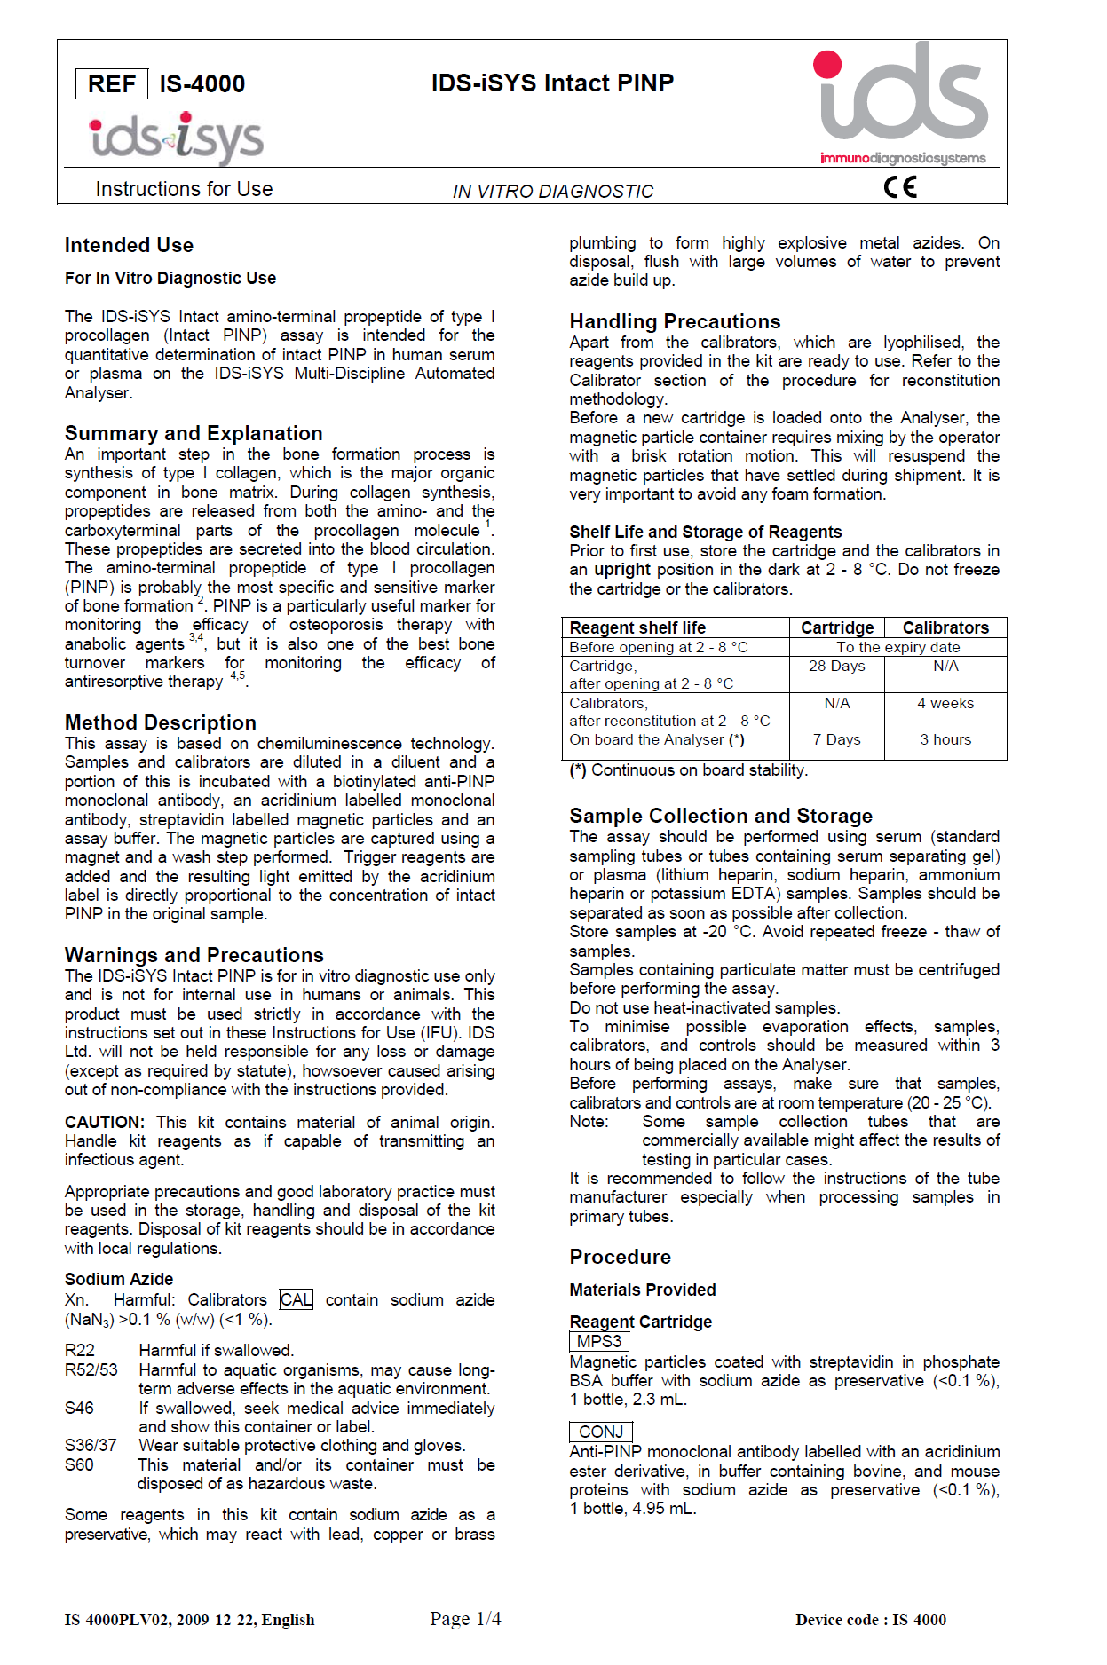
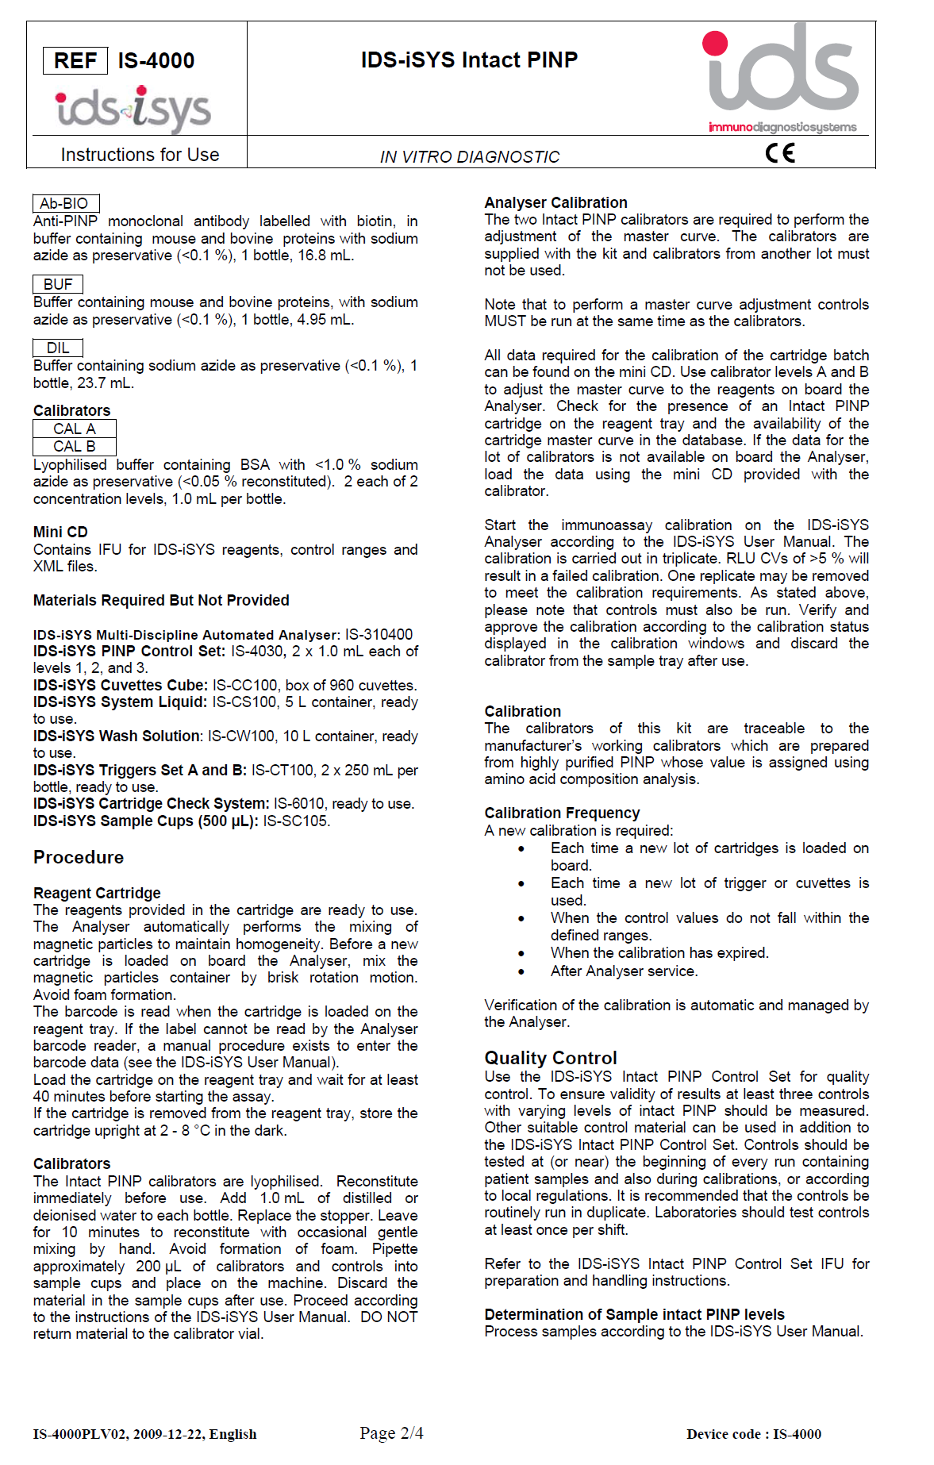
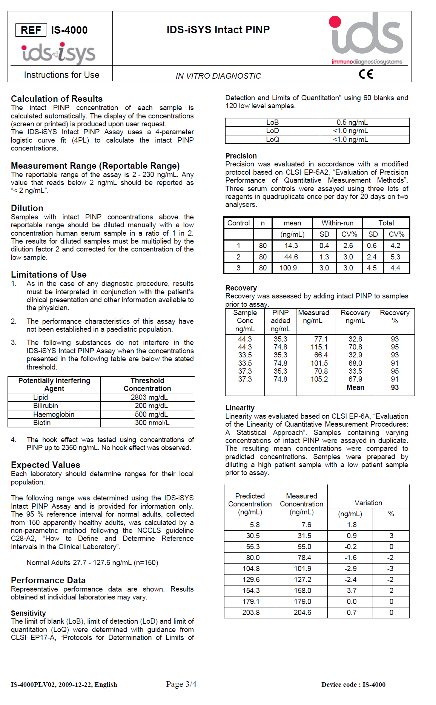
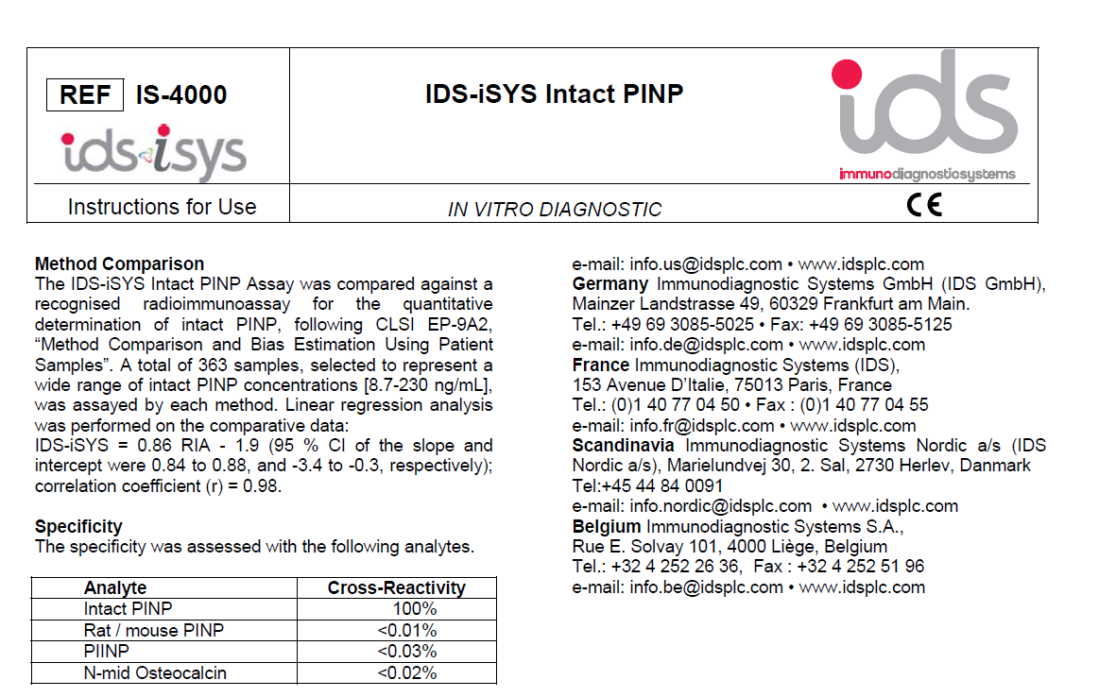

Appendices 1.1: CTX Kit Insert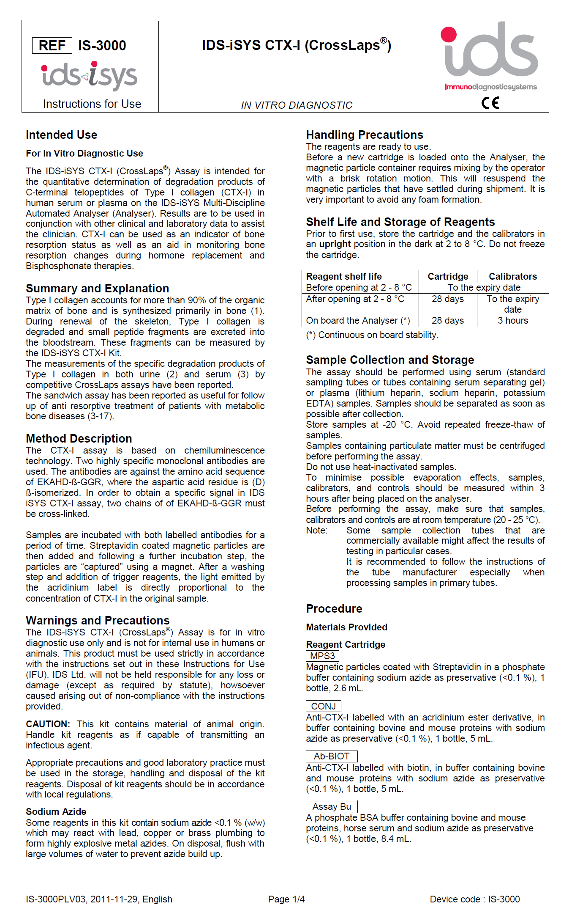

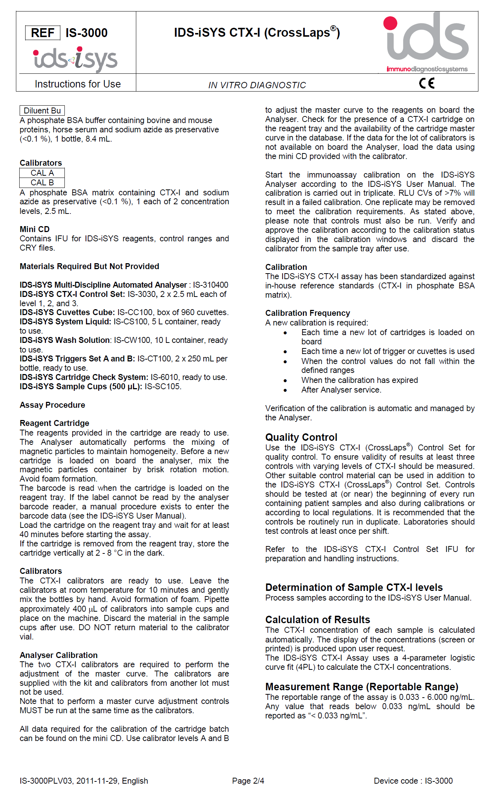
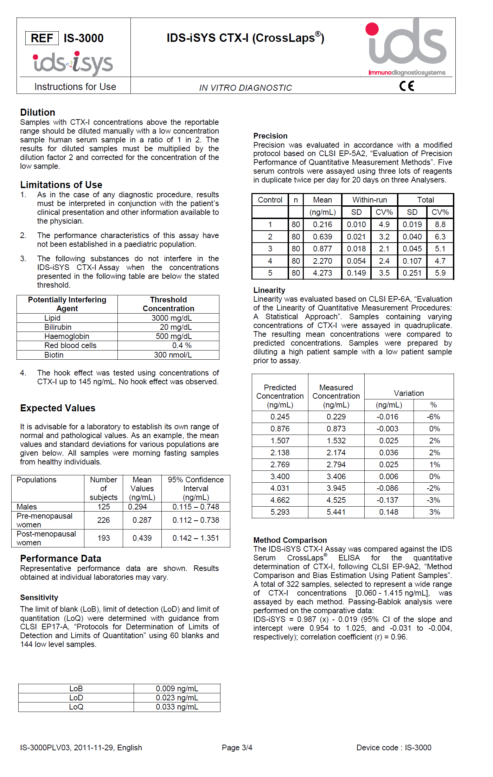

Appendices 1.2: Osteoclacin Kit Insert
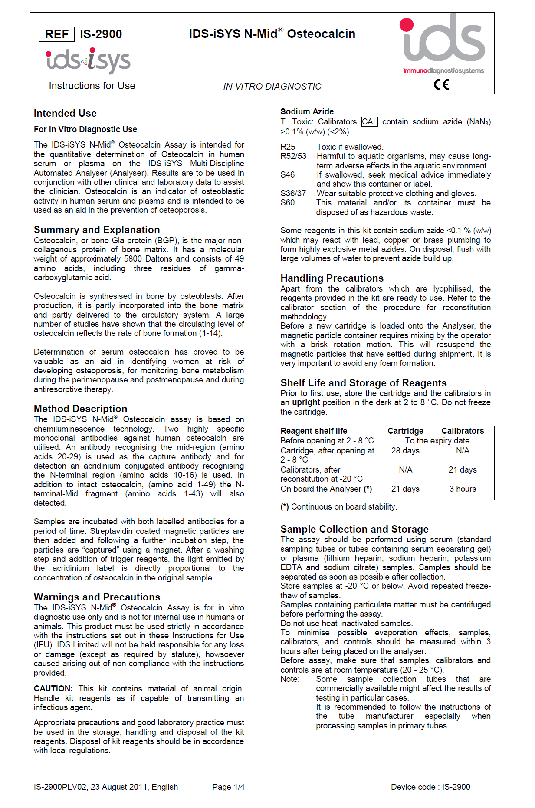
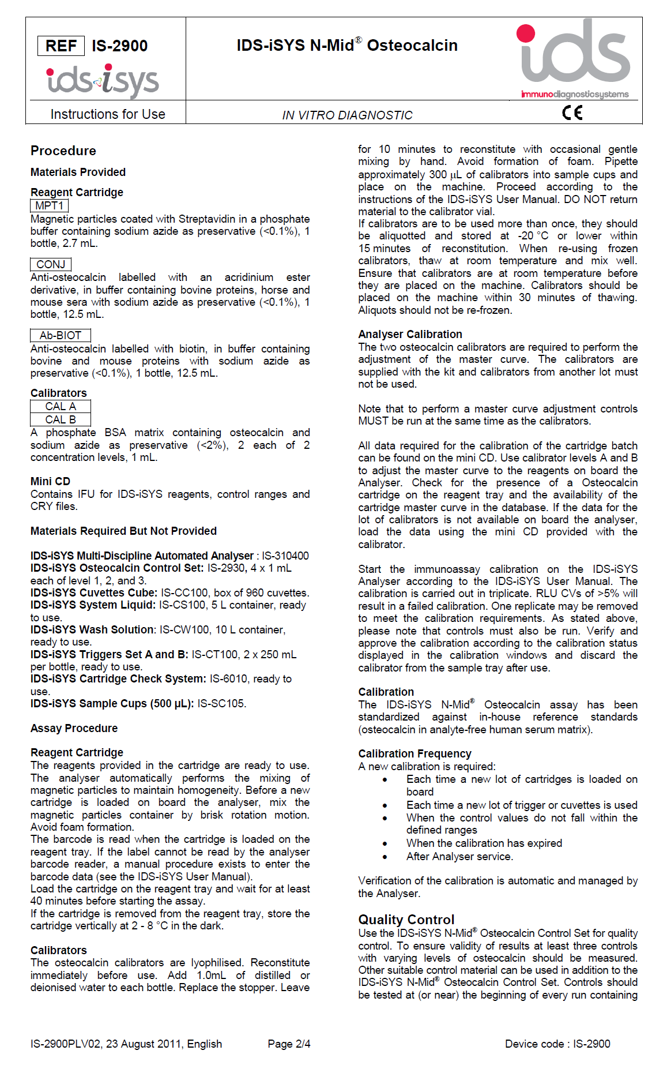
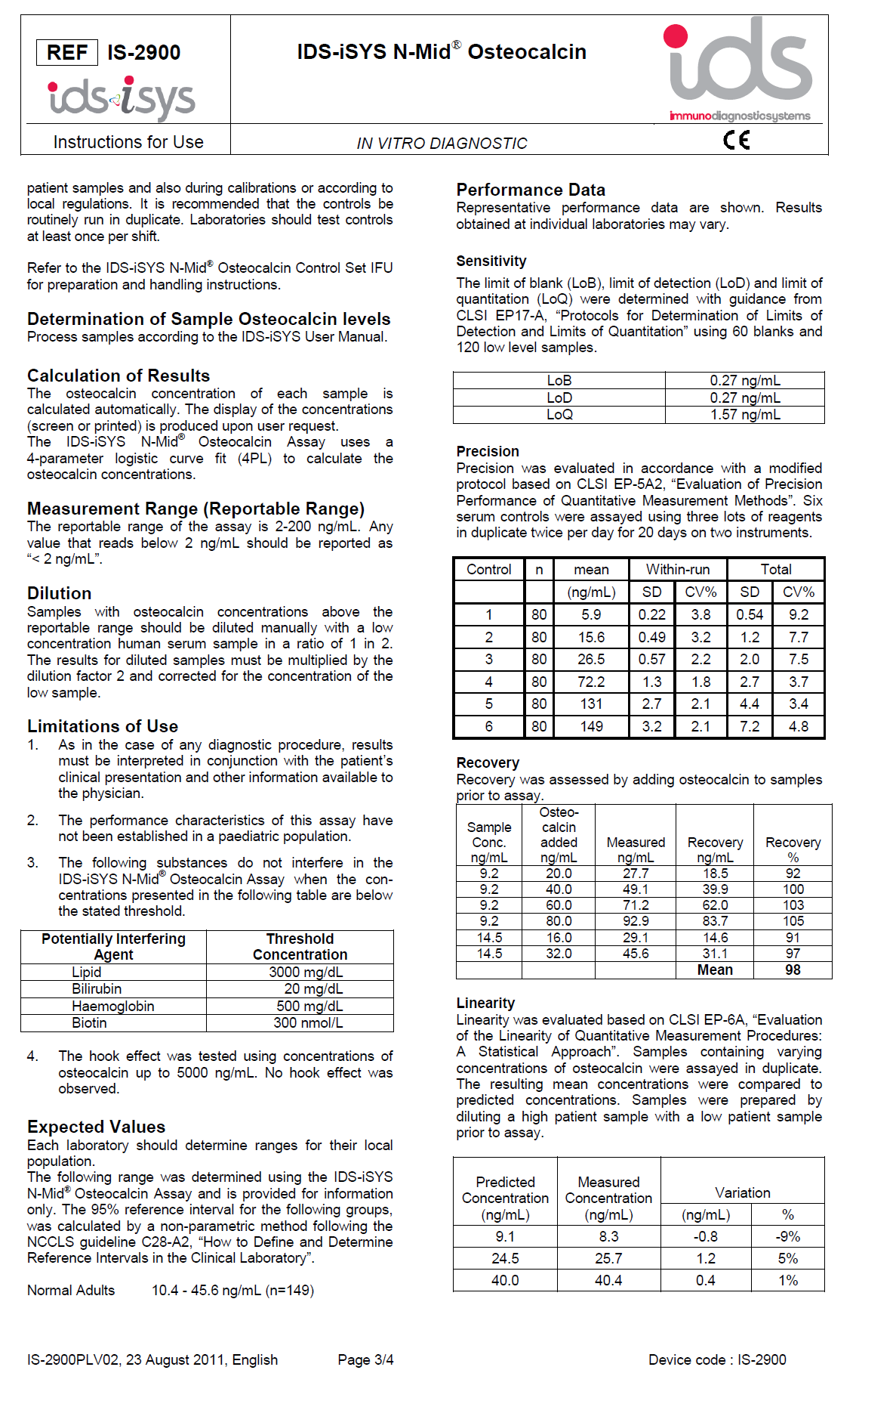
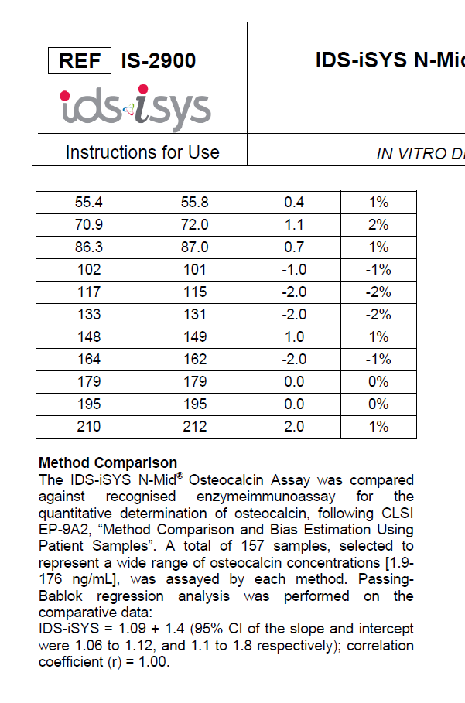

Appendices 1.3: Bone ALP Kit Insert
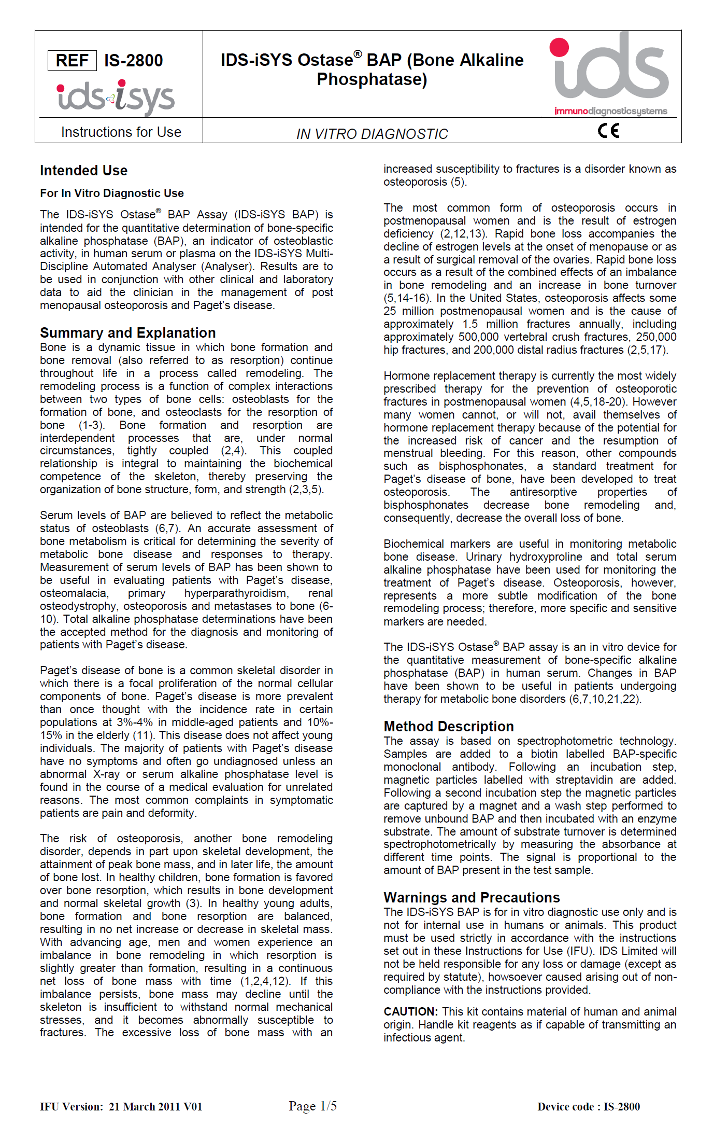
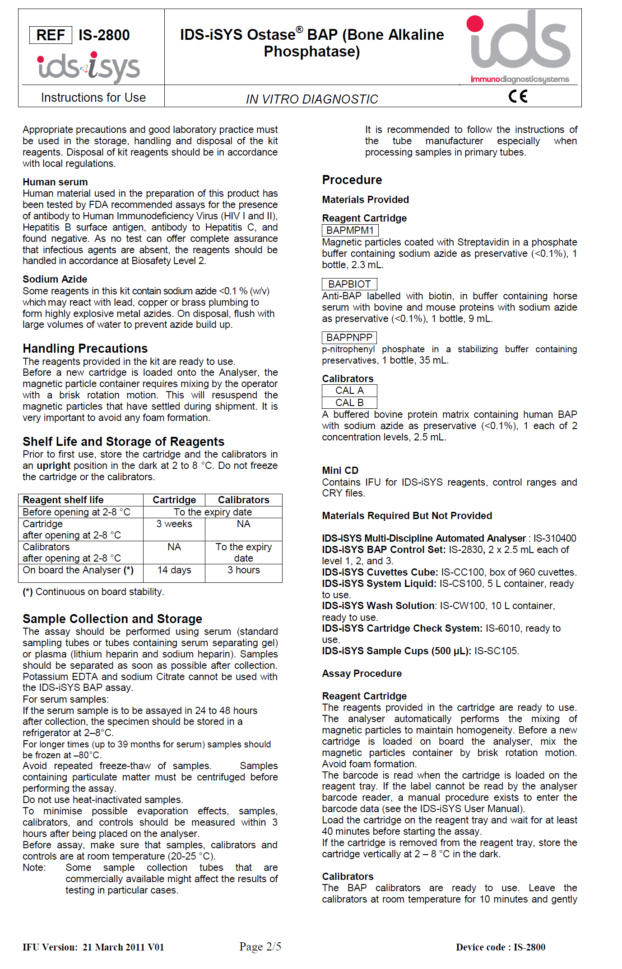
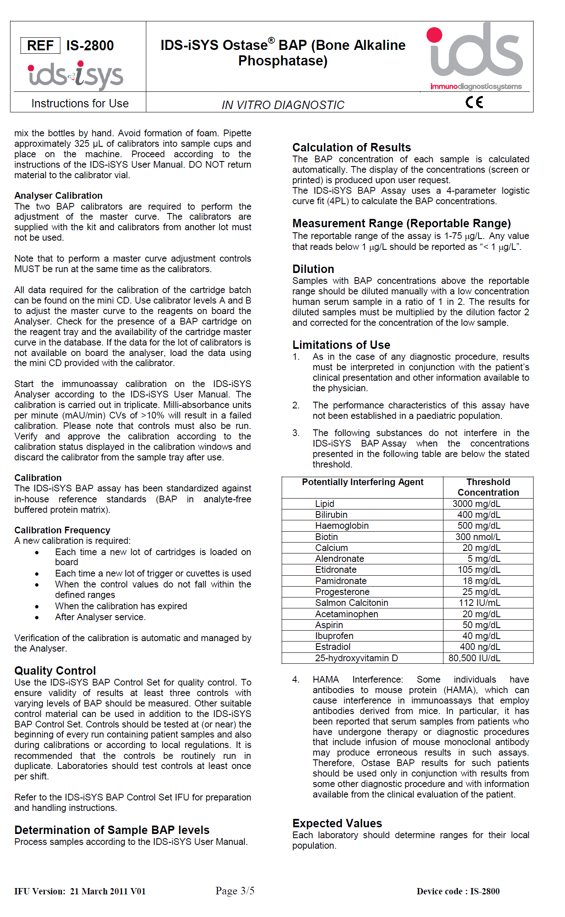
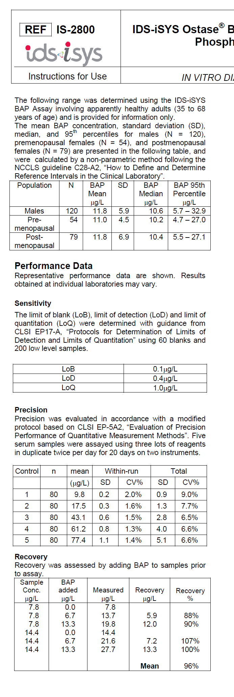

Appendices 1.4: Sclerostin Kit Insert
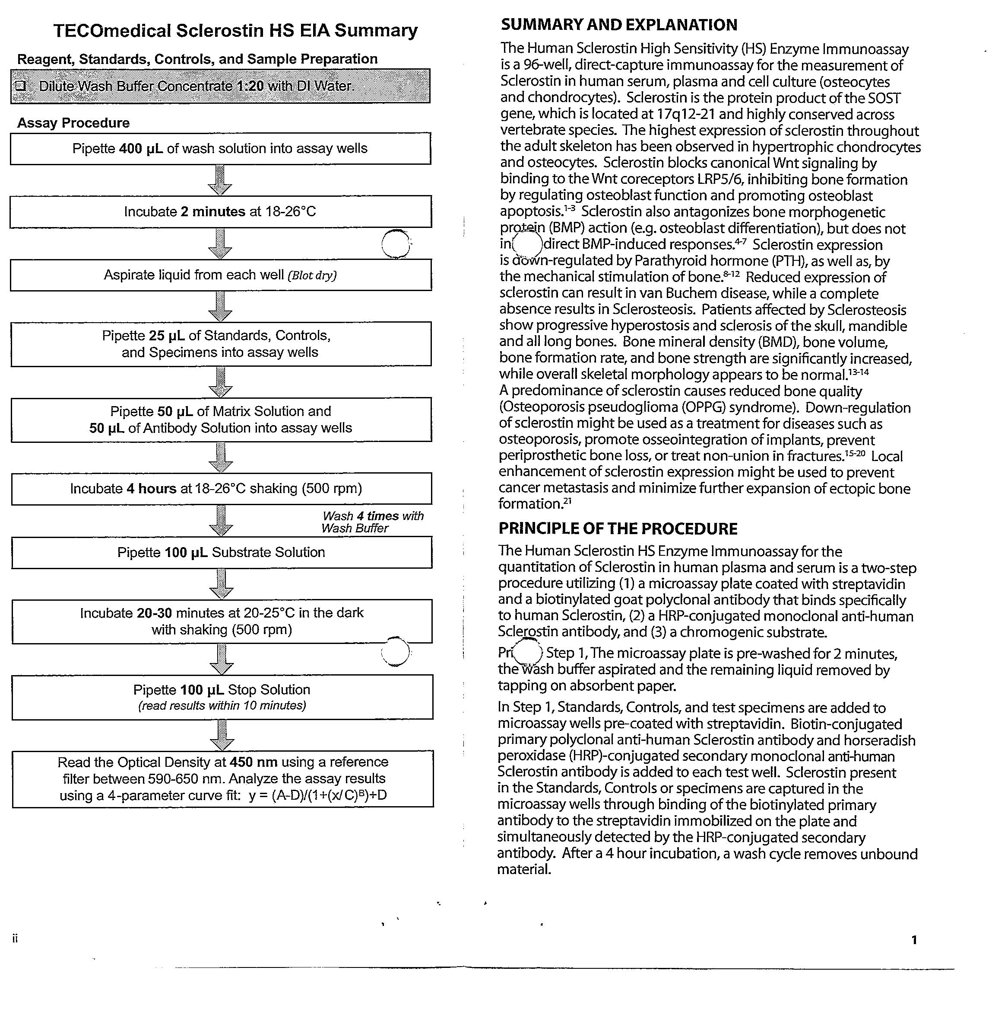



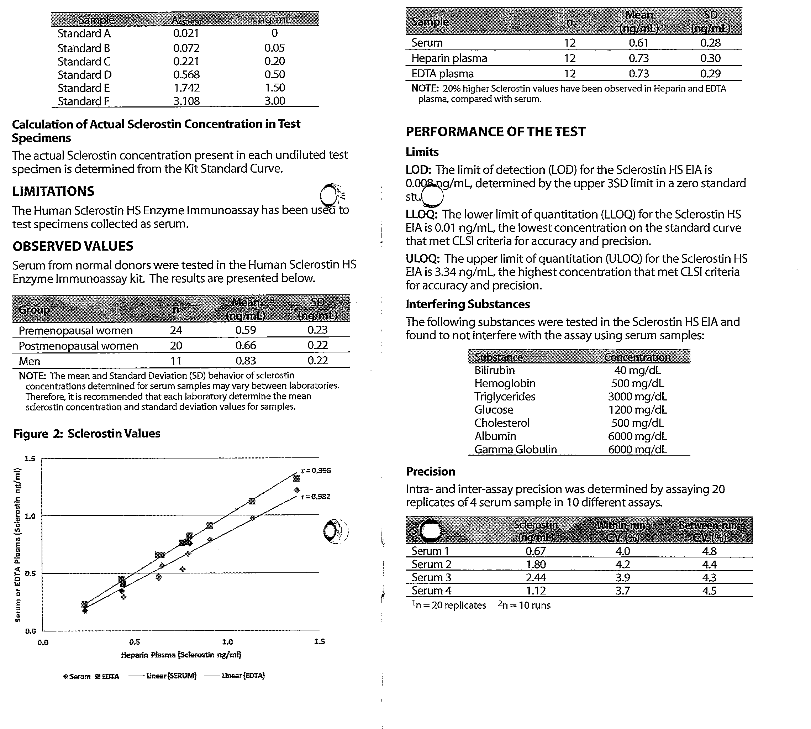
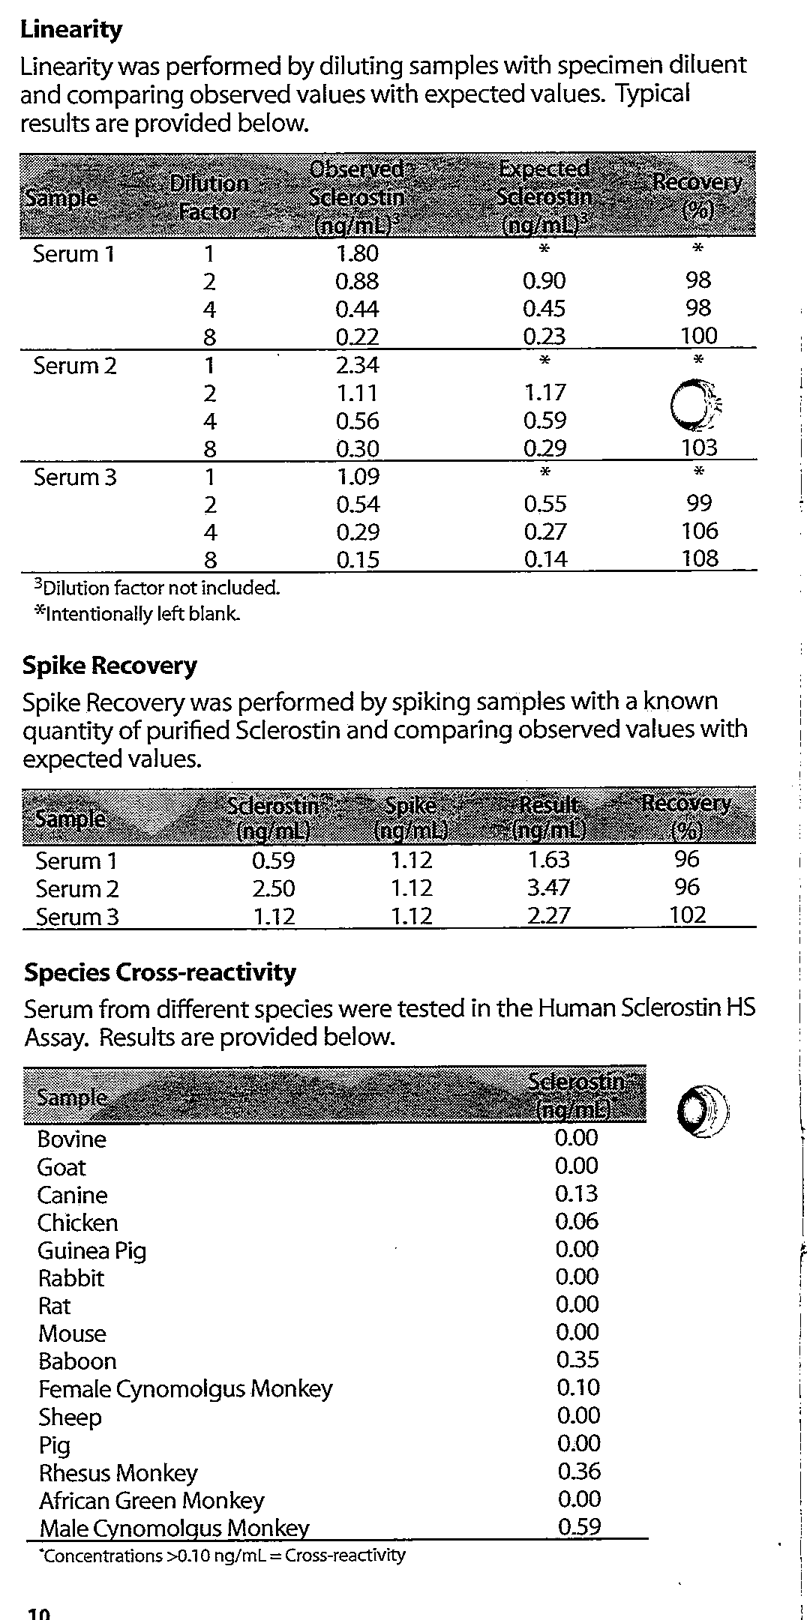

Appendices 1.5: NTX Kit Insert
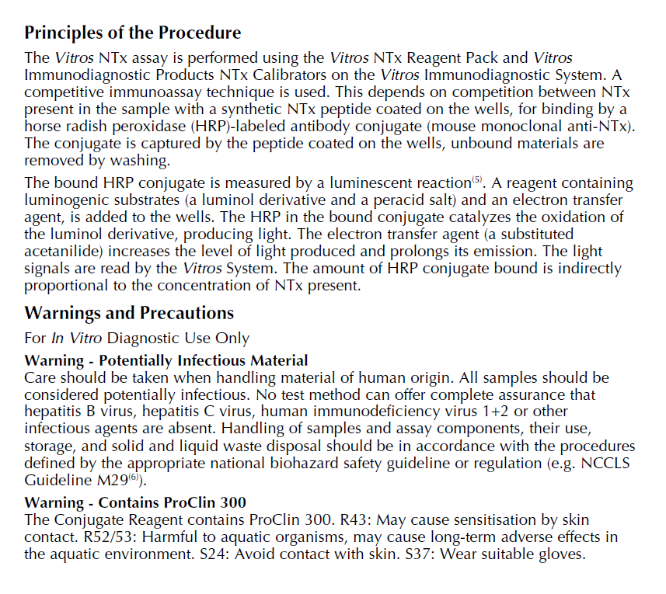
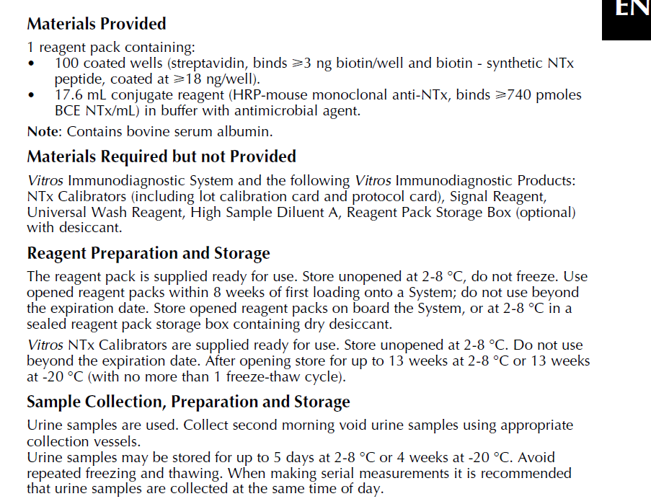
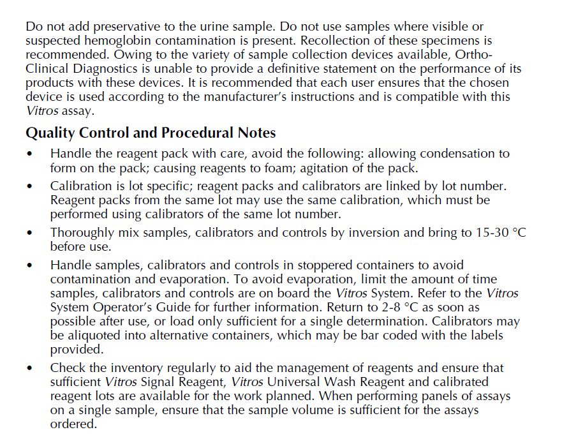
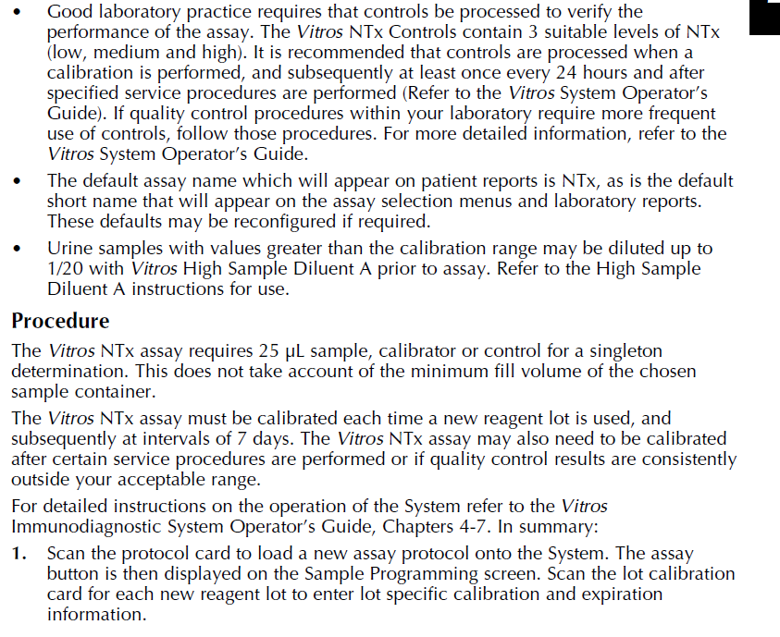
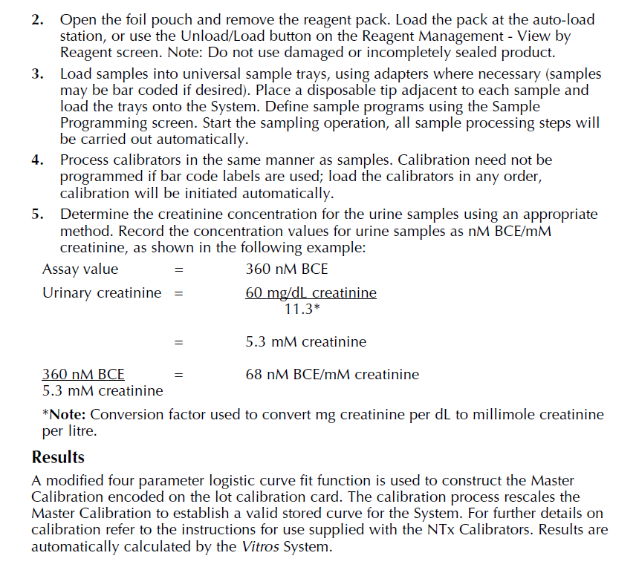
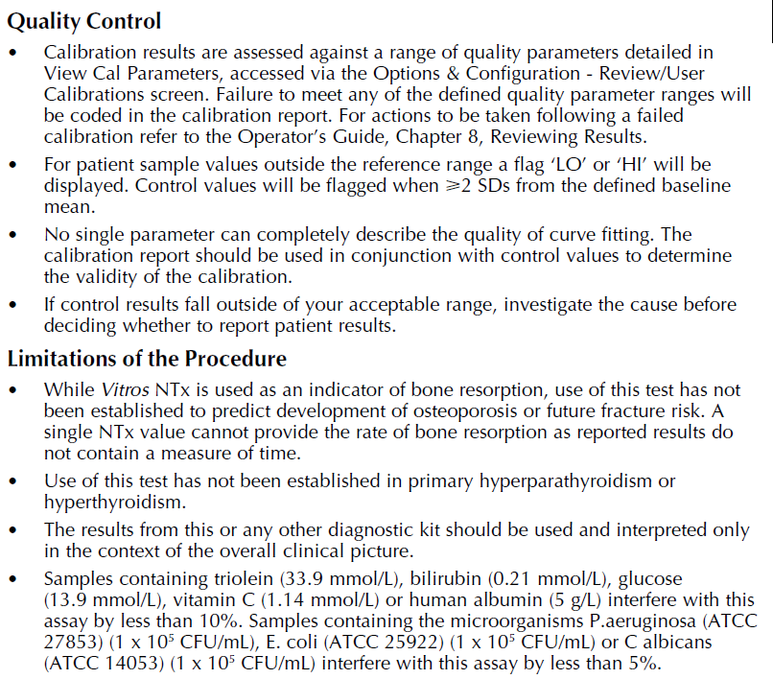
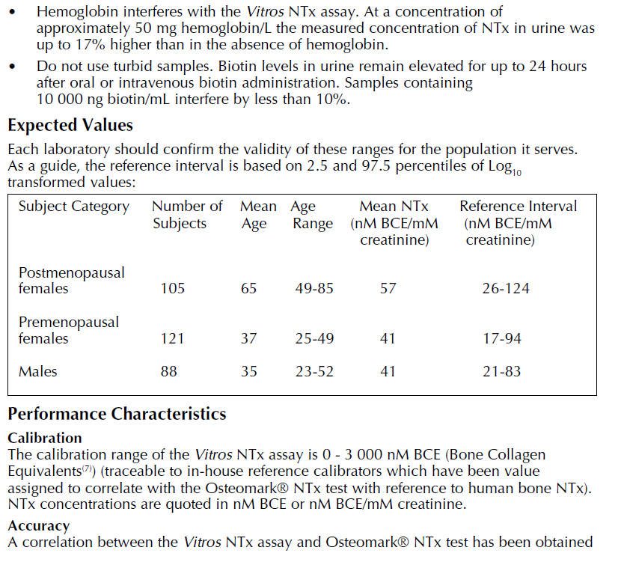
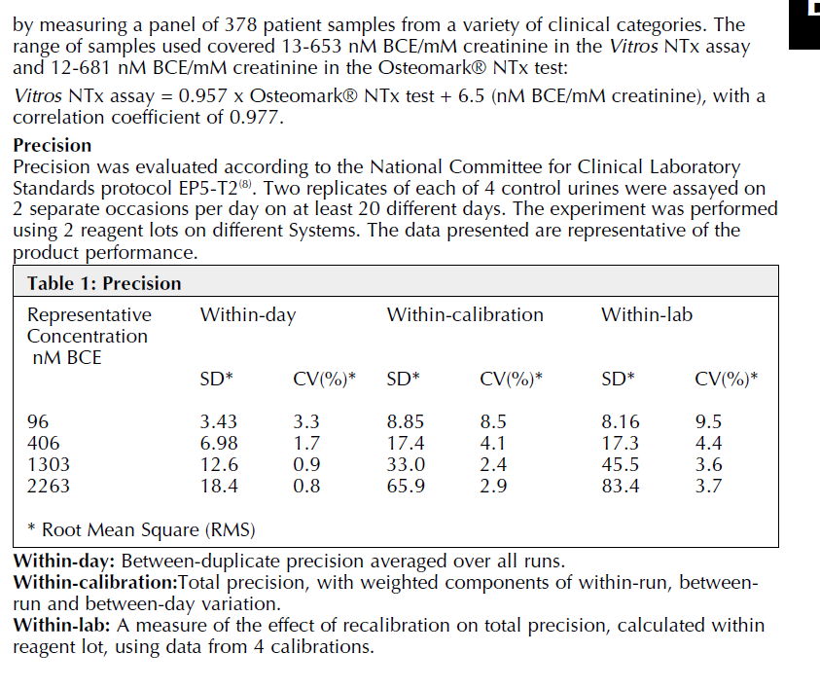

Appendices 1.6: Creatinine Kit Insert
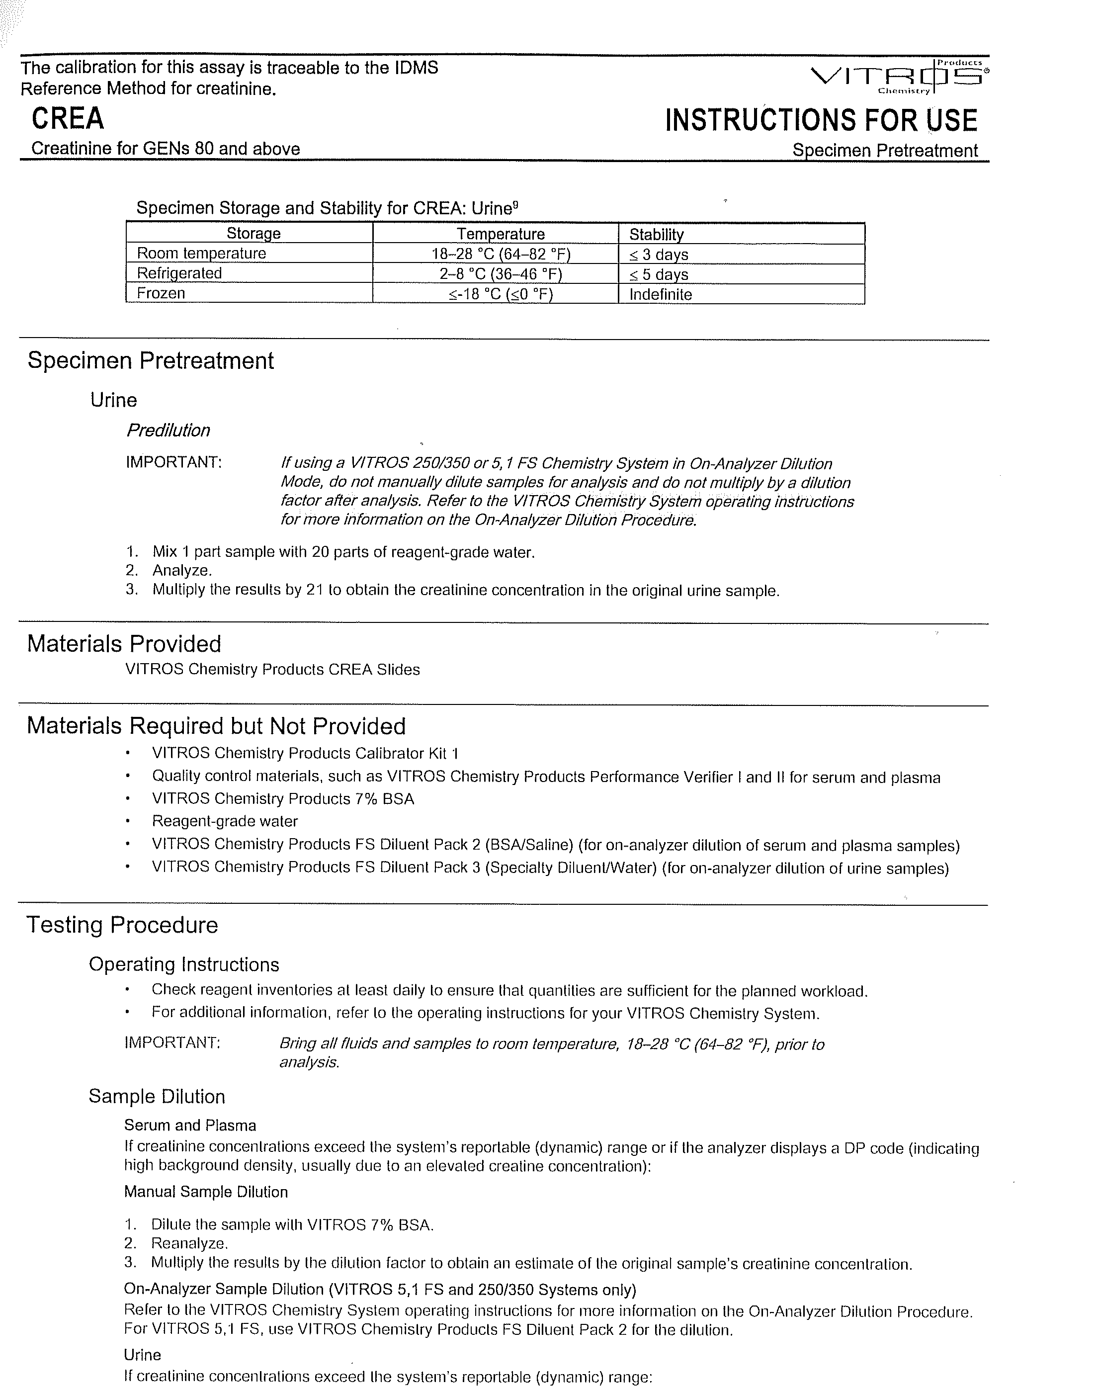
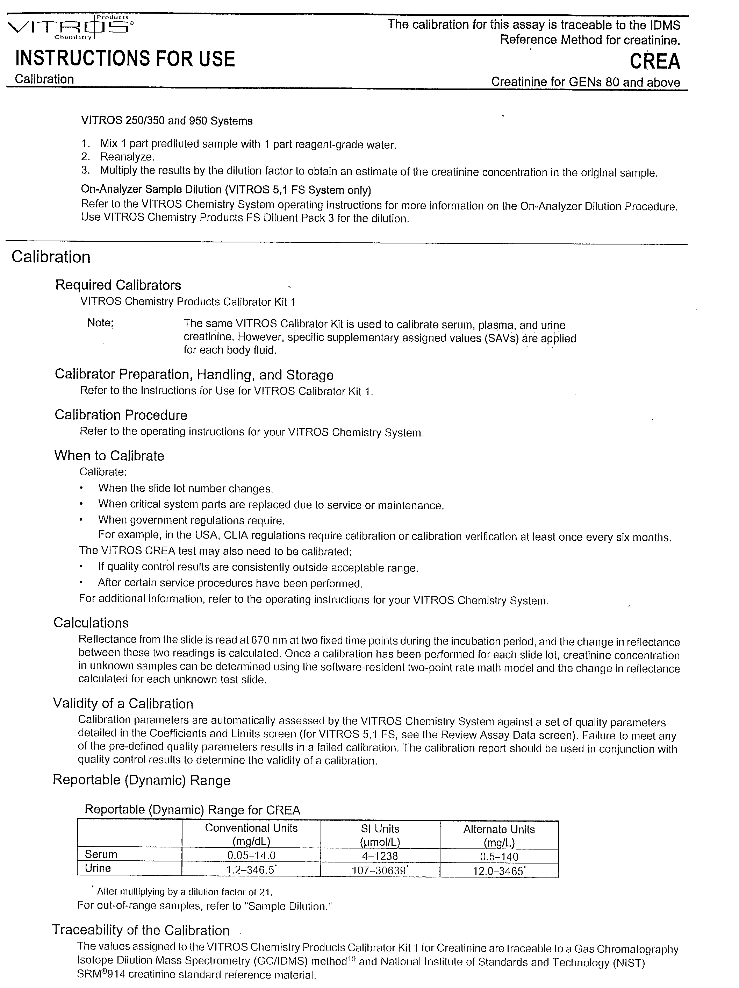

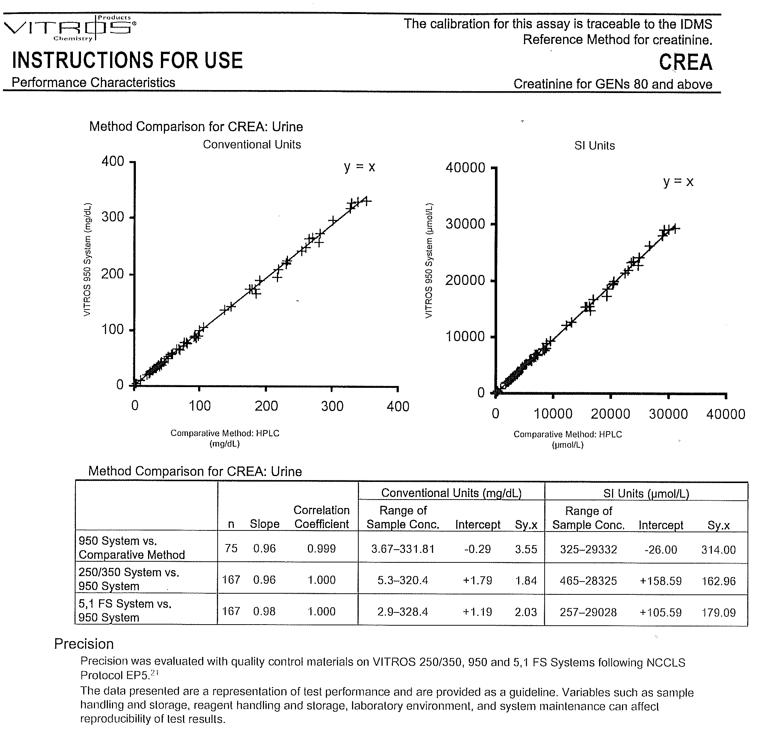

Appendices 2: Published papers
The following is a list of published papers that have originated from the research within my thesis:
- Establishing reference intervals for bone turnover markers in healthy postmenopausal women in a non-fasting state. Gossiel F, Finigan J, Jacques R, Reid D, Felsenberg D, Roux C, Glueer C, Eastell R. Bonekey Rep. 2014 Sep 3;3:573.

- Bone turnover markers after the menopause: T-score approach. Gossiel F, Altaher H, Reid DM, Roux C, Felsenberg D, Glüer CC, Eastell R. Bone. 2018 Jun;111:44-48.

- The effect of bisphosphosphonates on bone turnover and bone balance in postmenopausal women with osteoporosis: The T-score bone marker approach in the TRIO study. Gossiel F, Paggiosi MA, Naylor KE, McCloskey EV, Walsh J, Peel N, Eastell R. Bone. 2020 Feb;131:115158.

- Response to letter relating to Gossiel F, Paggiosi MA, Naylor KE, et al. The effect of bisphosphosphonates on bone turnover and bone balance in postmenopausal women with osteoporosis: the T-score bone marker approach in the TRIO study. F Gossiel and R Eastell. Bone 2020 Aug;137:115430

- The effect of bisphosphonate treatment on osteoclast precursor cells in postmenopausal osteoporosis: The TRIO study. Gossiel F, Hoyle C, McCloskey EV, Naylor KE, Walsh J, Peel N, Eastell R. Bone. 2016 Nov;92:94-99

