Citizen Science Communicators, Boundary-Work and Scientific Authority: Struggle for Discourse Authority between Scientists and the Public in the Digital Media Environment of China

Zheng Yang

The Department of Sociological Studies
The University of Sheffield

Thesis submitted for the degree of Doctor of Philosophy
March 2021

Declaration
I, Zheng Yang, confirm that the work presented in this thesis is my own. Where information has been derived from other sources, I confirm that this has been indicated in the thesis.

Acknowledgements

During my nearly four years of PhD study and research, I received rich help from many people. Without them, this thesis would not have been completed. Here I want to express my sincere gratitude to them.

Firstly, I want to show my thanks to my three supervisors for their generous support, Dr Stefania Vicari, Dr Warren Pearce, and Dr Annamaria Carusi. This thesis has benefitted immeasurable from their detailed instruction. Their patience and erudition allowed me to learn how to act as a qualified social science scholar during my PhD period. I also want to thank Dr Kate Weiner and Prof. Ian Sabroe, who were my first-year confirmation review panellists. They also gave me some very valuable advice on the development direction of the paper and the choice of methodology. And I also want to thank all the staff at the Department of Sociological Studies, University of Sheffield, who generously gave me a lot of support and help.

Secondly, I would like to thank the Chinese Scholarship Council, which rewarded me a four-year scholarship. With this scholarship, I was able to do the research I wanted to do without any worries during my PhD life.

Finally, I want to thank my parents who always give me very warm support and encouragement. Similarly, I also need to thank those people who have been by my side and given me the greatest support and encouragement: Weidong Wang, Chenming Qian, Jiaxun Li, Xi Lu, and my other friends. I could not express in words the help these warm people have given me and the gratitude I hope to express.

Abstract

With recent developments in both public engagement with science and the digital media environment in China, the relationship between Chinese scientists and the Chinese public is being increasingly affected by online science communication processes. Against such a background, this study explores the online science communication process in the Chinese context. It specifically focuses on the struggle of discourse authority between Chinese scientists and the Chinese public, exploring the topic of genetically modified food on Zhihu, the biggest Chinese knowledge-sharing social network site. The study raises three main research questions: RQ1. How has the traditional authoritative position of scientists been challenged in the online science communication process in China? RQ2. How do Chinese scientists address such challenges? RQ3. What do these dynamics say about the features and structure of contemporary online science communication in China?

The study’s theoretical background draws upon science communication, public understanding of science, public engagement with science, philosophy of science, and digital sociology, specifically engaging with debates focused on citizen science, discourse authority of science and the ‘boundary-work’ of Thomas Gieryn and the digital participatory cultures of Henry Jenkins. This research takes a mixed-methods approach, incorporating online ethnography via observation and interviews, critical discourse analysis and digital methods aided by social network analysis. The online ethnography findings show that a number of Zhihu users without a professional scientific background – which I call ‘citizen science communicators’ – actively assume the social responsibility of science communication. The study shows that the emergence and popularity of this group in the digital media environment weakens scientists’ absolute control of the science communication process and deconstructs some of the characteristics that science communication has traditionally had in the Chinese context. This shows that scientists’ discourse authority in the science communication process seems to be challenged in the context of digital media in China.

The online ethnography toward the scientist user’ online behaviour on Zhihu and critical discourse analysis of scientists’ discourse on Zhihu both provides evidence of Chinese scientists’ attempts to strengthen the boundary between themselves and the public by employing specific discourse techniques. Chinese scientists on Zhihu emphasize the difference between ‘we/us’, who are qualified as science communicators, and the public ‘you’, who are not qualified to be science communicators. Such a power struggle was further investigated through interviews with a sample of Zhihu users. The social network analysis of Zhihu interactions clearly shows that in this power struggle scientists are still seen as the most authoritative sources of science communication and interactions among scientists and non-scientists are limited. Overall, the study results indicate that, despite recent developments in the digital media environment and the science communication process in China, interactions between scientists and non-scientists are still limited and affected by traditional power divides. Further investigation into discourse dynamics between scientists and the public may provide new perspectives to improve science communication processes and enhance public engagement with science in the digital media environment.

Contents

Declaration 2
Acknowledgements 3
Abstract 4
List of Tables 9
List of Figures 10
Chapter 1: Introduction 11
Chapter 2: Literature Review 16
2.1 Science communication and public engagement with science 16
2.1.1 Key concepts in the science communication field 16
2.1.2 The development of the model of science communication 20
2.1.3 Science communication in the digital media environment 26
2.1.4 Science communication in China 30
2.2 Discourse authority and boundary-work in science communication 31
2.2.1 Discourse authority of science 32
2.2.2 The origins of discourse authority of science 34
2.2.3 Boundary-work and the discourse authority of science and scientists 37
2.3 Participatory culture and online public engagement 42
2.3.1 Discourse authority of science, boundary-work and online public engagement 42
2.3.2 Participatory culture, Zhihu and science communication 44
2.4 Conclusion 47
Chapter 3: Background: Science Communication in the Contemporary Chinese Digital Ecosystem 48
3.1 Science and scientists in contemporary China 48
3.1.1 Deified image of science in contemporary China 48
3.1.2 Deified image of scientists in contemporary China 50
3.1.3 Challenges to the deified image of science in recent China 51
3.2 Science communication in contemporary China 53
3.2.1 The development of science communication in China 53
3.2.2 Features of science popularization in contemporary China 55
3.3 Chinese digital media environment and netizens 58
3.3.1 Web 1.0 era in China 59
3.3.2 Web 2.0 era in China 59
3.3.3 Web 3.0 era in China 60
3.3.4 Knowledge-sharing networks in China 61
3.3.5 Features of the digital media environment in China 62
3.3.6 Basic information about Chinese netizens 63
3.4 Science communication in the Chinese digital media environment 65
3.4.1 Science communication in the Web 1.0 era 66
3.4.2 Science communication in the Web 2.0 era 67
3.4.3 Science communication in the Web 3.0 era 68
3.5 Online science communication on Zhihu 70
3.6 Science communication about GMF in China 72
3.7 Conclusion and research questions 74
Chapter 4: Methodology 76
4.1 Case study selection: GMF on Zhihu 76
4.2 Digital ethnography 77
4.2.1 Introduction to digital ethnography 78
4.2.2 The field of digital ethnography 80
4.2.3 Observation 81
4.2.4 Interviews 83
4.3 Discourse analysis 84
4.3.1 Introduction to discourse analysis 85
4.3.2 Analysis scope 87
4.3.3 Analysis framework 87
4.3.4 Analysis sample 90
4.4 Digital methods 91
4.4.1 Introduction to digital methods 91
4.4.2 Data collection 93
4.4.3 Network construction 93
4.4.4 Network visualization 94
4.4.5 User classification 95
4.4.6 Network measures 98
4.5 Ethical considerations 98
Chapter 5: The Public Challenge to the Discourse Authority of Scientists: Citizen Science Communicators on Zhihu 100
5.1 CSCs on Zhihu 101
5.2 The popularity of citizen science communicators on Zhihu 104
5.3 Three representative CSCs and their discursive practices 108
5.4 CSC discursive practices on Zhihu 109
5.4.1 Humorous expression 109
5.4.2 Multi-perspective discussion 115
5.4.3 Establishing trust through group identity 119
5.4.4 Iterative problem-solving path 124
5.4.5 Active commitment to science communication 131
5.5. CSCs and the digital media environment: Why CSCs appear widely on Zhihu 134
5.6 Conclusion 138
Chapter 6: Scientists’ Defence of Discourse Authority on Zhihu 141
6.1 Introduction to analysis 141
6.2 Discourse techniques used by scientists on Zhihu 142
6.2.1 Register 143
6.2.2 Writing content 151
6.2.3 Writing tone 167
6.2.5 Boundary-work and anti-boundary-work created by scientist users on Zhihu 169
6.3 Boundary-work: How do scientist users perceive their behaviour on Zhihu? 173
6.4 Conclusion 179
Chapter 7: When the Public and Scientists Meet on Zhihu: Unbalanced Power between Scientists and Non-scientists on Zhihu 182
7.1 Interactive structures and discourse power 183
7.2 Partition and homophily in the online scientific discussion on Zhihu 184
7.3 Clusterization of scientists and fragmentation of non-scientists on Zhihu 188
7.4 Centrality and social capital on Zhihu 192
7.5 Conclusion: Inadequate interaction and unbalanced power between scientists and non-scientists on Zhihu 205
Chapter 8: Struggle for Scientific Discourse Authority Between Scientists and the Public on Zhihu 209
8.1 Struggle for the role of science communicators on Zhihu 209
8.1.1 Public lack of trust in scientists and willingness to be science communicators 210
8.1.2 Scientists disparage CSCs and firmly grasp their role as communicators 213
8.2 Struggle for the source of scientific information credibility on Zhihu 216
8.2.1 Public users: Believing in ‘personal experience’ and ‘local knowledge’ 217
8.2.2 Scientists: Believing in ‘authoritative science/expert knowledge’ 219
8.3 The struggle between the ‘deficit model’ and ‘public engagement’ 220
8.3.1 Public users: ‘Empty vessels’ with limited scientific literacy? 220
8.3.2 Scientific literacy is not important for public participation 222
8.4 Struggle for the disinterestedness of Chinese science 224
8.4.1 Are Chinese science and scientists individually interest-free? 224
8.4.2 Are Chinese science and scientists profit-driven? 227
8.5 Impact on the discourse authority of Chinese scientists 228
8.6 The impact of struggles on the structure of science communication in the Chinese digital environment 230
8.7 The impact of struggles on ‘science in society’ in the Chinese context 233
8.8 Conclusion 237
Chapter 9: Discussion and Conclusion 239
9.1 Responses to the research questions 239
9.1.1 Citizen science communicators and challenged discourse authority of scientists (RQ1) 239
9.1.2 Boundary-work and the discourse techniques used by scientists to maintain their discourse authority (RQ2) 241
9.1.3 Struggles between scientists and the public and the reconstruction of the online science communication system (RQ3) 244
9.2 Citizen science communicators and anti-media-centralism: reflections on theories of science communication 245
9.2.1 CSCs and the new stage of public engagement with science 245
9.2.2 Reflections on media-centrism in science communication 252
9.2.3 From ‘public understanding of science’ to ‘scientists’ understanding of the public’ 256
9.3 Further considerations 259
9.3.1 Limitations of the project 259
9.3.2 Future research 261
9.4 Conclusion 263
Bibliography 267
Appendices 314
Appendix 1: Interviewee Information 314
Appendix 2: Interviewee Framework 316
Appendix 3: Selected Samples of Scientist Users’ Answers 318
Appendix 4: Information Sheet 321
Appendix 5: Consent Form 324

List of Tables

Table 1: Backgrounds of the three representative CSCs on Zhihu 84
Table 2: Basic information about the three representative CSCs on Zhihu 85
Table 3: Discourse analysis framework 89
Table 4: Identities of the 30 most active answer-providers on the topic of GMF on Zhihu 105
Table 5: Identities of the answer-providers of the hottest answers on the topic of GMF on Zhihu 106
Table 6: Basic information about the three representative CSCs on Zhihu 108
Table 7: Backgrounds of the three representative CSCs on Zhihu 109
Table 8: Pronouns used by scientists on Zhihu 150
Table 9: Frequency of discourse techniques for boundary-work in all selected samples 171
Table 10: Frequency of discourse techniques for anti-boundary in all selected samples 171
Table 11: Important actor labels in network analysis 191
Table 12: Main celebrities and gatekeepers in in the network based on the comment-relationship in the 100 answers with the most likes on the topic of GMF on Zhihu 195
Table 13: Indicators of the discourse power in social network analysis 195
Table 14: Weighted degree centrality ranking and identities of nodes in comment-network 1 196
Table 15: In-degree centrality ranking and identities of nodes in comment-network 1 197
Table 16: Betweenness centrality ranking and identities of nodes in comment-network 1 197
Table 17: Closeness centrality and identities of nodes in comment-network 1 198
Table 18: Number and proportions of scientists and non-scientists in the network based on the comment-relationship in all answers with different degrees 200
Table 19: Number and proportions of scientists and non-scientists in the network based on the comment-relationship in all answers with different in-degree centrality 201
Table 20: Number and proportions of scientists and non-scientists in the network based on the comment-relationship in all answers with different betweenness centrality 202
Table 21: Number and proportions of scientists and non-scientists in the network based on the comment-relationship in all answers with different closeness centrality 202
Table 22: Identities of nodes with highest closeness centrality 202
Table 23: Beliefs of Chinese scientists and the public about who is qualified to answer scientific questions on Zhihu 213
Table 24: Beliefs of Chinese scientists and the public about their motivations to participate in the science communication process 225

List of Figures

Figure 1: Relationship between the public’s knowledge of and their attitude toward science 26
Figure 2: The relationship between boundary-work and science communication 41
Figure 3: Analysis approach of boundary-work and discourse authority of science 43
Figure 4: Basic demographic information of Chinese netizens 66
Figure 5: A Case oh Question Page about GMF on Zhihu 82
Figure 6: Fairclough’s Framework of Critical Discourse Analysis 87
Figure 7: Example of proven scientist users’ Zhihu homepage (1) 94
Figure 8: Example of proven scientist users’ Zhihu homepage (2) 94
Figure 9: Example of unproven users’ homepage 95
Figure 10: An example of a CSC’s Zhihu homepage (User A) 100
Figure 11: An example of CSC’s answer (User A) 101
Figure 12: An example of a CSC’s homepage (User B) 102
Figure 13: An example of a CSC’s answer (User B) 102
Figure 14: Proportion of different identities of the most active answer-providers on the topic of GMF on Zhihu 104
Figure 15: Proportion of different identities of the answer-providers of the most popular answers on the topic of GMF on Zhihu 104
Figure 16: Humorous emoji-pictures used by CSCs in their answers 109
Figure 17: Videogame screenshot used by CSC in their answer 115
Figure 18: Replies to scientists’ statements on Zhihu (1) 123
Figure 19: Replies to scientists’ statements on Zhihu (2) 124
Figure 20: Replies to one CSC’s answer on Zhihu (1) 125
Figure 21: Replies to one CSC’s answer on Zhihu (2) 125
Figure 22: Replies to one CSC’s answer on Zhihu (3) 126
Figure 23: Replies to one CSC’s answer on Zhihu (4) 126
Figure 24: Replies to one CSC’s answer on Zhihu (5) 127
Figure 25: Model of the public’s responses to scientists’ answers on Zhihu 128
Figure 26: Iterative model of the public’s responses to CSCs’ answers on Zhihu 128
Figure 27: Professional scientific visualization tool used by scientists on Zhihu (No.8) 158
Figure 28: Professional scientific visualization tool used by scientists on Zhihu (No.18) 158
Figure 29: Professional scientific visualization tool used by scientists on Zhihu (No.26) 159
Figure 30: Professional scientific visualization tool used by scientists on Zhihu (No.9) 159
Figure 31: Professional scientific visualization tool used by scientists on Zhihu (No.8) 160
Figure 32: Professional scientific visualization tool used by scientists on Zhihu (No.29) 160
Figure 33: Professional scientific visualization tool used by scientists on Zhihu (No.29) 160
Figure 34: Example for life-oriented image used by scientists on Zhihu (No.6, Question: What is the value of the GMF? Does human being really need GMF?) 163
Figure 35: Example for life-oriented image used by scientists on Zhihu (No.25, Question: How can the US-approved GM potato ‘reduce the acrylamide produced during frying’?) 164
Figure 36: Mention network of the GMF discussion on Zhihu (clusterization) 183
Figure 37: Network based on the comment-relationship in the 100 answers with the most likes on the topic of GMF on Zhihu 186
Figure 38: Main subnetwork (giant component) of the whole network based on the comment-relationship in the 100 answers with the most likes on the topic of GMF on Zhihu 187
Figure 39: Celebrities in the mention network of the GMF discussion on Zhihu 191
Figure 40: Celebrities and gatekeepers in the network based on the comment-relationship in the 100 answers with the most likes on the topic of GMF on Zhihu 192
Figure 41: Network based on the comment-relationship in all answers on the topic of GMF on Zhihu 197
Figure 42: The development of public engagement with science (stage 1) 244
Figure 43: The development of public engagement with science (stage 2) 246

Chapter 1: Introduction

In 2015, Chinese agriculture and biology scientist Wang Qiang published an article in Nature pointing out that China’s science communication about genetically modified food (GMF) needs to involve more public participation to reduce the public’s scepticism about the subject (Wang, 2015). The context of Wang’s statement is the long-term suspicion and distrust of the Chinese public concerning GMF and scientists’ discourse about related technologies. Although the Chinese public’s scientific literacy continues to rise – in 2018, 8.47% of Chinese citizens were considered to be scientifically literate (Ren et al., 2019) – attitudes towards some scientific and technological issues, such as genetic modification, still seem to differ greatly between scientists and the public. Thus, some traditional Western views of science communication and the relationship between public and science/scientists – such as the ‘deficit model’, which suggests that the public is ignorant of facts and has irrational fears of new technologies, thus it is the duty of scientists to educate the public; or consider that the higher the public’s scientific literacy, the more the public trusts and supports science and scientists (Sturgis and Allum, 2004) – is not always appropriate to explain the contemporary Chinese context.

In the Chinese context, especially in the traditional science popularization process, Chinese scientists always enjoy an aura of authority in the interpretation and dissemination of information relevant to science-related issues (Chen, 2009; Lian and Luo, 2013). However, in relation to several popular and controversial science-related topics, such as GMF, nanotechnology, and gene editing, Chinese scientists have recently discovered that their discourse authority – which they originally only needed their identity as scientists to enforce – has gradually been challenged and deconstructed, especially in the digital media environment (Zhang and He, 2015; Shuai, 2018). In the face of such issues, Chinese scientists are seeking other ways to maintain their discourse authority and increase public trust and support for science.

Wang (2015) also observed that “the popularity of social-media sites gives researchers a new way to enter into genuine and respectful dialogue over the true risks and benefits of GM. If China is to make good on its intentions to boost its GM efforts, then more scientists speaking up is a good place to start” (p.7). The rapid development of the digital media environment has provided unprecedented opportunities for science communication and public engagement with science. Many scientists or science communication researchers like Wang believe that, in the digital media environment, the ‘respectful’ and ‘equal’ dialogue between scientists and the public can be effectively realized (see Chen and Liu, 2012; Du and Sun, 2014; Wang et al., 2018). But is this reflected in practice? How does the public use the digital media environment to increase their discourse power and to further participate in the discussion and governance of controversial scientific and technological issues? What kind of confrontations occur between scientists and the public in the process of science communication and public participation in science in the digital media environment? These issues have not been fully explored in the Chinese context and are therefore the core issues of this research.

To explore such questions, this study selects the topic of GMF – representative of the many controversial scientific and technological issues in China – as its research topic, and Zhihu – China’s biggest knowledge-sharing social network – as the research platform to analyse the discussions, communication and interaction between the Chinese public and scientists. Theories from the fields of philosophy of science, sociology of science, and science communication provide the theoretical framework for this research, with concepts such as ‘boundary-work’ of science, ideology and discourse of science, public engagement with science and citizen science. These theories and concepts provide an analysis framework for the construction and deconstruction of discourse authority in the process of science communication, which can effectively help further understand how Chinese scientists maintain their own discourse authority in the process of science communication and discussion in the Chinese digital media environment, as well as how public intervention in science communication and discussion affects the discourse authority of science/scientists. In addition, as this research focuses on science communication and public engagement with science on Chinese digital media platforms, relevant digital media research theories that focus on ‘participatory cultures’, are also introduced to help analyse how the public intervenes in the process of science communication discussion and how such public intervention and participation is achieved.

This research adopts a mixed-methods approach, combining traditional social research methods, such as digital ethnography, interviews, and critical discourse analysis, and digital methods focusing on the relationships between different users on digital platforms, such as social network analysis. Digital ethnography in this study is used to analyse the public’s involvement in online science communication and discussion about GMF on Zhihu and the potential impact of such public intervention on the discourse authority of scientists. Within the digital ethnography, in combination with observation and the interview, is used to explore how scientists and public users on Zhihu view themselves and each other, including their roles in the online science communication and discussion process. Critical discourse analysis is used to analyse how Chinese scientists on Zhihu use a series of discursive and rhetorical techniques to maintain their discourse authority, combined with the theory of ‘boundary-work’ of science. Digital methods, incorporating social network analysis, are used to analyse the interactions between scientists and the public on Zhihu in discussing GMF, as well as the distribution of discourse power between these two groups in the communication and interaction process on Zhihu.

The findings of this research contribute to a better understanding of science communication, especially the construction and deconstruction of the discourse authority of Chinese scientists in the online science communication process in the Chinese digital media environment. This understanding is reached through the identification of a new group in the online science communication process on Zhihu – citizen science communicators – and their online behavioural and discursive features. This study finds that the discourse authority of Chinese scientists in the online science communication process has been challenged by the public, represented by citizen science communicators. This study also finds that when facing challenges to their discourse authority, scientists have not sat idly by but have adopted a series of discursive and rhetorical methods to reinforce the boundary between ‘scientists-as-communicators’ and ‘public-as-audience’, and to further maintain their discourse authority.

The findings of this research also suggest a new stage of public engagement with science: previously, when analysing public participation in science, researchers have mostly started from the perspective of the governance of scientific and technological issues or the production of scientific knowledge (such as citizen science). This research further develops the understanding of public participation in science to the field of science communication through the exploration of citizen science communicators. Moreover, previous understandings of interactions in science communication have mostly been based on analyses of the interaction between scientists as communicators and the public as active audiences who can provide feedback. However, this study found that the public can be more than just audiences, they can also act as communicators in the science communication process in the digital media environment, and this role can also be recognized by other members of the public. On the one hand, the research suggests the applicability and conditionality of a series of theories about science communication and the discourse authority of scientific discourse in the Chinese context. On the other hand, it also provides more widely applicable information that may help Western countries, especially, to better understand science communication in the Chinese context, which could be further used to compare the science communication processes in different cultural contexts.

Chapter 2 provides the theoretical framework of this research, which is organised around three aspects: science communication and public engagement with science; discourse authority of scientists and boundary-work in science communication; and participatory culture and public engagement. Chapter 3 provides the basic background information for this study: it considers China’s science communication, public participation in science and the digital media environment in which this research takes place. Chapter 4 introduces the research methods and details the research steps, including: why Zhihu and GMF were chosen as the research platform and topic, respectively; the practical framework and steps taken in the digital ethnography; and how critical discourse analysis and digital methods were implemented.

Chapters 5-8 are the main analysis chapters, based on the empirical research using the methods described in Chapter 4. Chapter 5 discusses the relevance of a group of users on Zhihu who are defined as ‘citizen science communicators’. Based on an exploration of the online behavioural and discursive features of this group, this chapter proposes the conclusion that scientists’ discourse authority in online science communication has been challenged, especially in relation to the deconstruction of the ‘exclusive legitimacy’ of scientists as communicators and serious scientific discourse as legitimate discourse to interpret GMF on Zhihu. Chapter 6 presents findings on the measures taken by scientists to deal with this kind of challenge to their discourse authority. Under the theoretical framework of ‘boundary-work’ – which indicates that the discourse authority of science and scientists comes from a series of discursive and rhetorical techniques used by scientists to build the boundary between themselves and other social groups – and the method of critical discourse analysis, this chapter specifically analyses how Chinese scientists use discourse techniques to distinguish the boundary between ‘scientist as legitimate communicator’ and ‘public as audience’ to further maintain their discourse authority in the online science communication process. Chapter 7 uses social network analysis to analyse the interactions between the public and scientists on Zhihu on the topic of GMF. In a knowledge sharing social network like Zhihu, the interaction between Chinese scientists and the public still shows characteristics of partition and homophily. Moreover, faced with challenges to their discourse authority, as analysed in Chapter 5, Chinese scientists still hold a stronger discourse power than the public in online science communication and discussion on Zhihu, as shown by the unbalanced possession of network capital by scientist users and public users. Chapter 8 analyses the struggle between the Chinese public and scientists in terms of discourse power and legitimate roles as communicators in online science communication and discussion on Zhihu. Interview findings indicate that the Chinese public strives to participate more widely in the online science communication and scientific discussions on Zhihu, but that Chinese scientists still do not trust the Chinese public’s ability to participate in science communication as communicators. Scientists still insist on their own legitimacy as science communicators and the illegitimacy of the public as science communicators. Finally, Chapter 9 summarizes the findings of this research, considering the present research’s limitations and suggesting prospects for future research.

Chapter 2: Literature Review

As mentioned in Chapter 1, this study mainly explores science communication in the Chinese digital environment, focusing on the discourse power relationships between Chinese scientists and the public. In this chapter, a literature review is presented to introduce the study’s theoretical background, which mainly revolves around three parts. The first part focuses on the main concepts and model development of science communication, particularly in the Chinese contemporary digital media environment. The second part focuses on the main theory employed by this study – Tomas Gieryn’s ‘boundary-work’ (1983; 1999) – and further reviews the overlaps between ‘boundary-work’, ‘discourse authority’ and ‘ideology of scientists’, and the studies that have applied these concepts in the science communication field. The last part focuses on digital platform studies, especially Jenkins’ ‘participatory culture’ (2006; 2007), and its application to the study of public engagement with science in the online world. Following the literature review, the main research questions of this study are proposed.

2.1 Science communication and public engagement with science
It is necessary to clarify some key concepts in the field of science communication studies and to review relevant existing studies. This subsection starts by discussing the definitions of these key concepts, and further reviews the theoretical and practical development of science communication, especially in the Chinese digital media environment.

2.1.1 Key concepts in the science communication field
Science communication is a growing area of practice and research. During the past few decades, the volume of activities, research, and practitioners has steadily increased (Burns et al., 2003, p.183). The concept of science communication constantly overlaps with the concepts of science popularization, public understanding of science, public awareness of science, and various other relevant concepts (Burns et al., 2003). In the 1930s, British physicist and founder of Studies of Science John Desmond Bernal first proposed the concept of ‘Scientific Communication’ (Ren and Zhai, 2014). He claimed that, “in accordance with the old concepts of science, communication is the only bridge between scientists”, however after years of development, he stated that, “we need to consider the overall problem of scientific communication seriously, not only including the problem of communication between scientists, but also including the communication facing public” (Bernal, 1939, cited in Ren and Zhai, 2014, p.42).

Since the first half of the 20th century, such a public-oriented definition of science communication has been widely disseminated and accepted (Logan, 2001; Weigold, 2001). In October 2000, a joint report of the Office of Science and Technology and the Wellcome Trust in the UK (Sainsbury and Dexter, 2000), based on the collection and analysis of popular definitions of science communication, defined science communication as encompassing communication between: groups within the scientific community, including those in academia and industry; the scientific community and the media; the scientific community and the public; the scientific community and government, or others in positions of power and/or authority; industry and the public; the media (including museums and science centres) and the public; and the government and the public (Sainsbury and Dexter, 2000). Although many definitions have been introduced, there is still no consensus among both science communication researchers and practitioners that answers the question: “what is science communication” (Ren and Zhai, 2014, pp.37 and 49). But in the modern context, researchers and practitioners still tend to agree that science communication is the practice of communicating science-related topics by experts (scientists/professional science communicators) to non-experts (the public/lay people) (Fischhoff, 2013).

Because of this unidirectional understanding of science communication, from experts to non-experts, science communication is often called ‘science popularization’, especially in the Chinese context (Ren and Zhai, 2013; 2014). The term science popularization emphasises the unequal knowledge and communication positions between scientists and the public. It implies bringing science to the general public, to disseminate scientific knowledge and to foster a scientific way of thinking among people (Topham, 2016). This concept is considered to have a clear utilitarian tendency to promote the scientific literacy of the public through all available means (Vrana, 2013; Gao et al., 2016). Underlying this is an assumption that the public has a ‘deficit’ of scientific knowledge and that this contributes to public distrust of science (Sturgis and Allum, 2004). In this ‘deficit model’ of science communication, improved communication from scientists is assumed to help strengthen public trust in science.

In 1985, the Royal Society published a famous and far-reaching report: Public Understanding of Science (PUS). The core points of this report identified that: the public needs to learn more about science; scientists have the responsibility to provide scientific information and education to the public, who lack scientific knowledge; the more the public knows about science, the more they will trust and support science (The Royal Society, 1985). Although the views presented in this report received much criticism as the ‘deficit model’, its influence is so widespread that it has almost become another name for science communication (Ziman, 1991; Miller, 2001; Burns et al., 2003). The two most influential journals in the field of science communication today are Science Communication and Public Understanding of Science, which indicates the persistent connection between these two terms.

Similar to the concept of science popularization, ‘public understanding of science’ also emphasises the unequal relationship between scientists/experts and the public/non-experts in the communication process. ‘Public’, ‘science’ and ‘understanding’ are all complex concepts which require careful definition. According to Jasanoff (2014), these three concepts are always in the process of dynamic development. Under the deficit model (traditional PUS model),

‘science’ as a world apart, whether as a body of knowledge or as work in stylized laboratory settings; it imagined a phantom public ignorant of basic factual knowledge and detached from science in its everyday doings; and it sought to bridge the perceived gap between two with an oversimplified, even cartoonish, notion of ‘understanding’ that misconceived both what publics know and what they are capable of grasping (ibid., pp.22-23).

To overcome such misunderstandings, Jasanoff (2014) suggests promoting a “more robust conception of publics – not treating them as natural collectives, but as dynamically constituted by changes in social context” (p.23), switching “gears from the understanding of science to the representation of science”, and also expanding the focus of PUS research “from science pure and simple to science (and technology) in society” (p.24).

Therefore, since its introduction, the concept of public understanding of science has been criticized by a series of scholars, criticizing it for ignoring the role, value and initiative of the public (Sturgis and Allum, 2004; Dickson, 2005; Trench, 2008; Simis et al., 2016). In 2000, the British House of Lords published the Science and Technology Report and proposed the concept of ‘science dialogue’ as a substitute for public understanding of science. This report proposed that in the context of a risk-based society, the discussion and governance of scientific affairs needs to involve the participation of the public and ultimately establish an equal dialogue model between scientists, policy makers and the public, and further pointed out that the dialogue model is an ideal way to rebuild the public’s trust in science (House of Lords, 2000).

‘Science dialogue’ refers to communication about science that brings greater understanding to all parties. The key feature is that science dialogue is bi-directional – information and insights are gained on both sides (Sriraman and Benesch, 2006; Zorn et al., 2012). The Science and Technology Report is believed to have initiated a ‘deliberative turn’ in the field of science communication, and the public understanding of science has gradually begun to develop as public engagement with science/public participation in science (Jasanoff, 2003; Gregory and Lock, 2008; Schäfer, 2009; Stilgoe et al., 2014). Public engagement with science describes intentional, meaningful interactions that provide opportunities for mutual learning between scientists and members of the public. It has always been used in science government or scientific decision/policy making fields (Chopyak and Levesque, 2002; Wynne, 2007; Stilgoe et al., 2014; Lerner and Gehrke, 2017), but recently it has been found in the scientific knowledge producing process as ‘citizen science’ projects (Dickinson et al., 2010; Bonney et al., 2014; Phillips et al., 2019). From the ‘public understanding of science’ to ‘science dialogue’ and ‘public engagement with science’, there has been a clear development of the model of science communication in both Western and Chinese contexts (Liu, 2009; Wu and Luo, 2019) – this is further discussed in the next section.

2.1.2 The development of the model of science communication
Deficit model and central broadcast mode
The change in terminologies in science communication has been accompanied by the evolution of science communication models. It has been widely recognized in the science communication field that the model of science communication has been developed from the deficit model, which has been introduced to the dialogue model and engagement/participant model from the end of the 20th century (Davies and Horst, 2016; Smallman, 2016; Reincke et al., 2020). The dialogue model claims that science communication should not and also cannot be unidirectional:

That is, scientists lecturing lay people is not the only, or usually most effective, method of sharing scientific information. In the dialogue model, the scientists are still viewed as the expert, but the public has the opportunity to ask questions, respond, and play a more active role in shaping the political and social repercussions of the science (Faller, 2019).

The engagement/participation model in science communication not only emphasizes the dialogue between the public and scientists, but also further emphasizes public participation in scientific matters and its value. The proposal and development of the engagement/participation model in science communication has been believed to be closely related to the rediscovery of the public’s local/lay knowledge (Wynne, 1996; 1998).

But Liu (2008) believes that there was a stage before the deficit model in science communication practice: the ‘central broadcast model’ or ‘traditional science popularization model’. According to Liu (2008), if the public understanding of science and the deficit model is based on the perspective of the scientific community, then the central broadcasting model tends to be based on the standpoint of the government or political parties. This model is believed to be suitable for planned economies, such as in the Soviet Union or China before reform and opening up. The one-way popularization and education of scientific knowledge to the public is subject to the needs of the country and the government, and the main purpose is to promote the country’s economic development and social stability. This model emphasises scientific authority and scientific beliefs and specific scientific knowledge about technology, ignoring scientific methods and scientific research processes, and does not mention the social operation of science, let alone discuss the limitations of science and the faults of science and scientists. In this model, science is held up as a “sacred image” (Liu, 2008, p.14). This model exists in relatively few countries. It is generally believed that in Western societies, due to the integration of scientific and liberal thought brought about by the Enlightenment, there is generally no such “central broadcasting model/science popularization model” with a “dictatorial” nature (Golinski, 1999).

In the Western context, the deficit model was more common in the science communication field and lasted for a long period – and is still active in some cases (Simis et al., 2016; Cook and Pearce, 2020). Based on the understanding of the deficit model, enhancing the public understanding of science is the key to enhancing the public’s trust in and support for science (Sturgis and Allum, 2004). This basic assumption contains two main aspects: first, the goal of science communication is to enhance the public’s understanding and acceptance of the relevant dimensions of science. This makes the deficit model largely inseparable from the construction of citizens’ scientific literacy and the global popularity of scientific literacy investigation and construction and the deficit model from the second half of the 20th century (Sturgis and Allum, 2004; Liu, 2009). Secondly, the utilitarian goals of enhancing the public’s trust in and support of science also shows the standpoint of the deficit model mentioned above, which is based on the perspective of the scientific community (Liu, 2008).

The deficit model was first proposed by a group of scientists (Royal society, 1985). Scientists who put forward this concept are considered to be more concerned about safeguarding the interests of scientists themselves. Their remarks that “knowing more about science is helpful to the public’s lives” are also considered to be nothing more than the discourse means used by scientists to promote “science” (Liu, 2008). But beyond such utilitarian goals of the scientist community, scientists under the deficit model also believe that a better understanding of science is important for public daily life (Royal Society, 1985, p.10). Therefore, based on group interests and social responsibility, scientists who follow the deficit model believe that it is their duty to educate the public and instil more scientific knowledge in them, which also makes scientists regard themselves as above the public (Huckin, 2002; Trench, 2008). Thus, under the deficit model, public scientific literacy is promoted by governments and scientific organisations through education and unidirectional dissemination (Glynn and Muth 1994; DeBoer, 2000). The science communication process under the deficit model also tends to be one-way and lacking in interaction between scientists as communicators and the public as audiences (Darch, 2011; Ahteensuu, 2012; Simis et al., 2016). The discourse power of scientists and the public is also extremely unequal in the deficit model. In this model, the public needs to passively accept scientific education from the group of scientists, and automatically trust and support science after absorbing the scientific information and scientific knowledge delivered by them. The public’s initiative and enthusiasm for participation in scientific discussions and scientific affairs has been largely eradicated (Darch, 2011).

However, many empirical studies have shown that a one-way public understanding of science cannot directly bring about public trust and support of science. Bauer (2009) summarized the inverted U-shaped relationship between the scientific knowledge held by the European public and their attitude towards science through the survey data of the European Barometer in 2005. In this inverted U-shaped relationship, when the public’s scientific knowledge is below a certain level, improving the public’s scientific knowledge can increase the public’s overall attitude towards science, including trust and support. However, once this level is exceeded, the increase in the public’s scientific knowledge will quickly lead its attitude towards science to the other extreme, as Kahan and colleagues (2012) observed: “Members of the public with the highest degrees of science literacy and technical reasoning capacity were not the most concerned about climate change”, the increased science literacy has a polarising effect in specific scientific issues (p.732). The regression analysis of the metadata about citizens’ scientific knowledge and attitudes towards science in the 2005 European Barometer data further confirmed the inverted U-shaped quadratic correlation proposed by Bauer (Figure 1, y axis: Attitude means public general attitude toward science; X axis: Know means public general knowledge about science). Such a correlation between the public’s scientific knowledge and their attitude towards science, according to Bauer, is a result of how the public thinks about what they already know about science, and the two low points represent “the public’s disregarding attitude towards science due to lack of knowledge”, and “the attitude of disregarding science because the public thinks they already fully understand science” (p.223). Therefore, according to Bauer, simply improving the public’s scientific knowledge, after a certain point, will have a side effect on the public’s attitude towards science.

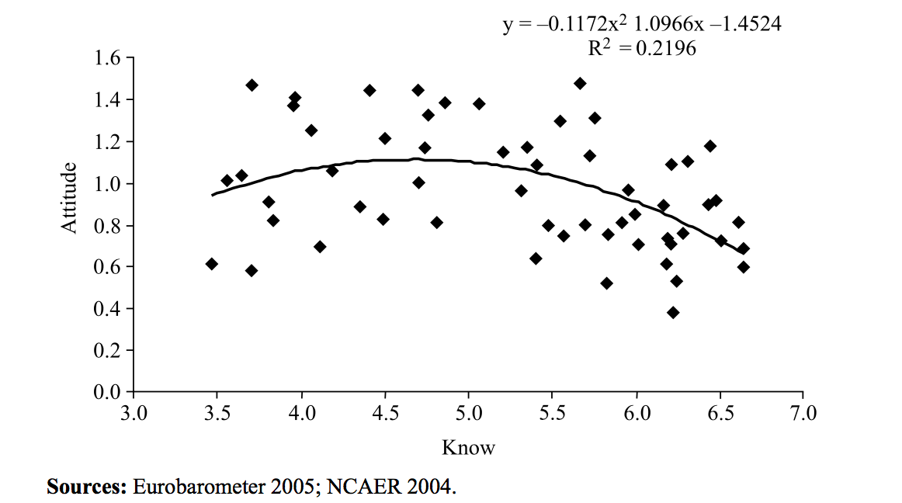
Figure 1: Relationship between the public’s knowledge of and their attitude toward science
Source: Bauer (2009).

Dialogue model
In contrast to the scientist group’s controlling position in the deficit model, the dialogue model (or democracy model) is more inclined to favour the public (Liu, 2009, p.12). The dialogue model was introduced at the end of the 1990s (Holliman et al., 2009, pp.19-20), when an influential House of Lords report detected “a new mood for dialogue” (2000). In the dialogue model, scientist groups take a more approachable position to communicating scientific knowledge to the public. Scientists have become aware of the public’s diverse needs and seek to find out the public’s views of science, wishing to gain feedback in the process of science communication (Trench, 2008). The development of the digital media environment has greatly promoted the development and application of the dialogue model, since it has provided an unprecedented real-time interactive platform (Michael, 1998; Brossard and Shanahan, 2007). As mentioned above, science dialogue refers to communication about science that brings all parties a greater understanding. When it is applied in practice, it is essential to introduce public participation in scientific discussions and scientific governance, such as Public Scientific Juries, Public Science Conference, and National Science Discussion (see Irwin and Wynne, 1996; Wynne, 2005; Stilgoe and Wilsdon, 2008). Therefore, in terms of theory and practice, the dialogue model is inseparable from the engagement/participation model – they are both part of the second generation of major science communication models after the deficit model (Sturgis and Allum, 2004; Bucchi, 2008; Davies, 2009; Reincke et al., 2020). But compared with engagement/participation models, the dialogue model emphasises the state of equality between the public and scientists in terms of discourse power (Sturgis and Allum, 2004; Jackson et al., 2005).

Engagement/participation model
In the criticism of deficit models and scientists’ absolute monopoly over scientific affairs, the role of the public in scientific discussion and governance has been gradually revealed, especially after Wynne highlighted the importance of ‘lay knowledge’ (also called local knowledge) (Wynne, 1989; 1996; 2002). On this basis, the engagement/participation model that emphasises public participation in scientific discussions, scientific governance and other science-related affairs has emerged and been developed (Stilgoe et al., 2014; Jensen and Buckley, 2014). The engagement/participation model emphasises that the public participate in scientific affairs as proactive actors and form a joint force with other groups such as scientists, the government or policy makers to promote scientific affairs (Matson and Parsons, 1998; Trench, 2008; Stilgoe et al., 2014; Jensen and Buckley, 2014). Affected by the deliberative democracy trend, the engagement/participation model has been used more often in politics or science-related governance fields. It emphasises the interaction between the scientific community and the public in decision-making and public affairs governance, for example the “GM Nations?” public engagement with science exercise to help the government decide whether Britain should adopt a European free-trade policy on genetically modified crops (Leshner, 2003; Horlick-Jones et al., 2006). The engagement/participation model in the decision-making on scientific policies and the governance of scientific affairs deconstructs, to some extent, the absolute dominance of scientists and government managers over the discourse around scientific matters. From the end of the 20th century, the engagement/participation model or public engagement with science has derived a new form that transcends the political realm: public engagement with scientific research, also known as ‘citizen science’. But it should be noted that, even with the development of the engagement/participation model in science communication, the power structure in the process of science communication and scientific governance has not been completely changed, which is why the deficit model has continued to exist (Holliman and Jensen, 2009).

Citizen science has been defined as those scientific projects that involve public engagement with scientific knowledge-producing processes (Bonney, 1995). The public, called citizen scientists in citizen science projects, has been invited to enter the scientific research process to collect and analyse scientific data for a variety of scientific projects. For instance, in the citizen science project Galaxy Zoo, lay people were invited to work with astronomers to identify more than 1 million pictures of galaxies (Raddick et al., 2009; 2019). Citizen science has been widely used in many natural science fields such as ornithology, environmental science, hydrology, botany and astronomy (McCaffrey, 2005; Raddick et al., 2009; 2019; Dickinson et al., 2010; McKinley et al., 2017). From the traditional engagement/participation model in science decision-making or scientific governance to citizen science in the scientific knowledge-producing process, it can be seen that the scope of science in which the public can participate is expanding, and the depth of public involvement in scientific affairs is also deepening. The engagement/participation model is also regarded as an important criterion for scientific development and governance in the 21st century (Stilgoe et al., 2014).

Recently, however, the engagement/participation model has been subject to criticism. Some scholars believe that the so-called ‘engagement/participation model’ is actually just a copy of the deficit model, a method used by scientists to cover up their absolute hegemony over scientific affairs (Wynne, 2006; Jension and Holliman, 2009; Simis et al., 2016; Jia, 2020). In practice, most public engagement with science activities are organised by the scientific community with the purpose of ensuring that the public accepts science. Thus, public participation in science is a technique that allows the public to accept science through interaction, which is not the original intention of public participation in science (Jasanoff, 2014). True public engagement with science should abandon this dominant position of science and allow it to have a more equal dialogue with all kinds of meaningful knowledge and actors – this has not happened in many countries (Wynne, 2006; Dickson, 2015). Therefore, some scholars have proposed post-engagement models in science communication studies. For instance, Alan Irwin has proposed the ‘context science communication model’, which states that the boundary between the deficit model and the participation model is fuzzy, and it is necessary to conduct contextualized and reflexive design and analysis of each independent scientific communication practice to obtain the best communication effect (Irwin et al., 2014). Although the engagement/participation model has been developed and other models similar to the context science communication model have been proposed (Jones, 2014; Chilvers and Kearnes, 2020; Jia, 2014; 2020), those that dominate the field of science communication research and practice are still the deficit model and the engagement/participation model (Stilgoe et al., 2014; Simis et al., 2016). It should be noted that these models do not present a rigorous, linear iterative relationship diachronically, although it is often claimed that the dialogue and engagement/participation model is the advancement of the deficit model. In many practical situations, multiple models coexist (Liu, 2009). Although it has always been criticized, the deficit model maintains some vitality, especially in China (Wu and Luo, 2019).

2.1.3 Science communication in the digital media environment
The digital media environment, or more broadly the new media environment, is believed to have changed the landscape of science communication significantly (Nisbet and Scheufele, 2009; Brossard, 2013). First, there is undeniable that the digital media environment makes it easier for all people, not just the public but also scientists, to access scientific information (Peters et al., 2014, p.749). The exponential growth of scientific information in the digital media environment is believed to have greatly promoted the development of scientific communication (Peters et al., 2014). More importantly, many scholars believe that the development of the digital media environment represents an unprecedented opportunity to develop science communication, especially an equal science dialogue between scientists and the public and public engagement with science (Bik and Goldstein, 2013; Smith, 2016). It is widely accepted that the digital media environment has already changed the “classical linear models of science communication process whereby information is produced by scientists and travels via mass-media into public consciousness” (Connor and Joffe, 2014, p.2), and also has the potential to update such one-way linear processes of science communication to a two-way, interactive process by providing various interactive and dialogical functions between scientists and the public (Lee and Van Dyke, 2015; Peters et al., 2014, p.749). For scientists as communicators, the digital media environment offers “more opportunities to communicate directly with the general public rather than having to rely on journalists as mediators” as journalists could miscommunicate scientific information to the public (Peters, et al., 2014, p.751). Such opportunities to communicate include science blogs and social media platforms (Colson, 2011; Trench, 2012; Su et al., 2017). In the fragmented digital media environment, scientists and other science communicators can effectively use their fragmented time to carry out such science communication work on social media platforms, which can reduce the burden of science communication for the scientists (Karlsson-Vinkhuyzen et al., 2017; Young and Anderson, 2017).

The public has also been provided with more channels to give feedback to scientists or to interact directly with scientists as communicators in the science communication process through the digital media environment (Schmitt, 2018). Peters observed that the digital media environment “allows a more symmetrical communication and the formation of online communities focusing on certain topics via social networks such as Twitter and Facebook” (2013, p.14108). Many scholars welcome such opportunities, as they expect them to enable a more dialogic form of science communication, increased participation of laypeople in debates on science and science policy, and discourse about the ethical, legal and social implications of research (Goode, 2009; Gerhards and Schafer, 2010; Delborne et al., 2011; Colson, 2011; Trench, 2012).

Moreover, the digital media environment, especially personal media such as blogs, personal Podcasts or social media accounts, also provide the public with chances to act as communicators in the science communication process (Nancy, 2016). In the digital media environment, especially on knowledge-sharing networks and in online communities, scientists are no longer the only communicators in the science communication process; the public, always treated as an audience in the traditional model of science communication, can also disseminate their knowledge to other people, including scientists (Kiousis, 2002; Lister et al., 2008; Brossard, 2013; Lee and Van Dyke, 2015, pp.2-3). Some have argued that the digital media environment has brought about an equal dialogue relationship between scientists and the public (Brossard, 2013). The unique feature of the digital media environment of decentralization and empowering disadvantaged groups allows the public to gain more discourse power space and power in the process of scientific communication, which is believed to effectively eliminate the discourse hegemony of the scientist community in the online science communication process (Howard, 2002; Van Aelst and Walgrave, 2002; Koteyko et al., 2015).

In addition to the communicative relationship between scientists and the public, the digital media environment has also changed much about the content of science communication. In the traditional media environment, science communication often presents a relatively singular form, such as word-image forms in newspapers and magazines, sound forms in radio broadcasts, and sound-image forms on television. However, multimedia forms in the digital media environment mean that science communication can combine different forms of media texts, especially through hyperlinks and social media (Luo, 2017; Zhang and Wang, 2017; Zhu and Jiang, 2017). Digital media forms such as short videos, live broadcasts and electronic games have brought innovation to the science communication field that would be unimaginable in traditional media (Aitkin, 2004; Welbourne and Grant, 2016; Armon, 2018; Finkler and Leon, 2019). The enthusiasm of scientists and the public to participate in science communication has been greatly mobilized, and science communication itself has also been presented in a diverse range of methods.

In addition to recognising the benefits of digital media environment, some scholars are also worried about the disadvantages it may bring to science communication. Some studies have indicated that scientists still tend to be sceptical of the abilities and attitudes of the public with respect to science (Besley and Nisbet, 2011; Peters et al., 2013). Such beliefs may hinder the full development of the democratic potential of the digital media environment. More seriously, some scholars think that the public will gradually lose their ability to make judgements when faced with overwhelming volumes of scientific information. The nature of the digital media environment means that the communication process runs too quickly to allow time for audiences to think (Plank, 1983; Thomson and Arganbright, 1997). This makes it difficult for audiences to fully digest and absorb scientific information, resulting in the ‘information overload’ phenomenon of the digital media environment (Standage, 1998; Edmunds and Morris, 2000; Bawden and Robinson, 2009). The mixture of ‘true’ scientific information and much ‘false and untrue’ scientific information in the digital media environment without a strict gatekeeping mechanism also makes it difficult for the public to make judgements about scientific issues (Peters et al., 2014). This situation has proven to be significant during the Covid-19 epidemic, the World Health Organisation (WHO) seriously warned the public around the world, as well as scientists, to be vigilant against the spread of an ‘infodemic’ – the rapid spread of misinformation or rumours about Covid-19 on the Internet, which the WHO considered to be no less serious than the virus itself (Zarocostas, 2020; WHO, 2020).

Furthermore, due to the algorithms of digital media and the recommendation function of content with similar opinions, some scholars believe that the public become bound in ‘information cocoons’, with their beliefs amplified or reinforced by communication and repetition inside a closed system that insulates them from rebuttal, known as an ‘echo chamber’ (Gossart, 2014; Kobayashi et al., 2015; Williams et al., 2015). For instance, Williams and his colleagues found that interaction on social media platforms shows strong homophily between polarized ‘activist’ and ‘sceptic’ groups in climate communication. Digital media only strengthened the public’s original consciousness and attitudes and did not effectively change or influence them (Williams et al., 2015).

Whether the digital media environment brings more benefits to science communication or indelible disadvantages, it is unlikely that a definitive conclusion will ever be reached. However, it is certain that the digital media environment has changed the interactive relationship between scientists and the public in the traditional science communication process to a large extent. The change of this interactive relationship is bound to bring about the dynamics of discourse power relations between scientists and the public, which provides a suitable environment to further explore discourse power and its impact on scientists in the science communication system.

2.1.4 Science communication in China
As discussed in Chapter 3, science communication still exists mainly in the form of ‘science popularization’ which is considered to be one-way and not particularly interactive in modern China (Wu and Luo, 2019). Even with the rapid development of the digital media environment, the interaction between Chinese scientists and the public is still underdeveloped in online science communication. Many scholars find that the model that is dominant in the contemporary Chinese science communication system is still the deficit model (Jia, 2014; Wu and Luo, 2019). Some optimistic scholars believe that science communication in China has begun to gradually shift from the popularization of science under the rule of the central broadcasting model and the public understanding of science under the rule of the deficit model to scientific dialogue and public participation in science (Liu, 2008; Cao, 2009; Jia, 2014; Sun and Zhou, 2018; Yang, 2018). However, studies on the small number of public participation science projects in China have found that so-called public participation in science is nothing more than unidirectional education of scientific knowledge by scientists to the public (Wu and Luo, 2019). The interactive relationship between scientists and the public and their respective communication status has shown a relatively solid state in the special context of China (Liu, 2008; Jia, 2014; Wu and Guo, 2019). But the emergence and development of the digital media environment, especially social media platforms, alleviates this kind of solidified communication relationship between Chinese scientists and the public to a certain extent (Guo, 2018), as explored through empirical studies in this thesis.

The academic research on science communication in China is deeply influenced by pragmatism, with the fundamental goal of improving the scientific literacy of Chinese citizens (Zhang and Zhang, 1993; Wang and Li, 2004; Chin, 2005; Zhen and Gao, 2008; Chen et al., 2009; Gao et al., 2016; Yao and Guo, 2018). The research on philosophical and metaphysical reflections on science communication practices and theories is limited. This kind of pragmatist tendency to pursue improvement in citizens’ scientific literacy has also caused China’s academic circles and practical fields of science communication to be influenced and controlled by the deficit model in the long term (Jia, 2014; Wu and Guo, 2019). There are very few studies on the Chinese science communication system from the perspective of critical theory, focusing on the discourse or power relationships among different actors in the science communication system. But in the Western context, critical theory has already produced much influential research (such as Gieryn, 1983; 1999; Trench, 2008; Bauer, 2008; Molek-Kozakowska, 2018). The lack of philosophical reflection research also means that China’s current science communication theories derive from translation of and reference to Western theories, lacking theoretical consideration of the Chinese context, which this study comes in. Moreover, due to the characteristics of Chinese social science research, most of the conclusions of Chinese science communication research are published in Chinese journals, and the research on Chinese science communication in the international field is also limited (Zhou, 2013; Wang and Yue, 2018). Therefore, this research intends to start with an analysis of discourse power relations between Chinese scientists and the public in the Chinese online science communication system, via empirical research, to break through the shackles of the pragmatic approach to improving scientific literacy among the Chinese public, and to provide an empirical and theoretical analysis that addresses the Chinese context in the international field.

2.2 Discourse authority and boundary-work in science communication
This study explores the science communication process in the Chinese digital media environment, focusing on the discourse power relationship between Chinese scientists and the public, and further analyses how Chinese scientists’ discourse authority has been challenged in the digital media environment and how scientists take steps to maintain their discourse authority. Based on such ideas, some core concepts need to be defined, such as discourse authority, along with their origins and specific representations in science communication. Gieryn’s boundary-work theory will be used in the following analysis to explore the discourse authority interaction between scientists and the public in the science communication process.

2.2.1 Discourse authority of science
In social science, including sociology, political science and science technology studies (STS), authority has been defined as the legitimate power that a person or a group of persons consensually possess and practice over other people (Arendt, 1958; Frank, 1999). The persons or groups with authority are believed to have the power to determine, adjudicate or otherwise settle issues or disputes (Goodman, 1967). Authority is considered to exist widely in various social organisations/units at different levels, such as the family (parental authority), small groups (informal authority of leadership), intermediate organisations such as schools, churches, armies, industries and bureaucracies (organisational and bureaucratic authority), and society-wide or inclusive organisations, ranging from the most primitive tribal society to the modern nation-state and intermediate organisations (political authority) (Dahl, 1990; Bloom, 2010). In modern and postmodern societies, science is regarded as an authoritative social institution (Shapin, 2004; Gauchat, 2011). Some scholars believe that the authority of science as a social institution surpasses traditional authoritative social institutions of religion, justice and politics (Ormiston and Sassower, 1989; Ward, 1997; Lewis and Hammer, 2010; Gauchat, 2011). And the authority of science in society is believed to be concentrated on its discourse authority (Lewis and Hammer, 2010).

Discourse authority (sometimes called discourse power) describes the legitimate power to exercise control over other persons or groups without violence or coercive measures (Eira, 1998; Karlberg, 2005). Different from the national government’s judicial agencies, law enforcement agencies and political agencies, which rely on their own violent machinery and mandatory legal provisions, social organisations with discourse authority often rely on their own ‘soft power’ (cultural power) to influence and control others’ ideology and cognitive style (Geuss, 1981). Discourse authority is considered to be the most special authority in the authority system, with the most subtle and irresistible influence on people. Many people affected by discourse authority cannot effectively perceive that they are being influenced and controlled by such authority (Geuss, 1981). Therefore, the authority of discourse is usually inseparable from ideology (Geuss, 1981; Scollon, 1995; Gieryn, 1983; 1999; Van Dijk, 2013a). For instance, science as a social institution without coercive force, in modern and postmodern societies, is considered to have a power that other social institutions cannot match for controlling and influencing the public (Aronowitz, 1988). This kind of control and influence over the public, that does not rely on coercive force, comes from science as an ideology’s control and exclusive right of interpretation of knowledge and reality, which ultimately forms its sole right of interpretation and suggestion on natural reality, social reality, and public behaviour. All interpretations of reality that are different from science are marked as anti-science and pseudo-science and criticized further (Gieryn, 1983; 1999; Aronowitz, 1988). Wynne (2006) observed that: “what is typically called ‘public rejection of science’ is properly described as public rejection of commitments based on value commitments that are misunderstood and misrepresented by scientists and policy experts as if solely scientifically determined” (p.214). In reality, many people cannot perceive that they are being controlled and influenced by science as an authority, but their ways of understanding the world and their own behavioural methods have actually been influenced and even controlled by modern science, and they even appreciate the influence and control of science on their lives (Aronowitz, 1988). This is just the authority of scientific discourse.

Scholars of the critical school often talk about the ‘authority’, ‘cultural authority’ and ‘discourse authority’ of science. They believe that in contemporary times, science and its accompanying instrumental rationality have become the organisational principles of modern society. By oppressing and governing other types of knowledge (such as engineering, social science, arts, and religion) and non-expert groups such as the public, it creates a society characterised by alienation, materialization or one-dimensionality (Geuss, 1981, p.3). György Lukács’ opposition to “science’s extension and domination of the social sphere”, Max Weber’s “lament on society being ruled by soulless experts and the instrumental rationality adopted by them”, and Max Horkheimer and Herbert Marcuse’s ideological analysis of “instrumental rationality and scientific authority’s maintenance of the status quo of capitalist notification” all reveal the dissatisfaction of the critical school with the authority of science in society and their willingness to break such authority (Geuss, 1981; Bohman, 2005). In the view of Benjamin and others, introducing the public and democratizing and publicizing the original elite culture and art (and perhaps science) is an effective way of deconstructing the privileges of experts and the authority of discourse (Benjamin,1935; Elihu Katz, 2003). The critical school’s discourse on the authority and power of science and instrumental rationality can give this research profound theoretical nutrients.

In the communication relationship, discourse authority is often manifested in the absolute control of the communication content and process by the communicator. In the communication relationship within an absolute discourse authority, feedback and the interaction between the communicator and the audience are considered insufficient and unimportant, because the audience does not match the discourse power and space of the communicator (Price, 2007; Van Dijk, 2013b). This situation often occurs in the process of traditional educational communication. As a group with discourse authority, the interaction between teachers and their students is often considered to use this one-way mode that does not emphasise feedback and interaction (Baker, 1989; Buzzelli and Johnston, 2001). In the process of science communication, especially in traditional science popularization and public understanding of science processes under the deficit model, scientists with discourse authority and the public are not matched in discourse power and space; the interaction between scientists and the public and the public’s feedback to the science communication process is also considered insufficient. Scientists with scientific authority not only have an absolute right to interpret scientific content, but they also have an exclusive right to criticize the media as an inaccurate and irresponsible intermediary (Gieryn, 1983; 1999; Wilson, 2000).

2.2.2 The origins of discourse authority of science
Many scholars believe that the discourse authority of science comes from the special attributes of science as a type of knowledge from the perspective of ontology (Rouse, 1993; Yearley and Steven, 1994). Scholars believe that the inherent objectivity, verifiability, system interpretability, reliability, accuracy, precision and predictability of science, as well as the standardization of scientific methods, makes science a type of knowledge different from other types of knowledge such as religion and humanities. This unique objectivity, neutrality, reflexivity and normativity give science a unique advantage in explaining the natural world (Rouse, 1993; Yearley and Steven, 1994). Because of this advantage, science has also been further introduced into the research and analysis of society and regarded as a standard (Cohen, 1994). Therefore, in the interpretation and further suggestion of natural reality and social reality, science should have the privilege of discourse beyond other types of knowledge (Gieryn, 1983). Merton’s scientific norms fully summarize this idea. According to Merton (1973), modern science is and should involve communism, universalism, disinterestedness and organised scepticism. These four Mertonian norms, along with originality, have become the main features of modern science (Ziman, 2000) – people think that science is and should be like this. Therefore, such knowledge has been considered to be eligible to have discourse authority through its representatives: scientists, in modern society (Macfarlane and Cheng, 2008).

At the same time, the rapid development of society brought about by science and technology has led some to argue that we need to give science and technology a unique discourse privilege (Hull, 2010). This situation is particularly clear in China. After Deng Xiaoping, the second-generation core leader of New China, made the statement “science and technology are the primary productive forces” in China, science has enjoyed a discourse authority unmatched by other types of knowledge among the public, especially considering that China is still building and developing a modern society, (Deng, 1994). Combining these two points, whether in the West or in China, science is considered to have a unique discourse authority.

Scientific authoritative research based on essentialism and ontology first considers that scientific knowledge is a constant/essential, and ought to be characteristic. These characteristics and the accompanying scientific research methods together constitute the philosophical soil for the acquisition of discourse authority of science. However, as many scholars have repeatedly emphasised, ‘science is fluid’ (Williams et al., 1999; Adcock and Kinderlerer, 2004). Science and scientific knowledge do not have a constant existence. With the development of Science and Technology Studies (STS) and Sociology of Scientific Knowledge (SSK), especially in the Edinburgh School and the Paris School, the essential attributes of science and scientific knowledge have completely different perceptions (Wang and Xu, 2007; Wynne, 2007). In SSK’s cognitive system, which tends towards constructivism, scientific knowledge is the result of group consultations among scientists (Barnes, 2013). From the view of Actor Network Theory (ANT), which is the representative theory of the Paris School, the production of scientific knowledge is the result of interaction and negotiation between human actors such as scientists and inhuman actors such as technology, venues and systems (Latour, 1996). Latour and Woolgar, representative of the Paris School of STS research, through ethnographic surveys and research in science laboratories have found that the production of scientific knowledge is actually full of uncertainty, being not as strict, precise, and stable as the public understanding of science (Woolgar and Latour, 1986; Latour, 1987). Barry Barnes and other members of the Edinburgh School pointed out that scientific knowledge and its production occur in a social context and are affected by various non-objective social factors with contingency or interpretative flexibility (Shapin, 1995; Barnes et al., 1996; Barnes, 2013). STS and SSK broadly characterise the inherent objectivity, verifiability, system interpretability, reliability, accuracy, precision and predictability attributes of science as socially constructed. Although SSK has been criticized for being too aggressive, believing that scientific knowledge lacks the necessary objectivity basis it claims and constructed by social existence and social interactions, SSK provides a new understanding of scientific knowledge (Collins and Ycarley, 1991). Science as a type of knowledge, its social attributes and characteristics, are not necessarily better than other types of knowledge, such as religion and humanities. Therefore, it is also untenable to use those attributes of science that are ‘socially constructed’ as a source of scientific authority.

Meanwhile, the development of science has not just brought progress to society. Since World War II and after, the harm and potential crises that science have brought to society have also been significant, such as the use of nuclear weapons, nuclear leakage, gene editing and the safety risks of GMF, increases in carbon emissions and global climate change, and genetic species variation (Capra, 1983; Fleck, 1986; Saltelli and Funtowicz, 2017). These crises have challenged science’s status as a source of unquestioned authority in society.

Since neither the knowledge attributes of science nor the influence science has on society can fully explain its discourse authority in society, where does the discourse authority of science and scientists come from? From the perspective of constructivism, Gieryn proposed the theory of the discourse of science and the scientific community, the ‘boundary-work of science’, under the influence of the British Edinburgh School and other scientific sociological constructivism and Luhmann’s scientific system of structure-functionalism (Gieryn, 1983; 1999; Luhmann, 1995; Yang, 2020).

2.2.3 Boundary-work and the discourse authority of science and scientists
In 1983, Thomas Gieryn first proposed the boundary-work of science theory (Gieryn, 1983). From the perspective of constructivism, Gieryn believes that the difference between science and non-science as knowledge types comes from a series of practical actions by the science community and scientists as a group. These actions create, promote and strengthen the boundaries between science and other knowledge areas. The discourse authority of science as a special type of knowledge in society comes from such demarcation and boundary-work (Gieryn, 1983; 1999).

Gieryn first put forward a series of thoughts about the authority of science in Cultural Boundaries of Science: Credibility on the Line:

Why does science have special discourse authority in the operation of society? Why can science be widely trusted? Why do we often seek personal, policy or organisational decisions from scientists? Why do we provide a large amount of public sponsorship to science? Why does science have the legal power to define and explain nature and other realities? (1999, p.7).

These questions posed by Gieryn generate an overarching question: how is the discourse authority of science produced? Gieryn further explained that the discourse authority of science comes from the boundary-work behaviour that science and scientists actively adopt. Such behaviour divides the boundaries between scientific and non-scientific, scientists and non-scientific groups (1999, p.10). Gieryn also pointed out that this boundary-work between science and non-science is not static, but is the result of constant negotiation between science as actors and other actors in a cultural environment, which is specifically manifested as the interaction between science and non-science, scientists and the group of non-scientists at different social levels.

Gieryn cited five sets of examples (science and religion; science and technology; anatomy and craniology; astronomy and astrology; natural science and social science) to show how science highlights its own characteristics and advantages by setting the boundaries between itself and other types of knowledge, and finally obtains discourse authority. In these five sets of cases, Gieryn argues that the boundary-work of science is about exposing its own characteristics of knowledge and knowledge production to non-scientific communities, and on this basis, it rejects other types of knowledge as non-scientific and pseudo-scientific (1999). In such a process, craniology, astrology, religion and the social sciences struggle for legitimacy in terms of science in the face of the public or government. This also forms the process of science communication or discussion at different levels: the debate between science and non-science; science reveals its own knowledge characteristics to the public or the government and strives for its own legitimacy; non-scientific knowledge strives for its own legitimacy and refutes scientific theories; science criticizes and refutes non-science by setting boundaries (Gieryn, 1983; 1995; 1996; 1999). Although Gieryn did not use the term science communication – instead using the concept of scientific rhetoric – he implied that the different levels of communication between science and other types of knowledge, as well as scientists and non-scientists, are representative of knowledge types (Figure 2).

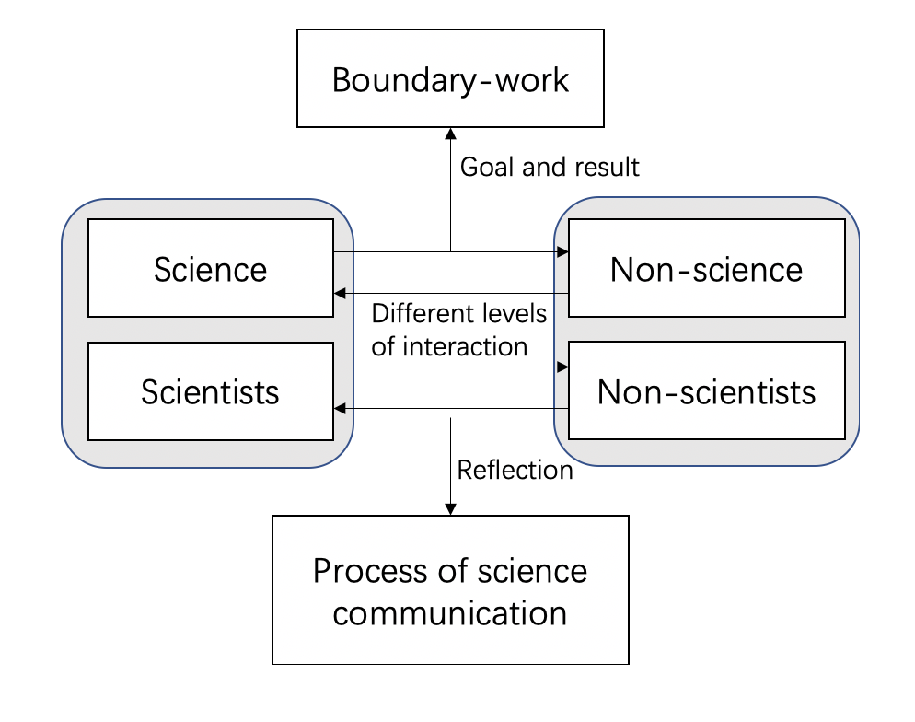
Figure 2: The relationship between boundary-work and science communication

Taking Gieryn’s discussion of the boundary-work between science and religion as an example, the struggle between science and religion on the discourse authority of the production and interpretation of ‘knowledge’ reached a climax in the mid-19th century with Charles Darwin’s Origin of Species (Gieryn, 1999). To erase the control of religion and further develop the discourse authority of science as a type of knowledge, and scientists as a social profession, science has set a series of boundaries between itself and religion. Gieryn pointed out that, unlike when science and technology compete for discourse authority and the main audience that science faces is the government and project funding sponsors, the discourse authority that science and religion compete for is mainly established among the public: science needs to usurp the discourse authority of religion (Gieryn, 1996; 1999). Gieryn noted that to achieve such a goal, a group of scientific workers declared through a series of public speeches, publications, news reports and public debates that: (1) science is useful at the practical level, while religion can only produce effects at the spiritual level; (2) science is empirical, therefore it is also the only path to natural truth through experiment and observation, while religion is only metaphysical; (3) science is full of scepticism, while religion is dogmatic; and (4) science represents objective and fair knowledge, which discards prejudice, emotion and personal desire, while religion is subjective and emotional (Gieryn, 1999).

By dividing and strengthening the above-mentioned boundaries, science first erased the identity of the ‘theological handmaid’ at the level of epistemology and gained an independent identity as a form of knowledge. In the struggle for public trust, science constantly strengthens its own characteristics of knowledge and emphasises its own rationality in explaining nature and other types of reality. As a result, religion has been dismissed as non-science, pseudo-science and as illegitimate ‘knowledge’ for the interpretation of objective reality. Finally, science has obtained the unique right to interpret nature, as well as the discourse authority in society (Gieryn, 1983; 1995; 1999). In this struggle, the ideology of science and scientists is realized through boundary-work. As Gieryn said: “the ideological efforts by scientists are just to distinguish their intellectual work from other non-scientific intellectual activity. The core of this distinction lies in the boundary-work performed by scientists” (Gieryn, 1983, p.782). This kind of boundary-work of science is realized through the process of science communication with different audiences in different forms. It can be scientific writing or speeches, or media-based popularization of science; it can also be debates with other special knowledge fields, or alliances with governments and other subjects of discourse power. However, regardless of the different forms, the theory and practice of boundary-work are inseparable from the process of science communication. Thinking about the boundary-work of science from the perspective of science communication may provide a new way of understanding the generation of discourse authority, especially in the digital media environment, in which the discourse power and space are believed to be more dynamic and fluid than ever (Herring, 2013; KhosraviNik, 2017).

Gieryn (1983; 1999) believes that the ideology of science is achieved through the rhetoric of science in interaction with other types of knowledge. This rhetoric is mainly shaped in two aspects: the representative content of scientific knowledge; and the style in which the science is presented. The ideology of science is further used by scientists to advance and maintain the authority of science and scientists by smoothing the inconsistencies and advancing the interests of scientists across the whole society. The realization of the whole process is called ‘boundary-work’ by Gieryn. According to Gieryn’s examples (1983; 1996; 1999), the boundary-work of science can be reflected in three different dimensions: rhetorical style; figurative language; and symbolic expression in the science communication process. On the basis of these examples, the research methods of communication, especially discourse analysis, were effectively introduced into the study of boundary-work and discourse authority of science in the science communication process (Figure 3). Recently, some science communication studies have emerged in the Western context from the perspective of boundary-work following Gieryn’s research path (Riesch, 2010). For instance, Shanahan (2011) pointed out in his research on blog-based science communication that scientists, as the communicators in the science communication process, used a series of communication methods, techniques and content packaging to establish a clear discourse distinction and boundary with the audience of the communication process (the public) and further build their unique discourse space. The use of these special communication techniques is considered to be an important source of authority for scientists in the process of communication (Shanahan, 2011). Rödder (2016) also confirmed the important role of science communication and professional expression in the construction of scientists’ social identities that differed with the public through the theory of identity communication.

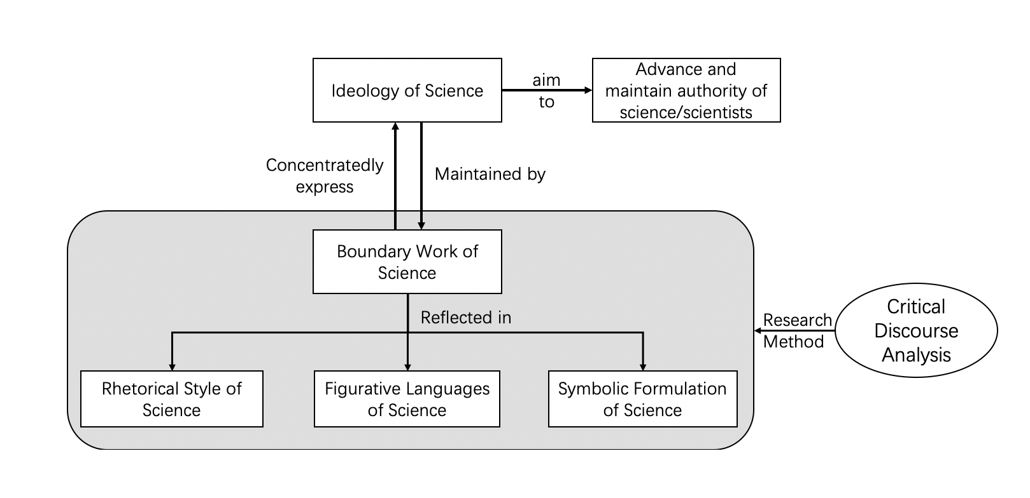
Figure 3: Analysis approach of boundary-work and discourse authority of science

Gieryn’s boundary-work theory provides an effective analysis framework to explore the discourse interaction between scientists and the public, the source of the discourse authority of the scientists from the perspective of science communication and its content through discourse analysis.

2.3 Participatory culture and online public engagement
Since this study explores science communication and the dynamics of the discourse authority of scientists in the Chinese digital media environment – using Zhihu as an example – digital media theories, especially those relevant to public engagement, interaction, and dialogue between scientists and the public, are reviewed below.

2.3.1 Discourse authority of science, boundary-work and online public engagement
Although Gieryn believes that the construction of the boundary of science, as well as the maintenance of the ideology of science, is derived from the process of communication and interaction between science and other types of knowledge (and between scientists and other social groups), excessive interaction across such boundaries and extensive public participation in scientific affairs may also dissolve the boundary between science with other types of knowledge, scientists with non-scientist groups, and the discourse authority of science and scientists, as discussed above. Although some studies have shown that scientists still use a series of methods to maintain and even strengthen the boundaries between science and non-science and scientists and non-scientists in the digital media environment (Shanahan, 2011; Rödder, 2016), other studies show that the identity boundary between scientists and the public is gradually loosening and blurring in a digital media environment where interaction and dialogue are constantly being strengthened (Bubela et al., 2009; Davies and Horst, 2016; Bruggemann et al., 2020).

As mentioned above, the digital media environment provides unprecedented opportunities and assistance for public participation in science, whether it is through discussion of scientific topics (Holliman et al., 2009; Grant et al., 2010; Holliman, 2011; Junger and Fahnrich, 2020), the formulation of scientific and technological policies (Janssen and Wimmer, 2015; Dreher et al., 2016), or the production of scientific knowledge (Hemment et al., 2011; Wynn, 2017). In the context of the continuous deepening and widening of the public’s participation in science, the ‘actor subject’ of scientific affairs began to gradually change. If the previous boundary-work between scientists and non-scientists ultimately produced science’s unique right to interpret reality and further gave suggestions based on such interpretations, then the main manifestation of such a right lies in the dominance of scientists over ‘scientific affairs’, whereby only scientists are qualified to participate in scientific affairs and have the power and space to speak (Gieryn, 1999; Riesch, 2010). The extensive involvement of the public has diluted the actor subject of scientific affairs – it is no longer just a group of scientists, which is also accompanied by the continuous attention and development of deliberative democracy in science (Burgess et al., 2007; Dryzek and Niemeyer, 2019). In the context of such dilution of the actor subject, the identity boundary between scientists and the public in scientific affairs has gradually become blurred, especially when the public has begun to have equal dialogue with scientists, equal power in science and technology governance and science and technology policy formulation, and has also become involved in the production of scientific knowledge. Therefore, the development of public engagement with science is regarded as an important factor in dissolving the discourse authority and discourse monopoly of scientists, dissolving the original identity boundary between scientists and the public, and also reconstructing the discourse power relationship between scientists and the public (Felt and Davies, 2020).

The public can participate in scientific discussions through a series of functions provided by digital media platforms, such as reposts, comments and likes (Xu et al., 2018). Additionally, blogs and social media platforms also provide the public with the possibility of acting as communicators, thereby giving them another opportunity to participate in science communication (Kouper, 2010; Peters, 2013; Kahle et al., 2016). Some government websites, proprietary technology policy and scientific discussion websites also provide spaces for the public to directly participate in the discussion and formulation of scientific policies by setting up a feedback mechanism (Pidgeon et al., 2003; Firmstone and Coleman, 2015; Lee-Geiller and Lee, 2019). Some citizen science projects have also developed their own digital media platforms, such as websites or mobile apps, to realize and develop public participation in the production process of scientific knowledge (Newman et al., 2012; Liberatore et al., 2018). Digital media platforms have greatly expanded the possibilities and scope of public participation in science. Therefore, digital media is also regarded as an important contributor to the elimination of the identity boundary between scientists and the public and the discourse privilege of scientists, combined with the development of both theories and practices of public participation in science/public engagement with science.

2.3.2 Participatory culture, Zhihu and science communication
Participatory culture provides an excellent analytical theoretical framework to explore the public’s participation in science communication, scientific discussions and other scientific affairs in the digital media environment. Participatory culture, as an opposing concept to consumer culture, has been defined as a culture in which private individuals (the public) do not only act as consumers, but also as contributors or producers (prosumers) (Fuchs, 2014). This concept became popular since Harry Jenkins integrated it with the digital media environment. Jenkins defines participatory culture as one that allows free expression of artistic talent and civic engagement in sharing creations with others. In the process, everyone becomes a producer (as well as a user). Users also establish social connections with others by sharing their creations (Jenkins, 2006; 2009; 2012; Jenkins and Ito, 2015). Jenkins believes that participatory culture is one of the basic characteristics of the digital media society (or ‘networked era’) (Jenkins, 2006; Jenkins and Ito, 2015).

As digital technology continues to enable new venues for communication, collaboration and circulation of ideas, it has also given rise to new opportunities for consumers to create their own content (Jenkins, 2012). Especially in the Web 2.0 era, people no longer blindly absorb and consume what large media corporations distribute. They are consumers who also produce their own content on social media platforms. Some scholars even believe that the relationship between Web 2.0 tools and participatory culture is more than just material. As the mindsets and skillsets of participatory practices have been increasingly taken up, people have become increasingly likely to exploit new tools and technology in 2.0 ways (Deodato, 2014; Jenkins and Ito, 2015). Van Dijck and Poell (2013) also pointed out when analysing the logic of social media that the new media environment enables users to:

become his or her own editor of the flow of information, deciding who can add and who has access [and] users themselves also have the ability to shape these algorithmic mechanisms. They can either ‘go with the flow’ or they can manipulate coded interaction, for instance by massively retweeting or liking particular content, thereby pushing a topic to become trending (p.6).

The core of the idea of users’ participatory culture in the digital media environment is consistent with the development of public participation/engagement in science, especially in the digital media environment. The core idea of public participation in science is to liberate the public from the single audience identity in the traditional science popularization model and to give them more important roles in science communication, scientific discussions, science and technology governance and even scientific knowledge production (Stilgoe et al., 2014).

Under the model of public participation in science, the public can also become producers, not only producers of local knowledge and personal experience, but also of scientific knowledge (Jasanoff, 2003; Gergory and Lock, 2008; Schäfer, 2009; Stilgoe et al., 2014). As mentioned earlier, this kind of participation has been developed and amplified in the digital media environment, which provides the public with more new avenues for communication, collaboration and circulation of ideas (Deodato, 2014; Jenkins and Ito, 2015). Therefore, the development of public participation in science can also be regarded as a manifestation of participatory culture in the field of science. Using participatory culture as the theoretical background to analyse the public’s participation in science communication and scientific discussions in the digital media environment and the interaction between scientists and the public on this basis may reveal new discoveries.

Based on the participatory culture theory, Jenkins and others further proposed the concept of participatory media. Participatory media is defined as media through which the user can share their opinions and voice involved in the production of news and entertainment, precipitated by online technologies (Guzzetti and Lesley, 2016). In participatory media, the ‘produsage’ feature of those media platforms means that the lines between producers and consumers have become blurred (Bruns, 2008; Miller, 2020). For instance, YouTube encourages users to create and upload their content to share it around the world, creating an environment for content creators old and new (Lindgren, 2011). Most social media platforms are considered to have the attributes of participatory media (Guzzetti and Lesley, 2016; Miller, 2020). However, some scholars also note that because they lack effective autonomous forces, participatory culture unique to digital media platforms may contribute to ‘riots’, such as the “Haren Facebook riot” in the Netherlands in 2012 (van Dijck and Poell, 2013). The lack of a strong supervision mechanism may cause public users who have participated in creation to realise powers that they cannot fully control, which may cause harm to other people or society when they use the power of participation. Furthermore, the digital media environment holds “the promise of being more egalitarian and democratic than mass media in a sense that all users could equally participate and contribute content” under the participatory culture environment, however, on those digital platforms, “their techniques for filtering out popular items and influential people became gradually more sophisticated” (van Dijck and Poell, 2013, p.6). Therefore, not all scholars have a positive attitude towards the participatory features of the digital media environment.

Zhihu, as the research field in this study, can also been seen as a typical example of participatory media. As mentioned in the previous chapter, Zhihu is the biggest Chinese knowledge-sharing platform, also known as a Question and Answer (Q&A) platform. Both questions and answers on the platform are provided by users. Users can be divided into active and inactive according to their degree of activity, but active users cannot be divided into communicators (producers) and audiences (consumers) according to the traditional linear communication model. Every active user is both a communicator (producer) and an audience member (consumer). In addition to asking and answering questions, users can also participate in the creation of information and text through other functions provided by Zhihu, such as likes and comments. Thus, Zhihu has several clear characteristics of participatory media.

According to Van Dijck (2013), the characteristics of participatory media and the participatory cultural atmosphere it creates can effectively promote users’ engagement in content-production on such media, including both explicit and implicit participation. Therefore, it can be inferred that the attribute of this participatory culture on the Zhihu platform can effectively promote public participation in science communication and scientific discussion, and further promote the dialogue and interaction between scientists and the public in the scientific topic sections on Zhihu, such as GMF, but this is only theoretical speculation at this point. Whether this potential for participatory culture can indeed promote interaction between scientists and the public, and further affect the discourse authority of scientists in the science communication process, requires further empirical research and investigation.

2.4 Conclusion
This chapter described the theoretical framework and related background adopted by this study. I reviewed the evolution of the models of science communication in the Western context, and also argued that such models have rarely been applied to the Chinese context. Among these models, the dialogue model and the participation/engagement model of science communication have assumed increased importance with the arrival of the digital media environment, which impacts on established hierarchies of the science communication system. I also reviewed Gieryn’s research on ‘boundary-work’ of science as a way of understanding how scientists maintain their discourse authority over non-scientists in wider society, and proposed my own framework for how this operates based on Gieryn’s theory. Finally, I assessed the impact of participatory culture – a key characteristics of new media – on online science communication. Together, this shows that the digital media environment provides both opportunities and challenges for the reconstruction of science communication systems and the ‘discourse authority’ in the communication and interaction process. In the next chapter I will introduce the basic practical background information of this project in combination with the theoretical framework introduced in this chapter.

Chapter 3: Background: Science Communication in the Contemporary Chinese Digital Ecosystem

This chapter provide some basic background information about science, scientists, science communication and the interactional relationship between scientists and the public in the contemporary Chinese context, especially in the Chinese digital ecosystem. The analysis in this chapter mainly relies on Chinese research, government reports and other materials. The conclusion forms the background for the whole project and the forthcoming analysis.

3.1 Science and scientists in contemporary China

3.1.1 Deified image of science in contemporary China
The term ‘science’ (科学, kexue) was first introduced to China at the end of the Qing dynasty, around the end of the 19th century, by capitalist progressive thinkers such as Liang Qichao, Kang Youwei and Yan Fu (Zhu, 2005). At the time of its introduction, Chinese thinkers had abandoned the historical orientation of natural philosophy in the concept of science in the Western context, and only retained the sense of a knowledge system based on experiments and calculations represented by physics, mathematics and chemistry that had emerged since the 16th century – they especially focused on the technical promotion and transformation functions of science (Li, 1979). Since China was in a social context of internal and external troubles at the time, science was regarded by those capitalist progressive thinkers as the best ‘weapon’ to save China. This idea was further inherited by socialist activists in the early 20th century, such as Li Dazhao and Chen Duxiu, who proposed the “Two Carriages to Save China: Science and Democracy” (Li, 1979). Unlike the development of science in the Western context, which experienced a relatively full accumulation period and a bottom-up development and communication path, science as a foreign issue was mainly introduced by the upper class in China and lacked the necessary public base at the point of its introduction at the end of the 19th century. Many members of the general public – and even government officials in the last years of the Qing Dynasty – regarded science as a ‘foreign religion’ that could destroy China’s traditional social system. This trend of thought linking science with theology and religion also connects to the earliest scientific concepts and technical applications that the Chinese people came into contact with, from the missionaries in Christian churches in China. Therefore, when science was first introduced into China, it was already somewhat alienating and mysterious to the Chinese public (Zhou, 2010).

After the founding of the People’s Republic of China (PRC) in 1949, science was further promoted to the heights of national strategy by the Communist Party of China. In 1956, Mao Zedong, the first leader of the New China, proposed China’s first development strategy plan. As part of the plan, Mao clearly put forward the development instruction of ‘March toward Science’ and clarified the important strategic position of modern science in the construction and development of New China (Wu, 2008). This view of science as the most important driving force for national development, was further inherited and developed by Deng Xiaoping, the second-generation leader of the PRC. In 1978, Deng Xiaoping pointed out that “Science and Technology are productive forces” at the National Science Conference of China, and later, in 1988, he added: “Science and Technology are primary productive force.” Thus, the ‘highest position’ of science in contemporary China’s strategic development was determined (Deng, 1994). In 1995, the third-generation leader of the PRC, Jiang Zemin, on the basis of Mao’s and Deng’s ideas, further put forward the national development strategy to “Develop the Country through Science and Education”, which consolidated the position of science in contemporary Chinese society (Hui, 1998). This series of national strategies not only placed science at a high level of authority on the macro level, but also closely linked science with the country in the minds of the Chinese public, thus establishing the ‘grand, great and authoritative’ image of science in a contemporary Chinese context. The ‘national strategic’ image of science in contemporary China further protects science from infringement and criticism. Science has become synonymous with ‘correct’, ‘perfect’, and even ‘deified’ as a concept that can save and develop the country (Fan and Kou, 1994).

Such a ‘correct’ or ‘perfect’ image of science in the contemporary Chinese context has further been strengthened by Chinese education. Many studies have already shown that contemporary China’s education, especially primary and secondary, overemphasizes support for science by insisting that science is absolutely correct and is not allowed to make mistakes – anything with a mistake is not science (Mao, 1999; Lin, 2002; Liu, 2018; Zou, 2018). Science education and scientism have already gained the status of ‘hegemony’ in Chinese school education (Lin, 2002). Under such a scientism educational philosophy, the ideas instilled in Chinese students must be inclined to absolute ‘loyalty’, ‘trust’ and ‘support’ of science. Chinese students’ attitudes towards science created by such education further strengthens the ‘deified’ image of science in society.

Since science was introduced to China, it has maintained a relatively macroscopic, grand and even deified image which is far removed from the Chinese public, and such an image is further equated with being ‘correct’ and ‘perfect’ in the contemporary Chinese context.

3.1.2 Deified image of scientists in contemporary China
In the context of the deification of science, scientists as the main spokespersons for science have also received deification treatment in contemporary China. In the history of China, intellectuals have always enjoyed the highest social status in society, and they have been able to directly participate in national management and decision-making. Chinese historian Huang Renyu referred to Chinese politics as “document politics”, the type of national politics controlled by intellectuals and managed by written documents (Huang, 1981). Therefore, intellectuals who have mastered knowledge have enjoyed a higher social statue in society than peasants, businesspersons, craftspersons and other social actors since ancient times. Such a social tradition in China means that scientists, as a new kind of intellectual in contemporary China who have mastered scientific and technological knowledge still enjoy high social status and reputation in Chinese society.

Scientists have also always appeared in heroic, positive images in various Chinese texts. Haynes (2003) analysed the images of scientists appearing in Western literature and summarized them into the following six categories: alchemist; stupid virtuoso; unfeeling scientist; heroic adventurer; helpless scientist; and scientist as idealist. There are a large number of negative impressions of scientists in Western literature. However, in the Chinese context, scientists tend to be portrayed as personally heroic characters, who rely on their diligence and talent to break through knowledge barriers, deal with dangerous problems, and promote social progress (Zhang, 2007). Scientists are further portrayed as selfless, great people who do not pursue personal interests. There are very few depictions of the negative image of scientists in Chinese texts (Zhan et al., 2011). This situation is particularly clear in the field of education. In Chinese primary and secondary education, Chinese students are taught that scientists are a sacred and glorious profession, and scientists are a group of intelligent, selfless and great people. Therefore, in many years of research on primary school students’ career aspirations in China, scientists have been among the most desirable occupations for Chinese pupils (Chen, 2009).

According to Lian and Zhao (2013), scientific discourse is the favourite discourse in the Chinese press today for gaining public trust in journalists’ stories. The Chinese public has always maintained a high degree of trust in science and scientists. Against the background of scientific deification, social respect and worship of scientists, scientists have become a group with a great social status and discourse power in contemporary China. In such an environment, the Chinese people have learned a habit of absolute trust in what science and scientists say. Science and scientists have formed a ‘deified’ alliance in the contemporary Chinese context.

3.1.3 Challenges to the deified image of science in recent China
The ‘deified’ image of science and scientists mentioned above has gradually undergone subtle changes in the Chinese context in recent years. Firstly, in the 21st century, the gradual emergence and popularity of neoliberalism in China has challenged the absolute discourse authority and social status of science and scientists in Chinese society to some extent. Neoliberalism emphasizes individualism and regards personal values and cognitive systems as important criteria for evaluating social reality. Judgement standards imposed on individuals by external societies, such as science, are regarded as the limitation and deprivation of individuals’ ability to judge. In addition, neoliberalism opposes authoritativeness, whether in the political, economic or epistemological fields, especially against elitism (Wang, 2015). Therefore, the emergence and popularity of neoliberalism in modern China is bound to cause the Chinese public to gradually question the absolute discourse authority of science and scientists and their deified image.

More importantly, some unexpected events in recent years have weakened the discourse authority of science and scientists and their ‘deified’ image among the Chinese public. Firstly, the occurrence of natural disasters such as the Wenchuan earthquake and its serious consequences showed the failure of China’s current approach to science in the early warning of natural disasters. Research shows that after the Wenchuan earthquake, the Chinese public’s trust in Chinese science and scientists fell to the lowest point in history (Shuai et al., 2018). Secondly, the emergence of a large number of controversial scientific and technological issues has caused a contradiction between the public’s understanding of science and traditional social cognition. Taking gene-editing and genetically modified food (GMF) as examples, China is a country with a cultural tradition that respects nature. A pure green diet has always been regarded as the healthiest diet in China and the appearance and promotion of GMF has gradually challenged the public’s traditional perception of nature. This confrontation between science and traditional understandings and culture in modern China not only brings about controversial scientific discussion, but also shakes the public’s absolute trust in science. This kind of shake up can be clearly found in the current wave of GMF in China (Zhang and He, 2015). Thirdly, scandals in Chinese scientific research and among scientists have also reduced the Chinese publics’ trust in science and scientists and challenged the deified image of both in the contemporary Chinese context. For example, in 2018, He Jiankui, associate professor of Southern University of Science and Technology in China, disregarded research ethics, pursued personal fame and fortune, self-raised funds, deliberately evaded supervision, privately organised relevant personnel, and carried out gene-editing activities with human embryos for reproduction purposes that were specifically prohibited by the state. He was ultimately sentenced to three years in prison. This incident had a widespread social influence in China. His unethical scientific research greatly damaged the image of science and scientists among the Chinese public, suggesting that science can be used by unethical scientists for private interests and to harm the general public (Tian, 2019). In recent years, news that academic papers published by Chinese scholars in English journals have been frequently withdrawn due to academic fraud has not been uncommon. To the public, this news show that science and scientists in China are no longer completely reliable and may also deal in falsehoods. In addition, the concealment of facts such as the number of deaths in the SARS and Covid-19 epidemics made by the alliance between the Chinese scientific community and the government has caused the public to realize that the scientific community is not interest-free. All the above-mentioned events have in recent years to some extent deconstructed the deified image of science and scientists in Chinese society.

However, it is noteworthy that although the deified image of science and scientists has recently been challenged in Chinese society, science and scientists still enjoy extremely high social status and discourse authority in China. But the present time may be when the discourse authority of science and scientists changes dramatically.

3.2 Science communication in contemporary China

3.2.1 The development of science communication in China
The Chinese practice of science communication originated at about the same time the concept of science was introduced to China. In the late 19th century, a large number of Western missionaries entered China; not only did they bring Christian doctrines, but also Western scientific ideas and technologies. British missionary John Fryer (1839-1928), who founded the first scientific journal in China (The Chinese Scientific Magazine), is considered to be the first Westerner to conduct science communication for the public in China. Subsequently, the Translation House of Jiangnan Manufacturing Bureau established by the Qing Dynasty translated a large number of Western science and technology books. Although those books were mainly used by the Qing Dynasty to achieve technological transformation and were not directed at the general public, they did play a role in communicating science in the process of their translation and publishing (Zhu and Jiao, 2019). However, most of the science communication practice in the late Qing Dynasty only focused on the bureaucracy as the main target audience, and the science popularization facing the general public was sporadic. In the period of the Republic of China, a group of elites who returned from studying abroad began to consciously launch science popularization activities for the general public. In 1914, the first Chinese science communication organisation, Science Society of China, was established, and the following year, one of the most influential science popularization magazines in modern China, Science Magazine, commenced publication. During 1932-1937, officials and scholars from the Republic of China launched China’s first large-scale science popularization campaign and made China’s science communication and popularization its goal (Li, 2014). The main characteristics of China’s scientific communication and popularization events at this stage were: scholars who studied in the US were the main organisers; the purpose of such events was ‘using science to save the country’; they tried to follow the model of the Royal Society of the UK and actively carried out activities relating to scientific discussion and knowledge popularization; and their audiences included both the bureaucratic class and ordinary people.

After the founding of the PRC in 1949, the work of science communication and popularization began to be formally incorporated into the daily work of the country. China’s science communication and popularization began to enter a new phase under government organisation and management. It should be noted that when the government of the People’s Republic of China (hereafter referred to as China) formulates and organises various science communication policies and activities, the term they use until now is science popularization (科学普及), not science communication (科学传播). The use of such terminology embodies the unidirectional and linear characteristics of science communication activities in the Chinese government’s mind, and also the view that scientists need to educate and popularize scientific knowledge to the general public, under the control of the deficit model.

In 1949, China established the first official government organisation in charge of science communication and popularization: China Association of Science and Technology (CAST). It was then that science popularization practice in China began to be officially politicized. With the emphasis of several generations of Chinese leaders on the importance of science in society, such as Deng Xiaoping’s claim that “Science and technology are primary productive forces”, science popularization began to receive greater attention in China. In 2002, China promulgated the world’s first science popularization law – Law of the Peoples Republic of China on the Popularization of Science and Technology – which officially defines science popularization as China’s basic strategy and highlights the importance the Chinese government attaches to science popularization. In the same year, CAST implemented the “2049 Project (The National Scientific Literacy Action Plan)”. In 2006, the State Council of China officially promulgated the Outline of the National Scientific Literacy Action Plan (2006-2010-2020), China’s first national long-term plan for improving citizens’ scientific literacy. With the government’s emphasis on science popularization, various non-governmental organisations also began to join the work of popularizing science, including some commercial organisations and media platforms.

In the 21st century, with the development of the digital media environment, China’s science popularization has begun to enter a new stage of multi-party participation (analysed below). Chinese science communication scholar Professor Li Daguang observed the following current trends and characteristics of science popularization in New China: the degree of internationalization of China’s science popularization has gradually increased; the results of Chinese scientific literacy surveys have entered into the international comparison report; the science popularization activities of Chinese non-governmental organisations are becoming more active; more scientists are participating in science popularization works; the traditional mainstream media still has an important impact on science popularization; and major scientific issues are always followed by related science popularization (Li, 2014, p.311).

3.2.2 Features of science popularization in contemporary China
As discussed above, the phrase that Chinese governments used in their science communication work, science popularization, already shows that, for the Chinese government, science communication is a one-way, linear communication activity. However, science popularization in the Chinese context has some special features. Firstly, political tendency: after the foundation of CAST and the work of science popularization becoming incorporated into the daily work of all levels of Chinese government, science popularization work has gradually been quantified and used as an indicator to measure political performance. Therefore, in the context of modern China, science popularization has become more of a political task. The implementation logic of science popularization in China is generally that the central government of China issues the overall work aims and guiding spirit for national science popularization work. Local governments at all levels design and implement science popularization activities in accordance with those central aims and spirit, and finally report their results to the upper government for review.

The science popularization work in China also has had a clear utilitarian tendency since its inception. In 1951, at the first China National Natural Science Practitioners Conference, Mao Zedong observed that China should: “strive to develop natural science, popularize scientific knowledge, for constructing Chinese industry, agriculture and national defence” (Li, 2014, p.308). Serving China’s industrialization construction has always been the most important goal of popularizing scientific knowledge in modern China. In 1994, this main goal began to change to ‘improving the Chinese peoples’ scientific literacy’. Such a change is closely related to the rise of the global citizen scientific literacy survey in the second half of the 20th century (Bauer, 2008). To improve its international status and gain an advantage in the comparison of international citizens’ scientific literacy China began to promote the improvement of citizens’ scientific literacy as the most important – if not the only – goal of their science popularization work. The only standard for measuring the effect of science popularization in a region at present is through the results of the biennial China National Scientific Literacy Survey (Li, 2014). In the Law of the Peoples Republic of China on the Popularization of Science and Technology, the China government clearly defined its purpose as: “in order to implement the strategy of rejuvenating the country through science and education, strengthen the popularization of science, improve the scientific literacy of citizens, and promote economic development and social progress, this law was launched.” After the implementation of the 2049 project and the National Scientific Literacy Action Plan (2006-2010-2020), science popularization works became equivalent to the endeavour to improve the scientific literacy of Chinese citizens. The utilitarian purpose of improving scientific literacy has already become the full meaning of science popularization in China.

The pursuit of such a utilitarian end has further led to the reliance of China’s science popularization on a one-way, linear process of communication. The logic behind the scientific literacy model is that the public lacks necessary scientific literacy and requires effective education by scientists (Ziman, 1991; Irwin and Wynne, 1996; Bauer, 2008), which is under the control of the ‘deficit model’ (Bauer, 2008). Therefore, although many Chinese scholars have introduced the ‘dialogue model’ and ‘engagement model’ into the Chinese science communication environment and called for the application of these new interactive models in China’s science communication (see Cao, 2009; Jia, 2014; Sun and Zhou, 2018; Yang, 2018), under such a utilitarian purpose, Chinese science communication/popularization is still under the control of the deficit model (Wu and Luo, 2019). In this context, excessive public participation is considered to affect the communication effect. Therefore, the one-way, educational, indoctrination-based communication process led by scientists is considered to be an effective way to improve Chinese citizens’ scientific literacy and increase government performance in the short term, because most of the Chinese National Citizen’s Scientific Literacy Survey questions are multiple choice or judgement questions related to scientific common sense. This is why, although the ‘dialogue model’ and ‘engagement model’ of science communication have been active in China for almost 20 years, there is still no public participation in scientific discussion projects similar to the GM Nations Project (UK) and the citizen science project Galaxy Zoo (UK) in China. The root difference between the rationales of China’s and the UK’s understandings of science communication makes it difficult for China to achieve public participation in the science communication process at a practical level. Also for this reason, although the digital media environment has developed rapidly in China, in the Chinese science communication environment, the ‘node-to-surface’ traditional media that lack interaction still occupies the most important position, and is seen as a useful and effective channel to improve Chinese citizens’ scientific literacy (Li, 2014, p.311).

Because of the utilitarian purpose of science popularization in China, the Chinese government must rely on the alliance between Chinese scientists and the media to achieve public scientific education. Therefore, scientists in China, as well as in the media (especially the traditional media), have been given a very high discourse authority in the process of science popularization. Because of ignorance about the interaction between scientists and the public in the science popularization process in China, the Chinese public not only lacks the right to speak in the process of science popularization, but also lacks the discourse power to doubt Chinese scientists and science popularization led by those scientists. But this situation has been considered to have been relieved to some extent in the digital media environment (Guo, 2018), which is further explored in this thesis.

In short, the practice of science communication (or science popularization) has only been around for 100 years in China, which is far less than in Western countries, such as the UK and the US. In contemporary China, the unidirectional linear communication model occupies the main part of the science popularization practice and is deeply imprinted among the Chinese government, scientists and the public. The public’s participation in science communication is limited, and the alliance between Chinese scientists and traditional media still holds the absolute discourse power and authority in science popularization practices.

3.3 Chinese digital media environment and netizens
Digital media refers to media that are encoded in machine-readable formats. This includes text, audio, video, and graphics that are transmitted via the Internet for viewing on the Internet (Rayburn, 2012). In the Chinese context, digital media is often confused with concepts of new media and network media. For instance, Kuang Wenbo, Professor of Journalism and Communication in Renmin University of China, claimed that: “New media is just Internet-based media, which is based on digital technology and communicate information using network as carrier” (Kuang, 2008, p.66). To date, in the academic and practical fields in China, the concepts of digital media, social media, new media, and Internet media are still messily intertwined. The following process of tracking the development of Chinese digital media mainly considers the development of the Internet and different media platforms on it as the thread and divides the development of Chinese digital media environment into the eras of Web 1.0, 2.0 and 3.0.

3.3.1 Web 1.0 era in China
Web 1.0 is a retronym referring to the first stage of the World Wide Web’s evolution. In the global environment, it roughly refers to the period between 1991 and 2004. In the Web 1.0 era, content creators were few, with the vast majority of users simply acting as consumers of content (Cormode and Krishnamurthy, 2008). On 20th April 1994, China officially connected to the Internet, and the 64K international private line connected to the Internet provided by the US Sprint Corporation was opened to achieve full-featured connection to the Internet (Li and Li, 2011). In the first three years of the Internet, due to the lack of hardware and network content providers, its development in China was extremely slow, with just government intelligence agencies using it. In 1997, two major Chinese Internet companies – NetEase (Wangyi) and Sina (Xinlang) – were established as portals providing news and information services. At this stage, China’s digital media mainly existed in the form of search engines and portals, providing netizens with Internet news and basic text search services. In 1999, QQ, one of the most famous Chinese Internet instant message services, was published by one of the biggest Chinese Internet companies, Tencent. Although QQ later developed into a digital media platform integrating instant messaging, social interaction, blogging, Weibo and other functions, in the beginning of its creation its sole instant messaging function could not fully realize the interaction required by Web 2.0

3.3.2 Web 2.0 era in China
In 2005, Sina Company released the Sina Blog and China entered the era of Web 2.0. This year was also called the ‘Blog First Year’ in China. Web 2.0 (also known as participative web or social web) refers to websites or digital media platforms that emphasize user-generated content, ease of use, participatory culture and interoperability for end users. A Web 2.0 digital platform allows users to interact and collaborate through social media dialogue as creators of user-generated content in a virtual community (O’Reilly, 2007; Cormode and Krishnamurthy, 2008). Examples of Web 2.0 features include social networking or social media sites (such as Facebook, which is further subdivided as a typical example of Web 3.0), blogs, wikis, folksonomies, video sharing sites, hosted services, web applications, collaborative consumption platforms, and mashup applications.

Between 2005 and 2010, almost all of the important Web 2.0 digital platforms were established in China, such as the biggest Chinese blog site, Sina Blog (2005), the biggest Chinese video sharing site, Youku (2006), the biggest Chinese wiki, Baidu Baike (2006), and the biggest Chinese knowledge-sharing network, Zhihu (2010). During this period, with the rapid development of China’s network technology and the rapid popularization of hardware equipment, the number of Internet users in China began to grow rapidly, increasing almost five-fold between 2005 and 2010. The rapid growth of the number of Internet users and the establishment of multiple Web 2.0 platforms resulted in China witnessing a rapid development of digital media in these five years.

3.3.3 Web 3.0 era in China
In the Western context, Web 3.0 refers to a supposed third generation of Internet-based services that collectively comprise what might be called ‘the intelligent Web’ – such as those using semantic web, microformats, natural language search, data-mining, machine learning, recommendation agents, and artificial intelligence technologies – which emphasize a machine-facilitated understanding of information to provide a more productive and intuitive user experience (Markoff, 2006; Lassila and Hendler, 2007). However, in the Chinese context, Web 3.0 is simply used to refer to mobile social media with big data calculation and recommendation functions. Some Chinese netizens and scholars refer to the mobile-based digital media platforms as Web 3.0 (Liu, 2008). Deviating from the West, China’s definition of Web 3.0 puts more emphasis on the media functions that users experience (Li and Li, 2011).

For Chinese netizens, the typical examples of Chinese Web 3.0 include WeChat (established in 2011), Sina Weibo (2009); Mobile Phone Taobao (2012); and TikTok (2016). Mobile-based social media platforms (WeChat, Weibo) and short video sharing media platforms (TikTok, Kwai) have become synonymous with Web 3.0 for Chinese netizens. With the popularity of smart phones, these platforms have quickly attracted a large number of Chinese netizens to use them. Taking TikTok as an example, by the beginning of 2020, daily active users of TikTok had already exceeded 400 million worldwide. In the era of Web 3.0, China’s digital media began to gradually move out of China and have an important influence in the wider world. By April 2020, downloads of TikTok’s overseas version had already exceeded 2 billion (TikTok, 2019 and 2020).

3.3.4 Knowledge-sharing networks in China
Since this research focuses on the online science communication process on one Chinese knowledge-sharing network, Zhihu, it is necessary to consider the development process of such networks in China. A knowledge-sharing network is a “collection of individuals and teams who come together across organisational, spatial and disciplinary boundaries to invent and share a body of knowledge” (MIT, 2014). In the digital media environment, as well as in this research, a knowledge-sharing network specifically refers to those digital media platforms based on the Internet for users to share their knowledge. A typical knowledge-sharing network in the Western context is Quora. These kinds of knowledge-sharing networks have also been called Q&A (question-and-answer) digital platforms. In China, the first and most influential knowledge-sharing network is Zhihu, founded in 2011. Compared with Quora, Zhihu is more like a forum with a community-like feature. Users on Zhihu can follow and discuss topics they are interested in through special topic sections, including GMF. These sections attract Zhihu users with similar interests and have a cohesive effect, creating many small network communities based on topic interests. After 2015, many specific knowledge-sharing platforms in professional fields begun appearing in China, but Zhihu still has the advantage; at the end of 2019, daily active users of Zhihu exceeded 220 million. The huge number of users and the content created by the users in various fields means that Zhihu already has the function of a search engine in the Chinese context. Asking, answering, and browsing questions on Zhihu has become a daily routine for young netizens in China (Li and Zhang, 2018).

3.3.5 Features of the digital media environment in China
In the last two decades, the Chinese digital media environment has developed its own characteristics. The first is rapid growth in a short period of time. Although the Internet was first introduced in China at the end of the 20th century, due to the lack of network infrastructure and the high price of home desktop computers, few Chinese people were able to use the Internet at the time. The rapid growth of Chinese netizens has gone through two stages. One was during the period 2005-2010, when the popularity of optical fibre networks increased the data of Chinese netizens five-fold, from fewer than 100 million online to more than 400 million. Further growth occurred after 2013 when the popularity of smartphones and the mobile Internet when Chinese netizens began to encompass the elderly, populations in remote areas, ethnic minorities and other people who had previously experienced difficulty in accessing and using the Internet. The Internet has experienced a rapid fall from elite to grassroots in China over the past 20 years. One problem caused by the rapid increase in the number of Internet users is that the literacy of Chinese netzines has not kept up with the popularity of Internet use. This further brought about cyber chaos claimed by many Chinese scholars, such as the frequent occurrences of cyber violence and Human Flesh Searches (人肉搜索) in China (Li and Wang, 2012; Rui and Zhang, 2012; Huai et al., 2018).

Accompanying the literacy of Chinese netizens, the proportion of Chinese Internet users who produce content in the Chinese digital media environment is also relatively low. Chinese scholars note that compared with producing content in the digital media environment, the vast majority of Internet users in China are more inclined to only browse online content; the number of content-producing network users in the Chinese digital media environment is much lower than that of browsing users (also known as silent Internet users) (Ran et al., 2017). Even on Zhihu, users who actively ask and answer questions only account for less than 10% of daily active users (Guo et al., 2018).

In addition to this rapid development, the special political environment of China has also brought about characteristics that are different from those of the West to the Chinese digital media environment. Typical characteristics are Internet surveillance from government and international quarantine. In China, the potential power of digital media has been viewed by the government as a double-edged sword. On one hand, it can be leveraged as a tool to project the government narrative in a controlled yet decentralized way. On the other hand, the government views the digital media environment as a potential destabilizer, especially social media, which can provide a voice to dissidents. For this reason, the Chinese government tightly controls the country’s digital media environment through Internet surveillance. Under the China Internet Security Law, and with the help of many local Chinese Internet and technology companies, such as Tencent, Dahua, ByteDance, Sina, and Huawei, all the words and deeds of Chinese netizens on the Internet are monitored by the Chinese government. Once comments against the government or that threaten public stability are located, the government immediately cancels the netizen’s online account and deletes the content they posted; if the situation is more serious, they may even be arrested. Besides strict surveillance, for better monitoring and controlling Chinese netizens, the Chinese government has blocked almost all Western mainstream digital media platforms, such as Google (including Google Scholar and other sub-functions), Facebook, Twitter, Instagram and WhatsApp. The Chinese government believes that Chinese netizens are easily agitated and influenced by ‘anti-China forces’ on Western digital media platforms (Pan, 2010). But it is worth noting that although the Chinese government strictly controls the import of Western digital media to China, it also vigorously promotes the export of Chinese digital media, such as TikTok, to the outside world. Meanwhile, although the Chinese government strictly controls the use of Western digital media by Chinese netizens, Chinese netizens themselves are still struggling to establish relationships with the Western digital media environment through the use of various (commercial and non-commercial) VPNs. There is an interesting battle going on between Chinese netizens and the government about the former’s right to use Western digital media platforms.

3.3.6 Basic information about Chinese netizens
Before analysing the behaviour and discourse of Zhihu users, it is necessary to obtain a preliminary understanding of the overall situation of netizens in China. According to the 45th Statistical Report on Internet Development in China released by the China Internet Network Information Center (CNNIC), by March 2020, China had more than 900 million netizens and the Internet penetration rate reached 64.5%. Among all netizens, mobile Internet users accounted for more than 99.3% of total users (897 million). The ratio of male to female netizens in China is 51.9:48.1, with the proportion of male netizens slightly higher than that of the overall population (51.1%). The proportions of netizens aged 20-29 and 30-39 were 21.5% and 20.8%, respectively, higher than other age groups; the proportion of netizens aged 40-49 was 17.6%; netizens aged 50 and above was 16.9%. The Internet continues to penetrate to the middle-aged and elderly population. The proportion of netizens with junior high school, high school and college-level technical training was 41.1%, 22.2% and 14.6% respectively, and the proportion of netizens with a university education or above was only 4.9%. Students account for the greatest proportion of netizens in China, accounting for 26.9%; followed by self-employed/freelancers at 22.4%; and corporate/company managers and general at 10.9% (CNNIC, 2020). In general, netizens in China are currently dominated by young people with low education levels.

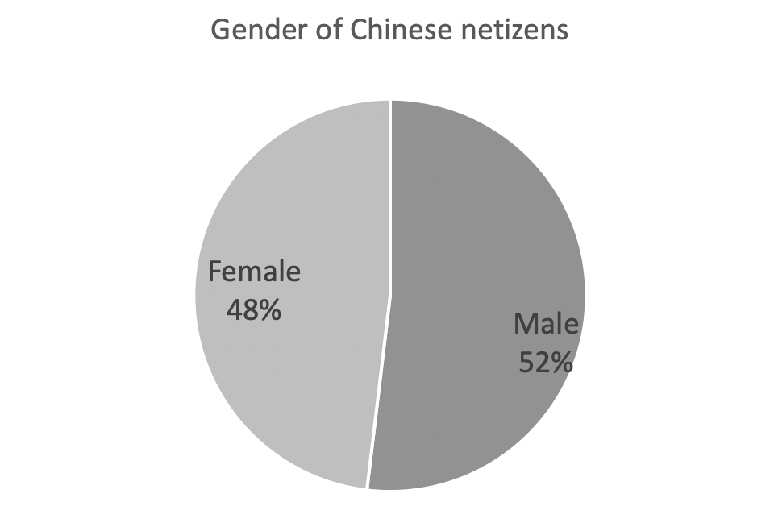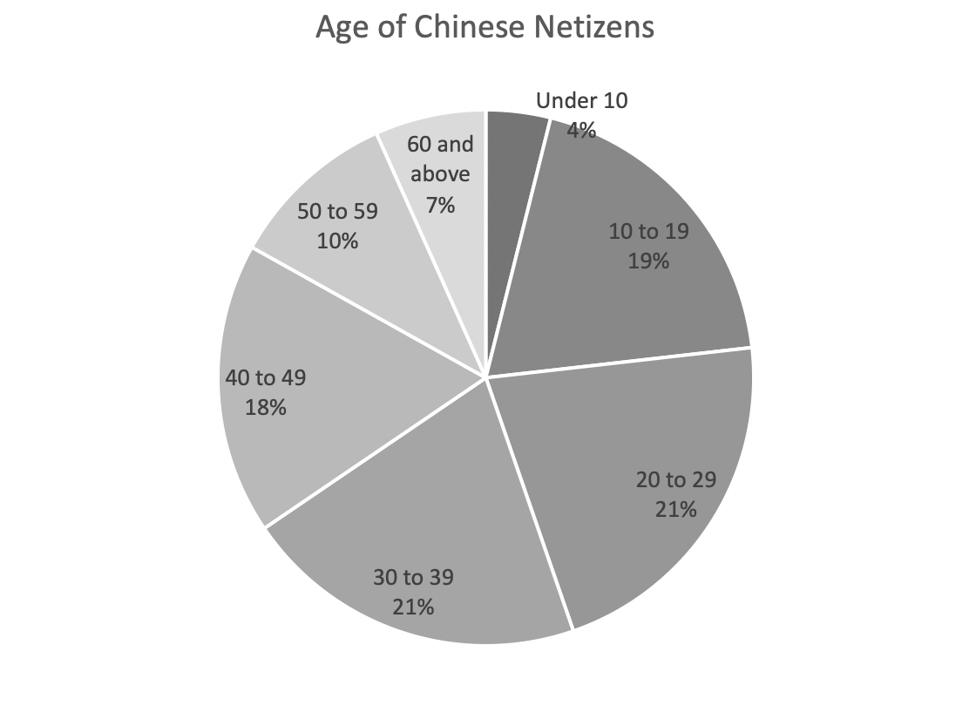
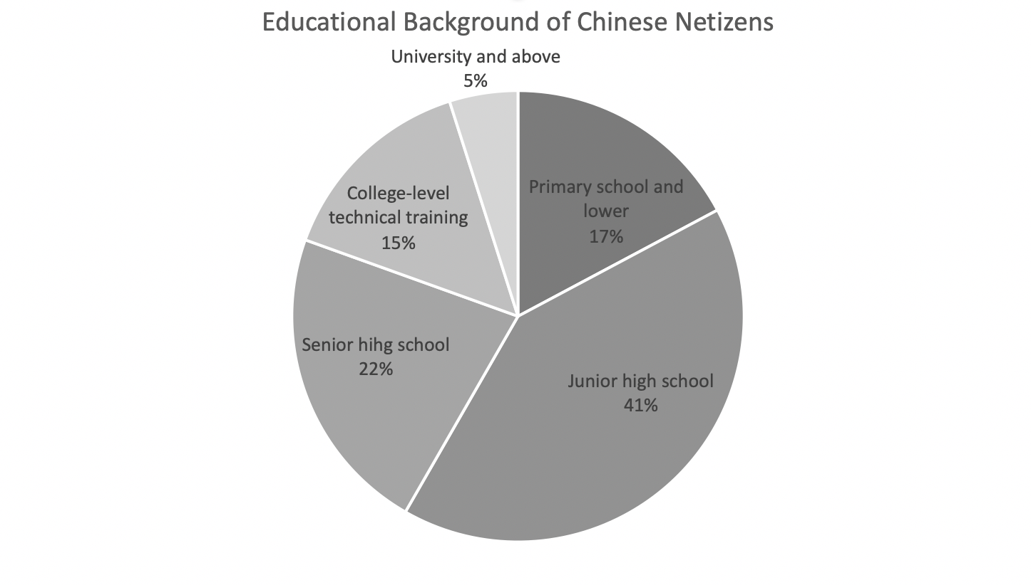
Figure 4: Basic demographic information of Chinese netizens

3.4 Science communication in the Chinese digital media environment
Online science communication also shows varied characteristics alongside the different development stages of China’s digital media environment. This sub-section uses the division of eras into Web 1.0, 2.0, 3.0 mentioned above to analyse online science communication across different periods of the Chinese digital media environment.

3.4.1 Science communication in the Web 1.0 era
In the era of Web 1.0 in China, the development of online digital media platforms happened relatively slowly. But in 2000, the Chinese government launched a ‘Newspaper-Website Interaction’ (Bao Wang Hu Dong) campaign to encourage traditional paper-based newspaper media to create their own websites or open online versions (Zhang, 2000). Under such circumstances, some scientific newspapers began to create their own online editions – this was the first step towards online science communication in China (Yang, 2015). At the same time, the main portals in China, such as Sina, Sohu, and NetEase, also set up science and technology sections on their homepages to provide science and technology news and information. Online science communication at this stage basically maintained the traditional media science communication mode. It merely changed the media for public access from paper to digital, and provided hardly any effective interactive channels. The advantages of digital media platforms for scientific communication were not exploited.

By 2015, except for the very few state-owned large-scale scientific newspapers – such as Chinese Science Times, whose online website (ScienceNet.cn) is still in operation – most of the online websites of scientific newspapers were already in a semi-dormant state, and the ‘Newspaper-Website Interaction’ campaign in the field of science had stalled. Using online scientific newspapers to carry out science communication under the model of ‘Newspaper-Website Interaction’ also had little effect (Yang, 2015). Due to the impact of commercial interests, the science and technology sector of major portals gradually became a platform for promoting technology products, such as analysing the configuration and efficacy of the latest mobile phones or computers, or the market dynamics of technology companies. Although it can also play a role in the communication of science and technology, excessive commercialization has caused the content they present move further away from the original intention of science communication. Ultimately, most of the online science communication in the era of Web 1.0 in China represented just a simple copying of scientific news from traditional media, a lack of interactive modes, a single actor involved in launching science communication, and a limited number of netizens – all of which contributed to online science communication in this period being ineffectively developed, only playing a limited role in the wider society.

3.4.2 Science communication in the Web 2.0 era
During the Web 2.0 era in China, online science communication witnessed a rapid development. First, the emergence and popularity of blogs gave individuals the opportunity and discourse power to participate in online science communication, especially scientists. Sina Blogs and a more professional science blog site, Chinese ScienceNetBlog, provided platforms for Chinese scientists to independently write scientific and popular science articles. The interactive functions of those platforms, such as comments and likes, made it possible for readers and scientist writers to engage in dialogue. By 2009, ScienceNetBlog hosted more than 3,000 active science blogs, providing science popularization content including basic science, biology, engineering, information science, and medicine (Wang et al., 2013).

As well as the emergence of science blogs, this era saw the appearance of some professional science communication websites. Among them, Guokr (Guo Ke) was the biggest and most influential professional science communication website, and it remains so today. Guokr, founded in 2010, was the first professional commercial science online community website in China. The idea behind Guokr combines serious orthodox science with popular culture in the Web 2.0 era. The main sections of Guokr include ‘Scientific Person’, which mainly provides high-quality science popularization articles written by scientists and interviews with scientists, aiming to build a bridge between science and the public; and ‘MOOC School’, which is an open online science study community. Guokr has tried to resist offline science communication activities, such as science lectures. As the most influential science communication website and the biggest science culture brand in China, by 2019 Guokr had more than 20 million active readers per day. The name Guokr has even become synonymous with ‘online science communication’ in the Chinese context (Zhan, 2015).

In the era of Web 2.0 in China, with the emergence of diverse forms of online science communication in the digital media environment, China’s science communication started to integrate. Chinese scientists began to adapt to the use of digital media platforms for conducting individual-based science communication activities, and the actors of science communication effectively expanded. However, even though the Chinese online science communication developed rapidly in the Web 2.0 era, the effect of communication was still limited and conducted in a unidirectional, linear mode. Many Chinese scholars have found that although blog platforms have provided potential interaction for scientists to engage in a dialogue with the public, in practice, few scientists have actively responded to the public’s comments on their blogs. Blogs are more like an online newspaper or magazine for carrying out science popularization writing (Yuan, 2010). Moreover, some Chinese scholars also found that most readers of science blogs are other scientists, thus science blogs only play a role similar to professional scientific journals, which are used to communicate within the scientific community, and the communication effect on the public is very limited (Yuan, 2010). Similarly, science communication on Guokr is centred on scientists, mainly through articles written by them and interviews, and also lacks effective interaction, dialogue and public participation. This pattern of online science communication has been called the ‘Central Broadcasting Model’ in China (Liu, 2009).

3.4.3 Science communication in the Web 3.0 era
In the era of Web 3.0 in China, Chinese online science communication has gradually begun to enter a new era of diversification, interaction and individualization. The development and popularity of various social media platforms has provided unprecedented opportunities for individual scientists to become involved in science communication and create a dialogue with the public, especially since the Chinese government encourages scientists to actively use social media platforms to carry out science popularization work.

On Sina Weibo and Zhihu, online science communication is mostly dominated by individual scientists. Among them, a group of scientists with social influence who are actively engaged in the popularization of science has emerged. For instance, an associate professor of chemistry from the University of Science and Technology of China, Yuan Lanfeng, started his individual science popularization work on Weibo in 2013. To date, he has published almost 50,000 individual science popularization tweets and attracted 2.4 million followers on Weibo. He has also expanded his science popularization work into other digital media platforms, such as Zhihu, since 2015. On Zhihu, he has answered around 500 scientific questions and written more than 1,800 science popularization articles, gaining around 500,000 likes and 200,000 followers. Another example is an associate professor from China University of Geosciences, Xing Lida, who started his science popularization work on Zhihu in 2019. In less than one year he published more than 13,000 science popularization tweets on Weibo and gained more than 4.6 million followers. These two cases illustrate that in the era of Web 3.0, Chinese scientists have begun to actively use social media platforms to carry out science popularization, and their work is appreciated and recognized by Chinese netizens. Yuan Lanfeng even gained an award from the Chinese government as one of China’s Top 10 Science Popularization Figures in 2018 for his science popularization work on social media platforms, which also shows that the Chinese government is paying attention to science popularization by individual scientists in the digital media environment.

Different from Weibo and Zhihu, which are mainly dominated by individual users, on WeChat – the most popular social media platform in China at time of writing – most of the online science communication is based on public accounts operated by professional organisations or communities. Due to the comments function on WeChat, which does not allow non-friends to follow each other, most communication facing the public exists on WeChat in the form of public accounts. In 2015, there were more than 700 active science popularization public accounts on WeChat. Most were run by official institutions, such as the Association of Science and Technology at various levels, science museums, universities, and various scientific societies (Jin et al., 2016). But most science popularization public accounts on WeChat have not successfully attracted audiences: articles with more than 10,000 views accounted for less than 3% of all articles on these science popularization public accounts (Jin et al., 2016). However, the public accounts on WeChat have motivated different organisations, institutions and communities to become involved in online science communication (Wei, 2013).

In the last few years, online science communication has further attempted to use new digital media platforms, such as short video sharing platforms like TikTok. Many individual scientists and science institutions have joined TikTok and published science popularization short videos. By the end of 2019, according to official statistics from TikTok, there were more than 27,000 science communication accounts on the site, which had published more than 5.2 million science popularization short videos in total, whose cumulative playback volume exceeded 500 billion (TikTok, 2020). The popularity of TikTok and the combination of scientific communication on TikTok has changed traditional online science communication’s over-reliance on words. Some scholars even refer to the ‘Dou knowledge’ (Dou Zhi) project, jointly launched by TikTok with the Science Communication Bureau of the Chinese Academy of Sciences, China Science News, and the China Science and Technology Museum in 2019, as the new starting point for China’s visual science communication (Zhu, 2020).

One Chinese science communication professor in Tsing Hua University, Jin Jianbing, identified the following three points about the features of Chinese online science communication in the Web 3.0 era: the structural changes in science communication participants – more individual scientists and members of the public have become involved in the online science communication process; the methods of science communication have achieved great changes, visualization has gradually become a trend, and the possibility of interaction and dialogue is also growing; and scientists’ attitudes towards participating in science communication is slowly changing – the Chinese government and society have increasingly recognized the science popularization work of scientists, and the value of such work for scientists has also increased (Jin et al., 2016).

3.5 Online science communication on Zhihu
Since this project focuses on Zhihu, it is necessary to provide a basic introduction to science communication on the site. Zhihu is the biggest Chinese knowledge-sharing network and has attracted a group of scientists and professional science communicators to answer scientific questions and popularize science. Similar to Quora (Zhihu is often called the Chinese version of Quora), Zhihu is a public-facing platform with no threshold for use. In 2014, Zhihu launched the identity recognition function, which guaranteed the reliability of the identity and authority of the information provided by answer providers on Zhihu. By the beginning of 2020, more than 75% of all users whose identities were recognized were professionals with a scientific education background (Zhihu, 2020). This function also indirectly promoted the popularization of science centred on scientists and professionals. At the same time, there were more than 1,000 active science-related sections on Zhihu, which accommodated almost 1.5 million science-related questions and more than 3 million answers (Zhihu, 2020). Science-related sections have also become one of the most popular fields on Zhihu. According to official Zhihu statistics, its three most popular fields are science, life and history (Zhihu, 2020). It is noteworthy that, even in the science sections, Zhihu is still a public-facing platform, where most of the users on Zhihu are not professional scientists. Other than Guokr, Zhihu has already become the most comprehensive and popular science communication digital platform in China. Because of its knowledge-sharing and social functions, it is easier for Zhihu than for Guokr to create interaction between different groups of people in the science communication process, such as scientists-public; public-public; and scientists-scientists. Some Chinese scholars believe that Zhihu realizes effective interaction and dialogue between scientists and the public in the scientific discussion process (Cao, 2014; Yang, 2016; Ju, 2019). But there are also some Chinese scholars who claim that there is an echo-chamber phenomenon at work in the science communication and scientific discussion process on Zhihu, and the interaction between scientists and the public is not satisfactory (Yang, 2020). The real situation is explored in this project.

Due to the influential science communication on Zhihu and its broad participation, Zhihu’s function of science communication and popularization has also been discovered and valued by the Chinese government. In 2019, the Chinese Association of Science and the Chinese Health Commissions united to launch the ‘Refuting Rumour by Science’ campaign and established a special section dedicated to refuting rumours on Zhihu. Zhihu also extended its science communication function into the offline environment. In 2019, Zhihu launched the ‘Science Season of Awareness Project’ focusing on organising offline scientific lectures, discussions, and training sessions for developing scientists’ communication skills. More than 50,000 professional scientists and science popularization practitioners participated in the event (Yu, 2020). Zhihu as a digital media platform has already begun to recognize its social responsibility for the communication and popularization of science.

3.6 Science communication about GMF in China
Since this project focuses on the science communication and scientific discussion of the topic of GMF in the Chinese digital media environment, it is also necessary to provide a basic introduction to this topic. There are two main reasons for choosing GMF as the example to explore Chinese science communication and interaction between scientists and the public on Chinese digital media platforms. Firstly, GMF is one of the hottest scientific topics in China at present, which involves many people of different identities in the discussion, including scientists, policymakers, government officials, celebrities, journalists, and the general public. At the same time, because the discussion about GMF is still inconclusive, it attracts people’s attention and discussion (Qi and Zhou, 2010). Secondly, since this project explores the potential interaction between Chinese scientists and the public in the Chinese digital media environment, the fields of traditional ‘hard science’ – such as particle physics, with low public impact and mobilization, little controversy among experts, and which are propelled by visible research institutions – may encourage a deficit-like pattern in which the public is not invited and willing to appreciate the spectacle of science’s achievement (Bucchi, 2008, p.71). However, an issue such as GMF – touching many publicly relevant themes including food, safety, biodiversity and resource distribution, with a certain amount of disagreement between experts, propelled by corporate actors in a highly sensitive context, alert and mobilized to questions of environment and globalization – is unlikely to be contained in the deficit model (Bucchi, 2008, p.71). Thus, this topic is more suitable for exploring the relationship and interaction between scientists and the public.

The Ministry of Agriculture of China first introduced two genetically modified papaya breeding factories in 1985. In 1988, China’s anti-virus genetically modified tobacco was commercialized; in 1992, southern China began to plant GM rice in large areas; and in 1997, China began importing genetically modified soybeans. China’s use of GMF started early, but the science communication and popularization of GMF lags behind the practice of GM genes. In the 21st century, due to the widespread use of GMF in the daily Chinese diet, public doubts about GMF began to appear, and the science popularization of GMF was pushed onto the national agenda. The science communication around GMF in the Chinese context has always revolved around the discourse struggle between support and opposition. In 2001, the Ministry of Agriculture of China, in combination with the China Association of Science and Technology, launched the first large-scale national science popularization activity on genetically modified technology aimed at eliminating public concerns about GMF, but this event had little effect. On the contrary, in 2004, Chinese newspaper Southern Weekly, famous for its disclosure and criticism of social issues, published an article entitled, Genetically Modified Rice: Suspense for the Benefits of 1.3 Billion People behind Staple Food. This report claimed that GMF was a risk for human health, and the national government’s vigorous promotion of GMF was driven by its own self-interest. The appearance of this article greatly aroused the Chinese public’s suspicion and panic about GMF, and the Chinese government and scientists then established an alliance to deal with such anti-GM comments in society. In 2012, after the outbreak of the Golden Rice incident, China’s domestic anti-GMF speech reached a climax. In recent years, the alliance by the Chinese government and scientists has increased their control over the GMF discourse and increased the strength and frequency of science popularization of GMF through various media channels. Opinions against genetic modification have declined, but still exist (Jia and Fan, 2015).

In China, there is a struggle between the alliance of scientists, the government and the official media who support GMF on one side, and celebrities such as Cui Yongyuan, the Southern Weekly and other commercial newspapers arranged against GMF on the other. The Chinese public’s attitude towards GMF is still in a state of ambiguity (Sun, 2019). Similar with the early situation of the soil governance in Cumbrian which highly relied on the scientific expertise, the GM governance and even discussion in China still also rely on the scientific expertise (Wynne, 1996). Expertise, which means advanced knowledge or skills in some specific field, and also been placed as contrary to the lay knowledge or local knowledge shared by the public, is indeed important in the discussion and governance of scientific matters, especially some controversial scientific topics. But, just as Wynne (1996), Collins & Evans (2002) have found that relying only on expertise and ignoring lay/local knowledge is not enough to completely resolve controversial scientific issues, and it may even bring some side effects. Such conclusions of justifying lay/local knowledge also remind us that we should re-examine the relationship between scientists and the public, scientific expertise and lay/local knowledge in the discussion and governance of GMF, especially in China, such a context where scientific expertise is highly respected.

Chinese scholars also put forward the following problems in China’s current GM science communication when summarizing why China’s GM science popularization is so tortuous. First, Chinese citizens have insufficient scientific literacy and limited ability to absorb and accept scientific and technological knowledge. Second, most science popularized by scientists on GMF is not popular and easy enough to understand to be accepted by the public. Third, compared to TV celebrities who oppose genetic modification, Chinese scientists who support GMF still have insufficient media exposure. Finally, the emergence of various new media platforms has loosened the Chinese government’s control of GM public opinion, and people who oppose GM have begun to find more space to be heard (Jia and Fan, 2015). Determining the characteristics of science communication on the topic of GMF in China’s digital media environment is one of the questions that this thesis will explore.

3.7 Conclusion and research questions
This chapter has presented the basic history and background information needed to understand the context of the present research: the introduction and development of science in China; the development process of science communication and popularization in China and its current position in the digital media environment; the basic development and status quo of the Chinese digital media environment and its netizens; and finally information relating to the two examples used in this research – science communication on Zhihu, and science communication about GMF. All the information provided in this chapter forms the background for the research and analysis presented in the following chapters.

Combined with the literature review provided in Chapter 2 and the original research intentions discussed in Chapter 1, I propose the following three research questions to help refine the research around science communication in the Chinese digital media environment, focusing on the discourse power and relationship between Chinese scientists and the public:

- RQ1. Has the authoritative position of scientists been challenged in the Chinese online science communication process?
- RQ2. If so, how do Chinese scientists face and deal with such challenges?
- RQ3. How does the interaction between scientists and the public – and in particular, dynamics around science discourse authority – affect the process of online science communication in China?

In the next chapter, I introduce the study’s methodology.

Chapter 4: Methodology

This thesis examines the interaction between the public and scientists in the online science communication process in the Chinese digital media environment, taking the topic of genetically modified food (GMF) on Zhihu as an example. This research takes a mixed-methods approach, incorporating digital ethnography via observation and interviews, critical discourse analysis and digital methods aided by social network analysis. In this chapter, I outline why I chose Zhihu and GMF as examples and how I employed the research methods and collected the data to address my research questions across four sections: case study selection; digital ethnography; discourse analysis; and digital methods. In the last three sections, I show the theoretical and epistemological commitments underlying these methods, the reasons they were chosen, the relevance between the methods and the research questions, the detailed steps of employing the methods, the data collected, the data analysis used and ethical considerations. The design and implementation of the methods used in this project received ethical approval by the Department of Sociological Studies at the University of Sheffield.

4.1 Case study selection: GMF on Zhihu
This study uses Zhihu as the main research object to study online science communication in the Chinese digital media environment. The reason for not choosing more popular social media in China, like Weibo, WeChat, or TikTok, as research objects is because the content production and user behaviour on Zhihu – a professional Chinese knowledge sharing social network platform – are specifically focused on knowledge sharing, which science communication can also be treated as a kind of knowledge sharing activities.

According to Zhihu’s official statistics, there are more than 50,000 topics on the site, many of which are scientific. Since this research explores and analyses the interaction between Chinese scientists and the public on Zhihu, choosing a scientific topic of public concern that is suitable for public participation would better address the research aims. As Massimiano Bucchi (2008) said, some ‘hard science’, such as particle physics, with low public impact and mobilization and little controversy among scientists, may lend itself to a deficit-like pattern in science communication about these topics, where the public is only invited and willing to appreciate the spectacle of science and scientists’ achievements. But issues such as GMF, which touch upon many themes that the public is concerned about – such as food, safety, biodiversity and resource distribution, propelled by corporate actors in a highly sensitive context, alert and mobilized to questions of environment and globalization – was unlikely to be contained in the deficit-like pattern (Bucchi, 2008, p.71). Thus, this study uses the topic of GMF on Zhihu as the main research field, not only because the topic of GMF is very hot in China, but also because the attributes of GMF make it easier to attract public discussion and participation. Additionally, the topic of GMF has not yet reached a consensus in China (see Chapter 2). There is huge disagreement about GMF between scientists and the public and as well as among the public generally, with both groups trying to influence the other. Therefore, the interaction between the scientists and the public exceeds other scientific topics in China (Fan et al., 2013; Wang et al., 2015). In the discussion block of GMF on Zhihu there are more than 200,000 followers. More than 500,000 Zhihu users have participated in discussions on this topic, and there are almost 5,000 active questions and over 20,000 answers in this virtual community. Among these answers, there are 1,000 ‘excellent answers’ – those identified by the Zhihu platform as having the most likes and comments (data correct as of 1st December 2019). This virtual community, on the topic of GMF, has already become one of the most active and popular on Zhihu. In this community, both scientists and non-scientists users are very active, which is helpful for exploring the interaction between Chinese scientists and the public in the digital media environment.

4.2 Digital ethnography
Since this study explores the science communication process and the behaviours of different actors in this process in the Chinese digital media environment, the study first employs the method of digital ethnography to provide an appropriate research perspective. This methodological approach can help to explore two of the research questions raised in the last chapter:
- RQ1: Has the authoritative position of scientists been challenged in the Chinese online science communication process?
- RQ3: How does the interaction between scientists and the public – and in particular, dynamics around science discourse authority – affect the process of online science communication in China?

4.2.1 Introduction to digital ethnography
Traditional ethnography is “a qualitative approach that seeks to develop a bottom-up understanding of the cultural practices of the communities under study” (Hammersley and Atkinson, 1983, cited by Darch, 2014, p.48), and “in its most characteristic form it involves the ethnographer participating, overtly or covertly in people’s daily lives for an extended period of time, watching what happens, listening to what is said, asking questions - in fact, collecting whatever data are available to throw light on the issues that are the focus of the research” (Hammersley and Atkinson, 1995, p.1). Digital ethnography, also sometimes called “virtual ethnography” (Hine, 2000), “network ethnography” (Howard, 2002), “netnography” (Kozinets, 2002), “Internet ethnography” (Sade-Beck, 2004), “cyberethnography” (Dominguez et al., 2007), “webnography” (Puri, 2007; Hjorth and Horst, 2017), is a research approach that applies traditional ethnographic research methods in a computer-mediated communication environment (Androutsopoulos, 2008). In particular, digital ethnography has been widely applied in the fields of digital media studies, communication studies, science communication studies, and Science Technology and Society (STS) (see Berglund, 1998; Trumbo, 1999; Saville-Troike, 2008). According to Bu, digital ethnography is “a research approach using the Internet’s expression platform and interactive tools to collect information to explore and interpret the Internet and related social and cultural phenomena… The obvious difference between digital ethnography and traditional ethnography is the nature of ‘field’” (2012, p.45). In digital ethnography, the practice of fieldwork has changed from a physical space to a virtual discussion community, which has introduced some new media culture such as the Internet and chatrooms into ethnographical studies (Bogdan and Biklen, 2007).

Since the 1990s, ethnographic research approaches have been applied in the field of Internet research, such as studies of the behaviour of Internet users and communication among online communities (Escobar et al., 1994). Many early digital ethnographic studies focused on the construction of online communities and their cultural representations, such as Correll’s (1995) research on a bulletin board intended for lesbians; Thomsen and colleague’s (1998) research on cyber streets; and Ward’s (1999) research on feminist online communities. With the prosperity of the empirical research, the theoretical construction of digital ethnography has also gradually begun to develop. In 2000, Hine systematically analysed digital ethnography from the perspectives of digital ethnography’s cultural background, objects, processes, and ethical issues. According to Hine’s research, “the Internet could be understood in two quite different ways: as a culture in its own right, and as a cultural artefact” (2000, p.29). If the Internet is treated as a culture in its own right, to obtain a deep understanding of this culture from an overall perspective, a more macro cultural research method is required – Hine believes that digital ethnography can effectively meet this requirement (Hine, 2000). Based on this view, Hine elaborated on the possibility and methodology of conducting ethnographic research in the Internet environment (Hine, 2000; Bu, 2012). Since then, digital ethnography has been widely adopted and promoted as a method to understand the importance of the Internet in people’s cultural lives (Bu, 2012).

Similar to traditional ethnography, digital ethnography also pays attention to the relationship and interaction between persons in the field. This kind of attention and research orientation of digital ethnography is helpful to discover the relationship and interaction between scientists and the public in the new media environment.

According to some online ethnography scholars, such as Hammersley and Atkinson’s (1995) and Pink et al. (2015), there are five steps in digital ethnography: 1) defining research issues and survey topics; 2) identifying and selecting communities; 3) community participant-observation and data collection; 4) data analysis and interpretation; and 5) composing and showing findings. The digital ethnography in this project is based on this process, with some adjustments. The research issues and topics have already been defined above, with the online communities on Zhihu as the ethnographic field. The observation was conducted in a multi-perspective way, which will be discussed in the following subsection. The method of interview was also introduced into the digital ethnography research to address the disadvantages of ethnographic observation alone. Some of the ethnographical data was further combined with the method of critical discourse analysis to explore the discourse power relationship among different users in the online science communication process on Zhihu. The research questions proposed above form the research topics of the digital ethnographic research, in particular the relationship and interaction of scientists and the public, and the citizen scientist group in the new media environment. For the data collection process, the project uses non-invasive observation, interviews and other data sources on Zhihu as data resources.

4.2.2 The field of digital ethnography
The field is where ethnographic research takes place. In traditional ethnography, the field always refers to some physical community, such as an indigenous tribe, village or city block. The introduction of digital ethnography changes the understanding of ‘field’: virtual rather than real communities can also become the objects of research. According to some definitions, a virtual community is not one formed by a shared geographical space, but a community founded by common interest (Licklider and Taylor, 1968). The most important factors of virtual community are shared resources, common values, reciprocal behaviours (Rheingold, 1993) and shared rules (Preece, 2000). Because of the lack of material and tangible foundations, questions of whether a virtual community can serve as a site for true ethnographic research have also been raised. Some scholars point out that although a virtual community is intangible, it still provides a good platform for building relationships and social rules that are real and meaningful (Paccagnella, 1997; Lysloff, 2003; Leander and McKim, 2003). On such platforms, social interactions and group structures emerge, and new a subjectivity and group identity may also appear (Lysloff, 2003). This has provided the foundation of and possibility for virtual communities to become the field of ethnographic research. As mentioned above, there are more than 50,000 topics on Zhihu, and not all would be suitable for the purpose of this research; the topic of GMF was chosen as the virtual community to be the main digital ethnography field for reasons discussed above.

4.2.3 Observation
The main realization of ethnographic research is based on observation (Hine, 2000). As mentioned above, this project mainly uses the methods of non-invasive observation and interviews in its ethnographic approach. The first major part of this digital ethnography focuses on observing the online discussion space of GMF on Zhihu. Ethnographic observation can provide a rich descriptive resource and data to explore the discourse and behavioural features of the interaction between scientists and the public and the characteristics of potential battles for discourse power. Furthermore, ethnographic observation can also help to investigate the interaction between scientist users and public users in the online science communication process on Zhihu and the characteristics of these interactions. Such data can effectively help to explore whether the authoritative position of scientists has been challenged in the Chinese online science communication process, as well as how changes with respect to the discourse authority affect the process and structure of online science communication in China.

The discussion spaces are the main sites of interaction between scientist groups and the public and the ideal place to study this relationship. In this digital ethnography, I consistently visited the topic of GMF on Zhihu from September 2018 to December 2019. I logged onto Zhihu every day to observe the new questions, answers, comments, and changes in the numbers of likes that appeared on the topic, and also the replacement of popular answers, and the identity of the main answer providers, paying attention to the interaction between the answer providers and the those who asks the questions and the answer providers and the commenters, the registers and content of the answers. During the observation I mainly focused on the following threads: the actual identity of users; the roles of those users on Zhihu; questions and their changes in topic; the responses to each question; the followers of each question; the active users and their online behaviours; and the online discursive behaviours between those users (see Figure 5). The observation and collection of this data provided information to answer the research questions about the relationship between scientists and the public, the change of authoritative position of scientists, and the possible new group in the science communication process in the Chinese digital media environment.

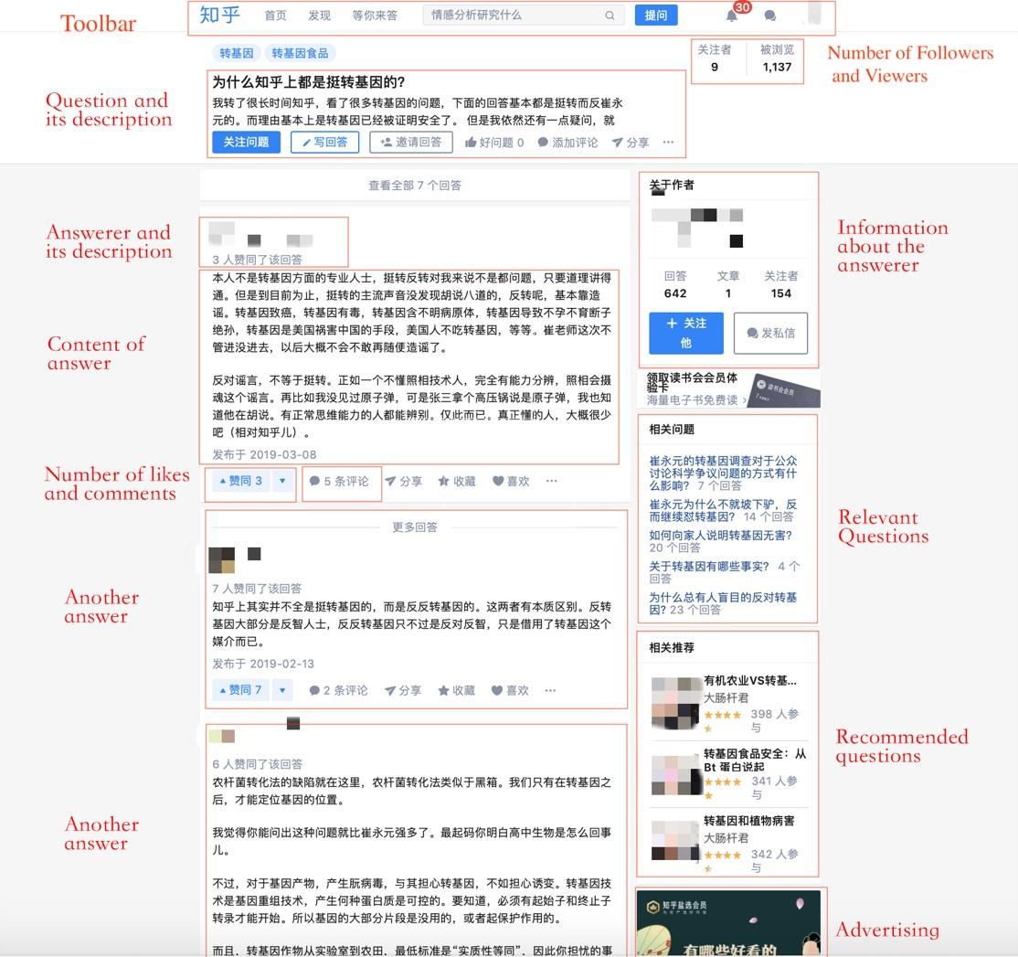

Figure 5: An example of Question Page about GMF on Zhihu

For the observation of public users on Zhihu, this study used three non-scientist users (or, more specifically, citizen science communicators [CSCs] as identified in Chapter 5) as representatives of public users. These three non-scientists were chosen as representatives of CSCs because, even though they do not have professional scientific backgrounds, they still actively participated in the online science communication process as communicators on Zhihu. While there are many such non-scientist users on Zhihu, these three were chosen because they were the most active users who answered questions about the topic of GMF, comparable to the activity of scientist users (Tables 1 and 2).

Table 1: Backgrounds of the three representative CSCs on Zhihu
Username | Educational Background | Current Job
Chiwanjiue | Finance and Insurance | Insurance broker
Yangdi | Sociology | State agency
Louyan | Law | Law student

Table 2: Basic information about the three representative CSCs on Zhihu
Username | Number of Answers | Number of answers in 1,000 answers with the most likes on the topic of GMF | Number of followers
Chiwanjiue | 2,115 | 73 | 36,519
Yangdi | 407 | 13 | 81,335
Louyan | 217 | 11 | 13,242

4.2.4 Interviews
The second part of the digital ethnography research involved interviews. The observation phase of digital ethnography can provide rich descriptive data to explore the discourse features, behavioural features and interactive relationships of scientist users and public users on Zhihu. But ethnographic observation alone could not allow me to explore the motivations, purposes, and feelings of different types of users’ participation in the science communication and scientific discussions on Zhihu. According to Hollway and Jefferson (2000) and other qualitative researchers (such as Remington and Tyrer, 1979; Barriball and While, 1994; Rabionet, 2011), semi-structured interviews can effectively help explore the inner worlds of participants, and thus help to further investigate the rationales, purposes, motivations, feelings and reflections of their specific behaviours. Therefore, semi-structured interviews can effectively make up for the shortcomings of ethnographic observation by providing rich exploratory data.

I interviewed 20 active users of Zhihu who followed the topic of GMF, focusing on their behaviours, motivations, feelings and reflections of their experiences of using Zhihu and participating in science communication and discussion. As this project explores the online science communication process and the interaction between scientists and the public in the Chinese digital media environment, the 20 interviewees consisted of ten scientist users and ten non-scientist users (see Appendix 1 for interviewee information). Among both scientists and non-scientists there were active answer providers and the those who ask the questions and passive viewers. The criteria of interviewees selection are first their liveness on Zhihu, and secondly their identity. The identities of potential interviewees were first determined through their authentication information on their user homepages; I then sent them a message via Zhihu to confirm the accuracy of their identity. For those users with clear identities, I sent them a private message to invite them to participate in this study, along with a project information sheet. Some of the scientist users rejected the invitation to interview. And then I further invited other scientist users until the number of scientist interviewees reaches 10. The users who agreed to participate, both scientist users and non-scientist users signed a consent form. 14 interviews were conducted online, while 6 were implemented face-to-face. All interviews were audio-recorded with the interviewees’ consent.

The interviews were semi-structured and the interview guide was composed of five parts with 23 questions that covered: interviewee demographics; basic behaviour on Zhihu; attitudes towards scientists and their answers on the topic of GMF on Zhihu; relationship between scientists, citizen science communicators and the public on Zhihu; and public scientific literacy on Zhihu (see Appendix 2 for detailed interview questions). During the interviews, I adjusted the order of the questions or added or edited some questions according to the specific answers given by the interviewees. All the interview records have been manually transcripted, and open coded by the researcher with three steps: initial coding, focused coding, and axial coding. The initial coding mainly focused on the characteristics of the interview text itself, the focused coding mainly examined the interview text’s answers to the interview questions and its summary based on initial coding results, and the axial coding mainly examined the interview text’s response to the research questions proposed in the whole project.

4.3 Discourse analysis
As noted in the research questions, one of the main targets of this research explores the relationship, especially the discourse power relationship, between Chinese scientists and the public in online science communication and discussion processes. Discourse analysis – especially critical discourse analysis, one of the most common qualitative research methods for exploring the power relationship between two parties in a dialogue or interaction – can effectively help to investigate the discourse power relationship hidden behind the questions and answers of scientists and public users on Zhihu.

4.3.1 Introduction to discourse analysis
Discourse usually means a spoken or written communication between people, especially serious discussion of a particular subject. In linguistics, it is natural spoken or written language in context, especially when complete texts are being considered (Cameron & Panovic, 2014). Discourse analysis is the analysis of language used and the investigation of what that language is used for (Brown and Yule, 1983, p.2). In 1952, US structural linguist Z. Harris published Discourse Analysis in Language, introducing the term ‘discourse analysis’, which has now been in use for more than 50 years. In research, discourse analysis has provided many new opportunities for researchers to explore social science and humanities issues, recently focusing on the textual perspective (Phillips and Hardy, 2002, p.2). From the perspective of functionalism, ‘discourse’ has been considered to be a language in use, and a natural language that is not restricted by sentence grammar, expressing complete semantic meaning in certain contexts (Halliday and Hasan, 1985). Discourse has also been described as a tool for personal identity representation: “a discourse is a characteristic way of saying, doing, and being. When you speak or write anything, you use the resources of language to project yourself as a certain kind of person, a different kind in different circumstances. You also project yourself as engaged in a certain practice or activity” (Gee, 2004, p.30). In terms of structure and appearance of language, ‘discourse’ is a language unit that is larger than a sentence (Brown and Yule, 1983; cited in Hu, 2007, p.30). In general, the level of language elements can be simply expressed as: morphemes < words < phrases < clauses < sentences < discourse (Brown and Yule, 1983; cited in Hu, 2007, p.30). However, in some cases, only a word can constitute a discourse, such as the ‘Exit’ sign in a train station or ‘no’ in daily conversation. The effective presentation of complete meaning is an important factor for the existence of discourse (Brown and Yule, 1983). In addition, the meaning of discourse is not unilaterally determined by the communicator, nor by the conceptual meaning of the linguistic unit. The meaning of discourse is constructed through the effective interaction of the communicators and the receivers in a specific textual environment (Hu, 2007, p.32). Therefore, the analysis of discourse not only involves the intent of the communicators, but also the understanding process of the receivers, the difference in knowledge background between communicators and receivers, and the context in which the discourse occurs. In this study, discourse on Zhihu has been understood as a kind of social practice in a specific context, which can be analyzed and understood from many different perspectives, such as the discourse strategy, genre, register, discourse style and so on (Wodak & Meyer, 2016)

In the system of discourse analysis, there are many different research approaches, such as rhetorical discourse analysis (RDA), critical discourse analysis (CDA), and multimodal discourse analysis (MDA). In this project, I focused on the approach of CDA, which is a mode of discourse analysis dedicated to exposing how language is influenced by power relations and ideologies, neither of which is likely to be apparent to language users themselves (Fairclough, 1992, p.12). Different from RDA and MDA, CDA is more inclined to focus on relationships, especially the asymmetric relationships between the different sides of discourse (Fairclough, 1992). For example, Harvey and Koteyko applied critical discourse analysis in their study of the asymmetric positions between doctors and patients in clinics (2012, pp.7-37). Such an approach has also been used in the science communication and science journalism field by scholars like Pieczka and Eschoar (2013), who used CDA to explore the dialogical relationship between scientists and the public in the British science policy-making and public engagement process and found that the equally dialogical relationship between scientists and the public is less common in the science policy-making process. In CDA, “the concept of discourse is linked to the broader constructivist view” of social reality, which postulates that social texts do not merely reflect phenomena and processes that pre-exist in the social and natural world, but rather they actively construct them (Lupton, 1998; cited in Harvey and Kotoyko, 2012, pp.138-139). This view of CDA is valuable for studying the discourse power relationship between scientists and the public in the online science communication process, and also the changes in this kind of relationship in the Chinese digital media environment.

4.3.2 Analysis scope
In discourse analysis, defining and choosing the scope of discourse is crucial. Different research focus on analysis scope. For example, interactive sociolinguistics tends to focus on the non-linguistic features in discourse analysis (Gumperz, 1982); and communicative ethnography focuses on the discourse behaviours and interactive behaviours in discourse analysis (Zhu, 2003). Since the CDA used in this study was mainly conducted in a network virtual environment, it is hard to observe non-linguistic features in those discourse events. The critical analysis in this thesis focuses on the linguistic features of questions and answers in the topic of GMF on Zhihu, such as language structure, presentation style, language norms and genres, the relationship and behaviours of discourse formed by questions and answers in the topic of GMF, and the network environment of those discourse events.

4.3.3 Analysis framework
In 1989, Norman Fairclough introduced a framework for critical discourse analysis consisting of four parts: integrated text analysis; discourse production; analysis of distribution and consumption of discourse; and social-cultural analysis of discourse events. Fairclough suggests that each discourse event can be regarded as a three-dimensional composition: text (including spoken or written language); discourse practice (including production, distribution and interpretation of discourse); and social-cultural practice of discourse. Therefore, the CDA process must include three directions: text analysis; analysis of the production, distribution, and consumption of text; and social-cultural analysis of discourse events (see Figure 6) (Fairclough, 1989).

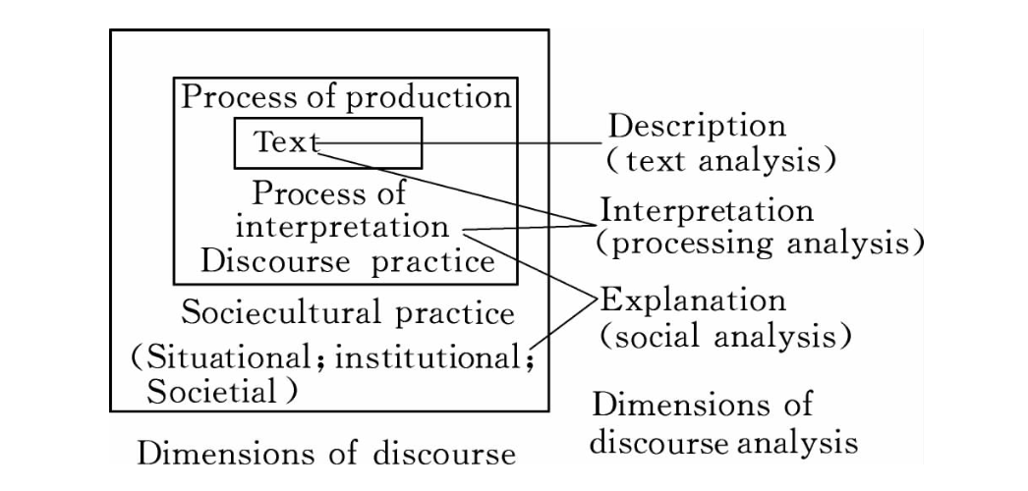
Figure 6: Fairclough’s Framework of Critical Discourse Analysis

Based on Fairclough’s framework, Van Dijk further developed a detailed framework of CDA (Hu, 2007, p.186). In Van Dijk’s framework, CDA should include three parts – social analysis; cognitive analysis; and structural analysis – and each can also be subdivided into several approaches (see Table 3) (Van Dijk, 1993). The CDA employed in the present study follows this framework to analyse the discourse events in the topic of GMF in Zhihu. However, it should be noted that not all analysis aspects will appear in all individual discourses. The CDA conducted in this project focuses on some special analysis aspects according to the situation of each element of individual discourse. The social analysis and social cognitive analysis in cognitive analysis have been provided in the Introduction and Literature Review parts as the background of specific analysis of the answers provided by scientists and non-scientist users in the GMF discussion on Zhihu. The personal cognitive analysis in cognitive analysis and structure analysis parts in Table 3 with some specific cases will become the practical analysis framework used in the specific critical discourse analysis, especially in the analysis of how scientists answer the question of how to construct the boundary between themselves and the public via their GMF answers.

Table 3: Discourse analysis framework
Analysis aspects | Subdivided aspects
Social analysis | Social structure analysis
 | Organisational relationships analysis
 | Organisational structure analysis
Cognitive analysis | Social cognitive analysis
 | Personal cognitive analysis
Structural analysis | Surface structure analysis
 | Grammar analysis
 | Word-canonical analysis
 | Local semantics
 | Comprehensive semantics

4.3.4 Analysis sample
Since this project explores the discourse power relationship between the public and scientists in the online science communication process on Zhihu, discourse analysis was also conducted separately with different identities. For public users on Zhihu, the findings of the digital ethnography were used to select three typical citizen science communicators to conduct a discourse analysis of the questions and answers they provided on the topic of GMF on Zhihu (see Tables 1 and 2). According to the information collected from their homepages and statistics of the 1,000 answers with the most likes on the topic of GMF, they had all answered a large number of questions – some already had the most popular answers on the topic of GMF – and they also had large groups of followers on Zhihu, which meant that they were influential and valuable for studying citizen science communicators on the site.

In addition, 30 answers were randomly selected from scientists and users from the 1,000 answers with the most likes and comments on the topic of GMF on Zhihu to explore the discourse feature of scientists and non-scientists in the online science communication process. To achieve this random selection, the answer providers of those 1,000 excellent answers were identified as scientists, non-scientists or neither (those that could not be clearly determined or were non-personal accounts), according to the information provided on these answer providers’ homepages, and finally 30 answers were separately selected from the databases by simple random sampling (see Appendix 3 for detailed answer information).

4.4 Digital methods
The research questions hypothesise that there may be a struggle between Chinese scientists and the public over the discourse authority in their interactions in the online science communication process. It is thus necessary to measure the interaction and potential struggle between the Chinese scientists and the public on Zhihu. Therefore, social network analysis, as an effective method for measuring various indicators of interactive networks, was used in this study.

4.4.1 Introduction to digital methods
‘Digital methods’ does not refer to a single research method but is a general term for a class of research methods. According to Richard Rogers’s identification, a digital method is not only a toolkit for Internet research, or operating instructions for a software package; it deals with broader questions, such as how we can study social media and wider society (Rogers, 2015). In particular, digital methods are those that use web-native techniques for research into cultural change and societal conditions (Rogers, 2015), such as use of online and digital technologies to collect and analyse data relating to a social phenomenon. Similar to Rogers’s understanding, Hutchinson (2016) also identifies digital methods as “a term that seeks to capture a recent development in Internet-related research, summarized as approaches to the web as data set” (Hutchinson, 2016, p.1). Digital methods serve as a collection of various Internet-based research methods (often social media-based), including text-mining, big-data, network, sematic and sentiment analyses.

As mentioned above, in this project, I use social network analysis (SNA) to measure the interaction between scientist users and the public on Zhihu. As Zhang and Leung (2015) note, SNA has already become an important and inevitable research method in studying social interaction in recent years. Network analysis is the process of investigating social structures using networks and graph theory. It characterizes networked structures in terms of nodes (individual actors, people, or things within the network) and the ties, edges, or links (relationships or interactions) that connect them (Borgatti, 1998; Borgatti et al., 2009). Through the measuring and visualization of such social relations, we can more effectively understand the interactive relationships between different social units, as well as their aggregation, alienation, centrality and other characteristics. Because of this, SNA is increasingly being applied in the study of the relationship between different units in the digital age, especially in the field of communication and new media culture studies (for example, Kwak et al., 2010; Cheong and Cheong, 2011; Ceron et al., 2014).

Secondly, since one of the main aims of this project is to explore the relationship between scientists and the public in the new media environment, social network visualization analysis can provide a more intuitive and quantitative perspective to examine this kind of relationship and effectively compensate for the potential deficiencies of the above qualitative research methods (discourse analysis and digital ethnography). Furthermore, SNA can also help explore the online science communication or scientific discussion process on Zhihu from an interactive and structural perspective, as Bandyopadhyay and colleagues wrote, SNA “serves as a powerful tool for the identification of changes in a pattern of social structure” (2011, p.5).

When SNA is used to analyse social relations and the structure of those social relations, there are some key measures to consider, such as density, centrality, and clustering. Each term can show the different characteristics in the network of social relations (De Laat et al., 2007). Such terms are also the focus of consideration in this project: the SNA was conducted in the following order, as detailed below: data collection from Zhihu; network construction; network visualization; and user classification.

4.4.2 Data collection
In this project, I used the cross-platform computer programming language Python to create a web crawler to collect all the data from September 2019 on the topic of GMF on Zhihu. A web crawler is a computer programme that can automatically grab information from the Internet using certain rules (Thelwall, 2001). I used open-source toolkits within Python to help set up and run this web crawler, including ‘requests’, ‘BeautifulSoup4’ and ‘json’. The ‘requests’ toolkit helped to implement the ‘http’ requests, while ‘BeautifulSoup4’ and ‘json’ toolkits helped extract information from the ‘http’ obtained database. In particular, the web crawler used in this project implemented the following basic functions: simulated login in Zhihu, crawling user basic information (such as username, ID, gender and homepage address), crawling basic information of each answer (such as the question the answer answered, basic information about the answer provider, the number of likes and comments, the content of each answer, basic information about each commenter, the content of each comment), and finally accessing data in an .xlsx file.

4.4.3 Network construction
Since this research explores the interaction and relationship between scientists and the public and the structure of such interactions on Zhihu, the interaction data could be extracted from the data collected. On Zhihu, there are three main interactive functions among users: likes, comments and mentions (@ function). Since Zhihu does not provide personal information such as usernames or the ID of the users who like each answer, this project mainly focuses on the other two forms of user interaction on Zhihu: comment and mention.

The mention function is an important interactive tool that can be employed by users to build relationships and is always used to draw attention to or engage in conversations with other users on Zhihu. This kind of interaction is often based on users’ active behaviours. Therefore, analysing the network based on the mention function used in the topic of GMF on Zhihu can help to explore the interactive relationships among different users.

In addition to the mention function, the comment function is frequently used for building interactions on Zhihu. In the section about GMF on Zhihu, as of 25th March 2019, there were 64,195 comments, which means there were 64,195 instances of interactive relationships. To control the volume of data and increase the possibility of defining the identities of users, the comment-relationships in the 100 answers with the most likes on the topic of GM food were further collected.

But a network analysis based only on the 100 answers with the most likes on the topic of GMF on Zhihu may be not big enough and could contain bias, since most of the praised answers have similar discourse characteristics, such as a large number of words and a combination of pictures and text. To control such bias, the network based on comment relationship was extended to all answers on the topic of GMF on Zhihu. Through the SNA described above, the data came from three networks: the mention network of all GMF discussion on Zhihu; the comment network of 100 answers with the most likes on the topic of GMF on Zhihu; and the comment network of all the answers on the topic of GMF on Zhihu.

According to the different types of ties, Borgatti and colleagues (2009) divided the network into four basic types: similarities network (based on location, membership, attribute); social relations network (based on kinship, other roles, affective, cognitive); interaction (e.g., sex, talk, advice); and flows network (e.g., information, beliefs, personnel, resources) (pp.893-894). Both the mention network and comment network on Zhihu are interaction networks mainly based on users or nodes’ active behaviour.

4.4.4 Network visualization
All the networks mentioned above based on the mention and comment functions were created and visualized in Gephi_0.92 using ForceAtlas2 force-directed layout algorithm provided by Gephi, “an open source software for graph and network analysis, it uses a 3D render engine to display large networks in real-time and to speed up the exploration and provides easy and broad access to network data and allows for spatializing, filtering, navigating, manipulating and clustering” (Bastian, Heymann and Jacomy, 2009, p.361). ForceAtlas2 in Gephi is “a force directed layout: it simulates a physical system in order to spatialize a network. Nodes repulse each other like charged particles, while edges attract their nodes, like springs. These forces create a movement that converges to a balanced state. This final configuration is expected to help the interpretation of the data” (Jacomy et al., 2014). Although there are other default layout algorithms on Gephi, ForceAtlas2 can most effectively and intuitively present the interactive relationship between nodes in the networks, and its visualization results are considered to be the most adapted with the calculation results of node centrality (Jacomy et al., 2014).

4.4.5 User classification
The users appearing in the networks on Zhihu were classified as scientists, non-scientists and unknown according to both the users’ self-descriptions on their Zhihu homepages and the content of the answers they provided and the questions asked. The ‘scientist’ identity here relates to those users who have at least a master’s degree in a scientific discipline and are now engaged in science-related work. The master’s degree was used as the bottom line for identifying a scientist because in China most science students need to spend three years completing their master’s degree and spend most of their study time on laboratory work. Most need to publish academic papers in peer-reviewed journals in order to apply for their master’s degree. After such master’s training, most Chinese science master’s students are considered competent for basic work in scientific research or laboratory settings. Such work and study experience make it easier for those science students with a master’s degree to be accepted and recognized as scientists by both others and themselves.

Users often include their educational experience and career on their Zhihu homepage (see Figures 7 and 8). If they also upload evidence such as their diploma or certificate of enrolment, Zhihu will further mark them as ‘Blue Star’ users (with a little blue medal on their homepage) which means the information about those users’ educational background and career on their homepage has been verified. In this research, information about users’ educational background and career and whether they were a Blue Star user was used as the main criteria for defining their identity as scientists.

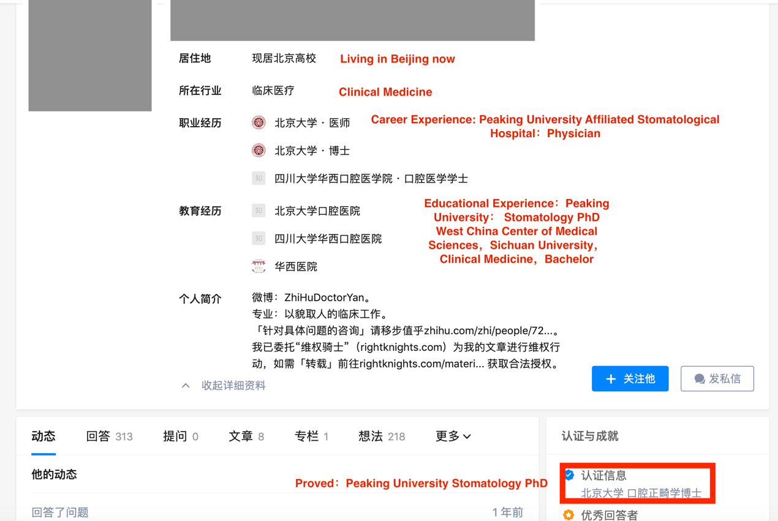
Figure 7: Example of proven scientist users’ Zhihu homepage (1)

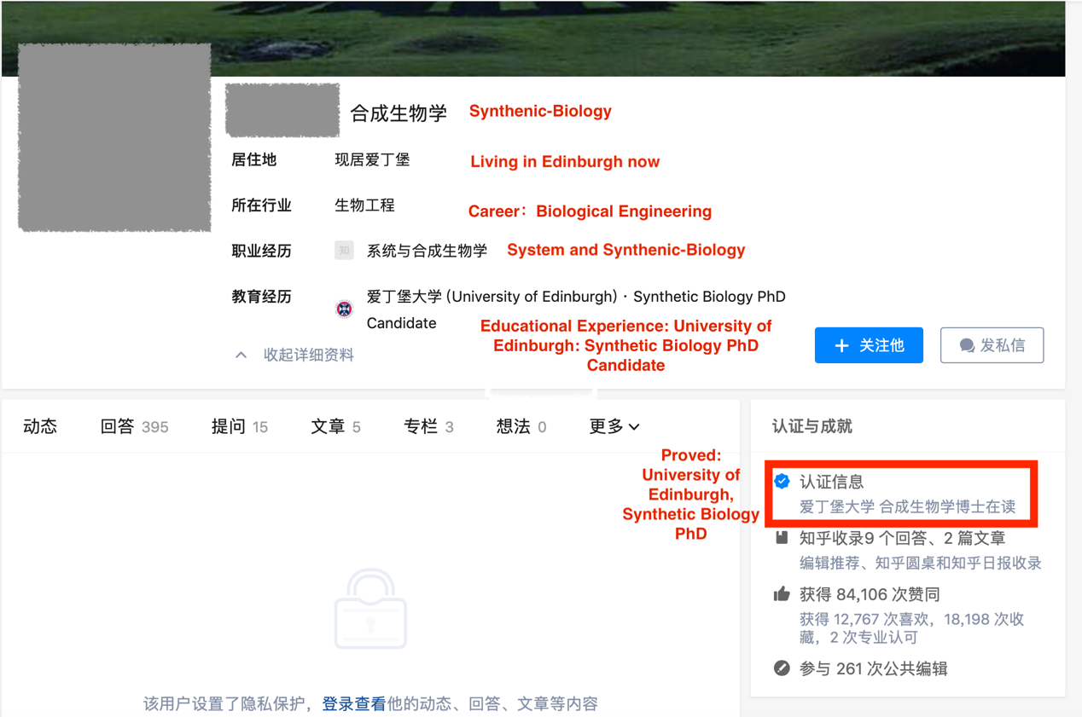
Figure 8: Example of proven scientist users’ Zhihu homepage (2)

For those users who did not write anything about their educational background or were not a Blue Star user – constituting a very small part of all sample users in this research – all the answers and questions they provided on Zhihu were read, and as long as they provided evidence to prove their credentials, their identities were further defined. For example, although the following answer provider did not write anything about their educational background and career on their homepage, in their answer they revealed their educational experience, which was further proven by the scientific jargon they used, thus this user was categorised as a scientist.

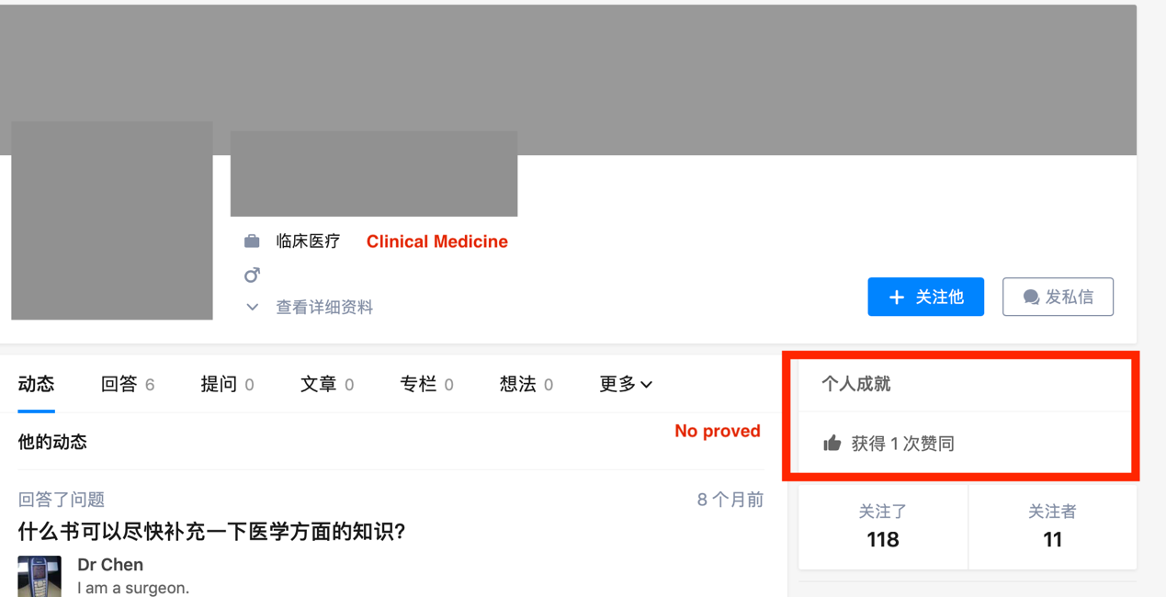
Figure 9: Example of unproven users’ homepage

I have not systematically researched the neural mechanisms of sleep. But the possible phenomenon found in this study is understandable. In the past 10 years, one of the most popular brain networks of brain neuroimaging – the default memory network DMN, has been found in patients and normal people to perform tasks, it is negatively activated, and it is very active in quiet state. I think we can already guess the existence of a more precise division of labour from here (Answer provided by the above user).

For those users who did not indicate their educational background or career on their Zhihu homepage and did not provide any relevant information in the answers they provided, their identity was marked as ‘unknown’.

4.4.6 Network measures
In this part of social network research, I tested the discourse power situation of scientists and the public during their interaction process on Zhihu. A node’s power is defined by its centrality within the network (Vicari, 2014, p.7), and the most central nodes decide what the correct information is and send this information back out to the other nodes (Borgatti et al., 2009, p.892). Thus, centrality is seen as one of the most important indicators of the social capital and discourse power of a node (Borgatti et al., 1993; 1998; 2009). In other words, the more central a node is in the network, the more social capital it will have. As Brass (1984) observed, the attributions of individual nodes, such as centrality, are linked with their power and influence in the network.

In measuring the centrality of nodes, the three sub-indicators – degree centrality, betweenness centrality and closeness centrality – are considered to be the most commonly used and effective (Leydesdorff, 2007; Opsahl et al., 2010). In SNA, degree centrality of a node refers to the number of adjacencies in a network. Betweenness of a node relies on the identification of the shortest paths and measures the number that passes through that node. Closeness centrality of a node is defined as the inverse sum of the shortest distances to all other nodes from that node (Opsahl et al., 2010). In the following analysis sections, these three indicators are used to compare the social capital and discourse power of scientist and non-scientist users on Zhihu and further test whether those distributions are balanced. The centrality automatic calculation function of Gephi was used to this end. Since the node capacity of the mention network is limited, the following analysis Chapters will mainly focus on the two comment networks.

4.5 Ethical considerations
This project employed a range of analytical techniques that raise distinct ethical issues. Firstly, the digital research, including digital ethnography and social network analysis, was fully considered within the context of Internet research ethics. Zhihu is an open online knowledge-sharing community. According to its regulations, all statements posted on Zhihu are public and can be used for non-commercial purposes. While the platform policy considers this data to be public, in this research, this data has also been treated as personal and followed ethical practices in protecting individual’s rights to privacy, such as avoiding unnecessary disclosure of personal information and deleting any potentially sensitive content. For digital ethnography, especially with the three representative citizen science communicators, before launching long-term observation of their online behaviour on Zhihu, an information sheet and consent form were sent to them electronically. After their consent was given and documents were signed, digital ethnographic observation and data collection were carried out. The information sheet provided the participants with sufficient information to understand the implications of the project and clarified their responsibilities and powers when participating. It further specified the potential harm that participants may experience in participating and specific response measures. The consent form asked ten questions in detail to determine the specific use and exposure of the participants’ wishes for their data (see Appendix 4 and 5 for information sheet and consent form). With their consent, the three representative citizen science communicators’ real Zhihu usernames are used in this thesis. Other users’ usernames shown in the digital ethnography analysis, discourse analysis and social network analysis have been anonymized. All information that may reveal the identities of the participants, such as avatars and personalized signatures, were also obscured in the thesis. The original words of the participants were translated from Chinese into English and paraphrased in the thesis.

Before the interviews were conducted, online invitations with information sheets and consent forms were sent to the potential participants. After obtaining their signed consent forms, the interviews were carried out, and all 20 interviewees agreed to be recorded during the process. During the analysis and presentation of the interview texts, the names of the interviewees were replaced by their surnames. Because there are many common Chinese surnames, this treatment effectively protected the privacy of the interviewees and also distinguished between them in the text.

This project received ethical approval from the University of Sheffield, Department of Sociological Studies, before any research was conducted (reference number: 023021).

Chapter 5: The Public Challenge to the Discourse Authority of Scientists: Citizen Science Communicators on Zhihu

In the literature review and introduction chapter, I argued that Chinese science communication and public engagement with scientific discussion are experiencing rapid transformations and development, and the digital media environment has played an important role in this process. In this chapter I will focus on the challenges that Chinese scientists’ discourse authority is facing in the online science communication process on Zhihu. From the online ethnography research, I have found that such challenge mainly comes from the ‘intervention’ of a special group of the public on Zhihu in the role of science communicators that was originally monopolized by scientists. I call this group ‘citizen science communicators’ (CSCs).

This chapter focuses on the role of CSCs in the science communication process on Zhihu. I analyse the empowerment of the public in the process of online science communication and scientific discussion, the interaction between scientists and non-scientists, and the new features of science communication in the digital media environment. By exploring this group’s online behaviour and discourse characteristics, I will further try to analyse the Chinese public’s challenge to the discourse authority of Chinese scientists in the online science communication process on Zhihu. This chapter is mainly based on the findings from the online ethnography. The method of critical discourse analysis is also used in this chapter to explore the discourse features of CSCs’ answers on Zhihu. As discussed in the Methodology Chapter, the discourse analysis framework adjusted from van Dijk (1993) focusing on the people’s cognition, self-identity, and discourse power has been used here to help to explore the discourse feature of the science communication led by CSCs and also their self-cognition about their identity and power relationship between themselves and scientists. The theories of participatory culture and discourse authority of science discussed in the literature review are used in this chapter to help with understanding CSCs’ online behaviour and discourse features in discussing genetically modified food (GMF) on Zhihu. In the following sections, the identity of CSCs and their popularity on Zhihu is first examined, then their online behaviour and discourse practices, and finally their impact on the discourse authority of scientists and the online science communication system.

5.1 CSCs on Zhihu
CSCs are defined here as a specific type of citizen scientist. As discussed in the literature review, the idea of the citizen scientist refers to those members of the public who collect and/or process data as part of a scientific enquiry in citizen science projects (Silvertown, 2009). Although this concept originally referred to members of the public who were directly involved in the scientific research process, as the concept developed, its connotations gradually expanded to refer to those citizens who actively take on various responsibilities of scientists, including scientific research and other societal science-related responsibilities, such as communicating science-related knowledge (Patel et al., 2016). In this project, the main concern is the societal responsibility of scientists to communicate and disseminate scientific knowledge or science-related information, rather than their scientific research responsibility.

Therefore, the term CSCs is used to specifically refer to those citizens who have no traditional scientific background or are not currently engaged in any scientific employment, but who actively undertake scientists’ societal responsibility to communicate and disseminate scientific knowledge or science-related information to other publics on digital platforms like Zhihu. When emphasizing the initiative and importance of the public in the science communication process, the focus is often on the ‘feedback’ they provide as the audience of science communication, rather than on their role as scientific information communicators (Bubela et al., 2009). This chapter, instead, employs the label of CSC to refer to those Zhihu users who do not have a traditional scientific background but who try to answer GMF-related questions and engage with science discussions as communicators on Zhihu. In order to help get a better understanding of which users can be called CSCs on Zhihu, the following two examples are provided.

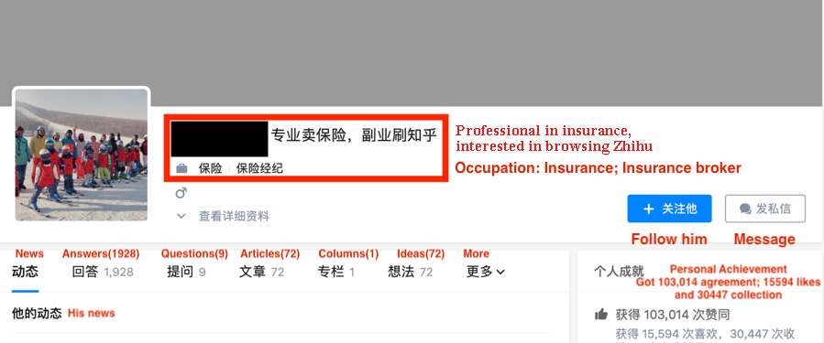
Figure 10: An example of a CSC’s Zhihu homepage (User A)

Based on the information provided on the homepage of Zhihu User A (Figure 10) (whose username has been anonymized), it is clear that their educational background is related to ‘finance’ and ‘insurance’, which are not traditionally scientific pursuits. And according to the self-introduction on this homepage, which says “Professional in insurance and amateur in Zhihu”, User A’s employment is not science-related, which indicates they are not a typical scientist. However, User A widely participates in discussions on scientific topics such as GMF on Zhihu. For instance, in Figure 11, User A answered the question “Can genetically modified food really solve hunger in the world?” In their answers, they first clarified that “Genetically modified (new food technology) is not to solve the problem of hunger, but to increase the population of the earth to a higher level in a more harmonious and environmentally friendly manner, such as from 7 billion to 8 billion, 10 billion or even 20 billion.” They used figures and other evidence from the United Nations’ World Population Prospects report as support. User A is not a traditional scientist, but they try to answer the science-related question using second-hand data with a basic scientific answer mode using data and resources. To competently address this question, one should have expert knowledge in the area of food science or food biotechnology. However, this user has no relevant academic background, although his answers still provide rich information and receive many (142) likes. Therefore, when such users provide relevant scientific information and answers to other members of the public as ordinary citizens with no scientific background, and actively undertake scientists’ traditional responsibility to disseminate scientific-related information to others, they can be called CSCs.

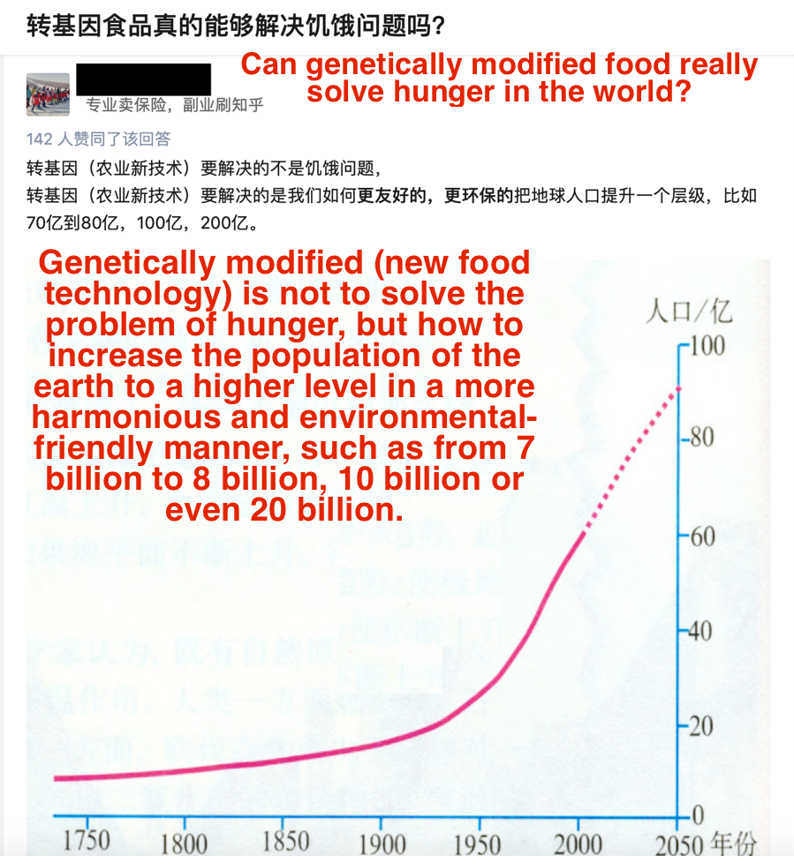
Figure 11: An example of CSC’s answer (User A)

User B in Figure 12 is a law student at Santa Clara School of Law. They answered the question “How to explain genetically modified technology to old women in a simple way?” on Zhihu and received many 399 likes (Figure 13). To address this question, a user might be expected to have expert knowledge in the area of food science or food biology. But User B employed a comparison and storytelling method to express the information they knew about genetically modified rice and Chinese agronomist Yuan Longping and further conveyed a positive attitude towards GM technology and food to other users on Zhihu.
Figure 12: An example of a CSC’s homepage (User B)

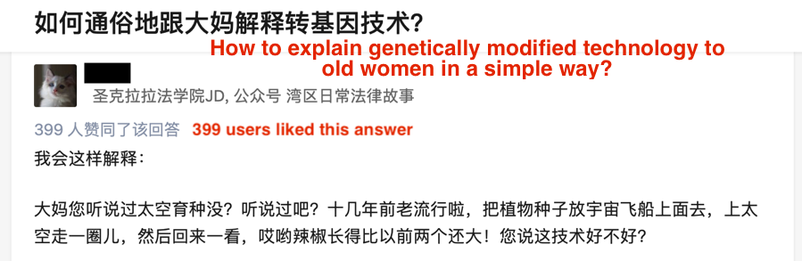
Figure 13: An example of a CSC’s answer (User B)

The online behaviours of the above two example users can be considered as a new form of ‘public engagement with science’, making them typical examples of CSCs on Zhihu. It is also worth noting that CSCs on Zhihu are still a part of the general public without a scientific background from a demographic point of view.

5.2 The popularity of citizen science communicators on Zhihu
Through the statistics of different types of users on the Zhihu platform, it is found that it is not rare for answers that enjoy great engagement (through likes) to be provided by CSCs. Taking the 1,000 answers with the most likes on the topic of GMF on Zhihu as examples, only 270 answers were provided by users with scientific backgrounds. In other words, CSCs contributed almost 70% of those answers with the most likes about GMF on Zhihu (some answers were written by media organisations rather than individual users and some answer-providers’ identities were difficult to clarify, marked as NULL in the upcoming tables). This data shows that CSCs are highly involved in scientific knowledge-sharing as communicators on Zhihu.

Further investigation on the topic of GMF on Zhihu (Table 4) found that the number one active answer-provider, who answered the most questions in the section of GMF on Zhihu, was also a CSC. Calculating the ratio of CSCs and scientists among all the most active answers, the proportion of scientists (48%) is only a little higher than that of CSCs (36%) (Figure 14).

Table 4: Identities of the 30 most active answer-providers on the topic of GMF on Zhihu
Username | No. of answers | CSC/ Scientist | Username | No. of answers | CSC/ Scientist
Username1 | 73 | CSC | Username16 | 9 | S
NULL | 50 | NULL | Username17 | 9 | CSC
Username2 | 29 | CSC | Username18 | 7 | S
Username3 | 18 | CSC | Username19 | 6 | CSC
Username4 | 16 | S | Username20 | 6 | S
Username5 | 14 | S | Username21 | 6 | CSC
Username6 | 13 | CSC | Username22 | 6 | S
Username7 | 12 | CSC | Username23 | 5 | NULL
Username8 | 12 | S | Username24 | 5 | NULL
Username9 | 11 | NULL | Username25 | 5 | CSC
Username10 | 11 | S | Username26 | 5 | S
Username11 | 11 | S | Username27 | 5 | S
Username12 | 10 | S | Username28 | 5 | CSC
Username13 | 9 | CSC | Username29 | 5 | S
Username14 | 9 | S | Username30 | 5 | S
Username15 | 9 | NULL

Figure 14: Proportion of different identities of the most active answer-providers on the topic of GMF on Zhihu

Such a difference in proportion also exists in the group of most popular answers with the highest number of likes on the topic of GMF on Zhihu. Among the 50 most popular answers, defined by the number of likes and approvals by audiences, 23 were provided by scientists and 19 were written by CSCs. The top three most popular answers were all written by scientist users rather than CSCs.

Figure 15: Proportion of different identities of the answer-providers of the most popular answers on the topic of GMF on Zhihu

Table 5: Identities of the answer-providers of the hottest answers on the topic of GMF on Zhihu
Answer code | Number of likes | Identity of answer-provider | Answer code | Number of likes | Identity of answer-provider
1 | 87,000 | S | 26 | 21,000 | CSC
2 | 85,000 | S | 27 | 21,000 | S
3 | 82,000 | S | 28 | 21,000 | CSC
4 | 68,000 | CSC | 29 | 19,000 | NULL
5 | 66,000 | CSC | 30 | 18,000 | S
6 | 52,000 | CSC | 31 | 18,000 | NULL
7 | 52,000 | CSC | 32 | 16,000 | S
8 | 49,000 | S | 33 | 16,000 | CSC
9 | 46,000 | S | 34 | 15,000 | CSC
10 | 44,000 | CSC | 35 | 15,000 | CSC
11 | 43,000 | S | 36 | 14,000 | NULL
12 | 39,000 | CSC | 37 | 14,000 | S
13 | 38,000 | NULL | 38 | 14,000 | CSC
14 | 35,000 | S | 39 | 14,000 | NULL
15 | 34,000 | CSC | 40 | 14,000 | S
16 | 33,000 | NULL | 41 | 14,000 | S
17 | 27,000 | S | 42 | 13,000 | CSC
18 | 26,000 | S | 43 | 13,000 | CSC
19 | 25,000 | S | 44 | 13,000 | S
20 | 24,000 | S | 45 | 12,000 | S
21 | 24,000 | CSC | 46 | 12,000 | S
22 | 23,000 | CSC | 47 | 12,000 | NULL
23 | 22,000 | CSC | 48 | 11,000 | S
24 | 22,000 | NULL | 49 | 11,000 | S
25 | 21,000 | CSC | 50 | 11,000 | NULL

All the data above indicates that among the scientific topics on Zhihu, such as GMF, CSCs play an active role as communicators. But their influence and popularity are still less than those of scientist users on Zhihu in terms of their contribution to the volume of answers. According to previous research, users on knowledge-sharing networks such as Zhihu tend to give their likes to the answers they trust (Wang et al., 2016; Jin et al., 2018). Therefore, the likes given by audiences to the answers of CSCs show that such answers are trusted. Such public trust, in turn, also provides discourse power and legitimacy for CSCs to participate in the online science communication process as communicators on Zhihu.

5.3 Three representative CSCs and their discursive practices
As discussed in Chapter 4, I carried out a one-year ethnographic observation of the topic of GMF on Zhihu. Through this long-term ethnographic observation, I not only found that CSCs are very active and popular on Zhihu, but also that they share a set of common characteristics. To expand on this, the coming sub-sections focus on three CSC users: Chiwanjiue, Luoyan, and Yangdi. It is worth noting that these users do not just play the role of CSCs, and their answers are also not all science-related – they also played the role of communicators in other non-scientific sections, as well as audiences on Zhihu. In online ethnography, the observed objects can have multiple identities at the same time, but observers often need to focus on one specific identity (Hine, 2011). In this study, although these three users also played a role as audiences, they were mainly observed and studied as CSCs on Zhihu. There are three reasons for choosing these users. First, according to the information collected from their homepages and statistics about the 1,000 answers with the most likes on the topic of GMF on Zhihu (see Table 6), they all answered a large number of questions and some were among the most popular answers on the topic of GMF, and they also had a large number of followers on Zhihu.

Table 6: Basic information about the three representative CSCs on Zhihu
Username | Number of Answers | Number of answers in 1,000 answers with the most likes on the topic of GMF | Number of followers
Chiwanjiue | 2,115 | 73 | 36,519
Yangdi | 407 | 13 | 81,335
Louyan | 217 | 11 | 13,242

Second, these users are all typical of CSCs on Zhihu. As mentioned above, they are all actively engaged in discussion and providing answers on the topic of GMF on Zhihu and have also created some very popular answers in this field, which makes them eligible for the title of science communicators on Zhihu. Third, their educational background and jobs are all non-science-related (Table 7). The different non-scientific fields of their professional backgrounds make it possible to obtain more varied and different perspectives when conducting the online ethnographic observation.

Table 7: Backgrounds of the three representative CSCs on Zhihu
Username | Educational Background | Current Employment
Chiwanjiue | Finance and Insurance | Insurance broker
Yangdi | Sociology | State agency
Louyan | Law | Law student

During the online ethnographic observation process, this study focused on the three CSCs’ online behaviours in terms of asking and answering questions, giving likes, and making and replying to comments. In the online environment, especially the knowledge-sharing network based on questions and answers, the text level is one the most important levels, because most of the online behaviours exist in the form of written expressions (Hine, 2011). Therefore, the online ethnography also focused on the textual and discourse level of the CSCs, especially the textual and discourse level of their answers on Zhihu.

5.4 CSC discursive practices on Zhihu
The analysis above provides a preliminary understanding of the popular status of CSCs on Zhihu. The following subsection explores the online behavioural and discursive practices of this group using the three CSCs as examples. Through the long-term online ethnographic observation, the online behaviour of the three CSCs on the topic of GMF on Zhihu were shown to demonstrate five main features: 1) humorous expression; 2) multiple-perspective discussion; 3) trust through group identity; 4) iterative problem-solving; and 5) active commitment to science communication.

5.4.1 Humorous expression
Science communication (also known as science popularization in China) in the traditional media environment is taken seriously in the Chinese context (Yang et al., 2015). Scientists are expected to produce correct and objective scientific knowledge to pass on to the public through various media platforms. Although some scientists or media occasionally use humour when conducting science communication, the communication itself and the whole science-discourse is still taken very seriously in China. For example, The Chinese Society for Science and Technology Journalism claimed that “Science communication is not a trivial matter. It should be serious and rigorous. Normative and scientific nature should be the first priority of science communication” (Zeng, 2007); and The Chinese Social Science News published a paper suggesting that science communication should use the infectious power of the human spirit to spread rigorous and serious scientific knowledge (Zhou and Han, 2017).

In recent years, although many scholars have begun to emphasize the interest and readability of science communication content in taking advantage of digital media platforms (for example, Baram-Tsabari and Lewenstein, 2013), the seriousness of science communication is still deeply rooted among Chinese scientists. Chinese scholars have found that, even on social media platforms such as Sina Weibo, when scientists are engaged in personal science communication (independent of media translation), they still tend to use a serious tone (Wang et al., 2018; Li and Jin, 2019).

On Zhihu, CSCs are mostly involved in science communication and scientific discussion in a non-serious manner on the topic of GMF. Humour is the most prominent feature of their non-serious discourse expression in these CSCs’ scientific issues-related answers:

GMF is too cheap, Bengong only buys expensive ones, not the right ones. (Question: How to gracefully reject GM? Answer-provider: Chiwanjiue).

Oh, my dear aunt, have you ever heard of space breeding? What? You never heard that before? It was really popular more than a decade ago. Put the seed of the plants on the spaceship, go for a walk-in space, and then come back, take a look. Guess what? Oh my god, that pepper is twice as big as before. Do you think this technology is good? (Question: How to explain genetically modified technology in an easy-understanding way to middle-aged women? Answer-provider: Luoyan).

The humour used in the exaggerated tone or teasing in these examples would normally be considered by Chinese scientists and many scholars as not serious enough and thus inappropriate for science communication or discussion (Wang et al., 2018; Li and Jin, 2019). Furthermore, the humour in these three CSCs’ answers is not only reflected in their textual content, but also in the visualizations they use, such as the ‘emoji package’. In the Chinese context, the phenomenon of ‘emoji package’ means that people use pictures of popular celebrities, cartoons, and movie screenshots as materials and sometimes matching text to express specific emotions.

(Question: Is GMF safe? What are the advantages and disadvantages of them? Answer-provider: Chiwanjiue)
Figure 16: Humorous emoji-pictures used by CSCs in their answers

Chiwanjiue used the emojis pictures in Figure 16 in his answers on Zhihu to express his incredulous emotions when seeing comments that went against genetic modification. These emojis pictures are exaggerated and have obvious humorous intentions in the communication process and would normally be considered inappropriate in traditional science communication. According to research on pictures used in Chinese science communication, most of the pictures used in Chinese science communication content are either professional scientific images (such as cell structures) or photos of scientists in white coats working in the laboratory (Wang and Tang, 2013; Chai et al., 2014). This type of visual expression is more normally considered to have the ability to show the preciseness and authority of science ,which is also considered more suitable to be used to represent the image of science when communicating science to the public under the traditional science popularization model (Wang and Tang, 2013).

The use of slang or sayings is also considered to be a means of humorous expression in Chinese, especially enigmatic folk similes (Xiehouyu) (Rohsenow, 1991). According to Shu (2015), the use of Xiehouyu and other folk sayings in Chinese can have ‘humorous’ and ‘smart’ effects. But because of the humour of Xiehouyu, they are not considered serious enough for use in official settings, such as the traditional science popularization process. However, on Zhihu, such humorous folk sayings and Xiehouyu have been widely used by the three CSCs in their science-related answers. For instance:

Which plant gene can be affected by crossbreeding? No one knows. Just like all blind cats run into dead mice (even a blind squirrel finds a nut every now and then). If you do not run into a dead mouse, that means you’ll waste time and money. (Question: How to explain genetically modified technology using an easy-understanding way to middle-aged women? Answer-provider: Chiwanjiue).

When you can only eat meat in the Spring Festival, do you care whether the meat you eat comes from free-range pigs or pigs that grew up on feed? Do not take up the bowl to eat, put down the chopsticks and say some dirty words (Behave as a gentleman while the dishes are being served; Swear like a bully when the dinner is over! No treat, no civilization!) (Question: How do you view the Guangzhou reporter’s behaviour of resignation and eating 100 days of GMF? Answer-provider: Yangdi).

Similar to Xiehouyu, using broad analogies would also normally be considered an unserious means of expression in the Chinese traditional science popularization process. In the view of traditional science popularization in China, science should be accurate and true, with its pursuit to convey the accuracy and truth of science to the public. Although the media occasionally uses some simplifications or metaphors in their ‘science paraphrasing’, such behaviour has been criticized by scientists for damaging the accuracy of science (Gregory and Miller, 1998). The use of analogy is considered to damage the accuracy and correctness of science in the science communication process, especially when using common concepts from daily life as analogies for profound scientific concepts. However, in the answers provided by the three CSCs on Zhihu about the topic of GMF, such ‘unserious’ analogies are widely used:

Risks need to be faced, which is human nature. But if we just wanted to avoid all risks, we would not have fallen from the trees in ancient times. Those who find lions in the grass and those who don’t let people down from the tree are not the same thing. (Question: How will people evaluate Yongyuan Cui, if science proves the disadvantages of GMF decades later? Answer-provider: Chiwanjiue).

When it comes to GMF, I think there is a metaphor that makes sense: a group of people walk blindfolded, and a person runs with their eyes open. Which one do you think is safer? (Question: How do you see the genetic modification? Answer-provider: Yangdi).

More extreme humorous and non-serious expressions that use metaphors or analogy on Zhihu are known as ‘shaking clear’ (doujiling, a Chinese phrase similar to producing humour) (Jin et al., 2017) by Chinese netizens. Such doujilinng expressions usually answer questions in unexpected ways with few sentences, thus creating humorous or unexpected effects. Not directly answering scientific questions in this way is also considered to be unsuitable for use in the science communication and popularization process. For instance:

The hazards: the IQ of a large group of people is exposed, affecting the money bag (income) of organic food suppliers. (Question: What are the tangible proven hazards of GMFs? Answer-provider: Chiwanjiue).

Can’t give this world to someone you despise. (Question: Is there any point in arguing with Cui Yongyuan on the Internet? Answer-provider: Yangdi).

GMF is too cheap, Bengong only buys expensive ones, not the right ones. (Question: How to gracefully reject GM? Answer-provider: Chiwanjiue).

The above-mentioned expressions all reveal a common discourse feature of these three CSCs’ answers on Zhihu: humour and non-seriousness. Although these answers were not purely scientific, they played a role in conveying certain scientific information and different perspectives of thinking about the issue of GMF. As a new form of science communication, the answers of these three CSCs on Zhihu deconstructed the seriousness of science and science communication. Such deconstruction makes these three CSCs’ answers more digestible and audience friendly. China has always emphasized that “science popularization is the process of the continuous socialization and popularization of science and technology” (Chen, 2014, p.80), and to realize this process, the serious scientific context must be deconstructed. However, in the context of deified science, science communication in traditional Chinese media is still conducted in a serious style, and most of the scientific communication texts written by individual scientists on digital media platforms also emphasise the seriousness of science. However, on Zhihu, such ‘exclusive legitimacy’ of scientific serious discourse in science communication has been challenged and deconstructed by CSCs and their humorous science communication and discussion discourse. The popularity of CSCs and the wide public acceptance of their answers (shown through likes) also indicates that this kind of non-serious discourse in science communication and discussion is also acceptable to public users on Zhihu. These acceptable non-serious discourse characteristics further help CSCs without a professional scientific background to fight for their legitimacy as science communicators, which was originally firmly controlled by scientists through serious discourse.

5.4.2 Multi-perspective discussion

In traditional science popularization or scientific discussion in China, only ‘science’ has the right (or exclusive legitimacy) to interpret issues related to science. Other aspects related to these issues are often suppressed by science and then ignored. And ‘science’ in China is overwhelmingly understood as natural and health science, rather than social science or humanities (Chen, 2013). However, as the issue of GMF shows, it is clear that this issue is not only related to science but involves many other factors, such as people’s livelihoods, food culture, economy and politics. But in the Chinese context, many non-scientific perspectives on GMF have been ignored in the science popularization process, where science is over-magnified. For instance, Xinhua News Agency, one of the most important and influential news agencies in China, reported that: “genetic modification is a scientific issue” (2015). According to Chinese scholars, most of the current GMF reports in China, whether published in traditional or digital media, take a scientific point of view, explaining the scientific principles of GMF or involving scientific discussions about GMF. Most of the figures who appear in such reports are scientists in biology, agriculture or related natural science fields rather than experts from other disciplines (such as Jiang, 2012; 2018; Chen, 2013). However, following Helliwell and colleagues’ analysis of the non-scientific dimensions of the discourse of genome editing in the Western context (Helliwell, Hartley, Pearce, 2019), such a scientific ‘monopoly’ on the discussion and communication of GMF topics on Zhihu has also been deconstructed to some degree in the three CSCs’ discussions, in both the questions asked and the answers they have provided.

Among the 159 questions proposed by the three CSCs on Zhihu (Chiwanjiue: 29; Luoyan: 15; Yangdi: 115), 28 were related to the topic of GMF. Among these GMF questions, none was proposed from a purely scientific perspective – such as asking about the scientific principles of genetically modified crops or the nutritional components of GMF using scientific terms – but instead used multi-angle and non-scientific perspectives, such as “Once genetically modified crops enter the Chinese market and are grown on a large scale, will it not only be used to make feed?” (proposed by Luoyan) and “On the same day, Cui Yongyuan announced the opening of non-GMF company, and a group of young people released a GMF documentary. How to evaluate both sides?” (proposed by Yangdi). Most answers by the three CSCs discussed science-related issues on Zhihu from different perspectives, involving some scientific content, but such content was not the main topic of the answer. For instance, from the perspective of policy:

The food issue is a national strategic issue, as is the strategic position of oil in industry. Grain reserves and petroleum reserves and strategically prominent in any country. To achieve a basic well-off in China, food must also be basically self-sufficient… You and us cannot do an experiment and write an article to prove scientifically that GM is harmless. But we need to understand the value of GM from other perspectives… According to the data from the Development Research Center of the State Council, by 2020, the food demand will reach 548.87 million tons based on 1.43 billion people. By then, China’s domestic food supply gap will be 40 million to 50 million tons. Genetically modified crops can just fill such a food supply gap. (Question: Why should us promote genetically modified crops? Answer-provider: Chiwanjiue).

From the perspective of history:

The Donglin Party in Chinese history is precisely the group of people who were most active and interested in the scientific knowledge brought by Christians and missionaries in the late Ming Dynasty. It is estimated that they will also take the initiative to accept GMF, if they were in today. (Question: Are there some similarities between the people who do not support GMF and the Dongling Party in Ming dynasty? Answer-provider: Chiwanjiue).

From the perspective of culture:

Many Chinese people accept Chinese medicine, maybe because their names are romantic and friendly, such as Angelica (Danggui), Sedum (Jingtian) and Xuchangqing. They all have a kind of Chinese culture in them. Especially Chinese culture has a special good feeling for plants growing out of the land. But for synthetic western medicine, most of them have a cold name, such as ‘azole’ or ‘amine’, which is difficult to be directly accepted in culture level by Chinese. (Question: Is genetically modified rice eatable? Answer-provider: Yangdi).

From the perspective of philosophical logic:

Cui Yongyuan made a logic mistake: selective bias in the selection of interview subjects. Judging from his edits, he basically selected only those who were opposed to GM, and most of those who agreed to GM were not interviewed by him. (Question: Is GMF safe? What are the advantages and disadvantages of them? Answer-provider: Luoyan).

From the perspective of entertainment and gamification:

Just like this game screenshot, when humans first lit the ‘agricultural’ technology tree, they began to violate the laws of nature. (Question: Genetically modified crops violate natural laws, and organic agriculture is good? Answer-provider: Chiwanjiue).

Figure 17: Videogame screenshot used by CSC in their answer

The non-scientific discussions about GMF by the three CSCs above were also accompanied by non-scientific questions on the topic of genetic modification. Among all the questions corresponding to the sample answers above, more than half were non-scientific questions.

According to the online ethnography, all of the non-scientific questions corresponding to all sample answers were proposed by non-scientist users on Zhihu. This suggests that the public is indeed concerned about non-scientific aspects of the GMF topic. They further transformed their concerns about non-scientific perspectives into questions on digital platforms, such as Zhihu. This has further led to discussions among CSCs. Even when faced with scientific questions, the three CSCs still try to find alternative ways to answer from a non-scientific perspective. For example, the question: Is genetically modified rice edible? This question should arguably be analysed from a scientific perspective concerning whether GMFs are physiologically harmful. However, in the samples, CSC Yangdi answered this question from the perspective of Chinese culture and gained many likes, which shows that the Zhihu audience also accepts this kind of interpretation from a non-scientific perspective.

While broadening the discussion dimension of GMF, the non-scientific discussions about GMF by the CSCs above also effectively deconstructed the exclusive legitimacy of scientific discourse in interpreting GMF. The popularity and widespread acceptance of CSCs shows that users on Zhihu also accept this kind of interpretation of GMF from non-scientific perspectives, which further indicates that scientific discourse led by scientists is no longer the exclusive legitimate discourse to communicate or discuss GMF topics on Zhihu. Other non-scientific discourses which are easier for non-scientist users or experts in other non-scientific fields to draw on have also gained legitimacy to be recognized by other users on Zhihu. This also means that the discourse authority enjoyed by science/scientists through the construction and maintenance of the exclusive legitimacy of scientific discourse to interpret science-related topics has also been challenged and deconstructed by CSCs and their multi-dimensional discussions of GMF.

5.4.3 Establishing trust through group identity
According to Tomas Gieryn’s boundary-work theory, the discourse authority of science and scientists is based on their being distinguished from non-scientists, especially the public, in the science communication process (Gieryn, 1983; 1999). Scientists have shown a condescending attitude in science communication practices (Huckin, 2002), especially in the Chinese context, due to the deification of science and the bureaucracy of science and technology management (Kim, 2000), thus scientists and the public have already formed a clear identity boundary. This boundary has also mutually reinforced China’s scientist-centric, one-directional ‘science popularization’ model, thus an insurmountable identity gap has formed in Chinese science communication: scientists are the only group considered to be worthy of being communicators, and the public can only be the audience. However, on Zhihu, the emergence and popularity of CSCs has gradually changed this identity gap in online science communication. The popularity of CSCs means that the public accepts, trusts and likes their answers, and their answers received many likes and signs of agreement (through comments) on Zhihu. Such popularity brings the CSCs as a new communicator group more discourse power on Zhihu. The CSCs’ answers demonstrate that CSCs think of themselves as part of the public. This attitude is mainly reflected in two ways in their answers: their experiences as ordinary persons; and their use of personal pronouns.

Expressing answer-providers’ personal experiences as ordinary persons could effectively resonate with wider audiences. By expressing such ordinary experiences, rather than using scientific discourse, the CSCs’ identities as part of the public in their minds is also better reflected:

Because you’ve never been poor. When I was little, I was so poor that I couldn’t afford enough food to eat. And I also couldn’t afford fresh vegetables in my daily life. Therefore, the greatest contribution of GMF is to provide rich food sources for the poor people on the whole world. (Question: What is the value of GMF? Do we really need GMF? Answer-provider: Chiwanjiue).

As anyone who has owned a dog knows, dogs cannot eat chocolate. Because dogs cannot metabolize theobromine in chocolate. (Question: Is GMF safe? What are the advantages and disadvantages of them? Answer-provider: Luoyan)

The use of personal experiences that are similar to those of the general public rather than science practitioners or professional science communicators frequently appears in the answers of these three CSCs, which could reflect their idea that they think of themselves as part of the general public. However, what best reflects the attitude of these CSCs as a part of the public is their use of personal pronouns, especially plural personal pronouns, such as ‘we’, ‘us’ and ‘you’, which can effectively reflect the identity attributes that the author holds when speaking. In these three CSCs’ answers on Zhihu about GMF, they make heavy use of plural first-person pronouns to refer to a wider group that they consider themselves part of, along with the audience:

If the food is not tested as unsafe, then we, the public, can juts treat it as safe. (Question: Whether the idea of guilty inference can be applied to GMFs? Answer-provider: Chiwanjiue).

First of all, what our people (laobaixing) call ‘there will be problems later’, in biology, it mainly means ‘enrichment utility’. (Question: How to objectively evaluate the speech content of "Banmen Axe Genetically Modified" released by Cui Yongyuan Weibo? Answer-provider: Yangdi).

What the genetically modified technology can bring about is a full in price of food. In fact, most ordinary people like us benefits the most from it. After all, we have to face the price of food every day. (Question: Whether the idea of guilty inference can be applied to GMFs? Answer-provider: Luoyan).

The use of such plural first-person pronouns, as well as some Chinese special plural personal pronouns, such as laobaixing (ordinary people), indicates that these three CSCs see themselves as part of the public. The identity gap between communicators and audience in these three CSCs’ science-related answers has been dissipated to some extent.

However, regarding and showing themselves as part of the general public without a professional scientific background could cause problems for the CSCs’ answers, in terms of conveying the credibility of the information provided in their answers. Some scholars point out that the public’s trust in the information provided by science communication does not actually depend on the context of science communication but relies more on the identity of communicators as scientists (Schafer, 2016; Irwin and Horst, 2016; John, 2018). In addition, terminology used in science communication that is difficult for the public to understand is also believed to earn the public’s trust by creating “cults of unintelligibility” (Merton, 1973). Especially in the Chinese context, due to the deified status of science, such technical terminology earns the trust of the Chinese public. However, these three CSCs neither have or demonstrate the identity of scientists that the public’s trust depends on, nor are they used to using scientific terminology in their answers. But the answers provided on Zhihu’s Q&A platform by these three CSCs still convey their opinion to the audience and try to convince them to believe such opinions. In science-related topics on Zhihu, since it is impossible for these CSCs to depend on their identity or rely entirely on the use of scientific terminology, a new discourse system has been developed by these CSCs to prove that their answers are trustworthy.

The first part of this discourse system relies on deified science. The use of scientific discourse and terminology or the endorsement of professional scientists in their answers are still effective ways for these CSCs to provide credibility for their answers on Zhihu, which is more evident in Yangdi’s answers:

PRSV (papaya ringspot virus) or PLDMV Papaya mosaic potexvirus are mostly transmitted by aphids. The papaya without genetically modifications are easily to die. Therefore, there is basically no unmodified papaya in the world now. (How to objectively evaluate the speech content of "Banmen Axe Genetically Modified" released by Cui Yongyuan Weibo? Answer-provider: Yangdi).

Cui Yongyuan’s logic is kind of chaotic, such as ‘some of you have similar opinions with me, so all of you are deceiving us.’ I really want to discuss the mathematical concepts of intersection, complementary set, subset, proper subset with him. (No.14, Question: How to objectively evaluate the speech content of "Banmen Axe Genetically Modified" released by Cui Yongyuan Weibo?).

Because very few people really understand this scientific principle, many of them will question the authenticity of this information. I learned this information from a Research Fellow in Guangzhou Research Institute of Agricultural Sciences, and I have also verified it by myself. So, it is worthy to be believed. (No.14, Question: How to objectively evaluate the speech content of "Banmen Axe Genetically Modified" released by Cui Yongyuan Weibo?).

However, the use of scientific discourse or terminology only exists in limited numbers in the three CSCs’ answers, especially in the answers of Chiwanjiue and Luoyan. Most of the answers of these three CSCs on the topic of GMF on Zhihu did not use any professional scientific expressions. Even when scientific jargon has been used, it is not always used professionally, or it is difficult to understand. Most jargon used include common scientific terms, such as concepts from high school textbooks. For example, the concept of ‘set’ (集) in the second example above is a concept that all Chinese high school students would learn and master in their first year of high school, and thus not a particularly obscure scientific concept for most Zhihu users. Therefore, compared with a traditional science communication context or the answers provided by scientists on Zhihu, these CSCs’ answers do not have any advantage in using scientific terminology, although using such scientific discourse can indeed provide a certain degree of credibility of their answers, especially with science-related topics.

In addition to using professional scientific jargon, these three CSCs also try to use professional terminology or official data from other disciplines to convince audiences of the reliability of their answers on Zhihu. As mentioned above, the three CSCs have different academic backgrounds and employment fields. Although they are not experts in the field of science, they may be experts in their own areas. This allows them to use their professional terminology or data to provide evidence for their answers:

A large amount of corn and soybeans in China are imported from the United States. Source of information: (http://www.Goukr.com/article/ 438078/?luicode=10000359). The various strategies of the United States have already shown their will to control China’s rise. When the food economy of a country is valued by other countries, how much confidence can this country adhere to its principles? (Question: Is it difficult to prove that GMFs are safe? Identity of answer-provider: postgraduate student on economy, Answer-provider: Chiwanjiue).

For the determination of the safety of GMF, it should follow the Principle of non-retroactivity of law. The government should propose New safety standards, and GMF and pharmaceutical products should follow them accordingly. (Question: Whether the idea of guilty inference can be applied to GMFs? Answer-provider: Luoyan).

These non-scientific professional discourses can also provide some credibility to the answers, especially when endorsed by a more authoritative source of information. When the topic is science-related but not purely scientific, such as GMF, the effect of these non-scientific professional discourses is even more significant.

The use of personal experience and logical deduction without scientific evidence are also common methods to provide credibility employed by the three CSCs on Zhihu. According to Schweiger (2000), providing detailed personal experience can be an important source of credibility in the communication process. Detailed descriptions can provide a more intimate sense of reality to the audiences. Such discourse techniques are widely used by the three CSCs when discussing the topic of GMF:

I can’t afford salmon since I was little, but now if you provide free genetically modified salmon, I can eat you to be bankrupt. Why use salmon as an example? Because it’s too expensive, I really can’t eat it as I want. (Question: How do you view the Guangzhou reporter’s behaviour of resignation and eating 100 days of GMF? Answer-provider: Chiwanjiue).

Pure harmless cannot be obtained, this is only a logical concept, not a realistic possibility. Therefore, such a view that "any kind of food must prove itself to be harmless, otherwise it cannot be eaten by ordinary consumers" is confusing logic. (Question: Whether the idea of guilty inference can be applied to GMFs? Answer-provider: Yangdi).

The examples above show that the three CSCs have used a system of discourse techniques that are different from the sources of credibility that traditional science popularization relies upon. Whether relying on non-scientific professional discourse, personal experience or other discourses, these CSCs have deconstructed the discourse features that traditional science communication relies on to persuade their audiences of the veracity of their arguments. The popularity and wide acceptance of the CSCs and their answers show that the discourse means that they used in their answers have proven effective in attracting other public users’ trust. This shows that the identity of scientists or using scientific discourse is not the only way to gain audiences’ like and trust in the current science communication process in the digital media environment. Non-scientists such as CSCs on Zhihu can also utilize a rich range of discourse or online behavioural tools to support their answers or discussions on science-related topics, such as GMF. As discussed in Section 5.2, users tend to give likes to the answers they trust (Wang et al., 2016; Jin et al., 2018); the widespread appearance of CSCs and the popularity of their answers on Zhihu also shows that this non-scientific discourse means of persuasion is accepted and trusted by audiences in the science communication process in the digital media environment.

5.4.4 Iterative problem-solving path
In the traditional science popularization process, the public, as audience, only have very limited discourse power and space. Scientists, as original ‘exclusively legitimate’ scientific information communicators, control the discourse power in this process (Huckin, 2002; Burns et al., 2003). Even in the digital media environment, which is believed to have the ability to empower the public and give them some discourse space in the science communication process (Jensen, 2010), due to the discourse power monopoly of scientific knowledge by scientists and the deification of science and scientists in China, it is rare to see the public’s suspicions, inquiries, and reflections on the science communication carried out by scientists. For example, under the following answer provided by an associate professor in physics at the University of Science and Technology of China on Zhihu about the topic of GMF, a whole page of the comments made by other users on Zhihu feature praise and approval of the articles, and the remaining comments are complementary towards those scientists’ statements, such as “With reason!”, “Yes, just like @XXX said, in Newton’s era, the archbishop criticized Newton as a non-believer”, “Your answer is really good”, and “I really agree with you.” There is almost no doubt or objection made about the content or veracity of this scientist’s answer.

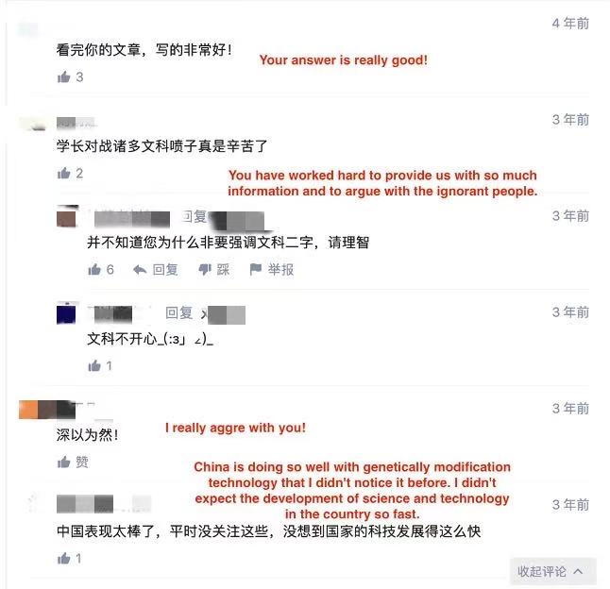
Figure 18: Replies to scientists’ statements on Zhihu (1)
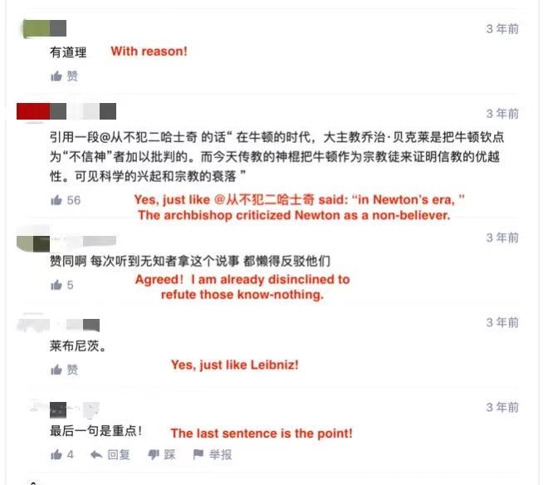
Figure 19: Replies to scientists’ statements on Zhihu (2)

But under the answers provided by the three CSCs on Zhihu, a quite different situation is presented: an iterative problem-solving path. As mentioned earlier, CSCs’ answers to science-related questions are often not just taken from an articulate scientific perspective. In addition, CSCs are also naturally ill-equipped with the discourse authority attached to the deified image of traditional scientists. Thus, other public users on Zhihu find space for further questioning, criticism, and even opposition to CSCs’ answers in their comments. Such a context can further bring about a multi-layered discussion of the questions proposed, and these discussions can also lead to multi-layered answers to the questions beyond the original answers. For example, one of the answers provided by Chiwanjiue (How will people evaluate Yongyuan Cui, if science proves the disadvantages of GMF decades later?) demonstrated that there is much iterative discussion in the comments appended to this answer (Figures 20-24).
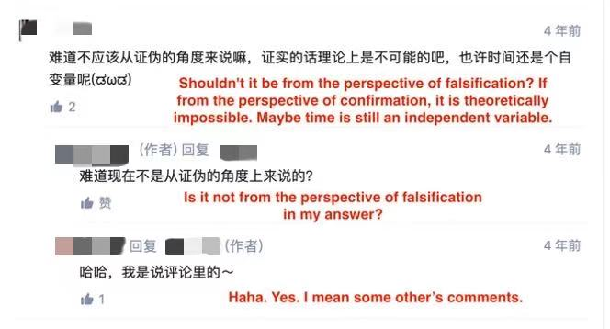
Figure 20: Replies to one CSC’s answer on Zhihu (1)
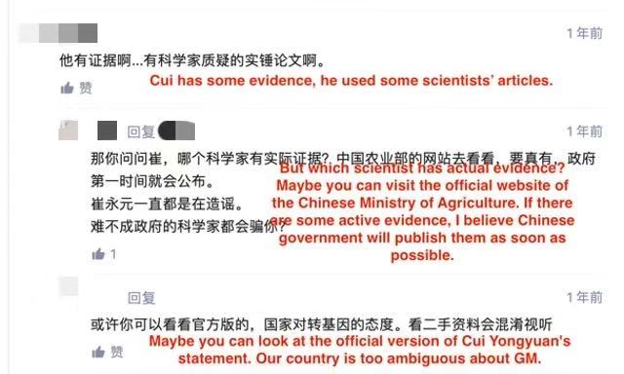
Figure 21: Replies to one CSC’s answer on Zhihu (2)

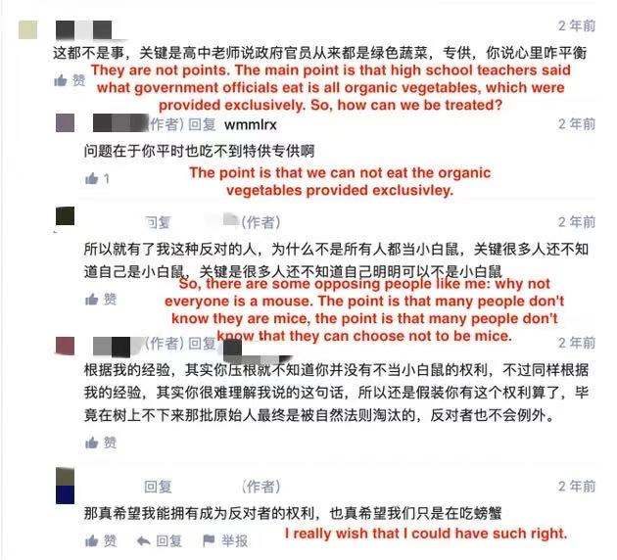
Figure 22: Replies to one CSC’s answer on Zhihu (3)

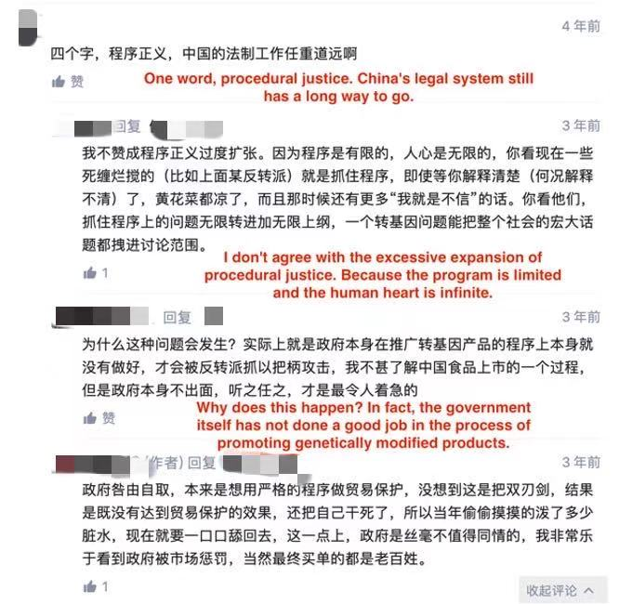
Figure 23: Replies to one CSC’s answer on Zhihu (4)

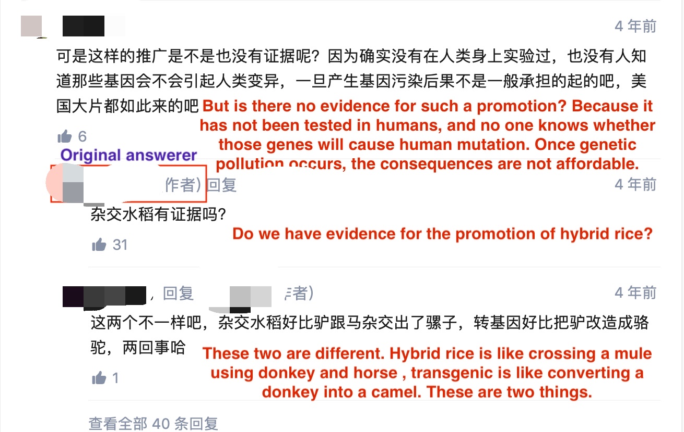
Figure 24: Replies to one CSC’s answer on Zhihu (5)

This example shows that, compared with science communication by scientists on digital platforms, CSCs’ answers sparked a richer discussion, including both among commenters and between the original answer-provider and commenters. The online ethnographic observation of Zhihu showed that scientists do not tend to actively engage in dialogue or discussion with other commenters, and the discussion and dialogue between public commenters is also limited. This may be because most public comments on scientists’ answers represent endorsement or support for those answers, removing space for questions and discussion. However, underneath the answers of CSCs are many challenges to the answers provided by CSCs, the responses of CSCs to those challenges, proposals for new related questions, answers to these new questions provided by other users or CSCs, and supplements to the original answers. Such content constitutes an iterative way of providing answers on Zhihu, and the discussions are enriched through this iterative method of discussion. In the samples analysed here, the longest discussion reached more than 50 levels in the comments. Figures 25 and 26 visualise two different forms of discussion under the answers provided by scientists and CSCs, which are frequently seen under the three CSCs’ answers and scientists’ answers on Zhihu.

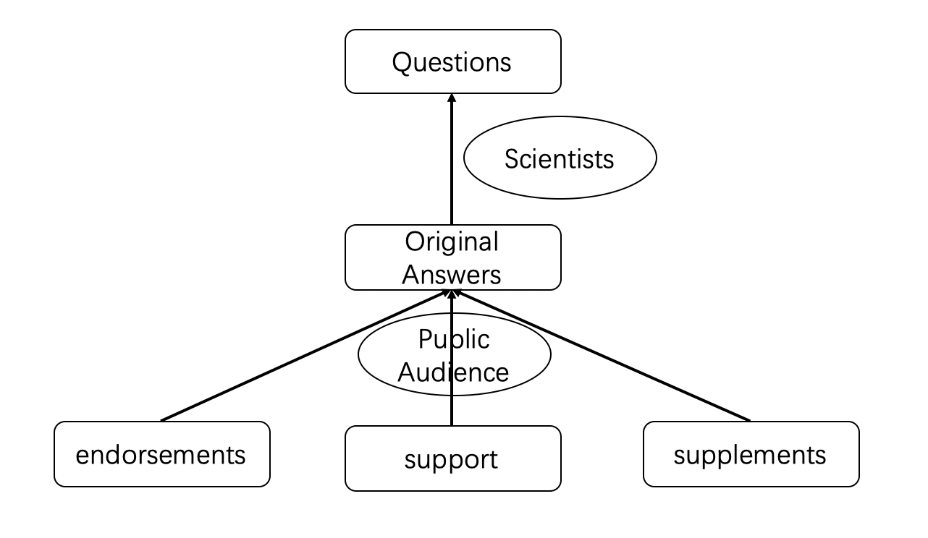
Figure 25: Model of the public’s responses to scientists’ answers on Zhihu

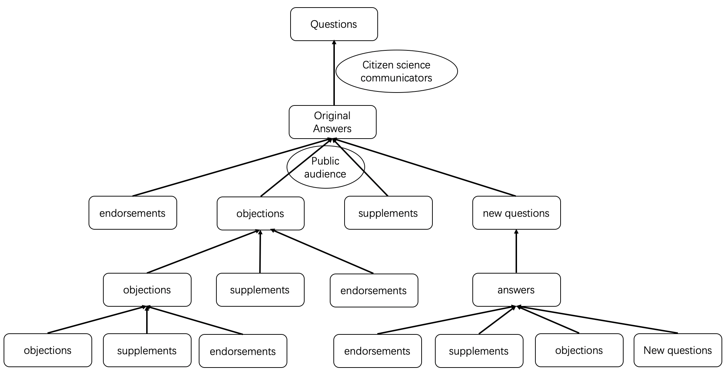
Figure 26: Iterative model of the public’s responses to CSCs’ answers on Zhihu

These figures show that public participation and discussion of scientific issues that science communication academics have always wanted to achieve are mostly realized only under answers provided by CSCs on Zhihu. The discourse authority of scientists has limited, to some extent, the public’s deep participation in scientific topic discussion. The encouragement of deep public participation in such scientific discussion has led to the emergence and popularity of CSCs and further deconstructed the ‘rule by the voice of one man alone’ discursive structure of scientists in the original science popularization model. The public can participate in scientific discussions more actively and widely through the CSCs and express their attitudes and opinions on scientific affairs. Thus, with the answers of CSCs, the public is freer to express their support or opposing attitudes to GMF – this is rare under the answers provided by scientists on Zhihu. This phenomenon may be relevant to the special cultural norms of Chinese public during the Chinese science communication/popularization process. Cultural norms are behavioural standards that a society or group adopts as a whole and follows when interacting with one another (Keller, 1991). As shown above and in Chapter 3, against the background of the long-term deification of science and scientists in China since the beginning of 20th century, in the process of one-way science popularization, what the public as the audience is asked to learn is only respect for science and scientists, and the unconditional acceptance of the information and knowledge conveyed by them. The criticism and questioning of science and scientists are not allowed in the current context of the deification of science in China. Therefore, in the context of deifying science, the cultural norm that the Chinese public has learnt through the long-term one-way science popularization process controlled and led by the Chinese government is merely endorsement and support of science and scientists. However, when the identity of the communicators changes from deified scientists to CSCs with a similar identity as the wider public, the acquired cultural norms of the public as audiences no longer play such a strong role. Thus, diverse kinds of feedback from the public audience can be found under the answers provided by CSCs on Zhihu.

5.4.5 Active commitment to science communication
Communicating scientific information to the general public has always been considered one of the social responsibilities of scientists (Russel, 1960; Verhoog, 1981; Reydon et al., 2012). But the public, without scientific background or employment, are not required or considered to be qualified to engage in scientific communication as communicators. Especially in the Chinese context, science popularization is regarded as one of the political tasks of the government. It is coordinated and managed by a government agency, the China Association for Science and Technology (deputy ministerial level), which is an official association of scientists and technicians. The unified management of the government makes the work of science communication and popularization in the traditional media environment has basically been monopolized by Chinese scientists and media allied with those Chinese scientists. However, in this research, the CSCs are specifically proposed for analysis because they have broken through this division of social responsibility of science communication. The CSCs on Zhihu have taken the initiative to assume the social responsibility of science communication, especially on digital platforms. Moreover, such online behaviour that assumes the social responsibility of science communication of the CSCs on Zhihu is consciously conducted, as reflected in the three CSCs’ answers on Zhihu:

I have no right to shut him up, but I have a responsibility to point out his common-sense mistakes… At this point, the science popularization work was not in place, and I deeply blame myself… I am only the fans of science…We can’t do much with science popularization, so I need to keep going on science popularization. (Question: How to objectively evaluate the speech content of "Banmen Axe Genetically Modified" released by Cui Yongyuan Weibo? Answer-provider: Yangdi).

I think it is necessary for me to communicate some knowledge and information about GMF to everyone here. (Question: Do you know the real threat of genetical modification technology? Answer-provider: Chiwanjiue).

Recently, I saw Professor Rao Yi’s "What’s Genetically Modified" lecture. And the debate on GMF has been in the whole society for some time. I have always felt that there is nothing to argue with this topic. But I don’t know why the discussion about this is getting more and more intense. And Mr. Cui Yongyuan even spent the money to investigate this and make a documentary in the United States. After seeing that, I feel that I must say something about this. I’m not trying to be famous; I just want to give us a science popularization. (Question: Is GMF safe? What are the advantages and disadvantages of them? Answer-provider: Yangdi).

As you know, I am not a student majoring in Biology but in Law, but I think it is necessary to tell everyone what I know about this issue, especially what I have learnt in the USA about GMF. (Question: How do you see the genetic modification? Answer-provider: Luoyan).

Through the examples above, it is clear that these three CSCs have already regarded the popularization of science as their social responsibility: they believe that it is necessary to disseminate what they know to other publics (not only scientific knowledge but also related knowledge in other fields). Moreover, their active role in science communication has received support and likes from other users on Zhihu. Taking the four answers above as examples, they received 3,486, 688, 531 and 221 likes, respectively, ranking among the top three in all answers under the same question. The actions of the three CSCs who take responsibility for science communication and the popularity of their science popularization content shows that they are capable of such science popularization work on Zhihu. This further deconstructs the traditional scientists’ monopoly on the role of science communicator and the authority of discourse in the process of science communication.

The discursive and online behavioural features of the three CSCs on Zhihu around the topic of GMF show a commonality: the deconstruction of traditional science communication, especially the ‘science popularization’ model, as well as the ‘exclusive legitimacy’ of scientists and traditional scientific discourse in the science communication process in the Chinese context. The scientific communication or discussion based on CSCs’ answers does not have to be serious but can be humorous and down-to-earth. Scientific discourse or terminology is no longer the sole source of authority or credibility in scientific communication. Professional discourse in other disciplines, answer-providers’ own experiences and logical reasoning can all be sources of authority and credibility for CSCs’ science-related answers on Zhihu. Science communication or discussion of scientific topics no longer has to be based only on a scientific perspective. Non-scientific perspectives can also contribute to the discussion of science-related topics, such as GMF. The relatively fixed pattern of scientists providing unquestionable answers in the process of traditional Chinese science popularization has also begun to be challenged by iterative methods used by CSCs and other public users on Zhihu. The stable roles of scientists and the public in the process of science communication have become less absolute. Finally, the identity gap between communicators and audiences in the traditional Chinese science popularization model has also been deconstructed. Under the science communication led by CSCs, the public can be audience members and communicators, rather than conforming to the binary identity opposition between scientists as communicators and the public as audience in the traditional science popularization model.

In general, the emergence and popularity of CSCs has constructed a new scientific discussion model that is different from the traditional Chinese scientist-centric, one-way, science popularization model. Such a new model, on the one hand, expands the scope of public participation in science: from the initial public scientific discussion, to the scientific policy formulation, to scientific research and scientific knowledge producing in citizen science projects, to the current science communication process in the digital media environment. On the other hand, the new model has also changed the role of the public in the science communication process from ‘active audience’, emphasized in the public engagement with science model, to the role of ‘active communicators’ in the online science communication process. This will be discussed further in Chapter 9.

5.5. CSCs and the digital media environment: Why CSCs appear widely on Zhihu
The statistical and online ethnography data analysed above show that CSCs have already become an active and influential group in the scientific discussion of GMF on Zhihu. But why do CSCs appear so widely, actively engaging in such a science-related topic? Henry Jenkins and colleagues’ participatory culture theory provides an analytical framework to explore this question, theory providing a lens to understand specific mechanisms that attract the public, especially CSCs, to collaborate and produce creative, self-expressive, and self-initiated media products on Zhihu (Chau, 2010). This part is mainly based on theoretical discussion rather than empirical data.

According to Henry Jenkins (2009, p.3),

a participatory culture is a culture with relatively low barriers to artistic expression and civic engagement, strong support for creating and sharing creation, and some type of informal mentorship whereby experienced participants pass along knowledge to novices [and] in a participatory culture, members also believe their contributions matter and feel some degree of social connection with one another (at the least, members care about others’ opinions of what they have created).

In the participatory culture environment, each individual – even those who were originally thought to have limited discourse power – is encouraged to participate in the content creation and sharing process, just like the CSC group on Zhihu.

While Jenkins treats participatory culture as an essential part of “new media culture” (2009, p.4), many scholars claim that the digital media environment can greatly promote the emergence and development of such participatory culture (Jenkins, 2006; Spurgeon et al., 2009; Chau, 2010; Li, 2010; Morgan and Pallascio, 2015). With low entry requirements and gradual participatory trajectory (Chau, 2010, p.67), digital platforms serve as an ideal space for wide engagement among different users.

Zhihu is principally designed as a content-sharing site. Beyond a simple and intuitive interface design, Zhihu also features many instructions to guide new users at all levels of participation. Its informal and unregulated mentorship also provides opportunities for users to take on different responsibilities and have different levels of involvement. At any level of participation of users on Zhihu, from viewing an answer to answering a question, users contribute greatly to its online knowledge-sharing community. Zhihu’s database takes into account every comment, like and disagreement. The most popular answers with the most likes are promoted on the Zhihu homepage and the main page of each topic. Registered users can access a customizable profile as well as followed and follower lists to keep track of favourite topics, questions and users and to receive updates when a new answer is provided under question or topic they subscribe to. All these features make Zhihu more conducive to generating a participatory culture on the platform. The participatory culture also further promotes users without scientific backgrounds who were originally thought to have only limited voice power in the science communication process to participate in scientific discussion and take the role of communicators of scientific information.

In addition to the platform features of Zhihu and the participatory culture constructed on it, the development of science communication has also promoted CSCs’ engagement in scientific discussion on Zhihu. As discussed in the Literature Review and earlier in this chapter, science communication has experienced development process from the deficit model, and the dialogue model to the participation and citizen science models (Trench, 2008; Davies and Horst, 2006). The emphasis on the public and their local knowledge has also increased within science communication and governance of scientific affairs (Burns et al., 2003; Nisbet and Scheufele, 2009). Although such a growing trend in academia has not been particularly smooth in turning into practice (Holliman and Jensen, 2009), an atmosphere that respects the public’s right to speak has gradually developed among scientists (Irwin et al., 2014). In the Chinese context, in the report of the 19th National Congress of the Communist Party of China, the Party pointed out that it is necessary to build a social governance pattern of co-construction of scientific affairs and to strengthen public participation in science and technology governance. The Bureau of Science Communication of the Chinese Academy of Sciences (2018) also noted when guiding the work of the 14th China Public Science Day that the public’s right to a voice should be respected and that the public should also be given sufficient space for a voice in science communication activities.

Under such conditions, Chinese scientists have gradually learned to respect and permit the public’s engagement in scientific discussion and governance of scientific affairs. The public has also gradually acquired the ability and skills to speak in science-related discussions, although they may not be active science communicators. Meanwhile, the interdisciplinarity of some popular science-related topics also makes the public’s engagement and the activeness of CSCs easier. The topic of GMF in the current Chinese discourse environment, as an example, is not only about science itself, such as gene editing technology or synthetic biology, but also concerns other aspects, including economics, politics, culture and entertainment. For instance, both the international trade game between Monsanto and Chinese local seed companies, and the debate between scientists supporting genetic modification and entertainment stars who oppose it indicate that the boundaries of GMF discussions have already extended beyond pure science (Wang, Zhong and Jia, 2015). This context allows the public to participate in and discuss science-related topics such as GMF from a broader perspective, thereby lowering the barriers for them to engage with scientific discussion.

Apart from the platform’s features and the development of science communication, the public’s own growth has also promoted their participation. Although according to the Chinese Netizen Survey Report (2019), launched by China Internet Network Information Center, only 9.9% of Chinese netizens have received or are receiving undergraduate education (CNNIC, 2019), the overall educational level of Chinese citizens and Internet users is growing. According to the National Bureau of Statistics of China, in 2018 the enrolment rate of nine-year compulsory education (including elementary and junior high school education) in China reached 94.2% (Chen, 2019), and the gross enrolment rate of higher education reached 48.1%. This has ensured that most of the Chinese young people who are also the major user groups of Zhihu have basic levels of scientific knowledge. The scientific literacy of Chinese citizens also increased from 1.6% in 2005 to 8.47% in 2018 (China Research Institute for Science Popularization, 2018). Education and the improvement of scientific literacy provide a basic knowledge base for Chinese citizens to participate in discussions on science-related topics online.

Meanwhile, with the improvement of scientific literacy, the Chinese public’s enthusiasm for participating in scientific discussions and governance of science and technology has also increased. According to the 10th Chinese Citizens’ Scientific Literacy Survey, the enthusiasm of Chinese citizens for public scientific affairs, especially among the youth, has increased significantly compared with five years earlier (China Research Institute for Science Popularization, 2018). The improvement of scientific education levels and concern for scientific subjects have jointly promoted the participation of Chinese citizens in discussions on scientific topics.

The points above – including the platform, cultural atmosphere, scientists and science communication, and the public themselves – have together promoted the public’s engagement with the discussion of scientific topics in the digital media environment, which has further contributed to creating the CSCs group and promoted its growth on Zhihu.

5.6 Conclusion
The online statistics drawn from the Zhihu data have shown that CSCs have already become a widespread group in scientific discussions on the platform, especially regarding the topic of GMF. The popularity of citizen science communication on Zhihu has been analysed from the perspective of the digital media environment, the literacy of users, and the development of science communication. More importantly, based on the online ethnography of three representative CSCs, the emergence and popularity of CSCs and their involvement in online science communication has profoundly changed the mode of science communication on Zhihu, especially China’s science popularization model.

As noted above, science communication in China, even in some digital media environments, is mostly conducted through a one-way, scientist-centric science popularization model. Under this model, Chinese scientists export scientific knowledge and information unidirectionally, which may be explained and translated through traditional media, or by using digital platforms to reach audiences directly. In this model, the public can only passively receive this scientific knowledge or information as audiences. They are believed to lack effective channels and qualifications to question or participate in discussions. This is just one of the reasons why, although Chinese academics have called for public engagement with scientific discussion on GMF, China has not yet launched a public debate project like the UK’s ‘GM nations’ (Willis et al., 2005; Rowe et al., 2005).

The role of scientists and the public has solidified in the practice of science communication under a one-way, scientist-centric science popularization model, since the public has no access to and is also further considered ineligible to become science communicators. Such a solidification of the roles between science communicators and audience may further lead to unequal powers and even oppositional tendencies between scientists and the public. This disparity in discourse power between scientists and the public is partly because knowledge and information are considered to be the important sources of discourse power in a communicative relationship, and scientists hold these sources in their own hands; and partly because the public lacks feedback mechanisms and the qualifications to question scientists in the science communication process. This phenomenon has deepened with the Chinese people’s attitude towards science and scientists. Many Chinese scholars refer to the current Chinese attitude to science as “scientism” (Hua, 1993; Li, 2003; Wu, 2011), that is, over-respecting and over-trusting science and scientists, and even equating the word ‘science’ with ‘absolutely correct’ in all Chinese discourse systems. For example, the Chinese government used the phrase “Scientific outlook on development” to refer to their correct and reasonable development ideas, even though they are not really scientific or science-related. This deified attitude towards science and scientists has further expanded the discourse power difference between the scientists and the public in China under the traditional science popularization model.

However, such a disparity in discourse power has been alleviated in the digital media environment, on Zhihu, due to the emergence and popularity of CSCs, especially with their reconstruction of the science communication process and the science communication relationship. Firstly, the emergence and popularity of CSCs on digital media platforms like Zhihu has further extended the public engagement with science to the new field of science communication. The new ‘citizen empowerment’ with the new stage of public engagement with science has also further developed the public’s deconstruction of scientists’ privileged discourse power into the new field which is beyond scientific affairs governance and scientific knowledge production: the field of science communication. Secondly, those CSCs on Zhihu clearly realize that they are part of the public without a scientific background, but they have the consciousness to assume the social responsibility of science communication. Thirdly, the CSCs’ behaviour and discourse on Zhihu has deconstructed some characteristics of traditional science communication in China through a series of discursive and online behaviours, such as using humorous memes and a multi-perspective field discourse. They have shown that scientific discussions do not have to be serious and 100% scientific, and this has created the possibility for the public as communicators to participate in scientific discussions.

In summary, CSCs and their discursive and behavioural features on Zhihu have challenged and deconstructed the ‘exclusive legitimacy’ of scientists as science communicators and pure scientific content in science communication. As discussed above, the popularity of the answers provided by CSCs shows that they and their answers are also trusted by audiences on Zhihu. Therefore, the emergence of CSCs and the increase in the discourse space afforded to the public mean that scientists are no longer the only trustworthy communicators related to scientific topics on Zhihu. Returning to the first research question – has the authoritative position of scientists been challenged in the science communication process in the digital media environment of China? – it has been shown that, on Zhihu, the emergence and popularity of CSCs has challenged and deconstructed the absolute discourse privilege and authoritative position of scientists in science communication and the scientific discussion process. A further open question is worth proposing here: does this phenomenon only happen on Zhihu, a specialized knowledge-sharing platform, or does it also occur on more mainstream platforms, such as Weibo, WeChat and TikTok? This question needs further empirical research to answer definitively. In the next chapter, I explore the responses of Chinese scientists and scientific discourse to the challenges and deconstructions brought about by CSCs.

Chapter 6: Scientists’ Defence of Discourse Authority on Zhihu

As shown in the previous chapters, the emergence of citizen science communicators (CSCs) on Zhihu has challenged the absolute discourse privilege of scientists and deconstructed the authoritative position held by scientists. However, this raises further questions: How do scientists respond to this challenge? How do they interact with other Zhihu users? Do they utilize some means to defend their discourse authority? These questions can help to address Research Question 3: Do scientists maintain their authoritative position in the contemporary new media environment in China? If so, how?

The analysis in this chapter is mainly based on evidence from critical discourse analysis and interviews. The theories of boundary-work, authority of science and social identity discussed in the literature review will be used in this chapter to help with understanding scientists’ discourse behaviours in science communication processes on Zhihu.

6.1 Introduction to analysis
According to the literature review and the analysis in previous chapters, the discourse authority of Chinese scientists in the new media environment, especially on Zhihu, has been challenged in recent years from different perspectives, such as the evolution of models of science communication and the deeper involvement of the public in scientific affairs (Miller, 2001; Lewenstein, 2003; Wilsdon and Willis, 2004; Trench, 2006; Brown, 2009; Holliman and Jensen, 2009; Bodmer, 2010; Perrault, 2013; Irwin, 2014; Smallman, 2016; Patel et al., 2016), the rediscovery of citizen’s local knowledge and the irresponsibility of science in relation to certain issues in China (Han et al., 2011; Liang, 2016), and CSCs’ deconstruction of the original one-way science communication process (Holliman and Jensen, 2009; Temple, 2013; Luo and Wang, 2016). However, according to Gieryn’s theory of boundary-work of science, based on the professional ideology of scientists, they do not easily give up their discourse authority in the face of science-related issues, but tend to monopolize professional authority and resources by excluding rivals from within as outsiders with labels such as ‘pseudo’, ‘deviant’, or ‘amateur’ (Gieryn, 1983; 1999). This also indicates that when scientists face a threat to their discourse authority, they use discursive and rhetorical strategies, according to Gieryn’s theory, to draw boundaries to differentiate themselves from others and to further build their own discourse authority in science-related issues.

Gieryn’s theory of boundary-work provides an important hypothesis: if Chinese scientists want to cope with the challenges from the general public as CSCs and further maintain their own discourse authority on Zhihu, they could apply discursive strategies, including rhetorical styles, figurative language, and symbolic formulation, to build a boundary between themselves and non-scientists in their interactions with them – the process of science communication or public engagement with scientific discussion on Zhihu. In Davies and Horst’s words: “scientists communicate science with the public for ‘science’ and ‘scientists’ themselves rather than the public”, and “science communication constructs identities for science and scientists” (2016, pp.55-58); only when scientists are separated from non-scientists can scientists’ discourse authority be effectively maintained (Gieryn, 1999). But is this really the case? Have scientists on Zhihu used a series of discursive and rhetorical strategies in their interactions with the public to draw boundaries to differentiate themselves from the public to maintain their discourse authority? These hypotheses can also help answer Research Question 3: Do scientists maintain their authoritative position in the contemporary new media environment in China? The following section mainly focuses on the science communication content and register produced by scientists through the answers they provide in relation to questions about GMF on Zhihu, as analysed through critical discourse analysis. Evidence from interviews with Zhihu users, especially scientist users, will also be incorporated into the analysis.

6.2 Discourse techniques used by scientists on Zhihu
Before analysing the rhetorical strategies or discourse techniques used by scientists and exploring the potential effects of these discourse techniques, it is necessary to classify the questions answered by scientists on Zhihu. Taking the 30 scientists’ answers selected in this thesis as examples, the questions answered by scientists can be roughly classified into two types: non-scientific questions – which mainly focus on the social and ethical dimensions of GMF – and scientific questions. When Zhihu users try to answer the public’s questions, such as No.11: “Why do some people refuse GMF?”, scientific knowledge and principles are not considered to be necessary elements of the answers. Scientific questions here mean those that focus on the scientific principle of GMF – when they are answered, scientific knowledge and interpretation of scientific principles is required, and there is a threshold for the public to participate, such as question No.9: “In the Agrobacterium transformation method, how is the T-NDA in the Ti plasmid inserted into the DNA of the target chromosome?” It should be noted that some questions are hybrids, and it is difficult to completely define whether they are public or scientific questions. Among the 30 answers (two of which were provided for one question), 12 of the questions were scientific and the rest were public (see Appendix 3). In other words, most of the questions answered by scientists in all samples were still public questions. This should be remembered in the subsequent analysis to help analyse the boundary between science and the public created by scientists.

Based on Gieryn’s theory of boundary-work, a hypothesis has been proposed whereby scientists on Zhihu may adopt discursive techniques, including rhetorical styles, figurative language, and symbolic formulation to help maintain their discourse authority. However, the discourse used by any Internet groups will not only have a bonding function – reinforcing close-knit networks among people sharing similar backgrounds and beliefs – but also may have a bridging function, bringing together disparate communities (Norris, 2002). The bridging and bonding theory of the online communities will be used in later analysis to help comprehensively understand the discourse techniques used by scientists and the functions of their discourse techniques.

The following section focuses on the discourse techniques used by scientists on Zhihu from both bonding and bridging perspectives, testing whether those discourse techniques could be used to help scientists maintain their discourse authority in the online science communication process on Zhihu. The analysis of those discourse techniques will be carried out in three main parts: register, content, and tone.

6.2.1 Register
This part mainly focuses on the personal cognitive perspective, such as scientist users’ personal experience and knowledge, and their target audience in their mind, and also some structural perspective (Table 3), such as surface structure analysis and grammar analysis.

Target audience
Language, including content and register, is believed to be an effective way of creating social distance (McGraw et al., 2012). Before analysing the discourse techniques used by scientists on Zhihu, it should be made clear that some answers provided by scientists on Zhihu are not mainly written for the public. The imagined audiences of scientist answer-providers profoundly influences the use of discourse techniques by scientists. Rather than taking the wider general public as the target audience in the traditional science communication process, some answers provided by scientists about GMF on Zhihu are clearly only directed at other scientists. For instance,
I kindly disagree with @ Dr XX’s opinions, the main reason is… (No.28, Question: If genetically modified crops are planted in large quantities, will it affect the ecological cycle?).
In this answer, the scientist answer-provider wanted to have a direct interaction with another scientist on Zhihu: Dr XX. This kind of interaction is achieved through Zhihu’s mention function (@). The question here is about the effect of genetically modified crops on the ecological cycle, which is not a particularly scientific or technical question. It means that this question may be more intended to reach a wider range of users, including scientists and the general public. However, in this environment, this scientist answer-provider still wanted to engage in a conversation or interaction within the circle of scientists. Such a claim clearly places the public outside the conversation, and the public can only serve as a passive audience, rather than as participants. Moreover, when answers provided by scientists occur in response to other scientists on Zhihu, the language they use tends to be more specialised. Whether the general public can understand their answers may not be part of their consideration, because the public is not their target audience.

Scientific formats
Returning to the register of scientist answer-providers on Zhihu, according to the theory of boundary-work, writing formats, especially professional ones, can also be used to build a boundary between scientist answer-providers and general public audiences. Scientists have their own professional registers and formats, and such styles are obviously different from the general public’s daily writing habits, such as using academic citations, hierarchical titles, scientific graphs and tables. According to practitioners and researchers, public science communication should avoid using a complex professional register and aim to have attributes that are easy to read, understand, remember and spread (Wilson, 1998; Bucchi and Trench, 2008; Berger et al., 2010). This is particularly relevant to the Chinese context, since according to the Chinese Netizen Survey Report (2019), only 9.9% of Chinese netizens have received or are receiving undergraduate education (CNNIC, 2019). Although there is no official survey report on the educational background of all Zhihu users, in the context of the low level of general education of all Chinese netizens, we may reasonably assume that there must be many users with low educational levels on Zhihu. However, the scientific formats based on scientific paper writing and publishing cannot aid a general audience without at least an undergraduate education to understand the information and knowledge contained in such answers. Considering the answers provided by scientists about GMF on Zhihu, more than one third (11/30) of all the selected samples used a scientific format, such as using scientific references and paper titles, graphs and tables with obvious scientific formats. For instance,
Genetically Engineered Crops: Experiences and Prospects. Washington, DC: The National Academies Press. doi:10.17226/23395. (No.8, Question: Genetically modified crops: what is their experience and future?).
Figure 3-1. Effects of human selection and domestication of teosinte (life) that yielded maize (right). SOURCE: Based on Fuller (2005). NOTE: The U.S. quarter coin is included for scale (about 2 centimetres in diameter). (No.8, Question: Genetically modified crops: what is their experience and future?).
The effects of using such scientific writing formats are similar to highlighting scientists’ community-unique experiences. It can help the answer providers to obtain a more adequate response credibility, but it also distinguishes the answer provider as a scientist from other answers provided by non-scientists, and with the type of content that the general public can access in their daily life. In McGraw’s (2012) words, registers that are not familiar to the audiences will increase the psychological distance between audiences and authors. Therefore, the general public who are unfamiliar with such scientific writing formats may feel a sense of distance when they read such answers.

Grammatical register
In addition to the writing formats discussed above, grammatical register also contributes to creating the social distance between scientist answer-providers and their audiences. It has been widely accepted in academic circles that the active voice is inappropriate in academic writing and that the passive voice and the omission of the agent of action are justified (Gong and Dragga, 1995; Hyland, 2002, p.1095). Although in recent years using active sentences has gradually become more accepted in academic writing, non-active writing is still stereotypically common and can be a barrier to a broader audience (Simis-Wilkinson et al., 2018, p.326). Writing in the passive voice has become one of the major features of scientific writing, in both English and Chinese contexts. However, Chinese sentences are more accustomed to using the active voice by taking people or things as subjects. When the subject in a sentence is not clear, a no-subject voice rather than a passive voice is more likely to be used (Xiong and Liu, 1999). Chinese sentences that the general public in non-academic circles can understand in their daily lives mostly exist in the form of the active voice. It is odd for two Chinese people to communicate with each other using the passive voice in their daily lives. However, some of the answers provided by scientists about GMF on Zhihu are almost written in a passive voice, such as:
Gene-driven technology can be applied not only to mosquitoes, but also to many species. (No.29, Question: What is gene-driven technology? What is the biological mechanism of its realization?).
If the NDA of the GMF is extracted and heated to 100 degrees, the DNA that is deformed without the annealing conditions is not at risk. If the genetically modified crop is eaten raw, the genetically modified crop cells will be broken down in the gastrointestinal tract, and there is also no risk. (No. 3, Question: Why is GMF hated by some people who do not really know GM?).
This kind of academic and non-life-oriented language expression has distinguished the unique forms of scientific discourse from forms of non-scientific discourse. When reading these sentences written in the passive voice, scientists may feel a sense of familiarity and be accustomed to the practice. However, the Chinese public, without a scientific academic background, may find such writing to be unfamiliar and alienating, since this kind of expression is not what they use in their daily lives. Thus, this kind of expression with the passive voice produces similar effects to using professional scientific formats discussed above. Users who can use and are familiar with such expressions will demonstrate and share their identity as scientists, defined as different from ‘you’ who are not familiar with such expressions as the general public. Thus, the bonding network among scientist users and the boundary between ‘we’ and ‘you’ are both strengthened further. In contrast, when scientists on Zhihu use an active voice, they are more inclined to construct a dialogue relationship with the public audience.

Personal pronouns
The boundary-work discussed above is mainly based for indirectly distinguishing the scientists and the public on Zhihu via academic register. However, in terms of register, scientists have also adopted a more direct way of distinguishing themselves from non-scientists on Zhihu: using opposite personal pronouns. The use of personal pronouns is seen as an important sign of separation between a ‘self-perspective’ and an ‘other-perspective’. In discourse analysis, the use of plural first-person pronouns (I/we) and second-person pronouns (you) is also regarded as an important representation of the relationship between the speaker-self and the receiver in speakers’ minds (van Dijk and Kinstch, 1983; Fairclough, 1992; Maitland and Wilson, 1987). Analysing the use of pronouns with context in discourse can also help to explore the authors’ understanding of identity (Tang and John, 1999; Mora, 2004). The plural subject pronouns used by scientists on Zhihu, such as ‘we’, ‘us’, and ‘our’, can highlight their understanding of their collective identity attributes. For example:
What makes me feel more terrified is that so many people have been ignorantly persuaded by Cui Yongyuan’s claims and treat GMF as the devil. We understand science. We look at ‘papers’. We put facts in your face. We express the principles to you. But what about those people who are anti-GM? If you really doubt the government, why do you argue about this with us? You don’t even know science, don’t read ‘papers’. Our researchers use a common way of explaining this to you, and you don’t listen. Please do not be such hooligans. (No. 17, Question: Is Cui Yongyuan’s attitude towards GM wrong?).
Glossing over the condescending attitude and this scientist respondent’s view of the public as ignorant, in this sample, the answer-provider repeatedly uses the plural subject pronouns ‘we’ and ‘us’. This may sound like a criticism of the scientists’ view of the public, but as Jensen and Holliman (2010, pp.56-57) note, the deficit model still controls the scientists’ view of the public, especially in a country like China, where science is already deified. Considering the actions associated with these pronouns, the groups of people this answer-provider refers to are not the author and the reader – which are often used in conversational relationships to refer to both sides of a conversation – but the wider group of scientists. However, the target audiences for this answer are not other scientists, and this can also be seen from the register and content. This also means that the scientific community, referred to as ‘we’ and ‘us’ in this example, is not complicit in the conversational relationship constructed by this answer. This author is talking to their audience in the role of a representative of the scientist community. This makes it clearer that the author did not see themselves as a part of the general public that makes up the target audience for this answer, but a special social group: scientists.

In addition to the plural subject pronouns, the second-person pronouns used in scientists’ answers on Zhihu also highlight the scientist answer-providers’ understanding of their identity and the opposing treatment between themselves and the public. It should be made clear before analysing the second-person pronouns used by scientists on Zhihu that, unlike in English, which uses ‘you’ as both singular and plural second-person pronouns, Chinese has different words for the singular second-person pronoun (你), and the plural second-person pronoun (你们). These two kinds of second-person pronouns are used differently by scientists on Zhihu. The singular second-person pronoun is always used by scientists on Zhihu to refer to the person reading the answers provided by them, and the specific person they want to talk to is often another scientist. For instance:
I have said so many types of reasons for opposing GM, but it doesn’t matter. And no matter which type you (你) are, I don’t care. And do not comment at me, I will not reply to you (你). (No.30, Question: I just do not want to eat genetically modified. Why do some people always want to convince me?).
The frequency of the use of singular second-person pronoun is much lower than the plural second-person pronouns in scientists’ answers on Zhihu. Rather than referring to the person reading the answers by using the singular second-person pronoun, scientists tend to use plural second-person pronouns to refer to the general public as an ‘other’ group. For instance:
It doesn’t matter if you eat GMF or not. But, if you (你们) refuse to eat GMF without knowing the relevant knowledge, I would laugh at you (你们) because of your ignorance. (No. 30, Question: I just do not want to eat genetically modified. Why do some people always want to convince me?).
All right, I know you (你们) probably don’t understand this, then I will translate the key information for you (你们). (No.20, Question: How do you evaluate some resolute opposition to the idea that the staple food should be genetically modified?).
Vegetables grown with fertilizers and pesticides taste far worse than natural vegetables, but the yield is large. In the United States and Europe, people pursue health, and then eat organic vegetables. But can the Chinese do so? The organic vegetables with the price of 20 yuan/pound, I can usually buy and eat, but is your (你们的) money enough? (No.2, Question: Why are there 134 Nobel Prize winners who support GM?).
In these examples, the public as the audience has been placed in the ‘other’ position by the scientists. A role-contradictory relationship between the public and scientists has been created as an ‘I (we)-and-you relationship’. The public is only the object of discourse, and not in the same league as the scientists as communicators. In addition, using such second person pronouns also reveals these scientists’ condescending attitudes toward the public. Especially in the last two examples, the answer-providers not only highlight their different community attributes from the general public through using opposite personal pronouns, ‘I’ and ‘you’, but they also show their superiority by implying their higher economic and social statuses. Therefore, the public is not only excluded from the scientists’ discussion but is also placed in a lower status by scientists on Zhihu.

In conclusion, scientists on Zhihu use several registers, such as some opposite personal pronouns (Table 8), to refer to themselves and the general public. Through the use of first-person pronouns (we) referring to scientists with a common identity and second-person pronouns (you) referring to the audience, a more close-knit bonding network among scientists has been built. And the public as the audiences has also been positioned as ‘others’. Comparing the distinction based on knowledge, experience, and writing habits, this distinguishing between scientists and the public becomes clearer. The boundary between scientists and the public has also been reinforced through such online discourse behaviour by scientists.

Table 8: Pronouns used by scientists on Zhihu
Users | Pronoun | Referential object
Scientists | I | Individual as a scientist
 | We/us/our | Scientist community (me and other scientists)
 | You/your (singular) | The person reading this answer
 | You/your (plural) | The general public (with a lower status than scientists)

However, the discursive practice of many groups serves both bridging and bonding functions. Taking the use of pronouns as an example, scientists on Zhihu have also used non-opposite personal pronouns to try to get closer to the public. For instance:
Let us see what these changes mean to us. So, let us start with this question: why do we need this kind of natural potato? (No.25, Question: How can the US-approved GM potato ‘reduce the acrylamide produced during frying’?).
I still very clearly remember that Professor Ye’s tone of voice is full of pride and honour. Is it he who continues to provide us with many papayas to eat, not just a small number? (No.18, Question: What kinds of delicious food are brought about by genetically modified technology?).
In these two examples, the scientist answer-providers both used ‘we/us’ to refer to both themselves and the public rather than just themselves and other scientists. This kind of non-opposite pronouns use in scientists’ answers indicates that scientists see themselves as a part of the public rather than holding a condescending view of the public. This kind of identity cognition of scientists, treating themselves as a part of the public, also highlights the ‘bridging’ function of scientists’ answers on Zhihu. It seems that they wish to build a communication network across different identities as scientists or non-scientists based on using such non-opposite pronouns.

It seems that scientist answer-providers on Zhihu use the registers to try to build both a bonding network with other scientists and a bridging network with the public. What does this dual function mean and which kinds of function are clearest in scientists’ answers on Zhihu? These questions will be answered later in the analysis.

6.2.2 Writing content

In this part, I mainly focus on the local semantics, comprehensive semantics analysis, such as how scientist users explain their claims and how to construct their themes, combining some grammar analysis and word-canonical analysis, such as intertextuality and scientific metaphors, from structural analysis perspective with the analysing of the writing content of the scientists’ GMF answers on Zhihu (Table 3).

In addition to the register, including writing formats, the content of the answers provided by scientists could more easily reflect the identity of scientists and the boundary between scientists and the public on Zhihu. The readability of scientific information is a prerequisite for effective discussion between scientists and the public (Barkemeyer et al., 2016, p.3). Compared with scientific writing formats, which are more inclined to alienate a public audience, professional scientific content can more significantly reduce the readability of science communication text. The content that cannot be effectively understood by the audience will produce the “exclusivity of language” (Simis-Wilkinson et al., 2016, p.325), which, in Rodman’s (2012) words, extends the social distance between speakers and listeners. Although the principle of science communication whereby the scientific professional context should be avoided and effectively explained, has always been repeated (Wilson, 1998; Bucchi and Trench, 2008; Berger et al., 2010), in science communication practices, using a scientific professional register and content seems to be a habit of scientists and proves difficult to avoid, especially when scientists undertake their duty of communicating science in the new media environment as individuals without the professional media’s translation and gatekeeping (Simis-Wilkinson, et al., 2016). On Zhihu, scientific content, such as scientific jargon, scientific professional metaphor, de-familiarization of daily vocabulary, and professional scientific visual content, also appears in scientists’ answers.

Scientific jargon
The exclusivity of language of a public-facing science communication text is significantly determined by the scientific jargon used in that text (Simis-Wilkinson et al., 2016, p.325). Jargon is a general term for a group of specialized words or meanings relating to a particular field, as well as the study of such terms and their use (Sonneveld and Loenning, 1994). Use of jargon within a discipline is considered to be one of the important signs of professional construction and maintenance of disciplinarity. Using such jargon in some non-professional environments is considered to act as a boundary between that discipline and others (Klein, 1996). When people use the same jargon to communicate with each other, they tend to think that they belong to the same group. Thus, jargon provides a linguistic basis for the identification and attribution of a group identity and has the function of exclusivity.

Although some research claims that using scientific jargon in the science communication process can allow the public to generate trust in science and scientists (Leach et al., 2009), more scholars believe that the use of scientific jargon that cannot be easily understood by the general public in the process of science communication creates a sense of alienation at the psychological level of the public towards science (Myers, 2003; Warden, 2010; Perz et al., 2010). Among all the selected sample questions answered by scientists, two-thirds used scientific jargon and English abbreviations, which can be difficult to understand for a general public who do not possess a special scientific background. For instance:
The papaya we eat now is the GM anti-prsv papaya which was originally cultivated in this lab. Viruses are difficult to fix in both humans and plants. Just as the current flu virus and retrovirus HIV are very hard to deal with, viruses are also very hard to deal with in plants. So, at the end of the twentieth century, using the principle of cross protection, papaya was transferred to the CP of PRSV to make it resistant to some special viruses. (No.18, Question: What kinds of delicious food are brought about by genetically modified technology?).
In short, that is a double-stranded RNA’s (dsRNA) specific silencing homologous gene. This silencing can directly prevent the transcription of DNA, called Transcriptional Gene Silencing (TGS); it can also be the translation of mRNA that inhibits the transcription of dsRNA, but the process by which DNA is transcribed into mRNA is unaffected, called Post-Transcriptional Gene Silencing (PTGS). (No.26, Question: How can the US-approved GM potato ‘reduce the acrylamide produced during frying’?).
Using scientific jargon, such as anti-prsv, CP of PRSV, and PTGS, in the science communication process could hamper public understanding of scientific information. More importantly, the professional scientific barriers built by such jargon creates a clear intellectual boundary between the scientists who can use and understand this jargon and the public who cannot.

Scientific jargon does not just appear in the answers provided by scientists, but also in the description of some questions which were clearly proposed by scientists in the topic of GMF on Zhihu. The professional presentation style and jargon used in these questions demonstrates the barriers for the general public in participating in these issues:
How does the US-approved GM potato reduce the acrylamide (C3H5NO) produced during frying? (No.25, No.26, Question: How can the US-approved GM potato ‘reduce the acrylamide produced during frying’?).
If the public wants to participate in discussions about this issue, they first need to understand the term “acrylamide (C3H5NO)” and have some basic knowledge of the scientific principle about the relationship between acrylamide and frying, which is unlikely for most people without a scientific background. Unlike other public questions, such as “how should we treat GMF”, such scientific questions require a high threshold of scientific knowledge. Because of this, both the questioner and respondents under this question are most likely to be science practitioners – the public is significantly excluded.

Scientific professional metaphors
In addition to using scientific jargon directly, scientists on Zhihu also apply this jargon to metaphors. A metaphor is a figure of speech that, for rhetorical effect, directly refers to one thing by mentioning another (Lakoff, 1994, p.203). A metaphor always has two parts: the tenor and the vehicle. The tenor is the subject to which attributes are ascribed. The vehicle is the object whose attributes are borrowed (Richards, 1937). For instance, in the ‘medicine as war’ metaphor, medicine is the tenor, and war is the vehicle borrowed to ascribe medicine (Diekema, 1989). Using metaphors can make expressions more vivid, concise, flexible, and visual. But these effects are usually based on using imagery with objectification-familiarity as vehicles (Blasko and Connine, 1993, p.295). However, if the vehicles used in the metaphor are not familiar to the audiences, the rhetorical effect of that metaphor is weakened and the understanding of the original sentence by audiences is obstructed (Glucksberg, 2003). For instance, in one of the selected samples, one scientist answer-provider wrote:
However, there are also functional non-coding RNAs that you don’t know in the process. Those ‘weakly interacting massive particles (WIMP)’ in genomes make up the vast majority of the transcriptome. (No.10, Question: Is the intron a useless DNA sequence?).
In this example, the answer-provider used the “weakly interacting massive particles (WIMP)” as the vehicle to metaphorize the “functional non-coding RNAs” as the tenor. Different from the metaphor ‘medicine as war’, in which commonly used military language such as ‘invade’, ‘fight’, and ‘enemy’, are taken as the vehicles, in this answer, the respondent used the professional jargon “WIMP” as the vehicle. The conception of “weakly interacting massive particles”, which as a physical term is almost as esoteric as the biological term “functional non-coding RNAs”, the tenor in this metaphor could not easily be understood by general users on Zhihu, since only 9.9% of Chinese netizens have received undergraduate education. Only scientists who have similar experiences and knowledge with those answer-providers could understand such sentences and metaphors. But, on a public platform like Zhihu, if the content someone expresses can only be accepted and understood by a specific group, then there will be a function of exclusivity and discourse division between that group and others (Kelly et al., 2005; Weiss and Wodak, 2007).

Intertextuality
Such a shared professional language usage habit among scientists undoubtedly strengthens the boundary between scientists and the public in communication and scientific discussion on Zhihu. Furthermore, such a boundary based on identity presentation has been strengthened by intertextual relationships among scientists on Zhihu. Intertextuality is the shaping of a text’s meaning by another text. It is the interconnection between similar or related works of literature that reflect and influence an audience’s interpretation of the text (Fairclough, 1992). The intertextual relations between different texts can be a direct borrowing, such as a quotation or plagiarism, or more indirect, such as parody, pastiche, allusion, translation, or meaning link. Through intertextuality, the different pieces of text can form a network relationship. This kind of relationship has been helpful for forming the bonding network among the writers of these texts (Beach and Anson, 1992; Narris, 2002). The direct borrowing of intertextuality among scientists on Zhihu is apparent in comments such as:
A committee of experts from the US Academy of Sciences, the Academy of Engineering, and the Academy of Medicine recently published a report entitled ‘GM Crops: Time and Prospects’… (No.8, Question: Genetically modified crops: what about their experience and future?).
@Dr.xx and @Dr.xxxxx have already explained the issue of RNAi very clearly, and also demonstrated that the process of Asparagine + Sugar produces arylamide very clearly; according to their points, the process of Asparagine + Sugar should be focused on RNAi. (No.25, Question: How can the US-approved GM potato ‘reduce the acrylamide produced during frying’?).
Establishing intertextual relationships with other scientists’ answers on Zhihu does not just rely on direct quotations or plagiarism – indirect means are sometimes more important. Among these indirect means, sharing meanings is significant: as mentioned above, scientists on Zhihu often assume shared knowledge among scientist groups as being common sense. They also often use the term ‘common sense’ to strengthen the consensus among scientists. For instance:
It is impossible for something to prove completely harmless in science. This is kind of common sense. (No.2, Question: Why are there 134 Nobel Prize winners who support GM?).
Some people want to scientifically prove that GMF is completely harmless. This is fundamentally anti-science common sense. (No.11, Question: Why do some people refuse GMF?).
We all know that science is not about proving truth, but falsehood. (No.17, Question: Is Cui Yongyuan’s attitude towards GM wrong?).
This is the common sense in science: The Black Swan Theory. If we have not found that GMF is a clear hazard, we can call it harmless. (No. 23, Question: What do people who have studied biology think of GMFs as a controversial topic?).
In these examples, common sense has become the intertextual link. Although the third case does not use the term ‘common sense’, “We all know” still expresses shared meaning among scientists. The content of this ‘common sense’ is shared by scientists, and by sharing such common sense (falsificationism), these answers have acquired a similar logical basis. Perhaps those answer-providers do not subjectively try to imitate the views of a certain respondent, but their views can indeed act as evidence for supporting each other’s answers. The existence of such intertextual relationships based on sharing points of view means that the scientists’ answers on Zhihu form a scientific discourse network. Within this network, answers have similar logical and theoretical backgrounds and even similar writing formats. Such intertextual networks further strengthen bonding relations among scientists and help those answer-providers on Zhihu to define their identities as scientists, from ‘I’ as an individual scientist, to ‘we’ as a group of scientists. The general public and their discussions about GMF on Zhihu cannot therefore be integrated into such a network – without shared ‘common sense’ as an intertextual link, the public are further defined as ‘you’ and ‘your opinions’.

The intertextuality with the broader scientific text outside Zhihu also provides a solid guarantee for those scientists’ answers on Zhihu to gain credibility and discourse authority. The external texts they quoted in their answers are mostly from science institutions which are regarded as authoritative. Based on the intertextuality linked with such authoritative scientific texts, if there is someone opposed to the information these answer-providers provide or the views they hold on Zhihu, then they are also opposed to this authoritative ‘science’. For instance:
A committee of experts from the US Academy of Sciences, the Academy of Engineering, and the Academy of Medicine recently published a report entitled ‘GM Crops: Time and Prospects’… (No.8, Question: Genetically modified crops: what is their experience and future?).
In addition to imagining an audience and using scientific intertextuality to represent their identity as scientists, scientist answerers on Zhihu have also showed and shared their identity by highlighting their professional scientific knowledge background and research experience. For instance:
I used to study in this lab which originally cultivated this kind of papaya for exchange. The papaya we eat now are the GM anti-prsv papaya which were originally cultivated in this lab. (No.18, Question: What kinds of delicious food are brought about by genetically modified technology?).
Through emphasis on the personal research experiences in “this lab”, the scientist responder can obtain more credibility for what they say. However, the guarantee of such credibility is based on boundary-work by showing dissimilar experiences with the public and resonating with other scientists with similar experiences. Such intergroup behaviours are based on perceived group status differences, the perceived legitimacy and stability of those status differences, and the perceived ability to move from one group to another (Tajfel and Turner, 1979; Turner, 1999). The ideology behind such an experience highlights the community-uniqueness of this kind of behaviour. Participating in the lab and other scientific research processes is a group-specific behaviour that marks out the answer-provider as a scientist or a trustworthy scientific information communicator. Other social groups that do not have similar behaviours should be excluded from the circle of scientists and trustworthy scientific information communicators. Highlighting the personal scientific experience is always related to defining the identity of scientists on Zhihu. The subtext behind the personal scientific research experience is that ‘I am a member of the scientist community’.

The above scientific expression based on scientific jargon can tentatively be considered to ensure accurate information of scientific texts – some research claims that the accuracy of scientific information can be lost in the process of translation and simplification, so it is necessary to ensure the accuracy of science communication content through use of scientific jargon (such as Hirst, 2003; Sharon et al., 2014). However, the professional expressions discussed below can be considered as unnecessary and completely based on the writing habits of scientists.

Expression habits
Each social group has its own unique discourse expression habits: for scientists these habits are based on scientific paper writing and scientific communication (Tilly, 1991). Through such expression habits, Chinese scientists often tend to use specific English expressions and abbreviations that can be recognized in scientific circles. For instance, when Chinese scientists are talking about writing articles, they always use the phrase: “写paper”. Chinese scientists tend to use a mix of Chinese and English expressions rather than just Chinese because scientists have already become accustomed to using the English word ‘paper’ to refer to journal articles. Use of such English words has become widely accepted in the Chinese scientific community, but not by the general public. In communicating science with the public, when scientists use the scientific meaning of such expressions, the content they express will be contradicted against the meaning of the public’s lay understanding, and thus will eventually produce a defamiliarizing effect among the public. For instance:
这又不像当年要造原子弹是重大机密。没有人会把paper藏着掖着不让你看。(This is not like making an atomic bomb as in former years. No one will hide the research articles and not let you see.) (No. 17, Question: Is Cui Yongyuan’s attitude towards GM wrong?).
把家里吃的大米用水浸泡24h, 放入把冰箱冷藏进行低温春化24h, 然后置于昼夜节律交替 (L16h/D8h) 的环境中观察2-3d, 倘若超过week都没曾观测到露白, 那么很不幸, 你购买的是转基因大米 (Soak the rice eaten at home for 24h, put it in the refrigerator and freeze it for 24h, then observe it in the environment of circadian rhythm (L16h/D8h) for 2-3d. If the white has not been observed before the weekend, then unfortunately, you have bought GM rice. (No.18, Question: What kinds of delicious food are brought about by genetically modified technology?).
In this example, the writer as a scientist used several English words, abbreviations and symbols, such as “d” (for day), and “L16h/D8h” (for Light 16 hours/Dark 8 hours), and “week”, which are widely accepted and used among scientists. This kind of expression, which can be seen as another type of scientific jargon, comes from scientific education and communication experiences that are common among scientists. However, in the Chinese context, people do not use the English single-letter abbreviation to refer to some commonly used concepts in their daily lives, such as time, date, and location. Thus, the English single-letter abbreviation in this example would not be widely understood by the general public who have no relevant educational background or communication experience. People who resonate with such expressions are other scientists, rather than the wider general public users on Zhihu with understandings of such expressions and similar expression experiences as this answer provider.

Visualization
The analysis above is mainly based on written content, although visualization plays an increasingly important role in the science communication process (Suplee and Bradford, 2003; Nisbet and Scheufele, 2009). In the scientists’ answers on Zhihu, many visualization tools are also used, including figures and charts. However, most are professional and scientific, and thus difficult to understand for non-scientists. They include: professional illustrations used in English academic papers (Figure 27, No.8); screenshots taken directly from scientific articles (Figure 28, No.18; Figure 29, No.26); figures full of English jargon and professional information (Figure 30, No.9, Figure 31, No.8); and scientific pictures presented without further explanation (Figure 32 and Figure 33, No.29).

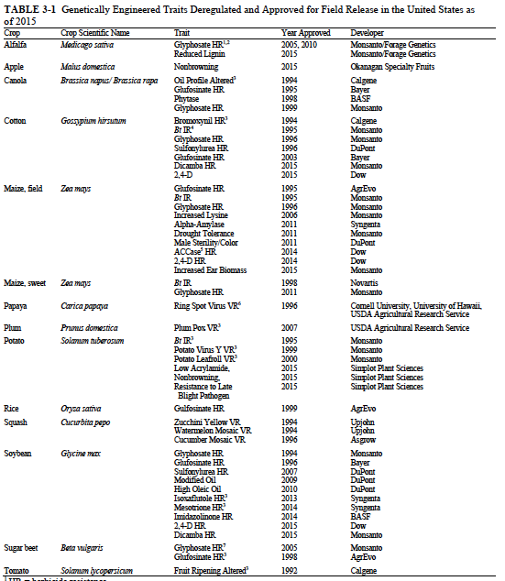
Figure 27: Professional scientific visualization tool used by scientists on Zhihu (No.8)

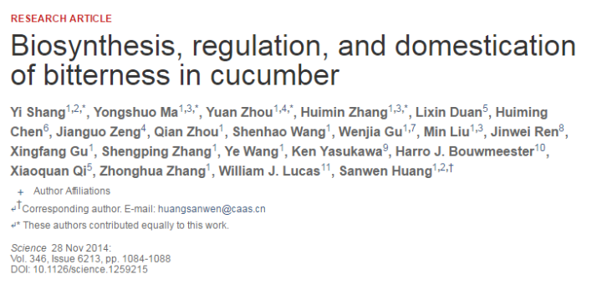
Figure 28: Professional scientific visualization tool used by scientists on Zhihu (No.18)

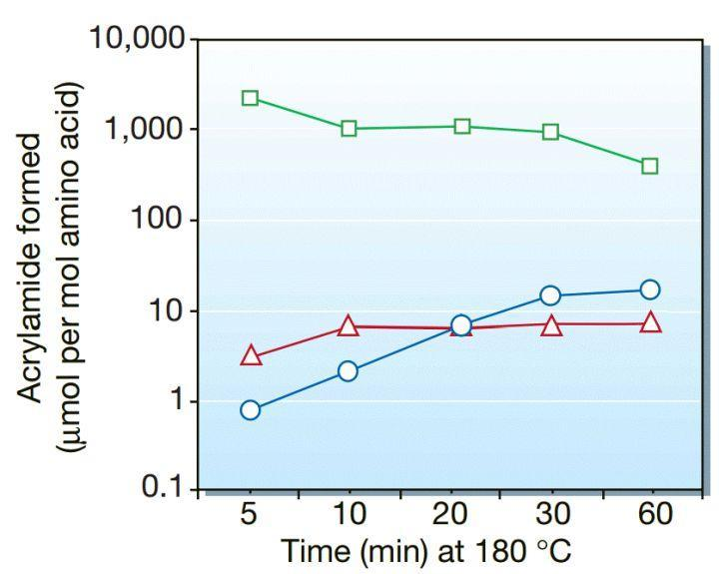
Figure 29: Professional scientific visualization tool used by scientists on Zhihu (No.26)

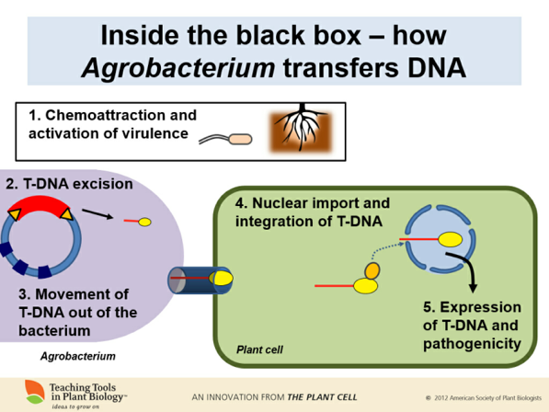
Figure 30: Professional scientific visualization tool used by scientists on Zhihu (No.9)
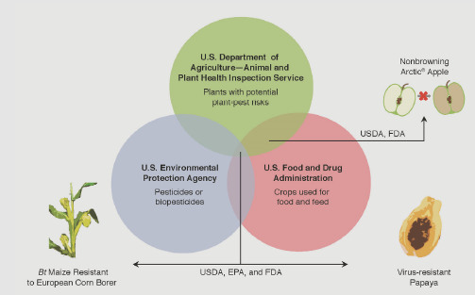
Figure 31: Professional scientific visualization tool used by scientists on Zhihu (No.8)
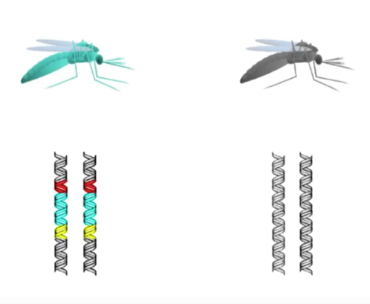
Figure 32: Professional scientific visualization tool used by scientists on Zhihu (No.29)
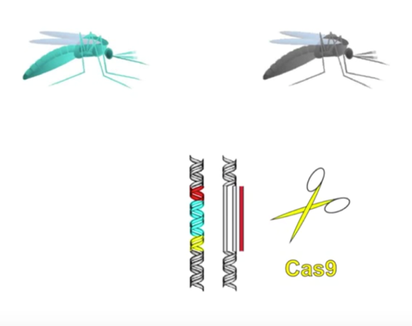
Figure 33: Professional scientific visualization tool used by scientists on Zhihu (No.29)
Some studies claim that using visualization tools in the science communication process can help scientists to simplify scientific knowledge and improve the public’s understanding of science (Johansson et al., 2010; Eppler, 2004; Bucher and Niemann, 2012; Ma et al., 2011; Landau et al., 2009), and even narrow the distance between the public and science (Bennett, 2009; Mellor, 2009). However, all the advantages of visualization tools are based on tools used by science communicators being easily accepted and understood by the public, and the visual tools reducing the complexity of the original scientific content.

However, taking the figures above as examples, some could help people get a better understanding of the scientific principles behind them, but most are not so easy to understand. For instance, Figures 32 and 33 convey scientific information and try to use some narrative to explain the scientific principles of a gene drive. However, the professional elements and a lack of explanatory information in these figures means that the general audience are not likely to effectively understand what the authors wanted to express, thus the work would not resonate with the public. The other figures selected as examples are also filled with scientific content that is unfamiliar and likely to be incomprehensible to the public. Whether it contains English content or a purely scientific display, the people who can understand the information in such scientific visualizations are more likely to be other scientists on Zhihu. The visualization tools used on Zhihu not only fail to achieve the aims of narrowing the distance between science and the public, but also further define the boundary between scientists and the public, just like the effects of the jargon and professional expression discussed above.

Like the analysis above, many researchers have already pointed out the phenomenon in science communication texts – especially the science communication process led by individual scientists – whereby there is a large volume of professional content that is difficult for the public to understand (Ledesdorff and Hellsten, 2005; Holliman et al., 2009; Sismondo, 2010; Simis et al., 2016). In this research, the relationship between this phenomenon and the identity, boundary-work and discourse authority of scientists is considered. The analysis of scientific content above highlights a feature of scientists’ answers on Zhihu: due to the professional scientific content in scientists’ answers, on the one hand, those answers can demonstrate the answer-providers’ identity as scientists to form a bonding network with other scientists; on the other hand, because of the difficulty in being understood and accepted by the public, they have increased the social distance between scientists and the public on Zhihu. Thus, according to Gieryn’s theory, a boundary is built, and the authority of scientists on Zhihu has also been further maintained.

Bridging functions
Of course, following Norris (2002), the discursive practices of many groups serve both bridging and bonding functions – scientists do not just use such professional scientific content in their answers on Zhihu in the topic of GMF, they also use some life-oriented textual and visual content in their answers, such as personal experiences as an ordinary person, narratives, first-person pronouns, lifestyle metaphors or active voices. These means are generally believed to be used by scientists to communicate scientific knowledge in an easy-to-understand way, which can create a form of intimacy with the public (Xiong and Liu, 1999; Gong and Dragga, 1995; Hyland, 2002; Holliman and Jensen, 2009). For instance:
Who told you that farmers do not have the habit of keeping teserve seeds. The vegetables and fruits we eat in my hometown are all teserve seeds. (No.20, Question: How can we evaluate some resolute opposition to the idea that the staple food should be genetically modified?).
I have discussed this issue with my friends on WeChat (following with the screen shot of the discussion on WeChat). (No.5, How does Chai Jing’s smog investigation compare with Cui Yongyuan’s GM survey? Why is the latter much more controversial?).
Through such expressions, scientists do not actively demonstrate their behavioural characteristics or experiences as scientific practitioners, instead referencing ordinary behaviours in a non-scientific environment, such as chatting on a social media platform. The public, as audiences for such answers, may find that such behaviours or experiences shown by scientists are ones they can identify with, potentially creating a feeling of resonance and intimacy:
Can I ask you several questions? 1. A knife can be used to cut vegetables; can it also be used to cut people? (Answer Yes or No!); 2. Can you 100% predict that you will not cut yourself when you are using a knife to cut vegetables? 3. If you cannot 100% guarantee that you will not be cut by the knife, will you be more careful when using a knife? (No.12, Question: What do you experts think of vaccine and genetic modification?).
In this example, the duality of a knife for both helping people and hurting people was used to analogize the advantages and disadvantages of GMF. The familiar concept of a knife in this metaphor can effectively help the public understand the abstract principle of the duality of GMF. In this answer, although the scientist answer-provider did not provide detailed scientific information about the advantages and disadvantages of GMF, a public reader can still clearly understand the conclusion that applies in the case of GMF, and that GMF should not be considered from only one perspective. Some lifestyle visualizations have also been used by scientists on Zhihu: Figure 34 shows a common wall painting about Chairman Mao in the Chinese countryside; Figure 35 is a picture of sausages, as eaten in daily life. By using these images scientists link the scientific concepts and principles of genetic modifications with the public’s daily lives. These life-oriented visualizations give the public the feeling that scientific knowledge and the scientists who introduce such scientific knowledge are just like them.

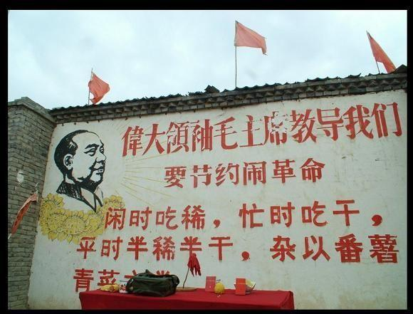
Figure 34: Example for life-oriented image used by scientists on Zhihu (No.6, Question: What is the value of the GMF? Do human beings really need GMF?)

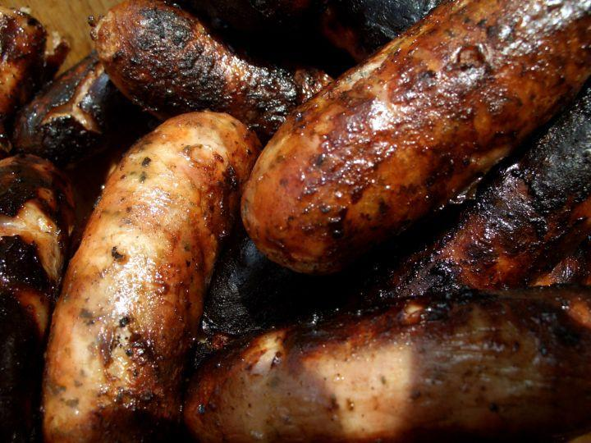
Figure 35: Example for life-oriented image used by scientists on Zhihu (No.25, Question: How can the US-approved GM potato ‘reduce the acrylamide produced during frying’?)

Clearly, the bonding function of scientists’ answers on Zhihu has become entangled with their bridging function. How such tangled outcomes can be used to answer the research question will be discussed in the remainder of the chapter.

6.2.3 Writing tone
This part further expands the personal cognitive analysis and structural analysis done above with the writing tone analysis. The boundary-work in scientists’ answers on Zhihu is not only reflected in scientists distinguishing themselves from the public, but also in placing these two groups in unequal discourse positions. As mentioned above, Chinese scientists on Zhihu tend to think that the general public has a lower social status than themselves. This kind of condescending attitude of scientists has already been proven by some researchers (see Kim, 2000; Huckin, 2002; Nisbet, 2008). The patronising and teacher-like gestures of public-facing scientists are believed to be important signals for such condescending attitudes (Huckin, 2002). Using patriarchal and teacher-like gestures such as employing an educational tone in the science communication process can easily cause an imbalance between scientists as communicators and the public as audiences. For instance:
You do not know anything about science and are not willing to read papers. We, scientific researchers, explain that to you in an easy-to-understand way, but you do not listen. (No.17, Question: Is Cui Yongyuan’s attitude towards GM wrong?).
I would like to ask everyone to think about this question: why are all synthetic biology and genomic engineering circles too conservative on this topic? If you don’t know the answer, let me tell you. (No.1, Question: Do those people who support GM technology really know much about it?).
Among these examples and others, scientist answer-providers maintain a cautionary and educational tone, positioning themselves as educators. The audiences are treated like ignorant children who need the guidance of scientists and safeguarding in scientists’ discourses. Using an edifying tone indicates on the one hand that scientists tend to place themselves and the public as audiences in unequal discourse positions; on the other hand, it indicates that the deficit model still exists in scientists’ minds and the science communication process. Holliman and Jensen (2009) claimed that in the interactive, participatory science communication process, the deficit model is still deeply imprinted in scientists’ collective mindset. In the first example in this section, the scientist answer-provider believed that the public lacks necessary scientific knowledge and is unwilling to learn more about science, and further claimed that this is the reason why the public blindly listens to falsehoods about GMF from celebrities, such as Cui Yongyuan. What the public needs most – according to this scientist – is to receive education from scientists and accept scientific knowledge and ideas from scientists.

It can also be found from other examples that scientists seem to enjoy their role as educators. The question-and-answer approach to organising answers highlights their enthusiasm for answering questions from ‘students’. For instance:
Have you ever heard of prions? (I didn’t expect such a simple question that so many people cannot understand.) In fact, the digestion and absorption of many proteins occurs in the form of a short peptide. (No. 23, Question: What do people who have studied biology think of GMFs as a controversial topic?).
In this example, the scientist answer-provider provides some scientific information in a question-and-answer approach. But in the Chinese context, asking a question and answering it oneself as a kind of rhetorical device is not commonly used in daily communication. It appears more often in professional literary expressions or scientific textbooks (Li, 2005). In addition, the questions raised by scientists in their answers are not the focus of the original questions. For instance in the original question of No.23 – “What do people who have studied biology think of GMF as a controversial topic?” – the questioner may not be concerned about prions and their scientific principles. But the approach of asking a question and answering it used by the scientist here assumes that the question of prions is of concern for both the questioner and other members of the public. This assumption, based on the scientist’s own understanding, further demonstrates that scientists are still imposing their own self-cognition on the public, and still believe that the issues that scientists are interested in should also be of interest to the public. Such a condescending attitude to the level of knowledge demonstrates the unequal status of scientists and the public among scientists. This sense of inequality further characterizes the discourse techniques scientists have used when interacting with the public on Zhihu, as analysed above, to distinguish themselves from the public and further place them in two unequal positions. Thus, the boundary between scientists and the public is not only built but strengthened.

6.2.4 Boundary-work and anti-boundary-work created by scientist users on Zhihu
After a long discourse analysis, it can be concluded that Chinese scientists on Zhihu use a series of professional scientific discourse techniques and life-oriented discourse techniques to try to build a bonding network with other scientists or a bridging network with the public. Following Norris (2002, p.3), in practice, each group serves both bridging and bonding functions. But, as noted, science communication or scientific discussion on a public platform should avoid professional scientific discourse techniques (Wilson, 1998; Bucchi and Trench, 2008; Berger et al., 2010). Thus, although scientists on Zhihu might use life-oriented discourse techniques to build a bridging network with the public, they also use some professional scientific discourse techniques. Such techniques have had a progressive effect on boundary-work and the maintenance of the authority of scientists. First, those discourse techniques can help the scientist answer-providers on Zhihu to represent their identity as scientists and further build a bonding network with other scientists. Based on such a network and the difficulty of those discourse techniques for the public, the social distance between scientist users and public users has been further expanded on Zhihu. Finally, like the effect of the use of opposite pronouns by scientists, the public and the scientists on Zhihu have been distinguished by the use of those discourse techniques. This kind of distinction is also common in other environments beyond Zhihu (Bbensaude-Vincent, 2001).

Secondly, based on the writing tone of scientists on Zhihu, they and the public have been placed further into positions of inequality. The distinction between scientists and the public and the condescending attitude of scientists on Zhihu have shown that the boundary which Gieryn said is mainly used to distinguish scientists and non-scientists, scientific knowledge and non-scientific knowledge has been built on Zhihu: only scientists are qualified to be science communicators online, and the public need to be informed and educated by scientists. Based on this kind of boundary-work, scientists on Zhihu have maintained their privileged position of answering science-related questions and interpreting science-related knowledge, and the public are excluded from the bonding network of scientists and considered to have limited discourse power to get involved in the discussion of science-related topics by scientists. Even if the public does participate in the discussions of scientific topics on such knowledge-sharing networks, the knowledge or information they provide will also be identified by scientists as being outside the scientific circle, untrustworthy and not authoritative.

The discourse techniques used by Chinese scientists on Zhihu analysed above also correspond with the three discourse dimensions of boundary-work of science proposed by Gieryn (1983; 1999): rhetorical style; figurative language; and symbolic formulation. The scientific professional writing format and content, including scientific intertextuality analysed above, can be related to the ‘rhetorical style of science’ proposed by Gieryn. The use of scientific metaphors and the discourse techniques used to depict the ‘scientist-public’ relationship as ‘teacher-student’, such as educational tone, can be regarded as concrete manifestations of ‘figurative languages of science’ in the boundary-work of science theory. The scientific professional visualization tools, scientific professional citations, opposite personal pronouns, and other specific symbols used to construct the oppositional relationship between ‘scientists as communicators’ and ‘the public as audience’ can reflect the ‘symbolic formulation of science’ dimension of boundary-work of science.

In the face of this kind of boundary-work, it might be suggested that the professional scientific discourse techniques might just be a phenomenon that is unique to Zhihu. Perhaps scientists on Zhihu are more inclined to use more live discourse techniques. To respond to this assumption, the frequency of the boundary-work and anti-boundary-work discourse techniques in the 30 answers were counted (see Tables 9 and 10). The results show that the discourse techniques for boundary-work appear more frequently in all the selected samples compared to the discourse techniques for anti-boundary in all the corresponding perspectives, which means that scientists are more likely to use boundary-work discourse techniques in their answers on Zhihu. Although the dataset is small and more precise predictions cannot be made, the simple comparison of the frequency of two kinds of discourse techniques shows that using professional scientific discourse techniques is not a personal writing habit of a few individual scientists or a rare phenomenon on Zhihu – it is a relatively common phenomenon in the online scientific discussion process on Zhihu.

Returning to the research question cited at the beginning of this chapter – do scientists maintain their authoritative position in the contemporary new media environment? – scientists on Zhihu use a series of professional scientific discourse techniques to build a boundary between themselves and the public with the effect of maintaining their authoritative position. But are these discourse techniques consciously used? Or are they unconscious, based on scientists’ usual writing habits? Do scientists on Zhihu deliberately try to maintain their authority? Or are their online behaviours part of a collective unconsciousness controlled by what Gieryn called the “ideology of science”? These questions will be addressed in the following sections, with further evidence drawn from the interviews with scientist answer-providers on Zhihu.

Table 9: Frequency of discourse techniques for boundary-work in all selected samples
Discourse techniques | Frequency of occurrence | Samples
Identity representation | 24/30  （80%） | No.1; No.2; No.3; No.4; No.5; No.6; No.7; No.8; No.9; No.10; No.11; No.12; No.13; No.15; No.17; No.18; No.19; No.21; No.23; No.24; No.25; No.26, No.28; No.29
Scientific writing formats | 13/30  (43%) | No.3; No.7; No.8; No.9; No.10; No.11; No.13; No.14; No.22; No.25; No.26; No.28; No.29
Scientific Content | 28/30  (93%) | No.1; No.2; No.3; No.4; No.5; No.6; No.7; No.8; No.9; No.10; No.11; No.12; No.13; No.14; No.15; No.17; No.18; No.19; No.20; No.21; No.22; No.23; No.24; No.25; No.26; No.27; No.28; No.29
Opposite personal pronouns | 80%  （24/30） | No.1; No.2; No.3; No.4; No.5; No.6; No.7; No.8; No.10; No.11; No.12; No.15; No.16; No.17; No.18; No.19; No.20; No.21; No.22; No.23; No.24; No.25; No.27; No.30
Educational tone | 50%  （15/30） | N0.1; No.3; No.4; No.6; No.9; No.10; No.11; No.12; No.15; No.17; No.18; No.20; No.23; No.25; No.29

Table 10: Frequency of discourse techniques for anti-boundary in all selected samples
Discourse techniques | Frequency of occurrence | Samples
Identity representation as ordinary persons | 4/30  (13%) | No.5; No.12; No.18; No.20
Life-oriented Content | 22/30  (73%) | No.1; No.2; No.3; No.4; No.5; No.6; No.7; No.11; No.12; No.14; No.15; No.16; No.17; No.18; No.19; No.20; N0.21; No.23; No.24; No.25; No.27; No.30
Non-opposite personal pronouns | 27%  (8/30) | No.4; No.5; No.15; No.17; No.18; No.20; No.25

6.3 Boundary-work: How do scientist users perceive their behaviour on Zhihu?
It has been established that both discourse techniques for boundary-work and anti-boundary-work have been used in scientists’ answers on Zhihu. But do scientists on Zhihu intentionally use both kinds of discourse techniques or do they favour one over the other? This section will explore these questions based on evidence from interviews with scientist answer-providers on Zhihu.

The interviews indicate that scientists are aware of significant cognitive differences between their uses of these two discourse techniques. Most scientists interviewed said that they were careful about using easy-to-understand, publicly acceptable expressions when writing answers on Zhihu. They seemed to be clear about their duty in terms of public facing science communication, and really wanted to build a bridging network between them and the public. One synthetic biology PhD researcher at Edinburgh University, who is also a popular answer-provider on Zhihu on the topic of GMF, said:
I think the answers I wrote on Zhihu are understandable to the public. And I also try to avoid using very professional expressions or jargon. What I used in my answers are all expressions of scientific knowledge that everyone can understand. I also used my own experiences and thoughts to help the public understand the principles of GMF or synthetic biology. I think my answer is already approachable. (Liu, 20/03/2019).
Indeed, this scientist used some reader-friendly expressions to help the public to understand the scientific principles of GMF and synthetic biology in his answer, such as using life-based examples, lifestyle metaphors and narratives. However, many ‘boundary-work’ discourse techniques can also be found in his answer. For instance:
Let me give you a piece of Nobel-Prize-level research as an example: In 1987, microbial geneticists discovered that there is an interval repeated palindromic sequence and named it later as ‘Short Regularly Spaced Repeats (SRSR)’. (No.1, Question: Do those people who support GM technology really know much about it? Written by Liu).
In this short example by Liu on Zhihu, a series of discourse techniques for building a boundary between himself and the public was used, such as opposite personal pronouns, English jargon and its abbreviations. But in his interview, Liu seemed unaware of his use of such specialized expressions. He could remember using some discourse techniques for the public designed to provide easy understanding and to build a bridging network, such as the example above, but he did not remember how he expressed this example.

A similar statement also appeared in another scientist’s interview. A biogeography professor at Sun Yat-Sen University who is active on various digital platforms said:
As far as I know, not only me, but also some of my colleagues answered the questions on Zhihu – some of us even opened a WeChat public account to recommend some good journal articles. We kept the abstracts and conclusions of those articles, compressed their content, and removed the incomprehensible parts to make sure the public could understand them. (Liang, 13/10/2019).
Liang believed that he and his colleagues had already spent much time on their duty of science communication for the public. They tried to translate scientific principles using publicly acceptable language and to provide easy-to-understand scientific content, which is not credited to their university. Having done so much for the public, they believe that they should be able to dissolve the boundary between the public and themselves and expect more gratitude and esteem for their efforts. But scientists like Liang participating in the online science communication process do not realise that the simplified explanations they think they have used are all based on their own scientific knowledge and training, which may not be appropriate for the general public. According to Fahnestock (1998), scientists are always uncomfortable with the simplification of their scientific expression, which they may think is harmful for the accuracy of what they have written. Thus, when scientists carry out scientific popularization writing for the public, they often find that they cannot accurately use expressions that the public can easily understand, even though the scientist writers think that they have used simplified discourse techniques. This is alongside scientists’ overestimation of the public’s acceptance and understanding of scientific knowledge. This point has been discussed above and demonstrated by many other scholars (such as Braun et al., 2015; Fischhoff, 2019). Scientists like Liang, who think that the public would be satisfied with their science popularization work, overestimate the non-scientific public’s interest in and understanding of science. Audiences without a scientific background may not be interested in high-quality journal articles about the esoteric and newest aspects of disciplines that are of particular interest to the scientific community. What the general public needs in science communication is what Fahnestock called “science accommodation”, which involves finding the points of interest in the topic that will appeal to readers who are not specialists in the field (Fahnestock, 1998, p.355), rather than directly selecting scientific knowledge and ‘translating’ it into a language which scientists believe is easy-to-understand. An analysis of the scientists’ answers on Zhihu shows that scientist answer-providers do not complete this task successfully.

Although Liang and other scientists on Zhihu have used a series of simplified means to provide their answers, their results often still retain much professional scientific content. However, the above examples show that during the online science communication process, scientists as communicators always exaggerate their efforts and the effects of their simplification work. Another scientist answer-provider added:
I do think the answers I wrote on Zhihu are very life oriented. I used a lot of lifestyle examples and humorous ways to prove my point. For example, I remember there was a question on Zhihu about how to solve the problem of an overheating experimental instrument. I first made a joke, said that you need to wear gloves, and then said more about scientific processes. (Qian, PhD researcher in chemistry, Imperial College London, 16/06/2019).
Some may argue that the reason that scientists have adopted such discourse techniques for boundary-work may be because scientists on Zhihu are not writing answers for the public or for the part of the public with a higher educational background. However, interviews with scientist answer-providers show that they think their answers to science-related questions are suitable for the general public. Although they seldom directly said that their answers responded to other scientists, they still believed that most of their answers were written for the public, which is also why they want to participate in such a knowledge-sharing network. For instance, one engineering physics researcher at Embry-Riddle Aeronautical University said:

I do think I wrote my answers for the general public. If I want to write something to other circle-insiders, I can use Xiaomuchong, Research Gate, or some other professional platforms. Most users of Zhihu you know are still the general public. (Qiao, 22/07/2019).

Zhang, a PhD researcher in physics and complex systems from Arizona State University also said:

The original purpose of my usage of Zhihu is just to communicate the scientific knowledge I know to the public. And as for the dialogues between scientists on Zhihu, I think these also allow the public to get a better understanding of what scientific discussion and scientific proof looks like. (Zhang, 12/03/2019).

Such interviews suggest that scientists believe their answers are written for the general public and that on Zhihu the public is a homogeneous group without a consciousness of hierarchy of the public users on Zhihu. Priest (2009) proved that in many science communication practices scientists tend to treat public audiences as a homogenous group. For instance:
I think I am a person with scientific literacy. But I think most of the public users of Zhihu do not have scientific literacy. Yes, they do not have it. They do not have that kind of scientific rationality. (Li, PhD researcher in physics, Fudan University, Nottingham Trent University, 20/07/2019)
The scientific literacy of the public users of Zhihu is just here. The way they talk about GMF just shows that they lack scientific literacy. But you should know, the public’s scientific literacy is just like this [gestures to show it is not high]. If their scientific literacy is enough, then we do not need the professionals anymore. (Liu, PhD researcher in quantitative and synthetic biology, Edinburgh University, 20/03/2019).
Although those scientists used some adverbs such as ‘most’, the tendency is to view the public on Zhihu as a homogenous group that lacks knowledge. For scientists, the public on Zhihu with shared low scientific literacy do not need to be treated differently in the science communication process. Returning to the hypothesis above, based on these interviews, the reason that scientists on Zhihu used such professional discourse techniques in their answers is not because they were writing their answers for the public or just for the part of the public with a higher educational background, but is more likely due to their writing habits as scientific practitioners.

But do scientists realize that they have used such professional scientific discourse techniques and maintained their discourse authority based on creating a boundary with the public on Zhihu? The interviews suggest that scientists’ use of such boundary-work discourse techniques is carried out unconsciously. For instance, when I asked the scientist answer-providers whether they used professional discourse techniques in their answers on Zhihu, they held the view that they rarely used them.

Interviewer: What do you think about some science practitioners who like to use some scientific paper writing formats in their answers on Zhihu, such as scientific references, English figures or tables?
Zhu: I don’t have any special thoughts about the writing format. I think that is just a matter of writing habits. But I definitely didn’t write my answers in this way on Zhihu.
Interview: So, in general, how would you write your scientific answers on Zhihu?
Zhu: I usually write the conclusion at the beginning of my answers and them explain it to the audiences. I would avoid using professional vocabulary as much as possible. Even if I use these words or principles, I would definitely write in a way that primary school students or non-professionals can understand. And I always use some life-oriented examples in my answers. I don’t use very professional, academic content or expressions in my answers on Zhihu. (Zhu, research fellow in engineering and automatic control, University of Sheffield).

A similar response appears in almost all interviews with scientist answer-providers on Zhihu. Such behaviour – using boundary-work discourse techniques but not believing that they have been used excessively – can be defined as collective unconscious behaviour, which may be relevant to their collective ideology as a scientific community. According to Gregory (2008, p.3): “scientists en masse are most usually referred to as a community, rather than just as a profession […] and a community could be a group of people who share a physical location, have some particular quality in common, and share the same ideology.” As a social community, their collective unconscious behaviour is believed to be profoundly influenced by the ideology of the community and the concentrated expression of such ideology (Eagleton, 1979; Gullatz, 2010; Hopper and Weinberg, 2011; Vovelle, 2016). The social behaviours that people unconsciously or subconsciously engage in reflect their inherent mindset, which is considered to be culturally learned as a member of a community group (Guzeldere, 1995). Therefore, compared with those behaviours that people intentionally carry out, their collective unconscious behaviours reveal more about their shared behavioural paradigm, culture, mindset, and the ideology behind them. As Gieryn observed, one of the most important aspects of the ideological efforts by scientists is to distinguish themselves from the general public and other intellectual groups, such as astrologers and pastors, and distinguish their work and products from non-scientific intellectual activities, finally maintaining the professional autonomy and authoritative position of science and scientists (Gieryn, 1983, p.782). Building a boundary and defending their authority may already be rooted in the scientists’ mindset. Thus, scientists on Zhihu adopt a series of boundary-work discourse techniques without realizing but they are also more sensitive to the other discourse techniques for anti-boundary-work that they use.

Many scholars believe that the collective mindset of a community or group is deeply related to the community or group member’s understanding and acceptance of their community or group identity (Hummon, 1990; Hogg, 2005; Kim, 2007), from the training they received to become a member of such a community or group (Machin and Van Leeuwen, 2016). Scientists gain the understanding of their role from their scientific education and the research experience that is unique to scientists. Science students learn their code of practice and the unconditional trust and loyalty to science from their education. Through the consolidation of their repeated research or lab-work behaviours that are unique to scientists they finally gain understanding and acceptance of their roles as scientists, and as spokespersons and guardians of science. Based on their understanding and acceptance of such roles and their trust in and loyalty towards science, maintaining the authority and inviolability of science is imprinted into their mindset. Thus, it is not surprising that scientists on Zhihu are not conscious of their online behaviours in terms of using professional scientific discourse techniques to build boundaries to maintain their discourse authority.

In summary, scientists on Zhihu do use a series of boundary-work discourse techniques. But compared with the anti-boundary-work discourse techniques used by scientists on Zhihu, which are exaggerated by the scientists themselves, their online behaviour of using boundary-work discourse techniques tends to be collectively unconscious.

6.4 Conclusion
This chapter first analysed the discourse techniques used by scientists in their answers on Zhihu. Even in public questions, scientists still tended to use scientific style and principles as if they were answering scientific questions. They have adopted some anti-boundary discourse techniques to make their answers approachable, especially in public questions. Both bonding functions and bridging functions were found across the discourse analysis of the 30 samples. On Zhihu, the bonding function of scientists’ answers has two aspects: linking other scientists to form the scientist network and excluding non-scientists from this network. The bridging function of scientists’ answers on Zhihu encourages intimacy with the public and pulls them into the scientific discussions, as per the ‘dialogue model’ and ‘participative model’ of science communication. Through the discourse analysis, these two functions were both found in public questions and scientific questions, but to different degrees. In scientific questions, the bonding function is more significant than bridging, while in public questions, the two functions are both apparent. In general, for all the questions answered by scientists on Zhihu, the two functions are both present in their discourse, while the bonding function (boundary-work discourse) is more prevalent.

Employing Gieryn’s theory of boundary-work, the bonding function of scientists’ answers on Zhihu seems aligned with the boundary-work distinguishing scientists from non-scientists and combining scientists together. Thus, the bridging function can also be identified as anti-boundary-work. The prominent effect of these discourse techniques for building a boundary is to define ‘we’ as scientists and authoritative science communicators and ‘you’ as the general public and the audiences of science communication, and further place ‘we’ and ‘you’ in unbalanced positions with differing discourse power. The display and differentiation of such identities, on the one hand, comes from indirectly presenting the content and expression that only scientists can understand and use, and on the other, from the direct oppositional pronouns used by scientists. Through such boundary-work, scientists on Zhihu have further maintained their authoritative role as unquestionable interpreters and disseminators of scientific knowledge and information.

Returning to the research questions proposed at the beginning of this chapter: Do scientists maintain their authoritative position in the contemporary new media environment, and if so, how? Scientists do use a series of professional scientific discourse techniques to distinguish themselves from the public, and then they build a boundary for maintaining their discourse authority on Zhihu. Interviews showed that, compared to the discourse techniques for bridging the public that scientists engaged in intentionally, their discursive boundary-work behaviour is not necessarily deliberate. And scientists do not think that their answers on Zhihu are written for other scientists or a particular part of the public – they see the public as a homogenous group with insufficient scientific literacy. Thus, such boundary-work behaviours, using professional scientific discourse techniques, may reflect the social identity shared by scientists as a community. According to Gieryn’s discussion of ideology of science and the boundary-work of scientists, the most important parts of the ideological efforts of science are to distinguish science from other types of knowledge, to distinguish scientists from non-scientists, and to preserve the authority of science and the scientific community. Therefore, the collective unconscious discourse techniques used by scientists on Zhihu to build boundaries between themselves and the general public, distinguishing ‘we’ from ‘you’, and further maintaining their discourse authority, embody the ideology of science hidden in the process of online science communication. In summary, a boundary between scientists and the public is indeed built in the online science communication process based on using a series of professional discourse techniques by scientists on Zhihu to maintain their discourse authority.

Chapter 7: When the Public and Scientists Meet on Zhihu: Unbalanced Power between Scientists and Non-scientists on Zhihu

The previous two chapters discussed the online behaviours and discourse characteristics of scientists and the public, especially citizen science communicators (CSCs), on Zhihu. Taking discourse authority of scientists as the analytical lens, the challenges brought by the public and the means adopted by scientists to maintain their discourse authority on Zhihu were further explored. The findings of the previous chapters indicate that there is indeed a kind of struggle in terms of scientific discourse authority between the public, who challenges the scientists’ absolute discourse authority, and scientists, who try to maintain their discourse authority through various discourse features. But what is the outcome of such a struggle and what impact will it have on Chinese science communication? To answer these questions, more detailed research with appropriate methods is needed. The previous analysis was mainly based on textual analysis of online science communication or scientific discussion and focused on scientists and the public separately. However, in addition to heightened potential for content production, the digital media environment also opens up new channels of communication and possibilities for interaction (Jensen, 2010). For science communication, the decentralized and participatory nature of online social media offers a novel opportunity to study previously inaccessible aspects of social interaction about scientific topics – such as GMF (Auer et al., 2014) – including the social network structures that link individuals engaged in online debate and are likely to affect how attitudes evolve over time (Williams et al., 2015, p.126). Thus, the present chapter focuses on the relationship between scientists and the public in the GMF section of Zhihu by focusing on social network dynamics.

As Williams and colleagues (2015, p.135) have observed, cross-group interactions that indicate an open channel for information flow and potential influence are one of the aims of online science communication and discussion. The following social network analysis will help to test whether this aim is achieved on Zhihu in relation to the topic of GMF, and further help to answer the research questions: how do scientists and non-scientists interact with each other, and what does the structure of such interaction indicate in terms of power dynamics between scientists and the public on Zhihu? In the current context, have Chinese scientists successfully maintained their discourse advantage in the face of challenges from the public?

7.1 Interactive structures and discourse power
One of the most common objectives of social network analysis is understanding the relationships within a social structure composed of ‘actors’, such as customers, employees, students, or any other group of people, and identifying how members of the network interact with each another (Wasserman and Faust, 1994; Newman, 2011). “Influence is a form of power, suggestion, or domination” (Pinheiro, 2011, p.134), and the analysis of the structure of interaction among different groups can help with understanding the power distribution among those groups.

Van Dijk (1993) claimed that power involves control, by (members of) one group over (those of) other groups, and Foucault (1982, p.781) also saw power as a structural expression of “a complex strategic situation in a given social setting that requires both constraint and enablement”. Power is therefore revealed and achieved through interaction between (members of) different social groups. This feature is more pronounced in the process of communication, because communication could be seen as a process of interaction based on information exchange between different individuals or groups. Furthermore, social interactions, especially those in which power is generated, often appear in a structured form. For instance, as Lee and colleagues (2005) have observed, social structures often lead to uneven distributions of social capital in social interactions, and such uneven distributions of social capital often produce ‘discourse power’. Therefore, it is feasible to analyse the power relationship between scientists and the public, and the formation and situation of such power in the process of science communication from the perspectives of interaction and the structure of such interaction, especially in the digital media context.

As mentioned above, the more important reconstruction of the digital media environment for communication is the channels and possibilities of interaction it provides (Jenson, 2010). By empowering the weakened party (Bennett, 2003; Loader, 2007) or amplifying the social capital of the stronger party in the traditional social world (Williams, 2007; Ellison and Vitak, 2015), such as male (stronger) and female (weakened) or elites (stronger) and lay people (weakened), digital media is restructuring social interaction in the communication process. In this context, to explore the interactive features and power relationships in a certain online communication process, an interactive and structural perspective is even more important.

As discussed in Chapter 4, throughusing networks and graph theory, social network analysis has emerged as a key technique for investigating individual or group interactions and social structures (Wasserman and Faust, 1994; Otte and Rousseau, 2002; Newman, 2011). It is thus suitable for this research to use the perspective of interactive structures and the method of social network analysis to study the power relationship in online science communication processes on Zhihu. The detailed steps followed for this social network analysis were provided in Chapter 4.

7.2 Partition and homophily in the online scientific discussion on Zhihu
As discussed in Chapter 4, there are three kinds of interactive mechanism on Zhihu: mentions, comments, and likes. However, the like mechanism on Zhihu does not provide publicly-accessible information about users who add likes to answers or comments – only the person who received the like can see this information. As the interactions between scientists and the public on Zhihu are being explored, the identity information of users is crucial, so the mention and comment functions were further selected as sources of interaction data in this study. The mention function (@) is one of the main interactive functions used by Zhihu users to ‘tag’ others in their answers. This function is triggered by using the @ symbol in the content of answers on Zhihu. In terms of function, it is similar to the mention function on the Twitter platform, both of which are used to attract the attention of the mentioned user. The usernames of those users who are mentioned by this function feature a hyperlink to their homepages. Mentions and links are visible and accessible to all users on Zhihu. It should be clarified that a ‘mention’ on Zhihu is not a real interactive behaviour but is an initial action used to try and construct interaction with other users. It can thus help to explore the attitudes and tendencies of different users towards interactions on Zhihu. The user who is mentioned by other users receives a system notification informing them that they were mentioned by someone else. But whether they interact with the user who mentions them depends on the wishes of the user mentioned – they can also choose to ignore the mention – but generally those users who are mentioned by others tend to reply and interact. If the mentioned user wants to reply to the mention, they can only reply in the comment space below the answer containing the mention. Compared to the comment function, mention is not a directly interactive behaviour among users on Zhihu.

The social network analysis of the mention function used in all the answers about GMF on Zhihu led to the visualization in Figure 36, in which the colour of nodes indicates the identities of each node. The red nodes represent scientists, yellow represents non-scientists, and black nodes represent those users whose identities cannot be clearly identified. The node sizes represent the different centrality degrees, which means the number of adjacencies of each node in a network. A line with an arrow between two nodes indicates that they are in a mentioned interactive relationship (one user mentioned another user). The directional network used here can not only help to explore which users are most active in the potential interaction on Zhihu, scientists or public, but further indicate which users tend to mention other users or are mentioned by other users.

The data clearly shows that the overall mention network is not cohesive but rather characterised by a number of small – two-node – subnetworks. For a better understanding of such clusterization, some main independent subnetworks have been manually highlighted in Figure 36.
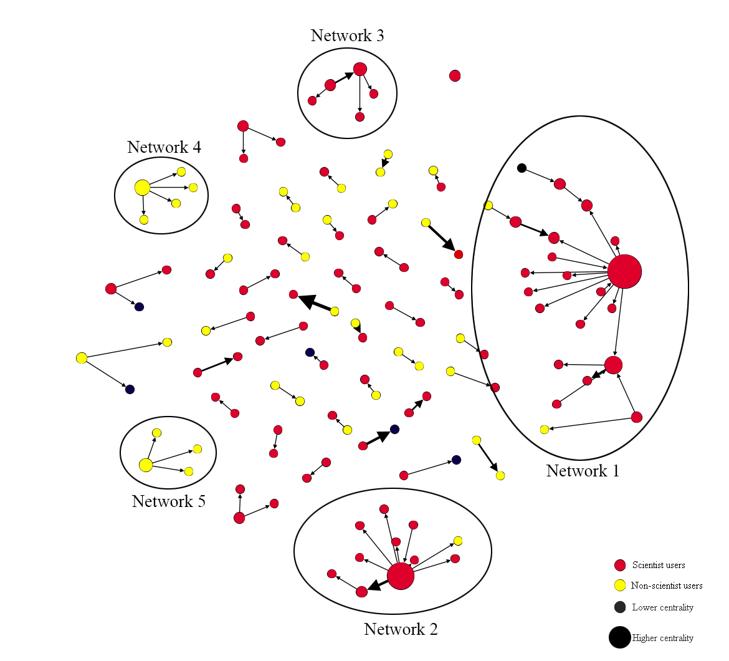
Figure 36: Mention network of the GMF discussion on Zhihu (clusterization)

In the overall mention network of all the answers about GMF on Zhihu, five major subnetworks were identified. In these five subnetworks, the homogeneity between users is clear. In the three larger subnetworks (networks 1 to 3), almost all of the nodes are scientists; non-scientist users only appear occasionally (networks 1 and 2). Similarly, in the two smaller major subnetworks (networks 4 and 5), all of the nodes are non-scientists. Therefore, there is a partition between scientists and non-scientists in the overall mention network. The boundary-work between scientists and the public on Zhihu, discussed in previous chapters, is also evident in the way Zhihu users interact. Figure 36 also shows that, in addition to the partition of the overall mention network, a homophily of each subnet is apparent. Homophily in social network analysis means a tendency in social networks for nodes with the same or similar attributes to be connected with each other (McPherson et al., 2001). The main subnets show that the nodes with the same identity attributes, scientists or non-scientists, tend to be connected with each other.

Both the network partition and homophily suggest the failure of interaction between nodes with different attributions in the overall network (Shimeall and Spring, 2014). In the overall mention network of the GMF discussion on Zhihu, the partition and homophily based on the phenomenon of clusterization indicates that the scientist subnets and non-scientist subnets did not form an effective interaction with each other. It seems that there is an interaction barrier between scientists and non-scientists in the overall mention network on Zhihu. According to the mention function on Zhihu, which represents a kind of active online behaviour by users, it is assumed that the network partition in the overall network was proactively manufactured by scientists and non-scientists on Zhihu, which means both parties seem reluctant to interact across groups.

In addition to showing the failure of mention interactions between scientists and non-scientists, the different sizes of those subnets also indicate the unbalanced interactions in the GMF discussion on Zhihu. The two biggest subnets (1 and 2) are mostly composed of scientist nodes, which also demonstrates that compared with non-scientists, scientists are more inclined to interact with each other within the scientist group.

To repeat for emphasis, from the partition and homophily of the mention network of the GMF discussion on Zhihu, it can be concluded that scientists and the public have still not achieved effective interactions across identity differences. It seems that from the perspective of interactional structure on Zhihu, ‘bonding work’ is far easier to identify than ‘bridging work’. It also seems that the two different groups are not even trying to interact with each other, since the mention function as the initial action used to try to construct interaction with other users can effectively indicate the attitudes and tendencies of different users concerning interaction on Zhihu. Following with the findings in the last chapter, although scientist users on Zhihu adopt both bonding (boundary-work) and bridging (anti-boundary-work) discursive and rhetorical techniques in their answers, the effects of bonding discursive and rhetorical techniques seem to be clearer and more powerful than bridging techniques. Williams and his colleagues (2015) observed that most users in the digital media environment interact only with others of a similar background. But the expectation for a digital media environment like Zhihu is that it can bring about real interaction between scientists and the public in the process of science communication, scientific discussion or public engagement with science (Park and Thelwall, 2006; Brossard and Scheufele, 2013; Peter, 2013). Many scholars have already pointed out that the digital media environment has the ability and potential to bring about interaction between scientists and the public (Irwin, 2008; Bucchi, 2008; Lee, 2015; Grand, 2016). Benkler even claimed that people want to be engaged and actively and productively interact with other users, they just need feasible opportunities, enabling environments, and the networks to enable those actors to obtain many-to-many interactions (Benkler, 2006). But the empirical analysis conducted so far indicates that such interaction has not yet been realized. If the digital media environment does have the ability to bring about interaction, but it has not yet been realized, does this mean that the most important barrier is not the media environment but the actors themselves? This question will be answered progressively in the following sections and in the next chapter.

7.3 Clusterization of scientists and fragmentation of non-scientists on Zhihu
Returning to the social network analysis of the interaction between scientists and non-scientists on Zhihu, partition and homophily can be found not only in the mention network, but also in the comment networks (Figure 37). Similar to the mention function, the comment function is one of the main interactive functions used by Zhihu users, which is much more often used to generate interaction with other users and therefore could provide more interaction data for this study. There are comment spaces under each answer on Zhihu. Users can write their feedback for that answer in this space, and each comment will be seen by all users on Zhihu, and the answer-provider will be sent a notification about the new comments, just like the comment functions on Twitter and Weibo. Thus, comments always produce some communication and interaction between those commenting and those answering. From the network based on the comment-relationship in the 100 answers with the most likes on the topic of GMF on Zhihu (Figure 37), by removing many two-node and small-size networks it is clear that there is only one main subnet containing almost half of the nodes in the overall network (Figures 37 and 38). In this network, the red nodes represent scientists, the yellow nodes represent non-scientists, and the black nodes represent those users whose identities cannot be clearly identified on Zhihu. Different from Figure 36 in this network, the sizes of nodes indicate the in-degree of each node, because in this directed comment-network, the exploration concerns the directed information flow and the role of information gatekeepers, which are mainly evaluated by the in-degree of nodes.

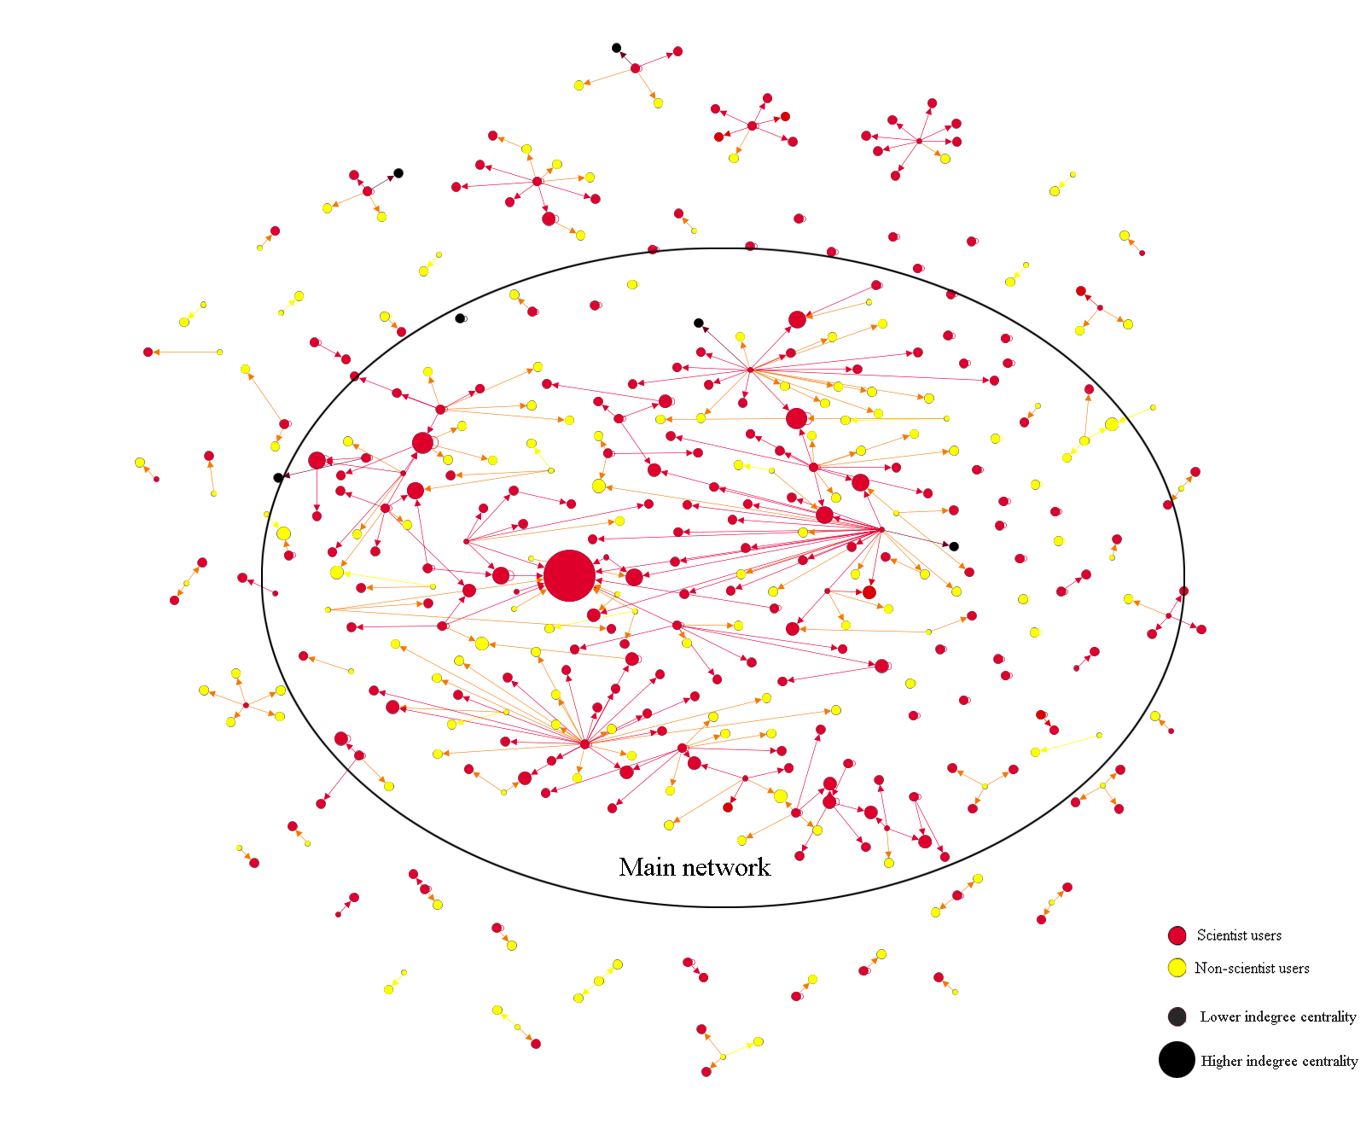
Figure 37: Network based on the comment-relationship in the 100 answers with the most likes on the topic of GMF on Zhihu

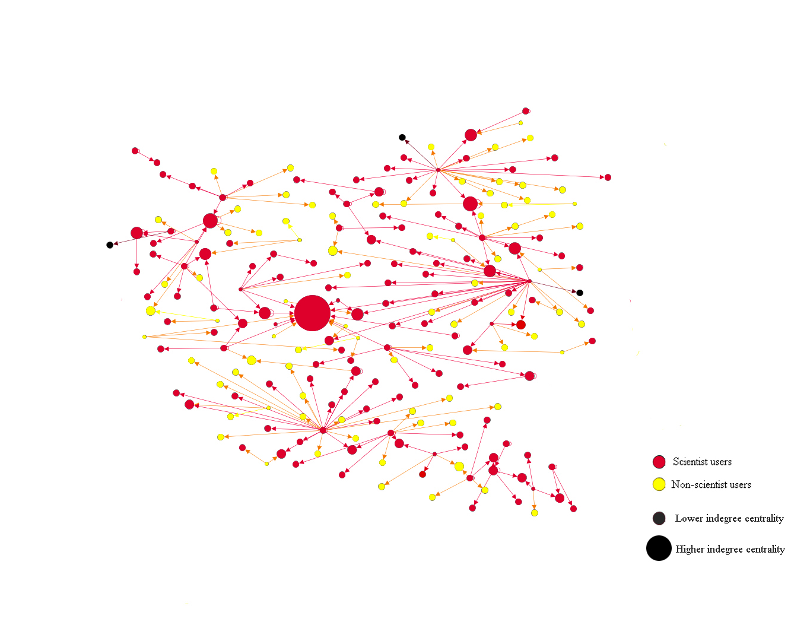
Figure 38: Main subnetwork (giant component) of the whole network based on the comment-relationship in the 100 answers with the most likes on the topic of GMF on Zhihu

In this comment network (Figure 37), there is only one main decentralised subnetwork (giant component) in the overall network (Figure 38). The decentralized network shows the hierarchical structure of a set of actors connected in the form of a larger actor with an additional link forming a loop (Baran, 1964, p.1). This kind of structure shows a phenomenon of unbalanced clusterization and fragmentation on the power relationship between scientists and non-scientists on Zhihu. In social network analysis, clusterization means the tendency of nodes in a network to cluster together; fragmentation is defined as the proportion of mutually reachable nodes as each node is removed from the network (Borgatti, 2003; Makagon et al., 2012). In Figure 38, the users in the giant component show a more pronounced tendency to interact and cluster with other users than other users outside of the giant component, which also means that those isolated points scattered outside the giant component show a fragmented state. Compared to non-scientist users (22%), scientist users (77%) are more inclined to appear in the giant component, while non-scientist users appear more at the edge or outside of this giant component as several small and two-node subnets. There are also users, most often scientists, engaging in different subnetworks bridging those subnetworks in the main decentralized network. This indicates that in the entire comment network based on the 100 answers with the most likes, scientists are more inclined to interact as a group than non-scientists, which also means that scientist users on Zhihu are more inclined to show a clustered state, while non-scientist users are more likely tend to show a fragmented state.

In social network analysis, clusterization and fragmentation can both be used to measure the degree of stability or cohesion of a certain group (Makagon et al., 2012; Liu et al., 2016). A group that tends to show a more obvious clustered status is considered to be more cohesive, stable, and centripetal. In contrast, a group that tends to show a fragmented state is considered to be less cohesive, stable, and centripetal. As mentioned above, from the social network analysis based on the mention function used in all the answers about GMF on Zhihu (Figure 36), it is clear that compared with non-scientist users, scientist users are more inclined to demonstrate clusterization, since the two biggest subnetworks are almost entirely composed by scientists rather than non-scientist users. This conclusion also further demonstrates the analysis of discourse techniques used by scientists in the previous chapter, especially the analysis of scientific intertextuality and the acquisition of authority of scientists’ answers on Zhihu.

In the interaction between different groups, the group with a higher degree of group cohesiveness is more likely to gain interactive advantages and discourse power. This is because group cohesiveness is a bond that pulls people towards membership in a particular group and aspirations within that group can bring interpersonal attraction, group pride and commitment to the work of the group (Mullen and Copper, 1994). The members of a group with a high cohesiveness will have a preference or desire to interact with each other and enjoy such interaction; and they also view their membership of such a specific group with fondness, feel proud of their group membership, and value their continued presence in this group, which is similar to the scientists’ maintenance of science and their identity of scientists discussed above. The members of a group with high cohesiveness will also value the work of the group and believe in its goals. They are willing to work together to complete tasks that are aligned with these group goals, even through adversity (Hogg, 1992). Those characteristics will make it easier for a group with higher cohesiveness to gain a competitive advantage when it competes or interacts with other groups with lower cohesiveness. For instance, it is easier to form a stable group force when one group competes for discourse authority with other groups.

According to the structural analysis of the network based on the comment-relationship in the 100 answers with the most likes on the topic of GMF on Zhihu (Figure 37), as well as the mention function network (Figure 36), compared with non-scientist users who tend to show a fragmented state, scientist users on Zhihu are inclined to be more clustered. An obvious clusterization always means a higher degree of stability or cohesion of a group, which could bring competitive advantages for this group. In the competition between scientists and non-scientists about the discourse authority on Zhihu revealed in the previous two chapters, compared with non-scientist users, scientist users may have clearer structural advantages in this competition.

7.4 Centrality and social capital on Zhihu
Alongside the structure analysis of the overall network, in social networks, the locations of nodes can also show the different social capitals of different actors or groups in the network (Borgatti et al., 1998). ‘Locations’ of nodes are kinds of ‘relational concepts’, which means they are explored through the analysis of relational data. Through a structural investigation of the locations of actors, the importance of individual nodes in the overall network and their social capital can be analysed (Borgatti et al., 2009).

Generally, the important locations or roles of nodes in a network are considered to be structural holes, celebrities, linkmen, bridges, gatekeepers, or isolates (Burt, 1992; Borgatti et al., 1998). Table 11 shows the definitions and references of those important actor labels in network analysis.

Table 11: Important actor labels in network analysis
Sources: Burt (1992); Haythornthwaite (1996); Nooteboom (2003); O’Malley and Marsden (2008); Musial and Juszczyszyn (2009).
Actor label | Definition
Structural hole | A structural hole is understood as a gap between two individuals who have complementary sources of information. Structural holes exist in social networks when there is a lack of a direct contact or tie between two or more entities.
Celebrities (Stars) | Celebrities or stars in a network relates to nodes that have been linked many times. They are often the most desirable and influential people in the group.
Linkmen (connector) | A linkman or connector in a network means a node that has a connection to two or more groups that are not connected to each other, but this node does not belong to either of these groups.
Bridges | A bridge in a network is a node that belongs to two or more groups at the same time and connects groups.
Gatekeepers | Gatekeepers in social network analysis are those nodes that form a connection between disorganised others, or more specifically, actors in network that hold a position between other actors that are not linked directly.
Isolates | Isolates are those nodes with no or relatively few links in the network.

Among the locations and roles of nodes mentioned above, with the exception of the isolates, all are considered to be central positions and roles that can bring more social capital. Since the focus is on the roles of users on Zhihu – the role of nodes in the networks above – and there are only two groups – scientist users and non-scientist users in the networks – the structural roles, linkmen and bridges are not immediately apparent in these networks. Therefore, to explore the discourse power and social capital of scientist users and the public users on Zhihu in relation to the topic of GMF, the analysis below mainly discusses the roles of celebrities and gatekeepers.

In the mention network (Figure 39), although there are no obvious gatekeepers in this network because of the limited size of the overall network, the top three celebrities with the most links are also all scientists, which means that in the mention network, scientist users with more interactive relationships hold more social capital and discourse power than non-scientist users.

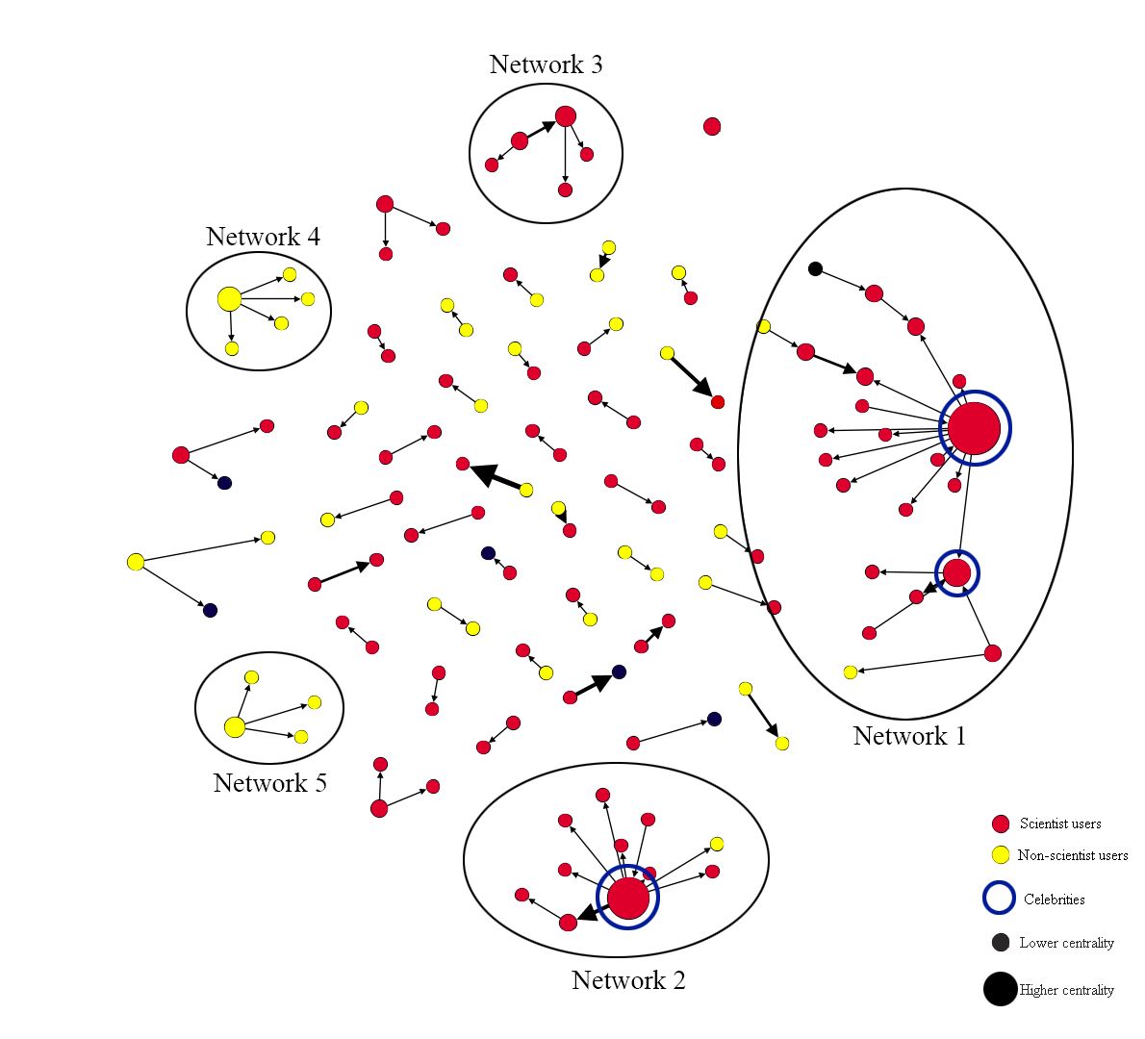
Figure 39: Celebrities in the mention network of the GMF discussion on Zhihu

In the network based on the comment-relationship in the 100 answers with the most likes on the topic of GMF on Zhihu, an attempt was also made to mark the celebrities and gatekeeper nodes in the main subnet (Figure 40).

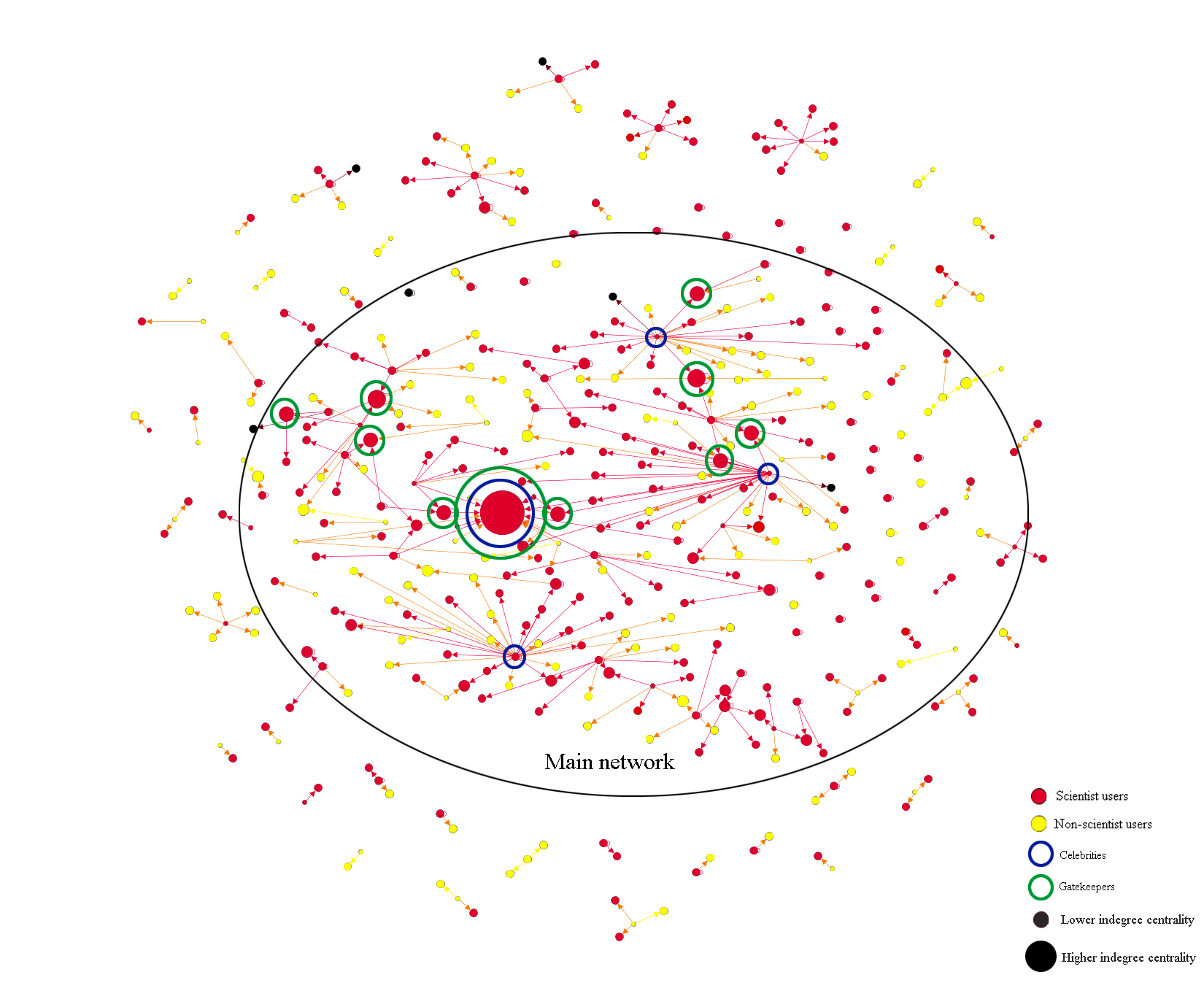
Figure 40: Celebrities and gatekeepers in the network based on the comment-relationship in the 100 answers with the most likes on the topic of GMF on Zhihu

In Figure 40, four main celebrities (nodes with the most links) and 10 main gatekeepers (nodes with the potential ability to control the information flow which is indicated by in-degree and also shown by the node sizes in Figures 37 and 38) have been identified and marked (see Table 12). Through the visualization of the identities of users in this network, it is clear that all the identified main celebrities and gatekeepers are scientists, which means that compared with non-scientist users, scientist users on Zhihu tightly control the important locations and roles of nodes in the comment network. According to Borgatti (1999; 2003; 2009), the important positions and roles of nodes can determine the social capital and discourse power of those nodes in the network or broader social interaction and social communication process. Combining Borgatti’s theory and the empirical outcomes of a social network analysis of Zhihu, it can be speculated that, compared with non-scientist users, when interacting with other users, scientist users are inclined to hold more social capital and discourse power.

Table 12: Main celebrities and gatekeepers in in the network based on the comment-relationship in the 100 answers with the most likes on the topic of GMF on Zhihu
Main Celebrities |  |  | Main gatekeepers
ID (anonymized) | Degree | Identity | ID (anonymized) | In-degree | Identity
Yuer | 30 | Scientist | Taishizimu | 12 | Scientist
Scientific Owle | 29 | Scientist | Jiangshan | 6 | Scientist
Heku | 22 | Scientist | Scientific Owle | 6 | Scientist
Zhiquan Liu | 15 | Scientist | Wolfccb | 6 | Scientist
 |  |  | Kanshan | 6 | Scientist
 |  |  | Raoyi | 5 | Scientist
 |  |  | Chenyan Duan | 5 | Scientist
 |  |  | Lhiquan Liu | 5 | Scientist
 |  |  | Yuer | 4 | Scientist
 |  |  | Yuandong Hu | 4 | Scientist

As discussed in Chapter 4, measuring the centrality of nodes can help to explore the discourse power of different groups in those networks. As Brass (1984) observed, the centrality of individual nodes is linked with their power and influence in the network. Three indicators – degree centrality, betweenness centrality, and closeness centrality – are used here to analyse the centrality of nodes in the interactive networks of Zhihu users. Furthermore, since all the three networks are directed, in-degree centrality, which is considered to be more effective in measuring the discourse power of nodes in directed networks, has also been calculated.

Table 13: Indicators of the discourse power in social network analysis
Sources: Leydesdorff (2007); Opsahl et al. (2010).
Indicators | Definition
Degree centrality | Degree centrality of a node refers to the number of adjacencies in a network.
In-degree centrality | The in-degree centrality for a node is the fraction of nodes its incoming edges are connected to.
Betweenness centrality | Betweenness of a node relies on the identification of the shortest paths and measures the number that passes through that node.
Closeness centrality | Closeness centrality of a node is defined as the inverse sum of the shortest distances to all other nodes from that node.

The node capacity of the mention network is limited; a mention is a kind of unreturned interactive behaviour on Zhihu, which means that the mention function may not completely form a two-way interaction. For example, when a user mentions another user on Zhihu, the latter can choose to ignore the mention – in this case, the two-way interaction cannot be established. Therefore, the following analysis mainly focuses on two comment networks: the network based on the comment-relationship in the 100 answers with the most likes (comment-network 1); and the network based on the comment-relationship in all answers (comment-network 2) on the topic of GMF on Zhihu.
Firstly, for the network based on the comment-relationship in the 100 answers with the most likes on the topic of GMF on Zhihu (comment-network 1), four indicators (degree centrality, in-degree centrality, betweenness centrality, and closeness centrality) have been calculated separately (Tables 14, 15, 16 and 17).

Table 14: Weighted degree centrality ranking and identities of nodes in comment-network 1
Ranking | ID (pseudonyms) | Degree Centrality | Scientist/Non-scientist
1 | Yuer | 30 | Scientist
2 | Scientific Owle | 29 | Scientist
3 | Heku | 22 | Scientist
4 | Zhiquan Liu | 15 | Scientist
5 | Shangshanfae | 12 | Scientist
6 | Chenyan Duan | 11 | Scientist
7 | Yang Liu | 10 | Scientist
8 | Huajiachicat | 10 | Scientist
9 | Junnian Wei | 10 | Scientist
10 | Zhongkuizhuogui | 9 | Scientist
11 | Taishizimu | 9 | Scientist
12 | Jiangshan | 8 | Scientist
13 | Raoyi | 8 | Scientist
14 | Intellectual | 7 | Scientist
15 | Kanshan | 7 | Scientist
16 | Yu Zhang | 7 | Scientist
17 | Jinliang Wei | 6 | Scientist
18 | Wolfccb | 6 | Scientist
19 | Maomao Yang | 6 | Scientist
20 | Yuandong Hu | 6 | Scientist

Table 15: In-degree centrality ranking and identities of nodes in comment-network 1
Ranking | ID (pseudonyms) | In-degree Centrality | Scientist/Non-scientist
1 | Taishizimu | 12 | Scientist
2 | Jiangshan | 6 | Scientist
3 | Scientific Owle | 6 | Scientist
4 | Wolfccb | 6 | Scientist
5 | Kanshan | 6 | Scientist
6 | Raoyi | 5 | Scientist
7 | Chenyan Duan | 5 | Scientist
8 | Lhiquan Liu | 5 | Scientist
9 | Yuer | 4 | Scientist
10 | Yuandong Hu | 4 | Scientist
11 | Lihu Si | 4 | Scientist
12 | Byuuet | 4 | Scientist
13 | Carrent Cai | 4 | Scientist
14 | Caesar Liu | 4 | Non-scientist
15 | Lee2 | 4 | Scientist
16 | Bou Bi | 4 | Scientist
17 | Lie Nong | 3 | Scientist
18 | Sleepwell | 3 | Scientist
19 | Goodpoint | 3 | Non-scientist
20 | Maomao Yang | 3 | Scientist

Table 16: Betweenness centrality ranking and identities of nodes in comment-network 1
Ranking | ID (pseudonyms) | Betweenness Centrality | Scientist/Non-scientist
1 | Zhongkuizhuogui | 12.0 | Scientist
2 | Yu Zhang | 4.0 | Scientist
3 | Wolfccb | 3.0 | Scientist
4 | Yifan Liu | 2.0 | Scientist
5 | DeanHH | 1.0 | Scientist
6 | Zhenrui Liu | 1.0 | Non-Scientist
7 | Xidong Yang | 1.0 | Scientist
8 | Eating Gene | 1.0 | Scientist
9 | Garfield | 1.0 | Scientist
10 | Fache | 1.0 | Non-Scientist
11 | Haiyang Yin | 1.0 | Scientist
12 | Chunnuanxiaochu | 1.0 | Scientist

Table 17: Closeness centrality and identities of nodes in comment-network 1
Closeness | Scientists | Non-scientists | Total
1.0 | 80/88% | 11/12% | 91
Closeness | ID | Scientist/Non-scientist
0.967742 | Scientific Owle | Scientist
0.966667 | Yuer | Scientist
0.958333 | Heku | Scientist
0.933333 | Zhiquan Liu | Scientist
0.9 | Junnian Wei | Scientist
0.888889 | Intellectual | Scientist
0.833333 | Yang Liu | Scientist
0.8 | Big Fly Elephant | Scientist
0.75 | Huajiachicat | Scientist
0.75 | Wandering Toad | Non-scientist
0.75 | Pansz | Scientist
0.75 | Gillbert Hao | Scientist
0.733333 | Taishizimu | Scientist
0.666667 | Lanling | Scientist
0.555556 | Beifeng | Non-scientist

Tables 14-17 show that of the top 20 nodes with the highest degree of centrality, 18 with the highest in-degree centrality are scientists; 10 in 12 users with a betweenness centrality greater than 1.0 and 88% of users with 1.0 closeness centrality are also all scientists. Although there are two non-scientist users in Tables 15 and 16, their in-degree centrality (4.0 and 3.0) and betweenness centrality (1.0) are also much lower than scientist users. Users with betweenness centrality higher than 1.0 are also shown to be all scientists. Similarly, in Table 17, among the rest of the users with a closeness centrality lower than 1.0, only two are non-scientists. It is clear that scientists have a higher centrality than non-scientists in this network.

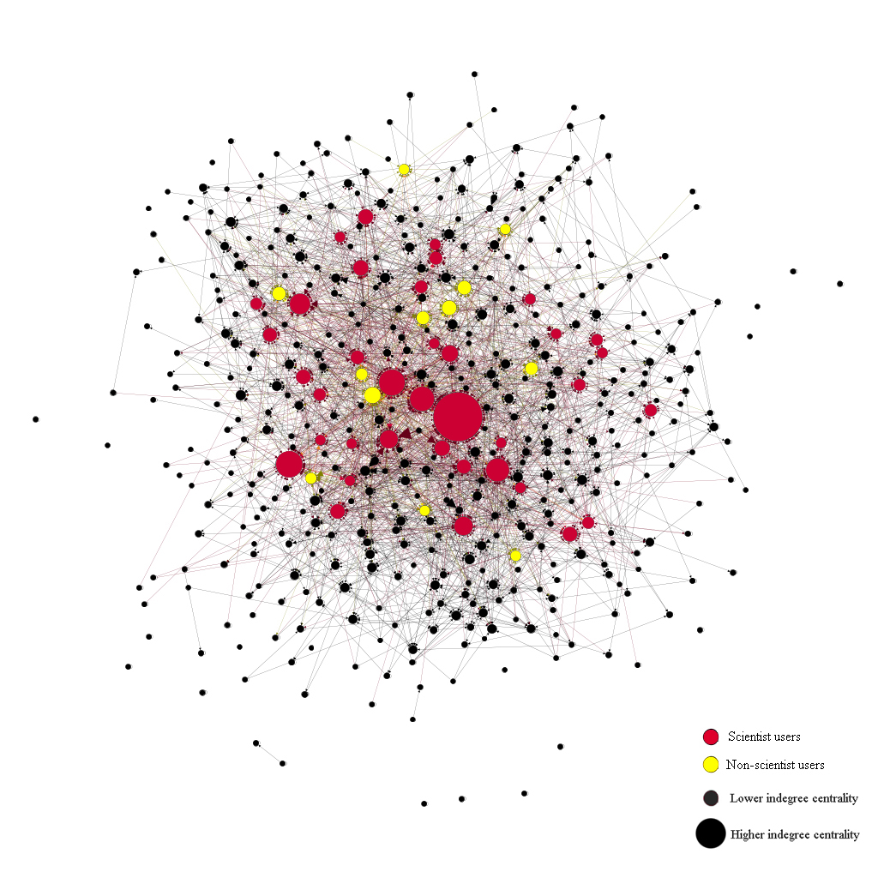
Figure 41: Network based on the comment-relationship in all answers on the topic of GMF on Zhihu

The results above show that scientist users are much more central than non-scientist users on Zhihu. But the discussion above is based on only the comment network of 100 answers with the most likes on the topic of GMF on Zhihu and thus may be biased. To control for such bias, the network based on the comment-relationship was extended to all answers in the topic of GMF on Zhihu (comment-network 2). In this network (Figure 41), because of the excessive number of nodes, it is impossible to define the identities of each node manually. Therefore, nodes with a degree below 3 have been filtered out, and only the top 50 nodes with the highest in-degree have been marked with their identities (red for scientists; yellow for non-scientists, black for nodes whose identity has not been defined). This graph shows that scientists also seem to occupy more important nodes than non-scientists. There are more scientist users than non-scientists among the top 50 biggest nodes and the top biggest nodes are all scientists. To explore further, data was calculated for the four indicators mentioned above: degree centrality, in-degree centrality, betweenness and closeness centrality for this network.

In this network based on the comment-relationship in all answers on the topic of GMF on Zhihu (Figure 41), in all the nodes whose degree centrality exceeds 50, scientists and non-scientists account for approximately 64% and 36% of the total respectively, which does not appear to be a large gap. It seems that scientists and non-scientists both occupy the centre of the network, and scientists only have a non-obvious advantage (Table 18). However, when the standard of the degree of centrality of the node is gradually increased, the proportion of non-scientists decreases. For those nodes whose degree centrality exceeds 100 and 500, non-scientists only occupied approximately 30% and 20% of the total respectively. For the 10 nodes with the highest degree centrality, only one is a non-scientist. As Freeman and other scholars have observed, degree centrality is a basic indicator of centrality of nodes, often used as a first step in studying networks (Freeman, 2004; McPherson et al., 2001; Wasserman and Faust, 1994; Opsahl et al., 2010). The tendency of such degree centrality of scientists and non-scientists in this comment-network shows that the closer they are to the centre of this network, the less prominent the non-scientists are. Although there is no significant difference in the volume of nodes of scientists and non-scientists in this network, the volume of the number of non-scientists is slightly larger than scientists – there are significant differences between these two communities in the network centrality.

Table 18: Number and proportions of scientists and non-scientists in the network based on the comment-relationship in all answers with different degrees
Degree centrality | Scientists | Non-scientists
Top 10 degree | 9/90% | 1/10%
Degree >500 | 16/80% | 4/20%
Degree >300 | 19/76% | 6/24%
Degree >200 | 35/78% | 10/22%
Degree >100 | 61/71% | 25/29%
Degree >50 | 101/64% | 57/36%

A similar tendency was also found in the statistics of in-degree centrality, betweenness centrality, and closeness centrality of nodes in the whole comment-network. For in-degree centrality, similar to degree centrality, non-scientist users occupied around 40% among the nodes where the in-degree exceeded 50. However, when the standard of the in-degree of centrality of the node is gradually increased, the proportion of non-scientists decreases as well. For those nodes whose in-degree centrality exceeds 300 and 500, non-scientists only occupied approximately 30% and 25% of the total respectively. For the 10 nodes with the highest in-degree centrality, there is also only one non-scientist user. For the betweenness centrality, among the top 500 nodes with the highest betweenness centrality, 32% are non-scientists. However, as the betweenness centrality increases, the proportion of non-scientists gradually decreases. For the top 10 nodes with the highest betweenness centrality, only one is a non-scientist (Table 20). Similar to the betweenness centrality of nodes in this network, only 11% of the whole nodes with 1.0 closeness centrality are non-scientists, while as the closeness centrality decreases, the number of non-scientists gradually increases in proportion (Table 21). However, it is significant that scientists still make up the vast majority of high closeness centrality nodes. To evidence this finding, the top 15 nodes with a closeness centrality of less than 1.0 were also chosen and identified (Table 22) – among these users, only one is a non-scientist.

Table 19: Number and proportions of scientists and non-scientists in the network based on the comment-relationship in all answers with different in-degree centrality
In Degree centrality | Scientists | Non-scientists
Top 10 in-degree | 9/90% | 1/10%
In-degree >500 | 15/75% | 5/25%
In-degree >300 | 20/69% | 9/31%
In-degree >200 | 38/74% | 13/28%
In-degree >100 | 69/66% | 35/34%
In-degree >50 | 95/61% | 61/39%

Table 20: Number and proportions of scientists and non-scientists in the network based on the comment-relationship in all answers with different betweenness centrality
Betweenness Centrality | Scientists | Non-scientists
Top 10 | 9/90% | 1/10%
Top 50 | 41/82% | 9/18%
Top 100 | 74/74% | 26/26%
Top 200 | 142/71% | 58/29%
Top 300 | 228/76% | 72/24%
Top 500 | 340/68% | 160/32%

Table 21: Number and proportions of scientists and non-scientists in the network based on the comment-relationship in all answers with different closeness centrality
Ranking | Closeness Centrality | Scientists | Non-scientists
1-184 | 1.0 | 163/89% | 21/11%
185-300 | 0.97-0.24 | 99/85% | 17/15%
301-524 | 0.24-0.15 | 170/76% | 54/24%

Table 22: Identities of nodes with highest closeness centrality
Closeness | Scientists | Non-scientists | Total
1.0 | 163/89% | 21/11% | 163
Closeness | ID (pseudonyms) | Scientist/Non-scientist
0.967742 | Scientific Owle | Scientist
0.966667 | Yuer | Scientist
0.958333 | Heku | Scientist
0.933333 | Zhiquan Liu | Scientist
0.9 | Junnian Wei | Scientist
0.888889 | Intellectual | Scientist
0.833333 | Yang Liu | Scientist
0.8 | Big Fly Elephant | Scientist
0.75 | Huajiachicat | Scientist
0.75 | Wandering Toad | Non-scientist
0.75 | Pansz | Scientist
0.75 | Gillbert Hao | Scientist
0.733333 | Taishizimu | Scientist
0.666667 | Lanling | Scientist
0.555556 | Beifeng | Non-scientist

Using degree centrality, in-degree centrality, betweenness centrality, and closeness centrality as indicators to measure the centrality of nodes in both comment networks shows that, compared to non-scientists, scientist nodes always have higher centrality in these two comment-networks related to GMF discussion on Zhihu. Furthermore, the closer to the centre of the overall network (the higher the centrality indicators), the higher the proportion of scientists, which means scientists have a much more central position than non-scientists in this whole comment-network. Brass (1984) observed that the individual centrality on a network is linked with power and influence; the nodes with higher centrality always have more social capital and discourse power in the network (Borgatti et al., 2009; Ingold, 2011; Merand et al., 2011; Farrell et al., 2016). For non-scientists, since it is difficult to get them involved in the core of the discussion network and they are thus excluded from the core of such interactions, as Freeman (1979) noted, the greater the distance to other nodes, the less the chance they have of receiving information in a timely way, and the more difficult it is to interact with other actors – they also enjoy less social capital. For the communication process, the most central nodes can decide what the correct information is and send this information back out to the other nodes (Borgatti et al., 2009). Putting this conclusion in the context of the online science communication or scientific discussion process, the nodes with higher centrality can decide what kind of information or knowledge related to the discussed scientific topic is right or not, which matches the discourse power discussed in the previous chapter. Combining the three centrality indicator analyses of this overall network, it is clear that scientists have greater social capital and discourse power in interactions between scientists and non-scientists on Zhihu. This unbalanced centrality of scientists and non-scientists shows the inequality of discourse power between scientists and non-scientists in an online knowledge-sharing network.

7.5 Conclusion: Inadequate interaction and unbalanced power between scientists and non-scientists on Zhihu
The social network analysis in this chapter suggests two main findings. Firstly, the partition and homophily of the interaction networks indicate that the scientist/non-scientist interactions on Zhihu do not live up to the potential for increased dialogue identified by scholars. Some scholars consider the digital media environment to be an unprecedented opportunity for breaking barriers and bringing about dialogical interaction between scientists and the public (Bonetta, 2009; Nisbbet and Scheufele, 2009; Schafer, 2012). The digital media environment – believed to have the ability to empower the general public in public engagement – is considered to have the ability to reconstruct the former one-way and scientists-centric structure of science communication (Papacharissi, 2008; Nisbbet and Scheufele, 2009; Schafer, 2012). Combined with the publicly increased desire for engagement brought about by the digital environment (Benkler, 2006; Frischmann, 2007, p.1120), the two-way interactive relationship between scientists and the public in the digital environment seems to have been achieved. However, as Auer and colleagues (2014) have observed, although the digital media environment and electronic communications do offer substantive, scientific wisdom for public consumption, ‘more science’ neither necessarily makes the problem (public engagement) more tractable nor increases the public’s willingness to engage with scientific issues (pp.292-293). The social network analysis shows that the digital media environment, at least on Zhihu, does not bring about two-way, dialogical interaction between scientists and the public. The partition and homophily of an interaction network and the centralized scientists’ position in interactions show that even on Zhihu science communication is still in a scientist-centred, one-way state, which has been called “the continuation of deficit model” by Jensen and Holliman (2009, pp.57-60). Furthermore, many scholars have found in the Western digital media environment, such as on Twitter, that people tend to have conversational connections with other like-minded or like-backgrounded people (see Yardi and Boyd, 2010; Pearce et al., 2014). The clusterization of scientists and non-scientists and the homophily of various subnetworks indicate that scientists and non-scientists are both more inclined to interact with people on Zhihu who have a similar identity or background to themselves. The interactions across identities, whether via the function of mention or comment, still seems difficult to achieve on Zhihu.

Secondly, the structure of interaction networks and the roles and attributes of nodes, especially the centrality of scientist users and non-scientist users, indicate the unbalanced social capital and discourse power between scientist and non-scientist users in the discussion of GMF on Zhihu. The different degree of aggregation of scientist and non-scientist users indicates that, compared to non-scientist users, scientist users can more easily gain advantages in the struggle for discourse power with the public, thus they can get more team centripetal force from their network interactions. In those interaction networks, scientist users occupied almost all the important roles of nodes, such as celebrities and gatekeepers. The important roles of these nodes in networks have the ability to control the network directions and information flows in those networks. Based on the centrality of nodes – always used as the indicator of the discourse power and social capital of each individual node in a network – scientist users have significantly higher network centrality than non-scientist users in the interactive networks in relation to the discussion of GMF topic on Zhihu. Furthermore, the higher the indicators of network centrality (degree, betweenness centrality, and closeness centrality), the higher the proportion of scientists. This evidence shows that scientists still hold significantly stronger social capital and discourse power than non-scientists in online scientific discussion on Zhihu. In the online scientific discussion on Zhihu, scientists still control the discourse power – it is difficult for non-scientists to access. As shown in Chapter 5 through online data from Zhihu, although the CSCs have already played an important role as communicators in the online science communication process on Zhihu, the more popular answers are still mainly from scientist users. This also indicates that, in terms of discourse power, the public (including CSCs) is still in a weaker position compared to scientists on Zhihu.

Returning to the research questions proposed above: in the current Chinese context, do scientists successfully maintain their authoritative position in the digital media environment in the face of challenges from the public? The social network analysis findings indicate that scientists do have more discourse power that can be used to maintain their authoritative position in the digital media environment. It is noteworthy that the questions on Zhihu wherein all the interactional relationships analysed above exist do not all have a scientific basis, but both scientific and non-scientific questions focus on the social and ethical dimensions of the topic. It is understandable that in scientific/technical questions, scientists have more tendency to discuss scientific principles with other scientists on Zhihu, and also hold more discourse power than non-scientists. But for non-scientific questions, the public should theoretically be able to participate in discussions and build interactive relationships with other scientists or non-scientists. However, according to the social network analysis, scientists clearly have greater discourse power than non-scientists and are more willing to interact with other scientists rather than the public.

Based on the typology of social networks mentioned earlier, the mention-network and comment-networks analysed in this chapter are interaction networks based on actors’ active behaviours (Borgatti et al., 2009, pp.893-894). Therefore, considering that the mention-network and comment-networks are based on scientists’ and non-scientists’ active online behaviours, it can be further speculated that the greater discourse power and social capital gained by scientists in those networks are also the outcomes of those scientists’ initiating online behaviours. Returning to the research question, it could be said that scientists do maintain their authoritative position in the digital media environment by obtaining more social capital and discourse power in their interactions with other scientists and non-scientists online.

Combined with the analysis of the previous two chapters, under the background of the public’s challenge to scientists’ discourse authority and scientists’ maintenance of their discourse authority on Zhihu, scientists and the public have not reached an effective point of interaction. The unbalanced discourse power based on social network analysis also indicates that the effect of scientists on maintaining their discourse authority is clearer. The ineffective interactions and uneven distribution of power will also affect the realization of true public participation in scientists’ discussions. As noted above, the digital media environment, represented by Zhihu, may still have the ability to bring about real interaction, but in this study, such interaction between Chinese scientists and the Chinese public in relation to GMF remains inadequate. Koteyko and colleagues (2015) noted that in the social media environment, “the relationship between information and patient empowerment is by no means direct” but “it is also challenged by a culture of medical paternalism that is also evident” (pp.479-480). Such an empowerment of public and paternalism of science also coexists on Zhihu.

Chapter 8: Struggle for Scientific Discourse Authority Between Scientists and the Public on Zhihu

Previous chapters have analysed the challenge of the discourse authority of science and scientists by the public, represented by citizen science communicators (CSCs) on Zhihu (Chapter 5); the maintenance of the discourse authority of scientists via a series of discourse techniques on Zhihu (Chapter 6); and the unequal power relationship in the interaction between scientists and the public (Chapter 7). These aspects have all led to asymmetric contradictions and antagonism between scientists and the public, thus contributing to the struggle between scientists and the public about the ‘legitimacy’ and discourse power in science communication and discussion about GMF on Zhihu. Chapter 8 focuses on this struggle and further explores its impact on the science communication structure of the Chinese digital environment and the relationship between science and society in the Chinese context. These analyses will also be combined with the conclusions from previous chapters to answer the final research question: how does the interaction between scientists and the public – particularly dynamics around science discourse authority – affect the process of online science communication in China? The analysis in this chapter is primarily based on interviews with 10 scientist Zhihu users and 10 non-scientist Zhihu users, including some CSCs. Online ethnographic and discourse analysis findings from Chapters 5 and 6 will also be used as supporting evidence in this chapter.

8.1 Struggle for the role of science communicators on Zhihu
The struggle for the scientific discourse authority between scientists and the public has mainly been seen in the struggle for the ‘legitimacy’ of the role of science communicators between these two groups on Zhihu. Scientists and non-scientists have different understandings of what constitutes a legitimate role for science communicators.

8.1.1 Public lack of trust in scientists and willingness to be science communicators
One important prerequisite for the idea that scientists could hold the role of communicators of scientific knowledge and information, whether in a traditional media environment or a digital one, is public trust in scientists (Shapin, 2004; Sismondo, 2010). In other words, if the public’s trust in science communication does not rely on their trust in the identity of scientists, the scientists’ monopoly as science communicators, or the ‘exclusive legitimacy’ of scientists as science communicators, will be deconstructed. Interviews with general public users on Zhihu showed that their trust in scientists on Zhihu has not been unconditional. Their distrust in scientists is not manifested in doubt about the information or knowledge provided by scientists on Zhihu, but in doubt about the purposes and motivations of scientists’ participation in science communication on Zhihu or other digital platforms. For instance:

Interviewer: When you see those scientific answers provided by scientists, who do you think those answers were written for?
Huang (Non-scientist): I think those scientist writers are paid. They took the money and wrote the answers as they were told. And then when they wrote those answers as they were told, they could get more attention on Zhihu, and more stream. And you know, in this digital media environment, stream is just money!

Interviewer: What do you think about those scientists who actively participate in online science communication on Zhihu, such as Yuan Lanfeng?
Li (Non-scientist): As the saying goes, you cannot get early without profits (Always do things with purpose. Never do things without purpose). I think there must be some benefits for those scientists to be so actively involved in the online science communication process. I even think that they may have been bought off by some interest groups, such as GMF companies, they are so extreme in supporting GMF.

Although no more direct evidence was provided by these interviewees, the distrust of these members of the public in the purposes and motivations of scientists such as Yuan Lanfeng to actively participate in online science communication leads to public distrust in information provided by scientists, and even in the whole science communication process. As discussed in Chapter 2, in China in the 21st century, due to the rise of commercialization and neoliberalism, people’s trust in all science began to gradually decline. Some of the public, including the CSCs, are more likely to rely on their own information-seeking and information-differentiating abilities to judge whether the answers provided by scientists they read on Zhihu are trustworthy. For instance:

Interviewer: Will you pay attention to the identity of those answer-providers when you read their answers on Zhihu? Such as: are they researchers at some scientific institutions or just the general public? Or are their identities officially certified by Zhihu?
Liu (Non-scientist): I usually do not pay much attention to the identities of those answer-providers. It is not necessarily that what scientists say is all absolutely true. We cannot have such a kind of ‘identity cult’. I prefer to see whether the information provided by scientists on Zhihu is consistent with what I know or not. If it isn’t, I will conduct further research, and see which is true.

Although some of the general public users interviewed said that they would pay attention to the identities of the answer-providers, and that a scientist would increase their trust in the answers they read, some non-scientist users said that they were more likely to believe in their own ability to gather information and made judgements. This relative downgrading of the identity of scientists in the online science communication process may be relevant with the recent popularity of the neoliberal ethos in China. As discussed in Chapter 2 (2.1.2), many Chinese scholars claim that with the development of China’s Reform and Opening Up since the end of the last century, neoliberalism has gradually spread from the economic field to the political, ideological, cultural, and other fields in China, and has had a profound impact on the Chinese people (Yang, 2005; Zhu and Cai, 2012; Zhou, 2017). In the neoliberal trend of thought, individualism has been emphasized and amplified. Individuals and their actions are thought to be self-interested first, and altruistic second (Wilson, 2017). Such recognition is essentially at odds with Merton’s (1973) view that science should be disinterested. Although science is disinterested as a knowledge system, scientists as spokespersons and practical operators of science are more likely to be regarded as self-interested under neoliberalism. Therefore, with the recent popularity of neoliberalism in China, it is understandable that the Chinese public is suspicious of the purposes and motivations of scientists to participate in science communication. The public’s distrust of scientists’ identities in science communication may also be relevant to the recent spate of scientific scandals (discussed in Chapter 3). These scandals have made the Chinese public suspicious of China’s long-held promotion of scientists as altruistic, impartial, and public-saving heroes. In short, the deification of science and scientists in China has begun to be stripped away, as the role of scientists in science communication has begun to be scrutinised by the public.

Along with the public’s distrust of scientists as communicators in science communication, there is also the issue of the public’s enthusiasm for being science communicators on Zhihu. As discussed in Chapters 3 and 5, Zhihu is a public-facing Chinese digital platform, and the public now sees communicating the scientific knowledge they have to other users as a task they can and must perform when using digital media. For instance:

Interviewer: What do you think about those public users without scientific background but have answered scientific questions actively on Zhihu?
Lu (Non-scientist): I think it’s a very good thing. I am just such a person. I don’t have a traditional scientific background, but I’m happy to share what I know about GMF on Zhihu with other users. Not all science-related questions have to be answered by scientists, if so, what’s the point of this knowledge-sharing platform? I wish people like me could get more involved in answering these questions.

Lu’s remarks are similar to those of other non-scientist users interviewed. They not only acknowledge and support the emergence of CSCs on Zhihu, but also wish to be such users, to actively participate in the discussion of scientific topics and the communication of scientific information. The entanglement of the public’s conditional trust (or distrust) in the scientific community and their willingness to become science communicators together challenges the dominance and discourse authority of scientists in the science communication process.

8.1.2 Scientists disparage CSCs and firmly grasp their role as communicators
Chinese scientists have demonstrated remarkably consistent responses to the publics’ distrust of the role of scientists as science communicators and the public’s own enthusiasm for acting as science communicators on Zhihu. Scientists believe that general public users on Zhihu are not qualified to intervene in the science communication process as communicators. In their opinion, the already widespread CSCs on Zhihu are and should be marginal figures in the science communication process. Although these scientists did not use excessively negative words during their interviews, it can be seen from their discourse that most still hold a relatively negative attitude towards CSCs on Zhihu. For instance:

Interviewer: What do you think about the general public users’ scientific literacy on Zhihu? Is it enough to support them to answer scientific questions on Zhihu?
Li (Scientist): I do not think so. I think most of those general users without a scientific educational background do not have scientific literacy. Although some of them have a certain amount of critical spirit, they are too ridiculous on Zhihu. They do not have enough rationale.

Fan (Scientist): I think there should be a bottom line for participating in the science communication process as communicators. Even if this bottom line is not ‘science’, it should at least be logic. But with all due respect, I do not think most of the general public users on Zhihu have this kind of logic.

Liu (Scientist): The public’s scientific literacy is just here. If the public’s scientific literacy is high enough, why does society need us scientists? Right? You cannot expect every member of the general public to be a biologist and have enough scientific knowledge to answer these questions on Zhihu. This is unrealistic. I believe this is the case in every country, even in those developed countries where public education is very advanced. It is impossible for the public without a scientific background to see things as we professionals do. Hence there are some pseudoscience and anti-science discussions on Zhihu related to the topic of GMF. This is normal.

Zhu (Scientist): I think if we are talking about the scientific principles of GMF, the public without professional scientific backgrounds should not get involved, especially as communicators.

Zou (Scientist): It depends on the types of questions. If those questions are just daily life oriented, I think they can, just like our scientists. But if those questions are professionally scientific, such as GMF, I think they’d better cede the space to professional scientists. Otherwise, they may produce something wrong or anti-science for other members of the public.

These interviews with scientists on Zhihu indicate that public users without a scientific background are considered to be on the opposite side of science. Scientists on Zhihu hold the view that the public lacks necessary scientific knowledge and literacy and are considered likely to produce unscientific answers to science-related questions or topics. Only non-scientific fields are believed to be appropriate for public engagement, especially as communicators, as seen in Zou’s interview. In science-related fields, the public are suited to the role of the audience taught by scientists. The boundary between science-related fields and non-scientific fields has already been discussed in Chapter 5, suggesting that although the GMF topic has many different perspectives, it has already been constructed as a science, or at least primarily as a science topic in China. Therefore, the view held by Chinese scientist users on Zhihu is typical of a deficit model understanding of the public in terms of science. However, Chapter 5 also showed that CSCs without a scientific background not only employ rigorous rational logic but also use scientific data to support their views when answering science-related questions. Thus, Chinese scientists still hold on to an inherent stereotype about the public. Chinese scholars Wu and Luo (2019) describe such an attitude as the “strong dominance of deficit model in China.” Based on this stereotype, Chinese scientists on Zhihu further distinguish themselves from the public in their condescending manner, believing that users who have a scientific background are qualified to participate in science communication as communicators, and users who do not have a scientific background and scientific literacy are not qualified to participate. Such a distinction is further related to the division in science-related questions on Zhihu, whether science-related or otherwise, and forms the following matrix about the legitimacy of communicators in the online science communication process on Zhihu. For instance, as Zou (scientist) said above, since GMF is a science-related topic, questions about it should be answered by scientists or experts – the public should keep their distance.

Table 23: Beliefs of Chinese scientists and the public about who is qualified to answer scientific questions on Zhihu
 | Science-related question |  | Life-oriented question
 | In scientists’ belief
Scientists | Qualified |  | Qualified
Public | Not qualified |  | Qualified
 | In public’s belief
Scientists | Qualified | Qualified
Public | Qualified | Qualified

Table 23 shows that according to most users of Zhihu interviewed in this research, Chinese scientists are resistant to the participation of the public, as well as CSCs, in the science communication process. Most scientist users interviewed believe the public is only qualified to answer some questions that are daily life-oriented and have nothing to do with science. Science-related questions can only be answered by scientists with the requisite scientific literacy and rational ability. This kind of view contradicts the public’s enthusiasm for being science communicators on Zhihu, as previously noted. According to public users, both themselves and scientists are qualified to be communicators in both science-related and life-oriented discussions. This leads to a struggle between scientists and the public over the legitimate role of science communicators on Zhihu.

Returning to the statistical data shown in Chapter 5, the emergence and popularity of CSCs and the large ratio of those answers with most likes provided by scientists show that scientists and CSCs seem to have reached a stalemate: one occupies a greater quantity of answers, and the other more high-quality answers. Public users without a scientific background answered more questions about GMF, while most high-quality answers with more likes and approvals were provided by scientist users. However, CSCs have gradually developed under a situation in which scientists have held the absolute discourse power in traditional science communication in China. From a diachronic point of view, in the traditional media era, especially in China, scientists and media firmly control the discourse power of science communication and the legitimate role of science communicators. In such a process, even if the public has the enthusiasm to act as communicators, the external media environment makes such a desire difficult to realize. However, in the digital media environment, the public is empowered to act as communicators. In the science communication process on Zhihu, the public, especially CSCs, use such empowerment to obtain a role in science communication from the scientists’ absolute control. As shown in Chapter 5, CSCs contributed almost 70% of answers to the section of GMF on Zhihu, however, scientist users do not acknowledge this contribution. To the scientists, the public is still and should be in the position of audience in the online science communication process. In the struggle between scientists and the public on Zhihu, from the diachronic perspective, it can be said that the public has won a preliminary victory. Such a victory is inseparable from the emergence and development of digital media platforms such as Zhihu.

8.2 Struggle for the source of scientific information credibility on Zhihu
In addition to the direct struggle for the legitimate role of science communicators between scientists and the public on Zhihu, there is also a disagreement about the sources of credibility of answers. The public is more likely to examine the fitness between the answers on Zhihu and their own experience and local knowledge; while scientists on Zhihu are more likely to rely on scientific data or resources. This also contributes to the struggle for the discourse power between scientists and the public in online science communication on Zhihu.

8.2.1 Public users: Believing in ‘personal experience’ and ‘local knowledge’
Public users’ personal experience and local knowledge plays an important role in their judgement about the credibility of science-related answers on Zhihu, although they are not the only factors. Before conducting this research it was assumed that the public might consider such answers to be more credible because of the answer-provider’s identity as a scientist or the presence of scientific concepts, principles, or jargon in the answers. However, interviews with public users on Zhihu found that ‘identity cults’ and ‘cults of unintelligibility’ (Merton, 1973b) are not popular on Zhihu. For instance:

Interviewer: What do you think about some scientists who like to use some specialized and professional scientific data or figures and charts in their answers?
Shi (Non-scientist): I don’t like those scientific charts or figures on Zhihu. Because I cannot read and understand them. Maybe those scientists use some spurious data. Who knows? I don’t know.

Interviewer: Do you think that knowing the answer-providers’ identity as scientists would increase your belief in their answers?
Pan (Non-scientist): I do not only believe in any identities. To be honest, I do not believe in any answers one hundred per cent, even if they use so-called professional scientific terminologies or recourse. Yes, for those answers with such terminologies and scientific recourse which I cannot understand, I would be more sceptical.

The interviews suggest that, whether faced with non-scientific answers they can understand or scientific answers with professional jargon and data they cannot easily understand, public users on Zhihu tend to compare such answers with both their own personal experience and local (or experiential) knowledge. They are more likely to believe in those answers that match their own life experiences or local knowledge. Thus, when they are considering professional scientific answers, they are more likely to focus on the answers’ application to their daily lives. For instance:

Interviewer: What kinds of answers in topic about GMF would you trust more?
Pan (Non-scientist): If the content of those answers matches what I have already known, I will choose to trust them.
Interviewer: So, you mean you will judge those answers based on your own knowledge base and how those answers you read on Zhihu match that, right?
Pan (Non-scientist): Yes!

Liu (Non-scientist) To be honest, I don’t know much about the scientific principles of GMF. I can’t tell whether what those people say [in those scientific answers] is true or false. However, I have some experiences with the production and consumption process of GMFs in my daily life. I think these personal experiences of mine are the criteria for judging those answers’ credibility.

Li (Non-scientist): I will not discuss those scientific answers at first, because I cannot understand the whole of what they said on Zhihu. I do not know whether I should believe in those answers or not, because I do not have an effective criterion. For those life-oriented questions, such as what kinds of GMF we can buy on the market, I will judge them by my own life experiences and my own knowledge.

The interviews above reveal a pattern whereby the public relies more on their experiential knowledge when participating in science communication and evaluating scientific information. This may seem contrary to the concept of scientific literacy that science communication hopes to achieve. But in reality, compared to scientific or expert knowledge, experiential knowledge that is closer to their daily lives and constituted by their personal experience is easier to access and in guiding the public’s behaviour (Borkman, 1976; 1990).

8.2.2 Scientists: Believing in ‘authoritative science/expert knowledge’
Different from the public’s reliance on their own experience and knowledge, scientist users on Zhihu are more inclined to judge whether answers are credible based on pure scientific discourse. Scientist users’ requirements for such discourse in answers on Zhihu are not only reflected in scientific data or figures and charts, but also in the clear and authoritative sources of this scientific data. For instance:

Interviewer: If you are going to evaluate whether an answer related to the topic of GMF on Zhihu is credible or not, what aspects would you consider?
Fan (Scientist): The first and most important is whether this answer used references or not. It must have some reference. And those references must be from reliable journals.

Li (Scientist): If they can provide some references, some formal and academic quotes, I would trust them more.

Qian (Scientist): I think believing in those answers or not does not depend on myself. It should depend on the objective supporting information those answer-providers used in their answers, such as whether the data, charts and figures they used in their answers are scientific and authoritative or not.

Such an emphasis on authoritative scientific information in answers is further elevated to the level of ‘logic’ by some scientist users. Whether those answer-providers can scientifically and reasonably use authoritative data to support their opinions in their answers is regarded by those scientist users as a sign of ‘scientific logic’. Such a sign is further regarded by these users as an important criterion to judge whether the answers on Zhihu are credible. For instance:

Interviewer: When you read an answer about GMF on Zhihu, what kinds of things will make you believe that answer?
Liu (Scientist): I think, in general, the most important thing is the logic, the scientific logic. That is, whether the answer has a valid argument, and more importantly, whether he is able to support his argument with scientific evidence.

The interviews above illustrate that scientists and the public have different criteria for credibility when reading GMF-related answers on Zhihu. It seems that the two criteria do not constitute a struggle between scientists and the public. However, the disagreement over the source of information credibility between scientists and the public on Zhihu is essentially a disagreement over whether the latter are qualified to produce ‘credible’ information. The credible sources of information that scientist users espouse are based on authoritative scientific information (expert knowledge) that only they are more likely to have an ability to produce, rather than public users without scientific backgrounds. Meanwhile, the public also continually tries to challenge science and scientists’ monopoly of authority and credibility. They generate new sources of credibility without science through the resonance of their experiential knowledge. Such a credible source with scientific intervention makes it possible for the public to act as trusted answer-providers to other public users on Zhihu. Therefore, the disagreement over the source of information credibility between scientists and the public on Zhihu seems like a struggle for credibility between two types of knowledge (experiential versus expert) in the science communication process. This should be considered as an extension of the struggle between the public and scientists over the role of legitimate communicators.

8.3 The struggle between the ‘deficit model’ and ‘public engagement’

8.3.1 Public users: ‘Empty vessels’ with limited scientific literacy?
The difference in belief in information credibility of answers on Zhihu can be further represented as the differences between how scientists and the public view themselves and each other on Zhihu. In terms of their attitude towards the public, scientists on Zhihu continue to hold views that adhere to the “strong dominance of deficit model in China” (Wu and Luo, 2019) that treats the public as ignorant ‘empty vessels’; while the public on Zhihu are more likely to see themselves from the perspective of the public engagement model, which believes that they are qualified to actively play different roles in many science-related actions. This different understanding is not only related to the struggle between the public and scientists about the legitimate role of science communicators in the online science communication process, but also to the image and role of the public in the wider ‘science-society’ relationship. The public in the ‘science-society’ relationship cannot just be seen as science communicators but can also include the roles of active audience in the science communication process, participants in public scientific policy making, and equal interlocutors with scientists, among others. The realization of these public roles on Zhihu and beyond depends on the recognition of the public’s ability to assume those roles by scientists and the public themselves. However, many scientists on Zhihu still believe that the public lacks the necessary qualities and literacy to take on such roles. For instance:

Interviewer: What do you think about general public users’ scientific literacy on Zhihu? Is it enough to support them to answer scientific questions on Zhihu?
Li (Scientist): I do not think so. I think most of those general users without a scientific educational background do not have scientific literacy. Although some of them have a certain amount of critical spirit, they are too ridiculous on Zhihu. They do not have enough rationale.

Liu (Scientist): The public’s scientific literacy is just here. If the public’s scientific literacy is high enough, why does the society need us scientists? Right? You cannot expect every member of the general public to be a biologist and have enough scientific knowledge to answer these questions on Zhihu. This is unrealistic. I believe this is the case in every country, even in those developed countries where public education is very advanced. It is impossible for the public without scientific backgrounds to see things as we professionals do. Hence there are some pseudoscience and anti-science discussions on Zhihu facing the topic of GMF. This is normal.

Zhu (Scientist): I think if we are talking about the scientific principles of GMF, the public without a professional scientific background should not get involved in it, especially as communicators.

Although academia has emphasized the need to replace the deficit model to change the attitudes of scientists towards the public, Chinese scientists’ attitudes are still dominated by the deficit model in the digital media environment (Wu and Luo, 2019). The public has been treated as ‘empty vessels’ with limited scientific literacy by Chinese scientists and considered to be unqualified to participate in a wide range of scientific matters. Chinese scientists also believe that it is their task alone to educate the ‘ignorant’ public about science – only they are qualified to do this job. For instance, the opinion of scientist user Yang is common among most scientist users interviewed:

Interviewer: Do you think Zhihu can help improve the public’s scientific literacy?
Yang (Scientist): I don’t think it has anything to do just with this platform. It depends on how Chinese scientists use this platform. Because after all, only scientists, or let’s say, science educators can improve the public’s scientific literacy. There is no way to improve that by only relying on the public themselves or a digital media platform.

The interviews demonstrate that scientific literacy is the primary criterion for evaluating whether the public is qualified to participate in scientific discussions and to be involved in the process of scientific communication as communicators.

8.3.2 Scientific literacy is not important for public participation
Contrary to Chinese scientists’ perception of them, the Chinese public believes that they are already qualified to participate in various scientific matters and to play different roles within them. Most of the public users interviewed thought that their scientific literacy was insufficient, but they still thought that they were qualified to participate in scientific discussion. They believe that scientific literacy is not the primary criterion for evaluating whether they are qualified to participate in the process of scientific communication as communicators. Instead, they believe that their enthusiasm for participation and the democratic nature of science means that in scientific governance or discussion, it is not just scientists but other related groups who are eligible for corresponding discourse space and power (Irwin, 2008). For instance:

Interviewer: Do you think that you are a scientifically literate person? Or do you think you have enough scientific literacy?
Pan (Non-scientist): I always think that my scientific literacy is not sufficient. The accumulation of knowledge of some certain subjects is insufficient. […]
Interviewer: Do you think it’s a good thing that members of the public without a scientific background like you get involved in scientific discussions?
Pan (Non-scientist): Of course. I think it is not only a good thing, but also necessary. Science also needs democracy. You can’t just let the scientists talk. And I think now that information technology is so advanced, the public has been able to retrieve information and get what they need to participate in these scientific discussions.

Interviewer: Do you think you have enough scientific literacy?
Liu (Non-scientist): I do not think it is enough.
Interviewer: Why do you think so?
Liu (Non-scientist): After all, I am not a science student, and I also do not pay special attention to science. […]
Interviewer: Do you think that is necessary to get the public involved in scientific issues, such as scientific discussion?
Liu (Non-scientist): I think it is necessary. Scientific affairs are more than just science. And those government officials are not all scientists.

These interviews reveal a public perception different to that of scientists: the Chinese public users on Zhihu think that scientific literacy may not necessarily be a hard benchmark for public participation in science. The public believes that their citizenship and the democratic appeal of science are the prerequisites for citizens to participate in science, rather than the level of scientific knowledge and methods required by scientists. This difference in perception between scientists and the public seems to be a different acceptance of the ‘deficit model’ and ‘public engagement model’ by Chinese scientists and the public, respectively. Chinese scientists and the public subscribe to their own standards: scientists hold that only people with enough scientific literacy are qualified to participate in scientific affairs; the public thinks that their citizenship makes them eligible for participation. Such disparity in standards further intensifies the struggle between Chinese scientists and the public over the ‘legitimate role’ in scientific affairs as well as the right to communicate in these roles. The ‘legitimacy’ of the roles can often give ‘credibility’ and ‘authority’ to what those roles say (Cash et al., 2002).

8.4 Struggle for the disinterestedness of Chinese science
The struggle between Chinese scientists and the public regarding the legitimacy of the roles of participating in scientific affairs is not only reflected in the different perceptions of the public, but also in the different perceptions of Chinese science and scientists by the two groups. Robert K. Merton (1973a) once proposed the four norms of science, which became widely accepted: communism, universalism, disinterestedness, and organised scepticism. However, academic fields such as Sociology of Scientific Knowledge have questioned the salience of Merton’s characteristics (Wang, 2007; Gieryn, 1982). Many scholars believe that Merton’s four norms are not intrinsic characteristics of science but a series of self-representational means for scientists to obtain their social recognition and authority (Gieryn, 1982; Cheng and Liu, 2009; Cheng, 2016). Among these four norms, discussion about whether scientists are disinterested is particularly lively and has had a profound impact on the public (Weinstein, 1979; Schmaus, 1983; Djorup and Kappel, 2013). According to Merton (1973a), disinterestedness of science means scientific institutions or scientists act for the benefit of a common scientific enterprise, rather than for the personal gain of individuals. However, the interviews showed that scientists and public users on Zhihu have opposing views on whether Chinese scientists and science are individually interest-free.

8.4.1 Are Chinese science and scientists individually interest-free?
Scientist users on Zhihu generally tend to think that scientists are individually interest-free in their conduct of scientific affairs, including conducting scientific research and communicating scientific knowledge to the public, and this understanding demonstrates a hierarchical feature. They firstly think that scientists are disinterested in acting as communicators in online science communication on Zhihu. The motivation driving them to participate in the online science communication process is not only about their personal interest, but more a sense of social responsibility. For instance:

Interviewer: In your mind, what’s the reason that you answered so many scientific questions on Zhihu, and does such science communication work?
Zhang (Scientist): Societal responsibility, I think. Of course, there are also some personal interests. But I think it is more important that I feel the need to communicate the correct scientific knowledge to the public. This is a social responsibility that science practitioners like me must take.

Interviewer: Why do you spend time writing such long and detailed scientific popularization articles on Zhihu under such a heavy scientific research workload?
Liu (Scientist): First of all, I am interested in doing science popularization work myself. Secondly and more importantly, I think this is the social responsibility of our science-practitioners to spread the necessary scientific knowledge to the public.

Furthermore, scientist users on Zhihu translate their own ‘self-disinterestedness’ to the wider scientific community and believe that no scientist has a personal interest in participating in science communication activities. Although they have not systematically studied Merton’s four norms of science, they are already devout supporters of Merton’s behaviours. As some scholars have said, Merton’s four norms of science is not a summary of the real behaviour of scientists, but more of a ‘guarantee measure’ to protect the authority of science and the propagandistic means adopted by scientists and science advocates to proclaim their own credibility and the credibility of the knowledge they produce (Gao, 2011; Djorup and Kappel, 2013). Therefore, the claims by scientist users of disinterest in the online science communication process can also be regarded as an effort to protect their discourse power in the digital environment from a series of challenges. For instance:

Interviewer: Do you know other scientists involved in such online science communication work? And how do you evaluate such behaviour?
Li (Scientist): Indeed, I know many scientists like me who are very enthusiastic about participating in such online science communication, such as on Zhihu. And I think they are very socially responsible. In fact, you know, they and me cannot get any personal benefits for such science communication activities. I think it is a sense of social responsibility to urge them to participate in these activities.

However, when science communicators on Zhihu are not scientists, the understanding of these scientist users undergoes a fundamental change, represented by their views on Cui Yongyuan, a famous TV presenter and journalist in China and a ‘GMF celebrity’. In recent years, Cui has gained wide public attention with his popular reverse-genetics speeches. Chinese scientists have repeatedly criticized Cui’s speeches and further refuted his legitimate role as a science communicator without a professional scientific background (Jia, Wang and Zhong, 2015). The interviews show that scientists’ refutation of Cui is further reflected in their evaluation of his motivation to participate in scientific discussion of GMF. For instance:

Interviewer: What do you think about Cui Yongyuan and his behaviour in scientific discussion of the topic of GMF online?
Li (Scientist): Those media-people are all ‘no gain, no rise’. I think Cui Yongyuan must be under the control of some interest groups, otherwise, how dare he – as a journalist – get involved in such a scientific field?

Interviewer: What do you think about Cui Yongyuan and his behaviour in scientific discussion of the topic of GMF online?
Qian (Scientist): You know that Cui Yongyuan has opened several organic food stores. Isn’t this already obvious? He tried to discredit GMF just to make his organic foods sellable.

The distinctions made by these scientist users – between their own motivations and those of non-scientists for participating in discussion of GMF on Zhihu – is clear. As mentioned earlier, this distinction is actually a measure used by scientists to further enhance their legitimacy as science communicators and to refute the participation of non-scientist groups as communicators in science communication.

8.4.2 Are Chinese science and scientists profit-driven?
As shown in section 8.1.1, the public on Zhihu has a different understanding of the motivation of scientists who participate in science communication than the scientists themselves. The public also believes that the motivation of non-scientists, such as Cui Yongyuan, is not innocent but driven by personal interests. But they also believe that scientists on Zhihu are also not as disinterested as they claim to be.

To the public, neither scientists nor non-scientists are disinterested parties in the science communication process. Unlike scientist users who believe that non-scientists’ motivation is so impure that they are not qualified or suitable to participate in the discussion of scientific issues or the communication of scientific knowledge, public users believe that scientists are also not disinterested: but they do not think that scientist users lose their eligibility to participate in science communication as a result of their impure motivations. Therefore, motivation is not the standard by which public users judge whether an individual or a group is qualified to be involved in the science communication process as communicators. Such different perceptions about whether motivation is a criterion for judgement essentially represent a struggle between the public and scientists for the legitimate role of communicators in the online science communication process (as shown in Table 24).

Table 24: Beliefs of Chinese scientists and the public about their motivations to participate in the science communication process
 | Is motivation a criterion for judgement? | Are they disinterested or personal interest-driven? | Conclusion
Scientists | Yes | Scientists: disinterested | Only scientists are qualified to be science communicators
 |  | Non-scientists: personal interest-driven
Public | No | Scientists: personal interest-driven | Both scientists and the public are qualified to be science communicators
 |  | Non-scientists: personal interest-driven

8.5 Impact on the discourse authority of Chinese scientists
In previous discussions, it has been assumed that the initiative of public users to actively take on the role of science communicators on Zhihu represented a challenge to the discourse authority of scientists in the online science communication process. But the logic and rationale underlying such claims has not been fully explained. This section considers how the struggle found in allocating the legitimate role of science communicators in the online science communication process between scientist and public users on Zhihu could affect scientists’ discourse authority in such a process.

According to Coser (1998), in any social conflict and struggle between different classes or groups, the members of any group never appear in the image of individuals, but in the image of group representatives. They will see themselves as a manifestation of their group’s goals and powers and equate themselves with their group. Any threat to their group will be seen as a threat to themselves. This research found that, in their struggle with public users, individual scientist users on Zhihu do not voice and fight for their personal interests. Their speeches all represent scientists as a group, and they have always regarded themselves as members and representatives of this group to express their opinions and views. This is clear in what they say about the disinterestedness of both themselves and scientists in general. Thus, to those scientist users, maintaining the discourse authority of the whole group of scientists is consistent with maintaining their own discourse authority.

According to Blau (1964), the authority – including discourse authority – of a group does not apply to all levels of society at the same time. It only exists in some special social interactions on specific occasions. For instance, judges have discourse authority only when handling legal matters in court, and such authority does not mean that they also have discourse power in other fields, such as science and technology (Blau, 1964, p.66). Similarly, scientists only have and tend to maintain their discourse authority for special reasons, such as in the science communication process. Blau (1964) further pointed out that the authority of a group comes from the legality of members’ identity in particular social interactions on particular occasions. For instance, the authority of a judge in a court depends on them and other actors appearing in the court to admit the legitimacy of their identity as a judge. Such legal identity must be monopolized and exclusive in the interaction with other groups to ensure the existence and operation of the authority of that group. For instance, if the identity of the judge in a court is not monopolized and exclusive, everyone could change their role to be a judge, and the authority of the judge would no longer exist. Based on Blau’s theory, it can be concluded that the discourse authority of scientists in the science communication process – interacting with the public and other actors – is derived from their monopolistic and exclusive legitimate identity as the science communicators in such a process.

The various struggles between scientists and the public discussed above are essentially struggles about the monopolistic and exclusive science communicator roles of scientists. Public users on Zhihu try to break this monopoly and exclusivity while scientists try to maintain it. Thus, contradictions and struggles emerge. According to Coser (1998), social conflicts and struggles can cause changes in social structures, especially changes in authority structures. Authority will flow among those struggling groups and finally form a new pattern of social authority. Thus, the struggle between scientists and the public in the online science communication process may cause the reconstruction of the discourse authority structure in science communication in the digital media environment.

As discussed in Chapter 5 regarding the group of CSCs on Zhihu, in the digital media environment the public has begun to actively participate in the science communication process, not only as active audience members, but also in the role of communicator – this is a result of empowerment engendered by the digital media environment; the improvement of their own scientific literacy; and the enhancement of their awareness of participation in scientific issues. Such public behaviour in actively participating in scientific communication in the role of communicator has challenged scientists’ monopolistic and exclusive role as science communicators in online science communication. The interviews showed that, although the public did not deny scientists’ legitimacy in the role of scientific communicator as the scientist look down on the public, the public did challenge the ‘uniqueness’ of the scientist’s role of science communicator in the online science communication process. The public hopes to build a situation of ‘co-governance’ of science communication and share the identity of science communicator with scientists in the digital media environment. The struggle around the monopolistic and exclusive role of science communicators between scientists and the public in the online science communication process, and the public’s challenge of the monopolistic and exclusive role of scientists (as per the rise of CSCs on Zhihu shown in Chapter 5) has caused the deconstruction of the absolute discourse authority of scientists in the online science communication process. The emergence and popularity of CSCs on Zhihu also shows that scientists and the public have begun to share the identity of science communicators.

Coser (1998) observed that conflict could bring about a new authority structure, and the struggle between scientists and the public in the online science communication process has actually resulted in the deconstruction of the scientists’ discourse authority and a situation whereby the public and scientists share the discourse role of science communicators in the digital media environment.

8.6 The impact of struggles on the structure of science communication in the Chinese digital environment
As discussed above, the struggle for discourse authority between Chinese scientists and the public on Zhihu can be directly expressed as the struggle for the legitimate role of science communicators on Zhihu between scientist and public users. The first change to the structure of science communication in the Chinese digital environment brought about by such a struggle and its outcome is the structural change of the subject of communication. As shown in Chapter 5, scientists are no longer the only subject of scientific communication on Zhihu. The public, represented by the CSCs, intervenes in this subject group and occupies a considerable role, as has been repeated many times in the analysis. More importantly, the change of the subject structure further brings about the change of public trust in the role of ‘science communicator’ in the online science communication process. As many scholars claim, the public’s trust in scientific information in the science communication process often relies on the communicator’s identity as scientists on the one hand, and the ‘cults of unintelligibility’ of professional scientific content that is difficult to understand on the other hand (Merton, 1973a; Lidskog, 1996; Shapin, 2004; Eiser et al., 2009). Therefore, the public’s involvement in the role of science communicator on the one hand eliminates the certainty of the identity of communicators as scientists in the online science communication process; on the other hand, the public as communicators often does not use scientific jargon when conducting online science communication. Thus, the public’s trust in the scientific information in the online science communication process will decline accordingly. As a consequence, the doubts and denials of CSCs and the information provided by them in the iterative problem-solving path mentioned in Chapter 5 emerge.

The struggle between scientists and the public on Zhihu, especially scientists’ rejection and denial of the legitimacy of the public’s role as science communicators in online science communication (above and Chapter 6), divides science communication on Zhihu into two incompatible modes: science communication led by scientists; and that led by the public. The online science communication led by scientists does not break away from the ‘deficit model’. On Zhihu, scientist communicators still treat the public as a passive audience that lacks necessary scientific literacy and needs to receive education from them. Audiences have also shown their respect for and acceptance of the science communication led by scientists (as shown in Chapter 5). The public’s participation in the online science communication process led by scientists is mostly grounded in appreciation and recognition of scientists’ work in science popularization, as shown in Chapter 5. Thus, the whole communication process continues in a unidirectional linear pattern.

However, the online science communication led by the public, or CSCs, is clearly different. The public audience is much more active in getting involved in the whole online science communication process. As discussed above, the public’s identity as non-scientists allows the public audience to feel more able to challenge the scientific information provided by citizen science communicators. Therefore, the feedback generated by those audiences in wider online science communication will not only include appreciation and approval as found in science communication led by scientists, but also begin to encourage more questions and doubts. These questions and doubts bring about the possibility of dialogue between communicators and audiences in the online science communication process. This is also why there are more likes and unilateral appreciation and comments from audiences under scientists’ answers on Zhihu, but CSC answers are more likely to be accompanied by dialogue and discussion, as shown in Chapter 5.

The change of science communication mode that academia has emphasized and hoped to achieve – from the unidirectional linear mode to the interactive dialogue mode (deficit model to participation model) – has not yet been fully realized, even in the digital media environment, especially in those science communication processes led by scientists as communicators. However, in the online science communication process led by CSCs, an interactive dialogue has emerged. Thus, the desire to change the mode of science communication may have been biased by only focusing on the perspectives of medium, channel of science communication process, or scientific literacy of the audience. Perhaps the issue needs to be addressed from the perspective of communicators. Expanding the definition of science communicator beyond scientists can effectively change the ‘deficit model’ of science communication, which has recently controlled the science communication environment (Bucchi, 2008; Wu and Luo, 2019). Changing the attitude of scientists themselves to participate in science communication as communicators may also be useful, especially in their perception of the public as audiences. Thus, changing science communication does not require greater ‘public understanding of science’, but more of an increased ‘scientists’ understanding of the public’ (Levy-Leblond, 1992).

Returning to the question of the impact of the struggles between scientists and the public on the structure of science communication in the Chinese digital environment, although this struggle has brought a new interactive dialogue to the online science communication led by the public, beyond traditional scientist-led science communication, such a struggle seems to have had a limited effect on long-standing scientist-led science communication. It has not brought about the overall transformation of the science communication model hoped for in the Chinese digital media environment. Following the results from the online ethnography, although CSCs began to appear widely on Zhihu and have answered many questions about GMF on Zhihu, the most popular and widely circulated answers about GMF on Zhihu are still those written by scientist users. In other words, on Zhihu at present, science communication led by scientists still occupies a dominant position. Therefore, the scientists' dominance in online science communication on Zhihu has not been overturned. But the evidence presented in this thesis clearly also shows how it is being eroded.

8.7 The impact of struggles on ‘science in society’ in the Chinese context
The struggle for the legitimate role of science communicators and discourse authority between Chinese scientists and the Chinese public in the online science communication process does not only have an impact on science communication itself, but also on the broader field of ‘science’ across Chinese society. Such an impact can be embodied in four aspects: the image, function, status, and boundary of science in society.

According to many Chinese scholars, science has always been portrayed with a serious image in the Chinese context, and this image has been further strengthened by China’s science education, examination, and popularization systems (Li, 1988; Liu, 2018; Zhou, 2018; Zhang and Wang, 2019). ‘Science should be serious’ is the message that has been transmitted to Chinese citizens. Perhaps this is why China has never seen any formal and influential scientific comedy programming, which has been popular in the Western context, such as The Big Bang in the US and the ‘Bright Club’ and stand-up science comedy in the UK (Pilcher, 2010; Riesch, 2015). However, the online ethnography on Zhihu and discussion in Chapters 5 and 6 show that when the public tries to intervene in the process of scientific discussion and science communication as communicators, they tend to use richer humorous discourse compared to scientists. This is because, on the one hand, serious scientific discourse is beyond the scope of the general public’s intellectual ability, and on the other, using humour makes it easier to attract a public audience. Through this discourse – which is different from that used by scientists in the traditional science popularization process – the CSCs have opened up a new discourse characteristic of science communication in the Chinese digital environment: humorous, non-serious, and informal. The struggle between the public and scientists, through such discourse feature employed by the public in online science communication, combined with the achievements of CSCs in the Chinese digital media environment, the serious image of science, scientific knowledge and science communication have all been partially deconstructed. If the public is further adapted to this science communication pattern dominated by CSCs then the image of science, scientific knowledge and discussions no longer needs to be serious and purely formal.

Corresponding to the deconstruction and expansion of the image of science in society, the struggle between scientists and the public also widens the function of science in society. Many scholars in both China and the West have pointed out that in the process of science communication the aesthetic and entertainment values of science should be emphasized and strengthened (Gilbert, 2001; Bubela et al., 2009; Ma, 2016). However, in the Chinese context, the function of science in society is still mainly focused on education. For instance, in a public lecture in 2019, the director of the China Science Museum, Wang Chunfa, pointed out that the main functions of science culture in society are to educate people, improve their literacy, open their minds, and cultivate their scientific thinking (Wang, 2019). The entertainment function of science and science communication is not given due attention. However, while the four main functions of communication were summarized by Wilbur Schramm (1973) as a branch of practical communication (radar, control, education, and entertainment functions), the function of science communication in society should be limited to education only. In the traditional Chinese science popularization led by scientists, to maintain the serious image of science, the educational function of science has been enlarged, while the entertainment function has been compressed. But in the digital media environment, the public’s involvement as communicators has increased the explainable latitudes of scientific topics. As shown in Chapter 5, pure scientific discourse is no longer the monopolistic discourse for explaining scientific topics, such as GMF. Political, economic, and even entertainment discourses can all be used to explain scientific topics. In these non-scientific discourses, the entertainment function of scientific discussion and communication has been displayed and amplified. When CSCs answer serious scientific questions in humorous, informal ways – telling stories, making jokes, and ‘shaking clear’ (doujiling) – the entertainment function is more pronounced. These kinds of answers have been shown to be popular on Zhihu. Unfortunately, the traditional Chinese science popularization model does not cater to this public acceptance.

The non-serious image and entertainment function of science caused by the struggle between scientists and the public in the online science communication process has further impacted Chinese science in that it may be shaken from its pedestal, and its deification may also begin to be gradually chipped away. In China, the deification of science has always been associated with its ‘purity’: science undisturbed by other external environments, such as politics or economics, and also unaffected by personal interests (Liu, 2018). To maintain the ‘purity’ of science, in China only ‘noble’ scientists, such as Yuan Longping and Guo Yonghuai, are qualified to engage in scientific research and other scientific issues. Such recognition is highly respected and publicized by the Chinese government. As a result, some surveys on Chinese citizens’ perceptions of the image of scientists have found that the public believes that scientists should be purely noble and content in poverty and devoted to spiritual things (Zhang and Wang, 2019; Zhou, 2018). They cannot enjoy a prosperous life, otherwise they will be open to criticism by the Chinese public.

In 2020, the son of famous Chinese scientist Zhong Nanshan was attacked by members of the Chinese public on social media, accusing him of extravagance because he wore a Hermes belt in a television interview. But his income means that he can afford such commodities. This event shows that the Chinese public wants their scientists to be noble and humble, highlighting the continued deified image of science and scientists in China. But the involvement of the public – represented by CSCs in the scientific and the science communication processes – in scientific affairs undermines this purity. Science is no longer simply manipulated only by scientists. The involvement of the public provides public audiences with the ability and courage to evaluate and criticize those scientific affairs, as shown in Chapter 5. Some peripheral matters related to science, such as science communication and policy making, have gradually become less sacred and inviolable.

In addition, the Chinese public has begun to gradually reflect on the motivation of individual scientists to participate in science communication and other scientific affairs. As shown earlier in this chapter, some public users on Zhihu have begun to believe that scientist users are also driven by personal interests to conduct science communication work. According to public users, Chinese scientists are no longer absolutely pure and noble: their motives are considered similar to businessmen and politicians. The public is not used to questioning famous scientists and science communication is dominated by them at present, as shown in Chapter 5, but what they have learned from questioning the scientific information provided by CSCs and the motivation of individual scientists may one day be used in questioning traditional Chinese scientists and the scientific communication process beyond Zhihu.

The changes in the image, function, and status of science in Chinese society caused by the struggle have further brought about changes in the boundaries of science in the Chinese context. Under the original serious, educational, and deified image of science, the boundaries of science were relatively closed, essentially introverted. Only members who belong to this circle have the possibility of equal interaction and dialogue with others. In external interactions, they tend to show only one-way output, as per traditional science popularization in China. Public and non-scientific discourses are often excluded from science and scientific discussions. However, the struggle between the public and scientists in the digital media environment for the legitimate role of science communicators and discourse authority in the science communication process brings the public and non-scientific discourse into the science circle. Previously closed borders have partially opened and the public’s efforts to become involved in the science communication process and dispel the boundary of science contradicts the boundary-work that scientists try to maintain (see Chapter 6). The boundaries scientists have tried to construct between themselves and the public are being worn down by the public’s efforts in the digital media environment. Therefore, following Gieryn, the discourse authority of Chinese scientists will also continue to decrease.

The four perspectives related to the impacts of the struggles between scientists and the public on ‘science in society’ in the Chinese context can, on the one hand, be regarded as signs of the decline of the discourse authority of Chinese scientists. On the other hand, these four factors also promote reflexivity regarding the absolute discourse authority of Chinese scientists.

8.8 Conclusion
This chapter has analysed the struggle between scientists and the public on Zhihu using interviews with both scientists and non-scientist users. According to this data, it is clear that the struggle between Chinese scientists and the public is mainly focused on the legitimate role of communicators in the online science communication process. Whether its specific expression concerns the perception of scientists by the public or the public’s perception of Chinese scientists, the core of the struggle is that the Chinese public wants to prove the legitimacy of their identity as communicators in the science communication process, but Chinese scientists want to maintain their discourse authority by failing to recognize the legitimacy of the public’s participation in the process of science communication in the role of communicators. Perhaps in practice, there are some more complicated and detailed classifications of participants, such as scientists who speak outside of their areas of direct expertise or non-scientists with different levels of knowledge. But on the whole, the struggle between Chinese scientists and the public over the legitimate role of science communicators and discourse power is a key dynamic in science communication on Zhihu. Findings from Chapter 5 show that the public has already played the role as science communicators in the digital media environment. However, Chapter 6 also shows that the scientist users on Zhihu used some ‘boundary-work’ discourse techniques to maintain their discourse authority as the only ‘legitimate’ science communicators. The struggle between Chinese scientists and the public has clear impacts on China’s science communication and the wider status of science in society: it erodes the absolute discourse authority of Chinese scientists; divides the dissemination of science in China into two distinct systems; and changes the image, function, and status of science in Chinese society.

In this struggle, Chinese scientists tend to maintain the traditional science popularization system, and the relationship between scientists and the public in this system, as well as the public’s image and role of science and scientists. However, to obtain more legitimate discourse space as communicators in the science communication process, the public (represented by CSCs) are more inclined to work hard to break this inherent traditional science popularization model and change the relationship between scientists and the public in the science process. Therefore, most of the changes brought about by this struggle derive from the public’s efforts to break down the status quo. Hence, most of the preceding analysis, especially regarding the impacts of this struggle, has been considered from the perspective of the public. In conjunction with the findings from social network analysis in Chapter 7, efforts to erode the status quo are still of limited effectiveness. It seems that the public (including CSCs) requires more effort to achieve equality in discourse positions and dialogue/interaction with scientists in the Chinese online science communication process.

Chapter 9: Discussion and Conclusion

In this chapter I summarize the findings presented in the previous chapters and discuss how this work contributes to existing research in the fields of science communication, public engagement with science, and digital media studies. Section 9.1 summarizes findings from the four empirical chapters to address the three research questions raised at the beginning of this thesis. Section 9.2 further considers the theoretical contributions, in addition to answering the questions raised. Section 9.3 addresses the limitations, potential future directions for research and broader implications that may follow from the results of this project. Finally, Section 9.4 presents the overall conclusion of this project.

9.1 Responses to the research questions
The research questions for this project relate to science communication and scientific discourse authority in the Chinese digital media environment. At the end of Chapter 3, three research questions were proposed, and each question has been addressed by the findings presented in the preceding four chapters. The research questions were as follows:

RQ1. Has the authoritative position of scientists been challenged in the Chinese online science communication process?
RQ2. If so, how do Chinese scientists face and deal with such challenges?
RQ3. How does the interaction between scientists and the public – and in particular, dynamics around science discourse authority – affect the process of online science communication in China?

9.1.1 Citizen science communicators and challenged discourse authority of scientists (RQ1)
RQ1 was based on the literature reviews about the development of science communication and public engagement with science, and the increasing public discourse power in the digital media environment. The interview data presented in Chapter 8 showed that in the view of the Chinese public, scientists are no longer the only legitimate holders of the science communicator role. The findings show that members of the Chinese public accessing knowledge sharing platforms seem willing to take on the role of science communicators in the online science communication process. Some of the necessary factors for the role of scientists as legitimate and respected science communicators, such as the disinterestedness of science and scientists, have begun to be gradually deconstructed by the Chinese public. The expert knowledge possessed by scientists has also begun to be regarded as not the only solution to address scientific matters, especially controversial issues such as genetically modified food (GMF). The Chinese public has gradually discovered and recognised the importance of their own local knowledge (traditionally labelled lay knowledge). This has led to the public regularly demanding its role as legitimate science communicators and more important participants in scientific affairs. However, these roles were originally firmly in the hands of scientists in China.

In the traditional Chinese science popularization model, only scientists with professional scientific knowledge are eligible to be seen as legitimate science communicators and participants in the governance of scientific affairs as allies of governments (Wang et al., 2015; Wu and Luo, 2019). Once such public demand is fulfilled, it will inevitably weaken the absolute control of scientists in the science communication process, thus eliminating the absolute discourse privilege of scientists in the process of science communication to some extent. According to the findings in Chapter 5, this demand of the Chinese public has been realized to a certain extent in the form of citizen science communicators (CSCs). CSCs – defined as those public users who have no professional scientific employment or educational background but actively undertake scientists’ responsibility to disseminate scientific-related information to others – have emerged and become popular in China’s digital media environment. For instance, in the topic of GMF on Zhihu, CSCs contributed almost 70% of the answers with the most likes.

The emergence and popularity of CSCs benefits on the one hand from the development of the Chinese public, including their knowledge level, willingness to participate in science, and ability to collect and integrate knowledge. On the other hand, it also benefits from the unique characteristics of participatory cultures in the digital media environment. The emergence and popularity of CSCs in the digital media environment indicates that scientists’ absolute control over the process of science communication and the role of science communicators has begun to loosen. The traditional role of scientists and the public was solidified in the traditional practice of science communication under a one-way, scientist-centric science popularization model, since the public had no access to and further considered ineligible to become science communicators. Such a solidification of the roles between science communicators and audience may further lead to unequal powers and even opposing tendencies between scientists and the public. But in the digital media environment, such a relationship between the roles of scientist-communicator and public-audience has begun to be eroded, especially with the popularity of CSCs. Furthermore, the online behaviour and discourse of CSCs in the Chinese digital media environment has deconstructed some characteristics of traditional science communication in China through a series of discourse and online behaviour features, such as humorous memes and multi-perspective field discourse. They have shown that scientific discussions do not have to be serious and 100% scientific, and this has created the possibility for the public as communicators to participate in scientific discussions. Returning to RQ1, it has been shown that, at least on Zhihu, the emergence and popularity of CSCs has challenged and deconstructed the traditional discourse privilege and authoritative position of scientists in science communication and the scientific discussion process.

9.1.2 Boundary-work and the discourse techniques used by scientists to maintain their discourse authority (RQ2)
According to Gieryn’s theory of boundary-work of science, based on the professional ideology of scientists, they do not easily give up their discourse authority in relation to science issues, but tend to monopolize the professional authority and resources by excluding rivals as outsiders with labels such as ‘pseudo’, ‘deviant’, or ‘amateur’ (Gieryn, 1983; 1999). This also indicates that when scientists face a threat to their discourse authority, they tend to use some means to maintain it. Based on the findings from the interviews discussed in Chapter 8, when the Chinese public wants to prove the legitimacy of their identity as communicators in the science communication process, Chinese scientists try to maintain their discourse authority by failing to recognize the legitimacy of the public’s participation. Scientists tend to think that the Chinese public is less educated in professional scientific disciplines and lacks necessary scientific knowledge and literacy, thus depriving them of their legitimate participation in scientific affairs, especially as science communicators. More obviously, scientists maintain their absolute discourse authority through a series of discourse means in their online science dissemination content. Considering Gieryn’s theory of boundary-work, the bonding function of scientists’ answers on Zhihu seems aligned with the boundary-work distinguishing scientists from non-scientists and combining scientists together. The prominent effect of such discourse techniques in building boundaries is to separate ‘we’ as scientists and authoritative science communicators from ‘you’ as the general public and the audiences of science communication, and further place ‘we’ and ‘you’ in unbalanced positions with differing discourse power. The display and differentiation of such identities, on the one hand, comes from indirectly presenting the content and expression that only scientists can understand and use, and on the other, from the direct oppositional pronouns used by scientists. Through such boundary-work, scientists on Zhihu have further maintained their authoritative role as unquestionable interpreters and disseminators of scientific knowledge and information.

Returning to RQ2 – how do scientists face and deal with the challenges toward their discourse authority in the online science communication process? – findings suggest that scientists use a series of professional scientific discourse techniques to distinguish themselves from the public, then build a boundary for maintaining their discourse authority on Zhihu, and further treat the public as illegitimate communicators and participants in scientific affairs. Further considering the effect of the public’s challenge to scientific authority and the scientists’ maintenance of their authority, the social network analysis in Chapter 7 indicates that although the public is trying to intervene in the community of science communicators and challenge the absolute discourse authority of scientists, the effect of their challenge is not as dramatic as expected. According to the findings from social network analysis, the partition and homophily of the interaction networks indicate that the interaction between scientists and non-scientists on Zhihu does not follows the traditional dynamics of power that the scientists are no longer effectively maintaining their own authority, while the CSCs are not gaining recognition from the scientists.

As mentioned earlier, the Chinese scientists in this study maintain their discourse authority by setting boundaries between themselves and the public and separating ‘we’ as scientists and authoritative science communicators from ‘you’ as the general public and the audiences of science communication. However, such boundary-work does not achieve much interaction with the public, but it more unilaterally conveys textual content that reveals its identity to non-scientists on Zhihu. The partition and homophily of the interaction network and the centralized scientists’ position in interaction shows that even on Zhihu, science communication is still a scientist-centred, one-way process. The clusterization of scientists and non-scientists and the homophily of various subnetworks indicate that scientists and non-scientists are both more inclined to interact with people on Zhihu who have a similar identity or background to themselves. Interactions across identities, whether through mentions or comments, still proves difficult in the discussion of GMF on Zhihu. More importantly, the structure of interaction networks and the roles and attributes of nodes, especially the centrality of scientist users and non-scientist users, all indicate the unbalanced social capital and discourse power between scientist users and non-scientist users in the discussion of GMF on Zhihu. The different degrees of aggregation of scientist and non-scientist users indicates that compared to non-scientist users, scientists on Zhihu can more easily gain advantages in the struggle for discourse power with the public on Zhihu, where they can obtain more team centripetal force from their network interaction. Scientist users have significantly higher network centrality than non-scientist users in the interactive networks in the discussion of GMF on Zhihu, which means that scientists still hold significantly stronger social capital and discourse power than non-scientists in online scientific discussion.

Reviewing this struggle for authority of discourse between the Chinese public and scientists, the public has taken advantage of the development of the digital media environment to try to realize their role as science communicators and their rights to intervene in scientific affairs, and thus weaken scientists’ absolute control of the science communication process and their absolute discourse authority. Meanwhile, Chinese scientists, through their own expert advantages, use a series of discourse means in the online science communication process, by distinguishing between themselves and the public and further denouncing the latter as less-educated and illegitimate science communicators and participants in scientific affairs to further maintain their own discourse privileges and authority. In the present Chinese context, scientists have temporarily maintained their advantages in this struggle, but it can be expected that with the continuous development of public engagement with science, the innovations of the digital media environment, and the improvement of public literacy, the advantaged and disadvantaged parties in this struggle may soon change position.

9.1.3 Struggles between scientists and the public and the reconstruction of the online science communication system (RQ3)
In the original traditional Chinese science communication process – particularly the science popularization process – only scientists were eligible to become legitimate science communicators (Wang et al., 2015; Wu and Luo, 2019). But now the public can play this role, relying on the digital media environment and its participatory features, and can be recognized as such by other public users. In the traditional science communication/popularization process led by scientists, due to the knowledge gaps and the inherent ideological tendency of scientists maintaining their discourse authority (Gieryn, 1999), Chinese scientists tend to regard the public as ignorant, thus defining science communication as the process of teaching scientific knowledge to the ignorant public in a one-way direction (Wu and Luo, 2019). But as shown in Chapter 5, in those science communication processes led by CSCs, the public has become more active and more widely participates in the discussion of scientific affairs.

Chapter 5 also showed that the science communication model that both academia and practitioners have pursued for years in terms of effective public participation has not been realized in the science communication practice led by scientists in China. Instead, it has been achieved to some degree in the subversive science communication practice where non-scientists play the role of communicators. In addition, the emergence and popularity of citizen scientist groups has also changed the original characteristics of science communication to some extent. As noted above and in Chapter 5, the emergence and popularity of CSCs and the science communication process led by them make it unnecessary to discuss scientific issues from a scientific perspective. Scientific issues can also be deconstructed from other perspectives, such as politics, economy, entertainment, and culture. At the same time, discussions about scientific issues need not be serious: they can be humorous and informal. These influences on the characteristics of science communication have invisibly expanded the possibility of public participation, thus changing the original unidirectional and educational structure of science communication. As discussed above, this effect of changing the structure of traditional science communication is not as prominent as expected.

The findings from social network analysis in Chapter 8 show that science communication led by scientists still occupies a dominant position in the science communication ecology in the Chinese digital media environment. At the same time, according to the discourse analysis of the science communication content led by scientists in Chapter 6, even in the digital media environment, the science communication led by Chinese scientists seems to follow the deficit model. The effective interaction between scientists and the public is limited, and the process of communication is more likely to present a kind of condescending educational process. Scientists also tend to show a paternalistic attitude in such communication processes. The discourse space in which the public can participate and the discourse power they master in the science communication process are both very limited. Therefore, the struggle for discourse power and the legitimate role as science communicators between scientists and the public has changed the structure and characteristics of Chinese science communication to some extent, especially in the context of digital media, but the effect of this change is limited at present.

9.2 Citizen science communicators and anti-media-centralism: reflections on theories of science communication

9.2.1 CSCs and the new stage of public engagement with science
As discussed in Chapter 5, I developed the concept of ‘citizen science communicators’ from the concept of ‘citizen science’ and ‘citizen scientists’. Citizen science – defined as those projects introducing the general public without a scientific background to the process of scientific knowledge production – has been regarded as the new stage of public engagement with science (Kasperowski and Kullenberg, 2019). Therefore, can CSCs be regarded as a new stage and form of public engagement with science in the digital media environment? This issue should begin with the public understanding of science movement from the last century.

As discussed in Chapter 2, the concept of PES (public engagement with science) has experienced a development process, from public engagement with scientific discussion, decision-making, science governance to scientific knowledge producing (citizen science) (Leshner, 2003; Horlick-Jones et al., 2006; Strasser et al., 2019). The space in which the public can participate in science-related issues is constantly expanding as part of this development process (Strasser et al., 2019) (see discussion in Section 2.1).

Chapter 2 also showed that, as part of this development process, public engagement with scientific knowledge producing (citizen science) itself has also experienced a deepening of public participation. Strasser and colleagues (2019, p.59) summed up this deepening process from public participation in nature observation, such as birdwatching, to experimental disciplines, such as biology and chemistry subjects. Field and Powell (2001) claim that before the public participates in scientific research, they need to go through a “public understanding of research” process. Only when the public fully understands the process, principles and significance of scientific research can public engagement with scientific research be further realized. Even so, the field of research in which the public can participate is also constantly changing. The initial citizen science projects were mainly concentrated on the fields of plant and animal taxonomy, geology, anthropology, and simple astronomy. The scientific tasks undertaken by the public were mainly to observe and record relevant data (Strasser, 2012). Initially, laboratory science was considered to be difficult to integrate into public engagement because of its complex scientific barriers and practical difficulties (Strasser et al., 2019). But in recent years, some experimental science research, such as medicine, physics, and machine learning, have gradually opened up to public engagement (Haklay, 2013; Beck et al., 2018). The fields of scientific research in which citizens can participate are constantly expanding.

The discussion above is mainly based on the Western – particularly British – context, but as proposed in Chapter 3, China’s science communication theories are basically derived from Western theories, especially British theories (Jia et al., 2017; Jia, 2020). Chinese scholars have now generally realized the importance of public participation in science and have tried to practice the participation model in science in different fields, such as discussions on GMF and scientific investigations and analysis of endangered species (Wang et al., 2015). However, the science popularization model still occupies the mainstream understanding of science communication and the relationship between science/scientists and the public in China. But the situation is in the process of transforming to a science dialogue and public participation in science models. The evolution of public participation in science in China also shows a trend that is consistent with that in the West. This may be because China’s science communication theories almost all come from the absorption and reference of Western theories.

In summary, from public understanding of science (the deficit model), public engagement with science has generally experienced a process of development, as shown in Figure 42. The scope of science in which the public can participate continues to expand, from scientific discussions and scientific and technological policy formulation to the production of scientific knowledge. Public engagement with science was proposed as an advanced alternative to the deficit model, but in practice and in academia it was initially divided into two forms: political and consultative public engagement with scientific discussion and governance with political and deliberative significance; and public engagement with scientific knowledge production: citizen science. In recent years, these two trends have gradually merged.

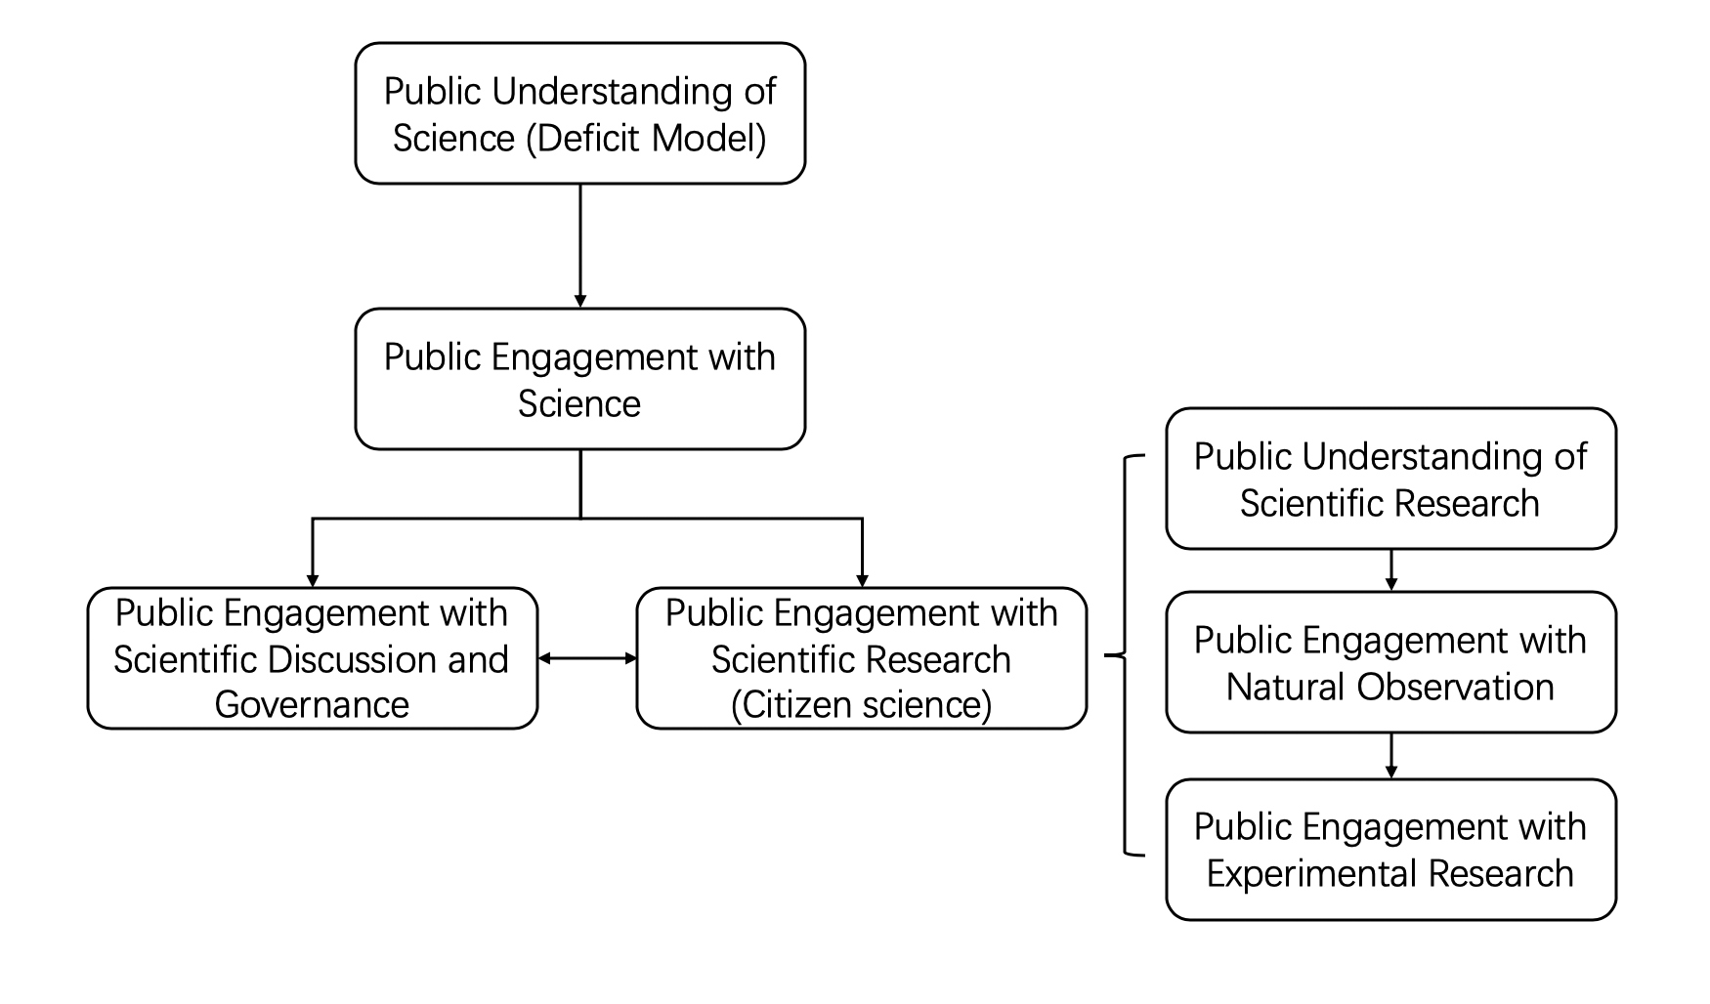
Figure 42: The development of public engagement with science (stage 1)

During the development of public engagement with science, the field of science that the public can get involved in has experienced a gradual expansion process, from the public discussion of scientific issues, scientific governance, and nature observation to lab research. The ‘science process’ not only includes the governance of scientific affairs and the production of scientific knowledge, but also the dissemination and popularization of scientific knowledge. If citizen science is regarded as an extension of public engagement with science into the field of scientific knowledge production, the phenomenon of CSCs can also be seen as a new stage of public engagement with science in the field of public science communication: the public has begun to participate in the science communication process, especially the online science communication process, as an active participant.

Strasser (2019) summarized the development of public engagement with science as the process of expanding “citizen empowerment” into the field of “science-issues”. Initially, science was considered to be a special type of knowledge controlled by elite groups. Only elites who had received professional scientific training had the right to participate in related matters – the public had almost no discourse power. Especially under the deficit model, the public could only accept education from scientists in a passive position. Under the deficit model, the discussion about many scientific issues has always been limited to technical matters, but such issues have other important social impacts which require the public’s engagement. With the development of the democratization of science and the rediscovery of lay knowledge, the public’s discourse power in scientific affairs has gradually expanded. As participants, the public are believed to be meaningful in promoting the democracy of science and society and improving the results of scientific governance (Irwin, 2001; 2014). Meanwhile, the value of the public as assistants to scientists has gradually been recognized in the scientific research field, and citizen empowerment in the field of scientific knowledge production has also been realized (Strasser et al., 2019). In the digital media environment, such as on Zhihu, this citizen empowerment has further developed into the field of science communication. In traditional science communication, especially in China’s science popularization, members of the public who have not received scientific education are not qualified to be disseminators or communicators of scientific knowledge. However, on Zhihu, those CSCs without a professional scientific background not only participate in the process of science communication as science communicators, but also receive considerable recognition from other members of the public. The emergence and popularity of CSCs on Zhihu indicates that, in the digital media environment, public engagement with science has developed to a new stage: public engagement with science communication (Figure 43).

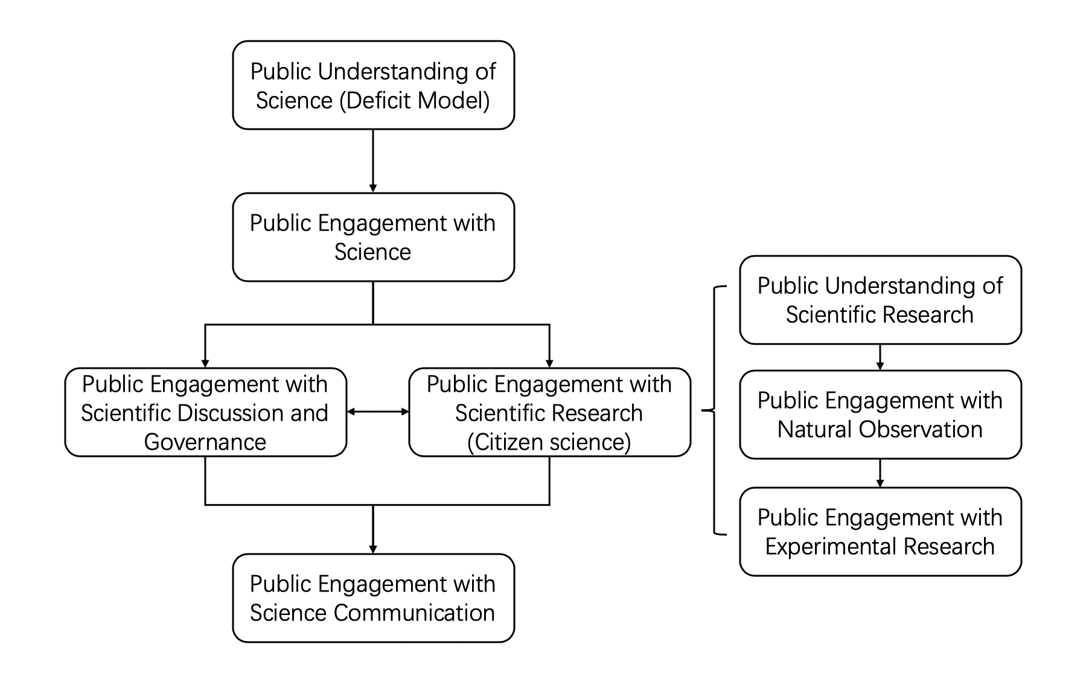
Figure 43: The development of public engagement with science (stage 2)

Some researchers have claimed that the public could participate in the science communication process, but such research always regards the public as an ‘active audience’ when emphasizing public engagement with science communication (Nisbet and Scheufele, 2009; Maier and Taddicken; 2013; Davies and Horst, 2016). They regard the process of public engagement with science communication as the public providing feedback to scientists and the science communication led by scientists or maintaining a dialogue with scientists as audience members, for instance: “reading a popular science book, attending a public lecture, or engaging in activism on a technoscientific issue may all contribute to the collective interrogation and discussion of science that we think comprises scientific citizenship in science communication” (Davies and Horst, 2016, p.196). These researchers do not recognize the possibility and value of the public as communicators in the process of science communication. Such a limitation on the possibility of the role of the public may stem from the influence of communication research. The communicators are only responsible for disseminating information, while the audience is only responsible for receiving information and providing feedback (Rogers, 1994). In terms of science communication, the role of the scientist as communicator and the role of the public as audience in public science communication is regarded as fixed and unchangeable. In addition, the absolute discourse authority of science and scientists in science communication is also regarded as an important reason for scientists’ absolute control over the role of science communicators (Gieryn, 1999).

However, when discussing public engagement with science, it should be emphasized that the public gets involved in scientific affairs more as active actors and gradually attains a status like that of scientists. For example, in scientific governance, the public’s local knowledge needs to be treated equally with scientists’ scientific knowledge: in citizen science projects, the public’s role as scientific knowledge producers also needs to be recognized. In short, public engagement with science expands the main body of scientific affairs, allowing the public to enter the domain that originally belonged only to scientists. Therefore, the public’s participation in the process of science communication as audiences, in the form of providing feedback or participating in dialogue, does not meet the logical essence of public engagement with science. Only when the public gets involved in the science communication process in the role of science communicators – initially thought to be a role that could only be held by scientists – can it be called public engagement with science communication.

On Zhihu, with the emergence and popularity of CSCs, the public have become engaged in the online science communication process not in an ‘active audience’ mode, but as ‘active communicators’. The group of communicators in the online science communication process has expanded. In traditional Chinese science communication, or science popularization, the public is considered to lack the necessary scientific literacy to effectively intervene in scientific affairs, let alone act as communicators in the science communication process. The general public discussing GMF on Zhihu collects relevant information about GMF by themselves and passes it to other public users through their own understanding and integration (shown in Figure 43). However, in terms of scientific accuracy and credibility, they may not be comparable to traditional scientists, but their emergence and popularity demonstrates the awakening of the public’s awareness of their participation in scientific affairs, especially in a more active way, as shown in Chapter 5. The awakening of the public’s awareness to participating in scientific communication as communicators and the enhancement of their scientific information collection and integration capabilities, shown by this example, have pushed public engagement with science to a new stage: the space for public engagement is constantly expanding, and the role of the public in engagement is also evolving.

However, a positive perspective is insufficient for understanding the expansion and development of public participation in science. The expansion of the public’s participation in scientific affairs and the corresponding increase in their discourse power on scientific issues may also bring some negative effects. Taking the CSCs in this study as an example, public users without a professional scientific knowledge background cannot fully guarantee the accuracy and scientific validity of the information that they collect, understand and disseminate, because they lack the necessary professional knowledge background, which means they cannot fully guarantee what they know. Rumours or falsehoods about GMF can originate from these public communicators (Ji et al., 2019). Similarly, excessive pursuit of absolute equality of discourse between the public and scientists may also bring problems. Therefore, when considering the positive effects of the role of CSCs on the promotion of public participation models and the elimination of the monopoly of scientists’ discourse authority, attention needs to be paid to the negative effects that excessive public participation may bring to society, and how an effective gatekeeping mechanism might be established to better ensure the scientific information disseminated by those CSCs is accurate.

However, it should also be noted that although the public is trying to participate in the process of scientific discussion and the science communication process on Zhihu, this project’s findings show that, for the moment, the interaction between the Chinese public and Chinese scientists is limited (as shown in Chapter 7). Although CSCs are active in answering scientific questions and communicating scientific information and knowledge about the topic of GMF food on Zhihu, the results of social network analysis still indicate that scientists continue to hold much stronger discourse power than the public (including CSCs) on Zhihu in relation to GMF, and the communication between Chinese scientists and the public is still ‘one-way’ rather than part of a dialogue. Optimistically, the increase in public enthusiasm and ability to participate in scientific discussion and scientific communication, as marked by the popularity of CSCs, should contribute to a new vision of communication and interaction between the Chinese public and scientists in the Chinese digital media environment in the future.

9.2.2 Reflections on media-centrism in science communication
As noted in Chapter 7, many scholars believe that the participatory nature of the digital media environment can effectively break down barriers and bring about real interaction between scientists and the public (Bonetta, 2009; Nisbet and Scheufele, 2009; Schafer, 2012). The digital media environment is believed to have the ability to produce more opportunities for scientists to have direct dialogue with the public on various digital platforms, and also reduce the sense of alienation between scientists and the public caused by the intermediation of traditional media (Holliman et al., 2009; Dudo, 2015). The digital media environment is also regarded as having the potential to empower the public in science communication. According to Benkler (2006), the public has the potential to participate in the production, shaping and experiencing of cultural information, and the emergent digital nature of the information environment has unlocked this potential. In the digital media environment, individuals have more freedom to satisfy their desires to do more for and by themselves, to choose among different types of producers and different information goods, and to choose to participate in a wide range of political, cultural, scientific, and communicative activities (Benkler, 2006; Frischmann, 2007, p.1119). Such a characteristic is concentrated in the process of science communication as the possibilities of public participation in scientific communication and discussion. Benkler also observed that the public has the desire to become engaged in interaction on digital platforms, wanting to be active and productive – they just need opportunities and an enabling environment to do so (Benkler, 2006; Frischmann, 2007).

Several empirical studies have also demonstrated an increase in interaction and dialogue between scientists and the public on digital platforms, such as Twitter (Lopez-Goni and Sanchez-Angulo, 2018), Facebook (McClain, 2017), and Quora (Jiang et al., 2018). Furthermore, the digital media environment is also believed to bring about equality between communicators and audiences, narrowing the discourse power gap in the original communication relationship (Buckingham, 2007; Jenkins, 2009; Goh, 2015). The monopolistic discourse power of scientists in the science communication process is considered to have endured a degree of challenge and deconstruction in the context of the digital media environment (Marsh, 2018; Helliwell, 2019). However, according to findings through the social network analysis shown in Chapter 7, the partition and homophily of the interaction networks indicate that the interaction between scientists and non-scientists on Zhihu is ineffective, despite many scholars’ claims that the digital media environment could represent an unprecedented opportunity for breaking down barriers and bringing about dialogical interaction between scientists and the public (Bonetta, 2009; Nisbet and Scheufele, 2009; Schafer, 2012). Scholars claim that digital media platforms can at least bring exchanges, communication and interaction between scientists and non-scientists across the different identities. Although effective and sufficient interaction between scientists and non-scientists is difficult to measure, the partition and homophily of the interaction network and the centralized scientists’ position in interactions show that, even on Zhihu, science communication still occurs in a scientist-centred, single direction, which has been called “the continuation of deficit model” (Jensen and Holliman, 2009, pp.57-60). The structure of interaction networks and the roles and attributes of nodes, especially the centrality of scientist and non-scientist users, also indicate the unbalanced social capital and discourse power between scientist and non-scientist users in the discussion of GMF on Zhihu. The equality between communicators and audiences is also not as easily achieved as some scholars claim (Buckingham, 2007; Jenkins, 2009; Goh, 2015).

Indeed, as a digital media platform, Zhihu has contributed to the reconstruction of the discourse power relationship between Chinese scientists and the public to a large extent. The public participation in scientific discussions and the emergence of CSC groups discovered in this study are all dependent on the characteristics of a participatory culture unique to the digital media environment. It can be said that the evolution of the media environment – from the non-interactive traditional media environment to the interactive digital media environment – has profoundly affected the discourse power relationship between different actors in the communication system. The fluidity and dynamics of communication roles, discourse space, and even time and space brought about by the digital media environment, all give different actors opportunities to reconstruct their positions and roles in the communication system, thus greatly changing the fixedness of the role of communication and its discourse power in the traditional media environment. However, this study’s empirical findings show that the actual interaction between Chinese scientists and the public on Zhihu in terms of GMF is limited.

Such a gap between the ideal and reality of online science communication may be a wake-up call to show that too much attention is being paid to the media side in the research and practice of science communication – known as ‘media-centralism’ or ‘media-centrism’ in science communication. Media-centralism can be seen as a weakened version of media determinism, which overemphasizes the role of the media in social development and change, and even believes that the development and revolution of media technology can determine the development and revolution of society (García-Orosa et al., 2020). Although media-centrism is not as extreme as media determinism, it still emphasizes the important role of media in the communication system and social development; from the perspective of media-centrism, the research and practice of communication tends to pay too much attention to the media, ignoring other elements of the communication system (Couldry, 2005; Flew, 2017). Such a tendency to overemphasize the role and status of the media is particularly clear in the field of science communication. As noted above, many scholars believe that the characteristics of digital media technology and the media revolution brought about by the digital media environment can naturally bring an equal interaction between scientists and the public in the online science communication process. This may be partly because in the science communication system, the social identities of the communicator and the audience are more certain than in other communication systems: the communication relationship between the scientist as the communicator and the public as the audience is considered by a large number of science communication scholars and practitioners to be how the relationship should be. Therefore, their attention may be further focused on the media side with diversified forms as intermediaries that they think are less certain.

Indeed, the development of the digital media environment brings more opportunities and channels for the interaction of scientists and non-scientists than in the traditional media environment. On Zhihu, it has been seen that some scientists try to transmit scientific information directly to the public, and non-scientists question the positions and judgements or support the views of scientists. However, many communication processes, such as scientists trying to deliver information directly to the public, and non-scientists showing respect and support to scientists, have not formed effective information interactions. The results in Chapter 7 show that the innovation of media and the development of the digital media environment, including Zhihu, cannot directly bring about equal interaction between scientists and the public. The role of media in science communication is undoubtedly magnified to some extent by some science communication scholars (such as Bonetta, 2009; Nisbet and Scheufele, 2009; Schafer, 2012). Furthermore, the communicative relationship between scientists and the public in the science communication process, which was considered to be definite, is also found to be less fixed: the public can also act as communicators. The variability of roles as communicators and audiences in the science communication system is larger than expected.

In addition, according to findings from online ethnography and critical discourse analysis in Chapters 5 and 6, what really hinders the formation of effective and equal dialogue and interaction between scientists and the public in the science communication process may not necessarily be the media environment itself. It is more likely to be the discourse means that the scientist group tends to adopt under the influence of the ideology shared by scientists and the result of the boundary-work set by those discourse means, so that the public is excluded from the circle of science discussion and science communication. To become truly and effectively involved in the process of science communication, especially in the more proactive role of communicator, increasing their scientific literacy, as well as their own passion for engagement with scientific affairs, are important factors that the public cannot ignore. Although it may be that during this process, the digital media environment with participatory cultural features provides great convenience, attention should not just be paid to the media environment, to the exclusion of other elements, such as actors and actors’ ability, motivation, and attitude towards participating in science communication systems.

Therefore, to effectively realize the transformation of science communication from the deficit model to the dialogue model and the participation model, and to realize a more effective dialogue and interaction between scientists and the public, it is not enough to only focus on the media. Greater focus is needed on the ‘people’ who are ‘actors’ in the science communication system. And those ‘actors’ should also no longer be bisected into ‘scientists as communicators’ and ‘public as audience’. The roles of scientists and the public in science communication, especially in the science communication system in the context of digital media, are actually fluid and variable. In addition, with more and more personal media accounts acting as intermediaries in the digital media environment, those users should also be regarded as ‘actors’ in the online science communication process and therefore worthy of academic attention. Moving beyond a media-centric vision and focusing on these actors’ thoughts, ideologies, behavioural orientations, personal literacy, and the development trends of these factors may provide a new perspective to further consider and practice better science communication.

9.2.3 From ‘public understanding of science’ to ‘scientists’ understanding of the public’
Whether it is the ‘public understanding of science’ under the deficit model proposed at the end of the 20th century or public participation in scientific discussion, citizen science, and scientific communication based on the dialogue model and the participation model, the logic behind these models hints at the deterministic relationship between the public and science: that science and scientists should be understood by the public, and the public should understand them. This relationship is unidirectional and irreversible. Scientists tend to believe blindly that the “public knows little about a range of scientific issues and they see this knowledge deficit as shaping risk perceptions, policy preferences and decisions” (Besley and Nisbet, 2011). They further believe that the public’s lack of scientific knowledge has led to their distrust and lack of support for science (Bauer et al., 1994; Irwin and Wynne, 2003; Allum et al., 2008). Since the end of the 20th century, under the guidance of Brian Wynne, a movement began to re-examine the public’s lay and local knowledge and re-discover their value (Wynne, 1991; 1996). However, although some scholars have tried to emphasize the importance of the public’s local and lay knowledge for science and technological governance, in practice such knowledge has still not received sufficient attention from scientists and other knowledge managers. Over-emphasizing the unidirectional and irreversible relationship of ‘public understanding of science’ maintains an unequal discourse power relationship between science/scientists and the public. In this relationship, scientists with condescending attitudes tend not to deign to communicate with the public, intending only to admonish and teach them, while the public as believers constantly need to understand the admonishment and teaching coming from this ‘deity’ and to continually find faith in it.

Chapter 2 showed that such a unidirectional public understanding of science cannot directly bring about public trust and support of science. Similar results have also been provided by other research institutes. Nisbet and colleagues (2002) noted that the level of knowledge mastered by the public may cause three different attitudes towards science – reservations, promises, and support – and the media’s coverage and depictions of scientific images act as an important catalyst in the public’s scientific knowledge-attitude relationship. Different attitudes of the public towards science may exist in public groups with the same level of knowledge (Bauer and Suerdem, 2016). Therefore, the public’s support and trust in science is not as completely dependent on the public’s understanding of science as predicted by scientists. However, further appreciation of the level of public understanding of science helps to position it in the above inverted U-shaped relationship, thus providing a reference for further measures to enhance the public’s trust and support in science. But in this situation, the subject of this ‘understanding’ will change from the public to the scientists, from ‘public understanding of science’ to ‘scientists’ understanding of the public’s scientific knowledge level’. As some scholars claim, the public’s sense of ‘trust’, ‘support’ and ‘participation’ in science is closely related to the social background and the overall state of the public (Gauchat, 2011; Bauer et al., 2018). Without fully understanding mainstream social consciousness, the public’s ideology and knowledge level, and the operating rules of the media, the scientific community cannot effectively improve the public’s attitude toward science (Thorpe and Gregory, 2010; Moore et al., 2011; Davies, 2016).

Compared with the public understanding of science, scientists’ understanding of the public is a more neglected subject (Lundy et al., 2006; Mooney, 2010). As mentioned above, it is difficult for scientists to accurately recognize the level of scientific knowledge and the value of local and lay knowledge the public holds. They tend to believe that the public needs their education, and that this is the scientists’ noble social responsibility, with an unnecessarily condescending attitude towards the public (Mooney, 2010). What scientists lack is not only necessary knowledge about the public but the language skills needed for dialogue and interaction with the public, so the need for ‘scientists’ understanding of the media’ has also been recognised by some scholars (Lundy, 2005; Besley and Nisbet, 2013). Therefore, it may be speculated that the barriers to communication and dialogue between many scientists and the public may not be caused entirely by the lack of the public’s necessary knowledge of science, but by scientists’ lack of knowledge of the public.

As shown in Chapter 6, the scientists in this study stuck to the discourse means they were used to and believed that the public found this acceptable. In Chapter 8, the interviews showed that scientists experience many misunderstandings about the public, especially CSCs. It may therefore be time to change perceptions of the relationship between science and the public, from one of ‘public understanding of science’ to ‘scientists’ understanding of the public’. This is not to say that ‘public understanding of science’ is no longer important or should be abandoned. It means that both ‘public understanding of science’ and ‘scientists’ understanding of the public’ should be understood in combination. This research shows that the unequal discourse power and authority between scientists and the public may be an important factor that hinders effective dialogue and interaction between the public and scientists in the science communication system. The traditional ‘public understanding of science’, including ‘public participation in science’, contains an unequal discourse power relationship whereby the discourse status of science and scientists should be higher than the public, science and scientists should be the object of being understood and the inviting party of ‘participation and dialogue’, and the public should be the party to understand and be invited to participate. Therefore, to eliminate this unequal discourse power relationship, it is necessary to rethink and remake the relationship between scientists and the public, to accept both the public and scientists as the subjects and objects of understanding.

9.3 Further considerations

9.3.1 Limitations of the project
Firstly, the main research object of this project is the ‘discourse authority’, which is a kind of illusory object. Because it is not objective and tangible, I set some indicators to measure the discourse authority studied in this project. When setting these indicators, although I also referred to classic studies, there is still the possibility of being insufficiently comprehensive. For example, when measuring the discourse authority of scientists on Zhihu, I mainly used the content and form of answers and interactive networks with the public, but their discourse authority may exist at other levels on Zhihu.

The topic of GMF was selected as the research case study for this project. As I indicated at the beginning of the thesis, this topic was chosen because of its particularity in the Chinese context. The conclusions drawn from this topic may not be directly applicable to the discussion and communication of other scientific topics that are not as controversial and popular. Similarly, Zhihu was chosen to represent China’s digital media environment as it has attracted a large number of scientific practitioners due to its special knowledge-sharing network characteristics, and users on this platform are more inclined to focus on discussion and communication of knowledge. Thus, the science communication on this platform is likely to be more (inter)active than that on other digital media platforms such as WeChat or Weibo. Therefore, caution is advised before applying the conclusions about science communication drawn from this research on Zhihu to other digital media platforms and the wider Chinese digital media environment.

I noted earlier that in this project, the research methods I adopted tended towards qualitative analysis, such as critical discourse analysis and online ethnography, with some of my own self-reflective experience. For example, the influences of the Edinburgh School, Paris School, Brian Wynne, and others on the deconstruction tendency of science that I learnt about during my PhD study oriented me as a social science researcher to be more radical in my approach towards science. The ‘critical’ perspective was inevitably brought into my qualitative analysis of scientists and the public in the science communication process, which made me seem ‘critical’ towards scientists and deliver ‘compassion and praise’ towards the public.

Moreover, due to the limited resources available to a PhD researcher, it was not possible to select a larger sample when performing qualitative analysis. For example, in the online ethnography, I only conducted long-term ethnographic observation research and analysis on three typical CSCs. In critical discourse analysis, I also randomly selected only 30 answers from scientists and 30 from citizen scientists. And for the interviews, only ten scientist users and ten public users were selected.

Finally, although the study is an investigation of the discourse power relationship and interaction between Chinese scientists and the Chinese public in the process of Chinese science communication in the Chinese digital media environment, it is hoped that this study will be able to provide a reference for more general digital media research and science communication research. But as noted earlier in relation to research cases and objects, the particularity of the Chinese environment perhaps means that the research results are not as universal and widely applicable as intended. The history of China’s worship and deification of science, the close alliance between the Chinese government and ‘the science’ and scientists in China, the rapid development of China’s digital media environment and rapid expansion of Chinese netizens, and China’s special media management policies all combine to give the science communication and digital media environment in China unique features which cannot be found in other countries. Therefore, this research may only be a special study for the Chinese context.

9.3.2 Future research
In this section I consider the ways in which the approach and findings of this thesis could be broadened beyond this project. Although I have employed several different methodological approaches in this thesis, they are only some of the possible approaches to studying online science communication and the discourse authority of actors in such a process. Using different methodological approaches to study these issues may provide different and richer perspectives. One example would be a behavioural study or psychoanalytic approach, to draw out individuals’ different psychological reactions due to the different roles they have played in the process of participating in science communication, as well as their attitudes and understanding of the discourses of other actors in the science communication process. With an in-depth interview process, open discussions or psychologically controlled experiments, the cognition, perception, and attitude of different actors in engagement with science communication process could be explored through psychoanalytic approaches. It could further explore how the discourse and behaviours in engagement with science communication allow different actors to prove the legitimacy of participation and the authority of roles (Hills, 2005). Such approaches could also draw out motivations and emotional benefits to participation, which actors may not be conscious of, and further explore the role of science in personal and communal identity formation (Marsh, 2018).

Another alternative methodological approach of studying online science communication and the discourse authority of different actors would be through communication effects. Although this research is an investigation of Chinese online science communication, most of the research in this thesis focused on the content and channel aspects of communication, and the analysis of the effect of communication is underdeveloped. The analysis of the effect of online science communication is also a good perspective to explore the role of discourse authority in the online science communication process – for example, the audience’s acceptance of scientific knowledge, the increase of participants’ scientific literacy and attitudes toward science in the online science communication process. It also helps to explore the ‘reflexive’ model of science communication: improving the scientific literacy of the audience through science communication, enhancing the possibility of participation by raising the scientific literacy of the audience, and finally increasing the possibility of dialogical communication and communication effects by increasing the possibility of participation. Such a methodological approach would require more extensive empirical research, involving long-term observation and follow-up interviews.

With respect to questions about how actors prove their legitimate roles and maintain their discourse power in the online science communication process, the perspectives and methodological approaches of this thesis could also be usefully applied to other case studies. Alternatively, the analysis of scientific discourse authority could be made with online science communication and discussion on other digital platforms, such as Weibo and WeChat in China, or Twitter, Facebook, and Instagram in the West. The special characteristics of knowledge sharing and the identity authentication functions of Zhihu make it easier to study the scientific discourse authority as well as the relationship between the discourse authority and the identities of the communicator, but on other digital media platform where the communication mode is looser and the identity boundaries are more ambiguous, such as Weibo (Sha, 2020), the authority of discourse may show different characteristics. The methodological approaches and perspectives adopted in this thesis may provide some reference for online science communication and scientific discourse authority research on other digital media platforms.

Furthermore, it is also worth considering how other research methods and perspectives could have contributed to deepening understanding of the online science communication process and discourse authority in such a process. For example, considering how actors construct their scientific discourse authority, and whether there is a more obvious connection between this construction and their identity in offline science communication and discussion, could be valuable for understanding the special role of digital media platforms in the promotion of discourse power struggles. More questions in the offline world could be asked around aspects of offline scientific discussion which potentially discourage the actors from engagement with science, and whether there is a discourse power struggle between the public and scientists in offline science communication and scientific discussion, since in the offline world, people’s identities are clearer, more recognizable.

In addition to the considerations of new research methods tin exploring this topic, this study has also raised some new research questions that require further research. For instance, since CSCs have already become very important science communicators on digital media platforms such as Zhihu, how can the accuracy and scientificity of the scientific information they convey be ensured when they lack a professional background? A gatekeeping mechanism for CSCs seems necessary. Therefore, considering the popularity of CSCs, the design of an effective gatekeeping mechanism is also an important issue. Additionally, the struggle for discourse power between scientists and the public is far from over, according to the conclusions of this research. With the continuous development of the digital media environment, the developing dynamics of the struggle for discourse power will need to be closely monitored.

9.4 Conclusion
With the recent developments in both public engagement with science and the digital media environment in China, the relationship between Chinese scientists and the public is being increasingly affected by online science communication processes. Studying the interaction between Chinese scientists and the public, specifically focusing on the struggle for discourse authority between these two groups, allows for close investigation of the changes in patterns of Chinese science communication in the context of the rapid development of the digital media environment. I have explored how scientific discourse authority forms and different groups struggle against such discourse authority, which is less visible in traditional science communication research. Such investigation could help to better understand the dynamic of science communication and public engagement with science in the Chinese digital media environment. I integrated the ideas of citizen science, discourse authority of science, and boundary-work from the fields of science communication, public understanding of science, public engagement with science, philosophy of science and digital sociology, and digital participatory cultures from digital media studies. These sources provided perspectives on the formation and maintenance of scientific discourse authority, and the type and motivation of public participation.

The findings contribute to the study of science communication firstly by identifying a new group in the Chinese digital media environment: those digital platform users without a professional scientific background – which I call citizen science communicators – who actively assume the social responsibility of science communication. The study shows that the emergence and popularity of this group in the digital media environment weakens scientists’ absolute control of the science communication process and deconstructs some of the characteristics that science communication has traditionally held in the Chinese context. This shows that scientists’ discourse authority in the science communication process seems to be challenged in the context of digital media in China.

Against such challenges of scientists’ discourse authority in the Chinese online science communication process, this study contributes to science communication research secondly by illustrating how Chinese scientists deal with such challenges and further maintain their discourse authority in the online science communication process via critical discourse analysis. This study provides evidence of Chinese scientists’ attempts to strengthen the boundary between themselves and the public by employing specific discourse techniques.

The interviews with Chinese scientist and non-scientist Zhihu users further demonstrated the struggle for scientific discourse authority between these two groups. But the social network analysis results show that in this power struggle, scientists are still seen as the most authoritative sources of science communication and interactions among scientists and non-scientists are limited. The public only has limited discourse power in the online science communication and public scientific discussion process, although they are keen to be involved in such discussion and participate in scientific issues in the digital media environment.

This study also contributes to the study of science communication by exploring how the struggle of scientific discourse authority between scientists and the public affects Chinese science communication and the wider status of science in Chinese society. It deconstructs the absolute discourse authority of Chinese scientists; divides the dissemination of science in China into two distinct systems; changes the image, function, and status of science in Chinese society; and also eliminates scientific boundaries.

The above characteristics and changes of Chinese science communication are all profoundly affected by the digital media environment. The digital media environment’s characteristic of participatory culture enables the public to participate in online science communication and scientific discussion more broadly, effectively, and proactively. The digital media environment’s characteristics of empowering the public also mean that the public has more discourse power than in the traditional media environment to compete for the legitimate role of science communicator. As a result, the struggle for legitimate scientific communicators and the authority of scientific discourse takes place between Chinese scientists and the public. This kind of struggle should be regarded as a positive social change, mainly because such a struggle eliminates the monopoly of science, scientific discourse, and scientists in the science communication process, especially in the digital media environment. Such elimination further provides more potential and opportunities for the public to actively engage in the science communication process. The expanded public engagement with science could also undoubtedly further cultivate the public’s “scientific citizenship” (Davies and Horst, 2016), which could help promote the development of the public’s own literacy on the one hand and promote the democratization of science across wider society on the other.

The core point of this study behind the above findings is that research into science communication should avoid the constraints of a media-centrism approach. As demonstrated in this study, even in the digital media environment, the interaction between scientists and the public has not been realized as many scholars have expected – it is still limited. And scientists still hold much stronger discourse power than the public. Deliberative democracy is also hard to achieve in the modern Chinese online science communication process. Therefore, more attention should be paid to the actors of science communication – not just scientists, but the public and other stakeholders – rather than just the media environment in which such communication takes place. Exploring the ideology, behaviour patterns, and interactions of these actors provides new perspectives to understand the essence of science communication, improve the effects of science communication processes and enhance public engagement with science in the digital media environment. The analysis of scientists and their ideology, discourse features and authority in Chapters 5, 7 and 8 seems to have a critical theory tendency when analysing the unbalanced power relation between scientists and the public, although the method of quantitative social network analysis is rare in the tradition of critical theory research. As mentioned in Chapter 2, this study has gleaned inspiration from the Critical School or Frankfurt School. The findings of this study also help us, as science communication researchers, to raise a critique of the Chinese scientists’ monopoly on discourse authority, or discourse hegemony, in the science communication process, as per Gramsci: “The core of critical theory lies in opposing all hegemonies, and opposing ideas are being reduced to tools conducive to rule through various forms” (2000, p.33).

Indeed, this study also contributes to the critical studies of science and science communication in the digital media environment. However, it should be remembered that the Chinese public has neither completely ‘succumbed’ to this discourse authority of science, nor has it become a ‘controlled person’ by science or scientists – to maintain the existing social rule and class order the public are using all available external resources and their own progress to rebel against the discourse hegemony in science communication. There is thus hope for the development and evolution of the system of online science communication in China, as well as for the continued fruitful interaction and discourse relationship between the Chinese public and Chinese scientists.

Bibliography

Adcock, M. and Kinderlerer, J., 2004. The Detail of Law Relating to Modern Biotechnology. Global Bioethics, 17(1), pp.113-117.
Ahteensuu, M., 2012. Assumptions of the deficit model type of thinking: Ignorance, attitudes, and science communication in the debate on genetic engineering in agriculture. Journal of agricultural and environmental ethics, 25(3), pp.295-313.
Ahteensuu, M., 2012. Assumptions of the deficit model type of thinking: Ignorance, attitudes, and science communication in the debate on genetic engineering in agriculture. Journal of agricultural and environmental ethics, 25(3), pp.295-313.
Ai, L.L., 2019. 挑战和应对:人胚胎基因编辑的国家治理 [Challenges and Responses: National Governance of Human Embryo Gene Editing]. 中国科技论坛/ China Science and Technology Forum. 274(02), pp.14-16.
Aitkin, A.L., 2004. Playing at Reality: Exploring the potential of the digital game as a medium for science communication. A thesis submitted for the degree of Doctor of Philosophy of The Australian National University
Akkermans, H., Gyan, N.B., Bon, A., Tuyp, W., Grewal, A., Boyera, S. and Allen, M., 2011, June. Is (web) science ready for empowerment? In Proceedings of the 3rd international web science conference (p. 27). ACM.
Allan, S., 2009. Making science newsworthy: Exploring the conventions of science journalism (pp. 149-165). Oxford University Press.
Allum, N., Sturgis, P., Tabourazi, D. and Brunton-Smith, I., 2008. Science knowledge and attitudes across cultures: A meta-analysis. Public understanding of science, 17(1), pp.35-54.
Amonson, S., 1977. Style in scientific writing. Essays of an Information scientist, 3, pp.4-13.
Androutsopoulos, J., 2008. Potentials and limitations of discourse-centred online ethnography. Language@ internet, 5(8), pp.45-56
Arendt, H. (1958). What is authority? Between past and future, 91, 92-124.
Armon, R., 2018. Interactional Alarms: Experts’ Framing of Health Risks in Live Broadcast News Interviews. Health communication, 33(10), pp.1257-1266.
Aronowitz, S., 1988. Science as power: Discourse and ideology in modern society. U of Minnesota Press.
Auer, M.R., Zhang, Y. and Lee, P., 2014. The potential of microblogs for the study of public perceptions of climate change. Wiley Interdisciplinary Reviews: Climate Change, 5(3), pp.291-296.
Bai, J.N., 2017. “官科”眼中的“民科”["Minke" in the eyes of "official scientists"]. 北京科技报/ Beijing Science and Technology News. 2017-05-22(030).
Baker, C.D., 1989. Teacher Authority in Classroom Discourse. Language, authority, and criticism: Readings on the school textbook, 22, p.263.
Bandyopadhyay, S., Rao, A. R. and Sinha, B. K., 2011. One introduction to social network analysis. In Bandyopadhyay, S., Rao, A. R., and Sinha, B. K. Advanced Quantitative Technology in the Social Sciences: Models for social networks with statistical applications (Vol. 13, pp. 1-29). Thousand Oaks, CA: SAGE Publications, Inc. doi: 10.4135/9781452226538
Barak, M. and Dori, Y.J., 2011. Science education in primary schools: Is an animation worth a thousand pictures? Journal of Science Education and Technology, 20(5), p.608.
Baram-Tsabari, A. and Lewenstein, B.V., 2013. An instrument for assessing scientists’ written skills in public communication of science. Science Communication, 35(1), pp.56-85.
Barnes, B., 2013. Scientific knowledge and sociological theory. Routledge.
Barnes, B., Bloor, D. and Henry, J., 1996. Scientific knowledge: A sociological analysis. AandC Black.
Barriball, K.L. and While, A., 1994. Collecting data using a semi-structured interview: a discussion paper. Journal of Advanced Nursing-Institutional Subscription, 19(2), pp.328-335.
Barton, A.C., 2000. Autobiography in science education: Greater objectivity through local knowledge. Research in Science Education, 30(1), pp.23-42.
Bastian, Mathieu, Sebastien Heymann, and Mathieu Jacomy. "Gephi: an open source software for exploring and manipulating networks." In Third international AAAI conference on weblogs and social media. 2009, pp.361-362
Bauer, M., Durant, J. and Evans, G., 1994. European public perceptions of science. international Journal of Public opinion research, 6(2), pp.163-186.
Bauer, M.W. and Suerdem, A. (2016) Relating ‘science culture’ and innovation. In: OECD Blue Sky Forum on Science and Innovation Indicators 2016, 19-21 September 2016, Ghent, Belgium. This version available at: http://eprints.lse.ac.uk/67933/
Bauer, M.W., 2008. Paradigm change for science communication: commercial science needs a critical public. In Communicating science in social contexts (pp. 7-25). Springer, Dordrecht.
Bauer, M.W., 2008. Survey research and the public understanding of science. In Handbook of public communication of science and technology (pp. 125-144). Routledge.
Bauer, M.W., 2009. The evolution of public understanding of science—discourse and comparative evidence. Science, technology and society, 14(2), pp.221-240.
Bauer, M.W., Pansegrau, P. and Shukla, R. eds., 2018. The Cultural Authority of Science: Comparing Across Europe, Asia, Africa and the Americas. Routledge.
Beach, R. and Anson, C.M., 1992. Stance and intertextuality in written discourse. Linguistics and Education, 4(3-4), pp.335-357.
Bealey, F. (1999). The Blackwell dictionary of political science: a user’s guide to its terms. Wiley-Blackwell.
Beck, S., Berner, A.M., Bignell, G., Bond, M., Callanan, M.J., Chervova, O., Conde, L., Corpas, M., Ecker, S., Elliott, H.R. and Fioramonti, S.A., 2018. PGP-UK: a research and citizen science hybrid project in support of personalized medicine. BioRxiv, p.288829.
Becker, B.J., 1958. Relatedness and alienation in group psychoanalysis. American Journal of Psychoanalysis, 18(2), pp.150-157.
Bellander, T. and Landqvist, M., 2018. Becoming the expert constructing health knowledge in epistemic communities online. Information, Communication and Society, pp.1-16.
Benkler, Y., 2006. The wealth of networks: How social production transforms markets and freedom. Yale University Press.
Bennett, J., 2009. From flow to user flows: understanding good science programming in the UK digital television landscape. Information Systems-Creativity and Innovation in Small and Medium-Sized Enterprises, p.183.
Bennett, W.L., 2003. New media power. Contesting media power, pp.17-37.
Benney, J., 2011. Twitter and legal activism in China. Communication, Politics and Culture, 44(1), p.5.
Benjamin, W., 1935. The Work of Art in the Age of Mechanical Reproduction, 1936.
Bensaude-Vincent, B., 2001. A genealogy of the increasing gap between science and the public. Public Understanding of Science, 10(1), pp.99-113.
Berglund, E.K., 1998. Knowing nature, knowing science: An ethnography of environmental activism. White Horse Press.
Besley, J.C. and Nisbet, M., 2013. How scientists view the public, the media and the political process. Public Understanding of Science, 22(6), pp.644-659.
Besley, J.C., Dudo, A. and Storksdieck, M., 2015. Scientists’ views about communication training. Journal of Research in Science Teaching, 52(2), pp.199-220.
Besley, J.C., Oh, S.H. and Nisbet, M., 2013. Predicting scientists’ participation in public life. Public understanding of science, 22(8), pp.971-987.
Bijker, W.E., Bal, R. and Hendriks, R., 2009. The paradox of scientific authority: The role of scientific advice in democracies. MIT press.
Bik, H.M. and Goldstein, M.C., 2013. An introduction to social media for scientists. PLoS biology, 11(4), p.e1001535.
Blasko, D.G. and Connine, C.M., 1993. Effects of familiarity and aptness on metaphor processing. Journal of experimental psychology: Learning, memory, and cognition, 19(2), p.295.
Blau, P.M., 1964. Social exchange theory. Retrieved September, 3(2007), p.62-77
Bloom, H., 2010. The genius of the beast: A radical re-vision of capitalism. Prometheus Books.
Bodmer, W., 2010. Public understanding of science: The BA, the Royal Society and COPUS. Notes and Records of the Royal Society, 64(suppl_1), pp.S151-S161.
Bogdan, R.C. and Biklen, S.K., 2007. Research for education: An introduction to theories and methods. New York: Pearson.
Bohman, J., 2005. Critical theory. Stanford: Stanford University Press.
Bonacich, P., 1972. Factoring and weighting approaches to status scores and clique identification. Journal of mathematical sociology, 2(1), pp.113-120.
Bonetta, L., 2009. Should you be tweeting? Cell, 139(3), pp.452-453.
Bonney, R., Cooper, C.B., Dickinson, J., Kelling, S., Phillips, T., Rosenberg, K.V. and Shirk, J., 2009. Citizen science: a developing tool for expanding science knowledge and scientific literacy. BioScience, 59(11), pp.977-984.
Bonney, R., Shirk, J.L., Phillips, T.B., Wiggins, A., Ballard, H.L., Miller-Rushing, A.J. and Parrish, J.K., 2014. Next steps for citizen science. Science, 343(6178), pp.1436-1437.
Borgatti, S. P., Jones, C., and Everett, M. G., 1998. Network measures of social capital. Connections, 21(2), pp.27-36.
Borgatti, S. P., Mehra, A., Brass, D. J., and Labianca, G., 2009. Network analysis in the social sciences. science, 323(5916), pp. 892-895.
Borgatti, S., 1998. What is social network analysis. In 1998.1998 Social Networks Conference in Barcelona (pp. 5-21).
Borgatti, S.P. and Everett, M.G., 2000. Models of core/periphery structures. Social networks, 21(4), pp.375-395.
Borgatti, S.P., 2003. The Key Player Problem1. In Dynamic Social Network Modeling and Analysis: Workshop Summary and Papers. The National Academies Press; Washington, DC: 2003. pp.241-252
Borgatti, S.P., Jones, C. and Everett, M.G., 1998. Network measures of social capital. Connections, 21(2), pp.27-36.
Borkman, T. J., 1990. Experiential, professional, and lay frames of reference. In T. J. Powell (Ed.), Working with self-help (p. 3–30). National Association of Social Work.
Borkman, T., 1976. Experiential knowledge: A new concept for the analysis of self-help groups. Social service review, 50(3), pp.445-456.
Brass, D. J., 1984. Being in the right place: A structural analysis of individual influence in an organisation. Administrative science quarterly, pp.518-539.
Brewer, P.R., 2013. The trappings of science: Media messages, scientific authority, and beliefs about paranormal investigators. Science Communication, 35(3), pp.311-333.
Brodnig, G. and Mayer‐Schönberger, V., 2000. Bridging the gap: the role of spatial information technologies in the integration of traditional environmental knowledge and western science. The Electronic Journal of Information Systems in Developing Countries, 1(1), pp.1-15.
Bronner, E., 2011. Critical Theory: A Very Short Introduction. Oxford University Press
Brossard, D. and Scheufele, D.A., 2013. Science, new media, and the public. Science, 339(6115), pp.40-41.
Brossard, D., Shanahan, J. and Nesbitt, T.C. eds., 2007. The media, the public and agricultural biotechnology. Cabi.
Brown, G. and Yule, G., 1983. Discourse analysis. Cambridge university press.
Brown, M.B., 2009. Science in democracy: Expertise, institutions, and representation. MIT Press.
Brown, S., 2009. The new deficit model. Nature nanotechnology, 4(10), p.609.
Brüggemann, M., Lörcher, I. and Walter, S., 2020. Post-normal science communication: exploring the blurring boundaries of science and journalism. Journal of Science Communication, 19(3), p.A02.
Bruns, A., 2008. Blogs, Wikipedia, Second Life, and beyond: From production to produsage (Vol. 45). Peter Lang.
Bu, Y.M., 2012. Online Ethnography: Filed, Methodology and Ethic. Sociological Study, 2012(6). pp. 217-236
Bubela, T., Nisbet, M.C., Borchelt, R., Brunger, F., Critchley, C., Einsiedel, E., Geller, G., Gupta, A., Hampel, J., Hyde-Lay, R. and Jandciu, E.W., 2009. Science communication reconsidered. Nature biotechnology, 27(6), pp.514-518.
Bucchi, M., 2008. Of deficits, deviations and dialogues: Theories of public communication of science. In Handbook of public communication of science and technology (pp. 71-90). Routledge.
Bucher, H.J. and Niemann, P., 2012. Visualizing science: the reception of PowerPoint presentations. Visual Communication, 11(3), pp.283-306.
Buckingham, D., 2007. Digital Media Literacies: rethinking media education in the age of the Internet. Research in comparative and international education, 2(1), pp.43-55.
Bureau of Science Communication Chinese Academy of Science., 2018. 中国科学院第十四届公众科学日圆满落幕[The 14th Public Science Day of the Chinese Academy of Sciences ended successfully]. Available at: http://www.bsc.cas.cn/gzdt/201805/t20180523_4646959.html
Burgess, J., Stirling, A., Clark, J., Davies, G., Eames, M., Staley, K. and Williamson, S., 2007. Deliberative mapping: a novel analytic-deliberative methodology to support contested science-policy decisions. Public Understanding of Science, 16(3), pp.299-322.
Burns, T.W., O’Connor, D.J. and Stocklmayer, S.M., 2003. Science communication: a contemporary definition. Public understanding of science, 12(2), pp.183-202.
Burt, R.S. 1992.Structural holes. Cambridge: Cambridge University Press
Burt, R.S. and Minor, M.J., 1983. Applied network analysis: A methodological introduction. Sage Publications, Inc.
Buzzelli, C. and Johnston, B., 2001. Authority, power, and morality in classroom discourse. Teaching and teacher education, 17(8), pp.873-884.
Cairns, C. and Carlson, A., 2016. Real-world islands in a social media sea: Nationalism and censorship on Weibo during the 2012 Diaoyu/Senkaku crisis. The China Quarterly, 225, pp.23-49.
Calheiros, D.F., Seidl, A.F. and Ferreira, C.J., 2000. Participatory research methods in environmental science: local and scientific knowledge of a limnological phenomenon in the Pantanal wetland of Brazil. Journal of Applied Ecology, 37(4), pp.684-696.
Cao Y., 2009. 科学传播"民主模型"的现实意义——公众参与科技决策的理论研究[The Realistic Significance of the "Democratic Model" of Science Communication——Theoretical Research on Public Participation in Science and Technology Decisions]. 科学技术哲学研究/ Philosophy of Science and Technology Studies. 26(4), pp.108-112.
Cao, Y.P., 2014. 科普网站的社交功能对科技传播带来的影响——以知乎网为例[The impact of the social function of popular science websites on the spread of science and technology-taking Zhihu.com as an example]. 科技传播/ Science and Technology Communication. (20), pp.129-131.
Capra, F., 1983. The turning point: Science, society, and the rising culture. Bantam.
Cash, D., Clark, W.C., Alcock, F., Dickson, N.M., Eckley, N. and Jäger, J., 2002. Salience, credibility, legitimacy and boundaries: linking research, assessment and decision-making.
Ceron, A., Curini, L., Iacus, S. M., and Porro, G., 2014. Every tweet counts? How sentiment analysis of social media can improve our knowledge of citizens’ political preferences with an application to Italy and France. New media and society, 16(2), pp. 340-358.
Chai, Y., Leng, Q. and Gao, H.Y., 2014. 科学松鼠会微博科普的可视化分析[Visual analysis of science popularization on Weibo of Science Squirrel Club]. 科普研究/Science Popularization. 9(06), pp.34-42.
Chau, C., 2010. YouTube as a participatory culture. New directions for youth development, 2010(128), pp.65-74.
Chen, B.S., 2019. Historical Achievements and Realistic Mission of Education in New China. People’s Dairy, 09-10, A03
Chen, C.T. and Wang, T., 2003. 从中国科协的运作模式看其对地方科技立法的影响[Viewing the influence of China Association for Science and Technology on local science and technology legislation from its operating mode]. 中国科技论坛/ China Science and Technology Forum. 000(004), pp.125-129.
Chen, F., Shi, Y. and Xu, F., 2009. An analysis of the public scientific literacy study in China. Public Understanding of Science, 18(5), pp.607-616.
Chen, H., 2014. 科学的艺术作品:科普作品的文学性与科学性[Scientific works of art: the literary and scientific nature of popular science works]. 科普研究/Science Popularization. 9(03), pp.79-84.
Chen, H.F., 2013. 我国主流媒体转基因报道的框架分析——以2007年—2012年《人民日报》报道为例[Analysis of the Framework of Genetically Modified Reports in Mainstream Media in my country——Taking the 2007-2012 "People’s Daily" report as an example]. 中国报业/ China Press. (22), pp.45-46+48.
Chen, P. and Liu, X., 2012. 新媒体时代下的科学传播[Science Communication in the New Media Age]. 理论视野/Theorical Horizon, 12(4), pp.16-18.
Chen, W.D., 2009. 当代少年儿童价值观的基本现状及主要特点[The Basic Status and Main Characteristics of Contemporary Children’s Values]. 少年儿童研究/ Children’s Research. (3X), pp.18-21.
Cheong, F., and Cheong, C., 2011. Social Media Data Mining: A Social Network Analysis Of Tweets During The 2010-2011 Australian Floods. PACIS, 11, pp. 46-46.
Chilvers, J. and Kearnes, M., 2020. Remaking participation in science and democracy. Science, Technology, and Human Values, 45(3), pp.347-380.
Chin, C.C., 2005. First‐year Pre‐service Teachers in Taiwan—Do they enter the teacher program with satisfactory scientific literacy and attitudes toward science? International Journal of Science Education, 27(13), pp.1549-1570.
China Research Institute for Science Popularization., 2019. 中国科普政策法规汇编（1949-2018）[Compilation of Chinese Science Popularization Policies and Regulations (1949-2018)]. 中国法制出版社/ China Legal Publishing House.
China Research Institute for Science Popularization.,2018. Results of the Tenth Chinese Citizens’ Scientific Literacy Survey. Science and Technology Forum,(09), p.62.
China Youth Studies Editorial Office., 2013. 《新华每日电讯》. 我国网民达5.91亿["Xinhua Daily Telegraph". my country’s Internet users reach 591 million]. 中国青年研究/ China Youth Studies. 000(011), pp.118.
Chopyak, J. and Levesque, P., 2002. Public participation in science and technology decision-making: trends for the future. Technology in Society, 24(1-2), pp.155-166.
Cohen, I.B., 1994. Interactions: some contacts between the natural sciences and the social sciences. MIT Press.
Cohn, J.P., 2008. Citizen science: Can volunteers do real research? BioScience, 58(3), pp.192-197.
Collins, H. and Ycarley, S., 1991. Epistemological Chicken", in A. Pickering (ed.), Science as Practice and Culture, Chicago, University of Chicago Press.
Colson, V., 2011. Science blogs as competing channels for the dissemination of science news. Journalism, 12(7), pp.889-902.
Comte, A., 1975. Auguste Comte and positivism: The essential writings. Transaction Publishers.
Cook, C.N., Mascia, M.B., Schwartz, M.W., Possingham, H.P. and Fuller, R.A., 2013. Achieving conservation science that bridges the knowledge–action boundary. Conservation Biology, 27(4), pp.669-678.
Cook, J. and Pearce, W., 2019. 9 Is emphasising consensus in climate science helpful for policymaking? Contemporary Climate Change Debates: A Student Primer, p.127.
Cormode, G. and Krishnamurthy, B., 2008. Key differences between Web 1.0 and Web 2.0. First Monday, 13(6). 1-30.
Correll, S., 1995. The ethnography of an electronic bar: The lesbian cafe. Journal of contemporary ethnography, 24(3), pp.270-298.
Coser, L.A., 1998. The functions of social conflict (Vol. 9). Routledge.
Couldry, N., 2005. Transvaluing media studies. Media and cultural theory, pp.177-194.
Cripe K L., 2016. Empowering the Audience: Television’s Role in the Diminishing Respect for the American Judicial System[J]. Ucla Ent.l.rev, 12(4), pp.124-154
Cronin, K., 2010. The “citizen scientist”: reflections on the public role of scientists in response to emerging biotechnologies in New Zealand. East Asian Science, Technology and Society: An International Journal, 4(4), pp.503-519.
Curtis, M.K., 1995. Monkey trials: science, defamation, and the suppression of dissent. Wm. and Mary Bill Rts. J., 4, p.507.
Dahl, R.A., 1990. After the revolution? Authority in a good society. Yale University Press.
Dahlstrom, M.F., 2014. Using narratives and storytelling to communicate science with nonexpert audiences. Proceedings of the National Academy of Sciences, 111(Supplement 4), pp.13614-13620.
Darch P., 2011. When scientists meet the public: An investigation into citizen cyberscience (Doctoral dissertation, University of Oxford).
Davies, S.R. and Horst, M., 2016(a). Deficit and Dialogue: Reframing Science Communication Research and Practice. In Science Communication (pp. 213-231). Palgrave Macmillan, London.
Davies, S.R. and Horst, M., 2016(b). Science communication: Culture, identity and citizenship. Springer.
Davies, S.R., 2008. Constructing communication: Talking to scientists about talking to the public. Science Communication, 29(4), pp.413-434.
Davies, S.R., 2009. Doing dialogue: Genre and flexibility in public engagement with science. Science as Culture, 18(4), pp.397-416.
Davies, W., 2016. The limits of neoliberalism: Authority, sovereignty and the logic of competition. Sage.
De Laat, M., Lally, V., Lipponen, L. and Simons, R.J., 2007. Investigating patterns of interaction in networked learning and computer-supported collaborative learning: A role for Social Network Analysis. International Journal of Computer-Supported Collaborative Learning, 2(1), pp.87-103.
DeBoer, G.E., 2000. Scientific literacy: Another look at its historical and contemporary meanings and its relationship to science education reform. Journal of research in science teaching, 37(6), pp.582-601.
Delborne, J.A., Anderson, A.A., Kleinman, D.L., Colin, M. and Powell, M., 2011. Virtual deliberation? Prospects and challenges for integrating the Internet in consensus conferences. Public understanding of science, 20(3), pp.367-384.
Deng, X., 1994. Science and technology constitute a primary productive force. Works of Deng Xiaoping, 3.
Deodato, J., 2014. The patron as producer: libraries, web 2.0, and participatory culture. Journal of documentation, 70(5), pp.734-758.
Dickinson, J.L., Zuckerberg, B. and Bonter, D.N., 2010. Citizen science as an ecological research tool: challenges and benefits. Annual review of ecology, evolution, and systematics, 41, pp.149-172.
Dickson D. Public ‘Isolated from Science ‘in Rich and Poor Nations[EB/OL].(2015-06-22)[2020-05-50]. http://www. scidev.net/global/communication/news/public-isolated-from-science-in-rich-and-poor-na.html?%20stay=full.
Dickson, D., 2005. The case for a ‘deficit model’ of science communication. SciDev. net, 27.
Diekema, D.S., 1989. Metaphors, medicine, and morals. Soundings, pp.17-24.
Djørup, S. and Kappel, K., 2013. The norm of disinterestedness in science; a restorative analysis. Sats, 14(2), pp.153-175.
Domínguez, D., Beaulieu, A., Estalella, A., Gómez, E., Read, R., and Schnettler, B. (Eds). 2007., Virtual ethnography. Thematic issue, Forum: Qualitative Social Research, 8(3). Retrieved August 20, 2008 from http://www.qualitative-research.net/fqs/fqs-e/inhalt3-07-e.htm
Dreher, T., McCallum, K. and Waller, L., 2016. Indigenous voices and mediatized policy-making in the digital age. Information, Communication and Society, 19(1), pp.23-39.
Dryzek, J.S. and Niemeyer, S., 2019. Deliberative democracy and climate governance. Nature human behaviour, 3(5), pp.411-413.
Du, Z. and Sun, J., 2014. 面向公众的科学传播研究：一个综述[Public Science Communication Research: A Review]. 中国科技论坛/Forum on Science and Technology in China, 26(3), pp.118-123.
Dudo, A., 2015. Scientists, the media, and the public communication of science. Sociology Compass, 9(9), pp.761-775.
Durant, J., 1999. Participatory technology assessment and the democratic model of the public understanding of science. science and Public Policy, 26(5), pp.313-319.
Eagleton, T., 1979. Ideology, fiction, narrative. Social Text, (2), pp.62-80.
Edmunds, A. and Morris, A., 2000. The problem of information overload in business organisations: a review of the literature. International Journal of Information Management, 20(1), pp.17-28.
Einsiedel, E.F., 2008. Public participation and dialogue. Handbook of public communication of science and technology, pp.173-184.
Eira, C., 1998. Authority and discourse: Towards a model for orthography selection. Written Language and Literacy, 1(2), pp.171-224.
Eiser, J.R., Stafford, T., Henneberry, J. and Catney, P., 2009. “Trust me, I’m a scientist (not a developer)”: Perceived expertise and motives as predictors of trust in assessment of risk from contaminated land. Risk Analysis: An International Journal, 29(2), pp.288-297.
Elihu Katz ed., 2003. Canonic texts in media research: Are there any should there be how about these. Blackwell Publishing.
Ellison, N.B. and Vitak, J., 2015. Social network site affordances and their relationship to social capital processes. The handbook of the psychology of communication technology, 32, pp.205-228.
Eppler, M.J., 2004. Facilitating Knowledge Communication through Joint Interactive Visualization. J. UCS, 10(6), pp.683-690.
Escobar, A., Hess, D., Licha, I., Sibley, W., Strathern, M. and Sutz, J., 1994. Welcome to Cyberia: Notes on the Anthropology of Cyberculture [and comments and reply]. Current anthropology, 35(3), pp.211-231.
Ettema, J.S., 2005. Crafting cultural resonance: Imaginative power in everyday journalism. Journalism, 6(2), pp.131-152.
Fairclough, N., 1989. Language and Power (Language in Social Life Series).
Fairclough, N., 1992(a). Discourse and social change. Cambridge, UK: Polity Press
Fairclough, N., 1992(b). Discourse and text: Linguistic and intertextual analysis within discourse analysis. Discourse and Society, 3(2), pp.193-217.
Fairclough, N., 2001. The dialectics of discourse. Textus, 14(2), pp.231-242.
Fan, J.Q., Jia, H.P. and Zhang F., 2013. Research on the Dissemination of Controversial Scientific Topics in Social Media: Taking Sina Weibo as an Example of “Golden Rice Event”. Journalism and Communication. 2013(11). pp.106-116
Fan, Z. and Hong, S.Q., 1994. 试析科学主义的产生与发展[Analysis of the emergence and development of scientism]. 自然辩证法研究/ Studies in Dialectics of Nature. 11(2), pp.13-22.
Farrell, J., 2016. Network structure and influence of the climate change counter-movement. Nature Climate Change, 6(4), p.370.
Faust, K., 1997. Centrality in affiliation networks. Social networks, 19(2), pp.157-191.
Felt, U. and Davies, S.R. eds., 2020. Exploring Science Communication: A Science and Technology Studies Approach. SAGE Publications Limited.
Field, H. and Powell, P., 2001. Public understanding of science versus public understanding of research. Public Understanding of Science, 10(4), pp.421-426.
Finkler, W. and Leon, B., 2019. The power of storytelling and video: a visual rhetoric for science communication. Journal of Science Communication, 18(5), p.A02.
Firmstone, J. and Coleman, S., 2015. Public engagement in local government: the voice and influence of citizens in online communicative spaces. Information, Communication and Society, 18(6), pp.680-695.
Fischer, F., 2000. Citizens, experts, and the environment: The politics of local knowledge. Duke University Press.
Fischhoff, B., 2013. The sciences of science communication. Proceedings of the National Academy of Sciences, 110 (Supplement 3), pp.14033-14039.
Fixdal, J., 1997. Consensus conferences as ‘extended peer groups’. Science and public policy, 24(6), pp.366-376.
Fleck, L., 1986. Crisis in science. In Cognition and Fact (pp. 153-158). Springer, Dordrecht.
Flew, T., 2017. The ‘theory’ in media theory: The ‘media-centrism’ debate. Media Theory, 1(1), pp.1-12
Foucault, M., 1982. The subject and power. Critical inquiry, 8(4), pp.777-795.
Freeman, L., 2004. The development of social network analysis. A Study in the Sociology of Science, 1.
Freeman, L.C., 1978. Centrality in social networks conceptual clarification. Social networks, 1(3), pp.215-239.
French, J. and Raven, B., 1959. The bases of social power in D Cartwright (ed) Studies in social power Ann Arbor. MI: Institute for Social Research. 13, pp.150-167
Friman, M., 2010. Understanding Boundary-work through Discourse Theory: Inter/disciplines and Interdisciplinarity. Science Studies, 23(2).pp.5-19
Frischmann, B.M., 2007. Cultural Environmentalism and The Wealth of Networks, 74 U. Chi. L. Rev, 1083, p.1125.
Fuchs, C., 2014. Social Media as Participatory Culture. C. Fuchs, Social Media: A Critical Introduction, pp.52-68.
Funtowicz, S., Shepherd, I., Wilkinson, D. and Ravetz, J., 2000. Science and governance in the European Union: a contribution to the debate. Science and Public Policy, 27(5), pp.327-336.
Gao, F.R., 2012. 对默顿科学规范结构的元规范解读[An Interpretation of the Meta-norm of the Norm Structure of Merton’s Science]. 郑州轻工业学院学报(社会科学版)/ Journal of Zhengzhou University of Light Industry (Social Science Edition). 13(04), pp.12-22.
Gao, H., He, W., Zhang, C. and Ren, L., 2016. Building scientific literacy in China: achievements and prospects. Science Bulletin, 61(11), pp.871-874.
Gao, L. and Stanyer, J., 2014. Hunting corrupt officials online: the human flesh search engine and the search for justice in China. Information, Communication and Society, 17(7), pp.814-829.
García-Orosa, B., López-García, X. and Vázquez-Herrero, J., 2020. Journalism in digital native media: Beyond technological determinism. Media and Communication, 8(2), pp.5-15.
Gauchat, G., 2011. The cultural authority of science: Public trust and acceptance of organised science. Public Understanding of Science, 20(6), pp.751-770.
Gee, J.P., 2004. An introduction to discourse analysis: Theory and method. Routledge.
Gerhards, J. and Schäfer, M.S., 2010. Is the internet a better public sphere? Comparing old and new media in the USA and Germany. New media and society, 12(1), pp.143-160.
Geuss, R., 1981. The idea of a critical theory: Habermas and the Frankfurt School. Cambridge University Press.
Gieryn, T., 1996. Policing STS: a boundary-work souvenir from the smithsonian exhibition on" science in American life". Science, Technology, and Human Values, 21(1), pp.100-115.
Gieryn, T.F., 1982. Relativist/constructivist programmes in the sociology of science: Redundance and retreat. Social Studies of Science, 12(2), pp.279-297.
Gieryn, T.F., 1983. Boundary-work and the demarcation of science from non-science: Strains and interests in professional ideologies of scientists. American sociological review, pp.781-795.
Gieryn, T.F., 1995. Boundaries of science. In Science and the Quest for Reality (pp. 293-332). Palgrave Macmillan, London.
Gieryn, T.F., 1999. Cultural boundaries of science: Credibility on the line. University of Chicago Press.
Gilbert, J.K., 2001. Towards a unified model of education and entertainment in science and technology centres. In Science communication in theory and practice (pp. 123-142). Springer, Dordrecht.
Glucksberg, S., 2003. The psycholinguistics of metaphor. Trends in cognitive sciences, 7(2), pp.92-96.
Glynn, S.M. and Muth, K.D., 1994. Reading and writing to learn science: Achieving scientific literacy. Journal of research in science teaching, 31(9), pp.1057-1073.
Goh, D., 2015. Narrowing the knowledge gap: The role of alternative online media in an authoritarian press system. Journalism and Mass Communication Quarterly, 92(4), pp.877-897.
Golinski, J., 1999. Science as public culture: Chemistry and enlightenment in Britain, 1760-1820. Cambridge University Press.
Gong, G. and Dragga, S., 1995. A writer’s repertoire. HarperCollins College Publishers.
Goode, L., 2009. Social news, citizen journalism and democracy. New media and society, 11(8), pp.1287-1305.
Goodman, R.A., 1967. Ambiguous authority definition in project management. Academy of Management Journal, 10(4), pp.395-407.
Goodwin, J. and Honeycutt, L., 2009. When science goes public: From technical arguments to appeals to authority. Studies in Communication Sciences, (2).pp.19-30
Gossart, C., 2014. Can digital technologies threaten democracy by creating information cocoons? In Transforming politics and policy in the digital age (pp. 145-154). IGI Global.
Gramsci, A., 2000. The Gramsci reader: selected writings, 1916-1935. NYU press.
Grant, E. and Grant, E.E., 1996. The foundations of modern science in the Middle Ages: their religious, institutional and intellectual contexts. Cambridge University Press.
Grant, W.J., Moon, B. and Busby Grant, J., 2010. Digital dialogue? Australian politicians’ use of the social network tool Twitter. Australian Journal of Political Science, 45(4), pp.579-604.
Green, L.W., 2006. Public health asks of systems science: to advance our evidence-based practice, can you help us get more practice-based evidence? American journal of public health, 96(3), pp.406-409.
Gregory, J. and Lock, S.J., 2008. The evolution of ‘public understanding of science’: Public engagement as a tool of science policy in the UK. Sociology Compass, 2(4), pp.1252-1265.
Gregory, J. and Miller, S., 1998. Science in public: Communication, culture, and credibility. Plenum Press.
Gu, S., Chen, X. and Xu, L., 2019. Content Crowdsourcing and Digital Publishing. 2019 9th International Conference on Information and Social Science (ICISS 2019). pp.134-138
Gullatz, S., 2010. Constructing the collective unconscious. Journal of Analytical Psychology, 55(5), pp.691-714.
Gumperz, J.J., 1982. Discourse strategies (Vol. 1). Cambridge University Press.
Guo, B., Zhao, J.R. and. Sun, Y., 社会化问答社区用户行为统计特性及其动力学分析: 以知乎网为例 [The statistical characteristics and dynamic analysis of user behaviour in social question and answer communities: Taking Zhihu as an example]. 数据分析与知识发现/ Data Analysis and Knowledge Discovery. 2(4), pp.43-56.
Guo, W.C., 2018. 当前数字媒体发展新趋势[New trends in current digital media development]. 新闻与传播研究/Journalism and Communication. 25(S1), pp.124-125.
Guo, Y.Y., 1990. 中国现代思想中的唯科学主义[Scientism in Modern Chinese Thought]. 江苏人民出版社/ Jiangsu People’s Publishing House.
Guston, D.H., 2001. Boundary organisations in environmental policy and science: an introduction. 23(4), pp.19-52.
Guzeldere, G., 1995. Consciousness: what it is, how to study it, what to learn from its history. Journal of Consciousness Studies, 2(1), pp.30-51.
Guzzetti, B.J. and Lesley, M., 2016. Handbook of research on the societal impact of digital media. Information Science Reference.
Haklay, M., 2013. Citizen science and volunteered geographic information: Overview and typology of participation. In Crowdsourcing geographic knowledge (pp. 105-122). Springer, Dordrecht.
Halliday, M.A., Hasan, R. and Hasan, R., 1985. Language, text and context. Victoria: Derkin University.
Hammersley, M. and Atkinson, P., 2007. Ethnography: Principles in practice. Routledge.
Han, Z., Hu, X. and Nigg, J., 2011. How does disaster relief works affect the trust in local government? A study of the Wenchuan earthquake. Risk, Hazards and Crisis in Public Policy, 2(4), pp.1-20.
Harary, F. 1969.Graph theory. New York: Addison-Wesley.
Harrington, K.J., 2012. The use of metaphor in discourse about cancer: a review of the literature. Clinical journal of oncology nursing, 16(4), p.408-412
Harvey, K. and Koteyko, N., 2012. Exploring health communication: language in action. Routledge.
Hasan, R. and Halliday, M.A.K., 1985. Language, Context and Text. Victoria: Deakin University.
Haynes, R., 2003. From alchemy to artificial intelligence: Stereotypes of the scientist in Western literature. Public Understanding of Science, 12(3), pp.243-253.
Haythornthwaite, C., 1996. Social network analysis: An approach and technique for the study of information exchange. Library and information science research, 18(4), pp.323-342.
Helliwell, R., Hartley, S. and Pearce, W., 2019. NGO perspectives on the social and ethical dimensions of plant genome-editing. Agriculture and Human Values, 36(4), pp.779-791.
Hemment, D., Ellis, R. and Wynne, B., 2011. Participatory mass observation and citizen science. Leonardo, 44(1), pp.62-63.
Herring, S.C., 2013. Discourse in Web 2.0: Familiar, reconfigured, and emergent. Discourse, 2, pp.1-25.
Hilgartner, S., 1990. The dominant view of popularization: conceptual problems, political uses. Social studies of science, 20(3), pp.519-539.
Hills, M., 2005. Patterns of surprise: The “aleatory object” in psychoanalytic ethnography and cyclical fandom. American Behavioural Scientist, 48(7), pp.801-821.
Hine, C., 2000. Virtual ethnography. Sage Publications Ltd.
Hjorth, L., Horst, H., Galloway, A. and Bell, G. eds., 2017. The Routledge companion to digital ethnography. Taylor and Francis.
Hoffman, S., 2015. Citizen science: the law and ethics of public access to medical big data. Berkeley Technology Law Journal, 30(3), pp.1741-1805.
Hogg, M.A., 1992. The social psychology of group cohesiveness: From attraction to social identity. New York.
Hogg, M.A., 2005. Uncertainty, social identity, and ideology. In Social identification in groups (pp. 203-229). Emerald Group Publishing Limited.
Holliman, R. and Jensen, E., 2009. (In) authentic sciences and (im) partial publics:(Re) constructing the science outreach and public engagement agenda. na.
Holliman, R., 2011. Advocacy in the tail: Exploring the implications of ‘climategate’ for science journalism and public debate in the digital age. Journalism, 12(7), pp.832-846.
Holliman, R., Whitelegg, L., Scanlon, E., Smidt, S. and Thomas, J., 2009. Investigating science communication in the information age: Implications for public engagement and popular media. Oxford University Press.
Hollway, W. and Jefferson, T., 2000. Doing qualitative research differently: Free association, narrative and the interview method. Sage.
Hopper, E. and Weinberg, H. eds., 2011. The social unconscious in persons, groups and societies: Mainly theory. Karnac Books.
Horlick-Jones, T., Walls, J., Rowe, G., Pidgeon, N., Poortinga, W. and O’Riordan, T., 2006. On evaluating the GM Nation? Public debate about the commercialisation of transgenic crops in Britain. New Genetics and Society, 25(3), pp.265-288.
House of Lords, 2000. Third Report of the House of Lords Select Committee on Science and Technology.
Howard, P.N., 2002. Network ethnography and the hypermedia organisation: New media, new organisations, new methods. New media and society, 4(4), pp.550-574.
Hu, C.Y., 2007. Discourse Analysis: The New Approach for Communication Studies. Shanghai People’s Publishing House
Hu, J.F. and Shi, Y.M., 2016. 国外学术期刊同行评审造假的分析及启示——基于2015年三次大撤稿事件的分析[Analysis and Enlightenment of Peer Review Falsification of Foreign Academic Journals——Based on the Analysis of Three Major Retractions in 2015]. 中国科学基金/ China Science Foundation. (06), pp.91-94.
Hu, J.P., 2013. 全国科普示范县(市、区)创建活动管理模式及SWOT分析[National Science Popularization Demonstration County (City, District) Creation Activity Management Mode and SWOT Analysis]. 科学管理研究/ Scientific Management Research. 031(003), pp.54-56,61.
Hua, S., 1993. Scientism and Humanism: Two Cultures in Post-Mao China (1978-1989). SUNY Press.
Huang, R., 1981. 1587, A year of no significance: The Ming dynasty in decline. Yale University Press.
Huckin, T., 2002. Critical discourse analysis and the discourse of condescension. Discourse studies in composition, 155, p.176.
Hui, Y.Z., 1998. 知识经济与科教兴国[Knowledge Economy and Rejuvenating the Country through Science and Education].中国科技财富/ China Tech Fortune. (1), pp.7-10.
Hull, D.L., 2010. Science as a process: an evolutionary account of the social and conceptual development of science. University of Chicago Press.
Hummon, D.M., 1990. Commonplaces: Community ideology and identity in American culture. SUNY Press.
Huntington, H.P., 2000. Using traditional ecological knowledge in science: methods and applications. Ecological applications, 10(5), pp.1270-1274.
Hutchinson, J., 2016. An introduction to digital media research methods: how to research and the implications of new media data. Communication Research and Practice, 2(1), pp.1-6.
Hyland, K., 2002. Authority and invisibility: Authorial identity in academic writing. Journal of pragmatics, 34(8), pp.1091-1112.
Ibarra, H., 1993. Network centrality, power, and innovation involvement: Determinants of technical and administrative roles. Academy of Management journal, 36(3), pp.471-501.
Ignatov, D.Y., Filippov, A.N., Ignatov, A.D. and Zhang, X., 2016. Automatic analysis, decomposition and parallel optimization of large homogeneous networks. Труды Института системного программирования РАН, 28(6).141-152
Ingold, K., 2011. Network structures within policy processes: Coalitions, power, and brokerage in Swiss climate policy. Policy studies journal, 39(3), pp.435-459.
Íñigo-Mora, I., 2004. On the use of the personal pronoun we in communities. Journal of Language and Politics, 3(1), pp.27-52.
Irwin, A. and Horst, M., 2016. Communicating trust and trusting science communication―some critical remarks. Journal of Science Communication, 15(6), p.L01.
Irwin, A. and Wynne, B. eds., 2003. Misunderstanding science? The public reconstruction of science and technology. Cambridge University Press.
Irwin, A., 2001. Constructing the scientific citizen: science and democracy in the biosciences. Public understanding of science, 10(1), pp.1-18.
Irwin, A., 2008. 24 STS Perspectives on Scientific Governance. The handbook of science and technology studies, p.583.
Irwin, A., 2014. From deficit to democracy (re-visited). Public Understanding of Science, 23(1), pp.71-76.
Irwin, A., Bucchi, M. and Trench, B., 2014. Risk, science and public communication. Routledge handbook of public communication of science and technology, pp.160-172.
Jackson, R., Barbagallo, F. and Haste, H., 2005. Strengths of public dialogue on science‐related issues. Critical Review of International Social and Political Philosophy, 8(3), pp.349-358
Jacomy, M., Venturini, T., Heymann, S. and Bastian, M., 2014. ForceAtlas2, a continuous graph layout algorithm for handy network visualization designed for the Gephi software. PloS one, 9(6), p.e98679.
Janssen, M. and Wimmer, M.A., 2015. Introduction to policy-making in the digital age. In Policy Practice and Digital Science (pp. 1-14). Springer, Cham.
Jasanoff, S., 2003. Breaking the waves in science studies: comment on HM Collins and Robert Evans,The third wave of science studies’. Social studies of science, 33(3), pp.389-400.
Jasanoff, S., 2014. A mirror for science. Public Understanding of Science, 23(1), pp.21-26.
Jenkins, H. and Ito, M., 2015. Participatory culture in a networked era: A conversation on youth, learning, commerce, and politics. John Wiley and Sons.
Jenkins, H., 2006. Quentin Tarantino’s Star Wars? Digital cinema, media convergence and participatory culture. Media and cultural studies: Keyworks, pp.549-576.
Jenkins, H., 2006. Fans, bloggers, and gamers: Exploring participatory culture. nyu Press.
Jenkins, H., 2009. Confronting the challenges of participatory culture: Media education for the 21st century (p. 145). The MIT Press.
Jenkins, H., 2012. Textual poachers: Television fans and participatory culture. Routledge.
Jensen, E. and Buckley, N., 2014. Why people attend science festivals: Interests, motivations and self-reported benefits of public engagement with research. Public Understanding of Science, 23(5), pp.557-573.
Jensen, E. and Holliman, R., 2009. Investigating science communication to inform science outreach and public engagement (pp. 55-71). Oxford University Press.
Jensen, K.B., 2010. Media convergence: The three degrees of network, mass and interpersonal communication. Routledge.
Ji, J., Chao, N. and Ding, J., 2019. Rumormongering of genetically modified (GM) food on Chinese social network. Telematics and Informatics, 37, pp.1-12.
Jia, H.P. and Fan, J.Q., 2015转基因科普之路 谁才是拦路虎？[Who is blocking the road to genetically modified science?]. 食品界/ Food Industry. (3), pp.45-50.
Jia, H.P., 2014. 谁是公众,如何参与,何为共识?——反思公众参与科学模型及其面临的挑战[Who is the public, how to participate, and what is consensus? ——Reflection on the scientific model of public participation and its challenges].自然辩证法研究/ Studies in Dialectics of Nature. 030(011), pp.54-59.
Jia, H.P., 2020. 国际科学传播最新理论发展及其启示[The Latest Theoretical Development of International Science Communication and Its Enlightenment]. 科普研究/Science Popularization. 15(04), pp.5-15+105.
Jiang, H., Qiang, M., Zhang, D., Wen, Q., Xia, B. and An, N., 2018. Climate change communication in an online Q&A community: A case study of Quora. Sustainability, 10(5), p.1509.
Jiang, P., 2012. 媒体如何建构转基因技术之形象——以2010年国内重要报纸的分析为例[How does the media construct the image of genetically modified technology——take the analysis of important domestic newspapers in 2010 as an example]. 南京农业大学学报(社会科学版)/ Journal of Nanjing Agricultural University (Social Science Edition). 12(02), pp.101-109.
Jiang, P., 2018. 从憧憬到冷静:转基因技术形象变迁研究——以《人民日报》为中心的考察[From Longing to Calmness: Research on the Image Change of Genetically Modified Technology——A Survey Centered on "People’s Daily"].中国农史/ Chinese Agricultural History. 37(06), pp.46-55.
Jie, L.I., 2005. A Pragmatic Analysis of Chinese Rhetorical Questions [J]. Journal of Nanhua University, 4.
Jin, C., Liu, B., Qi, W. and Qin, J., 2018, December. Research on the Evolution of the Influence of Opinion Leaders in Social Networking Sites Taking Zhihu. com as an Example. In 2018 IEEE International Conference on Big Data (Big Data) (pp. 4127-4134). IEEE.
Jin, J.B., Jiang, S.J., Chen, A.F. and Shen, Y., 2017. 新媒体平台上的科学传播效果:基于微信公众号的研究[The effect of science communication on new media platforms: a research based on WeChat official accounts]. 中国地质大学学报(社会科学版)/ Journal of China University of Geosciences (Social Science Edition). 17(02), pp.107-119.
Jin, Y., Huang, J. and Wang, X., 2017. What influences content popularity? An empirical investigation of voting in social Q&A communities. In Pacific Asia Conference on Information Systems (PACIS). Association For Information Systems.
Johansson, J., Neset, T.S.S. and Linnér, B.O., 2010, July. Evaluating climate visualization: An information visualization approach. In 2010 14th International Conference Information Visualisation (pp. 156-161). IEEE.
John, S., 2018. Epistemic trust and the ethics of science communication: Against transparency, openness, sincerity and honesty. Social Epistemology, 32(2), pp.75-87.
Jones, R.A., 2014. Reflecting on public engagement and science policy. Public Understanding of Science, 23(1), pp.27-31.
Ju, Y.H., 2019. 社会化问答社区中的科普传播特点分析——以知乎网为例[Analysis of the characteristics of popular science dissemination in the socialized question-and-answer community——Taking Zhihu.com as an example]. 视听/Audiovisual. (10), pp.22-27.
Jung, C.G., 1936. The concept of the collective unconscious. Collected works, 9(1), pp.99-104
Jünger, J. and Fähnrich, B., 2020. Does really no one care? Analysing the public engagement of communication scientists on Twitter. New Media and Society, 22(3), pp.387-408.
Kahan, D.M., Peters, E., Wittlin, M., Slovic, P., Ouellette, L.L., Braman, D. and Mandel, G., 2012. The polarizing impact of science literacy and numeracy on perceived climate change risks. Nature climate change, 2(10), pp.732-735.
Kahle, K., Sharon, A.J. and Baram-Tsabari, A., 2016. Footprints of fascination: digital traces of public engagement with particle physics on CERN’s social media platforms. PloS one, 11(5), p.e0156409.
Karlberg, M., 2005. The power of discourse and the discourse of power: Pursuing peace through discourse intervention. International journal of peace studies, pp.1-25.
Karlsson-Vinkhuyzen, S.I., Friberg, L. and Saccenti, E., 2017. Read all about it!? Public accountability, fragmented global climate governance and the media. Climate Policy, 17(8), pp.982-997.
Kasperowski, D. and Kullenberg, C., 2019. The many modes of citizen science. Science and Technology Studies, pp.2-7.
Kelly, J., Fisher, D. and Smith, M., 2005, May. Debate, division, and diversity: Political discourse networks in USENET newsgroups. In Online Deliberation Conference (pp. 1-35). Stanford University.
KhosraviNik, M., 2017. Social media critical discourse studies (SM-CDS). Handbook of critical discourse analysis, 583, p.596.
Kim, Y.S., 2000. Science and bureaucracy in traditional China. The Medieval History Journal, 3(2), pp.363-379.
Kim, Y.Y., 2007. Ideology, identity, and intercultural communication: An analysis of differing academic conceptions of cultural identity. Journal of Intercultural Communication Research, 36(3), pp.237-253.
Kiousis, S., 2002. Interactivity: a concept explication. New media and society, 4(3), pp.355-383.
Klein, J.T., 1996. Crossing boundaries: Knowledge, disciplinarities, and interdisciplinarities. University of Virginia Press.
Kobayashi, T., Boase, J., Suzuki, T. and Suzuki, T., 2015. Emerging from the cocoon? Revisiting the tele-cocooning hypothesis in the smartphone era. Journal of Computer-Mediated Communication, 20(3), pp.330-345.
Kohler, R., 2000. Cultural Boundaries of Science: Credibility on the Line by Thomas F. Gieryn.
Kouper, I., 2010. Science blogs and public engagement with science: Practices, challenges, and opportunities. Journal of science communication, 9(1), p.A02.
Kozinets, R.V., 2002. The field behind the screen: Using netnography for marketing research in online communities. Journal of marketing research, 39(1), pp.61-72.
Kuang, W.B., 2008. "新媒体"概念辨析[An Analysis of the Concept of "New Media"].国际新闻界/Chinese Journal of Journalism and Communication. (06), pp.68-71.
Kwak, H., Lee, C., Park, H. and Moon, S., 2010, April. What is Twitter, a social network or a news media? In Proceedings of the 19th international conference on World wide web (pp. 591-600).
Lakoff, G., 1994. What is metaphor. Advances in connectionist and neural computation theory, 3, pp.203-258.
Landau, J., Groscurth, C.R., Wright, L. and Condit, C.M., 2009. Visualizing nanotechnology: the impact of visual images on lay American audience associations with nanotechnology. Public Understanding of Science, 18(3), pp.325-337.
Langellier, K. and Peterson, E., 2004. Storytelling in daily life: Performing narrative. Temple University Press.
Lash, S., Szerszynski, B. and Wynne, B. eds., 1996. Risk, environment and modernity: towards a new ecology (Vol. 40). Sage.
Lassila, O. and Hendler, J., 2007. Embracing" Web 3.0". IEEE Internet Computing, 11(3), pp.90-93.
Latour, B., 1987. Science in action: How to follow scientists and engineers through society. Harvard university press.
Latour, B., 1996. On actor-network theory: A few clarifications. Soziale welt, pp.369-381.
Leach J, Yates S, Scanlon E. Models of science communication. Investigating Science Communication in the Information Age. 2008.pp.128-146
Leander, K.M. and McKim, K.K., 2003. Tracing the everyday ‘sitings’ of adolescents on the internet: A strategic adaptation of ethnography across online and offline spaces. Education, communication and information, 3(2), pp.211-240.
Lee, C.J. and Scheufele, D.A., 2006. The influence of knowledge and deference toward scientific authority: A media effects model for public attitudes toward nanotechnology. Journalism and Mass Communication Quarterly, 83(4), pp.819-834.
Lee, J., Árnason, A., Nightingale, A. and Shucksmith, M., 2005. Networking: social capital and identities in European rural development. Sociologia ruralis, 45(4), pp.269-283.
Lee, N.M. and VanDyke, M.S., 2015. Set it and forget it: The one-way use of social media by government agencies communicating science. Science Communication, 37(4), pp.533-541.
Lee-Geiller, S. and Lee, T.D., 2019. Using government websites to enhance democratic E-governance: A conceptual model for evaluation. Government Information Quarterly, 36(2), pp.208-225.
Lerner, A.S. and Gehrke, P.J., 2017. Organic public engagement: How ecological thinking transforms public engagement with science. Springer.
Leshner, A.I., 2003. Public engagement with Science. Science, 299(5609), pp.977-977.
Lévy-Leblond, J.M., 1992. About misunderstandings about misunderstandings. Public Understanding of Science, 1, pp.17-22.
Lewenstein, B.V., 2003. Models of public communication of science and technology.
Lewis, J.R. and Hammer, O. eds., 2010. Handbook of Religion and the Authority of Science. Brill.
Leydesdorff, L. and Hellsten, I., 2005. Metaphors and diaphors in science communication: Mapping the case of stem cell research. Science communication, 27(1), pp.64-99.
Leydesdorff, L., 2007. Betweenness centrality as an indicator of the interdisciplinarity of scientific journals. Journal of the American Society for Information Science and Technology, 58(9), pp.1303-1319.
Li, Z.W. and Liu. B., 2003. Research on Theory of Public Understanding of Science: Durant’s Deficit Model. Science and Society. (3), pp.12-15
Li, A.D., Zhang, X. and Liang, B., 2019. 中国学者发表的国际科技论文被撤销现象分析[Analysis of the Phenomenon of Revocation of International Scientific Papers Published by Chinese Scholars]. 中国科技期刊研究/ Research on Chinese Sci-tech Journals. (10), pp.1-14.
Li, B.C., 1988. 略论科学技术的社会形象和对科学技术的社会态度[On the social image of science and technology and the social attitude towards science and technology]. 自然辩证法研究/ Studies in Dialectics of Nature. (04), pp.29-36.
Li, D.G., 2014. 科学传播简史[A brief history of science communication]. 中国科学技术出版社/ China Science and Technology Press.
Li, J. and Wang, Z.J., 2012. 网络文化与社会秩序构建[Network culture and construction of social order]. 学术界/Academics in China. 000(012), pp.75-86.
Li, J.H. and Zhang, T.T., 2018. 社会化问答知识分享用户感知有用性影响因素研究——以知乎为例[Research on Influencing Factors of User Perceived Usefulness of Social Q&A Knowledge Sharing——Taking Zhihu as an Example]. 现代情报/Journal of Modern Information. 322(04), pp.22-30.
Li, J.Q. and Li, X.H., 新媒体传播导论[Introduction to New Media Communication]. 四川大学出版社/ Sichuan University Press.
Li, Q., 2010. Digital game building: Learning in a participatory culture. Educational research, 52(4), pp.427-443.
Li, X.M., 2004. 就科学主义及反科学主义答客问[Answer guest questions about scientism and anti-scientism]. 科学文化评论/ Scientific Culture Review. (04), pp.94-106.
Li, Y. and Jin, J.B., 2019. 网络舆论极化与科研人员对科学传播活动的参与[The Polarization of Internet Public Opinion and the Participation of Scientific Researchers in Science Communication Activities]. 现代传播(中国传媒大学学报)/ Modern Communication (Journal of Communication University of China). 41(03), pp.32-37+42.
Li, Z.H., 1979. 中国近代思想史论[On the History of Modern Chinese Thought]. 人民出版社/ People’s Publishing House.
Lian, N., Chen, M., 2013. 新闻报道引用科学家话语的框架分析——以3·11日本地震为例[Analysis of the Framework of News Reports Citing Scientists’ Discourse——Taking the March 11 Earthquake as an Example]. 新闻界/Press Circles. (05), pp.20-24.
Liang, B. and Lu, H., 2010. Internet development, censorship, and cyber crimes in China. Journal of Contemporary Criminal Justice, 26(1), pp.103-120.
Liang, Y., 2016. Trust in Chinese Government and Quality of Life (QOL) of Sichuan Earthquake Survivors: does trust in government help to promote QOL? Social Indicators Research, 127(2), pp.541-564.
Liang-bin, C.H.E.N.G., 2016. Rethinking Merton’s Norm of Universalism. Studies in Philosophy of Science and Technology, (3), p.16.
Liberatore, A., Bowkett, E., MacLeod, C.J., Spurr, E. and Longnecker, N., 2018. Social media as a platform for a citizen science community of practice. Citizen Science: Theory and Practice, 3(1), pp.25-40
Licklider, J.C. and Taylor, R.W., 1968. The computer as a communication device. Science and technology, 76(2), pp.1-3.
Lidskog, R., 1996. In science we trust? On the relation between scientific knowledge, risk consciousness and public trust. Acta sociologica, 39(1), pp.31-56.
Lin, C.J., 2012. A textual analysis of the coverage of SARS and the image of China-a comparative analysis. Asian Social Science, 8(3), p.49.
Lin, J., 2002. 人文主义教育与科学主义教育思潮评析[Comments on Humanism Education and Scientism Education Thought]. 江苏高教/Jiangsu Higher Education. (3), pp.51-54.
Lindgren, S., 2011. YouTube gunmen? Mapping participatory media discourse on school shooting videos. Media, Culture and Society, 33(1), pp.123-136.
Lister, M., Giddings, S., Dovey, J., Grant, I. and Kelly, K., 2008. New media: A critical introduction. Routledge.
Liu, C.Q., 2018. 走向科学只是教育学的一种策略——兼及实证研究的有限合理[Going to science is only a strategy of pedagogy-and the limited rationality of empirical research]. 教育科学文摘/ Educational Science Digest. (4), pp.9-11.
Liu, C.X., 2018. 科学的形象、划界与普及[The image, demarcation and popularization of science]. 中国社会科学报/ China Social Science News. 2018-01-30(007).
Liu, H.J., 2009. 科学传播的三种模型与三个阶段[Three models and three stages of science communication]. 科普研究/Science Popularization. (02), pp.12-20
Liu, L. and Cheng, L.B., 2009. Rethinking Merton’s Organised Skepticism Norm [J]. Studies in Dialectics of Nature, 7.
Liu, X., 2009. Beyond science literacy: Science and the public. International Journal of Environmental and Science Education, 4(3), pp.301-311.
Liu, Y., Li, H., Goncalves, J., Kostakos, V. and Xiao, B., 2016. Fragmentation or cohesion? Visualizing the process and consequences of information system diversity, 1993–2012. European Journal of Information Systems, 25(6), pp.509-533.
Liu. C., 2008. "网人合一":从Web1．0到Web3．0之路["Integration of Net People": The Road from Web1.0 to Web3.0]. 河南社会科学/ Henan Social Sciences. (2), pp.137-140.
Loader, B.D. ed., 2007. Young citizens in the digital age: Political engagement, young people and new media. Routledge.
Lock, S.J., 2008. Lost in translation: Discourses, boundaries and legitimacy in the public understanding of science in the UK (Doctoral dissertation, University of London).
Loening, K.L. and Sonneveld, H.B., 1994. Introducing Terminology: International Journal of Theoretical and Applied Issues in Specialized Communication. Terminology. International Journal of Theoretical and Applied Issues in Specialized Communication, 1(1), pp.1-6.
Logan, R.A., 2001. Science mass communication: Its conceptual history. Science Communication, 23(2), pp.135-163.
López-Goñi, I. and Sánchez-Angulo, M., 2018. Social networks as a tool for science communication and public engagement: focus on Twitter. FEMS Microbiology letters, 365(2), p.fnx246.
Louv, R. and Fitzpatrick, J.W., 2012. Citizen science: Public participation in environmental research. Cornell University Press.
Luhmann, N., 1995. Social systems. Stanford University Press.
Lundy, L., Ruth, A., Telg, R., and Irani, T., 2006. It Takes Two: Public Understanding of Agricultural Science and Agricultural Scientists’ Understanding of the Public. Journal of Applied Communications, 90(1), p.6.
Luo, Y.C., and Wang, D.Y.,2016. Opinion Expression and Behaviours of Internet Users in the Context of New Media Empowerment. Contemporary Communication, (2), pp.4-7
Luo, H. and Wang K.Y., 2015. Report on Development of China’s Science Education [2015], Social Sciences Academic Press, Beijing
Lupton D., 1998. Risk. London, UK: Routledge
Lysloff, R.T., 2003. Musical Community on the Internet: An On‐line Ethnography. Cultural Anthropology, 18(2), pp.233-263.
Ma, J., 2016. 浅谈科普专题节目的趣味性[On the Interest of Popular Science Special Programs]. 新闻研究导刊/ News Research Guide. 7(08), pp.192-193.
Ma, K.L., Liao, I., Frazier, J., Hauser, H. and Kostis, H.N., 2011. Scientific storytelling using visualization. IEEE Computer Graphics and Applications, 32(1), pp.12-19.
Macfarlane, B. and Cheng, M., 2008. Communism, universalism and disinterestedness: Re-examining contemporary support among academics for Merton’s scientific norms. Journal of Academic Ethics, 6(1), pp.67-78.
Machin, D. and Van Leeuwen, T., 2016. Multimodality, politics and ideology. Journal of Language and Politics, 15(3), pp.243-258.
Maier, M. and Taddicken, M., 2013. Audience perspectives on science communication. Journal of Media Psychology: Theories, Methods, and Applications, 25(1), pp.1-2.
Maitland, K. and Wilson, J., 1987. Pronominal selection and ideological conflict. Journal of pragmatics, 11(4), pp.495-512.
Makagon, M.M., McCowan, B. and Mench, J.A., 2012. How can social network analysis contribute to social behaviour research in applied ethology? Applied animal behaviour science, 138(3-4), pp.152-161.
Mao, Y.Q., 1999. 从两极到中介, 科学主义教育和人本主义教育方法论研究[From bipolar to intermediary, research on the methodology of scientism education and humanism education]. 北京师范大学出版社/ Beijing Normal University Press.
Markoff, J., 2006. Entrepreneurs see a web guided by common sense. New York Times, 12, p.2006.
Marsden, P.V., 1988. Homogeneity in confiding relations. Social networks, 10(1), pp.57-76.
Marsh, O.M., 2018. " Nah, musing is fine. You don’t have to be’doing science’": emotional and descriptive meaning-making in online non-professional discussions about science (Doctoral dissertation, UCL (University College London)).
Matson, J.O. and Parsons, S., 1998. The nature of science: achieving scientific literacy by doing science. In The nature of science in science education (pp. 223-230). Springer, Dordrecht.
Mauro, F. and Hardison, P.D., 2000. Traditional knowledge of indigenous and local communities: international debate and policy initiatives. Ecological applications, 10(5), pp.1263-1269.
McCaffrey, R.E., 2005. Using citizen science in urban bird studies. Urban habitats, 3(1), pp.70-86.
McClain, C.R., 2017. Practices and promises of Facebook for science outreach: becoming a “Nerd of Trust”. PLoS biology, 15(6), pp.23-34
McGreavy, B., Hutchins, K., Smith, H., Lindenfeld, L. and Silka, L., 2013. Addressing the complexities of boundary-work in sustainability science through communication. Sustainability, 5(10), pp.4195-4221.
McKinley, D.C., Miller-Rushing, A.J., Ballard, H.L., Bonney, R., Brown, H., Cook-Patton, S.C., Evans, D.M., French, R.A., Parrish, J.K., Phillips, T.B. and Ryan, S.F., 2017. Citizen science can improve conservation science, natural resource management, and environmental protection. Biological Conservation, 208, pp.15-28.
McPherson, M., Smith-Lovin, L. and Cook, J.M., 2001. Birds of a feather: Homophily in social networks. Annual review of sociology, 27(1), pp.415-444.
Mellor, F., 2009. Image-music-text of Popular Science. Information Systems-Creativity and Innovation in Small and Medium-Sized Enterprises, p.205.
Mérand, F., Hofmann, S.C. and Irondelle, B., 2011. Governance and state power: a network analysis of European security. JCMS: journal of common market studies, 49(1), pp.121-147.
Merton, R.K., 1973(a). Paradigm for the sociology of knowledge (Chapter 1), The normative structure of science (Chapter 13), and Priorities in scientific discovery (Chapter 14). The Sociology of Science: Theoretical and Empirical Investigations. University of Chicago Press: Chicago.
Merton, R.K., 1973(b). The sociology of science: Theoretical and empirical investigations. University of Chicago press.
Miller, S., 2001. Public understanding of science at the crossroads. Public understanding of science, 10(1), pp.115-120.
Miller, V., 2020. Understanding digital culture. SAGE Publications Limited.
Millstone, E. and Van Zwanenberg, P., 2000. A crisis of trust: for science, scientists or for institutions? Nature Medicine, 6(12), p.1307.
Mody, B. and Rolston, M., 1991. Designing messages for development communication: An audience participation-based approach. New Delhi: Sage Publications.
Molek-Kozakowska, K., 2018. Popularity-driven science journalism and climate change: A critical discourse analysis of the unsaid. Discourse, Context and Media, 21, pp.73-81.
Mooney, C.C., 2010, July. Do scientists understand the public? Cambridge, MA: American Academy of Arts and Sciences.
Moore, K., Kleinman, D.L., Hess, D. and Frickel, S., 2011. Science and neoliberal globalization: a political sociological approach. Theory and Society, 40(5), pp.505-532.
Moore, R., 1998. Creationism in the United States: I. Banning evolution from the classroom. The American Biology Teacher, 60(7), pp.486-507.
Moore, R., 2000. The revival of creationism in the United States. Journal of Biological Education, 35(1), pp.17-21.
Morgan, C. and Pallascio, P.M., 2015. Digital media, participatory culture, and difficult heritage: Online remediation and the Trans-Atlantic slave trade. Journal of African Diaspora Archaeology and Heritage, 4(3), pp.260-278.
Mullen, B. and Copper, C., 1994. The relation between group cohesiveness and performance: An integration. Psychological bulletin, 115(2), p.210.
Munda, G., 2000. Conceptualising and responding to complexity. Cambridge: Cambridge Research for the Environment.
Musiał, K. and Juszczyszyn, K., 2009, October. Properties of bridge nodes in social networks. In International Conference on Computational Collective Intelligence (pp. 357-364). Springer, Berlin, Heidelberg.
Myers, G., 2003. Discourse studies of scientific popularization: questioning the boundaries. Discourse studies, 5(2), pp.265-279.
Nancy T (2016), "Personal Media", The International Encyclopedia of Media Effects, American Cancer Society, pp. 1–13, doi:10.1002/9781118783764.wbieme0180, ISBN 978-1-118-78376-4
Newman, G., Wiggins, A., Crall, A., Graham, E., Newman, S. and Crowston, K., 2012. The future of citizen science: emerging technologies and shifting paradigms. Frontiers in Ecology and the Environment, 10(6), pp.298-304.
Nisbet, M.C. and Scheufele, D.A., 2009. What’s next for science communication? Promising directions and lingering distractions. American journal of botany, 96(10), pp.1767-1778.
Nisbet, M.C., Scheufele, D.A., Shanahan, J., Moy, P., Brossard, D. and Lewenstein, B.V., 2002. Knowledge, reservations, or promise? A media effects model for public perceptions of science and technology. Communication Research, 29(5), pp.584-608.
Nonini, D.M., 2008. Is China becoming neoliberal? Critique of Anthropology, 28(2), pp.145-176.
Nooteboom, B., 2003. Inter-firm collaboration, learning and networks: An integrated approach. Routledge.
Nowotny, H., 2018. 9. The Public Engagement of Science and Society. Grand Challenges For Science In The 21st Century, 7, p.41.
O’Connor, C. and Joffe, H., 2014. Gender on the brain: a case study of science communication in the new media environment. PLoS One, 9(10), p.e110830.
O’malley, A.J. and Marsden, P.V., 2008. The analysis of social networks. Health services and outcomes research methodology, 8(4), pp.222-269.
Oh, H.J. and Lee, B., 2012. The effect of computer-mediated social support in online communities on patient empowerment and doctor–patient communication. Health communication, 27(1), pp.30-41.
Opsahl, T., Agneessens, F., and Skvoretz, J., 2010. Node centrality in weighted networks: Generalizing degree and shortest paths. Social networks, 32(3), pp.245-251.
O’Reilly, T., 2007. What Is Web 2.0: Design Patterns and Business Models for the Next Generation of Software (No. 4578). University Library of Munich, Germany.
Ormiston, G.L. and Sassower, R., 1989. Narrative experiments: The discursive authority of science and technology. U of Minnesota Press.
Otte, E. and Rousseau, R., 2002. Social network analysis: a powerful strategy, also for the information sciences. Journal of information Science, 28(6), pp.441-453.
Paccagnella, L., 1997. Getting the seats of your pants dirty: Strategies for ethnographic research on virtual communities. Journal of Computer-Mediated Communication, 3(1), p.JCMC314.
Pan, X., 2010. Hunt by the Crowd: an exploratory qualitative analysis on cyber surveillance in China. Global Media Journal, 9(16), pp.1-19.
Park, H.W. and Thelwall, M., 2006. Web-science communication in the age of globalization. New Media and Society, 8(4), pp.629-650.
Patel, D.I., Winkler, P., Botello, J., Villarreal, J. and Puga, F., 2016. The citizen scientist: community-academic partnerships through Translational Advisory Boards. Patient education and counseling, 99(12), pp.2087-2090.
Patel, D.I., Winkler, P., Botello, J., Villarreal, J. and Puga, F., 2016. The citizen scientist: community-academic partnerships through Translational Advisory Boards. Patient education and counseling, 99(12), pp.2087-2090.
Perrault, S., 2013. Communicating popular science: From deficit to democracy. Springer.
Perz, S.G., Brilhante, S., Brown, I.F., Michaelsen, A.C., Mendoza, E., Passos, V., Pinedo, R., Reyes, J.F., Rojas, D. and Selaya, G., 2010. Crossing boundaries for environmental science and management: combining interdisciplinary, interorganisational and international collaboration. Environmental conservation, 37(4), pp.419-431.
Peters, H.P., 1995. The interaction of journalists and scientific experts: co-operation and conflict between two professional cultures. Media, Culture and Society, 17(1), pp.31-48.
Peters, H.P., 2013. Gap between science and media revisited: Scientists as public communicators. Proceedings of the National Academy of Sciences, 110(Supplement 3), pp.14102-14109.
Peters, H.P., Brossard, D., De Cheveigné, S., Dunwoody, S., Kallfass, M., Miller, S. and Tsuchida, S., 2008. Science-media interface: It’s time to reconsider. Science Communication, 30(2), pp.266-276.
Peters, H.P., Dunwoody, S., Allgaier, J., Lo, Y.Y. and Brossard, D., 2014. Public communication of science 2.0: Is the communication of science via the “new media” online a genuine transformation or old wine in new bottles? EMBO reports, p.e201438979.
Phillips, N. and Hardy, C., 2002. Discourse analysis: Investigating processes of social construction (Vol. 50). Sage Publications.
Phillips, T.B., Ballard, H.L., Lewenstein, B.V. and Bonney, R., 2019. Engagement in science through citizen science: Moving beyond data collection. Science Education, 103(3), pp.665-690.
Pidgeon, N.F., Poortinga, W., Rowe, G., Horlick‐Jones, T., Walls, J. and O’Riordan, T., 2005. Using surveys in public participation processes for risk decision-making: The case of the 2003 British GM nation? Public debate. Risk Analysis: An International Journal, 25(2), pp.467-479.
Pieczka, M. and Escobar, O., 2013. Dialogue and science: Innovation in policy-making and the discourse of public engagement in the UK. Science and Public Policy, 40(1), pp.113-126.
Pilcher, H., 2010. A better class of heckle: Helen Pilcher on the rise of science comedy. Nature, 467(7315), pp.530-531.
Pinheiro, C.A.R., 2011. Social network analysis in telecommunications (Vol. 37). John Wiley and Sons.
Pink, S., Horst, H., Postill, J., Hjorth, L., Lewis, T. and Tacchi, J., 2015. Digital ethnography: Principles and practice. Sage.
Pink, S., Sinanan, J., Hjorth, L. and Horst, H., 2016. Tactile digital ethnography: Researching mobile media through the hand. Mobile Media and Communication, 4(2), pp.237-251.
Plank, B.A., 1983. The revolution in communication technology for public relations. Public Relations Review, 9(1), pp.3-10.
Polanyi, M., 2000. The republic of science: Its political and economic theory. Minerva, 38(1), pp.1-21.
Powell, M.C. and Colin, M., 2008. Meaningful citizen engagement in science and technology: What would it really take? Science Communication, 30(1), pp.126-136.
Preece, J., 2000. Online communities: Designing usability and supporting sociability. John Wiley and Sons, Inc.
Price, S., 2007. Discourse power address: the politics of public communication. Ashgate Publishing, Ltd.
Pruitt, T.C., 2011. Authority and the Production of Knowledge in Archaeology (Doctoral dissertation, University of Cambridge).
Puri, A., 2007. The web of insights: The art and practice of webnography. International journal of market research, 49(3), pp.387-408.
Qi, Z.H. and Zhou, H., 2010. 消费者对转基因食品认知的实证分析——以武汉市为例[An Empirical Analysis of Consumers’ Perceptions of Genetically Modified Foods——Taking Wuhan City as an Example]. 中国农村观察/ China Rural Observation. (06), pp.37-45.
Qiu, P.E., 2009, 网络媒体:影响公共安全的双刃剑[Online media: a double-edged sword affecting public safety]. 红旗文稿/ HongQi Wengao. (16), pp.20-23.
Rabionet, S.E., 2011. How I Learned to Design and Conduct Semi-Structured Interviews: An Ongoing and Continuous Journey. Qualitative Report, 16(2), pp.563-566.
Raddick, J., Lintott, C.J., Schawinski, K., Thomas, D., Nichol, R.C., Andreescu, D., Bamford, S., Land, K.R., Murray, P., Slosar, A. and Szalay, A.S., 2007, December. Galaxy Zoo: an experiment in public science participation. In Bulletin of the American Astronomical Society (Vol. 39, p. 892).
Raddick, M.J., Bracey, G., Gay, P.L., Lintott, C.J., Murray, P., Schawinski, K., Szalay, A.S. and Vandenberg, J., 2009. Galaxy zoo: Exploring the motivations of citizen science volunteers. arXiv preprint arXiv:0909.2925.
Raddick, M.J., Prather, E.E. and Wallace, C.S., 2019. Galaxy zoo: Science content knowledge of citizen scientists. Public Understanding of Science, 28(6), pp.636-651.
Ramírez-i-Ollé, M., 2015. Rhetorical strategies for scientific authority: A boundary-work analysis of ‘climategate’. Science as Culture, 24(4), pp.384-411.
Ran, X.B., Liu, Y.W. and Jiang, J.H., 2017. 社交网络个体活跃行为的大数据分析:从网络外部性的视角[Big data analysis of individual active behaviours in social networks: from the perspective of network externalities]. 管理科学/ Management Science. 30(5), pp.77-86.
Rayburn, D., 2012. Streaming and digital media: understanding the business and technology. CRC Press.
Reincke, C.M., Bredenoord, A.L. and van Mil, M.H., 2020. From deficit to dialogue in science communication: The dialogue communication model requires additional roles from scientists. EMBO reports, 21(9), p.e51278.
Remington, M. and Tyrer, P., 1979. The social functioning schedule—a brief semi-structured interview. Social Psychiatry, 14(3), pp.151-157.
Ren, F. and Zhai, J., 2013. Communication and popularization of science and technology in China. Springer Science and Business Media.
Ren, F. and Zhai, J., 2014. Science and Technology Communication and Popularization and Public Scientific Literacy Construction. In Communication and Popularization of Science and Technology in China (pp. 159-207). Springer Berlin Heidelberg.
Ren, L., Zhang, C., He, W., 公民的科技态度正成为新时代科学文化的重要表征——2018 年中国公民科学素质调查结果分析[Citizens’ attitudes towards science and technology are becoming an important symbol of science and culture in the new era-analysis of the results of the survey of Chinese citizens’ scientific literacy in 2018]. 科普研究/Science Popularization, 14(5), pp.85-91.
Resnik, D.B., Elliott, K.C. and Miller, A.K., 2015. A framework for addressing ethical issues in citizen science. Environmental Science and Policy, 54, pp.475-481.
Reydon, T.A., Kampourakis, K. and Patrinos, G.P., 2012. Genetics, genomics and society: the responsibilities of scientists for science communication and education. Personalized Medicine, 9(6), pp.633-643.
Rheingold, H., 1993. The virtual community: Finding connection in a computerized world. Addison-Wesley Longman Publishing Co., Inc.
Richards, I.A., 1936. The command of metaphor. The philosophy of rhetoric, 1, pp.115-138.
Riesch, H. and Potter, C., 2014. Citizen science as seen by scientists: Methodological, epistemological and ethical dimensions. Public understanding of science, 23(1), pp.107-120.
Riesch, H., 2010. Theorizing boundary-work as representation and identity. Journal for the Theory of Social Behaviour, 40(4), pp.452-473.
Riesch, H., 2015. Why did the proton cross the road? Humour and science communication. Public Understanding of Science, 24(7), pp.768-775.
Rim, H. and Song, D., 2016. “How negative becomes less negative”: Understanding the effects of comment valence and response sidedness in social media. Journal of Communication, 66(3), pp.475-495.
Riskin, J., 2002. Science in the age of sensibility: The sentimental empiricists of the French enlightenment. University of Chicago Press.
Rödder, S., 2017. The climate of science-art and the art-science of the climate: Meeting points, boundary objects and boundary-work. Minerva, 55(1), pp.93-116.
Rodman, L., 2001. You-attitude: A linguistic perspective. Business Communication Quarterly, 64(4), pp.9-25.
Rogers, E.M., 1994. History of communication study. New York: Free Press.
Rogers, R., 2015. Digital methods for web research. Emerging trends in the social and behavioural sciences: An interdisciplinary, searchable, and linkable resource, pp.1-22.
Rohsenow, J.S., 1991. A Chinese-English dictionary of enigmatic folk similes (Xiehouyu). University of Arizona Press.
Rouse, J., 1993. What are cultural studies of scientific knowledge? Configurations, 1(1), pp.1-22.
Rowe, G., Horlick-Jones, T., Walls, J. and Pidgeon, N., 2005. Difficulties in evaluating public engagement initiatives: reflections on an evaluation of the UK GM Nation? public debate about transgenic crops. Public Understanding of Science, 14(4), pp.331-352.
Ruddle, K., 2000. Systems of knowledge: dialogue, relationships and process. Environment, development and sustainability, 2(3-4), pp.277-304.
Rui, B.F. and Zhang, B.Q., 2012. 新的传播权力呼唤新的社会责任——以"合肥少女毁容案"的网络传播为例[New Communication Power Calls for New Social Responsibility——Taking the Internet Communication of "Hefei Girl Disfigurement Case" as an example]. 新闻记者/Journalists. (04), pp.33-37.
Russell, B., 1960. The Social Responsibilities of Scientists. Science, 131(3398), pp.391-392.
Sade-Beck, L., 2004. Internet ethnography: Online and offline. International Journal of Qualitative Methods, 3(2), pp.45-51.
Sainsbury, L. and Dexter, M., 2000. Science and the public: A review of science communication and public attitudes to science in Britain. London: A Joint Report by the Office of Science and Technology and the Wellcome Trust.
Saltelli, A. and Funtowicz, S., 2017. What is science’s crisis really about? Futures, 91, pp.5-11.
Saville-Troike, M., 2008. The ethnography of communication: An introduction (Vol. 14). John Wiley and Sons.
Schäfer, M.S., 2009. From public understanding to public engagement: An empirical assessment of changes in science coverage. Science Communication, 30(4), pp.475-505.
Schäfer, M.S., 2012. Online communication on climate change and climate politics: a literature review. Wiley Interdisciplinary Reviews: Climate Change, 3(6), pp.527-543.
Schäfer, M.S., 2016. Mediated trust in science: concept, measurement and perspectives for the science of science communication’. Journal of Science Communication, 15(5), p.C02.
Schmaus, W., 1983. Fraud and the Norms of Science. Science, Technology, and Human Values, 8(4), pp.12-22.
Schmitt, C.V., 2018. Push or pull: recommendations and alternative approaches for public science communicators. Frontiers in Communication, 3, p.13.
Schramm, W.L., 1973. Men, messages, and media: A look at human communication. Harper and Row.
Schweiger, W., 2000. Media credibility—experience or image? A survey on the credibility of the World Wide Web in Germany in comparison to other media. European journal of communication, 15(1), pp.37-59.
Sciarra, C., Chiarotti, G., Laio, F. and Ridolfi, L., 2018. A change of perspective in network centrality. Scientific reports, 8(1), p.15269.
Scollon, R., 1995. Plagiarism and ideology: Identity in intercultural discourse. Language in Society, 24(1), pp.1-28.
Sha, M., 2020. Media Fandom: Social Media Use and Collective Identity in China—a Case Study of Z. Tao’s Weibo Fandom (Doctoral dissertation, University of South Florida).
Shackley, S. and Wynne, B., 1996. Representing uncertainty in global climate change science and policy: Boundary-ordering devices and authority. Science, Technology, and Human Values, 21(3), pp.275-302.
Shanahan, M.C., 2011. Science blogs as boundary layers: Creating and understanding new writer and reader interactions through science blogging. Journalism, 12(7), pp.903-919.
Shapin, S., 1995. Here and everywhere: Sociology of scientific knowledge. Annual review of sociology, 21(1), pp.289-321.
Shapin, Steven. 2004. The way we trust now: The authority of science and the character of the scientist. In Trust Me, I’m a Scientist, ed. P. Hoodbhoy, D. Glaser, and S. Shapin, 42-63. London: The British Council.
Shimeall, T.J. and Spring, J.M., 2014. Network analysis and forensics. In Introduction to Information Security (pp. 235-251). Syngress.
Shu, D., 2015. Chinese xiehouyu (歇 后 语) and the interpretation of metaphor and metonymy. Journal of Pragmatics, 86, pp.74-79.
Shuai, M., Luo, J.D. and Yang, K.H., 2018. 地震对基层政府信任演化的影响和作用机制——基于汶川震后三年期追踪调查数据[The impact and mechanism of the earthquake on the evolution of grassroots government trust: based on the three-year follow-up survey data after the Wenchuan earthquake]. 西安交通大学学报(社会科学版)/ Journal of Xi’an Jiaotong University (Social Science Edition). 38(05), pp.64-72.
Shuchman, M. and Wilkes, M.S., 1997. Medical scientists and health news reporting: a case of miscommunication. Annals of Internal Medicine, 126(12), pp.976-982.
Simis, M.J., Madden, H., Cacciatore, M.A. and Yeo, S.K., 2016. The lure of rationality: Why does the deficit model persist in science communication? Public understanding of science, 25(4), pp.400-414.
Sismondo, S., 2010. An introduction to science and technology studies (Vol. 1). Chichester: Wiley-Blackwell.
Smallman, M., 2016. Public Understanding of Science in turbulent times III: Deficit to dialogue, champions to critics. Public Understanding of Science, 25(2), pp.186-197.
Smith, A., 2015. " Wow, I didn’t know that before; thank you": How scientists use Twitter for public engagement. Journal of Promotional Communications, 3(3), pp.232-244.
Spoel, P., Goforth, D., Cheu, H. and Pearson, D., 2008. Public communication of climate change science: Engaging citizens through apocalyptic narrative explanation. Technical Communication Quarterly, 18(1), pp.49-81.
Spurgeon, C., Burgess, J., Klaebe, H., McWilliam, K., Tacchi, J. and Tsai, M., 2009. Co-creative media: theorising digital storytelling as a platform for researching and developing participatory culture. In Proceedings of the 2009 Australian and New Zealand Communication Association Conference (ANZCA 2009) (pp. 274-286). Massey University.
Sriraman, B. and Benesch, W., 2005. Consciousness and Science: an Advaita-vedantic perspective on the Theology–Science Dialogue. Theology and Science, 3(1), pp.39-54.
Standage, T., 1998. The Victorian Internet: The remarkable story of the telegraph and the nineteenth century’s online pioneers. Phoenix.
Stasser, G., Stewart, D.D. and Wittenbaum, G.M., 1995. Expert roles and information exchange during discussion: The importance of knowing who knows what. Journal of experimental social psychology, 31(3), pp.244-265.
Stilgoe, J., 2009. Citizen Scientists: reconnecting science with civil society. London: Demos.
Stilgoe, J., Lock, S.J. and Wilsdon, J., 2014. Why should we promote public engagement with science? Public understanding of science, 23(1), pp.4-15.
Strasser, B., Baudry, J., Mahr, D., Sanchez, G. and Tancoigne, E., 2019. " Citizen Science"? Rethinking Science and Public Participation. Science and Technology Studies, 32(ARTICLE), pp.52-76.
Strasser, B.J., 2012. Collecting nature: Practices, styles, and narratives. Osiris, 27(1), pp.303-340.
Sturgis P, Allum N., 2004. Science in Society: Re-Evaluating the Deficit Model of Public Attitudes. Public Understanding of Science, 13(1), pp.55-74.
Su, L.Y.F., Scheufele, D.A., Bell, L., Brossard, D. and Xenos, M.A., 2017. Information-sharing and community-building: Exploring the use of Twitter in science public relations. Science Communication, 39(5), pp.569-597.
Sun, Q,F. and Zhou, L.Q., 2018. 走向有效的公众参与科学——论科学传播"民主模型"的困境与知识分工的解决方案[Towards Effective Public Participation in Science: On the Dilemma of the "Democratic Model" of Science Communication and the Solution to the Division of Knowledge].科学学研究/ Studies in Science of Science. (11), pp.1921-1927.
Sun, T., 2019. 转基因科普面临的四个形式和一个手段[Four Forms and One Means Facing Transgenic Science Popularization]. Agrogene blog. Available at: http://www.agrogene.cn/info-5716.shtml
Tajfel, H., Turner, J.C., Austin, W.G. and Worchel, S., 1979. An integrative theory of intergroup conflict. Organisational identity: A reader, pp.56-65.
Tamburrini, N., Cinnirella, M., Jansen, V.A. and Bryden, J., 2015. Twitter users change word usage according to conversation-partner social identity. Social Networks, 40, pp.84-89.
Tang, R. and John, S., 1999. The ‘I’ in identity: Exploring writer identity in student academic writing through the first person pronoun. English for specific purposes, 18, pp.S23-S39.
Temple M., 2013. Civic and audience empowerment: the role of citizen journalism. The Media, Political Participation and Empowerment, 13(2), pp.233-248
Thelwall, M., 2001. A web crawler design for data mining. Journal of Information Science, 27(5), pp.319-325.
Thomsen, S.R., Straubhaar, J.D. and Bolyard, D.M., 1998. Ethnomethodology and the study of online communities: exploring the cyber streets. Information research, 4(1), pp.4-11.
Thomson, K. and Arganbright, L., 1997. People, technology and communication: The case for superhighway codes. Journal of Communication Management, 2(2), pp.172-180.
Thorpe, C. and Gregory, J., 2010. Producing the post-Fordist public: The political economy of public engagement with science. Science as Culture, 19(3), pp.273-301.
Tian, S., 2019. 以法律制裁侵害社会的科学[Use legal sanctions against science that violates society]. 中国科技论坛/ China Science and Technology Forum. 274(02), pp.12-14.
Tik Tok., 2019. 2019抖音大数据报告[2019 Tik Tok Big Data Report]. Available at: https://cloud.tencent.com/developer/article/1582037.
Tilly, C., 1991, September. Domination, resistance, compliance... discourse. In Sociological forum (Vol. 6, No. 3, pp. 593-602). Springer Netherlands.
Topham, J.R., 2016. Rethinking the history of science popularization/popular science. In Popularizing science and technology in the European periphery, 1800–2000 (pp. 21-40). Routledge.
Trench, B., 2006, May. Science communication and citizen science: how dead is the deficit model. In IX International Conference on Public Communication of Science and Technology (PCST), Seoul, Korea.
Trench, B., 2008. Towards an analytical framework of science communication models. In Communicating science in social contexts (pp. 119-135). Springer, Dordrecht.
Trench, B., 2012. Scientists’ blogs: Glimpses behind the scenes. In The sciences’ media connection–Public communication and its repercussions (pp. 273-289). Springer, Dordrecht.
Trumbo, J., 1999. Visual literacy and science communication. Science communication, 20(4), pp.409-425.
Tsui, L., 2003. The Panopticon as the Antithesis of a Space of Freedom: Control and Regulation of the Internet in China. China information, 17(2), pp.65-82.
Turner, J.C., 1999. Some current issues in research on social identity and self-categorization theories. Social identity: Context, commitment, content, 3(1), pp.6-34.
Van Aelst, P. and Walgrave, S., 2002. New media, new movements? The role of the internet in shaping the ‘anti‐globalization’ movement. Information, Communication and Society, 5(4), pp.465-493.
Van Dijck, J. and Poell, T., 2013. Understanding social media logic. Media and communication, 1(1), pp.2-14.
Van Dijk, T.A., 1993. Principles of critical discourse analysis. Discourse and society, 4(2), pp.249-283.
Van Dijck, J., 2013b. The culture of connectivity: A critical history of social media. Oxford University Press.
Van Dijk, T.A., 2013a. Ideology and discourse. The Oxford handbook of political ideologies, pp.175-196.
Van Dijk, T.A., 2013b. Discourse, power and access. In Texts and practices (pp. 93-113). Routledge.
Van Dijk, T.A., Kintsch, W. and Van Dijk, T.A., 1983. Strategies of discourse comprehension.
Verhoog, H., 1981. The responsibilities of scientists. Minerva, pp.582-604.
Vicari, S., 2014. Networks of contention: The shape of online transnationalism in early twenty-first century social movement coalitions. Social Movement Studies, 13(1), pp.92-109.
Vovelle, M., 2016. Ideologies and mentalities. In Culture, Ideology and Politics (Routledge Revivals) (pp. 14-23). Routledge.
Vrana, R., 2013, October. Promotion of scientific literacy and popularization of science with support of libraries and internet services. In European Conference on Information Literacy (pp. 324-330). Springer, Cham.
Wallis, R., 1985. Science and pseudo-science. Information (International Social Science Council), 24(3), pp.585-601.
Wang, D.P., Zhong, Q. and Jia HP., 2015. Science Communication: Participation in Science from Popular Science to the Public——Thinking from Cui Yongyuan and Lu Daru’s Gene Debate. The Journalist Monthly. 2015(6). pp.8-15
Wang, C.F., 2019. 科学文化的社会功能[The social function of science and culture]. 光明网/ Guangming Net. Available at: http://mini.eastday.com/a/190511053004288.html
Wang, D., Jia, H. and Wu, O., 2018. 网络自媒体时代的科学传播新功能——以“网红”科学家为例[New Kinetics of Science Communication in the Era of Network Self-Media——Taking "Internet Celebrity" Scientists as Examples]. 新闻记者/Journalists, 428(10), pp.49-58.
Wang, D.P., Zhong, Q. and Jia, H.P., 2015. 科学传播:从科普到公众参与科学——由崔永元卢大儒转基因辩论引发的思考[Science Communication: From Popularization of Science to Public Participation in Science——Thinking Triggered by Cui Yongyuan and Lu Daru Debate on Genetically Modified]. 新闻记者/Journalists. (06), pp.8-15.
Wang, G.Y. and Tang, S.K., 2013. 传播学视角下的科学可视化研究[Research on Scientific Visualization from the Perspective of Communication Studies]. 科普研究/Science Popularization. 8(06), pp.20-26.
Wang, G.Y. and Yue, M.M., 2018. 管窥科学传播的十年国际研究趋势蝉变 ——基于SSCI期刊Science Communication 2008—2017年文献分析[A Restricted View of the Ten-Year International Research Trend of Science Communication——Based on the Literature Analysis of the SSCI Journal Science Communication 2008-2017]. 科普研究/Science Popularization. 013(005), pp.5-11,39.
Wang, H.P. and Xu, W.M., 2007. STS: 从 SSK 到 SEE[STS: From SSK to SEE]. 自然辩证法研究/ Studies in Dialectics of Nature. 23(3), pp.67-70.
Wang, M. and Li, C.Y., 2004. 我国公民科学素质建设运行机制创新--基于社会结构转型的探讨[Innovation in the Operational Mechanism of my country’s Citizens’ Scientific Literacy Construction]. 科学学研究/Studies in Science of Science. 22(01), pp.38-42.
Wang, Q., 2015. China’s scientists must engage the public on GM. Nature, 519(7541), pp.7-7.
Wang, S., Cui, Y.H. and Bao, L.Y., 2013. 学术博客在学科知识交流中的作用分析——基于科学网博客的实证分析[Analysis of the Role of Academic Blogs in Subject Knowledge Exchange——Based on the Empirical Analysis of Science Net Blog]. 现代情报/ Journal of Modern Information. (02), pp.127-130+135.
Wang, Y.G., 2015. 新自由主义思潮的真实面目[The true face of neoliberalism]. 红旗文稿/HongQi WenGao. 000(005), pp.8-12.
Wang, Z. and Zhang, P., 2016. Examining user roles in social Q&A: The case of health topics in Zhihu. com. Proceedings of the Association for Information Science and Technology, 53(1), pp.1-6.
Ward, K.J., 1999. The cyber-ethnographic (re) construction of two feminist online communities. Sociological Research Online, 4(1), pp.1-14.
Ward, T., 1997. Law, common sense and the authority of science: expert witnesses and criminal insanity in England, CA. 1840-1940. Social and Legal Studies, 6(3), pp.343-362.
Warden, R., 2010. The Internet and science communication: blurring the boundaries. ecancermedicalscience, 4. P.203
Wasserman, S. and Faust, K., 1994. Social network analysis: Methods and applications (Vol. 8). Cambridge university press.
Wei, F., 2013. 浅谈新媒体时代的科学传播[On Science Communication in the New Media Age]. 现代传播(中国传媒大学学报)/ Modern Communication (Journal of Communication University of China). 35(09), pp.159-160.
Wei, H., Yan, Y. and Bai, Y.J., 2018. 网络直播泛娱乐化乱象解读与有序治理[Interpretation of Pan-entertainment Chaos in Webcast and Orderly Governance]. 湖北社会科学/ Hubei Social Sciences. 000(002), pp.194-198.
Weigold, M.F., 2001. Communicating science: A review of the literature. Science communication, 23(2), pp.164-193.
Weinstein, D., 1979. Fraud in science. Social Science Quarterly, 59(4), pp.639-652.
Weiss, G. and Wodak, R. eds., 2007. Critical discourse analysis. New York, NY: Palgrave Macmillan.
Welbourne, D.J. and Grant, W.J., 2016. Science communication on YouTube: Factors that affect channel and video popularity. Public understanding of science, 25(6), pp.706-718.
West, S.S., 1960. The ideology of academic scientists. IRE Transactions on Engineering Management, (2), pp.54-62.
WHO., 2020. Managing the COVID-19 infodemic: Promoting healthy behaviours and mitigating the harm from misinformation and disinformation. Available at: https://www.who.int/news/item/23-09-2020-managing-the-covid-19-infodemic-promoting-healthy-behaviours-and-mitigating-the-harm-from-misinformation-and-disinformation
Williams, D., 2007. The impact of time online: Social capital and cyberbalkanization. CyberPsychology and behaviour, 10(3), pp.398-406.
Williams, H.T., McMurray, J.R., Kurz, T. and Lambert, F.H., 2015. Network analysis reveals open forums and echo chambers in social media discussions of climate change. Global environmental change, 32, pp.126-138.
Williams, S.J., 1999. Is anybody there? Critical realism, chronic illness and the disability debate. Sociology of Health and Illness, 21(6), pp.797-819.
Wilsdon, J. and Willis, R., 2004. See-through science: Why public engagement needs to move upstream. Demos.
Wilson, J., 2017. Neoliberalism. Routledge.
Wilson, K.M., 2000. Communicating climate change through the media. Environmental risks and the media, pp.201-217.
Woolgar, S. and Latour, B., 1986. Laboratory life: the construction of scientific facts. Princeton University Press.
Woo-Young, C., 2005. Online civic participation, and political empowerment: Online media and public opinion formation in Korea. Media, Culture and Society, 27(6), pp.925-935.
Wright, N. and Nerlich, B., 2006. Use of the deficit model in a shared culture of argumentation: the case of foot and mouth science. Public Understanding of Science, 15(3), pp.331-342.
Wu, G.S., 2011. 走向科学传播[Towards science communication]. 学习时报/Study Times. 2011-05-30(007).
Wu, Q.L. and Luo, C., 2019. 我国社会性科学议题的科学传播模型初探——以“PX项目”事件为例[A Preliminary Study on the Science Communication Model of Social Science Issues in my country——Taking the "PX Project" event as an example]. 科学与社会/Science and Society. 9(02), 00.92-110.
Wu, Y.S., 2008. 毛泽东与自然科学[Mao Zedong and Natural Science].人民日报/People’s Daily. Available at: http://www.people.com.cn/GB/shizheng/8198/30446/30451/2210699.html.
Wynn, J., 2017. Citizen science in the digital age: rhetoric, science, and public engagement. University of Alabama Press.
Wynne, B., 1989. Sheepfarming after Chernobyl: A case study in communicating scientific information. Environment: Science and Policy for Sustainable Development, 31(2), pp.10-39.
Wynne, B., 1991. Knowledges in context. Science, Technology, and Human Values, 16(1), pp.111-121.
Wynne, B., 1996. A reflexive view of the expert-lay knowledge divide. Risk, environment and modernity: Towards a new ecology, 40, p.44.
Wynne, B., 2006. Public engagement as a means of restoring public trust in science–hitting the notes, but missing the music? Public Health Genomics, 9(3), pp.211-220.
Wynne, B., 2007a. Dazzled by the mirage of influence? STS-SSK in multivalent registers of relevance. Science, Technology, and Human Values, 32(4), pp.491-503.
Wynne, B., 2007b. Public participation in science and technology: performing and obscuring a political–conceptual category mistake. East Asian Science, Technology and Society: An International Journal, 1(1), pp.99-110.
Xie, Q,G., 2011, 中国近代科技传播史[History of Science and Technology Communication in Modern China]. 科学出版社/ Science Press.
Xinhua News Agency., 2015. 聚焦一号文件：转基因是一个科学问题[Focus on Document No. 1: Genetic modification is a scientific issue]. Available at: http://law.southcn.com/c/2015-02/06/content_117966421.htm.
Xiong, M, and Liu. M., 1999. Discourse view, information structure and passive voice. Foreign Language and Foreign Language Education, (3), pp.15-18.
Xu, Q., Yu, N. and Song, Y., 2018. User Engagement in Public Discourse on Genetically Modified Organisms: The Role of Opinion Leaders on Social Media. Science Communication, 40(6), pp.691-717.
Yan, Z.L., 2019. 从“群众科学”到“民科”:新时期科幻的一个侧面[From "mass science" to "civil science": an aspect of science fiction in the new era]. 文艺理论与批评/ Literary Theory and Criticism. (06), pp.31-42.
Yang, B., 2005. “新自由主义”的泛滥及其危害[The spread of "neo-liberalism" and its harm].探索/Probe. (04), pp.146-150+128.
Yang, Z., 2015. 科技类报纸报网融合研究[Research on the Convergence of Sci-tech Newspapers and Networks].青年记者/ Youth Journalist. 000(026), pp.80-81.
Yang, Z., 2016. 新媒体在科学传播领域的实践——以知乎网为例的分析[The Practice of New Media in the Field of Science Communication——An Analysis of Zhihu.com as an Example]. in中国科普理论与实践探索——第二十三届全国科普理论研讨会论文集[Exploration of Science Popularization Theory and Practice in China-Proceedings of the 23rd National Science Popularization Theory Symposium]. pp. 123-128.
Yang, Z., 2020. 科学权威,意识形态与科学传播——基恩"边界设置"理论研究[Scientific Authority, Ideology and Science Communication: A Theoretical Study of Keene’s "Boundary-work"].自然辩证法研究/ Studies in Dialectics of Nature.(5), pp.21-33.
Yang, Z., Zhao, L.Y. and Xiao, T.H., 2015. 具有科普性质的严肃时政节目研究——以《真理访谈》为例[A Study of Serious Current Affairs Programs with a Popular Science Nature——Taking "Interview with Truth" as an example]. 今传媒/Today’s Massmedia. 23(06), pp.90-92.
Yan,Y. and Wang., 2007. On SSK-Challenge Towards the Theory of Merton Ethos. Science Technology and Dialectics, 3. 14-24
Yao, J.X. and Guo, Y.Y., 2018. Core competences and scientific literacy: the recent reform of the school science curriculum in China. International Journal of Science Education, 40(15), pp.1913-1933.
Yearley, S., 1994. Understanding science from the perspective of the sociology of scientific knowledge: an overview. Public Understanding of Science, 3(3), pp.245-258.
Young, D.G. and Anderson, K., 2017. Media diet homogeneity in a fragmented media landscape. Atlantic Journal of Communication, 25(1), pp.33-47.
Yu, J., 2020. 为防止大V出走，知乎对科学类创作者下手了[In order to prevent the big V from leaving, Zhihu started with scientific creators]. Zhihu. Available at: https://zhuanlan.zhihu.com/p/102493614.
Yuan, Y., 2010. 科学博客难以促进公众科学传播[Science blogs are difficult to promote public science communication]. 科学新闻/Science Journalism. 000(008), p.72.
Zarocostas, J., 2020. How to fight an infodemic. The Lancet, 395(10225), p.676.
Zeng, Y., 2007. 科学传播应重视规范性和科学性——以近年几家大报的若干文章为例[Science communication should attach importance to standardization and scientificity——take several articles in several major newspapers as examples]. In中国科技新闻学会.中国科技新闻学会第九次学术年会论文集[China Science and Technology Journalism Society. Proceedings of the Ninth Annual Conference of China Science and Technology Journalism Society]. Pp.387-389.
Zhan, Q., 2015. 科学社交网络可信度机制初探——以果壳网、科学松鼠会为例[A Preliminary Study on the Credibility Mechanism of Scientific Social Networks——Taking Guokang and Science Squirrel Club as examples]. 当代传播/ Contemporary Communication. (1), PP.13-21.
Zhan, Z.M., Jin, Y. and Chen, X.Q., 2011. 中国科学传播报告.2010-2011[China Science Communication Report. 2010-2011].社会科学文献出版社/ Social Science Literature Press.
Zhang, B.X., 1998. 试析当前教育研究中的"唯科学主义"[ An Analysis of "Scientism" in Current Educational Research]. 清华大学教育研究/ Tsinghua University Education Research. (1), pp.1-5.
Zhang, G.Z., 2001. 来自中国社会科学院的调查 互联网:当代中国青年的"双刃剑"[ Survey from the Chinese Academy of Social Sciences Internet: the "double-edged sword" of contemporary Chinese youth]. 中国青年研究/China Youth Studies. (6), pp.47-51.
Zhang, J.J., 2000. 整合广告资源实现报网互动——网络时代报业广告的新契机[Integrating advertising resources to achieve newspaper-web interaction-a new opportunity for newspaper advertising in the Internet age]. 当代传播/ Contemporary Communication. 000(004), pp.6-7.
Zhang, M. and Wang, W., 2017. Study on public opinion propagation in self media age based on time delay differential model. Procedia Computer Science, 122, pp.486-493.
Zhang, P.F. and Wang, K., 2019. 科学网博客中的科学家形象研究——以中科院科学家为例[Research on the Image of Scientists in the Blog of Science Net——Taking the Chinese Academy of Sciences as an example]. 科普研究/Science Popularization. 14(05), pp.66-71+78+111.
Zhang, Y. and Leung, L., 2015. A review of social networking service (SNS) research in communication journals from 2006 to 2011. New Media and Society, 17(7), pp.1007-1024.
Zhang, Z. and Zhang, J., 1993. A survey of public scientific literacy in China. Public understanding of science, 2(1), pp.21-38.
Zhang, Z.S. and He, Y., 2015. 转基因技术与现代性的焦虑——一种社会心态学的视角[Transgenic Technology and Modernity Anxiety——A Perspective of Social Psychology]. 天津社会科学/ Tianjin Social Sciences. (3), pp.54-61.
Zhang, Z.Y., 2007.科学教育中的科学家形象塑造[The Image Creation of Scientists in Science Education].现代中小学教育/ Modern Primary and Secondary Education. (06), pp.36-38.
Zhao, S., Grasmuck, S. and Martin, J., 2008. Identity construction on Facebook: Digital empowerment in anchored relationships. Computers in human behaviour, 24(5), pp.1816-1836.
Zheng, D. and Gao, J.H., 2008. 从科学技术普及到公民科学素质建设——对中国提高公众科学素质举措的历史考察[From the Popularization of Science and Technology to the Construction of Citizens’ Scientific Literacy: A Historical Investigation of China’s Measures to Improve the Public’s Scientific Literacy]. 自然辩证法研究/ Studies in Dialectics of Nature. (11), pp.81-86.
Zhou, C., 2010. "科学"的起源及其在近代中国的传播[The origin of "science" and its spread in modern China].科学学研究/Studies in Science of Science. 28(4), pp.481-488.
Zhou, H.L., 2017. 新自由主义的批判[Criticism of Neoliberalism]. 党政论坛/ Party and Government Forum. 000(002), pp.12-15.
Zhou, L.Q., 2018. 单向度的公众——论科学传播中体制化科学对公众形象的表征与消解[One-dimensional public——On the representation and deconstruction of public image by institutionalized science in science communication]. 自然辩证法研究/ Studies in Dialectics of Nature. 34(08), pp.64-69.
Zhou, R.T., 2017. 科学传播：能力表征与实践路径[Science Communication: Capability Representation and Practice Path]. 中国社会科学报/ China Social Science News. 2017-06-09(006).
Zhou, W., 2005. "民科"不容轻视["Minke" should not be taken lightly]. 科技信息/ Technology Information. (04), p.23.
Zhou, Y.L., 2013. 科学传播研究的国际学术理路——对SCIENCE COMMUNICATION期刊论文的计量研究[The International Academic Philosophy of Science Communication Research——A Quantitative Research on the Journal Papers of SCIENCE COMMUNICATION]. 自然辩证法研究/ Studies in Dialectics of Nature. 29(6), pp.50-54.
Zhu YS., 2003. Fifty Years of Discourse Analysis: Retrospect and Prospect. Journal of Foreign Language. 2003(3). pp. 43-50
Zhu, A.D. and Cai, W.H., 2012. 新自由主义泛滥的恶果[The consequences of neoliberalism]. 党政干部参考/ Party and Government Officials Reference. (7), pp.45-47.
Zhu, F.H. and Jiao, Q.Z., 2019. 晚清刊物《格致汇编》中的科学传播[Science Communication in the Late Qing Periodical "Gezhi Collection"].青年记者/Youth Journalist. (17), pp.108-109.
Zhu, F.J., 2005. 最早引进“科学”一词的中国人辨析[Discrimination of the Chinese who first introduced the term "science"]. 吉首大学学报（社会科学版）/ Journal of Jishou University (Social Science Edition). (02), pp.63-65.
Zhu, L. and Jiang, Y., 2017. Big Data Evolution Monitoring Service of the Science and Technology Public Opinion in Self-media. DEStech Transactions on Computer Science and Engineering, (aiea).
Zhu, R.M., 2020. 抖音能给科普带来什么？[What can Tik Tok bring to popular science?]. available at: http://www.360doc.com/content/20/0226/16/66390497_894977445.shtml.
Ziman, J., 1991. Public understanding of science. Science, Technology, and Human Values, 16(1), pp.99-105.
Ziman, J., 2002. Real science: What it is and what it means. Cambridge University Press.
Zorn, T.E., Roper, J., Weaver, C.K. and Rigby, C., 2012. Influence in science dialogue: Individual attitude changes as a result of dialogue between laypersons and scientists. Public Understanding of Science, 21(7), pp.848-864.
Zou, Y., 2018. 科学教育中的科学主义与人文转向[Scientism and Humanistic Turn in Science Education]. 全球教育展望/ Global Education Outlook. 47(05), pp.27-36.

Appendices

Appendix 1: Interviewee Information
No. | Date of Interview | Occupation | Educational Background | Age | Gender | Length of interview | Scientist?
1 | 2019/2/16 | Undergraduate student | Undergraduate-Telecommunication Engineer-Manchester University | 21 | Male | 26 | No
2 | 2019/3/11 | Project Manager | Bachelor-English-Dongruan College | 32 | Male | 23 | No
3 | 2019/3/12 | PhD Researcher | PhD-Physics-Complex Systme-Arizona State University | 25 | Male | 32 | Yes
4 | 2019/3/20 | PhD Researcher | PhD-Quantitative and synthetic biology-Edinburgh University | 28 | Male | 35 | Yes
5 | 2019/4/28 | Data Analyst | Master- Sociology-Nanjing University | 27 | Male | 32 | No
6 | 2019/6/16 | PhD Researcher | PhD-pharmacochemistry-Imperial College London | 26 | Male | 32 | Yes
7 | 2019/6/17 | PhD Researcher | PhD-polymer chemistry-Sheffield University | 30 | Male | 25 | Yes
8 | 2019/7/8 | Undergraduate student | Undergraduate-Social Work-Minzu University of China | 21 | Male | 25 | No
9 | 2019/7/13 | PhD Researcher | PhD-Atmospheric hydrology-University of Science and Technology of China-University of Twente | 28 | Female | 32 | Yes
10 | 2019/7/15 | PhD Researcher | PhD-optical engineering-University of Science and Technology of China | 26 | Female | 23 | Yes
11 | 2019/7/15 | Undergraduate student | Undergraduate-Big data-University of Science and Technology of China | 18 | Male | 25 | No
12 | 2019/7/18 | Undergraduate student | Undergraduate-Journalism and Communication-Liaoning University | 20 | Male | 27 | No
13 | 2019/7/20 | PhD Researcher | PhD-Physics-Fudan University-Nottingham Trent University | 28 | Male | 31 | Yes
14 | 2019/7/20 | Urban Planner | PhD-University of Birmingham-cultural geography | 34 | Female | 33 | No
15 | 2019/7/21 | PhD Researcher | PhD-Landscape-Southeast University of China- Sheffield University | 28 | Female | 31 | No
16 | 2019/7/22 | PhD Researcher | PhD-astrophysics-Embry-Riddle Aeronautical University | 25 | Female | 33 | Yes
17 | 2019/7/22 | Consultant | Master-Digital Media- Sheffield University | 27 | Female | 30 | No
18 | 2019/7/28 | Research Fellow | PhD-System Engineering and Automatic Control-Sheffield University | 32 | Male | 28 | Yes
19 | 2019/7/29 | Journalist | Master-Journalism and Communication-University of Science and Technology of China | 31 | Male | 31 | No
20 | 2019/7/29 | University Lecturer | PhD-Electronic Equipment Engineering-Harbin Institute of Technology | 35 | Male | 30 | Yes

Appendix 2: Interviewee Framework
Demographics
1 | Can you tell me your education background?
2 | Can you tell me something about your present employments?
Basic behaviour on Zhihu
1 | How often do you log onto Zhihu?
2 | Do you often answer questions on Zhihu or just browse?
3 | What kind of questions or topics have you followed on Zhihu?
4 | What is the motivation for you to participate in Zhihu?
Main Questions
IQ no. | Central Topics | IQ formulation
1 | Position of Scientist group on Zhihu | Are you a scientist? / Who do you think can be seen as a scientist?
2 |  | Do you often talk about (or see) scientific topics or answer scientific questions on Zhihu?
3 |  | What kind of scientific information have you sent on (or gotten from) Zhihu? Where did you get it originally, and why did you choose it? (Or why do you believe in that information?)
4 |  | Why do you want to share or seek scientific knowledge or answer questions on Zhihu?
5 |  | How do you see yourself on Zhihu? And how do you think other users of Zhihu see you?
6 |  | Are there some answers (provided by you or others) on Zhihu that you trust more or think are more reliable, why?
7 |  | Do you care about identity tag when you answer some scientific questions or see answers on Zhihu?
8 |  | how do you like to talk about scientific topics on Zhihu? For example, using colloquial expression, humorous language or scientific paper format, like references and so on.
9 |  | What do you think about some answers using complex charts, formulas and references on Zhihu? Do you think they are accessible to all?
10 |  | what type of questions did you ever ask?
11 |  | What do you think about answers provided by non-professionals? For instance, some GM food questions were answered by non-scientists?
12 |  | What do you think about the quality of the answers to the questions about GM food or other scientific questions on Zhihu? Do you feel satisfied with them?
13 | Relationship among scientists, citizen science communicators and the public | Do you always read the comments toward your answers?
14 |  | Have you ever written comments toward answers written by scientist group? Did you get some replies?
15 |  | How do you think of the public’s feedback and comments toward your answers on Zhihu?
16 |  | How do you think of the social function of Zhihu? Such as the functions of message, comments and invitation?
17 |  | Do you always interact with the audience of your answers, such those providers of comments or just readers?
18 |  | Have you set up some interactions or friendships with other people?
19 | Public scientific literacy on Zhihu | What is scientific literacy to you?
20 |  | How do you think the average scientific literacy of users on Zhihu?
21 |  | What do you think the scientific literacy of non-scientists on Zhihu?
22 |  | Do you think you are a scientifically literate person? Why or Why not?
23 |  | Do you think using Zhihu increase your scientific literacy?

Appendix 3: Selected Samples of Scientist Users’ Answers
Number | Questions | Identity of Answerers
1 | Do those people who support GM technology really know much about it? | National University of Taiwan, Master of Synthetic Biology, University of Edinburg, PhD of Synthetic Biology
2 | Why there are 134 Nobel Prize winners who support GM? | Postdoctoral fellow at the University of California, Los Angeles, postdoctoral fellow at the University of California, San Francisco, Chemist, researcher
3 | Why is GM food hated by some people who do not really know GM? | Johns Hopkins University, Ph.D. in Genetics, researcher
4 | How to treat that a professor of Beijing University of Chinese Medicine claimed that eggs and milk are scourges of city life? | postdoctoral fellow at Medical School of Harvard University
5 | How does Chai Jing’s smog investigation compare with Cui Yongyuan’s GM survey? Why is the latter much more controversial? | Tsinghua University PhD of Chemistry
6 | What is the value of the GM food? Does human being really need GM food? | Peking University PhD of Chemical Biology, researcher
7 | Insulin, from natural to genetically modified | Doctor of Endocrinology, Clinical Health Worker
8 | Genetically modified crops: experience and future | Doctor of Microbiology, Postdoctoral of Food Microbiology
9 | In the Agrobacterium transformation method, how is the T-DNA in the Ti plasmid inserted into the DNA of the target chromosome? | Master of Genetics in Fudan University,  PhD of Genetics in University of Wisconsin-Madison
10 | Is the intron a useless DNA sequence? | Postdoctoral researcher in Tsinghua University, National Nanoscience Center, Nano Biomedical Researcher
11 | Why there are someone refuse GM food? | PhD of Physics in Harvard University, researcher
12 | How dose you experts think of vaccine and genetic modification? | Doctor of Crop Genetics and Breeding in Henan Agricultural University, researcher
13 | Why is there no open genetically modified plant cultivation in China? | Doctor of Plant Breeding in University of Wageningen
14 | Science is always perfected in continuous verification. Should we completely believe in science? | IMBS PhD in Cambridge University Baylor College of Medicine
15 | Is hybrid rice genetically modified? | PhD of Bioinformatics in Technical University of Munich
16 | How do teachers teach evolution and genetic modification in the biology class now? | Biology PhD in Tsinghua University, Associate Professor in Institute of Biophysics, Chinese Academy of Sciences
17 | Is Cui Yongyuan’s attitude toward GM wrong? | Bachelor of biomedical engineering in Tsinghua University, PhD in School of Electrical and Electronic Engineering, Nanyang Technological University
18 | What kinds of delicious food are brought about by genetically modified technology? | PhD in The Medical School of Tsinghua University
19 | How to easily judge whether the family is eating genetically modified rice or not? | Doctor of Molecular Chemistry and Molecular Biology, researcher
20 | How can we evaluate some resolute opposition to the idea that the staple food should be genetically modified? | Bachelor of biology in Wuhan University, Master in Life sciences and technology
21 | How to think about Wei Jingliang’s article ‘Broke the news: National Genetic Testing Center fraud’? | Medical PhD, clinical medical worker
22 | From a scientific perspective, how do you prove to the public and decision makers the safety of approved GM varieties? | Bachelor of Physics in University of Science and Technology of China, PhD of Complex Systems in Arizona State University
23 | How do people who have studied biology think of genetically modified foods as a controversial topic? | PhD of Genetics in Chinese Academy of Sciences
24 | The GM debate is actually not related to science? | PhD of Chemistry in University of Science and Technology of China, Postdoctoral fellow in biochemistry at Cornell University, associate professor in University of Science and Technology of China
25 | How can the US-approved GM potato ‘reduce the acrylamide produced during frying’? | Doctor of Plant Breeding in University of Wageningen
26 | How can the US-approved GM potato ‘reduce the acrylamide produced during frying’? | PhD of Plant Protection in Northwest A&F University
27 | Can we use genetic modification technology to turn human beings into "mutant people"? | Undergraduate in Biochemistry and Molecular Biology in Sun Yat-Sen University, Master of Evolutionary Biology in Yale University, Ph.D. in Systems Biology in Stanford University
28 | If genetically modified crops are planted in large quantities, will it affect the ecological circle? | Researcher in Huazhong Agricultural University
29 | What is gene-driven technology? What is the biological mechanism of its realization? | PhD of Molecular Biology in University of Edinburg
30 | I just do not want to eat genetically modified. Why do some people always want to convince me? | PhD of Computer Theory in MIT

Appendix 4: Information Sheet
Department Of Sociological Studies.

Citizen Science Communicators, Citizen Science Communicators, Boundary-Work and Scientific Authority: Struggle for Discourse Authority between Scientists and the Public in the Digital Media Environment of China

Participants Information Sheet
You are invited to take part in a research project that aims to investigate the feature of science communication about genetically modified food and the relationship between scientists, citizens scientists and the public in new media environment. Before you decide whether to take part in this research project, it is important that you understand why the research is being done and what it will involve. Please read the following information carefully and discuss it with others if you wish. Ask us if there is anything that is not clear or if you would like to get more information.

What is the project’s purpose?
There are three purposes of this research project. This research project is going to explore the relationship between scientist group and the public in China’s current new media environment, and the impact of this kind of relationship on science communication of controversial scientific topics, such as Genetically Modified Food. Furthermore, this project will also explore whether the new media environment in China has changed or is changing the relationship between scientist group and the public in China. Thirdly, this research project is going to explore whether we can effectively utilize the characteristics of the new media environment in China to effectively improve the relationship between scientist group and the public in China and help us to achieve the purposes of science communication, such as promoting public scientific literacy.

Why have I been Chosen?
I am inviting some Zhihu users who have followed the topic of genetically modified food in Zhihu. I hope to recruit around 15 Zhihu users with different internet behavioural characteristics to do this interview.

Do I have to take part?
No. It is up to you to decide whether or not to take part. If you do decide to take part you will be given this information sheet to keep (and be asked to sign a consent form), but you can still withdraw at any time. You do not have to give a reason.

What will happen to me if I take part?
This research project involves taking part in an interview about your experience about questioning, answering and viewing the topic of genetically modified food in Zhihu. This will take around 30 minutes to 1 hour. The interview will be taken via Skype, QQ or WeChat. You can just stay at everywhere you want and connect with me through the social media mentioned above. At the end of this interview, I will ask you to think about the questions I have mentioned in next two months. In two months’ time, I will contact you again and ask you to do another short interview about your new idea about those questions. All the interview will be recorded for research. But all the source files of interview record will be destroyed after the end of research.

Do I need to provide any personal data during participating?
During the research project, all the personal data I need is only the information about your academic background and employment. But since your name and other kind of personal information will be anonymous. So, no one can identify you through that personal information you will provide.

How can I store data provided by you?
Firstly, all personal information will be anonymous. Interview and Zhihu data will be saved and processed in the UK. With regarding the benefits and rights of participants, data will be stored in the University google drive and will be used securely. I will follow the University of Sheffield Research Data Management guidelines in relation to handling such data. For example, I will use strong passwords and I will never share them with other people.

What are the possible benefits of taking part?
It is hoped that this work will help people to get a deeper understanding about their behaviour and roles in process of science communication and the new media environment. By taking part in this research project, you may also gain a better understanding in how social media are being used for understanding of scientific topics, and how these can be improved.

What are the possible disadvantages of taking part?
Taking part in this research project will require you to commit some of your time- to complete two interviews. However, there is no disadvantages to be worried about.

What if something goes wrong?
If you have any concerns about this research project during interview, you can stop it as your wish. If you want to make a complaint about this research project, then you can contact the lead research (Mr. Zheng Yang, zyang68@sheffield.ac.uk) or his supervisors (Dr. Annamaira Carusi, a.carusi@sheffield.ac.uk and Dr. Stefania Vicari, s.vicari@sheffield.ac.uk) in the first instance. If you feel that your complaint has not been handled to your satisfaction, then you can contact the Head of the IICD Department (Professor Timothy Chico, t.j.chico@sheffield.ac.uk) and the Head of the Department of Sociological Studies (Professor Kate Morris
, Kate.Morris@sheffield.ac.uk), who will then escalate the complaint through the appropriate channels.

Will my taking part in this project be kept confidential?
All of the information that I collect from you during this research will be kept strictly confidential. I will keep the collected information in a locked cabinet at the University of Sheffield. All the digital data will be kept on password protected drives. You will not be able to be identified in any reports or publications that arise from this research project.

What will happen to the findings of the research project?
The findings of this research project will be reported in Mr. Zheng Yang’s PhD final dissertation. Some research findings may be published on some peer-reviewed journals or academic confereces. If you would like to receive a copy of the findings, the please contact Mr. Zheng Yang (zyang68@sheffiled.ac.uk). As above, it is important to note that your individual data will not be able to be identified in any reports or publications that arise from this research project.

Who is organising and funding this research project?
The research is being carried by the University of Sheffield and is funded by China Scholarship Council- the University of Sheffield joint scholarship.

Who has ethically reviewed the project?
This project has been approved by the Research Ethics Committee both in the Medical School and the Department of Sociological Studies at the University of Sheffield. For more information on this procedure, please visit: https://www.sheffield.ac.uk/medicine/prospectivepg, and https://www.sheffield.ac.uk/socstudies/research/ethics.

Contact for further information
If you would like more information about this project, then you should contact Mr. Zheng Yang (zyang68@sheffield.ac.uk).

Thank you for reading this far and considering taking part in this research project. If you would like to participate then please complete and sign the consent form, which is attached.

Appendix 5: Consent Form
Citizen Science Communicators, Boundary-Work and Scientific Authority: Struggle for Discourse Authority between Scientists and the Public in the Digital Media Environment of China
Consent Form

Please tick the appropriate boxes |  |  | Yes | No
Taking Part in the Project
I have read and understood the project information sheet or the project has been fully explained to me. (If you will answer No to this question please do not proceed with this consent form until you are fully aware of what your participation in the project will mean.)
I have been given the opportunity to ask questions about the project.
I agree to take part in the project. I understand that taking part in the project will include being interviewed and recorded
I understand that my taking part is voluntary and that I can withdraw from the study at any time; I do not have to give any reasons for why I no longer want to take part and there will be no adverse consequences if I choose to withdraw.
How my information will be used during and after the project
I understand my personal details such as name, phone number, address and email address etc. will not be revealed to people outside the project.
I understand and agree that my words may be quoted in publications, reports, web pages, and other research outputs. I understand that I will not be named in these outputs unless I specifically request this.
I understand and agree that other authorised researchers will have access to this data only if they agree to preserve the confidentiality of the information as requested in this form.
I understand and agree that other authorised researchers may use my data in publications, reports, web pages, and other research outputs, only if they agree to preserve the confidentiality of the information as requested in this form.
I give permission for All of DATA that I provide to be deposited in The University of Sheffield so it can be used for future research and learning
I agree to assign the copyright I hold in any materials generated as part of this project to The University of Sheffield.
Name of participant [printed] | Signature | Date
Name of Researcher [printed] | Signature | Date

Project contact details for further information:
Project Researcher: Zheng Yang, PhD student in Medical Humanities Centre and The Department of Sociological Studies
Email: zyang68@sheffield.ac.uk
University address: PhD work suite, Department of Sociological Studies, Elmfield Building, S10 2TN
Project Supervisors: Dr. Annamaria Carusi , Reader in Madical Humanities, Honorary Reader In Philosophy
Email: a.carusi@sheffield.ac.uk
University address: Room C15, Department of Philosophy, 45 Victoria Street, Sheffield, S3 7QB
Dr. Stefania Vicari, Senior Lecturer in Digital Sociology
Email: s.vicari@sheffield.ac.uk
University address: LG13 Department of Sociological Studies, Elmfield Building, S10 2TN
Head of Department: Prof. Tim Chico Deputy Head of Department of Infection, Immunity and Cardiovascular Disease
Email: t.j.chico@sheffield.ac.uk
University address: Lab C13a, Firth Court, University of Sheffield, Western Bank, Sheffield, S10 2TF

Data source: Eurobarometer 2005, http://ec.europa.eu/commfrontoffice/publicopinion/archives/eb/eb63/eb63_en.htm [Accessed: 2019/10/01]
Bengong is a self-address used by ancient Chinese court ladies, which has become popular thanks to several Chinese television series, such as Empresses in the Palace (Legend of Zhenhuan) in recent years.
The tone in the original Chinese context does not mean to belittle the public audience, it is more of a rhetorical effect of exaggeration and humor.
Xiaomuchong is a Chinese academic social platform. Members of this platform are mainly PhD researchers or young scholars from universities and research institutes.
Yuan Lanfeng is an associate professor in chemical physics at the University of Science and Technology in China. He was also among the ‘Top Ten Science Communication Figures’ awarded by ‘China Science Communication’ in 2018.

