

Textbook consumption in the classroom: A study of ESL textbook use in a Saudi Arabian tertiary education context

Samar A. AlGhamdi

A thesis submitted in partial fulfilment of the requirements for the degree of
Doctor of Philosophy

The University of Sheffield
School of English, Faculty of Arts and humanities
Department of English Language and Linguistics

Submission Date
January / 31 / 2021

Abstract

The aim of this research is to explore English language teachers’ attitudes towards the English language textbook English Unlimited Special Edition (Rea, Clementson, Tilbury & Hendra, 2017), used in the English Language Institute (ELI) in King AbdulAziz University (KAU) located in Jeddah, Saudi Arabia. In addition, this study also focuses on the role that this textbook plays in the context it is being used. This textbook was produced specifically for the ELI in collaboration with Cambridge University Press and may therefore be seen as a ‘localized’ textbook (Garton & Graves, 2014). In addition to the role of the textbook and the teachers’ perceptions towards the textbook, this study also investigates teachers’ actual use of the textbook and the extent to which they adapt it. Furthermore, this research also aims to examine the learners’ attitudes towards the textbook used in the ELI, as this is an aspect of textbook research that has not been given much attention in the literature, and enables me to compare teachers’ and learners’ views towards the textbook. Employing both quantitative and qualitative methods, ten teacher participants were observed during lessons and interviewed, along with 116 students who participated through a questionnaire, which contained both open-ended and closed-ended questions. Teachers’ views towards English Unlimited Special Edition (Rea, Clementson, Tilbury & Hendra, 2017) are split, with some teachers projecting contentment, some teachers showing negativity and finally some teachers holding a more nuanced view towards the textbook. Furthermore, regarding the extent teachers used the textbook and the role that it actually played in this specific context, it was obvious that the textbook plays a prominent role in the ELI. However, this does not imply that the teachers used it slavishly, as it was clear that there were many adaptations made by teachers to the textbook. Four adaptation techniques (adding, editing, deleting, replacing) were observed to have been applied, with editing and deleting being the most commonly used adaptation techniques. Teachers reported many justifications for resorting to these adaptation techniques, the most common reasons being the proficiency level of students, time constraints, cultural reasons and pedagogical beliefs. With regards to the second group of participants, the students, disturbingly the majority of the responses towards the textbook were negative, and there was a marked contrast between teachers’ and students’ views regarding the coverage of grammar in the textbook, the students being more positive about this aspect of the book than the teachers. The thesis concludes by discussing the implications arising from the study. These implications are divided into four salient issues relating to teacher education, the teachers’ book, institutional support for teachers, and finally implications for textbook publishers.

Acknowledgements

To my supervisor and mentor, Professor Nigel Harwood, no amount of words can ever express the deep gratitude I have for you. Aside from the academic level, you always gave me a great push of confidence and made me feel calm, even in the hardest of times and when I was on the verge of going stir crazy. You were such a great pleasure to work with, and I am forever grateful that I was lucky enough to have you as my supervisor and mentor, not once, but twice. My deepest heartfelt thanks go out to you.

Dr. Aziza, my internal supervisor. Thank you for believing in me, and for your continuous support throughout this journey. All your phone calls, text messages and tips helped me and kept me strong. I could not have chosen a better internal supervisor, and I thank God for you.

I would also like to thank King AbdulAziz University for providing me with a scholarship and giving me the chance to complete my studies. A great thank you goes to all the teachers and students who participated in my study. I am grateful for your help, and quite literally, this research would not have been possible without your participation. Thank you!

On a more personal note, they say “a whole family does a PhD, not an individual”, and this could not be more true for me. I would firstly like to thank my husband and children for all their patience and understanding. Rayan, thank you for being my rock during this time, and always. I will forever be grateful for your love and support, without you I would not have had the courage to take off on this journey in the first place. You always managed to make me feel stronger with your positive attitude. Thank you for keeping up with me during this phase of our life. Now, you proudly deserve the “I survived my wife’s PhD” coffee mug!

Tala & Battal, my loves, I am sorry for all the times I missed out on your activities, but I hope and believe with all my heart that one day, when you’re old enough to understand, you will read this and it will give you all the inspiration you need, to do the things you put your heart to.

To my parents, words are not enough and will never express my indebtedness. You believed in me, and that was enough. Baba, Dr. Ahmed, you were there with me every single step of the way, since my BA and MA days. Your continuous voice notes & thumbs up emojis were my energy throughout all these days, and I saved and will continue to save every single one of them. Mama Nora, my best friend and my twin. I can never repay you for all what you did and still do. You were a second mother to my children and you always make me feel like somehow I am the best person on this earth. Your prayers got me where I am now, and I could not have done this without you.

To my siblings: Rayan, Aseela, Lama, Fares and Lana. Thank you for your support and for being the best bunch of friends that take my mind off my research, for a while. Rayan, I know I may be a doctor now, but you’re still the smarty pants of the family! Aseela, our computer whiz, and my children’s 3rd mother! My thesis looks beautiful because of you! I love you Bride-to-be!

To my father-in-law, Dr. Ali, thank you for all your encouragement. I am lucky enough to have you as a father-in-law, you continuously asked about my studies, even when we were far away, and that was enough support for me. I am extremely grateful for you!

Jaddah Mariam, you were there with me since the beginning, I know you are not here now to see me finish, but I believe with all my heart that you can feel my happiness. I can only hope to be half as strong as the woman you once were. Uncle Faisal, since day one you changed my name in your phone to Dr. Samar. If this isn’t support, I don’t know what is! I love you!

Last but surely not least, Rugaya, you fed my kiddos, played with them and helped through the most difficult days. You helped me through thick and thin. You were with me when we were alone in Riyadh. You will forever have my utmost gratitude.

Table of contents

Chapter One Introduction

- Introduction……………………………………………………………………….…….17
1.1. The aim and significance of the study………………………………………………….17
1.2. The context of the study………………………………………………………………...23
1.3. The outline of the thesis………………………………………………………………...26

Chapter Two Literature Review

- Introduction……………………………………………………………………………..27
2.1. Descriptive overview of TESOL textbook research……………………………………27
2.2. Arguments for textbook use…………………………………………………………….33
2.2.1. Positive effects on teachers…………………………………………………………………33
2.2.1.1. Textbooks can help develop teacher knowledge and teaching skills…………...33
2.2.1.2. Textbooks can help provide a framework for teachers to follow……………….35
2.2.1.3. Textbooks can help in enhancing the creativity of teachers…………………….36
2.2.1.4. Textbooks help teachers save time……………………………………………...37
2.2.2. Positive effects on students…………………………………………………………………37
2.2.2.1. Textbooks are considered maps/guides for students thereby providing feelings of
security…………………………………………………………………………..37
2.2.2.2. Textbooks can be used as out-of-class resources………………………………..39
2.3. Arguments against textbook use………………………………………………………...39
2.3.1. Using a textbook controls and deskills teachers…………………………………….39
2.3.2. Textbooks are ineffective in the classroom………………………………………….40
2.3.3. Textbooks are pedagogically impoverished………………………………………....41
2.3.4. Using textbooks leads to textbook reification……………………………………….42
2.4. Addressing claims and controversies in textbook research……………………………..43
2.4.1. Teacher-made materials vs. Commercial materials………………………………….43
2.4.2. Teachers will use textbooks slavishly………………………………………………..44
2.4.3. Textbooks do not cater for students’ individual needs…………………………….....45
2.4.4. Textbooks are pedagogically impoverished……………………………………….....46
2.5. Approach/stance of current research/study……………………………………………...48
2.6. Part 2: Teachers’ adaptation techniques when using materials……………………….....50
2.6.1. Adaptation techniques………………………………………………………………..51
2.7. Studies of textbook use………………………………………………………………….53
2.7.1. Effects of exams on textbook use/Exam
washback…………………………………………………………………………….55
2.7.2. Cultural effects……………………………………………………………………….60
2.7.3. How teacher experience/teacher training affects teaching practises………………....68
2.7.4. Motivation……………………………………………………………………………78
2.7.5. Student textbook consumption…………………………………………………….....80
2.7.6. How context affects use of textbooks………………………………………………..85
2.7.7. Most relevant studies in light of the current project……………………………….....91

Chapter Three Methodology

- Introduction……………………………………………………………………………...99
3.1. Philosophical approach of study/Paradigm of the research……………………………..99
3.2. Research design and data collection instruments……………………………………....100
3.2.1. Observations………………………………………………………………………..101
3.2.2. Interviews…………………………………………………………………………..106
3.2.3. Questionnaires……………………………………………………………………...113
3.3. Participants of the study………………………………………………………………..116
3.3.1. Recruiting participants……………………………………………………………..119
3.4. Pilot study……………………………………………………………………………...119
3.4.1. Classroom observations……………………………………………………………120
3.4.2. Teacher interviews…………………………………………………………………121
3.4.3. Student questionnaires……………………………………………………………..125
3.5. Transcribing and coding the data………………………………………………………125
3.5.1. Teacher interviews…………………………………………………………………126
3.5.1.1. Inter-rater/intra-rater reliability…………………………………………………129
3.5.2. Student questionnaires……………………………………………………………...135

Chapter Four Results and Discussion

- Introduction…………………………………………………………………………….139
4.1. Overview of teachers’ attitudes towards the textbook………………………………....139
4.2. Teachers with a negative view towards the textbook…………………………………..142
4.2.1. Teacher TM’s view towards the textbook…………………………………………..142
4.2.1.1. Teacher TM’s actual use of the textbook…………………………………….....152
4.2.2. Teacher TZ’s view towards the textbook…………………………………………..152
4.2.2.1. Teacher TZ’s actual use of the textbook…………………………………….....159
4.2.3. Teacher TD’s view towards the textbook……………………………………….....160
4.2.3.1. Teacher TD’s actual use of the textbook……………………………………….162
4.2.4. Teacher TK’s view towards the textbook………………………………………….162
4.2.4.1. Teacher TK’s actual use of the textbook……………………………………….163
4.3. Teachers with a positive attitude towards the textbook………………………………..164
4.3.1. Teacher TS’s view towards the textbook…………………………………………...164
4.3.1.1. Teacher TS’s actual use of the textbook………………………………………..166
4.3.2. Teacher TN’s view towards the textbook…………………………………………..166
4.3.2.1. Teacher TN’s actual use of the textbook……………………………………….167
4.3.3. Teacher TF’s view towards the textbook…………………………………………..168
4.3.3.1. Teacher TF’s actual use of the textbook………………………………………...170
4.4. Teachers with a more nuanced view towards the textbook……………………………170
4.4.1. Teacher TR’s view towards the textbook…………………………………………..170
4.4.1.1. Teacher TR’s actual use of the textbook……………………………………….172
4.4.2. Teacher TJ’s view towards the textbook…………………………………………...172
4.4.2.1. Teacher TJ’s actual use of the textbook………………………………………..174
4.4.3. Teacher TA’s view towards the textbook…………………………………………..174
4.4.3.1. Teacher TA’s actual use of the textbook……………………………………….176
4.5. Teachers’ textbook use………………………………………………………………...177
4.5.1. Editing……………………………………………………………………………...178
4.5.1.1. Editing due to students’ proficiency level……………………………………...179
4.5.1.2. Editing to generate student interest…………………………………………….188
4.5.1.3. Editing to generate a helpful/safe learning environment………………………196
4.5.1.4. Editing to relate content to students’ culture…………………………………...203
4.5.1.5. Editing due to time constraints………………………………………………....209
4.5.2. Adding………………………………………………………………………………214
4.5.2.1. Adding for further practise……………………………………………………...214
4.5.2.2. Adding to generate student interest……………………………………………..232
4.5.2.3. Adding due to students’ different learning preferences………………………..238
4.5.2.4. Adding to bring content closer to the students’ lives…………………………..241
4.5.3. Deleting…………………………………………………………………………….245
4.5.3.1. Deleting due to time constraints………………………………………………..247
4.5.3.2. Deleting due to students’ low proficiency level………………………………..252
4.5.3.3. Random scenarios of deletion observed in lesson observations………………..254
4.5.4. Replacing…………………………………………………………………………...261
4.5.4.1. Replacing due to certain pedagogical beliefs…………………………………..261
4.6. The extent to which teachers use the textbook………………………………………...263
4.7. Most important factors that influenced teachers’ use and adaptation of the textbook...264
4.7.1. Time pressure/Constraints…………………………………………………………265
4.7.2. Examinations………………………………………………………………………269
4.7.3. Institutional constraints……………………………………………………………273
4.7.4. Students’ attitude…………………………………………………………………. 277
4.7.5. Students’ low proficiency level……………………………………………………280
4.8. Results of the students’ opinions towards the textbook……………………………….282
4.8.1. Students’ educational background………………………………………………...283
4.8.2. Students’ opinions on different aspects of the textbook…………………………..285
4.9. Discussion of the results………………………………………………………………291
4.9.1. The textbook as a reference……………………………………………………….292
4.9.2. The textbook as a guideline……………………………………………………….293
4.9.3. The textbook as a time-saver……………………………………………………...295
4.9.4. The textbook as a helpful aid in preparing for exams……………………………..296
4.10. Types of adaptations teachers in the ELI made……………………………………...297
4.11. Exam washback……………………………………………………………………...303
4.12. Culture and textbook use…………………………………………………………….305
4.13. Teacher training in textbook use…………………………………………………….308
4.14. Discussion of the students’ results…………………………………………………..311

Chapter Five Conclusion

- Introduction…………………………………………………………………………….313
5.1. Summary of the findings of this research……………………………………………...313
5.2. Implications of this research…………………………………………………………...320
5.3. Limitations of this research……………………………………………………………325
5.4. Suggestions for further research……………………………………………………….326

REFERENCES

APPENDICES

Appendix A Description of the English course preparatory year students enrol in…...340
Appendix B Participant consent form + Participant information sheet……………….341
Appendix C Example of observational schedule used in one of the lessons………….346
Appendix D Teacher interview………………………………………………………..353
Appendix E Student questionnaire……………………………………………………357
Appendix F First codebook version…………………………………………………..362
Appendix G Second codebook version………………………………………………..364
Appendix H Third codebook version………………………………………………….368
Appendix I Fourth codebook version………………………………………………...371
Appendix J Fifth codebook version………………………………………………….374
Appendix K Final codebook version…………………………………………………..385
FIGURES

Figure 1. An example of observational notes……………………………………………...103
Figure 2. An example of an observational note……………………………………………104
Figure 3. Background questions for teachers………………………………………………108
Figure 4. Prompt card #1 presented in teachers' interviews………………………………110
Figure 5. Prompt card #2 presented in teachers' interviews……………………………….111
Figure 6. Prompt card #3 presented in teachers’ interviews………………………………111
Figure 7. Prompt card #4 presented in teachers' interviews……………………………….112
Figure 8. Part #2 of teachers' interview……………………………………………………123
Figure 9. Part #5 of teachers' interview……………………………………………………124
Figure 10. Items I did not code…………………………………………………………….131
Figure 11. Items I did not code…………………………………………………………….131
Figure 12. Items I coded……………………………………………………………………132
Figure 13. Items I coded……………………………………………………………………132
Figure 14. Examples of overlapping codes………………………………………………....133
Figure 15. Examples of misunderstood codes………………………………………………134
Figure 16. Examples of open-ended questions used in student questionnaire……………...136
Figure 17. Open-ended question in student questionnaire………………………………….137
Figure 18. Examples of 4 student responses………………………………………………..137
Figure 19. Open -ended question taken from student questionnaire………………………..138
Figure 20. Prompt card #1 (used in teachers’ interviews)…………………………………..139
Figure 21. Prompt card #2 (used in teachers’ interviews)…………………………………..140
Figure 22. Prompt card #3 (used in teachers’ interviews)…………………………………..140
Figure 23. First page of unit from English Unlimited Special Edition (Rea, Clementson, Tilbury & Hendra, 2017, p. 48)……………………………………………………………..144
Figure 24. Second page of unit from English Unlimited Special Edition (Rea, Clementson, Tilbury & Hendra, 2017, p. 49)……………………………………………………………..146

Figure 25. Listening transcript of unit from English Unlimited Special Edition (Rea, Clementson, Tilbury & Hendra, 2017, p. 151)……………………………………………...147
Figure 26. Grammar rule of unit from English Unlimited Special Edition (Rea, Clementson, Tilbury & Hendra, 2017, p.49)……………………………………………………………..148
Figure 27. Listening transcript of unit from English Unlimited Special Edition (Rea, Clementson, Tilbury & Hendra, 2017, p.151)………………………………………………149
Figure 28. Speaking part of unit from English Unlimited Special Edition (Rea, Clementson, Tilbury & Hendra, 2017, p.49)……………………………………………………………...150
Figure 29. Writing part of unit from English Unlimited Special Edition (Rea, Clementson, Tilbury & Hendra, 2017, p. 49)……………………………………………………………..150
Figure 30. Reading passage of unit from English Unlimited Special Edition (Rea, Clementson, Tilbury & Hendra, 2017, p. 48)……………………………………………….151
Figure 31. First page of unit from English Unlimited Special Edition (Rea, Clementson, Tilbury & Hendra, 2017, p. 54)……………………………………………………………..154
Figure 32. Second page of unit from English Unlimited Special Edition (Rea, Clementson, Tilbury & Hendra, 2017, p. 55)……………………………………………………………..155
Figure 33. Third page of unit from English Unlimited Special Edition (Rea, Clementson, Tilbury & Hendra, 2017, p. 56)……………………………………………………………..156
Figure 34. Fourth page of unit from English Unlimited Special Edition (Rea, Clementson, Tilbury & Hendra, 2017, p. 57)……………………………………………………………..157
Figure 35. Fifth page of unit from English Unlimited Special Edition (Rea, Clementson, Tilbury & Hendra, 2017, p. 58)……………………………………………………………..158
Figure 36. Activity from English Unlimited Special Edition (Rea, Clementson, Tilbury & Hendra, 2017, p. 31)………………………………………………………………………...181
Figure 37. Activity from English Unlimited Special Edition (Rea, Clementson, Tilbury & Hendra, 2017, p. 39)………………………………………………………………………...182
Figure 38. Activity from English Unlimited Special Edition (Rea, Clementson, Tilbury & Hendra, 2017, p. 79)………………………………………………………………………...183
Figure 39. Activity from English Unlimited Special Edition (Rea, Clementson, Tilbury & Hendra, 2017, p. 24)………………………………………………………………………...185
Figure 40. Activity from English Unlimited Special Edition (Rea, Clementson, Tilbury & Hendra, 2017, p. 58)………………………………………………………………………..186
Figure 41. Page taken from English Unlimited Special Edition (Rea, Clementson, Tilbury & Hendra, 2017, p. 58)………………………………………………………………………...189
Figure 42. Page taken from English Unlimited Special Edition (Rea, Clementson, Tilbury & Hendra, 2017, p.59)…………………………………………………………………………190

Figure 43. Activity from English Unlimited Special Edition (Rea, Clementson, Tilbury & Hendra, 2017, p. 27)………………………………………………………………………...193
Figure 44. Activity from English Unlimited Special Edition (Rea, Clementson, Tilbury & Hendra, 2017, p. 31)………………………………………………………………………194
Figure 45. Activity from English Unlimited Special Edition (Rea, Clementson, Tilbury & Hendra, 2017, p. 68)……………………………………………………………………….195
Figure 46. Activity from English Unlimited Special Edition (Rea, Clementson, Tilbury & Hendra, 2017, p. 34)……………………………………………………………………….198
Figure 47. Listening transcript taken from English Unlimited Special Edition (Rea, Clementson, Tilbury & Hendra, 2017, p. 150)…………………………………………….198
Figure 48. Activity from English Unlimited Special Edition (Rea, Clementson, Tilbury & Hendra, 2017, p. 49)……………………………………………………………………….199

Figure 49. Activity from English Unlimited Special Edition (Rea, Clementson, Tilbury & Hendra, 2017)………………………………………………………………………………200
Figure 50. Activity from English Unlimited Special Edition (Rea, Clementson, Tilbury & Hendra, 2017)………………………………………………………………………………201
Figure 51. Activity from English Unlimited Special Edition (Rea, Clementson, Tilbury & Hendra, 2017, p. 59)………………………………………………………………………..202
Figure 52. Activity from English Unlimited Special Edition (Rea, Clementson, Tilbury & Hendra, 2017, p. 60)………………………………………………………………………..202
Figure 53. Activity from English Unlimited Special Edition (Rea, Clementson, Tilbury & Hendra, 2017, p. 46)………………………………………………………………………..204
Figure 54. Activity from English Unlimited Special Edition (Rea, Clementson, Tilbury & Hendra, 2017, p. 47)……………………………………………………………………….205
Figure 55. Page one of the pacing guide……………………………………………………211
Figure 56. Activity from English Unlimited Special Edition (Rea, Clementson, Tilbury & Hendra, 2017, p. 82)………………………………………………………………………...213
Figure 57. Activity from English Unlimited Special Edition (Rea, Clementson, Tilbury & Hendra, 2017, p. 53)………………………………………………………………………...217
Figure 58. Teacher TR's self-created grammar table (a)……………………………………218
Figure 59. Slides from teacher TR's Power Point presentations……………………………219
Figure 60. Teacher TR's self-created grammar practice……………………………………220
Figure 61. Teacher TR's self-created grammar table (b)…………………………………...221
Figure 62. Extra grammar practise by teacher TR………………………………………….221
Figure 63. Teacher TR’s self-created extra grammar practise (a)………………………….222
Figure 64. Teacher TR’s self-created extra grammar practise (b)………………………….222
Figure 65. Activity from English Unlimited Special Edition (Rea, Clementson, Tilbury & Hendra, 2017, p. 32)………………………………………………………………………224
Figure 66. Activity from English Unlimited Special Edition (Rea, Clementson, Tilbury & Hendra, 2017, p. 37)………………………………………………………………………225

Figure 67. Activity from English Unlimited Special Edition (Rea, Clementson, Tilbury & Hendra, 2017, p. 61)………………………………………………………………………226
Figure 68. Activity from English Unlimited Special Edition (Rea, Clementson, Tilbury & Hendra, 2017, p. 42)………………………………………………………………………227
Figure 69. Activity from English Unlimited Special Edition (Rea, Clementson, Tilbury & Hendra, 2017, p. 59)………………………………………………………………………228
Figure 70. Activity from English Unlimited Special Edition (Rea, Clementson, Tilbury & Hendra, 2017, p. 125)……………………………………………………………………..229
Figure 71. Reading passage taken from English Unlimited Special Edition (Rea, Clementson, Tilbury & Hendra, 2017, p. 40)……………………………………………………………230
Figure 72. Activity from English Unlimited Special Edition (Rea, Clementson, Tilbury & Hendra, 2017, p. 60)……………………………………………………………………….234
Figure 73. Activity from English Unlimited Special Edition (Rea, Clementson, Tilbury & Hendra, 2017, p. 34)……………………………………………………………………….237
Figure 74. Activity from English Unlimited Special Edition (Rea, Clementson, Tilbury & Hendra, 2017, p. 30)……………………………………………………………………….239
Figure 75. Activity from English Unlimited Special Edition (Rea, Clementson, Tilbury & Hendra, 2017)………………………………………………………………………………242
Figure 76. Activity from English Unlimited Special Edition (Rea, Clementson, Tilbury & Hendra, 2017, p. 41)………………………………………………………………………..243
Figure 77. Activity from English Unlimited Special Edition (Rea, Clementson, Tilbury & Hendra, 2017, p. 67)………………………………………………………………………..244
Figure 78. Activity from English Unlimited Special Edition (Rea, Clementson, Tilbury & Hendra, 2017, p. 30)………………………………………………………………………..246
Figure 79. Activity from English Unlimited Special Edition (Rea, Clementson, Tilbury & Hendra, 2017)………………………………………………………………………………249
Figure 80. Activity from English Unlimited Special Edition (Rea, Clementson, Tilbury & Hendra, 2017, p. 70)………………………………………………………………………..250
Figure 81. Activity from English Unlimited Special Edition (Rea, Clementson, Tilbury & Hendra, 2017, p. 89)………………………………………………………………………..253
Figure 82. Activity from English Unlimited Special Edition (Rea, Clementson, Tilbury & Hendra, 2017)……………………………………………………………………………….254
Figure 83. Activity from English Unlimited Special Edition (Rea, Clementson, Tilbury |& Hendra, 2017, p. 33)……………………………………………………………………..255
Figure 84. Astrid’s story English Unlimited Special Edition (Rea, Clementson, Tilbury & Hendra, 2017, p. 121)……………………………………………………………………255
Figure 85. Nuria’s story English Unlimited Special Edition (Rea, Clementson, Tilbury & Hendra, 2017, p. 129)…………………………………………………………………….256
Figure 86. Activity from English Unlimited Special Edition (Rea, Clementson, Tilbury & Hendra, 2017, p. 34)……………………………………………………………………...257
Figure 87. Activity from English Unlimited Special Edition (Rea, Clementson, Tilbury & Hendra, 2017, p. 32)………………………………………………………………………257
Figure 88. Listening transcript from English Unlimited Special Edition (Rea, Clementson, Tilbury & Hendra, 2017, p. 151-152)……………………………………………………..259
Figure 89. Activity from English Unlimited Special Edition (Rea, Clementson, Tilbury & Hendra, 2017)……………………………………………………………………………...262
Figure 90. Prompt card used in teachers' interviews (constraining factors affecting use of textbook)…………………………………………………………………………………...264
Figure 91. Part taken from English Unlimited Special Edition Edition (Rea, Clementson, Tilbury & Hendra, 2017)…………………………………………………………………...265
Figure 92. Part taken from the pacing guide in the ELI……………………………………266
Figure 93. Percentage of metaphors chosen by students…………………………………...289
Figure 94. Teachers’ and students’ metaphors for describing the textbook………………..291

Tables

Table 1. Divisions of teachers' interviews…………………………………………………..107
Table 2. Teacher profiles……………………………………………………………………116
Table 3. Number of lessons observed for each teacher……………………………………..118
Table 4. Pilotee teachers' profiles…………………………………………………………...121
Table 5. Length of interviews of pilot study………………………………………………..122
Table 6. Teachers’ responses to prompt card #3……………………………………………141
Table 7. Quantitative overview of the adaptation techniques that teachers used in their lessons ………………………………………………………………………………………………178
Table 8. Teachers’ use of the textbook……………………………………………………..263
Table 9. Type of schooling students received before university……………………………283
Table 10. English tutoring students received……………………………………………….283
Table 11. English courses students attended………………………………………………..284
Table 12. Students’ level of English………………………………………………………..284
Table 13. Accessibility of the textbook for students………………………………………..285
Table 14. Appropriateness of the textbook for the students………………………………...285
Table 15. How motivating the topics and themes are………………………………………286

Table 16. Amount of grammar in textbook…………………………………………………287
Table 17. Metaphors chosen by students…………………………………………………...288
Table 18. Metaphors chosen by teachers…………………………………………………...290
Table 19. Teacher training………………………………………………………………….309

List of Abbreviations

ELI English Language Institute
KAU King AbdulAziz University
ESL English as a Second Language
EFL English as a Foreign Language
EAP English for Academic Purposes
MOE Ministry of Education
TESOL Teaching English to Speakers of Other Languages
PARSNIP Politics / Alcohol / Religion / Sex / Narcotics / Pork

Declaration

I, Samar A. AlGhamdi, confirm that the Thesis is my own work. I am aware of the University’s Guidance on the Use of Unfair Means (www.sheffield.ac.uk/ssid/unfair-means). This work has not been previously been presented for an award at this, or any other, university.

Chapter One – Introduction

- Introduction

In this introductory part of the thesis, three points will be discussed. The initial part will be a statement explaining the aim and significance of this research. This will then be followed by a complete description of the context of the study. Finally, this introduction will be concluded with an outline of the rest of the thesis.

  - The aim and significance of this study

The aim of this research is to investigate teachers’ perceptions towards the textbook published by Cambridge University Press, English Unlimited Special Edition (Rea, Clementson, Tilbury & Hendra, 2017), used in the English Language Institute (ELI) in King AbdulAziz University (KAU), located in Jeddah, Saudi Arabia. It also explores how teachers actually use the textbook within their lessons, and to what extent they adapt this textbook. In addition, students’ views on English Unlimited Special Edition are also included. The reason this study aimed to look at learners’ as well as teachers’ viewpoints on the textbook is because this is an aspect of textbook research that has been neglected in the field of Applied Linguistics, where teachers are the centre of attention in most studies (Gok, 2019; Harwood, 2014; Tomlinson & Masuhara, 2010).

During the past couple of years, Saudi Arabia has started implementing the 2030 vision (https://vision2030.gov.sa/en), which is an ambitious and courageous policy, aiming to create a better, brighter future for the country, and it is to be applied to all sectors of the country. Since this study is focused on an educational context, the educational vision will be explained briefly. For nearly four decades, the Grammar Translation Method and the Audiolingual method dominated the educational system in Saudi Arabia, especially in the teaching of the English language (Alharbi, 2015; Alrabai, 2016; Al-Saraj, 2014; Al-Seghayer, 2014; Rugh, 2002). In addition, the educational system delayed the introduction of English language lessons until the intermediate level, i.e., the 7th year of schooling. Hence, students would be aged 12 to 13 years old when they first begin to learn the English language. Al-Nasser (2015) described the educational system in Saudi Arabia from the 1970s until 2001 as “outmoded” (p. 1613). He specifically described how “the curriculum and syllabus are not revised as per [a] modern teaching approach” and how they rely heavily on the Grammar Translation method (p. 1613).

To explain the educational context in more detail, the emphasis in English lessons was on memorizing grammar rules and memorizing vocabulary, translating texts with the use of L1 (Arabic) by teachers and learners during English lessons being accepted and commonplace. Hence, English language lessons depended on rote learning, and there was lack of creativity and also a lack of practise in using the target language (AlGhamdi, 2018; Rugh, 2002). Furthermore, according to Al-Seghayer (2014), “the employment of these two traditional teaching methods (the Grammar Translation method and the Audiolingual method) [has] fail[ed] to produce learners who are able to take part or engage in a basic conversation or comprehend a simple oral command or written message” (p. 22), due to the type of teaching that the students are receiving. Alharbi (2015) describes this scenario further as follows:

Saudi public schools typically do not employ successful contemporary techniques such as pair work, group work, role-playing . . . These techniques encourage shy students to participate and discuss . . . with their classmates instead of only with teachers (p. 109)

The situation described above is problematic, especially as it seems at odds with the aim of the 2030 vision. Such a pedagogy seems unlikely to stimulate the creative independent thinking that the country needs “which is important for economic prosperity” (Rugh, 2002, p. 50). In addition, students will lack a good command of the English language, which is not only important for basic communication, but also vital for the economic and political domains (Alrabai, 2016). Furthermore, according to Richards (2017):

Effective programs for the teaching of English are increasingly seen as essential to national development in many countries. Mastery of English by at least a significant segment of the population is also increasingly viewed as the key to progress in education, business, industry, trade and commerce, and to membership of the international community (p. 3).

What Richards is describing in this quotation precisely reflects the rationale behind the 2030 vision in Saudi Arabia nowadays. It is important to explain here that Saudi Arabia has taken a major step in trying to actively encourage tourism and trying to make Saudi Arabia an attractive location for global business, including those from outside the Arab world. Thus, educational specializations such as tourism and hospitality are now being increasingly promoted. In addition, new political, social and economic initiatives, which again seek to engage with international partners, have been implemented in Saudi universities. Hence, it is clear how important a goal it is for the government of Saudi Arabia that its graduates have appropriate skills that will benefit the country and aid it in enacting its new vision. Some of the aims of this vision are:

seeking to develop general and basic skills of all students to enable them to face modern life requirements, in addition to specialized skills for each profession that covers all professional fields for young generations.
(retrieved from https://www.moe.gov.sa/en/Pages/vision2030.aspx)

In addition, the vision seeks to
Clos[e] the gap between the outputs of higher education and the requirements of the job market. We will also help our students make careful career decisions, while at the same time training them and facilitating their transition between different educational pathways.
(retrieved from https://vision2030.gov.sa/en/search/node/education)

Furthermore, the vision promises a

Redoubling [of] efforts to ensure that the outcomes of our education system are in line with market needs. We will prepare a modern curriculum focused on rigorous standards in literacy, numeracy, skills and character development. We will track progress and publish a sophisticated range of education outcomes, showing year-on-year improvements.
(retrieved from https://vision2030.gov.sa/en/search/node/education)

In order to achieve these goals and aims, the government of Saudi Arabia has taken several important steps to advance the educational sector through the platform of the 2030 vision. These initiatives will be discussed in what follows. Firstly, all universities have been decentralized. Each university now has the freedom to offer programs which it believes will benefit the future of the country, on condition that what it applies is in accordance with the religion and political direction of the country. The intention behind this decision is to create competition amongst universities in offering the best educational programs to its students.

Secondly, in order to achieve these basic skills and distinct specializations that the 2030 vision envisages for students, it is stipulated that the English language must be implemented at all educational levels. Therefore, the Ministry of Education (MOE) in Saudi Arabia has started to expand the English subject in Saudi school systems (Alharbi, 2015; Al-Saraj, 2014; Rugh, 2002). The English language is now introduced and taught from primary school instead of starting in middle school. In addition, in King AbdulAziz University, which is the context of this study, a recent system has been implemented in which there is a preparatory year for all students regardless of their educational background, in which they must enroll and pass an English course comprising four levels. Therefore, it may be seen through these new educational implementations in Saudi Arabia that the English language plays an extremely influential role in implementing the 2030 vision. In fact, as Cortazzi & Jinn (1999) state:

It is now broadly accepted in most parts of the world that learning a foreign language is not simply mastering an object of academic study, but it is more appropriately focused on learning a means of communication (p. 197).

Therefore, it is clear that the 2030 educational vision aims to create a new generation of students who, through their educational journey, acquire skills that when employed will contribute to the economic growth of the country. Yusef (2017) described these changes in education, saying: “the changes in curriculum after vision 2030 will be reflected through the transformation of challenges in educational opportunities and quality leap in learning English language skills” (p. 112). Furthermore, the increasing interest in the role that the English language plays in all aspects of life, and especially in education, has heightened the need for research in this specific field. However, despite the popularity of the teaching of English language all over the world, there is actually little research done on the use of textbooks in ESL/EFL contexts in general, and in Saudi Arabia in particular; this will be more evident in the studies to be discussed in the literature review.

After describing the educational system in Saudi Arabia and the vision of 2030, we see that “it has been increasingly recognized that there is an urgent need for educational reform in Saudi Arabia, especially after it has launched the Economic Vision 2030, which needs educational reforms in order to succeed” (Almnakrah & Evers, 2020, p. 25). Hence, for the Ministry of Education to be able to incorporate change, it is important that “education . . . concentrate on three key areas: curriculum development, higher education advancements, and building critical and value skills needed for the job market” (Almnakrah, 2020, p. 33). Because this study focuses on tertiary education and is specifically conducted in the context of the ELI, the changes that this specific institute is undertaking in accordance with the 2030 vision will be tackled. Starting by giving a general explanation of the direction of change, before providing details, what the ELI is aiming for in order to implement this 2030 vision is to give its students intensive English language instruction. Not only is it focusing on intensive instruction, but it is also focusing on quality instruction. The ELI is trying to achieve this standard of instruction by means of two strategies. Firstly, by employing qualified instructors and secondly, by focusing on a more comprehensive communicative curriculum. Through these two steps the ELI attempts to develop and improve the students’ English language skills, which is its way of realizing the 2030 vision.

The ELI is working very hard to implement these changes that it believes will aid it in recognizing the 2030 vision. For instance, if we compare the past system in the ELI and the more recent system that is applied, one will notice some obvious changes. For example, in the past, the ELI took a more traditional teaching approach. The academic year was simply divided into two semesters, each semester being about three months long. Each individual semester was considered a separate level, where only one textbook was covered for that whole semester. Therefore, there were basically two levels of English that students were required to pass: an intermediate level first, and then a more advanced level during the second semester. Teaching during this period also took a traditional approach, where it was more teacher-centered, depended on rote learning, with little focus on speaking. With regards to the exams during that period, they were still unified similar to nowadays, in order to reduce administrative complications/problems due to the large number of students in each class. The textbooks used previously were from the well-known textbook series New Headway Plus. Since Headway is a global textbook, it might contain certain topics or pictures that would not be considered appropriate in the Saudi context. Hence, teachers were responsible for avoiding any topics that might be taboo during instruction.

During this former period, ELI teachers were normally MA and PhD holders. However, it was not unheard of for BA holders to be employed, as well. In fact, newly graduated students may apply for teaching jobs in the ELI. As a matter of fact, I was employed in the ELI as an English language instructor immediately after graduating university. Therefore, as we can see, experience was not a requirement for teaching in the ELI. However, because the ELI is focusing on more quality instruction nowadays, securing employment there is not as easy as before. Currently, there are few teachers who are only BA holders—teachers must have a higher degree (MA or PhD), preferably in TESOL. In addition, teachers are required to have a CELTA degree. With regards to the students, under the previous system, they were placed automatically in the first level, regardless of what their actual proficiency level is.

Further changes to the ELI have been applied, as described in what follows. These changes have been designed to help in developing the teaching/learning context, making it more focused on implementing the 2030 vision. First of all, one of the primary steps that the ELI took in order to implement change is that it teamed up with Cambridge University Press in order to create a textbook that is designed specifically for the Saudi context. The reason for opting for a more localized textbook is to enhance the teaching/learning environment by using more interesting and familiar content, as well as to create a more relaxed environment for the students. In addition to changing the textbook, the ELI recognized that the rote learning method that it was using should be changed. Therefore, more student-centered teaching was called for, as well as a focus on getting the students to practise more speaking and also more critical thinking. Moreover, the ELI also implemented the modular system, in which the semester is split into four divisions. Each of these divisions is considered a level, thus making the English language course a combination of four different levels. Exams are still unified to this day, due to the large number of students. With regards to the students, they are required to take a placement exam before the beginning of the semester, in order to be placed in their suitable level.

To sum up, against the backdrop of these recent educational policies and Saudi Arabia’s 2030 vision, I aim to investigate how teachers in the English Language Institute (ELI) actually use their textbooks and what their views towards them are. In addition, I will also investigate students’ views towards these textbooks. Hence, this study will not only be beneficial for textbook writers and textbook publishers, as they will gain an insight into the views of actual teachers and students with regard to textbooks, it will also benefit the ELI and therefore KAU.

  - The context of study

This study was conducted in the English Language Institute (ELI) in King AbdulAziz University (KAU), located in Saudi Arabia. It is important to note that KAU is divided into two campuses, a female campus and a male campus. Being as I am a female, I collected my data from the ELI located in the female campus. This of course brings with it certain limitations, which will be discussed later in my thesis.

The ELI provides general English courses to every student that registers in the university. There is an English placement exam at the beginning of the school year, placing students in a suitable level, whether level one, level two, level three or level four. Students that are placed in level one have very low proficiency levels of English, whereas level four is considered the highest level. There is one circumstance in which a student may be exempt from sitting a placement exam, and that is if he or she achieves a score of five or above in IELTS (with no band less than 4.5), or a 45 in TOEFL. All students of the first year, also known as the preparatory year, are obliged to enroll in this general English course and pass it, before majoring in a specific field. First year students are either Science field students or Arts field students. In addition to this English course, students in the Science field also study Statistics, Computer science, Physics, Chemistry, Mathematics, Arabic studies and Islamic studies. All these courses are delivered in the English language with the exception of the Arabic and Islamic courses.

Regarding the Arts field, students study Arabic studies, Islamic studies, Social studies, Psychology, History, Statistics, Computer science and Geography. All these courses are delivered in Arabic with the exception of Computer science and Statistics, which are both taught in English. The reason why Arts students are taught in Arabic is because most courses of departments related to the Arts section are taught in Arabic. The English course that the students are required to enroll in is a general English course that is not focused on a particular linguistic aspect or academic discipline (see Appendix A). The students are first year students and hence still not majored in any specific field. The aim of this course is to help these students reach a sufficient level of English where they are able to communicate using correct grammar and have the ability to produce written English as well. The course contains elements focusing on grammar, listening, speaking, reading, writing, vocabulary and pronunciation. It is important to mention that the textbook used in the ELI is specifically prescribed by the administration. In fact, it is a result of a collaboration between Cambridge University Press and the ELI administrators and is a textbook produced specifically for the Middle East, making it a localized textbook.

Regarding the teaching itself, the academic year in the ELI is divided into four parts, otherwise known as four modules. The semester is divided into two modules, with each module covered in six to seven weeks. Each of these modules is considered a separate level, and thus has a different textbook, which contains 14 different themed units. English lessons are given five days a week, for three and a half to four hours per lesson. Regarding assessment procedures, there are two grammar quizzes each accounting for 10% of the final grade, two writing exams each accounting for 10% of the final grade, one final writing exam accounting for 10 % of the final grade, one listening and speaking exam accounting for 10% of the final grade and one computer based final exam accounting for 40% of the final grade. The two quizzes given during the course of the semester always have the same structure: both contain multiple-choice questions, in addition to fill in the blanks. The final exam, on the other hand, contains multiple-choice questions only. It is important to note that all these assessments are the same for both the male and female campuses, and the exams are set by an exam committee in the male section. Furthermore, in the case that a student fails an exam, he/she has one make-up exam to improve his/her grade. If the student fails the make-up exam as well, he/she is required to repeat the whole level. It is important to describe here, how common it actually is for students to fail exam re-sits. In fact, it is not unheard of that students have to repeat levels from two to three and up to four times, as well.

With regards to the system in the ELI, it is considered to be somewhat a restrictive system. Other than the specifically prescribed textbook, the ELI has a pacing guide that all teachers must abide to. In this pacing guide are the topics that should be covered in each unit, in addition to the page numbers that teachers are required to cover in each week. It is important for teachers to keep close attention to this guide, as exam dates are set beforehand. Hence, all teaching must be done according to the dates given in the pacing guide, as not to coincide with exam dates. More description of the pacing guide and an excerpt of it will be given in section 4.5.1.5.

I now say a few words about my own role in KAU and in the ELI, which also partly explains my motivation for choosing the topic of this thesis. I am a teacher in the Department of European Languages and Literature in KAU. In this department, first year students are taught basic English courses, which include reading, writing, listening and speaking. After their first year, students are then introduced to literature and linguistics courses, such as syntax, semantics, phonetics, poetry, novels, modern literature and Shakespeare. I personally teach the basic skills courses and some linguistics courses, since my major is Applied Linguistics. Before that, however, I had some experience in teaching in the ELI. I worked there as an English Language instructor for one academic year, immediately after graduating from university. Hence, I did not have any teaching experience, other than a four-week practicum course during my undergraduate studies. During that period, the teaching system in the ELI was different than the one that is currently implemented, for there was no quarterly system, it was a regular term, in which only one textbook was covered. For my first classes, I remember I had relied very much on the textbook. In fact, I treated it as my personal teaching bible, progressing through it in class page by page. I also remember how important it was for me to do every single activity in the textbook, in addition to covering all the texts. However, by the middle of the semester, I became somewhat less rigid in using the textbook as my confidence in the classroom increased. Additionally, I remember I used to supplement the grammar parts of the textbook. This was because I did not feel that grammar was covered properly by the textbook, in terms of explaining the grammatical rules and providing sufficient examples. Thus, I started to use additional grammar materials, which I created using past English language textbooks I had used as a student, in addition to videos on YouTube. During breaks and in the teachers’ lounge when we discussed our classes, I noticed that teachers differed in their ways of using the textbook. Although most agreed that the grammar parts in the textbook were not sufficient, not all of them took action to alleviate this problem. I also noticed after starting to work in the European Languages Department that there was diversity in the ways teachers used their textbooks. Thus, I became interested in this topic and wanted to find out the reasons teachers differ in their ways of using textbooks, in addition to how they regarded these textbooks.

1.3. The outline of the thesis

This thesis is divided into seven main chapters. It starts with an introduction stating the aim and significance of this study, followed by a comprehensive review of the literature. After that comes the methodology chapter, which starts with a fuller description of the context of this study as well as a description of the participants who took part in this research. There is also a description and discussion of a pilot study which helped shape the design of the main study. Following the methodology chapter comes the results and discussion chapter, where the results of the study will be reported and interpreted. Finally, the limitations of the study
and the conclusion follow, featuring pedagogical implications for KAU and also for textbook writers and publishers in this specific Arab region and in other contexts, as well.

Chapter Two – Literature review

2.0. Introduction

This literature review is divided into two parts. The purpose of the first part is to provide a descriptive overview of the field of TESOL textbook research, which includes researchers’ main views on textbook use. The second part will include textbook consumption studies, which are studies that look into actual textbook use in classrooms. It is important to note that the review of the literature will not be confined to TESOL textbook studies; however, mainstream education studies (e.g., from mathematics education) will be reviewed as well. The reason for that is due to the relatively small number of textbook consumption studies in TESOL. On the contrary, mainstream education scholars have appreciated and noticed the importance of textbook consumption studies for a long time and hence there is quite an amount of literature in this field. In addition to this, textbook consumption studies in mainstream education are known for their high quality (Harwood, 2014).

2.1. Descriptive overview of TESOL textbook research

Allwright (1981) described the process of language learning as a cooperation between three main constituents: the teacher, the students and the materials. All three of these constituents are included in this research, with the materials being the main element, as textbooks play a foundational role in ESL classrooms (Garton & Graves, 2014; Richards, 1993; Tomlinson, 2003).

There is more than one way in which textbooks can be studied that have been reported in the literature (Forman, 2014; Harwood, 2014). According to Forman (2014), studying English language textbooks takes one of two pathways. The first focuses on content and the second focuses on pedagogy, which is the actual way in which teachers use textbooks. Furthermore, Harwood (2014) classifies three ways in which textbooks may be studied, which are content, consumption and production. Studying the content of textbooks includes the analysis of the topics included in textbooks, how cultures are portrayed in textbooks and of course the linguistic components in textbooks. Studies of textbook consumption are interested in how teachers and students utilize textbooks within the lessons. Lastly, production is, as the name suggests, the study of the processes that are involved in the creation of textbooks. Of these varying ways of studying textbook use, the content approach has received a large amount of attention (Harwood, 2010, 2017; Tomlinson & Masuhara, 2010). The pedagogical/consumption perspective, on the other hand, has received less attention and seems to be neglected. This deficiency in research on textbook use, especially in the ESL context, has been noted by researchers such as Crawford (2002), Forman (2014), Garton & Graves (2014), Harwood (2005, 2010), Hutchinson (1996), Masuhara (2011), Sosniak & Stodolsky (1993) and Tomlinson & Masuhara (2010, 2017).

In addition to the low number of research projects on textbook use, there is also the issue of ‘pedagogically unsound textbooks’ which Harwood (2005) addresses. Harwood (2005) explains two reasons for this perceived deficiency, which have a large impact on why textbooks nowadays are supposedly not of high quality. The first of these reasons is that textbook writing is seen as a low status job, and therefore, not many academics are willing to be linked to textbook writing; Swales (1995) also acknowledges this point. Furthermore, Alred & Thelen (1993) also tackled this issue, stating that “in most academic departments, textbook authorship has long been viewed as trivial at best and, at worst, as a form of faculty moonlighting” (p. 466). In fact, “many people are unwilling to assign any credit to textbook writing as a scholarly activity” (Alred & Thelen, 1993, p. 466). Hence, there is a prejudiced view towards textbook writing. As a result, and because of the fact that textbook writing is shunned, not many academics are engaging in such jobs, which may be, at least in part, responsible for low quality textbooks.

The second reason why textbooks are reportedly of low quality is due to the fact that the main concern of publishing companies is to make a profit instead of being concerned with the quality of their textbooks. Tomlinson & Masuhara (2018) commented on this issue, saying that there is a very large number of ELT textbooks in the market, which raises the possibility that there are simply too many textbooks on the market. Though this might seem like a positive thing, this may mean that the market is flooded with a glut of low-quality textbooks. Tomlinson & Masuhara (2018) go on to explain this view by describing how the educational institutes that will be using these textbooks are in a rush to purchase the whole of the textbook series. Therefore, when these institutes have a wide variety of textbooks to choose from, they tend to prefer the ones which are all readily available: “they [the educational institutes] are not prepared to wait for all the levels and supporting components to dribble out from the publisher over the course of many months or even years” (p. 149). Given this, textbook publishers tend to focus on publishing as quickly as possible, paying less attention than they might to the actual quality of the textbooks.

Tomlinson (2008) also illustrated how commercial materials nowadays “are driven by considerations of what the buyers are likely to want rather than of what the learners are likely to benefit from” (p. 9). This may be because, in McGrath’s words, publishing textbooks ‘is a complex business’:

It is a business because publishers are motivated primarily by profit. It is complex because many people, with very different roles, are involved and because so many factors have to be considered. This is particularly true of coursebook packages, and especially those intended for sale in a number of different countries (the so called global coursebook) (p. 29).

This brings us to another problem that prevails in the classroom and requires the study of textbook use, which is the discrepancy that is sometimes found between the textbook used and the educational context itself. According to Prabhu (2001), the larger the group of learners to use the textbook, the more variety in their learning needs there will be. In order to bridge this gap, he brought up the issue of designing materials with specific groups of learners in mind. Prabhu (2001) concluded that there is a need for “a fundamental change in the design of materials in the direction of providing greater flexibility in decisions about content, order, pace and procedures” (cited in Maley, 2011, p. 380). In other words, Prabhu argued there was the need for an increase in local as against global textbooks. These types of textbooks are developed in order to better suit individual contexts in which they are used, and have been mentioned in the literature by researchers such as Garton & Graves (2014), Gok (2019), Harwood (2010), Jolly & Bolitho (2011), Pulverness (2013), Tomlinson (2008) and Tomlinson & Masuhara (2017). Local textbooks may either be created specifically for a certain country or region by local writers, or they may be “local versions of global books . . . written . . . either by ‘experts’ from English speaking countries, or by local writers or in collaboration” (Garton & Graves 2014, p. 6).

The supposed benefit of these types of textbooks is that they focus on a specific set of learners, and therefore might be able to cater for their needs more appropriately. As Ball & Cohen (1996) stated, in order for textbooks to make a positive contribution to the teaching/learning environment, textbooks should be “created with closer attention to processes of curriculum enactment” (Ball & Cohen, 1996, p. 7), that is, the process whereby teachers and students co-create materials with a specific context in mind. Furthermore, locally appropriate materials will allow students to communicate about their culture and also learn about other foreign cultures, as the writer of the locally produced textbook will have a better idea of how much knowledge learners will have about other cultures. Hence, this writer will be better placed than a global textbook writer to provide learners with an appropriate amount of cultural context, and as a result students may become more interculturally competent. According to Garton & Graves (2014), “exploring sociocultural and sociolinguistic differences are an important part of learning a new language. Materials can provide opportunities for learners to explore these differences and so develop a broader global awareness” (p. 272). Moreover, according to Jolly & Bolitho (2011):

A home-produced coursebook, if it is well produced, stands a much greater chance of success locally simply because the authors are more aware of the needs of learners in that context, and are able to design the materials in such a way as to fit in with their own learning and teaching traditions, and with the conceptual world of the learners (p. 128).

Furthermore, Pulverness (2013) acknowledges the importance of textbooks; however, he also believes they should be more localized in order to compensate for their weaknesses. He stated that “coursebooks provide invaluable resources (topics, texts, visuals, language) and enable teachers and students to structure learning, but they also impose constraints which can be difficult to resist” (p. 141). The constraints Pulverness refers to here are cultural constraints. Although a number of researchers, as mentioned previously, suggest that more locally suitable textbooks should be produced, there are relatively few of these textbooks in existence (Pulverness, 2013; Tomlinson, 2012). Instead, Pulverness (2013) stated that what is widely used and promoted in language classes is the “one size fits all” international textbook. In which case, “the teacher has a vital role to play in acting as an intercultural mediator” (p. 406). Pulverness therefore proposes that publishers create more locally based textbooks, giving examples of specific textbooks used in Eastern Europe which were a result of collaborative work between local teachers and British publishers and which were successful. In fact, Amrani (2011) suggested and predicted, from a publisher’s point of view, that textbook evaluation should be “an ongoing process where materials are refined and even changed throughout the life of a product” (p. 295). Additionally, an important point of view worth mentioning here is found in the following quote by Tomlinson (2012), where he also talks about the benefits of creating more localised textbooks, or even creating global textbooks in a way that enables them to be refined to fit a particular context.

I would like to see more localised textbooks and more global textbooks which are designed to be flexible and to offer teachers and students opportunities for localisation, personalisation and choice. In addition, publishers could produce web-based global ‘coursebooks’ which offer opportunities for choice, modification and replacement.

Moreover, Tomlinson (2012) echoes these suggestions in describing his vision for textbooks in the future, stating: “what I hope is that commercial publishers will respond to the challenge from local publications and develop more flexible courses designed to be localised, personalised and energised by teachers and learners” (p. 171). Furthermore, this suggestion is similar to one made by Gray (2002), which he named “editionizing”. Gray was inspired by the local editions of national newspapers in Britain, which are modified in order to better suit the specific part of the country they are sold in. Hence, publishers of newspapers customize the content and the types of advertisements presented in these newspapers. Gray (2002) suggested that textbook publishers also editionize global coursebooks in order for them to better cater for the various learners’ needs across countries and contexts. He specifically defines this term as “a way whereby publishers produce more tailor-made versions of coursebooks for smaller groups of consumers” (p. 187). Therefore, the smaller the group the textbook is intended for, the more it is likely to cater for their needs; as Pulverness (2013) puts it, “small is beautiful” (p. 404).

Hence, it is believed that because local textbooks are designed with a specific group of learners in mind, they may be able to decrease the amount of teaching/learning problems that occur when using global textbooks. This point is important with reference to the context of this study specifically because as mentioned, the Saudi government is calling for a renewed focus on English language teaching, which is part of the development process that the 2030 vision envisages for the country. Furthermore, localized textbooks may be more suitable for such a context as Saudi Arabia because of the cultural differences between Saudi Arabia and some of the other markets which global textbooks are aimed at. In fact, the current situation in Saudi Arabia is similar to what Bacha, Ghosn & McBeath (2008) are describing in the following quotation:

Teaching English to Arab learners has taken on a different dimension in recent years as English for academic and professional life becomes increasingly significant at both national and international levels. If we are to compete and make a difference, our materials must effectively further this. This implies that materials . . . combine the best elements of global coursebooks with local needs and expectations. (p. 298)

Therefore, these views which identify a number of issues with textbooks only heighten the importance of studies of textbook use and especially the study of local textbooks. As Tomlinson & Masuhara (2017) suggest, “what we would both like to see are more localized textbooks and more global textbooks that offer variability and flexibility for use in order to help teachers and students to localize and personalize the materials for themselves” (p. 27).

Going back to the textbook and the use of the textbook in class, “true learning”, as described by Cabrera (2014), is a fundamental feature that teachers desire and work for in their classroom. Nevertheless, the distinct approaches and viewpoints of teachers regarding what they consider a “true learning” teaching context has led to a debate regarding the use of textbooks in classrooms. According to Hutchinson & Torres (1994), “no teaching/learning situation is complete until it has its relevant textbook” (p. 315). In fact, textbooks are usually common in a classroom, and their existence is seen as something completely natural, as natural as a blackboard or a desk in a classroom. The reason textbooks are so important is because “they will dictate what is taught, in what order and to some extent, how as well as what learners learn” (McGrath, 2006, p. 171). Additionally, according to Canniveng & Martinez (2003), “materials have always been considered as the only way to supply enriched input in the language classroom . . . Whether successful or not, they have been able to provide a natural link between the teachers, the students and the language to be learned” (p. 148). In sum, as Yastrebova & Chesnokova (2015) conclude in their study, “love them or hate them, course books are a fact of classroom life” (p. 174).

Yet, regardless of this status that the textbook has, there has always been a debate between researchers regarding using textbooks in classrooms. This debate can be seen as being waged between those who are for and those who are against using textbooks. According to Rubdy (2003), the reason for this polarization of views regarding the use of textbooks is due to the “conflict of interests . . . between commercial agencies who view ELT books as big business, and those committed to the choice of a coursebook simply for its value for effective classroom use” (p. 8). In the following section, I will outline the arguments of both advocates and critics of textbooks, before identifying a third, more pragmatic position midway between these two extremes. To conclude, whether we focus on arguments for or against textbooks, it is important that both the positive and negative outcomes of using textbooks should be taken into consideration (Richards, 2001; Rubdy, 2003). This brings us to the next part of the literature review, which will discuss the different views towards textbook use and the justification for these positions.

2.2. Arguments for textbook use

In this part of the literature review, the positive effects of using textbooks will be discussed. These positive effects will be divided into two different sections: positive effects on teachers and positive effects on students.

2.2.1. Positive effects on teachers

Using textbooks in the classroom has many potential benefits for the teacher. I have divided these benefits into four main points.

2.2.1.1. Textbooks can help develop teacher knowledge and teaching skills

According to Brophy (1982), in order to teach successfully, teachers must develop their knowledge and teaching skills to such an extent that they take pleasure in teaching. Because textbooks are based on an organized and structured syllabus (Richards, 1993), and quite often this syllabus has been tested (Bell & Gower, 2011), textbooks are therefore able to provide teachers with advanced skills in teaching, thereby developing their knowledge in the hope that they actually reach this stage of pleasure that Brophy describes.

Furthermore, “current trends in education, technological advances, information explosion and the communications revolution” (Rubdy, 2003, p. 18) place various demands on teachers to improve themselves. Because of this continuous development that is happening in education, teachers are obliged to evolve and increase their qualifications and their skills. According to Rubdy (2003), textbooks fulfil a major role of helping teachers in developing and improving; he states “a commercial coursebook can play an important role in teacher development . . ., it offers teachers the opportunity to learn more about the language and about approaches to teaching in a way that allows them to integrate new ideas into their experiences” (p. 18).
Hence, textbooks may be considered a resource through which a teacher can gain knowledge and teaching skills, thereby offering teachers professional development (Ball & Cohen, 1996). Moreover, Collopy (2003) believes that due to the fact that textbooks are a fundamental component in teachers’ lives, “they are well situated to offer ongoing support for pedagogy and subject-matter content through an entire school year . . .As teachers try instructional practises in their classrooms, they may develop new beliefs and understandings.” (Collopy, 2003, p. 288). In fact, when a teacher interacts with textbooks and is well able to adapt them and use them in ways which are beneficial for both him/herself and his/her students, this teacher can be described as a skilled and knowledgeable teacher.

In addition, textbooks may be considered as the point of supply for content knowledge for teachers. Textbooks provide teachers with a supply of content knowledge because they present them with different feasible ideas for teaching (Cabrera, 2014; Rubdy, 2003). For example, textbooks contain information on how to teach different parts of the language. They also assist teachers in preparing for their lessons and in planning activities that can be covered in class. Furthermore, textbooks present teachers with ideas on how to handle certain activities and how to get students motivated during the lesson. They also have the potential to support the individuality of a teacher, by providing them with suggestions to try activities and approaches they have not used before. Hence, textbooks may also act as a database for teachers (Kuo, 1993) with the varieties of options that it gives to them. Moreover, Richards (2017) states that textbooks are considered a tool that enables institutions, and hence teachers, to fulfil their objectives. He further explains that textbooks “provide the basis for courses and tests, they can help support a coherent approach to teaching” (p. 245). Therefore, with all this advice and skills that textbooks offer to teachers, it may be said that textbooks play a counselling role within teachers’ lessons; they can aid teachers in transforming and bettering their teaching.

An additional important aspect to mention is that textbooks are an important aid for novice teachers (Freebairn, 2000; McGrath, 2013; Rubdy, 2003). According to Freebairn (2000), “many novice teachers rely on textbooks to learn their craft” (p. 2). New teachers lack the confidence and the courage to create their own materials; in addition, they lack experience to do so as well. Therefore, textbooks can provide them with the knowledge needed to create a well-planned and structured teaching environment. Furthermore, novice teachers may use textbooks as a teaching script for their classes. Hence, textbooks “provide a focus for their teaching” (Masuhara & Tomlinson, 2008, p. 20). Moreover, another positive benefit of textbooks for novice teachers is that they are considered a strong stimulant for making them aware of various innovative teaching methods and practises. As Richards (2017) explains, “in the case of inexperienced teachers, they (textbooks) may serve as a form of teacher training, providing ideas on how to plan and teach lessons as well as formats that teachers can use for teaching different aspects of language” (p. 245). Textbooks have also been described by Rubdy (2003) as “powerful catalysts for consciousness-raising” for both novice and experienced teachers (p. 19). Thus, textbooks do not only benefit novice teachers, but are considered a support system for all teachers in general regardless of how experienced or inexperienced they are (Ahmadi & Derakhshan, 2016; Hutchinson & Torres, 1994). The reason textbooks are claimed to provide teachers with the benefits described above is because they “have undergone many changes following methodological and other theoretical trends” (Canniveng & Martinez, 2003, p. 148).

2.2.1.2. Textbooks can help provide a framework for teachers to follow

Due to the fact that textbooks have a specific pattern/organization, they are able to provide teachers with a certain framework to follow (Knecht & Najvarova, 2010; Wen-Cheng et al., 2011). Accordingly, it may be said that textbooks are used as an outline or a support system which teachers can follow in a manner that is most suitable for their own specific context and their own specific students. Moreover, textbooks are able to provide guidance for teachers as well (Bolster, 2015; Hutchinson & Torres, 1994). This guidance comes from the fact that textbooks are considered a tangible tool that is durable and also portable, meaning teachers can use a textbook’s pedagogy and proposals for activities immediately and directly in their classes. Guidance is considered an extremely important asset of using textbooks in the classroom. In fact, many of the teachers in the literature and in this study as well, as will be seen in the results and discussion chapter, describe textbooks as guides. The reason guidance is considered an important effect of the textbook is because it gives a sense of security for teachers. According to Yastrebova & Chesnokova (2015), textbooks which are logical and well-organized support teachers and make them feel secure. Thus, guidance is directly linked to feelings of security. Consequently, when teachers feel secure this leads to “better planned lessons, creative methodology, and more useful materials adaptations” (Hutchinson & Torres, 1994, p. 323). Another reason why feeling secure is a critical point in teaching is because as a result, teachers will be more creative in using the textbook in ways which will be the most beneficial to themselves and their students as well. This leads us to the third positive effect of textbooks on teachers regarding creativity, discussed in the next section.

2.2.1.3. Textbooks can help in enhancing the creativity of teachers

Textbooks decrease the load on teachers, therefore giving them more time to design creative activities and think out of the box when it comes to teaching. Thus, textbooks have the effect of enhancing creativity in teachers (Bell & Gower, 2011; Harmer, 2001). Furthermore, textbooks contain a variety of activities, topics, tests and also solutions that teachers may use regarding difficult issues that sometimes arise during lessons. By supplying teachers with these suggestions, textbooks can boost teachers’ confidence and give them a chance to employ their creativity, widen their repertoire and push themselves and take risks. In addition, these suggestions that textbooks offer may give teachers insight into new teaching approaches, thereby acting as “agents of change” (Hutchinson & Torres, 1994, p. 323).

Another way in which textbooks help with creativity of teachers is due to the fact that “the global course book can become a useful instrument for provoking cultural debate, and concomitantly, a genuine educational tool” (Gray, 2000, p. 281). In other words, teachers can use the cultural differences that are found in the pages of a textbook as topics of discussion in the classroom. Hence, this may lead to rich discussions in the classroom between the teacher and the learners, or even between the learners themselves. This is considered an important feature because discussions within the classroom constitute authentic exchanges, featuring real use of the language, thus hopefully leading to more learning of the language.

2.2.1.4. Textbooks can help teachers save time

Saving time is also an important effect of using textbooks. Teachers commonly have heavy workloads and a plethora of duties, such as preparing lessons, correcting homework, sometimes even creating exams and trying to generate new activities that will gain students’ appreciation and attention. It is important to note that all of these may be required to be done in the teachers’ own time, which makes it extremely difficult for teachers to create their own materials (Brophy, 1982). Furthermore, Richards (2017) stated that by using textbooks, much of the “burden of developing materials” that would otherwise be placed on teachers is decreased. The reason for that is because using textbooks “enable teachers to spend more time on other classroom activities” (p. 245). In addition, it is argued that teacher-made materials are actually similar to the published materials that already exist. They resemble them in many respects and their creation is therefore a waste of teachers’ valuable time (Swales, 1980). Hence, using textbooks reduces teachers’ lesson preparation time (Bolster, 2015; Brophy, 1982; McGrath, 2013). This allows teachers to invest time in other equally important activities which enhance the teaching/learning experience, such as being able to cater for students’ individual needs (Brophy, 1982). In addition, teachers will have the opportunity to dedicate more time to existing textbook activities to adapt them to best suit their learners instead of trying to create new ones (Miranda & Del Compo, 2016).

2.2.2. Positive effects on students

In this part of the literature review, the potentially positive effects of using textbooks on learners will be discussed.

2.2.2.1. Textbooks are considered maps/guides for students, thereby providing feelings of security

Not only do textbooks have potentially positive effects on teachers, but students can also benefit from them. Firstly, the glossy covers and bright colourful images that textbooks contain supposedly make learning more enjoyable for the students (Masuhara & Tomlinson, 2008; Richards, 1993). In addition, the benefits of textbooks on learners are not only superficial but include important learning-related benefits as well. For example, for many language learners, these textbooks are considered their only source of contact with the language other than their teacher (O’Neill, 1982; Wen-Cheng et al., 2011). In some situations, it is only in school where students are exposed to the second language, especially if English is not widely used in everyday life in their contexts, which may be the case for many students and is especially the case in the context of the current study.

In addition to those advantages of textbooks mentioned above, and as mentioned previously, textbooks can be seen as beneficial for learners because language classrooms are considered an active cooperation between three main elements of teacher, learners, and materials. This active cooperation has been described as a ‘social event’ (Crawford, 2002; Prabhu, 1992), and one of the main characteristics of any social event is its unpredictability. Indeed, it is this feeling of unpredictability that makes both teachers and students feel cautious and sometimes even stressed. Thus, in order to avoid the feeling of being threatened, teachers and students routinize the classroom encounter. How does the textbook play a role in this process? According to Crawford (2002), “materials can play a key role in social routinization” (p. 83). Knowing what is going to happen in the lesson and expecting a certain structure of events makes this social interaction (the lesson) less stressful. Likewise, Tsui (2003) also stated a similar point of view, arguing that “the use of routine is therefore a very important part of . . . teaching. In fact, it is considered to be an essential element in classroom survival” (p. 31).
Furthermore, textbooks offer structure and consistency (Canniveng & Martinez, 2003), and therefore may be considered a map or a guide for the students. By acting as a guide, students will be able to predict what will happen in the classroom (Crawford, 2002; Swales, 1980), as well as knowing what is expected from them as students. Additionally, students are able to track their progress in the language, and they are able to take charge of their own learning, thereby being provided with the means to achieve greater autonomy (Crawford, 2002; Masuhara & Tomlinson, 2008). According to Swales (1980), the “shape” aspect of the textbook provides the student with a positive advantage, which is “assurance of where he is going, how far he has gone, and how far he still has to go” (p. 18). Moreover, textbooks are present in most teaching/learning environments. In fact, using a textbook in the classroom may be considered a habitual activity. Ball & Cohen (1996) indicate that because of this central position that textbooks have, textbooks “afford . . . a uniquely intimate connection to teaching” (p. 6).

2.2.2.2. Textbooks can be used as out-of-class resources

Moreover, textbooks provide students with the topics that will be covered in class, in addition to providing them with summaries, grammar rules and sometimes revision of what they have already learned. By providing all this and actually being a permanent tool during the language learning process, students are able to use the textbook outside the classroom and use it for self-study as well (Hutchinson & Torres, 1994; Maley, 2011; Richards, 1993; Swales, 1980). In fact, Swales (1980) considers this an important benefit for learners, stating that by providing students with “proper and regular opportunities for self-study, this . . . advantage outweighs any putative loss of flexibility caused by being unable to develop a course” (p. 18).
Also, if students miss a lesson for any reason, textbooks allow them to catch up and see what they had missed (O’Neill, 1982). Hence textbooks decrease the likelihood of learning gaps. To conclude, textbooks provide consistency for students (Ahmadi & Derakhshan, 2016), and with that comes a sense of security, as well.

2.3. Arguments against textbook use

In this part of the chapter, the contrary views against textbook use will be stated.

2.3.1. Using a textbook controls and deskills teachers

The most common claim that anti-textbook researchers make is that using a textbook is considered as a straitjacket for teachers. Opponents claim that textbooks restrain teachers in their teaching practises and cause their pedagogical knowledge to atrophy, as well (Apple & Jungck, 1990; Ball & Feiman-Nemser, 1988). The reason the textbook is seen in this way is because of its structure. It is claimed that the structure of the textbook is rigid, unchangeable and is seen as a script for the teachers to follow blindly, regardless of the context it is used in (Bacha et al., 2008). Over time, this controlling effect will cause a reduction of teacher creativity, known as deskilling (Masuhara, 2011; Richards, 2017; Shannon, 1987). Hence, without creativity and freedom, the teacher’s role in the classroom is assumed to be confined to that of a ‘technician’ (Richards, 1993), or a ‘manager’ of a preplanned event (Littlejohn, 1992). In addition, using textbooks reportedly leads to reducing imaginativeness and resourcefulness that teachers can successfully contribute within their classrooms. Moreover, it has also been said that using a textbook may also lead to reducing students’ engagement and connection with the learning context. Hence, according to Edge & Wharton (1998), obliging teachers and students to use a specific textbook “may place the learners’ autonomy and the teachers’ creativity at risk” (cited in Cam le, 2005, p. 7). To conclude, it is claimed when teachers and their learners are obliged to use a textbook, this creates some sort of control over both parties.

2.3.2. Textbooks are ineffective in the classroom

According to Ball & Cohen (1996), textbooks are not very effective when it comes to actual classroom practise. The first reason why textbooks are not as influential as they should be is supposedly because creators of textbooks do not take teachers or students into consideration when actually developing the materials. Firstly, textbooks are written with no particular group of learners in mind, hence the level of proficiency of a given class of learners and the proficiency required to get the most out of a textbook do not always coincide. In addition, publishers tend to believe the assumption that teachers can manage new materials without the need to learn how to actually use them (Ball & Cohen, 1996, p. 6). This leads to teachers using the textbook according to their own personal comprehension of it. This causes problems related to textbook use because of “the gap between curriculum developers’ intentions for students and what actually happens in lessons” (Ball & Cohen, 1996, p. 6).

Another reason why textbooks are not very effective is due to the viewpoints of some educators towards them. There are many teachers who view textbooks negatively; they reject textbooks, abandon them, belittle them and finally declare that they do not and will not use them. For example, in Ball & Feiman-Nemser’s (1988) longitudinal study, which was on a teacher education programme and conducted at a large Midwestern U.S university, an idea that was largely promoted in that context by the trainers was that “good teachers do not use textbooks, but develop their own curriculum instead” (p. 402). According to Ball & Cohen (1996), “this idealization of professional autonomy leads to the view that good teachers do not follow textbooks, but instead make their own curriculum”; and in fact, “advocates of this view acclaim teachers who create original materials and lessons” (p. 6).

2.3.3. Textbooks are pedagogically impoverished

Moreover, researchers who are against textbook use claim that textbooks are pedagogically impoverished when the books’ teaching approaches are compared to the insights offered by current pedagogical research (Ball & Feiman-Nemser, 1988; Sheldon, 1988; Tomlinson, 2012). To explain this point further, Tomlinson & Masuhara (2017) reported that “there have been many changes in the methodologies coursebooks claim to be using, but very little change in the pedagogy they actually use” (p. 159). They further elaborated on this point as follows:

For the last forty years, most coursebooks have been and are still using PPP approaches, with a focus on discrete forms and frequent use of such low-level practise activities as listen and repeat, dialogue repetition, matching and filling in the blanks. A number of writers have criticized this continuing use of approaches for which there is no theoretical or research-based justification (p. 160).

Furthermore, textbook opponents claim that textbooks fail to meet the requirements of a classroom. According to them, textbooks are written with no attention given to students’ needs, nor even to the local context that they will be used in (Richards, 1993). Moreover, it has also been claimed that textbooks are not actually based on good solid research (McGrath, 2013). Publishers provide little evidence of the research that has been undertaken in order to create the textbook (Harwood, 2005; Kuo, 1993; Sheldon, 1988; Swales, 1980). Justifications for using certain approaches or selecting certain language items over others are vague. It may be a popular idea amongst people that textbooks are research based; however, according to Harwood (2005) this is not always true. In fact, “reports of how writers actually write materials reveal that they rely heavily on retrieval from repertoire, cloning successful publications and spontaneous ‘inspiration’” (Tomlinson, 2012, p.152). Many proponents of textbook use claim that textbooks are actually revised and new editions are created without any development made to these textbooks or empirical investigation into the effectiveness of the textbook activities. Furthermore, Alred & Thelen (1993) question how fast the revised versions of textbooks are published and put onto the market. With this rapid turnaround in which revised textbooks are published, it may be said that “revision is motivated not by scholarship, but by . . . the desire for a bigger market share” (Alred & Thelen, 1993, p. 473).

Another point to mention here is that the content of a textbook may sometimes be viewed as pedagogically impoverished because it can either be uninteresting (Yastrebova & Chesnokova, 2015), or it can be unsuitable due to cultural or religious taboo topics (Gray, 2000; Sheldon 1988). This highlights another argument that is used against textbooks which is that, to avoid controversy, textbooks tend to contain bland topics, and to be predictably and tediously homogeneous throughout (Gray, 2002; Bruton, 1997). According to Gray (2002), “modern coursebooks now resemble each other, not just in terms of glossy designs, but also in terms of content” (p. 157). To elaborate, ELT textbook writers are restricted as to what to include in the content of textbooks. It has been reported that publishers tend to rely on the acronym PARSNIP, which signals the topics that should be avoided when writing a textbook (politics, alcohol, religion, sex, narcotics, and pork) (Gray, 2002, p.159). Duarte & Escobar (2008) agree with this point, and in fact view textbooks negatively because according to them, textbooks do not allow deep thinking from the students due to the blandness of the topics portrayed in them. There is no reference to “real and significant” topics, such as war, crime, drugs, etc. Hence, because of the lack of these topics, students view textbooks as boring and therefore learner interest is diminished. Another reason that Duarte & Escobar (2008) put forward for negative feelings associated with textbooks is that they make students feel anxious because of the practise examinations that accompany them, when on the other hand textbooks should make students feel calm.

2.3.4. Using textbooks leads to textbook reification

Moreover, reification of textbooks is another negative impact of using textbooks that has been identified in the literature (Forman, 2014; Luke et al., 1983; Richards, 1993; Shannon, 1987). “Reification refers to the unjustifiable attribution of qualities of excellence, authority and validity to published textbooks” (Richards, 1993, p. 6). It has been said that the integrity and soundness of a textbook may be taken for granted, especially by non-native English teachers, who may presume it contains no errors due to the fact that it has been created by English native speakers. As Koprowski (2005) states, “the printed word has the power to authenticate itself and both teachers and students may find little reason to doubt or scrutinize the products of well-established ELT publishers” (p. 330). However, in reality, as has been demonstrated by textbook study after textbook study, there is a gap between how language is actually used in everyday life and the kind of language textbooks teach (Biber & Reppen, 2002; Conrad, 2004; Koprowski, 2005; Lee, 2006; Ruhlemann, 2009). The reasons for this could be due to the fact that when creating these textbooks, publishers tend to rely on their beliefs about language use and not on actual evidence of language use (e.g., attested by a corpus of spoken data), which results in textbooks that “often fail to provide an accurate reflection of the language actually used by speakers and writers in natural situations” (Biber & Reppen, 2002, p. 200).

Another reason put forward for the supposed suspect quality of textbooks is that some textbook writers “still insist upon traditional forms, which are often quite out of step with current English usage and fail to demonstrate awareness of linguistic variation in different contexts” (Lee, 2006, p. 90). In other words, these textbooks do not offer students appropriate language practise that will aid them in real life situations. This gives rise to the problem that English learners are being trained to become, in Ruhlemann’s (2009) words, more “readers of British newspapers” than natural conversationalists (p. 430). Lastly, reification of textbooks is considered a negative point because it supposedly leads to teachers using the textbook uncritically, regardless of the context it is actually used in (Richards, 1993). This may lead to textbooks being used inappropriately, which could eventually yield negative results in the teaching/learning context.

2.4. Addressing claims and controversies in textbook research

In this part of the chapter, the most important claims of both opposing (pro- and anti-) views on textbooks will be addressed.

2.4.1. Teacher-made materials vs. commercial materials

The first claim which will be discussed is that pro-textbook researchers believe that teacher-made materials are similar to published materials and that producing them is a waste of teachers’ valuable time (Swales, 1980). However, in some cases, teachers are forced to adapt and supplement the textbooks they are using due to certain deficiencies in the textbook materials. Thus, they are actually trying to compensate for these deficiencies; hence there can be much time spent creating or adapting materials whether one is teaching with or without a textbook. Harwood (2005) also points out that in many instances teachers actually have to do research to correct or otherwise fill in some of the faulty parts in the commercial textbook; hence, “in the end teachers are obliged to do research that the textbook writer should have done in the first place” (p. 156). This situation was observed in Zacharias’ (2005) study, in which he collected his data from teachers from five universities in Central Java, Indonesia. These teachers stated during their interviews that there are times when the locally produced materials are inadequate or short of exercises, hence they had to fill in these gaps, thereby adding to their teaching load.

2.4.2. Teachers will use textbooks slavishly

One of the arguments of the anti-textbook view is that teachers will use textbooks slavishly; they will stick subserviently to them without being innovative or creative, hence not tailoring their textbooks as the contextual conditions should determine. It could be argued that textbooks may in fact sometimes be quite constricting, but to conclude that teachers slavishly stick to the textbook seems exaggerated. So far, little evidence has been gathered in support of this claim. In fact, there will be certain instances during the lesson in which the teacher will deviate from the textbook. Even small everyday changes made in the classroom are considered adaptation as argued by Madsen & Bowen (1978):

Every teacher is in a very real sense an adapter of the textbook or materials he uses . . . He adapts when he adds an example not found in the book . . . He adapts when he refers to an exercise covered earlier, or when he introduces a supplementary picture, song, realia or report (cited in McGrath, 2013, p. 24).

Even supposing there are other pressures that oblige teachers to use the textbook, in the end, no matter how strong these external pressures are, teachers will act according to their students’ needs (Brophy, 1982). Ur (1996) addresses this point by stating that “a coursebook should be related to critically; we should be aware of its good and bad points in order to make the most of the first and compensate for or neutralize the second” (p. 187). Thus, part of being a responsible, competent teacher includes being able to select the most suitable parts in a textbook and using them intelligently in the classroom. Textbooks should never overshadow the teacher. They are, however, an excellent source of supply of a plethora of ideas and different types of content and activities that teachers may use in their classrooms. Hence, coursebooks are an excellent source of ideas that teachers use, but they should keep in mind that adapting this content as they go along is crucial. As Cabrera (2014) concludes in his study, “classes must be personalized if they are to trigger true learning” (p. 274).

In addition, as Allwright (1981) points out, textbooks assist teachers in providing the content of the lesson; however, the actual learning that happens is due to the cooperation between the teacher, the students and the textbook. Therefore, teachers’ use of the textbook in a way that improves the teaching/learning situation “entails being ready to adapt, simplify things, replace, omit or add to the textbook’s contents and activities as much as necessary depending on our aims” (Grant, 1987, cited in Cabrera, 2014, p. 276). In fact, “most language teaching coursebooks probably need supplementing to some extent, if only in order to tailor to the needs of a particular class or to offer richer options” (Ur, 1996, p. 189). In sum, regardless of the limitations of textbooks, “textbooks cannot be fully disposed of, as they are still widely recognized as a beneficial aid and a useful tool” (Cabrera, 2014, p. 275).

2.4.3. Textbooks do not cater for students’ individual needs

Opponents of textbook use claim that textbooks are not suitable for use because they do not satisfy students’ individual needs. However, upon closer examination, one can see that this principle of catering for all needs is quite challenging, if not impossible. It is difficult and impractical for language learning institutions to investigate and cater to students’ needs individually (O’Neill, 1982). In addition, it is not possible for institutions to foresee all of their students’ needs (Crawford, 2002). More importantly, when creating global materials, it is unrealistic for textbook writers to try and meet the needs of all teachers and students (Bell & Gower, 2011). First of all, no two teaching contexts are the same. In fact, two teachers teaching in the same institute may even be working under different conditions and constraints; they are also bound to have differences in their teaching styles. In some contexts, using textbooks may be obligatory, whereas in other contexts teachers may have the freedom and independence to use self-made materials. As Kuo (1993) described it, “even within the same broad context, educational goals at different levels, curriculum design factors, and learning styles may still differ” (p. 179). Indeed, when looking at different teachers, one can see that there are a number of different teaching styles that these teachers may have (Brown, 2009; Freeman & Porter, 1989; Shawer, 2010; Wette, 2010). These teaching styles differ according to the priorities of a specific teacher or of a specific context, and there is also variation depending on teachers’ pedagogical knowledge base, their experience, their qualifications and their teaching competence. Hence, this leads to different approaches when teaching depending on the context. Therefore, all these reasons “point to the relevance of continuing to produce standard textbook materials which, despite being designed with no actual student in mind, can still prove to be useful in offering teachers a sound reference map that can be exploited in a wide range of ways” (Cabrera, 2014, p. 268).

Furthermore, this issue of not satisfying students’ individual wants should not be considered a problem because according to O’Neill (1982), in many contexts, students’ needs are more similar than we may imagine. In fact, “it is nonsense to argue that the grammatical and functional framework is never the same from one group to another” (p. 106). To conclude, “it would be simply unrealistic to expect global materials to satisfy all the needs and wants of learners” (Masuhara & Tomlinson, 2008, p. 22). Learners come from different contexts, have different learning styles and different cultures and traditions; thus, it is not possible for a textbook to adequately meet or comply with all these differences no matter how strong or how popular that textbook is. As a solution, Masuhara & Tomlinson (2008) give suggestions in order to try and compensate and use materials in as beneficial a way as possible. They state that all three parties, teachers, students and publishers, should be involved in this process. Firstly, publishers should be more serious in trying to cater for the variety of needs in teaching/learning contexts. Secondly, teachers must be more confident and willing to adapt textbooks to an extent that fulfils the needs of their classroom. Finally, students should be given a chance by the teachers to participate in the language learning process by suggesting themes that they are interested in, or maybe even by contributing in the content with material they bring to class.

2.4.4. Textbooks are pedagogically impoverished

Furthermore, there are claims that textbooks are pedagogically impoverished compared to the state-of-the-art teaching methodology promoted by TESOL pedagogical research. However, Hutchinson & Torres (1994) compared two textbooks written by the same well-known textbook author, Peter Viney, but which were written with a considerable amount of time between them, to determine the extent to which there were differences between these two textbooks. They found that in addition to the change in content, the new edition of the textbook contained more interactive exercises, such as “role play, songs, games and integrated videos as well”. Therefore, they concluded that “each new generation of books is more comprehensive and more highly structured than the last” (Hutchinson & Torres, 1994, p. 316). Another example is that of Littlejohn (2011), who compared the first textbook he ever used as an inexperienced teacher with how today’s textbooks are. He explained that in his first lesson as a language teacher, the principal of the school he had worked in presented him with the textbook to be used in his lessons. The textbook, as the principal described it then, was “the best book available” (p. 179). This was due to the fact that it had “a major technological innovation - a piece of green card which students should use . . . with the text” (p. 179). Students would use the green card during lessons to cover the text while they looked at four pictures and listened to a tape recording.

If we look at textbooks nowadays, both novice and experienced teachers are indulged with a wide variety of materials, and it would seem that textbooks and their pedagogical approach have moved on as evidenced by both Hutchinson and Torres’ and Littlejohn’s studies. Any textbook teachers choose to use will be supplemented with workbooks, students’ books, teachers’ guides, CD’s, test generators and sometimes even much more. Littlejohn (2011) explained that “ELT publishing has become a fiercely competitive industry. A simple text such as the first one I used would stand no chance of surviving these days, as it would be drowned out by the abundance of materials offered” (p. 180). Accordingly, it could be argued that textbooks have come a long way in terms of appearance and the variety of activities they offer. Nevertheless, one cannot deny the fact that textbooks are not without certain drawbacks. However, by using these textbooks accurately and judiciously, teachers gain many advantages. Furthermore, the different ideas and approaches that textbooks contain may improve the quality of the teachers’ teaching and hence enhance the whole of the teaching/learning experience.

In conclusion, it is obvious that there are certain deficiencies of textbooks. However, this does not mean that they should be discarded; “rather, we should strive to raise the quality of textbooks being produced” (Harwood, 2005, p. 158). The first step in improving the language-learning context should be to decide on a suitable textbook that is best able to fulfil the needs of that specific context. Therefore, the question should not be whether we should use textbooks or not, but rather how these textbooks can be a positive addition in the teaching/learning context (Crawford, 2002). “In short, it is the teacher and not the course book who should control or manage what happens, and one of the ways in which that control can manifest itself is through creative use of the course book” (McGrath, 2013, p. 23).

2.5. Approach/stance of current research/study

After presenting both antithetical views of textbook use, it is apparent that textbooks are not always pedagogically suitable, but on the other hand, the idea of abandoning textbooks is rather unsettling as well. Thus, Harwood (2005) concludes that the most suitable stance towards textbooks is what he calls the weak anti-textbook view, which is his own stance. As the name suggests, this view is not completely against using textbooks; however, it views textbooks as being currently “unsatisfactory” (p. 150), and that “we should strive to raise the quality of textbooks being produced” (p. 158). This may lead us to consider whether using tailor-made materials is more beneficial than using ready-made materials, or vice-versa. This is a difficult question because if published materials are seen as being unsuitable, creating materials may also be something that is impractical due to many reasons, such as teachers’ heavy workloads leaving them little time to produce carefully authored materials, the high cost of creating materials and finally time constraints. In other words, “a great need for tailor-made materials is perceived but situational constraints that require the use of published materials also pertain” (Kuo, 1993, p. 172).

Hence, we see that “criticisms of the coursebook per se . . . seem to be increasing, but the demand for printed coursebooks is still high worldwide.” (Tomlinson & Masuhara, 2018, p. 163). Therefore, in order to compensate for this problem, there has been a shift to creating local coursebooks. In fact, it has been said that locally created textbooks are more capable of catering for local needs in the teaching/learning environment than globally made materials (Jolly & Bolitho, 2011; Masuhara, 2011; Sheldon, 1988; Tomlinson, 2013). According to Al-Busaidi & Tindle (2010), by using locally produced materials, “we focus on content that is real to the learners and avoid one of the pitfalls of global materials (p. 137), which in “trying to cater for everybody end up engaging nobody” (Tomlinson, 2013, p. 140). Duarte & Escobar (2008) also identify the importance of creating local materials. They concluded their article by suggesting this as a solution that may be applied to address negative effects of textbooks. By developing local materials, teachers will choose content that is familiar and well suited for their students’ needs. Furthermore, Cam le (2005) addresses the issue of localization of textbooks by explaining how lack of cultural ties to textbooks makes learners unenthusiastic to learn or interact in the classroom. He then recommends “localizing materials” (p. 3) in order to make the textbooks more relatable for the students. By adding content related to the culture of the ESL students, the hope is that the class would be more motivated to learn the language. As Brown (1994) highlights, “when the material is meaningful, students are more participatory and successful at learning a language” (cited in Cam le, 2005, p. 3). Moreover, by creating more culturally relevant materials, we are not only benefiting the students, but the teachers benefit as well, for when students are interested in the content, this makes teachers more productive in the classroom.

However, as mentioned, creating materials may be quite difficult for teachers; hence some researchers in the literature have proposed ways that might help, such as suggestions for more flexible materials to compensate for these textbook problems. These suggestions include the “unfinished” or “half-finished” textbook (Swales, 1980), and so-called “semi-materials” (Prabhu, 2001), both of which were suggested some time ago. More modern proposals include the “gapped textbook” (Bolster, 2014), the “skeleton coursebook” (Freebairn, 2000), and the “pay-as-you-go coursebook” (Tomlinson & Masuhara, 2018).

The “gapped textbook” which Bolster (2014) proposes is simply a regular textbook which contains blank pages in all of its units. The purpose of including these blank pages is to give both teachers and students a chance to add their own ideas to the textbook. “This 'gap' in the textbook would partially free teachers from the constraints of published materials and allow them to 'personalize', 'individualize', 'localize' and 'modernize' - some of the key reasons why teachers adapt materials” (p. 17). With regards to the “skeleton textbook”, Freebairn (2000) describes it as being a CD-ROM to which teachers can add materials, and hence print the materials out in school. Therefore, it may be considered as a “build-your-own on-line coursebook, with options to choose from, depending on your age, level of English and interests” (Freebairn, 2000, p. 5). Regarding “pay-as-you-go textbook”, Tomlinson & Masuhara (2018) describe it as simply being individual modules that are uploaded online, and that users can mix and match. In other words, educators would be able to scroll through these available modules and choose whichever material is suitable for their specific context. According to Tomlinson & Masuhara (2018), these types of textbooks would have positive effects, such as being “much more economical as printing, storage and distribution costs can be reduced . . . and users can communicate better and achieve a closer match between demand and supply” (p. 163).

Furthermore, as McGrath (2002) points out, Brumfit (1979) also suggested something similar to compensate for the weaknesses of textbooks, which he calls ‘resource packs’. He explains that these resource packs may provide teachers with suggestions for adaptations and modifications that they may apply to the textbooks in order to fulfil certain needs. This idea was also apparent in Allwright’s (1981) well-known article, in which he introduced what he calls ‘learning materials’. He explained that instead of focusing on teaching materials, the focus should be on ‘learning materials’, which as the name suggests focuses more on the learner by providing him/her with guidance on language learning. In addition to ‘learning materials’, he also calls for ‘ideas books’ or ‘rationale books’ for teachers which provide them with support on how to use the textbook. By incorporating both types of materials that focus on both learners and teachers, this would allow for shared management responsibilities. Moreover, Cam le (2005) also suggests that teachers use external resources alongside the textbook. This lessens the feeling of being restricted by the materials for the teachers and gives them space to use their imagination and creativity. In addition, teachers can ask students to bring texts which they are interested in to class. When students feel that they have an input into the materials covered and an influence on the content it seems likely they will learn in class, given their feeling of involvement. To sum up, these researchers propose ideas of textbooks that are flexible and adaptable to meet the needs of the learners.

Having argued for the need to critically evaluate textbooks and textbook use; and made the case for the localized rather than the global textbook, then, I examine the use of a localized textbook, and the views of both teachers and learners towards this textbook, in the Saudi context.

2.6. Part 2: Teachers’ adaptation techniques when using materials

The discussion in the previous part of this chapter attempted to cover the debate around different views towards textbook use in the classroom, identified pro- and anti-textbook arguments and explained the stance of this current study. In this part of the literature review, adaptation techniques of materials will be explained; and following this there will be a review of studies of textbook consumption, many of which feature teachers utilizing some of these adaptation techniques.

2.6.1. Adaptation techniques

Adapting materials is generally defined as making some changes to the materials in order to enhance the teaching/learning experience (McDonough et al., 2013; McGrath, 2002; Richards, 2017), in addition to making these materials more suitable for students’ needs (Bosompem, 2014). Furthermore, Richards (2017) explains that a “good provider of materials” is a teacher who uses the material wisely. This wise use of materials entails the ability to select content fit for the context, the ability to edit content in order to make it more suitable and the ability to add content if needed. In fact, Richards (2017) stated that “commercial textbooks can seldom be used without some form of adaptation to make them more suitable for the particular context in which they will be used” (p. 251). Therefore, when teachers are using their textbooks/materials, they are adapting them in order to fulfil certain student and personal needs. In these changes that the teachers make lies “the heart of teaching” (Richards, 2017, p. 251).

According to McDonough et al. (2013) the main reasons for adapting materials lie in personalizing, individualizing and localizing, terms which are explained in the following excerpt:

Personalizing refers to increasing the relevance of content in relation to learners’ interests and their academic, educational or professional needs. Individualizing will address the learning styles both of individuals and the members of a class working closely together. Localizing takes into account the international geography of English language teaching (p. 69).

After explaining the reasons for adaptation, McDonough et al. (2013) go on to discuss the five adaptation techniques that may be applied to textbooks, which are as follows:

- Adding: to supply more material to the already existing material (p. 70)
- Deleting: to take out material (not cover it) (p. 71)
- Modifying: an internal change in the material (p. 73)
- Simplifying: to make the material simpler (p. 74)
- Reordering: to adjust the sequence of the material (p. 75)

The kinds of adaptation techniques in Bosompem’s (2014) study are:

- Addition: “teachers retain what the textbook contains and add materials from other sources to it” (p. 106).
- Modification: when teachers change the form or order of some of the features in the textbook.
- Replacement: when teachers substitute some parts of the textbook with others.
- Deletion: when teachers delete some parts of the textbook.

Before I turn to in-depth reviews of teachers’ textbook adaptations, I briefly review one more study, by Sunderland et al. (2001), which presents us with an alternative taxonomy of adaptation techniques. In their study, Sunderland et al. (2001) provided a framework of how teachers deal with specific parts of the textbook (in their case, textbook content relating to gender issues). Sunderland et al. focused on teachers’ behaviour towards certain parts of their textbooks used during ESL lessons. Because there were multiple researchers working on this study, data was collected from three different locations, which included Portugal, Greece and the UK. The data collected in Portugal was collected from adult EFL classes, whereas the data collected in Greece was from two private language institutes and the data collected in the UK was from a comprehensive school. It is important to mention that all three data collections shared the same methodology and research questions. Sunderland et al. concluded their study with three ways in which teachers deal with parts of the textbook: endorsement, subversion and ignoring. A text is considered endorsed through the teacher’s explicit positive comment, “through being dealt with uncritically or through simply being taught” (Sunderland et al., 2001, p. 277). Subversion, on the other hand, occurs through “the teacher explicitly or implicitly confronting a particular representation . . . [,] for example showing a lack of enthusiasm” (Sunderland et al., 2001, p. 277). Ignoring the text is considered a somewhat confusing category because according to Sunderland et al. (2001), “it may simply result from the teacher not noticing . . . [,] not thinking it is important or interesting, or deliberately ignoring the issue for pedagogical reasons” (p. 281). It is worth mentioning that even though this study focused on how teachers dealt with gender issues presented in their textbooks, the framework that resulted could be used when analysing teachers’ adaptations more generally.

2.7. Studies of textbook use

In the following part of the literature review, I will move on to in-depth reviews of studies which look at textbook use which also talk of teachers’ adaptations.

The first in-depth review of a textbook use study in this thesis is Shawer’s (2010) study. The reason I start with this study is because I consider it an introductory study that paves the way for the studies which follow. In his research, Shawer (2010) describes in great detail the three main patterns of textbook use teachers follow, from greater to lesser reliance on the materials, and therefore I see it as a good introduction to how teachers can adapt textbooks in very different ways. Shawer (2010) conducted this study to analyse how ESL/EFL teachers approach their curriculum, or in other words, the materials used in the classroom, and what strategies are used as part of these approaches. The study involved 10 EFL college teachers who taught in different contexts in the UK. In addition, these teachers differed in their gender, their age, their years of experience and whether or not the institutions they worked in have a restricted curriculum policy on textbook use or permitted teachers latitude in the materials they used. Shawer used a qualitative approach for his study; he used both classroom observations and one-to-one teacher interviews. These interviews were divided into pre- and post-observation interviews. In the pre-observation interview, Shawer focused on the teachers’ planning strategies, whereas post-observation interviews were to compare between the plan and the actual lesson.

Shawer divided the teachers of his study into three categories, each category representing an approach to how they used the materials in their classrooms. The first of these categories is the ‘curriculum fidelity’ approach. Teachers who follow this approach use textbooks exactly as they are and Shawer calls them curriculum transmitters. The second category is the ‘curriculum adaptation’ approach, in which “teachers play a pivotal role” (p. 174) in adapting the materials to match students’ needs, instead of just acting as mere transmitters of knowledge and Shawer calls these teachers curriculum developers. This approach views the textbook as an important tool, and it is in fact used within the classroom. However, teachers make the necessary changes to the materials according to the needs of their students. The third approach is ‘curriculum enactment’. Teachers who pursue this approach extend their roles from using and adapting materials to creating materials and Shawer calls these teachers curriculum makers. In this approach, teachers rarely if ever use the textbook, and rely on their students for topic suggestions to be taught in their lessons, although sometimes the teachers also drew inspiration from the textbook when producing their own materials or used the books very occasionally. Hence, Shawer applied this framework and used the lesson observations in addition to the pre- and post-observation interviews to collect his data. Analysis of the data resulted in five teachers classified as curriculum developers, three teachers classified as curriculum makers and two teachers as curriculum transmitters.

The teacher ‘developers’ changed the curriculum to suit their specific context. They also experimented with materials, meaning they teach the material in more than one way until they believe the way in which it is delivered is maximally effective for their students. As one teacher states, “there’s always some degree of experimentation . . . to know how . . . some ideas haven’t worked, so I can immediately respond” (p. 177). This all adds up to teachers that are better able to adapt materials and have the knowledge to know what works or does not work with the students. Furthermore, there was also the act of “curriculum expansion” (p. 177), in order to push students and also fill in parts of the textbook that are weak. Hence, these teachers use the textbook as a framework that provides them with the basic content that can then be adapted to suit their classrooms. Curriculum makers, on the other hand, deploy a different set of strategies. These teachers decided with their students what would be covered in their lessons, thus using the students as a source of inspiration for topics. Furthermore, they seldom used the textbook. In fact, they chose from the topics from the textbook table of contents that they felt were suitable and then they created their own materials instead of using the textbooks.

The methodological framework for this study was quite strong, as it combined both lesson observations and two sets of teacher interviews (pre- and post-observation), thereby allowing the researcher a chance to probe for sufficient answers as to why certain teachers used materials in certain ways. However, the theoretical framework is oversimplified, especially since there was no clear relationship identified between certain factors (age, gender, experience, institutional policies) and the specific approach that the teacher follows in his/her class. For example, if we look at the two teachers who were considered ‘curriculum transmitters’, we notice that one of them worked in a college where teachers were permitted a choice of textbook and the latitude to use or adapt or abandon the textbook as they saw fit, whereas the other teacher’s college required her to adhere to a mandated book. However, both applied the transmitter approach, and an exploration as to the teachers’ reasons for belonging to the transmitters category is required.

A further example of the oversimplified framework of this study can be identified with reference to the ‘curriculum developer’ teachers. All five teachers in this category differed radically in their teaching experience; it ranged from 3 up to 11 years. Hence, no actual link between these factors and the approach taken to materials is observed here either. However, while no causal links between variables like experience and context can be established by this study to explain textbook use, especially given the small numbers of participants and the qualitative study design adopted, Shawer’s work raises important issues. It seems that in order to investigate teachers’ textbook use, researchers should also look into teachers’ personal beliefs and views towards textbooks, as well as their personal backgrounds (e.g., in terms of qualifications and history of pre- and in-service training), as these factors may play a large role in how they deal with textbooks.

The following additional textbook use studies will be reviewed according to theme.

2.7.1. Effects of exams on textbook use / Exam washback

In this part of the thesis, studies that looked into the effects of examinations on teachers’ use of the textbook will be reviewed. This theme is relevant to my thesis as high-stakes in-house exams play an important role in my context.

The first study to be reviewed is that of Lee & Bathmaker (2007). They conducted a study which focused on how teachers of upper secondary normal technical (NT) classes used their textbooks in teaching English. The study took place in Singapore and included 23 teachers. The researchers used a semi-structured questionnaire as their only data collection tool. It is worth noting that in Singapore there is a large emphasis on academic achievement. In fact, students’ grades, in English language specifically, are important in sorting them into different educational tracks. At the end of primary school, and based on students’ results on an exit exam, they are sorted into one of three streams in secondary school. These streams are the Special, Express or Normal secondary school streams. The Normal stream is divided into the Normal Technical (NT) stream, which is the specific level of students of this study, and the Normal Academic (NA) stream; hence, this study focused on low achievers. Similar to the primary level leaving exam, secondary students sit a Normal Syllabus Technical exam at the end of their four years of study. Thus, the importance of examinations is quite clear.

This study is interesting and quite unique for two reasons. Firstly, teachers in this study used a prescribed textbook (New Clue) that was developed according to the 1991 syllabus revision in Singapore. Hence, it may be assumed that there will be only a small amount or maybe even no adaptation necessary on the part of the teachers, seeing that the textbook was revised and developed according to a national syllabus. Secondly, teachers in this context had the freedom to use any external materials other than the textbook prescribed.

Results revealed that the prescribed textbook had a lower frequency of use when compared with external materials in classrooms. These external materials include past exams, CDs and software packages. Hence, the prescribed textbook was used, but not for all lessons and certainly not for all teaching. When asked why they used external materials, teachers reported that some parts of the textbook were too difficult for the students. In addition, some parts were not relevant to the exam. Thus, teachers deviated from the textbook in order to better prepare their students for the examinations, as we have seen how important they are for the students’ educational future. Teachers deleted, modified or supplemented the textbook depending on what is included in the exams. This is an interesting observation because in textbook consumption studies, teachers report that they are sometimes forced to stick to the textbook due to exams (Pelly & Allison, 2000) rather than depart from them. Seeing that the context of this study was somewhat unique, it deserved a more in-depth look. A questionnaire alone is not enough to draw conclusions about how teachers use their textbooks in the teaching of English. For example, the researchers could have used classroom observations and teacher interviews to gather more in-depth results as the results of the research only tell us about reported rather than actual classroom practises. Another idea that could have been implemented is content analysis of the actual prescribed textbook, comparing that with past exams to see exactly where the gaps between exams and textbook content reside.

Another study which also took place in Singapore and also highlighted the importance of exams in influencing textbook use is that of Pelly & Allison (2000). Questionnaires were distributed to 58 primary school English teachers, in addition to holding semi-structured interviews with four teachers in order to investigate the effect of assessments on the teaching of English. It is worth noting that the questionnaire contained mostly closed questions, with only 4 open-ended questions that asked about the changes the teachers would like to see in their teaching context. Pelly & Alison’s study is of interest in this literature review because similar to the current study, their context is also exam oriented where there is a focus on exams and of students passing them. This obviously has a major impact on teachers’ use of the textbook, which is also similar to that of the present study, as will be seen in the results and discussion chapter.

Similar to the study of Lee & Bathmaker (2007), teachers in this study also reported that exams largely influence their textbook use: “we don’t cover the whole coursebook, only what we think is going to come in the exams” (p. 95). It was obvious that teachers viewed this effect of exams negatively, saying: “too much testing is cutting down teaching time” (p. 93). In fact, 79% of teachers reported that teaching was determined to a very large extent by exams. Additionally, 69% of the questionnaire respondents and all four of the interviewees reported that there was “too much stress on exams” (p. 93). The researchers also reported that there is “limited scope for teachers to manoeuvre their way around some of the difficulties they face” in their teaching, which is due to a strong examination culture in that specific context. (p. 94). Again, we can pinpoint a lack of depth and detail in the study which is associated with the research design. Although closed questions have an element of focus, and are quicker and easier to answer, including more open-ended questions that allow space for the teachers to talk about their feelings, or interviewing more teachers would have resulted in more substantial, in-depth understandings. In addition, combining these data collection tools with actual lesson observations would have given a platform that allows comparison between the beliefs stated by teachers and their actual practises within the classroom.

In the two following studies, there is more focus on the connection between textbook use and examination washback. In the first study, Abdel Latif (2017), the researcher aimed to examine the use of the grammar textbook Hello! English for secondary schools in classrooms, and the teachers’ reasons for their patterns of use. This study was conducted in six secondary schools in Cairo, Egypt. The participants in this study were 12 Egyptian teachers, all of whom were BA holders in English teaching, and whose experience ranged from 10-30 years of teaching English. In this study, the researcher used both interviews and lesson observations to collect his data. He conducted two semi-structured interviews per teacher, in which he asked the teachers about their views towards the textbook, what they think about the different activities in the textbook and why they feel this way. He also asked about their grammar teaching practices and what their idea of good grammar materials is.

The results of the study revealed that all 12 teachers tended to omit half of the grammar activities in the textbook. Surprisingly, though, they used their own external materials to teach grammar. In fact, “the data . . . provide evidence that the 12 teachers preferred to teach grammar using their own instructional scenarios and self-designed activities rather than using textbook materials” (Tomlinson & Masuhara, 2018, p. 109). Of the factors that the researcher concluded as being responsible for this behaviour, one was the issue of exam washback. According to the teachers in this study, the textbook tends to focus on teaching grammar inductively using communicative activities, and they believe that grammar is best taught deductively in a concrete way. In addition, the reason the teachers focus on grammar is due to the focus of the examinations in this context, which is on grammar.

Another study which also revealed an examination washback effect is that of Loh & Renandya (2015), which was conducted in Singapore. In this study, the researchers looked at two types of schools, a typical government school (Singa) and a government-aided school (Pura) and how both schools implemented the newly created STELLAR program and to what extent it has actually improved primary education in Singapore. Before explaining this new program, it is important to explain the difference between the two types of schools in this study. The Singa primary school is a typical government school located in a suburban neighborhood, drawing its students from the surrounding areas. Its main source of funding is the Ministry of Education, and it is ordinary in the sense that it has not received any excellence or academic awards. With regards to the Pura primary school, this is a government-aided school, which is more prestigious. It has won many academic and excellence awards, and its main source of funding is the government as well as local partners and university research partners.

Regarding the participants in this study, they are 58 teachers with 20 of them being beginner teachers with less than 4 years of experience, 17 teachers having more than 10 years of experience and the rest of the teachers having 4-10 years of experience. It is important to note that Singa primary schools had the majority of the beginner teachers, whereas most of the experienced teachers were from the Pura primary schools. Thus, Pura schools have more experienced teachers, which is expected given the higher prestige of this school.

Going back to the program STELLAR (Strategies for English Language Learning and Reading), it is a national literacy reform program, which is designed to strengthen students’ oral language, grammar and reading skills. This program focuses on conducting interactive lessons, which focus on project work, speech and drama and also oral presentations. Furthermore, instead of using regular textbooks, “students are taught using age-appropriate Big Books” (p. 96). It is believed that “through the reading of these stories and texts, an enjoyable and purposeful language learning environment is built” (p. 96). Therefore, the aim of this study is to investigate how this program is being used in these two types of schools, if there are any differences in the use between the two types of schools and also the teachers’ attitudes towards this program.

The researchers of this study collected their data in two stages. The first stage consisted of a questionnaire, whereas the second stage consisted of lesson observations, artifact analysis of the curriculum and interviews. Results of the study indicate that teachers in both schools saw the value in the STELLAR program and hence were satisfied and had positive attitudes towards it. However, there was an issue that did not generate such agreement from the teachers, which is the adequacy of exam preparation. It was found that the teachers in the Singa schools provided less emphasis on exam related materials, while the teachers in Pura schools showed a very strong exam-oriented context. The reason for this might be the fact that Singa teachers had less experience in teaching, in addition to the reputation and history of the Pura schools. Furthermore, because there was less emphasis on exams in the Singa schools, teachers were more flexible in creating their own materials and deviating from the program. On the other hand, because of the exam washback in the Pura schools, teachers were not as flexible. They “were restricted due to the packed schedules and additional curriculum . . . So that they could manage and complete the national and school-based curricular requirements” (p. 106).

2.7.2. Cultural effects

This part of the literature review will look into culture and how it may have an effect on teachers’ use of the textbook. This theme is relevant to my study because of the fact that Saudi culture is very different to many Western cultures, and hence, it seemed likely that this theme would surface when exploring teachers’ and students’ views in a Saudi context. An important study that is always linked to the use of culture in the discussion of ESL/EFL textbooks is Gray’s (2000) study which was conducted in Barcelona. Gray explored 12 teachers’ thoughts on cultural content in materials taken from the coursebook The Cambridge English Course 1 (Swan & Walter, 1984), in addition to their behaviours towards inappropriate materials. It is important to note that all teacher participants were native English speakers from Britain. Thus, they were familiar with the cultural content portrayed in the textbook; in addition, the books were ‘global’ textbooks, written in the West, rather than being tailored to local cultures. Of these teacher participants, seven were highly qualified and had between 10 to 20 years’ experience, four were teachers with some teaching experience studying for the DELTA qualification, and the last participant was a recently certified teacher with less than two years’ experience.

Gray used a two-part questionnaire to collect his data. The first part of the questionnaire dealt with coursebooks which teachers had used in their own teaching. Gray’s aim in this part was to analyse the topics that teachers viewed as culturally inappropriate and how they dealt with these topics. In the second part of the questionnaire, teachers were asked about their views towards example material taken from The Cambridge English Course 1, Gray’s aim being to find out what teachers think about cultural content and how they behave towards content they are not comfortable with.

Although the participants were native English speakers from Britain and hence familiar with British culture, they reported feeling uncomfortable with the way it was represented in the textbook. In fact, they described the cultural content as “stereotypical representation, irrelevant, outdated and sexist” (p. 276). For example, one teacher singled out a picture of British parenting presented in the coursebook that she was using. She stated that “the text painted a very negative picture of British childrearing and compared it unfavourably with European parenting” (p. 276). She further explained that as a mother, “she felt very unlike the stereotype represented in the coursebook, and for that reason she did not want to use the material” (p. 276). Another teacher mentioned an example of a text in the textbook that dealt with alcohol and vocabulary associated with pub culture. He stated that he had felt uncomfortable teaching this text, because his class contained females who were wearing the hijab. He went on to explain that the “material was obviously irrelevant, inappropriate probably offensive to some” (p. 277).

Gray concluded that half of the teachers reported abandoning topics they were uncomfortable with. This is quite an interesting point because in studies such as those by Forman (2014) and Zacharias (2005), L2 English teachers admitted that they do not feel comfortable adapting materials because of the fact that they were a product of native English speakers. In Gray’s (2000) study, however, the teachers were all natives and they chose to censor certain parts of the materials. Thus, we can see that the fact that native English speakers create these textbooks does not make textbooks immune to what is felt to be culturally inappropriate content by fellow native speakers. Although Gray’s study raised an important issue regarding cultural appropriateness, his study only employed questionnaires. Interviewing these teachers might have resulted in more detailed responses and a more detailed comparison between teachers’ views about certain cultural topics and their justifications for such views.

Gray (2002) followed up his previous study with a more in-depth study in which he interviewed his participants. 22 adult EFL teachers were interviewed, 10 of these teachers spoke languages other than English as their L1, and 12 spoke English as their L1. All 22 teachers had experience that ranged from seven to twenty years in teaching and all were situated in the Barcelona area. These teachers reported that there was too much use of Western cultural icons in textbooks such as Mickey Mouse and Bill Gates. In addition, the one point that all teachers seemed to agree on is that there is a need for more local content. This point is in sharp contrast with the prejudice against local materials that Zacharias (2005) reported in his study, which will be discussed next, in which his teacher participants favoured internationally published materials over locally produced ones.

Another important point to state is that all 22 teachers commented on the inclusivity aspect of global textbooks, and in fact viewed this inclusivity as a positive characteristic. For example, one of the female teachers specifically mentioned an illustration in the textbook in which a woman was leaving for work and her husband was wearing an apron and waving goodbye to her. The teacher viewed this illustration as a positive example of inclusivity and of breaking away from stereotypical images. However, we may wish to reserve judgement on how typical these positive feelings towards the materials were. Gray’s is another qualitative study involving relatively small numbers of participants, and it may be that materials which break away from stereotypical images of how certain individuals in society are portrayed may not always be received so sympathetically by teachers or by their students. For example, in an Arabian culture, this type of scenario may not be seen in such a positive light, as Arab societies are fairly male dominant, where the husband is the breadwinner in most families. Furthermore, not all females would likely have a similar positive opinion of this image; hence, the issue of inclusivity and breaking away from stereotypical images of how certain individuals in society are portrayed is not as simple as suggested in this study. It surely depends on deeper aspects such as how a person may have been brought up, for example.

Another study which investigated the beliefs of teachers towards internationally published materials is Zacharias’ (2005) study. He studied the viewpoints of tertiary teachers in Indonesia and he compared between these beliefs and the teachers’ actual classroom practises. Zacharias used three tools to collect his data: questionnaires, interviews and classroom observations. 100 teachers who differed in their age and their teaching experience completed the questionnaire, in which Zacharias aimed to identify teachers’ beliefs towards the textbooks they were using. In addition, 13 teachers were both observed and interviewed. Classrooms were observed in order to crosscheck teachers’ beliefs with their actual classroom practise, and 15 to 20-minute interviews were conducted to give teachers the opportunity to communicate their views of using the textbook in more depth.

In general, teachers favoured internationally published materials over locally produced materials, especially in teaching the oral parts of the language such as listening and pronunciation, because they felt internationally published materials expose students to cultures of English-speaking countries. However, “if we use materials from Indonesia, then we will only present Indonesian culture. Hence, by using internationally-published materials students can be exposed to the culture of English-speaking people” (p. 32). In addition, according to these teachers, internationally published materials “provide 'natural', 'authentic', 'real', 'original', 'realistic', 'accurate' and 'correct' (error-free) exposure to English” (p. 29).
Furthermore, teachers reported that there were many phonological inconsistencies in the local materials. Surprisingly though, during the interviews, some teachers admitted that both they and their students sometimes face difficulties in understanding certain cultural content in the international materials, which forces them to adapt these difficult parts of the textbook.

It is clear from the results of this study that there is to some degree a tension between the messages teachers convey. On the one hand, they acknowledge the fact that exposing students to new cultures helps with their language learning. However, they then go on to state that sometimes, including cultures of other countries causes difficulties in understanding textbook content for them and their students. I believe that their positive evaluation of the textbooks, despite the problems they have implementing them, may be due to the fact that the teachers view internationally published materials as authoritative; therefore, they favour using them over locally produced materials. Zacharias even stated that some of the teachers admitted to never using locally produced materials, which may reveal some prejudice against local materials. This study may be considered methodologically strong due to the employment of three different methods: questionnaires, observations and interviews. However, it would have been better if the researcher tried to probe more deeply into teachers’ reasons why they prefer internationally published materials over local ones when, in some cases, teachers refused to use local materials at all.

Another study in which the participants also welcomed textbook content which focused on new cultures is that of Kirkgöz (2009). He conducted a study in a Turkish primary school and employed the use of interviews in addition to questionnaires to understand teachers’ and students’ perceptions towards three ELT textbooks (Texture, Time for English and Trip 1), which were compiled by the Turkish Ministry of National Education and used in that specific primary school. According to the students, the appearance and artwork of textbooks influenced their evaluations, leading them to favour a certain textbook over others because of its attractive pictures, believing attractive pictures helped them in learning English. In addition, students enjoyed textbooks that portrayed different topics and cultures. In fact, they specifically stated that they enjoyed the fact that “they could learn both about Turkish and British culture” (p. 81). It is quite obvious, then, that students in this study view the learning of new foreign cultures as something beneficial and would maybe even help motivate them to learn the new language. The reason this study is included in the literature review is because it solicits learners’ views of their textbooks. My study will also investigate this aspect; however, in a very different context (Saudi Arabia) and with a different profile of learners (tertiary level).

Wu & Coady (2010) have also researched students’ views on materials, specifically on students’ perceptions of cultural content. Their study took place in a middle-school ESL classroom in Florida, USA which used the READ 180 package. This package, which is created by Scholastic, is a reading program designed for English language learners that struggle with reading. Moreover, the READ 180 program provides packages for all three educational levels: elementary, middle, and high school, in addition to providing these levels with resources for both teachers and students. The researchers focused specifically on how these middle school students responded to the READ 180 program in relation to their cultural needs. Four 8th grade students participated in this study: two were from Puerto Rico, one from Chile and one from China. Hence, “all were culturally and linguistically diverse” (p. 156). Additionally, all four students had arrived in the United States with their parents and were receiving ESL instruction.

The researchers used three tools to collect their data: student interviews, classroom observations and student reading logs. The interviews were done individually with each of the students and lasted for 30 minutes. Through the interviews, the researchers focused on identifying students’ perceptions towards the material, their experiences in using the material and their general evaluation of the program. Classroom observations were done in order to focus on the reading parts that students chose to read during class. Finally, student reading logs were collected, which are similar to forum posts where students reflected on READ 180 reading materials. Hence, this study may be considered a methodologically strong study, as three important tools that allow for sufficient understanding of the students’ views were used.

One positive aspect as recorded by students is that the textbook met their needs by reflecting their immigrant experiences in the USA, for example how difficult it can be to acclimatize to a new country. However, although the textbook portrayed situations which were familiar to ESL learners, students reported that it also contained topics that presented an identity clash for them. For example, in the book, a topic called the New Americans explored the idea of the students’ ‘immigrant’ identity. This topic was somewhat problematic, as two of the students could not determine if they were considered immigrants or not. In the book, an ‘immigrant’ was defined as ‘a person who moves from one country to another’. The Puerto Rican student, however, was confused. She stated that “I don’t know if I am considered an immigrant ’cause Puerto Rico is kind of a territory of the USA” (p. 158). Another problem reported was that the program content had little specific connection to the students’ own culture. For example, one student explained that “the materials could be misleading because they were culturally generic and tended to over-generalize information about her culture” (p. 159). These results echo those of Zacharias (2005) in which his teachers reported both positive and somewhat negative views towards the cultural content included in their textbooks. Furthermore, it can be seen from the latter student’s reactions that textbook writers may be taking something of a risk in portraying students’ cultures if they, the writers, are not from the culture themselves. This risk is apparent in the fact that textbook writers may misrepresent the culture and arguably a misrepresentation could result in more negative responses from textbook users than responses to no representation at all.

Teachers in Forman’s (2014) study had a different view to those described in the studies above. This study was conducted in a Thai university, which prescribed the global textbook Passages for its English language classes. It is worth noting that the context of this study is rural, and that we are told the students who study in this university live frugal lives. In this study, Forman aimed to investigate how this textbook presented key features of the L2 and associated cultural contexts. In addition, Forman aimed to identify teachers’ views towards the content of this textbook and how they use it in their classrooms. To answer these questions, Forman gathered data on nine teachers, eight being Thai and one Australian. Data for this study was collected through lesson observations and teacher interviews.

Forman audio-recorded the lessons of three teachers in addition to interviewing them (pre- and post-observation interviews). He concluded that textbook reification emerged from the data of all three of his teachers, due to the fact that teachers spoke of how the textbook was written by native speakers who are more knowledgeable about their culture. Additionally, Forman reported that the teachers held negative views towards the textbook due to some instances of cultural taboos, and these views were made manifest in the teachers’ adaptations: the observations revealed that all spoken activities, whether pair or group work, were omitted. The reason for this was because these types of exercises necessitate students to ‘express themselves’ and open up and speak about themselves. This behaviour, however, is reportedly not acceptable in the Thai culture, as Thailand emphasizes social harmony. The people of Thailand believe that this harmonious value “encourages a focus away from the individual” (p. 79). Thus, these types of exercises were deemed culturally unacceptable by the teachers and students.

Secondly, two of the teachers reported in their interviews that they disliked the textbook because it was unsuitable for the students and the Thai culture. In fact, the book was described by the teachers as “very culture-bound”(p. 81), which posed a problem for both students and teachers. It was problematic for the teachers because sometimes it contained cultural content which is described as “complicated” (p. 81) and even the teachers had a difficult time in comprehending it. In addition, “this cultural distance of the text impacted negatively on students’ participation”; hence, “it kills interest and motivation” (p. 81). Furthermore, this negative view was also evident in the third teacher’s lesson. The topic of the lesson in question was about filing complaints due to bad services during travels or during dining out. Hence, it is obvious that “the unit . . . presents a cosmopolitan, affluent lifestyle which includes overseas travel and holidays spent at hotels” (Forman, 2014, p. 77). As mentioned previously, however, the context of this study meant it is unlikely that students have had the luxury of travelling abroad, staying at hotels or even dining out. Hence, it was expected that none of the students had experienced these points in question.

The teacher, regardless of this, asked her students if anyone had ever been abroad. Forman noted this moment during the lesson observation as significant—he believes that by asking this question, the teacher is distancing herself from the textbook thereby giving the students a sense that she and them are equal. It is on the basis of this teacher’s behaviour that Forman (2014) added a fourth type of behaviour to Sunderland et al.’s framework discussed in section 2.6.1 above, which he called “distancing”; “it refers to a positioning of text and audience as distant from one another” (p. 78). Furthermore, during this teacher’s interview, this stance was “amplified” as she described the textbook as “culture-bound and not relevant for Thailand” (p. 79). It is worth pondering that this specific behaviour of ‘distancing’ might be due to the fact that the teacher herself was also Thai; hence she connected with and understood her students. However, what would have happened if the teacher were a foreigner who was not very familiar with the Thai culture or their way of life? Perhaps she would have handled the material differently, being less knowledgeable about her students’ backgrounds and likely reactions to the textbook content. Thus, it may be concluded that this fourth stance of distancing “is more likely to be found in an EFL environment, where students and teachers share a common lingua culture” (Forman, 2014, p. 78).

According to Hedge (2000), “it is commonplace for materials published in a particular English-speaking culture to use that culture as a setting for stories and dialogues” (p. 38). In addition, Cortazzi & Jin (1999) have also stated that “it is generally expected that second or foreign language textbooks should include elements of the target culture” (p. 196). However, this issue of culture inclusion in textbooks, as seen from the studies reviewed above, is not straightforward in terms of the reactions it generates on the part of both teachers and students as to the extent of the actual benefits of incorporating other cultures into the textbook. For example, a study by Guerrettaz & Johnston (2013) concluded that “richer language use arose when the affordances offered by the materials provided the learners with opportunities to relate them to their own lives and experiences” (p. 788). Gray’s (2010) study, on the other hand, encapsulates this debate, where some teachers reacted positively to ‘exotic’ cultural content which was different to the culture of the classroom they were working in, while others were much less positive. As an example, one of the participants in his study mentioned a speaking exercise about women working as mechanics, which would be considered unusual in Cairo, which is the context where he was teaching. He explained that this speaking exercise was “the basis of a fantastically successful lesson”, because “it was a fascinating area, it prompted lots of interest, the cultural content really went down well, it got lots of discussion” (p. 152). On the other hand, most of the participants in Gray’s (2010) study had the opposite view regarding culturally alien material in textbooks. For instance, one of the teachers stated that there was “overtly British content in the textbook” she was using (p. 153) and believed that it is boring to limit the attention of the content to British culture when the textbook was to be used internationally. Similarly, another participant in this same study reported that some of the topics in the textbook may be more suitable for a class studying in Britain. However, the textbook was used in Barcelona, and according to him “using a public telephone and similar activities (presented in the textbook) is largely irrelevant to students in Barcelona” (p. 151).

In addition to these complex views, some studies report that teachers adapted cultural content in their textbooks. For example, Gray (2000) reported that “at least half the teachers (in his study) dealt with what they considered to be inappropriate cultural material by censorship” (Gray, 2000, p. 278): “Of the 12 teachers consulted, six said they dropped material they felt uncomfortable with . . . The remaining five said that they adapted material, or would now do so” (Gray, 2000, p. 277). Additionally, some of the teachers in Zacharias’s (2005) study reported that they tend to delete or adapt textbook topics that they feel are not suitable for their context: “They commented that sometimes they found some cultural aspects too remote to be understood or even the language too difficult” (Zacharias, 2005, p. 33). Moreover, Forman (2014) reported similar findings in his study, which was done in a Thai university located in a rural context. Two of the teachers in his study described their textbook as “culture bound” (p. 81). He also described how one of the teachers skipped all speaking activities in the textbook because “a key Thai cultural value is that of social harmony. Such harmony encourages a focus away from the individual” (Forman, 2014, p. 79). Therefore, it is not considered appropriate for individuals to speak about themselves in that particular context. Another teacher in the same study stated that “the cultural distance of the text impacted negatively on students’ participation” (Forman, 2014, p. 81). Hence, she felt obliged to delete some parts of the textbook.

To conclude, I believe that the reception of materials which portray other cultures depends very much on the culture of the country in which the book is actually used. The cultures of some countries may welcome new ideas that are not very common to theirs, such as how the Turkish students enjoyed learning about the British culture in Kirkgöz’s (2009) study. Other cultures, on the other hand, may not be this comfortable or welcoming of new ideas, such as in Forman’s (2014) study. Additionally, these are small qualitative oriented studies conducted in certain contexts; hence, results may differ elsewhere.

2.7.3. How teacher experience/ teacher training affects teaching practises

Teaching experience is an important factor that may have an effect on textbook use, and hence studies which tackled this issue are discussed in this part of the literature review. The first study I review, which looks at the relationship between teacher experience, teacher training and textbook use, is a mainstream education rather than a TESOL study. Nevertheless, I include it here because of its maximal relevance to my own research, and because of its high quality as regards its research design. In this study, Smagorinsky et al. (2002) focused on Andrea, a novice teacher who was exposed to student-centered pedagogies during her university teacher training, in contrast to the more traditional exam-driven context in her new job as a teacher. Andrea then went on to teach in a high school located in a prosperous suburb of a large American city. The researchers observed and interviewed Andrea for a period of two years. They studied Andrea’s textbook use focusing on the tensions Andrea experienced between wanting to act on her personal pedagogical beliefs that she acquired during her teacher education and the mandates of her exam-driven, teacher-centered context. The researchers observed that “through her teacher education program, her identity began to shift away from the traditionalist and toward the “progressive liberal” educator who emphasized personal connections with learning over detached analysis of texts” (p. 195). Over the course of the two-year period of data collection, the researchers identified three different stances that Andrea took towards the curriculum: accommodation, acquiescence and resistance. Each of these stances will be explained in the following.

During the beginning of her teaching, Andrea was found to accommodate her personal pedagogical beliefs to the demands of the curriculum, hence taking an accommodationist stance. For example, during her interview she explained how one of the mandated poems that she was required to teach caused her discomfort. It was a poem that talked about Odysseus’s journey, and one of the questions on this poem was “What themes does this poem emphasize?”. Andrea described how she believed that the theme of the poem focuses on the journey of life; however, according to the county exams, the right answer is the theme of home and family. Therefore, she ended up explaining to the students something that she was not satisfied with but had to do so in order to accommodate to the curriculum and in order for her students to pass the county exams.

In time, Andrea grew more experienced with making these accommodations, stating at interview that the curriculum “is kind of pervasive but I’m getting a lot better at trying to minimize it.” (p. 206). Furthermore, as the year progressed, Andrea became more willing to abandon the curriculum. Hence, the second stance, resistance, was apparent. During this period, Andrea discovered that rather than only accommodating the curriculum, her teacher colleagues went about teaching their lessons according to their own beliefs without much regard to the curriculum. Therefore, she too “found ways to resist the mandates that constrained her efforts to teach a student-centered curriculum” (p. 207). She specifically described her approach as trying “to incorporate as much of . . . that ideal (the ideal way of teaching she was taught pre-service) as you can into what the current educational reality is” (p. 207). However, “her rebellion was practised more quietly” (p. 207). For instance, in one of the novels that they were required to cover in class, Andrea assigned a project for her students in which they explain their interpretation of the novel through “art, video, drama and music” (p. 208). However, it is important to note that these instances of resistance only occurred when there were no priorities being impacted negatively, such as the students’ exams. It was important for Andrea that what she did in the classroom did not affect her students’ performance in their exams.

As the term further progressed, however, Andrea revealed “immense frustration over who she had become as a teacher” (p. 207). During her interviews, Andrea explained her frustration was due to the fact that because she was trying to apply both her personal beliefs and the school’s mandates, “a hybrid classroom” resulted. Andrea said this hybrid classroom “does not achieve the goal of either school of teaching” (Smagorinsky et al, 2003, p. 203). However, in time, “Andrea was growing more experienced with making these accommodations less of a strain” (p. 206).

In sum, in this study it was apparent that “the main conflict she (the teacher) experienced was between the ideal notion of a good teacher she had learned through her preservice course work and the beliefs about good teaching that formed the expectations at CHS (the school she worked at)” (Smagorinsky et al, 2003, p. 209). During the first period as a teacher when she took an accommodationist stance, Andrea had strong feelings that she could not deviate from what was prescribed by her context and the materials, and these feelings were affecting her personally. According to Smagorinsky et al. (2003), “for Andrea, teaching was a career that she believed in strongly; her identity was that of a teacher” (p. 210). Hence, she thought about teaching not only during her working hours, but at home as well. Because she was not teaching in the way that she believed in, Andrea felt negativity towards herself. However, as time progressed, and as she gained more experience, these feelings changed—in line with her willingness to change her classroom practise to a less accommodative stance. She stated that “I feel that I have become a competent . . . teacher by learning how to dance the acquiescence, accommodation, resistance waltz” (Smagorinsky et al., 2003, p. 211). Hence, through this study, we may say that as teachers gain experience, their interaction with and use of their textbooks changes. Although this study may be said to be methodologically strong, as it follows Andrea for two years, hence enabling the researchers to get a true longitudinal picture of Andrea’s changing pedagogy and the factors that contributed to that change, being a qualitative study it is only one teacher’s journey and whether Andrea’s experiences and journey are typical of most teachers is open to question.

Tsui (2003) conducted a multiple case study of four secondary school teachers teaching in the same school in Hong Kong. The school was located in a working-class environment. Thus, the majority of the students were working-class children, who had had very little exposure to the English language. It is important to note that although this study was not specifically focused on textbook consumption but was rather a study of teacher expertise and whether or not this affects teachers’ practises, Tsui did in fact touch upon textbook use in her results.
The four teachers in this study differed in their experience; the first teacher had the most experience and was considered the expert teacher, two teachers had five years’ experience and finally the fourth teacher had only one year’s experience. The data collection methods included observations of lessons in which a whole textbook unit was covered; hence the researcher had the chance to observe how teachers covered a whole unit including speaking, reading, writing and listening. In addition, Tsui employed teacher interviews and also analysis of teaching plans, teaching materials and students’ work. It was concluded that the more experienced the teachers were, the more autonomy they exhibited. This sense of independence was evident in their modifications to the textbooks. Novice teachers, on the other hand, did not have the confidence to depart from the textbook. This is of course expected, as new teachers do not have the experience of what works and does not work for students. In addition, with time and more teaching experience, teachers will gain both the confidence and knowledge to adapt their materials. This point was also evident in the results of the following study.

Lloyd (2008) claims that an “understanding of . . . mutual adaptation between teachers and curriculum materials is important” (p. 64). Hence, Lloyd conducted a mainstream education study on a pre-service teacher’s use of mathematics curricula over a period of seven weeks. I include this mainstream study here because of its exemplary research design and the relevance of the theme of the impact of teacher experience on textbook use. It is important to note that Anne, the teacher participant, used two different textbooks in her teaching, Everyday Mathematics (EM) and Mathematics Their Way (MTW); hence, the researcher investigated the teacher’s use of both textbooks. The context of this study is a kindergarten class in an American elementary school, where Anne and the original teacher of the class, named Ms. Roy, both taught mathematics to the students. This class was also taught by another student teacher along with her teacher mentor, Ms. Jones. However, they did not take part in this research and were not observed or interviewed. Lloyd employed two data collection tools, lesson observations and both pre- and post-observation interviews. In these interviews, the researcher focused on Anne’s lesson plans for future lessons, she asked about specific adaptations that were observed during lessons and she also asked Anne to describe her experience with using both textbooks. During Anne’s internship, she and the other student teacher had a weekly meeting with their teacher mentors in order to plan what was to be taught during the week and by whom, since all were teaching the same class. Again, Ms. Jones and her student teacher were not part of this study; however, during these weekly meetings, Ms. Jones and Ms. Roy offered some “commentaries” to the student teachers based on their experience with teaching these textbooks to kindergarteners.

With regards to Anne’s use of EM, it was observed that she did not follow the recommendations given by the textbook; she in fact wrote her own notes and made her own adaptations. After she taught four lessons using this textbook, these adaptations resulted in a curriculum that “differed significantly in content and pedagogy from their original” (p. 74). In fact, Lloyd (2008) stated that in time, Anne took the main ideas of the lesson from the textbook and then made her own lessons, which is similar to what Shawer (2010) calls ‘curriculum developer’ behaviour. Furthermore, Lloyd (2008) concluded there were three main reasons for Anne’s adaptations to the textbook: firstly, to maintain student interest, secondly to focus on certain mathematical ideas more and finally to respond to students’ ideas and comments that come up during the lesson. Anne’s use of the second textbook, MTW, was different because she did not use the textbook greatly; however, she “appropriated the two kindergarten teachers’ ways of conducting MTW lessons that had been modeled for her” (p. 81). Therefore, Lloyd (2008) decided to characterize her use of MTW as “adaptation of improvisation”, in other words Anne’s “instruction reflected both Ms. Roy’s (the original kindergarten teacher) improvisations of the activities presented in the MTW book and her own adaptations of Ms. Roy’s approaches” (p. 84).

Thus, we see that in Anne’s implementation of both textbooks there is adaptation. According to Lloyd, this might seem like an unexpected result, since most findings of textbook use research conclude that “less experienced teachers were . . . thorough piloters of their curriculum materials” (p. 85). In other words, inexperienced teachers tend to not make changes to their textbooks. She therefore concluded that “classroom experience may not be the primary influence on teachers’ general patterns of curriculum use” (p. 86). In Anne’s case, her mathematical knowledge was very strong, she was an excellent math student and stated it to be one of her favourite subjects. In fact, Lloyd described how “some of Anne’s lesson alterations reflected her genuine appreciation for mathematics and her desire for students to develop mathematical understandings” (p. 87). It is worth mentioning that prior to this teaching experience, Anne underwent a teacher education program in which she was exposed to many different curriculum materials. Therefore, this experience that Anne had with a variety of textbooks might have had an impact on her textbook use during her kindergarten mathematics’ lessons. Hence, Anne’s teacher preparation program “may have contributed to Anne’s curriculum use” (p. 89). This is in fact similar to the results of Smagorinsky et al.’s study in which they found that their participant’s pre-service education shaped her pedagogical beliefs and eventually influenced her textbook adaptations. In sum then, it seems that other factors apart from (lack of) teaching experience can impact novice teachers’ use of textbooks.

Another study looking at teachers of various levels of experience is a publication by Bosompem (2014), who studied teachers’ use of textbooks in a Ghanaian government-run tertiary institution. In Ghana, English is considered the official language, and is also the medium of instruction in schools. It is also worth mentioning that the textbook in Ghanaian schools plays a pivotal role in the teaching of English, due to the fact that “Ghana is a context in which students have limited opportunities to encounter authentic spoken or written materials” and in fact is the main learning material (p. 105). In her study, Bosompem aimed to investigate whether teachers adapt their materials or not, what techniques they use if they do adapt and their opinions and attitudes towards adaptation. She distributed questionnaires to twelve teachers and interviewed an additional four teachers. All teachers were university graduates and their experience ranged from one-ten years of teaching.

All twelve teachers’ answers to Bosompem’s questionnaire reveal a positive attitude towards adaptation in general. In fact, nine of the twelve teachers described adaptation as a “legitimate teaching practice” (p. 110). Regardless of this positive view towards adaptation, in some of their interviews, teachers claimed that they do not adapt their textbooks. For instance, the teachers Irene, Lampty and Henry stated that they do not engage “intentionally” in adaptation and that the textbooks do not need any changes to be made (p. 110). Furthermore, Henry stated that he does not adapt his textbook; however, “he would leave the contents as they are but look for addition elsewhere to supplement” (p. 110).

With regards to teaching experience and its relation to textbook adaptation, Bosompem concluded that “experience seems to be a key factor in the practice of adaptation” (p. 111). For example, Kwasi commented that his five years’ experience as a teacher have helped him in adapting, and it has become a natural part of his teaching. In addition, Kofi and Abena, two inexperienced teachers, admitted that at the beginning of their teaching they were reluctant to adapt materials, but after a few weeks and continuous practise, they felt more confident to adapt. The methodological issue associated with this study is the lack of classroom observations, which would have been a good way to investigate textbook adaptation and issues related to it further. The teachers may not have adequate knowledge about all the adaptation techniques or may not have all had the same phenomenon in mind when they spoke about adaptation in their questionnaire or interview responses. The potential for different understandings of adaptation can be seen in Henry’s remark that he would “leave contents as they are but look for addition elsewhere to supplement” (p. 110). It is quite obvious from his comment that he is unaware of the fact that supplementation is actually a form of adaptation, and in fact signals that he would be prepared to adapt. Secondly, through observations, Bosompem could have referred to actual scenarios that happened in the classroom and asked teachers about them instead of depending on individual accounts of teachers with no substantial proof that their reported behaviours would match their actual classroom practises.

Hutchinson (1996) conducted a PhD study on textbook use, in which she studied the views of both teachers and students (the students’ responses in her study will be described later, in section 2.7.4.). For our present purposes, it should be noted that the two teachers in focus in Hutchinson’s study had different levels of experience. The study is concerned with the teachers’ use of an EAP textbook in a Philippines fisheries college. Hutchinson employed the use of classroom observations, in which she audio-recorded the lessons, in addition to informal interviews with the teachers. The observations of the lessons occurred for one whole semester. The informal interviews were so called because they were in the form of a conversation and Hutchinson held them when the opportunity arose, for example before or after lessons and sometimes even within the class time while the students were doing classwork. These interviews were not audio-recorded, Hutchinson instead taking notes of what was discussed.
Regarding the teachers’ profiles, Nancy had seven years of teaching experience. However, most of this experience related to teaching psychology. It is important to note that at the time of this study, Nancy was using her textbook for the first time. The second teacher, Marcia, had seventeen years of teaching experience, she held a master’s degree in education, specifically in ESL, and she had extensive ESL training. Furthermore, she had grown up in a fisheries community and as such had some background knowledge of fisheries. Concerning the learner profiles, the students of both teachers had a low language proficiency, and all had a rural background; hence their only contact with English was during lesson times. Nancy’s learners specialized in fish preservation, and Marcia’s learners specialized in aquaculture.

The following are the most notable results of Hutchinson’s study for the purposes of the current study. Hutchinson reported that because of Nancy’s “meagre ELT experience”, she “depended on the textbook to manage her teaching” (p. 186). Furthermore, because she did not have any experience/training in teaching ESL, she showed dependency on the textbook due to the “confidence and security” it gave her (p. 236). Marcia, on the other hand, showed more autonomy in using the textbook; she did not follow the sequence of the tasks as ordered in the textbook. For example, in one lesson she started with vocabulary before the textbook reading because “she believed learners needed to understand first the words they will encounter in the . . . texts” (p. 257). She also added to and omitted some of the tasks in the textbook. Hence Hutchinson concluded that the teachers’ use of the textbook depends to a large extent on their experience and training or otherwise.

After tackling the issue of experience and how it may have an effect on textbook consumption, this brings us to the final study of this part, which is older than the studies previously reviewed, and which highlights the importance of teacher training on textbook use and adaptation. As much as experience is an important aspect that has an impact on textbook use, training on how to use these textbooks would appear to be equally important. According to McGrath (2002), “teacher education programs must prepare teachers, psychologically as well as theoretically and practically, for this role, a role which involves evaluation as well as creativity” (p. 3). Moreover, Garton & Graves (2014) also discussed the importance of teacher education, stating:
the need to educate teachers to understand and learn how to use materials is a corollary of the need for teacher input into the materials they use . . . Analysis of coursebooks and how to use and adapt them needs to be threaded through all teacher preparation courses, including those that focus on core areas such as second language acquisition (p. 275).

Hence, in the following study, the researchers tackled the issue of whether teacher education has an impact on textbook use. Ball & Feiman-Nemser (1988) conducted a two-year longitudinal study between 1982-1984 on six prospective teachers in a pre-service preparation program at a large Midwestern US university. The researchers observed the program courses, in addition to the field experience of the student teachers. Additionally, student teachers were also interviewed four times each year throughout the two-year period of this study to record any changes in their ideas and on what they were actually learning in their courses.

The researchers reported that all student teachers in their interviews claimed that good teachers do not use textbooks. This was due to the fact that both teacher education program courses belittle textbooks. However, when put into an actual teaching setting, five of the six student teachers ended up using the textbook, regardless of their ideas and of what they had been taught. The reported reasons why student teachers resorted to using their textbooks included maintaining established classroom practise, in addition to being overwhelmed by the new responsibility of teaching. Ball & Feiman-Nemser also reported that even when they decided to use the textbooks, student teachers “discovered they were unprepared to use” them. (p. 415). Hence, student teachers faced difficulties as they did not know how to actually use textbooks.

This study may be considered methodologically strong as it combines both interviews and observations, in addition to it covering a long time period. This type of research, where the researcher has prolonged contact within the field of study, is

reflective of the everyday life of individuals; hence, the researcher is able to gain a holistic (systemic, encompassing, integrated) overview of the context under study: its logic, its arrangements, its explicit and implicit rules. (Miles & Huberman, 1994, p. 6)

Additionally, an important point to mention is that the results of this study highlight how crucial teacher training is. It is clear that teacher education programs must include how to use and adapt textbooks as one of its core topics. In fact, training teachers, whether pre-service or in-service, to use materials is a crucial issue that has been discussed by many researchers (Bosompem, 2014; Graves & Garton, 2014; Harwood, 2014; Humphries, 2014) and has also been brought up by teachers in this current study, which will be discussed in the results and discussion chapter of the thesis.

Another important area that is related to the topic of training and what kinds of training teachers should undergo is teacher beliefs. In the field of TESOL, reflective practise is gaining much attention (Farrell, 2016). In fact, according to Farrell (2016), “reflective practice seems to have . . . been embraced as an important educational paradigm that should be supported in teacher educations and development programs” (p. 224). The reason this is considered an important aspect in teachers’ behaviour is because it is believed that this sort of reflection “leads to more awareness” on teachers’ behalf (Farrell, 2013, p. 78). In other words, when teachers reflect on some of their behaviours/actions in the classroom, this reflection/consideration aids them in actually understanding what they do in their classrooms. (Farrell, 2013). In fact, “research indicates that both preservice and in-service teachers are interested in, and feel they benefit from, reflecting on various aspects of their practice” (Farrell, 2016, p. 241). To conclude this point as to how teachers’ reflection on their actions should be part of teacher education programs, I will describe briefly the main sources of teachers’ beliefs. According to Farrell (2013), teachers’ beliefs come from six possible sources:

- Teachers’ past experience as language learners (Farrell, 2013, p. 77)
- Experience of what works best in their classes (Farrell, 2013, p. 77)
- Established practice within a school that is difficult to change (Farrell, 2013, p. 77)
- Personality factors of teachers (Farrell, 2013, p. 77)
- Educationally based or research-based principles (Farrell, 2013, p. 77)
- “Method-based sources of beliefs suggest that teachers support and implement a particular method in their classes” (Farrell, 2013, p. 77)
All of these could impact teachers’ textbook use.

2.7.4. Motivation

Dörnyei & Ushioda (2011) define motivational strategies as techniques that “consciously generate and enhance student motivation, as well as maintain ongoing motivated behaviour and protect it from distracting and/or competing action tendencies” (p. 103). When talking about the topic of motivation in learning the L2, there seems to be a general agreement in TESOL that “SL motivation is related to achievement and that SL motivation is the driving force” for learners to learn the language (Moskovsky et al., 2013, p. 35). In other words, the more motivated the language learners are, the better they will be at learning the language (and, for the purposes of my study, the better they will be at engaging with textbook content in and out of the classroom).

There are many studies done on motivation and language learning. However, because of space reasons I am not able to cover all of these studies, and also wish to keep my discussion maximally relevant in relation to the focal point of my study. Only the parts which are related to my study will be tackled here. The first point to discuss in relation to motivation is utility value. What is meant by utility value is the exact worth/merit of learning the language: how will the learner benefit from learning this new language? For example, learners’ motivation may be enhanced by teachers making clear the value and practical benefits that come with learning this language.

The first study that will be referred to in this part is that of Fryer et al. (2014). This study is important to include in the literature review because it was conducted in a compulsory English language learning environment, similar to the ELI. In this research, Fryer et al. (2014) were interested in studying the students’ perceptions of the importance and value of the English language in their lives. It was conducted in Japan, specifically on first year students in tertiary education. The students were of mixed majors; however, they were required to take two compulsory English language courses. Results of this study indicated that utility value plays an important role among the students who study compulsory English language courses. In fact, “students who think English is important and useful . . . generally have clear distal goals for the role of English in their future lives” (Fryer et al., 2014, p. 252).

Another study which looked at utility value and motivation is that of Uner, Mouratidis & Kalender (2020). Their research aimed to examine whether utility value plays a role in motivating students to learn the English language in demanding contexts. Similar to this current study, exams in the focal context are very high stakes and the future of the students depends on how well they do in their exams. Therefore, the setting and focus are directly relevant to my study because the ELI is also an exam-based context. In this study, the context is a Turkish university, in which students must enrol in a preparatory English language course and pass it before being accepted in their majors. Both interviews and questionnaires were employed in this research. The results revealed that “students who placed high value on learning tasks . . . were more likely to report the use of rehearsal, critical thinking and meta-cognitive self-regulation strategies” (Uner, Mouratidis & Kalender, 2020, p. 793). Hence, we see that there seems to be a notion that there is a relationship between students’ perception of the value of the language they are learning, and their motivation to learn that language. Of course in this study, results might indicate that certain students adopt different learning strategies, however, this point is worthy of future research. Furthermore, another point that surfaces from the result of these studies is that there also seems to be a relationship between exams and students’ enhanced motivation to learn. However, according to Lamb (2017) “the relationship between motivation and assessment is under-researched . . . in L2 education . . . indeed, high-stakes testing regimes feature as a prominent demotivating factor in some research” (p. 38).

An equally important issue to talk about regarding motivation is relationships. “Teacher-student and peer relations have been found to be important to learner motivation in general education . . . but it is possible that they are even more central to language teaching which necessarily involves more frequent interpersonal communication” (Lamb, 2017, p. 45). Therefore, we see that the relationship between teachers and their students may have an impact on students’ motivation to learn the language. In the research reviewed below, Moskovsky et al. (2013) study how certain teachers’ behaviours and motivational strategies in the classroom affect their students’ desire to learn. The study was done in six different educational facilities in Saudi Arabia: two high schools, two universities and two colleges. It involved 14 teachers and 259 English language students. The teachers were aged between 20-50 years old, and their experience ranged from as little as 5 years to over 15 years. With regards to the students, because they were from different educational contexts, their ages ranged from 12-25, and their proficiency levels differed. Moreover, the participants of this study were split into two different groups, an experimental and a control group. Students in the former group were taught using 10 motivational strategies, while the latter group were taught using the traditional teaching methods used in Saudi Arabia. This intervention period was a duration of eight-weeks, in which the students were given a questionnaire to fill out at the beginning and at the end of the trial period. Results of this study indicated that “implementing motivational strategies in Saudi EFL classrooms resulted in a significant positive change in the learners’ SL motivation in these classes” (Moskovsky et al., 2013, p. 57). Thus, it may be said that implementing motivating strategies results in enhanced learner motivation. To conclude this point, it seems of crucial importance that in addition to raising teachers’ awareness of the importance of motivating their students, it is beneficial to provide teacher training on how to foster motivation, and how this can be accomplished with reference to textbook use.

2.7.5. Student textbook consumption

As mentioned previously, students’ views towards textbooks in ESL/EFL classes should be taken into account. In fact, Harwood (2014) emphasizes the importance of studying students’ consumption of textbooks, due to them being “the largest group of textbook users and their views on and use of the textbook will play a major part in determining its success or otherwise” (p. 17). Hence, it is important to study both teachers’ and students’ views on textbooks (McGrath, 2002; Pelly & Allison, 2000). The following studies tackle the topic of students’ views towards textbooks.

In the same study reviewed previously (see section 2.7.3: How teacher experience/ teacher training affects teaching practises) Hutchinson (1996) included students’ views towards their textbooks. Hutchinson reported that the learners gave a great deal of importance to “content” provided by textbooks. For them, the textbook was a “source of knowledge” (p. 138). It provides them with information, whether on fisheries or on English grammar. For example, some of the comments made by students were:

“. . . textbook is very important because you get more knowledge . . . in the fish preparation . . .”. (p. 189)

“Improves knowledge and how to read English and how to speak English”. (p. 189)

“Process/management” is also another theme that described students’ reasons for wanting to use the textbook. According to them, using a textbook “makes learning faster and easier”, and also helps them in preparing for their exams (p. 140). In addition, by using a textbook, it is easy for them to access information outside their classrooms. They said:

“. . . I bring it home . . . and have time to understand it well” (p. 189).

“because you can bring the book in the home to study and if you cannot understand into your teacher you can depend into the book” (p. 242)

“I can also read this book if I even in homes and during vacant time” (p. 242).

Finally, “authority” is the last category Hutchinson uses to describe students’ perceptions towards textbooks and why they wanted to use them. According to the students, textbooks are authoritative due to the fact that they contain “better knowledge” and “contain the correct sort of things” (p. 142). This may be due to the fact that some of the learners did not use a textbook in their previous course, depending instead on their teacher for information.

In her study, Yakhontova (2001) examined learners’ views towards a US based English for academic purposes (EAP) writing textbook, Academic Writing for Graduate Students (AWG) by Swales & Feak (1994). This study was conducted in a Ukrainian University, specifically with two groups of post-graduate learners, a PhD group and a Masters group. The researcher collected the data for this study by using three different sources. Firstly, students were asked to fill out a questionnaire at the end of the course. However, some of the students suggested that instead of filling in the questionnaire, they could respond in a longer essay format. Hence, Yakhontova asked the rest of the participants to answer the questionnaires as open-ended questions. Secondly, the researcher used a survey with the Masters group, which focused on students’ attitudes towards academic writing in general and if there were any issues that arose with the use of AWG. Finally, Yakhontova also used her own pedagogical observations of the lessons in order to analyse students’ reactions to the textbook.

The first and most powerful reaction that Yakhontova recorded was students’ interest in the “novelty” aspect of AWG. Students reported the way the information was presented in the textbook was new to them, as they were used to mostly narratives in Ukrainian textbooks. In AWG however, it was more ‘task-oriented’ and students stated that they enjoyed this style of presentation. As one of the learners put it, “. . . there are no similar textbooks in Ukrainian”.’ (p. 405). Furthermore, most of the students expressed positive attitudes towards the cultural knowledge provided in the textbook, especially those related to academic practises such as the concept of “makeup exam” in which students who miss an exam are given another chance/exam, which was new to them. On the other hand, there were resistant voices with regards to the cultural aspect of the textbook; for instance one student stated: “I think it (AWG) is a little bit unusual culturally for Ukrainian students”, while another student said “some American customs are not understandable to me” (p. 405). Nevertheless, there was a generally positive attitude amongst students with regards to the cultural characteristics of the textbook.

When talking about the textbook as a tool used in self-learning, there were differing opinions. 60% of the learners stated that the textbook may be used without the help of the instructor, hence they may use it on their own, whereas the rest of the learners described it as difficult to use without help from their instructors. With regards to the different parts of the textbook, students’ interest was varied. For instance, the parts of the textbook that they felt to be most beneficial received high appreciation and enthusiasm, such as the part named “an approach to academic writing”, which tackles the important characteristics of academic writing. On the other hand, some components of the textbook were not as popular with the students, for example the unit on “data commentary” was one of the less favourable units due to its length and perceived excessive details. Furthermore, some students expressed their dissatisfaction with the absence of topics such as how to construct journal abstracts. In sum, Yakhontova (2001) concluded that students’ educational beliefs impact strongly on the way they regard new materials. In addition, “a textbook designed out of US classroom experience has some limitations when used in a Ukrainian university setting” (p. 412), and so the issue of culture surfaces again in this study. Hence, Yakhontova (2001), similar to Ball & Cohen (1996), Garton & Graves (2014), Gok (2019), Harwood (2010), Jolly & Bolitho (2011), Pulverness (2013), Tomlinson (2008), Tomlinson (2012) and Tomlinson & Masuhara (2017) suggests that alternative versions of global textbooks should be designed “for non-native speakers . . . educated within different intellectual traditions . . .” (p. 412).
Another study which focused on students is that of Sakai & Kikuchi (2009), which studied the demotivating factors influencing 656 Japanese senior high school students studying English. Although this study was concerned with demotivating factors more generally, it is included in this literature review because several of its findings were related to textbooks and teaching materials. Sakai & Kikuchi used a questionnaire consisting of 35 five-point Likert-scale questions about demotivation. These 35 questions measured five factors that affect motivation, which were “learning contents and materials, teachers’ competence and teaching styles, inadequate school facilities, lack of intrinsic motivation and test scores” (p. 62). The results of this study indicated that learning contents and materials were one of the strong demotivators for many of the students. Students justified this feeling of negativity towards the textbook by referring specifically to lessons that focused on grammar, in addition to lengthy passages in the textbook. Using a Likert scale as the main tool for collecting data only takes us so far, as students’ views and their rationale for such views cannot thus be understood in any depth. Nonetheless, it is clear that the materials used in this specific context create difficulties for the students, to the extent that they are considered a demotivator. Thus, in addition to the questionnaire, student interviews would have provided the opportunity to study in greater detail the reasons why these students feel this way towards the materials. But although the results lack depth, the fact that textbooks and learning materials emerge as a demotivator is a cause for concern.

The final study in this part is Kesen’s (2010) study which also focused on students’ viewpoints towards their textbooks. Kesen (2010) believes “metaphors undoubtedly stand as an essential tool for investigating our understanding and conception of education with its many components as the teacher, the learner, the teaching/learning context and so forth” (p. 109). Hence, Kesen (2010) employed metaphors in his study on EFL learners’ perceptions towards their language textbooks. His study was conducted in Northern Cyprus in Cyprus International University. His participants were 150 students who were enrolled in an EFL course in this university. In order to elicit the students’ views towards their textbook, Kesen’s (2010) data collection method was divided into two stages. In the first stage, students were asked to fill in a prompt card which contained the following sentence: “A foreign language coursebook is a/an ……”, with a metaphor they found suitable. In stage two of the data collection, students were asked to explain more about the metaphors they chose in writing. It is important to note that the students were given the freedom to write at length on the metaphor they chose. Kesen (2010) believed that by combining these two stages, this would produce “. . . more reliable data and strengthen the data collection procedure” (p. 110).

After collecting the data, the researcher categorized the 57 metaphors collected into 15 different themes based on these metaphors and on the learners’ explanations of them. Kesen (2010) concluded that ten positive themes emerged from the students’ descriptions, whereas there were five negative themes. Furthermore, more than half of the participants have positive perceptions towards their textbook. The three mostly chosen positive themes were “guidance and enlightenment”, “variety” and “pleasure”. According to Kesen (2010), “this might be attributed to learners’ good experiences in language classes” (p. 115). The most chosen metaphor found under the “guidance and enlightenment” theme was “guide”. Other examples include, “map”, “lamp”, “compass” and “candle”. It is obvious through these metaphors that the learners “expect a coursebook to guide the readers . . . and shed light onto the topic studied” (p. 113). With regards to the second theme, “variety”, a group of different metaphors were chosen by the students, such as “circus”, “garden”, “department store” “rainbow” and “pizza”. These metaphors may not seem to have much in common, but Kesen (2010) explained that “learners developing these metaphors imply the combination of different tastes, different colors or feelings” (p. 113). Finally, some of the metaphors under the category “pleasure” are “song” and “film”. In fact, the metaphor “song” had the highest frequency amongst the students, and they made it clear that these metaphors represent happy songs and films with happy endings.

With regards to the negative themes, the mostly chosen theme by the students was “mystery”, which “. . . represents the feeling of uncertainty or enigma experienced by the learners” (p. 116). Some of the metaphors chosen under this category are “planet”, “foreign country”, “secret garden” and “space”. Kesen explained that these metaphors “imply the baffling features of language coursebooks” (p. 115). Moreover, according to Kesen, the reason for such a negative feeling “might be attributable to inappropriate selection of language textbooks by language teachers” (p. 116). In sum, this intriguing study underlines how incorporating the views of textbook users is enlightening, and specifically asking users to come up with metaphors describing the textbook is a useful and interesting heuristic. This method also reappears in section 2.7.6 where a study adopting a similar approach, but which canvassed the views of teachers rather than students will be reviewed.

2.7.6. How context affects use of textbooks

We saw from Smagorinsky et al.’s (2012) study, reviewed in section 2.7.3, how teacher training could affect teachers’ use of textbooks. However, the potential effects of context also emerged in that study, with Andrea’s test-driven context pressurising her to adopt a stance of textbook fidelity. In the current section I now focus squarely on the effects of context, another factor explored in my own research.

An older study which foregrounds contextual effects is Freeman & Porter (1989). This study is a non-TESOL mainstream education study situated in the US which aimed to describe styles of textbook use according to different contexts, and to do so by means of comparing content presented in textbooks and content covered in instruction. Four elementary school teachers participated in this year-long study. The teachers worked in three Michigan districts, which were selected for differences in type and strength of district policies regarding textbook use that could potentially influence content decisions. In other words, these three districts ranged from those which gave teachers relative autonomy in choosing their textbooks, to those which had officially mandated textbooks to be covered. The researchers used two tools for data collection, teacher daily logs and interviews. In the daily logs, teachers were required to keep an account of the time they devoted to math instruction and content covered, examples of problems during lessons and to identify any problems with the textbook. The log data was complemented by weekly structured interviews for most of the school year. Topics discussed during these interviews included teachers’ content decisions and their rationale for the ways they used their textbooks or other instructional materials.

Results of this study indicate three styles of textbook use among these four teachers: textbook bound, focus on the basics and focus on district objectives. Of the four teachers, only one teacher was ‘textbook bound’. Although in her interviews she expressed clear ideas about what she wanted to teach in class, “her conceptions were overshadowed by her faith in the content authority of the text” (p. 408). Two teachers adopted the ‘focus on basics’ style. Hence, they taught lessons that were directly linked to the basic mathematical skills and concepts and skipped lessons that were not related. Only one teacher ‘focused on the district objectives’. Similar to the first teacher, he also projected a high content authority onto the textbook. This fidelity to the textbook appeared to be influenced by the constraints imposed by the district he worked in, where teachers were provided with a detailed list of assignments with the textbook lessons to be covered.

Results of the study also reveal that teachers do not always defer to the authority of the textbook when deciding what topics to teach. In addition, an interesting conclusion was that teachers who adopt a ‘textbook bound’ style do not necessarily cover their textbooks completely as is believed (cf. Shawer, 2010). In this study, the textbook follower failed to use 40% of the lessons in her textbook. Therefore, “textbooks are not the content control policy instruments they are billed to be” (p.419). Finally, teachers’ content decisions depend on factors other than the textbook, such as student aptitude, limits in instructional time and teachers’ own beliefs.

To conclude, using observations in studies that are related to action in the classroom would yield stronger results, as doing so would have enabled Freeman and Porter to ask at interview about some of the things they saw in the teachers’ classes. In addition, using observations would inspire more confidence in terms of validity, in that results concerning what happens in the classroom regarding textbook use would not just be reported data, as in this study. Additionally, this study involved only four teachers and the data was collected 30 years ago, hence the results may be questioned as to how accurately they represent general practise amongst teachers currently. Another point to bear in mind is that this is a non-TESOL study conducted in an L1 speaking context; hence, we may reasonably wonder whether similar findings would be found in TESOL contexts. However, this study highlights the potential role that context can play in shaping teachers’ textbook use.

Farooqui (2008) also focused on context, but in the rather different setting of Bangladesh, aiming to gain insight into teachers’ perceptions of the newly implemented textbook English for Today. After comprehending the importance of the English language in the 1990s, the Bangladeshi government started implementing some changes in the educational system; a curriculum reform which started with giving more importance to the teaching of the English language. Along with the help of the UK’s Department of International Development, the government of Bangladesh introduced this new textbook English for Today into classrooms. Hence, Farooqui’s aim was to gain an understanding of English teachers’ perceptions of this textbook. He recruited 26 teachers who were males and females with teaching experience that ranged from 3-41 years; in addition, these teachers were either BA or MA holders. Furthermore, Farooqui recruited his teacher participants from a variety of contexts: he selected teachers from schools located in urban, semi-rural and rural regions of Bangladesh, anticipating that this variety of teachers would provide a wider range of perspectives. Farooqui utilized a qualitative approach for this study using semi-structured interviews with the teachers. In his interviews, he focused on teachers’ experience, teachers’ qualifications, teachers’ context (because they were from different areas in Bangladesh), teachers’ perceptions of the textbook and finally teachers’ attitudes towards the new curriculum.

Results of this study revealed a satisfaction amongst teachers with regards to the textbook used. In addition, all participants expressed satisfaction about the organization of the textbook. Furthermore, the majority of participants stated that the textbook uses an impressive collection of topics and themes from different disciplines and subjects. They specifically mentioned how the reading texts cover an interesting set of topics such as ‘Space Technology’, ‘Using a Library’ and ‘Exploring Mars’. In addition to interesting topics, the teachers were pleased with the fact that the textbook also covers social, historical, cultural and environmental topics related to Bangladesh. They believe that “students will find these topics interesting and would be able to relate to them” (p. 200).

Participants of this study seemed to agree on opinions regarding the content of the textbook. However, they disagreed when it comes to the language used in the textbook. According to some participants, students do not understand the language, especially students from rural areas. For example, the meanings of ‘exam fitness’ and ‘women power’, which were topics in the textbook, were reportedly difficult for them to understand. Additionally, an important result was some teachers raised concerns about practicality. In fact, a number of constraining factors were identified by the teachers. For instance, these factors include time constraints, seating arrangements, large class size, students’ poor proficiency in English and finally exam effects. Time constraints was considered the number one factor that affected teachers’ perception towards their textbook. They stated that the short duration of the class time prevents them from using the textbook as suggested in the teacher guide. They specifically described how there are certain administrative requirements that take up class time. These requirements include taking attendance and collecting homework from the students, which usually takes up about 10-15 minutes of the whole class time. Seating arrangements are also one of the affecting factors, as the seats are bolted to the floors facing towards the chalkboard and in bench-like rows, thereby making it difficult for teachers to monitor the students closely. Furthermore, the number of students in Bangladeshi classrooms ranges from 70-80 students, which makes it extremely hard for teachers to do any group or pair-work activities, as the textbook sometimes suggests. Teachers also stated that students’ low proficiency levels affect their use of the textbook, as students cannot participate in some of the activities due to their limited understanding of English. Another important issue is because of the fact that exams are extremely important in Bangladesh as they impact on job opportunities, teachers stated that reading and writing are the only kinds of activities that they focus on because of their inclusion in the exams. Hence, “they do not find any reason for practicing speaking and listening” (p. 204).

In conclusion, the participants of this study demonstrated a general appreciation of the textbook. However, there were certain contextual elements that made it difficult to utilize the textbook in the best possible way. Adding classroom observations as a data collection tool and noting exactly how the textbook is used within the lesson would have resulted in more understanding of teachers’ perceptions towards the textbook. For instance, the teachers gave an example of the topic ‘women power’ and how its meaning was not clear, but if the researcher had been present during the lesson, he could have determined whether similar scenarios arose—in addition to providing the researcher with the opportunity to validate the teachers’ beliefs about the reception of the textbook materials by the learners.

The last study reviewed in this part is by Wette (2010) as it reports findings from a high constraint context, which means that there is a prescribed syllabus and textbook used in its context, similar to the context of this current study. Wette aimed to investigate ESL teachers’ curriculum making practises according to their context, whether of high, low or medium constraints. Her study featured three adult TESOL teachers teaching TESOL courses, which took place in New Zealand and ranged over a period of one whole course for each teacher. The three courses differed in their length, between nine to sixteen weeks, which will be described specifically below. It is important to note that all teacher participants were “well-qualified, experienced and effective” (p. 571). All were native English speakers, they each had more than ten years of experience in TESOL and all had graduate and postgraduate degrees in Applied Linguistics. In addition, they were described by their managers and colleagues as effective teachers in their context.

Regarding the different teaching contexts, the first teacher (Gay) taught a 9-week upper intermediate level class in a high constraint context in which the syllabus was specifically prescribed. The second teacher (Chris) taught a 16-week elementary level class in a medium constraint context in which “curriculum specifications comprised a competency-based syllabus outline and a flexible schedule of in-house assessments” (p. 572). Finally, the third teacher (Fran) taught a 9-week upper intermediate class in a low constraint context, which means there was no syllabus or exams for this course, which lasted nine weeks. Fran developed her own materials on the basis of the results of the diagnostic tests she had conducted on her students, producing materials on the skills the students needed help in. The teacher, therefore, developed her own materials.

With regards to the data collection instruments, Wette relied upon teacher interviews. Because Wette did not observe any lessons, she used debriefing type interviews, in which teachers were given a chance to talk about their experience without being stopped or interrupted. These debriefings were beneficial in that they provided the researcher with details about lessons in addition to suggesting topics to discuss during interviews. Wette divided the interviews into three different parts. Firstly, there was a pre-course interview, which was an hour long and tackled the issues of course planning procedures and teachers’ conceptions of the courses they were to teach. The second phase of the study consisted of repeating 30-minute interviews which took place every week for the duration of the course. The third and final stage consisted of a final interview, held after completion of the course. In this interview, teachers were asked about how they diverged from pre-course plans and other curriculum issues.

Through the interviews it was clear that teachers’ plans were quite provisional and in fact they did not do much pre-course planning. Their reasons included the fact that they had already taught the course more than once, hence they felt they knew what was to be included. Moreover, they still did not know their students or their level and preferences; hence, they preferred to postpone their planning stage until after they met their students and got to know them well. For example, one teacher commented: “I usually don’t (do much pre-course planning). It’s more a question of waiting to teach them for a bit and finding out what they’re like, what their needs are, and kind of what stage they’re at” (p. 573).

With regards to the teachers’ in-course planning, it was highly dependent on contextual constraints. For example, teacher one, who worked in a high constraint context, was obligated to finish a certain amount of material in a certain time frame. Hence, she prepared an outline for the students to provide them with the plan of the week. The teacher of the medium constraint context was less detailed and less straightforward. She was able to negotiate with her students which textbook topics they would cover in class as long as “preparations for fixed-schedule competency-based assessments were being maintained” (p. 573). Finally, the planning of the low constraint context teacher was “the most provisional and short-term of the three teachers” (p. 573). This was due to there not being any syllabus constraints to abide by, in addition to her diagnostic tasks that she provided to students.

Wette also concluded that teachers monitored their classroom development through three sources of information. Firstly, by implicit feedback from the students, such as delayed responses or inability to respond. Secondly, thorough students’ task performance. The third source is through students’ explicit feedback, such as requests or queries. Another important point was that all the teachers stated that they tend to consult with their students regarding particular tasks and whether or not they needed more practise. Furthermore, teachers also reported that these student requests were usually adhered to, unless there were strong syllabus or context constraints. It is noteworthy that “requests for additional support were reported more frequently by the two teachers in the medium and high constraint contexts” (p. 574). This may be due to the fact that teachers are short on time due to the timing and exam constraints of their contexts, in addition to the fact that learners in these situations were more anxious about their progress and preparedness for the upcoming tests. All of this monitoring therefore affected the way the materials were taught and consumed by teachers and learners.

Finally, the most important result of relevance to the current study is the adaptations that were made to the textbook in the classroom. Wette reported that the following alterations were made in teachers’ classes on a regular basis: additions, substitutions, postponements, deletions and changes to the pace of instruction. She then gave an explanation of each of these alterations, as below:
- Additions: teachers give additional instruction and practise tasks due to learner
difficulty (Wette, 2010, p. 574).
- Substitutions: substitution happens when the task is too demanding, too easy or due to lack of student interest (Wette, 2010, p. 574).
- Postponements/deletions: This alteration method was reported happening when a
task had taken longer than anticipated (Wette, 2010, p. 575).
- Changes to the pace of instruction: This alteration technique was the most reported by teachers. It is the slowing of the instructional pace due to learners’ needs (Wette, 2010, p. 575).

To conclude, “comments about time and pace were most frequent with regard to the high constraint course” (p. 575). The reason for this was because Gay wanted to finish two units per week, however she was unable to do so due to some issues in the classroom. For example, she described how some of her students had some difficulties with parts of the textbook, and she had to create extra tasks in order for her students to understand.

This study is important in that it provides a good comparison between teachers’ practises who were operating in different contextual constraints. Wette’s use of three different interview types (pre-, post- and in between lessons) provided her with insights into teachers’ plans as well as any changes to textbook use that occurred. However, supplementing these interviews with lesson observations would have yielded a stronger study, as teachers’ reports of their practises could then have been supported by actual scenarios observed. Students could also have been consulted regarding their reactions to the textbook materials.

2.7.7. Most relevant studies in light of the current project

In this part of the literature review, the most relevant studies to that of the current one are discussed; an explanation of why they are the most relevant to my study will be given with each review.

The first study discussed here is McGrath’s (2006) study. This study is relevant to that of the current study because the interview prompt card used in my study is a replication of that used by McGrath, as will be fully explained in the methodology chapter. As mentioned previously, teachers’ attitudes towards textbooks may have a considerable influence on their actual use of textbooks within their classrooms, and teachers’ attitudes may also influence learners’ attitudes. Hence, it is important that teachers’ precise views towards textbooks are taken into consideration. In the hope of understanding this issue more and understanding the exact views of teachers and students, McGrath (2006) conducted a study which focuses on teachers’ and students’ attitudes towards textbooks through the use of metaphors. McGrath (2002) believed metaphors can “offer insight into the way teachers perceive coursebooks” (p. 7). McGrath asked approximately 75 teachers of English, mainly secondary school teachers of English in Hong Kong and several hundred secondary school pupils in Hong Kong, to describe the textbook they are using with a metaphor. These metaphors were collected over a two-year period. McGrath then compared between the two sets of data and concluded that there were major differences between the teachers’ and the students’ views.

Teachers’ textbook metaphors were mostly positive with one negative category. The positive metaphors covered three themes, which were guidance, support and resource, while the negative category was constraint. Some examples of the metaphors under each of the themes are: Guidance (map – guideline – compass). Support (belt – blind man’s stick – petrol). Resource (convenience store – daily bread – oil in cooking). Constraint (roadblock – millstone – straitjacket).
Students’ textbook metaphors, on the other hand, spanned four negative categories, which include constraint (with metaphors such as wall – mountain – barrier), boredom (sleeping pills – bed – toxic), worthlessness (rubbish bin – toilet paper – nothing) and source of anxiety and fear (nightmares – a devil – lions and tigers). McGrath concludes his study with two important findings. Firstly, although the students’ negative metaphors spanned four categories, there were also positive responses such as authority (with example metaphors of bible – Superman – God’s messenger), resource (key – teacher – library) and support (bridge – a coach – signpost); hence, “many learners seem to attach a great deal of importance to their coursebook” (p. 178). Secondly, the negative responses that students used to describe the textbook were extremely powerful, for example, heavy mass, devil and professional killer. According to McGrath, these strong metaphors might imply that the textbook used is inappropriate, or that it might not be properly used. Furthermore, McGrath stated that the difference between the images of teachers and students was alarming. When analysing both parties’ metaphors it is evident that the most frequently chosen images of teachers were positive (map – petrol – oil in cooking), whereas students’ images were mostly negative (barrier – ugly and terrible – rubbish bin).

McGrath’s conclusion highlights the major conflict between teachers’ views and students’ views towards textbooks. Moreover, McGrath’s use of metaphors to extract participants’ actual views appears a promising means of collecting quantitative and qualitative data. The reason for that is because “metaphors offer an insight into the images teachers hold of teaching and learning” (Thornbury, 1991, p. 196). Thornbury believes that when teachers explain their views towards the learning context and use certain images in their descriptions, these “provide valuable insights for teacher educators” (p. 193). Hence, by focusing on these images that teachers use, Thornbury states that this will raise consciousness of teachers’ inner beliefs about teaching—and here, about textbooks—therefore benefiting researchers.

The second study in this part of the literature review is Menkabu (2010) (see also Menkabu & Harwood, 2014). This study is particularly relevant because it is the closest context to that of the current study, as it was conducted in Saudi Arabia and in a tertiary level setting as well. In her study, Menkabu focused on textbook use in an ESP course of medicine, specifically on teachers’ use of the textbook Oxford English for Careers: Nursing 1 (Grice & Greenan, 2006) and Oxford English for Careers: Nursing 2 (Grice & Greenan, 2007). She also drew on McGrath’s (2006) study reviewed above to elicit teachers’ attitudes to their textbook via metaphors.

Seven female English language teachers who differed in their native language participated in this study. It is important to note, however, that the teachers’ experience was mostly in EFL rather than ESP. All the teachers had less than five years’ experience in ESP, except for one teacher who had taught ESP for nine years. Teachers were interviewed and observed to gain a deeper understanding of their beliefs and actual practises. With regards to the teachers’ attitudes towards their textbook, three of them felt constrained by it due to its medical content and time limitations; they used the following metaphors to describe their textbooks: straitjacket – sleeping pills – nightmares. The rest of the teachers felt positively towards the textbook and referred to it as a guide and used the following metaphors: path – compass – parachute.

Although there were certain constraints on these teachers, such as a set textbook and unified exams, teachers were reported to have used the textbooks according to their own beliefs and their students’ needs by means of a number of adaptation techniques such as adding, reordering, modifying and deleting materials. From the observations, it was obvious that adding was the most commonly used adaptation technique. All teachers stated that their main reason for adding was to give students more practise, specifically in grammar sections of the textbook, as they were insufficient. One of the teachers also reported that she tends to add vocabulary activities for her students, due to them not understanding some words. Furthermore, Menkabu reported that deleting was applied in the lessons by teachers due to two reasons: time constraints and the need to teach to the exam. For example, one of the teachers deleted a section of the textbook that asked students to prepare presentations, since there was no speaking component in the exam. Another teacher said that she deletes writing tasks because students are not assessed on writing during examinations. With regards to culturally unsuitable topics (alcohol – sex), two teachers reported deleting them because they were uncomfortable discussing them with their students. In addition, one of the teachers also stated that she deletes these topics; however, not because she considered them unsuitable, but because they had already been covered in a previous textbook. Similar to her, the rest of the teachers stated that they do not delete these types of topics because they enjoy discussing topics that are culturally different with their students, in order to learn new information.

Reordering was also one of the adaptation techniques that Menkabu noticed in her teacher participants’ lessons. One of the teachers reported that she regularly reorders parts of the textbook; she would sometimes reorder activities according to how heavy or light they were. For instance, she would cover pronunciation related activities before the reading tasks because the latter are heavier as they require more thinking. She also stated that she tends to reorder activities which she finds are illogically ordered. With regards to modifying, Menkabu reported that she did not observe much modifying during lessons; however, the teachers claimed during their interviews that they modified frequently. For example, one participant stated that she modifies some activities to match her students’ exam needs. Another teacher reported that she modifies due to time constraints, such as asking her students to present their research in a written report instead of an oral presentation.
To conclude, the results of Menkabu’s study reveal a strong, effectively conducted study, due to her data collecting instruments. Furthermore, Menkabu’s study focused predominantly on teachers’ views and their use of textbooks and illustrates how the teaching context and its constraints impacts upon textbook use. However, analysing student experiences and perceptions and how this affects the teaching/learning experience as a whole would have given a more complete picture.

A final study, which is relevant to this present study as it studies both teachers’ and students’ views like the current research, is the PhD research of Gok (2019). This study was conducted in Turkish primary schools, where a localized textbook was used. The researcher took a two-level approach, macro and micro, in his study. “The macro (non-classroom) level aims to reveal the design and development process of the coursebook series” (p. 5). “The micro (classroom) level aims to explore the attitudes and perceptions of the students and teachers towards the textbook used” (p. 5). It is important to note that the textbook under scrutiny had two levels (level 3 and level 4) and is unnamed to protect the identity of the textbook author who is involved as a participant in the research in the macro part of the study. I will only be reviewing the results of the micro level, due to its relevance to this current study as a textbook consumption study. The researcher used three tools to collect his data: semi-structured questionnaires for both students and teachers, interviews with both students and teachers, in addition to classroom observations. With regards to level three, he distributed the questionnaire to 16 teachers, who were all BA holders; 11 had 1-10 years’ teaching experience and five had 11-20 years’ experience. Ten level four teachers participated in the study and were also all BA holders. Seven of these teachers had 1-10 years’ teaching experience, whereas three teachers had 11-20 years’ experience.

Regarding the results of the questionnaires, level three teachers had a generally positive attitude towards the design of the textbook. They were also content with the artwork and stated that pictures and figures facilitate students’ understanding. In addition, teachers were also mainly positive towards the language skills in the textbook and believed them to be suitable, especially the listening skills. On the other hand, teachers expressed negative views about the structure of the textbook due to its lack of clarity. They stated that the students cannot easily understand what the textbooks ask them to do; in addition, the layout of the textbook is not encouraging for the students. Teachers also stated that the textbook does not provide meaningful communicative practise. Another important critique reported by 68% of the teachers related to time constraints and how the time allotted for teaching is insufficient to get through the book. The students’ views towards level three were also generally positive. They stated that the textbook is impressive and physically attractive. 90% of the students also reported that the artwork in the textbook is helpful to understand the lessons. In addition to the artwork, students also provided positive feedback about the topics of the textbook, claiming they are engaging.

With regards to level four of the textbook, both teachers and students made the same comments as those describing level three. The only difference is that teachers stated that there is a clear difference between levels three and four, and also explained how this affects the students. Most teachers described this negatively because according to them, “it poses significant challenges to students . . . There is a sharp increase in difficulty” (p. 158). With reference to actual textbook use, findings suggest that it varies from teacher to teacher for reasons such as the teacher’s experience and teacher’s familiarity with the textbook. In fact, Gok stated that the more qualified and experienced the teacher is, the more he/she would adapt their textbook. Furthermore, another important point that Gok discussed in his thesis is the reasons that teachers give for resorting to adaptation techniques. He divided these reasons into four different parts. Firstly, student-oriented reasons, which are related to students’ proficiency levels and characteristics. In other words, teachers would adapt their textbooks depending on their students’ needs. Second are teacher-oriented reasons, which are related to teachers’ pedagogical beliefs, experience and teaching style. Third are the resource-oriented reasons, which are related to the availability and quality of resources such as time and equipment. Finally, there are the materials-oriented reasons, which are obviously related to issues and failings associated with the textbook in the teacher’s eyes.

Results also indicate that teachers do not follow the textbook strictly and resort to adapting the textbook. According to Gok’s results, addition was the most frequently used adaptation technique, and teachers gave different reasons for adding to their materials. For example, one of the teachers explained how he had taught two different level classes using the same textbook and how he had to adapt it in both these classes. For the higher-level group, the textbook was fine; however, he supplemented the activities in the textbook to challenge his students more. Another example is that of two teachers who supplemented the grammar and vocabulary activities in the textbook because they felt students needed more practise. Teacher TD explained the need for further practise as follows, by associating it with learner characteristics: “these young kids forget the rules easily, so repetition is necessary” (p. 179). Therefore, she gives them more grammar and exercises as sort of a repetition of the grammar rules. Furthermore, Gok reported that omission was as frequent as addition in the lessons he observed. This was mostly due to time issues. For example, one teacher stated she would omit some activities in the textbook and assign them as homework because of time issues. In addition, one of the teachers stated that he and his students prefer activities that involve all the senses (kinaesthetic); hence, if he feels an activity is boring, he would omit it.

This research may be considered methodologically strong as it included a complete study of the creation of the textbook as well as examining its actual consumption by its end-users. In addition, it included both teachers’ and students’ views towards the textbook, which covers the gap in the research on students’ views. The researcher also employed three tools to collect his data, which give his study a robust design.

To conclude the discussion in this chapter, it is obvious from the literature that the textbook has a pivotal role in second language classrooms all over the world (Bell & Gower, 2011; Brophy, 1982; Hutchinson & Torres, 1994). Yet, regardless of the important role that textbooks play in the classroom, given their potential to improve educational outcomes, there has been an insufficient amount of research on textbook use (Crawford, 2002; Garton & Graves, 2014; Guerettaz & Johnston, 2013; Harwood, 2005, 2010; Tomlinson & Masuhara, 2010). Lloyd (2008) also states that “the nature of the interaction (between teachers and textbooks) remains a key issue for researchers, teachers, educators, and curriculum developers and supervisors” (p. 64). Furthermore, McGrath (2002) classifies textbooks as a central component in any learning context, hence this “centrality makes the study of language learning-teaching materials, and their development, classroom use and evaluation, not only a legitimate but also a hugely important focus of research for teachers and teacher educators” (p. 204). Firstly, this research will benefit textbook writers worldwide, in opening their eyes to important matters that concern the users of the textbooks they are creating. In addition, it will improve the process of teaching/learning. Hence, there should be an increase in research on textbook use and specifically textbook use in the ESL context.

This current study is concerned with how teachers use textbooks in their classrooms and is therefore considered a study on the consumption level. As mentioned previously, the teaching/learning process includes a number of important constituents, which are teachers, students and materials that work cooperatively to reach the goal of language learning. Therefore, according to Bruton (1997), in order to improve the role of these constituents, it is essential that teachers and students contribute in the process of creating materials. Furthermore, given the key role the textbook plays in many classrooms, analysing these textbooks and how they are used is important (Harwood, 2014).

My research questions are therefore the following:

- What is the role of the textbook in teachers’ classes?
- What are the teachers’ attitudes towards using the textbook?
- To what extent do teachers actually use the textbook?
- What kinds of adaptions do teachers make? Why?
- What are the students’ views towards the textbook?

Chapter Three - Methodology

3.0. Introduction

In this part of the thesis, the methodology chapter, I describe the design of the study. The first part will be an explanation of the philosophical approach of my research followed by a description of the instruments used for the data collection as well as the justification for using those instruments. The third part will include a description of the participants, which will then be followed by the fourth part which delineates the pilot study. Finally the chapter will be concluded with an explanation of the transcribing and coding of the data.

3.1. Philosophical approach of study / Paradigm of the research:

It is very important that a researcher put into words the underlying philosophy that underpins his/her research, in order to make the contribution of their work clear (Creswell, 2013). In this part of the thesis, I will explain the framework of my research. The philosophical approaches that resonate most with this research are the social constructivism approach and the pragmatism approach. In the following part, an explanation of these two approaches is given, followed by an explanation about how they are linked with this research.

According to Creswell (2013),

In social constructivism, individuals seek understanding of the world in which they live and work. They develop subjective meanings of their experiences
. . . These meanings are varied and multiple, leading the researcher to look for the complexity of views rather than narrow meanings into few categories or ideas (p. 25).

In order for researchers to be able to reach such a meaning as Creswell is describing above, in social constructivism they interact quite closely with the individuals and also come into close contact with the context that these individuals are in. “The goal of research, then, is to rely as much as possible on the participants’ views of the situation” (Creswell, 2013, p. 25). This point was achieved in my research through conducting lengthy interviews with the teachers, who are the main participants in my study. In addition, I relied very much in these interviews on open-ended questions, in which I give participants the chance to talk at length and in detail. Furthermore, another data collection method used in this research, which contributed to the social constructivism paradigm of this research, is classroom observations. These observations enabled me to understand the phenomenon under study more, as I was able to view the participants in a live teaching context. In other words, my intent was to understand teachers’ views towards textbooks and how they are used within classrooms.

The second approach related to this research is that of pragmatism. Creswell (2013) describes researchers taking this view as being more focused on “the outcomes of the research – the actions, situations, and consequences of inquiry – rather than antecedent conditions” (p. 28). He further explains that pragmatists take “many approaches to collecting and analyzing data rather than subscribing to only one way” (p. 28). This was apparent in my research through employing multiple data collection methods. In fact, both quantitative and qualitative methods were used to collect the data and eventually be able to understand and analyze this data. Lengthy interviews were held with the teachers, in addition to multiple classroom observations and finally student questionnaires were also employed.

3.2. Research design and data collection instruments

Creswell & Creswell (2018) define mixed methods research as the collection of both quantitative and qualitative data. They describe mixed methods research as being strong due to its combination of both qualitative and quantitative research; hence, “minimizing the limitations of both approaches” (p. 216). Furthermore, Miles & Huberman (1994) also discuss the advantages of using mixed methods research, stating that it allows elaboration and development of analysis, thereby “providing richer detail” (p. 41). In addition, using mixed methods adds “depth” and “breadth” to a study because of the use of more than one method in collecting the data (Ivankova & Creswell, 2009; Miles & Huberman, 1994). Another benefit of using mixed methods research is that by combining both “numeric information . . . And text”, a researcher will have a better chance of answering his/her research questions (Creswell, 2008, p. 138). Creswell further explained what may be considered a mixed methods study, stating that it “can use observation, interviews, open response questionnaire items, verbal reports, and diaries to collect data” (p. 137). With regards to this current study, three research methods were used in collecting the data: lesson observations, interviews and questionnaires. By using lesson observations as one of my research tools, I was able to focus closely on the teachers’ use of the textbook and their adaptations of it, thereby collecting “the data of interest within natural and authentic settings” (Tetnowski & Damico, 2001, p. 23). Furthermore, interviewing the teachers allowed me to better understand their attitudes towards the textbook, and also allowed them to explain their adaptations of the textbook, if adaptations occurred during lessons. Finally, because students’ attitudes towards the textbook being used is also one of the focuses of this research, using questionnaires allowed me to understand these attitudes. Hence, by incorporating these three methodological tools, this may be considered mixed methods research. In the following part, each of the research methods employed in this study will be explained.

3.2.1. Observations

In the literature, observations have been defined as a data collecting tool which involves the act of conscious observing of the behaviours and actions of individuals within their naturalistic setting, along with a combination of detailed note taking known as field notes. (Cohen et al, 2007; Cowie, 2009; Creswell & Creswell, 2018; Creswell & Poth, 2018; Mackey & Gass, 2005; Richards, 2009). Furthermore, Cowie (2009) describes observations as a method that “can help researchers literally look at what is going on around them and give them important insights into the external aspects of language learning” (p. 168). For this reason and in order to reach valid answers to my research questions, it was important that I immerse myself, as a researcher, in the context of the study and observe lessons and how teachers go about using their textbook within the classroom. Therefore, I took the role of a non-participant observer, or as Cohen et al. (2007) call it, “the complete observer: who only observes . . . and is detached from the group” (p. 543). By acting as a non-participant observer of the ELI English lessons, I had a chance to observe first-hand the behaviour of teachers regarding their use of the textbook, and whether or not there were any adaptation techniques applied to it. Furthermore, other than these stated advantages, observations are beneficial for researchers due to the fact that they give them access to “rich,” (Mackey & Gass, 2005, p. 176), “live” (Cohen et al., 2007, p. 542) and “descriptive”(Tetnowski & Damico, 2001, p. 23) data within a natural context. As can be seen, observations have unique qualities, which give them strength as a data collection tool. More specifically, observations have “the potential to yield more valid or authentic data than would otherwise be the case with mediated or inferential methods” (Cohen et al, 2007, p. 542).

When implementing observations as a data collecting tool, it is important for the researcher to decide on an observation procedure/protocol. Creswell & Poth (2018) discuss observation procedures and how important the use of a protocol is, defining it as “a predesigned form used to record information collected during an . . . observation” (p. 169). Hence, it is seen as an organizing tool that helps the researcher organize his/her thoughts while observing the context. In their book, Creswell & Poth (2018) include an observational protocol example, where the researcher divides the page he is using for his field notes into two columns; one is used for descriptive notes while the other is for reflective notes. Additionally, Cowie (2009) also exemplifies an observational protocol, in which he suggests dividing the notebook into three columns. One column is for details about time and place, one “is for the field notes themselves, and one is for analytical memos and comments about the field notes, which are usually made after the observation is over” (p. 172).

With regards to the observational protocol used for this study, similar to Creswell & Poth’s (2018) suggested protocol, I used a large A4 notebook which I divided into two sections. The first was dedicated to descriptive notes, and the second was dedicated for reflective notes. At the top of the page, I recorded the time, date, and name of the teacher. The descriptive notes include information such as the teachers’ use of the textbook and whether any adaptation techniques were noticed. In addition to that, I also used this section of the field notes to add any scenarios that I noticed during the lesson and thought were worth asking about. In the reflective part of the observational schedule, I wrote down the questions that came to me during observations, or questions that I wanted to ask regarding some of the behaviours I noticed during these observations. In addition to this A4 notebook, I also had the textbook English Unlimited Special Edition (Rea, Clementson, Tilbury & Hendra, 2017) and the workbook with me during observations of all lessons. This was because, during these observations, I aimed to look for how teachers used the textbook, and if there were any adaptation techniques applied, in addition to observing if there were any external materials used during the lesson. Finally, it is important to mention that lessons were not recorded as teachers would not consent to this. I therefore depended on my observational notes during lesson observations.

During these lesson observations, I preferred to sit in the back of the class in order to have a full view of the classroom, and also as not to distract the students with my notetaking. I also made sure that I came to class 15 minutes before the lesson was due to commence, so as not to walk in after class had begun and cause any disruptions. This was to comply with the teachers’ requests for me to arrive early and to be as unobtrusive as possible. In the following Figure is an example of a section taken from one of my observation field notes. The complete observational field notes for this lesson may be found in Appendix C.

Figure 1. An example of observational notes
Descriptive Notes | Reflective Notes
Pg. 34 exercise #3:  Teacher read each and every line in the description box for this exercise. Teacher asked students to move chairs and make groups and work together to write about an event that happened to them. | Did you plan on doing this exercise as a group? If yes, why?  Did this exercise turn out as you had planned/imagined?
For the writing activity, teacher divided students into 5 groups. | Do you usually do this group work for all your writing exercises?  What do you believe are the benefits for students doing this activity in groups  instead of doing it individually?

In addition to the notes written in this notebook, I made notes in the textbook itself. For instance, I would tick the parts that teachers covered and cross off the parts that were skipped or deleted. After each teacher’s lesson observation, I would go through my field notes and especially through the reflective notes, and from there I created a list of questions to ask teachers in their interviews, in addition to the set of interview questions that I already had. As an example of such reflective notes, in one of teacher TM’s lesson observations, and during a listening exercise, she informed her students that she would be playing the audio track two times instead of one. Here, I was curious to know the reason she would be playing this specific track twice and thus took a note of this. The field notes of this particular incident can be found in the following figure:

Figure 2. An example of an observational note
Descriptive Notes | Reflective Notes
For this listening part, teacher TM read the list of questions given in the exercise and talked to the students about what information to listen for. Then, she told the students that she will play track twice because as she quotes “it’s not very easy”. | Ask teacher how many times the students hear the listening tracks during exams?  Do you usually play the listening track twice?

Hence, in the same manner described above, I went through all field notes of all ten teachers’ lesson observations and started creating questions from the reflective notes that I had taken. It is worth noting that in all lesson observations there occurred a number of reflective notes that were eventually turned into questions which were added to their interviews.

Regardless of the obvious strengths associated with observations and regardless of the benefits that researchers gain by using observations, there are certain limitations associated with using them. For instance, researchers talk about what is known as “the halo affect” in which participants act in ways that they believe the researcher wants them to (Dörnyei, 2007). Another point to consider is timing, where typically the longer the observations are, the richer the data will be, as according to Cowie (2009) “prolonged observation is more likely to lead to a deeper, richer and more grounded understanding of what is happening in a classroom” (p. 170). However, a researcher should also keep in mind the feasibility of his/her observational plan within the time available. In certain circumstances, especially where the researcher has a set of questions that he/she is looking to answer from the observations, “very brief visits to the classroom can yield useful insights into the original research question” (Cowie, 2009, p. 170).

With regards to the time issue of this current study, because, as described in the context section 1.2., the collection of data was near the end of the semester, I was pressed for time and had to manage the lesson observations with the time I had available. In the ELI, English lessons are held five days a week (Sunday through Thursday), and each day is divided into two divisions, morning classes and afternoon classes. Morning classes are held from 8 am to 11 am, whereas the afternoon classes are held from 11 am to 3 pm. Furthermore, as described earlier, the ELI follows a modular system in which the module is given in a period of six to seven weeks. Therefore, in order for me to observe as many lessons as I could, it was important that I schedule two observations a day: one morning lesson and one afternoon lesson. Although I understood this may result in researcher fatigue, I had no other choice as the module was short and in order for me to collect as much data as possible, I had to observe two lessons a day. In addition, teachers usually gave their students breaks during these lessons, and hence, I was able to get up and walk around or even get a coffee from coffee machines in the buildings where these classes were held.

When creating the observational schedule, I was faced with two difficulties. Firstly, some of the teachers had their lessons on the same days and times and this created a clash between classes I could have potentially observed. Secondly, some teachers did not agree to being observed more than once and allowed me to observe one lesson only. With these two points in mind, I tried to create a suitable observation schedule. Some of the teachers were very cooperative and helpful in allowing me to choose the time and days that are suitable for me, as long as there were no exams on the days that I chose. Eventually, I was able to observe a number of twenty lessons for this study, and these lesson observations lasted for five weeks starting from March 27th until April 25^{th.}

Furthermore, another limitation of observations is that they do not allow researchers understanding of the participants’ underlying reasons for their actions (Mackey & Gass, 2005). The reason for that is because they are only a manifestation of what is happening in front of the researcher and not an explanation of this specific behaviour, and as Cohen et al. (2007) state, “one cannot always judge intention from observation” (p. 561). Therefore, according to Mackey & Gass (2005), “observations may be most useful when combined with one or more of the other methods” (p. 176). These other methods, as Cowie (2009) explains, may include “interviews or questionnaires, providing important preliminary information about participants’ external behaviour which can then be followed up with questions about their inner values or beliefs” (p. 166). For this reason, teacher interviews were also used as a data collection method in this study, in order to better understand the underlying reasons behind teachers’ use and adaptation of the textbook, and also to better understand the role that the textbook plays for these teachers.

3.2.2. Interviews

“Interviews as a data collection method lie at the heart of qualitative research” (Richards, 2009, p. 195). From this quotation, it is clear that interviews play a prominent role in qualitative research and are considered one of the main tools to use when conducting this type of research. In addition to this important role that interviews play, they help researchers understand the beliefs and attitudes of participants towards the topic under study. Seeing that my research is related to the participants’ beliefs and attitudes towards using the textbook, it was important that I chose the most suitable tool that would help me in understanding and eliciting these beliefs. According to McGrath (2006), “the preferred method for researching attitudes is the interview . . . which permits issues to be explored in greater depth.” (p. 171). In fact, Cohen et al. (2007) describe the interview as “a powerful tool for researchers”, because according to them, “the interview can do what surveys cannot, which is to explore issues in depth” (p. 506). As can be seen from the two descriptions of interviews given above, they both refer to “depth”; and the reason interviews allow for more depth and richness is because they deal with aspects which are not easy to be observed, such as attitudes. Furthermore, another reason why interviews are deep is due to the fact that they allow for a flow of information between the researcher and the participants. For instance, when using interviews, the researcher will be able to probe for more details in the case of unclear answers, or in the case of complex issues that cannot simply be answered by surveys (Cohen et al., 2007; Mackey & Gass, 2005). Another reason why interviews are beneficial is because when they are administered in a proper way, “they can provide insights into people’s experiences, beliefs, perceptions, and motivations at a depth that is not possible with questionnaires” (Richards, 2009, p. 187).

In the literature, interviews are divided into three main types: structured, unstructured and semi-structured interviews (Mackey & Gass, 2005; Richards, 2009). Structured interviews, or “survey interviews” as Richards (2009) calls them, are where there is a set list of questions that the researcher asks to all respondents and in the same order. Unstructured interviews are the exact opposite of the structured ones, where there are no predetermined questions; however, “interviewers develop and adapt their own questions” as the interview goes along (Mackey & Gass, 2005, p. 225). Finally, there is the semi-structured interview, which is considered “the most commonly used type” in Applied Linguistics (Richards, 2009, p. 185). In the case of semi-structured interviews, the topics or questions that will be dealt with are set; however, the researcher has the freedom in asking more questions to probe for additional information (Mackey & Gass, 2005; Richards, 2009). Because the aim of this study is to focus on teachers’ use of the textbook and the role that the textbook plays in the classroom, there was a set of questions that I knew I wanted to ask the teachers during the interviews. In addition, I was also open to add more questions regarding issues that come up during lesson observations. Hence, semi-structured interviews were employed in this study, in which a set list of questions was used as a guide, but which also allowed space to add further questions that come up during the interview to probe for more details (Mackey & Gass, 2005).

The teacher interview was done in the English language. It is worthy of mentioning that I considered to hold some of the interviews in Arabic, as eight of the teacher participants speak Arabic as their first language, and I had in fact made an Arabic version of the interview ready. However, these eight teachers preferred that the interview is to be done in English, hence, all teacher interviews were done in the English language. Furthermore, the teacher interview was divided into eight parts, with each part covering a certain theme/topic, as shown in the table below. The first six parts of the interview contain the set questions that were asked to all teacher participants. Parts seven and eight include the questions that came up during the lesson observations and anything else that the teachers wished to add or talk about regarding textbook use.

Table 1. Divisions of teachers' interviews
Interview Part | Theme/Topic
Part 1 | Lesson preparation techniques
Part 2 | Identifying different adaptation methods
Part 3 | Teachers identifying with different views towards the textbook
Part 4 | Using metaphors to describe the textbook
Part 5 | Views towards the different parts of English
Part 6 | Constraining factors
Part 7 | Questions on scenarios that had come up during observation of lessons
Part 8 | Anything extra the teacher wished to add

In addition to the interview questions, in the beginning, I planned on giving teachers a questionnaire a day before their interview, which consists of background questions. This decision was made to save time during the actual interview for the other questions I had. However, teachers preferred to answer this questionnaire during the actual interview instead of before, since they had busy schedules. I therefore added these background questions to the teacher interviews; these background questions can be found in Figure 3 below.

Figure 3. Background questions for teachers
- What is your native language?
……………………………………………………..
- Mark only one
What are your qualifications?
Bachelor’s degree

Master’s degree

PhD

Other ………………..

- Have you had any sort of teacher training?

Yes

No

- Have you had any training on how to use textbooks in class?
Yes

No

- How long have you been teaching ESL?
Less than one year

1 – 5 years

6 – 10 years

11 - 15 years

16 – 20 years

21 – 30 years

With regards to the eight different parts of the teacher interview, in the following, I will explain the topic that each part tackled. First of all, when structuring the questions of the interview and deciding on the order of these questions, it was important that I order them according to the topic that they cover. That way, I would hopefully be able to, as Richards (2009) describes, “produce a naturally developing line of exploration” (p. 187).

In part one of the interview (lesson preparation techniques), I asked teachers about the procedures they follow when preparing for their lessons, and whether or not they use external references when preparing. In this initial part of the interview, I started with the question “What are the procedures you follow when preparing for a lesson?”. The reason I started the interview with this open question instead of a more structured one, such as the ones in the personal background, was to get the teachers to open up and talk from the beginning of the interview. According to Richards (2009), starting interviews with a structured question is not a good idea, as this will lead the participants to get accustomed to answering in “short precise” answers (p. 186), which may make it difficult for them to conform to a more open approach of interaction/questions. This point is especially important; because “the interviewer respondent relationship that is established at the outset is likely to determine the nature of the exchanges that follow, it is a good idea to begin with a fairly open question” (Richards, 2009, p. 186). Therefore, by asking the teachers to talk about their lesson planning procedures, I was firstly getting them acquainted to the flow of the interaction, and secondly, this would give me a hint as to whether or not they use any external materials and their relationship with the textbook.

Part two of the interview (identifying different adaptation methods) was adapted from Menkabu & Harwood’s (2014) study, in which a prompt card including a list of adaptation techniques (with their definitions) was given to the teachers; they were then asked what kinds of adaptations they make to their textbook. In part three of the interview (teachers identifying with different views towards the textbook), teacher participants were presented with two sets of quotes on using the textbook. These quotes can be seen in Figure 4 below.

Figure 4. Prompt card #1 presented in teachers' interviews
These are two quotes by two teachers explaining their views towards textbooks:

Nora: “Good teachers do not use textbooks.”
Nejwa: “Using a textbook is a must for all teachers.”

These are two quotes by two teachers explaining their opinions towards adapting the textbook:

Suad: “I make many adaptations to the textbook.”
Tala: “I rarely adapt the textbook.”

They were then asked to identify with a certain quote and explain why. Part four of the interview (using metaphors to describe the textbook) is also an adaptation and it was adapted from McGrath’s (2006) study. As seen from the topic, this part of the interview is related to metaphors. According to the literature, using metaphors allows researchers to gain deeper understanding of teachers’ beliefs (Lakoff & Johnson, 1980; McGrath, 2002; Munby, 1986; Thornbury, 1991). In fact, as Munby (1986) states, “one fruitful way to begin to understand the substantive content of teachers’ thinking is to attend carefully to the metaphors that appear when teachers express themselves” (p. 201). Therefore, the aim of employing metaphors in this study is to gain a better understanding of the teachers’ and students’ beliefs/attitudes towards the textbook. Furthermore, Thornbury (1991) reports that, “when it comes to verbalizing their [teachers’] experience: metaphors help . . . to see what is invisible” (p. 193). Additionally, “metaphors offer an insight into the images teachers hold of teaching and learning.” (Thornbury, 1991, p. 196). Therefore, to obtain as clear an understanding of teachers’ views towards textbooks as possible, metaphors were utilized in this study in two ways. The first use of metaphors was in the following prompt card, in which teachers were asked to choose one or more of the metaphors in Figure 5 that best describes their view towards the textbook they are using, this table being adapted from McGrath’s (2006) study.

Figure 5. Prompt card #2 presented in teachers' interviews
Sleeping pills | Belt | Heavy stone
Daily bread | Guideline | Cooking oil
Petrol | Straitjacket | Blind man’s stick
Roadblock | Water | Toxic
Map | Rubbish bin | Nightmare
Headache | Compass | Dark / Devil

The second use of metaphors was in another prompt card, which asked the teachers to complete a sentence with a metaphor they see fit, shown below.

Figure 6. Prompt card #3 presented in teachers’ interviews
Please complete this sentence with a metaphor/metaphors that reflects your attitude towards the textbook:

“A textbook is . . . . . . . . . . . . . . . . . . . ”

Part five of the interview (views towards the different parts of English) is related to teachers’ views towards the different parts of the English language, such as grammar, reading, writing, listening and speaking. Here, teachers were asked which part of English they enjoy teaching the most and their reasons. The aim of this question was to see if there might be a direct link/connection between what teachers enjoy teaching and how they teach it. For instance, it may be the case that a teacher enjoys teaching grammar, and therefore gives more attention to the grammar in the textbook. Or in an opposite example, maybe teachers who do not necessarily enjoy teaching grammar might skip some parts of it in the textbook, and in this way, their feelings towards the different parts of the language may have a connection to the way they use and view certain parts of the textbook.

Part six of the interview (constraining factors) covers, as the name suggests, the topic of constraining factors, which were drawn from Menkabu & Harwood’s (2014) study as well as drawing upon my own knowledge as an insider in the ELI context. In this part, teachers were given the following prompt card, which contains a list of constraining factors, which may have an effect on the teacher’s use of the textbook, as reproduced in Figure 7 below.

Figure 7. Prompt card #4 presented in teachers' interviews
Time constraints | Unified exams | Other workloads that the teacher is required to do in university (correcting papers, attending meetings, writing reports etc.) | Students’ proficiency level
Institutional  Constraints | Exams are set by a committee other than the teacher | Teacher has limited knowledge about certain parts of the textbook | Students’ attitudes towards learning the English language

They were then asked which of the factors affects the way in which they use the textbook.

Part seven of the interview was linked to the classroom observation and was the open (unstructured) part of the interview which contained the questions about specific scenarios that happened during classes.

In part eight of the interview, teachers were asked if there was anything else they would like to add regarding textbooks. The complete teacher interview schedule is presented in Appendix D.

Finally, an important point to state here, is that two of the teacher interviews were done via Skype. Both teacher TD’s and teacher TR’s interviews were conducted through a Skype call, due to the semester coming to an end, and these teachers having no further classes. Therefore, both suggested that they have their interview through Skype. At this point, I was not worried about the validity of these interviews as using Skype as an interviewing platform in qualitative research has been dealt with in the literature (Hanna, 2012; Janghorban et al., 2014; Lacono et al., 2014; Seitz, 2016). In fact, according to Hanna (2012), “modern software, such as Skype, further advance the internet as a medium to create the most feasible alternative to face-to-face interviews” (p. 241). It is, however, important to note that there are certain constraints to Skype interviewing that have been discussed in the literature. For instance, building a close relationship with the participants through Skype can be quite challenging (Lacono et al., 2016; Rowley, 2012). The reason building a rapport through Skype may be seen as something difficult is because “sitting down with someone face-to-face can create a personal connection”, whereas in the case of Skype interviewing, this personal connection may be lost (Seitz, 2016, p. 229). With regards to this current study, however, building a relationship with the participants was not seen as something challenging, and in fact did not create a problem, because I knew both these teachers and met them prior to their Skype interview.

Another restriction of using Skype is possible loss of data due to internet problems. Indeed, this was a point that I was worried about, as I was afraid that low quality internet connection may affect the interviews. To overcome this concern, teacher TR and I did a trial Skype call two days before the actual interview, in order to get acquainted with Skype and how to use it. With regards to teacher TD, she was already an experienced and frequent Skype user, as her sister lived abroad and they contacted each other often through Skype. She therefore did not want/need a trial call. Furthermore, before the actual interview call, I emailed both teachers the prompt cards that were to be used during the interview, and a date and time for these calls were set. According to Glogowska (2011), “it is generally accepted in the literature that the time permitted for a telephone interview will be shorter than for a face-to-face interview” (p. 23). However, this was not the case for these two Skype interviews, as their duration was typical to the face-to-face teacher interviews I had done.

3.2.3. Questionnaires

The questionnaires is a data collection method that is commonly used in quantitative studies, and which allows researchers to investigate a certain topic with reference to a large group of participants. In addition to collecting information from a large group of participants, questionnaires are also useful because they are considered “one of the most common methods of collecting data on attitudes and opinions from a large group of participants” (Mackey & Gass, 2005, p. 102). Therefore, I felt that using questionnaires with the students in the ELI would be suitable in order to gain information on their attitudes towards the textbook they are using, and I would also be able to do that in a relatively short time, seeing that my data collection was near the end of the semester.

Another important benefit of using questionnaires is the fact that they are able to provide both quantitative and qualitative data due to the fact that they may include both open-ended and closed-ended questions, hence making them a flexible data collection method (Mackey & Gass, 2005). Hence, by using open-ended questions in the questionnaire, the researcher adds a more detailed dimension to his/her research. As Cohen et al. (2007) describe, “open-ended responses might contain the ‘gems’ of information that otherwise might not be caught in the questionnaire” (p. 475). Moreover, by implementing open-ended questions in the questionnaire, this allows the participants to talk more about the topic under study, and it also gives them a chance to elaborate and add more details. Additionally, it lessens the restrictive/limiting effect of using only closed-ended questions (Brown, 2009; Cohen et al., 2007). For this reason, it was important to me that the student questionnaire contained a section with open-ended questions in order for me to gain a better understanding of their views and attitudes towards the textbook they were using in the ELI. A copy of this questionnaire may be found in Appendix E.

The student questionnaire is divided into five main sections. In the first section, the questions are related to the students’ previous education and whether or not they have ever taken or attended English language courses. It was important to ask these questions, as they might have a link to their attitude towards the textbook and towards the learning of the language in general. For instance, it might be the case that if they were introduced to the English language earlier in their education, they might not view it as negatively, as if they were introduced to it later in their education. In the second part of the questionnaire, students were asked about how easy it was to find and purchase the textbook, as this was also believed to potentially be a causal factor in their attitude towards the textbook. Furthermore, as can be seen from Appendix E, the third section in the questionnaire tackles the topic of grammar in the textbook and their opinions on how grammar is covered by the textbook. The reason grammar was specifically chosen to be asked about, rather than any of the other skills, is because as has been stated, the ELI is very grammar-oriented, and it was obvious how important grammar is as a skill for the students to learn in order to pass their exams. In the fourth section of the questionnaire, students were asked straightforwardly about their opinion on the textbook, and in this section, open-ended questions were implemented. It was important that I included open-ended questions in this part specifically, in order to gain as much of an understanding of the students’ views towards the textbook as possible. In fact, by including these open-ended questions, I am giving the students a chance “to express their own thoughts and ideas in their own manner” (Mackey & Gass, 2005, p. 102). For example, instead of them simply stating their opinion on the different parts of the textbook, they are given the opportunity to explain this opinion. Moreover, in the fifth section of the questionnaire, students were asked to describe what they like/dislike about the textbook, hence, giving them more space to talk about their feelings. Finally, students were also given the same table that was given to the teachers in order to choose the metaphors that best describe their feelings towards the textbook; thereby giving me the chance to directly compare between both students’ and teachers’ views towards the textbook.

Another important point to mention is that in addition to using open-ended questions in the student questionnaire, it was also vital that it be in the students’ L1, Arabic. According to Mackey & Gass (2005), “if the questionnaire is completed in the L2, . . . lower proficiency in the L2 may constrain the answer” (p. 96). Hence, an L1 questionnaire would increase the chances of generating richer, more descriptive data, where the students were more comfortable in writing about their feelings in a language they are competent in. Their responses were then translated into English during the analysis of the data, which will be discussed in more detail in section 3.5.2. With regards to distributing the questionnaire, I distributed it to the students myself. I usually did this during students’ class breaks. I would choose random students sitting in hallways and introduce myself and my research, then I would ask for their consent and give them a copy of the questionnaire. Although having the researcher present may be uncomfortable or even threatening to the participants, there are other advantages to being present and distributing the questionnaires myself. For instance, Cohen et al. (2007) have stated that “the presence of the researcher is helpful in that it enables any queries or uncertainties to be addressed immediately with the questionnaire designer. Further, it typically ensures a good response rate. It also ensures that all the questions are completed” (p. 404). However, keeping in mind that my presence may be uncomfortable for some of the students, after explaining what they were required to do and instructing them to complete the questionnaire on their own, I would take a brisk walk and come back and ask if they had any questions. If they still needed more time, I would leave them again. In the end, I was able to collect a total of 116 questionnaires.

3.3. Participants of the study

As explained in the context section of this study 1.2., King AbdulAziz University is divided into two main campuses, an all-male campus and an all-female campus, due to cultural and religious reasons. For this reason, the participants of this study are all females as the research was done in the female campus. The number of teacher participants is ten; seven of them are MA holders while three of them are PhD holders. Their native languages differ; whereas eight of the teachers speak Arabic as their native language, the ninth teacher speaks English and the tenth teacher speaks Urdu as her native language. Their teaching experiences differ as well as their teacher training; details of their teaching experience and training can be found in the following table.

Table 2. Teacher profiles
Teacher | Teacher training | Experience | Highest Qualification
Teacher TD |  | 1 – 5 years | MA
Teacher TA |  | 1 – 5 years | PhD
Teacher TR |  | 6 – 10 years | MA
Teacher TF |  | 11 – 15 years | BA
Teacher TK |  | 11 – 15 years | MA
Teacher TM |  | 16 – 20 years | MA
Teacher TZ | X | 16 – 20 years | PhD
Teacher TJ |  | 16 – 20 years | MA
Teacher TN |  | 16 -20 years | PhD
Teacher TS |  | 21 – 30 years | MA

As can be seen from Table 2, the majority of the teachers were either MA or PhD holders, and one teacher was a BA holder. The exact amount of teaching experience has not been specified in the interest of retaining their anonymity; however, their experiences ranged from as little as three years to as much as 30 years of teaching.
With regards to teacher training, nine of the teachers mentioned that they had some sort of training prior to their job in the ELI, this training took place during their BA degree where they took teaching practicum courses that lasted between 7-10 weeks. With regards to teacher TZ, she did not receive any training. Moreover, of the ten teacher participants, it seemed that teacher TR was the only one that had experienced an intensive teacher training course. She explained that she attended many training courses, which occurred before she was employed. Additionally, she talked about her MA degree and how she considers it an “intensive training course”. She explained how during her MA “we were doing peer observation, we went to classrooms and taught, there were professors to evaluate our teaching”; hence, she considers it as a training course. With regards to training on textbook use, she mentioned that during her MA she took a “teaching methodologies” course, although this course was not specifically aimed at learning to use English Unlimited Special Edition. However, “it gave us focused training on how to teach different skills and how to use different teaching approaches and strategies, but the focus was not on the textbook”.

Furthermore, teacher TR talked about an orientation that was given by Cambridge University Press, where they sent a trainer to the ELI to introduce English Unlimited Special Edition. This orientation lasted three days. However, it is important to note that attendance was optional. In fact, only one other teacher from this study referred to this orientation and stated that she had attended, teacher TN.

Moreover, teacher TD also had more to say on the teacher training that she received. Similar to teacher TR, she also had her training during her MA. She explained how she did not teach an actual ESL class, but during her MA course she was asked to create lessons from scratch, where she chose the level of students and the target language she would like to teach. Afterwards, she taught this lesson that she had created to her classmates. With regards to the rest of the teachers, they stated that they had received teacher training during their studies, however, no teacher reported serious teacher training sessions.

As explained previously in sections 3.2.1. and 3.2.2., lesson observations and teacher interviews were conducted for this study and in Table 3 below is the number of lessons observed for each of the ten teacher participants.

Table 3. Number of lessons observed for each teacher
Teachers | Number of lessons observed
Teacher TM | 4 lessons
Teacher TR | 4 lessons
Teacher TA | 3 lessons
Teacher TF | 2 lessons
Teacher TJ | 2 lessons
Teacher TN | 1 lesson
Teacher TD | 1 lesson
Teacher TZ | 1 lesson
Teacher TK | 1 lesson
Teacher TS | 1 lesson

Finally, the second group of participants in this study are the students. Similar to the teachers, all student participants are females, and all are in their first year of university, which is called the preparatory year. In other words, they are in the first general year of study, where they are not registered in a specific major/department but studying basic courses. More details on what the students study and what kinds of courses they are required to take may be found in section 1.2.

These first-year students may generally be divided into two, in that they either attended private or state school. The difference in these two types is that students who attended private schools will have been more exposed to the English language, as private schools tend to focus more on the English language. With regards to students who have attended state schools, they would have been exposed to the English language much later in their education. This difference in the amount of exposure to the English language might be helpful in understanding the views of the students towards the English language. Another important point to mention with regards to the students is that there seems to be a negative view amongst them towards their English language classes. There seems to be a general belief that it is not of importance to learn the English language, especially since most of these female students will not be travelling or even working abroad for their careers.

3.3.1. Recruiting participants

Having had my project ethically approved by the University of Sheffield, before contacting potential teacher participants in the ELI, I was required to write a proposal where I explained to the Head of the ELI the general aim of my research, in addition to explaining the tools that I would be using to collect the data. Hence, I submitted a proposal to the ELI and waited for their approval. After gaining permission to proceed with my research, the Head of the ELI gave me the phone number of the Teacher Coordinator, who connected me with the teachers in the ELI, providing me with the contact information of 14 teachers, whom I then contacted and explained my research to. Therefore, instead of the teacher coordinator contacting the teachers directly, I would contact them and explain what my aim of observing was. I believe this is a more positive way of recruiting participants, because as Cowie (2009) states, “if . . . the gatekeeper has some authority over the teacher being observed, this might make the teacher perceive the observation as a threat rather than as an academic activity, and this may make them behave very differently than they otherwise would” (p. 169). Therefore, by explaining the research and asking for permission myself, this might lessen the threat felt by the teachers, and also give them more freedom in agreeing or not agreeing to take part of the research. I therefore, sent them the consent form and the participant information sheet to read (see Appendix B) and as a result, 10 teachers consented to take part in my research.

3.4. Pilot study

It was important that I conducted a pilot study before I started with the main study. Firstly, there are three tools to be used for the data collection, and piloting each of them enabled me to actually test their feasibility, and whether or not they capture and fulfil the aim of the research. Additionally, by piloting the tools, this allowed me to detect any weaknesses in the tools and try to overcome them before the main study. In this part of the chapter, the piloting of all three data collection methods will be discussed, which will then be concluded with an explanation of the data transcribing and coding.

3.4.1. Classroom observations

Classroom observations were the first of the data collection tools to be piloted. For the pilot study, I aimed to observe the lessons of four teachers, and did in fact gain permission and consent from four teachers to do so. However, I faced some difficulties, which led to some pilotees dropping out. This was not a surprise as “it can be complicated to enter another teacher’s world” (Cowie, 2009, p. 169). The first problem I encountered was that one of the teachers cancelled the lesson observation we had scheduled at the last minute and dropped out of the study, without giving a reason other than she did not want to be included any longer. Luckily, I managed to find a fourth teacher to replace her. The second problem I encountered was that, during the lesson observation of this fourth teacher, there was a power-cut, which resulted in the cancellation of classes for that day. Due to this cancellation, I lost my 4th participant, and I could not find a replacement because the timing was near the end of the module and the final exams were set. It is worth mentioning that this teacher did offer that we reschedule the observation to the beginning of the next module. However, it would have then been too late. As a result, I ended up with three teacher participants for the pilot study, teacher T1, T2 and T3.

With regards to the observational protocol/schedule, as described in section 3.2.1., my initial plan was to use a schedule adapted from Menkabu & Harwood’s (2014) study in addition to an A4 notebook where there were two columns to fill out, one for descriptive notes and the other for reflective notes, which was also described in section 3.2.1.. However, I found it quite difficult to keep switching between my notebook and my observation schedule, due to the small desks in the classrooms. In addition, the shifting between the notes and the textbook was causing too much distraction in class. Therefore, I found it to be much more practical to use the A4 notebook for all my note taking. With regards to the notes taken on the adaptions done by teachers, I added these to the textbook itself. For example, I put checks next to all the activities/parts (reading, listening, speaking, writing) that were actually covered during the lesson. Also, if there was any sort of reordering or any skipping, I made a small note of that in the textbook as well. Because the teaching pace is unified amongst teachers due to the pacing guide, I knew that with each new observation, a new part of the book would be covered. Therefore, I was not afraid of mixing notes of one observation with another. Hence, after piloting the observational schedules, I felt that this final version fitted the purpose of my study, as well as providing enough structure to help me in looking for the information that I needed.

3.4.2. Teacher interviews

In addition to the lesson observations, the teacher interviews were piloted. By piloting the interview, I aimed to test two important points. Firstly, I wanted to check the duration of the interview; how long it would typically take. This was important to me as it would help me in creating the actual interviewing schedule for the main study and making suitable arrangements with the teacher participants. The second aim of piloting the interview was to test out the questions and see whether these questions were comprehensible and arranged in a logical order. Therefore, the same three teachers who were observed were interviewed for the pilot study as well. In the following table are details of these three teachers.

Table 4. Pilotee teachers' profiles
Teacher | Qualification | Experience
Teacher T1 | MA | 16 – 20 years
Teacher T2 | MA | 6 – 10 years
Teacher T3 | MA | 6 – 10 years

The first trial interview was with teacher T1 who was a Masters holder and had the longest teaching experience of all three teachers with 16 – 20 years of experience. The second teacher is teacher T2, who was also a Masters holder and has 6 – 10 years of teaching experience, and the third teacher, T3, was a Masters holder and also had 6 – 10 years of experience. It is important to note that the profiles of these three teachers are typical of most of the ELI teachers, as I wanted to recruit pilotees who were not outliers, in line with Richards’ (2009) suggestion to do a pilot interview “with respondents similar to the ones you will interview in the main study” (p. 188).

All interviews were done at a time that was convenient for the teachers, as they chose both the time and place of the interview. In addition, all interviews were recorded. Teacher T1’s interview was conducted in the study lounge, while teacher T2’s interview was done in her private office, and teacher T3’s interview was in her office cubicle. It is worth noting that teacher T3’s interview was divided into two separate ones, as she had to attend an emergency meeting and we stopped midway into the interview. Table 5 below records the length of all three interviews.

Table 5. Length of interviews of pilot study
Teacher | Duration of interview
Teacher T1 | 50 minutes
Teacher T2 | 1 hour 20 minutes
Teacher T3 | Interview a: 33 minutes  Interview b: 38 minutes

During the piloting of the teacher interviews, I noticed that I could not do the interviews on the same day of classroom observations, as I needed time to go over my notes and compile a list of questions that I had written in the reflective notes during the observations. Hence, scheduling the interview on another day gave me the chance to revise my notes and add these questions to each teacher’s individual interview. Another point that was noted was that ideally, I wanted and preferred the interviews to be on the day right after the classroom observation to minimise recall issues on the part of the pilotees. However, due to teachers’ other workloads, we sometimes had to postpone the interviews to two or three days after the lesson observation. As for teacher T3, we had the first part of the interview and stopped due to a meeting she had to attend, and we then completed the interview the day after.

With regards to the actual questions of the interview, they were clear and participants did not ask for any explanation during their interviews. I did, however, notice the order of the questions was not satisfying for me as an interviewer. To explain more, I refer to part #2 in the interview, which can be found in Figure 8 below:

Figure 8. Part #2 of teachers' interview
Part 2: (Identifying different adaptation methods)

In the following, there is a list of adaptation methods, which are explained:

1. Deleting (i.e. when the teacher decides NOT to cover an activity or skill in the textbook)
2. Editing (i.e. when the teacher MAKES CHANGES to an activity in the textbook)
3. Adding (i.e. when the teacher ADDS an activity in order to introduce an activity in the textbook)
4. Replacing (i.e. when the teacher REPLACES an activity with another)

Q. 1. What kind of adaptations do you make in your lessons in general?

Q. 2. Which of these adaptation methods do you use the most?

Q. 3. I will then ask about specific examples from the lesson, which was observed.

I found myself postponing question #3, in which I ask the teachers about specific examples of adaptations they remember doing in any of their past lessons, to part #7 of the interview, (questions on scenarios that had come up during observation of lessons), which is about specific scenarios of textbook use that I noticed during the lesson observations. With this restructuring, I felt the interview was more organized, and the flow of conversation was smoother, where we discuss all the questions of the interview first, then we discuss any scenarios of textbook use that happened in the past. Furthermore, I reordered the interview questions in part #5 of the interview, which can be found in Figure 9 below.

Figure 9. Part #5 of teachers' interview
Part 5:

- Which part of English, in general, do you enjoy teaching the best?
- Grammar
- Reading
- Listening
- Speaking
- Writing

- Now I’d like to ask you a similar question, but with reference specifically to using the ELI textbook. So, the textbook used in the ELI consists of different parts, such as grammar, reading, listening, speaking and writing. Which of these different parts do you enjoy teaching the best?
- Grammar
- Reading
- Listening
- Speaking
- Writing

(After asking which of the different parts of the book they enjoy teaching, I will ask them to explain how this might affect their use of the textbook.)

3. To what extent do any other factors affect your use of the textbook?

4. As we talked about in the previous question, there are different parts in the
textbook used. Which of these different parts do you feel you are most competent in or that you teach the best?

(some might have taken a course on how to teach a specific part of the language, such as how to teach writing to ESL learners. Therefore, this question may provide us with more details. In addition, I will also ask if this would also have an effect on how they use the textbook.)

I reordered question # 4 so that it came before question #3. The reason for that was because I felt that we should complete talking about the “favourite and competent” factors mentioned in questions #1 and #2 before talking about the other factors that affect the use of the textbook; I felt this ordering of the questions was more logical and organized. Therefore, with these reorganizations of the interview questions, I finalized the interview questions draft for the main study.

In the end, by conducting these three pilot interviews, I found myself gaining more confidence in interviewing, especially during the instances when a teacher might not open up or answer in as much detail as I had hoped. I also learned how to accept silences sometimes, and not hurry on and jump to another question, because often times, teachers end up talking more. This confidence can also be apparent when looking at the durations of my pilot interviews. The first interview was only 50 minutes, however, by the second and third interview, the duration became longer resulting in richer data, and I believe this is because I gained more confidence in interviewing.

3.4.3. Student questionnaires

In addition to piloting the two previous data collection instruments, the student questionnaire was piloted as well. By piloting the questionnaire, I was able to test the questions and see if all items were clear for the students. Also, because the questionnaire was translated into the students’ L1, I wanted to examine the responses and see if they faithfully captured the meaning of the questions of the original English version. This pilot questionnaire was distributed among five students who attended English language classes in the ELI. Similar to the teachers, these five students’ profiles were typical of prep year students inasmuch as they were 1st year university students who are registered in the English classes in the ELI. I chose five students, introduced myself and my research and handed them the questionnaire. After explaining the instructions, I gave them a chance to fill out the questionnaire on their own and walked around the hallway, so that they did not feel my presence was intrusive. After they completed the questionnaire, I asked the students if there were any difficulties that they faced, or if there were any questions that they did not understand. All five students replied that the questions were clear; however, one of the students suggested that the font of the questions either be bigger or bold. It is worth mentioning that I used font size 11 in this pilot interview, in an attempt to reduce the number of pages required for the questionnaire, so as not to intimidate the students or increase the chances of them withdrawing from the study. However, after this comment, I used font size 12 for the questionnaire of the main study.

3.5. Transcribing and coding the data

Due to the fact that there was more than one data collection instrument in my research, I will divide this section according to each individual method and account for how the data for that particular method was transcribed and coded.

3.5.1. Teacher interviews

With regards to the teacher interviews, all were conducted in English and hence, no translations were needed. Therefore, the first step I took in analysing the teacher interviews is transcribing them. According to Duff (2008), “the conventions used in transcribing and the level of detail included depend on what one is studying” (p.154). In addition, Mackey & Gass (2005) also stated that “it is not always the case that every utterance . . . on a tape will need to be transcribed. In some cases, only the features of interest for the study are transcribed” (p. 222). Thus, for this particular study, a simple transcription of the interviews was enough, in which repetitions and hesitations (such as er, um, etc.) were removed.

After transcribing the teacher interviews, I started the coding process, which may be considered the most important part of the analysis. The reason why coding is an important step in the analysis is because through this coding process, researchers are enabled to create and understand the meaning of the transcriptions that they have. As Richards (2009) suggests, “all successful analysis depends . . . on the way in which codes and themes are identified and developed” (p. 191). Mackey & Gass (2005) also identified the importance of coding the data, stating that “transcriptions of oral data can yield rich and extensive . . . data, but in order to make sense of them, they must be coded in a principled manner” (p. 225). Hence, one can see the dominant part that coding plays in the data analysis.

When defining coding, it is considered a process that involves studying the data and looking for patterns or connections in order to better interpret the data, and with that researchers are able to draw conclusions (Bryman & Burgess, 1994; Coffey & Atkinson, 1996; Mackey & Gass, 2005; Saldaña, 2009). Thus, coding can be seen as reducing the data into organized proportions that can then be analysed. Moreover, Saldaña (2009) describes coding as “the transitional process between data collection and more extensive data analysis” (p. 4).
Coding takes many forms, and in his book, Saldaña (2009) explains the steps of the coding process in order to prepare the data for the final stage of analysis. For example, he firstly suggested that the text of a transcript be separated into short paragraphs instead of running as a long passage. I took this suggestion into account, considering that my interviews ran to 20 pages; I therefore double spaced the interview transcriptions and separated the longer answers into separate passages, as I felt this would make for more clarity and ease of coding. I also made sure to keep a wide right-hand margin in the transcriptions for writing notes and preliminary codes. In addition, I separated the text into short paragraph lengths. Furthermore, during the coding of the interviews, I always had a copy of my research questions in front of me, as this helped in keeping my ideas focused and reminded me of the aim of my research.

I then started creating the codes, and because “the number of codes can accumulate quite quickly and change as analysis progresses” (Saldaña, 2009, p. 21), I kept a record/file of all emerging codes from the beginning of this procedure. In this file, I collected all the provisional codes that arose during the coding process, as I knew there would be many cycles of coding. As Tetnowski & Damico (2001) suggest, “since the actual data are always available . . . The analyst . . . of the research would have access to repeated replay or review of the data” (p. 25). Furthermore, according to Saldaña (2009), “data are not coded, they are recoded” (p. 45). Lapadat & Lindsay (1998) also emphasize this point, stating that “it is the process that is valuable. Analysis takes place and understandings are arrived at through the process of listening and re-listening, viewing and re-viewing” (p. 6). Indeed, this is what occurred during my coding, because I had immediate access to the data; as interviews were recorded and transcriptions were saved, there was more than one cycle of coding. In fact, creating the codebook for this study was a process of many stages, where the codebook was refined in each stage; all codebooks that occurred during the coding of the data may be found in Appendices F through K.

Mackey & Gass (2005) suggest that “schemes for qualitative coding generally emerge from the data rather than being decided upon . . . prior to the data being collected or coded” (p. 137). However, for this study, I had a preliminary codebook with the themes/codes that I believed would be apparent in the teacher interviews; for example, the codes included adaptation techniques - reasons for adapting the textbook - reasons for not adapting the textbook - teachers’ views towards textbooks whether positive or negative - textbook metaphors. These codes are based on my research questions and are connected to the aim of my research, and therefore seemed obvious to include in the codebook, as they are some of the themes that were to be discussed during the teacher interviews. Gradually, however, codes were increased and refined after the analysis of the teacher interviews. In other words, as I read and went over the interview transcriptions of different teachers, different points came up and were added to the codebook. In addition, there were also instances where a code would emerge from one interview, however, after analysing the rest of the interviews, this code did not appear again, and hence, I deleted it, unless I felt it was an important theme to discuss, and then I would make it as an in-vivo code. For instance, in her interview, teacher TR talked about how she finds teaching repeaters is more difficult than teaching regular students. It seemed she faced quite a challenge with these types of students, and hence this was an important topic to talk more about and include as a code. However, she was the only teacher who talked about this problem. I therefore included the following in-vivo code “teaching repeaters is much more difficult than teaching regular students”.

Some examples of how the codebook gradually developed will be discussed here. For instance, the third version of the codebook is where most of the changes start appearing, as many new codes emerged in this codebook. For example, in teacher TD’s interview, she talked about an instance where during the start of the semesters, and specifically during the adding/dropping period, students do not attend classes. According to her, this is a well-known tradition amongst students, where even if their schedules are fixed, they would not attend. This specific point teacher TD described led to the insertion of a new code, “culture of university students”, which was not present in the codebook beforehand. In addition, more children codes were added to the mother code “reasons for adaptations”. As more teacher interviews were being analysed, more reasons for textbook adaptations were being discussed. In the second codebook, the children codes under “reasons for adaptations” included “bring content closer to reality / generate student interest / non-suitable themes”. In the third codebook, however, two more codes were added, which are “level of the exercise / time”. Furthermore, teacher TM and teacher TD talked about teacher autonomy in their interviews, which was a new emerging topic that was not brought up in previous teachers’ interviews. Therefore, “teacher autonomy” was also a new code added in the third codebook. Moreover, the fourth codebook also had new emerging codes, as more interviews were being analysed. For example, some teachers talked about previous textbooks they used, whether in the ELI or in previous jobs they had, and they gave a comparison between those books and the ones they are currently using; hence the code “comparison between different textbooks” was added to the codebook. Another important topic that came up during teacher interviews was the exams in the ELI and how they affected the teaching process, which also led to a new code, “effects of being exam driven”. A final example to give in this section can be found from a code which emerged from teacher TF’s interview, where she talked about how she had a very low number of students in her classroom. She talked about how having five students affects the teaching and learning process, and therefore the code “how the number of students affects the teaching process” was added. By the time I reached the fifth version of the codebook, there were not as many additions of new codes; rather, most of the changes were to refine the codes. For example, instead of having these three separate code categories “experience as a novice teacher / experience as a student / past teaching experiences”, all three were merged under a main code called “experience affects the use of the textbook”. In addition, the code “time constraints” was merged under the main code “constraining factors”. This refining of the codebook was an important step in the coding process, because it enabled me to better organize the codebook. In addition, it decreased the number of codes, which was helpful when it came to inter-coding, which will be discussed in the next part of the chapter. To conclude this part, after these five versions of the codebook, I reached a number of 34 codes, which I was content with as well as the definitions of these codes, and hence a finalized version of the codebook was printed. Once the final version of the codebook was ready, I used it to re-code all of the interviews.

3.5.1.1 Inter-rater / intra-rater reliability

According to Mackey & Gass (2005),

because coding involves making decisions about how to classify or categorize particular pieces of data, if a study employs only one coder and no interrater reliability measures are reported, the reader’s confidence in the conclusions of the study may be undermined. To increase confidence, it is important . . . to have more than one rater code the data (p. 243).

Therefore, another step that I took during the coding process of the teacher interviews is that I calculated the inter-rater and intra-rater reliability of my codebook. Inter-rater reliability is when two independent coders code the same data and reach a certain agreement on the codes that should be associated with this data; whereas intra-rater reliability is when the same researcher rates his/her data the same way in two different time periods (Barbour, 2007; Campbell et. al, 2013; LeCompte & Goetz, 1982; Mackey & Gass, 2005).

In the beginning, I aimed to calculate the inter-rater reliability only. However, I found it quite difficult to find a second coder to code my data; therefore, I decided to re-code the data myself, hence, calculating intra-rater reliability, instead. During this stage, I stopped interacting with my data for a period of three weeks and a couple of days, with the aim that when I came back to the data, I would see it with fresh eyes/a fresh mindset. After this break period, I chose one of the teacher interviews and recoded it using the latest version of the codebook that I had used previously in coding this interview, with an agreement percentage of 98.34%. However, it is important to mention that during my second round of coding for the intra-rater reliability check, I was able to find a second coder that was willing to help me with the inter-rater reliability check. The second rater had an excellent command of English, was planning on doing his Master’s degree and hence had a basic command of coding through a research methods course he had taken. He was keen on coding one interview only, as the interviews were long and would take some time to code. I duly provided this second coder with the codebook (found in Appendix J), which included all the codes as well as definitions of these codes and examples of each one. I explained to him what to do and asked if he had any questions, then gave him the time he needed to code. After receiving his coded interview, I calculated the percentage of agreements between us and reached a percentage of 74% agreement. Regardless of the percentage that was calculated, the outcome of the discussion between the 2nd coder and I, regarding the differences that occurred between us, was fruitful. As Barbour (2001) states, “the degree of concordance between researchers is not really important; what is ultimately of value is the content of disagreements and the insights that discussion can provide for refining coding frames” (p. 1116).

Hence, after studying his coded interview and studying the differences that occurred between both our ways of coding the interview, I was able to divide the points of disagreements between us into three main points. In other words, the codes that we disagreed on were generally of three kinds, as follows: i) the 2nd coder coded items that I did not code; ii) I coded items that he did not code; and finally iii) there were disagreed upon codes due to overlapping, where two codes had similar definitions that overlapped, or because there was a misunderstanding, where the 2nd coder misunderstood the meaning of the teacher response. Examples of each of these three types of differences are shown in the figures that follow.

Figure 10. Items I did not code
Second coder coded items that I did not code
In her interview, teacher TD stated that “level four is bit different. I wouldn’t prepare, but I would actually prepare speaking for each lesson even if there is no speaking in the lesson”.

In this quote, teacher TD is explaining her lesson planning procedure. For this quote, the second coder coded it under “level of students effects preparing the lesson”, which was actually not a code on the list, but he created it. Whereas in my version of coding, I did not code this part of the interview with anything.

For this example, I was not satisfied with adding this new code that he had suggested, as I already have the code “process of lesson planning”, and this quote may be put under it. Hence, this part of the interview was left as is, with no coding.
Another example in this category, where the second coder coded something that I did not code, is in Figure 11.

Figure 11. Items I did not code
Second coder coded items that I did not code
In the interview, teacher TD talked about a previous textbook she used in her previous job, saying: “ . . . I taught National Geographic Learning. It was too difficult, and it was designed for ESL students rather than EFL students”.

Here, the second coder coded this quote under “past teaching experiences”. However, this was considered a misunderstanding as the definition of the code “past teaching experiences” is when the teacher talks about her past teaching experiences and how it affects her way of teaching or of using the textbook.

When looking at this quotation, however, teacher TD is merely describing a past textbook she used, but not how it affected her way of teaching or of using the current textbook. Hence, I was not satisfied with this code either and I explained to the second coder where this confusion he had might have stemmed from.
In the following figures are examples of instances where the second coder did not code items that I coded.

Figure 12. Items I coded
Second coder did not code items that I coded
In her interview, teacher TD talked about how she appreciates the listening parts of the textbook, saying: “By the way, I like the listening parts in the textbook. They are really culturally sensitive”.

For this quotation, I coded it under two codes: “cultural sensitivity in the textbook” and “parts of the textbook covered best”. However, the second coder did not code this part of the interview with anything.

During our meeting to discuss our differences, we talked about this part and why he did not code it and this resulted in the second coder agreeing these two codes should have been added, as he understood the meaning after our discussion.

Figure 13. Items I coded
Second coder did not code items that I coded
In her interview, teacher TD stated: “ . . . I really do believe that the sole reason for learning a language is to communicate. But, I feel grammar builds confidence, correct grammar builds more confidence to produce language. If their grammar is correct and they know that their grammar is correct, they are motivated to produce, whether in writing or speaking”.

This quotation was coded as “personal beliefs”, whereas the second coder did not code this part of the interview under any of the codes.

This part was also included in the discussion between the second coder and I, and after explaining the meaning of the quote and my justification for coding it, he was satisfied and coded it under “personal beliefs” as well.

The third category, which includes overlapping and misunderstanding of some codes, was the most common of the three categories for coding disagreements. In this part, examples from this category will be given.

Figure 14. Examples of overlapping codes
Overlapping codes
- In her interview, teacher TD stated: “if each teacher was to create her own content not using a textbook, she has the autonomy to do whatever she likes for example, I think we will have better results and English will be taught better”.

In this quotation, the second coder coded it under “teacher’s personal beliefs”, whereas I coded it under “beliefs about appropriate pedagogy”.

- Teacher TD stated: “I have a pacing guide that does not take into consideration the culture of university students where they don’t attend the first week, or for example they don’t attend the exam week. So, I have for example two or three weeks that are missing lessons”.

In this quotation, the second coder coded it under “institutional constraints”, whereas I coded it under “system of the ELI”.

- Teacher TD stated: “I’m always assigned for two weeks in a class and then they change me with another teacher, and I feel this affects the students”.

In this quotation, the second coder coded it under “institutional constraints”, whereas I coded it under “system of the ELI”.

As is clear from the examples given in Figure 14 above, there seems to be an overlap between the two codes “institutional constraints” and “system of the ELI”. Another example is between the two codes “teacher’s personal beliefs” and “beliefs about appropriate pedagogy”, where these two codes also created a disagreement between the second coder and I. After going back to the codebook and reading the definitions of these overlapping codes, I concluded they should be merged into one code, as they were close in meaning. Therefore, I ended up with the code “beliefs about appropriate pedagogy”, which “teacher’s personal beliefs” could come under. With regards to the second overlapping codes, I also merged them under one main code, “institutional constraints”.

Finally, the last category of disagreed upon codes are the ones where the second coder misunderstood the meaning implied by the interviewer, and hence coded differently than I did. In the following figure are two examples of these disagreements.

Figure 15. Examples of misunderstood codes
Misunderstood codes
- In her interview teacher TD talked about how she likes for her students to teach parts of the textbook sometimes, stating: “the reason why I like this way of teaching is because I was introduced to this way of teaching in my MA. As students, we were assigned chunks of the book that we were never taught and we have to read them, understand them and explain them to the class. Putting them in action . . . I feel it will make the information stick in their heads more”.

For this quotation, the second coder coded it under “experience as a student”, whereas I coded it under “beliefs about appropriate pedagogy”.

- Teacher TD talked about a part in the textbook which caused her a problem in the past during her teaching, stating: “I remember there was a listening about moving from an African country to Scotland and seeing snow for the first time, and most of the girls did not even go to Dubai. They really did not care to listen, and even I did not enjoy it. So, every time I come across this lesson, I just feel unmotivated to teach”.

For this quotation, the second coder coded it under “experience as a student”, whereas I coded it under “past teaching experience”.

With regards to example number one in Figure 15 above, I coded it under “beliefs about appropriate pedagogy” as teacher TD was explaining her justification of putting her students in charge of teaching sometimes. She believes that making them teach a certain part of the textbook might make them remember the information better. This, to me, is considered a personal belief of hers on how certain items can be taught. When looking at the second coder’s code, however, he looked at the beginning part of the quote where teacher TD talks about how she was introduced to this way of teaching during her MA studies and how this might have an effect on her teaching, at present. He therefore coded this part under “experience as a student”. After the second coder explained to me his point of view regarding this quotation, and why he coded it the way he did, I was satisfied, and ended up double coding this excerpt, under “experience as a student” in addition to “beliefs about appropriate pedagogy”.

In the second example, shown in Figure 15 above, the second coder seemed to have misunderstood teacher TD’s meaning, as she was not talking about her past experience as a student, but rather her past experience as a teacher. When I explained this to him, he realized that he had indeed misunderstood this part and coded it under “past teaching experience”.

In sum, these were examples of some of the discussions that I had with the second coder, and how we overcame our differences in coding. Discussions were held regarding all the disagreements in coding. Eventually, a final version of the codebook was created based on these discussions that the second coder and I had. For instance, the code “teachers’ personal beliefs” was merged under the more general code “beliefs about appropriate pedagogy”, and the code “system of the ELI” was merged under the more general code “institutional constraints”. As a result of these refinements, the number of codes dropped from 34 codes to 32 codes. This final version along with the definitions may be found in Appendix K.

    - Student questionnaires

The student questionnaires, as described in section 3.2.3., contained both open-ended and closed-ended questions, and hence included both qualitative and quantitative data. With regard to the open-ended questions (qualitative data), I was quite confident with the coding and analysis, as I had gained experience of coding this type of data with the teacher interviews, as well as during my Master degree. The closed-ended questions (quantitative data) on the other hand, posed a challenge for me, as I was not familiar with this type of data. However, I tried to educate myself with the basic skills I needed in order to analyse such data, and especially on using the suitable tools for calculating the percentages for this type of data. The first step I took in analysing the student questionnaires was to check them, as Cohen et al. (2007) suggest: “prior to coding, the questionnaires have to be checked. This task is referred to as editing. Editing questionnaires is intended to identify and eliminate errors made by respondents” (p. 504). Therefore, I went over the questionnaire to make sure that all items had been answered. Indeed, there were instances of unanswered items, and as a result a number of questionnaires were disregarded, due to them not being complete. There were a total of 116 complete questionnaires.
With regards to the quantitative data, I used Excel in order to calculate the percentages. For the qualitative data, however, more steps were taken. In order to better understand the coding process that evolved from analysing the student responses, the open-ended questions of the questionnaire will be shown below. These questions will not be shown in the order that they appeared in the original questionnaire, as there was not a separate part dedicated to open-ended questions, but they were ordered according to topic.
Figure 16. Examples of open-ended questions used in student questionnaire
- How would you rate the quality of the reading activities in the textbook?

Excellent – Good – Average – Weak

Why?
…………………………………………………………………

- How would you rate the quality of the listening activities in the textbook?

Excellent – Good – Average – Weak

Why?
………………………………………………………………….

- How would you rate the quality of the speaking activities in the textbook?

Excellent – Good – Average – Weak

Why?
…………………………………………………………………….

- How would you rate the quality of the writing activities in the textbook?

Excellent – Good – Average – Weak

Why?
……………………………………………………………………..

- Please complete the following sentence:
I think the main barrier to improving my English skills is

………………………………………………………………………………………

- Describe 3 things you LIKE about your English textbook.
- ……………………………………
- ……………………………………
- ……………………………………

- Describe 3 things you DISLIKE about your English textbook.
- ………………………………
- ………………………………
- ………………………………

Similar to the coding of the teacher interviews, the coding of the students’ responses took more than one cycle. Furthermore, this coding process took quite some time, as there are some items that contained more than one category. For instance, in the first four questions shown in Figure 16 above, students are required to choose between (Excellent / good / average / weak) and to explain why they chose their specific answer. Therefore, I had to create an individual codebook for each category. As an example, with regards to question #1, shown in Figure 17 below:

Figure 17. Open-ended question in student questionnaire
How would you rate the quality of the reading activities in the textbook?
Excellent – Good – Average – Weak

Why?...........................................................

I created a different set of codes for each choice, codes for excellent, codes for good, codes for average and codes for weak. As an example of this coding, in Figure 18 below are four answers taken from four different student questionnaires.
Figure 18. Examples of 4 student responses
Student | Rating of reading activities | Reason given | Code
Student #1 | Excellent | “Reading passages are interesting” | Interesting passages
Student #2 | Very good | “Reading passages are clear” | Clarity of passages
Student #3 | Good | “There is difficulty in some words” | Vocabulary
Student #4 | Weak | “There are many” | Quantity

The same process was used when coding the questions that required a rating, and the rest of the open-ended questions, as well.
Two cycles of coding were done on the student questionnaires, which resulted in more refined codes. For instance, with regards to question #5 shown in Figure 19 below:

Figure 19. Open -ended question taken from student questionnaire
Please complete the following sentence:

I think the main barrier to improving my English skills is

………………………………………………………………

During the first cycle of coding, a total of 45 codes were created for this question alone. However, after refining this number and merging categories together, the second cycle of coding resulted in just 9 codes for responses to this question. Some examples of how refining the codes occurred include the following three codes. These three codes that were drawn up after the first cycle coding were: “long English lectures / taking more than one level during one semester / curriculum is fast / time”. After the second cycle of coding, I merged these codes under a more general one called “the quarterly system”, where under it I was able to add “length of lecture / fast curriculum / more than one level in a term”. Another example of such refining of codes is with reference to the following group of codes: “not using the language / no desire to learn / not revising the language / disliking the English course / do not enjoy reading in English / no determination”. During the second cycle of coding these codes were merged under a new mother code I had created, which was called “the student” and under it come the children codes “internal factors + external factors”. All versions of codebooks from both the first and second cycles of coding may be found in appendices D and E.

Having explained the methodology taken in this research, the following chapter will be a description of the results of the study. In addition, after the presentation of these results, they will be tackled and related to similar studies in the literature.

Chapter Four – Results and discussion

4.0. Introduction

In this chapter, I will begin by reporting the results of this study. Firstly, teachers’ attitudes towards the textbook will be reported, followed by a close look at teachers’ use of the textbook. In other words, the kinds of adaptations that these teachers made, along with their justifications for making these adaptations. Secondly, there will be a more focused examination of the extent to which teachers in the ELI actually used their textbook within their lessons. This will then be followed with the most important factors that were found to influence teachers’ textbook use in the ELI. A small part is then dedicated to the students, where their opinions regarding the textbook will be presented. Finally, the chapter will close with a discussion of the results and a comparison of other relevant studies in the literature.

4.1. Overview of teachers’ attitudes towards the textbook

The dominant question of this research is how teachers use their textbooks within their lessons, otherwise known as textbook consumption, and why they use them in the way that they do. However, in order to fully understand teachers’ textbook consumption, it is important that we also look into their attitudes towards these textbooks, as this will help us in comprehending their behaviours and their actual use of the textbook. Therefore, in an attempt to understand the teachers’ views towards their textbooks, three prompt cards were used during the teachers’ interviews in order to elicit their perceptions. In the following are three figures which reproduce these attitude related prompt cards.

Figure 20. Open -ended question taken from student questionnaire
These are two quotes by two teachers explaining their opinions towards the textbook, which do you identify with?

Nora: “Good teachers do not use textbooks.”
Nejwa: “Using a textbook is a must for all teachers.”

Figure 21. Prompt card #2 (used in teachers’ interviews)
Please complete this sentence with a metaphor/metaphors that reflects your attitude towards the textbook:
“a textbook is ……….”

Figure 22. Prompt card #3 (used in teachers’ interviews)
Which of these metaphors best describes your attitude towards English Unlimited Special Edition? You may choose more than one.
Sleeping pills | Belt | Heavy stone
Daily bread | Guideline | Cooking oil
Petrol | Straitjacket | Blind man’s stick
Roadblock | Water | Toxic
Map | Rubbish bin | Nightmare
Headache | Compass | Dark / Devil

With regards to prompt card number two (shown in Figure 21), which asked teachers to write their own metaphor describing the textbook, it was obvious from the teachers’ responses that opinion was split towards the textbook, where some teachers seemed content with it, while others had their reservations towards it. Moreover, this division in teachers’ views towards textbooks was even more prominent from the teachers’ answers to the third prompt card (Figure 22). In the following table is a summary of the teachers’ responses to prompt card three.

Table 6. Teachers’ responses to prompt card #3
Metaphors | Teachers
Metaphors | TM | TA | TK | TJ | TS | TZ | TF | TN | TD | TR
Sleeping pills
Daily bread
Petrol
Read block
Map
Headache
Belt
Guideline
Strait jacket
Water
Rubbish bin
Compass
Heavy stone
Cooking oil
Blind man’s stick
Toxic
Nightmare
Dark/Devil

It is evident from Table 6 that the teachers in this study differed in their attitudes towards the textbook. In fact, after analysing their answers to this prompt card, they were divided into three different groups. The first group (4 teachers) held a negative view towards the textbook, the second group (3 teachers) held a positive view and finally the third group (3 teachers) had a more nuanced view towards the textbook. In the following, a brief discussion on these three different stances towards the textbook will be given along with each teacher’s individual response to the attitude related prompt cards she was given, which were shown above.

4.2. Teachers with a negative view towards the textbook

In this part of the discussion, the views of teachers who express anti-textbook attitudes will be presented and discussed.

4.2.1.Teacher TM’s view towards the textbook

A textbook is: “quicksand”

Teacher TM | Metaphors to describe textbook
Teacher TM | Roadblock  Headache  Rubbish bin

From teacher TM’s answers shown above, it is evident that she holds a negative attitude towards the textbook. It was quite obvious from her interview responses that this negative attitude stems from what she sees as the textbook’s obstructive effects on the students and the teaching/learning experience as a whole. This feeling was also apparent in the metaphor she used, “quicksand,” to describe the textbook, which reflects feelings of confinement and suffocation. Furthermore, she stated that the design of the textbook is not suitable for her or the students:

I really don’t like these kinds of books, because they’re not academic
. . . I don’t know what they’re exactly trying to teach. I would prefer at the university level, an academic book . . . teaching them reading skills, academic skills, writing skills, speaking skills, listening skills, that they can apply to their other subjects.

Here, teacher TM is specifically criticizing the way in which the textbook presents the different learning skills; according to her, the skills displayed in the textbook are not the most appropriate for learners in academic contexts. When asked to talk about this point further she explained how university students, especially those in their first year, should be introduced to skills they will need for their upcoming academic courses. She then gave examples of such skills:

They need for example, as university students, reading skills of skimming, scanning, drawing conclusions, summarizing. This is all academic. This [the textbook] has nothing of this. It doesn’t teach them any of these skills. Because they’re going to use them in their subjects, they need to take notes, they need to summarize, they need to present. Writing, they need to write academically. They [referring to the textbook] don’t teach them how to write a topic sentence or a concluding sentence or supporting ideas . . . even speaking or listening. When you listen, you want to listen for the main ideas that are important, so you can take notes. You can have this skill of noting it, so you can analyse, compare and contrast. Do things like make deductions and inductions.

Therefore, we see that according to teacher TM, the textbook she is using does not fulfil the academic needs required for university students. Furthermore, to make her point clearer, she referred to one of her past teaching experiences and compared between the textbook used then and the textbook she is using now. It was apparent that this teaching experience affected the way in which she views the textbook she is presently using, due to how much she appreciated the previous one. During this past teaching experience, teacher TM taught ESP in the Business School in KAU. She described the textbook used in that previous job as “a really good book,” since it was highly relevant to the students’ field of study. She explained how the textbook included topics that were related to what the students were actually studying, for example topics on advertising and companies. In addition, it taught them how to write formal emails and how to answer letters, “so, it’s [the textbook] academic in a business context. It’s just so related to them. It’s so useful. They teach them . . . so many things that they need”.

She then described the current textbook she is using in much less favourable terms where relevance is concerned, because according to her the textbook lacks cohesion:
But this [the textbook] I don’t know is what. Some grammar, some language. They [the students] can pick this up from the internet . . .
I don’t see any benefit from it for me. Even the writing isn’t structured that well. It [the textbook] just has so much information that is not related to each other.

When asked to give examples on how the different parts of the textbook are not related, she went through a unit of the textbook explaining how its different parts lack coherence. The unit she refers to is reproduced in various figures below to add clarity to teacher TM’s views.
Figure 23. First page of unit from English Unlimited Special Edition (Rea, Clementson, Tilbury and Hendra, 2017, p.48)
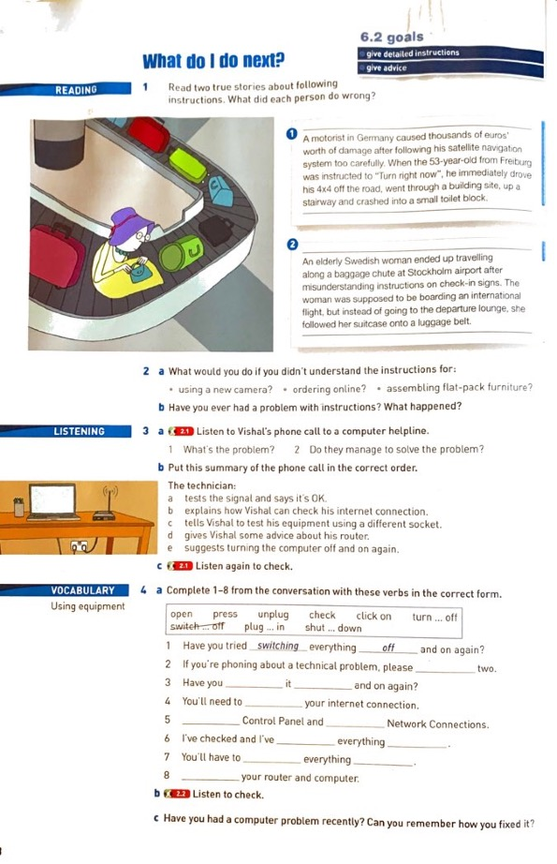

As shown in Figure 23 above, the unit starts with a reading passage, followed by a listening activity and then vocabulary all presented on one page. Figure 24 below reproduces the second page of the unit.

Figure 24. Second page of unit from English Unlimited Special Edition (Rea, Clementson, Tilbury and Hendra, 2017, p.49)
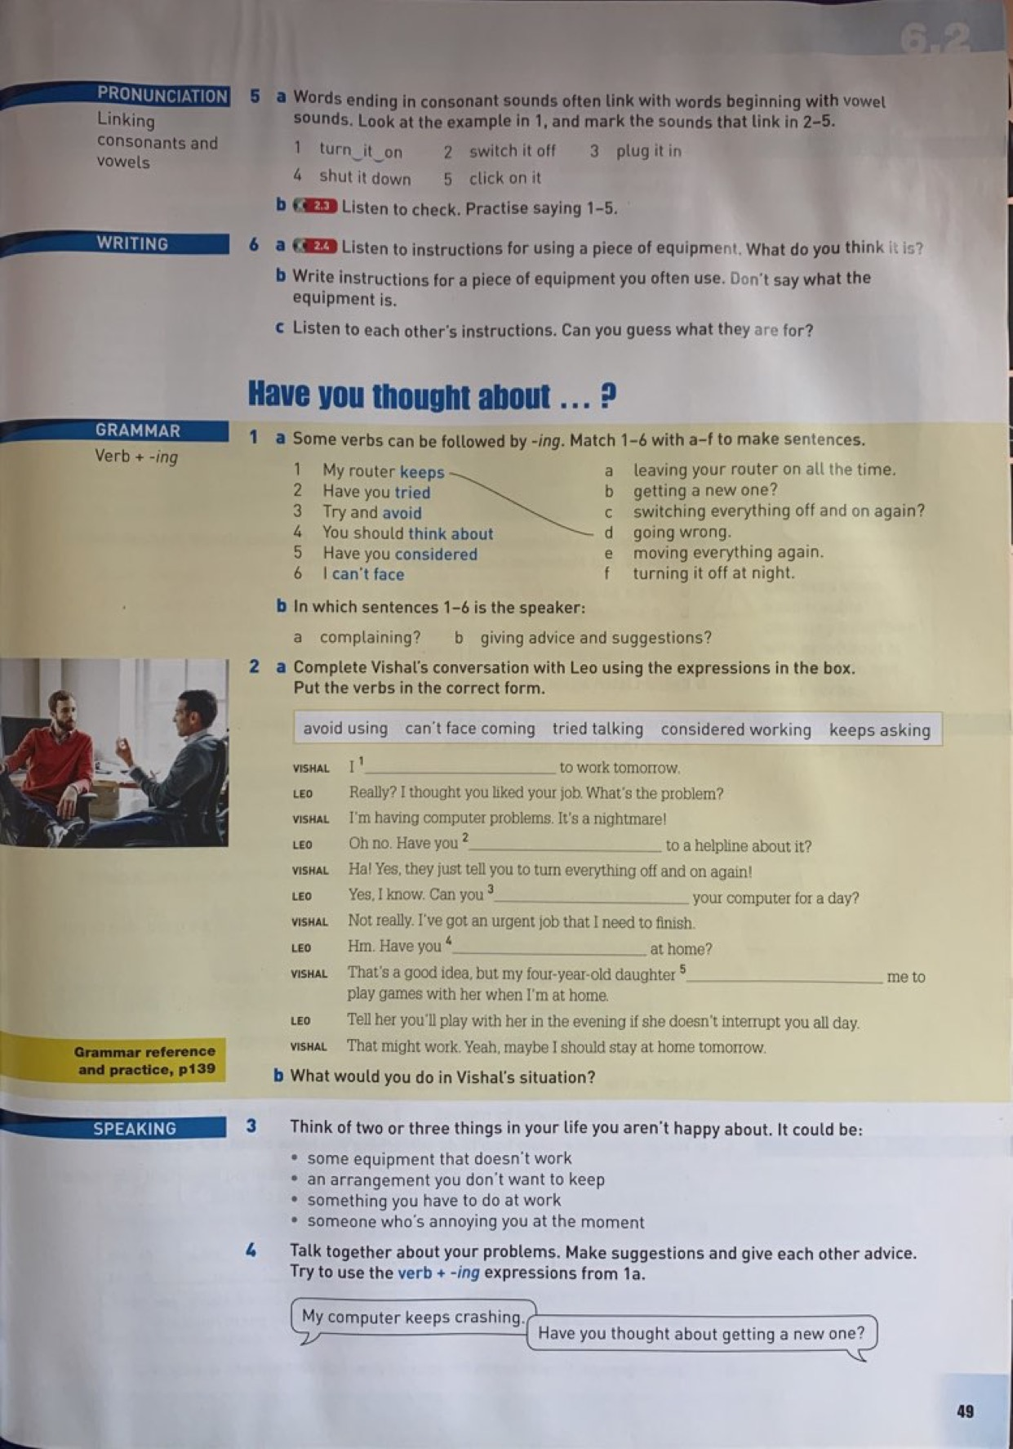
On the second page of the unit, shown in Figure 24, we have a pronunciation activity followed by writing, grammar and finally speaking. According to teacher TM, the reading at the beginning of this unit has nothing to do with the grammar, which is (verbs + ing), nor has it anything to do with the listening part; she stated “it [the reading part] had not much to do with the listening that came after that”. In the following, we will see a transcript of the listening part teacher TM is referring to, in order to understand her point of view more clearly.

F Figure 25. Listening transcript of unit from English Unlimited Special Edition (Rea, Clementson, Tilbury and Hendra, 2017, p. 151)

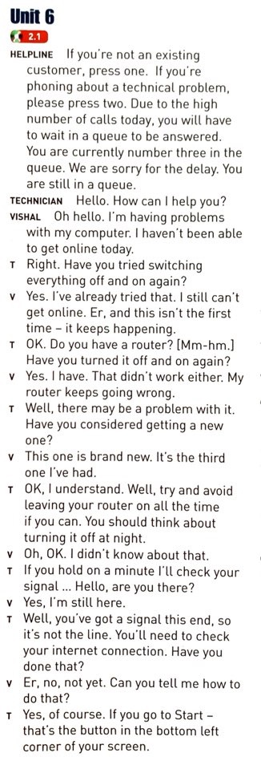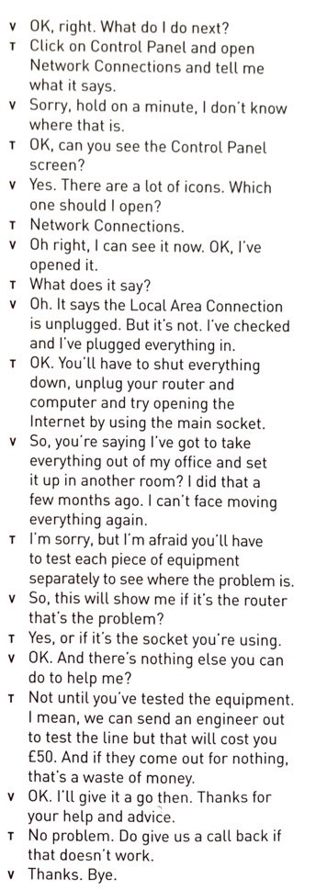

Hence, we see that teacher TM is claiming that the different parts of the unit are not related to each other. However, in order to understand this claim she is making, it is important that each of the different parts that she referred to in her quote (reading, grammar, listening) be looked at closely. For this reason, each of these three different parts will be shown below in order to examine teacher TM’s assessment further. In Figure 26 below, we will be looking at the grammar of the unit.

Figure 26. Grammar rule of unit from English Unlimited Special Edition (Rea, Clementson, Tilbury & Hendra, 2017, p.49)
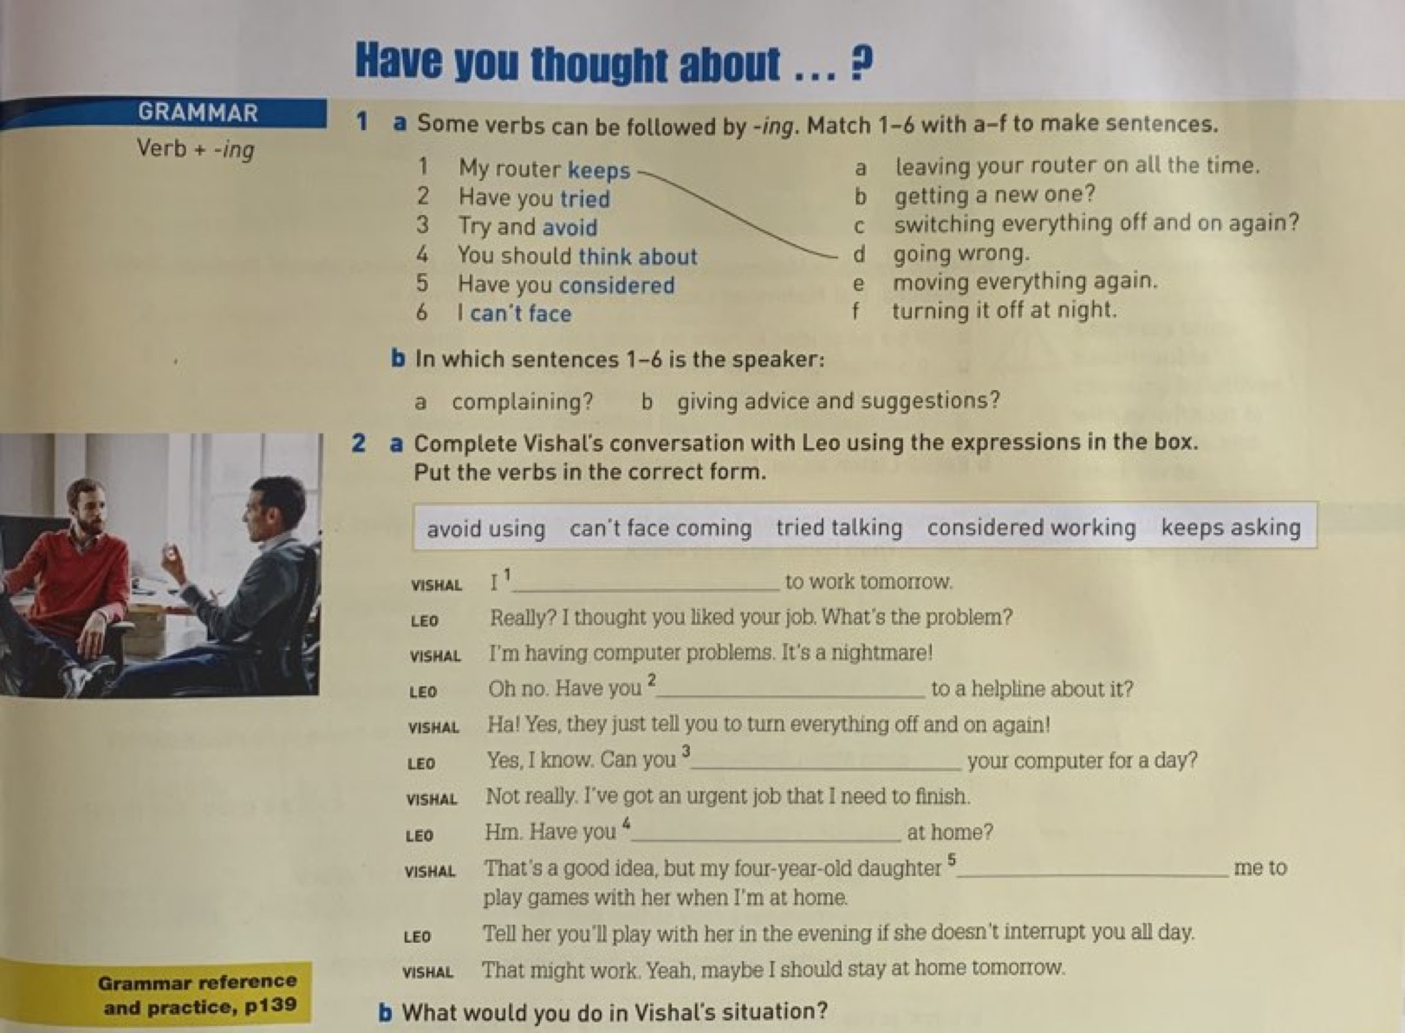

As it is clear from Figure 26, the grammar rule of the unit focuses on (verbs + ing). When looking at the listening transcript (shown in figure 27 below) that teacher TM sees as unrelated to this grammar rule, we see that it actually employs the rule (verb + ing) within the speakers’ discussion.

Figure 27. Listening transcript of unit from English Unlimited Special Edition (Rea, Clementson, Tilbury & Hendra, 2017, p.151)

Additionally, the speaking part, which is shown below in Figure 28, also asks the students to use the (verb + -ing) expressions in their answers, which is also a focus on the grammar rule of this particular unit.

Figure 28. Speaking part of unit from English Unlimited Special Edition (Rea, Clementson, Tilbury & Hendra, 2017, p.49)
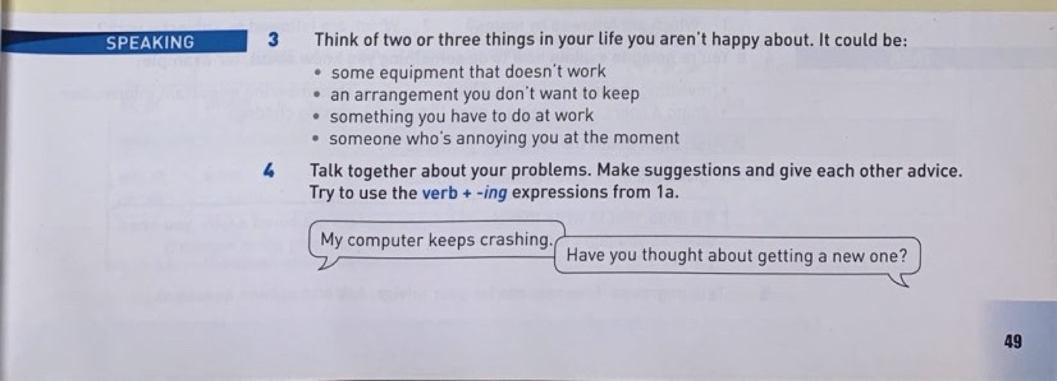

Therefore, it is apparent that all these three different parts of the unit have one particular theme in common, which is giving instructions, and they also focus on the grammar rule of the unit (verb + ing). Even when looking at the writing section of this unit, we see that it asks students to “write instructions for a piece of equipment”, which also incorporates the theme of the unit.

Figure 29. Writing part of unit from English Unlimited Special Edition (Rea, Clementson, Tilbury & Hendra, 2017, p. 49)



However, according to teacher TM, there is no cohesion between the different parts of the unit. It is clear, at this point, that teacher TM has not appreciated how the textbook writers have made the materials coherent in the unit we have just looked at. However, contrary to what she believes, there is a common coherent thread running through the unit, which is the grammar rule (verb + ing).

She then specifically talked about the reading of the unit (shown in Figure 30 below) and how it is not related to any of these other parts. She judged it to be a waste of time.

Figure 30. Reading passage of unit from English Unlimited Special Edition (Rea, Clementson, Tilbury & Hendra, 2017, p. 48)
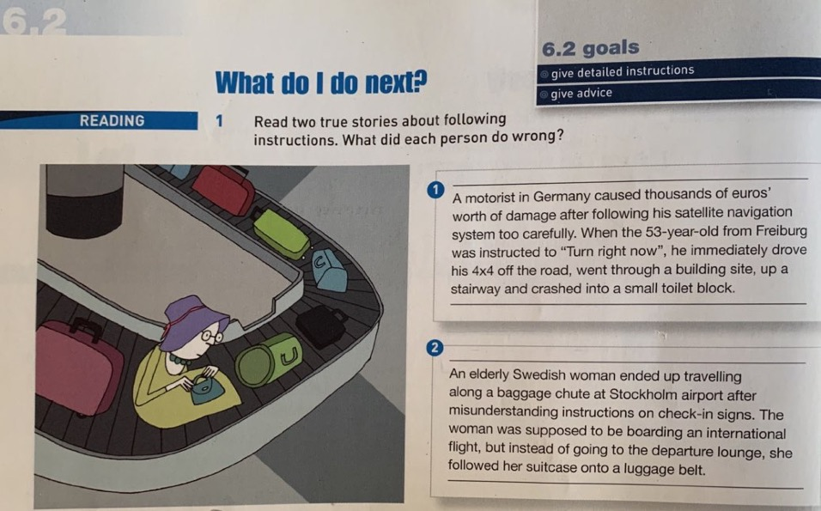

Teacher TM described this passage saying:

. . . these two readings here [number 1 & number 2], I thought they were so irrelevant . . . It’s about following instructions, but it’s just so unrelated [to the other parts of the unit]. These [the characters in the passage] are people that made mistakes because they didn’t follow instructions. The vocab was really difficult, and I felt that it was just going to be more detrimental than beneficial.

From these previous instances, it is quite obvious that teacher TM has certain pedagogical beliefs that she is comfortable with and prefers to abide by in her teaching and in her use of the textbook. In fact, in her interview, she wholeheartedly explained how she is a firm believer in what she called “the holistic approach”, by which she means that the parts of something are seen as interconnected or integrated as a whole. When applying this definition to textbook use, it means that she prefers and wants the different parts of the textbook, the reading, listening, speaking, vocabulary and writing to be related to each other. She further explained her views by saying: “I really have this approach, the holistic approach, making things connected. So, where I can find connections [between the parts of the textbook], I try to focus”. Thus, it may be said that teachers’ beliefs about appropriate pedagogy have an influence on the way they perceive and use textbooks, and this in fact was evident in her lesson observations, as we shall see below.

4.2.1.1. Teacher TM’s actual use of the textbook

When looking at teacher TM’s lesson observations, it is clear that she applies this holistic approach from the way that she goes about teaching the unit. In none of her four observed lessons did she follow the unit in the order it is presented in the textbook; rather, she jumped from one part to another. More details and scenarios about her actual use of the textbook in class will be given in section 4.5.

4.2.2. Teacher TZ’s view towards textbooks

A textbook is: “disorganized, mismatch of a lot of things”

Teacher TZ | Metaphors to describe textbook
Teacher TZ | Roadblock  Guideline  Map

Another teacher who also displayed a very negative attitude towards the textbook is teacher TZ. In her interview, she stated that she does not like the textbook she is using for many reasons:

I don’t even like this book. It is just all over the place, it is not organized, so much information crammed into pages, and you teach for four hours and then you find yourself only covered two pages, so it is demoralizing for teachers . . ., it is just useless.
From teacher TZ’s comments above, we see that there are two factors which contribute to her dislike of the textbook. First of all, she believes it lacks organization, which is similar to what teacher TM stated. Additionally, teacher TZ sees the textbook as containing too much information for teachers to be able to cover in the duration of a lesson. It is clear that these two factors caused teacher TZ a major problem in her teaching to the extent that she described the textbook as “demoralizing”. In order to better understand these claims that she is making, it is important to look closely at the different parts of the textbook that she believes are not organized. In the figures that follow, a unit of the textbook is reproduced that demonstrates how the different sections of a unit are divided.

Figure 31. First page of unit from English Unlimited Special Edition (Rea, Clementson, Tilbury & Hendra, 2017, p. 54)
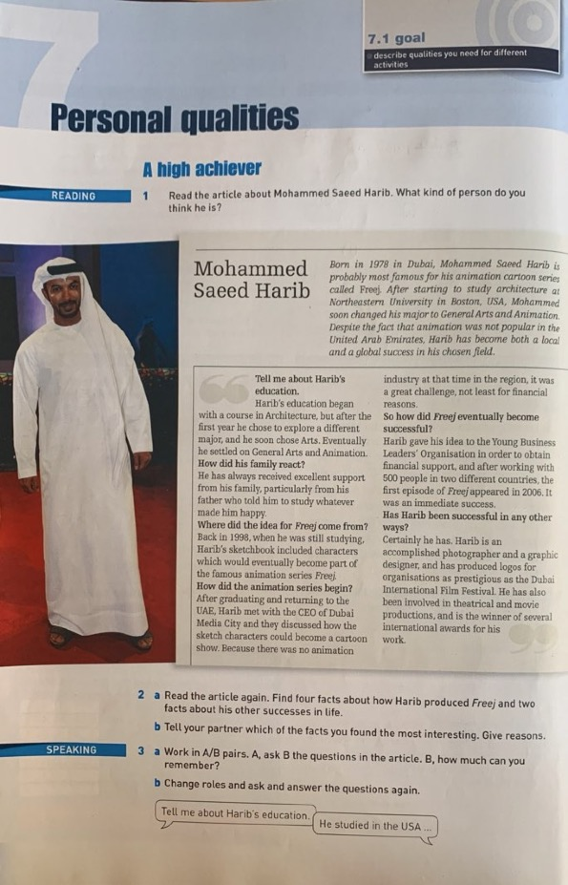
In this first page of unit 7, we see that it starts with a reading passage followed by a speaking activity. Then we move on to the second page, which is shown in Figure 32 below.

Figure 32. Second page of unit from English Unlimited Special Edition (Rea, Clementson, Tilbury & Hendra, 2017, p. 55)
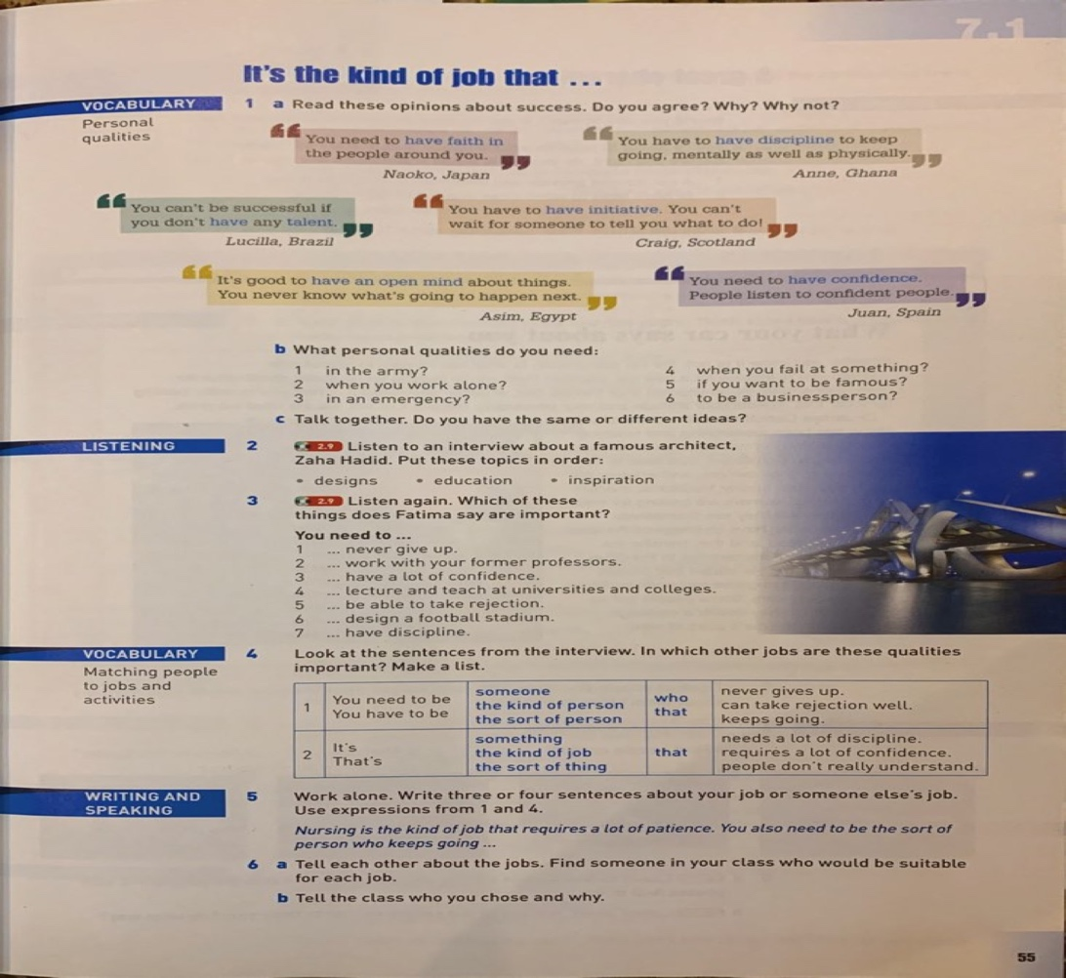

On this second page of the unit, we have a vocabulary exercise followed by a listening activity, then we have another vocabulary part and finally the page ends with a writing and speaking exercise.

Figure 33. Third page of unit from English Unlimited Special Edition (Rea, Clementson, Tilbury & Hendra, 2017, p. 56)
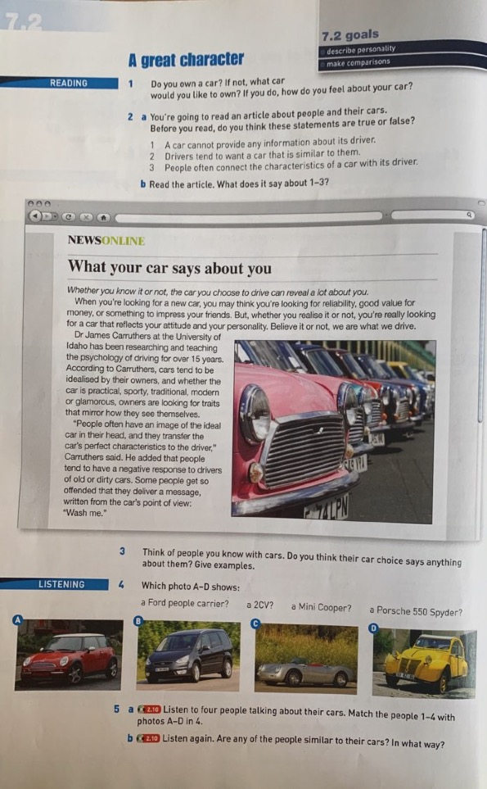

On this third page of the unit shown in Figure 33 above, there is a second reading passage followed by a second listening activity, as well.

Figure 34. Fourth page of unit from English Unlimited Special Edition (Rea, Clementson, Tilbury & Hendra, 2017, p. 57)
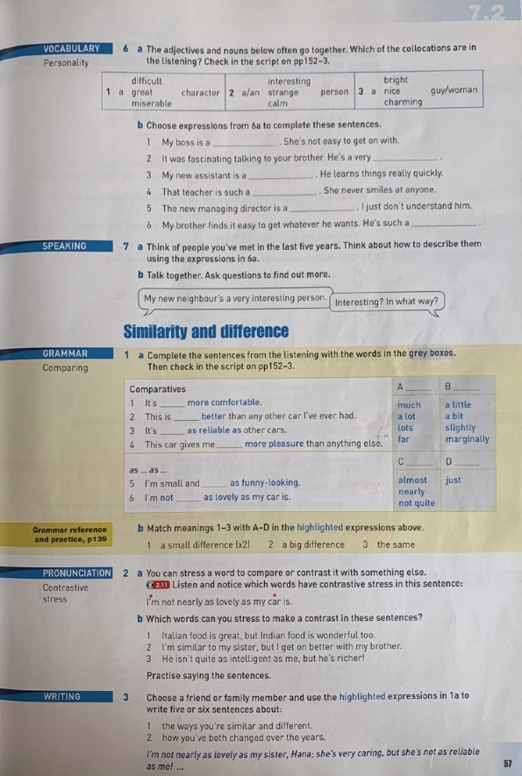

On the fourth page of the unit shown in Figure 34, we see that it is somewhat crammed with information, as it contains five different skill activities; we have vocabulary followed by speaking, grammar, pronunciation and finally writing.

Figure 35. Fifth page of unit from English Unlimited Special Edition (Rea, Clementson, Tilbury & Hendra, 2017, p. 58)
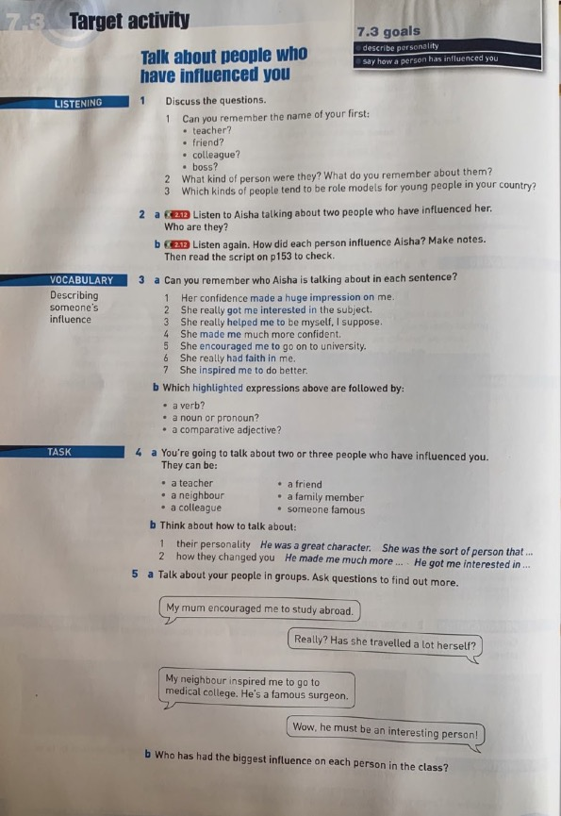

In this page, there is a third listening activity and a fourth vocabulary activity of this unit.
As teacher TZ described, it is clear from the figures shown above that the unit contains a great deal of information; for example, we see there are five different vocabulary parts in the unit.
In addition, there are two reading passages and four listening exercises. Furthermore, we see how these parts are not organized in a sequential way, in which similar skills follow each other. For instance, the unit starts with a reading passage, goes on to a listening exercise, which is then followed by vocabulary, then we have another listening track followed by another vocabulary exercise. According to teacher TZ, this is not a logical order; she also emphasized the messiness of the textbook when describing it as “disorganized”.

When looking closely at the different parts of this unit, which teacher TZ is describing as “all over the place”, we see that the main goal of the unit (shown at the top right corner of each page) is describing different qualities that a person may have. Accordingly, when looking at the different activities, we see that they all have this theme in common. For instance, in the first reading passage of the unit “Mohammed Saeed Harib” (shown in Figure 31), we see that this article is about Mr. Harib’s educational journey and his present occupation. Through the explanation of his education and current job, the writer describes Mr. Harib’s characteristics, which is the basic goal/theme of the unit. Furthermore, when looking at the vocabulary part “personal qualities” (shown in Figure 32), it is also obvious that the theme of the unit is apparent. This activity discusses the different qualities that people need for different circumstances, for instance qualities you need in the army or qualities you need in order to be famous. Hence, it is evident this theme pattern of “describing qualities/characteristics”, as we can see from the previous figures, occurs in all the activities of the unit teacher TZ is referring to. Therefore, similar to teacher TM, teacher TZ also does not see the common thread between the different parts of the unit.

4.2.2.1. Teacher TZ’s actual use of the textbook

As mentioned previously in the methodology chapter, only one lesson was observed for teacher TZ. In that lesson, she covered most parts of the textbook, such as reading, grammar, vocabulary and listening, and in much the same order that they appeared in the textbook. Another point noted during observations was that teacher TZ uses the L1 very much within the exercises. More on her use of the textbook and her incorporation of the L1 within her lessons will be discussed in section 4.5.

4.2.3. Teacher TD’s view towards the textbook

A textbook is: “Lacking appealing ingredients”.

Teacher TD | Metaphors to describe textbook
Teacher TD | Headache  Nightmare  Guideline

Another teacher who projected a negative view towards the textbook is teacher TD. Although she did not reveal as strong an aversion as teacher TZ, she still had her reservations regarding the textbook. In her interview, she described the textbook as “lacking appealing ingredients”. Moreover, she bluntly stated, “seriously, I do hate the book, but at the same time I also hated the book in my previous job. So, maybe I'm against all books.”
When asked why she detests textbooks, she justified her resentment saying:

I like teaching by theme and the way we are taught English in schools . . . [is that] lecturing and grammar translation is the dominant method . . . I see this has to do with using a textbook. If each teacher was to create her own content not using a textbook, she has the freedom and autonomy to do whatever she likes . . . I think we will have better results and English will be taught better.

From this quotation, it is clear that independence is an important characteristic that teacher TD wants to be able to feel as a teacher. It was obvious throughout her interview that she felt very much constricted by using a textbook and believes that it is the reason for not teaching/learning the English language properly. It is worth noting that this negative view towards textbooks is not only because of the current book teacher TD is using; she expressed the same attitude towards textbooks in general. Therefore, we see that autonomy is paramount for teacher TD and this may be the strongest reason for her negative stance towards the textbook she is using. She feels confined by it and she explicitly mentioned autonomy as a salient factor during her interview, saying “look, we don't have the autonomy to just not use the book. I would have to use it anyway. But do I love using it or not, here is where I have the freedom to talk”.

Going back to the metaphors that teacher TD chose from the prompt card she was provided with, they were headache, nightmare and guideline. From her choices, we see that the first two metaphors are negative; whereas the third metaphor has a positive feel to it. Therefore, I asked her to explain her choices, to better understand her thoughts on the textbook. She then explained saying, “what I mean is that it [the textbook] serves as a guideline, if I have to teach this book. So, I would just get the theme from the book then I just make a whole different lesson”. She therefore considers the textbook as a guideline in the sense that it provides her with ideas, themes or starting points for the lesson to be taught, then she creates her own exercises based on these starting points and does not actually follow the textbook. This approach in using the textbook is similar to that of what Shawer (2010) calls a “curriculum maker”. In his article, Shawer (2010) describes his idea of a curriculum maker as a teacher who only very rarely consults their textbook. When curriculum makers do consult the book, one of the ways they do so is by looking at the textbook’s table of contents and drawing inspiration from that to then create their own materials to teach the language points suggested by the textbook. Furthermore, this lack of dependency on the textbook was also evident in teacher TD’s account of the process of lesson planning, where she described her lesson planning:

I usually . . . look at the general objectives of the lesson and I don't do a lesson plan, but I plan as I teach. I just know what I'm going to teach, what topic, what theme, I put the grammar on slides, I do my own controlled exercises, and then I start teaching spontaneously.

Similarly, Cabrera (2014) described textbooks as being a helpful originator of different ideas and content that teachers may implement in their lessons, without specifically following them diligently. In fact, he described textbooks as being “a point of departure” (Cabrera, 2014, p. 276), which is the same as how teacher TD is describing her textbook, inasmuch as she uses it as a starting point for her lessons only. In sum, it is obvious that teacher TD is against textbooks because she feels they strip her of her freedom as a teacher to cover what she believes is suitable for her lesson.

4.2.3.1. Teacher TD’s actual use of the textbook

However, when looking at teacher TD’s lesson observations, we find there are some contradictions between the way she claims she uses her textbook and her observed practise. In contrast to her alignment with a curriculum maker at interview, during her lesson observation she adhered quite closely to the textbook. In fact, she covered everything in the unit, except for the grammar, and in exactly the same order that it appeared in. More details on her use of the textbook will be found in section 4.5.

4.2.4. Teacher TK’s view towards the textbook

A textbook is: “strict, too much”.

Teacher TK | Metaphors to describe textbook
Teacher TK | Heavy stone

Teacher TK also had a negative attitude towards textbooks, albeit not as strong as the previous teachers’ attitudes. This negativity is shown through her choice of metaphors in describing the textbook. She explained that she feels the textbook is “too much to follow”. That is, according to her, the level of the exercises is too difficult for her students. She talked about this problem further below:

I don't know if it's because we are teaching this to our students or if we had to teach this to a different level of students would it be less complicated? . . . But for me, I feel it is too complicated . . . there are some questions that I think this is impossible, I can't do this with the girls.

She then described how her way around this problem is by adapting the textbook, which we will examine further in section 4.5: “but if you were a person who would follow this [the textbook], it would be too much to follow. I mean the exercises, it's too much”.
Furthermore, another negative element of textbooks that teacher TK mentioned is the fact that using a textbook tends to limit a teacher’s creativity: “I feel that in the classroom I can't be creative because I'm limited to what is in the textbook”. Expanding on this point more, she gave a comparative example between her and her brother-in-law. She described how he is an inexperienced lecturer teaching for the first time. In his context of teaching, he is not given a textbook; in his institute “they told him this is the class, you come up with the material”. She described how he complained of not knowing how to come up with materials and decided to use the same textbook he used when he was a student. Of course, in her case, it is the exact opposite scenario, where she is given a specific textbook to use in addition to a pacing guide to follow. According to her, “you really can't [be creative] because they [the administration] tell you what to cover page by page”. This is why she feels restricted; in fact, she specifically described her brother-in-law as “lucky” because of the freedom he is given in creating his own materials. She believes that by having the freedom as a teacher to create your own content:
You have room to be creative. You can create everything from tests to quizzes . . . you can give them [the students] whatever you feel is important, whatever is appropriate for their level . . . It's nice to be able to feel out the situation with the level and give them according to their level . . .

When asked to describe a way in which she would feel less restricted than she is now, she replied, “if they [the administration] say . . . [in] this module you have to cover these grammar rules, I would love that. You would be able to look at different books, you will choose the best way to introduce something to your students depending on their level. That would be lovely”. In the scenario teacher TK is describing, she would only be restricted in the types of grammar rules to cover in lessons; other than that, she would have the freedom to create her own activities according to what she believes is suitable for the level of her students, which is similar to teacher TD’s point of view and what Shawer (2010) describes as the approach of the “curriculum maker”.

4.2.4.1. Teacher TK’s actual use of the textbook

Teacher TK was one of the teachers who only had one lesson observed. During her lesson observation, it was noticed that she covered most of the activities of the main components of the textbook, such as the reading and listening. Furthermore, it was also noticed that she focused on vocabulary throughout the lesson. She occasionally asked the students about the meanings of random words that she chose, whether they were from the listening tracks or the reading articles. More on teacher TK’s use of the textbook and the adaptation techniques she employed will be discussed in section 4.5.

4.3. Teachers with a positive attitude towards the textbook

The second group of teachers in this study are the ones that appreciate having textbooks. In the following, these teachers’ views on textbooks will be discussed, in addition to a brief summary of their actual use of the textbook.

4.3.1. Teacher TS’s view towards the textbook

A textbook is “a Bible”

Teacher TS | Metaphors to describe textbook
Teacher TS | Petrol  Map  Guideline  Compass  Blind man’s stick

Teacher TS’s positivity towards textbooks is shown through her description of the assigned textbook, which was “A Bible”. She explained that the textbook is unquestionably helpful for her and for any teacher, for that matter; in fact, “it will be very difficult for you to do teaching without a textbook”. Additionally, more positivity was revealed through her selection of metaphors from the prompt card she was provided with: Petrol, Map, Guideline, Compass, Blind man’s stick. As observed from the set of metaphors she chose, all are positive, and all have a sense of prominence in people’s daily lives. That is, it is obvious that one cannot drive a car without petrol, thus making it a requirement for driving; also, maps are important to help us get to our destination. Furthermore, a compass helps us orient ourselves and go in the right direction, and lastly a blind man would not be able to walk without his stick. Therefore, just as these items are important for their users, a textbook is important for a teacher.

However, teacher TS made it clear in her interview that although textbooks are essential, they should be used wisely and not slavishly (cf. Islam & Mares, 2003); she stated:

Of course, the teachers should make a lot of adaptations to the textbook . . . these [the adaptations] are very important because the textbook doesn’t know your students. You as a teacher, you will know your students.

According to her, teachers should use their textbooks keeping in mind students’ different learning styles and their individualized learning needs at the same time. She further explained the importance of using textbooks in a thoughtful way, saying:

If I got a free hand [freedom in using any materials she wanted], I would have my textbook and also, I would have other sources to supplement . . . It [the textbook] will provide a springboard for you. So, use the textbook but at the same time use it in a way to serve the purpose of . . . helping the students achieve their learning outcomes. So, textbook is a must.

Here, teacher TS used the word “springboard” to describe the textbook as being a stable starting point for teachers; it can be used to give teachers ideas about the main points that need to be covered in a lesson, then the teacher can start from there and bring out her creativity in creating the lesson in a way that is suitable for her students, hence using the textbook in a way that enriches the learning experience. From what teacher TS has explained, she may be described as what Shawer (2010) calls a “curriculum developer”, who considers textbooks as an important element in the classroom, but uses them wisely and appropriately, bearing the learners and their needs in mind.

4.3.1.1. Teacher TS’s actual use of the textbook

This attitude of teacher TS was evident in her lesson observations, where she conformed to the textbook, while she also adapted where she believed adaptation was required. In sum, we see that teacher TS views the teacher as the manager in the classroom who uses the textbook in a manner that is suitable for his/her individual context. More on her actual use of the textbook within her lesson will be discussed in section 4.5.

4.3.2. Teacher TN’s view towards textbooks

A textbook is “the backbone of teaching most of the four language skills”

Teacher TN | Metaphors to describe textbook
Teacher TN | Petrol  Map  Guideline  Compass

The second teacher in this group with a positive attitude towards textbooks is teacher TN. In her interview, she spoke favourably about the textbook. Firstly, her positive perspective was evident through her response to prompt card #1 (shown below), where she was asked to choose a quotation that reflected her attitude towards textbooks.

These are two quotes by two teachers explaining their opinions towards the
textbook:

Nora: “Good teachers do not use textbooks.”
Nejwa: “Using a textbook is a must for all teachers.”

From this prompt card, teacher TN chose the second quotation, “using a textbook is a must for all teachers”, and she also added the following sentence to this quotation: “and for most of the students”. She described how she sees the textbook as a “solid reference, something to resort to” not only for herself as a teacher, but “for the students themselves”. This positivity towards textbooks was also evident in the metaphors she used to describe her book. In the first question, which asked for a metaphor describing the textbook, she answered that a textbook is “the backbone of teaching most of the four language skills”. This comment echoes that of a participant in Farooqui’s (2008) study, who also stated that if the textbook is taught properly, students will be able to develop the four language skills. Furthermore, she chose the following metaphors to describe the textbook: Petrol, Map, Guideline, and Compass. From these choices it is apparent that the textbook holds a prominent role for teacher TN. Moreover, she emphasized the merit of the textbook by a term she personally added to the table, which is “energetic”. She explained that she views the textbook as energetic because it gives students energy by showing them what will be covered in lessons. She believes that when students know what they will be learning in their English language lessons, this gives them a positive effect and they will receive an energy boost to help motivate them to learn.

Moreover, teacher TN’s positive view towards textbooks was apparent throughout her whole interview; in fact, she believes that the negativity towards textbooks that some teachers have is actually of their own making: “it’s [the textbook] a heavy stone if I decided to make it a heavy stone. If I’m not going to use it for my benefit”. Furthermore, at another point during her interview, teacher TN concluded: “I know the value of the textbook. It’s not a belt, it’s not a prison, it is not a dark devil . . . I need it especially with beginners, you need something to start from”. This view of using a textbook as a starting point has in fact been mentioned in the literature and is considered a positive effect of using a textbook, especially with students (Crawford, 2002; Swales, 1980).

4.3.2.1. Teacher TN’s actual use of the textbook

With regards to teacher TN’s use of the textbook, as predicted from her attitude, she covered most parts of the unit and in the same order they are presented. However, she made some changes to the grammar part of the unit, as we will see in section 4.5.

4.3.3. Teacher TF’s view towards the textbook

A textbook is: “a big world”

Teacher TF | Metaphors to describe textbook
Teacher TF | Daily bread  Petrol  Map  Water  Compass  Cooking oil  Blind man’s stick

Teacher TF’s attitude towards textbooks mirrors that of teacher TS; she also has a generally positive attitude towards textbooks and confirms their importance. However, she states that the word ‘must’ in the quote in the prompt card she was provided with (highlighted below) is exaggerated.

Nora: “Good teachers do not use textbooks”
Nejwa: “Using a textbook is a must for all teachers”

She changed this quote to “it is a must that we abide by our textbook and at the same time be creative”. Hence, she believes in the importance of using textbooks in lessons; however, she also believes teachers must use textbooks in a way that is creative and not necessarily stick to the textbook dutifully. Furthermore, the metaphors portrayed by teacher TF also reveal a positive attitude towards textbooks; she chose the following metaphors: Daily bread, Petrol, Map, Water, Compass, Cooking oil, Blind man’s stick, which all represent positive feelings. In addition, when asked to describe the current textbook she was using, she said: “a big world”. She further explained this description, saying: “it's a big world that we can travel in all its corners . . . So, before traveling . . . we need to be well-prepared, so this is for me the textbook”. From this description, it appears that according to teacher TF, using a textbook makes a teacher well-prepared. A sense of direction was also obvious in some of the other metaphors she chose, such as Map, Compass, and Blind man’s stick. Hence, it may be speculated that organization and planning are important characteristics for this specific teacher, which are provided to her by the textbook. In fact, this organization and well-preparedness was evident in her lesson preparation process and in her organization of the lesson.

When asked about her lesson preparation techniques, teacher TF reported that the first step she takes when preparing a lesson is to check the pacing guide.

So, the first thing I check is the pacing guide to know what pages or what tasks am I going to do in class . . . and then later I try to prepare a lesson plan . . . so pacing guide, then I look at the textbook, then I prepare the lesson.

It is worth mentioning that she is the only teacher in this study that mentioned the fact that she refers back to the pacing guide before preparing lessons. Moreover, it was noticed during her lesson observations that she starts her lessons in a very organized manner. For example, she starts her lecture by dividing the whiteboard into three. The first part of the whiteboard is for the lesson objectives, the middle part is for the lesson itself, such as grammar rules and finally the far-left corner includes random vocabulary words that come up during the lesson. Teacher TF justified this routine act in the following way:

I don't want the board to be clumsy [messy] because when the board is clumsy, even the students might get clumsy. But when you organize it . . . students won't get confused . . . so if the teacher is clear, students' mind will be clear.

Thus, it is obvious that organization and clarity are critical issues for teacher TF; hence this may explain her positive attitude towards textbooks, as they provide her with the organization and precision that she needs and wants. Similarly, Hutchinson & Torres (1994) state that “the very fact that a lesson is a dynamic interaction . . . leads not to a need for maximum freedom, but to a need for a predictable and visible structure both within the lesson and across lessons. The textbook . . . is the best means of providing this structure” (p. 321). Furthermore, other advocates of textbook use reported how textbooks provide teachers with guidance, organization and direction (Guerrettaz & Johnston, 2013; Miranda & Del Campo, 2016).

4.3.3.1. Teacher TF’s actual use of the textbook

With regards to teacher TF’s use of the textbook, like most of the teachers in this study, she covered the majority of the unit components and in the same order they appeared. More on her use of the textbook will be found in section 4.5.

  - Teachers with a more nuanced view towards the textbook

In this part, the replies of teachers who revealed a somewhat nuanced view towards textbooks will be discussed.

4.4.1. Teacher TR’s view towards the textbook

A textbook is “a Road map”

Teacher TR | Metaphors to describe textbook
Teacher TR | Map  Guideline  Compass

In teacher TR’s interview, she spoke favourably about the textbook. However, it was noted that this positivity comes from the fact that textbooks are very much related to exams. For this reason, teacher TR believes that textbooks are an important element in the classroom, and they play a major role in enabling students to practise and pass their exams. When presented with the two quotations on textbook use, shown in the following prompt card,

These are two quotes by two teachers explaining their opinions towards the
Textbook:

Nora: “Good teachers do not use textbooks.”
Nejwa: “Using a textbook is a must for all teachers.”

Teacher TR revealed some reluctance in choosing, before she replied:

I think the second one [the quotation]. . . Here in the ELI, it is a must for all teachers, because you could say a textbook is like a road map for the teacher because it says what should be covered in the lesson because it also reflects the exam. The textbook . . . helps the students to study and prepare for the exam . . . The teacher is pushed [by the administration] and she has to follow the textbook in order to help the students prepare for the exam. If I told them I won’t use the textbook, the students will be confused, they won’t know what to do for the exam and how to prepare for the exam. I think it [using the textbook] is a must for the teacher and it depends on the institution.

There are various issues that emerge from this interview excerpt. First of all, at the beginning of the excerpt, there is the impression that teacher TR regards textbooks as an important companion in the classroom. This is found in her description of the textbook’s benefit for both teachers and students. According to her, the textbook acts as a “road map” for the teacher because it helps her by giving her the range of topics that should be covered in class and that students will be examined on. With regards to the students, the textbook plays an even more important role because it is considered an aid in helping them prepare and do well in their examinations. Therefore, it is noted from her descriptions of the textbook that she views it positively, not necessarily because of the textbook itself, but because of its close relation to the examinations in the ELI. This may also be sensed through the part of the quotation “the teacher is pushed and she has to follow the textbook”. I sensed something of a feeling of negativity towards the textbook here, and I felt that the positive perspective teacher TR has is somehow forced. I therefore asked her, regardless of institutional pressures, if she had the freedom to either use a textbook or not, what would she prefer, and she replied she would prefer not to have a textbook:

I will just be free to use the materials that I think suitable for my students. I will just be free to design my lessons in a way that I feel like appropriate for my students because I will give you an example. The level I taught they were repeaters and I think the textbook was so difficult for them, I think if I weren’t in the ELI in KAU, I would have used a different textbook and different materials and I would have a different approach. It won’t be the same class and the materials would be different, won’t be the same.

In sum, from teacher TR’s comments, we sense that exams are a dominant affecting factor in the ELI. In fact, using textbooks as preparation for exams and the linkage between textbooks and exams is a point that has been mentioned by other teachers in this study and has also been reported in the literature. Hence, this point will be further tackled in section 4.7.2.

4.4.1.1. Teacher TR’s actual use of the textbook

It was noted during teacher TR’s lesson observations that she focused on the grammar and vocabulary parts of the textbook the most. The reason for this may be the fact that exams in the ELI are grammar oriented. Therefore, her textbook use is similar to her exam-driven perspective towards the textbook and how she views it as important due to its close connection to the exams in the ELI. More specific details and scenarios on her use of the textbook will be discussed in section 4.5.

4.4.2. Teacher TJ’s view towards the textbook

A textbook is “a breath of fresh air as it introduces some wonderful topics for the students to exercise their brains”.

Teacher TJ | Metaphors to describe textbook
Teacher TJ | Map  Guideline  Water  Compass

At the beginning of teacher TJ’s interview, she projected a positive view towards textbooks, which was evident in her description of the textbook, as well as from the metaphors she chose, which are shown above. This appreciation of textbooks was also revealed in some of her general comments on the textbook. For instance, she talked about the quality and the design of the textbook and how these are its strong suits. However, despite the fact that teacher TJ’s choice of metaphors reflected a positive view, when presented with the two sets of quotes on textbook use, shown below, she chose neither.

Nora: “Good teachers do not use textbooks”
Nejwa: “Using a textbook is a must for all teachers”

She stated:

I think I would fall somewhere in between. One says “don’t use textbooks” and one says “using the textbook is a must”. I say I think you do a bit of both and adapt and supplement a lot. I would feel that that would be very good.

From this statement, it is clear that teacher TJ has a balanced view towards textbooks. She believes in the importance of textbooks and the importance of using them; however, she also believes that textbooks should be adapted:

if I was doing something on my own [not using the textbook], it wouldn’t be very focused, it wouldn’t be very organized, and if I said I am only using the textbook, then I am not giving a very enriching experience to the students. They need to have other ideologies and other things put in and supplemented with the lesson.

What she means by “enriching experience” is the teaching/learning experience as a whole. She explained how she considers it part of the students’ right to be introduced to extra materials, whether it be for linguistic or cultural reasons. For instance, she described how her students’ level varies from one module to another, and obviously from one student to another, which in her opinion makes them entitled to this adaptation: “So, it [adapting] has to be done. Otherwise, they [students] could get either very bored or they could find it very very challenging and they will not be able to adjust . . ., they won’t know what is going on”.

4.4.2.1. Teacher TJ’s actual use of the textbook

With regards to teacher TJ’s use of the textbook, two of her lessons were observed. What was noticed during the two observations was that she covered most parts of the unit. However, in some parts where she felt it was needed, she adapted the textbook, as she had stated during her interview. More details and scenarios on her textbook use will be shown in section 4.5.

4.4.3. Teacher TA’s view towards the textbook

A textbook is: “the Boss”

Teacher TA | Metaphors to describe textbook
Teacher TA | Daily bread  Map  Guideline  Compass

Teacher TA similarly had a balanced stance towards textbooks, and her justification of this stance is logical and quite blunt. Like teacher TJ, teacher TA also expressed a position that identified neither with pro- nor anti- textbook arguments. When presented with the two quotes,
Nora: “Good teachers do not use textbooks”
Nejwa: “Using a textbook is a must for all teachers”

she stated that:

I don't agree with neither . . . because textbooks are made by people who have long years of experience. Some textbooks are really good . . . I think good teachers try to be eclectic, but only when they have the choice . . . so I totally disagree with Nora. And with Nejwa: ‘it is a must for teachers’, this is a very sad statement. Yes, it's a must. We have to use it. It's a compulsory thing. We don't have a choice. This is a very sad thing to be honest.

Moreover, this nuanced view was evident throughout her whole interview, for she had a strong opinion regarding textbooks and their importance in the educational context, which was obvious from the metaphors she chose to describe them: Daily bread, Map, Guideline, Compass. However, she also had certain more critical opinions towards the ELI textbook. For example, when asked to describe the textbook using a metaphor, teacher TA replied it is “the boss”. Although she was quite confident with her choice, she expressed her reservations towards it by saying “I'm sorry . . . I don't like this metaphor. I don't like that my textbook is my boss, but somehow, he is a boss”. Here, she acknowledges the importance of textbooks, she is not necessarily happy with this, but nevertheless she accepts the authority of textbooks in general.

When asked more about this, to enable me to understand her perception clearly, she explained that she does not have a negative perspective towards textbooks; in fact, “I don't hate textbooks. I don't feel that textbooks are barriers or anything. But the more I use it [the textbook], the more I feel I don't understand the logic behind it”. In this quote, teacher TA was referring to the textbook English Unlimited Special Edition specifically. She commented that sometimes there are topics in the textbook that she questions regarding their suitability for her students. We may therefore conclude that the reason why teacher TA is critical towards the textbook she is using is due to the selection of topics that, according to her, are not related to her students. More on this issue and examples of some of the topics she finds unsuitable will be discussed in section 4.5.

4.4.3.1. Teacher TA’s actual use of the textbook

Regarding the extent of teacher TA’s actual use of the textbook, she covered most parts of it. Moreover, similar to teachers TJ, TM, TR and TK, she also emphasized certain parts of the textbook, such as grammar and vocabulary. She covered each and every single grammar activity in the textbook, along with the grammar reference in the back of the textbook. In addition, she also covered the grammar exercises in the workbook; in fact she was the first of two teachers observed to use the workbook during actual class time. When asked about this, she explained how important practise is for the students. She stated that she knows for a fact that they will not practise at home, hence she feels she is obliged to give them practise in class. In fact, she specifically told her students: “You have a specific amount of time to practise. If you don't use it [the language], you will lose it. This is the only time you have to practise English”.

Moreover, the same pattern of use was observed regarding the vocabulary parts of the units, where every activity was covered in addition to the reference parts and the workbook. Teacher TA justified her emphasis on vocabulary due to her personal past experience as a student. She explained that when she was a student, she used to translate every single word that she came across in a reading passage. Many of her teachers told her that this was not a good strategy and explained the importance of learning the meaning from the context, but she did not change her technique. She then described how her students rely very much on Google Translate and Arabic dictionaries, especially when it comes to reading passages. As a consequence, during their exams, they do not know how to deduce the meaning of words from the context. Hence the importance of vocabulary practise in Teacher TA’s view.

To sum up, it is clear from the data above that teachers in this study differed regarding their attitudes towards textbooks. Comparing these results with those of McGrath (2006) and Menkabu (2010), some differences as well as similarities are observed. McGrath (2006) reported that the teacher images in his study were mainly positive except for only one negative category, which was ‘constraints’. Similar to the current study, the teachers in Menkabu’s (2010) study were divided in their views towards their textbook. Three teachers felt constrained by their textbook and therefore chose negative metaphors, such as ‘straitjacket’, ‘sleeping pills’ and ‘nightmares’, while four teachers echoed teacher TS, TF and TN in this study, in which they viewed their textbooks as providing guidance: a ‘path’, ‘compass’ and ‘teacher parachute’. The reason for these differences, it might be assumed, is due to certain contextual factors. For example, Menkabu (2010) reported that the negative metaphors used by her teacher participants may be due to the fact that her study was done in an ESP context requiring the teachers to have medical background knowledge. In fact, she reported “teachers’ insufficient medical background knowledge influenced their perceptions of the textbook” (p. 34). Whereas in both the current study and that of McGrath, the data was collected from general English language classrooms where specialist knowledge of this type was not required.

Furthermore, it was apparent from the lesson observations that teachers in the ELI do in fact use the textbook, and to a very large extent. This may be due to two reasons. Firstly, it is a compulsory textbook that must be covered. Secondly, the exam content closely reflects the content of the textbook. Nonetheless, teachers showed some autonomy in reordering the different components of the textbook, and in focusing on different parts of the textbook according to their own beliefs. These results are similar to what Menkabu (2010) reported in her study of textbook use, where she concluded that her teachers’ textbook was “the main and the only textbook used” in their lessons (p. 29). That textbook was also a prescribed textbook by the institute and also the “only source of examinations” (p. 33).

4.5. Teachers’ textbook use

In this part of the results and discussion chapter, the spotlight is on the main focus of this research, which is teachers’ textbook use and the kinds of adaptations that they make and why they make them. In the answer to these questions lies the heart of this thesis, as they yield an understanding of how textbooks are used inside classrooms. The organization of this part will be according to the most dominant themes/codes that have arisen during the analysis of the teachers’ textbook consumption. Hence, each theme/code will be presented followed with the findings, as well as an analysis of these findings. As an introduction to this part of the chapter, I present a quantitative overview of the types of adaptation techniques that the teacher participants reported using in their classes.

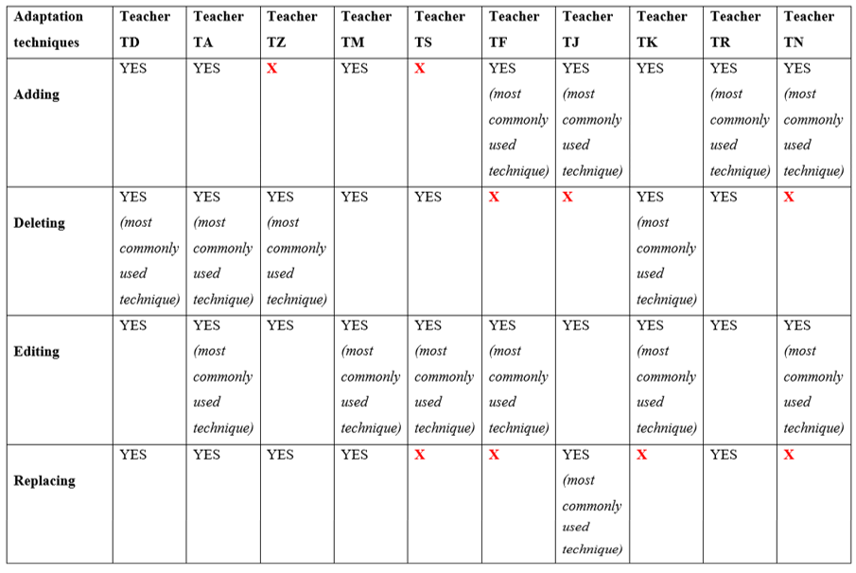
Table 7. Quantitative overview of the adaptation techniques that teachers used in their lessons

I chose to start this part of the chapter with the following quote from a teacher:

“I cannot change the textbook, but I can use it in the way I think best” (TN).

This quote sums up most of the teachers’ views regarding the issue of textbook consumption. This quote may be especially apt to describe the situation in a context where a specific textbook is prescribed by the administration, as is the case in the ELI. In this quote, the teacher acknowledges the importance of covering the prescribed textbook; however, she is also aware of the importance of using adaptation techniques.

4.5.1. Editing

It was concluded through the teacher interviews that editing was the most commonly used adaptation technique, all ten teacher participants stating that they edit their textbook. More specifically, seven of the ten teachers (TA, TZ, TM, TS, TF, TK and TN) stated that editing is, in fact, their most commonly used adaptation technique. Furthermore, lesson observations also revealed many instances in which teachers edited their textbook. These scenarios were then brought up during the teacher interviews in order to better understand teachers’ justifications for these edits. In the following are the different reasons for editing that the teachers explained.

4.5.1.1. Editing due to students’ proficiency level

A number of teachers claimed to edit due to students’ proficiency level:
Editing due to students’ proficiency level
Teacher TJ
Teacher TA
Teacher TD
Teacher TF
Teacher TK

“Editing is a response to the students’ understanding, [or] to the students’ level” (TA).
In this quote, teacher TA summarizes the main reason why half of the teachers in this study claim they edit their textbook. However, before going on to explain this point, it is important to remind readers how the modular system in the ELI works, which was explained thoroughly in section 1.2. At the beginning of every academic year, the ELI has a placement exam for first year university students (prep year students). Depending on these exam results, students are then placed in their suitable level, whether level one, level two, level three or level four. Students who are placed at level four at the beginning of the year are usually the strongest, language wise. The problem, however, occurs with students who are placed at level one or level two, because in a matter of weeks only, students are moved to the next level. Therefore, when they reach level four in this very short time period, they are still basically level one or level two. Teacher TM explains this point further, saying:

In five weeks, which is the actual teaching that we give . . . you’re supposed to move them [the students] to another level. So, there’s a gap. Then, you move them again to another level, there’s another gap. So, they reach level four and there’s this huge gap in their proficiency level that they can’t reach.

Furthermore, teacher TJ also brought up this issue in her interview, describing level four as
“the most disheartening [level] for us [to teach] . . . not just for me, but when I talk to other teachers all of us feel the same way”. She explained that level one and two are usually fine. However, when students reach level three or four that is when the problems arise. She is convinced this is due to the modular system, stating that:

By the time they [the students] are at level four many of them are completely lost, they don’t know what is going on because they are still level one, basically. And in the course of about six or seven weeks we fast track them to level four. So, they don’t know what is really going on”.

Teacher TM additionally explained that as a teacher she feels she is not helping the student to move to another level by the actual outcome of teaching, but what is literally happening is that “I’m just moving her [the student up to the next level], but she’s not really moving [in terms of ability]. Thus, as is clear, level three and four students are required to have a certain level of language competence; however, due to the modular system, they are not able to reach that level. In fact, this gap poses a serious problem for teachers to the extent that they call this issue “the level four phenomena”. Hence, it is no surprise that students’ proficiency level would have a major effect on how and why teachers edit their textbooks.

Teachers TJ, TA, TD, TF and TK all stated during their interviews that they edit the textbook in line with their students’ level; they explained how for low achievers it is important to adapt activities accordingly. For instance, teacher TJ reported “I do edit sometimes. I make it [the activity] a little simpler if the students don’t understand it, I make it a little more difficult to challenge and they can cover those challenging activities”. Therefore, according to her, her editing of the textbook would depend on her students’ level. In some cases where she has a higher-level group of students, she would edit the activities to make them more challenging, whereas in the case of low-level students, she would do the opposite. During her lesson observation, it was noted that she did an editing of this sort in the following matching activity from the textbook. She made a small change, which she justified due to her students’ low level of English.

Figure 36. Activity from English Unlimited Special Edition (Rea, Clementson, Tilbury & Hendra, 2017, p. 31)
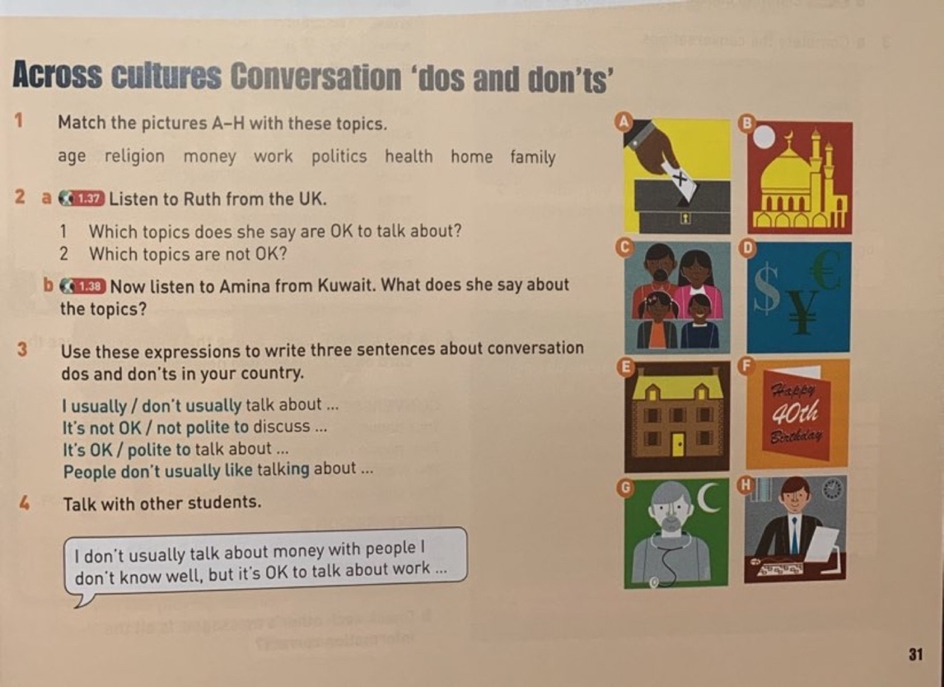

As seen from Figure 36, there are a number of pictures on the side of the page, and students are asked to match these pictures to the words (age – religion – money – work – politics – health – home – family). When covering this activity during the lesson, teacher TJ matched the word (religion) to the picture of the mosque first, then she matched the words (home, age, health, work) each to its suitable image, doing some of the work the textbook asks students to do. After that, she asked her students to match the rest of the words in the activity. She explained that she matched these five words (religion – home – age – health – work) first, because “they are easy and well-known”, and therefore this will motivate the students to match the rest of the images to the words, and also what is left of the activity will be easy to do.
Another editing episode that happened in teacher TJ’s lesson observation was during a reading activity in the textbook. After the students read the passage and were answering the reading comprehension questions, she made sure that she told them in which paragraph they could find the answers; for instance, she would say, “you will find the answer to question number one in paragraph two” and so on. When asked about this during the interview, she explained that this is her way of editing the task in order to make it simpler for her students.

Furthermore, in teacher TA’s lesson observation, it was also noticed that she did some editing, specifically to the grammar part of the unit covered in that lesson. In Figure 37 below, we see the actual grammar section of that unit.

Figure 37. Activity from English Unlimited Special Edition (Rea, Clementson, Tilbury & Hendra, 2017, p. 39)
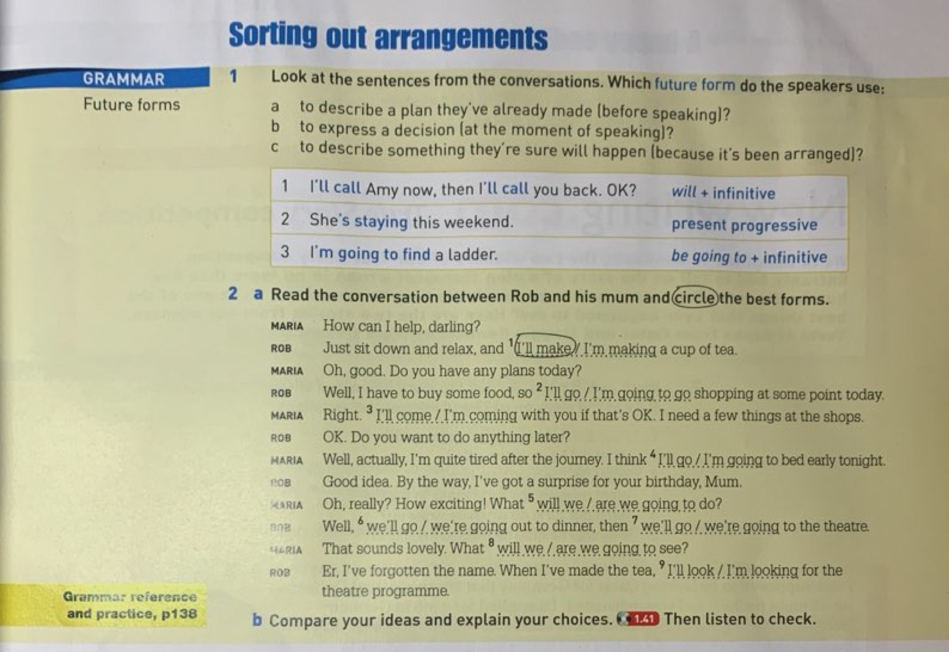
As seen from Figure 37, this grammar section includes the grammar rule, in which the language focus is on future forms, immediately followed by exercises on this rule. However, instead of starting with the textbook, teacher TA explained the grammar rule on the board and gave her own examples before covering this part in the textbook. On the board, she wrote the following two dialogues:

‘Mohammed: What will you do today?
‘Ahmed: I will call my friend Sami to see if he wants to go out.’

‘Mohammed: What are you going to do over the weekend?
Ahmed: I am going to go to Makkah.’

After that, teacher TA asked her students “What is the difference between the two sentences?” After discussing some possible answers with the students, she explained that “The first example is used [using will] when we do not have a plan, we just decided at the moment. We also use ‘will’ when we make a promise”.
Then, she wrote down an example of the third form of the grammar in focus, on the board as well: “My auntie is coming to visit us next July”. Here, she explained to the students that we also use the present progressive to talk about the future, and how we usually use it when talking about something planned, for example travelling and so on. In addition, teacher TA specifically told the students that this form “usually has a time at the end of the sentence”, which she considered as a clue to make grammar easier for them.

In fact, it was noticed in other lesson observations as well that teacher TA gives her students hints that they can use in order to help them better understand grammar. For instance, for the grammar rule found in Figure 38 below, teacher TA explained to her students how noticing the word that comes after the verb in a sentence may help in figuring out the correct verb form.

Figure 38. Activity from English Unlimited Special Edition (Rea, Clementson, Tilbury & Hendra, 2017, p. 79)
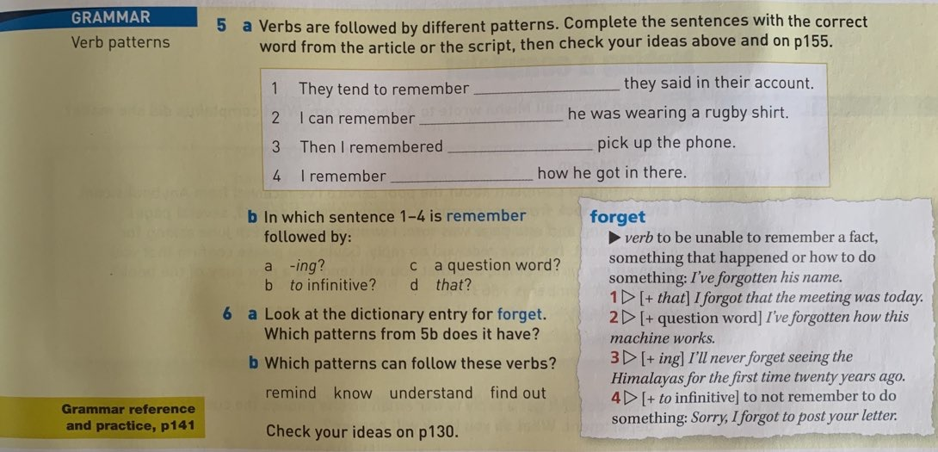
For example, with regards to the four verbs in 6b shown in Figure 38 (remind – know – understand – find out), she explained when the verb is followed by the word that, then this verb is usually related to ideas and thinking: something abstract, such as know / understand. Another example she gave is of the verb remind and how it has to be followed with a pronoun such as him / her or Samar / Sara. After that, she asked her students when they go home to “try and focus on what comes after or does not come after the verbs”. Moreover, she explained at interview that sometimes because of the students’ low English levels they just want to pass without trying to understand the grammar rules, and so she believed it was beneficial to explain grammar as something that they need to think about, to look for hints and to memorize, similar to what they do with mathematical rules.

If you see this, you do that. The key word tells you this tense . . . With the past perfect, they [people who write the questions] will put ‘before or after’. With the present simple they will put ‘everyday’. They will put something that will guide you.

In the previous quote, teacher TA is giving an example of what she would tell her students during the explanation of a grammar rule, and how when the students read the questions in the textbook or even in the exam, they should look for clues that will help them in identifying the correct answer. She admitted during her interview that this may not be the best way to teach grammar; however she maintained that, given the level of her students, it is suitable, and she feels obliged to make this change to the grammar parts in the textbook.

I know this is not the best bet of English and modern views will of course attack me for doing this, but I'm talking for my students. I'm talking about the situation I'm in. And maybe I like it because I feel they understand or try to understand.

Teacher TD is also one of the teachers who reported editing the textbook in order to make it a more suitable level for her students. For instance, in the following Figure 39 is a reading passage on ‘Multiple intelligence’ taken from a unit of the textbook.

Figure 39. Activity from English Unlimited Special Edition (Rea, Clementson, Tilbury & Hendra, 2017, p. 24)
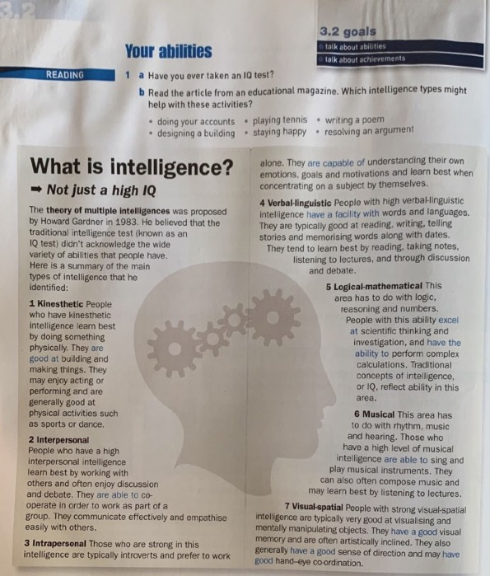

As seen from Figure 39, the passage may be considered somewhat advanced, as it contains some scientific terms, such as theory – multiple intelligence – kinaesthetic – interpersonal – intrapersonal – introverts – verbal linguistic – logical mathematical – spatial – manipulating. In fact, teacher TD considered this passage very advanced for her students to the extent that she described it as “disastrous” and described how the level of her students was far too low for them to comprehend the information in this passage. She explained how during the lesson of this particular unit and in the middle of covering this passage with the students, she decided to stop reading the passage, and finished off the rest of the unit instead, which included a listening track on people’s different achievements and the grammar rule of present perfect and time expressions. Then, during the next lesson, she displayed the reading passage on the projector screen and discussed the topic of multiple intelligences in Arabic, reading each sentence of the passage and explaining it individually, thereby making it simpler for her students to understand the concept of multiple intelligences. She also explained this topic more by giving the students an example of how she does not have kinaesthetic intelligence, however, she does have interpersonal intelligence; and she made this into a group discussion where all the students talked about the different kinds of intelligence they believe they hold. Finally, teacher TD explained that she considers this a successful example of editing because “they [the students] managed to understand the topic and . . . they actually did the comprehension questions”.

Moreover, teacher TF reported in her interview that she sometimes makes changes to the activities in the textbook “so that it can fit them [the students] as low achievers and the outcome will be something good”. As an example, she talked about the change she made to the following activity during one of her lessons.

Figure 40. Activity from English Unlimited Special Edition (Rea, Clementson, Tilbury & Hendra, 2017, p. 58)

The theme of this unit was work and life balance, and in this vocabulary part, the focus was on different jobs. Teacher TF explained how she did number 1 and 2 from the above activity, and how she also changed it into a charades game where she divided the students into groups and asked each group “to think of the job and then act it with gestures”. For example, if they chose the job of a doctor, they would act out the action of checking the chest of a patient, and in that way, they would know that doctors use their hands. According to her, by changing the activity into a game, it motivated the students and it indirectly gave the students a hint that doctors’ jobs involve using hands; therefore, they were be able to complete this activity easily.

Another example of editing that was observed in teacher TF’s lesson was in a writing activity that asked the students to ‘Write three sentences about work and studies. They can be about you or about somebody you know.’ When doing this activity with her students and as a way of editing it to better suit them, she asked the students to write one sentence only, instead of three. She explained to me that, if they are able to present one sentence only, this is good enough for her due to the students’ extremely low level of English.
The final teacher in this section is teacher TK, who stated that editing is one of her most commonly used adaptation techniques during lessons. Furthermore, during her interview, she reported that “students’ proficiency level of course . . . affects [teachers’ use of the textbook]. I mean you . . . edit according to their level”. She then gave an example of this adaptation technique, which is also similar to the example given by teacher TF above. In the textbook, the following question occurred: ‘Think of one of your possessions. Write three or four sentences to describe it. Don’t say what it is.’ (Rea, Clementson, Tilbury & Hendra, 2017, p. 66). Teacher TK described how she asked her students to write two sentences each instead of three or four “because of their level”. She also made this adaptation with the class size and timing constraints in mind: “I wanna be able to listen to all of them, so I just say two [sentences] for each or one each”. Therefore, by making this change to the activity, she is making it more suitable for her students’ level, as well as giving her more time to be able to check the answers of all her students.

4.5.1.2. Editing to generate student interest

A number of teachers claimed to edit in order to generate student interest:

Editing to generate student interest
Teacher TR
Teacher TM
Teacher TJ

One reason for editing that three of the teachers (TR, TM and TJ) in this study reported is editing in order to generate student interest. As mentioned previously in section 1.2, lessons in the ELI are usually three and a half to four hours long, and teachers explained that this is a long time to keep students engaged with the lesson. Therefore, they resort to making changes to the textbook in order to maintain students’ interest. For example, during teacher TR’s interview, she explained that she constantly changes the order of the textbook because this creates a more interesting atmosphere for the students:

I don’t go through a very specific order [of the parts of the textbook] in every class because some teachers have a specific order in each lesson, and they try to stick to that. For me, no I try to change the order of the sections. I don’t strictly follow everything in the book. Because I believe it is boring when the students anticipate what the teacher will do in class. So, this will become very boring. So, it is more interesting when you try to change the order of things.

She further explained that although she focuses on changing the order of the textbook, she makes sure to try and cover the grammar part or the vocabulary part of the unit first, before going on with the other parts of the textbook, such as reading, listening, speaking and writing. She justified this behaviour, saying: “I believe the students, you can have their attention and they are more focused at the beginning of the lesson . . . So, you can give them the most important points at the beginning of the lesson”. She further elaborated:

the most important thing for me is to have like the basic structures, to have a warm-up activity and then the grammar section and the vocab but the other parts of the lesson I just play with them and change them, and I don’t follow like a specific structure or order with them.

As an example, in the following are figures containing the pages of a unit of one of teacher TR’s observed lessons.

Figure 41. Page taken from English Unlimited Special Edition (Rea, Clementson, Tilbury & Hendra, 2017, p. 58)
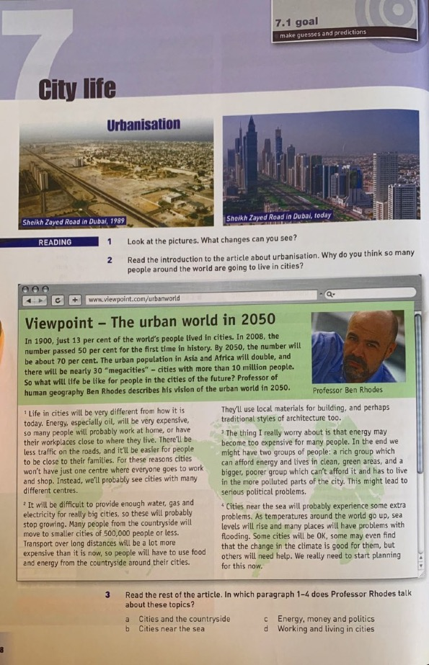
Figure 42. Page taken from English Unlimited Special Edition (Rea, Clementson, Tilbury & Hendra, 2017, p.59)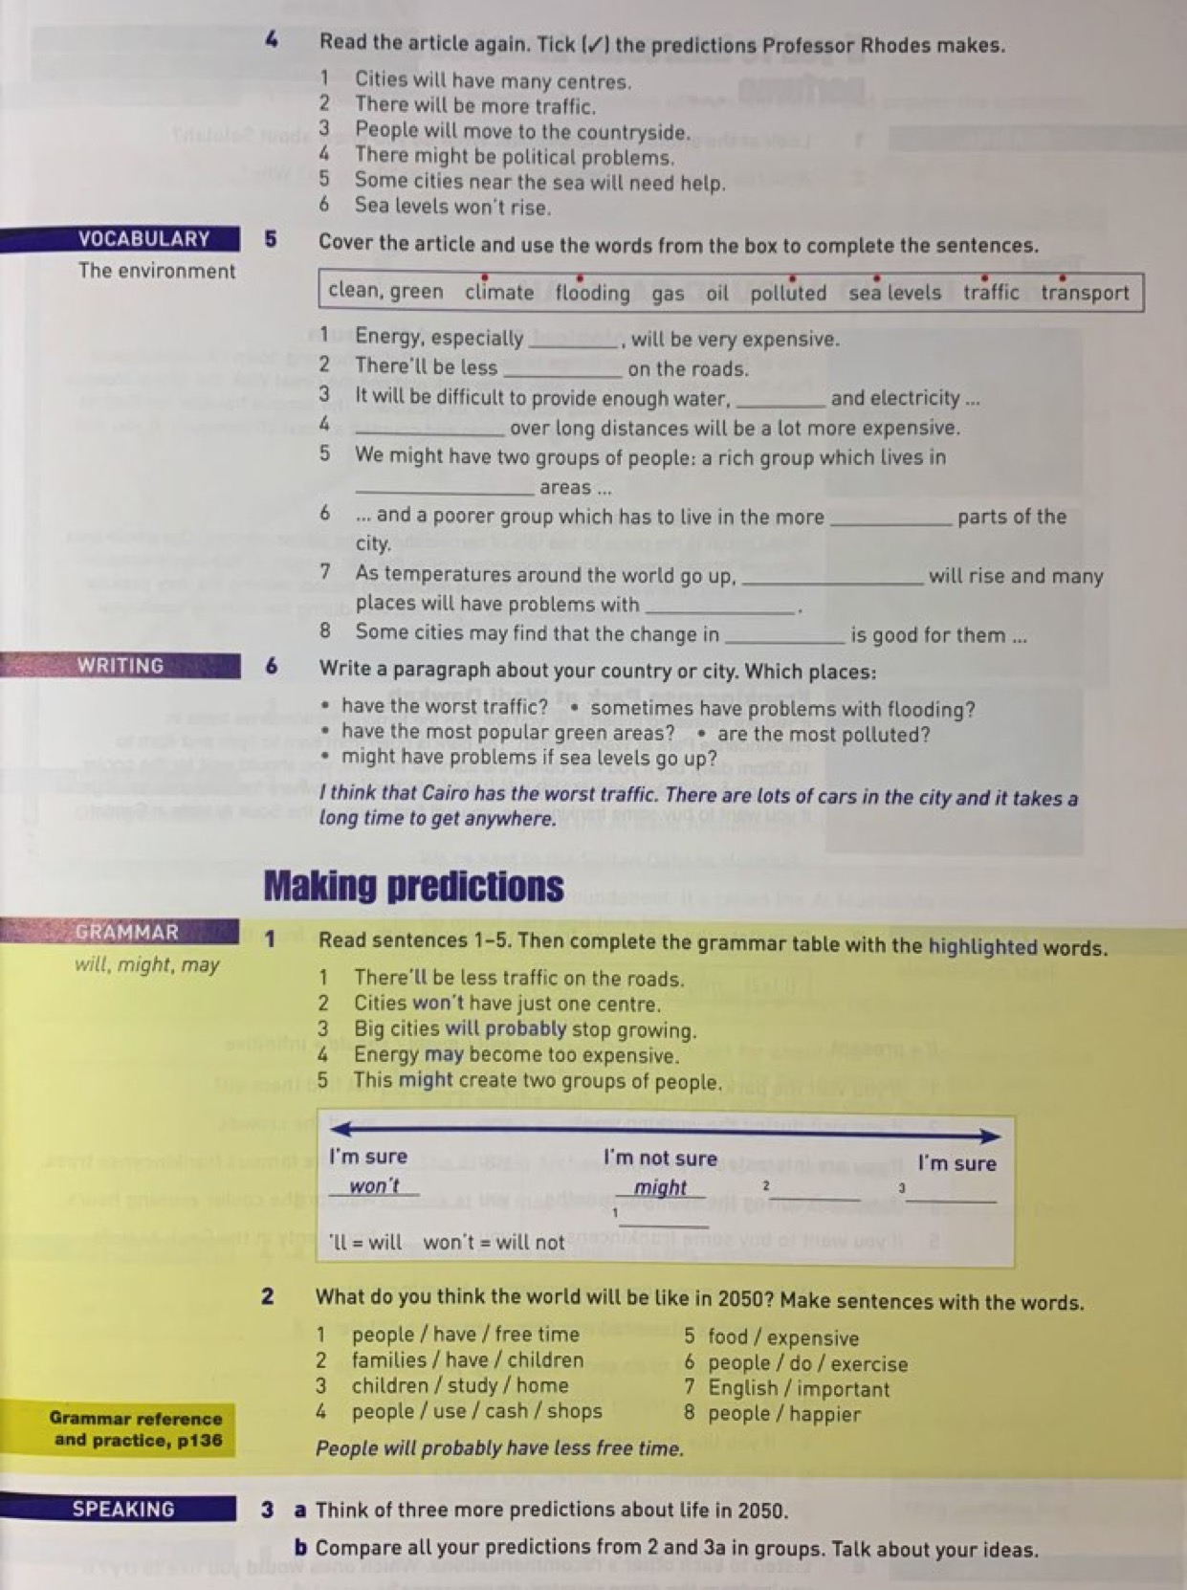

As seen from Figures 41 and 42, the unit starts with a reading activity followed by vocabulary, writing, grammar and speaking. However, during the actual lesson, teacher TR changed this order as follows. She firstly began her lesson by asking the students to work in groups and write two to three sentences to answer the question “What do you think life will be like in the future?”. After discussing their answers, she read the following sentences from the screen of the projector, which she had prepared beforehand.
“Some people might live on the moon. / People will probably be happier. / Robots might replace people at work. / Cars may fly. / Life will be better.”

She then started talking about the words written in red and explained to the students that these words are used when making predictions about the future. From this example, we see that teacher TR started her lesson with a warm-up discussion in accordance with the theme of the unit, which is urbanization and how the world will look in the future. In addition, in these sentence examples, she focused on the target grammar of the unit, which was using will, might, may to talk about the future. Hence, the grammar she is highlighting in the warm-up activity is in fact the same target grammar which features in the textbook. Therefore, teacher TR reorganized the unit and instead of starting with the reading passage as in the textbook, she started with the grammar part first.

Teacher TR gave another example in her interview of an exercise she edited in order to initiate student interest. She stated how in one of her previous lessons during a previous semester, there was a writing activity that asked the students to write about happiness; specifically, to write about the things that make them happy. She explained, “it was a writing lesson, but I didn’t start with writing, I didn’t enter the class and say today we are going to write about happiness”. Instead of simply asking the students to start writing their paragraphs, teacher TR described how she used “a specific procedure” called “process writing” in covering this writing activity. She went on to describe this process, saying:

there was a process, at the beginning we started with introducing the topic and warm up activity and then I gave them [the students] some ideas about the topic. I asked them to practise the words they are going to use in their writing and then they ended with writing about happiness. So, it was interesting.

Teacher TR described in more detail how as a warm-up activity, she put pictures of different things that might bring happiness to people on the board. After that, she introduced the students to “specific phrases that they have to use in their writing”. Then, she played a video which contained people talking about what makes them happy “even the video itself was funny. It had the element of humour”. In the final step of this process, she asked the students to start with their writing. Therefore, “there was a specific procedure, it was gradual”. Teacher TR explained that she was very pleased with this editing, “so, I enjoy teaching any lesson especially the ones in which my students are communicating and participating and engaged . . . with the lesson”. In fact, these adaptations that she makes help her feel a sense of satisfaction; she explained how “I am satisfied with my lesson when I see the students communicate well with me and with each other, when I see them enjoying the lesson, when they participate, when I see them really learning and enjoying what I am teaching in class”.

Teacher TM also reported editing the textbook in order to create a more interesting environment in the classroom. She explained “I try to use authentic materials as much as I can if it’s possible, because it’s interesting for the girls. So, if sometimes I can find a documentary or a video that was made [I will use it]”. For instance, in Figure 43 below
is a reading passage that talks about supermarkets and markets and the differences in the experiences of shopping in them.

Figure 43. Activity from English Unlimited Special Edition (Rea, Clementson, Tilbury & Hendra, 2017, p. 27)


During her interview, teacher TM reported that she had reservations regarding this reading passage. She explained how the pictures are “so small” and that the reading itself “is kind of boring”. She then explained how for this reading passage she found an online YouTube video that actually compared between shopping in a market and a supermarket. She described this video saying:

they were . . . talking about the supermarket and the market . . . They did this test that one of them went to the supermarket and one of them went to the market, and they looked at the different experiences, the different prices, the different products and they compared. So, it was really interesting for the girls.

She concluded this example saying, “wherever [anywhere outside the textbook] I can find something that they [the students] can . . . enjoy and think about, and then have a discussion about it, really apply what we’re taking [covering in class], I do that”.

Another example, which was also noted in teacher TM’s lesson observation, was editing of the exercise in the following figure.

Figure 44. Activity from . English Unlimited Special Edition (Rea, Clementson, Tilbury & Hendra, 2017, p. 31)
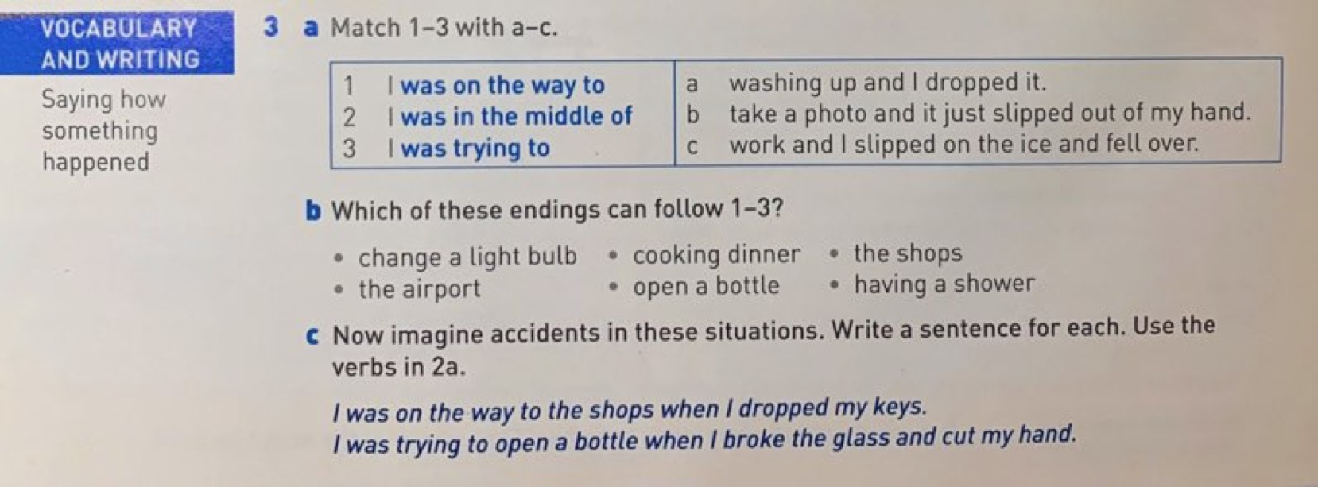

In this matching activity, she assigned pair-work, where she asked the students to work in pairs and match the sentences. After that, she asked each pair to write a sentence as in activity 3C. Following this, she asked the pairs to write their sentences on the board. This point was discussed during the interview, because it was interesting that although there were many time constraints on the teachers, she still dedicated time for the different pairs to come up to the board and each write their sentence. When asked about this scenario, teacher TM explained that she took this decision:

because they [the students] like to do that and just to get them moving in the classroom, because they will just go to sleep if they’re just sitting and getting information. So, I just get them moving and to see their own production, and you know engage them and at the same time they benefit from what we’ve been discussing and teaching.

Therefore, by taking the time to let students write their answers on the board and discuss them, teacher TM is allowing her students to see their development in the language. In addition, this will help in creating a fun learning environment for the students. She concluded that, “I’m just trying my best to not bore them to death. So, this group work that I do, this is in my effort not to bore them to death and just let the hours pass. When we don’t do group work, I’m like what is this? It’s killing me!”.
Furthermore, teacher TJ talked about an editing she did to the following reading passage of one of her units.

Figure 45. Activity from English Unlimited Special Edition (Rea, Clementson, Tilbury & Hendra, 2017, p. 68)
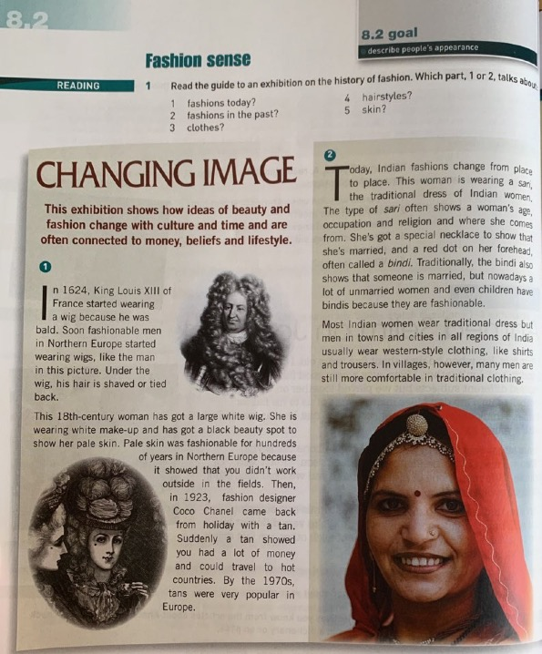

She explained how in one of the previous modules, she actually brought in a real Sari (traditional Indian women’s clothing) to class and demonstrated to the students how it is worn. She called one of her students up in front of the class and draped the Sari around her and explained how it is worn and talked about its history to the students. She concluded talking about this example by saying: “they were very fascinated to find so many yards of a cloth could actually be draped around someone and yet be so elegant. And they found it, because it was really a hands-on thing . . ., they really enjoyed it”. Therefore, rather than reading about Saris and simply seeing a picture of a woman wearing one, teacher TJ changed this part of the reading passage into something practical in a way that evoked students’ curiosity and generated their interest, and the result was fascination from her students.

Therefore, all three teachers in the previous examples edited their textbooks to make an activity more interesting for their students. In sum, it is clear from these scenarios described that teachers sometimes tend to edit their textbooks in order to create some sort of variety in the lesson.

4.5.1.3. Editing to generate a helpful / safe learning environment

Four of the teachers claimed to edit in order to generate a more relaxing environment for the students:

Editing to generate a helpful / safe learning environment
Teacher TM
Teacher TA
Teacher TR
Teacher TN

In addition to the reasons explained above, teachers reported other motives why they tend to edit their textbook. For example, teacher TM and TA explained that they resort to editing the textbook in order to give their students a chance to help each other. For instance, teacher TM changes individual writing activities into group work activities, which she names “collaborative writing”, explaining this technique as follows:

I found that collaborative writing was really . . . good for them [the students], because . . . they discuss it [the topic] and they talk to each other, they are kind of tutoring each other . . . So, I really capitalize on collaborative writing and group writing.

In teacher TM’s first lesson observation, there was a writing task that asked the students to write about an experience that they have been through, reproduced in Figure 46.
Figure 46. Activity from English Unlimited Special Edition (Rea, Clementson, Tilbury & Hendra, 2017, p. 34)
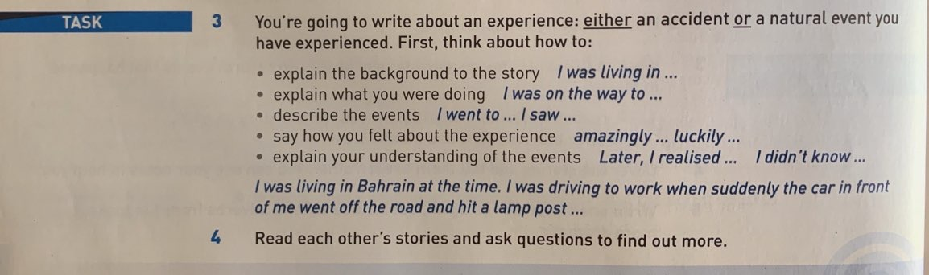

Here, teacher TM divided the students into five groups and asked them to arrange their seats according to their group. She then asked each group to write about an experience that they had been through. In addition, she had the transcript of the listening track of that particular unit on the projector and told the students to focus on the order of the events in the speaker’s story. Hence, she used this listening track transcript, found in Figure 47 below, as a model paragraph for them to follow.

Figure 47. Listening transcript taken from English Unlimited Special Edition (Rea, Clementson, Tilbury & Hendra, 2017, p. 150)
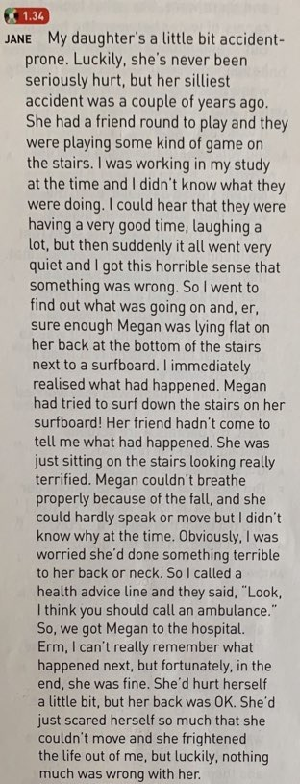

Teacher TM also asked the students to send in their paragraph to the class WhatsApp group, so that she could put the paragraphs on the projector and correct them together as a whole class discussion. In her interview, she talked about her belief that when students are grouped together during activities, this creates a beneficial atmosphere where they help each other, school-work wise.

This belief was echoed by teacher TA, who also stated that she changes some individual activities in the textbook into groupwork activities, in order for students to assist their classmates and to “give each other ideas how do they do it [do the exercise]”. Similarly, in her lesson observation, it was noted that she assigned pairs to answer the reading comprehension questions found in the following figure.

Figure 48. Activity from English Unlimited Special Edition (Rea, Clementson, Tilbury & Hendra, 2017, p. 40)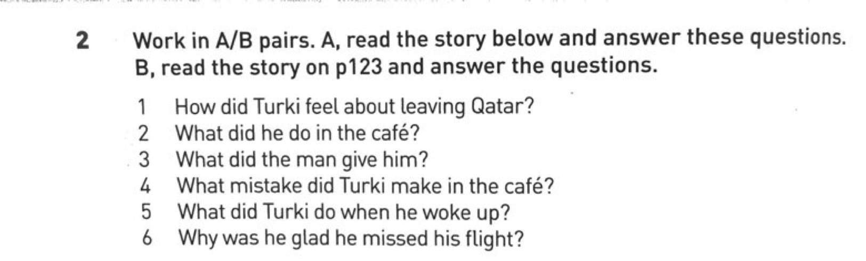

After giving her students some time to discuss the answers of these questions together, she adapted the activity slightly by posing an additional question which didn’t feature in the textbook, asking them “How many questions were you able to answer?” and explained to them that the number of questions they have answered will give them a picture of how well they will do in the upcoming exam. This additional question that teacher TA asked her students gives a hint of how the exam-driven context seems to be at least one reason for teachers’ adaptations.

Another related reason for editing is to make the learning atmosphere more relaxed and to not have the students worry about making mistakes in front of their peers. As an example on this, in her first lesson observation, it was noticed that teacher TM changed a fill in the blank grammar activity into a pair-work activity. This grammar activity is reproduced in Figure 49 below.

Figure 49. Activity from English Unlimited Special Edition (Rea, Clementson, Tilbury & Hendra, 2017, p. 137)
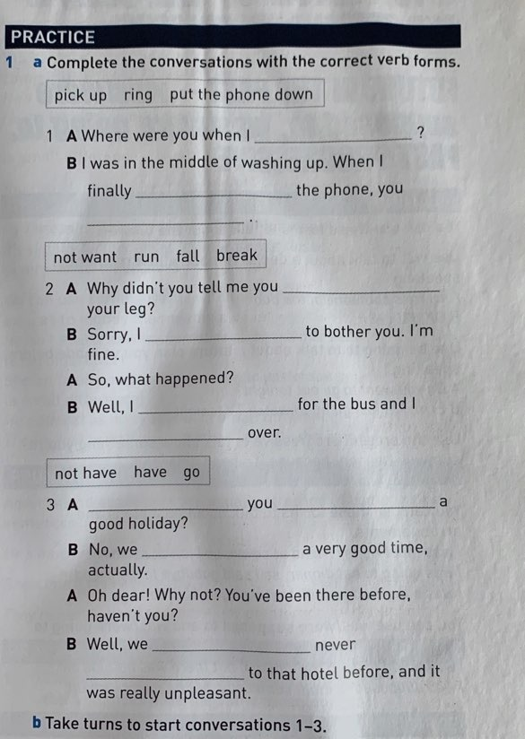

Here, teacher TM chose pairs of students in advance and asked them to fill in the blanks and then read their answers aloud as a conversation between them. During her interview, she stated that by changing some of the activities into group or pair-work activities like the one she edited here, she minimizes her students’ insecurities about making mistakes. She described the atmosphere she hopes to create as “low stakes”, in which “. . . not one of them was the one who got something wrong, we’re all in this together and there is nothing to worry about”.

Similarly, teacher TR echoed teacher TM and TA’s view regarding the benefit of using pair-work during some of the activities. It was noticed during her lesson observations that she was one of the teachers who assigns many group activities. In fact, in one of her lessons, she assigned either group or pair-work for all the activities in that lesson. Another point that was noted through her observations was that she likes for her students to write their answers on the board after they had done the group/pair-work. As an example, in Figure 50 is a fill in the blank grammar activity, which she assigned as pair-work.

Figure 50. Activity from English Unlimited Special Edition (Rea, Clementson, Tilbury & Hendra, 2017, p. 136)
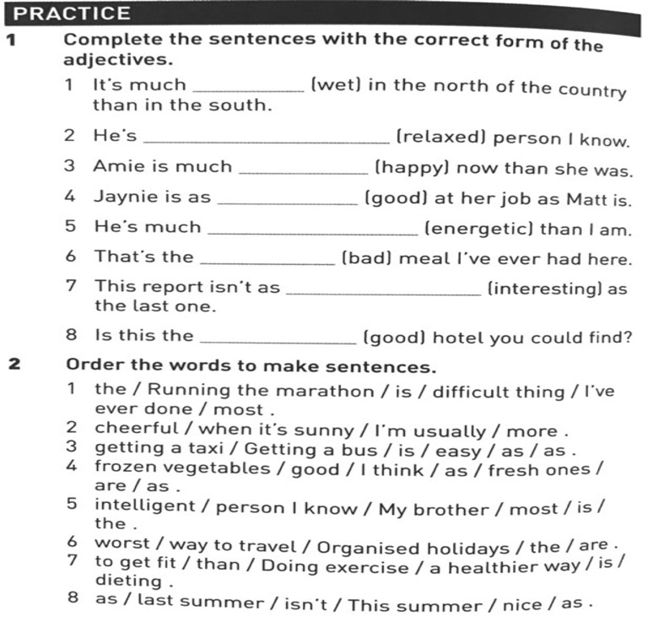

After the students had finished this exercise, she asked them to write their answers on the board. This type of scenario was observed very much in teacher TR’s classroom, where she focuses on group/pair-work, and also on getting the students moving out of their chairs. She justified this by saying:

I think it is highly effective [doing group/pair-work] . . . It’s also good to include more communicative activities. . . So, I think this is a good way, especially with the shy students, some of the students are too shy to speak but when you put them in groups, they get encouragement and help from their group members and their friends and they start to speak. So, I think it is more threatening for them when you put them on the spot and you tell them, ‘Ok speak or talk or do this activity by yourself’, they don’t work so well like when you put them in groups.

Another example taken from one of teacher TR’s lesson observations was the following grammar activity:

Figure 51. Activity from English Unlimited Special Edition (Rea, Clementson, Tilbury & Hendra, 2017, p. 59)
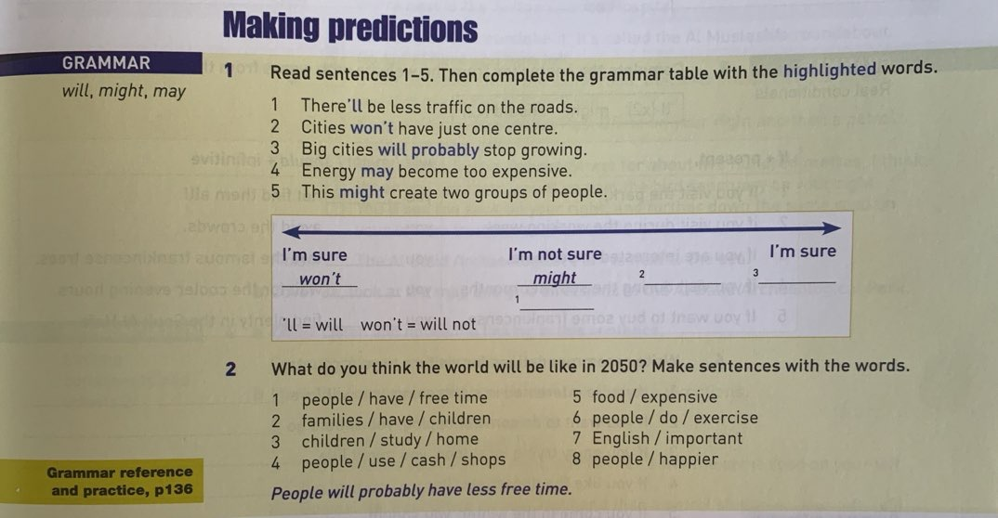

For this activity, she gave the students sticky notes and asked them to each write a sentence explaining what they believe the world will be like in 2050. After they had finished, she asked them to exchange sticky notes with their friends and each of the students read the note they received. According to teacher TR, with this editing of the activity, she is minimizing “putting them on the spot”, and students will not be self-conscious of reading the note in their hand or making mistakes.
Furthermore, teacher TR also assigned the following grammar activity as pair-work, and she stressed the fact that they should work in pairs.

Figure 52. Activity from English Unlimited Special Edition (Rea, Clementson, Tilbury & Hendra, 2017, p. 60)
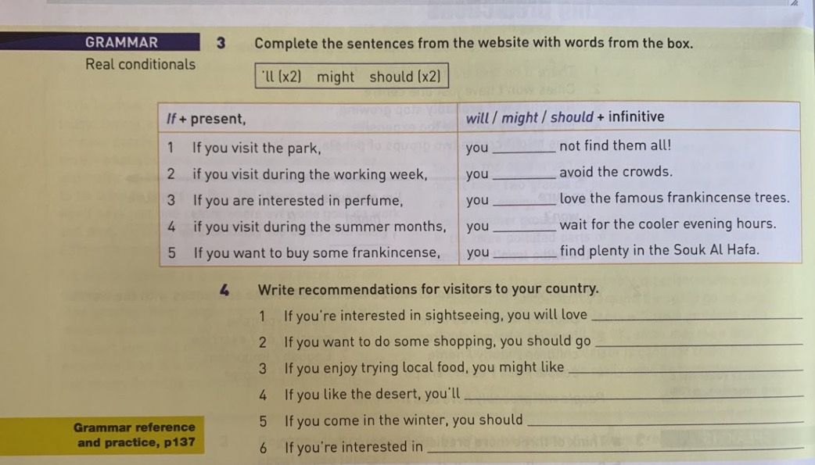
During the interview, teacher TR was asked about her determination to change most, if not all of the activities into group/pair-work activities, explaining this behaviour by saying:

Because I think it is like more effective when students work in groups. When they negotiate the correct answers with their group members, they become more active and more focused than when they work individually. I noticed that when I asked them to work just individually, I noticed they don’t pay attention, they don’t work effectively as when they work in groups, that is why . . . I try . . . to do lots of group work activities in my lessons.

Teacher TN also reported a similar point of view to those discussed above; she also edited an activity during her lesson observation for the same reason. The original activity read: ‘Do you take a lot of risks? Do the quiz and find out. Then, check your score on page 118’. (Rea, Clementson, Tilbury & Hendra, 2017, p. 30). Here, teacher TN changed the activity by asking the students to discuss their answers in pairs instead of doing it individually, justifying this by saying:

because this is the only chance to practise English in class. They will never never ever ever think of speaking English outside the class. If they talk to me, it's . . . student to teacher, but student to student they are not intimidated . . . So, it's better to use language with one another.

4.5.1.4. Editing to relate content to students’ culture

Five of the teachers claimed to edit due to cultural reasons:

Editing to relate content to students’ culture
Teacher TZ
Teacher TA
Teacher TJ
Teacher TS
Teacher TN

Half of the teacher participants in this study TZ – TA – TJ -TS – TN reported that they edit some parts of their textbook in order to make the content more related to their students’ culture. For instance, teachers TZ and TA both referred to a specific example in the textbook which they felt was not relevant at all for their students’ culture. They referred to a reading passage about saving money, which was basically about a woman who lived on one pound a day. In the following figure is a part of the reading passage which includes tips on how to survive on one pound a day.

Figure 53. Activity from English Unlimited Special Edition (Rea, Clementson, Tilbury & Hendra, 2017, p. 46)
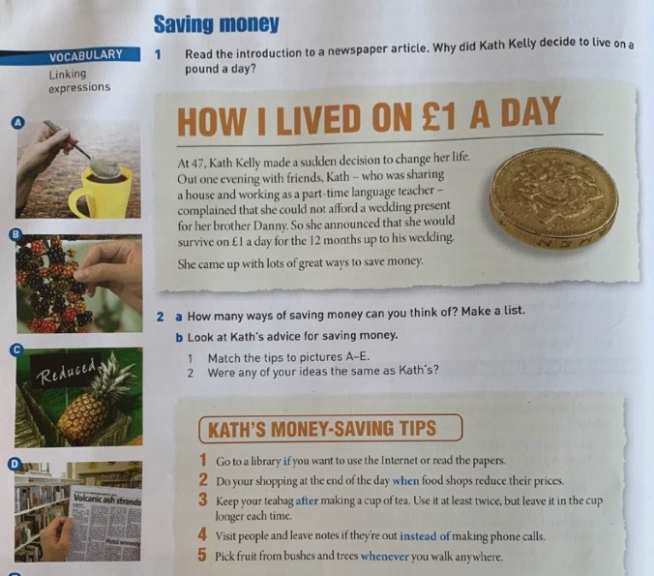

Figure 54. Activity from English Unlimited Special Edition (Rea, Clementson, Tilbury & Hendra, 2017, p. 47)
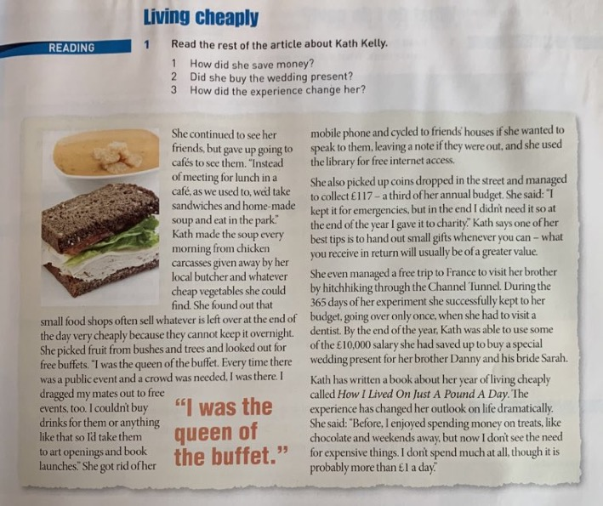

As seen from Figure 54, the passage includes tips on how to save money. However, according to teacher TZ, regardless of the fact that being frugal is something that people are ashamed of in Saudi Arabia, the tips on saving money that were given in the passage were strange and cannot be applied in this specific context. For example, one of the tips in the textbook is “pick fruit from bushes and trees”, but teacher TZ commented “if we see a flower, it is a blessing!”, hence she questioned how Saudis were expected to pick fruit when even flowers are rarely grown in the country, because of its very hot weather. She also commented on other tips included in the passage, such as “she got rid of her mobile phone and cycled to friends’ houses if she wanted to speak to them, leaving a note if they were out”. She stated, “Jeddah is a huge city, you cannot go and visit people with your bike! It is ridiculous!”. “Or at the end of the day when the fruit shop reduces the prices, it is not even in their [the students’] culture!”. What teacher TZ means here is that in Saudi Arabia, it is not customary that the prices of goods are lowered at the end of the day, and according to her, the students will not be able to connect with these tips or see how beneficial they actually are in another culture. It is worth noting that teacher TZ was quite agitated when discussing these examples. She claimed this topic was not successful because none of the tips discussed were applicable in the students’ culture. She elaborated, stating:

each country has its own way of saving money, this is ridiculous [the tips presented in the passage], and living on one pound a day, she is bragging about saving money. In our culture it is regarded shameful to save money or seem that you are stingy. It is a culture thing, so they are talking about stuff that doesn’t even relate to them [the students].

She then explained how she edited this reading passage, stating “I ended up telling them [the students] a story in my life when I was living in a place where I could use their [the textbook] tips”. Teacher TZ explained to the students how in some countries you may be able to actually apply these tips. She described to them how when she lived abroad to complete her PhD studies, she had a chance to apply these tips because she lived in a culture where they can ride bikes and where there are flowers and fruits which can be picked. Another step she took in editing the topic to make it more relatable to the students’ culture was by asking them “In Saudi Arabia, how can we save money?”.

Interestingly, teacher TA also gave the same example of this reading passage in her interview when referring to culturally inappropriate material. As a reminder, we discussed teacher TA’s view towards the textbook and how she holds a nuanced perspective towards it. However, she mentioned that she finds some textbook topics unsuitable to teach:

There are many good things about this textbook . . . But sometimes . . . why are you teaching the students this thing? Why this topic? . . . So sometimes I don't understand the logic behind it for our students.

What teacher TA means by logic behind the textbook is that she sees no benefit of some of the topics used in the textbook for her students, specifically. She then gave an example of a topic she does not find logical, and she referred to the same topic, ‘saving money’ which teacher TZ referred to above. As can be seen from the passage and what was stated by teacher TZ, the ways in which the textbook character Kath Kelly managed to save money are somewhat quirky and may not be applied in other cultures. For her part, teacher TA acknowledges the fact that saving money is an important topic and that this passage is seen as a way to encourage students to save money; however, she believes what is presented is unrealistic:

. . . the way they are presenting in the book is a very exaggerated form of saving money. You come to a society where, I asked two classes of my students do you save up money and they don't save up money and you come and present this to them. A lady who lived on one pound for a year. Get serious. Get real. Who can do this?

She further commented that the topic itself is good; nevertheless, it could have been presented in a different way.

. . . The material itself could be presented in a different way. Talk about more realistic things . . . that encourage them [the students] to save up money. When we were talking do you think about saving up money, none of them were even encouraged to save money . . . the story it's like I think putting them off.

Another point which demonstrates the importance of the relatability and the suitability of topics to teacher TA is a comparison she made between the current textbook she is using and a previous one called National Geographic. She stated that she prefers the previous textbook to the current one because “they talk about different things, nature, space and other things”.
In fact, this point is very important to teacher TA to the extent that she chose “topics and themes” as one of the most constraining factors she faces when teaching because of its relation to cultures and learning about other cultures. During her interview, she stated that “it is nice to know about other cultures”; however, she believes that there are times when there is “too much of other cultures”. She talked about two reasons why she feels that sometimes studying about other cultures is problematic for the students in the ELI. Firstly, in explaining what she believed to be the design process behind the localized textbook in use at the ELI, she explained how the textbook writers are not actually from the ELI or know our culture very well:

all they [the writers] did was cover up ladies and move alcoholic words [when adapting the global textbook to a localized version]. I even talked to one person from Cambridge Press, she said: ‘don’t worry the book doesn’t have any bikinis so ladies are covered and no alcoholic drinks’, but this is not the thing we are talking about. Some students enjoy knowing about other cultures and I know this and it is good, but sometimes you want to talk about yourself and you want to talk about your culture.

This brings us to the second reason why teacher TA believes studying about other cultures may be problematic. She explained how during exams, students are asked to talk about themselves or about topics that are more related to the Saudi culture. The problem is, the students are not used to doing this in class, where they only talk about other cultures. This poses some complications for the students because they view exams as different and difficult, “so sometimes I think it is good to personalize things”.

Furthermore, teacher TJ also reported that she tends to edit the textbook “depending on the culture of the students to make it more hands on and more personal for them”. Although, as previously mentioned, the textbook English Unlimited Special Edition is specifically designed for the Middle East, teacher TJ reported that she still sometimes feels that some topics are not suitable. “These books have been adapted to our culture, but I still try to bring it down to their [the students’] level, to their home and to their society and to the culture so they can really identify and understand it”. According to her, the topics of the textbook are mostly fine. However, there are times where the students cannot relate to these topics, giving an example of a unit about ‘moving to a new house’, which she had taught in a previous module. She explained that her students could not connect with this topic because in similar situations usually the head of the family is responsible for moving, the students have never had the experience of such a situation. In addition, she talked about how travelling is limited for her students, and how hardly any of them have ever travelled; therefore, she sees that talking about “Western countries” is problematic for them. She specifically said:

If the book is talking about . . . other countries, Western countries, then I feel completely at a loss because I can’t make them [the students] envision something they’ve never seen or have never been to, and they can’t understand the countries. But I know it is not a reason for the book to limit itself to the Arab world. It shouldn’t because eventually they [the students] may go out, some of them may go out into the world outside so they do need that [information about other cultures].

Moreover, teacher TJ gave another example of an editing she did to an exercise in the textbook, and this example was also echoed by teacher TS and teacher TN. All three teachers reported changing an activity in the textbook that asked the students to describe the famous Italian dish ‘pasta/pizza’ to describe the famous Saudi dish ‘kabsa’ instead. Teacher TS justified this example, saying that editing is an important adaptation technique that teachers should apply to their textbooks, especially with scenarios in which culture is involved, because students somehow feel good when they know that their teacher acknowledges their culture. She stated: “sometimes when I say kabsa, I see the lights get lit. You see the spark in their [the students’] eyes so sometimes you relate to . . . things like that”. Teacher TN similarly stated that she edited this activity because “I just wanted my students to be involved. They talk about something related to their culture”.

Regardless of the fact that there are teachers who prefer to edit or even delete culturally sensitive topics, there are also teachers who prefer to engage with these topics and believe them to be beneficial. As mentioned, teacher TJ argued that just because students may not be familiar with certain topics, does not mean teachers should delete them, because it is good for the students to learn about other cultures. More on cultures and textbook use will be discussed in section 4.11.

4.5.1.5. Editing due to time constraints
A number of teachers claimed to edit due to time constraints:

Editing due to time constraints
Teacher TA
Teacher TD
Teacher TM

Another important reason teachers in this study reported for editing their textbook is because of time constraints. The issue of timing and how it has a major effect on teaching in the ELI will be thoroughly discussed in section 4.7.1. For the time being, however, it is important to remind readers that there are certain time constraints in the ELI due to there being a pacing guide that all teachers must adhere to. Figure 55 below reproduces a page of the pacing guide, which will hopefully give a picture of what teachers should adhere to regardless of any situation that may come up in the lesson.

Figure 55. Page one of the pacing guide

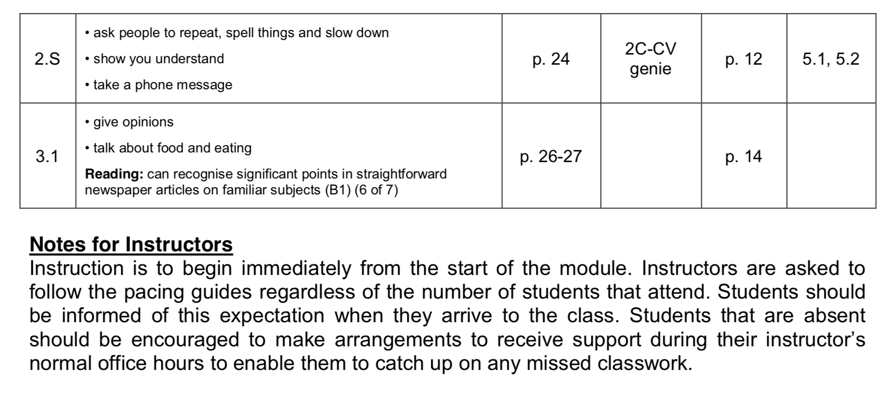

As seen from Figure 55, the pacing guide contains the topics and the learning outcomes of each part of the unit. Additionally, it contains the page numbers of the textbook that should be covered by the teachers during each specific week.

Another important point to explain in relation to the issue of time limitations is the unified exam. As mentioned previously in section 1.2, all exams in the ELI are unified and given on set dates for all class sections; hence, this also pressures the teachers into finishing the parts of the textbook by a certain time. All this leads to teachers editing their textbook in order to conform to the time restrictions that they are under. For example, in one of teacher TA’s lesson observations, she edited a reading exercise in the textbook and justified this adaptation as being due to time pressure. In this reading exercise, the question asks the students to ‘work in A/B pairs. Student A: read the story below and answer these questions. Student B: read the story on page 123 and answer the questions.’ (Rea, Clementson, Tilbury & Hendra, 2017, p. 40). However, teacher TA changed this question and asked her students to work in pairs and answer the questions related to one passage only, instead of assigning each one with a passage. When asked about this change of exercise during her interview, she explained “I just assigned pair-work because there were too many questions”.

Interestingly, and in quite the opposite manner, teacher TD edited a pair-work activity, which is shown in the figure below, during her lesson observation and asked her students to do it as a whole class group.

Figure 56. Activity from English Unlimited Special Edition (Rea, Clementson, Tilbury & Hendra, 2017, p. 82)
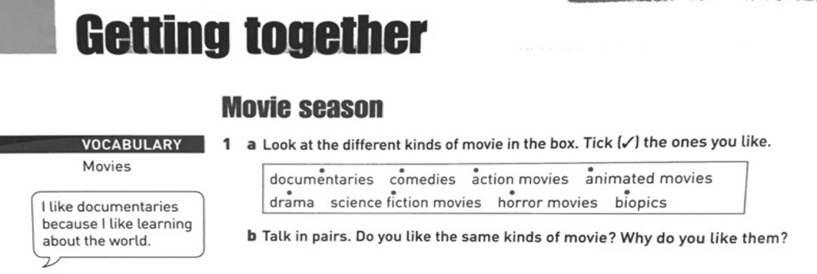
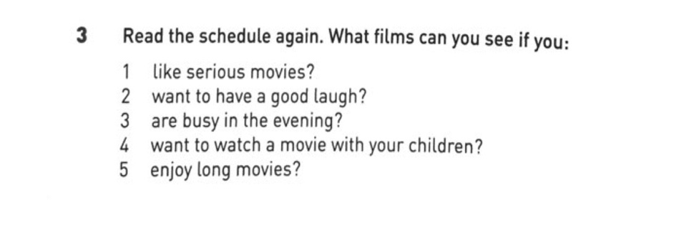
Exercise 1b asks the students to work in pairs, but teacher TD did this question as a whole class group activity instead of working in pairs. In addition, activity number three at the bottom of the page was also done as a whole class group. Teacher TD justified this by explaining, “because mostly it's time. Mostly, group activities I do them as a class, all of us together because it's time consuming”. Hence, by changing some activities into group work activities, she believes that she is saving time. For instance, instead of dividing the students into different groups and allocating time for them to answer the activities, then spending more time to go over their answers, teacher TD assigns these activities as a whole class activity to save more time.

Furthermore, it was also noticed that teacher TM edits some activities in the textbook in order to save time. As described in the example given in section 4.5.1.3, teacher TM constantly changes the writing exercises into what she calls “collaborative writing”, and one of the reasons she does so is due to time restrictions. For example, when coming to a writing part in the textbook, she would either divide the students into pairs or into groups and ask them to perform the writing task together. According to her, this saves them time, where they cover the writing and are still able to cover the rest of the unit. She described this situation thus:

we have too many students in the class . . . I did an activity [writing activity] as individuals, it took all of the class [time] and I wasn’t able to cover the unit. But I didn’t know how to manage the time, because I chose to do them [the writing activities] individually. I had each girl come to me and write and I was checking, and we lost the class.

Therefore, after this problematic encounter that teacher TM had with the writing, she decided to employ “collaborative writing” in order to save time.

From the examples given above, we see that teachers TA, TD and TM edit their textbooks in order to finish quickly, due to the time restrictions that they are under. Hence, to conclude this part, it may be said that the main reasons the teachers in this study reported for editing their textbooks are due to students’ proficiency level, to generate student interest, to create a helpful learning environment, to relate textbook content to students’ lives, and to save time.

4.5.2. Adding

Given that time constraints is a major issue in this context, and all ten teachers had complained of this during their interviews, it might be assumed that adding is rarely used as an adaptation technique. Surprisingly though, teachers applied this technique in their lessons, and in this part of the discussion the different reasons for adding that were observed and that the teachers reported during their interviews will be tackled.

4.5.2.1. Adding for further practise

Four of the teachers in this study claimed they add to the textbook to create more practise opportunities for their students:

Adding for further practise
Teacher TR
Teacher TM
Teacher TF
Teacher TA

From the data collected through the interviews, teachers reported many reasons as to why they add to the textbook. The most obvious and logical reason that was mentioned is adding for further practise; teachers TR, TM, TF and TA stated that they add to their textbook in order to create more practise opportunities for their students. For example, teacher TR stated during her interview that she tends to use adding the most out of the four adaptation techniques. She specifically associated adding with the textbook’s grammar component, saying:

grammar here [in the textbook] is not enough, you have to use extra activities from the internet . . . but the coursebook by itself, no. I feel like the students need more practise regarding the grammar because the one we have in the book is not enough.

It was also apparent during her lesson observations that she was more likely to add grammar and vocabulary practise to the exercises in the textbook, with a more specific focus on the grammar part. In her interview, she talked more about this, explaining:

I like my class to be more communicative but because of our exams . . . We are pushed to focus more on the grammar sections of the book, to focus more on the vocab, so communicative activities and speaking activities doesn’t take much of our class time and that is because of the exams. That’s why sometimes . . . we have to focus on what is important, which is vocab and grammar. The other activities we do it, but it doesn’t take much time in the class.

Indeed, teacher TR was one of the teachers observed to add the most to her lessons, especially to the vocabulary and grammar parts of the textbook. Four of her lessons were observed and the main characteristic that was apparent in them was that she consistently started her lesson with a non-textbook activity. In all four of these lessons, she had a PowerPoint presentation ready with different types of grammar activities. For example, she would start each lesson with a number of pictures or sentences of her own design that give hints of what the grammar rule in focus for that lesson would be. After doing these grammar introductory activities with the students, she usually had ready-made activities on the PowerPoint slides, or activities printed on handouts, which she distributed to her students. These were different kinds of activities, for example, match, fill in the blank, or write your own sentences. After doing these different activities with the students, teacher TR explained the grammar rule explicitly through a neat table, which she displayed on her PowerPoint slides. Only then would she refer back to the textbook in order to do the grammar exercises. Additionally, she did each and every grammar exercise in the unit, as well as the grammar reference at the end of the textbook.

In order to better understand this routine that was observed in teacher TR’s lessons, in the following we will go through an outline of one of her lessons. For instance, in her first lesson observation, the grammar rule of the unit to be covered was the comparative and superlative forms. In Figure 57 below, we will see the grammar part taken from the actual unit, and then we will describe how teacher TR went about this lesson.

Figure 57. Activity from English Unlimited Special Edition (Rea, Clementson, Tilbury & Hendra, 2017, p. 53)
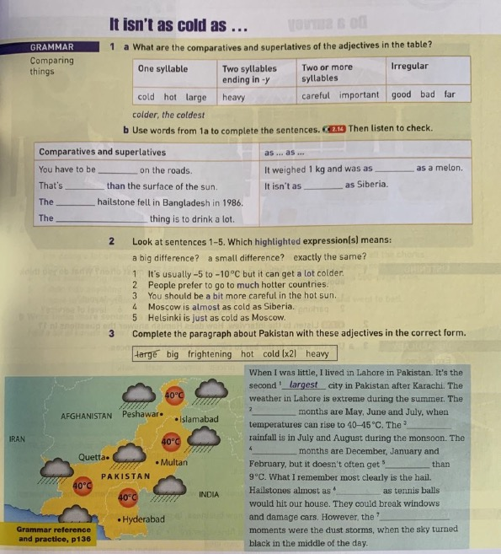

As mentioned, teacher TR always starts her lessons with a warm-up activity related to the grammar rule. For this lesson, she started the class by hanging four pictures on the board. Two were face side up and two were backside up, and she also had two sentences written on the board:

Sara is beautiful.
The red bag is very expensive.

After reading the two sentences, she asked her students “What type of word is beautiful?” Students replied “adjective”, and she then asked them to read the second sentence and to find out where the adjective is. After that, she flipped the other two back-sided pictures, which revealed a picture of a scary woman and a picture of a cheap bag. She then asked the students to compare between the two women using the adjective “beautiful”. She gave them an example saying: “Sara is more beautiful than Maha.” At this point, teacher TR explained that this is called a “comparative adjective”, which means comparing between two objects or two people. She then asked her students to create a sentence comparing between the two bags in the two pictures. Hence, she considered this as a warm-up activity that introduces them to the grammar rule of that lesson.

After this warm-up activity, teacher TR had another grammar exercise prepared and assigned it as group work. She divided her students into groups and gave each group a sheet of paper which contained a list of adjectives and the opposites of these adjectives and asked them to match the adjective with its suitable opposite. After they matched these up, she asked the students to write the comparative form of the adjectives and put them in sentences, and upon finishing, they discussed their answers together as a whole class. After doing these two grammar related activities as an introductory to the grammar rule, teacher TR read and explained to her students the rule of the unit, which is the comparative form, using a neat table she created, shown on the projector screen. Figure 58 reproduces this table that she created.

Figure 58. Teacher TR's self-created grammar table (a)
How do we build a comparative form?
Short adjective + ER  Old older  Young younger  CVC [consonant vowel consonant] + ER (the final consonant is doubled)  Big bigger  Hot hotter  Short adjective ended in -Y IER  Easy easier  Heavy heavier | Long adjective: MORE + long adjective  Exciting more exciting  Beautiful more beautiful  Irregular adjectives  Good better  Bad worse
We use THAN after the comparative form of the adjective.

John is taller than Mary.

A Ferrari is more expensive than a Fiat.

After thoroughly explaining to her students the grammar rule shown in Figure 58, teacher TR showed the following three PowerPoint slides for the students to read as more practise on the grammar rule.

Figure 59. Slides from teacher TR's Power Point presentations
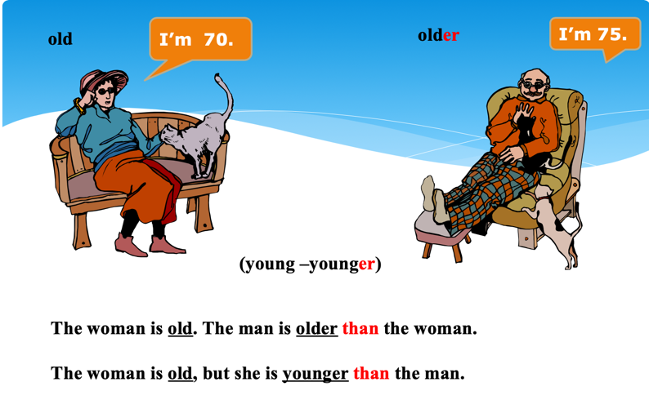

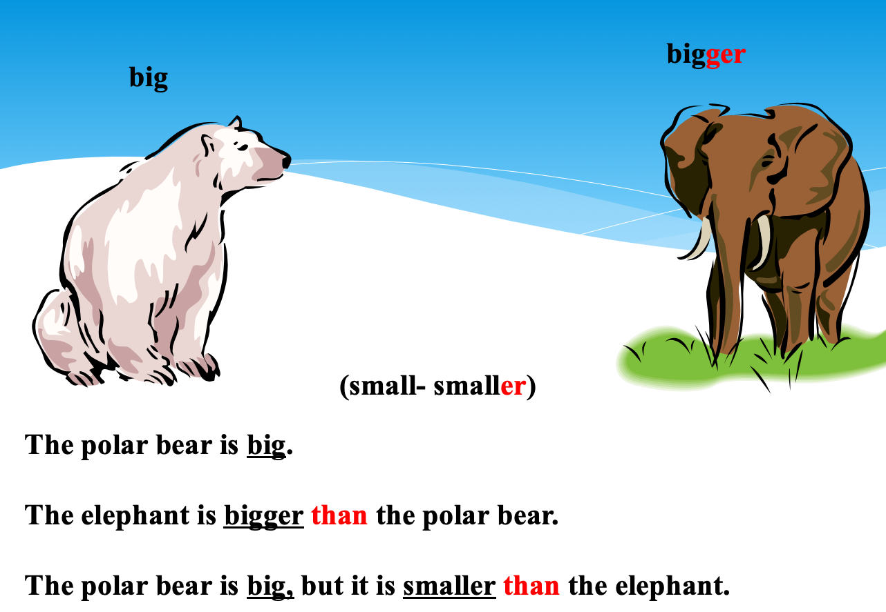

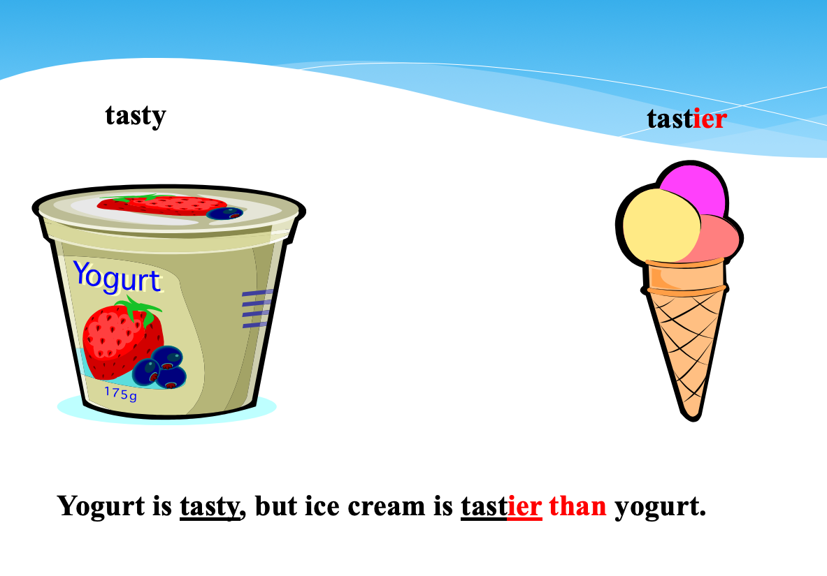
Teacher TR then assigned another grammar activity on the comparative form, which contained a complete the sentence activity, which can be found in the following figure:

Figure 60. Teacher TR's self-created grammar practise

Complete the following sentences. Use the comparative form of the adjective in brackets.

- Tiny is (tall) than Sky.
- Sky is (good) at basketball than Tiny.
- Tiny is (fast) than Sky.
- Sky is (popular than Tiny.
- Sky’s feet are (big) than Tiny’s feet.

In this way, teacher TR covered the comparative form and now moved on to the superlative form of the rule. She explained this second rule to the students in the same way she used to explain the first rule, in which she used a table that she had created on the projector screen.

Figure 61. Teacher TR's self-created grammar table (b)
How do we build a superlative form?
Short adjective + EST  Old the oldest  Young the youngest  CVC [consonant vowel consonant] + ES (the final consonant is doubled)  Big the biggest  Hot hottest  Short adjective ended in -Y IEST  Easy the easiest  Heavy the heaviest | Long adjective: THE MOST + long adjective  Exciting The most exciting  Beautiful The most beautiful  Irregular adjectives  Good The best  Bad The worst
We use THE before the superlative form of the adjective.

John is the tallest.

A Ferrari is the most expensive car.

Furthermore, similar to the extra practise she did with the comparative from, she also had a list of sentences containing the superlative form for her students to read as extra practise on this rule as well.

Figure 62. Extra grammar practise by teacher TR
Old Older The oldest

Big Ben is old.

The tower is older than Big Ben.

The pyramids are older than the tower.

The pyramids are the oldest.

After explaining the superlative forms and reading the practise sentence shown in Figure 60, teacher TR assigned a grammar practise exercise, which contained a complete the sentence activity, shown in Figure 63 below.

Figure 63. Teacher TR’s self-created extra grammar practise (a)

Complete the following sentences. Use the superlative form of the adjective between brackets.

- Al is (short).
- Ed is (thin).
- Al is wearing (colourful) clothes.
- Ed is (tall).
- Joe is (smart).

After assiduously explaining both the comparative and superlative forms and practising using these forms, teacher TR assigned more grammar practise that combined both grammar rules, which will be illustrated below.

Figure 64. Teacher TR’s self-created extra grammar practise (b)
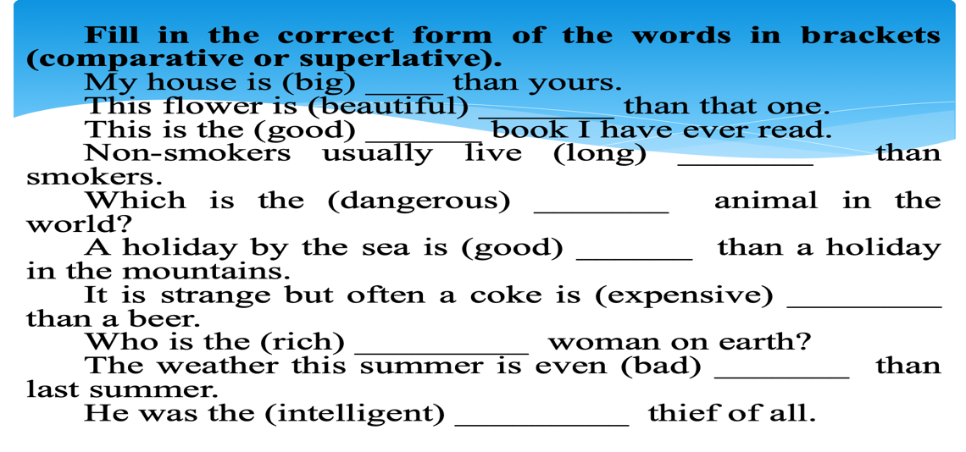
After covering the grammar practise shown in Figure 64 with her students, teacher TR assigned another grammar practise, which also combined both the comparative and superlative forms. This time, she showed her students pictures of salad – fries – chocolate with the following adjectives (healthy – sweet – tasty – fattening) and she asked them to use these adjectives to compare between the foods in the pictures using the comparative and superlative forms. By means of a second PowerPoint slide, a similar activity was also done, where there were pictures of a bike – eco-friendly car – a regular car along with the adjectives (cheap – slow – small – comfortable). Here, she also asked her students to compare between the pictures using the adjectives in front of them. Only then did she refer to the grammar practise in the textbook.

Hence it is quite obvious from the examples given how many extra grammar activities teacher TR adds to the textbook. In her follow-up interview, she justified these additions she makes to the grammar parts of the textbook due to the fact that the textbook provides students with insufficient practise:

. . . the grammar part in the textbook they explain a specific grammar rule, and they don’t provide enough examples or explanations to the students, so I try to add more activities and more practise for them . . . I like to bring materials from outside the book. I think the book is not enough, I always feel that the book is not enough.

Moreover, it is apparent from these ‘adding’ examples found in teacher TR’s lessons that she adds to the materials before actually covering the textbook. This is in accordance with McDonough & Shaw’s (2013) argument regarding how ‘adding’ does not necessarily have to happen at the end of an activity; it can also occur “and be introduced before it appears in the
. . . coursebook” (p. 71). This is also similar to what Bosompem (2014) reported about one of her teacher participants, where she was observed to add warm-up or lead-in activities in order “to stimulate the targeted teaching/learning activities when none is suggested by her textbook” (p. 115).

In a similar manner to teacher TR, teacher TM also puts much of her focus on grammar and practising as much grammar as possible with her students, because “our system is test oriented, and the biggest focus is on the grammar and the vocab”. Also, an important point that was observed in teacher TM’s lessons is that in addition to covering all the grammar activities within the unit, she also covers the grammar practise in the grammar reference part, at the end of the textbook. It is worth mentioning that this grammar reference is not included in the pacing guide, and teachers are therefore not required to cover it in class. When asked about this during the interview, teacher TM replied:

I think it [the grammar reference] is something important . . . because here in the unit itself it is not really explaining the grammar, it is mostly application. So, I like them [the students] to know the rules and go back to it and just give them more exercises to make sure . . . Just to enhance, make sure that they [the students] understand.

She then gave an example of a lesson she had delivered in a previous semester to illustrate this point, and she described how it turned out to be extremely successful, which gave her the motivation to keep on adding material. In Figure 65 below is the grammar section that teacher TM is referring to.

Figure 65. Activity from English Unlimited Special Edition (Rea, Clementson, Tilbury & Hendra, 2017, p. 32)
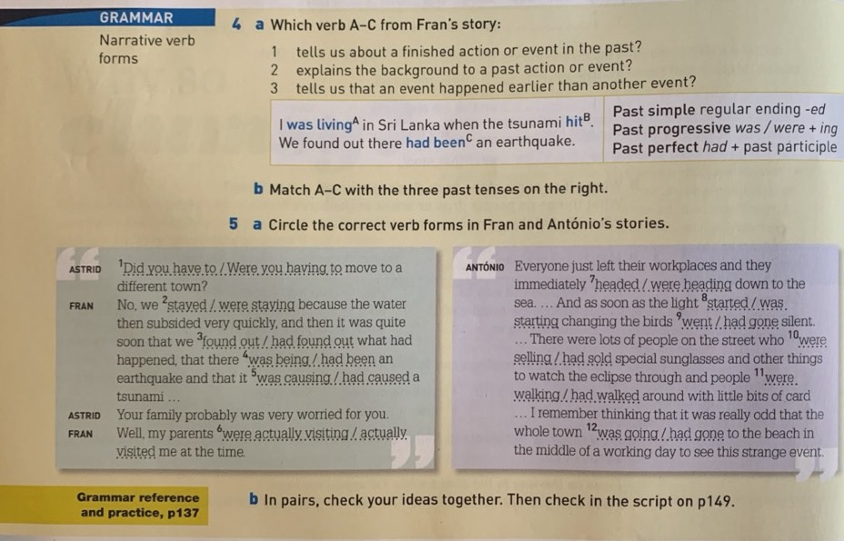

In Figure 65, we see that the grammar rule is on narrative verb forms and telling stories. The activity related to this grammar rule is a simple fill in the blank, which can be found in the following figure.

Figure 66. Activity from English Unlimited Special Edition (Rea, Clementson, Tilbury & Hendra, 2017, p. 37)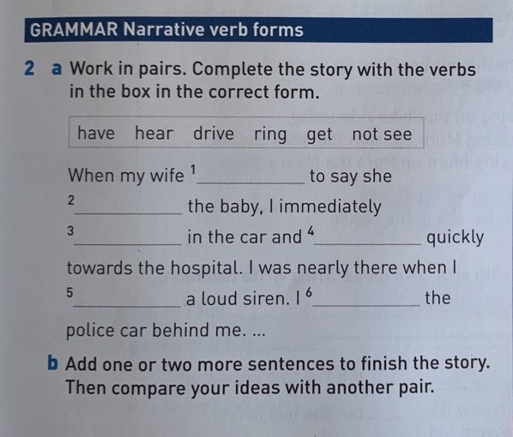

For this grammar rule, teacher TM explained how she added a collaborative writing activity as extra practise for her students, stating: “So . . . we applied the grammar rule in writing our own stories. So, we did collaborative writing and each group had to write their own story, using the grammar phrases, at least four from the ones that we’ve taken [looked at in class], and using them to write a story”. She was very enthusiastic about this example, because in the exam, almost none of her students made a mistake in the questions related to this grammar rule, and she explained how she believed this was “because they remembered that experience, because stories stick to your mind”. She further elaborated on this example, saying:

when I do the collaborative writing, this is not mentioned in the book. I do add those activities, because I see their benefit . . . They [the students] get new information every day. So, I try my best that within these hours that we’re spending together that they use [practise] the focus of the lesson as much as they can.

Furthermore, teacher TF was also one of the teachers who was observed to add to the textbook. Figure 67 below shows the grammar rule covered in teacher TF’s lesson observation.

Figure 67. Activity from English Unlimited Special Edition (Rea, Clementson, Tilbury & Hendra, 2017, p. 61)
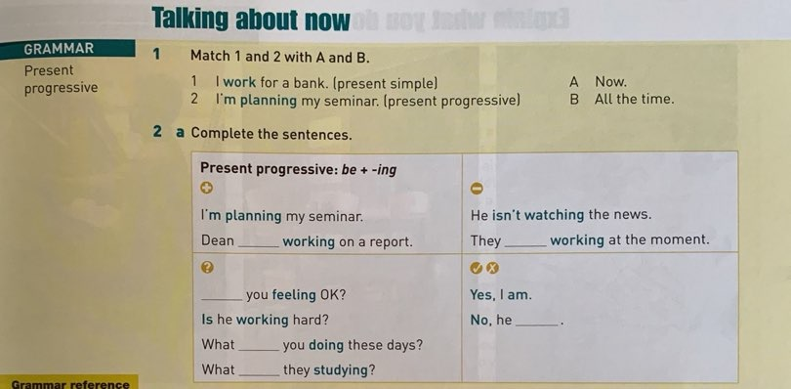

However, before teaching this rule from the textbook and doing the activity assigned, she wrote the following on the board:

I study English [All the time]

I am studying English [Now]

She then explained to the students the difference between the underlined verbs in the two sentences, and how the verb in the first sentence is used when talking about something that happens for a long period of time, whereas the second verb is used when talking about something that is happening now. After that, she asked her students to each write one sentence which contains the form of the verb in the second sentence example shown above (am studying). She then referred to the textbook and did activity number one and two.
After finishing these exercises, teacher TF put the grammar rule on the board organized neatly in a table, which she had divided into four different parts. The first part showed the positive form of the present progressive (I am studying English), the second part the negative form of the present progressive (I am not studying English), the third part showed the question form of the present progressive (Are you studying English?) and finally the fourth part showed the short answer format (Yes, I am / No, I am not). When asked about these additions during her interview, teacher TF explained that she mostly adds to the grammar parts of the textbook “I add . . . activities for further practise, especially in grammar”.
Moreover, it was noticed that teacher TF does not only add extra grammar practise, she also adds to the reading parts of the textbook. In both lesson observations, an example of this was recorded. Figure 68 shows a reading passage followed by five reading comprehension questions.

Figure 68. Activity from English Unlimited Special Edition (Rea, Clementson, Tilbury & Hendra, 2017, p. 42)
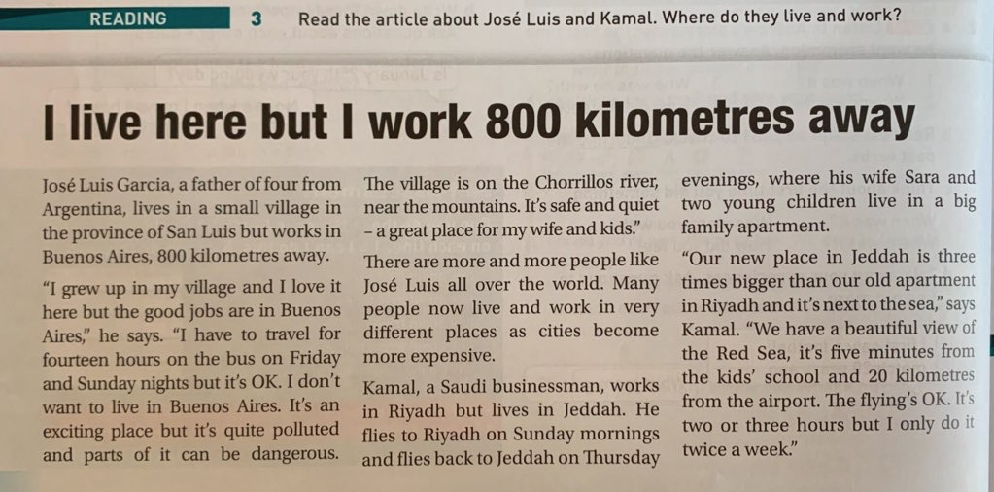

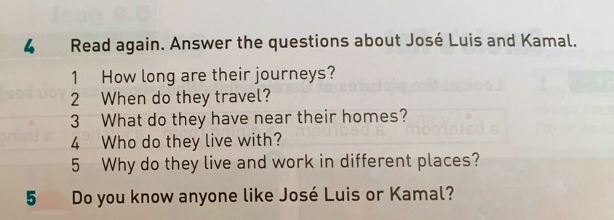

In her lesson, teacher TF asked her students to read the article, and after they finished, she asked them two non-textbook questions before covering the five questions in the textbook, asking: “Where is Jose from? / Where is Kamal from?” A similar example was noticed in her second lesson observation, where there were two reading passages, each talking about a random person and describing how he/she spends a typical day in their life.

Figure 69. Activity from English Unlimited Special Edition (Rea, Clementson, Tilbury & Hendra, 2017, p. 59)


After teacher TF assigned the students to read this article shown in Figure 69, she asked them the following questions, in addition to the ones in the textbook:
“How old is Pete? / What does he do? / Where does he work? / For how many people does he cook? / Where does he go after work? / What does he do in evenings? / How many hours does he sleep?”. With regards to the second passage, which is shown below, teacher TF also asked students a similar set of questions: “How old is she? / What does she do? / Where does she work? / What does she do in [the] evenings?”

Figure 70. Activity from English Unlimited Special Edition (Rea, Clementson, Tilbury & Hendra, 2017, p. 125)
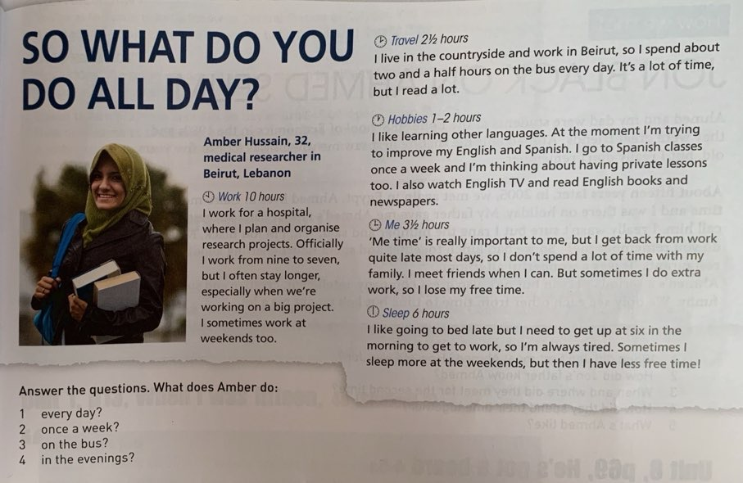

When asked about these two scenarios during the post-observation interview, teacher TF described these questions she adds to the reading passages as “check-up questions”, and she stated that she adds these activities to the ones in the textbook “ . . . in order to foster their [the students’] understanding . . .”.

A similar scenario to this (adding to the reading comprehension questions) was noticed in teacher TA’s lesson observation as well. Although during her interview, she claimed that she does not add to the textbook because she feels “we have enough, so I don’t usually do . . . adding”, in her lesson observation, she actually added a set of questions to the reading comprehension questions in the unit she was covering. In the following figure is the reading passage along with the reading comprehension questions.

Figure 71. Reading passage taken from English Unlimited Special Edition (Rea, Clementson, Tilbury & Hendra, 2017, p. 40)
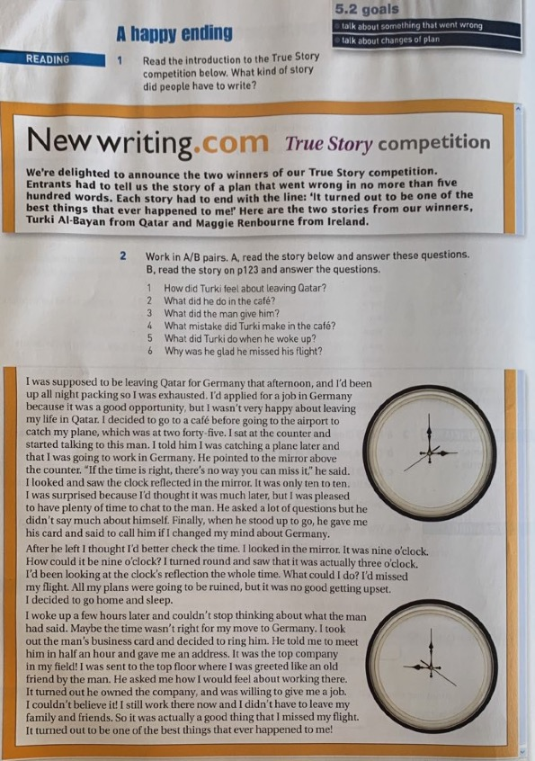

After reading this passage and answering the questions with her students, teacher TA asked them the following additional questions: “You read about the competition, what is it called? / How many people won the competition? / Who are the winners, what are their names? / What did they write about? / What is the topic of their stories?”. When asked for the reason why she added questions to the ones already in the textbook during the post-observation interview, teacher TA explained that by asking these additional questions, she is making sure that her students have actually read the passage, and not just simply giving the written answers in their pre-owned textbooks. She further explained how most of her students buy used textbooks from previous students who have finished this level, and therefore the textbook’s exercises have already been completed in their books. In fact, she described how sometimes during a lesson she would notice most of the students will be answering the activities and participating; however, she finds out that they are actually reading the answers in their textbook without doing the work. For this reason, she adds activities just “to make sure that they [the students] are really reading”, and that they comprehend what they are learning in the classroom. Here, teacher TA explained how important it is for her that her students indeed comprehend what is being taught in the lesson and that they are not just reading the answers written in the book by previous students. According to her, by adding questions like the ones shown above, she is able to check students’ comprehension and make sure that they have indeed read the passage in front of them. Therefore, we see that she adds activities to the textbook as further practise, not because of a perceived lack of activities in the book, but due to the fact that students are using pre-owned textbooks. As a matter of fact, teacher TJ also complained about this issue and was not happy with the fact that the students had the answers in front of them:

many of them [the students] bring books that have answers written for them and they are raising their hands and they answer all the questions. To an onlooker that seems they know the answers, but it is because they have the answers and they don’t understand anything.

4.5.2.2. Adding to generate student interest

Four of the teachers claimed to add to generate student interest:

Adding to generate student interest
Teacher TA
Teacher TR
Teacher TZ
Teacher TF

Another important reason for adding materials to the textbook which the data revealed is adding to generate student interest. For example, this type of adding was observed in teacher TA’s lesson, in which the grammar rule of that particular lesson was future forms. In this lesson, teacher TA wrote the following statements on the board:

“Find someone who will study psychology or chemistry. / Find someone who will go home between 11 am to 1 pm today. / Find someone who will travel over the weekend. / Find someone who will leave early today.”

Then, she asked the students to go around the classroom and find people who will do any of these statements they see on the board. She said: “Find as many people as you can, as we did last time”. Hence, it was clear that the students were used to this type of activity. When asked about this specific scenario during the post-observation interview, teacher TA explained that she does these kinds of activities that involve moving in order to get students excited:

at that day when you came to the class, I didn’t plan to do a survey, I didn’t plan to move them up [make them move around class], but they were so sleepy . . . As you saw, the students were excited to do that [activity] and even lazy students will be pushed to do something.

Therefore, she feels she sometimes needs to adapt according to the students’ immediate attitude in the classroom, and she does not necessarily plan her adaptations. She further described how she first got this idea of adapting the activities in the textbook in a way that allows students to move around the classroom from one of her previous students. She explained how in a past module, one student mentioned the fact that “we need more movement in the class”, and as a result of this comment, teacher TA started thinking seriously about this idea and applying it to her lessons. Likewise, one of Gok’s (2019) teacher participants reported that he edits activities which he feels are boring for his students. He explained: “ . . . students like being active . . . they do not like dull activities. They like kinaesthetic activities . . ., activities that address all senses. If an activity looks like it lacks most of these characteristics, then I either modify or omit it” (p. 176). Teacher TA, then, concluded that the most important point she focuses on when adding similar activities to the one she describes above is:

getting them moving while they are doing some part of their education. So, relating English to something nice, especially with the bad attitude some students have towards English class . . . So, I think this is a main reason . . ., make it [the lesson] more interesting for them because they get bored . . . Sometimes the activities I feel it is boring to be honest . . . , to make it more interesting like instead of them sitting down . . . we do a lot of talking in pairs . . . or let’s make it in groups or let us make a survey or something like this, to make it more interesting and more fun.

With regards to teacher TR, she explained during her interview that:

I always use the internet because I believe the stuff we have in the book is just sometimes not interesting enough for the students . . . So, I try to utilize the internet . . . to integrate like exciting and interesting stuff in my lesson like using YouTube, or sometimes I use PowerPoint presentations, lots of other things I try to integrate which are not in the textbook.

As an example, it was observed in one of her lessons that she added to the grammar exercise in the textbook, shown in the following figure.

Figure 72. Activity from English Unlimited Special Edition (Rea, Clementson, Tilbury & Hendra, 2017, p. 60)

As is clear from Figure 72, the unit tackled the grammar rule of Real conditionals – if clauses. After doing this activity with the students, teacher TR had an additional, non-textbook activity ready for them. Firstly, she divided them into groups of six and distributed a number of cards for each group. These cards contained jumbled up sentences made up of an if clause and a conditional clause; for instance, one of the unjumbled sentences read: “If I have time tomorrow, I will go to the gym”. Teacher TR asked the groups to order these cards in a way that created a grammatically correct sentence. It is worth noting that the students were actually having fun with this activity, and after they were finished ordering their sentences, each group came up in front of the class with the sentence they had created. The group which finished first were awarded a box of chocolates by the teacher.

Teacher TR was asked about this scenario during her interview, and she described the activity in the textbook as a “traditional one” and she also used the phrase “very boring activity” to describe it, but by using group work and getting the students to move around in the classroom while doing classwork, “I believe it helped them, it evoked more focus in that practise and it helped them to practise using the if clause in like more effective way than the one in the book”. She further explained:

I have to integrate things into my lesson, to inject interesting things, because I notice that when I strictly follow what is in the book, I lose the students, I feel they are not really paying attention. They already know what will happen, but when I bring things from outside the book, they become more engaged.

With regards to her decision to reward the group that finished first, teacher TR explained her thinking as follows:

Incentives, I feel it is very simple. It could be chocolate, sometimes there could be stickers, very simple things, sometimes [temporary] tattoos. I noticed it brings some kind of excitement in the class, it motivates. These simple rewards motivate them to learn and to attend the classes, to be engaged. That is why I use it.

Teacher TZ also reported that student interest is a strong motivational factor for her to integrate new ideas or activities as supplementary materials into the course. However, she does so in a different way to teacher TR. Whereas teacher TR adds to the textbook in order to stimulate student interest, teacher TZ only adds content if the students are interested. She explains her point of view further, saying:

. . . so, if they [the students] are interested, I try to use it for my advantage. So, I get more information and we can talk about it and do groups and let’s compare. If they are not interested, then let’s move to the other thing.

When asked to give a specific example of this, she cited unit 7, which is titled Personal qualities. In this unit, the reading passage was about the creator of a famous Arabian cartoon series called “Fireej” as well as a listening passage on Zaha Hadid , in which in both these parts personal qualities of successful people were discussed. Teacher TZ explained how for this unit, she decided she would like to add more information other than the ones mentioned in the textbook just to make the topic more interesting; thus, she brought in extra material on Zaha Hadid. She described how one class did not know who she was, but were interested in finding out about her, hence she was motivated to bring in extra material to the lesson. The second class, however, did not know Zaha Hadid, and they were not interested in finding out about her, either. Therefore, she was not motivated to adapt the textbook and she just went on with the lesson as it was in the textbook. As she explained, “if they [the students] are interested, yes I can go deeper [bring in extra materials]. If they are not, I just do basic which allows them to pass”. Here, teacher TZ is acknowledging the fact that student interest is a strong motivational factor for her when deciding how to use and supplement the textbook. The more she feels the students are engaged and interested, the more she is motivated to add external materials. If the students show no interest, on the other hand, she only covers the basic parts of the unit which are required to pass the examinations.

Another example teacher TZ gave is the fact that she uses technology and games very much in her classroom. During her lesson observation, she added two games to the textbook material through a program called ‘Kahoots’. She stated that she uses these games when she feels the students are not paying attention to the lesson. Also, in addition to adding these games in order to generate student interest, she explained how they serve another purpose which is equally important. She explained how the ELI has recently started asking teachers to cover some parts of the workbook, and she explained how this created a problem for her because her students do not bring in their workbooks to class: “33 students, not one of them bought the workbook, and the ones before them another 35 didn’t buy the workbook . . . I have to cover the workbook, so one way of me covering the workbook is to use it in Kahoot”. Therefore, we see that as a way around this problem of students not buying textbooks that she faces, she decided to incorporate the activities of the workbook into these games that she adds to her lessons. In doing so, she is creating a fun learning environment for her students, and she is covering the activities in the workbook as well. She further explains:

. . . when I feel them dying or sleeping or whatever or playing with their phones, so this is when I use the Kahoot, but at the same time it serves the purpose. I am covering the workbook. This is a smart way of covering it. Students who were sleeping, were jumping on the chairs for me [after playing the games she adds] they were like: ‘Teacher, another one!’. And they were always competing, and I always give them something afterward, a bookmark or chocolate.

As a final example in this part, teacher TF gave a small example of how she tries to add to the textbook in order to make the lesson more interesting. For example, in Figure 73 below, we see that the unit is called “Technology firsts”, and basically talks about the first editions of the technologies we have nowadays, such as phones and computers and how they have changed.
Figure 73. Activity from English Unlimited Special Edition (Rea, Clementson, Tilbury & Hendra, 2017, p. 34)
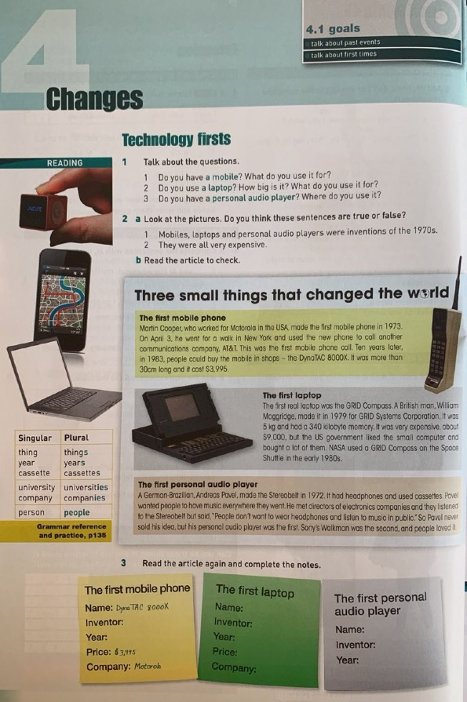
Teacher TF explained how as a warm-up activity she decided to have a whole class discussion where each of the students talked about her first mobile phone. She stated: “I have asked them to dig in their memories and to remember the first time they had a mobile phone and to describe how was it . . . So, it was a very funny warming up”.

4.5.2.3. Adding due to students’ different learning preferences

Only two of the teachers claimed to add due to their students’ different learning preferences:

Adding due to students’ different learning preferences
Teacher TN
Teacher TR

In their interviews, teacher TN and teacher TR both talked about the different learning preferences that different students may have. They believe they should try to integrate as many different types of learning styles as possible in their lessons, in order to satisfy everyone’s learning preferences. For instance, in her interview, teacher TN mentioned multiple intelligence theory, and explained how some people are visual and therefore learn more when they see, whereas others learn better through listening, which she called “auditory intelligence”, and other people have artistic skills and they learn better through drawing. She therefore believes that as a teacher, she should try to cater for these different preferences as much as possible. In fact, she was observed to have applied this theory during her lesson observation, specifically when explaining vocabulary. As an example, during the reading passage of that lesson, which can be found in Figure 74, teacher TN wrote the following words on the board, which she had taken from the passage: risk / fewer / upbringing/ cautious. While she was explaining the meanings of these words to her students, she told them: “I don’t mind if you write the meanings of words in Arabic or write it in a sentence to remember”. When talking about this scenario during her interview, she explained that some students will learn new vocabulary better if they link it to their L1, and that is why she reassured them that they could use the L1 if it is their preference.

Figure 74. Activity from English Unlimited Special Edition (Rea, Clementson, Tilbury & Hendra, 2017, p. 30)
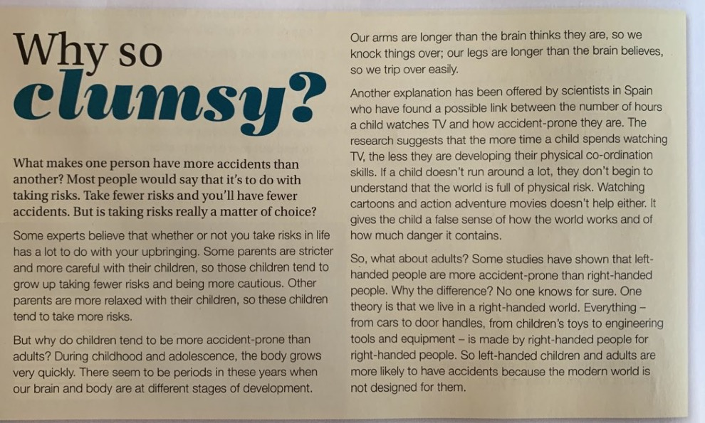

Teacher TN explained that “they [the students] can use L1 to help them learn L2 because words when they are written, she [the student] will do some effort by her hand, it's a kind of psychomotor skill”, which will help in the student’s learning of this new word. She further explained her beliefs about multiple intelligences as follows:

Some people they are visual, they learn by seeing. They have to see something and relate it to vocab, and they have to see the word to get it stuck in their mind. So, they have to see the word; to see something that reminds them of the word.

She then concluded: “my strategy [in teaching] is that I try to involve as many skills as I can, as many ways to learn as I can”. This is why she sometimes adds to the vocabulary activities, to make sure that all types of preferred learning styles are covered.

Furthermore, teacher TR, in a manner similar to teacher TN, believed in using different methods of teaching:

I love using multi-media, which means different kinds of resources, because you can teach someone who is visual, and maybe someone who has a different type of personality. So, in order to meet all these preferences and different types of abilities that you have in your class, you have to use different types of media and different resources, so you can reach your students. You can get them to be engaged and to motivate them. You can improve the students’ understanding and you can improve the learning process by using different methods.

Teacher TR was very passionate about this topic, because it was actually the subject of her MA thesis, in which she studied the use of YouTube to teach vocabulary. Therefore, it may be said that she is basing her teaching beliefs on knowledge that she acquired while studying for her MA. She explained how there is a common belief amongst researchers that when students see the information they are being taught, as opposed to only being orally taught, they will be able to retrieve it more easily. She further justified this pedagogical belief as follows:

because this is how the mind processes the information. The information will stick in your mind and will be restored easily when you see it. When you see something and hear it, you will remember it better than when you just hear it.

She then talked about how she tries to keep in mind the different types of student personalities when giving a lesson and to have a variety of activities that may appeal to different types of students, such as using videos and pictures:

when I teach you a word and you see it on the board, for example happiness . . . you teach it in a conventional way, and you put a picture of someone smiling . . . it is different than when you show . . . short videos of people talking about what makes them happy. When you put pictures of things that make people happy, like money, friends, traveling or hobbies, all these things when they [the students] see it in pictures this will improve their memory, so they can remember the information better. So, I always try that these two elements [are] to be found in my class, they [the students] should see and hear and also practise; listening and writing is not enough.

Indeed, when looking at her lesson observations, there were many instances in which teacher TR uses different teaching strategies, such as applying group work activities, using pictures and also using out of the textbook activities, which were discussed in the different types of adaptation that have been reported until this point. In sum, as illustrated via teacher TN’s and TR’s points of view, it may be said that some teachers add to their textbooks in order to try to cover all the learning preferences that may be found in their classroom.

4.5.2.4. Adding to bring content closer to the students’ lives

Two teachers in this study claimed to add to bring content closer to their students’ lives:

Adding to bring content closer to the students’ lives
Teacher TA
Teacher TD

As mentioned previously, although the textbook used in the ELI is specifically designed for its context, some of the teachers felt that there are parts in the textbook that do not relate to the students, and therefore, sometimes have to be adapted. For instance, teacher TA and TD stated in their interviews that on occasions, they add to the content in the textbook in order to bring it closer to the students’ reality and make it more contextualized. As explained in section 4.5.1.4, teacher TA had a specific opinion about using “other cultures” in the textbook. She acknowledges the importance of learning about different cultures; however, she believes that sometimes there is “too much” talk about other cultures. She explained how “sometimes, I want to personalize to let the students talk about themselves, because this is what they are asked to do at the very end [in the speaking exam]”. Accordingly, teacher TA adapts some of the activities that she senses do not relate to the students. Following up on this point, teacher TA claimed that “at the speaking exam we are going to ask them [the students] to talk about themselves. If I am going to ask them to do that, if I am not training them to do this in the class, so this answers for you [answers your question]”. What teacher TA is describing here is that when the textbook focuses too much on other cultures, and the students are only used to practising speaking about other cultures, then there will surely be a problem during the speaking exams, as they are not used to speaking about themselves. In point of fact, this issue is not only relevant to the speaking parts of the textbook, but also to the reading parts as well. According to teacher TA, when you look at the mid-term exams for example, they contain reading passages that are what she calls “a Saudi version of the passages”. For instance, these passages contain “Saudi street names”. Regardless of the fact that the intention of the exam makers was positive, and they meant for this to be a positive characteristic of the exams, as students are familiar with these names, teacher TA had a different point of view. She believes that “for some students it is not easier, it is just different. They don’t get it as easier, oh it is just different, because we didn’t read something like that”. She then gave an example, citing a part of a unit that she had adapted during that week. Figure 75 shows the activity that teacher TA is referring to.

Figure 75. Activity from English Unlimited Special Edition (Rea, Clementson, Tilbury & Hendra, 2017, p. 48)
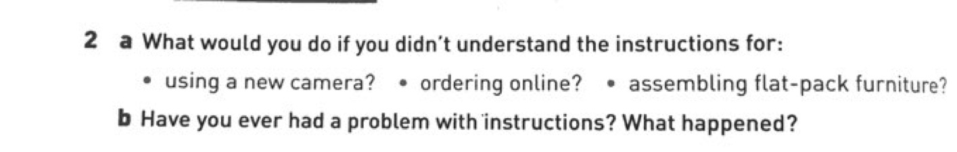

In this activity (2A), students are asked what they would do if they do not understand instructions in three different scenarios. Before covering this exercise, however, teacher TA explained how she asked her students what would they do in the case that they were in an exam, and they did not understand the instructions given by the teacher: “So what would you do if you didn’t understand the instructions?”. According to her, by adding this question to the one in the textbook, she is somehow relating the topic more to her students and giving them an example of a situation they can actually picture themselves in. She explained, “to me this is more contextual for them . . . just adding a small little bit to make it more contextualized”.

Moreover, in teacher TA’s first lesson observation, a similar scenario was noted. Figure 76 below shows the textbook vocabulary activity which she added to.

Figure 76. Activity from English Unlimited Special Edition (Rea, Clementson, Tilbury & Hendra, 2017, p. 41)
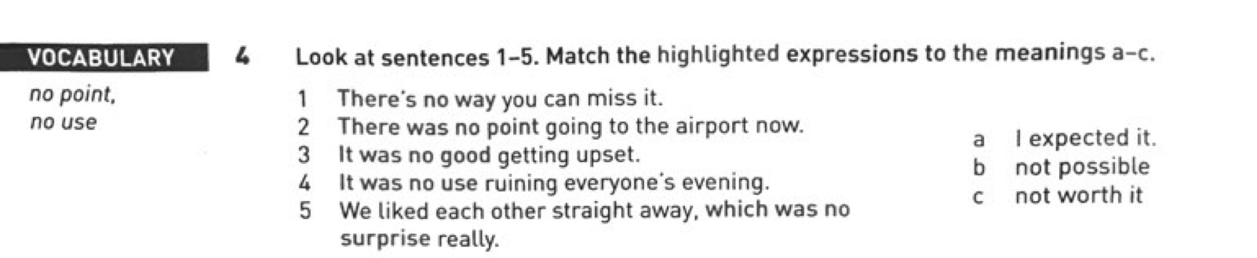

When covering this exercise with her students, she explained that the expressions in 1-5 come in certain contexts and should be memorized as they are. She explained the meaning of each of the expressions, then she gave them an additional example, saying: “If your friend is very upset because of yesterday’s exam, what will you say to calm her?” In which the answer will be “it was no good getting upset”. She then gave them another example saying, “all of you passed the quiz, which was no surprise!”, in which in both examples, she used the phrases shown in the textbook.

Moreover, teacher TD had reservations about some of the themes and topics in the textbook, so much so that she declared topics and themes as one of the most constraining factors she faces when using the textbook. In her interview, she stated that “there are many themes that are not relevant, but we have to teach”. She gave examples of some of these topics saying: “for example, new year festivals or directions. Maybe now directions it's relevant, but before, no [she means because women were not allowed to drive previously]”. She gave further examples as below:

. . . for example, units about dealing with money, units about studying abroad, or living abroad, students wouldn't relate to the ideas in the unit . . . I remember there was a listening about moving from an African country to Scotland and seeing the snow for the first time and most of the girls did not even go to Dubai. They really did not care to listen, and even I did not enjoy it. So, every time I come across this lesson, I just feel unmotivated to teach. So, if it's up to me . . . I wouldn't use it [the textbook] in teaching if the themes are not appealing.

From her above statement, we see that the relevance of topics is an important factor for teacher TD, to the extent that it affects her motivation to teach. She then gave a concrete example of such a scenario in which she added an external activity to a reading passage in the textbook, in order to allow her students to identify more with the topic in question. Figure 77 shows the reading passage which teacher TD is referring to.

Figure 77. Activity from English Unlimited Special Edition (Rea, Clementson, Tilbury & Hendra, 2017, p. 67)
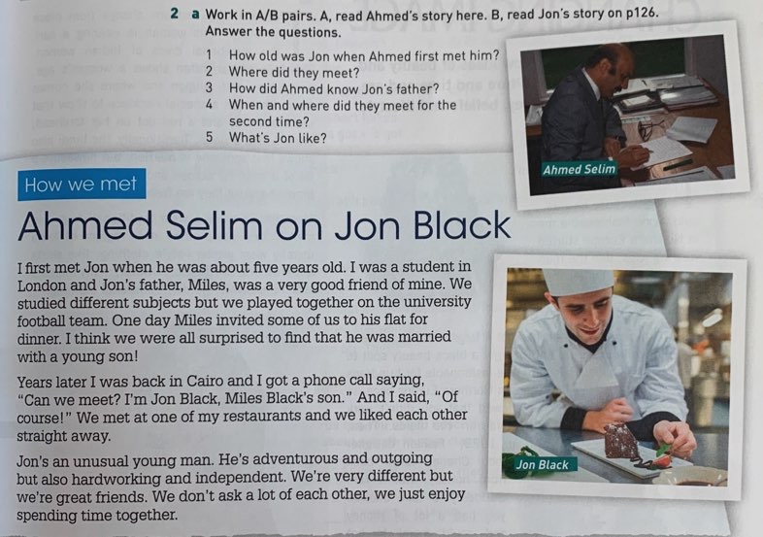

As seen from Figure 77, the text is about two people describing each other, which is in fact the objective of the unit, in which students learn how to ‘describe people’s personalities’. According to teacher TD, “it was a very easy reading”; however, she supplemented it with two more reading passages about Steve Jobs and Sultan Bin Salman, the Saudi King’s son. She justified adding these two passages, saying “I felt like they [the students] need more famous people to identify with, success wise. I mean who is Ahmed Selim? I mean even when I was reading, I was like who is he, why not bring someone I know”. By adding these two famous individuals, teacher TD is relating the content more to the students’ lives and discussing the personalities of people that they have heard of.

4.5.3. Deleting

The third adaptation technique that will be tackled is deletion/deleting. Seven of the ten teachers in this study (TM, TA, TZ, TD, TS, TK, TR) stated that they occasionally delete parts of their textbooks and had their justifications for doing so. The other three teachers (TJ, TF, TN), on the other hand, claimed they do not delete any part of the textbook. In fact, teachers TJ and TF talked about deletion in a negative manner. Teacher TJ stated she does not believe in deletion and never deletes any part of the textbook: “I try never to delete because I feel if the book is recommending it, it is definitely a valuable skill or activity the students need to cover”. Here it is clear that there may be some sort of textbook reification evident in teacher TJ’s response, which may be considered a reason why she does not believe in deletion. In accordance with what she stated in her interview, when the observation data was analysed, it was clear that teacher TJ, in fact, did not delete any part of the unit covered during her lesson.

Teacher TF is also a teacher who had a negative perspective towards deleting parts of the textbook. She clarified why she does not delete parts of the textbook, explaining: “good conscience is a soft pillow and for example when I delete, I feel that my mind is blaming me
. . ., so I never delete”. Accordingly, and similar to teacher TJ, no deletions were noted during her lesson observation, as she covered all parts of the unit. The third anti-deletion interviewee, teacher TN, claimed she does not have the authority to delete any part of the textbook; she stated: “we are not allowed to delete. No, we can't delete anything. We are not allowed because we don't teach on our own. We have to follow a system.”. She further explained: “I don't have the authority to delete. I'm not allowed. What I can do is that I ask them [the students] to do [textbook exercises] at home and we check here. That's the utmost deletion [that’s the limit to the kind of selection] we can do”. However, in her lesson observation, it was apparent that she did in fact delete a part of the textbook, shown in figure 78 below.

Figure 78. Activity from English Unlimited Special Edition (Rea, Clementson, Tilbury & Hendra, 2017, p. 30)
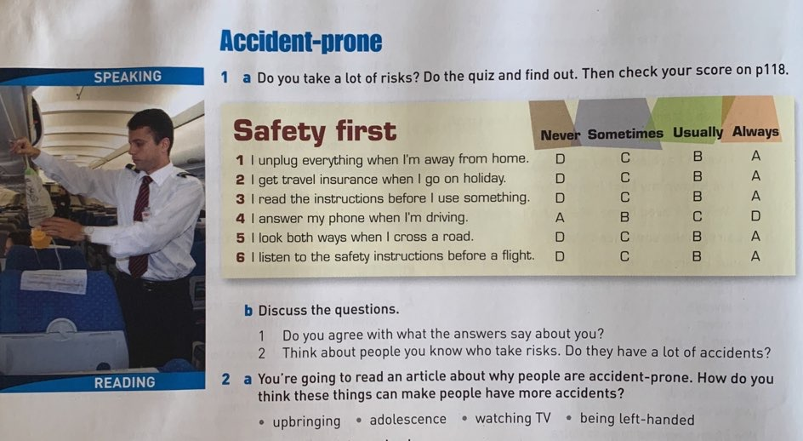

As seen from the figure, there are six questions on safety that students are expected to answer with their friends. The second part of this speaking activity (b), which was the part deleted by teacher TN, asks the students to discuss this topic more by giving them two extra questions (“Do you agree with what the answers say about you? Think about people you know who take risks. Do they have a lot of accidents?”). When asked why she deleted these two questions, teacher TN replied: “sometimes I skip questions if there is a lot of padding”. She explained that ‘padding’ means when there are many repeated facts, or questions asking for the same information. Therefore, the organization of the textbook is the reason why she deletes some parts of the textbook, for she feels there is no need to cover these parts repeatedly. With regards to the rest of the teachers in this study (7 teachers), each of them had their own rationale for deleting, and each of them explicitly exemplified the parts of the textbook that they tend to delete the most. In the following part, these reasons for deletion which were reported and observed will be explained.

4.5.3.1. Deleting due to time constraints

A number of teachers claimed to delete due to time constraints in the ELI:

Deleting due to time constraints
Teacher TR
Teacher TD
Teacher TA
Teacher TK

Time is one of the most important factors affecting teaching in the ELI, due to the modular system, which was described in detail in section 1.2. In fact, time was found to be a motivating factor in all four types of adaptation techniques, as seen thus far, and as will be seen for the rest of the techniques to come. Moreover, time was described by all ten teachers as a serious issue in the ELI; it is the reason for not only deleting, but it is also described as a reason for most of the problems that these teachers face in their daily teaching. This point will be discussed further in section 4.7.1.

In their interviews, teachers TR, TD, TA, and TK affirmed that they delete parts of the textbook because of time constraints. Teachers TD and TK were even more specific and explained why this time issue is present in the ELI. In her interview, teacher TD described a well-known culture amongst the university students where they do not attend the first week of teaching. As a teacher in KAU, I have seen this myself, and it is in fact a tradition that has been routinized by students. However, the ELI administration does not take this into consideration, and includes the first week of university within the pacing guide as a teaching week. Teacher TD further explains:

we have a pacing guide that we must follow, and we are always behind because of the first week of the university people [students] don't show up, but somehow the academic coordinator designed the pacing guide including the first week.

When asked if the administration of the ELI knows that student attendance is very low in the first week, she confirmed that it is well-known and that the administration knows. Therefore, her way around this issue of students’ absence during the first week is by deleting parts of the textbook: “so we basically, at least the first two weeks, I just cover the vocabulary and the grammar that I include in quiz one. So, it’s always deleting either the listening or the speaking”. It is important to note that during her lesson observation she had covered all the parts included in the unit, in addition to the speaking and listening. However, this lesson observation was done during the end of the module, and there were no exams scheduled during that time period. Hence this may be why she had taken her time in covering the textbook.

Teacher TK also talked about the issue of time and why it poses a problem for teachers, explaining how there are always new rules or certain issues that come up in the ELI which force teachers to start deleting parts of the textbook:

and the time, especially this module, we’ve been having to rush. Every day there is something new, either they add a quiz or because of the weather conditions, so we’ve been having to rush throughout this module four, and sometimes I can't really go through everything in the class.

What teacher TK means here is that the ELI administration is always changing their rules and regulations. For example, in previous semesters, teachers were not required to cover any part of the workbook during their lessons. In fact, they never used the workbook to the extent that students do not buy it anymore. However, during the module in which the current study was conducted, the administration changed this, and workbooks are now required to be covered during lessons. Of course, many teachers were dismayed at this decision because of the time constraints it is putting them under. This point was also echoed by teacher TJ, who mentioned the fact that during the last two modules the ELI administration started to focus on the workbook, and it is now considered as a requirement to be covered within the lesson, but that this new policy is not one she is comfortable with:

I don’t think we should be focusing on the workbook in the class . . . Because now I feel my time is divided between the textbook and the workbook. And when I’m doing that, I am not able to focus too well on all the skills properly. So, I would prefer to just focus on the textbook and leave that, they’re old enough now to do something on their own. We shouldn’t be spoon feeding them because they are older students. So . . . I don’t like that at the back of my mind that I have to make them practise in the workbook plus many of them don’t have workbooks, they don’t buy them, they don’t bring them to class, so it is a real stumbling block.

In addition to what was stated, teacher TK also mentioned that because of these time constraints she is under, “sometimes I cannot really go through every single exercise, so I do the most important ones or the ones that are related [to the exam]. If some questions have fun factors, like for example go on the internet and search in a certain topic, I skip that because of the time constraint”. She also added:

the writing it also takes a lot of time so, I have to maybe skip some things just to get to the writing. Now, I have 26 students but normally we'd have thirty or thirty-five . . . some teachers they have forty students, so you wanna get to them and check their papers. So yeah, sometimes you don't get to cover everything.

Accordingly, in her lesson observation, the exercise in the following figure was deleted.

Figure 79. Activity from English Unlimited Special Edition (Rea, Clementson, Tilbury & Hendra, 2017, p. 68)
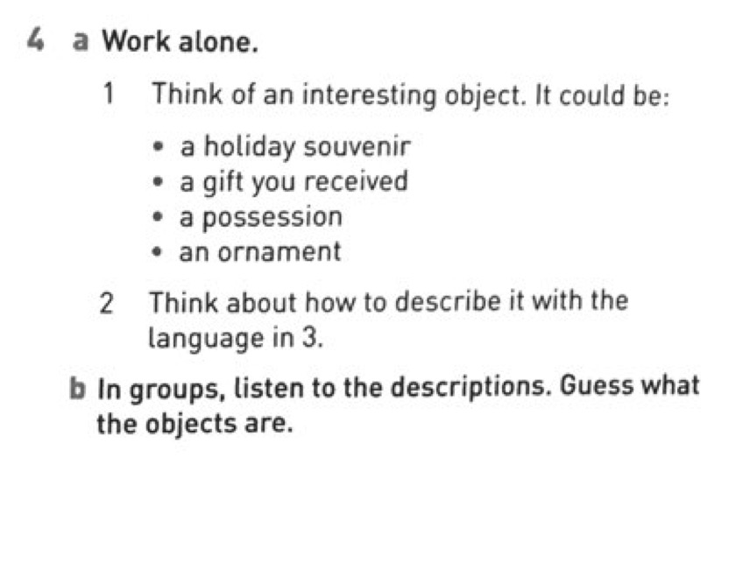
When asked about this during the interview, she justified her deletion by saying: “because we have writing so this is one of the parts that I skip. I mean it's a fun activity that they could do . . . Normally, if we have time I would do it. But that day we had the writing, so I didn't do it”. Another example of deleting found in the same lesson observation was of activity (2b) ‘Read again to check. How do you think Kurt and Philip felt afterwards?’, seen in Figure 80.

Figure 80. Activity from English Unlimited Special Edition (Rea, Clementson, Tilbury & Hendra, 2017, p. 70)
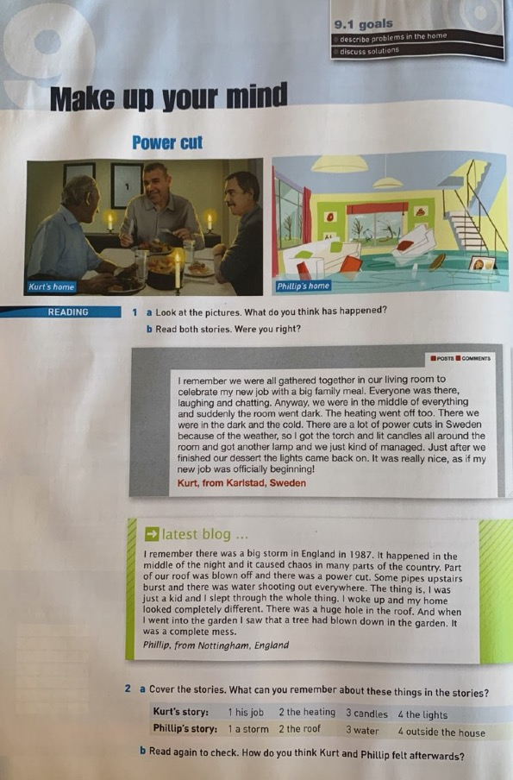

Teacher TK explained that “this is a speaking, so I sometimes skip speaking if we have writing in the same unit”, because as she claimed in her quote above, “the writing it also takes a lot of time, so I have to . . . skip some things just to get to the writing”.

Furthermore, teacher TR stated that: “time is one of the major factors affecting the teacher’s use of the textbook . . . Because there are things I want to focus on. . .and I can’t because of time. . . So, I am forced to skip a lot of things, maybe even things I know are important”. When asked to speak more about this issue and how it affects her teaching, specifically, teacher TR explained that:

you have to delete certain parts, we have to skip like the reading parts and
. . . most of the time I don’t do the reading, the reading and the speaking because I think they are time consuming, and so I have to skip them in order to focus on what is important [the grammar and vocabulary parts].

When looking at teacher TR’s lesson observations, indeed, in none of the four lessons did she do either the reading or the speaking components and she focused more on the grammar and vocabulary parts of the units.

Similarly, teacher TA also asserted during her interview that she deletes parts of the textbook that she feels are not important:

I have time pressure, so the activities which might not be very important, they might be deleted. Sometimes speaking and writing activities I delete it . . . They’re not really like of the main ones . . . They get deleted because of the time pressure.

The reason teacher TA considers the speaking and writing activities as not part of the main activities is because the exams in the ELI focus mainly on grammar and vocabulary, as has been seen and discussed. According to teachers in the ELI, even if they want to cover such activities, students will not be motivated because they are more focused on their grades. Hence, they end up being deleted. Moreover, similar to teacher TR’s lesson observations, teacher TA’s observations also revealed that she deleted the speaking of the unit of her first lesson observation, as well as the speaking and writing of the unit in her second lesson observation.

Hence, from the above comments and examples, we see that teachers agree not only about time being a crucial reason for their deletions of specific exercises, but also that time is a reason they tend to delete certain parts of the book (e.g., speaking activities generally). All four teachers stated that when forced to delete because of time constraints, they delete the speaking parts the most. The reason for this might be the fact that students are examined in speaking only once, and the main focus of exams is on grammar and vocabulary. Hence, due to the ELI being an exam-oriented system, teachers focus on parts of the textbook that are in fact the focus of ELI examinations.

4.5.3.2. Deleting due to students’ low proficiency level

With regards to students’ low proficiency level, teacher TZ claimed that she deletes because of this factor:

Deleting due to students’ low proficiency level
Teacher TZ

This reason for deleting parts of the textbook was reported by one teacher only, teacher TZ. Before discussing this finding, however, it is important to mention that teacher TZ displayed a very negative attitude towards her students. Throughout her whole interview she kept on criticizing their level of English as well as their attitude towards learning the language and their attitude towards life in general. This theme of students’ attitude and how it may have an effect on teachers’ use of the textbook will be further discussed in section 4.7.4. Teacher TZ admitted during her interview that she deletes heavily: “I delete a LOT [emphasized], especially with the weak groups . . . so I do a lot of deleting with the weaker students, less deleting with the higher level”. She explained that: “I have very much to give”, however, she is positive that the students will not understand due to their low level of English. Here, she is explaining that she has many creative ideas to implement in her classroom; however, the level of her students is a barrier to her creating innovative lessons. She further explained: “I need to focus on at least if they [the students] came out of the class learning two or three things, I am grateful. So, I have to delete a lot of it [the textbook]”.

Additionally, teacher TZ explained how she tends to delete the speaking parts more than any other part of the textbook, “because they [the students] were not going to speak in English. They will die before they speak English”. Here, we see that teacher TZ seems convinced that her students would refuse to speak English in class “I am realistic, it is not going to happen [students willing to speak in class]”. As stated previously, only one lesson was observed for teacher TZ, and in that lesson she indeed deleted all but one speaking activity, which can be found in Figure 81 below.

Figure 81. Activity from English Unlimited Special Edition (Rea, Clementson, Tilbury & Hendra, 2017, p. 89)
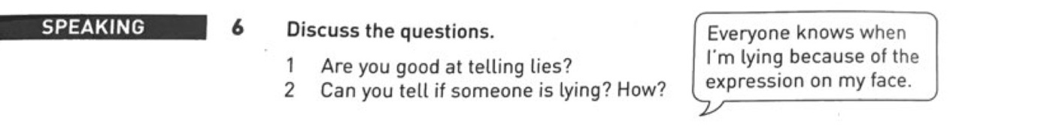

It is important to note, however, that when covering this speaking activity, she discussed the two questions with her students in Arabic, their L1. When asked about this during her interview, she justified using the L1 due to students’ low proficiency level and explained how she is positive they would not have understood if she had spoken in English.

Another example of a deletion scenario observed in teacher TZ’s lesson is of an activity in the textbook that asked the students to write a short conversation from a list of words provided and perform a dialogue in class (see Figure 82).

Figure 82. Activity from English Unlimited Special Edition (Rea, Clementson, Tilbury & Hendra, 2017, p. 93)
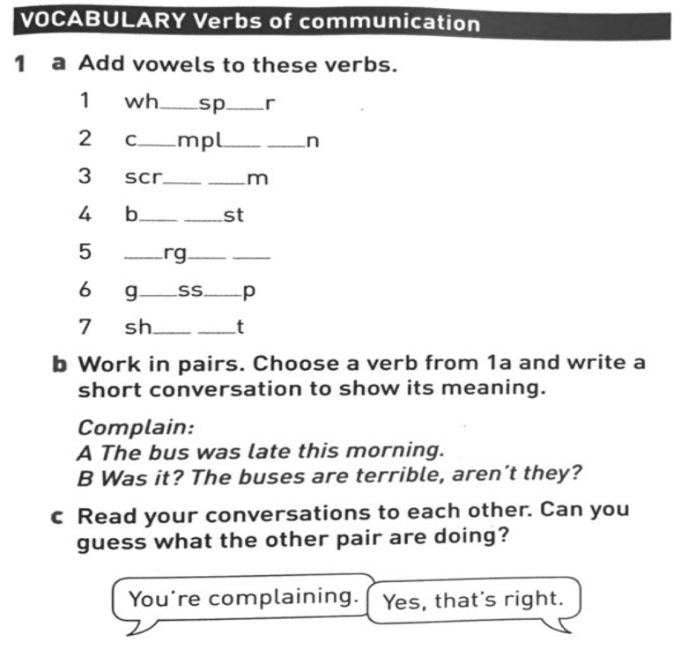

She justified deleting this activity thus:

Because of level. They have no idea what it means. Today, we read the word ‘complain’. I asked, have you ever complained? And she [a student] says ‘what does complain mean?’ How is she going to do this speaking?

Furthermore, it was noted during this lesson observation that teacher TZ skipped the reading comprehension questions. She only read the passage and explained it in Arabic to her students, then she went on to cover a different part of the unit. In her interview, she explained that “they [the students] have no idea what they are doing” and added “I did none of the reading questions . . ., there is no point”, again, justifying her deleting by referring to the students’ low proficiency level.

4.5.3.3. Random scenarios of deletion observed in lesson observations

In this part of the results, the more random reasons for deletion which were observed in specific teachers’ lessons will be referred to. These scenarios are not related in any way; however, they are all examples of using deletion as an adaptation technique and seemed worthy of mention. The first case we refer to is from one of teacher TM’s lesson observations. During her interview, teacher TM justified most of her deleting by referring to her belief in the holistic approach. As explained in section 4.2.1, she believes in the holistic approach and in the importance of linking the different parts of the textbook together in order for the students to understand what they are learning. Thus, she explains that she also has this holistic approach in mind when resorting to any sort of adaptation technique—in fact, this is the main reason why she adapts. She then gave an example of a deletion that she applied in the previous lesson.

In unit four of the textbook, which was about ‘natural disasters’, students were asked to talk and write about a natural event that happened in Mexico, which they had just read about. This exercise is reproduced below in Figure 83.

Figure 83. Activity from English Unlimited Special Edition (Rea, Clementson, Tilbury & Hendra, 2017, p. 33)
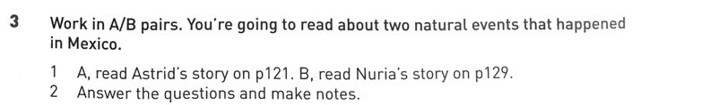

Figure 84. Astrid’s story English Unlimited Special Edition (Rea, Clementson, Tilbury & Hendra, 2017, p. 121)
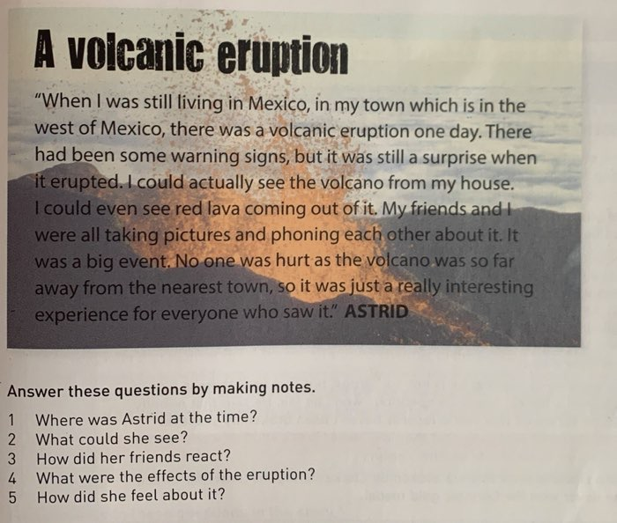

Nuria’s story
Figure 85. Nuria’s story English Unlimited Special Edition (Rea, Clementson, Tilbury & Hendra, 2017, p. 129)
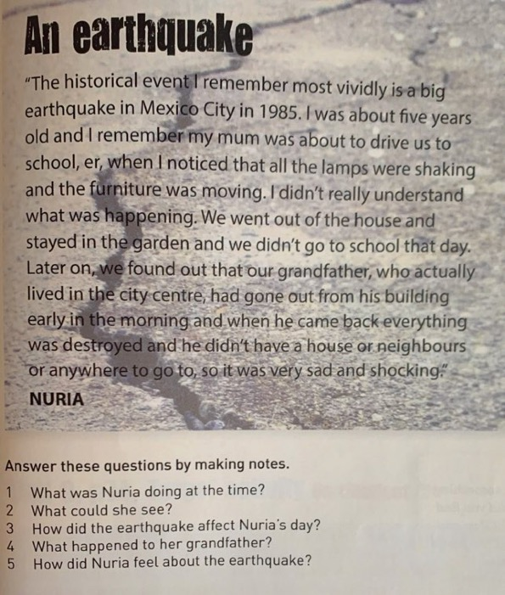

However, teacher TM decided to skip this activity:

I skipped the writing about ‘the events that happen in Mexico’ because I felt that doing the exercise on page 34, where they write about their experience [of a natural disaster] was much more important and enough.

Figure 86 shows the writing task that teacher TM is referring to in the above quote.

Figure 86. Activity from English Unlimited Special Edition (Rea, Clementson, Tilbury & Hendra, 2017, p. 34)

It is obvious from this writing task that it focuses more on the narrative forms and the phrases to use when telling a story, which is related to the grammar rule of that particular unit, found in the figure below.

Figure 87. Activity from English Unlimited Special Edition (Rea, Clementson, Tilbury & Hendra, 2017, p. 32)
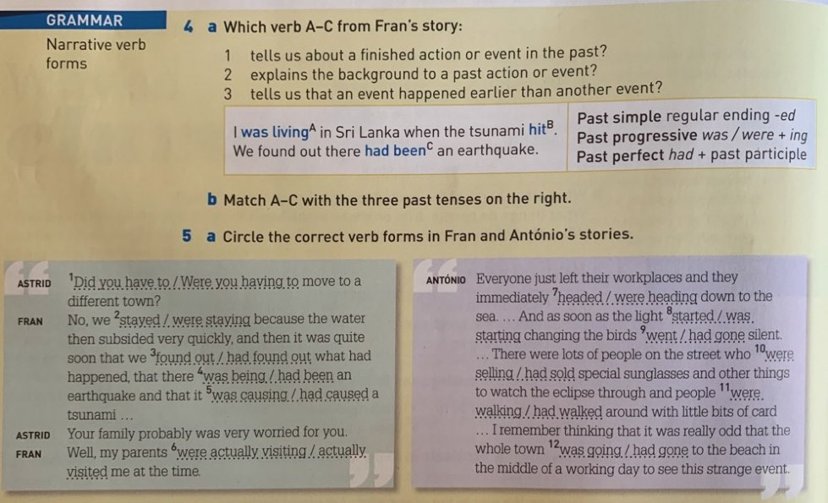

In addition, it also allows students to practise the vocabulary of that unit, which was ‘adverbs for telling stories’, such as ‘immediately / suddenly / slowly / amazingly’. Whereas if we look at the activity that teacher TM decided to delete, there was no application of these rules. Thus, according to her, it is of no use to cover that activity. She stated, “If I don’t see that it’s beneficial, I skip it”.
She further explained: “I delete . . . if there is no link and I do not feel that there is use of it [a part of the textbook], and it most probably won’t come in the exam, I just delete it”.
This finding is similar to that found in Lee & Bathmaker’s (2007) study which looked at how teachers of secondary level schools in Singapore use textbooks in class. They found that their teacher participants also deleted parts of the textbook which were not relevant to exams. In fact, they specifically stated that there was a general focus on the reading and writing parts of the textbook, whereas very little attention was given to the speaking and pronunciation parts. They concluded that “this might be due to the fact that the weighting of oral components in the examinations is far less than that of reading comprehension and writing” (Lee & Bathmaker, 2007, p. 361). In sum, it may be said that teachers’ pedagogical beliefs and whether the material is included in exams or otherwise might have an effect on how they use and adapt their textbooks within their lessons.

Furthermore, in her interview, teacher TM also stated that she tends to delete parts of the textbook that she feels are not related to the students. As a concrete example, in one of her lesson observations, she deleted the listening activity found in the following figure.

Figure 88. Listening transcript from English Unlimited Special Edition (Rea, Clementson, Tilbury & Hendra, 2017, p. 151-152)
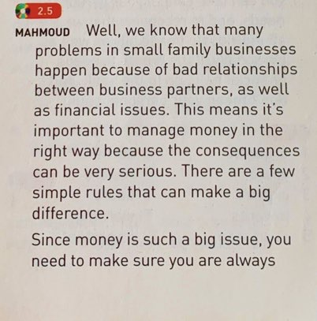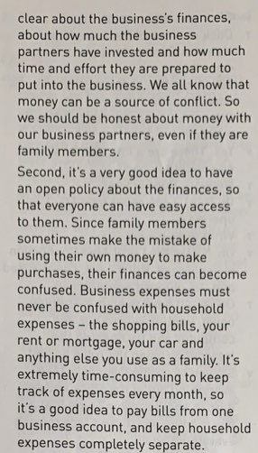

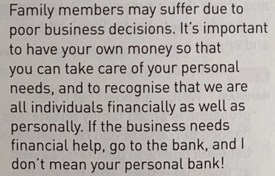

As can be seen from the transcript in Figure 88, this listening track is not a dialogue, which is what students are used to, it is basically a speaker giving advice on family businesses. According to teacher TM, this listening activity is “so business oriented”; thus, she decided to delete it. She further described this exercise, justifying her deletion of it, saying
“it’s so irrelevant to their context, talking about family businesses. It’s just hardcore business. Really hard . . . ideas that really are not related to them. It’s out of their context. So, they can’t contextualize”. Therefore, other than the fact that the content of the listening track is irrelevant, teacher TM also described it as being too difficult for the students to comprehend. In a similar scenario, Wette (2010) reported how a teacher participant also adapted an activity because the content was difficult; the teacher specifically stated: “the banking unit was quite heavy, the students were struggling” (p. 575). In this example, the teacher is also describing the content of an activity from the textbook as being too difficult for his students. However, instead of deleting the activity like teacher TM, Wette’s teacher replaced it with a game-type activity.

Moreover, another interesting instance of deletion that was noticed during the data collection of this study was in teacher TS’s lessons. In both lesson observations, it was observed that she deleted every speaking activity that she came upon in the textbook. When asked about this during her interview, she explained that:

I have a Master’s student, she has a certain project that she is right now implementing with my students and I’m just giving her this space to be able to implement her own project. That is why when I come to a speaking task I just leave it to her to cover because I know it is the focus of her study and she will do it better than I do it . . ., so that is the reason I am not doing the speaking in my class.

Therefore, during the students’ breaks, this researcher, who was doing a study on a certain approach to teaching speaking, came into teacher TS’s class and covered the speaking parts with the students.

As a concluding point, lesson observations revealed that teachers differed in the parts of the textbook that they deleted the most. For instance, it was noticed that teacher TD, TR and TA tend to delete speaking the most, all stating that they delete the speaking parts of the unit the most due to the time-consuming nature of these activities. Teacher TD added listening as also being a component of the textbook which she skips. On the other hand, teacher TR skips reading activities, while teacher TA skips the writing parts of the unit due to time constraints.

4.5.4. Replacing

The fourth and final adaptation technique is replacing. In the following, examples of replacements that happened during lessons will be discussed, and this part of the thesis will also be divided according to the reasons that the teachers gave for replacing.

4.5.4.1. Replacing due to certain pedagogical beliefs

Some teachers claimed they replace parts of the textbook due to certain pedagogical beliefs they hold:

Replacing due to certain pedagogical beliefs
Teacher TM
Teacher TR

Two of the teachers in this study (TM, TR) justified their replacement of some parts of the textbook in relation to specific pedagogical beliefs they hold. An example of replacing due to pedagogical beliefs is one found in teacher TM’s lessons. She reported during her interview that sometimes she would replace certain grammar rules with external online videos she emails to her students, which explain the rule in Arabic. This was usually applied to the grammar rules she believes are difficult for her students. According to her, these students are at a level that requires this; in addition, the videos that she uses are “really nice grammar videos . . . that are short, that are five to ten minutes in Arabic. They are really done in an excellent way . . . And the girls really like it”. She further explained her reasons for replacing the grammar in the textbook with these videos, saying:

they’re really fun and it helps them [the students] break down the idea behind the grammar. So, because they can’t get the concept, just having it in class… Because they take new lessons every day, new grammar every day. So, there’s no time to really absorb what they’re taking. So, this [the grammar videos], at least they can take it home and watch it as much as they can, and actually . . . understand what it really is, when it’s in their own language and it’s a fun way.

Similar to teacher TM, teacher TR also takes into account the fun factor in her lessons, thereby replacing some parts of the textbook to make the atmosphere of the classroom more interesting. She explains her pedagogical perspective towards implementing the fun component in her lessons, saying:

I replace the activities of the book with more interesting activities . . . I like there to be some kind of innovation and creativity in my class. I don’t like to use traditional activities . . . I think it is kind of boring.

Accordingly, in one of her lesson observations, teacher TR replaced the following activity with what she saw as a more fun way of practising the target language, adverbs of frequency.

Figure 89. Activity from English Unlimited Special Edition (Rea, Clementson, Tilbury & Hendra, 2017, p. 51)
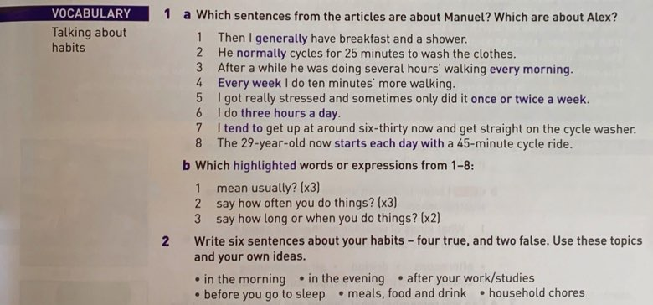

In her replacement activity, teacher TR put the adverbs of frequency on cards and distributed these cards to the students. She then asked them to create sentences about their daily routine using the words on these cards. According to her, “in the book was a very boring . . . activity . . . so my focus was to draw students’ attention to how to use the adverbs of frequency in the present simple, to talk about daily routine”.

To conclude this part, lesson observations and teacher interviews revealed that all four adaptation techniques were used in the classrooms of the ELI, with editing and deleting as the most common adaptation techniques. This is similar to Menakbu’s (2010) research where all adaptation techniques were used. With regards to Gok (2019), he reported that the most commonly used adaptation techniques in his study were “addition, omission and supplementation” (p. 176), whereas Lee & Bathmaker’s (2007) teachers reported deleting, editing and adding to their textbooks in order to meet their students’ needs. To sum up, many reasons were reported for the use of these adaptation techniques, the most common being level of students, time constraints, cultural reasons and pedagogical beliefs.

4.6. The extent to which teachers use the textbook

As can be seen from the descriptions above, the textbook plays a prominent role in the ELI and it was present in all the lessons observed for this study. However, this does not necessarily imply that it was used slavishly. In fact, as was seen and illustrated in the results, teachers in the ELI differed in their use of the textbook, and also in the parts that were adapted or otherwise. In the following, Table 8 presents a quantitative overview of the teachers’ use of the textbook.

Table 8. Teachers’ use of the textbook
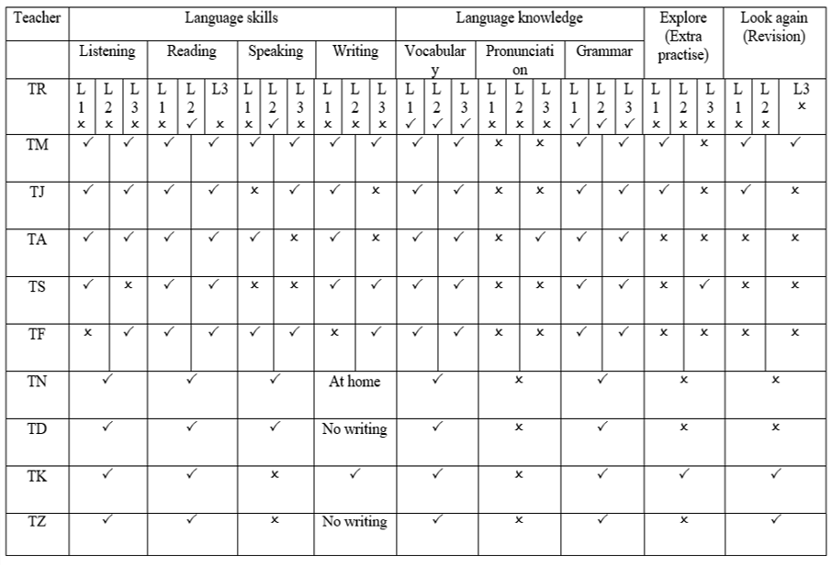

From Table 8 we notice that all the grammar and vocabulary sections of the textbook were covered by all 10 teachers in all their lesson observations. This was expected, given the fact that the ELI is an exam-oriented context, in which the main focus of these exams is on grammar and vocabulary. With regards to the rest of the parts, such as reading, writing, listening and speaking, the teachers differed in what they covered and in the adaptation techniques they used in covering these parts. In the next part of the chapter, then, I present some of the most important factors that were raised during interviews and observed in lessons to have an impact on teachers’ use of the textbook.

4.7. Most important factors that influenced teachers’ use and adaptation of the
textbook

It has been apparent from the results thus far that several factors which help account for the teachers’ textbook use have recurred, such as time constraints, examinations, students’ attitude and students’ proficiency level. In this part of the chapter, these factors will be discussed in more detail. Before proceeding, however, it is worth mentioning that this part of the data derives from the teachers’ answers to the following prompt card.

Figure 90. Prompt card used in teachers' interviews (constraining factors affecting use of textbook)
Which of these factors affect your use of the textbook the most?
Time constraints | Unified exams | Other workloads that the teacher is required to do in university (correcting papers, attending meetings, writing reports etc..) | Students’ proficiency level
Institutional constraints | Exams are set by a committee other than the teacher | Teacher has limited knowledge about certain parts of the textbook | Students’ attitude towards learning the English language

During the interviews, teachers were provided with this prompt card, which itemises potentially constraining factors. Teachers were then asked to choose the factors which they feel affect their use of the textbook the most.

4.7.1. Time pressures/constraints

Teachers | TA | TJ | TK | TR | TS | TD | TF | TZ | TM | TN
Time constraints | √ | √ | √ | √ | X | √ | √ | √ | √ | X

The one circumstance that seems to have the largest effect on teaching practises in the ELI is time constraints. According to the data, this time issue is an extremely influential factor when it comes to teachers’ use and adaptation of the textbook. These time pressures are unsurprising, given the demands of the ELI to cover one whole textbook, containing fourteen units, in a period of six to seven weeks only. It is important at this point to take a look at how much instructional time each unit of the textbook is intended to take by the textbook writers and compare it to the time the teachers actually have according to the pacing guide, which are shown in the figures below.
Figure 91. Part taken from English Unlimited Special Edition (Rea, Clementson, Tilbury & Hendra, 2017)
teacher's book
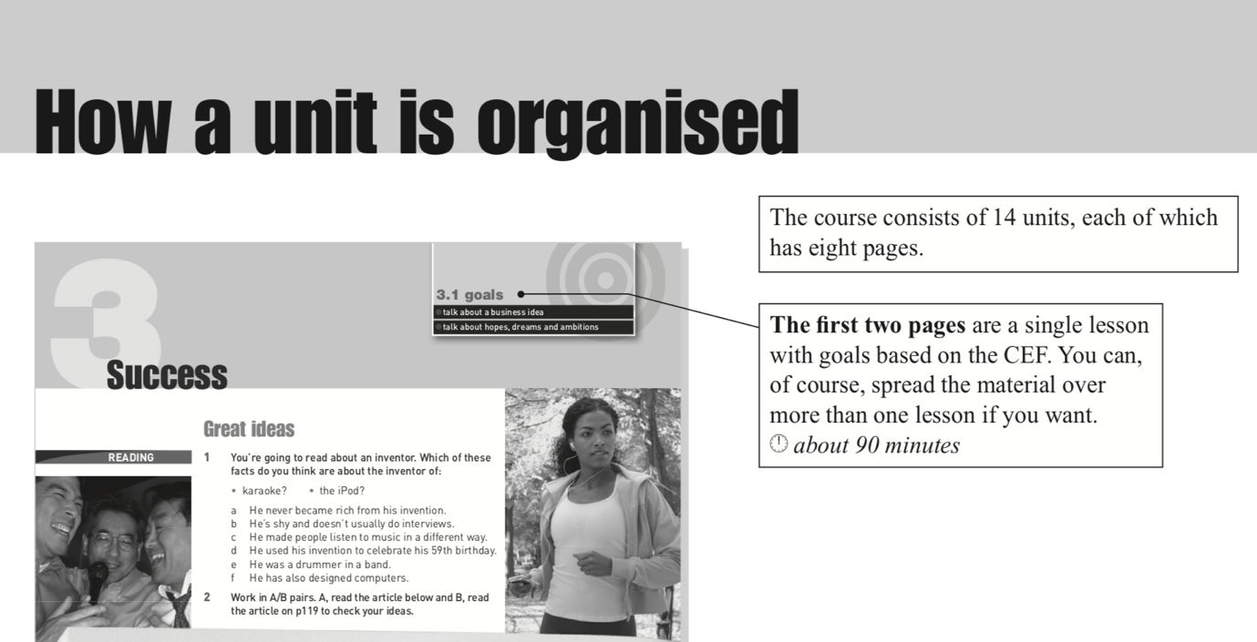
Figure 92. Part taken from the pacing guide in the ELI
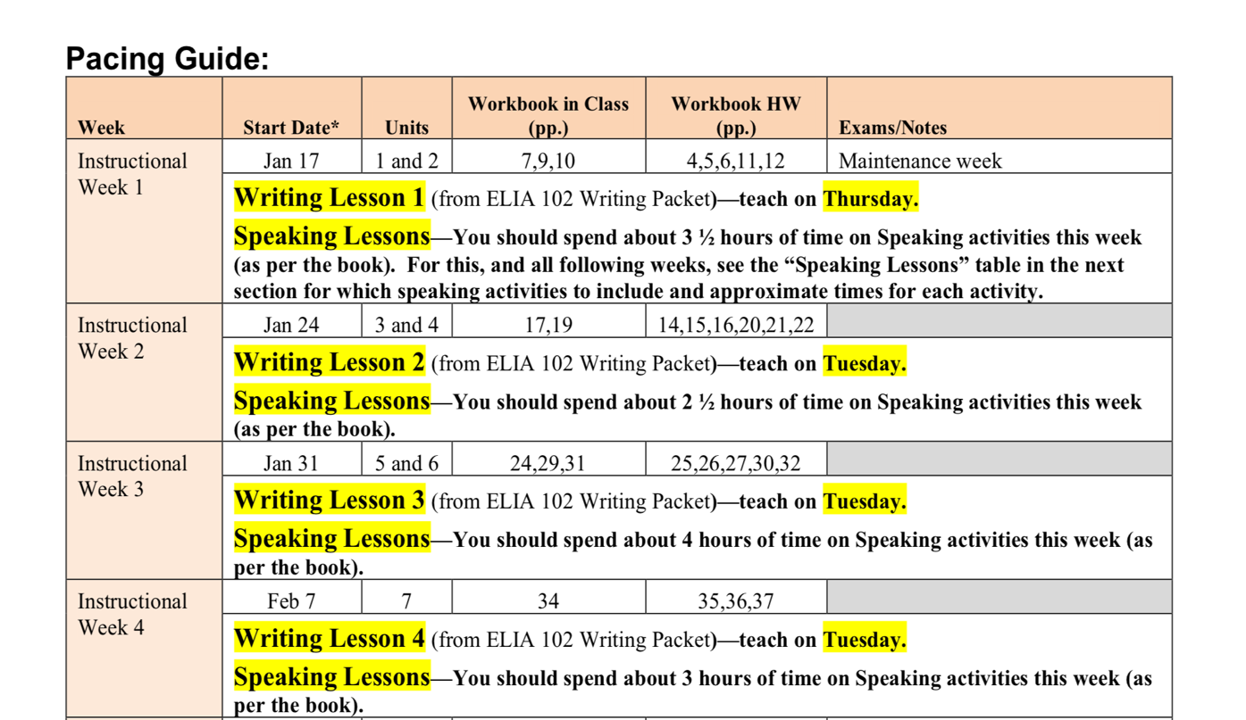

From Figure 91, we see that each two pages in a unit are considered a single lesson and are created with the intention of being covered in 90 minutes. Hence, the textbook writers’ vision is for teachers to be able to finish one whole unit in a matter of four days, where they cover two pages a day. In the ELI, however, each lecture takes from three to four hours. When looking at the pacing guide shown in figure 92 above, we see that in a matter of one week, teachers are expected to cover two units, with that teachers cover four pages a day. During the collection of the data, teachers constantly complained about the burden of time they work under, in fact, eight out of the ten teachers in this study (TA, TJ, TD, TR, TK, TM, TZ and TF) all reported that time is one of the most constraining factors on their teaching and on their use of the textbook. They explained how because of these time pressures, they are not able to focus on certain parts of the textbook that some students may need more help on. In addition, on many occasions they are not able to use supplementary material, due to this time constraint. Take Teacher TA’s thoughts on time pressure, for instance:

let me be honest with you, I don’t even think of using other things [external materials] because of what is going on in classes. Sometimes you are going under very huge big time pressure. You need to finish this before quiz one, finish that before quiz two. You find yourself sometimes just following [the book], unfortunately.

Furthermore, teacher TJ described time as being “the main enemy for this modular system”. As a matter of fact, time constraints affect her to the point that she consistently mentions this problem with time pressure to the administration of the ELI, and constantly writes about this issue in surveys that are distributed to the teachers, in the hope that it will change.

Unfortunately, at the time of the study, the modular system was still being applied in the ELI. It is important to note here that English lessons in the ELI are three and a half to four hours long, and this is the administration’s way of compensating for the fact that teachers must cover fourteen units in a matter of six to seven weeks. When looking at this time duration of lessons, it may technically be enough for teachers to finish teaching the textbook. To explain more, the textbook writers vision is to cover two pages per lesson (90 minutes), making it a total of six hours a week and one unit per week. With regards to the time the teachers in the ELI have, they are required to cover four pages per lesson (180-240 minutes), making it a total of 20 hours a week and two units per week. Therefore, technically speaking, teachers do have enough time to get through the materials. However, in reality, this timing is not suitable for either the teachers or the students because the lessons are too long for students to focus. As teacher TD mentioned, these long hours of teaching are exhausting for her and her students as well:
I have four to five hours of class time. I get tired, students get tired. They get unmotivated, I get unmotivated. Honestly, the last quarter of the semester, it is just screaming. I scream and they [the students] are quiet. It’s sad, but I don’t know what to do.

In the above quotation, teacher TD is describing the end of the module as being the most difficult phase of teaching. The reason for that is because during the end of the module, everyone is in a rush to try and finish the content of the textbook before the final exams. However, because it is the end of the term, students are usually drained and are not motivated or in good spirits. As a consequence, she feels she has to be strict with them and described how at the end of the semester she unfortunately has to yell at them in order to get them to work, and of course this is an unpleasant experience for her and the students, as well.

This point of view was also emphasized by teacher TR:

It is very difficult to do everything in the textbook in reality in the classroom with the students, because of the time. Even though our class is three hours but these three hours with the students’ level is a bit difficult.

Moreover, teacher TK also talked about time constraints as being one of the most limiting factors on the prompt card. She described how she cannot get through everything in the textbook because of this limitation in time. She stated that: “I do the most important ones [activities] or the ones that are related [to the exam]”. Additionally, teacher TM claimed that time is the most challenging factor that impacts her use of the textbook; she explicitly stated: “it [the textbook] is too much information for this short time”. Not only does she believe that the textbook contains too much information, but according to her, the textbook they are using is not designed for a modular system. She further explained: “it is designed for a semester”, for an institution that covers the textbook in a whole semester where they take their time with the content. However, because of the modular system in the ELI, this textbook is considered “too much information for students”.

With regards to teacher TZ, she also felt confined regarding what she does in class with her students because of these time limitations in the ELI:
sometimes I feel limited . . . and I want to do something extra with the students, but I know I can’t . . . Time limits because I know I have to cover these pages, because if I gave them something extra and for example I don’t give them page 49 and they go to the exam and the exam is from page 49, it is not fair.

Finally, teacher TF also shared her perspective on time-related issues for both teachers and students for reasons related to her and her students. Firstly, these time pressures affect her because she feels stripped of her creativity as a teacher: “So, honestly, we don't have much time to be creative here, because we have the big constraint of time. So, you have to follow everything in the pacing guide and at the same time motivate students”. Secondly, according to her, this reduction of creativity also has a negative impact on the students.

Creativity is directly related to motivation. When you reduce creativity, motivation might be reduced, and for example, sometimes you feel that you are running. As I told you from the beginning running against the clock can make students feel that you are giving them things in a very limited time. They might get tired and bored.

In sum, time constraints may be considered a main factor that influences textbook consumption, as it has been reported in studies similar to the current one. For example, limited time is concluded as “the most commonly cited reason for adapting materials” in Bolster’s (2015) research (p. 19). In fact, one of the teacher participants in her study stated that “the amount [of the textbook] to be covered in class is too much in the given time” (Bolster, 2015, p. 18). It is noteworthy that this specific teacher had a generally positive attitude towards the textbook used; however, he felt restricted due to time constrictions. Similarly, Wette (2010) reported that two of her teachers, Chris and Fran, were found to replace some activities in the textbook with shorter ones because of the time constraints they were under. Furthermore, Menkabu (2010) also echoed these results and concluded that time constraints was one of the three major influencing factors on how teachers in her study used their textbooks. Moreover, the teachers in Farooqui’s (2008) study “singled out” time constraints as being the principal reason for their adaptation of the textbook. In fact, one of the teachers stated that the textbook used requires time because it mostly utilizes communicative activities, and according to him “arranging group work, involving the students in communicative activities in the class and monitoring these activities require time” (p. 202). In addition, Gok’s (2019) research results echoed those stated above; 68.8% of his teacher participants reported that the teaching content cannot be covered in the time allotted. They claimed that “they feel confused about what to focus on in one lesson, as there is insufficient time to cover all the content” (p. 138).

4.7.2. Examinations

Teachers | TA | TJ | TK | TR | TS | TD | TF | TZ | TM | TN
Examinations | √ | X | √ | √ | X | √ | X | √ | √ | X

The second most influencing factor according to the teacher interview data is examinations. As in the present study, high-stakes examinations have been found to exert a major influence on teachers’ use of textbooks in other studies (Chandron, 2003; Lee & Bathmaker, 2007; Menkabu, 2010; Pelly & Allison, 2000). These examinations, as Hedge (2000) explained, can act as “gatekeepers to higher education or good employment prospects” (p. 26).

In the current study, teachers explained that the ELI is test-oriented, and the test writers’ biggest focus is on grammar and vocabulary. It has also been mentioned previously, but is worth reminding the reader, that grades are extremely important for students in this period, the prep year, because their acceptance in the major they wish to study depends solely on their GPA, and sometimes in specific majors English language grades are important as well. Therefore, one can see that exams are a salient issue in the ELI. Subsequently, this concentration on examinations affects teachers’ handling of the textbook as they are pushed to focus on grammar and vocabulary sections of the textbook. Teacher TM explains:

I have to be realistic . . . because our system is test oriented, and the biggest focus is on the grammar and the vocab . . . I need to help the students pass. So, I need to let them have the right focus. So, their focus is grammar and vocab.

Moreover, teacher TR also mirrored this view. In her interview, she admitted that she would like for her classes to be more communicative, but because of the focus of the exams, she feels restricted as to what she can do in class. She went on to explain how the administration of the ELI claims that taking a communicative approach is important and tells teachers it should be applied in class, however, in reality, that is not the case:

They [the administration] tell you that the ELI is encouraging teachers to move towards communicative based approaches, but in reality, we are not really motivated. We don’t have the time to do communicative activities, we are pushed to focus more on the grammar sections of the book, to focus more on the vocab.

Teacher TR explained here how the aim of the ELI is apparently to implement a more communicative approach in teaching English to its students, in order to enhance their English language skills. In reality, though, the exams are still more focused on grammar and vocabulary. Therefore, there is a contradiction between the supposed aspirations of the ELI on the one hand and the realities of the exam-driven environment on the other. In fact, teacher TR displayed her awareness of this contradiction, saying: “even when you read our policies and regulations it is one thing, and when you see the class it is something else. We know we are preparing the students for the exams and we have a very limited time to prepare them”.

Furthermore, in teacher TA’s interview, she showed awareness of what she calls “the wash back effect”. She stated quite bluntly:

usually you will see it in the classes. . ., you see the wash back effect . . . Teachers are focusing on exams, not just students. [During lessons, teachers keep on saying] ‘You see this in the exam, in the exam you see that’. Then you [as an observer] will see that they [the teachers] are teaching them [the students] for exams, not just to improve their proficiency and I admit I'm aware of this and I don't have any other choice. It's for their own benefit. I'm not talking about the benefit when it comes to English proficiency, I'm talking about their future. I don't want English to stop their future. Actually, I'm opening one door. If they do well in English, they pass the English level, they would actually have better feelings about English, and they might start learning English. But if they fail and fail and fail, you know what is the end.
From the above quotations, we notice that there is the use of the phrases “we are pushed” and “we are forced”, which hint that these teachers’ focus on certain parts of the textbook is something that they are required to do, regardless of how they actually feel about this way of teaching. This in turn affects them negatively and makes them feel helpless, as is clear from their responses. As Lee & Bathmaker (2007) have concluded, “certain assessment practices in schools can have a strong negative influence on teaching . . . Too much emphasis on texts and examinations can influence . . . attitudes towards the value of educational objectives” (p. 369).

Another important point related to examinations is the fact that the exams are unified and are created by an exam committee. Thus, teachers do not have a say in what will be included in their students’ exams. The data showed that this is an influencing factor on how teachers use the textbooks and on their attitude towards teaching in general. In the following, teacher TM summarizes what the teachers in this study feel regarding the examination procedures in the ELI:

Prep year is killing everything . . . Even killing the sense of responsibility. I don’t put [design] the tests. I don’t correct them. I don’t . . . review the students, what their mistakes are.

Teacher TM here is explaining how not being able to tailor the curriculum and the textbook to meet the needs of her students ‘kills’ the sense of responsibility that they have as teachers. This ultimately impacts their attitudes as teachers and hence impacts their textbook use.

Teacher TZ also spoke of this problem and explained how as teachers, they feel they cannot help their students properly prepare for their exams, because they themselves do not design these tests. In addition, students do not know what their mistakes are in the examinations because teachers “cannot give them feedback” (TZ). Moreover, teacher TD claimed that unified exams is the strongest constraining factor that she faces when teaching. She stated:

I never see students’ outcomes [the grades of the students] and I feel teaching the material not knowing the way in which the questions [exam questions] are formed at the end, it's offensive to me as teacher. It is a very uncomfortable environment for me to teach in, honestly.

Teacher TD is alluding to the fact that because there is a large number of students in the preparatory year, and because exams are unified, the scripts are corrected via automated computer scoring. Therefore, teachers do not know how their students did in the exams, and they do not know where their points were actually deducted, making it hard to know what to focus on with students. She further explains how her students always ask about the exams and how the questions will be formed; unfortunately, she cannot answer them. According to her, this is “a very unpleasant answer for me and even for the students”.

On the contrary, teacher TN and TS do not view unified exams as a problem; in fact, they talked about the advantages of these types of exams during their interviews. Teacher TN justified her positive view towards them by saying: “I don't mind [the unified exams] because we teach thousands of students, so if I follow individuality here, it will be catastrophe”. For her part, teacher TS explained that having a unified exam means all parts of the textbook are covered—the exam focuses on grammar, vocabulary, speaking, listening and writing. Hence, “unified exams . . . just brings everybody to the same point, I don’t have problems on that”.

4.7.3. Institutional constraints

Teachers | TA | TJ | TK | TR | TS | TD | TF | TZ | TM | TN
Institutional constraints | √ | X | X | X | √ | √ | X | √ | √ | X

Additionally, according to teachers’ interviews institutional constraints also have an influence on teachers’ teaching and use of the textbook. One of these institutional constraints concerns the modular system associated with the prep year. As described in the background section of this thesis, prep year students take other courses alongside the English language course during their first year; thus, their schedules are always full. In addition to that, during exam periods, students may have multiple exams on one day, and as a result, during examinations, students do not attend any of their English language classes. In fact, as stated previously, this has become a norm, where during exam periods, classes are cancelled. As a result, this absence of students affects the teaching of English, because while teachers have to finish the textbook in a short amount of time, they are forced to cancel classes because of the very small numbers attending. This issue creates a large problem for teachers, to the point that teacher TA describes these exams as “intruders”:

We always have the other subjects coming in and out. So, we always have them intruding into our . . . modular system. So, like this week we don't have any classes because of the exam week . . . I'm really tired
. . .it's affecting how we are teaching.

Furthermore, this modular system, where English carries on throughout the year but none of the students’ other subjects do, affects the students’ motivation and enthusiasm for learning, which in turn affects the teachers’ teaching. Students get fed up as their other subjects are over, but they have to keep on studying English. According to teacher TM, it is difficult to make students take the English course seriously, because of this modular system. She explained this point more clearly, saying: “it's so easy at this time of the year to lose them [the students], it is the end of the year and the other courses are almost finalizing and we’re still starting. So, it is so easy to lose them”. Additionally, she expressed dissatisfaction towards this modular system and the prep year, saying: “unfortunately, . . . I’m here with the prep year, who are all going in one direction like goats. Really, it’s killing creativity, it’s killing everything”. Here, she is describing the teachers in the ELI as a herd of goats walking in the same direction. She feels teachers are just being led by the pacing guide and by these rules and regulations without having a say in how the teaching is being done, “it’s [the teaching] just a process that we have to go through and I’m not happy I’m doing this”.

Another point that may also be discussed under institutional constraints is the fact that some classes are co-taught by two teachers. Hence, one teacher would teach three days of the week, while another teacher teaches the other two days. It is also important to note that these classes are not taught consecutively; teachers do not see their students every day, which may have an effect on the teachers and on the students, as well. Firstly, teachers will not have enough time to get to know their students properly; by the time they feel they are getting used to each other, it is already the end of the module. Another equally important point is that the two teachers co-teaching a class have their different ways of teaching, hence, students are being taught in a different way by a different teacher in every lesson.

Out of the teacher participants of this study, three of them (TD, TA, TM) were actually co-teaching their classes with another colleague. Teacher TD made reference to this point, explaining:

There is constant change of teachers, especially when there are two teachers teaching the same class. For example, I’m always assigned for two weeks in a class and then they change me with another teacher, and I feel this affects the students.

Furthermore, not only does this continual change of teachers have an impact on the students, it affects the teachers as well. Teacher TA, who also shares the teaching of a class with another colleague, stated that co-teaching a section affects her motivation to teach:

This module, because of the situation, because I’m not the main teacher, I am not doing as much as I used to do [with regards to teaching], to be honest. I am keeping it simple and I am still trying to make it interesting.

She explained how she is trying to make classes as interesting as possible, but still making sure it is ‘simple’. In other words, teacher TA tries to make her classes interesting and fun, but at the same time, she keeps in mind to keeps this fun factor as simple as possible; she is not going over the top with extra activities and fun. She justified this due to the fact that she is not teaching most of the time: “I don’t want to give them [the students] hopes and then gone with the wind”. What teacher TA means in this quotation is that because she is a co-teacher, she does not want her students to get used to a certain level of enthusiasm and fun in class, and then suddenly all this may change in the co-teacher’s lesson due to different teaching styles.

Moreover, teacher TM also talked about an unpleasant scenario that happened due to her having to teach a class with a co-teacher. She explained how during the beginning of the module, she was covering an activity with her students and spent a long time on it. As a result, “it took all of the class [time] and I wasn’t able to cover the [rest of the] unit and I was in trouble from the other teacher. Then after that she [her co-teacher] decided ok you do your units I do mine, and this was better for me”. From this quotation, it is clear that the two teachers were not in the same rhythm and did not cover the textbook at the same speed. Because of spending a long time on an exercise, teacher TM was forced to stop at a part of the unit that she was supposed to have finished teaching. By the next class, the co-teacher was surprised that what she had planned to cover for the lesson was not suitable, because of the delay in the previous lesson of teacher TM. However, these co-teachers were able to find a solution to this kind of problem and ended up dividing the different parts of the textbook between each other. Each teacher would be assigned a unit to cover and did not have to worry about where to stop or how much she had already covered during a lesson.

Furthermore, having to adhere to a pacing guide is also an institutional constraining factor that was mentioned by four of the teachers in this study (TD, TS, TA and TZ). These teachers gave their justifications for preferring not to adhere to a pacing guide due to the following reasons. First of all, as reported by teacher TD, the pacing guide disregards the fact that there are certain weeks of the module, such as exam weeks, where students do not attend. Regardless of the prevailing student circumstances, teachers are still expected to follow the pacing guide and to be able to finish the module on time. For this reason, in every module, teachers are obliged to confront the problem that “two or three weeks…are missing lessons” (TD).

Similarly, teacher TS also had a negative view towards the pacing guide, explaining that one aspect of the textbook that she does not enjoy is its lockstep nature, requiring that certain parts of the textbook should be taught on a particular day. She explained her reasons for preferring a ‘freer’ approach as follows:

The fact that the book is prescribed, we have to just swallow it . . . because I am against prescription . . . So, somebody has sat down and said this part of the book has to be covered on this particular day. I am against that because it doesn’t give me freedom on what to teach and on what days. Because sometimes you have to teach this part of grammar and you don’t feel like doing that on that particular day, you feel like if I bring a nice listening to those girls, they would be interested . . . so prescription is an element of this book I don’t like at all.

The desire for flexibility in managing the textbook is an issue which emerges from other textbook consumption studies, such as that by Bolster (2015), who conducted a study on how teachers adapt textbooks in their lessons. Comparable to teacher TS, Bolster reported one of her teacher participants also longed for greater flexibility in using the textbook and had specifically stated: “it’s being told when, what and how to teach using those materials that limit teachers in their practice” (Bolster, 2015, p. 19). Furthermore, teachers reported that having a pacing guide gives them a sense that they are restrained, and hence affects their way of teaching and of using the textbook. Teachers spoke of feeling kind of robotic” (TZ), and “we are controlled on what we do” (TA).

On the other hand, teacher TJ viewed the pacing guide positively. According to her, having a pacing guide is advantageous as it structures her lesson plans; she described it as follows:
“we get a very nice pacing guide. We are told exactly what we have to follow per week. So, it is very structured and it’s very nice to know because everything is organized and is planned. So, it is not confusing”.

4.7.4. Students’ attitude

Teachers | TA | TJ | TK | TR | TS | TD | TF | TZ | TM | TN
Students’ attitude | √ | X | X | √ | X | √ | X | √ | X | √

Students’ attitude is another constraining factor on teachers’ use and adaptation of textbooks which emerged from the data. Teachers TZ, TA, TR, TD and TN all described their students’ negative attitudes as having an impact on the way they teach, with teacher TZ holding the strongest opinion on this topic. Throughout her whole interview, she gave negative comments regarding her students and their attitudes. She talked about not only their attitudes in class, but their attitudes towards life in general. She described this as being a generation problem, speaking of an “on demand generation”, where students “demand things and they want things and they want it on their terms, when they want it and how they want it.”. Unfortunately, according to her, this problem affects their behaviour in school and at university, as well. She further explained this behavioural problem in university, saying that because of the fact that students are used to demanding and getting what they want from their families, they actually end up demanding the grades they want from their teachers. She went on to give an example of this, illustrating how during a speaking exam where she and her co-teacher were the examiners, one of the students asked the co-teacher to give her a grade of five on the speaking task, the top mark. Surprisingly, the co-teacher gave that student a five. Teacher TZ then explained how she was extremely frustrated about this and how she sent the student out of class and deducted the five marks that she had unfairly received; she described these students as very arrogant and very rude, that they saw themselves entitled to ask teachers for higher grades.

Teacher TA also echoed teacher TZ’s views regarding students’ general attitude in life. She described how when she waits in line for the lift, students do not respect her, or anyone else for that matter. The moment the door to the lift opens, students waiting in line enter without giving the chance for the people inside to exit. This may seem a simple example; however, according to her it is extremely upsetting, and indeed it seemed she was agitated when she was describing this incident. In fact, she talked more about it, saying:

There is a general attitude [amongst students] that's not really likable. I'm afraid sometimes when I come into the lift and then I see those students, I get outraged to be honest inside, and I'm afraid that it might affect maybe when I enter the class. Especially if I see similar attitudes in the class.

In addition to their rude attitude, teachers also reported how students have negative mindsets towards learning the English language. Teacher TZ talked about this issue more, describing how just before the writing exam, she scheduled a revision lesson in which she gave a short course on how to write paragraphs, and the importance of spelling. However, students did not bother coming to the class, because they do not really care. In addition, she also gave an example of how, in one of the units, she created a list of all the important vocabulary of that unit and distributed it to her students, as a way of helping them and making it easier for them to find the vocabulary all in one place. Nevertheless, she said that after this specific lesson she found these vocabulary papers on the floor of the classroom; students did not even bother taking them home. Incidents like this might explain the extremely negative attitude teacher TZ had towards the students.

Teacher TR also had a similar comment towards her students’ attitudes, in which she described students by saying: “they are just careless, they are not motivated”. Interestingly, though, teacher TR related this attitude problem to students’ repetition of the English courses, linking negative attitudes towards learning English especially with classes full of repeaters. For instance, in her class more than half of the students are repeaters. She described how difficult it is to teach such students:

I’m telling you it was hard to teach them, maybe teachers in the ELI need training courses about how to deal . . . with repeaters . . . Because we are not well trained. How to deal with . . . the ones who lack motivation, the ones who just don’t like the language and are not interested in learning the language.

She further stated:

We taught the good ones [the students] and we know how to teach them and how to facilitate the language learning . . . but those repeaters, especially repeaters for the second or the third time, they are much more difficult than teaching the regular students.

Additionally, teacher TD and TN also mentioned students’ attitudes as one of their constraining factors. Teacher TR stated that her students “don’t want to learn”, whereas, according to teacher TN, her students “feel bored or fed up”. She also explained how sometimes she would like to take an extra ten minutes after class to go over important points with her students; however, they do not stay after class.

Contrary to what has been reported above, teacher TJ had a very positive view towards her students’ attitudes. We therefore see there is a split in teachers’ views towards their students’ attitudes. However, it still seemed to pose a problem for some teachers and was therefore worthy of including.

Going back to teacher TJ, she stated that students’ views towards learning in general have changed from when she first started teaching. She explained that during the beginning of her teaching experience:

they [the students] were not interested at all . . . They were totally demotivated. I think that had a lot to do with their goals. Now, their goals are more important, they want to take jobs . . . Before that, they came to the university and they knew they were going to get married a month later, two months later, a year later. So, they were . . . just passing time. But now, no, they are more focused, they are more goal oriented . . . so I am seeing a change.

4.7.5. Students’ low proficiency level

Teachers | TA | TJ | TK | TR | TS | TD | TF | TZ | TM | TN
Students’ low proficiency level | √ | X | X | √ | X | X | X | √ | √ | X

As seen from the table above, four of the teachers in the ELI chose students’ low proficiency level in English as one of the constraining factors that face them in their teaching. It affects their use of the textbook and the way they adapt it. For example, in teacher TR’s interview, it was clear that she was very concerned with this issue and, in fact, had a specific class in mind which she had taught in the previous module when talking about this problem. She specifically used that class as an example of how language proficiency of students affects her teaching, stating:

I will give you an example . . . I felt it mostly when I taught level 4 last year . . . Level 4, the book was very advanced, and the students’ level was very weak, the terminology and vocab were very advanced. I didn’t know what to do and the students also didn’t understand it. So, the situation was a bit hard.

It was not only that the students’ level was low, but teacher TR reported that they were repeaters, as well. During this period that she is describing was her first time to teach repeaters, and she specifically stated that many of them were repeaters for the third time. Hence, she felt obliged and pressured to increase their chances of success in the exam. She further explained that this pressure she was under compelled her to use and adapt the textbook in certain ways, such as adding to the textbook to give her students a chance to practise more. She concluded this part of the interview by saying that if “next year I find the students outstanding, so I don’t have to do a lot of adaptation to the textbook”. She is therefore asserting that she adds components to the textbook because of her students’ low level in English. This point is interesting because it is the exact opposite of teacher TZ’s point of view. In her interview, teacher TZ claimed that she adds more to the textbook when her students are of a high proficiency level.

If the students are good, like the ones we get from the placement test, the ones which are actually level 4, they require more effort. So, I do get . . . extra materials, I give them extra stuff. For example, like they have adjectives for personality qualities [in the textbook], like I am patient, or I am generous, I am disciplined, I have faith in myself, etc. No, I add more adjectives.

It is clear, then, that teacher TR and teacher TZ have opposite points of view regarding adaptation of material in connection with the proficiency level of the students. Teacher TR adds to the textbook due to her students’ low level, whereas teacher TZ states if the students are of a high level, she would be more motivated to adapt and change the textbook around.

Furthermore, teacher participants in Wette’s (2010) study on textbook use stated that they resort to additional activities due to “learners’ difficulties” (p. 574). They reported that they tend to add activities to some exercises around grammar structures, vocabulary and sometimes to speaking activities as well. Thus, it may be concluded that the proficiency level of students is also a reason why some teachers add to their textbooks in other contexts.

Teacher TA also had her thoughts on students’ low proficiency level and claimed that it affects her teaching. In her interview, she described the prep year students, saying: “students come from school with a very very very very low level of English . . . To be honest, one year only English might help them. Only English, no other subjects”. Here, teacher TA is not only describing how low the students’ level is, but she is also declaring that she sees the solution to this problem might be for the students to study English for one whole year without any other subjects, and maybe then their level in the English language will improve. She then described how her way around this constraining factor is that she uses the L1 in class. Although she seemed embarrassed about this fact, she still admitted to using the L1:

I use Arabic for one reason, not . . . because they don't understand, but to make them comfortable. They have a big problem with English, to be honest . . . And when I enter classes . . . speaking English like I'm speaking now; it makes them so frustrated. And sometimes they come and complain about the teacher. She is perfect, she is amazing, but she doesn't speak Arabic. I know it's wrong, but what can I do? All the modern views . . . it's not me saying, researchers saying, using L1 it's good for their psychology. Sometimes I use L1. I try to minimize it, sometimes I try to control myself.

Moreover, another teacher who was also noticed to use Arabic during lesson observations is teacher TZ. She used the L1 very much within the exercises, as we have discussed previously. As an example, in the reading passages of her observed lesson, she read every sentence of each of the passages and explained it in Arabic. She stated during her interview that she uses the L1 in class due to her students’ low proficiency level, describing their level as very low to the extent that they are “beyond repair”.

To conclude, it is apparent from the data that the most constraining factors that ELI teachers face in their everyday teaching include time constraints, examinations, institutional constraints and students’ attitudes.

4.8. Results of the students’ opinions towards the textbook

As explained in the literature review, students’ views towards textbooks may be considered an understudied area (Edge & Garton, 2009; Garton & Graves, 2014; Harwood, 2014) in the field of ESL. Since students are one of the three main elements in the classroom, and are in fact, the “largest group of textbook users” (Harwood, 2014, p. 17), it seems only fair that their views towards the textbook they are using are taken into account. McGrath (2006) also echoes the importance of studying students’ views on textbooks, which according to him, will result in “a spur to professional self-development” (p. 171). The reason for that is because the awareness of students’ views will result in benefits to the teaching/learning environment. For instance, if there occurs a noticeable difference between teachers’ and students’ views towards textbooks, this may indicate unsuitability of the textbook or even unsuitability of the teachers’ use of the textbook. This, then, results in awareness that “might stimulate the kind of awareness-shift and self-questioning that leads to attitude change and ultimately self-directed professional development” (McGrath, 2006, p. 178). In other words, the study of students’ views may lead to modifications in teaching practises. Therefore, a small part in this research is dedicated to students’ views towards the textbook English Unlimited Special Edition.

4.8.1. Students’ educational background

In this section, the educational background of the students’ will be presented, as it might have a connection to the way they view their textbook. As explained previously, there are two types of schools in Saudi Arabia, state schools and private schools; thus, students were asked about their previous education and whether they attended state schools, private schools or maybe even both types of schools. According to the results of the questionnaire, as demonstrated in Table 9 a majority of the students attended state schools, where they were only introduced to the English language in their seventh grade.

Table 9. Type of schooling students received before university
Type of school | Number of students | Percentage of students
State school | 94 | 81.03%
Private school | 12 | 10.34%
Both | 10 | 8.62%

In addition to their prior education, students were also asked whether they have received any type of English tutoring, or if they have ever attended any English courses outside school, as these would both have resulted in additional practise in and contact with the English language.

Table 10. English tutoring students received
English language tutoring | Number of students | Percentage of students
Yes | 42 | 36.21%
No | 74 | 63.79%

Table 11. English courses students attended
English courses attended | Number of students | Percentage of students
Yes | 28 | 24.14%
No | 87 | 75%

The last question asked in this part of the questionnaire was for the students to assess their level of English.

Table 12. Students’ level of English
Level of English | Number of students | Percentage of students
Excellent | 4 | 3.45%
Very good | 34 | 29.31%
Good | 59 | 50.86%
Weak | 18 | 15.52%

As is clear from the above tables, the students’ relationship with the English language might seem shaky. Firstly, more than half of the students 81% attended state schools, where they did not receive English instruction until grade seven. Secondly, with regards to any English tutoring or private English courses they have undertaken, a majority (64% and 75% respectively) had not experienced either tutoring or private courses. This also emphasizes the fact that their contact with the English language is quite low. Finally, regarding their level of English and how they evaluate themselves, only 3% of the students rated their level as excellent, with the majority of the students 51% rating their level as good. Hence, it seems that as the teachers have described in their interviews, students may have a problem with low proficiency levels in English, which could have affected their use of the textbook.

4.8.2. Students’ opinions on different aspects of the textbook

Students’ opinions on certain aspects of the textbook were also explored. For instance, it seemed important that I ask students about how accessible the textbook is. The reason for this is because, in the department I teach in, there sometimes are cases where the textbooks that are chosen for courses are not always available. Students in such cases end up photocopying or using PDF files to get access to the textbook. Therefore, it seemed that this specific detail of how accessible the textbook actually is could be important as it might have an impact on students’ views towards the textbook.

Table 13. Accessibility of the textbook for students
How easy it was to find the textbook | Number of students | Percentage of students
Very easy | 26 | 22.41%
Easy | 63 | 54.31%
Difficult | 24 | 20.69%
Very difficult | 3 | 2.59%

From Table 13, it may be concluded that most students did not have problems in finding the textbook, although a considerable minority 23.28% reported difficulties. In addition to the accessibility of the textbook, students were also asked about their thoughts on the appropriateness of the level of the textbook, and their thoughts on the topics and themes used in the textbook.

Table 14. Appropriateness of the textbook for the students
Appropriateness of the level of textbook | Number of students | Percentage of students
Exactly the right level- Not too easy, not too difficult | 45 | 38.79%
Approximately the right level- Not perfect more or less appropriate | 52 | 44.83%
Not the right level | 17 | 14.66%

With regards to the appropriateness of the level of the textbook for the students, we see that 38.79% of them feel that the textbook is the right level, and almost half, 44.83%, view the textbook level as appropriate to their level. With regards to the last column in the table, 14.66% of the students reported that the textbook level is not suitable for them. This is interesting because as we have seen elsewhere in the study, most of the teachers claimed that the textbook is not the right level for their students and hence resort to adaptation of parts of the textbook. Therefore, we see that there is a contrast between what the teachers believe about the suitability of the level of the textbook for the students, and what the students actually believe
In the following table are the results of how motivating the themes in the textbook are in the students’ learning.

Table 15. How motivating the topics and themes are
How motivating and interesting the topics and themes of the textbook are | Number of students | Percentage of students
They motivate and interest me a lot | 9 | 7.76%
They motivate and interest me to some extent | 69 | 59.48%
They don’t motivate or interest me at all | 38 | 32.76%

From the table it is clear that more than half of the students 59.48% see the topics and themes in the textbook as motivating and interesting to some extent, whereas 32.76% students claim that they are not motivating, and only 7.76% believe that the topics and themes are motivating. So although a majority of students claimed the textbook was stimulating to some extent, the number of students who found the textbook content unappealing is concerning.

Regarding the grammar in the textbook, this was also an area that students were asked about, due to the fact that it was something the teachers referred to very much. As has been seen in the context section 1.2, the ELI is grammar oriented and the focus of the exams is also on grammar; thus, in the questionnaire, students were asked to evaluate the appropriateness of the amount of grammar content in the textbook and their thoughts regarding the actual presentation of these grammar rules.

Table 16. Amount of grammar in textbook
Appropriateness of the amount of grammar in the textbook | Number of students | Percentage of students
Strongly agree | 14 | 12.07%
Agree | 62 | 53.45%
Disagree | 32 | 27.59%
Strongly disagree | 5 | 4.31%

The results seen in Table 16 are interesting because there seems to be quite a contrast between teachers’ views on the grammar of the textbook and the students’ views on the grammar. About half of the students 53.45% believe that the amount of grammar in the textbook is suitable. As we have seen from the teachers’ results, there were many instances in which the teachers added to the grammar in the textbook. Hence, this may be a reason why students feel they are having enough grammar practise.

Furthermore, similar to prompt card #2 that the teachers were given, students were also asked to choose a metaphor that they feel best describes the textbook English Unlimited Special Edition. In the following table is a summary of their answers, which will then be compared with the teachers’ responses.

Table 17. Metaphors chosen by students
Metaphor | Number of students | Percentage of students
Headache | 66 | 56.90%
Heavy stone | 53 | 45.69%
Nightmare | 39 | 33.62%
Straitjacket | 38 | 32.76%
Guideline | 31 | 26.72%
Roadblock | 31 | 26.72%
Map | 23 | 19.83%
Sleeping pills | 20 | 17.24%
Toxic | 17 | 14.66%
Water | 17 | 14.66%
Blind man’s stick | 13 | 11.21%
Daily bread | 12 | 10.34%
Rubbish bin | 11 | 9.48%
Dark devil | 9 | 7.76%
Compass | 8 | 6.90%
Belt | 6 | 5.17%
Petrol | 4 | 3.45%
Cooking oil | 3 | 2.59%

Figure 93. Percentage of metaphors chosen by students
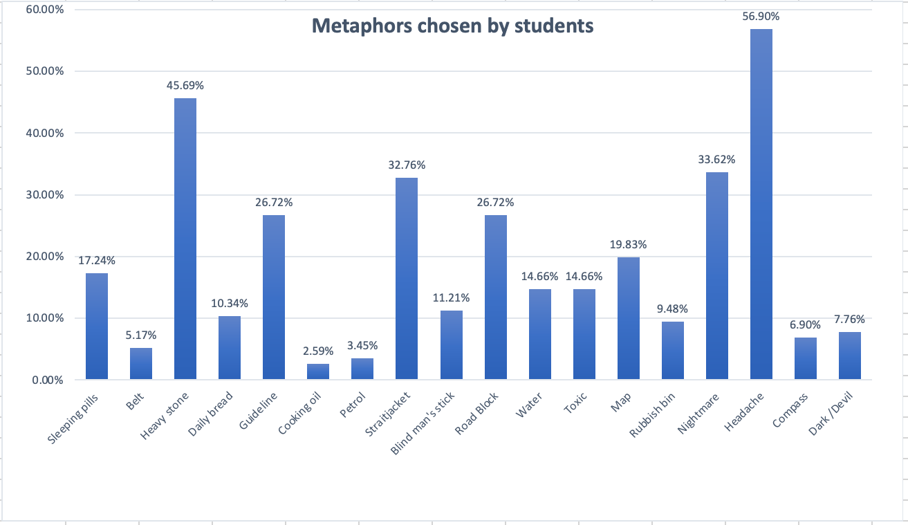

As seen from the above graph, the two most chosen metaphors by the students are “headache” 57% and “heavy stone” 46%, which both imply negative feelings towards the textbook. With regards to the teachers’ choices of metaphors, these are summarized in Table 18.
Table 18. Metaphors chosen by teachers
Metaphor | Chosen by | # of teachers
Sleeping pills | X | 0
Belt | X | 0
Heavy stone | TK | 1
Daily bread | TA – TF | 2
Guideline | TD – TR – TS – TJ – TA TZ – TN | 7
Cooking oil | TF | 1
Petrol | TS – TF – TN | 3
Straitjacket | X | 0
Blind man’s stick | TS – TF | 2
Road - block | TM – TZ | 2
Water | TJ – TF | 2
Toxic | X | 0
Map | TR – TS – TJ – TA – TZ TF – TN | 7
Rubbish bin | TM | 1
Nightmare | TD | 1
Headache | TD – TM | 2
Compass | TR – TS – TJ – TA – TF – TN | 6
Dark devil | X | 0

Regardless of the difference of the numbers of students and the number of teachers, there seems to be a contrast between their attitudes towards the textbook. Although there are some negative responses from the teachers, there seems to be a general acknowledgment of the importance of the textbook. From Table 18, it is clear that most of the teachers’ responses are associated with positive metaphors, such as map, guideline, and compass. Whereas when looking at the students’ responses, most were negative; heavy stone and headache were the most chosen metaphors. (A graph showing both the teachers and students responses for comparison can be found in Figure 94 below.) This finding is analogous with that found in McGrath’s (2006) study, where the students’ responses covered a wider range of negative responses and the teachers’ responses were “predominantly positive” (p. 178).

Figure 94. Teachers’ and student’s metaphors for describing the textbook
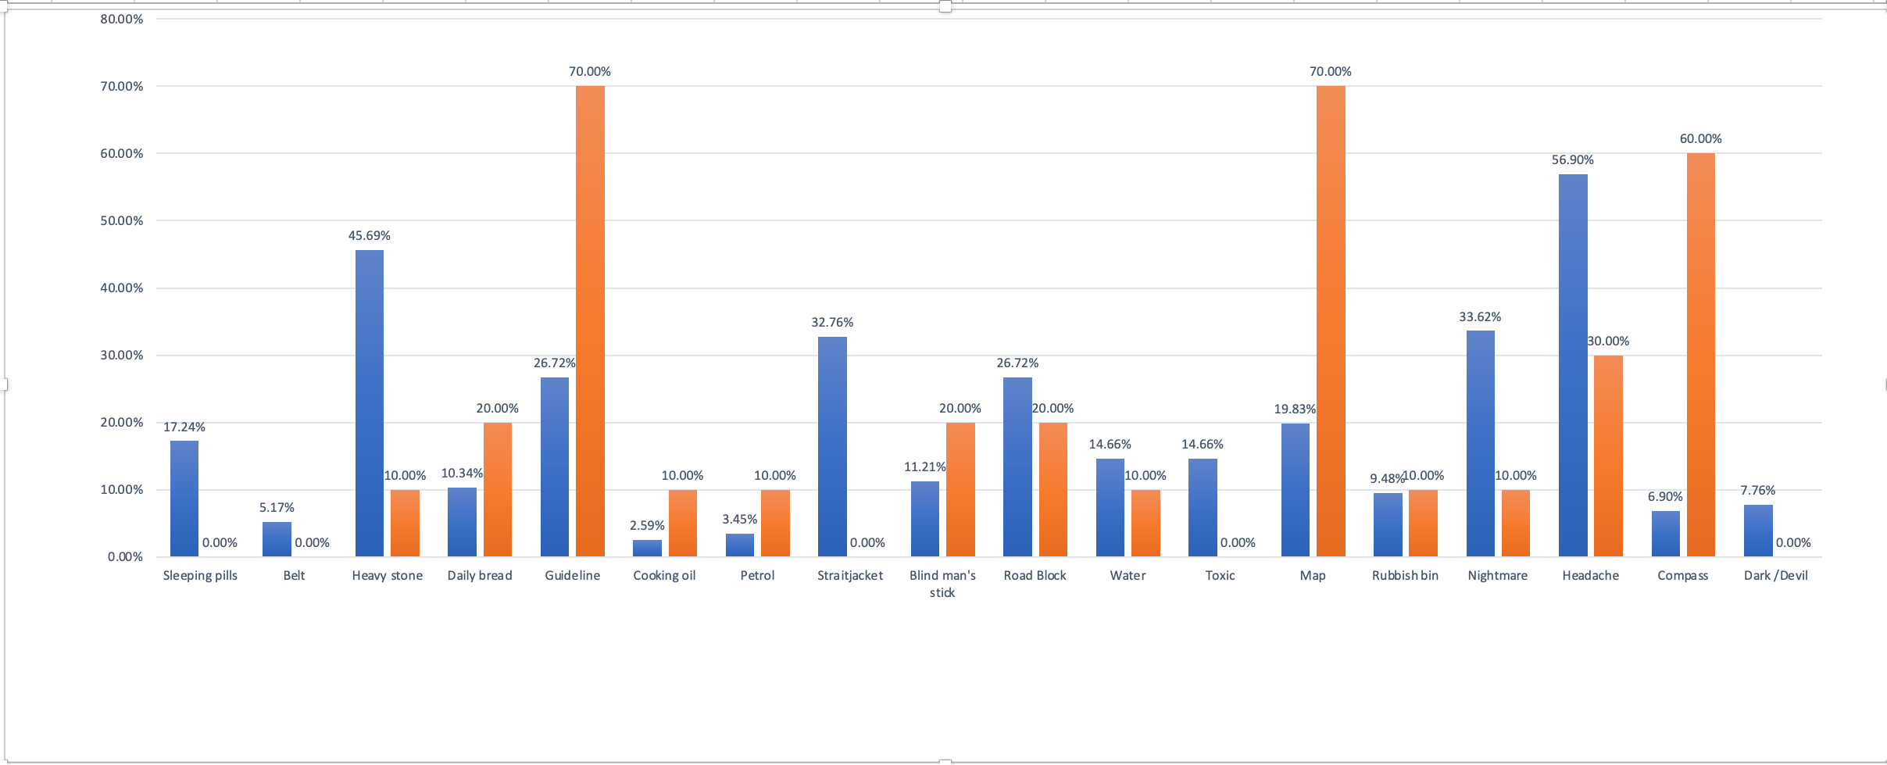
Students’ responses Teachers’ responses

4.9. Discussion of the results

In this part of the thesis, the most important/main findings of this research will be discussed in relation to the literature and in relation to the research questions. The lesson observations conducted in the ELI revealed that the textbook English Unlimited Special Edition plays a prominent role in the classroom. This, of course, might be due to the fact that it is a prescribed curriculum that must be used in classes conducted in the ELI. Thus, due to its importance, the textbook has been given many roles/plays many roles in this context, such as a reference, a guideline, a plan, a time saver and an aid for exam preparation. In the following, each of these roles will be discussed separately.

4.9.1. The textbook as a reference

The teacher interviews revealed some interesting comments that indicate how important the textbook is. For example, teacher TN regards the textbook as a source of information for her as a teacher, which she turns to in her lessons. She also emphasized the importance of this role for the students, where the textbook is a secure stable point of reference for them in the language classroom. She specifically described the textbook as: “a solid reference . . . For me as a teacher and for the students themselves. I can't let them just sway in the air, nowhere to stand, not knowing what to do . . . They need something to lean on”. This positive influence of textbooks being references for students and being advantageous for students in other ways (e.g, gives students structure and consistency, helps to routinize the classroom, gives them feelings of autonomy by being able to track their progress) is reported in the literature by many researchers (e.g., Ahmadi & Derakhshan, 2016; Canniveng & Martinez, 2003; Crawford, 2002; Hutchinson & Torres, 1994; Maley, 2011; Masuhara & Tomlinson, 2008; O’Neil, 1982; Richards, 1993; Swales, 1980).

Moreover, teacher TS echoed this view and used the same description to describe the textbook as that of teacher TN: “reference”. She stated that “using the textbook is a must for all teachers, we have to have a reference”. In fact, according to her, teaching without a textbook is “difficult”. She then further explained this role, describing the textbook as a “springboard” for the teacher where it provides the content of a lesson. She believes that the topics of the lesson should be taken from the textbook, then the teacher can adapt these topics according to his/her students’ individual needs. Pulverness (2013) discusses this point of view, reporting that teachers sometimes use “topics from the coursebook units as springboards for lessons. . .” (p. 406). This view is also similar to that of Cabrera (2014), who used the same word, ‘springboard,’ to describe the role of textbooks. Cabrera stated that textbooks should be used in a “flexible” way, in which teachers use it as “a point of departure or a kind of springboard” (p. 276). He exemplifies this view further, describing the textbook as “offering teachers…a sound reference map that can be exploited in a wide range of ways” (p. 268).
Furthermore, this role of the textbook as a reference and of having a facilitating and supporting role has also been reported by the teachers in Bosompem’s (2014) study, which aimed to look at materials adaptation and teachers’ attitudes towards these materials in Ghana. Four of the teachers in this study stated that textbooks are “very helpful”, “absolutely necessary for a good lesson”, “help the teacher to teach effectively” and “makes teaching less difficult” (p. 109). These views are, in fact, similar to the views of many researchers in the literature, who advocate for using textbooks according to one’s own individual context, by making modifications accordingly. Hence, textbooks are viewed as resources rather than courses (Bell & Gower, 2011; Freebairn, 2000; Knecht & Najvarova, 2010; Lee & Bathmaker, 2007; Richards, 1993). In sum, Freebairn (2000) asserts that “the course book is a resource. The teacher has always been the element in bringing about learning in the classroom” (p. 3). Thus, the teacher is seen as the manager of the classroom and the director of what actually happens within the lesson, which is analogous with what teacher TS stated in her interview.

4.9.2. The textbook as a guideline

In addition to being an important headspring of information and having the role of a reference, the textbook provides teachers with a plan to follow within their classrooms, for it contributes to the organization of a lesson acting as a guide/guideline. According to teacher TR, “it [the textbook] is good, it gives me like guidelines about what to do”. She further elaborated that a textbook is similar to:

A roadmap that you know what to cover in each class. You can modify . . ., delete and replace and do all the modifications you think are appropriate
. . . it gives you some kind of guidance about what you do with the students
. . . to feel that you are guided.

In this quotation, teacher TR is stressing the point that the textbook acts as a guide for her in her lessons. This is similar to what Menkabu (2010) reported about one of her teacher participants describing the textbook as a guide because it helps her manage teaching.
Additionally, in her research on material use and adaptation, Bolster (2015) reported that most of the teachers in her study acknowledged the guidance that their textbooks offer. Hutchinson & Torres (1994) also reported similar findings in their research, where “teachers see managing their lessons as their greatest need. Most of their responses centre around the facilitating role of the textbook: it . . . gives direction to lessons, guides discussion” (p. 318). Moreover, according to Guerettaz & Johnston (2013) “the first and most straightforward role of materials in the classroom . . . was that of organizer of planned content” (p. 784). In addition, a final study to refer to is that of Miranda & Del Campo (2016), which looked into the role of textbooks in a teacher training program. Comparable with the previous studies, they also described that “the material was beneficial for both professors and students because it provided them a guide precisely at the moment of teaching” (p. 320).

Furthermore, teacher TF also explained that the textbook provides her with organization and direction, which are important factors that she likes to be present in her lessons. Similarly, Hutchinson & Torres (1994) reported in their study that 74% of teachers said they used textbooks for reasons connected with classroom management, such as guiding lessons and organizing teaching (p. 318). In addition, according to Guerrettaz & Johnston’s (2013) research, the textbook plays an organizational role in the classroom, leading them to conclude that “textbooks are a . . . powerful presence, being used . . . as organizers of curriculum and classroom interaction” (p. 792). Teacher TS also asserted that the textbook is important for her in the classroom because it serves as an outline, a plan for her lessons. She stated:

As teachers, a textbook would be a plan for you to follow, that is very important, you have to have a plan. But if you don’t have a textbook, you don’t have a plan.

It is, therefore, clear from her statement that the textbook plays a dominant role in her classroom, for she considers it as a plan for her lessons. Hutchinson & Torres (1994) echo this point of view, stating that “learners see the textbook as a framework or guide that helps them to organize their learning both inside and outside the classroom” (p. 318).
Thus, according to these teachers that we have seen in different contexts of different studies, the textbook is an important object in the English language classroom, because it provides them with support and helps keep their lessons structured. This is precisely what Hutchinson & Torres (1994) reported in their study, saying “textbooks . . . are the most convenient means of providing the structure that the teaching learning system . . . requires” (p. 317).

4.9.3. The textbook as a time-saver

It is generally known that teachers have an overabundance of responsibilities other than preparing for their lessons. These duties include correcting exams, correcting homework, creating activities for students, and in the context of the ELI specifically, teachers are also asked to plan extra-curricular activities and extra revision lessons for their students. Hence the textbook plays a major role in allowing them to be able to perform these responsibilities. It is important to note, however, that as much as this beneficial role of textbooks is important for teachers, it is crucial that the textbooks be of a certain quality. This point was highlighted in the literature; as Harwood (2005) notes, "textbooks can save teachers work, but only if the materials are of a high standard" (p. 157).

In this study, teacher TN discussed this time saving element that textbooks provide, stating “the coursebook helps me not to miss anything out, because I am fully loaded [has a full schedule] the textbook helps me”. She explained how she is a member of the academic accreditation committee in the ELI; hence, she has another responsibility in addition to her teaching schedule. She also explained how she is very busy and focused on these different responsibilities to the extent that she forgets about staff meetings most of the time. Therefore, the textbook plays a major role in her specific case, by offering her content that she can use in her lessons and saving her time. Similar to teacher TN’s comment, a teacher in Bosompem’s (2014) study also reported “it is tedious and time consuming for me to prepare new sets of materials for each lesson I teach” (p. 109). In fact, this finding is similar to that which emerges from a number of studies; for example, tutors in Bolster’s (2015) study felt that using published materials “saved preparation time” (p.18). In addition, two of the teachers in Hutchinson & Torres’ (1993) study stated that the textbook enables them to save time, due to the fact that they had heavy workloads. Hutchinson & Torres further explained this point, describing how “teachers were not spending their time scouring for materials . . . But were free to concentrate on planning the lessons . . . this resulted in better planned lessons, a more creative methodology and more useful materials adaptation and supplementation” (p. 323). Furthermore, when evaluating the textbook used in their study, Miranda & Del Campo (2016) found that it “provided practical benefits to the teachers in terms of saving time” (p. 320). Therefore, in general, having a textbook saves teachers’ preparation time, and hence they can focus on adapting the materials to suit their learners. (Bolster, 2015; McGrath, 2013; Miranda & Del Campo, 2016; Richards, 1993).

4.9.4. The textbook as a helpful aid in preparing for exams

As has been seen from the results, there are certain institutional characteristics in the ELI, which give even more prominence to the textbook; for example, exams in the ELI are unified. That is, exam committees are responsible for creating all the exams in the ELI, as well as for setting a time and date for them. Therefore, because teachers are not allowed to create their own exams and do not know the content of the exams, textbooks are a helpful aid in this matter, because of the fact that the test designers base the exams on the textbook. As teacher TR noted, “in my institution the exam depends on the textbook, so it [the textbook] helps me to know what should be done in my class, what I have to cover”. This point was also noted by teacher TF: “in reality we need to abide by our textbook because the exam . . . is based on the textbook. On things that the students have learnt.”

In sum, as seen from the discussion of the different roles given above, it is clear that the textbook plays an important role for the teachers in the ELI. To finalize the discussion around this point about textbook roles, it is worth mentioning that there was some textbook reification noticed amongst two of the teachers (TA, TJ) in this study, which can also affirm the importance of the textbook in teachers’ eyes. For instance, in teacher TA’s interview there was obvious textbook reification (see section 2.3.4. for definition of reification). She explained:

textbooks are made by people who have long years of experience. Some textbooks are really good, really nice . . . there are other people who are experts in designing materials. They know what's right and what's wrong, so I need to benefit from their experience.

Here, teacher TA is stressing the fact that the textbook is published by experts who know what they are doing, as if this in itself makes it immune to mistakes or any gaps that need to be filled. Likewise, teacher TJ’s views can also be linked with the concept of textbook reification; in her interview she stated that she avoids deleting any part of the textbook because it has been designed by native English speakers. This attitude of associating globally published textbooks with qualities of excellence and soundness was also evident in textbook consumption studies by Forman (2014) and Zacharias (2005). The English language teachers in these two studies made it clear that they sometimes avoid adaptation because of the fact that textbooks were published by native English speakers. As an example, one of the teacher participants in Forman’s (2014) study stated that she limits her adapting of the textbook, because “it is written by native speakers of English with information from their own country” (p. 79). Additionally, a second teacher from this same study who adhered carefully to the textbook stated that “it [the textbook] has been written and trialled by the native speaker, so we just follow what it says in the text” (p. 84). Comparably, a teacher in Gok’s (2019) textbook consumption study also reported that he adheres quite closely to the textbook “because it has been designed by experts” (p. 176). Hence, these beliefs that some non-native English teachers hold indicate the important role that textbooks have to play in their classrooms and how these “texts appear above criticism” (Luke, De Castell & Luke, 1989, p. 113).

4.10. Types of adaptations teachers in the ELI made

Lesson observations and teacher interviews revealed that all four adaptation techniques were used in the classrooms of the ELI, with editing and deleting as the most commonly used adaptation techniques. This is similar to Menkabu’s (2010) research where all adaptation techniques were used. With regards to Gok (2019), he reported that the most commonly used adaptation techniques in his study were “addition, omission and supplementation” (p. 176). Lee & Bathmaker’s (2007) teachers reported deleting, editing and adding to their textbooks in order to meet their students’ needs.

Regardless of the fact that the teachers in this study at times used the same adaptation techniques, they gave different reasons for using them. For instance, one of the reasons that was apparent in using most of the adaptation techniques is students’ low level in English. Take teacher TZ’s deletion of all the speaking activities during her lessons as an example. She stated that she deletes the speaking parts of the textbook because she is certain her students will not speak, due to their lack of proficiency in the English language. For similar reasons, perceptions of students’ low English proficiency coupled with their negative attitudes towards English, teacher TZ was observed to have deleted the reading comprehension questions during her lesson, because according to her “students don’t know what they’re doing”. Similar to teacher TZ, one of the teachers in Menkabu’s (2010) study stated that she deletes speaking activities because students do not like these activities and are not willing to speak. In a similar manner, teacher participants in Farooqui’s (2008) study complained of the students’ low proficiency level and that it interferes with their participation in speaking activities. It is worth mentioning here that the teachers in Farooqui’s study related the students’ low proficiency level of English to the primary education system in Bangladesh, which is the context of that specific study. They explained that primary education in Bangladesh strongly emphasizes “memorization, imitation and repetitive practice” in the teaching/learning of the English language (p. 204). Therefore, students reach secondary level and they have become used to memorizing the language in order to learn it; in fact when they reach this level, “they had fully developed and normatively accepted the habit of rote learning and memorization” (p. 204). Both teacher TD and TA in the present study described the Saudi education system in similar critical terms. Teacher TD criticized the way the English language is taught in Saudi middle and high schools, in which “the grammar translation method is the dominant method” of teaching. Teacher TA, likewise, stated in her interview that she and her teacher colleagues usually complain “about the . . . education system” in Saudi Arabia, where students are encouraged to memorize the language. She explained that most of her teacher colleagues including herself believe this is the primary reason why students reach university level with low English proficiency. Therefore, because of this gap in proficiency levels, teachers in the ELI adapt their textbook to better suit their students’ levels.

Furthermore, teacher TJ reported in her interview that her adaptation of the textbook depends on her students’ level, so if her students are of a somewhat higher level, she would challenge them with extra activities, whereas if the students are lower in level, she would edit the activity accordingly. Gok (2019) reported an analogous point to that of teacher TJ, where one of his teachers stated that she felt it necessary to make changes to the textbook depending on the students’ level. She reported that she had used the same textbook with two different sections containing different level students. According to her, “with the better group, this book worked very well, but I sometimes had to supplement it, so that it became more challenging. With the lower-level students . . . I had to simplify some parts” (p. 132). Additionally, teacher TK described the textbook as “too much” which, according to her, makes it difficult for the students. This is comparable to what has been reported in Bolster’s (2015) study, in which teachers stated that the textbook they were using did not correspond with the level of their students. Additionally, a teacher in Gok’s (2019) study also had the same comment regarding the suitability of the textbook that the teachers were using. He stated, “I think the content is suitable, but the structures to focus on in each unit can be revised a little bit more, because students find them too . . . complicated” (p. 135).

Moreover, as discussed previously in section 4.7.5, this low proficiency level of students leads to a gap in the students’ level and what is called “a level four phenomena”. In his study, Gok (2019) also reported a similar situation as that of the level four phenomena in the ELI. His teacher participants asserted that they suffer from not having enough time to cover the content of their textbooks, which in turn affects the students’ practise of grammar. Thus, according to them, “as a result [of having inadequate grammar practice] some students fail to learn them [the target grammar points] before moving on to the next topic” (p. 138). In sum, it is apparent that the students’ lack of competence and motivation towards learning the English language is considered a fundamental issue in the way that teachers use their textbooks, and in their attitudes in general. This may suggest the need for teacher training in how to interact/connect with such low proficiency students, and more importantly, how to interact with repeating students in a way that raises their motivation and makes them more enthusiastic towards learning English. Maybe even creating extra-curricular activities where the students practise more of the language in a context which is not as intimidating as that of the classroom. More on teacher training will be discussed in section 4.12.

Other reasons teachers in my study reported for adapting the textbook include time constraints and certain weaknesses of the textbook. For instance, one of the teachers’ critiques of their textbook is that it lacks cohesion. According to teacher TM, the textbook is not coherent because there are no links between its different parts. Hence, she finds herself obliged to adapt it. This criticism of the textbook is comparable to those of some teachers in Gok’s (2019) study, where they stated that they are forced to make changes to the units of the textbook because they lack cohesion. Teacher TZ also talked about how the textbook is disorganized and contains a great deal of information, which is, again, akin to Gok’s (2019) study where 37% of the teachers held negative views towards the structure of their textbook and stated that neither the structure nor sequence of it were clear. In these statements, we therefore see teachers claim that the textbook they are using lacks cohesion, and they fail to see the relation between its different parts. However, as we have seen in previous scenarios described in section 4.2.1 and 4.2.2, there are instances in which teachers claimed there is no connection between the different parts of the unit they were covering, but after closely looking at these different activities, it was clear that they were connected either by theme or even by a unified grammar rule. Hence, this raises the issue of why teachers are viewing the textbook in this way. One possible reason may be that these teachers may have certain weaknesses in their planning process, such as not spending enough time understanding the textbook material or the aims of the lessons. It is worth mentioning that at the top right corner of each unit, there is a box containing the goals of that unit and whether there is a theme or not. What was interesting is that from all ten teacher participants, only one teacher referred to those goals during her lesson preparation process, and actually wrote them down on the board at the beginning of her lesson. She explained her reasons for doing so, saying: “because I want the education to be goal oriented. We [the students and herself] are not flying in the air without a direction”. She further explained that she likes for her students to know what they will be learning in the lesson. Hence, it may be the case that the teachers in the ELI are not able to see the cohesion amongst the different parts of the units, because of the lack of time they devote to planning and/or their lack of understanding of the goals of the unit when preparing for their lessons. This may also be related to the fact that teachers are not given teacher’s guides, which would have explained the target language and presumably the connections between the sections. Teachers should of course be able to work these out for themselves, but all of this raises the questions about the time they take to plan and their ability to exploit materials they are given.

Furthermore, teacher TN also reported that she deletes parts of the textbook because it is full of information and because some information is repeated. She specifically described it as being “padded”; therefore, she believes it is unnecessary that she goes over this information repeatedly. This justification was also stated by a teacher in Hutchinson’s (1996) study on textbook use. Hutchinson reported that the main reason why teacher Marcia deleted some parts of the textbook is due to repetition of certain activities, and “because the thorough and exhaustive discussions on some . . . tasks related to those she skipped, made doing those tasks unnecessary” (Hutchinson, 1996, p. 260). Therefore, instead of wasting time on repeated items, these teachers resorted to deleting them.

Another negative aspect of the textbook that teachers mentioned is the fact that it lacks sufficient grammar activities, which results in them adding grammar activities in order to give more practise for their students. This brings us to the discussion of the workbook and why teachers did not draw upon it, as of course the workbook featured additional grammar exercises. Throughout all the lessons observed, only two teachers referred to the workbook during the lesson. With regards to the rest of the teachers, they stated that they were not required by the administration to cover any activities in the workbook, and for this reason, students never brought in their workbooks, which leads teachers to add external activities for further practise. Similarly, Menkabu (2019) reported that adding was apparent amongst her teacher participants, and in fact was the most used adaptation technique in the lessons she observed. In addition, similar to the teachers of the current study, all seven teachers in Menkabu’s (2010) research also reported that “there was insufficient grammar coverage in the textbook” (p. 38). Hence, they refer to additional activities. This is an important point to discuss because supposedly the workbook contains extra activity practises for the students to do. However, because the ELI administration does not require that the workbooks be covered during lessons, neither teachers nor students are keen to use them. Especially with the time constraints that teachers are under, they sometimes feel that workbook activities might be a waste of time; hence it may be said that the lockstep approach to teaching in the ELI causes problems for teachers in using their textbook.

In addition to what has been discussed above, some teachers in this study described some of the activities in their textbook as “boring”, which also leads them to adapt in order to generate their students’ interest. Similarly, a teacher in Gok’s (2019) study reported that she edits certain activities in the textbook in order to attract students’ interest. Menkabu (2010) also reported that “teachers in this [her] study made editing . . . to match their students' needs and interests” (p. 40). Furthermore, another example of this was observed in teacher TZ’s lessons, where she changed some of the activities in the textbook into games for her students to play, which intrigued them. Likewise, a teacher in Gok’s (2019) research also integrated games into his lessons for the same reason teacher TZ mentioned. He states:

if we try to use the materials as they are, the lesson may become boring for the students, so, I try to find some interesting . . . games . . . and integrate them into my lessons . . ., especially . . . when my students look bored and need a change (p. 196).
Moreover, in Bosompem’s (2014) study, which looked at teachers’ textbook adaptation, a similar result was found. The questionnaire distributed to the teacher participants asked what teachers did with regard to their materials “when topics are not likely to stimulate students’ interest and participation . . .” (p. 114). Bosompem reported that two of her teachers stated that they would employ addition in these circumstances. One teacher indicated that she would employ addition through extra explanation, while the second teacher described how he would employ addition by bringing in examples from external sources. Therefore, teachers sometimes resort to adding to the textbook when they find that the topics or activities do not generate enthusiasm in the classroom. Additionally, as we have seen, in this study, teacher TR adds to the grammar activities in the textbook because according to her the exercises in the textbook are boring. In a similar manner, a teacher in Gok’s (2019) study added an extra vocabulary activity to the one in the textbook, because she believed that “they [the students] felt bored and I wanted to give them some challenge as well” (p. 181). It is important to note that teacher TR mentioned the fact that when she adds to the textbook, she makes sure that the activities are up to date with what the students are interested in, such as “social media”. This is comparable with a teacher in Gok’s (2019) study, who used an external video from the internet in one of her lessons. With a similar perspective to teacher TR, Gok’s teacher also stated that when using these “real things” in class, in other words non-textbook materials, this evoked a response from her students. In fact, she specifically reported “if I integrate something from the real world into my lessons, my students could be more interested and participative” (p. 190).

As a final example, teacher TD explained how she tends to add to the material in the textbook in order to bring content closer to students’ lives, as we have seen in her example of adding an external reading passage which talks about local influencers in section 4.5.2.4. A similar finding was highlighted in Gray’s (2002) research, which was conducted in Barcelona to study the way teachers behave towards cultural content in English language textbooks. Gray (2002) reported that one of his teacher participants stated that “we need locally produced material that really tap on the here and now of the learners locally, and that will engage them” (p.164). This teacher further explained how he adds external ‘local’ material to the coursebooks, in order to bring the content of the textbook closer to his students’ reality. More on the issue of culture and how it affects the teaching will be discussed in section 4.11.

The last point to discuss in this part, and which may be considered one of the main reasons for adapting the textbook, is time constraints. As we have discussed in section 4.7.1, time is one of the most constraining and impactful factors of teaching in the ELI due to the modular system being implemented there. It is considered one of the causes of all of the adaptation techniques—for instance, seven of the teachers in this study reported that they delete due to time constraints. This is similar to what has been reported by Menkabu (2010) and Gok (2019), in whose studies teachers deleted parts of the textbook due to time constraints they were under. In addition, Farooqui (2008) reported that more than half of the teachers in his study said that they skip some activities, especially the communicative and group work activities, due to the short amount of time in their classrooms. Another similar example is taken from Bolster’s (2015) study, where she reported that one of her teacher participants was observed to delete parts of the textbook, such as questions asking students to predict what the reading will be about “because of time constraints” (p. 17). In sum, many reasons were reported for the use of these adaptation techniques, the most common being level of students, time constraints, cultural reasons and pedagogical beliefs.

4.11 Exam washback

Language assessment (examinations) are important in any learning context. However, it is crucial that there be some sort of shared understanding as to the way these exams are to be conducted. Unfortunately, this issue of examination washback is considered quite new, specifically in language teaching/learning classes. Bailey & Masuhara (2013) and Green (2006). According to Bailey & Masuhara (2013), “language tests have been evaluated in terms of four criteria: reliability, validity, practicality and wash back” (p.295). Each of these four criteria will be explained briefly. Firstly, tests have been evaluated in terms of reliability—in other words consistency. It is important that examinations and the ways of scoring are consistent and unified across all tests administered in an institute. For instance, exam markers should assess an exam using the same level of leniency and assessment criteria. The second criterion, which is “probably the one that matters the most to . . . teachers” (Bailey & Masuhara, 2013, p. 295) is validity. This basically means that items in a test should actually measure what the exam is supposed to measure. For instance, when conducting a speaking exam, scores should be awarded not only for grammar, but for fluency and pronunciation as well. The third criterion is practicality, which means “how much work is involved and how many resources are consumed in developing, administrating and scoring a test” (p. 295). The final criterion, which is the focus of this part of the research, is washback: in other words, the effects that exams have on the teaching and learning, whether this effect is positive or negative. Weigle & Jenson (1997) explain this point clearly, saying, “test tasks should require the same authentic, interactive language use promoted in the classroom so that there is a match between what is taught and what is tested” (p. 205, cited in Bailey & Masuhara, 2013, p. 295). Usually, this washback effect happens in high stakes exam contexts, such as in the ELI, which is the context of this current study. Bailey & Masuhara (2013), define high stakes exams as being “standardized tests . . . that can have a major impact on students’ lives because of the influence the scores exert in important decisions, such as college admissions and job placement or advancement” (p. 296).

In their chapter, Bailey & Masuhara (2013) tackle an important issue which is apparent in the ELI. They talk about the issue of a certain clash that happens in the goals of the language learners. For example, some students may have long term goals such as learning the language for a job or for immigration, and they also have short term goals such as passing their English exams. This clash between these goals may cause the students to behave in ways that cause them problems. For instance, Bailey & Masuhara gave a concrete example of this, describing an intensive English language program that they directed in the 1990’s. They described how in that particular program, one week before their exams, students would stop attending their English classes in order to better study and prepare for this exam. This is exactly what has been described by the teachers in the ELI.

Moreover another important point when discussing washback is whether using detailed test preparation materials is considered positive or negative. For example, if students are introduced to the testing and scoring criteria and how they will be evaluated, this might limit their studying to only the components that will come up in exams. On the other hand, it is of major importance that students know the scoring criteria, not only to better prepare for their exams, but also to better interpret the results of their exams. In other words, “if students do not know how to read their test scores, they will not be able to use that information to improve their performance or language proficiency” (p. 301). Therefore, we see that the way in which the students are given their scores may have an impact on their overall performance. If they are given their grade without much information on why they received such a grade or where they went wrong, such as is happening in the ELI, this would have a negative impact on their performance. On the other hand, if the students are provided a report with their score, explaining where their marks got deducted, for example, or where they had the highest mark, this would surely impact their performance positively. The reason for this positive effect is because students would then have a clear picture of their language strengths and weaknesses and would know what to focus on when studying.

4.12. Culture and textbook use

Culture is one of the most debated topics when talking about textbook consumption (Cortazzi & Jin, 1998; Gray, 2010; Hedge, 2000). This is somewhat expected due to the difference between the culture of the textbook writers and that of the learners, and this is especially the case when a global coursebook is used. According to Hedge (2000), “it is commonplace for materials published in a particular English-speaking culture to use that culture as a setting for stories and dialogues” (p. 38). In addition, Cortazzi & Jin (1999) have also stated that “it is generally expected that second or foreign language textbooks should include elements of the target culture” (p. 196). However, this issue of culture inclusion in textbooks led to a debate amongst teachers about the extent of the actual benefits of incorporating other cultures into the textbook, and in the literature we see that teachers differ in their beliefs on this topic. For example, the well-known study of Gray (2000) on how culture may affect teachers’ textbook consumption focused on this debate amongst teachers, where some were content with the appearance of foreign cultures in the textbooks, while other teachers were against this. As an example, one of the participants in Gray’s (2000) research, who was a teacher in Cairo, referred to a speaking exercise about women working as mechanics, which is considered rare in the context he was teaching in. This teacher explained that the speaking exercise was “the basis of a fantastically successful lesson”, because “it was a fascinating area, it prompted lots of interest . . . it got lots of discussion” (p. 152). Therefore, because women mechanics were a rarity in Cairo, this developed into a rich topic of discussion amongst the students. On the other hand, most of the participants in Gray’s (2000) study had the opposite view regarding culture in textbooks. One of the teachers specifically stated that there was “overtly British content in the textbook” she was using (p. 153) and believed that it is boring to limit the attention of the content to British culture when the textbook was to be used internationally. Similarly, another participant in this same study reported that some of the topics in the textbook may be more suitable for students studying in Britain. An interesting finding relating to this topic is also found in Guerrettaz & Johnston’s (2013) study, where they noticed that “richer language use arose when the affordances offered by the materials provided the learners with opportunities to relate them to their own lives and experiences” (p. 788). In other words, talking about their own culture resulted in a rich experience of using the language. Furthermore, in Gok’s (2019) study, teachers were divided regarding how they viewed the local cultural content in the textbook they were using. He reported that the larger number of teachers were content with the local cultural content in the textbook, and believed it was motivating for the students. However, there was a small number of teachers who were against this local cultural content and justified their views, saying “the level of closeness to own culture is too much and a little dangerous in a fast globalizing world” (p. 133). Hence, they believed that the textbook should include more global cultural content in order for students to “broaden their horizons” (p. 133).

Regarding the teachers of this current study, it was also noticed that there was a difference in views regarding using cultures in the textbook. For instance, teacher TA believes it is beneficial for students to study about cultures other than their own, and she gave an example of reunions. She explained how in one of the units of the textbook there was a topic about attending reunions and although they are not common in the Saudi culture, she found this topic very “lovely,” saying:

[this is] something lovely talking about odd things. Something like about real life, about real people. It doesn't matter which cultural background you are from, reunions it is not very common in our culture, but . . . even if we don’t have them maybe the students will think about reunions, it’s lovely. This way you can introduce students to things from other cultures and they might be interested even to do it.

However, regardless of this positive example she gave, teacher TA still felt that there is too much inclusion of foreign cultures in the textbook English Unlimited Special Edition. She claimed this made it difficult to cover some topics; therefore, she resorts to adapting them. Similarly, some of the teachers in Zacharias’ (2005) study reported that they tend to delete or adapt topics of the textbook that they feel are not suitable for their context. “They commented that sometimes they found some cultural aspects too remote to be understood or even the language too difficult” (Zacharias, 2005, p. 33). For example, one of the teachers in Zacharias’ research reported that he edited an activity in the textbook so that instead of discussing the dating system in English speaking countries, the class discussed the dating system in Indonesia, to make it more suitable. Moreover, Zacharias (2005) concluded that although teachers were fond of using global English textbooks, they “found some cultural aspects too remote to be understood. In which case, they were forced to adapt” (p. 33).
Forman (2014) also reported a similar finding in his study, which looked at textbook use in a Thai university. Two of the teachers in his study described their textbook as “culture bound” (p. 81). Additionally, one of the teachers went into more detail and described how she edited an individual speaking activity in the textbook, changing it into a group work activity, due to the reluctance in Thai culture to speak about oneself. The reason for this is because “a key Thai cultural value is that of social harmony. Such harmony encourages a focus away from the individual” (Forman, 2014, p. 79). In other words, it is not considered appropriate for individuals to speak about themselves in this particular context. This teacher also spoke of how the culture presented in the textbook affected her students adversely, as it “impacted negatively on students’ participation” (p. 81). Hence, she felt obliged to delete some parts of the textbook. Another example is that of Fiifi, a teacher participant in Bosompem’s (2014) study, who also stated that she modifies content of the textbook that is not culturally suitable for her students; however, no examples were given in the study.

On the contrary, we have seen that teacher TJ holds a different opinion than those described above, since she believes that learning about other cultures is important for the students, in order to prepare them for the “world outside”. In the same vein, five teachers in Menkabu’s (2010) study supported this view and saw the benefits in being exposed to other cultures. Menkabu (2010) reported that these five teacher participants enjoyed the discussions that they and their students have regarding different cultures “so that they could learn from and about them” (p. 38). These views, indeed, match up with the view that Gray (2000) promotes that the textbook can foster “cultural debate”:

by engaging with the coursebook as a bearer of messages, and encouraging our students to view materials as more than linguistic objects . . . It is at this point . . . that the global coursebook can become a useful instrument for provoking cultural debate and, concomitantly, a genuine educational tool. (Gray, 2000, p. 281)

Moreover, another important point to discuss here is that when adapting the textbook to bring the content closer to students’ culture, this may result in positive feelings from students. For instance, teachers TS, TJ and TN all reported a similar scenario in which they edited an activity that asked the students to describe pasta, to one where they describe kabsa instead. It is important to mention that these three teachers were not Saudi, they were foreign teachers, which might explain the fact that students enjoyed this activity, because they felt that their teachers had made a particular effort to recognize their culture. Similar to what these three teachers did regarding the kabsa example, a scenario analogous to this was reported by a teacher in Gok’s (2019) study. The teacher stated, “I described a traditional food on purpose . . . I try to find things that they [the students] are familiar with . . . They got really excited when they heard it . . . There was a smile on their face” (p. 188). Additionally, teacher TS in the current study described how her students’ eyes lit up when she mentioned the word ‘kabsa’ to them. Hence, we see that both groups of learners, in the current study and in Gok’s study, felt happy when their teachers related the content of the lesson to the local culture.
To conclude this part, Kuo (1993) gave a somewhat logical recommendation in his study, in which he stated that:

EST textbooks may serve as a kind of data bank which provides EST teachers with a great variety of texts, skills, problem solving tasks, and classroom activities . . . It is essential, however, that there be room for local input. In other words, the published texts, activities, and tasks should be capable of accommodating any social or cultural learning context. EST teachers can always supplement or replace certain parts with tailor-made materials catering for the specific needs of their learners (p. 173).

4.13. Teacher training in textbook use

Teacher training is an important point to tackle, because it may be said that lack of teacher training may be a fundamental problem with teachers in the ELI and may be the cause for some of the stumbling blocks that they encounter, such as unmotivated students and weak lesson preparation techniques. Harwood (2014) states, inadequate teacher training in textbook use may lead to teachers evaluating textbooks negatively. As a result, teachers may improperly utilize their textbooks, or misunderstand some of the aspects in their textbooks, such as the case in this study. Hence, because of the importance of teacher training in understanding teachers’ use of the textbook, as described in section 3.3, during the teacher interviews teachers were asked if they had had any pre- or in-service training or training on textbook use, in the following table is a reminder of their responses.

Table 19. Teacher training
Teacher training | Textbook use training
Teacher TN | Teacher TN
Teacher TR | Teacher TK
Teacher TM | Teacher TJ
Teacher TK | Teacher TS
Teacher TS | Teacher TF
Teacher TJ
Teacher TF
Teacher TA
Teacher TD

As explained in section 3.3. two of the teachers mentioned that they had attended an orientation that the ELI held regarding the textbook English Unlimited Special Edition. Teacher TN explained how this orientation was beneficial because the teachers were introduced to the textbook, along with “whatever is related to the textbook”. When asked to be more specific, she explained that the textbook was accompanied by iTools, which is an online version of the textbook and which includes answer keys and listening tracks. Therefore, it is basically the same textbook, but in an online form, which makes it easier for teachers to use in their PowerPoint presentations. According to her, this orientation was successful in that it introduced the textbook well; however, “she [the sales representative] didn’t explain how to use it in class”.

This point is similar to what Ball & Cohen (1996) stated in their article, on how “new adoptions in schools or districts are often accompanied by . . . brief “training” for teachers. Sometimes trainers are publishers’ representatives who are more versed in sales and promotion than instruction” (p. 8). This point is analogous with what teacher TN explained in her interview, where the benefit of the textbook orientation was that they were introduced to the textbook. She believed that receiving a proper introduction to the textbook from its publishers is a great start to textbook use training; however, it should have been accompanied by training on how to use the textbook. As Cabrera (2014) stated, “learning to use a textbook means developing the required skills to approach it critically and adapt whatever becomes necessary so as to tune into . . . students’ needs and main interests” (p. 282). Furthermore, he believes that “the key for EFL teachers when learning to use textbooks adequately is to develop critical-evaluation skills. No textbook should be regarded as the master of any class.” (p. 274). Humphries (2014) also stated a similar point of view to that of Cabrera regarding textbook use training, suggesting that:

We need workshops where teachers can practice using new materials and discuss issues of methodology with colleagues and teacher trainers. From such hands-on practice and problem focused discussions, teachers can feel more confident about adopting changes that work in their context (p. 265).

Moreover, an important point to discuss in this part is teaching repeaters in the ELI. As previously explained, the ELI implements a quarterly system, in which the semester is divided into four different level modules. Teachers described how teaching during the beginning of the semester is not much of a problem, because students are placed in their suitable levels based on their entrance exam results. However, because of the fact that they are only in this level for the duration of six to seven weeks, when they reach level four, it becomes too advanced for them. In fact, many of these students will repeat this level more than once, which results in the teaching of repeaters. This point was brought up by teacher TR during her interview. She explained how she finds it very difficult to interact with and teach repeaters: “it was kind of challenging for me to get them engaged in the lessons. It was really difficult for me to explain the instructions for them, they didn’t attend [come to class] most of the time”. She then concluded that she would prefer if there was some sort of teacher training on how to deal with such students:

maybe teachers in the ELI need training courses about how to deal . . . With repeaters . . . Because we are not well trained. How to deal with these kinds of students, the ones who lack motivation, the ones who just don’t like the language and are not interested in learning the language.

This brings up an important issue in teacher training, which is that “training needs to be relevant to the issues that teachers face in their classrooms” (Humphries, 2014, p. 264). Or in other words, as Milambiling (2001) suggests training should be “context-sensitive” in which “teacher educators should be aware of the diverse backgrounds, concerns and aspirations of the students enrolled in their programs” (p. 3). Therefore, in the case of the ELI, teacher training should have a higher focus on how to specifically deal with repeaters, for as we have seen students sometimes repeat a level more than two times. As Brophy (1982) suggests, teachers should be educated not only on how to adapt the curriculum, but also on how to deal with students. According to him, it is important that “in service teacher education alert teachers to students’ needs and prepare teachers to deal with these needs” (Brophy, 1982, p. 11).

To conclude, as we have seen, the teachers in this study did not receive much training on textbook use, which may explain the views they had regarding the textbook, and the way that they actually used it in the classroom. Teacher training is an important aspect that should not be overlooked and giving more focus on this issue may surely lead to better textbook understanding and eventually better textbook use. As McGrath (2002) strongly argues for “inclusion of a materials’ component in pre-service and in-service teacher education programmes” (p. 204).

4.14. Discussion of the students’ results

As the results have shown us thus far, the students’ attitude towards the textbook is quite concerning, as the majority of the responses were negative. This negative attitude was related to the students’ relationship with the English language and the kind of educational background they had with the English language. As teacher TD and teacher TA mentioned in their interviews, the way English is taught in Saudi schools may be considered an important cause of such negative attitudes on the students’ behalf. Unless students attend private schools, they are not introduced to the English language until the intermediate level. Therefore, their first six years of schooling are English free, before suddenly in their 7th grade, they are introduced to the language. In addition to this, and as we have seen in the results, the majority of the students (75%) have not received any private English courses. Thus, it may be said that these are the most important causes of students’ low proficiency levels and hence their negative attitudes towards the English language, in general.

With regards to the metaphors that students chose for describing the textbook, they were mostly negative, with ‘headache’ and ‘heavy stone’ being the mostly chosen ones. This finding is similar to McGrath’s (2006) findings where he reported that the majority of the students in his study chose negative metaphors to describe the textbook. Their metaphors include ‘mountain’, barrier’ and ‘sleeping pills’ along with much stronger metaphors such as ‘heavy mass’ and ‘devil’. The students in Kesen’s (2010) study had much more favourable feelings, however, seeming content with their textbook. He reported that more than half of the students had positive views towards the textbook. The three mostly chosen metaphors were ‘guide’, ‘map’ and ‘lamp’. With regards to the negative metaphors, the most chosen one was ‘mystery’, which is not as strong as those found in McGrath’s (2006) and this current study.

Furthermore, an important point that came up in the current study regarding the metaphors is the major conflict between the metaphors chosen by teachers and those chosen by students. The majority of teachers chose positive metaphors to describe the textbook, where the majority of students chose negative metaphors. McGrath (2006) reported the same finding: he also found a difference among the metaphors chosen by teachers and those chosen by students, where the teachers chose mostly positive metaphors and the students chose mostly negative.

Regardless of the generally negative attitude the students in this study had towards the textbook, there were two aspects that the students seemed to have neutral feelings towards: grammar and topics/themes of the textbook. With regards to the grammar, 53.45% of the students believed the amount of grammar in the textbook is suitable. In Sakai & Kakuchi’s (2009) study, students were not as satisfied, where a majority of them referred to the textbook as focusing too much on grammar. With regards to the topics/themes of the textbook, more than half of the students found them to be motivating to some extent. Although this seems like a good number, nevertheless, the number of students who found the topics/themes not interesting is a cause for concern.

Chapter Five - Conclusion

5.0. Introduction

This chapter is divided into four different sections/parts. To begin, I will present a summary of the findings of this research. This section will then be followed with some salient themes that have emerged from the findings of this study, which will be presented and discussed in the implications section. Then I will discuss the limitations of my study, which will then be followed with the last section of this chapter, suggestions for future research.

5.1. Summary of the findings of this research

In this section, I will display some of the most important results of the study according to the research questions. In other words, the reader will be reminded of each research question in turn, which will then be followed with the most important results the data revealed in answer to that specific question.

RQ 1: What is the role of the textbook in teachers’ classes?

It was concluded in this study that the textbook used, English Unlimited Special Edition (Rea, Clementson, Tilbury & Hendra, 2017) plays a prominent role in the specific context of the ELI. In all 24 lessons observed, the textbook was used by the teachers. In fact, it was observed that the textbook was the only textbook used in the classrooms, for it was prominent in all observed lessons. It is also worth repeating here that this textbook was specifically designed for the ELI, where the administrators of the ELI and Cambridge University Press collaborated to create it. Furthermore, it has been noted through the lesson observations and teacher interviews that the textbook fills many roles for teachers, such as a reference, a guideline, a time-saver, and a helpful aid in preparing for exams. Each of these roles will be briefly discussed below.

Results of this study’s data have shown that the textbook is considered a teaching reference which teachers resort to, and it also provides them with a plan to follow within their classrooms. It has been shown that not only does the textbook provide teachers with a plan, but it also contributes to the organization of a lesson by acting as a guideline. As we have seen, teacher TR described the textbook saying, “it [the textbook] is good, it gives me like guidelines about what to do”. This may especially be the case because of the pacing guide that the ELI utilizes, where it refers to each of the units of the textbook that should be covered. Additionally, some of the teachers’ interview responses revealed that the textbook is an important object in their classroom, because it provides them with support and helps keep their lesson structured. Thus, one of the important roles that the textbook plays in the ELI is an organizational role. It guides teachers’ lessons and helps keeps them organized and on track with the pacing guide. This is an important aspect for the teachers in the ELI specifically, because of the fact that students in all the English classes take a single exam which is based on the textbook, hence, teachers must be organized and on schedule in order to finish teaching before the exams.

Another important role of the textbook that the data of this study revealed, is the time saving element that it provides for teachers. Many of the teachers in the ELI have other tasks that they are required to do, such as holding extra grammar lessons during students’ breaks or participating in different committees of the ELI. These extra responsibilities are in addition to the English language lectures that they deliver. Therefore, they may not have time to create their own materials. This is where the textbook comes in, where it provides them with content to use in the classroom. As teacher TN explains, “the coursebook helps me not to miss anything out; because I am fully loaded [has a full schedule] the textbook helps me.”

Furthermore, some contextual characteristics in the ELI give even more prominence to the textbook. As explained previously, exams in the ELI are unified. Exam committees are responsible for creating all the exams, as well as for setting a time and date for them. Also, as we have seen, teachers are not allowed to create their own exams and do not know the content of these exams, either. Thus, textbooks act as a valuable resource in connection with exam preparation, providing teachers with exam-relevant content.

However, regardless of these positive roles that the textbook fills for teachers, there were reservations regarding certain aspects of the textbook by some teachers. For example, one of the reservations that these teachers reported is the disorganization of the textbook. According to them, the textbook is not structured in a way that they see as logical, jumping between the different skills (vocabulary, grammar, reading, listening, etc.) in no rational order. A second reservation is related to the level of the textbook. Some of the teachers feel that the level of the textbook is not suitable for the types of students in the ELI, especially since they come into the ELI with very low English proficiency levels. Furthermore, autonomy is also a feature that affected the way teachers view the textbook and was a cause for their reservation towards it. For instance, teacher TD and teacher TK both mentioned this feature and how the textbook does not allow them room for creativity, and how they feel restricted by it. Finally, another reason that teachers stated for their reservations towards the textbook is that they find some of the topics in the textbook unsuitable for the specific context of the ELI. These topics are mostly related to culture, and some of these scenarios were presented in the results of the study.

To conclude, the textbook plays an important role in the classrooms of the ELI. This was evident through the lesson observations, as all teachers participating in this study used the textbook in class; in fact, they relied solely on the textbook in their lessons, notwithstanding some of the reservations they expressed towards it.

RQ2: What are teachers’ attitudes towards using the textbook?

The results of this study indicated that the teachers differed in their attitudes towards the textbook. In fact, they were divided into three different categories based on the opinions they held. There were four teachers (TM, TZ, TD, and TK) who had a positive view towards the textbook, three teachers (TS, TN, and TF) who had a negative view towards the textbook and finally three teachers (TR, TJ, and TA) who had a more nuanced view towards the textbook. Each of these teachers had their justifications for such views and these reasons were stated and discussed in section 4.1.

Teachers who held negative views towards the textbook had four different reasons for feeling this way. According to teacher TM, the skills being introduced in the textbook are not academic and do not benefit her students: university students need skills that are more academically focused, such as skimming and scanning in reading and how to write academic paragraphs and essays. In addition, teacher TM also claimed that the textbook lacks cohesion, and according to her the different parts of the textbook are not logically organized. Teacher TZ similarly described the textbook as disorganized. Additionally, she sees the textbook as containing too much information for her to be able to cover in the duration of a lesson, which contributes to her feelings of negativity towards the textbook. Moreover, in a similar description to that of teacher TZ, teacher TK describes the textbook as “too much” in addition to being difficult for her students. She further explained that she feels restricted by using the textbook and is not able to be creative or use materials outside of the textbook. Teacher TD, likewise, described being restricted by the textbook. In her interview, she talked about how autonomy is an important aspect that she feels teachers should be able to retain during their teaching. However, because of the prescribed textbook along with the pacing guide, she feels she is being deprived of her autonomy as a teacher.

As stated above, four teachers had positive views towards the textbook. According to them, the textbook is an important element in the classroom. In fact, teacher TS specifically stated that it would be “difficult” to teach without a textbook. Teacher TN also explained the importance of the textbook to her by describing it as a “reference” for her and her students. In addition, teacher TF echoes teacher TN’s and teacher TS’s positive stance towards the textbook by stating how important it is for her because it helps keep her organized in the classroom.

The third group of teachers are those that held a nuanced view towards textbooks. They agree that the textbook is an essential part in the teaching/learning context. However, they also believe that the textbook should be used in a way that is suitable for the context it is used in, and that certain parts of the textbook needed to be adapted as appropriate.

RQ3: To what extent do teachers actually use the textbook?

Results show that all 10 teacher participants used the textbook in their classes and covered the majority of the different parts of a unit. However, it was also apparent that they adapted the textbook in many ways. Additionally, it was concluded that teachers used the textbook in the way they did due to two main reasons. Firstly, the use of the textbook is compulsory as stipulated by the ELI administration; in fact, teachers are given a pacing guide containing the parts of the textbook they must cover, and which they have to adhere to closely. The second reason is that the exams in the ELI are created based on the textbook and seeing that the ELI is an exam-oriented context and the emphasis is placed on doing well in what are high-stakes exams, teachers used the textbook accordingly.

RQ4: What kinds of adaptations do teachers make and why?

All four adaptation techniques (editing, deleting, adding, replacing) were used by the teachers, with editing and deleting being the most commonly used type. Each of the teachers had her own justification of why she adapted the textbook in that specific way. In the following, some of the most common reasons stated for textbook adaptation will be explained.

Five of the teachers stated that they edit the textbook due to their students’ low proficiency level. They explained how they would edit the activities in the textbook in a way that would make them more suitable for their students, whether by simplifying activities, or by making them more challenging. A second reason reported by teachers for editing is in order to generate student interest. Because of the long lecture hours in the ELI, both the teachers and their students tend to feel overwhelmed and tired. For this reason, teachers find themselves editing certain parts of the textbook in order to create some sort of enthusiasm in class and get the students more energized. Furthermore, four of the teachers claimed that they edit in order to create a safe learning environment. For example, they described how they would edit activities and change them into group or pair-work activities to create a low-stakes environment where students are not afraid to answer incorrectly. Another reason that five of the teachers gave for their editing is to relate the content of the textbook more to the students’ culture. They find themselves editing certain topics in order to make them more understandable for their students. The final reason teachers gave for editing the textbook is due to the time restrictions that they are under. As described previously, the ELI follows a modular system where the term is divided into four different modules. In addition to that, exams in the ELI are unified on specified days and dates, meaning that teachers teach to a strict schedule that they must abide by very carefully.

The second adaptation technique that teachers in this study were found to use is adding. The first reason teachers gave for adding to the content in the textbook is for further practise. They explained that they add activities in order to give their students more practise opportunities. They were observed to especially add to the grammar parts in the textbook. This does not come as a surprise seeing that the ELI is an exam-oriented context and the main focus in exams is on grammar. Moreover, teachers were found to add in order to generate student interest, because of the long duration of the English language lessons. Also, an important reason for adding that two of the teachers referred to is adding due to students’ different learning styles. Both teacher TN and teacher TR stated in their interviews that they believe in the notion that each individual student may have a preferred style of learning, where someone may learn better through reading, while another learns better through listening and some even learn better through drawing. Thus, these teachers tend to add different activities to the textbook that require different skills in order to try to cater to all their students’ learning styles. A final reason that two teachers reported for adding is to bring the content of the textbook closer to their students’ lives.

Seven of the ten teachers reported that they resort to deleting as an adaptation technique. The first reason that was reported for deleting is due to time constraints. As we have repeatedly seen in this thesis, time is an ongoing issue in the ELI because of the modular system that it employs. Here, four teachers mentioned that they tend to delete speaking activities or activities with fun elements because of the time constraints that they are under. Another reason given for deleting is due to students’ low proficiency level. This justification was specifically given by teacher TZ. She explained how she finds herself deleting many of the speaking activities in the textbook because her students are reportedly not willing to speak. They do not have the basic level of English that allows them to create a dialogue, hence she resorts to deletion.

Furthermore, two teachers in this study stated that they are inclined to replace some parts in the textbook. Only one reason was given for doing so and that is due to certain pedagogical beliefs that they hold. For instance, teacher TM was found to replace some of the grammar rules in the textbook with external videos that explain these grammar rules in the Arabic language. She explained how she believes this helps the students in remembering the rules better, and she also finds them more suitable than the grammar rules provided in the textbook. Another example was found in teacher TR’s lesson observation where she replaced a fill in the blank grammar activity with an activity that involved movement on the part of the students. She explained that she likes for her lesson to involve activities that make the students move around because it relates learning with something fun.

More specific scenarios associated with these adaptation techniques and more thorough justifications teachers gave for resorting to these adaptation techniques may be found in section 4.5. To conclude, from what we have seen, the most recurring factors that affected teachers’ textbook use are time constraints, examinations, students’ attitudes and students’ proficiency level. Results indicated that time constraints and examinations may be considered even more pressurizing in the context of the ELI because of the system applied in this institution. In the ELI, the semester is divided into four separate modules, where each module is to be completed in a time period of six to seven weeks. In other words, teachers are expected to finish the whole textbook in this time duration, including administering exams during this time as well. Thus, this is why time is a major constraining factor for teachers in the ELI. Moreover, results also revealed that examinations are considered important constraining factors for the teachers in the ELI. The reason for that is because teachers in this context lack the autonomy to create their own exams. In fact, exams are unified and an examination committee is responsible for creating and correcting these exams for all students. Teachers conveyed frustration in connection with this issue, as it makes them feel helpless, since they cannot help their students by providing guidance as to the content of the exams and cannot even find out where their students went wrong in their exams. This brings us to the last two of the most dominant reasons for adaptations: students’ attitudes and students’ proficiency level. Most of the teachers in this study complained of their students’ low proficiency in the English language, which ultimately leads to their lack of motivation to learn the language. These two factors had a major influence on teachers’ use of the textbook and on their teaching in general.

RQ5: What are the students’ views towards the textbook?

Students in the ELI were found to have a very negative attitude towards the textbook. In fact, there were some responses in the questionnaire where the respondents did not have any positive comments about the textbook. This attitude was also clear through the metaphors the students chose to describe the textbook, where the two most chosen metaphors were headache and heavy stone. This does not come as a surprise, as the students’ relationship with the English language seemed tenuous. A significant minority of students appeared to have little or no motivation to learn English at all, which may be due to the context of the research where they feel they do not/cannot use the language. Thus, their contact with the English language is low. Another reason that may be linked to such negative attitudes towards the English language is the fact that 80% of the students attended state schools, in which they are not introduced to English until the intermediate level. Furthermore, we have seen that more than half of the students did not receive any private English courses, nor English language tutoring. All of these factors that delayed their contact with the English language may be said to play a role in how the students feel regarding the textbook and regarding the English language in general. In fact, only 3% of the students rated their level in English as excellent.

5.2. Implications of this research

In this part of the thesis, the implications of the research will be discussed. Four salient points emerge from my study, which are related to teacher education, institutional support, the teacher’s book and finally a note for textbook publishers. First of all, in relation to teacher education, according to Garton & Graves (2014), “as the orchestrators of classroom practice, teachers play a critical role in how materials are used, which in turn, depends on the teachers’ understanding and skill in using them” (p. 273). In other words, it is quite obvious the salient role that teachers play in using the textbook; thus, it is important that teachers know how to best use these textbooks. To help ensure this, institutions should provide teacher education programs for their teachers, in order for them to be able to develop their teaching skills. This will, hopefully, enhance teachers’ confidence in using textbooks and in being able to adapt them in more suitable ways. Hence, institutions should try and arrange workshops or seminars that focus on textbook use and adaptation of textbooks.

In the specific context of this study, it is even more important that the ELI provide training courses for their teachers. As we have seen throughout this research, the ELI is implementing a new system, which is the modular system, in trying to apply the 2030 vision. In this new approach that the ELI is taking, the semester is divided into four different modules (levels) which students are required to pass before being admitted in their chosen majors. It is important to note that these modules are about 5-6 weeks of instruction. With this new system, the ELI believes that longer, more intense hours of English instruction will result in faster learning of the language.

Another step that the ELI has taken in implementing the 2030 vision is using a localized textbook created through a collaboration with Cambridge University Press. Since the demand for printed textbooks is high world-wide (Tomlinson & Masuhara, 2018), a shift towards localized textbooks has been noticed, and the ELI is no exception, especially in the light of the 2030 vision and the importance that learning of the English language has been given. In fact, the ELI is working hard to prove itself capable of being an independent local English language institute that provides English language courses to anybody and not just being limited to BA level students. The ELI has strived to accomplish this by, for instance, using more localized textbooks, and there are plans to start providing MA TESOL courses for those interested. Hence it is crucial that teachers receive proper training and education in order to be able to cope with this dramatic change. Rather than regular, generic teacher training, more specialized training would seem in order because of the specific nature of these changes in the ELI. For instance, one of the most important issues that teachers mentioned in this study is the fact that many students are repeaters and hence lack motivation to learn the language or even attend classes. As we have seen through teacher TR’s comment in which she stated she believes teachers in the ELI lack training on teaching repeaters, this also emphasizes the importance of teacher education/training and specifically on more specialized teacher training. To explain further, teachers should be briefed on the specific context that they will be teaching in, including the level and background of the students that they will be teaching. For instance, in the case of the teachers in the ELI, they would benefit greatly from workshops or training on how to motivate repeating students to get them more energized and excited to re-take their course.

Masuhara (2006) also argues for a very important type of training, in which teachers are not only trained on textbook use, but are trained on materials development, as well. According to her, “after a teacher training course, teachers have knowledge and skills. After a materials development course, teachers not only have knowledge and skills but also materials they can use tomorrow” (p. 35, cited in Masuhara, 2011, p. 261). Masuhara (2011) explained this point more explicitly, stating that she believes training in materials development is very beneficial for teachers because “it can help teachers become more aware, able, critical, creative and effective” (p. 261). All these are important characteristics that teachers should have in order to better their use and understanding of the textbook. Another important point to mention is that these teacher education programs should be compulsory, for, as seen in this study, some teachers did not attend the textbook orientation given by Cambridge University Press. By making these kinds of workshops mandatory, teachers will ultimately enhance their pedagogical skillset with regard to being able to use textbooks effectively from the topics and questions that may arise during these workshops.

The second implication is that effective change will only be realized through institutional support. Other than effective training opportunities, institutions may also foster change through the support they give to their teachers. As we have seen, the teachers in this study voiced their opinions regarding more than one issue, such as the modular system, the unified exams, and the newly implemented rule of using the workbook within class time. All of these issues have caused negative feelings, which may explain in part teachers’ negative views towards the textbook and the way in which they use the textbook. Therefore, institutions should be aware of their teachers’ concerns and give attention to their recommendations. In other words, institutions should listen to teachers’ views on new rules regarding their feasibility before actually implementing them. Furthermore, institutional support is also important because it helps teachers feel appreciated and supported by the institutes they work in. This brings us to an important issue, which is the examination system in the ELI. As we have seen from the study, exams are unified for all students, and teachers do not, in fact, create these exams; rather a committee does. Therefore, the exam system in the ELI needs to be improved. There is nothing wrong with unified examinations; however, teachers should have a role to play in co-authoring their students’ exams, or at the very least, they should be allowed to have access to these exams. This will, firstly, give teachers the impression that their institute appreciates them and has their trust. Secondly, teachers will be in a position to better prepare their students for the exams; as we have seen, the results of these exams play a major role in the students’ future.

This brings us to an important topic to discuss, which is providing support for the students. With regards to the students of the ELI, as we have seen, they projected very negative views regarding the English language and showed extreme demotivation to learn the language. This demotivation stems from the fact that students are still not aware of the importance of the English language in Saudi Arabia’s 2030 vision of the future. Therefore, it is crucial that students are actually taught the value of the English language and how learning it will provide them with major/better job opportunities. This is especially important in the context of this study, seeing that it focused on a female only context. The reason for that is because female students might still be unaware of the variety of opportunities for them nowadays as opposed to the past. For instance, females are now allowed to apply to study engineering and tourism specializations, which were formerly typically male-only specializations. In fact, “many researchers in the field have effectively argued that teachers should be more active in ensuring that the students know the value of what they are studying” (Fryer et, al., 2014, p. 253). Regardless of whether these are compulsory English courses or not, it is important that teachers stress the value that the students will receive from this specific course. Therefore, it may be said that in addition to providing institutional support and training for teachers, the same support should also be put in place for students. It is important that they are aware of these changes, as this awareness may influence their motivation to learn the language.

Furthermore, another beneficial step to take in regard to providing student support is through building a healthy relationship with them. As mentioned in the literature review, teachers should also be aware of the importance of the relationship between themselves as teachers and their students. As we have seen, students seem to show better motivation to learn the language when they feel their teachers are close to them and are concerned for their well-being. In other words, students’ levels improve when their relationships with their teachers are good. This is an important point to mention here because as we have seen in this study, there does not seem to be any close relationships between the students and the teachers. In fact, some of the teachers had nothing positive to say about their students. They described them as arrogant and wanting to be spoon-fed and not actually caring about the English course. On a similar note, students also had a negative view towards their teachers. This shaky relationship might be due to the fact that in some classes there are co-teachers. In other words, two teachers teach the same class, discouraging the building up of strong and stable relationships. Therefore, the ELI should ensure only one teacher is timetabled to teach one individual section, which will aid the teachers in building a good foundation for their relationship with their students.

A third salient issue derived from this study relates to the teachers’ book and its importance in the teaching process. As has been seen from certain teachers’ comments on some of the textbook activities, it was clear that these teachers did not understand the textbook writers’ reason for these activities, or even their justification for ordering things the way they are ordered in the book. Therefore, teachers provide an evaluation of the textbook that is inaccurate. In fact, Harwood (2014) talked about this point, stating that “teachers’ lack of access or failure to consult the teachers’ guide could partly explain unsuccessful textbook use, since no account is taken of the writers’ intentions” (p. 26). Hence, by referring to the teachers’ book, teachers will surely benefit from the different comments and suggestions within it and will hopefully improve their attitude towards the textbook and this will lead to better use and adaptation of the textbook. At present, teachers are not supplied with the teachers’ book. In the interests of ensuring teachers better understand the aims and objectives of the textbook writers, this needs to change. The ELI should give higher priority to teachers’ guides and explain to the teachers the importance of these guides and that they are “potentially powerful tools for teacher development and learning” (Harwood, 2014, p. 27).

The final implication in this section is for textbook publishers. This point emerged from teacher TA’s comment on the suitability of the textbook, when she pointed out that the publishers only deleted textbook content related to alcoholic drinks and pictures of women wearing revealing clothing when they were localizing the textbook. According to Teacher TA, there is more to creating a suitable textbook for a specific context. Hence, it may be the case that if textbook publishers took the time to interview people from the target audience, this would give them a clearer picture of the context and would hopefully improve the textbook content and its suitability to meet the needs of its audience. In fact, Masuhara (2011) has spoken of this particular topic, where she argued that there should be a bigger focus on teachers’ needs. Masuhara recommended several methods that may be taken in order for publishers and teachers to have a better connection, so as publishers may have a better understanding of the teachers’ ideas/viewpoints towards the textbooks. According to Masuhara (2011), “textbook users have little control over how their needs and wants are realised in the materials they use. In this sense, the emerging trend of collaboratory materials development between the producers and users seems promising” (p. 262). She specifically emphasized the importance of pre-use and post-use evaluation, where groups of teachers are in charge of materials selection. Another interesting idea that Masuhara (2011) proposes is “keeping records of use” (p. 259). She stated: “it would make a very interesting study to keep records of which parts of a coursebook are used and which are not” (p. 259). As a result, publishers will gain a better understanding of the parts that are not satisfying for the users. This is an important step to be taken because “if teachers and students are dissatisfied with the global coursebooks they are being obliged to use . . . then finding ways of expressing this dissatisfaction is essential if publishers are to be made to feel that they might better satisfy market demands by making changes to their products” (Tomlinson & Masuhara, 2017, p. 167).

Furthermore, this brings us to another suggestion which is the piloting of textbooks (Harwood, 2014, Tomlinson & Masuhara, 2017). If draft versions of the local textbooks were extensively piloted in the local context, this would greatly benefit the end users. Firstly, it would allow publishers to understand what teachers and students think of the textbook. Secondly, it would also allow publishers to see first-hand how teachers actually use the textbook within their lessons. Consequently, publishers may make necessary changes to the textbook according to the feedback of the teachers and students. As Tomlinson & Masuhara (2017) state, “trialling materials before their final publication . . . is the most reliable way of gaining information about the effectiveness of the materials for their users” (p. 75).

5.3. Limitations of this research

As with any research, this study certainly had its limitations. Firstly, the research was conducted on a small scale, and the participants were females only. This was due to contextual limitations, where females and males are in separate campuses. Including males within the research scope might have yielded different opinions towards the textbook, or even different ways of using it. Secondly, because the data collection was near the end of the module, this might have affected the teachers’ use of the textbook; for instance, they might have been in a rush to finish the units before the examinations. This of course may have an effect on the adaptation techniques they used or declined to use. Hence, collecting the data at a different time of year might have enabled me to observe more lessons, which would have been beneficial in allowing me to compare all the teachers’ behaviours in more than one lesson. Having said that, the findings clearly show the pervasive effect of time constraints during at least part of the academic year.

Furthermore, another limitation of this study is the fact that the number of lesson observations for each teacher was not equal. For example, one teacher might have had four of her lessons observed, whereas another teacher had only one lesson observed. Prolonged observations allow for a comparison between a teacher’s behaviour over more than one lesson, which is more likely to yield a better understanding for the teacher’s behaviour (Cowie, 2009). However, I was not able to do this because not all teachers agreed to having more than one lesson observed. Therefore, I had to make do with the number of lessons that the teachers allowed me to observe.

Moreover, teachers’ lesson planning and lesson plans were not studied and the lessons themselves were not recorded. This means that I did not look at teachers’ plans and compare them with the actual lessons. Including such a point in the study would allow the researcher to observe planned adaptations of the textbook and decisions of adaptations made within the lesson itself. This would also have enriched my understanding of teachers’ textbook use and adaptation techniques. However, looking at lesson plans would have meant that I needed to interview teachers before their lesson observations, and as mentioned previously, timing was very critical in the ELI. Many of the teachers were unable/unwilling to be interviewed pre- and post-lesson observations due to their heavy schedules. In fact, as we have seen, two of the teachers were interviewed via Skype because of this time limitation that we were all under.

5.4. Suggestions for future research

Having discussed the limitations of this study, this part will be dedicated to suggestions for further research. This study was conducted/administered in King AbdulAziz University in Jeddah, Saudi Arabia, where a certain system (the preparatory year) was in focus. Hence, conducting a similar study in another context, whether in Saudi Arabia or outside of Saudi Arabia, might certainly yield different results, which would be a valuable and interesting point of comparison between different contexts to the results emerging from my own study of textbook consumption. Moreover, including lesson plans of teachers promises to produce noteworthy results, with implications for teachers, teacher trainers, and directors of language programs in the Middle East and beyond.

Furthermore, as we have seen in this study, the coursebook used was specifically designed for the context it was to be used in; hence it may be said that it was a localized textbook. However, there were many concerns on the teachers’ behalf regarding the suitability of this textbook, which may lead to the conclusion that more research on textbooks in general, and localized textbooks in particular, is needed. Research projects on how local textbooks are used inside the classroom, and the degree they actually do produce the desired results in language learning would be beneficial in that they may provide a comparative overview between local textbooks and global textbooks. This would be a major contribution to ESL textbook consumption research as it would help in determining the advantages and disadvantages of both these types of textbooks. Hence, further awareness is needed into how textbooks (local, global) are used inside the classrooms and what are the causes that make teachers and students use them in the way that they do.

Another important point that has emerged from this study is the importance of teachers’ guides. As we have seen, not having the teachers’ guide present may explain some of the reasons as to why teachers viewed the textbook in the ways that they did. This only emphasizes the importance of teachers’ books and that they are in fact considered one of the most important components in the English language classroom. However, teachers’ book consumption studies are not receiving the attention they should in the literature (Harwood, 2014). For this reason, studies on this specific topic would also help in improving textbook use and understanding of textbook use.

A final point to mention also concerns the focus on textbook consumption studies. As Harwood (2014) states, although there are relatively few textbook consumption studies, the ones that exist tend to focus on teachers only rather than students. According to Harwood (2014), this is regrettable because of the fact that students actually make up a greater number of textbook users than teachers and including students’ views on these textbooks would hugely contribute to the field. Hence, studies that focus more on students’ views and their actual use of the textbooks is an important topic that should be given more attention. By including both teachers’ and students’ views, textbook writers and publishers may be able to raise the standard of their textbooks, because then they will be based on solid research.

To conclude, as we have seen in this research and in the literature review, there is a gap in textbook consumption studies (Harwood, 2014; Tomlinson & Masuhara, 2010). Therefore, it is important to look into these views. In addition, the communication between the textbook end-users (teachers and students) and the textbook writers and publishers needs to be made more possible (Harwood, 2010, 2014; Masuhara, 2011) as this would greatly improve the process of creating these textbooks and using them effectively.

References

Abdel Latif, M., M. (2017). Teaching grammar using inductive and communicative materials: Exploring Egyptian EFL teachers’ practice and beliefs. In: Masuhara, H., & Mishan, F., & Tomlinson, B. (eds.) Practice and Theory for Materials Development in Language Learning Newcastle upon Tyne: Cambridge Scholars Publishing, pp 275-289
Ahmadi, A., & Derakhshan, A. (2016) ‘EFL teachers’ perceptions towards textbook evaluation’, Theory and Practice in Language Studies, 6(2): 260-267 <http://doi.org/10.17507/tpls.0602.06>
Al-Busaidi, S., & Tindle, K. (2010) ‘Evaluating the impact of in-house materials on language learning’, In: Tomlinson, B., & H. Masuhara (eds.) Research for Materials Development in Language Learning Evidence for Best Practice London: Continuum, pp 137-149
AlGhamdi, S. (2018) ‘Curriculum Innovation in Selected Saudi Arabia Public Secondary Schools: the Multi-stakeholder Experience of the Tatweer Project’ Unpublished PhD Thesis, The University of Sheffield <https://doi.org/http://etheses.whiterose.ac.uk/23683/>
Alharbi, H. A. (2015) ‘Improving students ’ English speaking proficiency in Saudi public schools’, International Journal of Instruction, 8(1): 105-116 <http://www.e-iji.net/dosyalar/iji_2015_1_8.pdf>

Allmnakrah, A., & Evers, C. (2020). The need for a fundamental shift in the Saudi education system: Implementing the Saudi Arabian economic vision 2030. Research in Education, 106(1), 22–40. https://doi.org/10.1177/0034523719851534
Al-nasser, A. S. (2015) ‘Problems of English language acquisition in Saudi Arabia: an exploratory-cum-remedial study’, Theory and Practice in Language Studies, 5(8): 1612-1619 <https://doi.org/http://dx.doi.org/10.17507/tpls.0508.10>
Alrabai, F. (2016) ‘Factors underlying low achievement of Saudi EFL learners’, International Journal of English Linguistics, 6(3): 21-37 <https://doi.org/10.5539/ijel.v6n3p21>
Al-Saraj, T. M. (2014) ‘Foreign language anxiety in female Arabs learning English: case studies’, Innovation in Language Learning and Teaching, 8(3): 257-278 <https://doi.org/10.1080/17501229.2013.837911>
Al-Seghayer, K. (2014) ‘The four most common constraints affecting English teaching in Saudi Arabia’, International Journal of English Linguistics, 4(5): 17-26 <https://doi.org/10.5539/ijel.v4n5p17>
Allwright, R. L. (1981) ‘What do we want teaching materials for?’, ELT Journal, 36(1): 5-18 <http://doi.org/10.1093/elt/36.1.5>
Alred, G. J., & Thelen, E. A. (1993) ‘Are textbooks contributions to scholarship?’, College Composition and Communication, 44(4): 466-477 <https://doi.org/10.2307/358382>
Amrani, F (2011) ‘The process of evaluation: a publisher’s view’, In: Tomlinson, B. (eds.) Materials Development in Language Teaching Cambridge: Cambridge University Press, pp. 267-295
Apple, M. W., & Jungck, S. (1990) ‘You don’t have to be a teacher to teach this unit: teaching, technology and gender in the classroom’, American Educational Research Journal, 27(2): 227-251 <https://www-jstor-org.sheffield.idm.oclc.org/stable/pdf/1163008.pdf?refreqid=excelsior%3A8e4d7bd8118444ced049cb8a35734532>
Bacha, N., Ghosn & N., McBeath. (2008) ‘The textbook, the teacher and the learner: a Middle East perspective’, In: B. Tomlinson (eds.) English Language Learning Materials- A Critical Review London: Continuum, pp. 281-299
Bailey,K., & Masuhara, H. (2013). Language testing washback: The role of materials. In: Tomlinosn, B. (ed), Applied Linguistics and Materials Development London: Bloomsbury 466-494
Ball, D., & Feiman-Nemser, S. (1988) ‘Using textbooks and teachers’ guides: A dilemma for beginning teachers and teacher educators’, Curriculum Inquiry, 18(4): 401-423 <http://doi.org/10.2307/1179386>
Ball, D., & Cohen, D. K. (1996) ‘Reform by the book: what is-or might be-the role of curriculum materials in teacher learning and instructional reform?’, Educational Researcher, 25(9): 6-8 <https://www-jstor-org.sheffield.idm.oclc.org/stable/pdf/1177151.pdf?refreqid=excelsior%3Ae3adfa969b68087a02329d17298bd87f >
Barbour, R. (2001) ‘Checklists for improving rigour in qualitative research: a case of the tail wagging the dog’, BMJ, 322(7294):1115-1117 <https://doi.org/10.1136/bmj.325.7373.1164>
Barbour, R. (2007) ‘Starting to make sense of focus group data’, In: Barbour, R. (eds.) Doing Focus Groups London: SAGE publications, pp. 116-128 <https://doi.org/10.4135/9781849208956>
Bell, J., & Gower, R. (2011) ‘Writing course materials for the world: A great compromise’, In: B. Tomlinson (eds.), Materials Development In Language Teaching Cambridge: Cambridge University Press, pp. 135-150
Biber, D., & Reppen, R. (2002) ‘What does frequency have to do with grammar teaching?’, SSLA, 24: 199-208 <https://doi.org/10.1017/S0272263102002048>
Bryman, A. & Burgess, R. (1994) Analyzing Qualitative Data, London: Routledge
Bolster, A. (2014) ‘Materials adaptations of EAP materials by experienced teachers (part I)’, MATSDA Folio, 16(1): 16-22 <http://doi.org/10.13140/RG.2.1.3099.1447>
Bolster, A. (2015) ‘Materials adaptation of EAP materials by experienced teachers (part II)’, MATSDA Folio, 16(2): 16–21
Bosompem, G. (2014) ‘Materials adaptation in Ghana: teachers’ attitudes and practices’, In: Garton, S. & Graves, K. (eds.) International Perspectives on Materials in ELT New York: Palgrave Macmillan, pp. 104-120
Brophy, J. E. (1982) ‘How teachers influence what is taught and learned in classrooms’, The Elementary School Journal, 83(1): 1-13 <http://www.jstor.org.sheffield.idm.oclc.org/stable/pdf/1001555.pdf?refreqid=excelsior:e6bf8ae7660c1ac1fc76a50cb4e7fff9>
Brown, JD. (2009) ‘Open-response items in questionnaires’, In: Heigham, J. & R., Croker (eds.) Qualitative Research in Applied Linguistics: a Practical Introduction New York: Palgrave Macmillan, pp. 200-219
Bruton, A. (1997) ‘In what way do we want textbooks to differ?’, System, 25(2): 275-284 <https://0-ac-els--cdn-com.serlib0.essex.ac.uk/S0346251X97000146/1-s2.0-S0346251X97000146-main.pdf?_tid=4754dfdb-e5df-4a76-95bc-65b10b75a156&acdnat=1534249989_44884cfc84c1b0e40ea8fc2b5c07ef85>
Cabrera, M. (2014) ‘Textbook use training in EFL teacher education’, Utrecht Studies in Language & Communication, 27: 267-286 <https://search-proquest-com.sheffield.idm.oclc.org/docview/1521944766/fulltextPDF/49AFA10873BF4391PQ/1?accountid=13828>
Cam le, N. T. (2005) ‘From passive participant to active thinker: a learner-centered approach to materials development’, English Teaching Forum, 43(3): 2–27
Campbell, J. L., Quincy, C., Osserman, J., & Pedersen, O. K. (2013) ‘Coding in-depth semistructured interviews: problems of unitization and intercoder reliability and agreement, Sociological Methods and Research, 42(3): 294-320 <https://doi.org/10.1177/0049124113500475>
Canniveng, C & Martinez, M. (2003) ‘Materials development and teacher training’, In: B. Tomlinson (eds.) Developing Materials for Language Teaching London: Bloomsbury, pp. 479-489
Coffey, A., & Atkinson, P. (1996) Making Sense of Qualitative Data, Thousand Oaks:
Sage

Cohen, L., Manion, L., & Morrison, K. (2007) Research Methods in Education, 6th ed.
London: Routledge

Collopy, R. (2003) ‘Curriculum materials as professional development tool: how a
mathematics textbook affected two teachers’ learning’, The Elementary School Journal,
103(3): 287-311 <https://doi.org/10.1086/499727>
Conrad, S. (2004) ‘Corpus linguistics, language variation, and language teaching’, In: J. McH. Sinclair (eds.) How to Use Corpora in Language Teaching Amsterdam: John Benjamins, pp. 67-85
Cortazzi, M., & Jin, L. (1999) ‘Cultural mirrors materials and methods in the EFL classroom’, In: E. Hinkel (eds.) Culture in Second Language Teaching and Learning Cambridge: Cambridge University Press, pp. 196-219
Cowie, N. (2009) ‘Observation’, In: J. Heigham & R., Croker (eds.) Qualitative Research
in Applied Linguistics: A Practical Introduction Basingstoke: Palgrave Macmillan,
pp.165-181

Crawford, J. (2002) ‘The role of materials in language classroom: finding a balance’,
In: J. C. Richards & W. A., Renandya (eds.) Methodology in Language Teaching
Cambridge: Cambridge University Press, pp. 80-91

Creswell, J. (2008) Educational Research: Planning, Conducting, and Evaluating Quantitative and Qualitative Approaches to Research, 3rd edn. NJ: Merrill/ Pearson Education

Creswell, J. (2013) Qualitative Inquiry and Research Design: Choosing Among Five
Approaches, 3rd edn. Thousand Oaks: Sage

Creswell, J. & Creswell, D. (2018) Research Design: Qualitative, Quantitative, and Mixed
Methods Approaches, 5th edn. Thousand Oaks: Sage

Creswell, J. & Poth, C. (2018) Qualitative Inquiry and Research Design: Choosing Among
Five Approaches, 4th edn. Thousand Oaks: Sage

Dörnyei, Z. (2007) Research Methods in Applied Linguistics: Quantitative, Qualitative, and
Mixed Methodologies Oxford: Oxford University Press

Duarte, S. A., & Escobar, L. A. (2008) ‘Using adapted material and its impact on university
students’ motivation’, Profile, 9(1): 63-87

Duff, P. (2008) Case Study Research in Applied Linguistics, Mahwah: Lawrence Erlbaum
Associates
Edge, J. & S. Wharton (1998) ‘Autonomy and development: living in the materials world’, In: B. Tomlinson (eds.) Materials Development in Language Teaching Cambridge: Cambridge University Press, pp. 236-265
Farooqui, S. (2008) ‘Teachers’ perceptions of textbook and teacher’s guide: A study in secondary education in Bangladesh, The Journal of Asia TEFL, 5(4): 191-210
Farrell, T., (2013). Reflection on teachers’ beliefs. In: Farrell, T., (ed), Reflective Practice in ESL Teacher Development Groups: From Practices to Principles London: Palgrave Macmillan UK 77-90
Farrell, T., (2016). Anniversary article: The practices of encouraging TESOL teachers to engage in reflective practice: An appraisal of recent research contributions. Language Teaching Research, 20(2), 223-247
Forman, R. (2014) ‘How local teachers respond to the culture and language of a global English as a foreign language textbook’, Language, Culture and Curriculum, 27(1): 72-88 <http://doi.org/10.1080/07908318.2013.868473>
Freebairn, I. (2000) ‘The coursebooks – future continuous or past?’, English Teaching
Professional, 15: 1-5
Freeman, D., & Porter, A. (1989) ‘Do textbooks dictate the content of mathematics instruction in elementary schools?’, American Educational Research Journal, 26(3): 403-421 https://www.jstor.org/stable/1162980
Garton, S., & Graves, K. (2014) ‘Identifying a research agenda for language teaching materials, The Modern Language Journal, 98(2): 654-657 <http://doi.org/10.1111/j.1540-4781.2014.12094.x>
Glogowska, M., Young, P., & Lockyer, L. (2011) ‘Propriety, process and purpose: considerations of the use of the telephone interview method in an educational research study’, Higher Education, 62(1): 17-26 <https://doi.org/10.1007/s10734-010-9362-2>
Gok, S. (2019) ‘How Are Materials Actually Used in Classrooms? Towards a Systematic Evaluation of a Locally Published Coursebook Series for Young Learners in Turkey’ Unpublished PhD Thesis, University of Leicester <https://lra.le.ac.uk/bitstream/2381/43790/1/2019GOKSOPhD.pdf>
Gray, J. (2000) ‘The ELT textbook as cultural artefact: how teachers censor and adapt’, ELT Journal, 54(3): 274-283 <http://doi.org/10.1093/elt/54.3.274>
Gray, J. (2002) ‘The global coursebook in English language teaching’, In: Block, D. & D.
Cameron (eds.) Globalization and Language Teaching London: Routledge, pp.151-
167
Gray, J. (2010) ‘The construction of English: culture, consumerism and promotion in the ELT global coursebook, ELT Journal, 66(1): 125–127 <https://doi.org/10.1093/elt/ccr075>
Guerrettaz, A. M., & Johnston, B. (2013) ‘Materials in the classroom ecology’, Modern Language Journal, 97(3): 779-796 <http://doi.org/10.1111/j.1540-4781.2013.12027.x>
Hanna, P. (2012) ‘Using internet technologies (such as Skype) as a research medium: A research note’, Qualitative Research, 12(2): 239-242 <https://doi.org/10.1177/1468794111426607>
Harmer, J. (2001) ‘Coursebook: a human, cultural and linguistic disaster?’, Modern English Teacher, 10(3): 5-10
Harwood, N. (2005) ‘What do we want EAP teaching materials for?’, Journal of English for Academic Purposes, 4(2): 149-161 <http://doi.org/10.1016/j.jeap.2004.07.008>
Harwood, N. (2010). English Language Teaching Materials: Theory and Practice, Cambridge: Cambridge University Press
Harwood, N. (2014) ‘Content, consumption, and production: three levels of textbook research’, In: Harwood, N. (eds.) English Language Teaching Textbooks: Content, Consumption, Production Basingstoke: Palgrave Macmillan, pp. 1-41
Harwood, N. (2017) ‘What can we learn from mainstream education textbook research?’, RELC Journal, 48(2): 264-277 <https://doi.org/10.1177/0033688216645472>
Hedge, T. (2000). Teaching and learning in the language classroom, Oxford: Oxford University Press
Humphries, S. (2014) ‘Factors influencing Japanese teaches’ adaption of communication-oriented textbooks’, In: Garton, S. and K., Graves (eds.) International perspectives on materials in ELT New York: Palgrave Macmillan, pp. 253-269
Hutchinson, E. G. (1996) ‘What Do Teachers and Learners Actually Do With Textbooks? Teacher and Learner Use of a Fisheries-based ELT Textbook in the Philippines’ Unpublished PhD Thesis, University of Lancaster <http://ethos.bl.uk/OrderDetails.do?uin=uk.bl.ethos.337343>
Hutchinson, T., & Torres, E. (1994) ‘The textbook as agent of change’, ELT Journal, 48(4): 315-328 <http://doi.org/10.1093/elt/48.4.315>
Islam, C., & Mares, C. (2003) ‘Adapting classroom materials’, In: Tomlinson, B. (eds.) Developing Materials for Language Teaching London: Bloomsbury, pp. 86-100 <https://ebookcentral.proquest.com/lib/sheffield/reader.action?docID=1742612#>

Ivankova, N. & Creswell, J. (2009) ‘Mixed methods’, In: Heigham, J. & R., Croker (eds.) Qualitative Research in Applied Linguistics Palgrave: Macmillan pp. 135-161
Janghorban, R., Roudsari, R. L., & Taghipour, A. (2014) ‘Skype interviewing: the new generation of online synchronous interview in qualitative research’, International Journal of Qualitative Studies on Health and Well-Being, 9(1): 1-2 <https://doi.org/10.3402/qhw.v9.24152>
Jolly, D. and Bolitho, R. (2011) ‘A framework for materials development’, In: B. Tomlinson (eds.) Materials development in language teaching Cambridge: Cambridge University Press, pp.107-34
Kesen, A. (2010) ‘Turkish EFL learners’ metaphors with respect to English language coursebooks’, Novitas-Royal (Research on Youth and Language), 4(1): 108-118 <http://www.novitasroyal.org/Vol_4_1/kesen.pdf>
Kirkgöz, Y. (2009) ‘Evaluating the English textbooks for young learners of English at Turkish primary education’, Procedia - Social and Behavioral Sciences, 1(1): 79-83 <http://doi.org/10.1016/j.sbspro.2009.01.016>
Knecht, P., & Najvarova, V. (2010) ‘How do students rate textbooks? A review of research and ongoing challenges for textbook research and textbook production’, Journal of Educational Media, Memory & Society, 2(1): 1-16 <http://www.jstor.org/stable/43049337>
Koprowski, M. (2005) ‘Investigating the usefulness of lexical phrases in contemporary coursebooks’, ELT, 59/4: 322-332 <https://doi.org/10.1093/elt/cci061>
Kuo, C. H. (1993) ‘Problematic issues in EST materials development’, English for Specific Purposes, 12: 171-181<https://doi.org/10.1016/0889-4906(93)90017-I >
Lacono, V. Lo, Symonds, P., & Brown, D. H. K. (2016) ‘Skype as a tool for qualitative research interviews’, Sociological Research Online, 21(2): 1-15 <https://doi.org/10.5153/sro.3952>
Lakoff, G. and Johnson, M. (1980) Metaphors We Live By Chicago: University of Chicago Press
Lamb, M. (2017). The motivational dimension of language teaching. Language Teaching, 50(3), 301–346. https://doi.org/10.1017/S0261444817000088
Lapadat, J. C., & Lindsay, A. C. (1998) ‘Transcription in research and practice: from standardization of technique to interpretive positioning’, Qualitative Inquiry, 5(1): 64-86 <http://doi.org/10.1177/107780049900500104>
LeCompte, D., & Goetz, J. (1982) ‘Problems of reliability and validity in ethnographic research’, Review of Educational Research, 52(1): 31-60
Lee, J. (2006) ‘Subjunctive were and indicative was: A corpus analysis for English language teachers and textbook writers’, Language Teaching Research, 10(1): 80-93 <https://doi.org/10.1191/1362168806lr185oa>
Lee, R. N. F., & Bathmaker, A. M. (2007) ‘The use of English textbooks for teaching English to “vocational” students in Singapore secondary schools: A survey of teachers’ beliefs’, RELC Journal, 38(3): 350-374 <http://doi.org/10.1177/0033688207085852>
Littlejohn, A. P. (1992) ‘Why are English Language Teaching Materials the Way They Are?’ Unpublished PhD Thesis, Lancaster University
Littlejohn, A. (2011) ‘The analysis of language teaching materials: inside the Trojan horse’, In: Tomlinson, B. (eds.) Materials Development in Language Teaching Cambridge: Cambridge University Press, pp. 179-211
Lloyd, G. M. (2008) ‘Curriculum use while learning to teach: one student teacher’s appropriation of mathematics curriculum materials’, Journal for Research in Mathematics Education, 39(1): 63-94 <https://www-jstor-org.sheffield.idm.oclc.org/stable/pdf/30034888.pdf?refreqid=excelsior%3A10c52201c690ad450fea282ba5dc2c71>
Loh, J., & Renandya, W. A. (2015). 6 Exploring Adaptations of Materials and Methods: a Case From Singapore. The European Journal of Applied Linguistics and TEFL, 4(2), 93–112. Retrieved from http://go.galegroup.com/ps/anonymous?id=GALE%7CA528616275&sid=googleScholar&v=2.1&it=r&linkaccess=abs&issn=21921032&p=AONE&sw=w
Luke, C., Castell, S., & Luke, A. (1983) ‘Beyond criticism: the authority of the school text, Curriculum Inquiry, 13(2): 111-127 <http://doi.org/10.1080/03626784.1983.11075873>
Mackey, A., & Gass, S. M. (2005) ‘Second Language Research: Methodology and Design’, New Jersey: Lawrence Erlbaum
Maley. A., (2011) ‘Squaring the circle – reconciling materials as constraint with materials as empowerment’, In: B. Tomlinson (eds.), Materials Development in Language Teaching Cambridge: Cambridge University Press, pp. 379-402
Masuhara, H., Tomlinson, B. (2008) ‘Materials for general English’, In: B. Tomlinson's (eds.) English Language Learning Materials: a Critical Review London: Continuum, pp. 17-37
Masuhara, H. (2011) ‘What do teachers really want from coursebooks?’, In: B. Tomlinson (eds.) Materials Development in Language Teaching Cambridge: Cambridge University Press, pp. 236-265
McDonough, J., Shaw, C. and Masuhara, H. (2013) Materials and Methods in ELT: A Teacher’s Guide, (eds.) Oxford: Wiley-Blackwell
McGrath, I. (2002) Materials Evaluation and Design for Language Teaching, Edinburgh: Edinburgh University Press
McGrath, I. (2006) Teachers’ and learners’ images for coursebooks’, ELT Journal, 60(2): 171-180 <http://doi.org/10.1093/elt/cci104>
McGrath, I. (2013) Teaching Materials and the Roles of EFL/ESL Teachers: Practice and Theory, London: Bloomsbury Academic
Menkabu, A. (2010) ‘An Investigation into Teachers’ Use of the Textbook and the Teachers’ Guide for the 1st Year Medical Students at a University in Saudi Arabia’ Unpublished Masters Dissertation, University of Essex
Menkabu, A. & Harwood, N. (2014) ‘Teachers’ conceptualization and use of the textbook on a medical English course’, In: Harwood, N. (eds.) English Language Teaching Textbooks: Content, Consumption, Production Basingstoke: Palgrave Macmillan, pp. 145 - 177
Miles, M.B. & Huberman, A.M. (1994) Qualitative Data Analysis: An Expanded Sourcebook, 2nd edn. Thousand Oaks: Sage
Milambiling, J. (2001) ‘More than talk: A proposal for TESOL teacher education’, TESOL Journal, 10(4): 3-4
Miranda, M. B., & Del Campo, R. M. (2016) ‘A theoretical-practical view over the way textbooks are used in the training of English teachers’, Revista Linhas, 17(35): 301-322 <http://doi.org/10.5965/1984723817352016301>
Moskovsky, C., Alrabai, F., Paolini, S., & Ratcheva, S. (2013). The Effects of Teachers’ Motivational Strategies on Learners’ Motivation: A Controlled Investigation of Second Language Acquisition. Language Learning, 63(1), 34–62. https://doi.org/10.1111/j.1467-9922.2012.00717.x
Munby, H. (1986) ‘Metaphor in the thinking of teachers: An exploratory study’, Journal of Curriculum Studies, 18(2): 197-209 <https://doi.org/10.1080/0022027860180209>

O'Neill, R. (1982) ‘Why use textbooks?’, ELT Journal, 36(2): 104-111

Pelly, C. P., & Allison, D. (2000) ‘Investigating the views of teachers on assessment of
English language learning in the Singapore education system’, Hong Kong Journal of
Applied Linguistics, 5(1): 81-107
Prabhu, N. S. (1992) ‘The dynamics of the language lesson, TESOL Quarterly, 26(2): 225-241 <http://doi.org/10.2307/3587004 >
Pulverness, A., & Tomlinson, B. (2013) ‘Materials for cultural awareness’, In: B. Tomlinson (eds.) Developing materials for language teaching London: Bloomsbury, pp. 396-410
Richards, J. (1993) ‘Beyond the textbook: the role of commercial materials in language teaching’, RELC Journal, 24(1): 1-14
Richards, J. (2001) ‘The role of textbooks in a language program’, RELC Guidelines, 23(2): 1-6 <http://aaboori.mshdiau.ac.ir/FavouriteSubjects/role-of-textbooks.pdf>
Richards, K. (2009) ‘Interviews’, In: J. Heigham & R.A. Croker (eds.), Qualitative Research in Applied Linguistics: A Practical Introduction New York: Palgrave Macmillan, pp. 182-199
Richards, J. (2017) Curriculum Development in Language Teaching (2nd eds.), Cambridge: Cambridge University Press
Rowley, J. (2012) ‘Conducting research interviews’, Management Research Review, 35(3-4): 260–271 <https://doi.org/10.1108/01409171211210154>
Rubdy, R. (2003) ‘Selection of materials’, In: Tomlinson, B. Developing Materials for Language Teaching London: Bloomsbury, pp. 42-81
Rugh, W. A. (2002) ‘Education in Saudi Arabia: choices and constraints’, Middle East Policy, 9(2): 40-55
Rühlemann, C. (2009) ‘Discourse presentation in EFL textbooks: a BNC-based study’, In: Renouf, A. & Kehoe, A. (eds.) Corpus linguistics-refinements and reassessments, Amsterdam; Brill, p. 415-436
Sakai, H., & Kikuchi, K. (2009) ‘An analysis of demotivators in the EFL classroom’, System, 37(1): 57-69 <http://doi.org/10.1016/j.system.2008.09.005>
Saldaña, J. (2009) The Coding Manual for Qualitative Researchers, London: Sage Publications
Seitz, S. (2016) ‘Pixilated partnerships, overcoming obstacles in qualitative interviews via Skype: a research note’, Qualitative Research, 16(2): 229-235 https://doi.org/10.1177/1468794115577011
Shannon, P. (1987) ‘Commercial reading materials, a technological ideology, and the deskilling of teachers’, The Elementary School Journal, 87(3): 307-329 <http://doi.org/10.1086/461497>
Shawer, S. F. (2010) ‘Classroom-level curriculum development: EFL teachers as curriculum-developers, curriculum-makers and curriculum-transmitters’, Teaching and Teacher Education, 26(2): 173-184 <http://doi.org/10.1016/j.tate.2009.03.015>
Sheldon, L. E. (1988) ‘Evaluating ELT textbooks and materials’, ELT Journal, 42(4): 237-246 <https://doi.org/10.1093/elt/42.4.237>
Smagorinsky, P., Lakly, A., & Johnson, T. (2002) ‘Acquiescence, accommodation, and resistance in learning to teach within a prescribed curriculum’, English Educator, 34(3): 187-213 <https://search-proquest-com.sheffield.idm.oclc.org/docview/214372768?rfr_id=info:xri/sid:primo>
Sosniak, L. A., & Stodolsky, S. S. (1993) ‘Teachers and textbooks : materials use in four fourth-grade classrooms’, The Elementary School Journal, 93(3): 249-275 <http://zeta.math.utsa.edu/~hvz231/dissertation/dissertation.pdf>
Sunderland, J., Cowley, M., Rahim, F. A., Leontzakou, C., & Shattuck, J. (2001) ‘From bias “in the text” to “teacher talk around the text”: An exploration of teacher discourse and gendered foreign language textbook texts’, Linguistics and Education, 11(3): 251-286 <http://doi.org/10.1016/S0898-5898(00)00034-6>
Swales, J. (1980) ‘ESP: the textbook problem, The ESP Journal, 1(1): 11-23 <http://ac.els-cdn.com/0272238080900062/1-s2.0-0272238080900062-main.pdf?_tid=dc7a3d10-657b-11e7-a2c9-00000aacb361&acdnat=1499697011_3067d42de33f8581a8284a8724201474>
Swales, J. M. (1995) ‘The role of the textbook in EAP writing research’, English for specific
purposes, 14(1): 3-18
Tetnowski, J. A., & Damico, J. S. (2001) ‘A demonstration of the advantages of qualitative methodologies in stuttering research’, Journal of Fluency Disorders, 26(1): 17-42 <https://doi.org/10.1016/S0094-730X(01)00094-8>
Thornbury, S. (1991) ‘Metaphors we work by’, ELT Journal, 45(13): 193-200

Tilbury, A. et al. (2017) English Unlimited Special Edition, Level 2. Cambridge: Cambridge
University Press

Tilbury, A. et al. (2017) English Unlimited Special Edition, Level 3. Cambridge: Cambridge
University Press

Tilbury, A. et al. (2017) English Unlimited Special Edition, Level 4. Cambridge: Cambridge
University Press

Tomlinson, B. (2003) Developing Materials for Language Teaching, London:
Bloomsbury

Tomlinson, B. (2008) English Language Learning Materials: A Critical Review, London:
Continuum

Tomlinson, B. & Masuhara, H. (2010) Research for Materials Development in Language
Learning: Evidence for Best Practice, London: Continuum

Tomlinson, B. (2012) ‘Materials development for language learning and teaching’, Language Teaching, 45(2): 143-179 https://doi.org/10.1017/S0261444811000528

Tomlinson, B. (2013) ‘Humanizing the coursebook’, In: Tomlinson, B. (eds.) Developing
materials for language teaching New York: Bloomsbury Academic, pp. 129-143

Tomlinson, B. Masuhara, H. (2017) The Complete Guide to the Theory and Practice of
Materials Development for Language Learning, Germany: Wiley

Tomlinson, B., & Masuhara, H. (2018). Materials adaptation, In: Tomlinson, B., & Masuhara, H., (eds), The Complete Guide to The Theory and Practice of Materials Development for Language Learning Hoboken, NJ: Wiley Blackwell 82-116
Tsui, A. (2003) ‘Characteristics of expert and novice teachers’, In: Tsui, A. (eds.) Understanding Expertise in Teaching: Case Studies of Second Language Teachers Cambridge University Press, pp. 22-41 <http://doi.org/10.1017/CBO9781139524698.004>
Üner, A., Mouratidis, A., & Kalender, İ. (2020). Study efforts, learning strategies and test anxiety when striving for language competence: the role of utility value, self-efficacy, and reasons for learning English. Educational Psychology, 40(6), 781–799. https://doi.org/10.1080/01443410.2020.1736989
Ur, P. (1996) A Course in Language Teaching: Practice and Theory, Cambridge: Cambridge University Press
Wen-Cheng, W., Chien-Hung, L., & Chung-Chieh, L. (2011) ‘Thinking of the textbook in the ESL/EFL classroom’, English Language Teaching, 4(2): 91-96 <http://doi.org/10.5539/elt.v4n2p91>
Wette, R. (2010) ‘Making the instructional curriculum as an interactive, contextualized process: case studies of seven ESOL teachers’, Language Teaching Research, 13(4): 337-365 <http://doi.org/10.1177/1362168809341528>
Wu, C. hui, & Coady, M. R. (2010) ‘The United States is America?”: A cultural perspective on READ 180 materials’, Language, Culture and Curriculum, 23(2): 153-165 <https://doi.org/10.1080/07908318.2010.494732>
Yakhontova, T. (2001) ‘Textbooks, contexts, and learners’, English for Specific Purposes, 20: 397-415 <https://ac-els-cdn-com.sheffield.idm.oclc.org/S0889490601000187/1-s2.0-S0889490601000187-main.pdf?_tid=7f670d41-a920-4e48-91b9-6cfa71ca037c&acdnat=1544362678_febab17e162b4827d552dffbc79a00d0>
Yastrebova, L., & Chesnokova, I. (2015) ‘A coursebook in a trilingual classroom: to use or not to use’, Procedia-Social and Behavioral Sciences, 206(11): 173-176 <http://doi.org/10.1016/j.sbspro.2015.10.048>
Yusuf, N. (2017) ‘Changes required in Saudi universities curriculum to meet the demands of 2030 Vision’, International Journal of Economics and Finance, 9(9): 111-116 <https://doi.org/10.5539/ijef.v9n9p111>
Zacharias, N. T. (2005) ‘Teachers’ beliefs about internationally-published materials: A survey of tertiary English teachers in Indonesia’, RELC Journal, 36(1): 23-37 <http://doi.org/10.1177/0033688205053480>

APPENDIX A
Description of the English Course Preparatory Year Students Enrol in
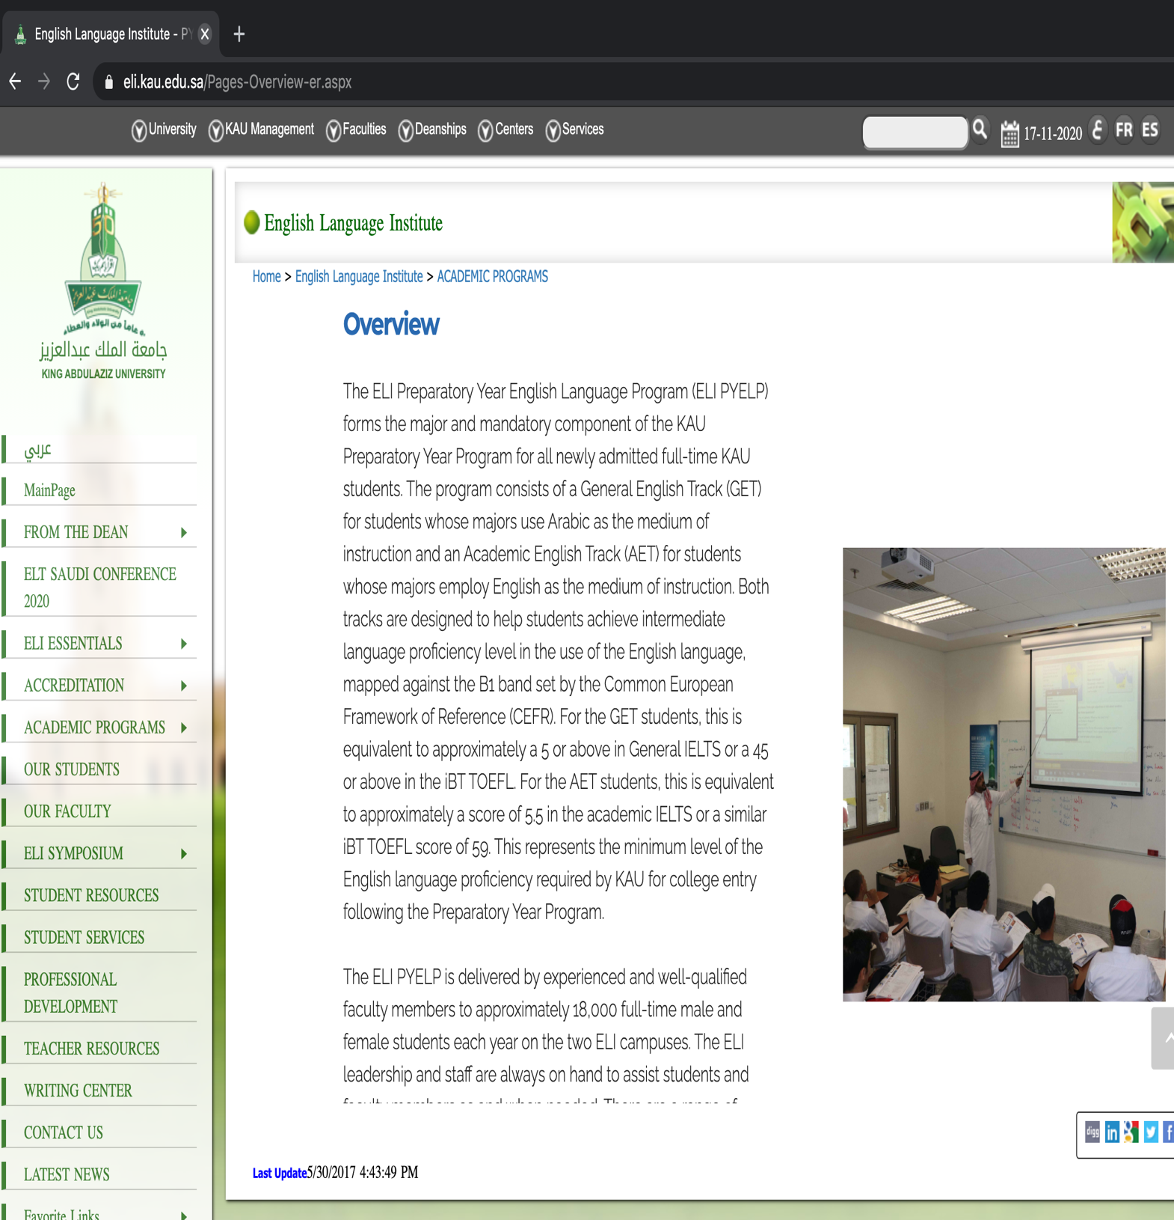

Appendix B

Participant Consent Form + Participant Information Sheet

Participant Consent Form

Title of Research Project: Teachers’ use of textbooks in teaching English to ESL learners

Name of Researcher: Samar AlGhamdi

Participant Identification Number for this project: Please initial box
- I confirm that I have read and understand the information sheet dated ___________ explaining the above research project and I have had the opportunity to ask questions about the project.

- I understand that my participation is voluntary and that I am free to withdraw
at any time without giving any reason and without there being any negative consequences. In addition, should I not wish to answer any particular question or questions, I am free to decline.

- I understand that my responses will be kept strictly confidential
I give permission for members of the research team to have access to my anonymised responses. I understand that my name will not be linked with the research materials, and I will not be identified or identifiable in the report or reports that result from the research.

- I agree to take part in the above research project.

________________________ ________ __________
Name of Participant Date Signature

_________________________ __________ _____________
Name of person taking consent Date Signature
To be signed and dated in presence of the participant

________________________ ___________ ___________
Lead Researcher Date Signature
To be signed and dated in presence of the participant

Teacher information sheet

Research project title:
Teacher’s use of textbooks in teaching English to ESL learners

You are being invited to take part in a research project. Before you decide whether you wish to take part, it is important for you to understand why the research is being done and what it will involve. Please take time to read the following information carefully and discuss it with others if you wish. Ask us if there is anything that is not clear or if you would like more information. Take time to decide whether or not you wish to take part. Thank you for reading this.
Purpose of project: This study is done to investigate teachers’ actual use of their English language textbooks. In addition to that, students will also be asked to fill a questionnaire regarding the textbooks used in class. Both the teachers’ and students’ views will then be compared.
Why was I chosen? You were chosen because you are a teacher of English language in the English language institute.
Do I have to take part?
If you do decide to take part you will be given this information sheet to keep (and be asked to sign a consent form) and you can still withdraw at any time without it affecting any benefits that you are entitled to in any way. You do not have to give a reason if you decide to withdraw.
What will happen to me if I take part?
If you decide to take part, 4 of your lessons will be observed. These observations will be general observations that do not require audio or video recording.
Pre and post interviews will be done for the observations, which equal a number of 8 interviews in addition to 1 initial interview about your teaching profile, experience, etc. The interviews will be audio recorded, and will range from 20 to 60 minutes each. I will be asking you questions about your teaching and the English textbook.
In the final lesson observation, a questionnaire will be distributed to your students, asking them about the lessons I observed and the English textbook.
The data I collect during this research will be used only for analysis and for illustration of my results when I write up my thesis, and when I present my research in conference presentations and lectures. No other use will be made of them without your written permission, and no one outside the project will be allowed access to the original recordings.
What happens if something goes wrong?
If you feel you were mistreated by the researcher, or if something serious occurs during or following your participation in this project, please contact the principal supervisor of this project (n.harwood@sheffield.ac.uk). Should you feel your complaint has not been handled to your satisfaction, please contact the Head of Department (Professor Adam Piette), who will then escalate the complaint through the appropriate channels.

Will my taking part in this project be kept confidential?
All the information that we collect about you during the course of this research will be kept strictly confidential. You will not be able to be identified in any reports or publications I publish about my research.
Who has ethically reviewed the project?
This project has been ethically approved by the School of English, Sheffield.
Contact for further information: If you wish to obtain more information please feel free to contact one or all of the following:
Researcher:
Samar AlGhamdi Tel #: 0555080573 Email: salghamdi4@sheffield.ac.uk
Principal supervisor:
Dr. Nigel Harwood Email: n.harwood@sheffield.ac.uk

Student information sheet

Research project title:
Teacher’s use of textbooks in teaching English to ESL learners

You are being invited to take part in a research project. Before you decide whether you wish to take part, it is important for you to understand why the research is being done and what it will involve. Please take time to read the following information carefully and discuss it with others if you wish. Ask us if there is anything that is not clear or if you would like more information. Take time to decide whether or not you wish to take part. Thank you for reading this.
Purpose of project: This study is done to investigate teachers’ actual use of their English language textbooks. In addition to that, students will also be asked to fill a questionnaire regarding the textbooks used in class. Both the teachers’ and students’ views will then be compared.
Why was I chosen? You were chosen because you are a student of English language in the English language institute.
Do I have to take part?
If you do decide to take part you will be given this information sheet to keep (and be asked to sign a consent form) and you can still withdraw at any time without it affecting any benefits that you are entitled to in any way. You do not have to give a reason if you decide to withdraw. Participating or not will have no impact on your grade. In addition, your teacher will not be aware of which students choose to participate.
What will happen to me if I take part?
If you decide to take part, you will be given a questionnaire to answer about your English class and the textbook you use. This questionnaire will be given to you during your class time. It should be made clear that your teacher will not be present in class during this time.

What happens if something goes wrong?
If you feel you were mistreated by the researcher, or if something serious occurs during or following your participation in this project, please contact the principal supervisor of this project (n.harwood@sheffield.ac.uk). Should you feel your complaint has not been handled to your satisfaction, please contact the Head of Department (Professor Adam Piette), who will then escalate the complaint through the appropriate channels.
Will my taking part in this project be kept confidential?
All the information that we collect about you during the course of this research will be kept strictly confidential. You will not be able to be identified in any reports or publications I publish about my research.
Who has ethically reviewed the project?
This project has been ethically approved by the School of English, Sheffield University.

Contact for further information: If you wish to obtain more information please feel free to contact one or all of the following:
Researcher:
Samar AlGhamdi Tel #: 0555080573 Email: salghamdi4@sheffield.ac.uk
Principal supervisor:
Dr. Nigel Harwood Email: n.harwood@sheffield.ac.uk

Appendix C
Example of Observational Schedule Used in One of the Lesson Observations

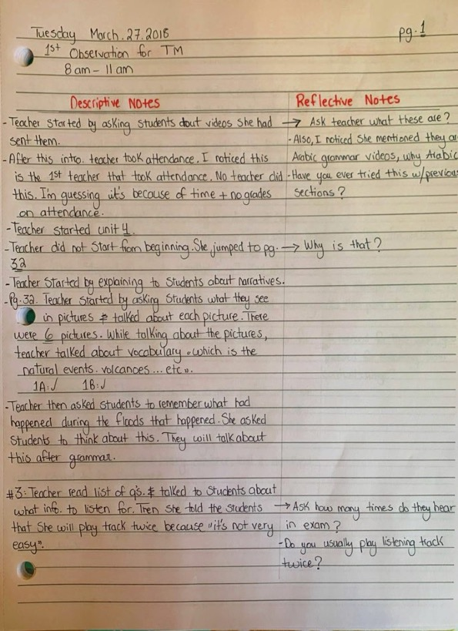
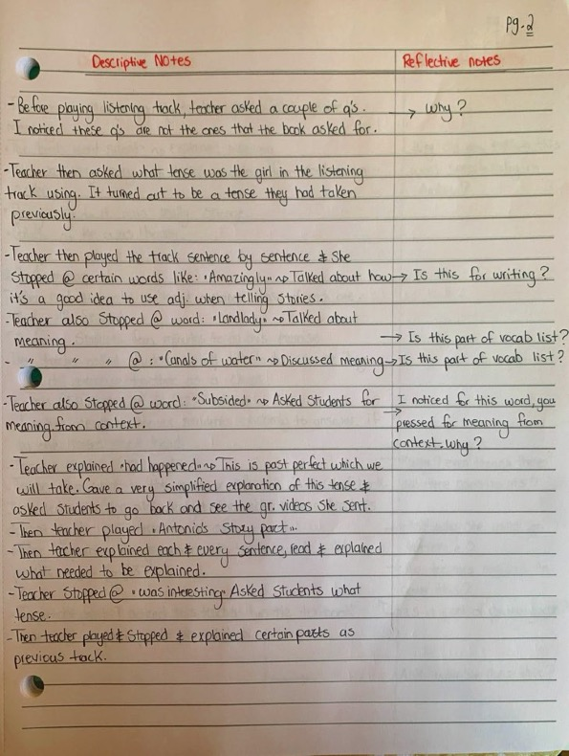

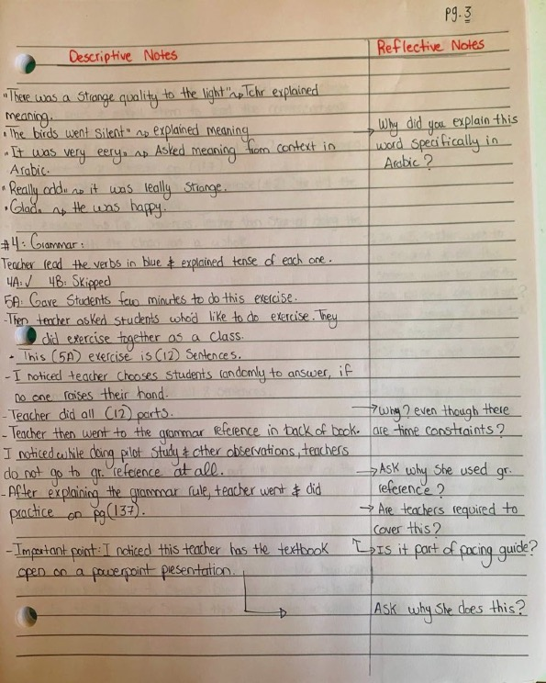

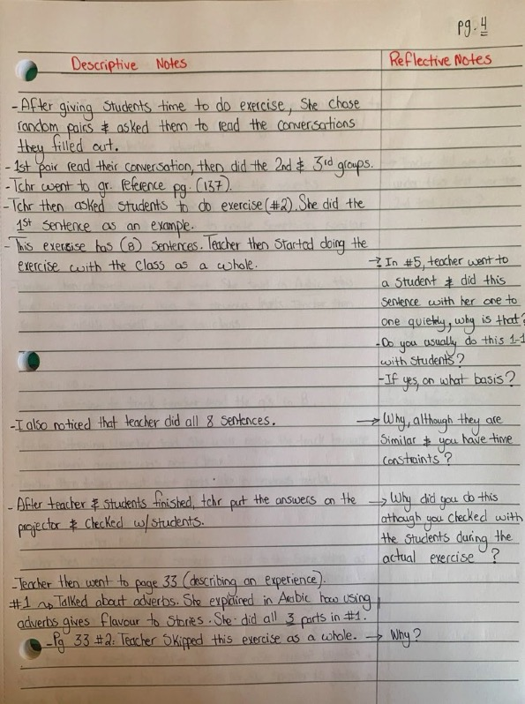

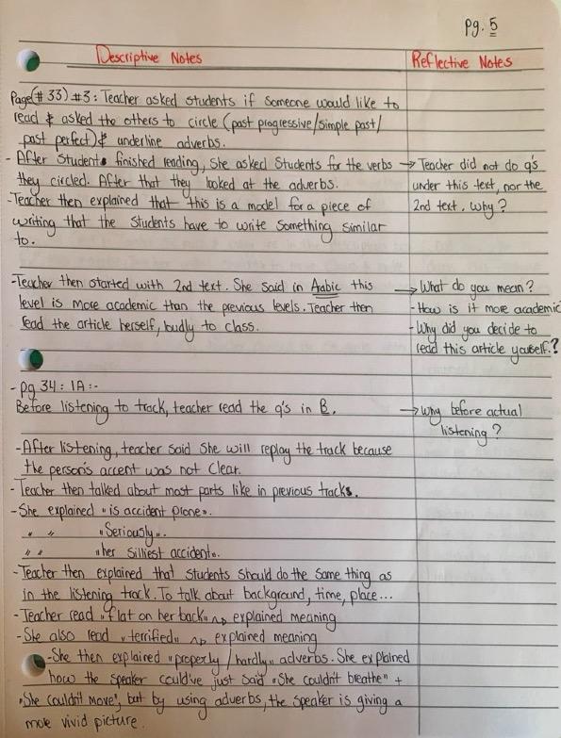

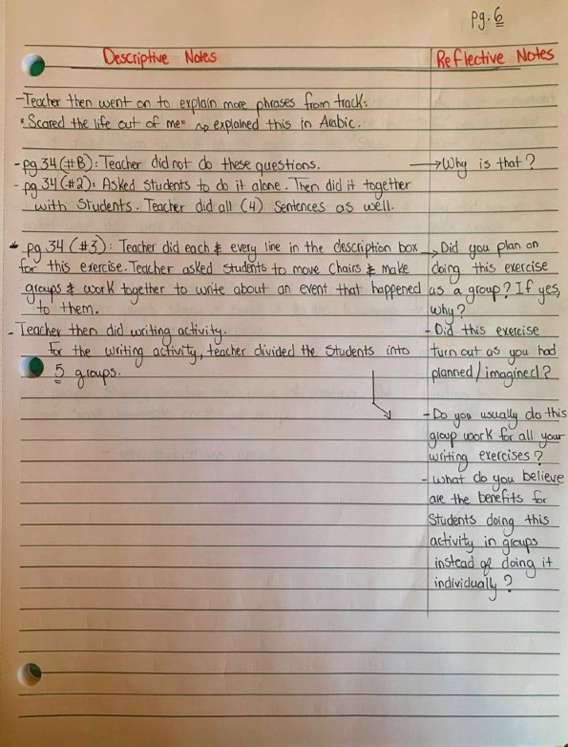

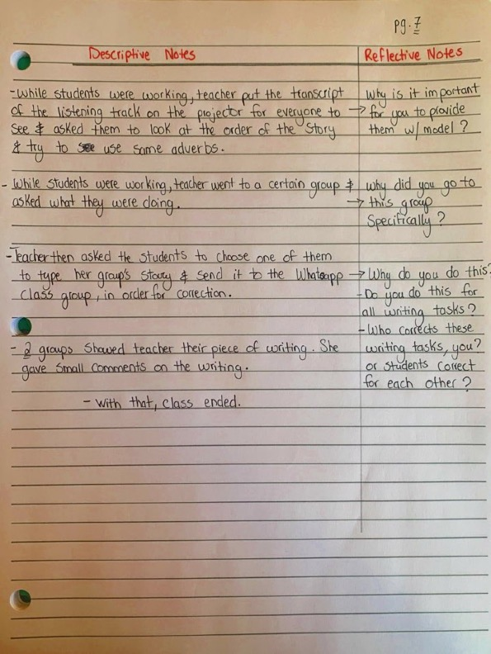

APPENDIX D
Teacher Interview

Part 1: (Lesson preparation techniques)

- What procedures did you follow when preparing for the lesson that was just observed?

- Did you use any external references when preparing for it? (external references means anything other than the actual textbook) Why? Or Why not?

- If yes, what kinds of external references did you use?

- Could you maybe think of a recent lesson from the last couple of weeks and how you prepared for it?

Part 2: (Identifying different adaptation methods)

In the following, there is a list of adaptation methods, which are explained:

1. Deleting (i.e. when the teacher decides NOT to cover an activity or skill in the textbook)
2. Editing (i.e. when the teacher MAKES CHANGES to an activity in the textbook)
3. Adding (i.e. when the teacher ADDS an activity in order to introduce an activity in the textbook)
4. Replacing (i.e. when the teacher REPLACES an activity with another)

Q. 1. What kind of adaptations do you make in your lessons in general? and Why?
Q. 2. Which of these adaptation methods do you use the most? And Why?
Q. 3. I will then ask about specific examples from the lesson, which was observed.

Part 3: (Teachers identifying with different views towards the textbook)

- These are two quotes by two teachers explaining their opinions towards the
Textbook:

Nora: “Good teachers do not use textbooks.”
Nejwa: “Using a textbook is a must for all teachers.”

2. These are two quotes by two teachers explaining their opinions towards adapting
the textbook:

Suad: “I make many adaptations to the textbook.”
Tala: “I rarely adapt the textbook.”

- Let us now talk about certain lessons in which you had successfully adapted the
textbook. Can you tell me about a lesson from the past couple of weeks where
you had adapted an exercise or certain parts of the textbook and felt that it was
successful?

(here, I would like to hear specific examples from the teacher’s experience.)

- Let us now talk about certain lessons in which you had unsuccessfully adapted the textbook. Can you tell me about a lesson from the past couple of weeks where you had adapted an exercise or certain parts of the textbook and felt that it was not so successful?

(here, I would like to hear specific examples from the teacher’s experience. Then, I will ask if this negative instance has made her doubt adaptation as a whole.)

Part 4: (Using metaphors to describe the textbook)

1. Please complete this sentence with a metaphor/metaphors that reflects your attitude towards the textbook:
“A textbook is ……………….”

2. Which of these metaphors reflects your attitudes towards the textbook? Why?
3. Which of these metaphors do not reflect your attitudes towards the textbook? Why
not?
(here, I will also ask the teachers to explain their choices by talking about their experiences of using textbooks in their English classes and giving examples of things that have happened to them.)

Sleeping pills | Belt | Heavy stone
Daily bread | Guideline | Cooking oil
Petrol | Straitjacket | Blind man’s stick
Road block | Water | Toxic
Map | Rubbish bin | Nightmare
Headache | Compass | Dark / Devil

Part 5:

- Which part of English, in general, do you enjoy teaching the best?
- Grammar
- Reading
- Listening
- Speaking
- Writing

- Now, I’d like to ask you a similar question, but with reference specifically to using the ELI textbook, So the textbook used in the ELI consists of different parts, such as grammar, reading, listening, speaking and writing. Which of these different parts do you enjoy teaching the best?

- Grammar
- Reading
- Listening
- Speaking
- Writing

(After asking which of the different parts of the book they enjoy teaching, I will ask them to explain how this might affect their use of the textbook.)

3. To what extent do any other factors affect your use of the textbook?

4. As we talked about in the previous question, there are different parts in the
textbook used. Which of these different parts do you feel you are most competent in? Or which of these parts do you feel that you teach the best? And why?

(some might have taken a course on how to teach a specific part of the language, such as how to teach writing to ESL learners. Therefore, this question may provide us with more details. In addition, I will also ask if this would also have an effect on how they use the textbook.)

Part 6: (Constraining factors)

This is a list of potentially constraining factors, which may affect the teachers’ use of the textbook:

Time constraints | Unified exams | Other workloads that the teacher is required to do in university (correcting papers, attending meetings, writing reports etc..) | Students’ proficiency level
Institutional constraints | Exams are set by a committee other than the teacher | Teacher has limited knowledge about certain parts of the textbook | Students’ attitudes towards learning the English language

- Which of the above factors affects the way in which you use the textbook? (Here, I will specifically ask about each constraining factor that the teacher will choose, probing for specific examples from their lessons.)

- Are there any other factors that affect your use of the textbook?

Part 7:

In this part, I will ask questions which may rise during the observation of the lesson itself.

Part 8:

Is there anything else that you would like to say about your experience of using the textbook?

APPENDIX E
Student Questionnaire

Your views on the textbook you use in English classes

In my study, I would like to find out about your views towards the textbook used in your English lessons. Please answer the questions below to help me find out.
This questionnaire is divided into 4 main parts.

Part 1: About You
Please tick (✔) the answer which applies to you:

- Did you study in a state school or a private school before entering university?

State school ( )
Private school ( )
Both state & private schools ( )

2. Have you ever had private English tutoring?

Yes ( )
No ( )

- Have you taken any English language courses outside of school?

Yes ( )
No ( )

- How would you rate your current level in English?

Excellent ( ) – Very good ( ) – Good ( ) – Weak ( )

The rest of the questionnaire is about your views on your English textbook, English Unlimited

Part 2:
Please tick (✔) the answer that best applies to you:

- How easy was it to find and buy the English textbook English Unlimited?

Very easy ☐
Easy ☐
Difficult ☐
Very difficult ☐

- To what extent is the textbook appropriate for you?
Choose one of the options below:

a. The textbook is exactly the right level for me - not too easy, not too difficult. ☐
b. The textbook is approximately the right level for me - not perfect, but more or
less appropriate. ☐
c. The textbook is not the right level for me - it’s too easy or too difficult. ☐

- To what extent do the topics/themes in the textbook motivate and interest you?
Choose one of the options below:

a. They motivate/interest me a lot ☐
b. They motivate/interest me to some extent ☐
c. They don’t motivate/interest me at all ☐
____________________________________________________________________

Part 3:
Following are two statements about your textbook. I would like you to indicate your opinion on each statement by putting a tick (✔) by the choice that best reflects your opinion.

- The amount of grammar in the textbook is appropriate- not too much, not too little.

Strongly agree ☐
Agree ☐
Disagree ☐
Strongly disagree ☐

- The presentation of different grammar structures in the textbook moves from simple to difficult.

Strongly agree ☐
Agree ☐
Disagree ☐
Strongly disagree ☐

Part 4:
In this part I would like to know more about your opinion on your English textbook. There is no ‘right/wrong’ answer. Please circle the answer that best reflects whatever you feel about your textbook, and then please explain why you feel that way.

1. How would you rate the quality of the reading activities in the textbook?

Excellent – Good – Average – Weak
Why?
…………………………………………………………………

- How would you rate the quality of the listening activities in the textbook?

Excellent – Good – Average – Weak

Why?
………………………………………………………………….

- How would you rate the quality of the speaking activities in the textbook?

Excellent – Good – Average – Weak

Why?
…………………………………………………………………….

- How would you rate the quality of the writing activities in the textbook?

Excellent – Good – Average – Weak

Why?
……………………………………………………………………..

- How attractive are the visuals (pictures, drawings) in your English textbook?

The visuals are very attractive ☐
The visuals are attractive ☐
The visuals are unattractive ☐
The visuals are very unattractive ☐

- To what extent do the visuals (pictures and drawings) in the textbook motivate you to talk about the subject?

I feel the visuals motivate me very much ☐
I feel the visuals motivate me to some extent ☐
I feel the visuals do not motivate me at all ☐

- To what extent is the knowledge from the textbook useful in real life?

It is very useful in real life ☐
It is useful in real life to some extent ☐
It is not useful in real life ☐

_____________________________________________________________________

Part 5:
Now I would like to ask you about the English language in general.

- Which part of the English language do you enjoy learning the best?

Reading ☐
Listening ☐
Speaking ☐
Writing ☐
None ☐

Please explain your choice
………………………………………………………………………………………………………………………………………………………………………………………………………………………………………………

- Which parts of the English language do you think are best covered by the textbook?

Reading ☐
Listening ☐
Speaking ☐
Writing ☐
None of these ☐

Please explain your choice
………………………………………………………………………………………………………………………………………………………………………………………………………………………………………………………………………………

- Please complete the following sentence:
I think the main barrier to improving my English skills is…

………………………………………………………………………………………………………………………………………………………………………………………………………………………………………………………………………………

- Describe 3 things you LIKE about your English textbook.
- ……………………………………………….
- ……………………………………………….
- ……………………………………………….

- Describe 3 things you DISLIKE about your English textbook.
- ……………………………………………………………
- ……………………………………………………………
- …………………………………………………………….

Thank you very much for your help
Your help is very much appreciated

APPENDIX F
First Codebook Version

- Adaptation techniques

- Teachers’ positive views towards textbooks

- Teachers’ negative views towards textbooks

- Beliefs about appropriate pedagogy:
- Practise is better
- Reading
- Writing
- Repetition
- Using technology

- Beliefs about students:
- Being exam driven
- Their capabilities
- Their interests
- Their learning style preferences
- Their views towards the textbook

- Context mediates textbook use

- Contrasting pre-textbook planning with in-use planning

- Experience affects adaptation of textbook

- Experience as a novice teacher

- Experience of using different / past textbooks

- External references when planning:

- Blackboard
- Colleagues
- Google
- Youtube

- Factors that affect teaching practises:
- External factors
- Internal / personal factors

- Institutional limits on resources:
- Destructed instructional tools
- Lack of teachers’ guides
- Lesson planning:
- Experience
- Theoretical knowledge

- Reasons for adapting textbook:
- Bring content closer to reality
- Generate student interest
- Non suitable themes

- Reasons for disliking the current textbook

- Reasons for not adapting textbook:
- Culturally suitable
- Reification of textbook
- Unified exams

- Reification of textbooks

- Teacher evaluation of textbooks:
- Negative characteristics
- Positive characteristics

- Teacher profile

- Teacher’s feelings towards adaptation:
- Negative
- Positive

- Teacher’s views towards textbooks:
- With
- Against

- Teaching vocabulary

- Textbook metaphors:
- Positive
- Negative

- Time constraints

- Using technology in the classroom
- Reasons
- Problems that arise

APPENDIX G
Second Codebook Version

Code | Definition | Guideline for using | Example
Teacher Profile | When teachers talk about their background, previous jobs, any training they had. Workshops and seminars attended. Years of experience. | Basically when teacher talks about herself. | “I didn’t study anything related to TESOL, but I’ve learnt. It’s a journey”
Experience of using different/past textbooks | When teachers talk about using past textbooks. |  | “we’ve been through 4 textbooks”
Factors that affect teaching practises:
- personal
- external

Experience as a novice teacher

Teacher evaluation of textbooks
(past / present)

- Positive characteristics (teachers-students)

- Negative characteristics
(teachers-students)

Beliefs about appropriate pedagogy

- Reading
- Writing
- Repetetion
- Using technology
- Practise is better

How textbook use is mediated by the context:

- Students

Time constraints

Planning for lessons
- experience
- Theoretical knowledge

External references when planning:
- Google
- Blackboard
- YouTube
- Colleagues

Institutional limits on resources:

- lack of teachers’ guides
- do not fix broken items

Reasons for adaptations
(Teachers-students)
- generate student interest
- bring content closer to reality
- Non-suitable themes

Examples of successful adaptation scenarios
(story + benefits)

Reasons for adapting:

- students interests
- non suitable themes (sexist)

Contrasting Pre-textbook planning with in-use planning
(examples & Reasons)

Teaching vocabulary
- styles (reasons)

Teachers’ views on textbooks:

- With (reasons)
- Against (reasons)

How experience affects adaptation

Reification of textbooks

Reasons for not adapting:
- culturally suitable
- reification
- unified exams

Beliefs about students:
- their interests
- their views towards the textbook
- their capabilities
- their learning style preferences
- why they are exam driven

Using technology
- reasons
- problems that rise

Textbook metaphors:

- Positive
- Negative
Reasons for disliking the specific textbook

The most preferred skill to teach (reasons)

How preferring certain parts of the language affects teaching practises

Student demands affects teacher practises

Factors that affect the use of textbooks (Prompt card)
(how)

Constraining factors

Teachers’ feelings towards adaptation:

- positive
- negative

Exam driven context
(reasons, beliefs, examples)

APPENDIX H
Third Codebook Version

- Adaptation techniques.
- Mostly used adaptation techniques

- Beliefs about appropriate pedagogy
- Making students teach
- Practise is better
- Reading
- Writing
- Repetition
- Using technology

- Beliefs about students
- Being exam driven
- Their capabilities
- Their interests
- Their learning style preferences
- Their views towards the textbook

- Constraining factors
- Exams are set by a committee other than the teacher
- Institutional constraints
- Other workloads that teacher is required to do
- Students’ attitudes towards learning the English language
- Students’ proficiency level
- Teacher has limited knowledge about certain parts of the textbook
- Unified exams

- Context mediates textbook use

- Contrasting pre-textbook planning with in-use planning

- Cultural sensitivity and the textbook

- Culture of the ELI

- Culture of university students

- Experience affects adaptation of the textbook

- Experience as a novice teacher

- Experience as a student affects textbook use

- Experience of using different / past textbooks

- External references when planning

- Factors that affect teaching practises

- Factors that affect the use of textbooks

- Factors that project positive feelings towards the textbook

- How certain experiences may affect the use of the textbook

- In vivo codes

- Institutional constraints

- Institutional limits on resources
- Destructed instructional tools
- Lack of teacher’s guides

- Lesson planning
- Experience
- Objectives (how teachers handle textbook objectives)
- Process of lesson planning
- Theoretical knowledge

- Making students in control

- Most competent in teaching
- Writing
- Speaking
- Listening
- Reading

- Negative effects of using textbooks

- Negative feelings portrayed by teachers

- Negative institutional actions

- Parts of the textbook covered best
- Grammar
- Listening
- Speaking
- Grammar
- Writing

- Parts of the textbook mostly adapted

- Past teaching experiences

- Positive effects of using textbooks
- Reasons for adaptations

- Bring content closer to reality
- Generate student interest
- Level of the exercises
- Non suitable themes
- Time

- Reasons for disliking the current textbook

- Reasons for not adapting the textbook
- Culturally suitable
- Reification of textbook
- Unified exams

- Reification of textbooks

- Safety that textbooks offer

- Teacher autonomy

- Teacher created materials

- Teacher evaluation of textbooks
- Negative characteristics
- Positive characteristics

- Teacher profile

- Teachers’ feelings towards adaptation
- Negative
- Positive

- Teachers’ views on textbooks
- With
- Against

- Teachers’ feelings towards textbooks

- Teaching vocabulary

- Textbook metaphors
- Negative
- Positive

- Time constraints

- Using technology in the classroom
- Reasons
- Problems that arise
APPENDIX I
Fourth Codebook Version

- Adaptation techniques
- Mostly used adaptation techniques
- Parts of textbook mostly adapted

- Beliefs about appropriate pedagogy
- Beliefs about students
- Being exam driven
- Their capabilities
- Their interests
- Their learning style preferences
- Their beliefs

- Comparison between different textbooks

- Constraining factors
- Exams are set by a committee other than the teacher
- Institutional constraints
- Other workloads teacher is required to do
- Students’ attitude towards learning English
- Students’ proficiency level
- Teacher has limited knowledge about certain parts of textbook
- Unified exams
- Other

- Cultural sensitivity and the textbook

- Culture of university students

- Time constraints

- Effects of being exam driven
- Effects on the learning process
- Effects on the teaching process

- Experience affects adaptation of textbook

- Experience as a novice teacher

- Experience as a student affects textbook use

- Experience of using different / past textbooks

- External references when planning
- Apps
- Blackboard
- Colleagues
- Internet
- Past textbooks that were used
- YouTube
- Other

- Factors that affect the use of textbooks
- Design of the textbook
- How popular / unpopular certain parts of the textbook are
- Level of the students
- Quality of the textbook
- Topics/themes used in the textbook
- Other

- How students’ level affects teacher’s motivation

- How the number of students affects the teaching process

- In vivo codes

- Lesson planning
- Objectives (how teachers handle objectives)
- Process of lesson planning
- Using teacher’s book

- Most competent in teaching

- Negative feelings portrayed by teachers

- Pacing guide

- Parts of English teachers enjoy teaching the most

- Parts of the textbook covered best

- Positive effects of unified exams

- Positive effects of using textbooks

- Reasons for adaptations
- A way to overcome classroom problems
- Bring content closer to reality
- Further practise
- Generate student interest
- Institutional guidelines
- Level of the exercises
- Level of the students
- Non suitable themes/topics
- Students’ attitude
- Used textbooks
- Time constraints
- Other
- Reasons for disliking current textbook

- Reasons for liking current textbook

- Reasons for not adapting textbook
- Culturally suitable
- Reification of textbook
- Students’ low level
- Time limitations
- Unified exams

- Reification of textbooks

- Relationship with the workbook

- Safety that textbooks offer

- Students’ negative attitude

- System of ELI

- Teacher autonomy

- Teacher created materials

- Teacher profile
- Teacher training

- Teacher’s views towards adaptation
- Negative
- Positive

- Teacher’s views towards textbooks
- Negative
- Positive

- Teacher’s personal beliefs

- Textbook metaphors
- Negative
- Positive

- Relationship between teachers and students

- Using technology in the classroom
- Reasons
- Problems that arise

APPENDIX J
Fifth Codebook Version
Code | Definition | Example
1. Adaptation techniques:  a. Mostly used adaptation techniques | When the teacher talks about the adaptation techniques that she uses the most in her classroom. Also, if she justifies why she uses this specific adaptation technique/s the most  (Adaptation techniques include adding, deleting, replacing, editing). | “Adding yes we always add especially in writing. Because the text here doesn’t have solid training for writing.”
b. Parts of the textbook mostly adapted | When the teacher talks about the parts of the textbook that she adapts the most, and whether she mentions any reasons for doing so.  (Parts of the textbook include reading, listening, speaking, writing, vocab, grammar). | “I always replace the speaking activities.”  …………………………………..  “Mostly reading because we don't have much reading here. Every lesson has one reading passage. That's not enough to prepare them for reading.”
2. Beliefs about appropriate pedagogy | When the teacher talks about her beliefs on appropriate pedagogy. (How certain parts of the language should be taught, how certain parts of the textbook should be covered, or just how teaching in general should be done). | “I don’t believe in teaching grammar in rules. I believe that by listening to correct language and using correct language- I make them (the students) memorise their lines. Some people might be against this, but I’m not. Because when they use the language correctly, and she memorises a good chunk of well-written English and speaks it, she’s going to acquire it at some point. She will identify the good structures from the bad ones. So, I like holistic teaching. I don’t like to separate things.”
3. Comparison between different textbooks | When the teacher talks about a different textbook than the one she is currently teaching.  (This comparison could be negative or positive). | “Headway was highly integrated and Headway would present a language that is more academic so it would sufize my students’ learning needs. This book has got a lot of emphasis on spoken language not academic wise. It doesn’t give consideration to my students’ need for an academic level of English language.”
4. Teachers’ personal beliefs | When the teacher talks about her personal beliefs on the English language, or on how certain parts of the language should be taught, or on textbook adaptation, or anything related to education in general. | “I like doing group work better than pair- work. Pair-work sometimes because they have friends next to them, they use it for gossiping. . .”  …………………………………..  “My philosophy in teaching is caring. These are not just a bunch of kids and you walk in the classroom and say something and then you go out. You have to have care for them.”
5. Constraining factors:  a. Exams | When the teacher talks about how not creating her own exams might affect her teaching or her use of the textbook. (Whether positively or negatively.  Or  When the teacher talks about how unified exams in the institution affect her teaching or her use of the textbook. (Whether she sees this as something positive or negative). | “Because I never see students’ outcomes and I feel teaching the material not knowing the way in which the questions are formed . . ., it's offensive to me as teacher. It is a very uncomfortable environment for me to teach in.”  ……………………..  “because of the unified exams sometimes you cannot skip certain question or this topic is very important and I saw that it has been covered in previous exams so we have to cover. There is no way to skip it or change it.”
b. Institutional constraints | When the teacher talks about how certain rules |& regulations of the institute may have an effect on her teaching or her use of the textbook.  (Whether positively or negatively.) | “We have a pacing guide that we must follow and we are always behind because of the first week of the university people don't show up, but somehow the academic coordinator designed the pacing guide including the first week.”
c. Other tasks teacher is required to do | When the teacher talks about her workload and how this might have an effect on her teaching or her use of the textbook. (Whether positively or negatively.) | “I feel stressed out and the workload makes me more stuck to the textbook, so I cannot be creative anywhere.”
d. Students’ attitude towards learning English | When the teacher talks about the students’ attitude towards the English language and how this might have an effect on her teaching or her use of the textbook. (Whether positively or negatively.) | “we teach 18 hours. Students feel bored or fed up.”
e. Students’ proficiency level | When the teacher talks about her students’ proficiency level and how this might have an effect on her teaching or her use of the textbook. | “Proficiency level is also a factor, I felt it mostly when I taught level 4 last year or the year before. Level 4 the book was very advanced and the students’ level was very weak.”
f. Teacher has limited knowledge of some parts of the textbook | When the teacher talks about whether having limited knowledge of the English language affects her teaching or her use of the textbook. | “I know my limitation is grammar. I understand it, if you ask me I know how to do it but I don’t know how to explain why this is happening”  ………………………………………  “I don't think this is a big constraint even if I have a limited knowledge, I can read more about it, and that's it. I'm not gonna have limited knowledge”
g. Time constraints | When the teacher talks about how time constraints affect her teaching or her use of the textbook. | “Because of the time, if I had more time I feel like I would work wonder with these girls.”
h. Other | If the teacher talks about any other constraining factors, (which are not included in the previous factors) that affect her teaching or her use of the textbook. | “I think it would affect the teaching if I'm not interested in the topic.”
6. System of the ELI | When the teacher discusses anything related to the rules and regulations of the ELI. (or even if the teacher discusses how things are done in the ELI) | “They tell you that the ELI is encouraging teachers to move towards communicative based approaches, but in reality we are not really motivated, we don’t have the time to do communicative activities we are pushed to focus more on the grammar sections of the book to focus more on the vocab.”  “There is constant change of teachers especially when there are two teachers teaching the same class. For example, I’m always assigned for two weeks in a class and then they change me with another teacher and I feel this affects the students.”
7. Cultural sensitivity and the textbook | When the teacher talks about anything related to culture in the textbook.  (Whether it is culturally suitable or not suitable.) | But some things they can’t relate to like moving the house they never do things like that independently over here. It is always with the family.”
8. Culture of university students | When the teacher talks about certain ideas or actions that are popular amongst university students. (Whether positive or negative.) | “the culture of university students where they don't attend the first week, or for example they don't attend the exam week.”
9. Effects of being exam driven:  a. Effects on the learning process | When the teacher talks about how being exam driven affects the students’ learning. | It’s hard to get them to focus or to cooperate with you when you do other activities that are not in the textbook or the ones that are more communicative focused than the ones in the textbook.”
b. Effects on the teaching process | When the teacher talks about how being exam driven affects her way of teaching or her way of using the textbook. | “Anything related to grammar in the book I just have to cover each and every one it is very important like I told you the test is grammar oriented.”
10. How experience affects the use of the textbook:  a. Experience as a novice teacher | When the teacher explains if her experience as a novice teacher affected her way of teaching or of using the textbook. | “It's the first time I teach and I was going with the style of teaching every bit in the book so I was behind.”
b. Experience as a student | When the teacher explains if her experience as a student had any effect on her teaching or her use of the textbook. | “Mainly because of my own experience in writing. I was a very lousy writer and I had a very good instructor, I took writing 1 and 2 with her. so I became a very good writer. So I really know how to take someone from being a lousy writer to somewhat a good writer.”
c. Past teaching experiences | When the teacher talks about her past teaching experiences and how it affects her way of teaching or of using the textbook. | I used to lower effective filters in CBA. I used to play music, we used to play karaoke, we used to watch movies. I can't do this, now. . . So it was nice. I really set a good mood for them to learn and speak.”
11. External references when planning for lessons:  a. Apps (applications) | Here the teacher talks about any external references that she uses when planning for her lessons other than the textbook. (For example, phone applications that she might use). | “I get the progress tests from the teacher’s book and I post it on WhatsApp to them because they don’t have access to that. So we use that app a lot.”
b. Colleagues | If the teacher mentions that she asks her colleagues for help when planning for her lessons. | “Sometimes when I have a problem with a certain section or conveying a certain skill, then yes I will speak to colleagues who have covered it and maybe get ideas from them.”
c. Internet | If the teacher mentions that she uses the internet (Google, YouTube..etc) when planning for her lessons. | “The internet usually the internet. I search for games or stuff like that. This is the only thing I use.”
d. Past textbooks that were used | If the teacher mentions that she uses past textbooks when planning for her lessons. | “Past textbooks that were used, yeah. I used to do this before I take for example some pictures from them.”
e. Other | If the teacher mentions any other references (other than the ones stated above) that she uses when planning for her lessons. | “I talk to my husband because he is a teacher too so we discuss things.”
12. How students’ level affects teachers’ motivation | When the teacher mentions if the students’ proficiency level has an effect on her motivation to teach. (Whether this affect is positive or negative). | “I was more innovative, I found myself honestly working very hard and it took so long from my time to prepare for their lessons . . . But I felt it’s worth it when I get in the class and I see the students’ engagement it encouraged me to work hard.
13. How the number of students affects the teaching process | If the teacher talks about how the number of students in her class has any effect on her teaching or her use of the textbook. | “When you have a whole class discussion, you will have plenty of ideas . . . But when you have few students . . . you won’t have this richness in sharing ideas.”
14. Lesson planning:  a. Objectives | When the teacher talks about how she handles the objectives in the textbook.  (Whether she goes over them when she plans her lessons or not). | “I usually look at the lesson at the objectives, in general the big objectives. there are always big objectives and then I rarely look at each practise objective because most of the time we have a certain time-line and pacing guide for the lesson so most of the time the practises’ objectives they take much time if I want to focus on each objective.”
b. Process of lesson planning | When the teacher talks about her way of planning for her lessons. What she does in the process of lesson planning. (Whether she actually plans her lessons or not). | “I don't do a lesson plan, but I plan as I teach. I just know what I'm going to teach, what topic, what theme, I put the grammar on slides, I do my own controlled exercises, and then I start teaching spontaneously. There is no real preparation for the lesson.”
c. Using the teacher’s book | When the teacher talks about the teacher’s book and whether or not she uses it when planning for her lessons. | “So I use teachers book when I'm not sure about the objectives.”
15. Most competent in teaching | When the teacher talks about the parts of English (listening, speaking, reading, writing, vocabulary, grammar) she feels most competent in teaching and why. | “It could be vocab, and grammar. I feel I can just be creative, I can do a great job in teaching vocab and grammar.”
16. Pacing guide | When the teacher talks about anything related to the pacing guide given to them by the institute. (Whether positively or negatively). | “But I don’t look at the pacing guide, I never look at the pacing guide, I don’t care about it.”  …………………………..  “We get a very nice pacing guide we are told exactly what we have to follow per week. So it is very structured and it’s very nice to know because everything is organized.”
17. The parts of English, teachers enjoy teaching the most | When the teacher talks about how she enjoys teaching a certain part of English (speaking, listening, reading, writing, grammar, vocab) | “Listening and speaking because it is like a realistic picture of how language is used.”
18. Parts of the textbook covered best | When the teacher talks about the parts of the textbook that are well covered (Has sufficient amount of exercises, is clear etc..) and her justification for that. | “I like the listening parts in the book. They are really culturally sensitive.”  ………………………………  “Reading I think the articles are chosen carefully”
19. Reasons for adapting the textbook:  a. A way to overcome classroom problems | When the teacher talks about how she adapts the textbook during lessons to avoid certain problems that may occur in the classroom. | “When the listening is lengthy, and when they have listened and I asked questions and they can’t answer the questions, I put the transcript on the board, so it is like support.”
b. Bring content closer to reality | When the teacher talks about how she adapts the textbook in order to bring it closer to the students’ everyday life. | “I would like to adapt a lot as I said depending on the culture of the students to make it more hands on and more personal for them.”  …………………..  “This lesson mainly about safety first, so I tried to make things related to their life. For example I reminded them of when you don't fasten your belts, you will pay some fine.”
c. Further practise | If the teacher adapts the textbook in order for her students to have more practise (Usually adding). | “About adding: yeah I add of course activities for further practise specially in grammar.”
d. Generate student interest | If the teacher adapts the textbook in order to make students more interested. (if she feels they are bored for example.) | “I have to integrate things into my lesson to inject interesting things because I notice that when I strictly follow what is in the book. I lose the students, I feel they are not really paying attention.”
e. Level of the exercises | If the teacher adapts the textbook because of the level of the exercises (whether too easy or too difficult). | “I never use the Speaking activities in the book because I feel they are too complicated when giving instructions.”  …………………………………  “I make it a little more difficult to challenge and they can cover those challenging activities.”
f. Level of the students | If the teacher adapts the textbook because of the level of the students. (whether too low or too advanced) | “Obviously if the students are good like the ones we get from the placement test . . . they require more effort, so I do get extra materials.”  …………………………………..  “With this group, I am trying to delete as much as possible because they don’t retain anything.”
g. Time constraints | If the teacher adapts the textbook because of the time constraints she is under. | “So I have time pressure so the activities which might not be very important they might be deleted. Sometimes speaking and writing activities I delete it.”
h. Other | If the teacher mentions any other reasons (other than what has been stated previously) of why she adapts the textbook. | “To be honest for that day I just assigned pair-work because there were too many questions and I want them to help each other. I don't usually do this with reading.”
20. Reasons for not adapting the textbook:  a. Reification of textbook | Reification of textbooks means when teachers idolize the textbook and believe that anything written in it is correct because it is created by natives. | “I try never to delete because I feel if the book is recommending it, it is definitely a valuable skill or activity the students need to cover.”
b. Time limitations | If the teacher does not adapt the textbook because of time limitations. | “I rely almost a hundred percent on the book because for time limitation I can't go here or there.”
c. Unified exams | If the teacher does not adapt the textbook because of unified exams. | “because of the unified exams sometimes you cannot skip certain question or this topic is very important and I saw that it has been covered in previous exams so we have to cover. There is no way to skip it or change it.”
d. Other | If the teacher states other reasons (other than the ones previously stated) of why she does not adapt the textbook. | “Good conscious is a soft pillow and for example when I delete, I feel that my mind is blaming me for doing that so I never delete.”
21. Reasons for disliking current textbook | When the teacher talks about why she dislikes the textbook she is currently using. | “It’s just all over the place, it is not organized so much information crammed into pages.”
22. Reasons for liking the current textbook | When the teacher talks about why she likes the textbook she is currently using. | “The audio tracks that we have, have a variety of accents which gives you a real picture of them. So that is really good.”
23. Reification of textbooks | When the teacher talks about the textbook in an idolizing way. | ”textbooks are made by people who have long years of experience. Some textbooks are really good, really nice.”
24. Relationship with the workbook | When the teacher talks about the workbook and whether she uses it or not. (Whether positively or negatively). | “many of the students don’t have work-books they don’t buy them they don’t bring them to class so it is a real stumbling block.”
25. Students’ negative attitude | When the teacher talks about students’ negative attitudes. (Whether it is towards the language, towards the teacher, towards life in general..etc) | “When it's attitudes, I really sometimes don't know how to deal with the students. since not just their attitudes towards learning. Their attitudes. Their life attitudes, my problem.”  ……………………………..  “The level 4 students who come from the placement test at the beginning of the year, they have the same problems in attitude, but at least they make up for it they are good students work wise, apart from that they have the same rude attitude but they are obnoxious as well seeing that they know English. So, every set of them have their unique set of problems.”
26. Teacher autonomy | When the teacher talks about her professional independence in the ELI and whether she can make autonomous decisions about what to teach and how to teach. | “teacher autonomy. There is none! ZERO! I can't cancel a class.”  ………………………………….  “the teacher has no say in it. It’s like we’re just moving a herd of goats and sheep in one direction.”
27. Teacher created materials | When the teacher talks about her experience in creating materials. (If she has any) | “At the beginning it was from old textbooks the ones I taught in my previous workplace. But after that, I started doing my own speaking activities.”
28. Teacher profile | When the teacher talks about her education, qualifications, how long she has been teaching…etc | “My specialty is in testing and evaluation so my background is deeply related to teaching English language. But I have done an MA and PHD in English literature just to be close to the language”
29. Teacher training | If the teacher talks about any training she had undertaken, whether pre teaching service or within her teaching profession. | “The author of this book. She came here and she gave us almost three or four workshops on how to use that textbook.”  ……………………………..  “It was part of teaching training that I did it was how to use a textbook to utilize the textbook in a way to suit your students’ learning needs.”
30. Teacher’s views towards textbooks  (Positive) | When the teacher talks about her opinion on textbooks in general. (Positive opinion) | “|I know the value of the textbook. It's not a belt, it's not a prison, it is not a dark devil. I need it especially with beginners you need something to start from.”
31. Teacher’s views towards textbooks  (Negative) | When the teacher talks about her opinion on textbooks in general. (Negative opinion) | “I just don't like textbooks in general. I would rather design my own lesson. Honestly.”
32. Textbook metaphors  (Positive) | When the teacher uses metaphors to describe the textbook.  (Positive metaphors) | “It's a big world that we can travel in all its corners.”  ………………………..  “it’s like a bible.”

33. Textbook metaphors  (Negative) | When the teacher uses metaphors to describe the textbook.  (Negative metaphors) | “Quicksand”  ……………………..  “It is demoralizing for teachers.”
34. Relationship between teachers and students | When the teacher talks about her relationship with her students. This does not have to be a literal description but may be a hint of the relationship through scenarios that the teacher mentions in the interview. Anything that you can sort of feel through the teacher’s words.  (Any scenarios that sort of give a feel of the relationship between the teacher and her students, whether positive or negative) | “I do activities sometimes single individuals and sometimes I am doing it in groups, and if they ask for groups I give them single, when they ask for single I give them groups this is what I do for them this is my revenge so yes, this is it.”  …………………………….  “You also will be surprised of the kind of the level of their thinking and the kind of ideas they give to you so I enjoy that so much. I enjoy listening to them.”
Appendix K
Final Codebook Version
Code | Definition | Example
1. Adaptation techniques:  a. Mostly used adaptation techniques | When the teacher talks about the adaptation techniques that she uses the most in her classroom. Also, if she justifies why she uses this specific adaptation technique/s the most  (Adaptation techniques include adding, deleting, replacing, editing). | “Adding yes we always add especially in writing. Because the text here doesn’t have solid training for writing.”
b. Parts of the textbook mostly adapted | When the teacher talks about the parts of the textbook that she adapts the most, and whether she mentions any reasons for doing so.  (Parts of the textbook include reading, listening, speaking, writing, vocab, grammar). | “I always replace the speaking activities.”  …………………………………..  “Mostly reading because we don't have much reading here. Every lesson has one reading passage. That's not enough to prepare them for reading.”
2. Beliefs about appropriate pedagogy | When the teacher talks about her beliefs on appropriate pedagogy. (How certain parts of the language should be taught, how certain parts of the textbook should be covered, or just how teaching in general should be done).  OR  When the teacher talks about her personal beliefs on the English language, or on how certain parts of the language should be taught, or on textbook adaptation, or anything related to education in general. | “I don’t believe in teaching grammar in rules. I believe that by listening to correct language and using correct language- I make them (the students) memorise their lines. Some people might be against this, but I’m not. Because when they use the language correctly, and she memorises a good chunk of well-written English and speaks it, she’s going to acquire it at some point. She will identify the good structures from the bad ones. So, I like holistic teaching. I don’t like to separate things.”  …………….  “I like doing group work better than pair- work. Pair-work sometimes because they have friends next to them, they use it for gossiping. . .”  …………………………………..  “My philosophy in teaching is caring. These are not just a bunch of kids and you walk in the classroom and say something and then you go out. You have to have care for them.”
3. Comparison between different textbooks | When the teacher talks about a different textbook than the one she is currently teaching.  (This comparison could be negative or positive). | “Headway was highly integrated and Headway would present a language that is more academic so it would sufize my students’ learning needs. This book has got a lot of emphasis on spoken language not academic wise. It doesn’t give consideration to my students’ need for an academic level of English language.”
4.Constraining factors:  a. Exams | When the teacher talks about how not creating her own exams might affect her teaching or her use of the textbook. (Whether positively or negatively.  Or  When the teacher talks about how unified exams in the institution affect her teaching or her use of the textbook. (Whether she sees this as something positive or negative). | “Because I never see students’ outcomes and I feel teaching the material not knowing the way in which the questions are formed . . ., it's offensive to me as teacher. It is a very uncomfortable environment for me to teach in.”  ……………………..  “because of the unified exams sometimes you cannot skip certain question or this topic is very important and I saw that it has been covered in previous exams so we have to cover. There is no way to skip it or change it.”
b. Institutional constraints | When the teacher talks about how certain rules |& regulations of the institute may have an effect on her teaching or her use of the textbook.  (Whether positively or negatively.)  OR  When the teacher discusses anything related to the rules and regulations of the ELI. (or even if the teacher discusses how things are done in the ELI) | “We have a pacing guide that we must follow and we are always behind because of the first week of the university people don't show up, but somehow the academic coordinator designed the pacing guide including the first week.”  …………………..  “There is constant change of teachers especially when there are two teachers teaching the same class. For example, I’m always assigned for two weeks in a class and then they change me with another teacher and I feel this affects the students.”  …………………………………  “They tell you that the ELI is encouraging teachers to move towards communicative based approaches, but in reality we are not really motivated, we don’t have the time to do communicative activities we are pushed to focus more on the grammar sections of the book to focus more on the vocab.”
c. Other tasks teacher is required to do | When the teacher talks about her workload and how this might have an effect on her teaching or her use of the textbook. (Whether positively or negatively.) | “I feel stressed out and the workload makes me more stuck to the textbook, so I cannot be creative anywhere.”
d. Students’ attitude towards learning English | When the teacher talks about the students’ attitude towards the English language and how this might have an affect on her teaching or her use of the textbook. (Whether positively or negatively.) | “we teach 18 hours. Students feel bored or fed up.”
e. Students’ proficiency level | When the teacher talks about her students’ proficiency level and how this might have an effect on her teaching or her use of the textbook. | “Proficiency level is also a factor, I felt it mostly when I taught level 4 last year or the year before. Level 4 the book was very advanced and the students’ level was very weak.”
f. Teacher has limited knowledge of some parts of the textbook | When the teacher talks about whether having limited knowledge of the English language affects her teaching or her use of the textbook. | “I know my limitation is grammar. I understand it, if you ask me I know how to do it but I don’t know how to explain why this is happening”  ………………………………………  “I don't think this is a big constraint even if I have a limited knowledge, I can read more about it, and that's it. I'm not gonna have limited knowledge”
g. Time constraints | When the teacher talks about how time constraints affect her teaching or her use of the textbook. | “Because of the time, if I had more time I feel like I would work wonder with these girls.”
h. Other | If the teacher talks about any other constraining factors, (which are not included in the previous factors) that affect her teaching or her use of the textbook. | “I think it would affect the teaching if I'm not interested in the topic.”
5. Cultural sensitivity and the textbook | When the teacher talks about anything related to culture in the textbook.  (Whether it is culturally suitable or not suitable.) | But some things they can’t relate to like moving the house they never do things like that independently over here. It is always with the family.”
6. Culture of university students | When the teacher talks about certain ideas or actions that are popular amongst university students. (Whether positive or negative.) | “the culture of university students where they don't attend the first week, or for example they don't attend the exam week.”
7. Effects of being exam driven:  a. Effects on the learning process | When the teacher talks about how being exam driven affects the students’ learning. | It’s hard to get them to focus or to cooperate with you when you do other activities that are not in the textbook or the ones that are more communicative focused than the ones in the textbook.”
b. Effects on the teaching process | When the teacher talks about how being exam driven affects her way of teaching or her way of using the textbook. | “Anything related to grammar in the book I just have to cover each and every one it is very important like I told you the test is grammar oriented.”
8. How experience affects the use of the textbook:  a. Experience as a novice teacher | When the teacher explains if her experience as a novice teacher affected her way of teaching or of using the textbook. | “It's the first time I teach and I was going with the style of teaching every bit in the book so I was behind.”
b. Experience as a student | When the teacher explains if her experience as a student had any effect on her teaching or her use of the textbook. | “Mainly because of my own experience in writing. I was a very lousy writer and I had a very good instructor, I took writing 1 and 2 with her. so I became a very good writer. So I really know how to take someone from being a lousy writer to somewhat a good writer.”
c. Past teaching experiences | When the teacher talks about her past teaching experiences and how it affects her way of teaching or of using the textbook. | I used to lower effective filters in CBA. I used to play music, we used to play karaoke, we used to watch movies. I can't do this, now. . . So it was nice. I really set a good mood for them to learn and speak.”
9. External references when planning for lessons:  a. Apps (applications) | Here the teacher talks about any external references that she uses when planning for her lessons other than the textbook. (For example, phone applications that she might use). | “I get the progress tests from the teacher’s book and I post it on WhatsApp to them because they don’t have access to that. So we use that app a lot.”
b. Colleagues | If the teacher mentions that she asks her colleagues for help when planning for her lessons. | “Sometimes when I have a problem with a certain section or conveying a certain skill, then yes I will speak to colleagues who have covered it and maybe get ideas from them.”
c. Internet | If the teacher mentions that she uses the internet (Google, YouTube..etc) when planning for her lessons. | “The internet usually the internet. I search for games or stuff like that. This is the only thing I use.”
d. Past textbooks that were used | If the teacher mentions that she uses past textbooks when planning for her lessons. | “Past textbooks that were used, yeah. I used to do this before I take for example some pictures from them.”
e. Other | If the teacher mentions any other references (other than the ones stated above) that she uses when planning for her lessons. | “I talk to my husband because he is a teacher too so we discuss things.”
10. How students’ level affects teachers’ motivation | When the teacher mentions if the students’ proficiency level has an effect on her motivation to teach. (Whether this affect is positive or negative). | “I was more innovative, I found myself honestly working very hard and it took so long from my time to prepare for their lessons . . . But I felt it’s worth it when I get in the class and I see the students’ engagement it encouraged me to work hard.
11. How the number of students affects the teaching process | If the teacher talks about how the number of students in her class has any effect on her teaching or her use of the textbook. | “When you have a whole class discussion, you will have plenty of ideas . . . But when you have few students . . . you won’t have this richness in sharing ideas.”
12. Lesson planning:  a. Objectives | When the teacher talks about how she handles the objectives in the textbook.  (Whether she goes over them when she plans her lessons or not). | “I usually look at the lesson at the objectives, in general the big objectives. there are always big objectives and then I rarely look at each practise objective because most of the time we have a certain timeline and pacing guide for the lesson so most of the time the practises’ objectives they take much time if I want to focus on each objective.”
b. Process of lesson planning | When the teacher talks about her way of planning for her lessons. What she does in the process of lesson planning. (Whether she actually plans her lessons or not). | “I don't do a lesson plan, but I plan as I teach. I just know what I'm going to teach, what topic, what theme, I put the grammar on slides, I do my own controlled exercises, and then I start teaching spontaneously. There is no real preparation for the lesson.”
c. Using the teacher’s book | When the teacher talks about the teacher’s book and whether or not she uses it when planning for her lessons. | “So I use teachers book when I'm not sure about the objectives.”
13. Most competent in teaching | When the teacher talks about the parts of English (listening, speaking, reading, writing, vocabulary, grammar) she feels most competent in teaching and why. | “It could be vocab, and grammar. I feel I can just be creative, I can do a great job in teaching vocab and grammar.”
14. Pacing guide | When the teacher talks about anything related to the pacing guide given to them by the institute. (Whether positively or negatively). | “But I don’t look at the pacing guide, I never look at the pacing guide, I don’t care about it.”  …………………………..  “We get a very nice pacing guide we are told exactly what we have to follow per week. So it is very structured and it’s very nice to know because everything is organized.”
15. The parts of English, teachers enjoy teaching the most | When the teacher talks about how she enjoys teaching a certain part of English (speaking, listening, reading, writing, grammar, vocab) | “Listening and speaking because it is like a realistic picture of how language is used.”
16. Parts of the textbook covered best | When the teacher talks about the parts of the textbook that are well covered (Has sufficient amount of exercises, is clear etc..) and her justification for that. | “I like the listening parts in the book. They are really culturally sensitive.”  ………………………………  “Reading I think the articles are chosen carefully”
17. Reasons for adapting the textbook:  a. A way to overcome classroom problems | When the teacher talks about how she adapts the textbook during lessons to avoid certain problems that may occur in the classroom. | “When the listening is lengthy, and when they have listened and I asked questions and they can’t answer the questions, I put the transcript on the board, so it is like support.”
b. Bring content closer to reality | When the teacher talks about how she adapts the textbook in order to bring it closer to the students’ everyday life. | “I would like to adapt a lot as I said depending on the culture of the students to make it more hands on and more personal for them.”  …………………..  “This lesson mainly about safety first, so I tried to make things related to their life. For example I reminded them of when you don't fasten your belts, you will pay some fine.”
c. Further practise | If the teacher adapts the textbook in order for her students to have more practise (Usually adding). | “About adding: yeah I add of course activities for further practise specially in grammar.”
d. Generate student interest | If the teacher adapts the textbook in order to make students more interested. (if she feels they are bored for example.) | “I have to integrate things into my lesson to inject interesting things because I notice that when I strictly follow what is in the book. I lose the students, I feel they are not really paying attention.”
e. Level of the exercises | If the teacher adapts the textbook because of the level of the exercises (whether too easy or too difficult). | “I never use the Speaking activities in the book because I feel they are too complicated when giving instructions.”  …………………………………  “I make it a little more difficult to challenge and they can cover those challenging activities.”
f. Level of the students | If the teacher adapts the textbook because of the level of the students. (whether too low or too advanced) | “Obviously if the students are good like the ones we get from the placement test . . . they require more effort, so I do get extra materials.”  …………………………………..  “With this group, I am trying to delete as much as possible because they don’t retain anything.”
g. Time constraints | If the teacher adapts the textbook because of the time constraints she is under. | “So I have time pressure so the activities which might not be very important they might be deleted. Sometimes speaking and writing activities I delete it.”
h. Other | If the teacher mentions any other reasons (other than what has been stated previously) of why she adapts the textbook. | “To be honest for that day I just assigned pair-work because there were too many questions and I want them to help each other. I don't usually do this with reading.”
18. Reasons for not adapting the textbook:  a. Reification of textbook | Reification of textbooks means when teachers idolize the textbook and believe that anything written in it is correct because it is created by natives. | “I try never to delete because I feel if the book is recommending it, it is definitely a valuable skill or activity the students need to cover.”
b. Time limitations | If the teacher does not adapt the textbook because of time limitations. | “I rely almost a hundred percent on the book because for time limitation I can't go here or there.”
c. Unified exams | If the teacher does not adapt the textbook because of unified exams. | “because of the unified exams sometimes you cannot skip certain question or this topic is very important and I saw that it has been covered in previous exams so we have to cover. There is no way to skip it or change it.”
d. Other | If the teacher states other reasons (other than the ones previously stated) of why she does not adapt the textbook. | “Good conscious is a soft pillow and for example when I delete, I feel that my mind is blaming me for doing that so I never delete.”
19. Reasons for disliking current textbook | When the teacher talks about why she dislikes the textbook she is currently using. | “It’s just all over the place, it is not organized so much information crammed into pages.”
20. Reasons for liking the current textbook | When the teacher talks about why she likes the textbook she is currently using. | “The audio tracks that we have, have a variety of accents which gives you a real picture of them. So that is really good.”
21. Reification of textbooks | When the teacher talks about the textbook in an idolizing way. | ”textbooks are made by people who have long years of experience. Some textbooks are really good, really nice.”
22. Relationship with the workbook | When the teacher talks about the workbook and whether she uses it or not. (Whether positively or negatively). | “many of the students don’t have workbooks they don’t buy them they don’t bring them to class so it is a real stumbling block.”
23. Students’ negative attitude | When the teacher talks about students’ negative attitudes. (Whether it is towards the language, towards the teacher, towards life in general..etc) | “When it's attitudes, I really sometimes don't know how to deal with the students. since not just their attitudes towards learning. Their attitudes. Their life attitudes, my problem.”  ……………………………..  “The level 4 students who come from the placement test at the beginning of the year, they have the same problems in attitude, but at least they make up for it they are good students work wise, apart from that they have the same rude attitude but they are obnoxious as well seeing that they know English. So, every set of them have their unique set of problems.”
24. Teacher autonomy | When the teacher talks about her professional independence in the ELI and whether she can make autonomous decisions about what to teach and how to teach. | “teacher autonomy. There is none! ZERO! I can't cancel a class.”  ………………………………….  “the teacher has no say in it. It’s like we’re just moving a herd of goats and sheep in one direction.”
25. Teacher created materials | When the teacher talks about her experience in creating materials. (If she has any) | “At the beginning it was from old textbooks the ones I taught in my previous workplace. But after that, I started doing my own speaking activities.”
26. Teacher profile | When the teacher talks about her education, qualifications, how long she has been teaching…etc | “My specialty is in testing and evaluation so my background is deeply related to teaching English language. But I have done an MA and PHD in English literature just to be close to the language”
27. Teacher training | If the teacher talks about any training she had undertaken, whether pre teaching service or within her teaching profession. | “The author of this book. She came here and she gave us almost three or four workshops on how to use that textbook.”  ……………………………..  “It was part of teaching training that I did it was how to use a textbook to utilize the textbook in a way to suit your students’ learning needs.”
28. Teacher’s views towards textbooks  (Positive) | When the teacher talks about her opinion on textbooks in general. (Positive opinion) | “|I know the value of the textbook. It's not a belt, it's not a prison, it is not a dark devil. I need it especially with beginners you need something to start from.”
29. Teacher’s views towards textbooks  (Negative) | When the teacher talks about her opinion on textbooks in general. (Negative opinion) | “I just don't like textbooks in general. I would rather design my own lesson. Honestly.”
30. Textbook metaphors  (Positive) | When the teacher uses metaphors to describe the textbook.  (Positive metaphors) | “It's a big world that we can travel in all its corners.”  ………………………..  “it’s like a bible.”

31. Textbook metaphors  (Negative) | When the teacher uses metaphors to describe the textbook.  (Negative metaphors) | “Quicksand”  ……………………..  “It is demoralizing for teachers.”
32. Relationship between teachers and students | When the teacher talks about her relationship with her students. This does not have to be a literal description, but may be a hint of the relationship through scenarios that the teacher mentions in the interview. Anything that you can sort of feel through the teacher’s words.  (Any scenarios that sort of give a feel of the relationship between the teacher and her students, whether positive or negative) | “I do activities sometimes single individuals and sometimes I am doing it in groups, and if they ask for groups I give them single, when they ask for single I give them groups this is what I do for them this is my revenge so yes, this is it.”  …………………………….  “You also will be surprised of the kind of the level of their thinking and the kind of ideas they give to you so I enjoy that so much. I enjoy listening to them.”

A localized textbook is a book that focuses on a specific set of learners in a specific local context (Garton & Graves, 2014). A more thorough explanation of the difference between local and global textbooks will occur in section 2.1.
Sunderland et al’s (2001) framework states that the discourse of textbooks could be endorsed, subverted or ignored by classroom teachers (p. 277).
Information about students’ level of proficiency is not given because this information was not available.
As explained in section 1.2. , students in the ELI may have to re-take the modules due to them failing the exams. Hence, these students who re-take the level are called repeaters.
Zaha Hadid is an Iraqi architect, who has received prestigious global awards, such as the Pritzker Architecture Prize in addition to The Stirling Prize.
One student left this particular question blank. Hence, the total number of students equals 115 and not 116.
One student left this particular question blank. Hence, the total number of students equals 115 and not 116.
Three students left this question a blank.
The academic accreditation committee is a committee that works on ensuring that the requirements of the Commission on English Language Program Accreditation (CEA) are being met in the ELI, such as being student-centered and providing students with the services described in its materials.
EST is the acronym for English for science and technology (Kuo, 1993, p. 171).

