Redressing the imbalance: inclusive educational practices in the male dominated music technology classroom.

Jamie Donnelly
MA by Research, Interactive Media
University of York
Theatre, Film, Television and Interactive Media

2019 - 2021

Abstract
This dissertation addresses a gap in research on gender equality and inclusive practices within the sound and music technology classroom. Previous research has investigated how women have been excluded in academia and the workplace, sex aggregated data on sound and music technology programmes throughout the academic levels, and why women are dissuaded from academic progression and careers in sound and music technology. The research presented as part of this dissertation draws from these previous studies, while simultaneously expanding the knowledge in the field by exploring ways in which to apply the research in a sound and music technology classroom setting and reflecting upon the impact of inclusive educational practices in the male dominated music technology classroom.

This body of work includes an analysis of experiences of equality and inclusivity (or lack thereof) in the sound and music technology classroom, based on a bespoke survey. In addition to analysing the results of the survey, the dissertation explores the impact they have had on my own practices as a lecturer, informing a number of changes to curriculum delivery and design, as well as teaching environment configuration. These changes have resulted in a more diverse range of projects submitted by students, an increase in diversity of authors in student reference lists, and a more conscious, harmonious and respectful classroom.

The combination of an in-depth literature review, survey results analysis and reflection on my own practices and the impact of applied changes, result in a set of recommendations and guidelines for improving gender equality and inclusive practices within the sound and music technology classroom.

Table of Contents
Acknowledgements 5
Declaration 6
Myth 7
Chapter 1 8
Introduction: Why It Matters 8
1.1 The Need To Redress 8
1.2 Why Language Matters 10
1.3 On Role Models, Collectives and Organisations 13
1.4 On Research 15
Chapter 2 16
Literature Review 16
2.1 The Paradox of Inclusivity 16
2.2 The ‘Leaky Pipeline’ 17
2.3 Feedback Loops and Glassy Metaphors. 18
2.4 Interpreting STEM Subjects Data 20
2.5 Male Dominance in Sound and Music Technology 23
2.6 Redressing technological sexism 26
2.7 Sexism in the Syllabus 28
2.8 Collectives and Networks 30
2.9 The #audioequalitypledge 33
2.10 Reflections on Academic Literature 36
Chapter 3: 39
Survey on Promoting Inclusive Environments Within the Sound and Music Technology Classroom 39
3.1 Introduction and Survey Design 39
3.3 Demographics 55
Chapter 4: 61
Implementing Change 61
4.1 Teaching and Learning Resources 61
4.2 Staffing 68
4.3 Attempting a Collective 69
4.4 Providing Opportunities for Students of Minority Genders 70
4.5 Amplifying Voices 71
Chapter 5: 74
Conclusion 74
5.1 Recommendations 74
5.2 Concluding Thoughts 77
Appendix 1: Early Survey Design 80
Appendix 2: Final Survey Design 88
Appendix 3 – Ethics Form 98
Glossary of Terms 111
References 117
Filmography 133
Error! Hyperlink reference not valid.
Error! Hyperlink reference not valid.
Error! Hyperlink reference not valid.
Error! Hyperlink reference not valid.
Error! Hyperlink reference not valid.
Error! Hyperlink reference not valid.
Error! Hyperlink reference not valid.
Error! Hyperlink reference not valid.
Error! Hyperlink reference not valid.
Error! Hyperlink reference not valid.
Error! Hyperlink reference not valid.
Error! Hyperlink reference not valid.
Error! Hyperlink reference not valid.
Error! Hyperlink reference not valid.
Error! Hyperlink reference not valid.
Error! Hyperlink reference not valid.
Error! Hyperlink reference not valid.
Error! Hyperlink reference not valid.
Error! Hyperlink reference not valid.
Error! Hyperlink reference not valid.
Error! Hyperlink reference not valid.
Error! Hyperlink reference not valid.
Error! Hyperlink reference not valid.
Error! Hyperlink reference not valid.
Error! Hyperlink reference not valid.
Error! Hyperlink reference not valid.
Error! Hyperlink reference not valid.
Error! Hyperlink reference not valid.
Error! Hyperlink reference not valid.
Error! Hyperlink reference not valid.
Error! Hyperlink reference not valid.
Error! Hyperlink reference not valid.
Error! Hyperlink reference not valid.
Error! Hyperlink reference not valid.
Error! Hyperlink reference not valid.
Error! Hyperlink reference not valid.
Error! Hyperlink reference not valid.
Error! Hyperlink reference not valid.
Error! Hyperlink reference not valid.
Error! Hyperlink reference not valid.
Error! Hyperlink reference not valid.
Error! Hyperlink reference not valid.
Error! Hyperlink reference not valid.
Error! Hyperlink reference not valid.
Error! Hyperlink reference not valid.
Error! Hyperlink reference not valid.
Error! Hyperlink reference not valid.
Error! Hyperlink reference not valid.
Error! Hyperlink reference not valid.
Error! Hyperlink reference not valid.
Error! Hyperlink reference not valid.
Error! Hyperlink reference not valid.
Error! Hyperlink reference not valid.
Error! Hyperlink reference not valid.
Error! Hyperlink reference not valid.
Error! Hyperlink reference not valid.
Error! Hyperlink reference not valid.
Error! Hyperlink reference not valid.
Error! Hyperlink reference not valid.
Error! Hyperlink reference not valid.
Error! Hyperlink reference not valid.
Error! Hyperlink reference not valid.
Error! Hyperlink reference not valid.
Error! Hyperlink reference not valid.

Acknowledgements
Thank you to Dr Jude Brereton, Dr Kat Young, Dr Liz Dobson, Emmanual Vaas and Barkley McKay, the panel at the February 2018 Audio Engineering Society North of England’s “#HeForShe Event: Gender Equality and the Audio Industries”, which directly influenced my desire to research how the Sound and Music Technology classroom can be more diverse. Further thanks to Dr Jude Brereton, Dr Kat Young and Dr Liz Dobson for their continued steerage.

Thank you to my supervisor, Dr Mariana J. Lopez, for providing counsel and feedback throughout this project, as well as chairing the 2018 Audio Engineering Society North of England event. Dr Lopez’s passion for change made seeking a supervisor very simple, and I am glad to have been able to embark on this academic journey with her guidance.

Thank you to the 96 respondents of my questionnaire, whose contributions were pivotal to this body of work.

Thank you to my employer for their financial support to embark on this research, and to my colleagues for being incredible sound boards and keeping me in high spirits.

Final thanks to my partner for always being in my corner.

Declaration
I declare that this thesis is a presentation of original work and I am the sole author. This work has not previously been presented for an award at this, or any other, University. All sources are acknowledged as References.

Myth

Long afterward, Oedipus, old and blinded, walked the
roads. He smelled a familiar smell. It was
the Sphinx. Oedipus said, “I want to ask one question.
Why didn’t I recognize my mother?” “You gave the
wrong answer,” said the Sphinx. “But that was what
made everything possible,” said Oedipus. “No,” she said.
“When I asked, What walks on four legs in the morning,
two at noon, and three in the evening, you answered,
Man. You didn’t say anything about woman.”
“When you say Man,” said Oedipus, “you include women
too. Everyone knows that.” She said, “That’s what
you think.”

Muriel Rukeyser

Chapter 1

Introduction: Why It Matters

1.1 The Need To Redress

This body of work focuses on addressing the inclusivity imbalance experienced by people of minority genders in Sound and Music Technology education. Sound and Music Technology oscillates between science and the arts, with degree courses in this area of study typically defined as either Bachelor of Arts (BA) or Bachelor of Science (BSc). Furthermore, due to sound and music originating from vibrations and varying voltages, it is common to find courses containing science-based topics such as acoustics and digital signal processing as well as art-based topics such as composition and performance. To be able to make recommendations for creating more inclusive environments within Sound and Music Technology education, it is important to take a look at existing research regarding gender imbalances within academia and the workplace, as well as how more inclusive environments can be created to promote a more equal workplace and gender-balanced industry. In doing so, both science and art contexts will be explored. Moreover, to understand this disparity more clearly, we must also consider gender equality in broader terms, as a wider view of attitudes toward gender is likely to highlight generalised, unconscious discrimination, such as the language we use and the behaviours that can be conjured as a consequence of language.

As a lecturer of B.Sc (hons) Sound and Music Technology, B.Sc (hons) Audiovisual Technology and Access to Higher Education (abbreviated as HE) Music, I observe gender inequality annually through the application and enrolment processes of the courses, with the overwhelming majority of applicants and enrolled students being male. I observe gender inequality daily, as part of an entirely male teaching team. In classrooms I have observed students excluding based on gender. I have heard sexist and exclusionary language, as well as insults and derogatory language toward people of minority genders from male peers. In reflecting on my own teaching, I have been able to observe areas of my own practice that require improvement as I strive toward fostering more inclusive learning environments.

In February 2018 I attended the Audio Engineering Society North of England’s “#HeForShe Event: Gender Equality and the Audio Industries”. #HeForShe, initiated by UN Women, is a campaign striving for equality by encouraging men and boys to take action against the inequalities faced by people of minority genders. At this event, I was inspired by the discussions of the panel which led to formally inviting Dr Elizabeth Dobson to my academic institute to talk about her work with Yorkshire Sound Women Network (YSWN). I hoped that Dr Dobson sharing her experience and expertise would help to increase the awareness of the issues of gender inequality in the sound and music technology classroom and workplace, for staff and students. One student in particular was so moved by Dr Dobson that they wrote a reflective blog post chronicling their views on equality before and after Dr Dobson’s visit.

It is in the spirit of supporting change, while also acknowledging my own privilege, that I have addressed the present research project. The overall aim of this research is to develop a better understanding of the issues surrounding gender inequality in sound and music technology HE programmes. My research is focused on reflecting on the following research questions:

Research Question 1: What are the driving forces of diversity in sound and music technology?

Research Question 2: What are the barriers to the successful delivery of inclusive education?

I have addressed the research questions in the following ways:

- I have identified the driving forces of diversity and the barriers to the successful delivery of inclusive education through an in-depth review of available literature; exploring data on gender imbalance within academia and the workplace, literature exploring gender-based discrimination, bias and perception as well as broader themes from feminist theory. I have also carried out a survey aimed at people of minority genders who are either currently undertaking or have previously undertaken a sound and music technology related HE program. The literature review has informed survey design, as well as initial implementations to personal practice, which in conjunction with the survey results has led to more concrete recommendations for the wider academic context.
- I have critically evaluated models of teaching and learning in relation to equality and diversity by examining my own models of teaching and learning through an equality and diversity lens, making adjustments to ensure that it is fit for purpose from an inclusive and an academic standpoint.
- I have explored stakeholder views and practices related to equality and diversity, including the driving forces and barriers. This has been achieved by evaluating the current incentives of promoting equality that are adopted by my employer, and assessing where improvements can be made to ensure consistent inclusivity throughout.
- I have made recommendations for academic institutes interested in improving equality and diversity. My research puts forward suggestions as to why inequality within sound and music technology academia exists, as well as recommendations for institutes looking to narrow the divide, in order to promote more equal and diverse environments.

1.2 Why Language Matters

It is a frequently retold estimate that only 5% of those working in audio are women (Mazurek 2019). If you have been exposed to the world of professional audio for a prolonged period, there is a strong chance that you have been exposed to the stereotypical gendered language associated with the male-dominated industry. Two such terms are 'sound man’ and ‘sound guy’. A quick Google search of ‘soundman’, for example, brings up a blog post from a London based video, film, greenscreen and voiceover studio titled “The Importance of – the Soundman (Sound Engineer, Mixer, Recordist)”. While the post does parenthesis “or women” after using the term soundman for the first half of the blog post, the term soundman is used six times in the post, three times prior to suggesting women could also operate sound; though the use of the pronoun ‘women’ is still not fully inclusive as it excludes those who identify as neither a man nor a woman. It would have been more appropriate to use gender neutral language such as sound engineer. The final paragraph uses the male pronoun exclusively (Camberwell Studios 2013).

A series of more detailed searches on Sound On Sound’s (which I would define as being the world’s premiere music recording technology magazine) website locates multiple articles gendering the role of a sound engineer. Through searching ‘soundman’ one particular interview can be found using exclusive language such as soundman and manpower (Burton 2012). It is not only interviews where this nomenclature is used. “Classic Tracks” articles for Led Zeppelin and Van Halen recordings also use ‘soundman’ to describe the role of the sound engineer (Tingen 2012; Doyle 2019), as well as a technique article (Glasper 2009) and an audio interface review (Tubbs 2005), also guilty of gendering the role of an Audio Engineer. I was able to locate a further seven articles where the role of sound engineer has been gendered as soundman or sound man across a range of sound and music technology disciplines (Bieger 2017; Buskin 2013, 2014; Cooper 2015; Corbett 2011; Crofts 2012; Lockwood 2019), although these articles were referring to male sound engineers, it is nonetheless important to note the language being used. I was able to locate three more articles where sound man was used to describe the role of a sound engineer as opposed to a specific person who is male, demonstrating that the language is being used in hypothetical scenarios as well as literal (Cooper 2015; Ingles 2013; Lockwood 2019). What is also interesting to note here is that all articles referenced are authored by men.

Similar results can be found using the term ‘sound guy’ instead of ‘sound man’. While ‘guys’ is often used to address a group of people regardless of sex or gender, as a singular, guy means ‘man’ (oxfordlearnersdictionaries.com n.d.). Although the use of the plural is more common when referring to a collective, irrespective of gender, there is still a clear gender dimension attached to it and find the term problematic, with folks or folx (see Glossary of Terms) a much more inclusive term when addressing a group, and the term sound engineer adequate for describing someone in the field without gendering an area of industry. There are an additional seven articles spanning topics such as live sound reinforcement, music production, recording studio engineering and equipment reviews that demonstrate the use of the term ‘sound guy’ to specifically describe a male sound engineer (Cooper 2015; Greeves 2005; Harding and White 2012; Inglis 2014; Kevin Lemoine: FOH Engineer 2013; Senior 2009; White 2013), with a further twelve articles using the term ‘sound guy’ to describe the role of a sound engineer (Crofts 2012, 2016a, 2016b; Daley 2006; Doyle 2010; Korff 2015; Sherborne 2009; Stewart 2006; Tingen 2018; Ward 2005; White 2013, 2017). I was able to find one article that used the term ‘sound guy’ to both describe a male sound engineer and to describe the role (Flint 2013). Once more, all articles using this language were written by men.

Stahlberg et al., (2007) states that linguistic forms influence the mental representation of gender, such as the role of a nurse being perceived as female, or the role of a bus driver being perceived as male (Rippon 2019). For example, the perception that bands playing rock and alternative music are comprised of men, leading to female members of bands being asked “so, which band is your boyfriend in?”. This specific example was turned into a documentary of the same name in 2019, with members of the UK’s DIY and underground music scenes interviewed regarding their experiences in the scene as people of minority gender (Harrison 2019). With this in mind, while previous uses of the term ‘sound guy’ may not have consciously excluded women from the role, Stahlberg et al., (2007) confirm the influence, and immediate discrimination of people of minority genders that the term implies. The influence and immediate discrimination linguistically, is apparent with children, as they continue developing gender concepts until they are around nine years old (Vervecken, Hannover and Wolter 2013). An audit of a London based primary school (Ferguson 2019) found members of staff unconsciously using sexist language such as “man up”, addressing a collective of more than the male gender as “guys”, asking smartly dressed pupils whether their mother had gotten them dressed and asking for a “… big strong boy” to help move an object. This unconscious sexism was influencing pupils, too, with phrases such as “you throw like a girl” being used, and pupils writing stories about dinosaurs where the characters were almost entirely male (Ferguson 2019). Vervecken, Hannover and Wolter (2013) state that educational contexts aid the continual shaping of a child’s gender perceptions. This can furthermore be evidenced in Ferguson’s (2019) article. That same audit found the use of ‘mankind’ in wall displays, where the gender-neutral term ‘humankind’ would have been more appropriate. Moreover, they found exhibits of work exclusively celebrating famous men. In addition to this, lessons exploring artists, explorers and inventors were male dominated and the literature available in the library mirrored the sexist language used by staff and students, with one specific example labelling a book about war “for boys” (Ferguson 2019). These male-dominated educational contexts were shaping the gender perceptions of not only the children at the school, but also the staff. It is therefore crucial to be mindful of language used, as this can prevent premature circumscription to stereotypical career paths.

In a review of gender-fair language for reducing gender stereotyping and discrimination, it was found that gender-fair language is accepted more when backed by official regulation (Sczesny, Formanowicz and Moser 2016). If gender-fair language prevents the influence of the perceived gender of a particular role, for example sound engineer, a gender-fair language policy in the sound and music technology classroom may go toward influencing the perception of pertinent roles within the industry. The barriers of equality throughout the industries are being upheld by the adults within and must be addressed. However, it is important to consider children, who will make up the future shape of the industries. A top-down approach is still important in an attempt to redress current equality and diversity issues. However, it is of paramount importance to ensure that we are instilling good equality and diversity practices in children, to allow the attitudes towards building inclusive environments in industry to change over time, as the children become adults and enter the sound and music technology workplace or classroom. Perhaps this is where initiatives such as #HeForShe, the United Nations’ Women Solidarity Movement for Gender Equality (HeForShe 2017), in conjunction with academic policy can help to shape a diverse future classroom and industry, with a more diverse range of identities.

1.3 On Role Models, Collectives and Organisations

In a 2019 Guardian article (Joshi 2019), producer, recording and mixing engineer Marta Salogni (The Orielles, Bjork, Goldfrapp) stated how isolated her initial experiences in audio were, due to not being able to find a role model. Comparisons can be drawn in Science, Technology, Engineering and Mathematics (abbreviated as STEM), where a 2007 paper on the representation of women in STEM in the US cited a “dearth of role models” as a “contributing factor to the under representation of women in science” (De Welde, Laursen and Thiry 2007, p2). Salogni also describes that the historic recording studio experience as a “rock ‘n’ roll patriarchy” and “sexist man cave” still affects how she both feels in a space and how she is perceived by others. Salogni’s sentiments are also expressed in a 2016 Audio Engineering Society (abbreviated to AES) Convention Paper, where “unapproachable male-dominated environments in which women are unacknowledged and talked over” is identified as being a facet of the culture, as well as outright sexism and sexual assault (Mathew, Grossman and Andreopoulou 2016). Salogni goes on to suggest that if the environment is uncomfortable for women, it is unlikely they will persevere to stay. It is therefore important to research methods of implementing role models in academia to ensure no student is without someone with who they can identify, as well as ensuring the environments in which they learn and work are fit for all. Regarding role models, it is not that these role models do not exist, but that the data gap has prevented role models such as Lenise Bent to become as revered as her male contemporaries. I use Lenise Bent as an example here as she has been part of the engineering teams on some of the most revered records of the last five decades, including Supertramp’s “Breakfast in America”, Fleetwood Mac’s “Tusk” and Steely Dan’s “Aja”, with “Aja” considered exemplar in the audio engineering and audiophile communities (Del Colliano 2019).

Positive discrimination is another strategy for redressing the imbalance and is currently being amplified throughout the industry with initiatives such as the EQL Directory. The EQL Directory, in association with Soundgirls.org are promoting the work of women and gender nonconforming people with a searchable database, allowing employers to search for individuals by location. Each professional is listed by name, skills set and location (Artists.spotify.com 2019). There is also Primetime, a comparable enterprise for film and television. While these are both excellent resources for creating more inclusive environments within the sound and music workplace, as well as the film and television industry, the focus of this research is on what can be done in order to attract more people of minority genders into Sound and Music Technology in the first place.

There are also several skills sharing groups for people of minority genders, often ran by people of minority genders, such as Yorkshire Sound Women Network (YSWN), founded in 2015; Women’s Audio Mission, founded in 2003; #NormalNotNovelty, founded in 2017 and Saffron, founded in 2016. Please see the Glossary of Collectives for more information on these organisations, and others offering opportunities to people of minority genders. These groups share a common objective, giving people of minority genders the skills and networking opportunities to be able to progress in sound and music technology. As well as the skills that can be gained at these events, the support available ensures that future generations are able to progress within an environment that is more diverse than before (Joshi, 2019). While it is difficult to quantify the growth there has been in terms of diversity within sound and music technology, we are able to examine the membership of professional societies and organisations. In examining the percentiles of female members of the AES (founded in 1948) and International Computer Music Association (founded in 1979), the percentage of female members has grown steadily between 2006 and 2015 (Mathew, Grossman and Andreopoulou 2016), as shown in Fig 1. It is important to note that the growth of female members in the AES and ICMA does not necessarily correlate with the growth of minority genders in the sound and music technology industry or the classroom.

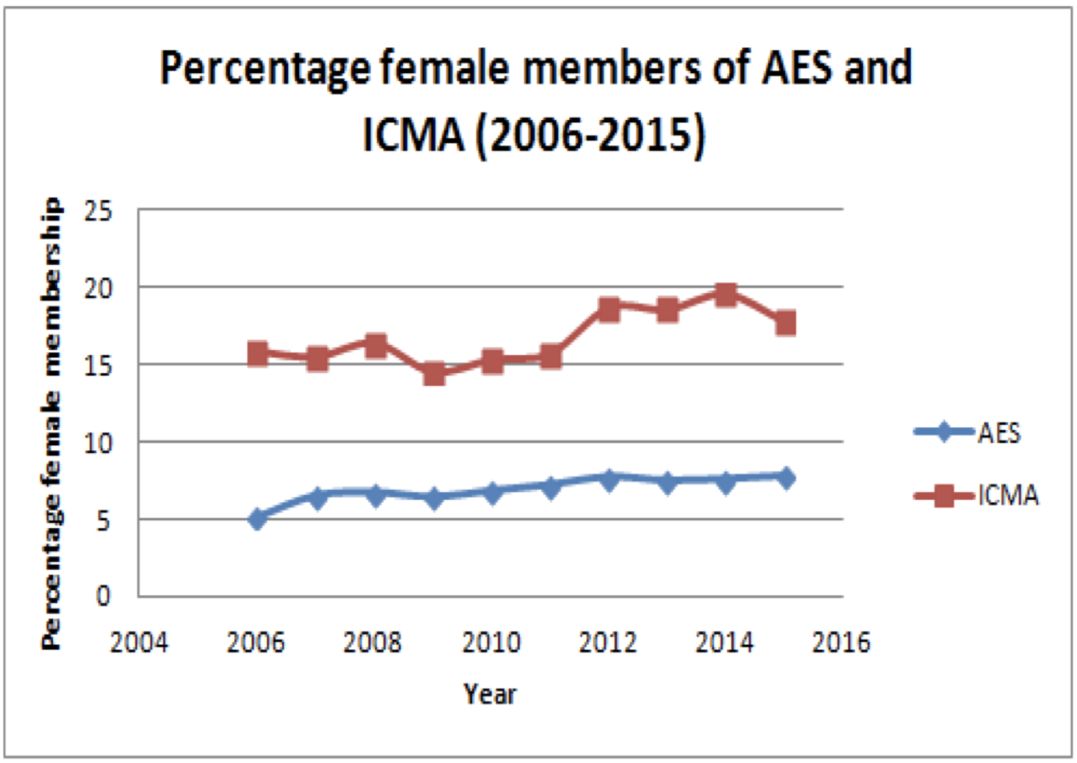
Fig 1: Percentage of female members of the Audio Engineering Society and International Computer Music Association between 2006 and 2015 (Mathew, Grossman and Andreopoulou 2016).

If we consider for a moment the related field of STEM, between 1980 and 2012 the STEM workforce of the United States of America grew from 5.8% to 14%. Leslie Lamberson, an assistant professor of Drexel University College of Engineering cites how during her time as an aerospace engineering student, where classes were male dominated, she “held back in classes” because she was afraid to get picked on. Today, however, Lamberson notes how the women she teaches seem unphased by being vastly outnumbered by men. This comes as no surprise when you consider The Society of Women Engineers has a chapter at Drexel University, with over 200 women belonging to the Drexel group (Kaufmann 2015). The Society of Women Engineers encourages women to pursue their chosen careers through support and training, embracing diversity and a commitment to creating inclusive environments for all members and stakeholders, as well as providing an organisation that fosters mentoring and the development of networks, both professional and personal (Society of Women Engineers, 2020). The aforementioned would suggest that networks are vital to improving inclusivity in academia, however, with sound and music technology being a relatively niche field in comparison to traditional engineering, and therefore yielding smaller numbers, it may be more useful to tap into online networks, to ensure strength in numbers. Online collectives will not be explored fully in this body of work but are an area I would like to explore in future projects.

1.4 On Research

Throughout this dissertation I hope that the reader gains knowledge on professionals of minority genders working in the sound and music technology and related industries. The examples used throughout this dissertation have been included with the desire to amplify the voices of people of minority genders working in industry, as well as the inclusion of the Glossary of Collectives and Bibliographical Dictionary to provide further reading for individuals and institutes looking to improve the equality and diversity of their sound and music technology programmes.

To be able to provide resources for others, it was first important that I assimilated the available literature across sound and music technology, STEM, pedagogy and feminism, to further inform my own research and practice as a lecturer and professional.

Chapter 2

Literature Review

2.1 The Paradox of Inclusivity

Helen Turnbull’s 2013 TEDTalk discusses the inclusion paradox. She explains that as humans, we are all alike experiencing humankind, yet paradoxically all uniquely different based upon physical characteristics and life experiences. These characteristics and experiences form an affinity bias, that is, a preference to surround oneself with people similar to oneself, causing individuals to unconsciously exclude others based upon being different (Turnbull 2013). It is vital that individuals start to become conscious of these biases in order to transition into becoming consciously unbiased, allowing environments to be welcoming to all (Easterly and Ricard 2011).

In order to gauge an understanding of how to create environments that are welcoming for all, in this chapter I have reviewed a wide range of literature including texts focused on feminism, pedagogy, and equality and diversity. I have been able to make inferences from the existing research and apply them to my sound and music technology classroom. The literature includes research on workplace and academic retention, looking at stages in which people of minority genders start disengaging from STEM related subjects and the workplace. I have also explored sexism within science and how that directly impacts the classroom environment. Other issues addressed focus on diversity funding, as well as problems linked to the interdisciplinary nature of sound and music technology when disseminating the available theories on diversity and inclusivity. Furthermore, the chapter engages with a series of glassy metaphors and their usefulness for explaining the dearth of people of minority genders in sound and music technology. The chapter then moves on to explore sex aggregated academic performance data; the impact of boys dominating the classroom; sexism in the syllabus and visiblity, Finally, the chapter ends by exploring the importance of collectives, networks and role models. The literature review presented in the next sections informed the survey design process outlined in Chapter 3.

2.2 The ‘Leaky Pipeline’

Born and Devine (2015) state that between 1994 and 2012 student numbers for Music Technology based HE programmes rose by 1400%, an increase that coincides with the introduction of the Music Technology A-level in 1998. The authors reflect on how historically, applications from women have been low, and as such, the exponential growth in popularity of Music Technology courses, in conjunction with applications by women being so low, has resulted in an overwhelmingly male dominated programme. While the authors do not provide any further theories as to why Music Technology courses have become overwhelmingly male dominated, research by Blickenstaff (2006) suggests that a ‘leaky pipeline’ could be to blame, more so than a ‘gender filter’.

The leaky pipeline is a metaphor often used to describe the under-representation of women in STEM, with the ‘pipe’ a metaphor for the journey from secondary school education, through higher education and into the STEM workplace. While it is true that men ‘leak’ at various points in the pipeline too, the overwhelming majority are female (Blickenstaff 2006). If you have a leak in a pipe, the solution to fixing the leak isn’t to send more water down the pipe. Therefore the solution to helping STEM students of minority genders progress from HE to STEM is not necessarily to recruit more students of minority gender, but to fix the leaks along the pipeline that are preventing the successful transition from the classroom to the workplace. Explanations for the leaky pipeline have included biological differences between men and women, with studies looking at the relationship between brain size and IQ in an unsuccessful attempt to claim intellectual inferiority as the reason behind the ‘leaks’ (Birke 1992). Academic preparedness is another leaky theory, which has been discredited. A 1997 meta-analysis using data from over 400 academic tests, using 1500 data sets from millions of students in the United States shows that differences in scores for maths and science are negligible between genders (Cole 1997). A 2014 inquiry into the leaky pipeline by the Science and Technology Committee in UK Parliament called for standardisation across HE. Such standardisation included working conditions for women scientists, as well as inviting a review of the academic career structure, in an attempt to foster more stable career pathways. The committee also highlighted how as commendable as it may be that the Government wish to inspire more women into STEM subjects at school (noting this as the point at which decisions about careers begin to be made), efforts are wasted due to the disadvantages women scientists disproportionally face (Science and Technology Committee, 2014).

Theories regarding attitudes toward early experiences of science may hold more weight. McGuire et al., (2020) found that gender stereotypes in STEM emerge early in childhood, with boys more likely than girls to have STEM self-efficacy, by which I mean how boys are more likely to believe they are good at STEM subjects than girls. This is damaging, as gender stereotypes have been shown to negatively affect self-efficacy (Hill et al., 2010; Litzer et al., 2014). Though the national curriculum of the United Kingdom requires all students to complete GCSE Science, an analysis of 2017 GCSE STEM subjects found girls outperformed boys in science, additional science, physics, biology and chemistry GCSE examinations (Welcome to the WISE Campaign n.d.). However, there is a trend that suggests girls opt out of science as soon as it is no longer compulsory, though where girls do opt for science in Further Education (FE), they still outperform their male peers (Stewart 1998).

2.3 Feedback Loops and Glassy Metaphors.

Ashcroft (2013) explains how people derive an identity from work, while simultaneously their workplace derives an identity from them. For example, if white men derive their identity from working within audio engineering, audio engineering derives an identity from white men. This leads to a feedback loop that is harmful to diversity. A hypothetical loop could be a sound and music technology course preparing marketing materials. If the project leader is not consciously considering diversity, it is possible for all-male marketing content to be submitted, whereby the language used is gendered toward the male default, using terms such as sound man or sound guy, and imagery shows men in a position of power, such as men behind the mixing console in a position of dominance. This can perpetuate that the course identity is male, and the men identify with sound and music technology. Ashcroft (2013) puts forward the glass slipper metaphor, the glass slipper is derivative of the Cinderella story. If the glass slipper does not fit the foot, you do not marry the Prince (Grimm Brothers 1812). Ashcroft (2013) states that collective occupational identity, in relation to social identity (the foot) can aid sustainable integration of diversity in the workplace (the glass slipper). In the context of this dissertation, the occupational identity could be student identity, with workplace synonymous with the educational environment. Hypothetically, with a more conscious effort towards a more diverse marketing campaign, the identity of the course could be one of equality and diversity, attracting a more diverse cohort of students. Similar glassy metaphors include the glass ceiling, glass escalator and glass cliff. The glass ceiling refers to a metaphorical barrier experienced by women working in male-dominated professions that prevents their ascension into more senior roles (Loden 2017). The glass escalator refers to the fast tracking of men in predominantly female professions to more senior roles based upon perceived competency (Williams 2013). The glass cliff metaphor refers to women being preferentially placed in positions with an increased risk of negative consequences over their male counterparts (Ryan and Haslam 2005). Ryan and Haslam (2005) found that companies that had women on their board were more likely to have experienced consistently poor performance for the previous five months. Cook and Glass (2013) found similar results examining Fortune 500 companies over a 15-year period , reporting that white women and men and women of colour were more likely than white men to be promoted to CEO of a poorly performing company. With increased scrutiny and criticism, a consequence of underperformance, the glass cliff is but another hurdle for women to overcome in the workplace (Ryan and Haslam 2005).

From research carried out between 2010 and 2015, Born and Devine (2015, p.146) found that music technology degree programmes are “alarmingly imbalanced” with 90% of the student population being male. On the contrary, traditional music degree programmes, whose discipline is firmly in the arts, are closer to national student population averages, with 55% of the student population female and 45% male. These figures would suggest that female students are not being dissuaded from pursuing careers in the arts, based upon the percentage of female traditional music students. However, they do appear to be dissuaded from the more science leaning subject of sound and music technology. Born and Devine’s data showed over 11,000 men applied to music technology-based degree programmes over their five-year study, as opposed to 1,400 women applicants. In absolute terms, music technology degree programmes accept more male students than females, the acceptance rate from applicants is slightly higher for women than men; though no specific figure to demonstrate this higher rate of acceptance is provided by the authors. Born and Devine also note a greater percentage of women enrolled onto A-Level Music Technology programmes (17.5%) than onto Music Technology based degree programmes (12%). While those figures do not explain why fewer women progress from Music Technology A-level to degree level, the fact that acceptance rates from female students are higher than that of their male peers suggests that it is not related to the applications and enrolment process, but perhaps related to the perception of sound and music technology as a degree program.

2.4 Interpreting STEM Subjects Data

Parallels to the research carried out by Born and Devine (2015) can be found in other vocational subjects as seen in the statistics in Fig 2-4, originally presented by Burns (2013). The data shows that in 2013, only 5% of those that studied BTEC Level 2 Engineering were girls - 810, up from 680 the previous year. Of the 810 girls who studied BTEC Level 2 Engineering, 37% achieved a distinction grade, compared to 20% of the male students taking the same course (as shown in Fig 2). At Level 3, 4% of students were female, but again outperformed their male peers by 5%; 14% of female students achieved a distinction as opposed to 9% of male students.

Fig 2: 2013 BTEC Level 2 and Level 3 Engineering Distinction Grade statistics (Burns 2013).

Burns (2013) also states that similar trends can be observed in BTEC Level 2 Information Technology, where girls made up 38% of the cohort, and 31% of those gained a distinction, compared to 21% of the boys (see Fig 3). Similarly, with the Level 3 cohort, although only 18% of the cohort were female, 15% achieved the top grade as opposed to 12% of their male peers.

Fig 3: 2013 BTEC Level 2 and Level 3 Information Technology Distinction Grade statistics (Burns 2013).
A statistics report by Gill (2016) confirms the perceived gender biases in computing. It was reported that 61.25% of students sitting GCSE Computing/Information Technology examinations in 2014 were male (69,698 male students, as opposed to 44,100 female students), demonstrating a clear disparity (see Fig 4).

Despite there being 25,598 more male students than female students, 73.75% of female students achieved A* - C grades, as opposed to 66.31% male students (see Fig 4). This shows that although there were more male students than female students, a greater percentage of female students achieved higher grades than their male counterparts, demonstrating that female students are no less able than their male peers with Computing/Information Technology.

Fig 4: Students Sitting GCSE Computing/Information Technology Examinations and Achievement in 2014 (Gill 2016).

In 2014, the gender gap at GCSE Music examinations was quite narrow, with 51.77% of total students being female. However, similarly to Computing/Information Technology, female students outperformed their male peers by as much as 6.73% in terms of achieving A* - C grades (79.80% female to 73.07% male). Demonstrating that the female student is no less able than their male peer (Knott 2018).

Knott (2018) suggests educational performance measures like the English Baccalaureate (abbreviated as EBacc) are leading to pupils gravitating toward subjects their friends are studying, due to having fewer subject choices available to pupils. This may be the cause of the widening of the gender gap in GCSE between the academic years 2013/14 and 2017/18 (Knott 2018), as shown in Fig 5, with 16% more female students entering GCSE music exams than male.
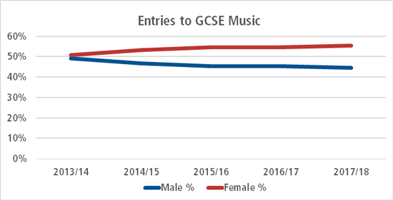
Fig 5: The widening of the GCSE Music gender gap between 2013/14 and 2017/18 (Knott 2018).

GCSE students will typically study 9 GCSEs, with the EBacc encouraging the study of English language, mathematics, science (including computer science), a humanity and a modern foreign language. This leaves the student with three additional GCSE options to choose from.
Fig 6 is a table showing how options are often put to students, based on a 2014 student booklet from a high performing secondary school that is local to me in Teesside. A student can choose one option from each column; however, one of the three options must be an EBacc subject; shaded in the table below. Music has been highlighted in yellow. Note how many none EBacc subjects appear multiple times throughout the table, yet music does not. Health & Social Care appears twice in the column ‘Option C’.

Option A | Option B | Option C
Computing | Computing | Computing
French | French | French
Geography | Geography | Geography
History | History | History
Spanish | Spanish | Spanish
Art | Art | Art
Business Studies | Business Studies | Business Studies
Dance | Catering | Catering
Drama | Graphics | Engineering
Enterprise | ICT | Health & Social Care
Health & Social Care | Physical Education | Health & Social Care
ICT | Religious Studies | ICT
Resistant Materials | Sociology | Music
Sociology | Sport | Physical Education
Fig 6: GCSE options table; adapted from page 5 of GCSE Routes (Macmillan Academy 2014).
Romer (2018) highlights that entries to art related GCSE exams have fallen by 25.6% between 2014 and 2018, coinciding with the Government’s emphasis on EBacc entries, with EBacc subjects seeing an increase of 4.6%, while total GCSE entries have grown by 3.4%. Knott’s article also quotes The Association of School and College Leaders who have found correlation between friendship groups and the subject choices made by students at GCSE (Knott 2018). This would suggest that female students and female friendship groups are choosing music, while male students and their male friendship groups are moving away from choosing GCSE music, which would explain the more pronounced gap in 2017/18 as opposed to 2013/14. This suggests that one of the pertinent issues surrounding the gender divide in HE sound and music technology based subjects may be rooted in friendship and social circles, and therefore important to consider how we can establish networks to further strengthen these likeminded social circles through sound and music technology.

Born and Devine’s research led me to the work of Hallam, Rogers and Creech (2008) whose research centres around gender differences in children’s musical instrument choice across 150 local authority music services in England. The data is organised by Key Stage (KS) and ranges from KS1 (where children are aged between 5 and 7) to KS4 (where children are aged between 14 and 16). Pupils within the Post-16 category (16 to 19) were also included as part of the study. The data shows that between KS1 – KS4, 40% of students that identify ‘Music Technology’ as their instrument are female. Post-16 this percentage drops to 25%, among Music Technology A-Level students, this percentage further drops to 18% and again to 10% for Music Technology degree programmes (Hallam, Rogers and Creech 2008).

2.5 Male Dominance in Sound and Music Technology

It has been suggested that male dominance in primary school could go some way to explaining how a female student’s early experience in the science classroom can lead to an unconscious belief of science being a profession more suited to men than women. An example of such male dominance is the seizing of interactive teaching materials by boys (Whitelegg 2001). This dominance can not only be observed in the classroom, but also in learning resources, too. In an analysis of visual content of online science educational resources aimed at primary school children (aged 4 to 11 years old), Kerkhoven et al. (2016) found 3,191 people depicted in 333 resources, with boys or men depicted most often (56.4% as opposed to 43.6%). Furthermore, men were depicted with a science profession more often than women (75% as opposed to 25%). Interestingly, the same analysis found that women were depicted as working in education more often than men (63.9% as opposed to 36.1%). Not only could this affect women entering STEM, but it may also have an effect on student performance.

O'Brien and Crandall (2003) found that women given a maths test and told that the test had “been shown to produce gender differences” scored fewer marks than women taking the same test that they were told had “not been shown to produce gender differences” (O'Brien & Crandall 2003, p. 785). The purpose of the study was to test the psychological impact of telling somebody that a test had gender differences, in an effort to tap into stereotype and affect performance, in this instance the stereotype is that men are better than women at maths (O’Brein 2020). The study refers to this phenomenon as “stereotype threat” and found that the outcome of the test was unaffected for men who were informed of the stereotype threat prior to undertaking the test (O’Brien & Crandall 2003, p. 782). The aforementioned suggests that gender stereotyping can negatively impact test scores for women, as well as male dominance in the classroom and unbalanced learning materials creating the perception of a learning environment being unsuitable for people of minority genders. It is therefore important that the classroom provides equal access, with a careful approach to classroom management to ensure that nobody, regardless of their gender, dominates resources, as well as ensuring logistical aspects such as seating arrangements are not segregated. Diverse working groups should be encouraged for collaborative work. Sexist and exclusive language and behaviour should be excluded from the classroom, whether that is staff, students or resources, with an active approach to seeking more inclusive classroom resources.

Comber, Hargreaves and Colley in a 1993 review of technology in the classroom highlighted how boys aged 11-12 years old and 15-16 years old were regularly using personal computers as much as three times more frequently than girls, with most of the boys’ time spent on computer games, whereas girls described time spent playing computer games as being “rather tedious”, using computers for tasks they found more interesting or more mature, such as word processing (Comber, Hargreaves and Colley 1993, p. 128). This suggests from the outset that boys have associated computers with play. Boys also felt that they were either better or much better than their female peers with the use of music technology, with boys having an increasing self-confidence in music technology with age, in contrast to girls’ decreasing self-confidence (Comber, Hargreaves and Colley 1993). Annetts’ (2015) research discusses the hierarchy of the audio domain, with those perceived as being more masculine able to act as gatekeepers for the hierarchy. Masculine dominance was identified as being fundamentally connected to expressions of competence and technical knowledge (Annetts 2015). This masculine dominance and expressions of technical knowledge was highlighted by mastering engineer Mandy Parnell in a 2017 interview with the Guardian (Hutchinson 2017), where she discusses her belief that women need to work twice as hard in the studio to prove themselves. This ‘alpha-male’ mentality has led to circumstances where male engineers would be treated preferentially by record producers, with conversations being more colloquial and friendlier, whereas Parnell would be subjected to a technical grilling as if having to prove her credentials due to her gender. This experience is not unique. There is evidence to suggest that both men and women use gender stereotyping to determine expertise, with women being perceived to be less competent than men in masculine environments (Hollingshead and Fraidin 2003).

Parnell’s experiences are paralleled in a study by Smith et al. (2019) in which 75 female-identifying songwriters and producers were interviewed regarding the barriers they face due to their gender in music, as well as potential solutions to presently existing problems. Out of those interviewed, 25% reported they were the only women in the studio and 28% indicated they had been dismissed. The term ‘dismissed’ is here defined as circumstances where knowledge, capability and ability were either doubted or undercut by colleagues or circumstances where women had to prove themselves to individuals who might work with them. Moreover, an alarming 39% were objectified. Furthermore, 43% of those surveyed highlighted the two main issues faced within industry were being dismissed or not taken seriously by colleagues, and having to prove competence to their male peers. Given the research by Smith et al. (2019) it is hardly surprising that people of minority genders are finding they are having to work harder than their male counterparts for similar roles when gender seems to be a contributing factor in judging the competency, knowledge and skills of an individual. The interviewees stated that creating more welcoming environments for women, that generate opportunities for the utilisation of their skills and talents would be a positive change for the industry. As well as this, participants felt it paramount to highlight role models and mentors for women as crucial for positive change.

2.6 Redressing technological sexism

Comber, Hargreaves and Colley (1993) stated that the inclusion of technology in music education had the potential to play a major role in redressing the balance of the sexes in the classroom. However, while the introduction of technology to the music classroom was successful in attracting more boys to the previously female dominated traditional music classroom, it would appear that the music technology classroom has become male dominated; evidenced by the current gender gap and could be linked to the perceived masculinity of computer technology (Comber, Hargreaves and Colley 1993). Murray (1993) has argued previously that technology at its core is perceived to be masculine, stating how technology “plays an important role as a boundary marker; what is perceived to be technological is perceived to be masculine” (Murray 1993, p67).

Given the issues surrounding gender imbalances in the sound and music technology classroom, technology itself needs to be carefully considered to ensure it is appropriate for a more gender-neutral audience if we are to see an increase in minority genders in sound and music technology. It is worth clarifying that when I suggest the technology needs to be carefully considered, I am not suggesting the feminising of mixing desks and microphones in a similar fashion to Bic for Her pens. Manufacturers have often failed at addressing this issue, for example, with company MIDIPlus releasing an audio interface called “Mirror” that resembled an eyeshadow case, marketed specifically for females. Mirror was quite rightly met with criticism (Young 2018), however the company has since rebranded it as “a fun way to add visual flare as well as perfectly capture every detail of your performance; Mirror is an audio interface designed especially with your webcast self-karaoke channel in mind” (MIDIplus 2020). It should also be noted that MIDIPlus have since issued an apology and full statement regarding the initial, ill-received launch of Mirror. In this instance, when suggesting the need for gender neutral, I am referring to the way technology is approached in the academic setting, particularly as it pertains to language.

Cabling terminology is an area of sound and music technology that would benefit from more gender-neutral language. An XLR cable used to connect a microphone to a pre-amplifier is regularly referred to as having a male end and a female end, a direct analogy to sex organs. I see no reason as to why connector and fastener was not adopted instead. There are similar issues with the use of the term ‘master’ and ‘slave’ when one device controls one or more other devices, though it appears that in the wake of George Floyd companies such as social media network Twitter and Microsoft subsidiary Github have dropped terms in favour of the more inclusive ‘leader’ and ‘follower’ (BBC 2020). The move to more inclusive language can go a long way to helping facilitate more inclusive environments.

There is evidence that men dominate most levels of technological development and implementation, leading to the female experience of technology being created in the image of man (Lie et al. 1988). This is problematic due to the concept of gender appearing in different forms on different societal levels. Harding (1986) offers gender structure, symbolism and individualism based on identity and behaviour as ways of conceptualising gender. Harding (1986) states that one cannot begin to tackle gender-based issues on one level, without approaching the other levels. For example, we cannot begin to emasculate the male-dominated technical professions while men derive their identity from technology and are symbolised in technology as the dominator in marketing materials and textbooks. This is paralleled by Comber, Hargreaves and Colley (1993), noting that women and girls will continue to feel excluded from technology unless those who manufacture and market the equipment begin catering for the entire gender spectrum, as explored previously in 2.3.

In the 27 years since Comber, Hargreaves and Colley’s work, technology has found itself a classroom norm. Colley and Comber (2003) published an updated study of 11 to 12-year old and 15 to 16-year old students and their attitudes towards computer usage. In the ten years that had passed from their previous work (Comber, Hargreaves and Colley 1993) there was some evidence to suggest a narrowing of the gender gap in the use of computers for applications such as word processing and programming (Colley and Comber 2003). However, the gap still existed in terms of attitudes, with boys liking computers more, having a heightened sense of computer literacy and usage outside of school (Colley and Comber 2003). It is also interesting to note that 15-16-year-old girls were found to hold the least positive attitudes towards computers, with the authors believing that this may be influenced by cultural pressures of gender stereotyping (Colley and Comber 2003). A meta-analysis of fifty studies related to gender and attitudes toward technology use found that attitudinal differences regarding technology between the genders was narrower at college level than it was at secondary school, suggesting that female students at college level are more technologically preprepared, in terms of knowledge and competence, than secondary school students and the general female population (Cai, Fan and Du 2017). While is unsurprising that female students at college level feel more adept with technology than secondary school students, it is concerning that the general female population feel less able. It is clear then that more work needs to be done regarding attitudes towards technology at an earlier age, as this could be dissuading people of minority genders from pursuing technological subjects further, as well as continuing to bestow confidence in technology in the general female population to ensure that irrespective of age, any person of minority gender is not dissuaded from exploring tech further.

A publication from the United Kingdom’s Department of Education in April 2019 highlighted how technology is becoming increasingly a large part of our society as the world becomes more digitally enabled. Due to this, it is important that young people are introduced to technologies at a young age, and those who wish to upskill have the opportunity to do so. In harvesting this digital competency, communities will be able to explore and benefit more from the technology available. What is most welcomed is that the government’s digital strategy begins with proper implementation throughout the education system, ensuring that all children have equal opportunities with technology such as tablets and laptops in class, as well as digital resources, software and services to aid teaching and learning (Hinds 2019).

While the aforementioned statement seems promising, it is important to be mindful of the gender perceptions and expectations that are often ignored when embedding technology, as this can lead to technological ambivalence and alienation. For example, Armstrong (2003) observed that boys and girls, aged between 15 and 18 years old, displayed many similarities during the initial stages of composition, where both would play around to inspire further compositional ideas. The differentiation, however, regarded the tools used for play. Girls preferred to compose acoustically, whereas boys were almost entirely computer based. Furthermore, Armstrong observed the male perception of technical competence and dominance in the classroom, which echoes back to Lie et al. (1988) at the beginning of this subchapter. Gender perceptions and expectations were found amongst both teachers and pupils in the work of Comber, Hargreaves and Colley (1993), where both groups saw the computer as a boys’ technological toy. While it is difficult to deny the enormous possibilities embedding technology can have on the classroom, it is important that as educators we are mindful that a technological focus for particular activities such as a student demonstrating a technical competency via a video tutorial as opposed to a traditionally typed essay or report as an assessment, may be discouraging diversification, further excluding learners (Armstrong 2003).

2.7 Sexism in the Syllabus

Aside from the technology, the music syllabus itself has historically excluded women. In 2015, Jessy McCabe, an A-Level music student noted that the Edexcel Music syllabus featured 63 male composers and no female composers. Upon writing to the exam board, she received an e-mail stating that due to the lack of prominent female composers in the western classical tradition, there would be very few female composers that could be included (Khomami 2015). That is simply not true, with the International Encyclopaedia of Women Composers containing over 6000 female composers that could have been considered for inclusion (Criado Perez 2019). This discrimination and exclusion are not new. Historically, due to their ‘place in society’, women were scarcely able to compose, and if they were it was in private and deemed improper for large scale orchestral works (Beer 2016). For women, music could not be considered a career, with nineteenth Century composer Fanny Mendelssohn told as a child that music could be a career for her brother, but for her it should never become part of her daily life (Rothenberg 1993). Due to the suppression of female composition, it is unsurprising perhaps that the trickle-down effect of their influence is invisible to the mainstream, whereas the impact of Bach, Beethoven and Mozart can be traced through to present day. Fortunately, through a petition, Jessy McCabe was able to compel Edexcel into creating a more inclusive syllabus. While the addition of five compositions by women may seem slight, it is a step in the right direction and hopefully in time will aid to influence the next generations of composers (Khomami 2015).

These inspirational figures are out there, and as educators, it is our responsibility to ensure their contributions are visible in the classroom, where appropriate. Wendy Carlos won three Grammy awards in 1969 for her work “Switched on Bach”, which received a standing ovation upon playback at the 1968 Audio Engineering Society conference (Synthmuseum.com, n.d.). Mica Levi is a critically acclaimed composer, winning multiple awards for her work scoring “Under the Skin” (directed by Glazer 2013) and receiving high praise for her work scoring “Jackie” (directed by Larraín 2016). Her work on “Jackie” led to Levi receiving an Academy Award nomination for “Best Original Music Score”, the first female composer nominated in sixteen years and only the fifth in history (Beauman 2017). In 2020, Hildur Guðnadóttir became the sixth female composer to receive an Academy Award nomination for her score of “Joker” (directed by Phillips 2019), which she won. Guðnadóttir also became the first solo woman to win the Best Original Music BAFTA (Hamer 2020).

Research conducted and summarised by Julia Eckhardt and Leen De Graeve in 2016 highlights how non-male artists in the field of sounding arts are perceived as “other” by men and women alike (Eckhardt and De Graeve 2016, p 60.), facing negative discrimination in the forms of assumptions, remarks, stereotyping, exclusion and sexualisation. There are parallels to Eckhardt and De Graeve’s findings in Goldin and Rouse’s research (2000), which found explicit conscious biases with many musical directors choosing not to hire women due to their belief that women have less musical talent than men. However, where the player’s identity is concealed behind a screen to ensure impartiality, Goldin and Rouse found the probability of a woman being hired by a musical director increased by 50% (Goldin and Rouse 2000). It is interesting to note the increase in women being hired by orchestras when gender is hidden, however, in academia, people of minority genders are often lost prior to the application process, as highlighted when discussing the leaky pipeline metaphor, and therefore the barriers of entry must be explored.

Though men also encounter discrimination, albeit to a much lighter degree, Eckhardt and De Graeve’s (2016) research found that men were able to regard the remarks lightly. It is important to note that the authors did not discuss ethnicity, and as such do not discuss the possibility of Black and Minority Ethnicities (abbreviated as BAME) men facing discrimination, or how BAME women may face double discrimination for ethnicity and gender. Women on the other hand were found to perceive the discrimination as unsettling and discouraging, developing strategies to circumvent future situations where discrimination may arise. Due to this, the sound arts field is perceived as male dominated and can feel unwelcoming for women. The results of Eckhardt and De Graeve’s research seem to suggest that despite most artists being in favour of diversity, networks are gendered. Highlighting the importance of networking as a means of finding employment in the field, the research also suggests that due to gendered networks the working industry is also dominated by men (Eckhardt and De Graeve 2016). If networks are male dominated, resulting in women feeling unwelcomed and therefore at a disadvantage when seeking employment, students could be directed to women led networks with men invited to learn from such groups.

The following section explores a number of collectives and networks that aim to connect people of minority genders together, offering industry related skills sharing events (such as Yorkshire Sound Women Network’s Level Up! Series), job opportunities (such as Women’s Audio Mission’s regularly updated Job Board) and exclusive tools and opportunities via subscription (such as Saffron Members).

2.8 Collectives and Networks

Founded in 2003, the Women’s Audio Mission (WAM) based in San Francisco are an example of the power and influence an all women network can have when addressing gender imbalances in Sound and Music Technology. WAM have been responsible for over 500 women being placed in paid positions with companies such as Google, Pixar, Dolby Laboratories and many more, as well as being consultants for The White House Office of Social Innovation regarding educating women and girls, and over 2000 classes have been delivered to over 12,000 Women and girls since the Network’s inception (Women’s Audio Mission 2016).

In the UK, #NormalNotNovelty is a regular series of workshops for female-identifying people working in audio and is mainly held at Red Bull Studios, London; though the workshops have taken place at other venues. These workshops intend to connect female-identifying sound engineers, DJs and electronic producers with other female-identifying members of the community. Each event explores a different topic, with workshops carried out by professional female-identifying practitioners in the industry, such as mastering engineer Mandy Parnell (PSNEurope 2019). In a 2019 article for Audio Media International, freelance producer and recording/mix engineer Jess Bartlett wrote of how her first #NormalNotNovelty experience was one of enlightenment, one where a room full of unearthed talent was suddenly given visibility. Bartlett states that those workshops at #NormalNotNovelty are showcasing women succeeding in audio and that networking with the workshop leaders has led to shadowing opportunities, the likes of which Bartlett would not have had access to outside of the events (Bartlett 2019). Giving women a platform to showcase their skills and abilities, as well as having visible role models was also highlighted in the previously discussed Smith et al.’s report. While I would disagree with Bartlett’s statement of shadowing opportunities not being available outside of the #NormalNotNovelty networking experience, I acknowledge that without access to the appropriate networks, it can be very difficult. Accessing information in order to access such opportunities can be quite challenging if you are not already ‘in the know’. Issues with gendered networking and gatekeeping were discussed earlier in relation to Eckhardt and De Graeve’s 2016 research, as well as being highlighted by 40% of interviewees in Smith et al’s work.

Girls Rock London (GRL) work on issues pertaining girls’ self-esteem, confidence, resilience and body image. Entry and exit surveys showed that 46% of participants said that GRL helped them, through promoting collaboration, empowering the girls to make music and allowing them to take up space that would traditionally have been dominated by men (Girls Rock London 2018). The National Foundation for Education and Research found that female, working class and BAME students lacking confidence and experience, lower a teacher’s expectations of their abilities (MacDonald 2014). Although the aforementioned is a clear example of unconscious bias in the classroom, as well as promoting ways for educators to become more conscious of these biases, explored in Chapter 3, it is also important to ensure we’re promoting confidence in our students to prevent these unconscious biases developing.

Yorkshire Sound Women Network (YSWN), founded in 2015, seeks to inspire and enable women and girls to explore Sound and Music Technology through workshops and meet-ups, as well as a host of resources available on their website (such as workshop plans on how to build a piezo contact microphone, how to solder a noise instrument, and a lesson plan on women in electronic music history). In the first three years of the group, YSWN delivered over 80 workshops, partaking in mentoring and skill-sharing activities with public performances and community events inspiring new groups, as well as developing partnerships with companies such as Syntorial, Audulus and Ableton. The workshops delivered in those first 3 years of the YSWN helped inspire regional groups across Yorkshire and further afield, such as Calderdale Sound Women Network, Leeds Sound Women Network, SONA and Malta Sound Women Network (Yorkshire Sound Women Network, 2019). Influencing the creation of new skills-sharing groups with the intention to inspire and enable women in audio is crucial to the cause of gender equality in audio. By giving more people of minority genders a platform to explore audio, they will take up space in the audio community, making people of minority genders working with sound and technology the norm, not a novelty.

The partnerships secured by the YSWN are crucial to allow the organisation to continue to grow, helped by the larger reach of the aforementioned companies, as well as the financial support of Arts Council England and the University of Huddersfield. In 2018, Music Radar carried out a survey to find out what Digital Audio Workstations (DAW) their readership was using, with Ableton Live coming in second, ahead of industry titans Pro Tools and Logic (Owsinski 2018). While the readership of Music Radar may not be representative of the whole audio community, it certainly shows that it is representative of a very popular website amongst music makers, globally. Having such a popular DAW company supporting a grassroots collective is vital to the growth of organisations such as the YSWN. It is also worth noting that Ableton have extended their support further, including collaboration with WAM at 2018’s Loop event, which is a three-day event consisting of expert panels, presentations, studio sessions, installations, discussions and interactive workshops aimed at skills sharing cutting edge sound and music technology creative practice, as well as networking with like-minded people (Loop.ableton.com, 2019). The mentorships delivered by YSWN, WAM, GRL and many more minority gender and feminist sound and music technology collectives is having a directly positive impact on those within the collectives, as seen with WAM’s placement success and GRL’s empowerment, and therefore I will be exploring ways of connecting and collaborating with these collectives further in an attempt to positively impact current students, and visibly promote inclusivity within our courses.

It is interesting to note that although these networks are welcoming of non-binary participants, the fact that many use gendered terms such as ‘woman’ or ‘girls’ in their name makes them potentially exclusionary. There is a similar issue with HeForShe.

2.9 The #audioequalitypledge

YSWN founder Dr Liz Dobson, collaboratively put forth a guide to supporting women in sound in 2018. This guide recommends focussing on three actions for improving social equity in audio. It is these measures that I have been focussing my attentions on in my profession as a lecturer. These steps are:

Collaborate, “offering support to feminist collectives, adopting new interventions, understanding and addressing unconscious bias” (Dobson et al. 2018). To aid with collaboration, Dobson has compiled a list of over fifty all-women and feminist sound/music tech collectives, co-ops and non-profits.

Perspective, researching, checking assumptions, recognising double discrimination (Dobson et al. 2018).

Changing Environments, creating fit for purpose learning environments (Dobson et al. 2018). With organisations such as Yorkshire Sound Women Network, Women’s Audio Mission, #NormalNotNovelty and more, it is clear that a room full of minority gendered creatives thrives, due to pre-existing gender barriers no longer existing. As explored earlier in relation to a first experience with #NormalNotNovelty,

When I went to my first NNN event, I remember being completely blown away, and just kept asking myself where all these incredible people had been hiding! It was amazing but equally very enlightening, as it became very apparent to me just how important it is to get all these women visible in the industry. (Bartlet 2019).

Knowledge is built through interchanges of experiences and concerns from people of minority genders. Individuals are provided with resources and wider networking opportunities than before, and voices are amplified where previously they may have been unheard (Dobson 2018). These productive and collaborative relationships begin to form within education and industry, the likes of which can be seen with Yorkshire Sound Women Network’s relationships with University of Huddersfield and Ableton, or Women Audio Mission’s relationships with The Recording Academy and Avid.

No longer should a female-identifying person in audio wonder, paraphrasing Bartlet (2019), where all the incredible people like themselves have been hiding. Learning environments should be safe spaces and as Dobson et al. highlight, fit for purpose. If the Sound and Music Technology classroom is only highlighting the achievements of white men in sound and music technology, then it is only representing white men and is only fit for white men. Female-identifying professionals should be included in the reference materials of lectures, sit amongst their male peers on inspiration boards and be included in the marketing material, not in a way that suggests they need to prove their worth, but in a way that is representative of women in audio. This is what makes the Recording Academy’s ‘Producer & Engineer Inclusion Initiative’ so important. Through this initiative stakeholders are asked to identify and consider at least two women as part of the hiring process for producers or engineers (GRAMMY.com, 2019). These initiatives are what made the AES’s UK section’s #HeForShe pledge in 2018 so important, especially as an educator. #HeForShe invites all to participate in the pursuit of gender equality, not just women. As a pledger of the AES UK #HeForShe campaign, and an educator, my pledge is one of awareness of diversity and one of building awareness amongst my students, as well as challenging cultural and sociological biases (Gillmore n.d.). This can be achieved utilising the aforementioned suggestions for creating more suitable learning environments.

Through the creation and maintenance of suitable learning environments, we can aid progression to the workplace and in turn influence the future of the workplace. A 2019 publication by Berklee regarding the obstacles and opportunities women in the U.S music industry face, found that women are facing gender bias, with women of colour feeling significantly less supported in the workplace than white and Hispanic respondents. The report also found that work life impacts affected women more so than men, particularly regarding decisions to have children, and that nearly half of the 2000 respondents felt they should be further ahead in their careers. This publication suggests that the current sound and music technology workplace is not a suitable environment for women, however, participants did believe that a focus on increasing diversity, suitable mentorship, internships and networking opportunities had aided them to overcome barriers and improve inclusion within the industry (Prior, Barra and Kramer 2019). If the aforementioned are ways to overcome barriers and improve inclusion within the industry, perhaps integrating these strategies in the classroom from the beginning will aid students of minority genders coming through the educational system and into industry to experience an enriching, diverse career in sound and music technology through prior preparation.

My initial research has broadened my perspectives significantly. Through the research carried out, I am able to recognise aspects of my own practice that may not have been as welcoming to those different to me, particularly when it comes to gendering language, as well as teaching materials being male dominant due to the ease of access to these resorts. This is something that I have not consciously been aware of in the past, and through researching, it is clear that is a discrimination risk. With a wider perspective, I am able to recognise assumptions and discriminations, conducting myself accordingly and informing others when a perspective check may be required. Upon an initial review of teaching materials, not only was I able to observe a lack of minority gender representation, but also a lack of BAME representation. While the focus of this research is gender, there are many parallels with ethnicity, too, and have therefore considered ethnicity when building learning environments and teaching materials, as can be observed in section 4.1.

2.10 Reflections on Academic Literature

Figures presented by Hallam, Rogers and Creech (2008) in section 2.4 suggest that more work ought to be carried out to maintain and build upon the 40% of those identifying as Music Technologists between the ages of 5 and 16. As a lecturer of predominantly HE, the main focus of my research pertains to the betterment of inclusive learning environments within Sound and Music Technology at HE. However, what has become clear from the research so far, is that gender stereotyping has a harmful effect on self-efficacy, and that a dearth of role models could explain a dearth of diversity in sound and music technology. I am concerned that efforts to redress the balance at HE may in fact be too late in the academic journey and that collaborating with FE providers, primary and secondary schools regarding how they approach teaching and learning within sound and music technology may be the most effective way of trying to improve diversity-based retention.

Section 2.5 explored male dominance in the classroom, in terms of male students seizing interactive teaching materials, and also the use of male figures in teaching materials. I have experienced similar seizing in mixed gender groups, particularly in a recording studio environment where male students tend to gravitate toward the setting up of microphones or the operation of a control surface, often excluding their peers of minority genders. I have found in my practice that moments like this serve as perfect instances to reflect with students regarding these behaviours in an attempt to bring consciousness of dominance to the forefront. I have also experienced the dominance of male figures in teaching materials. This is particularly noticeable when compiling reading lists and would hypothesise that due to the dearth of people of minority genders within the field, the pool of people of minority genders within the field that are publishing suitable materials is even smaller. It is not that these people do not exist, but that it takes more time and effort, and it is often the lecturers themselves who are devising reading lists for multiple modules, across multiple cohorts, sometimes across multiple courses and multiple year groups, such as myself teaching from level 3 to level 6. Educational institutes have a responsibility therefore to ensure either time or resources are put in place to ensure lecturers are able devise more diverse and inclusive teaching and learning materials, or that the responsibility of building such materials is shared. This shared responsibility could either be via a separate team, for example a team responsible for seeking more diverse texts that can be reviewed by a module leader for inclusion in a module reading list or shared responsibility throughout the department. This departmental collaboration could be lecturers of similar modules sharing resources, for example, a lecturer of L4 Recording Studio Techniques may share resources with a lecturer of L3 Music Recording Techniques to promote more diverse teaching and learning materials that can quite easily be modified to suit the academic level and module.

Section 2.6 discussed technological sexism, particularly as it pertains to language. I believe it is of paramount importance that we begin to consider how gender structure, symbolism and individualism are implemented in teaching and learning materials in order to ensure we, as gatekeepers of education, are allowing all to express their artistic and academic potentials with whatever tools available, free from restrictions caused by the aforementioned social constructs. Whether this is using the more gender-neutral terms of fastener and connector when describing ends of an XLR cable or discussing the usability of a microphone by referring to technical specification, such as how it responds to certain frequencies, as opposed to referring to microphones as being suitable for a male or female voice.

Akhna Skop, receiver of the American Society for Cell Biology Prize for Excellence in Inclusivity, has written of how her life experiences helped give her the power and passion to advocate and be an ally to others (2018). By creating more diverse and inclusive experiences at Higher Education, it is possible that the experiences our students have could go on to shape their workplace destination. As an undergraduate student I was aware of only a handful of female role models in sound and music technology. Had the lecture materials and reading lists contained more practitioners of minority genders, I believe I would have been able to create more diverse and inclusive experiences for my students in my first years of lecturing. As I became more consciously aware of the inclusivity issue within sound and music technology, I began consciously seeking more diverse role models for students, informing resource choices and ensuring students have a wide range of role models to draw inspiration from. It is these reflections that have inspired the open questions of my survey, which hopes to capture qualitative data on people of minority genders’ experience of HE sound and music technology, specifically regarding student experience.

In 2014, the UK had the lowest participation of women in the STEM workforce in Europe, more-so in IT and Engineering (MacDonald 2014). Based upon my own personal experiences, I am a part of three separate programmes as a lecturer, all eight members of staff delivering across the programmes are white, cis men. As much as we may endeavour to push inclusivity and diversity, it is impossible to ignore that there is a distinct lack of non-male role models delivering on the course. Despite the achievements of the female students who have enrolled onto our courses, it is hardly surprising that the number of women enrolling onto the HE Sound and Music Technology programme I’m a part of are consistent with the figures presented by Born and Devine’s 2015 work discussed previously; only around 12% of enrolled students are female. Based upon the reading and analysis carried out thus far, it is essential that the course team works to improve visibility of women in sound and audio technologies. We can start by consciously including more female-identifying role models and literature into our lecture materials, whether these are examples of recording techniques from Sylvia Massy (Producer and Recording Engineer), synthesis and film scoring from Wendy Carlos (Composer) or simply having more images of women and non-binary practitioners in sound and music technology displayed in our classrooms. Small changes through the aforementioned inclusions may have a positive impact on our current and prospective female-identifying students. Long term, with the growth of our suite of courses, attracting non-male staff to the teaching team would further amplify our inclusivity and diversity, through day-to-day role models in the classroom. Furthermore, the language that we use as leaders of education is crucial. I discussed the use of gender-fair or gender-neutral language in section 1.2. Stout and Dasgupta (2011) found that women responded to the use of gender-exclusive language (i.e he/him), during a mock job interview with less motivation, emotional engagement, identification with the job and a lower sense of belonging than those exposed to more inclusive or neutral language. I would hypothesise that women in the classroom and industry experience similar demotivation, emotional engagement and identification with the module, course and/or industry when hearing gendered language used to describe gender neutral roles and processes.

It is these reflections on the literature, framed alongside reflections in my own personal practice and experiences of education, that have informed my approach to the questions used in the survey.

Chapter 3:

Survey on Promoting Inclusive Environments Within the Sound and Music Technology Classroom

3.1 Introduction and Survey Design

In order to address the research question “what are the driving forces of diversity in sound and music technology?” and “what are the barriers to the successful delivery of inclusive education?” an online survey was designed to gather both qualitative and quantitative data on the topic of inclusion or lack thereof in audio education and its potential connection to demographics, including highest academic level attained or studied and main focus of the programme. Questions regarding discrimination and inclusivity invited the participant to expand further if they desired, allowing for a wealth of qualitative data to be analysed in relation to student experience. While the quantitative data has been useful for identifying the most common areas of discrimination faced, it is the narrative responses from the qualitative data, combined with existing literature, which has informed the series of recommendations presented in section….

I approached survey design with recommendations from Oppenheim (1992) to prevent design flaws being missed and ensuring a robust data collection stage. For example, this body of work intends to uncover the driving forces of diversity in sound and music technology as well as the barriers. These are specific issues for investigation, and as such the questions reflect that. In order to capture as many responses as possible as well as comply with the requirements of the Department of Theatre, Film, Television and Interactive Media Ethics committee, I designed the form using the approved Google Forms platform. Once I received ethics approval, I started the piloting phase. Through piloting, a process that involved sending the survey to a select group of trusted individuals who were my target audience, it became clear that there were a number of interpretation issues due to the wording of some of the questions. An early version of the survey can be seen in Appendix 1. Similarly, a number of the provided multiple-choice options needed modifying to be more fit for purpose. For example, an early version of the survey used the term 'lower class’ instead of ‘working class’, which could be perceived as being offensive. The irony here is that, myself, as a working class individual, had not recognised this issue, and it was thanks to the piloting phase, and external input that I was able to modify the terminology used. The original and changed questions and options can be seen in Fig 7 below.

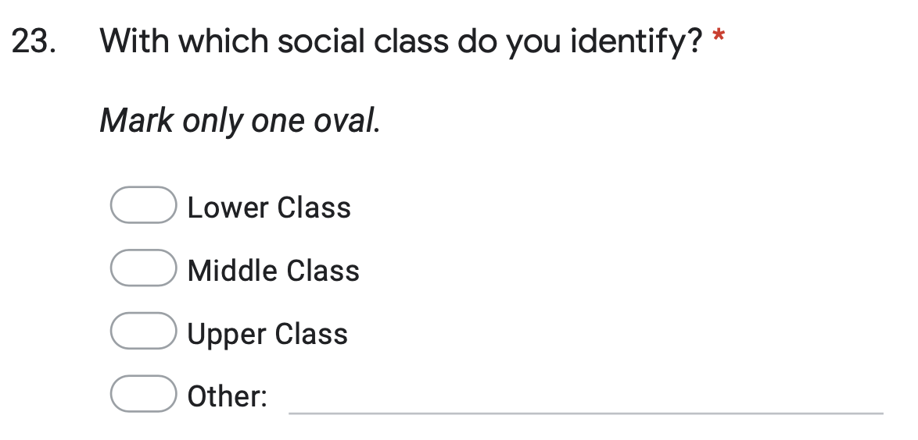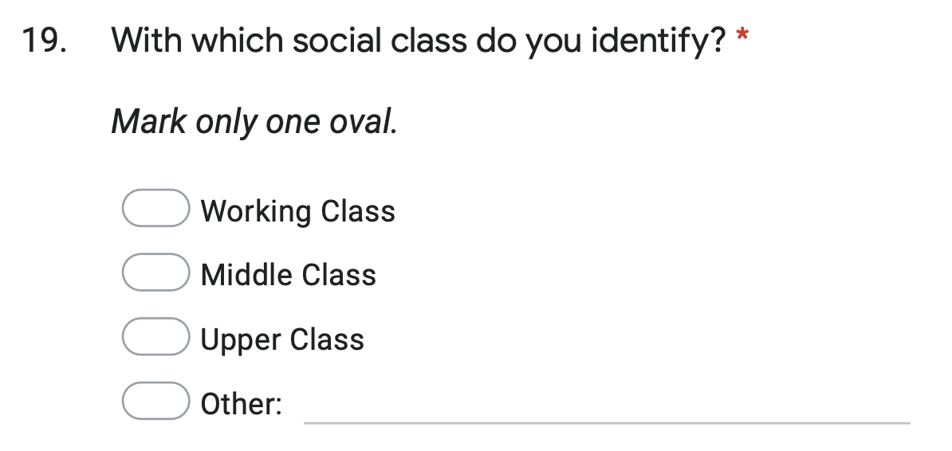
Fig 7: Left screenshot shows the original question and answers, with the right screenshot demonstrating the change of language.

I also introduced the option of ‘other’ to some of the questions, with accompanying free text space so as to allow the consideration of criteria not included in the initial design. Questions pertaining to the area of study became more closed, too, to enable a smoother coding process. The original question, modified question and options can be seen in Fig 8. Note how the question used in the final survey still allows for ‘other’ responses. This is to ensure any programme that fell outside of the scope of the answers could still be captured and coded at a later point. This also protects a participant’s anonymity, as the area of study is captured, not necessarily the specific name of the course.

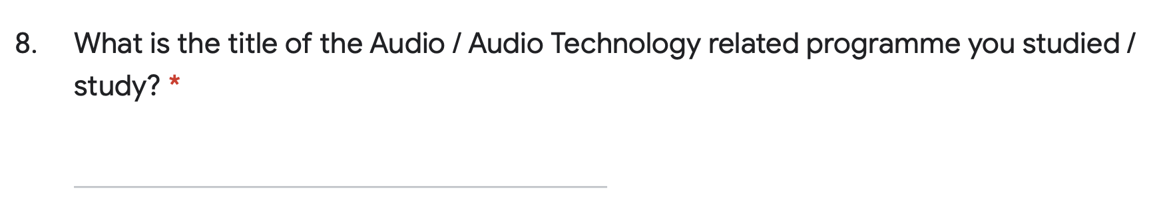
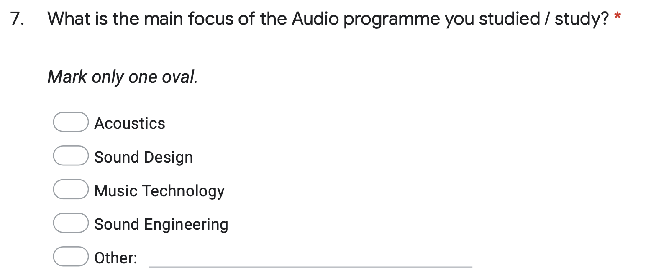
Fig 8: Top screenshot shows the original, open question, with the lower screenshot demonstrating the change of question, introduction of answers and inclusion of the ‘other’ answer.

Due to the nature of the research topic, a number of open questions were required to allow individual experience to be captured. An open question ensures the participant is able to record an exact answer, free from the constraints of the survey design. Where closed questions have been used, the follow-up question invites the participation, but it is non-mandatory, to elaborate upon their previous response. An example of the use of a closed question, followed by an open question inviting further, voluntary elaboration can be found in Fig 8.
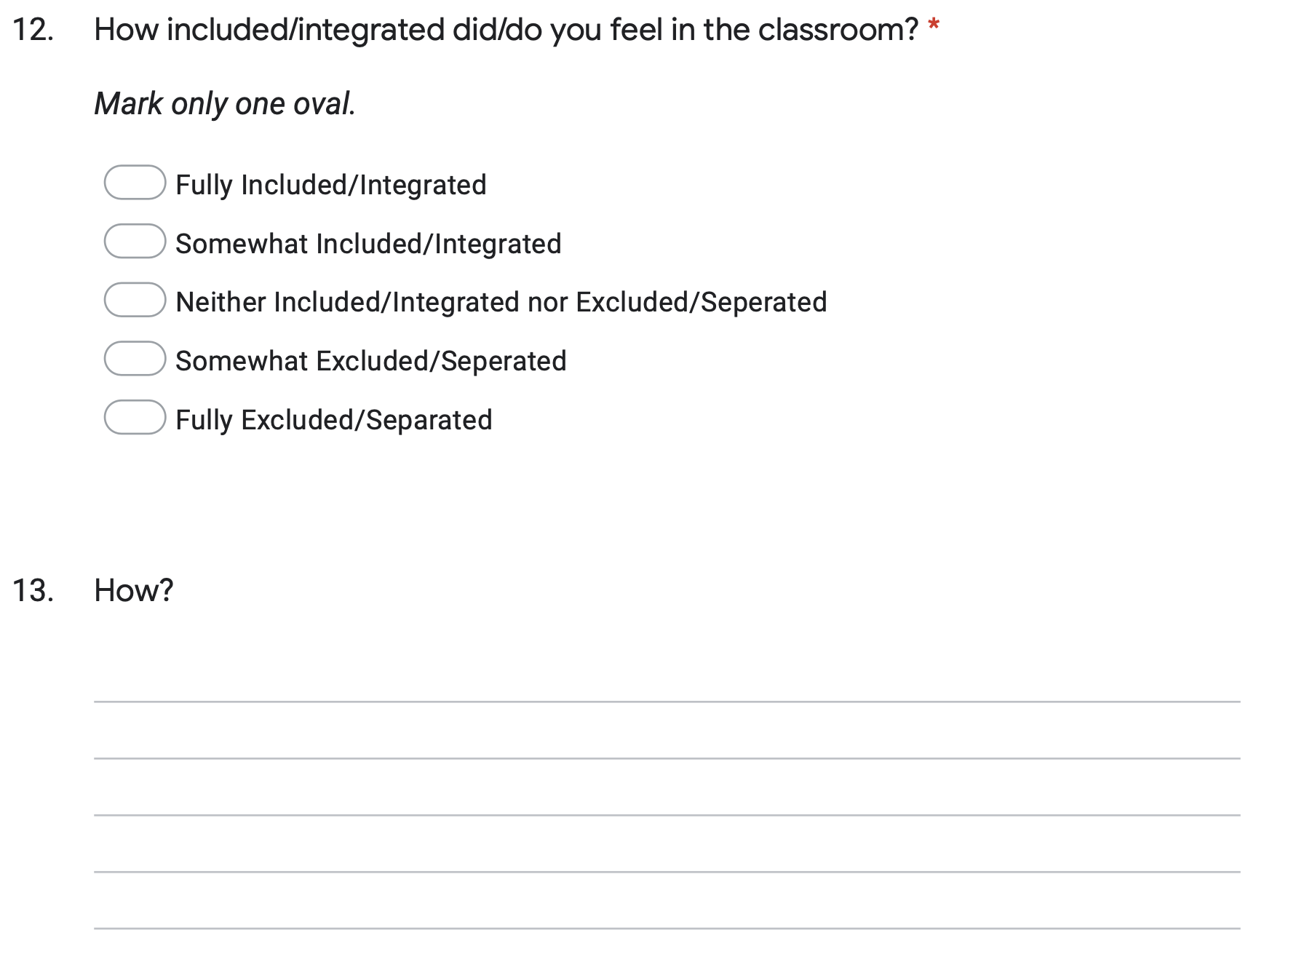
Fig 9: An example of a Likert styled closed question, followed by a more open question, inviting the participant to elaborate further if they wish. Taken from the final survey design.

In addition to the specific questions, I also paid particular attention to their order, as research suggests that classifying questions and personal data questions, such as age, ethnicity and gender, can be quite off-putting to respondents (Oppenheim, 1992). Due to this, classifying and personal data questions were purposefully moved to the end of the survey in an attempt to maximise participant engagement. Data has been collected, coded and charted from 96 responses. Key themes from the data have been referenced in line with existing literature. The final survey can be seen in Appendix 2.

3.2 Student Experience

3.2.1 Academic Data

Survey circulation took place after identifying higher education providers of sound and music technology related degree programmes and e-mailing the respective course leaders with information on the project, as well as requesting the survey to be forwarded on to any students they believe would be suitable. The survey was also disseminated through specialised social media accounts, including SoundGirls, Sound Women Network, the Audio Engineering Society’s UK mailing list and Yorkshire Sound Women Network. The survey was able to attract 96 respondents, with 92% of respondents having experienced or currently experiencing Higher Education (see Fig 10). It is possible that those who answered “Further Education qualification” are current undergraduate students who were unclear regarding the meaning of the question, and instead answered their most recent qualification. It is also possible that the participants were unaware of the distinction between Further and Higher Education. Regardless, the FE experience is also important, with many attitudes regarding gender equality and inclusivity forming much earlier than HE.

Fig 10: Education level of participants.

I was also interested in gauging whether particular programmes are more susceptible to discrimination than others, and therefore gathered data regarding the focus of the audio programme studied by the participant (see Fig 11). Responses under the ‘Other’ category encompassed the art end of the spectrum, including traditional music, song writing, sound art and interdisciplinary art.

Fig 11: The focus of participants’ education programmes.
Similar to my conclusions regarding demographic data, due to the sample size, it is difficult to draw meaningful conclusions when cross-referencing programmes with whether or not a respondent had felt they had faced gender-based discrimination.

To gauge the validity of my research, the question “How important are issues of Gender equality/reducing gender inequalities in relation to sound and music technology to you?” seemed pertinent. Responses indicated that 79% deemed the issue of gender equality and the reduction of gender inequality in sound and music technology to be at least ‘somewhat important’, with only 10% of respondents feeling that reducing gender inequality was either not so important or not at all important (see Fig 12).

Fig 12: Responses on the importance of gender equality in sound and music technology.

In order to gauge how inclusive students felt the teaching staff on their completed programmes are/were, a Likert scale was used, where 1 is fully inclusive and 5 is fully exclusive (see as Fig 13).


Fig 13: Likert scale used in survey

While it is encouraging to see 48% of participants rated their teaching staff as fully inclusive or somewhat inclusive, there are still 52% of participants rating their teaching staff as neither exclusive nor inclusive to fully exclusive (as shown in Fig 14). This combined percentile of participants rating their teaching staff as neither exclusive nor inclusive to fully exclusive is identical to the percentage of respondents who have felt discriminated against due to their gender during their time in academia. It is important to note that traditionally 5 would be the ‘highest score’ and 1 would be the ‘lowest score’ on a Likert scale. I intentionally inverted the scale to ensure people were reading the questions properly, as this is a key aspect of survey methods. In order to ensure the question was understood correctly and that the answers were consistent, I reviewed the follow up question where participants were invited to elaborate on their previous response. I found no evidence to suggest the Likert scales had been interpreted incorrectly.

Fig 14: Responses on the perceived levels of inclusivity of staff.

I also included a question regarding how included/integrated a participant felt or feels in the classroom, as the two may not be mutually exclusive. Teaching staff could be inclusive in a classroom environment, yet individually you could feel excluded. Results can be found in Fig 15. While it is encouraging to see 73% of participants feel somewhat included/integrated or fully included/integrated, 27% either felt neither, somewhat or fully excluded/separated, with 16% of participants feeling either fully or partly excluded in the classroom.

Fig 15: Responses of feelings of inclusion and integration.

Respondents were invited to provide further details regarding their responses to the above question. Several elaborations were positive, and in response to the previous question being answered as somewhat exclusive or fully exclusive. Negative responses included all male or predominantly male teaching staff, unconscious bias and language. Some of the discussions surrounded gender normative language, whereby male is seen as the norm, as well as non-male students being underestimated due to their gender. Of the responses, I was particularly interested by the concept of “dead naming,” gendering when gender neutral is appropriate, and manels. Recommendations regarding dead naming and gendered language are both discussed at length in section 4.1. and fall under mandatory training and re-educating members of staff. It is important to ensure that this information trickles down to students, too. It is disappointing that organising bodies still seem to fail to achieve inclusivity and diversity by putting together manels.

3.2.2 Representation at AES 2019 New York

In the interest of exploring manels further, I decided to analyse the 2019 AES Convention in order to gauge the panel diversity of the event. Fig 16 shows the final calendar of the 147th AES Convention held on October 16th 2019 in New York. If you remove the events where there is no representation of minority genders on panels and presentations the event number is reduced from 107 to 45. That’s a reduction of 58% of total events. You can see a revised timetable omitting all male panels and presentations in Fig 17.

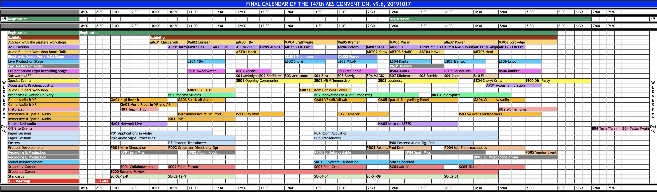
Fig 16: Final Calendar of the 147th AES Convention showing 107 different events, panels and masterclasses. Business Meeting and Cancelled have been omitted from the calculation as well as registration and exhibition.

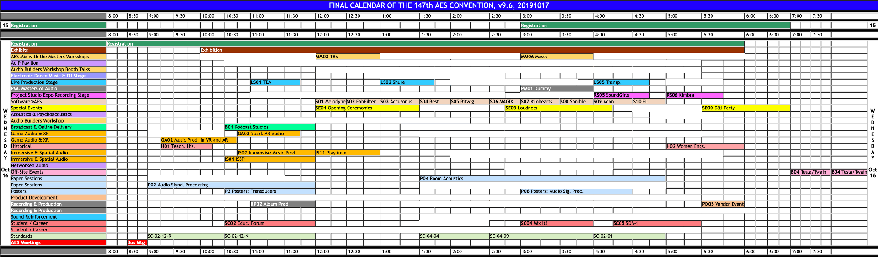
Fig 17: Final Calendar of the 147th AES Convention showing 45 different events, panels and masterclasses where minority genders are either not represented or the panel/presenter is not listed. Out of the total in this table, 62 events are either all male presenters or all male panels.

Due to a number of events not specifying the host, such as the Software@AES events, it is not possible to gather precise data regarding representation at panels or presentations. If we omit the events where the host is not specified, and therefore unable to ascertain whether the event was hosted by a man or person of minority genders, only 18% of the total events for the first day of the 147th AES convention had confirmed people of minority genders explicitly represented in panels and/or presentations. A revised version of the calendar showing only events where people of minority genders are confirmed to have been represented on panels or as presentation hosts can be seen in Fig 18.

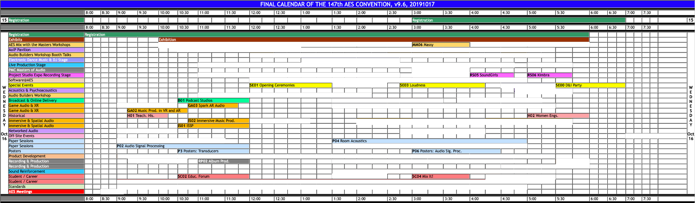
Fig 18: Final Calendar of the 147th AES Convention showing 19 different events, panels and masterclasses where minority genders are explicitly represented. This is 18% of all events.

It is disappointing to see such low representation of minority genders among the convention events, especially as the convention took place after the AES UK Chapter’s #HeForShe pledge in 2017, a pledge that wasn’t signed by AES international. It is worth mentioning that among the contributors to the convention, Ulrike Sloma, a non-male researcher, was a co-author of the Audio Engineering Society’s ‘Paper of the Year’ for their work “Synthesis of Binaural Room Impulse Responses for Different Listening Positions Considering the Source Directivity” (Sloma, Klein, Werner and Pappachan Kannookadan 2019, this achievement is paralleled in section 2.4 when exploring the gender disparity in a particular subject in relation to achievement. Although people of minority genders were represented poorly at the AES convention, it is encouraging to see a non-male researcher co-authoring the ‘Paper of the Year’.

A research article published in 2017 analysed colloquium speakers at US colleges and universities in 2013-14 and found that men were more likely than women to have been speakers. Follow up research revealed that women as colloquium chairs and in committees increased the likelihood of women appearing as speakers (Nittrouer et al., 2017). This suggests that those who are inviting, and scheduling speakers are serving as gender gatekeepers. Therefore, in order to ensure more diverse panels and presentations, more consideration is needed regarding the person or persons responsible for organising such events. It is clear from Nittrouer et al., (2017) that women are more likely to be included as colloquium speakers when a woman is in the organisation panel. I would therefore recommend that those organising panels and presentations consider having people of minority genders as part of the organisation, and where this is not possible, allies of minority genders must be present to ensure inclusivity is considered and executed. Panels that neglect to include people of minority genders are speaking to the male experience, and therefore neglecting minority genders in the industry or aspiring to be in the industry. It is this neglect that is no doubt partly responsible for putting up barriers for those seeking a pathway through sound and music technology.

3.2.3 Discrimination in Academia

It became clear at this point in the data analysis that the outcome of my research would not be based upon targeting particular geographical areas or degree programmes with guidelines on fostering more equal and inclusive environments, but instead more holistic recommendations to providers as a whole, based upon the experiences coded from qualitative data.

Of those surveyed, 52% explicitly stated that they had felt discriminated against due to gender during their time in academia. Elaborations in the ‘other’ box were provided by 3% of those surveyed, with comments such as “not explicitly”, “hard to say” and “depends on the criteria”. These responses could be a reflection of the difficulty people can face trying to identify what is discrimination and what isn’t. It is positive that 45% of respondents have not felt discriminated against due to their gender during their time in academia, however, 52% of the respondents have (see Fig 19). With more than 1 in every 2 people experiencing gender-based discrimination, this is an issue that needs urgent work.

Fig 19: Results show that 52% of participants have felt discriminated against due to gender during their time in academia.

In order to gather more perspective regarding gender-based discrimination in academia, I included a question that allowed participants to elaborate (See Fig 20), as well as a question inviting participants to explicitly make recommendations (See Fig 21).

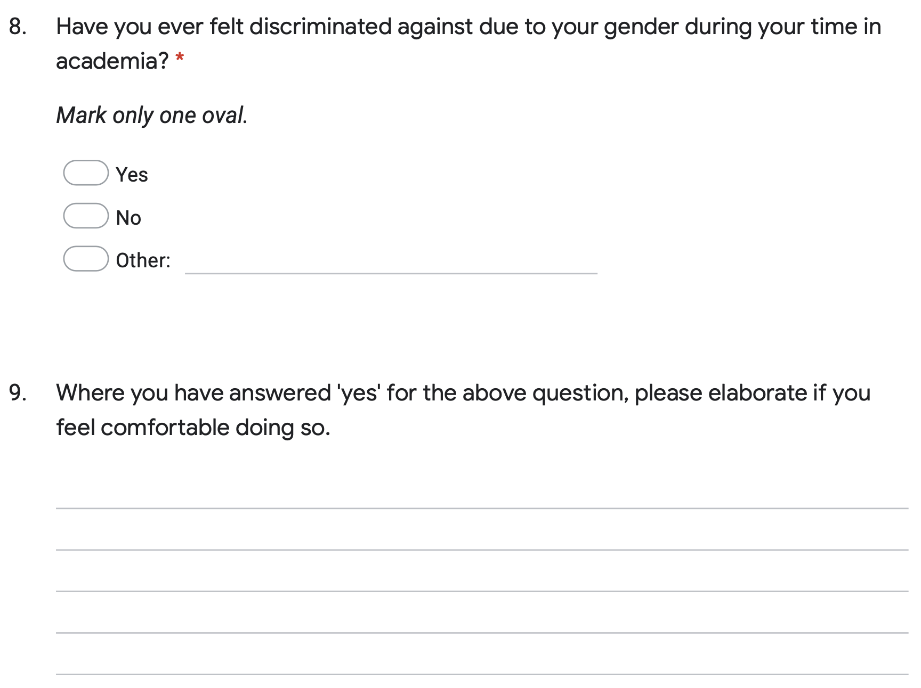
Fig 20: Questions from the final survey design pertaining to experiences of discrimination in academia, and a follow up question asking for elaborations, if the participant felt comfortable.

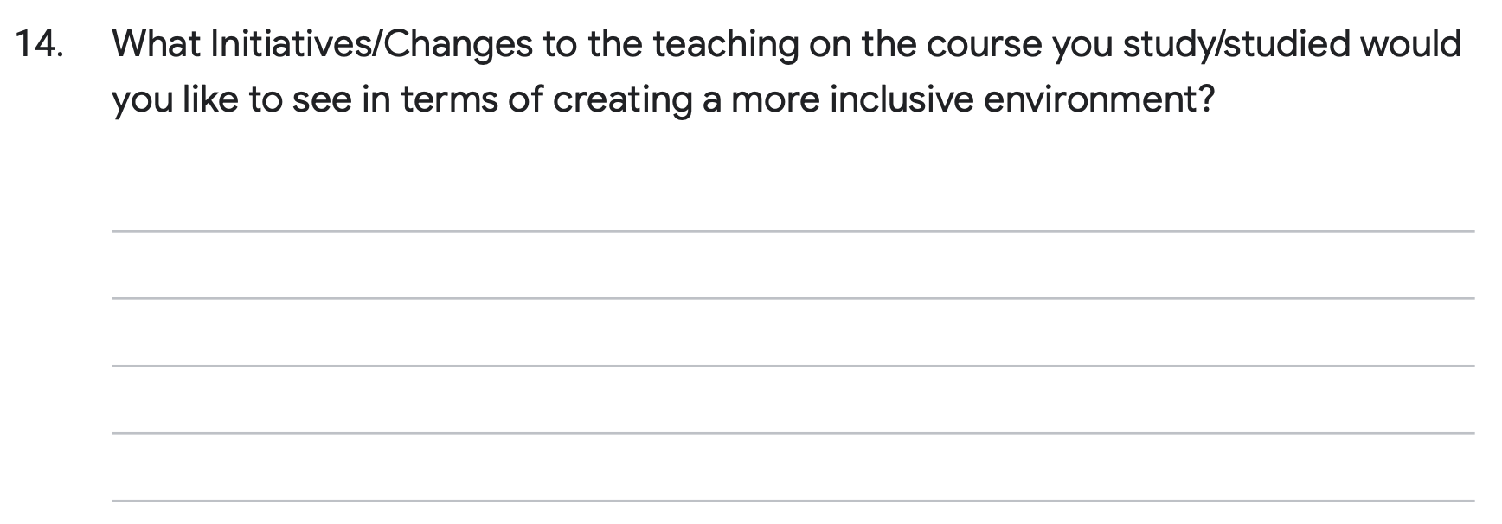
Fig 21: An invitation for participants to submit their suggestions regarding improvements to inclusive practices in the classroom.

Of the responses pertaining to gender-based discrimination I was able to code 54 examples of discrimination into 6 distinct categories: conscious bias, unconscious bias, course design, learning environment, sexual harassment, and personnel issues (see Fig 22). These codes were achieved by carefully examining each response and considering what type of discrimination or exclusionary experience the respondent had faced based upon the information provided.

Responses from the question pertaining to initiatives respondents would like to see have been coded under the categories: staffing, education, course design, marketing material, networking, support and language (see Fig 23).

Fig 22: Coded responses to elaborations on the question ‘Have you ever felt discriminated against due to your gender during your time in academia?’

Fig 23: Coded responses based upon initiatives and changes to the teaching that participants would you like to see in terms of creating a more inclusive environment in their courses.

Issues pertaining to sexual harassment were raised by five different respondents. Responses included sexual harassment in the classroom, sexual harassment in industry placements, sexual assault, sexist ‘jokes’ and having their image superimposed onto pornography. All companies and academic institutes are required to comply with the Equalities Act 2010, yet these examples provide anecdotal evidence of clear failings of compliance of those within the structure of a company or academic institute. It has been shown that male-dominated workplaces are often the worst for sexual harassment (Trade Union Congress 2014), with Trade Union Congress (2016) reporting that women were less likely to take action against a colleague or employer who is sexually harassing them if they believed their job security to be vulnerable. The same report showed that 52% of the 1,553 women polled had experienced unwanted behaviour at work, with the percentage rising to 63% for those between 18 – 24 (Trade Union Congress 2016). It is worth noting that 18 is the youngest age of most undergraduate students.

Though 5 out of 96 respondents (about 5.2%), felt comfortable enough to come forward and state that they had experienced sexual harassment in sound and music technology, up to 68% of women in the UK have experienced sexual harassment (Duncan and Topping, 2018). There is quite a significant disparity between the percentage of respondents reporting that they have experienced sexual harassment in sound and music technology and the percentage gained from Trades Union Congress’s 2016 polling (Trades Union Congress 2016). This disparity could be accurate, and respondents may not have experienced any sexual harassment, may have experienced sexual harassment outside of sound and music technology, or it is entirely possible that it is not being reported, with Chalabi (2016) conveying how over half of the allegations made to the US Equal Employment Opportunities Commission (EEOC) in 2015 resulted in no charge, and over 70% of those experiencing sexual harassment at work are not reporting it through fear of reprisal or fear that nothing will change (Chalabi 2016). The culture that has allowed for 5 respondents to experience sexual harassment must change. As educators we must be able to report it when it is seen, with confidence that there will be consequences. We must be able to instil confidence in our students to be able to report sexual harassment and know that it will be dealt with the severity it deserves. There has been a proliferation of sexual harassment related research available post-#MeToo, and while the importance of the research cannot be overstated enough, a thorough analysis of the topic is outside the scope of this dissertation. For more information, I would recommend exploring The 1752 Group’s website.

A 2019 investigation by the BBC found that students who had reported sexual misconduct to their university were failed by the complaints process, often leaving the student feeling traumatised due to loopholes in safe-guarding procedures, an absence of mandatory guidelines and even resulting in students being dissuaded from coming forward due to distressing reports from peers regarding advice given by Universities. This advice included spending the night in the library to avoid returning to accommodation due to fears of being attacked, and another student described feeling like they were “being gaslit” by their institute (Lee and West 2019).

Teaching issues included overt dismissiveness toward female students, suggesting they ask their male peers for help and support instead of the lecturer, as well as lecturers making inappropriate comments regarding the physicality of sound engineering, suggesting that muscles are an indicator of a good sound engineer. One participant gave the example of a lecturer shoehorning gender equality in music technology into lectures to the point that it became diminishing and took time away from classroom learning. While it is commendable that the lecturer is bringing these discussions to the forefront of consciousness, it is important that it is not done to the detriment of the lecture itself. Regarding the lecturer linking muscles to being a good sound engineer, he ought to seek Kim Watson (Live Sound Engineer)’s mentor who taught her that “you lift with your mind, not with your muscles” (Larsson 2019).

While these were specific issues with teaching staff, similar issues were coded as unconscious and conscious bias. With staff and students guilty of either making comments regarding how non-men shouldn’t be in music and music technology as the hours are long and the work is physical, or making assumptions based on gender, such as not being as technically proficient and low expectations from peers and lecturers in comparison to male peers. There were also examples given of male dominance in both the teaching materials, and in the ways in which male students would gravitate toward seizing interactive materials, both of which mirror the literature reviewed in section 2.5. Workplaces should adopt continued professional development and mandatory training events based around unconscious bias. This type of training could constitute a good starting point to have those in positions of influence check their unconscious bias and work toward becoming consciously unbiased. It is also worth noting that Atewologun, Cornish and Tresh (2018) concluded that unconscious bias training can be effective for reducing implicit bias, but unlikely to eliminate it. The authors also noted the limitations of unconscious bias training to effectively change behaviour, and in some cases, how said training can be responsible for back-firing effects. It may therefore be worthwhile looking at how networks within an institute can operate to make people conscious of their biases, this could be through departmental meetings with an agenda to standardise learning materials; such as a course team ensuring they are making an effort to balance a reading list, or include more gender-neutral and gender inclusive imagery in sessions.

Due to the number of issues with teaching staff raised by participants, I was curious to discover how much issues pertaining to equality and diversity are explored on my institute’s Post Graduate Certificate of Education (abbreviated as PGCE). From discussions with the module leader, I have discovered that the course does not have a standardised curriculum, which is likely to result in some institutes covering equality and diversity more than others. However, the course team have several classes exploring inclusivity and diversity, including taught sessions covering unconscious, affinity and confirmation bias, as well as encouraging students to take the Harvard University Project Implicit test.

3.2.4 The Effects of the Learning Environment

Issues pertaining to learning environment included the environment being dominated by men, as well as a respondent stating that “there were no female toilets on the floor that most of the recording studios were on.” A comment that implies that there were male toilets, which seems to be an accessibility issue and an oversight during construction. I would hypothesise that this oversight stems from a gap in perspective, likely due to not including women in the planning process. “When planners fail to account for gender, public spaces become male spaces by default” (Criado Perez 2019, p.66. Interestingly, the lecturer who suggested that muscles are an indicator of a good sound engineer also stated, “If the air-conditioning in the classroom is too cold for you, you will never survive in the studio”. The respondent stated that these comments were directed only towards women and, although highly inappropriate, there is a modicum of truth in the consideration of room temperature. The formula that is used to determine the standard office temperature is based on the metabolic resting rate of the average forty-year-old man, so while the air-conditioning in the classroom and recording studio may not be bothersome for the lecturer, and perhaps male students too, there is good reason why a female student, whose metabolic resting rate is typically lower than that of a forty-year-old man, would experience the environment as being too cold (Kingma and van Marken Lichtenbelt 2015). Maslow’s Heirarchy of Needs (1943) (see Fig 24), indicates that women are being failed at the most basic need, physiological, which can hinder progress toward more advanced needs such as belongingness, esteem and self-actualisation. While I am not suggesting that all women are hindered by the temperature in the classroom, I am suggesting that not considering the teaching environment for temperature or accessibility to toilet facilities can make the environment seem unwelcoming to non-men.

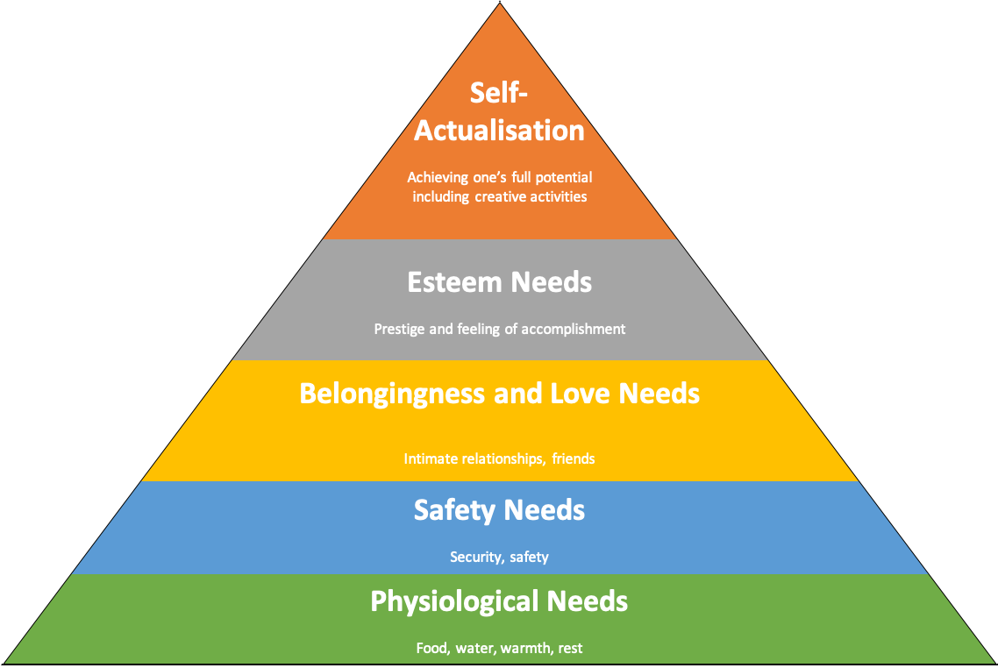
Fig 24: Adapted from Maslow’s Heirarchy of Needs (Maslow 1943).
If the environment seems unwelcoming to people of minority genders, it is possible that the environment is informing that a particular course may not be suitable for them without ever attending a lecture, just from the classroom design and course materials. This could also become apparent early into course delivery through curriculum and language used by lecturers and peers. This may lead to an individual deciding not to pursue sound and music technology further. This may explain the 5% drop off from A-Level to HE and/or be a contributing factor in women not completing courses (Born and Devine 2015).

Seven of the coded responses relate to course design (see Fig 22). The gender-based discrimination relating to course design can be further divided into two categories: (1) all-male teaching staf and (2) lack of female visibility within course materials, tackled in section 3.4. I’m first going to address the issue of female visibility within teaching materials. In section 2.7 I discussed sexism in the syllabus, highlighting Khomami’s (2015) article regarding Jessy McCabe’s efforts to have Edexcel increase their female representation in their A-Level syllabus. Woodzicka and Wingfield (2010) found that female students performed better in science when the textbooks had both male and female scientist representation. The study also found that stereotype threat negatively impacted the performance of female students (Good, Woodzicka and Wingfield 2010). Identity and a sense of belonging can be linked to the psychological needs of Maslow’s Heirarchy (Maslow 1943), and it is likely that there is a link between a sense of belonging within an educational framework and performance, as demonstrated by the students in Good, Woodzicka and Wingfield’s (2010) study.

I recommend teaching staff take an objective look at female visibility within the aspects of their teaching that they have control over and make amendments, where suitable. This next section explores the changes I made to classroom design, teaching materials, reading lists and the virtual learning environment in an effort to increase visibility.

3.3 Demographics

I was interested in gathering demographic information such as which region the participant was born in, which region the participant currently lives in, race, social class, highest level of schooling the participant’s parents had completed, age and identified gender. I was motivated to gather this information due to links between socio-economic status and self-esteem (Twenge and Campbell 2002). A meta-analysis of 446 samples (containing 312,940 total participants) found that those with a higher socio-economic status reported a higher sense of self-esteem than those with a lower socio-economic status. The relationship between socio-economic status and self-esteem is particularly affected in young adults (Twenge and Campbell 2002).

I was curious to see what could be gathered from analysing relationships between a participant’s demographics and experiences with discrimination. I was interested in capturing data regarding place of birth and the region in which the participant currently lives to gauge whether potential geographical environments, i.e more industrialised areas which are often linked to a lower socio-economic class, cause barriers for those wishing to step outside of the “norm”, where an individual may be expected to conform to the family norm. It became apparent from cross-referencing geographical data from participants that regardless of location, gender-based discrimination took place. With a larger sample size, more meaningful conclusions regarding regional discrimination may have been present. Results regarding place of birth (see Fig 25) and region in which the participant currently lives (see Fig 26) can be found below. There is a high percentage of respondents born in the North East which is likely linked to my regional networks. Similarly, there are a high percentage of participants currently based in London and I would hypothesise that this is due to the highest concentration of jobs in the sound and music technology industries being in London.

Fig 25: Responses on regions in which survey participants were born.

Fig 26: Responses on geographical location of survey participants.

I was interested in collating race data as part of the survey to gauge whether double discrimination was present in my findings. None was disclosed, however, as can be seen in Figure 27, 78% of respondents identified as White/White British. These percentages are comparable to the gender divide in sound and music technology explored in section 2.4. and believe it is therefore important to be mindful of double discrimination and ensure approaches to improving gender equality don’t result in a lack of BAME representation.

Fig 27: Race and ethnicity responses.

Similar to the discussions surrounding places of birth, I was interested in collating social class data to gauge whether those from ‘lower’ social classes experienced more discrimination than those of a more privileged background. As can be seen in Fig 28, there is only 7% difference between those who identify as working class and those who identify as middle class, and in cross referencing social class with experiences of discrimination, there are no major deviations to be found between the classes. The 1% who identified as upper class provided key anecdotal information regarding their experiences with discrimination which influenced recommendations for institutes. I believe this is simply a coincidence, though the combination between class and academic achievement may have resulted in those identifying as upper class being able to recognise and eloquently put forth experiences that others may not have been able to. A larger sample size, particularly a larger sample of those who identify as upper class, may have yielded more meaningful conclusions regarding the relationship between social class and discrimination experienced. I am keen to pursue links between social class and discrimination in academia in the future.

Fig 28: Responses on social class from survey participants.

Based upon past experiences with students, I was interested in gauging whether the educational background of a student’s parent/guardian impacted their experiences with discrimination, results shown in Fig 29. As with previous demographic data, upon cross-referencing it did not appear to.

Fig 29: Results on survey participants’ parents/guardians’ education.

As was the case with race data, I was interested in analysing whether double discrimination was apparent based on ageism for any mature students that may have been completing the survey, and therefore collected data on participants’ age (as shown in Fig 30), however, none was disclosed. It is interesting to see most participants between 21 – 29 and therefore likely to have graduated more recently, with the experience still relatively fresh in their mind. I note one participant is 17 or younger, however, their responses did not skew data, and anecdotal evidence, though likely from an FE point of view, is still valid.

Fig 30: Age of survey participants.

Due to the focus of this work being on creating inclusive educational practices for all genders, I was interested in collecting data on the gender of survey participants. Out of the total number of respondents, 79% identified as female, 5% preferred not to say, 6% identified as genderqueer or non-binary, and 4% as other without further clarification (see Fig 31). It is worth noting that 5% of respondents are male. I have decided to include these results as part of the research as these participants put forward useful suggestions for improving inclusivity in the classroom, many of which mirrored suggestions from participants of minority genders. It is also important to note that those who have identified as male may not necessarily be cis-male and therefore are still part of a minority group. While I have no way of ascertaining whether the male respondents are cis-male or trans-male it is worth noting that all male respondents stated that they have never felt discriminated against due to their gender during their time in academia.

Fig 31: Gender of survey participants.

Chapter 4:

Implementing Change

4.1 Teaching and Learning Resources

The results from this survey came in prior to the start of the 19/20 academic year (September 2019 to May 2020), and as such I was able to implement a number of changes to the delivery and design of a number of modules I teach across different programmes and levels. The first module I addressed was Recording Studio Techniques, a first-year undergraduate module that explores recording studio audio engineering in bespoke recording studios. In the past, module handbooks and reading lists have been lengthy and as such, often neglected by students. In order to create more engaging resources for the students my module reading list was streamlined, embedded as text and hyperlinks, and easily accessible, within the Virtual Learning Environment (VLE). Since the 17/18 academic year, Owsinski’s ‘The Recording Engineer’s Handbook’ (2017) and Massy’s ‘Recording Unhinged’ (2016) have been listed as essential texts on my recording-based module reading lists, providing equal representation for male and female authors. This was a conscious effort. Prior to this the only essential text was Owsinski. I have been able to locate information pertaining to the number of times a book has been issued for loan and the number of times a book has been renewed stretching back to 16/17. In 16/17 with Owsinski’s being the only essential text, ‘The Recording Engineer’s Handbook’ was loaned once and not renewed. In 17/18 ‘Recording Unhinged’ was purchased and available from the library. The information in Fig 32 below shows both essential texts, the number of students enrolled onto that cohort, the academic years where both books have been available, the number of times the texts had been issued, and times an issue has been renewed.

Resource | Academic Year
Resource | 17/18  14 students | 18/19  4 students | 19/20  8 students
The Recording Engineer’s Handbook | 2 issues; 0 renewals | 1 issue; 1 renewal | 6 issues; 6 renewals
Recording Unhinged | 4 issues; 4 renewals | 5 issues; 5 renewals | 4 issues; 3 renewals
Fig 32: Table of resources issued and renewed 17/18 – 19/20

I am encouraged to see the growth of both texts, as of Academic Year 19/20 we have three copies of Owsinski and two copies of Massy, the third copy of Owsinski has correlated to a doubling in student loans and hope that this continues as students’ progress through the academic levels from an Access to HE Diploma (the equivalent of level 3), through to the final year of a degree (equivalent of level 6). While there does not appear to be correlation between the number of students in a cohort and the number of issues, the number of issues of both books increased from 17/18 to 18/19 as the reading lists become more interactive and visible, along with more visible citation in lecture materials. It is clear from the small amount of data available that highlighting diverse literature in the reading list can be received well by students. Anecdotal evidence from marking assignments and observing citations would suggest that more students have access to Massy than the figures obtained from my institute’s library, which is encouraging. Furthermore, I am aware of a number of students who have purchased their own copies of ‘Recording Unhinged’. It is important to note that access to the facilities ceased on March 20th in line with COVID-19 guidelines. As such students completing assignments have been unable to access the physical resources and it is possible that the texts would have been issued and renewed at a higher rate had the facilities remained open, due to a number of recording based assignments due after March 20th 2020. Due to the COVID-19 pandemic, we are currently in the process of obtaining electronic copies of the books on our module reading lists. It is my hope that this will further increase the utilisation of more diverse texts due to accessibility no longer being limited to whether a physical copy is available.

As well as providing equal representation in the reading list, I also provided a list of acclaimed recording engineers (as shown in Fig 33), hyperlinked to their Discogs.com credits and a small description of artists they have worked with. This not only provides students with access to resources for checking out exemplar recordings, but also provides role models. The list also provides equal representation for male and female engineers. Unfortunately, we have no way to determine whether or not the students have interacted with the hyperlinks. However, examples of recordings by these acclaimed engineers are explored in taught sessions, with students encouraged to discuss the timbre, spatialisation and loudness of what they are hearing.
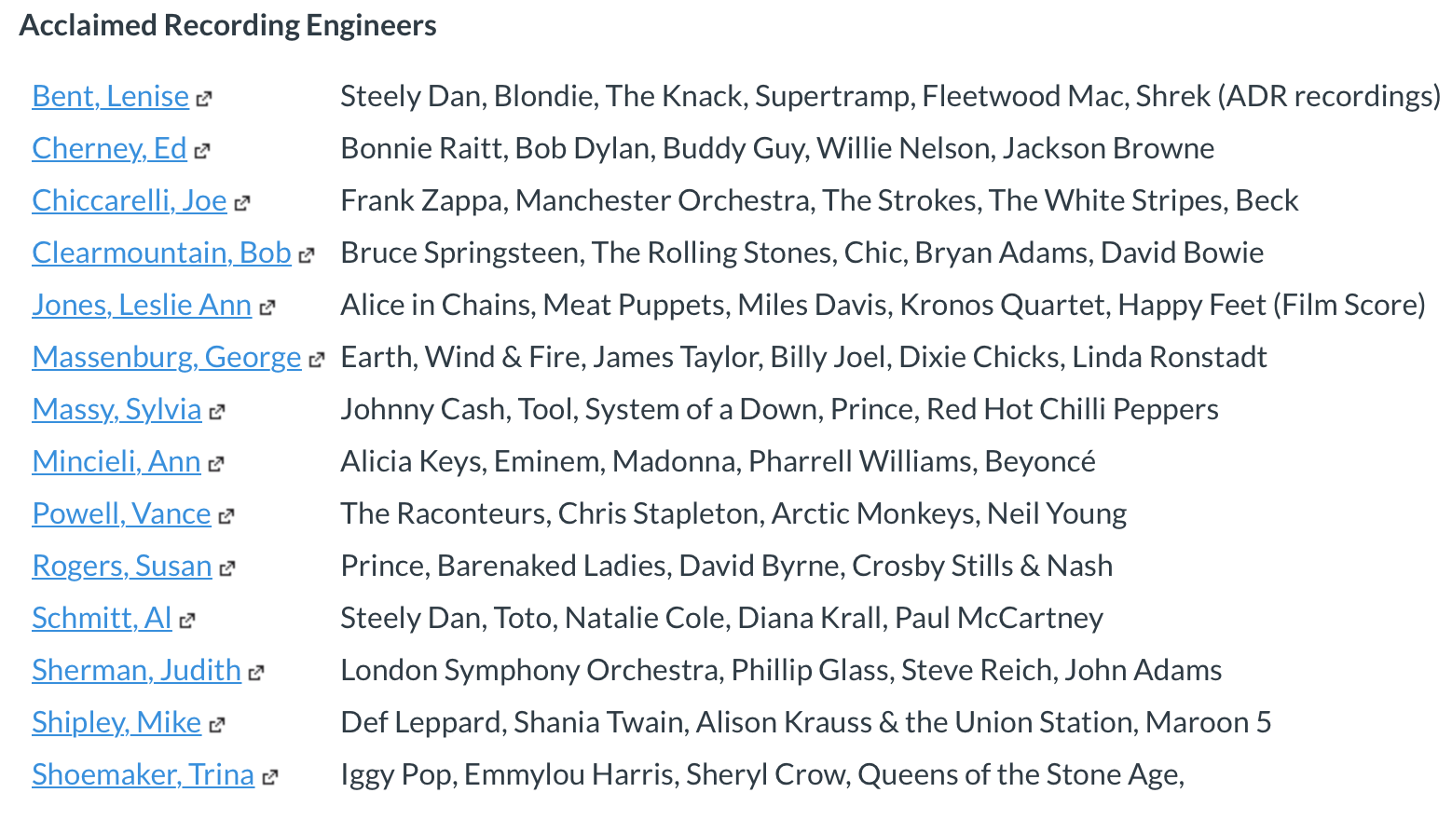
Fig 33: Acclaimed Recording Engineers list as found on the interactive reading list for Recording Studio Techniques.

The increase in visibility of non-male engineers provided through the interactive and streamlined reading lists, and discography examples, was a direct response to the comments explored in section 3.2.3. Through those comments, respondents reflected on gender-based discrimination linked to course design and was expressed as partly due to a lack of “non-male composers or audio producers studied” and “no attempt at female visibility in the field”. A balanced resources list and highlighting a more diverse range of engineers and their diverse work allows for these comments to be addressed.

Lectures themselves should also continue to showcase a more diverse range of practitioners in their regular teaching sessions. The inclusion of more women should not be done out of tokenism, but out of an effort to rebalance the gender imbalance in sound and music technology. Just because 5% of those working in audio are women, doesn’t mean we should only be referencing women 5% of the time. If it is through a lack of role models and visibility that more women aren’t studying sound and music technology and inspired to become the next Marcella Araica (mixing engineer for over 100 chart-topping singles), Ann Mincieli (recording engineer and studio co-ordinator for Jungle City Studios, New York), Amanda Davis (front of house live sound engineer for Janelle Monáe), Linda Perry (four time Grammy nominated producer and songwriter and 2015 Songwriters Hall of Fame inductee) or Emily Lazar (Grammy and TEC Award winning Mastering Engineer). As educators we have a collective responsibility to right that wrong.
Figure 34 shows a slide from a lecture on timbre (the character or quality of a sound), where students are invited to think about timbre as tonality, frequency and colours, as stated by Marcella Araica. Students are also invited to listen to her work via the hyperlinks in the parenthesis.

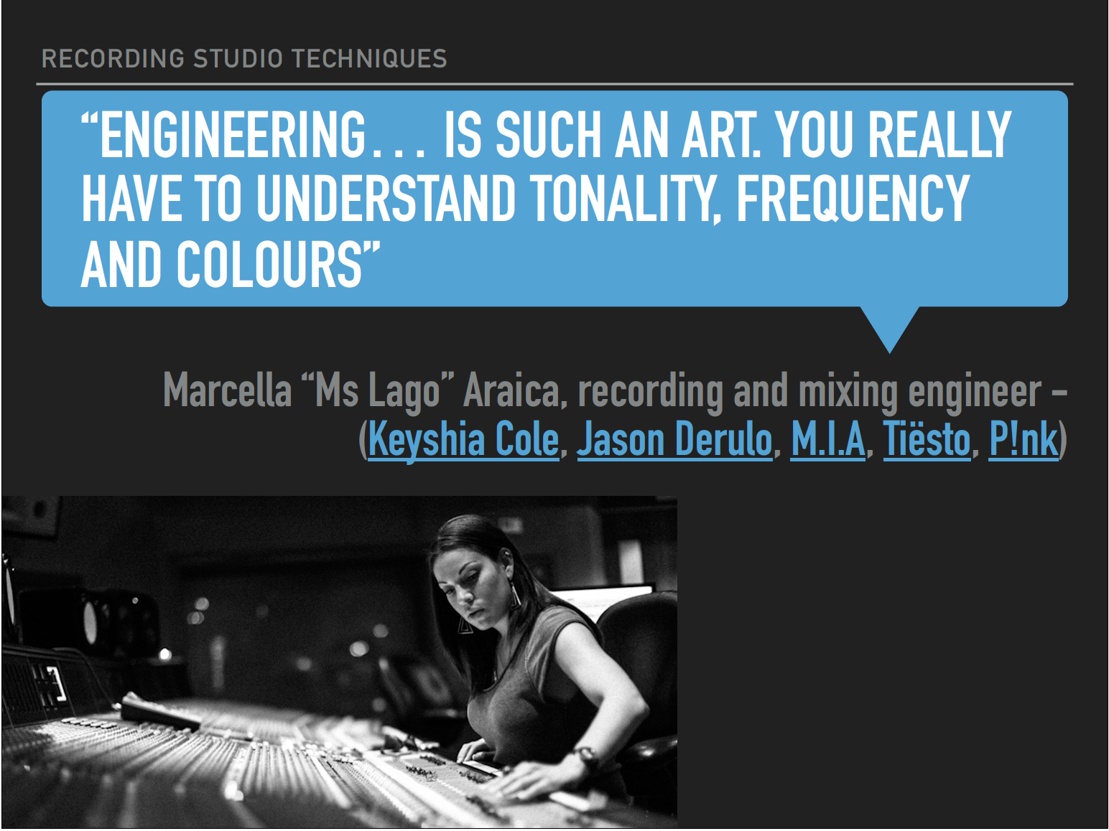
Fig 34: Example of a Recording Studio Techniques lecture slide, demonstrating how to diversity can be embedded.

Figure 35 shows a weekly overview front page for a lecture on recording the drums. American session percussionist Bobbye Hall is depicted, with hyperlinks to her work provided in the image description, further amplifying the voices of women, and the BAME community through teaching materials. A host of YouTube videos are recommended viewing to accompany the lecture, with Sylvia Massy demonstrating how to capture the drums in one of the videos.

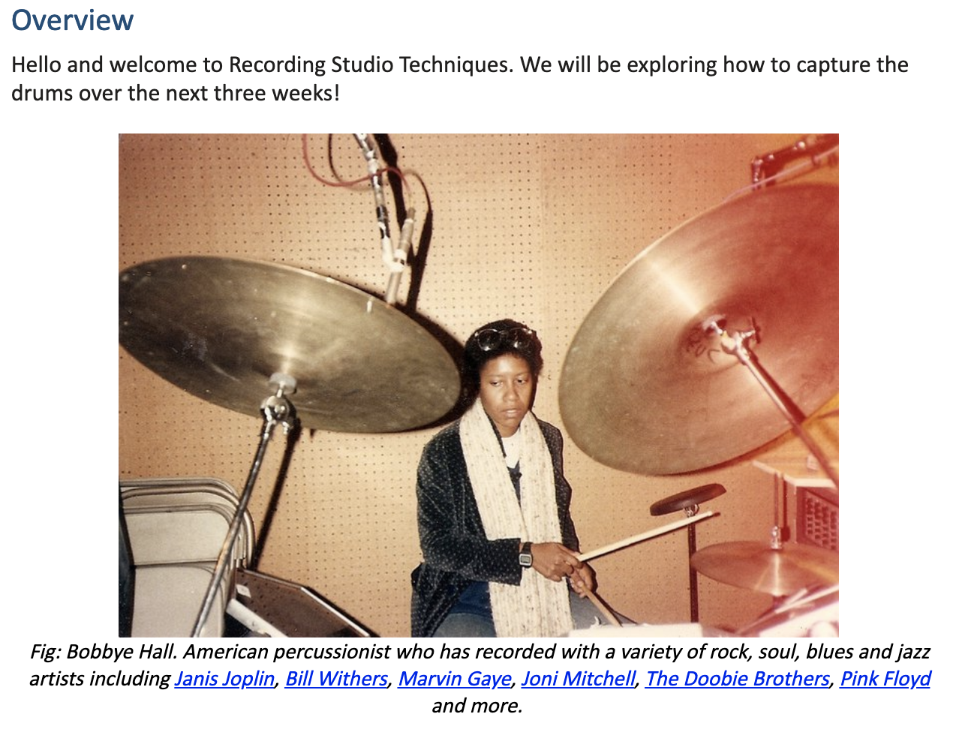
Fig 35: Example of a Recording Studio Techniques weekly overview page, demonstrating how gender and BAME based diversity can be embedded.

I was able to observe on a Level 3 Access to HE Music programme, that consciously introducing students to a more diverse range of practitioners in Music Technology in 19/20 for their Digital Performance module resulted in students referencing a more diverse range of practitioners in their work. In the previous academic year, the unit was delivered as a project unit, where the students were encouraged to research and carry out practical tasks based upon their creative tastes. The outcome was overwhelmingly male, with students submitting projects influenced by Bob Dylan, Dr. Dre and Radiohead, among other male creatives. In 19/20 students opted to carry out creative projects inspired by more non-male practitioners than male. While core content pertaining to creative music production techniques was still present, it was supplemented with gender conscious examples and featured audio and video clips of non-male practitioners utilising music technology in live performance. Such non-male practitioners included Imogen Heap (Grammy nominated artist and inventor of the Mi.Mu gloves), Laurie Anderson (avant-garde artist, composer, Grammy award winning musician and inventor), Rachel Collier (music producer and performer who has given a guest lecture at my institute in collaboration with Ableton Live), Delia Derbyshire (musician and composer who carried out pioneering work with the BBC Radiophonic Workshop) and Wendy Carlos (Electronic Musician and Composer), among others. While the sample size may be small (fewer than ten students), I do believe that there is a strong connection between gender conscious lecture materials and the increase in projects being inspired by people of minority genders. A breakdown of the Access to HE Music cohorts for academic years 18/19 and 19/20 and whether they chose to research a male practitioner or person of minority genders person can be found in Fig 36 below. Both cohorts had a total of 6 students.

Practitioner | 18/19 | 19/20
Male | 5 | 3
Minority Genders | 1 | 3

Fig 36: Table of practitioners researched for 18/19 and 19/20 Access to HE Music

In addition to the changes mentioned above, I also addressed the redesign of the visual layout of the classrooms. In the academic year 2019/20, as my teaching was situated predominantly in a single classroom for non-recording studio-based delivery, I seized the opportunity and redecorated the space. Figure 37 is an image of what used to be displayed on the classroom boards. A series of albums that a previous iteration of the course team considered enjoyable and inspirational. While I have no qualms with showing the students what staff find inspirational, the board was overwhelmingly white and even more overwhelmingly male. There are also issues pertaining to misconduct that can be found in both the artwork itself and the artists featured. For example, Cream’s “Disraeli Gears” is featured. Cream’s guitarist, Eric Clapton, was the impetus behind the Rock Against Racism movement after a racist outburst on stage at a 1976 concert (Manzoor 2008). Blink 182’s “Enema of the State” is also featured. The album artwork features porn star Janine Lindemulder dressed in a nurse uniform, pulling on a rubber glove.

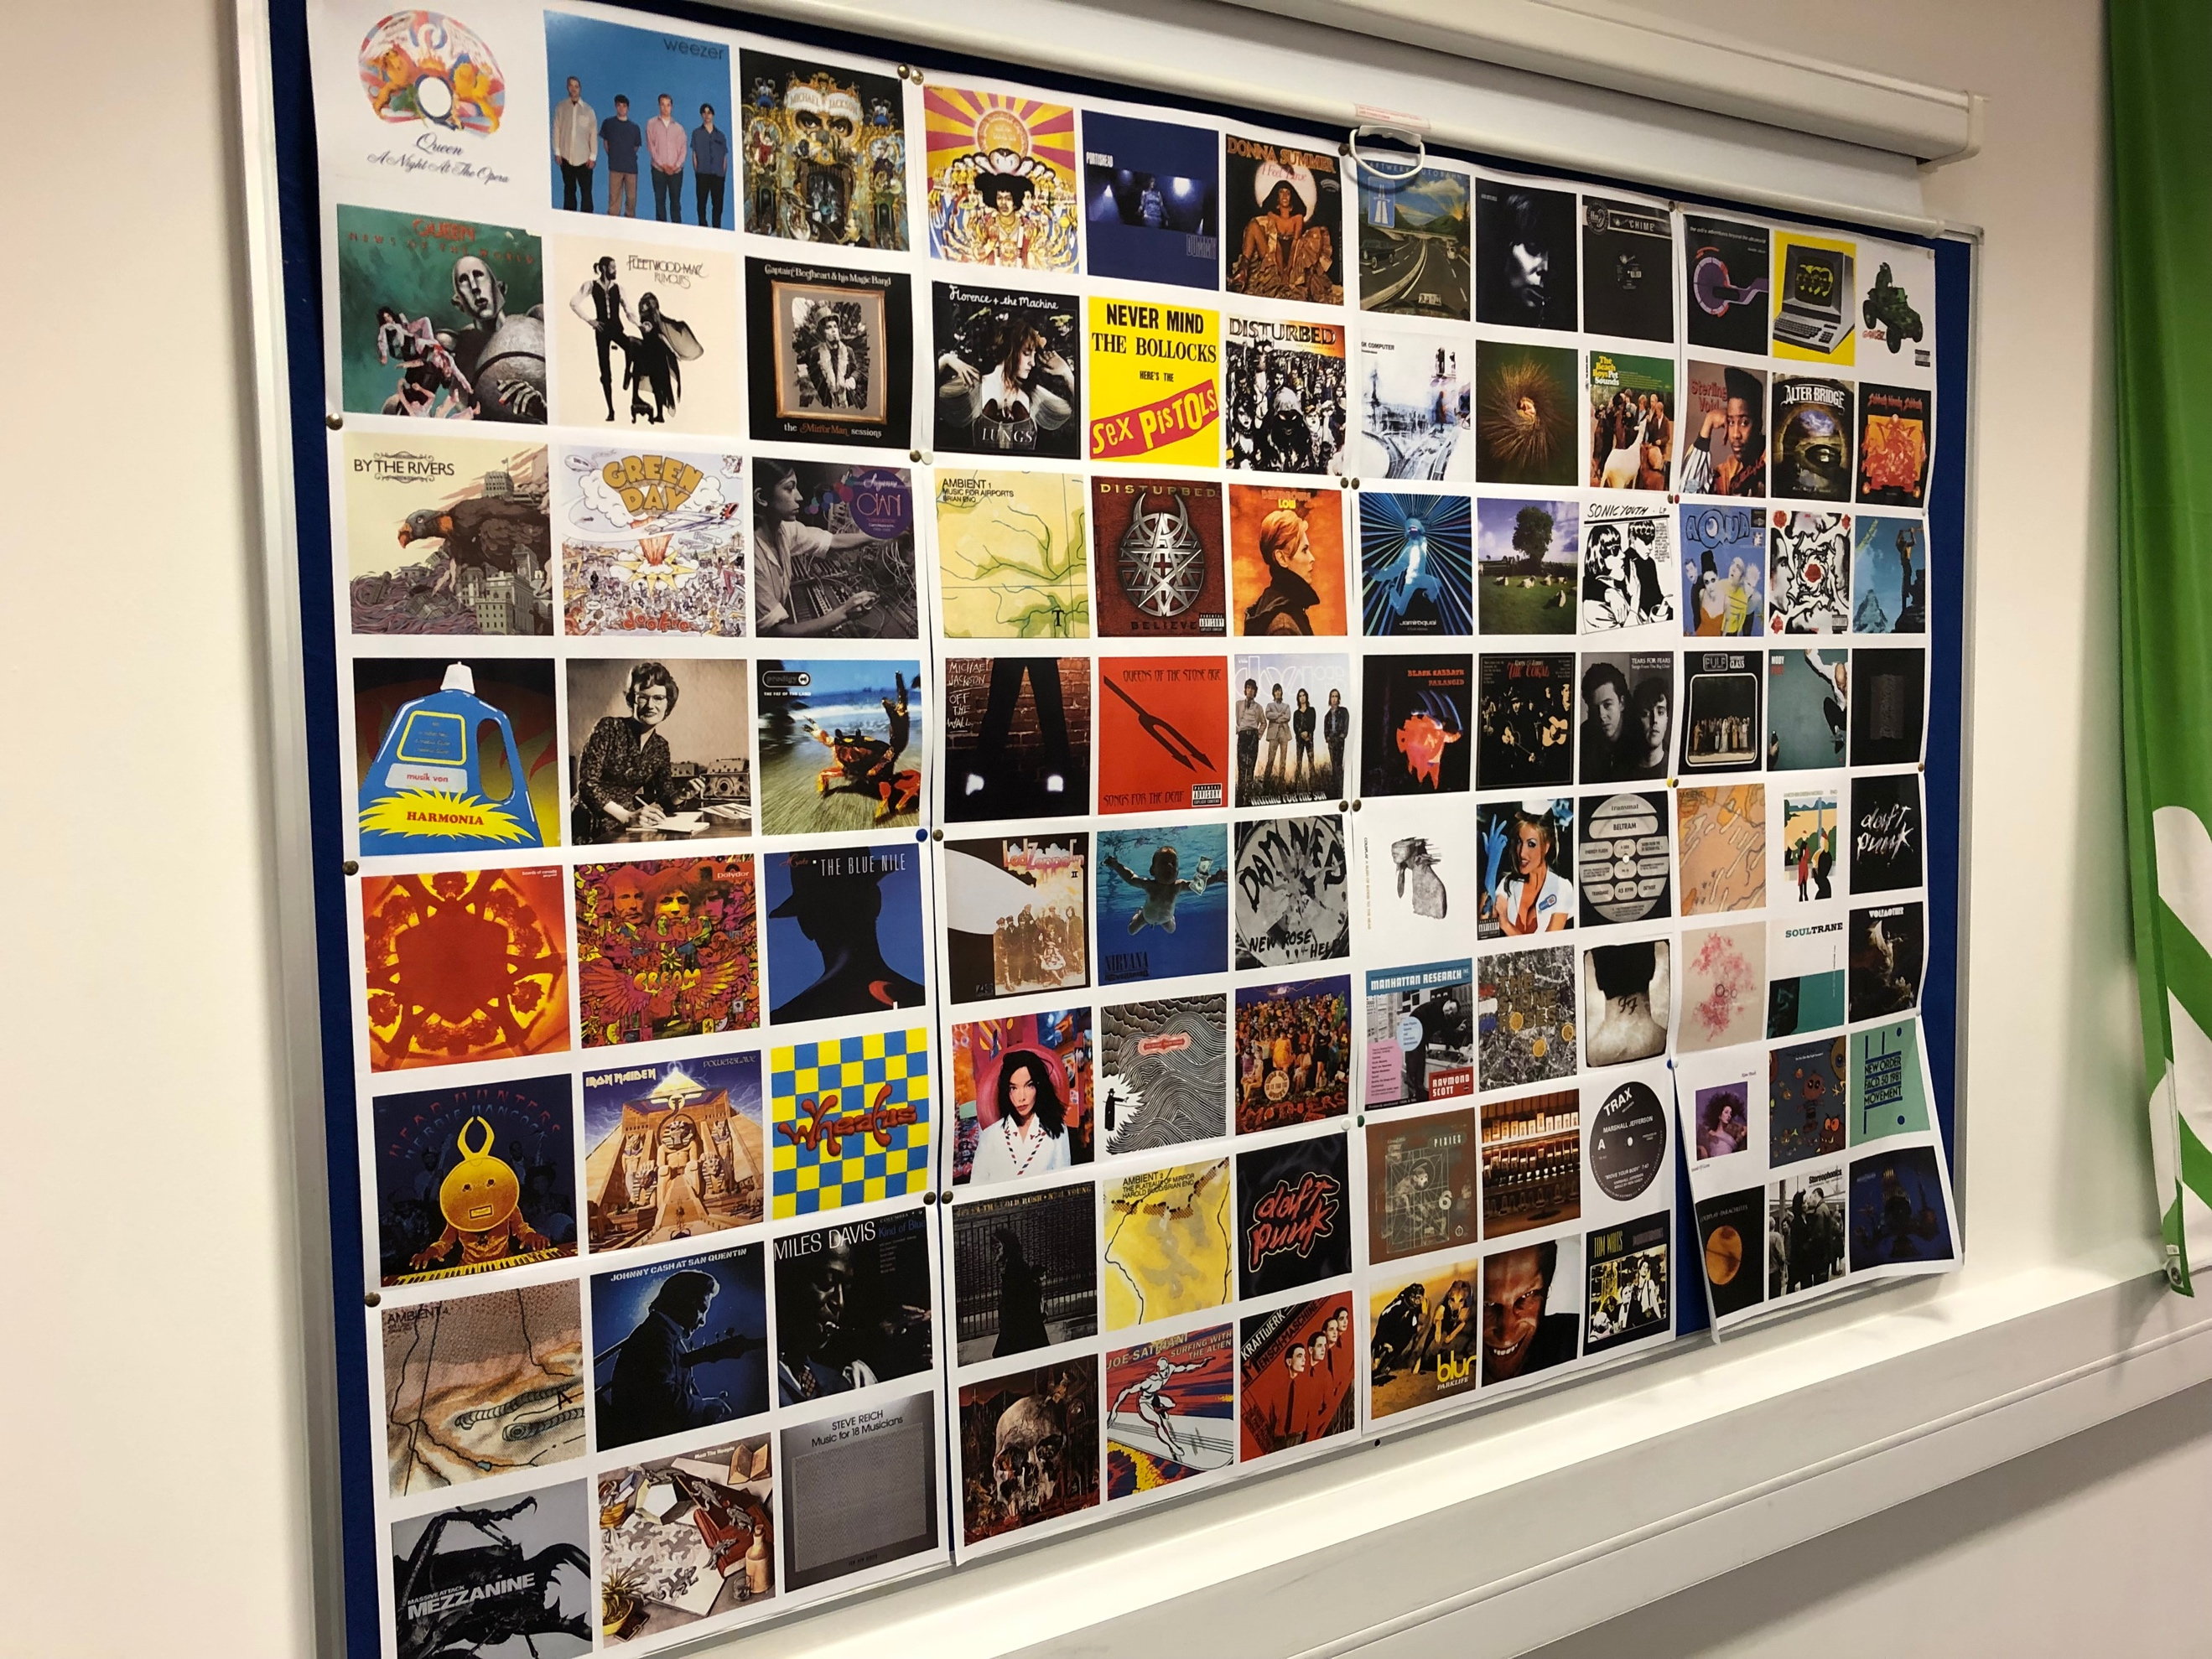
Fig 37: Classroom notice board pre-implementation. Overwhelmingly white and male.
With support from the current course team, I redesigned the board shown in Figure 37 and replaced it with the design shown in Figures 38a and 38b. Not only does it promote gender equality, but there is also trans and BAME representation and none of the role models displayed feature on the acclaimed engineers list shown in Fig 33, increasing the visibility of diverse role models for students. It’s worth noting that there is no mention of the trans role model’s ‘dead name’ because it is not appropriate to the discussion, ever. As well as the imagery of role models, there is also an accompanying note about the individual, discussing their role and highlighting achievements such as Grammy Awards. These boards appear in each of the three teaching classrooms, with different role models in each room.

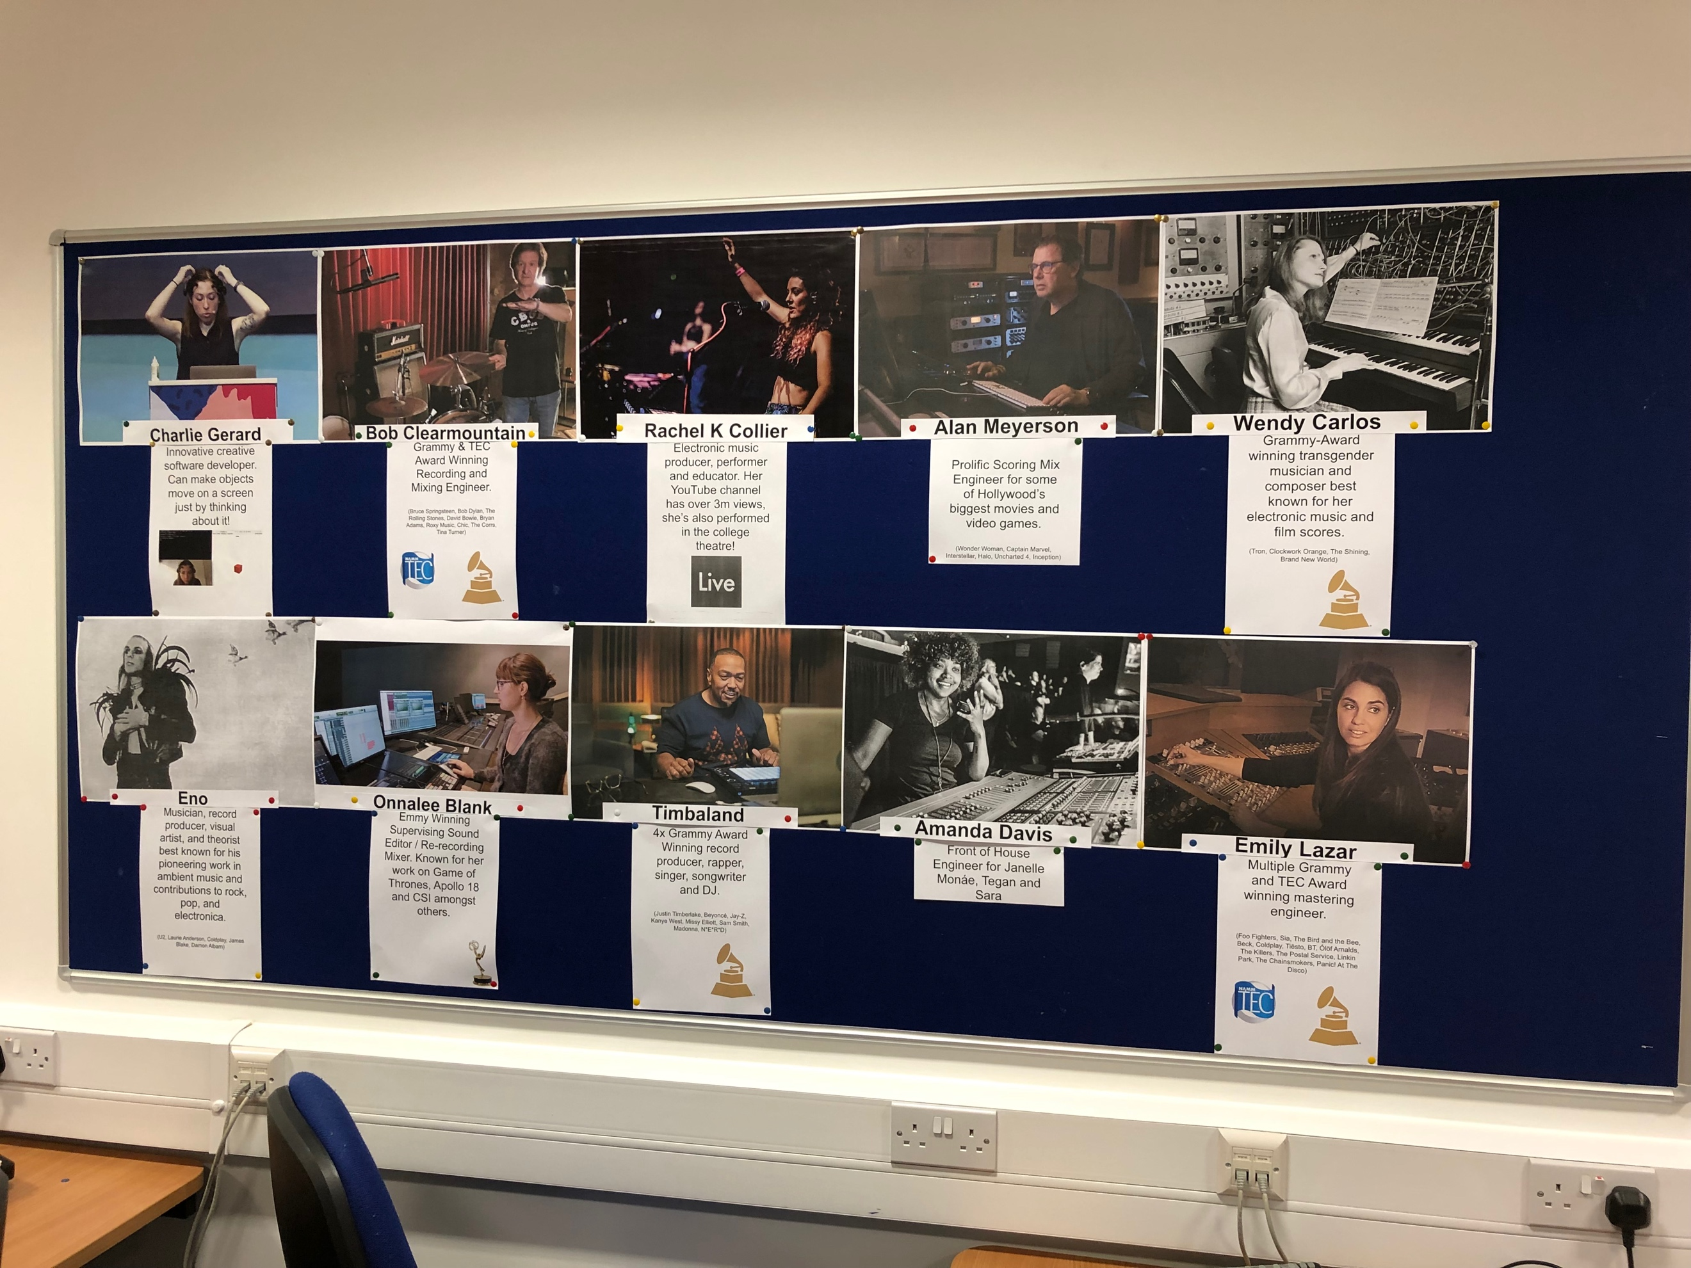
Fig 38a: Classroom notice boards post-implementation. Male, Female, Trans, BAME representation is included.

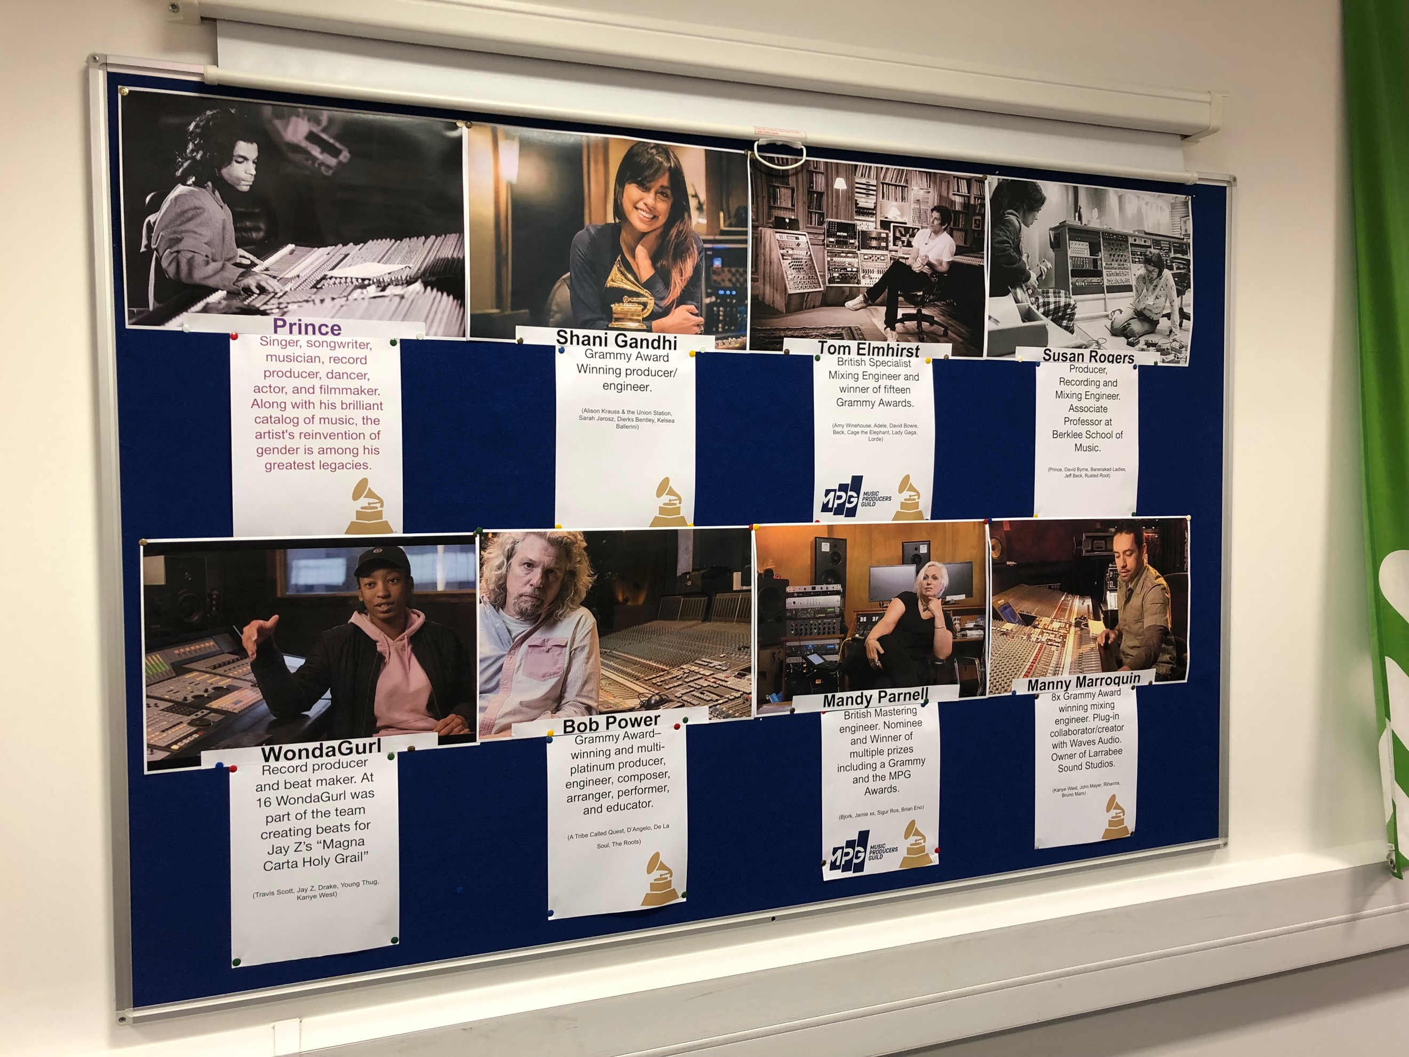
Fig 38b: Classroom notice boards post-implementation. Male, Female, BAME representation is included.

4.2 Staffing

Figure 23 in Section 3.2.3 showed how 35% of those who chose to put forth ideas regarding initiatives stated they would like to see improvements to staffing of courses, specifically the visibility of non-men delivering lectures, either as part of the faculty permanently or in the form of guest lectures. There is a ‘feedback loop’ of sorts occurring here. Non-men take up a small percentage of the audio world and as such are immediately disadvantaged when it comes to employment in the classroom as there is a higher chance of more men applying for the position in the first place. While the best person for the job should always be hired, it is worth considering whether or not the application or interview process is biased to begin with, and institutes should ensure that they are doing all they can to ensure fairness throughout, starting with the job advertisement itself, for example, by avoiding gendered language or imagery.

Surveyed participants who had experience with female tutors discussed feeling more comfortable knowing that there was somebody like them, that they could go to with academic or pastoral issues. I think the latter point is crucial, and courses should endeavour to have representation within the faculty however they can. If this cannot be achieved on a subject level, it could be achieved through visiting or guest lecturers, academic support staff and/or a dedicated pastoral tutor/support officer. While I am part of an all-male faculty on the subject front, we do have a female study skills lecturer who has been a great addition to the team. At the start of the 19/20 academic year, I began planning a level 6 career development-based module, focused on guest lecturers from industry talking about their development. Based on the findings from my survey results, it was of paramount importance to consider gender diversity when booking guest speakers, and as such out of the 8 guests, four were non-male and two of the non-male guest lecturers were course alumni. As highlighted by respondents in Section 3.2.3, it is clear that the experiences of non-men working in the industry is important for people of minority genders as they are more likely to identify with the guest, as well as being made to feel visible. It is also important for male students to be aware that not only are people of minority genders in the industry, but also to have access to an insight into the experience of being a minority in the industry. A more diverse range of guests also invites male students to reflect on their own behaviour and conduct toward people of minority genders. One of the guests (Gabriel Haley, co-founder of audio software company Black Goblin) discussed the conscious effort to make their company name seem genderless to remove any gender-based bias from potential clients. Another guest (Katie Tavini, mastering engineer and a former preservation audio engineer at The British Library) discussed the funding opportunities available to women in audio from companies such as the Performing Rights Society. Both guests discussed gender-based discrimination that they had faced in industry, and how they overcame those discriminatory barriers.

4.3 Attempting a Collective

Every guest lecturer of minority gender discussed the importance of networking, which 3 respondents suggested in Section 2.3.2 as a step towards greater inclusive practices. Prior to undertaking this research, I attempted to start a local network of women in audio, inspired by the work of the Yorkshire Sound Women Network, but have struggled to get it off the ground. As I had tried to start the network from within my institute, the pool of students of minority gender was already quite small. See Fig 39 below for a breakdown of total students across all Sound and Music Technology cohorts I teach on for academic years 17/18 – 19/20.

 | 17/18 | 18/19 | 19/20
Male | 86% | 81% | 82%
Minority Genders | 14% | 19% | 18%
Total Students | 50 | 31 | 22
Fig 39: Table of practitioners researched for 18/19 and 19/20 Access to HE Music

Section 1.2 discusses the frequently retold statistic that only 5% of those working in audio are people of minority genders. It is encouraging to see in Fig 39 that although the numbers are small, as a course we seem to attract a higher number of people of minority genders than the 5% statistic. There is still some way to go to achieve a more diverse classroom though, and in terms of raw numbers, the number of students of minority genders each year is low. This poses problems as networks and movements tend to thrive with more people. As a white male academic, I felt conflicted about my own privilege. It is clear from Section 2.3.2 that visibility of people of minority genders is crucial, and therefore struggled with how I could support the network without taking control of it. In addition to this, and while fortunate for the possibility of using my institute’s facilities for the network, there wasn’t funding available for this enterprise, which would be essential to cover speaker expenses and the organisation of developmental activities. Requesting professionals to give talks, demonstrations and workshops for free would only fuel the problem I’m working to dismantle. Through conversations with students, it became apparent that the additional burdens and pressures of being an undergraduate student were a major barrier in the group being able to run self-sufficiently. I am still hopeful of putting together a collective, though this may manifest in skills sharing workshops ran by students for students, as opposed to a more formalised collective with goals and a mission statement.

4.4 Providing Opportunities for Students of Minority Genders

The students who took part in Dr Dobson’s visit in July 2018 have now completed their studies, and I am keen to reignite discussions regarding the network, even if the formation is non-male alumni providing support for current students in a similar fashion to what I implemented in the 19/20’s career-development module. I have not allowed my experience in trying to set up the network dissuade my work to provide equal opportunities to our non-male students. I do this by utilising affirmative action while selecting assistants for my own recording studio opportunities. I advertise using a ‘first come, first served’ policy unless a student of minority genders volunteers after a male student, at which point I open up a second assisting position to ensure the opportunity for experience is there. Similarly, when approaching bands to take part in my Recording Studio Engineering lectures I utilise affirmative action while selecting from bands who apply, in favour of more diverse line-ups. I have found from experience that female students are much more forthcoming in sessions where the band has female representation, as opposed to all-male bands.

As a member of multiple all women/feminist sound collective mailing lists, I often receive e-mails from collectives with opportunities for people of minority genders, and ensure these e-mails are forwarded on to students of minority genders. This has led to a number of students attending Yorkshire Sound Women Network related events, which has resulted in more networking for our students, and feedback post-event has always been very positive. I have attended open-to-all events myself, to continue networking with those doing important work in inclusive and equal opportunities audio education. My advice to educators is to ensure that you are providing equal opportunities for all students. Due to the privilege maleness brings in audio, it can be quite easy for male students to secure opportunities. It is not the same for students of minority genders, who face many barriers due to how male dominated the industry is, as discussed in detail in Section 2.5. Work with local collectives to gain perspective and discuss how you could collaborate. There weren’t any audio-based collectives in our locale, which initially led to me reaching out to the Women’s Audio Mission in June 2016 for advice. The Women’s Audio Mission turned me on to collectives within the U.K. which resulted in my discovery of the Yorkshire Sound Women Network and the AES event that inspired this research. A number of gender-based collectives have cropped up since, rooted in friendship, art and music promotion. Through networking with these groups that share a similar passion I was able to secure a live sound placement for a female student running an International Women’s Day multi-stage event in an independent venue and have been in touch with other promoters about providing similar opportunities, and have more recently secured placements with a local not-for-profit organisation who operate for the benefit of musicians and audiences, providing live sound and technical support work experience for all students. The aforementioned not-for-profit are one of the largest providers of entertainment in the area, with ties to multiple venues, promoters and music festivals. However, due to the COVID-19 pandemic, live sound opportunities have been reduced significantly, meaning placements have been less accessible.

4.5 Amplifying Voices

Based upon the literature review and the results of the survey, the importance of role models was apparent. I analysed the first 46 podcasts released by Warrant Huart’s “Produce Like a Pro” series and found that only 1 (Lenise Bent) of the first 46 guests represent minority genders. While I cannot locate the number of listeners or subscribers, I am able to see that the YouTube channel has surpassed 359 000 subscribers and 32 million views and therefore consider Warren Huart to be in a position of influence within sound and music technology. Due to the popularity of podcasts, with an estimated 15.6 million podcasts listened to in the UK in 2020 (Statista 2020), I wanted to gauge whether there was interest in a podcast that interviewed a more diverse range of audio and audio technology professionals, the results of which can be seen in Figure 40.

Figure 40: Survey participants’ answers regarding their interest in more diverse podcasts.

I had begun planning the creation of a sound and music technology podcast similar to those that already exist, entitled ‘Sound Folx’. However, due to the current COVID-19 pandemic, this has not been possible as the workload demands in academia during the pandemic have grown exponentially. In this area, it is of importance to highlight the work of Soundgirls, who began producing podcasts during the pandemic. As you would expect from a collective such as Soundgirls, the guest list is diverse, featuring the likes of Fela Davis (podcast producer and audio engineer), Alexandria Perryman (NASA’s live broadcast engineer) and Beth O’Leary (freelance live sound engineer and tech). Instead of creating a podcast in an effort to network with more diverse professionals and amplify the voices of people of minority genders working in the industry, I started including podcasts as part of my interactive module reading lists. The inclusion of a podcasts section in the module reading list; as shown in Fig 41, amplify people of minority genders further, whether that is directly with Soundgirls, Gender Amplified or Sisters of Sound who are specifically amplifying these voices, or indirectly via the diverse hosting on Production Expert, or guests on Bobby Owsinski and Working Class Audio. As mentioned in Section 4.1 regarding teaching and learning materials, it is not that more diverse materials don’t exist, guest speakers or podcasts exist, but that it takes more time and effort to seek them out, and should not be left to the lecturer themselves to implement; as discussed in section 2.10.

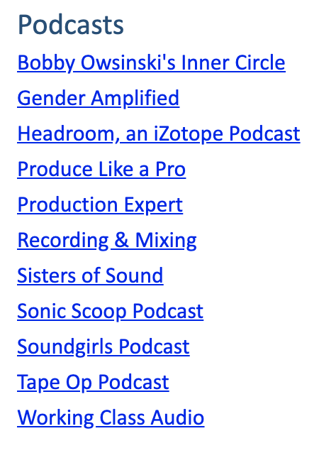.
Fig 41: Podcasts section of the interactive Module Reading List for Recording Studio Techniques, a level 4 module.

Chapter 5:

Conclusion

As I come to conclude this body of work, I am drawn to a quote by black, queer, singer, songwriter, rapper, actress, producer and activist Janelle Monáe:

I like to think that representation can drive innovation because when you have people in a room who might be from different worlds, different societies, different genders, that’s when you get the opportunity to meet someone different than yourself, then you’re trading ideas, then the sparks are flying, you know I just think that if you have the same people in the same room you’re going to get the same ideas. There’s no innovation. (Monáe 2018).

The following sections include a list of recommendations for educators and institutions wishing to remove the barriers to the successful delivery of inclusive education, and improve diversity in the sound and music technology classroom, as well as offering some concluding thoughts, that bring together what I have explored in previous chapters as well as highlighting areas that require further exploration.

5.1 Recommendations

My research reflected on two very specific questions:

- What are the driving forces of diversity in sound and music technology?
- What are the barriers to the successful delivery of inclusive education?

It is clear from my research that barriers to the successful delivery of inclusive education are multi-faceted. Learning Environment must be fit for purpose. Teaching Staff must be fit for purpose. Learning Materials must be fit for purpose. Classroom Behaviour must be fit for purpose. Based on my findings I would encourage those educators and institutions looking to create more inclusive environments to consider the following recommendations:

First and foremost, the learning environment needs to take into consideration basic human needs. This means ensuring the temperature is suitable for all and not just the male default and that all students feel safe and secure in the classroom, free from discrimination and exclusion, either intentional or unintentional, from students and staff alike.

The learning environment should also be inspiring. If you are displaying role models, consider the balance of male vs. minority gender. When using sound and music technology imagery, consider how it is portrayed and avoid materials that use sexualised marketing, gendered language, and look into the history of the imagery itself.

It is of the utmost importance that staff are educated on inclusivity and diversity issues. This should include training on unconscious bias and the issues surrounding it. Training provided should also cover the negative consequences of using gendered language and the importance of refraining from the use of binary forms.

It is key that staff also engage with their role as gatekeepers of inclusivity in the classroom. It is crucial to be mindful of unconscious bias occurring in the classroom which could lead to exclusionary practices, i.e are the students of minority genders together? Do they purposefully exclude? Classroom dynamics are also central, refraining from allowing the male student voice to dominate the classroom. While one should encourage participation, as a facilitator one should be able to identify who is contributing more than others and who is being left behind. Educators should ensure people of minority gender are not being left behind and that their participation is welcomed, encouraged and their voices heard. Central to the latter is allowing space for students of minority genders to present ideas and demonstrate, too, especially during practical tasks.

Where possible, minority gender representation within the faculty should be a central consideration. Whenever possible, diversity within your course team should be aspired to, by hiring permanent minority gendered lecturers and/or technicians. Where this is not possible, due to budgeting and staffing limitations, the gender gap could be covered by hiring minority gendered guest lecturers where possible and appropriate. Visiting lectures could be via web conferencing software which would reduce travel expenses for institutions, as well as allowing a greater level of choice of speakers as the choice is no longer impacted by the location of the speaker.

It is also of importance to ensure the availability of people of minority genders for pastoral or academic support if a student of minority gender requests it. I acknowledge that there is a potential problem with emphasising that men are less suitable for more caring, emotional roles. However, I am not stating that men should not also be utilised as pastoral or academic support, but instead that students have a choice when it comes to staff supporting them in pastoral matters. As with visiting lectures, support could be offered remotely. It is important to note that institutions would need to look into how potentially more requests for female members of staff is likely to increase workload, and as such other responsibilities would need to be reduced in order to facilitate such a support role.

Learning materials need to be fit for purpose, this should include utilising a diverse reading list that isn’t populated with male-only authors. It is important to note that in fields where the industry is male dominated, you may find the reading materials are also male dominated. Diversifying a reading list is about visibility and amplification. If you are unable to find physical books, consider alternate materials such as instructional videos, journal articles and podcasts. A more diverse range of interactive materials is also recommended for use during lectures, i.e refraining from utilising only male examples in, for example, YouTube clips, showing only men in dominant technical environments, and utilising a more varied list of in-session references.

It is also of the utmost importance that educators refrain from using gendered language in learning materials and draw discussion where this cannot be avoided, i.e the gendering of XLR connections or highlighting how frequency charts sometimes show male and female frequency responses and why this is problematic - not only does it assume that there are only two genders, but also assumes that there are only two frequency responses. Frequency response will depend on the range of the vocalist and the physical make-up of the components that allow us to sing.

There should be zero tolerance to discriminatory behaviour. Discussions during induction may be useful, as well as the inclusion in student and module handbooks. This would also include guidance on how to identify your own unconscious, affinity and confirmation biases, as well as what to do if you’re experiencing these biases.

It is of paramount importance to note that the removal of barriers to the successful delivery of inclusive education, and improvement of diversity in the sound and music technology classroom should not just be down to what the individual tutors can do, but what institutions can do to help, too. Academic institutes need to be supportive, with the entire institute responsible for delivering inclusive education and improving diversity. This can be done through reducing workloads of academics to ensure equality and diversity can be appropriately embedded, allowing staff to engage with diversity and adapt existing materials, as well as introducing new methods of driving of diversity. It must be a collaborative effort.

5.2 Concluding Thoughts

In ensuring a course is inclusive, an educator, with the support of their academic institution, has the power to remove the unconscious barriers that should enrich the experience of all in the sound and music technology classroom. If an educator continues to be an ally outside of the classroom, too, the potential to network and provide opportunities for people of minority genders outside of education and in the industry grows exponentially. As members of the audio community, academics should reject invitations to partake in manels or himposia. They should highlight the issue to the organiser in the hope of more inclusive and diverse panels and symposia in the future.

While this body of work focusses specifically on minority genders in higher education sound and music technology, the issues start much earlier. There is also a parallel to be found pertaining to the representation of BAME and LGBTQ+ students/professionals and I would be interested in carrying out similar research into what can be done to attract more BAME and LGBTQ+ students to sound and music technology. However, any future research projects I may undertake will be done with students at a more critical age in an effort to prevent any notion that sound and music technology is unsuitable for those of minority gender. As such, I am interested in working with students younger than FE in an effort to inspire the next generation of sound and music technologists. It is important to reflect upon how at present, the UK Government’s emphasis on the English Baccalaureate is causing students to opt out of pursuing GCSE Music, as discussed in Section 2.4, with a 2018 BBC Survey of over 1200 schools finding that 90% of the schools who responded had cut back on lesson time, staff or facilities in at least one creative arts subject (Jeffreys 2018). When coupled with OFSTED’s 17/18 report which stated academic subjects, i.e EBacc, are the best route to higher-level study for working-class children (Spielman 2018) and the disproportional effect that 86% of Conservative Government austerity has fallen on women (Butler 2018), particularly as we enter another recession, it is more important than ever to ensure that our future sound and music technologists are aware that not only are there viable routes through higher-level study with sound and music technology, but also viable career paths.

Without a conscious effort to increase diversity and inclusivity in the classroom, you are setting yourself up for academic Groundhog Day. By opening your classroom up and inviting people in from different societies, genders, ethnicities, you are exposing yourself as an educator to different narratives you may not have experienced before. These narratives can not only aid the development of your class, as students begin to collaborate with people who are different from themselves, but also the development of your perspectives as an educator too.

This body of research aimed to address a gap in research on gender equality and inclusive practices within the sound and music technology classroom. Through thorough analysis of the results of the survey and review of the literature, I have dismantled my own practices and begun again, making a number of key changes to curriculum and learning environment design, which I have also shared with colleagues in an effort to improve visibility and amplify minorities in sound and music technology through our teaching and learning materials. These modifications have resulted in a number of positive changes. These have included students delivering projects based on more diverse practitioners, as well as students correcting themselves and each other when recognising the use of problematic language (such as the term sound man instead of sound engineer). Moreover, students’ reference lists are becoming more diverse as a direct reflection of the diversification of reading lists as well teaching and learning materials provided by lecturers.

The aim of this dissertation was to explore ways of redressing the imbalance and creating inclusive practices in the currently male dominated music technology classroom. The findings of this dissertation can be extended across disciplines, as there are parallels with non-sound and music technology subjects, as well as with other protected characteristics such as ethnicity and sexuality. While one person’s efforts alone cannot bring about an increase in minority gender applications and enrolment, my network has become more diverse over this research period and, as a result, I have been able provide students of minority gender with opportunities they weren’t previously aware of, including Yorkshire Sound Women Network events, live sound opportunities with local venues for events held by minority gender collectives, live sound opportunities with touring bands at local venues, and career advice from non-male audio professionals.

This research has the potential to be adopted and adapted by others in the field looking to create more inclusive teaching environments. For those interested in making improvements to inclusive practice within their sound and music technology courses, I hope they find this body of work useful, and I have included a Glossary of Terms, Glossary of Collectives and Bibliographical Glossary which could be utilised in order to improve visibility within teaching and learning materials. It is clear from the research that a top-down approach is needed to affect those students that are already in the system and it would be useful to forge strong relationships with other like-minded individuals in order to continue to amplify the voices of those who are not currently being heard. It is important to note, however, that further work is required, and would likely be much more effective, when applied much earlier than FE and HE to avoid students of minority genders ever being discouraged from enrolling on sound and music technology-based programmes, or wider STEM programmes in the first place.

Appendix 1: Early Survey Design

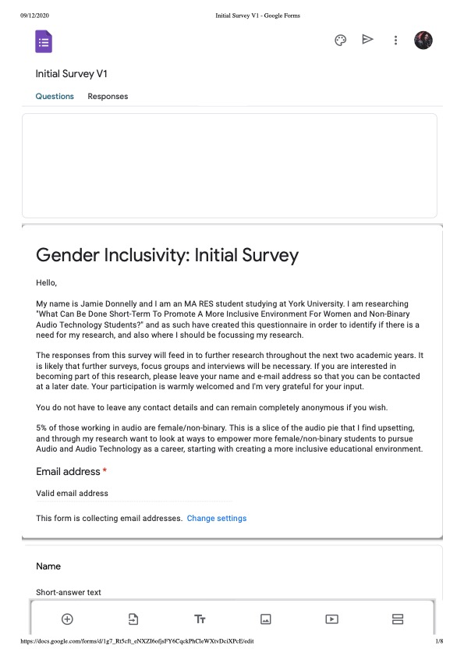

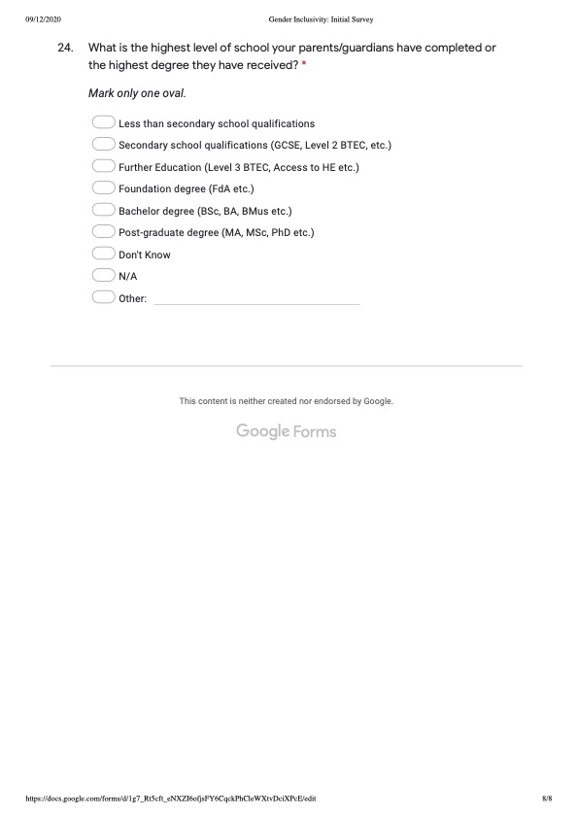

Appendix 2: Final Survey Design

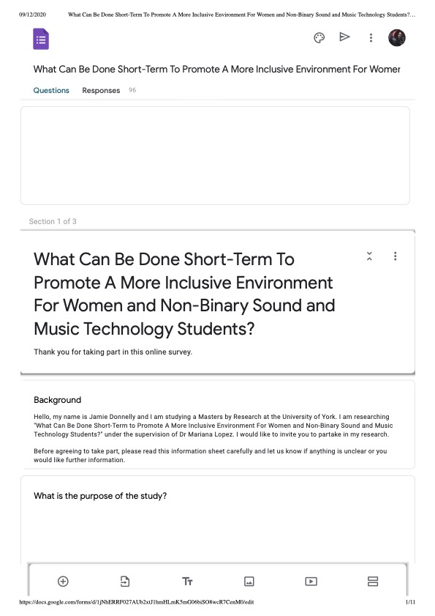

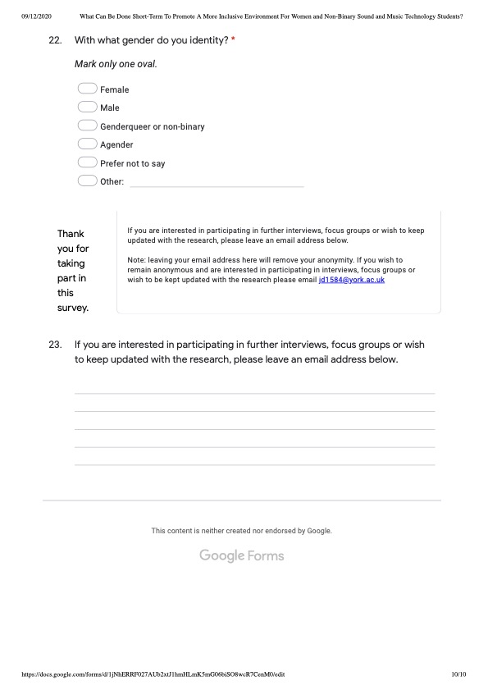

Appendix 3 – Ethics Form



Department of Theatre, Film and Television
Ethics Committee

RESEARCH ETHICS CHECKLIST

This checklist is to be used ONLY for research by TFTV staff and research students where the work can be considered low-risk from an ethical perspective.

Completed Research Ethics Checklists should be submitted to the TFTV Ethics Committee for review, by email to tftv-ethics@york.ac.uk at least TWO WEEKS before the commencement of the research work for which ethics clearance is being sought, unless an alternative deadline has been agreed, in advance, in writing with the TFTV Ethics Chair.

All research student applications MUST be first discussed, reviewed and approved by their supervisor prior to their submission. Student applications should also copy their supervisor on the email submission.

Before completing this form, please consult the TFTV Research Ethics Guidelines, available on the TFTV Ethics VLE site and Research Ethics web pages.

SECTION 1: APPLICANT AND PROJECT DETAILS

Box 1A: Applicant Details
ALL applicants must complete this box.
Applicant Name | Jamie Donnelly
E-mail address | Jd1584@york.ac.uk
TFTV Staff or TFTV Student | TFTV Student

Box 1B: Programme Details
STUDENT applicants must complete this box.
Degree Programme of Study | MA RES Interactive Media
Supervisor name(s) and Email address(es) | Dr Mariana Lopez  mariana.lopez@york.ac.uk

Box 1C: Research Details
ALL applicants must complete this box.
Research Project Title | What Can Be Done Short-Term To Promote A More Inclusive Environment For Women and Non-Binary Sound and Music Technology Students?
Project Start Date | September 2018
Project Duration | 2 Years
Collaborator details  (if applicable, names, email addresses and institutions) | N/A
Funding source  (if applicable) | N/A

Box 1D: Other Ethics Reviews  ALL applicants must complete this box. | YES | NO
Has this project been submitted to any other ethics or compliance procedures? |  | /
If YES, please provide details

Box 1E: Conflicts of Interest  STAFF applicants must complete this box. |  | YES | NO
1 | Are any ethical concerns / conflicts of interest likely to arise as a consequence of funding source (with respect to your own work or that of other individuals/departments within in the University e.g. perceived or actual with respect to direct payments, research funding, indirect sponsorship, board or organisational memberships, past associations, future potential benefits etc…) |  | /
2 | Does the Principal Investigator or any other key investigators or collaborators have any direct personal involvement in the organisation sponsoring or funding the research that may give rise to a possible conflict of interest? |  | /
IF YES to either question please describe these possible ethical concerns or conflicts of interest.

Please complete Section 2: Research Summary
SECTION 2: RESEARCH SUMMARY

Box 2A: Research Outline
ALL applicants must complete this box.
1 | Aims and objectives of the research  Please provide the aims and objectives of the research, including the questions or hypotheses that will be examined.
1 | Question: What Can Be Done Short-Term To Promote A More Inclusive Environment For Women and Non-Binary Sound and Music Technology Students?  Despite a 1400% rise in applicants for Music Technology based higher education programmes between the mid-1990s and 2012, only 12% of those applicants were Female (Born and Devine, 2015). My research project focuses on methods through which more inclusive learning environments can be created at UK based Universities. The responses from this survey will feed into further research throughout the next two academic years, providing focal points and indicating what initiatives should be further researched through focus groups and interviews to suggest methods for creating more inclusive educational environments for women and non-binary sound and music technology students.  This survey is aimed at non-male individuals who are either studying or studied a sound / music technology related degree at a UK based University. All information collected from this survey is anonymous.
2 | Methods of data collection and types of data  Please outline how the data will be collected from or about human participants (e.g. face to face audio recorded interviews, anonymous online surveys hosted by Google Forms, telephone surveys etc.) Please give details of all proposed research activities and specify exactly what types of data will be collected for each activity (e.g. paper based notes, photographs, audio recordings etc.).
2 | Anonymous online surveys hosted by Google Forms.
3 | Research Outside of the UK  Will you be conducting research outside of the UK? If so, specify where. Have you checked whether local ethical approval is required? Are there any different civil, legal, financial or cultural conditions that you need to be aware of? If so, please provide details of how you will ensure compliance with these conditions and/or regulations.  See the University’s guidance on conducting research outside the UK for further details: https://www.york.ac.uk/staff/research/governance/research-policies/guidanceoutsideuk/
3 | N/A

Please complete Section 3: Participants

SECTION 3: PARTICIPANTS

Box 3A: Participant Summary
ALL applicants must complete this box.
1 | Recruitment of Participants  How many participants will take part in the research? How will they be identified and invited to take part in the study? Please give details for all activities described in Box 2A, Question 2.  It is sufficient to provide estimated numbers. But, please provide details for each of the research activities described in the previous box.
1 | As many participants as possible within a month of sending out the survey. I am aiming for a minimum of 70 participants invited via a web-link to the Google Form. Web-link will be shared to UK based academic institutes, as well as UK-based Women Networks and on social media.  This survey is aimed at non-male individuals who are either studying or studied a sound / music technology related degree at a UK based University. All information collected from this survey is anonymous.
2 | Anonymity  Will the data you collect from participants be treated anonymously or non-anonymously in any outputs (e.g. reports, assessments, research papers etc.)?  If you intend to treat your data anonymously in the outputs, how will you ensure that anonymity is maintained? If you intend to treat the data non-anonymously, please explain and justify why a non-anonymous approach is appropriate in this work?  Note that a “privacy by design” approach is required for research activities, whereby data is always treated anonymously in outputs unless there is a good reason to identify the participants.
2 | All data collected from participants will be treated anonymously by design. Names and e-mail addresses will not be collected with survey responses.
3 | Payments, reimbursements and incentives  If research participants are to receive any payments, reimbursement of expenses, or any other incentives or benefits for taking part in your research, please give details, indicating what and how much they will receive and the basis on which this was decided. Please also explain how you will ensure that you are complying with financial regulations.
3 | N/A
4 | Obtaining Consent  Please explain how voluntary informed consent to participate will be elicited from participants. If different groups are involved in the study (e.g. parents, children, staff), please describe the sequence of consent. Please give details for all activities described in Box 2A, Question 2.
5 | Information Sheets | YES | NO
5 | Please confirm that you will provide all participants with a Participant Project Information Sheet that is based on the template provided on the TFTV Research Ethics web pages. | /
6 | Consent Forms | YES | NO
6 | Please confirm that you will take written Informed Consent from all participants using a form that is based on the template provided on the TFTV Research Ethics web pages.  Note that it is expected that explicit written Informed Consent is taken from all participants, unless there is a good reason to use verbal consent. | /
6 | If NO, please explain in what situations and contexts you will take verbal consent and how you will manage and record that verbal consent has been taken.
6 | Consent is integrated into the survey with the final two sentences “By partaking in this survey you are consenting to your responses being used as part of this research. All information collected from this survey is anonymous.”, as well as the incorporation of a mandatory ‘consent’ box following the introduction.
7 | Feedback | YES | NO
7 | Will you be providing the participants with any feedback on their involvement? E.g. providing them with access to research papers?  Note that it is generally expected that participants will have the option to receive some form of feedback on the work. | /
7 | If YES, please explain how you will provide the relevant parties with feedback and when, e.g. by giving them access to the completed report by emailing them a pdf version of accepted conference papers.  If NO, please explain why not.
7 | For those who wish to be informed of the research post-survey, there is an e-mail address that the can contact to keep in touch. This is completely separate to the survey itself and in no way can the two be linked.
8 | Dissemination and Distribution | YES | NO
8 | Do you intend to disseminate or distribute your finished work anywhere? | /
8 | If YES, please explain what you intend to do with the finished work? E.g. put on YouTube, submit to conferences etc.
8 | Submit and present to conferences.  Use as literature as part of a podcast series.

Please complete Section 4: Research Ethics Concerns
SECTION 4: RESEARCH ETHICS CONCERNS

Box 4A: Checklist of Research Ethics Questions  ALL applicants must complete this box |  | YES | NO
1 | Will the project involve conducting work that would typically require NHS Ethics approval?  That is, will you be working with any of the following as participants, if recruited specifically due to their involvement with the NHS:  Patients and Users of the NHS,  Relatives or carers of patients and users of the NHS,  NHS staff?  OR will you be using or accessing NHS premises or facilities as part of the work? |  | /
2 | Will the project involve conducting work that would typically require Her Majesty’s Prison & Probation Service Ethics approval?  That is, will you be conducting research with staff and/or offenders in prison establishments, National Probation Service (NPS)/Community Rehabilitation Companies (CRC) regions or within Her Majesty’s Prison and Probation Service (HMPPS) Headquarters?  OR will you be conducting research on HMPPS premises? |  | /
3 | Will you be working with vulnerable participants (e.g. those under 18, people with learning disabilities, people with mental impairment due to health or lifestyle, people who are terminally ill or recently bereaved etc.)?  Note that if you are unsure whether someone you would like to work with could be considered vulnerable under the circumstances, you are required to discuss your concerns with your supervisor and/or Ethics Chair. It is generally expected that any student working with vulnerable groups would submit a Full Research Ethics Clearance form. |  | /
4 | Will you be discussing sensitive or potentially upsetting or distressing topics with participants? | /
5 | Is it reasonably foreseeable that the work could involve causing physical or emotional distress to participants or researchers? | /
6 | Is it reasonably foreseeable that the participants could disclose or discuss participation in illegal activities (e.g. drug use)? |  | /
7 | Is it reasonably foreseeable that the participants could disclose confidential or sensitive information (e.g. financial data, sensitive organisational data)? |  | /
8 | Will you be deliberately misleading the participants in any way? |  | /
9 | Will you be filming or making recordings of people without their knowledge and consent (e.g. covert filming of people in non-public places)? |  | /
10 | Will you be researching or discussing issues relating to terrorism or political extremism as part of your work? |  | /
11 | Will you be collecting online data that has been generated by human participants (e.g. social media data) from closed, restricted forums (i.e. from closed communities or those that require approved membership to view, e.g. restricted Facebook groups)? |  | /
12 | Will you be identifying anyone from online data that has been generated by human participants (e.g. social media data) from either open or closed forums (i.e. by including information that could make the individual identifiable, such as direct quotes or usernames)? |  | /
13 | Could the work involve potentially damaging property and/or the natural environment? |  | /
14 | Will the work involve animals? |  | /
15 | Is it reasonably foreseeable that the work could result in any anticipated university/institutional risk (e.g. adverse publicity or financial loss)? |  | /

If you have answered “YES” to ANY of the questions in Box 4A: Checklist of Ethical Research Ethics Questions:

This Research Ethics Checklist may be insufficient to accommodate the ethical risks of your proposed work.

Some lower-risk ethical issues can be accommodated without further scrutiny by the TFTV Ethics Committee provided that you agree to follow a process that is considered appropriate. These situations and processes are described on the TFTV Ethics VLE site.

IF there is a suitable procedure to manage this ethics issue, please complete Box 4B to provide further details of how you intend to manage the ethical issues associated with your proposed work.

If there is no identified procedure to manage these ethical issues then you will need to submit the longer Research Ethics Clearance Form to explore these ethical issues in more depth.

Box 4B: Further Details
Complete this box if you answered “Yes” to any question in Box 4A AND there is an identified procedure to manage the ethical risks in this situation.
Provide details of the nature of the ethical risks that you identified by answering YES to questions in Box 3A and describe the process that you will follow to minimise the risks.

Alternatively, the associated risks of your proposed work may be sufficiently low risk that an appropriate approach can be agreed with the TFTV Ethics chair without requiring submission of the TFTV Research Ethics Clearance form. Your supervisor/module convenor may contact the TFTV Ethics on your behalf to identify an agreed process on a case-by-case basis. If your supervisor has discussed your proposed work with the TFTV Ethics Chair via email, please complete Box 4C: Case-By-Case Agreed Process.

Box 4C: Case-By-Case Agreed Process  Applicants must complete this box IF they have answered “YES” to any questions in Box 4A AND there is no identified procedure to manage the ethical risks of the proposed work.  Note, that most applicants will need to submit a TFTV Research Ethics Clearance form and this case-by-case process approach is ONLY suitable for work that can be considered low risk. |  | YES | NO
1 | Have you or your project supervisor discussed the proposed work and associated ethical risks with the TFTV Ethics Chair via email? | /
2 | Were you or your project supervisor able to agree a process to manage the low risks associated with your proposed work? | /
IF YES to BOTH questions please provide further details of the anticipated risks of the proposed work and the process that was agreed with the TFTV Ethics chair. Please include dates of the email correspondence AND the name and email address of people involved.
Due to the nature of the study centring around inclusivity, it is possible that past discrimination could be discussed which would fall under the below questions.
“Will you be discussing sensitive or potentially upsetting or distressing topics with participants?”
“Is it reasonably foreseeable that the work could involve causing physical or emotional distress to participants or researchers?”
Ethical Risks are managed in the survey design itself. The initial paragraph explains the survey clearly. This will circumvent the participation of those who do not wish to proceed with the survey. Similarly, mandatory questions are quite general. Probing questions asking for more information can be skipped if the participant wishes.

If the associated risks of your proposed work cannot be accommodated through an identified procedure or through a case-by-case agreed process, then you will need to submit an application to the TFTV Ethics Committee for review using the Research Ethics Clearance Form.

Please complete Section 5: Data Protection

SECTION 5: DATA PROTECTION

Box 5A: Checklist of Data Protection Questions  ALL applicants must complete this box |  | YES | NO
1 | Will you guarantee that you will inform all people whose personal and/or special category data that you are using:  What data you will be collecting and why;  How you will be storing the data;  The legal basis under which you are storing the data;  When/if/how the data will be destroyed?  Please note that using a GDPR Compliant Project Information Sheet will ensure you meet these requirements. | /
2 | Will you guarantee that IF you use a portable device to collect electronic data you will transfer that data to your University Google Drive account or University Filestore as soon as possible after the interview AND delete it from your personal device? | /
3 | Will you guarantee that the data will ONLY be accessible to the project team AND that IF the project team extends beyond the University of York that you have consulted the University’s IP and Legal team to ensure appropriate data protection safeguards are in place? | /
4 | Will you guarantee that you will ONLY use Google Forms OR Qualtrics to host online surveys that collect personal and/or special category data? | /
5 | Will you guarantee that you are collecting the MINIMUM amount of data necessary for the intended project? | /
6 | Will you guarantee that IF you are storing or accessing data from OUTSIDE the European Economic Area (EEA) you will access the data through your University of York Google Account connected to the University of York Virtual Private Network (VPN)? | /
7 | Will you guarantee to destroy all physical AND electronic data EITHER after your module marks have been ratified by the Board of Examiners OR 10 years after last requested access? | /
8 | IF storing electronic data for 10 years after last requested access, will you guarantee to EITHER use a University Google Drive account OR an approved data repository service to store the data? | /
9 | Have you screened your project against the Data Protection Impact Assessment (DPIA) screening questions AND if required conducted a DPIA and submitted a copy to the Data Protection Officer for review? | /

Box 5B: Further Details
Complete this box if you answered “Yes” to any question in Box 5A.
Provide details of the nature of the data protection risks that you identified by answering YES to questions in Box 5A and describe the process that you will follow to minimise the risks. Please note that if you are not compliant with the agreed procedures above, this application will be referred to the University Data Protection Officer for advice.

Please complete Section 6: Applicant Agreement

SECTION 6: APPLICANT AGREEMENT

Please mark your answer to each question in Box 6A: Applicant Agreement with an “X” or a tick in the appropriate column. Please note that you MUST NOT begin contacting participants UNITL you have received a response from the Ethics committee.

If you are a research student, please also have your supervisor also complete Box 6B: Supervisor Agreement and provide their signature overleaf.

Once completed, submit the checklist for review by the TFTV Ethics committee by emailing the checklist to tftv-ethics@york.ac.uk from the applicant’s University of York account. The Ethics Committee will accept a typed/digital signature from the applicant if the form is returned by email from the applicant’s University of York account, and similarly a typed/digital signature and responses to the supervisor questions if the supervisor is cc’d to that email.

Box 6A: Applicant Agreement  ALL applicants must complete this box. |  |  | YES | NO
1 | I will ensure that the research conducted for the above project will meet all the statements as expressed in this Research Ethics Checklist. |  | /
2 | I will ensure that all work related to the research will be guided by the University’s ethical rules and regulations. |  | /
3 | I understand that I must not progress with this project until I have received confirmation from the TFTV Ethics committee that Ethics approval through this Research Ethics Checklist is appropriate for this project. |  | /
4 | I have included example Project Information Sheets and Participant Informed Consent Forms, as part of this Ethics application, if appropriate. |  | /
5 | I understand that I must adhere to the TFTV requirements for storing and using personal and special category data in compliance with the General Data Protection Regulation.  Note that GDPR compliance guidance can be found on the TFTV Ethics VLE site. |  | /
6 | I agree to ensure that all payments made to personnel in relation to this project will comply with financial regulations. |  | /
7 | I agree to report any changes to the above as soon as is feasible to the Chair of the TFTV Ethics Committee. |  | /
Applicant Name |  | Jamie Donnelly
Signed
Date |  | 03/02/19

Box 6B: Supervisor Agreement  STUDENT applicants must have their supervisor complete this box. |  |  | YES | NO
1 | I have reviewed this checklist in discussion with the student.
2 | I believe the Research Ethics Checklist is appropriate for this work and that no further Ethics approval is required.
3 | IF you have selected “No” in response to statement 2:  I confirm that the student will submit either the Research Ethics Clearance Form for further ethical approval.
Supervisor Name |  | Dr Mariana Lopez
Signed
Date

Glossary of Terms

A Levels – Advanced Level Qualifications. Studied at Further Education colleges. A Levels are the most common method used for entry criteria to UK Universities to determine an applicant’s suitability for their applied course.

BTEC – Business and Technology Education Council. A provider of secondary school leaving and further education qualifications in England, Wales and Northern Ireland. BTEC Level 2 qualifications are the equivalent of GCSE grades A* - C. BTEC Level 3 qualifications; also referred to as BTEC Nationals, are the equivalent to A Levels, and typically more vocational subjects.

EBACC – English Baccalaureate. A school performance indicator linked to traditional academic GCSE students, considered by the Government of the United Kingdom as a way to keep young people’s options open for further study and future careers. EBACC subjects include English language and literature, maths, the sciences, geography or history and a language.

Folx - a gender-neutral way to refer to members of or signal identity in the LGBTQ community.

Further Education – Education in addition to Secondary Education. Typically, further education is a method of attaining necessary qualifications to progress in to Higher Education. In the United States and Canada, the term continuing education has a similar meaning.

GCSE – General Certificate of Secondary Education. A part of the National Curriculum taught to pupils between the ages of 14 – 16; students can also complete GCSE qualifications at Further Education if unsuccessful in Secondary Education. Core, compulsory subjects include English, Maths and Science. Students should also study Physical Education, Computing and Citizenship; though a GCSE examination may not be compulsory. Schools must offer at least one subject from the arts, design and technology, modern foreign languages and humanities, though it is up to the student to choose one of those subjects.

Deadnaming – Referring to a transgender person by the name they used prior to transitioning. Can also be described as referring to somebody by their birth name or given name.

Higher Education – also referred to as post-secondary education, third-level and tertiary education. Higher Education is the pursuit of an academic degree. Higher education can refer to undergraduate, post-graduate and doctoral level studies.

Secondary Education – In the United Kingdom, students between the ages of 12 – 16 are legally required to attend a secondary school. During a student’s time at secondary school they will; as a minimum, carry out GCSE examinations for core compulsory subjects English, Maths and Science.

Glossary of Collectives

2% Rising, founded in 2020 by mastering engineer Katie Tavini and artist and producer Rookes. An online networking hub aimed at women and non-binary folx working specifically in music production and studio engineering, particularly in the UK and Europe. More information available at: https://www.facebook.com/groups/489211901763135

EQL Directory, a directory powered by Soundgirls in partnership with Spotify and other organisations, the EQL directory aims to amplify the careers and achievements of women and gender nonconforming people working behind the scenes in audio and production. People of minority genders are able to upload their resume to the directory for free. More information available at: https://makeiteql.com/

Femnoise, founded in 2017, a collective fighting for the reduction of the gender gap in the music industry. Connecting and empowering underrepresented individuals worldwide through an online community of over 2000 searchable members by name, location, area of the industry and musical styles. More information available at: https://www.femnoise.com

Saffron, founded in 2015, is a music tech initiative taking an intersectional approach to redressing the gender imbalance in the industry by offering training in music production, sound engineering and DJing, as well as artist development, for womxn. More information available at: https://saffronmusic.co.uk/

Soundgirls.org, co-founded in 2013 by live sound engineers Karrie Keyes and Michelle Sabolchick Pettinato, are an international organisation with over 6000 members worldwide. Soundgirls.org provide scholarships, mentorships, job placements, business development and workshops. More information available at: https://soundgirls.org/ - I would particularly recommend exploring the resources available at: https://soundgirls.org/resources/inclusive/ - as well as exploring the profiles page for examples of people of minority genders working in the industry available at: https://soundgirls.org/profiles/ - as well as a list of related website available at: https://soundgirls.org/related-websites/ - and a collection of blogs, collectives and organisations by or for people of minority genders available at: https://soundgirls.org/women-in-the-music-industry/

Women’s Audio Mission, founded in 2003; is a San Francisco/Oakland-based nonprofit organisation that uses music and media as a training environment. WAM attract 2000 women, girls and gender nonconforming individuals each year into STEM and creative technology careers. Since inception, Women’s Audio Mission have delivered over 4000 classes to 16000 women, girls and gender nonconforming individuals, as well as placing 750+ women, girls and gender nonconforming individuals into paid positions of work with companies such as Google, Pixar, NPR and Dolby Labs. More information available at: https://womensaudiomission.org/

Women in Lighting is a digital profile that platforms women working in lighting design. It promotes the passions and achievements, as well as celebrating the work and elevating the profiles of women in lighting. More information available at: https://womeninlighting.com/

Yorkshire Sound Women Network, founded in 2015 by women working in the sound technology industry who wanted to use their influence and skills to address racial and gender inequality. These inequalities are addressed by providing women and non-binary, agender and gender variant people with access to resources, skills sharing and collaborative opportunities. Men are welcome to support the network. More information available at: https://yorkshiresoundwomen.com/ also affiliated with Calderdale Sound Women Network, Leeds Sound Women, SONA, YSWN Huddersfield Makers, YSWN York and Malta Sound Women Network.
Biographical Glossary

The following biographical glossary is a list of people of minority genders in industry. It is by no means complete, and serves as a starting point for those looking for more diverse professionals to reference in teaching and learning materials. For a more comprehensive list, please visit https://soundgirls.org/profiles/

Adair, Deb – Emmy winning re-recording mixer. Credits include Aladdin, South Park and Moneyball.

Araica, Marcella – recording and mixing engineer. Credits include Britney Spears, Duran Duran, Keri Hilson, Madonna, Pink and Timbaland.

Bent, Lenise - producer, engineer, mixer and sound editor. Credits include Steely Dan, Blondie, The Knack, Supertramp, Fleetwood Mac, and Shrek (Additional Dialogue Recordings recordings).

Ghandi, Shani – Grammy award winning producer, recording and mixing engineer. Credits include Alison Krauss & the Union Station, Kelsea Ballerini, Sarah Jarosz and Sierra Hull.

Howard, Mary – one of the earliest known female recording engineers. Credits include Glenn Miller, Arturo Toscanini and Charles Ives.

Jones, Leslie Ann - Director of Music Recording and Scoring at Skywalker Sound, Lucasfilm, Ltd. Grammy winning recording and mixing engineer. Credits include Alice in Chains, Meat Puppets, Miles Davis, Kronos Quartet, Happy Feet (film score) and Star Wars (film score).

Keyes, Karrie – audio engineer and executive director of Soundgirls. Monitoring engineer for Red Hot Chilli Peppers (1990 – 2000) and Pearl Jam.

Klein, Sherry – Emmy-nominated re-recording engineer for shows including Sons of Anarchy, Arrested Development and The Shield.

Lazar, Emily – Grammy award winning mastering engineer. Credits include Foo Fighters, Sia, The Bird and The Bee, Beck, Vampire Weekend, Haim, Jacob Collier and Coldplay.

Massy, Sylvia – producer, engineer, mixing engineer and author. Credits include Johnny Cash, Tool, System of a Down, Prince, Red Hot Chilli Peppers and Thunderpussy.

Mincieli, Ann – Grammy winning recording and mixing engineer. Credits include Alicia Keys, Eminem, Madonna, Pharrell Williams and Beyoncé.

Rogers, Susan – producer, engineer, mixing engineer and Berklee professor. Credits include Prince, Wendy & Lisa, Barenaked Ladies, David Byrne and Crosby Stills & Nash.

Sherman, Judith – Grammy winning sound engineer and producer. Credits include London Symphony Orchestra, Phillip Glass, Steve Reich and John Adams.

Shoemaker, Trina – Grammy winning producer, sound engineer and mixing engineer. Credits include Iggy Pop, Emmylou Harris, Sheryl Crow and Queens of the Stone Age.

References

Annetts, Alex (2015) Masculinity and gear fetishism in audio technology community discourse. Doctoral thesis, Anglia Ruskin University.

Armstrong, V. (2003). Girls’ And Boys’ Technological Toys: Music Composition In The Computerized Classroom. GEMS (Gender, Education, Music, & Society), [online] 2(1). Available at: https://www.researchgate.net/publication/327623787 [Accessed 8 Jun. 2019].

Ashcraft, K. (2013). The Glass Slipper: “Incorporating” Occupational Identity in Management Studies. Academy of Management Review, 38(1), pp.6-31.

Atewologun, D., Cornish, T. and Tresh, F., 2018. Unconscious Bias Training: An Assessment Of The Evidence For Effectiveness. [ebook] Equality and Human Rights Commission. Available at: <https://www.equalityhumanrights.com/sites/default/files/research-report-113-unconcious-bais-training-an-assessment-of-the-evidence-for-effectiveness-pdf.pdf> [Accessed 25 August 2020].

Bartlet, J. (2019). Normal Not Novelty: A Notch in the Belt - Audio Media International. [online] Audio Media International. Available at: https://www.audiomediainternational.com/2019/03/08/normal-not-novelty-a-notch-in-the-belt/ [Accessed 10 Jun. 2019].

BBC, 2020. George Floyd: Twitter Drops 'Master', 'Slave' And 'Blacklist'. [online] BBC News. Available at: <https://www.bbc.co.uk/news/business-53273923> [Accessed 7 December 2020].

Beauman, N. (2017). Mica Levi’s Intensely Unconventional Film Scores. [online] The New Yorker. Available at: https://www.newyorker.com/culture/persons-of-interest/mica-levis-anti-musical-soundtracks [Accessed 2 Nov. 2019].

Beer, A. (2016). Sounds and Sweet Airs. Oneworld Publications.

Bieger, H. (2017). Vox Recording Studios, Los Angeles. [online] Soundonsound.com. Available at: https://www.soundonsound.com/music-business/vox-recording-studios-los-angeles.

Birke, L. (1992), In pursuit of difference: scientific studies of women and men, In G. Kirkup & L. S. Keller (Eds.), Inventing women: science, technology and gender (pp. 81-102). Cambridge, UK.

Born, G. and Devine, K. (2015). Music Technology, Gender, and Class: Digitization, Educational and Social Change in Britain. Twentieth-Century Music, 12(02), pp.135-172.

Blickenstaff, J. (2005). Women and science careers: leaky pipeline or gender filter?. Gender and Education, [online] 17(4), pp.369-386. Available at: https://www.tandfonline.com/doi/full/10.1080/09540250500145072?scroll=top&needAccess=true.

Braun, F., Sczesny, S. and Stahlberg, D. (2005). Cognitive Effects of Masculine Generics in German: An Overview of Empirical Findings. Communications, 30(1), pp.1-21.

Burns, J. (2013). Outnumbered science girls beat boys. [online] BBC News. Available at: https://www.bbc.co.uk/news/education-23181672

Burns, J. (2014). 'Bright girls' among physics dropouts. [online] BBC News. Available at: https://www.bbc.co.uk/news/education-27596247.

Burton, J. (2012). Jon Burton (The Prodigy): Outdoor Sounds — Engineering Sound For Festival Events. [online] Soundonsound.com. Available at: https://www.soundonsound.com/people/jon-burton-prodigy-outdoor-sounds-engineering-sound-festival-events [Accessed 17 Jan. 2020].

Buskin, R. (2013). Classic Tracks : Beastie Boys 'Sabotage'. [online] Soundonsound.com. Available at: https://www.soundonsound.com/people/classic-tracks-beastie-boys-sabotage [Accessed 17 Jan. 2020].

Buskin, R. (2013). Classic Tracks : Beastie Boys 'Sabotage'. [online] Soundonsound.com. Available at: https://www.soundonsound.com/people/classic-tracks-beastie-boys-sabotage [Accessed 17 Jan. 2020].

Butler, D., 2018. Twitter. [online] Twitter.com. Available at: <https://twitter.com/DawnButlerBrent/status/1052868452195553280> [Accessed 25 August 2020].

Cai, Z., Fan, X. and Du, J. (2017). Gender and attitudes toward technology use: A meta-analysis. Computers & Education, 105, pp.1-13.

Camberwell Studios. (2013). The Importance of – The Soundman (Sound Engineer, Mixer, Recordist) - Camberwell Studios. [online] Available at: http://www.camberwellstudios.co.uk/blog/film-production-tips/the-importance-of-the-sound-man-sound-engineer-sound-mixer-sound-recordist.html [Accessed 17 Jan. 2020].

Chalabi, M., 2016. Sexual Harassment At Work: More Than Half Of Claims In US Result In No Charge. [online] the Guardian. Available at: https://www.theguardian.com/money/2016/jul/22/sexual-harassment-at-work-roger-ailes-fox-news [Accessed 29 April 2020].

Cole, N. S. 1997. The ETS gender study: how females and males perform in educational settings, Princeton, NJ: Educational Testing Service.

Colley, A. and Comber, C. (2003). Age and gender differences in computer use and attitudes among secondary school students: what has changed?. Educational Research, 45(2), pp.155-165.

Colliano, J., 2019. What Is The Most Cliché Audiophile Album Of All Time?. [online] Audiophile Review. Available at: https://audiophilereview.com/audiophile-news/what-is-the-most-cliche-audiophile-album-of-all-time.html [Accessed 20 May 2020].

Comber, C., Hargreaves, D. and Colley, A. (1993). Girls, Boys and Technology in Music Education. British Journal of Music Education, 10(02), p.123.

Cook, A. and Glass, C., 2013. Above the glass ceiling: When are women and racial/ethnic minorities promoted to CEO?. Strategic Management Journal, 35(7), pp.1080-1089.

Cooper, G. (2015). Charlie Watkins. [online] Soundonsound.com. Available at: https://www.soundonsound.com/people/charlie-watkins [Accessed 17 Jan. 2020].

Cooper, G. (2015). Goldfrapp At The Royal Albert Hall. [online] Soundonsound.com. Available at: https://www.soundonsound.com/people/goldfrapp-royal-albert-hall [Accessed 17 Jan. 2020].

Cooper, G. (2015). Oasis & Britannia Row: Live At Knebworth. [online] Soundonsound.com. Available at: https://www.soundonsound.com/people/oasis-britannia-row-live-knebworth [Accessed 17 Jan. 2020].

Corbett, I. (2011). Peter Gabriel Live. [online] Soundonsound.com. Available at: https://www.soundonsound.com/people/peter-gabriel-live [Accessed 17 Jan. 2020].

Criado Perez, C., 2019. Invisible Women: Exposing Data Bias In A World Designed For Men. 1st ed. Chatto & Windus.

Crofts, M. (2012). RCF HD12A. [online] Soundonsound.com. Available at: https://www.soundonsound.com/reviews/rcf-hd12a [Accessed 17 Jan. 2020].

Crofts, M. (2016a). Phantom Power. [online] Soundonsound.com. Available at: https://www.soundonsound.com/techniques/phantom-power [Accessed 17 Jan. 2020].

Crofts, M. (2016b). Alto Professional MixPack 10. [online] Soundonsound.com. Available at: https://www.soundonsound.com/reviews/alto-professional-mixpack-10 [Accessed 17 Jan. 2020].

Davies, C. (1996). The Sociology of Professions and the Profession of Gender. Sociology, 30(4), pp.661-678.

Daley, D. (2006). Recording Latin Percussion. [online] Soundonsound.com. Available at: https://www.soundonsound.com/techniques/recording-latin-percussion [Accessed 17 Jan. 2020].

de Boise, S., 2017. Gender Inequalities and Higher Music Education: Comparing the UK and Sweden. British Journal of Music Education, 35(1), pp.23-41.

de Boise, S., 2017. Tackling gender inequalities in music: a comparative study of policy responses in the UK and Sweden. International Journal of Cultural Policy, 25(4), pp.486-499.
de Boise, S., 2014. Learning to be Affected: Masculinities, Music and Social Embodiment. Sociological Research Online, 19(2), pp.1-15.

De Welde, K., Laursen, S. and Thiry, H. (2007). Women in Science, Technology, Engineering and Math (STEM). [ebook] Boulder, p.2. Available at: https://www.uc.edu/content/dam/uc/win/docs/stem_fact_sheet.pdf [Accessed 26 Jan. 2020].

Department for Education (2019). Realising the potential of technology in education: A strategy for education providers and the technology industry. [PDF] Department for Education. Available at: https://assets.publishing.service.gov.uk/government/uploads/system/uploads/attachment_data/file/791931/DfE-Education_Technology_Strategy.pdf

Dickerson, James L. “Go Girl, Go! The Women’s Revolution in Music”. New York, NY: Schirmer Trade Books. (2005): 188-205.

Dobson, L. (2018). #audioequitypledge. [online] Dr Liz Dobson. Available at: https://drlizdobson.com/2018/08/28/audioequitypledge/

Dobson, E. (2018). Digital Audio Ecofeminism: The Glocal Impact of All-female Communities on Learning and Sound Creativities in L. De Bruin, P. Burnard and S. Davis Creativities in Arts Education, Research and Practice: Glocalised Perspectives for the Future of Learning and Teaching

Doyle, T. (2010). Recording Latin Percussion. [online] Soundonsound.com. Available at: https://www.soundonsound.com/techniques/recording-latin-percussion [Accessed 17 Jan. 2020].

Doyle, T. (2019). Classic Tracks: Led Zeppelin 'Kashmir'. [online] Soundonsound.com. Available at: https://www.soundonsound.com/techniques/classic-tracks-led-zeppelin-kashmir.

Duncan, P. and Topping, A., 2018. Men Underestimate Level Of Sexual Harassment Against Women – Survey. [online] the Guardian. Available at: https://www.theguardian.com/world/2018/dec/06/men-underestimate-level-of-sexual-harassment-against-women-survey [Accessed 29 April 2020].

Easterly, D. and Ricard, C. (2011). Conscious Efforts to End Unconscious Bias: Why Women Leave Academic Research. Journal of Research Administration, [online] 42(1), pp.61 - 73. Available at: https://files.eric.ed.gov/fulltext/EJ955003.pdf.
Eckhardt, J. and De Graeve, L. (2016). Survey on: sound | music & gender | sex. pp.60 - 61.

Ferguson, D. (2019). A year to clean five schools of sexism – shouldn’t others do the same?. [online] the Guardian. Available at: https://www.theguardian.com/education/2019/nov/12/clean-five-schools-of-sexism-teachers-pupils-gender-equality [Accessed 22 Jan. 2020].

Flint, T. (2013). Dan Deacon: Performing Electronica Live. [online] Soundonsound.com. Available at: https://www.soundonsound.com/people/dan-deacon-performing-electronica-live [Accessed 17 Jan. 2020].

Freeman, A., Tyrovolas, S., Koyanagi, A., Chatterji, S., Leonardi, M., Ayuso-Mateos, J., Tobiasz-Adamczyk, B., Koskinen, S., Rummel-Kluge, C. and Haro, J., 2016. The role of socio-economic status in depression: results from the COURAGE (aging survey in Europe). BMC Public Health, 16(1).

Gadir, T. (2016). Resistance or Reiteration? Rethinking Gender in DJ Cultures In: Contemporary Music Review, 35, 115 - 129

Gadir, T. (2017). Forty-Seven DJs, Four Women: Meritocracy, Talent and Postfeminist Politics In: Dancecult: Journal of Electronic Dance Music Culture, 9, 50 - 72

Gill, T., 2016. GCSE Uptake And Results, By Gender 2005-2014. [online] Available at: https://www.cambridgeassessment.org.uk/Images/290195-gcse-uptake-and-results-by-gender-2005-2014.pdf.

Gillmore, K. (n.d.). Changing the World: Audio Engineering Society UK #HeForShe Event. [online] SoundGirls.org. Available at: https://soundgirls.org/changing-the-world-audio-engineering-society-uk-heforshe-event/ [Accessed 10 Jun. 2019].

Girls Rock London (2018). Why Girls Rock London. [online] Girlsrocklondon.com. Available at: https://www.girlsrocklondon.com/wp-content/uploads/2018/03/Why_Girls_Rock_London.pdf.

Goldin, C. and Rouse, C. (2000). Orchestrating Impartiality: The Impact of “Blind” Auditions on Female Musicians. American Economic Review, [online] 90(4), pp.715-741. Available at: https://cos.gatech.edu/facultyres/Diversity_Studies/Goldin_Orchestrating%20Impartiality.pdf.

Good, J., Woodzicka, J. and Wingfield, L., 2010. The Effects of Gender Stereotypic and Counter-Stereotypic Textbook Images on Science Performance. The Journal of Social Psychology, 150(2), pp.132-147.

GRAMMY.com. (2019). Women In The Mix: Producer & Engineering Inclusion Initiativ. [online] Available at: https://www.grammy.com/recording-academy/women-mix-producer-engineering-inclusion-initiative [Accessed 10 Jun. 2019].

Greeves, D. (2005). Jonathan Lucas: Freelance Engineer. [online] Soundonsound.com. Available at: https://www.soundonsound.com/people/jonathan-lucas-freelance-engineer [Accessed 17 Jan. 2020].

Grimm, J. and Grimm, W., 1812. Grimms' Fairy Tales.

Hallam, S., Rogers, L. and Creech, A. (2008). Gender differences in musical instrument choice. International Journal of Music Education, 26(1), pp.7-19.

Hamer, S., 2020. ‘Joker’ Composer Hildur Guðnadóttir Is First Solo Female To Win Best Original Music BAFTA. [online] Classic FM. Available at: https://www.classicfm.com/composers/gudnadottir/hildur-first-solo-female-bafta-winner-joker/ [Accessed 21 April 2020].

Harding, S (1986): The Science Question in Feminism. New York: Cornell University Press.

HeForShe. (2017). The HeForShe Story. [online] Available at: https://www.youtube.com/watch?v=2Wm4U7kzKD4 [Accessed 22 Jan. 2020].

Hollingshead, Andrea B. and Fraidin, Samuel N., Gender Stereotypes and Assumptions about Expertise in Transactive Memory (2003). Journal of Experimental Social Psychology, Vol. 39, pp. 355-363, 2003 . Available at SSRN: https://ssrn.com/abstract=1802170
Hutchinson, K. (2019). Master blaster: the woman making Björk, Aphex Twin and Eno sound so good. [online] the Guardian. Available at: https://www.theguardian.com/music/2017/feb/16/sound-engineer-mandy-parnell-bjork-aphex-twin-brian-eno [Accessed 10 Jun. 2019].

Inglis, S. (2013). Recording & Mixing The Price Of Kings. [online] Soundonsound.com. Available at: https://www.soundonsound.com/techniques/recording-mixing-price-kings [Accessed 17 Jan. 2020].

Inglis, S. (2014). Tour De Force: Crosby, Stills, Nash and Young. [online] Soundonsound.com. Available at: https://www.soundonsound.com/people/tour-de-force-crosby-stills-nash-and-young [Accessed 17 Jan. 2020].

Jeffreys, B., 2018. Creative Subjects Squeezed, Say Schools. [online] BBC News. Available at: <https://www.bbc.co.uk/news/education-42862996> [Accessed 25 August 2020].

Jordan, K. and Carden, R., 2017. Self-efficacy and gender in STEM majors. Modern Psychological Studies, 22(2).

Joshi, T. (2019). Digital masters: how new initiatives equalise women in sound. [online] the Guardian. Available at: https://www.theguardian.com/careers/2019/jun/24/digital-masters-how-new-initiatives-equalise-women-in-sound?CMP=share_btn_tw [Accessed 8 Jul. 2019].

Kaufmann, A. (2015). Empowering the female engineer - The Triangle. [online] The Triangle. Available at: https://www.thetriangle.org/news/empowering-the-female-engineer/ [Accessed 26 Jan. 2020].

Kerkhoven, A., Russo, P., Land-Zandstra, A., Saxena, A. and Rodenburg, F. (2016). Gender Stereotypes in Science Education Resources: A Visual Content Analysis. PLOS ONE, [online] 11(11), p.e0165037. Available at: https://www.ncbi.nlm.nih.gov/pmc/articles/PMC5112807/#pone.0165037.ref038.

Kevin Lemoine: FOH Engineer. (2013) [online] Available at: https://www.soundonsound.com/people/kevin-lemoine-foh-engineer [Accessed 17 Jan. 2020].

Khomami, N. (2015). A-level music to include female composers after student's campaign. [online] the Guardian. Available at: https://www.theguardian.com/education/2015/dec/16/a-level-music-female-composers-students-campaign-jessy-mccabe-edexcel [Accessed 2 Nov. 2019].

Kingma, B. and van Marken Lichtenbelt, W., 2015. Energy consumption in buildings and female thermal demand. Nature Climate Change, 5(12), pp.1054-1056.

Knott, J. (2018). EBacc blamed for growing gender imbalance in GCSE choices. [online] ArtsProfessional. Available at: https://www.artsprofessional.co.uk/news/ebacc-blamed-growing-gender-imbalance-gcse-choices [Accessed 27 Jan. 2020].

Korff, C. (2015). Rocking Fillers. [online] Soundonsound.com. Available at: https://www.soundonsound.com/reviews/rocking-fillers [Accessed 17 Jan. 2020].

Larsson, N., 2019. ‘You Lift With Your Mind, Not With Your Muscles’: Female Sound Engineers On Working In Audio. [online] The Guardian. Available at: https://www.theguardian.com/careers/2019/jun/24/you-lift-with-your-mind-not-with-your-muscles-female-sound-engineers-on-working-in-audio [Accessed 29 April 2020].]

Lee, D. and West, K., 2019. Universities 'Failing' Victims Of Sexual Misconduct. [online] BBC News. Available at: <https://www.bbc.co.uk/news/uk-49421735> [Accessed 16 July 2020].

Lie, M, Berg, A-J, Kaul, H, Kvande, E, Rasmussen, B, Sørensen, K H (1988): I menns bilde. Kvinner, teknologi, arbeid (In the Image of Man. Women, Technology and Work). Trondheim: Tapir.

Lie, M., 1995. Technology and Masculinity. European Journal of Women's Studies, 2(3), pp.379-394.

Lockwood, D. (2019). Celestion F12–X200. [online] Soundonsound.com. Available at: https://www.soundonsound.com/reviews/celestion-f12-x200 [Accessed 17 Jan. 2020].

Lockwood, D. (2019). The Man Behind The Brand: Phil Dudderidge of Focusrite. [online] Soundonsound.com. Available at: https://www.soundonsound.com/news/man-behind-brand-phil-dudderidge-focusrite [Accessed 17 Jan. 2020].

Loden, M., 2017. 'Why I Invented The Glass Ceiling Phrase'. [online] BBC News. Available at: https://www.bbc.co.uk/news/world-42026266 [Accessed 20 April 2020].

Loop.ableton.com. (2019). A Summit for Music Makers. [online] Available at: https://loop.ableton.com [Accessed 3 Jul. 2019].
MacDonald, A. (2014). “Not for people like me?” Under-represented groups in science, technology and engineering. [online] Wisecampaign.org.uk. Available at: https://www.wisecampaign.org.uk/wp-content/uploads/2018/06/not_for_people_like_me-full-report.pdf.

Macmillan Academy (2014). Routes 2014. [ebook] pp.4 - 5. Available at: <http://www.macmillan-academy.org.uk/parents/routes2014.pdf> [Accessed 25 August 2020].

Makeiteql.com. 2021. The EQL Directory. [online] Available at: <https://makeiteql.com/> [Accessed 4 January 2021].

Manzoor, S., 2008. 1978, The Year Rock Found The Power To Unite. [online] the Guardian. Available at: <https://www.theguardian.com/music/2008/apr/20/popandrock.race> [Accessed 9 December 2020].

Marshall, A. (2019). The Myth of Meritocracy - Gender Equality in Tech - Medium. [online] Medium. Available at: https://medium.com/gender-equality-in-tech/the-myth-of-meritocracy-b009e00c56b8 [Accessed 8 Jul. 2019].

Maslow, A. H. (1943). A theory of human motivation. Psychological Review, 50(4), 370–396. https://doi.org/10.1037/h0054346

Mazurek, M. (2019). Less than 5% of Audio Engineers are Women — This is My Story | 98.7WFMT. [online] 98.7WFMT. Available at: https://www.wfmt.com/2018/09/27/less-than-5-of-audio-engineers-are-women-this-is-my-story/ [Accessed 8 Jul. 2019].

McGuire, L., Mulvey, K., Goff, E., Irvin, M., Winterbottom, M., Fields, G., Hartstone-Rose, A. and Rutland, A., 2020. STEM gender stereotypes from early childhood through adolescence at informal science centers. Journal of Applied Developmental Psychology, 67, p.101109.

MIDIPlus, 2020. MIRROR丨MIDIPLUS. [online] Midiplus.com. Available at: <http://midiplus.com/html/mirror.html> [Accessed 9 December 2020].

Monáe, J., 2018. [online] Available at: https://www.youtube.com/watch?v=l9oLJXhndY0 [Accessed 9 May 2020].

Murray, F. (1993). Gendered by Design? Information Technology and Office Systems. Gender and Society: Feminist Perspectives on the Past and Present Series. Taylor and Francis, p.67.

Newman, C. (2013). Will Gove's 'posh white blokes' history curriculum ignore women?. [online] Telegraph.co.uk. Available at: https://www.telegraph.co.uk/women/womens-life/9790633/Will-Goves-posh-white-blokes-history-curriculum-ignore-women.html [Accessed 1 Nov. 2019].

Nittrouer, C., Hebl, M., Ashburn-Nardo, L., Trump-Steele, R., Lane, D. and Valian, V., 2017. Gender disparities in colloquium speakers at top universities. Proceedings of the National Academy of Sciences, 115(1), pp.104-108.

O'Brien, L. and Crandall, C., 2003. Stereotype Threat and Arousal: Effects on Women's Math Performance. Personality and Social Psychology Bulletin, 29(6), pp.782-789.

Oppenheim, A. (1992). Questionnaire Design, Interviewing and Attitude Measurement. London: Continuum.

Owsinski, B. (2018). Here Are The 20 Most Popular DAWs. [online] Bobby Owsinski's Music Production Blog. Available at: https://bobbyowsinskiblog.com/2018/02/06/20-popular-daws/ [Accessed 10 Jun. 2019].

Oxfordlearnersdictionaries.com. 2020. Guy_1 Noun - Definition, Pictures, Pronunciation And Usage Notes | Oxford Advanced Learner's Dictionary At Oxfordlearnersdictionaries.Com. [online] Available at: https://www.oxfordlearnersdictionaries.com/definition/english/guy_1 [Accessed 20 April 2020].

Primetime. 2021. Primetime. [online] Available at: <https://primetime.network/> [Accessed 4 January 2021].

Prior, B., Barra, E. and Kramer, S. (2019). Women in the U.S. Music Industry: Obstacles and Opportunities. [online] Berklee.edu. Available at: https://www.berklee.edu/sites/default/files/Women%20in%20the%20U.S.%20Music%20Industry%20Report.pdf [Accessed 31 Oct. 2019].

PSNEurope Staff (2019). Why we need campaigns like Red Bull Studios’ Normal Not Novelty. [online] PSNEurope. Available at: https://www.psneurope.com/studio/why-we-need-normal-not-novelty.

Publications.parliament.uk. (2014). Women in scientific careers: Government Response to the Committee’s Sixth Report of Session 2013–14. [online] Available at: https://publications.parliament.uk/pa/cm201314/cmselect/cmsctech/1268/1268.pdf [Accessed 1 Nov. 2019].

Rippon, G. (2019). Lifting Limits: We can ALL be who we want to be. [PDF] p.5. Available at: https://www.liftinglimits.org.uk/wp-content/uploads/2019/12/We-can-all-be-final-report-for-website.pdf [Accessed 22 Jan. 2020].

Romer, C., 2018. GCSE Results Confirm Continued Collapse Of Arts In Schools. [online] ArtsProfessional. Available at: <https://www.artsprofessional.co.uk/news/gcse-results-confirm-continued-collapse-arts-schools> [Accessed 25 August 2020].

Rothenberg, S. (1993). “Thus Far, But No Farther”: Fanny Mendelssohn-Hensel's Unfinished Journey. The Musical Quarterly, 77(4), pp.689-708.

Rukeyeser, M. (2019). Myth - Muriel Rukeyeser Website. [online] Muriel Rukeyeser Website. Available at: http://murielrukeyser.emuenglish.org/2018/12/07/myth/ [Accessed 1 Nov. 2019].

Ryan, M. and Haslam, S. (2005). The Glass Cliff: Evidence that Women are Over-Represented in Precarious Leadership Positions. British Journal of Management, 16(2), pp.81-90.

Saini, A. (2017). Inferior. London: 4th Estate.

Sczesny, S., Formanowicz, M. and Moser, F. (2016). Can Gender-Fair Language Reduce Gender Stereotyping and Discrimination?. Frontiers in Psychology, 7.

Senior, M. (2009). Armin Van Buuren. [online] Soundonsound.com. Available at: https://www.soundonsound.com/people/armin-van-buuren [Accessed 17 Jan. 2020].

Sherborne, S. (2009). Imogen Heap: Recording Ellipse. [online] Soundonsound.com. Available at: https://www.soundonsound.com/people/imogen-heap-recording-ellipse [Accessed 17 Jan. 2020].

Skidmore, C. (2013). Sorry NUT, Gove's history reforms are no 'pub quiz'. [online] Telegraph.co.uk. Available at: https://www.telegraph.co.uk/education/educationopinion/9973999/Sorry-NUT-Goves-history-reforms-are-no-pub-quiz.html [Accessed 1 Nov. 2019].

Skop, A., 2018. The entrance: how life experience shaped my passion for diversity and inclusion. Molecular Biology of the Cell, 29(22), pp.2608-2610.

Sloma, U., Klein, F., Werner, S. and Pappachan Kannookadan, T., 2019. Synthesis Of Binaural Room Impulse Responses For Different Listening Positions Considering The Source Directivity. [online] Aes.org. Available at: <http://www.aes.org/e-lib/browse.cfm?elib=20610> [Accessed 15 July 2020].

Smith, D., Choueiti, M., Pieper, D., Case, A., Villanueava, S., Onyeabor, O. and Kim, D. (2019). Inclusion in the Recording Studio? Gender and Race/Ethnicity of Artists, Songwriters & Producers across 600 Popular Songs from 2012 - 2018. [pdf] USC Annenberg. Available at: http://assets.uscannenberg.org/docs/aii-inclusion-recording-studio-2019.pdf [Accessed 10 Jun. 2019].

So, Which Band is Your Boyfriend In?. (2019). [film] Directed by S. Harrison.

Society of Women Engineers. (2020). About SWE - Society of Women Engineers. [online] Available at: https://swe.org/about-swe/ [Accessed 26 Jan. 2020].

SoundGirls.org. 2021. Soundgirls.Org. [online] Available at: <https://soundgirls.org/> [Accessed 4 January 2021].

Spielman, A., 2018. Amanda Spielman Launches Ofsted's Annual Report 2017/18. [online] GOV.UK. Available at: <https://www.gov.uk/government/speeches/amanda-spielman-launches-ofsteds-annual-report-201718> [Accessed 25 August 2020].

Stahlberg, D., Sczesny, S. and Braun, F. (2001). Name Your Favorite Musician. Journal of Language and Social Psychology, 20(4), pp.464-469.

Statista, 2020. Podcast Reach Forecast UK 2017-2024 | Statista. [online] Statista. Available at: <https://www.statista.com/forecasts/1147560/podcast-reach-uk> [Accessed 11 December 2020].

Stewart, D. (2006). Little Phatty by Bob Moog. [online] Soundonsound.com. Available at: https://www.soundonsound.com/reviews/little-phatty-bob-moog [Accessed 17 Jan. 2020].

Stewart, M. 1998. Gender issues in physics education. Educational Research, (40)(3): 283–293.

Stout, J. and Dasgupta, N. (2011). When He Doesn’t Mean You: Gender-Exclusive Language as Ostracism. Personality and Social Psychology Bulletin, 37(6), pp.757-769.

Synthmuseum.com. (n.d.). Synthmuseum.com - Moog. [online] Available at: http://synthmuseum.com/moog/ [Accessed 2 Nov. 2019].

Tingen, P. (2012). Ross Hogarth: Van Halen 'Tattoo'. [online] Soundonsound.com. Available at: https://www.soundonsound.com/people/ross-hogarth-van-halen-tattoo [Accessed 17 Jan. 2020].

Tingen, P. (2018). Inside Track: ABBA 'Mamma Mia! Here We Go Again'. [online] Soundonsound.com. Available at: https://www.soundonsound.com/techniques/inside-track-abba-mamma-mia-here-we-go-again [Accessed 17 Jan. 2020].

Trades Union Congress, 2014. Women And Casualisation: Women’s Experiences Of Job Insecurity. [pdf] Available at: https://www.tuc.org.uk/sites/default/files/Women_and_casualisation_0.pdf [Accessed 29 April 2020].

Trades Union Congress, 2016. Still Just A Bit Of Banter? Sexual Harassment In The Workplace In 2016. [pdf] Available at: https://www.tuc.org.uk/sites/default/files/SexualHarassmentreport2016.pdf [Accessed 29 April 2020].

Turnbull, H. (2013). Inclusion, Exclusion, Illusion and Collusion : Helen Turnbull at TEDxDelrayBeach. [online] YouTube. Available at: https://www.youtube.com/watch?v=zdV8OpXhl2g

Vervecken, D., Hannover, B. and Wolter, I. (2013). Changing (S)expectations: How gender fair job descriptions impact children's perceptions and interest regarding traditionally male occupations. Journal of Vocational Behavior, 82(3), pp.208-220.

Walford, G. 1981. Tracking down sexism in physics textbooks. Physics Education, 16: 261–265.

Ward, P. (2005). Line 6 Variax Bass 700. [online] Soundonsound.com. Available at: https://www.soundonsound.com/reviews/line-6-variax-bass-700 [Accessed 17 Jan. 2020].

Welcome to the WISE Campaign. (n.d.). Analysis of GCSE STEM entries and results - Welcome to the WISE Campaign. [online] Available at: https://www.wisecampaign.org.uk/statistics/analysis-of-gcse-stem-entries-and-results/.

White, P. (2013). Fohhn LX601 & XS30. [online] Soundonsound.com. Available at: https://www.soundonsound.com/reviews/fohhn-lx601-xs30 [Accessed 17 Jan. 2020].

White, P. (2013). Q. Which types of pickup are available for guitar?. [online] Soundonsound.com. Available at: https://www.soundonsound.com/sound-advice/q-which-types-pickup-are-available-guitar [Accessed 17 Jan. 2020].

White, P. (2017). Career Opportunities. [online] Soundonsound.com. Available at: https://www.soundonsound.com/people/leader-0617 [Accessed 17 Jan. 2020].

White, P. and Harding, J. (2012). HK Audio Elements. [online] Soundonsound.com. Available at: https://www.soundonsound.com/reviews/hk-audio-elements [Accessed 17 Jan. 2020].

Whitelegg, L. 2001. “Girls in science education: of rice and fruit trees”. In The gender and science reader, Edited by: Lederman, M. and Bartsch, I. 373–382. New York: Routledge.

Williams, C. (2013). The Glass Escalator, Revisited. Gender & Society, 27(5), pp.609-629.

Women's Audio Mission. (2016). About | Women's Audio Mission. [online] Available at: https://www.womensaudiomission.org/about/.

Yorkshire Sound Women Network (2019). About YSWN · Yorkshire Sound Women Network. [online] Yorkshire Sound Women Network. Available at: https://yorkshiresoundwomen.com/about/.

Young, C., 2018. Audio Interface 'For Females' Sparks Outcry. [online] ProSoundNetwork.com. Available at: <https://www.prosoundnetwork.com/pro-sound-news-blog/audio-interface-for-females-draws-outrage-midiplus-interface-sexism-women-in-audio-pro-sound> [Accessed 7 December 2020].

Filmography

Jackie. (2016). [film] Directed by P. Larraín.

The Joker. (2019). [film] Directed by T. Phillips.

Under the Skin. (2013). [film] Directed by J. Glazer. BFI, Film4.

http://womeninsound.blogspot.com/2018/07/the-importance-of-yorkshire-sound-women.html
Classic Tracks is a series of articles providing technical and anecdotal information about the creation of songs considered exemplar by Sound on Sound.
Cinderella is the story of a girl enslaved in rags by her wicked stepmother and stepsisters. Due to her situation, Cinderella has no chance of attending the royal ball until she is visited by her fairy godmother who magically transforms her out of rags and into a ball gown and glass slippers but must return before midnight when the spell wears off. Cinderella and the prince are entwined as the clock strikes midnight, causing Cinderella to flee before the magic wears off. Cinderella leaves a glass slipper behind. The next day to prince sets out to find the person whose foot fits the slipper, marry her and live happily ever after.
Fortune 500 is a list of the 500 largest companies in the United States compiled by Forbes magazine annually. Companies are ranked by their annual revenues for their respective fiscal years. The list includes both public and private companies and uses publicly available data to define their placement on the Fortune 500.
Bic “For Her” pens are a range of pens by pen brand Bic designed with a “thin barrel to fit a woman’s hand”, with an “elegant design – just for her!”. The Bic “For Her” range has received criticism due to the patronising tone of their “For Her” marketing.
Statement available at: http://midiplus.com/html/mirror.html
I acknowledge that there are issues with the term BAME as a form of othering. I am referring to the terminology used in the literature.
Dead naming is referring to a transgender person by the name they used prior to transitioning. It can also be described as referring to somebody by their birth name or given name.
Manel is a panel of ‘experts’ or participants that consists solely of men.
https://1752group.com/research/
The Harvard Universirty Project Implicit Test measures attitudes and beliefs that people may be unwilling or unable to report. For example, somebody may believe that genders are equally associated with science, but their automatic assumption could show that they associate one gender with science more than they associate another.
Groundhog Day is the name given to a situation in which events appear to be continually repeating or are continually appearing.

