Interconsonantal Intervals in Bisha Arabic and Makkah Arabic: New Insights from Variable Vowel Insertion

Obied Al-Aqlobi

Doctor of Philosophy

University of York

Language & Linguistic Science

September 2020

Abstract
This thesis aims to gain insights into the phonology of Bisha Arabic (BA) and Makkah Arabic (MA) from the pattering of interconsonantal intervals (ICIs) in L1 and L2. In pursuit of this aim, three experiments were carried out. Experiment 1 investigates the status of inserted ICIs as intrusive versus epenthetic using the diagnostics proposed by Hall (2006). Intrusive ICIs do not contribute to syllable structure whereas epenthetic ICIs occupy as syllable nuclei. The results of Experiment 1 indicate that word-initial clusters in BA and MA are modified with intrusive ICIs whereas word-medial clusters are broken up with epenthetic ICIs. Consequently, word-initial clusters must be present in the underlying representation of BA and MA, even though they are broken up in the surface structure, since intrusive ICIs do not contribute to syllable structure. Word-medial clusters are not attested in either the underlying or surface structure of BA and MA, since they are broken up with epenthetic ICIs. Word-final consonant clusters obey sonority constraints in BA and MA.

Experiments 2 and 3 explore the ability of BA and MA speakers to produce and perceive L2 English clusters. These experiments are employed as independent evidence in support of Hall’s (2006) proposed diagnostics of intrusive versus epenthetic ICIs. The results of these experiments show that L2 English peripheral consonant clusters were accurately produced and perceived by BA and MA speakers, which supports the presence of peripheral clusters in L1 BA and MA. In contrast, L2 English word-medial clusters were difficult for BA and MA speakers to produce and perceive, which is consistent with the absence of word-medial clusters in L1 BA and MA. Hence, the results of Experiments 2 and 3 provide independent evidence for the conclusion drawn from Experiment 1.

Table of Contents
Abstract 2
List of Tables 7
List of Figures 10
Declaration 15
1 Aims and outline summary of the thesis 16
1.1 Aims of the study 16
1.2 Chapter 2 18
1.3 Chapter 3 20
1.4 Chapter 4 20
1.5 Chapter 5 21
1.6 Chapter 6 22
1.7 Chapter 7 24
1.8 Chapter 8 24
2 Arabic Syllable Phonotactics 25
2.1 Introduction 25
2.2 Historical Background of Syllable Theory 26
2.3 Constituents of syllable structure 28
2.4 Sonority Constraints 30
2.4.1 Sonority Sequencing Principles (SSP) 31
2.4.2 Minimum Sonority Distance 32
2.4.3 The complete sonority hierarchy (Parker, 2002; 2008; 2011) 34
2.5 Syllable weight and consonant clusters 36
2.5.1 The problem with the third mora 37
2.6 Inserted vowels (interconsonantal intervals): Articulatory Phonology analysis 58
2.6.1 Hall (2006): Cross-linguistic patterns of vowel intrusion 59
2.6.2 Hall’s diagnostics in the reviewed literature 63
2.7 Conclusion of reviewed literature on Arabic syllable phonotactics 64
2.7.1 What do we know about Arabic syllable phonotactics? 64
2.7.2 What do we not know about Arabic syllable phonotactics? 66
2.8 Research problems of Arabic syllable phonotactics 67
3 Methodology of Experiment 1: Production of L1 consonant clusters in BA and MA 69
3.1 Introduction 69
3.2 Objectives and appointed gap in the reviewed literature 69
3.3 Experimental design 71
3.3.1 Methodology approach (quantitative method) 71
3.3.2 Variables 72
3.3.3 Stimuli 72
3.3.4 Experimental Tasks 74
3.4 Data collection 75
3.4.1 Participants of the experiment 75
3.4.2 Technical equipment used for data collection 76
3.5 Data analysis 77
3.5.1 Auditory analysis 77
3.5.2 Vowel normalisation 83
3.5.3 Statistical Analysis 89
3.6 Conclusion of methodology of Experiment 1 92
4 Chapter 4: Results of Experiment 1 93
4.1 Introduction 93
4.2 Word-initial Consonant Clusters in BA and MA 96
4.2.1 Incidence of word-initial consonant clusters in BA and MA (presence versus absence of consonant clusters) 97
4.2.2 The status of ICIs in word-initial consonant clusters in BA and MA 100
4.2.3 Interim summary of ICIs in word-initial consonant clusters in BA and MA 118
4.3 Word-medial Consonant Clusters 119
4.3.1 Cluster size of medial consonants in BA and MA 120
4.3.2 Diagnostics of ICIs in word-medial consonant clusters BA and MA: I) The effect of place of articulation 123
4.3.3 Diagnostics of ICIs in word-medial clusters in BA and MA: II) markedness status of modified clusters 123
4.3.4 Diagnostics of ICIs in word-medial clusters in BA and MA: III) Vowel quality 124
4.3.5 Interim Summary 127
4.4 Word-final Consonant Clusters 127
4.4.1 Incidence of word-final consonant clusters in BA and MA (presence versus absence of consonant clusters) 128
4.4.2 Diagnostics of ICIs in word-final consonant clusters BA and MA: I) The effect of place of articulation 131
4.4.3 Diagnostics of ICIs in word-final consonant clusters BA and MA: II) Markedness status of modified clusters 131
4.5 Interim Discussion 135
4.5.1 Consonant clusters in BA and MA 135
4.5.2 Status of inserted ICIs to simplify consonant clusters in BA and MA 136
4.5.3 Syllable phonotactics in BA, MA and English 140
5 Producing L2 English consonant clusters by BA and MA speakers: background, empirical experiment, results with interim discussion 141
5.1 Introduction 141
5.2 L1 English syllable structure 141
5.2.1 Simplicity versus complexity of L1 English consonant clusters 141
5.2.2 Sonority constraints of L1 and L2 English consonant clusters: 142
5.3 Syllable phonotactics in L2 144
5.3.1 Syllable Structure Transfer Hypothesis (SSTH) 145
5.3.2 Linguistic Universals 148
5.3.3 Ontogeny Phylogeny Model 151
5.4 Conclusion 153
5.4.1 Predictions of SSTH and Linguistic Universals in the case of BA and MA 153
5.5 Methodology of Experiment 2: Production of L2 English consonant clusters 155
5.5.1 Objectives of the Experiment 2 155
5.5.2 Experiment design 155
5.5.3 Data analysis 161
5.6 Results of Production Experiment on English Consonant clusters 162
5.6.1 Introduction 162
5.6.2 Word-initial Consonant Clusters (L2) 164
5.6.3 Word-medial Consonant Clusters 168
5.6.4 Word-final consonant clusters 172
5.6.5 Interim discussion 175
6 Perception of L2 English consonant clusters by BA and MA speakers: background, empirical experiment, results with interim discussion: 177
6.1 Introduction 177
6.2 Background 177
6.2.1 Speech Learning Model 177
6.2.2 Perceptual Assimilation Model 178
6.2.3 Perceptual illusion of L2 syllable phonotactics 180
6.2.4 Signal Detection Theory (SDT) 181
6.2.5 Conclusion 185
6.3 Methodology of Experiment 3: Perception of L2 English consonant clusters 187
6.3.1 Objectives of Experiment 3 187
6.3.2 Experiment design 188
6.4 Data collection 192
6.4.1 Participants of the experiment 192
6.4.2 Process of data collection 192
6.4.3 Technical equipment used for data collection 193
6.5 Data analysis 193
6.5.1 Statistical analysis 193
6.5.2 Signal Detection Theory (SDT) 194
6.6 Results Experiment 3: Perception of L2 English Consonant Clusters by BA and MA Speakers 196
6.6.1 Mixed Effects Models (GLMM) 196
6.6.2 Signal Detection Theory 199
6.7 Interim Discussion 203
7 General Discussion 207
7.1 Aims and outlines 207
7.2 Summary of research results 207
7.2.1 A summary of Experiment 1: Production of L1 consonant clusters in Bisha Arabic (BA) and Makkah Arabic (MA) 207
7.2.2 A summary of Experiment 2: Production of L2 English consonant clusters by BA and MA speakers 208
7.2.3 A summary of Experiment 3: Perception of L2 English consonant clusters by BA and MA speakers 208
7.3 Discussion of Experiments’ results 209
7.3.1 Syllable phonotactics of BA and MA 209
7.3.2 Independent evidence for Hall’s (2006) typology of inserted ICIs 212
7.3.3 Asymmetrical pattering of onset/coda clusters in the reviewed literature of L1 Arabic syllable phonotactics: 215
7.3.4 Adopting PAM principles to explain SDT behaviour: proposed discrimination categories for L2 syllable phonotactics 219
8 Conclusion 229
8.1 Summary of the current PhD research 229
8.2 Contribution of this PhD thesis 230
8.3 Recommendation for future research 231
Appendices 232
Appendix 1: Information sheet 232
Appendix 2: Consent Form 236
Appendix 3: demographic information and language background 238
Appendix 4: Letters showing the low English proficiency of participants in Experiment 2 and Experiment 3 241
Appendix 5: Norming study for stimuli (pseudo words) used in Experiment 3 (perception of L2 English consonant clusters) 245
References 257

List of Tables
Table 2.1: A summary of models identifying the nature and internal structure of the syllable. 27
Table 2. 2: MSD values for onsets 33
Table 2. 3: Examples of Minimal Sonority Distance across linguistically 33
Table 2.4: Final hierarchy of relative sonority (Parker, 2011) 35
Table 2. 5: Classification of Arabic dialects proposed by Kiparsky (2003) (shaded dialects in this table display vowel insertion strategy, so they will not be discussed in the current section unless it is necessary, since they will be discussed later in Section 2.5.1.2). 42
Table 2. 7: Two sets of data used in Shaw’s et al. (2009) study. 48
Table 2. 8: Analysis of Onset/Rhyme approach for vowel insertion in Cairene, San`aani and Iraqi Arabic across syllable positions (Broselow, 1992, 2018; Watson, 2007). 54
Table 2. 9: Analysis of vowel insertion in CV and VC dialects (Kiparsky, 2003; Watson, 2007). 55
Table 2. 10: Syllabification steps in the Directional Approach (Itô, 1989). The assigned numbers indicate the number of existing moras. 57
Table 2. 11: A summary of diagnostics of intrusive ICI versus epenthetic ICI. 62

Table 3. 1: A list of stimuli used in Experiment 1 alongside their conditioned variables. 73
Table 3. 2: A summary of acoustic and articulatory features of pharyngeals, adapted from Al-Tamimi (2017). 79
Table 3. 3: Long vowels in Arabic. 81
Table 3. 4: Transliteration of stimuli comprising long vowels. 82
Table 3. 5: A list of vowel normalisation methods (Flynn, 2011). 85

Table 4. 1: Percentage of inserted ICIs by BA and MA speakers across syllable positions. 95
Table 4. 2: Percentage of inserted ICIs by BA and MA in word-initial position. 98
Table 4. 3: Mixed effects coefficients (predicting ICI rate with the fixed correlated effects: dialect and sonority) for the binomial GLMM model visualised in Figure 4.3. 100
Table 4. 4: A summary of diagnostics of intrusive ICIs versus epenthetic ICIs. 101
Table 4. 5: Mixed effects coefficients (predicting ICI rate with the fixed effects: dialect, sonority and place of articulation) for the binomial GLMM model visualised in Figure 4.5. 103
Table 4. 6: Mixed effects coefficients (predicting ICI rate with the fixed effects: dialect, sonority, experimental tasks and place of articulation) for the binomial GLMM model visualised in Figure 4.7. 106
Table 4. 7: Grand mean and standard error of F1 and F2 values for long vowels in BA and MA. 112
Table 4. 8: Manova test results of the degree of overlap between long vowels [i:] – [u:] in BA and MA. 113
Table 4. 9: Grand mean and SE of F1 and F2 values for short vowels (ICIs) breaking up word-initial consonant clusters in BA and MA. 113
Table 4. 10: Manova test results of the degree of overlap between short vowels “i” and “u” in BA and MA. 115
Table 4. 13: A summary of diagnostics of ICIs breaking up word-initial clusters in BA and MA. 119
Table 4. 14: Examples of medial clusters in some Arabic dialects. 120
Table 4. 15: percentage of produced ICI breaking up word-medial clusters in BA and MA. 121
Table 4. 16: Mixed effects coefficients (predicting ICI rate with the fixed effects: dialect) for the binomial GLMM model visualised in Figure 4.17. 122
Table 4. 17: Grand mean and standard deviation of F1 and F2 values for word-medial vowels in BA and MA. 126
Table 4. 18: Percentage of inserted ICIs by BA and MA in word-final position. 128
Table 4. 19: Mixed effects coefficients (predicting ICI rate with the fixed correlated effects: dialect and sonority) for the binomial GLMM model visualised in Figure 4.20. 129
Table 4. 20: Mixed-effects coefficients (predicting ICI rate with the fixed effects, dialect and manner of articulation for plateau sonority clusters in word-final position) for the binomial GLMM model visualised in Figure 4.22. (Reference level for dialect is Bisha, and for manner of articulation is nasal-nasal clusters). 132
Table 4. 21: A summary of word-final consonant clusters in BA and MA according to: (i) sonority slope with more details in plateau sonority clusters, (ii) ICI insertion (presence versus absence), and (iii) markedness status according to similar results found in Modern Irish (Carnie, 1994), Hebrew (Bat-El, 2012), and Najdi Arabic (Alkhonini, 2014). 134
Table 4. 22: A summary of inserted ICIs in BA and MA across syllable positions. 137
Table 4. 23: A summary of consonant clusters in the underlying representation of BA and MA. 139

Table 5. 1: Examples of Minimal Sonority Distance across linguistically (Zec (2007) and Parker (2011, p: 1169)). 144
Table 5. 2: Percentage of speakers’ errors (Anderson, 1987). 150
Table 5. 3: A list of stimuli used in Experiment 2. 158
Table 5. 4: Mixed effects coefficients (predicting cluster presence with the fixed correlated effects dialect and sonority) for the binomial GLMM model visualised in Figure 5.7. 166
Table 5. 5: Mixed effects coefficients (predicting cluster presence with fixed correlated effects: dialect and syllable boundaries) for the binomial GLMM model visualised in Figure 5.9. 170
Table 5. 6: Mixed effects coefficients (predicting cluster presence with fixed correlated effects: dialect and sonority slopes) for the binomial GLMM model visualised in Figure 5.11 174

Table 6. 1: A summary of assimilation levels proposed in the PAM (Best, 1994, 1995). 179
Table 6. 2: Potential results of Yes-No design 183
Table 6. 3: Potential results of AXB task using Yes-No design. 184
Table 6. 4: A list of pseudo words used in Experiment 3 190
Table 6. 5: An example of the four trials of AXB task. 192
Table 6. 8: Mixed effects (accurate discrimination with the fixed effects: dialect, conditions, condition order, and position) for the binomial GLMM model visualised in Figure 6.3. 198
Table 6. 9: d prime and criterion scores from the AXB discrimination task predicted by item position and speakers’ dialects. 201

Table 7. 1: Summary of observed consonant clusters in BA and MA with the different statuses of inserted ICIs. 210
Table 7. 2: A summary of consonant clusters in the underlying representation of BA and MA. 211
Table 7. 3: A summary of consonant clusters in the underlying representation in L1 BA/MA and produced/perceived L2 English clusters by BA and MA speakers. 214
Table 7. 4: A summary of assimilation categories proposed in the PAM. 221
Table 7. 5: A summary of suggested interpretations for the results of perceiving L2 English consonant clusters by BA and MA listeners according to cluster position. 225
Table 7. 6: A summary of proposed categories to discriminate L2 syllable phonotactics based on: (i) L1 syllable phonotactics, and (ii) parallels between measurements of PAT and SDT. 227

List of Figures
Figure 2.1: Flat ordering (a) and hierarchical ordering (left branching (b) and right branching (c)) of constituents within syllable (Bosch, 2011). 28
Figure 2.2: Hierarchical ordering of English syllable structure, as proposed by Fudge (1969). 29
Figure 2. 3: Sonority Scale (Clements, 1990; Selkirk, 1984) 31
Figure 2. 4: Moraicity of some syllable types of Arabic (McCarthy & Prince, 1990). 36
Figure 2. 5: Violation of bimoraicity constraint (* indicates the violation). 37
Figure 2. 6: word-initial consonant clusters in Arabic according the analysis of McCarthy & Prince (1990) 39
Figure 2. 7: word-final consonant clusters in Arabic according the analysis of McCarthy & Prince (1990) 41
Figure 2. 8: Semisyllables in C dialects and at the word level for VC dialects. 43
Figure 2. 9: Final consonant clusters in in C and VC (word-level only) dialects. 43
Figure 2. 10: Initial consonant clusters in in C and VC (word-level only) dialects. 43
Figure 2. 11: Final consonant clusters in in CV dialects. 44
Figure 2. 12: Adjunction-to-Mora (Mora Sharing). 46
Figure 2. 13: Adjunction-to-Mora applied to (CVVCC) [ɡaalʃ] “he did not say” adopted from Watson (2007, p: 350-351). 46
Figure 2. 14: Landmarks showing the movement of a gesture starting from the onset ending with release (Gafos, 2002). 47
Figure 2. 15: “Schematic representation of three intervals delineated by points in an initial consonant cluster and a common anchor. The alignment schema on the left represents temporal predictions of the simplex onset hypothesis. The alignment schema on the right represents predictions of the complex onset hypothesis” (Shaw et al., 2009, p:189) 48
Figure 2. 16: An example token. Durations are measured from the Left-edge (midpoint of [m]) the Right-edge (midpoint of [s]) and C-center (the mean of the midpoints of [m] and [s]) to the anchor point, defined as the end of the vowel (Ruthan et al., 2018, p. 3) 50
Figure 2. 17: Proposed Representations showing the overlap between consonants that triggers vowel intrusion (Hall, 2006, p. 406) 60

Figure 3. 1: Waveform and spectrogram of /kita:b/ ‘book’ (Participant M1) segmented into two consonants (C1, C2) and ICI. 78
Figure 3. 2: An example of Prosodylab-Aligner result, extracted from the recording of Participant 07 among BA speakers. Each sound of the word [sa:kin] “resident” presented example is labelled in Romanised transliteration. 83
Figure 3. 3: “(Color online) Visualizations for each measure for the vowel data of Hillenbrand et al. (1995) for /u/ (uw) and /ʊ/ (uh). The /u/ and /ʊ/ pairing was selected as an example of two vowels that should present some degree of acoustic overlap based on the similarity of their associated formant values. Formant values have been Lobanov normalized, and all 139 speakers in the data set were used in the calculation. Some speakers had missing formant values, which were denoted with a “0” in the data set. We included these speakers and the 0 values to help visualize how outliers affect the measures. Note that the scale differs between some of the plots, notably the plot for the Pillai score” (Kelley & Tucker, 2020, p. 139). 86
Figure 3. 4: Hypothetical plot illustrate Pillai score in each plot and visualises the relative degree of vowel overlap. Each dot represents a single vowel (Stanley, 2019). 88
Figure 3. 5: “Response durations as a function of trial order (‘experiment time’) for three different participants; Yasmeen and Logan speed up throughout the experiment, Dan slows down; the bold line shows the population-level estimates (across participants); the dashed lines represent the participant-specific ‘random effect’ estimates; top row: a model with varying intercepts but not varying slopes tends to mischaracterize the participant-specific response patterns; bottom row: a model with varying intercepts and varying slopes characterizes the participant-specific trends more accurately” (Winter, 2019, p: 235). 91

Figure 4. 1: Median and interquartile range for ICI rate produced by BA (n= 22) and MA (n= 29) speakers in word-initial, -medial and -final clusters with different sonority slopes (falling sonority clusters in the final position have no ICIs). The Y axis represents the count of ICI count. In Figure A, each participant produced 18 items in word-initial and word-final positions. In Figure B, each participant produced 6 items in word-medial position. 94
Figure 4. 2: Median and interquartile for ICI insertion rate produced by BA and MA speakers in the word-initial clusters with different syllable nuclei (high / low vowels). 97
Figure 4. 3: Predicted marginal means (and 95% CI) for the binomial GLMM by sonority and group reported in Table 4.3. 99
Figure 4. 4: Median and interquartile range for ICI insertion rate produced by BA and MA speakers in the word-initial consonant clusters across place of articulation. 103
Figure 4. 5: Predicted marginal means (and 95% CI) for the binomial GLMM by sonority, place of articulation and group reported in Table 4.5. 104
Figure 4. 6: Median and interquartile range for ICI insertion rate produced by BA and MA speakers in the word-initial consonant clusters across two experimental tasks. 105
Figure 4. 7: Predicted marginal means (and 95% CI) for the binomial GLMM by sonority, tasks, place of articulation and group reported in Table 4.6. 107
Figure 4. 8: Markedness status of onset clusters in terms of sonority constraints. 108
Figure 4. 9: Grand mean and ellipses (level= 95%) of F1 and F2 values for long vowels in BA and MA. A refers to non-normalized vowels and B refers to normalized vowels. 111
Figure 4. 11: Grand mean and ellipses (level= 95%) of F1 and F2 values for short vowels (ICIs) breaking up word-initial clusters in BA and MA. A refers to non-normalized vowels and B refers to normalized vowels. 114
Figure 4. 12: An example of 0.3 Pillai score extracted from Joey Stanley tutorial in measuring vowel overlap in R. “The value ranges from 0 to 1, with values closer to 0 indicating more overlap while values closer to 1 mean complete separation” (Stanley, 2019). 115
Figure 4. 13: Grand mean and ellipses (level= 95%) of F1 and F2 values for long and short vowels (ICIs) breaking up word initial consonant clusters in BA and MA. 116
Figure 4. 14: Formant values of English schwa in word-internal and word-final positions (Flemming, 2009, p. 3) 118
Figure 4. 16: Median and interquartile range for ICI insertion rate produced by BA and MA speakers in the word-medial consonant clusters. 121
Figure 4. 17: Predicted marginal means (and 95% CI) for the binomial GLMM by group. 122
Figure 4. 18: Grand mean and ellipses (level= 95%) of F1 and F2 values for long and short vowels in BA and MA. 125
Figure 4. 19: Median and interquartile range for ICI insertion rate produced by BA and MA speakers in the word-final consonant clusters. Falling sonority clusters (e.g. [kanz] “treasure”) were not visualised since they have zero ICI rate. 129
Figure 4. 20: Predicted marginal means (and 95% CI) for the binomial GLMM by sonority and group, reported in Table 4.18. Falling sonority clusters (e.g. [kanz] “treasure”) were not visualised since they have zero ICI rate. 130
Figure 4. 21: Markedness status of coda clusters in terms of sonority constraints. 131
Figure 4. 22: Predicted marginal means (and 95% CI) for the binomial GLMM by dialect and manner of articulation for plateau sonority clusters in word-final position, reported in Table 4.20. 133
Figure 4. 23: Word-initial clusters in BA 136
Figure 4. 24: Word-final clusters in BA/ MA 136

Figure 5. 1: Hierarchical ordering of English syllable structure, as proposed by Fudge (1969). 142
Figure 5. 2: Sonority Scale 142
Figure 5. 3: Application of SSP to English consonant clusters across syllable positions. 143
Figure 5. 4: Extraprosodic consonant (underlined) in word-medial clusters [CCC] [ɡiltlu]. 147
Figure 5. 5: Percentage of correctly pronounced L2 English clusters across syllable positions, sonority slopes for peripheral clusters (CC), and syllable boundary for medial clusters (CCC), produced by BA and MA speakers. Falling sonority clusters in the initial position and rising sonority clusters in the final position were not tested since they are absent in English phonology. 163
Figure 5. 6: The percentage of present English word-initial consonant clusters produced by BA and MA speakers across two levels of sonority: rising and plateau. 165
Figure 5. 7: Predicted marginal means (and 95% CI) for the binomial GLMM by group and sonority. 167
Figure 5. 8: The percentage of present and modified English word-medial consonant clusters produced by BA and MA speakers across three syllable boundaries. 169
Figure 5. 9: Predicted marginal means (and 95% CI) for the binomial GLMM by group and syllable boundaries. 171
Figure 5. 10: The percentage of present English word-final consonant clusters produced by BA and MA speakers across two levels of sonority: falling and plateau. 173
Figure 5. 11: Predicted marginal means (and 95% CI) for the binomial GLMM by group and sonority slopes. 174

Figure 6. 1: A hypothetical figure of SDT extracted from Gardner (2019) with a few changes. Figure (A) represents a normal distribution of signal presence overlapped with signal absence (noise) illustrated with probability of potential outcomes. The measurement d` prime equals the distance between the peak of signal presence and the peak of signal absence. Criterion is the threshold that observer employs to respond to the sensitivity of each signal. Figure (B) represents a liberal criterion and Figure (C) represents a conservative criterion. 183
Figure 6. 2: Percentage of accurate discrimination of English consonant clusters by BA and MA speakers across syllable positions. 197
Figure 6. 3: Predicted marginal means (and 95% CI) for the binomial GLMM by cluster position, surface conditions, order of stimuli and dialects. 199
Figure 6. 4: d prime and criterion scores for each syllable position by BA and MA speakers. 201

Figure 7. 2: word-final clusters following sonority m constraints in BA and MA 211
Figure 7. 1: Word-initial clusters in BA and MA. 211
Figure 7. 3: Vowel insertion after the stray consonant (underlined) in BA and MA 216
Figure 7. 4: Final consonant clusters in CV dialects 217
Figure 7. 5: Word-initial clusters in BA and MA. 218
Figure 7. 6: word-final clusters following sonority constraints in BA and MA 218
Figure 7. 7: Process of two measurements used in a perceptual assimilation task (PAT): (1) categorising L2 segments and (2) goodness of fit rating of the selected categorisation. 222
Figure 7. 8: Process of two measurements used in AXB: (1) deciding the true answer according to listeners (the accuracy of listeners’ answers is calculated using d prime), (2) reflecting the degree of mental attention required before making a decision using criterion scores. 223
Figure 7. 9: Suggested parallel between measurements of the PAT (using PAM) with measurements of the AXB (using SDT). 226

Acknowledgment

First and Foremost, my praise is to Allah, the Almighty, who gave me the strength and ability to undertake this task. Without Him, I would be nothing.

On September 14, 2016, I will not forget the tears of my dear parents when I left Saudi Arabia to start my PhD journey. Hopefully, I can see their smile when they see the fruits of this research.

On September 19, 2016, I will not forget the start of the endless support provided by my supervisor, Dr. Sam Hellmuth. Being supervised by her is a great success in my academic life.

On June 28, 2017, I will not forget the first day for my family in the UK. Aysha, Abdallah and Jana, your sacrifice will always be in my heart.

Finally, to everyone else who contributed to the success of this research, I wholeheartedly thank you for your help and support.

Declaration
I declare that this thesis is a presentation of original work and I am the sole author. This work has not previously been presented for an award at this, or any other, University. All sources are acknowledged as References.
I declare that part of the results of my thesis was presented in these conferences:
- The 27th Manchester Phonology Meeting, mfm 27, Manchester, UK, May, 23-25, 2019.
- The 29th conference of the European Second Language Association, EuroSLA 29, Lund, Sweden, Aug. 28-31, 2019

I hereby give consent for my thesis, if accepted, to be made available for photocopying and for inter-library loan, and for the title and summary to be made available to outside organizations.

Aims, description of tested Arabic dialects and outline summary of the thesis

Aims of the study
Bisha Arabic (BA) and Makkah Arabic (MA) are two dialects spoken in the south and the west of Saudi Arabia. Consonant clusters in BA have not previously been investigated whereas consonant clusters in MA were studied by Bruce Ingham (1971). Ingham’s study took place a long time in the past, however, it remains unknown whether MA has since undergone linguistic changes. The goal of this PhD study is therefore to examine the properties of consonant clusters in BA and MA.

The motivation for this study is that the existing phonological analysis of Arabic syllable phonotactics generally treats all interconsonantal intervals (ICIs) (i.e., vowel insertion) as phonological units that contribute to syllable structure. However, Hall (2006) claims that not all ICIs are phonologically equal. She differentiates between two kinds of ICIs: (i) intrusive versus (ii) epenthetic. Intrusive ICIs are phonetic transitions between consonants that do not function as syllable nuclei, whereas epenthetic ICIs are phonological units employed to simplify illicit consonant clusters, which contribute to syllable structure by serving as syllable nuclei. To differentiate between these two kinds of ICIs, Hall (2006) lists phonological diagnostics of different kinds. Based on Hall’s (2006) claim regarding syllabicity and the diagnostics of intrusive and epenthetic ICIs, the current PhD study investigates whether i) BA and MA display only one kind of ICI in accordance with the assumptions of prior phonological approaches, or ii) BA and MA display both kinds of ICIs: intrusive and epenthetic ICIs following Hall’s claim (2006).

In pursuit of this main goal, three phonological experiments were conducted:
- Experiment 1: production of consonant clusters in L1 BA/ MA.
- Experiment 2: production of L2 English consonant clusters recruiting the same participants of Experiment 1.
- Experiment 3: perception of L2 English consonant clusters recruiting the same participants of Experiment 1.

Experiment 1 tested the diagnostics of intrusive and epenthetic ICIs proposed by Hall (2006), and Experiments 2 and 3 examined perception and production of L2 English clusters. Since these experiments involved the same participants in the three tests, this allows for the L2 performance of BA and MA speakers to function as independent evidence for the distinction between intrusive and epenthetic ICIs in their L1 BA/MA.

The results of Experiment 1 reveal that both intrusive and epenthetic ICIs are employed in BA and MA, but that they appear in different syllable positions. The L2 experiments provide independent evidence from both perception and production for the conclusions obtained in Experiment 1.

Linguistic Background on tested dialects: Bisha Arabic and Makkah Arabic

In this section, a brief linguistic background will be provided for each of the dialects investigated in this study. Bisha Arabic (BA) is spoken by roughly 250,000 people in the south west of Saudi Arabia as shown in Figure 1.1. According to the results of the current study, BA is similar to Najdi Arabic to a large extent and two similarities have been found: (i) BA and Najdi Arabic both allow word-initial ([kta:b] “book”) and -final consonant clusters ([bint] “girl”) (Alghmaiz, 2013; Alqahtani, 2014), (ii) word-medial clusters in BA and Najdi Arabic are broken up with inserted vowels (e.g., [ɡultǝlu] “I said to him”). As a native speaker of BA, I would say that BA can be described as both a Bedouin and a sedentary dialect. I personally am proficient in both forms of speaking, considering that there is no major difference between the forms. Similarly B. Ingham (1991, p. 43) states that Najdi Arabic is a bedouin dialect and that there is no major difference between “bedouin and non-bedouin Najdis”.

Makkah Arabic (MA) is spoken by roughly a million and a half people in the west of Saudi Arabia as shown in Figure 1.1. According to Abu-Mansour (1991) and Kabrah (2004), word-initial and -medial consonant clusters are broken up with inserted vowels (e.g., [kita:b] “book”), [ɡultǝlu] “I said to him”). Word-final clusters are attested in MA on the condition that they adhere to sonority constraints (e.g. [bint] “girl”). However, Watson (2007) classifies MA as one of a group of Arabic dialects such as Cairene Arabic in which coda clusters are always allowed even if they violate sonority rules (e.g., [tamr] “dates”). The current study shows different results, as will be discussed later in Chapter 4.

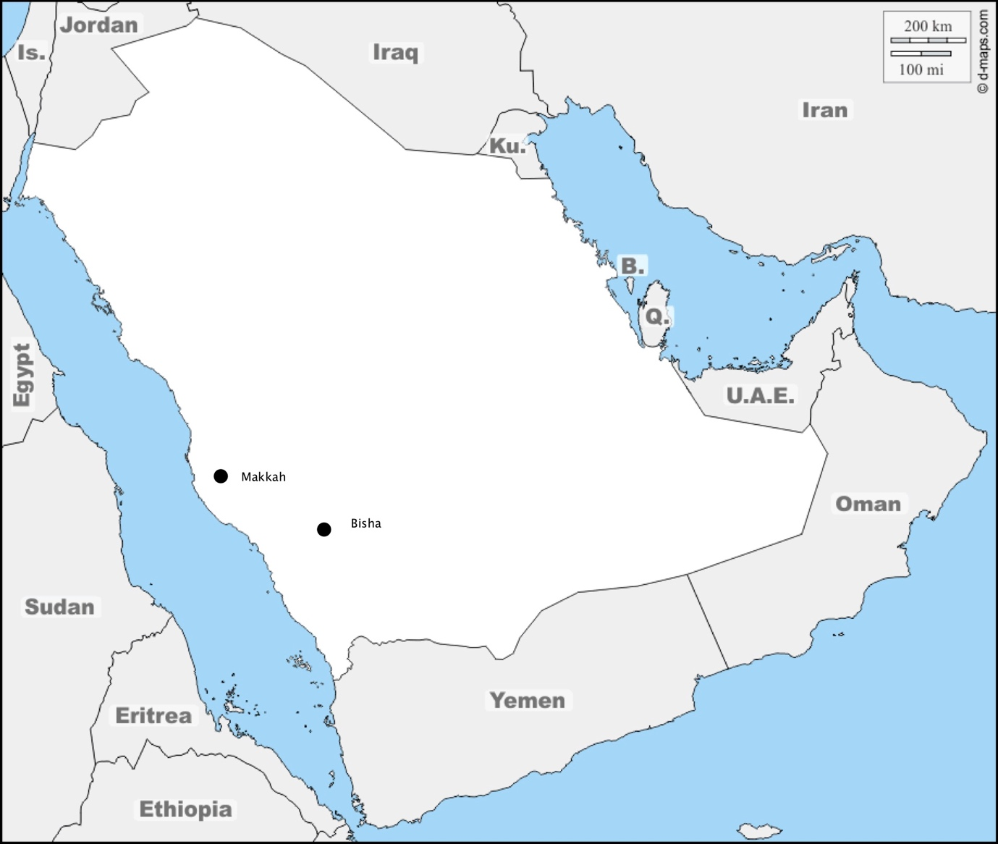
Figure ‎1.1: A map showing the location of Bisha and Makkah where BA and MA are respectively spoken (D-maps, 2020)

Chapter 2
Chapter 2 provides a historical review of syllable structure. Bosch (2011) claims that the Constituency View (Fudge, 1969; Selkirk, 1982) is widely used in the analysis of syllable structure studies. The Constituency View identifies the permissible sequences of segments (e.g., consonant clusters) using two key phonological factors: (i) sonority constraints, and (ii) syllable weight. Based on these two factors, Chapter 2 reports the reviewed literature of consonant clusters across Arabic dialects.

The Bimoraicity Constraint is a key constraint associated with syllable weight in Arabic, which limits Arabic syllables to be maximally and optimally bimoraic, as in: CV_{µ}V_{µ} and CV_{µ}C_{µ} (Broselow, 1992). However, there are some superheavy trimoraic syllables as in: CV_{µ}C_{µ}C_{µ} (e.g., [bi_{µ}n_{µ}t_{µ}] “girl”) and CCV_{µ}V_{µ}C_{µ} (e.g., [kta_{µ}a_{µ}b_{µ}] “book”). These types of syllables are widely argued to be strictly prohibited by Arabic grammar. Two strategies are employed to avoid trimoraic syllables in Arabic: (i) treating consonant clusters that trigger the third mora as heterosyllabic clusters creating a so-called “stray consonant” (i.e., non-branching clusters) (e.g., [kalb] > [kal.b] “dog”), and (ii) simplifying consonant clusters that trigger the third mora through vowel insertion (ICIs), creating less heavy syllables (e.g., [kalb] > [ka.lib] “dog”). Phonological analytical approaches employing these two strategies are reported in this chapter.

As will be shown, there are two limitations to these approaches: (i) unsatisfactory analysis of the onset/coda asymmetry in Arabic dialects, as acknowledged by some authors of these approaches (Broselow, 1992, 2018; McCarthy & Prince, 1990; Selkirk, 1981b; Watson, 2007), and (ii) the proposed analytical approaches generally treat all ICIs as phonological units that contribute to syllable structure. Hall’s (2006) claim about syllabicity and diagnostics of intrusive versus epenthetic ICIs might transcend these limitations; hence, Hall’s (2006) study is also summarised in this chapter.

Chapter 2 concludes with the research problems of syllable phonotactics in BA and MA based on the limitations mentioned earlier. These research problems are: (i) the incidence of consonant clusters in BA and MA (i.e., presence versus absence of clusters), and (ii) the status of inserted vowels (ICIs) if consonant clusters are broken up (intrusion versus epenthesis).

Chapter 3
Chapter 3 reports the methodology of Experiment 1: production of consonant clusters in L1 BA/ MA. This experiment seeks to answer the following questions:

- Do BA and MA allow non-branching consonant clusters across syllable positions: word-initially, -medially and -finally?
- If not, are consonant clusters in BA and MA modified with intrusive or epenthetic ICIs?
The experimental variables reported in this chapter are: (i) cluster position (initial - medial - final), (ii) sonority slope (rising - falling - plateau), and (iii) types of vowels in initial syllables (high [i, u] - low [a]). The stimuli of Experiment 1 were designed in light of these experimental variables.
This chapter also sets out details of the experimental tasks employed to collect data from 51 male participants who speak BA (N = 22) and MA (N = 29). They were between 18 and 22 years of age. Two tasks were employed to elicit speech from subjects: (i) naming pictures, and (ii) reading sentences.
Two approaches to analysing the collected data are summarised in Chapter 3: (i) auditory analysis using Praat (Boersma & Weenink, 2001), and (ii) statistical analysis using R software (Core Team, 2014). The statistical test employed to analyse the results of Experiment 1 is generalised linear mixed models (GLMM).

Chapter 4
In this chapter, the results of Experiment 1 are presented. It starts with a general overview of the results across syllable positions: word-initially, -medially and -finally, indicating that there are asymmetrical patterns between cluster positions. Therefore, the results of each position are presented in considerable detail. The main finding is that not all inserted ICIs that break up consonant clusters in BA and MA are phonologically equal, supporting Hall’s (2006) typology of inserted ICIs. The results of the current research indicate that BA and MA display two types of ICIs: (i) intrusive ICIs and (ii) epenthetic ICIs. They vary in BA and MA according to syllable position.
In word-initial position, the main findings are that the employed ICIs that break up word-initial clusters in BA and MA are intrusive, since they meet the diagnostics of intrusive ICIs proposed by Hall (2006). The finding suggests that word-initial clusters are present in the underlying representation of BA and MA, since the employed ICIs do not function as syllable nuclei. Hence, this suggests that underlying word-initial clusters are attested in BA and MA.
In word-medial position, the main results indicate that consonant clusters are broken up with epenthetic ICIs that contribute to syllable structure (e.g., [ɡultǝlu] “I said to him”). Consequently, BA and MA disallow word-medial clusters in both surface structure and the underlying representation.
Word-finally, consonant clusters meeting sonority constraints are typically maintained in BA and MA without vowel insertion (i.e., ICIs) (e.g., [bint] “girl”). In contrast, word-final clusters violating sonority constraints in BA and MA are broken up with epenthetic ICIs, which contribute to syllable structure. Hence, such clusters are not attested in BA and MA.

Chapter 5
Chapter 5 aims to investigate how BA and MA speakers produce L2 English consonant clusters. This chapter has three main sections. It first provides an overview of L1 English consonant clusters and how these clusters would be produced by L2 learners of English based on theoretical baselines, such as L1 transfer and linguistic universals (i.e., markedness).
The second section of this chapter sets out details of Experiment 2, which tests production of L2 English clusters by BA and MA speakers. The main question of this experiment is:
- Do BA and MA speakers produce L2 English consonant clusters as clusters?

The experimental variables reported in this chapter are: (i) native dialect of participants (BA – MA), (ii) cluster position (initial - medial – final), and (iii) sonority slope (rising – falling – plateau). A total of 33 stimuli were designed in light of these variables. The participants in this experiment are the same ones who participated in Experiment 1 (22/ BA, 29/MA), which provides a link between the results of Experiment 1 and the results of Experiment 2. All of these participants are low-proficiency English learners (beginners). The experimental task employed in Experiment 2 is a multiple-choice grammar task involving target words featuring English consonant clusters in different positions. The aim of using a grammar task is to distract participants’ attention from the aim of the experiment in an attempt to obtain spontaneous speech. The results were analysed using mixed effects models (GLMM).
In the final section of Chapter 5, the results of Experiment 2 are presented, which indicate that BA and MA produce peripheral L2 English clusters without vowel insertion, whereas English medial clusters were broken up with inserted ICIs to a significant extent. The interim interpretation for such a finding is the effect of L1 phonology. In Experiment 1, BA and MA speakers break up their L1 word-initial clusters with intrusive ICIs which do not contribute to syllable structure, which, in turn suggests the presence of word-initial clusters in the underlying representation of BA and MA. Consequently, BA and MA speakers have no difficulty in producing L2 English word-initial clusters (e.g., [θriː] “three”), since such clusters are attested in their L1 phonology. As for word-final position, BA and MA speakers produce word-final clusters in a target-like manner (e.g., [hɛlθ] “health”), since such clusters are attested in their L1 phonology.
Word-medially, BA and MA speakers break up English word-medial clusters with inserted ICIs, since these clusters in their L1 are broken up with epenthetic ICIs, which serve as syllable nuclei, to a significant extent in contrast to intrusive ICIs. Word-medial clusters are unattested in BA and MA, which results in difficulties in producing L2 English word-medial clusters.

Chapter 6
This chapter seeks to test how BA and MA listeners perceive L2 English consonant clusters. This chapter has three sections: (i) background about L2 perceptual models and the perceptual illusion literature, (ii) methodology of Experiment 3, and (iii) results of Experiment 3.

The first section of Chapter 6 summarises the existing L2 perceptual models (e.g., Perceptual Assimilation Model (Best, 1995); Speech Learning Model (Flege, 1995)), which are limited to testing perception of singleton segments, not sequences of segments (Dupoux, Parlato, Frota, Hirose, & Peperkamp, 2011). Subsequently, the L2 perceptual illusion literature which treats perception of sequences is also summarised. The analytical approach used in most of the reviewed literature is Signal Detection Theory (SDT); therefore, this theory is summarised likewise (MacMillan, 2002).
In the second section of Chapter 6, the methodology of Experiment 3 is summarised, which is a replication of an L2 perceptual study conducted by Dupoux, Kakehi, Hirose, Pallier, and Mehler (1999). The main question of Experiment 3 is:

- Are BA and MA listeners able to discriminate between plain English consonant clusters and English clusters that have been broken up by vowel insertion?

The employed independent variables in Experiment 3 are: (i) native dialect of participants (BA – MA), (ii) cluster position (initial - medial – final), and (iii) sonority slope (rising – falling – plateau). The stimuli of this experiment were pseudo-English words designed on the variables mentioned earlier. The rationale of having pseudo-words in this experiment is to minimise any semantic/lexical effects that might result from real words. A total of 19 subjects (8/ BA, 11/MA) who participated earlier in the production experiment of English consonant clusters were presented 108 trials of an AXB discrimination task. In each trial, participants listened to three stimuli (e.g. AAB: [pli:k]^{A} , [pli:k]^{A} , [pəliːk]^{B}). The listeners had to decide whether the second (A) [pli:k] is similar to the first (A) [pli:k] or similar to (B) [pəliːk].

The third section presents the results of Experiment 3, which were analysed using SDT. In this theory, there are two measurements: (i) d prime, which represents the accuracy of discriminating L2 English clusters, and (ii) criterion scores, which represents the mental effort that L2 listeners make during discrimination. The results of the first measurement (i.e., d prime) show that BA and MA listeners successfully discriminated peripheral L2 English clusters (e.g., [sməʊ] “pseudo word”), whereas the English medial clusters (e.g., [mɪldrətʃ] “pseudo word”) were poorly discriminated. The second measurement in SDT (i.e., criterion scores) shows that even though peripheral onset and coda clusters were both accurately discriminated, the attention paid to the task of discriminating English word-initial clusters (e.g., [sməʊ] “pseudo word”) was higher than that of word-final clusters (e.g., [tɛlθ] “pseudo word”). Hence, this finding indicates that discriminating L2 word-initial clusters by BA and MA listeners is doable but hard, whereas discriminating L2 word-final clusters by BA and MA listeners is doable and easy.
The interim interpretation for these results is the effect of L1 phonology, as similarly summarised in the outline of Chapter 5 provided above.

Chapter 7
Chapter 7 seeks to discuss the results of the three experiments conducted in this thesis and therefore starts by summarising the three experiments. Following this summary, four main points are discussed: (i) syllable phonotactics of L1 BA/MA, (ii) using L2 behaviour of BA and MA speakers as independent evidence for Hall’s (2006) claim about diagnostics and syllabicity of intrusive versus epenthetic ICIs, (iii) confirming the onset /coda asymmetry observed in syllable phonotactics of L1 BA / MA, and finally (iv) adopting the principles of the Perceptual Assimilation Model (PAM) to interpret the results of statistical analysis done with Signal Detection Theory (SDT) in order to propose discrimination categories for L2 syllable phonotactics.

Chapter 8
This chapter provides a brief summary of the experiments conducted in this research and their findings. It also highlights the main contributions of the current PhD research which are: (i) adding syllable phonotactics of BA and MA to the literature of L1 Arabic phonology, (ii) proposing perceptual discrimination categories for L2 syllable phonotactics, and (iii) the innovation methodology of the current thesis (i.e., appealing to L2 behaviour as independent evidence for L1 phonology). Finally, Chapter 8 suggests further lines of investigation regarding syllable phonotactics in Arabic from both theoretical and methodological perspectives.

Arabic Syllable Phonotactics

Introduction
In this chapter, some of the key prior studies examining Arabic syllable phonotactics will be reported on. As a starting point of this chapter, a general review of cross-linguistic syllable structure, involving a brief history of syllable theory, will be summarised. As theories of syllable structure treat phonotactics in a way that differs from segments, phonotactic rules will be a key section in this chapter in the discussion of two overlapping sets of constraints: (1) sonority slope (i.e., rising, plateau and falling), and (2) syllable weight (i.e., moraicity). These constraints have been also tested from articulatory and acoustic persepectives, so these approaches will also be summarised in this chapter.

If the constraints mentioned above are not fulfilled when forming consonant clusters, such clusters are expected be modified with particular strategies, including vowel insertion (i.e., intrusive or epenthetic vowels). Articulatory Phonology is one of the key linguistic approaches that phonologically and phonetically differentiates intrusive and epenthetic vowels. Therefore, a brief summary of this approach will be provided. It is worth mentioning that the current research does not employ Articulatory Phonology to draw conclusions; however, this framework provides a general overview about intrusion and epenthesis from an articulatory phonological perspective and gives a comprehensive interpretation of intrusive vowels and how these vowels affect consonant clusters. Each model mentioned above will be discussed in turn.

Based on the findings, reccommendations, and limitations found in the related studies and models mentioned above, this chapter will reach the following conclusions:
- There is a gap in the reviewed literature in respect of consonant clusters in Arabic dialects, and in particular how they are formed and how they are broken up.
- Based on the gap mentioned in (a), research questions of this PhD project will be designed.
- Based on the gaps mentioned in (a) and (b), this chapter will finish with the hypothesis that may lead to answer the questions of this PhD research.

Historical Background of Syllable Theory
“Everyone talks about syllables, but no one seems to do anything about defining them” (Haugen, 1956, p. 196). For the more than fifty years since this generalisation was made by Einar Haugen, many studies have been conducted to define the syllable, but no solid agreement has been achieved (Bosch, 2011). It is surprising that the definition of a syllable is as yet unclear; however, many speculative definitions have been proposed and each definition has led to different views of internal structures of syllables. Goldsmith (2011) summarises five main models that attempt to identify the nature and structure of the syllable. Most of these models have been posited in recent decades (Goldsmith, 2011); the historical chronology of these models will therefore not be considered. Table 2.1 illustrates these models alongside recommended readings that are cited by Goldsmith (2011).

Table 2.1: A summary of models identifying the nature and internal structure of the syllable.
View |  | Summary |  | Further reading
Sonority view |  | This view assigns each segment a sonority value. These values reach their peak with vowels and decrease with consonants and syllable boundaries. |  | (Fischer-Jørgensen, 1952; Goldsmith, 2011; Jones, 1975; Whitney, 1872).
Constituency view |  | The syllable is structured according to a group of constituents such as onset, coda and peak. |  | (Blevins, 1995; Davis, 1986; Fudge, 1969; Goldsmith, 2011; Harris, 1983; Kubozono, 1989; Selkirk, 1982; Wells, 1947)
Segment sequence view |  | This view deals with the permissibility of sequences of segments. |  | (Clements, 1990; Goldsmith, 2011; Hooper, 1972, 1976; Kiparsky, 1979; Selkirk, 1984; Steriade, 1982).
Syllable timing view |  | “Pike suggested that some languages (he cited English) were stress-timed, and some were syllable-timed (he mentioned Spanish). By this he meant that there was a strong tendency in a stress-timed language for stresses to appear equally spaced in time, while in syllable-timed languages, the tendency was greater for syllables to be equally timed (or isochronous). While this difference has survived many decades of usage, and a clear formulation in Abercrombie (1967: 97), it has not found experimental support over the years” (Goldsmith, 2011, p. 171-172). |  | (Abercrombie, 1967; Goldsmith, 2011; Pike, 1947; Roach, 1982).
Articulatory phonology |  | Syllables emerge from the temporal coordination of gestures (physics) of consonants and vowels and how they are temporally coordinated. |  | (Browman & Goldstein, 1986, 1988, 1989, 1990a, 1992a; Byrd, 1995; Fujimura, 1992; Goldsmith, 2011)

Among these models, the constituency view provides a convenient terminology to represent syllable structure, and it is widely used in syllable structure analysis (Bosch, 2011). Therefore, this research will employ this model to analyse its results. More details about this view and how it overlaps with sonority will be illustrated below.

Constituents of syllable structure
The constituency view posits that the syllable is a structural arrangement of constituents, such as onset, coda and peak: “The syllable can be shown to motivate the existence of privileged groupings of segments within the syllable, which must be thought of as constituent-like linguistic units themselves . . . an internally-structured tree quite analogous to a tree representing syntactic structure” (Selkirk 1982: 237). Selkirk thus argues that syllable structure is grounded in the ordering relations of constituents, in a similar fashion to syntactic tree structures. The order of these constituents within the syllable, however, is a source of debate. Generally speaking, there are two main views discussing the order of constituents within the syllable: hierarchical structure and flat structure, as shown in Figure 2.1.
a) σ

Onset Peak Coda

c) σ
Onset Rhyme
Coda Nucleus
b) σ
Body Coda
Onset Nucleus
Figure 2.1: Flat ordering (a) and hierarchical ordering (left branching (b) and right branching (c)) of constituents within syllable (Bosch, 2011).

The syllable diagrams depicted in Figure 2.1 show two views of ordering syllable constituents: flat (a) and hierarchical (b and c) structures. Starting with the flat structure, constituents according to this view are directly aligned with syllable nodes without any branching or hierarchy (Bosch, 2011; Hockett, 1955). Among others, Bosch (2011) discusses the criticism directed towards the flat ordering of syllable constituents. The main issues with this ordering are: i) the confusion of parsing consonant clusters in the syllable margins (i.e., onset and coda consonant clusters), and ii) the insufficiency of determining what segments should be defined as peaks, especially when the right margin of the syllable is a sonorant sound (e.g., “arm”). This criticism of flat ordering has led researchers to propose a hierarchical ordering of syllable constituents, as depicted in Figure 2.1 (b and c). Starting with the left-branching structure (Figure 2.1.b), this ordering is designed to suit the syllable structure of tone languages, such as Korean and Mandarin Chinese, although there are some studies that contradict this generalisation with respect to the Chinese languages (cf. Bosch, 2011; Duanmu, 2011). The right branching ordering, which is the most common ordering, consists of a binary branching: onset and rhyme. The latter is divided into two sub-constituents: nucleus and coda. This division solves the problem of peak definition, which is a clear limitation of flat ordering. The other issue, consonant clusters, has been solved but with further developments to the right-branching ordering, which were initially proposed by Fudge (1969) and Selkirk (1982, 1984). English, for example, allows consonant clusters, which can be phonotactically represented in Figure 2.2.
Figure 2.2: Hierarchical ordering of English syllable structure, as proposed by Fudge (1969).
Syllable
Onset Rhyme (Termination)
Peak Coda
1 2 3 4 5 6

The advantage of the ordering of the syllable constituents presented in Figure 2.2 is that it considers consonant clusters rather than individual segments. As can be seen in Figure 2.2, onset and coda constituents have binary branching, which indicates that complex onsets and complex codas do exist in English. The constituent called “termination” is primarily for segments on the far-right edge of words, which mainly represent morphemes, such as plurality and past tense morphemes. Some other phonologists propose another term for “termination” using “appendix” instead. As mentioned earlier, this hierarchical ordering is the most common and typical view of syllable structure and can be generalised to other languages (cf. Bosch, 2011; Fudge, 1969; Goldsmith, 2011; Selkirk, 1982). Therefore, the current research project will rely on this hierarchical ordering to represent Arabic and English syllable structure.
Having discussed the hierarchical ordering of constituents and how this view construes consonant clusters, the relevant question becomes: why is the final consonant cluster in [sɒlt] “salt” allowed in English for example but disallowed word-initially [lt]*? Are there any restrictions on forming consonant clusters according to the view of hierarchical ordering of constituents within the syllable? These restrictions are caused by sonority constraints, which will be explained in greater detail below.

Sonority Constraints
Before answering the addressed questions in the previous section, it is crucial to define sonority, which “can be defined as a unique type of relative, n-ary (non-binary) feature-like phonological element that potentially categorizes all speech sounds into a hierarchical scale” (Parker, 2011, p: 1160). From a phonetic perspective, the closest notion to sonority relates to the manner of articulation, since the latter notion physically categorises speech sounds, and sonority uses the same categories of manner of articulation to organise the order of allowed segments within syllables (Parker, 2011). Considering the few studies that examine the acoustics of sonority, there are some acoustic correlates that may explain the phonetic basis of sonority. For example, sonority could be correlated with jaw opening and F1 measurements. However, one issue with such correlates is that F1 might successfully measure the sonority of vowels but that would be awkward with consonants especially obstruents due to the lack of an inherent F1 in obstruents. Another key feature of sonority is inherent loudness which might be acoustically measured using the intensity of sounds. Parker (2002, 2008) found a correlation between the phonetic measurement of intensity and the phonological basis of sonority

Having said that, what are the constraints of sonority that phonologically and phonetically organise the order of consonant clusters within syllables? These constraints could be defined according to the proposed parameters of sonority. These parameters are: i) Sonority Sequencing Principles (SSP), and ii) Minimum Sonority Distance (MSD). Each of these parameters will be discussed in turn, ending with a comprehensive model of sonority proposed by Parker (2002, 2008, 2011).

Sonority Sequencing Principles (SSP)
Simply put, SSP can be represented using the scale of sonority presented in Figure 2.3:

- Sonorous obstruent < nasals < liquids < glides < vowels + Sonorous
Figure 2. 3: Sonority Scale (Clements, 1990; Selkirk, 1984)

This scale organises sounds in terms of their sonority, starting with stops and ending with the most sonorous segments, vowels. Applying this scale to consonant clusters, Selkirk (1984, p:116) states that “in any syllable, there is a segment constituting a sonority peak that is preceded and/or followed by a sequence of segments with progressively decreasing sonority values”. Clements (1990) states that all languages share the preference for syllables in which the nucleus is the most sonorant part (i.e., vowel), whereas syllable margins should be less sonorous than the nucleus. Consequently, singleton onsets and codas abide by SSP because they should be consonants, which are less sonorous than vowels (i.e., the nucleus), disregarding syllabic consonants. However, onset and coda consonant clusters have more restricted rules. If there is a two-elements onset (C1C2), C1 should be less sonorous than C2, since C2 is closer to the peak (i.e., nucleus). For a two-member coda (C1C2), C1 should be more sonorous than C2 because it is closer to the peak (i.e. nucleus). Based on this generalisation, onset clusters show rising sonority, as in /trʌɪ/ “try”, and coda clusters show falling sonority, as in [sɒlt] “salt”.
Although the overall patterns of SSP can be generalised cross-linguistically, there are some exceptions. The cluster /mt͡svrtn/ is attested word-initially in the Kartvelian language (Parker, 2011). English shows another exception to SPP as in /skɪl/ “skill”. Are these exceptions indicative of the insufficiency of SSP? In response to this question, Parker (2011) states that most languages obey the constraints of SSP while recognising these exceptions. Complexity versus simplicity of consonant clusters could be a reason for such exceptions, as found in Moroccan Arabic. Shaw et al. (2011) examine word-initial consonant clusters in Moroccan Arabic. They report two different views of analysing initial clusters in Moroccan Arabic. The first view treats initial clusters as belonging to one syllable, such as [sbul.ha] ‘her ear’ (complex onset hypothesis). The second view affiliates such clusters into two syllables [s.bul.ha] (simplex onset hypothesis). Using electromagnetic articulometry, the authors examine the difference between the two views by asking one native speaker of Moroccan Arabic to pronounce relative stimuli. The results indicate that initial clusters in Moroccan Arabic pattern consistently with the simplex onset hypothesis. Initial clusters affiliate into two syllables [sbu] > [s.bu]. This means that this cluster is not tautosyllabic, which implies SSP is not violated in this case.

In conclusion, SSP is observed as a strong tendency cross-linguistically, although there are some exceptions. The reviewed literature has studied reasons behind these exceptions, as found in Moroccan Arabic.
Having discussed the contribution of SSP to phonotactic rules, the question now is: why does English, for instance, allow the consonant cluster /kl/ as in /kleɪm/ “claim” but disallow the cluster /kn/*, despite both clusters respecting SSP? The answer to this question is presented in the following section in the light of Minimum Sonority Distance (MSD).

Minimum Sonority Distance
Why does English, for instance, allow the consonant cluster /kl/ as in /kleɪm/ “claim” but disallow the cluster /kn/*, despite both clusters respecting SSP? The answer to this question is beyond the scope of the SSP because not all consonant clusters with rising sonority are attested in onset position. This restriction is attributed to a key sonority parameter, the so-called Minimum Sonority Distance (MSD). Based on the numeric sonority scale in Table 2.2, the MSD was generated to determine the minimum distance between constituents of onset consonant clusters, as shown below (Broselow & Finer, 1991; Clements, 1990; Selkirk, 1982, 1984; Steriade, 1982; Zec, 1995). The main difference between MSD and SSP is that SSP is a universal parameter that can be applied to most languages, whereas MSD relies solely on the specific phonological properties of each language (Broselow & Finer, 1991; Parker, 2011).
Table 2. 2: MSD values for onsets
Segment class | Onset value
Stops | 1
Fricatives | 2
Nasals | 3
Liquids | 4
Glides | 5

Setting such numeric values will provide an easy way to explain the permissible onsets in any language. If a language (X) has an MSD value of 5, then (X) will only have singleton onsets of all five segment classes shown in Table 2.2 because the value 5 is greater than minimum requirement to create a cluster, which is 4. Another example is that if a language (Y) has an MSD value of 4, this means (Y) will have the five possible singleton onsets in (X) in addition to one type of cluster, which is stop-glide. If a language (Z) has an MSD value of 3, (Z) will have 5 singleton onsets plus three types of complex onsets: stop-glide, stop-liquid and fricative-glide. Consequently, the greatest sonority distance is the most probable way of creating the least marked clusters. Conversely, the shortest sonority distance is the most probable way of creating the most marked clusters (Broselow & Finer, 1991).
Languages exhibit great diversity in their application of MSD. Zec (2007) and Parker (2011, p: 1169) provide other examples of allowed onset clusters in different languages according principles of MSD, as shown in Table 2.3.
Table 2. 3: Examples of Minimal Sonority Distance across linguistically
 | Maximal inventory of permissible onset clusters | Languages
MSD = 0 | OO, ON, OL, OG, NN, NL, NG, LL, LG, GG | Bulgarian, Leti
MSD = 1 | ON, OL, OG, NL, NG, LG | Chukchee
MSD = 2 | OL, OG, NG | Gizrra, Kurdish, Spanish
MSD = 3 | OG | Mono, Panobo, Japanese, Mandarin Chinese
Note: O = obstruent, N = nasal, L = liquid, G = glide.

According to Table 2.3, if any language allows consonant clusters with shorter sonority distance, other consonant clusters with further sonority distance are also expected to be allowed. For instance, Bulgarian allows onset clusters consisting of obstruent-obstruent, and hence, it allows clusters consisting of obstruent-nasal, obstruent-glide, etc. In contrast, in languages such as Japanese that minimally allow consonant clusters consisting of obstruent-glide (MSD = 3), it is not expected to have consonant clusters with shorter sonority distance, such as obstruent-obstruent.

In sum, SSP is a key sonority parameter but it is not enough to determine what kind of clusters should be attested in a given language. This indicates the need for MSD, which means that each language has a specific inventory of permissible consonant clusters. It can be concluded that SSP is a universal parameter, whereas MSD relies solely on specific phonological properties of each individual language.

The question now is: Is it possible to have one scale that combine the tendencies of SSP and MSD? This question has been answered by Parker (2002; 2008; 2011) in his complete sonority hierarchy, which is summarised below.

The complete sonority hierarchy (Parker, 2002; 2008; 2011)
According to Parker (2002), more than 100 scales to quantify sonority have been suggested. Specific criteria for the sonority scale suggest various parameters, for example:
“a. Universal: It potentially applies to all languages.
b. Exhaustive: It encompasses all categories of speech sounds.
c. Impermutable: Its rankings cannot be reversed (although they may be collapsed or ignored).
d. Phonetically grounded: It corresponds to some consistent, measurable physical parameter shared by all languages” (Parker, 2011, p. 1177).

Based on these criteria, Parker proposes a suggested comprehensive scale of sonority, as quoted in Table 2.4.
Table 2.4: Final hierarchy of relative sonority (Parker, 2011)
Natural class | Sonority index
low vowels | 17
mid peripheral vowels (not [ǝ]) | 16
high peripheral vowels (not [ɨ]) | 15
mid interior vowels ([ǝ]) | 14
high interior vowels ([ɨ]) | 13
glides | 12
rhotic approximants ([ɹ]) | 11
flaps | 10
laterals | 9
trills | 8
nasals | 7
voiced fricatives | 6
voiced affricates | 5
voiced stops | 4
voiceless fricatives (including [h]) | 3
voiceless affricates | 2
voiceless stops (including [ʔ]) | 1

This scale of sonority is fairly comprehensive and includes vowels that have not been discussed in this chapter. Justification and further interpretation of the scale in Table 2.4 is discussed at length in Parker (2002; 2008; 2011).
In conclusion, different parameters of sonority have been discussed in this section. The main two parameters are SSP and MSD in which the former suggests that the nucleus of the syllable is the most sonorous sound whereas syllable margins are less sonorous. Hence, onset clusters are supposed to be rising sonority clusters, whereas coda clusters are supposed to behave oppositely (i.e., falling sonority). However, there are some consonant clusters that adhere to SSP which are not attested in some languages. This restriction is attributed to MSD which is responsible for determining the types of consonant clusters that exist in a specific language. Consequently, languages vary in the matter of which consonant clusters are allowed. Parker (2008, 2011) comes up with a comprehensive scale of sonority, which fulfills specific criteria to quantify sonority constraints.
Having discussed the principles of sonority and how they contribute to syllable phonotactics, syllable weight also crucially affects the shape of consonant clusters. This phenomenon will be discussed below.

Syllable weight and consonant clusters
Studies conducted on syllable weight, and its significant effect on the internal structure of consonant clusters in Arabic, have enriched the knowledge of moraicity constraints not for Arabic only, but cross-linguistically (Broselow, 2018). According to McCarthy (1979) and McCarthy & Prince (1990), moras do the work of measuring the weight of the syllable, where a light syllable refers to a monomoraic syllable and a heavy syllable refers to a bimoraic syllable, as shown in Figure 2.4.

(a) Light CV (b) Heavy CVV (c) Heavy CVC
Syllable Syllable Syllable
σ σ σ
µ µ µ µ µ

C V C VV C V C
Figure 2. 4: Moraicity of some syllable types of Arabic (McCarthy & Prince, 1990).

It is apparent from Figure 2.4 that Arabic allows both monomoraic and bimoraic syllables. This is attributed to the non-dominated constraint which is the “ Bimoraicity Constraint: syllables are maximally and optimally bimoraic” (Broselow, 1992, p. 10). This constraint means that the minimum syllable weight is a single mora and the maximum syllable weight is two moras.
However, there are some superheavy syllables that occur in the surface structure, such as:
- CVVC (superheavy syllable) [ɡaal] “he said”
- CVCC (superheavy syllable) [kalb] “dog”
- CCVVC (superheavy syllable) [ktaab] “book”
- CVCC.CV (superheavy syllable) [ɡilt.lu] “I said to him”
These syllable types are expected to be trimoraic syllables, which as a result violate the non-dominated bimoraicity constraint, as shown in Figure 2.5.

(a) σ * (b) σ * (c) σ * (d) σ * σ
µ µ µ* µ µ µ* µ µ µ* µ µ µ µ

ɡ a a l* k a l b* k* t a a b* ɡ i l t* l u
Figure 2. 5: Violation of bimoraicity constraint (* indicates the violation).

Figure 2.5 shows that the bimoraicity constraint is violated by the third mora in the superheavy syllables presented in this figure. As mentioned earlier, trimoraic syllables are strictly prohibited in Arabic phonology. Hence, two strategies are employed to deal with the third mora, as discussed in the following section.

The problem with the third mora
The third mora occurs in two types of syllables: (i) syllables that have long vowels, as in Figure 2.5 (a), and (ii) syllables that have consonant clusters, as in Figure 2.5 (b-c-d). As the current research examines consonant clusters, superheavy syllables that have long vowels will be excluded from the following discussion.
As for the problematic third mora occurring within consonant clusters, it is resolved in production using two strategies:
- Treating consonant clusters that trigger the third mora as heterosyllabic clusters creating a so-called “stray consonant” (i.e., non-branching clusters) (e.g., [kalb] > [kal.b] “dog”).
- Simplifying consonant clusters that trigger the third mora through vowel insertion creating less heavy syllables (e.g., [kalb] > [ka.lib] “dog”).
These strategies will be discussed below with further details; however, it is crucial to state that Arabic dialects vary considerably in how these two strategies apply. Some Arabic dialects display both strategies and some of them only display a single strategy. Additionally, the proposed analytical approaches to the third mora do not provide a comprehensive and unified analysis in all phonological contexts for all dialects, especially for variations in vowel insertion. “Thus, the question of whether any single approach can present a unified treatment of vowel insertion in all contexts is still not fully resolved” (Broselow, 2018, p. 43).
Each strategy will be discussed below in turn.

Treating segments that receive third mora as stray consonants
In this phonological treatment, consonants that associate with a third mora will not be linked to the superheavy syllable and they will be treated as stray consonants. These stray consonants occur in different syllable positions: (i) word-initial (e.i., Figure 2.5 (c) [ktaab] “book”), (ii) word-medial (e.g., Figure 2.5 (d) [ɡilt.lu] “I said to him”), and (iii) word-final (e.g., Figure 2.5 (b) [kalb] “dog”).

However, the prosodic affiliation of such consonants has been a source of debate for decades. There are several approaches that contribute to the analysis of the status and the prosodic affiliation of stray consonants. One approach analyses this stray consonant as an extraprosodic element which creates its own syllable, but is not linked to other syllables (McCarthy & Prince, 1990). A similar approach analyses that consonant as a semisyllable linked to the word node rather than the syllable node (Kiparsky, 2003). A third approach treats the stray consonant in word-final clusters as an onset with an empty nucleus or rhyme in the word-initial position (Selkirk, 1981b). The fourth analysis approach is mora sharing or Adjunction-to-mora in which two constituents are dominated by a single mora (Broselow, 1992; Watson, 2007). Finally, stray consonants have been analysed from articulatory and acoustic perspectives (Alqahtani, 2014; Ruthan, Durvasula, & Lin, 2018; Shaw et al., 2011). Although these approaches differ in orientation, the shared conclusion among these approaches is the absence of branching consonant clusters in Arabic dialects. Each approach will be discussed in turn.

Extraprosodic consonant approach (McCarthy & Prince, 1990)
The main claim of this approach is that the stray consonants positioned word-initially and word-finally are treated as extraprosodic consonants linked with their own syllables. However, these consonants are asymmetric, whereby the initial consonant is analysed as an extrametrical mora and the final consonant has no moraic status. Each position will be discussed below with further details.

Starting with the initial position, the first consonant (i.e., stray), as in [ktaab] “book”, is analysed as an extrametrical mora creating its own syllable without linking to other syllables. McCarthy and Prince (1990) state that Standard Arabic exhibits underlying word-initial clusters and that the initial consonant of these clusters is analysed as a stray consonant.
“These appear in verb forms and their derivatives that have what is traditionally called hamzatu lwasli, the “elideable” glottal stop. Examples include Form 7 ʔinfaʕal, Form 8 ʔiftaʕal, and Form 10 ʔistafʕal. The distribution of this property forces any generative phonological analysis to say that the initial glottal stop and the vowel following it are not in fact elided, but rather inserted in the course of syllabification. For example, the underlying representation of the Form 8 stem is ftaʕal, although on the surface this word in isolation is pronounced as ʔiftafʕal” (McCarthy & Prince, 1990, p. 11).
In application of the underlying consonant clusters in Form 8 ftaʕal to moraic theory, the initial (stray) consonant [f] is analysed as an extrametrical mora which is not linked to adjacent syllables, as presented below in Figure 2.6 (McCarthy & Prince, 1990). This predicts that branching onsets will be unattested in Arabic.
σ σ
(µ) µ µ µ
f t a ʕ a l

Figure 2. 6: word-initial consonant clusters in Arabic according the analysis of McCarthy & Prince (1990)

The employed evidence to support this argument is the independent motivation of the epenthesis position in Cairene Arabic (McCarthy & Prince, 1990). In this dialect, the epenthetic vowel is inserted to the right of the stray consonant (underlined), as shown in the following contexts:
- -CC_C- medial clusters: /katabtlu/ > /katabtilu/ “I wrote for him”.
- #C_C loan words: plastic > /bilastik/
- #C_C Templatic verbs: /ɡtamaʕ/ > iɡtamaʕ (ʔiɡtamaʕ) “to meet”
However, epenthesis directionality does not of itself provide the evidence of extrametrical moraicity since this directionality does not necessarily mean the stray consonant is linked to an extrametrical mora. This limitation has been acknowledged by McCarthy & Prince (1990, p.13) who state that although the analysis using an extrametrical mora is “puzzling”; nevertheless, “prosodic theory forces us to posit this analysis in both Standard Arabic and the Cairene colloquial” based on the independent motivations mentioned in the examples above.
In word-final position, the same analysis mentioned above is employed, but with a minor change. The final stray consonant in superheavy syllables (underlined), as in [kalb] “dog”, will be analysed as an extraprosodic consonant, as shown in Figure 2.7, but without receiving moraicity unlike the initial stray consonant (McCarthy & Prince, 1990). The reason behind reducing syllable weight in this respect is the potentiality of resyllabifying word-final consonants, since it could be resyllabified as the onset for a following suffix as in [kal.ba.na] “our dog”, hence, creating a new syllable.

σ σ
µ µ
k a l b

Figure 2. 7: word-final consonant clusters in Arabic according the analysis of McCarthy & Prince (1990)

In conclusion, according to McCarthy and Prince (1990), the initial consonant in phrase-initial onset CC clusters is analysed as an extrametrical mora. However, this analysis has a limitation, as initially acknowledged by McCarthy and Prince (1990). They state that the analysis using an extrametrical mora is “puzzling” since their evidence to support an extrametrical mora for the initial consonant is not fully persuasive. Regarding word-final position, the final stray consonant within a superheavy syllable is analysed as an extraprosodic consonant but without receiving moraicity as if it were a word-initial syllable. The implied conclusion is that there are no branching onsets, nor branching codas, in Arabic. Another approach to analyse the stray consonant in Arabic is proposed by Kiparsky (2003). A summary of this approach is provided below.

Semisyllables (Kiparsky, 2003)
When the stray consonant (i) is linked with the word node rather than the syllable node, and (ii) receives moraic status, then the stray consonant will be called a “semisyllable”. “Formally, semisyllables arise where a constraint License-µ, which requires all moras to be licensed by syllables, is outranked by markedness constraints on the form of syllables and feet” (Kiparsky, 2003, p. 151). Arabic dialects are varied in their phonological licensing of these semisyllables. Based on these variations, Kiparsky (2003) classifies Arabic dialects into three categories, as presented in Table 2.5. According to Broselow (2018), this classification is the most ambitious classification targeting syllable phonotactics of Arabic dialects.

Table 2. 5: Classification of Arabic dialects proposed by Kiparsky (2003) (shaded dialects in this table display vowel insertion strategy, so they will not be discussed in the current section unless it is necessary, since they will be discussed later in Section 2.5.1.2).
Dialect | Area | #CC [ktaab] “book” | -CCC-  [yiktbu] “they write” | CC#  [ʔakl] “food” | semisyllable presence
VC- dialects word level | Delta in Egypt, Asyut, Iraq, Syria and Eastern Libya. | k_{µ}(ta´a)b | (y´ık).t_{µ}.bu | (ʔak)lμ | Yes
VC- dialects  postlexical level | Delta in Egypt, Asyut, Iraq, Syria and Eastern Libya. | (ʔik).(taa)b_{μ} | (yi.ki)t_{μ}.bu | (ʔa.ki)l_{μ} | No
C- dialects | Tunisia, Rufaidah in Saudi and Maltese. | k_{µ}(ta´a)b | (y´ık).t_{µ}.bu | (ʔak)l_{μ} | Yes
CV- dialects | Cairo, most of Delta, Middle Egypt, the oases of Libyan desert | kita´ab | yiktibu | ʔakl | No
CV-dialect | Sana`a. | kita´ab | yiktibu | ʔakil | No

Before explaining the notion of semisyllables, this approach proposed by Kiparsky (2003) addresses the two strategies for solving a problematic third mora mentioned earlier in Section 2.5.1. However, the current section only discusses the first strategy, which is stray consonants. The second strategy (i.e., vowel insertion) which exists in the shaded dialects in Table 5 will not be discussed herein unless it is necessary, e.g., when discussing word-final consonant clusters in CV dialects (since the semisyllable is absent in this position but the cluster still exists e.g., [ʔakl] “food”)). The other properties of shaded dialects that involve vowel insertion will be discussed later in Section 2.5.1.2.

Starting with medial clusters, Watson (2007) states that Kiparsky built this classification based on dialectal variation in treatment semisyllables in the medial cluster - CCC - as in [ɡiltlu] ‘I said to him’. C dialects and VC dialects (at word level only) retain this -CCC- cluster without modification, as presented in Figure 2.8. This figure shows that the consonant [t] is unsyllabified, moraic and affiliates with the word node. In this case, the stray consonant will be characterised as a “semisyllable”.
W
ɸ
σ σ
µ µ µ µ
ɡ i l t l u

Figure 2. 8: Semisyllables in C dialects and at the word level for VC dialects.
In word-initial and -final positions, the analysis of semisyllable is applicable to C dialects and at word-level only for VC dialects, in which the leftmost consonant in word-final clusters is analysed as a semisyllable and linked with the word node, as exemplified in Figure 2.9/ 2.10.
W
ɸ
σ
µ µ µ
ʔ a k l
W
ɸ
σ
µ µ µ µ
s l a: ħ

Figure 2. 9: Final consonant clusters in in C and VC (word-level only) dialects.
Figure 2. 10: Initial consonant clusters in in C and VC (word-level only) dialects.

In Figure 2.9, the initial consonant [s] is analysed as a semisyllable similarly to the rightmost consonant [l] in Figure 2.10. However, Kiparsky (2003, p. 149) adds extra information for word-initial consonant clusters in such dialects. He states that “phrase-initial onset CC- clusters are allowed in VC- and C-dialects, which accordingly allow the pan-Arabic process that deletes high vowels in open syllables to reduce even initial CiC- to CC-”. Vowel syncope, in fact, plays a key role in Arabic syllable phonotactics, especially in the initial position, as found in Jordanian Arabic (Sakarna, 2005), Libyan Arabic (Harrama, 1993), and in Najdi Arabic (Alghmaiz, 2013; Alqahtani, 2014).
For CV dialects, semisyllables are absent in final position in such dialects; however, stray consonants are attested in final position as in [ʔakl] “food”, as exemplified in Figure 2.11. The rightmost consonant [l] “is parsed in the word phonology as a non-moraic stray consonant (an “extrametrical” consonant adjoined to the prosodic word)” (Kiparsky, 2003, p. 161).
w
ɸ
σ
µ µ
ʔ a k l
Figure 2. 11: Final consonant clusters in in CV dialects.

In conclusion, this approach proposed by Kiparsky (2003) analyses stray consonants as semisyllables where such semisyllables are adjoined to the word node rather than syllable node. Arabic dialects vary in their licensing of semisyllables, as presented in Table 2.5. We turn next to the third approach that analyses stray consonants in Arabic languages: Degenerate Syllables.

Degenerate Syllable (Selkirk, 1981b)
The third alternative approach that might explain superheavy syllables (mainly consonant clusters) is degenerate syllables (Selkirk, 1981b). In this approach, the word-final consonant in Cairene Arabic is analysed as an onset for an empty nucleus, as in the following example:
katab + t “I wrote” (ka) (tab) (t_) katabt

The underscore sign (_) refers to the empty nucleus. Although Selkirk (1981) provides a detailed analysis for word-final consonant clusters, she acknowledges that using the same analysis for word-initial clusters is “less” easy, as in the following example:
ktib “write” (_k)(tib) (?) iktib

She follows the analysis of Aoun (1979), where word-initial cluster in Cairene Arabic is analysed as a rhyme for an empty onset due to the essentiality of rhyme elements for syllable structure as opposed to onsets (Selkirk, 1981b, pp. 218-219).

However, Selkirk’s analysis of word-initial clusters in Cairene Arabic involves a clear violation of Arabic syllable structure, which is the non-tolerance of onsetless syllables in all Arabic dialects (Broselow, 2018).

Even though the empty onset analysis provides an account of word-initial clusters, Selkirk (1981) acknowledges the limitation of that analysis, indicating that it is not satisfactory. Similarly, McCarthy and Prince (1990) acknowledge the limitation of using an extrametrical mora for word-initial clusters, as mentioned earlier. Kiparsky (2003) does not even attempt to analyse word-initial clusters that may be attested in CV dialects.

Mora Sharing (Broselow, 1992; Watson, 2007)
In an attempt to provide further analysis of unresolved syllabification phonotactics, Watson (2007) expands the application of the Adjunction-to-Mora constraint which was initially proposed by Broselow (1992). To fully understand the concept of this constraint, it is crucial to understand the reason for proposing it. As mentioned earlier, Arabic strictly adheres to the Bimoraicity Constraint (i.e. the maximum weight of a syllable is two moras) (Broselow, 1992; McCarthy & Prince, 1990); however, there are some superheavy syllables (e.g., CVVC) that may trigger trimoraic syllables instead of bimoraic syllables. Therefore, Broselow (1992) proposed the Adjunction-to-Mora constraint that satisfies the Bimoraicity Constraint. It allows a single mora to dominate two constituents, which means that a consonant is dominated by the mora of the preceding vowel. This constraint has been used by Watson (2007) in her investigation of syllabification typology of Arabic dialects and she called that constraint Mora Sharing, which is exemplified below in Figure 2.12.
σ σ
µ µ
ɡ a: l ʃ

Figure 2. 12: Adjunction-to-Mora (Mora Sharing).
σ σ σ
µ µ µ µ
V C V C
V

Figure 2. 13: Adjunction-to-Mora applied to (CVVCC) [ɡaalʃ] “he did not say” adopted from Watson (2007, p: 350-351).

In Figure 2.13, the consonant [l] is dominated by the mora of the preceding vowel [aː]. This is a clear application of mora sharing since the consonant [l] is dominated by the mora of the preceding vowel [a:], which is the optimal principle of mora sharing. Without mora sharing, this syllable would be a trimoraic syllable *(CV_{µ}V_{µ}C_{µ}C) > *[ɡa_{µ}a_{µ}l_{µ}ʃ], which is banned in Arabic, as mentioned earlier. The final consonant [ʃ] is analysed as an extrasyllabic consonant which has no moraic status.
It could be claimed that Mora Sharing is simply a clever trick rather than a strategy for analysing extraprosodic consonants. However, Mora Sharing was phonetically investigated by Broselow, Chen, and Huffman (1997, p. 76) who propose that “the assumption that moraic representations provide a valid reflection of syllable-weight oppositions, and we proposed moraic analyses of several languages based on their phonological patternings. In our examination of four languages, we found a striking correspondence between durational patterns and independently motivated moraic representations. This suggests that moraic structure is directly reflected in phonetic timing in these languages”.

Articulatory Phonology: simplex versus complex onsets
Before discussing the notion of simplicity and complexity of syllable onsets, it is crucial to understand the main principles of Articulatory Phonology (AP, hereafter). To clearly define AP, Broman and Goldstein (1990b, p: 269) state that:
“much phonological organisation arises from constraints imposed by physical systems… In our view, phonological structure is an interaction of acoustic, articulatory, and other (e.g., psychological and/or purely linguistic) levels of organisation. We are focussing on articulatory organisation because we believe that the inherently multi-dimensional nature of articulation can explain a number of phonological phenomena, particularly those that involve overlapping articulatory gestures. Thus, we represent linguistic structures in terms of coordinated articulatory movements, called gestures, that are themselves organized into a gestural score that resembles an autosegmental representation”.

Based on this definition, gestures are the main tool that AP employs to represent linguistic structure. Gafos (2002, p. 276) depicts the mechanism of these gestures in Figure 2.14.

“ONSET: the onset of movement toward the target of the gesture.
TARGET: the point in time at which the gesture achieves its target.
C-CENTER: the mid-point of the gestural plateau.
RELEASE: the onset of movement away from the target of the gesture”.

Figure 2. 14: Landmarks showing the movement of a gesture, starting from the onset, and ending with release (Gafos, 2002).

Shaw et al. (2009; 2011) used gestures in AP to examine initial clusters in Moroccan Arabic. As demonstrated in this study, there are two different broad approaches used to analyse initial clusters in Moroccan Arabic. The first approach treats initial clusters as monosyllables such as /kra/ ‘rent’ and /skru/ ‘his ploughshares’ (complex onset hypothesis). The second class affiliates such clusters into heterosyllables ([k.ra] and [sk.ru]) (simplex onset hypothesis). Using electromagnetic articulometry, the authors examined the difference between the two classes by asking one native speaker of Moroccan Arabic to pronounce two sets of data. The first set examined both singleton and CC onset clusters as in Table 2.7. The other set of data extends the number of onset elements up to three consonants as in Table 2.7.

Table 2. 6: Two sets of data used in Shaw’s et al. (2009) study.
Stimuli | C | CC | CCC
First set | bal ‘to unirate’ | dbal ‘to fade’ | ---
First set | tab ‘to repent’ | ktab ‘book’ | ---
Second set | bulha ‘her urine’ | sbulha ‘her ear (of grain)’ | ksbulha ‘they owned it’
Second set | dulha (nonce) | kdulha (nonce) | bkdulha (nonce)

Their analysis was built on C-centre analysis, as presented in the schemas depicted below in Figure 2.15.

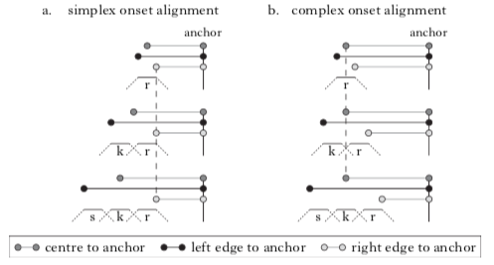
Figure 2. 15: “Schematic representation of three intervals delineated by points in an initial consonant cluster and a common anchor. The alignment schema on the left represents temporal predictions of the simplex onset hypothesis. The alignment schema on the right represents predictions of the complex onset hypothesis” (Shaw et al., 2009, p:189)

Shaw, Gafos, Hoole & Zeroula (2009, p. 189-190) explain Figure 2.15 as follows:
“In these schemas, the temporal structure of segments is represented by three connected lines: a dotted line corresponding to movement towards constriction, a solid line corresponding to constriction duration and a second dotted line corresponding to movement away from constriction. For both alignment schemas, three words differing in the number of initial consonants, r, kr, skr, are shown. In addition, the figure shows three intervals for each word type. The intervals are left-delimited by the left edge, right edge and centre of the consonant cluster, and right- delimited by a common anchor point. The relevant pattern is in how the duration of different intervals changes across words with increasing numbers of initial consonants, e.g. laid, played, splayed or rue, crew, screw. The most stable interval in each alignment schema is denoted by a vertical dashed line running from top to bottom, across all words within that schema. Simplex onset alignment corresponds to a pattern whereby the RIGHT EDGE TO ANCHOR interval is more stable than the CENTRE TO ANCHOR interval or the LEFT EDGE TO ANCHOR interval (Byrd 1995). Complex onset alignment corresponds to a different pattern, whereby the centre to anchor interval is more stable across words than the left edge to anchor interval and the right edge to anchor interval (Browman & Goldstein 1988, Honorof & Browman 1995)”.

The results of the studies indicate that initial clusters in Moroccan Arabic tend to display patterns supporting the simplex onset hypothesis. Initial clusters affiliate to two syllables [sbu] > [s.bu]. This means CC initial clusters in Moroccan Arabic are non-branching onsets in articulatory terms. This articulatory finding about Moroccan Arabic confirms the generalisation concluded from the analysis of moraic theory in which branching clusters are predicted to be unattested in all Arabic dialects, including Moroccan Arabic.
However, we might still ask does AP provides an answer to the unsolved question about the prosodic affiliation of the stray consonant in word-initial clusters, at least in Moroccan Arabic since it is articulatorily investigated? Shaw et al.’s (2009, p: 213) study, in fact, does not answer this question; however, the authors expect that such a question could be articulatorily answered in the future. A recommendation made by the Shaw et al. is that “it is in principle possible to conduct an analysis of interval stability based on the acoustic correlates of articulatory landmarks. This would enable stability-based analyses of structure in languages for which it may be difficult to collect articulatory data”. This recommendation was followed up by an acoustic study to test the simplicity versus complexity of onset clusters in another Arabic dialect, as discussed below.

Acoustic analysis: simplex versus complex onsets
In a recent study, Ruthan et al. (2018) examine the simplicity versus complexity of word-initial onset clusters in Jazani Arabic, a dialect spoken in the south west of Saudi Arabia. As presented above in Figure 2.16, there are three intervals used for schematic representation in the articulatory phonology approach. Using Praat scripts, these intervals were acoustically transformed into three durational measurements as in Figure 11: (i) left edge to anchor: from the midpoint of the leftmost consonant to the end of the vowel, (ii) right edge to anchor: from the midpoint of the rightmost consonant to the end of the vowel, and (iii) centre to anchor: from the midpoint of the consonant sequence to the end of the vowel.
Figure 2. 16: An example token. Durations are measured from the Left-edge (midpoint of [m]) the Right-edge (midpoint of [s]) and C-center (the mean of the midpoints of [m] and [s]) to the anchor point, defined as the end of the vowel (Ruthan et al., 2018, p. 3)
The results show that word-initial clusters in Jazani Arabic are consistent with the simplex onset hypothesis. This finding is in line with the earlier claim that consonant clusters in Arabic dialects are non-branching clusters, regardless of their syllable position (Broselow, 1992; Kiparsky, 2003; Shaw et al., 2009). Again, the study fails to determine the prosodic affiliation of the stray consonant, indicating that this question has not yet been solved.
A criticism that might be pointed at Ruthan et al.’s study (2018) is the choice of the tested dialect, which is Jazani Arabic. This dialect is a previously untested dialect from the perspective of Articulatory Phonology; however, it was acoustically tested and compared to Moroccan Arabic, which was articulatorily analysed. It would be more reliable if the acoustic analysis provided by Ruthan et al., (2018) was conducted on Moroccan Arabic too to have the chance to compare between findings of Articulatory Phonology and the acoustic analysis.

Conclusion of analysing stray consonants (i.e., third mora) in consonant clusters
The reviewed literature about stray consonants in consonant clusters is summarised here from three perspectives: (i) Moraic Theory, (ii) Articulatory Phonology, and (iii) acoustic analysis. The main conclusion drawn from all these perspectives is that branching consonant clusters are banned in all Arabic dialects regardless of their syllable positions. Based on the analysis of Moraic Theory, word-medial clusters (e.g., [ɡiltlu] “I said to him”) are successfully analysed in the approach proposed by Kiparsky (2003) where he analyses the stray consonant in such clusters as a semisyllable.

For the final stray consonant as in [kalb], it is analysed in four different ways: (i) as a semisyllable in VC (word level) and C dialects (Kiparsky, 2003), (ii) as an extraprosodic consonant without moraic status linked with the word node in CV dialects (Kiparsky, 2003), (iii) as an extraprosodic consonant without moraic status but linked with the syllable node in some Arabic dialects (Broselow, 1992; McCarthy & Prince, 1990), (iv) and as a degenerate syllable in Cairene Arabic (Selkirk, 1981). The authors of these approaches justify their claims from different perspectives.

What seems to be problematic is the analysis of the stray consonant in word-initial clusters. The most confident analysis is provided by Kiparsky (2003), who he analyses the stray consonants in such clusters as semisyllables (i.e., linked with the word node and with moraic status) in C dialects (e.g., Moroccan) and VC dialects at word level (e.g., Iraqi). For CV dialects, he states that initial clusters do not exist in such dialects (e.g., Cairene). However, McCarthy & Prince (1990) and Selkirk (1981) state that initial clusters do exist underlyingly in Cairene Arabic. Watson (2007) also states that some CV dialects (e.g., Sana`ani) allow initial clusters in fast speech. McCarthy and Prince (1990) and Selkirk (1981) provide unsatisfactory analysis of initial clusters in some Arabic dialects such as Cairene Arabic. This dissatisfaction is acknowledged by the authors themselves.
Based on the analysis of Articulatory Phonology and the acoustic analysis summarised above, onset clusters in Moroccan and Jazani Arabic are simplex onsets, similar to the predictions of Moraic Theory approaches. However, the prosodic affiliation of the stray consonant in the word-initial position remains unexamined.
In conclusion, the issue of the questionable prosodic affiliation of the stray consonant in word-initial clusters is not satisfactorily analysed in prior approaches, as acknowledged by their authors and by other critics as follows:
- “I do not in fact have a satisfactory answer to the question here” (Selkirk, 1981b, p. 219).
- “It is puzzling… Prosodic theory forces us to posit this analysis in both Standard Arabic and the Cairene colloquial. Other facts of Standard Arabic are consistent with this approach, but they do not prove its correctness” (McCarthy & Prince, 1990, p. 13).
- “While some dialects, for example Cairene as a CV dialect and Haifa as a VC dialect, exhibit all the predicted characteristics of their respective dialect type, some of the dialects do not” Watson (2007, p. 341), in criticism of Kiparsky’s model (2003) presented in Table 2.5.
No attempt to solve this phonological problem has been conducted yet; however, Articulatory Phonology could solve it in the future, according to Shaw et al. (2009, p. 213):
“As the prosodic affiliation of initial consonant clusters is still a matter of debate in a number of languages, … there is immediate utility to the analytical techniques developed in this paper. We aim to generalise the methodology to evaluate phonological structure at levels of representation above and below the syllable. In particular, the class of theoretical proposals consistent with the simplex onset hypothesis disagree as to the prosodic status of C1 in #C1C2V, e.g. minor syllable (Boudlal, 2001), mora (Kiparsky, 2003) or syllable nucleus (Elmedlaoui & Dell, 2002). Although we have provided evidence for the simplex onset hypothesis, we have not attempted to distinguish among the different proposals that adhere to this broad hypothesis. Future work will develop temporal predictions which distinguish between different syllabic roles and evaluate these predictions in our data”.
Having discussed the first strategy of solving the problematic third mora in Arabic, which is the stray consonant that occurs in consonant clusters, the following section will highlight the second strategy: vowel insertion.

Simplifying trimoraic consonant clusters with vowel insertion
As discussed earlier, Arabic dialects do not tolerate trimoraic syllables that have long segments, as in Figure 5.b ([ktaab] “book”). Therefore, vowel insertion is employed in some Arabic dialects to simplify such syllables (Broselow, 2018), producing heavy syllables that satisfy the Bimoracity Constraint (e.g., ([kitaab] “book”).
Phonologically, there are two main approaches to observed patterns of vowel insertion. The first approach is the Global Approach whereby Arabic dialects are classified into onset dialects or rhyme dialects accoring to the perefrred properties of vowel insertion (Broselow, 1992). This approach has been extended by Kiparsky (2003), as will be discussed below. The second approach is the Directional Approach, where syllables should be approached from the peripheral positions, either initially or finally (Itô, 1989).

The Global Approach has two versions: the Onset/Rhyme analysis (Broselow, 1992) and the Semisyllable analysis (Kiparsky, 2003). For the former version, “syllables are constructed around each vowel for a maximum syllable size of CVC. Unassigned consonants trigger insertion of the minimum number of vowels required to accommodate each consonant in a syllable” (Broselow, 2018, p. 41). For example, Cairene and Sana`ani Arabic are described as an onset dialect since a single vowel is inserted after the unassigned consonant (underlined in Table 8), and hence, this consonant will be an onset for the newly-generated syllable, as exemplified in Table 8. Conversely, Iraqi Arabic is described as a coda dialect since the vowel is inserted before the unassigned consonant, and hence, the consonant will be a coda for the inserted vowel, as exemplified in Table 2.8.

Table 2. 7: Analysis of Onset/Rhyme approach for vowel insertion in Cairene, San`aani and Iraqi Arabic across syllable positions (Broselow, 1992, 2018; Watson, 2007).
dialect |  | position |  | Example |  | gloss
Onsetjdialects: Cairene Sana`ani |  | word-initial |  | ktaab > ki.taab |  | book
Onsetjdialects: Cairene Sana`ani |  | word-medial |  | ka. tab.t lu > ka. tab. ti. lu |  | I wrote to him
Onsetjdialects: Cairene Sana`ani |  | word-final |  | ʔibn > ʔibn (Cairene) n ʔibin (Sana`ni) |  | son
Coda dialect:  Iraqi |  | word-initial |  | ktaab > ʔiktaab ~ ki.taab |  | book
Coda dialect:  Iraqi |  | word-medial |  | ka. tab.t lu > ka. ta. bit. lu |  | I wrote to him
Coda dialect:  Iraqi |  | word-final |  | ʔibn > ʔibin |  | son

Table 2.8 shows that Iraqi Arabic is correctly predicted by Onset/Rhyme analysis since the unsyllabified consonant is preceded by vowel insertion in all syllable positions, but with an additional insertion: a glottal stop ([ʔik.taab] “book”). The function of inserting a glottal stop is to add an onset to [ik.taab]*, since Arabic does not tolerate onsetless syllables. For Cairene and Sana`ani Arabic, the unsyllabified consonant is also correctly predicted by this Onset/Rhyme approach, apart from in final position (Broselow, 2018; Watson, 2007). In final position in Cairene, no vowel insertion is predicted [ʔibn] “son”. For San`aani, vowel insertion after the unsyllabified consonant [n] is expected; however, insertion occurs before the target consonant [n] > [ʔibin], violating the prediction of the Onset/Rhyme approach, as acknowledged by Broselow (2018). In conclusion, the Onset/Rhyme approach successfully analyses vowel insertion in onset and coda dialects, apart from in final position in some Onset dialects such as in San`aani Arabic.

The second version of the Global Approach is the Semisyllable analysis proposed by Kiparsky (2003), whereby he employs the same prosodic constituents (i.e., onset, nucleus, and coda), as well as higher-ranking prosody: foot and word levels. “Formally, semisyllables arise where a constraint License-µ, which requires all moras to be licensed by syllables, is outranked by markedness constraints on the form of syllables and feet” (Kiparsky, 2003, p. 151). If semisyllables exist in an Arabic dialect, they will be associated with the highest prosodic ranking, which is word node rather syllable node, and they will receive a moraic status. If not, vowel insertion will be employed instead. This section focuses on vowel insertion; therefore, on cases where semisyllables do not exist.

Although vowel insertion excludes semisyllables, Kiparsky analyses vowel insertion in a way that is both similar to and different from the Onset/Rhyme version. In sum, the onset dialects in the Onset/Rhyme approach are similarly analysed in Kiparsky’s model, but by using a different term, namely CV dialects, since the vowel insertion occurs after the unsyllabified consonant, as shown in Table 2.9.
Table 2. 8: Analysis of vowel insertion in CV and VC dialects (Kiparsky, 2003; Watson, 2007).
Dialect classification |  | Syllable position |  | Example |  | Gloss
CV dialects:  Cairene San`aani |  | Word-medial |  | ka. tab. t lu > ka. tab. ti. lu |  | I wrote to him
CV dialects:  Cairene San`aani |  | Word-initial |  | ktaab > ki.taab |  | book
CV dialects:  Cairene San`aani |  | Word- final |  | ʔibn > ʔibn (Cairene)  ʔibn > ʔibin (Sana`ni) |  | son
VC dialects:  Iraqi |  | Word-medial |  | ka. tab. t_{µ} lu > ka. (ta.bi)t_{µ}.lu  word level postlexical level |  | I wrote to him
VC dialects:  Iraqi |  | Word-initial |  | k_{µ}taab > (ʔik).taab  word level postlexical level |  | book
VC dialects:  Iraqi |  | Word- final |  | ʔibn_{µ} > (ʔibi)n_{µ}  word level postlexical level |  | son

It is noticeable that there is no difference between onset dialects presented in Table 2.8 and CV dialects presented in Table 2.9, especially in word-initial and -medial positions. For the word-final position, Cairene is not subject to vowel insertion but San`aani, as presented in Table 2.9. Again, Kiparsky’s model fails to analyse the site of vowel insertion in final position for all CV dialects, for same reasons mentioned above for the Onset/Rhyme approach (Broselow, 2018; Watson, 2007).
For VC dialects as presented in Table 2.9, Kiparsky (2003) states that the unassigned consonant (underlined) is analysed on two levels: (i) word-level, and (ii) postlexical level. At the former level, the unassigned consonant is analysed as a semisyllable that has moraic status and associates directly with the word node, as discussed earlier. At the postlexical level, the semisyllable is broken up by postlexiccal epenthesis, but it will keep its moraic status as shown in Table 2.9. “In the VC-dialects, the vowel is epenthesized before rather than after the semisyllable because of prosodic Faithfulness: it is the minimal modification that brings the word-level moraic (semisyllabic) parse into line with the language’s surface syllable canon. Thus, (y ́ık).tμ.bu → (y ́ı.ki)tμ.bu, not (*y ́ık).(ti.bu)” (Kiparsky, 2003, p: 159).
To conclude, in the Onset/Rhyme approach (Broselow, 1992), Arabic dialects have been classified by the site of vowel insertion in accordance with the principles of the prosodic approach (onset, nucleus, and coda), and this has been extended by Kiparsky (2003) to include higher prosodic ranking (word and foot prosodic levels). In Broselow’s analysis, there are two kinds of dialects: onset dialects and coda dialects; in the former type of dialect, the stray consonant is followed by an inserted vowel, shifting that stray consonant into an onset for a new syllable; in coda dialects, the unassigned consonant is preceded by an inserted vowel, shifting that stray consonant into a coda. In Kiparsky’s analysis, there are two kinds of dialects that allow vowel insertion: CV dialects (e.g., Cairene Arabic) and VC dialects at the postlexical level (e.g., Iraqi Arabic). In the former dialects, a new syllable will be generated after inserting a vowel to the right of the stray consonant. For VC dialects, the stray consonant is analysed as a semisyllable at the word level when there is no vowel insertion; however, when the vowel is inserted, the semisyllable will be broken up, but it will keep its moraic status.
The second approach to analysing vowel insertion in Arabic dialects is the so-called Directional Approach (Itô, 1989). The syllable in this approach is organised from either the left or the right edge, where the directionality of organisation relates to the site of vowel insertion. The following example in Table 2.10 will illustrate this approach.
Table 2. 9: Syllabification steps in the Directional Approach (Itô, 1989). The assigned numbers indicate the number of existing moras.
Dialect | 1st step: assigning mora to segments | 2nd step: vowel insertion | 3rd step: syllable directionality
Cairene | (ka)¹_{µ} (ta)² _{µ} (b)³_{µ} (t)⁴_{µ} (lu)⁵_{µ} | (ka)¹_{µ} (tab)²⁻³_{µµ} (ti)⁴_{µ} (lu)⁵_{µ} | (left-to-right)
Iraqi | (ka)¹_{µ} (ta)² _{µ} (b)³_{µ} (t)⁴_{µ} (la)⁵_{µ} | (ka)¹_{µ} (ta)²_{µ} (bit)³⁻⁴_{µµ} (la)⁵_{µ} | (right-to-left)
Each mora in the example above has been numbered for ease of exposition. As presented in Table 2.9, there are three steps in the syllabification process. The first step is to assign each CV a single mora and any consonant that has no adjacent vowel will receive its own mora. The second step is to have vowel epenthesis, which is inserted in different positions in different dialects. In Cairene Arabic, the third mora [b]³_{µ} is associated with the second one (ta)²_{µ} creating a single syllable CV_{µ}C_{µ} since it is a well-formed syllable in Cairene Arabic. The remainder pair [(t)⁴_{µ} (lu)⁵_{µ}] is not eligible to create a well-formed syllable, since there is no onset cluster [tlu]* in Cairene; therefore, vowel insertion will be employed to break up the cluster after the [t] > [ti.lu]. As a result, it is claimed that epenthetic vowels will be inserted from the left-to-right in Cairene Arabic, which is the third step of syllabification process in the Directional Approach.
In Iraqi Arabic, the first step follows the same process as in Cairene Arabic. In the second step, unlike Cairene, the epenthetic vowel in Iraqi Arabic is inserted before the fourth mora [(bit)³⁻⁴_{µµ} (la)⁵_{µ}]. The different position of epenthesis in Iraqi indicates that syllabification directionality in this dialect is from right-to-left which is the third step.
Since this approach has different techniques of organising segments within syllable structure that may differ from the global approach (Selkirk, 1982; 1984 among others) summarised in Section 2.3, the Directional Approach will not be employed to analyse the results of the current PhD research and the global approach will be used instead.
To conclude this section, there are two approaches that analyse vowel insertion in Arabic dialects: (i) the Onset/Rhyme approach (Broselow, 1992) and its extended version proposed by Kiparsky (2003), and (ii) the Directional Approach (Itô, 1989). The pros and cons of each approach have been discussed, ending with the conclusion that the global approach will be employed to analyse the results of the current research.
The question now is: are all inserted vowels identical, or do they vary? The simplest answer is that “they vary”. It is claimed that they could be epenthetic or intrusive vowels (Hall, 2006). Is it possible to interpret the phonological structure of these inserted vowels using the traditional approach of the theoretical background that has been mentioned so far? Or, are there any other superior approaches that might comprehensively explain them? According to Hall (2006), Articulatory Phonology is able to to model the inserted vowels, especially intrusive ones. Further information about this approach and how inserted vowels vary in terms of their phonological status is provided in the following section.

Inserted vowels (interconsonantal intervals): Articulatory Phonology analysis
As mentioned earlier, gestural movements are the main employed element in Articulatory Phonology (AP), which analyses speech sounds from an articulatory perspective. Gestures can be employed to identify the status and the distribution of interconsonantal intervals (hereafter, ICIs) that modify illicit consonant clusters. These ICIs are claimed to vary in their underlying status as either epenthetic or intrusive, as mentioned earlier. Epenthetic ICIs are phonological units used to modify illegal structures. Gestures of such ICIs are not affected by surrounding consonants because they have their own gestural representation “articulatory target”. In contrast, intrusive ICIs are phonetic transitions “produced between consonants through a retiming of existing articulatory gestures, without addition of a vowel articulation” (Hall, 2006, p.388). This retiming of the existing gestures results from a low degree of overlap between two consonants, and hence an acoustic release is produced. This release might be heard as vowel-like, although no vowel gesture has been added.

Hall’s (2006) study is one of the central studies that differentiates between epenthetic and intrusive ICIs. Relevant findings in this study, therefore, will be summarised with more details in the following sub-section.

Hall (2006): Cross-linguistic patterns of vowel intrusion
Hall’s study (2006) will be summarised as follows: (i) gestural representation of intrusive ICIs using AP, and (ii) phonological diagnostics of intrusive and epenthetic ICIs.

Gestural representation of intrusive and epenthetic ICIs
Before representing ICIs in AP, it is crucial to represent phonological alternations in AP more generally, since they are modelled differently from traditional phonological representations. In the phrase “perfect memory”, for instance, the final consonant /t/ cannot be heard. However, an X-ray of such a phrase shows the presence of the gestural movement (i.e. alveolar gesture) for /t/. It is still existent even though the acoustic correlates of the sound have disappeared. This alternation in AP is called a gestural change (Browman & Goldstein, 1990b).

These gestural changes, however, are not applicable to all phonological alternations. Phonological alternations are either non-categorical processes (e.g. partial assimilation) or categorical processes (e.g. deletion or epenthesis). Hall (2006) states that AP can model non-categorical processes but is limited in modelling categorical processes. These limitations have been solved by other proposed models that associate gestural representations with phonological features (cf. Zsiga, 1997) and lexical phonology (cf. McMahon, Foulkes & Tollfree, 1994).
Similar to Zsiga’s model, Hall (2006, p: 406) proposes the model shown in Figure 2.17. In Hall’s model, epenthesis alternation is classified as a categorical process and intrusion as a gradient (i.e., non-categorical) process:
“Epenthesis occurs when a segment is added to the representation. An epenthetic segment is associated with its own gestural material, and hence may have a phonetic quality that is not dependent on that of surrounding sounds. Vowel intrusion is a phenomenon that concerns only the gestural layer of the representation, and occurs when the phasing of existing gestures produces a vowel-like percept. It does not involve addition of a vowel segment. Syllable nodes organise segments, and hence the presence of intrusive vowels is irrelevant to syllable count”.
However, the phonetic manifestation of intrusive vowels would be vowel-like even though they do not contribute to syllable structure.
In Hall’s model, epenthetic ICIs are phonological units that serve as syllable nuclei, whereas intrusive ICIs do not.
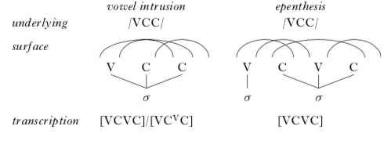

Figure 2. 17: Proposed Representations showing the overlap between consonants that triggers vowel intrusion (Hall, 2006, p. 406)
The motivation for epenthetic vowels is to simplify illicit clusters that do not match syllable phonotactics of L1. In contrast, intrusive vowels are used by a speaker to make clusters easier to perceive. In Articulatory Phonology, gestural phasing is determined by “the need to make gestures perceptually recoverable” (Chitoran, Goldstein, & Byrd, 2002; Silverman, 1995; Wright, 1996). A gesture’s recoverability is compromised when its acoustic cues are weak or absent, for example due to overlap with other gestures. Consonant clusters pose a problem for per- ceptibility, because CV and VC transitions convey information about consonant place. If a consonant transitions directly into another conson- ant, there is no CV transition for the first consonant, and no VC transition for the second. However, the perceptibility of the adjacent consonants is increased if there is a release burst between them. The release burst can carry some articulatory information about the consonants. A burst that is voiced and has vocalic characteristics – i.e. an intrusive vowel – should be particularly suited to convey articulatory information about the adjacent consonants”. (Hall, 2006, p. 407).

Having discussed the gestural representation of ICIs and their syllabification status, the following section will identify the diagnostics of epenthetic versus intrusive vowels, which will be employed to analyse the results of the current research.

Phonological diagnostics of intrusive and epenthetic ICIs
Hall (2006) states that the reviewed literature differentiates intrusive and epenthetic ICIs in terms of stages of a phonological derivation. Phonological rules are expected to be applied in a stage that is prior to inserting intrusive ICIs. Consequently, intrusive ICIs will be “invisible” to these phonological rules, and they will therefore be classified as non-phonological units (i.e. non-syllable nuclei). In contrast, epenthetic ICIs are expected to be inserted in a derivational stage, before the application of phonological rules; therefore, such ICIs will “visible” to these phonological rules. Hence, they are counted as phonological units (i.e. syllable nuclei).

Hall (2006, p: 391) re-examines the phonological environment of intrusive and epenthetic ICIs, adding further diagnostics of such ICIs in addition to the representational visibility and invisibility account. These diagnostics are presented in Table 2.11.

Table 2. 10: A summary of diagnostics of intrusive ICI versus epenthetic ICI.
Intrusive ICIs |  | Epenthetic ICIs
It should be a schwa or a copy of nearby vowel. |  | It is not restricted to schwa. It could be a schwa or any other vowel.
It occurs in heterorganic clusters. |  | It is not affected by place of articulation.
It is optional as it may disappear in fast speech rates and it shows variability in duration measurements. |  | It is not affected by speech rates.
“It does not seem to have the function of repairing illicit structures. The consonant clusters in which the vowel occurs may be less marked, in terms of sonority sequencing, than clusters which surface without vowel insertion in the same language” (Hall, 2006, p. 391). |  | “The vowel repairs a structure that is marked, in the sense of being cross-linguistically rare. The same structure is also likely to be avoided by means of other processes within the same language.” (Hall, 2006, p. 391).

These diagnostics will be used to analyse the results of the current research.

In sum, intrusive and epenthetic ICIs have been explained in this section using two models: AP and the traditional approach of phonological representation. The main conclusion is that epenthetic ICIs are phonological units, and hence, that they serve as syllable nuclei, whereas intrusive vowels do not. The AP approach will not be used directly in the current research for a financial reason, but the phonological diagnostics will be employed instead.

Hall’s diagnostics in the reviewed literature
A number of studies have been conducted using Hall’s diagnostics mentioned above. Tripolitanian Arabic, for example, exhibits optional vowels that may or may not be inserted to break up consonant clusters. “The use of epenthesised and non-epenthesised forms are not social or geographical variants, although they may well be stylistic variants; both may be used by one and the same speaker” (Watson, 2007, p. 345). This optionality of vowel presence breaking up consonant clusters is supported by Plug et al., (2019) based on acoustic analysis, instead of auditory analysis which was the analysis basis of Hall’s (2006) study, as indicated by Plug et al., (2019).

In another acoustic study following some of Hall’s (2006) diagnostics of intrusion versus epenthesis, Bellik (2018) states that Turkish speakers tend to produce non-lexical vowels (i.e., intrusive vowels) in complex onsets. The implication is that “Turkish phonology does not categorically ban complex onsets” (Bellik, 2018, p. 1).

Other acoustic studies have also demonstrated cases of intrusion cross-linguistically, as in Tashlhiyt word-initial clusters (Ridouane & Fougeron, 2011), Khmer word-initial clusters (Kirby, 2014) and word-initial and word-medial consonant clusters in Cruceno Spanish (Kilpatrick, McGee, & Kirby, 2006).

The key contributions of the reported studies above are additional acoustic evidence that supports most of Hall’s diagnostics. As previously stated, intrusion manifestations were initially demonstrated using articulatory phonology (Browman & Goldstein, 1988, 1992b). Impressionistic and auditory analysis then supported this finding (Hall, 2006). More recently, acoustic analysis has been employed to build upon prior work on intrusion.

In a critical account of Hall’s (2006) study, Michael et al. (2014) claim that intrusive vowels in Scottish Gaelic contribute to the syllable structure of that language (contrary to Hall, 2006). They support their claim using data based on (i) six phonological experiments, and (ii) the intuitions of the experiments’ participants who speak Scottish Gaelic as a native language. However, they claim that the inserted vowel has “an intermediate phonological status” which is different from that of underlying vowels. Additionally, they claim that their “results would seem to imply that any phonology–phonetics distinction for inserted vowels is probably more of a continuum, rather than a categorical split, or at least that there are more than two types of inserted vowels” (Michael et al., 2014, p. 150).

Conclusion of reviewed literature on Arabic syllable phonotactics
This conclusion will be presented by addressing two questions: (i) what do we know, and (ii) what do we not know, about Arabic phonotactics?

What do we know about Arabic syllable phonotactics?
In sum, Arabic dialects show wide variation in respect of allowing consonant clusters in word-initial, -medial and -final positions. This variation is attributed to a key non-dominant constraint which is the bimoraicity of syllables (i.e., prohibition of trimoraic syllables). There are some syllables that include a third mora in the surface structure such as [ka_{µ}l_{µ}b_{µ}]* “dog”. As a response to the violation resulting from this third mora, two strategies are observed: (i) treating the third mora as a new syllable (e.g., [ka_{µ}l_{µ}b_{µ}]* > [ka_{µ}l_{µ}.b] “dog”), and (ii) simplifying the trimoraic syllables through vowel insertion (e.g., [ka_{µ}l_{µ}b_{µ}]* > [ka_{µ}.li_{µ}b_{µ}] “dog”). These two strategies have been discussed in a number of seminal studies that show different analytic proposals. However, it is crucial to state that not all Arabic dialects fit neatly into the generalizations of the proposed approaches (Watson, 2007). What could be generally concluded from these approaches is summarized in what follows.

- General summary
  - There are three dialects that most analytic approaches mentioned above differentiate, which are: Moroccan, Iraqi, and Cairene Arabic.
  - Other dialects would generally but not necessarily be grouped with one of these three dialects, as proposed by Kiparsky (2003).
  - Some authors of the analytic approaches summarized in the current PhD research establish their proposals based on data reported a long time in the past. In Kiparsky’s (2003) model, for instance, Moroccan was reported in 1962, Cairene was reported in 1980 and Iraqi was reported in 1963. There is a possibility that sound change has since occurred in one or more dialects.
- Summary of some known aspects related to stray consonants (first strategy)
  - In prohibited trimoraic syllables that include consonant clusters, the consonant that receives the third mora will be treated as a stray consonant (e.g., [ka_{µ}l_{µ}b_{µ}]* > [ka_{µ}l_{µ}.b] “dog”). This generalization regarding stray consonants is found in most, if not all, Arabic dialects and it has been shown phonologically, acoustically and articulatorily.
  - However, the prosodic affiliation of the stray consonant mentioned in (a) differs based on two variables: (i) the target dialect of Arabic, and (ii) syllable position.
  - Generally, stray consonants sited in word-medial and -final positions have been analysed with considerable confidence in respect of their prosodic affiliation (Kiparsky, 2003; McCarthy & Prince, 1990; Selkirk, 1981b; Watson, 2007).
  - The prosodic affiliation of the word-initial stray consonant for some dialects (Moroccan and Iraqi dialects are excluded from this statement) is still problematic for researchers; although some attempts have been made to analyse such consonants, they have been described as unsatisfactory analyses by their authors.
- Summary of some known aspects related to vowel insertion (second strategy)
  - In trimoraic syllables that include consonant clusters, a vowel will be inserted to the right or the left of the consonant that occupies the third mora (e.g., [ɡilt.lu]* > [ɡil.tə.lu] “I said to him”).
  - Arabic dialects show considerable variation in respect of the site of vowel insertion either before the stray consonant (e.g., [ɡi.lit.lu] as in Iraqi dialect) or after it (e.g., [ɡil.tə.lu] as in Cairene dialect).
  - Based on the site of the inserted vowel, Arabic dialects have been classified into various classifications; Kiparsky’s model (2003) is deemed one of the most ambitious models (Broselow, 2018).
  - All inserted vowels are not identical. There are some phonological and phonetic differences between epenthetic vowels and intrusive vowels. Diagnostics for such vowels are listed in Hall’s (2006) study.
  - Intrusive vowels are phonetic transitions between consonants that do not contribute to syllable structure, whereas epenthetic vowels are phonological units used as syllable nuclei to break apart illicit consonant clusters.

What do we not know about Arabic syllable phonotactics?
There are many phonological phenomena in Arabic syllable phonotactics that still need to be investigated. However, the answer to the above question will only focus on the gaps that have been identified based in the summarised literature reviewed here. These gaps will be similarly presented as for the previous question.
- General summary
  - Not all Arabic dialects have been tested in respect of phonotactic rules. Among these dialects is Bisha Arabic, which is the native language of the current research’s author and the language medium of interaction in his institution, the sponsor of the author.
  - Although Makkah Arabic was tested by Bruce Ingham (1971), it is unknown whether this dialect has since undergone some linguistic changes, as it was tested a long time in the past. Therefore, Makkah Arabic is investigated here.
  - In terms of syllable phonotactics, similarities and differences between Bisha and Makkah Arabic are unknown. These similar and different aspects are the main research interest of the current PhD study.

- Summary of some unknown aspects related to stray consonants (first strategy)
- The prosodic affiliation of the initial consonant in word-initial clusters (e.g., [ktaab] “book”), when such clusters are produced by speakers who insert a vowel after the stray consonant in medial position (e.g., [ɡil.tə.lu]) is yet unknown.
- In all summarized dialects in this PhD research, consonant clusters are analysed as non-branching clusters in both onset and coda position, hence, the sonority constraint is expected to have no effect. However, sonority constraints ban rising sonority clusters in the final position, as in San`aani Arabic (e.g., [baħr]* “sea”) (Watson, 2002, 2007). The degree of sonority effect in such cases is unknown.
- In particular, the unknown aspects mentioned in (a) and (b) will be tested in Bisha and Makkah Arabic, as they are the target dialects in the current research.
- Summary of some unknown aspects related to vowel insertion (second strategy)
  - The inserted vowels between consonants of potential clusters in most Arabic dialects are generally treated as epenthesis. Although a few Arabic studies have shown some differences between epenthesis and intrusion, the status of inserted vowels in many Arabic dialects is unknown, since the diagnoses of intrusion and epenthesis are not employed in many studies in the reviewed literature.
  - Among the dialects mentioned in (a) are Bisha and Makkah Arabic, since the role of intrusion and epenthesis is still unknown in these two dialects.

Research problems of Arabic syllable phonotactics
In respect of Arabic syllable phonotactics, this portion of the current PhD study is an attempt to fill the gaps listed above in Section 2.7.2. Two key questions are thus raised to identify (i) the nature of consonant clusters in Bisha and Makkah Arabic dialects (i.e., presence versus absence of non-branching clusters), and (ii) the status of inserted vowels if consonant clusters are found to be broken up (intrusion versus epenthesis). These two questions are listed below:
    - Do BA and MA allow non-branching consonant clusters across syllable positions: word-initially, medially and finally?
    - If not, are consonant clusters in BA and MA modified by intrusive or epenthetic vowels?
These questions will be addressed in Experiment 1, as presented in the following section.

Methodology of Experiment 1: Production of L1 consonant clusters in BA and MA

Introduction
The current experiment will focus on Arabic syllable phonotactics in two ways: (i) consonant clusters (i.e., presence versus absence of non-branching clusters), and (ii) simplification strategies employed to modify such clusters, if any (intrusive versus epenthetic vowels). Methods of Experiment 1 will be presented as follows:
- Experiment objectives: a brief review of experiment aim(s) and the related gap(s) in relevant literature will be reiterated followed by the experiment sub-question(s).
- Experiment design: methodology approach (quantitative analysis), measurement of target variables, design of stimuli, and justification for adopting the selected methods will be defined and explained.
- Data collection: this subsection will set out the details of the study including participants of each experiment, instruments used for data collection, and finally the process of data collection.
- Data analysis: due to the selected approach of analysis (i.e. quantitative analysis), this section will focus on the statistical analysis including the employed software and related issues.
It is worth mentioning that this PhD research has further two further experiments which will be discussed later. If any section has the same or similar materials across the three experiments 1, 2, and 3, detailed information will be provided in relevant sections of experiment 1 and a brief summary of that will be provided in experiments 2 and 3 with a cross-reference to what has been written in Experiment 1.

Objectives and identified gap in the reviewed literature
This experiment has three main goals which are: i) studying the nature of consonant clusters in Bisha Arabic (BA) and Makkah Arabic (MA) at three sites: word-initial, medial and final positions; ii) investigating the status and the underlying distribution of interconsonantal intervals (ICIs) that break up consonant clusters; and iii) using the results of this experiment to predict the possible influence of phonotactic rules in BA and MA on the production and perception of English consonant clusters, if transfer from L1 to L2 occurs in the behaviour of BA and MA speakers.
For the first goal, the main conclusion from the reviewed literature summarised in Chapter 2 is that attested consonant clusters in all Arabic dialects are non-branching clusters. In contrast, it is well known that English consonant clusters are branching clusters (Eddington, Treiman, & Elzinga, 2013a, 2013b; Selkirk, 1982, 1984; Treiman, 1984, 1986; Treiman & Danis, 1988). This difference between English and Arabic dialects might create some difficulties for Arabic learners of English as a second language (L2).
It is worth mentioning that Watson (2007) classified MA as a CV dialect based on an old study conducted by Bruce Ingham (1971) which examined some characteristics of MA speech. The grammar of languages, however, is subject to change over time in response to different linguistic conditions. Many of the recent studies on MA phonology cite Ingham’s research even though it was conducted more than fifty years ago. Therefore, MA has been re-examined in this project to determine whether the recent results match Ingham’s findings. BA consonant clusters have not been previously investigated; therefore, studying the phonotactic rules of BA is one of the main contributions of the current research.
For the second goal of this experiment (i.e., testing the status of inserted vowels), it is expected that some consonant clusters in Arabic will be modified with vowel insertion regardless of their syllable position (Broselow, 1992; Kiparsky, 2003; Watson, 2007). These inserted vowels (interconsonantal intervals (ICIs)), however, are not always identical. Most of the old studies that examine Arabic phonotactic rules treat all ICIs as one particular vowel and treat it as a case of epenthesis. A few recent studies indicate that ICIs in some Arabic dialects (e.g., Moroccan, Tripolitanian Libyan and Lebanese Arabic) are not only restricted to epenthetic vowels, however, intrusive vowels might be employed in these tested dialects in a similar way to epenthetic vowels (Gafos, 2002; Hall, 2006, 2013; Heath, 1987; Plug, Shitaw, & Heselwood, 2019). Therefore, the current study will test the status and distribution of potential ICIs between consonant clusters (i.e., epenthetic versus intrusive vowels) in BA and MA.
In conclusion, this experiment aims to test consonant clusters in BA and MA and what kind of ICIs (intrusive versus epenthetic ICIs) would modify such clusters. The implied goal is to use the results of this experiment to test the effect of L1 consonant clusters on producing and perceiving L2 English consonant clusters. The related gaps in the literature are:
- Consonant clusters in Arabic dialects classified by Kiparsky (2003) are non-branching clusters. However, there are two gaps in Kiparsky’s classification:
  - Bisha Arabic is not included in this classification.
  - Makkah Arabic was tested 50 years ago and languages are subject to phonological change.
- ICIs employed to modify consonant clusters might differ in light of differences between intrusive and epenthetic ICIs. Such vowels have not been tested in BA and MA yet.
Based on these gaps, the research questions of this experiment are presented as follows:
- Do BA and MA allow non-branching consonant clusters across syllable positions: word-initially, medially and finally?
- If not, are consonant clusters in BA and MA modified with intrusive or epenthetic ICIs?
These questions will be addressed in this experiment, as presented in the following section.

Experimental design
In this section, the following subsections will be explained and defined: a) methodological approach (quantitative method) b) explanation of the variables of the current experiment (dependent versus independent variables), and finally c) experimental tasks.

Methodological approach (quantitative method)
“Quantitative research tends to subscribe to particular empirical approach to knowledge, believing that if we measure things accurately enough we can make claims, with some degree of certainty, about the object of the study” (Langdridge & Hagger-Johnson, 2009, p. 13). This is a key feature of quantitative research, that replicating such a study with similarly controlled settings would arrive at similar findings to the original research. This approach indicates the validity of quantitative studies, which makes them reliable studies. Due to these features of a quantitative method, it will be the employed approach for the current research.

Variables
The main goal of this experiment is i) to investigate the presence and the absence of consonant clusters in BA and MA, and ii) to examine the potential ICIs (i.e., epenthesis vs intrusive) that may break up the consonant clusters. These are considered as the main dependent variables. Previous studies indicate that ICIs are influenced by two main independent variables: i) cluster position (i.e., initial, final and medial) and ii) sonority slope (i.e., rising, falling and plateau) (Broselow, 1992; Kiparsky, 2003; McCarthy, 2008; McCarthy & Prince, 1990; Watson, 2007). Kiparsky (2003) extended these variables by specifying the addition of vowel type in initial syllables. In common with other Arabic dialects lacking initial clusters, such as MA and Classical Arabic, initial clusters in Iraqi Arabic, for example, result from deleting high vowels in unstressed open syllables (e.g. [sila:ħ] > [sla:ħ] ‘weapon’). Since BA is expected to have word-initial clusters, this example would be pronounced as [sla:ħ] by BA native speakers. Therefore, the type of vowel in initial syllables will be included as an independent variable. The literature indicates that only high vowels are subject to syncope; however, the low Arabic vowel [a] was included in this experiment for several reasons. First, BA is an Arabic dialect that has not been previously tested and there is a lack of knowledge about what kind of vowels are subject to deletion in this variety. Second, low vowels were included in this experiment to act as a control variable and to enable comparison with high vowels since they are both in the same syllable position in the current experiment. To conclude, the independent variables of experiment 1 are as follows:
- Cluster position with three levels: a) initial b) final c) medial
- Sonority slope with three levels: a) rising b) falling c) plateau
- Type of vowels in initial syllables with two levels: a) high b) low
The stimuli for the present experiment were produced in consideration of these variables, which will be discussed below.

Stimuli
A total of 42 stimuli were used in this experiment, as illustrated in Table 3.1. These were designed in light of the variables mentioned earlier in this experiment (Kiparsky, 2003; Watson, 2007). These variables are cluster position, sonority slope and vowel type. Each variable will be discussed in turn.
Table 3. 1: A list of stimuli used in Experiment 1 alongside their conditioned variables.
position | sonority | vowel | cluster | Items according to the author’s intuition | gloss
initial  #CC | rising | high | tr | tuˈra:b ~ ˈtra:b | sand
initial  #CC | rising | high | ɣl | ɣiˈla:f ~ ˈɣla:f | cover
initial  #CC | rising | high | fl | fuˈlu:s ~ ˈflu:s | money
initial  #CC | rising | low | sm | ˈsamak | fish
initial  #CC | rising | low | bl | ˈbalaħ | dates
initial  #CC | rising | low | mr | ˈmaraq | broth
initial  #CC | falling | high | nħ | niˈħa:s ~ ˈnħa:s | copper
initial  #CC | falling | high | nʕ | niˈʕa:l ~ ˈnʕa:l | shoes
initial  #CC | falling | high | rx | ruˈxa:m~ ˈrxa:m | marble
initial  #CC | falling | low | mtˤ | maˈtˤa:r | airport
initial  #CC | falling | low | rb | raˈbi:ʕ | spring
initial  #CC | falling | low | rs | raˈsu:l | prophet
initial  #CC | plateau | high | kt | kiˈta:b ~ ˈkta:b | book
initial  #CC | plateau | high | ʒd | ʒiˈda:r ~ ˈʒda:r | wall
initial  #CC | plateau | high | ɣb | ɣuˈba:r ~ ˈɣba:r | dust
initial  #CC | plateau | low | nm | ˈnamir | tiger
initial  #CC | plateau | low | sk | ˈsakan | accommodation
initial  #CC | plateau | low | fh | ˈfahad | a proper name
final  CC# | rising | NA | ʃm | ˈxaʃm ~ ˈxaʃim | nose
final  CC# | rising | NA | bn | ˈʒubn ~ ˈʒubun | cheese
final  CC# | rising | NA | ħr | ˈbaħr ~ ˈbaħar | sea
final  CC# | rising | NA | bl | ˈħabl ~ ˈħabil | robe
final  CC# | rising | NA | ml | ˈnaml ~ ˈnamil | ants
final  CC# | rising | NA | bl | ˈʃibl ~ ˈʃibil | cub
final  CC# | falling | NA | ŋk | ˈbaŋk | bank
final  CC# | falling | NA | nz | ˈkanz | treasure
final  CC# | falling | NA | rt | ˈkart | card
final  CC# | falling | NA | lʒ | ˈθalʒ | ice
final  CC# | falling | NA | nt | ˈbint | girl
final  CC# | falling | NA | rʒ | ˈburʒ | tower
final  CC# | plateau | NA | mn | ˈsamn ~ samin | ghee
final  CC# | plateau | NA | nm | ˈɣunm ~ ɣunum | winning
final  CC# | plateau | NA | zq | ˈrizq | livelihood
final  CC# | plateau | NA | fʃ | ˈʕafʃ | luggage
final  CC# | plateau | NA | sk | ˈmisk | perfume
final  CC# | plateau | NA | bd | ˈkabd | liver
medial  -CCC- | NA | NA | mt.l | raˈsamtə.lih | I drew for him
medial  -CCC- | NA | NA | lt.l | ʔaˈrsaltə.lih | I sent to him
medial  -CCC- | NA | NA | bt.l | kaˈtabtə.lih | I wrote for him
medial  -CCC- | NA | NA | kt.l | taˈraktə.lih | I kept something for him
medial  -CCC- | NA | NA | lt.l | ɡulˈtə.lih | I said to him
medial  -CCC- | NA | NA | rt.l | ðaˈkartə.lih | I mentioned to him

The sonority variable has three levels: rising, falling and plateau. As presented in Table 3.1, it is aligned with the position variable, resulting in three levels of sonority for word-initial position and three levels of sonority for word-final position. Each level of sonority for each level of position was examined with six stimuli (a total of 36 stimuli). For medial clusters, they are tri-literal clusters resulting in a syllable boundary between the two consonants of coda and the singleton onset as in [gult.lih] ‘I said to him’. Therefore, sonority is not applicable to such consonant clusters.
Following Kiparsky’s generalization (2003), the vowel type in initial syllables might affect the presence and the absence of word-initial clusters. Initial clusters in Iraqi Arabic, for example, result from deleting high vowels in unstressed open syllables (e.g. [sila:ħ] > [sla:ħ] ‘weapon’). Therefore, two types of vowels in open unstressed syllables have been tested, as shown in Table 3.1. It is expected that the high vowels will be deleted, creating word-initial consonant clusters, whereas the low vowel will not be subject to deletion.
Finally, it is worth mentioning that stimuli for word-medial clusters that were used in some previous studies (Broselow, 1992; Kiparsky, 2003; Watson, 2007) have been replicated in the current experiment (e.g., [ɡult.lih] ‘I said to him’), as illustrated in Table 3.1.

Experimental Tasks
Two tasks were conducted: (1) naming pictures and (2) reading sentences. In the first task, participants were presented with a visual prompt, showing some pictures using Qualtrics software, and they were simply asked to name those pictures. The reason behind employing this task is to avoid a potential extraneous variable, which is the effect of written forms of Standard Arabic (Fusħa). As this experiment investigates consonant clusters, Fusħa Arabic is deemed to be extraneous for two reasons: i) Fusħa Arabic has no word-initial clusters (Broselow, 1992; Hall, 2013; McCarthy & Prince, 1990), and ii) it has wide prevalence in most Arabic countries through media, religious speech and texts and education system. Given the significant status of Fusħa Arabic, effort is required to encourage spontaneous speech from BA and MA speakers and to minimise the impact of Fusħa Arabic to the greatest degree possible. Therefore, the naming pictures task was employed. This task lasts for approximately fifteen minutes.
With respect to the reading sentence task, participants were asked to read Arabic sentences presented in Qualtrics software. As mentioned earlier, Fusħa Arabic might affect this task; however, it was written in the colloquial dialect of participants to try to encourage spontaneous speech from participants. This task lasts for approximately fifteen minutes.

The rationale behind employing two tasks is to see if there is a significant difference between them. If so, the reading sentence task might be the task that fails to motivate the experiment’s participants to speak spontaneously. This failure would be attributed to the effect of Fusħa Arabic as it has no word-initial consonant clusters. If not, this would indicate successful elicitation of spontaneous speech, which is crucial in this experiment.

Having discussed how the experiment has been designed, including the stimuli and the experimental tasks, detailed information about how these experimental tasks were run and how the stimuli have been collected, is now provided.

Data collection
Three main points will be discussed in this section: i) participants of the experiment, ii) instruments used for data collection and iii) the process of data collection.

Participants of the experiment
The initial sample of the current study is 51 male participants of which 29 speak MA, spoken in Makkah to the west in Saudi Arabia. The other 22 participants speak BA as a native dialect, spoken in Bisha to the south in Saudi Arabia. To control other confounding variables that may affect L1 grammar of participants, the following demographic information has been obtained. Participants were asked about their place of birth and where they and their parents and grandparents grew up in order to control for the effect of other dialects on their grammatical systems. Participants who grew up in other places than Bisha and Makkah, or whose parents did, were excluded.
The MA and BA participants were students at the University of Umm Al-Qura in Makkah province and University of Bisha, respectively. They were between 18 and 22 years of age. None of the participants reported any hearing or speech problems.
The sample of the current research was limited to male participants because of the regulations of the education system in Saudi Arabia in which males and females receive their education separately. Thus, the researcher was prevented from entering females’ institutions. Additionally, females might refuse the necessary recording of their participation in experiments due to cultural reasons, unless a female researcher had asked them to participate.

Based on the eligibility criteria mentioned above, two sampling strategies were applied to avoid generating biased findings: i) systematic and ii) cluster sampling. The systematic sampling “is often used as a substitute for random sampling whereby we draw the sample from the population at fixed intervals from the list”. For cluster sampling, the entire group is recruited rather than individuals (Langdrige & Hagger-Johnson, 2009:54). Both strategies were applied, once the participants’ institutions had provided a list of English classes for all first-year students. Students in the morning classes (i.e. systematic sampling) who met the conditions for the population of interest were chosen as a whole (i.e. cluster sampling) to be participants of the current study. All were advised to read the information sheet of the study. Then, they were asked to electronically sign the consent form of the study using Qualtrics Software, and they were provided with a hard copy of the signed form.

Technical equipment used for data collection
Subjects’ speech was recorded in a quiet room at the participants’ institutions. Recordings were made using a Marantz PMD661 solid state data recorder directly to digital format (.wav) at 44.1kHz. The microphone used for recording is a Shure SM10A headset microphone. A key advantage of this recorder is enabling the researcher to assign a unique code to each recording. For example, the first speaker was given a unique code in the demographic information and the consent form, which is M01. This code is specified in the recording device indicating that M01 written in the demographic information is linked with the M01 code in the sound file recordings. This unique code for each participant is used across the three experiments.

Process of data collection
The data were collected in December 2017 in Saudi Arabia at the University of Bisha (Bisha participants) and Umm AlQura University (Makkah participants). The researcher conducted the study himself in the lab of the English Department in each university (Bisha and Umm AlQura).

In this experiment, two experimental tasks were employed to obtain subjects’ participation: (1) naming pictures and (2) reading sentences. In the first task, participants were presented with a visual prompt (some pictures using Qualtrics software), and they were simply asked to name those pictures. This task was followed by the sentence reading task in which participants were asked to read the Arabic sentences presented in Qualtrics software. The average time for both tasks was about 15 minutes.

It is worth mentioning that the participants in this experiment are the same as in Experiment 2 and 3; therefore, each participant was given an anonymous code to connect his participation across the three experiments. For example, the first participant among the BA speakers was given a code (B01) and it is linked to his participations in Experiment 1, 2 and 3.

This section has clarified how the data were collected. It is now necessary to explain how the collected data was analysed, which will be discussed in the next part of this research.

Data analysis

Auditory analysis
In this PhD research, Praat (Boersma & Weenink, 2001) has been used in two ways: (i) to cut long sound files into short files using Praat scripts, and (ii) to segment target clusters and the vowel that breaks up such clusters, if any.
For the cutting of long sound files, they were cut using three scripts adapted from Mietta Lennes (2002). They are summarised as follows:
- Mark Pauses Script: it “creates a TextGrid object for a long sound object and sets boundaries at pauses on the basis of an intensity analysis”.
- Label from File Script: it “reads lines from a text file and adds them line by line as labels for intervals in a selected text tier in the selected TextGrid object”. The text file includes stimuli codes that are used in each short sound file.
- Save Intervals Script: it “saves each interval in the selected interval tier of a TextGrid to a separate WAV sound file”.
As for segmentation, the target clusters were segmented using two tiers. Tier 1 was created to record presence or absence of a vowel. If the ICI was present, (yes) was labelled, and if not, (no) was labelled. In tier 2, boundaries of target clusters and the inserted vowel, if any, were marked using oscillogram and spectrogram simultaneously, as exemplified in Figure 3.1.
An example of employing some of these principles of segmentation is provided below in Figure 3.1
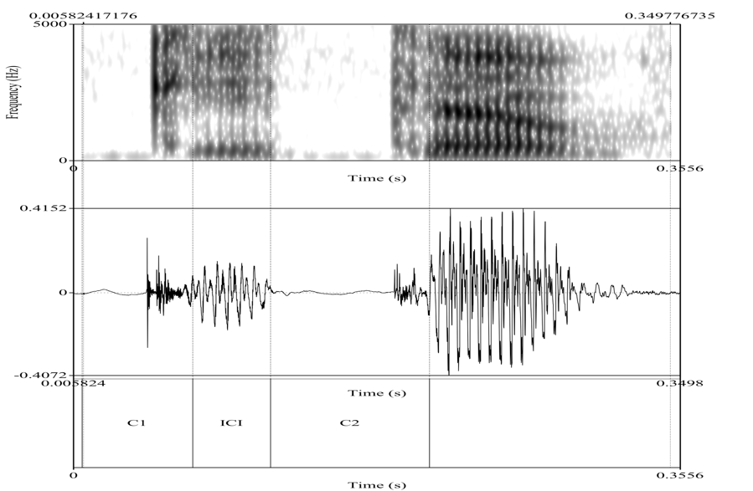
Figure 3. 1: Waveform and spectrogram of /kita:b/ ‘book’ (Participant M1) segmented into two consonants (C1, C2) and ICI.

Regarding consonant segmentation, literature on the acoustic features of consonants (Foulkes, Docherty, & Jones, 2010; Grice, Savino, & Roettger, 2018; Ladefoged & Johnson, 2011; Machač & Skarnitzl, 2009) formed the basis of segmentation. Low resonant/formant frequencies -especially F1- were taken to indicate nasality. The sharp transitions to/from vowels in addition to low F1 and high F3 were cues to laterals. For glides, they have clear sharp formant transitions in which rising F1 and falling F2 indicate [j] and rising for both F1 and F2 indicate [w]. Friction and noise patterns indicate fricatives, whereas closure and release were cues to stops. The most difficult sounds to segment were i) voiced velar fricative [ɣ] and ii) emphatics (pharyngeals) [ ʕ, ħ]. As presented in Table 3.2, Al-Tamimi (2017) provides a summary of articulatory and acoustic correlates of the effect of pharyngealization on the adjacent vowels, as indicated in literature. This summary forms the basis of segmenting pharyngeals in the current study.
Table 3. 2: A summary of acoustic and articulatory features of pharyngeals, adapted from Al-Tamimi (2017).
Articulatory | Acoustic | Additional
Retraction | ↓ F2 | ↑ F3-F2
Open | ↑ F1 | ↑ F1-F0
Narrow/compact | ↓ F2-F1, ↓ F3 | ↓/↑ F3-F2
Roundness/ lip-protrusion | ↓ F1, ↓ F2, ↓ F3 | ↓ F2-F1, ↓/↑ F3-F2
Raised larynx | ↑ F1, ↓ F2, ↓ F3 | Spectral slope
Pressed/ tense voice | -- | Spectral slope
Epilaryngeal constriction | -- | Amplitude upper harmonics

For ICIs (vowels) that break up consonant clusters in BA and MA, they were generally identified using two main acoustic correlates: periodicity generated by the vibration of vocal folds (source) and formants resulting from harmonic resonance (filter) (Ladefoged and Johnson, 2006). The periodicity was identified using two indicators: voicing bars and high amplitudes.

Vowel quality was identified using two techniques: (i) auditory identification, and (ii) acoustic comparison between long vowels and short vowels in BA and MA. Each technique will be discussed in turn.

The reason for conducting an auditory identification (i.e., first technique) is that short vowels that break up consonant clusters in BA and MA might be epenthetic or intrusive vowels. If they are intrusive vowels, the vowel quality should be fixed, either a schwa or a copy of a nearby vowel (Hall, 2006). However, identifying the quality of schwa is not always straightforward. It poses difficulties for some researchers:
“the labelling of potential schwa was not always straightforward. We thus adopted a liberal approach, labelling as a schwa any interval presenting periodic vibrations accompanied either by a local increase in the signal energy at the consonantal release, and/or any interval after the consonantal release with formant structure or energy in the F2/F3 region characteristic of vowels. In some cases, deciding on the presence of these acoustic features was very difficult. Thus, we kept track of these ambiguous cases and ran all statistical analyses with and without these problematic cases. Exclusion of these cases did not make any difference” (Grice et.al 2018:2478).

Whatever segmentation difficulties with schwa were encountered, the liberal approach outlined by Grice et al. (2018) will be employed.

The second technique to identify vowel quality is to draw an acoustic comparison between long vowels and short vowels (ICIs) in BA and MA. Before discussing this technique, it is worth mentioning that the current study does not aim to identify the vowel inventory of BA and MA. The aim of this comparison is to provide a comprehensive vowel space of relevant vowels in BA and MA, hence, the quality of target ICIs (i.e., short vowels) will be easy to determine. The selection and extraction from Praat tiers and labels presented in vowel plots will be discussed in detail below.

For short vowels, they are the same ICIs that break up consonant clusters in BA and MA, therefore, ICIs and short vowels are interchangeable. The formants of such vowels were extracted using a Praat script. In the vowel plots, the vowels were labelled according to the intuitions of the author, who is a native speaker of BA. His intuition about vowel quality in BA is identical to short vowels in Standard Arabic, as presented in Table 3.3 (Albirini, 2016; Saadah, 2012; Tsukada, 2011; Watson, 2002).

Table 3. 3: Long vowels in Arabic.
Short vowels | Long vowels
a | a:
i | i:
u | u:

Long vowels in BA and MA used in this research were labelled as presented in Table 3.3. They were extracted from the corpus of this PhD research using Prosodylab-Aligner (Gorman, Howell, & Wagner, 2011). The first step of the extraction procedures was determining the boundaries of target words that comprise long vowels (i.e., they are mainly extracted from participants’ production of the second task of Experiment 1 which is a reading sentences task). They are 36 words categorised according to the target vowels [i:, u:, a:]; 12 words for each vowel as presented in Table 3.4. These words were written in Romanised transliteration as presented in Table 3.4.

Table 3. 4: Transliteration of stimuli comprising long vowels.
[i:] |  |  | [u:] |  |  | [a:]
Transliteration Gloss Transliteration Gloss Transliteration Gloss
gi:mah | price |  | rasu:l | prophet |  | kala:mi: | my talk
yiji:ni: | come to me |  | ghyyiru:ha | change it |  | jida:r | wall
2ddi:rah | village |  | bu:yah | paint |  | ghathaya:n | nausea
fi:l | elephant |  | yizu:r | visit |  | bra:sik | your head
ladhi:dh | delicious |  | marbu:t | tight |  | guhba:r | dust
2ddilfi:n | dolphin |  | ma3ru:Dah | exhibited |  | wa:hid | one
elmadi:nah | city |  | filu:s | money |  | tura:b | sand
sili:g | broth |  | yigu:lu:n | they say |  | gihla:f | cover
2ssi:n | china |  | su:g | market |  | elba:rih | last night
jami:l | beautiful |  | ma3ru:D | exhibited |  | sa:kin | resident
elmafa:ti:h | keys |  | tishu:f | to see |  | risa:lah | letter
tixali:k | keep you |  | tibu:k | a city name |  | zima:n | in the past

Using scripts of Prosodylab-Aligner, the list of words presented in Table 3.4 were aligned to the audio recordings of the current research’s participants as exemplified in Figure 3.2. Using a Praat script, formant values for these vowels were extracted into a Microsoft-Excel file. By the end of this step, long and short vowels were ready to be compared.
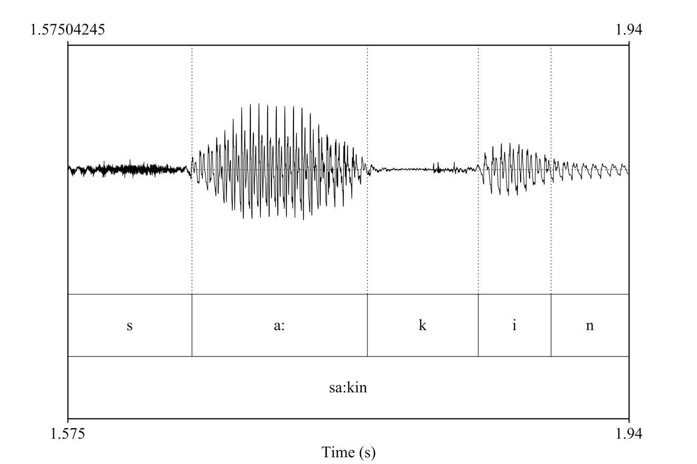
Figure 3. 2: An example of Prosodylab-Aligner result, extracted from the recording of Participant 07 among BA speakers. Each sound of the word [sa:kin] “resident” presented example is labelled in Romanised transliteration.

Vowel normalisation
Listeners can discriminate almost vowels pronounced by speakers of their native language (Adank, Smits, & van Hout, 2004). However, when a vowel is produced by a speaker, is it acoustically identical to the same vowel produced by all speakers of the same language? The answer is that speakers’ vocal tracts are physically different (Adank, 2003; Adank et al., 2004; Watt, Fabricius, & Kendall, 2010). For this main reason, vowels need to be normalised to minimise variation between vowel tokens. Due to the high number of participants in the current project (51 speakers from two different dialects), it is worth normalizing their produced vowels to obtain the goals of normalization mentioned above, especially the last goal, which is to control for the physical differences of vocal tracts among the participants.
The question now is: what is vowel normalisation? From an acoustic perspective, “vowel normalisation can, generally, be defined as a transformation of the acoustic representation of vowel tokens that aims at minimizing the acoustic consequences of specific sources of variation in the acoustic representation of vowel tokens” (Adank, 2003, p.3) .
There are various methods for performing vowel normalisation. Based on a review of the literature, this can be done according to three parameters: i) speaker, ii) formant and iii) vowel. These normalisation methods vary according to the procedures employed to manipulate these three parameters. These procedures are either i) intrinsic or ii) extrinsic. Flynn (2011) and Watt et al. (2010, p. 113) provide a list of normalisation methods presenting the three parameters mentioned above (i.e., speaker, formant and vowel) and the employed procedures (intrinsic versus extrinsic). This list is summarised below in Table 3.5.
Determining the proper method to use depends on the goal of normalisation. However, Adank et al. (2004, p. 3099) draw a comparison between three normalisation methods which are: Lobanov, Nearey1 and Gerstman. The comparison aims to identify the best method that preserves both the sociolinguistic background of the speakers and the phonemic properties of vowels. Also, it aims to determine the best method that minimises linguistic variation resulting from physical differences of speakers’ vocal tracts. 80 males and 80 females participated in Adank’s et al. (2004) study and they were classified according to their sociolinguistic background. The fundamental frequency (F0), F1, F2 and F3 were employed in the normalisation process. The results showed that Lobanov was the best method to achieve the goals mentioned above. Therefore, the Lobanov method will be employed to normalise vowels in the current research.

Table 3. 5: A list of vowel normalisation methods (Flynn, 2011).
Scale/Method | Speaker | Vowel | Formant | Reference; NORM suite name
Bark | intrinsic | intrinsic | intrinsic | Traunmüller 1990, 1997
mel | intrinsic | intrinsic | intrinsic | Stevens and Volkman 1940
Koenig | intrinsic | intrinsic | intrinsic | Koenig 1949
ERB | intrinsic | intrinsic | intrinsic | Moore and Glasberg 1983
Syrdal and Gopal | intrinsic | intrinsic | extrinsic | Syrdal and Gopal 1986
Bark Difference  Metric | intrinsic | intrinsic | extrinsic | Bark Difference Metric
Gerstman | intrinsic | extrinsic | intrinsic | Gerstman 1968
Lobanov | intrinsic | extrinsic | intrinsic | Lobanov
Nearey CLIH_{i4} | intrinsic | extrinsic | intrinsic | Nearey 1977/8; Nearey1
Watt and Fabricius | intrinsic | extrinsic | intrinsic | Watt and Fabricius 2002;  Watt and Fabricius
Nordström and  Lindblom | intrinsic | extrinsic | extrinsic | Nordström and Lindblom  1975
Nearey CLIH_{s4} | intrinsic | extrinsic | extrinsic | Nearey 1977/8; Nearey2
Labov ANAE  methods | extrinsic | extrinsic | extrinsic | ANAE

It is worth mentioning that vowels might be overlapped before or after normalisation. In this case, it might be awkward to identify the vowel quality and this difficulty varies according to the degree of overlap as well as the employed measure to calculate such overlap. Kelley and Tucker (2020, p. 137) compared four vowel overlap measures: (i) the spectral overlap assessment metric (Wassink, 2006), (ii) the a posteriori probability (APP)-based metric (Morrison, 2008), (iii) the vowel overlap analysis with convex hulls method (Haynes & Taylor, 2014), and (iv) Pillai score (Hay, Warren, & Drager, 2006) (see Figure 3.3 below).

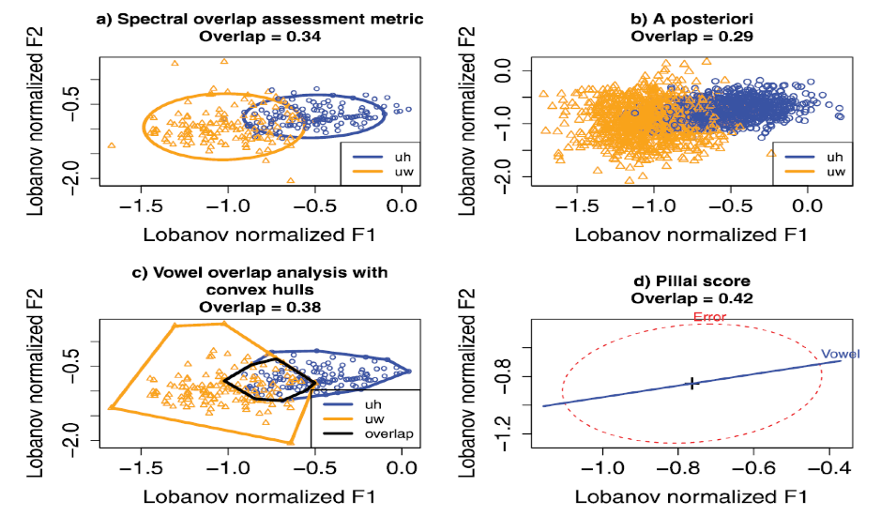
Figure 3. 3: “(Color online) Visualizations for each measure for the vowel data of Hillenbrand et al. (1995) for /u/ (uw) and /ʊ/ (uh). The /u/ and /ʊ/ pairing was selected as an example of two vowels that should present some degree of acoustic overlap based on the similarity of their associated formant values. Formant values have been Lobanov normalized, and all 139 speakers in the data set were used in the calculation. Some speakers had missing formant values, which were denoted with a “0” in the data set. We included these speakers and the 0 values to help visualize how outliers affect the measures. Note that the scale differs between some of the plots, notably the plot for the Pillai score” (Kelley & Tucker, 2020, p. 139).

The conclusion of this empirical comparison was that the Pillai score performs as the best measure among these methods. Therefore, the Pillai score measure will employed in this research if needed. The Pillai score is an outcome of Multiple Analysis of Variance (MANOVA) which mathematically shows the proportion of a variance that might be expected by another variance under any specified condition. In application of the Pillai score to acoustic measurements of vowels, the overlap between vowels is calculated based on the input of all vowel formants values rather than averages. Values of the Pillai score range from 0 to 1 in which 1 indicates the lowest degree of vowel overlap and 0 indicates the highest the degree of overlap as presented in Figure 3.4 (Hay et al., 2006; Kelley & Tucker, 2020; Nycz & Hall-Lew, 2013; Stanley, 2019).

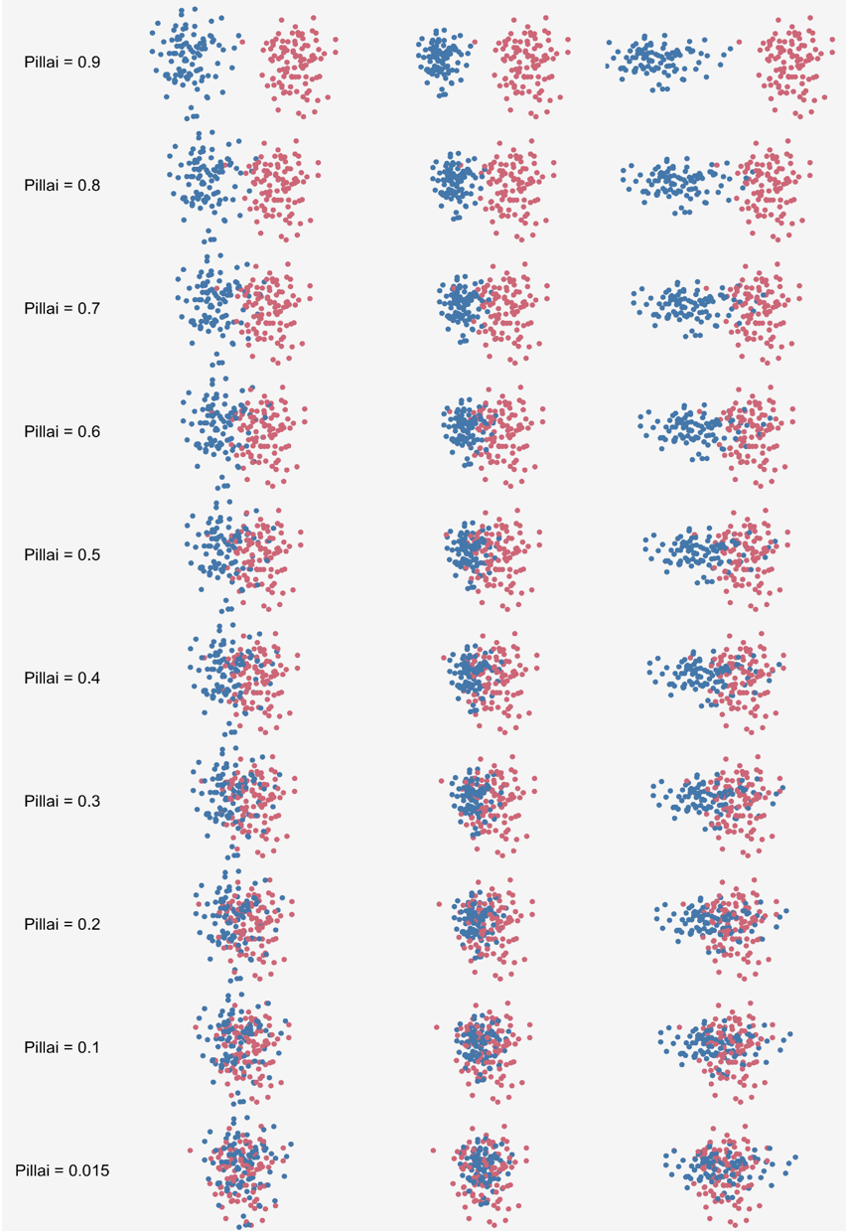
Figure 3. 4: Hypothetical plot illustrate Pillai score in each plot and visualises the relative degree of vowel overlap. Each dot represents a single vowel (Stanley, 2019).
Statistically, Pillai scores were calculated after normalisation using a Manova test in R following the tutorial presented by Stanley (2019) in the following formula:
manova (cbind (F1, F2) ~ vowel, data = data frame)
Having discussed principles of vowel segmentation, including formant values and how they were extracted and compared, the final relevant measurement is vowel duration which “is usually measured from vowel onset to vowel offset” (Di Paolo, Yaeger-Dror, & Wassink, 2010, p. 98). Vowel duration was measured, as it is a diagnostic of vowel intrusion versus epenthesis, as discussed earlier. Intrusive vowels are characterised as variable in duration. Therefore, duration of ICIs that break up consonant clusters in BA and MA as well as word duration were measured and extracted using a Praat script and visualised using "tidyverse” (Wickham, 2017) in R (Core Team, 2014)
In conclusion, the auditory analysis of the current study was established using Praat software. Principles for segmenting consonants and vowels were presented earlier based on the reviewed literature. Due to the high number of participants (51 speakers), vowel normalisation was performed to minimise the variation that may result from the physical differences of speakers’ vocal tracts. The degree of vowel overlap is calculated using Pillai scores as they perform as the best measure of such overlap.
This section has identified the principles of segmentation and vowel normalisation. The next part of this chapter will explain the statistical analysis and how it was performed using R software.

Statistical Analysis
The results of the current research were analysed using two types of statistics: a) descriptive and b) inferential statistics. The former aims to describe, summarise and visualise the current data using the "tidyverse” (Wickham, 2017) in R (Core Team, 2014).

For the latter, a generalised linear mixed model (GLMM) using “lme4” (Bates, Mächler, Bolker, & Walker, 2015) was conducted in this experiment for two reasons. First, the variable outcome of the dependent variable is repeatable (binary, vowel versus no vowel). Second, participants and stimuli of the current study are “randomly” sampled to represent the population of speakers and the population of words in the target language. When such an experiment is conducted anew, other participants and stimuli might be selected. Hence, they are not repeatable as the dependent variable (Baayen, Davidson, & Bates, 2008; Bates et al., 2015). Therefore, results were explored using GLMM. Using other models such as ANOVA without considering the random effects of participants and stimuli would result in some drawbacks.
“These drawbacks include (a) deficiencies in statistical power related to the problems posed by repeated observations, (b) the lack of a flexible method of dealing with missing data, (c) disparate methods for treating continuous and categorical responses, as well as (d) unprincipled methods of modeling heteroskedasticity and non-spherical error variance (for either participants or items)” (Baayen et.al, 2008:391).

Using mixed modelling will provide better analysis to avoid these drawbacks. For example, mixed modelling will predict the unseen levels of random-effects factors. In this research, only 51 participants represent the target population. The unseen level of other participants would be predicted using this model. Therefore, mixed-effects logistic regression was chosen as the statistical model used in this research.

Besides the random effects of the mixed models (i.e., participants and items), random slopes are crucial to end up with more comprehensive models which can be achieved using GLMM. “These models allow incorporating non-independent clusters of data into one’s analysis. In other words: you can tell your mixed model about the dependency structures within a dataset so that it makes appropriate estimates and draws appropriate inferences” (Winter, 2019, p: 234). This allows the model to consider the variance of fixed effects with relative random effects (which mainly are participants and stimuli as in the field of linguistics). Figure 3.5, which is extracted from Winter (2019), provides a good example of explaining the importance of including random effects and random slopes in mixed models. It is worth mentioning that Winter (2019) adopts the terminology of “varying intercepts” for “random effects” and “varying slopes” for “random slopes”.

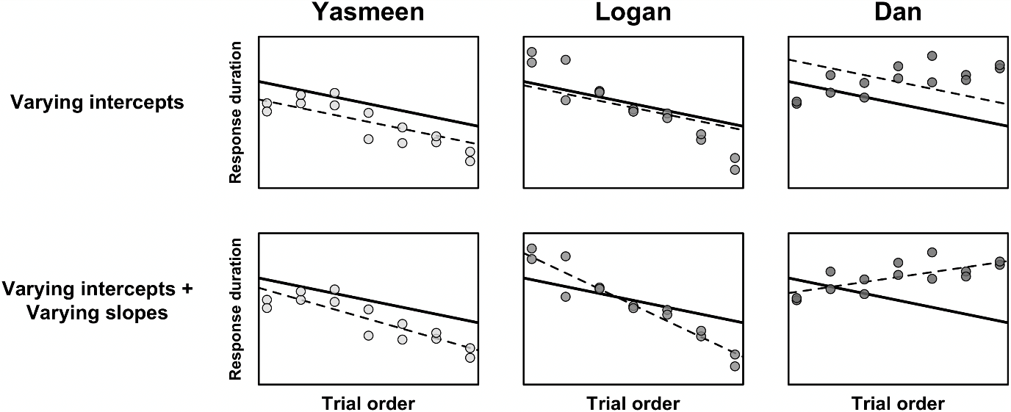
Figure 3. 5: “Response durations as a function of trial order (‘experiment time’) for three different participants; Yasmeen and Logan speed up throughout the experiment, Dan slows down; the bold line shows the population-level estimates (across participants); the dashed lines represent the participant-specific ‘random effect’ estimates; top row: a model with varying intercepts but not varying slopes tends to mischaracterize the participant-specific response patterns; bottom row: a model with varying intercepts and varying slopes characterizes the participant-specific trends more accurately” (Winter, 2019, p: 235).

Finally, it is a common issue in mixed-effects models to come across convergence issues. These issues are often attributed to the complexity of the model, but it is not the only reason for that. To solve these issues, the following steps have been employed in the current research following Winter’s recommendation (2019). Firstly, Winter (2019) suggested to check convergence issues in lme4 package using this command: ?convergence. It usually provides useful solutions such as changing the optimizer of the model using the afex package, which suggests several optimizations algorithms. However, if the warning resulted from running the model is the boundary:singular warning, it means that changing the optimizer would not be useful. Secondly, it would be useful to simplify the model and this will be the final solution after exhausting previous solutions. Random slopes often create convergence issues, but dropping such slopes is not the most straightforward solution. Rather than doing so, an intermediate solution is suggested, which is “to explore whether the model converges with a random effects structure for which there is no slope/intercept correlation term” (Winter, 2019, p: 266). An example from the current experiment is glmer (ICI_present ~ sonority * group + (1+sonority|subject) + (1+group|item). If this model failed to converge, the intermediate suggested solution is: glmer (ICI_present ~ sonority * group + (1| subject) + (0 + sonority | subject) + (1| item) + (1+ group | item). These recommendations will be followed in this research if needed. If they fail, the last solution is to simplify the models, and it will be footnoted if they have been simplified.
So far, this section has focused on the descriptive and inferential statistics. The final part of data analysis is visualising normalised vowels. They were normalised following the tutorial of Barlaz (2019). In this tutorial, four R packages were employed: “tidyverse” (Wickham, 2017), “phonR” (McCloy, 2014), “phonTools” (Barreda, 2015) and “vowels” (Kendall & Thomas, 2018).
In conclusion, this chapter has focused on the methodology used to investigate consonant clusters and the expected simplification strategies of such clusters in BA and MA. The aims of Experiment 1 have been restated in addition to the methods used to achieve them. The process of collecting data and how such data will be analysed have also been clarified.

Conclusion of methodology of Experiment 1
Experiment 1 aims to investigate the syllable phonotactics of BA and MA. Two tasks have been employed to elicit subjects’ productions, which were recorded and analysed auditorily and acoustically. Results of this experiment are presented in the following chapter.

Chapter 4: Results of Experiment 1

Introduction
An analysis of research data gathered from 51 subjects who each produced a total of 42 stimuli examining the status of consonant clusters of Bisha (BA) and Makkah (MA) is presented and the research questions of experiment 1 are addressed and restated. An overview of the results that compare BA with MA is represented visually using boxplots of interconsonantal interval (ICI) rates across syllable positions: word-initially, medially and finally. This summary is followed by a detailed analysis of each syllable position. The analysis is clarified quantitatively using two statistical dimensions: descriptive statistics and inferential statistics, as mentioned earlier in Chapter 3.
The aim of experiment 1 is: i) to study the nature of consonant clusters in BA and MA at three sites: word-initial, medial and final positions and ii) to investigate the status and distribution of ICIs between consonant clusters if they have been broken up. In this experiment, subjects participated in two tasks: naming pictures and reading sentences written in their own dialects to avoid the formal register of Arabic language. Each task involved 42 stimuli that allow us to examine consonant clusters in both dialects across syllable positions. Their participation was recorded using high-quality recording equipment to elicit reliable results, which are visualised in Figure 4.1 and presented in Table 4.1.

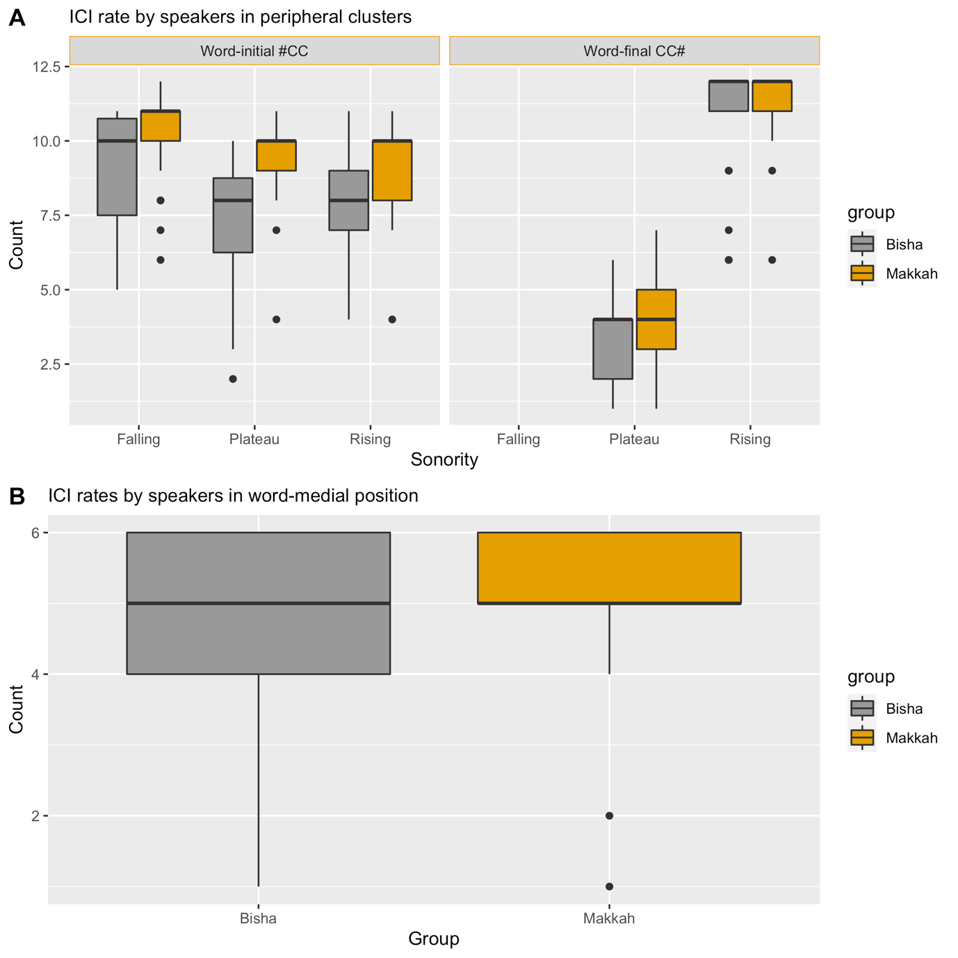
Figure 4. 1: Median and interquartile range for ICI rate produced by BA (n= 22) and MA (n= 29) speakers in word-initial, -medial and -final clusters with different sonority slopes (falling sonority clusters in the final position have no ICIs). The Y axis represents the count of ICI count. In Figure A, each participant produced 18 items in word-initial and word-final positions. In Figure B, each participant produced 6 items in word-medial position.

Table 4. 1: Percentage of inserted ICIs by BA and MA speakers across syllable positions.
Dialect | Cluster position | % of overall ICI insertion | % of inserted ICIs according to sonority slope
Dialect | Cluster position | % of overall ICI insertion | Falling | Plateau | Rising
BA | Initial #CC | 74 | 82 | 70 | 75
BA | Medial -CCC- | 80
BA | Final CC# | 45 | 0 | 38 | 96
MA | Initial #CC | 91 | 92 | 89 | 92
MA | Medial -CCC- | 87
MA | Final CC# | 49 | 0 | 50 | 98

Figure 4.1 and Table 4.1 indicate that word-initially the median of the ICI rate for BA speakers is always lower than that for MA speakers across sonority slopes, which in turn suggests that the number of word-initial consonant clusters is higher for BA (74 %) than for MA (91 %). The spread of values suggests that the MA mean relative ICI rate varies much less across speakers and items than that in BA. Hence, the more consistent MA mean relative ICI rate should make predictions about the ICI insertion rate for MA speakers more dependable than the more variable BA ICI rate.

In contrast, the differences between the dialects in word-final clusters is much less than that for clusters in word-initial position, as shown in Figure 4.1. The sonority slope plays a key role in creating similar patterns among both groups’ speakers, especially for clusters with falling and rising sonority. It indicates full absence of ICI for clusters with falling sonority (0 %) and a low ICI rate for clusters with plateau sonority (38 % for BA and 50 % for MA). Conversely, rising sonority clusters are frequently broken up with an ICI (96 % for BA and 98 % for MA), although there are some outliers. To sum up, both dialects display sensitivity to sonority constraints in word-final position. Medial consonant clusters are not visualised in Figure 4.1 (A) since their fixed effects differ from the fixed effects of peripheral consonant clusters. Therefore, they are visualised below in Figure 4.1 (B).
Figure 4.1 (B) and Table 4.1 show that BA and MA have the same median ICI rate, as the median of the boxplot is five for both dialects, which suggests, in turn, that both dialects have a high rate of ICI (80 % for BA and 87 % for MA), although insertion in word-medial clusters in BA shows some variation.
Overall, Figure 4.1 (A) indicates a high rate of ICI insertion to break up word-initial consonant clusters in MA dialect, whereas it shows a slightly lower number of ICIs in BA. It also suggests that word-final clusters in both dialects are very sensitive to sonority constraints, which, in turn, suggests that there is no difference between the dialects in this respect. For medial clusters, Figure 4.1 (B) shows that BA and MA have a high rate of ICI. Finally, it can be observed that the sonority slopes in the initial position do not overlap with sonority slopes in the final position. This suggests the need to analyse results for each position separately, which will be presented in the following sections (Section 4.2: initial clusters, Section 4.3: medial clusters, and Section 4.4: final clusters).

Word-initial Consonant Clusters in BA and MA
The question of experiment 1 was directed to an examination of a) the existence of consonant clusters in word-initial position in both BA and MA dialects (i.e. presence versus absence of consonant clusters) and b) the status of ICIs used to break up such clusters (i.e. epenthesis versus intrusion). A total of 18 tokens were used to test #CC by considering three independent variables to design these stimuli: cluster size, sonority constraints, and vowel type in the initial syllables. The cluster size was limited to two constituents #CC (e.g. [ktaab] “book”) because #CCC is not permitted in Arabic apart from some dialects spoken in North Africa (e.g. Moroccan). The second variable, which is sonority slope, has three levels: rising (e.g. [traab] “sand”), falling (e.g. [nħaas] “copper”) and plateau sonority (e.g. [ktaab] “book”).
For the third variable, Kiparsky (2003) states that #CCs in Arabic result from deleting syllable nuclei when there are high vowels located in unstressed open syllables (e.g. [silaħ] > [slaħ] ‘weapon’). Therefore, two types of vowels in open unstressed syllables have been tested in the current study:
- high vowels:
  - [i]: (e.g. [kitaab] > [ktaab] “book”).
  - [u]: (e.g. [turaab] > [traab] “sand”).
- low vowel:
  - [a]: (e.g. [rasuul] > [rasuul] “prophet”).
A summary of results based on these variables is provided below, discussing the respective aims of the current experiment: 1) presence versus absence of consonant clusters, 2) status of present ICIs (i.e. epenthesis versus intrusion).

Incidence of word-initial consonant clusters in BA and MA (presence versus absence of consonant clusters)
Following Kiparsky’s generalization (2003), #CC in some Arabic dialects would result from deleting syllable nuclei when they are high vowels in unstressed open syllables. This generalization is confirmed in that there is more syllable nuclei deletion with high vowels than low vowels, as shown in Figure 4.2. This means that if there is statistical evidence for the presence of consonant clusters in BA and MA, they are more likely to result from deleting the high vowels [i], [u] in unstressed open syllables. It also suggests that deletion of low vowels plays no role in creating consonant clusters; therefore, they will be excluded from any further analysis, which will be restricted to high vowels only.
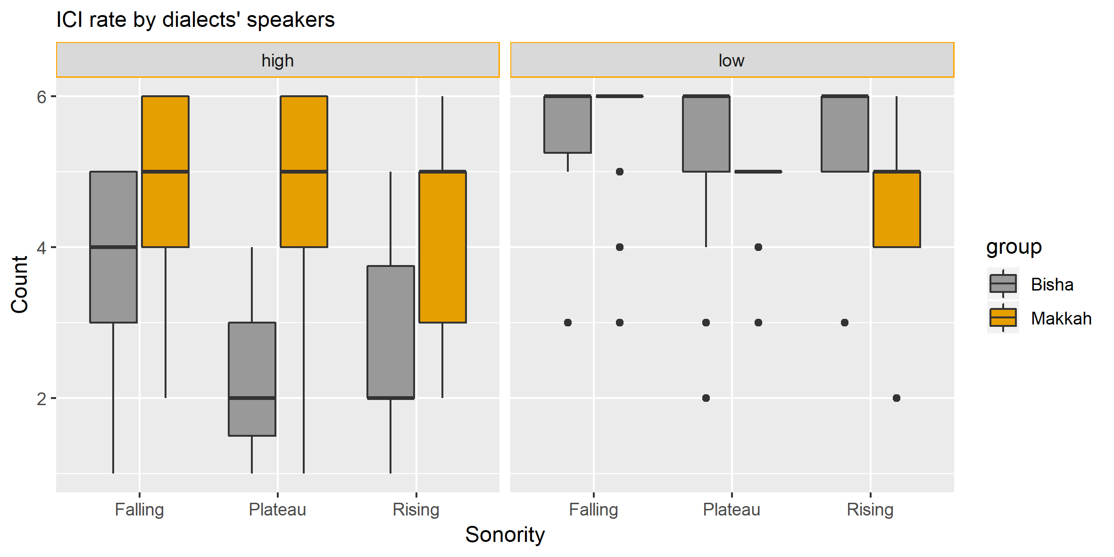
Figure 4. 2: Median and interquartile for ICI insertion rate produced by BA and MA speakers in the word-initial clusters with different syllable nuclei (high / low vowels).

Table 4. 2: Percentage of inserted ICIs by BA and MA in word-initial position.
Dialect | Vowel position | % of overall ICIs | % of inserted ICIs according to sonority slope
Dialect | Vowel position | % of overall ICIs | Falling | Plateau | Falling
BA | high [i, u] | 49 | 67 | 34 | 48
BA | low [a] | 99 | 99 | 100 | 100
MA | high [i, u] | 83 | 86 | 79 | 84
MA | low [a] | 99 | 98 | 100 | 100

As presented in the left panel of Figure 4.2 and Table 4.2, a comparison between the tested dialects reveals that the ICI rate produced by MA speakers (83 %) is generally higher than that of BA speakers (49 %). When these ICI rates are split by sonority slope, we see that sonority plays less of a role in MA, because the median of ICI rate is 5 for all cluster types regardless of their sonority slope. In BA, by contrast, Figure 4.2 suggests a key role for sonority in which the median ICI rate is 4 in falling sonority clusters (67 %), with a decrease to 2 in plateau (34 %) and rising sonority (48 %) clusters, although the latter has more variability. Consequently, sonority constraints might be more influential in BA than MA. The strength of this influence is statistically examined below using mixed-effects models.

Using R, a series of binomial generalised linear mixed models (GLMM) and lme4 (Bates, Mächler, Bolker, & Walker, 2015) were established to test the relationship between ICI as the dependent variable and the fixed factors: dialects and sonority slope with random effects of item and subject. Random slopes were included in some models, but they were excluded during convergence troubleshooting. The statistical significance of results was identified using likelihood ratio tests of the full model with the effect in question against the model without the effect in question (i.e. full.model vs null.model). Model effects were visualised using ggplot2 (Wickham, 2010) and their predictions were explored using lsmeans (Lenth, 2016). R syntax for the best-fit model is provided in a footnote.
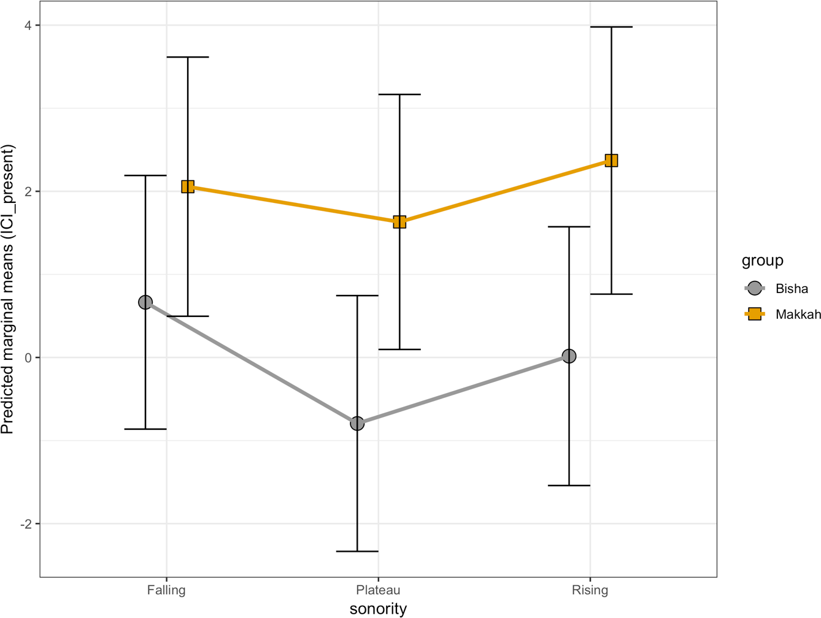
Figure 4. 3: Predicted marginal means (and 95% CI) for the binomial GLMM by sonority and group reported in Table 4.3.

Figure 4.2 showed that sonority constraints could be influential in BA, whereas they may not be for MA. Therefore, interactions between sonority and group variables are worth testing. The best-fit model (with interaction) shows a significant difference for the presence of ICI (z = 3.73, p = 0.0001) as a function of group, indicating that BA has more #CC in comparison with MA, as represented in Figure 4.3 and Table 4.3. The model also shows interactions between sonority constraints and groups for the presence of ICI: the rate of ICI breaking up MA consonant clusters with falling versus plateau and falling versus rising sonority is statistically higher than its counterpart in BA (plateau sonority: z = 2.38, p= 0.01, rising sonority: z = 2.07 p = 0.03). Within groups, however, there were no significant differences between sonority slopes, as can be seen in Figure 4.3 and Table 4.3. This confirms the interpretation of Figure 4.2.
Table 4. 3: Mixed effects coefficients (predicting ICI rate with the fixed correlated effects: dialect and sonority) for the binomial GLMM model visualised in Figure 4.3.
 | Estimate | SE | z value | p value
Intercept | 0.66 | 0.58 | 1.44 | 0.25
Makkah dialect | 1.39 | 0.37 | 3.73 | 0.0001 ***
Plateau sonority | -1.45 | 0.79 | -1.83 | 0.06
Rising sonority | -0.64 | 0.79 | 0.81 | 0.41
Makkah dialect: plateau sonority | 1.03 | 0.43 | 2.38 | 0.01*
Makkah dialect: rising sonority | 0.96 | 0.46 | 2.07 | 0.03*

To sum up, this model tested the presence versus absence of word-initial consonant clusters in BA and MA and its interactions with sonority. The results indicate that BA is more likely to have #CC than MA. Also, sonority has no main effect on ICI rate; however, the interaction between dialect and sonority shows a significant effect: the rate of ICI to break up MA consonant clusters with falling versus plateau and falling versus rising sonority is statistically higher than its counterpart in BA. The status of ICIs (intrusion vs epenthesis) might serve to explain the different rates of ICI in the two dialects, which will be discussed below.

The status of ICIs in word-initial consonant clusters in BA and MA
Based on the model visualised in Figure 4.3, BA tends to have #CC more often than MA, which in turn suggests that MA has ICIs more than BA. However, the literature indicates that ICIs are not always identical. Some Arabic dialects (e.g. Moroccan Arabic) involve a phonetic transition between two consonants resulting in intrusive vowels which are not phonological units (i.e. syllable nuclei). In contrast, some other dialects have epenthetic vowels, which may serve as syllable nuclei. To differentiate between intrusive and epenthetic vowels from a phonological perspective, Hall (2006) lists four diagnostics of such vowels, as presented in Table 4.4.
Table 4. 4: A summary of diagnostics of intrusive ICIs versus epenthetic ICIs.
Intrusive ICIs |  | Epenthetic ICIs
It should be a schwa or a copy of a nearby vowel. |  | It is not restricted to schwa. It could be a schwa or any other vowel.
It occurs in heterorganic clusters. |  | It is not affected by place of articulation.
It is optional as it may disappear in fast speech rates and it shows variability in duration. |  | It is not affected by speech rates.
“It does not seem to have the function of repairing illicit structures. The consonant clusters in which the vowel occurs may be less marked, in terms of sonority sequencing, than clusters which surface without vowel insertion in the same language” (Hall, 2006, p. 391). |  | “The vowel repairs a structure that is marked, in the sense of being cross-linguistically rare. The same structure is also likely to be avoided by means of other processes within the same language.” (Hall, 2006, p. 391).

It is worth mentioning that some diagnostics of ICIs are partially shared between epenthetic and intrusive ICIs. For example, intrusive ICIs should be schwa or a copy of a nearby vowel. Similarly, epenthetic ICIs might be a schwa, but it is not necessary as it could a be schwa or any other vowel. Therefore, only having a vowel quality diagnostic is not enough to determine the status of ICIs and it must be supported with other diagnostics. In contrast, there are some diagnostics that are not shared between epenthetic and intrusive ICIs, such as the markedness status of consonant clusters. For instance, epenthetic ICIs only occur in marked clusters, whereas intrusive ICIs occur in less marked clusters in terms of sonority sequencing. Therefore, the markedness status diagnostic necessarily indicates the presence or the absence of either intrusive or epenthetic ICIs and might be enough to determine one of these ICIs. In contrast, vowel quality, for instance, should be supported with diagnostics to determine the status of inserted ICIs. In the current study, I will try to start with the diagnostics, which are not shared to have initial indications of the status of inserted ICIs either epenthetic or intrusive.
The diagnostics used in the current study are: (i) place of articulation, (ii) markedness status of modified clusters, (iii) vowel quality, and (iv) variability in ICI duration. Each diagnostic will be discussed in turn. Speech rate is not applicable to the current experiment since the only provided rate is normal speech; therefore, this diagnostic will be excluded from any further analysis.

Diagnostics of ICIs: I) The effect of place of articulation
Intrusive vowels generally occur in heterorganic clusters (e.g., [fulu:s] “money”), but epenthetic vowels are by comparison unaffected by place of articulation (Hall, 2006). Based on this, Figure 4.4 indicates a clear difference in ICI rates between homorganic and heterorganic consonant clusters, showing a high rate of ICI in heterorganic clusters in both dialects.

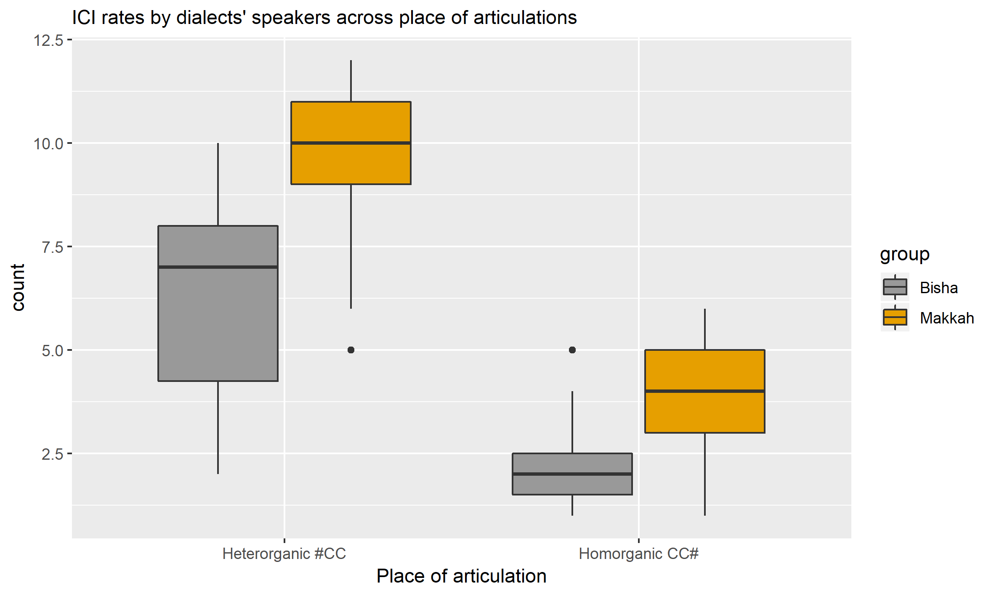
Figure 4. 4: Median and interquartile range for ICI insertion rate produced by BA and MA speakers in the word-initial consonant clusters across place of articulation.

If the difference between the two types of clusters, presented above in Figure 4.4, is significant, it would indicate that ICIs are intrusive in BA and MA, which is presented below in Figure 4.5 and Table 4.5.

Table 4. 5: Mixed effects coefficients (predicting ICI rate with the fixed effects: dialect, sonority and place of articulation) for the binomial GLMM model visualised in Figure 4.5.
 | Estimate | SE | z value | p value
Intercept | 0.17 | 0.40 | 0.43 | 0.66
Makkah dialect | 2.06 | 0.33 | 6.21 | 5.03e-10 ***
Homorganic clusters | -2.15 | 0.42 | -5.05 | 4.37e-07 ***
Plateau sonority | 0.06 | 0.60 | 0.10 | 0.91
Rising sonority | 1.43 | 0.63 | 1.25 | 0.02 *

Table 4.5 presents the statistical results for ICI rate predicted by group, place of articulation and sonority, with speakers and items as random effects, as well as place of articulation and group as random slopes for speakers and items respectively. The model reveals that homorganic clusters are significantly different from heterorganic clusters (SE = 0.42, z = -5.05, p = 4.37e- 07), indicating that the latter type of cluster has a higher ICI rate, as presented in Figure 4.5. Also, the model shows that rising sonority clusters have significantly higher ICI rate than plateau and falling sonority across BA and MA.
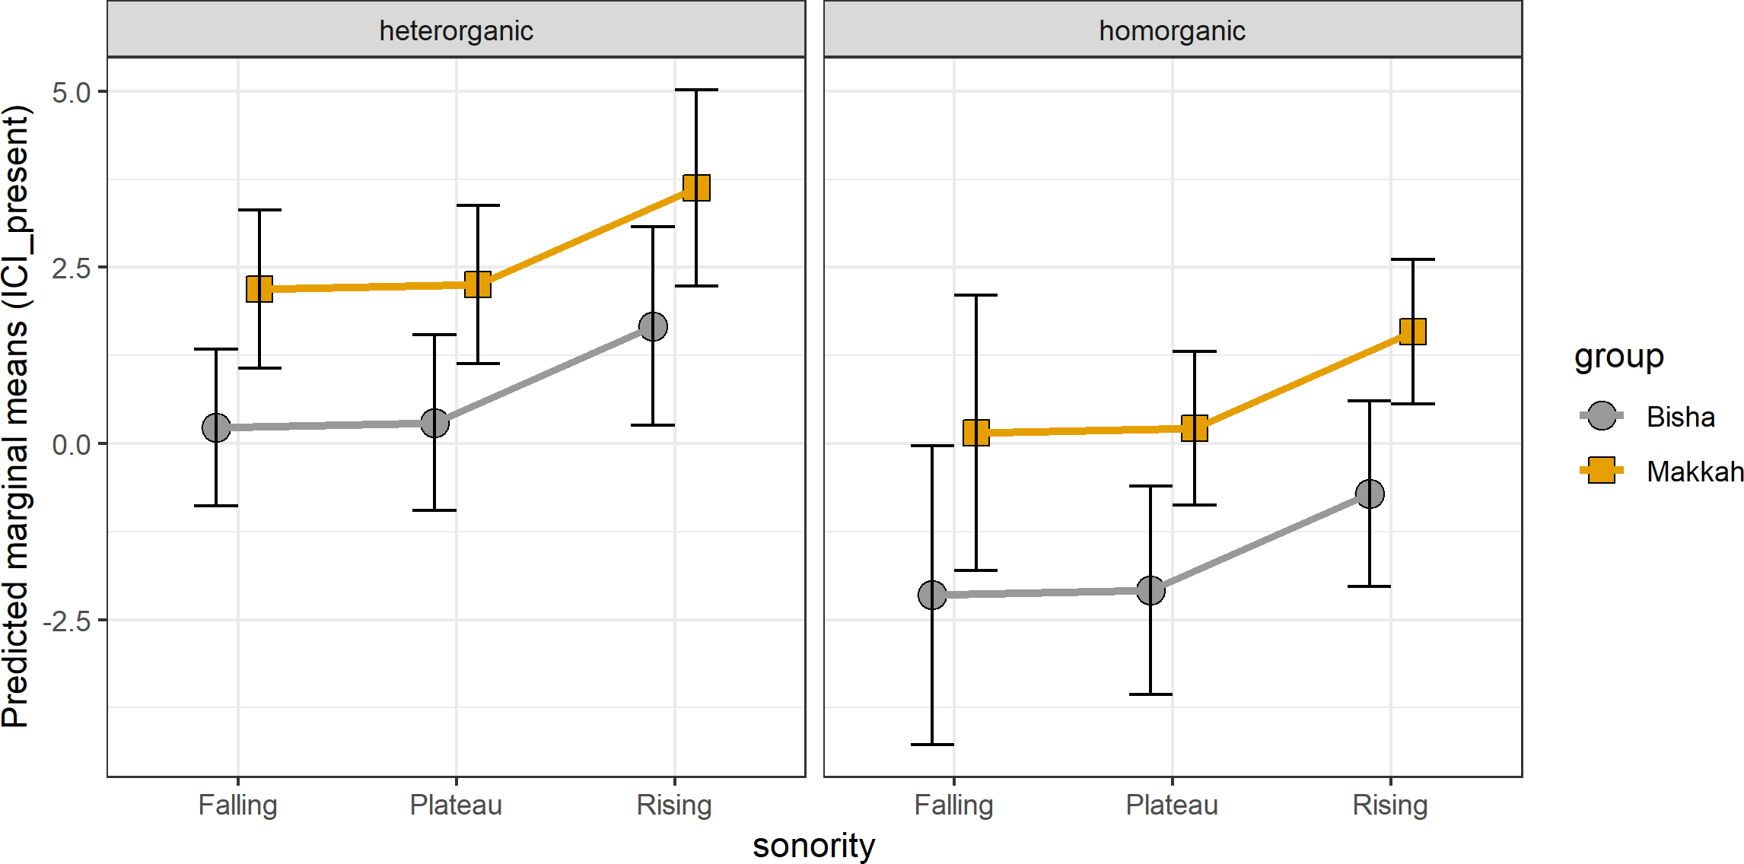
Figure 4. 5: Predicted marginal means (and 95% CI) for the binomial GLMM by sonority, place of articulation and group reported in Table 4.5.

The likelihood ratio test confirms the presented results in which place of articulation is a significant predictor of ICI rates for both dialects (χ² (5) = 21.13, p = 0.00076), lowering it by about 2.15, with SE = 0.42. In comparison with the former model presented in Figure 4.3, this finding shows that place of articulation is more influential than sonority constraints for the ICI rate, as illustrated in Figure 4.5. Additionally, this model supports analysis of ICIs as intrusive vowels in BA and MA because breaking up heterorganic clusters with an ICI is a diagnostic of intrusion.

Recall that two tasks were conducted to elicit subjects’ participation: (1) naming pictures and (2) reading sentences. In the first task, participants were presented with a visual prompt, showing some pictures using Qualtrics software, and they were asked to name those pictures. With respect to the reading sentence task, participants were asked to read the Arabic sentences presented in Qualtrics software. To test all possible factors that may affect ICI rate, the possible effect of experimental tasks will be statistically tested, as presented below in Figure 4.6.

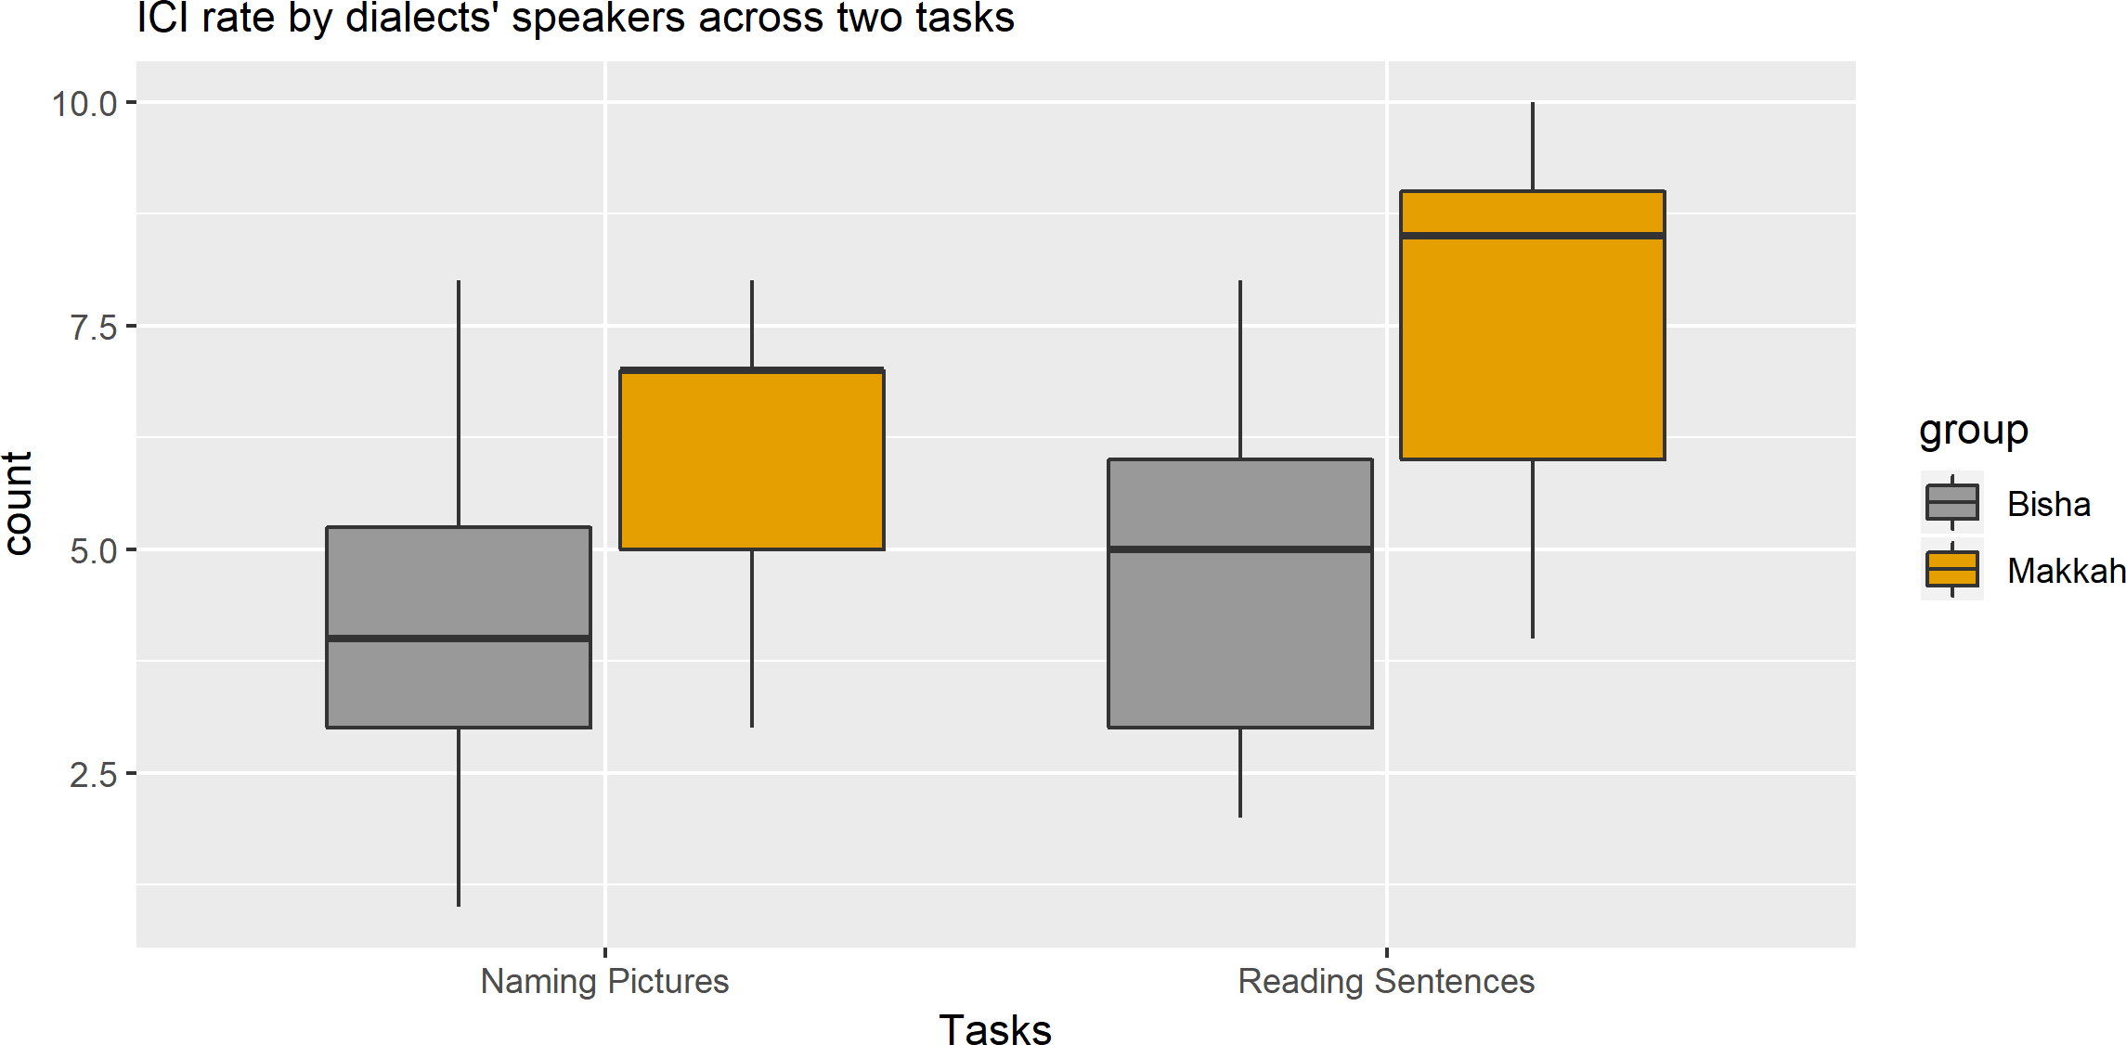
Figure 4. 6: Median and interquartile range for ICI insertion rate produced by BA and MA speakers in the word-initial consonant clusters across two experimental tasks.

As presented in Figure 4.6, experimental tasks show small differences between and within dialects. The figure reveals that there is a slight increase in the ICI rate in the reading sentences task between BA and MA and within each dialect likewise. However, when experimental task is statistically tested with other fixed effects like sonority and place of articulation, the impact of such tasks on ICI rate is not of itself significant, as will be statistically clarified below.

Table 4. 6: Mixed effects coefficients (predicting ICI rate with the fixed effects: dialect, sonority, experimental tasks and place of articulation) for the binomial GLMM model visualised in Figure 4.7.
 | Estimate | SE | z value | p value
Intercept | 0.09 | 0.40 | 0.22 | 0.82
Makkah dialect | 2.07 | 0.33 | 6.25 | 4.02e-10 ***
Homorganic clusters | -2.20 | 0.42 | -5.20 | 1.94e-07 ***
Task: read speech | 0.19 | 0.19 | 1.01 | 0.30
Plateau sonority | 0.17 | 0.59 | 0.03 | 0.97
Rising sonority | 1.44 | 0.62 | 2.29 | 0.02 *

The results obtained from the mixed effects model are summarised in Table 4.6 and visualised in Figure 4.7. The model reveals that experimental task plays no role in ICI rates. It also reveals that the outcomes of other fixed effects (i.e., dialect, sonority and place of articulation) are very similar to the model presented in Table 4.5 and Figure 4.5.
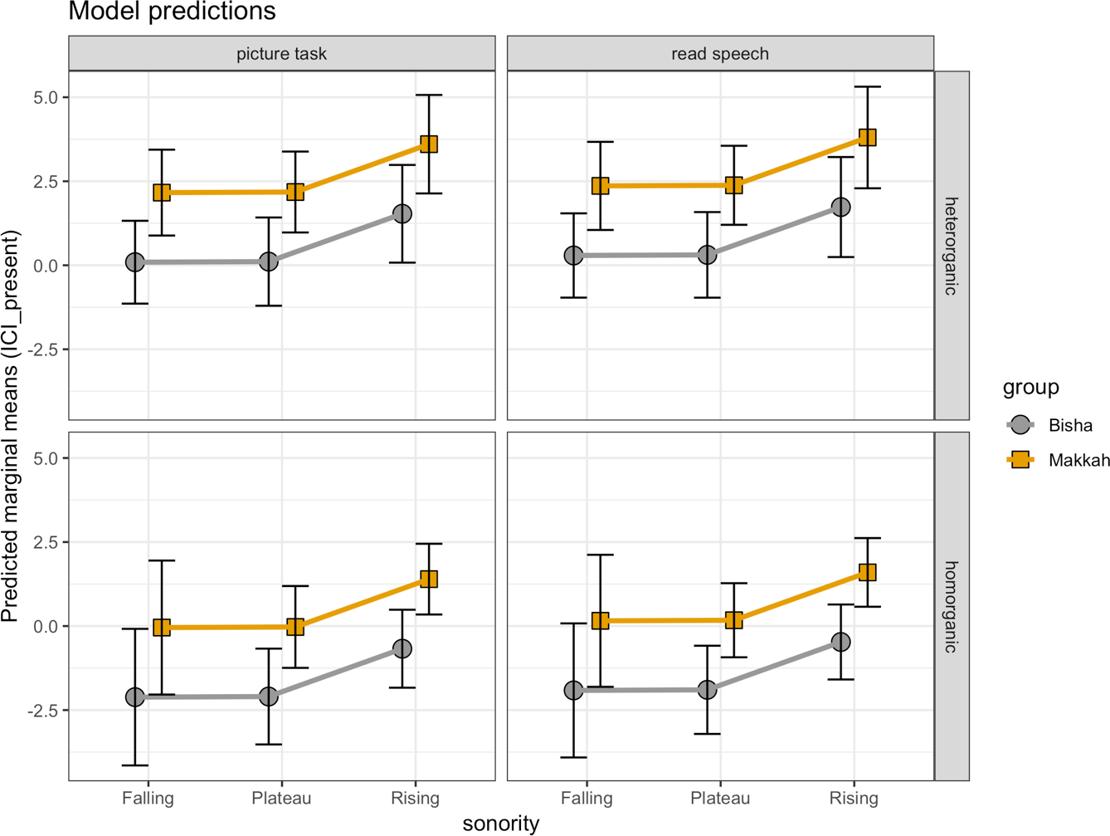
Figure 4. 7: Predicted marginal means (and 95% CI) for the binomial GLMM by sonority, tasks, place of articulation and group reported in Table 4.6.

To sum up all models presented above, the main conclusions are that i) the ICI rate in MA is higher than in BA, ii) clusters with rising sonority have significantly a higher rate of ICI, iii) place of articulation shows a significant effect on the rate of ICIs whereby heterorganic consonant clusters trigger higher ICI rates in both dialects in comparison with homorganic clusters, and finally iv) experimental task appear to have an effect on ICI rates in the descriptive plots; however, this effect disappears when other fixed effects are taken into account. The following section will shed light on the second diagnostic of intrusion versus epenthesis, which is the markedness status of modified clusters.

Diagnostics of ICIs: II) Markedness status of modified clusters
According to Hall (2006), intrusive ICIs seem to occur in less marked clusters, whereas epenthetic ICIs serve as a repair of marked clusters in terms of sonority constraints. Sonority is expected to increase from the syllable margins (onsets and codas) toward syllable peak (nucleus). Consonant clusters violating sonority constraints are described as marked clusters (Carlisle, 1997, 2001; Eckman, 1977; Eckman & Iverson, 1993; Greenberg, 1965; Parker, 2002, 2008, 2011). The markedness status of onset clusters is presented in Figure 4.8.

- less marked + more marked

rising sonority clusters plateau sonority clusters falling sonority clusters
(e.g., [drɪl] “drill”) (e.g., [steɪ] “stay”) (e.g., [rka:.lu] “they shout”)

Figure 4. 8: Markedness status of onset clusters in terms of sonority constraints.

To discuss the markedness status of modified clusters in the current study, the relevant results of the latest model visualised in Figure 4.7 and reported in Table 4.6 will be reiterated, as it shows the effect of sonority constraints. The model shows that ICI rate as a function of sonority is significantly higher in rising sonority clusters (e.g., [ɣla:f] “cover”) than of that in plateau (e.g., [ʒda:r] “wall”) and falling sonority clusters (e.g., [rxa:m] “marble”), even though rising sonority clusters are less marked than other types of clusters. This finding meets a diagnostic of intrusive ICIs. “The consonant clusters in which the vowel occurs may be less marked, in terms of sonority sequencing, than clusters which surface without vowel insertion in the same language” (Hall, 2006, p. 391).
In sum, ICIs that break up word-initial consonant clusters in BA and MA tend to be intrusive ICIs since they occur in less marked clusters in terms of sonority constraints. Having discussed the markedness status of modified clusters, the next section will shed light on the third diagnostic of epenthesis versus intrusion: vowel quality.

Diagnostics of ICIs: III) Vowels Quality
The second applicable diagnostic of ICI status is vowel quality. Intrusive vowels should be a schwa or a copy of the nearby vowel, whereas epenthetic vowels are not restricted to schwa (Hall, 2006). To determine the quality of the ICIs, a comparison between long vowels and short vowels in both dialects, BA and MA will be provided. The aim of including long vowels in this comparison is to provide a comprehensive vowel space of relevant vowels in BA and MA; hence, the quality of target ICIs (i.e., short vowels) will be easy to determine.

Aiming for comprehensive results, the comparable vowels will be presented with and without normalizing their formant values. The rationale behind normalization in this project is to “eliminate variation caused by physiological differences among speakers” and “to preserve sociolinguistic/dialectal/cross-linguistic differences in vowel quality” (Watt, Fabricius & Kendall, 2010:112). Although the demographic background of speakers was carefully controlled (see Chapter 3 for further details), this control does not remove the need to normalise target ICIs. Due to the high number of participants in the current project (51 speakers from two different dialects), it is worth normalizing their produced vowels to achieve the goals of normalization mentioned above. The applied technique of vowel normalization is Lobanov’s technique (1971), since it applies z-score transformation without any other linguistic prerequisites. Also, it has been identified as the best technique among three comparable techniques which are: Lobanov, Nearey1 and Gerstman (Adank, Smits & van Hout 2004) (see Chapter 3 for further details).

Since “ggplot2” (an R package) provides informative and attractive plots, vowel plots will be presented using this package in addition to the required packages to normalize formant values: “vowels”, “phonR” and “phonTools” (Barlaz, 2019).

The presentation of vowel quality is ordered as follows: 1) long vowels with and without normalization, 2) short vowels with and without normalization, and finally 3) a general summary of all findings.

Long vowels
In the following results, normalized and non-normalized formant values of long vowels [i:] and [u:] will be presented. If any degree of overlap exists, Pillai scores will be applied to test such overlap. Finally, a general summary of these findings will be initiated.
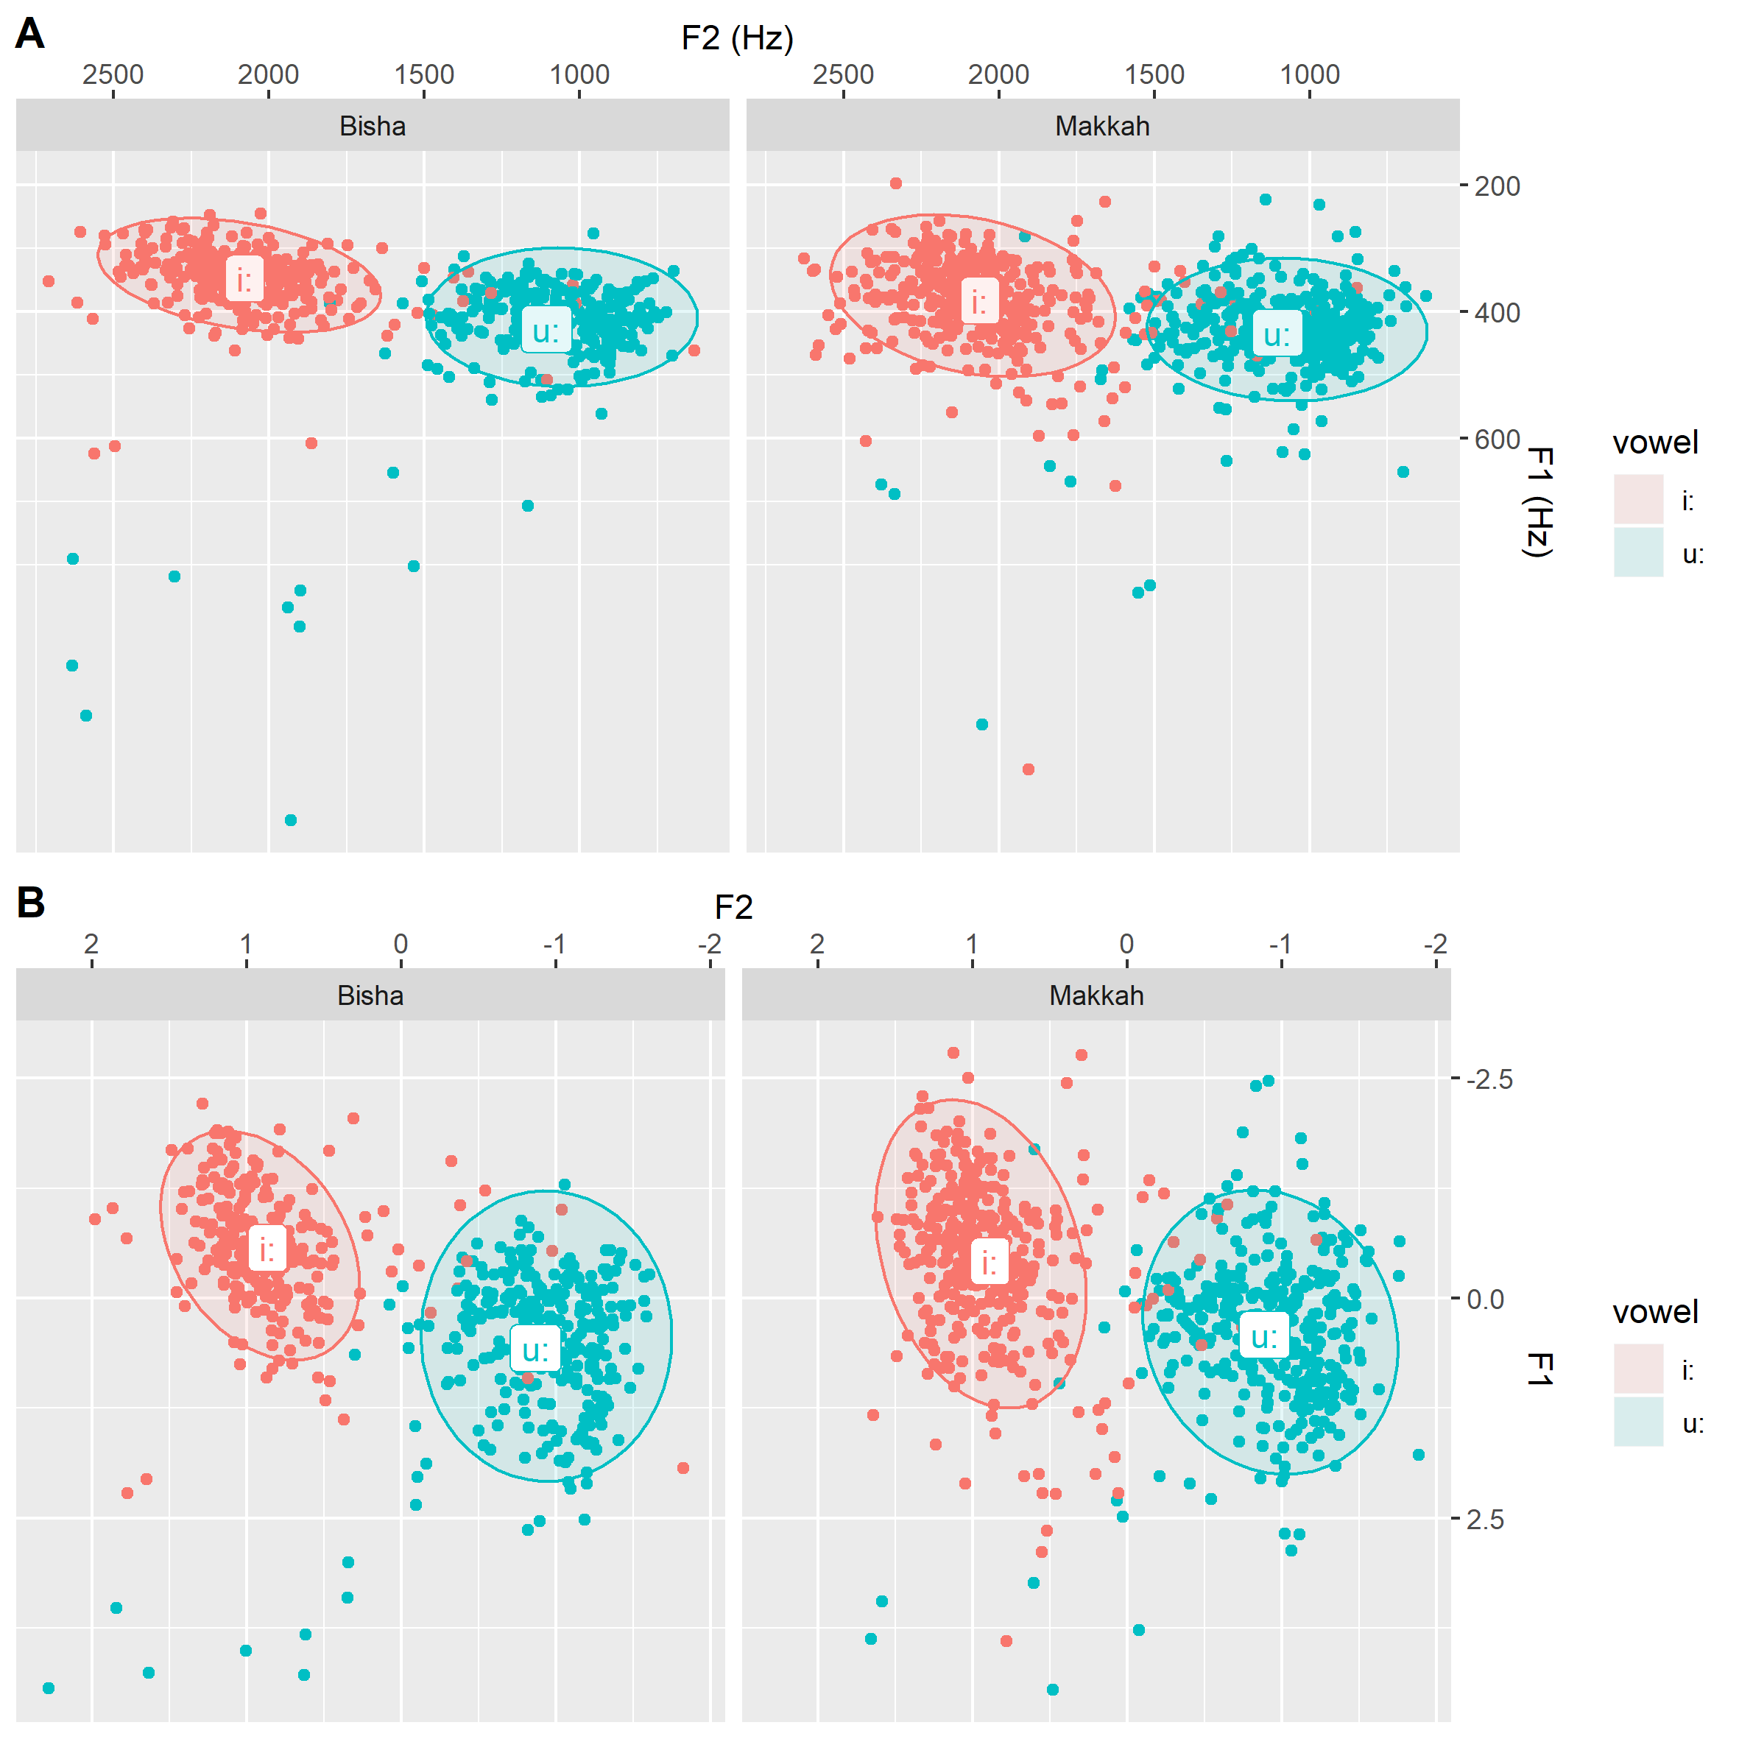

Figure 4. 9: Grand mean and ellipses (level= 95%) of F1 and F2 values for long vowels in BA and MA. A refers to non-normalized vowels and B refers to normalized vowels.

Table 4. 7: Grand mean and standard error of F1 and F2 values for long vowels in BA and MA.
Vowel | Group | Mean_F1 | Mean_F2 | Se_F1 | Se_F2
i: | Bisha | 348 | 2076 | 2.96 | 15.23
i: | Makkah | 383 | 2060 | 3.80 | 12.86
u: | Bisha | 428 | 1106 | 6.13 | 16.47
u: | Makkah | 433 | 1103 | 3.85 | 12.17

In Figure 4.9, it is apparent that there are two long vowels: i) front vowel [i:] and back vowel [u:]. The degree of overlap between these vowels seems to be very low, as depicted in Figure 4.9. This is attributed to the big difference between the formant values of the target vowels, as shown in Table 4.7. Interestingly, both plots (A and B) share the same tendency of separation between target vowels, which indicates that normalization process is not influential in this respect. Dialects (BA and MA) seem to play no role in F2 values since the difference between the target dialects is fairly small and it is expected to be not significant. Regarding F1 values, there is a noticeable difference between [i:] and [u:], as shown in Figure 4.9 and Table 4.7 in which the front vowel [i:] has smaller F1 values than of that in the back vowel [u:]. This difference is consistent across dialects although the F1 of the vowel [i:] in MA (~ 383 Hz) is slightly higher than [i:] in BA (~ 348 Hz). To test this expectation and the overlap degree between these vowels, Pillai scores will be calculated using a Manova test in R.
Manova test was run to test the degree of overlap between the long vowels [i:] and [u:] in BA and MA. The model suggests that these vowels (i.e. [i:], [u:]) are almost separated since the Pillai score is 0.80, which indicates the very low degree of overlap, as shown in Table 4.8 and Figure 4.9.

Table 4. 8: Manova test results of the degree of overlap between long vowels [i:] – [u:] in BA and MA.
 | Pillai score | Pr(>F)
Vowel | 0.80312 | < 2.2e-16 ***

To sum, Figure 4.9 and Table 4.7 show that i) long vowels [i:] and [u:] exist in BA and MA, ii) BA and MA are fairly similar in respect of F1 and F2 values of these vowels, iii) a Manova test suggests that these vowels are almost separated, since the Pillai score is 0.80 as shown in Table 4.8, and finally iv) normalized and non-normalized formants of long vowels share the same findings mentioned above. Having discussed the quality of long vowels in BA and MA, the next section addresses the quality of short vowels to end up with a comprehensible vowel space in BA and MA.

Short vowels
Results for short vowels will be presented following the same procedures applied in the long vowels section showing formants of short vowels with and without normalization. As shown in Figure 4.10, there is no big difference between normalized and non-normalized vowels in BA and MA. The figure also indicates that there is a considerable overlap between the target vowels [i, u] that break up consonant clusters. The degree of overlap between these vowels in BA is slightly higher than of that in MA. F1 values of the first vowel [i] are to some extent similar to F1 values of the second vowel [u]. This similarity is consistent across dialects (BA and MA), as summarized in Table 4.9. With regard to F2 values, Table 4.9 indicates that F2 values of the vowel [i] are higher than of that in the second vowel [u]. This finding is noticeable across the two dialects: BA and MA.
Table 4. 9: Grand mean and SE of F1 and F2 values for short vowels (ICIs) breaking up word-initial consonant clusters in BA and MA.
Vowel | Group | Mean_F1 | Mean_F2 | Se_F1 | Se_F2
[i] | Bisha | 464 | 1657 | 12.28 | 26.50
[i] | Makkah | 445 | 1744 | 8.46 | 16.72
[u] | Bisha | 499 | 1409 | 10.22 | 32.82
[u] | Makkah | 504 | 1370 | 6.44 | 23.16

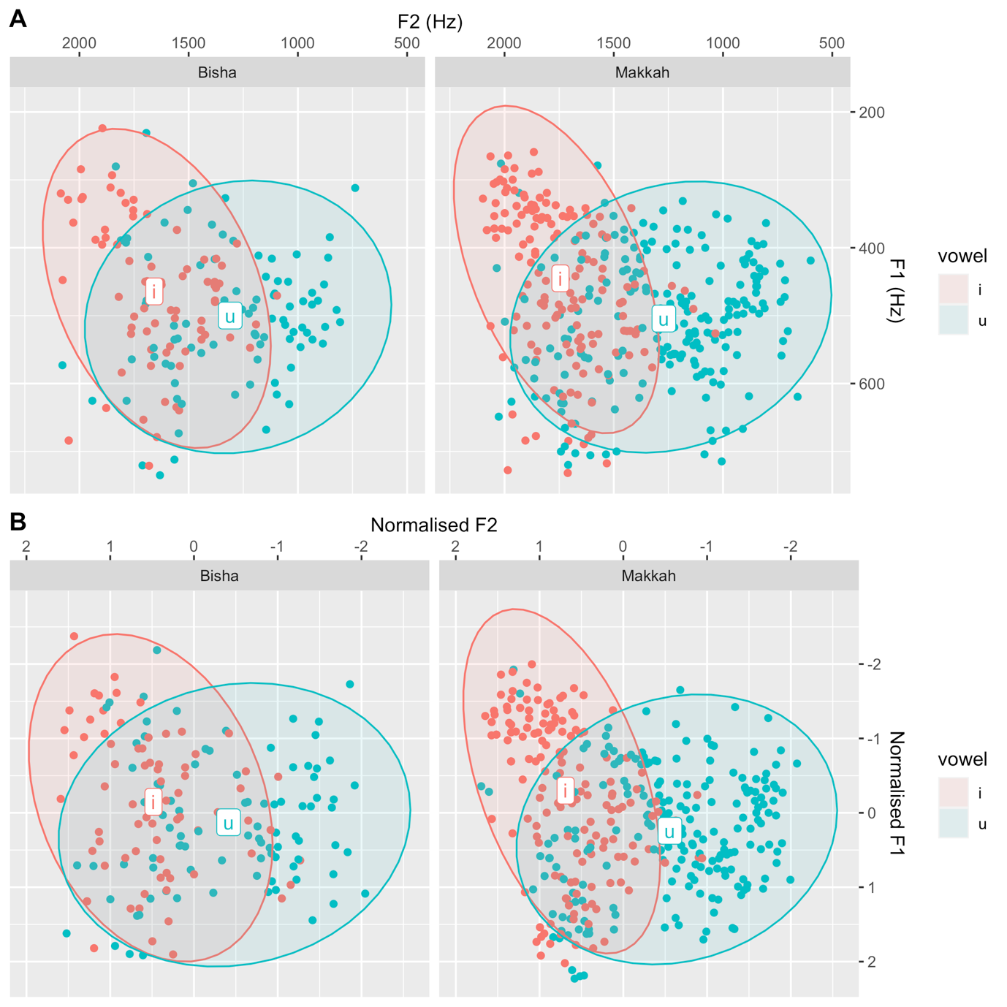
Figure 4. 10: Grand mean and ellipses (level= 95%) of F1 and F2 values for short vowels (ICIs) breaking up word-initial clusters in BA and MA. A refers to non-normalized vowels and B refers to normalized vowels.
To test degree of overlap between these vowels depicted in Figure 4.10, Pillai scores will be calculated using the Manova test in R. As summarized in Table 4.10, the results of the Manova test suggest that there is a high degree of overlap between the vowels [i] and [u] that break consonant clusters in the word-initial position in BA and MA. Pillai score testing the degree of overlap between these vowels is about 0.38, which, in turn, indicates the high degree of overlap between the target vowels as shown in Figure 4.11.
Table 4. 10: Manova test results of the degree of overlap between short vowels “i” and “u” in BA and MA.
 | Pillai score | Pr(>F)
Vowel | 0.38 | < 2.2e-16 ***

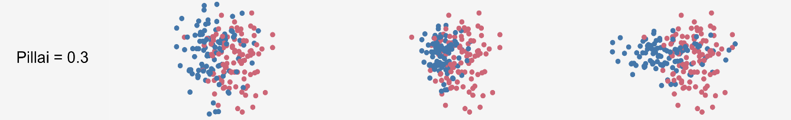
Figure 4. 11: An example of 0.3 Pillai score extracted from Joey Stanley tutorial in measuring vowel overlap in R. “The value ranges from 0 to 1, with values closer to 0 indicating more overlap while values closer to 1 mean complete separation” (Stanley, 2019).

To sum, i) the rounded F1 values of all short vowels range between about 400 Hz to 500 Hz, ii) the rounded F2 values of the same vowels range between 1400 Hz to 1700 Hz iii) Pillai scores suggest that there is a high degree of overlap between [i] and [u].
It is worth mentioning that the normalization process seems to play no role in determining the degree of overlap between target vowels whether they are long or short vowels. This might be attributed to the fact that the gender, age and dialects of the current research’s participants were carefully controlled. Therefore, normalized vowels will be excluded from any further analysis.
Having separately discussed both types of vowels (i.e., short and long vowels) the main goal of this discussion is to compare both types of vowels to end up with a suggested quality of short vowels that break up consonant clusters in word-initial position in BA and MA. In what follows, a single plot of long and short vowels will be provided to determine the quality of each single short vowel.
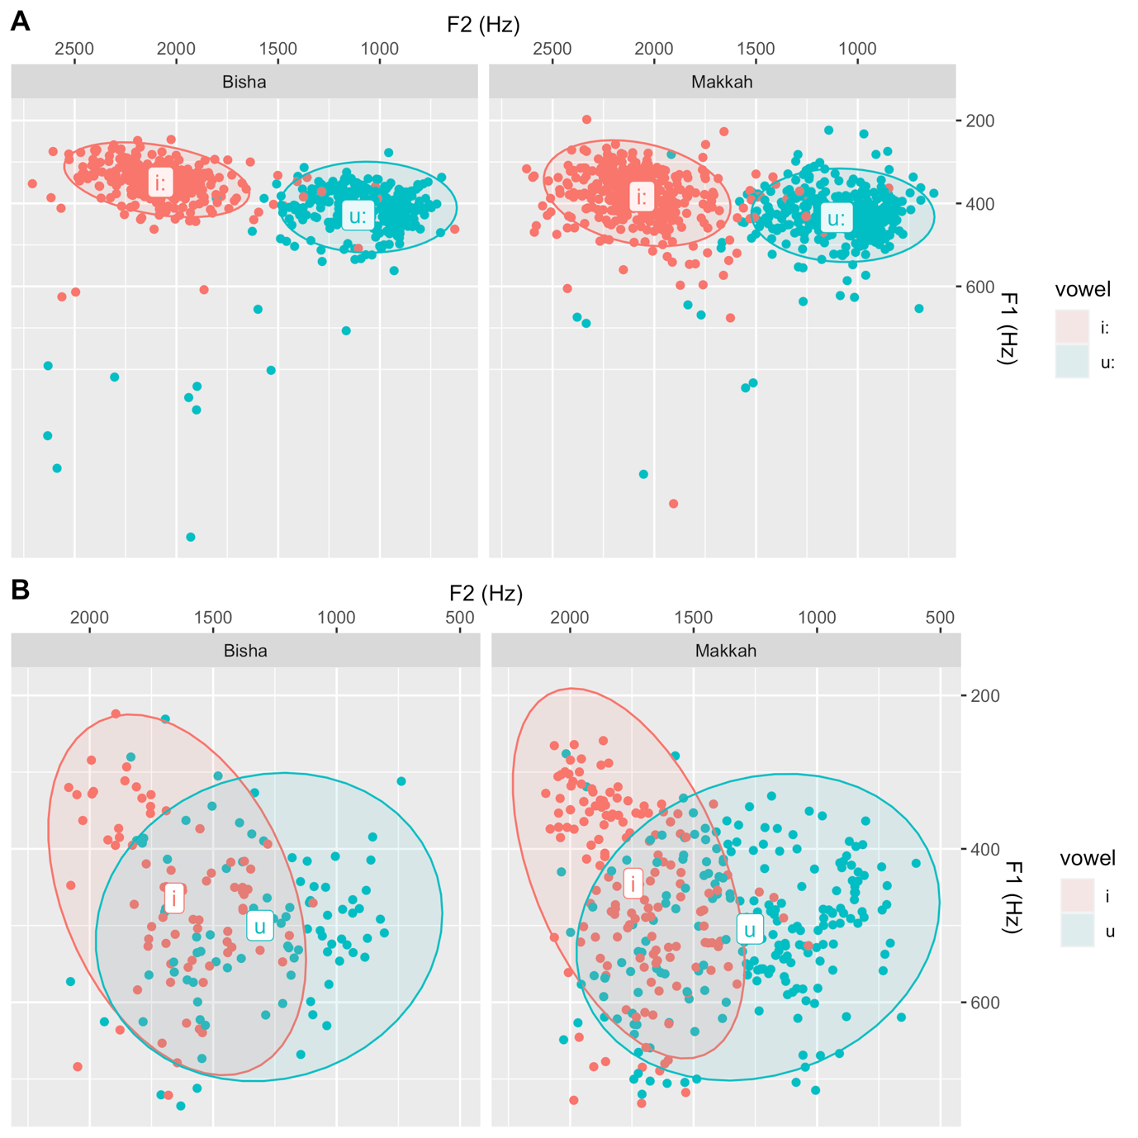

Figure 4. 12: Grand mean and ellipses (level= 95%) of F1 and F2 values for long and short vowels (ICIs) breaking up word initial consonant clusters in BA and MA.
Figure 4.12 provides a general summary of non-normalized formants of long and short vowels in BA and MA. First, there is a clear separation between the long front vowel [i:] and the back one [u:], indicating a very low degree of overlap between them, which is statistically shown using a Manova test (Pillai score ~ 0.80). In contrast, there is a clear overlap between short vowels (ICIs) in the word-initial position [i, u], which is statistically shown using a Manova test (Pillai score ~ 0.38). Second, the target dialects (BA and MA) are fairly similar in terms of formant values and the degree of overlap between vowels irrespective of vowel length.
Based on the summary mentioned above, I claim that the short vowels, namely [i] and [u], behave as schwa-like vowels since they feature schwa-like characteristics. These characteristics are summarized in what follows, in addition to the application of such features to the short vowels in this research. First, it is apparent and statistically shown that long vowels show a clear separation between the two qualities, whereas short vowels to a greater extent exhibit overlap. This overlap in short vowels is very similar to English schwa in word-internal context. Formant values of non-final reduced schwa in English are roughly high and variable, as depicted in Figure 4.13 (Flemming & Johnson, 2007). Second, Flemming (2009) states that schwa is restricted to unstressed syllables. This feature is applicable to [i] and [u] since all of them are restricted to unstressed syllables in the initial position in BA and MA. Third, schwa is subject to syncope processes, as in Hindi and Dutch (cf. Booij, 1995; Ohala, 1983). Similarly, [i] and [u] often undergo deletion by BA and MA speakers, as discussed earlier in this chapter. Based on this justification, I claim that [i] and [u] behave as schwa-like vowels.
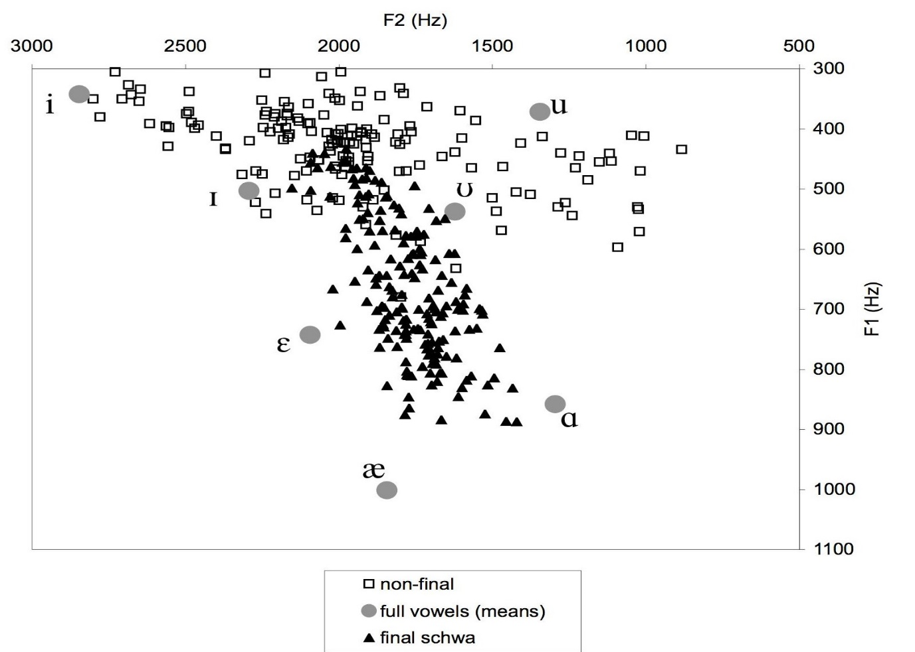
Figure 4. 13: Formant values of English schwa in word-internal and word-final positions (Flemming, 2009, p. 3)

Having discussed vowel quality of such ICIs that break up word-initial consonant clusters in BA and MA, in what follows is an interim summary of ICIs in BA and MA.

Interim summary of ICIs in word-initial consonant clusters in BA and MA
In conclusion, this portion of the current experiment presents the results of word-initial consonant clusters and their ICIs. The question of experiment 1 was directed to an examination of a) the existence of consonant clusters, including ones in initial position in both BA and MA dialects (i.e., presence versus absence of consonant clusters) and b) the status of ICIs used to break up such clusters (i.e., epenthesis versus intrusion). The results were obtained from a quantitative analysis including descriptive figures (boxplots) and inferential analysis (mixed effects models). The results indicate that BA allows word-initial consonant clusters more often than MA. For ICIs diagnostics, they meet the diagnostics of intrusive ICIs, as presented below in Table 4.13.
Table 4. 11: A summary of diagnostics of ICIs breaking up word-initial clusters in BA and MA.
Diagnostics of intrusive ICIs | Fulfilment of intrusion diagnostics for ICIs breaking word-initial clusters in BA and MA.
They occur in less marked clusters in terms of sonority sequencing. | √
They occur in heterorganic clusters. | √
They are schwa-like. | √
They are variable in duration. | √

These crucial results provide evidence that ICIs in BA and MA behave as intrusive vowels because they fulfil the diagnostics of intrusion. Therefore, the three main conclusions that may be obtained from this experiment are:
- BA allows word-initial consonant clusters significantly more than MA, but both dialects display ICIs in word-initial position.
- The employed ICIs that break up word-initial consonant clusters in BA and MA behave like intrusive vowels because they fulfil the diagnostics of intrusion.
- As a result of (a) and (b), BA and MA are likely to have underlying consonant clusters because the employed ICIs (i.e., intrusive vowels) do not serve as syllable nuclei, which in turn, suggests that the two consonants form a cluster in line with the reviewed literature in Chapter 2.

Word-medial Consonant Clusters
The question of experiment 1 was directed to an examination of a) the existence of consonant clusters including medial position in both BA and MA dialects (i.e., presence versus absence of consonant clusters) and b) the status of ICIs used to break up such clusters (i.e., epenthesis versus intrusion). In this portion of the experiment, stimuli to test medial consonant clusters were designed as a replication of stimuli employed in prior studies (Broselow 1992 among others). The most commonly used example in older studies that discuss medial clusters in Arabic is [gultlih] “I said to him”. Table 4.14 shows how Arabic dialects vary in their realization of such medial consonant clusters.
Table 4. 12: Examples of medial clusters in some Arabic dialects.
cluster | Moroccan | Cairene | Iraqi | Gloss
-[CCC]- | ɡəltlu  [CCC] | ɡultilu  [CCvC] | ɡəlitlu  [CvCC] | I said to him

It is apparent that some Arabic dialects have medial consonant clusters with three constituents [CCC], as in Moroccan Arabic, whereas other dialects break up such clusters with epenthesis, resulting in clusters with two consonants [CC] only. Additionally, the site of epenthesis is different among dialects, as in Iraqi and Cairene Arabic, as mentioned earlier in Chapter 2. Therefore, the target dialects of the current study (BA and MA) will be investigated to identify whether the cluster [CCC] is maintained without modification or broken up with an ICI ([CCvC] or [CvCC]). Also, the status of the employed ICI (epenthesis vs intrusion) will be investigated.

Cluster size of medial consonants in BA and MA
Figure 4.15 and Table 4.15 show that BA and MA have the same median of ICI rate across speakers, as the median of the boxplot is 5 for both dialects, which suggests in turn that both dialects have a high rate of ICI, although insertion in word-medial clusters in BA shows some variation. The only epenthesis site to break up word-medial clusters in BA and MA is [CCvC] (e.g., [ɡultilu] “I said to him]). Other epenthesis sites such as [CvCC] are absent in BA and MA. Based on these frequencies, it is expected that a mixed effects model will show no significant differences between the target dialects, which will be discussed below.
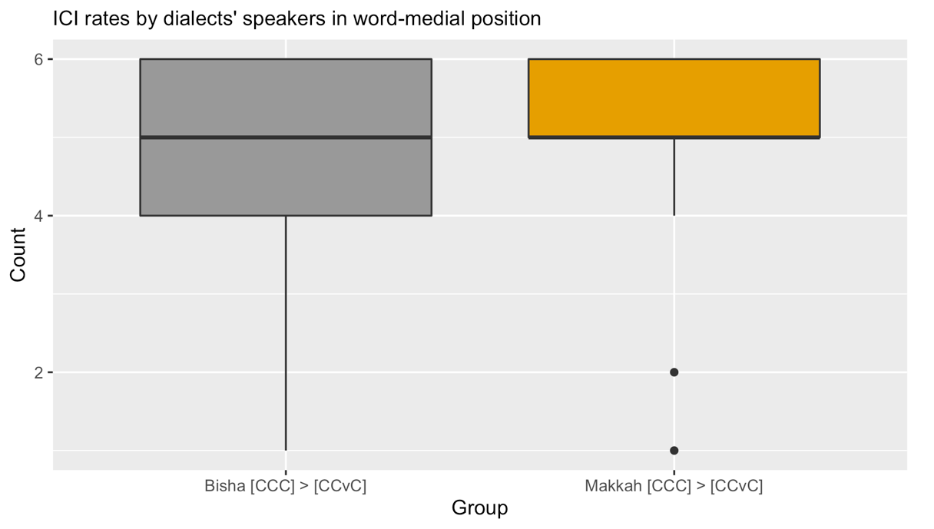
Figure 4. 15: Median and interquartile range for ICI insertion rate produced by BA and MA speakers in the word-medial consonant clusters.

Table 4. 13: percentage of produced ICI breaking up word-medial clusters in BA and MA.
Dialect | % of ICI rate
BA |  | 80 %
MA |  | 87 %

The results obtained from the mixed-effects model are summarised in Table 4.16 and visualised in Figure 4.16. The model shows no significant differences between the dialects (SE = 0.83, z = 1.15, p = 0.24), which, in turn, suggests that both dialects have the same ICI rate in the medial position.

Table 4. 14: Mixed effects coefficients (predicting ICI rate with the fixed effects: dialect) for the binomial GLMM model visualised in Figure 4.16.
 | Estimate | SE | z value | p value
Intercept | 2.28 | 0.66 | 3.44 | 0.0005 ***
Makkah dialect | 0.97 | 0.83 | 1.15 | 0.24

It is noticeable that the intercept of the current model shows high significance, which means that the ICI rate in BA is significantly different from zero. Interestingly, this significant result indicates that the high rate of ICI in MA is even higher, because the estimate of ICI in MA is higher than that in BA by 0.97. Consequently, both dialects show ICI of highly significant rates.

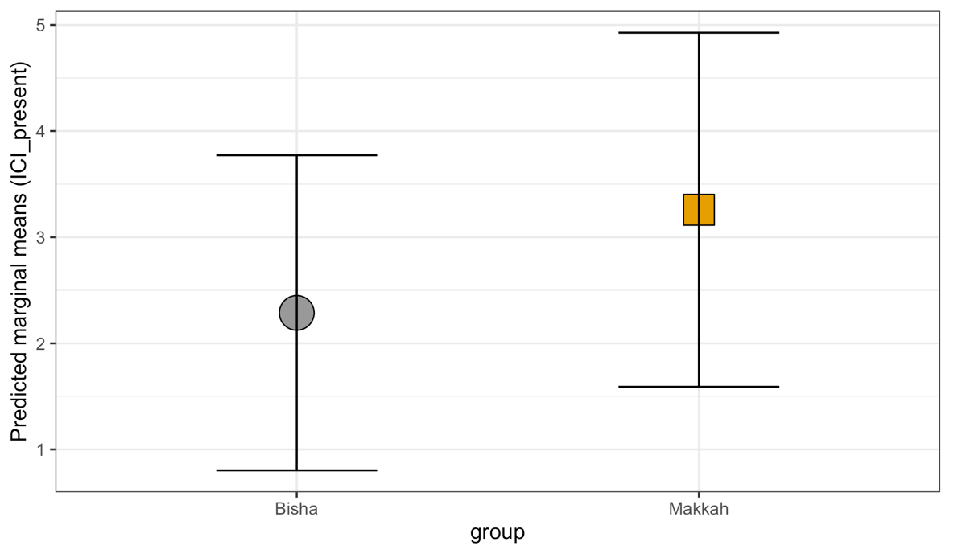
Figure 4. 16: Predicted marginal means (and 95% CI) for the binomial GLMM by group.

In sum, the model shows that BA and MA have medial clusters that are broken up to a significant extent, with an ICI resulting in [CCC] ~ [CCvC] /ɡultilih/ “I said to him”. The status of the employed ICI in such clusters is investigated below using the same techniques used in word-initial position.

Diagnostics of ICIs in word-medial consonant clusters BA and MA: I) The effect of place of articulation
Intrusive vowels generally occur in heterorganic clusters, but epenthetic vowels are not affected by the place of articulation of consonants to some extent (Hall, 2006). All tested word-medial clusters in the current experiment consist of three consonants [CCC] (e.g., [ɡultilu] “I said to him]). As discussed in the previous section, ICI insertion to break up medial clusters in BA and MA occurs to a significant extent between the second and the third consonants [C₁C₂VC₃] (e.g., [ɡultilu] “I said to him]). The site of ICI insertion suggests that the relevant consonants that should be tested in terms of place of articulation as a diagnostic of ICI contrast (i.e., intrusion versus epenthesis) are the second and the third consonants, since the ICI occurs between them. However, the tested word-medial stimuli in the current experiment do not vary in terms of place of articulation, since all relevant clusters are homorganic clusters (e.g., [tl] (alveolar) in [ɡultilu] “I said to him]). If ICIs break up the homorganic clusters [tl] in the current experiment, this suggests that the inserted ICIs in such clusters are not intrusive ICIs, as these do not occur in homorganic clusters. If not, the alternative conclusion is that the inserted ICIs are epenthetic ICIs, as they are not affected by place of articulation, meaning that they occur in homorganic and heterorganic clusters. This hypothesis is discussed below.

Based on Figure 4.16 and the mixed effects model reported above in Table 4.16, it is apparent that medial consonant clusters in BA and MA are broken up with ICIs at highly significant rates. These clusters are homorganic clusters, as discussed earlier, which in turn suggests that the employed ICIs in such clusters are epenthetic ICIs, because they are not affected by place of articulation. Other diagnostics may confirm this expectation, such as the markedness status of modified clusters, which will be discussed below.

Diagnostics of ICIs in word-medial clusters in BA and MA: II) markedness status of modified clusters
The second diagnostic of intrusive versus epenthetic ICIs is that intrusive ICIs are phonetic transitions that occur in less marked clusters, whereas epenthetic ICIs occur as a repair of marked clusters that are illicit in a target language (Hall, 2006). The reviewed literature in Chapter 2 indicates that word-medial clusters consisting of three consonants [-CCC-] are marked in many Arabic dialects such as Cairene and Iraqi Arabic in spite of being the site of vowel insertion (Broselow, 1992; Kiparsky, 2003; Watson, 2007). The results of the current experiment are line with dialects that do not allow word-medial clusters, since such clusters in BA and MA are broken with ICIs [-CCC] > [CCvC] (e.g., [ɡultilu] “I said to him]). This finding meets a diagnostic of epenthetic ICIs since they occur to modify marked clusters, which is applicable to the results for word-medial clusters in BA and MA. In conclusion, word-medial clusters comprising three consonants [CCC] are marked in BA and MA. The ICIs employed to modify such marked clusters are epenthetic ICIs.

Diagnostics of ICIs in word-medial clusters in BA and MA: III) Vowel quality
The second applicable diagnostic of ICIs is vowel quality. Intrusive vowels should be a schwa or a copy of the nearby vowel, whereas epenthetic vowels are not restricted to schwa (Hall, 2006). After plotting the results for word-initial position, the same techniques will be used for medial position. It is worth mentioning that long vowels and short vowels in the initial position will be plotted in addition to word-medial vowels for the sake of comparison and to obtain more comprehensive results.

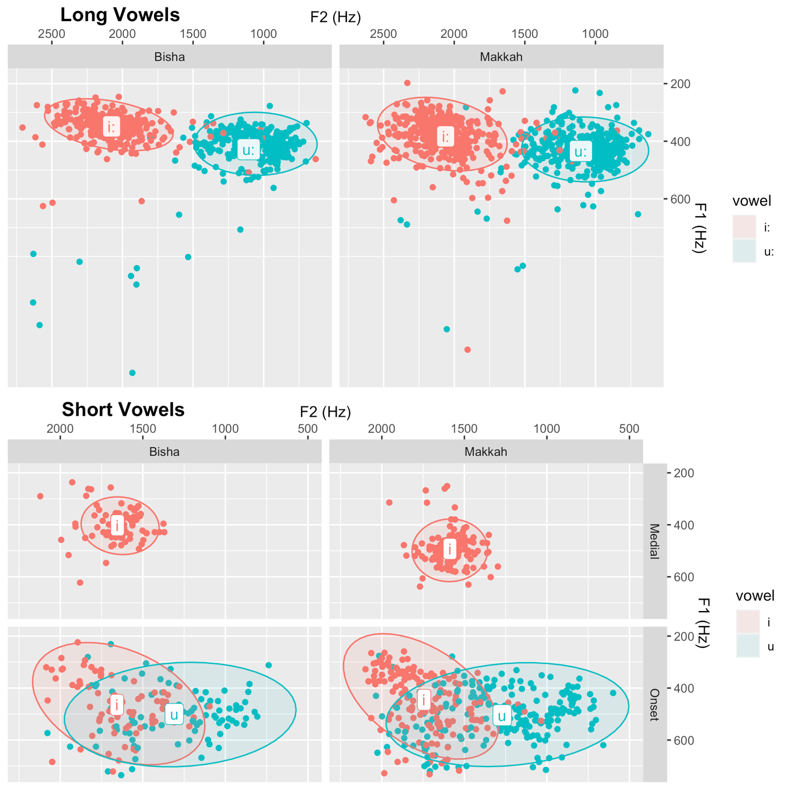
Figure 4. 17: Grand mean and ellipses (level= 95%) of F1 and F2 values for long and short vowels in BA and MA.
Figure 4.17 and Table 4.17 indicate that the vowel [i] employed to break up medial consonant clusters in BA and MA are similar in terms of formant values. For F1 values, the grand mean for BA is about 400 Hz and 490 in MA. The values of F2 are 1650 Hz in BA and 1580 in MA. It is noticeable that the differences between the two dialects are minor and the vowels’ formants fall in the frequency range of the formants of schwa. Therefore, I claim that the employed ICIs in medial consonant clusters in BA and MA are schwa-like. This result does not confirm that these ICIs behave as epenthetic vowels; however, neither does it contradict the expectation of having epenthesis in the target dialect because the diagnostic of epenthesis in terms of vowel quality is as follows:
“The vowel’s quality may be fixed or copied from a neighbouring vowel. A fixed-quality epenthetic vowel does not have to be schwa” (Hall, 2006, p. 391).
This means that ICIs that behave as epenthetic vowels could be schwas, but they could be also any other vowels. It might be claimed that these ICIs are intrusive vowels because they are schwa-like; however, this claim is rejected because these ICIs are not affected by place of articulation, as mentioned earlier, and this is an obvious diagnosis of epenthesis rather than intrusion.
Table 4. 15: Grand mean and standard deviation of F1 and F2 values for word-medial vowels in BA and MA.
Vowel | Group | Position | Mean_F1 | Mean_F2 | Se_F1 | Se_F2
[i] | Bisha | word-medial | 401 | 1653 | 6.22 | 13.48
[i] | Makkah | word-medial | 492 | 1587 | 5.87 | 9.99

It is worth mentioning that prior studies show that the ICI employed to break up word-medial clusters in MA is the low vowel [a] (Abu-Mansour, 1991; Kabrah, 2004). However, as discussed earlier, the current empirical study shows a different vowel quality is found in these situations, the high vowel [ə]. During the data collection stage of this PhD thesis, I had the opportunity to chat with some of MA speakers who had participated in the research. I asked them about my observation regarding their shift from [a] to [ə]. Their response was that it is “shameful” to speak like older MA speakers. They challenged me to find a single MA-speaking youth who says [ɡultalu] “I said to him]).

In conclusion, there are two diagnostics that indicate the employment of epenthetic ICIs to break up word-medial consonant clusters in BA and MA, which are: (i) place of articulation (ICIs occur in homorganic clusters), and (ii) markedness status of modified clusters (medial clusters in BA and MA [CCC] are described as marked clusters). Other diagnostics such as speech rate is not applicable to the current experiment, since normal speech rate is the only rate tested in the experiment.

Interim Summary
This portion of the current experiment presents the results of word-medial consonant clusters and their ICIs. It aims to examine: a) the incidence of word-medial consonant clusters in BA and MA dialects (i.e. presence versus absence of consonant clusters) and b) the status of ICI used to break up such clusters (i.e. epenthesis versus intrusion). The results were obtained based on a quantitative analysis including descriptive figures (boxplots) and inferential analysis (mixed effects models). The results indicate that medial clusters [CCC] in BA and MA are broken up with ICIs [CCvC] at highly significant rates. The applicable diagnostics of employed ICIs suggest that these ICIs behave as epenthetic vowels because (i) they are not affected by the place of articulation of the target clusters, and (ii) they occur in marked clusters which are diagnostics of epenthesis.
So far, this chapter has focused on word-initial and -medial consonant clusters in BA and MA. The last part of this chapter turns its attention to word-final consonant clusters.

Word-final Consonant Clusters
The aim of this section is to examine (i) the existence of consonant clusters including final position in both BA and MA dialects (i.e. presence versus absence of consonant clusters) and b) the status of ICI used to break up such clusters (i.e. epenthesis versus intrusion). A total of 18 tokens were used to test CC# by considering two independent variables to design the stimuli: cluster size and sonority constraints. The cluster size was limited to two constituents CC# (e.g. [kanz] “treasure”) because #CCCs are not permitted in Arabic apart from some dialects spoken in north Africa (e.g. Moroccan). The second variable, which is sonority slope, has three levels: rising (e.g. [baħar] “sea”), falling (e.g. [kanz] “treasure”) and plateau sonority (e.g. [kabd] “liver”).
A summary of results based on these variables is provided below, discussing the aims of the current experiment: 1) presence versus absence of consonant clusters, and 2) status of present ICIs (i.e. epenthesis versus intrusion).

Incidence of word-final consonant clusters in BA and MA (presence versus absence of consonant clusters)
Table 18 and Figure 4.18 show that both dialects adhere to sonority constraints. In particular, the figure indicates a high rate of ICI in consonant clusters with rising sonority (e.g. [baħar] “sea”) and a dramatic reduction in the ICI rate in consonant clusters with plateau sonority (e.g. [kabd] “liver”), as the median of the boxplot (i.e. count of ICI) dramatically declines from about 12 to 3. Table 18 indicates the complete absence of ICIs in consonant clusters with falling sonority (e.g. [kanz] “treasure”). Therefore, the latter type of clusters will be excluded from any further analysis, since the inclusion of such absent clusters would cause convergence issues in GLMM analysis. In conclusion, the Table 4.18 and Figure 4.18 suggest that both dialects obey sonority constraints. It is apparent that there are no noticeable differences between dialects, which will be statistically investigated below.
Table 4. 16: Percentage of inserted ICIs by BA and MA in word-final position.
Dialect | % of overall ICIs | % of inserted ICIs according to sonority slope
Dialect | % of overall ICIs | Falling | Plateau | Falling
BA | 45 | 0 | 38 | 96
MA | 49 | 0 | 50 | 98

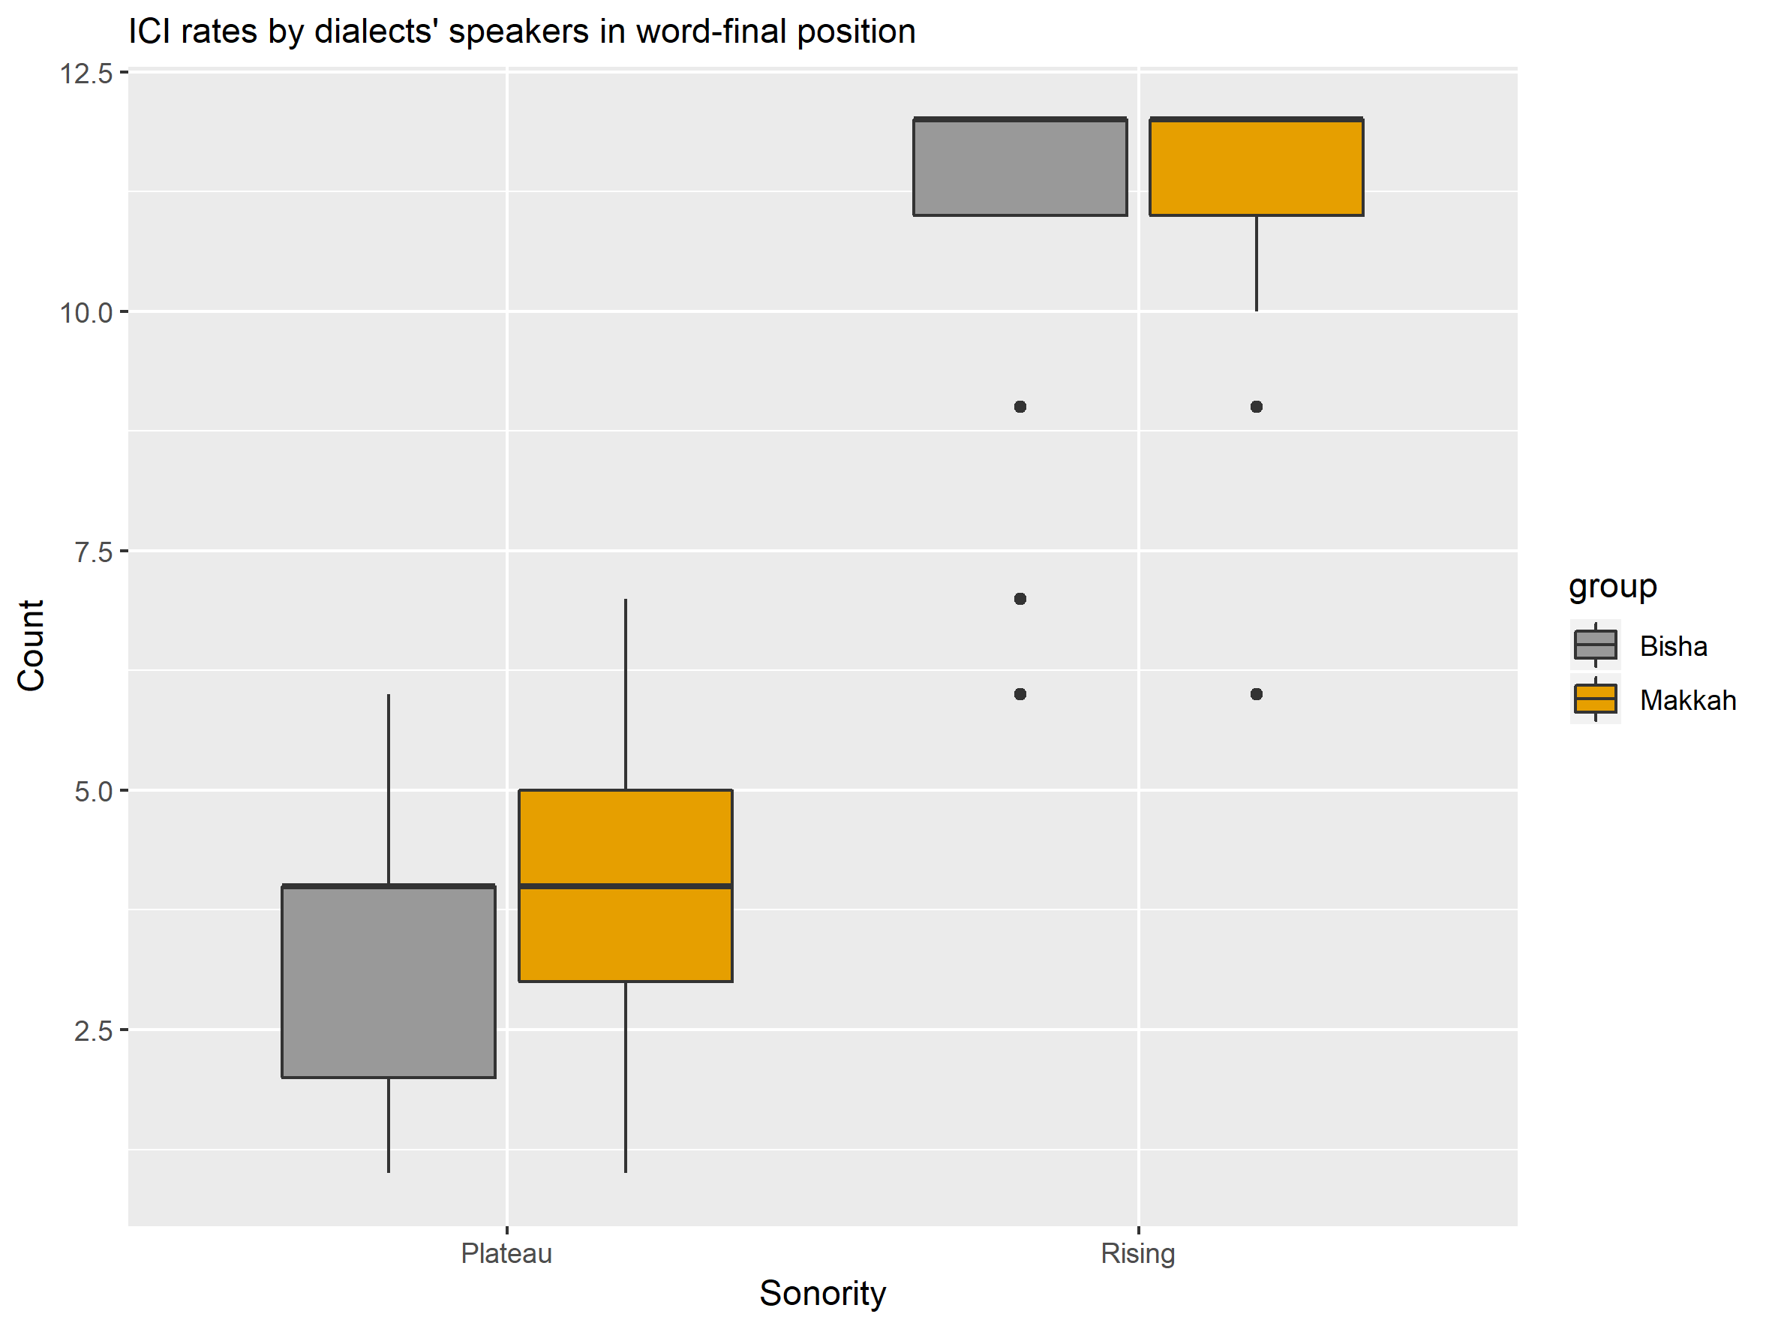
Figure 4. 18: Median and interquartile range for ICI insertion rate produced by BA and MA speakers in the word-final consonant clusters. Falling sonority clusters (e.g. [kanz] “treasure”) were not visualised since they have a zero ICI rate.
Following the same mixed models-based approach as that used to analyze clusters in word-initial and -medial positions, significant differences between the dialects will be tested. A series of models were established to test the relationship between the ICI rates and the fixed effects: dialect and sonority, with item and subject as random effects. Random slopes were included in some models, but they were excluded during convergence troubleshooting.
Table 4. 17: Mixed effects coefficients (predicting ICI rate with the fixed correlated effects: dialect and sonority) for the binomial GLMM model visualised in Figure 4.19.
 | Estimate | SE | z value | p value
Intercept | -1.79 | 1.53 | -1.17 | 0.24
Makkah dialect | 1.46 | 0.99 | 1.47 | 0.14
Rising sonority | 12.86 | 2.69 | 4.77 | 1.79e-06 ***
Makkah dialect: rising sonority | -2.09 | 2.36 | -0.88 | 0.37

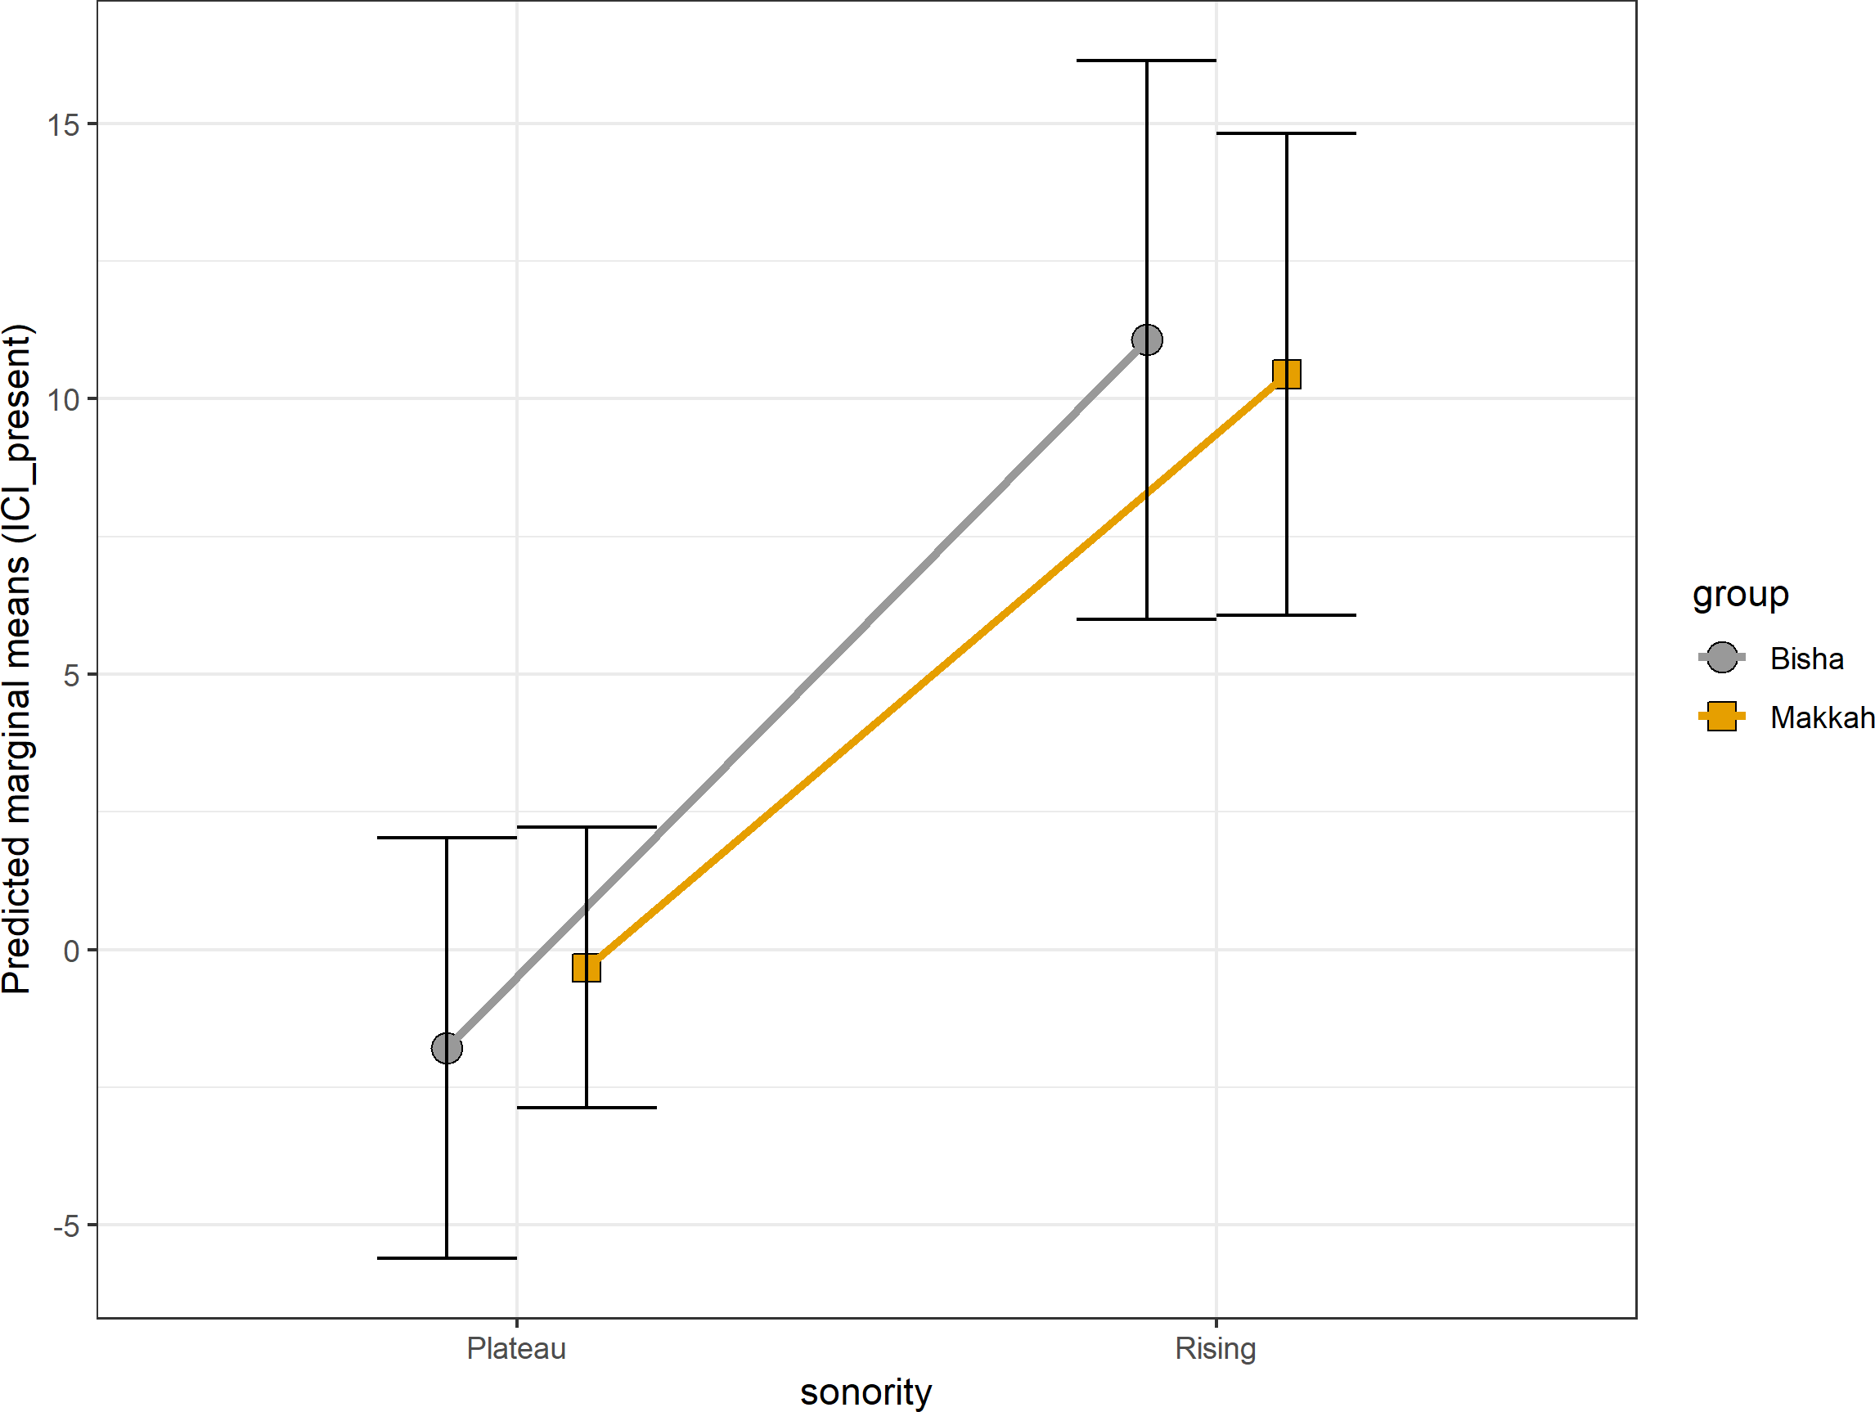
The best-fit model (with interaction) indicates that there is no significant difference between BA and MA for ICI presence as a function of sonority constraints (z = -1.17, p = 0.24), as shown in Table 4.19. However, the model shows highly significant differences between falling sonority on one hand and rising sonority on the other hand across both dialects (z = 4.77, p = 1.79e-06), as shown in Table 4.19 and visualised in Figure 4.19.
Figure 4. 19: Predicted marginal means (and 95% CI) for the binomial GLMM by sonority and group, reported in Table 4.19. Falling sonority clusters (e.g. [kanz] “treasure”) were not visualised since they have a zero ICI rate.

To sum up, the established model indicates that there is no difference between BA and MA in terms of the presence of ICIs as a function of sonority. The model, however, shows a significant difference between sonority slopes (falling and plateau versus rising) across both dialects. Having investigated the first goal of the current experiment in CC# clusters (presence versus absence of ICIs), the following section will address the second research question, which is the status of inserted ICIs.

Diagnostics of ICIs in word-final consonant clusters BA and MA: I) The effect of place of articulation
Intrusive ICIs occur in heterorganic clusters, whereas epenthetic ICIs occur in homorganic clusters (Hall, 2006). Unfortunately, the stimuli containing word-final clusters that were broken up with ICIs are all heterorganic clusters and there are no homorganic clusters that could be compared with heterorganic clusters. Therefore, this diagnostic cannot be applied to test the ICI status of word-final clusters.

Diagnostics of ICIs in word-final consonant clusters BA and MA: II) Markedness status of modified clusters
Epenthetic ICIs serve as a way to repair marked structures that are illicit in the native language of speakers, whereas intrusive ICIs are phonetic transitions that occur in less marked structures in terms of sonority constraints. Sonority should fall from the peak of the syllable toward the coda. Consonant clusters violating sonority constraints are described as marked clusters (Carlisle, 1997, 2001; Eckman, 1977; Eckman & Iverson, 1993; Greenberg, 1965; Parker, 2002, 2008, 2011). The markedness status of the coda clusters is presented in Figure 4.20.

- less marked + more marked

falling sonority clusters plateau sonority clusters rising sonority clusters
(e.g., [hɛlθ] “health”) (e.g., [ɒpt] “opt”) (e.g., [ʔakl] “food”)

Figure 4. 20: Markedness status of coda clusters in terms of sonority constraints.

The markedness status as a diagnostic of inserted ICIs is applicable to the current experiment as the results visualised in Figure 4.20 and reported in Table 4.18 indicate that the rising sonority clusters (e.g., [baħr] “sea”), which are marked clusters, as shown above, are broken up with ICIs at a significant rate (z = 4.77, p = 1.79e-06). The insertion of ICIs to modify such marked clusters is consistent across both dialects, BA and MA.
Interestingly, some researchers found that coda clusters with plateau sonority containing sonorants, especially nasals (e.g., [samn] “ghee”), are treated similarly to coda clusters with rising sonority in terms of markedness degree (i.e., they have similar degree of markedness). For example, Alkhonini (2014) found that Najdi Arabic speakers insert an ICI to break up rising sonority clusters (e.g., [ɡɑbl] > [ɡɑbil] “before”) and equal sonority clusters containing nasals (e.g., [samn] > [samin] “ghee”). In contrast, falling sonority clusters in word-final position and plateau sonority clusters comprising obstruent-obstruent clusters are maintained without ICI insertion (e.g., [silk] “wire”, [nafs] “self”, respectively). A similar finding is also observed in Modern Irish (Carnie, 1994) and Hebrew (Bat-El, 2012) .
In the current study, BA and MA speakers insert ICIs to break up word-final clusters with rising sonority (e.g., [baħr] > [baħar] “sea”), as discussed above. Similarly, they insert ICIs to break up plateau sonority clusters containing nasal-nasal clusters in word-final position (e.g., [samn] > [samin] “ghee”). In contrast, falling sonority clusters and plateau sonority clusters containing obstruent-obstruent are maintained without ICI insertion (e.g., [kart] “card”, [kabd] “liver”, respectively). This finding is statistically tested using mixed-effects models, as presented below in Table 4.20 and Figure 4.21.
Table 4. 18: Mixed-effects coefficients (predicting ICI rate with the fixed effects, dialect and manner of articulation for plateau sonority clusters in word-final position) for the binomial GLMM model visualised in Figure 4.21. (Reference level for dialect is Bisha, and for manner of articulation is nasal-nasal clusters).
 | Estimate | SE | z value | p value
Intercept | 2.66 | 1.29 | 2.00 | 0.044*
Makkah dialect | 1.00 | 0.94 | 1.06 | 0.286
Obstruent-obstruent clusters | -6.28 | 1.75 | -3.57 | 0.000355***

The established model shows that the ICI rate in nasal-nasal clusters is substantially higher than that in obstruent-obstruent clusters (z = -3.57, p = 0.000355). The model also reveals that ICI rate does not vary as a function of dialect, indicating that BA and MA have a similar rate of ICI. Interestingly, the p value of the intercept is significant (0.044), indicating that the ICI rate in nasal-nasal clusters is significantly distant from zero rate.
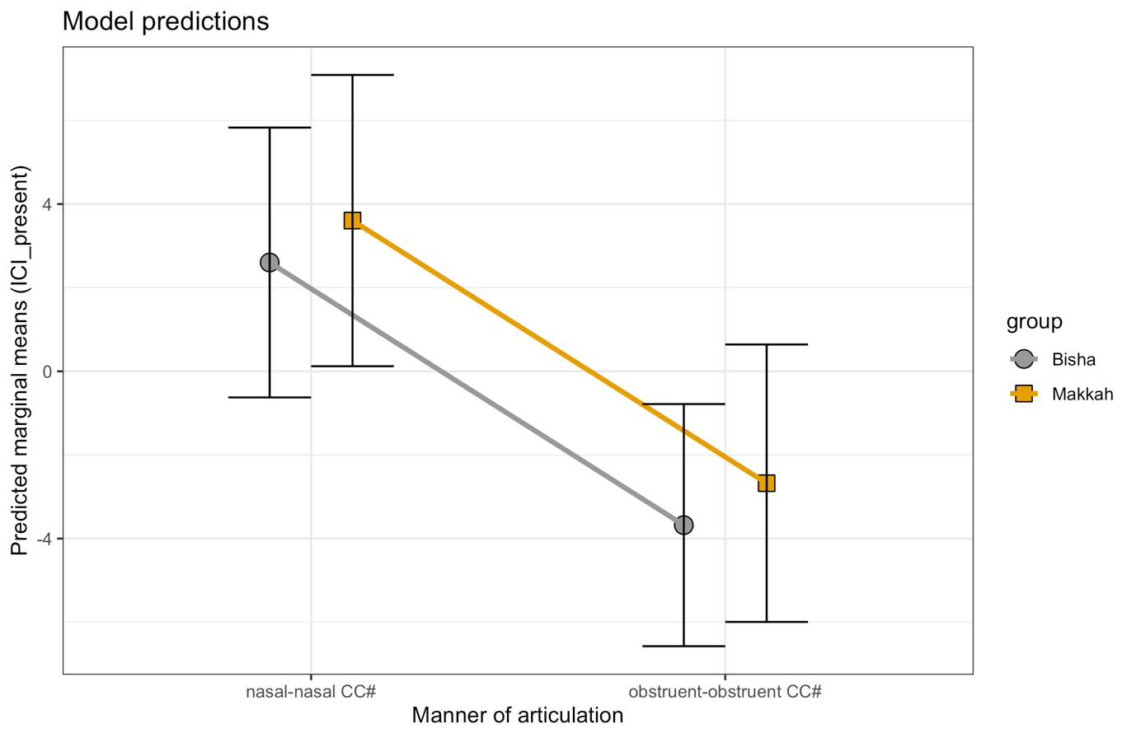
Figure 4. 21: Predicted marginal means (and 95% CI) for the binomial GLMM by dialect and manner of articulation for plateau sonority clusters in word-final position, reported in Table 4.20.
A summary of word-final clusters in BA and MA is provided below in Table 4.21.

Table 4. 19: A summary of word-final consonant clusters in BA and MA according to: (i) sonority slope with more details in plateau sonority clusters, (ii) ICI insertion (presence versus absence), and (iii) markedness status according to similar results found in Modern Irish (Carnie, 1994), Hebrew (Bat-El, 2012), and Najdi Arabic (Alkhonini, 2014).
Cluster Type | ICI insertion | Markedness status
Rising sonority clusters  (e.g., [baħr] > [baħar] “sea”) | Yes | More marked
Plateau sonority clusters (nasal-nasal)  (e.g., [samn] > [samin] “ghee”) | Yes | More marked
Plateau sonority clusters (obstruent-obstruent)  (e.g., [kabd] “liver”) | No | Less marked
Falling sonority clusters  (e.g., [kart] “card”) | No | Less marked

According to the results, summarised in Table 4.21, I claim that the inserted ICIs serve to break up rising sonority clusters in BA and MA, and that plateau sonority clusters containing nasals trigger as epenthetic ICIs, since they occur in more marked clusters, as presented above. Plateau sonority clusters containing obstruents and falling sonority clusters were not broken up by ICIs, since they are less marked in BA and MA, as found in some other languages.
In conclusion, the employed ICIs to break up word-final clusters in BA and MA are epenthetic ICIs, since they meet the markedness status of epenthetic ICIs.

The remaining diagnostic of epenthetic ICIs is vowel quality, which aims to differentiate between intrusive and epenthetic ICIs. However, vowel quality diagnostics might not change the conclusion of the presence of epenthetic ICIs in word-final position, since these clusters are more marked clusters that trigger epenthetic ICIs, as discussed earlier. Intrusive ICIs do not modify marked clusters, since they only occur in less marked clusters; therefore, the presence of intrusive ICIs is not predicted. Similar results were found in word-medial clusters, as discussed in Section 4.3.4. As a result, vowel quality would not change the conclusion of the presence of epenthetic ICIs in word-final clusters in BA and MA; and hence, it will not be tested in this position.

Interim Discussion
As pointed out earlier, Experiment 1 examines two key notions of syllable phonotactics in BA and MA: (i) the nature of consonant clusters across syllable positions, and (ii) the status of the inserted vowels if such clusters were broken up. The results indicate that word-initial clusters are significantly more common in BA than in MA. Word-medially, consonant clusters are broken up by inserted ICIs to a significant extent in both dialects. In final position, the results indicate that clusters in this position in BA and MA follow sonority constraints where falling sonority clusters are allowed and rising sonority is strictly prohibited. Plateau sonority clusters are allowed when they are obstruent-obstruent clusters such as [kabd] “liver”. In contrast, plateau sonority clusters containing nasals are broken up with ICIs to a highly significant extent. For the status of the inserted vowels, the results indicate that word-initial clusters are broken up with intrusive vowels in both dialects, since such vowels fit the diagnostics of intrusion proposed by Hall (2006). In contrast, word-medial and -final clusters in both dialects are broken up with epenthetic vowels.
The interim discussion for these results will be presented in light of the reviewed literature summarised in Chapter 2.

Consonant clusters in BA and MA
Generally speaking, branching consonant clusters are prohibited in most Arabic dialects due to the non-dominated constraint, the Bimoraicity Constraint, in which the maximum weight of syllables in Arabic is two moras and the minimum weight is a single mora (Broselow, 1992; Kiparsky, 2003; McCarthy & Prince, 1990; Selkirk, 1981b; Watson, 2007). The attested surface clusters in BA are sited in word-initial positions, as in [flu:s] “money”, and -final positions, as in [bint] “girl”. MA typically allows word-final clusters. Hence, such clusters in both positions behave as non-branching clusters as follows:
σ
µ µ
b i n t
σ
µ µ
f l uu s

Figure 4. 22: Word-initial clusters in BA
Figure 4. 23: Word-final clusters in BA/ MA

It is apparent that the maximum weight in each syllable exemplified in both Figure 4.22 and Figure 4.23 is a bimoraic syllable in spite of its position. Consonants that trigger additional moras are treated as stray consonants due to the Bimoraicity Constraint. The prosodic affiliation of the stray consonants is a source of debate, which will be discussed in detail in the discussion chapter. In short, attested clusters in BA and MA behave as non-branching clusters. The interaction between non-branching clusters and sonority constraints will be discussed in further detail in the Chapter 7.

Status of inserted ICIs to simplify consonant clusters in BA and MA
A summary of inserted ICIs in BA and MA is presented in Table 4.22. The table shows that intrusive ICIs only occur in word-initial clusters in BA and MA, whereas consonant clusters in word-medial and -final positions are broken up by epenthetic ICIs. Word-final clusters following sonority constraints are maintained without ICI insertion.

Table 4. 20: A summary of inserted ICIs in BA and MA across syllable positions.
Cluster position in the surface structure | Status of inserted ICIs (intrusive vs. epenthetic)
Cluster position in the surface structure | BA | MA
#CC | intrusive | intrusive
-CC.C- | epenthetic | epenthetic
CC# (violating sonority) | epenthetic | epenthetic
CC# (following sonority) | not broken up | not broken up

Phonological representation of vowel insertion
It was stated earlier that epenthetic ICIs are phonological units that serve as syllable nuclei, whereas intrusive ICIs are phonetic transitions between consonants and do not contribute to syllable structure (Hall, 2006). Combining the implications of this claim and the results summarised earlier in Table 4.22, word-initial clusters in BA and MA appear to be present in the underlying structure and are broken up with ICIs in the surface structure, since these ICIs are intrusive ICIs, which do not contribute to syllable structure. The phonological derivation of word-initial clusters is provided in 1.
- Representation of word-initial clusters in BA and MA (e.g., /ktaab/ “book”)
        - /ˈktaab/ underlying representation (UR)
        - [ˈkətaab] ~ [ˈktaab] surface: phonetic vowel intrusion (optional)
The representation provided in (1) shows the presence of a word-initial cluster in the UR of BA and MA, and the presence of an intrusive vowel in the surface structure.
Considering morphology enables us to rule out the possibility of a lexical vowel in the UR breaking these clusters. If the initial vowel shown in (1b) (underlined) were a lexical vowel, it would not be deleted when a prefix is attached to the stem of the word /ktaab/. According to the native speaker intuitions of the author, having a prefix would result in vowel syncope in word-initial position as in /bik.taab.na/ “with our book”. This example indicates that the deleted vowel is not a lexical vowel because it is affected by morphology. These results contradict the conclusions of previous studies that suggest blocked syncope of vowels between consonants in word-initial position. For example, Abu-Mansour (1991) and Kabrah (2004) claim that vowels in the initial position (e.g., [kitaab] “book”) are lexical vowels and will not be deleted. However, the current study, based on empirical evidence elicited from 51 participants as presented in Section 4.2, indicates that the vowels breaking up word-initial clusters in BA and MA are intrusive vowels, and that they are subject to syncope.
Word-medial clusters are absent in both the UR and the surface structure, since they are broken up with epenthetic ICIs, which are phonological units that serve as syllable nuclei as shown in (2).
- Representation of word-medial clusters in BA and MA (e.g., /ɡultlih/ “I said to him”)
      - /ɡultlih/ UR
      - /ɡultəlih/ epenthesis
      - [ɡultəlih] surface structure: epenthetic vowel (underlined)

The inserted vowel (underlined) shown in (2c) is not a lexical vowel since it is inserted across words /gult/ “I said” and /lih/ “to him”. Furthermore, as Section 4.3 argues, the inserted vowel is not an intrusive vowel. Hence, the employed vowel in word-medial clusters in BA and MA is an epenthetic vowel.

Word-final clusters are attested in the phonology of BA and MA as shown in (3).
- Representation of word-final clusters in BA and MA (e.g., /bint/ “girl”, /ʃibl/ “cub”)
- /bint/ /ʃibl/ UR
- --- /ʃibil/ epenthesis
- [bint] [ʃibil] surface structure: epenthetic vowel (underlined)
As presented in (3a), word-final consonant clusters are attested in the UR of BA and MA, but they are broken up with inserted vowels in the surface form as in (3c). In Section 4.4, I argue that the inserted vowel in (3c) is not an intrusive vowel. The two remaining possibilities regarding the status of inserted vowels in this position are: (i) lexical and (ii) epenthetic vowels. I claim the inserted vowel in (3c) is not a lexical vowel since it is deleted when a suffix is attached to the stem /ʃibl/ as in [ʃib.li.na] “our cub”. Hence, the vowel used to break up word-final clusters in BA and MA is an epenthetic vowel. Abu-Mansour (1991) found similar results, showing that final CC# clusters show epenthesis if they have rising sonority, but not if they have falling sonority. His data is apparently introspective, so the current research makes an important contribution by bringing actual production data from a large number of speakers to confirm this.

A summary of consonant clusters in BA and MA is provided below in Table 4.23.
Table 4. 21: A summary of consonant clusters in the underlying representation of BA and MA.
Consonant position | Presence of clusters in the underlying representation
Consonant position | BA | MA
#CC | Yes | Yes
-CC.C- | No | No
CC# | Yes | Yes

Table 4.23 shows that peripheral clusters in BA and MA are attested in the underlying structure, whereas word-medial are absent in BA and MA.

Finally, attested consonant clusters in BA and MA are described as non-branching clusters due to the Bimoraicity Constraint, as discussed earlier in Chapter 2 and Chapter 4.

Syllable phonotactics in BA, MA and English
As stated earlier, this PhD study focuses on L1 Arabic and L2 English phonotactics. Therefore, it is worth comparing the two languages. The key findings presented in Table 4.22 indicate that BA and MA are simultaneously both similar to and different from English. On the one hand, BA and MA are similar to English in the fact of having their consonant clusters in word-peripheral positions (regardless of the branching status of such clusters). On the other hand, BA and MA are different from English in two ways: (i) peripheral consonant clusters in English are branching clusters, whereas they are not in BA and MA, (ii) word-medial clusters are attested in English (Treiman, 1984; 1986), whereas such clusters are not attested in BA and MA. Based on these differences and similarities, the remaining questions now are:
- Do the permitted non-branching peripheral consonant clusters in BA and MA facilitate or hinder production and perception of branching peripheral English clusters?
- Does the absence of medial consonant clusters facilitate or hinder production and perception of English medial clusters?

These questions will be discussed in the next part, which is about the production of L2 English phonotactics.

Production of L2 English consonant clusters by BA and MA speakers: background, empirical experiment, results with interim discussion

Introduction
The current chapter aims to test the production of L2 English consonant clusters by BA and MA speakers. The structure of the current chapter is different from the previous chapters that discuss Arabic results. The findings for Arabic are split into three chapters: (i) L1 Arabic syllable phonotactics, (ii) methodology of an empirical experiment focused on the production of Arabic clusters by BA and MA speakers, and finally, (iii) results of the relevant experiment followed by interim discussion. The current chapter will focus on L2 English consonant clusters produced by BA and MA speakers; however, the literature review, the methodology of the conducted experiment, and the results will be merged into a single chapter. The reason for such a different structure is that the Arabic findings discussed in previous chapters form a basis for discussion of the findings for L2 English consonant clusters; and hence, the Arabic findings were discussed in more detail.

L1 English syllable structure
In this section, two phonological phenomena will be discussed: (i) simplicity versus complexity of L1 English consonant clusters, (ii) sonority constraints in L1 English phonotactics.

Simplicity versus complexity of L1 English consonant clusters
English syllables were under investigation in one of the seminal studies that investigated the internal structure of syllables, as presented below in Figure 5.1 (Fudge, 1969; Selkirk, 1982, 1984). The figure shows that onset and coda constituents are binary branching, which indicates that complex onsets and complex codas do exist in English (Treiman, 1984, 1986; Treiman & Danis, 1988), contrary to Arabic, which bans branching clusters, as discussed in Chapter 2. The termination segments represent morphemes such as plurality and past tense morphemes (e.g., [sɪlks] “silks”).
Syllable
Onset Rhyme (Termination)
Peak Coda
1 2 3 4 5 6
Figure 5. 1: Hierarchical ordering of English syllable structure, as proposed by Fudge (1969).

Sonority constraints of L1 and L2 English consonant clusters:
For sonority constraints, the two models were discussed in Arabic chapters and will be reiterated herein but with focus on L1 and L2 English consonant clusters.

Sonority Sequencing Principles (SSP):
The scale depicted in Figure 5.2. represents SSP (Clements, 1990; Selkirk, 1984).
- Sonorous obstruents < nasals < liquids < glides < vowels + Sonorous
Figure 5. 2: Sonority Scale

The main point of this scale is that sonority is expected to increase from the syllable margins (onsets and codas) toward the syllable peak (nucleus). Considering a cluster consisting of two consonants [C₁C₂], the sonority degree for C₁ must be different from C₂ according to the position of the clusters (i.e., onset versus coda). In onset position, the sonority degree for C1 is less than C2, since the C2 is closer to the syllable peak (nucleus); therefore, it should be more sonorous than C1. In contrast, C1 in Coda position should be more sonorous than C2, since C1 is closer to the nucleus.

In English, consonant clusters follow SSP, as presented below in Figure 5.3 (Broselow & Finer, 1991; Eddington et al., 2013a, 2013b; Selkirk, 1984; Treiman, 1984, 1986; Zec, 1995).

Onset position Peak (nucleus) Coda position

rising sonority clusters falling sonority clusters
(e.g., [drɪl] “drill”) (e.g., [hɛlθ] “health”)
Figure 5. 3: Application of SSP to English consonant clusters across syllable positions.

However, why is the cluster [kleɪm] in “claim” allowed in English, but not *[km]? The answer to this question is provided below.

Minimum Sonority Distance (MSD):

Minimum Sonority Distance (MSD) was generated based on a numeric distance of sonority between consonants of clusters, as presented below in Table 5.1. For example, English allows clusters with MSD = 2, which are obstruent-liquid (e.g., [drɪl] “drill”) and nasal-glide (e.g., [mju:t] “mute”). This finding has two significant implications:
- English allows clusters with longer sonority distance: MSD = 3, which is obstruent-glide (e.g., [fju:] “few”].
- English bans clusters with shorter sonority distance: MSD = 1, which is obstruent-nasal (e.g., [km]*].

Table 5. 1: Examples of Minimal Sonority Distance across linguistically (Zec (2007) and Parker (2011, p: 1169)).
 | Maximal inventory of permissible onset clusters | Languages
MSD = 0 | OO, ON, OL, OG, NN, NL, NG, LL, LG, GG | Bulgarian, Leti
MSD = 1 | ON, OL, OG, NL, NG, LG | Chukchee
MSD = 2 | OL, OG, NG | Gizrra, Kurdish, Spanish, English
MSD = 3 | OG | Mono, Panobo, Japanese, Mandarin Chinese
Note: O = obstruent, N = nasal, L = liquid, G = glide.

In short, English allows MSD = 2. This implies that clusters of longer sonority distance are allowed, but clusters with shorter distance are disallowed. Having discussed the principles of syllable strucure of L1 English, it is crucial to discuss their ramifications in terms of producing L2 English phonotactics.

Syllable phonotactics in L2
L1 effects form an important theoretical background to analyse the perception and the pronunciation of consonant clusters in an L2 target (Davidson, 2011; Eckman, 2004). Examples in (4) show the effect of L1 in determining the epenthesis site among Iraqi and Cairene ESL learners based on the Syllable Structure Transfer Hypothesis (Broselow, 1983, 1984).
(4)
English Target Iraqi Modification Cairene Modification Gloss
frɛd ifrɛd firɛd Fred

It has been found that CV is the universal syllable structure in all languages (Carlisle, 2001; Clements, 1990; Greenberg, 1965). Some studies state that CV is the preferred pattern of simplifying complex onsets and codas. Historical evidence supports this finding by showing that syllable preference laws significantly impact the syllable structure changes. For instance, Vennemann (1987) found that initial clusters in Early Old High German have reduced to single onsets as in (5).
(5)
Early OHG Late OHG gloss
hnigan nigan ‘white’

In contrast to syllable preference laws, Broselow (1983) states that if CV is the preferable pattern among all languages, Iraqi ESL learners would modify initial CC in the same way as Cairene speakers, as shown in (4). However, Iraqi speakers are affected by their L1 since it is a Right-to-Left language based on the epenthesis directionality proposed by Itô (1989).

Several models have been proposed to examine the relationship between transfer rules and linguistic universals. For example, the Markedness Differential Hypothesis (MDH) (Eckman, 1977) states that any linguistic aspect that is marked and not present in the L1 grammar will be more difficult to acquire than any aspect that is marked but exists in the L1 grammar. However, if the L2 learners produce, as a simplification strategy, a modification which is found in neither the L1 nor the L2, the Interlanguage Structural Conformity Hypothesis (ISCH) (Eckman, 1991; Eckman, Moravcsik, & Wirth, 1989) is an appropriate model to analyse this finding. The current short summary provides information on how transfer and Universal Grammar analyse difficulties that run across L2 learners. The models mentioned above, and some other syllabification theories, will be discussed in turn.

Syllable Structure Transfer Hypothesis (SSTH)
Broselow states that “when the target language permits syllable structures that are not permitted in the native language, learners will make errors which involve altering these structures to those which would be permitted in the native language” (1984:263). The most common alternation to conform to the syllable structure of L1 is epenthesis (Broselow, 1983, 1992; Colantoni, Steele, & Escudero, 2015; Lin, 2001). Focusing solely on Cairene (CEA) and Iraqi Arabic (IA), Broselow (1983) studied the production of English clusters by speakers of these two dialects. She finds that CEA and IA speakers modify initial clusters with epenthesis, each with an alternative strategy to conform to the syllable structure of their L1. Learners’ modifications involve different sites of epenthesis, as shown in (6).

(6)
CEA modifications IA modifications Gloss
[filoor] [ifloor] ‘floor’
[θirii] [iθrii] ‘three’

The author states that IA speakers show a low level of errors in comparison with CEA speakers. The main aspect of their errors is inserting a vowel before the stimuli, as shown in (6). This can be attributed to transfer from their L1 grammar since the epenthesis may optionally occur before initial clusters in IA [θneen] ~ [iθneen] ‘two’.

On the other hand, initial clusters are not allowed in CEA, leading its speakers to modify English clusters with epenthesis between the cluster’s consonants, as shown in (6). However, the site of epenthesis by CEA speakers is still in question because CV and VC syllables exist in CEA, as shown in (7).
(7)
CV syllable in CEA Imperative form in CEA
[bint] ‘girl’ [iktib] ‘write’

This means that initial clusters preceded by a vowel exist in CEA. Consequently, CEA speakers may modify English initial clusters as [filoor] or [ifloor] ‘floor’, in the same way IA speakers’ modifications. However, their errors, as clarified in (6), only show one substitution [filoor], and the other predicted form [ifloor] remains absent. The author states that L1 plays no role in explaining this finding. However, she states that the treatment of medial clusters in CEA and IA may explain why speakers of these dialects modify English initial clusters differently.

Based on epenthesis directionality, IA and CEA speakers modify medial clusters, CCC (presented in Figure 5.4), in their L1 differently. On the one hand, IA speakers split these clusters with epenthesis to the left of the extraprosodic consonant resulting in CvCC, as shown in (8). On the other hand, CEA speakers split these clusters with epenthesis to the right of the extraprosodic consonant, resulting in CCvC, as in (8).

(8)
Iraqi: C → iC (Right-to-Left) [ɡәlitlu] ‘I said to him’
Cairene: C → Ci (Left-to Right) [ʔultilu] ‘I said to him’

W
ɸ
σ σ
µ µ µ µ
ɡ i l t l u

Figure 5. 4: Extraprosodic consonant (underlined) in word-medial clusters [CCC] [ɡiltlu].
As evidence of transfer, speakers of these two dialects modify medial English clusters, CCC, following the same directionality of epenthesis, as in (9).
(9)
Iraqi: C → iC [ɡәlitlu] ‘I said to him’
[tʃilidren] ‘children’
Cairene: C → Ci [ʔultilu] ‘I said to him’
[tʃildiren] ‘children’
Following the treatment of medial clusters [CCC] in both languages, L1 and L2, CEA and IA speakers will apply the same treatment to English initial CC clusters, as shown in (10).
(10)
Iraqi: C → iC ( __f) (loor)
Cairene: C → Ci (f__) (loor)

“If the analysis of epenthesis as a syllable-based process is accepted, then, it allows us to see the differing treatment of second language clusters by speakers of these two Arabic dialects as a result of transfer of first language rules. If epenthesis is a way of dealing with impermissible syllable structures which arise in the native language as a result of the concatenation of morphemes, it makes sense that the same process will be used to facilitate the pronunciation of second language forms which are defined as impermissible by the native language syllable structure constraints” (Broselow 1983: 275).

This summary provides evidence for the impact of L1 on the syllable structure of L2. It shows that epenthesis is the primary strategy to facilitate difficult clusters in L1 and how this strategy can be transferred to simplify difficult clusters in L2.
SSTH is crucial to the current study since this hypothesis predicts that BA and MA speakers might transfer their L1 syllable phonotactics in the production of L2 English consonant clusters. Therefore, SSTH will be employed in the current research.

Having discussed the transfer rules in L2, linguistic universals also remain influential to L2 phonotactics, as mentioned earlier. These universals are summarised below.

Linguistic Universals
One of the key figures investigating linguistic universals is Joseph Greenberg. With respect to consonant sequences, he studied the typology of consonant clusters across 100 languages. One of his key findings is that “shorter clusters are preferred over longer ones” (Greenberg, 1965: 29). Carlisle (2001) states that many studies support this generalization. For example, Arabic speakers modified 18 % of complex onsets and codas regardless of cluster position, whereas they modify none of their singleton consonants (Anderson, 1987). Thai speakers mispronounced 37% of English onsets consisting of two consonants, whereas they modified 15 % of singleton consonants (Hancin-Bhatt, 2000). For Cantonese ESL learners, they correctly pronounce 62% of the triliteral stimuli, whereas they accurately uttered 80% of biliteral consonant clusters. This shows that shorter clusters are easier than longer clusters for Cantonese ESL learners (Chan, 2010). These studies and some others (Eckman, 1991; Eckman & Iverson, 1993; Weinberger, 1987) support Greenberg’s generalization. Hence, L2 learners tend to acquire singleton onsets and codas before complex ones (Carlisle, 2001). The latter conclusion by Carlisle can be tied to markedness principles, which will be discussed in the following section.

Markedness
The idea behind markedness involves implications between two oppositions. The occurrence of a linguistic aspect implies the occurrence of the other, but not vice versa. Markedness also indicates rare phenomena cross-linguistically. As cited in Eckman (2004), Gundel, Houlihan & Sanders (1986:108) define markedness as follows:
“A structure X is typologically marked relative to another structure, Y, (and Y is typologically unmarked relative to X) if every language that has X also has Y, but every language that has Y does not necessarily have X”.

Concerning L2 phonology, two influential hypotheses analyse L2 phonology from the markedness perspective: The Markedness Differential Hypothesis (Eckman, 1977) and the Structural Conformity Hypothesis (Eckman, 1991). Each hypothesis will be discussed in turn.

Markedness Differential Hypothesis (MDH)
Difficulties that might face L2 learners could be predicted in the light of MDH as follows:
“a. Those areas of the target language that differ from the native language and are more marked than the native language will be difficult;
b. The relative degree of difficulty of the areas of difference of target language that are more marked than the native language will correspond to the relative degree of markedness;
c. Those areas of the target language that are different from the native language but are not more marked than the native language will not be difficult” (Eckman, 1977: 321).

Many empirical studies have addressed the MDH. For example, Mandarin and Arabic ESL learners run into some difficulties in pronouncing peripheral clusters as the level of markedness increases, as shown in Table 5.2. Final clusters are more difficult than initial ones for Mandarin speakers. This is attributed to the fact that final clusters are more marked than initial clusters (Anderson, 1987). Arabic speakers pronounce English final clusters less accurately than initial clusters.

Table 5. 2: Percentage of speakers’ errors (Anderson, 1987).
English clusters | Mandarin speakers’  errors % | Arabic speakers’  errors %
#C- | 1 | NA
#CC- | 10 | 7
-C# | 20 | 2
-CC# | 50 | 17.4
-CCC# | 74 | 30

More recently, a study conducted by Chan (2010) supported MDH predictions and its universals. It aimed to investigate the production of English initial clusters by Cantonese speakers. None of the participants acquired onset clusters with three elements before they had mastered the onsets of two members. Also, the relative degree of difficulty of triliteral clusters was higher than that of biliteral clusters.

In sum, MDH focuses on two areas: (1) relative degree of difficulty and (2) order of acquisition in relation to markedness. However, some modifications were found in neither L1 nor L2. Therefore, the MDH cannot explain such modifications. The Interlanguage Structural Conformity Hypothesis (ISCH) may provide a more persuasive interpretation. More details about ISCH are shown in the following section.

Interlanguage Structural Conformity Hypothesis (ISCH)
One limitation of the MDH is that if there is no effect of L1, MDH cannot provide a scientific analysis. On the other hand, the ISCH can explain such modifications because it generates its analysis from the fact that “the universal generalizations that hold for primary languages hold also for interlanguage” (Eckman, 1991, p. 24). Put more simply, interlanguage (IL) means that L2 learners create their own version of the target language. This new version of the language is neither native-like nor somewhat target-like. However, it follows the linguistic universals that occur in all languages of the world (Eckman, 2004). ISCH, then, will make predictions relying on implicational universals, not the difference between L1 and L2 as MDH does. Also, ISCH predicts the frequency of modifications in IL based on linguistic universals.
A number of studies have tested the validity of ISCH (Eckman, 1991). The author of the theory recruited 11 speakers of three different languages (Korean, Japanese and Cantonese) to pronounce two-member and three-member English onsets. The subjects’ productions were elicited through four tasks: reading of a word list, naming pictures, reading stories and a free conversation interview. Eckman used an 80 % criterion measurement. For instance, if a subject pronounces the cluster /tr/ in ‘tree’ with an accuracy of 80%, the author considers that cluster as existing in his/her IL. The results confirm ISCH’s claims since only 5 cases out of 524 tests of ISCH contradicted the universal generalizations that ISCH was generated from. This study and some others (Carlisle, 1997; Eckman & Iverson, 1993) support ISCH claims. The following section will shed light on a model that connects linguistic universals, transfer and language development, namely the Ontogeny Phylogeny Model (Major, 2001, 2008).

Ontogeny Phylogeny Model
The linguistic outcomes of IL in the Ontogeny Phylogeny Model (OPM, hereafter) are a product of three factors: L1, L2 and universals (Eckman, 2004). OPM claims that:

“chronologically L2 acquisition increases, L1 transfer decreases, and universals increase and then decrease (in this model interlanguage is composed of elements of L1 [transfer], L2 [acquired], and universals [including UG]). The Similarity Corollary of the OPM further captures the generalizations of a number of studies and observations concerning similarity. It claims for phenomena that are similar in L1 and L2 that L2 acquisition proceeds slowly, transfer persists; consequently, the role of universals is relatively small, compared to “normal” (phenomena that are neither similar nor marked). This is because the components of interlanguage, L1 transfer, L2 forms, and U (universals), have to add up to 100 percent” (Major, 2008: 74).

From this quote, it is apparent that OPM is very useful in longitudinal studies that examine the developmental process of acquisition. Thus, OPM will be excluded since my research does not examine the developmental process of acquisition.

Studies about Arabic speakers’ production and perception of L2 English consonant clusters:
There are a number of studies that investigate the production and perception of L2 English clusters by Arabic speakers with a varying range of L2 English proficiency and with different native Arabic dialects. Starting with word-initial clusters, Saudi Faifi Arabic speakers modify L2 English word-initial clusters (#CC, [twɪntɹɪs]) by inserting a glottal stop and vowel before the cluster (e.g., [ʔitwɪntɹɪs]). Similarly, Saudi Assiri Arabic speakers epenthesize English initial clusters between consonants of clusters (e.g., [tiwɪntɹɪs]) (Alfaifi, 2015). Both groups of speakers are described as low-proficiency English speakers according to the author. Another group of Arabic speakers were tested by Esshali (2014), who examined the ability of Central Najdi Arabic speakers to pronounce three consonants of onset in English word-initial clusters (e.g., [splɪt] “split”). Such clusters were awkward for this group, resulting in a significant modification by inserting a vowel after the first consonant (e.g., [siplɪt]) or after the second consonant of the cluster (e.g., [spilɪt]).

English word-medial clusters (e.g., [tʃɪldrən] “children”) were difficult for Arabic speakers regardless of their native Arabic dialect. Generally, speakers epenthesize such clusters but with different positions. Najdi and Cairene speakers insert a vowel after the second consonant of the cluster (e.g., [tʃɪldirən] “children”), whereas Iraqi speakers insert a vowel after the first consonant of the cluster (e.g., [tʃɪlidrən] “children”) (Broselow, 1983, 1984; Hago & Khan, 2015). L1 effect is expected to have an important influence on the position of vowel insertion (Broselow, 1983, 1984) (for further information, see Section 5.3.1).

As for word-final clusters, the degree of difficulty varies according to cluster size. English biconsonantal clusters following sonority rules (e.g., [hænd] “hand”] present no difficulties for native speakers of Arabic regardless of their English proficiency. In contrast, with three or four consonants in word-final position, the level of difficulty increases even for advanced L2 English speakers (e.g., [tɛksts] “texts”). This difficulty results in vowel insertion to simplify such clusters (e.g., [tɛkists] “texts”) (Al Azmi, 2019; Al-Aqlobi, 2013)

Conclusion
Theories and models of the transfer rules and linguistic universals in L2 have been highlighted in Background Section, starting from SSTH, which is a theory that shows the effect of the structure of L1 syllables on the production of L2 syllables. Following that, theories of linguistic universals, such as MDH and ISCH, were highlighted.
In what follows, a brief summary of the predictions of these theories in the case of BA and MA speakers producing L2 English consonant clusters will be provided.

Predictions of SSTH and Linguistic Universals in the case of BA and MA
This chapter investigates how BA and MA speakers produce L2 English consonant clusters. Before predicting the results of these respective theories, it is important to recall Arabic syllable phonotactics discussed earlier in Chapter 4 to predict production of L2 English clusters by BA and MA.

Consonant clusters in BA and MA vary according to the position of the cluster. In word-initial position, consonant clusters are absent in the surface structure but present in the underlying representation, since these clusters are broken up with intrusive ICIs in the surface structure, which do not contribute to syllable structure. Word-medial clusters and word-final clusters violating sonority constraints are absent in both underlying and surface structures, since these clusters are broken up with epenthetic ICIs, which are phonological units that contribute to syllable structure.
As a result of BA and MA syllable phonotactics, SSTH and Linguistic Universals can predict how BA and MA would produce L2 English consonant clusters, as follows:

- BA and MA speakers are expected to have no difficulty in producing L2 English clusters #CC in the initial position, since word-initial clusters are present in the L1 underlying structure in BA and MA, although such clusters are broken up in the surface structure.
- BA and MA speakers are expected to have some difficulties in producing word-medial clusters [-CCC-] due to two reasons: (i) clusters comprising three consonants are more marked than clusters of two consonants [CC], and (ii) word-medial [-CCC-] clusters are absent in BA and MA.
- BA and MA are expected to have no difficulty in producing L2 English clusters CC# in the final position clusters, since word-final clusters are attested in BA and MA.

Having discussed these models and their predictions, the following section will highlight an empirical experiment that investigates the production of L2 English consonant clusters by BA and MA speakers.

Methodology of Experiment 2: Production of L2 English consonant clusters

The current experiment aims to test how BA and MA speakers produce L2 English consonant clusters in different syllable positions. The methods used in Experiment 2 will be presented as follows:
- Experimental objectives: a brief overview of experimental aim(s), followed by the experimental sub-question(s).
- Experimental design: methodological approach (quantitative analysis), measurement of target variables, design of stimuli, and justification for adopting the selected methods will be defined and explained.
- Data collection: this subsection will set out the details of the study, including participants of each experiment, instruments used for data collection, and finally the process of data collection.
- Data analysis: due to the selected approach of analysis (i.e., quantitative analysis), this section will focus on the statistical analysis including the employed software and its related issues.

Objectives of the Experiment 2
The main goal of Experiment 2 is to examine production of L2 English consonant clusters by BA and MA speakers. The sub-question of this experiment is:

- Do BA and MA speakers produce L2 English consonant clusters?

These questions will be addressed in this experiment, as presented in the following section.

Experiment design
In this section, the following subsections will be explained and defined: a) methodology approach (quantitative method) b) explaining the variables of the current experiment (dependent versus independent variables), and finally c) experimental tasks.

Methodology approach (quantitative method)
The approach used in this experiment is a quantitative method. “Quantitative research tends to subscribe to a particular empirical approach to knowledge, believing that if we measure things accurately enough we can make claims, with some degree of certainty, about the object of the study” (Langdridge & Hagger-Johnson, 2009, p. 13). See Experiment 1 for further details.

Variables
In Experiment 1, the main dependent variable is the presence of ICIs (intrusive versus epenthetic ICIs) employed to break up consonant clusters in BA and MA. It is already stated that epenthetic vowels serve as syllable nuclei, whereas intrusive vowels do not (Hall, 2006). Hence, if BA and MA allow intrusive vowels between consonants, this in turn suggests the existence of underlying consonant clusters in these dialects. Hence, speakers of these dialects should have no difficulties in pronouncing English consonant clusters. If epenthetic vowels were employed instead, this in turn suggests the absence of consonant clusters in BA and MA. Thus, speakers of these dialects would be expected to break up English consonant clusters via epenthesis. Therefore, the presence versus the absence of epenthesis will be the main dependent variable of Experiment 2.

For independent variables, many studies demonstrate variables that may affect the production of epenthesis in L2. The main external variable is the influence of L1. Broselow (1983) states that speakers of Egyptian Cairene Arabic and Iraqi Arabic modify English consonant clusters differently because of the different syllabification typology of their L1. Therefore, the effect of L1 (BA – MA) will be the first independent variable.

Sonority is another key variable in which onset clusters are easier to produce than coda clusters because of the greater sonority distance (Broselow & Finer, 1991; Eckman & Iverson, 1993). As different phonological representations of L1 Arabic clusters are found in different positions, as discussed in experiment 1, it will be considered in this experiment whether this difference affects transfer into the L2. To conclude, the independent variables of Experiment 2 are summarised as follows:

- L1 with two levels: a) BA b) MA
- Cluster position with three levels: a) initial b) final c) medial
- Sonority slope with three levels: a) rising b) falling c) plateau

Stimuli
As presented in Table 5.3, a total of 33 items were used to examine the produced English clusters by BA and MA speakers. This set of stimuli has two main independent variables: cluster position and sonority slope. Both variables match the variables described in experiment 1 with a minor change in the number of stimuli.
In this experiment, there are fewer items examining onset plateau and coda plateau clusters because of the more limited variation of such clusters in English. They have been categorised into three stimulus types in both onset and coda positions. For medial clusters in English, there are nine items, as those clusters have greater variation in comparison with medial clusters in Arabic. Medial items have three subcategories: (1) C.CC medial clusters involving a singleton onset and CC coda as in [tʃɪl.drən] ‘children’, (2) CC.C medial clusters involving CC onset and singleton coda as in [əsʌmp.ʃən] ‘assumption’ and (3) .CCC medial clusters involving CCC onset clusters as in [dɪ.skrɪpʃən] ‘description’. The syllable boundary of these stimuli is built based on the theory Maximum Onset Principle (MOP) and the syllabification of Oxford English Dictionary. MOP indicates that if possible, consonants should be incorporated with onsets rather than codas (Selkirk, 1981a).

Table 5. 3: A list of stimuli used in Experiment 2.
Position | Sonority | Cluster | IPA | Gloss
Initial clusters #CC | rising | sn | snəʊ | snow
Initial clusters #CC | rising | sm | smʌɪl | smile
Initial clusters #CC | rising | pl | pleɪ | play
Initial clusters #CC | rising | θr | θriː | three
Initial clusters #CC | rising | kw | kwiːn | queen
Initial clusters #CC | rising | hj | hjuːdʒ | huge
Initial clusters #CC | rising | mj | mjuːt | mute
Initial clusters #CC | rising | nj | njuːz | news
Initial clusters #CC | rising | lj | ljʊərɪd | lurid
Initial clusters #CC | plateau | st | steɪ | stay
Initial clusters #CC | plateau | sp | spɛnd | spend
Initial clusters #CC | plateau | sk | skʌɪ | sky
Final clusters CC# | rising | lθ | hɛlθ | health
Final clusters CC# | rising | lf | sɪlk | silk
Final clusters CC# | rising | lm | fɪlm | film
Final clusters CC# | rising | ln | kɪln | kiln
Final clusters CC# | rising | nd | hand | hand
Final clusters CC# | rising | mp | stamp | stamp
Final clusters CC# | rising | mp | kamp | camp
Final clusters CC# | rising | ŋk | raŋk | rank
Final clusters CC# | rising | ŋk | θɪŋk | think
Final clusters CC# | plateau | pt | ɒpt | opt
Final clusters CC# | plateau | sk | ɑːsk | ask
Final clusters CC# | plateau | dθ | wɪdθ | width
Medial clusters -CCC- | NA | l.dr | tʃɪl.drən | children
Medial clusters -CCC- | NA | n.tr | ɪn.trəstɪŋ | interesting
Medial clusters -CCC- | NA | m.pl | kəm.pleɪn | complain
Medial clusters -CCC- | NA | .skr | dɪ.skrɪpʃən | description
Medial clusters -CCC- | NA | .str | ˈɔː.kɪ.strə | orchestra
Medial clusters -CCC- | NA | .str | dɪ.strʌkʃən | destruction
Medial clusters -CCC- | NA | mp.ʃ | əsʌmp.ʃən | assumption
Medial clusters -CCC- | NA | ld.h | tʃaɪld.hʊd | childhood
Medial clusters -CCC- | NA | lb.tʃ | skʌlp.tʃər | sculpture

Experimental Tasks
In the field of L2 speech, there are four categories of production tasks (Colantoni et al., 2015). First, interaction tasks which involve an interaction between a participant and an interlocutor(s) like interviews and map tasks. Second, narrative tasks which require participants to discuss a topic or tell a story. Third, there is elicited imitation which involves imitation of target speech, either isolated words or complex sentences; however, this kind of task has been criticised since it might not reflect the real proficiency of speakers. Finally, we have reading tasks which require participants to read units ranging from single words to long reading passages. The advantages of this kind of task are: (i) the ability to control the speech uttered by participants, which allows us to obtain almost exactly identical production by all subjects, and (ii) the efficiency to control the task time period. Due to these advantages, a reading task was used in the current experiment.

The reading task used in this experiment is a multiple-choice grammar task. Using Qualtrics software, participants were presented with a multiple-choice grammar task about the present continuous tense. They were asked to read the questions and two presented choices, and then choose and read the right answer. Their speech was recorded. The aim of using such a task was to distract participants’ attention from the goal of the experiment and to attempt to elicit their spontaneous speech, since they would mentally focus on finding the correct answer for the grammar task.

Having discussed how the experiment was designed, including the stimuli and the experimental tasks, detailed information about how these experimental tasks were run and how the stimuli were collected will be presented.

Data collection
The data of this experiment has been collected in a very similar way to the data collected in Experiment 1 with minor changes, which are discussed below.

Experimental participants
The participants in Experiment 1 are the same as in Experiment 2. They were 51 male participants of which 29 speak MA, which is spoken in Makkah in the west of Saudi Arabia. The other 22 participants speak BA as a native dialect, which is spoken in Bisha to the south of Saudi Arabia. However, participants’ proficiency might affect their production of L2 consonant clusters. It is expected that low-proficiency L2 English speakers would have some difficulties producing and perceiving L2 English (Chan, 2010; Colantoni et al., 2015; Lin, 2001). Therefore, participation in the current experiment was limited to a group of speakers who are described as beginners in learning English and their English proficiency is low. Two procedures were employed to assess their proficiency level. First, participants’ institutions provide a placement test to assess students’ proficiency. This test is a standardised test, and it is approved by Oxford University. All subjects in this experiment were assessed as low-proficiency English speakers. Due to confidentiality reasons, participants’ institutions refused to provide written letters of participants’ scores. However, they provided letters showing that those participants are low-proficiency English speakers, as shown in Appendix 4. Second, all participants were first-year Bachelor students. They had not received any phonetic training beforehand. Their instructors assessed them as low-proficiency English speakers.

It is worth mentioning that the code given to participants in Experiment 1 are the same codes as given to them in Experiment 2.

Technical equipment used for data collection
Subjects’ speech was recorded in a quiet room at the participants’ institutions. Recordings were made using a Marantz PMD661 solid state data recorder directly to digital format (.wav) at 44.1kHz. The microphone used for the recordings is Shure SM10A headset microphone.

Process of data collection
As in to Experiment 1, the data was collected in December 2017 in Saudi Arabia at the University of Bisha (Bisha participants) and Umm AlQura University (Makkah participants). The researcher conducted the study himself in the lab of the English Department in each university.

As mentioned earlier, the employed task is a reading task presented as a multiple-choice grammar task. The average time for the task was about 15 minutes.

Data analysis
The data for Experiment 2 is analysed in the same way as the data for Experiment 1 in terms of both the acoustic analysis and statistical analysis. See the relevant section in Experiment 1.
Having discussed the methodology of this experiment, the results are presented in the following section.

Results of Production Experiment on English Consonant clusters

Introduction
The experiment involved 51 subjects’ participation (29 MA/ 22 BA). Participants were presented with a multiple-choice grammar task about the present continuous tense. They were asked to read 33 questions and the presented choices, and then choose the right answer. Each question and one choice involved a target stimulus. These stimuli were designed to include English consonant clusters across three syllable positions: word-initial, medial and final (see Section 5.5 for more details). The participant needed to read the question and all of the presented choices, and then, he could choose his answer. Following the same techniques employed in Experiment 1, a detailed analysis of consonant clusters across the three positions will be presented. The analysis is clarified quantitatively using two statistical dimensions: descriptive statistics and inferential statistics, as mentioned earlier in chapter 4. In what follows, an overview of all results across syllable positions is visualised in Figure 5.5.

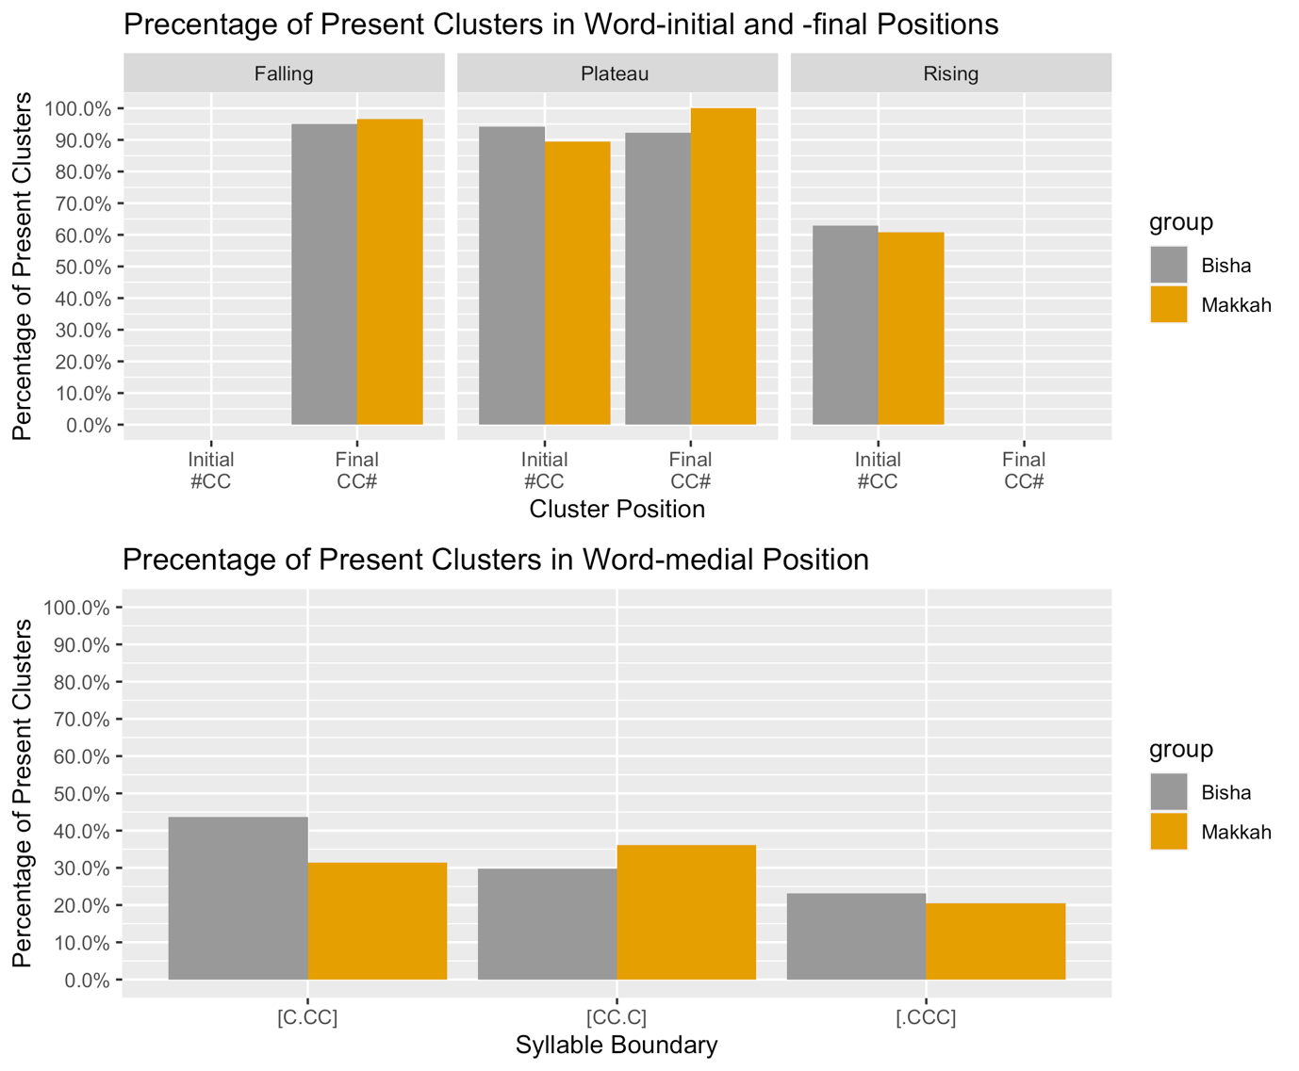

Figure 5. 5: Percentage of correctly pronounced L2 English clusters across syllable positions, sonority slopes for peripheral clusters (CC), and syllable boundary for medial clusters (CCC), produced by BA and MA speakers. Falling sonority clusters in the initial position and rising sonority clusters in the final position were not tested since they are absent in English phonology.

Figure 5.5 shows two findings in terms of syllable positions: (i) the overall percentage of L2 English clusters in word-initial (e.g., stay) and -final (e.g., health) positions produced by BA and MA speakers is exceedingly high; however (ii) the percentage of cluster production by the same speakers dramatically decreases in medial position. Sonority seems to play no role in the peripheral positions apart from rising sonority clusters in the initial position (the percentage of produced clusters in this slope is about 60 % whereas the percentage in other slopes is over 90 %). In the medial position, the percentage of produced consonant clusters across syllable boundaries is generally low (less than 40 %). Finally, it seems that BA and MA are equal in the percentage of produced L2 English consonant clusters regardless of the clusters position.

Word-initial Consonant Clusters (L2)
Before presenting the L2 results, it is crucial to summarise the results of L1 word-initial consonant clusters in BA and MA, which are summarised as follows:
- BA and MA allow word-initial consonant clusters, but they occur more frequently in BA than in MA.
- The employed ICIs that break up word-initial consonant clusters in BA and MA behave as intrusive vowels because they fulfil the diagnostics of intrusion.
- As a result of (a) and (b), BA and MA dialects are likely to have underlying consonant clusters of some kind because the employed ICIs (i.e. intrusive vowels) do not serve as syllable nuclei.
On the basis of this brief summary, BA and MA speakers are expected to have no difficulties in acquiring word-initial English consonant clusters. The rationale behind this expectation is that BA and MA speakers will positively transfer their L1 word-initial underlying consonant clusters to acquire word-initial English consonant clusters without any modification. This notion is quantitatively tested in the subsidiary question:
- Do BA and MA L1 speakers produce L2 word-initial English consonant clusters as clusters as clusters?
To answer this question, a total of 12 tokens were used to test English #CC by considering three independent variables to design these stimuli: target dialects, cluster size and sonority constraints. The target dialects are Bisha and Makkah (located respectively in the south and west of Saudi Arabia). The cluster size was limited to two constituents #CC (e.g. [θri:] “three”). The second variable, which is sonority slope, has three levels: rising (e.g. [θri:] “three”) and plateau sonority (e.g. [steɪ] “stay”).

It is worth mentioning that the dependent variable in this experiment is the presence versus the absence of consonants in consonant clusters, whereas the dependent variable in Chapter 4 (Arabic Results) is the presence versus the absence of ICI. This difference is intentional because it highlights the fact that most Arabic dialects do not allow surface consonant clusters and they are broken up by an ICI. Therefore, the interest of Chapter 4 (Arabic Results) is the quality of employed ICIs. In contrast, the English language allows surface consonant clusters; therefore, the goal of this chapter is to examine the presence and absence of consonant clusters regardless of the employed modification, which is discussed below.

Figure 5.6 below presents the results of a comparison between BA and MA speakers producing word-initial consonant clusters across two levels of sonority: rising and plateau sonority.

The figure shows that speakers of both dialects maintain English clusters to an equal extent, especially in the case of clusters that are in line with plateau sonority (~ 90% of clusters are maintained). The figure also indicates that there is no difference between the dialects in their production of English clusters. This finding is statistically tested below.

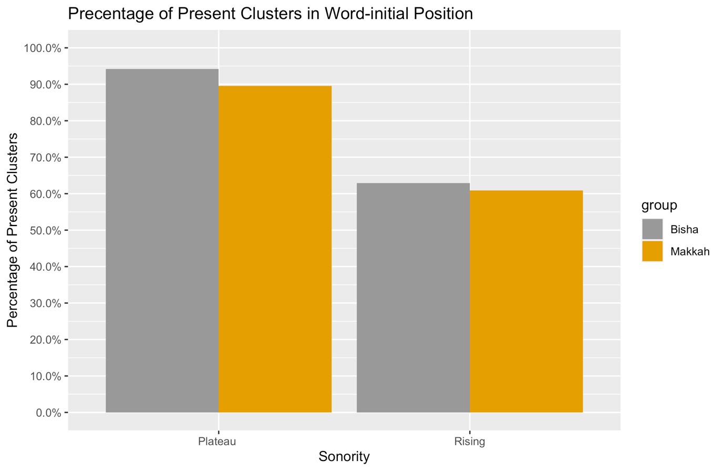
Figure 5. 6: The percentage of present English word-initial consonant clusters produced by BA and MA speakers across two levels of sonority, rising and plateau.

Using R, a binomial generalised linear mixed model (GLMM) and lme4 (Bates et al., 2015) was established to test the relationship between cluster presence as the dependent variable and the fixed factors: dialects and sonority slope, with item and subject as random effects. The model failed to converge when dialects were included as a random slope; therefore, sonority was the only random slope that was used. The significance of effects was identified using likelihood ratio tests of the full model with the effect in question against the model without the effect in question (i.e. full.model vs null.model). The models were visualised using ggplot2 (Wickham, 2009) and their predictions were explored using lsmeans (Lenth, 2016). R codes of the best-fit model are provided in a footnote.
Table 5. 4: Mixed effects coefficients (predicting cluster presence with the fixed correlated effects dialect and sonority) for the binomial GLMM model visualised in Figure 5.7.
 | Estimate | SE | z value | p value
Intercept | 3.47 | 0.73 | 4.74 | 2.13e-06 ***
Makkah dialect | -0.13 | 0.24 | -0.54 | 0.58
Rising sonority | -2.89 | 0.78 | -3.69 | 0.000218 ***

The best-fit model – as shown in Table 5.4 – shows no significant differences between BA and MA for presence of English clusters (z = -0.54, p = .58). It is crucial to state that the intercept of the current model is positive (3.47) and highly significant, which means that the presence of L2 English clusters is significantly far from zero, which, in turn, suggests significant English production differences, as there is no difference between the dialects as shown in the model. Interestingly, among those clusters that have been modified by the dialects’ speakers, consonant clusters with rising sonority are modified significantly more (z = -3.69, p = 0.000218) than their counterparts with plateau sonority, as shown in Figure 5.7.

The likelihood ratio test indicates that sonority is significant for the cluster presence (χ² (3) = 15.28, p = 0.001). In comparison with Figure 5.6, the significant effect of sonority is not surprising. Figure 5.6 shows that about 60% of rising sonority consonant clusters and about 95% of plateau sonority clusters are produced in a target-like manner by the dialects’ speakers. This means that the latter type of clusters is almost fully maintained. Therefore, there was a significant difference between the sonority conditions.
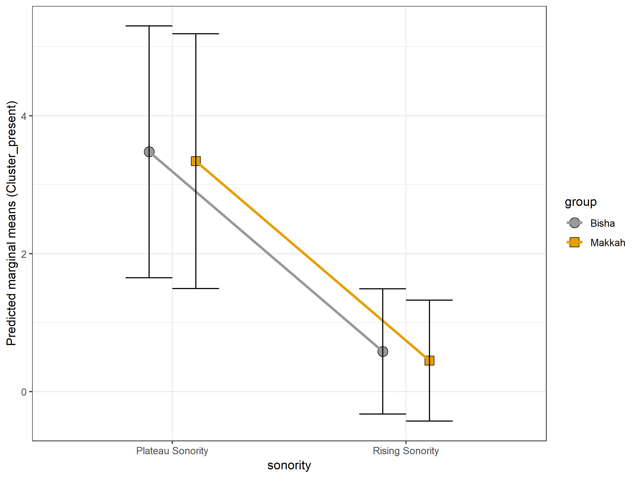
Figure 5. 7: Predicted marginal means (and 95% CI) for the binomial GLMM by group and sonority.

It is worth mentioning that some of the stimuli used in the current experiments are low frequency words (e.g., “lurid”) and/or highly variable among native speakers of English (e.g., “huge”). To for the effect of these low frequency words, the statistical model (i.e., GLMM) was run again, but these words were excluded. Excluding these words from the model does not change the conclusions obtained from the model, as presented in Table 5.4 and Figure 5.7.

In summary, the established model and the descriptive plots lead to the following conclusions:
- BA and MA speakers are highly likely to pronounce English word-initial consonant clusters in a target-like manner (i.e., as a cluster).
- Sonority constraints play a significant role in predicting English cluster presence, such that clusters with plateau sonority are realised as clusters by speakers more often than their counterparts with rising sonority.

Having discussed the pronunciation of English word-initial consonant clusters by BA and MA speakers, the next part of this chapter is dedicated to analysing English word-medial consonant clusters.

Word-medial Consonant Clusters
Before presenting the L2 results, it is crucial to summarise the results of L1 word-medial consonant clusters in BA and MA:
- Medial clusters [CCC] in BA and MA are broken up with ICIs [CCvC] to an extremely significant extent.
- The applicable diagnostics of employed ICIs suggest that these realised ICIs behave as epenthetic vowels because they are not affected by the place of articulation of the target clusters, which is an obvious diagnostic of epenthesis.
- Based on (a) and (b), BA and MA lack word-medial consonant clusters (CCC) > (CCvC).
On the basis of this brief summary, BA and MA speakers are expected to break up English word-medial consonant clusters (CCC) with an ICI, since they lack such clusters in their L1. This expectation is quantitatively tested in response to the following sub-question:

- Do BA and MA L1 speakers produce L2 word-medial English consonant clusters?
To answer this question, a total of 9 stimuli were used to test English -CCC- by considering syllable boundaries as follows:
- [.CCC] as in [dɪ.skrɪpʃn] “description”.
- [C.CC] as in [tʃɪl.drən] “children”.
- [CC.C] as in [əsʌmp.ʃən] “assumption”.
These stimuli were presented in their orthographic form to 51 participants (29 MA / 22 BA) in a multiple-choice grammar task, as mentioned earlier in Section 5.5. Each stimulus was pronounced twice by each participant. The analysis of participants’ pronunciations is illustrated below.

Figure 5.8 indicates that speakers both dialects are highly likely to simplify the three types of English word-medial consonant clusters, especially clusters consisting of three consonants in the onset position [.CCC], in which about 20% of these clusters have been produced. The other two types of clusters are equally simplified by the dialects’ speakers, in which about 35% of these clusters have been produced. This tendency towards [CCC] modification is statistically investigated below using mixed-effects models.

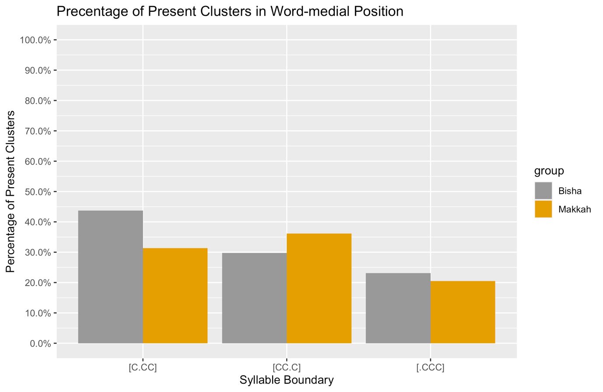
Figure 5. 8: The percentage of present and modified English word-medial consonant clusters produced by BA and MA speakers across three syllable boundaries.

As shown in Table 5.5 and Figure 5.9, the best-fit model indicates that the dialect variable has no significant effect on the production of [CCC] sequences as clusters (z = -1.07, p = 0.28). It is crucial to state that both speakers of both dialects tend to modify English word-medial [CCC] consonant clusters because the intercept of the current model is negative (-0.48), indicating that dialect variable predicts the absence of [CCC] clusters. Additionally, and within syllable boundaries, the model shows that clusters with three consonants in the onset position [.CCC] are more likely to be modified ( z = -1.98, p = 0.04) in comparison with the other types of clusters.

Table 5. 5: Mixed effects coefficients (predicting cluster presence with fixed correlated effects: dialect and syllable boundaries) for the binomial GLMM model visualised in Figure 5.9.
 | Estimate | SE | z value | p value
Intercept | -0.48 | 0.500 | -0.95 | 0.33
Makkah dialect | -0.39 | 0.36 | -1.07 | 0.28
Syllable boundary [CC.C] | -0.39 | 0.64 | -0.62 | 0.53
Syllable boundary [.CCC] | -1.36 | 0.68 | -1.98 | 0.04*

The likelihood ratio test indicates that syllable boundaries are a significant predictor of English word-medial consonant clusters (χ² (7) = 25.21 , p = 0.0006). This significance of syllable boundaries is clearly depicted below in Figure 5.9.

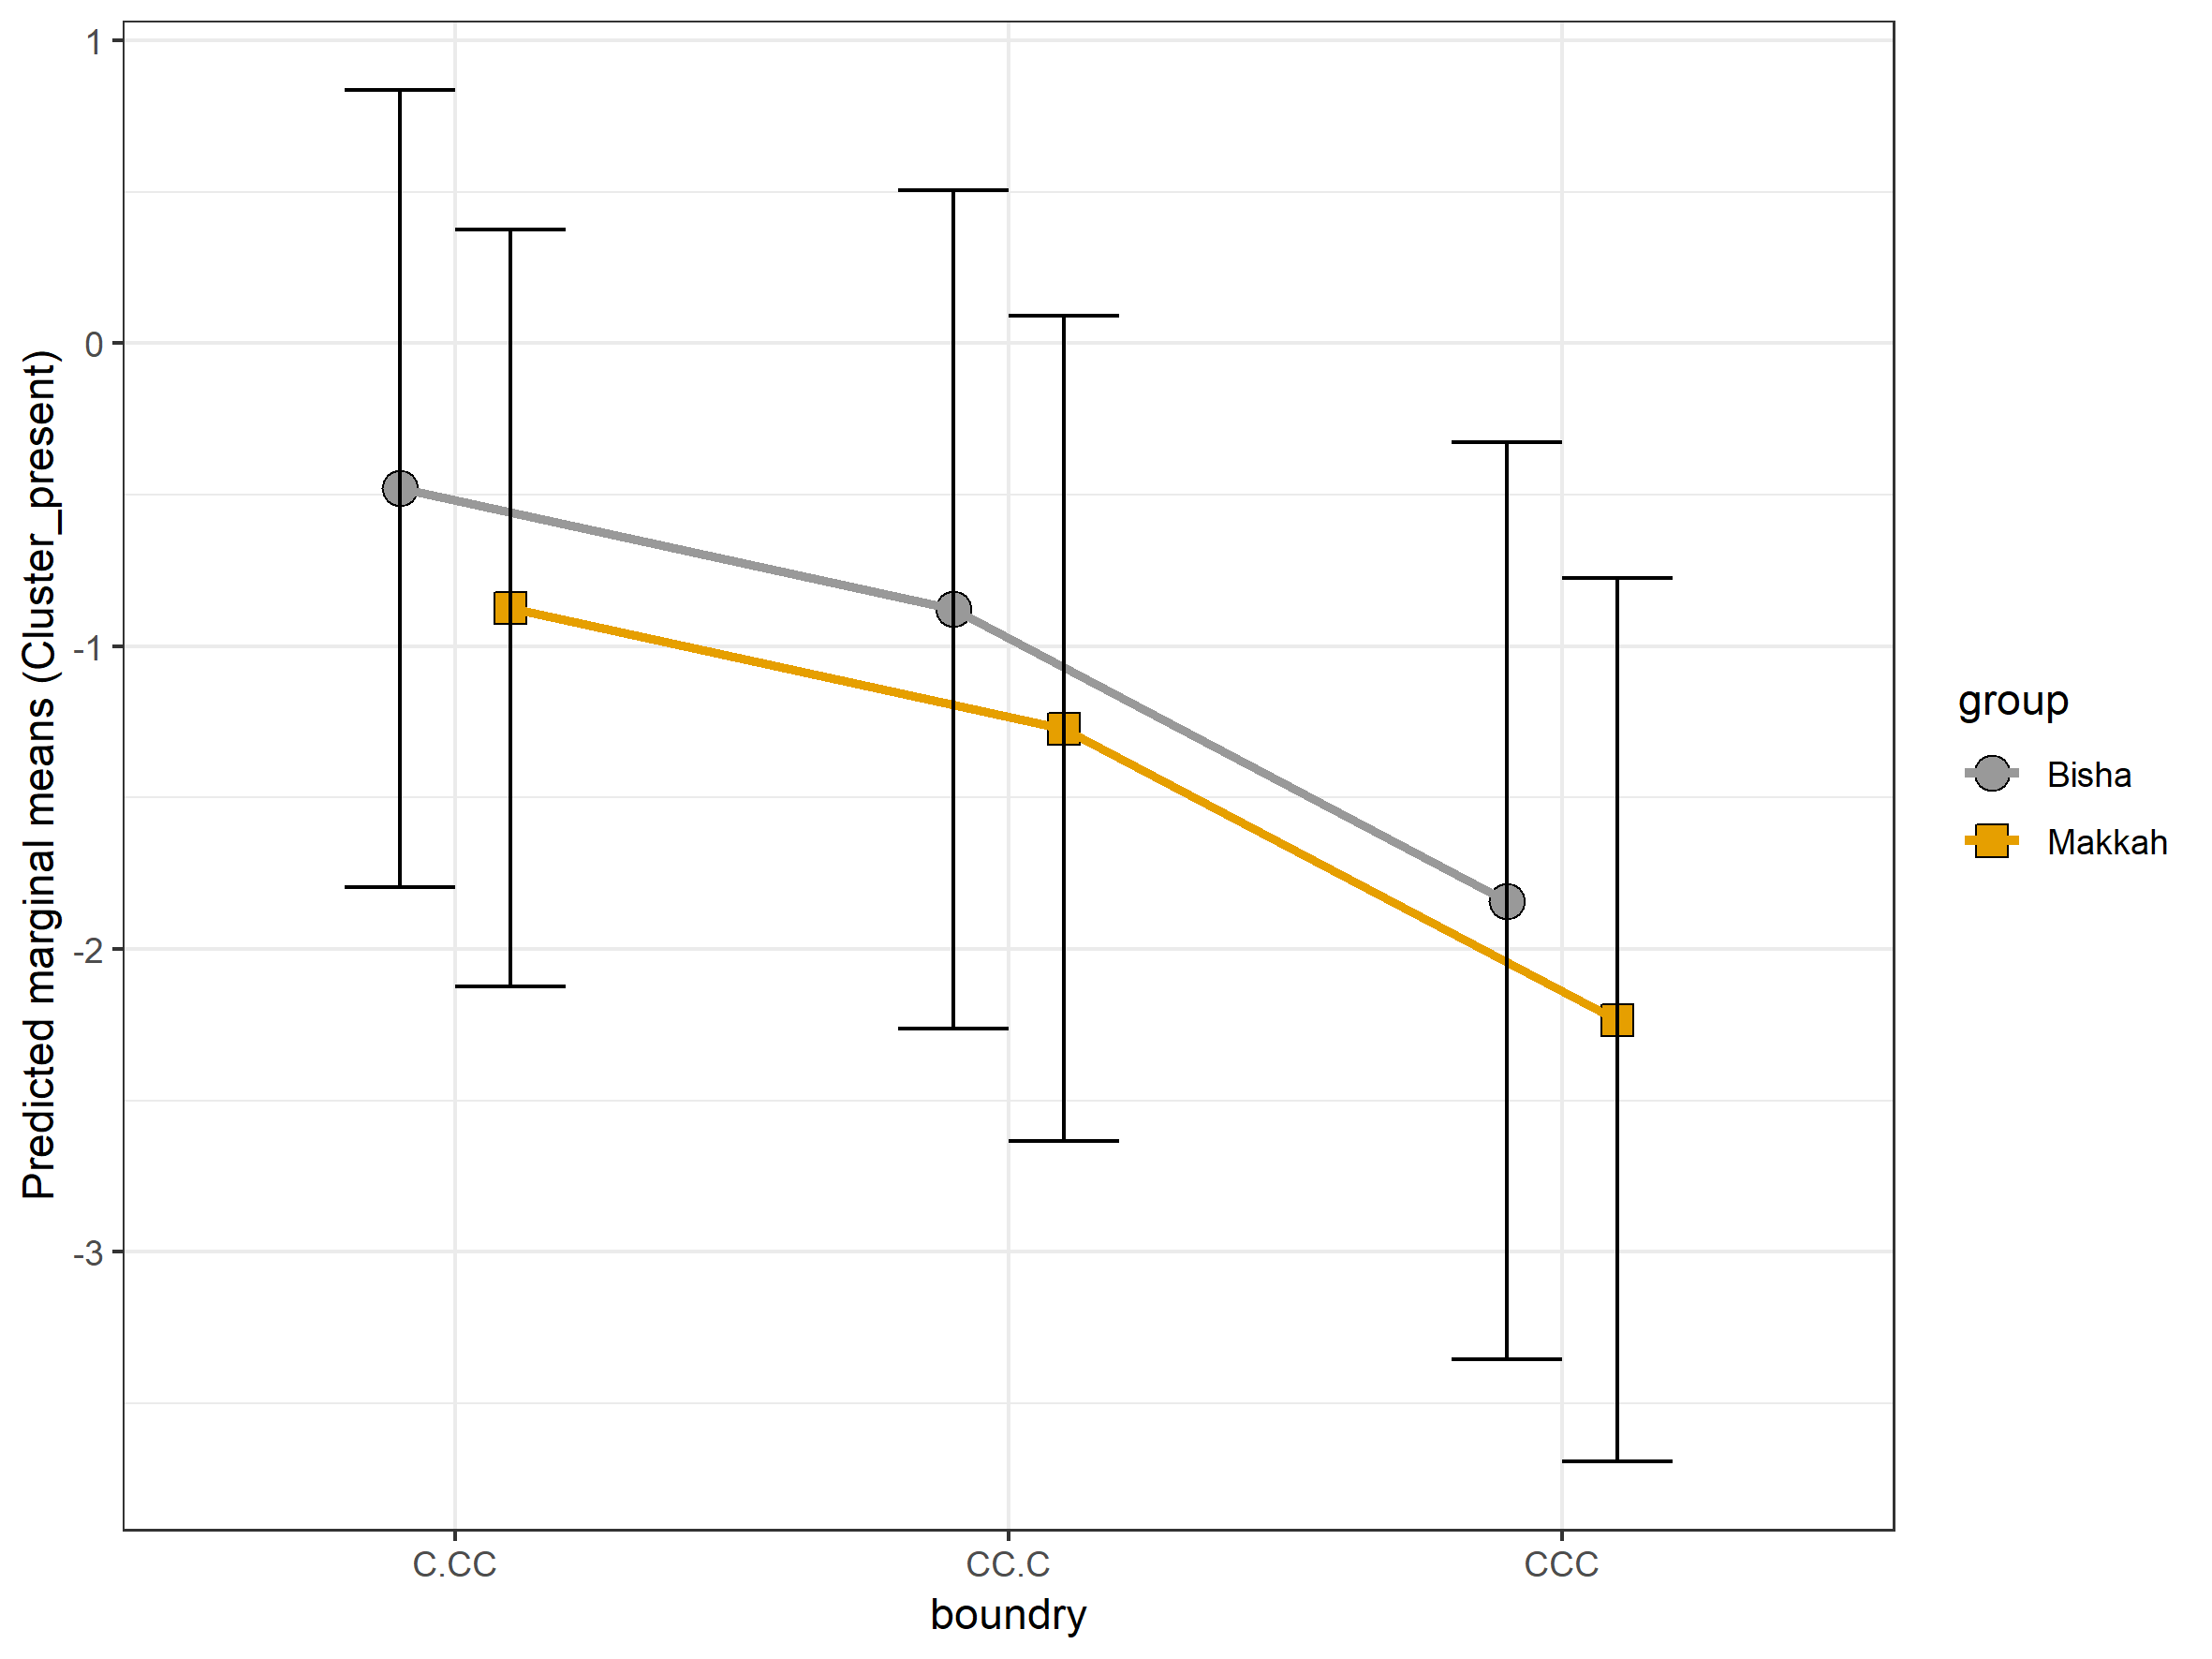
Figure 5. 9: Predicted marginal means (and 95% CI) for the binomial GLMM by group and syllable boundaries.

In summary, the established model and the descriptive plots lead to the following conclusions:
- BA and MA speakers are highly likely to modify English word-medial consonant clusters.
- Syllable boundaries play a significant role in predicting the presence of English medial clusters, whereby clusters with three consonants in the onset position are modified more than the other types of clusters.

Having discussed the pronunciation of English word-initial consonant clusters by BA and MA speakers, pronunciation of English word-final consonant clusters will be the theme of the next part in this chapter.

Word-final consonant clusters
Following previous sections, this section will start with a summary of word-final consonant clusters in BA and MA and compare them with their counterparts in English. The summary of such clusters is as follows:
- Consonant clusters with:
    - rising sonority (e.g. [baħar] “sea”) are broken up by epenthetic ICIs,
    - plateau sonority (e.g. [kabd] “liver”) are pronounced as plain clusters,
    - falling sonority (e.g. [kanz] “treasure”) are pronounced as plain clusters.
- The finding of (a) is consistent across the target dialects, BA and MA.

Based on the summary mentioned above, word-final clusters in BA and MA are very similar to their counterparts in English, in which the latter lacks consonant clusters with rising sonority, whereas consonant clusters with plateau and falling sonority do occur, as in “act” and “health” (Treiman, 1984; 1986). This comparison suggests that BA and MA speakers are expected to have no difficulties in pronouncing English consonant clusters in final position. This expectation is empirically examined and analysed below.

Figure 5.10 shows that there is a clear trend of accuracy (~ 90 %) in pronouncing English consonant clusters by BA and MA speakers. This accuracy of pronunciation is consistent across the target slopes of sonority: plateau and falling slopes. These descriptive findings are statistically examined below using “lme4” package in R.

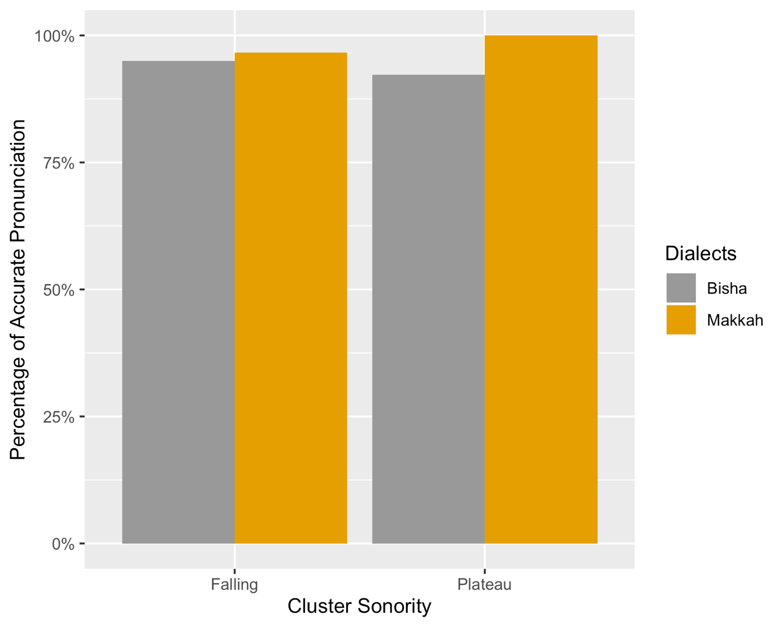
Figure 5. 10: The percentage of present English word-final consonant clusters produced by BA and MA speakers across two levels of sonority: falling and plateau.

As shown in Table 5.6 and Figure 5.11, the best fit model shows no significant differences between BA and MA for English clusters’ presence ( z = 0.36, p = .52). It is crucial to state that the intercept of the current model is positive (10.12) and significant, which means the presence of English clusters in the reference level (i.e., BA) is also significant. Likewise, this in turn suggests a significant presence of English clusters in MA because there is no difference between the dialects, as shown in the model. The model also suggests that plateau and rising slopes of sonority are almost identical as predictors of pronunciation accuracy (z = 1.01, p = 0.31). The likelihood ratio test confirms the mixed model presented in Table 5.6 suggesting that sonority plays no role as a predictor of pronunciation accuracy of word-final consonant clusters by BA and MA speakers (χ² (3) = 4.48 , p = 0.21).

Table 5. 6: Mixed effects coefficients (predicting cluster presence with fixed correlated effects: dialect and sonority slopes) for the binomial GLMM model visualised in Figure 5.11
 | Estimate | SE | z value | p value
Intercept | 10.12 | 4.56 | 2.21 | 0.0265 *
Makkah dialect | 0.79 | 1.25 | 0.63 | 0.5251
Sonority: plateau | 8.29 | 8.17 | 1.01 | 0.3106

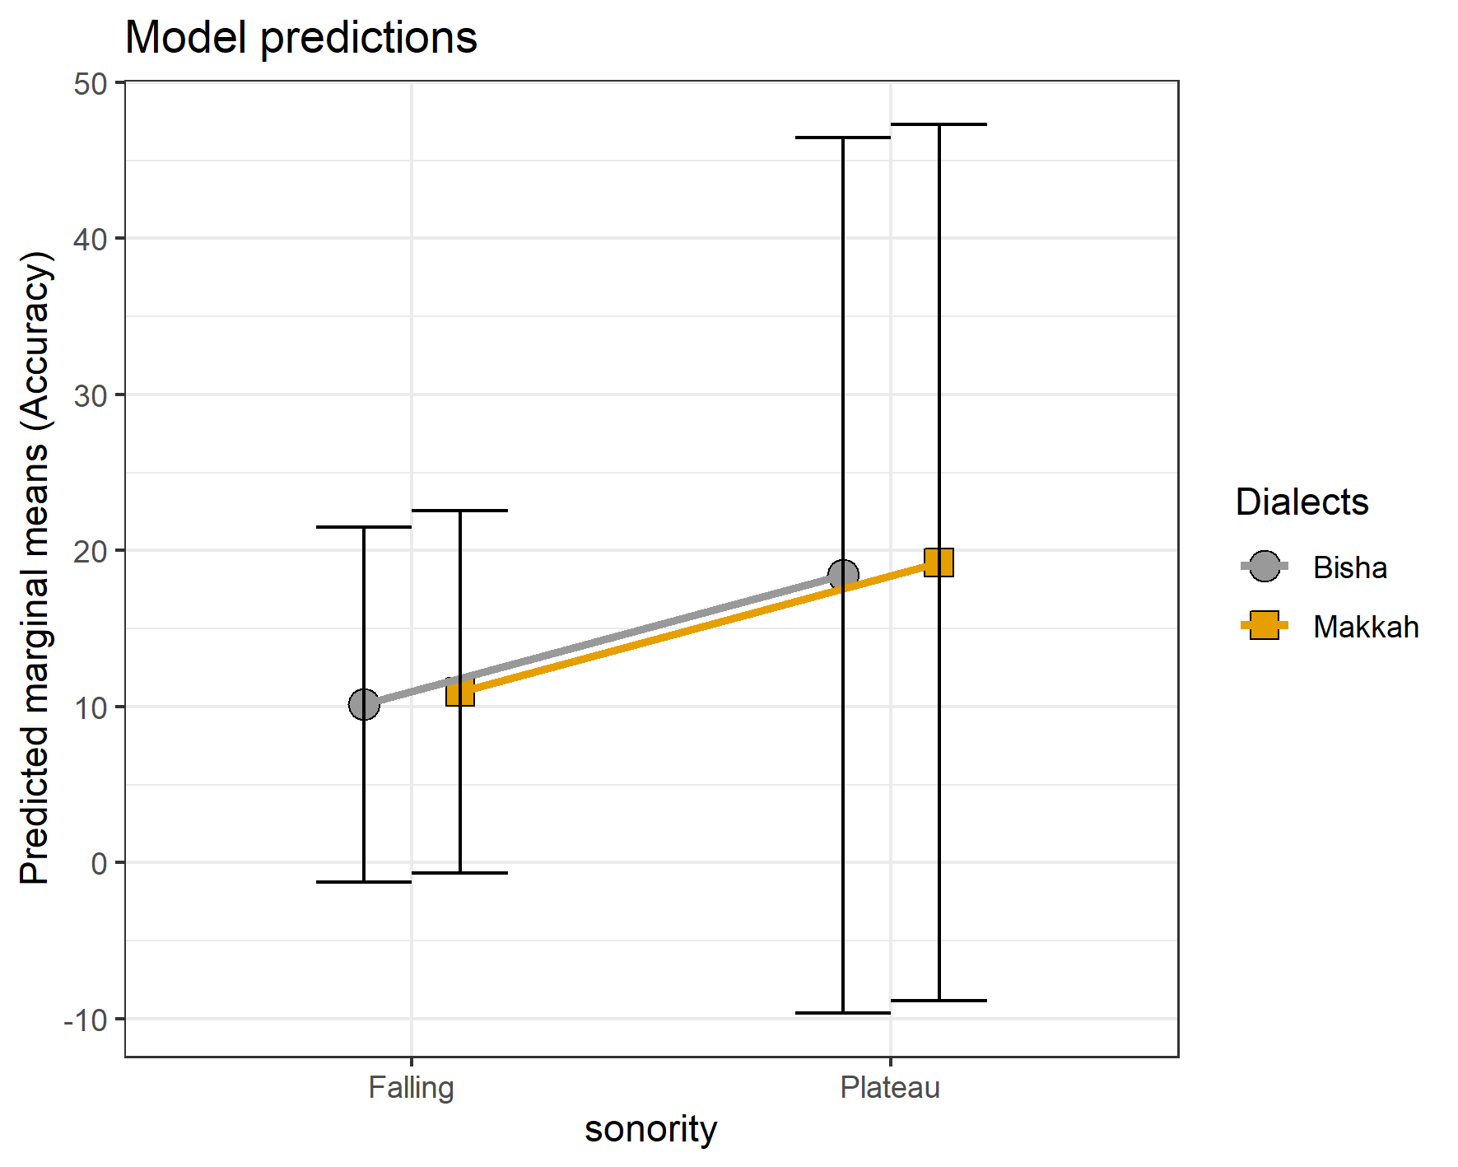
Figure 5. 11: Predicted marginal means (and 95% CI) for the binomial GLMM by group and sonority slopes.

Interim discussion
BA and MA speakers are generally able to pronounce English word-initial consonant clusters in a target-like manner (i.e. as clusters) in contrast to speakers of other Arabic dialects such as Faifi and Assiri Arabic speakers (see Section 5.4 for further information). In word-medial position, [CCC] English clusters were difficult for BA and MA speakers, similarly to speakers of other Arabic speakers such as Saudi, Cairene and Iraqi Arabic speakers. This difficulty results in a significant modification by inserting a vowel to simplify English medial clusters. For word-final consonant clusters (CC#), these clusters were very easy for BA and MA L1 speakers.

Interestingly, L2 word-initial consonant clusters also appear easy for the dialects’ speakers, even though they lack such clusters in their L1 (the rate of present consonant clusters in BA is higher than of that in MA). Why are two-position [CC] onset clusters easy word-initially, but difficult word-medially [C.CC] for BA and MA speakers?

I argue that BA and MA speakers employ intrusive vowels to break up word-initial onset clusters in their L1. Phonologically, this vowel cannot occupy as a syllable nucleus (Hall, 2006), thus BA and MA do allow underlying consonant clusters in word-initial position. Consequently, word-initial English clusters are easy for them to produce. In contrast, BA and MA speakers use epenthetic vowels in their L1 to modify word-medial clusters. Epenthetic vowels are phonologically considered a syllable nucleus (Hall, 2006). Hence, they show negative transfer of L1 properties resulting in difficulties in their production of word-medial English clusters [C.CC]. Further analysis will be provided in the discussion chapter.

This finding is supported by Syllable Structure Transfer Hypothesis (SSTH). “When the target language has syllable structures which do not occur in the native language, speakers may take action to force the target language structures into conformity with native language restrictions. A common means of dealing with differences between first and second language syllable structures is insertion of a vowel to transform the target language syllables into shapes which are acceptable in the first language” (Broselow, 1984, p. 262).

In accordance to SSTH, BA and MA speakers transfer their strategy to simplify illicit L1 medial clusters into their treatment of illicit L2 medial clusters. This strategy is vowel insertion as in [ɡiltlu] > [ɡiltǝlu] “I said to him” and it has been transformed into their production of L2 English clusters ([tʃɪl.drən] > [tʃɪl.dǝ.rən] “children”). Other strategies are rarely found in the current study.
In fact, it is not only Arabic speakers who employ vowel insertion as their predominant simplification strategy; this pattern conforms to prior research that indicates the prevalence of this strategy cross-linguistically (Colantoni et al., 2015; Davidson, 2006; Davidson, Jusczyk, & Smolensky, 2004; Hancin-Bhatt & Bhatt, 1997; Lin, 2001; Tarone, 1980).

In the initial position, BA and MA speakers generally appear not to experience difficulties in pronouncing L2 English clusters, since such clusters do exist in their underlying phonological grammar, although they are broken up by surface vowels (intrusive vowels), as discussed earlier. Therefore, they face no significant challenges regarding L2 English word-initial clusters.

The production of “easy” L2 onset clusters [CC] is not limited to Arabic speakers only. English speakers also find L2 pseudo-Czech onset clusters [CC] easy even though some of the target clusters are unattested in English grammar (Davidson, 2006). For example, the cluster [fn] violates English phonotactics word-initially but the accuracy of producing [f + nasal] clusters is over 75 %. “In order to produce the unattested sequences, English speakers seem to be accessing phonological information about similar sequences that are phonotactically legal in word-initial position and extending their knowledge of those sequences by analogy to the unfamiliar ones” (Davidson, 2006, p. 133). Therefore, analogy is a key factor in the mental representation of speakers’ phonology that significantly contributes to the ease of producing unattested sequences in the L2.

In the following chapter, perception of L2 English consonant clusters by BA and MA speakers will be discussed.

Perception of L2 English consonant clusters by BA and MA speakers: background, empirical experiment, results with interim discussion:

Introduction
Experiment 3 aims to test the accuracy of perceiving L2 English consonant clusters by BA and MA speakers using an AXB discrimination task. The motivation for this experiment is to provide a further potential source of evidence about L1 phonology (i.e., BA and MA phonology) from L2 behaviour. The structure of this chapter will be as follows: (i) a review of models and theories that test the perceptual illusion of L2 consonant clusters, (ii) methodology of the empirical experiment, and (iii) results of the experiment followed by an interim discussion.

Background
Infants acquire sounds of their native language (L1) as categories in very early stages (Ioup, 2008; Ohala, 2008; Strange & Shafer, 2008). Once these L1 categories are established, L2 categories might be easy or difficult for L2 learners to acquire, according the similarities and differences between L1 and L2 categories (Ioup, 2008). The perception of these L2 categories is the main theme of L2 perceptual models, which propose a mechanism to predict listeners’ discrimination of L2 sound categories, based on the degree of similarity and difference between their L1 and L2 (Colantoni et al., 2015). In the next subsections, two influential models will be summarised: The Perceptual Assimilation Model and the Speech Learning Model.

Speech Learning Model
Flege (1995, 2003) established the Speech Learning Model (SLM) on the basis of hypothesis of “equivalence classification”. It means that L1 phonemes are distinct categories that are stored as mental representations. These established categories result in: (i) a high degree of proficiency in classification of L1 sounds, and (ii) decreased ability to discriminate differences between L1 and L2 categories. Consequently, L2 learners may employ their classification strategies for L1 categories to classify speech sounds of L2.

However, the accuracy in classifying L2 categories varies (Flege, 2003). The more similar L2 categories (i.e., phonemes) are to L1 categories, the more difficult it is for L2 learners to form a target-like category in the L2. In contrast, the more dissimilar L2 categories are to their L1 equivalents, the easier the formation of new target-like L2 categories is. For instance, the American English vowels [ɑ] and [ʌ] are difficult to discriminate for Spanish speakers learning English, since these two English vowels are both similar to the Spanish vowel [a] (Ioup, 2008).

The following section will discuss the second perceptual model: The Perceptual Assimilation Model.

Perceptual Assimilation Model
The Perceptual Assimilation Model (PAM) was established to predict discrimination of L2 contrasts based on articulatory representation of gestures (Best, 1995; Best & Tyler, 2007). The model “posits that non-native speech perception is strongly affected by listeners’ knowledge (whether implicit or explicit) of native phonological equivalence classes, and that listeners perceptually assimilate non-native phones to native phonemes whenever possible, based on detection of commonalities in the articulators, constriction locations and/or constriction degrees used” (Best et al., 2001, p. 4). PAM is unlike SLM, which models discrimination of individual segments based on the mental representation of phonemes (i.e., categories); PAM, on the other hand, rejects the assumption of storing phonemes as mental representations. The phoneme in PAM is instead represented by the gestural movements that result in a speech sound and may show variability that equates to the allophonic variations in the traditional theory of phonemes. Based on this assumption, L2 learners to a varying extent assimilate the gestural movements of L2 phonemes into their similar articulatory gestures in L1 (i.e., they model the articulation of L2 sounds on near equivalents in the L1) (Best, 1994, 1995; Best & Tyler, 2007).
However, the assimilation process varies according to the categories found in L1 and L2, as also mentioned in the SLM. Best (1994, 1995) proposes that different levels of assimilation are predicted to be displayed by L2 learners. These levels are summarised in Table 6.1.

Table 6. 1: A summary of assimilation levels proposed in the PAM (Best, 1994, 1995).
Assimilation level |  | Definition |  | Examples
Two-Category Assimilation (TC) |  | Speakers assimilate two L2 segments (i.e. contrasts) into two different categories in the L1. |  | a) Hindi /ɖ/ English /d/.  b) Hindi /d̪ʰ/ English /ð/.
Category-Goodness Difference (CG) |  | Speakers assimilate two L2 segments (i.e. contrasts) into a single L1 category but one of the L2 contrast may be more similar to the L1 category than the other. |  | a) Zulu /kˈ/ English /k^{h}/.  b) Zulu /k/ English /k^{h}/.
Single-Category Assimilation (SC) |  | Speakers assimilate two L2 segments (i.e. contrasts) into a single category in the L1. |  | a) Salish /kˈ/ English /k^{h}/.  b) Salish /qˈ/ English /k^{h}/.

There are three further levels of assimilation in the PAM; however, most studies concern the levels presented in Table 6.1 (Colantoni et al., 2015). For further information, see Best (1994, 1995); Best and Tyler (2007).

It worth mentioning that the assimilation categories mentioned above in Table 6.1 are generally identified using a so-called Perceptual Assimilation Task (PAT). In this task, L2 listeners go through a sequence of stages: (1) they hear an L2 target stimulus, (2) they are presented with several L1 categories (i.e., stimuli) that are similar to the heard L2 stimulus and they are asked to identify which of the L1 categories is the most similar to the L2 stimulus, and finally (3) they are presented with a goodness of fit rating on scale (0-7) and they are asked to rate the goodness of fit of their answer mentioned in (2), “where 1 meant a poor or bad rendering of the selected sound and 7 meant a good, native-like example” (Cebrian, 2019, p. EL54).

This brief summary highlighted two key models used in L2 studies that investigate L2 segments (SLM) or L2 contrasts (PAM). The common feature among these models is the proposal of a mechanism to predict the extent of assimilation/discrimination of L2 categories based on the degree of similarity and difference between L1 and L2. However, these two models examine singleton segments not sequences of segments (Dupoux et al., 1999; Dupoux et al., 2011). The current research focuses on sequences of segments, not singleton segments. For this reason, I assume they will not explain any difficulties shown by L2 learners in perception of English consonant clusters. To my knowledge, there is no specific hypothesis that examines the perception of consonant clusters from a phonological perspective. We turn therefore to the literature about perceptual illusion, and in addition to Signal Detection Theory, which will be employed to model the perception of sequences of segments.

Perceptual illusion in L2 syllable phonotactics
Misperception of consonant clusters in L2 has been attributed to a type of “perceptual illusion” caused by the lack of such clusters in the native language of learners (Davidson & Shaw, 2012; Matthews & Brown, 2004).

“When processing the L2 speech signal, a learner’s L1 constraints on syllable structure generate an abstract epenthetic vowel to separate consonants of illicit clusters (e.g., CCV), thereby causing the learner to perceive an illusory vowel where no acoustic cue exists (e.g., CVCC). Consequently, it should come as no surprise that the learner’s productions of target L2 consonant clusters are non-native since they are generated from representations that contain material not present in the L2 input, but rather introduced by the learner’s perceptual system as constrained by his or her L1” (Matthews & Brown, 2004, p. 7).

This tendency of perceptual illusion is reiterated in the context of pseudo-words by Durvasula and Kahng (2015, p. 386) who state that “when a native speaker is presented with a nonsense word containing a consonant sequence that violates the phonotactic constraints in their language, an illusory vowel is perceptually induced between the consonants, thereby creating an illusory sequence that respects the phonotactic constraints of the language”.

The illusory vowel effect mentioned above has been observed in a number of studies. For instance, Dupoux et al. (1999) found that Japanese speakers tend to perceive an illusory vowel breaking up non-native medial clusters VCCV [ebzo], resulting in VCvCV [ebɯzo] due to the lack of such clusters in their native language. A similar finding occurs in the perception of illicit clusters (e.g., lbif) in English and Korean by native speakers those languages.
Methodologically, the most commonly used tasks in such studies are AX and ABX with some variations to the design of the latter task, such as the AXB task (Dupoux et al., 1999; Dupoux et al., 2011; Durvasula, Huang, Uehara, Luo, & Lin, 2018; Durvasula & Kahng, 2015; Kabak & Idsardi, 2007). In the AX task, listeners hear two tokens (A and X) and decide whether X sounds like A or not (Colantoni et al., 2015; Strange & Shafer, 2008). An example derived from an empirical study shows that English native speakers listened to non-native word-initial consonant clusters presented using AX task (e.g., [zmatu]-[zəmatu]). The listeners were asked to decide if X [zəmatu] sounds like A [zmatu] (Davidson & Shaw, 2012).

In AXB task, “listeners hear three tokens (A, X and B) and have to decide whether the second sound ‘X’ sounds more like the first ‘A’ or the third ‘B’” (Colantoni et al., 2015, p. 97). This task has four presentation sequences (AAB, ABB, BBA, BAA). If we use the example mentioned above and apply it to AXB task, English listeners would listen to the stimuli [zmatu] as follows: [zmatu]-[zmatu]-[zəmatu]. This example is presented in the order: AAB. Listeners should decide if the second A [zmatu] sounds more like the first A [zmatu] or B [zəmatu]. Other sequences (ABB, BBA, BAA) would be presented similarly, but with different orders.

Theoretically, the analytical approach employed to analyse the results of perceptual illusion studies is Signal Detection Theory, regardless of the task used in such studies (Davidson & Shaw, 2012; Durvasula et al., 2018; Durvasula & Kahng, 2015; Kabak & Idsardi, 2007). Therefore, this theory will be summarised in the following section.

Signal Detection Theory (SDT)
When uncertainty in making a decision about something is present, SDT is employed as a decision-making analytic. SDT “is a framework for understanding accuracy that makes the role of decision processes explicit” (MacMillan, 2002, p. 43). For instance, if physicians are uncertain about the presence of tumor, would it be safer to fail to detect such a tumor, or to decide on its presence although it is really absent? SDT may help those physicians to make a safe decision (MacMillan, 2002). Initially, this theory was used by radar operators to distinguish between an threat, such as a plane (Signal) or noise, such as a flock of birds (Noise) (Peterson, Birdsall, & Fox, 1954).
The Signal (e.g. presence of a tumor) versus Noise (e.g. absence of a tumor) mentioned in the previous example are called binary stimuli, and each of these stimuli has its distribution, as shown in Figure 6.1 (A). The distributions of stimuli (i.e. Signal and Noise) are represented by the observer with sensitivity and strength of sensory stimulus. This sensitivity is called d` (d prime) (MacMillan, 2002).

The higher the degree of overlap between the distributions of the stimuli, the higher the number of errors, and vice versa as presented in Figure 6.1 (A). Therefore, the observer should set a strategy or criterion (C or β) to divide the binary distributions into two responses: Yes and No. A Yes response indicates high values and denotes the presence of Signal (e.g. presence of tumor) and a No response indicates low values and means that the current stimuli is Noise (e.g. absence of tumor) (MacMillan, 2002). The default criterion is to centralise the binary distributions by dividing them into two equal regions, as shown in Figure 6.1 (A). If the observer tends to say Yes more than No, this indicates that his/her criterion has been changed or biased toward a liberal criterion, as shown in Figure 6.1 (B). In contrast, if the observer tends to say No more than Yes, this indicates that his/her criterion has been changed or biased toward a conservative criterion, as shown in Figure 6.1 (C). The questions now are: what are the potential results of saying Yes? And what are the potential results of saying No? This question will be answered in the following subsection.

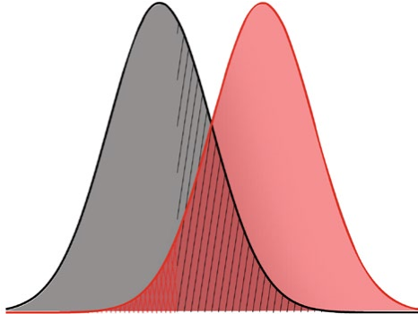
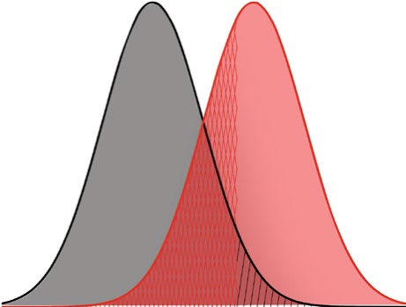
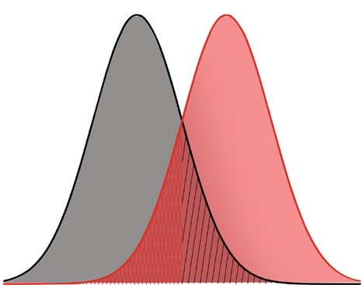
d`
Liberal criterion
Conservative criterion
B
C
Noise
Signal

Criterion
False alarms
Misses
Log-likelihood ratio of signal presence vs. absence
Probability density
Hits
Correct
rejections
A

Figure 6. 1: A hypothetical figure of SDT extracted from Gardner (2019) with a few changes. Figure (A) represents a normal distribution of signal presence overlapped with signal absence (noise) illustrated with probability of potential outcomes. The measurement d` prime equals the distance between the peak of signal presence and the peak of signal absence. Criterion is the threshold that observer employs to respond to the sensitivity of each signal. Figure (B) represents a liberal criterion and Figure (C) represents a conservative criterion.

The Yes-No Design
What are the potential results of saying Yes, there is a Signal (e.g. presence of tumor)? And what are the potential results of saying No, it is only Noise (e.g. absence of tumor)? There are four potential results of this question which are summarised in Table 6.2.
Table 6. 2: Potential results of Yes-No design
Stimulus | Response
Stimulus | “yes” | “no”
S (Signal) | hit | miss
N (Noise) | false alarm | correct rejection

These potential results are depicted in Figure 6.1 (A), which shows the distribution of each response. “Hits” and “correct rejections” respectively represent the Signal and the Noise distributions when they are not overlapped. If they are not overlapped, total confidence of the observer would be implied since the overlap between the target distributions is absent. This confidence decreases with the introduction of “false alarms” and “misses” because these results respectively represent an overlap between the Signal and the Noise distributions.

To apply Yes-No design to AXB discrimination task used in L2 perception studies, it is firstly crucial to specify Signal distribution and Noise distribution. Since this research is about perception of L2 consonant clusters, the presence of such clusters will represent the Signal distribution. In contrast, the absence of clusters will represent the Noise distribution, since an illusory vowel has been inserted between consonants. The potential results of the task are presented in Table 6.3.
Table 6. 3: Potential results of AXB task using Yes-No design.
 | Response
Stimulus | “Yes”  (matching the intended accuracy of pronunciation) | “No”  (mismatching the intended accuracy of pronunciation)
(Signal)  (the presence of a cluster)  (AAB/ BAA) | hit | miss
(Noise)  (the absence of a cluster)  (BBA/ ABB) | false alarm | correct rejection

Having reviewed some literature of L2 perception, the following section will focus on the relationship between L2 perception and production.

Conclusion
In Background section (6.2), the SLM and the PAM were briefly summarised. These perceptual models are proposed to predict the ability of L2 listeners to discriminate the L2 categories based on the similarities and differences between L1 and L2. However, predictions of the PAM and the SLM are limited to singleton segments, not sequences of segments. Therefore, the literature on L2 perceptual illusion was summarized, including the most commonly used tasks to test perception of consonant clusters (AX and AXB). Results of these tasks are generally analysed using the two main measurements in SDT: d` prime and criterion scores.
Based on the provided summary in this section, predictions of BA and MA speakers’ accuracy in perceiving L2 English consonant clusters will be summarised below.

Predictions of BA and MA speakers’ accuracy in perceiving L2 English consonant clusters
The perceptual ability to discriminate the presence or absence of L2 English consonant clusters by BA and MA speakers will be examined in Experiment 3. Reviewed literature summarised above shows a significant effect of L1 constraints resulting in perceptual illusion of L2 syllable phonotactics. Similar findings are predicted in the current experiment. These predictions are summarised as follows:

- BA and MA listeners are expected to have no difficulties in perceiving L2 English consonant clusters in peripheral positions, since such clusters are allowed in their L1. In contrast, English word-medial clusters are expected to be difficult to perceive by BA and MA listeners, since such clusters are absent in their L1.
- As a result of (a), BA and MA listeners are expected to easily differentiate between the two distributions: (i) Signal (plain peripheral consonant clusters) and (ii) Noise (peripheral consonant clusters with deliberately inserted vowels), since peripheral consonant clusters are present in their L1. This potential high degree of discrimination suggests that d prime scores for BA and MA listeners for peripheral clusters are expected to be high since this measurement calculates the sensitivity by listeners toward distinguishing the two distributions: Signal and Noise. In contrast, BA and MA listeners are expected to hardly differentiate between the two distributions: (i) Signal (plain medial consonant clusters) and (ii) Noise (medial consonant clusters with inserted vowels), since medial consonant clusters are absent from their L1. This low degree of discrimination suggests that d prime scores for detection of medial clusters by BA and MA listeners are expected to be low.

These predictions will be examined in Experiment 3, which is about perceiving L2 English consonant clusters by BA and MA speakers.

Methodology of Experiment 3: Perception of L2 English consonant clusters
The current experiment aims to examine how BA and MA listeners perceive L2 English consonant clusters across syllable positions. Methods of Experiment 3 will be presented as what follows:
- Experiment objectives: a brief review of experiment aim(s) followed by the experiment sub-question(s).
- Experiment design: methodology approach (quantitative analysis), measurement of target variables, design of stimuli, and justification for adopting the selected methods will be defined and explained.
- Data collection: this subsection will set out the details of the study including participants of each experiment, instruments used for data collection, and finally the process of data collection.
- Data analysis: due to the selected approach of analysis (i.e. quantitative analysis), this section will focus on the statistical analysis including the employed software and its related issues.

Objectives of Experiment 3
The first goal of this experiment is to test the perceptual ability of BA and MA speakers to discriminate the illusory vowel that has been deliberately inserted between consonants of English clusters, using the AXB task. Second, this experiment aims to provide independent evidence to support the concluded argument from Experiment 1 in which BA and MA allow underlying consonant clusters in the word-initial position, whereas such underlying clusters are disallowed word-medially. If BA and MA speakers show high accuracy of discriminating word-initial consonant clusters and a lower degree of accuracy in the medial position, this provides further evidence supporting the argument mentioned earlier. If not, another interpretation should be provided.
Based on these goals, the sub-questions of the current experiment are:

- Are BA and MA listeners able to discriminate between plain English consonant clusters and English clusters that have been broken up by vowel insertion?
This question will be addressed in this experiment, as presented in the following section.

Experiment design
In this section, the following subsections will be explained and defined: a) explaining the variables of the current experiment (dependent versus independent variables), and finally b) experimental tasks.

Variables
There are many studies on the perception of epenthesis. In a series of four experiments in a widely cited study conducted by Dupoux et al. (1999), native Japanese and French speakers were tested on how they perceive stop-nasal, stop-stop and stop-fricative medial clusters using nonsense words. The results indicated a significant difference between speakers in their perception of epenthesis. The authors attributed this difference to the impact of L1. Among others, Matthews and Brown, (2004) conducted a study to examine the perceptual illusion of epenthesis among Japanese and Thai English learners. The results demonstrate that Japanese speakers were more accurate than Thai speakers. The authors proposed that the variable that produced such results was cluster type (i.e. sonority), as stop-stop clusters are subject to perceptual epenthesis. Based on this literature, a summary of variables for the current experiment is presented below:
- Dependent variable: mean discrimination error rates. It can be simply summarised as: (Do speakers discriminate the absence versus presence of epenthesis?)
- Independent variables:
  - L1 with two levels: a) BA b) MA
  - Cluster position with three levels: a) initial b) final c) medial
  - Sonority slope with three levels: a) rising b) falling c) plateau

Stimuli
The same target consonant clusters in Experiment 2 have been investigated perceptually in the current experiment. A total of 27 stimuli were chosen based on the linguistic independent variables mentioned above. Applying this number of stimuli to the four sequences of the AXB task, the total amount of stimuli is 108 tokens. It is worth stating that these words will be pseudo-words based on the literature written about the AXB task (Davidson & Shaw, 2012; Dupoux et al., 1999; Durvasula & Kahng, 2015). The rationale of having pseudo-words in the current experiment is to minimise any semantic/lexical effects that might result from real words (Szenkovits, Peelle, Norris, & Davis, 2012). “Pseudo words do not have a lexical meaning and it is not possible to find their phonological form by means of addressed phonology; pseudo words, then, require phoneme by phoneme (or syllable by syllable) assembled processing and are less connected with semantics than real words” (Plaza, 1997, p. 282). Pseudo-words in the current experiment were generated following strategies proposed by Treiman (1984) to generate nonwords in which two real words are blended. “An English example would be the combination of “grasp” and “clutch” to produce the nonword “grutch””. (Treiman, 1984, pp. 343-344). The minimal pairs used in the experiment are listed below in Table 6.4.

Table 6. 4: A list of pseudo words used in Experiment 3
Position | Sonority | Cluster | Licit cluster | Modified cluster
Initial clusters #CC | rising | sn | snal | sənal
Initial clusters #CC | rising | sm | sməʊ | səməʊ
Initial clusters #CC | rising | pl | pliːk | pəliːk
Initial clusters #CC | rising | θr | θreɪ | θəreɪ
Initial clusters #CC | rising | kw | kwaːm | kəwaːm
Initial clusters #CC | rising | hj | hju:k | həju:k
Initial clusters #CC | rising | mj | mjuːk | məjuːk
Initial clusters #CC | rising | nj | njuːb | nəjuːb
Initial clusters #CC | rising | lj | lju:m | ləju:m
Initial clusters #CC | plateau | st | stɛt | sətɛt
Initial clusters #CC | plateau | sp | spak | səpak
Initial clusters #CC | plateau | sk | skeɪf | səkeɪf
Final clusters CC# | rising | lθ | tɛlθ | tɛləθ
Final clusters CC# | rising | lf | kɛlf | kɛlf
Final clusters CC# | rising | lm | sʌlm | sʌləm
Final clusters CC# | rising | ln | fʌln | fʌlən
Final clusters CC# | rising | nd | reɪnd | reɪnəd
Final clusters CC# | rising | mp | nɪmp | nɪməp
Final clusters CC# | rising | mp | vɪmp | vɪməp
Final clusters CC# | rising | ŋk | hɪŋk | hɪŋək
Final clusters CC# | rising | ŋk | lʌnk | lʌnək
Final clusters CC# | plateau | pt | vɪpt | vɪpət
Final clusters CC# | plateau | sk | nɪsk | nɪsək
Final clusters CC# | plateau | dθ | adθ | adəθ
Medial clusters -CCC- | NA | l.dr | mɪldrətʃ | mɪl.də.rətʃ
Medial clusters -CCC- | NA | .skr | kɪskrʌktɪŋ | kɪs.kə.rʌktɪŋ
Medial clusters -CCC- | NA | ld.h | naɪldəhɪm | naɪl.də.hɪm

A control study was conducted to judge the grammaticality of the pseudo-words listed in Table 6.4. Using a Google survey, 42 English L1 speakers studying Linguistics at the University of York were asked to rate how English-like the words sounded to them. The rating was from 1 to 7, where 1 does not sound English at all, and 7 indicates totally English-sounding. The survey is provided in Appendix 5.

Experimental task
In this experiment, an AXB discrimination task was employed. In each trial, “listeners hear three tokens (A, X and B) and have to decide whether the second sound ‘X’ sounds more like the first ‘A’ or the third ‘B’’ (Colantoni et al., 2015, p.97). Sequences of the AXB task are varied in the same manner as some other studies that have used this task. For instance, (Dicanio, 2011) used AXB discrimination task to examine the categorical perception of Itunyoso Trique tone by Trique and French listeners. He increased the sequences number of the AXB task in the following order: BBA, BAA, ABB and AAB. The inter-stimuli interval was 500 ms. The gender of the voice used to produce the stimuli was neutralised in contrast to some other studies. For example, (Larraza, Samuel, & Oñederra, 2016) used two variations of the AXB task (AAB and ABB) and presented stimuli with a different voice and gender (e.g., female 1 - male 1 - female 2 OR male 1 - female 1 - male 2). The inter-stimuli interval was 300 ms. One influential study conducted by Dupoux et al. (1999) used ABX discrimination task with four variations (BBA, BAA, ABB, AAB) to present stimuli with a different voice and gender.

In this experiment, an AXB task was employed to replicate the technical procedures of the ABX task in the study of Dupoux et al. (1999), since it involves the four sequences of this task (BBA, BAA, ABB and AAB) and it includes different voices and genders in the stimuli. The stimuli were recorded by two native speakers of British English who are phonetically trained. Examples of the four sequences of the task are provided below in Table 6.5.

Table 6. 5: An example of the four trials of AXB task.
AXB task | Talker 1 (female)  1st stimuli | Interval | Talker 2 (male)  2nd stimuli | Interval | Talker 1 (female)  3rd stimuli | condition | order
AAB | sməʊ | 500 ms | sməʊ | 500 ms | səməʊ | surface cluster | first
BAA | səməʊ | 500 ms | sməʊ | 500 ms | sməʊ | surface cluster | second
ABB | sməʊ | 500 ms | səməʊ | 500 ms | səməʊ | surface vowel | first
BBA | səməʊ | 500 ms | səməʊ | 500 ms | sməʊ | surface vowel | second

In Table 6.5, (A) in AXB stands for a stimulus that includes a plain consonant cluster (e.g., [sməʊ]). In contrast, (B) stands for a stimulus that comprises an inserted vowel breaking up the consonant clusters (e.g., [səməʊ]).

Data collection
Three main points will be discussed in this section: i) participants in the experiment, ii) instruments used for data collection, and iii) the process of the data collection.

Participants of the experiment
A subset of the same speakers in Experiments 1 and 2 performed the AXB task (8 BA and 11 MA). The data was collected online due to practical reasons, which will be discussed below in the following section.

Process of data collection
Experiment 3 was conducted online using Qualtrics software in September 2018. In the consent form of this PhD research, participants were introduced to the three experiments: 1 (Arabic production), 2 (English production), and 3 (English perception) indicating that the third experiment would be conducted online; therefore, their contact information was recorded based on their agreement. The task link (i.e., powered by Qualtrics) was sent to them using their contact information that was assigned to their anonymous codes. Once participants opened the link, they were asked to enter their anonymous codes that were given to them in Experiments 1 and 2. The reason behind this question is to link between their participation across the three experiments. If a participant did not enter his code, he could not complete the task. Then, the participants were again given an explanation of the AXB task, which was written in Arabic for the sake of simplicity, as the participants were assessed as low-proficiency English learners. Finally, participants were randomly presented with 124 trials of the AXB task. The average time taken to complete the task was about 18 minutes.

Technical equipment used for data collection
Experiment 3 was conducted online using Qualtrics software. It was chosen for several reasons. First, it was approved by the University of York as secure software to protect the data. Second, it can randomise the questions in the experiment according to any strategy proposed by the researcher. Third, it shows the exact time from the onset of the experiment until completion, which enables the researcher to exclude any participant that significantly exceeds the average time of completion.

Data analysis
In this experiment, there will not be any acoustic analysis as in the prior Experiments 1 and 2. However, there will be two dimensions of analysis: (i) statistical analysis, and (ii) Signal Detection Theory analysis.

Statistical analysis
As in Experiment 1, two types of statistics will be provided: (i) descriptive statistics which aim to visualise the results of the current experiment using the "tidyverse” package (Wickham, 2009, 2017) in R, and generalised linear mixed models (GLMM) using “lme4” (Bates et al., 2015).
It is essential to state that the dependent and independent variables of this experiment underwent some amendments for the sake of simplicity. The first amendment concerns about the sequences of the AXB task, which have been collapsed into two conditions, according to whenever the target (X) has a surface vowel (B) or a surface cluster (A), as shown in Table 6.5. As a result, any (A) refers to a plain cluster without modification (e.g. [pli:k]), and (B) means the clusters is modified with an inserted vowel (e.g. [pəli:k]).

The second amendment targeted the order of stimuli in AXB task. As shown in Table 6.5, the order of the task sequences (i.e., AXB versus BXA) is rearranged in the variable “order” with two levels: first and second.

The last key clarification is about the accuracy of participants in the discrimination of inserted illusory vowels. This accuracy is divided into two categories: match versus mismatch of the correct discrimination. If participants successfully identify the inserted vowel in each trial, his response will be labelled as “match”. If not, his response will be labelled as “mismatch”, as exemplified in Table 6.6. To statistically investigate this accuracy, two dimensions of quantitative analysis were provided: 1) descriptive statistics 2) inferential statistics. Results of both dimensions were extracted using R software, as shown below.

Subject | trial | 1st stimuli | 2nd stimuli | 3rd stimuli |  | right answer |  | subject’s answer | accuracy
M03 | AAB | mjuːk | mjuːk | məjuːk |  | similar to the 1st one. |  | similar to the 1st one. | match
M04 | AAB | mjuːk | mjuːk | məjuːk |  | similar to the 1st one. |  | similar to the 3rd one. | mismatch
Table 6. 6: Illustration of how the discrimination accuracy is identified based on the answers of subjects M03 and M04. The subjects needed to decide if the second (A) (e.g., [mjuːk]) is more similar to the first (A) (e.g., [mjuːk]) or more similar to the third (B) (e.g., [məjuːk]). The right answer in this example is that the second stimulus is more similar to the first one.

Signal Detection Theory (SDT)
As mentioned earlier in Chapter 8, two aspects of SDT are crucial to analyse the outcomes AXB task: (i) Yes-No design including their relevant information, and (ii) the mathematical parameters that result from this design, which are: criterion (C or β) and sensitivity (d prime or d`). Each aspect will be discussed blow.
Starting with the first aspect, the simplest design of these distributions in SDT is the Yes-No design. It means the observer should make a decision saying Yes or No. This design will be employed to analyse results of the current experiment following prior research (Davidson & Shaw, 2012; Durvasula & Kahng, 2015). However, what are the potential results of saying: Yes, there is a Signal (e.g., presence of plain consonant clusters)? And what are the potential results of saying: No, it is only Noise (e.g., absence of plain consonant clusters)? There are four potential results of this question, which were previously summarised in Table 6.3 in Section 6.2.4.1.
The second crucial aspect of SDT is the parameters resulting from the Yes-No design which are: d prime (d`) and criterion (C or β). According to MacMillan (2002, pp. 46-47), d` and C can be represented in the following equations:
1. d` = M_{S} - M_{N} = _{Z}(H) - z(F)
      - $C= -\frac{1}{2} [z\left(H\right)+z\left(F\right)]$
Where Ms = mean of the Signal distribution, M_{N} = mean of the Noise distribution, z = z score, H = hits, F = false alarms.
It is worth stating that these parameters were calculated using "tidyverse” package (Wickham, 2009, 2017) in R software.
In conclusion, this experiment aims to investigate the perception of English consonant clusters by BA and MA speakers. In this section, the research questions of Experiment 3, the experimental task, and its application have been clarified. Additionally, the analysis of collected data was explained, including the statistical analysis and SDT analysis.
Having discussed the methodology of this experiment, the results are presented in the following section.

Results Experiment 3: Perception of L2 English Consonant Clusters by BA and MA Speakers
This section reports the results of Experiment 3, which investigates the perception of English consonant clusters by BA and MA speakers. In this experiment, 19 subjects (8 BA, 11 MA) who participated earlier in the production experiment of English consonant clusters were presented with 108 trials in the AXB discrimination task.

To analyse the current experiment, two approaches of analysis were provided: 1) mixed effects models (GLMM) and 2) analysis with Signal Detection Theory (SDT). The aim of the first approach is to identify how accurate participants are in perceiving English consonant clusters. The SDT analysis aims to examine how easy the stimuli are to discriminate. It is worth mentioning that the number of MA participants (11 speakers) is higher than BA participants (8 speakers). This restatement is crucial to be considered in analysing results of the two approaches, especially the values of mean and standard deviation.

Mixed Effects Models (GLMM)
Figure 6.2 shows that BA and MA speakers are very similar in their ability to discriminate consonant clusters of English and that this similarity is compatible across surface conditions and syllable positions. For the conditions variable, surface vowels are more easily discriminated than surface clusters by speakers of both dialects.

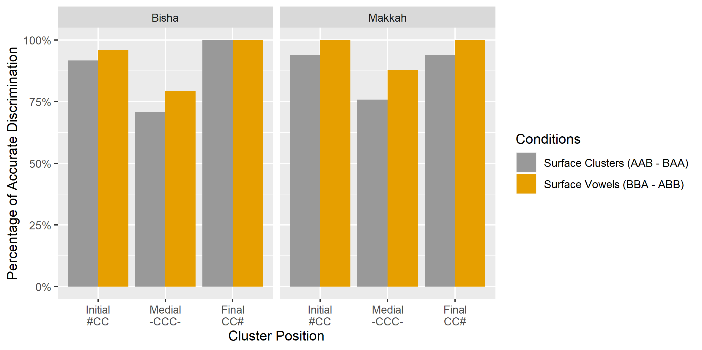
Figure 6. 2: Percentage of accurate discrimination of English consonant clusters by BA and MA speakers across syllable positions.
The most important pattern in the data is that the accuracy of discriminating consonant clusters in word-medial position is clearly lower than that of correctly identified consonant clusters in either of the peripheral positions. This lower percentage of discrimination is consistent across conditions of the presented surface forms and across target dialects.

To sum up this brief analysis, i) there appears to be no variation between BA and MA speakers in terms of their ability to discriminate English consonant clusters, ii) stimuli with surface vowels (ABB – BBA) as in [pəliːk] are more accurately discriminated than stimuli with surface clusters (AAB – BAA) as in [pliːk], and iii) consonant clusters in word-medial positions are less accurately discriminated than consonant clusters in the peripheral positions. This conclusion is statistically investigated below using the lme4 package in R.

Table 6.7 presents results of the best fit model used to predict accurate discrimination of English consonant clusters predicted by cluster position (i.e., initial – medial – final), participants’ dialect (BA – MA), surface condition (surface vowel – surface cluster), and order of presented stimuli (first in order – second in order). Order of stimuli and cluster position also served as random slopes for the random factors, which are participants and stimuli. The model shows that consonant clusters in word-medial position show significantly lower accuracy of discrimination because the estimate of such clusters is lower than the estimate of the reference level (i.e., consonant clusters in the initial position) by -1.77. This finding suggests that clusters in the medial position are more difficult to match correctly than are clusters in the word-initial and -final positions, as shown in Table 6.7 and Figure 6.3 (SE = 0.49, z = -3.60, p = 0.00031 ***).
Table 6. 7: Mixed effects (accurate discrimination with the fixed effects: dialect, conditions, condition order, and position) for the binomial GLMM model visualised in Figure 6.3.
Fixed effects | Estimate | SE | z value | Pr(>|z|)
intercept | 2.77577 | 0.56307 | 4.930 | 8.24e-07 ***
word-medial position | -1.77158 | 0.49118 | -3.607 | 0.00031 ***
word-final position | 0.64994 | 0.59735 | 1.088 | 0.27658
surface vowel condition | 0.93715 | 0.29454 | 3.182 | 0.00146 **
stimuli: second order | 0.44423 | 0.42082 | 1.056 | 0.29114
Makkah dialect | -0.03414 | 0.63172 | -0.054 | 0.95690

The model also suggests that surface vowels are more accurately discriminated than surface clusters by BA and MA speakers, since the estimate of such a surface vowel is higher than the estimate of surface cluster by 0.93 and this difference is significant, as shown in Table 6.8 and Figure 6.3 (SE = 0.29, z = 3.18, p = 0.00146 **). The order of stimuli shows no significant differences between stimuli ordered first or second (SE = 0.42, z = 1.05, p = 0.29). Finally, BA and MA speakers are equally accurate in their discrimination of English consonant clusters, since the model shows no significant difference between the dialects of the speakers (SE = 0.63, z = -0.054, p = 0.95).
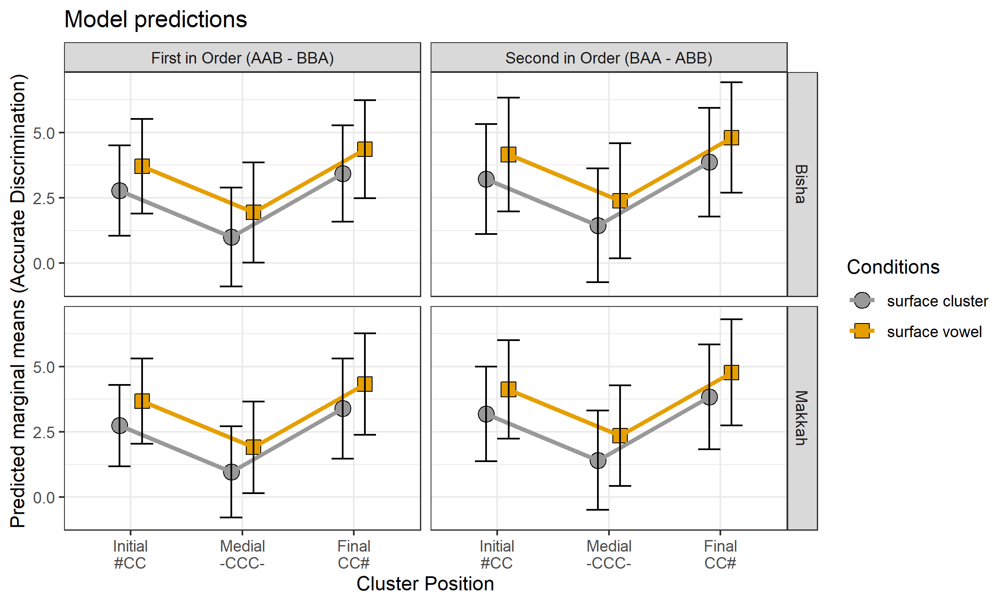
Figure 6. 3: Predicted marginal means (and 95% CI) for the binomial GLMM by cluster position, surface conditions, order of stimuli and dialects.
To sum up, the current model suggests that i) word-medial consonant clusters in the medial position are more difficult to identify correctly than are clusters in the peripheral positions, ii) stimuli of surface vowels conditions (i.e. ABB, BBA) are easier to discriminate than surface cluster conditions (i.e. AAB, BAA), iii) the order of stimuli does not play a significant role in the degree of accurate discrimination, and finally iv) BA and MA speakers are almost identical in their accuracy of discrimination of English consonant clusters.

Having discussed the results of the first category (i.e., statistical analysis), the following analysis will discuss the results of the AXB experiment after the application of SDT.

Signal Detection Theory
In applying SDT to the current study, the question that can be answered is how similar and different English pseudo-stimuli are using the AXB discrimination task. For example, when the participants listen to the following trial: [səməʊ¹ - səməʊ² - sməʊ³] “English pseudo words”, they will be asked to make a decision (i.e., discriminate) on the basis of whether they think the second stimulus in the trial is similar to the first one or similar to the third one. The only difference between these stimuli is the inserted vowel after the initial consonant. If the participants are able to discriminate that vowel, this means the decision is easy for them to make and their d' prime score will accordingly be high. If not, this indicates the decision is difficult for the listeners, which in turn, suggests low d' scores.

In the results of this study, Table 6.8 and Figure 6.4 (left) suggest that English consonant clusters in medial position are the most difficult clusters to discriminate, since their d` scores are the lowest scores (1.13 for BA and 1.64 for MA). This difficulty indicates a high degree of perceptual illusion leading to discrimination difficulties between plain clusters [CCC] and modified clusters [CCvC] in English (e.g. [kɪskrʌktɪŋ] vs [kɪskərʌktɪŋ “pseudo English words”]. This finding is consistent across target dialects: BA and MA. This consistency disappears in peripheral consonant clusters, however. Word-final clusters are easier to match accurately than word-initial clusters for BA speakers since their d` scores are (3.53 (final) < 2.47 (initial)). In contrast, MA speakers apparently found word-final clusters easier than initial ones, since their scores are (2.82 (final) < 3.09 (initial)). However, these differences between peripheral clusters among BA and MA speakers are expected not to be meaningful, since they show no significant differences between them in the analysis of the mixed-effects model summarised in Section 6.6.3. In conclusion, the degree of difficulty in perceptually discriminating English consonant clusters, according to syllable position and d` scores is presented as follows:

BA: _{more difficult} medial clusters < initial clusters < final clusters _{less difficult}
MA: _{more difficult} medial clusters < final clusters < initial clusters _{less difficult}

Table 6. 8: d prime and criterion scores from the AXB discrimination task predicted by item position and speakers’ dialects.
dialect | item position | d prime scores | criterion scores
BA | word-initial | 2.474 | 0.387
BA | word-medial | 1.130 | 0.246
BA | word-final | 3.538 | -0.093
MA | word-initial | 3.097 | 0.451
MA | word-medial | 1.641 | 0.348
MA | word-final | 2.824 | -0.077

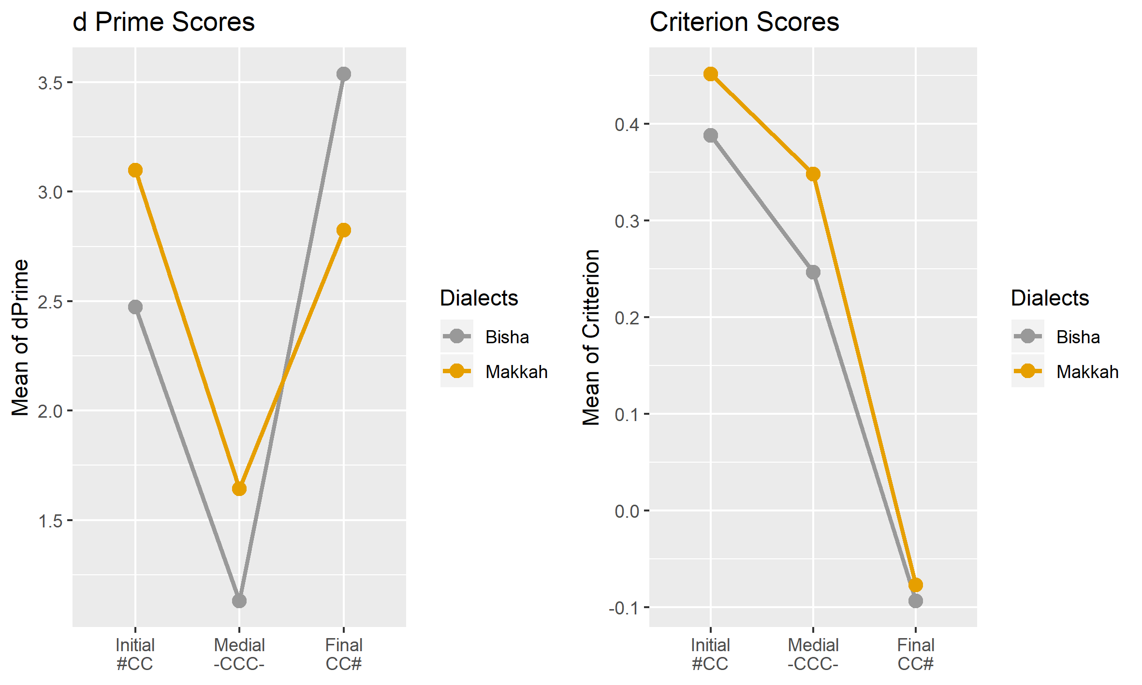
Figure 6. 4: d prime and criterion scores for each syllable position by BA and MA speakers.

Interestingly, SDT can also measure the step that precedes the final decision (i.e., outcome), which is thoughts and attention paid by the decision makers before submitting their decision. This attention can be measured by the so-called criteria scores. Using the tumor example again, the same question will be asked: if physicians are uncertain about tumor presence (i.e., first possibility) and tumor absence (i.e., second possibility), would it be safer to fail to detect such a tumor, or to decide its presence although it is really absent? Doctors should think how to act based on the initial data they have. These thoughts and attention about presence versus absence of the tumor by doctors are classified into two criteria which are:

- Bias to say “Yes”: the tumor is present. In this case the doctors prefer a conservative criterion which indicates their predisposition to say “Yes”. For such doctors even a little evidence is enough to decide the presence of tumor.
- Bias to say “No”: the tumor is absent. In this case the doctors prefer a liberal criterion which indicates their predisposition to say “No”. Such doctors are very conservative and decide the presence of the tumor only if there is very strong evidence.

The rationale behind doctors’ preferences completely rely on their attention and thoughts before making the final decision. These thoughts are measured using what so-called: criterion (C) scores.

In the current study, the criterion scores to discriminate L2 English consonant clusters by BA and MA are presented in Figure 6.4 (right) and Table 6.8. According to the presented data, there are two criteria. First, BA and MA listeners tend to be very biased to say “No” to the presence of word-initial consonant clusters unless they have very strong evidence [(0.387) for BA and (0.451) for MA]. The bias toward saying “No” to the presence of clusters is also observed in the medial position but to a lesser degree than in the initial position [(0.24) for BA and (0.34) for MA listeners). Second, BA and MA listeners are very biased to say “Yes” to the presence of word-final consonant clusters [(-0.093) for BA and (-0.077) for MA]. In conclusion, the degree of bias of saying either “Yes” or “No” to the presence of L2 English consonant clusters are presented as follows according to syllable position and C scores:

BA/ MA _{high response} initial clusters < medial clusters < final clusters _{low response}

In conclusion, the current experiment was established to investigate BA and MA speakers’ ability to perceive English consonant clusters in different syllable positions. Two kinds of analysis have been conducted: mixed models (GLMM) and SDT analysis. The main results are summarised as follows:

- Medial clusters are less accurately discriminated than peripheral clusters (shown by GLMM and SDT).
- Surface vowels were significantly easier to detect correctly than surface clusters (shown by GLMM).
- There is no significant difference between BA and MA in this experiment (shown by GLMM and SDT).
- BA and MA speakers were biased to say “No” to the presence of consonant clusters in word-initial and -medial positions, although the degree of bias in the latter position is less than that in the former one.
- BA and MA speakers were biased to say “Yes” to the presence of consonant clusters in word-final position.

Interim Discussion
The main finding of this chapter is that BA and MA speakers found medial clusters difficult to discriminate, whereas peripheral clusters seemed generally easy. A similar finding was found for the production of English clusters by the same speakers of the two groups, in that word-initial clusters were more accurately pronounced, and word-medial clusters appeared to be difficult to pronounce.

By comparing the results of Experiments 1, 2, and 3, an interesting finding is observed. In the initial position, L2 English onset clusters [CC] (e.g. [θri:] “three”) are apparently easy for BA and MA speakers, although the same speakers break up their L1 onset clusters with inserted vowels (e.g., [kta:b] > [kǝta:b] “book”]). In the perception experiment, a similar finding is observed in that L2 onset clusters are accurately discriminable (e.g., [səməʊ] versus [sməʊ] “English pseudo words”).

In contrast, L2 English onset clusters in the medial position [C.CC] (e.g., [tʃɪl.drən] “children”) are difficult for BA and MA speakers, resulting in a significant rate of vowel insertion (e.g., [tʃɪl.drən] > [tʃɪl.dǝ.rən] “children”). Similar findings are observed in the L1 of the same speakers (e.g., [ɡiltlu] > [ɡiltǝlu] “I said to him”) and in the perception of L2 English clusters (e.g., [mɪl.də.rətʃ] versus [mɪl.drətʃ] “English pseudo words”).

In the final position, consonant clusters [CC] were accurately produced by BA and MA speakers in their L1 Arabic (e.g., [bint] “girl”) and their L2 English (e.g., [hɛlθ] “health”). Similar accuracy is observed in their perception of L2 English clusters in the final position (e.g. [nɪsk] “pseudo word”).
Based on this observation, the following questions are raised:
- In the initial position, why are L2 onset clusters [CC] (e.g. [θri:] “three”) easy to pronounce for BA and MA speakers and apparently easy to accurately discriminate in perception even though such clusters are unattested in the surface structure of BA and MA?
- In the medial positions, why are L2 onset clusters [C.CC] (e.g., [tʃɪl.drən] “children”) difficult to pronounce for BA and MA speakers and apparently difficult to accurately discriminate in perception (e.g., [mɪl.də.rətʃ] “a pseudo word”)?
- In the final position, why are English clusters [CC] easy to produce and perceive by BA and MA speakers?
- Regarding C scores (i.e., degree of bias), BA and MA speakers were biased to say “No” to the presence of consonant clusters in word-initial and -medial positions, although the degree of bias in the latter position is smaller than that in the former one. BA and MA speaker were biased to say “Yes” to the presence of consonant clusters in word-final position. Why do BA and MA listeners show different degrees of bias in perceiving English clusters across syllable positions?

I would argue that BA and MA speakers employ intrusive vowels to break up word-initial onset clusters in their L1. Phonologically, this vowel is not a syllable nucleus (Hall, 2006), and thus BA and MA allow underlying consonant clusters in word-initial position. Consequently, word-initial English clusters were easy for them to pronounce and discriminate. In contrast, BA and MA speakers use epenthetic vowels in their L1 to modify word-medial clusters. These epenthetic vowels are phonologically considered a syllable nucleus (Hall, 2006). Hence, they show negative transfer of L1 properties, resulting in difficulties in their production and the perception of word-medial English clusters.
It is worth mentioning that all of the stimuli for initial and final clusters in Experiment 3 and Experiment 2 are monosyllabic words and consist of four phonemes, while the stimuli for medial clusters are 2-3 syllables and have up to ten phonemes. Hence, it might be argued that the length of stimuli in terms of the number of phonemes could result in difficulty to produce and perceive medial clusters. However, this claim is not consistent with the simplification strategy used. If the reason for difficulty is the word length, phoneme deletion would be expected to simplify the perception and the production of stimuli. However, the employed strategy in these experiments is vowel insertion, which increases the count of phonemes. Using vowel insertion as a simplification strategy suggests that the word length is not influential. The effect of word length in this respect has been studied previously (Hulme, Surprenant, Bireta, Stuart, & Neath, 2004; Juul & Petersen, 2017). The conclusions of these studies indicate that the number of phonemes has no significant effect.

This argument might answer the questions raised above. In the next chapter, the argument will be supported with further analysis as follows:

- Syllable phonotactics of BA and MA in light of Hall’s typology (2006) of the different statuses of inserted ICIs (intrusive versus epenthetic ICIs).
- Independent evidence of Hall’s typology using the behaviour of BA and MA speakers in their L2.
- Confirming the asymmetrical analysis of consonant clusters in different positions in L1 BA and MA.
- Adopting PAM principles to explain SDT behaviour.

General Discussion

Aims and outlines
This chapter aims to discuss the results of the current experiments on the production of consonant clusters in L1 Arabic (BA and MA), and the perception and production of clusters in L2 English. Three main sections will be provided in this chapter. Section 7.2 will briefly summarise the key findings of the three experiments conducted in this research. Section 7.3 will interpret the results of consonant clusters in both languages (Arabic (L1) and English (L2) in an attempt to answer the questions of the research experiments and to discuss reasons behind the occurrence of such results based on existing theories). Such interpretation will also link between the finding of this research and the reviewed literature to identify the contributions of this research. In Section 7.4, limitations of the current research will be discussed in two ways: first, limitations that have been ameliorated once they were discovered, and how they valuably contribute to the existing results, and second, limitations that could not be overcome and how they would be corrected for future research.

Summary of research results

A summary of Experiment 1: Production of L1 consonant clusters in Bisha Arabic (BA) and Makkah Arabic (MA)
Experiment 1 aimed to examine (i) consonant clusters in BA and MA in word-initial, -medial, and -final positions, and (ii) the status of ICIs inserted to break up such clusters (intrusive versus epenthetic ICIs). The key findings of Experiment 1 are:
- BA allows word-initial consonant clusters [#CC] (e.g., [ktaab] “book”) in the surface structure more than MA does.
- The ICIs inserted to break up word-initial consonant clusters in both dialects (BA and MA) behave like intrusive vowels because they fulfil the diagnostics of intrusive ICIs.
- As a result of (i) and (ii), BA and MA are likely to have underlying word-initial consonant clusters because the employed ICIs (i.e. intrusive vowels) do not serve as syllable nuclei.
- BA and MA lack word-medial consonant clusters [-CCC-] (e.g., [gultǝlu] “I said to him”), since the employed ICIs to break up such clusters are epenthetic ICIs, which contribute to the syllable structure, in contrast to intrusive ICIs.
- Word-final consonant clusters meeting sonority constraints (e.g., [bint] “girl”) are attested in BA and MA. Clusters violating sonority in this position (e.g., [baħr] “sea”) are broken up with epenthetic ICIs, which in turn, suggests that word-final clusters violating sonority are unattested in BA and MA.

A summary of Experiment 2: Production of L2 English consonant clusters by BA and MA speakers
Experiment 2 examined how BA and MA speakers produce L2 consonant clusters in different positions within words. It also provides independent evidence to support the claim of the different status of inserted ICIs in L1 BA and L1 MA summarised above in Section 7.2.1. The key findings of Experiment 2 are:
- BA and MA speakers are able to pronounce English word-initial [#CC] (e.g., [pleɪ] “play”) and word-final [CC#] (e.g., [hɛlθ] “health”) consonant clusters to a great extent in a target-like manner (i.e. as clusters).
- In word-medial position, pronunciation of English clusters [-CCC-] (e.g., [tʃɪl.drən] “children”) appeared difficult to achieve for BA and MA speakers, resulting in vowel insertion to simplify such clusters.

A summary of Experiment 3: Perception of L2 English consonant clusters by BA and MA speakers
The goal of this experiment was to test the perceptual ability of BA and MA speakers to discriminate L2 English consonant clusters using the AXB task. It also provides independent evidence to support the concluded argument of the status of vowel insertion to break up consonant clusters in L1 BA and MA. The key findings of Experiment 3 are:
- BA and MA listeners are able to discriminate L2 English clusters in word-initial (e.g., [sməʊ] “pseudo word”) and word-final positions (e.g., [dʌlk] “pseudo word”).
- Word-medial clusters (e.g., [mɪldrətʃ] “pseudo word”) are perceptually harder to detect than peripheral clusters.
- Based on the criterion scores measured using Signal Detection Theory, BA and MA speakers were biased to say “No” to the presence of consonant clusters in word-initial and -medial positions, although the degree of bias in the latter position is smaller than that in the former one. In contrast, BA and MA speakers were biased to say “Yes” to the presence of consonant clusters in word-final position.
Having briefly summarised the results of the three experiments, the following section will provide an interpretation of these results.

Discussion of Experimental results
In this section, four main points will be discussed: (i) adding the syllable phonotactics of BA and MA to the literature on Arabic syllable structure in light of Hall’s typology (2006), (ii) supporting Hall’s typology (2006) using the behaviour of BA and MA speakers in their L2 English as independent evidence, (iii) confirming the asymmetrical status of consonant clusters in different positions in L1 BA and MA, and finally (iv) proposing an account for the identified asymmetry using the L2 data of this research. Each point will be discussed in turn.

Syllable phonotactics of BA and MA
As mentioned earlier in Chapter 2, most L1 Arabic dialects are highly sensitive to the presence of trimoraic syllables (e.g., [kta_{µ}a_{µ}b_{µ}]*, “book”) that include consonant clusters due to the non-dominant constraint known as the Bimoraicity Constraint. This constraint suggests that “syllables are maximally and optimally bimoraic” (Broselow, 1992, p. 10). However, there are some trimoraic syllables that occur in the surface structure of some Arabic dialects. These trimoraic syllables are handled in Arabic dialects using two strategies:
- Simplifying consonant clusters that trigger the third mora through vowel insertion (ICIs), creating less heavy syllables (e.g., [traab] > [ti.raa.b] “sand”).
- Treating consonant clusters that trigger the third mora as heterosyllabic clusters, creating a so-called “stray consonant” (i.e., non-branching clusters) (e.g., [ktaab] > [k.taa.b] “book”).
In the results of the current research, both strategies are observed in BA and MA, as summarised in Table 7.1. Starting with the first strategy of treating trimoraic syllables (i.e., ICI insertion), Table 7.1 shows that consonant clusters in BA and MA across all syllable positions are broken up with ICIs, apart from word-final clusters with falling sonority (e.g., [kart] “card”). However, the results of Experiment 1 indicate that the ICIs inserted to modify consonant clusters in both BA and MA have different phonological statuses: (i) intrusive ICIs and epenthetic ICIs. The evidence for having different statuses of inserted ICIs is provided in considerable detail in Chapter 4.
Table 7. 1: Summary of observed consonant clusters in BA and MA with the different statuses of inserted ICIs.
Cluster position in the surface structure | Status of inserted ICIs (intrusive vs. epenthetic)
Cluster position in the surface structure | BA | MA
#CC | intrusive | intrusive
-CC.C- | epenthetic | epenthetic
CC# (violating sonority) | epenthetic | epenthetic
CC# (following sonority) | not broken up | not broken up

Hall (2006) claims that epenthetic ICIs are phonological units that are employed to modify illicit clusters in the native language of speakers. In contrast, intrusive ICIs are merely phonetic transitions between consonants, but they do not contribute to syllable structure. Considering this claim in the context of the results summarised in Table 7.1, this suggests that word-initial clusters in BA and MA are present in the underlying representation, although they are broken up with ICIs in the surface structure, since these ICIs are intrusive ICIs which do not contribute to syllable structure. In contrast, word-medial clusters are absent in the underlying representation and surface structure of BA and MA, since they are broken up with epenthetic ICIs, which are phonological units that serve as syllable nuclei. For word-final clusters, they are attested in the grammar of BA and MA. A summary of underlying consonant clusters in BA and MA is provided below in Table 7.2.
Table 7. 2: A summary of consonant clusters in the underlying representation of BA and MA.
Consonant position | Presence of clusters in the underlying representation
Consonant position | BA | MA
#CC | Yes | Yes
-CC.C- | No (broken up with epenthetic ICIs) | No (broken up with epenthetic ICIs)
CC# | Yes | Yes

Table 7.2 shows that peripheral clusters in BA and MA are attested in the underlying structure, whereas word-medial are absent in BA and MA. This finding indicates that the second strategy of treating trimoraic syllables (i.e., non-branching clusters) exists in BA and MA, as depicted in Figure 7.1 and Figure 7.2. This analysis (proposed for other dialects) can in principle be used for BA and MA also. However, the C-scores (i.e., independent evidence obtained from Experiment 3) suggest that structures of peripheral clusters are not in fact equal, as will be discussed in Section 7.3.3.
σ
µ µ
b i n t
σ
µ µ
f l uu s

Figure 7. 2: word-final clusters following sonority m constraints in BA and MA
Figure 7. 1: Word-initial clusters in BA and MA.

In conclusion, the reviewed literature indicates that consonant clusters that trigger a third mora are avoided in Arabic dialects using two strategies: (i) vowel insertion (ICIs), and (ii) treating the consonant that triggers the third mora as a stray consonant. Both strategies are observed in BA and MA. Prior studies analyzing the syllable phonotactics of Arabic generally treat all inserted ICIs as phonological units that serve as syllable nuclei. However, the current thesis found that BA and MA display two kinds of inserted ICIs: epenthetic and intrusive ICIs. Hall (2006) claims that epenthetic ICIs are phonological units, whereas intrusive vowels are not. Therefore, not all inserted ICIs in BA and MA are phonologically equal. The following section will review the independent evidence for the incidence of vowel intrusion and vowel epenthesis in L1 BA and MA that arises from BA and MA speakers’ production behaviour in their L2 English.

Independent evidence for Hall’s (2006) typology of inserted ICIs
Hall (2006) claims that intrusive ICIs are phonetic transitions between consonants that do not contribute to syllable structure, whereas epenthetic ICIs are phonological units that serve as syllable nuclei. Phonological diagnostics for each kind of ICI are listed in Section 2.6.1.2, Table 2.11.
In applying these diagnostics to consonant clusters in BA and analysing the results of Experiment 1 (i.e., production of L1 consonant clusters by BA and MA speakers), both dialects are shown to break up word-initial clusters [CC] using intrusive ICIs. Word-medial clusters [CCC] are broken up with epenthetic ICIs. Word-finally, consonant clusters [CC] following sonority constraints are attested in BA and MA; however, clusters that violate sonority constraints are broken up with epenthetic ICIs. In light of Hall’s claim, the implicit conclusion on the basis these findings is that BA and MA dialects have underlying consonant clusters of some kind in word-initial position. This is because the employed ICIs (i.e. intrusive vowels) do not serve as syllable nuclei, which in turn, suggests that the initial clusters are present in the underlying representation of BA and MA. In contrast, word-medial clusters [CCC] are absent from the surface structure and underlying representation of BA and MA, since such clusters are broken up with epenthetic ICIs, which are phonological units and function as syllable nuclei. Finally, word-final clusters following sonority constraints are attested in BA and MA, but those clusters that violate sonority in BA and MA are broken with epenthetic ICIs. This summary of attested clusters in L1 BA and MA is repeated below in Table 7.3.

If Hall’s (2006) claim regarding the diagnostics and syllabicity of intrusive versus epenthetic ICIs is accurate, BA and MA speakers are expected to have no difficulties in producing and perceiving L2 English consonant clusters in word-initial position, since initial clusters in BA and MA are broken up with intrusive ICIs, which do not contribute to syllable structure. In contrast, word-medial clusters in English are expected to be difficult for BA and MA speakers, since word-medial clusters in BA and MA are broken up with epenthetic ICIs, which serve as syllable nuclei. Finally, BA and MA speakers are expected to have no difficulty in producing and perceiving L2 English clusters, since final clusters (following sonority) in BA and MA are not broken up with vowel insertion.

The results of Experiment 2 (i.e., production of L2 English clusters) and Experiment 3 (i.e., perception of L2 English clusters) provide independent evidence for the diagnostics and syllabicity of epenthetic ICIs versus intrusive ICIs, since BA and MA speakers to some extent produce and perceive peripheral consonant clusters in English in a target-like manner (i.e., as a cluster). In contrast, L2 English clusters in the medial position seem exceedingly difficult for BA and MA speakers in both perception and production tasks, which results in a significant rate of vowel insertion.

The good performance by BA and MA speakers in producing and perceiving word-initial English clusters is observed even though such clusters in L1 BA and L1 MA are broken up with ICIs in the surface structure. This observation supports the analysis that the employed ICIs in word-initial clusters in BA and MA do not contribute to syllable structure (i.e., intrusive ICIs), which is exactly what Hall’s (2006) proposal claims about the syllabicity of intrusive ICIs. In contrast, the poor performance by BA and MA speakers in producing and perceiving word-medial English clusters indicates that medial clusters in L1 BA and L1 MA are broken up with ICIs in the surface structure. This observation in turn supports the analysis that the employed ICIs in word-medial clusters in BA and MA do contribute to syllable structure (i.e., epenthetic ICIs), which is exactly what Hall’s (2006) proposal claims about the syllabicity of epenthetic ICIs. These findings clearly provide independent evidence for Hall’s (2006) claim regarding the diagnostics and syllabicity of intrusive versus epenthetic ICIs. This summary of produced L2 English clusters by BA and MA is provided below in Table 7.3 alongside the L1 patterns.

What makes this evidence reliable is two points: (i) the BA and MA participants in Experiment 1 in which they produced L1 consonant clusters are the same participants who participated in Experiment 2 and Experiment 3, so they are the same individuals across the three experiments, (ii) the English proficiency of the participants is very low, as described in Appendix 4. Some of them cannot even decipher English orthography or comprehend very simple utterances. So, we cannot ascribe to the good performance in their L2 English to an assumption that those participants speak English proficiently.
Table 7. 3: A summary of consonant clusters in the underlying representation in L1 BA/MA and produced/perceived L2 English clusters by BA and MA speakers.
Cluster position | Cluster presence in underlying representation of BA / MA | Produced L2 English clusters by BA/ MA speakers | Perceived L2 English clusters by BA / MA speakers | C-scores to discriminate L2 English clusters by BA / MA speakers
#CC | Yes | Yes | Yes | Very biased to say No to the presence of #CC
-CCC- | No | No | No | Biased to say No to the presence of -CCC- but lower than #CC
CC# | Yes | Yes | Yes | Very biased to say Yes to the presence of CC#

It could be questioned why BA and MA speakers do not transfer their L1 intrusive ICIs in the initial position to their production of L2 English consonant clusters. The answer to this question relates to the phonological representation of Arabic. As mentioned earlier, word-initial clusters in BA and MA are broken up with intrusive ICIs. These ICIs only occur in the surface structure and are absent in the underlying representation since they do not contribute to syllable structure. Therefore, BA and MA speakers transfer their grammar in the underlying representation (i.e., the presence of word-initial consonant clusters) to their L2 English, resulting in a good performance in their L2 English.

The next section will discuss the third main point in this chapter, which is about the known onset/coda cluster asymmetry in Arabic clusters.

Asymmetrical pattering of onset/coda clusters in the reviewed literature on L1 Arabic syllable phonotactics:
L1 onset / coda asymmetry is observed in the L2 behaviour of BA and MA speakers. The evidence for this observation is obtained from the analysis of Experiment 3 (i.e., perception of L2 English clusters) using Signal Detection Theory (SDT). In this experiment, BA and MA listeners were randomly presented with 124 trials of the AXB task to test their ability to discriminate L2 English consonant clusters (e.g., [sməʊ] - [sməʊ] - [səməʊ]). The results of this experiment were analysed using SDT. Two key measurements were calculated: (i) d prime and (ii) criterion scores. d` prime scores in the current study indicate the degree of difficulty of discriminating L2 English consonant clusters by BA and MA listeners. Criterion scores indicate BA and MA listeners’ attention to L2 English clusters before discrimination. The results of d prime scores show that word-medial English clusters were harder to discriminate than peripheral clusters by BA- and MA- speaking listeners. The criterion scores show that even though peripheral clusters were accurately discriminated, the attention paid to discriminate English word-initial clusters was higher than was the case for word-final clusters. This finding indicates that discrimination of L2 word-initial clusters by BA and MA listeners is doable but hard, whereas discriminating L2 word-final clusters by BA and MA listeners is doable and easy. Hence, there is an onset / coda asymmetry in the degree of attention paid of discriminating L2 English clusters. Similarly, L1 phonological approaches summarised in Chapter 2 indicate onset / coda asymmetry in the analysis of L1 Arabic consonant clusters.
This section revisits the proposed analytical approaches that analyse consonant clusters in Arabic dialects from a phonological perspective. These approaches provide a satisfactory analysis of coda clusters in some Arabic dialects, but their analysis of onset clusters is unsatisfactory, as is acknowledged by the authors themselves (McCarthy & Prince, 1990; Selkirk, 1981b). This limitation results in an asymmetrical pattern across onset / coda clusters in Arabic dialects. These approaches are summarised in detail in the following subsections.

Semisyllables (Kiparsky, 2003)
When a stray consonant in a cluster (underlined [kalb ] “dog”) is directly linked to the word-node and has a moraic status, it will be called a semisyllable. These features of the semisyllable disappear when the target cluster is broken up via ICI insertion. Kiparsky (2003) classifies Arabic dialects into three categories: C dialects, CV dialects and VC dialects.
In the results of the current research, BA and MA fit the features of CV dialects in Kiparsky’s model in their treatment of medial consonant clusters, where the cluster -CCC- is broken up via epenthesis [ǝ] after the stray consonant (underlined), as in [-CCC-] > [CCvC]: / ɡult.li/ > / ɡul.tǝ.li/ “I said to him”, as presented in Figure 7.3.
W
ɸ ɸ
σ σ σ
µ µ µ µ
ɡ i l t i l u

Figure 7. 3: Vowel insertion after the stray consonant (underlined) in BA and MA

In word-final position, BA and MA partially fit the features of CV dialects as they allow word-final clusters, as in [bint] “girl” as presented in Figure 7.4.

w
ɸ
σ
µ µ
b i n t
Figure 7. 4: Final consonant clusters in CV dialects

However, is this initial classification consistent with other features of CV dialects, especially in word-initial position? Kiparsky (2003) claims that CV dialects have no tolerance for word-initial clusters. In contrast, BA and MA allow underlying word-initial clusters. Consequently, BA and MA do not fully fit the features of CV dialects. This finding supports Watson’s (2007, p. 341) criticism of Kiparsky’s (2003) analysis: “while some dialects, for example Cairene as a CV dialect and Haifa as a VC dialect, exhibit all the predicted characteristics of their respective dialect type, some of the dialects do not”. BA and MA are another example of the puzzle that Watson notes.

Extrametrical Mora Approach (McCarthy & Prince, 1990)
This approach analyses the stray consonant differently according to cluster position. In word-initial position, the stray consonant is treated as an extraprosodic consonant linked directly to its own syllable and has moraic status. In word-final position, the stray consonant is treated in a similar way to how it is treated in the initial position, but without receiving moraic weight. The evidence for this analysis is discussed in detail in Section 2.5.1.1.1. However, the evidence used to analyse the word-initial cluster as an extrametrical mora does not necessarily entail that the stray consonant has moraic status, as acknowledged by McCarthy and Prince (1990), who state that this analysis is “puzzling”. BA and MA are another example of this puzzle.

In this approach, the stray consonant in word-initial clusters in BA and MA would be analysed as an extrametrical mora that creates its own syllable and receives moraic status, as in Figure 7.5. Word-finally, the stray consonant in BA and MA is analysed as an extraprosodic consonant that creates its own syllable but without moraic status, as in Figure 7.6.
σ σ
µ µ
b i n t
(µ) σ
µ µ
f l uu s

Figure 7. 5: Word-initial clusters in BA and MA.
Figure 7. 6: word-final clusters following sonority constraints in BA and MA

McCarthy & Prince’s analysis allows for adjacent consonants in underlying structure in both word-initial and word-final positions but assigns different status to the extraprosodic consonant in each case. The BA and MA data provide support for this account, since clusters are observed in peripheral positions but pattern differently. In L1 BA and MA, word-initial clusters show no sensitivity to sonority, and they display intrusive ICIs. In contrast, word-final consonant clusters in BA and MA show high sensitivity to sonority, and they display epenthetic ICIs. In the L2 data, peripheral consonant clusters are produced and perceived equally well in respect of the surface structure, but C-scores suggest that they are processed differently.

Degenerate Syllable (Selkirk, 1981b)
In this approach, the word-final consonant in Cairene Arabic is analysed as an onset for an empty nucleus. Selkirk (1981) states that the stray consonant in word-initial clusters could be analysed as a rhyme for an empty onset, but she describes this analysis as unsatisfactory as it violates the ban on onsetless syllables. Again, this is an approach which can provide solid evidence for analysis of the stray consonant in coda position. However, the proposed analysis in onset position is not adequately proven.

Conclusion of the observed asymmetrical analysis
The proposed approaches do not fully analyse the syllable phonotactics of certain Arabic dialects, including BA and MA. This limitation occurs in the unsatisfactory analysis of stray consonants in onset clusters, whereas the evidence for analysing coda clusters is more compelling. The authors of the proposed analytical approaches acknowledge their limited answer to the question of analysing stray consonants in word-initial position as follows:
- “I do not in fact have a satisfactory answer to the question here” (Selkirk, 1981b, p. 219).
- “It is puzzling… Prosodic theory forces us to posit this analysis in both Standard Arabic and the Cairene colloquial. Other facts of Standard Arabic are consistent with this approach, but they do not prove its correctness” (McCarthy & Prince, 1990).
- “While some dialects, for example Cairene as a CV dialect and Haifa as a VC dialect, exhibit all the predicted characteristics of their respective dialect type, some of the dialects do not… some dialects are not unambiguously ascribable to any one category” Watson (2007, p. 341), in criticism of Kiparsky’s dialectical classification.
- Finally, Broselow (2018, p. 43), in recent criticism of most analytic approaches of Arabic syllabification phonotactics, states that “the question of whether any single approach can present a unified treatment of vowel insertion in all contexts is still not fully resolved”.
In conclusion, the summary provided above indicates that patterns of coda clusters in some Arabic dialects are phonologically known and well-analysed. However, appropriate representation of onset clusters in Arabic dialects remains a mystery.
The current research does not provide a phonological solution for the asymmetrical patterns observed in the L1 findings, but the BA and MA data confirms the existence of the paradox. Furthermore, the data suggests that the paradox is empirically supported in nature (it is observed in different patterns for d prime and C-scores in the L2 perception data) as well as being purely theoretical. It is beyond the scope of this thesis a fully articulated new phonological analysis. The present data confirms that a new analysis is needed. However, in the next section, we explore what insights can be gained from models of L2 phonological behaviour.

Adopting PAM principles to explain SDT behaviour: proposed discrimination categories for L2 syllable phonotactics
The Perceptual Assimilation Model (PAM) and Speech Learning Model (SLM) are L2 perceptual models designed to propose a mechanism that predicts L2 listeners’ discrimination of L2 contrasts based on the degree of similarity and difference between L1 and L2. In these models, however, “the recognition of one phoneme is essentially independent from that of the adjacent ones. In particular, language-dependent sequential information, i.e. phonotactics, is not taken into account, and therefore, perceptual epenthesis effects cannot be explained” (Dupoux et al., 2011, p. 200). Therefore, these models might not provide a satisfactory analysis for discriminating L2 syllable phonotactics. The current research adopts PAM principles to propose discrimination categories for L2 syllable phonotactics in light of perceptual behaviour reflected in SDT results, and in particular for the results of Experiment 3 (i.e., perception of L2 English clusters by BA and MA listeners). To clarify, four steps will be taken: (i) summarising the principles of PAM, (ii) summarising the principles of SDT, (iii) summarising the results of Experiment 3 using SDT, and finally (iv) applying PAM principles to the analysis of Experiment 3 using SDT.
PAM is an L2 perceptual model positing “that non-native speech perception is strongly affected by listeners’ knowledge (whether implicit or explicit) of native phonological equivalence classes, and that listeners perceptually assimilate non-native phones to native phonemes whenever possible, based on detection of commonalities in the articulators, constriction locations and/or constriction degrees used” (Best et al., 2001, p. 4). In the PAM, there are six assimilation levels that predict the perceptual assimilation of L2 gestures or “phonemes” into the native language of L2 listeners. Table 7.4 only reports three of these assimilation levels, as they are the most influential levels in most L2 perceptual studies (Colantoni et al., 2015).

Table 7. 4: A summary of assimilation categories proposed in the PAM.
Assimilation level |  | Definition | Expected discrimination degree | Examples
Two-Category Assimilation (TC) |  | Speakers assimilate two L2 segments (i.e., contrasts) into two different categories of L1. | Excellent | a) Hindi /ɖ/ English /d/.  b) Hindi /d̪ʰ/ English /ð/.
Category-Goodness Difference (CG) |  | Speakers assimilate two L2 segments (i.e., contrasts) into a single L1 category but one of the L2 contrast may be more similar to the L1 category than the other. | Moderate to very good | a) Zulu /kˈ/ English /k^{h}/.  b) Zulu /k/ English /k^{h}/.
Single-Category Assimilation (SC) |  | Speakers assimilate two L2 segments (i.e. contrasts) into a single category of L1. | Poor | a) Salish /kˈ/ English /k^{h}/.  b) Salish /qˈ/ English /k^{h}/.

Table 7.4 presents three levels of L2 perceptual assimilation: (i) Two-Category Assimilation, (ii) Category-Goodness Difference, and (iii) Single-Category Assimilation. Each level is defined in Table 7.4. For example, English speakers learning Hindi are expected to assimilate the Hindi retroflex stop [ɖ] to their native English stop [d], and simultaneously they assimilate the Hindi breathy voiced dental stop to their native English dental fricative [ð]. It is observed that the two Hindi sounds are assimilated into two different categories (i.e., phonemes) of the L1 (i.e., English). This finding represents the first level of the PAM, which is Two-Category Assimilation (TC).

To identify which assimilation level L2 learners might apply to perceive L2 segments, a perceptual assimilation task (PAT) is normally used to identify the applicable assimilation level and the expected discrimination degree. In this task, two measurements are employed: (1) categorising L2 segments into L1 phonemes, and (2) rating goodness of fit of the selected categorisation.
The first measurement in the PAT (i.e., categorisation) is established via two steps:
- L2 learners hear an L2 target stimulus.
- Then, they are presented with several L1 categories (i.e., stimuli) that are similar to the heard L2 stimulus and they are asked to identify which of L1 categories is the most similar to the L2 stimulus.

As for the second measurement in the PAT (i.e., rating goodness of fit of the selected categorisation), L2 learners rated the goodness of fit of their selected answers in the previous task on a scale from 0-7 “where 1 meant a poor or bad rendering of the selected sound and 7 meant a good, native-like example” (Cebrian, 2019, p. EL54).

The process to obtain the two measurements used in the PAT is depicted below in Figure 7.7.
measurement 1:
measurement 2:

Figure 7. 7: Process of two measurements used in a perceptual assimilation task (PAT): (1) categorising L2 segments and (2) goodness of fit rating of the selected categorisation.

Having briefly summarised the PAM, SDT principles should be summarised. SDT is a theory designed to assist decision makers to make safer decisions when there are multiple options (MacMillan, 2002). One of the applications of this theory in the discipline of linguistics is to test the perception of L2 consonant clusters using L2 perceptual discrimination tasks, such as the AXB task (MacMillan, 2002). Results of the AXB task testing perception of L2 consonant clusters are extracted using two key measurements of SDT: d prime and criterion scores. The results of d' testing indicate the level of difficulty experienced by listeners when attempting to discriminate L2 consonant clusters, whereas criterion scores indicate the amount of attention paid by L2 listeners when assessing L2 consonant clusters prior to making their discrimination decision. The process used to obtain the two measurements in the AXB task is depicted below in Figure 7.8.
measurement 1:
measurement 2:

Figure 7. 8: Process of two measurements used in AXB: (1) deciding the true answer according to listeners (the accuracy of listeners’ answers is calculated using d prime), (2) reflecting the degree of mental attention required before making a decision using criterion scores.

In the current research, SDT was employed to analyse the results of AXB task testing the ability of BA and MA listeners in discriminating L2 English consonant clusters. The results of d prime scores show that word-medial English clusters (e.g., [mɪldrətʃ] “pseudo word) were harder for BA and MA listeners to discriminate than peripheral clusters (e.g., [sməʊ] “pseudo word”). The criterion scores show that even though peripheral clusters were accurately discriminated, the attention paid to the task of discriminating English word-initial clusters (e.g., [sməʊ] “pseudo word”) was higher than word-final clusters (e.g., [tɛlθ] “pseudo word”). This finding indicates that discriminating L2 word-initial clusters for BA and MA listeners is doable but hard, whereas discriminating L2 word-final clusters by BA and MA listeners is doable and easy.

One possible interpretation for this finding is the effect of syllable phonotactics in L1. As mentioned earlier in Experiment 1, the surface structure of word-initial clusters in BA and MA is broken up with intrusive ICIs that do not function as syllable nuclei. Accordingly, the word-initial clusters are maintained in the underlying representation of BA and MA, although they are broken up with surface vowels. In contrast, word-medial clusters in BA and MA are modified with inserted ICIs, which are phonological units and break up target clusters in both the surface structure and underlying representation. For word-final position, consonant clusters in BA and MA are not broken up with any inserted ICIs, which indicates the presence of such clusters in both the surface structure and underlying representation.
Based on these findings in L1, I claim that L2 English word-initial clusters are easy for BA and MA listeners to discriminate. However, the task requires a high degree of attention on the part of those listeners. This could be attributed to the finding that BA and MA have similar but not identical syllable phonotactics to English. On the one hand, L1 (BA and MA) word-initial clusters are absent in the surface structure but present in the underlying representation. On the other hand, L2 (English) word-initial clusters are present in both the surface and the underlying structures. Hence, speakers tend to go through additional mental processes to differentiate between their L1 consonant clusters and L2 clusters. Therefore, English word-initial clusters require more attention on the part of BA and MA listeners, although they show successful performance in the actual discrimination task.

In medial position, English clusters are poorly discriminated by BA and MA listeners, but they do not require quite as much attention as initial clusters do. This could be attributed to the L1 phonology of BA and MA, in which medial clusters in these Arabic dialects are phonologically absent in both the underlying representation and the surface structure. Consequently, when BA and MA listeners encounter English medial clusters, the prediction is that they will find these clusters difficult, since clusters of this kind are completely absent in their L1. Therefore, additional attention toward such clusters will be required but to a lesser extent than toward English word-initial clusters.

Word-finally, L2 English clusters in this position are successfully discriminated by BA and MA listeners, and the attention required to discriminate them was much lower than that of word-initial and -medial clusters. L1 syllable phonotactics is expected to contribute to this finding, since word-final clusters are attested in both the underlying representation and the surface structure of BA and MA. Similarly, English allows word-final clusters in both the underlying representation and the surface structure as in BA and MA. Hence, BA and MA listeners successfully discriminate word-final English clusters with a lower degree of attention.

These findings are summarised below in Table 7.5.
Table 7. 5: A summary of suggested interpretations for the results of perceiving L2 English consonant clusters by BA and MA listeners according to cluster position.
Cluster position | Findings of perceiving L2 English clusters by BA/MA listeners
Word-initial | When BA and MA permit consonant clusters in the underlying representation but not in the surface structure, and L2 English permits consonant clusters in both structures (underlying and surface), L2 learners are expected to discriminate L2 consonant clusters well, but a high level of attention will be required to differentiate between their L1 and L2 properties before discriminating L2 clusters.
Word-final | When BA and MA permit consonant clusters in the underlying and the surface structures, and L2 English permits consonant clusters in both structures (underlying and surface), L2 learners are expected to successfully discriminate L2 consonant clusters with the lowest degree of attention required before discriminating L2 clusters.
Word-medial | When BA and MA disallow consonant clusters in the underlying structure and in the surface structure, and L2 English permits consonant clusters in both structures (underlying and surface), L2 learners are expected to discriminate L2 consonant clusters poorly and the degree of attention required to discriminate L2 clusters in this position will be high, though less than that in word-initial position.

Using (1) results of the current study presented in Table 7.5 and (2) the summary of the PAM and SDT provided earlier, perception of L2 syllable phonotactics could be mapped into perceptual categories similar to the categories used in the PAM. There are two suggested steps to propose perceptual categories for L2 syllable phonotactics:
- Establishing a parallel between the two measurements used in the PAT (depicted in Figure 7.4), and the two measurements used in AXB (depicted in Figure 7.7).
- Translating interpretations for the results of the current study (summarised in Table 7.8) to the established parallel suggested in (1).

To clarify the first step, measurement 1 in the PAT (i.e., categorising L2 segments by L2 listeners) is suggested to be parallel with the first measurement in AXB (calculating the accuracy of selected answers using d prime). Similarly, the second measurement in PAT (goodness of fit rating of the selected categorisation) is suggested to be parallel with the second measurement in AXB (calculating the mental attention before making decision using criterion scores). This suggested parallel between the measurements of PAT and AXB could be depicted in Figure 7.9.

measurement 1:
measurement 2:

measurement 1:
measurement 2:

Figure 7. 9: Suggested parallel between measurements of the PAT (using PAM) with measurements of the AXB (using SDT).

Based on the parallel between the measurements of the PAT with the measurements of AXB (depicted in Figure 7.9), the results of the current study summarised in Table 7.5 could be translated into theoretical categories for perceiving L2 syllable phonotactics. The proposed categories for syllable phonotactics are presented below in Table 7.6.
Table 7. 6: A summary of proposed categories to discriminate L2 syllable phonotactics based on: (i) L1 syllable phonotactics, and (ii) parallels between measurements of PAT and SDT.
Discrimination condition |  | Expected discrimination degree of L2 clusters |  | Expected mental attention degree
When L1 allows consonant clusters in underlying representation (UR) and surface structure (SS), and L2 allows consonant clusters in UR and SS. |  | High |  | Low
When L1 allows consonant clusters in UR but not in the SS, and L2 allows consonant clusters in UR and SS. |  | High |  | High
When L1 disallows consonant clusters in UR as well as in in the SS, and L2 allows consonant clusters in UR and SS. |  | Low |  | Moderate

In conclusion, this section of the discussion proposes discrimination categories of L2 syllable phonotactics. This proposal is suggested on the basis of: (i) PAM principles and the task employed in this model (i.e., the PAT), (ii) SDT principles and the task employed in this theory (i.e., AXB), and (iii) the results of Experiment 3 (i.e., perception of L2 English clusters by BA and MA listeners). The proposed categories are presented above in Table 7.6.

It is worth mentioning that this PhD research is not designed to propose categories for L2 syllable phonotactics. However, the proposal presented in Table 7.6 is suggested based on the results obtained from Experiment 1 and Experiment 3. Further investigation is needed, as fully articulated perceptual models for L2 syllable phonotactics are beyond the scope of the current research.

Having discussed the results of the current research, the final chapter will provide a brief summary of the presented chapters in this thesis and the main contributions (i.e., our understanding of Arabic phonology) obtained from the empirical findings.

Conclusion
This chapter provides a summary of the main findings observed in the current PhD thesis. In Section 8.1, a summary of the prior seven chapters will be provided. Section 8.2 seeks to highlight the main contributions of this thesis to L1 syllable phonotactics of Arabic dialects and L2 perceptual literature. The final section (8.3) will make some suggestions for further investigation.

Summary of the current PhD research
The current PhD research aimed to test the syllable phonotactics of L1 Bisha Arabic (BA) / Makkah Arabic (MA). To achieve this goal, three experiments were conducted:
- Experiment 1: production of consonant clusters in L1 BA/ MA.
- Experiment 2: production of L2 English consonant clusters by BA / MA speakers.
- Experiment 3: perception of L2 English consonant clusters by BA / MA listeners.

Chapters 2, 3, and 4 provide considerable detail about Experiment 1: (i) reviewed literature on the syllable phonotactics of Arabic dialects, (ii) the methodology of Experiment 1, and (iii) the findings of the experiment. The empirical evidence obtained from this experiment shows that not all inserted interconsonantal intervals (ICIs) are phonologically equal, following Hall’s (2006) claim about the diagnostics and syllabicity of inserted ICIs (intrusive versus epenthetic ICIs). More specifically, word-initial clusters in BA and MA were modified with intrusive ICIs which do not contribute to syllable structure. In contrast, word-medial and -final clusters were broken up with epenthetic ICIs which function as syllable nuclei.

Chapters 5 and 6 provide the results of Experiments 2 and 3 that tested L2 behaviour of BA and MA speakers in producing and perceiving L2 English clusters. The results show that L2 English peripheral clusters were well produced and discriminated, whereas English medial clusters were poorly produced and discriminated by BA and MA speakers. Furthermore, the criterion score results in Experiment 3 show that BA and MA speakers were biased towards “No” responses when exposed to consonant clusters in word-initial and -medial positions, although the degree of bias in the medial position is less than that in the initial one. In contrast, BA and MA speaker were biased to say “Yes” to the presence of consonant clusters in word-final position.
These findings provide independent evidence for Hall’s claim about the diagnostics and syllabicity of inserted ICIs, lending further support to the results of Experiment 1.

In Chapter 7, the results of the three experiments conducted for this thesis were synthesised, leading to (i) adding information about syllable phonotactics of BA and MA to the literature on Arabic linguistics, (ii) using results of Experiments 2 and 3 to support the conclusion of Experiment 1, (iii) confirming the asymmetrical status of consonant clusters in different positions in L1 BA and MA, and (iv) proposing discrimination categories for L2 syllable phonotactics in light of the Perceptual Assimilation Model (PAM) and Signal Detection Theory (SDT) principles.

Contribution of this PhD thesis
The contribution of this PhD research can be classified into three categories: (i) L1 phonology, (ii) L2 phonology, and (iii) methodological contributions.

For L1 phonology, this thesis adds the syllable phonotactics of BA and MA to the linguistics literature for Arabic, showing the attested and unattested consonant clusters. Also, it shows that not all inserted ICIs in BA and MA are phonologically equal, a claim supported by three empirical experiments.

As for L2 phonology, it is argued that the existing L2 perceptual models (e.g., PAM and SLM) might not interpret perceptual phenomena in L2 syllable phonotactics satisfactorily. The current research proposes categories to discriminate L2 syllable phonotactics based on (i) L1 syllable phonotactics, and (ii) drawing a parallel between the principles of the PAM and SDT.

From a methodological perspective, some studies might focus only on L1 phonology or only on L2 phonology, in either production or perception studies. However, this thesis provides (i) an L1 production study, (ii) an L2 production study, and (iii) an L2 perception study, and synthesises the results of the three studies. Another methodological advantage of this research is that participants in the L1 production study are the same ones who participated in the other two studies conducted in this research. This is a very useful advantage that makes the connection between participants’ behaviour in L1 and their behaviour in L2 more reliable and generalisable. Finally, this research used L2 behaviour as independent evidence for the concluded evidence of an L1 study, which supports the finding of the L1 production study.

Recommendation for future research
The current PhD research was established: (1) to test the production of consonant clusters in two Arabic dialects: BA and MA, and (2) to test the production and the perception of L2 English clusters by the speakers of the two dialects and using the results of L2 findings as independent evidence for L1 behaviour.

The results of Experiment 1 were interpreted using Hall’s (2006) proposal about diagnostics of epenthetic and intrusive vowels. She explains the mechanism of intrusion in an articulatory phonological manner. However, the diagnostics could be tested acoustically. Very recent studies (Bellik, 2018; Plug et al., 2019) have tested vowel intrusion acoustically in the light of Hall’s diagnostics with detailed analysis, such as the voicing status of the target vowels and adjacent consonants, as well as directionality of place of articulation (i.e., whether the direction is from bilabial towards glottal or from glottal to bilabial). These studies have been published after designing the current PhD research. Future work considering these acoustic analyses in addition to speech rate variability would be extremely useful and perhaps more practical than articulatory studies.

Categories for L2 syllable phonotactics presented in Section 7.3.4 is proposed based on analysis of segment-based approach. Further work in the light of Articulatory Phonology (gesture-based) is suggested to improve the proposed categories due to two reasons: (i) the proposed categories for perceiving L2 syllable phonotactics in this thesis adopt PAM principles which are phonologically articulatorily oriented (gesture-based), and (ii) Hall’s (2006) proposal about diagnostics and syllabicity of intrusive versus epenthetic ICIs is also phonologically articulatorily oriented (gesture-based). Therefore, articulatory work to improve the proposed categories is highly recommended.

Appendices

Appendix 1: Information sheet


Department of
Language and
Linguistic Science
Heslington, York, YO10 5DD, UK
Phone number +966505581310
+447415401134
Email oaa532@york.ac.uk
INFORMATION SHEET

PLEASE KEEP THIS INFORMATION SHEET AND A SIGNED COPY OF THE CONSENT FORM FOR YOUR RECORDS
You are invited to take part in a research study. Before you decide whether to participate it is important for you to understand why the research is being done and what it will involve. Please take the time to read the following information carefully. If there is anything you do not understand, or if you want more information, please ask the researcher.
Title of study:
Pronunciation of learners of English from different regions of Saudi Arabia
Researcher:
Obied Al-Aqlobi

What is the research about?
This is a study of the pronunciation of different types of English words by learners of English from different regions of Saudi Arabia.
Who is carrying out the research?
Obied Al-Aqlobi, a PhD student in the Department of Language and Linguistic Science at the University of York.

Who can participate?
Participants in this research should:
- speak Bisha Arabic or Makkah Arabic as their first language.
- study English as their second language.
- be in their first two years at university.
- not speak any other languages except Arabic and English.
- be 18+ years old.
- not have any hearing or speech difficulties.

What does the study involve?

Three types of tasks will be conducted: speaking in Arabic, speaking in English and listening in English.
For the speaking task in Arabic, you will be presented a visual prompt showing some pictures and a reading sentence task. In the visual prompt, you will be asked to name the pictures. In the reading task, you will be asked to read the presented sentences. Your speech will be recorded as an audio file.
In the speaking task in English, you will be presented a multiple-choice grammar task (present continuous), and then you will be asked to choose the right answer after reading each question and the presented choices in the task.
Once you finish the speaking tasks, you will participate in the listening task. In this task, you will hear a word alongside two presented comparison words. Then, you will be asked to say which of the comparison words is the closest match to the text word.
Each of the three tasks will take approximately 15 minutes. There will be a short break between each task. The total time for all tasks is one hour.
The recordings will take place in the lab of the English department. The researcher will conduct the study himself.
Do I have to take part?
You do not have to take part in the study. If you do decide to take part you will be given this information sheet to keep and will be asked to sign two copies of the consent form (one copy is for you to keep). If you decide to take part you will still be free to withdraw without giving a reason, even during the session itself. If you withdraw from the study, we will destroy your data and will not use it in any way.
What are the possible risks of taking part?
There is no risk in participating in this study. This is not a test. None of your instructors will have access to this research.

Are there any benefits to participating?
No, participation is entirely voluntary. You are free to quit at any time before the end of the survey, and your data will be destroyed and will not be used in the research.

What will happen to the data I provide?
The recordings and responses you provide will be used alongside those of other participants to compare the pronunciation and perception of English and Arabic word types by speakers from different regions of Saudi Arabia. Your data will be stored securely at the University of York, Department of Language and Linguistic Science. The data you provided will be used after finishing this study, but it will be anonymised with no indication to your identity.
What about confidentiality?
Your identity will be kept strictly confidential. No real names will be used in any presentations or publications or in my dissertation.

Will I know the results?

The results will be presented as group results not individual results in the researcher’s dissertation.

This study has been reviewed and approved by the Departmental Ethics Committee of the Department of Language and Linguistic Science at the University of York. If you have any questions regarding this, you can contact the chair of the L&LS Ethics Committee, Márton Sóskuthy, (email: marton.soskuthy@york.ac.uk; Tel: (01904) 324171).
If you have further questions regarding this study, please feel free to contact:
Obied A. Al-Aqlobi
Department of Language and Linguistic Science
University of York, Heslington, York, YO10 5DD
tel: +447415401134
email: oaa532@york.ac.uk

Appendix 2: Consent Form
Title of project
Perception and Production of L2 English Clusters by Speakers of Two L1 Arabic Dialects
Consent form
This form is for you to state whether or not you agree to take part in the study. Please read and answer every question. If there is anything you do not understand, or if you want more information, please ask the researcher.

Have you read and understood the information leaflet about the study? | Yes ❒ No ❒
Have you had an opportunity to ask questions about the study and have these been answered satisfactorily? | Yes ❒ No ❒
Do you understand that the information you provide will be held in confidence by the research team, and your name or identifying information about you will not be mentioned in any publication? | Yes ❒ No ❒
Do you understand that you may withdraw from the study at any time before the end of the data collection session without giving any reason, and that in such a case all your data will be destroyed? | Yes ❒ No ❒
Do you understand that the information you provide may be kept after the duration of the current project, to be used in future research on language? | Yes ❒ No ❒
Do you agree to take part in the study? | Yes ❒ No ❒
If yes, do you agree to your interview being recorded on audio? | Yes ❒ No ❒
Do you agree to excerpts from your audio recordings to be used in presentations or in teaching by the researcher, without disclosing your real name?  (You may take part in the study without agreeing to this). | Yes ❒ No ❒
Do you agree to the researcher’s keeping your contact details after the end of the current project, in order that s/he may contact you in the future about possible participation in other studies?  (You may take part in the study without agreeing to this). | Yes ❒ No ❒

Your name (in BLOCK letters): ___________________________________________________

Your signature: ________________________________________________________________

Researcher’s name: Obied A. Al-Aqlobi

Date: ________________________________________________________________________

Appendix 3: demographic information and language background

What is your gender?

Male □

Female □

What is your age?

18-22 □

23-26 □

27-30 □

Where were you born?

Bisha □

Makkah □

Other: ……………..

Where did you grow up?

Bisha □

Makkah □

Other: ……………..

Where did your father grow up?

Bisha □

Makkah □

Other: ……………..

Have you been in a country speaking English as the official language?

Yes □

No □
6.1- If yes to (6), for how long?
- Month □
- 3 months □
- 6 months □
- More than 6 months □
6.2- If yes to (6), was your purpose learning English?

Yes □

No □

- Age of learning English
- Less than 6 years old □
- 8 years old □
- 10 years old □
- 12 years old □

- Current use of English
- 10% □
- 25% □
- 50% □
- 75% □
- 100% □

- Do you have any speech or hearing difficulty?

Yes □

No □

Appendix 4: Letters showing the low English proficiency of participants in Experiment 2 and Experiment 3

Appendix 5: Norming study for stimuli (pseudo words) used in Experiment 3 (perception of L2 English consonant clusters)

Appendix 6: Reading task used in Experiment 1
- بوي يقول نعال جدي قديمة: غيروها
- أشهد ألا إله إلا الله وأن محمدا رسول الله
- اذا شفت كتاب الرياضيات يجيني غثيان
- اذا مو معجبك كلامي صك براسك في اقرب جدار مدهون بوية جديدة
- قيمة حبة رخام وحدة مثل قيمة سيارتك
- غبار الديرة احسن من بحر فلوريدا
- عمي ابو نمر راح يزور عمي ابو فهد
- اذا انك تدوّر عن سكن في الرياض كانك تدوّر عن كنز في بحر العرب
- قد شفت لك شبل اسد ياكل نمل ؟
- خبر طازج: حبل مربوط في خشم فيل ويسحب برج ايفيل
- اذا عليك قرض في بنك، كانك واحد في سجن
- سيارة جديدة كرت، معروضة للبيع
- كبد بالجبن أحسن اكلة عند اهل اليمن
- أنا أقول تراب مزرعتنا أحسن من تراب مزرعتكم
- صدقني يا علي غلاف الجوال معفن زي وجهك الحلو
- عمي يقول فلوس مافيه فلوس: ضف وجهك
- البارح سمك البحر يلعب مثل الدلفين
- جدي يقول بلح المدينة لذيذ
- أهل الرياض يقولون مرق وأهل اليمن يقولون سليق
- ولد عمي يقول نحاس الصين أحسن من نحاس الهند
- كنت البارح في مكان جميل مطار جدة الجديد
- الشهر الرابع هو شهر ربيع الثاني
- ولد عمي مناحي قلت له يا ولد خل عنك الرجة
- ولد عمي مناحي أزعجني وتركت له المفاتيح في البيت وهربت
- ولد عمي مناحي يوم كان ساكن في بيشة رسمت له رسمة
- عمي أبو رزق يوم كان يبيع في سوق السيارات أرسلت له رسالة
- ولد عمي مناحي كان مشكلجي وكتبت له معروض يقدمه على الشرطة
- ولد عمي مناحي ذكرت له يوم كنا نلعب زمان في المزرعة
- أول مرة في حياتي أشوف ثلج نازل على تبوك
- مطعم الصفا يسوي لك كبسة رز أبو بنت تخليك تشوف صنعاء من جدة
- أمي تقول عندكم سمن ؟
- عمي يقول اذا معك عفش فاطلع المطار بدري
- أنا درست في مدرسة عبدالرحمن بن غنم الابتدائية
- ختامها مسك: شكراً لك

Appendix 7: Multiple-choice grammar task used in Experiment 2
- The snow delayed the train.
- The snow is delaying the train.
- The snow delays the train.

- He likes to play football.
- He should play football.
- He is playing football.

- Ali gave him a smile in the meeting
- Ali gives him a smile in the meeting.
- Ali is giving him a smile in the meeting.

- Ahmad met Saad at three o`clock.
- Ahmed meets Saad at three o`clock.
- Ahmed is meeting Saad at three o`clock.

- The queen came yesterday.
- The queen is coming.
- The queen has come.

- Sara made a huge cake.
- Sara makes a huge cake.
- Sara is making a huge cake.

- He made a mute robot.
- He is making a mute robot.
- He makes a mute robot.

- He usually listens to news in the evening.
- He is listening to news.
- He listened to news.

- He painted his house with a lurid colour.
- He paints his house with a lurid colour.
- He is painting his house with a lurid colour.

- Did he stay home?
- Is he staying home?
- Does he stay home?

- You spend all of your time reading books.
- You should spend all of your time reading books.
- You are spending all of your time reading books.

- Ali looked up at the sky without glasses.
- Ali was looking up at the sky without glasses.
- Ali is looking up at the sky without glasses.

- His health improved.
- His health is improving.
- His health has improved.

- She wears a silk scarf.
- She is wearing a silk scarf.
- She was wearing a silk scarf.

- They watch a film every week.
- They were watching a film.
- They are watching a film right now.

- We baked bricks in a kiln in the morning.
- We are baking bricks in a kiln in the morning.
- We were baking bricks in a kiln in the morning.

- He takes my hand to the library
- He is taking my hand in our way to the library.
- He is taking my hand in our way to the library.

- Ali used the official stamp yesterday.
- Ali was using the official stamp.
- Ali is using the official stamp.

- We met at summer camp.
- We meet at summer camp.
- We are meeting at summer camp.

- I think he was reading newspaper.
- I think he is reading newspaper.
- I think he read newspaper.

- You opt for the warm path again.
- You should opt for the warm path again.
- You are opting for the warm path again.

- She can ask her teacher.
- She can’t ask her teacher.
- She is asking her teacher.

- I was thinking about the room’s width in the old house.
- I’m thinking about the room’s width in the old house.
- I thought about the room’s width in the old house.

- He played with children at school.
- He is playing with children at school.
- He plays with children at school.

- He read a very interesting article.
- He was reading a very interesting article.
- He is reading a very interesting article.

- Ahmed did not complain about his grade.
- Ahmed complained about his grade.
- Ahmed is complaining about his grade.

- I wrote a descriptive essay.
- I’m writing a descriptive essay.
- I was writing a descriptive essay.

- He wrote a book about destruction of property.
- He is writing a book about destruction of property.
- He writes a book about destruction of property.

- We can’t make a safe assumption about the study.
- We made a safe assumption about the study.
- We are making a safe assumption about the study.

- My mother told me about my childhood in the evening.
- My mother is telling me about my childhood in the evening.
- My mother has told me about my childhood in the evening.

- He destroyed his orchestra instruments.
- He has destroyed his orchestra instruments.
- He is destroying his orchestra instruments.

- The children made sculptures out of wire.
- The children are making sculptures out of wire.
- The children make sculptures out of wire.

- He reaches the rank of general.
- He reached the rank of general.
- He is reaching the rank of general.
Appendix 8:
Arabic Script | IPA symbol | Transliteration
Consonants
أ | Ɂ | 2
ب | b | b
ت | t | t
ث | θ | th
ج | ʒ | j
ح | ħ | H
خ | x | x
د | d | d
ذ | ð | dh
ر | r | r
ز | z | z
س | s | s
ش | ʃ | sh
ش | ʧ | ch
ص | sˁ | S
ط | tˁ | T
ض | dˁ | D
ظ | ðˁ, zˁ | DH, Z
ع | ʕ | 3
غ | ɣ | gh
ف | f | f
ق | q | q
ك | k | k
g | ɡ | g
ل | l | l
م | m | m
ن | n | n
ه | h | h
و | w | w
ي | j | y
v | v | v

Vowels
ا | aː | a:
ي | iː, eː | i:, e:
و | uː, oː | u:, o:
َ فتحة | a | a
َ كسرة | i | i
َ ضمة | u | u

Other symbols:

gemination | double the letter (e.g. 2alla:h)
al- | assimilate the l- when it is assimilated  e.g. lwalad TTawi:l
attach prepositions to nouns | Examples:  minil madi:na (من المدينة)  fil be:t (في البيت)  b3ishrin: (بعشرين)  fiTTari:g (في الطريق)

References
Abercrombie, D. (1967). Elements of general phonetics. Chicago: Aldine and Atherton.
Abu-Mansour, M. (1991). Epenthesis in Makkan Arabic: Unsyllabifiable consonants versus degenerate syllables. In M. Eid & J. McCarthy (Eds.), Perspectives on Arabic linguistics iii: Papers from the third annual symposium on Arabic linguistics (pp. 137-159). Amstrdam: John Benjamins.
Adank, P. (2003). Vowel normalization: A perceptual acoustic study of Dutch vowels. (Unpublished doctoral dissertation). University of Nijmegen, Wagingen, NE: Ponsen & Looijen.
Adank, P., Smits, R., & van Hout, R. (2004). A comparison of vowel normalization procedures for language variation research. The Journal of the Acoustical Society of America, 116(5), 3099-3107. doi:10.1121/1.1795335
Al Azmi, S. (2019). Aural and orthographic input: Implications for the acquisition of English consonant clusters by northern Najdi Arabic speakers. (Doctoral dissertation). Newcastle University, Newcastle.
Al-Aqlobi, O. (2013). Difficulties in pronouncing and perceiving English word-final consonant clusters among Saudi ESL learners. (Master’s thesis). Southern Illinois University Carbondale, Ann Arabor. Linguistics and Language Behavior Abstracts (LLBA) database.
Al-Tamimi, J. (2017). Revisiting acoustic correlates of pharyngealization in Jordanian and Moroccan Arabic: Implications for formal representations. Laboratory Phonology, 8(1), 28. doi:10.5334/labphon.19
Albirini, A. (2016). Modern Arabic sociolinguistics: Diglossia, variation, codeswitching, attitudes and identity. London: Routledge.
Alfaifi, A. H. M. (2015). An optimality-theoretic approach to Saudi English learners’ production of word-initial biconsonantal clusters. (Master’s thesis). Southern Illinois University Carbondale, Ann Arbor. Linguistics and Language Behavior Abstracts (LLBA) database.
Alghmaiz, B. A. (2013). Word-initial consonant cluster patterns in the Arabic Najdi dialect. (Master’s thesis). Southern Illinois University Carbondale, Ann Arbor. Linguistics and Language Behavior Abstracts (LLBA) database.
Alkhonini, O. (2014). Coda consonant cluster patterns in the Arabic Najdi dialect. (Master’s thesis). Southern Illinois University Carbondale, Ann Arbor. Linguistics and Language Behavior Abstracts (LLBA) database database.
Alqahtani, M. S. (2014). Syllable structure and related processes in optimality theory: An examination of Najdi Arabic. (Doctoral dissertation). University of Newcastle, Newcastle.
Anderson, J. (1987). The markedness differential hypothesis and syllable structure difficulty. In G. Ioup & S. Weinberger (Eds.), Interlanguage phonology: The acquisition of a second language sound system (pp. 279-291). Rowley , MA: Newbury House.
Baayen, R. H., Davidson, D. J., & Bates, D. M. (2008). Mixed- effects modeling with crossed random effects for subjects and items. Journal of Memory and Language, 59(4), 390-412. doi:10.1016/j.jml.2007.12.005
Barlaz, M. (2019). Vowel normalization in R. Retrieved from https://marissabarlaz.github.io/portfolio/vowelnormalization/#which-method-is-best
Barreda, S. (2015). Phontools: Functions for phonetics in R. R package version 0.2-2.1.
Bat-El, O. (2012). The sonority dispersion principle in the acquisition of Hebrew word final codas. In S. Parker (Ed.), The sonority controversy (pp. 319-344). Berlin/ Boston: Walter de Gruyter.
Bates, D., Mächler, M., Bolker, B., & Walker, S. (2015). Fitting linear mixed- effects models using lme4. Journal of Statistical Software, 67(1), 1-48. doi:10.18637/jss.v067.i01
Bellik, J. (2018). An acoustic study of vowel intrusion in Turkish onset clusters. Laboratory Phonology, 9(1). doi:10.5334/labphon.112
Best, C. (1994). The emergence of native-language phonological influences in infants: A perceptual sssimilation model. In C. Best (Ed.), The development of speech perception: The transition from speech sounds to spoken words (pp. 171-204). Cambridge, MA: MIT Press.
Best, C. (1995). A direct realist perspective on cross-language speech perception. In W. Strange (Ed.), Speech perception and linguistic experience: Theoretical and methodological issues in cross-language speech research (pp. 167-200). Timonium, MD: York Press.
Best, C., McRoberts, G., & Goodell, E. (2001). Discrimination of non-native consonant contrasts varying in perceptual assimilation to the listener’s native phonological system. The Journal of the Acoustical Society of America, 109(2), 775-794. doi:10.1121/1.1332378
Best, C., & Tyler, M. (2007). Nonnative and second-language speech perception. In O.-S. Bohn & M. Munro (Eds.), Language experience in second language speech learning : In honor of James Emil Flege (pp. 13-34). Amsterdam/Philadelphia: John Benjamins.
Blevins, J. (1995). The syllable in phonological theory. In J. Goldsmith (Ed.), The handbook of phonological theory (pp. 206-244). Cambridge, MA & Oxford: Blackwell.
Boersma, P., & Weenink, D. (2001). Praat, a system for doing phonetics by computer. Retrieved from http://www.praat.org/
Bosch, A. (2011). Syllable-internal structure. In M. v. Oostendorp, C. J. Ewen, E. Hume, & K. D. Rice (Eds.), The Blackwell companion to phonology (pp. 781-798). Oxford: Blackwell.
Boudlal, A. (2001). Constraint interaction in the phonology and morphology of Casablanca Moroccan Arabic. (Unpuplished doctoral dissertation). Mohammed V University, Rabat.
Brame, M. (1974). The cycle in phonology: Stress in Palestinian, Maltese, and Spanish. Linguistic Inquiry, 5(1), 39-60.
Broselow, E. (1983). Nonobvious transfer: On predicting epenthesis errors. In G. Susan & L. Selinker (Eds.), Language transfer in language learning (pp. 269-280). Amsterdam: John Benjamins.
Broselow, E. (1984). An investigation of transfer in second language phonology. International Review of Applied Linguistics in Language Teaching : IRAL, 22(4), 253.
Broselow, E. (1992). Parametric variation in Arabic dialect phonology. In E. Broselow, M. Eid, & J. McCarthy (Eds.), Prspectives on Arabic linguistics iv (pp. 7-45). Amsterdam: Benjamins.
Broselow, E. (2018). Syllable structure in the dialects of Arabic. In E. Benmamoun & R. Bassiouney (Eds.), The routledge handbook of Arabic linguistics (1 ed., pp. 32-47). London and New York: Routledge.
Broselow, E., Chen, S.-I., & Huffman, M. (1997). Syllable weight: Convergence of phonology and phonetics. Phonology, 14(1), 47-82. doi:10.1017/S095267579700331X
Broselow, E., & Finer, D. (1991). Parameter setting in second language phonology and syntax. Second Language Research, 7(1), 35-59. doi:10.1177/026765839100700102
Browman, C., & Goldstein, L. (1986). Towards an articulatory phonology. Phonology Yearbook, 3, 219-252.
Browman, C., & Goldstein, L. (1988). Some notes on syllable structure in articulatory phonology. Phonetica(45), 140-155.
Browman, C., & Goldstein, L. (1989). Articulatory gestures as phonological units *. Phonology, 6(2), 201-251. doi:10.1017/S0952675700001019
Browman, C., & Goldstein, L. (1990a). Gestural specification using dynamically-defined articulatory structures. Journal of Phonetics, 18(3), 299-320. doi:10.1016/S0095-4470(19)30376-6
Browman, C., & Goldstein, L. (1990b). Tiers in articulatory phonology, with some implications for casual speech. In J. Kingston & M. Beckman (Eds.), Papers in laboratory phonology I: Between the grammar and physics of speech (pp. 341-376). Cambridge: Cambridge University Press.
Browman, C., & Goldstein, L. (1992a). Articulatory phonology: An overview. Phonetica, 49, 155-180.
Browman, C., & Goldstein, L. (1992b). “Targetless” schwa: An articulatory analysis. In G. Docherty & R. Ladd (Eds.), Papers in laboratory phonology II: Gesture, segment, prosody (pp. 26-56). Cambridge ; New York: Cambridge University Press.
Byrd, D. (1995). C-centers revisited. Phonetica, 52, 285-306.
Carlisle, R. (1997). The modification of onsets in a markedness relationship: Testing the Interlanguage Structural Conformity Hypothesis. Language Learning., 47(2), 327-361.
Carlisle, R. (2001). Syllable structure universals and second language acquisition. International Journal of English Studies (IJES), 1(1), 1-19.
Carnie, A. (1994). Whence sonority? Evidence from epenthesis in Modern Irish. MIT Working Papers in Linguistics, 21, 81-108.
Cebrian, J. (2019). Perceptual assimilation of British English vowels to Spanish monophthongs and diphthongs. Journal of the Acoustical Society of America., 145(1), EL52-EL58. doi:10.1121/1.5087645
Chan, A. (2010). An investigation into Cantonese ESL learners' acquisition of English initial consonant clusters. Linguistics, 48(1), 99-141.
Chitoran, I., Goldstein, L., & Byrd, D. (2002). Gestural overlap and recoverability: Articulatory evidence from georgian. Gussenhoven, Warner, Papers in Laboratory Phonology, 7, 419-447.
Clements, G. (1990). The role of the sonority cycle in core syllabification. In J. Kingston & M. Beckman (Eds.), Papers in laboratory phonology I between the grammar and physics of speech (pp. 283-333). Cambridge: Cambridge University Press.
Colantoni, L. a., Steele, J. a., & Escudero, P. a. (2015). Second language speech : Theory and practice: Cambridge University Press.
Core Team, R. (2014). R: A language and environment for statistical computing. Vienna, Austria. Retrieved from https://www.r-project.org/
D-maps (Cartographer). (2020). Saudi Arabia map. Retrieved from https://d-maps.com/pays.php?num_pay=63&lang=en
Davidson, L. (2006). Phonology, phonetics, or frequency: Influences on the production of non-native sequences. Journal of Phonetics, 34(1), 104-137. doi:10.1016/j.wocn.2005.03.004
Davidson, L. (2011). Phonetic and phonological factors in the second language production of phonemes and phonotactics. Language and Linguistics Compass, 5(3), 126-139.
Davidson, L., Jusczyk, P., & Smolensky, P. (2004). The initial and final states: Theoretical implications and experimental explorations of richness of the base. In R. Kager, J. Pater, & W. Zonneveld (Eds.), Constraints in phonological acquisition (pp. 321-368). Cambridge: Cambridge University Press.
Davidson, L., & Shaw, J. (2012). Sources of illusion in consonant cluster perception. Journal of Phonetics, 40(2), 234-248. doi:10.1016/j.wocn.2011.11.005
Davis, S. (1986). Topics in syllable geometry. (Unpuplished doctoral dissertation). University of Arizona dissertation, Arizona.
Di Paolo, M., Yaeger-Dror, M., & Wassink, A. (2010). Analysing vowels. In M. Di Paolo & M. Yaeger-Dror (Eds.), Sociophonetics (pp. 87-106). London: Routledge.
Dicanio, C. T. (2011). Coarticulation between tone and glottal consonants in Itunyoso Trique. Journal of Phonetics, 40(1). doi:10.1016/j.wocn.2011.10.006
Dupoux, E., Kakehi, K., Hirose, Y., Pallier, C., & Mehler, J. (1999). Epenthetic vowels in Japanese: A perceptual illusion? Journal of Experimental Psychology: Human Perception and Performance, 25(6), 1568-1578.
Dupoux, E., Parlato, E., Frota, S., Hirose, Y., & Peperkamp, S. (2011). Where do illusory vowels come from? Journal of Memory and Language, 64(3), 199-210. doi:10.1016/j.jml.2010.12.004
Durvasula, K., Huang, H. H., Uehara, S., Luo, Q., & Lin, Y. H. (2018). Phonology modulates the illusory vowels in perceptual illusions: Evidence from Mandarin and English. Laboratory Phonology, 9(1). doi:10.5334/labphon.57
Durvasula, K., & Kahng, J. (2015). Illusory vowels in perceptual epenthesis: The role of phonological alternations *. Phonology, 32(3), 385-416. doi:10.1017/S0952675715000263
Eckman, F. (1977). Markedness and the Contrastive Analysis Hypothesis. Language Learning, 27, 315-330.
Eckman, F. (1991). The Structural Conformity Hypothesis and the acquisition of consonant clusters in the interlanguage of ESL learners. Studies in Second Language Acquisition, 13(1), 23-41.
Eckman, F. (2004). From phonemic differences to constraint rankings: Research on second language phonology. Studies in Second Language Acquisition, 26(4), 513-549. doi:10.1017/S027226310404001X
Eckman, F., Elreyes, A., & Iverson, G. (2003). Some principles of second language phonology. Second Language Research, 19(3), 169-208.
Eckman, F., & Iverson, G. (1993). Sonority and markedness among onset clusters in the interlanguage of ESL learners. Second Language Research, 9(3), 234-252.
Eckman, F., Moravcsik, E., & Wirth, J. (1989). Implicational universals and interrogative structures in the interlanguage of ESL learners. Language Learning, 39(2), 173-205.
Eddington, D., Treiman, R., & Elzinga, D. (2013a). Syllabification of American English: Evidence from a large-scale experiment, part II. Journal of Quantitative Linguistics, 20(2), 75-93. doi:10.1080/09296174.2013.773136
Eddington, D., Treiman, R., & Elzinga, D. (2013b). Syllabification of American English: Evidence from a large-scale experiment. Part I∗. Journal of Quantitative Linguistics, 20(1), 45-67. doi:10.1080/09296174.2012.754601
Elmedlaoui, M., & Dell, F. (2002). Syllables in Tashlhiyt Berber and in Moroccan Arabic: Dordrecht: Kluwer.
Esshali, A. K. (2014). Difficulties of pronouncing English tri-literal consonant clusters in word-initial position among Najdi Arabic-speaking ESL learners. (Master). Southern Illinois University Carbondale, Linguistics and Language Behavior Abstracts (LLBA) database. (AAI1541936)
Fischer-Jørgensen, E. (1952). On the definition of phoneme categories on a distributional basis. Acta Linguistica, 8-39.
Flege, J. (1995). Second-language speech learning: Theory, findings, and problems. In W. Strange (Ed.), Speech perception and linguistic experience: Theoretical and methodological issues in cross-language speech research (pp. 233-277). Timonium, MD: York Press.
Flege, J. (2003). Assessing constraints on second-language segmental production and perception. In N. O. Schiller & A. Meyer (Eds.), Phonetics and phonology in language comprehension and production : Differences and similarities (pp. 319-355). Berlin: Mouton de Gruyter.
Flynn, N. (2011). Comparing vowel formant normalisation procedures. York papers in linguistics, 2(11), 1-28.
Foulkes, P., Docherty, G. J., & Jones, M. (2010). Analysing stops. In M. D. Paolo & M. Yaeger-Dror (Eds.), Sociophonetics (pp. 58-71). London: Routledge.
Fudge, E. C. (1969). Syllables. Journal of Linguistics, 5(2), 253-286. doi:10.1017/S0022226700002267
Fujimura, O. (1992). Phonology and phonetics-a syllable-based model of articulatory organization. Journal of the Acoustical Society of Japan (E), 13(1), 39-48. doi:10.1250/ast.13.39
Gafos, A. (2002). A grammar of gestural coordination. Natural Language & Linguistic Theory, 20(2), 269-337. doi:10.1023/A:1014942312445
Gardner, J. (2019). Optimality and heuristics in perceptual neuroscience. Nature Neuroscience, 22(4), 514-523. doi:10.1038/s41593-019-0340-4
Goad, H. (2011). The representation of Sc clusters. In M. v. Oostendorp, C. J. Ewen, E. Hume, & K. D. Rice (Eds.), The Blackwell companion to phonology (pp. 898-923). Oxford: Wiley-Blackwell.
Goad, H. (2012). S c clusters are (almost always) coda-initial. The Linguistic Review, 29(3), 335-373. doi:10.1515/tlr-2012-0013
Goldsmith, J. (2011). The syllable. In J. Goldsmith, J. Riggle, & A. Yu (Eds.), The handbook of phonological theory (Vol. 75, pp. 164-196). Cambridge: Wiley-Blackwell.
Gorman, K., Howell, J., & Wagner, M. (2011). Prosodylab-aligner: A tool for forced alignment of laboratory speech. Canadian Acoustics, 39(3), 192-193.
Greenberg, J. (1965). Some generalisation concerning initial and final consonant sequences. Linguistics, 18, 5-34.
Grice, M., Savino, M., & Roettger, T. B. (2018). Word final schwa is driven by intonation-the case of Bari Italian. The Journal of the Acoustical Society of America, 143(4), 2474-2474. doi:10.1121/1.5030923
Hago, O., & Khan, W. (2015). The pronunciation problems faced by Saudi EFL learners at secondary schools. Education and Linguistics Research, 1(2), 85-99.
Hall, N. (2006). Cross- linguistic patterns of vowel intrusion. Phonology, 23(3), 387-429. doi:10.1017/S0952675706000996
Hall, N. (2013). Acoustic differences between lexical and epenthetic vowels in Lebanese Arabic. Journal of Phonetics, 41(2), 133-143. doi:10.1016/j.wocn.2012.12.001
Hancin-Bhatt, B. (2000). Optimality in second language phonology: Codas in Thai ESL. Second Language Research, 16(3), 201-232. doi:10.1191/026765800671362605
Hancin-Bhatt, B., & Bhatt, R. M. (1997). Optimal L2 syllables interactions of transfer and developmental effects. Studies in Second Language Acquisition, 19(3), 331-378.
Harrama, A. M. (1993). Libyan Arabic morphology: Al-jabal dialect. (Unpublished doctoral dissertation). The University of Arizona., Retrieved from http://hdl.handle.net/10150/186157
Harris, J. (1983). Syllable structure and stress in Spanish: A nonlinear analysis. Cambridge, MA: MIT Press.
Haugen, E. (1956). Syllabification in Kutenai. International Journal of American Linguistics, 22(1), 196.
Hay, J., Warren, P., & Drager, K. (2006). Factors influencing speech perception in the context of a merger-in-progress. Journal of Phonetics, 34(4), 458-484. doi:10.1016/j.wocn.2005.10.001
Haynes, E. F., & Taylor, M. (2014). An assessment of acoustic contrast between long and short vowels using convex hulls. The Journal of the Acoustical Society of America, 136(2), 883-891. doi:10.1121/1.4887479
Heath, J. (1987). Ablaut and ambiguity: Phonology of a Morcoccan Arabic dialect. New York: SUNY Press.
Hellmuth, S., & Almbark, R. (2017). Intonational variation in Arabic corpus. Essex.
Hockett, C. (1955). A manual of phonology. Baltimore: Waverly Press.
Hooper, J. (1972). The syllable in phonological theory. Language, 48(3), 525.
Hooper, J. (1976). An introduction to natural generative phonology. New York: Academic Press.
Hulme, C., Surprenant, A. M., Bireta, T. J., Stuart, G., & Neath, I. (2004). Abolishing the word-length effect. Journal of experimental psychology. Learning, memory, and cognition, 30(1), 98-106. doi:10.1037/0278-7393.30.1.98
Ingham, B. (1971). Some characteristics of Meccan speech. Bulletin of the School of Oriental and African Studies, 34(2), 273-297. doi:10.1017/S0041977X00129544
Ingham, B. (1991). Subordinate clauses of time and condition in Bedouin dialects. Bulletin Of The School Of Oriental And African Studies-University Of London, 54, 42-62.
Ioup, G. (2008). Exploring the role of age in L2 phonology. In J. Hansen Edwards & M. Zampini (Eds.), Phonology and second language acquisition (pp. 41-62). Philadelphia: John Benjamins.
Itô, J. (1989). A prosodic theory of epenthesis. Natural Language & Linguistic Theory, 7(2), 217-259.
Jones, D. (1975). An outline of English phonetics. Cambridge: Cambridge University Press.
Juul, H., & Petersen, D. K. (2017). Length effects in pseudo-word spelling: Stronger in dyslexic than in non-dyslexic students. Annals of dyslexia, 67(3), 369-382. doi:10.1007/s11881-017-0149-3
Kabak, B., & Idsardi, W. J. (2007). Perceptual distortions in the adaptation of English consonant clusters: Syllable structure or consonantal contact constraints? Language and Speech, 50(1), 23.
Kabrah, R. S. (2004). Opacity and transparency in the phonology of Makkan Arabic: A stratal optimality-theoretic approach. Boston: Boston University.
Kelley, M. C., & Tucker, B. V. (2020). A comparison of four vowel overlap measures. The Journal of the Acoustical Society of America, 145(3), 1934-1934. doi:10.1121/1.5102046
Kendall, T., & Thomas, E. (2018). Vowels: Vowel manipulation, normalization, and plotting. R package, version 1.2-2.
Kilpatrick, C., McGee, K., & Kirby, J. (2006). Intrusive vowels in Cruceno Spanish. The Journal of the Acoustical Society of America, 120(5), 3373-3373. doi:10.1121/1.4781579
Kiparsky, P. (1979). Metrical structure assignment is cyclic. Linguistic Inquiry, 10(3), 421. doi:10.2307/4178120
Kiparsky, P. (2003). Syllables and moras in Arabic. In C. Fery & R. Vijver (Eds.), The syllable in optimality theory (pp. 147-182). Cambridge: Cambridge University Press.
Kirby, J. P. (2014). Acoustic transitions in khmer word-initial clusters. In (pp. 230-233).
Kubozono, H. (1989). The mora and syllable structure in Japanese: Evidence from speech errors. Language and Speech, 32(3), 249-278. doi:10.1177/002383098903200304
Ladefoged, P., & Johnson, K. (2011). A course in phonetics. Boston, MA: Wadsworth/Cengage Learning.
Langdridge, D., & Hagger-Johnson, G. (2009). Introduction to research methods and data analysis in psychology (2nd ed.). Harlow: Pearson Prentice Hall.
Larraza, S., Samuel, A. G., & Oñederra, M. L. (2016). Listening to accented speech in a second language: First language and age of acquisition effects. Journal of Experimental Psychology: Learning, Memory, and Cognition, 42(11), 1774-1797. doi:10.1037/xlm0000252
Lenth, R. (2016). Least- squares means: The R package lsmeans. Journal of Statistical Software, 69(1), 1-33. doi:10.18637/jss.v069.i01
Lin, Y. h. (2001). Syllable simplification strategies: A stylistic perspective. Language Learning, 51(4), 681-718. doi:10.1111/0023-8333.00171
Machač, P., & Skarnitzl, R. (2009). Principles of phonetic segmentation. Praha: Nakladatelstvi Epocha.
MacMillan, N. (2002). Signal Detection Theory. In H. Pashler & J. Wixted (Eds.), Stevens’ handbook of experimental psychology, 3rd edition, volume 4: Methodology in experimental psychology (pp. 43-90). New York: John Wiley & Sons.
Matthews, J., & Brown, C. (2004). When intake exceeds input: Language specific perceptual illusions induced by l1 prosodic constraints. International Journal of Bilingualism, 8(1), 5-27.
McCarthy, J. (2008). The gradual path to cluster simplification. Phonology, 25(2), 271-319. doi:10.1017/S0952675708001486
McCarthy, J., & Prince, A. (1990). Prosodic morphology and templatic morphology. In M. Eid & J. McCarthy (Eds.), Perspectives on Arabic l inguistics ii: Papers from the second annual symposium on Arabic linguistics (pp. 1-54). Amsterdam: John Benjamins.
McCloy, D. (2014). Phonetic effects of morphological structure in indonesian vowel reduction. Proceedings of Meetings on Acoustics, 12(1). doi:10.1121/1.4870068
McMahon, A., Foulkes, P., & Tollfree, L. (1994). Gestural representation and lexical phonology *. Phonology, 11(2), 277-316. doi:10.1017/S0952675700001974
Michael, H., Natasha, W., Andr, a, D., Andrew, C., Diana, A., & Muriel, F. (2014). Vowel insertion in Scottish Gaelic. Phonology., 31(1), 123.
Morrison, G. S. (2008). Comment on "a geometric representation of spectral and temporal vowel features: Quantification of vowel overlap in three linguistic varieties" [j. Acoust. Soc. Am. 119, 2334-2350 (2006)]. The Journal of the Acoustical Society of America, 123(1), 37-40. doi:10.1121/1.2804633
Nycz, J., & Hall-Lew, L. (2013). Best practices in measuring vowel merger. The Journal of the Acoustical Society of America, 134(5), 4198-4198. doi:10.1121/1.4831400
Ohala, D. (2008). Phonological acquisition in a first language. In J. Hansen Edwards & M. Zampini (Eds.), Phonology and second language acquisition (pp. 19-40). Philadelphia: John Benjamins.
Parker, S. (2002). Quantifying the sonority hierarchy. (Unpupblished doctoral dissertation). University of Massachusetts, Amherst.
Parker, S. (2008). Sound level protrusions as physical correlates of sonority. Journal of Phonetics, 36(1), 55-90. doi:10.1016/j.wocn.2007.09.003
Parker, S. (2011). Sonority. In M. v. Oostendorp, C. J. Ewen, E. Hume, & K. D. Rice (Eds.), The Blackwell companion to phonology (pp. 1160-1184). Oxford: Blackwell.
Peterson, W., Birdsall, T., & Fox, W. (1954). The theory of signal detectability. Transactions of the IRE Professional Group on Information Theory, 4(4), 171-212. doi:10.1109/TIT.1954.1057460
Pike, K. L. (1947). Phonemics, a technique for reducing languages to writing. Ann Arbor: Univ. of Michigan Press.
Plaza, M. (1997). Phonological impairment in dyslexic children with and without early speech-language disorder. European Journal of Disorders of Communication, 32(2), 277-290. doi:10.3109/13682829709020410
Plug, L., Shitaw, A., & Heselwood, B. (2019). Inter-consonantal intervals in Tripolitanian Libyan Arabic: Accounting for variable epenthesis. Laboratory Phonology: Journal of the Association for Laboratory Phonology, 10(1), 1-33. doi:http://doi.org/10.5334/labphon.122
Ridouane, R., & Fougeron, C. (2011). Schwa elements in Tashlhiyt word-initial clusters. Laboratory Phonology, 2(2), 275-300. doi:10.1515/labphon.2011.010
Roach, P. (1982). On the distinction between “stress-timed” and “syllable-timed” languages. In D. Crystal (Ed.), Linguistic controversies (pp. 73-79). London: Edward Arnold.
Ruthan, M., Durvasula, K., & Lin, Y. (2018). Temporal coordination and sonority of Jazani Arabic word-initial clusters. Paper presented at the Proceedings of the Annual Meetings on Phonology.
Saadah, E. (2012). The production of Arabic vowels by English L2 learners and heritage speakers of Arabic. In E. Saadah (Ed.), (Vol. 73, pp. 0176-0176).
Sakarna, A. K. (2005). The linguistic status of the Modern Jordanian dialects. Arabica, 52(4), 522-543. doi:10.1163/157005805774320231
Selkirk, E. (1981a). English compounding and the theory of word structure. In M. Moortgat, H. v. d. Hulst, & T. Hoekstra (Eds.), The scope of lexical rules (pp. 229-278). Berlin, Boston: De Gruyter Mouton.
Selkirk, E. (1981b). Epenthesis and degenerate syllables in Cairene Arabic. In H. Borer & Y. Aoun (Eds.), Theoritical issues in the grammar of Semitic languages (pp. 209-232). Cambridge: Mass: MIT.
Selkirk, E. (1982). The syllable. In H. v. d. Hulst & N. Smith (Eds.), The structure of phonological representations: Part 2 (pp. 337-384). Dordrecht: Foris.
Selkirk, E. (1984). On the major class features and syllable theory. In M. Aronoff & R. Oehrle (Eds.), Language sound structure (pp. 107-136). Cambridge, MA: MIT Press.
Shaw, J., Gafos, A. I., Hoole, P., & Zeroual, C. (2009). Syllabification in Moroccan Arabic: Evidence from patterns of temporal stability in articulation *. Phonology, 26(1), 187-215. doi:10.1017/S0952675709001754
Shaw, J., Gafos, A. I., Hoole, P., & Zeroual, C. (2011). Dynamic invariance in the phonetic expression of syllable structure: A case study of Moroccan Arabic consonant clusters. Phonology, 28(3), 455-490. doi:10.1017/S0952675711000224
Silverman, D. D. (1995). Phasing and recoverability. Retrieved from Linguistics and Language Behavior Abstracts (LLBA) database.
Stanley, J. (2019). A tutorial in measuring vowel overlap in r. Retrieved from http://joeystanley.com/blog/a-tutorial-in-calculating-vowel-overlap
Steriade, D. (1982). Greek prosodies and the theory of syllabification. (PhD Dissertation). MIT, Cambridge, MA.
Strange, W., & Shafer, V. (2008). Speech perception in second language learners. In J. Hansen Edwards & M. Zampini (Eds.), Phonology and second language acquisition (pp. 153-192). Philadelphia: John Benjamins.
Szenkovits, G., Peelle, J. E., Norris, D., & Davis, M. H. (2012). Individual differences in premotor and motor recruitment during speech perception. Neuropsychologia, 50(7), 1380-1392. doi:10.1016/j.neuropsychologia.2012.02.023
Tarone, E. E. (1980). Some influences on the syllable structure of interlanguage phonology. International Review of Applied Linguistics in Language Teaching, 18(2), 139.
Treiman, R. (1984). On the status of final consonant clusters in English syllables. Journal of Verbal Learning and Verbal Behavior, 23(3), 343-356. doi:10.1016/S0022-5371(84)90237-8
Treiman, R. (1986). The division between onsets and rimes in English syllables. Journal of Memory and Language, 25(4), 476-491. doi:10.1016/0749-596X(86)90039-2
Treiman, R., & Danis, C. (1988). Syllabification of intervocalic consonants. Journal of Memory and Language, 27(1), 87-104. doi:10.1016/0749-596X(88)90050-2
Tsukada, K. (2011). The perception of Arabic and Japanese short and long vowels by native speakers of Arabic, Japanese, and Persian. The Journal of the Acoustical Society of America, 129(2), 989-998. doi:10.1121/1.3531801
Vennemann, T. (1987). Preference laws for syllable structure: And the explanation of sound change with special reference to German, Germanic, Italian, and Latin. Boston, MA: Walter de Gruyter.
Wassink, A. (2006). A geometric representation of spectral and temporal vowel features: Quantification of vowel overlap in three linguistic varieties. The Journal of the Acoustical Society of America, 119(4), 2334-2350. doi:10.1121/1.2168414
Watson, J. (2002). The phonology and morphology of Arabic: Oxford University Press on Demand.
Watson, J. (2007). Syllabification patterns in Arabic dialects: Long segments and mora sharing *. Phonology, 24(2), 335-356. doi:10.1017/S0952675707001224
Watt, D., Fabricius, A. H., & Kendall, T. (2010). More on vowels. In M. Di Paolo & M. Yaeger-Dror (Eds.), Sociophonetics (pp. 107-118). London: Routledge.
Weinberger, S. (1987). The influence of linguistic context on syllable simplification. In G. Ioup & S. Weinberger (Eds.), Interlanguage phonology: The acquisition of a second language sound system (pp. 401-417). Rowley: MA: Newbury House.
Wells, R. (1947). Immediate constituents. Language, 23, 81.
Whitney, W. D. (1872). Oriental and linguistic studies.
Wickham, H. (2009). ggplot2: Elegant graphics for data analysis. New York, NY.
Wickham, H. (2017). R for data science : Import, tidy, transform, visualize, and model data. Beijing ; Farnham: O'Reilly Media.
Wright, R. A. (1996). Consonant clusters and cue preservation in tsou. Retrieved from Linguistics and Language Behavior Abstracts (LLBA) database.
Zec, D. (1995). Sonority constraints on syllable structure *. Phonology, 12(1), 85-129.
Zec, D. (2007). The syllable. In P. de Lacy (Ed.), The Cambridge handbook of phonology (pp. 161-194). Cambridge: Cambridge University Press.
Zsiga, E. C. (1997). Features, gestures, and Igbo vowels: An approach to the phonology-phonetics interface. Language: Journal of the Linguistic Society of America, 73(2), 227-274. doi:10.2307/416019

The motivation for presence of intrusive ICIs is discussed in Section 2.6.1.1.
It might be claimed that intrusive ICIs may make the string more complicated because the sequence now contains three elements rather than two elements. However, intrusive ICIs do not add complexity to string, since they are targetless ICIs. Further information about intrusive ICIs is discussed in Section 2.6.1.1.
The reconciliation between underlying and surface forms for superheavy syllables is discussed in Section 2.5.1.1.
Stray consonant indicates the consonant that receives a third mora. This consonant has been assigned many terms in different analytical approaches such as: appendix, extraprosodic, unsyllabified, unassigned, degenerate, and semisyllable. These terms might have some different implementations; however, they generally share the fact that the target consonant, regardless of the used term, receives the third mora.
Non-branching consonant clusters are disyllabic clusters whereas branching clusters share a single syllable.
This section is summarised from two handbook chapters written by Bosch (2011) and Goldsmith (2011).
This section is paraphrased from the handbook chapter written by Parker (2011).
It is worth mentioning that these principles did not emerge fully-formed in one definitive block; however, a cumulative series of studies, starting many years ago and continuing into the present decade, have been conducted. For further details, see Blevins (1995); Clements (1990); Hooper (1972, 1976); Parker (2011); Selkirk (1984).
This view indicates that two consonants of onset in addition to a vowel (i.e., syllable nuclear) could make their own syllable.
This view indicates that consonants in a cluster could affiliate to different syllables (disyllabic clusters). This view has been tested acoustically, phonologically and articulatorily. For further information, see Section 2.5.1.1.
This cluster still occurs in certain remoter parts of northern Scotland. I argue that it's a feature of northern and insular Scots, rather than English, on the other hand).
Applications of this parameter vary according to the phonology of a language. For example, MSD values in Dutch differ from English in this respect since each language has its own phonological properties.
The term ‘non-dominated constraint’ means that the Bimoraicity Constraint overrides other phonological constraints.
Stray consonant indicates the consonant that manifests a third mora. This consonant has been assigned many terms in different analytic approaches such as: appendix, extraprosodic, unsyllabified, unassigned, degenerate, and semisyllable. These terms might have different minor implementations; however, they generally share the fact that the target consonant, regardless of the used term, receives the third mora.
This resyllabification is plausible at least in BA and MA because the lack of resyllabification would result in a violation of a key constraint, namely that Arabic has no onsetless syllables (e.g., [kalb.ana]* “our dog”). To avoid the onsetless syllable constraint, other alternation could be employed such as glottal stop [ʔ] insertion (e.g., [kalb.ʔana]*). However, hence, once the suffix is attached to the word [kalb], it will have a moraic status and it will have a timing role.
The dialects were classified based on the site of the inserted vowels. On the one hand, VC dialects split that cluster with epenthesis to the left of the extraprosodic consonant resulting in CvCC as in [gəlitlu] ‘I said to him’. On the other hand, CV dialects split that cluster with epenthesis to the right of the extraprosodic consonant resulting in CCvC as in [ʔultilu]. C dialects retain these -CCC- clusters without any modification.
Sana`ani Arabic spoken in Yemen is added by Watson (2007) to this classification.
The logical start should arguably be with word-initial position; however, medial clusters are the ones that Kiparsky’s classification was built on. So, I started with them.
This term is initially used by Broselow (2018).
This dialect has been added by Watson (2007) and she classifies it as a CV dialect.
Prosodic Faithfulness indicates how semisyllables are parsed in the surface structure of syllables. In VC dialects, epenthesis alternation is applied before assigning the stress, hence VC dialects keep their moraic status. In contrast, stress is assigned before epenthesis in CV dialects, resulting in the lack of semisyllables at any level in CV dialects (Brame, 1974; Kiparsky, 2003).
The term “Gestural changes” seems to be an unusual choice of name, since the gesture for the /t/ mentioned in the example above is still present. However, we will use this name as proposed by Browman & Goldstein (1990b).
Hall (2006) provides a list of examples as evidence for the occurrence of intrusive ICIs in heterorganic clusters. However, she acknowledges some exceptions such as the intrusive ICIs that occur between coronal consonants and coronal flaps in the Armenian, Hocank, Spanish and Saami languages.
Based on a typological survey provided cross-linguistically, Hall (2006, p: 408) finds that “Hocank has intrusion in obstruent-sonorant onsets but not in obstruent-obstruent onsets. Scots Gaelic has intrusion in some sonorant-obstruent codas but not obstruent-obstruent codas. Finnish has intrusion in some hetero- syllabic clusters of falling sonority but not in those of rising sonority”
The main reason is the high cost of using the computational techniques required in AP models.
Standard (i.e., Fusħa) Arabic is a term used “to refer to the variety that is officially recognized across the Arab region and is often associated with education and literacy”. It relates to Modern Standard Arabic and Classical Arabic (Albirini, 2016, p. 10)
Controlling age variable is a key procedure in this experiment to control the proficiency of English variable which will be discussed with further details in Experiment 2.
The same items were included in both tasks.
Al-Tamimi (2017, p. 28) states that “there do not seem to be any accounts of the acoustic correlates of the tense or pressed articulation, and/or raised larynx, which are usually measured in terms of articulation”.
Identification of vowels herein aims to distinguish between consonants and vowels from broad perspective. Further analysis of identifying specific vowel quality is provided below.
“Fixed” herein means that intrusive vowels should be a i) schwa or ii) a copy of a nearby vowel. They could be affected by context; however, they should not go beyond the range of acoustic properties of schwa and the acoustic properties of the nearby vowel.
Since Prosodylab-Aligner does not allow for IPA symbols, the stimuli in this table were transliterated. Symbols used in the transliteration are extracted from Hellmuth and Almbark (2017) and are presented in Appendix 8.
The use of the term “almost” here reflects the mistakes that speakers occasionally make
The term ‘convergence issue’ refers to the model’s failure to operate mathematically.
Prior to analysing frequencies of ICI rate depicted above, it should be considered that the number of BA participants (n = 22) is lower than of MA participants (n = 29).
glmer (ICI_present ~ group * sonority + (1| speaker) + (1| item). NB: This model failed to converge when random slopes were included.
This table is extracted from the model summary established in R and visualised in Figure 4.3. Our interest in this model is to extract the P value of the fixed effects which can be easily read from this table. To establish the accurate intercepts of fixed effects of this model, the estimates presented in this table should be amended since the model shows the interaction between the fixed effects. The accurate estimates of the fixed effects could be extracted visually from Figure 4.3 or could be calculated using some R packages such as emmeans or afex packages. For more information, see Winter (2019).
There is a fifth diagnostic which is the fact that native speakers of a language are unaware of intrusive vowels and they do not write them orthographically (Hall, 2006). However, this diagnostic could not be used in this study because of the orthographic rules of Arabic. All short vowels in Arabic are not orthographically written as vowels, but they are written using diacritics in Arabic, namely “fathah, dammah, and kasrah”. Therefore, using native speakers’ intuition and the orthographic rules of their language as a diagnostic of ICIs typology would not be informative in Arabic.
The speech rates of the different talkers could be measured since it is expected that some will speaker faster and some will speak slower. I measured their individual differences in speech rates, but this variable had no effect on the results.
glmer (ICI_present ~ group + place of articulation + sonority + (1 + place | speaker) + (1 + group| item). The model failed to include sonority as a random slope.
glmer (ICI_present ~ group + sonority + (1 | speaker) + (1 + group| item).
glmer (ICI_present ~ group + place + sonority + task + (1 + place | speaker) + (1 + group| item). The model failed to include sonority and tasks as random slopes.
It could be argued that [s] and [t] are not of equal sonority; however, Parker (2011) and Zec (2007) treat fricatives and stops as one class, that of obstruents.
The first two examples in this scale are extracted from English whereas falling sonority example is extracted from Leti language in Indonesia (Parker, 2011).
The vowel herein meant to be intrusive vowels.
The aim of proposing this diagnostic by Hall (2006) is to differentiate between the motivation of epenthetic ICIs on the one hand, and intrusive ICIs on the other hand. Epenthetic ICIs are usually used to simplify marked or illicit clusters that do not meet the L1 phonology of speakers. However, intrusive ICIs differ from epenthetic ICIs in terms of their motivation. These are usually used as a phonetic transition between consonants regardless of markedness of consonant clusters. According to Hall (2006, p. 410) “The difference between them is that epenthetic vowels are most likely to occur in the most marked types of CC clusters that a language contains, while the distribution of intrusive vowels is unrelated to the markedness of the clusters”.
Pillai scores measure the overlap degree between vowels using a quantitative method. Results of Pillai scores range from 0 to 1 in 0 indicates more overlap whereas 1 indicates complete separation. See chapter 4 for further details.
It could be claimed that the figures in B are different from the figures in A in a comparison with descriptive statistics presented in Table 4.7. However, this difference between the plots and the figures in Table 4.7 could also be attributed to the high standard errors in the descriptive statistics, especially for F2.
manova(cbind(F1, F2) ~ vowel, data = long_vowels). According to the literature testing vowel mergers, F1 and F2 values should be combined using “cbind” command in R to have an overall generalization. If either F1 or F2 has more interest, there is no need to combine them and the model then should include the corresponding formant either F1 or F2. In this study, we are interested to end up with an overall generalization rather than discussing each formant separately.
manova(cbind(F1, F2) ~ vowel, data = short_vowels). For further details about the concept of the Manova test, see the first Manova test established in long vowels section.
I tried to use the same scale for the x axis in both plots as shown in the following R script: scale_x_reverse(position = "top", name = "F2 (Hz)", breaks = seq(500, 2500, by = 500))”. However, the x axis in Figure B has not been changed.
glmer (ICI_present ~ group + (1 | speaker) + (1 | item). The model failed to include group as a random slope.
I tried to use the same scale for the x axis in both plots as shown in the following R script: scale_x_reverse(position = "top", name = "F2 (Hz)", breaks = seq(500, 2500, by = 500))”. However, the x axis in Figure B has not been changed.
glmer (ICI_present ~ group * sonority + (1 + sonority | speaker) + (1 + group | item)).
Falling sonority clusters were not included in the model since they have zero ICI rate, and the model will not work with zero values. Although they were not included in the model, they must be significantly different from the rising sonority clusters in terms of the ICI rate since the plateau clusters, which have a low ICI rate, are significantly different from rising ones. As a result, falling clusters must be significantly different from the rising ones in terms of the ICI rate.
The first two examples in this scale are extracted from English, whereas the rising sonority example is extracted from Moroccan Arabic (Kiparsky, 2003).
glmer(ICI_present ~ dialect + manner of articulation +(1+ manner of articulation |speaker)+ (1+ dialect |item).
English allows three consonants in word-initial position (e.g., street). Prosodic affiliation of S clusters is a source of debate. For further information, see (Goad, 2011, 2012).
I added English to this table since the MSD in English = 2 (Eckman, 2004; Eckman, Elreyes, & Iverson, 2003; Eckman & Iverson, 1993).
The glottal stop in this example represents the alternate of the same historical consonant in IA and Classical Arabic.
It does not mean that the IL is a language that is completely different from the L2 or L1; however, the IL shows some linguistic aspects that are found neither in the L1 nor the L2.
The aim of including this model is to show the reader that the OPM is used in some L2 studies but is, however, not useful for the current study.
English Consonant clusters comprising non-Arabic sound like /p/ and /v/ could be pronounced with feature change in terms of voicing; however, this study focuses on vowel insertion rather than other substitutions.
The transcription is extracted from the Oxford English Dictionary: www.oed.com
Words such as “lurid” are less frequent words; however, such words do not statistically change the conclusions based on the results of Experiment 2. For further information, see Section 2.7.2.
As for words ending with nasal + obstruent clusters, the final obstruents in these clusters could be plural forms (e.g., teams) or tense form (e.g., cleaned). However, I was trying to have monomorphemic words in an attempt to avoid the effects of morphology. Therefore, I have two examples of the clusters /mp/ and /ŋk/”.
NA here indicates that sonority is not applicable, since some of these clusters are cross syllable boundary.
In this thesis, I use analyses that treat stops and fricatives as one phonological class (i.e., obstruents).
glmer (cluster_present ~ group + sonority + (1 + sonority | speaker) + (1 | item)
glmer (cluster_present ~ group + boundary + (1 + boundary | speaker) + (1 | item). The model failed to converge when group was included as a random slope.
In this section, production of only 20 participants (10 BA/ 10 MA) were analysed since their initial results show a clear trend of accuracy in pronouncing English final clusters in a target-like manner (i.e., as clusters). Therefore, 20 participants were deemed enough to generalise their results.
glmer (accuracy ~ Dialects + sonority + (1 + sonority| speaker) + (1 | item). The model failed to include dialects as a random slope.
The cluster [fn] was existed in English a long time ago; however, it is not currently produced by English speakers.
Phonological equivalence means that L1 phonemes are distinct categories that are stored as mental representations.
Best, McRoberts, and Goodell (2001) state that PAM is an L2 perceptual model designed on articulatory phonological basis where combinations of gestures is equivalent to phonemes, articulators are equivalent to organs of speech, constriction locations are equivalent to place of articulation, and finally constriction degrees are equivalent to manner of articulation.
The small-v in this example indicates the deliberate insertion of a vowel.
The listeners decided which stimuli sounded like other stimuli. However, this is a question of degree rather than of the stimuli being the exactly the same or completely different.
This section is summarised from the book article written by MacMillan (2002).
MacMillan (2002) suggests capitalising Signal and Noise.
’Intended accuracy of pronunciation’ herein means how accurately the pronunciation matches the IPA transcription given to the trained phoneticians who produced the stimuli for Experiment 3 (i.e., pseudo words listed in Table 6.4).
For further information, see the software webpage on the university website: https://www.york.ac.uk/it-services/services/qualtrics/#tab-5
glmer (accuracy ~ position + condition + stimuli_order + dialect + (1 + position + order | speaker) + (1|stimulus). NB: This model failed to converge when condition and group variables were included as random slopes.
In this part of the results section, we follow the predictions of the C scores. These scores mathematically measure the degree of bias based on the correlation between d prime and C scores.
The rate of vowel insertion in MA is higher than BA.
Results in Chapter 4 indicate that the rate of ICI inserted to break up word-initial clusters in BA is higher to some extent than MA.
For further information regarding the difference between surface and underlying representation in word-initial clusters, see Section 4.5.3.
The aim of Figure 7.1 and Figure 7.2 is to show the presence of word-initial non-branching clusters. The prosodic affiliation of such clusters will be discussed in Section 7.3.3.
Not all BA and MA speakers produce and perceive English clusters accurately to the same extent. There is some variation across speakers and across items as presented in Chapter 5 and Chapter 6. What I mean by Yes and No in this table is the results of statistical tests (i.e., mixed effects). The term “Yes” in the table indicates a significant effect showing typical accurate production or perception of clusters by BA and MA speakers based on the results of the statistical test. The term “No” in the table means the clusters are typically not produced or perceived by BA and MA speakers, based on the results of the statistical test.
Adjacent ones here refers to neighbouring phonemes.

