

Doctoral Thesis

Quantifying the impact of processing conditions on the performance of infiltrated Solid Oxide Fuel Cell electrodes

Author: Supervisor:
Edward James Rackley Dr Denis Cumming

A thesis submitted in fulfilment of the requirements for the degree of Doctor of Philosophy
in the
Department of Chemical and Biological Engineering
University of Sheffield

September 2020

Acknowledgements

I want to thank Dr Denis Cumming and his SOFC research group at the University of Sheffield for their ongoing support throughout my PhD, both scientifically and on a personal level. In addition, I would like to thank Jen and Ana for being great lab mates but even better friends.
I am extremely grateful to Dr Tom Heenan of the Electrochemical Impedance Lab at University College London for his help, training, and expertise for the PXCT sample preparation. The PXCT work would not be possible without his guidance and discussions.
Special thanks to Dr Silvia Cipiccia and Dr Darren Batey of the I13 beamline at the Diamond Light Source for their all their help during my beamtimes. Especially Silvia, who was always free to answer any questions I had seemingly 24/7.
In a similar vein I would like to thank both Dr James McGregor and Dr Alan Dunbar for their time and discussions inspiring some of the experimental work done during this project. Additionally, I would like to thank Dr Will Jacobs and Dr Ge Wang for their help mentoring me throughout my PhD especially during the writing process.
Special thanks are reserved for Gareth and Ana, for their ability to keep me sane throughout my writing process even during lockdown. Turns out when you have great friends, anything is possible.
I would like to thank both of my parents for their love, faith, and encouragement throughout my degree. My father has always inspired me to be an engineer from a young age and my mother for being the epitome that hard work can get you anywhere.
Last but by no means least, I would like to thank my partner Tori for her never ending supply of patience and support throughout my PhD. This work would not be possible without her.

“An expert is a person who has made all the mistakes that can be made, in a narrow field”
Niels Bohr
Table of Contents
Acknowledgements 2
Table of Figures 8
Glossary of Terms 18
Abstract 19
Chapter 1: Introduction 20
1.1 Historical Background and development of Fuel Cells 20
1.2 Overview of Fuel Cell Technology 22
1.2.1 Basic Fuel Cell Operating Principles 22
1.3 Solid Oxide Fuel Cells (SOFCs) 23
1.4 Applications, Advantages, and Developments in Fuel Cell Technology 25
1.5 Solid Oxide Fuel Cell Components 26
1.5.1 Electrolyte 26
1.5.2 Electrode 26
1.5.3 Barriers to SOFC Commercialisation 29
1.6 Materials Challenges for Solid Oxide Fuel Cells 29
1.7 Thesis Outline 30
1.7.1 Aims 30
1.7.2 Outline 30
Chapter 2: Literature Review 31
2.1 Motivation 31
2.2 SOFC Anode production methods 32
2.2.1 Powder methods 32
2.2.2 Infiltration 33
2.3 Mechanisms of Degradation 35
2.3.1 Electrode Fabrication: Precursor and Infiltrate decomposition 35
2.3.2 Fuel Electrode Degradation during Operation 44
2.4 Sintering Characterisation Methods for SOFCs 56
2.4.1 Sintering Characterisation 56
2.4.2 Microstructural Imaging 57
2.4.3 Electrochemical Testing 65
2.4.5 Chemisorption 71
2.4.6 Energetic Barriers to Sintering 72
2.5 Concluding Remarks 74
Chapter 3: Materials and Methods 75
3.1 Symmetrical Fuel Electrode Sample Preparation 75
3.1.1 YSZ Electrolyte and Fuel Electrode Backbone Production 75
3.1.2 Infiltrate Solution Production 78
3.1.3 Infiltration and Drying of Nickel Catalysts 79
3.1.4 Pillar Sample Preparation 80
3.1.5 Witness Sample Preparation 81
3.2 Experimental variable changes 82
3.2.1 Scaffold Ink Composition 82
3.2.2 Drying Atmospheres 82
3.2.3 Current Collector 82
3.2.5 Ceramic Backbone Material 82
3.3 Characterisation Techniques 83
3.3.1 X-ray Diffraction 83
3.3.2 Scanning Electron Microscopy 86
3.3.3 Temperature Programmed Reduction 88
3.3.4 Fourier Transform Infra-Red Spectroscopy 90
3.3.5 Electrochemical Impedance Spectroscopy 91
3.3.6 Ptychographic X-ray Computed Tomography (PXCT) (Scanning diffraction microscopy) 94
3.4 Experimental Characterisation Methodology 99
Chapter 4: Quantifying the impact of gas drying atmospheres on infiltrated SOFC fuel electrodes 99
4.1 Introduction 99
4.1.1 Chapter Aims 99
4.1.2 Hypotheses 100
4.2 Experimental Procedure Overview 100
4.2.1 Sample preparation 100
4.2.2 X-ray Diffraction 100
4.2.2.1 Particle size analysis 101
4.2.3 Fourier Transform Infra-red Spectroscopy 101
4.2.4 Temperature Programmed Reduction 101
4.2.5 Scanning Electron Microscopy 101
4.2.6 Electrochemical Impedance Spectroscopy 101
4.3 Results 101
4.3.1 Structural Identification 102
4.3.1.1 X-ray Diffraction 102
4.3.2 Chemical Identification 104
4.3.2.1 Fourier Transform Infra-red Spectroscopy 104
4.3.3 Particle size analysis 106
4.3.3.1 WAXS crystallite size calculations 106
4.3.4 Microstructural Evaluation 108
Microstructural evaluation using scanning electron microscopy (Surface, cross-sectional) 108
4.3.5 Reactivity analysis 112
4.3.5.1 Temperature Programmed Reduction – active area measurements 112
4.3.6 Electrochemical Performance 117
4.3.6.1 Electrical Impedance Spectroscopy 117
4.3.6.2 Equivalent Circuit Fitting 123
4.4 Discussion 129
4.5 Conclusions 134
Chapter 5: Assessing the Impact of Current Collector Degradation on the initial Electrochemical Performance of infiltrated Solid Oxide Cells 135
5.1 Introduction 135
5.1.1 Chapter Aims 135
5.1.2 Hypotheses 135
5.2 Experimental Procedure Overview 135
5.2.1 Sample Preparation 135
5.2.1.1 Current Collector Application 136
5.2.2 Characterisation 136
5.3 Results 137
5.3.1 Macroscopic Degradation and Current Collector Delamination 137
5.3.2 Electrochemical performance using electrical impedance spectroscopy 138
5.3.3 Microstructural evaluation using Scanning Electron Microscopy 158
5.3.4 Temperature programmed reduction – active area measurements 163
5.4 Discussion 164
5.5 Conclusions 166
Chapter 6: Identifying Initial coarsening mechanisms in infiltrated SOFC Fuel Electrodes 167
6.1 Introduction 167
6.1.1 Chapter Aims 168
6.1.2 Hypotheses 168
6.2 Experimental procedure overview 168
6.2.1 Characterisation Techniques 168
6.2.1.1 X-ray diffraction 168
6.2.2.2 Ptychographic X-ray Computed Tomography Experiment Diamond Light Source I13-1 169
6.3 Results and Discussion 169
6.3.1 Electrochemical Impedance Spectroscopy 169
6.3.2 Focussed Ion Beam Scanning Electron Microscopy 171
6.3.2.1 Back-scattered electron microscopy 174
6.3.3 X-ray Diffraction 176
6.3.3.1 Tracking nanoparticle growth using X-ray Diffraction 176
6.3.4 Ptychographic X-ray Computed Tomography of aged Ni-YSZ coarse pillars 177
6.3.4.1 Mass attenuation coefficient calculation 178
6.3.4.2 Phase segmentation using Ptychography 181
6.3.4.3 Tracking identical regions of interest 192
6.4 Conclusions 197
7.1 Quantifying the impact of gas drying atmospheres on infiltrated SOFC fuel electrodes 198
7.1.1 Recommendations from Chapter 4 199
7.1.2 Further work from Chapter 4 199
7.2 The impact of current collector degradation on the initial electrochemical performance of infiltrated Solid Oxide Cells 200
7.2.1 Recommendations from Chapter 5 200
7.2.2 Further work from Chapter 5 201
7.3 Identifying Initial coarsening mechanisms in infiltrated SOFC fuel electrodes 201
7.3.1 Recommendations from Chapter 6 201
7.3.2 Further work from Chapter 6 202
7.4 Concluding Remarks 203
References 204
Appendix 236
4.3.1 Structural Identification 236
4.3.2 Chemical Identification 236
4.3.4 Microstructural Identification 237
Percent dispersion (%) calculations 240
4.3.5 Electrochemical performance 241
5.3.2 Electrochemical performance using electrical impedance spectroscopy 242
Electrochemical Performance Activation Energy Plots 242
6.3.2 Focussed Ion Beam Scanning Electron Microscopy 243
Back-scattered electron micrographs of infiltrated Ni-YSZ samples 243
6.3.4 Attenuation coefficient ratio of Ni-YSZ fuel electrodes at 20 keV 244
6.3.4 Ptychographic datasets 244

Table of Figures
Figure 1.1 Diagrams of the coal based fuel cells developed In the Baur laboratory from 1921 to 1937[20] 22
Figure 1.2: Photograph of the stacked Francis Bacon Alkaline Fuel Cell from 1959 [21]. 22
Figure 1.3: Timeline of important events in the conception and production of different fuel cell types across the past 180 years [14], [16], [20]–[24] 23
Figure 1.4: Diagram of the operating cycle of a fuel cell with a proton conducting electrolyte. Adapted from Appleby [16] 24
Figure 1.5: Energy efficiencies of different fuel cell types in combined heat and power units [3], [30]–[32] 25
Figure 1.6: Number of publications relating to SOFCs available on the Scopus search engine from January 1961- June 2018 [27] 25
Figure 1.7: Comparison of the power densities and degradation rates of commercial SOFCs (1-3) with infiltrated cells. All the data sets used SOFC stacks operating at 800 ⁰C, H₂ as the fuel, and Ni-YSZ fuel electrodes (4-9) [4], [74]–[80] 28
Figure 1.8: Diagrams of the reduction of electrolyte thickness and move to anode-supported designs for SOFCs: a. Electrolyte supported b. Anode supported, c. Interconnector supported stack [93], [95] 29
Figure 2.1: Ishikawa fish bone diagram detailing the four degradation paths for SOFCs. Adapted from Patel et al [104], [107], [111], [119] 32
Figure 2.2: Diagram of the mixed ionic electronic conduction system present in SOFCs. The oxide ions conduct through the electrolyte via an oxygen partial pressure gradient ($pox2$). The red denotes the movement of the electrons via an external circuit doing useful work. $µox2$ denotes the mobility of the oxygen vacancies, $Vo∙∙$ [1], [17], [64], [127]. 33
Figure 2.3: A schematic of the infiltration process with diagram A showing the soaking period of the liquid phase and diagram. B showing the dried nitrate on the scaffold surface. C showing the decomposed decoration of metal NPs on the surface of the scaffold post calcination [7], [57], [145] 34
Figure 2.4: Flowchart detailing the processing steps used to produce an infiltrated SOFC electrode [8], [137], [144], [159]. 37
Figure 2.5: A series of figures overlaid showing the effect of desiccation on the properties of infiltrated LSCF/GDC cathodes. All the desiccated Triton X-100 samples are in green. a) Plots the Polarisation resistance, R_{P} against temperature of the three separate samples b) SEM micrographs of the GDC scaffold with LSCF adatoms on the surface c) The imaginary impedance plotted against the frequency impedance from the EIS cycling of LSCF/GDC [161], [162]. 38
Figure 2.6: Diagram detailing the impact of utilising an inert drying atmosphere with an infiltrated SOFC electrode. Adapted from [177], [179] 39
Figure 2.7: Venn diagram detailing the similarities between the catalysts used in surface catalysis and infiltrated SOFC fuel electrodes [7], [8], [167], [173]–[176] 40
Figure 2.8: TGA graph of the percentage mass loss versus temperature for nickel nitrate hexa-hydrate detailing the various steps for the thermal decomposition reaction. The dark line shows the thermal breakdown in a nitrogen atmosphere [192], [195]. 42
Figure 2.9: Differential Scanning Calorimetry graph illustrating the effect of ramping at 1°C per minute on a nickel nitrate sample under different atmospheres. The grey trace line is the effect of ramping the nickel nitrate sample in air and the black line shows the effect of ramping the sample in a NO/He atmosphere [175]. 43
Figure 2.10: Mass change and decomposition temperature for a variety of nickel nitrate decomposition routines using TGA [190], [191], [194], [195], [204], [206], [207]. 44
Figure 2.11: Diagram detailing the two forms of TPB found in an SOFC with the red and purple circles indicating the cathode and anode sides respectively. The red arrow details the useful work of electrons in an external circuit. Adapted from Vohs and Shishkin et al [22], [137], [211] 46
Figure 2.12: Conductivity profiles of Ni Conductivity profiles of carbon pore formed nickel infiltrated YSZ anodes with varying amounts of Ni infiltrate and inhibitor phases. The red line shows the addition of 5.86 vol % Gd-doped CeO₂ (GDC), the blue line shows the addition of 2.04vol % GDC and the green line details the addition of 3.60 vol % TiO₂ on the conductivity of the wet impregnated Ni/YSZ anodes [219]. 48
Figure 2.13: Conductivity profiles of carbon pore formed nickel infiltrated YSZ anodes with varying amounts of Ni infiltrate [219]. 49
Figure 2.14: Diagram depicting the movement of As and P containing species through the cermet anode structure [111] 52
Figure 2.15: A graph depicting the overvoltage vs. parts per million of hydrogen sulphide in a Ni/YSZ (8% Y₂O₃ - 92% ZrO₂) [230] 53
Figure 2.16: A set field-emission scanning electron micrograph of the PMMA pore formed YSZ scaffold with nickel particles. Images a and b detail the microstructure in the as reduced state. [(a.) top-down view and b.) cross-section] Images c and d show the microstructure of the sample after the 500-800°C annealing step [246], [247] 56
Figure 2.17: A set field-emission scanning electron micrograph of the as-prepared YSZ scaffold with nickel particles. Images a and b detail the microstructure in the as reduced state. [(a.) top-down view and (b.) cross-section] Images c and d show the microstructure of the sample after the 500-800°C annealing step [246], [247] 57
Figure 2.18: Transmission electron micrograph of a focussed ion beam milled Ni/YSZ TEM sample [107] 59
Figure 2.19: A selection of transmission electron micrographs showing the formation of silicate glass impurity phases between the Ni particles and the YSZ electrolyte [252] 59
Figure 2.20: Scanning transmission electron micrographs of Nickel nitrate hydroxide (centre) on silica substrates after a drying step at 120⁰C. The outer images depict the NiO catalysts after a heat treatment at 450°C in different atmospheres. The micrographs on the LHS use air and RHS use either helium or 1%NO/He[175]. 60
Figure 2.21: FIB-SEM 3D renderings of the two wet impregnated Ni/GDC anodes with various phases present. Row (a) shows the presence of Ni in the system, Row (b) shows the Ni/GDC interfaces present in the arrangement and Row (c) shows the TPB lines in the sample [265]. 62
Figure 2.22: 3D renderings of the available three phase boundaries present in an infiltrated Ni/YSZ anode heated at different temperatures for a time period of 500 h after a thermal ageing step at 1100°C for an hour a) 1000 °C b) 1100 °C c) 1200 °C 63
Figure 2.23: Impedance Spectra of anode supported SOFCs tested for 1500 h at 750 and 850 °C under a load current of 0.75 Acm⁻² and 1.75 Acm⁻² respectively. (a) Diamonds – pre-HT, Triangles – post HT. (b) Square – pre-HT, Circles – post HT [253] 66
Figure 2.24: Comparison of the different polarization resistance values generated for a variety of nickel/YSZ anodes. Data points in the boxes indicate co-sintered Ni/YSZ samples. All R_{P} values were produced with using EIS [242], [253], [286], [287]. 67
Figure 2.25: Diagram of the 4PP apparatus [288] 68
Figure 2.26: DC Conductivity measurements of infiltrated Ni/YSZ samples heated at (a) 750 °C and (b) 850 °C [253]. 68
Figure 2.27: Comparison of measured LSR values with added confidence values and comparison with other literature sources. a) 700°C b) 800°C c) 850°C [291] 69
Figure 2.28: LSR values for a variety of Ni/YSZ patterned anodes processed at a variety of temperatures and partial gas pressures. The black line shows the estimated line specific resistance values as a function of temperature [100], [213]. 70
Figure 2.29: X-ray diffraction spectra of two Ni/YSZ samples both reduced in humidified hydrogen at 500 °C. LHS – Ni/YSZ co-precipitated sample. RHS – Ni/YSZ infiltrated sample [154], [246], [250] 71
Figure 2.30: Diagram of the bonding present in a Gas Chemisorption (GC) catalysis event [296], [298] 72
Figure 2.31: A typical dynamic gas chemisorption spectrum developed by the adsorption of gas onto the sample. Adapted from Webb [296] 73
Figure 2.32: Idealised 4 surface particle system supported on a substrate from a top-down view. The arrows indicate that the surface energy of the particles is balanced due to their identical size, shape, and inter-particle distance. 74
Figure 2.33: 4 particle system supported on a substrate with one shorter inter-particle distance from a top-down view. The arrows indicate the movement of the particles to the one of the RHS in a bid to reduce surface energy and the leading to subsequent sintering events [300], [301] 74
Figure 3.1: Schematic breaking down the components used in the Specac Manual Hydraulic Pellet Press [311] 76
Figure 3.2: Firing profile for the YSZ dense electrolyte. The sintering time was 4 h. 77
Figure 3.3: Doctor blading technique to forming symmetrical porous samples – the black indicates the YSZ/C slurry and the white the electrolyte material. The black dotted line is 80µm thick scotch tape the red arrow indicates the direction of the blue doctor blade. Parts c. and d. show the doctor blading method repeated on the 2nd side of the dense YSZ pellet and then fired to form two porous regions. 77
Figure 3.4: Images of the doctor blading process. 1. Dense YSZ pellet with scotch tape, 2. Dried YSZ/C S1 of P2 and 3. Mounted doctor bladed YSZ P1 pellet on an SEM stub. S1 is facing upwards in image 3. 77
Figure 3.5: Firing profile for the porous YSZ scaffolds for the fuel electrode samples 78
Figure 3.6: Photograph of the porous scaffold// YSZ electrolyte with porous YSZ scaffold mounted on a 45° SEM sample stub prior to sputter coating 78
Figure 3.7: Scanning electron micrograph of the P10 ink layer. Measurements were done using the JEOL Touchscope software 79
Figure 3.8: Schematic of the sealed sample case during drying under flowing N₂. The hot plate was set to 120°C. 80
Figure 3.9: Sample Preparation: a-c. Doctor blading of YSZ/C tape onto YSZ pellet, nitrate solution, d. Firing of porous scaffolds, e. Infiltration with nickel nitrate solution, f. Drying under flowing N₂ (120 °C, 1 h), g-h. Calcination then reduction under 10 % H₂/N₂ 80
Figure 3.10: Diagram of the laser lathing of the fine Ni-YSZ pillar using the alumina tube mounted in the Oxford Micromachining Laser unit 81
Figure 3.11: Photograph of the Ni-YSZ pillar sample after the first fine lathing pass. The alumina mount is also visible in the image. 82
Figure 3.12: Scanning electron micrographs of the laser milled fine Ni-YSZ pillar sample milled for the first pass. The edges of the sample illustrate the conical nature of the laser. 82
Figure 3.13: Diagram of the milled sample husk split into 4 witness sample segments 82
Figure 3.14: Diagram of an X-ray photon being emitted from a Cu atom. A 2p electron filling a hole generated by the elastic collision of a 1s electron and the accelerated electron in an X-ray tube. The red orbitals indicate the s orbitals, the blue p respectively. Adapted from West, Prins, and Thomas [294], [297], [319] 84
Figure 3.15: Top-down diagram of the Wide-Angle X-ray Scattering unit at the 9-ID beamline at ANL. The monochromatic radiation from the Si (220) crystal is focussed using a collimator. Adapted from Ilavsky et al [332] 87
Figure 3.16: Diagram of the sample interaction volume in scanning electron microscopy[319] 87
Figure 3.17: 2 images of the YSZ scaffold samples being coated with gold with the Emscope sputtering instrument 88
Figure 3.18: Image of the protective platinum layer applied to the NiO-YSZ sample by electron beam (5000x magnification) 89
Figure 3.19:Micrograph of a FIB-SEM trench milled at 52⁰ in an infiltrated Ni-YSZ fuel electrode sample (3500 x magnification) 89
Figure 3.20: Photograph of the Micromeritics 2720 Chemisorb instrument used for the TPR work 90
Figure 3.21: Nyquist plot showing the complex impedance response of an yttria-stabilised zirconia (YSZ) pellet at 300 ⁰C 93
Figure 3.22: Images of the ceramic compression jig used to perform the electrochemical impedance spectroscopy measurements. a. Shows a photograph of the ceramic compression jig lengthways without the alumina sheath. b. A photograph of the stainless-steel flange with gas inlet, outlet, and K-type thermocouple. c. An exploded schematic of the sample housing with sample layers and jig components in the compression clip. d. A photograph of a Ni-YSZ symmetrical cell in the sample housing (denoted by the red square – diagram found in part c.) including the pyrophyllite piston. 94
Figure 3.23: Real and complex parts of the transmission function plotted against X-ray wavelength [363] 96
Figure 3.24: Diagram of the I13-1 sample to detector set up including focussing optics. Adapted from Sala et al [362] 96
Figure 3.25: Figure showing the field of view of a sample with rotations around the x axis. The incident beam is approaching via the y axis. 97
Figure 3.26: Figure showing the initial ptychography scans of a milled infiltrated Ni-YSZ pillar sample. 97
Figure 3.27: Diagram of the heating apparatus used to age the Ni-YSZ fine pillar samples. The gas atmosphere was humidified 10 % H₂/N₂ at with an inlet flow rate of 5 mLmin⁻¹. The apparatus was mounted in a tube furnace via clamps and the entire apparatus was housed in a fume cupboard. 98
Figure 3.28: Breakdown of the two workflows required to convert raw PXCT data to 3D tomographic renderings. The workflow moved from ptychographic to tomographic during data processing and analysis 98
Figure 3.29: A flow chart detailing the data processing steps required to produce a 3D digital rendering of ptychographic diffractograms. The orange sections detail the data format, python modules used and rendering software. In this case the * indicate a DLS python module and the ** show the rendering program used 99
Figure 4.1: X-ray Diffraction patterns of samples containing nickel compounds. From left to right: NiO powder (JT Baker, USA), nickel metal foil (Alfar Aesar), calcined NiO-YSZ (N₂ dried) and calcined NiO-YSZ (Air dried). Characteristic peaks for nickel oxide, nickel and yttria-stabilised zirconia are denoted by +, -, and * respectively 103
Figure 4.2: X-ray diffraction pattern of the infiltrated NiO-YSZ sample dried in Air and then calcined for at 350 °C for 1.5 hours [382]. 104
Figure 4.3: Overlaid FTIR spectra of the three NiO samples. The samples are offset by 0.8. The NiO calibration powder (JT Baker) and the NiO produced after air and nitrogen drying and calcination steps. The data was taken between wavenumbers of 4000-400 cm⁻¹ 105
Figure 4.4: FTIR Spectra of NiO samples based around wavenumbers ranging between 750-400 cm⁻¹ 106
Figure 4.5: Overlaid FTIR spectra of nickel nitrate hexahydrate dried in air and nitrogen (denoted by the black and red series respectively) [47]–[49] 106
Figure 4.6: Overlaid FTIR spectra of nickel nitrate hexahydrate dried in air and nitrogen (denoted by the black and red series respectively) 107
Figure 4.7: Wide Angle X-ray Scattering diffraction pattern of an NiO-YSZ electrode sample (Air-dried) post calcination. 107
Figure 4.8: Wide Angle X-ray Scattering diffraction patterns of Pellet A and B (Air red and N₂ ₋dried blue respectively). 108
Figure 4.9: Scanning electron micrographs of the dried nickel nitrate solution dried on: a. YSZ electrolyte pellet 500x (b. 5000x magnification), c. YSZ porous scaffold under an air atmosphere 500x (d. 5000x magnification), e. YSZ porous scaffold under an N₂ atmosphere and (f. 5000x magnification) 109
Figure 4.10: Scanning electron microscopy of the surface if the air-dried Ni-YSZ electrode after a reduction at 350 °C 110
Figure 4.11: Scanning electron microscopy of the surface if the nitrogen-dried Ni-YSZ electrode after a reduction at 350 °C 111
Figure 4.12: Scanning electron microscopy of the surface if the air-dried Ni-YSZ electrode aged for 50h in a 800 ⁰C 10 %H₂/N₂ atmosphere 111
Figure 4.13: Scanning electron microscopy of the surface if the N₂-dried Ni-YSZ electrode aged for 50 h in a 800 ⁰C 10 % H₂/N₂ atmosphere 112
Figure 4.14: Scanning electron micrograph of the fractured cross section of an infiltrated Ni-YSZ fuel electrode sample (AD) aged for 50 h in an 800 ⁰C 10 % H₂/N₂ atmosphere 112
Figure 4.15: Scanning electron micrograph of the fractured cross section an infiltrated Ni-YSZ fuel electrode sample (ND) aged for 50 h in an 800 ⁰C 10 % H₂/N₂ atmosphere 113
Figure 4.16: Micrographs of a 50h aged Ni-YSZ sample (secondary electron on the left, back-scattered electron on the right) 114
Figure 4.17: Normalised Temperature Programmed Reduction profiles of all of the drying and calcination combinations and a 3.0mg NiO calibration sample from JT Baker. 115
Figure 4.18: Deconvolution of TPR profiles of NiO-YSZ samples using a Gaussian distribution. a. Air Dried Air Calcined, b. Air Dried Nitrogen Calcined, c. Nitrogen Dried Nitrogen Calcined and d. Nitrogen Dried Air Calcined 116
Figure 4.19: Comparison of the impact of ageing time on the crystallite length (in nm) and % dispersion of the Ni in Ni-YSZ fuel electrodes (ND). 117
Figure 4.20: Series resistance for infiltrated Ni-YSZ samples dried under different atmospheres across 50h of ageing. The filled markers denote that the sample was dried in air (AD), non-filled markers (ND). 118
Figure 4.21: Polarisation resistance for infiltrated Ni-YSZ samples dried under different atmospheres across 50h of ageing. The filled markers denote that the sample was dried in air (AD), non-filled markers (ND). 118
Figure 4.22: Scatter graph detailing the evolution of the series and polarisation resistance of a YSZ electrolyte pellet over 50h of ageing at 800°C using a NiO current collector. The black series denotes the series resistance and the red polarisation resistance respectively 119
Figure 4.23: Series resistance for infiltrated Ni-YSZ samples across 50h of ageing. The filled markers denote that the sample was dried in air (AD), non-filled markers (ND). The diamond marker shape shows that the sample was calcined in air (AC) and the square calcined in (NC) respectively 119
Figure 4.24: Polarisation resistance for infiltrated Ni-YSZ samples across 50h of ageing. The filled markers denote that the sample was dried in air (AD), non-filled markers (ND). The diamond marker shape shows that the sample was calcined in air (AC) and the square calcined in (NC) respectively 120
Figure 4.25: Nyquist plot detailing the evolution of the Z’ and Z’’ of the ND AC sample over 50h of ageing time. The blocked points indicate frequency increments between 10⁻¹ – 10⁴ Hz 121
Figure 4.26: Nyquist plot detailing the evolution of the Z’ and Z’’ of the ND NC sample over 50h of ageing time. The blocked points indicate frequency increments between 10⁻¹ – 10⁴ Hz 121
Figure 4.27: Nyquist plot detailing the evolution of the Z’ and Z’’ of the AD AC sample over 50h of ageing time. The blocked points indicate frequency increments between 10⁻¹ – 10⁴ Hz 122
Figure 4.28: Nyquist plot detailing the evolution of the Z’ and Z’’ of the AD NC sample over 50h of ageing time. The blocked points indicate frequency increments between 10⁻¹ – 10⁴ Hz 122
Figure 4.29: Bar chart showing the change in the polarisation resistance, Rp of the infiltrated NI-YSZ samples after 10h and 50h ageing time 123
Figure 4.30: Equivalent circuit used for the first fitting of the EIS data for the infiltrated Ni-YSZ symmetric cells utilising a resistor Rs and an RQ component [130], [131], [233], [354] 124
Figure 4.31: Nyquist plot of the ND AC samples (50h aged). The instant fitting (green) can be seen in the data using Figure 4.32. 124
Figure 4.32: : Equivalent circuit used for the first fitting of the EIS data for the infiltrated Ni-YSZ symmetric cells [405] 125
Figure 4.33: Nyquist plot of the AD AC sample after 50h of ageing. The line series is the fit achieved using the EC in Figure 4.34. 126
Figure 4.34: The EC fit of the AD NC sample using an EC utilised 1R and 2RQ in series 127
Figure 4.104: EC circuit used to fit the ND AC wet impregnated sample 127
Figure 4.36:Theta vs Frequency plot for the ND NC sample fit using the equivalent circuit model shown in Figure 4.37. The new impedance arc is denoted by the red square 128
Figure 4.37: Nyquist plot of the ND NC sample with the EC fitted data 128
Figure 4.38: EC circuit used to fit the ND AC wet impregnated sample 129
Figure 4.39: Nyquist plot of the normalised EIS data from the ND AC sample after 50 h of ageing and the EC fit 130
Figure 4.40: Diagram of the pronounced eggshell and eggshell morphologies displayed by the nickel nitrate plates dried under flowing air or nitrogen in this work 132
Figure 4.41: Decomposition pathways for the infiltrated nickel particles prior to SOFC testing. The stages of decomposition from left to right: drying, calcination and reduction to metallic nickel. The green denotes the dried nitrate, the black the calcined bunsenite and the white the reduced nickel metal. 134
Figure 5.1: Photograph of the delaminated Pt current collector after 50h of ageing 138
Figure 5.2: Series resistance vs. ageing time for 50h of ageing at 800⁰C in a 10%H₂/N₂ atmosphere 140
Figure 5.3: Polarisation resistance vs. ageing time for 50h of ageing at 800⁰C in a 10%H₂/N₂ atmosphere 140
Figure 5.4: Series and Polarisation resistance vs ageing time for the Ni-YSZ samples coated in a Ag current collector 141
Figure 5.5: Stacked Nyquist plots for the Ag1 Ni-YSZ sample coated in an Ag current collector over a 50 h ageing period. The markers track the evolution of the samples in 5 h increments. The hollowed markers indicate the data taken at intervals between 142
Figure 5.6: Stacked Nyquist plots for the Ag2 Ni-YSZ sample coated in an Ag current collector over a 50 h ageing period. The markers track the evolution of the samples in 5 h increments. The hollowed markers indicate the data taken at intervals between 10 h 142
Figure 5.7: Stacked Nyquist plots for the Ag3 Ni-YSZ sample coated in an Ag current collector over a 50 h ageing period. The markers track the evolution of the samples in 5 h increments. The hollowed markers indicate the data taken at intervals between 10 h increments 143
Figure 5.8: Equivalent circuit used to model the electrochemical process present in the Ni-YSZ electrode coated in silver current collector (Diagram made in XM Studio). 143
Figure 5.9: Arrhenius plot of the polarisation resistance vs 1000/T for the Ag1 at 400-800⁰C in 100⁰C increments. The error bars are calculated from the standard deviation of the dataset 145
Figure 5.10: Scatter graphs showing the Series and Polarisation resistance vs ageing time for the Ni-YSZ samples coated in an Au current collector 146
Figure 5.11: Stacked Nyquist plots for the Au1 Ni-YSZ sample coated in an Au current collector over a 20 h ageing period. The markers track the evolution of the samples in 5 h increments. The hollowed markers indicate the data taken at intervals between 147
Figure 5.12: Nyquist plots for the Au2 Ni-YSZ sample coated in an Au current collector over a 50 h ageing period. The markers track the evolution of the samples in 5 h increments. 147
Figure 5.13: Equivalent circuit used to model the electrochemical process present in the Ni-YSZ electrode coated in gold current collector (Diagram made in XM Studio). 148
Figure 5.14: Nyquist plots for the Au1 Ni-YSZ sample coated in an Au current collector over a 20 h ageing period. The markers track the evolution of the samples in 5 h increments. The equivalent circuit fit is denoted by the black line series 149
Figure 5.15: Nyquist plots for the Au2 Ni-YSZ sample coated in an Au current collector over a 50 h ageing period. The markers track the evolution of the samples in 5 h increments. The equivalent circuit fit is denoted by the black line series 149
Figure 5.16: Arrhenius plot of the polarisation resistance vs 1000/T for the Au1 at 400-800 ⁰C (673 – 1073 K). Three gradients were identified with linear fitting. 1. 400-550 °C 2. 550 – 700 °C 3. 700 – 800 °C. The error bars are calculated from the standard deviation of the dataset 150
Figure 5.17: Phase diagram of gold and nickel metals. Adapted from Colbus et al [456] 151
Figure 5.18: Nyquist plots for the Ni-YSZ sample coated in a Pt current collector over a 50h ageing period (P2) including the equivalent circuit fit using the circuit in Figure 5.118 152
Figure 5.19: Scatter graphs showing the evolution of the Series resistance vs ageing time for the Ni-YSZ samples coated in a Ni current collector (Shoei, Japan) 153
Figure 5.20: Scatter graphs showing the evolution of the Polarisation resistance vs ageing time for the Ni-YSZ samples coated in a Ni current collector (Shoei, Japan) 153
Figure 5.21: Stacked Nyquist plot Nyquist plots for the Ni-YSZ sample coated in a Ni current collector over a 50h ageing period (Ni2) 154
Figure 5.22: Equivalent circuit used to model the electrochemical process present in the Ni-YSZ electrode coated in gold NiO collector (Diagram made in XM Studio). 154
Figure 5.23: Nyquist plots for the Ni-YSZ sample coated in a Pt current collector over a 50h ageing period (Ni2) including the equivalent circuit fit 155
Figure 5.24: Theta vs Frequency plot for the Ni2 Ni-YSZ sample fit using the equivalent circuit model shown in Figure 5.22 155
Figure 5.25: Arrhenius plot of the polarisation resistance vs 1000/T for the Ni3 at 400-800⁰C at 50⁰C increments. The error bars were calculated from the standard deviation of the dataset. The tangent at 600 °C is purple and the tangent at 800 °C blue respectively 157
Figure 5.26: Initial Nyquist plots of the 4 representative samples for the symmetrical Ni-YSZ samples. The red, green, orange and blue series are Ag, NiO, Au and Pt respectively. 158
Figure 5.27: Scanning electron micrograph of the surface of the 50 h aged Ag//Ni-YSZ electrode (a. 40,000x magnification and b. 100,000x) 159
Figure 5.28: Scanning electron micrograph of the surface of the Ni-YSZ electrode after 20h of ageing. The gold current collector has broken down as shown by the large chunks on the surface 25000x) 160
Figure 5.29: Scanning electron micrograph of the surface of the 50h aged Ni-YSZ. The region shown is a position where the gold current collector delaminated from the sample 160
Figure 5.30: Micrographs of the surface of the Ni-YSZ gold electrode after 20 h of ageing using back-scattered electrons. The gold current collector has broken down as shown by the large chunks on the surface 25000x). The right-hand micrograph is an inverted. The white, light grey, dark grey and black denote the pores, YSZ, nickel/gold alloy and gold respectively 161
Figure 5.31: Micrograph of the surface of the interface between the Ni-YSZ electrode and the gold current collector layer after 50 h of ageing. The gold current collector has broken down as shown by the large chunks on the surface 10,000x). 161
Figure 5.32: Scanning electron micrograph of the surface (Edge Site) of the Ni-YSZ electrode after 50h of ageing. The nickel oxide current collector has broken down as shown by the large chunks on the surface 50000x) 162
Figure 5.33: Back scattered electron micrograph of the surface (Edge Site) of the Ni-YSZ electrode after 50h of ageing. The nickel oxide current collector has broken down as shown by the large chunks on the surface 50000x) 162
Figure 5.34a. Scanning electron micrograph of the surface (central Site) of the Ni-YSZ electrode after 50h of ageing. The NiO current collector has broken down into large chunks on the surface. b. Back-scattered electron micrograph at 50,000x magnification 163
Figure 5.36: Temperature programmed reduction profile of Shoei nickel paste on a YSZ electrolyte pellet 164
Figure 5.36: Diagram of the formation of a stagnant gas layer on the infiltrated fuel electrode sample. The right hand side shows the position of this layer in the ceramic impedance jig in this study. The change in the concentration of H₂ fuel C is inversely (C_{j.A}) related to thickness of the stagnant gas layer l. The fuel electrode area is denoted by A and the electrochemical species is H₂ respectively 165
Figure 6.1: Diagram of atomic ripening and particle migration coalescence using hemispherical particles [118], [300] 168
Figure 6.2: Series resistance for infiltrated Ni-YSZ samples dried under different atmospheres across 50h of ageing. The filled markers denote that the sample was dried in air (AD), non-filled markers (ND). 170
Figure 6.3: Polarisation resistance for infiltrated Ni-YSZ samples dried under different atmospheres across 50h of ageing. The filled markers denote that the sample was dried in air (AD), non-filled markers (ND). 171
Figure 6.4: Scanning electron micrographs of the air and nitrogen dried Ni-YSZ samples after grinding and polishing after setting with an epoxy resin. The magnification from left to right is 5,000x and 10,000x respectively 172
Figure 6.5: Scanning electron micrograph of the milled cross section of the 0 h aged air-dried infiltrated Ni-YSZ fuel electrode sample at a magnification of 25,000x. The region measures 20 µm x 10 µm, respectively. The top 1 µm layer is the platinum protective layer. The next 10 µm are the infiltrated Ni-YSZ fuel electrode witness sample with a porous YSZ ceramic backbone. 173
Figure 6.6: Scanning electron micrograph of the milled cross section of the 0 h aged nitrogen-dried infiltrated Ni-YSZ fuel electrode sample at a magnification of 25,000x. The region measures 20 µm x 10 µm, respectively. The top 1 µm layer is the platinum protective layer. The next 10 µm are the infiltrated Ni-YSZ fuel electrode witness sample with a porous YSZ ceramic backbone. 173
Figure 6.7: Scanning electron micrograph of the milled cross section of the 5 h aged air-dried infiltrated Ni-YSZ fuel electrode sample at a magnification of 25,000x. The electrode region measures 20 µm x 10 µm, respectively. The top 1 µm layer is the platinum protective layer. The next 5 µm is the coarsened nickel network on top of the YSZ scaffold. The next 5 µm is the porous YSZ scaffold with infiltrated nickel of the witness sample. The white layer at the bottom of the micrograph is the top of the milled trench. 174
Figure 6.8: Scanning electron micrograph of the milled cross section of the 5 h nitrogen-dried infiltrated Ni-YSZ fuel electrode sample at a magnification of 25,000x. The region measures 20 µm x 10 µm, respectively. The top 1 µm layer is the platinum protective layer. The next 10 µm are the infiltrated Ni-YSZ fuel electrode witness sample with a porous YSZ ceramic backbone. The white layer at the bottom of the micrograph is the top of the milled trench. 174
Figure 6.9: Scanning electron micrographs of the cross sections of the infiltrated Ni-YSZ fuel electrode witness samples (80,000x magnification). No epoxy was used in these micrographs. 175
Figure 6.10: Overlaid histograms of the 0 h aged air and nitrogen dried infiltrated Ni-YSZ sample. The air and nitrogen histograms are orange and blue respectively 176
Figure 6.11: Back scattered electron micrographs of the 0 h aged air and nitrogen-dried Ni-YSZ samples at 25,000x 176
Figure 6.12: X-ray Diffraction patterns of infiltrated Ni(O)-YSZ aged between 0 -3h. From left to right: NiO-YSZ (AD, 0 h), Ni-YSZ (AD, 2 h), NiO-YSZ (ND, 0 h), and Ni-YSZ (ND, 3 h)Characteristic peaks for nickel oxide, nickel and yttria-stabilised zirconia are denoted by +, -, and * respectively [382], [488], [493]. 177
Figure 6.13: Ptychographic diffraction patterns of the base of the Ni-YSZ anode pillar sample aged as reduced and aged for 1 h at 800⁰C.in 10% H₂/N₂ . A sintered nickel particle is denoted by the white circle. The black denotes pores, and the light grey denotes the YSZ ceramic backbone 178
Figure 6.14: Ptychographic ortho-slices images from the I13-1 beamline of the same Ni-YSZ sample having been aged for 0h to 2h. White nickel agglomerates have sintered on top of the grey YSZ scaffold (red box). 179
Figure 6.15: Percentage transmission for the YSZ ceramic phase (Density of 6.05 gcm⁻³) using a 15 µm thick sample for photon energies ranging from 0 – 20 keV[363] 180
Figure 6.16: Percentage transmission for the 20 vol % Nickel phase (Density of 8.9 gcm⁻³) using a 15 µm thick sample for photon energies ranging from 0 – 20 keV [363] 180
Figure 6.17: Percentage transmission for the air/pore phase using a 15 µm thick sample for photon energies ranging from 0 – 20 keV [363] 180
Figure 6.18: 3D Rendering of the microstructure in the Ni-YSZ cermet contrast sample. The white phase is the YSZ ceramic scaffold, and the red phase is the Ni metal. The orientation is XY 183
Figure 6.19: 3D Renderings of the microstructure in the Ni-YSZ cermet contrast sample. The white phase is the YSZ ceramic scaffold, and the red phase is the Ni metal. The orientations from top to bottom are XZ and YZ 183
Figure 6.20: 3D Rendering of the microstructure in the Ni-YSZ cermet contrast sample. The white phase is the YSZ ceramic scaffold, the red phase is the Ni metal and the grey phase is the air. The orientation is XY 184
Figure 6.21: 3D Renderings of the microstructure in the Ni-YSZ cermet contrast sample. The white phase is the YSZ ceramic scaffold, the red phase is the Ni metal, and the grey phase is the air. The orientations from top to bottom are XZ and YZ 184
Figure 6.22: Segmented 3D renderings of the ROI sub volume of the 0 h aged, air-dried Ni-YSZ fuel electrode using Avizo Lite. The nickel, ceramic and pore phases are red, white, and grey, respectively. The Ni and YSZ phase are rendered in a. and the three phases in b. 185
Figure 6.23: Segmented 3D renderings of the ROI sub volume of the 2 h aged, air-dried Ni-YSZ fuel electrode using Avizo Lite. The nickel, ceramic and pore phases are red, white, and grey, respectively. The Ni and YSZ phase are rendered in a. and the three phases in b. 185
Figure 6.24: Volume % per slice of the nickel catalyst phases from the top to the bottom of the Roi. The 0 h aged nickel is denoted by the grey series and the 2 h aged the pink series, respectively. Slices 0-20 denote the top of 2.5 µm of the volume. Slices 20-60 denote the Ni-YSZ electrode approaching the electrode/electrolyte interface 186
Figure 6.25: Diagram of the Ni-YSZ fine pillar sample sections including ambient air (grey) 188
Figure 6.26: Histogram of the Grayscale values for the whole 2 h aged NI-YSZ sample ptychographic scan. The peak was found to be ambient air, the right-hand side was the highly attenuating ceramic phase and the left-hand side the nickel catalyst 188
Figure 6.27: XZ orientation ortho-slice window used to segment the three phases. The Nickel, YSZ and pores are red, blue and black respectively 189
Figure 6.28: 3D renderings of the whole Ni-YSZ fuel electrode. Left-hand side the nickel and ceramic phases, right-hand side the nickel, ceramic, and pore phases. The nickel, ceramic and air are red, white and grey respectively. 190
Figure 6.29: Volume % of the ceramic phase through the base of Ni-YSZ sample. 0-100 denotes the XY ortho-slice files from the top to the base of the scan 191
Figure 6.30: Volume % of the pore phase through the base of Ni-YSZ sample. 0-100 denotes the XY ortho-slice files from the top to the base of the scan 191
Figure 6.31: Histogram of the Grayscale values for the whole 4 h aged NI-YSZ sample ptychographic scan. The peak was found to be ambient air, the right-hand side was the highly attenuating ceramic phase and the left-hand side the nickel catalyst 192
Figure 6.32: 3D renderings of the whole 4 h aged Ni-YSZ fuel electrode. a. Pillar was the nickel and ceramic phases. b. Pillar with the nickel, ceramic, and pore phases. The nickel, ceramic and air are red, white, and grey respectively 192
Figure 6.33: 3D rendering of the base of the 4 h aged Ni-YSZ fuel electrode. The nickel and ceramic phases are red, white respectively 193
Figure 6.34: Images of the 150th and 250th ortho-slice between the 2 h and 4 h aged samples. An identical pore structure is shown in the yellow boxes of the tomograms of the samples 194
Figure 6.35: Selection of the 3D region of interest in Avizo Lite using the ortho-slice files for the 4 h aged, infiltrated Ni-YSZ sample 194
Figure 6.36: 3D renderings of the ROI sub volume of the 2 h aged Ni-YSZ fuel electrode using Avizo Lite. The nickel, ceramic and pore phases are red, white, and grey, respectively. The Ni and YSZ phase are rendered in a. and the three phases in b. 195
Figure 6.37: 3D renderings of the ROI sub volume of the 4 h aged Ni-YSZ fuel electrode using Avizo Lite. The nickel, ceramic and pore phases are red, white, and grey, respectively. The Ni and YSZ phase are rendered in a. and the three phases in b. 195
Figure 6.38: Volume percent per slice of the nickel catalyst phases from the top to the bottom of the Roi. The 2 h aged nickel is denoted by the red series and the 4 h aged the grey series respectively 196
Figure 7.1: Transmission of the X-ray photon in 10 microns of nickel (20 volume %) and YSZ [500] 203
Figure A1: X-ray diffraction patterns of the Ni-GDC samples dried in either air or nitrogen. The 1 and 2 denote the peaks assigned to bunesnite (NiO) 237
Figure A2: Full FTIR Spectra of the Overlaid FTIR spectra of nickel nitrate hexahydrate dried in air and nitrogen (denoted by the black and red series respectively) 237
Figure A3: 5 µm * 5 µm section of the Air DC Ni-YSZ sample used for particle size analysis using FIJI 238
Figure A4: 5 µm * 5 µm section of the N₂ DC Ni-YSZ sample used for particle size analysis using FIJI 239
Figure A5: Calibration curve of the NiO bulker powder from 3-20mg for Temperature Programmed Reduction measurements 241
Figure A6: Diagram of the (111) crystallographic plane in the Ni FCC Unit cell. The atomic radius of nickel is denoted by r. The unit cell length is denoted by a respectively 242
Figure A7: Arrhenius plot polarisation resistance vs 1000/T for the Ag2 at 400-800 ⁰C 243
Figure A8: Arrhenius plot polarisation resistance vs 1000/T for the Ag3 at 400-800 ⁰C 243
Figure A9: Back-scattered electron micrograph of the 0 h aged air-dried infiltrated Ni-YSZ fuel electrode sample at 25000x magnification. The white region corresponds to the element with the highest atomic number (Pt). The region measures 20 µm x 10 µm, respectively. 244
Figure A10: Back-scattered electron micrograph of the 0 h aged nitrogen-dried infiltrated Ni-YSZ fuel electrode sample at 25000x magnification. The white region corresponds to the element with the highest atomic number (Pt). The region measures 20 µm x 10 µm, respectively. 244

Glossary of Terms
Abbreviated Term | Unabridged Term | Abbreviated Term | Unabridged Term
FC | Fuel Cell | SOFC | Solid Oxide Fuel Cell
Fuel Electrode | Anode in an SOFC operating in FC mode | Oxygen Electrode | Cathode in an SOFC operating in FC mode
NPs | Nanoparticles | TPB | Triple/ three phase boundary
OR | Ostwald ripening | PMC | Particle migration coalescence
h | Hours | σ_{ionic} | Ionic conductivity
σ_{el} | Electronic conductivity | REDOX | Reduction and Oxidation
YSZ | (Y₂O₃)_{0.08}(ZrO₂)_{0.92}  Yttria Stabilised Zirconia | GDC | Ce_{0.9}Gd_{0.1}O₂  Gadolinium Doped Ceria
MIEC | Mixed Ionic Electronic Conductor | CP | Co-precipitated
ppm | Parts per million | Oxysalts | Metal salts formed under oxidising conditions i.e. Ni₃ (PO₄)₂
SIMS | Secondary ion mass spectrometry | DFT | Density functional theory
TPB_{l} | Triple phase boundary length | TEM | Transmission electron microscopy
LSR | Line specific resistance | R_{PA} | Total anode polarisation resistance (also known as the anode resistance)
Infiltration | Wet impregnation or ion impregnation | TPR | Temperature Programmed Reduction
LSCF | (La_{0.6}Sr_{0.4}Fe_{y}Co_{1-y}O_{3-x}) / popular SOFC cathode material | DRIFTS | Diffuse reflectance infrared fourier transform spectroscopy
T_{decomp} | Decomposition temperature of nitrate precursor solution | T_{Tammann} | Tammann temperature
AR | Atomic Ripening or Ostwald Ripening | PMC | Particle Migration Coalescence
XCT | X-ray computed tomography | PXCT | Ptychographic X-ray Computed Tomography
ACR | Attenuation Coefficient Ratio | GSR | Gray-scale ratio

Abstract
The development of commercially viable Solid Oxide Fuel Cells has presented a series of complex materials challenges that need to be overcome. Most notably under the elevated operating temperature of SOFCs (T ≥ 800 °C) the fuel electrode catalyst sinters to reduce its surface energy leading to diminished stack performance. High surface area nanostructured infiltrated electrodes have been developed to accommodate for this performance loss. However, current infiltrated systems are also prone to catalyst coarsening. To ensure these materials can withstand the harsh reductive conditions at the anode extensive work needs to be done on characterising the catalyst sintering mechanism and mitigating it.
In this thesis the impact of different processing steps on the early stage (t ≤ 50 h) degradation of infiltrated Ni-YSZ electrodes has been investigated. This included the characterisation of the first use of an inert N₂ drying atmosphere on infiltrated Ni-YSZ symmetrical cells samples to control the particle size and dispersion of the catalyst. This included tracking the crystallite size changes across the first 3 h of ageing using the Debye-Scherrer equation. Drying under a Nitrogen atmosphere showed a 20 % reduction in the Ni crystallite size in comparison with air-dried cells leading to a 1.5 % increase in the percent dispersion for the N₂ dried nanoparticles. The formation of these smaller particles was linked to an egg-shell drying model is presented from Scanning Electron Microscopy and Fourier Transform Infrared spectroscopy data.
The impact of utilising different current collector materials (Ag, Au, NiO) on the electrochemical impedance spectroscopy of infiltrated symmetrical anodes was also investigated. Nickel oxide produced the lowest polarisation resistance over 50 h of ageing.
In addition, Ptychographic X-ray Computed Tomography was used to quantify the microstructural changes of present in infiltrated Ni-YSZ pillars between 0-4 h of ageing. This entailed the first successful phase segmentation of the catalyst, ceramic and pore phases for infiltrated fuel electrode samples from an in ex-situ snapshot imaging procedure. This included tracking the nickel migration towards the triple phase boundary and pore blocking also imaged with FIB-SEM. This led to the identification of the infiltrated nickel coarsening mechanism as particle migration coalescence at ageing times after 2h.
Overall, this work demonstrated the potential of utilising an inert drying step to control the dispersion and size of infiltrated fuel electrode catalysts. The PXCT dataset has highlighted the importance of phase quantification on the degradation characterisation of infiltrated SOFC anodes. Further work is needed to optimise these processes to inform future sinter resistant SOFC electrode designs.

Chapter 1: Introduction
Solid oxide fuel cells (SOFCs) are a key technology for clean energy production. Their stackable design, variable operating temperatures and ceramic components makes them exceedingly efficient (>90% in combined heat and power units) [1]–[3].
The fuel electrode in SOFCs usually consists of a cermet material made up of an electro catalyst (usually nickel) supported on an oxide ion conductor such as YSZ (8 mol % Y₂O₃/ZrO₂). Since their discovery over half a century ago, these cermet (ceramic matrix with metal particles )materials are still a mainstay as SOFC anodes [4].
Over the past two decades, infiltration has been a key method of electrode manufacture in solid oxide cells (SOCs)[5]–[8]. By decorating the surface of a ceramic electrode backbone with nano-scale catalysts the active area of SOFCs are known to increase [9], [10]. Despite high initial power densities these cermet structures are susceptible to degradation during the high temperature operation synonymous with SOFC use (800-1000 °C). These temperatures facilitate rapid reaction kinetics and oxide ion conduction in the YSZ phase. Under these conditions decorated nickel nanoparticles sinter in a bid to reduce their surface energy, transitioning to a lower energy state and as a result diminish their high active area.
For SOFCs to be cost effective, maintaining the high-power densities associated with infiltrated electrodes is vital. This thesis explores the impact of modifying infiltration and drying methods to combat nanoparticle sintering.

1.1 Historical Background and development of Fuel Cells
The first fuel cell reaction was performed by Sir Humphrey Davy in 1802 [11]. This was followed by Sir William Grove Grove’s “Gas Voltaic Battery” (GVB) one of the first fuel cell prototypes in 1839 [12]–[14]. The GVB used H₂ as a fuel and oxidised this with oxygen passed through a sulphuric acid electrolyte. During the hydrogen oxidation reaction, a current was observed in an external circuit connected to the GVB. Grove concluded that the interaction area between the gases, electrolyte and electrodes held the key to this reaction but could not provide the evidence for this theory [12], [13]. This theory was validated over 50 years later by Ostwald in 1894 [15]–[19].
Utilising the principles outlined by Ostwald, the first use of a solid electrolyte (zirconium) was demonstrated by Nernst in 1900 [1], [20]. Nernst also derived the potential of an electrochemical cell based on its reactive species; this can be found below in Equation 1.1. This reaction is key in both fuel cell and electrolyser units. Nernst equation for the Voltage, U of a cell, where Uº is the standard electrode potential, R is the gas constant, T is temperature in degrees Kelvin, n is the number of electrons, and F is the Faraday constant [1], [20]. The square brackets denote the activity of either the reducing or oxidative species in solution.
$${U_{0}=U}^{○}+\frac{RT}{nF} \frac{\left[Reduction\right]}{\left[Oxidation\right]}$$
Equation 1.1
Key fuel cell development milestones in the 20th century mostly focussed on the optimisation of reaction kinetics utilising either high temperatures or catalysts. The first molten carbonate fuel cell was produced in 1921, this was one of the first demonstrations that a fuel cell electrolyte did not have to be a liquid (Figure 1.1) [20]. Despite being a large innovation in terms of cell construction, Baur struggled to overcome the corrosion issues associated with using a hot molten electrolyte [20].

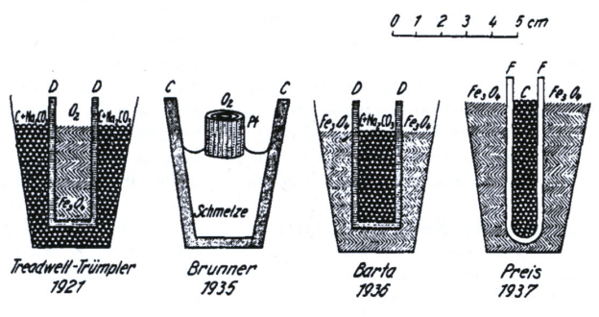
Figure 1.1 Diagrams of the coal based fuel cells developed In the Baur laboratory from 1921 to 1937[20]
In a bid to avoid expensive catalyst metals such as platinum in fuel cell reactions, Francis Bacon used nickel-based electrodes during his development of Alkaline Fuel Cells (AFC) from 1932–1939 [21]. For Bacon, the high cost of Pt catalysts was the main barrier to the commercial adoption of fuel cells. Nickel was selected as it possesses a high affinity for the oxidation of hydrogen. This combined with the aqueous KOH electrolyte, 200 °C and 5 MPa of operating pressure led to the production of a system with a power output of 5 kW in 1959 (Figure 1.2) [21].
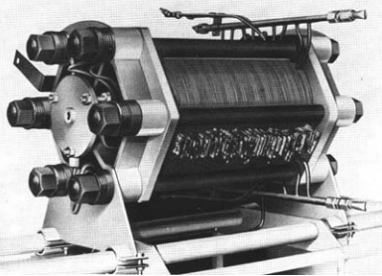
Figure 1.2: Photograph of the stacked Francis Bacon Alkaline Fuel Cell from 1959 [21].
Important events concerning the research and creation of the major fuel cell types can be found in Figure 1.3 and are discussed in Section 1.2.2.

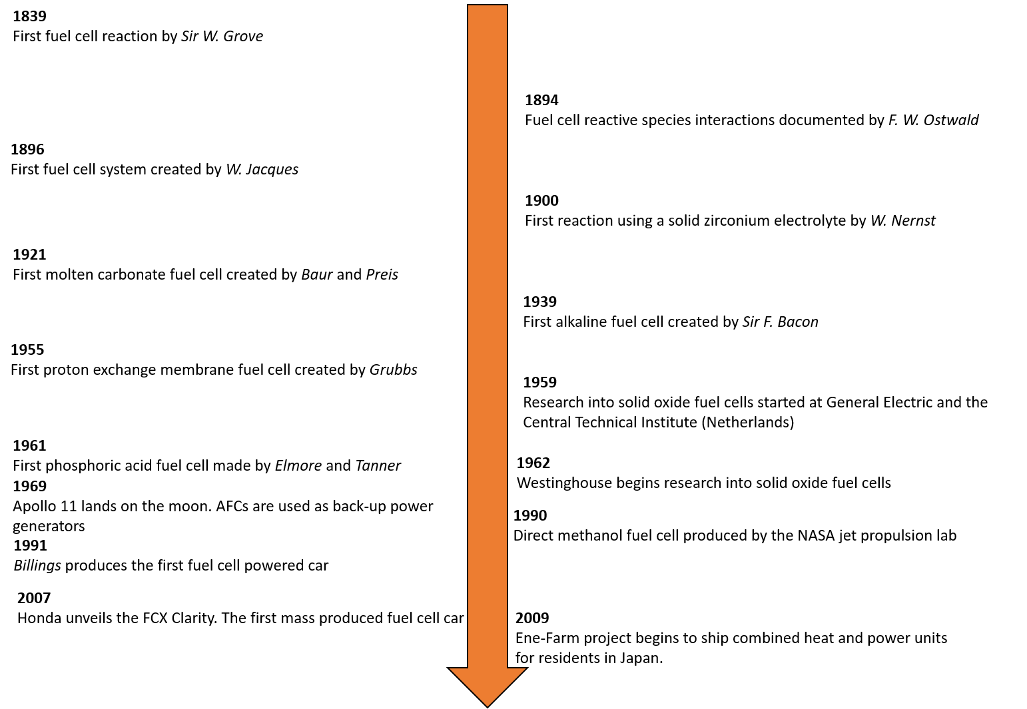
Figure 1.3: Timeline of important events in the conception and production of different fuel cell types across the past 180 years [14], [16], [20]–[24]

1.2 Overview of Fuel Cell Technology

1.2.1 Basic Fuel Cell Operating Principles
A fuel cell is an electrochemical device which both reduces and oxidises air and fuel components at the cathode and anode which release electrons which can be cycled to do useful work [1], [17], [22].
$$H_{2(g)}→ {2H}^{+}+{2e}^{-}$$
Equation 1.2
$${\frac{1}{2}O}_{2(g)}+{2e}^{-}→{O^{2-}}_{(g)}$$
Equation 1.3
$${\frac{1}{2}O}_{2(g)}{+ H}_{2(g)}→H_{2}O_{(g)}$$
Equation 1.4
Fuel cells (FCs) operate by converting chemical energy into electrical energy. Electricity is produced by movement of ions thus creating a potential difference (Figure 1.4). Oxygen at the cathode is reduced forming oxide ions which pass through the ionically conductive electrolyte to the fuel electrode (Equation 1.2 Equation 1.3). These ions then react with the fuel at the anode releasing electrons which do useful work in an external circuit before returning to the cathode. The fuel and oxidant combine to form water (Equation 1.4). In this case the free energy change in FCs (ΔG) is associated with the unidirectional movement of these free electrons [1], [17], [22].
Electrochemical devices are limited by Carnot heat efficiency unlike other electrical energy production methods such as nuclear fission, coal, and natural gas. Maximum energy conversion efficiency in a perfect electrochemical system is denoted by${ η}_{Max}$ and is derived from the movement of the delocalised electrons [17]. The free energy change at the operating temperature is denoted by ΔG and the enthalpy under defined standard conditions by ΔH_{⁰} (Equation 1.5) [17].
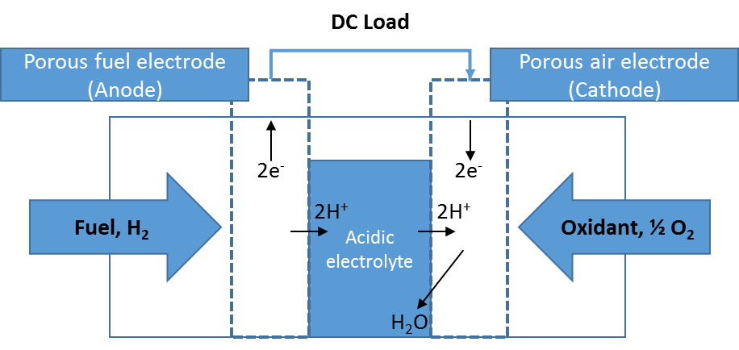
Figure 1.4: Diagram of the operating cycle of a fuel cell with a proton conducting electrolyte. Adapted from Appleby [16]
In the case of FCs highly abundant fuel sources can be used i.e., H₂ and O₂ to produce water and power. Most fuel cell systems use hydrogen as the fuel with oxygen being the oxidant.
$$η_{Max}= \frac{{∆G}_{Operating Temperature}}{{∆H}_{°}}$$
Equation 1.5
The power output of fuel cells can be varied by stacking separate cells in parallel but unlike other electrochemical devices fuel cells can operate for periods of up to 4 years by connecting new fuel sources. In the case of competitors such as batteries there are a finite number of charge-discharge cycles that can be performed before their internal electrode structure breaks down.
The different forms of fuel cell are split by their operating temperatures and largely their electrolyte phases and compositions. Fuel cell nomenclature is based upon the electrolyte material used in each system. These control their reaction kinetics and power outputs. Most fuel cells use a combination of H₂ and O₂ as their fuel and air reactants, respectively.

1.3 Solid Oxide Fuel Cells (SOFCs)
Solid oxide fuel cell (SOFC) research can be traced back to Baur and Prier in 1921 with their work on zirconium solid electrolytes. With further developments in 1959 by the Central Technical Institute in the Netherlands [11], [20].
SOFCs are fuel cell systems in which all the major components: anode, cathode and electrolyte consist of solid ceramic materials. In contrast to the basic fuel cell shown in Figure 1.4 oxide ions O²⁻ are transported from the cathode to the anode through the solid electrolyte.
The use of ceramic materials facilitates the use of operating temperatures between 650-900 °C which promote fast reaction kinetics and energy efficiencies of up to 85-90 % in combined heat and power systems (CHPs) (Figure 1.5). Due to their high reaction rates, SOFCs in contrast with other fuel cell technologies do not need to use precious metal catalysts (i.e. Pt in AFCs, PEMFCs, DLFCs) [25], [26]. In addition, the use of solid electrolytes in SOFCs means they do not possess the spillage risks inherent with caustic liquid electrolytes like the KOH seen in AFCs [17], [22].
The field of SOFC research has continued to grow rapidly over the last six decades. This is highly evident as more SOFC publications have been produced in the past 7 years (2011-2018) than the previous 50 years (See Figure 1.6) [27].
Stationary power generation has been the main application of SOFCs due to their high densities and ability to co-generate electricity and heat. These systems are attractive in for power in residential areas due to their low emissions, lack of noise and low maintenance costs. One of the largest profile SOFC companies Bloom Energy has installed 200 MW of fuel cell stacks in the USA [28]. The company installed its fifth fuel cell stack for Ikea in 2017 [29].
Figure 1.5: Energy efficiencies of different fuel cell types in combined heat and power units [3], [30]–[32]
Figure 1.6: Number of publications relating to SOFCs available on the Scopus search engine from January 1961- June 2018 [27]
SOFC stacks form 10 % of the largest commercial project involving residential CHPs [29], [33]. The Japanese Ene-Farm project is considered the most successful rollout of public use solid oxide fuel cells since its’ inception in 2009 with 22,000 SOFC units [29], [33].
Despite these highly favourable efficiency statistics there are numerous disadvantages with using such high temperatures. A typical solid oxide cell is expected to operate for 40,000 hours, hence the use of ceramics due to their high thermal stability [34]. However, under these high temperatures microstructural changes in the electro catalyst degradation can cause electrical losses and eventual shorting [17], [22], [25]. Combined heat and power systems also possess heat up times of up 24 hours which could mean that SOFCs would have to be combined with other fuel cells to produce immediate power [29], [33].

1.4 Applications, Advantages, and Developments in Fuel Cell Technology
Fuel cells are becoming more popular in a variety of applications namely: portable, transport and stationary power generation [25], [33], [35]–[39]. The commercialisation of fuel cells hinges on the decreasing the production, maintenance and infrastructure costs associated with the hydrogen economy [21], [31], [40], [41].
Portable electronics are a key part of modern life. As user demand get increasingly complex, battery lifetimes for devices such as laptops or mobile phones decrease rapidly. PEMFC portable recharging units have been released by companies such as Intelligent Energy (UK) and MyFC (Sweden) in the past 2 years (2000 h cycling) [42]. The operating range of 1-10 W PEMFCs means that these systems are ideal for this application. As described in Section 1.5.3 the commercialisation of fuel cells will require them to be competitive in terms of cost compared to traditional energy production methods. The low weight of PEMFC stacks lends them to both portable and transport applications [43].
Start-ups such as Bramble Energy are integrating established portable circuit board production methods to reduce the manufacturing cost of portable PEMFC units. They estimate that this will reduce manufacturing costs by up to 20 % and that iterative prototypes can be manufactured in under 2 weeks [44]. This could be key in closing the gap between the cost of energy between PEMFCs and traditional production methods.
Electric vehicles have generated large interest in the media as possible replacements for internal combustion engine (ICE) cars. In the past 5 years 2 FC cars are available in the UK market the Toyota Mirai and the Hyundai Nexo [45]. Both cars utilise PEMFCs. The Toyota Mirai’s 5 kg H₂ fuel tank costs between £50-75 to refill making the Mirai more expensive than similar model ICE cars [45]. This underlines the need for investment in FC manufacture and general H₂ infrastructure [3], [25], [46]. Hyundai anticipate that the global fuel cell car market will grow over 80 times between 2018 and 2030 [45].
Heavy-duty vehicles such as lorries or buses have been unveiled in the past year by various fuel cell companies. Hyundai is developing a fuel-cell powered lorry. PEMFC stacks for vehicular applications have a predicted lifetime of 2000 h of cycling [47]. This is 4 % of the expected lifetime associated with fuel cell systems suitable for stationary applications [48], [49].
High temperature fuel cells such as SOFCs lend themselves to stationary/ heavy duty applications due to two factors: their high densities leading to increased transport costs and their high power efficiencies in comparison with non-solid electrolyte fuel cells [25], [50]–[52]. Companies such as Bloom Energy in USA have taken orders for high profile companies such as Apple and Ikea in the past 2 years [28], [53].

1.5 Solid Oxide Fuel Cell Components

1.5.1 Electrolyte
The electrolyte is one of the three most critical components in an SOFC. The electrolyte provides the system with a pathway for oxide ions to travel to the fuel electrode whilst also being an electronic insulator. In addition to its functional properties, this region must be highly stable under reduction, oxidation, and high temperatures [22], [38], [54]–[57].
Few materials possess this unique blend of functional, chemical and mechanical properties however stabilised fluorite oxides such as yttria-stabilised zirconia (YSZ, Y₂O_{3(0.08)}-ZrO_{2(0.92)}) have been a mainstay since 1959 [25], [58]. Its O²⁻ ion conductivity of 0.1 Scm⁻¹ at 800 °C (0.13 Scm⁻¹ at 1000 °C) is the benchmark for any potential electrolyte material [25], [57]–[59]. Additionally, YSZ is highly stable under REDOX atmospheres further cementing it as one of the best SOFC electrolyte materials.
Ceramic fluorite oxide materials have been the predominant options for electrolyte layers in SOFCs. Their high number of via oxide ion vacancies and ability to create more of these vacancies via intrinsic doping makes them ideal for the ionically conductive membrane [23], [60], [61].
Other doped fluorites have also been investigated as SOFC electrolyte materials. Scandium-stabilised zirconia (Sc₂O_{3(0.11)} -ZrO_{2(0.89)}, SSZ) has been reported to possess twice as high O²⁻ conductivity than YSZ at 850 °C [62]. Despite this, SSZ has some inherent disadvantages in comparison with YSZ. The chemical and functional stability of SSZ is lacking at typical SOFC operating temperatures as impurity phases can form which contributes to conductivity degradation [25], [62]. The largest downside is the cost of scandium oxide, Sc₂O₃ which is over 200 times more expensive than that of Y₂O₃ (£819.71 /kg Sc₂O₃, £3.49 /kg Y₂O₃) due to its scarcity and lack of reliable sources [63]. Unless there is a large decrease in price, scandium-based electrolytes are highly unlikely to be used as SOFC electrolytes.
Gadolinium-doped ceria (Ce_{0.9}Gd_{0.1}O_{2-δ}, GDC) has been an electrolyte material of interest for SOFCs operating at intermediate temperatures (500-700 °C) [3], [35]. However, the dopants in these materials can be costly. Gadolinium costs almost 10x times more than yttrium oxide and cerium oxide is also over 20 % more expensive than yttrium oxide (£33.43 /kg Gd; £4.25 CeO₂ /kg) [35], [63]. These concerns with costs are echoed in other doped ceria materials such as samarium-doped ceria.

1.5.2 Electrode
The electrodes on both sides of the electrolyte have been a source of constant innovation in the SOFC research. This has been largely due to the discovery of cermets almost 50 years ago [57]. Cermets consist of metallic particles embedded in a ceramic matrix this system possesses much improved gas percolation routes (due to the presence of pores) consequently improves the percolation of incident gases through the scaffold [64]. These materials dramatically changed the SOFC electrode landscape as mixed ionic and electronic conduction (MIECs) were now key electrode property. Additionally, adding the electrolyte material a key electrode component has helped reduce mechanical stresses originating from thermal expansion coefficient mismatch [25], [65].
Co-sintering is the most popular method of fabricating cermet materials. This product method revolves around either the mixing of two constituent powders or combining these powders with pore formers. In the case of Ni/YSZ anodes, NiO granules are reduced to Ni catalyst particles on surface of the Y₂O₃-ZrO₂. However, this process is done at 1000 °C and earlier sintering steps are done at temperatures up to 1400 °C [1], [8]. These can cause issues from catalyst sintering especially in nickel [66]–[68].
In the last 20 years the power output of SOFC electrode materials has been vastly improved by the implementation of infiltration [8], [69]–[71]. This alternative MIEC production method avoids the high sintering steps associated with co-sintering. The electro catalyst is injected as a solution into a pre-fired porous ceramic scaffold. The solution penetrates deep into the sponge-like pores coating the scaffold in metallic nanoparticles [8], [69]–[71]. After a soaking period, the scaffold is dried to remove the liquid phase which results in a decoration of metal nanoparticles on the surface of the sample. The high catalyst surface area present in infiltrated electrodes translates to high initial power densities (Figure 1.7) [72].
All of the infiltrated SOFCs assessed in Figure 1.7 (4-9) have not been assessed for a period longer than 1.5 kh which is 3.75 % of the target 40,000 h[3], [73]. This is not representative of the overall operating lifetime and thus linear degradation rates are assumed to provide the %/kh degradation rates provided.
Figure 1.7: Comparison of the power densities and degradation rates of commercial SOFCs (1-3) with infiltrated cells. All the data sets used SOFC stacks operating at 800 ⁰C, H₂ as the fuel, and Ni-YSZ fuel electrodes (4-9) [4], [74]–[80]
Despite the obvious initial benefits of wet impregnation, the infiltrated nanoscale catalyst has a high affinity for coarsening to reduce its surface energy [72], [81]. This results in de-wetted dead zones and a huge reduction in performance in the first 500 h of cycling. The high thermal stability of the ceramic components is in stark contrast to the behaviour of their electro-catalyst and interconnect components during operation. Electro catalyst sintering is a major factor as to why SOFCs do not operate for their 4-5 year projected lifetimes [32], [41], [82].

1.5.2.1 Cathode
An SOFC oxygen electrode must be capable of both ionic and electronic conduction. The materials involved must have an affinity for the oxygen reduction reaction (ORR, Equation 1.6) and additionally be stable under typical SOFC operating temperatures (800-1000 °C) [70], [83]–[85].
$${O_{2}}_{(g)}+{4e}^{-}↔ {{2O}^{2-}}_{(g)}$$
Equation 1.6
Cermet composite cathodes have been utilised to great effect in SOFCs. Materials such as LSCF (La Sr Cobalt Ferrite) have been utilised successfully as oxygen electrodes. LSCF suffers from stability issues stemming from the segregation of strontium to grain boundaries [86], [87]. This forms an insulative phase which blocks the conduction of electrons and can stop the adsorption of oxygen. Detrimental secondary phases can form at temperatures approaching 400 °C [87].
The oxygen electrode has been the most widely studied electrode for SOFCs. Oxygen electrode supported SOFCs have been proven to maximise the power density (Wcm⁻²) of SOFC stacks. However, the high cost of electrolyte and cathode supported SOFC systems has led to the anode being the used as the support electrode as it provides a compromise between power density and cost [88], [89].

1.5.2.2 Anode
As the principal location of the hydrogen oxidation reaction (in H₂/O₂ SOFCs) the anode requires almost identical properties to the cathode i.e. high stability, electrolyte compatibility and electrical conductivity [17], [22], [34], [90]. The major difference against the cathode is that its electrochemical activity is focused on hydrogen so the anode needs to be stable under reducing conditions [1], [25], [91]. The anode can also be known as the fuel electrode as the fuel is the incident hydrogen gas. There are various combinations of anodes covered in recent literature, but the most popular composition has been the nickel/ yttria stabilised zirconia (Ni/YSZ) system [25].
The fuel electrode is an integral SOFC component which has been highlighted by the switch from electrolyte-supported to anode-supported cells in the last 20 years (Figure 1.8) [92]. This means that the reduction of the anode-specific resistance (ASR) and fuel electrode specific degradation has become paramount for the commercialisation of SOFCs. Interconnector supported cells have also been studied, however these use costly thin film deposition techniques [93]. Ferritic stainless steel supported cells have been the focus of Ceres Power to reduce resistances from the three parts [94].
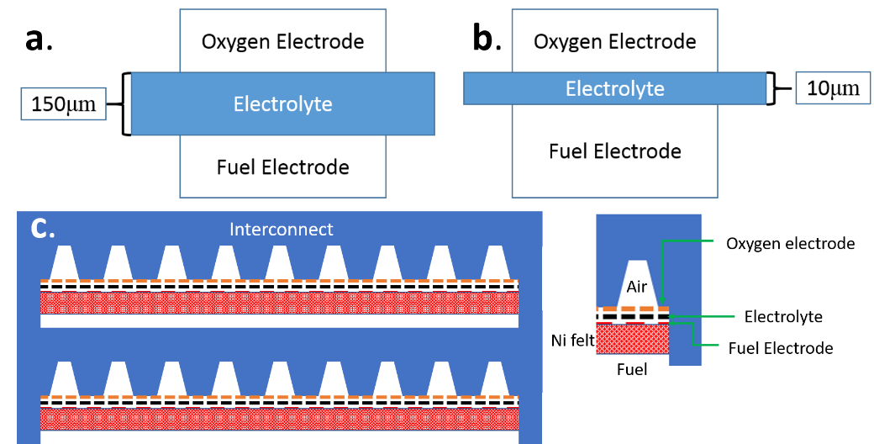
Figure 1.8: Diagrams of the reduction of electrolyte thickness and move to anode-supported designs for SOFCs: a. Electrolyte supported b. Anode supported, c. Interconnector supported stack [93], [95]
Anode triple-phase boundaries (TPBs) are the positions where fuel oxidation occurs in SOFCs (Further information can be found in Section 2.3.2.1). This region combines electrons, oxide ions, fuel gas, electrode material and electrolyte forming water (Equation 1.7) [17], [22]. Microstructural factors such as the electrode porosity, pore size, pore distribution and active catalyst area are key to the anodic polarisation resistance in SOFCs [25], [57].
$${H_{2}}_{g}+{O^{2-}}_{g}→{H_{2}O}_{g}+ {2e}^{-}$$
Equation 1.7

SOFC anode cermet materials
Initially, pure nickel was used as an anode material in SOFCs. However, despite its high electronic conductivity (2x10⁵ Scm⁻¹); nickel suffers from thermal expansion mismatch with the electrolyte reducing its effectiveness as a SOFC fuel electrode [25].
This solution to this problem was proposed in 1970 by a patent from Spacil [96]. The first SOFC Ni/YSZ cermet was produced by sintering a mixture of ceramic oxide and metal powders together. This combined the mechanical and thermal stability associated with the ceramic with the catalytic activity and electronic conductivity of the metal. Porous Ni/YSZ fuel electrodes exhibit an electronic conductivity of between 10²-10⁴ Scm⁻¹ which far exceeds the 10² Scm⁻¹required for an SOFC electrode [25]

1.5.3 Barriers to SOFC Commercialisation
With solid oxide cell design moving towards anode-supported designs, the sintering of electro-catalysts in both cermet and infiltrated fuel electrodes is a major degradation mechanism in SOFCs. In wet-impregnated systems, the active area of the catalyst is higher than that of cermet systems leading to high power densities. However, the issue of electro-catalyst sintering is more keenly felt in wet-impregnated systems as the infiltrated media reduces surface interfacial energy by coarsening. Degradation rates per 1000 h cycled of SOFCs utilising infiltrated electrodes are rarely published. The degradation problems associated with infiltrated electrodes manifest themselves so acutely that none of these electrodes can meet degradation <1 %/1000 h rate target [59], [97].
Degradation issues such as this combine with expensive manufacturing, maintenance, and operating costs. Anode manufacture alone can cost between £113-225, depending whether the manufacturing is based on nitrate decomposition or co-sintering ceramic powders [55], [98]. According to one parametric study on Japanese SOFCs, a cost per watt of electricity is £3.84 to break-even [99]. This requires that the 5-10 kW SOFCs involved had an operating lifetime of greater than 80,000 h.
Scaling up SOFC unit production volume has been underlined as one of the key metrics to reducing the manufacturing costs associated with these units. Mass production of 1-10 kW systems is a landmark for the SOFC industry however, this can only be achievable once such systems can operate for a minimum of 4 years [3], [30], [73].

1.6 Materials Challenges for Solid Oxide Fuel Cells
SOFCs offer the highest energy efficiency of all the fuel cell types. Their high operating temperatures (800-1000 °C) are key as they promote fast reaction kinetics. For SOFCs to breach the mainstream electricity production market as a viable method, two major issues must be solved:
Firstly, SOFCs overcome their thermal degradation issues at high temperatures. This will enable SOFCs to fulfil the 4-5 year operating times set by industry. And secondly, SOFCs need to reduce the costs associated with these stability issues by increasing their power density [3], [100].
Various iterations have been made to SOFC design to either improve durability (% per thousand hours cycling) or increase power output (mWcm⁻²). The major materials properties are discussed in Chapter 2.
For SOFCs to be successfully deployed in a stationary power setting the price per kW of energy produced must be reduced under $1000 (£724) /kW of energy produced [101]. Currently, this reduction would occur around 2042 according to current US DoE estimates and 2032 assuming a linear reduction from the EUs estimates (See Table 1.1) [101], [102]. This underlines the need for continued power density increases via infiltration increase the commercial viability of SOFC stacks.
Table 1.1: Voltage degradation targets per 1000 h of operation for large-scale SOFC stacks from the US DoE and the EU FSH JU funding bodies between 2017 to 2050 [99], [101], [102]
Country or Region | Funding Body | Year [% /kh]
Country or Region | Funding Body | 2017 | 2020 | 2024 | 2030 | 2035 | 2050
USA | Department of Energy (DoE) | 1.0 | 0.50 | N/A | N/A | 0.30 | 0.20
Europe | Fuel Cells Hydrogen Joint Undertaking (FCH JU) | 1.0 | 0.50 | 0.42 | 0.36 | TBA | TBA
Table 1.2: Price per net kilowatt of energy produced by large-scale SOFC stacks from the US DoE and the EU FSH JU funding bodies between 2017 to 2050. The DoE target is £724 /kW [99], [101], [102]
Country or Region | Funding Body | Year
Country or Region | Funding Body | 2017 | 2020 | 2024 | 2030 | 2035 | 2050
USA | Department of Energy (DoE) | £1955 /kW | £1086 /kW | N/A | N/A | £869  /kW | £579 /kW
Europe | Fuel Cells Hydrogen Joint Undertaking (FCH JU) | £2575  /kW | £1717 /kW | £1288 /kW | £1030 /kW | TBA | TBA

1.7 Thesis Outline

1.7.1 Aims
This thesis aims to address the catalyst sintering issue present in infiltrated fuel cell anodes:
Objectives
- Produce sinter resistant anodes using gas drying steps
- To reduce the anode specific resistance degradation rate using drying atmospheres to reduce the impact of nanoparticle coarsening rate in infiltrated SOFC anodes
- Monitor, identify, and quantify the early-stage sintering mechanisms exhibited by nickel nanoparticles

1.7.2 Outline
This document is split into 7 chapters. Chapter 1 covers the history and applications of fuel cells. In the second chapter a literature review is conducted assessing the status of infiltrated SOFC anodes. A breakdown of the experimental methods used is discussed in Chapter 3. The use of nitrogen drying atmospheres to control the dispersion, size, and electrochemical properties of the nickel catalyst in infiltrated YSZ fuel electrodes is discussed in Chapter 4. Chapter 5 details the impact of different current collector materials on the polarisation resistance of wet impregnated fuel electrodes. Ptychography is used for the microstructural quantification of changes in nanoscale infiltrated electrodes during SOFC ageing in Chapter 6. Chapter 7 provides a short summary of this thesis and outlines routes of further study.

Chapter 2: Literature Review

2.1 Motivation
The high operating temperature of Solid Oxide Fuel Cells (650-1000°C) promotes high reaction kinetics and promotes total energy efficiencies of up to 85% in combined heat and power systems (CHPs) [3], [4], [31], [41]. Despite these highly favourable efficiency statistics there are numerous disadvantages with such conditions. A typical solid oxide cell is expected to operate for 40,000-50,000 h or between 4.5 – 5 years, hence the use of ceramics due to their excellent thermal stability [30], [91], [100]. However, current state of the art SOFCs struggle to produce the operating times stated above due to issues encouraged by the high operating temperatures and aggressive atmospheres [67], [103].
Four main sources of degradation in the fuel electrode are documented in the literature [103]–[106]. These stem from the environment, fuel, operation, and materials used [104]. The atmospheres utilised in an SOFC anode are highly corrosive and exert humidity’s exceeding 40 % due to the production of water during operation [107]–[110]. Catalyst poisoning via intermetallic formation or coking occurs during chemical reactions with the fuel [85], [111], [112]. The successive temperature and redox cycling during service promotes the expansion and shrinkage of the catalyst material which can lead to crack propagation and delamination of the electrode [57], [105], [113]–[115]. Lastly, the catalyst material (usually nickel) is susceptible to sintering, concurrently reducing the active surface area and reaction rates (Figure 2.) [1], [116]–[118].
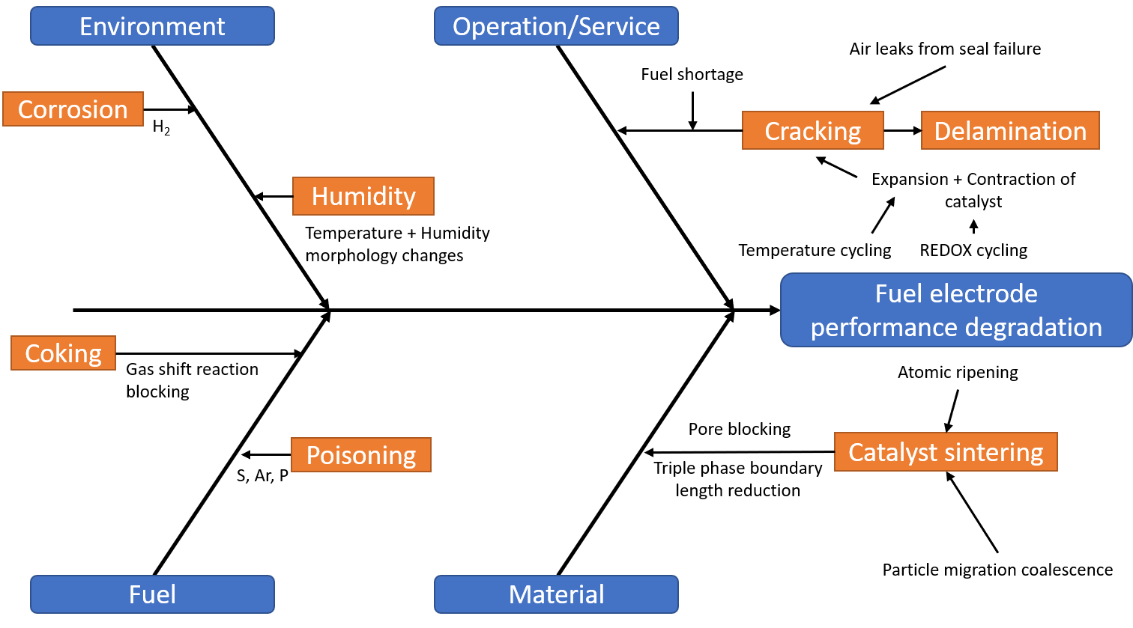
Figure 2.1: Ishikawa fish bone diagram detailing the four degradation paths for SOFCs. Adapted from Patel et al [104], [107], [111], [119]
The relationship between the cost of SOFCs and power density has been described by the US DoE SECA program as inversely proportional[3], [120]. For SOFC stack to be commercially competitive with other forms of energy production the price needs to drop to $44/kW (£33.25/kW) [3]. For this to be achieved the power density of the SOFC stack needs to quadruple from 0.5-2.0 Wcm⁻² [3], [92], [121].
For wet-impregnated SOFCs to be competitive with their co-sintered counterparts, their power densities need to exceed 0.7 Wcm⁻² [76], [77], [80], [122]–[125]. However, the poor thermal stability of infiltrated electrodes is hampering their adoption (power density degradations > 1% / 1000 h). This project focusses on understanding the deactivation mechanisms via catalyst sintering in wet impregnated SOFC fuel electrodes.
This review discusses the degradation mechanisms present in infiltrated fuel electrodes and strategies to characterise the rate of degradation.

2.2 SOFC Anode production methods
The key research materials for anodes in recent times have been cermet materials. A cermet is a combination of metal ions in a ceramic matrix which possesses much improved gas percolation routes (due to the presence of pores) consequently improves the percolation of incident gases through the scaffold [64], [126]. For these systems to work optimally they must conduct both oxide ions and electrons (mixed ionic electric conductor, MIEC) (Figure 2.2) [1], [17], [64]. The ceramic provides the oxide ion conduction and the metal the electronic. The metal must form a conductive network so that the electrons can reach the external circuit. In the case of SOFC anodes the cermets in question also revolve around the Ni/YSZ system. The advent of cermet fuel electrodes for solid oxide fuel cells began almost 50 years ago [96].
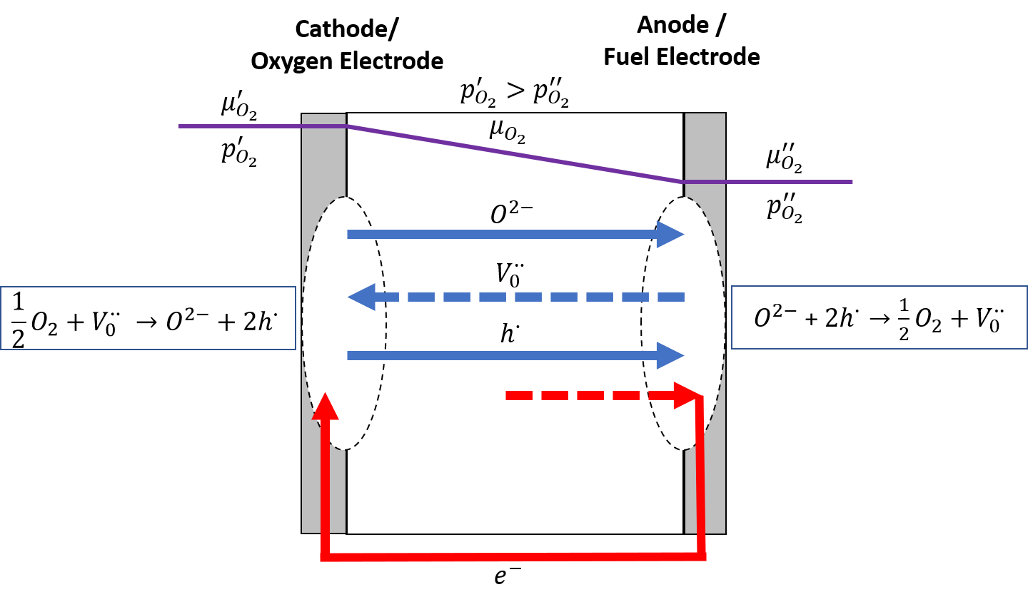
Figure 2.2: Diagram of the mixed ionic electronic conduction system present in SOFCs. The oxide ions conduct through the electrolyte via an oxygen partial pressure gradient (${p_{o}^{x}}_{2}$). The red denotes the movement of the electrons via an external circuit doing useful work. ${µ_{o}^{x}}_{2}$ denotes the mobility of the oxygen vacancies, $V_{o}^{∙∙}$ [1], [17], [64], [127].

2.2.1 Powder methods
Conventional SOFC electrodes are produced by ball milling and co-sintering. The constituent powders are mixed with or without a pore former. In Ni-YSZ production this is usually a combination of nickel oxide and yttria-stabilised zirconia of a Ni/Y₂O₃-ZrO₂ cermet anodes revolve around either the mixing of two constituent powders or combining these powders with pore formers. The NiO granules are reduced to Ni catalyst particles on surface of the Y₂O₃-ZrO₂. This process is performed at 1000 °C after earlier co-sintering steps (at temperatures up to 1400 °C) [1], [8], [91].
The high temperatures involved in co-sintered cermet anode production provide the catalytic media with excess thermal energy. In a bid to reduce this surface energy; the catalyst particles sinter to transition to a lower energy state [118], [128]–[130]. This leads to grain growth in this phase which concurrently reduces the electronic conductivity of the network and the active area of the electrode.
The coarsening issue is one of the key reasons that bulk cermet anodes exhibit power density losses exceeding -1 % per 1000 h [131]. As many of the core electro-chemical reactions occur within the 10 µm anode functional layer (AFL) between the electrode and the electrolyte, catalyst sintering from the nano to the microscale reduces the activity of the anode considerably [132]–[135]. Additionally, the grain growth of the ceramic phase can hinder the distribution of Ni catalysts throughout the structure, consequently reducing the number of active triple phase boundaries and concurrently the maximum power density [105], [136].
In response to these issues SOFC anode research transitioned to produce a microstructurally tailored systems known as a nanostructured electrodes [108], [137]. These systems were designed to maximise the active triple phase boundaries present in the fuel electrode to increase the power density and decrease cost [3], [138], [139].

2.2.2 Infiltration
Infiltration (also known as wet impregnation) has become one of the emerging technologies for nanostructured electrode fabrication [140], [141]. This technique involves the injection of a liquid solution of metallic nano-catalyst particles and complex agents to a pre-sintered porous substrate [64], [71], [142]. This solution coats the scaffold in metallic nanoparticles which also penetrate deep into the pores of the sample. Post soaking, the solvent is dried, and the resulting infiltrate is calcined resulting in a decoration of metal oxide nanoparticles on the surface of the sample (Figure 2.3) [8], [64], [143], [144].
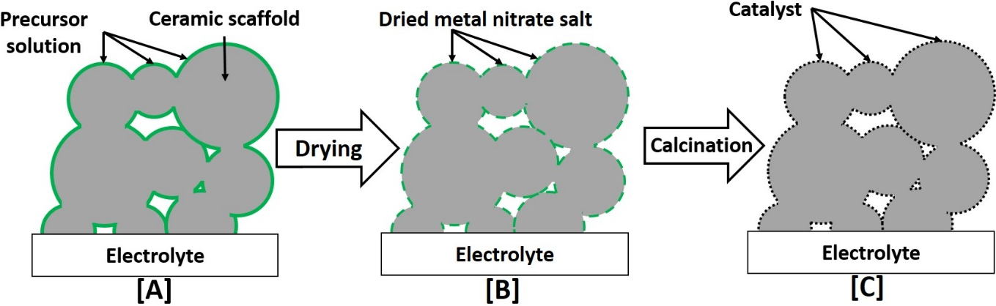
Figure 2.3: A schematic of the infiltration process with diagram A showing the soaking period of the liquid phase and diagram. B showing the dried nitrate on the scaffold surface. C showing the decomposed decoration of metal NPs on the surface of the scaffold post calcination [7], [57], [145]
The flexibility of the wet impregnation technique means that it can be utilised to produce nanoscale engineered electrodes. This technique appears to have dominated in terms of producing infiltrated cathodes with various literature review having been published on the topic [7], [8], [144].
It is known in the field of surface catalysis that a larger number of reactive sites can be utilised by nanoscale particles. The drive to decrease catalyst size constitutes a concerted effort in the literature to increase the surface to volume ratio of said particles. As discussed; higher number of potential active sites from the nanoparticles produced by ion impregnation has been shown to increase the power density of SOFCs [9], [74], [146].
The benefits of this method are numerous. The simple process produces a high degree of functional control as the amount of catalyst is directly controlled by the number of separate metal salt depositions. The calcination and firing of the porous YSZ scaffold can also be done at lower temperatures preserving more acute functional characteristics.
In addition, the increased porosity of the ceramic backbone in infiltrated electrodes reduces the effect of thermal expansion coefficient mismatch between the metal and the ceramic structure during operation. The avoidance of high temperature sintering steps means that this technique has a large degree of flexibility with the infiltrates that can be used.
The role of coordination number (CN) or ligancy in catalysis cannot be understated. This is the measure of the central atom and the number of atoms bonded to it [147]. For a Ni atom in the face-centred cubic crystal the (111) crystal plane has the highest stability due to it possessing the highest coordination number via cubic close packing (See Table 2.1 below). This means that the atoms in this plane are prime locations for catalysis and chemisorption with the fuel via electronic-state variance. However, if just highly coordinated bonds existed the activity of the system would behave more similarly to a bulk reaction.
Table 2.1: A breakdown of the stability of the separate Ni crystallographic planes. Assuming that the red adatom is central to the system. Adapted from Li et al [147]
Crystallographic Plane | Coordination Number of red atoms | Diagram | Crystalline Stability
(100) | 8 |  | Moderate
(110) | 7 | 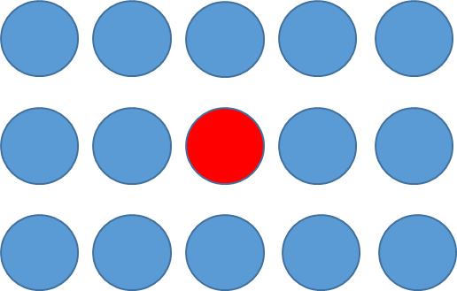 | Lowest
(111) | 9 |  | Highest
The high surface area in nanostructured electrodes ensures that step sites exist between the first (111) layer, second (111) layer and the (110) plane. These exposed positions can increase the catalytic activity of the system as the catalyst can interact with the fuel with less chance of adsorption. Due to its high order the Ni_{FCC} crystal consists of large number of repeating step sites especially in the (110) plane which increases the activity of the catalyst [146], [148]. This interaction underlines how key the coordination number is to heterogeneous catalytic activity. In the terms of infiltration an increased number of exposed plane atoms with low CN values should lead to better performance.
Solid oxide fuel cells do not need to produce water as the final by-product. Gases such as methane (CH₄) can also be reformed during the operation of an SOFC. Methane is key to the construction of hydrogen however the deposition of carbon can also occur on Ni/YSZ anodes during this process. Ni/YSZ systems are certainly more suited to the hydrogen oxidation reaction. The infiltration of additional compositional elements can also improve anode’s tolerance to carbon decomposition as shown by Gavrielatos et al [149], [150]. During this study, the addition of between 1-5 at % silver in the infiltrate. What was interesting was the discussion of how the silver affected the system. At temperatures exceeding 800 °C the resistance of the anode to carbon deposition dropped, this was visible by the 25 mAcm⁻² reduction in current density. This underlines the importance of the infiltration additions to the electrochemical properties.
Infiltration also produces highly homogenised arrangements of catalytic NPs on the scaffold surface. The resultant microstructure is finer than those created by production techniques such as co-sintering and conventional powder mixing. Despite the obvious processing differences, the properties of infiltrated samples are superior to other anode fabrication techniques [5], [8], [71], [151].
Wet-impregnated samples with uniform distributions of NPs are highly replicable in comparison with other fabrication techniques. This assertion from the Liu literature review in 2013 was certainly supported by the work of Busawon [145], [152], [153].
Jasinski et al compared the co-precipitation (CP) and infiltration production techniques to create Ni/YSZ cermets [154]. The authors noted an 11 % decrease in the thermal expansion coefficient in the wet impregnated samples in comparison with the CP samples. This could prove advantageous in the terms of mechanical strength in SOFC stack as the fuel electrode is less likely to expand and eventually damage the other components in contact with it.
The resistivity values produced by Haberko support the use of infiltration as a production technique for Ni/YSZ cermets as the use of this technique reduces the amount of catalytic reagent required for similar if not improved functional properties [154]. This inferred that at lower catalyst loadings the final microstructure is more impactful than the overall chemical constitution of the anode.
As a fabrication technique which is relatively immature in comparison with convention ceramic processing ion implantation (infiltration) is known to be extremely time consuming. This is due to the repetition of multiple injection and drying steps to generate an acceptable amount of infiltrate loading on the being too low. Busawon also noted that the nickel catalyst particles were likely to be susceptible to isothermal degradation [155]. This assertion is explored further in Section 2.3.2.
As nickel metal ions travel through the porous anode structure there will be a limit to how many ions can be incorporated in the cermet arrangement. It has been found that the percolation limits of a 1µm nickel powder is 30 vol % [83], [156]. For infiltrated nickel ions, which are nm in scale, the percolation limit is smaller at 9 vol %. Busawon’s findings that infiltrated nickel appeared to improve the redox stability of the anode was postulated by Klemensø to be down this effect [157], [158].
These studies underline the importance of using characterisation techniques to help identify the microstructural effect of impregnating the scaffold with nickel metal catalysts. As infiltrated electrodes have the potential to be more stable than other anode production routes.

2.3 Mechanisms of Degradation
To understand the breakdown of the infiltrated SOFC anodes, the microstructural and electrochemical changes during both production and operation must be fully understood. For the wet impregnation of catalytic NPs this section of the literature review examines the various stability problems exhibited by Ni-YSZ anodes.

2.3.1 Electrode Fabrication: Precursor and Infiltrate decomposition
One of the major gaps in the wet impregnated SOFC electrode literature that has not been widely investigated is the mechanism of infiltrate decomposition and its impact on the catalyst distribution. The infiltration electrode processing technique is a batch process with several repeated steps revolving around the decoration of the metal catalysts on the porous scaffold (See Figure 2.4) [8], [137], [144], [159].
This may initially seem superfluous when considering the overall fuel cell electrode composition and its durability requirements, but the small factors matter. If the precursor does not decompose correctly this step is repeated multiple times leading to a stacking error built up in every separate routine.
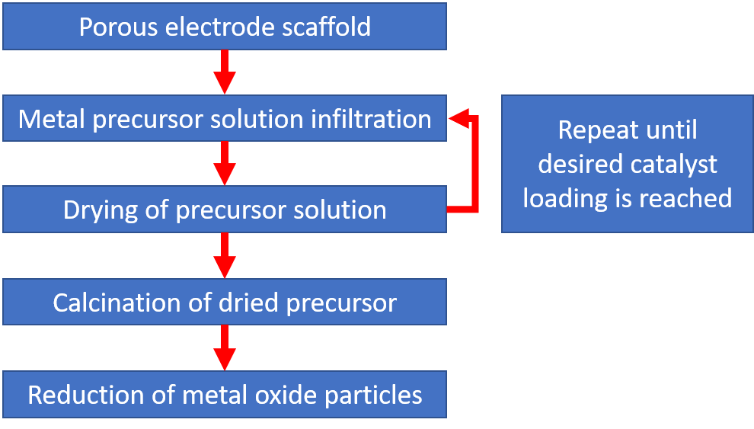
Figure 2.4: Flowchart detailing the processing steps used to produce an infiltrated SOFC electrode [8], [137], [144], [159].
In an ion impregnated SOFC anode the dispersal of the metal catalysts is key to the overall performance of the system. An infiltrated Ni/YSZ anode needs a continuous film of metal particles across the scaffold area to provide the foundation for large triple phase boundaries. This is achieved by producing a uniform coating of infiltrate and thus an even dispersal of nanoparticles during the soaking phase after the solution has been injected onto the sample.
The consequences of producing a non-homogenous layer can be quite evident during the infiltration process as that repeated impregnation steps are required to produce the optimal catalyst to scaffold volume ratio.
The dispersion of the catalyst adatoms does hinge upon the wettability of the metal salt solution on the ceramic scaffold. Transition metal nitrates have been a mainstay in the infiltrated fuel cell literature due to their solubility in water and supposed simple decomposition routes from nitrate to oxide using elevated temperatures. However, there is a significant body of work in surface catalysis which have illustrated that many pathways exist that map these steps. The drying and calcination steps are key to the catalytic properties of the infiltrated system and by extension in wet impregnated SOFC electrodes.

2.3.1.1 Drying of the nitrate precursor solution

SOFC Electrodes
The drying process is hugely important in the production of infiltrated catalysts. The rate of removal of water in the infiltrate solution, is hugely impactful on the dispersion and size of the catalyst adatoms.
The initial stages of fabrication dictate how the anode performs functionally. If the nickel infiltrate does not adsorb correctly onto the porous scaffold, this could cause early durability issues without even being electrochemically cycled. The effect of reducing the NP size has been well documented in improving electrochemical performance in anode. Despite this the investigation of drying on functional properties has been widely neglected in SOFCs. There is only one example in the past 5 years of precursor solution drying in SOFCs.
Burye et al studied the effect of desiccation on infiltrate properties on the electrochemical performance of infiltrated LSCF (La_{0.6}Sr_{0.4}Fe_{y}Co_{1-y}O_{3-x}) /GDC composite cathodes. The nitrate precursor and Triton X-100 surfactant solution was desiccated with CaCl₂ for 10h leading to a LSCF particle size reduction of 26 nm [160]. This kind of gain is huge in terms of electrochemical properties. As demonstrated by Figure 2.5:

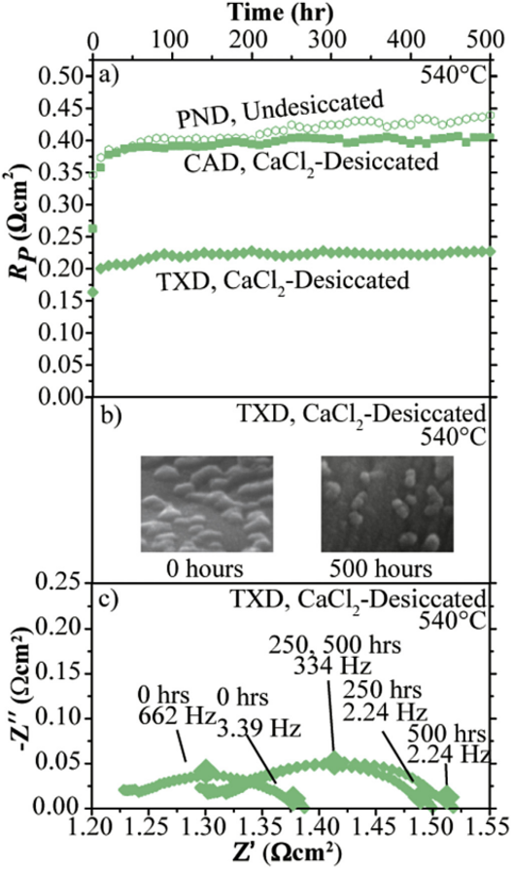
Figure 2.5: A series of figures overlaid showing the effect of desiccation on the properties of infiltrated LSCF/GDC cathodes. All the desiccated Triton X-100 samples are in green. a) Plots the Polarisation resistance, R_{P} against temperature of the three separate samples b) SEM micrographs of the GDC scaffold with LSCF adatoms on the surface c) The imaginary impedance plotted against the frequency impedance from the EIS cycling of LSCF/GDC [161], [162].
Figure 2.5 is a clear illustration of how impactful the fabrication process is to the properties of the oxygen electrode. By modifying the drying routine, the polarisation resistance was reduced by almost 45 % when compared to the undesiccated LSCF/GDC sample [163]. This is a large reduction in the polarisation resistance indicates that drying conditions do impact the functional properties of the electrode. However, the message of the paper is mixed as the use of citric acid-based precursors reduced the polarisation resistance even further than the desiccation. This work should be applicable to both infiltrated electrodes either side of the electrolyte. This conclusions of the Burye work illustrates the large amount of continuation research still required for wet impregnated SOFC anodes [163], [164].

This illustrates a large gap in the fuel electrode literature for examining the impact of drying on the dispersion and size of wet-impregnated adatoms. Additionally, how this impacts the electrochemical properties of the fuel electrode during operation also needs assessing.

Surface Catalysis
The work in surface catalysis scrutinising the impact of drying has focussed largely on the decomposition of transition metal nitrates supported on silica particles [165]–[171]. These adatoms are crucial for Fischer-Tropsch synthesis [172]. The major drying routine discussed in the past 10 years has around the optimisation of these catalysts by utilising a gas atmosphere during the drying step.

The De Jongh group (Utrecht, Netherlands) have led the field of surface catalysis in this area with a suite of papers discussing the impact of the drying atmosphere on the dispersion and size of wet impregnated catalysts [167], [173]–[176]. The major finding of this work was that the use of nitric oxide/helium flowing atmospheres helped produce smaller, more homogeneous nanoscale nickel particles.

Munnik summarised this work to describe the optimised conditions for producing catalysts with a high active area (size < 10 nm) and a resistance to sintering suitable for Fischer-Tropsch synthesis [177], [178]. Combining a drying temperature that exceeded 100 °C with a flowing nitrogen atmosphere produced the smaller cobalt oxide particles (7 nm in length) compared to those dried at 25 °C [177].

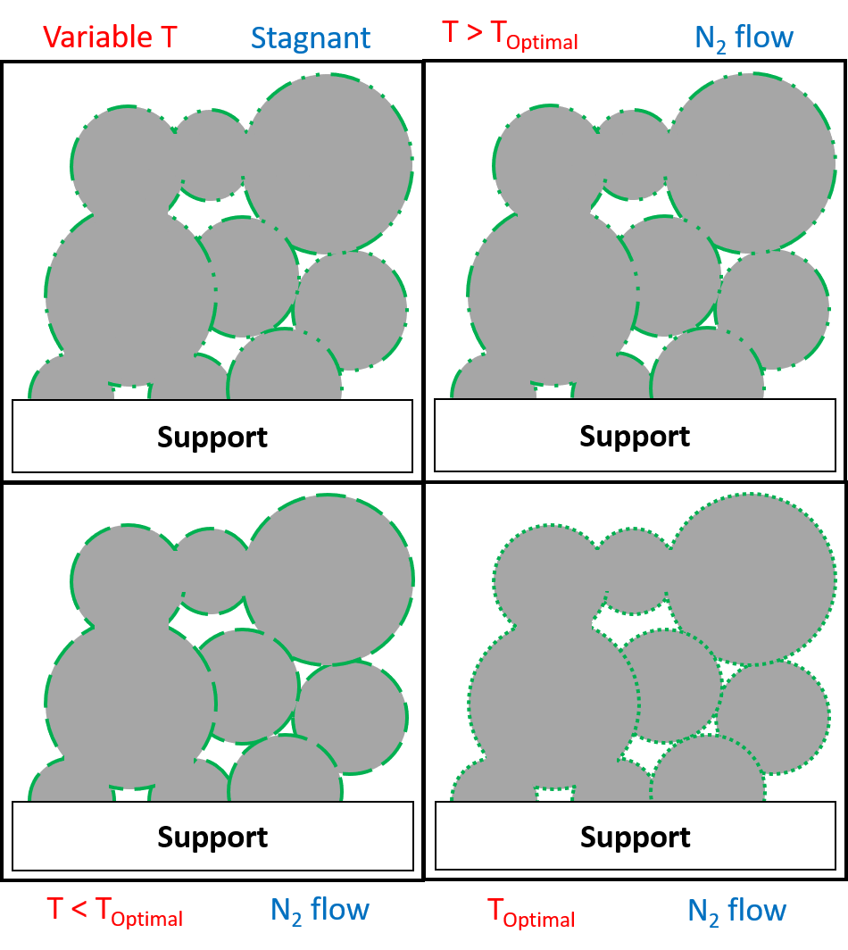
Figure 2.6: Diagram detailing the impact of utilising an inert drying atmosphere with an infiltrated SOFC electrode. Adapted from [177], [179]
The trialling of both temperature and atmosphere by the De Jongh group provides a robust framework to apply these drying conditions in a new field such as infiltrated SOFC electrodes to produce more active, sinter-resistant catalysts [165]–[171]. Figure 2.6 illustrates the expected impact of drying the metal salt solution in an infiltrated electrode using temperatures exceeding 100 ⁰C and a flowing inert atmosphere.
Despite the overlap between the research fields of surface catalysis and SOFCs in heterogeneous catalysis (Figure 2.7). The mechanism of particle formation during these drying steps has not been elucidated.
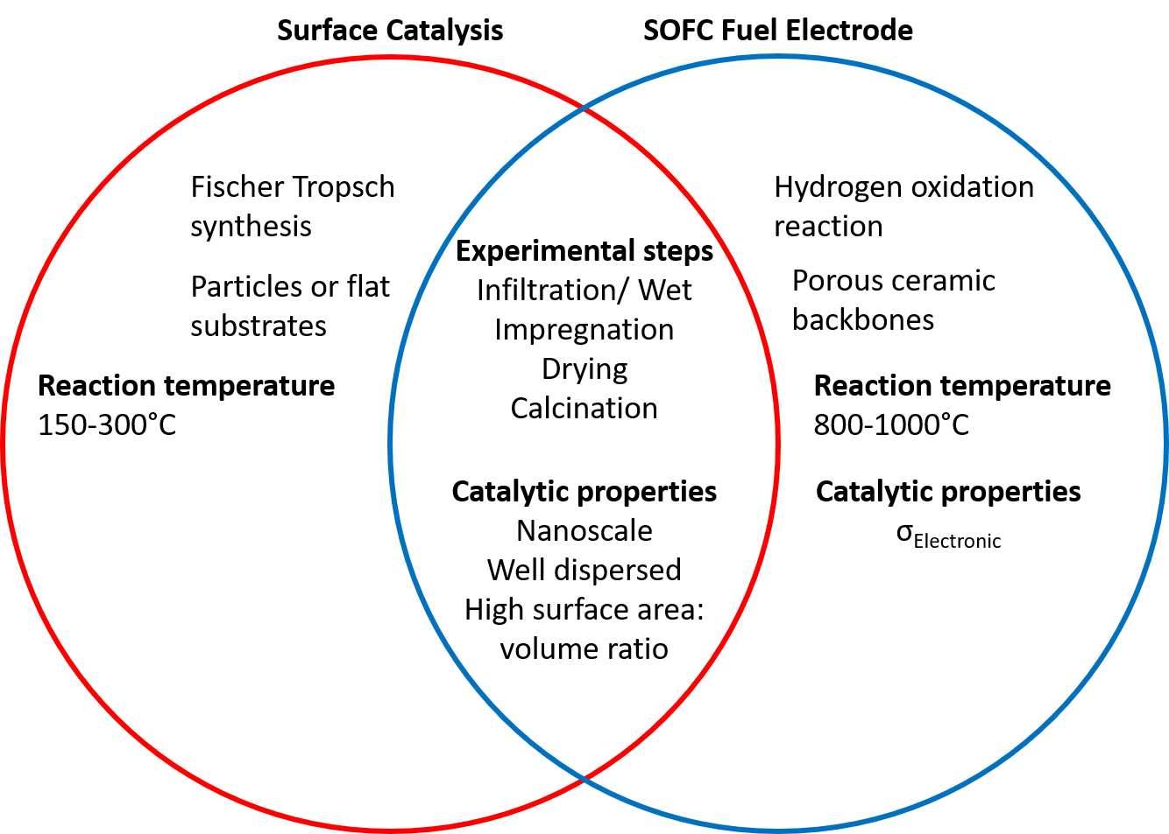
Figure 2.7: Venn diagram detailing the similarities between the catalysts used in surface catalysis and infiltrated SOFC fuel electrodes [7], [8], [167], [173]–[176]
Both sets of papers from Burye and Sietsma have emphasised their hypotheses that the infiltrate drying step is key to assessing how the overall anode material operates. Although both authors appear to be at very separate stages with their work [161], [174], [176], [180]. The evidence points to the decomposition of nickel nitrate hexa-hydrate forming basic intermediate salts which are then reduced in humidified hydrogen.

The effect of atmosphere on nickel dispersal has been raised by Sietsma and Wolters for nickel nitrate precursor solutions but there are key holes that need to be addressed. The major one being that there have not been any drying studies (either desiccation, thermal or atmospheric) on YSZ or any fuel electrode materials.

2.3.1.2 Nitrate Calcination
The thermal decomposition or drying step is essential in any infiltration process; the solution (in this case nitrate ions) must be removed from the sample to isolate the desired metal oxide required for catalysis. The thermal breakdown (calcination) of nickel nitrate has been researched in the last three decades using a combination of thermo-gravimetric analysis, temperature programmed reduction and mass spectrometry to determine the identity of the gaseous products [181]–[184]. The cationic charge density of the nitrates was shown to possess a negative correlation with the decomposition temperature(T_{Decomp})[183]. These temperatures are shown in Table 2.1 below.
The literature value for the thermal breakdown of anhydrous nickel nitrate is approximately 300 °C which has been replicated in the TGA range which was between 282- 332 °C [181]–[184]. These values throw some doubt onto some of literature as to whether their decomposition temperature has been enough to fully decompose the precursor solution on the porous YSZ scaffolds. The other unanswered point is that the use of excessive calcination temperatures would impact the final decomposition products [183], [184].
Table 2.2: A comparison of the decomposition and reduction temperatures of various transition metal nitrate samples. Temperatures were calculated using thermogravimetric analysis and temperature-controlled reduction in a 10% H₂/N₂ atmosphere. The values for anhydrous nickel nitrate are highlighted. Adapted from Yuvaraj and Addison et al [184], [185].
Sample Composition | 10³ Charge Density (e/nm³) | Literature T_{decomp}  [K] | T_{decomp}  [K] | T_{red}  [K]
Mn(NO₃)₂ | 1.18 | 473 | 480±20 | 510±15
Co(NO₃)₂ | 1.28 | 543 | 515±20 | 515±20
Ni(NO₃)₂ | 0.83 | 573 | 580±25 | 585±15
Cu(NO₃)₂ | 1.33 | 563 | 520±30 | 550±15
The thermal decomposition step is credited for lowering the reduction temperature (T_{Red}) of the nickel oxide via the back donation of electrons from the nitrogen-oxygen double bond to a vacant d orbital in the metal cation [183]. This results in a reduction of the nitrate bond order [186], [187].
Except for the T_{Red} from the TGA and TPR investigations; there are no other characterisation techniques in the study which discern this process. Further investigation is required to confirm the effect of back donation of reduction temperature.
The infiltrate decomposition step is a major form of degradation prevalent in all infiltrated SOFC fuel electrode systems. Aqueous nickel nitrate ([Ni(H₂O)₆(NO₃)₂]) is one of the major precursor solutions used in the wet impregnation process [6], [188], [189]. This metal salt solution provides the catalytic nanoparticles required to produce an infiltrated Ni/YSZ anode. A drying step prior to decomposition is crucial to remove the excess solvent before the calcination of the nickel nitrate. Equation 2.1 details the endothermic decomposition of nickel nitrate into nickel oxide, nitrogen dioxide and an oxygen radical [182] .
$$Ni{\left({NO}_{3}\right)}_{2(s)} →{NiO}_{(s)}+{2NO}_{2(g)}+\frac{1}{2}O_{2(g)}$$
Equation 2.1
The oxygen radical is cancelled out by another oxygen radical to form diatomic oxygen molecules. This reaction is driven by the NiO produced in Equation 2.1. The products of this chemical reaction were observed in mass spectrometry work of Criado [182].
The formation of intermediate compounds during the thermal decomposition of nickel nitrate has been documents by surface catalysis literature. The breakdown discussed by Criado could not monitor the thermal breakdown of the nitrate under the influence of a range of temperatures[182].
Multiple investigations detailing the emergence of intermediates in other thermogravimetric analysis routines[165], [183], [190]–[194]. Brockner compared the thermal decomposition of Ni(NO₃)₂.6H₂O against cobalt nitrate, Co(NO₃)₂.6H₂O [195]. This study had direct comparability with the Yuvaraj paper as both used similar temperature ranges and identical reduction stage conditions (10% H₂/N₂)[183].
The Brockner methodology matches up better than its predecessor, for one major reason: the lower TGA heating rate used in both studies[195]. The heating rate used by Yuvaraj in 2003, was 10 Kmin⁻¹ when heating the sample to temperatures exceeding 1000 °C [183]. When placed into context, the 2007 TGA investigation used a 0.7 Kmin⁻¹ ramp rate which gradually reached a maximum of 500 °C [195].
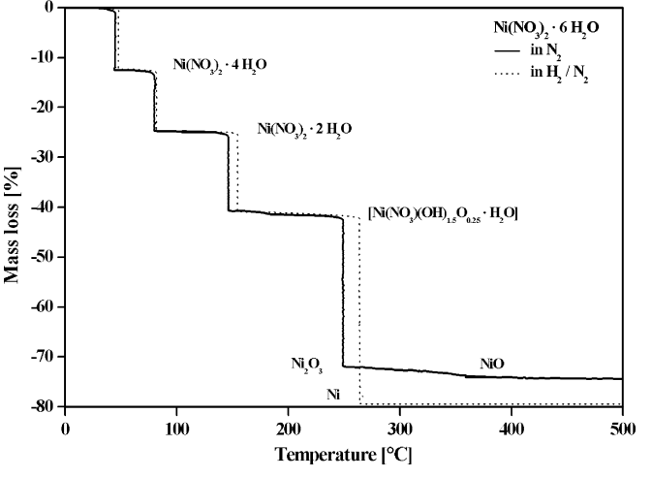
Figure 2.8: TGA graph of the percentage mass loss versus temperature for nickel nitrate hexa-hydrate detailing the various steps for the thermal decomposition reaction. The dark line shows the thermal breakdown in a nitrogen atmosphere [192], [195].
The TGA graph from Brockner (Figure 2.8) is a prime example of this with separate interactions clearly visible [192]. The nickel nitrate intermediate Ni (NO₃) (OH₂)₂ generated by the partial oxidation stages listed in the reaction analysis. This step liberates an electron from the nickel cation, which is key for production of these intermediate phases (Equation 2.2 )[165], [192], [195].
$${Ni}^{2+}→{Ni}^{3+}+e^{-}$$
Equation 2.2
The excess positive charge generated during the formation of basic nickel nitrate intermediate salts is cancelled out during the reduction of the sample.
These studies indicate that the drying of coordination complex systems such as hexa-hydrate, tetra-hydrate are not simple single step drying systems, illustrated by the higher drying temperatures used in the infiltration literature to remove the water from their samples. However, with such a high proportion of water ligands, it is more energetically favourable to split multiple times than removing all the ligands in a single reaction [196], [197]. This has been demonstrated with other transition metal hydrates [198], [199].
In contrast with earlier decomposition work a pair of papers by Sietsma et al discussed the impact of atmosphere on the decomposition of nitrate compounds [161], [174], [176], [180]. In these studies, a nitric oxide rich atmosphere was used during the drying step to determine whether the environment influences the nickel dispersion.
In addition, the findings from Sietsma et al pointed to the presence of basic intermediate phase Ni₃(NO₃)₂(OH)₄ when decomposing aqueous nickel nitrate on silica supports [169], [173]. The production of nickel nitrate hydroxide is thought to be a result of the drying step.
Thermally decomposing the nickel nitrate precursor under the influence of a nitric oxide/ helium atmosphere was shown by differential scanning calorimetry to trigger the decomposition of nickel nitrate quicker than in air (Figure 2.9) [166], [176].
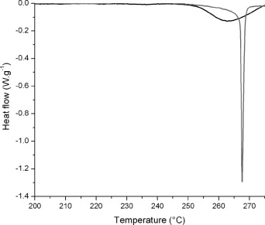
Figure 2.9: Differential Scanning Calorimetry graph illustrating the effect of ramping at 1°C per minute on a nickel nitrate sample under different atmospheres. The grey trace line is the effect of ramping the nickel nitrate sample in air and the black line shows the effect of ramping the sample in a NO/He atmosphere [175].
Under different atmospheres the reactants change which produces a variety of products. This is shown by Equation 2.3 below [169], [200]:
$$Ni{\left({NO}_{3}\right)}_{2(s)}+NO→{NiO}_{(s)}+{3NO}_{2(g)}$$
Equation 2.3
The key difference with this interaction is that an oxygen radical is not produced which promotes the reduction of NiO to nickel metal. Unlike in Equation 2.3 the nickel oxide rather than being first catalysing in the molecular oxygen recombination reaction. This method produces a readily reducible metal oxide ready for heterogeneous catalyst.
The surface-specific activity of nickel coated silica (calcined in NO/He) increased by 30 % in comparison with the air calcined nickel coated silica sample. This activity change was reported for a soybean oil hydrogenation reaction [170], [177].
The findings of Sietsma were also supported by the Wolters et al study into the low temperature interaction of nitric oxide on nickel and cobalt nitrate solutions. DRIFTS spectroscopy was used to study the impact of using a mixed NO/He atmosphere on the precursor solutions when they were heated at 350 °C [165], [201], [202]. These were compared with samples heated in a stagnant air environment for the same amount of time.
At lower temperatures use of nitric oxide especially (1 % NO/He) certainly improved the rate at which NiO was produced on the silica scaffold which could prove telling to produce metal nanoparticle catalysts. Nitric oxide is thought to remove excess oxygen from the reaction this hypothesis was supported by the lack of an oxygen signal from the mass spectrometry after the final decomposition step[168].
The use of nitric oxide on the production of metallic nanoscale catalysts has not been explored for infiltrated fuel electrodes. SOFCs anodes differ in both the substrate porosity and material, which will impact the decomposition due to metal-support interactions [57], [116], [203]. Despite this these two studies have underlined the importance of pre-processing on the properties of the sample.
In addition, the influence of the decomposition atmosphere has also been highlighted in earlier papers detailing the effect of hydrogen on the reaction rate of nickel catalysts. The chemisorption of hydrogen onto nickel/silica substrates was shown to only depend on the active surface area of the catalyst [204], [205]. The effect of a reducing atmosphere on the decomposition of nickel nitrate was also demonstrated on Ni/Al₂O₃ substrates by Bartholomew et al [204], [205].
This work used a specialised decomposition procedure which started the decomposition of impregnated nickel nitrate with a thermal calcination treatment which was done in a hydrogen atmosphere. This distinct heating step was mapped using TGA to show the effect on the breakdown of Ni(NO₃)₂.6H₂O using the combined heating regime. It must also be noted that the alumina pellets were used in this study. A direct comparison with this system with other studies is difficult due to the variety of decomposition regimes and substrates in use (Figure 2.10) [194], [204], [205].

Figure 2.10: Mass change and decomposition temperature for a variety of nickel nitrate decomposition routines using TGA [190], [191], [194], [195], [204], [206], [207].

Prior to this experiment the only mention of combining the reducing step with the calcination step was a study of the hydrogenolysis of ethane using nickel catalysts on silica supports. This study found that the that nickel catalyst surface area was the only significant factor in the controlling the reaction rate. In terms of catalyst functionality this study underlines the importance of active area of chemical reactions but in terms of wet infiltrated anodes lacks some relevance.
However, the mass change from a sample during the reduction step is easy to track across the separate studies. All the measurements were done using a thermogravimetric analyser and balance.
The work from surface catalysis has discussed the impact of the partial pressure of oxygen as a key factor to the formation of nickel oxide during the calcination process. The presence of excess oxygen in the reaction pushes the equilibrium reaction of the nickel nitrate to form nickel oxynitrate materials that hinder the rate of conversion to nickel oxide.
The determination of the true cause of degradation in nickel/ yttria stabilised zirconia is still a major goal for the SOFC research community. The large gap this leaves in the literature means that work revolving around SOFC durability should be made a priority.
The infiltrate drying step is key to assessing how the overall catalyst material operates [163], [170]. Although both authors appear to be at very separate stages with their work. The evidence points to the decomposition of nickel nitrate hexa-hydrate forming basic intermediate salts which are then reduced in humidified hydrogen.
Despite growing evidence that drying increases the activity of catalysts via improved dispersion and reduced size [170], [171], [174], [176], [177], [180]. There have been no studies to date, investigating the impact of the drying routine on the properties of infiltrated Ni-YSZ fuel electrodes for SOFCs. The use of a flowing inert gas atmosphere will be investigated during this project.

2.3.2 Fuel Electrode Degradation during Operation
To fully appreciate the influence of degradation phenomena on the effectiveness of an SOFC anode the key performance metrics of an SOFC system need to be understood. One of the most influential criteria in all SOFCs electrode materials is the active area.
The active area or triple phase boundary (TPB) is defined as the region in an SOFC where a major reaction occurs involving the electrode, electrolyte and gas phases [69], [208], [209]. This area of interaction between the 3 phases involved; is the principal location of the movement of charge transfer species namely electrons and oxide ions in an SOFC.
The conditions to produce a true TPB are quite restrictive [57], [137]. Vohs and Gorte assert that a 3-phase region exists only when the σ_{ionic} and σ_{el} are matched between the electrode and electrolyte materials [57], [137]. Creating a large TPB has been one of the driving factors in producing cermet electrodes with the inclusion of YSZ as the ceramic phase. Implementing YSZ in both electrodes also helps reduce the deleterious effect of a thermal expansion coefficient (TEC) mismatch between the two electrodes and the electrolyte. It was found that 30 % open porosity is a required for the electrode to possess effective gas transport towards the TPB [154], [210].
The TPB region at the cathode involves the reduction of diatomic oxygen molecules to two oxide ions which then travel through the electrolyte towards the anode. On the fuel side the oxide ions meet at the TPB and react with the hydrogen fuel producing water. Additionally, this liberates 4 electrons which are transferred through the anode to an external circuit. See Figure 2.11 below:

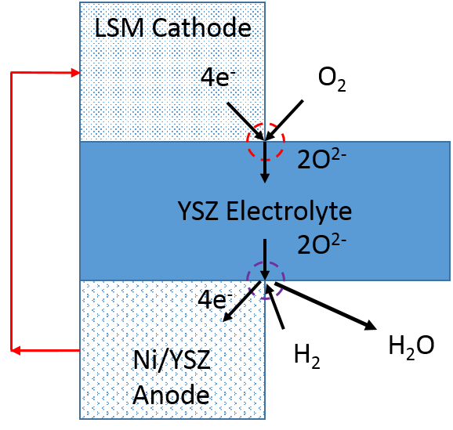
Figure 2.11: Diagram detailing the two forms of TPB found in an SOFC with the red and purple circles indicating the cathode and anode sides respectively. The red arrow details the useful work of electrons in an external circuit. Adapted from Vohs and Shishkin et al [22], [137], [211]
The problem with using the active area as figure of merit for how effective an SOFC anode will perform is due to the varying definitions of the triple phase boundary and how to define it.
The three-phase boundary region is usually described in the literature as a length (a 2D line where all the incident phases interact). One of the most innovative modelling papers for calculating the TPB length (TPB_{l}) was produced by Kenney et al in 2009 [135]. This study utilised coordinated number theory using randomly distributed particles to calculate the triple phase boundary length at the cathode/electrolyte/gas region. Although this model does not model the TPB found on the fuel electrode side of the TPB (Figure 2.11) it does discuss in some detail how the triple phase boundary is gauged. The model hinged on the movement of random distributed particles over a lattice where the process of TPB formation was simulated by the adhesion of a dropped particle onto units of 2 other phases. The adherence of this unit and creation of the TPB was represented by the coordinates of the centre points of the 3 spheres.
In this simulation the TPB boundary calculated by multiplying the circumference of the large circle by the magnitude of sinθ₁ (Equation 2.4) [212]. The hypotenuse is noted as length, d in Equation 2.4 which can be calculated by the 3D Pythagoras’ theorem:
$d= \sqrt{{\left(x_{1}-x_{2}\right)}^{2}+{\left(y_{1}-y_{2}\right)}^{2}+{\left(z_{1}-z_{2}\right)}^{2}}$ or simplified as $d= \sqrt{{r_{1}}^{2}+{r_{2}}^{2}}$
Equation 2.4
The relationship between the triple phase boundary length and the circumference of 2 spheres can be expressed as (Equation 2.5) [212]:
$${TPB}_{l}=2πr_{1}sinθ_{1}$$
Equation 2.5
One of the major advantages of this analytical approach is that it is relatively simple and works providing you have the appropriate particle sizes and other properties. However, this model also possesses some drawbacks.
Firstly, all the reacting particles in the model are considering to be spherical in shape which would certainly not be the case in terms of Ni and YSZ which could lead to issues in terms of dimensional accuracy. One of the key problems would also be the manner on which the particles interact. Other issues also manifest themselves for example this could invalidate the model in terms of how accurate it is in terms of dimensions. As the nickel catalysts in wet impregnated Ni/YSZ anodes are nanometres in scale this can cause an issue with imaging.
Density functional theory (DFT) has also been touted as a possible route for modelling the electrochemistry of the three-phase boundary. This method is more of an ab initio atomistic route to simulating the Ni/YZ interface. Early models used less than 20 particles with only one Ni atom [213], [214].
The TPB is the position where a large amount of charge transfer occurs due to the formation of water vapour, the movement of electrons and ions through the anode. This underlines the importance determining the amount of charge transferred to each Ni particle. This was calculated to be 1.16x10⁻²⁰C, however the issues with models such as this is that it has not been confirmed by experimental data [214].
Since 1993 the general view from the literature that the poor adhesion of Ni to the YSZ interface has been a driving factor for the sintering conditions observed in SOFC anodes [57], [215]. This consequently decreases the amount of active triple phase boundaries present in the overall system volume which hinders the overall power output of the stack.
Other sources discuss the TPB_{l} as a second order microstructural parameter with a similar impact to specific surface area. As discussed earlier the TPB_{l} is highly dependent on the size of the particles involved. These factors including the catalytic surface area and tortuosity are much harder to control.
Holzer et al used the centroid method to calculate the TPB_{l} in the Ni/GDC cermet scaffolds [117]. The formation of gas percolation routes in the anode means that the initial measurements and calculations of this parameter are highly unreliable [109]. The particle size distribution used in this study focussed on the splitting of the nickel particles into discrete particles (PSD_{D}). The shared voxels and pixels between the three phases constitute the calculation of the three-phase boundary.
The key issues with using this form of analysis is that it is hugely time consuming to calculate the secondary parameters from the 3D-cubes which could result in highly unreliable results as there were not a huge number of TPBs being analysed by the estimation. Another problem could be cementing an accurate method for particle identification which is key to all these studies [109], [214], [216].

2.3.2.1 Nickel Coarsening
One of the key degradation issues for infiltrated fuel electrodes in SOFCs is catalyst crystallite sintering. The inherent problem in using metallic NPs as catalysts in such systems is an issue of coarsening as a function of temperature and time. The advantage of wet impregnation is that the impregnated catalyst has a very high surface area which leads to improved reaction kinetics.
However, in a typical SOFC arrangement the high operating temperature hinders the rate of reaction due to the decoration of metallic particles on the electrode surface. Under excessive temperatures the NP grain grow/ coarsen eventually causing the formation of a metallic layer over the electrode material. This layer prevents the adsorption and movement of gases into the electrode hence stifling the efficiency of the SOFC.
One of the earliest examples in the literature detailing nickel coarsening was done by Simwonis et al [68]. Although the sample was not a wet impregnated sample, the effect of nickel sintering in an uniaxially pressed pellet of nickel and yttria stabilised powder be useful in terms of the manner of which the degradation manifests itself.
This event actually becomes more widespread in nickel infiltrated samples as the percolation threshold and amount of nickel catalysts are lower than conventional techniques which means that degradation problems such as sintering become more important as there is less of a margin for error i.e. with less active nickel sites and the same coarsening rate, more catalytic area will be affected by coarsening. This can also be described as a reduction in the contact between nickel adatoms [157], [217], [218].
This description appears to portray the nickel coarsening event as a fast grain growth event that begins to slow down as soon as the reactive species (i.e. the Ni NPs) become too few to fuel the peak coarsening rate.
This was demonstrated by Klemenso et al during their investigation of sintering inhibitors in wet impregnated Ni/YSZ anodes where despite the presence of these secondary phases the conductivity still decreased quickly over a short time period [219]. A relatively low loaded Gd doped CeO₂ Ni/YSZ anode (the red line in Figure 2.13) conductivity decreased by approximately 15 % across a time period of 240 h or 0.6 % of the total operating lifetime of an SOFC (if this is assumed to be 40,000 h). The speed of conductivity degradation in relation to nickel content can be visually portrayed in the Figure 2.13 below:
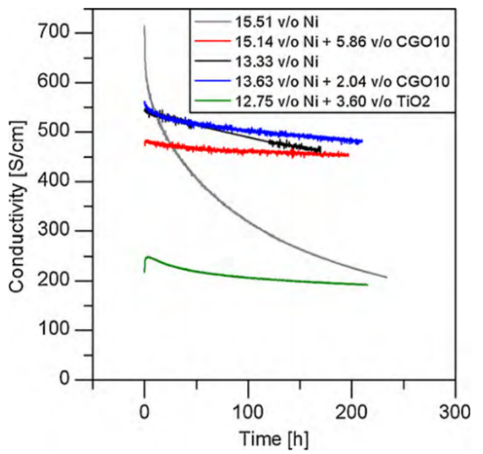
Figure 2.12: Conductivity profiles of Ni Conductivity profiles of carbon pore formed nickel infiltrated YSZ anodes with varying amounts of Ni infiltrate and inhibitor phases. The red line shows the addition of 5.86 vol % Gd-doped CeO₂ (GDC), the blue line shows the addition of 2.04vol % GDC and the green line details the addition of 3.60 vol % TiO₂ on the conductivity of the wet impregnated Ni/YSZ anodes [219].
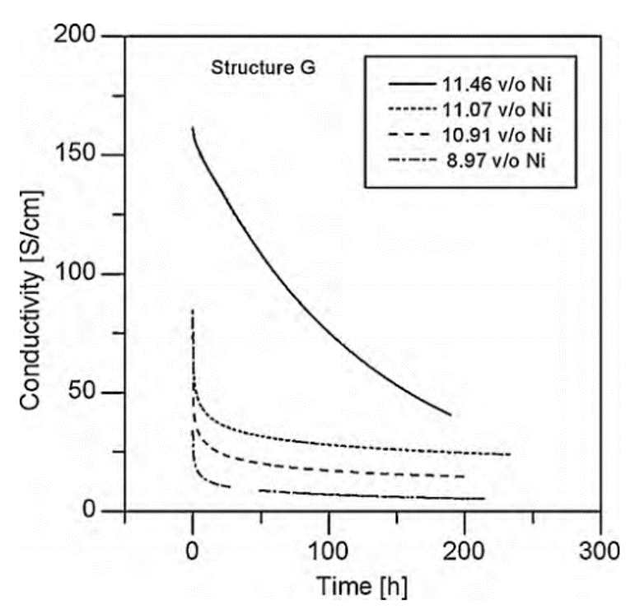
Figure 2.13: Conductivity profiles of carbon pore formed nickel infiltrated YSZ anodes with varying amounts of Ni infiltrate [219].
Outlining what sintering mechanisms dominate during NP coarsening could be key to modelling how SOFC materials degrade under elevated temperatures. Hansen et al discuss the impact of Ostwald ripening (OR) or particle migration coalescence (PMC) as possible coarsening routes for catalytic NPs [220].
Hansen lists three general steps for the sintering mechanisms that occur in NP systems [118]:
- Rapid activity decreases when particle diameter, d < 3 nm
- Reduction in sintering rate when 3nm < d < 10 nm
- The catalyst reaches a stable dispersion (reached equilibrium position)
Ostwald Ripening or the diffusion of surface adatoms is controlled by the Gibbs free energy and the concentration of particles. PMC is the Brownian motion of the NPs on the surface of the substrate material. It was found that the PMC route does not dominate in metal NP/ceramic systems like those found in an SOFC anode. The samples tested (Pd/Al₂O₃ and Ni/Mg2O₄) were held at 900 °C for 9 h and then consequently observed over 4000 h [220]. The NP mobility in both samples was attributed to the diffusion of surface adatoms which resulted in a change in the centre of mass of each particle. This diffusion type interaction supports OR as the key sintering route in cermet arrangements.
In the face of this evidence and experimental route, two questions arise in terms of how these findings impact SOFCs:
- It is widely known that the degradation phenomena for SOFCs occurs in the early phases of heating. So, the 9 h initial temperature step be significant in terms of degradation of electrical properties and NP coarsening?
- Does the cermet system composition affect which sintering mechanism dominates?
From the modelling of major sintering mechanisms for metal NPs in cermets it also becomes apparent that morphology could also be a factor in terms of sintering. This underlines the importance of modelling crystallite growth. A highly detailed assessment of crystallite shape was undertaken by Borodzinski et al in 1997 [221]. In this work the two key catalyst factors that were assessed for correlation were mean particle size and dispersion.
In any system involving heterogeneous catalysis the fraction of exposed surface atoms FE, can be described as the ratio between the surface catalyst atoms (N_{S}) and the total number of catalyst atoms (N_{T}) per unit weight of catalyst (Equation 2.6). Where N_{S} and N_{T} equate to the fractions described in Equation 2.7 and Equation 2.8 [221]:
$$FE=\frac{N_{S}}{N_{T}}=\frac{k}{d^{(3-D_{c})}}$$

Equation 2.6
$$N_{S}=\frac{No. of surface metal atoms}{Unit wt. of catalyst}$$
Equation 2.7
$$N_{T}=\frac{Total no. of metal atoms}{Unit wt. of catalyst}$$
Equation 2.8
Transition metals such as nickel were shown to favour icosahedral (111) and Cuboctahedra (100) morphologies. The authors discussed the finding that incomplete valence metal ions favoured the Cuboctahedra shape [221]. This finding is applicable to SOFC fuel electrode with the shape preference of the nickel phase displayed being analogous to the behaviour of infiltrated transition metal ions in infiltrated SOFC electrodes (i.e. Ni-YSZ) [222], [223]. However, these findings were gather using these assumptions:
- The crystallites were assumed to be perfect morphologies (Cuboctahedra and icosahedra)
- The crystallites were classed to be perfectly uniformly distributed across the scaffold
The key issue with modelling stems from their reliance on assumptions which assume perfect behaviour. Further nanoparticle models utilising the relative diameter (d_{rel}) averaged the effect of imperfect crystallites on the fraction exposed including non-nominal metal loading, partial metal poisoning by defects gases and the metal support interaction changing the particle shape [221].
In the case of Kennouche et al the number of microstructures that the Ni/YSZ system could possibly produce was limited to one [224]. This is a key example of how models may not truly represent the overall physical system. Regardless of the flaws with the power law coarsening methodology the metal and ceramic particle size determined by X-ray tomography fitted well with the model.
The characteristic nature of nickel sintering explained by Hansen et al is also described in terms of diffusion by Klemenso [219], [220]. At Stage 2 in Hansen et al the coarsening rate decreases in accordance with growth of the NPs to 10 nm in diameter which can also be expressed as the loss of the majority nickel contacts in the arrangement.
The Ni sintering rate appears to increase at lower temperatures this could be due to the precipitation of impurity phases (containing sulphur or phosphorus) under these conditions which means that this mechanism could be highly sensitive to incident gas compositions [103]. This hypothesis contrasts with findings by Kennouche et al which signalled that reducing the operating temperature also reduces the rate of reconfiguration of the catalyst nanoparticles after the NiO reduction reaction [224]. This rearrangement could underline why the number of active sites decreases in a more detrimental manner at low temperatures due to the Ni coarsening rate increasing.
In the past twenty years the use of modelling coarsening for fuel electrodes has become a key branch of the research field [221]b. In the past decade the rise of this field has occurred concurrently with the production of a simplified systems known as a model anode. The main benefits for this classification of anode is that electrochemical impedance spectroscopy and imaging measurements can directly access electrode/ electrolyte triple phase boundaries for better characterisation of these regions in the model anode in addition to the reduced computation time. In-operando studies which due to the highly aggressive atmosphere of the SOFC can be done via modelling. This has helped to construct and validate electrochemical models with physical systems pioneered by Bessler et al [213], [225].
Two forms of model anodes currently exist in the literature:
- Patterned fuel electrodes
These model anodes combine a layer of metal patterns onto the electrolyte substrate. The metal catalyst coating of these are etched to form intricate patterns desired dimensions (5-50 µm wide). Bessler et al calculated the effective TPB_{l} as in a typical 1 cm² pattern anode to be between 1-10 m [213], [225].
- Point/grid fuel electrodes
Instead of utilising metal deposition techniques to form the anode/electrolyte interfaces; either a weave or wire of metal is pressed against the solid framework [213], [225], [226]. The area of contact in these cases is understandably curved in shape which is results in smaller triple phase boundary lengths than patterned anodes (approximately 1 mm instead of 1-10 m) [213], [227].
The issue with modelling using model anodes is that the system although the same composition is not representative of the whole physical electrode. The construction of patterned fuel electrodes exemplifies this with TPBs much larger than a nanostructured fuel electrode. Additionally, experimental bulk systems combine both open pore arrangement and dead zones with reduced fuel/ catalyst contact which increases the computational complexity of a model. These production methods of these model anodes also diverge from the production of bulk anodes further highlighting the representativeness issue.
As the experimental field moves towards the in-operando imaging of the catalyst microstructural changes with techniques such as TEM and X-ray Computed Tomography – informed modelling will continue to be essential to the understanding of coarsening [213], [228]. A duality of the two approaches is key to the understanding of fundamental sintering mechanisms in SOFC fuel electrodes.

2.3.2.2 Reaction with Impurity Gases
Nickel coarsening is not the sole route for degradation; other factors can come into play when discussing a reduction in anode efficiency. One of the key issues is the interaction between the anode and incident gases.
A large number of reactions were characterised by Yokokawa et al in 2011 [229]. It must be noted that the SOFC stacks used were operated at 800-1000 °C and may contain some variation in comparison to units at difference temperatures [111]. Despite this the percolation of gases and the movement of impurity elements across various interfaces in the SOFC stack should still be like the infiltrated variant.
The authors assumed that the solid oxide stack reactions and electrochemistry could be equated to a form of corrosion. This model, known as local equilibrium approximation, lends itself to the poisoning of interfaces with elements such as sulphur and correlates well with the interface composition. In this set of experiments, a gaseous impurity level of 1 ppm was used to evaluate the effect on the properties of the fuel electrode.
Gas impurities that show a strong chemical attraction to the nickel in a fuel electrode cermet include:
- Arsenic, As
- Phosphorus, P
- Sulphur, S
The formation of intermetallic phases is thought to be highly detrimental to the overall conductivity of the Ni/YSZ cermet anode this behaviour is certainly dominant for each of the three elements above. The chemical atmosphere of the reaction is also key to how prevalent deleterious secondary phase construction is to the system.
Due to thermodynamic differences between As and P in the case a reducing hydrogen rich atmosphere the basic formula of As becomes As₂ or As₄. Phosphorus in the presence of water reacts to form phosphane (PH₃ ) or hydro phosphate (HPO₂) [111].
The most popular nickel intermetallic phase for As and P is Ni₅X₂ where X is the impurity phase. Under oxidising conditions (which is more likely to be in the cathode) oxysalts form. The results from the fuel electrode tests hint to a dominant formation of Ni₅As₂ at 1ppm when both As and P impurities were introduced at 800 °C.
The secondary ion mass spectrometry (SIMS) results produced a surprising result in terms that the intermetallic phases did not appear to affect the degradation of the fuel electrode. The arsenic intermetallic phase Ni₅As₂ was found to not poison the active area when it reached the TPB, preserving the functional properties of the anode. In fact the detrimental compound which reached the TPB was an phosphorus oxysalt [111]. This chemical, Ni₃(PO₄)₂ appeared to directly attack the Ni/ YSZ_{anode} / YSZ_{electrolyte} sites. Figure 2.14 below illustrates the movement of Ar and P phases through the fuel electrode arrangement:
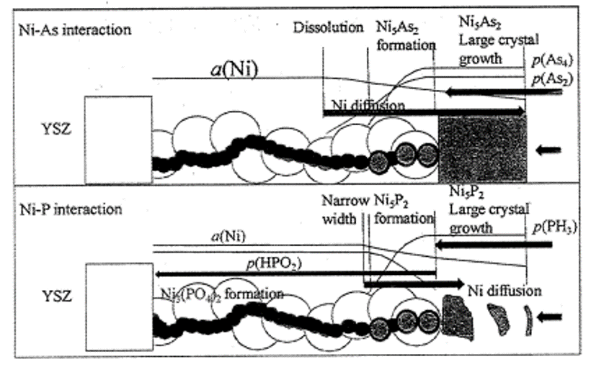
Figure 2.14: Diagram depicting the movement of As and P containing species through the cermet anode structure [111]
Formation of nickel phosphor oxysalt at the TPB The TPB is the position where a large amount of charge transfer occurs due to the formation of water vapour, the movement of electrons and ions through the anode. This underlines the importance determining the amount of charge transferred to each Ni particle. This was calculated to be 1.16x10⁻²⁰ C, however the issues with models such as this is that it has not been confirmed by experimental data [111].
This certainly explains the reason to reduce the operating temperature from 800 °C to 650 °C even just to slow down the reaction kinetics for the formation of the phosphorus oxysalts in Equation 2.9. The formation of nickel intermetallic and impurity phases means that the catalyst content at the anode surface is severely reduced. This nickel exhaustion in the fuel electrode dominates at high temperatures so reducing the operating temperature should help mitigate this problem.
$$3Ni+2HPO_{2(g)}+{4O}^{2-} →{Ni}_{3}{(PO_{4})}_{2}+ 8e^{-}$$
Equation 2.9
This study elucidates the key factors that can affect the fuel electrode structure in terms of how the impurities interact with the catalyst these are listed below:
- Speed of gaseous adhesion to the pore entrance catalyst particles
- Availability of active area for gas adsorption partially in this case poisoning
- Access to electrochemical species for redox reactions
Further work needs to be done to confirm how the reduction of operating temperature in SOFC stacks temperatures affects the formation of impurity phases like phosphorus oxysalts. The major impurity reaction involves sulphur.
The findings from Matsuzaki et al probed the effect of sulphur on the long-term durability of Ni/YSZ composite anode in terms of temperature and time [112], [230]. The polarisation impedance of the Ni/YSZ cermet anode increased with increased concentration of sulphur impurity in the incident gas. This interaction was confirmed to be unaffected by the partial pressure of sulphur but dependent on the increase in temperature. As demonstrated by Figure 2.15 below:
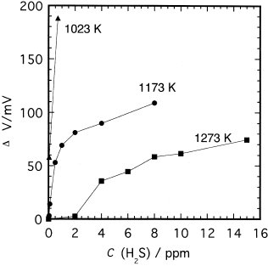
Figure 2.15: A graph depicting the overvoltage vs. parts per million of hydrogen sulphide in a Ni/YSZ (8% Y₂O₃ - 92% ZrO₂) [230]
Impurity segregation has also been confirmed as a mode of microstructural degradation by Liu et al in 2016 [231], [232]. Despite a large amount of literature investigating the pickup of impurity phases at temperatures exceeding 750 °C there appears to be much less data contamination ingress at lower temperatures. This could be due to the slower reaction speed because of decreased kinetics synonymous with the decreased temperature. Added detrimental effects like phase delamination could become prevalent with continued heating.
Similar issues can also occur with implementing the addition of extra phases to counter nickel sintering. Other cermet oxides like alumina and rutile (Al₂O₃ and TiO₂) are known to react with the elements present in Ni/YSZ infiltrated cermets which can seriously reduce the conductivity of the anode arrangement (Figure 2.12 and Figure 2.13 ) [219].

2.3.2.3 Influence of Operating Temperature and Creep
The thermal expansion coefficient can be the key to how a sample interacts whilst being electrochemically cycled. In the case of solid oxide fuel cell electrode materials, a metal is usually incorporated in the ceramic matrix or as catalytic media. In a service environment with a temperature that exceeds 600°C, the nickel catalysts increase in volume by up to 69% as a result of nickel oxide formation [233].
Metallic components such as the nickel present in Ni/YSZ cermets or on the surface of porous ceramic scaffolds could be subject to thermomechanical phenomena such as creep. Creep is the non-time dependent permanent deformation of a material in the presence of elevated temperatures. For bulk metals this effect is not usually a factor until the operating temperature exceeds half the melting point of the material [234].
In SOFCs the support media is usually synonymous with the electrode material to avoid cracking from thermal expansion mismatch. This is a key benefit to the use of wet impregnated Ni/YSZ fuel electrodes [235]–[237].
The Tammann temperature (T_{Tammann}) is defined as the temperature (in Kelvin) that a solid material develops 70 % of its vibrational freedom, when the temperature is equal to or exceeds half the melting point of the solid (See Equation 2.10 below)[238], [239]. In the case of the nickel catalyst this is 727.50 °C (1000.65 K). As SOFC stack operating temperatures have been documented to exceed 800 °C, this means that the catalyst media will possess a high degree of mobility priming sintering mechanisms.
Equation 2.10: The Tammann Temperature of a solid. If α is 0.5 the T_{Tammann} has been reached [238]–[240]
$$α= \frac{T_{Solid}}{T_{Melting Point}} T_{Tammann}≥0.5 T_{Melting}$$
Creep could also be a factor as the T_{Tammann} criteria is being met. However, creep is restricted to bulk samples and unlikely to affect nanostructured electrodes. The effect of “accelerated” creep was illustrated during an investigation into simultaneously loading and reducing the nickel oxide in stacked complete SOFC cells [234].
Another consequence of impurity interaction can in fact be mechanical wear. In cermet anodes the NiO powders involved can also include some SiO₂ impurities which penetrate into Y₂O₃-ZrO₂ causing surface damage. As the major constituent of glass, silica flows through the pores and abrades the surface of the YSZ causing deterioration.

2.3.2.4 Thermal Cycling and Degradation Load
During its lifetime a Ni-YSZ fuel electrode is subject to a series of changes including atmospheric, temperature and load cycling [115]. Each of these factors has an impact on the microstructural properties of the anode during operating.
As the operating temperatures of SOFCs exceed the T_{Tammann} temperature (800 – 1000 °C) the metal catalyst in Ni-YSZ electrodes possesses a high degree of mobility and moves to sinter to reduce its interfacial energy [240], [241].
During the start-up procedure the SOFC is heated from room to operating temperature at a rate between 1-5 °Cmin⁻¹ to avoid thermal shock and cracking in the ceramic materials. The start-up process can vary between 7 h and a few days depending on the application [242], [243]. In SOFC stacks a compromise is reached between the waste thermal energy removal rate through the cathode and temperature differences of up to 100 °C [242], [243]. In stationary power generation SOFC stacks are subject to a possible 1-2 start-ups a year.
Additional cycling issues are a result of the repeated reduction and oxidation of the nickel catalyst. During reduction bunsenite (NiO) has been documented to shrink by 40 vol % and then increase by 66 % during reoxidation triggering cracking in the ceramic material [115]. This is exacerbated by anode-supported systems where cracking can lead to exposure of the catalyst to air which perpetuates the re-oxidation of the catalyst [244], [245]. Voids form around the NiO because of the mismatch of the diffusion rates between the Ni⁺ cations diffusion towards the edge and oxygens anion towards the centre.
Oxidation of the catalyst can occur from several factors namely [115]:
- Application of a high electrical load and high fuel utilisation conditions such as those found at the fuel electrode TPBs
- Leaks in the interconnect and seals of the stack
- Impurities in the gas stream
- Lack of inert gas to protect the Nickel during restart processes
In nanostructured electrode such as wet impregnated Ni-YSZ electrodes reducing the pore size and reducing the Ni volume percent to 20 %, had been shown by the Birss group to hinder the volume expansion due to reoxidation [242], [243]. This was achieved by the physical trapping of the nickel catalyst in 200 nm pores in the YSZ backbone and the reduction of initial catalyst volume percent to offset the expansion [233].
In this thesis 20 vol % Nickel content was used to provide a comparison with the work of Buykaksoy et al [242], [243]. Additionally, it ensured that the reoxidation of the catalyst was not the key degradation mechanism in this work.

2.3.2.5 Interconnectivity Reduction
There are two points of discussion with infiltration analogous to the two primary components.
Firstly, a highly porous scaffold is required when trying to use wet impregnation to form suitable infiltrated electrode materials (30% open porosity). The pursuit of this overall density value has driven the use of pore formers in the manufacturing of the ceramic backbone in anode materials.
The microstructure of the scaffold material has been recently shown to be key in the controlling the size of the nanoparticle catalysts used in SOFC anode materials.
The impact of using a pore former (PMMA) in the production of the scaffold material was assessed to see whether this influenced the microstructural properties of the catalyst particles. The resultant structure from the burn out step of the pore former affected the distribution of the nickel particles. The 2 hour 1350°C heat treatment left large 5 µm openings which post infiltrate deposition lead to an uneven dispersal of nickel around the edge of these holes (See Figure 2.16). This was further exacerbated during the electrical testing at 800 °C which caused extreme agglomeration with large 4 µm Ni grains inserting themselves into the gaps.
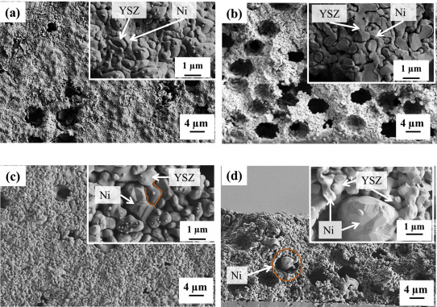
Figure 2.16: A set field-emission scanning electron micrograph of the PMMA pore formed YSZ scaffold with nickel particles. Images a and b detail the microstructure in the as reduced state. [(a.) top-down view and b.) cross-section] Images c and d show the microstructure of the sample after the 500-800°C annealing step [246], [247]
In contrast the pore size in the as prepared YSZ scaffold sample was much smaller (in the range of 200 nm) (See Figure 2.17). This had a beneficial effect on the nickel grain size with some nickel grains being reported at 1 µm in size. The key finding was that after the 800°C annealing stage was that despite the earlier crystallisation, these grains did not increase further in size and remained connected to the scaffold. This underlines the importance that the porous ceramic backbone has on constricting the nickel sintering process and could prove ideal in improving the durability of infiltrated SOFC anodes.
A large amount of the literature focuses on the coarsening of the nickel particles whilst Buyakaksoy et al has pinpointed interconnectivity loss as a primary degradation mechanism in anode materials [246], [247]. This factor has been relatively unexplored in the literature with Tao et al also investigating the effect of precursor solution on the distribution of catalyst particles [248].

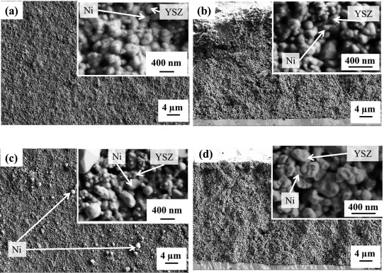
Figure 2.17: A set field-emission scanning electron micrograph of the as-prepared YSZ scaffold with nickel particles. Images a and b detail the microstructure in the as reduced state. [(a.) top-down view and (b.) cross-section] Images c and d show the microstructure of the sample after the 500-800°C annealing step [246], [247]

2.4 Sintering Characterisation Methods for SOFCs
Reducing the rate of electrocatalyst sintering in electrodes has been a key objective for the SOFC field in the past decade. The shift from analysing the REDOX stability of the cells in the past decade to phase quantification of the catalyst in using interrupted ex-situ imaging.

2.4.1 Sintering Characterisation
For the sintering and fuel electrode deactivation mechanisms in SOFCs to be fully understood; infiltrated fuel electrodes require a suite of techniques which can monitor the microstructural changes associated with coarsening.
These methods can be split into four subsections:
- Model electrode systems
- Microstructural quantification
- Electrochemical property testing
- Structural Analysis
One of the key challenges with characterising the degradation phenomena present in infiltrated SOFC fuel electrodes is that monitoring a specimen in-situ is extremely difficult. With the high operating temperatures and corrosive conditions present at the active TPBs phase boundaries, few characterisation techniques can accurately probe what is changing. Spectroscopic measurement techniques such as electrochemical impedance spectroscopy is invaluable at showing changes in anode functional properties during operation.
Linking the microstructural changes in the fuel electrode and their electrochemical properties is key to determining the rate limiting step present in infiltrated SOFC anodes. This underlines the importance of combining structural, microscopic, and spectroscopic methods to monitor the phases present in the anode.
This section of the document discusses the use of different characterisation techniques in terms of post fabrication analysis with a view to critiquing how useful each of the techniques are and how they assess the sample.
The spectroscopic measurement techniques have been split into their respective analysis media with Sections 2.4.2-2.4.4 detailing electron and X-ray characterisation techniques, respectively. The determination and assessment of functional properties such as the line specific resistance and TPB_{l} are also discussed.

2.4.2 Microstructural Imaging
This section discusses the impact of qualitative imaging techniques on characterising the arrangement of the fuel electrode with many of the methods utilising an electron as the investigative species. In the past decade of SOFC research microstructural imaging has transitioned from qualitative assessment into phase quantification of the microstructure changes in SOFCs.

2.4.2.1 Scanning Electron Microscopy /Energy Dispersive X-ray analysis (SEM/EDX)
A large segment of the characterisation techniques that are used to analyse infiltrated IT-SFOC anodes largely focus on imaging the microstructure of the system. Scanning and transmission electron microscopy are used for the qualitative imaging of the electrode surface in nearly every piece of anode degradation literature.
Some scanning electron microscopes utilise Energy Dispersive Spectroscopy or Energy Dispersive X-ray analysis (EDS/EDX) to provide a reading of what elements are present in a sample and can map how they are distributed across the sample. However, this technique is thought not to be viable for assessing infiltrated SOFC anodes as the interaction volume of the scanning electron is much greater in comparison than the volume of NP catalysts being assessed.
Despite this issue Jasinski et al successfully demonstrated in 2010 that EDX can used on wet impregnated Ni/YSZ anode samples. A pulverised nickel infiltrated Ni/YSZ pellet was assessed in this manner and produced a reading that had two very large peaks corresponding to Ni and Zr. Other elements such as oxygen were also identified. The presence of yttrium was not acknowledged in the resultant spectra by the authors, but this could be due to the EDX peak for this element either overlapping or being covered by that of zircon [154], [249].
A couple questions arise from the Jasinski investigation comparing wet impregnation against co-precipitation. An interesting observation during this study was that the agglomeration of YSZ was confirmed by SEM to be more widespread in the two infiltrated samples. This could have been due the NPs not being large enough to stop the YSZ clumping phenomena whilst in the CP the nickel in present in the matrix and would form blocking sites. When imaged using SEM it was noted that the co-precipitated YSZ particles were much finer and homogeneous than the infiltrated particles which would counter the clumping hypothesis [154], [250]. Focussed ion beam scanning electron microscopy has also been utilised in some studies.

2.4.2.2 Transmission Electron Microscopy (TEM)
Transmission Electron Microscopy (TEM) has been a mainstay for the nanoscale imaging of the Ni/YSZ microstructure. Samples suitable for this imaging system were in recent years hard to produce until the emergence of the focussed ion beam (FIB) method approximately 10 years ago. The FIB/lift out technique can be used to isolate a select region of sample to be polished and mounted for TEM assessment [251].
One standout study from Liu et al characterised the boundary between the two components of a Ni/YSZ half-cell pellet [252]. For the first time in the literature, the interface was directly imaged in a line using a JEM3000-F transmission electron microscope equipped with an electron gun. Figure 2.18 is a good example of a model patterned electrode with a deposited metallic layer coating the sample [213], [252].
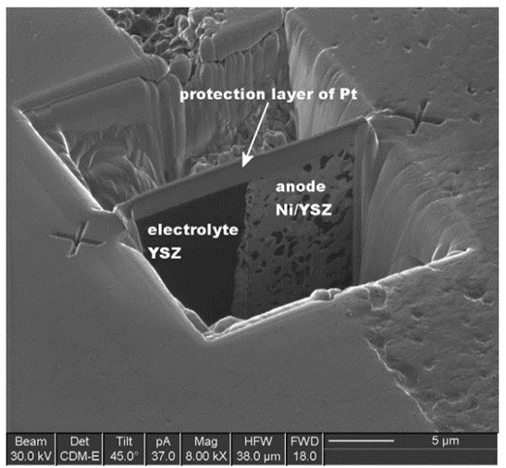
Figure 2.18: Transmission electron micrograph of a focussed ion beam milled Ni/YSZ TEM sample [107]
The half-cell was cycled under hydrogen at 850°C for 1800 h under an anodic load of 300 mAcm⁻². Using TEM the authors in this study found that a SiO₂ glassy phase formed between the nickel and the electrolyte which would seriously affect the functional properties of the half cell. In addition, this revelation is increasingly significant when there was only 100 ppm of SiO₂ in the system [252].
Utilising a wet impregnation fabrication method will avoid the formation of glassy phases in Ni-YSZ fuel electrodes (Figure 2.19) [252]. As the nickel nitrate solution does not possess the silicon impurity that can be found in the nickel oxide powders used in co-sintered cermet anodes.
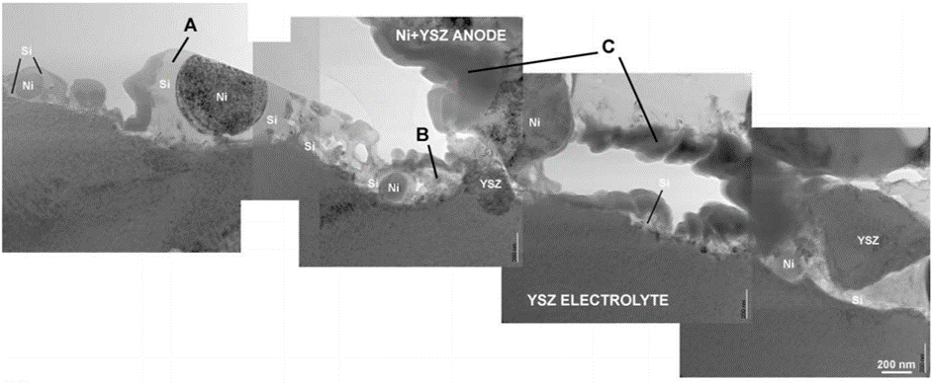
Figure 2.19: A selection of transmission electron micrographs showing the formation of silicate glass impurity phases between the Ni particles and the YSZ electrolyte [252]
The imaging of nickel crystallites on the surface of the ceramic substrate has been done successfully in a variety of situations with a notable example from a study into nickel catalyst dispersion by Sietsma. The use of high angular angle annular dark field imaging (HAADF) to image this system provided some striking transmission electron micrographs. The major benefit of using this detector setting is that the smaller catalyst particles are portrayed in white making analysing the image easier. (See Figure 2.20) These images illustrate how effective TEM can be for qualitative microstructural analysis of Ni/YSZ anodes. The micrograph showing the dispersion of the NiO across the silica (bottom right hand corner) also shows how at very small adatom sizes and high distributions the contrast begins to become slightly unclear [174], [253].
The dispersal of metal catalysts throughout the YSZ pore structure cannot be simply analysed using transition electron microscopy. This is due to the 2D image of the sample being producing less qualitative information of the 3D pore network. This opens the door for other characterisation techniques such as tomography and atomic force microscopy.
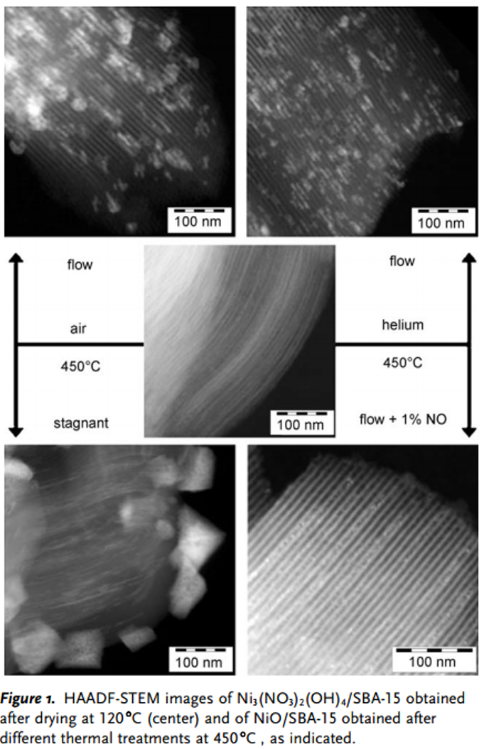
Figure 2.20: Scanning transmission electron micrographs of Nickel nitrate hydroxide (centre) on silica substrates after a drying step at 120⁰C. The outer images depict the NiO catalysts after a heat treatment at 450°C in different atmospheres. The micrographs on the LHS use air and RHS use either helium or 1%NO/He[175].

2.4.2.3 Focussed Ion beam Scanning Electron Microscopy (FIB-SEM)
In the past 15 years SOFC research has transitioned from the analysis of 2D micrographs to calculating the volume % changes of phases in the electrode using 3D reconstructions[254], [255]. This was first pioneered by Wilson et al. using Focussed-Ion Beam Scanning Electron Microscopy (FIB-SEM) [254].
In a bid to identify the rate limiting step present in fuel electrodes, microstructural phase quantification has become commonplace in SOFC research [254], [256]–[260]. FIB-SEM images the 2D polished cross-section of the region of interest. This is then destructively milled away using the ion beam and the nascent material is then imaged. These 2D micrographs are stacked to and processed using reconstruction algorithms produce a 3D rendering of the entire imaged microstructure [254], [256]–[260].
During the transition from micrograph to reconstruction the graphical representation of the region of interest has also changed. Pixels change into voxels which in addition to being adding a third dimension(depth) also possess scalar measures such as density [255], [261]–[263]. These form the building blocks of these reconstructed volumes and the voxel size is a measure of the resolution of the imaging used.
In fuel electrodes. three phases are then segmented- catalyst, pore and backbone- in most papers this consists of Ni-YSZ [254], [256]–[260]. 3D-tomographical phase distribution maps are produced by repeating the milling and imaging procedure to produce a stacked micrograph of the fuel electrode structure. In the past decade, this technique has been used to quantify the phase volume percentage changes.
Over the past 5 years the attention given to FIB-SEM has been fixed on proving concepts and illustrating the density of TPBs throughout MIEC and uncommon systems. Little to no FIB-SEM studies have been done focussing on the infiltrated Ni/YSZ cermet system [257], [264].
Despite being one of the less popular current SOFC anode compositions; the Ni-GDC (nickel – gadolinium doped ceria) system was the first fuel electrode composition analysed by FIB-SEM. Kishimoto delved into the how the triple phase boundary density evolved between the infiltrated Ni-GDC anode and a Ni-YSZ cermet [265]. Triple phase boundary densities were compared between the GDC scaffold, infiltrated Ni-GDC samples and a Ni/YSZ cermet anode. The specific resistance of each electrode was measured at 690 °C.
The results were extremely positive in terms of the wet impregnated samples with an almost quadruple increase in TPB density when the once infiltrated sample was contrasted with the Ni/YSZ cermet. When compared with the ten times infiltrated sample the TPB density values difference is even starker in comparison (18.4 µm µm⁻³, 2.49 µm µm⁻³) (Figure 2.21 below) [265].
The key points for discussion from this investigation are very much how the infiltration of nickel into the YSZ structure would affect the results. The comparison between the Ni/YSZ and Ni_{infiltrated} /GDC cannot be truly validated as the nickel in the first system is not synonymous in terms of mass when compared to the second system. Surely a comparison Ni_{infiltrated} / YSZ system with identical infiltrate loadings would be preferable in terms of assessing the effect of infiltration on TPB densities. The effect of TPB density was not also assessed in terms of functional properties, techniques such as electrochemical impedance spectroscopy (EIS) could be used to gauge the impact of the FIB-SEM results.
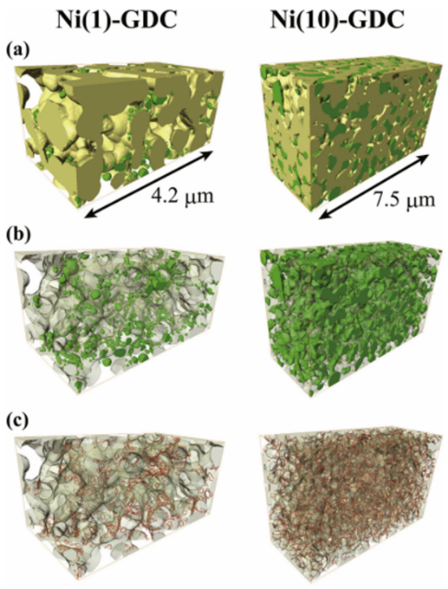
Figure 2.21: FIB-SEM 3D renderings of the two wet impregnated Ni/GDC anodes with various phases present. Row (a) shows the presence of Ni in the system, Row (b) shows the Ni/GDC interfaces present in the arrangement and Row (c) shows the TPB lines in the sample [265].
Some of the major issues with FIB-SEM lie with hinge upon its sample preparation especially during imaging. If the distance between each milled layer exceeds that of the catalyst being imaged key microstructural changes will be missed [266]. This could certainly be the case in infiltrated systems where the initial catalyst length is under 10 nm [171]. Additionally due to the milling process ageing experiments cannot be conducted with FIB-SEM [255], [256], [267].
One of the key issues in attempting to use FIB-SEM is its requirement of having to use back scattered electrons (BSE) to image the surface of the sample. BSE has multiple benefits in terms of surface resolution due its low interaction volume. Microstructural variance would almost certainly affect the TPB density values being produced from the rendering. One answer would be to do images of multiple surfaces and average the resultant TPB density values to produce a much more accurate set of results.
Further work needs to be done utilising FIB-SEM to characterise and calculate the TPB densities of infiltrated Ni/YSZ anodes. Caution would be required when the back scattered mode on the SEM as the nickel NPs would have a very low interaction volume which could affect the resolution of the imaging.

2.4.2.5 X-ray Computed Tomography (XCT)
Over the past 12 years X-ray computed tomography (XCT) has begun to supersede FIB-SEM in the procurement and monitoring of 3D rendered fuel electrode microstructures. This technique utilises X-rays to produce tomograms of a sample that is rotated in the path of the incident beam. This technique can produce transmission X-ray microscopy measurements (TXM) which observe the morphological changes of nickel nanoparticles on the surface of yttria-stabilised zirconia during ageing. A series of 3D images are generated by the system which map the microstructural evolution of the sample over time. The key advantage is that the same sample can be imaged throughout ageing times of interest [255], [265], [268]–[270].
One of the major advantages of this technique in that it can be performed interrupted in-situ measurements (4D-ageing time measurements) are possible, which leads to significant results in terms of degradation analysis. Kennouche et al first discussed the implications of TXM technique in 2013 [224]. During this study, TXM in was utilised to characterise the microstructural changes developed in a 50:50 NiO/YSZ pellet after a 1 hour, 1100 °C ageing step. The main purpose of this investigation was to assess the effect of temperature on the active triple phase boundary densities present in the fuel electrode.
Relatively short annealing/ reducing times (20-500 h) were applied to the cells at a variety of temperatures (800-1100 °C). SEM images showed that the rate of growth of the microstructural feature growth increased with larger annealing temperatures.
It was found that the active area at the anode appeared to decrease sharply at intermediate temperatures namely 1000 °C for 500 h produced the lowest active TPB density of 74 %. What was interesting in terms of SOFCs is that for the lowest temperature annealed (800 °C) the active TPB density was the highest for all the samples tested in this study.
A complementary study by Kennouche et al in 2016 measured the microstructural evolution of the fuel electrode compositions mentioned above [271]. The aim of the investigation was to assess the damage done by thermal cycling to infiltrated fuel electrode structures.
Figure 2.22 is a demonstration of how the number of active triple phase boundaries decrease at increased temperatures.
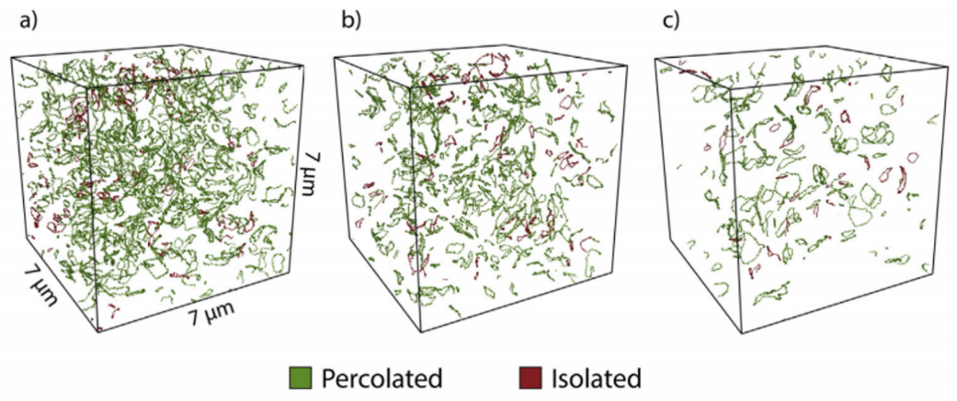
Figure 2.22: 3D renderings of the available three phase boundaries present in an infiltrated Ni/YSZ anode heated at different temperatures for a time period of 500 h after a thermal ageing step at 1100°C for an hour a) 1000 °C b) 1100 °C c) 1200 °C
In agreement with their earlier paper Kennouche et al have ignored the early-stage nickel coarsening phenomena listing them as an equilibration period for the particles in the anode. Similarly, to the paper from 2013 the thermal degradation behaviour was accelerated by cycling the sample at a much higher temperature than the stated SOFC operating temperature described in the introduction of this document.
Two samples were compared at two different temperatures: T1 and T2 (T2 being the elevated temperature) and then also compared with different ageing times to gauge which of the two parameters is more significant in terms of degradation.
One of the major results from this investigation was the fitting of the coarsening behaviour of the Ni/YSZ pellet to a power law model for validation purposes. This helped to cement the results and helped predict the behaviour of the fuel electrode over period much longer than 40,000 h. The authors noted that for systems with smaller features the degradation rate should be slower.
However, to ignore the first 100 h of heating/operating to account for structural equilibration does not appear to be the best course of action. In the same paper the authors discuss the impact of the first 24 hours on the microstructure of the fuel electrode and have also been part of a study where between 12-24 hours of heating the metallic particles coarsened. This highlights a period key to the microstructural changes present in SOFC operation [272], [273].
The ageing issue is an interesting one in terms of ceramic processing, it is well documented that the sintering temperature of Ni/YSZ cermets is 1400 °C. So, it is logical that Kennouche et al have used a temperature substantially lower than that for ageing the system. The view that the ageing will have accelerated the coarsening as if the SOFC is further into its lifetime is possibly a correct view having successfully fitted the data onto a coarsening model.
What cannot be confirmed is whether this increased temperature ageing has pushed the nickel sintering and grain growth past the point it would have been at intermediate temperatures (600-850 °C) for longer heating regimes. A comparative study attempting to compare the two would be preferably in future work. A brief discussion of the impact of smaller feature sizes at temperatures of 600 °C is included in the report.
TXM is a technique which has the advantage of being able to render 3D depictions of where the three phase boundary lines manifest themselves in the anode functional layer (AFL) and gives quantitative calculated percentages of the active triple phase boundaries within the sample [255], [274]–[276].
This method does possess many disadvantages when trying to observe the effect of elevated temperatures on the properties of the electrode material. A short breakdown of these problems is discussed below:
A large amount of sample preparation is required to get the sample to TXM standard – a cylindrical specimen spanning 15 µm by 80 µm is broken up. One of the pieces is focus ion beam milled into a tip with a sample edge [277]. This challenging multistep process could also add to the misrepresentation issue for TXM. An AFL in an operating SOC may not possess as acute edges and it is unknown how the pore arrangement differs at the edge of a sample to the interior.
The way the different particles interact at high temperatures could also be a source of error or effect how the system responds. Necks can form between adjacent Ni particles leading to a reduced active area at the triple phase boundary. The coalescence of Ni onto YSZ could also be a problem in terms of maintaining a high effective active area.
With comparing two samples at T₁ and T₂ (where T₁ < T₂) the following problems can occur:
- Uncertainties and errors from comparing different samples
- Averaged microstructural quantities may not be entirely representative (i.e., if outliers end up in the calculation)
- If the initial X-ray diffraction scan characterises a position in the sample which is not representative of the overall structure

The microstructural evolution of anode functional layers has been successfully examined using TXM. One of the key questions that further TXM studies must answer is whether this technique truly models the region of interest in SOCs – the active area. Current studies have ignored the early stage coarsening to focus on the long-term development of the Ni/YSZ fuel electrode. It appeared that at 1000 °C the maximum effect of degradation on the triple phase boundary density can be felt.
Continued research in the area should focus on the earliest stages of microstructural evolution as it widely assumed in the scientific community that Ni particles could sinter at much lower temperatures than 1100 °C which could explain the decrease in TPB density values at higher temperatures.
The state-of-the-art resolution of XCT has been stated to be around 50 nm [255], [261], [278]. This would be too low to characterise the early-stage sintering that would occur in infiltrated systems. One further research route would be to gauge the effect of feature size on the coarsening behaviour of infiltrated catalyst in the fuel electrode system. It was mentioned in the tomographical literature that a microstructure with well dispersed, nanoscale particles small aspects could help reduce the effect of degradation on the active TPB density. Infiltrating a porous YSZ scaffold with NPs of nickel could be one method of investigating this hypothesis.

2.4.2.6 Near-field Ptychography
Ptychography (also known as holo-tomography) is a non-destructive lenseless imaging method which can calculate the phase changes in a sample via changes in coherent interference patterns. Fourier transforms are deconvoluted to generate information on the phases present in a sample imaged at a range of angles [279], [280].
For the data to be termed ptychographic these three conditions must be fulfilled:
- Minimum of two interference patterns are taken where the radiation source has been shifted a known distance with respect to the sample
- Intensity data used must have been collected downstream from a sample that has been irradiated in transmission by a radiation source
- The phase approximations must be reconstructed with a minimum of two interference patterns utilising all the available diffraction directions
A practical method of producing the interference patterns required for ptychography is to rotate the sample in the illuminating beam. 180° of rotation can be extrapolated to produce interference patterns of the entire sample, hence the use of the term “ptycho” to fold. Phase information can then be deciphered by reconstructing these patterns using the branching iterative Goldstein algorithm [281]. These reconstructions can then be converted into 3D renderings of the system identical to that of XCT.
In the past several years, ptychography has been utilised in the characterisation of SOFC microstructures a total of three times[references]. The extremely fine resolution of this technique (around 30 nm) means that rapid microstructural changes such as coarsening can be imaged successfully. Despite this, only SOFCs produced using powder methods have been imaged using ptychography [262], [282], [283].
The simple sample preparation and high brilliance of the X-ray utilised in this technique means that more representative volumes than XCT (volumes exceeding 10 µm x 10 µm x 10 µm) can be segmented providing more information about mechanisms such as sintering and void formation during the REDOX cycle [284].
The challenge with SOFC fuel electrode compositions such as Ni-YSZ have very high X-ray attenuation coefficients. For adequate transmission through the ceramic phase the beam energies required can range between 16-30 keV, which are only achievable using X-ray radiation from synchrotrons. As the sample thickness increases the beam energy must increase; which was epitomised in the work done Villanova et al. in 2013 [262].
Although described as a non-destructive technique, due to the minimum requirement of at least 50% X-ray transmission, the sample diameter must be reduced to at least 100 µm but ideally around 15 µm. This also concurrently reduces scan time. Although unclear in some SOFC work; Ni-YSZ ptychography samples are usually milled to thickness using FIB-SEM, which is inherently destructive [262], [282], [283].
However, due to its high resolution, ptychography is uniquely equipped to characterise the initial coarsening stages in wet-impregnated fuel electrodes. As the sub 10 nm nickel particle sinter and coarsen their particle growth past 30nm and phase volume percent changes can be tracked using this technique.

2.4.3 Electrochemical Testing
This section discusses the tests used on a material to determine its effectiveness in terms of electrochemical cycling and functional properties.

2.4.3.1 Electrochemical Impedance Spectroscopy
This form of characterisation has been successfully utilised by a large proportion of the literature mainly to derive the polarisation resistance of the sample. Hagen successfully demonstrated that the cell voltage stability decreased as a result of decreased temperatures and increased current load (Figure 2.23) [253].
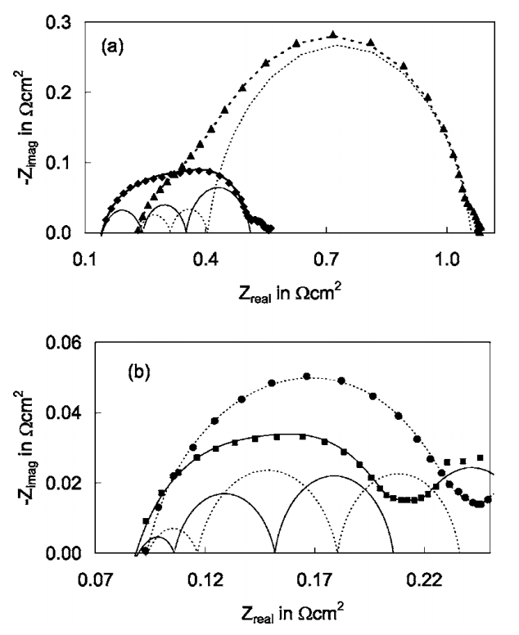
Figure 2.23: Impedance Spectra of anode supported SOFCs tested for 1500 h at 750 and 850 °C under a load current of 0.75 Acm⁻² and 1.75 Acm⁻² respectively. (a) Diamonds – pre-HT, Triangles – post HT. (b) Square – pre-HT, Circles – post HT [253]
The stability of the system after the 1500 h 850 °C HT is evident when compared with the 750 °C dataset. The scale of this durability is almost a fifth smaller in terms of imaginary impedance post heat treatment [253]. This is echoed by the polarisation resistance as shown below in Table 2.3. However, the two current loads were differed between samples so the comparability of these EIS spectra is certainly lacking.

When contrasted with the R_{P} values of an infiltrated Ni/YSZ anode (0.55 Acm⁻²) at after a 124h heating regime at 800 °C the polarisation resistance of the experiment was less than a third of the Buyukaksoy paper [233], [253].
Table 2.3: Polarisation resistance values of the samples before and after the HT treatments under various current loads [253].
Temperature [°C] | Load Current [A/cm²] | Polarisation Resistance, R_{P}
Temperature [°C] | Load Current [A/cm²] | Pre-Test | Post Test
750 | 0.75 | 0.41 | 0.89
850 | 1.75 | 0.15 | 0.16

Interestingly infiltrated samples appeared to possess a much lower polarization resistance in comparison with the co-sintered anode values (Figure 2.24). The experiment from Kim et al showing incredibly stable polarization resistance values despite a 550 h, 800 °C heating regime in a Ni/YSZ cermet sample. Although no further work has been done to support these results [285].
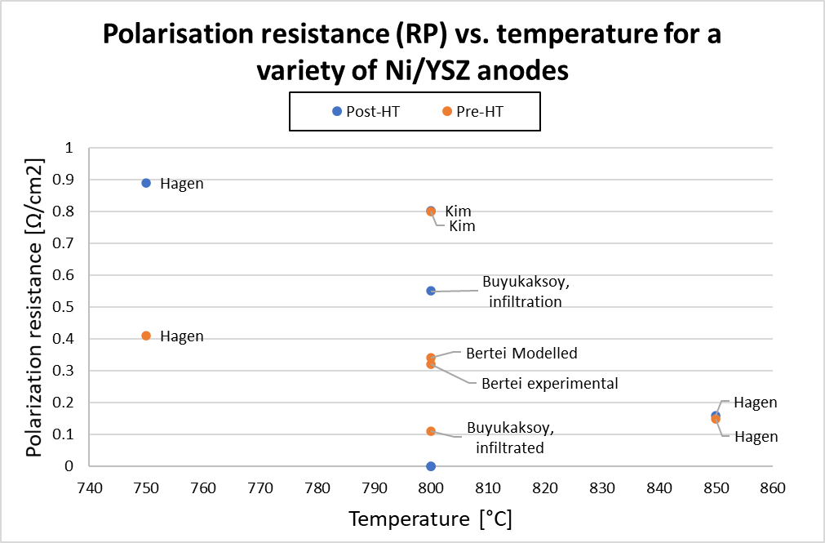
Figure 2.24: Comparison of the different polarization resistance values generated for a variety of nickel/YSZ anodes. Data points in the boxes indicate co-sintered Ni/YSZ samples. All R_{P} values were produced with using EIS [242], [253], [286], [287].
The large variety of sources using electrochemical impedance spectroscopy highlights its numerous advantages and will certainly be prevalent in any future work on infiltrated SOFC anodes.

2.4.3.2 DC Conductivity testing
One of the major methods of measuring the in-plane resistance of a sample is to use a set of direct current conductivity tests. This technique revolves around passing a current between two probes on the surface of the sample and measuring the resistance between the two points of electrical contact. As a potential difference is generated between these points which is key to calculating the resistance of the test piece.
The probe system arrangement varies between separate uses a four-point probe (4PP) system is a used usually for the characterisation of semiconducting materials (Figure 2.25). A potential difference is created between the two inner probes by passing a current through the outermost probes. Other set-ups have been known to run 2 probes [288].
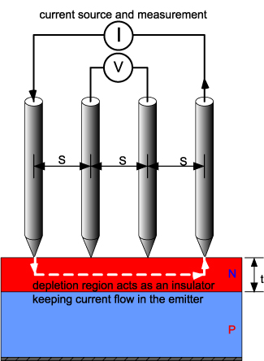
Figure 2.25: Diagram of the 4PP apparatus [288]
As alluded to earlier probe contact is key to maintaining the accuracy of this technique. To reduce the impact of this factor the tip of the probe is usually coated in a paste to ensure electrical contact is maximised during testing.
This technique has been used relatively sparingly with only a handful of studies using this method to study the cell voltage characteristics under load. Providing suitable electrical contact is maintained; DC conductivity measurements map the potential difference with a high amount of stability [253].
The cell voltage was certainly more unstable at lower temperatures and this instability increased at higher current loads (Figure 2.26). This is certainly a cause for concern when looking at infiltrated anodes that would be suitable for SOFCs. A lot more research using DC conductivity measurements of ion impregnated systems are required for this technique to be highly viable.
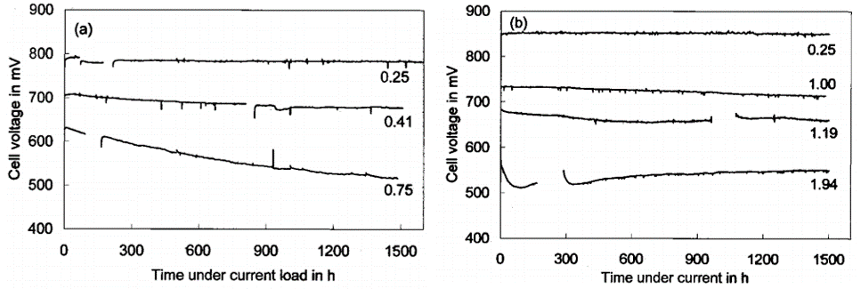
Figure 2.26: DC Conductivity measurements of infiltrated Ni/YSZ samples heated at (a) 750 °C and (b) 850 °C [253].
In a large majority of the recent literature there has been one core parameter which has been described as the controlling factor for the hydrogen oxidation kinetics. The line specific resistance (LSR, Ωm) is defined as the polarisation resistance generated along a triple phase boundary line.
A standout study by Rao et al demonstrated that the LSR is crystal structure dependent [289]. Symmetrical patterned Ni/YSZ cells are analysed using EIS and formed almost complete single semicircle arcs. The total polarisation resistance exhibited a crystal structure dependence listed below in order of favour:
- <100>
- <111>
- <110>
The LSR values for the <100> direction was in fact 50 % lower than the other two directions. This was mirrored by the capacitance of the Ni/YSZ system, respectively. This supports the findings of the Borodzinski relative diameter model which also hinted at <100> Cuboctahedra being formed by the Ni crystallites [100], [221], [290].
In composite electrodes such as Ni/YSZ anodes it can be tough the gauge the R_{PA} due to the multiple contributions from the different materials. This challenge has been steadily overcome using models such as the transmission line model which has been utilised in a variety of studies.
The issue of temperature dependence of LSR was tackled by Utz during her study of the patterned Ni/YSZ anodes where the transmission line model was successfully used to calculate the polarisation resistance of the composite electrodes. Utz found that the LSR was much larger for intermediate temperatures (700°C as a pose to 850°C). This underlines how important minimising the LSR is to the improved efficiency of the SOFC (Figure 2.27)[100], [291].
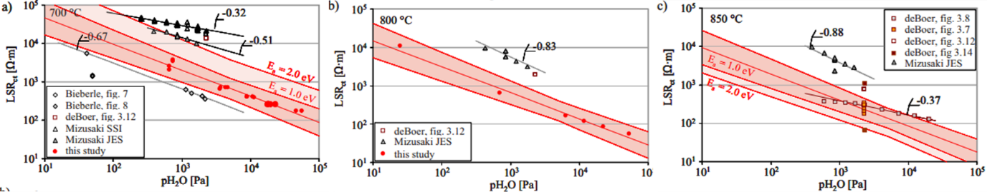
Figure 2.27: Comparison of measured LSR values with added confidence values and comparison with other literature sources. a) 700°C b) 800°C c) 850°C [291]
The problem with this course of action is that in a system modelled with roughly equal particle volume distributions with similar particle sizes should produce the highest TPB_{l.} This would show that infiltration techniques be highly detrimental to the TPB_{l} of a sample due to the disparity between the very small metal NPs and the much larger YSZ particles. Furthermore, a system with almost identical particle size distributions and sizes is highly idealised and currently unachievable experimentally.
An earlier paper from Zhu et al appeared to support this with a theoretical model on the ion impregnation in Ni/YSZ anodes [292]. In this case the size difference between the nickel and the yttria stabilised zirconia was much greater than the one discussed in Wilson’s paper [293]. And understandably the volume contribution from the YSZ was much larger than the Ni. The key aspect was that the maximum triple phase boundary length was discovered in this investigation when the Ni/YSZ size difference was at its greatest. This contradiction to the recent literature also emphasises how important experimental data is to the development and assessment of the validity of models.
The major equation that governs the R_{PA} involves the triple phase boundary length and anode resistance is listed below (Equation 2.11). The equation describes the relation between the specific line resistance (R^{LS}), effective ionic conductivity (σ_{ion}) and triple phase boundary length on the anode resistance [291].
$$R_{PA}=\sqrt{\frac{R^{LS}}{σ_{ion}l_{TPB}}}\coth\left(L\sqrt{\frac{l_{TPB}}{σ_{ion}R^{LS}}}\right)$$
Equation 2.11

This demonstrates how impactful the triple phase boundary length is on the overall fuel electrode resistance but if you break down the factors that govern the TPB_{l} a pattern emerges. The length of the triple phase boundary is a product of the system microstructure and particle size distribution which are in turn a result of the processing conditions used. These are also hugely impactful in determining the LSR of the composite anode components. The production conditions have a major effect on how tortuous the gas transfer pathways are through the oxygen electrode.
A comparative review by Bessler et al discussed the effect of hydrogen oxidation in SOFCs discussed the impact of LSR as a method of analysing the amount of degradation present in a Ni/YSZ patterned model anode [213]. What makes this study stand out is their modifications of the original TPB calculations. Bessler acknowledged that the TPB_{l} will elongate because of grain sintering at temperatures exceeding 600 °C and has adjusted their calculations to represent that. The success of these model can be seen in by how accurate the simulated LSR values plotted in Figure 2.28 in comparison to the experimental work.
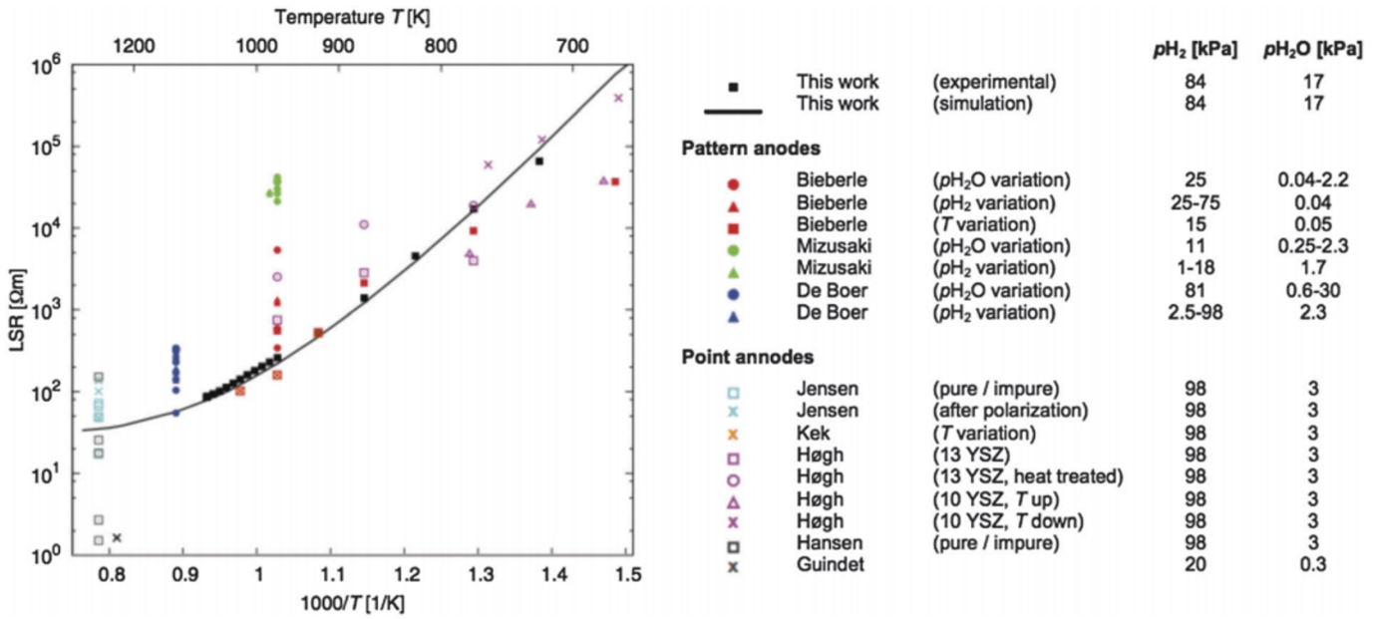
Figure 2.28: LSR values for a variety of Ni/YSZ patterned anodes processed at a variety of temperatures and partial gas pressures. The black line shows the estimated line specific resistance values as a function of temperature [100], [213].
The key issue with this study is of representation. The degradation rate seen in this study far exceeded that of current Ni/YSZ cermet anode SOFCs. The LSR appeared to increase post polarisation linearly at a rate of 0.4 Ωmh⁻¹ at 800 °C. This was reported to be 1000x larger than that of a cermet system. On the other hand, a patterned model anode is a highly idealised system with open porosity and short TPBs. The differences between this system and a cermet or infiltrated anode in terms of size and morphology could the reason as to why the line specific resistance is so much larger [100], [213].
The key point of continuation would be to do a benchmark test on an infiltrated Ni/YSZ system to compare with the patterned model anode and use the LSR calculation to analyse degradation. This technique with its continued modification due to changes in the TPB_{l} and particle size should provide an accurate method to assess the durability of a wet impregnated anode.

2.4.4 Structural analysis
The main structural examination method in fuel electrode studies is X-ray diffraction which is used by many authors in the literature. However, in recent times more innovative techniques have been used to examine the assembly of wet impregnated fuel electrodes in SOFCs.

2.4.4.1 X-ray Diffraction
Structural characterisation methods such as X-ray diffraction (XRD) can also be used to confirm whether the nickel oxide have been reduced successfully into catalytic nickel adatoms on the surface of the fuel electrode. An incomplete reduction event would result in a diffraction pattern that would contain peaks from nickel, nickel oxide and yttria stabilized zirconia. Studies such as Jasinski et al used XRD merely to confirm that this event had occurred (Figure 2.29) [154]. However, as this was more of a proof-of-concept investigation the XRD diffraction pattern provided was a co-precipitated Ni/YSZ sample and not either of the two infiltrated samples.
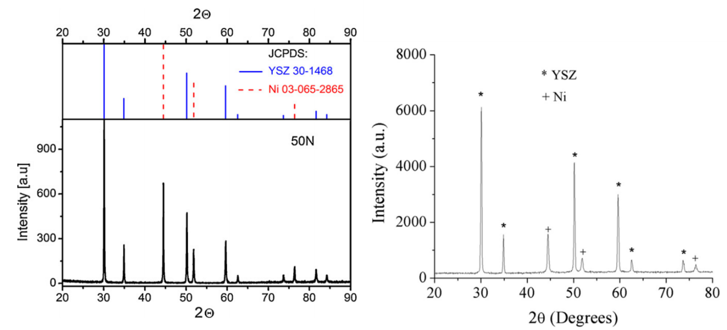
Figure 2.29: X-ray diffraction spectra of two Ni/YSZ samples both reduced in humidified hydrogen at 500 °C. LHS – Ni/YSZ co-precipitated sample. RHS – Ni/YSZ infiltrated sample [154], [246], [250]
One of the key issues for X-ray diffraction is the detection limit. When samples possess very small amount of impurity phases i.e. less than 1 wt % they may not be detected using x-ray diffraction [294], [295].
As alluded to earlier X-ray diffraction has been largely used to confirm the presence of certain phases during the decomposition of the nitrate precursor solution (in wet impregnated samples) and reduction steps. In the case of ion implanted samples, the nickel is at the surface of the anode and thus has much more intense peaks than those found in the co-precipitated sample [154], [246], [250].
As porosity increases the detection limit becomes more of a factor which is why XRD cannot be used to accurately map the microstructural evolution of the catalysts. Although the structural evaluation of samples at certain temperatures and atmospheres is possible.

2.4.5 Chemisorption
As an example of a heterogeneous catalyst process the infiltrated Ni-YSZ electrode is subject to adsorption by the fuel during operation. In this process the formation of a TPB between the gaseous hydrogen fuel, nickel catalyst particle and electrons are a clear example of chemisorption. This is defined as the movement of an interacting gas or solid with the consequential formation and cleavage of chemical bonds [296], [297]. The charge transfer generated by the atomic orbital overlap (See Figure 2.30) leads to the formation of strong almost covalent nature bonds between the catalyst and the probe gas.
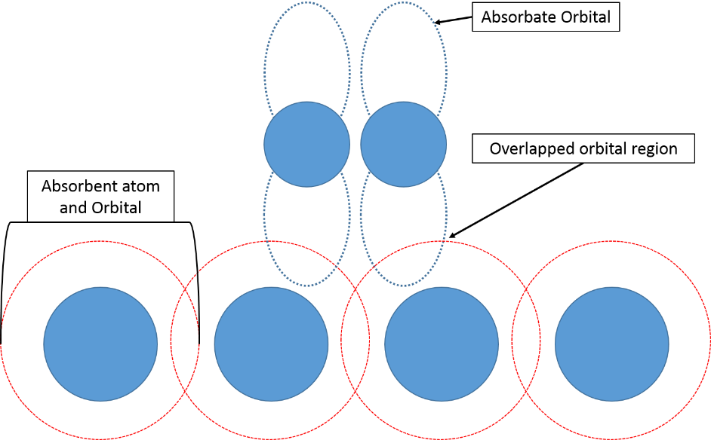
Figure 2.30: Diagram of the bonding present in a Gas Chemisorption (GC) catalysis event [296], [298]
One of the main problems with trying to examine NP sintering at the submicron scale is that many the characterisation techniques cannot probe or analyse the region at which the sample is being assessed. This opens the door for gas chemisorption to be used for a characterisation technique for infiltrated SOFCs as the radius of the probe gas particles (usually H₂ or CO) can easily penetrate the porous scaffold [297]. The probe molecules can chemisorb onto the catalyst and providing the volume and purity of the gas are known, information such as surface area and percent dispersion of the catalyst can be calculated. In addition, nickel catalysts like nickel have been documented to interact with probe gases such as H₂ or CO highlighting chemisorption as a key method of chemical analysis [148], [194].
One of the most used gas chemisorption techniques in surface catalysis is the pulsed gas chemisorption method. This process involves the injection of a fixed amount of infiltrate into a gas stream above the sample. As the infiltrate passes over the sample, a minute pressure increase occurs pressing the contained gas onto the sample surface. Meanwhile the rest of the infiltrate continues to move across the system towards a detector which calculates the amount of gas remaining within the adsorption media and displays it as a voltage. Further injections of the infiltrate are done until sample saturation occurs (See Figure 2.31 below) [296].
After many of these gas/ interface adsorption events occur, a monolayer form across the sample surface completely blocking the continued adsorption of gaseous molecules. This prevention of further adsorption is known as “saturation” and can be seen on a chemisorption spectrum as when the detector voltage readings lines become equal [296]. In Figure 2.31 this is shown after 6 applications of the adsorptive.

Figure 2.31: A typical dynamic gas chemisorption spectrum developed by the adsorption of gas onto the sample. Adapted from Webb [296]
In the field of infiltrated SOFC anode production gas chemisorption has been completely untested despite its use in assessing the concentration of solution absorption in other catalysis applications. This technique certainly has the potential to be able to assess the amount of precursor solution being absorbed by the porous scaffold in anode wet impregnation studies. This could lead to more accurate calculation on catalyst loading and finer control of the infiltration step.
The limitations of chemisorption stem from the dissociation of the adsorbate especially the H-H bond in a H₂ molecule [297]. The rupture of this bond requires an energy of 3-4 eV making chemisorption tough to achieve at room temperature. Additionally, the catalyst must have a high surface area and be able to produce a binding energy exceeding 2.31 V to facilitate chemisorption [298]. These drawbacks could mean that infiltrated nickel catalysts may not interact for pulsed gas chemisorption.

2.4.6 Energetic Barriers to Sintering
For infiltrated SOFC electrode design to effective in combatting electrocatalyst sintering; energetic barriers must be induced in the sample to make the reduction in surface energy unfeasible for the catalyst system. The materials challenge that stems from this solution are numerous:
The fuel electrode operates under extremely aggressive conditions with both a highly reductive atmosphere and temperatures exceeding the homologous temperature of the catalyst media. This means that these solutions must be able to withstand these conditions in addition to providing the desired energetic barrier to sintering.
Two coarsening routes are discussed as the dominant mechanisms in the nickel electro-catalyst [118], [299]:
- Atomic (Ostwald) Ripening
- Particle Migration Coalescence
In surface catalysis various reviews have discussed common strategies that are usually utilised to improve the dispersal and homogeneity of their catalysts or implement a physical barrier to sintering. The feasibility of these techniques is discussed in the next two sections.

2.4.6.1 Catalyst Morphology, Size and Dispersion
Atomic ripening is documented as one of the two major coarsening processes present in nanoscale fuel electrodes. This key to inhibiting this process is to engineer a catalyst network which possesses energetic barriers to sintering. For processes such as atomic ripening the catalyst particles are far less likely to sinter if their inter particle distances, morphology and size are similar [300], [301]. This also a case if the inter-particle distances between the close to equidistant, the surface energy for the particles is balanced by the attraction to other particles (See Figure 2.32 below).
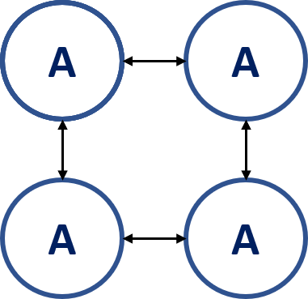
Figure 2.32: Idealised 4 surface particle system supported on a substrate from a top-down view. The arrows indicate that the surface energy of the particles is balanced due to their identical size, shape, and inter-particle distance.
In wet impregnated systems the morphology of the decorated catalysts can be tuned by a mixture of process changes:
- Changing the wetting angle [242], [302]–[304]
- Adding solvents with lower evaporation temperatures
- Adding a dispersant [6], [305]
Ideally, for this method to work in wet impregnated catalyst systems processing methods such as controlled drying must be implemented to ensure that all these parameters are as homogenous as possible during electrode manufacture. The dispersion of the particles would also have to be analysed using a gaseous probe to determine the active area of the nanoscale catalyst.
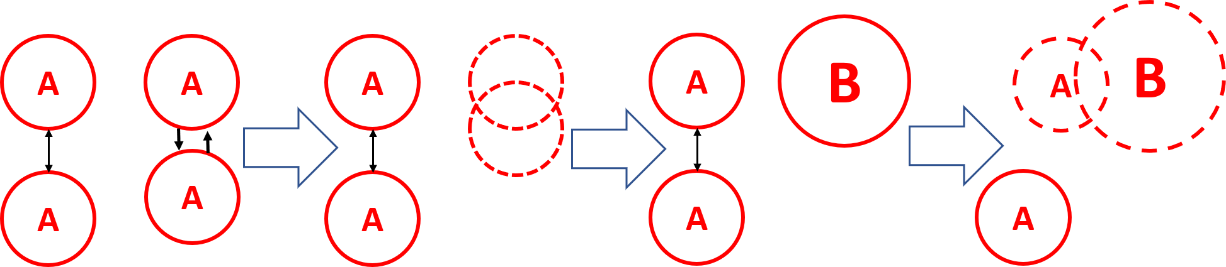
Figure 2.33: 4 particle system supported on a substrate with one shorter inter-particle distance from a top-down view. The arrows indicate the movement of the particles to the one of the RHS in a bid to reduce surface energy and the leading to subsequent sintering events [300], [301]
Figure 2.33 shows a top-down view of 4 adatoms (A) on top of a substrate where one of the particles has a shorter inter-particle distance than the other three particles. This leads to an energetically feasible attraction event that leads to the Ostwald ripening of the particles. Once the agglomerate has formed, the surface energy of larger particle (B) can overcome the energy barrier set by the separated particles leading a cascade-like effect where the agglomeration and sintering events continue until the surface energy has been reduced to a low energy state.
To reduce the rate of atomic ripening the particle size distribution of the particles is required to be as close to mono-disperse as possible [306], [307]. The diffusion coefficients of the particles lower with increased particle size distribution [308]. This should lower the catalyst sintering rate.
The system is still susceptible to coarsening via PMC however, this could be reduced by the fine controls during the wet impregnation step. The use of increased catalyst dispersion as a via coarsening inhibitor method for infiltrated electrodes has not been explicitly discussed. One key methodology that could change this is the use of drying steps to reduce the particle size and increase their dispersion [166], [169], [180].
An example from surface catalysis of a physical sintering barrier is the formation of Nickel Carbide (Ni₃C) as a coating for nickel catalysts. In steam reformation these supported catalysts are subject to carbon deposition and adsorption during the methanation preparation reaction. Further information can be found in Kihlman et al [309].
Carbon whiskers consisting of threads of graphite been documented to form via diffusion through the nickel catalyst under reductive atmospheres at temperatures exceeding 500 °C [309].These fibers are detrimental to the catalyst with the whiskers shearing the adhesion of the catalyst with its support.
Glancing Angle X-ray Diffraction GAXRD studies between 400 – 800 °C reveal that the nickel carbide and whisker formation between 500 – 600 °C causes internal stresses in the nickel (220) crystallographic plane [310]. The decomposition of the Ni₃C into graphitic C removes these stresses at temperatures exceeding 800 °C. This means that the interaction is possible in SOFCs with a methane (CH₄) fuel ad could be a key interaction in developing sinter resistant infiltrated Ni-YSZ anodes.

2.5 Concluding Remarks
A summation of what has been done for the literature for SOFC infiltrated anodes and the nickel coarsening phenomena seen in nanostructured fuel electrode systems has been conducted. This document discusses the various characterisation technique used to analyse the degradation of current state of art SOFC anode materials.
Despite the documented benefits of utilising infiltrated fuel electrodes, there is not a large amount of experimental data relating to the degradation of these materials. There are holes in key areas namely:
- Monitoring the microstructural changes and the deactivation mechanism in infiltrated fuel electrodes especially in early-stage sintering (0-10 h)
- Using new novel processing steps such as drying and nanoconfinement to reduce the rate of coarsening in infiltrated SOFC fuel electrodes
Additionally, the analysis of degradation events in SOFC fuel electrodes has been almost exclusively at the later stages of processing largely during the operation and cycling of the anodes. There appears to be a large gap in the fuel electrode literature where the initial stages of degradation in infiltrated systems have been overlooked. It is well known that the TPB_{l}, area and line specific resistances are highly affected by the processing. This highlights the need to analyse the impact of the processing steps on SOFC degradation. The properties of any material are directly influenced by its fabrication process, which underlines the need to assess the early stages of anode durability loss.
This PhD project will focus on:
- Understanding the deactivation mechanism in infiltrated SOFC fuel electrodes using ptychography
- Drying as a method of increasing electrocatalyst dispersion and decreasing the coarsening rate
- Characterising the influence of the current collector material in the degradation of infiltrated SOFC fuel electrodes
This rest of this document details how this project will be determination of the degradation mechanisms exhibited in infiltrated nickel/ yttria stabilised zirconia anodes. The techniques and sample preparation used to quantify these mechanisms are described in the next section of this document.

Chapter 3: Materials and Methods
This section of the thesis discusses the experimental methods used to discern the coarsening and degradation processes present in infiltrated Ni-YSZ solid oxide fuel electrodes. The first section details the construction of the symmetrical Ni-YSZ samples which are the primary cells used for the microstructural and impedance work in this project.
The second part of this chapter details the characterisation techniques used in this throughout the three experimental chapters in this project.

3.1 Symmetrical Fuel Electrode Sample Preparation

3.1.1 YSZ Electrolyte and Fuel Electrode Backbone Production
Yttria-stabilised zirconia powder (YSZ, DKKK - Japan) was ground and ball-milled in isopropanol and 1 wt% Triton X-114 dispersant for 18 h at 1800 rpm. The mixture was dried at 90 °C in a drying oven overnight prior to pressing. 0.25 g YSZ electrolyte pellets (0.5 mm thick, 12.0 mm diameter) were produced by uniaxial pressing into pellets under 1 T of force (867 kPa) for 30 s with a Specac Manual Press (Figure 3.1). The electrolyte pellets were sintered at 1400°C for 4 h in an Elite BRF 15/27 box furnace (Figure 3.2).
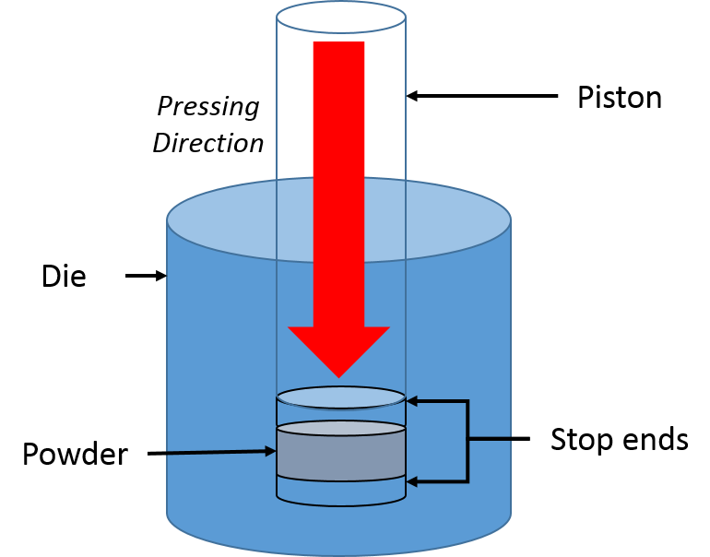
Figure 3.1: Schematic breaking down the components used in the Specac Manual Hydraulic Pellet Press [311]
42 wt % YSZ powder (DKKK) was mixed with 28 wt % KS4 Graphite (Imerys, Switzerland) powder, ethyl cellulose and Texanol solvent [312]. A slurry was formed by mixing the powder, plasticiser, binders, and dispersant using a DAC Speedmixer at 2100 rpm for five 2-minute intervals. The ink recipe with detailed component weight percent can be found below in Table 3.1.
Table 3.1: A breakdown of the different components of the YSZ/C ink including role in the mixture and the supplier. The ink consisted of 70 wt % solid materials with a powder surface area of 8.1 m²g⁻¹ and the Triton X-114 dispersant coverage was calculated to be 2.5 mg m⁻²
Ingredient | Details | Supplier | Weight (g) | wt %
YSZ (Ceramic) | Yttria-stabilised zirconia | DKKK | 21.00 | 42.0%
C (Pore Former) | KS4 Graphite | Imerys | 14.00 | 28.0%
Dispersant | Triton X-114 | Sigma Aldrich | 0.71(mg) | 1.4%
Binder | Ethylcellulose N7 grade | Ashland | 1.05 | 2.1%
Solvent | Texanol (Alcohol ester) | IMCD/Eastman | 13.24 | 26.5%
A hole punch was used to create a circular hole in the 80 µm thick scotch tape. The tape was applied to the surface of the dense YSZ pellet. The YSZ/C ceramic ink was applied by sliding a glass slide across the surface of the tape – filling the cavity with the slurry. The scotch tape was removed leaving a cylindrical region of ink on top of the pellet (See Figure 3.3).

Figure 3.2: Firing profile for the YSZ dense electrolyte. The sintering time was 4 h.
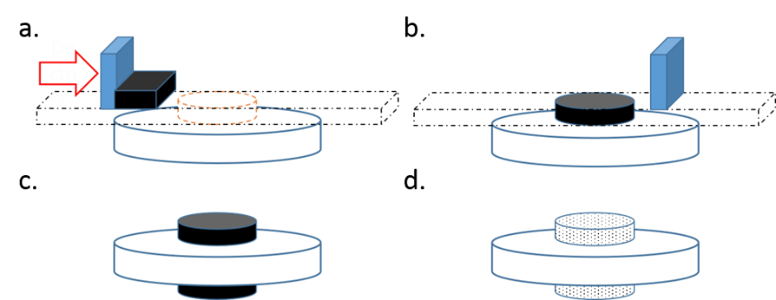
Figure 3.3: Doctor blading technique to forming symmetrical porous samples – the black indicates the YSZ/C slurry and the white the electrolyte material. The black dotted line is 80µm thick scotch tape the red arrow indicates the direction of the blue doctor blade. Parts c. and d. show the doctor blading method repeated on the 2nd side of the dense YSZ pellet and then fired to form two porous regions.
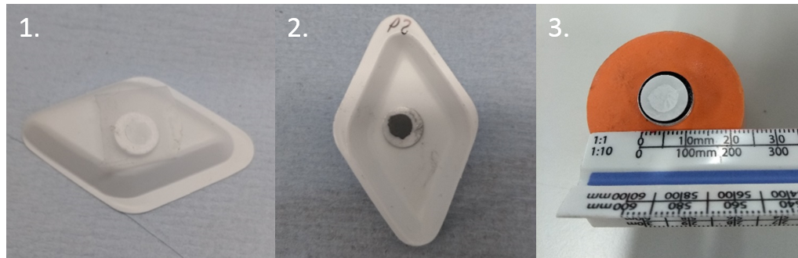
Figure 3.4: Images of the doctor blading process. 1. Dense YSZ pellet with scotch tape, 2. Dried YSZ/C S1 of P2 and 3. Mounted doctor bladed YSZ P1 pellet on an SEM stub. S1 is facing upwards in image 3.

The ceramic ink was dried for 1 hour in a drying oven at 120 °C then the doctor blading process was repeated on the other side of the pellet. The ink layers were fired on top of the YSZ pellets using a dwell at 600°C for 2 hours to remove the organic compounds in the ink. This was followed by a high temperature-firing step at 1150 °C for 2 hours (See Figure 3.45). The firing temperature routine was programmed using a Eurotherm 2416 controller and can be found in Figure 3.5.
Figure 3.5: Firing profile for the porous YSZ scaffolds for the fuel electrode samples

3.1.1.1 Thickness measurements
The non-infiltrated electrolyte was scored using a diamond scribe, sectioned and mounted onto a stainless-steel SEM stub using carbon tape (Figure 3.6). The mounted sample was coated with 10 nm of gold sputter coated using an Agar Sputter coater.
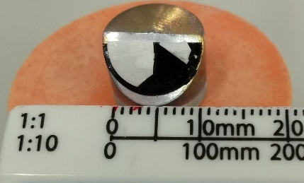
Figure 3.6: Photograph of the porous scaffold// YSZ electrolyte with porous YSZ scaffold mounted on a 45° SEM sample stub prior to sputter coating
The fired scaffolds were imaged using a JEOL JSM-6010LA Scanning Electron Microscope (Figure 3.48).
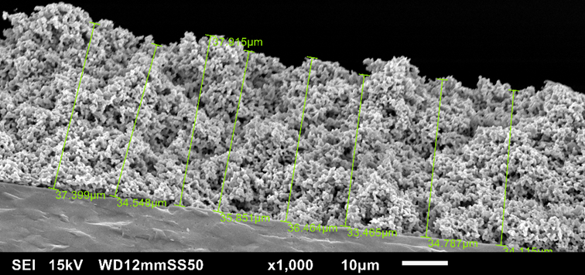
Figure 3.7: Scanning electron micrograph of the P10 ink layer. Measurements were done using the JEOL Touchscope software
A total of eight measurements were taken using the JEOL Touchscope software so that an average thickness of the scaffold could be calculated (Table 3.1).
Table 3.1: A table detailing the different ink thicknesses in microns measured across Figure 3.5
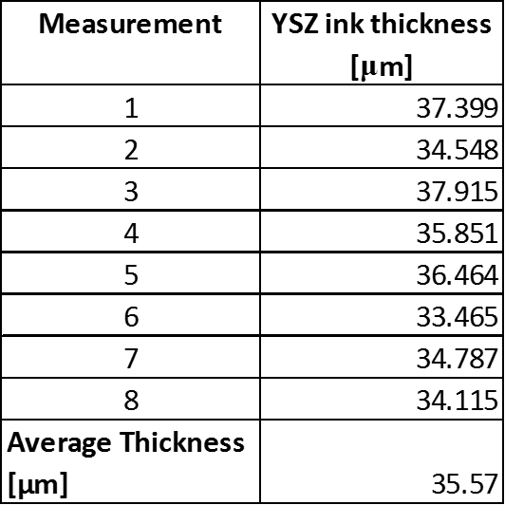
The thickness reduction of the YSZ/graphite ink during firing amounted to 55.54 % height loss. This was slightly lower than the anticipated 62.5 % (80 μm →30 μm). The diameter of the circular pores in the ink section pores measured between 0.5-1.0 μm which will be ideal for infiltration of sub 50 μm catalytic particles and for sufficient gas percolation. The scaffold was deemed suitable for infiltration.

3.1.2 Infiltrate Solution Production
The hydrated nickel nitrate (Sigma Aldrich, UK) solute was weighed using a Sartorius analytical balance. The solvent (de-ionised water) was added to the solute after measurement in a volumetric flask, followed by 1 wt % Triton X-114 dispersant (Sigma Aldrich, UK) (Table 3.2). The 5-M concentration solution was mixed using a CamLab MS-H280-Pro Magnetic Hotplate Stirrer at 100 rpm for 2h at 50 °C. The choice of molarity was to provide some comparability to papers for the Barnett group [313]. It also consequently reduced the number of infiltrations to reach 20 vol %.
Table 3.2: Table detailing the chemicals used to produce the aqueous 5M nickel nitrate solution
Substance Composition | Name/Role | Supplier
Ni (NO₃)₂.6H₂O | Nickel nitrate hexa-hydrate | Sigma Aldrich
H₂O | De-ionised water / solvent | CBE (UoS)
Triton X-114 | Triton X-114 / Dispersant | Sigma Aldrich

3.1.3 Infiltration and Drying of Nickel Catalysts
10 μL of 5 M Ni(NO₃)₂.6H₂O was injected onto the porous regions of the pellets using an Eppendorf pipette. The solution was left to soak for 0.5 h at room temperature and was absorbed into the layer by capillary motion. This side was dried under flowing air or N₂ at 120 °C for 1 hour (See Figure 3.8). The drying and calcination steps utilised a gas flow rate of 5 mLmin⁻¹ (1 bar). This routine was repeated for the other side. The sample was then calcined for 1.5 hours at 350 ˚C (Figure 3.9) [165], [184], [206]. A K-type thermocouple was used to monitor the internal temperature of the tube. This decomposed the Ni(NO₃)₂ to NiO particles on the surface of the porous YSZ sample. The infiltration process was repeated between the separate drying and calcination steps.

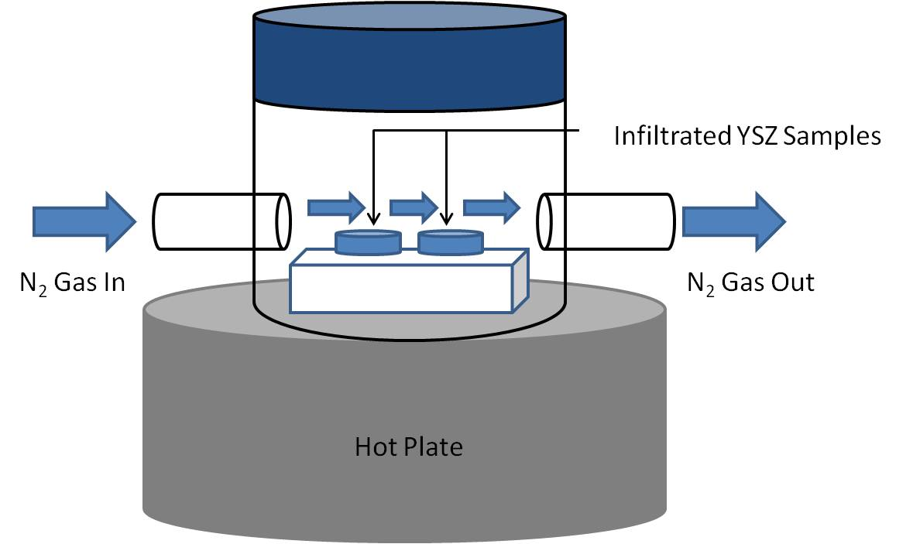
Figure 3.8: Schematic of the sealed sample case during drying under flowing N₂. The hot plate was set to 120°C.
The mass changes between each infiltrated drying step and calcination step for the infiltrated symmetrical cell samples were monitored using a Sigma Aldrich balance. The nickel loading during infiltration was measured using volume percent calculated from the mass changes after calcination. The minimum nickel loading for the samples was calculated to be 20 vol % [246], [247], [314].
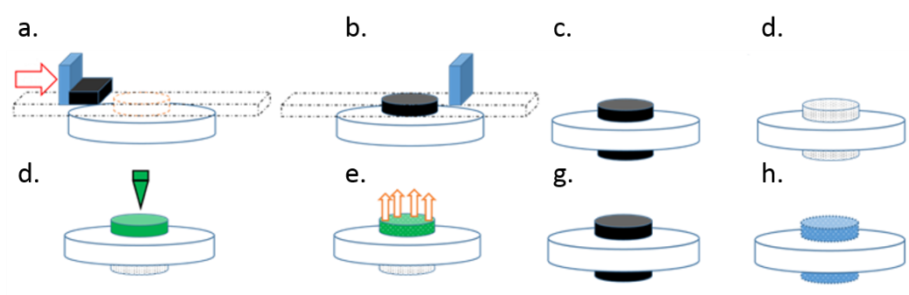
Figure 3.9: Sample Preparation: a-c. Doctor blading of YSZ/C tape onto YSZ pellet, nitrate solution, d. Firing of porous scaffolds, e. Infiltration with nickel nitrate solution, f. Drying under flowing N₂ (120 °C, 1 h), g-h. Calcination then reduction under 10 % H₂/N₂

3.1.4 Pillar Sample Preparation
For ptychographic imaging the infiltrated Ni-YSZ samples from Section 3.1.3 were milled into fine pillars. These were milled and lathed using an Oxford Instruments micromachining laser at the Electrochemical Innovation Laboratory (University College London, UK) [255], [272]. The Ni-YSZ pillar samples were produced using a 2-step procedure. Initially a coarse puck was milled with the instrument followed by a lathing step to produce a fine rod sample.

3.1.4.1 Sample Mount Production
To provide a flat surface for the fuel electrode puck and fine pillar structure. Aremco ceramic paste was applied to the end of the alumina tubes to produce a sealed platform for the infiltrated fuel electrode. The paste was left to set for 2 hours. The surface of this was ground flat and any excess paste was removed using sandpaper. A stainless-steel dowel was then coated in superglue and inserted into the alumina rod. The mounts were left for half an hour to dry.

3.1.4.2 Coarse Pillar
After infiltration, drying and calcination. Coarse NiO-YSZ cylindrical pillars (150 µm diameter) were milled with the Oxford Instruments micromachining laser. The laser was programmed using the Cimita 4.08 software with the optimised beam energies for zirconia. The sample was mounted onto a machining block in the laser chamber. The edges of the specimen were aligned using a reticule in the software. The initial coarse pillars took between 50-60 minutes to cut using a rotating donut beam path. Most of this time was spent cutting through the YSZ electrolyte.
All the coarse samples were mounted onto the alumina tubes with Aremco ceramic paste and air-dried overnight before a 2 h curing step in air in a tube furnace at 90 °C.

3.1.4.3 Fine Pillar Lathing
After the ceramic paste was cured the samples were mounted horizontally in the Oxford Instruments Micromachining laser chuck. The sample alignment was checked using internal cameras in 90° rotations to ensure that the centre of rotation matched with the stainless-steel dowel. This was achieved by making sure that a sample edge was parallel with the centre of rotation at 0°, 90°, 180° and 270°. Each of the fine pillar sample were initially lathed 50 µm then finished to a final diameter of 15 µm in 45 minutes (Figure 3.10). Photographs and micrographs of the fine pillar can be found in Figure 3.11 and Figure 3.12.
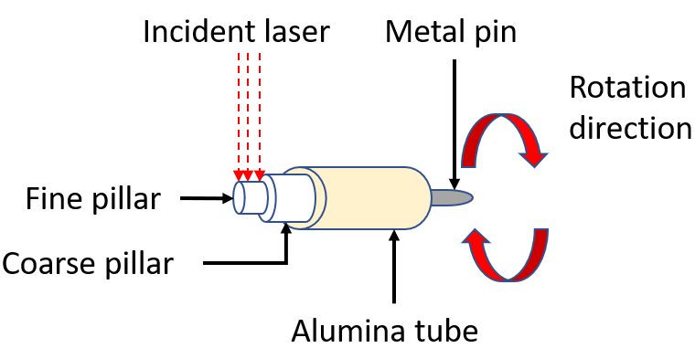
Figure 3.10: Diagram of the laser lathing of the fine Ni-YSZ pillar using the alumina tube mounted in the Oxford Micromachining Laser unit
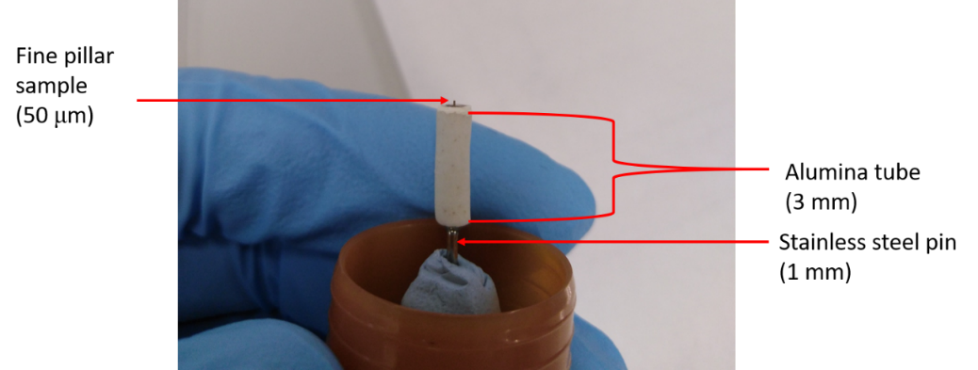
Figure 3.11: Photograph of the Ni-YSZ pillar sample after the first fine lathing pass. The alumina mount is also visible in the image.
The surface and milled thickness of the Ni-YSZ fuel electrode pillar samples were imaged using a JEOL JSM-6010LA SEM (Figure 3.10). The purpose of this was to check that the electrode was not removed during lathing.

Figure 3.12: Scanning electron micrographs of the laser milled fine Ni-YSZ pillar sample milled for the first pass. The edges of the sample illustrate the conical nature of the laser.

3.1.5 Witness Sample Preparation
The milled sample husks from section 3.1.4.3 were sectioned into four segments (Figure 3.13). These segments were aged offline in an alumina firing tray using an Elite 2580 tube furnace. These were aged for the same atmosphere and times as the samples analysed at the I13-1 beamline. This ensured that the data gathered from these samples could be directly compared with that of the samples utilised during the ptychographic experiments.
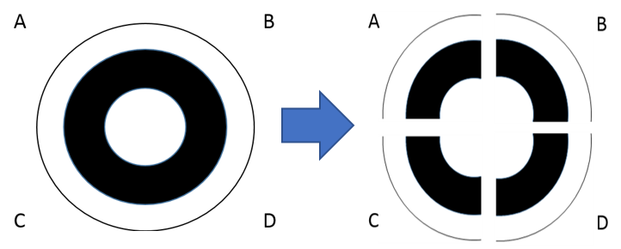
Figure 3.13: Diagram of the milled sample husk split into 4 witness sample segments

3.2 Experimental variable changes
The wet impregnation routine of the symmetrical fuel electrode samples was altered in 4 ways to test impact of the different variables on the electrochemical properties of the infiltrated system. Investigating the changes to the wet-impregnation method was a key part of the work with over half of the methods discussed changing variables associated with infiltrated. Two changes focussed on the scaffold with a view to controlling the electrode thickness. The choice of current collector material was scrutinised post-production during electrochemical impedance spectroscopy (EIS) work.

3.2.1 Scaffold Ink Composition
Two YSZ (DKKK, Japan) electrode inks were trialled for the doctor blading process. An in-house tape casting ink recipe was used (See Appendix, Section 3.1.1). The first of these inks had 28 wt % Graphite Imerys KS4 Graphite as the pore former and was fired at 1200 °C for 2 h. A carbonless ink was also synthesised using the method described in Section 3.1.1. The porous electrode ink composition was fired at 1100 °C for 2 h [314].

3.2.2 Drying Atmospheres
Two drying atmospheres were applied to the samples: Air and Nitrogen. Both gas streams were applied to the samples with identical flowrates of 5 mLmin⁻¹. These drying steps were implemented after the wet impregnation procedure and described in Section 3.1.3. The calcination atmospheres were also changed to these atmospheres. Further discussion into these steps can be found in Chapter 4.

3.2.3 Current Collector
For the first portion of electrochemical impedance spectroscopy work the current collector material used was a conductive silver (Gwent, UK) paste [315]. Further discussion into this can be found in Chapters 4 and 5. A total of four current collector materials were trialled. Each of the pastes was applied to the calcined symmetrical NiO-YSZ samples using screen printing. A hole punch was used to produce a cavity for the current collector grid to coat the electrode in a piece of scotch tape.
Prior to screen printing this piece was applied to the NiO-YSZ sample and the pastes were mixed with 50 wt% isopropanol. The sample was mounted under an MTI 12 x 12-inch precision screen (250 µm mesh size). The distance between the screen and the sample was 500 µm. A SPW aluminium squeegee was coated in the current collector and then brushed across the mesh applying a 15 µm thick grid.
The four current collector pastes used during this work are detailed in Table 3.3 below:
Table 3.3: List of the four current collector materials tested during the project including the suppliers and solid content. NB the nickel solids content is listed as N/A due to the paste being out of production
Current Collector Paste | Supplier | Product Code | Solids content [%]
Silver, Ag | Gwent Materials | C2010515D4 [315] | 83.0 ± 2
Gold, Au | Heraeus Materials Ltd | C5729 [316] | 86.5 ± 1
Platinum, Pt | Heraeus Materials Ltd | M637C [317] | 63.0 ± 1
Nickel Oxide, NiO | Shoei Chemicals Inc | X-NH053 [318] | N/A

3.2.5 Ceramic Backbone Material
The ceramic oxide material used during this study was either yttria-stabilised zirconia (Y₂O₃ – ZrO₂, YSZ) or gadolinium doped ceria (Gd CeO₂, GDC ). The main material used in this work is YSZ as both the electrolyte material and the porous ceramic backbone for the nanostructured symmetrical cell samples.

3.3 Characterisation Techniques

3.3.1 X-ray Diffraction
X-rays are a form of electromagnetic radiation with a wavelength of 1Å (10 nm). X-ray diffraction measures the constructive interference generated by the diffraction of this radiation by atoms in the sample. In crystalline structures these diffraction events stem from the interaction of X-ray photons with the crystallographic planes and lattices (2-3 Å interatomic distances). This non-destructive procedure technique characterises the crystal structure of a material. The radiation is produced via the elastic collision of an accelerated electron with one of the inner orbital electrons from the sample atom forming a hole. An electron from a higher energy orbital moves down to fill the hole leading to a subsequent emission of an X-ray photon and finally detection (Figure 3.14). The emitted X-ray photons consists of two forms: monochromatic and white radiation.
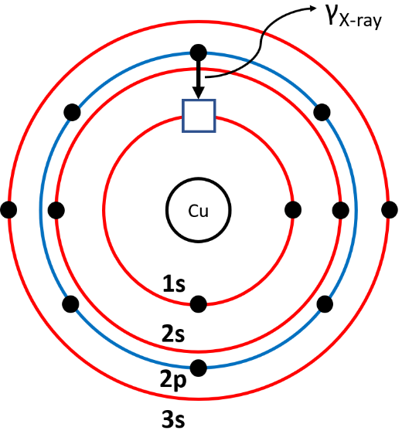
Figure 3.14: Diagram of an X-ray photon being emitted from a Cu atom. A 2p electron filling a hole generated by the elastic collision of a 1s electron and the accelerated electron in an X-ray tube. The red orbitals indicate the s orbitals, the blue p respectively. Adapted from West, Prins, and Thomas [294], [297], [319]
The X-ray diffraction pattern consists of reflection peaks generated by the constructive interference of these monochromatic photons superimposed onto the white (background) radiation. X-ray reflection peaks indicate that the incident X-ray radiation equals the angle in Bragg’s law (Equation 3.) . The product of the order of reflection n, X-ray wavelength λ, is equal to the twice the distance between crystallographic planes d and the sine of the angle of incidence between X-ray radiation and crystallographic plane θ [294].Angles of incidence which do not fulfil Bragg’s law destructively interfere and consequently do not contribute to the overall pattern.
$$nλ=2d\sin{θ}$$
Equation 3.1
In crystalline materials there can be thousands of lattice planes and interactions present; however due to crystallographic symmetry these can be sorted into repeating 3D grids. The unit cell is the lowest common denominator of the material’s crystalline structure. Each crystalline phase has a characteristic fingerprint X-ray diffraction pattern, which can be used to identify the material, derive the unit cell and crystallographic planes. Table 3.4 below details the diffraction peaks present in the fuel electrode materials analysed in this study.

The three main materials assessed in this thesis are:
- Yttria stabilised zirconia (electrolyte and fuel electrode ceramic backbone)
- Nickel Oxide (transition metal oxide catalyst precursor)
- Nickel (metal electrocatalyst in the fuel electrode)
X-ray diffraction was used to confirm the presence of NiO on the YSZ scaffold layer and to calculate the NiO crystallite length in nanometres. The diffraction patterns of the NiO-YSZ samples were obtained using a Bruker D2 XRD Phaser. The samples were scanned for 1 hour using Cu K_{α} radiation (1.54184 Å). The NiO crystallite length (D) was calculated using the Scherrer formula for line broadening analysis). The diffraction patterns of the materials were analysed using the ICDD PDF4+ 2016, Crystallography Open Database and Bruker Diffrac Eva programs [320]–[326].
Table 3.4: Table detailing the peak assignments present in the 20-80° θ range using Cu Kα radiation [320]–[326]
Material | Crystal Structure | Key Peak assignments | PDF card no. | Analysis program
Yttria stabilised zirconia  [(Y₂O₃)_{0.08} (ZrO₂)_{0.92}] | Cubic – Fluorite | (111)  (200)  (220)  (311)  (222)  (400) | 04-016-2092  04-010-3268  04-018-5452 | PDF4+ 2016  Bruker Diffrac Eva
Nickel (II) Oxide  [NiO] | Cubic - Rock Salt | (111)  (200)  (220)  (311)  (222) | 00-047-1049  00-044-1159  01-089-3080 | PDF4+ 2016  Bruker Diffrac Eva
Nickel  [Ni] | Face-Centred Cubic | (111)  (200)  (220) | 2102245  9008476 | PDF4+ 2016  Bruker Diffrac Eva  Crystallography Open Database (COD)
The experimental parameters for the Bruker D2 X-ray Diffractometer are listed below:
- Cu K_{α} radiation (1.54184 Å)
- 2θ range between 20-80°
- 0.02º increment of per measurements
- Lower and upper discriminators of 0.11 and 0.25
- A 1.0 mm Soller slit with a Ni filter
- 60 min scan time

3.3.1.1 Crystallite size measurements using X-ray diffraction
The full width half maximum β, of NiO crystallites in the by integrating the X-ray reflections using a peak analysis baseline fitting function in OriginPro 2020. This was converted to radians. The wavelength of the incident X-ray radiation is denoted by λ. The diffraction angle θ, is half the Bragg angle for the characteristic reflections in the diffraction pattern. A shape factor k, of 0.89 was used for the nickel compounds. This term is a dimensionless constant ranging between 0.62 - 2.08, 0.89 denotes a spherical morphology [295], [327]. The NiO and Ni crystallite lengths (D) were calculated using the Debye-Scherrer equation for line broadening analysis (Equation 3.2) [297], [319], [327]–[329]. The purpose of this was the monitor the crystallite lengths of the infiltrated catalysts during the first 5 h of ageing. The full width half maximum of the diffraction peaks was calculated using OriginPro 2020.
The instrumental contribution was removed from the data by subtracting the full width half maximum of a known calibration sample. In this study this was a bulk nickel foil sample (XRD pattern can be found in the Appendix) [295].
$$D= \frac{Kλ}{β\cos{θ}}$$
Equation 3.2
Debye-Scherrer analysis is not the sole method from which the particle size of a sample can be calculated. Nanocrystalline materials such as the infiltrated nickel phase in anode samples possess a strain component which impacts X-ray diffraction pattern produced from the samples. As these variables are independent of each other The strain ε of the full width half maximum, was calculated using the Williamson hall method (Equation 3.3), which removes this component from Equation 3.2.
$$ε= \frac{β_{Strain}}{4\tan{θ}}$$
$$β_{Strain}= \frac{4ε\sin{θ}}{\cos{θ}}$$
Equation 3.3
The impact of the strain component from Equation 3.3 on the FWHM was removed by applying the $tanθ = sinθ/cosθ$ equivalence to Equation 3.2
. After that the resulting equation was rearranged to make the crystallite length D, the subject (See Equation 3.4) [297], [319], [327]–[331].
$$β\cos{θ}= \frac{Kλ}{D}+4ε\sin{θ}$$
$$D= \frac{Kλ}{β\cos{θ}-4ε\sin{θ}}$$
Equation 3.4
The Debye-Scherrer calculation was used to calculate the crystallite lengths of the nickel particles present on the fuel electrode samples. These were calculated in Microsoft Excel 2016.

3.3.1.2 Wide Angle X-ray Scattering (WAXS)
The NiO-YSZ scaffold layers of two air dried and N₂ dried samples were scraped off their respective pellets and sealed in scotch tape. The powders were mounted on an aluminium plate and scanned at the Advanced Photon Source Argonne National Laboratory 9-ID beamline using) monochromatic radiation from a Si crystal (220) (wavelength λ, 0.58 Å) for a 4-minute scan time [332]. Wide-Angle X-ray Diffraction patterns between diffraction angles Q, of 1-6 Å⁻¹ were captured using the 300 mm WAXS camera (Figure 3.15). The data was collected by the 9-ID beamline scientists using the sample mail-in program.
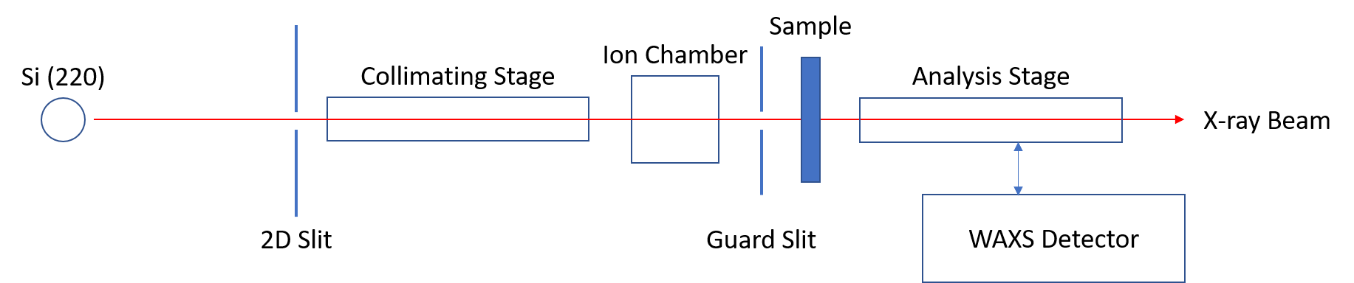
Figure 3.15: Top-down diagram of the Wide-Angle X-ray Scattering unit at the 9-ID beamline at ANL. The monochromatic radiation from the Si (220) crystal is focussed using a collimator. Adapted from Ilavsky et al [332]
The incident photon beam from the APS beamline is focussed through the Si crystal and mono-chromated with optics to the (220) direction in the collimating stage to produce a radiation λ, of 0.58 Å. These X-rays pass through the sample and undergo Bragg diffraction producing interference patterns which can be analysed in the same way as X-ray powder diffraction [294].

3.3.2 Scanning Electron Microscopy
Scanning electron microscopy utilises a raster-scan motion with an electron beam to image the microstructure of sample. First established in 1937 by Von Ardenne this characterisation technique can produce 3D images of the surface of a sample [319].The nascent electron beam is produced by thermionic emission using either a tungsten filament or a field emission gun. The beam energy can be varied between 0.2-40 keV using an electric field. The stream of electrons is firstly focussed to an outer diameter of under 5 nm using a pair of condenser lens before being diverted using deflector coils to the sample.
The electrons collide with the sample leading to several different collisions dependent on their energy. The raster motion and thin electron beam result in a rectangular field of view. From the initial point of contact with the electron beam a lachrymiform volume of the sample interacts with the electrons (Figure 3.16).
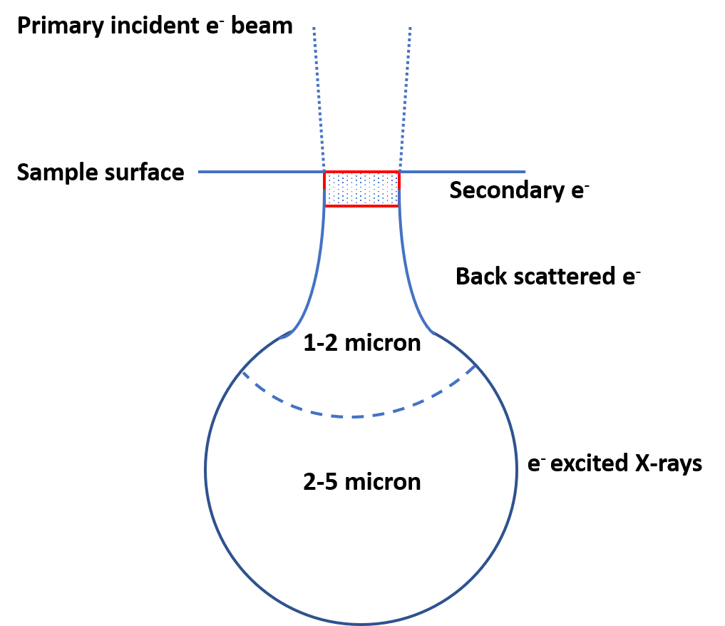
Figure 3.16: Diagram of the sample interaction volume in scanning electron microscopy[319]
The depth of this interaction volume ranges from 100-5000 nm (see Figure 3.13 above). The lachrymiform can be divided into 3 sections. Secondary electrons are released from the first 10 nm of the interaction volume. Back-scattered electrons are emitted from 100-2000 nm. X-rays from 2-5 µm.
The size of this region is entirely dependent on 3 factors:
- The energy of the incident electron beam
- The atomic number of the sample material
- The density of the sample material
Magnifications of between 50 - 500,000x possible with SEM with features of 1 nm available in ideal highly conductive samples [319]. However, the presence of the electrically insulative YSZ ceramic scaffold and electrolyte in the fuel electrode samples results in charge build up which reduces the resolution and clarity of the micrographs.
The size of the nickel particles in the micrographs were measured in the micrographs using the using the FIJI-ImageJ analysis program [333].

3.3.2.1 SEM sample preparation
The symmetric cells were sectioned using a diamond scribe. The samples were mounted on carbon tape and coated in a 10 nm layer of gold using an Emscope Sputter Coater (Figure 3.17). This was to reduce the charging effect generated by the electrolyte material. The scaffold thickness of non-infiltrated cells was measured using the TouchScope software. The micrographs of the symmetrical cell scaffolds were taken using a JEOL JSM-6010LA SEM
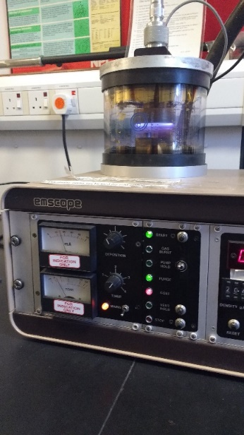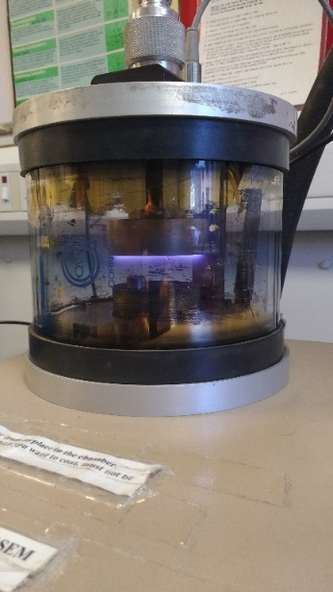
Figure 3.17: 2 images of the YSZ scaffold samples being coated with gold with the Emscope sputtering instrument
The SEM instruments used for this work were:
- JEOL JSM-6010LA in the Department of Chemical and Biological Engineering (University of Sheffield, UK)
- FEI Inspect F50 at the Sorby Centre for Electron Microscopy (University of Sheffield, UK)

3.3.2.2 Focussed Ion Beam Scanning Electron Microscopy
A new and upcoming portion of the research in terms of anode microstructural assessment is focussed ion beam scanning electron tomography (FST) [293], [334], [335]. This technique is highly unique as usually tomographical methods utilise x-ray diffraction to build up the structure into an image. This characterisation technique can render a 3D illustration from a FIB-SEM image to show the arrangement of pores within the system. These results can be used to produce an estimation into the proportion of TPBs in the overall system.
Focussed Ion Beam Scanning Electron Microscopy (FIB-SEM) was performed using a Helios Nanolab G3 instrument. Prior to imaging the sample was coated using with an 8 nm layer of gold. A platinum layer measuring 30 µm by 5 µm was applied with the electron beam then the GIS needle (Figure 3.18 and Figure 3.19). The samples were tilted 52⁰. The gallium source was used to coarsely mill a 15 µm trench using a beam current of 9.3 nA (Figure 3.19). Finer polishing steps including the reduction of the beam current 2.5nA and a finishing pass at 0.43 nA.
Further microstructural imaging was performed using the FEI Inspect F50 SEM in both secondary electron and back-scattered electron detector modes.
Figure 3.18: Image of the protective platinum layer applied to the NiO-YSZ sample by electron beam (5000x magnification)
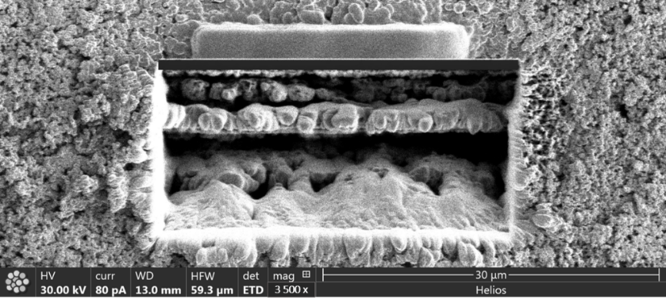
Figure 3.19:Micrograph of a FIB-SEM trench milled at 52⁰ in an infiltrated Ni-YSZ fuel electrode sample (3500 x magnification)

3.3.3 Temperature Programmed Reduction
Temperature Programmed Reduction (TPR) observes the interaction of a sample with a probe gas molecule during heating. In this case this procedure can be used to determine the changes in the oxidation state of the catalyst from its interactions with the reductive gas. Similarly, to gas calorimetry (GC) or mass spectroscopy (MS) a thermal conductivity detector (TCD) is utilised to monitor the gas uptake in TPR [319], [336], [337].
During TPR the supported catalyst is firstly flushed with an inert carrier gas prior to any heating which provides a baseline TCD reading. During the temperature ramp 5-10 vol % of the reductive gas is flowed across the sample in the inert carrier gas. The reduction event is denoted by the generation of a peak in the y axis (TCD reading) across a temperature range (x axis).
The area and positions of peaks illustrate the changes in the degree of reducibility of the catalyst material. In TPR data if a peak occurs at lower temperatures the reduction temperature of the catalyst involved has been reduced. If the peaks sharpen the reducibility of the catalyst has been increased. As a result, this method provides a combination of qualitative and quantitative data.
A Micromeritics 2720 Chemisorb was used to produce the temperature-reduction profiles of NiO-YSZ samples between 25-600 °C (Figure 3.20). Prior to reduction, the NiO-YSZ samples were flushed with pure argon for 15 minutes at room temperature at a flow rate of 25 mLmin⁻¹. After this samples were reduced in by a 5 % H₂/Ar carrier gas at a flow rate of 20 mLmin⁻¹ between 25-600 °C. This flowrate was selected to mimic the gas flow present during ageing and EIS. To eliminate the impact of moisture, all samples were dried for 2 hours at 100 °C in a drying oven and desiccated overnight prior to the any temperature-programmed reduction.
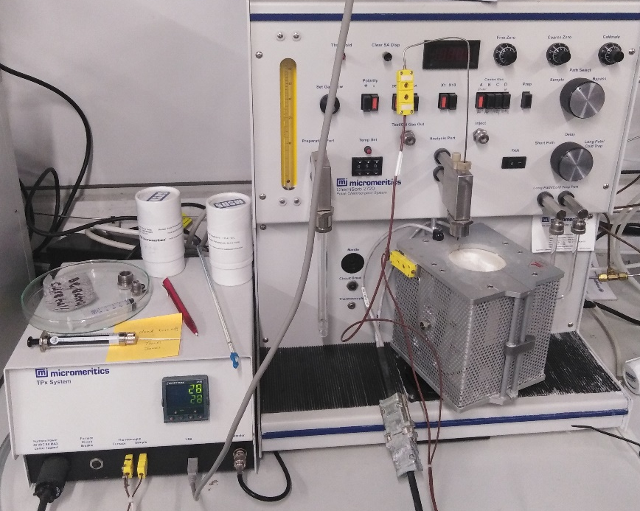
Figure 3.20: Photograph of the Micromeritics 2720 Chemisorb instrument used for the TPR work
The TCD response of the Micromeritics 2720 was calibrated using the reduction of a NiO powder sample (J.T. Baker, USA, 99.99 % pure). This sample was used to identify the reduction temperature of bulk NiO, with a view to seeing reduction events earlier in the infiltrated samples.
The temperature-programmed reduction profiles of the calcined NiO-YSZ samples 2 and 16 (N₂ and Air dried) were Micromeritics 2720 Chemisorb between 25-600 °C under a 5 % H₂/Ar atmosphere. A calibration curve was produced using between 3.0-40.0 mg NiO powder (JT Baker, USA).

3.3.3.1 Dispersion calculations
With knowledge of the crystallite length and particle size gleaned from the SEM, XRD and TPR. The % dispersion of the infiltrated nickel particles can be calculated using the particle sizes and crystallite lengths of the
The scanning electron micrographs revealed that the morphology of the wet impregnated nickel particles was spherical in shape (Figure 4.14 and Figure 4.15). This information means that calculations involving spherical particles can be assumed for any dispersion calculations.
Assumptions:
- Length of the crystallite is the diameter of the particles
- Particles are spherical in morphology (Figure 4.14 and Figure 4.15).
The planar density of nickel particles at the 111 crystallographic planes was calculated using the crystallite lengths determined by the Debye-Scherrer calculation assuming a spherical volume. The number of Ni unit cells were calculated by dividing the catalyst volume by the volume of a single Ni_{FCC} unit cell. Afterwards the percent dispersion of the nickel phase was calculated using the planar density, contact area and number of nickel atoms according to Equation 3.5.
$$D_{Ni}=\frac{{Ni}_{111 surface} }{{Ni}_{Total}}$$
Equation 3.5
The percent dispersion of the reduced nickel catalysts was calculated with respect to ageing time. The crystallite length determined by the Scherrer method was used to calculate the catalyst volume using the methods described below.

Unit cell length calculation – Volumetric method
Two methods were used to determine the unit cell length of the face centred cubic nickel. The first method utilised the molecular mass and density of nickel to calculate the volume of the unit cell to produce the unit cell length of the (111) crystallographic plane. This plane corresponded to the Ni_{FCC} peak used in the Scherrer calculation.
The volume of the unit cell was calculated by dividing the mass of the four atoms in the unit cell by the density of nickel (8.908 g/cm³). This volume was then cube rooted to produce the unit cell length in nm. This value was also checked using the atomic radii method [294], [338], [339].
Both methods produced a unit cell length of 0.352 nm (to 3dp). This value was then cubed to produce the unit cell volume in nm³. The percent dispersion was calculated by number of surface nickel atoms by the total number of atoms present in the sample (Equation 3.5). The nickel particles were found to be spherical in shape from Figure 4.14 and Figure 4.15.

3.3.4 Fourier Transform Infra-Red Spectroscopy
Fourier-transform Infra-Red Spectroscopy (FT-IR) analyses the wavelengths emitted from a sample after it has been subjected to infra-red wavelength radiation. The chemical composition of the material can be deduced by the spectrum generated by the sample. Key materials in this study like nickel nitrate can be identified by characteristic absorbance bands at wavenumbers of 1376 and 1620 cm⁻¹ [340], [341].
In FT-IR a high-energy ceramic light source is heated to 1200 K. The source emits an infra-red beam (10,000-100 cm⁻¹) that passes through a sample via radiation. This beam is partially converted to kinetic rotation or vibrational energy in the sample energy and resulting signal is collected as a spectrum. This spectral fingerprint is a result of the change in the dipole moment (µ) generated by the vibration of the sample bonds under the beam [341], [342].
The FT-IR instrument used during this work was a Shimadzu IRAffinity-1S instrument. The 4000 scans were taken for each sample. The FT-IR was used in attenuated total reflection (ATR) mode which used the change of refractive indexes induced with the presence of a sample in relation to an internal reflecting element [341].
A Shimadzu IRAffinity-1S Fourier Transform Infra-red Spectrophotometer was used to determine the phase transitions present during the drying and calcination of the transition metal nitrate. This includes checking whether an oxynitrate had formed after the calcination step. Each sample was scanned for a period of 1600 cycles. Each of the samples were dried in a drying oven at 120 ⁰C for 2h prior to FTIR assessment to remove any excess moisture from the powders.
One of the benefits of FTIR is that the absorption peaks related to the ceramic backbone do not overlap with the nickel oxide catalyst meaning that the decomposition of the nickel nitrate to nickel oxide can be mapped sufficiently [340], [343].
However, FT-IR does suffer from some drawbacks. Data analysis is nontrivial especially if the compounds being analysed produce discrete absorption peaks which may have shifted due to compositional and functional groups [297], [319]. Atmospheric moisture is also present in the spectra since the beam passes through air which could make analysis of dried compounds hard. The use of ATR can also provide some issues with beam penetration limited by the sample thickness [341].
FT-IR was used in this work to confirm that the calcination routine had successfully produced nickel oxide and to monitor if any oxynitrate complexes had been formed during drying.

3.3.5 Electrochemical Impedance Spectroscopy
Electrochemical Impedance Spectroscopy (EIS) is a versatile technique used to extract the resistance and capacitance values of a sample as function of temperature. This technique is well suited to the study of interfacial phenomena. It has been a mainstay for assessing the macroscopic properties of the electrode material on both sides of the SOFC electrolyte. As the primary method of functional analysis, it has been the most popular technique in terms of experimental design.
One of the largest characterisation issues with the current wet impregnated anode literature is due to the size of the nanoparticle catalysts such as nickel. To a large degree the macroscopic approach to degradation has been widely covered by various sources in the literature.
Impedance spectroscopy involves the variation of frequency with a view to affecting the electrical relaxation response of a sample across time. The impedance of a sample consists of two pieces which require calculating: a reactive (conductive/inductive) and resistive segment.

The major benefit of this technique is its flexibility in terms of assessment as individual conductive and resistive parts can be calculated for separate sections of the material. The method of taking an EIS measurement is listed below:
- An AC voltage is applied across a standard resistor and the sample (which are in series)
- In and out of phase components of voltage across the samples are then measured
- Dividing these parts by the current produces the resistive and reactive components of the impedance.
- With each frequency increment the measurements are repeated up to the desired frequency

This technique can isolate the different sources of resistance contributions from bulk resistance sources to grain boundary segments. The most common form of EIS plot is the Nyquist plot which maps the response of a linear system to different frequencies. This is shown by plotting the natural log of the imaginary frequency response against the logarithmic real frequency contribution of the system. The contribution of a Ni/YSZ anode usually shows an arc based on the x axis under a frequency of 10,000 Hz [66], [133].
$$Relaxation Time, τ=RC$$
Equation 3.6
For SOFCs this means that the complex impedance response of different fuel electrode components can be modelled using a series of resistors and capacitors (RC). The use of alternating frequencies means that a sinusoidal interaction is generated from the sample, meaning that the product of maximum loss ω_{Max} with the resistive and capacitive components equals 1 (Equation 3.7).
This means that a unique relaxation time τ, can be derived individual RC elements (i.e. fuel electrode parts such as pores) (Equation 3.6) [142], [344].
$$ω_{Max}RC=1$$
Equation 3.7
In the fuel electrode the frequency responses can be assigned separate components like the bulk and gas diffusion impedance[131], [133], [345]. The sinusoidal response results in a complex response from the system. The impedance Z is used to denote the total contribution of the resistive and capacitive elements (Equation 3.8). This is expressed as a Cartesian complex number so the real and imaginary parts (Z’ and Z’’) can be plotted in a Nyquist plot (Figure 3.21)[346].
$$Z=Z^{'}+jZ''$$
Equation 3.8
The complex response for each component in the specimen is represented in the Nyquist plot which monitors the impedance at increasing frequencies from right to left [347]. The high frequency i₁ (or Series resistance, R_{S}) represents entirely resistive behaviour (i.e. the electrolyte in an SOFC infiltrated fuel electrode and contributions from jig components) whilst the distance between this and the low frequency intercept i₂ signifies the contribution of the electrode itself. This transition is described as the charge transfer resistance to polarisation (R_{p}) [235], [348], [349].
Additionally, a Bode plot (plot of log frequency vs the absolute Z phase) can be used to identify the key frequencies responses for different fuel electrode contributions i.e. bulk and gas diffusion [133], [350]–[352]. These changes are represented by points of inflection these plots [353].
Examples of the impedance contributions to the complex impedance response of infiltrated fuel electrode samples can be found in Figure 3.21.

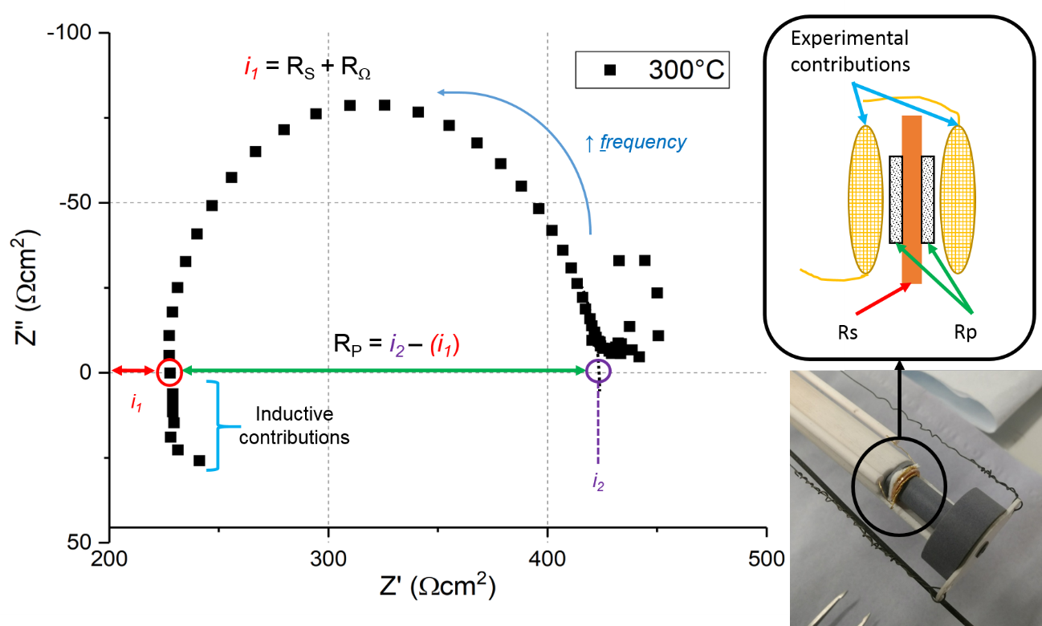
Figure 3.21: Nyquist plot showing the complex impedance response of an yttria-stabilised zirconia (YSZ) pellet at 300 ⁰C

3.3.6.1 Experimental Apparatus and Data Acquisition
A ceramic compression jig was fabricated to house the infiltrated symmetrical cell samples in this project. The ceramic internal tube was designed in Solidworks 2017 CAD Software. Alumina tubing was sectioned using a glassware saw and mounted into a stainless-steel flange. A stainless-steel O-ring with a rubber exterior was used to seal the chamber. The samples were housed in an alumina sheath with a K-type thermocouple monitoring the temperature by the Ni-YSZ sample (Figure 3.19). Gold meshes were spot welded onto the gold wires and these were compressed using spring loaded pyrophyllite piston to provide adequate electrical contact between gold mesh and the sample electrodes. Prior to EIS measurements, the samples were checked for short-circuits using a multi-meter.
Prior to EIS, the samples were coated in a nickel oxide conductive paste (Shoei, Japan) using a screen-printing method (See 3.2.3). The thickness of the electrodes was measured to be 35 µm per side (Figure 3.7). The area of the samples was calculated to be 0.2827 cm². After the current collector was dried the samples were loaded into the ceramic impedance jig (Figure 3.22). The samples were ramped at 5 °Cmin⁻¹ up to 800°C under a 5 mLmin⁻¹ flow of 10 % H₂/N₂. The gas was humidified to a H₂O saturation of 10 % at 25 °C via the use of an in-line check valve bubbler (Sigma Aldrich). The flowrate of the gas was kept constant 5 mLmin⁻¹ at using a Supelco rotameter. The heating was done using an Elite tube furnace, Eurotherm 2420 temperature controller and monitored with a K-type thermocouple and Picolog TC-08 datalogger. The complex impedance response was measured between 0.1 Hz-65 kHz using a Solartron Modulab 1250 frequency response analyser and 1287 electrochemical interface. Measurements were collected using the Scribner ZView and ZPlot software. Each sample was aged for a period of 50 h.
Additionally, between EIS measurements the gold meshes were cleaned using isopropanol and then heated in air to 200 °C for 2 h in the Elite tube furnace to remove any previous material and reduce the impact of cross-contamination between the samples.
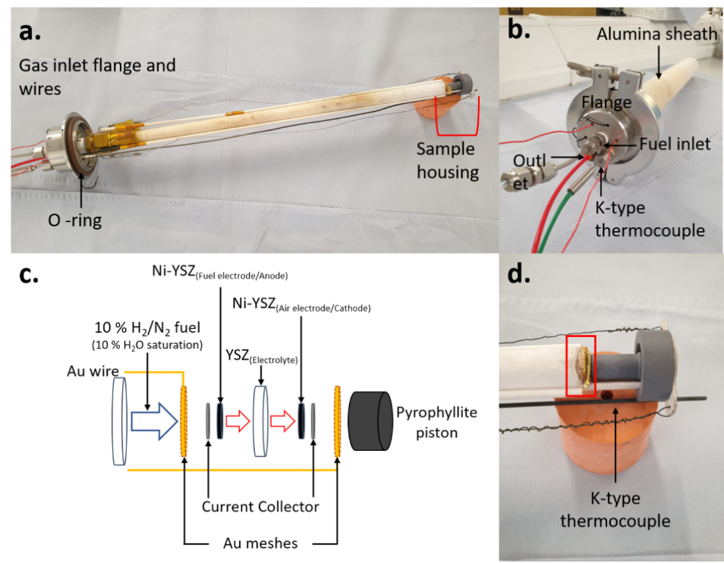
Figure 3.22: Images of the ceramic compression jig used to perform the electrochemical impedance spectroscopy measurements. a. Shows a photograph of the ceramic compression jig lengthways without the alumina sheath. b. A photograph of the stainless-steel flange with gas inlet, outlet, and K-type thermocouple. c. An exploded schematic of the sample housing with sample layers and jig components in the compression clip. d. A photograph of a Ni-YSZ symmetrical cell in the sample housing (denoted by the red square – diagram found in part c.) including the pyrophyllite piston.

3.3.6.2 Equivalent Circuit Fitting
Equivalent circuit (EC)fitting was also performed for each of the samples in ZView (Scribner, USA). The electrochemical impedance arcs present in the Nyquist plots were fitted using EC fitting tool in ZView. Each of the fittings were run for 100 iterations.
A resistor was used to emulate the contribution to the impedance of the electrolyte (R_{S}). The infiltrated electrode resistance component was represented using a resistor with a constant phase element. Initially an instant fit (IF) was performed on the data to produce rough estimations of the resistive values for the electrolyte and electrode. The Rs and R₁ values generated were used to inform the EC fit used with the first pass utilising this circuit (Figure 4.32) which has been used in multiple solid oxide fuel electrode studies [130], [131], [233], [354].

3.3.6 Ptychographic X-ray Computed Tomography (PXCT) (Scanning diffraction microscopy)
Ptychography is a form of coherent diffractive imaging (CDI) [275], [279]. This form of imaging retrieves phase data from a sample from reconstructed the diffractograms. These far field diffraction patterns are produced by illuminating the sample in the incident X-ray beam and taking images at increments within a 180° rotation. The illuminated sections overlap reducing the information lost when applying an iterative feedback algorithm [355]–[358]. These algorithms and imaging method can be combined with high flux X-ray sources to form a scanning diffraction microscopy technique known as Ptychographic X-ray Computed Tomography (PXCT).
With the use of high-brilliance X-rays, the resolution of PXCT exceeds that of its XCT counterparts[359], [360]. This is due to the fact that CDI techniques are lenseless and thus are only constrained by the wavelength of the X-ray radiation used [255], [275], [361]. Phase retrieval algorithms are substituted in for X-ray optics resulting in 3D tomographic renderings with sub 16 nm resolution[360]. This is far finer than the reported 50 nm resolution available to XCT with a 50 µm diameter sample[359].
The PXCT experiments performed in this project were done at the I13-1 beamline at the Diamond Light Source (Oxford, UK). Ptychographic scans at the coherence beamline utilise a 14 m detector to sample distance [358]. This beamline can produce X-rays wavelengths between 6-20 keV[356], [358]. The transverse coherence of the X-ray beam ξ_{t} is a function of the X-ray wavelength λ, sample-detector distance R, and the D the detachment between the point and X-ray source (Equation 3.9) [362].
$$ξ_{t}=\frac{1}{2}∙\frac{λR}{D}$$
Equation 3.9
The beam energy of the PXCT experiment was calculated using X-ray attenuation coefficients present approaching the nickel beam edge [363]–[365]. The sample to detector distance in these The density of the sample was calculated using by multiplying individual elemental densities with their weight percent[262], [366]. For sufficient phase recovery the X-ray beam must be coherent with respect to the material of interest[361]. To optimise the transverse coherence of the X-ray beam and reduce the impact of sample attenuation on D, the milled sample thickness was 15 µm (see Section 3.1.4).
$$n=1-δ+iβ$$
Equation 3.10
The relationship between the refractive index of a specimen n, with an X-ray beam of energy E, is expressed as a conjugate number (Equation 3.10) [275], [361]. The sample-reliant real (δ) and imaginary portions (β) of the transmission function(TF) in PXCT are used to express the lack of a phase by the use of binary values [355], [367]. This function can be described using (n-1) with respect to the horizontal axis of the optics Z, further information can be found in Sala et al [362].
The PXCT beam energy used in this study was 17 keV(near to a nickel beam edge), equating to a to a wavelength of 0.73 Å. Figure 3.23 below shows the refractive indexes of both parts against X-ray wavelength [363]. The numerical values of these parts were generated using the absorption values calculated by Henke et al [363]. The real (δ) and imaginary segments (β) amounted to 6 x 10⁻⁴ and 1.68 x 10⁻³, respectively (Figure 3.23).
Figure 3.23: Real and complex parts of the transmission function plotted against X-ray wavelength [363]

3.3.7.1 PXCT Data Acquisition
The Ni-YSZ pillar sample and SEM stub were mounted onto the sample stage manipulator using an align key. Prior to any beam work the top of the sample was raised to bring the sample into the beam denoted by an alignment laser. A sample to detector distance of 10 m was used to provide adequate transmission through the infiltrated Ni-YSZ fuel electrode pillar specimen (Figure 3.24).
The X-ray photons were counted using the EXCALIBUR detector after they had passed through the sample [368]. A series of focussing optics were used to optimise the incident beam for transverse coherence. The central stop (CS), Fresnel Zone plate (FZP) and Order Sorting Aperture (OSA) were aligned with respect optimising the sample resolution to the X-ray beam energy.
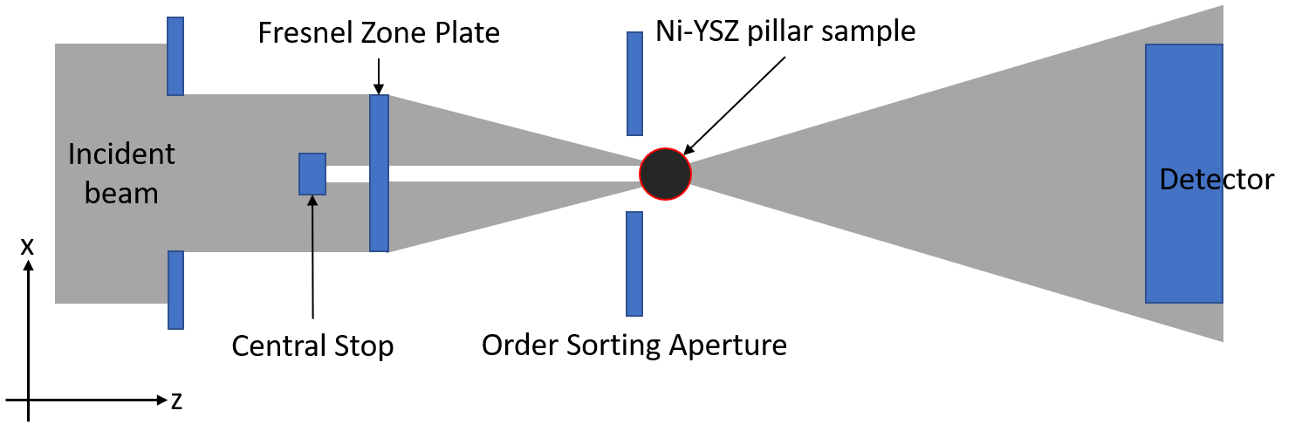
Figure 3.24: Diagram of the I13-1 sample to detector set up including focussing optics. Adapted from Sala et al [362]
Once the alignment of the optical components was complete. A Siemens star pattern was used to trial the beam energy and derive the beam size available at the sample surface. After this step, the final fine tuning for the sample alignment was done.

Sample Alignment
The sample was fixed to the rotation stage using an Allen key. The sample was then raised to a height where the pillar would be in the path of the X-ray beam. This is checked using an optical microscope prior to any use of synchrotron radiation.
The position of the axis of rotation of the sample is a key to the accurate reconstruction of the 3D microstructure of the phases present in the specimen. Therefore, the sample must be aligned so the region of interest is lined up to the centre of rotation.
Figure 3.25 below shows an example of the field of view present in ptychographic scans like those found in Figure 3.26. The I13-1 beamline utilises a series of cameras and detectors to monitor the position of the sample.
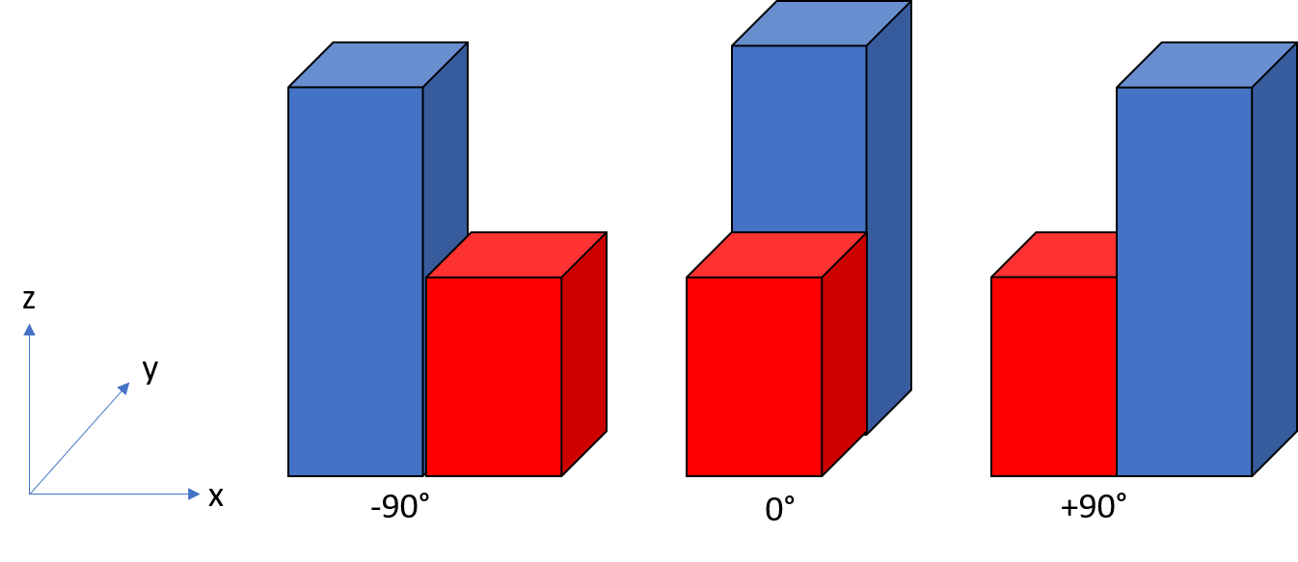
Figure 3.25: Figure showing the field of view of a sample with rotations around the x axis. The incident beam is approaching via the y axis.
For the ptychographic scans of the infiltrated Ni-YSZ samples the pillars were moved so that the outer edges of the pillars remained in the field of view. This ensured that the pillar itself was aligned to the centre of rotation for the rotational stage (Figure 3.26).
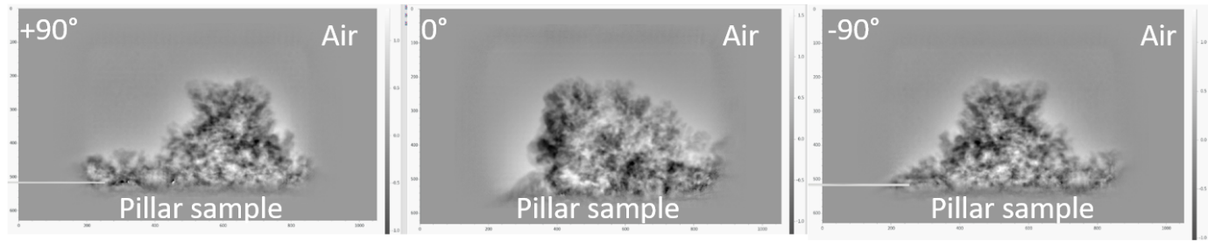
Figure 3.26: Figure showing the initial ptychography scans of a milled infiltrated Ni-YSZ pillar sample.
The initial scans were 32 µm x 16 µm in size
Once the sample is alignment was deemed suitable, the experimental beam hutch was opened and initial 32 µm x 16 µm scans were taken at -90°, 0° and 90° to ensure that the entire sample remains in the scan (Figure 3.26). Positional adjustments are made in the prior to long term scanning. These scans are checked for to ensure that the correct region of interest is centred.
To increase the amount of sample present in the scan, the x dimensions of the scan are reduced. For a tomographic raster scan the final scan size was taken (25 µm x 10 µm scans) [362], [369]. A total of 800 diffractograms were taken over a 180° rotation. The PXCT scans took 4-6 h to complete.

3.3.7.2 Sample Ageing
A pyrophyllite piece was designed using AutoCAD to house the fine pillar sample. The pyrophyllite sample tray was machined using a CNC machine and a pillar drill. The ceramic was fired using a temperature of 1100 °C for 2 hours.
An offline ageing procedure was performed on the fine Ni-YSZ pillar samples. being The fine pillar sample was loaded into the sample tray and inserted into the tip of the second glass piece (Figure 3.27). The glass heating rig was sealed using and the chamber was filled with 10 % H₂/N₂ gas. After leak testing the end of the tube was heated to 800 °C in an Elite tube furnace. This sample was heated for an hour prior to the system being cooled to room temperature at 10 °Cmin⁻¹. The temperature was monitored during the heating process using a Picolog TC-08 datalogger with K-type thermocouple.
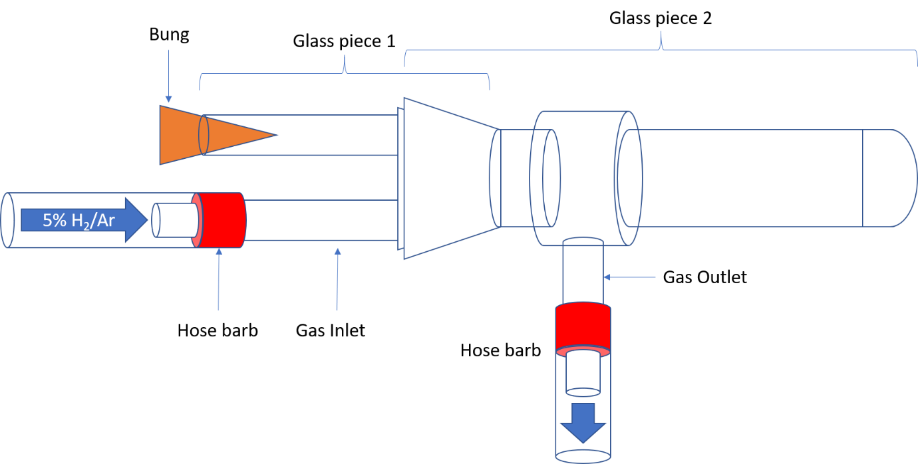
Figure 3.27: Diagram of the heating apparatus used to age the Ni-YSZ fine pillar samples. The gas atmosphere was humidified 10 % H₂/N₂ at with an inlet flow rate of 5 mLmin⁻¹. The apparatus was mounted in a tube furnace via clamps and the entire apparatus was housed in a fume cupboard.
After cooling the pillar sample was remounted into the sample holders detailed in Section 3.1.4. For further ptychographic scans. This scan and heating routine were repeated to enable the imaging of detailed ageing routines of the fuel electrode samples to be performed. This routine was used to track via snapshotting the evolution of the phases in the infiltrated Ni-YSZ symmetrical cell during ageing.

3.3.7.3 Data processing and manipulation
Ptychographic reconstructions were performed to convert the raw ptychogram to a tomogram suitable for phase segmentation in Avizo Lite (FEI). The data analysis was split using into two different procedures: ptychographic and tomographic (Figure 3.28).
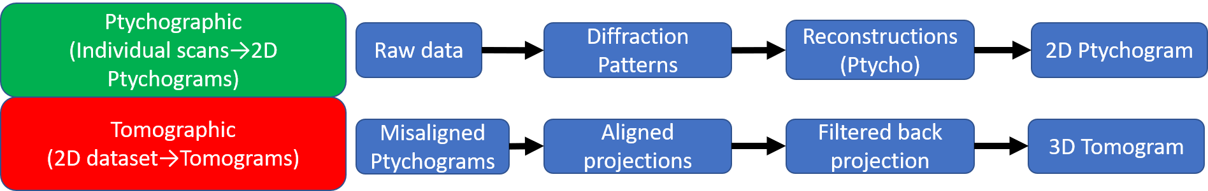
Figure 3.28: Breakdown of the two workflows required to convert raw PXCT data to 3D tomographic renderings. The workflow moved from ptychographic to tomographic during data processing and analysis
The ptychographic data workflow is primarily focussed on the producing 2D projections of the transmission function of the dataset for each individual scan file. These projections were collected for each angle of rotation in the scan. After alignment and back filtered correction are performed these files can be stacked to form a 3D dataset and resulting tomogram.
The diffraction patterns of the samples were trimmed to 700 x 700 pixels which combined with the rotation morphology of the dataset produced a reconstructed pixel size of 36 nm. Regions of zero phase shift (i.e. ambient air around the sample) were used to identify and remove phase offsets present in the data. After phase retrieval was completed the phase unwrapping was performed using the DLS DAWN (Data Analysis WorkbeNch, DLS I13-1) [370], [371]. This produced 2D sinogram projections of the transmitted function which were misaligned both vertically and horizontally [369].
Horizontal alignment was achieved via iterative reconstruction on the sinograms of the films. A filter-back projection was applied in combination with thresholding and an inverse Radon transform to apply localised tomography [362], [369]. This was repeated for each scan file, which were then joined to form a projection which was aligned pixel by pixel.
This produced a sinogram which was not correctly aligned to the centre of rotation utilised in the PXCT scan. A final arrangement in SAVU was applied to correct the file and create a series of TIF images which can be stacked to form a 3D tomogram [356], [358], [362], [369], [372]. Phase segmentation of the tomograms was performed on Avizo Lite. Figure 3.29 below details the various steps and data formats required to produce 3D tomographic renderings of the structure.
Figure 3.29: A flow chart detailing the data processing steps required to produce a 3D digital rendering of ptychographic diffractograms. The orange sections detail the data format, python modules used and rendering software. In this case the * indicate a DLS python module and the ** show the rendering program used

3.4 Experimental Characterisation Methodology
Table 3.5 below details the different characterisation techniques used throughout this thesis. For reference further details on the methods can be found in 3.3 preceding this table.
Table 3.5: A breakdown of the different characterisation techniques utilised during the 3 experimental chapters of this work
Thesis Chapter | Characterisation Technique
Thesis Chapter | XRD | WAXS | SEM | FIB-SEM | TPR | FTIR | EIS | PXCT
4
5
6

Chapter 4: Quantifying the impact of gas drying atmospheres on infiltrated SOFC fuel electrodes

4.1 Introduction
The key limiting factor toward the widespread application of infiltrated electrode systems is that of catalyst durability. Due to prolonged exposure under SOFC operating temperatures (800-1000°C) the fine nanoscale catalysts coarsen thus reducing the active surface area (See Chapter 2). This agglomeration leads to reduced reaction rates by the formation of dead zones. Reducing the size of the catalysts and increasing their dispersion has been discussed as a method of retaining these large surface areas and retain the high power densities associated with wet impregnated electrodes. [171], [173], [174], [200], [373].
One unexplored fabrication route for infiltrated fuel electrode materials is the use of a catalyst drying step under a specific atmosphere prior to reduction and electrochemical cycling. In the field of surface catalysis, a nitric oxide gas drying step was found to disperse and reduce the size of wet impregnated transition metal catalysts [171], [173], [174], [200], [373]. The implementation of this step produced well-ordered transition metal nanoparticles under 10 nm in length. The success of this technique was attributed to the ability of NO to remove the oxygen from the metal oxide nanoparticles forming NO₂ [176], [177], [374]. The examples of published work of drying infiltrated electrodes for SOFCs focussed on the desiccation of the oxygen electrode [9],[10]. There has been no literature to date quantifying the impact of drying atmospheres on the electrochemical properties of the fuel electrode.
This work sits in a unique position by applying knowledge from the field of surface catalysis to infiltrated SOFCs by demonstrating the impact of utilising a drying step on wet impregnated Ni-YSZ anodes.
To increase the dispersion and reduce the size of infiltrated NiO particles in Ni-YSZ fuel electrodes, an inert flowing nitrogen gas drying step was applied prior to calcination. These were compared to air-dried samples. Several characterisation techniques were utilised with a view to observing how these drying steps impact the dispersion, morphology, and size of the supported catalysts. The challenge of quantifying these structures is discussed with respect to their electrochemical performance. A total of four different decomposition configurations were assessed during this work.

4.1.1 Chapter Aims
This work aims to address the sintering mechanisms in infiltrated SOFC fuel electrodes using a tailored gas drying step prior to calcination. This is to study the effect of this processing stage on the size and distribution of the infiltrated electro-catalyst towards the application of controlling the particle sintering behaviour. It will secondarily identify the key processing parameter in the infiltration process and translate how it impacts the functional properties namely the polarisation resistance present in the anode.

4.1.2 Hypotheses
- The size of infiltrated catalysts can be reduced by using a pure N₂ drying atmosphere
- The initial polarisation resistance of the infiltrated fuel electrode can be reduced by drying the catalyst in an inert atmosphere prior to calcination
- The degradation rate of infiltrated fuel electrodes can be reduced using a N₂ drying step

4.2 Experimental Procedure Overview
The characterisation techniques used in this project are discussed in more detail in Chapter 3. The methods discussed below were used to characterise the wet impregnated fuel electrode samples used in this study.

4.2.1 Sample preparation
The Ni-YSZ symmetrical cells were produced using the procedure detailed in Section 3.1. A breakdown of the synthesis route is described Section 3.1. The key steps were:
- Sintering of YSZ electrolyte pellet (1400 ⁰C, 4 h)
- Doctor blading of YSZ/C ink
- Firing of porous YSZ ceramic backbone (1150 ⁰C, 2 h)
- Infiltration nickel nitrate solution
- Drying of nickel catalysts at 120⁰C using either a flowing Air or N₂ atmosphere
- Calcination of infiltrated media using either a flowing Air or N₂ atmosphere
The air and nitrogen dried samples were denoted using the nomenclature shown in Table 4.1 below:
Table 4.1: Table detailing the different gas atmospheres trialled during this body of experimental work
Drying atmosphere | Calcination atmosphere | Sample designation
N₂ | N₂ | ND NC (N₂ DC)
N₂ | Air | ND AC
Air | Air | AD AC (Air DC)
Air | N₂ | AD NC

This temperature was selected as it lies between the lowest calcination temperature of nickel nitrate and the Tammann temperature of nickel metal [238]. The removal of the nitrate phase must be as efficient as possible during the calcination step to ensure that as much NiO and consequently nickel is available for the fuel oxidation reaction in the cell.

4.2.2 X-ray Diffraction
Primarily the X-ray diffraction performed was used to confirm that NiO had been produced after the calcination step during the production of the wet impregnated symmetrical samples. The purity of the product was also monitored with Fourier Transform Infrared Spectroscopy (See Section 4.3.1)
X-ray diffraction has a detection limit of up to 1 % per volume of the sample [294], [297], [319], [375], [376]. However, the wet impregnated samples used in this work had a Ni content of 20 vol %, ensuring that the catalyst would be detected with the Bruker D2 XRD phaser.

4.2.2.1 Particle size analysis
Additionally, the crystallite length of the calcined and reduced catalyst phase was monitored using the Debye-Scherrer analysis (Section 3.3.1.1). This was used to calculate the crystallite length of the nickel species in the calcined infiltrated samples to track the particle growth over time. Additionally, Wide-Angle X-ray Scattering was performed to further reduce the impact of micro strain on the crystallite length calculations.

4.2.3 Fourier Transform Infra-red Spectroscopy
FTIR was performed to monitor the compositional changes present in the wet impregnated Ni-YSZ samples during infiltration, drying and calcination. This was done for both the AD and ND datasets.

4.2.4 Temperature Programmed Reduction
The dispersion and reactivity of the catalysts are key to ensuring a high hydrogen oxidation rate at the surface of the Ni-YSZ fuel electrodes. TPR was used to show the degree of reducibility of the fuel electrode catalysts and provide information of the dispersion and size of the catalytic media present on the samples.
Increased chemical activity was gauged using two metrics:
- Position of reduction peaks – reduction peaks earlier than 350 °C indicate a high surface area nanoscale system [206], [377]
- Reduction reaction temperature range – the reduction profile of a system with nanoscale is expected to occupy a smaller temperature range
The reduction temperature of nickel oxide is according to the literature between 280-450 °C depending on the size and activity of the particles [206], [377]–[379].

4.2.5 Scanning Electron Microscopy
Scanning electron microscopy (SEM) was utilised to show the changes displayed in the nickel catalytic media after drying and calcining in different atmospheres. Electron microscopy techniques such as SEM are essential in providing qualitative data which can be used to track microstructural changes in the electrode [90], [256], [259].

4.2.6 Electrochemical Impedance Spectroscopy
Electrochemical Impedance Spectroscopy (EIS) is the primary characterisation method for solid oxide electrode samples [108], [344], [380], [381]. The electrochemical performance of the infiltrated symmetrical fuel electrode samples was analysed using this method. The aim of this was to monitor the changes in the charge transfer polarisation resistance over time for the different drying and calcination routines.

4.3 Results
The experimental data collected for the wet impregnated samples dried under different atmosphere is described in this section of the chapter. Further information into the background of these methods can be found in Section 3.3. The samples for each of the characterisation techniques were taken from the same experimental batch to reduce the impact of processing errors including drying and calcination times.

4.3.1 Structural Identification

4.3.1.1 X-ray Diffraction
XRD was performed using a Bruker D2 phaser instrument using the parameters detailed in Section 4.2.2.1. Additionally, two nickel contrast samples were also scanned run to remove the instrumental contribution for both bunsenite (NiO) and reduced nickel metal, respectively. Figure 4.1 below shows these scans and two NiO-YSZ samples dried in N₂ or Air atmospheres. The nitrogen and air dried and calcined samples are referred to as following the N₂ and Air DC throughout this study.
Figure 4.1: X-ray Diffraction patterns of samples containing nickel compounds. From left to right: NiO powder (JT Baker, USA), nickel metal foil (Alfar Aesar), calcined NiO-YSZ (N₂ dried) and calcined NiO-YSZ (Air dried). Characteristic peaks for nickel oxide, nickel and yttria-stabilised zirconia are denoted by +, -, and * respectively

The diffraction patterns for the NiO-YSZ cells showed broadened reflections associated with nanoscale grains. The infiltrated NiO nanoparticles are a result of the calcination step where the nitrate species is decomposed to nitrous oxide via thermal decomposition. After calcination the colour of the infiltrated scaffolds went from green to black indicating that the nickel nitrate had decomposed to form nanoscale nickel oxide [243]. Furthermore, the wide peaks present in scans C and D (Figure 4.1) also show that that the bunsenite on the samples is nanoscale in length.

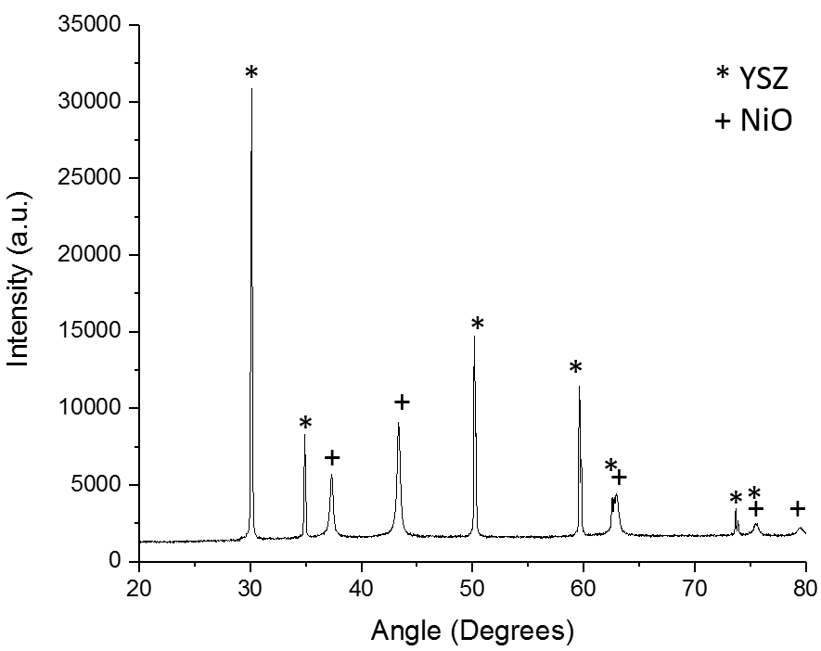
Figure 4.2: X-ray diffraction pattern of the infiltrated NiO-YSZ sample dried in Air and then calcined for at 350 °C for 1.5 hours [382].
The resulting diffraction patterns were analysed and matched to YSZ, nickel oxide and nickel samples in the ICDD PDF4+ database and the Bruker Diffrac. Eva program (Figure 4.2, Table 4.2) [382].
Table 4.2: A table detailing the International Crystallographic Diffraction Database PDF cards that the P17 sample has matched with during analysis
Compound | PDF card no. | Composition | Analysis program
Yttria zirconium oxide | 04-016-2092 | Y_{0.12}Zr_{0.88}O_{1.94} | PDF4+ 2016
Nickel oxide | 00-047-1049 | NiO | PDF4+ 2016
Yttria zirconium oxide | 04-010-3268 | Y_{0.12}Zr_{0.88}O_{1.94} | PDF4+ 2016
Nickel oxide | 00-044-1159 | NiO | PDF4+ 2016
Yttria zirconium oxide | 04-018-5452 | Y_{0.12}Zr_{0.88}O_{1.94} | Bruker Diffrac Eva
Nickel oxide | 01-089-3080 | NiO | Bruker Diffrac Eva
Nickel (metal) | 2102245 (CIF) [383] | Ni | COD
Gadolinium doped ceria | 4341042 (CIF) [384] | Gd_{0.1}Ce_{0.9}O_{1.95} | COD
No characteristic XRD peaks were found for the nickel hydroxynitrite and other complex compounds that can be formed if the calcination step does not completely decompose the wet impregnated nickel nitrate[191], [194], [385]. In the case of both drying atmospheres conditions, XRD has confirmed that the calcination step does decompose the nickel nitrate to nanoscale bunsenite.
Additionally, to trial the impact of changing the ceramic backbone material, two infiltrated Ni-GDC samples were also scanned used the Bruker D2 XRD. This was to investigate the impact of the metal-scaffold interaction between the nickel and the GDC, the diffraction patterns for these samples can be found in the Appendix Section 4.3.1.

4.3.2 Chemical Identification

4.3.2.1 Fourier Transform Infra-red Spectroscopy
Fourier transform infra-red spectroscopy was performed on a Shimadzu IRAffinity-1S Fourier Transform Infra-red Spectrophotometer. Measurements of three nickel oxide samples and two dried nickel nitrate hexahydrate samples were taken (Figure 4.3 and Figure 4.4):
- Nickel Oxide powder (JT Baker)
- NiO-YSZ (Air dried)
- NiO-YSZ (N₂ dried)
FTIR was used to measure the chemical composition of the infiltrated NiO phase. The use of air in the drying and calcination atmospheres was discussed to promote the formation of undesirable nickel hydroxy nitrate phases[185], [186], [194], [386].
Each of the measurements share key absorption peaks for a variety of chemicals. Two of the chemicals present in all the spectra are CO₂ and H₂O based from the atmosphere around the KBr source [340]. These were evident from the various peaks associated with these atmospheric water namely: O-H absorptions at 3537 cm ⁻¹ and H-O-H bonding vibration at 1650 cm ⁻¹ respectively [319], [340], [387]. The sharp peak at 2350 cm ⁻¹ is attributed to stretching of C=O which is associated with CO₂ [319], [340], [388].
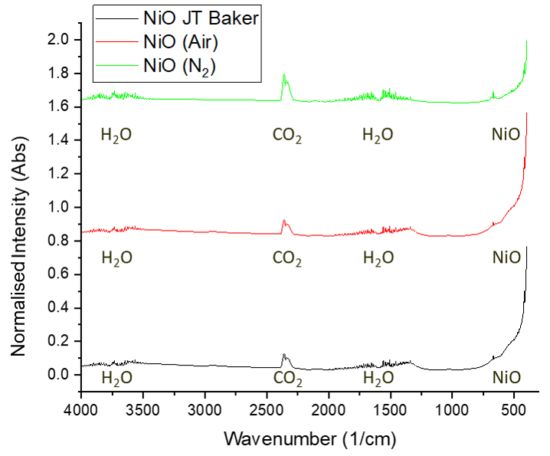
Figure 4.3: Overlaid FTIR spectra of the three NiO samples. The samples are offset by 0.8. The NiO calibration powder (JT Baker) and the NiO produced after air and nitrogen drying and calcination steps. The data was taken between wavenumbers of 4000-400 cm ⁻¹
In the case of compounds present in the calibration powder and wet impregnated samples the zirconia ceramic usually produces absorptions at 500 cm ⁻¹ and 560 cm ⁻¹ for YSZ, respectively [388]. This absorption was masked by the instrument. However, a peak associated with NiO can be seen at 412-420 cm ⁻¹ for all three of the samples (Figure 4.4) [340], [343], [389].
Figure 4.4: FTIR Spectra of NiO samples based around wavenumbers ranging between 750-400 cm ⁻¹
In addition to the calcined nickel oxide, nickel nitrate hexahydrate dried in both atmospheres was also analysed with FTIR. The spectra showed the presence of absorption bands relating to the free NO₃²⁻ ion(Figure 4.5)[390]–[392].
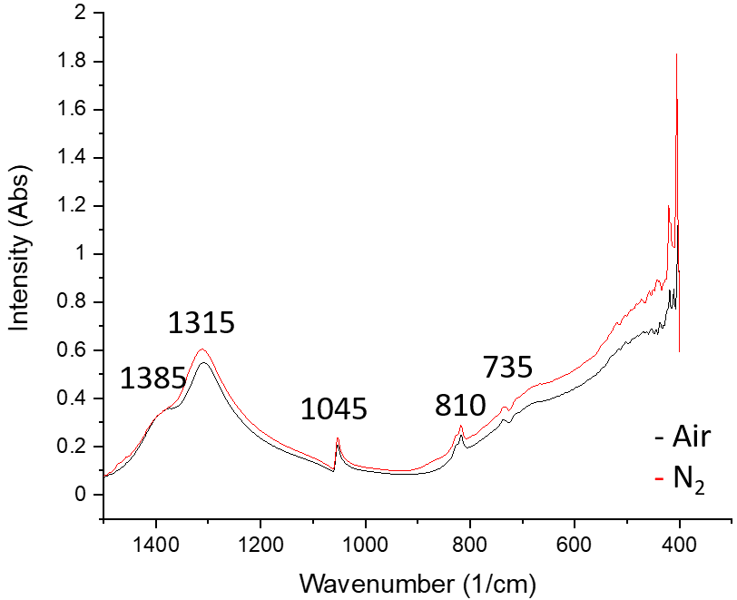
Figure 4.5: Overlaid FTIR spectra of nickel nitrate hexahydrate dried in air and nitrogen (denoted by the black and red series respectively) [47]–[49]
Upon further inspection, there was also the presence of the bunsenite related bands at 410 - 420 cm ⁻¹ which indicates that the nickel nitrate has already begun to decompose during drying(Figure 4.6) [340], [343], [389]. The presence of these eight bands underlines the speed of the decomposition of the nitrate material during the drying process.
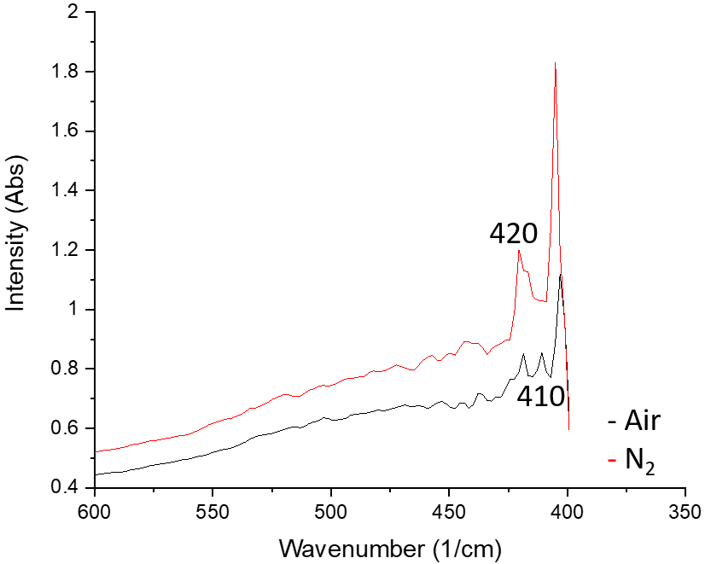
Figure 4.6: Overlaid FTIR spectra of nickel nitrate hexahydrate dried in air and nitrogen (denoted by the black and red series respectively)
There was no evidence of absorption peaks associated with nickel hydroxide or and nickel hydroxy nitrates. This indicates that the calcination step has been successful in the decomposition of nickel nitrate to nickel oxide under both air and nitrogen atmospheres.

4.3.3 Particle size analysis

4.3.3.1 WAXS crystallite size calculations
Two NiO-YSZ air dried and N₂ dried samples were analysed using the Argonne National Laboratory 9-ID beamline. Wide Angle X-ray scattering diffraction patterns of both samples were generated (Figure 4.8). The NiO crystallite lengths were calculated using the Debye-Scherrer analysis. The purpose of these results was to remove any nano strain-based contributions to the FWHM which would impact the crystallite length calculations. A comparison of NiO-YSZ X-ray diffraction and Wide-Angle X-ray scattering spectra can be found in Figure 4.7. From Figure 4.7 the NiO WAXS reflections are far more intense than the spectra gathered on the Bruker D2. The use of WAXS also removed the K_{β} contribution present at Q =3.4 Å ⁻¹. A comparison between AD and ND NiO-YSZ is shown in Figure 4.8.
Figure 4.7: Wide Angle X-ray Scattering diffraction pattern of an NiO-YSZ electrode sample (Air-dried) post calcination.
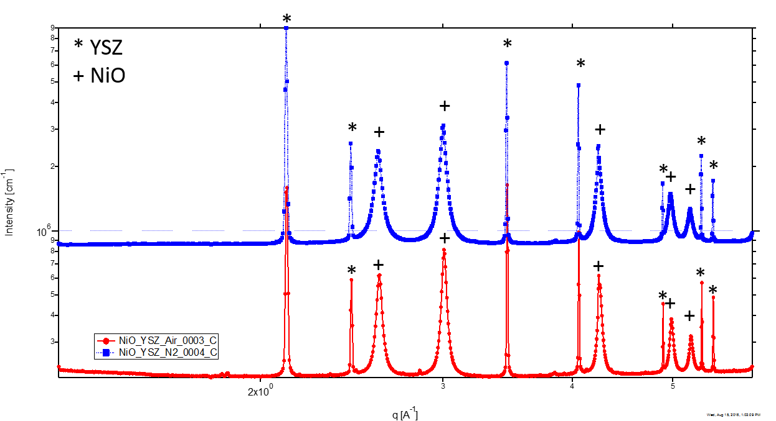
Figure 4.8: Wide Angle X-ray Scattering diffraction patterns of Pellet A and B (Air red and N₂ ₋dried blue respectively).
The crystallite length after the removal of the strain component is expected to increase after the removal of the strain component as the numerator is kept constant, whilst the denominator is concurrently reduced (See 3.3.1.1). The upper and lower range for the particle size for the Debye-Scherrer and Williamson Hall corrected values intersect. The use of higher flux (reduced wavelength) X-rays on the 9ID beamline has reduced the calculated crystallite lengths as much more of the strain contribution is removed by the higher X-ray flux.
Table 4.3: Table of the NiO and Ni crystallite length in nm calculated using Debye-Scherrer and Williamson Hall methods using two different X-ray Diffraction techniques for Ni-YSZ and Ni-GDC samples.
Sample composition  (Drying condition) | Crystallite Length in nm and determination method (Detector)
Sample composition  (Drying condition) | Debye-Scherrer  (D2) [nm] | Williamson Hall  (D2) [nm] | Debye-Scherrer  (9ID) [nm]
NiO-YSZ (AD) | 25.73 ± 1.01 | 27.06 ± 0.45 | 14.71 ± 1.13
NiO-YSZ (ND) | 19.65 ± 1.01 | 20.86 ± 0.39 | 10.20 ± 1.13
Ni-YSZ (AD) | 21.04 ± 1.01 | 22.16 ± 0.38 | N/A
Ni-YSZ (ND) | 16.88 ± 1.01 | 18.19 ± 0.31 | N/A
NiO-GDC (AD) | 7.37± 1.01 | N/A | N/A
NiO-GDC (ND) | 9.81± 1.01 | N/A | N/A
The use of the inert N₂ atmosphere has been shown to reduce the size of the infiltrated nickel oxide crystallites by 30 % compared to the air atmosphere (Table 4.3). This reduction was present in all the crystallite length calculations. Due to experimental procedure having identical drying, calcination temperatures and duration this indicates that the drying atmosphere is the sole parameter that controls the crystallite length in infiltrated Ni-YSZ cells. After reduction, the size difference between the two datasets became 22 %. The reduction decreased the crystallite length of the nickel by 15-20 %.
A 33 % reduction in the nickel crystallite length was also recorded for the Ni-GDC samples. This indicates that the size reduction mechanism induced by drying is not scaffold dependent. The nickel nanoparticle in this case does not equate solely with the crystallite length as a particle can consist of a group of crystallites. However, the monitoring the crystallite length can help monitor what is microstructural changes in the nickel phase as it evolves over time.
The reduction of the infiltrated NiO crystallites into metallic Ni nanoparticles occurs during the temperature ramp of the SOFC. This initiates an increase in the crystallite length of the catalyst as monitored by the Debye-Scherrer equation. The nickel length is detailed in Figure 4.88.

4.3.4 Microstructural Evaluation

Microstructural evaluation using scanning electron microscopy (Surface, cross-sectional)
Micrographs were taken of the as-reduced Ni-YSZ samples and additionally the 50 h aged samples for both surface and cross-sectional work. These were taken to show qualitatively that the drying atmosphere does impact the microstructure of the infiltrated fuel electrode.
Additionally, micrographs were taken of the dried nickel nitrate solution on a YSZ substrate and a porous YSZ scaffold for both drying conditions.

Surface
The nickel nitrate solution dried on the YSZ electrolyte dried into 25 µm wide overlapping plates on the surface of the substrate. Despite the flat substrate these plates have formed stacking layered structures seen in Figure 4.9.
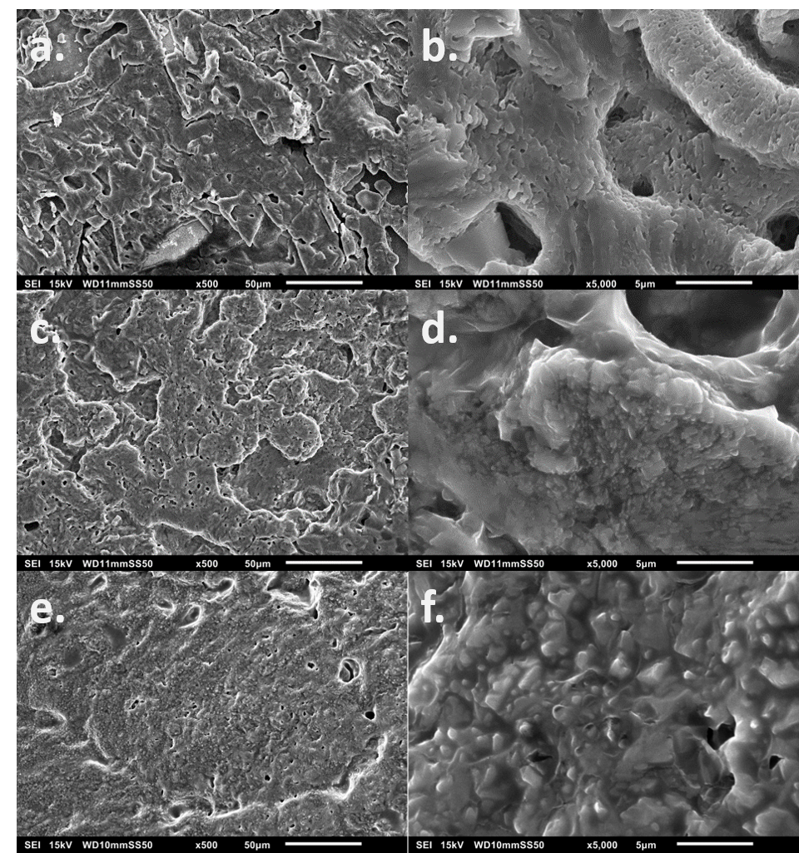
Figure 4.9: Scanning electron micrographs of the dried nickel nitrate solution dried on: a. YSZ electrolyte pellet 500x (b. 5000x magnification), c. YSZ porous scaffold under an air atmosphere 500x (d. 5000x magnification), e. YSZ porous scaffold under an N₂ atmosphere and (f. 5000x magnification)
After the wet impregnation of the infiltrate solution into the porous YSZ scaffold, the drying characteristics of the nickel nitrate differed under the two-drying atmospheres. Stacked nitrate plates are visible in Figure 4.9b and d particles have formed inside the deposited solid.

As reduced samples
The infiltrated nickel catalyst particles were imaged after a 1 h reduction at 350⁰C in 10% H₂/N₂ to emulate the in-situ reduction performed during SOFC operation. The surface of the wet impregnated electrodes consisted of a porous YSZ ceramic backbone with spherical nickel particles. A 5 µm * 5 µm region was selected in both micrographs. The nickel particle length was calculated using FIJI measurements on 50 particles in these sections a table detailing the average particle length can be found below (Table 4.4).
The surface of the AD sample (Figure 4.10) showed that the nickel particles were spherical in nature after the reduction. These particles ranged from 34-185 nm in length.
Figure 4.10: Scanning electron microscopy of the surface if the air-dried Ni-YSZ electrode after a reduction at 350 °C
In contrast, the surface of the ND dried electrode had less prominent nickel features. This was a result of the N₂ drying step having produced smaller more well dispersed nickel particles (Figure 4.11). This was also evident from the Debye-Scherrer and dispersion calculations in Section 4.3.2. The nickel in these electrodes ranged from 18-111 nm in length (Table 4.4).
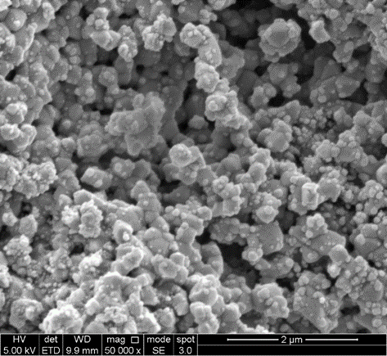
Figure 4.11: Scanning electron microscopy of the surface if the nitrogen-dried Ni-YSZ electrode after a reduction at 350 °C
Table 4.4: Table detailing the average nickel particle length for wet impregnated Ni-YSZ electrodes dried in either Air or N₂
Sample | Average particle length (nm)
Ni-YSZ (Air Dried) | 86.0 ± 11.6
Ni-YSZ (N₂ dried) | 47.6 ± 21.0

Aged Ni-YSZ samples
The surface of the wet impregnated electrode samples was then imaged after a 50 h ageing routine. The ageing conditions were identical to the that used in the EIS work (800⁰C, humidified 10 % H₂/N₂ atmosphere) for comparison purposes.
The decoration of the nickel catalyst lining the pores are evident in both sets of samples. This indicates that the wet impregnated catalyst network is still active. The circled particles illustrate the spherical morphology of the catalyst during ageing in H₂ (Figure 4.12 and Figure 4.13).
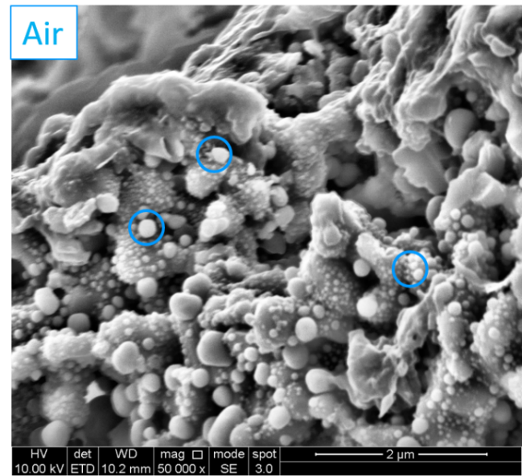
Figure 4.12: Scanning electron microscopy of the surface if the air-dried Ni-YSZ electrode aged for 50h in a 800 ⁰C 10 %H₂/N₂ atmosphere
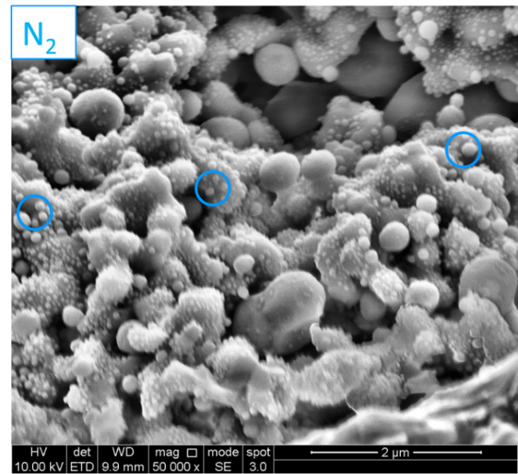
Figure 4.13: Scanning electron microscopy of the surface if the N₂-dried Ni-YSZ electrode aged for 50 h in a 800 ⁰C 10 % H₂/N₂ atmosphere
Both micrographs display a wide particle size distribution from 40-125 nm. The particles exceeding 200 nm are also visible at the edges of the pores and not present within them. This illustrates the fact that the particle coarsening rate appears to be reduced within the pore network. This was discussed as a method of sintering resistance by both Goodman and Buyukaksoy [233], [300].

Cross Section
The right-hand side of Figure 4.14 and Figure 4.15 show the YSZ electrolyte and 15 µm of Ni-YSZ electrode respectively.
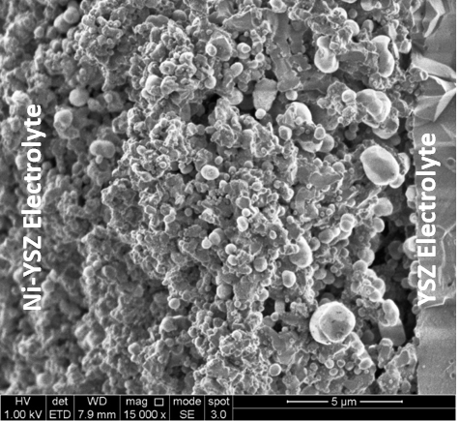
Figure 4.14: Scanning electron micrograph of the fractured cross section of an infiltrated Ni-YSZ fuel electrode sample (AD) aged for 50 h in an 800 ⁰C 10 % H₂/N₂ atmosphere
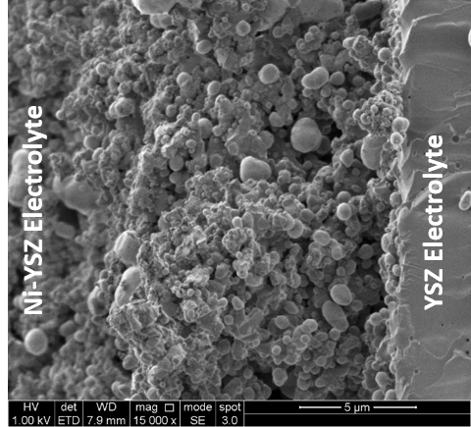
Figure 4.15: Scanning electron micrograph of the fractured cross section an infiltrated Ni-YSZ fuel electrode sample (ND) aged for 50 h in an 800 ⁰C 10 % H₂/N₂ atmosphere
The 50 h aged, air-dried Ni-YSZ sample has two agglomerates stacked upon one another (circled bottom right, Figure 4.14). This behaviour is a visual example of particle migration coalescence (PMC), a sintering mechanism where larger agglomerates attract smaller particles with a view to reducing both particles surface energy [300], [301]. The deposited catalyst can stack due to the repeated precursor solution injections in the infiltration procedure.
In contrast, the nickel phase in the micrograph of the N₂ dried electrode did not appear to be faceted. No obvious particle stacking, or PMC was seen in the cross-section of this sample. There were only two infiltration steps in the procedure for this study which suggests that the stacking in Figure 4.14 is largely the product of the drying conditions used for the electrode. As the nitrogen drying step expected to increase the dispersion of the particles the average particle size should be consistently smaller during ageing. This is evident with the average particle lengths calculated using FIJI in Table 4.5.
Table 4.5: Average particle length for the pristine and aged Ni-YSZ wet impregnated samples
Sample | Average Particle Length [nm]
Sample | 0h | 50h cross-section
Ni-YSZ (Air) | 86.0 | 805.7
Ni-YSZ (N₂) | 47.6 | 601.3

The nickel particles in the nitrogen dried system were after reduction 45.3 % smaller than their air counterpart. After 50 h of ageing at 800⁰C in the humidified 10 % H₂/N₂ atmosphere this reduction fell to 33.9 %. This confirms that the nitrogen drying atmosphere does reduce the initial nickel particle size and hinders sintering processes during ageing. However, it also suggests that - assuming a linear decrease - this reduced particle size will only last within the first 200h of ageing (0.5 % of the reported SOFC 40,000 h lifetime) [73], [393].
One of the key challenges with image analysis of Ni-YSZ is discerning the metallic phase from the ceramic backbone. Additionally, this issue is commonplace in micrograph throughout the literature [130], [394], [395]. This lack of clarity is especially apparent in Figures 4.15 and 4.16.
Micrographs using vacuum infiltrated epoxy resin were attempted during this project however due to the fragility of the scaffold the resin also coated the electrode cross-section during mounting, making phase contrast and segmentation difficult.
Back-scattered electron imaging was also performed, this underlined that the circular particles in the micrographs were nickel (as nickel has the lowest Z number in the electrode). Secondly, the nickel particles in this section were identified with their spherical morphology.
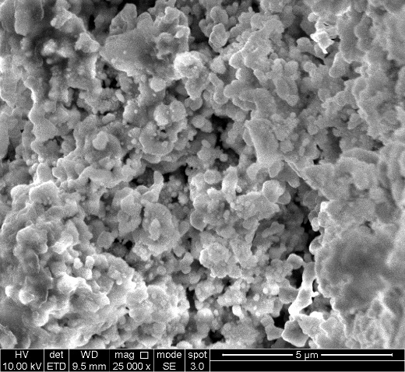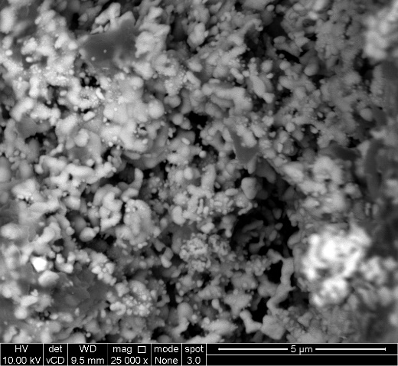
Figure 4.16: Micrographs of a 50h aged Ni-YSZ sample (secondary electron on the left, back-scattered electron on the right)
The SEM performed on the Ni-YSZ electrodes has shown that the use of a nitrogen drying atmosphere has reduced the initial and aged particle size of the catalyst phase. The micrographs shown indicate that the nitrogen drying atmosphere does impact the size and dispersion of the electro-catalyst. How these microstructural differences impact the reactivity and electrochemical performance of the solid oxide fuel electrodes are highlighted in sections 4.3.4 and 4.3.5.

4.3.5 Reactivity analysis

4.3.5.1 Temperature Programmed Reduction – active area measurements
A set of calibration profiles on NiO powder (JT Baker, USA) ranging from 3-20 mg were performed using the Micromeritics 2720 Chemisorption unit. These can be found in the Appendix 4.3.5. In the surface catalysis literature, there are multiple reduction peaks which detail the conversion of NiO to metallic nickel. Studies on bulk NiO have charted this interaction to fall between 350-400 °C [377], [396]. Nanoscale nickel particles have been documented to reduce at temperatures ranging between 290-350 °C. In this study the nickel oxide has been shown to be nanoscale in length due to the use of infiltration and the crystallite length calculations from XRD (Section 4.3.2).
The morphology of the reduction peaks in Figure 4.17 provide indicators to the size distribution of the infiltrated nickel particles present on the samples. In the AD samples there were a maximum of 5 reduction peaks in present between 290-330 °C region, in addition to bulk reductions at 375-385 ⁰C (Figure 4.89). This shows that the nickel particle size present in these samples range up to 50 nm. This is a result of the air-drying step producing complex nickel hydroxy nitrates [194], [204], [206].
Deconvolution of the TPR profiles for the NiO-YSZ samples was performed in OriginPro using a Gaussian distribution (Figure 4.18). The analysis revealed that the air-dried samples had a minimum of 6 reduction events (peaks) which is indicative of a heterogeneous particle size distribution in the NiO catalyst. The area beneath the peaks was calculated via integration for each of the reduction reactions. The reduction of NiO to metallic nickel has been documented to occur between 290 – 390 °C which has been further highlighted by the NiO-YSZ in this study.
Figure 4.17: Normalised Temperature Programmed Reduction profiles of all of the drying and calcination combinations and a 3.0mg NiO calibration sample from JT Baker.
For the AD samples the initial reduction between 290 – 320 °C are shared with interactions at 295, 313 and 317 °C (Table 4.6). These reactions account for 24.7 and 37.5 % for the AD AC and AD NC samples respectively. This indicates that the nitrogen calcination step has reduced the particle size distribution between the two systems. The % area of the surface NiO nanoparticles at 290 °C has not differed between the two datasets (13 %) which indicates that the calcination does not impact the smallest NiO nanoparticles. In the first 50 °C of reduction (290 -340 °C) the AC specimen also had another interaction at 305.2 °C which is not present in its NC counterpart. The inert calcination step has also increased the reducibility of the bulk NiO agglomerates shifting the interactions from 378.0 and 384.6 °C to 357.8 and 369.4 °C respectively. For the AD AC sample, the first 5 reduction events occurred in the first 50 °C region which was 2.7 % lower than its NC counterpart.
Table 4.6: Table showing the different reduction peak positions and % area per peak in the infiltrated NiO-YSZ samples processed with either an Air or Nitrogen atmosphere
Processing Condition | Peak Position [°C] | Integrated Peak Area | Area per Reduction Peak [%] |  | Processing Condition | Peak Position [°C] | Integrated Peak Area | Area per Reduction Peak [%]
AD AC | 292.0 | 9.00 | 13.04 |  | AD NC | 295.6 | 8.70 | 13.73
AD AC | 305.2 | 3.71 | 5.38 |  | AD NC | 313.2 | 0.63 | 0.99
AD AC | 312.7 | 0.87 | 1.26 |  | AD NC | 317.2 | 14.46 | 22.80
AD AC | 317.0 | 3.48 | 5.04 |  | AD NC | 338.4 | 18.67 | 29.43
AD AC | 321.0 | 27.30 | 39.54 |  | AD NC | 357.8 | 17.23 | 27.17
AD AC | 378.0 | 23.89 | 34.61 |  | AD NC | 369.4 | 3.73 | 5.88
AD AC | 384.6 | 0.79 | 1.14 |  | AD NC
Processing Condition | Peak Position [°C] | Integrated Peak Area | Area per Reduction Peak [%] |  | Processing Condition | Peak Position [°C] | Integrated Peak Area | Area per Reduction Peak [%]
ND NC | 349.5 | 4.36 | 19.99 |  | ND AC | 375.2 | 30.12 | 100.00
ND NC | 357.8 | 17.45 | 80.01 |  | ND AC

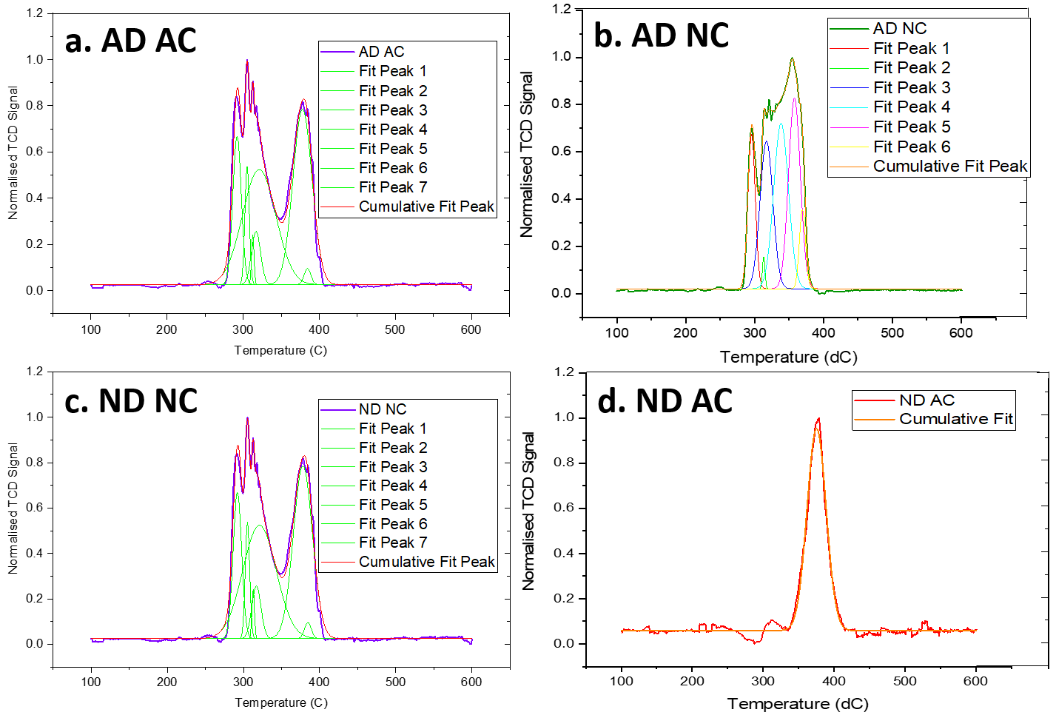
Figure 4.18: Deconvolution of TPR profiles of NiO-YSZ samples using a Gaussian distribution. a. Air Dried Air Calcined, b. Air Dried Nitrogen Calcined, c. Nitrogen Dried Nitrogen Calcined and d. Nitrogen Dried Air Calcined
In contrast, the ND samples possessed one distinct reduction peak, indicating very little variation in size of the wet impregnated nickel present (Figure 4.17). The lack of particle size variation has contributed to simple single-step reduction. This is supported by the fact the pure ND NC routine completely reduced in 40⁰C window compared to the 90⁰C of the bulk NiO calibration sample (See Figure 4.17). The reduction of nickel oxide to metallic nickel in the presence of a reductive gas can be described by Equation 4.1.
$$NiO+H_{2 }→Ni+ H_{2}O$$
Equation 4.1
The impact of the N₂ calcination step is illustrated by the fact that the AD NC sample reduction finished at 385⁰C a total of 20⁰C earlier than its other air-dried counterpart. In addition, the fact that the air calcined samples both had reduced reaction rate demonstrated by their longer TPR profiles.
It is well documented that increasing the calcination temperature of wet impregnated nitrate materials also reduces their surface area [176], [397]. This occurs as result of early stage particle sintering due to the calcination step [398]. However, the samples in this study were all calcined at the same temperatures and times using the same furnace to eliminate instrument and conditional effects.
The nitrogen calcination step has increased the degree of reducibility for the infiltrated nickel particles. This underlines the importance of utilising inert gas atmospheres in the preparation of heterogeneous catalysts.
The percent dispersion of a Ni-YSZ sample was calculated for the sample aged between 0-3 h of ageing [297], [339]. In Figure 4.19 the dispersion of the samples decreased by 48 % after the first hour of ageing. This is the opposite of the crystallite length of the nickel species, which rose after 3 h of ageing. This indicates that the sintering of the nickel phase into larger agglomerates impacts the dispersion of the catalyst species. The initial dispersion of the nickel species can be found below in Table 4.6.
Table 4.7: Table detailing the % dispersion of the Ni species in the wet impregnated fuel electrode samples
Sample composition  (Drying condition) | Crystallite Length in nm and determination method (Detector) |  |  | Percent dispersion of the infiltrated nanoparticles  [%]
Sample composition  (Drying condition) | Debye-Scherrer  (D2) [nm] | Williamson Hall  (D2) [nm] | Debye-Scherrer  (9ID) [nm] | Percent dispersion of the infiltrated nanoparticles  [%]
NiO-YSZ (AD AC) | 25.73 ± 1.01 | 27.06 ± 0.45 | 14.71 ± 1.13 | 4.73
NiO-YSZ (ND NC) | 19.65 ± 1.01 | 20.86 ± 0.39 | 10.20 ± 1.13 | 6.19
The dispersion of the infiltrated nickel electrocatalyst increased post reduction due to the crystallite length of the particles being reduced during the nitrogen drying step. As the catalyst phase coarsens under the elevated temperatures the crystallite length increases rapidly. Therefore, the dispersion of the particles drops due to the formation of large agglomerates.
Figure 4.19: Comparison of the impact of ageing time on the crystallite length (in nm) and % dispersion of the Ni in Ni-YSZ fuel electrodes (ND).

4.3.6 Electrochemical Performance

4.3.6.1 Electrical Impedance Spectroscopy
The electrochemical response of the symmetrical Ni-YSZ cells was gathered using a Solartron 1250/1287 frequency response analyser. Initially the infiltrated Ni-YSZ cells were coated with a silver current collector (Gwent) however this appeared to cause consistency issues with the samples. The electrolyte contribution was calculated as the resulting series resistance after the impedance jig contributions (1 Ω) were subtracted from the measured R_{S} prior to area normalisation. The Ni-YSZ fuel electrode contribution was calculated to be the R_{P} between the R_{S} and I₂ intercept (Section 3.3.6) [399], [400].
Figure 4.20 and Figure 4.21 detail the evolution of the series and polarisation resistance were taken using a silver current collector [315]. Three repeats were performed for both sets of samples.
Figure 4.20: Series resistance for infiltrated Ni-YSZ samples dried under different atmospheres across 50h of ageing. The filled markers denote that the sample was dried in air (AD), red non-filled markers (ND).
Figure 4.21: Polarisation resistance for infiltrated Ni-YSZ samples dried under different atmospheres across 50h of ageing. The filled markers denote that the sample was dried in air (AD), red non-filled markers (ND).
The series resistance of the air-dried samples (AD) R_{S} after 50 h of ageing appeared to be consistently 6 Ωcm². This was not the case with the ND samples which ranged between 11-15 Ωcm² this pointed to an issue with either the electrode or the current collector. It was found that the current collector material was delaminating during operation leading to suboptimal electrical contact for the impedance equipment. Further work into the impact of current collector degradation on the polarisation resistance of the Ni-YSZ cells can be found in Chapter 5.
The contribution associated with the YSZ electrolyte at 800°C was measured across and ageing period of 50h. The switch in current collector material to nickel oxide had a profound impact on the R_{P} of the symmetrical cells. The R_{P} of the cells dropped by over 50 % from just the switch in current collector material (Figures 4.22, 4.23 and 4.24).
Figure 4.22: Scatter graph detailing the evolution of the series and polarisation resistance of a YSZ electrolyte pellet over 50h of ageing at 800°C using a NiO current collector. The black series denotes the series resistance and the red polarisation resistance respectively
Figure 4.23: Series resistance for infiltrated Ni-YSZ samples across 50h of ageing. The filled markers denote that the sample was dried in air (AD), non-filled markers (ND). The diamond marker shape shows that the sample was calcined in air (AC) and the square calcined in (NC) respectively

Figure 4.24: Polarisation resistance for infiltrated Ni-YSZ samples across 50h of ageing. The filled markers denote that the sample was dried in air (AD), red non-filled markers (ND). The diamond marker shape shows that the sample was calcined in air (AC) and the square calcined in (NC) respectively
The lowest initial polarisation resistance was recorded by the ND AC sample. With the highest R_{P} being recorded by its other nitrogen dried counterpart. However, this does not indicate that the ND NC samples was worst performing of the set, just that it had the highest R_{P} after 50h.
When the change in the polarisation resistance for the symmetrical samples from pristine to 50 h is calculated and displayed the largest change is Rp is displayed by the AD AC samples (Table 4.8).
Table 4.8: Series and polarisation resistance of wet impregnated Ni-YSZ symmetrical cells dried and calcined under different atmospheres
Sample (Drying and Calcination atmosphere) | Initial Series Resistance, Rs₀  [Ωcm²] | Initial Polarisation Resistance, R_{P0} [Ωcm²] | Series Resistance after 50h of ageing, Rs  [Ωcm²] | Polarisation  Resistance after 50h of ageing, R_{P} [Ωcm²]
ND NC | 1.59 | 21.64 | 4.45 | 42.14
ND AC | 3.91 | 15.42 | 5.86 | 20.09
AD AC | 3.35 | 12.39 | 5.16 | 39.89
AD NC | 5.80 | 21.68 | 7.64 | 38.01

3D Nyquist plots of the five samples shown in Figure 4.24 were plotted with respect to the normalised Z’, Z’’ and ageing time. The legends in Figures 4.25, 4.26, 4.27 and 4.28 show the impedance arcs from red to pink corresponding to 0-50 h ageing time in 10 h increments.
Figure 4.25: Nyquist plot detailing the evolution of the Z’ and Z’’ of the ND AC sample over 50h of ageing time. The blocked points indicate frequency increments between 10 ⁻¹ – 10 ⁴ Hz
For all four samples the polarisation resistance after 50h of ageing exceeded the initial polarisation resistance. The nitrogen dried and calcined sample (ND NC) produced the highest polarisation resistance of any of the other samples discussed in this work. A second meso frequency arc was visible after 30 h of ageing, which was unique to this sample. The lowest final polarisation resistance was generated by the other nitrogen dried sample (Table 4.8).
Figure 4.26: Nyquist plot detailing the evolution of the Z’ and Z’’ of the ND NC sample over 50h of ageing time. The blocked points indicate frequency increments between 10⁻¹ – 10⁴ Hz
Figure 4.27: Nyquist plot detailing the evolution of the Z’ and Z’’ of the AD AC sample over 50h of ageing time. The blocked points indicate frequency increments between 10 ⁻¹ – 10 ⁴ Hz
Figure 4.28: Nyquist plot detailing the evolution of the Z’ and Z’’ of the AD NC sample over 50h of ageing time. The blocked points indicate frequency increments between 10 ⁻¹ – 10 ⁴ Hz
As a nanoscale system the infiltrated nickel catalyst phase is susceptible to coarsening in a bid to reduce its surface area under elevated temperatures such as those used in SOFCs. In this study the drying and calcination atmospheres are being investigated to determine whether the change in these processing steps impact the electrochemical properties of the samples.
The major resistive element being monitored is the polarisation resistance, Rp. This is derived from charge transfer reactions in the wet impregnated Ni-YSZ electrode sample [22], [401]. The samples were aged for a period of 50 h as discussed in Section 4.2.2.
The coarsening of nanoscale systems has been documented to follow three steps an initiation, propagation and stabilisation steps [402]. The use of EIS in this work is to track these phenomena by monitoring the evolution of R_{P} in the first 50 h of ageing. Figure 4.29 (below) shows the change in the polarisation resistance between 0-10 h and 0-50 h for each of wet impregnated fuel electrode samples.
Figure 4.29: Bar chart showing the change in the polarisation resistance, Rp of the infiltrated NI-YSZ samples after 10h and 50h ageing time
The AD samples both produced an increase in Rp after 10 and 50 h of ageing. However, the AD AC sample had a 9.775 Ωcm² increase in R_{P} during the 10-50 h aged time-period. This combined with the visual evidence in Figure 4.24 indicate that the electrode degradation mechanisms present in this sample set differ to those samples with nitrogen based drying and calcination steps.
The previously mentioned change in R_{P} is the largest change exhibited by any of the infiltrated samples discussed in this work. Indicating that the air calcination stage has exacerbated the degradation mechanisms. This is due to the coarsening initiation step having been elongated by the calcination in air [118].
Generally, a plateau appears in the samples from an ageing time of 10 h onwards which shows that the catalytic media have transitioned to the second stage of coarsening. This indicates that the first sintering stage dominates in the first 10 h of ageing. The exception to this rule appears to be the ND AC sample. Several works in the fuel electrode literature pre-age their systems for 100 h prior to electrochemical assessment [224], [403]. This fact that this behaviour is shared amongst four of the samples demonstrates that pre-coarsening step utilised in the literature appears to be excessive.
This is especially highlighted by the R_{P} change between 10-50 h of the ND NC sample which drops compared to the first 10 h of this ageing period. The systematic error between the samples was calculated to range between 0.02-0.05 % [404]. In fact, the R_{P} dropped by 2.54 % portraying a slight recovery of the infiltrated system. This drop was unexpected as the polarisation resistance is usually documented to rise during ageing. This behaviour was evident in both air-dried samples (AD NC with 9.77 % increase between 10-50 h).
A similar but more pronounced drop was also exhibited by the ND AC sample which suggests that this behaviour is not limited by the calcination step which are different for both samples. Nitrogen drying appears to be the most impactful combination in reducing R_{P}. However, in this sample 32.36 % drop denotes that the recovery mechanism present is far more prevalent than its ND NC counterpart.
This illustrates the impact of utilising an inert nitrogen-based atmosphere processing where the initial R_{P} degradation appears to have been largely constrained to the first 10 h of ageing. Over 90 % of the increase in R_{P} occurred for the AD NC calcined sample within the first 10 h. This underlines the importance of determining the early-stage rate limiting steps in infiltrated SOFC electrodes.
Additionally, it also highlights how implementing an inert N₂ atmosphere… in either the drying or calcination step reduces the rate of fuel electrode degradation. This was evident in the ND AC and AD NC samples which had the lowest Rp increases compared to the samples with same atmosphere drying and calcination steps.
The nitrogen drying step produced the smallest change in the polarisation resistance, with a Rp almost 50% of the other samples in this study. This highlights that nitrogen drying is a key processing step for wet impregnated solid oxide fuel electrodes.

Equivalent Circuit Fitting
The initial fitting of the Nyquist plots of the data using the circuit detailed in Figure 4.30 did not correctly fit the impedance arcs present in the data. A second low frequency arc (0.1-10 Hz) was also present in the data (Figure 4.31). This arc derived from the gas diffusion interaction with the electrode has been fit using two additional parallel resistor components to Figure 4.32 [314], [394], [405]. This arc has been present in all the electrochemical impedance data taken during this study. This arc is not fit well using the IF function.
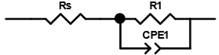
Figure 4.30: Equivalent circuit used for the first fitting of the EIS data for the infiltrated Ni-YSZ symmetric cells utilising a resistor Rs and an RQ component [130], [131], [233], [354]
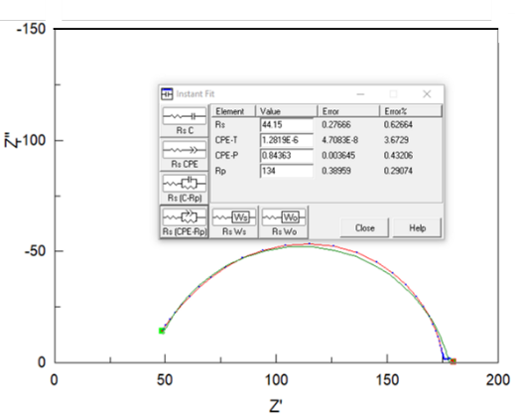
Figure 4.31: Nyquist plot of the ND AC samples (50h aged). The instant fitting (green) can be seen in the data using Figure 4.32.
The polarisation resistance R_{P} in the electrode is a combination of both arcs R_{P} = R₁+R₂. Iterations of the equivalent circuit fit were done utilising an additional RQ then an RC component [314], [394], [405].

Figure 4.32: : Equivalent circuit used for the first fitting of the EIS data for the infiltrated Ni-YSZ symmetric cells [405]
The error for the R₁ arc was minimised in the EC fitting to less than 1 %. In contrast, the percentage error in R₂ was consistently larger than 10 % for all the samples. However, due to the difference in magnitude between R₁ and R₂ % error in R is far higher than the first arc. The reasons for this high error are twofold: the calc modulus function in ZView weights each of the data points equally including the second arc. This skews the error between the large R1 arc and the smaller R2 despite the error (Ω) for both samples being within the same scale factor.

AD AC
The resistive characteristics of the pristine Ni-YSZ sample were fit using the equivalent circuit in Figure 4.32. The low frequency arc (0.1-10 Hz) gas diffusion impedance arc developed within the first 5 h of ageing in the AD AC sample. This indicates that this the reaction producing this arc is capacitive in nature. This arc persisted throughout the ageing process.
Table 4.9: Table detailing the percent errors in the calculated Rs and Rp for the AD AC sample
Sample | Ageing Time | Rs [Ωcm²] | Rs Error [%] | Rp [Ωcm²] | Rp Error [%]
AD AC | 0 | 3.14 | 2.71 | 12.41 | 9.26
AD AC | 5 | 3.65 | 0.76 | 23.59 | 3.03
AD AC | 10 | 3.97 | 0.76 | 29.36 | 2.12
AD AC | 15 | 4.13 | 0.66 | 34.33 | 1.69
AD AC | 20 | 4.73 | 0.45 | 29.15 | 1.97
AD AC | 25 | 4.66 | 0.32 | 27.40 | 2.02
AD AC | 30 | 5.07 | 0.43 | 35.44 | 1.93
AD AC | 35 | 5.00 | 0.34 | 34.07 | 2.90
AD AC | 40 | 4.93 | 0.33 | 34.58 | 2.98
AD AC | 45 | 5.06 | 0.32 | 32.72 | 3.35
AD AC | 50 | 5.16 | 0.329 | 39.63 | 2.86

The largest percent error was recorded for the pristine Ni-YSZ sample in both the series and polarisation resistances (Table 4.9). Despite this the error for the Rp was largely restricted between 1-10 %. An example of the fit of the model circuit can be found below and in Figure 4.33:
Figure 4.33: Nyquist plot of the AD AC sample after 50h of ageing. The line series is the fit achieved using the EC in Figure 4.34.
The magnitude of the second impedance arc suggests that the degradation mechanism present in this sample differs to the other samples. The fact that this sample possessed the largest increase in Rp for both the dataset and the EC fitting indicates air processing does not reduce the impact of sintering.

AD NC
This presence of the second electrochemical arc (0.1-2000 Hz) was visible in the Nyquist plot from the pristine to 50h aged conditions for the AD NC dataset. An equivalent circuit utilising 1R 2RQ components was utilised to fit the experimental data.
Table 4.10: Table detailing the % errors in the calculated Rs and Rp for the AD NC sample. The errors greater than 10% are indicated in red
Sample | Ageing Time | Rs [Ωcm²] | Rs Error [%] | Rp [Ωcm²] | Rp Error [%]
AD NC | 0 | 2.60 | 1.21 | 22.38 | 16.07
AD NC | 5 | 2.98 | 1.06 | 37.08 | 7.83
AD NC | 10 | 3.34 | 0.71 | 32.94 | 1.32
AD NC | 15 | 2.66 | 8.87 | 33.08 | 15.06
AD NC | 20 | 3.44 | 8.68 | 32.42 | 7.17
AD NC | 25 | 2.83 | 15.71 | 38.06 | 5.83
AD NC | 30 | 2.51 | 56.36 | 40.47 | 5.78
AD NC | 35 | 4.23 | 0.43 | 38.90 | 1.06
AD NC | 40 | 4.48 | 0.26 | 33.76 | 1.93
AD NC | 45 | 4.49 | 0.24 | 35.74 | 1.61
AD NC | 50 | 4.50 | 0.25 | 36.88 | 1.57

Errors exceeding 10 % are displayed by in Table 4.10 by the presence of red writing. For the series resistance the modelled R_{S} is appears to have dipped in the 25-30 h region leading to an increased error. The error in the Rp at 0h is due to noise in the data between 0.1-2000 Hz from the second emerging impedance arc. An example of the fit is provided below in Figure 4.34. The fitting for 0-50 h in 10 h increments can be found in Figure 4.28.
Figure 4.34: The EC fit of the AD NC sample using an EC utilised 1R and 2RQ in series
The modelled dataset possessed had a reduction of 11.22 % reduction in the change in Rp compared to its experimental counterpart. Despite the magnitude of this change, the fit still retained the same characteristics for the Rp across 50h. The average error across the Rp fit being 5.93 % which is considering that ZView struggles to quantify the overlap between the electrode impedance contributions is acceptable. Both the experimental and EC data underline the fact that the rate of Rp degradation is reduced by using a N₂ calcination step.

ND NC
This sample was unique in the infiltrated dataset due to its Nyquist plot showing the presence of three distinct impedance arcs. These arcs ranged from:
- 1500 – 65000 Hz Electrode contribution
- 10 - 1500 Hz Meso frequency gas diffusion impedance from porous transport
- 0.1 - 10 Hz Gas diffusion impedance


Figure 4.104: EC circuit used to fit the ND AC wet impregnated sample
From inspection of the theta vs frequency plot these three arcs are confirmed in the experimental data. The unique arc (10-1500 Hz) in this sample is visualised more clearly as a shoulder in Figure 4.36. The magnitude of the fit polarisation resistance was modelled sing a resistor and three RQ circuits in series (Figure 4.104). The third RQ component was added to help simulate the 10-1500 Hz impedance arc which was only present in this sample. EC fitting of the data between 0 – 50 h of ageing can be found in Figure 4.28.
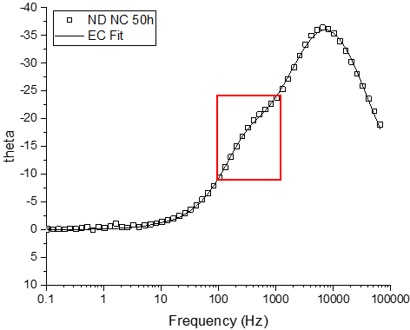
Figure 4.36:Theta vs Frequency plot for the ND NC sample fit using the equivalent circuit model shown in Figure 4.37. The new impedance arc is denoted by the red square
The fit shown in Figure 4.37 shows some inconsistencies in the EC fit between 100-1000 Hz. The fit at frequencies outside this range appeared to fit well for both the theta vs frequency plot and the Nyquist plot.
Figure 4.37: Nyquist plot of the ND NC sample with the EC fitted data
Despite the issue with the fit between the point of inflection at 1kHz the change in the Rp across the 50h ageing time between the EC and the data set was only 1.90 % (EC: 20.11 Ωcm², D: 20.499 Ωcm²). The use of the 3RQ elements to fit the three impedance arcs has helped to consistently minimise the average % error in the calculated Rp value to 2.80 % (Table 4.11). This was due to the emergence of a third impedance contribution.

Table 4.11: Table detailing the % errors in the calculated Rs and Rp for the ND NC sample
Sample | Ageing Time | Rs [Ωcm²] | Rs Error [%] | Rp [Ωcm²] | Rp Error [%]
ND NC | 0 | 1.52 | 0.79 | 21.52 | 6.27
ND NC | 5 | 2.34 | 0.92 | 39.95 | 1.24
ND NC | 10 | 2.94 | 0.82 | 42.07 | 2.45
ND NC | 15 | 3.12 | 0.89 | 47.92 | 2.42
ND NC | 20 | 3.42 | 0.72 | 42.74 | 2.26
ND NC | 25 | 3.60 | 0.69 | 42.79 | 2.27
ND NC | 30 | 3.91 | 0.61 | 42.39 | 2.41
ND NC | 35 | 4.16 | 0.64 | 42.14 | 3.00
ND NC | 40 | 4.34 | 0.62 | 41.95 | 2.83
ND NC | 45 | 4.52 | 0.59 | 47.32 | 2.51
ND NC | 50 | 4.76 | 0.60 | 41.63 | 3.00

Considering that the wet impregnated samples were all confirmed to be the same chemical composition by XRD and FTIR, the emergence of the impedance arc between 100-1500 Hz shows that processing the system entirely in N₂ has promoted an extra impedance contribution. This contribution is solely due to an extra gas phase diffusion impedance at 1500 Hz discussed by Gewies in 2008 [406], [407].

ND AC
The equivalent circuit utilising two RQ components did not fit the data well due to the emergence of the second arc at 50Hz especially at 0h. This magnitude of this error far surpasses the rest of the aged data visible in Table 4.12 below.
Table 4.12: Table of the calculated Rs and Rp and associated % errors from the EC fitting of the ND AC sample
Sample | Ageing Time | Rs [Ωcm²] | Rs Error [%] | Rp [Ωcm²] | Rp Error [%]
ND AC | 0 | 3.82 | 0.92 | 15.27 | 21.10
ND AC | 5 | 4.14 | 0.46 | 21.68 | 4.08
ND AC | 10 | 4.99 | 0.29 | 21.82 | 2.59
ND AC | 15 | 5.20 | 0.35 | 23.36 | 3.20
ND AC | 20 | 5.48 | 0.44 | 20.29 | 4.71
ND AC | 25 | 5.56 | 0.34 | 19.22 | 4.46
ND AC | 30 | 5.80 | 0.59 | 21.94 | 6.10
ND AC | 35 | 5.85 | 0.47 | 23.92 | 5.39
ND AC | 40 | 5.89 | 0.28 | 22.12 | 4.75
ND AC | 45 | 5.93 | 0.32 | 20.99 | 5.43
ND AC | 50 | 5.87 | 0.32 | 19.30 | 5.99
The electrode and gas diffusion contributions were simulated with 3 RQ components (Figure 4.38). These were used to reduce the impact of the overlap between the two impedance arcs. Initially 2 RQ components were utilised however this did not adequately fit the gas diffusion impedance arc (0.1-10 Hz). The R_{P} was calculated using the sum of the R1 - R3 resistors.
Figure 4.38: EC circuit used to fit the ND AC wet impregnated sample
Figure 4.39 shows the EC fit plotted against the 50h aged data. The % error produced by the fitting was ideally minimised to between 2.5-6.5 % for the polarisation resistance between 5-50 h ageing. EC fitting of the data between 0 – 50 h of ageing can be found in Figure 4.25.
Figure 4.39: Nyquist plot of the normalised EIS data from the ND AC sample after 50 h of ageing and the EC fit
The modelled sample produced the smallest increase in Rp across 50 h for any of the infiltrated Ni-YSZ samples. With an increase of 4.03 Ωcm² across the ageing period a 13.7 % reduction compared to the data. This error to due to a combination of the fact that due to magnitude of error in context with the resistance and that the ZView software struggled to quantify the overlap region between the resistive components in the RQ components in Figure 4.38.
Recommendation is to use a N₂ inert processing step ideally in the drying routine, but reduced degradation rates can be seen in the nitrogen calcined systems even with air drying previously.

4.4 Discussion
Drying the infiltrated catalysts with a flowing nitrogen atmosphere has been shown via Debye-Scherrer analysis and scanning electron microscopy to reduce the crystallite length of the nickel particles. A 22 % reduction in the nickel crystallite size was recorded between air and nitrogen dried samples in Table 4.3. Nickel particle size decreases of 45.3 % and 33.9 % were recorded for through SEM from Figures 4.84-4.87. The drop in nickel particle size post reduction was the same magnitude as the surface catalysis work performed by Sietsma and Munnik despite an entirely different backbone material [168], [202]. Further supporting the hypothesis that the size of wet impregnated catalysts can be reduced using an inert N₂ drying atmosphere. These results also imply that the catalyst-scaffold interactions do not impact the dispersion of the particles.
Additionally, the scanning electron micrographs (Figure 4.79) demonstrate the microstructural and chemical changes instigated in the dried nickel nitrate film from changing the drying atmosphere (Figure 4.79a-d). The AD nitrate material dried from top to bottom into plate morphology like the material mounted on the YSZ [408]. In contrast the presence of 500 ± 2 nm diameter particles in plates of the ND sample (Figure 4.79f.) film indicate the presence of a second mechanism derived from the inert drying atmosphere.
According to Munnik et al this physical process is driven by the rate of drying of the colloidal film, subsequent drying gradients and the nucleation rate of the nickel particles [171], [178], [196], [409], [410]. The formation of the particles in Figure 4.79f indicate that the nitrate film is breaking down. changes in dispersion have been detailed in surface catalysis literature this physical process. This mechanism is dictated [196], [410]. Drying gradients are highly evident in Figure 4.11 and Figure 4.12 of the AD samples where heterogeneous drying rates have formed a stacked plate structure [196], [411].
When these dried samples were probed using FTIR, a key finding was the presence of characteristic nickel oxide bands in both samples. In the ND sample a singular band was seen at 420 cm⁻¹ indicating the formation of only one bunsenite species (Figure 4.6) [340], [343], [389]. This confirms that the drying step does induce the breakdown of the nitrate phase as reported in recent literature [116], [178], [412].
In addition, Figure 4.17 also illustrates the homogeneity of the nickel oxide production produced using the inert gas drying step. The ND samples both showed a maximum of distinct reduction peaks at indicating the presence of uniform bunsenite nuclei particles. This single peak at this temperature underlines the lack of mobility of the infiltrated nickel particles during this process [397]. These well dispersed nickel nuclei particles are a result of the increased moisture removal rate in the nitrogen atmosphere.
The aggregation behaviour displayed by the AD specimens is evident in the initial bunsenite crystallite sizes produced via Scherrer analysis, where the crystallite size of the calcined NiO is 22 % larger than its N₂ counterparts (Table 4.3). This clear particle heterogeneity is visible for the AD sample is also illustrated by the multitude of TPR peaks in Figure 4.17 and Figure 4.18. The position of the plate structure with respect to the scaffold is also a concern, as the dried infiltrate does not appear to have penetrated the pores effectively (Figure 4.10). This could lead to electrode deactivation during operation due to pore blocking via nickel particle sintering of the wet impregnated microstructure.
These was no evidence during this study for the formation of nickel oxynitrates during the drying steps of either dataset. The lack of hydroxide ion (OH⁻) groups in the FTIR data and reduced drying temperature mean that these findings do not support the nickel nitrate decomposition model proposed by Brockner [195]. The resolution of the measurements was 1 cm⁻¹. This means that the absorption peaks present in should match those of the literature.
The variation in the plate lengths dictate the dispersion and size of the nickel species present in the electrode scaffold during air drying. As discussed by Che the decomposition of the nickel nitrate infiltrate and bunsenite precursor is key to the overall size of the reduced supported metal particles [397].
Monte-Carlo modelling work by Stannard also produced the plate-like structure seen in Figure 4.9 [413]. Discs formed when a high catalyst concentration existed with very little coverage under 5 %. However, that study focussed on a suspension and not a solution like this work, so the particles present are subject to different forces.
The morphology of the dried nickel nitrate display similar characteristics to nickel particles modelled by Liu [414]. The dried discs present in the air-dried samples are identical to the pronounced eggshell (PES) structures discussed in this study. The nitrate material is subject to convective forces, moving towards the edge of the support, stacking, and agglomerating into plates. This stacking behaviour is evident in Figure 4.9. These convection conditions and clumping are fulfilled in the 5 M infiltration solution for the wet impregnated samples with the percentage dispersion of the air-dried samples falling under the 5 % threshold. When decomposed this plate structure forms nickel oxide particles which agglomerate via nucleation and growth forming a heterogeneously dispersed system with a large particle size range.
The particles present in the nitrogen dried nickel nitrate samples are synonymous with the egg-shell (ES) morphology discussed by Liu [414]. The particles in Figure 4.11 are subject to back-diffusion and thus areas of high concentration are created in the centre of the dried nitrate disc (Figure 4.40). This leads to a homogeneously dispersed network of bunsenite particles under the dried nitrate film.
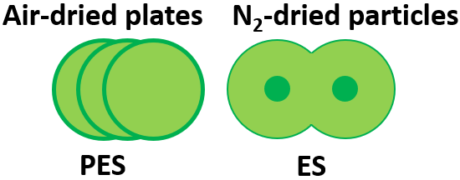
Figure 4.40: Diagram of the pronounced eggshell and eggshell morphologies displayed by the nickel nitrate plates dried under flowing air or nitrogen in this work
The chemical analyses focussed around the drying and calcination step did not find any evidence of the formation of nickel oxynitrates during these events. A high degree of control was taken during the sample processing to eliminate the influence of differing calcination times and temperatures. To minimise these issues the sample batches that shared calcination atmospheres were calcined together. The temperature of the calcination step was monitored using a K type thermocouple and all the reactions were timed. These results indicate that the drying atmosphere does not impact the calcination mechanism and that this decomposition can be achieved in 1.5 h at 400⁰C.
Additionally, pulsed gas chemisorption using both H₂ and CO probe molecules was also performed on the air and nitrogen dried samples batches. However, there was no quantifiable response was detected from the nickel present on the samples using either the Micromeritics 2720 Chemisorb or the Hidden Catlab Microreactor units [415]. This was due to the contamination of the catalyst with atmospheric air and the chemisorption routine being performed at too low a temperature for detectable desorption response (T< 180 ⁰C) from the TCD detectors in both instruments [221], [416], [417]. Further chemisorption work and Brunauer Emmett Teller (BET) analysis are required to characterise the surface area changes between drying atmospheres.
The Debye-Scherrer calculation cannot be solely relied upon to generate accurate particle and crystallite lengths [295], [327], [329], [418]. The infiltrate phase will possess micro-strains which will impact the full width half maximum associated with the nickel phases present in the sample [419]. These strains result from dislocation, vacancies and interstitial particles present in the infiltrated nickel particles and must be accounted for during any crystallite-size analysis [295], [327], [328], [420]. Otherwise, the crystallite length calculated via Debye-Scherrer could be compromised by the contribution to the FWHM of by the strain.
As a result, the calculations were checked using two methods: the Williamson Hall method and additionally some NiO-YSZ samples were scanning using ultra small angle X-ray scattering (Figure 4.7). The high flux of the X-ray beam used in this process reduced the impact of the strain on the FWHM of the samples. The use of strain and instrument corrected Scherrer analysis for the XRD, WH and WAXS data showed conclusively that the a minimum 22 % reduction in the crystallite length was achieved from just changing the drying atmosphere to a N₂ based drying atmosphere(See Figure 4.7, Figure 4.8 and Table 4.3). The NiO peaks used for this analysis were the (111) and (200) NiO diffraction peaks, due to the Debye-Scherrer analysis being limited to the first two reflections of a crystal structure [327].
This smaller particle size did not translate to earlier reduction events as shown by in 4.3.4. However, the use of the N₂ drying step did produce a more uniform particle size dispersion shown by the singular peak in the reduction profiles of the ND samples. The ND AC sample in particular reduced faster in comparison to the bulk nickel oxide calibration sample and those in the literature [337].
There was no data from the TPR or XRD or WAXS results which suggested that the calcination process had not completely decomposed the nickel nitrate to nickel oxide. However, in the case of the XRD phaser the detection limit of the unit is limited to 1 % by unit volume [294], [375], [421]. Meaning that some nitrate material could be present in the calcined sample.
It is clear from these results that the nitrogen drying step has a profound impact on the decomposition and initial particle size of the infiltrated nickel phase. This step has been shown via microstructural imaging, structural analyses, and chemical probes to produce smaller nickel crystallites in the wet impregnated fuel electrode.
The EIS data gathered through this study has not conclusively shown that drying nickel catalysts in an inert atmosphere reduces the initial polarisation resistance. The data from this study has highlighted that the AD AC sample lowest initial polarisation resistance. This likely to be due to the variety of nickel particle sizes (seen using TPR) reducing the initial electrode resistance. Further datasets including TEM are required to validate this hypothesis.
The EIS data has underlined the importance of using N₂ as a drying atmosphere. The particle size reduction achieved by this step has been translated to a reduced R_{P} in both the initial and 50 h aged datasets in this work. It should be noted that the Nyquist plots generated by these samples are at least one order of magnitude larger than infiltrated Ni-YSZ samples in the literature [6], [233], [422]–[424]. However, these results can be discussed and compared in relation to this study.
In infiltrated fuel electrode systems, a calcination step is used to decompose the metallic nitrate particles to oxide particles such as NiO, which is consequently converted to metallic Ni in the reductive fuel atmosphere. The implementation of the N₂ drying step in this has increased the percentage dispersion of the nickel catalysts, producing a well dispersed electro-catalyst network key to reducing the charge transfer resistance. This increased dispersion means that the interparticle distance between the nickel is more homogeneous than in the air-dried system. This has been discussed as a method to reducing the rate of sintering in the catalytic media [300], [301]. In a homogeneously distanced system, coarsening is supressed as the movement and agglomeration of the nickel particles must overcome an energy barrier to trigger [300], [301].
After 50 h of ageing the nitrogen dried air calcined samples produced the smallest increase in the polarisation resistance. This is due to the increased particle dispersion having been via the formation of bunsenite particle during the drying step(Figure 4.6 and Figure 4.11).
This work has also emphasised the importance of only using a single inert gas processing step should be utilised for the lowest change in the polarisation resistance during ageing. The air calcination atmosphere is better at decomposing the nitrate to NiO ready for in-situ reduction, which was also found in work by Wolters et al [202], [373]. This finding was also supported by the large reduction in initial Rp evident between the AD NC and ND AC samples.

In contrast, the ND NC samples showed the promotion of a second gas phase diffusion at 1500 Hz (Figure 4.26). This was attributed to the gas-water phase diffusion of the fuel electrode indicative of the formation of water [406], [425], [426]. This impedance contributions stem from the oxygen transfers from the YSZ phase towards the triple phase boundary. In the singular 10 % H₂/N₂ gas atmosphere utilised in this study, the oxide ions are being supplied by the YSZ phase inducing oxygen vacancies in the ceramic phase. At the TPBs these need to combine with two protons from the fuel to form water which is a two-step process shown below in Equation 4.2 [427], [428]. This interaction is denoted in EIS by an arc at 1500 Hz.
$${\left(O+H\right)}^{*}→{OH}^{*}$$
$${\left(OH+H\right)}^{*}→H_{2}O^{*}$$
Equation 4.2
The key learning from this work has hinged upon the utilisation of a nitrogen drying or calcination step to reduce the degradation rate of the fuel electrode during service. Further work is needed for this finding to be suitable for SOFCs. Variables such as gas flow rates, compositions and step durations are required to produce a method suitable for industrial SOFC stacks.
During the drying step, the inert nitrogen atmosphere has induced reduced the convection of the nickel nitrate crystals reducing their particle size and promoting the degradation of the film into NiO particles [116], [179], [373]. The dispersed particles are subject to nucleation and growth via back-diffusion due to the temperature exceeding 100⁰C and being physically constrained by the nitrate film (TPR, Figure 4.20) [397], [429], [430]. In contrast the particles in the air-dried system form disk-like agglomerates due to convective forces and clumped during drying (Figure 4.9) [412].
The decomposition mechanisms present in production of the infiltrated nickel catalyst and during SOFC operation are detailed in the Figure 4.41 below:
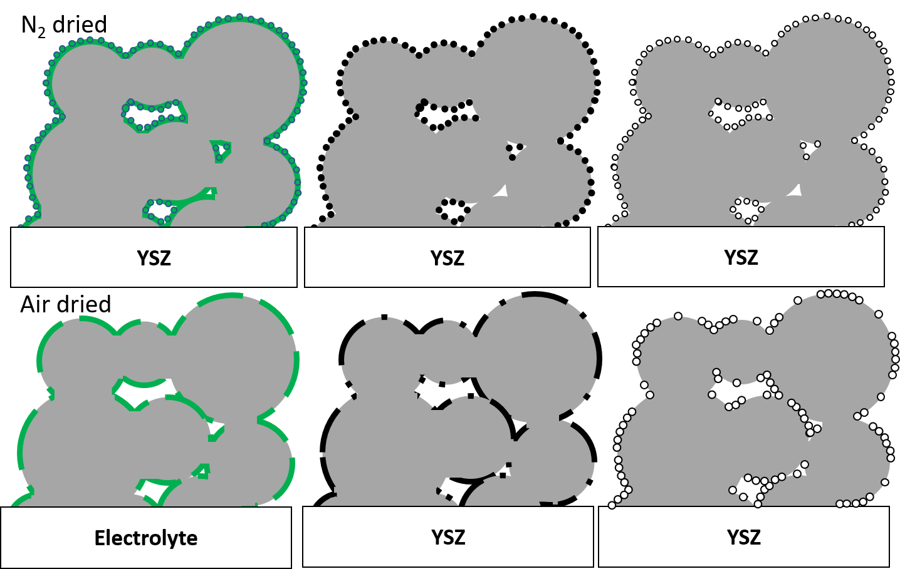
Figure 4.41: Decomposition pathways for the infiltrated nickel particles prior to SOFC testing. The stages of decomposition from left to right: drying, calcination and reduction to metallic nickel. The green denotes the dried nitrate, the black the calcined bunsenite and the white the reduced nickel metal.
The reduction of the air-dried NiO aggregate particles during SOFC ramp up results in multiple processes; including the breakdown of nitrate material core trapped in the bunsenite evident from the five reduction peaks present in Figure 4.17 and Figure 4.18. These reduction events have been discussed in other chemical literature, and are cited in these studies as evidence of particle heterogeneity in size and distribution [377], [396], [431], [432].
Furthermore, the single reduction peak indicates that the bunsenite present in the nitrogen-dried samples is homogeneous in terms of dispersion and size (Figure 4.43) [377], [396], [431], [432]. This appears to have a profound impact on the degradation rate of the electrode as the R_{P} increase for the ND AC samples was at least 40 % lower than its counterparts (Figure 4.8).

4.5 Conclusions
The first investigation into drying atmospheres in wet impregnated solid oxide fuel electrodes has been performed. It has been found that drying under a N₂ atmosphere has been proven to reduce the size of the infiltrated nickel electro-catalyst in SOFC anodes. The microstructural evolution of nickel nanoparticles has been tracked using X-ray diffraction and the Scherrer equation. The uniform catalyst dispersion was demonstrated by the singular temperature-programmed reduction peak exhibited by the nitrogen dried samples. This indicated that the decomposition of the nickel nitrate in the N₂ dried samples produced only nickel oxide on the surface of the electrodes.
Scanning electron micrographs taken during this study support the hypothesis that particle coarsening is exacerbated when drying in an air-based atmosphere. This supports the hypothesis that catalyst agglomeration is reduced in well dispersed systems. This was also supported by the increased change in the polarisation resistance for the air-dried samples in early-stage electrochemical impedance spectroscopy results (< 50h).
The implementation of a nitrogen drying step has decreased the size and increased the dispersion of the NiO nanoparticles in Ni-YSZ infiltrated anodes. It has also been shown by SEM and FTIR to instigate the formation of NiO particles under the surface of the dried nickel nitrate film. The reduced polarisation resistance degradation rate achieved by these samples after 50h of ageing was a consequence of the increased dispersion and reduced particle size.
Drying under a nitrogen atmosphere has been shown as the most impactful processing step in terms of reducing the initial and aged polarisation resistance. This study has also shown that processing under the same atmosphere increases the initial Rp compared to using different atmospheres for drying and calcination steps. Further studies with non-infiltrated Ni-YSZ cermet samples are needed to provide more context to how this new processing step compares to tradition cermet anodes.

Chapter 5: Assessing the Impact of Current Collector Degradation on the initial Electrochemical Performance of infiltrated Solid Oxide Cells

5.1 Introduction
Degradation during operation is not limited to the agglomeration of the nickel electrocatalyst in SOFC fuel electrodes. Current collector materials (which imitate interconnect materials in large-scale SOFC stacks) have also been documented to breakdown during service [433]. Despite their high electrical conductivity, the degradation of expensive precious metal interconnects such as Pt, Au or Ag further add to the cost per kW for a fuel cell stack has driven the research fields to find cheaper alternatives.
The current state of the art method for measuring the degradation of SOFCs is to use electrochemical impedance spectroscopy (EIS). This method relies on a current collector being applied to the sample electrodes prior to the impedance being taken. A variety of candidates for current collection have been documented in SOFC oxygen electrode literature [433]–[437]. Most notably Simner et al found that the thermochemical cation diffusion can occur in the current collector material [434]. Pt and Ag were shown via SEM to possess a high mobility at 750 °C under oxygen reduction reaction conditions [434].
Despite this large research focus in oxygen electrodes. There is very little literature on the impact of current collector material on the electrochemical characteristics of infiltrated anodes [438]. The hydrogen oxidation reaction present in the fuel electrode poses different issues to that of the cathode [57], [91], [439]. Current lab based EIS of cermet fuel electrodes has focussed on either Pt or the lower cost NiO paste [85], [132], [440], [441].
In this study the impact of changing the current collector material on the polarisation resistance of infiltrated Ni-YSZ fuel electrode samples. The degradation of the wet impregnated samples coated in four different materials (Ag, Au, Pt, NiO) was monitored with a view to informing SOFC interconnect materials selection and characterising current collector breakdown.

5.1.1 Chapter Aims
This study aims to identify which of the conductive paste materials produces the least impact on the polarisation resistance of infiltrated Ni-YSZ fuel electrodes.

5.1.2 Hypotheses
- The change in current collector material will affect the size of the polarisation arc in wet impregnated Ni-YSZ electrodes
- Deposition of a thin film current collector will help reduce the degradation rate of the polarisation resistance

5.2 Experimental Procedure Overview

5.2.1 Sample Preparation
The infiltrated symmetrical Ni-YSZ samples were produced using the procedure discussed in Section 3.1.3. The infiltrate was dried under an air atmosphere. Each of the samples were checked to see that 20 vol % loading of nickel was achieved post calcination. After the calcination step the samples were screen printed with the relevant current collector.

5.2.1.1 Current Collector Application
All the conductive pastes used in this experiment were mixed with isopropanol (Sigma Aldrich, UK) to form a screen-printing ink. 50 wt % of isopropanol was added to the pastes. To control the electrode area and thickness, the resulting ink was screen printed through an 80 µm thick mesh (MTI Corporation, USA). To control the current collector thickness during screen printing a piece of scotch tape was applied around the electrode material. This ensured that the thickness of the screen-printed material would be kept constant and that only the electrode would be coated during current collector application.
After screen printing the inks were dried in at 120°C in a drying oven before being turned over and the reverse side screen printed. This temperature was selected to remove as much moisture as possible without interfering with the catalyst phase.
The electrode area for the current collector pastes was calculated to be 0.2827 cm². The current collectors were then dried at 120°C for a 1 h before being applied on the other side of the symmetrical cells. A total of four conductive pastes were investigated these can be found below (Table 5.1):
Table 5.1: A breakdown of the different current collector materials tested in this study [315]–[318]
Current Collector Material | Manufacturer | Solids content [%] | Specification | Product Code
Silver Paste (Ag) | Gwent Materials | 83.0 ± 2 | Low Temp Co-Fired Ceramics Paste | C2010515D4[315]
Gold Paste (Au) | Heraeus Materials Ltd | 86.5 ± 1 | Gold Conductive Paste for Au wire bonding | C5729 [316]
Platinum Paste (Pt) | Heraeus Materials Ltd | 63.0 ± 1 | Platinum Electrode Paste | M637C [317]
Nickel Oxide Paste (NiO) | Shoei Chemical Inc. | N/A | Nickel Oxide Conductive Electrode Paste | X-NH053 [318]

Each of the inks were tested for electrical conductivity prior to electrochemical impedance spectroscopy assessment using a multi-meter. The only ink that was not tested for electrical conductivity was the nickel oxide paste which prior to reduction was not conductive.

5.2.2 Characterisation

5.2.2.1 Electrochemical Impedance Spectroscopy
EIS was used to track the changes in the electrochemical properties of the infiltrated Ni-YSZ symmetrical samples when they were coated in a different current collector. The coated NiO-YSZ symmetrical samples were then loaded into a ceramic compression jig between two gold meshes (Goodfellow, UK). The complex impedance response of the cells was monitored using a Solartron 1250/1287 FRA. The frequency was between 65000-0.1 Hz. This response was measured in 50°C increments from 400-800°C in a 10% wet H₂/N₂ gas (BOC, UK) gas atmosphere and then over a 50 h ageing period. The nickel-oxide catalytic media was reduced in situ during this ramp up step.

5.2.2.2 Microstructural Evaluation using Scanning Electron Microscopy
The fuel electrode samples were mounted onto a stainless-steel SEM stub and sputtered coated in a 10nm layer of gold using an Agar sputter coater. The mounted samples were imaged using a JEOL JSM-6010LA scanning electron microscope. This was used to check for any microscopic delamination and other breakdown routes in the current collector. The samples were analysed using the FIJI ImageJ analysis software.

5.2.2.3 Temperature Programmed Reduction – Active Area Measurements
TPR was performed on the nickel oxide paste using a Micromeritics 2720 Chemisorb. The reduction was performed between temperature ranging between 100-600 °C under a 10 % H₂/Ar atmosphere with a flow rate of 20 mLmin⁻¹. The inlet pressure was 1bar. This was to confirm that the paste had no glass frit impurities and would reduce in-situ during the temperature ramp of the symmetrical fuel electrode samples.
To retain comparability with the infiltrated nickel oxide samples the Shoei conductive paste was doctor bladed on the surface of a YSZ pellet and dried at 120 °C for an hour (dried thickness 40 µm) [318]. This ensured that the paste was supported on an identical material to that of the wet impregnated nickel oxide.
The temperature ramp was set to 5 °Cmin⁻¹ to mimic that used in the EIS analysis work and to avoid the fracture of the ceramic electrolyte.
Infiltrated Ni-YSZ samples were produced from the same batch to reduce the amount of sample variance via parallax error and identical production routines. The infiltrate loading of the samples was calculated to be 20 vol %.

5.3 Results

5.3.1 Macroscopic Degradation and Current Collector Delamination
One of the most conspicuous indicators that the current collector was degrading during the ageing of the infiltrated electrode samples was the visible delamination via after sample unloading. Images like those shown in Figure 5.1 and Table 5.1 show that this issue was certainly prevalent in the silver and platinum current collector systems. This indicates that the exposure to the reductive fuel electrode atmosphere (10% H₂/N₂, 800⁰C) has generated some mechanical fragility in the samples.
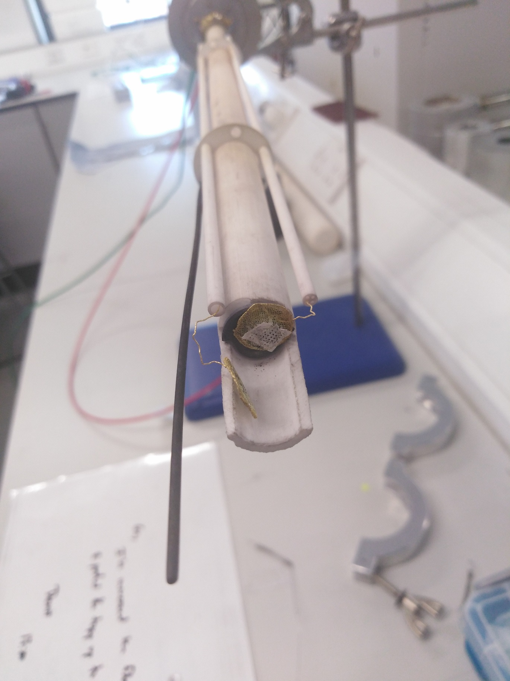
Figure 5.1: Photograph of the delaminated Pt current collector after 50h of ageing
The samples were all subject to the same compressive force because of being housed in the same ceramic compression jig during EIS assessment. The force applied to the samples was not measured in this study.

Table 5.1: Photographs of the macroscopic delamination present in the infiltrated Ni-YSZ symmetrical cells coated in two of the current collector materials. There was no macroscopic delamination present in the Au and NiO coated samples
Current collector | Ag | Pt
Photograph of the electrode after 50h of ageing |  | 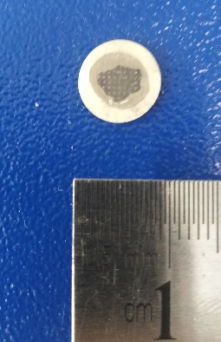

From literature analysis reasons for current collector delamination on the fuel electrode are twofold:
- Pores and void formation under hydrogen rich reductive atmospheres [442]–[445]
- Mechanical stresses from the oxidation of the current collector and catalyst [442], [443]
- Increased mobility, diffusion, and evaporation of the current collector under elevated temperatures and reductive atmospheres [438]
The R_{P} data in this study has been normalised with respect to an area of 0.2827 cm², however in the case of Pt especially this area is highly unlikely to have equated to the actual contact area between the current collector and the mesh.
A reduction in the contact area (and subsequent increase in the interfacial resistance) between the current collector and the electrode has been discussed with respect to the oxygen electrode in numerous studies [95], [434], [441], [442], [446]. In spite of the fact the current collector materials have delaminated from the electrode in Figure 5.1 and Table 5.1, hydrogen embrittlement is not thought to be a mechanism of degradation in the precious metal current collectors [447].

5.3.2 Electrochemical performance using electrical impedance spectroscopy
EIS was the primary characterisation technique utilised in this study. The changes in the charge transfers resistance to polarisation (R_{P}) have been tracked with a view to illustrating the impact of the different current collector materials on this parameter. The series and polarisation resistance over 50h of ageing time can be seen in Figure 5.2 and Figure 5.3.
The two characteristics of the two resistances show very different morphologies. For the series resistance, the degradation rate appears to be reaching a plateau at 40h (Figure 5.2). This stability is a result of this resistance stemming from the electrolyte material, yttria-stabilised zirconia (YSZ). The major conduction route for this material is oxide (O²⁻) oxide ion conduction. As the samples all utilised YSZ as their electrolyte material the series resistance, R_{S} for all the samples should be similar. In this case the R_{S} results are all in the same order of magnitude.
The polarisation resistance, R_{P} results for the Ni-YSZ fuel electrode samples contrast the R_{S}, with multiple mechanisms evident from the shape of the ageing profiles. It was expected that the Rp would increase over ageing time, however in the case of Au and Ni the R_{P} dropped significantly after 10h of ageing.

Figure 5.2: Series resistance vs. ageing time for 50h of ageing at 800⁰C in a 10%H₂/N₂ atmosphere. The blue, red, purple and green markers indicate platinum, silver, gold and nickel respectively

Figure 5.3: Polarisation resistance vs. ageing time for 50h of ageing at 800⁰C in a 10%H₂/N₂ atmosphere. The blue, red, purple and green markers indicate platinum, silver, gold and nickel respectively

The Nyquist plots of the symmetrical infiltrated Ni-YSZ cell samples were plotted in OriginPro 2020. The series resistance was not subtracted from the data. The Nyquist plots for each sample were plotted in 5 h increments. The initial impedance arc for all the samples is denoted by a black square and the 50 h ageing by the red pentagon series (Figure 5.5-Figure 5.7).

5.3.2.1 Silver/Ag
For two-thirds of the Ag//Ni-YSZ samples the series resistance displays a brief (10 h) rise followed by a plateau in the posterior hours (Figure 5.4). Despite the formation of this stage the polarisation resistance continues to rise indicating that the electrode degradation mechanisms dominate the anode specific resistance for these samples. The R_{P} vs ageing time plots show a large degree of variation between the three sample regardless of the fact they are from the same batch.
The Ni-YSZ symmetrical cells samples coated in the silver current collector are listed in Figure 5.2 and Figure 5.3 as Ag1-Ag3. The magnitude of the polarisation resistance for the initial impedance arc for all three samples ranged from 6.16 - 9.03 Ωcm².
Figure 5.4: Series and Polarisation resistance vs ageing time for the Ni-YSZ samples coated in a Ag current collector
Initially the Nyquist plots shown a singular arc between the 0.1-65 kHz frequency range. After a 5 h period in the humidified 10 % H₂/N₂ atmosphere a clear second arc is apparent especially in Ag2. The frequency at the point of inflection between the two impedance arcs is 16 kHz. This arc is present in all the repeats. The presence of an arc at these frequencies highlights the presence of a second interaction driving the electrode resistance mechanism. This second arc appeared after a 15 h ageing period under the humidified 10 % H₂/N₂ atmosphere.
Many instabilities are present in the datasets at frequencies approaching 0.1-100 Hz (Figure 5.5), which made determining the intercept tough. The Ag2 sample produced the most well-defined region in this frequency range (Figure 5.5). Over the 50 h ageing period the average Rp for the Ag coated samples increased by over sevenfold (Rp _{(0 h)} 8.25 Ωcm², Rp _{(50 h)} 59.39 Ωcm²).
Figure 5.5: Stacked Nyquist plots for the Ag1 Ni-YSZ sample coated in an Ag current collector over a 50 h ageing period. The markers track the evolution of the samples in 5 h increments. The hollowed markers indicate the data taken at intervals between
Figure 5.6: Stacked Nyquist plots for the Ag2 Ni-YSZ sample coated in an Ag current collector over a 50 h ageing period. The markers track the evolution of the samples in 5 h increments. The hollowed markers indicate the data taken at intervals between 10 h
Figure 5.7: Stacked Nyquist plots for the Ag3 Ni-YSZ sample coated in an Ag current collector over a 50 h ageing period. The markers track the evolution of the samples in 5 h increments. The hollowed markers indicate the data taken at intervals between 10 h increments

Equivalent circuit fitting
The symmetrical Ni-YSZ cells coated in the silver current collector were fit using XM Studio ECS circle fit function. The systematic and percentage error for both R_{S} and R_{P} were calculated from the error in the XM Studio ECS fitting function. In the case of Ag2 and Ag3 this was not done due to issues with the fitting program and finding the upper intercept for calculating the R_{P}.
The circuit utilised consisted of a resistor followed by two constant phase elements connected in series. The first resistor was used to model the ohmic resistance associated with the YSZ electrolyte.
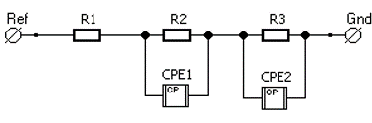
Figure 5.8: Equivalent circuit used to model the electrochemical process present in the Ni-YSZ electrode coated in silver current collector (Diagram made in XM Studio).
Due to the infiltrated Ni-YSZ electrode consisting of a 3D catalyst and pore network the interactions are not solely ohmic in response. The R₂ and R₃ resistors connected in series do not accurately represent the activation polarisation losses (R_{P}) present between in the Ni-YSZ electrode and the H₂ fuel. Initially the presence of the single impedance arc in the Nyquist plots for the silver coated Ni-YSZ symmetrical cells would indicate that an RC (Resistor-Capacitor) would be suitable for modelling the impedance of the system.
However, a constant phase element (CPE) was selected for two reasons. Firstly, due to the porous 3D nature of the fuel electrode an RC (Resistor-Capacitor) would not be suitable as the impedance arc splits into multiple contributions during ageing. A high frequency arc derived from the catalyst particle size and cermet structure and a low frequency arc [394]. These contributions stem from three interactions in the electrode: the oxidation of the of H₂ fuel, transfer of the resultant protons to the Ni-YSZ triple phase boundaries and finally the formation of oxygen vacancies via the production of water from the reaction between the oxide ions and the protons (Equation 5.1) [97], [133], [399], [448].
$$H_{2(g)} ↔2H^{+}+2e^{-}$$
$${H^{+}}_{Ni}↔ {H^{+}}_{YSZ}$$
$$2H^{+}+{O^{x}}_{Electrolyte}↔ H_{2}O_{(g)}+{V_{O}}^{2+}$$
Equation 5.1
In the fuel electrode literature, the production of the adsorbed protons at the Ni-YSZ boundary has been shown to exhibit double-layer capacitance behaviour which simple RC components cannot accurately model. Since 2000 the state-of-the-art modelling for the fuel electrode has utilised a constant phase element to model these more complex interactions [130], [133], [449].
The origin of the low frequency impedance arc (0.1- 100 Hz) is a product of the gas phase diffusion impedance present at the triple phase boundaries active in the second and third stages of Equation 5.1 [130]. The porous nature of the infiltrated fuel electrode reinforces the significance of this arc and its contribution to the total R_{P} of the silver coated Ni-YSZ system.
Hence, these interactions are the main reason for the use of utilising two connected CPE components in series to both mechanisms effectively. However, the emergence of an impedance arc at 16 kHz after 15 h of ageing in the samples utilising the silver current collector was unexpected (Figure 5.5, Figure 5.6 and Figure 5.7). This arc has been attributed to an additional gas transport step hindering charge transfer as discussed by both Primdahl, Boer and Gewies due to its frequency and relative magnitude to the arc from 16 – 65 kHz [130], [133], [425].
Table 5.2: Table detailing the Rs and Rp of Ag1 N-YSZ sample using equivalent circuit and circle fitting using XM Studio ECS
Sample | Fitting Type | Rs [Ω] | Rs Error [Ω] | Error% | Rp [Ω] | Rp Error [Ω] | Error%
Ni-YSZ (Ag1) | Circle | 25.26 | N/A | N/A | 57.36 | N/A | N/A
0 | EC Fit  1R – 2RQ | 21.61 | 0.03 | 0.14 | 61.61 | 0.01 | 0.02
5 | EC Fit  1R – 2RQ | 28.98 | 0.05 | 0.00 | 154.07 | 0.01 | 0.01
10 | EC Fit  1R – 1RQ | 29.12 | 0.13 | 0.45 | 212.55 | 0.02 | 0.01
15 | EC Fit  1R – 2RQ | 42.62 | 0.02 | 0.05 | 239.4 | 0.03 | 0.01
20 | EC Fit  1R – 1RQ | 41.05 | 0.02 | 0.05 | 270.8 | 0.03 | 0.01
25 | EC Fit  1R – 2RQ | 28.79 | 0.07 | 0.24 | 318.84 | 0.03 | 0.01
30 | Circle | 53.35 | N/A | N/A | 305.55 | N/A | N/A
35 | Circle | 58.45 | N/A | N/A | 333.00 | N/A | N/A
40 | Circle | 54.11 | N/A | N/A | 296.9 | N/A | N/A
45 | Circle | 50.92 | N/A | N/A | 332.68 | N/A | N/A
50 | Circle | 56.26 | N/A | N/A | 323.94 | N/A | N/A

Table 5.3: Tables detailing the Rs and Rp of the Ag2 N-YSZ sample using circle fitting using XM Studio ECS
Sample | Fitting Type | Rs [Ω] | Rp [Ω]
Ni-YSZ (Ag2) | Fitting Type | Rs [Ω] | Rp [Ω]
0 | Circle | 30.08 | 69.36
5 | Circle | 42 | 139
10 | Circle | 42.14 | 195.26
15 | Circle | 43.13 | 250.07
20 | Circle | 44.2 | 280.70
25 | Circle | 39.33 | 317.17
30 | Circle | 34.09 | 376.31
35 | Circle | 37.9 | 441.30
40 | Circle | 85.87 | 405.03
45 | Circle | 71.54 | 464.76
50 | Circle | 82.01 | 476.99

Table 5.4: Table detailing the Rs and Rp of Ag3 N-YSZ sample using circle fitting using XM Studio ECS
Sample | Fitting Type | Rs  [Ω] | Rp  [Ω]
Ni-YSZ (Ag3) | Fitting Type | Rs  [Ω] | Rp  [Ω]
0 | Circle | 23.39 | 50.26
5 | Circle | 39.33 | 106.77
10 | Circle | 41.46 | 156.94
15 | Circle | 41.38 | 196.82
20 | Circle | 43.22 | 254.18
25 | Circle | 43.57 | 274.13
30 | Circle | 42.86 | 310.44
35 | Circle | 45.33 | 334.22
40 | Circle | 50.09 | 353.91
45 | Circle | 48.39 | 367.91
50 | Circle | 43.34 | 399.46

Activation Energy
The activation energy in electron volts was derived from multiplying the gradient of the linear fit by the negative Boltzmann constant (8.314 JK⁻¹mol⁻¹) (Figure 5.9). The linear fitting was performed in OriginPro2020.
Figure 5.9: Arrhenius plot of the polarisation resistance vs 1000/T for the Ag1 at 400-800⁰C in 100⁰C increments. The error bars are calculated from the standard deviation of the dataset
The activation energy plot for the silver coated sample also illustrates a point of inflection at 600⁰C. The activation energy decreased by 0.72 eV (a reduction of 79.36%). Additionally this shows that the silver is highly temperature sensitive and indicates the presence of a migration mechanism in the current collector [450]. Silver has been documented to migrate across from the current collector into the electrode/electrolyte interface and cause short circuits at temperatures lower than its 968°C melting point [442], [450]. Curing in-situ has also led to polarisation resistance increase of up to 1 order of magnitude higher than using other current collectors such as platinum [441].

5.3.2.2 Gold/Au
The evolution of the polarisation resistance of the gold coated symmetrical Ni-YSZ samples over time produced extremely variable results. The stark difference between Ag1 and Ag2 at during the first stemmed from the nickel catalyst having different ageing times during operation (Figure 5.10). Au2 shorted at 400°C during an its first temperature ramp. This could mean that the higher polarisation resistance exhibited by this sample was due to the nickel catalyst already having been aged for 1 h above its Tammann temperature before the retest [238].
After between 3-10 h of ageing under the 10 % H₂/N₂ the polarisation resistance of the visibly dropped in comparison with the other Ni-YSZ samples. After 10 h the R_{P} dropped by 10.99% and 28.5% for the Au1 and Au2 samples, respectively. The reduction in these measurements is indicative of another interaction stemming from the change in current collector.
Figure 5.10: Scatter graphs showing the Series and Polarisation resistance vs ageing time for the Ni-YSZ samples coated in an Au current collector
At 10 hours aged the R_{S} of the Au coated samples increased steadily and showed no indication that the electrolyte impedance contribution had impacted the R_{P} measurements. This underlines that the electrode and current collector systems present are the only major contributors to the evolution of the R_{P} over the ageing period.
In contrast to the previous Ag//Ni-YSZ system the gold-based samples produced only two distinct impedance arcs. The first from 10-65,000 Hz and the second from 0.1 – 10 Hz as shown in the Nyquist plots in Figure 5.11 and Figure 5.12. Lower frequency arcs such as those in Figure 5.11 and Figure 5.12 demonstrate that the fuel gas phase impedance has produced a significant contribution to the charge transfer resistance in the anode. Due to the high porosity in the infiltrated electrode (35 %), this portion of the impedance is more prevalent that non-infiltrated electrodes [132], [451], [452].
Sensitivity to atmosphere is one of the factors discussed as possible root cause for the drop in polarisation resistance of the samples. For current collectors under anodic conditions such as those investigated during this study, the resistance of the gold is smaller than that of silver [453]. This is despite the fact that gold has reduced mobility in anodic conditions [454], [455].
Gold has also been documented to alloy with nickel at temperature exceeding 600⁰C [445], [456]. This impact of this alloying would have the effect of reducing the overall resistivity of the electrode under the H₂ rich environment [457], [458]. This is evident from the large drop from the peak R_{P} (144.86, 2h) which manifested itself around 10 h, indicating that the alloying reaction had finished during this period.
Despite a 1 h difference in the ageing time for the nickel catalyst both samples exhibited a drop in R_{P} during the ageing process, which also shows reduction in R_{P} is directly affected by this interaction alloying process. The large variation in the samples occurred despite the sample having been produced and processed identically according to the method discussed in Chapter 3.
Figure 5.11: Stacked Nyquist plots for the Au1 Ni-YSZ sample coated in an Au current collector over a 20 h ageing period. The markers track the evolution of the samples in 5 h increments. The hollowed markers indicate the data taken at intervals between
Figure 5.12: Nyquist plots for the Au2 Ni-YSZ sample coated in an Au current collector over a 50 h ageing period. The markers track the evolution of the samples in 5 h increments.

Equivalent circuit fitting
The symmetrical Ni-YSZ cells coated in the gold current collector were fit using the equivalent circuit function on the ZView2 software (Figure 5.13) The systematic and percentage error for both R_{S} and R_{P} for the Au coated samples were calculated from the error in the ZView2 equivalent circuit fitting software.
Figure 5.13: Equivalent circuit used to model the electrochemical process present in the Ni-YSZ electrode coated in gold current collector (Diagram made in XM Studio).
As discussed earlier both gold coated samples produced Nyquist plots with two distinct impedance arcs. The second of which occurred at a low frequency range 0.1-10 Hz, a product of gas diffusion impedance. The selection and use of the two CPE components in Figure 5.13 were used to mimic two electrode contributions to the resistance:
- Charge transfer resistance at the anode functional layer between the Ni-YSZ and gas phase TPB
- The gas diffusion loss in the anode functional layer via the formation of water [427], [459]
The error in the EC fitting for the R_{P} initially exceeded 8 %, this was due to the gas diffusion mechanism not being immediately present in the EIS spectra during the first measurement. As a result of the increased tortuosity of the porous electrode (via its 35 µm thickness) and non-ideal diffusion behaviour meant that a CPE element had to be used to model the system [405], [425], [460][461].
After 5h of ageing the current collector began to break down and the second mechanism produced low frequency impedance arc (Figure 5.14 and Figure 5.15). The percentage error of the EC circuit for the Au2 sample was consistently lower than 1 %.
Table 5.5: Table detailing the Rs and Rp of Au1 N-YSZ sample using equivalent circuit and circle fitting using XM Studio ECS
Sample | Fitting Type | Rs [Ohm] | Rs Error | Error% | Rp [Ohm] | Rp Error | Error%
Ni-YSZ (Au1) | Circle | N/A
0 | EC Fit  1R – 1RQ + 1RC | 13.08 | 0.33 | 11.60 | 132.37 | 10.90 | 8.23
5 | EC Fit  1R – 2RQ | 20.2 | 0.18 | 0.87 | 184.97 | 1.29 | 0.69
10 | EC Fit  1R – 1RQ | 28.77 | 0.21 | 0.71 | 110.63 | 0.41 | 0.37
15 | EC Fit  1R – 2RQ | 32.38 | 0.21 | 0.64 | 95.87 | 0.35 | 0.36
20 | EC Fit  1R – 1RQ | 38.97 | 0.19 | 0.48 | 87.56 | 0.24 | 0.27
Figure 5.14: Nyquist plots for the Au1 Ni-YSZ sample coated in an Au current collector over a 20 h ageing period. The markers track the evolution of the samples in 5 h increments. The equivalent circuit fit is denoted by the black line series

Figure 5.15: Nyquist plots for the Au2 Ni-YSZ sample coated in an Au current collector over a 50 h ageing period. The markers track the evolution of the samples in 5 h increments. The equivalent circuit fit is denoted by the black line series

Table 5.6: Table detailing the Rs and Rp % errors for the equivalent circuit model for the Au2 Ni-YSZ sample coated
Sample | Fitting Type | Rs [Ohm] | Rs Error | Error% | Rp [Ohm] | Rp Error | Error%
Ni-YSZ (Au2) | Circle | 28.53 | 0.26 | 0.91 | 1021.00 | 1.16 | 0.11
(0h) | EC Fit  1R – 2RQ | 25.91 | 0.29 | 1.13 | 1035.07 | 7.97 | 0.77
5h | EC Fit  1R – 2RQ | 23.36 | 0.83 | 3.55 | 781.10 | 6.68 | 0.86
10 | EC Fit  1R – 1RQ | 23.96 | 0.75 | 3.15 | 641.40 | 4.42 | 0.69
15 | EC Fit  1R – 2RQ | 24.87 | 0.71 | 2.85 | 624.50 | 4.00 | 0.64
20 | EC Fit  1R – 1RQ | 26.84 | 0.55 | 2.03 | 532.00 | 3.30 | 0.62
25 | EC Fit  1R – 2RQ | 28.49 | 0.48 | 1.68 | 517.40 | 3.09 | 0.60
30 | EC Fit  1R – 2RQ | 28.87 | 0.49 | 1.71 | 519.86 | 2.82 | 0.54
35 | EC Fit  1R – 2RQ | 28.90 | 0.51 | 1.77 | 524.54 | 2.71 | 0.51
40 | EC Fit  1R – 2RQ | 30.65 | 0.40 | 1.31 | 462.10 | 2.50 | 0.54
45 | EC Fit  1R – 2RQ | 30.56 | 0.35 | 1.16 | 437.99 | 2.06 | 0.47
50 | EC Fit  1R – 2RQ | 31.11 | 0.40 | 1.30 | 457.67 | 2.43 | 0.53

Activation Energy
The Arrhenius activation energy plot (Figure 5.126) for the gold coated Ni-YSZ samples showed three distinct linear gradients and two points of inflection. The intersected point between the 1st and 2nd linear gradients occurred 50 °C earlier than its silver counterpart (Au 550 °C, Ag 600 °C) (Figure 5.9 and Figure 5.16). The activation energy at the 2nd segment dropped by 0.53 eV in comparison with the 1st segment (Table 5.7). The activation energy of the gold was consistently lower than the silver which mirrors the reduced R_{P} also gathered during ageing.
Figure 5.16: Arrhenius plot of the polarisation resistance vs 1000/T for the Au1 at 400-800 ⁰C (673 – 1073 K). Three gradients were identified with linear fitting. 1. 400-550 °C 2. 550 – 700 °C 3. 700 – 800 °C. The error bars are calculated from the standard deviation of the dataset
The position of this change indicates initiation of a mechanism between either the infiltrated fuel electrode and/or the gold current collector. As the nickel T_{Tammann} temperature exceeds the temperature range of 2nd linear gradient – the process is predominantly a gold interaction – suggesting that diffusion, alloying and sintering are also prevalent in the current collector layer [238].
Table 5.7: Calculated Activation Energies of the three linear gradients from the Au1 Arrhenius plot
Temperature Range [°C] | Linear Fit Gradient, m [Ωcm²K] | Activation Energy [kJmol⁻¹] | Activation Energy [eV]
400 - 550 | 2.65 | -22.04 | -0.23
550 – 700 | 8.83 | -73.41 | -0.76
700 - 800 | 2.84 | -23.61 | -0.24
A solid solution is between the two metals is possible under the ageing conditions (800⁰C, 10% H₂/N₂). Due to the bulk of the system consisting of gold an α Au-Ni intermetallic would form during ageing above the T_{Tammann} (Figure 5.17) [445], [456]. This has been captured during the EIS of the gold current collector Ni-YSZ samples as the R_{P} dropped after a 10 h ageing period, indicating that a less electrically resistive alloy had formed. The atomic radii and crystal structure of both metals are also identical (135 pm and FCC), which means that the alloying process was not hindered by lattice distortion [294].
The fact that the activation energy gradient decreases after the T _{Tammann} also shows the propensity for gold to inter-diffuse with the nickel catalyst phase. Work done on gold electroplating by Pinnel linked gold diffusion to defects present in transition metals including at temperatures exceeding T _{Tammann} [238], [462]. Pinnel also concluded that gold-rich systems are more likely to diffuse than nickel rich systems like the one utilised in this study.
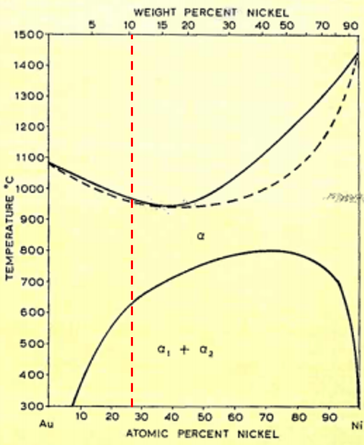
Figure 5.17: Phase diagram of gold and nickel metals. Adapted from Colbus et al [456]
The result of this interdiffusion is alloying between the phase with the second point of inflection at 700 °C can be attributed in part to the formation of the α Au-Ni intermetallic phase (See Figure 5.17) and the T_{Tammann} of the Ni (721 °C). Figure 5.127 has been marked with a 10.34 wt % Ni (20 vol %) to illustrate the transition from FCC α₁ + α₂ binary phases to a single α FCC Au-Ni alloy. The 7 % reduction in the activation energy between the 1st and 3rd linear gradients illustrates the reduction of interfacial resistance between the two layers with the formation of the α Au-Ni phase.

5.3.2.3 Platinum/Pt
In comparison with a study by Guillodo, the initial impedance spectra for the Pt1 sample is comparable with the platinum coated sample (32 Ω to 34.5Ω (Pt1))[438]. However, the degradation present in this sample far exceeds that of the other study especially after 5h of ageing.
A 330% increase in the R_{p} was observed for the sample between 0-5 hours of ageing (Figure 5.18). This rise is unprecedented in the context of the other fuel electrode samples tested during this study and in the literature[438], [463]–[465]. The 50 h aged, normalised R_{P} values for the platinum are the largest for any of the Ni-YSZ symmetrical cells assessed during this study. This was unexpected as Pt is one of two prevalent current collector materials utilised in the literature [438], [463]–[465]. This combined with the fact that the Pt2 sample had an over 100% larger than its Pt 1counterpart would suggest that the Heraeus Pt paste used is defective and the samples considered anomalous. The large variation between repeats and the physical delamination seen in Figure 5.1 meant that the Heraeus Pt paste was not investigated further.
Figure 5.18: Nyquist plots for the Ni-YSZ sample coated in a Pt current collector over a 50h ageing period (P2) including the equivalent circuit fit using the circuit in Figure 5.118

5.3.2.4 Nickel Oxide/NiO
Nickel current collectors have the theoretically greatest anode electrochemical activity for all of the current collector materials assessed during this study [435], [466]. This was evident in the R_{P} for the nickel coated samples which produced the lowest R_{p} after 50 h for any samples in this study (13.58 Ωcm²). Unlike the cells utilising a silver current collector the R_{S} for these samples levelled out after 30 h of ageing. The R_{P} of the cells showed some large variation over the ageing period. One of the key factors for this was the lack of an explicit R_{S} intercept in the data (Figure 5.131).
The morphology of the R_{S} vs ageing time plot (Figure 5.19) shows a gradual increase in this part of the impedance contribution. This steady rise suggests that the position of the R_{s} intercept is a key factor in the calculation of the R_{P}. Two of the nickel coated samples demonstrated a similar drop in R_{P} as was shown by the gold samples. A large reduction in the R_{P} was evident after 20 h of ageing for which samples.
Figure 5.19: Scatter graphs showing the evolution of the Series resistance vs ageing time for the Ni-YSZ samples coated in a Ni current collector (Shoei, Japan)
The nickel oxide coated samples produced the second lowest initial and lowest 50 h aged polarisation resistance for any of the Ni-YSZ fuel electrodes in this study. The Nyquist plots did not show the presence of a low frequency gas diffusion arc.
Figure 5.20: Scatter graphs showing the evolution of the Polarisation resistance vs ageing time for the Ni-YSZ samples coated in a Ni current collector (Shoei, Japan)
There appeared to be a distortion in the frequency response that was prevalent in the nickel oxide paste dataset that appeared every 5 h. This is evident by the stepped R_{S} in the first 50 h of ageing of the Ni1-Ni3 samples (Figure 5.19-Figure 5.21). The mostly likely source of these steps is a form of distortion from the 1287 frequency response analyser namely due to AC amplitude generation issues in the low frequency range < 350 Hz [467]. Further datasets with half hour measurements and for 100 h would have helped to firstly, confirm that it’s not a sample interaction and that this issue is only limited to the first 50 h of ageing. Additionally, comparison work with a separate FRA would triangulate that this issue is solely due to instrumental distortion.
Figure 5.21: Stacked Nyquist plot Nyquist plots for the Ni-YSZ sample coated in a Ni current collector over a 50h ageing period (Ni2)

Equivalent Circuit fitting
The symmetrical Ni-YSZ cells coated in the nickel oxide current collector were fit using the equivalent circuit function on the ZView2 software. In contrast with the samples coated in a gold current collector the Nyquist plots show only one impedance arc. The equivalent circuit used to model the samples is shown in Figure 5.22 below:
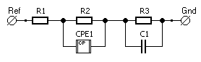
Figure 5.22: Equivalent circuit used to model the electrochemical process present in the Ni-YSZ electrode coated in gold NiO collector (Diagram made in XM Studio).
An RC component was connected in series to model the double-layer capacitance present between the nickel metal and the ceramic oxide material. Due to the nanoscale 2D morphology of the triple phase boundaries present in the electrode, a simple capacitor was used to model the impedance [451], [468][469].
In contrast to the gold and silver coated samples there was no presence of a second impedance arc in the data. This was also supported by the theta vs frequency plot as no low frequency (0.1-10 Hz) inflections were seen in Figure 5.23 and Figure 5.24. This indicates that the gas diffusion impedance did not provide a large contribution to the impedance in comparison to gold and silver current collectors.
Figure 5.23: Nyquist plots for the Ni-YSZ sample coated in a Pt current collector over a 50h ageing period (Ni2) including the equivalent circuit fit
Despite the fit in Figure 5.26 being very angular, the percentage error for the modelled polarisation resistance did not exceed 5% for any of the NiO current collector datasets present in this study.
Figure 5.24: Theta vs Frequency plot for the Ni2 Ni-YSZ sample fit using the equivalent circuit model shown in Figure 5.22

Table 5.8: Table detailing the Rs and Rp of Ni2 N-YSZ sample using equivalent circuit and circle fitting using XM Studio ECS
Sample | Fitting Type | Rs [Ohm] | Rs Error | Error% | Rp [Ohm] | Rp Error | Error%
Ni-YSZ (Ni2) | Circle | 24.61 | 0.52 | 2.13 | 87.19 | 0.58 | 0.67
0 | EC Fit  1R – 2RQ | 21.76 | 1.41 | 6.48 | 90.38 | 3.90 | 4.32
5 | EC Fit  1R – 2RQ | 27.25 | 0.37 | 1.37 | 166.82 | 4.40 | 2.64
10 | EC Fit  1R – 2RQ | 29.55 | 0.39 | 1.32 | 207.40 | 3.75 | 1.81
15 | EC Fit  1R – 2RQ | 30.66 | 0.37 | 1.21 | 242.70 | 3.59 | 1.48
20 | EC Fit  1R – 1RQ | 34.91 | 0.31 | 0.89 | 206.10 | 3.89 | 1.89
25 | EC Fit  1R – 2RQ | 34.27 | 0.24 | 0.71 | 194.16 | 4.01 | 2.07
30 | EC Fit  1R – 2RQ | 37.22 | 0.35 | 1.29 | 250.70 | 5.03 | 2.01
35 | EC Fit  1R – 2RQ | 36.75 | 0.27 | 0.73 | 241.15 | 6.98 | 2.89
40 | EC Fit  1R – 2RQ | 36.35 | 0.25 | 0.69 | 244.71 | 7.13 | 2.91
45 | EC Fit  1R – 2RQ | 37.32 | 0.25 | 0.67 | 253.20 | 7.52 | 2.97
50 | EC Fit  1R – 2RQ | 37.96 | 0.28 | 0.74 | 280.57 | 8.43 | 3.00

Activation Energy
An Arrhenius plot was drawn for the R_{P} of the Ni3 sample during the temperature ramp using the electrochemical data gathered by a frequency response analyser (Figure A9). The complex impedance response of the cells was measured using a Solartron 1250/1287 FRA between frequencies of 0.1-65,000 Hz. The response was measured in 50 ⁰C increments.
To determine the activation energies at 600 °C and 800 °C two tangents were drawn against the polynomial fit line of best fit (Figure 5.25). This was to observe the change in activation energy in this temperature range. The activation energy decreased by 0.16 eV during this temperature range. The activation energy at 800 °C was also equal to that of the gold coated samples under the same operating conditions.
Table 5.9: Calculated Activation Energy of the Ni3 sample from the two tangents drawn at 600 °C and 800 °C of the Arrhenius plot
Temperature Range [°C] | Linear Fit Gradient, m [Ωcm²K] | Activation Energy [kJmol⁻¹] | Activation Energy [eV]
600 | 4.69 | -38.99 | -0.40
800 | 2.78 | -23.07 | -0.24
The activation energy of the sample was calculated to be -0.24 eV which was 0.67 eV smaller than the silver coated sample. This was equal to the activation energy of the gold current collector. This demonstrates that the current collector is highly sensitive to changes in temperature and would suggest that it is highly mobile at the 800⁰C ageing temperature. Further work is needed to understand how the ramp rate impacts this interaction and for more datapoints at 25 °C increments for better fitting capabilities and improved R² values.
Figure 5.25: Arrhenius plot of the polarisation resistance vs 1000/T for the Ni3 at 400-800⁰C at 50⁰C increments. The error bars were calculated from the standard deviation of the dataset. The tangent at 600 °C is purple and the tangent at 800 °C blue respectively

5.3.2.5 Comparison between the different current collector materials
From inspection of initial Nyquist plot for a selected range of the samples showed immediately that the initial R_{P} of the Heraeus (Pt paste) coated sample was over twice that of the other three materials [317]. This trend continued across the 50 h ageing period, illustrating that the Pt paste is unsuitable for the electrochemical assessment of the infiltrated Ni-YSZ fuel electrodes.
These initial measurements except for the nickel current collector sample match the resistivities for each of the metals in terms of magnitude. The trend from the literature illustrates that the electrical resistivity drops by over 70% under a reductive H₂ atmosphere. In the case of the nickel samples a key reason for this is that the reductive atmosphere hinders the formation of nickel oxide, an issue less prevalent for the precious metals [470]. Despite its reported electrical resistivity under hydrogen exceeding the ag and au, the nickel oxide paste produced the second lowest initial Polarisation resistance of all of the current collector materials [433].
Table 5.10: Table of the electrical resistivity values and initial polarisation resistance for the metal current collector materials under air and hydrogen atmospheres at 800 °C/1073 K [433], [457], [458], [464], [471]
Current Collector Material | Electrical Resistivity under Air  [x10⁻⁸ Ωm] | Electrical Resistivity under H₂  [x10⁻⁸ Ωm] | Initial Polarisation Resistance, R_{P}  [Ωcm⁻²] | 50 h aged Polarisation Resistance, R_{P}  [Ωcm⁻²]
Ag | 6.99 [457] | 1.63 [433] | 8.11 | 48.19
Au | 9.84 [457] | 2.20 [471] | 18.09 | N/A
Pt | 37.71 [464] | 10.60 [433] | 34.85 | 199.90
Ni | 43.45 [458] | 7.20 [433] | 12.38 | 13.58

The only dataset with a physical Rs intercept is the sample utilising a silver current collector. The series resistance for the other datasets was a calculated using equivalent circuit fitting. This creates some uncertainty in the series resistance of the other Ni-YSZ samples.
Figure 5.26: Initial Nyquist plots of the 4 representative samples for the symmetrical Ni-YSZ samples. The red, green, orange and blue series are Ag, NiO, Au and Pt respectively.
The use of silver in this project could be one of the key factors as to why the polarisation resistance of these samples is up to 2 orders of magnitude higher than the Ag// Ni-YSZ literature [438], [441]. During EIS of the Ni-YSZ fuel electrode the incident humidified 10 % H₂/N₂ gas could cause pinhole formation in the silver paste [442]. This in combination with the curing the paste in-situ at 800°C and the high mobility of silver at temperatures exceeding 650°C would almost without a doubt increase the polarisation resistance of the symmetrical cells by at least one order of magnitude.
Despite having the highest activation energy (Table 5.11), the nickel oxide current collector produced the second lowest initial R_{P} and had a 9.7 % increase in after 50 h of ageing. This was due to the reduction in interfacial resistance between the catalyst and current collector phase due to their identical compositions [472]–[474].
Table 5.11: Table of the activation energies for each of the symmetrical Ni-YSZ samples coated in the four current collector materials
Current Collector Material | Activation Energy, E _{Act} at 800⁰C  [kJmol⁻¹] | Activation Energy, E _{Act} at 800⁰C  [eV]
Ag | -69.47 | -0.91
Au | -23.61 | -0.24
Pt | -58.86 | -0.61
Ni | -23.07 | -0.24

5.3.3 Microstructural evaluation using Scanning Electron Microscopy

Ag
The surface of the electrode was imaged in 3 places using an Inspect F50 Scanning Electron Microscope. After the 50 h of ageing under the 10% H₂/N₂ 800⁰C atmosphere the current collector has visibly coarsened into 1 µm agglomerates on the surface of the electrode (Figure 5.27) Upon further inspection these rod-like particles do not appear to be in contact with one another which is a key reason as to why the conductivity of the current collector and consequently the R_{P} of increased (Figure 5.27).
Additionally, the pinhole structure discussed by Majewski is not present in the silver current collector layer present for this sample [442]. The breakdown of the current collector layer has transitioned within 50 h to the formation of aggregates. This indicates that the layer has either succumbed to the formation of voids and split in separate particles or the layer has delaminated during ageing. The silver particles present in Figure 5.27 do not show the presence of any pores or pin holes which indicates delamination or diffusion the primary breakdown mechanism.
Another cause for concern is the fact that in these agglomerates dwarfs the pore network present (bar the cracking) in the image. The agglomerates larger than 200 nm exceed that of the 25 nm pores present in Figure 5.27 This illustrates that pore blocking by the agglomerates is a key issue with the current collector system and one that would increase the R_{P} of the sample. This would hinder gas flow and transfer to the anode function layer and triple phase boundaries present in the infiltrated Ni-YSZ electrode.
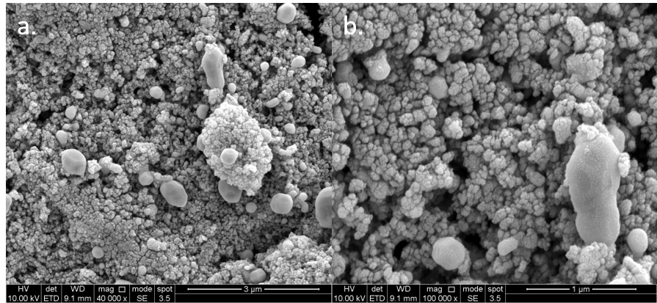
Figure 5.27: Scanning electron micrograph of the surface of the 50 h aged Ag//Ni-YSZ electrode (a. 40,000x magnification and b. 100,000x)

Au
The gold current also appeared to have broken down during the ageing process under the 800⁰C (10% H₂/N₂) atmosphere. In the case for the gold current collector the elevated temperatures. Blocky 1 µm agglomerates can be seen in Figure 5.34 and Figure 5.35 to have formed on the surface of the electrode. In contrast with its silver counterpart these particles have a spherical morphology.
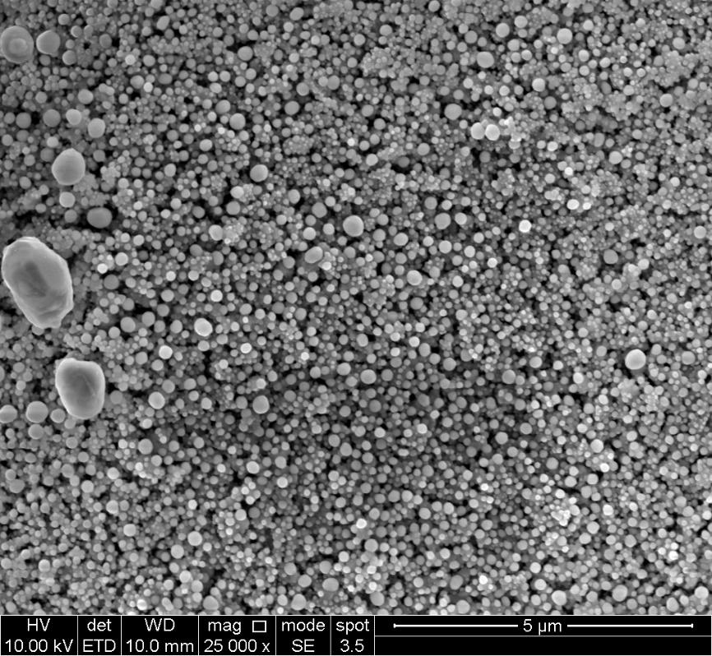
Figure 5.28: Scanning electron micrograph of the surface of the Ni-YSZ electrode after 20h of ageing. The gold current collector has broken down as shown by the large chunks on the surface 25000x)
Similar microstructural features to the silver coated sample can be seen in Figure 5.29. The delaminated region shows the remnants of the gold layer very similarly to the top right-hand corner of Figure 5.28. The gold particles do not appear to exceed that of the silver sample.
Figure 5.29: Scanning electron micrograph of the surface of the 50h aged Ni-YSZ. The region shown is a position where the gold current collector delaminated from the sample
The large difference in atomic number between the gold current collector and the nickel particles was not evident when using the back-scattered electron detector. The gold on the back scattered electron micrograph should be the brightest phase in the image. This indicates that the gold current has alloyed with the catalyst.
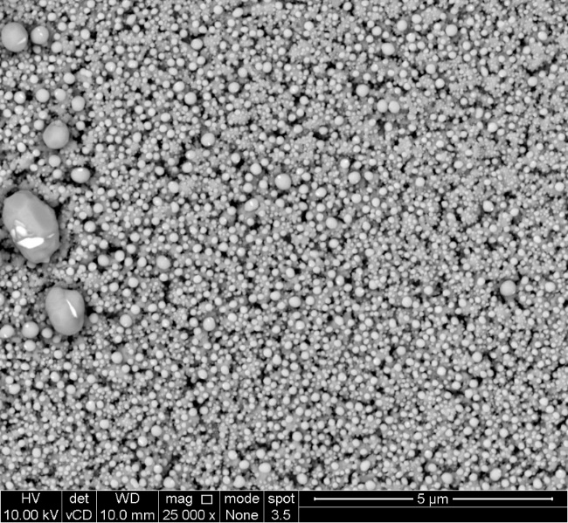
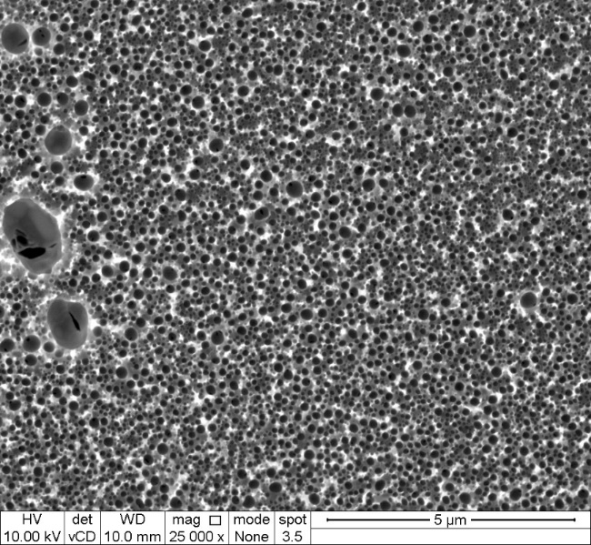
Figure 5.30: Micrographs of the surface of the Ni-YSZ gold electrode after 20 h of ageing using back-scattered electrons. The gold current collector has broken down as shown by the large chunks on the surface 25000x). The right-hand micrograph is an inverted. The white, light grey, dark grey and black denote the pores, YSZ, nickel/gold alloy and gold respectively
Inverting the micrograph in FIJI, showed the presence of some dark gold-rich regions (black) in the large agglomerates present on the surface of the sample (Figure 5.30). However, the microstructure is dominated by a series of dark grey particles, these particles consist of the nickel gold alloy.
To eliminate the possibility of the particles in Figures 5.28 – 5.30 being a product of the impedance jig gold pad degradation repeat micrographs were taken of other 50 h aged samples in the batch. These were taken on the JEOL JSM-6010LA SEM. The regions scanned were in positions where the current collector had visibly peeled away from the surface of the electrode (Figure 5.31).
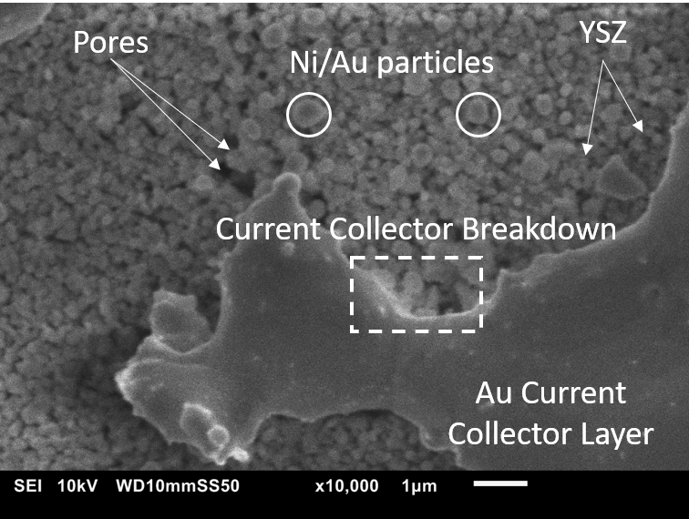
Figure 5.31: Micrograph of the surface of the interface between the Ni-YSZ electrode and the gold current collector layer after 50 h of ageing. The gold current collector has broken down as shown by the large chunks on the surface 10,000x).
The white square region shows the visible breakdown of the layer at the interface between the gold layer and the electrode where a minimum of three gold rich particles have sheared from the current collector. This supports the degradation of the gold current collector is the primary degradation mechanism in these samples.

NiO
After 50 h of ageing in the 800 °C (10 % H₂/N₂) atmosphere, the nickel oxide current collector layer has also broken down. Large agglomerates formed on the surface of the electrode after ageing (Figure 5.32). Back-scattered electron imaging and Weka 2D Segmentation was used to identify the positions of the Ni, YSZ and pore phases (Figure 5.33, Table 5.12). Two regions were analysed the edge and the centre of the current collector layer. The average agglomerate diameter for the edge was measured as 438 ±1 nm.
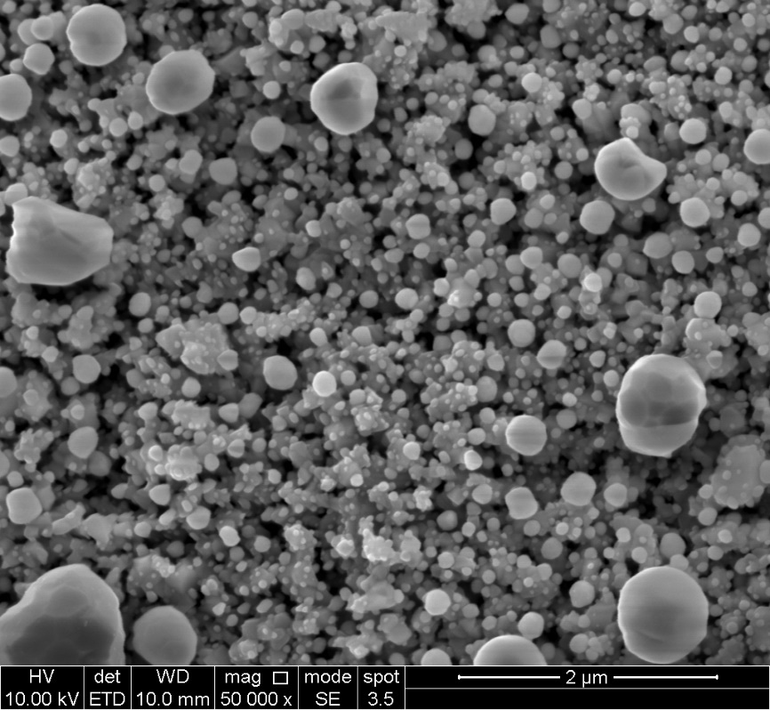
Figure 5.32: Scanning electron micrograph of the surface (Edge Site) of the Ni-YSZ electrode after 50h of ageing. The nickel oxide current collector has broken down as shown by the large chunks on the surface 50000x)
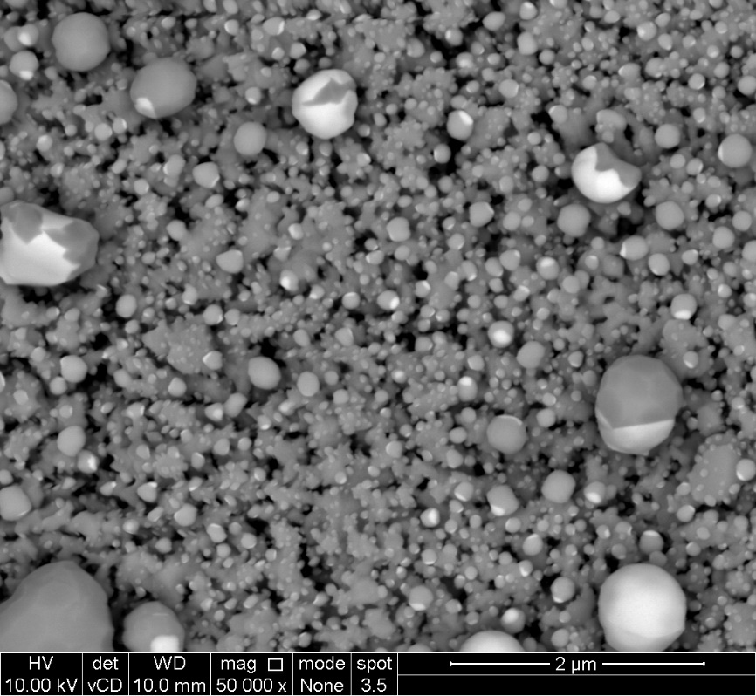
Figure 5.33: Back scattered electron micrograph of the surface (Edge Site) of the Ni-YSZ electrode after 50h of ageing. The nickel oxide current collector has broken down as shown by the large chunks on the surface 50000x)
Table 5.12: Table of the Ni, YSZ and pores segmented in the edge site of the Nickel current collector Ni-YSZ sample using Weka Segmentation in FIJI. The white denotes the segmented phase probability distribution calculated
Nickel | YSZ | Pores
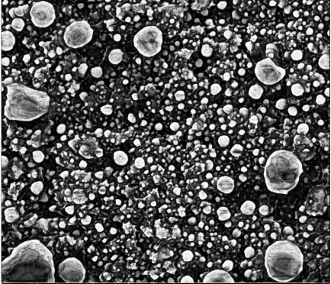 | 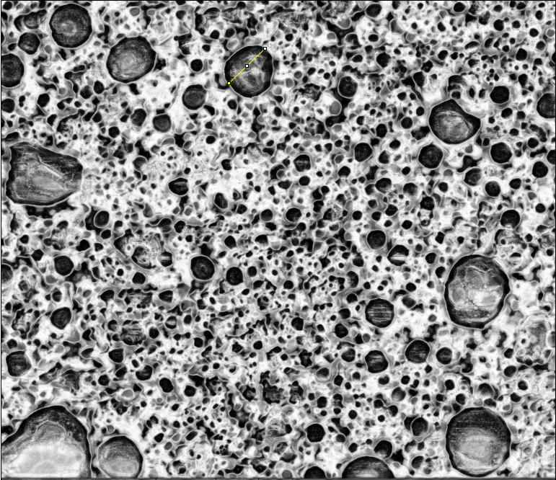 | 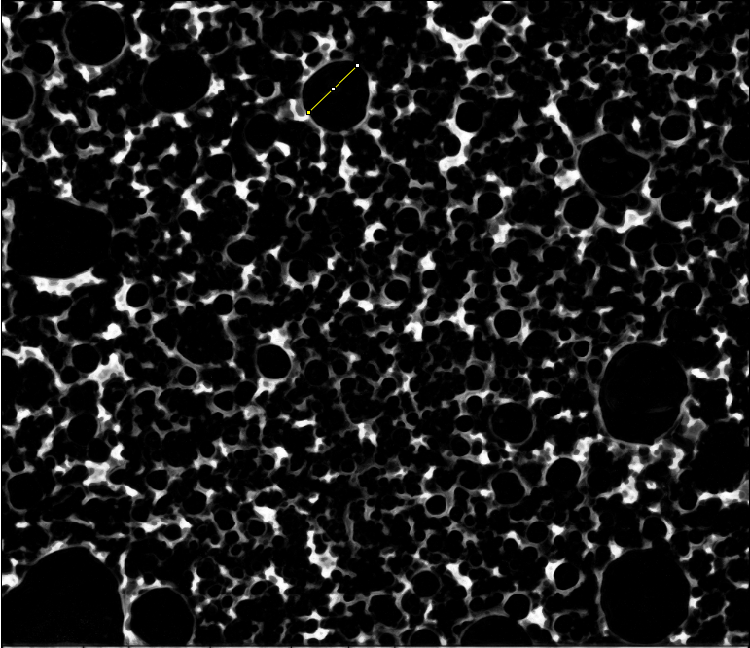
The agglomerates found in the centre of the current collector layer were smaller than their edge counterparts. The average particle size for this region was calculated to be 278 ±1 nm. Both regions showed a large breakdown of the current collector player into particles like the Gold and Silver coated samples.
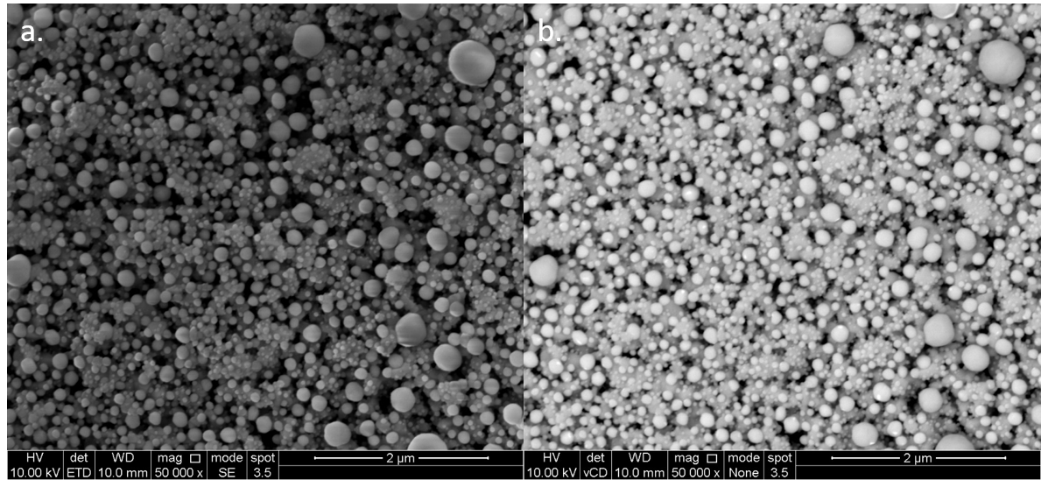
Figure 5.34a. Scanning electron micrograph of the surface (central Site) of the Ni-YSZ electrode after 50h of ageing. The NiO current collector has broken down into large chunks on the surface. b. Back-scattered electron micrograph at 50,000x magnification
In the case of the nickel coated samples the delamination and agglomeration of the current collector have also been shown to be non-homogeneous across the layer. With the agglomerate size decreasing by 58 % between the edge and the centre of the layer.
As the composition of the current collector material and the catalyst are the same metal, the agglomeration behaviour of the system was assumed to be homogeneous. However, due to the fact NiO was applied was a paste this was not the case [451], [475]. In areas of high pore concentrations, the nickel current collector were likely to agglomerate leading to particles seen in Figure 5.32 and Figure 5.34. Weka phase analysis was also performed for this sample and can be found in Table 5.13.

Table 5.13: Table of the Ni, YSZ and pores segmented in the central site of the Nickel current collector Ni-YSZ sample using Weka Segmentation in FIJI. The white denotes the segmented phase probability distribution calculated.
Nickel | YSZ | Pores
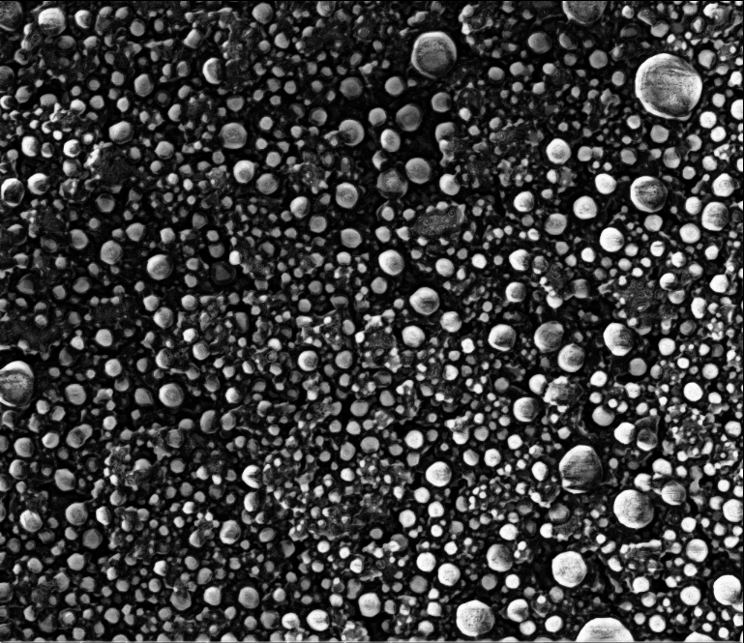 | 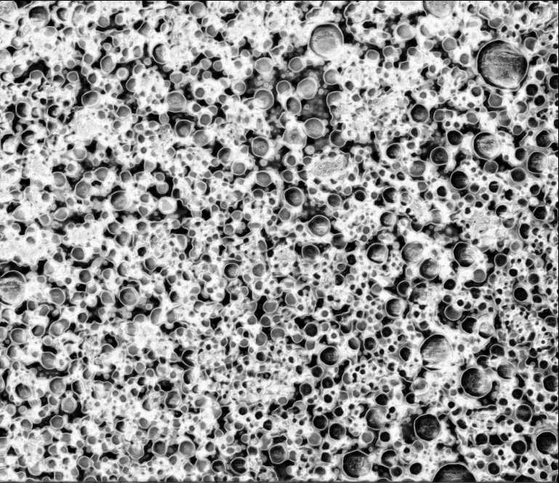 | 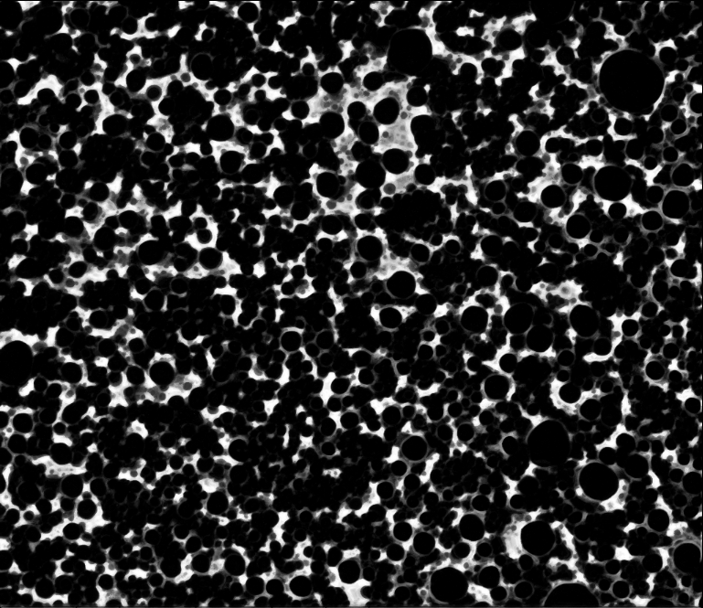

5.3.4 Temperature programmed reduction – active area measurements
TPR was performed on the nickel oxide paste using a Micromeritics 2720 Chemisorb. This was to confirm that the paste had no glass frit impurities and would reduce in-situ during the temperature ramp of the symmetrical fuel electrode samples.
The Ni paste supported on YSZ was reduced at 450 °C for 0.5 h in 20 mLmin⁻¹ of flowing 5 % H₂/Ar using the Micromeritics 2720 Chemisorption equipment. The paste initially started out as a black slurry then after reduction turned grey in colour indicating that the NiO film had reduced to metallic nickel. The film when tested with the multi-meter showed that the nickel paste was conductive after reduction. The resulting reduction reaction started at 200 °C with reduction peak at 284.4 °C indicating that the nickel oxide species in the paste is nanoscale in size (Figure 5.36) [203] .
Figure 5.36: Temperature programmed reduction profile of Shoei nickel paste on a YSZ electrolyte pellet
No response from the TCD was recorded for the other current collector systems during separate TPR runs on the Micromeritics 2720 Chemisorb. This indicates that the formation of oxides in the current collector layer is only an issue for the nickel oxide Shoei paste current collector[318].

5.4 Discussion
The application of different current collector materials does have a large impact on the electrochemical performance and properties of Ni-YSZ infiltrated fuel electrodes. The charge transfer resistance to polarisation (R_{P}) varied widely between the four current collector materials utilised in this study.
This variation in R_{P} demonstrates the ability of the current collector material to mask electrode degradation mechanism and in some cases add addition mechanisms to the system. The silver current collector produced a unique meso-frequency impedance arc (f > 16 kHz) which was a product of a gas transport impedance (Figure 5.5-Figure 5.7). In this case for the silver current collector this stems from the solubility of the H₂ fuel θ, which is almost twice that of gold (Table 5.14)[476].
Table 5.14: Hydrogen solubility for silver and metal current collector materials. Adapted from McLellan [476]
Current collector material | Hydrogen solubility, θ [x10⁶]
Silver, Ag | 3.05
Gold, Au | 1.66
Another source of impedance could be due to the formation of a stagnant gas layer between the fuel electrode and the incident fuel. This layer has been documented to form in impedance jig configurations utilising a direct gas inlet [477]. Diffusion of the electrochemical species (denoted by j) is directly related to the change in electrode area A, and the bulk gas B. The change in H₂ gas concentration between the two interfaces is the gradient across the stagnant layer between the bulk: stagnant gas and the stagnant layer fuel electrode interfaces (Figure 5.36)([132], [477]).
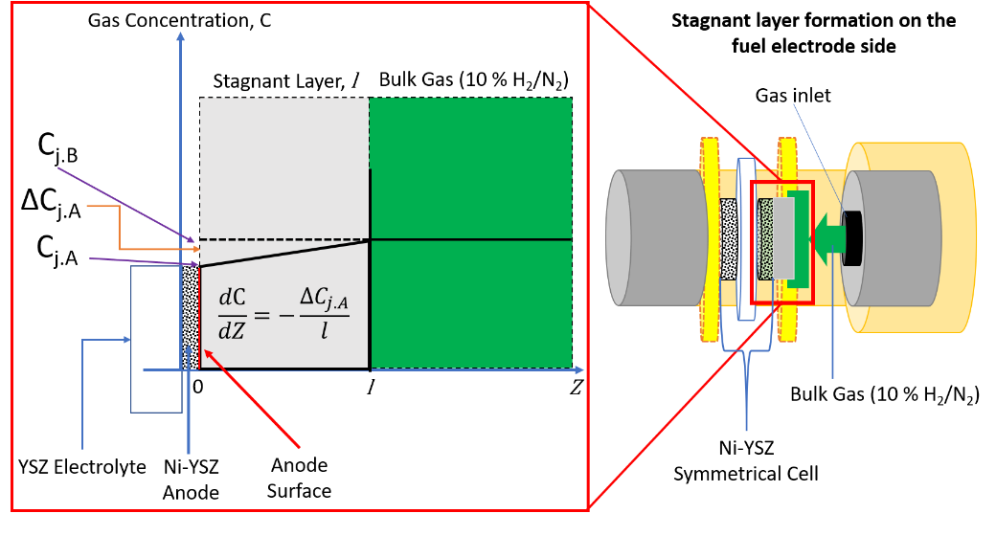
Figure 5.36: Diagram of the formation of a stagnant gas layer on the infiltrated fuel electrode sample. The right hand side shows the position of this layer in the ceramic impedance jig in this study. The change in the concentration of H₂ fuel C is inversely (C_{j.A}) related to thickness of the stagnant gas layer l. The fuel electrode area is denoted by A and the electrochemical species is H₂ respectively
Despite the silver producing the second lowest R_{P} for any of the infiltrated Ni-YSZ samples, the samples produced the largest increase in R_{P} between the ag, au and nickel current collectors during the ageing period. This is in part due to silver’s initially low resistivity under H₂ atmospheres as discussed in the literature since 1979 [433], [441], [457].
After ageing for 50 h in the 10 % H₂/N₂ atmosphere, microstructural imaging of the silver current collector layer and the formation of rods on the surface of the electrode. This would indicate that pinhole and void formation produced by the oxidation of the fuel has severed the layer [442], [478]. The timescale of this interaction was identified via EIS to occur within 15 h of ageing approximately 0.04 % of the desired lifetime for an SOFC system.
In addition, the diffusion of the silver current collector layer would also be a cause for concern in an SOFC. Silver has been reported to become extremely mobile above its Tammann temperature (480.9 °C) and has been documented to migrate towards the electrolyte on the air side of an SOFC [238], [240], [441], [442]. In anodic conditions used during this study the current collector layer has been susceptible to void formation and eventual delamination. As a current collector material for infiltrated SOFC fuel electrodes, silver has been found to be too mobile, too susceptible to void formation in H₂ and produce extra impedance contributions that stifle the electrode [433], [442], [443], [479].
In contrast with the silver and nickel samples, the gold coated Ni-YSZ sample showed some recovery via a drop in its initial R_{P} after 20 h of ageing. However, this material also showed a propensity to alloy with the nickel catalyst present in the fuel electrode under typical fuel electrode conditions used in this study [456], [462]. Analysis of back-scattered electron micrographs showed very little difference between the nickel and gold phases, indicating that an alloying event[445], [456]. The alloyed particles would also possess a lower electrical resistivity than pure nickel, reducing the R_{P} after the alloying event has finished [433], [457], [458], [464], [471].
A second low frequency (0.1-10 Hz) impedance arc indicative of the gas diffusion impedance was also recorded for the gold current collector [224], [289], [428]. This meant that the equivalent circuit fitting of the gold utilised a second RQ component to mimic the influence of this non-ideal interaction. This indicates that the second interaction favouring the formation water via the combination of the gaseous hydroxide with the proton at the nickel particle are energetically unfavourable as discussed by Liu and Kusnezoff [427], [480] .
$$O+H^{+}→OH^{+}(0.46-0.57 eV)$$
$$OH^{+}+H^{+}→ H_{2}O (0.83-1.05 eV)$$
Equation 5.2
The activation energy for the gold coated Ni-YSZ sample being smaller than those in Equation 5.2 illustrate that that the gas diffusion impedance is being caused during the formation of water. The presence of the Ni/Au alloyed particles would also hinder the percolation of both the fuel and the produce to and from the TPB, producing a gas diffusion impedance contribution [405].
The high mobility of this material under the ageing conditions via temperatures exceeding the T_{Tammann} (532⁰C) had led to prime conditions for alloying and further impedance contributions from the gas phase and highly variable data. This in combination with the gold system being primed to alloy with catalyst has led to non-ideal gas diffusion behaviour during short ageing times for this fuel electrode/current collector system.
The platinum current collector produced normalised impedance arcs up to three orders of magnitude higher than counterparts in the literature [434], [438]. These large R_{P} values illustrate how the current collector impedance contribution can be overlaid on top of that of the electrode [350], [438]. Despite utilising infiltrated Ni-YSZ symmetrical cells from the same batch these samples produced huge variance in R_{P} compared to the other samples in this study.
Although the Heraeus paste and resulting current collector layer being deemed defective the ageing behaviour of the Pt sample appears to be consist to that of the literature [438]. The polarisation resistance continues to rise with across the 50 h ageing period. The fact that the sample frequency response analyser, gas, temperature, and electrochemistry set up were used in this work demonstrates the importance of the current collector in EIS measurements.
The nickel oxide paste produced the smallest increase (9.7 %) in the R_{P} during the 50 h of EIS measurements of any of the current collector materials. Despite this the layer broke down during ageing. Inhomogeneous degradation was induced in the layer during ageing from the edge to the centre of the current collector was evident during microstructural assessment. The nickel agglomerates ranged from 278 – 438 nm in size across the surface of the electrode.
In contrast with other three current collector materials, the NiO paste had to be reduced in-situ to provide electronic conductivity suitable for electrochemical assessment. The TPR measurement underlined that the peak of this reduction occurs at 284.4 °C an indicator of nanoscale nickel oxide [65], [114], [378], [379]. This behaviour is identical to that of the catalyst present in the infiltrated fuel electrode. As the catalyst and current collector share the same composition, the fact that they share a length scale will reduce the initial R_{P} for the fuel electrode [438], [441].
This was evident during the equivalent circuit modelling, where the third component connected in series was an RC component. This was to model the breakdown of the nickel current collector and subsequent opening of the pores [440], [472], [473]. There was no presence of the low frequency impedance arc associated with the gas diffusion impedance in the Nyquist plots for the NiO coated samples [428], [460], [481].
After 50 h of ageing, the smallest increase in the polarisation resistance was observed by the nickel paste unlike the precious metal current collectors. The micrographs of the surface of each of the current collectors showed a de-wetting mechanism present in each of the materials. Only the Ni-YSZ sample coated in nickel current collectors remained conductive post-ageing. This indicates that the breakdown of the gold and silver current collectors has reduced the electrical conductivity of the layer, the antithesis of the role. This de-wetting behaviour in gold was also recorded in scanning electron micrographs by Guillodo et al [438].
The alloying effect displayed by the gold, does not appear to have occurred for the platinum, silver, or nickel current collector materials. Neither of these metals have been documented to exhibit the formation of any eutectics or alloys with the infiltrated nickel catalyst [438], [442], [482], [483]. This was evident in the lack of reduction of the polarisation resistance during ageing for these materials.

5.5 Conclusions
The use of the different current collector materials does have a profound impact on the polarisation resistance of infiltrated symmetrical cells. Changing the current collector material four times in this study produced highly varying electrochemical results for the infiltrated SOFC anodes.
Despite close control in the current collector thickness the impedance associated with these materials can supersede key contributions from the fuel electrode [438]. These current collector-based impedances are products of alloying, migration and eventual delamination [238], [433], [438], [444], [462]. Ideally the current collector material should remain stable during operation and not influence the impedance of the electrode under investigation [61].
Due to the elevated temperatures and reductive atmospheres utilised for SOFC fuel electrodes, the current collector materials in this study all visibly delaminated during 50 h of ageing (0.125 % of the desired SOFC lifetime) [73], [484]. The 800⁰C ageing temperature used in this study exceeded each of the current collector materials’ Tammann temperature (barring Pt) [238], [240]. This combined with the H₂ atmosphere primed the Ag, Au and Ni to migrate and sinter causing delamination and increased R_{P}. For electrochemical impedance spectroscopy in 10 % H₂/N₂ nickel oxide paste was the most suitable current collector material due its lack of influence on the impedance of infiltrated Ni/YSZ fuel electrode.

Chapter 6: Identifying Initial coarsening mechanisms in infiltrated SOFC Fuel Electrodes

6.1 Introduction
The major coarsening mechanisms described in SOFC literature revolve around two methods:
particle migration coalescence (PMC) and atomic ripening (AR). In PMC, surface particles move across the support surface using Brownian motion and agglomerate. The mechanism of Atomic/Ostwald ripening (AR) is driven by the by the movement and subsequent coarsening of nanoparticles compelled to reduce their free surface energy (Figure 6.1) [300], [301], [402].

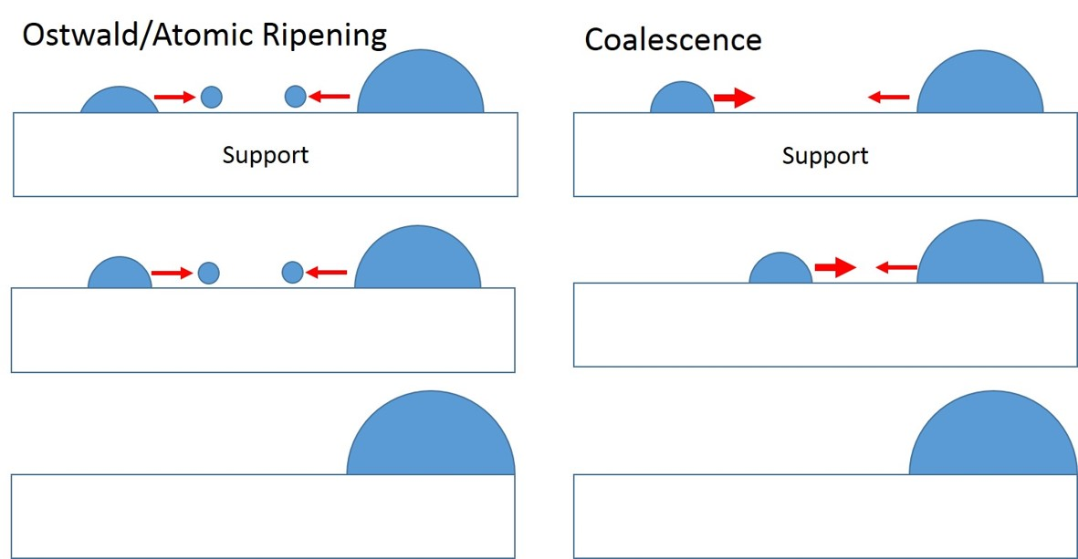
Figure 6.1: Diagram of atomic ripening and particle migration coalescence using hemispherical particles [118], [300]
Numerous methods have been used to reduce the impact of these catalyst sintering processes in a bid to retain the improved properties bestowed by catalyst infiltration. Buyukaksoy et al attempted to change the porosity of the scaffold in a bid to hinder Ni agglomeration in Ni/YSZ anodes [233]. However, a lack of understanding of these early stage-coarsening mechanisms has been driven by most research pre-coarsening their electro-catalysts by ageing their samples for 100 h [9].

Understanding the early-stage mechanisms of sintering and degradation in infiltrated SOFC electrodes should help inform the design of future sinter resistant impregnated systems. However, an additional challenge for the field has been the quantification of the nanoscale changes occurring during SOFC operation.

The challenges that present themselves are twofold: in operando studies are extremely difficult to perform due to the highly aggressive nature of the fuel atmosphere along with the elevated operating temperatures of SOFCs. Secondly, traditional microstructural quantification techniques such as FIB-SEM lift out have highly destructive sample preparation which can impact the volumes being segmented.

In the past ten years X-ray tomography techniques has become a popular method of tracking the microstructural evolution of the catalyst phase in fuel electrodes via 3D phase segmentation [255], [273], [485], [486]. This is done via offline ageing of the sample and reimaging the same over a desired time.
Unlike other X-ray tomography methods, ptychography being a technique not hindered by using lenses can provide higher resolutions than its TXM counterparts. Sub 30 nm resolutions are achievable using ptychographic imaging making it ideal in imaging the microstructural changes present in wet impregnated Ni-YSZ fuel electrodes [366], [487].
This experimental chapter focusses on the monitoring the microstructural changes evident in infiltrated solid oxide fuel cell anodes using ptychography as the main phase quantification method. This work is the first example of its kind using ptychography to image infiltrated SOFC fuel electrodes across an 8 h period. Characterising the sintering mechanisms of infiltrated samples is paramount to determining the deactivation steps present in the SOFC systems.

6.1.1 Chapter Aims
This study aims to use ptychography to identify the major coarsening mechanism present in infiltrated Ni-YSZ electrodes via the phase segmentation of the identical sample volumes over time.

6.1.2 Hypotheses
- The nickel, YSZ and pore phases can be successfully segmented for identical volumes in infiltrated Ni-YSZ fuel electrode samples
- Coarsening mechanism of the nickel electro-catalyst can be deduced using ptychography

6.2 Experimental procedure overview
The Ni-YSZ samples used in this chapter, were split into two groups: the ptychographic sample group and the witness sample group. Identical production batches and samples were used to provide comparability between both groups.

6.2.1 Characterisation Techniques
Wet impregnation/ infiltration has been shown to amplify the active area of the electro-catalyst in SOFC fuel electrodes, leading to enhanced reaction rates [70], [159], [231]. However, these nanoscale catalysts are primed to sinter under the elevated temperatures utilised for SOFC fuel electrodes [68], [488], [489]. Early-stage electrochemical impedance spectroscopy results under typical fuel electrode conditions (Temp: 800 °C Atmosphere: wet 10 % H₂/N₂), showed a large rise in the polarisation resistance during the first 10 h of ageing. The initial rate-limiting mechanism for infiltrated SOFC fuel electrodes is poorly understood.
Further discussion of the gathering of the EIS and FIB-SEM can be found in Chapter 3, Section 3.3.
The characterisation techniques discussed will provide structural and microstructural evidence to track this coarsening mechanism for the nickel electro-catalyst in SOFC fuel electrodes.

6.2.1.1 X-ray diffraction
X-ray diffraction was used to track the crystallite size of the nickel electro-catalyst in the witness samples using the Debye-Scherrer formula for line broadening analysis [165], [327]–[329]. The diffraction patterns of the Ni-YSZ samples were obtained using a Bruker D2 XRD Phaser. The samples were scanned for 1 h using Cu K_{α} radiation (1.54184 Å). The Debye-Scherrer equation can be found in Chapter 3, Equation 3.5.
The percentage dispersion for the nickel were calculated using Equation 3.5 in Chapter 3 to determine the impact of ageing on the catalyst distribution. The witness samples were heated at 5 °Cmin⁻¹ using an Elite tube furnace up to 800 °C under a 5 mLmin⁻¹ flow of wet 10 % H₂/N₂. The Ni-YSZ samples were aged for 5 h under these conditions.

6.2.2.2 Ptychographic X-ray Computed Tomography Experiment Diamond Light Source I13-1
Ptychographic X-ray Computer Tomography (PXCT) was performed at the I13-1 beamline at the DLS[358]. The milled fuel electrode samples were imaged using an interrupted ageing snapshot process was applied during beamtime. As the Ni-YSZ pillar system is a mixture of three phases: the metal catalyst, the YSZ scaffold and pores (filled with air), the selection of the beam energy was highly critical for producing good phase contrast. In this experiment a beam energy of 17 keV was utilised in order to produce a high phase contrast with the nickel phase and YSZ ceramic scaffold [262], [490].
To facilitate the use of this beam energy the detector to sample distance at the I13-1 CDI beamline was set to 10 m and the X-ray beam used had a beam size of 6 µm.

6.2.2.1 Ptychographic sample setup
A stainless-steel mount was machined using a pillar drill to produce a 650 µm diameter cylindrical hole to house the fine pillar Ni-YSZ samples. The base of this component was glued onto a 12.5 mm diameter SEM stub using superglue. After this had set for 10 minutes the milled fine Ni-YSZ pillar sample with pin was then glued into the machined slot. After each 1 h heating snapshot this process was repeated for each of the samples.

6.3 Results and Discussion

6.3.1 Electrochemical Impedance Spectroscopy
During the electrochemical impedance spectroscopy and subsequent ageing of the infiltrated Ni-YSZ samples the samples the series resistance rise stopped after a period of 10 h. Each of the samples in Figure 6.2 and Figure 6.3 showed an increase in the charge transfer resistance to polarisation (R_{P}) during the ageing period.
Figure 6.2: Series resistance for infiltrated Ni-YSZ samples dried under different atmospheres across 50h of ageing. The filled markers denote that the sample was dried in air (AD), non-filled markers (ND).
Despite this change, 50 % of the nitrogen dried Ni-YSZ samples levelled off after 2 h of ageing indicating that the initial coarsening mechanism in this system changes during this timescale. This is despite the series resistance of these samples showing little change in this intervening time. The EIS results show that this levelling off occurs at 30 h for the air-dried samples.
EIS has provided an indication of the key time scales present for the coarsening events in infiltrated nickel phase in SOFC fuel electrodes. However, this technique does not provide any indicators as to how the microstructure has changed in the anode during ageing.
The remainder of this study will involve tracking the evolution of the catalyst microstructure in the electrode in the 10 h aged timescale to identify the coarsening mechanism present in these systems.
Figure 6.3: Polarisation resistance for infiltrated Ni-YSZ samples dried under different atmospheres across 50h of ageing. The filled markers denote that the sample was dried in air (AD), non-filled markers (ND).

6.3.2 Focussed Ion Beam Scanning Electron Microscopy
Epoxy resin was also used to enhance the contrast between the nickel and ceramic scaffold phases.
Pristine and 50 h aged Ni-YSZ samples were sectioned and mounted in Buehler sample clips. The samples were vacuum impregnated using Buehler Epothin2 Epoxy. After the epoxy resin was cast, the sample was held in a Buehler “Cast N Vac” vacuum chamber for 60 minutes. The samples were removed from the container and left to set for a further 18 h.
The epoxy of the mounted sample stubs was clear with no evident of bubbles. The base of the sample mold was tough to remove indicative that a vacuum had formed during the setting process.
Thyden (2008) avoided the use of colloidal silica during a grinding and polishing routine for epoxy mounted samples [90]. The routine involved 3 grinding stages between 320-1000 µm. This was followed by polishing steps using 6,3 and 1 µm abrasive diamond paste.
This routine was implemented on the Ni-YSZ samples in this study however, due to the mechanical fragility of the scaffold this phase ended up covering the electrode increasing wear during polishing and grinding (Figure 6.4). This method was not used for further microscopy of the witness samples.
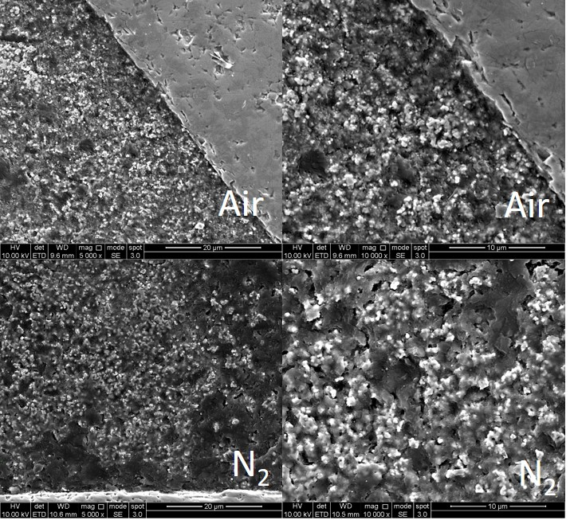
Figure 6.4: Scanning electron micrographs of the air and nitrogen dried Ni-YSZ samples after grinding and polishing after setting with an epoxy resin. The magnification from left to right is 5,000x and 10,000x respectively
Focussed Ion beam SEM micrographs of the air dried and nitrogen witness samples without epoxy resin were performed for 0 h aged and 5 h aged samples. Initially, 20 µm x 10 µm micrographs of the samples were taken of the milled cross-section (Figure 6.5 and Figure 6.6).
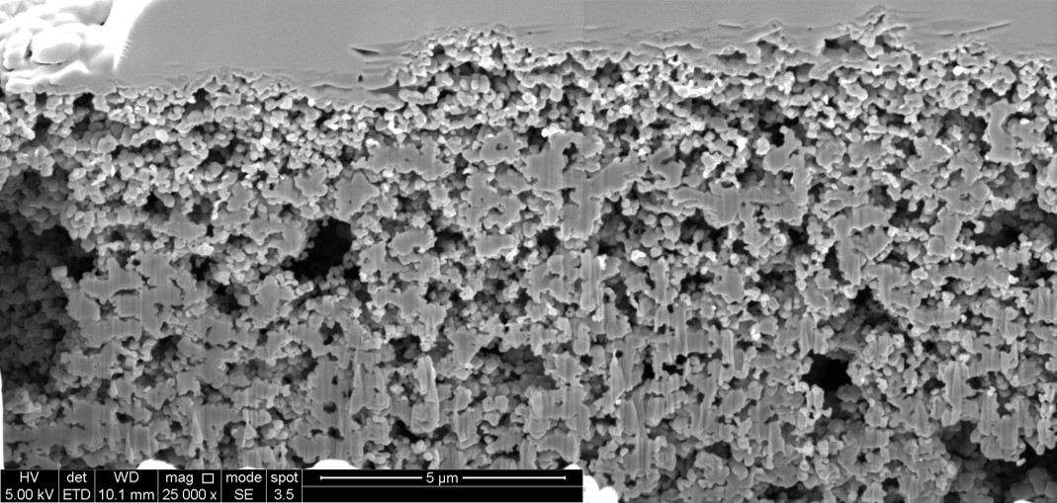
Figure 6.5: Scanning electron micrograph of the milled cross section of the 0 h aged air-dried infiltrated Ni-YSZ fuel electrode sample at a magnification of 25,000x. The region measures 20 µm x 10 µm, respectively. The top 1 µm layer is the platinum protective layer. The next 10 µm are the infiltrated Ni-YSZ fuel electrode witness sample with a porous YSZ ceramic backbone.
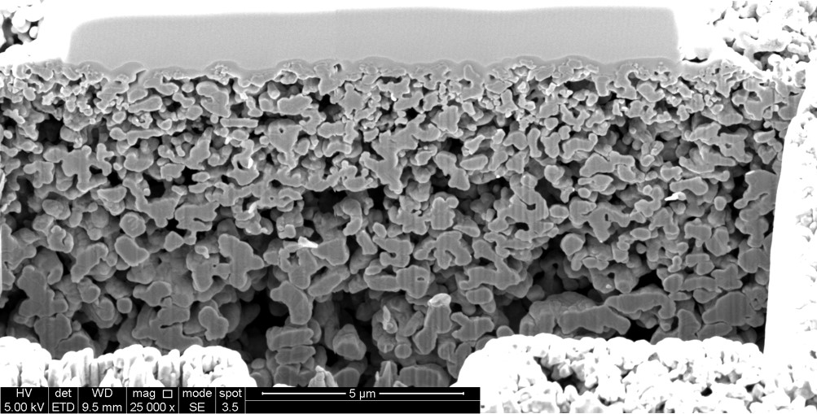
Figure 6.6: Scanning electron micrograph of the milled cross section of the 0 h aged nitrogen-dried infiltrated Ni-YSZ fuel electrode sample at a magnification of 25,000x. The region measures 20 µm x 10 µm, respectively. The top 1 µm layer is the platinum protective layer. The next 10 µm are the infiltrated Ni-YSZ fuel electrode witness sample with a porous YSZ ceramic backbone.
There was little sign of the infiltrated nickel phase for present in the two cross-sectional micrographs (Figure 6.5 and Figure 6.6). Back scattered electron micrographs were also taken and can be found in the Appendix (6.3.2). The air-dried sample had two large voids 3 µm for the top of the electrode, which indicate the presence of mechanical instabilities in the ceramic scaffold. Figure 6.5 bears a close resemblance to the uniaxially pressed YSZ scaffold microstructure present in Kim et al [129]. The bright platinum protective layer made grayscale segmentation in Weka difficult for the Ni and YSZ phases.
Two further infiltrated Ni-YSZ fuel electrode samples were imaged after 5 h of ageing at the conditions discussed in Section 3.3.6.
After this ageing period the microstructure of the air-dried system developed a network of elongated nickel chains which congregated in the first 5 µm of the electrode.
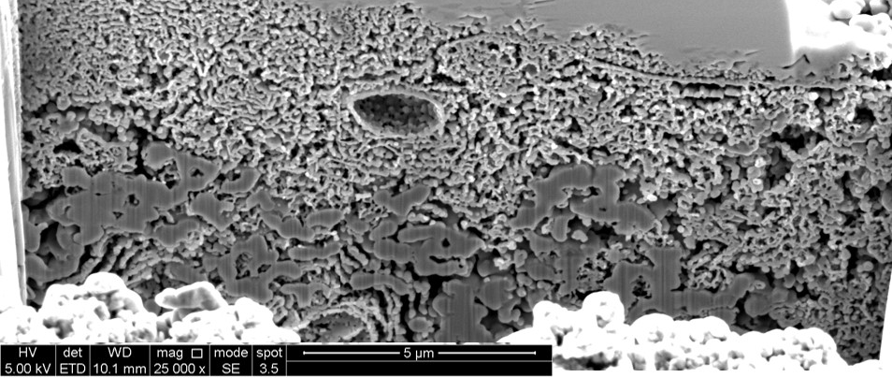
Figure 6.7: Scanning electron micrograph of the milled cross section of the 5 h aged air-dried infiltrated Ni-YSZ fuel electrode sample at a magnification of 25,000x. The electrode region measures 20 µm x 10 µm, respectively. The top 1 µm layer is the platinum protective layer. The next 5 µm is the coarsened nickel network on top of the YSZ scaffold. The next 5 µm is the porous YSZ scaffold with infiltrated nickel of the witness sample. The white layer at the bottom of the micrograph is the top of the milled trench.
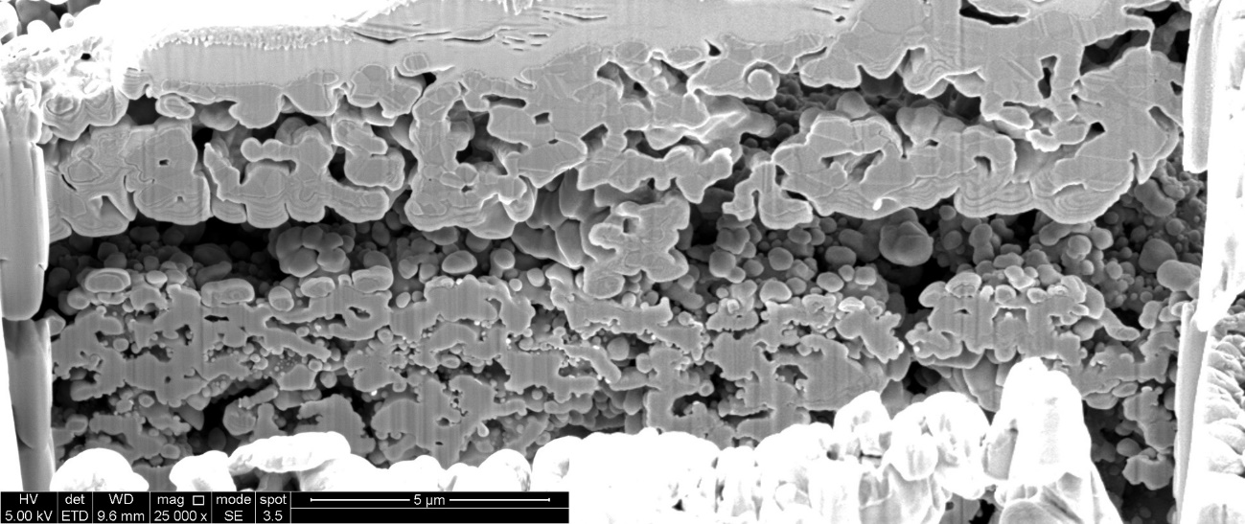
Figure 6.8: Scanning electron micrograph of the milled cross section of the 5 h nitrogen-dried infiltrated Ni-YSZ fuel electrode sample at a magnification of 25,000x. The region measures 20 µm x 10 µm, respectively. The top 1 µm layer is the platinum protective layer. The next 10 µm are the infiltrated Ni-YSZ fuel electrode witness sample with a porous YSZ ceramic backbone. The white layer at the bottom of the micrograph is the top of the milled trench.
In the nitrogen dried sample, the first 3 µm of the layer do not appear to have any nickel catalyst present (Figure 6.8). The nickel appears to have migrated to the pores further into the structure. This indicates that even after 5 h of ageing the nickel catalyst is highly mobile and that the sintering is not complete. This is evident from the images of the surface with the nickel oxide present in. The nickel appears to have either moved from the surface into the structure leading to the evident agglomeration (Figure 6.8).
Further micrographs were taken of the samples at 80,000x magnification. The infiltrated nickel oxide phase is harder to discern in the 0 h aged images, with the YSZ scaffold appearing bare (Figure 6.4 and Figure 6.5). Even in micrographs taken using the back-scattered electron detector, it did not look like the wet impregnated phase was present (Figure 6.11).
After 5 h of ageing there was clear sintering behaviour in both sets of wet impregnated Ni-YSZ samples. The network of particles in the air-dried sample look to have been blocked the pores in the top 14 % of the electrode (Figure 6.9b). In contrast in the nitrogen-dried sample the nickel appears to have migrated past this region and can be seen decorating pores further into the fuel electrode.
These micrographs illustrate the difference in using different drying routines and their effect on the catalyst distribution within the porous scaffold. Both indicate the presence of different short-term coarsening mechanisms exhibited by the nickel catalyst phase, which would stem from the drying step during sample production.
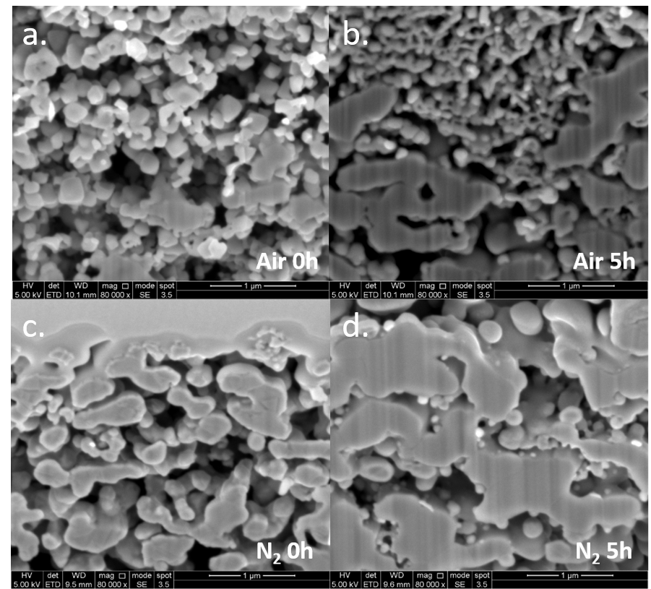
Figure 6.9: Scanning electron micrographs of the cross sections of the infiltrated Ni-YSZ fuel electrode witness samples (80,000x magnification). No epoxy was used in these micrographs.

6.3.2.1 Back-scattered electron microscopy
Due to presence of the protective platinum layer; phase discernment and contrast was difficult to achieve without sectioning a portion of the image to not include said component. The Pt dominates the 256th bin and due to its atomic number (78) being almost double and triple that of the ceramic and the catalyst [491]. This results in a bright phase which dominates the grayscale histogram of BSE images (see Figure 6.10 and Figure 6.11). As shown in Figure 6.10 the foremost phases in the grayscale histogram are the pore (GSV, 0) and the Pt (GSV, 256).
Figure 6.10: Overlaid histograms of the 0 h aged air and nitrogen dried infiltrated Ni-YSZ sample. The air and nitrogen histograms are orange and blue respectively
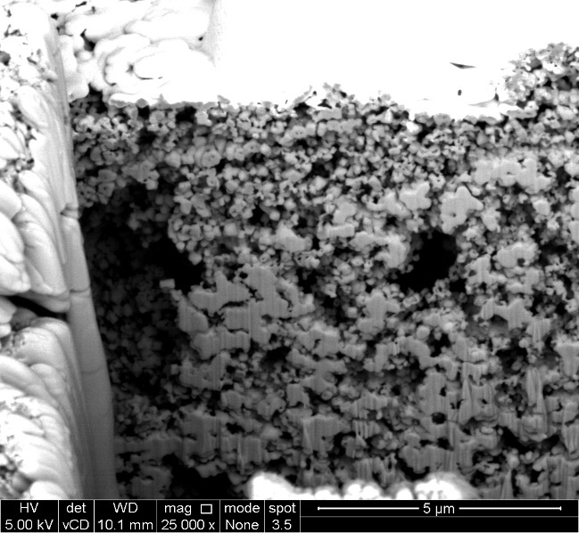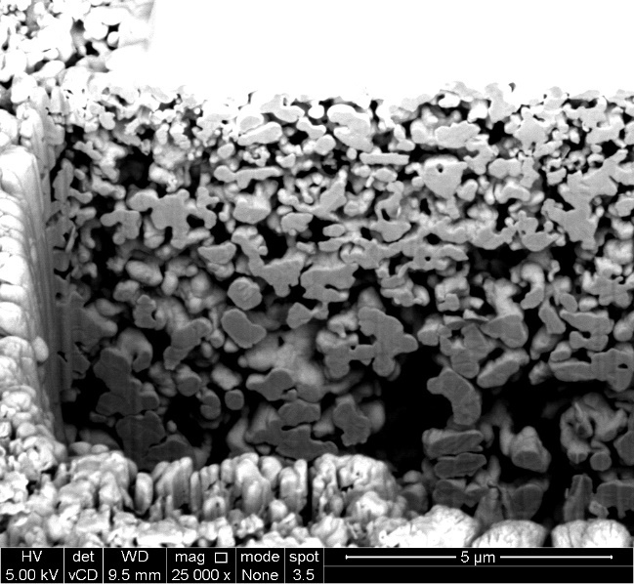
Figure 6.11: Back scattered electron micrographs of the 0 h aged air and nitrogen-dried Ni-YSZ samples at 25,000x
After 5 h of ageing the nickel volume percent in the air-dried electrode was 3.2 % higher than its nitrogen-dried counterpart. The difference between the upper and lower outliers of the segmented was 0.2 % of the ceramic scaffold, indicating no changes in this phase during ageing. The clear difference between the two systems is evident by the nickel probability distribution. The nickel in the nitrogen dried system has migrated from the top 3 µm of the layer towards the anode function layer.
The FIB-SEM images gathered during this study have illustrated the qualitative value of the technique on monitoring the microstructural changes evident in the nickel catalyst in SOFC fuel electrodes. In this case a large amount of sintering was observed for two sets of Ni-YSZ samples dried under different atmospheres.
However, due to the method being innately destructive and the scaffold being brittle, the evolution of the nickel phase in the same sample volume cannot be adequately monitored. The presence of the protective platinum layer lead to issues with segmentation even in BSE micrographs. Despite the highly aggressive milling process during the technique no streaking or deposition of the platinum layer was observed [10], [252], [259], [492].

6.3.3 X-ray Diffraction
X-ray diffraction patterns were taken of the infiltrated Ni-YSZ witness samples to track the evolution of the catalyst phase for Ni-YSZ sample segments aged between 0 – 8 h (Figure 6.12). This was to provide comparison with microstructural characterisation techniques.
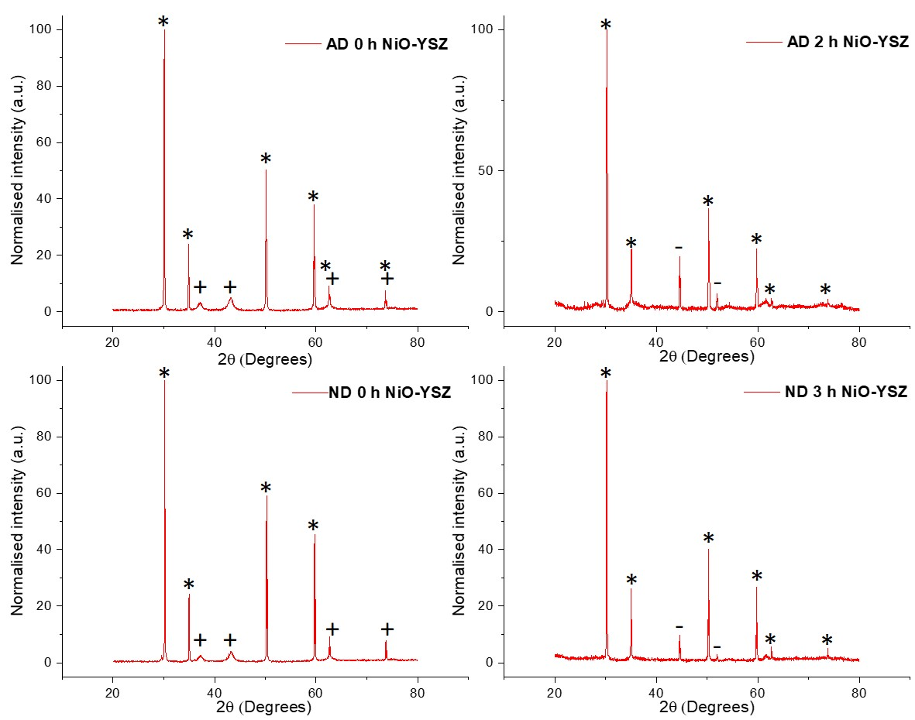
Figure 6.12: X-ray Diffraction patterns of infiltrated Ni(O)-YSZ aged between 0 -3h. From left to right: NiO-YSZ (AD, 0 h), Ni-YSZ (AD, 2 h), NiO-YSZ (ND, 0 h), and Ni-YSZ (ND, 3 h)Characteristic peaks for nickel oxide, nickel and yttria-stabilised zirconia are denoted by +, -, and * respectively [382], [488], [493]
The characteristic X-ray reflections for the Ni, NiO and YSZ compounds were matched to the literature samples using the Sieve+ function in the in the ICDD PDF4+ database. After 1 h of ageing the nickel oxide reduces completely to metallic nickel [114], [337], [378].

6.3.3.1 Tracking nanoparticle growth using X-ray Diffraction
The changes in the sintered nickel crystallite size D, were tracked using the Debye-Scherrer equation discussed in Section 3.3.1. The witness sample segments were aged using representative fuel electrode conditions to identically mimic the ageing done to the scanned Ni-YSZ samples during experiments on the I13-1 beamline.
Table 6.1 below charts the evolution of the nickel crystallite size during ageing between 0-8 h for the differently dried Ni-YSZ samples. The strain component contribution to D was removed by utilising the Williamson Hall correction (present in Section 4.3.5 of this document) [327], [329], [419], [494], [495]. The percent dispersion of the catalyst was calculated using these results [297], [339].

Table 6.1: Crystallite lengths of the infiltrated nickel phase in air and nitrogen dried Ni-YSZ witness samples. The * asterisk denotes a set of anomalous data.
Sample composition  (Drying condition) | Crystallite Length in nm and determination method (Detector) |  | Percent dispersion of the infiltrated nanoparticles  [%]
Sample composition  (Drying condition) | Debye-Scherrer  (D2) [nm] | Williamson Hall  (D2) [nm] | Percent dispersion of the infiltrated nanoparticles  [%]
Ni-YSZ (Reduced, AD) | 21.04 ± 1.01 | 22.16 ± 0.38 | 5.78
Ni-YSZ (1h aged, AD) | 47.41 ± 1.01 | 62.11 ± 1.07 | 2.57
Ni-YSZ (2h aged, AD) | 68.12 ± 1.03 | 83.72 ± 1.44 | 1.79
Ni-YSZ (8h aged, AD) | 33.77 ± 1.01 | 42.37 ± 0.73 | 3.60 *
Ni-YSZ (Reduced, ND) | 16.88 ± 1.01 | 18.19 ± 0.31 | 7.21
Ni-YSZ (1h aged, ND) | 31.98 ± 1.01 | 39.35 ± 0.68 | 3.80
Ni-YSZ (3h aged, ND) | 96.88 ± 1.03 | 103.36 ± 1.77 | 1.26
The air-dried sample appeared to show a reduction in crystallite size after 8 h of ageing, hence increasing the dispersion of the catalyst at this point. However, this result is anomalous. After 3 h of ageing the Debye-Scherrer relation breaks down as result of the crystallite size exceeding 100 nm [295], [419]. This interaction explains the drop in length at the 8 h ageing stage (Table 6.15).
These results illustrate the rapid evolution of the nickel during SOFC operation; as the crystallite size has quintupled in size (> 100 nm) after 3 h for both sets of samples. This timeframe has been identified due to the crystallite size exceeding this value after the Williamson Hall correction.

6.3.4 Ptychographic X-ray Computed Tomography of aged Ni-YSZ coarse pillars
Initial Ptychographic X-ray Computer Tomography (PXCT) measurements were performed on the DLS I13-1 beamline using air-dried infiltrated Ni-YSZ pillar samples. These samples measured 50 µm in diameter. The samples were aged used the apparatus and method described in Section 6.2.2.4. The aim of these scans was to quantitively segment and track the evolution of the infiltrated nickel during ageing.
PXCT was performed on these Ni-YSZ samples using a beam energy of 20 keV. This beam energy was selected to produce 20 % transmission for the nickel phase [363]. Both air and N₂ dried Ni-YSZ samples were scanned during this beamtime.
The diffractograms and ortho-slice images below show that large nickel agglomerates formed in our infiltrated electrodes after an ageing period of 1 h (Figure 6.13). An identical pore structure is denoted by the red markers in Figure 6.14. To reduce the impact of attenuation from sample thickness and reduced contrast, this energy was reduced to 17 keV. Nitrogen-dried samples were imaged using this beam energy.
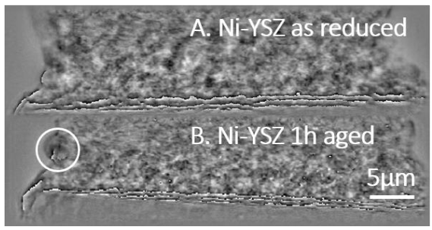
Figure 6.13: Ptychographic diffraction patterns of the base of the Ni-YSZ anode pillar sample aged as reduced and aged for 1 h at 800⁰C.in 10% H₂/N₂ . A sintered nickel particle is denoted by the white circle. The black denotes pores, and the light grey denotes the YSZ ceramic backbone
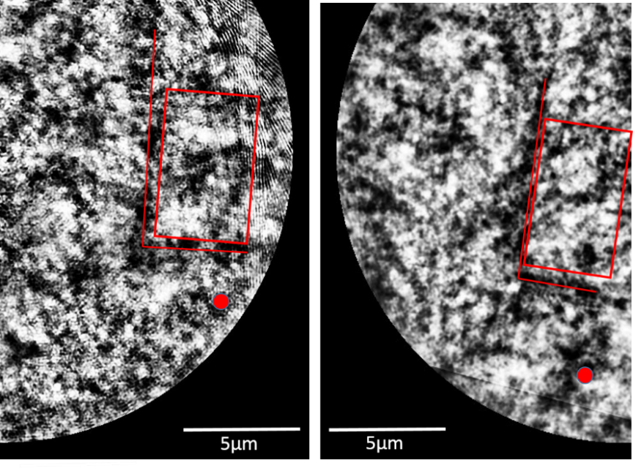
Figure 6.14: Ptychographic ortho-slices images from the I13-1 beamline of the same Ni-YSZ sample having been aged for 0h to 2h. White nickel agglomerates have sintered on top of the grey YSZ scaffold (red box)
The beam size of the PXCT scan data at the sample surface was 6 µm using a sample detector to distance of 10 m. The calculated voxel size for the ptychographic scans was 36 x 36 x 36 nm³ [356], [357], [362].

6.3.4.1 Mass attenuation coefficient calculation
The mass attenuation coefficients were calculated for the infiltrated Ni-YSZ electrode utilising the known densities, porosities for the phases present. These are key to the phase segmentation of the materials during data analysis.
The tomograms of the infiltrated anode consisted of three phases: nickel metal, YSZ ceramic scaffold and air (pores). The calculated vol % of the electrodes for the three phases are as follows: 20 %, 65 % and 15 % during manufacture. The values were calculated using mass changes in the electrode and Archimedes density analysis for the porous YSZ scaffold. The mass attenuation coefficients were calculated for each element in these phases and then adjusted for the sample composition [490].
The ratio between the ceramic scaffold and metallic phase revealed that the YSZ was the brightest phase present in the tomograms. The mass attenuation ratio between the Ni and the YSZ was calculated to be 7. These calculations were performed using the mass attenuation coefficients from Heenan and Stockmar et al [363], [364], [366], [490].
The percentage transmission was calculated for each of the phases using the transmission values calculated using the Henke, the thickness of the samples and the density of each of the material in the Ni-YSZ samples(Figure 6.15-Figure 6.17 and Table 6.16).
Figure 6.15: Percentage transmission for the YSZ ceramic phase (Density of 6.05 g cm⁻³) using a 15 µm thick sample for photon energies ranging from 0 – 20 keV[363]
Figure 6.16: Percentage transmission for the 20 vol % Nickel phase (Density of 8.9 g cm⁻³) using a 15 µm thick sample for photon energies ranging from 0 – 20 keV [363]
In the case of the Ni and YSZ phases their percentage transmission are 50 and 60 % respectively with a beam energy of 17 keV. The air has a transmission of almost 100 % meaning that in order of brightness in the tomograms the phases will go: YSZ > Ni > Air
Figure 6.17: Percentage transmission for the air/pore phase using a 15 µm thick sample for photon energies ranging from 0 – 20 keV [363]
However, the as the infiltrated Ni-YSZ fuel electrode samples consist of a combination of each of the three phases discussed (See Chapter 3). The volume percentage of the three phases in the electrode are described earlier.
The X-ray transmission in PXCT is based on the ratio between the transmitted beam I_{t} and the incident beam I₀ intensities in the scan. The transmission of an X-ray photon is denoted by T and can be found in Equation 6.1 [496]–[499].
$$Transmission, T=\frac{I_{t}}{I_{0}}$$
Equation 6.1
The mass attenuation coefficient µ of the electrode rely on three factors:
- Composition of the electrode material
- Thickness of the sample
- Energy of the X-ray photons present
The transmitted intensity of the X-ray photon is dependent of chemistry of the sample it is passing through. Each electrode element possesses a characteristic attenuation coefficient (µ) which impedes the incident beam [497]–[499]. This means that the overall attenuation and decay of the X-ray photon is a function of each of these components and the thickness of the sample.
The transmitted intensity I_{t}, of the X-ray photon after traversal through a specimen of thickness (t) is described by the exponential Beer-Lambert law (Equation 6.2)[364], [497]–[499]. The element incident energy is denoted by E₀ [364], [497]–[499].
$$I_{t}=I_{0}e^{-μ{(E}_{0})t}$$
Equation 6.2
In this study the composition via weight percent for the of the anode materials were used to calculate the mass attenuation coefficients µ_{m} for each of the elements in the anode(x= Ni, Y, Zr and O) [365], [490]. The contribution of each element was multiplied by their respective weight percent w_{i} and added together by Hubbell to generate the attenuation coefficient for a compound [365].
$$µ_{m}\left(E_{0}\right)=\sum_{i}{\left[w_{i}∙µ_{m}\left(i,E_{0}\right)\right]}$$
Equation 6.3
In the case of PXCT, a linear attenuation coefficient is required to calculate the transmission of the X-ray photons through the sample thickness. The coefficient is a product of the total mass attenuation coefficient $µ_{m}\left(E_{0}\right)$, and the crystallographic density of the specimen ρ_{i}. The X-ray attenuation length $µ\left(E_{0}\right),$ is inversely proportional linear attenuation coefficient [363].
$$µ\left(E_{0}\right)=µ_{m}\left(E_{0}\right)ρ_{i}$$
Equation 6.4
The total crystallographic density for the anode (20 % nickel) was calculated using the elemental data from Hubbell and Stockmar et al [262], [365], [366]. The fuel electrode density can be found below in Table 6.16.
Table 6.2: Table detailing the crystallographic densities of the Ni/YSZ fuel electrode material using elemental data from Hubbell [365]
Material | Ni | Y | Zr | O | Ni_{0.2}(Y₂O₃)_{0.08}(ZrO₂)_{0.92}
Density [g cm ⁻³] | 8.90 | 4.47 | 6.49 | 1.43 | 15.38

The manufactured compositions of the samples were multiplied by their mass attenuation coefficients to generate the attenuation coefficient ratio (ACR) between the nickel and YSZ phases.
In this case the YSZ ceramic material possesses a far higher mass attenuation coefficient than the metal catalyst at this beam energy. This means that the bright (most attenuating phase) is the scaffold material.
Table 6.3: Table detailing the mass attenuation coefficient and grayscale ratios of the Ni and YSZ phases at 17 and 20 keV [363], [364], [366], [490]
Electrode component | Nickel catalyst  Ni at 17 keV | YSZ ceramic scaffold  YSZ at 17 keV | Nickel catalyst  Ni at 20 keV | YSZ ceramic scaffold  YSZ at 20 keV
Attenuation Coefficient /cm ⁻¹ | 672 | 4700 | 410 | 2750
Attenuation Coefficient ratio (ACR) /unitless | 6.99 |  | 6.71
Grayscale value /unitless | 31.80 | 223.00 | 32.40 | 217.00
Grayscale value ratio (GSR) /unitless | 7.01 |  | 6.71
This contrasts with work by Stockmar and Vilanova et al the nickel was the meso-brightest phase at 17 keV [262], [366]. This due to a combination of factors. Namely the lower nickel volume percent the infiltrated samples, lower beam energy due to detector constraints and the histogram being is dominated by the attenuation of the ambient air present in the scan [262], [366], [500].

6.3.4.2 Phase segmentation using Ptychography

6.3.4.2.1 Ni-YSZ Contrast sample
A Ni-YSZ cermet sample was scanned using the I13-1 Beamline to determine the grayscale values for the three phases: the nickel, the YSZ and the pores. This will be described furthermore as the contrast sample. The scan size was 25 x 25 x 10 µm in size. The top 25 % of the scan contained imaged just atmospheric air.
The resulting tomograms of the contrast sample were used to generate grayscale values for A line profile was used across the centre of the tomogram in the FIJI analysis software to calculate the average grayscale value (GSV) of the air and the range of the data. Each line profile had 500 measurement points with a total of 6-line profiles being taken from ortho-slices 1-100. The average GSV for the air phase was calculated to be 57.44, with the GSV ranging from 36-70.
Utilising these GSVs for Air, the three phases were segmented using the threshold function in Avizo Lite across 256 bins. The nickel was the darkest phase because of its reduced vol % compared to the YSZ scaffold and its seven times smaller mass attenuation coefficient.
In terms of GSV the bins the Nickel was found to occupy were between 1-35 and the YSZ between 70-255. These quantities were used to segment the individual reconstructed tomograms and produce 3D renderings of the contrast sample microstructure (Figure 6.18 and Figure 6.19). These ranges also matched the expected grayscale values calculated from the mass attenuation coefficient ratio discussed earlier.
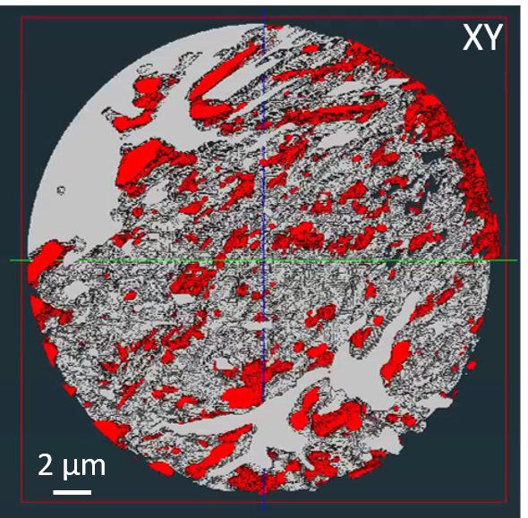
Figure 6.18: 3D Rendering of the microstructure in the Ni-YSZ cermet contrast sample. The white phase is the YSZ ceramic scaffold, and the red phase is the Ni metal. The orientation is XY
The GSV were also calculated for the nickel and YSZ phases using the line plot method in FIJI. Each line profile had 100 measurement points with a total of 6-line profiles being taken from ortho-slices 370-395. The average GSV for the ceramic scaffold and nickel metal phases were calculated to be 197.76 and 24.32, respectively. These results underline that the nickel phase is the darkest present for the tomography datasets.
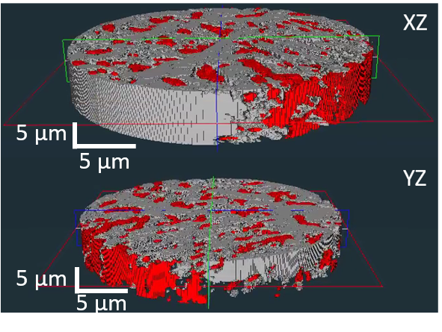
Figure 6.19: 3D Renderings of the microstructure in the Ni-YSZ cermet contrast sample. The white phase is the YSZ ceramic scaffold, and the red phase is the Ni metal. The orientations from top to bottom are XZ and YZ
Despite the pore phase separating the catalyst and the ceramic support in the grayscale histogram., the 3D renderings show that the catalyst is in contact with the YSZ in multiple positions (Figure 6.20 and Figure 6.21).
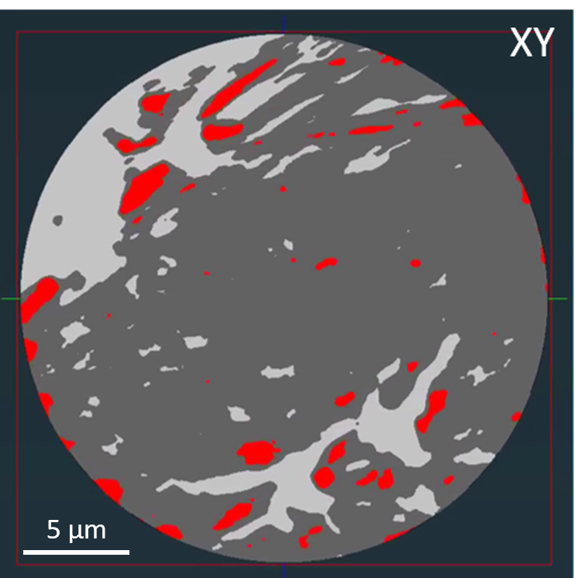
Figure 6.20: 3D Rendering of the microstructure in the Ni-YSZ cermet contrast sample. The white phase is the YSZ ceramic scaffold, the red phase is the Ni metal and the grey phase is the air. The orientation is XY
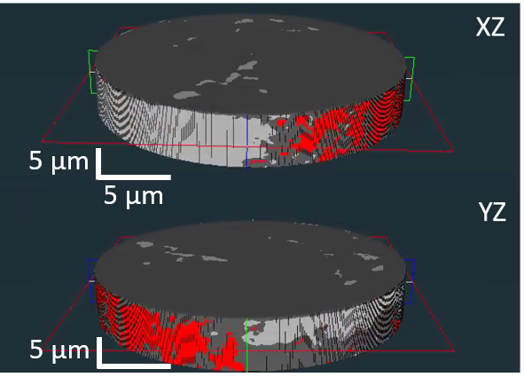
Figure 6.21: 3D Renderings of the microstructure in the Ni-YSZ cermet contrast sample. The white phase is the YSZ ceramic scaffold, the red phase is the Ni metal, and the grey phase is the air. The orientations from top to bottom are XZ and YZ

6.3.4.2.2 Air-dried Ni-YSZ samples
Quantitative analysis of the tomograms (Figure 6.13 and Figure 6.14) for the 0 and 2 h aged Ni-YSZ samples showed poor phase contrast between the nickel and YSZ scaffold. A median filter and local contrast brightness and contrast JavaScript macro was used to de-convolute the images in ImageJ [255].
Despite the high attenuation from the ceramic phase and attenuation due to sample thickness, the coarsening of the catalyst could be tracked by monitoring the change in the pore volume percent with ageing time. A 7.5 * 7.5 * 8 µm region of interest between the fuel electrode and the electrolyte was selected (see Figure 6.22 and Figure 6.23).
This was selected for comparison purposes with the nitrogen dried samples. This portion was segmented using the GSVs from the contrast sample and the from the samples using the L shaped pore structure denoted in Figure 6.14. Two air-dried Ni-YSZ PXCT scans were segmented in Avizo Lite.

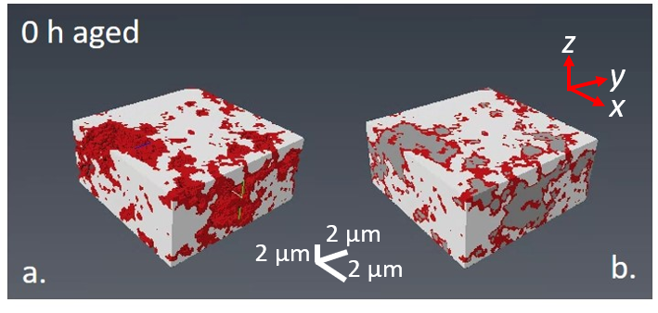
Figure 6.22: Segmented 3D renderings of the ROI sub volume of the 0 h aged, air-dried Ni-YSZ fuel electrode using Avizo Lite. The nickel, ceramic and pore phases are red, white, and grey, respectively. The Ni and YSZ phase are rendered in a. and the three phases in b.
From visual inspection between the two segmented volumes the nickel phase appears to have increased in volume during the two hours of ageing. This expansion can only be a product of coarsening as no additional nickel was added to the structure during ageing [67], [300], [501].
Initially, the segmented Ni-YSZ electrode volume consisted of 11.9 % pores. After 2 h of ageing this decreased to 3.5 %. These were calculated by dividing the phase volumes by the total scan volume.
However, the volume percent of the ceramic phase rose between scans. This is highly unlikely as YSZ sinters at temperatures exceeding 1200 °C [1], [294], [478], [488]. This would indicate that this increase is due to changes in the catalyst material.
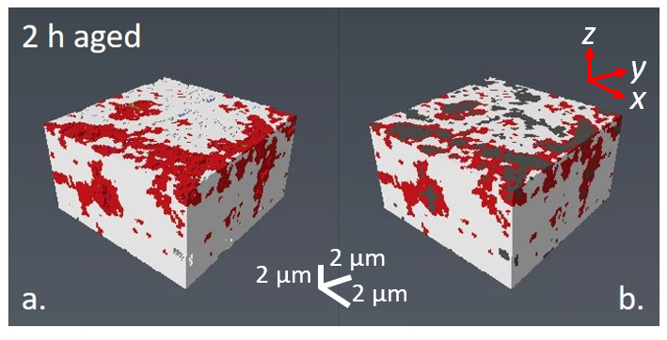
Figure 6.23: Segmented 3D renderings of the ROI sub volume of the 2 h aged, air-dried Ni-YSZ fuel electrode using Avizo Lite. The nickel, ceramic and pore phases are red, white, and grey, respectively. The Ni and YSZ phase are rendered in a. and the three phases in b.
The region of interest used in these renderings focussed on an 8 µm section at the interface between the infiltrated scaffold and the electrolyte. The position of this segment in the scaffold means that the YSZ vol % will increase due to decreased pore vol % and increased tortuosity.

Table 6.4: Table detailing the volume percent of the three phases present in the air-dried Ni-YSZ electrode sample
Sample | Phase [Vol %]
Sample | Nickel | YSZ | Pore
Ni-YSZ 0 h Air dried | 19.47% | 68.64% | 11.88%
Ni-YSZ 2 h Air dried | 19.27% | 77.25% | 3.48%
During the first two hours of ageing the nickel phase has increased in volume by over 8% (calculated via YSZ vol % change) (Table 6.4). This volume expansion is due to the coarsening of the metal making the nickel particle size exceed the voxel size and is exemplified by Figure 6.24 where the top of the segment to the electrolyte interface is denoted between 0 – 60. After just two hours of ageing the central 20 slices show an 5.2 % average increase in volume.
.
Figure 6.24: Volume % per slice of the nickel catalyst phases from the top to the bottom of the Roi. The 0 h aged nickel is denoted by the grey series and the 2 h aged the pink series, respectively. Slices 0-20 denote the top of 2.5 µm of the volume. Slices 20-60 denote the Ni-YSZ electrode approaching the electrode/electrolyte interface
However, in the bottom third of the ROI the vol % of the phase appears to have dropped, this indicates that the coarsening in the middle of the section is causing issues for catalyst migration and coarsening. This blocking behaviour has also been shown in Figure 6.9 in the 5 h aged micrograph where the nickel network has sintered to such an extent that it also appeared to have blocked the pores in the bottom third of the micrograph.
These snapshots have identified that the air-dried infiltrated nickel phase is highly mobile and moves migrates towards the electrolyte interface rapidly during the ageing process. However, due to the initial sintering mechanism present the metal agglomerates leading to pore blocking. This blocking would reduce the amount of fuel reaching the AFL and subsequently increase the polarisation resistance of the fuel electrode [153], [451].
The migration of the infiltrated phase towards the AFL indicates that for the air-dried Ni-YSZ system atomic ripening is the major sintering mechanism present for the infiltrated catalyst system. This is supported by the findings of DeLaRiva et al in 2013 who tracked the sintering mechanisms of nickel in MgAl₂O₄ catalysts using an environmental TEM [502], [503].
PMC has been discounted due to the work from Crump, who found that the migration distance of nickel crystallite X_{C,} decreased from by over a scale factor with a crystallite radius r, increase of 4 nm at 500⁰C [504]. This is related to the crystallite diffusivity D_{C}, surface diffusivity D_{S}, atomic radius α, temperature T, and ageing time t, in hours( Equation 6.6 and Equation 6.7)[504].
$$X_{C}=2{\left(D_{C}t\right)}^{\frac{1}{2}}$$
Equation 6.5
Utilising the migration distance expression stated by Crump relation and using a crystallite radius of 20 nm (Table 6.5) the particle migration distance at 800⁰C was found to be 3.4 ± 5.9 nm. Including the systematic error (10 nm) this is approximately, a 100th of the distance needed for the infiltrated nickel to migrate via PMC from the top of the ROI to the centre. As the radius of the nickel crystallite increases with ageing time, this distance will continue to decrease before the sample sinters and creates facetted particles [504]. This eliminates PMC as the initial coarsening mechanism for the air-dried Ni-YSZ electrode in agreement with Hansen et al [402], [502].
$$D_{C}=0.301 D_{s}{\left(\frac{α}{r}\right)}^{\frac{1}{2}}$$
Equation 6.6
$$D_{S}=D_{o}e^{-\frac{Q}{RT}}$$
Equation 6.7
In addition, the Crump expression is based on an ideal system with spherical nickel particles and a flat substrate. The increased tortuosity of the impregnated scaffold would mean the migration distances for the particles would be longer due to the impact of this parameter.
Table 6.5: Table detailing the calculated Particle migration distance X_{C} for infiltrated nickel particles with crystallite radii from 5 – 50 nm [504]
Crystallite radius r, [nm] | Activation Energy for Surface diffusion Q, [kJmol⁻¹] | Surface Diffusivity, D_{s} [x10⁹] | Crystallite Diffusivity, D_{c} | Particle Migration Distance  X_{c}, [nm] | Systematic Error [nm]
5 | 159 | 545.222 | 5669.782 | 54.21 | 0.02
10 | 159 | 545.222 | 734.804 | 13.55 | 0.07
20 | 159 | 545.222 | 45.925 | 3.39 | 0.29
50 | 159 | 545.222 | 2.870 | 0.54 | 1.85

6.3.4.2.3 Nitrogen-dried Ni-YSZ 2 h aged
After sample alignment was completed the sample was scanned using the Ptychographic setup at the I13-1. The scan volume measured 25 x 25 x 10 µm³. A total of 800 scans were measured across a 180⁰ rotation. The voxel size of the scans was calculated to be 36*36*36 nm. The beam energy used for these samples was 17 keV.
The scan file was reconstructed using the method discussed in Chapter 3 (Section 3.3.7.3). The 3D rendering of the sample was reconstructed in the segmentation editor in FEI Avizo Lite 9.0 software (DLS I13-1, University of Sheffield Wolfson Light Microscopy Facility). This reconstructed tomogram consisted of three regions detailed in Figure 6.25 overleaf.
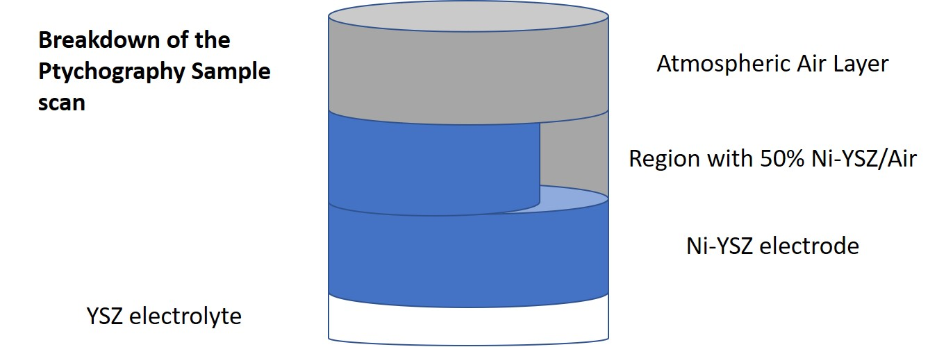
Figure 6.25: Diagram of the Ni-YSZ fine pillar sample sections including ambient air (grey)
The presence of the air layer was required for good phase contrast with the nickel and YSZ ceramic phases present in the sample. Using the GSVs calculated from FIJI for the Ni-YSZ cermet contrast sample, the scan was segmented using the threshold function in Avizo Lite. The peak in the grayscale histogram was shown by both Avizo and FIJI to be a product of the ambient air.
The largest peak in the histogram in this can will be the air-based phases (ambient and pore). The position of this peak indicates the GSV of the ambient air. Once the contribution of the ambient air has been removed from the data, the location of the peak will also provide the first sign that the catalyst coarsening has occurred. When the catalyst vol % increases because of sintering, the pore vol % will drop, lowering the GSV of the peak.
Upon initial inspection the GSV of the peak has dropped between 2 and 4 h of ageing, indicating that a sintering event has occurred in the infiltrated Ni-YSZ system (Figure 6.26 and Figure 6.31). The drop means that less pore phase is present in the 4 h aged sample which suggests that coarsening has taken place.
Figure 6.26: Histogram of the Grayscale values for the whole 2 h aged NI-YSZ sample ptychographic scan. The peak was found to be ambient air, the right-hand side was the highly attenuating ceramic phase and the left-hand side the nickel catalyst
The GSVs of the phases produced by the contrast sample were used to threshold the three phases present in the sample: Ni, YSZ and pores to produced accurate 3D renderings of the microstructure present in the aged infiltrated fuel electrode.
Additionally, the upper bins used to segment the samples also closely matched the GSR present in the mass attenuation coefficients with the nickel and ceramic phases having a ratio of 7.28, a 4.14% increase from calculated GSR (6.99) (Table 6.6).
Table 6.6: Table of Grayscale bins used to segment the Ni, YSZ and pore phases in the Ni-YSZ fuel electrode pillar sample
Ni-YSZ 2 h aged | Lower Grayscale value, GSV_{L} | Upper Grayscale Value, GSV_{H}
Total Grayscale Bins | 0 | 255
Ni | 0 | 35
Pore | 35 | 70
Air | 70 | 90
YSZ | 90 | 255

3 volumes were segmented using Avizo Lite: The entire pillar, the 50 % ambient air/ Ni-YSZ electrode and the Ni-YSZ electrode near the YSZ electrolyte (Figure 6.27). This will be referred to as the whole, the middle and the base. These were segmented to track the microstructural evolution of the nickel phase during ageing and deduce the coarsening mechanism present in the catalyst.
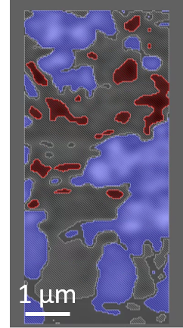
Figure 6.27: XZ orientation ortho-slice window used to segment the three phases. The Nickel, YSZ and pores are red, blue and black respectively

Whole 2 h aged Ni-YSZ pillar
Initially, the phase segmentation was performed on the entire scan of the pillar sample. Clear issues with the segmentation were clear – with disconnected portions of the ceramic phase present in the 3D rendering (Figure 6.28). These islands were removed using a function in Avizo Lite. These islands were a function of an issue during the reconstruction and are remnants of the ambient air phase. The volume was added to the ambient air phase and the phase was segmented separately to the other three phases.
The presence of the atmospheric air was useful for contrast purposes with the sample, however the pillar sample showed beam damage from the laser milling which led to an increased amount of this phase in the central tenet of the sample (Figure 6.25).
The presence of the ambient air phase was unavoidable as PXCT requires a contrast medium for the ptychographic reconstructions. The impact of this phase was nullified by removal of GSVs for this segment. These bins were identified in both the contrast sample and ortho-slices from the top of this scan.
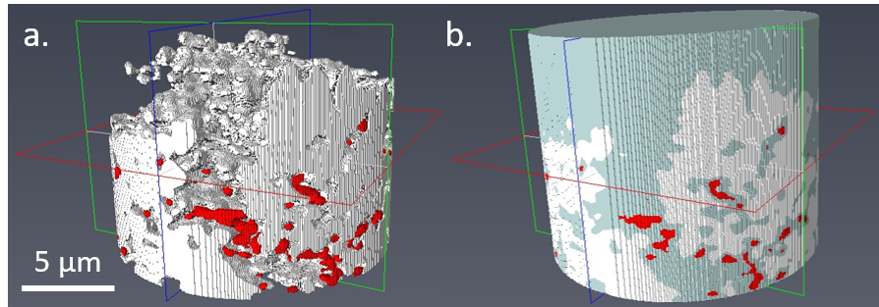
Figure 6.28: 3D renderings of the whole Ni-YSZ fuel electrode. Left-hand side the nickel and ceramic phases, right-hand side the nickel, ceramic, and pore phases. The nickel, ceramic and air are red, white and grey respectively.

Base of the 2 h aged Ni-YSZ pillar
To further remove the impact of the atmospheric air phase, the base 3.3 µm of the ptychographic scan was segmented as a separate sub-volume. This provided a volume with very little nickel present in the sample and larger amounts of YSZ than expected. The almost 8 % reduction in the pore vol % is almost completely equated to the increase in the ceramic vol % in the system (Table 6.21).
Table 6.21: Table of the vol % of the three phases present in the Ni-YSZ electrode sample
Sample | Phase [Vol %]
Sample | Nickel | YSZ | Pore
Ni-YSZ 2 h Whole | 0.46% | 67.26% | 32.29%
Ni-YSZ 2 h Base | 1.22% | 74.21% | 24.56%
The nickel volume percent is far lower than the stated volume percent of the sample after calcination. This is due to a combination of factors including increased tortuosity of the pores nearing the electrolyte, damage from sample production and reconstruction issues present in the sample.
As operating temperature of SOFCs (and the ageing temperature in this study, 800⁰C) exceeds the T_{Tammann} temperature for nickel, the catalyst will be highly mobile[238], [240]. These elevated temperatures mean that the Nickel can move towards the AFL reducing gas diffusion at the fuel electrode TPBs.
The vol % of the ceramic and pore phases was plotted in bar charts for each of the XY ortho-slice files in the ROI sub volume (Figure 6.29 and Figure 6.30). The tortuosity of the pore structure was shown to rise deeper into the base of the sample, this was signified by the 20.54% volume percent increase of the YSZ ceramic phase.
Figure 6.29: Volume % of the ceramic phase through the base of Ni-YSZ sample. 0-100 denotes the XY ortho-slice files from the top to the base of the scan
Conversely, to the other two phases the volume percent of the pore phase almost continually dropped with increased depth into the Ni-YSZ base. The largest reduction exhibited by this phase was 31.54 % which is entirely due to the proliferation of the Ni and YSZ phases.
Figure 6.30: Volume % of the pore phase through the base of Ni-YSZ sample. 0-100 denotes the XY ortho-slice files from the top to the base of the scan

6.3.4.2.4 Nitrogen dried Ni-YSZ 4 h aged
The sample was aged for another 2 h in the wet 10% H₂/N₂ atmosphere prior to a second ptychographic scan. The three phases were segmented using the threshold function in Avizo Lite (FEI) using the lower and upper GSVs in Table 6.17. The peak present in Figure 6.31 has dropped from the 85th to 75th bin, showing that as discussed previously sintering has taken place.
Figure 6.31: Histogram of the Grayscale values for the whole 4 h aged NI-YSZ sample ptychographic scan. The peak was found to be ambient air, the right-hand side was the highly attenuating ceramic phase and the left-hand side the nickel catalyst

Whole 4 h aged Ni-YSZ pillar
Initially the entire scan volume was segmented using the same GSV values from the previous scan (Table 6.20 and Table 6.21). 3D renderings of the whole scan file were generated using Avizo Lite (Figure 6.32). In comparison to Figure 6.28, the nickel phase appears to have migrated towards the AFL with a large amount of phase present in the bottom third of Figure 6.32.
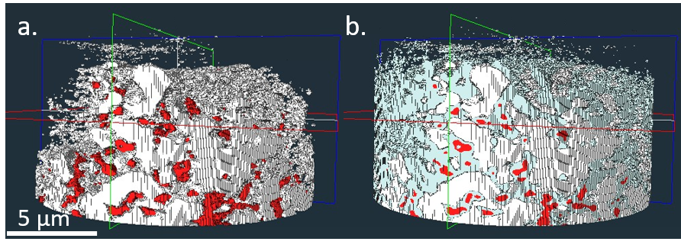
Figure 6.32: 3D renderings of the whole 4 h aged Ni-YSZ fuel electrode. a. Pillar was the nickel and ceramic phases. b. Pillar with the nickel, ceramic, and pore phases. The nickel, ceramic and air are red, white, and grey respectively
The volume percent of the nickel, YSZ and pore phases for the 4 h aged Ni-YSZ sample can be found in Table 6.8.

Base of the 4 h aged Ni-YSZ pillar
To provide comparability with the 2 h aged scan and concurrently remove the impact of the atmospheric air, the base 3.3 µm of the ptychographic scan was segmented as a separate sub-volume (Figure 6.33).
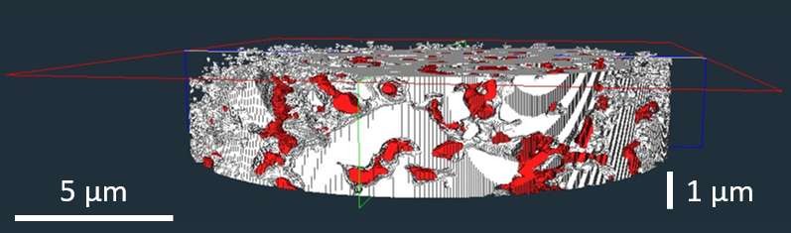
Figure 6.33: 3D rendering of the base of the 4 h aged Ni-YSZ fuel electrode. The nickel and ceramic phases are red, white respectively
In comparison with its 2 h aged counterpart the 4 h aged sample had a 4.38% increase in the volume percent of the catalyst phase. The YSZ phase vol % was also very similar (+0.30%) for both the whole and base volumes for the 4 h aged samples. The scaffold volume percent results show great agreement with the 65 % calculated value for the electrode during production. This confirms that the showing that the GSVs used phase segmentation were correct.
Table 6.8: Volume percent of the three phases present in the Ni-YSZ electrode sample
Sample | Phase [Vol %]
Sample | Nickel | YSZ | Pore
Ni-YSZ 4 h Whole | 4.50% | 59.20% | 36.30%
Ni-YSZ 4 h Base | 5.60% | 59.50% | 34.90%

6.3.4.3 Tracking identical regions of interest
One of the major advantages with tomographic and ptychographic imaging techniques is the fact that the same region of interest can be imaged between scans. In this study the same sub volume was imaged for at 2 h and 4 h aged, infiltrated Ni-YSZ samples. The number of voxels and consequently the volume of the three phases: Nickel, YSZ and pore were tracked between scans. The sub-volume in question measured 450 µm³.
Due to the fine Ni-YSZ pillar samples being remounted separately during the heating regime, the chance for an offset impacting the sample alignment was high. However, during this work the region of interest could be lined up due to the fact the same sample was being imaged during the MG24277-1 experiment. To reduce computational cost the pore structures, present in the ortho-slices of the sample were analysed using FIJI, prior to reconstruction in Avizo Lite (FEI).
A 7. 5 x 7.5 x 8 µm sub-volume was selected and aligned using the pore structure present in both ptychographic scans (Figure 6.34 and Figure 6.35). One eighth of the sample was selected as a sub volume for phase segmentation, thus balancing both computation power and making sure there was as much YSZ as possible in the volume. The position of the region of interest also contained some of the milled edge of the electrode to see and a characteristic line of pores for clearer identification.
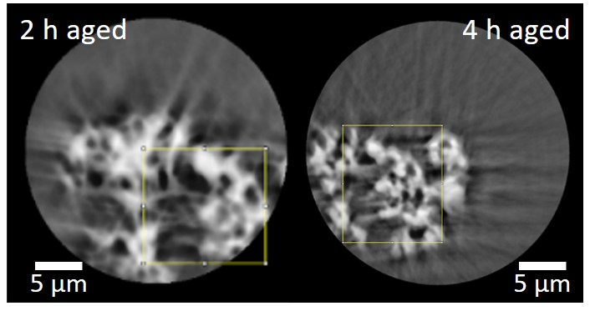
Figure 6.34: Images of the 150th and 250th ortho-slice between the 2 h and 4 h aged samples. An identical pore structure is shown in the yellow boxes of the tomograms of the samples
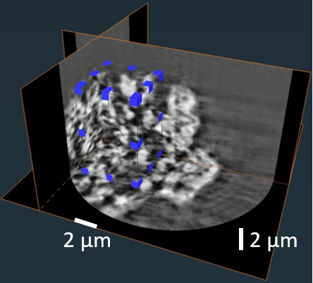
Figure 6.35: Selection of the 3D region of interest in Avizo Lite using the ortho-slice files for the 4 h aged, infiltrated Ni-YSZ sample
Despite the repeated reattachment of the samples after heating, an identical pore structure pore structure can be clearly identified in Figure 6.34 (Yellow box). Additionally, the ortho-slices files selected were the middle of the entire scan file. The sub volumes for both scans were generated in Avizo Lite. This sub volume was also selected due to its lack of proximity to the outside of the sample where beam damage or ambient effect could impact the phase segmentation of the fuel electrode materials. 3D projections of both scans of the Ni-YSZ pillar sample can be found in Figure 6.36 and Figure 6.37.
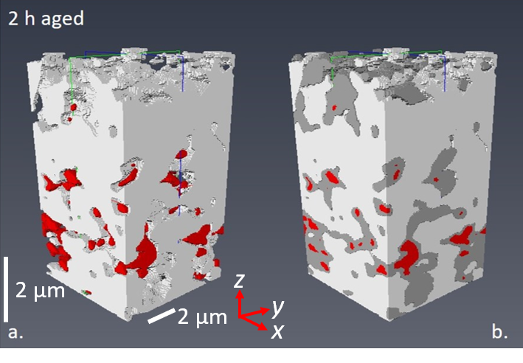
Figure 6.36: 3D renderings of the ROI sub volume of the 2 h aged Ni-YSZ fuel electrode using Avizo Lite. The nickel, ceramic and pore phases are red, white, and grey, respectively. The Ni and YSZ phase are rendered in a. and the three phases in b.
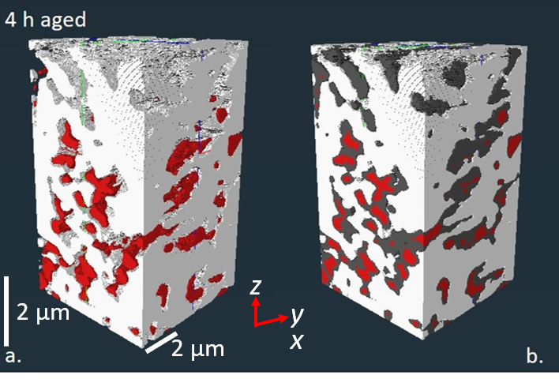
Figure 6.37: 3D renderings of the ROI sub volume of the 4 h aged Ni-YSZ fuel electrode using Avizo Lite. The nickel, ceramic and pore phases are red, white, and grey, respectively. The Ni and YSZ phase are rendered in a. and the three phases in b.
The volume percent of the catalyst phase rose by 7.77 % during between the 2-4 h of ageing (Table 6.23). As the same sub volume was segmented and the sample had no additional nickel added between scans, thus this rise is solely due to sintering. Both samples had YSZ vol % ± 3% of the 65% calculated density of the electrode during manufacture. Individual nickel particles cannot be determined clearly from the renderings.
Table 6.23: Volume percent of the three phases present in the region of interest for the Ni-YSZ electrode sample aged at 2 and 4 hours
ROI Samples | Phase [Vol %]
ROI Samples | Nickel | YSZ | Pore
Ni-YSZ 2 h | 3.45% | 63.04% | 33.51%
Ni-YSZ 4 h | 11.22% | 69.21% | 19.19%

6.3.4.3.1 Nickel distribution after 4 h of ageing
Figure 6.38 provides an insight into the migration behaviour of the nickel during the ageing period. After 2h of ageing charted in the segmentation, the volume distribution of the nickel phase changed dramatically across the region of interest. After 4 h of ageing the 39.86 % of the nickel present in the electrode resided between slices 140-180. This was a 18.65 % increase compared to its 2 h aged counterpart.
Figure 6.38: Volume percent per slice of the nickel catalyst phases from the top to the bottom of the Roi. The 2 h aged nickel is denoted by the red series and the 4 h aged the grey series respectively
In the top third (60 ortho-slices) of the ROI, the overall volume percent of the phase has changed very little during ageing (11.87 % 2 h, 12.00 % 4 h). This indicates that the migration process at the top of the sample has been balanced with the amount of catalyst coarsening.
In contrast with the air-dried samples, the migration behaviour of the nitrogen dried Ni-YSZ sample did not produce any blocking effects (Figure 6.9). The nickel catalyst has migrated towards the anode functional layer and leading to a reduction into electrical conductivity between the AFLs and the top of the fuel electrode.
The migration mechanism illustrated in both the FIB-SEM micrographs and the 3D phase segmentation renderings would indicate that the catalyst has coarsened in both sets of samples via PMC [402], [502]. However, this mechanism is restricted to the 2 h ageing windows evident from the phase segmentation. The voxel size of 36 nm is too large to quantify the first coarsening process present in the pristine infiltrated nickel system.
As discussed by Goodman and Hansen et al the first coarsening mechanism with the untouched catalyst system is likely to focus on atomic ripening where the smallest particles coalesce [300], [402], [502]. This occurs prior to a sintering mechanism based on PMC which has been monitored during this study through PXCT, FIB-SEM and XRD. Further measurements at ageing times under 1 h will be required to capture this phenomenon.
In the infiltrated systems characterised in this study the window has characterised the migration of the catalyst through the pores in the structure during the first 0 – 5 h of ageing. Pore blocking because of extensive PMC is a key deactivation mechanism in the microstructure of the air-dried cells. This was underlined by the scanning electron microscopy of the air-dried samples Figure 6.7 showed the agglomeration of the nickel phase against the pores. In the case of infiltrated cells, the pore volume in the electrode structure has been shown to reduce by up to 20 vol % towards 3.2 µm above anode function layer. This reduction means increases the likelihood of bottlenecks generated by decreases pore volume. Due to the dispersal of the catalyst dispersal throughout the pore structure, coarsening of stacked particles (especially air dried particles) shown in Figure 6.9 could form large agglomerates along pores as seen in Figure 6.23.
This reduces the active triple phase boundary area due to gas percolation restrictions as discussed by Hou et al [505]. Although this phenomenon has not widely discussed in the literature until this year [505], [506].
The impact of drying under a nitrogen atmosphere has been shown to produce a pronounced difference to the cells both microstructurally and electrochemically. The reduced polarisation resistance can be linked to the lack of pore blocking present in the nitrogen dried cells. However, the nitrogen dried samples are still subject to PMC and coarsening albeit at a slower rate than their air-dried counterpart. This is exemplified by the % dispersion of the nickel crystallite in the nitrogen cells dropping to under 1.5 % after an extra hour of ageing compared to the air-dried samples.
The migration of the infiltrated nickel towards the AFL in both sets of samples illustrate that ageing the catalyst well above its T_{Tammann} has provided the catalyst particles with extreme mobility under typical SOFC operating conditions [238].
Additionally, the ex-situ heating process utilised in this study means that the infiltrated nickel catalyst is subject to both thermal and atmospheric cycling. The repeated 1 h heating step and subsequent cooling of the pillar sample at 800 °C in 10 % H₂/N₂ ensured that within a 4 h period the sample had been subject to a temperature range between 25 and 800 °C. Over the past 12 years thermal cycling has been documented to increase the volume of the nickel phase in traditional cermet anodes [132], [244], [422], [507], [508].
Thermal cycling studies to date have not been performed using PXCT especially infiltrated anodes. However, a study by Guan et al detailed the volume change in co-sintered Ni-YSZ anode samples with 4 h thermal cycles between 25-750 °C using ex-situ XCT imaging technique [508]. Although the cycle is not analogous to the one in this work, it did link a 7.7 % drop in Ni-YSZ connectivity with a 36.4 % increase in the nickel volume after 32 h of ageing.
The Guan work provides insight into the coarsening behaviour of the catalyst material at ageing times past 10 h. Wet impregnated nanoscale catalysts have been well documented to sinter faster than their microscale co-sintered counterparts. In this study an 18.65 % increase in the nickel volume was documented after 4 h of ageing. This indicates that the nickel catalyst is coarsening at almost double the rate of the co-sintered anodes. This is a combination of both the elevated ageing temperature but also the fact that propensity of the nanoscale to sintering.
If the nickel sintering rate continues to be double that of a co-sintered cermet than the steady state coarsening step (step III) detailed by Hansen would be achieved by a wet impregnated system between 15-20 h of ageing. The nickel volume in Ptychograms taken after this time should not change more than a 1 %. The next step for infiltrated fuel electrode PXCT work would be to identify the time when the steady state sintering by ageing samples is achieved and compare the sintering rates with co-sintered anode samples under identical conditions.

6.4 Conclusions
Ptychographic X-ray computed tomography (PXCT) has been used to segment and image the microstructural changes present in infiltrated Ni-YSZ fuel electrodes. Regions of interest near the anode functional layer were successfully segmented using an ex-situ snapshot method across multiple ageing times for the same infiltrated cells using Avizo Lite. This is the first known example of infiltrated SOFC fuel electrode samples having been imaged using this technique.
The agreement between the mass attenuation coefficient and grayscale coefficient ratios allowed the assignment of the metal, scaffold and pore phase using grayscale bins. The major advantage of PXCT is that identical volumes can be continually reimaged during the ageing process.
This work has identified the primary coarsening mechanisms in wet impregnated Ni/YSZ fuel electrodes to be based on particle migration coalescence in a 4 h ageing window. It has also shown that the use of an inert drying atmosphere does reduce the rate of the coalescence for an infiltrated electrode due to reduced crystallite size. This is a result of reduced crystallite size allowing for greater movement through pores and less agglomeration via surface energy differences.
This work has illustrated that the timescale of fuel electrode coarsening is in the minutes. Further research is needed to track the evolution of nanoscale catalyst particles using thinner samples for better resolution at timescales preceding an hour. Additional work is also required to demonstrate the timescale when steady-state sintering is reached for the wet impregnated nickel phase.

7. Conclusions and Recommendations

7.1 Quantifying the impact of gas drying atmospheres on infiltrated SOFC fuel electrodes
The impact of utilising a flowing nitrogen atmosphere during the drying step of wet infiltrated electrodes was investigated during this work. This was compared to using an air-drying step at 120⁰C. The motivation for this enquiry was to utilise the drying step as a method of dispersing the wet impregnated nickel catalyst and consequently increasing its activity. Little was known about the decomposition of the nitrate material and its impact on the electrochemical properties of the wet impregnated fuel electrode. This activity increase was measured by monitoring the change in the polarisation resistance, R_{P} over a 50 h ageing period.
The nitrogen drying step was shown to have consistently produced a size reduction of 30 % for the nickel particles via strain corrected Debye-Scherrer analysis and scanning electron micrographs. This translated to a 1.5 % increase in the dispersion of the catalyst nanoparticles after calcination and reduction. In addition, FTIR spectra of both drying steps also showed that the drying promoted the decomposition of the nitrate phase with absorbance peaks at 1315 cm⁻¹ and 1385 cm⁻¹ indicative of the free NO₃²⁻ nitrate ion for both samples (Figure 4.6).
Scanning electron micrographs of the dried nickel nitrate precursor showed the formation of particles under the nitrogen drying regime. This was discussed to be the result of nucleation and growth of bunsenite particles confined by the dried nitrate film. This indicated that the air-dried nickel particles were subject to pre-reduction agglomeration, evident from the disk-like morphology present in the micrographs and the multiple reduction peaks present in TPR.
Using the combination of the structural, chemical, and microstructural analyses discussed during this chapter a decomposition pathway for both systems was described. In the air-dried system the dried disks decompose partially during drying leaving a heterogeneous dispersion of nickel nitrate particles which under calcination form bunsenite agglomerates. These clumped particles are reduced during SOFC start-up and sinter during the first 10-20 h of ageing. In the nitrogen dried system, the confinement of the nickel particles by the nitrate film during drying promotes the formation of monodisperse particles with a homogeneous size distribution and reduced sintering rate. This is the first known discussion of this mechanism for infiltrated fuel electrodes.
The electrochemical impedance spectra results (R_{P}) gathered through this study were consistently one scale factor larger than Ni-YSZ electrodes in the literature. This elevation was a combination of several factors. Firstly, the graphite in the YSZ ceramic ink interacted with the binder causing the formation of a shear-thinning ink, which impacted the mechanical stability of the scaffold, with large voids after firing. To mitigate this issue a carbonless ink was also trialled. The infiltration solution concentration was also reduced, as 5 M approaches the solubility limit for the nickel nitrate in water and could have blocked the pores inducing a larger R_{P}. A total of fifteen 40 sample batches were trialled during this project to ensure that despite these issues the datasets from the samples could be produced reliably. The age of the frequency response analyser may have also added to this issue.
The wet impregnated electrodes in this study can be compared as an enclosed system to display any trends that appear. After an ageing period of 50 h the nitrogen dried, air calcined Ni-YSZ samples showed the smallest rise in the polarisation resistance for the drying and calcination. A result of the increased dispersion and reduced size of the nickel particles prior to ageing.

After an ageing period of 10 h the R_{P} of these electrodes began to plateau, indicating early-stage stability for the infiltrated nickel system. This behaviour begins at far shorter time than the industrial standard of 100 h of ageing, suggesting that this period can be reduced for wet-impregnated systems.

7.1.1 Recommendations from Chapter 4
This study has illustrated the importance of the drying step on the microstructural properties of infiltrated Ni-YSZ fuel electrodes for SOFCs. The use of the nitrogen drying atmosphere has reduced the initial particle size of the nickel during processing, reducing the R_{P} degradation rate.
The following recommendations are suggested for those looking to investigate drying processing steps in wet-impregnated SOFCs:
- Avoid the use of drying and calcination of infiltrated electrodes under the same atmosphere. This promotes additional gas phase diffusion impedances and increases the rate of polarisation resistance degradation.
- Use an inert nitrogen drying atmosphere to increase the catalyst dispersion and reduce the initial catalyst size.
- Ensure that the calcination temperatures for the infiltrated material remain between the Huttig and Tamman temperatures of the metal catalyst (378⁰C and 728⁰C) to avoid addition sintering during processing [238], [240].

7.1.2 Further work from Chapter 4
This work has illustrated the essential need for further work on the gas drying step for infiltrated SOFC fuel electrodes. Optimisation via varying the gas flow rates and temperatures for the gas drying steps needs to be done for the continued improvement of the catalyst dispersion and activity. This enhanced activity could be characterised using chemical probes. Techniques such as hydrogen or carbon monoxide chemisorption or Branauer Emmett Teller studies would be able to track the active surface area of the nickel catalyst during different processing steps providing more information on the dispersion of this phase during electrode manufacture. The decomposition behaviour of the nickel nitrate precursor could also be monitored using Thermo-gravimetric analysis (TGA).
Tracking the microstructural evolution of the infiltrated phase during ageing via Debye-Scherrer analysis during the initial 10-h ageing window could provide a key insight to the growth of the nickel phase. An interrupted snapshot procedure like the one used in Chapter 6 could be used to age the catalyst phase in representative fuel electrode conditions using USAXS at the 9-ID beamline at ANL or similar facilities. This data coupled with microstructural quantification data from FIB-SEM or XCT could provide key crystallite size changes present in early-stage nickel sintering.
A repeat of this gas drying study on other infiltrated scaffold materials such as gadolinium doped ceria would help reduce the impact if any of Ni-substrate interactions on the sintering behaviour on the catalyst phase. Preliminary work conducted during this project has supported the hypothesis that these interactions do not affect the size reduction in the nickel. However, further work is needed to support this hypothesis.
Further EIS assessment of the ageing of the infiltrated Ni-YSZ cells at times exceeding 100 h are required. This would provide another level of robustness to the results from this work. As degradation rates per thousand hours could be calculated to provide comparison with studies in the literature. It would also illustrate the long-term impact that the drying has on the polarisation resistance of infiltrated SOFC anodes.
In addition, a larger number of EIS repeats are required for each drying condition to provide extra clarity on which step impacts the electrochemical performance of the cell. A baseline dataset of co-sintered Ni-YSZ cermet cells is also required for comparison with their wet impregnated counterparts. The power density characteristics of both datasets can be gathered from comparison of the samples respective IV curves. This will ensure that the data being produced is representative of current industrial standards.

7.2 The impact of current collector degradation on the initial electrochemical performance of infiltrated Solid Oxide Cells
The impact of using different current collector materials on infiltrated Ni-YSZ fuel electrodes was investigated during this study. The EIS data gathered during this work illustrated that the choice of current collector material is key to the electrochemical performance of the Ni-YSZ cells tested in this work. Four current collector materials pastes were assessed: silver, gold, platinum, and nickel oxide.
Despite its low initial R_{P} in comparison to the other materials, the silver current collector demonstrated a tendency to degrade in the wet 10 % H₂/N₂ atmosphere utilised for the fuel electrode samples in this study. This was evident by the breakdown of the silver during ageing in the micrographs (Figure 5.34) and the delamination of the current collector from the Ni-YSZ electrode after ageing for 50 h(Figure 5.35). Void formation due to increased hydrogen solubility has been documented in silver SOFC current collectors resulting in the second largest increase in R_{P} for any of the samples in this work.
The gold current collector showed an affinity to alloying with the nickel catalyst phase in reductive atmospheres as shown by the drop in polarisation resistance after 20 h of ageing. There was no way to discern the particles on the surface of the electrode using BSE indicating the mixture of the two metal phases (Figure 5.37). Nyquist plots for the gold coated Ni-YSZ samples also demonstrated the emergence of a low frequency gas diffusion impedance arc linked to the formation of water.
Despite its documented high resistivity under hydrogen, the nickel current collector material produced the smallest increase for the R_{P} after 50 h of ageing. This was attributed to current collector and catalyst interfacial resistance contribution being reduced due to their identical compositions.
Activation energy plots for each of the current collector materials demonstrated that the silver and gold materials had a propensity for diffusion and migration due to their Tammann temperature being exceeding during SOFC ramp up. Figure 5.30 illustrates this with a clear point of inflection for both materials. In the case of silver especially, it was clear that the presence of the void formation and degradation severely impact the performance of the electrode with the almost 600 % increase in the R_{P} over 50 h of ageing (Table 5.8).
Of the four materials analysed during this work, the nickel paste was deemed the appropriate for the role as current collector for wet impregnated Ni-YSZ electrodes. This was due to the current collector and catalyst having identical compositions and as a result producing having no gas phase interactions.

7.2.1 Recommendations from Chapter 5
Continued investigations into the impact of the current collector should focus on avoiding a material which has a T_{Tammann} temperature lower than the SOFC operating temperature. This should help reduce the impact of diffusion and alloying on the current collector. This could be achieved by either lowering the operating temperature or changing the current collector material.
Nickel oxide was shown to best the most suitable current collector material with the smallest change in R_{P} and no indication that the current collector interactions with the incident fuel gases present in the fuel electrode.

7.2.2 Further work from Chapter 5
The current collector candidates used in this study have different % metal contents. Further datasets with materials with the same metal content are required to produce more representative data. Additionally, the power density of samples utilising different current collectors can be compared using the IV curves of the specimens. These can be used to determine the impact that the current collector material has on the electrochemical properties of the samples. These ageing runs could also capture a longer timeframe (t <100 h) which would help with power density degradation calculations per 1000 h of operation.
Supplementary EIS datasets for each of the current collector materials are also required on separate FRA and impedance set ups. The data gathered from these experiments would eliminate the possibility that the variation seen in this work is solely due to the equipment faults.
Energy-Dispersive X-ray analysis on the cross section of the sample could be key to track the diffusion of the current collector material during different ageing times[260], [509], [510]. Spectroscopic measurements such as in-situ Raman spectroscopy could be used to monitor the gas phase changes in an infiltrated SOFC electrode [511].

7.3 Identifying Initial coarsening mechanisms in infiltrated SOFC fuel electrodes
To identify the initial sintering mechanisms, present in the wet impregnated catalyst phase in Ni-YSZ electrodes, the evolution and growth of the infiltrated catalyst phase during the first 4 h of ageing was characterised for the first time using PXCT. This was achieved using an ex-situ snapshot ageing method to replicate representative SOFC fuel electrode conditions. This is the first example of infiltrated Ni-YSZ electrode having been imaged with this method.
Regions of interest were identified using ptychographic ortho-slice images and successfully reimaged across two different samples using this method. A Ni-YSZ cermet contrast sample was successfully segmented to provide grayscale coefficients for the nickel, YSZ and pore phases. Particle migration coalescence (PMC) was determined to be the major coarsening mechanism in the wet impregnated nickel phase during this ageing period as shown by the nickel phase volume changes in the bottom 3.2 µm of the electrode (Figure 6.38).
To provide direct comparison with these samples, witness samples from the milled Ni-YSZ electrode were aged using identical conditions and imaged using FIB-SEM. A nickel network formed in the air-dried sample at the pore’s indicative of PMC. This agglomeration was reduced in the nitrogen dried sample because of a reduced initial particle size. This also facilitated greater mobility of the nickel phase through the pores.
The coarsening exhibited by the nickel phases in the wet impregnated samples also indicated that the primary coarsening event occurs within the catalyst at timescales closer to the minute scale.

7.3.1 Recommendations from Chapter 6
Due to relative immaturity of PXCT as a SOFC phase quantification technique in comparison with XCT and FIB-SEM continued improvements with the sample preparation, scanning and mounting are required. Additionally, further PXCT studies on infiltrated fuel electrodes are required to consolidate the findings of this work.
To enable better X-ray photon transmission for nickel throughout the ptychographic scanning, the sample thickness needs to be reduced to 10 µm, increasing the transmission of the nickel phase by 10%. Due to the highly destructive nature of the laser milling process the YSZ scaffold material must be possess high mechanical stability during fine pillar preparation. Higher nickel loadings would also aid the phase segmentation process.
A key source of alignment error during PXCT was the continued remounting of the Ni-YSZ fine pillar in the sample holder. This generated errors with sample alignment during gluing that impacted identifying the region of interest between scans. A custom sample mount is required that can house the pillar sample during ageing and imaging.

7.3.2 Further work from Chapter 6
Further PXCT studies on infiltrated nickel systems should reduce the beam energy used to image the samples to 8.2 keV, near a nickel absorption edge. Scanning wet impregnated Ni-YSZ samples at this energy will ensure that the most attenuating phase is the catalyst phase due to the proximity of the nickel absorption edge (Figure 7.1) [278], [500].
Figure 7.1: Transmission of the X-ray photon in 10 microns of nickel (20 volume %) and YSZ [500]
For the identification of the primary sintering mechanism in the wet impregnated catalyst phase for the SOFC ageing process a shorter timescale (10 mins) per scan is required. Scans in this period will elucidate the initial sintering mechanism present in the nickel system.
To supplement the data produced in this study, more PXCT scans are required on wet impregnated Ni-YSZ samples between 0-5 h of ageing to measure the rate of degradation for different drying routines and manufacturing method.
Coupling the PXCT data with USAXS scanning could be a key method to track the particle size distribution of the nickel crystallites over time providing structural data to complement the phase quantification data generated by PXCT.
The scanned pillar volume in this project amounted to 0.03 % of the total electrode volume in the Ni-YSZ samples. Such a low volume cannot be representative of the sample as a whole. Ideally, at least two further pillars need to be milled from the infiltrated electrode to produce a statistically relevant dataset. However, due to the destructive processing methods involved in creating a single pillar, obtaining multiple pillars from a single sample is near impossible. Additionally, increasing the scan volume for PXCT would be challenging due to increased attenuation and long scan times.
Moreover, further PXCT datasets need to include an ageing study for co-sintered Ni-YSZ cermets to provide further comparison with the infiltrated specimens. Imaging the time where steady state sintering in the wet impregnated nickel occurs will help pinpoint what early-stage ageing times are significant to the microstructural degradation of the anode. Additionally, it will contextualise these rates compared to the industrial state of the art electrodes.

7.4 Concluding Remarks
This project has investigated different processing techniques to reduce the degradation of infiltrated Ni-YSZ fuel electrodes. The nitrogen drying step trialled in this project displayed some promising results in increasing the dispersion and reducing the size of nickel catalysts. In addition, this drying step also began the decomposition of the nickel nitrate precursor. Particle migration coalescence was found to be the key mechanism of coarsening in infiltrated fuel electrode samples within the first 4 h of ageing.
To retain the high-power densities of wet impregnated electrodes more microstructural information is required on the sintering mechanism present in these systems. This mechanism of PMC requires the movement of the infiltrated nanoparticles to form agglomerates such as those seen in Figure 4.14 and Figure 4.15. This would aid the design of nanostructured electrodes that are resilient to coarsening under SOFC operating conditions. For wet impregnated SOFCs to be commercially viable, the sintering rate and degradation rate needs to be reduced by designing electrodes which are sinter resistant in design [118], [300].
In the case of PMC, confinement of the catalyst would help hinder the rate of particle migration and reduce the agglomeration present in the infiltrated cell. The implementation of a physical barrier to make sintering energetically unfeasible has proved popular with surface catalysis [300], [512]. The main strategy for confining the catalyst nanoparticles involve either the encasing the particles in a porous oxide material or the addition of a thin film to constrain the nanoparticles during operation
This poses a serious materials challenge as the nickel in infiltrated fuel electrodes would need to be interconnected for suitable electronic conductivity. Encasing the nickel in a porous oxide will provide gas percolation networks which is required for a fuel electrode. However, this encapsulation of must not affect the electronic conductivity of the nickel particles. Thin film deposition methods such as atomic layer deposition where the thickness of the film can be varied could be key for infiltrated SOFC electrodes.

References
[1] N. Q. Minh, “Ceramic Fuel Cells,” J. Am. Ceram. Soc., vol. 76, no. 3, pp. 563–588, 1993.
[2] E. Wachsman, T. Ishihara, and J. Kilner, “Low-temperature solid-oxide fuel cells,” MRS Bull., vol. 39, no. 9, pp. 773–779, 2014.
[3] E. D. Wachsman, C. A. Marlowe, and K. T. Lee, “Role of solid oxide fuel cells in a balanced energy strategy,” Energy Environ. Sci., vol. 5, no. 2, pp. 5498–5509, 2012.
[4] K. Huang and S. C. Singhal, “Cathode-supported tubular solid oxide fuel cell technology: A critical review,” J. Power Sources, vol. 237, pp. 84–97, 2013.
[5] J. M. Vohs and R. J. Gorte, “High-Performance SOFC Cathodes Prepared by Infiltration,” Adv. Mater., vol. 21, no. 9, pp. 943–956, 2009.
[6] P. Keyvanfar and V. Birss, “Optimization of Infiltration Techniques Used to Construct Ni/YSZ Anodes,” in Journal of The Electrochemical Society, 2014, 1st ed., vol. 161, no. 5, pp. F660–F667.
[7] D. Ding, X. Li, S. Y. Lai, K. Gerdes, and M. Liu, “Enhancing SOFC cathode performance by surface modification through infiltration,” Energy Environ. Sci., vol. 7, no. 2, pp. 552–575, 2014.
[8] S. P. Jiang, “A review of wet impregnation - An alternative method for the fabrication of high performance and nano-structured electrodes of solid oxide fuel cells,” Mater. Sci. Eng. A, vol. 418, no. 1–2, pp. 199–210, 2006.
[9] T. L. Skafte, J. Hjelm, P. Blennow, and C. Graves, “Quantitative review of degradation and lifetime of solid oxide cells and stacks,” in EFCF 2016 proceedings, 2016, p. B0501.
[10] M. Kishimoto, M. Lomberg, E. Ruiz-Trejo, and N. P. Brandon, “Enhanced triple-phase boundary density in infiltrated electrodes for solid oxide fuel cells demonstrated by high-resolution tomography,” J. Power Sources, vol. 266, pp. 291–295, 2014.
[11] J. M. Andújar and F. Segura, “Fuel cells: History and updating. A walk along two centuries,” Renew. Sustain. Energy Rev., vol. 13, no. 9, pp. 2309–2322, 2009.
[12] W. R. Grove, “XXIV. On voltaic series and the combination of gases by platinum,” London, Edinburgh, Dublin Philos. Mag. J. Sci., vol. 14, no. 86–87, pp. 127–130, 1839.
[13] W. R. Grove, “On the Gas Voltaic Battery. Experiments Made with a View of Ascertaining the Rationale of Its Action and Its Application to Eudiometry,” Philos. Trans. R. Soc. London, vol. 133, pp. 91–112, 1843.
[14] W. R. Grove, “On a Gaseous Voltaic Battery,” Philos. Mag., vol. 92, no. 31, pp. 3753–3756, 2012.
[15] A. B. Stambouli and E. Traversa, “Solid oxide fuel cells (SOFCs): A review of an environmentally clean and efficient source of energy,” Renew. Sustain. Energy Rev., vol. 6, no. 5, pp. 433–455, 2002.
[16] A. J. Appleby, “From Sir William Grove to today: fuel cells and the future,” J. Power Sources, vol. 29, no. 1–2, pp. 3–11, 1990.
[17] A. J. Appleby and F. R. Foulkes, Fuel Cell Handbook. Van Nostrand Reinhold, 1988.
[18] L. Carrette, K. A. Friedrich, and U. Stimming, “Fuel Cells: Principles, Types, Fuels, and Applications,” ChemPhysChem, vol. 1, no. 4, pp. 162–193, 2000.
[19] J. Kunze and U. Stimming, “Electrochemical versus heat-engine energy technology: A tribute to wilhelm ostwald’s visionary statements,” Angew. Chemie - Int. Ed., vol. 48, no. 49, pp. 9230–9237, 2009.
[20] H. H. Möbius, “On the history of solid electrolyte fuel cells,” J. Solid State Electrochem., vol. 1, no. 1, pp. 2–16, 1997.
[21] V. Hacker, M. Cifrain, K. Kordesch, T. Hejze, R. R. Aronsson, and K. Reichmann, “The Safe and Economic Revival of Alkaline Hydrogen/Air Fuel Cells with Circulating Electrolytes, Recommended for Vehicles Using Battery Hybrid Systems and H2 from Ammonia Crackers,” ECS Trans., vol. 11, no. 32, pp. 167–185, 2008.
[22] V. S. Bagotsky, Fuel Cells: Problems and Solutions: Second Edition. 2012.
[23] C. Wagner, “UÈber den Mechanismus der elektrischen Stromleitung im Nernststift.,” Naturwissenschaften, vol. 31, pp. 265–268, 1943.
[24] “No Title,” National Renewable Energy Laboratory, U.S. Department of Energy Hydrogen and Fuel Cells Program.
[25] N. Mahato, A. Banerjee, A. Gupta, S. Omar, and K. Balani, “Progress in material selection for solid oxide fuel cell technology: A review,” Prog. Mater. Sci., vol. 72, pp. 141–337, 2015.
[26] H. R. Ellamla, I. Staffell, P. Bujlo, B. G. Pollet, and S. Pasupathi, “Current status of fuel cell based combined heat and power systems for residential sector,” J. Power Sources, vol. 293, pp. 312–328, 2015.
[27] “Scopus Fuel Cell Search,” 2018. [Online]. Available: https://www.scopus.com/search/form.uri?display=basic.
[28] J. L. D. Hart F. Lehner, M. Klippenstein, R. Rose, “The Fuel Cell Industry Review 2017,” E4Tech, E4Tech Website, 2017.
[29] D. Hart, J. Lewis, F. Lehner, M. Klippenstein, and R. Rose, “The Fuel Cell Industry Review 2017 2 FUEL CELL INDUSTRY REVIEW 2017 ACKNOWLEDGEMENTS,” E4tech, pp. 1–52, 2017.
[30] NREL, “1–10 kW Stationary Combined Heat and Power Systems Status and Technical Potential . Independent Review Published for the U.S. Department of Energy Hydrogen and Fuel Cells Program,” US Department of Energy, 2010.
[31] H. R. Ellamla, I. Staffell, P. Bujlo, B. G. Pollet, and S. Pasupathi, “Current status of fuel cell based combined heat and power systems for residential sector,” J. Power Sources, vol. 293, pp. 312–328, 2015.
[32] U. United States Department of Energy, “Combined Heat and Power Technology Fact Sheets Series: Steam Turbines,” p. 4, 2016.
[33] T. Elmer, M. Worall, S. Wu, and S. B. Riffat, “Fuel cell technology for domestic built environment applications: State of-the-art review,” Renew. Sustain. Energy Rev., vol. 42, pp. 913–931, 2015.
[34] Z. Gao, L. V. Mogni, E. C. Miller, J. G. Railsback, and S. A. Barnett, “A perspective on low-temperature solid oxide fuel cells,” Energy Environ. Sci., vol. 9, no. 5, pp. 1602–1644, 2016.
[35] Z. Gao, L. V. Mogni, E. C. Miller, J. G. Railsback, and S. A. Barnett, “A perspective on low-temperature solid oxide fuel cells,” Energy Environ. Sci., vol. 9, no. 5, pp. 1602–1644, 2016.
[36] B. C. Ong, S. K. Kamarudin, and S. Basri, “Direct liquid fuel cells: A review,” Int. J. Hydrogen Energy, vol. 42, no. 15, pp. 10142–10157, 2017.
[37] N. Sammes, R. Bove, and K. Stahl, “Phosphoric acid fuel cells: Fundamentals and applications,” Curr. Opin. Solid State Mater. Sci., vol. 8, no. 5, pp. 372–378, 2004.
[38] B. C. H. Steele, “Material science and engineering: The enabling technology for the commercialisation of fuel cell systems,” J. Mater. Sci., vol. 36, no. 5, pp. 1053–1068, 2001.
[39] L. van Biert, M. Godjevac, K. Visser, and P. V. Aravind, “A review of fuel cell systems for maritime applications,” J. Power Sources, vol. 327, no. X, pp. 345–364, 2016.
[40] C. S. H. Maru, S. C. Singhal and D. Wheeler, “1 – 10 kW Stationary combined heat and power systems status and technical potential, National Renewable Energy Laboratory, USA,” no. November, p. 39, 2010.
[41] U. S. D. of Energy, “Combined Heat and Power Technology Fact Sheet Series,” U.S. Department of Energy, 2016.
[42] I. Energy, “Upp Product Page,” Intelligent Energy, 2016. [Online]. Available: http://www.intelligent-energy.com/our-products/consumer-electronics-old/consumer-electronics/products/upp/.
[43] S. J. Peighambardoust, S. Rowshanzamir, and M. Amjadi, Review of the proton exchange membranes for fuel cell applications, vol. 35, no. 17. Elsevier Ltd, 2010.
[44] “Revolve unveils van range-extender with Bramble PCB fuel cell,” Fuel Cells Bull., vol. 2018, no. 10, p. 5, 2018.
[45] J. Min-hee, “Hyundai Motor’s Nexo Outshines Japanese Counterparts,” 비즈니스코리아 - BusinessKorea. 비즈니스코리아 - BusinessKorea, 비즈니스코리아 - BusinessKorea, 2018.
[46] T. R. A. of Engineering, Infrastructure, Engineering and Climate Change Adaptation – ensuring services in an uncertain future. 2011.
[47] P. Pei and H. Chen, “Main factors affecting the lifetime of Proton Exchange Membrane fuel cells in vehicle applications: A review,” Appl. Energy, vol. 125, pp. 60–75, 2014.
[48] G. F. McLean, T. Niet, S. Prince-Richard, and N. Djilali, “An assessment of alkaline fuel cell technology,” Int. J. Hydrogen Energy, vol. 27, no. 5, pp. 507–526, 2002.
[49] T. G. B. D. C. Papageorgopoulos J. P. Kopasz, W. F. Podolski, “Status of the U. S. Department Of Energy, Energy Efficiency and Renewable Energy’s Fuel Cell Research and Development Efforts ,” ECS Trans., vol. 30, no. 1, pp. 3–15, 2011.
[50] L. van Biert, M. Godjevac, K. Visser, and P. V Aravind, “A review of fuel cell systems for maritime applications,” J. Power Sources, vol. 327, pp. 345–364, 2016.
[51] J. Fleig, K. D. Kreuer, and J. Maier, “Ceramic Fuel Cells,” Handb. Adv. Ceram. Mater. Appl. Process. Prop., vol. 2–2, pp. 59–105, 2003.
[52] F. Ramadhani, M. A. Hussain, H. Mokhlis, and S. Hajimolana, “Optimization strategies for Solid Oxide Fuel Cell (SOFC) application: A literature survey,” Renewable and Sustainable Energy Reviews, vol. 76. 2017.
[53] B. Owens and J. Mcguinness, “Ge-Fuel Cells the Power of Tomorrow,” p. 43, 2015.
[54] C. Su, W. Wang, M. Liu, M. O. Tadé, and Z. Shao, “Progress and Prospects in Symmetrical Solid Oxide Fuel Cells with Two Identical Electrodes,” Adv. Energy Mater., vol. 5, no. 14, 2015.
[55] S. P. S. Shaikh, A. Muchtar, and M. R. Somalu, “A review on the selection of anode materials for solid-oxide fuel cells,” Renew. Sustain. Energy Rev., vol. 51, pp. 1–8, 2015.
[56] A. V. Call, J. G. Railsback, H. Wang, and S. A. Barnett, “Degradation of nano-scale cathodes: a new paradigm for selecting low-temperature solid oxide cell materials,” Phys Chem Chem Phys, vol. 18, no. 19, pp. 13216–13222, 2016.
[57] A. Atkinson et al., “Advanced anodes for high-temperature fuel cells,” Nat. Mater., vol. 3, no. 1, pp. 17–27, 2004.
[58] H. Yokokawa, “Phase Diagrams and Thermodynamic Properties of Zirconia Based Ceramics,” Key Engineering Materials, vol. 153–154. pp. 37–74, 2009.
[59] Y. Matsuzaki and I. Yasuda, “Electrochemical properties of reduced-temperature SOFCs with mixed ionic-electronic conductors in electrodes and/or interlayers,” Solid State Ionics, vol. 152–153, pp. 463–468, 2002.
[60] S. De Souza, S. J. Visco, and L. C. De Jonghe, “Thin-film solid oxide fuel cell with high performance at low-temperature,” Solid State Ionics, vol. 98, no. 1–2, pp. 57–61, 1997.
[61] B. C. H. Steele and A. Heinzel, “Materials for fuel-cell technologies,” Nature, vol. 414, no. 6861, pp. 345–352, 2001.
[62] S. P. S. Badwal and F. T. Ciacchi, “Oxygen-ion conducting electrolyte materials for solid oxide fuel cells,” Ionics (Kiel)., vol. 6, no. 1–2, pp. 1–21, 2000.
[63] M. F. A. P. T. Y. LTD., “Global Mineral Prices,” Global Mineral Prices, 2017. [Online]. Available: http://mineralprices.com/.
[64] R. J. Gorte and J. M. Vohs, “Nanostructured anodes for solid oxide fuel cells,” Curr. Opin. Colloid Interface Sci., vol. 14, no. 4, pp. 236–244, 2009.
[65] N. F. P. Ribeiro, M. M. V. M. Souza, O. R. M. Neto, S. M. R. Vasconcelos, and M. Schmal, “Investigating the microstructure and catalytic properties of Ni/YSZ cermets as anodes for SOFC applications,” Appl. Catal. A Gen., vol. 353, no. 2, pp. 305–309, 2009.
[66] S. HYUN, H. LEE, J. MOON, J. KIM, S. KIM, and H. MOON, “Performance and durability of Ni-coated YSZ anodes for intermediate temperature solid oxide fuel cells,” Solid State Ionics, vol. 177, no. 9–10, pp. 931–938, 2006.
[67] M. Z. Khan, M. T. Mehran, R. H. Song, J. W. Lee, S. B. Lee, and T. H. Lim, “A simplified approach to predict performance degradation of a solid oxide fuel cell anode,” J. Power Sources, vol. 391, no. February, pp. 94–105, 2018.
[68] D. Simwonis, F. Tietz, and D. Stöver, “Nickel coarsening in annealed Ni/8YSZ anode substrates for solid oxide fuel cells,” Solid State Ionics, vol. 132, no. 3, pp. 241–251, 2000.
[69] S.-B. Lee, R.-H. Song, T.-H. Lim, M. S. Khan, J.-W. Lee, and S.-J. Park, “Effect of infiltrated transition metals on nickel morphology change and area-specific resistance of Ni-YSZ based SOFC anode during long-term operation,” J. Electroceramics, vol. 35, no. 1–4, pp. 81–89, 2015.
[70] S. P. Jiang, “Nanoscale and nano-structured electrodes of solid oxide fuel cells by infiltration: Advances and challenges,” Int. J. Hydrogen Energy, vol. 37, no. 1, pp. 449–470, 2012.
[71] D. Ding, X. Li, S. Y. Lai, K. Gerdes, and M. Liu, “Enhancing SOFC cathode performance by surface modification through infiltration,” Energy Environ. Sci., vol. 7, no. 2, pp. 552–575, 2014.
[72] T. L. Skafte, J. Hjelm, P. Blennow, and C. Graves, “Reactivating the Ni-YSZ electrode in solid oxide cells and stacks by infiltration,” J. Power Sources, vol. 378, 2018.
[73] J. Thijssen, “The impact of scale-up and production volume on SOFC manufacturing cost.” US Department of Energy, DoE , pp. 3–70, 2007.
[74] J. H. T.L. Skafte P. Blennow and C. Graves, “Quantitative review of degradation and lifetime of solid oxide cells and stacks,” in Proceedings of 12th European SOFC & SOE Forum 2016, 2016, p. 19.
[75] B. P. Borglum and H. Ghezel-Ayagh, “Development of Solid Oxide Fuel Cells at Versa Power Systems and Fuel Cell Energy,” ECS Trans., vol. 57, no. 1, pp. 61–66, 2013.
[76] Y. Zhou et al., “Long-term stability of metal-supported solid oxide fuel cells employing infiltrated electrodes,” J. Power Sources, vol. 295, pp. 67–73, 2015.
[77] C. Jia, M. Chen, and M. Han, “Performance and electrochemical analysis of solid oxide fuel cells based on LSCF-YSZ nano-electrode,” Int. J. Appl. Ceram. Technol., vol. 14, no. 5, pp. 1006–1012, 2017.
[78] T. B. Hertz, T. Heiredal-Clausen, and R. Küngas, “Characterization and Stack Testing of Solid Oxide Fuel Cells with Cathodes Prepared by Infiltration,” J. Electrochem. Soc., vol. 163, no. 2, pp. F38–F43, 2015.
[79] C. Nicollet, A. Flura, V. Vibhu, A. Rougier, J.-M. Bassat, and J.-C. Grenier, “An innovative efficient oxygen electrode for SOFC: Pr 6 O 11 infiltrated into Gd-doped ceria backbone,” Int. J. Hydrogen Energy, vol. 41, no. 34, pp. 15538–15544, 2016.
[80] X. Zhu, D. Ding, Y. Li, Z. Lü, W. Su, and L. Zhen, “Development of La0.6Sr0.4Co0.2Fe 0.8O3-δ cathode with an improved stability via La0.8Sr0.2MnO3-film impregnation,” Int. J. Hydrogen Energy, vol. 38, no. 13, pp. 5375–5382, 2013.
[81] F. S. Torknik, A. Maghsoudipour, M. Keyanpour-Rad, G. M. Choi, S. H. Oh, and G. Y. Shin, “Microstructural refinement of Ni/Ce0.8Gd0.2O 2-δ anodes for low-temperature solid oxide fuel cell by wet infiltration loading of PdCl2,” Ceram. Int., vol. 40, no. 8 PART A, pp. 12299–12312, 2014.
[82] N. R. E. Laboratory and U. S. D. of Energy, “1–10 kW Stationary Combined Heat and Power Systems Status and Technical Potential,” US Department of Energy, 2010.
[83] R. J. Gorte and J. M. Vohs, “Catalysis in Solid Oxide Fuel Cells,” Annu. Rev. Chem. Biomol. Eng., vol. 2, no. 1, pp. 9–30, 2011.
[84] Y. Li, X. Zhu, Y. Chen, S. Zhang, J. Li, and J. Liu, “Rapid synthesis of highly active Pt/C catalysts with various metal loadings from single batch platinum colloid,” J. Energy Chem., vol. 47, pp. 138–145, 2020.
[85] F. Wang, W. Wang, J. Qu, Y. Zhong, M. O. Tade, and Z. Shao, “Enhanced sulfur tolerance of nickel-based anodes for oxygen-ion conducting solid oxide fuel cells by incorporating a secondary water storing phase,” Environ. Sci. Technol., vol. 48, no. 20, pp. 12427–12434, 2014.
[86] S. S. C. Chuang and L. Zhang, “Perovskites and Related Mixed Oxides for SOFC Applications,” in Perovskites and Related Mixed Oxides: Concepts and Applications, Wiley Blackwell, 2015, pp. 863–880.
[87] M. Niania et al., “In situ study of strontium segregation in La0.6Sr0.4Co0.2Fe0.8O3−δ in ambient atmospheres using high-temperature environmental scanning electron microscopy,” J. Mater. Chem. A, vol. 6, no. 29, pp. 14120–14135, 2018.
[88] M. E. Chelmehsara and J. Mahmoudimehr, “Techno-economic comparison of anode-supported, cathode-supported, and electrolyte-supported SOFCs,” Int. J. Hydrogen Energy, vol. 43, no. 32, pp. 15521–15530, 2018.
[89] Y. Akdeniz, B. Timurkutluk, and C. Timurkutluk, “Development of anodes for direct oxidation of methane fuel in solid oxide fuel cells,” Int. J. Hydrogen Energy, vol. 41, no. 23, pp. 10021–10029, 2016.
[90] K. T. S. Thydén, Microstructural degradation of Ni-YSZ anodes for solid oxide fuel cells. 2008.
[91] B. C. Steele and A. Heinzel, “Materials for fuel-cell technologies,” Nature, vol. 414, no. 6861, pp. 345–352, 2001.
[92] A. V. Virkar, J. Chen, C. W. Tanner, and J. W. Kim, “Role of electrode microstructure on activation and concentration polarizations in solid oxide fuel cells,” Solid State Ionics, vol. 131, no. 1, pp. 189–198, 2000.
[93] H. Apfel, M. Rzepka, H. Tu, and U. Stimming, “Thermal start-up behaviour and thermal management of SOFC’s,” J. Power Sources, vol. 154, no. 2, pp. 370–378, 2006.
[94] V. V. Krishnan, “Recent Developments in Metal Supported Solid Oxide Fuel Cells Recent Developments in Metal Supported Solid Oxide Fuel Cells.”
[95] F. Zhao and A. V. Virkar, “Dependence of polarization in anode-supported solid oxide fuel cells on various cell parameters,” J. Power Sources, vol. 141, no. 1, pp. 79–95, 2005.
[96] H. S. Spacil, “Electrical device including nickel-containing stabilized zirconia electrode,” 1970.
[97] K. Vels Jensen, S. Primdahl, I. Chorkendorff, and M. Mogensen, “Microstructural and chemical changes at the Ni/YSZ interface,” Solid State Ionics, vol. 144, no. 3–4, pp. 197–209, 2001.
[98] S. P. S. Shaikh, S. V. Moharil, and B. S. Nagrare, “A comparative study of copper-cermet anode material synthesized by different technique,” Int. J. Hydrogen Energy, vol. 37, no. 8, pp. 6853–6861, 2012.
[99] J. Otomo, J. Oishi, T. Mitsumori, H. Iwasaki, and K. Yamada, “Evaluation of cost reduction potential for 1 kW class SOFC stack production: Implications for SOFC technology scenario,” Int. J. Hydrogen Energy, vol. 38, no. 33, pp. 14337–14347, 2013.
[100] Z. Gao, L. V. Mogni, E. C. Miller, J. G. Railsback, and S. A. Barnett, “A perspective on low-temperature solid oxide fuel cells,” Energy Environ. Sci., vol. 9, no. 5, pp. 1602–1644, 2016.
[101] M. M. Whiston, “Solid Oxide Fuel Cells - Advancing Solid Oxide Fuel Cell Technical and Economic Viability SOLID,” 2019.
[102] E. Weidner, R. Cebolla Ortiz, and J. Davies, Global deployment of large capacity stationary fuel cells – Drivers of, and barriers to, stationary fuel cell deployment. 2019.
[103] H. Yokokawa, H. Tu, B. Iwanschitz, and A. Mai, “Fundamental mechanisms limiting solid oxide fuel cell durability,” J. Power Sources, vol. 182, no. 2, pp. 400–412, 2008.
[104] N. K. Patel, S. R. Bishop, R. G. Utter, D. Das, and M. Pecht, “Failure modes, mechanisms, effects, and criticality analysis of ceramic anodes of solid oxide fuel cells,” Electron., vol. 7, no. 11, 2018.
[105] M. S. Khan, S. B. Lee, R. H. Song, J. W. Lee, T. H. Lim, and S. J. Park, “Fundamental mechanisms involved in the degradation of nickel–yttria stabilized zirconia (Ni–YSZ) anode during solid oxide fuel cells operation: A review,” Ceram. Int., vol. 42, no. 1, pp. 35–48, 2016.
[106] N. Mahato, A. Banerjee, A. Gupta, S. Omar, and K. Balani, “Progress in material selection for solid oxide fuel cell technology: A review,” Prog. Mater. Sci., vol. 72, pp. 141–337, 2015.
[107] A. Hagen, K. Neufeld, and Y. L. Liu, “Effect of Humidity in Air on Performance and Long-Term Durability of SOFCs,” J. Electrochem. Soc., vol. 157, no. 10, p. B1343, 2010.
[108] Z. Zhan, D. M. Bierschenk, J. S. Cronin, and S. A. Barnett, “A reduced temperature solid oxide fuel cell with nanostructured anodes,” Energy Environ. Sci., vol. 4, no. 10, pp. 3951–3954, 2011.
[109] L. Holzer et al., “Microstructure degradation of cermet anodes for solid oxide fuel cells: Quantification of nickel grain growth in dry and in humid atmospheres,” J. Power Sources, vol. 196, no. 3, pp. 1279–1294, 2011.
[110] Y. H. Lee, H. Muroyama, T. Matsui, and K. Eguchi, “Degradation of nickel-yttria-stabilized zirconia anode in solid oxide fuel cells under changing temperature and humidity conditions,” J. Power Sources, vol. 262, pp. 451–456, 2014.
[111] H. Yokokawa, K. Yamaji, M. E. Brito, H. Kishimoto, and T. Horita, “General considerations on degradation of Solid Oxide Fuel Cell anodes and cathodes due to impurities in gases,” J. Power Sources, vol. 196, no. 17, pp. 7070–7075, 2011.
[112] J. Shin, M. Liu, G. Kim, T.-H. Lim, S. Sengodan, and M. Liu, “ Enhancing Sulfur Tolerance of a Ni-YSZ Anode through BaZr 0.1 Ce 0.7 Y 0.1 Yb 0.1 O 3− δ Infiltration ,” J. Electrochem. Soc., vol. 161, no. 5, pp. F668–F673, 2014.
[113] B. D. Madsen and S. A. Barnett, “The influence of NiO content on ceramic-based solid oxide fuel cell anodes,” in Proceedings - Electrochemical Society, 2005, vol. PV 2005-07, pp. 1185–1194.
[114] Y. Zhang, B. Liu, B. Tu, Y. Dong, and M. Cheng, “Understanding of redox behavior of Ni–YSZ cermets,” Solid State Ionics, vol. 180, no. 36–39, pp. 1580–1586, Dec. 2009.
[115] A. Faes, A. Hessler-Wyser, A. Zryd, and J. Van Herle, “A review of RedOx cycling of solid oxide fuel cells anode,” Membranes (Basel)., vol. 2, no. 3, pp. 585–664, 2012.
[116] G. Prieto, M. Shakeri, K. P. De Jong, and P. E. De Jongh, “Quantitative relationship between support porosity and the stability of pore-confined metal nanoparticles studied on CuZnO/SiO2 methanol synthesis catalysts,” ACS Nano, vol. 8, no. 3, pp. 2522–2531, 2014.
[117] L. Holzer, B. Münch, B. Iwanschitz, M. Cantoni, T. Hocker, and T. Graule, “Quantitative relationships between composition, particle size, triple phase boundary length and surface area in nickel-cermet anodes for Solid Oxide Fuel Cells,” J. Power Sources, vol. 196, no. 17, pp. 7076–7089, 2011.
[118] T. W. Hansen, A. T. Delariva, S. R. Challa, and A. K. Datye, “Sintering of catalytic nanoparticles: particle migration or Ostwald ripening?,” Acc Chem Res, vol. 46, no. 8, pp. 1720–1730, 2013.
[119] P. A. Connor, J. T. S. Irvine, J. Ma, C. Jiang, and M. Cassidy, “Highly efficient, coking-resistant SOFCs for energy conversion using biogas fuels,” J. Mater. Chem. A, vol. 3, no. 37, pp. 19068–19076, 2015.
[120] E. Wachsman, T. Ishihara, and J. Kilner, “Low-temperature solid-oxide fuel cells,” MRS Bull., vol. 39, no. 9, pp. 773–779, 2014.
[121] K. T. Lee, A. A. Lidie, S. Y. Jeon, G. T. Hitz, S. J. Song, and E. D. Wachsman, “Highly functional nano-scale stabilized bismuth oxides via reverse strike co-precipitation for solid oxide fuel cells,” J. Mater. Chem. A, vol. 1, no. 20, pp. 6199–6207, 2013.
[122] A. J. Samson, P. Hjalmarsson, M. Sogaard, J. Hjelm, and N. Bonanos, “Highly durable anode supported solid oxide fuel cell with an infiltrated cathode,” J. Power Sources, vol. 216, pp. 124–130, 2012.
[123] T. B. Hertz, T. Heiredal-Clausen, and R. Küngas, “Characterization and Stack Testing of Solid Oxide Fuel Cells with Cathodes Prepared by Infiltration,” J. Electrochem. Soc., vol. 163, no. 2, pp. F38–F43, 2016.
[124] M. C. Tucker, G. Y. Lau, C. P. Jacobson, L. C. DeJonghe, and S. J. Visco, “Performance of metal-supported SOFCs with infiltrated electrodes,” J. Power Sources, vol. 171, no. 2, pp. 477–482, 2007.
[125] K. S. Howe, A. R. Hanifi, K. Kendall, M. Zazulak, T. H. Etsell, and P. Sarkar, “Performance of microtubular SOFCs with infiltrated electrodes under thermal cycling,” Int. J. Hydrogen Energy, vol. 38, no. 2, pp. 1058–1067, 2013.
[126] S. P. Jiang, “Nanoscale and nano-structured electrodes of solid oxide fuel cells by infiltration: Advances and challenges,” Int. J. Hydrogen Energy, vol. 37, no. 1, pp. 449–470, 2012.
[127] M. Ivanova et al., “Ceramic Materials For Energy and Environmental Applications: Functionalizing of Properties by Tailored Compositions,” in Doping: Properties, Mechanisms and Applications, 2013, pp. 221–276.
[128] S. P. Jiang, Y. Y. Duan, and J. G. Love, “Fabrication of High-Performance Ni/Y[sub 2]O[sub 3]-ZrO[sub 2] Cermet Anodes of Solid Oxide Fuel Cells by Ion Impregnation,” J. Electrochem. Soc., vol. 149, no. 9, p. A1175, 2002.
[129] J. Kim et al., “Enhanced sinterability and electrochemical performance of solid oxide fuel cells via a roll calendering process,” J. Mater. Chem. A, vol. 7, no. 16, pp. 9958–9967, 2019.
[130] Primdahl Søren, “Nickel/yttria-stabilised zirconia cermet anodes for solid oxide fuel cells,” University of Twente, 1999.
[131] S. Primdahl and M. Mogensen, “Durability and thermal cycling of Ni/YSZ cermet anodes for solid oxide fuel cells,” J. Appl. Electrochem., vol. 30, no. 2, pp. 247–257, 2000.
[132] Primdahl Søren, “Nickel/yttria-stabilised zirconia cermet anodes for solid oxide fuel cells,” University of Twente, 1999.
[133] B. de Boer, M. Gonzalez, H. J. M. Bouwmeester, and H. Verweij, “Effect of the presence of fine YSZ particles on the performance of porous nickel electrodes,” Solid State Ionics, vol. 127, no. 3, pp. 269–276, 2000.
[134] J. R. Wilson, J. S. Cronin, and S. A. Barnett, “Linking the microstructure, performance and durability of Ni-yttria-stabilized zirconia solid oxide fuel cell anodes using three-dimensional focused ion beam-scanning electron microscopy imaging,” Scr. Mater., vol. 65, no. 2, pp. 67–72, 2011.
[135] B. Kenney, M. Valdmanis, C. Baker, J. G. Pharoah, and K. Karan, “Computation of TPB length, surface area and pore size from numerical reconstruction of composite solid oxide fuel cell electrodes,” J. Power Sources, vol. 189, no. 2, pp. 1051–1059, 2009.
[136] Y. K. Chen-Wiegart, S. A. Barnett, J. S. Cronin, J. Wang, and D. Kennouche, “Three-Dimensional Microstructural Evolution of Ni- Yttria-Stabilized Zirconia Solid Oxide Fuel Cell Anodes At Elevated Temperatures,” J. Electrochem. Soc., vol. 160, no. 11, pp. F1293–F1304, 2013.
[137] R. J. Gorte and J. M. Vohs, “Nanostructured anodes for solid oxide fuel cells,” Curr. Opin. Colloid Interface Sci., vol. 14, no. 4, pp. 236–244, 2009.
[138] E. Wachsman, T. Ishihara, and J. Kilner, “Low-temperature solid-oxide fuel cells,” MRS Bull., vol. 39, no. 9, pp. 773–779, 2014.
[139] Ç. Timurkutluk et al., “Effect of nano ion conductor infiltration on the performance of anode supported solid oxide fuel cells,” in 11th International Symposium on Solid Oxide Fuel Cells (SOFC-XI)- 216th ECS Meeting, 2009, 2 PART 1., vol. 25, pp. 559–566.
[140] R. Craciun, S. Park, R. J. Gorte, J. M. Vohs, C. Wang, and W. L. Worrell, “Novel method for preparing anode cermets for solid oxide fuel cells,” J. Electrochem. Soc., vol. 146, no. 11, pp. 4019–4022, 1999.
[141] R. Craciun, “A Novel Method for Preparing Anode Cermets for Solid Oxide Fuel Cells,” J. Electrochem. Soc., vol. 146, no. 11, p. 4019, 2002.
[142] C. S. Ni, J. M. Vohs, R. J. Gorte, and J. T. S. Irvine, “Fabrication and characterisation of a large-area solid oxide fuel cell based on dual tape cast YSZ electrode skeleton supported YSZ electrolytes with vanadate and ferrite perovskite-impregnated anodes and cathodes,” J. Mater. Chem. A, vol. 2, no. 45, pp. 19150–19155, 2014.
[143] B. Timurkutluk, C. Timurkutluk, M. D. Mat, and Y. Kaplan, “Development of high-performance anode supported solid oxide fuel cell,” Int. J. Energy Res., vol. 36, no. 15, pp. 1383–1387, 2012.
[144] J. M. Vohs and R. J. Gorte, “High-performance SOFC cathodes prepared by infiltration,” Adv. Mater., vol. 21, no. 9, pp. 943–956, 2009.
[145] Z. Liu, B. Liu, D. Ding, M. Liu, F. Chen, and C. Xia, “Review Fabrication and modification of solid oxide fuel cell anodes via wet impregnation/infiltration technique,” J. Power Sources, vol. 237, pp. 243–259, 2013.
[146] Y. Li, Q. Liu, and W. Shen, “Morphology-dependent nanocatalysis: Metal particles,” Dalt. Trans., vol. 40, no. 22, pp. 5811–5826, 2011.
[147] Y. Li, Q. Liu, and W. Shen, “Morphology-dependent nanocatalysis: metal particles,” Dalt. Trans., vol. 40, no. 22, pp. 5811–5826, 2011.
[148] B. Roldan Cuenya and F. Behafarid, “Nanocatalysis: Size- and shape-dependent chemisorption and catalytic reactivity,” Surf. Sci. Rep., vol. 70, no. 2, pp. 135–187, 2015.
[149] I. Gavrielatos, D. Montinaro, A. Orfanidi, and S. G. Neophytides, “Thermogravimetric and electrocatalytic study of carbon deposition of Ag-doped Ni/YSZ electrodes under internal CH4Steam reforming conditions,” Fuel Cells, vol. 9, no. 6, pp. 883–890, 2009.
[150] I. Gavrielatos, D. Montinaro, A. Orfanidi, and S. G. Neophytides, “Thermogravimetric and electrocatalytic study of carbon deposition of Ag-doped Ni/YSZ electrodes under internal CH4Steam reforming conditions,” Fuel Cells, vol. 9, no. 6, pp. 883–890, 2009.
[151] Z. Liu, B. Liu, D. Ding, M. Liu, F. Chen, and C. Xia, “Review Fabrication and modification of solid oxide fuel cell anodes via wet impregnation/infiltration technique,” J. Power Sources, vol. 237, pp. 243–259, 2013.
[152] D. Driscoll, C. Hunt, J. Muretta, and S. W. Sofie, “Thermally Stabilized Nickel Electro-Catalyst Introduced by Infiltration for High Temperature Electrochemical Energy Conversion,” in ECS Transactions, 2013, 9th ed., vol. 53, no. 9, pp. 63–72.
[153] A. Buyukaksoy, V. Petrovsky, and F. Dogan, “Optimization of Redox Stable Ni-YSZ Anodes for SOFCs by Two-Step Infiltration,” J. Electrochem. Soc., vol. 159, no. 12, pp. F841–F848, 2012.
[154] M. Jasinski, M. Radecka, M. Rekas, P. Pasierb, and K. Haberko, “Structural and electrical properties of Ni–YSZ cermet materials,” J. Power Sources, vol. 195, no. 17, pp. 5527–5533, 2010.
[155] A. N. Busawon, D. Sarantaridis, and A. Atkinson, “Ni Infiltration as a Possible Solution to the Redox Problem of SOFC Anodes,” Electrochem. Solid-State Lett., vol. 11, no. 10, p. B186, 2008.
[156] U. Lucia, “Overview on fuel cells,” Renew. Sustain. Energy Rev., vol. 30, pp. 164–169, 2014.
[157] T. Klemenso̸, Y.-L. Liu, M. Mogensen, P. Vang Hendriksen, A. Hagen, and R. Barfod, “Detailed Characterization of Anode-Supported SOFCs by Impedance Spectroscopy,” J. Electrochem. Soc., vol. 154, no. 4, p. B371, 2007.
[158] A. N. Busawon, D. Sarantaridis, and A. Atkinson, “Ni Infiltration as a Possible Solution to the Redox Problem of SOFC Anodes,” Electrochem. Solid-State Lett., vol. 11, no. 10, p. B186, 2008.
[159] W. Zhu, D. Ding, and C. Xia, “Enhancement in Three-Phase Boundary of SOFC Electrodes by an Ion Impregnation Method: A Modeling Comparison,” Electrochem. Solid-State Lett., vol. 11, no. 6, p. B83, 2008.
[160] T. E. Burye, H. Tang, and J. D. Nicholas, “The Effect of Precursor Solution Desiccation or Nano-Ceria Pre-Infiltration on Various La _{0.6} Sr _{0.4} Fe _{y} Co _{1-y} O _{3-x} Infiltrate Compositions,” J. Electrochem. Soc., vol. 163, no. 9, pp. F1017–F1022, 2016.
[161] T. E. Burye, H. Tang, and J. D. Nicholas, “The Effect of Precursor Solution Desiccation or Nano-Ceria Pre-Infiltration on Various La0.6Sr0.4FeyCo1-yO3-x Infiltrate Compositions,” J. Electrochem. Soc., vol. 163, no. 9, pp. F1017–F1022, 2016.
[162] T. E. Burye and J. D. Nicholas, “Precursor solution additives improve desiccated La0.6Sr0.4Co0.8Fe0.2O3–x infiltrated solid oxide fuel cell cathode performance,” J. Power Sources, vol. 301, pp. 287–298, 2016.
[163] T. E. Burye, H. Tang, and J. D. Nicholas, “The Effect of Precursor Solution Desiccation or Nano-Ceria Pre-Infiltration on Various La0.6Sr0.4FeyCo1-yO3-x Infiltrate Compositions,” J. Electrochem. Soc. , vol. 163, no. 9, pp. F1017–F1022, Jan. 2016.
[164] T. E. Burye and J. D. Nicholas, “Precursor solution additives improve desiccated La0.6Sr0.4Co0.8Fe0.2O3-x infiltrated solid oxide fuel cell cathode performance,” J. Power Sources, vol. 301, pp. 287–298, 2016.
[165] M. Wolters, I. C. A. Contreras Andrade, P. Munnik, J. H. Bitter, P. E. De Jongh, and K. P. De Jong, “Impact of NO on the decomposition of supported metal nitrate catalyst precursors and the final metal oxide dispersion,” 10th International Symposium on Scientific Bases for the Preparation of Heterogeneous Catalysts, vol. 175. Louvain-la-Neuve, pp. 69–76, 2010.
[166] M. Wolters, L. J. W. W. Van Grotel, T. M. Eggenhuisen, J. R. A. A. Sietsma, K. P. De Jong, and P. E. De Jongh, “Combining confinement and NO calcination to arrive at highly dispersed supported nickel and cobalt oxide catalysts with a tunable particle size,” Catal. Today, vol. 163, no. 1, pp. 27–32, 2011.
[167] H. Friedrich, J. R. A. Sietsma, P. E. de Jongh, A. J. Verkleij, and K. P. de Jong, “Measuring Location, Size, Distribution, and Loading of NiO Crystallites in Individual SBA-15 Pores by Electron Tomography,” J. Am. Chem. Soc., vol. 129, no. 33, pp. 10249–10254, 2007.
[168] J. R. A. Sietsma et al., “Ordered Mesoporous Silica to Study the Preparation of Ni/SiO2 ex Nitrate Catalysts: Impregnation, Drying, and Thermal Treatments,” Chem. Mater., vol. 20, no. 9, pp. 2921–2931, May 2008.
[169] J. R. A. Sietsma et al., “The preparation of supported NiO and Co3O4 nanoparticles by the nitric oxide controlled thermal decomposition of nitrates,” Angew. Chemie - Int. Ed., vol. 46, no. 24, pp. 4547–4549, 2007.
[170] J. R. A. Sietsma et al., “How nitric oxide affects the decomposition of supported nickel nitrate to arrive at highly dispersed catalysts,” J. Catal., vol. 260, no. 2, pp. 227–235, 2008.
[171] P. Munnik, N. A. Krans, P. E. De Jongh, and K. P. De Jong, “Effects of drying conditions on the synthesis of Co/SiO2 and Co/Al2O3 fischer-tropsch catalysts,” ACS Catal., vol. 4, no. 9, pp. 3219–3226, 2014.
[172] J. Du, J. Yan, J. Hong, Y. Zhang, and J. Li, “RSC Advances Catalytic performance of Co / Zn – Al 2 O 3 Fischer – Tropsch catalysts : a comparative study of zinc,” RSC Adv., vol. 5, pp. 60534–60540, 2015.
[173] J. R. A. Sietsma, K. P. De Jong, A. J. Van Dillen, and P. E. De Jongh, “A Novel Calcination Method for Supported Metal Nitrate Catalyst Precursors,” p. 80003, 1998.
[174] J. R. A. Sietsma et al., “The Preparation of Supported NiO and Co3O4 Nanoparticles by the Nitric Oxide Controlled Thermal Decomposition of Nitrates,” Angew. Chemie Int. Ed., vol. 46, no. 24, pp. 4547–4549, 2007.
[175] J. R. A. Sietsma et al., “How nitric oxide affects the decomposition of supported nickel nitrate to arrive at highly dispersed catalysts,” J. Catal., vol. 260, no. 2, pp. 227–235, 2008.
[176] M. Wolters, L. J. W. Van Grotel, T. M. Eggenhuisen, J. R. A. Sietsma, K. P. De Jong, and P. E. De Jongh, “Combining confinement and NO calcination to arrive at highly dispersed supported nickel and cobalt oxide catalysts with a tunable particle size,” Catal. Today, vol. 163, no. 1, pp. 27–32, 2011.
[177] P. Munnik, N. A. Krans, P. E. de Jongh, and K. P. de Jong, “Effects of Drying Conditions on the Synthesis of Co/SiO2and Co/Al2O3Fischer–Tropsch Catalysts,” ACS Catal., vol. 4, no. 9, pp. 3219–3226, 2014.
[178] P. Munnik, P. E. De Jongh, and K. P. De Jong, “Recent Developments in the Synthesis of Supported Catalysts,” Chem. Rev., vol. 115, no. 14, pp. 6687–6718, 2015.
[179] T. Van Haasterecht, M. Swart, K. P. De Jong, and J. H. Bitter, “Effect of initial nickel particle size on stability of nickel catalysts for aqueous phase reforming,” J. Energy Chem., vol. 25, no. 2, pp. 289–296, 2016.
[180] M. Wolters, P. Munnik, J. H. Bitter, P. E. de Jongh, and K. P. de Jong, “How NO Affects Nickel and Cobalt Nitrates at Low Temperatures To Arrive at Highly Dispersed Silica-Supported Nickel and Cobalt Catalysts,” J. Phys. Chem. C, vol. 115, no. 8, pp. 3332–3339, 2011.
[181] J. G. Jackson, R. W. Fonseca, and J. A. Holcombe, “Mass spectral studies of thermal decomposition of metal nitrates,” Spectrochim. Acta Part B At. Spectrosc., vol. 50, no. 12, pp. 1449–1457, 1995.
[182] J. M. Criado, A. Ortega, and C. Real, “Mechanism of the thermal decomposition of anhydrous nickel nitrate,” React. Solids, vol. 4, no. 1–2, pp. 93–103, Oct. 1987.
[183] S. Yuvaraj, F. Y. Lin, T. H. Chang, and C. T. Yeh, “Thermal decomposition of metal nitrates in air and hydrogen environments,” J. Phys. Chem. B, vol. 107, no. 4, pp. 1044–1047, 2003.
[184] C. C. Addison and N. Logan, “Anhydrous Metal Nitrates,” Advances in Inorganic Chemistry and Radiochemistry, vol. 6. pp. 71–142, 1964.
[185] S. Yuvaraj, F. Y. Lin, T. H. Chang, and C. T. Yeh, “Thermal decomposition of metal nitrates in air and hydrogen environments,” J. Phys. Chem. B, vol. 107, no. 4, pp. 1044–1047, 2003.
[186] A. Davidson, J. F. Tempere, M. Che, H. Roulet, and G. Dufour, “Spectroscopic studies of nickel(II) and nickel(III) species generated upon thermal treatments of nickel/ceria-supported materials,” J. Phys. Chem., vol. 100, no. 12, pp. 4919–4929, 1996.
[187] G. Prieto, J. Zecevic, H. Friedrich, K. P. de Jong, and P. E. de Jongh, “- Towards Stable Catalysts by Controlling Collective Properties of Supported Metal Nanoparticles,” vol. 12.
[188] Z. Gao, E. C. Miller, P. W. Voorhees, Q. Sherman, and S. A. Barnett, “Stability of Nickel-Infiltrated Anodes in Intermediate Temperature SOFCs,” in ECS Transactions, 2015, 1st ed., vol. 68, no. 1, pp. 1245–1254.
[189] J.-S. Kim et al., “Highly Active and Thermally Stable Core-Shell Catalysts for Solid Oxide Fuel Cells,” J. Electrochem. Soc., vol. 158, no. 6, p. B596, 2011.
[190] M. A. A. Elmasry, A. Gaber, and E. M. H. Khater, “Thermal decomposition of Ni(II) and Fe(III) nitrates and their mixture,” J. Therm. Anal. Calorim., vol. 52, no. 2, pp. 489–495, 1998.
[191] J. M. Criado, A. Ortega, and C. Real, “Mechanism of the thermal decomposition of anhydrous nickel nitrate,” React. Solids, vol. 4, no. 1–2, pp. 93–103, 1987.
[192] W. Brockner, C. Ehrhardt, and M. Gjikaj, “Thermal decomposition of nickel nitrate hexahydrate, Ni(NO3)2·6H2O, in comparison to Co(NO3)2·6H2O and Ca(NO3)2·4H2O,” Thermochim. Acta, vol. 456, no. 1, pp. 64–68, 2007.
[193] G. Prieto, J. Zečević, H. Friedrich, K. P. de Jong, and P. E. de Jongh, “Towards stable catalysts by controlling collective properties of supported metal nanoparticles,” Nat Mater, vol. 12, no. 1, pp. 34–39, 2013.
[194] C. H. Bartholomew and R. J. Farrauto, “Chemistry of nickel-alumina catalysts,” J. Catal., vol. 45, no. 1, pp. 41–53, 1976.
[195] W. Brockner, C. Ehrhardt, and M. Gjikaj, “Thermal decomposition of nickel nitrate hexahydrate, Ni(NO3)2·6H2O, in comparison to Co(NO3)2·6H2O and Ca(NO3)2·4H2O,” Thermochim. Acta, vol. 456, no. 1, pp. 64–68, May 2007.
[196] O. Kletenik-Edelman, E. Ploshnik, A. Salant, R. Shenhar, U. Banin, and E. Rabani, “Drying-mediated hierarchical self-assembly of nanoparticles: A dynamical coarse-grained approach,” J. Phys. Chem. C, vol. 112, no. 12, pp. 4498–4506, 2008.
[197] A. J. van Dillen, R. J. A. M. Terörde, D. J. Lensveld, J. W. Geus, and K. P. de Jong, “Synthesis of supported catalysts by impregnation and drying using aqueous chelated metal complexes,” J. Catal., vol. 216, no. 1–2, pp. 257–264, 2003.
[198] K. Petrov and L. Markov, “Preparation of copper-cobalt oxide spinels by thermal decomposition of copper-cobalt basic nitrate mixed crystals,” J. Mater. Sci., vol. 20, no. 4, pp. 1211–1214, 1985.
[199] I. V. Morozov, K. O. Znamenkov, Y. M. Korenev, and O. A. Shlyakhtin, “Thermal decomposition of Cu(NO3)2·3H2O at reduced pressures,” Thermochim. Acta, vol. 403, no. 2, pp. 173–179, 2003.
[200] J. R. A. Sietsma et al., “Ordered Mesoporous Silica to Study the Preparation of Ni/SiO2 ex Nitrate Catalysts: Impregnation, Drying, and Thermal Treatments,” Chem. Mater., vol. 20, no. 9, pp. 2921–2931, 2008.
[201] M. Wolters et al., “DRIFTS/MS/Isotopic labeling study on the NO-moderated decomposition of a silica-supported nickel nitrate catalyst precursor,” J. Phys. Chem. C, vol. 114, no. 17, pp. 7839–7845, 2010.
[202] M. Wolters, P. Munnik, J. H. Bitter, P. E. De Jongh, and K. P. De Jong, “How NO affects nickel and cobalt nitrates at low temperatures to arrive at highly dispersed silica-supported nickel and cobalt catalysts,” J. Phys. Chem. C, vol. 115, no. 8, pp. 3332–3339, 2011.
[203] D. W. Southmayd, C. Contescu, and J. A. Schwarz, “Temperature-programmed reduction and oxidation of nickel supported on WO3-Al2O3 composite oxides,” J. Chem. Soc. Faraday Trans., vol. 89, no. 12, pp. 2075–2083, 1993.
[204] C. H. Bartholomew, “Mechanisms of catalyst deactivation,” Appl. Catal. A Gen., vol. 212, no. 1–2, pp. 17–60, Apr. 2001.
[205] D. J. C. Yates, W. F. Taylor, and J. H. Sinfelt, “Catalysis over supported metals. I. Kinetics of ethane hydrogenolysis over nickel surfaces of known area,” J. Am. Chem. Soc., vol. 86, no. 15, pp. 2996–3001, 1964.
[206] S. A. A. Mansour, “Spectroscopic and microscopic investigations of the thermal decomposition of nickel oxysalts: Part 2. Nickel nitrate hexahydrate,” Thermochim. Acta, vol. 228, pp. 173–189, 1993.
[207] B. Małecka, A. Łącz, E. Drożdż, and A. Małecki, “Thermal decomposition of d-metal nitrates supported on alumina,” J. Therm. Anal. Calorim., vol. 119, no. 2, pp. 1053–1061, 2015.
[208] S. De Angelis, P. S. Jørgensen, E. H. R. Tsai, M. Holler, K. Kreka, and J. R. Bowen, “Three dimensional characterization of nickel coarsening in solid oxide cells via ex-situ ptychographic nano-tomography,” J. Power Sources, vol. 383, no. February, pp. 72–79, 2018.
[209] T. Shimura, Z. Jiao, and N. Shikazono, “Evaluation of nickel-yttria stabilized zirconia anode degradation during discharge operation and redox cycles operation by electrochemical calculation,” J. Power Sources, vol. 330, pp. 149–155, 2016.
[210] D. W. Dees, T. D. Claar, T. E. Easler, D. C. Fee, and F. C. Mrazek, “Conductivity of Porous Ni∕ZrO2-Y2O3 Cermets,” J. Electrochem. Soc., vol. 134, no. 9, pp. 2141–2146, 1987.
[211] M. Shishkin and T. Ziegler, “Direct modeling of the electrochemistry in the three-phase boundary of solid oxide fuel cell anodes by density functional theory: A critical overview,” Phys. Chem. Chem. Phys., vol. 16, no. 5, pp. 1798–1808, 2014.
[212] B. Kenney, M. Valdmanis, C. Baker, J. G. Pharoah, and K. Karan, “Computation of TPB length, surface area and pore size from numerical reconstruction of composite solid oxide fuel cell electrodes,” J. Power Sources, vol. 189, no. 2, pp. 1051–1059, 2009.
[213] W. G. Bessler et al., “Model anodes and anode models for understanding the mechanism of hydrogen oxidation in solid oxide fuel cells,” Phys. Chem. Chem. Phys., vol. 12, no. 42, pp. 13888–13903, 2010.
[214] M. Shishkin and T. Ziegler, “Direct modeling of the electrochemistry in the three-phase boundary of solid oxide fuel cell anodes by density functional theory: a critical overview,” Phys. Chem. Chem. Phys., vol. 16, no. 5, pp. 1798–1808, 2014.
[215] N. Q. Minh, “Cermic Fuel Cells,” J. ther Am. Ceram. Soc., vol. 76, no. 3, pp. 563–588, 1993.
[216] N. Q. Minh, “Ceramic Fuel Cells,” J. Am. Ceram. Soc., vol. 76, no. 3, pp. 563–588, 1993.
[217] A. Faes, A. Hessler-Wyser, D. Presvytes, C. G. Vayenas, and J. Vanherle, “Nickel-zirconia anode degradation and triple phase boundary quantification from microstructural analysis,” Fuel Cells, vol. 9, no. 6, pp. 841–851, 2009.
[218] K. T. T. Klemensø M. Chen, H. Wang, “Stability of Ni–yttria stabilized zirconia anodes based on Ni-impregnation,” J. Power Sources, vol. 195, pp. 7295–7301, 2010.
[219] T. Klemensø, K. Thydén, M. Chen, and H. J. Wang, “Stability of Ni-yttria stabilized zirconia anodes based on Ni-impregnation,” J. Power Sources, vol. 195, no. 21, pp. 7295–7301, 2010.
[220] T. W. Hansen, A. T. Delariva, S. R. Challa, and A. K. Datye, “Sintering of nanoparticles: Particle Migration or Ostwald Ripening?,” Acc. Chem. Res., vol. 46, no. 8, pp. 1720–1730, 2014.
[221] A. Borodziński and M. Bonarowska, “Relation between crystallite size and dispersion on supported metal catalysts,” Langmuir, vol. 13, no. 21, pp. 5613–5620, 1997.
[222] Z. Yang, Z. Zheng, T. Zhu, and M. Han, “Preparation and performance of tri-layer composite anode supported fuel cell,” Kuei Suan Jen Hsueh Pao/Journal Chinese Ceram. Soc., vol. 41, no. 2, pp. 130–133, 2013.
[223] A. Borodzinski and M. Bonarowska, “Relation between crystallite size and dispersion on supported metal catalysts,” Langmuir, vol. 13, no. 21, pp. 5613–5620, 1997.
[224] D. Kennouche, Y. C. K. Chen-Wiegart, J. S. Cronin, J. Wang, and S. A. Barnett, “Three-dimensional microstructural evolution of ni-yttria-stabilized zirconia solid oxide fuel cell anodes at elevated temperatures,” J. Electrochem. Soc., vol. 160, no. 11, pp. 1293–1304, 2013.
[225] E. Ivers-Tiffée et al., “Model anodes and anode models for understanding the mechanism of hydrogen oxidation in solid oxide fuel cells,” Phys. Chem. Chem. Phys., vol. 12, no. 42, p. 13888, 2010.
[226] M. Kishimoto, H. Iwai, K. Miyawaki, M. Saito, and H. Yoshida, “Improvement of the sub-grid-scale model designed for 3D numerical simulation of solid oxide fuel cell electrodes using an adaptive power index,” J. Power Sources, 2013.
[227] E. Ivers-Tiffée et al., “Model anodes and anode models for understanding the mechanism of hydrogen oxidation in solid oxide fuel cells,” Phys. Chem. Chem. Phys., vol. 12, no. 42, p. 13888, 2010.
[228] Y. Liu, Z. Shao, T. Mori, and S. P. Jiang, “Development of nickel based cermet anode materials in solid oxide fuel cells – Now and future,” Mater. Reports Energy, no. July, p. 100003, 2020.
[229] Z. Cheng, J. H. Wang, Y. Choi, L. Yang, M. C. Lin, and M. Liu, “From Ni-YSZ to sulfur-tolerant anode materials for SOFCs: Electrochemical behavior, in situ characterization, modeling, and future perspectives,” Energy Environ. Sci., vol. 4, no. 11, pp. 4380–4409, 2011.
[230] Y. Matsuzaki and I. Yasuda, “The poisoning effect of sulfur-containing impurity gas on a SOFC anode: Part I. Dependence on temperature, time, and impurity concentration,” Solid State Ionics, vol. 132, no. 3–4, pp. 261–269, Jul. 2000.
[231] D. Ding and M. Liu, “Enhancing SOFC Electrode Performance Through Surface Modification,” in ECS Transactions, 2013, 1st ed., vol. 57, no. 1, pp. 1801–1810.
[232] M. Li et al., “Enhancing Sulfur Tolerance of Ni-Based Cermet Anodes of Solid Oxide Fuel Cells by Ytterbium-Doped Barium Cerate Infiltration,” ACS Appl. Mater. Interfaces, vol. 8, no. 16, pp. 10293–10301, 2016.
[233] A. Buyukaksoy, S. P. Kammampata, and V. I. Birss, “Effect of porous YSZ scaffold microstructure on the long-term performance of infiltrated Ni-YSZ anodes,” J. Power Sources, vol. 287, pp. 349–358, 2015.
[234] H. L. Frandsen et al., “Accelerated creep in solid oxide fuel cell anode supports during reduction,” J. Power Sources, vol. 323, pp. 78–89, 2016.
[235] T. B. Mitchell-Williams et al., “Infiltration of commercially available, anode supported SOFC’s via inkjet printing,” Mater. Renew. Sustain. Energy, vol. 6, no. 2, pp. 1–9, 2017.
[236] Y. Jin, H. Yasutake, K. Yamahara, and M. Ihara, “Improved electrochemical properties of Ni/YSZ anodes infiltrated by proton conductor SZY in solid oxide fuel cells with dry methane fuel: Dependence on amount of SZY,” Chem. Eng. Sci., vol. 65, no. 1, pp. 597–602, 2010.
[237] M. Kishimoto, Y. Kawakami, Y. Otani, H. Iwai, and H. Yoshida, “Improved controllability of wet infiltration technique for fabrication of solid oxide fuel cell anodes,” Scr. Mater., vol. 140, pp. 5–8, 2017.
[238] G. Tammann, “Zum Gedächtnis der Entdeckung des Isomorphismus vor 100 Jahren. Die chemischen und galvanischen Eigenschaften von Mischkristallreihen und ihre Atomverteilung,” Zeitschrift für Anorg. und Allg. Chemie, vol. 107, no. 1, pp. 1–239, 1919.
[239] C. Resident and I. Anandprakash, “Effect of Tammann Chromate Temperature and and Relative Humidity on Lead Compositions,” Def. Sci. J., no. 3, pp. 303–308, 1998.
[240] J. Sun et al., “Toward monodispersed silver nanoparticles with unusual thermal stability,” J. Am. Chem. Soc., vol. 128, no. 49, pp. 15756–15764, 2006.
[241] J. Van herle, A. Faes, C. G. Vayenas, A. Hessler-Wyser, and D. Presvytes, “Nickelâ“Zirconia Anode Degradation and Triple Phase Boundary Quantification from Microstructural Analysis,” Fuel Cells, vol. 9, no. 6, pp. 841–851, 2009.
[242] A. Buyukaksoy, S. P. Kammampata, and V. I. Birss, “Effect of porous YSZ scaffold microstructure on the long-term performance of infiltrated Ni-YSZ anodes,” J. Power Sources, vol. 287, pp. 349–358, 2015.
[243] A. Buyukaksoy and V. I. Birss, “Highly active nanoscale Ni - Yttria stabilized zirconia anodes for micro-solid oxide fuel cell applications,” J. Power Sources, vol. 307, pp. 449–453, 2016.
[244] B. Song, E. Ruiz-Trejo, A. Bertei, and N. P. Brandon, “Quantification of the degradation of Ni-YSZ anodes upon redox cycling,” J. Power Sources, vol. 374, no. November 2017, pp. 61–68, 2018.
[245] T. Shimura, Z. Jiao, S. Hara, and N. Shikazono, “Quantitative analysis of solid oxide fuel cell anode microstructure change during redox cycles,” J. Power Sources, vol. 267, pp. 58–68, 2014.
[246] A. Buyukaksoy and V. I. Birss, “Highly active nanoscale Ni - Yttria stabilized zirconia anodes for micro-solid oxide fuel cell applications,” J. Power Sources, vol. 307, pp. 449–453, 2016.
[247] A. Buyukaksoy, V. Petrovsky, and F. Dogan, “Stability and Performance of Solid Oxide Fuel Cells with Nanocomposite Electrodes,” J. Electrochem. Soc., vol. 159, no. 6, pp. B666–B669, 2012.
[248] M. Tao, X. Meng, Y. Lv, Z. Bian, and Z. Xin, “Effect of impregnation solvent on Ni dispersion and catalytic properties of Ni/SBA-15 for CO methanation reaction,” Fuel, vol. 165, no. 130, pp. 289–297, 2016.
[249] C. Erk et al., “Thin-walled Er3+:Y2O3 nanotubes showing up-converted fluorescence,” Phys. Chem. Chem. Phys., vol. 11, no. 19, pp. 3623–3627, 2009.
[250] B. Kusz, P. Jasinski, J. Karczewski, S. Molin, M. Gazda, and B. Bochentyn, “Solid oxide fuel cells with Ni-infiltrated perovskite anode,” Solid State Ionics, vol. 221, pp. 11–14, 2012.
[251] Y. L. Liu and C. Jiao, “Microstructure degradation of an anode/electrolyte interface in SOFC studied by transmission electron microscopy,” Solid State Ionics, vol. 176, no. 5–6, pp. 435–442, 2005.
[252] Y. L. Liu and C. Jiao, “Microstructure degradation of an anode/electrolyte interface in SOFC studied by transmission electron microscopy,” Solid State Ionics, vol. 176, no. 5–6, pp. 435–442, 2005.
[253] R. Barfod, A. Hagen, S. Ramousse, P. V. Hendriksen, and Y.-L. Liu, “Degradation of Anode Supported SOFCs as a Function of Temperature and Current Load,” J. Electrochem. Soc., vol. 153, no. 6, p. A1165, 2007.
[254] J. R. Wilson et al., “Three-dimensional reconstruction of a solid-oxide fuel-cell anode,” Nat. Mater., vol. 5, no. 7, pp. 541–544, 2006.
[255] T. M. M. Heenan, C. Tan, J. Hack, D. J. L. Brett, and P. R. Shearing, “Developments in X-ray tomography characterization for electrochemical devices,” Mater. Today, vol. 31, no. December, pp. 69–85, 2019.
[256] B. Song, E. Ruiz-Trejo, A. Bertei, and N. P. Brandon, “Quantification of the degradation of Ni-YSZ anodes upon redox cycling,” J. Power Sources, vol. 374, no. October 2017, pp. 61–68, 2018.
[257] M. Kishimoto, M. Lomberg, E. Ruiz-Trejo, and N. P. Brandon, “Enhanced triple-phase boundary density in infiltrated electrodes for solid oxide fuel cells demonstrated by high-resolution tomography,” J. Power Sources, vol. 266, pp. 291–295, 2014.
[258] J. R. Wilson, J. S. Cronin, and S. A. Barnett, “Linking the microstructure, performance and durability of Ni-yttria-stabilized zirconia solid oxide fuel cell anodes using three-dimensional focused ion beam-scanning electron microscopy imaging,” Scr. Mater., vol. 65, no. 2, pp. 67–72, 2011.
[259] J. S. Cronin, J. R. Wilson, and S. A. Barnett, “Impact of pore microstructure evolution on polarization resistance of Ni-Yttria-stabilized zirconia fuel cell anodes,” J. Power Sources, vol. 196, no. 5, pp. 2640–2643, 2011.
[260] H. Iwai et al., “Quantification of SOFC anode microstructure based on dual beam FIB-SEM technique,” J. Power Sources, vol. 195, no. 4, pp. 955–961, 2010.
[261] J. R. Izzo et al., “Nondestructive Reconstruction and Analysis of SOFC Anodes Using X-ray Computed Tomography at Sub-50 nm Resolution,” J. Electrochem. Soc., vol. 155, no. 5, p. B504, 2008.
[262] V. Julie et al., “3D phase mapping of solid oxide fuel cell YSZ/Ni cermet at the nanoscale by holographic X-ray nanotomography,” J. Power Sources, vol. 243, pp. 841–849, 2013.
[263] J. Joos, M. Ender, I. Rotscholl, N. H. Menzler, and E. Ivers-Tiffée, “Quantification of double-layer Ni/YSZ fuel cell anodes from focused ion beam tomography data,” J. Power Sources, vol. 246, pp. 819–830, 2014.
[264] S. N. Basu, Y. Lu, P. J. Gasper, S. Gopalan, and U. B. Pal, “Enhancing Anodic Catalytic Activity at High Fuel Utilization By Infiltration of Ni Nanoparticles,” ECS Trans., vol. 78, no. 1, pp. 1397–1405, 2017.
[265] M. Kishimoto, M. Lomberg, E. Ruiz-Trejo, and N. P. Brandon, “Enhanced triple-phase boundary density in infiltrated electrodes for solid oxide fuel cells demonstrated by high-resolution tomography,” J. Power Sources, vol. 266, pp. 291–295, Nov. 2014.
[266] Harshil Parikh, “MICROSTRUCTURE CHANGES IN SOLID OXIDE FUEL CELL ANODES AFTER OPERATION , OBSERVED USING THREE-DIMENSIONAL RECONSTRUCTION AND MICROCHEMICAL ANALYSIS by HARSHIL PARIKH Submitted in partial fulfillment of the requirements for the degree of,” 2015.
[267] T. Shimura, Z. Jiao, and N. Shikazono, “Evaluation of nickel-yttria stabilized zirconia anode degradation during discharge operation and redox cycles operation by electrochemical calculation,” J. Power Sources, vol. 330, pp. 149–155, 2016.
[268] A. Bertei, E. Ruiz-Trejo, F. Tariq, V. Yufit, A. Atkinson, and N. P. Brandon, “Validation of a physically-based solid oxide fuel cell anode model combining 3D tomography and impedance spectroscopy,” Int. J. Hydrogen Energy, vol. 41, no. 47, pp. 22381–22393, Dec. 2016.
[269] J. Chen, A. Bertei, A. Atkinson, E. Ruiz-Trejo, and N. P. Brandon, “Characterization of Degradation in Nickel Impregnated Scandia-Stabilize Zirconia Electrodes during Isothermal Annealing,” J. Electrochem. Soc., vol. 164, no. 9, 2017.
[270] D. Kennouche et al., “Observing the microstructural evolution of Ni-Yttria-stabilized zirconia solid oxide fuel cell anodes,” Acta Mater., vol. 103, pp. 204–210, 2016.
[271] D. Kennouche, Y. C. K. Chen-Wiegart, C. Riscoe, J. Wang, and S. A. Barnett, “Combined electrochemical and X-ray tomography study of the high temperature evolution of Nickel - Yttria Stabilized Zirconia solid oxide fuel cell anodes,” J. Power Sources, vol. 307, pp. 604–612, 2016.
[272] J. J. Bailey et al., “Laser-preparation of geometrically optimised samples for X-ray nano-CT,” J. Microsc., vol. 267, no. 3, pp. 384–396, 2017.
[273] T. M. M. Heenan et al., “Three-Phase Segmentation of Solid Oxide Fuel Cell Anode Materials Using Lab Based X-ray Nano-Computed Tomography,” Fuel Cells, vol. 17, no. 1, pp. 75–82, 2017.
[274] Y. K. Chen-Wiegart, S. A. Barnett, J. S. Cronin, J. Wang, and D. Kennouche, “Three-Dimensional Microstructural Evolution of Ni- Yttria-Stabilized Zirconia Solid Oxide Fuel Cell Anodes At Elevated Temperatures,” J. Electrochem. Soc., vol. 160, no. 11, pp. F1293–F1304, 2013.
[275] D. Claus et al., “Ptychography: A powerful phase retrieval technique for biomedical imaging,” Tenth Int. Conf. Correl. Opt., vol. 8338, 2011.
[276] L. Holzer, B. Münch, B. Iwanschitz, M. Cantoni, T. Hocker, and T. Graule, “Quantitative relationships between composition, particle size, triple phase boundary length and surface area in nickel-cermet anodes for Solid Oxide Fuel Cells,” J. Power Sources, vol. 196, no. 17, pp. 7076–7089, 2011.
[277] N. Vivet et al., “3D Microstructural characterization of a solid oxide fuel cell anode reconstructed by focused ion beam tomography,” Lancet, vol. 196, pp. 7541–7549, Sep. 2011.
[278] A. Tkachuk, F. Duewer, H. Cui, M. Feser, S. Wang, and W. Yun, “X-ray computed tomography in Zernike phase contrast mode at 8 keV with 50-nm resolution using Cu rotating anode X-ray source,” Zeitschrift fur Krist., vol. 222, no. 11, pp. 650–655, 2007.
[279] J. M. Rodenburg, “Ptychography and related diffractive imaging methods,” Adv. Imaging Electron Physics, Vol 150, vol. 150, pp. 87–184, 2008.
[280] F. Pfeiffer, “X-ray ptychography,” Nat. Photonics, vol. 12, no. 1, pp. 9–17, 2018.
[281] S.-K. Yoon, H.-J. Cho, D.-C. Kim, Y.-H. Yu, and S.-K. Kim, “Phase Unwrapping using Modified Goldstein Algorithm in Digital Holography,” Hankook Kwanghak Hoeji, vol. 18, no. 2, pp. 122–129, 2009.
[282] M. Stockmar et al., “X-ray nanotomography using near-field ptychography,” Opt. Express, vol. 23, no. 10, p. 12720, 2015.
[283] M. Hubert, J. Laurencin, P. Cloetens, B. Morel, D. Montinaro, and F. Lefebvre-Joud, “Impact of Nickel agglomeration on Solid Oxide Cell operated in fuel cell and electrolysis modes,” J. Power Sources, vol. 397, no. June, pp. 240–251, 2018.
[284] S. De Angelis et al., “Ex-situ tracking solid oxide cell electrode microstructural evolution in a redox cycle by high resolution ptychographic nanotomography,” J. Power Sources, vol. 360, pp. 520–527, 2017.
[285] J. Moon, H.-W. Lee, H. Moon, J. Kim, S.-H. Hyun, and S.-D. Kim, “Nano-composite materials for high-performance and durability of solid oxide fuel cells,” J. Power Sources, vol. 163, no. 1, pp. 392–397, 2006.
[286] J. Moon, H.-W. Lee, H. Moon, J. Kim, S.-H. Hyun, and S.-D. Kim, “Nano-composite materials for high-performance and durability of solid oxide fuel cells,” J. Power Sources, vol. 163, no. 1, pp. 392–397, 2006.
[287] A. Bertei, E. Ruiz-Trejo, F. Tariq, V. Yufit, A. Atkinson, and N. P. Brandon, “Validation of a physically-based solid oxide fuel cell anode model combining 3D tomography and impedance spectroscopy,” Int. J. Hydrogen Energy, vol. 41, no. 47, pp. 22381–22393, 2016.
[288] C. Honsberg, “Four Point Probe Resistivity measurements. ,” 2015. [Online]. Available: http://pveducation.org/pvcdrom/characterisation/four-point-probe-resistivity-measurements.
[289] M. Rao, S. H. Jensen, X. Sun, and A. Hagen, “Unwinding Entangled Degradation Mechanisms in Solid Oxide Electrolysis Cells Through Electrode Modifications and Impedance Analysis,” Fuel Cells, vol. 19, no. 4, pp. 445–457, 2019.
[290] M. V. Rao, J. Fleig, M. Zinkevich, and F. Aldinger, “The influence of the solid electrolyte on the impedance of hydrogen oxidation at patterned Ni electrodes,” Solid State Ionics, vol. 181, no. 25–26, pp. 1170–1177, 2010.
[291] A. Utz, H. Störmer, A. Leonide, A. Weber, and E. Ivers-Tiff́e, “Degradation and relaxation effects of ni patterned anodes in H2 - H2O atmosphere,” J. Electrochem. Soc., vol. 157, no. 6, pp. 920–930, 2010.
[292] W. Zhu, D. Ding, and C. Xia, “Enhancement in Three-Phase Boundary of SOFC Electrodes by an Ion Impregnation Method: A Modeling Comparison,” Electrochem. Solid-State Lett., vol. 11, no. 6, p. B83, 2008.
[293] J. R. Wilson, J. S. Cronin, and S. A. Barnett, “Linking the microstructure, performance and durability of Ni-yttria-stabilized zirconia solid oxide fuel cell anodes using three-dimensional focused ion beam–scanning electron microscopy imaging,” Scr. Mater., vol. 65, no. 2, pp. 67–72, 2011.
[294] A. R. West, Basic Solid State Chemistry, 2nd ed., vol. 14, no. 4. Wiley-Blackwell, 2000.
[295] A. Speakman, Scott, “Estimating Crystallite Size Using XRD,” Massachusetts, 2007.
[296] P. a Webb, “Introduction to Chemical Adsorption Analytical Techniques and their Applications to Catalysis,” MIC Tech. Publ., vol. 13, no. January, pp. 1–4, 2003.
[297] J. M. Thomas and W. J. Thomas, Principles and practice of heterogeneous catalysis. VCH, 1997.
[298] F. Ding and B. I. Yakobson, “Challenges in hydrogen adsorptions: From physisorption to chemisorption,” Front. Phys., vol. 6, no. 2, pp. 142–150, 2011.
[299] L. Kröll, L. G. J. De Haart, I. Vinke, and R. A. Eichel, “Degradation Mechanisms in Solid-Oxide Fuel and Electrolyzer Cells: Analytical Description of Nickel Agglomeration in a Ni/YSZ Electrode,” Phys. Rev. Appl., vol. 7, no. 4, pp. 1–22, 2017.
[300] E. D. Goodman, J. A. Schwalbe, and M. Cargnello, “Mechanistic Understanding and the Rational Design of Sinter-Resistant Heterogeneous Catalysts,” ACS Catal., vol. 7, no. 10, pp. 7156–7173, Oct. 2017.
[301] Y. Dai, P. Lu, Z. Cao, C. T. Campbell, and Y. Xia, “The physical chemistry and materials science behind sinter-resistant catalysts,” 4314 | Chem. Soc. Rev, vol. 47, p. 4314, 2018.
[302] X. Lou, Z. Liu, S. Wang, Y. Xiu, C. P. Wong, and M. Liu, “Controlling the morphology and uniformity of a catalyst-infiltrated cathode for solid oxide fuel cells by tuning wetting property,” J. Power Sources, vol. 195, no. 2, pp. 419–424, 2010.
[303] D. Ding, X. Li, S. Y. Lai, K. Gerdes, and M. Liu, “Enhancing SOFC cathode performance by surface modification through infiltration,” Energy Environ. Sci., vol. 7, no. 2, pp. 552–575, 2014.
[304] F. Abdeljawad, B. Völker, R. Davis, R. M. McMeeking, and M. Haataja, “Connecting microstructural coarsening processes to electrochemical performance in solid oxide fuel cells: An integrated modeling approach,” J. Power Sources, vol. 250, pp. 319–331, 2014.
[305] T. E. Burye and J. D. Nicholas, “Precursor solution additives improve desiccated La0.6Sr0.4Co0.8Fe0.2O3–x infiltrated solid oxide fuel cell cathode performance,” J. Power Sources, vol. 301, pp. 287–298, 2016.
[306] S. Hu and W. X. Li, “Influence of Particle Size Distribution on Lifetime and Thermal Stability of Ostwald Ripening of Supported Particles,” ChemCatChem, vol. 10, no. 13, pp. 2900–2907, 2018.
[307] W. Cai et al., “Oxidative steam reforming of ethanol over Ir/CeO 2 catalysts: A structure sensitivity analysis,” J. Catal., vol. 286, pp. 137–152, 2012.
[308] Q. Xu, K. C. C. Kharas, and A. K. Datye, “The effect of catalyst loading on the sintering of supported Pd/Al2O3 automotive catalysts,” Stud. Surf. Sci. Catal., vol. 139, pp. 157–164, 2001.
[309] J. Kihlman, N. Kaisalo, M. L. Koskinen-Soivi, P. Simell, M. Niemelä, and J. Lehtonen, “Whisker carbon formation in catalytic steam reforming of biomass gasification gas,” Appl. Catal. A Gen., vol. 564, no. February, pp. 133–141, 2018.
[310] A. W. Xiong, Y. S. Zhou, W. J. Hou, T. Guillemet, J. F. Silvain, and M. Lahaye, “Title : Nickel carbide ( Ni 3 C ) as an intermediate phase for graphene formation.”
[311] Specac, “Specac Manual Hydraulic Pellet Press Brochure Listing,” Specac Limited Product Page, 2020. [Online]. Available: https://www.specac.com/en/products/sample-prep/hydraulic-press/manual/manual. [Accessed: 20-Apr-2020].
[312] Imerys Graphite & Carbon, “Specialty Carbons for Powder Metallurgy and Hard Metals Produktbroschüre,” 2014.
[313] E. C. Miller, Z. Gao, and S. A. Barnett, “Fabrication of solid oxide fuel cells with a thin (La0.9Sr 0.1)0.98(Ga0.8Mg0.2)O 3-δ electrolyte on a Sr0.8La0.2TiO 3 support,” Fuel Cells, vol. 13, no. 6, pp. 1060–1067, 2013.
[314] A. Buyukaksoy, S. P. Kammampata, and V. I. Birss, “Effect of porous YSZ scaffold microstructure on the long-term performance of infiltrated Ni-YSZ anodes,” J. Power Sources, vol. 287, pp. 349–358, 2015.
[315] G. E. M. Ltd, “Gwent C2010515D4 Silver Ink Data Sheet,” Gwent Group Advanced Materials Catalog, 2020. [Online]. Available: http://www.gwent.org/gem_data_sheets/single_and_multilayer_products/ltcc_tape_products/ag_ink_c2010515d4.pdf. [Accessed: 22-Apr-2020].
[316] T. D. Sheet, “THICK FILM Product Type : Conductors,” Heraeus Thick Film Materials Fuel Cell Materials Technical Data Sheet, 2020. .
[317] Heraeus, “Fuel Cell Materials Technical Data Sheet,” Heraeus Thick Film Materials Fuel Cell Materials Technical Data Sheet, 2020. [Online]. Available: https://www.heraeus.com/media/media/het/doc_het/products_and_solutions_het_documents/thick_film/data_sheets_th/Fuel_Cell_Materials_Product_Feature.pdf. [Accessed: 24-Apr-2020].
[318] S. C. Inc., “Shoei Chemical Inc Products: Fine Powders and Thick Film Materials,” Shoei Chemical Inc Metal Paste, 2020. [Online]. Available: https://www.shoeichem.co.jp/global/products/eng_panf.pdf. [Accessed: 24-Apr-2020].
[319] R. Prins, A. Wang, and X. Li, Introduction to Heterogeneous Catalysis. World Scientific Publishing Company, 2016.
[320] S. Gates-Rector and T. Blanton, “The Powder Diffraction File: a quality materials characterization database,” Powder Diffr., vol. 34, no. 4, pp. 352–360, 2019.
[321] C. Giannini, M. Ladisa, D. Altamura, D. Siliqi, T. Sibillano, and L. De Caro, “X-ray Diffraction: A powerful technique for the multiple-length-scale structural analysis of nanomaterials,” Crystals, vol. 6, no. 8, pp. 1–22, 2016.
[322] R. J. Angel, U. Bismayer, and W. G. Marshall, “Local and long-range order in ferroelastic lead phosphate at high pressure,” Acta Crystallogr. Sect. B Struct. Sci., vol. 60, no. 1, pp. 1–9, 2004.
[323] M. Quirós, S. Gražulis, S. Girdzijauskaitė, A. Merkys, and A. Vaitkus, “Using SMILES strings for the description of chemical connectivity in the Crystallography Open Database,” J. Cheminform., vol. 10, no. 1, 2018.
[324] A. Merkys, A. Vaitkus, J. Butkus, M. Okulič-Kazarinas, V. Kairys, and S. Gražulis, “COD::CIF::Parser: An error-correcting CIF parser for the Perl language,” J. Appl. Crystallogr., vol. 49, pp. 292–301, 2016.
[325] S. Gražulis, A. Merkys, A. Vaitkus, and M. Okulič-Kazarinas, “Computing stoichiometric molecular composition from crystal structures,” J. Appl. Crystallogr., vol. 48, no. 1, pp. 85–91, 2015.
[326] S. Gražulis et al., “Crystallography Open Database (COD): An open-access collection of crystal structures and platform for world-wide collaboration,” Nucleic Acids Res., vol. 40, no. D1, 2012.
[327] U. Holzwarth and N. Gibson, “The Scherrer equation versus the ‘Debye-Scherrer equation,’” Nat. Nanotechnol., vol. 6, no. 9, pp. 534–534, Sep. 2011.
[328] A. R. Stokes, A. J. C. Wilson, and W. L. Bragg, “A method of calculating the integral breadths of Debye-Scherrer lines,” Math. Proc. Cambridge Philos. Soc., vol. 38, no. 03, p. 313, Jul. 1942.
[329] A. S. Vorokh, “Scherrer formula: estimation of error in determining small nanoparticle size,” Nanosyst. PHYSICS, Chem. Math., vol. 9, no. 3, pp. 364–369, 2018.
[330] V. Mote, Y. Purushotham, and B. Dole, “Williamson-Hall analysis in estimation of lattice strain in nanometer-sized ZnO particles,” J. Theor. Appl. Phys., vol. 6, no. 1, pp. 2–9, 2012.
[331] M. Saitou, “Characterization of electrodeposited Ni and Ni-Mo thin films by X-ray diffraction,” Int. J. Electrochem. Sci., vol. 9, no. 11, pp. 6033–6042, 2014.
[332] J. Ilavsky et al., “Development of combined microstructure and structure characterization facility for in situ and operando studies at the advanced photon source,” J. Appl. Crystallogr., vol. 51, pp. 867–882, 2018.
[333] J. Schindelin et al., “Fiji: an open-source platform for biological-image analysis,” Nat. Methods, vol. 9, no. 7, pp. 676–682, 2012.
[334] M. Kishimoto, H. Iwai, M. Saito, and H. Yoshida, “Quantitative evaluation of solid oxide fuel cell porous anode microstructure based on focused ion beam and scanning electron microscope technique and prediction of anode overpotentials,” J. Power Sources, vol. 196, no. 10, pp. 4555–4563, May 2011.
[335] T. Shimura, Z. Jiao, S. Hara, and N. Shikazono, “Quantitative analysis of solid oxide fuel cell anode microstructure change during redox cycles,” J. Power Sources, vol. 267, pp. 58–68, Dec. 2014.
[336] J. Sá, Y. Kayser, C. J. Milne, D. L. Abreu Fernandes, and J. Szlachetko, “Temperature-programmed reduction of NiO nanoparticles followed by time-resolved RIXS,” Phys. Chem. Chem. Phys., vol. 16, no. 17, pp. 7692–7696, 2014.
[337] B. Janković, B. Adnađević, and S. Mentus, “The kinetic study of temperature-programmed reduction of nickel oxide in hydrogen atmosphere,” Chem. Eng. Sci., vol. 63, no. 3, pp. 567–575, 2008.
[338] W. Callister and D. Rethwisch, “Materials Science & Engineering,” Comput. Sci. Eng., vol. 2, no. 4, p. 4172, 2014.
[339] M. Che and J. C. Vedrine, Characterization of Solid Materials and Heterogeneous Catalysts: From Structure to Surface Reactivity. Wiley, 2012.
[340] D. Das and F. Gharib, “Cubic NiO Nanoparticles: Synthesis and Characterization,” Int. J. Bio-Inorganic Hybrid Nanomater., vol. 4, no. 2, pp. 59–64, 2015.
[341] M. Schneider, P. Demoulin, R. Sussmann, and J. Notholt, Fourier transform infrared spectrometry, vol. 10. 2013.
[342] E. G. Krukowski, A. Goodman, G. Rother, E. S. Ilton, G. Guthrie, and R. J. Bodnar, “FT-IR study of CO2 interaction with Na+ exchanged montmorillonite,” Appl. Clay Sci., vol. 114, pp. 61–68, Sep. 2015.
[343] A. Dehno Khalaji, D. Das, J. Matalobos, and F. Gharib, “Cubic NiO Nanoparticles: Synthesis and Characterization,” Int. J. Bio-Inorganic Hybrid Nanomater., vol. 4, no. 2, pp. 59–64, 2015.
[344] J. T. S. Irvine, D. C. Sinclair, and A. R. West, “Electroceramics: Characterization by Impedance Spectroscopy,” Adv. Mater., vol. 2, no. 3, pp. 132–138, 1990.
[345] A. Bertei, E. Ruiz-Trejo, F. Tariq, V. Yufit, A. Atkinson, and N. P. Brandon, “Validation of a physically-based solid oxide fuel cell anode model combining 3D tomography and impedance spectroscopy,” Int. J. Hydrogen Energy, vol. 41, no. 47, pp. 22381–22393, 2016.
[346] J. T. S. Irvine, D. C. Sinclair, and A. R. West, “Electroceramics: Characterization by Impedance Spectroscopy,” Adv. Mater., vol. 2, no. 3, pp. 132–138, 1990.
[347] V. F. Lvovich, Impedance Spectroscopy: Applications to Electrochemical and Dielectric Phenomena. 2012.
[348] A. M. Hussain, J. V. T. Hogh, W. Zhang, E. Stamate, K. T. S. Thydén, and N. Bonanos, “Improved ceramic anodes for SOFCs with modified electrode/electrolyte interface,” J. Power Sources, vol. 212, pp. 247–253, 2012.
[349] V. S. Bagotsky, Fuel Cells: Problems and Solutions: Second Edition. Wiley, 2012.
[350] Primdahl Søren, Nickel/yttria-stabilised zirconia cermet anodes for solid oxide fuel cells, vol. PhD. 1999.
[351] Q. A. Huang, R. Hui, B. Wang, and J. Zhang, “A review of AC impedance modeling and validation in SOFC diagnosis,” Electrochim. Acta, vol. 52, no. 28, pp. 8144–8164, 2007.
[352] E. Drożdż-Cieśla, J. Wyrwa, W. Pyda, and M. Rękas, “A new method of preparing Ni/YSZ cermet materials,” J. Mater. Sci., vol. 47, no. 6, pp. 2807–2817, 2012.
[353] Y. Fu and M. Z. Bazant, “Theoretical and Experimental Study of Solid Oxide Fuel Cell (SOFC) Using Impedance Spectra,” 2014.
[354] P. Keyvanfar and V. Birss, “Optimization of infiltration techniques used to construct Ni/YSZ anodes,” in ECS Transactions, 2013, 1st ed., vol. 57, pp. 1627–1638.
[355] S. Cipiccia et al., “An Iterative Self-Absorption Correction Algorithm for 3D Ptycho-Fluorescence Imaging,” Microsc. Microanal., vol. 24, no. S2, pp. 96–97, 2018.
[356] C. Rau, U. Wagner, Z. Pešić, and A. De Fanis, “Coherent imaging at the Diamond beamline I13,” Phys. Status Solidi Appl. Mater. Sci., vol. 208, no. 11, pp. 2522–2525, 2011.
[357] C. Rau, “Imaging with Coherent Synchrotron Radiation: X-ray Imaging and Coherence Beamline (I13) at Diamond Light Source,” Synchrotron Radiat. News, vol. 30, no. 5, pp. 19–25, 2017.
[358] C. Rau et al., “Multi-scale imaging at the diamond beamline I13,” AIP Conf. Proc., vol. 2054, no. January, 2019.
[359] P. J. Withers, “X-ray nanotomography,” Mater. Today, vol. 10, no. 12, pp. 26–34, 2007.
[360] M. Holler et al., “X-ray ptychographic computed tomography at 16 nm isotropic 3D resolution,” Sci. Rep., vol. 4, pp. 1–5, 2014.
[361] J. M. Rodenburg, “Ptychography and related diffractive imaging methods,” Adv. Imaging Electron Phys., vol. 150, no. 07, pp. 87–184, 2008.
[362] S. Sala, D. J. Batey, A. Prakash, S. Ahmed, C. Rau, and P. Thibault, “Ptychographic X-ray computed tomography at a high-brilliance X-ray source,” Opt. Express, vol. 27, no. 2, p. 533, 2019.
[363] B. L. Henke, E. M. Gullikson, and J. C. Davis, “X-ray interactions: Photoabsorption, scattering, transmission, and reflection at E = 50-30, 000 eV, Z = 1-92,” Atomic Data and Nuclear Data Tables, vol. 54, no. 2. pp. 181–342, 1993.
[364] T. M. M. Heenan, C. Tan, A. J. Wade, R. Jervis, D. J. L. Brett, and P. R. Shearing, “Theoretical transmissions for X-ray computed tomography studies of lithium-ion battery cathodes,” Mater. Des., vol. 191, p. 108585, 2020.
[365] S. Seltzer, “Tables of X-Ray Mass Attenuation Coefficients and Mass Energy-Absorption Coefficients, NIST Standard Reference Database 126,” NIST Stand. Ref. Database 126, 1996.
[366] M. Stockmar et al., “X-ray nanotomography using near-field ptychography,” Opt Express, vol. 23, no. 10, pp. 12720–12731, 2015.
[367] J. M. Rodenburg, “Ptychography and related diffractive imaging methods,” Adv. Imaging Electron Phys., vol. 150, no. 07, pp. 87–184, 2008.
[368] J. Marchal et al., “EXCALIBUR: A small-pixel photon counting area detector for coherent X-ray diffraction - Front-end design, fabrication and characterisation,” J. Phys. Conf. Ser., vol. 425, no. PART 6, 2013.
[369] S. Sala et al., “Multiscale X-ray imaging using ptychography,” J. Synchrotron Radiat., vol. 25, no. 4, pp. 1214–1221, 2018.
[370] M. Basham et al., “Data Analysis WorkbeNch (DAWN),” J. Synchrotron Radiat., vol. 22, pp. 853–858, 2015.
[371] J. Filik et al., “Processing two-dimensional X-ray diffraction and small-angle scattering data in DAWN 2,” J. Appl. Crystallogr., vol. 50, no. 3, pp. 959–966, 2017.
[372] N. Wadeson and M. Basham, “Savu: A Python-based, MPI Framework for Simultaneous Processing of Multiple, N-dimensional, Large Tomography Datasets,” arXiv1610.08015 [cs], 2016.
[373] M. Wolters, L. J. W. Van Grotel, T. M. Eggenhuisen, J. R. A. Sietsma, K. P. De Jong, and P. E. De Jongh, “Combining confinement and NO calcination to arrive at highly dispersed supported nickel and cobalt oxide catalysts with a tunable particle size,” Catal. Today, vol. 163, no. 1, pp. 27–32, 2011.
[374] M. Wolters, L. J. W. van Grotel, T. M. Eggenhuisen, J. R. A. Sietsma, K. P. de Jong, and P. E. de Jongh, “Combining confinement and NO calcination to arrive at highly dispersed supported nickel and cobalt oxide catalysts with a tunable particle size,” Catal. Today, vol. 163, no. 1, pp. 27–32, 2011.
[375] D. Schwartz, “ITWG Guideline on Powder X-Ray Diffraction (XRD),” 2015. [Online]. Available: http://www.nf-itwg.org/pdfs/ITWG-INFL-PXRD.pdf. [Accessed: 27-May-2020].
[376] R. Geyer, J. Hunold, M. Keck, P. Kraak, A. Pachulski, and R. Schödel, “Methods for determining the metal crystallite size of Ni supported catalysts,” Chemie-Ingenieur-Technik, vol. 84, no. 1–2, pp. 160–164, 2012.
[377] Y. Zhang, B. Liu, B. Tu, Y. Dong, and M. Cheng, “Redox cycling of Ni-YSZ anode investigated by TPR technique,” Solid State Ionics, vol. 176, no. 29–30, pp. 2193–2199, 2005.
[378] L. Zhang, J. Lin, and Y. Chen, “Studies of surface NiO species in NiO/SiO2 catalysts using temperature-programmed reduction and X-ray diffraction,” J. Chem. Soc. Faraday Trans., vol. 88, no. 14, pp. 2075–2078, 1992.
[379] S. C. Ho and T. C. Chou, “The Role of Anion in the Preparation of Nickel Catalyst Detected by TPR and FTIR Spectra,” Ind. Eng. Chem. Res., vol. 34, no. 7, pp. 2279–2284, 1995.
[380] D. C. Sinclair, “D.C. Characterization of Electro-materials using AC Impedance Spectroscopy,” Bol. la Soc. Esp. Ceram. y Vidr., vol. 65, pp. 55–66, 1995.
[381] A. R. West, “Electrochemistry: Generation, Storage and Utilisation of Energy in Fuel Cells and Batteries,” MAT2920: Materials and Energy, no. 1. University of Sheffield, Department of Materials Science and Engineering, 2014.
[382] T. Maridurai, D. Balaji, and S. Sagadevan, “Synthesis and characterization of yttrium stabilized zirconia nanoparticles,” Mater. Res., vol. 19, no. 4, pp. 812–816, 2016.
[383] “2102245.”
[384] C. Artini, M. Pani, A. Lausi, R. Masini, and G. A. Costa, “High Temperature Structural Study of Gd-Doped Ceria by Synchrotron X-ray Diffraction (673 K ≤ T ≤ 1073 K),” Inorg. Chem., vol. 53, no. 19, pp. 10140–10149, Oct. 2014.
[385] B. Janković, S. Mentus, and D. Jelić, “A kinetic study of non-isothermal decomposition process of anhydrous nickel nitrate under air atmosphere,” Phys. B Condens. Matter, vol. 404, no. 16, pp. 2263–2269, 2009.
[386] J. G. Jackson, R. W. Fonseca, and J. A. Holcombe, “No +,” vol. 50, pp. 1449–1457, 1995.
[387] F. Rahmawati, I. Permadani, D. Syarif, and S. Soepriyanto, “Electrical Properties of Various Composition of Yttrium Doped-Zirconia Prepared from Local Zircon Sand,” Int. J. Technol., vol. 8, p. 939, Oct. 2017.
[388] T. Kaia, A. Zalga, A. Beganskienė, and A. Kareiva, “Thermoanalytical study of the YSZ precursors prepared by aqueous sol–gel synthesis route,” J. Therm. Anal. Calorim., vol. 110, Oct. 2012.
[389] S. Vijayakumar, S. Nagamuthu, and G. Muralidharan, “Supercapacitor studies on NiO nanoflakes synthesized through a microwave route,” ACS Appl. Mater. Interfaces, vol. 5, no. 6, pp. 2188–2196, 2013.
[390] D. Pozdnyakov, V. Filimonov, and K. Katal, “Infrared spectroscopic study of the chemisorption of nitric oxide and nitrogen dioxide on metal oxides,” Kinet. Katal, vol. 14, pp. 760–766, 1973.
[391] M. Y. Mihaylov et al., “Infrared spectra of surface nitrates: Revision of the current opinions based on the case study of ceria,” J. Catal., no. xxxx, pp. 1–14, 2020.
[392] V. A. Suárez-Toriello, C. E. Santolalla-Vargas, J. A. De Los Reyes, A. Vázquez-Zavala, M. Vrinat, and C. Geantet, “Influence of the solution pH in impregnation with citric acid and activity of Ni/W/Al<inf>2</inf>O<inf>3</inf> catalysts,” J. Mol. Catal. A Chem., vol. 404–405, no. April, pp. 36–46, 2015.
[393] S. Curtin Gangi, J., “Fuel Cell Technologies Market Report 2016.” Fuel Cell and Hydrogen Energy Association, Office of Energy Efficiency & Renewable Energy, 2016.
[394] S. Primdahl and M. Mogensen, “Durability and thermal cycling of Ni/YSZ cermet anodes for solid oxide fuel cells,” J. Appl. Electrochem., vol. 30, no. 2, pp. 247–257, 2000.
[395] B. Mo, J. Rix, U. Pal, S. Basu, and S. Gopalan, “Characterizing Performance of Electrocatalyst Nanoparticles Infiltrated into Ni-YSZ Cermet Anodes for Solid Oxide Fuel Cells,” J. Electrochem. Soc., vol. 167, no. 5, p. 054515, 2020.
[396] J. Sá, Y. Kayser, C. J. Milne, D. L. Abreu Fernandes, and J. Szlachetko, “Temperature-programmed reduction of NiO nanoparticles followed by time-resolved RIXS,” Phys. Chem. Chem. Phys., vol. 16, no. 17, pp. 7692–7696, 2014.
[397] M. Che, Z. X. Cheng, and C. Louis, “Nucleation and Particle Growth Processes Involved in the Preparation of Silica-Supported Nickel Materials by a Two-Step Procedure,” J. Am. Chem. Soc., vol. 117, no. 7, pp. 2008–2018, 1995.
[398] T. L. Lai, C. C. Lee, K. S. Wu, Y. Y. Shu, and C. Bin Wang, “Microwave-enhanced catalytic degradation of phenol over nickel oxide,” Appl. Catal. B Environ., vol. 68, no. 3–4, pp. 147–153, 2006.
[399] S. Primdahl and M. Mogensen, “Durability and thermal cycling of Ni/YSZ cermet anodes for solid oxide fuel cells,” J. Appl. Electrochem., vol. 30, no. 2, pp. 247–257, 2000.
[400] M. V. Rao, J. Fleig, M. Zinkevich, and F. Aldinger, “The influence of the solid electrolyte on the impedance of hydrogen oxidation at patterned Ni electrodes,” Solid State Ionics, vol. 181, no. 25–26, pp. 1170–1177, 2010.
[401] S. Skinner, Energy Storage and Conversion Materials, Illustrate. Royal Society of Chemistry, 2019.
[402] T. W. Hansen, A. T. Delariva, S. R. Challa, and A. K. Datye, “Sintering of catalytic nanoparticles: Particle migration or ostwald ripening?,” Acc. Chem. Res., vol. 46, no. 8, pp. 1720–1730, 2013.
[403] Y. K. C.-W. D. Kennouche J.S. Cronin, J. Wang, S.A. Barnett, “Three-Dimensional Microstructural Evolution of NiYttria-Stabilized Zirconia Solid Oxide Fuel Cell Anodes,” J. Electrochem. Soc., vol. 160, no. 11, pp. F1294–F1304, 2013.
[404] U. S. A. Hope College, “Error Propagation,” 2000. [Online]. Available: http://www.chem.hope.edu/~polik/Chem345-2000/errorpropagation.htm.
[405] S. Primdahl, “Nickel/yttria-stabilised zirconia cermet anodes for solid oxide fuel cells,” University of Twente, 1999.
[406] S. Gewies and W. G. Bessler, “Physically Based Impedance Modeling of Ni/YSZ Cermet Anodes,” J. Electrochem. Soc., vol. 155, no. 9, p. B937, 2008.
[407] S. Gewies, “Modellgestutzte Interpretation der ¨ elektrochemischen Charakteristik von Festoxid-Brennstoffzellen mit Ni/YSZ-Cermetanoden,” Heidelberg University, 2009.
[408] X. Liu, J. G. Khinast, and B. J. Glasser, “Drying of supported catalysts for low melting point precursors: Impact of metal loading and drying methods on the metal distribution,” Chem. Eng. Sci., vol. 79, pp. 187–199, 2012.
[409] H. Alhummiany, S. Jarvis, R. A. J. Woolley, A. Stannard, M. Blunt, and P. Moriarty, “Dewetting of Au nanoparticle assemblies,” J. Mater. Chem., vol. 21, no. 42, pp. 16983–16989, 2011.
[410] O. Kletenik-Edelman, C. G. Sztrum-Vartash, and E. Rabani, “Coarse-grained lattice models for drying-mediated self-assembly of nanoparticles,” J. Mater. Chem., vol. 19, no. 19, pp. 2872–2876, 2009.
[411] C. G. Sztrum, O. Hod, and E. Rabani, “Self-Assembly of Nanoparticles in Three-Dimensions: Formation of Stalagmites,” J. Phys. Chem. B, vol. 109, no. 14, pp. 6741–6747, Apr. 2005.
[412] J. Estellé, P. Salagre, Y. Cesteros, M. Serra, F. Medina, and J. E. Sueiras, “Comparative study of the morphology and surface properties of nickel oxide prepared from different precursors,” Solid State Ionics, vol. 156, no. 1–2, pp. 233–243, 2003.
[413] A. Stannard, C. P. Martin, E. Pauliac-Vaujour, P. Moriarty, and U. Thiele, “Dual-scale pattern formation in nanoparticle assemblies,” J. Phys. Chem. C, vol. 112, no. 39, pp. 15195–15203, 2008.
[414] X. Liu, J. G. Khinast, and B. J. Glasser, “A parametric investigation of impregnation and drying of supported catalysts,” Chem. Eng. Sci., vol. 63, no. 18, pp. 4517–4530, 2008.
[415] S. Chansai, R. Burch, C. Hardacre, H. Oh, and W. S. Epling, “An investigation of the role of surface nitrate species in the oxidation of propene on a Pt-based diesel oxidation catalyst,” Catal. Sci. Technol., vol. 3, no. 9, pp. 2349–2356, 2013.
[416] P. A. Webb, “Introduction to Chemical Adsorption Analytical Techniques and their Applications to Catalysis,” MIC Technical Publications, 2003.
[417] C. Amorim and M. A. Keane, “Catalytic hydrodechlorination of chloroaromatic gas streams promoted by Pd and Ni: The role of hydrogen spillover,” J. Hazard. Mater., vol. 211–212, pp. 208–217, 2012.
[418] J. S. J. Hargreaves *, “Powder X-ray diffraction and heterogeneous catalysis,” Crystallogr. Rev., vol. 11, no. 1, pp. 21–34, Jan. 2005.
[419] J. S. J. Hargreaves, “Some considerations related to the use of the Scherrer equation in powder X-ray diffraction as applied to heterogeneous catalysts,” Catal. Struct. React., vol. 2, no. 1–4, pp. 33–37, Oct. 2016.
[420] F. Girgsdies, “Peak Profile Fitting in XRD,” Berlin.
[421] J. A. Newman, P. D. Schmitt, S. J. Toth, F. Deng, S. Zhang, and G. J. Simpson, “Parts per Million Powder X-ray Diffraction,” Anal. Chem., vol. 87, no. 21, pp. 10950–10955, 2015.
[422] T. Klemensø, K. Thydén, M. Chen, and H.-J. Wang, “Stability of Ni–yttria stabilized zirconia anodes based on Ni-impregnation,” J. Power Sources, vol. 195, no. 21, pp. 7295–7301, 2010.
[423] R. Kiebach et al., “Infiltration of SOFC Stacks: Evaluation of the Electrochemical Performance Enhancement and the Underlying Changes in the Microstructure,” Fuel Cells, vol. 16, no. 1, pp. 80–88, 2016.
[424] A. Buyukaksoy and V. I. Birss, “Highly active nanoscale Ni - Yttria stabilized zirconia anodes for micro-solid oxide fuel cell applications,” J. Power Sources, vol. 307, pp. 449–453, 2016.
[425] S. Gewies, “Modellgestutzte Interpretation der ¨ elektrochemischen Charakteristik von Festoxid-Brennstoffzellen mit Ni/YSZ-Cermetanoden,” Heidelberg University, 2009.
[426] S. H. Jensen, A. Hauch, P. V. Hendriksen, M. Mogensen, N. Bonanos, and T. Jacobsen, “A Method to Separate Process Contributions in Impedance Spectra by Variation of Test Conditions,” J. Electrochem. Soc., vol. 154, no. 12, p. B1325, 2007.
[427] S. Liu, T. Ishimoto, D. S. Monder, and M. Koyama, “First-Principles Study of Oxygen Transfer and Hydrogen Oxidation Processes at the Ni-YSZ-Gas Triple Phase Boundaries in a Solid Oxide Fuel Cell Anode,” J. Phys. Chem. C, vol. 119, no. 49, pp. 27603–27608, 2015.
[428] Y. K. Chen-Wiegart, S. A. Barnett, J. S. Cronin, J. Wang, and D. Kennouche, “Three-Dimensional Microstructural Evolution of Ni- Yttria-Stabilized Zirconia Solid Oxide Fuel Cell Anodes At Elevated Temperatures,” J. Electrochem. Soc., vol. 160, no. 11, pp. F1293–F1304, 2013.
[429] N. T. K. Thanh, N. Maclean, and S. Mahiddine, “Mechanisms of nucleation and growth of nanoparticles in solution,” Chem. Rev., vol. 114, no. 15, pp. 7610–7630, 2014.
[430] B. Janković, S. Mentus, and D. Jelić, “A kinetic study of non-isothermal decomposition process of anhydrous nickel nitrate under air atmosphere,” Phys. B Condens. Matter, vol. 404, no. 16, pp. 2263–2269, 2009.
[431] J. T. Richardson, M. Lei, B. Turk, K. Forster, and M. V. Twigg, “Reduction of model steam reforming catalysts: NiO/α-Al2O3,” Appl. Catal. A, Gen., vol. 110, no. 2, pp. 217–237, 1994.
[432] S. He et al., “Ni/SiO<inf>2</inf> Catalyst Prepared with Nickel Nitrate Precursor for Combination of CO<inf>2</inf> Reforming and Partial Oxidation of Methane: Characterization and Deactivation Mechanism Investigation,” J. Nanomater., vol. 2015, 2015.
[433] K. C. R. De Silva, B. J. Kaseman, and D. J. Bayless, “Silver (Ag) as anode and cathode current collectors in high temperature planar solid oxide fuel cells,” Int. J. Hydrogen Energy, vol. 36, no. 1, pp. 779–786, 2011.
[434] S. P. Simner, M. D. Anderson, L. R. Pederson, and J. W. Stevenson, “Performance Variability of La(Sr)FeO[sub 3] SOFC Cathode with Pt, Ag, and Au Current Collectors,” J. Electrochem. Soc., vol. 152, no. 9, p. A1851, 2005.
[435] E. V. Tsipis and V. V. Kharton, “Electrode materials and reaction mechanisms in solid oxide fuel cells: A brief review. III. Recent trends and selected methodological aspects,” J. Solid State Electrochem., vol. 15, no. 5, pp. 1007–1040, 2011.
[436] Y. D. Zhen, A. I. Y. Tok, S. P. Jiang, and F. Y. C. Boey, “Fabrication and performance of gadolinia-doped ceria-based intermediate-temperature solid oxide fuel cells,” J. Power Sources, vol. 178, no. 1, pp. 69–74, 2008.
[437] I. M. Torres da Silva, J. Nielsen, J. Hjelm, and M. Mogensen, “Comparison of the Degradation of the Polarisation Resistance of Symmetrical LSM-YSZ cells, with Anode Supported Ni-YSZ/YSZ/LSM-YSZ SOFCs,” pp. 489–498, 2009.
[438] M. Guillodo, P. Vernoux, and J. Fouletier, “Electrochemical properties of Ni-YSZ cermet in solid oxide fuel cells. Effect of current collecting,” Solid State Ionics, vol. 127, no. 1–2, pp. 99–107, 2000.
[439] Z. Liu, D. Ding, B. Liu, W. Guo, W. Wang, and C. Xia, “Effect of impregnation phases on the performance of Ni-based anodes for low temperature solid oxide fuel cells,” J. Power Sources, vol. 196, no. 20, pp. 8561–8567, 2011.
[440] S. F. Wang, Y. F. Hsu, P. Hsia, W. K. Hung, and P. Jasinski, “Design and characterization of apatite La9.8Si5.7Mg0.3O26±δ-based micro-tubular solid oxide fuel cells,” J. Power Sources, vol. 460, no. March, p. 228072, 2020.
[441] Y. Gong, C. Qin, and K. Huang, “Can silver be a reliable current collector for electrochemical tests,” ECS Electrochem. Lett., vol. 2, no. 1, pp. 4–7, 2013.
[442] A. J. Majewski and A. Dhir, “Application of silver in microtubular solid oxide fuel cells,” Mater. Renew. Sustain. Energy, vol. 7, no. 3, pp. 1–13, 2018.
[443] R. W. Jackson, F. S. Pettit, and G. H. Meier, “The behavior of nickel and silver in a simulated solid oxide fuel cell environment,” J. Power Sources, vol. 185, no. 2, pp. 1030–1039, 2008.
[444] P. Singh, Z. Yang, V. Viswanathan, and J. W. Stevenson, “Observations on the structural degradation of silver during simultaneous exposure to oxidizing and reducing environments,” J. Mater. Eng. Perform., vol. 13, no. 3, pp. 287–294, 2004.
[445] Z. Yang, D. J. Lichtenwalner, A. S. Morris, J. Krim, and A. I. Kingon, “Comparison of Au and Au-Ni alloys as contact materials for MEMS switches,” J. Microelectromechanical Syst., vol. 18, no. 2, pp. 287–295, 2009.
[446] G. J. Nelson et al., “Three-dimensional microstructural changes in the Ni-YSZ solid oxide fuel cell anode during operation,” Acta Mater., vol. 60, no. 8, pp. 3491–3500, 2012.
[447] M. Avery, B. Chui, Y. G. Kariya, and K. Larson, “Hydrogen Induced Corrosion,” Mater. Sci., vol. 112, pp. 1–8, 2001.
[448] R. J. Aaberg, “A Possible Reaction Mechanism for the Oxidation of H2 on Ni/YSZ Cermet Electrodes,” ECS Proc. Vol., vol. 1997–40, no. 1, pp. 557–564, 1997.
[449] S. Primdahl and M. Mogensen, “Durability and Thermal Cycling of Ni/YSZ Cermet Anodes for SOFC,” J. Appl. Electrochem., vol. 30, pp. 247–257, 2000.
[450] H. Finklea, X. Chen, K. Gerdes, S. Pakalapati, and I. Celik, “Analysis of SOFCs using reference electrodes,” J. Electrochem. Soc., vol. 160, no. 9, 2013.
[451] A. Nenning, C. Bischof, J. Fleig, M. Bram, and A. K. Opitz, “The relation of microstructure, materials properties and impedance of SOFC electrodes: A case study of Ni/GDC anodes,” Energies, vol. 13, no. 4, pp. 5–9, 2020.
[452] R. Fernández-González, J. C. Ruiz-Morales, J. Canales-Vázquez, J. R. Jurado, A. Makradi, and P. Núñez, “Decreasing the polarisation resistance of a Ni-YSZ solid oxide fuel cell anode by infiltration of a ceria-based solution,” Int. J. Hydrogen Energy, vol. 41, no. 43, pp. 19731–19736, 2016.
[453] J. Guindet and M. Hères, “Technical papers,” Adv. River Sediment Res., pp. 35–35, 2013.
[454] I. Gavrielatos, V. Drakopoulos, and S. G. Neophytides, “Carbon tolerant Ni-Au SOFC electrodes operating under internal steam reforming conditions,” J. Catal., vol. 259, no. 1, pp. 75–84, 2008.
[455] I. Gavrielatos, D. Montinaro, A. Orfanidi, and S. G. Neophytides, “Thermogravimetric and electrocatalytic study of carbon deposition of Ag-doped Ni/YSZ electrodes under internal CH4Steam reforming conditions,” Fuel Cells, vol. 9, no. 6, pp. 883–890, 2009.
[456] J. Colbus and K. F. Zimmermann, “Properties of gold-nickel alloy brazed joints in high temperature materials,” Gold Bull., vol. 7, no. 2, pp. 42–49, 1974.
[457] R. A. Matula, “Electrical Resistivity of Cu, Au, Pd, and Ag,” J. Phys. Chem, vol. 6, no. 4. p. 1147, 1979.
[458] T. K. Chu and C. Y. Ho, “Electrical Resistivity of Chromium, Cobalt, Iron and Nickel,” 1982.
[459] M. Kusnezoff, N. Trofimenko, M. Müller, and A. Michaelis, “Influence of electrode design and contacting layers on performance of electrolyte supported SOFC/SOEC single cells,” Materials (Basel)., vol. 9, no. 11, 2016.
[460] B. de Boer, M. Gonzalez, H. J. M. Bouwmeester, and H. Verweij, “The effect of the presence of fine YSZ particles on the performance of porous nickel electrodes,” Solid State Ionics, vol. 127, no. 3–4, pp. 269–276, Jan. 2000.
[461] S. J. Cooper, A. Bertei, D. P. Finegan, and N. P. Brandon, “Simulated impedance of diffusion in porous media,” Electrochim. Acta, vol. 251, 2017.
[462] M. R. Pinnel, “Diffusion-related behaviour of gold in thin film systems,” Gold Bull., vol. 12, no. 2, pp. 62–71, 1979.
[463] S. M. Haile, “Fuel cell materials and components☆☆,” Acta Mater., vol. 51, no. 19, pp. 5981–6000, Nov. 2003.
[464] J. W. Arblaster, “Selected electrical resistivity values for the platinum group of metals part i: Palladium and platinum,” Johnson Matthey Technol. Rev., vol. 59, no. 3, pp. 174–181, 2015.
[465] E. Gunen, “Solid Oxide Fuel Cell Electrode Fabrication by Infiltration,” in Fuel Cell Science and Engineering: Materials, Processes, Systems and Technology, vol. 1, Wiley-VCH, 2012, pp. 275–299.
[466] J. Rossmeisl and W. G. Bessler, “Trends in catalytic activity for SOFC anode materials,” Solid State Ionics, vol. 178, no. 31–32, pp. 1694–1700, 2008.
[467] K. Elsøe et al., “Noise Phenomena in Electrochemical Impedance Spectroscopy of Polymer Electrolyte Membrane Electrolysis Cells,” Fuel Cells, vol. 18, no. 5, pp. 640–648, 2018.
[468] D. G. Goodwin, H. Zhu, A. M. Colclasure, and R. J. Kee, “Modeling Electrochemical Oxidation of Hydrogen on Ni–YSZ Pattern Anodes,” J. Electrochem. Soc., vol. 156, no. 9, p. B1004, 2009.
[469] A. Leonide, “SOFC Modelling and Parameter Identification by means of Impedance Spectroscopy,” 2010.
[470] S. Akanda and M. E. Walter, “Characterization of Electrode-Electrolyte Interface Strengths in SOFCs,” in 2010 Annual Conference on Experimental and Applied Mechanics, 2011, vol. 6, pp. 373–382.
[471] Laszlo Nanai, “Nanoscaled Films and Layers,” in Nanoscaled Films and Layers, 2017, pp. 38–39.
[472] H. Koide, Y. Someya, T. Yoshida, and T. Maruyama, “Properties of Ni/YSZ cermet as anode for SOFC,” Solid State Ionics, vol. 132, no. 3–4, pp. 253–260, 2000.
[473] J. Koong, K. Sun, D. Zhou, J. Qiao, and J. Li, “Anode-Supported IT-SOFC anode Prepared by Tape Casting Technique,” in 2006 International Forum on Strategic Technology, 2006, pp. 186–189.
[474] H. Y. Chen, H. C. Yu, J. Scott Cronin, J. R. Wilson, S. A. Barnett, and K. Thornton, “Simulation of coarsening in three-phase solid oxide fuel cell anodes,” J. Power Sources, vol. 196, no. 3, pp. 1333–1337, 2011.
[475] J. Ma and Y. Sahai, “Effect of electrode fabrication method and substrate material on performance of alkaline fuel cells,” Electrochem. commun., vol. 30, pp. 63–66, 2013.
[476] R. B. McLellan, “Solid solutions of hydrogen in gold, silver and copper,” J. Phys. Chem. Solids, vol. 34, no. 6, pp. 1137–1141, 1973.
[477] S. Primdahl and M. Mogensen, “Gas Diffusion Impedance in Characterization of Solid Oxide Fuel Cell Anodes,” J. Electrochem. Soc., vol. 146, no. 8, pp. 2827–2833, 1999.
[478] Z. Jamil, E. Ruiz-Trejo, P. Boldrin, and N. P. Brandon, “Anode fabrication for solid oxide fuel cells: Electroless and electrodeposition of nickel and silver into doped ceria scaffolds,” Int. J. Hydrogen Energy, vol. 41, no. 22, pp. 9627–9637, 2016.
[479] R. Kirchheim and A. Pundt, “Hydrogen in Metals,” Phys. Metall. Fifth Ed., vol. 1, pp. 2597–2705, 2014.
[480] F. S. Torknik, A. Maghsoudipour, M. Keyanpour-Rad, G. M. Choi, S. H. Oh, and G. Y. Shin, “Microstructural refinement of Ni/Ce0.8Gd0.2O 2-δ anodes for low-temperature solid oxide fuel cell by wet infiltration loading of PdCl2,” Ceram. Int., vol. 40, no. 8 PART A, pp. 12299–12312, 2014.
[481] Primdahl Søren, “Nickel/yttria-stabilised zirconia cermet anodes for solid oxide fuel cells,” Universiteit Twente, 1999.
[482] T. T. Aindow, A. T. Haug, and D. Jayne, “Platinum catalyst degradation in phosphoric acid fuel cells for stationary applications,” J. Power Sources, vol. 196, no. 10, pp. 4506–4514, 2011.
[483] B. D. Mcdonald, “The History of the Melting of Platinum,” pp. 55–60, 1958.
[484] H. Tu and U. Stimming, “Advances, aging mechanisms and lifetime in solid-oxide fuel cells,” J. Power Sources, vol. 127, no. 1–2, pp. 284–293, 2004.
[485] P. R. Shearing, J. Gelb, J. Yi, W. K. Lee, M. Drakopolous, and N. P. Brandon, “Analysis of triple phase contact in Ni–YSZ microstructures using non-destructive X-ray tomography with synchrotron radiation,” Electrochem. commun., vol. 12, no. 8, pp. 1021–1024, 2010.
[486] X. Lu et al., “Correlation between triple phase boundary and the microstructure of Solid Oxide Fuel Cell anodes: The role of composition, porosity and Ni densification,” J. Power Sources, vol. 365, pp. 210–219, 2017.
[487] S. De Angelis, P. S. Jørgensen, E. H. R. Tsai, M. Holler, K. Kreka, and J. R. Bowen, “Three dimensional characterization of nickel coarsening in solid oxide cells via ex-situ ptychographic nano-tomography,” J. Power Sources, vol. 383, no. January, pp. 72–79, 2018.
[488] J. T. Ma, X. P. Lin, and B. Q. Zhang, “Preparation and SEM of Ni/Ce-YSZ Anode Materials,” Key Engineering Materials, vol. 336–338. pp. 387–390, 2009.
[489] A. Cao, R. Lu, and G. Veser, “Stabilizing metal nanoparticles for heterogeneous catalysis,” Phys. Chem. Chem. Phys., vol. 12, no. 41, p. 13499, Oct. 2010.
[490] T. M. M. Heenan, D. J. . Brett, and P. R. Shearing, “X-ray attenuation properties of commonly employed solid oxide fuel cell materials,” J. Phys. Conf. Ser., vol. 849, 2017.
[491] M. E. Wieser, “Atomic weights of the elements 2005 (IUPAC Technical Report),” Pure Appl. Chem., vol. 78, no. 11, pp. 2051–2066, 2006.
[492] J. R. Wilson, J. S. Cronin, and S. A. Barnett, “Linking the microstructure, performance and durability of Ni-yttria-stabilized zirconia solid oxide fuel cell anodes using three-dimensional focused ion beam–scanning electron microscopy imaging,” Scr. Mater., vol. 65, no. 2, pp. 67–72, Jul. 2011.
[493] P. L. Llewellyn, V. Chevrot, J. Ragaï, O. Cerclier, J. Estienne, and F. Rouquérol, “Preparation of reactive nickel oxide by the controlled thermolysis of hexahydrated nickel nitrate,” Solid State Ionics, vol. 101–103, no. PART 1, pp. 1293–1298, 1997.
[494] K. Maniammal, G. Madhu, and V. Biju, “X-ray diffraction line profile analysis of nanostructured nickel oxide: Shape factor and convolution of crystallite size and microstrain contributions,” Phys. E Low-dimensional Syst. Nanostructures, vol. 85, pp. 214–222, 2017.
[495] J. I. Langford and A. J. C. Wilson, “Scherrer after sixty years: A survey and some new results in the determination of crystallite size,” J. Appl. Crystallogr., vol. 11, no. 2, pp. 102–113, Apr. 1978.
[496] “transmittance, T, τ,” IUPAC Compend. Chem. Terminol., 2008.
[497] Beer, “Bestimmung der Absorption des rothen Lichts in farbigen Flüssigkeiten,” Ann. Phys., vol. 162, no. 5, pp. 78–88, 1852.
[498] Klett, E. Witwe, Detleffsen, C. Peter, and others, IH Lambert... Photometria sive de mensura et gradibus luminis, colorum et umbrae. 1760.
[499] P. Bouguer, “Essai d’optique sur la gradation de la lumière,” Nature, vol. 111, no. 2784, pp. 320–320, 1923.
[500] B. L. Henke, E. M. Gullikson, and J. C. Davis, “X-ray Interactions: Photoabsoprtion, Scattering, Transmission and Reflection at E=50-30,000 eV, Z=1-92,” At. Data Nucl. Data, vol. 54, pp. 181–342, 1993.
[501] D. Simwonis, “Nickel coarsening in annealed Ni/8YSZ anode substrates for solid oxide fuel cells,” Solid State Ionics, vol. 132, no. 3–4, pp. 241–251, 2002.
[502] A. T. DeLaRiva, T. W. Hansen, S. R. Challa, and A. K. Datye, “In situ Transmission Electron Microscopy of catalyst sintering,” J. Catal., vol. 308, pp. 291–305, 2013.
[503] A. T. DeLaRiva, “Sintering of Ni/MgAl2O4 catalyst via in-situ TEM,” The University of New Mexico, 2010.
[504] J. G. Crump, “Crystallite Size Distributions of Sintered Nickel Catalysts,” vol. 85, pp. 417–425, 1979.
[505] J. Hou, K. Dong, L. Miao, and W. Liu, “Rationally structuring proton-conducting solid oxide fuel cell anode with Ni metal catalyst and porous skeleton,” Ceram. Int., 2020.
[506] P. Keyvanfar et al., “Enhancement of Ni-(Y2O3)0.08(ZrO2)0.92 fuel electrode performance by infiltration of Ce0.8Gd0.2O2-: δ nanoparticles,” J. Mater. Chem. A, vol. 8, no. 7, pp. 4099–4106, 2020.
[507] P. R. Shearing, J. Gelb, J. Yi, W. K. Lee, M. Drakopolous, and N. P. Brandon, “Analysis of triple phase contact in Ni-YSZ microstructures using non-destructive X-ray tomography with synchrotron radiation,” Electrochem. commun., vol. 12, no. 8, pp. 1021–1024, 2010.
[508] Y. Guan et al., “Quantitative analysis of micro structural and conductivity evolution of Ni-YSZ anodes during thermal cycling based on nano-computed tomography,” J. Power Sources, vol. 196, no. 24, pp. 10601–10605, 2011.
[509] Z. Jamil, E. Ruiz-Trejo, P. Boldrin, and N. P. Brandon, “Anode fabrication for solid oxide fuel cells: Electroless and electrodeposition of nickel and silver into doped ceria scaffolds,” Int. J. Hydrogen Energy, vol. 41, no. 22, pp. 9627–9637, Jun. 2016.
[510] D. R. Driscoll, M. D. McIntyre, M. M. Welander, S. W. Sofie, and R. A. Walker, “Enhancement of high temperature metallic catalysts: Aluminum titanate in the nickel-zirconia system,” Appl. Catal. A Gen., vol. 527, pp. 36–44, 2016.
[511] G. Schiller et al., “A novel concept for in situ gas-phase laser Raman spectroscopy for solid oxide fuel cell research,” Appl. Phys. B Lasers Opt., vol. 111, no. 1, pp. 29–38, 2013.
[512] A. V. Call, J. G. Railsback, H. Wang, and S. A. Barnett, “Degradation of nano-scale cathodes: a new paradigm for selecting low-temperature solid oxide cell materials,” Phys. Chem. Chem. Phys., vol. 18, no. 19, pp. 13216–13222, 2016.

Appendix

4.3.1 Structural Identification
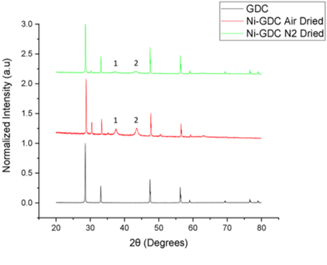
Figure A1: X-ray diffraction patterns of the Ni-GDC samples dried in either air or nitrogen. The 1 and 2 denote the peaks assigned to bunesnite (NiO)

4.3.2 Chemical Identification
Figure A2: Full FTIR Spectra of the Overlaid FTIR spectra of nickel nitrate hexahydrate dried in air and nitrogen (denoted by the black and red series respectively)

4.3.4 Microstructural Identification
Figure A3: 5 µm * 5 µm section of the Air DC Ni-YSZ sample used for particle size analysis using FIJI

Table A1: Particle size measurements from FIJI of the Air DC Ni-YSZ sample section
Ni-YSZ as reduced |  | Atmosphere: Air
 | Area [µm^2] | Particle Size [µm] | Average Particle Length [µm]
1 | 0.003 | 0.185 | 0.08596
2 | 0.001 | 0.095
3 | 0.002 | 0.13 | Average particle length [nm]
4 | 0.003 | 0.185 | 85.96
5 | 0.002 | 0.156 | 0.011633
6 | 0.002 | 0.136
7 | 0.001 | 0.109 | Error [nm]
8 | 0.002 | 0.153 | 11.6
9 | 0.001 | 0.106
10 | 9.44E-04 | 0.064
11 | 0.002 | 0.18
12 | 0.001 | 0.092
13 | 8.09E-04 | 0.055
14 | 0.002 | 0.133
15 | 0.001 | 0.089
16 | 0.001 | 0.082
17 | 0.002 | 0.13
18 | 0.001 | 0.108
19 | 0.001 | 0.092
20 | 8.09E-04 | 0.062
21 | 8.09E-04 | 0.061
22 | 9.44E-04 | 0.065
23 | 8.09E-04 | 0.057
24 | 0.001 | 0.094
25 | 0.001 | 0.088
26 | 5.39E-04 | 0.034
27 | 0.001 | 0.082
28 | 0.002 | 0.133
29 | 6.74E-04 | 0.047
30 | 0.001 | 0.085
31 | 0.001 | 0.094
32 | 0.001 | 0.076
33 | 0.001 | 0.077
34 | 0.001 | 0.094
35 | 0.001 | 0.077
36 | 0.002 | 0.133
37 | 6.74E-04 | 0.048
38 | 6.74E-04 | 0.052
39 | 6.74E-04 | 0.044
40 | 6.74E-04 | 0.041
41 | 6.74E-04 | 0.046
42 | 6.74E-04 | 0.05
43 | 5.39E-04 | 0.036
44 | 6.74E-04 | 0.05
45 | 8.09E-04 | 0.056
46 | 6.74E-04 | 0.042
47 | 6.74E-04 | 0.041
48 | 8.09E-04 | 0.056
49 | 6.74E-04 | 0.051
50 | 6.74E-04 | 0.046

Figure A4: 5 µm * 5 µm section of the N₂ DC Ni-YSZ sample used for particle size analysis using FIJI

Table A2: Particle size measurements from FIJI of the N₂ DC Ni-YSZ sample section
Ni-YSZ as reduced |  | Atmosphere: N₂
 | Area [µm^2] | Particle Size [µm] | Average Particle Length [µm]
1 | 1.00E-03 | 0.086 | 0.04758
2 | 1.00E-03 | 0.111
3 | 1.00E-03 | 0.081 | Average particle length [nm]
4 | 1.00E-03 | 0.078 | 47.58
5 | 8.14E-04 | 0.06
6 | 8.14E-04 | 0.053 | Error [nm]
7 | 8.14E-04 | 0.054 | 21.0
8 | 5.43E-04 | 0.031
9 | 6.78E-04 | 0.047
10 | 4.07E-04 | 0.024
11 | 6.78E-04 | 0.047
12 | 0.001 | 0.101
13 | 9.49E-04 | 0.073
14 | 6.78E-04 | 0.052
15 | 6.78E-04 | 0.042
16 | 8.14E-04 | 0.055
17 | 5.43E-04 | 0.029
18 | 5.43E-04 | 0.035
19 | 6.78E-04 | 0.052
20 | 6.78E-04 | 0.041
21 | 6.78E-04 | 0.048
22 | 6.78E-04 | 0.045
23 | 5.43E-04 | 0.037
24 | 5.43E-04 | 0.029
25 | 5.43E-04 | 0.031
26 | 6.78E-04 | 0.047
27 | 0.001 | 0.076
28 | 5.43E-04 | 0.029
29 | 6.78E-04 | 0.052
30 | 6.78E-04 | 0.041
31 | 5.43E-04 | 0.035
32 | 6.78E-04 | 0.047
33 | 6.78E-04 | 0.048
34 | 6.78E-04 | 0.044
35 | 5.43E-04 | 0.039
36 | 5.43E-04 | 0.037
37 | 4.07E-04 | 0.018
38 | 5.43E-04 | 0.035
39 | 8.14E-04 | 0.063
40 | 6.78E-04 | 0.047
41 | 5.43E-04 | 0.031
42 | 6.78E-04 | 0.044
43 | 5.43E-04 | 0.037
44 | 6.78E-04 | 0.045
45 | 5.43E-04 | 0.037
46 | 4.07E-04 | 0.023
47 | 5.43E-04 | 0.031
48 | 8.14E-04 | 0.053
49 | 5.43E-04 | 0.039
50 | 5.43E-04 | 0.039

Figure A5: Calibration curve of the NiO bulker powder from 3-20mg for Temperature Programmed Reduction measurements

Percent dispersion (%) calculations
Percent dispersion calculation of the nickel species in the infiltrated

Atomic radii method
This method was used to check that the unit cell length determined by the volumetric method was correct. The atomic radius used was 1.246Å. The unit cell length a, was calculated using Pythagoras’ theorem was rearranged with respect to a [294], [338], [339].

$${\left(4r\right)}^{2}={2a}^{2}$$
$${16r}^{2}={2a}^{2}$$
$${8r}^{2}=a^{2}$$
$${8r}^{2}=a^{2}$$
$$a=r\sqrt{8}$$
Equation A1

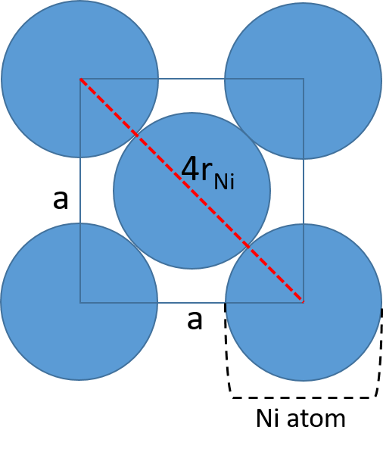
Figure A6: Diagram of the (111) crystallographic plane in the Ni FCC Unit cell. The atomic radius of nickel is denoted by r. The unit cell length is denoted by a respectively

4.3.5 Electrochemical performance
Table A3: Evolution of the series and polarisation resistance in 50 h of ageing
Sample (Drying and Calcination atmosphere) | Electrode Area [cm^{2]} | Initial Series Resistance, Rs₀  [Ωcm²] | Initial Polarisation Resistance, R_{P0} [Ωcm²] | Series Resistance after 50h of ageing, Rs  [Ωcm²] | Polarisation  Resistance after 50h of ageing, R_{P} [Ωcm²]
ND NC | 0.2827 | 1.585 | 21.641 | 4.446 | 42.140 (20.50)
ND AC | 0.2827 | 3.907 | 15.418 | 5.864 | 20.088 (4.67)
AD AC | 0.2827 | 3.35 | 12.385 | 5.163 | 39.886 (27.50)
AD NC | 0.2827 | 5.804 | 21.675 | 7.636 | 38.006 (16.33)

EC Fits
Table A27: Evolution of the series and polarisation resistance in 50 h of ageing using Equivalent circuit fitting
Sample (Drying and Calcination atmosphere) | Electrode Area [cm^{2]} | Initial Series Resistance, Rs₀  [Ωcm²] | Initial Polarisation Resistance, R_{P0} [Ωcm²] | Series Resistance after 50h of ageing, Rs  [Ωcm²] | Polarisation  Resistance after 50h of ageing, R_{P} [Ωcm²]
ND NC | 0.2827 | 1.52 | 21.52 | 4.76 | 41.63 (20.11)
ND AC | 0.2827 | 3.82 | 15.27 | 5.87 | 19.30 (4.03)
AD AC | 0.2827 | 3.14 | 12.41 | 5.16 | 39.63 (27.22)
AD NC | 0.2827 | 2.60 | 22.38 | 4.50 | 36.88 (14.50)

5.3.2 Electrochemical performance using electrical impedance spectroscopy

Electrochemical Performance Activation Energy Plots
Figure A7: Arrhenius plot polarisation resistance vs 1000/T for the Ag2 at 400-800 ⁰C

Figure A8: Arrhenius plot polarisation resistance vs 1000/T for the Ag3 at 400-800 ⁰C

6.3.2 Focussed Ion Beam Scanning Electron Microscopy

Back-scattered electron micrographs of infiltrated Ni-YSZ samples
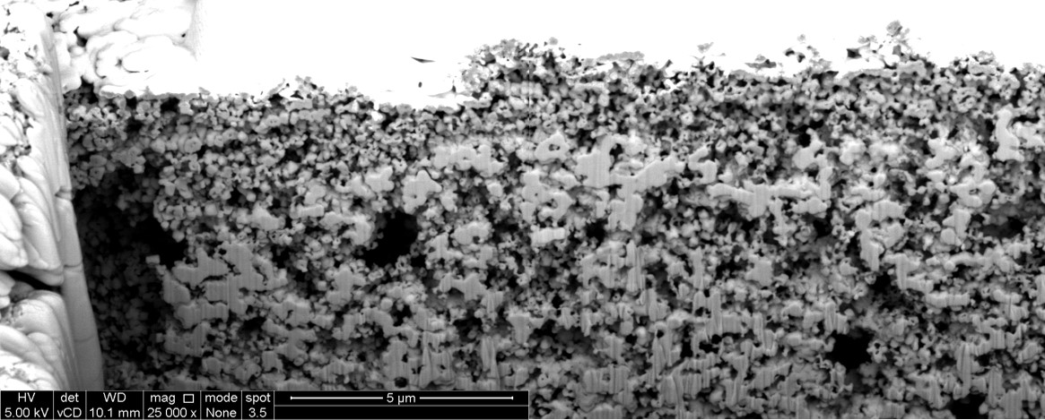
Figure A9: Back-scattered electron micrograph of the 0 h aged air-dried infiltrated Ni-YSZ fuel electrode sample at 25000x magnification. The white region corresponds to the element with the highest atomic number (Pt). The region measures 20 µm x 10 µm, respectively.
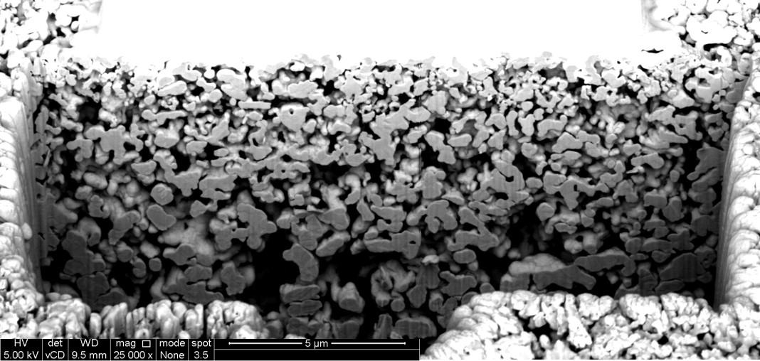
Figure A10: Back-scattered electron micrograph of the 0 h aged nitrogen-dried infiltrated Ni-YSZ fuel electrode sample at 25000x magnification. The white region corresponds to the element with the highest atomic number (Pt). The region measures 20 µm x 10 µm, respectively.

6.3.4 Attenuation coefficient ratio of Ni-YSZ fuel electrodes at 20 keV
Table A5: Table calculating the electrode attenuation coefficients for a beam energy of 20 keV [365], [490]
Element | Ni | Zr | Y | O
Mass attenuation coefficient, µ_{m}  [cm²/g] [365] | 2050 | 742 | 812 | 695
Electrode phase | Nickel (20%) | (Y₂O₃)_{0.08}(ZrO₂)_{0.92} (65%) | Air (15%) | ACR [unitless]
Electrode Attenuation coefficient $µ_{m}\left(E_{0}\right)$, µ_{m}  [cm²/g] | 410 | 2750 | 79.2 | 6.71

6.3.4 Ptychographic datasets

Contrast Sample

Air
Table A6: Table detailing the line profile measurements of the air phase in the Ni-YSZ contrast sample. The minimum, maximum and average GSV are shown on the right.
Air Grayscale Values
Measurement Number | Slice Number |  |  |  |  |  | Minimum GSV
Measurement Number | 1 | 20 | 40 | 60 | 80 | 100 | 36.00
0 | 54.000 | 48.000 | 47.000 | 45.000 | 37.000 | 36.000 | Maximum GSV
1 | 54.156 | 50.555 | 48.626 | 45.000 | 37.892 | 36.892 | 70.00
2 | 54.000 | 51.101 | 49.000 | 46.407 | 39.000 | 38.000 | Average GSV
3 | 54.000 | 52.873 | 49.000 | 47.000 | 40.110 | 38.635 | 57.44
4 | 54.000 | 54.390 | 49.000 | 48.390 | 41.813 | 39.961
5 | 54.000 | 56.000 | 49.000 | 50.000 | 43.000 | 39.540
6 | 54.000 | 56.713 | 49.047 | 50.713 | 43.475 | 39.856
7 | 54.000 | 58.962 | 50.926 | 52.962 | 44.974 | 39.332
8 | 53.808 | 57.218 | 51.808 | 53.000 | 44.151 | 39.000
9 | 53.095 | 56.095 | 51.095 | 51.098 | 44.189 | 39.000
10 | 53.000 | 56.000 | 51.000 | 49.000 | 45.896 | 39.000
11 | 53.000 | 56.000 | 51.000 | 49.000 | 46.719 | 39.823
12 | 53.000 | 56.000 | 51.658 | 49.000 | 45.556 | 41.000
13 | 53.000 | 55.902 | 54.000 | 49.085 | 45.027 | 41.173
14 | 53.000 | 55.051 | 54.000 | 50.232 | 45.619 | 43.846
15 | 53.000 | 55.000 | 56.105 | 51.743 | 46.937 | 44.000
16 | 53.000 | 55.000 | 57.000 | 52.000 | 47.000 | 44.480
17 | 54.433 | 55.000 | 57.000 | 53.433 | 48.433 | 45.903
18 | 56.000 | 55.000 | 56.756 | 55.000 | 50.369 | 46.426
19 | 56.518 | 55.526 | 56.090 | 55.000 | 52.008 | 48.890
20 | 59.000 | 58.000 | 56.000 | 55.000 | 53.025 | 49.081
21 | 59.000 | 58.000 | 56.000 | 55.000 | 54.884 | 51.650
22 | 59.000 | 58.000 | 56.000 | 56.819 | 55.000 | 51.473
23 | 59.000 | 58.000 | 56.000 | 57.566 | 55.000 | 51.000
24 | 59.000 | 58.000 | 56.000 | 58.000 | 55.000 | 51.373
25 | 58.930 | 59.012 | 56.000 | 58.192 | 55.058 | 51.581
26 | 59.284 | 61.000 | 56.000 | 58.662 | 56.495 | 53.142
27 | 60.987 | 61.000 | 56.000 | 59.841 | 57.995 | 53.995
28 | 61.000 | 61.000 | 56.000 | 59.896 | 59.980 | 54.000
29 | 61.000 | 61.000 | 56.272 | 60.000 | 61.000 | 54.697
30 | 61.000 | 61.000 | 58.295 | 60.000 | 62.337 | 55.703
31 | 61.000 | 61.000 | 59.000 | 60.000 | 64.000 | 56.061
32 | 61.000 | 61.000 | 59.000 | 60.000 | 64.193 | 55.853
33 | 60.927 | 61.000 | 59.030 | 60.000 | 64.970 | 56.449
34 | 60.823 | 61.000 | 59.778 | 60.000 | 64.222 | 56.149
35 | 60.532 | 61.000 | 61.679 | 61.614 | 63.128 | 56.000
36 | 60.862 | 61.000 | 60.296 | 62.091 | 63.000 | 56.091
37 | 61.000 | 62.333 | 59.000 | 60.601 | 62.803 | 56.823
38 | 61.000 | 63.419 | 59.000 | 60.000 | 61.366 | 57.781
39 | 60.879 | 64.000 | 58.566 | 60.000 | 60.000 | 59.000
40 | 60.766 | 64.000 | 58.042 | 60.000 | 60.000 | 59.000
41 | 58.250 | 64.000 | 58.000 | 60.000 | 60.000 | 59.000
42 | 58.001 | 63.994 | 57.237 | 61.538 | 60.000 | 58.988
43 | 58.000 | 61.611 | 56.910 | 62.620 | 60.000 | 57.940
44 | 58.000 | 59.924 | 56.583 | 62.503 | 59.946 | 56.946
45 | 58.000 | 57.857 | 56.901 | 60.776 | 59.422 | 56.235
46 | 57.790 | 57.000 | 58.000 | 59.000 | 59.000 | 55.000
47 | 55.728 | 57.000 | 58.000 | 58.967 | 59.000 | 55.000
48 | 55.000 | 57.000 | 58.000 | 57.113 | 59.000 | 55.000
49 | 55.000 | 57.000 | 58.000 | 56.088 | 59.000 | 54.508
50 | 55.000 | 55.372 | 58.000 | 56.000 | 59.000 | 54.300
51 | 55.000 | 54.409 | 59.298 | 56.000 | 59.000 | 54.591
52 | 55.000 | 54.000 | 61.000 | 55.930 | 59.000 | 54.824
53 | 55.167 | 54.000 | 61.000 | 55.230 | 59.000 | 55.000
54 | 56.571 | 54.580 | 61.000 | 55.000 | 59.000 | 55.290
55 | 57.941 | 56.321 | 61.686 | 55.000 | 60.372 | 56.810
56 | 58.000 | 57.000 | 61.415 | 55.578 | 61.000 | 57.000
57 | 57.530 | 57.000 | 60.530 | 57.201 | 60.530 | 57.470
58 | 56.212 | 57.307 | 60.000 | 58.000 | 60.236 | 58.477
59 | 55.000 | 59.073 | 60.000 | 58.000 | 60.000 | 58.065
60 | 55.000 | 60.000 | 60.000 | 59.477 | 59.957 | 58.000
61 | 55.000 | 60.000 | 60.000 | 60.994 | 59.088 | 58.000
62 | 55.000 | 60.000 | 60.000 | 60.103 | 59.412 | 58.389
63 | 55.000 | 60.000 | 60.000 | 60.000 | 59.658 | 59.003
64 | 55.000 | 60.000 | 60.000 | 60.000 | 61.004 | 59.000
65 | 55.061 | 59.608 | 60.000 | 60.000 | 61.000 | 58.980
66 | 57.004 | 59.000 | 60.000 | 59.880 | 60.966 | 58.332
67 | 58.000 | 58.929 | 60.118 | 59.000 | 60.105 | 58.000
68 | 58.000 | 56.944 | 61.821 | 59.000 | 60.675 | 58.000
69 | 60.395 | 56.000 | 62.000 | 58.883 | 61.407 | 58.000
70 | 61.000 | 56.000 | 62.000 | 58.125 | 61.738 | 58.000
71 | 61.000 | 55.907 | 62.465 | 58.094 | 61.427 | 58.000
72 | 61.000 | 55.188 | 63.174 | 59.129 | 61.000 | 58.000
73 | 61.000 | 55.000 | 62.456 | 60.000 | 60.832 | 58.544
74 | 61.000 | 55.047 | 61.000 | 60.000 | 59.985 | 59.985
75 | 61.000 | 57.691 | 61.000 | 59.741 | 58.611 | 59.090
76 | 61.000 | 58.000 | 60.406 | 59.050 | 56.506 | 59.000
77 | 59.275 | 59.150 | 60.000 | 59.000 | 56.000 | 59.198
78 | 58.000 | 60.000 | 58.350 | 59.000 | 55.573 | 60.295
79 | 58.000 | 60.278 | 56.567 | 59.169 | 54.722 | 59.658
80 | 57.881 | 61.260 | 55.881 | 59.213 | 54.000 | 57.145
81 | 57.019 | 62.955 | 55.019 | 59.982 | 53.568 | 57.000
82 | 54.530 | 62.197 | 55.000 | 60.000 | 53.006 | 56.167
83 | 54.462 | 62.000 | 54.161 | 59.161 | 52.315 | 55.315
84 | 54.037 | 61.988 | 53.993 | 58.993 | 52.000 | 54.993
85 | 55.401 | 61.672 | 53.284 | 57.660 | 52.416 | 54.284
86 | 56.000 | 61.819 | 53.000 | 55.000 | 53.986 | 53.986
87 | 56.000 | 60.247 | 53.000 | 55.000 | 53.378 | 53.378
88 | 56.000 | 58.892 | 53.204 | 55.000 | 53.000 | 53.000
89 | 56.000 | 58.368 | 54.849 | 55.000 | 53.000 | 52.206
90 | 56.000 | 58.000 | 55.000 | 54.299 | 53.000 | 50.364
91 | 55.502 | 56.666 | 55.000 | 54.000 | 53.677 | 50.025
92 | 55.000 | 55.000 | 55.625 | 54.000 | 55.000 | 49.408
93 | 55.000 | 55.000 | 57.565 | 54.439 | 55.000 | 50.565
94 | 55.000 | 55.000 | 58.000 | 57.000 | 55.000 | 51.000
95 | 55.000 | 55.000 | 58.000 | 57.000 | 55.000 | 51.000
96 | 55.000 | 55.000 | 57.700 | 57.000 | 55.000 | 52.958
97 | 55.000 | 55.000 | 57.176 | 57.000 | 53.499 | 53.323
98 | 55.000 | 56.294 | 57.000 | 56.840 | 52.000 | 54.942
99 | 55.000 | 57.000 | 56.108 | 55.276 | 52.000 | 56.000
100 | 55.000 | 57.000 | 54.000 | 53.000 | 52.000 | 56.000
101 | 55.013 | 57.000 | 54.000 | 53.000 | 52.000 | 56.000
102 | 55.925 | 57.000 | 54.000 | 53.000 | 52.000 | 56.000
103 | 58.128 | 56.283 | 54.000 | 53.000 | 52.000 | 55.306
104 | 58.576 | 56.000 | 54.000 | 53.000 | 53.706 | 55.000
105 | 59.000 | 55.981 | 54.000 | 53.000 | 55.000 | 55.000
106 | 59.000 | 54.006 | 54.000 | 53.000 | 55.000 | 55.000
107 | 59.000 | 53.000 | 54.000 | 53.000 | 55.000 | 55.000
108 | 59.000 | 53.000 | 54.000 | 53.000 | 55.000 | 55.000
109 | 59.000 | 53.000 | 54.000 | 52.942 | 55.000 | 55.000
110 | 61.036 | 53.000 | 54.000 | 53.000 | 55.000 | 55.000
111 | 61.554 | 53.000 | 54.478 | 53.000 | 55.084 | 55.000
112 | 61.422 | 53.000 | 56.050 | 53.000 | 55.683 | 55.000
113 | 61.000 | 53.000 | 57.000 | 53.000 | 55.855 | 55.000
114 | 60.745 | 53.000 | 57.000 | 53.000 | 53.807 | 55.000
115 | 58.190 | 53.717 | 56.283 | 53.000 | 53.000 | 55.000
116 | 58.000 | 55.860 | 54.140 | 53.000 | 53.000 | 55.000
117 | 58.000 | 56.582 | 54.000 | 53.909 | 53.000 | 55.000
118 | 58.000 | 58.736 | 54.000 | 55.481 | 53.000 | 55.000
119 | 56.279 | 59.361 | 54.000 | 56.000 | 53.361 | 55.000
120 | 55.000 | 61.698 | 54.000 | 56.000 | 55.649 | 54.416
121 | 55.000 | 62.000 | 54.000 | 56.000 | 56.000 | 52.000
122 | 55.000 | 62.000 | 54.000 | 56.000 | 56.000 | 52.000
123 | 55.000 | 62.000 | 54.000 | 55.665 | 56.000 | 52.000
124 | 55.000 | 62.000 | 54.000 | 55.012 | 56.000 | 52.000
125 | 55.000 | 60.870 | 54.000 | 55.000 | 56.000 | 52.000
126 | 55.000 | 59.000 | 54.000 | 54.983 | 56.000 | 52.000
127 | 55.000 | 58.746 | 54.000 | 53.158 | 56.000 | 52.000
128 | 55.000 | 56.000 | 54.016 | 52.000 | 56.000 | 52.066
129 | 55.000 | 56.000 | 56.226 | 52.000 | 56.000 | 52.083
130 | 55.244 | 56.000 | 57.000 | 52.000 | 55.886 | 52.114
131 | 57.525 | 56.000 | 57.000 | 52.000 | 55.362 | 52.638
132 | 58.000 | 56.000 | 57.000 | 52.414 | 55.000 | 53.000
133 | 58.000 | 56.000 | 57.182 | 53.000 | 55.000 | 53.365
134 | 58.000 | 56.000 | 57.883 | 53.000 | 55.000 | 55.000
135 | 58.000 | 56.000 | 57.031 | 53.000 | 55.000 | 55.000
136 | 56.617 | 56.000 | 57.000 | 53.000 | 55.000 | 55.000
137 | 55.143 | 56.000 | 57.000 | 53.000 | 55.000 | 55.000
138 | 55.000 | 56.000 | 57.000 | 53.000 | 55.000 | 55.990
139 | 55.000 | 56.935 | 57.000 | 53.000 | 55.000 | 57.788
140 | 55.161 | 59.000 | 57.000 | 54.502 | 54.727 | 58.000
141 | 56.825 | 59.000 | 57.000 | 56.000 | 55.000 | 58.000
142 | 57.958 | 59.748 | 57.000 | 56.000 | 54.598 | 58.000
143 | 58.000 | 61.634 | 57.000 | 56.000 | 54.798 | 58.000
144 | 58.000 | 60.302 | 57.000 | 56.000 | 54.550 | 58.000
145 | 58.000 | 59.027 | 57.000 | 56.000 | 54.499 | 58.000
146 | 58.000 | 59.000 | 57.503 | 56.000 | 54.838 | 57.502
147 | 58.000 | 58.382 | 60.000 | 56.000 | 56.206 | 57.000
148 | 58.044 | 56.000 | 60.000 | 56.000 | 57.018 | 57.000
149 | 59.861 | 56.000 | 60.000 | 56.000 | 57.000 | 57.000
150 | 60.896 | 56.000 | 60.000 | 56.000 | 57.000 | 57.000
151 | 61.000 | 56.000 | 60.000 | 55.857 | 57.000 | 57.000
152 | 61.000 | 56.000 | 60.000 | 56.000 | 56.587 | 57.000
153 | 60.255 | 56.000 | 59.105 | 56.000 | 55.000 | 56.620
154 | 58.528 | 56.310 | 57.000 | 56.000 | 55.000 | 54.932
155 | 57.999 | 59.000 | 57.000 | 56.000 | 55.000 | 54.000
156 | 56.113 | 59.000 | 57.000 | 56.000 | 55.000 | 54.000
157 | 55.521 | 59.000 | 54.654 | 58.114 | 55.000 | 53.739
158 | 55.652 | 60.550 | 54.000 | 59.000 | 55.000 | 53.215
159 | 55.691 | 62.000 | 54.000 | 59.000 | 54.874 | 53.000
160 | 55.167 | 62.000 | 53.784 | 59.000 | 54.383 | 52.351
161 | 55.072 | 62.000 | 53.000 | 59.000 | 54.048 | 50.000
162 | 55.115 | 62.000 | 53.000 | 59.000 | 54.902 | 50.000
163 | 57.444 | 59.556 | 53.000 | 59.000 | 54.775 | 50.000
164 | 58.000 | 59.000 | 53.000 | 59.000 | 55.000 | 49.381
165 | 58.000 | 59.000 | 53.000 | 59.000 | 55.000 | 49.218
166 | 58.000 | 57.892 | 54.108 | 57.892 | 55.739 | 49.000
167 | 58.000 | 56.000 | 56.000 | 56.390 | 57.000 | 49.501
168 | 57.998 | 56.000 | 56.000 | 56.000 | 57.000 | 50.000
169 | 57.493 | 56.000 | 56.000 | 56.000 | 57.000 | 50.000
170 | 57.000 | 56.000 | 56.000 | 56.000 | 58.552 | 50.000
171 | 57.000 | 56.000 | 56.000 | 56.000 | 59.253 | 50.000
172 | 57.000 | 56.000 | 56.000 | 56.000 | 57.916 | 49.521
173 | 57.000 | 56.000 | 56.000 | 56.000 | 57.000 | 49.000
174 | 57.000 | 56.000 | 56.000 | 56.000 | 57.000 | 49.000
175 | 57.021 | 56.000 | 56.000 | 56.081 | 57.000 | 49.000
176 | 57.000 | 56.000 | 56.000 | 58.706 | 57.000 | 49.575
177 | 57.000 | 56.000 | 55.263 | 59.000 | 54.788 | 51.221
178 | 57.000 | 56.000 | 55.000 | 59.000 | 54.000 | 52.000
179 | 57.000 | 56.000 | 55.000 | 59.000 | 54.000 | 52.000
180 | 57.785 | 56.000 | 55.000 | 59.000 | 53.799 | 52.312
181 | 59.284 | 56.361 | 55.000 | 58.736 | 53.716 | 52.836
182 | 59.997 | 58.991 | 55.000 | 56.291 | 53.363 | 53.000
183 | 60.000 | 59.000 | 55.000 | 55.036 | 53.135 | 53.000
184 | 60.000 | 59.000 | 56.224 | 55.000 | 55.465 | 53.285
185 | 60.000 | 59.000 | 57.871 | 55.000 | 56.000 | 54.958
186 | 60.000 | 59.000 | 58.000 | 55.000 | 56.367 | 56.000
187 | 60.000 | 59.000 | 58.000 | 55.000 | 57.970 | 56.000
188 | 60.000 | 57.488 | 58.000 | 55.000 | 58.000 | 56.000
189 | 60.000 | 56.000 | 58.000 | 55.084 | 58.000 | 56.000
190 | 60.000 | 57.087 | 58.000 | 57.742 | 58.000 | 56.000
191 | 60.000 | 57.980 | 58.000 | 58.150 | 58.000 | 56.227
192 | 60.000 | 58.795 | 58.000 | 60.004 | 58.000 | 57.697
193 | 60.000 | 59.000 | 57.000 | 61.000 | 58.000 | 58.079
194 | 60.000 | 59.430 | 56.017 | 61.417 | 58.000 | 58.278
195 | 59.801 | 61.000 | 55.000 | 64.000 | 58.000 | 60.227
196 | 57.246 | 61.000 | 55.000 | 64.000 | 58.000 | 60.975
197 | 57.000 | 61.939 | 55.000 | 64.000 | 58.388 | 61.000
198 | 57.000 | 63.524 | 55.000 | 64.000 | 59.025 | 61.000
199 | 57.000 | 64.000 | 55.000 | 64.000 | 59.740 | 61.000
200 | 57.000 | 64.000 | 55.000 | 63.229 | 60.859 | 60.486
201 | 57.000 | 64.000 | 55.529 | 60.824 | 61.000 | 59.000
202 | 57.000 | 63.917 | 58.000 | 59.977 | 61.000 | 59.000
203 | 57.958 | 61.230 | 58.000 | 58.482 | 61.000 | 59.000
204 | 59.909 | 60.351 | 58.000 | 57.061 | 61.000 | 59.000
205 | 60.000 | 58.492 | 58.000 | 56.281 | 61.000 | 58.589
206 | 60.000 | 58.000 | 58.000 | 54.110 | 60.594 | 58.065
207 | 60.000 | 57.869 | 56.623 | 54.000 | 60.000 | 57.082
208 | 59.993 | 57.290 | 55.457 | 54.000 | 60.000 | 56.034
209 | 60.000 | 57.970 | 56.463 | 54.000 | 60.000 | 56.000
210 | 57.478 | 58.646 | 57.522 | 54.000 | 59.995 | 56.000
211 | 57.000 | 58.445 | 58.000 | 54.000 | 60.000 | 56.000
212 | 57.000 | 58.000 | 58.000 | 54.000 | 59.835 | 56.000
213 | 57.000 | 58.000 | 58.000 | 54.000 | 57.720 | 56.000
214 | 57.000 | 58.000 | 58.000 | 54.000 | 57.000 | 56.000
215 | 57.000 | 58.000 | 58.000 | 54.129 | 57.000 | 56.000
216 | 57.000 | 58.000 | 58.000 | 56.067 | 56.502 | 56.000
217 | 57.000 | 58.000 | 56.319 | 56.940 | 54.179 | 57.681
218 | 57.000 | 57.855 | 56.017 | 57.000 | 54.000 | 59.000
219 | 57.000 | 57.125 | 56.390 | 56.616 | 54.000 | 59.000
220 | 57.550 | 57.000 | 57.009 | 57.000 | 54.000 | 59.000
221 | 59.675 | 57.000 | 58.000 | 56.957 | 54.417 | 59.000
222 | 60.000 | 57.000 | 58.000 | 57.000 | 56.000 | 59.000
223 | 60.000 | 57.000 | 58.000 | 57.000 | 56.000 | 59.000
224 | 60.000 | 57.000 | 59.807 | 57.000 | 56.000 | 59.000
225 | 60.000 | 57.000 | 60.958 | 56.385 | 57.845 | 59.000
226 | 60.000 | 57.000 | 61.000 | 56.000 | 57.158 | 59.000
227 | 60.000 | 57.000 | 61.000 | 56.000 | 56.000 | 59.000
228 | 60.000 | 57.000 | 61.000 | 56.000 | 56.000 | 59.000
229 | 60.022 | 57.000 | 60.999 | 56.022 | 55.936 | 59.000
230 | 60.428 | 57.000 | 61.000 | 56.428 | 53.186 | 59.000
231 | 60.000 | 57.025 | 58.899 | 56.000 | 53.000 | 59.000
232 | 60.000 | 58.966 | 58.709 | 56.255 | 53.000 | 59.000
233 | 60.000 | 60.000 | 58.141 | 56.393 | 53.000 | 58.930
234 | 60.000 | 60.000 | 58.000 | 57.123 | 53.000 | 57.509
235 | 60.000 | 60.394 | 58.000 | 59.000 | 52.740 | 56.000
236 | 60.000 | 62.949 | 58.000 | 59.000 | 51.692 | 56.000
237 | 60.000 | 63.000 | 58.000 | 59.000 | 51.000 | 55.555
238 | 60.000 | 63.000 | 58.000 | 59.000 | 51.000 | 53.895
239 | 60.000 | 63.000 | 58.000 | 59.000 | 51.000 | 52.879
240 | 60.000 | 61.832 | 58.000 | 57.832 | 51.000 | 52.153
241 | 60.000 | 60.000 | 58.000 | 56.623 | 51.000 | 52.000
242 | 60.000 | 60.000 | 58.000 | 56.000 | 51.278 | 52.000
243 | 60.000 | 60.000 | 58.000 | 56.661 | 53.833 | 52.000
244 | 60.000 | 57.612 | 58.000 | 58.364 | 54.000 | 52.000
245 | 60.000 | 57.000 | 58.000 | 59.000 | 54.000 | 52.000
246 | 60.000 | 57.000 | 58.000 | 57.662 | 54.000 | 51.501
247 | 58.748 | 57.417 | 58.000 | 56.000 | 54.710 | 50.019
248 | 57.176 | 57.941 | 58.000 | 56.000 | 57.026 | 48.748
249 | 57.000 | 57.398 | 58.000 | 56.000 | 58.000 | 49.680
250 | 57.000 | 55.190 | 58.000 | 56.000 | 58.000 | 50.720
251 | 57.000 | 55.000 | 58.000 | 56.000 | 58.000 | 50.626
252 | 56.977 | 55.045 | 56.173 | 56.000 | 58.037 | 50.957
253 | 56.697 | 56.987 | 55.000 | 56.000 | 58.561 | 51.000
254 | 56.745 | 58.000 | 54.063 | 56.000 | 59.000 | 51.857
255 | 55.472 | 58.000 | 52.000 | 56.192 | 58.808 | 52.472
256 | 56.607 | 58.000 | 52.000 | 56.046 | 58.960 | 54.002
257 | 56.738 | 58.000 | 52.000 | 58.601 | 58.108 | 54.570
258 | 56.847 | 55.844 | 52.000 | 59.000 | 59.000 | 56.307
259 | 57.000 | 55.000 | 52.000 | 59.000 | 59.000 | 55.893
260 | 57.325 | 55.000 | 52.000 | 59.000 | 59.000 | 55.000
261 | 58.000 | 55.000 | 52.821 | 59.000 | 59.000 | 55.000
262 | 60.000 | 55.000 | 55.000 | 59.000 | 59.000 | 55.000
263 | 60.000 | 55.000 | 55.000 | 59.000 | 59.000 | 55.000
264 | 62.485 | 55.000 | 57.652 | 59.000 | 59.269 | 54.731
265 | 61.166 | 55.000 | 58.577 | 59.000 | 61.003 | 52.894
266 | 60.000 | 55.000 | 60.079 | 56.882 | 61.468 | 52.349
267 | 60.000 | 55.000 | 60.817 | 56.000 | 60.233 | 53.031
268 | 60.000 | 55.000 | 60.295 | 56.000 | 59.000 | 55.000
269 | 60.000 | 55.000 | 58.000 | 56.000 | 59.000 | 55.000
270 | 60.000 | 55.000 | 58.029 | 56.000 | 59.000 | 55.000
271 | 60.000 | 57.369 | 58.000 | 56.000 | 59.000 | 57.351
272 | 58.076 | 58.000 | 57.875 | 57.924 | 59.000 | 58.000
273 | 57.000 | 59.540 | 57.034 | 59.000 | 59.000 | 58.000
274 | 57.000 | 62.034 | 56.000 | 59.884 | 59.000 | 58.000
275 | 57.000 | 64.410 | 56.000 | 62.000 | 59.000 | 58.000
276 | 57.000 | 66.631 | 56.000 | 62.000 | 59.000 | 58.000
277 | 57.000 | 67.245 | 56.000 | 62.000 | 58.878 | 58.000
278 | 57.000 | 69.327 | 56.751 | 62.000 | 57.093 | 55.747
279 | 57.000 | 70.000 | 57.000 | 62.000 | 56.000 | 55.000
280 | 57.000 | 70.000 | 57.000 | 62.000 | 56.000 | 55.000
281 | 57.000 | 70.000 | 57.000 | 61.623 | 56.000 | 55.000
282 | 57.000 | 70.000 | 57.435 | 60.206 | 56.235 | 55.000
283 | 57.000 | 70.000 | 60.000 | 60.000 | 56.741 | 55.000
284 | 57.000 | 70.000 | 60.000 | 60.000 | 58.610 | 55.000
285 | 57.000 | 70.000 | 60.000 | 60.000 | 59.000 | 55.000
286 | 57.000 | 68.872 | 60.000 | 60.000 | 60.609 | 55.000
287 | 57.000 | 68.000 | 60.000 | 60.000 | 62.000 | 55.000
288 | 57.000 | 68.000 | 60.000 | 60.000 | 62.000 | 55.000
289 | 56.794 | 67.849 | 60.000 | 60.000 | 62.000 | 55.000
290 | 56.847 | 65.241 | 60.000 | 60.000 | 62.000 | 55.000
291 | 55.696 | 65.000 | 57.533 | 60.000 | 62.388 | 55.000
292 | 54.974 | 65.000 | 57.000 | 60.000 | 62.331 | 57.019
293 | 55.259 | 64.727 | 57.000 | 60.000 | 62.000 | 58.000
294 | 55.130 | 63.870 | 57.000 | 60.000 | 60.869 | 58.000
295 | 56.572 | 62.298 | 57.000 | 60.000 | 59.000 | 58.000
296 | 57.164 | 61.000 | 57.000 | 60.000 | 59.000 | 58.000
297 | 57.974 | 61.000 | 57.000 | 60.000 | 59.000 | 58.000
298 | 58.000 | 60.643 | 56.673 | 60.000 | 59.000 | 60.351
299 | 58.000 | 59.011 | 54.369 | 60.000 | 59.000 | 61.000
300 | 58.000 | 58.000 | 54.000 | 60.000 | 59.000 | 61.182
301 | 58.000 | 58.000 | 54.000 | 60.000 | 59.000 | 62.715
302 | 58.436 | 58.000 | 54.134 | 60.000 | 59.000 | 63.000
303 | 58.818 | 58.000 | 56.307 | 60.000 | 58.990 | 63.000
304 | 60.680 | 57.152 | 57.000 | 60.000 | 59.000 | 63.000
305 | 61.000 | 55.580 | 57.000 | 60.000 | 58.856 | 63.000
306 | 61.000 | 56.198 | 57.000 | 58.077 | 58.403 | 62.138
307 | 62.345 | 55.884 | 58.345 | 57.000 | 58.000 | 61.407
308 | 63.735 | 55.621 | 60.000 | 57.000 | 58.000 | 60.441
309 | 64.000 | 55.234 | 60.454 | 56.819 | 58.000 | 60.298
310 | 64.000 | 55.573 | 63.000 | 56.419 | 58.000 | 57.997
311 | 64.000 | 55.050 | 63.000 | 54.429 | 58.000 | 57.145
312 | 64.000 | 52.463 | 64.748 | 54.000 | 58.000 | 57.000
313 | 64.000 | 52.000 | 65.999 | 54.000 | 58.000 | 57.000
314 | 64.000 | 52.000 | 66.000 | 54.000 | 59.229 | 57.000
315 | 64.103 | 52.000 | 66.069 | 54.000 | 61.000 | 56.964
316 | 64.000 | 52.000 | 66.000 | 54.000 | 61.000 | 55.144
317 | 64.192 | 52.000 | 66.192 | 54.000 | 61.000 | 54.000
318 | 64.227 | 52.000 | 66.227 | 54.000 | 61.000 | 54.000
319 | 64.000 | 50.570 | 66.427 | 54.000 | 61.000 | 53.332
320 | 64.000 | 50.000 | 67.653 | 52.962 | 62.212 | 51.962
321 | 64.000 | 50.000 | 67.890 | 51.000 | 62.920 | 50.000
322 | 64.000 | 50.000 | 68.365 | 51.000 | 61.667 | 50.000
323 | 64.000 | 50.827 | 69.000 | 51.000 | 61.000 | 50.000
324 | 64.000 | 52.727 | 69.000 | 51.000 | 61.000 | 50.000
325 | 64.000 | 53.000 | 68.936 | 51.000 | 61.000 | 50.000
326 | 64.000 | 53.000 | 68.371 | 51.000 | 61.000 | 50.000
327 | 62.999 | 53.000 | 67.359 | 51.000 | 61.000 | 50.000
328 | 61.427 | 53.000 | 65.810 | 51.855 | 61.000 | 50.997
329 | 61.114 | 54.145 | 65.000 | 54.000 | 59.855 | 53.000
330 | 61.101 | 55.727 | 65.000 | 54.000 | 58.273 | 53.000
331 | 61.000 | 56.000 | 65.000 | 54.000 | 58.000 | 53.000
332 | 61.000 | 58.114 | 65.000 | 56.114 | 58.000 | 53.000
333 | 61.000 | 59.590 | 63.959 | 57.000 | 58.000 | 53.000
334 | 61.000 | 61.329 | 62.000 | 57.000 | 58.000 | 53.000
335 | 61.000 | 63.463 | 62.000 | 57.000 | 58.000 | 53.000
336 | 61.000 | 66.000 | 61.802 | 57.148 | 58.000 | 53.148
337 | 61.000 | 66.000 | 59.706 | 58.720 | 58.000 | 54.720
338 | 61.000 | 66.000 | 58.000 | 60.000 | 58.000 | 56.000
339 | 61.000 | 66.000 | 58.265 | 59.735 | 58.000 | 56.000
340 | 61.000 | 66.000 | 58.000 | 60.000 | 57.564 | 56.000
341 | 61.000 | 66.000 | 58.133 | 60.000 | 56.802 | 56.000
342 | 61.000 | 65.420 | 57.967 | 60.000 | 57.420 | 56.000
343 | 61.060 | 63.788 | 59.000 | 60.000 | 56.002 | 56.000
344 | 61.000 | 63.000 | 58.970 | 60.000 | 56.454 | 56.000
345 | 61.190 | 63.000 | 59.000 | 60.000 | 56.899 | 56.000
346 | 61.000 | 61.663 | 59.000 | 60.000 | 57.759 | 56.000
347 | 61.192 | 60.182 | 59.000 | 60.000 | 58.000 | 56.000
348 | 61.000 | 60.000 | 59.000 | 60.000 | 57.663 | 56.000
349 | 61.000 | 60.000 | 59.000 | 60.000 | 57.139 | 56.000
350 | 61.000 | 59.204 | 57.720 | 60.000 | 57.000 | 55.958
351 | 61.000 | 57.347 | 56.022 | 60.000 | 57.000 | 55.916
352 | 59.999 | 57.000 | 56.000 | 60.000 | 57.000 | 55.229
353 | 58.076 | 57.000 | 56.000 | 60.000 | 57.000 | 54.404
354 | 58.000 | 57.000 | 56.000 | 60.000 | 57.000 | 52.546
355 | 58.000 | 56.986 | 56.000 | 59.999 | 57.000 | 52.000
356 | 58.000 | 55.414 | 56.000 | 59.200 | 56.718 | 52.000
357 | 57.949 | 54.000 | 56.000 | 57.000 | 54.000 | 52.053
358 | 57.931 | 54.000 | 56.000 | 57.000 | 54.000 | 52.577
359 | 57.973 | 54.000 | 55.779 | 57.000 | 54.000 | 53.000
360 | 58.000 | 54.000 | 53.469 | 57.000 | 54.000 | 53.000
361 | 58.000 | 54.000 | 53.000 | 57.000 | 54.000 | 54.188
362 | 58.000 | 54.000 | 53.000 | 57.000 | 54.000 | 55.767
363 | 58.000 | 54.589 | 53.000 | 57.000 | 54.589 | 56.000
364 | 58.000 | 56.161 | 53.000 | 57.000 | 56.161 | 56.000
365 | 58.000 | 57.000 | 53.000 | 57.000 | 57.617 | 56.000
366 | 58.000 | 57.000 | 54.599 | 57.000 | 59.787 | 56.000
367 | 58.864 | 57.000 | 56.000 | 57.000 | 60.159 | 56.000
368 | 60.778 | 57.000 | 56.000 | 57.000 | 61.464 | 56.648
369 | 61.000 | 57.000 | 56.000 | 57.000 | 63.000 | 58.504
370 | 61.000 | 57.000 | 56.000 | 57.000 | 63.000 | 59.000
371 | 61.000 | 57.000 | 57.164 | 57.000 | 63.000 | 59.000
372 | 61.000 | 57.000 | 58.877 | 57.000 | 63.000 | 59.000
373 | 63.417 | 57.000 | 59.000 | 57.000 | 63.000 | 59.000
374 | 64.000 | 57.000 | 59.000 | 57.000 | 63.000 | 59.000
375 | 64.000 | 58.451 | 60.451 | 58.451 | 63.000 | 59.000
376 | 64.000 | 60.005 | 62.000 | 60.000 | 63.000 | 59.000
377 | 64.000 | 61.595 | 62.000 | 60.000 | 63.000 | 58.872
378 | 63.944 | 63.000 | 62.000 | 60.000 | 63.000 | 56.260
379 | 63.420 | 63.000 | 62.000 | 61.330 | 63.000 | 56.000
380 | 62.808 | 64.416 | 61.808 | 63.000 | 62.176 | 56.000
381 | 60.769 | 65.802 | 59.769 | 63.000 | 60.396 | 56.000
382 | 60.000 | 66.248 | 59.000 | 63.000 | 60.000 | 56.000
383 | 60.000 | 68.026 | 59.000 | 63.000 | 60.000 | 56.403
384 | 60.000 | 68.995 | 59.000 | 63.000 | 60.000 | 59.000
385 | 60.000 | 68.367 | 59.000 | 63.000 | 60.000 | 59.000
386 | 60.000 | 68.000 | 59.000 | 63.000 | 60.000 | 59.794
387 | 60.132 | 68.000 | 59.000 | 63.397 | 60.000 | 60.000
388 | 60.464 | 68.000 | 59.000 | 63.909 | 60.000 | 60.000
389 | 60.589 | 68.000 | 59.000 | 64.003 | 60.000 | 59.309
390 | 60.000 | 68.000 | 59.000 | 64.314 | 59.478 | 57.000
391 | 60.000 | 68.000 | 59.000 | 63.266 | 57.295 | 57.000
392 | 60.000 | 67.609 | 59.000 | 63.000 | 56.609 | 57.000
393 | 60.000 | 65.197 | 59.688 | 63.000 | 56.027 | 57.000
394 | 60.000 | 64.000 | 61.246 | 61.244 | 56.000 | 57.000
395 | 59.957 | 64.000 | 61.037 | 59.105 | 56.000 | 57.000
396 | 59.272 | 62.539 | 61.000 | 58.764 | 56.000 | 57.000
397 | 57.000 | 61.000 | 61.000 | 56.896 | 56.283 | 57.000
398 | 57.000 | 61.000 | 61.000 | 56.025 | 58.838 | 57.000
399 | 56.191 | 60.014 | 61.000 | 56.000 | 59.000 | 57.000
400 | 56.000 | 57.439 | 61.000 | 56.000 | 58.244 | 56.622
401 | 56.000 | 57.000 | 60.392 | 56.000 | 57.000 | 56.447
402 | 56.000 | 57.000 | 58.478 | 56.000 | 57.000 | 56.592
403 | 56.000 | 56.599 | 58.000 | 56.000 | 57.000 | 56.877
404 | 56.000 | 56.322 | 58.000 | 56.000 | 57.000 | 57.000
405 | 56.000 | 55.393 | 58.000 | 56.000 | 57.000 | 57.000
406 | 56.000 | 55.475 | 58.000 | 56.000 | 57.000 | 57.000
407 | 55.750 | 55.249 | 55.876 | 56.000 | 55.791 | 57.000
408 | 55.226 | 54.751 | 55.000 | 56.000 | 54.243 | 57.000
409 | 55.000 | 55.105 | 55.000 | 56.000 | 54.000 | 57.000
410 | 55.000 | 53.941 | 55.000 | 56.000 | 54.000 | 57.000
411 | 55.000 | 54.961 | 55.000 | 55.660 | 54.357 | 56.949
412 | 55.000 | 53.390 | 55.000 | 55.886 | 54.983 | 54.394
413 | 57.492 | 54.309 | 57.097 | 55.890 | 55.000 | 54.000
414 | 58.000 | 54.821 | 57.082 | 56.000 | 55.000 | 54.000
415 | 58.000 | 55.236 | 57.236 | 56.000 | 55.000 | 54.000
416 | 58.000 | 56.000 | 57.831 | 56.000 | 55.000 | 54.797
417 | 58.186 | 56.000 | 60.000 | 56.000 | 55.000 | 56.510
418 | 60.936 | 56.000 | 60.000 | 56.028 | 55.000 | 56.000
419 | 61.000 | 53.510 | 60.000 | 56.183 | 56.660 | 56.000
420 | 61.000 | 53.000 | 60.042 | 56.039 | 57.682 | 56.126
421 | 61.312 | 53.000 | 60.586 | 56.000 | 58.000 | 58.953
422 | 62.000 | 53.127 | 61.000 | 56.000 | 58.000 | 59.933
423 | 61.550 | 55.161 | 61.000 | 56.000 | 58.000 | 60.000
424 | 59.000 | 56.000 | 60.736 | 56.696 | 58.000 | 60.464
425 | 59.000 | 56.000 | 58.181 | 58.942 | 58.000 | 61.962
426 | 59.000 | 57.951 | 58.043 | 59.043 | 58.000 | 62.163
427 | 59.000 | 59.633 | 58.000 | 57.714 | 58.000 | 62.903
428 | 59.000 | 60.000 | 58.000 | 57.000 | 58.000 | 63.000
429 | 59.269 | 60.000 | 58.000 | 57.000 | 58.000 | 63.000
430 | 60.000 | 60.000 | 58.000 | 57.000 | 58.000 | 62.699
431 | 60.000 | 60.017 | 58.000 | 57.000 | 58.000 | 62.175
432 | 60.000 | 60.000 | 58.000 | 57.000 | 58.000 | 62.000
433 | 60.000 | 60.000 | 58.000 | 57.000 | 58.000 | 62.000
434 | 60.000 | 60.000 | 58.480 | 57.000 | 58.000 | 60.758
435 | 60.000 | 60.000 | 60.262 | 57.000 | 58.000 | 59.086
436 | 59.351 | 60.000 | 61.000 | 57.000 | 58.445 | 59.000
437 | 58.630 | 60.000 | 61.000 | 56.985 | 58.969 | 59.000
438 | 57.975 | 60.493 | 61.000 | 56.984 | 58.989 | 59.000
439 | 57.321 | 61.000 | 61.000 | 57.000 | 58.138 | 58.985
440 | 57.850 | 61.000 | 61.000 | 56.017 | 58.000 | 58.459
441 | 58.659 | 61.000 | 61.000 | 57.000 | 58.000 | 58.529
442 | 59.760 | 61.000 | 60.263 | 57.000 | 58.000 | 58.657
443 | 60.000 | 60.193 | 58.000 | 57.000 | 58.000 | 58.649
444 | 59.726 | 58.000 | 58.000 | 57.000 | 58.000 | 58.000
445 | 57.084 | 58.000 | 58.000 | 57.000 | 58.000 | 58.000
446 | 57.000 | 58.000 | 58.000 | 57.000 | 58.000 | 58.000
447 | 57.000 | 58.743 | 58.000 | 57.626 | 58.000 | 58.000
448 | 57.000 | 59.000 | 58.000 | 59.621 | 56.701 | 58.000
449 | 57.000 | 59.000 | 58.000 | 60.000 | 55.000 | 58.000
450 | 57.000 | 59.000 | 58.000 | 60.000 | 55.000 | 58.000
451 | 57.075 | 59.000 | 58.000 | 60.000 | 55.000 | 58.000
452 | 59.320 | 59.000 | 58.000 | 60.000 | 55.000 | 58.000
453 | 60.000 | 59.000 | 58.000 | 59.447 | 55.000 | 58.000
454 | 60.000 | 59.000 | 58.000 | 57.453 | 55.000 | 58.000
455 | 60.000 | 59.977 | 58.000 | 57.000 | 55.000 | 58.000
456 | 60.000 | 60.320 | 58.000 | 57.000 | 55.000 | 58.000
457 | 60.000 | 59.362 | 58.000 | 57.000 | 55.000 | 58.000
458 | 60.129 | 59.000 | 58.000 | 57.000 | 55.000 | 58.000
459 | 62.789 | 59.000 | 58.000 | 57.000 | 55.000 | 58.000
460 | 63.000 | 59.000 | 58.000 | 58.523 | 55.000 | 58.000
461 | 63.000 | 59.000 | 58.598 | 59.817 | 55.000 | 58.000
462 | 63.000 | 59.061 | 59.000 | 60.000 | 55.000 | 58.000
463 | 62.342 | 60.184 | 59.904 | 60.000 | 55.000 | 58.000
464 | 60.000 | 61.135 | 62.000 | 60.018 | 55.000 | 58.000
465 | 60.000 | 61.359 | 62.000 | 60.646 | 55.000 | 58.000
466 | 60.000 | 61.000 | 61.672 | 62.760 | 55.000 | 58.000
467 | 60.000 | 61.487 | 60.138 | 63.000 | 55.000 | 58.000
468 | 60.000 | 62.305 | 59.000 | 63.000 | 55.237 | 58.000
469 | 60.000 | 62.131 | 59.000 | 63.000 | 57.100 | 58.000
470 | 60.000 | 61.000 | 59.000 | 63.000 | 58.000 | 58.000
471 | 60.000 | 61.000 | 59.000 | 63.000 | 58.000 | 58.000
472 | 60.000 | 61.000 | 59.000 | 63.000 | 58.000 | 57.088
473 | 60.000 | 61.000 | 59.000 | 62.320 | 58.000 | 56.865
474 | 60.000 | 61.000 | 59.000 | 60.426 | 58.000 | 56.958
475 | 60.000 | 61.000 | 59.000 | 59.542 | 58.000 | 56.241
476 | 60.000 | 60.296 | 59.000 | 59.000 | 58.000 | 55.778
477 | 60.000 | 58.202 | 59.000 | 59.000 | 58.624 | 55.720
478 | 60.000 | 58.000 | 59.000 | 59.000 | 61.000 | 55.451
479 | 60.000 | 58.000 | 59.000 | 59.000 | 61.000 | 55.975
480 | 60.000 | 56.833 | 59.000 | 59.000 | 61.000 | 56.000
481 | 60.000 | 55.000 | 59.000 | 59.000 | 61.000 | 56.000
482 | 60.000 | 55.000 | 59.000 | 59.000 | 61.482 | 56.000
483 | 60.000 | 55.000 | 59.000 | 58.929 | 62.000 | 56.047
484 | 60.000 | 55.000 | 59.000 | 56.990 | 62.000 | 56.000
485 | 60.000 | 55.000 | 59.000 | 56.000 | 62.000 | 56.000
486 | 60.000 | 55.000 | 59.000 | 56.000 | 62.000 | 56.000
487 | 60.000 | 55.000 | 59.000 | 56.000 | 62.000 | 56.501
488 | 60.000 | 56.776 | 59.000 | 56.000 | 62.000 | 58.439
489 | 60.000 | 58.000 | 58.881 | 56.983 | 62.000 | 59.000
490 | 60.000 | 58.000 | 59.000 | 58.816 | 62.000 | 59.000
491 | 60.000 | 58.564 | 58.328 | 58.560 | 61.212 | 59.000
492 | 60.000 | 60.359 | 58.996 | 56.005 | 59.640 | 59.000
493 | 60.000 | 60.414 | 58.860 | 56.000 | 59.000 | 59.000
494 | 60.000 | 60.951 | 59.000 | 56.000 | 59.000 | 59.000
495 | 60.000 | 61.000 | 59.000 | 56.000 | 59.000 | 59.000
496 | 60.000 | 61.000 | 59.000 | 56.000 | 59.000 | 59.000
497 | 60.000 | 61.000 | 59.000 | 55.385 | 59.000 | 59.000
498 | 60.000 | 61.000 | 59.000 | 53.511 | 59.000 | 58.799
499 | 60.000 | 60.564 | 59.000 | 54.571 | 59.000 | 57.044
500 | 60.000 | 58.381 | 59.000 | 53.065 | 59.035 | 57.000
Average/Slice | 58.63 | 58.57 | 57.81 | 57.22 | 56.99 | 55.43

YSZ
Table A7: Table detailing the line profile measurements of the YSZ phase in the Ni-YSZ contrast sample. The minimum, maximum and average GSV are shown on the right.
 | YSZ Grayscale Values
Measurement Number | Slice Number
Measurement Number | 370 | 375 | 380 | 385 | 390 | 395 | Minimum GSV
0 | 167.000 | 179.000 | 166.000 | 146.000 | 197.000 | 114.000 | 65.35
1 | 171.212 | 183.365 | 167.415 | 151.908 | 199.962 | 118.212 | Maximum GSV
2 | 175.423 | 186.923 | 169.409 | 157.370 | 202.813 | 122.981 | 250.75
3 | 179.677 | 189.843 | 170.781 | 164.352 | 206.179 | 128.266 | Average GSV
4 | 184.404 | 192.615 | 172.219 | 171.462 | 209.846 | 134.808 | 197.76
5 | 189.071 | 193.881 | 173.914 | 177.189 | 212.795 | 143.680 | Standard Deviation
6 | 192.091 | 194.000 | 175.741 | 184.115 | 216.106 | 152.216 | 40.87
7 | 194.690 | 194.000 | 177.942 | 189.183 | 216.702 | 161.208
8 | 196.231 | 194.000 | 180.490 | 192.923 | 215.769 | 170.846
9 | 197.637 | 195.250 | 183.945 | 194.801 | 213.740 | 179.577
10 | 200.077 | 196.303 | 185.900 | 198.731 | 211.659 | 188.202
11 | 202.246 | 196.804 | 183.897 | 203.262 | 209.754 | 197.038
12 | 203.500 | 198.346 | 178.751 | 207.885 | 208.173 | 204.231
13 | 204.484 | 200.141 | 172.728 | 212.734 | 207.891 | 209.656
14 | 206.630 | 201.428 | 166.234 | 216.284 | 207.928 | 214.567
15 | 207.631 | 203.314 | 158.556 | 219.490 | 208.256 | 219.429
16 | 209.462 | 205.923 | 150.770 | 222.462 | 209.000 | 223.923
17 | 211.016 | 208.016 | 142.288 | 225.206 | 210.340 | 227.206
18 | 213.524 | 209.798 | 132.550 | 227.784 | 211.519 | 229.764
19 | 216.246 | 212.118 | 123.846 | 230.523 | 213.548 | 231.725
20 | 218.865 | 215.019 | 115.624 | 233.365 | 215.365 | 233.288
21 | 222.006 | 218.273 | 107.237 | 235.170 | 217.881 | 234.561
22 | 225.418 | 221.120 | 100.921 | 236.668 | 220.769 | 235.817
23 | 227.599 | 224.490 | 94.675 | 238.664 | 223.920 | 237.663
24 | 230.385 | 228.077 | 92.318 | 240.692 | 229.462 | 239.000
25 | 233.192 | 231.039 | 92.000 | 241.295 | 233.840 | 239.000
26 | 235.813 | 234.063 | 92.677 | 242.250 | 236.750 | 239.062
27 | 238.865 | 237.862 | 95.831 | 243.004 | 238.933 | 239.879
28 | 242.827 | 242.231 | 99.922 | 243.404 | 240.212 | 239.904
29 | 245.371 | 245.298 | 101.545 | 243.927 | 239.802 | 239.875
30 | 248.048 | 247.207 | 103.341 | 243.341 | 239.048 | 239.250
31 | 249.054 | 247.679 | 106.797 | 243.180 | 239.304 | 238.106
32 | 249.923 | 247.923 | 113.191 | 243.000 | 238.923 | 236.077
33 | 250.702 | 248.702 | 120.678 | 241.936 | 238.375 | 235.529
34 | 250.750 | 248.750 | 130.380 | 240.750 | 237.870 | 234.601
35 | 250.125 | 248.125 | 143.251 | 240.125 | 237.773 | 233.862
36 | 248.981 | 248.000 | 158.198 | 239.000 | 236.000 | 233.577
37 | 247.875 | 247.875 | 174.616 | 237.648 | 234.977 | 233.135
38 | 246.654 | 247.250 | 187.621 | 236.644 | 235.000 | 232.639
39 | 245.625 | 246.391 | 198.322 | 236.391 | 234.625 | 233.000
40 | 244.692 | 245.846 | 208.003 | 236.154 | 234.154 | 233.154
41 | 243.051 | 244.442 | 215.478 | 235.683 | 234.350 | 231.391
42 | 242.216 | 243.039 | 222.469 | 233.966 | 234.712 | 229.462
43 | 241.571 | 242.064 | 227.143 | 233.615 | 234.632 | 226.625
44 | 240.865 | 241.731 | 231.452 | 233.000 | 234.135 | 224.635
45 | 239.827 | 240.952 | 234.938 | 231.917 | 233.833 | 222.619
46 | 238.423 | 240.173 | 237.194 | 231.457 | 233.043 | 220.130
47 | 237.398 | 239.246 | 238.801 | 230.481 | 231.644 | 217.269
48 | 235.615 | 238.615 | 239.492 | 229.000 | 230.000 | 215.000
49 | 234.898 | 237.375 | 240.326 | 227.023 | 228.587 | 212.337
50 | 233.793 | 237.000 | 240.475 | 224.308 | 226.793 | 208.808
51 | 233.125 | 236.369 | 240.625 | 220.933 | 225.494 | 204.814
52 | 232.750 | 235.250 | 241.051 | 216.750 | 224.250 | 200.000
53 | 232.820 | 233.840 | 241.980 | 212.608 | 222.596 | 194.782
54 | 233.058 | 232.428 | 242.962 | 208.664 | 221.250 | 189.212
55 | 233.087 | 230.039 | 242.870 | 204.704 | 220.686 | 181.445
56 | 232.000 | 228.000 | 243.622 | 202.000 | 220.000 | 174.538
57 | 230.125 | 225.977 | 245.103 | 200.519 | 219.621 | 168.083
58 | 228.500 | 224.500 | 246.038 | 199.303 | 219.250 | 163.543
59 | 227.250 | 223.250 | 246.867 | 197.571 | 217.375 | 160.583
60 | 227.231 | 221.135 | 247.000 | 194.865 | 216.865 | 156.865
61 | 226.811 | 218.814 | 246.276 | 192.189 | 216.831 | 154.269
62 | 225.500 | 218.322 | 244.884 | 188.861 | 216.716 | 151.788
63 | 224.250 | 217.734 | 242.907 | 185.602 | 216.692 | 148.025
64 | 223.000 | 217.846 | 240.733 | 184.385 | 216.846 | 143.846
65 | 222.375 | 218.234 | 237.928 | 183.125 | 215.984 | 139.859
66 | 221.851 | 219.111 | 235.056 | 182.067 | 214.351 | 135.106
67 | 222.000 | 220.468 | 231.612 | 182.539 | 213.273 | 131.388
68 | 220.481 | 220.942 | 227.577 | 183.289 | 211.500 | 126.885
69 | 218.227 | 221.231 | 220.724 | 183.026 | 210.398 | 123.587
70 | 218.260 | 221.409 | 212.806 | 180.168 | 209.139 | 120.346
71 | 218.484 | 221.548 | 203.255 | 177.269 | 208.846 | 118.073
72 | 219.077 | 221.077 | 193.281 | 175.385 | 209.000 | 117.692
73 | 219.231 | 220.071 | 182.332 | 175.974 | 207.125 | 118.987
74 | 219.067 | 218.250 | 170.960 | 176.490 | 207.245 | 120.529
75 | 216.962 | 216.375 | 160.198 | 176.869 | 207.150 | 123.806
76 | 214.115 | 214.096 | 148.342 | 177.154 | 206.596 | 128.731
77 | 210.558 | 212.600 | 137.023 | 177.827 | 205.596 | 131.990
78 | 206.500 | 211.313 | 127.650 | 176.563 | 205.063 | 133.562
79 | 202.641 | 208.971 | 122.060 | 176.548 | 204.602 | 133.512
80 | 199.385 | 205.692 | 119.841 | 176.846 | 204.308 | 133.231
81 | 196.039 | 202.327 | 120.439 | 176.400 | 203.352 | 131.260
82 | 193.385 | 198.269 | 122.497 | 175.577 | 203.664 | 128.812
83 | 190.167 | 194.856 | 126.802 | 175.660 | 202.708 | 128.016
84 | 188.289 | 192.789 | 132.380 | 175.404 | 201.500 | 125.769
85 | 187.052 | 191.353 | 137.369 | 174.234 | 199.228 | 123.481
86 | 186.495 | 191.490 | 140.429 | 173.668 | 198.740 | 120.192
87 | 185.625 | 191.950 | 142.276 | 172.404 | 197.260 | 115.100
88 | 185.000 | 192.077 | 144.648 | 171.077 | 196.077 | 109.000
89 | 183.631 | 192.375 | 147.211 | 169.629 | 194.698 | 100.667
90 | 182.654 | 191.404 | 147.950 | 167.942 | 193.346 | 90.462
91 | 181.250 | 189.375 | 149.209 | 166.375 | 192.250 | 80.000
92 | 179.846 | 186.519 | 148.865 | 165.135 | 191.154 | 74.808
93 | 178.317 | 183.885 | 148.904 | 163.970 | 189.176 | 71.470
94 | 176.236 | 181.236 | 149.131 | 163.976 | 187.447 | 69.611
95 | 174.263 | 178.888 | 150.612 | 163.849 | 184.877 | 69.698
96 | 171.462 | 175.462 | 152.160 | 163.539 | 183.000 | 68.308
97 | 169.279 | 173.484 | 154.264 | 162.048 | 180.218 | 67.100
98 | 166.846 | 171.010 | 156.744 | 160.904 | 178.250 | 65.808
99 | 164.039 | 169.802 | 159.860 | 160.296 | 176.375 | 65.345
100 | 162.115 | 167.673 | 162.808 | 157.000 | 175.000 | 66.423
Average/ slice | 214.09 | 214.97 | 173.63 | 200.69 | 214.42 | 168.72

Nickel
Table A8: Table detailing the line profile measurements of the Nickel phase in the Ni-YSZ contrast sample. The minimum, maximum and average GSV are shown on the right.
 | Nickel Grayscale Values
Measurement Number | Slice Number
Measurement Number | 370 | 375 | 380 | 385 | 390 | 395 | Minimum GSV
0 | 40.781 | 43.688 | 6.444 | 6.000 | 30.000 | 35.581 | 3.00
1 | 38.344 | 39.281 | 8.820 | 4.798 | 25.560 | 33.323 | Maximum GSV
2 | 36.906 | 36.125 | 11.306 | 4.042 | 23.560 | 31.161 | 43.69
3 | 35.750 | 34.281 | 13.031 | 3.128 | 21.840 | 29.226 | Average GSV
4 | 35.313 | 33.156 | 13.922 | 3.000 | 20.120 | 27.936 | 24.32
5 | 34.875 | 32.656 | 14.625 | 3.000 | 20.400 | 27.097 | Standard Deviation
6 | 34.563 | 32.438 | 16.047 | 3.000 | 18.680 | 26.968 | 9.34
7 | 34.250 | 32.844 | 17.955 | 3.000 | 18.960 | 26.839
8 | 34.000 | 33.125 | 20.125 | 3.043 | 17.480 | 27.581
9 | 33.531 | 33.688 | 23.063 | 3.731 | 17.520 | 28.839
10 | 33.531 | 34.156 | 28.609 | 4.000 | 16.800 | 30.871
11 | 33.875 | 34.375 | 33.406 | 4.532 | 15.540 | 33.323
12 | 34.094 | 34.625 | 36.578 | 5.031 | 13.680 | 36.387
13 | 34.375 | 35.094 | 38.000 | 5.766 | 12.820 | 22.647
14 | 34.094 | 35.156 | 38.438 | 6.979 | 11.960 | 18.294
15 | 33.281 | 34.938 | 38.438 | 7.891 | 11.200 | 15.235
16 | 32.563 | 34.344 | 36.660 | 8.404 | 12.240 | 12.765
17 | 31.406 | 33.531 | 34.375 | 9.617 | 13.380 | 10.941
18 | 30.281 | 32.219 | 33.409 | 10.830 | 14.000 | 10.059
19 | 29.188 | 30.875 | 32.316 | 12.043 | 14.660 | 10.000
20 | 28.094 | 29.313 | 29.968 | 13.388 | 14.800 | 10.000
21 | 26.938 | 27.938 | 27.031 | 15.039 | 15.880 | 10.000
22 | 25.375 | 27.188 | 24.281 | 15.745 | 16.240 | 10.000
23 | 23.563 | 26.688 | 21.982 | 17.899 | 16.220 | 10.000
24 | 21.719 | 26.406 | 20.672 | 18.979 | 16.720 | 34.025
25 | 19.938 | 26.063 | 19.563 | 19.000 | 15.500 | 31.425
26 | 18.625 | 26.031 | 19.419 | 19.000 | 15.640 | 29.625
27 | 17.500 | 25.625 | 20.184 | 19.851 | 15.000 | 28.475
28 | 16.719 | 25.000 | 21.780 | 20.000 | 15.000 | 28.125
29 | 16.156 | 24.469 | 22.500 | 19.234 | 16.000 | 28.150
30 | 16.063 | 24.344 | 24.703 | 18.523 | 16.000 | 28.600
31 | 16.500 | 24.500 | 26.906 | 18.027 | 16.340 | 29.875
32 | 17.156 | 24.938 | 29.109 | 17.083 | 17.000 | 31.600
33 | 18.125 | 25.656 | 29.563 | 15.807 | 18.380 | 33.325
34 | 19.344 | 26.406 | 30.672 | 14.766 | 19.480 | 35.200
35 | 20.906 | 27.469 | 32.719 | 14.064 | 21.300 | 15.714
36 | 30.200 | 33.571 | 34.141 | 13.239 | 22.960 | 16.510
37 | 30.356 | 32.686 | 25.460 | 12.553 | 25.460 | 17.327
38 | 31.134 | 31.743 | 31.125 | 12.412 | 27.680 | 18.888
39 | 31.490 | 32.250 | 38.111 | 12.752 | 30.460 | 20.415
40 | 32.567 | 27.458 | 38.213 | 13.936 | 33.000 | 21.000
41 | 34.911 | 24.125 | 35.889 | 15.043 | 35.667 | 21.000
42 | 33.963 | 21.292 | 31.977 | 16.548 | 32.400 | 23.143
43 | 33.593 | 19.375 | 29.156 | 17.557 | 29.800 | 24.862
44 | 33.185 | 18.042 | 26.277 | 20.043 | 31.333 | 25.204
45 | 32.889 | 16.917 | 24.000 | 23.490 | 32.200 | 26.939
46 | 32.630 | 16.292 | 23.938 | 28.010 | 33.000 | 28.459
47 | 32.556 | 16.417 | 23.624 | 33.000 | 32.733 | 30.469
48 | 32.259 | 16.500 | 22.813 | 25.401 | 32.600 | 32.895
49 | 32.222 | 17.208 | 23.761 | 30.863 | 32.600 | 35.000
50 | 32.111 | 18.250 | 27.047 | 37.783 | 32.067 | 35.827
51 | 32.296 | 19.292 | 29.929 | 36.086 | 27.000 | 26.013
52 | 33.000 | 20.625 | 34.498 | 37.044 | 25.200 | 20.796
53 | 33.259 | 22.458 | 38.569 | 32.174 | 23.600 | 17.333
54 | 33.037 | 24.375 | 30.672 | 27.304 | 23.200 | 14.947
55 | 33.000 | 26.208 | 32.719 | 23.000 | 23.600 | 13.249
56 | 32.333 | 28.000 | 34.141 | 21.783 | 23.333 | 12.511
57 | 31.556 | 29.667 | 35.519 | 19.848 | 22.400 | 11.200
58 | 30.815 | 17.000 | 34.407 | 17.000 | 22.667 | 10.000
59 | 41.152 | 17.905 | 33.889 | 14.978 | 21.333 | 9.578
60 | 29.852 | 18.288 | 34.148 | 13.044 | 19.800 | 8.267
61 | 37.006 | 18.778 | 34.889 | 11.109 | 18.333 | 8.000
62 | 35.723 | 20.148 | 36.148 | 11.000 | 18.867 | 8.000
63 | 35.100 | 22.152 | 37.556 | 10.239 | 18.200 | 8.000
64 | 34.658 | 25.667 | 39.111 | 10.304 | 19.933 | 7.600
65 | 34.375 | 31.634 | 41.370 | 9.000 | 19.333 | 7.689
66 | 35.711 | 29.543 | 39.856 | 9.000 | 19.000 | 8.120
67 | 36.241 | 28.371 | 38.448 | 9.000 | 17.800 | 7.987
68 | 37.149 | 27.657 | 37.040 | 8.435 | 18.333 | 8.000
69 | 38.871 | 27.371 | 35.031 | 9.000 | 19.000 | 7.680
70 | 38.614 | 27.286 | 35.353 | 9.304 | 19.533 | 7.436
71 | 36.743 | 27.286 | 35.519 | 11.000 | 20.667 | 7.756
72 | 34.345 | 27.714 | 34.407 | 12.174 | 21.000 | 7.400
73 | 30.504 | 28.457 | 33.889 | 14.000 | 21.000 | 7.778
74 | 26.107 | 29.429 | 34.148 | 15.087 | 23.133 | 8.289
75 | 23.542 | 30.771 | 34.889 | 19.022 | 27.000 | 8.200
76 | 20.248 | 32.257 | 36.148 | 24.087 | 31.000 | 8.409
77 | 17.326 | 33.486 | 37.556 | 27.304 | 34.000 | 8.822
78 | 15.327 | 34.000 | 39.111 | 30.783 | 32.773 | 9.000
79 | 14.186 | 34.057 | 36.926 | 30.152 | 31.844 | 9.147
80 | 13.604 | 33.571 | 32.353 | 27.957 | 31.332 | 9.356
81 | 12.099 | 32.686 | 26.601 | 25.761 | 31.000 | 10.067
82 | 11.693 | 31.743 | 25.365 | 23.522 | 31.031 | 10.978
83 | 11.545 | 30.829 | 24.565 | 21.370 | 31.859 | 11.000
84 | 11.000 | 29.971 | 23.184 | 22.391 | 32.000 | 11.880
85 | 11.000 | 29.571 | 23.000 | 23.000 | 32.188 | 13.280
86 | 11.000 | 28.914 | 36.923 | 23.261 | 31.981 | 14.124
87 | 11.000 | 28.543 | 37.000 | 26.000 | 31.297 | 15.453
88 | 11.000 | 28.057 | 38.077 | 27.000 | 31.449 | 17.889
89 | 11.000 | 27.771 | 39.000 | 29.065 | 30.500 | 21.124
90 | 11.508 | 27.714 | 39.000 | 33.000 | 30.106 | 24.347
91 | 12.366 | 28.371 | 38.308 | 33.260 | 30.063 | 27.827
92 | 12.802 | 29.371 | 38.385 | 31.120 | 30.844 | 31.649
93 | 12.713 | 30.600 | 35.462 | 27.400 | 31.000 | 35.000
94 | 12.624 | 31.714 | 33.539 | 24.000 | 31.000 | 36.203
95 | 13.020 | 33.286 | 30.615 | 23.8889 | 30.906 | 34.250
96 | 12.925 | 34.343 | 28.692 | 23.2222 | 30.020 | 33.141
97 | 13.700 | 35.514 | 25.769 | 23.2222 | 29.250 | 30.188
98 | 15.027 | 36.086 | 24.000 | 23.5926 | 27.551 | 27.292
99 | 16.347 | 36.714 | 23.039 | 24.8519 | 26.438 | 26.333
100 | 17.762 | 37.029 | 23.000 | 26.4444 | 25.137 | 25.391
Average/ slice | 26.45 | 28.45 | 29.84 | 17.49 | 23.56 | 20.11

