

Model electrodes for understanding solid oxide fuel cell reactions
Jennifer Louise Rossell
The department of Chemical and Biological Engineering The University of Sheffield

Thesis submitted to the University of Sheffield for the degree of Doctor of Philosophy

April 2020

Abstract
Technical solid oxide fuel cell electrodes are complicated by a porous geometry, and as such model electrodes are commonly used in studies focussing on elucidating mechanistic detail. However, similar studies report contrasting electrode performances. Inaccuracy in measuring the electrochemically active area – the triple phase boundary – has been suggested in the literature to account for unexpected results. This inaccuracy has been proposed to be caused by defects introduced during electrode fabrication, which are not accounted for in triple phase boundary length measurement. The hypothesis investigated in this thesis is that variation in electrode performance between similar studies is caused by the challenges in obtaining accurate measurements and several different sources of error are investigated, with error propagated.

Sources of error considered include error in fitting impedance data to an equivalent circuit, a sample placement error resulting from the experimental setup, error in measuring the electrode area and triple phase boundary length, and microstructural changes taking place in model electrodes during electrochemical testing at open circuit voltage in both H2 and CO based atmospheres for a range of pattern electrode thicknesses. Nickel electrodes 300 nm and thinner were found to be susceptible to solid-state dewetting during testing, whilst 1 µm thick electrodes were found to degrade differently in H2 and CO based atmospheres. The error in line specific resistance values was propagated based on the error in contributing factors. Pores developed in the electrode microstructure for 300 nm thick electrodes were found to result in LSR values with a propagated error of up to two orders of magnitude in both H2 and CO atmospheres. 1 µm electrodes resulted in LSR values with an error adjustment of half an order of magnitude.

The magnification of Scanning Electrode Microscopy images used to measure triple phase boundary length was also shown to effect calculated performance parameters. Fluctuation between repeats of the same test is a challenge which points towards additional sources of error.
Several methods for limiting the solid-state dewetting process in nickel pattern electrodes were investigated. Nano-additives and the use of polymer spheres deposited onto the YSZ substrate before nickel electrode deposition were found in preliminary tests on a limited number of samples to appear to slow the rate of dewetting compared to analogous unmodified electrodes. This could provide a route for further research.

Acknowledgements

I would like to thank my supervisor Dr. Denis Cumming and my second supervisor Dr. James McGregor for their help throughout the Ph.D. process.
I would also like to express my gratitude to my colleagues in the Dr. Denis Cumming research group, Edward Rackley and Ana Isabel Casas Hidalgo, for their advice and support over the past four years.
Lastly, I would like to extend my deepest thanks to my parents, family, and boyfriend for supporting me in everything I endeavour to do.
This work was funded by the EPSRC.

Contents

Chapter 1- Introduction 1
  - Renewable energy 1
    - Rechargeable batteries 2
    - Hydrogen as fuel 2
  - Fuel cells 3
  - Solid oxide fuel cells 4
    - Half-cell reactions 5
    - Materials 5
  - Challenges 9
    - Coarsening of nickel/YSZ cermet fuel electrodes 10
    - Fuel oxidation mechanisms 12
  - Model electrodes 16
  - Solid-state dewetting 17
  - Hypothesis and aims 18
Chapter 2 - Literature Review: A review of the discrepancies in Ni/YSZ pattern electrode data and possible causes 20
  - Introduction 20
  - Review of discrepancies in Ni/YSZ pattern electrode data 20
    - Number of semi-circles in electrochemical impedance spectra 20
    - Polarisation resistance in CO/CO2 and H2/H2O atmospheres 21
    - Line specific resistance 22
    - Activation energies 23
    - Gas partial pressure dependencies 24
    - Triple phase boundary length dependence 25
  - Stability of Ni/YSZ pattern electrodes 26
    - Initial degradation behaviour at constant temperature 26
    - Qualitative electrode stability 29
  - Causes of inconsistencies between Ni/YSZ pattern electrode studies 31
    - Varying gas partial pressures 32
    - Chemical impurities 32
    - Inaccuracy in triple phase boundary length measurement 33
    - Additional electrode area scaling pathway 35
  - Summary 36
Chapter 3 - Methodology 38
  - Sample preparation 38
    - Polycrystalline YSZ pellets 38
    - Substrate cleaning 39
    - Polymer sphere layer 39
    - Nanoparticle layer 39
    - E-beam deposition of pattern electrodes 40
    - Attaching current collectors 41
  - Electrochemical characterization 42
    - Linkam stage set-up 42
    - Sample cleaning 43
    - Gas set-up 43
    - Temperature calibration 44
    - Electrochemical measurements 47
    - Electrochemical impedance spectroscopy 48
  - Image analysis 55
    - Atomic Force Microscopy 55
    - Scanning Electrode Microscopy 55
  - Error calculation 60
    - Error in electrode area 60
    - Error in TPB length 60
    - Error in polarisation resistance 61
Chapter 4 – Hydrogen and carbon monoxide oxidation using nickel pattern electrodes – correlating electrochemical performance and microstructural stability 62
  - Introduction 62
  - Hypothesis and aims: 62
  - Results: 64
    - Nyquist plots 64
    - Activation energy tests 68
    - Constant temperature tests 84
  - Discussion 90
    - Size of polarisation resistance in CO/CO2 vs. H2/H2O 90
    - Microstructure during activation energy measurements 93
    - Microstructure during constant temperature tests 96
  - Conclusions 98
  - Future work 99
Chapter 5 –TPB length changes during testing and the effect on electrode performance 100
  - Introduction 100
  - Hypothesis and aims: 101
  - Results: 102
    - The effect of magnification on TPB length calculated from SEM images 102
    - Quantification of TPB length and effect on electrode performance 104
  - Discussion 110
    - The influence of magnification on TPB length measurements 110
    - Error in LSR values 111
  - Conclusions 114
  - Future Work 114
    - “in-situ”, “in-operando” measurements 115
    - Controlling the dewetting process 115
Chapter 6 – Controlling solid-state dewetting in nickel pattern electrodes 117
  - Introduction 117
  - Hypothesis and aims 118
  - Results 119
    - Polymer sphere layer 119
    - Nickel nanoparticle layer 129
7.3.3 Extended testing 137
  - Discussion 138
    - Electrochemical performance 138
    - Origin of the stabilising effect 140
  - Conclusions 144
  - Future work 144
Chapter 7 – General discussion 146
  - YSZ substrate 147
  - Non-standardised TPB length measurement 148
  - Microstructural changes during electrochemical testing 149
  - Scatter in identical samples 150
  - Area scaling pathway 152
  - Limitations of pre-and post-test analysis 152
  - Limiting microstructural changes 153
Chapter 8 – Conclusions and future work 154
References 156

Chapter 1- Introduction

Renewable energy
Renewable energy production in Europe has risen by two thirds over the last decade, driven by legally binding targets set by the 2009 EU Renewable directive to achieve 20% of all energy from renewable sources by 2020 [1]. Primarily, this renewable energy is sourced from bioenergy, wind power and hydropower, whilst solar energy is also a rapidly expanding sector [1].


Figure 1.1 - Share of total energy from renewable sources in the EU. Source: [1]

Whilst these targets are likely to be met by the EU as a whole (Figure 1.1), legally binding targets are set to increase to 27% of all energy from renewable sources by 2030 [2]. Therefore, further improvements in renewable energy technology are required.
One of the challenges with developing renewable energies such as wind power and solar power, is that the energy sources are intermittent, and therefore, energy cannot always be supplied on demand. The ability to transform renewable energy into storable energy in times of surplus, and transform the stored energy to usable energy as required is vital. 99% of global electrical energy storage capacity uses pumped hydroelectric energy storage technology [3], which utilises reservoirs at different elevations. During periods of low electricity demand, water is

pumped from the lower reservoir to the higher reservoir where it is stored. In periods of high energy demand, the water in the upper reservoir can be released and turbines and generators produce electricity [4]. Pumped hydroelectric energy storage is dependent on suitable geographic sites which can facilitate the bodies of water at different elevations required, and as such is favoured in mountainous regions [4]. Another method used to store renewable energies, uses electrochemical systems like rechargeable batteries or reversible fuel cells. Excess energy can be stored by charging batteries or as hydrogen fuel, ready to be converted to electricity when needed.

Rechargeable batteries
Rechargeable batteries are usually closed systems with energy storage and conversion taking place within the same cell [5]. When there is a surplus of electricity to be stored, the electricity is used to drive an electrochemical reaction and charge the battery, storing energy in compounds. When the battery is discharged, electricity is released as the electrochemical reaction proceeds in the opposite direction [5]. Lead-acid, nickel cadmium, nickel metal hydride, zinc-air, lithium ion and lithium-ion polymer are all rechargeable batteries which are commercially available. Rechargeable batteries can only store a limited amount of energy per unit mass (50-1000W kg⁻¹) [5].
Flow batteries are rechargeable batteries which store energy in electroactive species dissolved in liquid electrolytes. The liquid electrolytes are stored in separate tanks and pumped into separate sides of an electrochemical cell, with the two electrolytes separated by a membrane which allows protons to pass through for the charge transfer process. The charge transfer process creates a flow of current between the two porous electrodes which can be used by a device [6].

Hydrogen as fuel
Hydrogen has a high energy density by unit mass and therefore, has the potential to be an efficient form of energy storage. However, per unit volume, the energy density of hydrogen is low and therefore when stored in tanks, it is not very efficient. When surplus electricity is produced by renewable sources in times of high wind or solar energy, the electricity can be used to electrolyse water, producing hydrogen, which can be stored. To meet demand, hydrogen can be transformed back to electricity in electrochemical fuel cells. Theoretically, this is one of the most sustainable and practical options for energy storage, however, it requires

the current fossil fuel based infrastructure to be updated to enable the storage and transportation of hydrogen [7].
Hydrogen has to be compressed to be stored in tanks because of its low energy density per unit volume of hydrogen. Therefore, when considering hydrogen for use in transportation for example, the combined total weight of hydrogen and the tank must be considered which limits the achievable efficiency. Other options for storing hydrogen include storing hydrogen as methanol because methanol is easier to handle. A life cycle analysis showed that hydrogen production via centralised methane reforming is financially viable for future transport applications [8].

Fuel cells
Fuel cells convert chemical energy to electrical energy via electrochemical reactions with higher efficiencies than fossil fuel combustion [9], whilst producing lower levels of CO2 and NOX emissions [10, 11]. Fuel cells consist of two electrodes, separated by an electrolyte and connected by an external circuit [12]. Fuel (commonly hydrogen) is supplied to the fuel electrode and air (or oxygen) supplied to the air electrode, to create a potential difference (voltage) across the cell. This voltage drives the electrode reactions, the transport of ions across the electrolyte and the production of electrons. Electrons flow through the external circuit and electricity is produced. Unlike batteries, fuel cells are open systems which can theoretically continue to produce electrical energy as long as they are supplied with fuel and oxidant, and the products of the reactions are removed [12].
Fuel cells are still in the development stage, whereas batteries are widely used. Limitations preventing the widespread use of fuel cells include the high costs associated with energy generation and low durability causing short lifetimes [5]. In addition, the lack of suitable infrastructure for hydrogen storage and transportation is another challenging factor.
There are different types of fuel cells which can be classified according to their operating temperature, electrolyte material, and the type of ions transported across the electrolyte.

Table 1.1 – Types of fuel cell and properties.

Type of fuel cell | Fuel | Typical operating temperature (°C) | Typical electrolyte material | Electrolyte ion transfer type | Cell efficiency under optimum  conditions | Ref.
Low-temperature
Alkaline Fuel Cell (AFC) | High purity  H2 | 80 | H3PO4  solution | Hydroxide ions | 60-70% | [13]
Polymer Electrolyte Membrane Fuel Cell (PEMFC) | High purity H2 | 50-120 | Polystyrene sulfonate polymer/  Nafion | Protons | 40-70% | [13]
Direct Methanol  Fuel Cell (DMFC) | CH3OH | 50-120 | Nafion | Protons | 20-30% | [13]
Phosphoric Acid Fuel Cell (PAFC) | H2 | 180-210 | H3PO4  solution stabilized in a SiC based matrix | Protons | 40%, 70%  combined heat/ power | [13,  14]
High-temperature
Molten Carbonate Fuel Cell (MCFC) | Hydro- carbons and carbon  oxides | 600-700 | Molten Li2CO3 and K2CO3  in a LiAlO2 matrix | Carbonate ions | 50-60%,  85%  combined heat/ power | [13]
Solid Oxide Fuel Cell (SOFC) | H2,  hydro- carbons and CO | 600-1000 | Yttria (Y2O3)-  stabilized zirconia  (ZrO2) (YSZ) | Oxygen ions | 50-60%,  90%  combined heat/ power | [14,  15]

Solid oxide fuel cells
Solid oxide fuel cells are the fuel cell of focus in this thesis. High operating temperatures enable high efficiencies and internal reforming of hydrocarbon fuels. In addition, the high temperature of exhaust gases makes combined heat/power generation with gas turbines a possibility, which can maximise the overall efficiency of the fuel cell to 90% [15]. In addition, SOFCs have fuel flexibility owing to the high operating temperatures which enable internal reforming of fuels. SOFCs have potential to be used with the current hydrocarbon based fuel technology, particularly with natural gas, and could be used with hydrogen fuel in the future, once the technology is more developed [15]. A solid electrolyte makes SOFCs more attractive for use

in portable power applications, compared to MCFCs, as there are less concerns regarding leaking and stability of a corrosive liquid electrolyte [9, 10].
SOFCs are scalable and can be combined in fuel cell stacks connected by interconnects. They can therefore be used to meet both small scale and larger scale energy demands. In Japan, a Hitachi Zosen commercial scale fuel cell system was installed in 2017, and achieved 52% AC net thermal efficiency at early operation stage and a total thermal efficiency of 90% efficiency in test mode over 4000 hours [16].

Half-cell reactions
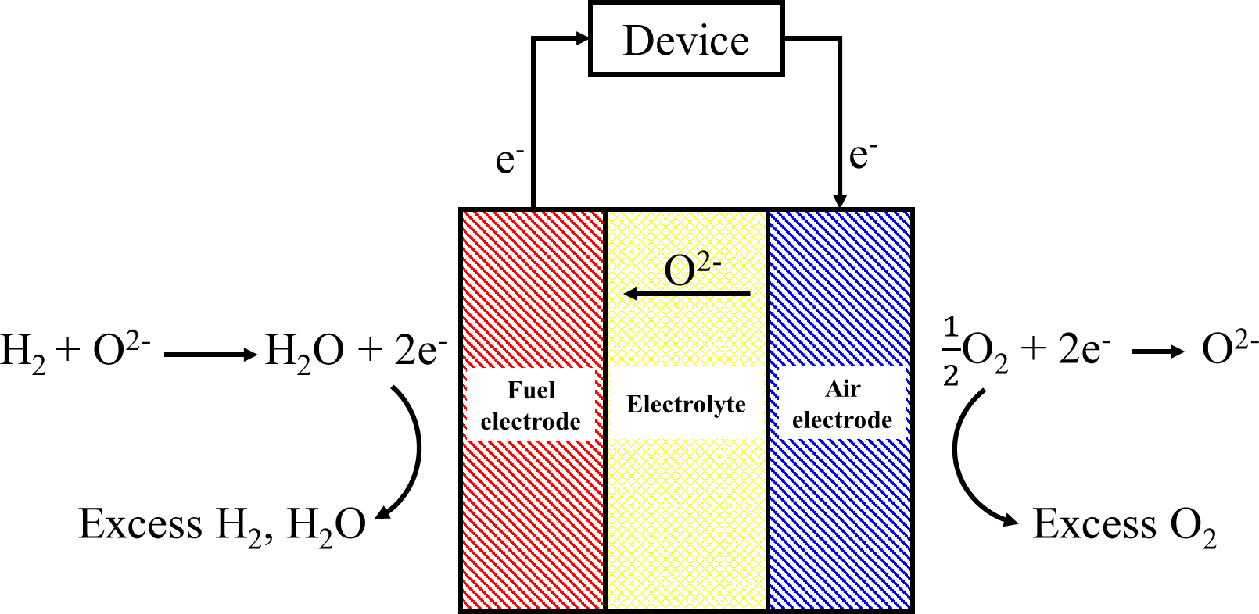
Figure 1.2 - Diagram of a solid oxide fuel cell and the chemical reactions at each electrode. Adapted from [10].
At the SOFC air electrode, molecular oxygen is reduced to oxygen ions. These ions flow through the solid electrolyte to the fuel electrode where they oxidise gaseous fuel to produce water, heat and electrons when operated with hydrogen, as well as carbon dioxide when operated with hydrocarbon fuels. The electrons flow through the external circuit back to the air electrode where they are used to reduce molecular oxygen (Figure 1.2).

Materials
      - Electrolyte
SOFCs have a solid ceramic electrolyte, typically dense yttria-stabilised zirconia (YSZ). SOFC electrolytes must be ionically conductive and dense to prevent mixing of fuel and oxygen gases. The electrolyte has to remain mechanically and chemically stable at high temperatures in both

reducing and oxidising environments, and must also be highly electronically resistive to prevent losses of current from the cell [17]. Despite being the most commonly used material, YSZ does not have the highest ionic conductivity under the operating conditions of SOFCs [17]. Electrolytes with higher ionic conductivities have been investigated to improve cell efficiencies, particularly at reduced operating temperatures. Gadolinium oxide-doped ceria (GDC) for example, has a higher ionic conductivity than YSZ. At 570°C a viable cell power output of 0.14 W cm⁻² and stability over 2500h testing on reformate fuel and air has been reported [18, 19]. However, the cells have a lower open circuit voltage (OCV) of 0.6 - 0.7 V
[18] compared to 1.1V [20] of YSZ electrolyte cells. The lower OCV is a result of the Ce⁴⁺ in the ceria based electrolyte being partially reduced to Ce³⁺ under the fuel electrode conditions. Ceria based electrolytes are mixed ionic and electronic conductors (MIEC) which in addition to a decreased OCV, can cause electron leakage into the electrolyte and short circuiting leading to a loss in cell performance [18, 19, 21].
Ceria-based electrolytes can be used in bi-layer systems in which a thin layer of purely ionic conducting material is sandwiched between the fuel electrode and the electrolyte to protect the ceria from reducing. A Sr- and Mg-doped LaGaO3 (LSGM)/ La2O3 doped ceria (LDC) bi-layer electrolyte has been used in a cell with a reported OCV of 1.02 and 1.06 V at 800°C and 650°C and a power output of 1.1 and 0.34 W cm⁻² respectively [22]. Overall cell performance is dependent on the total thickness of the electrolyte, with area specific resistances increasing with total thickness. However, as MIEC layers become thinner, the electronic conductivity increases, and so optimising the electrolyte structure is required to optimise cell performance [21].
Ceres Power has developed fuel cell stacks utilising a Gadolinia- doped ceria (CGO) electrolyte operating at 450-600°C, and which can be operated on steam-reformed natural gas, achieving 0.75V per cell at 570°C with 60% fuel utilisation. When operating with hydrogen/nitrogen fuel, an OCV of 1.1V is achievable and therefore close to the theoretical value of 1.23V [23].

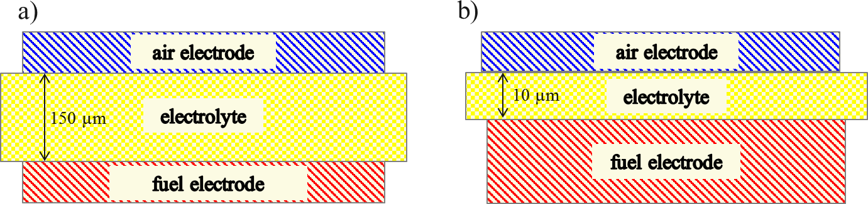

Figure 1.3 - a) electrolyte supported SOFC and b) fuel electrode supported SOFC.

SOFCs can be electrolyte or electrode supported (Figure 1.3). A YSZ electrolyte supported SOFC would typically require a thicker electrolyte than a fuel electrodes supported SOFC. A cell with a 150 µm thick electrolyte has been reported to have a resistance of 0.75 Ω cm² at 800°C [24, 25], whereas a fuel electrode supported SOFC with a thinner electrolyte of 10 μm [24, 26] has been reported to have a resistance of 0.05 Ω cm² at 800°C [25]. Although thin electrolytes can result in lower cell resistance, thin electrolytes have a greater risk of shrinking and cracking as cells are thermally cycled [20, 27]. State-of-the-art SOFCs are fuel electrode supported [26]. Ceres Power has also developed an interconnect metal supported SOFC which enables simple and robust sealing of the fuel cell to the interconnect by welding, minimising thermal stress induced seal leakage [23].
      - Air electrode
SOFC air electrodes are usually a lanthanum strontium manganite (LSM)/YSZ composite [28]. The LSM is the electrochemically active phase, whilst the YSZ provides ionic conductivity and stability to the electrodes by making the thermal expansion coefficients of the electrolyte and electrodes similar [26]. Since electrons must be transported through the electrode to the interface, the air electrode must be electronically conductive. In an LSM/YSZ composite, a minimum of 30 vol.% LSM is required to ensure the electronically conductive phase percolates throughout the entire electrode structure [10, 26]. SOFC air electrodes must also be porous to enable the transport of molecular oxygen to the electrode/electrolyte interface.
LSM has a good electrical conductivity and is inexpensive compared to noble metal catalysts [29]. By varying the quantity of strontium, the thermal expansion coefficient can be almost exactly matched to that of YSZ, minimising stress to the composite when thermally cycled [30]. However air electrodes using LSM can have high electrode overpotentials at temperatures lower than 750°C. Other perovskite oxides such as Sr-doped LaCoO3 (LSCo), LaFeO3 (LSF)

and LaFe0.8Co0.2O3 (LSCF) can lead to lower electrode overpotentials at low operating temperatures, but at the high temperatures required to fabricate SOFC electrodes, they undergo solid-state reactions with YSZ which can result in the formation of insulating phases [26, 30].
      - Fuel electrode
SOFC fuel electrodes are typically nickel/YSZ cermets [31, 32]. Similarly to the air electrode, SOFC fuel electrodes must be porous to enable the transport of gaseous fuel to the electrode/electrolyte interface, and must also be electronically conductive to transport electrons from reaction sites to the external circuit [33]. Ni/YSZ composites must therefore have a minimum of 30 vol.% nickel to ensure the conductivity of the electrode [31]. Nickel is susceptible to poisoning by sulphur impurities and by carbon, and other metals including platinum, copper and iron, have been investigated for use as the electrocatalytically active component of the fuel electrode [34-36]. However, the high catalytic activity of nickel for the fuel oxidation reaction and relative inexpensiveness compared to other metal catalysts, means it is still the most commonly used fuel electrode material [37].
      - Triple Phase Boundary
Porous composite electrodes are microstructurally complex, and are thought to only be active for the electrochemical reaction at specific sites known as triple phase boundaries (TPBs).

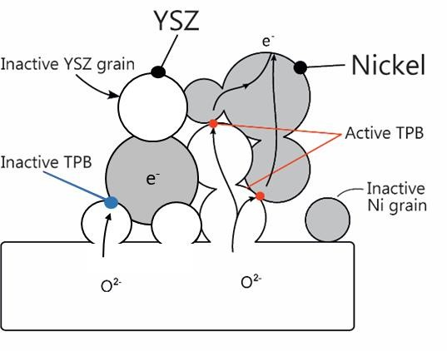
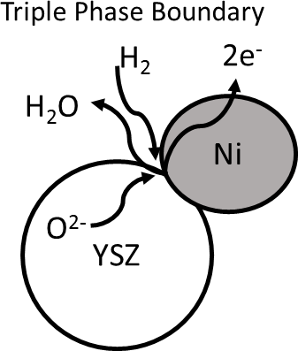
        - b)
Figure 1.4 – a) Diagram of a triple phase boundary in a Ni/YSZ fuel electrode, b) ideal structure of an SOFC electrode maximising TPB length.

TPBs are sites where oxygen ions, electrons and gaseous fuel or oxygen meet (Figure 1.4a) [38-41]. The electrode reaction is limited to this area because of the ionic non-conductivity of the electrocatalyst metal and the electronic non-conductivity of the electrolyte [42]. TPBs can be inactive if there is no percolation of the electrocatalyst or electrolyte, and therefore electrons or oxygen ions cannot be transported across the electrode (Figure 1.4b). It is widely reported that electrode performance scales with TPB length [15, 38, 41, 43-47], and consequently the ideal electrode structure is thought to be one which maximises the length of the TPB, whilst maintaining connectivity between the electrolyte, electrode, and gas phase (Figure 1.4b) [26, 42]. The spatial distribution of active reaction sites is also important, with the electrochemically active area in hydrogen-oxygen SOFCs limited to 10 µm into the fuel electrode from the electrode/electrolyte interface [48]. This spatial distribution of active reaction sites exists because of the slow solid state vacancy transport of oxygen ions through the electrolyte and YSZ phase of the electrode, compared to the diffusion of hydrogen through the electrode pores. Oxygen ions become depleted at the electrode/electrolyte interface through reaction, before they can diffuse very far into the electrode [49]. Therefore active sites are concentrated close to the electrolyte surface where the rate of reaction is higher [48].

Challenges
One of the main challenges limiting SOFC development is the overall high cost of energy production compared to fossil fuel combustion, which in part is because cells degrade before achieving their target lifetime of 40 000+ hours [10, 26, 50-52]. During operation, SOFC components degrade via different mechanisms including coarsening (fuel electrode), poisoning (air and fuel electrode) and cracking (electrolyte) [53].
Coarsening is the thermodynamically driven formation of larger particles at the expense of smaller particles, in order to decrease overall surface energies. The fuel electrode is particularly susceptible to coarsening at high temperatures. This is because of the instability of small particles (with high curvature), variation in the chemical composition of the gas atmosphere (e.g. high steam partial pressure), and poor wettability of many metals on oxide surfaces, with nickel on YSZ being a prime example [54-56]. Coarsening decreases electrode performance by reducing the TPB length and active sites for the electrode reaction to take place [55, 57].
Quantifying and characterising degradation in cermet electrodes is challenging because of the buried nature of the electrocatalyst within the electrode structure. Measuring the TPB length is therefore difficult via microscopy. Relatively new techniques such as X-ray computed

tomography can be used to produce three dimensional images of porous electrode microstructures non-destructively, which can be used to extract parameters such as porosity and interface length in cermet electrodes [58, 59].
Overall, there is a lack of quantitative data regarding the electrochemically active area in cermet electrodes, which creates challenges for mechanistic investigations. As such there are ambiguities surrounding the fuel oxidation mechanisms, which are discussed in the following sub-sections.

Coarsening of nickel/YSZ cermet fuel electrodes
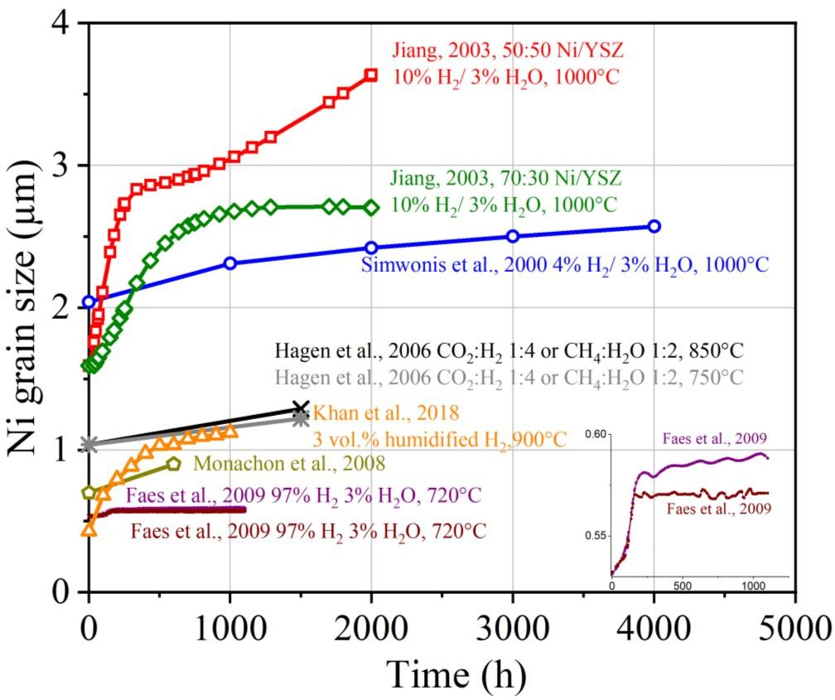
A small number of studies have quantified nickel grain growth in Ni/YSZ electrodes during heating, by cooling electrodes periodically and examining the surface using SEM [55, 57, 60- 63].

Figure 1.5 - Nickel grain size with operating time in Ni/YSZ cermet electrodes plotted from the literature. Conditions indicated on graph. Conditions for Monachon et al. 2008 [63] not reported. Faes et al. 2009 [57] report results for different data collection methods (intercept method, top and morphological operation, bottom). Adapted from: [64]. Sources: [55, 57, 60-63].
Comparison between the reported data is complicated by varying gas atmospheres, temperatures and measurement procedures (Figure 1.5).

Monachon et al. 2008 [63] measure nickel grain size by taking Back-Scattered Electron (BSE) SEM images and analysing the images using ImageJ software to extract grain size using an intercept method (as detailed in [63, 65]).
Faes et al. [57] used multiple cells tested for different lengths of time and BSE SEM images analysed by an in-house developed Mathematica® code to extract nickel particle size. Two different methods were used to extract the particle size- an intercept method and a morphological operation method (as detailed in [66]).
Jiang, 2003 [55] removed samples from the furnace after certain periods and analysed them before re-inserting the samples and resuming testing. Grain size was measured using SEM images and ‘Prism View’ computer software combined with manual measuring of grains using scaled transparance paper.
Simwonis et al. 2000 [60] used multiple samples tested for varying times, and analysed grain size by taking SEM images which were then segmented and processed with KS400 software and an intercept method.
Khan et al. 2018 [61] inserted 40 samples into an investigation chamber and removed 3 samples for microstructural analysis every 100h. Image-Pro® Plus was used to analyse BSE images and a line intercept method used to calculate mean nickel particle radius.
Hagen et al. 2006 [62] used multiple cells tested for different lengths of time, and used SEM for post-test analysis. The size distribution of nickel particles was obtained by superimposing a grid on the SEM image, and using an intercept method to measure the nickel particles which intercepted with the lines.
Therefore, the techniques used to measure grain size vary, complicating a comparison between studies. Studies using similar conditions like Simwonis et al. [60] and Jiang [55] report significantly different grain growth rates, which could be a result of the different measurement techniques used. In addition, the cooling of samples can also create an error in particle size measurement [67].
Several mechanisms have been proposed to explain nickel grain growth in Ni/YSZ cermet electrodes, including a gas phase evaporation/precipitation mechanism [62], and also a diffusion mechanism controlled by differences in neighbouring grain sizes [68]. However, the limited number of studies, varying conditions, differing reported kinetics and different measurement techniques mean the exact pathway remains unclear. Furthermore, the influence

of various parameters such as humidity or nickel quantity in the electrode are also uncertain, however it is thought that the presence of steam in Ni/YSZ electrodes increases grain growth [69, 70].
Although there are ambiguities in the grain growth rate and coarsening mechanism, Figure 1.5 shows that the grain size of nickel increases with operation time. Coarsening of nickel in cermet electrodes causes shortening of the TPB length and degradation in electrochemical performance and can even lead to a complete loss in percolation of the electronically conductive metal in cermet electrodes [60]. The TPB length is therefore dynamic, changing with operation time at high temperatures. Improving the understanding of TPB length changes during operation is important to the fabrication of electrodes with improved durability and electrochemical performance, but also to facilitate mechanistic understanding in fuel electrodes.

Fuel oxidation mechanisms
High operating temperatures and the buried nature of the electrochemically active area limit the techniques which can be used to analyse electrochemical performance and determine mechanisms in SOFC electrodes. Electrochemical Impedance Spectroscopy (EIS) is a commonly used technique for the real-time investigation of SOFC electrodes. However, spectra from porous cermet electrodes are complicated by multiple responses from the electrolyte, the transport of reactants and products, as well as processes occurring at the interfacial region [38, 40, 47, 71-74]. Fitting electrochemical data from cermet electrodes to theoretical models, and the identification of rate-limiting steps can therefore be challenging [75], and ambiguities in mechanisms in fuel electrodes exist. The mechanistic understanding of the oxidation of different fuels in Ni/YSZ cermet electrodes is discussed in the following sub-sections.

      - Hydrogen oxidation
Significantly different EIS spectra have been reported in the literature for the hydrogen oxidation reaction, which makes agreement on the number of processes involved challenging.
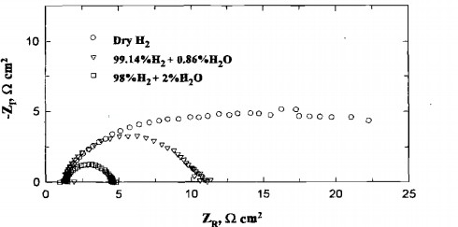

Figure 1.6 – Impedance spectra of a porous Ni-YSZ electrode at 1000°C and various H2O concentrations in H2. Source: [34].
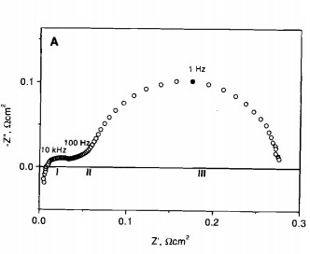
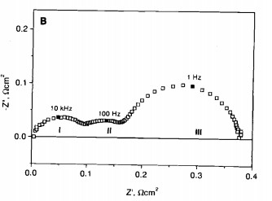
Figure 1.7 - Impedance spectra at 1000°C in 97% H2 and 3% H2O for A) standard electrode and
B) electrode fabricated with fine powder. Source:[76].

For example, two overlapping semi-circles were reported with a Ni-YSZ electrode operated at 1000°C in dry H2, with the near disappearance of the low frequency arc when the H2O concentration was increased to 2% (Figure 1.6) [34]. Elsewhere, in 3% H2O, at least three responses are reported, with the responses becoming more pronounced and total impedance increasing when a finer powder was used to fabricate the cermet (Figure 1.7) [76]. The standard anode of Figure 1.7A was prepared with a YSZ:NiO volume ratio of 40:60 and a YSZ particle size of 0.4 µm. The NiO particle size distribution was bimodal with fractions of approximately
0.4 µm and 10 µm in the volume ratio of 6:1. The fine powder anode of Figure 1.7B was prepared using radio-frequency plasma to obtain an ultrafine YSZ-NiO powder, as reported in [77]. The Ni:YSZ volume ratio was 50:50.

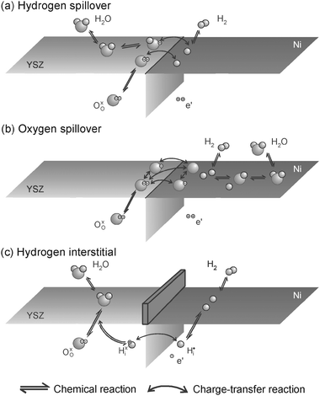

Figure 1.8 - Proposed mechanisms for the hydrogen oxidation mechanism at the TPB. Wall in (c) represents impurities. Source: [78].
The mechanism which has been concluded to show the best agreement to the electrochemical data reported in the literature is the hydrogen spillover mechanism (Figure 1.8a) [47, 78]. This mechanism involves the adsorption of dissociated hydrogen onto the electrocatalyst nickel surface, and subsequent transfer of the adsorbed hydrogen atoms to the YSZ surface. During this transfer, hydrogen atoms cross the TPB and transfer electrons to the nickel. On the YSZ, the hydrogen atoms react with O²⁻ or OH⁻ to form water [78]. However, other mechanisms for the hydrogen oxidation reaction have been proposed (Figure 1.8b and c) [78, 79].
At 500°C, the rate limiting step in the hydrogen oxidation reaction has been reported to be the two-step charge transfer step from the spillover of hydrogen from the nickel surface to hydroxyl ions on the YSZ surface, with an activation energy of 190 kJ/mol [78]:
HNi + OH⁻ ⇌□Ni + H2OYSZ + e⁻ (Equation 1.1) [78]
YSZ Ni
Whilst at 900°C, spillover of hydrogen from the nickel surface to oxygen ions adsorbed on the YSZ surface (190 kJ/mol ), OH⁻ diffusion on YSZ (55 kJ/mol) and water desorption from YSZ (55 kJ/mol) become co-limiting [78].

      - CO oxidation
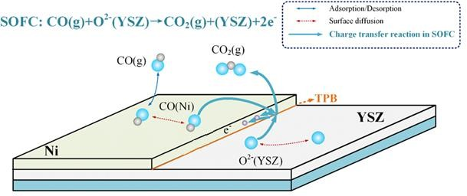
In addition to H2, SOFCs can also be operated with carbon containing fuels such as natural gas, CO and other hydrocarbon fuels. SOFCs operated with natural gas usually undergo a reforming process to convert the gas mixture to a H2/CO fuel which is then oxidised by the fuel electrode. [80].

Figure 1.9 – Proposed mechanism for the oxidation of carbon monoxide at the TPB of Ni/YSZ electrodes. Adapted from: [81].
Compared to H2, CO has received relatively little interest as a fuel source because the reaction kinetics of CO oxidation have widely been found to be much slower than for hydrogen oxidation [82-88]. However, there are several reports which contrast this, and report only very slight or no fuel dependence in activation energies between the two fuels [89, 90].
The key mechanistic steps in CO oxidation have been proposed to involve the adsorption of CO on the nickel surface, diffusion of the adsorbed CO to the TPB, simultaneous O²⁻ transport through the electrolyte to the TPB, followed by a two-step charge transfer reaction as the O²⁻ and the adsorbed CO meet at the TPB (Figure 1.9) [81, 84]. It has been concluded that strongly adsorbed CO on nickel does not cross the TPB to the YSZ surface like hydrogen atoms adsorbed on nickel are proposed to in the hydrogen spillover mechanism [91]. Large differences reported in activation polarisation between electrodes operated in the two fuels in some studies also suggest the rate determining steps for each reaction are different [82-87]. For CO oxidation, under dry conditions, the rate determining step has been reported to be the oxidation of CO adsorbed on the nickel surface by O²⁻ from the electrolyte, (Ea= 158 kJ/mol [92]), except when CO concentrations are low, in which slow gas diffusion becomes the rate determining step [93].

Overall, there are ambiguities in studies focussing on the mechanism of fuel oxidation in SOFC fuel electrodes. Detailed studies are hindered by high operating temperatures and lack of access to the electrochemically active region at the electrode/electrolyte interface, which limits the techniques which can be used to monitor electrode reactions during operation. Furthermore, complicated cermet electrode microstructure results in complex impedance spectra and the dynamic nature of the TPB and electrochemically active area due to coarsening also pose challenges for quantifying electrode data. Understanding the reaction mechanisms is critical to designing improved materials for SOFC electrodes and improving microstructures necessary to improve cell performance and durability.

Model electrodes
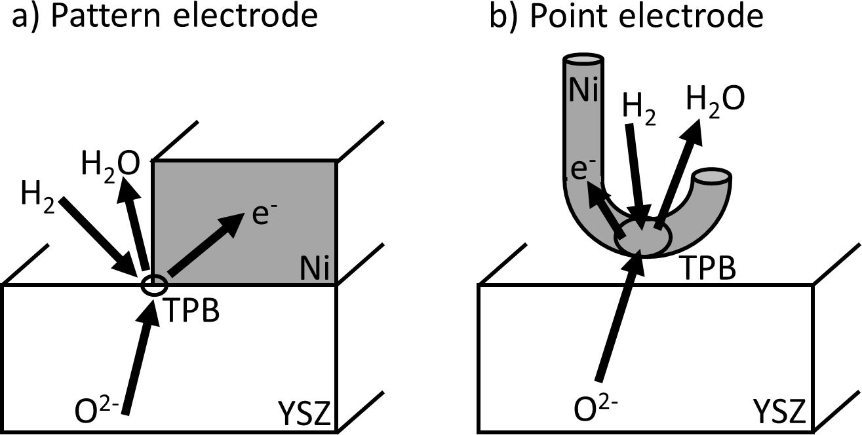
Many studies use simplified versions of cermet electrodes, known as model electrodes to examine mechanisms in more detail. Compared to cermet electrodes, model electrodes are better suited to spectroscopic investigation because they have more easily accessible surfaces, the electrode geometries are simpler to replicate, and TPB lengths are theoretically easier to quantify [71, 78]. Model electrodes produce simpler EIS data as they are not complicated by porous transport effects and so are better suited to studying complex mechanisms [71, 72, 78].

Figure 1.10 - Schematic illustration of model electrodes showing simplified electrode-electrolyte interfaces and well-defined TPB geometry (a) pattern electrode and (b) point electrode. Adapted from: [78].
Model electrodes can be fabricated either by depositing a thin metal film on top of a solid electrolyte substrate – pattern electrodes – or by pressing a metal wire or mesh into a solid electrolyte – point electrodes (Figure 1.10) [78]. However, despite the simple electrode design,

there is still ambiguity between model electrode studies which is discussed in more detail in a review of the literature (Chapter 2).
Model electrodes degrade on a quicker timescale compared to cermet electrodes. In one study, a degradation rate of 0.4%/h has been measured for nickel pattern electrodes [75], whilst 0.01%/h has been reported in another study for Ni/YSZ cermet electrodes operated with CO/CO2 fuel [75, 94]. The same thermodynamic drive to decrease surface energy which results in coarsening in cermet electrodes, causes thin metal films to degrade by solid-state dewetting [95].

Solid-state dewetting
Thin films deposited at room temperature are metastable, and when heated, they undergo solid- state dewetting at temperatures well below the melting point of the metal [96].
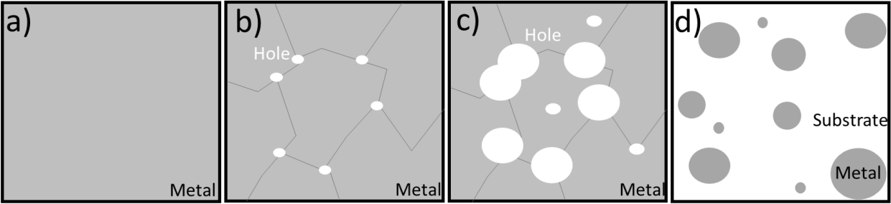
Figure 1.11 – Stages of solid-state dewetting in thin metal films during heating. a) dense film after initial metal deposition with small grains, b) agglomeration of small grains resulting in crystallisation of the film. Voids nucleate as grooves deepen at grain triple boundaries and contact the substrate surface. c) voids grow by edge retraction but metal film remains connected. Voids can also nucleate at metal and substrate defects. d) voids grow sufficiently large and impinge leaving isolated metal islands.
As temperatures are elevated, self-diffusion of nickel atoms is activated and small grains in the continuous, as-deposited film agglomerate to form larger grains and crystallise (Figure 1.11a and b) [95, 97]. At grain triple junctions with high tensile stress, the grooves deepen upon heating until they contact the substrate surface forming a hole. If the substrate is polycrystalline, then the grooves can align with grain boundaries in the substrate underneath. In thinner films, the number of grooves which contact the surface is increased compared to thicker films [96]. As heating continues, capillary energies drive the retraction of the edges of the hole, transporting material from the thicker rim of the hole to the flatter surrounding metal (Figure 1.11c) [95]. Holes can also nucleate at defects, either in the metal film or in the underlying substrate but at a later stage to the holes at grain triple boundaries [95]. As holes

continue to retract, and grooves at triple junctions continue to deepen, rim pinch-off can occur in which isolated small particles form [95, 96]. As edge retraction and hole growth continues, the holes impinge and the majority of the thin film is retracted, exposing the underlying substrate and forming metal islands (Figure 1.11d) [96, 97].
The transport of material from the thicker edges of the holes to the flatter surrounding metal can occur through mass surface diffusion, or by evaporation and condensation [96]. The process controlling microstructural evolution has been investigated using 40 nm nickel thin films and “in-situ” environmental scanning electron microscopy (E-SEM) data [95]. Small nickel particles formed during the dewetting process were observed to be stable whilst microstructural changes continued to occur in the larger connected film. There is therefore, no mass transport occurring between disconnected nickel, ruling out an evaporation-condensation mechanism. A fast diffusion model correlated best with the experimental data, in which the detachment and re-attachment of nickel atoms is the rate-determining step [95].

Hypothesis and aims
The focus of this thesis is on model SOFC fuel electrodes and specifically Ni/YSZ pattern electrodes, owing to the popularity of this electrode in the literature. A comparison of the data for Ni/YSZ pattern electrode performance from the literature is presented in a literature review in Chapter 2, highlighting discrepancies in the data between studies. Reports on the microstructural stability of thin film model electrodes are few and contrasting, and are also reviewed in Chapter 2.
The hypothesis for this thesis is that that variation in electrode performance between similar studies is caused by the challenges in obtaining accurate measurements. The aim of this thesis is to investigate different sources of error and to consider the effect these sources of error have on line specific resistance values.

In Chapter 3, methods and techniques utilised throughout this thesis are detailed.

Chapter 4 aims to consider the microstructural changes taking place in nickel pattern electrodes during electrochemical testing in H2 and CO atmospheres, and to consider sources of error in tests.
Chapter 5 aims to consider the effect of these sources of error, including microstructural changes, on line specific resistance values. An assessment as to whether the sources of error

considered could be causing the variation in performance between similar electrodes in the literature is made.
Based on conclusions drawn in the previous chapters, Chapter 6 aims to investigate whether solid-state dewetting can be limited in nickel pattern electrodes. A nanoparticle layer and a polymer sphere layer under the thin nickel film are investigated.
Chapter 7 provides a general discussion of the key themes in the thesis. Chapter 8 presents the final conclusions and future work.

Chapter 2 - Literature Review: A review of the discrepancies in Ni/YSZ pattern electrode data and possible causes

Introduction
Model electrodes are intended to simplify complex porous electrode geometry to a well-defined and reproducible representation of the electrode structure. Two-dimensional pattern electrodes eliminate complexities in impedance spectra arising from gas transport through interpenetrating Ni, YSZ and pore networks, and therefore improve the likelihood of identifying mechanistic detail from impedance spectra. Pattern electrodes also have electrochemically active areas which are more easily accessible to microscopic and spectroscopic techniques, compared to cermet electrodes, which can be used to gain microstructural information to complement EIS measurements.
However, despite the simplification of the electrode geometry, results obtained with model electrodes are still complicated, and are contrasting in many areas between similar studies [38, 72, 84, 88, 89, 98-105]. These discrepancies in Ni/YSZ pattern electrode data are discussed in the following review, along with several possible causes of the variation.

Review of discrepancies in Ni/YSZ pattern electrode data

Number of semi-circles in electrochemical impedance spectra
Nyquist plots can be used to determine how many characteristic features are present in a system, by fitting equivalent circuits to the impedance spectra and determining how many time constants or parallel resistor-capacitor (RC) components are contributing to the impedance [106]. However, for Ni/YSZ pattern electrodes operated with H2/H2O fuel, a varying number of RC components have been reported in Nyquist plots, varying between one and three in the literature: one [41, 72, 73], two [88, 89, 105] and three [38, 75, 98-102].
One hypothesis for the different number of time constants which has been suggested, is different experimental set-ups [107]. Some studies use a two-electrode set-up [72, 73, 75, 88,
101, 102], whilst others use a reference electrode in a three electrode set-up [38, 41, 89, 98- 100, 105]. Reference electrodes have been reported to cause possible distortion to impedance spectra due to misalignment [108]. Furthermore, measurement temperature varies between

700°C and 850°C, whilst the concentration of H2O in the H2 fuel stream varies between 0.02- 85%.
However, even comparing only those studies using a two-electrode set-up at 800°C, one time constant (6% H2O) [72], two time constants (4% H2O) [88], and three time constants (0.02- 85% H2O) [102] have all been reported, and therefore the variation in impedance spectra is unlikely to be a result of different experimental set-up alone.
Studies reporting CO oxidation with Ni/YSZ pattern electrodes also report impedance spectra with a varying amount of time constants when fit to equivalent circuits. Three time constants [103, 109], two time constants [88, 110, 111], and one time constant [92] have all been reported at temperatures between 700-850°C, and CO2 content varying from 9-99% and with up to 3% H2O content. Comparing only those studies at 800°C, three time constants (8-99% CO2, 0% H2O) [103] two time constants (50%CO2, 0% H2O) [88], and one time constant (9-98% CO2, 0% H2O) [92] are reported with similar measurement conditions. Those studies which have performed similar measurements in both H2/H2O fuels and CO/CO2 fuels, tend to report the same number of time constants for each fuel stream [88, 101-103, 112].

Polarisation resistance in CO/CO₂ and H₂/H₂O atmospheres
Studies comparing the oxidation of CO/CO2 and H2/H2O fuels with Ni/YSZ pattern electrodes present contrasting results regarding the magnitude of the polarisation resistances and whether the rate-limiting steps are likely to be the same in the oxidation of each fuel. In the majority of pattern electrode studies, resistances are higher in CO/CO2 atmosphere, which is thought to indicate different rate limiting processes [88]. However resistance ratios vary from 6.5 – 1.3 (RCO/CO2/RH2/H2O) [84, 88, 103, 110], and when resistances are relatively similar, it has been reported that the mechanisms responsible for fuel oxidation in each fuel are the same [103].
A smaller polarisation resistance for the oxidation of CO/CO2, compared to H2/H2O, has also been reported [89]. 1 µm thick nickel electrodes were found to have a resistance ratio of 0.625
– 2.4 and therefore some electrodes had smaller resistances in CO/CO2 compared to H2/H2O. These electrodes were observed to form bubbles under the nickel metal during heating to 800°C in H2/H2O. When the same tests were carried out with 500 nm thick nickel electrodes, the ratio of polarisation resistance in CO/CO2 compared to H2/H2O increased to 17-20. The structure of the 500 nm thick patterned electrodes became porous with small holes developing in the previously dense electrode [89]. The microstructure of pattern electrodes therefore effects the polarisation resistance in each gas atmosphere. There is a lack of data regarding how the gas

atmosphere effects degradation, and it is possible that different polarisation resistances in the two gas atmospheres are caused by varying solid-state dewetting kinetics. It has been reported that pattern electrodes heated in CO/CO2 degrade at a significantly lower rate (0.18%/h), compared to analogous electrodes heated in H2/H2O (0.40%/h) [109]. Different degradation rates in the two atmospheres are likely to cause different TPB lengths during measurements which in turn, influences the electrode performance in each gas atmosphere. Therefore, further investigation with detailed microstructural analysis is required to understand whether varying resistance ratios could be caused by microstructural degradation differing in each gas atmosphere.

Line specific resistance
𝐿𝑆𝑅 = 𝑅_{pol} × 𝐴 × 𝐿_{TPB} Equation 2.1 [102]

Line specific resistance is the product of polarisation resistance (Rpol), electrode area (A) and triple phase boundary length per electrode area (LTPB) (Equation 2.1) [102, 115]. It is a value used to compare electrode performance between pattern electrodes studies, accounting for different electrode geometries, and is also used to apply pattern electrode data to technical cermet electrodes [40].
Table 2.1 – Comparison of LSR values reported in the literature for Ni/YSZ pattern electrodes operated with H2/H2O. (NR=not reported)

Study | LSR (Ω.m) | T (°C) | pH2O (Pa) | pH2 (Pa) | LTPB.A  (m/cm²) | Electrode area (cm²) | Ea (kJ/ mol) | Electrode thickness (nm) | LSRcalc 700°C (Ω.m)
[113] | 21578 | 700 | 2.2x10³ | 1.1x10⁴ | 3.64 | NR | 72 | 500-800 | 21578
[38] | 229 | 700 | 2.2x10³ | 1.5x10⁴ | 3.65 | 0.68 | 84 | 1000 | 229
[98] | 28975 | 700 | 2.3x10³ | 1.0x10⁵ | 2.90 | 1.54 | 155 | 1200 | 28975
[105] | 297 | 700 | 3.0x10³ | 5.0x10⁴ | 1.2-5.2 | 0.18 | 70-  113 | 800-1000 | 297
[102] | 917 | 800 | 6.1x10³ | 9.0x10³ | 6.50 | 1.00 | 101-  132 | 800 | 2925-  4192
[73] | 3515 | 550 | 2.0x10³ | NR | 2.86 | 1.04 | 72 | 200 | 694
[88,  104] | 1366 | 700 | 2.3x10³ | NR | 0.2027 | 0.74 | 127-  181 | 1780 | 1366
[114] | 25333 | 700 | 7.1x10³ | 5.1x10³ | 1.9 | 0.19 | 93 | 800 | 25333

Table 2.2 – Comparison of LSR values reported in the literature for Ni/YSZ pattern electrodes operated with CO/CO2 (NR=not reported)

Study | LSR (Ω.m) | T(°C) | pCO (Pa) | pCO2 (Pa) | LTPB/A  (m cm⁻²) | Electrode  area (cm²) | Ea (kJ/mol) | Electrode  thickness (nm) | LSRcalc 700°C  (Ω.m)
[88] | 8381 | 700 | NR | NR | 0.2027 | 0.74 | 176 | 1780 | 8381
[116] | 23-99 | 700 | 1.0x10⁴ | 2.0x10⁴ | 1.2-5.2 | 0.18 | 100 | 1000 | 23-99
[103] | 570 | 700 | 3.9x10⁴ | 4.2x10⁴ | 1.3 | 1.00 | 137 | 800 | 570
[92] | 605 | 700 | 3.0x10⁴ | 2.0x10⁴ | 1.3 | 1.00 | 84 | 800 | 605
[92] | 669 | 700 | 9.2x10⁴ | 2.0x10⁴ | 1.3 | 1.00 | 141 | 800 | 669
[81] | 102 | 700 | 2.5x10⁴ | 2.5x10⁴ | 1.9 | 0.19 | 71 | 800 | 102

𝐸a = 𝐿𝑆𝑅2−𝐿𝑆𝑅1
Equation 2.2

𝑅 𝑇2−𝑇1

LSR values reported in studies are not always reported at the same temperature and values can be extrapolated using the Equation 2.2. However, even when the literature values are extrapolated to the same temperature, there is still a variation of two orders of magnitude in H2/H2O fuel (Table 2.1) and CO/CO2 fuel (Table 2.2).

Activation energies
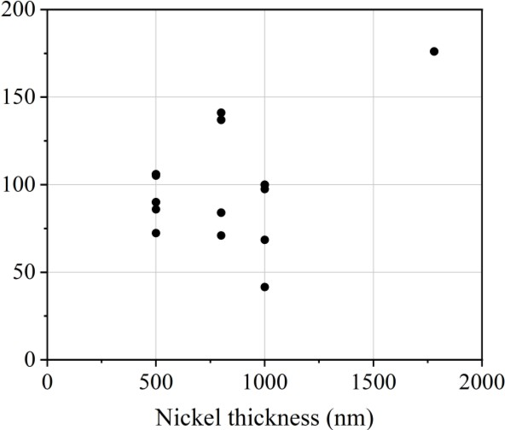
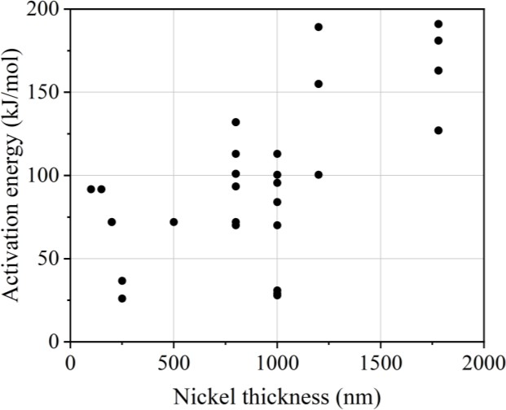The activation energies reported for the oxidation of H2/H2O and CO/CO2 fuels also vary considerably in the literature.
a)
b)

Figure 2.1 – Activation energies vs. thickness of nickel pattern electrodes compiled from the literature for a) H2/H2O atmosphere and b) CO/CO2 atmosphere. Where nickel thickness refers to the thickness of the nickel pattern electrode layer after deposition. Source: [38, 72, 73, 84, 88, 89, 92, 98, 103-105, 112-114, 116, 117].

For H2/H2O fuel, reported activation energies vary between 28 kJ/mol and 191 kJ/mol (Figure 2.1a) [38, 73, 88, 89, 98, 102, 104, 105, 113]. Several studies report different activation energies at high and low temperatures attributing this to a change in the dominating process [102, 105]. For CO/CO2 oxidation, reported activation energies vary between 41 kJ/mol and 176 kJ/mol (Figure 2.1b) [88, 89, 92, 103, 112, 116].

Gas partial pressure dependencies
𝑅_{pol} = 𝑐𝑝𝐻₂^{−𝑎}𝑝H₂O^{−𝑏} Equation 2.3 [102]

where Rpol is polarisation resistance, c is a rate constant, and a and b are the dependencies of resistance on the partial pressures of H2 and H2O respectively.
Ni/YSZ pattern electrode studies using H2/H2O fuel, generally tend to agree that increasing the partial pressure of water, decreases electrode resistance and therefore has a catalytic effect on electrode performance [38, 72, 75, 89, 98, 105, 113]. This is attributed to changes in the electrode potential, coupled with changes in the concentration of adsorbed species taking part in the charge transfer reaction [75]. However, the magnitude of the reported dependency of pattern electrode resistance on H2O partial pressure varies from -0.3 to -0.68 at temperatures between 550 and 850°C [38, 72, 89, 98, 102, 105] (Equation 2.3). Even when limiting the comparison to just studies using the same temperature (800°C), a variation in dependency of almost a factor of 2 is still found [72, 102].
The consensus for dependency of resistance on H2 partial pressure is that it is generally weak, with the majority of studies reporting dependencies between -0.07 and -0.145 at temperatures between 550°C and 800°C [38, 102, 105]. However stronger negative dependencies of -0.39 and -0.51 at 800°C have been reported [72], as has a positive dependency of +0.25 at 850°C [98].
𝑅_{𝑝𝑜𝑙} = 𝑐𝑝𝐶𝑂^{−𝑎}𝑝𝐶𝑂₂^{−𝑏} Equation 2.4 [102]

Several studies have reported values for CO2 partial pressure dependence using Ni/YSZ pattern electrodes in CO/CO2 fuel streams. The general consensus is that there is a negative dependency of polarisation resistance on CO2 partial pressure which varies with partial pressure of CO [92, 103]. Dependencies of -0.41 and -0.79 have been reported at p(CO) of 1x10⁴ Pa and 3.9x10⁴ Pa respectively [103] (Equation 2.4). Elsewhere, a dependency of -0.27 has been reported when p(CO)=1x10⁴ [112], and therefore there is fluctuation of a factor of 1.5 between these studies using similar measurement conditions.

Similarly, polarisation resistance dependence on CO partial pressure has been reported to vary with p(CO2) [103]. When the partial pressure of CO2 was 2x10⁴ Pa, a reaction order of -0.47 was been reported for p(CO) ≤10⁴, which switched to a value of +0.34 at p(CO) up to 10⁵ Pa. When the partial pressure of CO2 was increased to 5.1x10⁴ Pa, a reaction order of -0.39 was reported for p(CO) ≤10⁴ and -0.24 at p(CO) up to 10⁵ Pa [103]. An increasing polarisation resistance with increasing partial pressure of CO when p(CO2)= 2x10⁴, was also reported elsewhere [112], with a reaction order of +0.498 correlating with the value of +0.34 above [103]. There is therefore a variation of 1.5 times between these studies as well.
Furthermore, the dependency of polarisation resistance on the partial pressure of CO has been reported to change with thickness of the pattern electrodes. 1 µm thick electrodes were found to have a decreasing polarisation resistance with increasing p(CO), whereas 500 nm electrodes were observed to have the opposite p(CO) dependence. In this study, 1 µm electrodes were observed to suffer from adhesion problems and bubbling during heating, whilst the 500 nm electrodes formed holes and became porous [89]. There is therefore, an indication that microstructural changes in pattern electrodes cause varying gas partial pressure dependencies, and a link between electrode microstructure and electrode performance requires further investigation.

Triple phase boundary length dependence
The electrochemical reaction in SOFC fuel electrodes is widely accepted to be limited to active TPB sites because of the ionic non-conductivity of the electrode and the electronic non- conductivity of the electrolyte [15, 38, 41, 43-47]. The two dimensional design of pattern electrodes enables relatively easy variation of the electrode geometry and consequent TPB length compared to cermet electrodes, and as such the dependence of electrode performance on TPB length has been explored in numerous Ni/YSZ pattern electrode studies operated with H2/H2O [38, 72, 98, 99, 105].
𝑅_{𝑝𝑜𝑙} = 𝑅_{𝑝𝑜𝑙,0} × 𝐿_{𝑇𝑃𝐵}^{−𝛼} Equation 2.5 [72]

For a solely TPB length dependent electrochemical reaction, an α value of 1 would be expected (Equation 2.5). However, α values reported in the literature show significant variation, with values of 0.8 [99], 0.67-0.71 [38], 1.2 [38], 0.7-0.72 [105] (each using a reference electrode in a three-electrode setup) and 0.66 [72] (using a two-electrode setup) being reported at temperatures of 700-800°C.

Several causes of this deviation from the ideal value of 1 have been suggested, including inaccuracies in measuring the TPB length [38], as well as an alternative reaction pathway involving the electrode area [72]. Both of these are discussed further in Section 2.4.

Stability of Ni/YSZ pattern electrodes

Initial degradation behaviour at constant temperature
Detailed microstructural analysis of Ni/YSZ pattern electrodes and correlation with electrochemical data is limited in the literature, however several studies have reported nickel grain growth during the initial hours of testing pattern electrodes at a constant temperature.
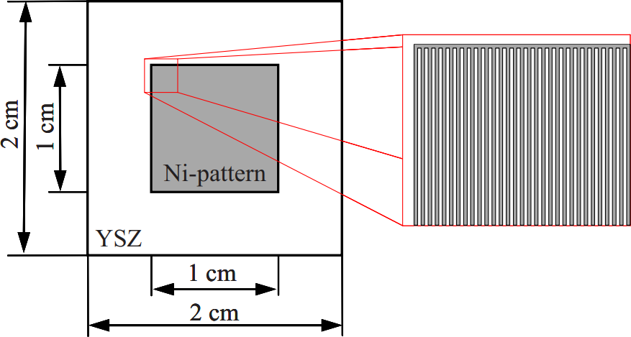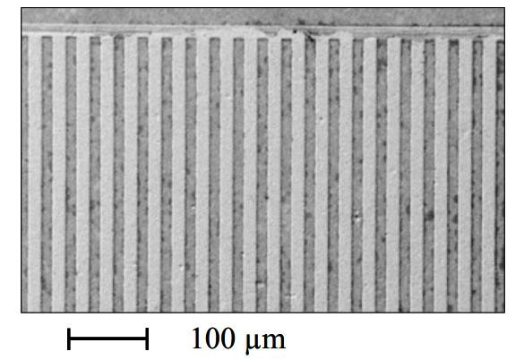a)

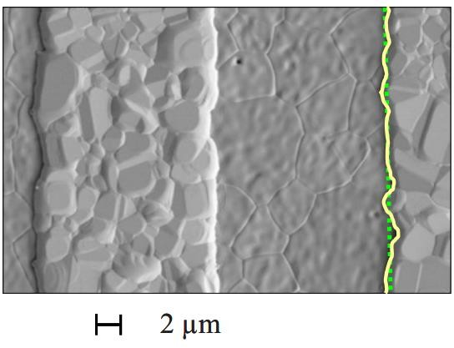
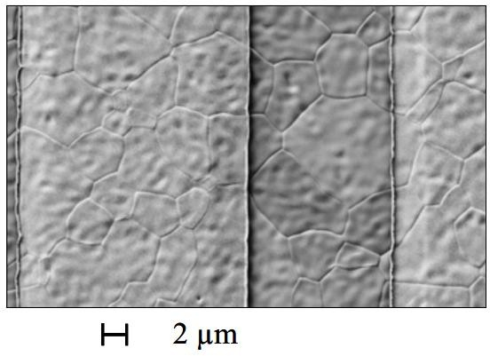
c)
b)

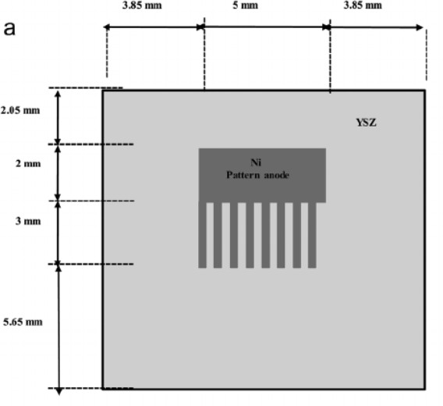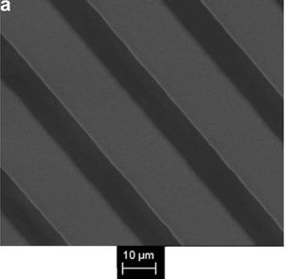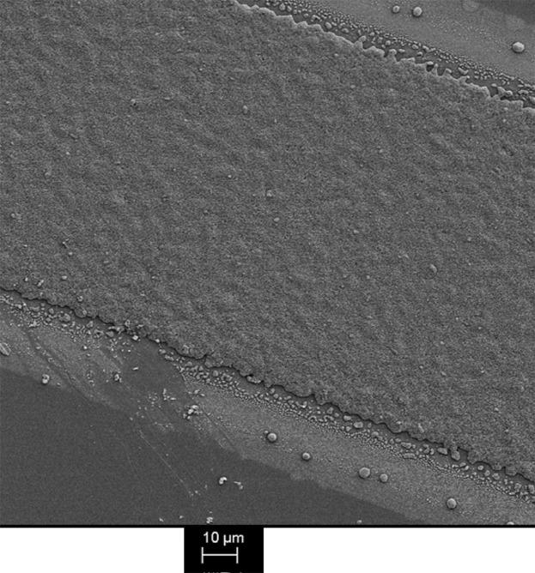
b)
c)

Figure 2.2 – a) scheme of nickel pattern electrode with the nickel electrode positioned in the centre of the YSZ substrate. SEM images showing striped design of prepared nickel pattern electrode with 15 µm stripe width/spacing and 800 nm layer thickness. Electrode design consists of stripes with two stripes at the ends to ensure a contacting of all stripes. b) SEM image of pattern electrode as prepared, and c) SEM image of patterned electrode after measurement programme: 700°C ≤ T ≤ 800°C, 6.9 x 10³ Pa ≤ pH2O ≤ 8.3 x 10⁴ Pa, 1.8 x 10⁴ Pa ≤ pH2 ≤ 8.7 x 10⁴ Pa. 13% ≤ βrel ≤ 82%, balance N2, exposure time = 210h. The solid line shows the increase in TPB length during characterisation compared to the theoretical length indicated by the dotted line. Source:[102].
800 nm electrodes heated at 800°C in H2/H2O have been reported to decrease in resistance by up to 65% during the first 30 hours of testing [75, 101, 102]. This activation in electrode performance has been attributed to grain growth in the nickel pattern electrodes decreasing grain boundaries, improving electrical connection between grains, and extending the TPB at the perimeter of the pattern by 30% (Figure 2.2). After this initial activation period, the resistance of the electrodes is reported to increase.

Figure 2.3 – a) Schematic top view design of 1µm deposited thickness Ni/YSZ pattern electrode showing Ni and YSZ strips with the same width. b) SEM image of Ni stripe patterns after fabrication and c) SEM image of the Ni pattern after electrochemical testing over 30 hours: pH2
= 50 000 Pa (50%), pH2O = 3000 Pa (3%), T= 750°C. Source: [105].

A deactivation in electrodes during the initial period of heating has also been reported. For example, Ni/YSZ pattern electrodes 500-800 nm in thickness were found to increase in resistance by ~30% in the first 30 hours of testing at 700°C, followed by relative stabilisation. The electrode deactivation was attributed to grain growth in the nickel film [41]. In the same study, when electrodes were heated to 800°C, resistances were constant throughout the testing period which was attributed to grain growth being instantaneous at higher temperatures, and therefore having taken place before the initial electrochemical measurement. Elsewhere, electrodes with a 1 µm nickel deposition thickness were found to increase in resistance by 200% when heated to 750°C, and by 100% when heated at 800°C during the initial 30 hours of testing, both followed by relative stabilisation. The increased resistance was also attributed to growth of nickel grains and migration of nickel particles causing shortening of the TPB length, however the electrode was determined to have maintained a dense structure (Figure 2.3) [105].
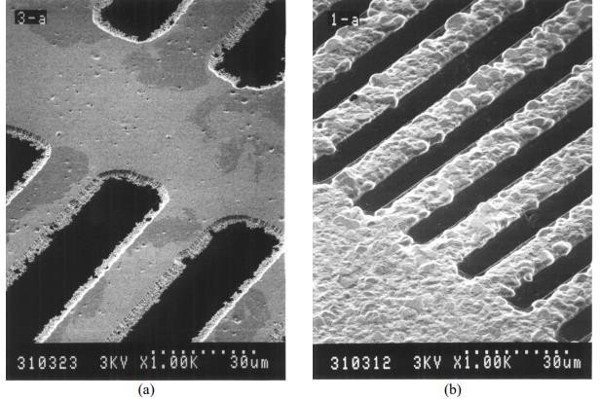

Figure 2.4 – SEM micrographs of 1.2 µm deposited electrode thickness nickel pattern electrode
a) before heating and b) after electrochemical experiments. Source: [98].

Furthermore, an increase in resistance of 70% over the first 30 hours of heating at 850°C has been reported for 1.2 µm electrodes, increasing to 120% by 120 hours [98]. This deactivation

corresponded to grain growth of nickel, decreased grain boundary length after measurement, and a decreased nickel perimeter measurement (Figure 2.4) [98].
The deactivating behaviour from nickel grain growth during initial heating therefore directly contrasts reports of an electrode performance activation attributed to grain growth in the nickel pattern electrodes decreasing grain boundaries, improving electrical connection between grains, and extending the TPB at the perimeter of the pattern by 30% [75, 101, 102]. Reports of the effect of electrochemical testing on TPB length and electrode performance are therefore contrasting, and require further investigation.

Qualitative electrode stability
In one study, a minimum nickel deposition thickness of 800 nm has been reported to be the minimum nickel thickness required to maintain electrode stability during electrochemical tests [115]. Electrodes 800 nm-1 µm in thickness are most commonly used in pattern electrode studies [38, 92, 102, 103, 105, 112-114, 116]. Detailed analysis of electrode microstructure during testing is the focus of few studies [89, 95, 115]. However, several studies do report a qualitative description of electrode stability during testing.
800 nm nickel pattern electrodes heated to 800°C in H2/H2O with steam concentrations between 0.04% and 90% have been reported to remain stable [115], and 1 µm pattern electrodes in wet H2 have also been reported to be free from detrimental microstructural changes when heated to 700°C [38].
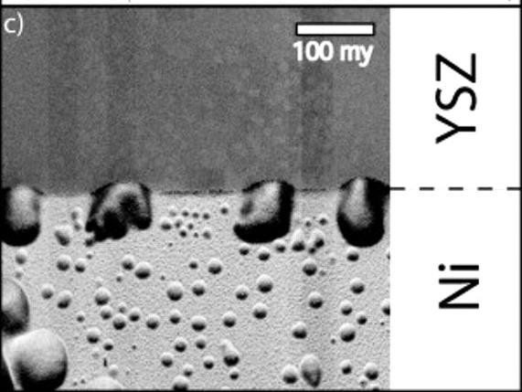

Figure 2.5 – Total Time-of-Flight Secondary Ion Mass Spectrometry ion signal scan picture of the TPB of a 1 µm thick nickel electrode showing bubbles which developed during electrochemical testing. Source:[89].

Contrastingly, 1 µm Ni/YSZ pattern electrodes operated at 700°C in both H2/H2O and CO/CO2 atmospheres were observed to develop bubbles at the nickel and YSZ interface but remained intact during operation of the electrode (Figure 2.5) [89]. Elsewhere 800 nm nickel electrodes heated to 700°C in 97% H2 3% H2O were reported to remain dense, whilst increasing the H2O concentration to 25% resulted in damage from delamination and hole formation [114]. 800 nm films have been reported to form holes at 700°C and 800°C and 5–70% H2O in H2. 1μm nickel films formed holes at 700°C and 10% water concentrations and above in H2 [107].
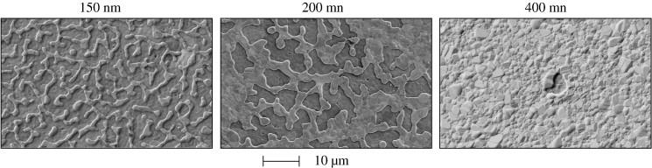Therefore, results regarding the microstructural stability of electrodes 800 nm-1 µm in thickness during electrochemical tests are contradictory.
Figure 2.6 – SEM images of nickel films of different thicknesses after heating to 800°C in dry H2. Source: [115].
The stability of thin metal films is linked to thickness as discussed in Section 1.6. 150 nm and 200 nm nickel films heated in H2 have been observed to partially dewet, and 400 nm films developed holes when heated to 800°C (Figure 2.6) [115]. Elsewhere, 500 nm nickel patterns were observed to be stable in dry H2 up to 550°C, but formed holes at 700°C [107]. In another study, 100 nm dense nickel films were observed to undergo a rapid morphological change after 5-6 hours at 850°C in CO/CO2 atmospheres, forming nickel islands which were reported to still be interconnected [84].
Therefore, whilst the stability of nickel pattern electrodes 800 nm – 1 µm in thickness is the subject of contrasting reports, there is a consensus that electrodes up to 500 nm in thickness experience degradation via solid-state dewetting during operation. Given 800 nm – 1 µm thick electrodes are most commonly used in the literature [38, 92, 102, 103, 105, 112-114, 116], it is important to clarify the stability of the electrodes. Also, microstructural degradation observed in thinner electrodes should be correlated with electrochemical performance, to understand how such changes in electrode microstructure effect electrochemical data. Furthermore, there is a lack of detailed analysis regarding microstructural changes in CO based atmospheres which requires further research.

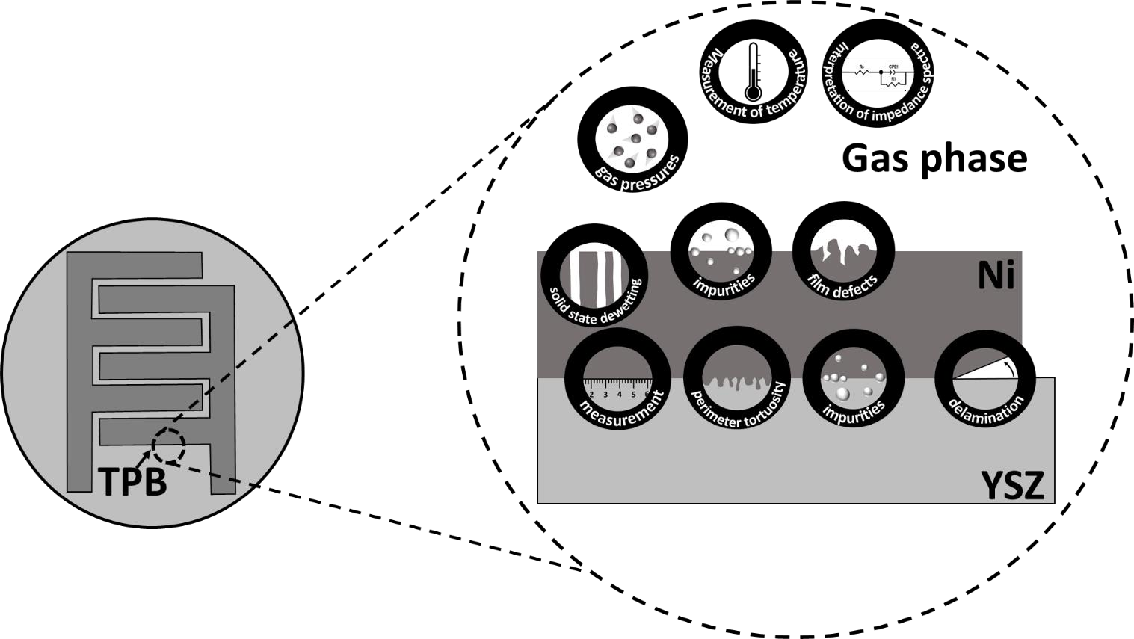
  - Causes of inconsistencies between Ni/YSZ pattern electrode
studies
a)

b)

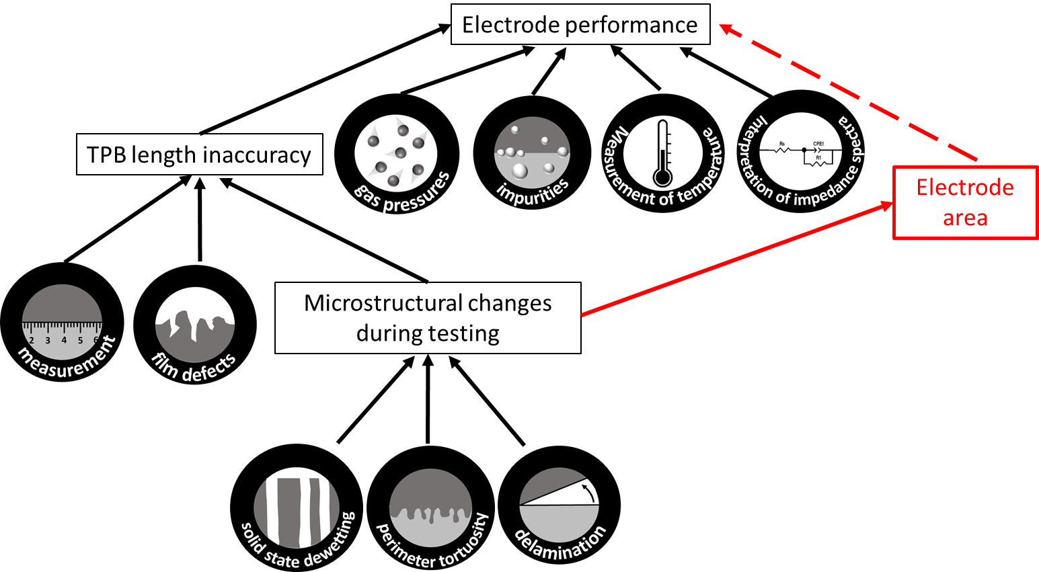
Figure 2.7. – a) Ni/YSZ/gas boundary showing the factors which vary between pattern electrode studies, b) diagram showing how these factors are proposed to contribute to varying electrochemical performance.

The variation in electrode performance between similar Ni/YSZ pattern electrode studies remains relatively unexplained. Several reasons suggested in the literature, and proposed in this work to account for differences between studies are shown in Figure 2.7, and are discussed in the following sub-sections.

Varying gas partial pressures
Tables 2.1 and 2.2 show that the gas partial pressures used in studies vary. Pattern electrode studies using H2/H2O fuel, have varying water partial pressures between 2 to 7 kPa, whilst hydrogen partial pressure varies between 5 and 100 kPa (Table 2.1).
As discussed in Section 2.2.5, dependence of electrode performance on the partial pressure of hydrogen is generally reported to be weak [38, 102, 105], (although stronger dependence has also been observed [72, 98]). Increasing water concentration has been reported to have a catalytic effect on electrode performance [38, 72, 75, 89, 98, 105, 113]. Varying water concentrations could therefore be causing variations in similar electrode performance between studies.
However, even when H2 and H2O gas partial pressures are similar [38, 113], LSR values extrapolated at 700°C still vary by two orders of magnitude.
Pattern electrodes operated with CO/CO2 fuel use CO partial pressures between 10 and 92 kPa and partial pressures of CO2 between 20 and 42 kPa (Table 2.2). As discussed in Section 2.2.5, dependencies of resistance on the partial pressures of CO and CO2 are complicated, and change with total partial pressure of the fuel, and therefore varying gas partial pressures between studies is likely to be contributing to the two orders of magnitude difference in LSR values at 700°C.

Chemical impurities
Chemical impurities have been found to accumulate in point electrode studies and block active sites at the TPB, decreasing electrochemical performance [118]. Impurities can originate from the electrode materials, the YSZ electrolyte or the gas phase. Silica impurities have been found to diffuse from the YSZ electrolyte to TPBs during electrode operation where they form a glassy barrier preventing ionic and electronic transport [118].
Nickel wire point electrodes with a purity of 99.995% were found to have polarisation resistances a factor of ten lower than point electrodes with a purity of 99.8%. Temperature was constant in both tests at 1000°C, as was the gas atmosphere 97% H2/3% H2O [118].

Detailed impurity analysis is not common in pattern electrode studies. Energy dispersive X-ray spectroscopy has been used to examine impurities present at the TPB of 800 nm nickel pattern electrodes after heating at 800°C, and found no evidence of impurities within the detection limit of 1-2% [75, 102]. Considering the apparent high purity, electrode performance would be expected to correlate with the performance of the high purity point electrodes discussed above [118], but LSR values lie between the LSR values for the 99.995% and 99.8% purity electrodes [118]. Therefore, the current data regarding chemical impurities in nickel pattern electrodes does not explain all variation between studies, and there is a lack of data regarding the effect of impurities on the performance of pattern electrodes.

Inaccuracy in triple phase boundary length measurement
Studies have reported that pattern electrodes without a stripe pattern and an assumed TPB length of ~0 m/cm² [41], or with a very low TPB length of 0.04 m/cm² [38], have a higher electrode performance than predicted, and attributed this to unaccounted for micropores and scratches in the metal film creating additional sites for the electrochemical reaction to take place and resulting in a smaller polarisation resistance than expected. Several causes of inaccuracy in TPB length measurement are discussed in the following sub-sections.
      - Unaccounted for defects
Several studies report that electrode preparation can result in scratches and micropores in the electrode bulk which can introduce errors in the TPB length measurement if not accounted for. Holes in the metal layer which are not measured, will result in additional TPB sites, an underreporting of TPB length, and smaller resistances than expected [38, 41]. Differing amounts of scratches between nominally similar samples has been provided as an explanation for scattering in electrode performance data [41].
      - Non-standardised TPB measurement
Additional inaccuracies in TPB length could be a result of different methods used during measurement and calculation. Reviewing the literature, TPB length is quantified from the ideal parameters of the applied mask or etching area [41, 73, 84, 100], or through the use of microscopy [38, 72, 75, 88, 89, 99, 103, 105]. When microscopy is used to measure the TPB length, measurements are either made pre-testing, in order to apply a correction factor to account for sputtering or etching defects [72, 99], or post-testing, to account for changes during testing [38, 75, 89, 98, 101-103, 105]. Correction factors of 1.3 and 24 [89, 101, 102, 115] have

been applied in studies to account for TPB length changes during heating. Varying magnifications used to analyse SEM images are likely to influence the measured length, because the perimeter of the nickel is hypothesised to be fractal-like in nature and therefore increasing in detail and length with increasing magnification down to an atomic scale, in a similar way to the coastline paradox [99].
Therefore, the various methods used to measure and calculate TPB length in model electrode studies are another contributor to TPB length inaccuracy, and a possible source of the varying performances reported between similar electrode studies.
      - Dynamic TPB length
Reviewing the data regarding the microstructural stability of pattern electrodes in Section 2.3, a hypothesis can be presented that pattern electrodes up to 1 µm in thickness are undergoing microstructural changes during electrochemical measurements at temperatures up to 800°C. The degree of microstructural change is dependent on electrode thickness, temperature of operation, as well as gas composition [115].
Given the thickness of nickel pattern electrodes used to study SOFC fuel electrode reactions in the literature varies from 200 nm to 1.8 µm, and thinner films are more susceptible to hole formation via solid-state dewetting than thicker films at elevated temperatures [96], the rate of dewetting is likely to vary between studies. Since cermet electrodes coarsen during operation, and the rate of degradation in 800 nm thick pattern electrodes has been found to be 40 times higher than in cermet electrodes with a particular particle distribution in one study [75, 94], it is likely that microstructural rearrangement is occurring in model electrodes during operation.
One of the widely reported benefits of using model electrodes, and particularly pattern electrodes, is that the TPB length is well defined [38, 72, 75, 92, 100, 104, 105, 107, 112], however if solid-state dewetting is occurring during pattern electrode studies, it is likely that the TPB length is not as well-defined as commonly considered, but instead is dynamic.
Inaccuracy in TPB length has the potential to effect reported and calculated LSR values, relative size of resistance in different gas atmospheres, activation energies, as well as TPB length dependence.
Even those studies which examine the microstructure of the electrode after measurements to calculate a post-test correction factor, are still possibly misrepresenting the real TPB length measurement because pre- and post-test analysis cannot capture all changes occurring to the

TPB length during the course of operation. By applying a post-test correction factor to intermediate time/temperature data, inaccuracy is introduced because the real TPB length at intermediate measurements is unknown. Furthermore post-test analysis can introduce error into the measurement as changes to the electrode microstructure and therefore the TPB length can occur during cooling [67].
Ideally, the TPB length should be measured using “in-situ” and “in-operando” characterisation of the electrode microstructure. “in-situ” environmental scanning electron microscopy (E-SEM) has been used to characterise the microstructural changes occurring in 40 nm electrodes operated at a constant temperature in H2/H2O, and correlate changes with electrochemical measurements [95]. Further studies aiming to quantitate TPB length during electrode operation with correlation of results to electrochemical measurements, would aid in clarifying whether a dynamic TPB length could be contributing to an overall TPB length inaccuracy and variation in electrode performance between similar studies.

Additional electrode area scaling pathway
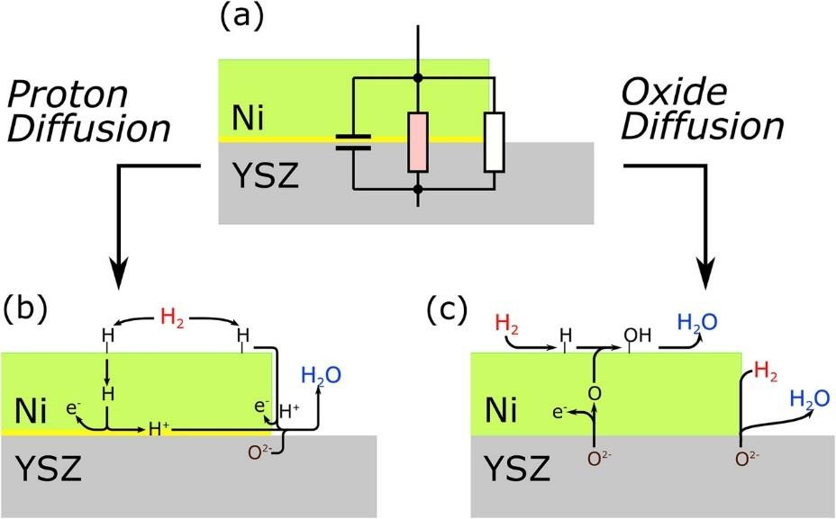
Figure 2.9- Reaction pathways proposed by Doppler et al. [72] for hydrogen oxidation. a) Proposed equivalent circuit. b) Proton diffusion mechanism: H2 dissociates and adsorbs at the nickel surface. The dissociated hydrogen diffuses through the nickel bulk and charge is transferred at the Ni/YSZ interface forming a proton. Protons diffuse along the Ni/YSZ interface to the TPB where they combine with oxide ions from the electrolyte to form water. The TPB dependant pathway occurs as dissociated hydrogen diffuses across the nickel surface to the TPB where the two pathways converge. c) Oxide diffusion mechanism: Oxide ions from the electrolyte are oxidised at the Ni/YSZ interface to form single oxygen atoms and release an electron in a charge transfer step. The oxygen atoms diffuse through the nickel bulk and combine with

adsorbed dissociated hydrogen at the nickel surface to form water. The TPB length dependant step occurs as oxygen ions combine with hydrogen directly at the TPB, with the two pathways converging as the water desorbs from the nickel surface. Source: [72].
An alternative hypothesis proposed to explain some inconsistencies between model electrode studies, is that the TPB is not the only site which is electrochemically active in Ni/YSZ pattern electrodes [72]. Evidence of an additional area-scaling pathway has been reported, with the same reaction order for the partial pressure of water as the TPB length dependant pathway [72]. The two pathways were concluded to converge on the water side of the reaction chain, and two possible mechanisms were proposed: a proton diffusion mechanism, and an oxygen diffusion mechanism (Figure 2.9) [72]. The reaction pathways involve the diffusion of either a hydrogen or oxygen species through the electrode bulk.

Summary
The number of parallel RC components, electrode resistances, performance in different fuels, gas partial pressure dependencies, activation energies, and TPB length dependence, all show variation between model electrode studies. Model electrode studies are supposed to be simplified and well controlled, however results suggest that there are additional uncontrolled factors. Several causes for the variation between studies have been suggested in the literature, although different experimental conditions and chemical impurities cannot account for all of the contrasting results alone.
Several studies have indicated that there could be inaccuracy in the measuring of TPB lengths, which has the potential to affect electrode resistances, performance in different fuels, activation energies and TPB length dependence. TPB length inaccuracies can result from unaccounted for scratches and defects in the electrode bulk during preparation, and are proposed to also arise from non-standardised measurement between studies, and microstructural rearrangement during measurements. There is limited data regarding microstructural changes during electrode operation, and at present the effect on TPB length and electrode performance requires further clarification.
An alternative hypothesis has been suggested elsewhere, that electrode performance scales with electrode area for hydrogen oxidation, because hydrogen or oxygen species are diffusing through the metal bulk.
Several causes for the variation between studies have been suggested in the literature, although different experimental conditions and chemical impurities cannot account for all of the

contrasting results alone. Further consideration is required to determine whether the sources of error discussed in the literature can account for the reported variation between similar studies. In particular, there is a lack of microstructural analysis of pattern electrodes during electrochemical testing, and the consequent effects on the error in TPB length.
Furthermore, there are relatively fewer studies investigating CO/CO2 oxidation with Ni/YSZ pattern electrodes, and understanding microstructural changes taking place in CO/CO2 could aid in understanding the different electrode performances reported for electrodes operated with the two gas atmospheres.
Understanding of causes of discrepancy in model electrode studies would improve the reliability of further model electrode studies, and in turn would benefit technical cermet electrodes, which model electrodes are designed to investigate.

Chapter 3 - Methodology

Sample preparation

Polycrystalline YSZ pellets
Pattern electrodes were prepared for experiments by depositing thin metal films on to YSZ pellets. Pellets were made by pressing YSZ powder and firing to form polycrystalline pellets.
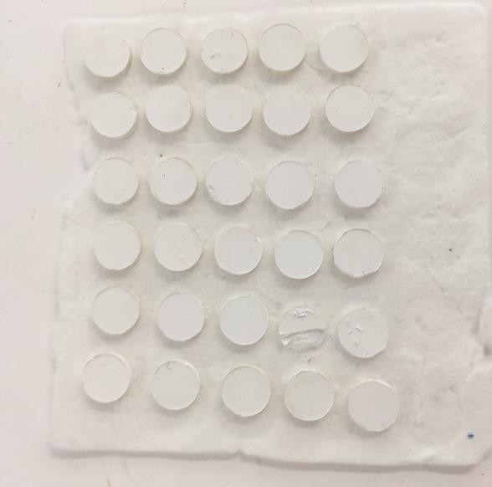
Yttria-stabilised zirconia (YSZ) powder (Daiichi Kigenso Kagaku Kogyo Co., Ltd., Japan) (20g) was combined with Triton X-114 (Sigma-Aldrich, UK) (0.2g) and added to milling media with propan-2-ol (Fisher Scientific, UK) (150 mL). The mixture was ball milled before drying in an 80°C oven overnight.

Figure 3.1 – polycrystalline YSZ pellets after firing at 1400°C overnight.

0.2 g YSZ powder was weighed using an analytical weighing balance. Care was taken to ensure accuracy to within two decimal places, and the resultant standard deviation over 128 samples was 0.003 g. The 0.2 ± 0.003 g YSZ powder was added to an 8 mm pellet die and compacted in a manual hydraulic press at 0.5 tonnes for 25 seconds. Pellets were fired at 1400°C in air overnight with a heating and cooling rate of 10°C/min (Figure 3.1). The fired pellets had a diameter of ~6 mm and a thickness of ~3 mm. Care was taken to ensure that YSZ was not lost in the pressing process. Given that each pellet was weighed to a two decimal place accuracy, an upper weight limit of 0.2099 g and a lower weight limit of 0.2000g is possible. Assuming a 0.2000g pellet results in a pellet thickness of 3 mm, the upper limit to pellet thickness would be 3.1 mm. One side of each pellet was ground and polished to a mirror finish using sequential

grit papers between 120 grit and 5000 grit, finishing with 1 µm diamond paste, similar to other studies [73, 86, 118].

Substrate cleaning
Prior to the deposition of thin films onto substrates, all substrates were cleaned.

YSZ pellets, single crystal YSZ (100) (PI-KEM Ltd., UK) and glass slides (Menzel-Glaser, Germany) were used as substrates. Substrates were cleaned ultrasonically for 2 minutes in acetone, propan-2-ol and distilled water sequentially, before drying in a 100°C oven for 10 minutes.

Polymer sphere layer
In Chapter 7, the effect of depositing a polymer sphere layer under the nickel thin film layer on YSZ substrates is investigated. The polymer sphere layer was fabricated according to the following steps:
      - Polymer solution
PS(1776)-b-P2VP(856) (Polymer Source, Inc., Canada) (25 mg, Mn 275 kg mol⁻¹) was added to toluene (Sigma- Aldrich, UK) (5 mL) and stirred for 3 days.
      - Dip-coating
Polymer layers were prepared using a dip-coating arm (KSV Nima, Sweden) to dip cleaned substrates into the polymer solution at a controlled speed of 5 mm s⁻¹, followed by immediate withdrawal at 5 mm s⁻¹.

Nanoparticle layer
In Chapter 7, the effect of depositing a nickel nanoparticle layer under the nickel thin film layer on YSZ substrates is investigated. The nickel nanoparticle layer was fabricated according to the following steps:
      - Direct loading
NiCl2.6H2O (Sigma-Aldrich, UK) (4 mg, 1.7x10⁻⁵ mol) was added to the prepared polymer solution (Section 3.1.3.1) and stirred for 7 days. Loading ratio of nickel to pyridine units = 0.2. Cleaned glass substrates were dipped into the polymer-salt solution at a speed of 5 mm s⁻¹ followed by immediate withdrawal at 5 mm s⁻¹. The polymer was removed and nickel salt

transformed to single nanoparticles by oxygen plasma cleaning (Diener electronic ZEPTO plasma system) at 0.5 bar pressure for 20 minutes.
      - Homopolymer loading
hP2VP (10 mg, Mn 30 kg mol⁻¹, 3.0 x10⁻⁷ mol) and NiCl2.6H2O (Sigma-Aldrich, UK) (11 mg,
4.6 x10⁻⁵ moles, Loading ratio = 0.5) were added to toluene (1 mL) and stirred for 3 days. The hP2VP-salt mixture was added to the prepared polymer solution (Section 3.1.3.1) and stirred for 1 week. Cleaned glass substrates were dipped into the polymer-salt solution at a speed of 5 mm s⁻¹, followed by immediate withdrawal at 5 mm s⁻¹. The polymer was removed and nickel salt transformed to single nanoparticles by oxygen plasma cleaning at 0.5 bar pressure for 20 minutes.
      - Post-loading
NiCl2.6H2O (Sigma-Aldrich, UK) (6 mg, 2.5 x10⁻⁵ mol) was added to distilled water (5 mL) and stirred until dissolved. After dip-coating in polymer solution (Section 3.1.3.2), substrates were immediately dipped into the nickel solution at a speed of 5 mm s⁻¹ and submerged for 2 minutes, before withdrawal at 5 mm s⁻¹. The polymer was removed and nickel salt transformed to single nanoparticles by oxygen plasma cleaning at 0.5 bar pressure for 20 minutes.

E-beam deposition of pattern electrodes
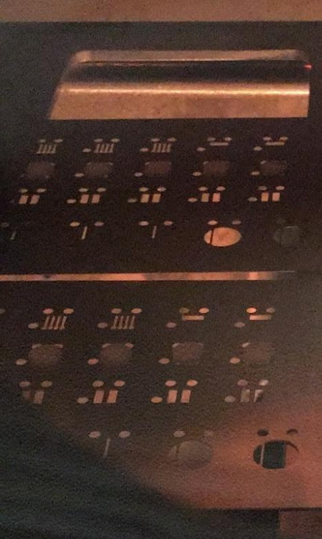
Nickel and platinum pattern electrodes were deposited onto YSZ substrates through a custom- made stainless steel mask (Photofab Ltd., UK).

a)
b)

Figure 3.2- a) stainless steel masks and YSZ substrates mounted in electron-beam (e-beam) evaporator during nickel deposition, b) diagram of electrode design (not to scale).
Cleaned substrates were placed, polished side down, onto the mask which was mounted in a Moorfield thin film evaporator (Figure 3.2a). Evaporation conditions are outlined in Table 3.1. Nickel layers 50 nm, 300 nm and 1 µm in thickness and platinum layers 50 nm in thickness were deposited through the mask based on the deposition rate and time. The film thicknesses from the evaporator could be controlled to within 1 nm of the target thickness. The interdigitated electrode design was selected to maximise the triple phase boundary length, and because of the close proximity between the two electrodes to minimise the distance for oxygen ions to diffuse, as discussed in Section 1.3 [49]. The interdigitated electrodes had a 300 µm spacing between the nickel stripes which were 400 µm wide (Figure 3.2b). The micron-scale spacing between the nickel stripes corresponds to a micron-scale separation between the working and counter electrode which helps form a complete circuit, and facilitates electrochemical analysis of the system by ensuring a sufficient sensitivity for impedance spectroscopy [119].
Table 3.1 – Conditions for e-beam evaporation of nickel and platinum

Metal | Evaporator | Pressure (mbar) | Current (mA) | Rate (A s-1) | Metal slug supplier | Metal purity level | Crucible type
Nickel | Moorfield Deposition  system type ES80M | 10-5 | 60 | 0.1-  0.3 | Kurt J. Lesker  Ltd., UK | 99.98% | Graphite
Platinum |  |  | 130 | 0.1 |  | 99.99%

Attaching current collectors
Current collector wires were attached to the electrodes deposited onto YSZ substrates using the following method:

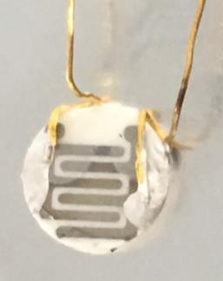
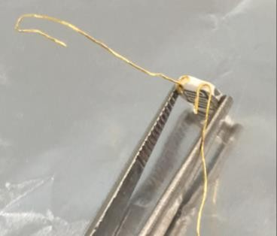
a) b)

Figure 3.3 – a) wires attached to a YSZ pellet with a small amount of Super Glue®, b) sample with wires attached and contacted to electrodes with silver paste. Note: Gold wire pictured but silver wire was used for all tests.
~5 cm lengths of silver wire (0.25mm diameter, 99.99% purity, Goodfellow Cambridge Limited, UK) were attached to either side of the symmetrical pattern electrodes using silver paste (Gwent Electronic Materials Ltd., UK) (Figure 3.33b). A small amount of Super Glue® (Loctite, Germany) was applied to the edges of the pellet with a pin head to secure the wires in place whilst the silver paste dried (Figure 3.3a). Samples were dried in a 100°C oven for 10 minutes.

Electrochemical characterization

Linkam stage set-up
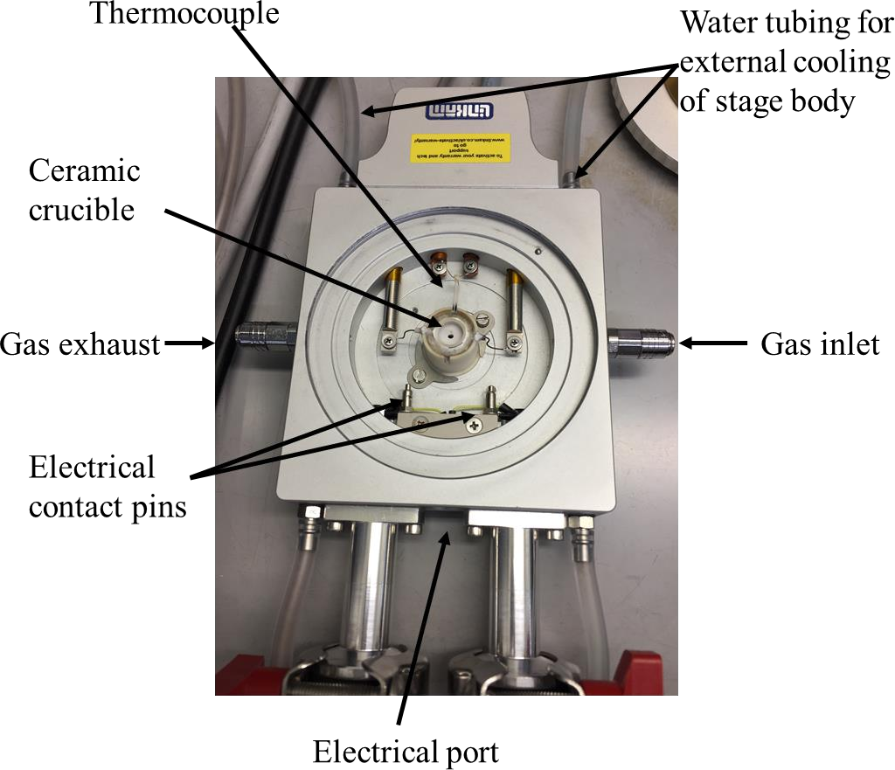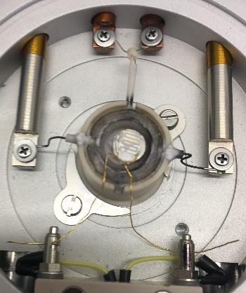
a)
b)

Figure 3.4 – a) Linkam stage b) sample mounted in ceramic crucible with wires connected to electrical contact pins.
Electrochemical measurements were carried out using a Linkam TS1500 hotstage (Linkam Scientific Instruments, UK) with electrical contacts (Figure 3.4a). Samples were placed in a

ceramic crucible on top of a piece of bored ceramic in the centre of the stage and fixed in place using attached wires and electrical pins on the stage (Figure 3.4b). The bored ceramic piece was measured to be 2.5 mm in thickness and was kept constant in all tests. The piece was used to raise the sample to the top of the crucible to minimise gas flow disturbance to the pattern electrode as well as to rest each sample on during measurements to minimise variation in sample placement within the crucible.

Sample cleaning
Prior to measurements, all samples were heated at a rate of 5°C/min to 400°C and held for 30 minutes before cooling at 5°C/min, to remove organic residues from the Super Glue® and silver paste. The lid was left off the Linkam stage during cleaning to ensure solvents were removed.

Gas set-up

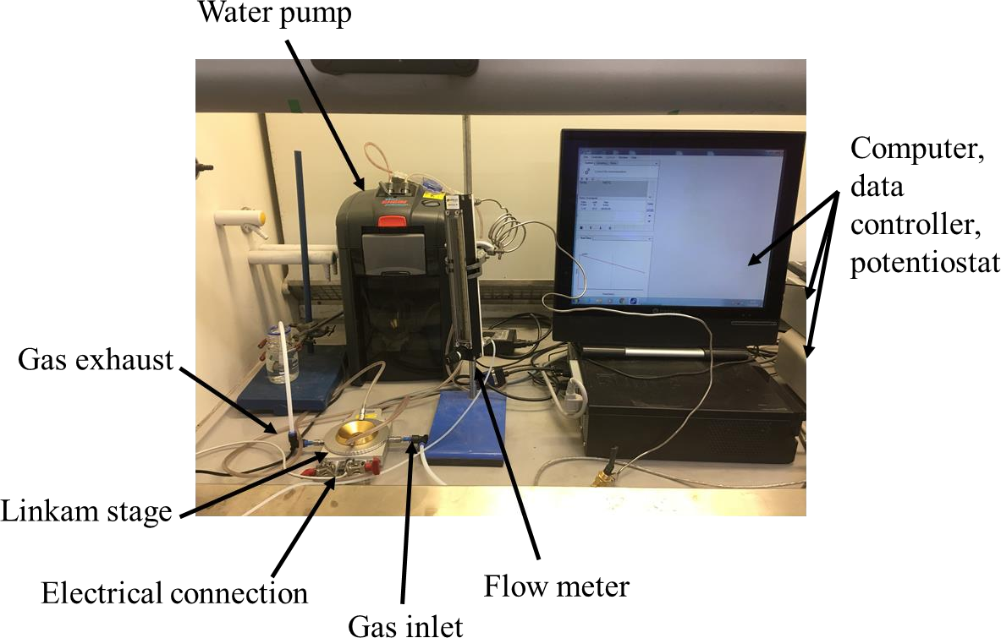

Figure 3.5 – Experimental set-up for 10%H2/N2 experiments

Fuel gas mixtures consisted of 10%H2/N2, 3%H2O/10%H2/N2 or 5%CO/50%CO2/Ar. The flow of 10%H2/N2 (BOC, UK) was controlled with a flow meter set to 5 mL/min with 1 bar total pressure (Figure 3.5). 3%H2O/10%H2/N2 mix was achieved by wetting the 10%H2/N2 through

a water bubbler at room temperature. The flow of 10%CO/Ar (BOC, UK) and CO2 (CP Grade, BOC, UK) was controlled using mass flow controllers (Bronkhurst, UK) to produce a 5%CO/50%CO2/Ar mix with a total flow rate of 5 mL/min.

Temperature calibration

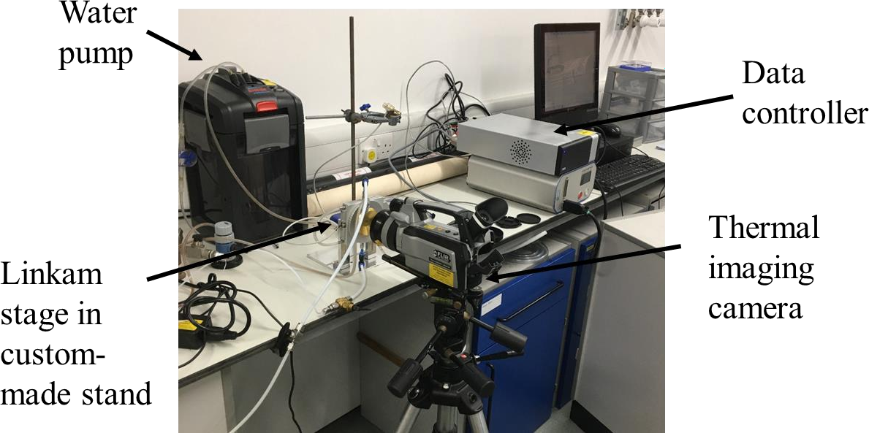
Figure 3.6 – Equipment set-up for thermal imaging measurements
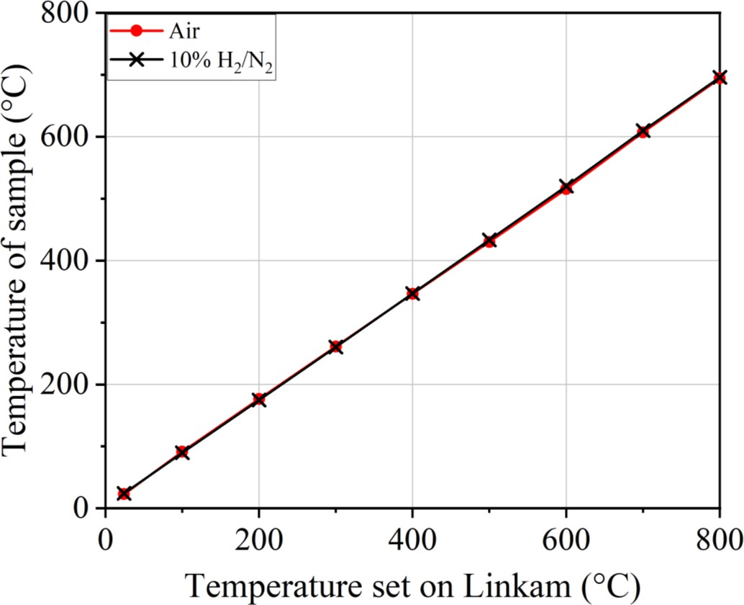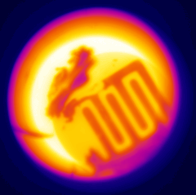
X
Y

Figure 3.7 – Sample temperature measured using the thermal imaging camera vs. the temperature set on the Linkam stage. Measurements taken in air (red circle) and in 10%H2/N2 (black cross). Inset: an example of a thermal image obtained, X and Y indicate the positions of measured temperatures.
A major limitation with the experimental set-up used in this thesis, is that the thermocouple on the Linkam stage is located at the bottom of the crucible. The temperature of the Linkam stage is controlled through the computer and data controller, and measured using the thermocouple embedded in the stage at the bottom of the crucible in which the samples are placed. Therefore a discrepancy between the temperature set on the data controller based on the temperature measured by the thermocouple, and the temperature at the patterned electrode surface was considered. The crucible is 6 mm deep and heats from the bottom. Samples were each placed on top of the same 2.5 mm thick bored piece of ceramic inside the crucible to control the positioning of the samples, and prevent them from sitting too far below the top of the crucible, which could disrupt the gas flow to the sample surface. Given the samples were ~3 mm thick with little fluctuation (Section 3.1.1), the samples sit in the crucible ~0.5 mm below the crucible edge.

Table 3.2 – Temperature measurements from the data controller and thermal imaging camera

Temperature set on data controller (°C) | Thermal camera imaging range (°C) | Temperature from thermal camera (°C)
 |  | Air |  |  | H2/N2
 |  | X  (°C) | Y  (°C) | Corrected  Y (°C) | X  (°C) | Y  (°C) | Corrected  Y (°C)
24 | 0 to 500 | 29.7 | 28.5 | 22.8 | 29.1 | 29 | 23.9
100 | 0 to 500 | 76.9 | 68.4 | 91.5 | 77.5 | 67.1 | 89.6
200 | 0 to 500 | 150.7 | 127.2 | 176.5 | 150.7 | 125.5 | 174.8
300 | 0 to 500 | 226.8 | 188.1 | 261.3 | 226.3 | 186.9 | 260.6
400 | 0 to 500 | 304.6 | 251 | 346.4 | 302.3 | 249.2 | 346.9
500 | 0 to 500 | 380.9 | 311.1 | 430.2 | 377.7 | 311 | 433.3
600 | 0 to 500 | 456.2 | 371.8 | 515.6 | 452.1 | 372.3 | 520.2
700 | 300 to 2000 | 531.4 | 438.5 | 607.1 | 528.1 | 437.9 | 609.8
800 | 300 to 2000 | 605.8 | 500.1 | 694.3 | 601.5 | 497.5 | 696.0

In order to verify the temperature of the sample surface compared to the temperature set through the data controller, a thermal imaging camera was used to examine the temperature of the sample surface during testing. Unfortunately, limited time and equipment necessitated the use of a thermal imaging camera (FLIR, USA) which was not kept serviced. ZnSe windows

were inserted into the Linkam stage for this test to prevent the quartz glass windows interfering with the temperature measurement. Figure 3.6 shows the Linkam stage mounted in a custom- made stand during measurements to enable close proximity between the stage and the thermal camera. The thermal camera used did not give an accurate absolute temperature readout, as the temperature of the crucible at room temperature was 29.7°C. Therefore, an assumption was made that the measured crucible temperature (point X in the inset of Figure 3.7), was the temperature set on the data controller. The temperature of a point on the electrolyte surface (point Y in the inset of Figure 3.7) was measured. The fluctuation between the temperature set on the data controller, and the temperature ‘X’ was used to correct the temperature of the electrolyte surface – Y (Table 3.2). An additional source of uncertainty was introduced by the thermal imaging camera having two temperature ranges for imaging, 0 to 500°C and 300 to 2000°C. It was therefore necessary to switch between the two ranges during the measurements to cover the full range of temperatures used in this thesis.
The corrected temperatures for the electrolyte surface were found to be up to 100°C lower than the temperature set through the data controller in both air and when a gas mixture was passed through the stage (Figure 3.7, Table 3.2). The uncertainty in these measurements is high, and ideally a third source would be used to clarify these measurements, however this was not possible owing to practical limitations.
Other studies using a Linkam stage with an embedded thermocouple have reported that samples placed at the top of the stage had a temperature 5.8°C higher than the thermocouple temperature, although the temperature was measured using the electroluminescence spectrum of a GaAs solar cell as the Linkam stage was heated, using the peak emission energy as a thermometer for cell temperature [120].
A consequence of the disparity between the set temperature and the measured sample surface temperature, is that the temperatures reported throughout the thesis, which are those set by the data controller unless specified otherwise, could be up to 100°C lower. Comparisons to the literature are therefore not possible based on the high degree of uncertainty in the temperature measurements.
In addition, given the apparent discrepancy between the temperature at the top and bottom of the crucible within the stage, there is likely to be some fluctuation between results based on small fluctuations in placement of each sample within the crucible. Since care was taken to ensure the samples did not fluctuate greatly in thickness (Section 3.1.1), the variation in height

of the sample surface between each experiment is likely only to vary by ~ 0.1 mm because of the variation in thickness of the sample. Although efforts were made to sit each sample on top of the bored ceramic, the tension of the wires attached to the sample and the stage could result in a very slight lift up of the sample. In these occasions, the wires were manipulated to ensure the sample sat as flat to the bored ceramic piece in the crucible as possible. An additional 0.5 mm variation between the height of samples in different repeats can be envisioned resulting from the wire tension, and therefore, a total height discrepancy of ~1 mm between repeats is assumed. Based on up to 100°C temperature change between the base of the crucible and the sample surface 6 mm above the base of the crucible, an approximate 1 mm sample placement error could result in an approximate 15°C fluctuation in sample surface temperature between samples. A temperature fluctuation error between samples of 15°C is used to propagate error in the following sections.

Electrochemical measurements
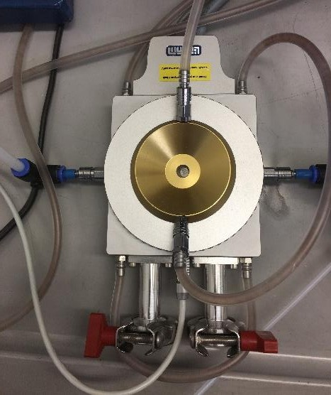
Figure 3.8 – sealed Linkam stage with gas-fittings and water tubing attached.

At the start of a measurement, the Linkam stage was sealed by screwing on the lid and attaching gas connections and water tubing (Figure 3.8). The water pump used to keep the external stage body cool during measurements was turned on, and gas was flushed through the stage for 5 minutes prior to beginning heating. All heating and cooling was carried out at a rate of 5°C/min.

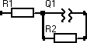

Figure 3.9 – Diagram of equivalent circuit used to analyse impedance data.

Electrochemical Impedance Spectroscopy (EIS) was performed using a Solartron 1250 frequency response analyser (Solartron Analytical, UK) or an IviumStat (Ivium Technologies, The Netherlands). The frequency was varied between 0.1 Hz and 100 kHz and the excitation voltage was fixed at 10 mV. EIS measurements were taken at open circuit voltage using 10 points per decade. All data was analysed using a simple equivalent circuit consisting of a serial resistor, R1, and a constant phase element, Q, in parallel to the electrode polarisation resistance, R2, (Figure 3.9). The same equivalent circuit has been used in similar studies [73]. Data was fit to equivalent circuits using the Ivium Equivalent Circuit Evaluator function of IviumSoft software (Ivium Technologies, The Netherlands). Goodness of fits and error in the application of this circuit to the data are considered in Chapter 4.
      - Activation energy tests
After heating to 400°C, electrochemical measurements were taken every 50°C up to 550°C. Each measurement took 3 minutes 30 seconds, during which time the temperature was held constant. Between 550°C and 800°C, electrochemical measurements were taken every 10°C. After reaching 800°C the stage was cooled to room temperature, and electrochemical measurements were taken every 100°C during cooling.
      - Constant temperature tests
For constant temperature tests, the stage was heated to 600°C and held for 48 hours before cooling. Electrochemical measurements were taken every hour upon reaching 600°C.

Electrochemical impedance spectroscopy
Electrochemical Impedance Spectroscopy is a commonly used tool for SOFC performance characterization because it enables “in-situ” and “in-operando” probing of the cell without detriment to the system [14]. EIS characterizes different regions of a material by measuring the frequency dependent response to an applied potential. Processes occurring in the bulk of a

sample, at grain boundaries and at interfaces are all distinguishable using impedance spectroscopy [20], and information about the underlying chemical processes can be revealed. An impedance response from a fuel cell can yield information about the entire cell including the reactivity and structure of the electrode/electrolyte interface, the conductivity of the electrode and the electrolyte, as well as gas diffusion processes [21].
Impedance is a measure of the opposition to a flow of current through an electrochemical system [14]. Impedance is defined as

𝑍 = 𝐸𝑡
𝐼𝑡
Equation 3.1 [106] [14]

In impedance spectroscopy, a small oscillating voltage is applied to a system at a known frequency, and the resultant current response is measured. A small voltage is applied so the resultant current response is pseudo-linear. When the oscillating voltage is applied at a known frequency:
𝐸_{𝑡} = 𝐸₀sin(𝜔𝑡) Equation 3.2 [14]

where Et is the potential at time t, E0 is the amplitude of the signal and 𝜔 is the angular frequency.
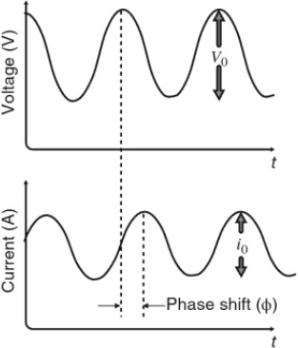

Figure 3.10 – Voltage perturbation (top), and current response (bottom), showing phase shift. Source: [14].

The current response 𝐼_{𝑡} from the system may undergo a phase shift, ∅, compared to the perturbation voltage. The current response still has the same period and therefore frequency as the voltage perturbation, but the amplitude 𝐼₀ is phase shifted by an amount ∅ (Figure 3.10).
The resultant current response is:

𝐼_{𝑡} = 𝐼₀sin(𝜔𝑡 + ∅) Equation 3.3 [106]

where It is the current at time t, I0 is the amplitude of the signal and 𝜔 is the radial frequency. To account for this phase shift, Equation 3.1 can be re-written as:

𝑍 = 𝐸𝑡 = 𝐸0sin(𝜔𝑡) = 𝑍
sin(𝜔𝑡)

Equation 3.4 [106]

𝐼𝑡
𝑖0sin(𝜔𝑡+∅)
0 sin(𝜔𝑡+∅)

Using Euler’s relationship,

𝑒^{𝑗∅} = cos ∅ + 𝑗sin∅ Equation 3.5 [106]

where j is the imaginary number,√−1,
it is therefore possible to rewrite the potential (Equation 3. 2) as a complex function:

𝐸_{𝑡} = 𝐸₀e^{𝑗𝜔𝑡} Equation 3.6 [106]

and the current response as:

𝐼_{𝑡} = 𝐼₀e^{𝑗𝜔𝑡−∅} Equation 3.7 [106]

The impedance (Equation 3.4) can then be split into its real and imaginary components:

𝑍 = 𝐸0e𝑗𝜔𝑡

𝐼0e𝑗𝜔𝑡−∅
= 𝑍0
𝑒^{𝑗∅} = 𝑍0
(cos ∅ + 𝑗sin∅) Equation 3.8 [106]

The real component of the system can be represented as:

𝑍_{real} = 𝑍₀cos ∅ Equation 3.9 [106]

And the imaginary component of the system can be represented as:

𝑍_{imag} = 𝑍₀sin ∅𝑗 Equation 3.10 [106]

Impedance data are typically plotted with Zreal (Z’) along the x axis and -Zimag (-Z’’) along the y axis, and these plots are known as Nyquist plots. The impedance response is measured at many frequencies over a pre-determined range and the Nyquist plot summarises the impedance

of the system. In this way, processes occurring within the electrodes and the electrolyte may be separated based on the frequency of the processes occurring. Data can be fit to equivalent circuit models to understand more about the parameters of the electrochemical system.
  - Ohmic resistance
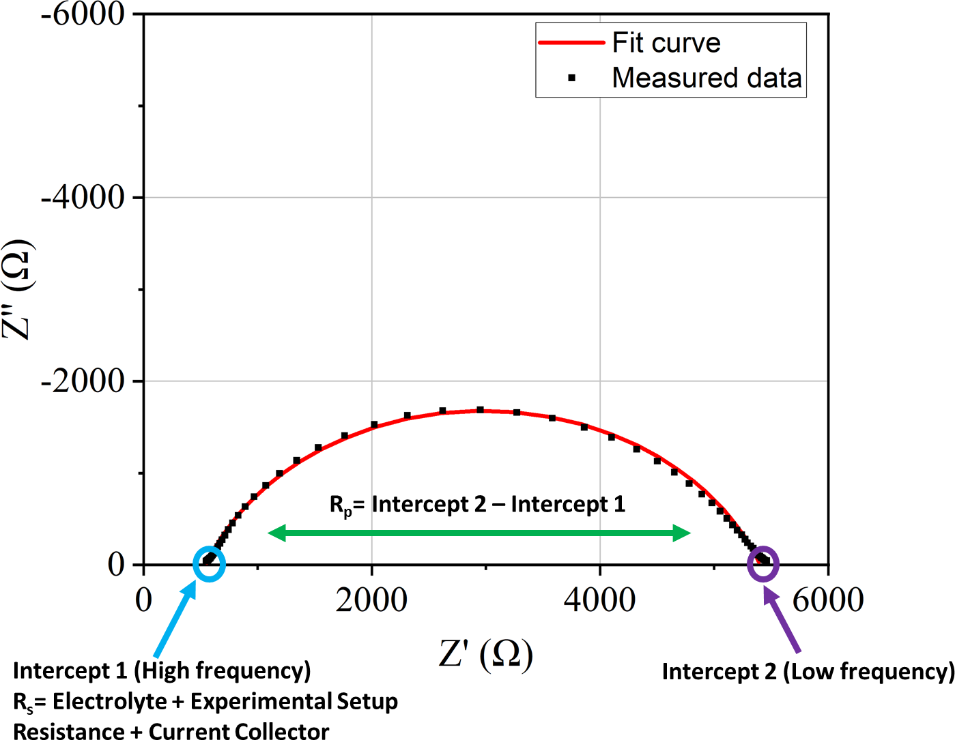

Figure 3.11 – Example Nyquist plot showing measured data and data fit with equivalent circuit in Figure 3.9.
At 800°C, standard Nyquist plots of the data obtained in this thesis showed one observable semi-circle (Figure 3.11). After fitting the data to the equivalent circuit in Figure 3.9, the ohmic resistance, Rs, was determined from R1 of the equivalent circuit and corresponds with the high frequency intercept of the semi-circle with the x-axis (Figure 3.11) [14]. The ohmic contribution Rs consists of a contribution from the processes occurring in the electrolyte, the experimental setup resistance, and a contribution from the current collector.

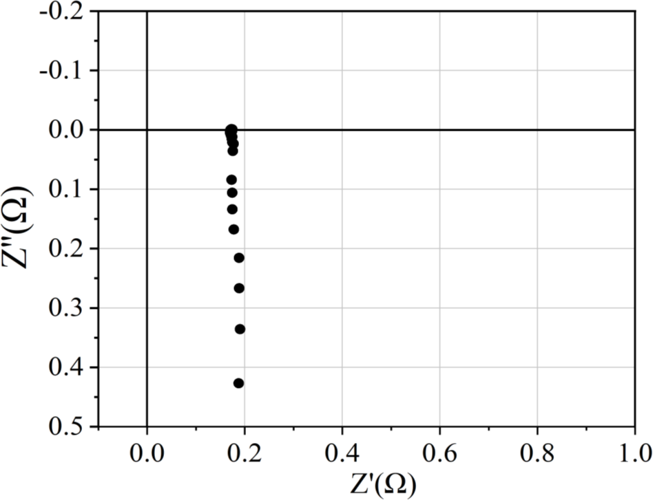

Figure 3.12 – Nyquist plot showing a short circuit measurement used to obtain the inductive contribution from the equipment at 800°C.
To separate the electrolyte contribution from the experimental set-up contribution, a short- circuit measurement was made to find the contribution solely from the equipment. Silver wires were attached to both electrical pins in the stage, and touched together. The inductive contribution was found to be ~0.2 Ω at 800°C (Figure 3.12) and is known to be of negligible temperature dependence [102], and therefore considered negligible during measurements of ohmic resistance.

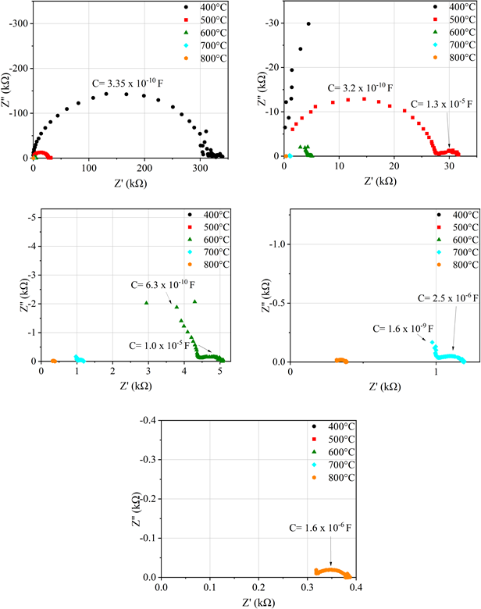
    - b)

c) d)

e)

Figure 3.13 –Nyquist plots showing the ohmic contribution of a blank pellet with silver current collectors between 400°C and 800°C in 10%H2/N2. Graphs a-e show the same measurements but with an increasingly smaller scale. Capacitances indicated on graphs.

The contribution to Nyquist plots from the electrolyte was measured by painting a small amount of silver paste onto two places on a blank pellet and attaching silver current collectors. Measurements were taken between 400°C and 800°C, and Nyquist plots are shown in Figure
3.13. At 400°C the capacitance indicates that the dominating process is a grain boundary process and therefore the electrolyte response dominates. As temperature increases, the response from the grain boundary gets smaller, and the contribution from the sample-electrode interface becomes more dominant [121, 122]. The capacitance of the electrolyte process of the YSZ pellets was used to fit an equivalent circuit to the semi-circle corresponding to the electrode process when more than one-semi circle was present in Ni/YSZ model electrode data at lower temperatures.
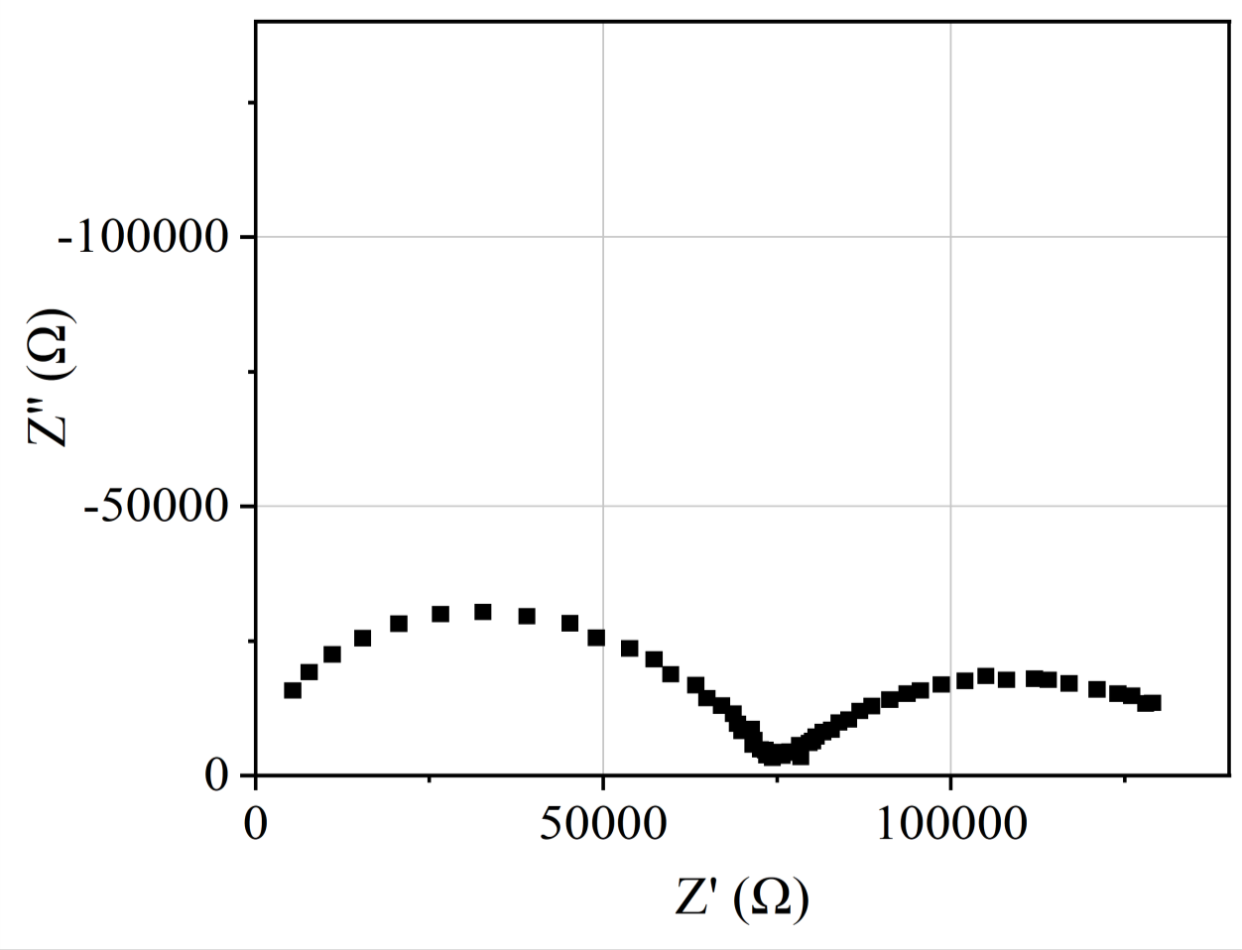
Figure 3.14 – Example Nyquist plot at 400°C from a Ni/YSZ pattern electrode with a 300 nm nominal electrode thickness in H2/N2.
Figure 3.11 shows an example of a Nyquist plot obtained at 800°C showing one visible semi- circle. At lower temperatures, up to 500°C, more than one visible semi-circle contributed to the Nyquist plots (Figure 3.14).

The capacitance of the semi-circles was calculated to determine which semi-circle corresponded to the electrode process, and to inform which semi-circle to use in the fitting of the equivalent circuit. In Figure 3.14, the capacitance of the high frequency semi-circle is 1.4 x 10⁻¹⁰ F and therefore of the same order of magnitude of the dominant process in the electrolyte only test (Figure 3.13). Therefore the high frequency semi-circle can be assigned to a grain boundary process in the electrolyte, whilst the low frequency semi-circle has a capacitance of
4.0 x 10⁻⁶ F which corresponds to sample electrode interface [121, 122]. Therefore, when more than one semi-circle was visible in the Nyquist plots at lower temperatures, equivalent circuits were fit to the low-frequency semi-circle.
3.2.6.2 Polarisation resistance
Polarisation resistance, Rp, is the contribution to impedance from the restriction of charge transfer at the electrode/electrolyte interface. In a Nyquist plot, polarisation resistance can be found from the low-frequency intercept (Rs+Rp), after subtracting the ohmic contribution, Rs (Figure 3.11) [14].

Image analysis

Atomic Force Microscopy
Atomic Force Microscopy (AFM) images were taken pre-testing using a Multimode 5 AFM (Bruker, USA) in tapping mode, with tapping mode tips – Tap300Al-G (Budget Sensors, Bulgaria). Images were processed using the open-source Gwyiddion software [123] and particle analysis was performed with the open-source FIJI distribution of ImageJ [124].

Scanning Electrode Microscopy
The electrode surface was imaged using Scanning Electrode Microscopy (SEM) on a JEOL JSM-6010LA (JEOL, Ltd., Japan) for 25-5000x magnification images or an Inspect F50 (FEI, USA) for higher magnification images. Post-test images were obtained by removing samples from the Linkam stage and carefully lifting off the silver current collectors. Ag paste was used to contact samples to carbon tape and the metal SEM stub, forming a conductive bridge. Measurement parameters are outlined in Table 3.3.

Table 3.3 – SEM measurement parameters

SEM | Magnification | Accelerating voltage (kV) | Working distance (mm) | Spot size
JEOL JSM- 6010LA | 25-5000x | 10 | 10 | 50
Inspect F50 | >5000x | 5 | 10 | 3

      - Converting SEM images to binary images
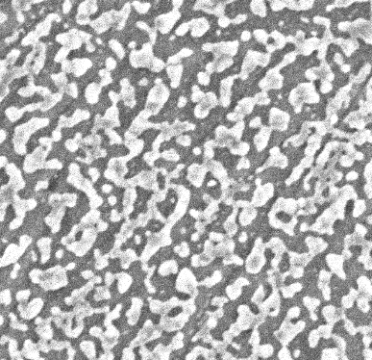
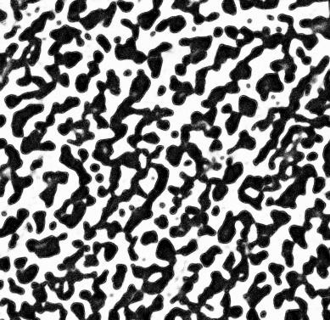

        - b) c)

Figure 3.15 – a) greyscale SEM image b) probability image obtained using Trainable Weka Segmentation and c) binary image.
SEM images were converted to binary images using the Trainable Weka Segmentation (TWS) tool which is distributed as part of the open-source software FIJI, a distribution of ImageJ [125] (Figure 3.15).
To use the TWS tool, the user assigns areas in an image to a class, and then the TWS tool classifies all pixels in an image based on predictive modelling. An image showing the probability that each pixel belongs to each class is produced – ‘confidence image’ - and if the classification has been successful, then the probability image obtained will be completely segmented. The benefit to using the TWS tool compared to thresholding, is a more efficient segmentation over large areas with relatively little user-input required.

      - Triple phase boundary length calculation
        - Electrode perimeter
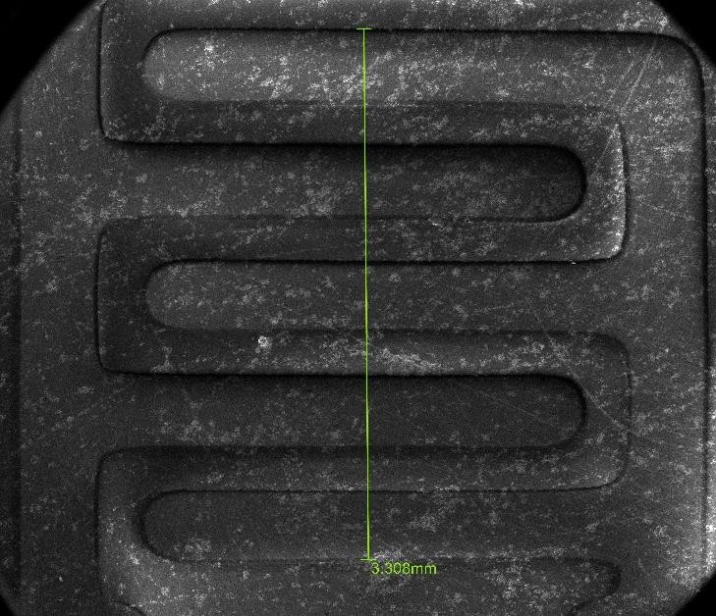
Figure 3.16 – SEM image at 25x magnification representative of the images used to calculate the TPB length of the nickel pattern electrode before testing.

The TPB length of the pattern electrodes after deposition and before heating was calculated using low magnification SEM images (25x magnification) (Figure 3.16), assuming the edges of the perimeter are straight, as has been done in other studies [73, 88, 104, 105, 113]. The total TPB length including the perimeter of both the counter electrode and working electrode was calculated to be 56 ± 1 mm, based on three sets of SEM images. The total area of the deposited nickel pattern (both counter and working electrode) was calculated to be 0.13± 0.01 cm² based on three sets of SEM images. The actual error in this measurement is likely to be high owing to the edges of the perimeter not being perfect straight lines, the limited magnification of the SEM images, and the lack of accounting for any defects in the bulk of the electrodes which create additional TPB length. TPB lengths are reported in the literature to a varying number of significant figures – for example: two [38], three [105, 113] and four significant figures [88, 104], however there is likely to be a high degree of uncertainty in this measurement. A low magnification was used to obtain a TPB length which could be used for a base calculation comparable to measurement techniques used to the literature, and then various efforts were made to correct the TPB length and area to account for sources of error, as is discussed in Chapter 5.

𝑇𝑃𝐵_{perimeter,corrected} = 𝐶𝐹 x 56 Equation 3.11

where TPB_{perimeter,corrected} is the length obtained by multiplying the low magnification TPB length with the calculated correction factor, CF.
In order to correct the low-magnification TPB length for changes at the electrode perimeter during testing (Equation 3.11), correction factors were calculated based on the deviation of the electrode perimeter away from a straight line.


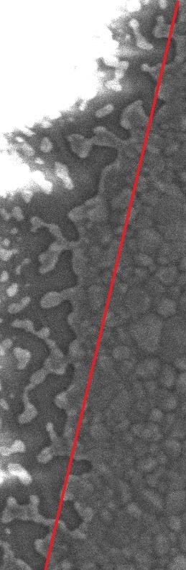
          - b)

Figure 3.17- a) greyscale SEM image of the perimeter of an electrode after testing. b) binary image of the same area after processing with TWS. Red lines indicate the perimeter measurement.

CF = TPBperimeter,measured
Lnickel,straight

Equation 3.12

where CF is the correction factor used to scale up the TPB length calculated from one SEM image to the entire electrode perimeter. TPB_{perimeter,measured} is the length of the TPB measured from the perimeter accounting for tortuosity (Figure 3.17b) and L_{nickel,straight} is the length of the nickel assuming a straight line at the perimeter (Figure 3.17a). Each correction factor was calculated based on an average measurement from three images of the perimeter.
        - Including holes in the nickel layer, still percolating
TPBtotal = TPBbulk + TPBperimeter,corrected Equation 3.13

where TPB
Area
= ( ) x TPB
cell
Equation 3.14 [95]

bulk
Areaimage
measured

where Area_{cell} is calculated to be 0.13± 0.01 cm², Area_{image} is the area of the SEM image and TPB_{measured} is the total perimeter of the Ni/YSZ interface measured in an SEM image of the nickel layer.
When electrodes were observed to develop holes, but there was no loss in percolation in the metal, the total TPB length is the sum of the TPB sites created in the bulk of the nickel and the corrected TPB length measured at the perimeter (Equation 3.13). TPB sites in the nickel bulk are measured from an SEM image of a known area, and then scaled for the entire electrode area using Equation 3.14. The final total TPB length is an average of the sum of length from 3 images of the perimeter and the sum of the length from 3 images of the electrode bulk.
        - Loss of percolation
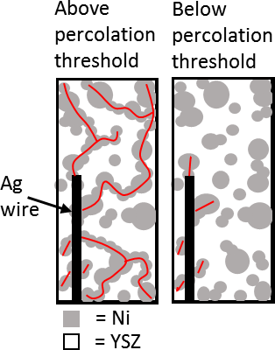

Figure 3.18 – Diagram of the percolation threshold in nickel electrodes. Red line indicates percolation pathway from silver current collector assuming the current collector contacts all nickel beneath it. Adapted from: [126].
When there was a loss of percolation in the nickel film (Figure 3.18), it was not possible to reliably determine the active triple phase boundary length from SEM images because it was not possible to view the nickel which remained connected to the current collector. Furthermore once a loss of percolation had occurred, it was not possible to know which nickel remained active for the electrochemical reaction, because it was unknown in which areas a conductive pathway was still present. Therefore a corrected TPB length could not be obtained for 50 nm electrodes which lost percolation across nickel films, as has been reported elsewhere [84].

  - Error propagation
The uncertainty in each LSR value calculated is presented in Chapter 5. The uncertainty was propagated using the error in each of the contributing factors shown below:
LSR = R_{pol} × A × L_{TPB} Equation 3.15 [102] The uncertainty was propagated using the following formula:

δLSR= |LSR|
√(δRpol)2
|Rpol|
+ (δA)²
|A|
+ (δLTPB)2
|LTPB|
Equation 3.16 [127]

Error in electrode area
LSR values in Chapter 5 were calculated using an electrode area calculated from low magnification (x 25) SEM images. In order to calculate the electrode area, SEM images of the electrode structure were taken, and measurements of the perimeter were made in Image J, assuming the perimeter to be straight. Three sets of SEM images were used to calculate an electrode area, which is the area of nickel over both electrodes. A standard deviation was calculated based on the variation between the three sets of images. The total area measurement was found to be 0.13± 0.01 cm².

Error in TPB length
TPB length was calculated at different points in the electrochemical testing (Section 3.3.2.2). LSR values presented in Chapter 5 show calculations based on two different TPB lengths – the first, represented as plotted points, is the TPB length calculated from low magnification SEM images, assuming all perimeter to be straight. This is often done in the literature [73, 88, 104, 105, 113]. Three sets of low magnification SEM images were used to calculate the electrode perimeter pre-testing. The total TPB length for both electrodes was calculated to be 56 ± 1 mm based on an average for the three sets of images, and where the error is the standard deviation in the measurements. The second method used to calculate LSR values used a TPB length calculated after cleaning electrodes and post-testing. This is shown in Chapter 5 as the shaded regions on the graphs. After cleaning the electrodes and using three 5000 x magnification SEM images of the electrode bulk, and three 5000 x magnification SEM images of the electrode perimeter, the TPB length (for both electrodes) was calculated (see Chapter 5 for values for each electrode thickness). The standard deviation in the average measurement was calculated

(see Chapter 5 for values for each electrode thickness). The same process was used to calculate the TPB length and error from post-test SEM images.

Error in polarisation resistance
The error in polarisation resistance measurements used to calculate LSR values presented in Chapter 5 was propagated using the goodness of fit of the equivalent circuit to the impedance data. This error was calculated by the IviumSoft software used to fit the equivalent circuits and is presented on all activation energy graphs presented in Chapter 4.
For constant temperature measurements, an additional source of error could be considered based on the results of the activation energy tests (Section 4.3.2). The temperature data from Section 4.3.2 was used to calculate the possible fluctuation in resistance with a 20°C temperature change from 590-600°. This data could then be used to propagate an uncertainty based on the sample placement uncertainty discussed in Section 3.2.4. The possible 1 mm variation in height between samples when placed in the crucible of the Linkam stage could result in an approximate 15°C temperature difference between samples.
Based on the results of the temperature ramp tests presented in Chapter 4, the average resistance change between 590°C and 610°C was calculated for polarisation and ohmic resistance. This value was found to be ± 470 Ω for polarisation resistance and ± 120 Ω for ohmic resistance. Based on these values, measurements taken at a constant temperature of 600°C in Chapters 4 and 6 were corrected to include this second source of resistance error.
Therefore, the error in polarisation resistance for the constant temperature tests presented in Chapters 4 and 6 have resistance error propagated according to the following equation:

δRpol= √(δsample placement)² + (δdata fit)² Equation 3.17

Chapter 4 – Hydrogen and carbon monoxide oxidation using nickel pattern electrodes – correlating electrochemical performance and microstructural stability

Introduction
As discussed in Section 2.2, the performance of nickel pattern electrodes used in similar studies has been found to vary. Amongst the reasons suggested for the variation in the literature (Section 2.4), is the hypothesis that reported TPB lengths are inaccurate. It has been suggested that unaccounted for scratches and pores created during the fabrication of pattern electrodes results in the underreporting of TPB length and consequent lower electrode resistances than expected in some studies [38, 113]. The hypothesis presented in Section 2.5, is that there are other sources of TPB length inaccuracy including non-standardised measurement techniques between studies and TPB lengths which change during testing. In Section 2.3, the contrasting literature data regarding the stability of Ni/YSZ pattern electrodes in H2/H2O atmosphere at SOFC operating temperatures was discussed. Further research is required to understand whether changes in the microstructure of nickel pattern electrodes during testing can account for the performance differences. A more detailed look at the impact of sources of error on electrochemical performance measurements is required.

It is possible that inaccuracy in the reporting of TPB lengths is affecting LSR values calculated to compare between studies. In addition, TPB lengths changing during electrochemical testing could affect the accuracy to which the data can be fit to an equivalent circuit and effect the accuracy of activation energy measurements. In particular, this could explain why some studies report different activation energies at high and low temperatures. Furthermore, there are few reports of the microstructural stability of pattern electrodes operated with CO/CO2, and therefore, it is plausible that different microstructural stabilities in CO and H2 based atmospheres are affecting comparisons of the magnitude of resistance in each gas atmosphere.

Hypothesis and aims:
The hypothesis investigated in this chapter is that microstructural changes occurring during electrochemical testing in both H2 and CO based atmospheres, are causing an increased error in the fitting of electrochemical data to equivalent circuits as the microstructural changes progress.

In order to assess this hypothesis, electrochemical testing is carried out with nickel pattern electrodes in H2 and CO based atmospheres, and the microstructure of electrodes pre-and post- test is compared. In this chapter, the electrochemical impedance data is fit to an equivalent circuit and the error in the fitting of that data is plotted for all measurements. Observed microstructural changes during testing are also reported. In Chapter 5, additional causes of error in the measurements are considered in more detail, including the effect of the microstructural changes on TPB length and how this effects the error in LSR values used to compare between studies.

The following aims are set for this chapter to test the above hypothesis:

    - To use nickel pattern electrodes in activation energy tests in both H2 and CO based atmospheres, fitting the data to an equivalent circuit and plotting the associated error.

    - To use nickel pattern electrodes in constant temperature tests in both H2 and CO based atmospheres, fitting the data to an equivalent circuit and plotting the associated error error.

    - To assess microstructural changes during testing using pre- and post-test SEM analysis of the electrodes.

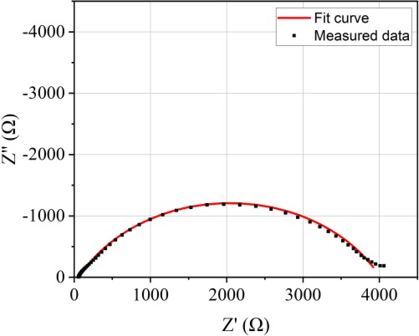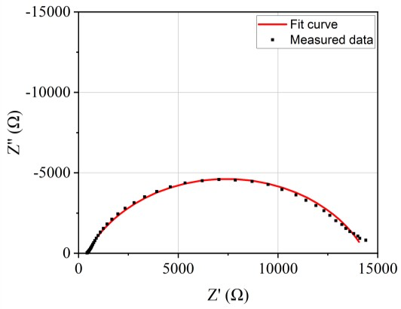
i)

Results:

Nyquist plots

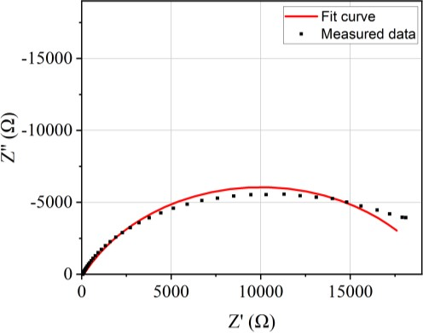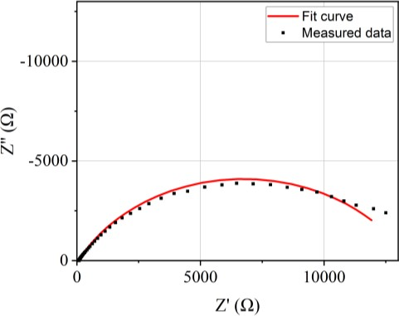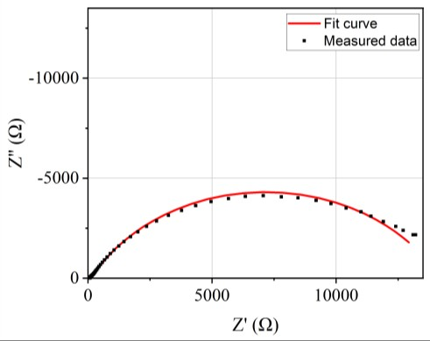
a)
b)
c)
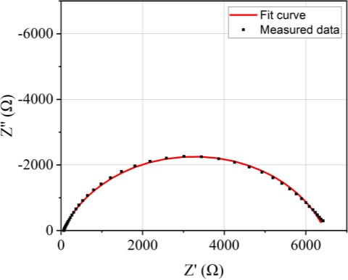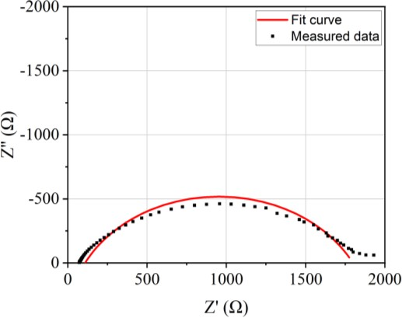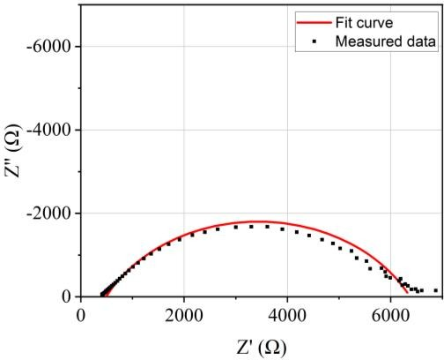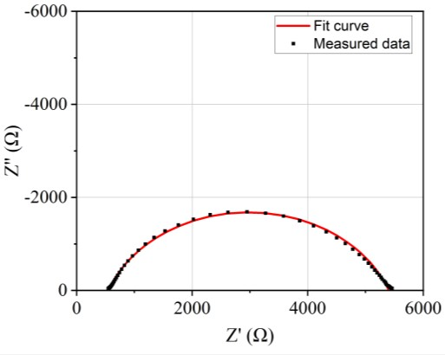f)
d)
e)
g)
h)

Figure 4.1– Nyquist plots showing the measured impedance data and the equivalent circuit fit for a,b,c) 1 µm thick electrode, d,e,f) 300 nm thick electrode, g,h,i) 50 nm thick electrode. a,d,g) in 10%H2/N2, b,e,h) in 3%H2O/10%H2/N2 and c,f,i) in 5%CO/50%CO2/Ar at 800°C.

Figure 4.1 shows representative Nyquist plots obtained for each of the three electrode thicknesses in each gas atmosphere measured at 800°C and the equivalent circuit fit. All data throughout the thesis was fit to the equivalent circuit in Figure 3.9. The error in the fit of each data set to the equivalent circuit was also measured and plotted in the following sub-sections. The same equivalent circuit has been used in similar studies [73].

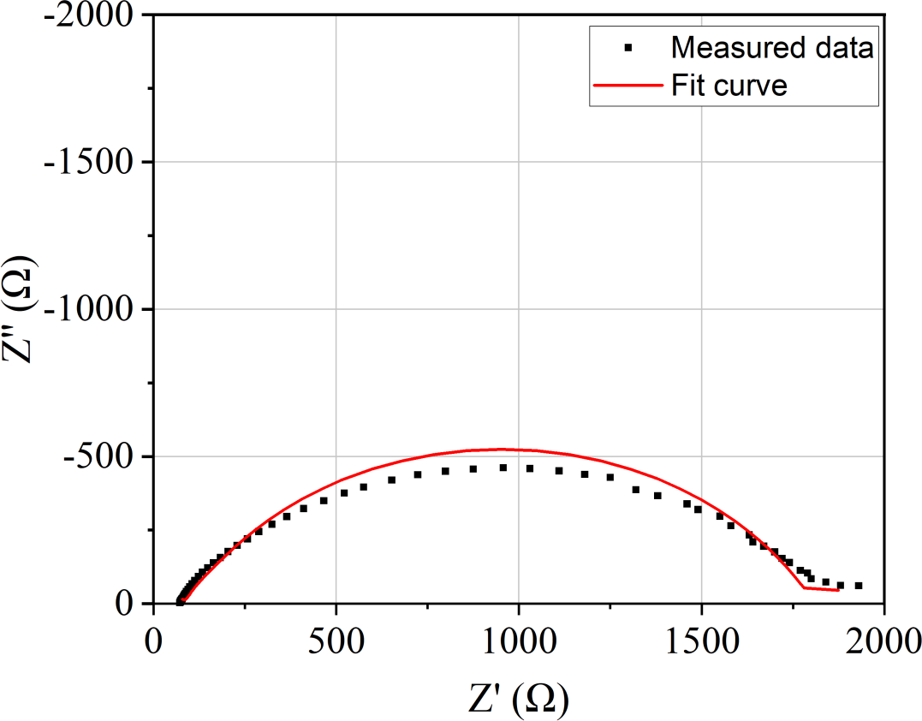

Figure 4.2– Nyquist plots showing the measured impedance data and the equivalent circuit fit for a 300 nm thick electrode in 3%H2O/10%H2/N2 at 800°C, corresponding to graph e) in Figure 4.1.

The equivalent circuit shown in Figure 3.9 did not represent an ideal fit for all data. For many samples, the fitting of the high frequency data to the equivalent circuit was poor, and this is a problem reported for fitting pattern electrode data elsewhere [98]. Using a more complicated model - L1*Q1+Q2*R2+Q3*R3+Q4*R4 – changed the fitting of the high frequency as shown in Figure 4.2, and therefore the equivalent circuit used to fit the data throughout the thesis (Figure 3.9) is likely an oversimplification. There is no clear equivalent circuit which accounts for all the data ideally, and a wide range of equivalent circuits are used in similar studies in the literature. The error in fitting all data to the equivalent circuit shown in Figure 3.9 is incorporated as part of the error bars in subsequent graphs.

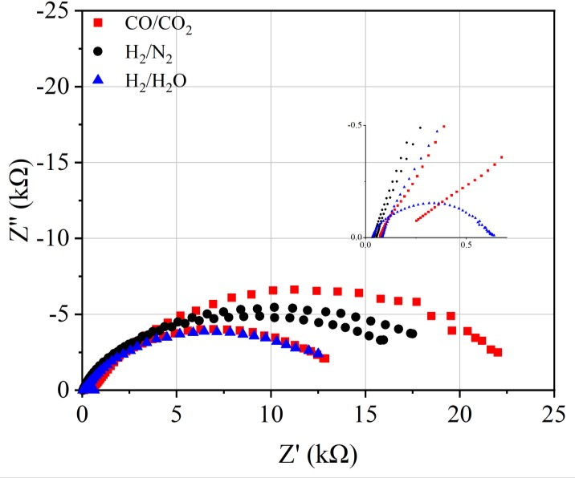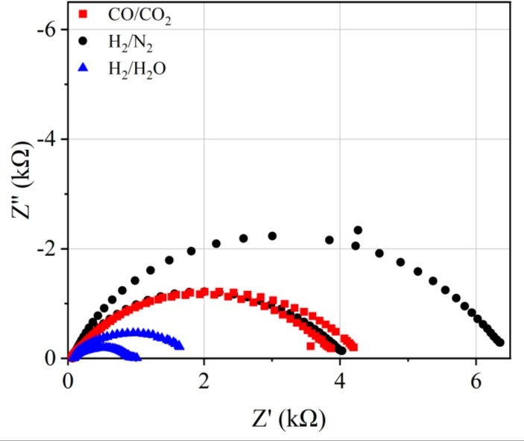
a)
b)
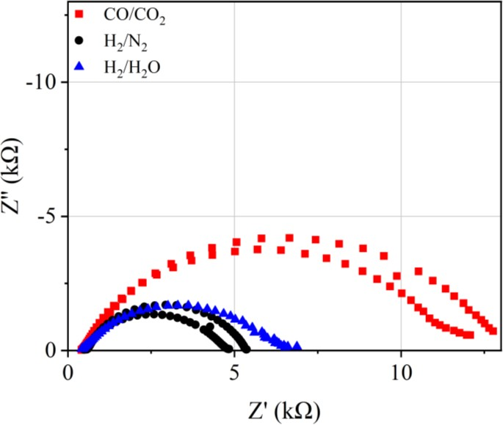
c)

Figure 4.3 – Nyquist plots for nickel pattern electrodes of a) 1 µm thickness, b) 300 nm thickness and c) 50 nm thickness. Gas atmospheres are 5%CO/50%CO2/Ar (red square), 3%H2O/10%H2/N2 (blue triangle) and 10%H2/N2 (black circle). All measurements at 800°C. Two repeats of the same test shown except for 50 nm electrodes in 3%H2O/10%H2/N2, for which only one sample was tested.

Each measurement in 5%CO/50%CO2/Ar, 3%H2O/10%H2/N2 and 10%H2/N2 gas atmospheres for electrodes of 1 µm, 300 nm and 50 nm pattern electrode thicknesses is presented in Figure
4.3. The variation between two similar repeats is observable and in some cases large – the two 1 µm electrode repeats in 3%H2O/10%H2/N2 atmosphere vary by a factor of 15 (Figure 4.3a), whilst 1 µm electrodes in 5%CO/50%CO2/Ar atmosphere (Figure 4.3a), and 300 nm electrodes in 10%H2/N2, vary by a factor of 1.6 (Figure 4.3b).

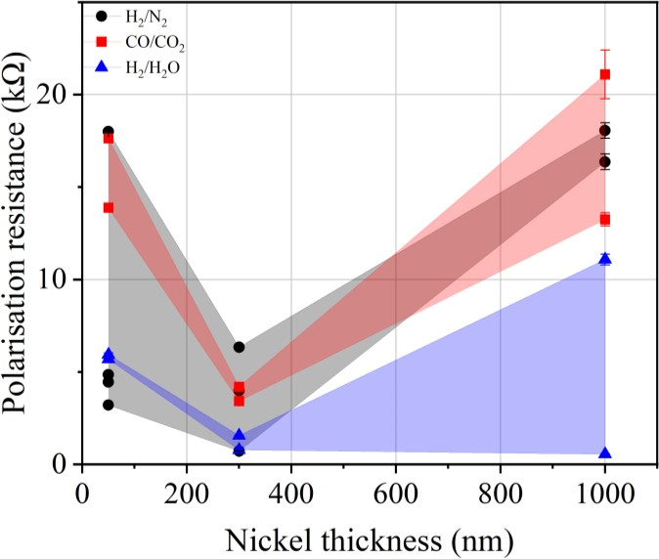
a)
b)

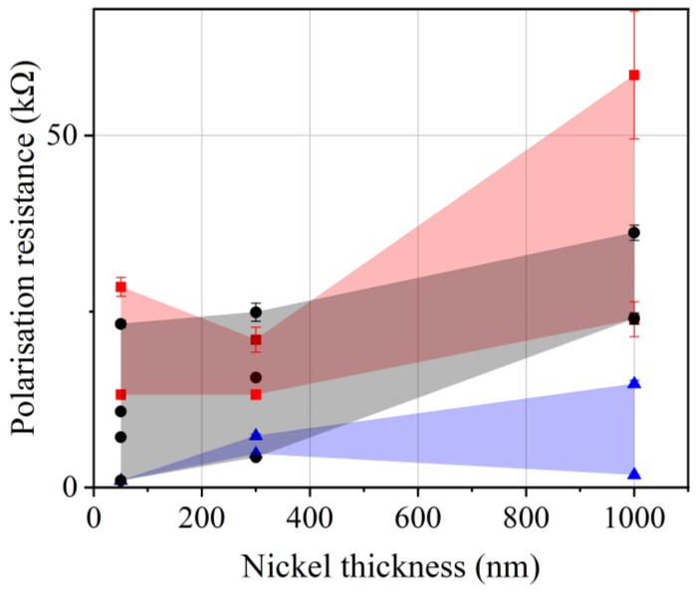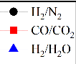Figure 4.3- Polarisation resistances plotted against nickel pattern electrode thickness for all measurements in 5%CO/50%CO2/Ar (red square), 3%H2O/10%H2/N2 (blue triangle) and 10%H2/N2 (black circle) gas atmospheres. Error bars show the error in fitting the data to an equivalent circuit (Figure 3.9). Measurements at a) 600°C and b) 800°C.

The equivalent circuit in Figure 3.9 was fit to all Nyquist plots for each measurement to obtain a polarisation resistance value, and an associated error in the fitting. The polarisation resistance value and error in the fitting is plotted in Figure 4.4 for all measurements in each gas atmosphere tested at 600°C and 800°C. The scattering of the data between similar repeats as observed in Figure 4.3 is also observable in Figure 4.4. The error in the fitting of the data to the equivalent circuit in Figure 3.9 does not account for the large scattering of the data, and it is apparent that there are other factors contributing to the error, as considered further in Chapter
5. The large scattering of the data for electrodes of the same thickness makes a comparison between each gas atmosphere difficult. The limited number of repeats also contributes to difficulty in drawing conclusions. Qualitatively, the limited data points show polarisation resistance at each thickness is generally lowest in 3%H2O/10%H2/N2, and higher for 5%CO/50%CO2/Ar and 10%H2/N2. Tentatively, a general trend of increasing polarisation resistance with increasing electrode thickness can be observed at 600°C, for each of the gas atmospheres (Figure 4.4a), whilst at 800°C there is a drop in polarisation resistance in all three gas atmospheres for 300 nm electrodes (Figure 4.4b). More testing is required to confirm this is an accurate representation.

Activation energy tests
4.3.2.1 10%H₂/N₂
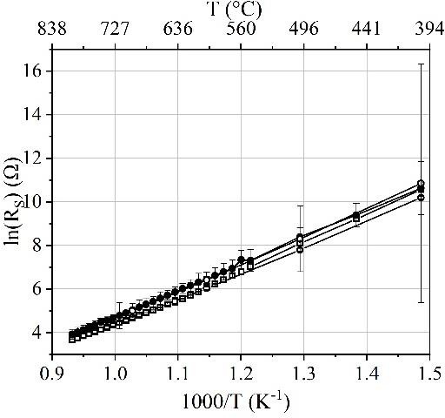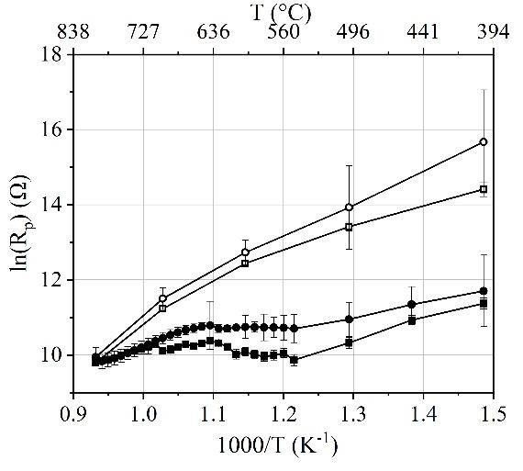a)
b)

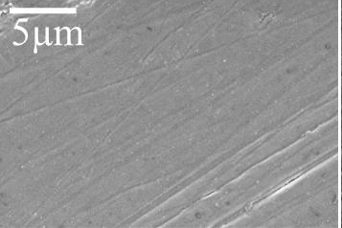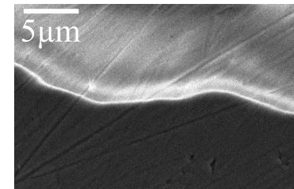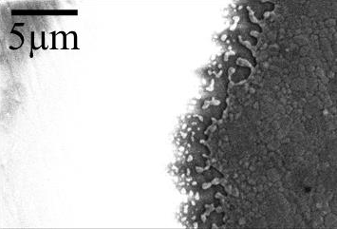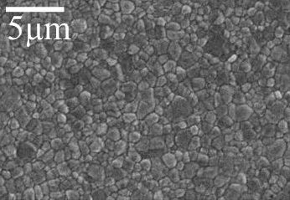
c)
d)
e)
f)

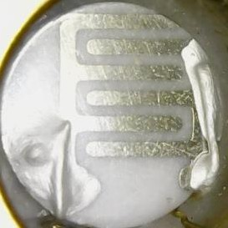
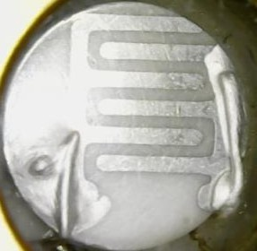
g) h)

Figure 4.5 – a,b) Graphs of resistance vs. temperature for 1 µm pattern electrodes heated in 10%H2/N2 atmosphere. a) polarisation resistance and b) ohmic resistance. Measurements were taken whilst heating (closed symbols) and whilst cooling (open symbols). Error bars show error in the fitting of the equivalent circuit (Figure 3.9) to the measured data. SEM images at 5000x magnification representative of electrode structures observed for both repeats. SEM images of

electrode bulk c) pre-testing d) post-testing and of electrode perimeter e) pre-testing and f) post- testing. Images of the electrodes g) pre-testing and h) post-testing are also presented.

Temperature ramp tests are commonly carried out in the literature to obtain activation energy values. Comparison of the activation energy between two nominally identical 1 µm electrodes heated in 10%H2/N2 atmosphere is presented in Figure 4.4. Activation energies were calculated using linear least squares fitting to the slopes of both the polarisation resistance plot (Figure 4.5a) and ohmic resistance plot (Figure 4.5b) during heating and cooling measurements. Resistance values were obtained from fitting Nyquist plots to the equivalent circuit in Figure
3.9. Error bars show the error in the fitting of each data point to the equivalent circuit. In polarisation resistance plots, at least two different activation energies are observed during heating (closed symbols), changing at approximately 640-660°C. The activation energies below this temperature are 13±3 and 31±3 kJ/mol. Above 640-660°C, activation energies increase to 35±4 and 54±6 kJ/mol. The two plots of polarisation resistance show relatively large resistances upon cooling (open symbols) and a significantly different slope. Activation energy becomes 75±11 and 99±10 kJ/mol for measurements taken during cooling. For the ohmic resistance (Figure 4.5b) activation energy is 98±1 and 101±1 kJ/mol whilst heating, and 98±1 and 99±2 kJ/mol when measurements were taken during cooling.

SEM images representing the electrode microstructure of both samples pre- and post-test are presented in Figure 4.5c-f. During heating, the structure crystallises, and grain boundaries can be observed across the sample whilst the perimeter increases in tortuosity. Images show the electrodes are visually unchanged after testing (Figure 4.5g and h). In Figure 4.5e showing both the nickel electrode and the YSZ, the nickel appears brighter because of the increased back- scattering coefficient of nickel compared to YSZ, resulting in more electrons reaching the detector from the nickel [128]. In Figure 4.5e the YSZ appears bright white whilst the nickel is grey owing to a charging effect in which the non-conductive YSZ becomes an electron trap and produces a strong, bright white signal [129].

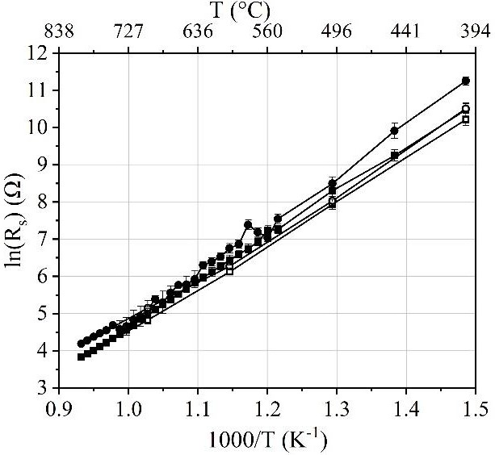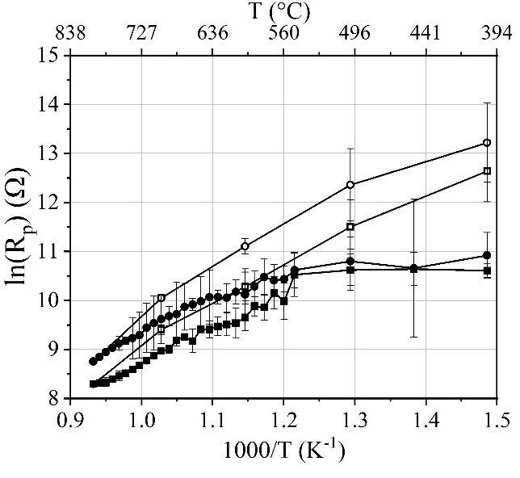
a)
b)
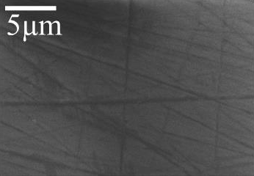
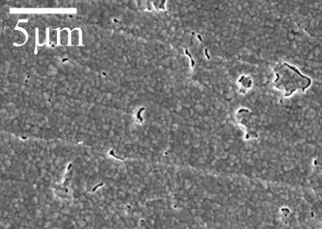
c) d)

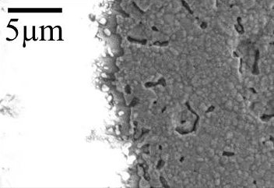
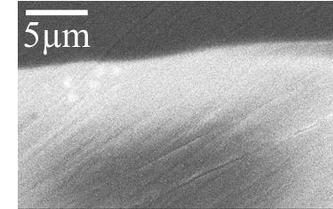
e)
f)

Figure 4.6 – a,b) Graphs of resistance vs. temperature for 300 nm pattern electrodes heated in 10%H2/N2 atmosphere. a) polarisation resistance and b) ohmic resistance. Measurements were taken whilst heating (closed symbols) and whilst cooling (open symbols). Error bars show error in the fitting of the equivalent circuit (Figure 3.9) to the measured data. SEM images at 5000x magnification representative of electrode structures observed for both repeats. SEM images of electrode bulk c) pre-testing d) post-testing, and of electrode perimeter e) pre-testing and f) post- testing.

Comparison of the activation energy between two nominally identical 300 nm electrodes heated in 10%H2/N2 atmosphere is shown in Figure 4.6. From the polarisation resistance plot (Figure 4.6a) activation energies whilst heating (closed symbols) are 32±4 and 49±6 kJ/mol, and 77±8 and 99±9 kJ/mol from measurements taken during cooling (open symbols). Similar

to the 1 µm electrodes, ohmic resistance was relatively unchanged between heating and cooling measurements, and activation energies were 101±1 and 106±3 kJ/mol from heating, and 97±2 and 87±4 kJ/mol from cooling measurements. Pre- and post-test SEM images (Figure 4.6c-f) show the nickel layer has crystallised and grain boundaries have formed during the heating process. Small holes have formed in parts of the structure, but the majority of the nickel remains connected. The perimeter of the electrode has increased in tortuosity during testing.

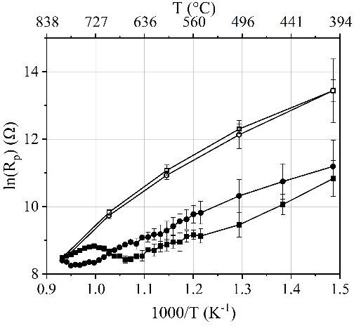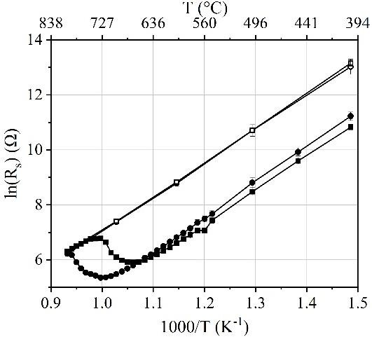
a)
b)

- d) e)
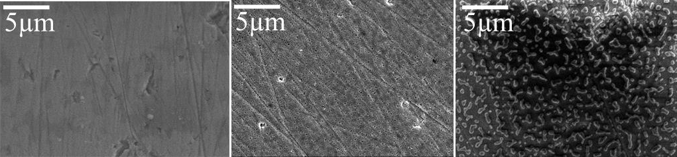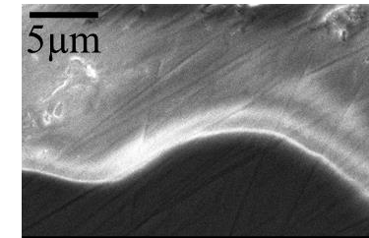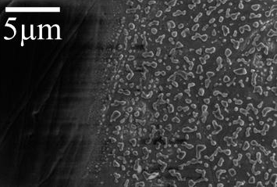
f)
g)

Figure 4.7 – a,b) Graphs of resistance vs. temperature for 50 nm pattern electrodes heated in 10%H2/N2 atmosphere. a) polarisation resistance and b) ohmic resistance. Measurements were taken whilst heating (closed symbols) and whilst cooling (open symbols). Error bars show error in the fitting of the equivalent circuit ( Figure 3.9) to the measured data. SEM images at 5000x magnification representative of electrode structures observed for both repeats. SEM images of

electrode bulk c) pre-testing, d) sample heated to 600°C and cooled, e) post-testing, and of electrode perimeter f) pre-testing and g) post-testing.

Comparison of the activation energy between two nominally identical 50 nm electrodes heated in 10%H2/N2 atmosphere is shown in Figure 4.7. From the polarisation resistance plot (Figure 4.7a) activation energies whilst heating (closed symbols) are 29±4 and 54±3 kJ/mol. A peak in resistance is observed in both the polarisation resistance and ohmic resistances starting between 670°C and 790°C. The two plots of polarisation resistance show relatively large resistances upon cooling (open symbols) and activation energies are 97±7 and 88±7 kJ/mol. From the ohmic resistance measurements whilst heating, activation energies are 52±10 and 81±8 kJ/mol whilst the activation energies from cooling measurements are 102±1 and 101±1 kJ/mol. SEM images of the electrode structure are presented in Figure 4.7c-g. In addition to pre- and post- test analysis, a sample was heated to 600°C (Figure 4.7d), with electrochemical measurements and then immediately cooled after the impedance measurement at 600°C was complete. This sample can be seen to develop small holes across the previously dense electrode structure. The post-test SEM image (Figure 4.7e) shows that the 50 nm film has dewet into isolated nano- islands, and the electrode structure has suffered a loss of nickel percolation pathway. Given the loss of percolation taking place between 600-800°C, it is assumed to correlate with the peak in resistance at 670-790°C, as the active TPB length is shortened by a reduction in contact with the silver current collector.

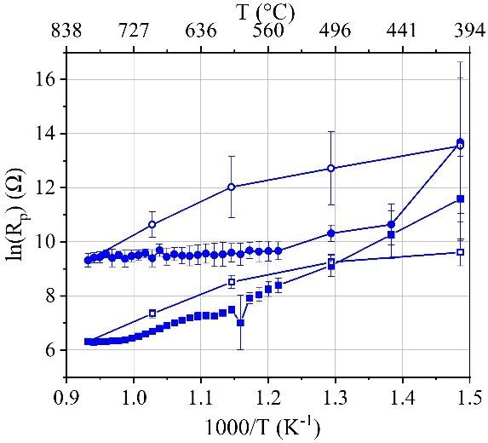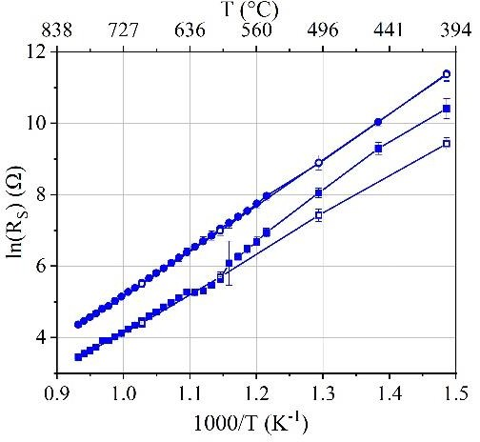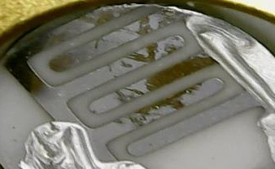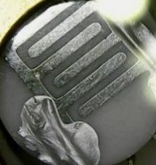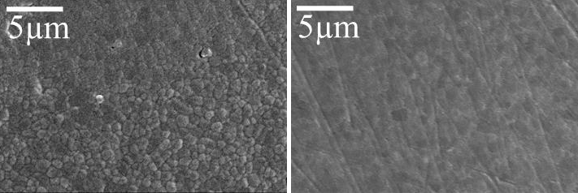4.3.2.2 3%H₂O/10%H₂/N₂
a)
b)
c)
d)
e)
f)

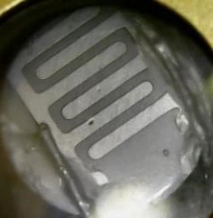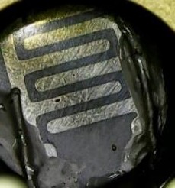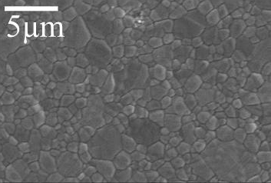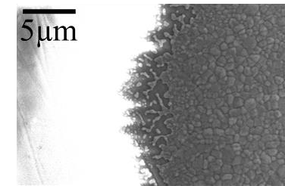
g)
h)
i)
j)
Figure 4.8 - a,b) Graphs of resistance vs. temperature for 1 µm pattern electrodes heated in 3%H2O/10%H2/N2 atmosphere. a) polarisation resistance and b) ohmic resistance. Measurements were taken whilst heating (closed symbols) and whilst cooling (open symbols). Images of the electrodes pre-testing are shown in c) and g) and post-testing in d) and h). Error bars show error in the fitting of the equivalent circuit (Figure 3.9) to the measured data. SEM images at 5000x magnification post-test presented in e), f), i) and j). c-f) correspond with the circle plotted points, whilst g-i) correspond to the square plotted points. j) SEM image of electrode perimeter post- testing is representative of both samples.

Comparison of the activation energy between two nominally identical samples in 3%H2O/10%H2/N2 atmosphere is shown in Figure 4.8. For 1µm samples, considerable variation in polarisation resistance between the two repeats was observed. Although some measurements had large errors in fitting the data to the equivalent circuit, especially when

measurements were taken during cooling, the fluctuation in the data appears to be significantly larger than the fitting error. Activation energies calculated from polarisation resistance plotted during heating are 58±3 kJ/mol and 12±2 kJ/mol. From measurements taken during cooling, activation energies are 85±12 kJ/mol and 65±9 kJ/mol. The peak in resistance observed for 1 µm electrodes heated in 10%H2/N2 atmosphere at 640-660°C is not seen here. Similarly, to the 1 µm and 300 nm electrodes heated in 10%H2/N2 atmosphere, ohmic resistance plots show little variation between heating and cooling measurements. Activation energies calculated from measurements during heating are 105±1 and 98±3 kJ/mol, whilst those calculated from measurements during cooling are 105±1 and 90±1 kJ/mol. Images of electrodes pre- and post- testing are presented in Figure 4.8 c-j. One of the electrodes (corresponding with the circle plotted points in Figure 4.8a and b) can be seen to have discoloured in areas after testing. From SEM images (Figure 4.8e and f), this corresponded to a microstructure which had flattened grain boundaries in the discoloured areas.

The second sample (corresponding with the square plotted points in Figure 4.8a and b), did not change visually with testing and the microstructure consisted of defined grain boundaries throughout, as shown in Figure 4.8i. The perimeter increased in tortuosity post-test for both samples (Figure 4.8 j).

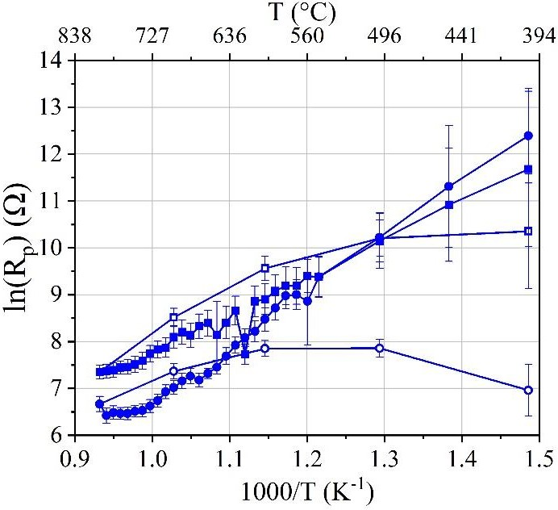
a)
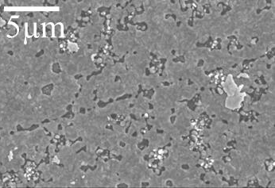
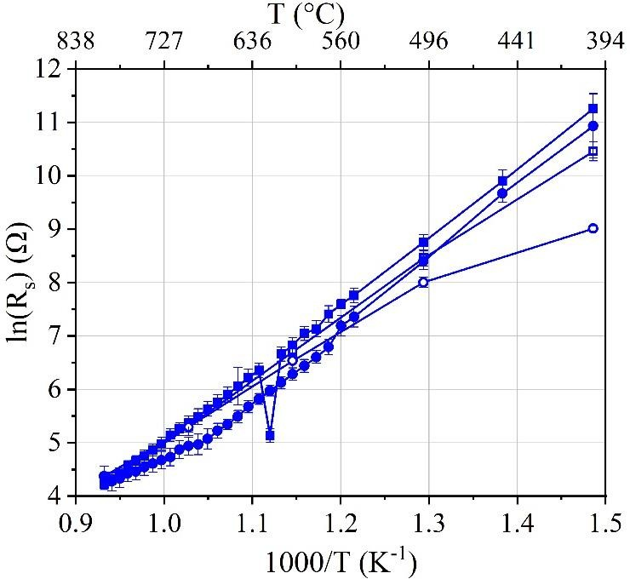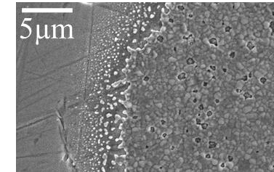c)
b)
d)
f)

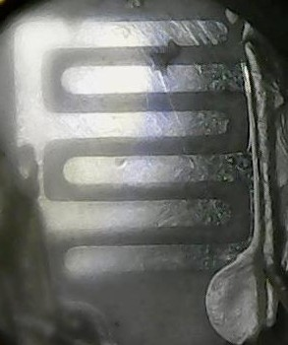
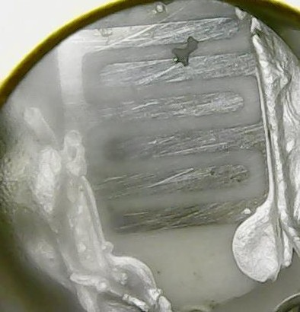
e)

Figure 4.9 – a, b) Graphs of resistance vs. temperature for 300 nm pattern electrodes heated in 3%H2O/10%H2/N2 atmosphere. a) polarisation resistance and b) ohmic resistance. Measurements were taken whilst heating (closed symbols) and whilst cooling (open symbols). Error bars show error in the fitting of the equivalent circuit (Figure 3.9) to the measured data. Post-test SEM images at 5000x magnification are representative of electrode structures observed for both repeats c) of the electrode bulk and d) of the electrode perimeter. Images of the electrode are also presented e) pre-testing and f) post-testing.

Comparison of the activation energy between two nominally identical 300 nm electrodes was carried out in 3%H2O/10%H2/N2 atmosphere (Figure 4.9). From the polarisation resistance plot (Figure 4.9a), activation energies whilst heating (closed symbols) are 60±4 kJ/mol and 83±4 kJ/mol. Activation energies from cooling measurements were 70±1 kJ/mol and 21±1 kJ/mol.

Ohmic resistance plots show a relatively small difference between heating and cooling measurements. Activation energies from measurements taken whilst heating are 103±4 kJ/mol and 98±3 kJ/mol, whilst from cooling measurements, are 95±1 kJ/mol and 65±6 kJ/mol. Post- test SEM images show the formation of holes in the film (Figure 4.9c), whilst the perimeter has increased in tortuosity (Figure 4.9d). No visual changes in electrode structure were observed (Figure 4.9e and f).
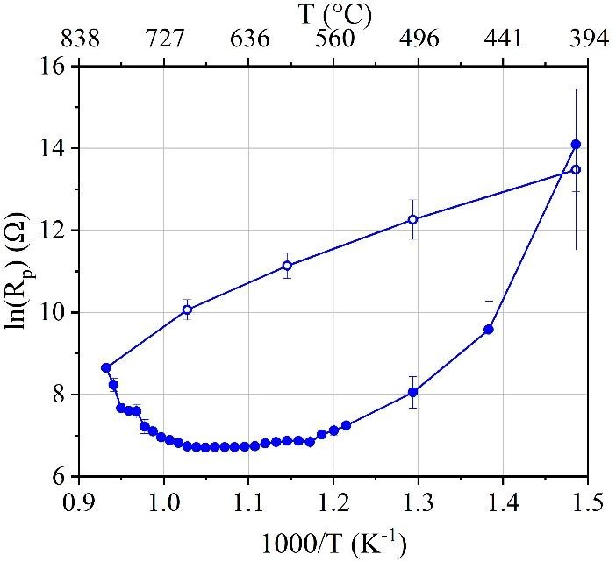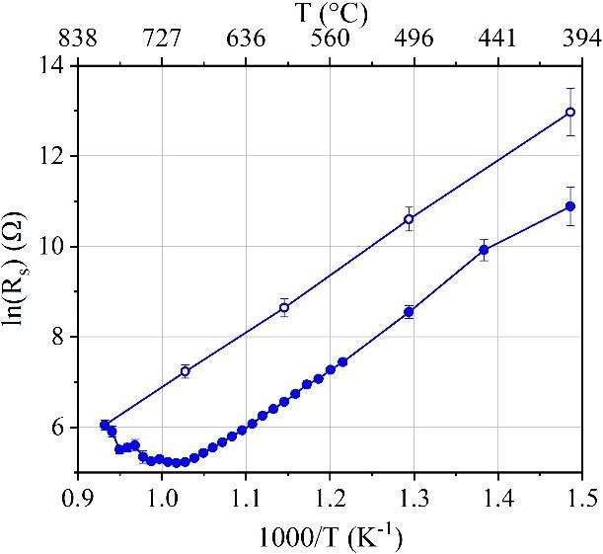
a)
b)
c)
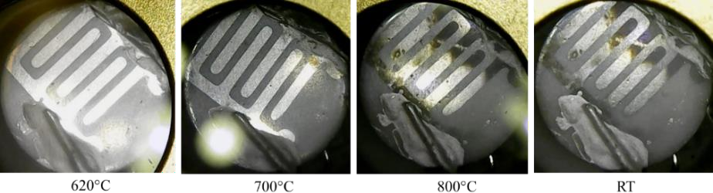
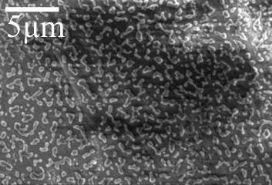
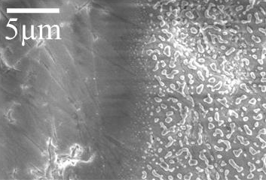
- e)

Figure 4.10 – a,b) Graphs of resistance vs. temperature for a 50 nm pattern electrode heated in 3%H2O/10%H2/N2 atmosphere. a) polarisation resistance and b) ohmic resistance. Error bars show error in the fitting of the equivalent circuit (Figure 3.9) to the measured data. Measurements were taken whilst heating (closed symbols) and whilst cooling (open symbols). c) Images of the electrode during the activation energy test with temperatures indicated below. d) SEM image at 5000x magnification showing electrode bulk post-test and e) electrode perimeter post-test.

Only one data set was attained for a 50 nm electrode heated in 3%H2O/10%H2/N2 atmosphere. The difference between heating and cooling values is large, similar to 50 nm electrodes in 10%H2/N2. From the plot of polarisation resistance (Figure 4.10a), activation energy is 55±7 kJ/mol when heating (closed symbols) and 89±9 kJ/mol when cooling (open symbols). From the ohmic resistance plot (Figure 4.10b), the activation energy from heating measurements is 82±3 kJ/mol and from cooling measurements is 103±2 kJ/mol. As was observed for 50 nm electrodes heated in 10%H2/N2, there is a peak in resistance starting at 710°C for both polarisation and ohmic resistance. Images of the electrode during the measurements are presented (Figure 4.10c) and show the electrode becoming dull in areas between 700°C and 800°C. Post-test SEM imaging (Figure 4.10d and e) shows the electrode structure has dewet into isolated nano-islands as was observed in 10%H2/N2, and there is a loss of percolating pathway across the entire electrode structure.
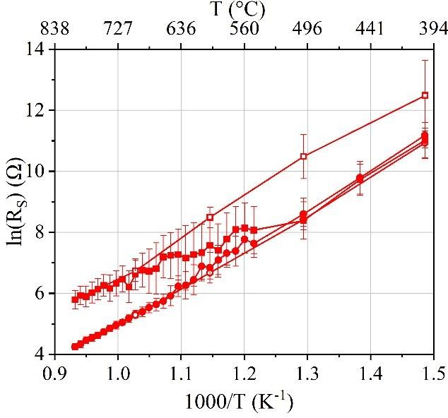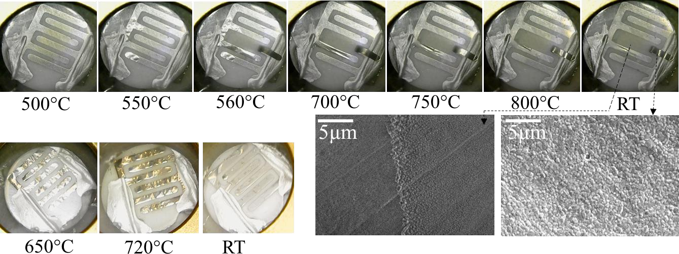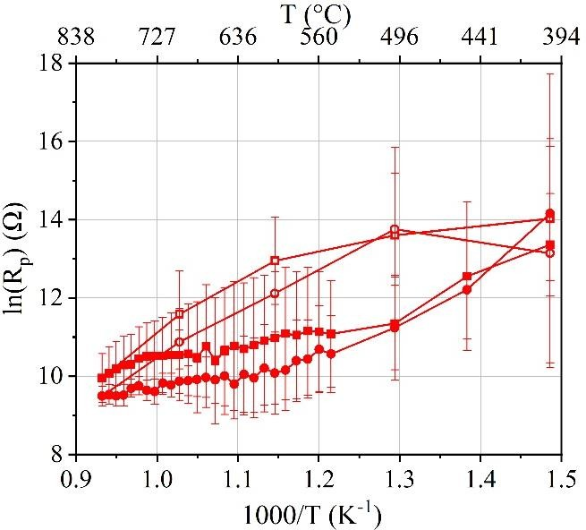4.3.2.3 5%CO/50%CO₂/Ar
b)
c)
d)
a)

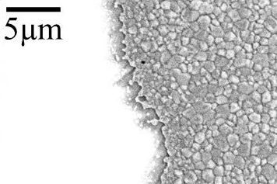
e)

Figure 4.11 – a,b) Graphs of resistance vs. temperature for 1 µm pattern electrodes heated in 5%CO/50%CO2/Ar atmosphere. a) polarisation resistance and b) ohmic resistance. Measurements were taken whilst heating (closed symbols) and whilst cooling (open symbols). c,d) Images of the electrode during the activation energy test, with temperature indicated below. Post- test SEM images of different parts of the electrode and electrolyte as indicated by arrows c) corresponds to circle plotted points, whilst d) corresponds to square plotted points. Error bars show error in the fitting of the equivalent circuit (Figure 3.9) to the measured data. e) SEM image at 5000x magnification showing electrode perimeter post-test, representative of both samples.

Comparison of the activation energy between two repeats was also carried out in 5%CO/50%CO2/Ar atmosphere. The error in fitting the data to the equivalent circuit in Figure
3.9 is relatively high compared to the data fit for 1µm electrodes in 3%H2O/10%H2/N2 and 10%H2/N2 atmospheres. Activation energies from polarisation resistance plots (Figure 4.11a) calculated from heating measurements are 39±3 kJ/mol and 38±4 kJ/mol. From cooling measurements, activation energies are 90±17 kJ/mol and 98±6 kJ/mol. There is little variation between heating and cooling measurements for plots of ohmic resistance (Figure 4.11b). Activation energies from heating measurements are 104±1 kJ/mol and 77±8 kJ/mol, whilst energies from cooling measurements are 100±2 kJ/mol and 105±1 kJ/mol.

During heating, the 1 µm electrodes were observed to change visually (Figure 4.11c and d). The nickel electrode on both samples appeared to develop bubbles underneath and peel. One sample (Figure 4.11c) formed bubbles at the bottom nickel stripe of the right electrode, and at the left electrode around the current collector at 550°C. By 560°C, the bubbling spread towards the middle of the sample, resulting in the middle nickel stripe of the right electrode peeling off the YSZ electrolyte completely, and folding backwards. By 700°C the metal appeared to relax back down, flattening out almost completely by 800°C, and at room temperature, with the exception of the peeled back section. Post-test SEM images (Figure 4.11c) from the underside of the peeled electrode show a crystallised structure, with pronounced grain boundaries, which was the same as the structure of the parts of the electrode lying flat with the electrolyte. Images of the electrolyte where the electrode was previously, show a perimeter of metal grains

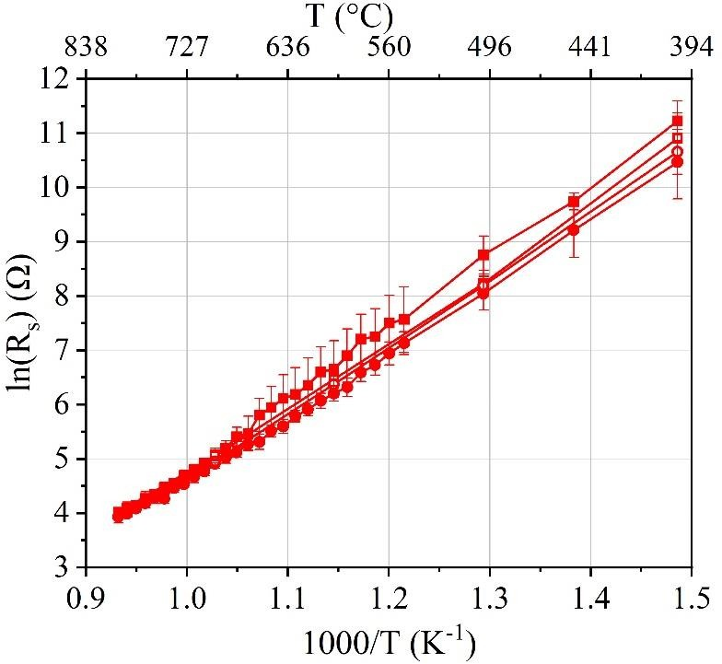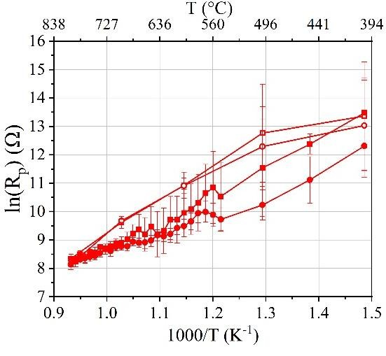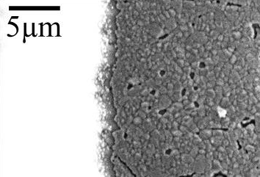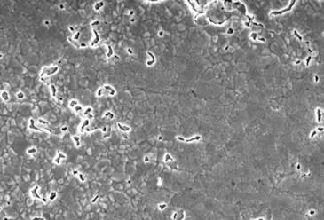indicating that some metal was left behind. The nickel electrode on the second sample (Figure 4.11d) appeared to bubble up from the YSZ electrolyte over the entire electrode, as opposed to the isolated bubbles observed in Figure 4.11c. Once cooled, the structure had flattened back again as was observed for the electrode in Figure 4.11c, and the microstructure was crystallised with well-defined grain boundaries. The perimeter of the electrodes increased in tortuosity during testing (Figure 4.11e)
a)
b)
c)
5µm
d)

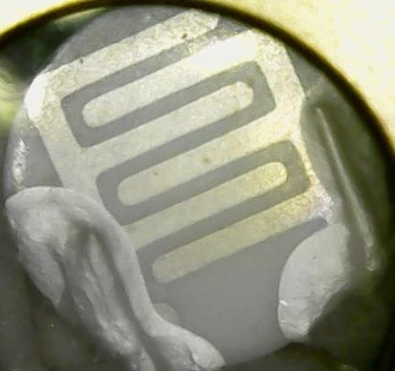
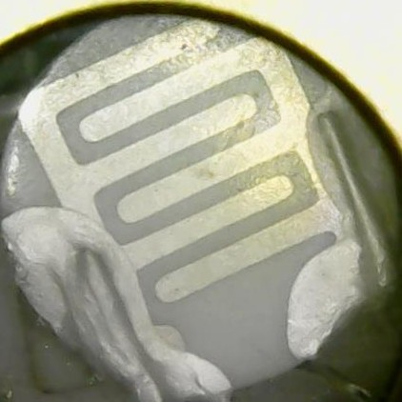
- f)

Figure 4.12 – a,b) Graphs of resistance vs. temperature for 300 nm pattern electrodes heated in 5%CO/50%CO2/Ar atmosphere. a) polarisation resistance and b) ohmic resistance. Measurements were taken whilst heating (closed symbols) and whilst cooling (open symbols). Error bars show error in the fitting of the equivalent circuit (Figure 3.9) to the measured data.

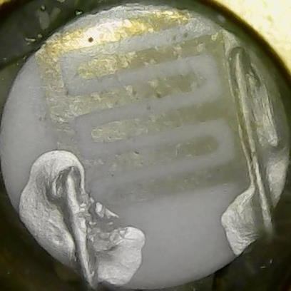
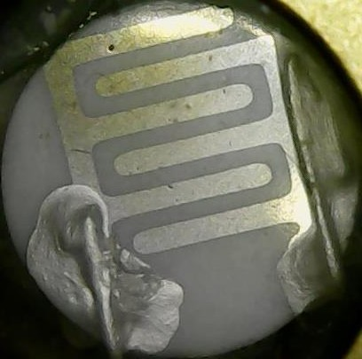

SEM images at 5000x magnification c) electrode bulk and d) electrode perimeter, representative of both repeats. Images of the electrode e) pre-testing and f) post-testing.

Comparison of the activation energy between two nominally identical 300 nm electrodes heated in 5%CO/50%CO2/Ar atmosphere is shown in Figure 4.12. From the polarisation resistance plot (Figure 4.12a) activation energies whilst heating (closed symbols) are 71±3 kJ/mol and 48±2 kJ/mol. Activation energies from measurements taken during cooling are 99±8 kJ/mol and 100±2 kJ/mol. Ohmic resistance measurements show little variation between measurements taken whilst heating and cooling, and activation energies from measurements taken whilst heating are 93±1 kJ/mol and 107±1 kJ/mol, whilst from cooling measurements activation energies are 98±3 kJ/mol and100±2 kJ/mol. Post-test SEM images (Figure 4.12c and d), show the formation of small holes in the film, and an increase in tortuosity at the perimeter. No visual changes in electrode structure were observed (Figure 4.12e and f).
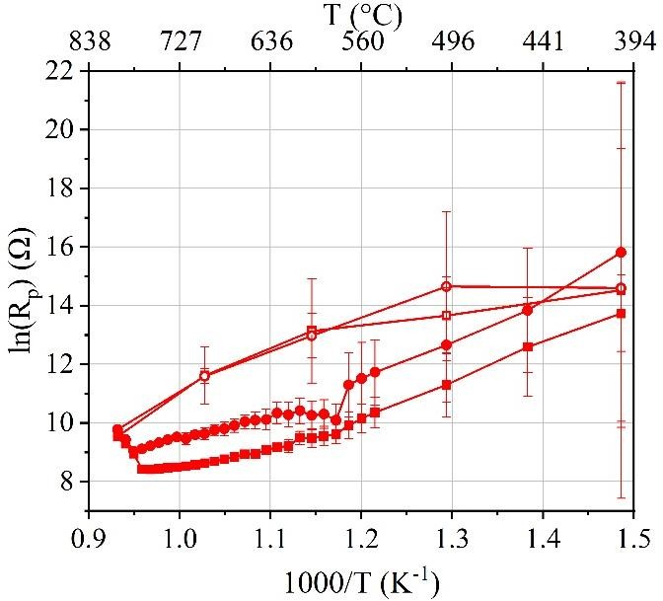
a)
c)

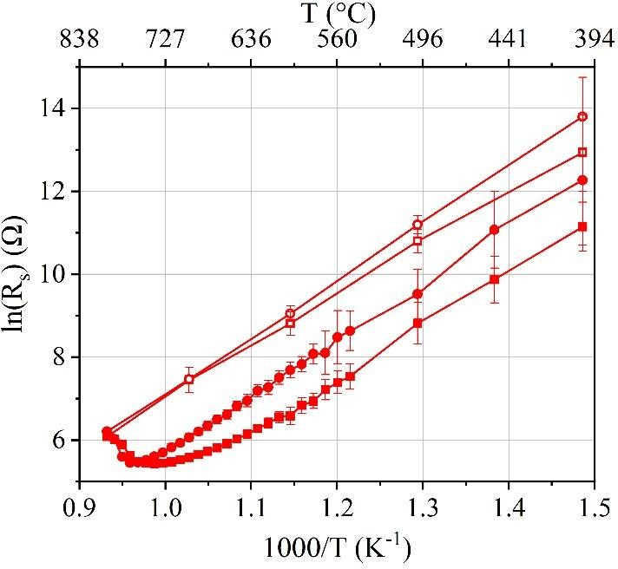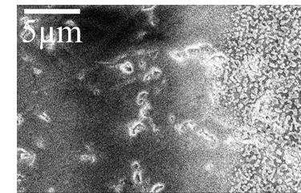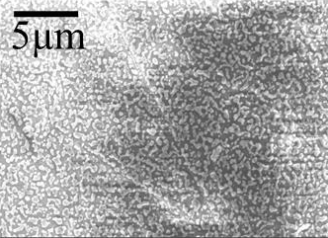e) f)
b)
d)

Figure 4.13– a,b) Graphs of resistance vs. temperature for 50 nm pattern electrodes heated in 5%CO/50%CO2/Ar atmosphere. a) polarisation resistance and b) ohmic resistance. Measurements were taken whilst heating (closed symbols) and whilst cooling (open symbols). Error bars show error in the fitting of the equivalent circuit to the measured data. SEM image at 5000x magnification of c) electrode bulk and d) electrode perimeter, representative of both samples. Images of the electrode e) pre-testing and f) post-testing.

50 nm electrodes heated in 5%CO/50%CO2/Ar atmosphere resulted in activation energies from plots of polarisation resistance whilst heating (Figure 4.13a – closed symbols) of 101±1 kJ/mol and 79±5 kJ/mol. Activation energies from polarisation resistance measurements during cooling are 97±7 kJ/mol and 88±7 kJ/mol. From the ohmic resistance plot (Figure 4.13b), the activation energies from heating measurements are 104±2 kJ/mol and 80±5 kJ/mol. From cooling measurements, the activation energies are 101±1 kJ/mol and 102±1 kJ/mol. As was observed for 50 nm electrodes heated in 10%H2/N2 and 3%H2O/10%H2/N2, there is also a peak in resistance at 770°C for both polarisation and ohmic resistance. Images of the electrode are presented (Figure 4.13e and f) and show the electrode has become dull after testing. The microstructure of the electrode post-test (Figure 4.13c and d) has dewet into isolated nano- islands.
4.3.2.4 Single crystal YSZ substrate
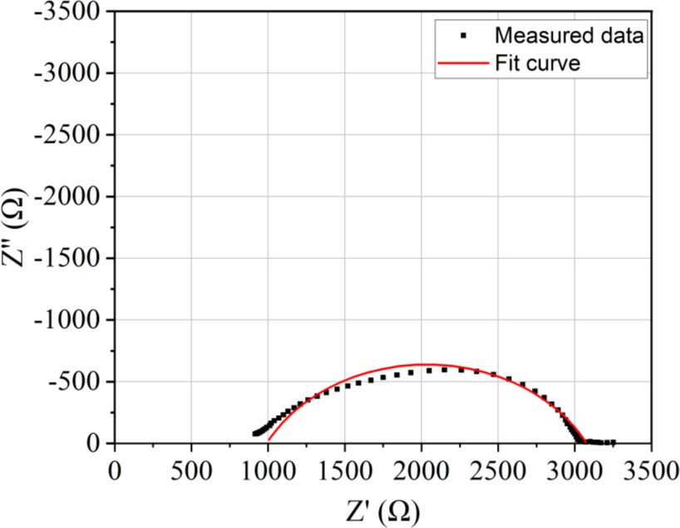
Figure 4.14 –Nyquist plots showing the impedance data and the equivalent circuit fit (Figure 3.9) for a 50 nm nickel electrode on YSZ (100) single crystal in 10%H2/N2 at 800°C.

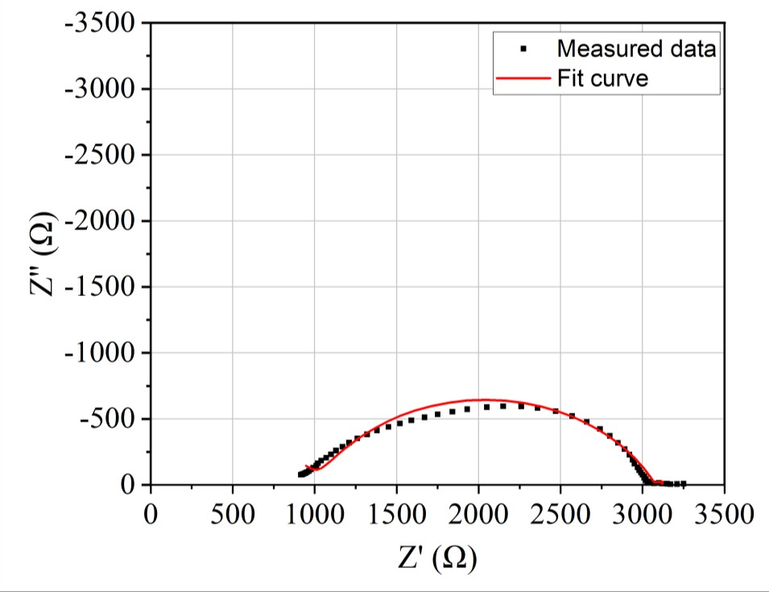

Figure 4.15–Nyquist plots showing the impedance data fit and equivalent circuit fit for a 50 nm nickel electrode on YSZ (100) single crystal in 10%H2/N2 at 800°C.

Figure 4.14 shows a Nyquist plot obtained for a 50 nm nickel pattern electrodes on single crystal YSZ at 800°C. The same equivalent circuit (Figure 3.9) was fit to single crystal data as for the electrode prepared on polycrystalline YSZ. The equivalent circuit appeared to have more error in the fitting for single crystal YSZ, although more repeats are required to confirm this. The quality of the equivalent circuit fit to the experimental data was poor, particularly at high and low frequencies. As described earlier in this chapter, a more complicated model - L1*Q1+Q2*R2+Q3*R3+Q4*R4 – changed the fitting of the data at high and low frequencies, as shown in Figure 4.15 and therefore the equivalent circuit used to fit the data for single crystal substrates (Figure 3.9) is likely an oversimplification. There is no clear equivalent circuit which accounts for all the data ideally, and a wide range of equivalent circuits are used in similar studies in the literature. The error in fitting all data to the equivalent circuit (Figure 3.9) was used to plot the error bars below.

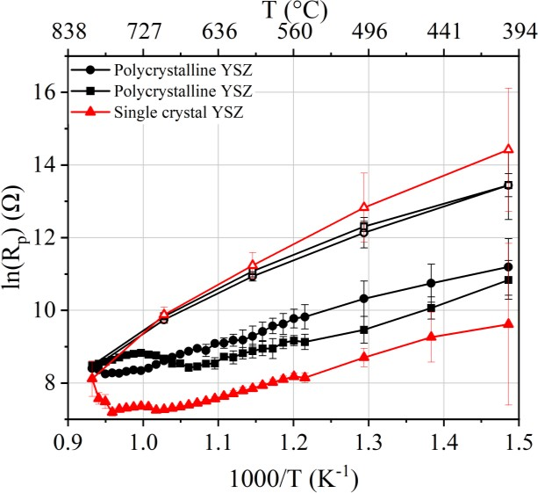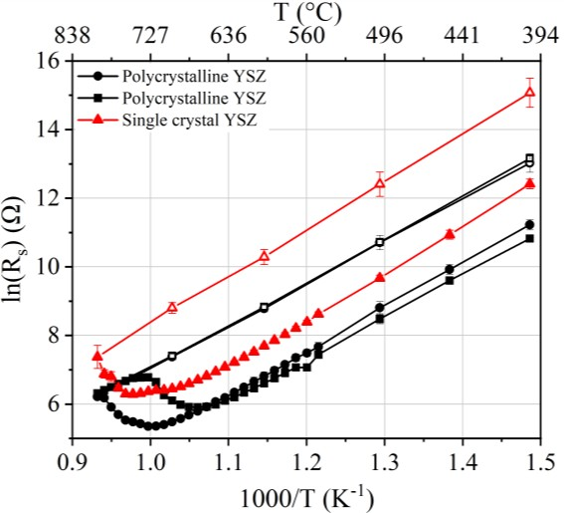
a)
b)
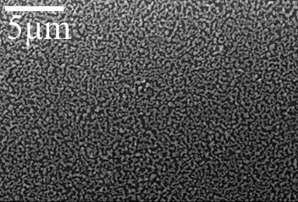
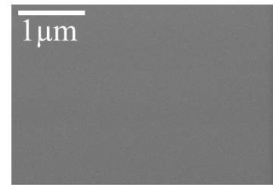
c) d)
e) f)
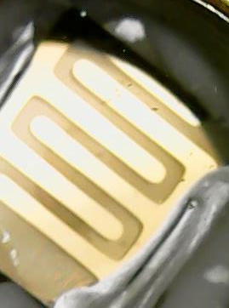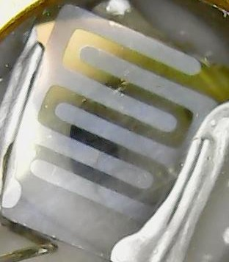
Figure 4.16 – Graphs of resistance vs. temperature for 50 nm pattern electrodes on polycrystalline YSZ and on YSZ (100) single crystal, heated in 10%H2/N2 atmosphere. a) polarisation resistance and b) ohmic resistance. Measurements were taken whilst heating (closed symbols) and whilst cooling (open symbols). Error bars show error in the fitting of the equivalent circuit (Figure 3.9) to the measured data. SEM images represent the structure of the electrode on single crystal c) pre-heating at 80 000x magnification and d) post-test at 5000x magnification. Images of the samples are also presented e) pre-testing and f) post-testing.

Compared to activation energy tests performed on the analogous samples fabricated with polycrystalline YSZ pellets, a sample fabricated on single crystal YSZ (100) showed lower polarisation resistances during heating measurements for which the activation energy was 41±5

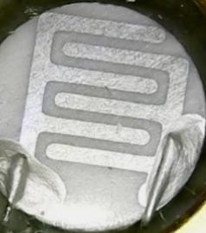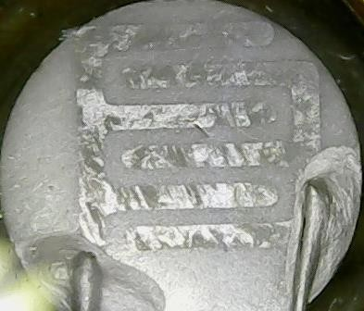

kJ/mol (Figure 4.16a). The error of fitting the equivalent circuit (Figure 3.9) to the data was higher for the electrode on single crystal than for the electrodes on polycrystalline YSZ at lower temperatures. Cooling measurements were considerably larger than heating measurements, as was observed for electrodes on polycrystalline YSZ. The activation energy calculated from measurements taken whilst cooling is 97±3 kJ/mol. The ohmic resistance plot (Figure 4.16b) also shows a similar trend to the polycrystalline samples, with activation energy from heating measurements calculated to be 84±2 kJ/mol and 114±6 kJ/mol from cooling measurements. Similarly, to each of the 50 nm samples heated on polycrystalline YSZ in the various atmospheres, the 50 nm electrode on single crystal YSZ (100) also peaks in ohmic and polarisation resistance around the same temperature – at 770°C. Post-test SEM image (Figure 4.16d) shows that the previously dense, smooth surface (Figure 4.16c), has dewet into a partially connected network.

Constant temperature tests
4.3.3.1 10%H₂/N₂
b)
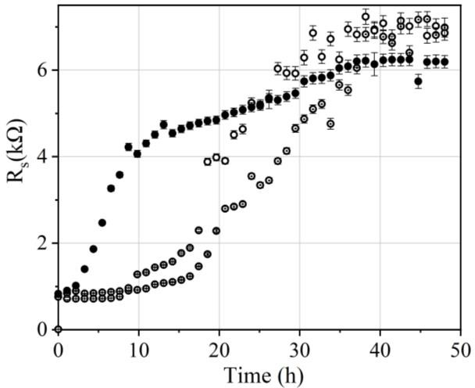
a)
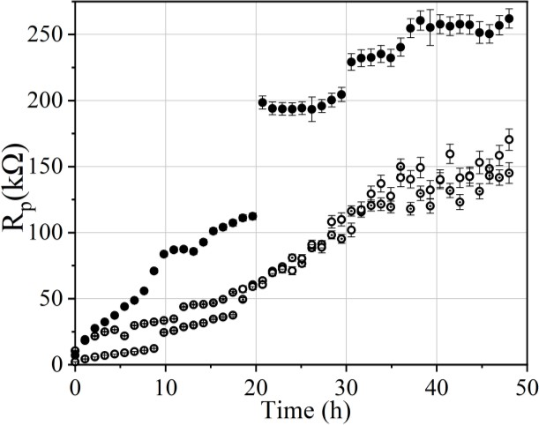
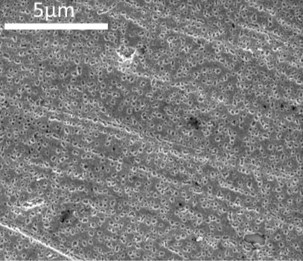
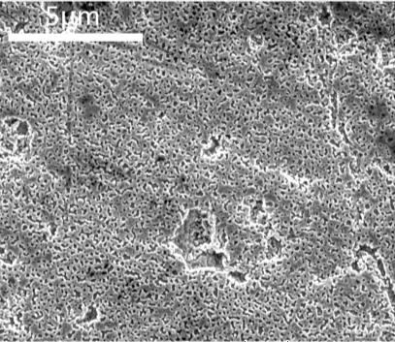
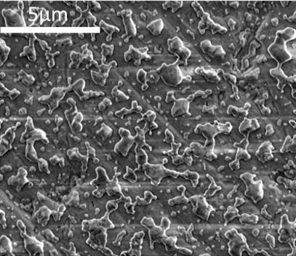
c) d) e)
f) g)

Figure 4.17 – Graphs of resistance vs. time for 50 nm pattern electrodes on YSZ pellets at 600°C in 10%H2/N2 atmosphere. a) polarisation resistance and b) ohmic resistance. The three symbol types represent three repeats. Error bars show the error in the fitting of the equivalent circuit (Figure 3.9) to the measured data and the sample placement error. SEM images at 20 000x magnification show the electrode structure after heating at 600°C for c) 3.5 minutes, d) 13 hours and d) post-test after 48 hours. Images of one of the electrodes f) pre-testing and g) post-testing are representative of all samples tested.

50 nm electrodes were heated to 600°C for 48 hours in 10%H2/N2 (Figure 4.17). Data scatter between repeats is large, with polarisation resistance varying after 48 hours by approximately 100 kΩ between repeats. The error bars in Figure 4.17 represent a total error in polarisation and ohmic resistance as calculated according to Section 3.4.3. The error bars therefore account for fluctuation in electrode placement between repeats in addition to the error of fitting each point to the equivalent circuit (Figure 3.9).

The considerable data scatter in shown in Figure 4.17 does not appear to be accounted for by the error bars and therefore is likely to be caused by additional factors than the error in the placement of electrodes within the crucible and the error in fitting data to equivalent circuit (Figure 3.9). Ohmic resistance over time can be categorised into three stages (Figure 4.17b). The initial stage is a period of relative stability in resistance which lasts between 1 and 16 hours. To understand how the microstructure of the film was affected during this stage, an additional sample was heated to 600°C, an impedance measurement was taken (lasting approximately 3.5 minutes) and the sample was cooled. The resultant structure can be seen in Figure 4.17c, and shows the film with small holes covering the electrode surface, but still intact with no visible loss of percolation pathway. Another sample was heated to 600°C and held at this temperature, taking impedance measurements every hour for 13 hours before cooling. The microstructure of this sample can be seen in Figure 4.17d, which shows the small holes have increased in size, but that the film remains connected without significant loss to the percolation pathway. After 1 to 16 hours, a second stage can be observed in the ohmic resistance, in which resistance increases rapidly over a maximum of 20 hours. Between hour 30 and 40 at 600°C, all three samples enter a third stage of a plateaued resistance. The microstructures of the samples after testing are represented by Figure 4.17e, in which the nickel film has dewet on the YSZ surface to form separated nickel nano-islands and the thin film has suffered a loss of percolation. Images of the electrode show that the samples became dull in areas after testing.

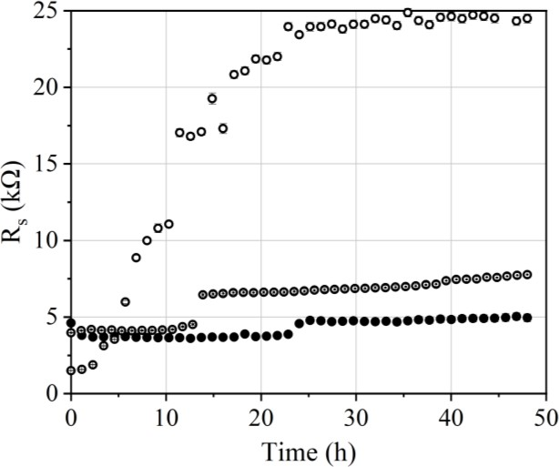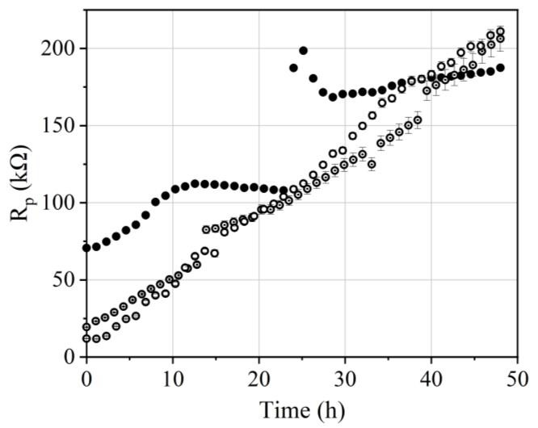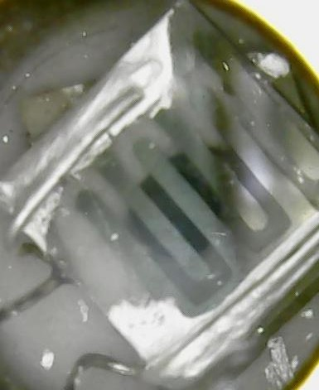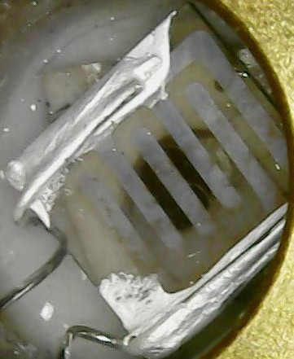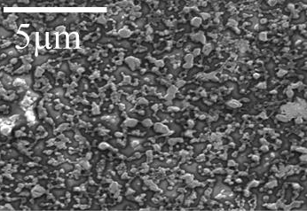These three stages in ohmic resistance over time, were harder to discern from polarisation resistance plots (Figure 4.17a). The initial stage of relatively stability was not observed, with polarisation resistance increasing over time.
a)
b)
c)
d)
e)

Figure 4.18 – Graphs of resistance vs. time for 50 nm pattern electrodes on YSZ single crystal
(100) at 600°C in 10%H2/N2 atmosphere. a) polarisation resistance and b) ohmic resistance. Three symbol types represent three repeats. Error bars show the error in the fitting of the equivalent circuit (Figure 3.9) to the measured data and the sample placement error. Images of the electrode
c) pre-testing and d) post-testing are presented. e) Post-test SEM image at 20 000x magnification representative of all samples tested.

Longer term testing at 600°C was also carried out for 50 nm electrodes on single crystal YSZ
(100) in 10%H2/N2 (Figure 4.18). A considerable data scatter is observable in the ohmic resistance plot over time (Figure 4.18b), with the largest and smallest resistances after 48 hours of testing differing by a factor of 6. The error bars plotted represent the error in fitting the data to an equivalent circuit in addition to the error in electrode placement (Section 3.4.3). It should be noted that error bars were plotted for all data points in Figure 4.18, although for many data points the error bars are too small to be visible compared to the large resistance values. The

three stages in ohmic resistance over time observed with YSZ pellets, are also observed in the ohmic resistance on single crystal. The initial incubation period lasts between 1 and 22 hours, which is longer than the maximum of 16 hours observed on polycrystalline pellets. The second stage of increasing resistance is considerably shorter than the maximum of 20 hours observed for polycrystalline YSZ pellets, taking 1 hour (dot symbol) and 2 hours (closed symbol) for two of the repeats, but 17 hours for the third (open symbol). A third stage of plateaued ohmic resistance is observed for each repeat. Two of the three repeats had an approximately linearly increasing polarisation resistance, as observed for polycrystalline YSZ pellets. (Figure 4.18a). The third repeat (closed symbols) increased at a relatively slow rate, then experienced a large spike in resistance around 25 hours before proceeding to increase more gradually again until the end of the testing.
4.3.3.2 3%H₂O/10%H₂/N₂
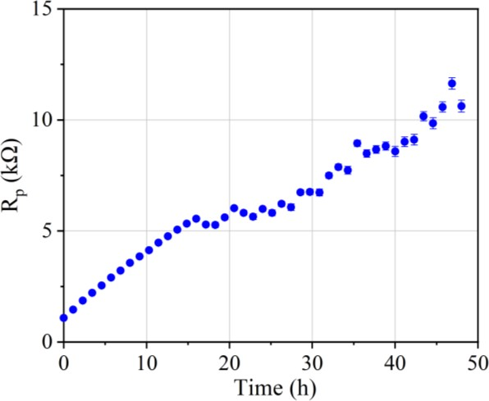
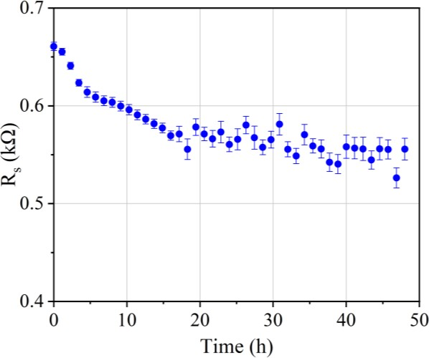
a) b)

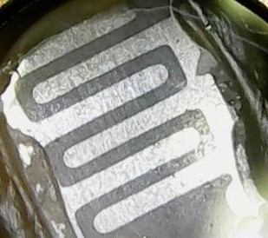
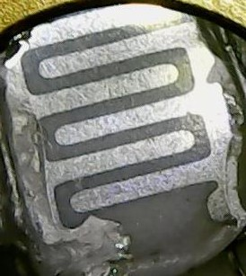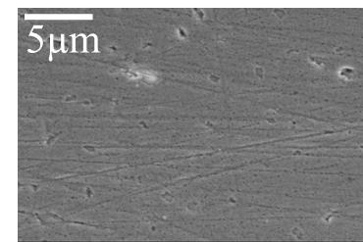c) d) e)
Figure 4.19 –Graphs of resistance vs. time for a 50 nm pattern electrode on a YSZ pellet at 600°C in 3%H2O/10%H2/N2 atmosphere. a) polarisation resistance and b) ohmic resistance. Error bars show the error in the fitting of the equivalent circuit (Figure 3.9) to the measured data and the sample placement error. Images of the electrode c) pre-testing and d) post-testing are presented.
e) Post-test SEM image at 5000x magnification.

A longer-term test was also carried out using a 50 nm electrode on a polycrystalline YSZ pellet at 600°C in 3%H2O/10%H2/N2 atmosphere (Figure 4.19). Only one sample was tested. In contrast to the stages of increasing ohmic resistance observed for 50 nm electrodes heated in 10%H2/N2 on both polycrystalline YSZ pellets and single crystal YSZ (100) (Figures 4.17 and 4.18), the ohmic resistance in 3%H2O/10%H2/N2 decreases over time (Figure 4.19b). Similarly, to the general trend in polarisation resistance observed for polycrystalline and single crystal YSZ samples in 10%H2/N2, the polarisation resistance increased approximately linearly over time for the 3%H2O/10%H2/N2 sample (Figure 4.19a). The error bars plotted represent the error in fitting the data to an equivalent circuit in addition to the error in electrode placement (Section 3.4.3). Post-test analysis of the electrode microstructure revealed a structure with small holes throughout and some more irregular larger holes. In contrast to the 50 nm electrode on polycrystalline YSZ in 10%H2/N2 (Figure 4.17), no loss of percolation has occurred, and the thin film remains visually unchanged after testing.

4.3.3.3 5%CO/50%CO₂/Ar
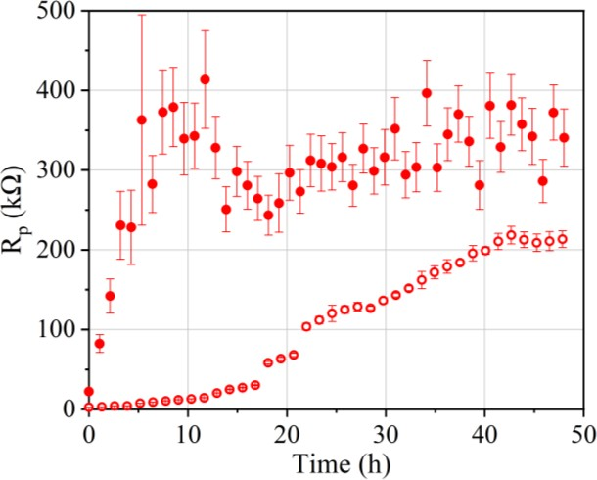
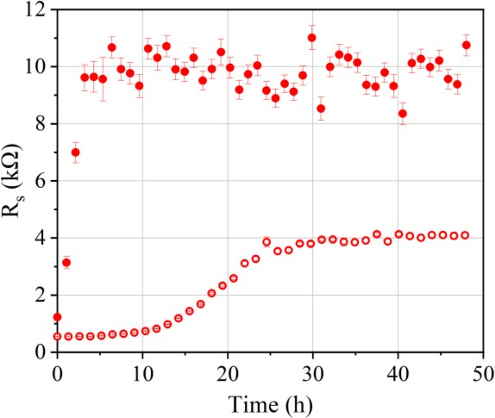
- b)

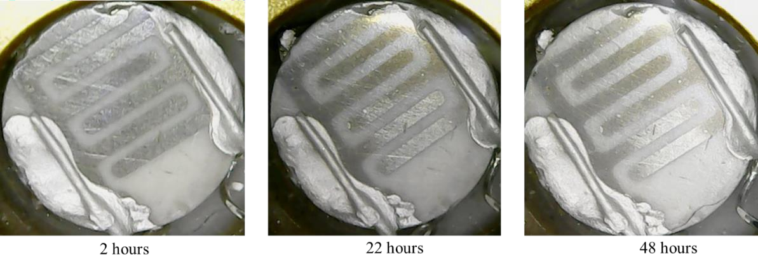
c)
d) e)
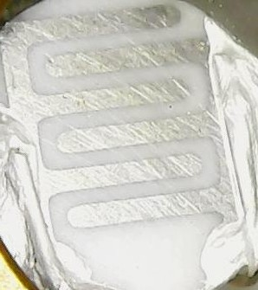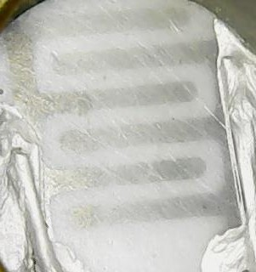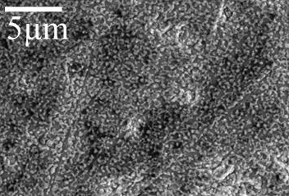

Figure 4.20 – Graphs of resistance vs. time for a 50 nm pattern electrode on a polycrystalline YSZ pellet at 600°C in 5%CO/50%CO2/Ar atmosphere. a) polarisation resistance and b) ohmic resistance. The two symbol types represent two repeats. Error bars show the error in the fitting of the equivalent circuit (Figure 3.9) to the measured data and the sample placement error. Images of the electrode c) corresponding with the open symbol plot and d) corresponding with the closed symbol plot. e) Post-test SEM image at 5000x magnification representative of both samples tested.

Longer-term tests were also carried out using 50 nm electrodes on polycrystalline YSZ pellets at 600°C in 5%CO/50%CO2/Ar atmosphere (Figure 4.20). The error bars plotted represent the error in fitting the data to an equivalent circuit in addition to the error in electrode placement (Section 3.4.3). The three stages of increasing ohmic resistance observed for 10%H2/N2 (Figure 4.17) were observed for one repeat (Figure 4.20b- open symbols), in which the first stage of relatively stable resistance lasted 10 hours, followed by the second stage of increasing resistance for 9 hours, and finally a plateaued, relatively high resistance until the end of testing. The second repeat (Figure 4.20b - closed symbols) did not exhibit the first stage of an incubation period with low stable resistance, and the second stage of rapidly increasing resistance had already begun by the first impedance measurement. The second stage of increasing resistance proceeded for 7 hours before the resistance plateaued at approximately
2.5 times higher than the ohmic resistance of the other sample tested. In contrast to the longer- term tests in 10%H2/N2 and 3%H2O/10%H2/N2 (Figures 4.17 and 4.19), the same stages could approximately be observed in the polarisation resistance for the two samples tested in 5%CO/50%CO2/Ar (Figure 4.20a). After 48 hours, the polarisation resistance of the two samples differed by ~2.5 times. The error in each of the samples was also considerably different. The data from the sample represented with closed circles (Figure 4.20) had a poorer fit to the equivalent circuit model (Figure 3.9), although the error bars do not appear to account for the full fluctuation between samples. Polarisation resistances after the 48 hours of testing are approximately 17 to 50 times larger than for 3%H2O/10%H2/N2. The sample with the larger polarisation resistance at the end of the 48 hours of testing had a dull appearance across the entire electrode (Figure 4.20d), whereas the sample with the lower polarisation resistance at the end of testing, dulled across the majority of the electrode (Figure 4.20c). Post-test SEM showed the electrode surface dewet into a partly interconnected network (Figure 4.20e).

Discussion

Size of polarisation resistance in CO/CO₂ vs. H₂/H₂O
As discussed in Section 2.2.2, studies comparing electrode performances in CO/CO2 atmosphere compared to H2/H2O atmosphere generally report higher resistances in CO/CO2 atmospheres, with ratios (Rpol(CO/CO2)/Rpol(H2/H2O)) varying between 1.3 and 6 at temperatures between 750-850°C, with electrodes 100 nm - 1.78 µm in thickness [84, 88, 103, 110]. Large ratios have been suggested to indicate that two different mechanisms control the oxidation of

each fuel, however ratios close to 1 are suggested to indicate the same mechanism for fuel oxidation [103].

Given that resistance has also been reported to vary with electrode thickness [89], it was hypothesised in Section 2.2.2 that different degradation rates between studies could be causing the different resistance ratios. In Figure 4.4, it was tentatively shown that pattern electrode thickness resulted in different electrode resistances, although more repeats are required to confirm a trend. At 600°C, thicker electrodes had increased polarisation resistance, whilst at 800°C, polarisation resistance was lowest for 300 nm electrodes thicknesses in all three gas atmospheres. Polarisation resistance was higher in 5%CO/50%CO2/Ar than in 3%H2O/10%H2/N2 at 600°C and 800°C for all electrode thicknesses correlating with the majority of the literature [84, 85, 88, 103, 110]. At 600°C, 50 nm electrodes resulted in Rpol(CO/CO2)/Rpol(H2/H2O) ratios of 13-30, 300 nm had ratios of 2-4, and 1 µm electrodes resulted in ratios of 2-33. At 800°C, 50 nm electrodes resulted in Rpol(CO/CO2)/Rpol(H2/H2O) ratios of 2-3, 300 nm electrodes resulted in ratios of 2-5, and 1 µm electrodes resulted in ratios of 1-38. Varying electrode thicknesses used in the literature could therefore be contributing to the variation in resistance. The Rpol(CO/CO2)/Rpol(H2/H2O) ratios are considerably higher than those reported in the literature, and this is attributed to the considerable difference in polarisation resistance observed between identical samples.

At both temperatures, polarisation resistances could be correlated to the observed electrode microstructure and the different changes observed for each electrode thickness. At 600°C, it was found that 50 nm electrodes in 10%H2/N2 developed small holes across the entire electrode surface (Figure 4.7d.). Therefore, active TPB is considerably longer for 50 nm electrodes than for dense 1 µm electrodes (Figure 4.5d). The amount of holes covering the surface was also considerably larger than for 300 nm electrodes at the end of testing (Figure 4.6d), and therefore TPB length is expected to be longest for 50 nm electrodes at 600°C. Although the microstructure of 50 nm samples was only analysed at 600°C for 10%H2/N2, it is presumed all 50 nm electrodes have a porous structure at 600°C because of the similarity in the dewet structures after heating to 800°C in each gas atmosphere, and the peak in resistance around the same temperature 670-770°C. Therefore, the polarisation resistances correlate with the expected active TPB lengths at 600°C, for the three electrode thicknesses.

At 800°C, 50 nm electrodes were observed to have dewet to form isolated nano-islands in all three gas atmospheres and consequently the active TPB length is expected to be reduced significantly. 300 nm electrodes remained intact with pores in all three gas atmospheres, and therefore had extended active TPB lengths correlating with the lowest resistances. 1 µm electrodes were also still in-tact but did not develop any pores during testing, and therefore the TPB length and electrochemically active area is entirely at the electrode perimeter, and shorter than the expected length in 300 nm electrodes, resulting in higher resistances.

Degradation was found to be different for 1 µm samples tested in H2 and CO. The delamination of 1 µm electrodes in 5%CO/50%CO2/Ar atmosphere only, has not been previously reported, although 1 µm nickel electrodes have been observed to bubble in H2/H2O elsewhere [89]. In this study, identical 1 µm electrodes prepared in the same batch as the electrodes heated in 5%CO/50%CO2/Ar, showed no signs of delamination in 3%H2O/10%H2/N2. It is hypothesised that the formation of bubbles under the 1 µm electrodes operated in 5%CO/50%CO2/Ar is the result of gas, possibly CO2, becoming trapped under the gas-tight dense thin films, causing film delamination. A difference in degradation between the two atmospheres was not observed in 300 nm and 50 nm electrodes, as these electrodes developed holes during testing and therefore were able to release any built-up gas. The delamination of the electrode is likely to result in considerable damage to the electrochemically active pathways, and result in a significant shortening of the active TPB length, resulting in large resistances. Different degradation processes mean the TPB length for identical samples heated in the two gas atmospheres are likely to change by different amounts during testing. Considering electrodes 800 nm and thicker are most commonly used to compare electrode resistances in the literature, different TPB lengths resulting from varying microstructural degradation processes offers an alternative explanation for the higher resistance in CO/CO2 compared to H2/H2O rather than a different rate controlling process. A similar effect has been observed for oxygen building-up under dense thin film platinum electrodes operated under anodic polarisation in air [130].

Therefore, variation in resistance values reported for nickel pattern electrode studies in the literature could be contributed to by changes in TPB length occurring during heating, since the microstructural changes observed in this study on a limited number of repeats do appear to change the resistance values as shown in Figure 4.4.

Microstructure during activation energy measurements
Activation energies reported in the literature for the oxidation of H2/H2O and CO/CO2 fuels vary as discussed in Section 2.2.4. There are several reports of different activation energies at high and low temperatures in H2/H2O fuel [102, 105], however the majority of studies report one activation energy. The rate limiting step for hydrogen oxidation has been suggested to be charge transfer at 500°C, with an activation energy of 190 kJ/mol, which becomes co-limited at 900°C with hydroxyl diffusion on YSZ and H2O desorption from YSZ, both of which have activation energies of 55 kJ/mol. For CO oxidation, the rate determining step has been reported to be the oxidation of CO adsorbed on the nickel surface by O²⁻ from the electrolyte with an activation energy 158 kJ/mol [92], except when CO concentrations are low, in which slow gas diffusion becomes the rate determining step [93].
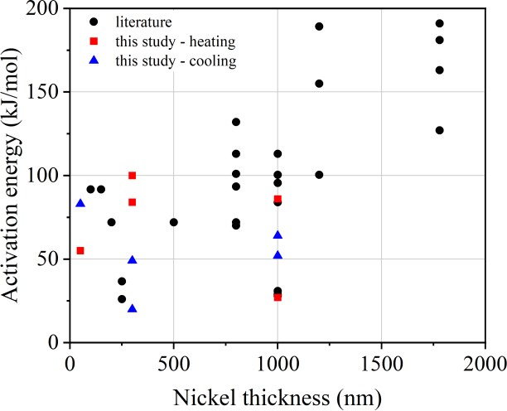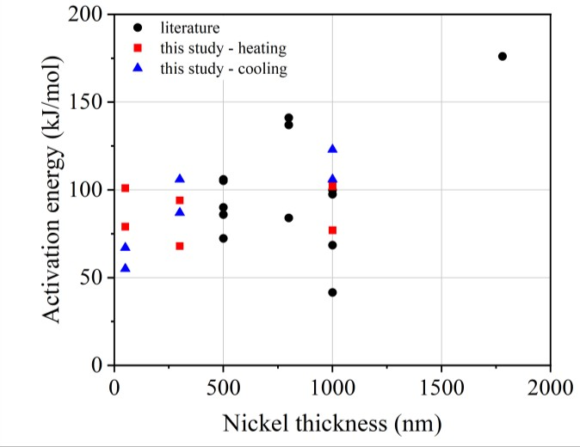
a)
b)
Figure 4.21 – Plots of activation energies compiled from the literature (black circle) and measured in this study (from heating measurements – red square, and cooling measurements – blue triangle) vs. nickel pattern electrode thickness for a) H2/H2O atmospheres and b) CO/CO2 atmospheres. Source: [38, 72, 73, 84, 88, 89, 92, 98, 103-105, 112-114, 116, 117]
The activation energies found in this study for all electrode thicknesses and both H2 and CO oxidation, showed a large fluctuation, as do the measurements reported in the literature. The accuracy of the plots used to obtain activation energies is affected by many factors.

Firstly, in many cases there were large differences in the resistances between repeats. As shown in Figure 4.3 this was particularly prominent for 1µm electrode repeats in 3%H2O/10%H2/N2. and 5%CO/50%CO2/Ar and 300nm repeats in 10%H2/N2 and 3%H2O/10%H2/N2. Error bars were included in all plots showing the error in fitting the data to the equivalent circuit (Figure

3.9). The error in the data fitting was considerably larger for 5%CO/50%CO2/Ar than the other gas atmospheres and tended to account for the fluctuation in repeats. However for 10%H2/N2 and 3%H2O/10%H2/N2 the error in fitting the data was not the sole cause of the fluctuation.

Secondly, microstructural changes were observed to take place at the electrode bulk and perimeter of pattern electrodes during testing to different extents for different electrode thicknesses and gas atmospheres, and to different extents between repeats of the same test as shown in Figures 4.5 – 4.13.

In several instances, repeats of the same test had significantly different microstructural behaviour. One of the 1µm electrodes in H2/H2O (Figure 4.8) dulled during testing, whilst the did not, 1µm electrodes in CO/CO2 (Figure 4.11) experienced lift-off to different extents, whilst 50 nm electrodes in CO/CO2 (Figure 4.20) dulled to different extents. The effect of these microstructural changes on active sites for the electrochemical reaction is likely to be affecting the resistance for each repeats. All electrode thicknesses in all gas atmospheres showed some degree of microstructural change during testing. Each of these changes affects the TPB length and the electrode resistance by changing the number of sites available for the electrochemical reaction. The effect of microstructural changes on TPB length is investigated further in Chapter
5. The most pronounced effect on activation energy plots was observed for 50 nm electrodes in each gas atmosphere, which had a peak in resistance at 670-770°C, presumed to be as a loss of percolation in the electrode occurred. Activation energy plots were no longer linear after this peak in resistance, and therefore activation energies extracted are likely highly inaccurate. However, the cause of the varying microstructural changes between repeats is an unknown source of error.

Another source of error which could be affecting the resistance between repeats is an error in the placement of each sample within the ceramic crucible. Every effort was taken to secure each sample in the same position. A piece of bored ceramic (2.5mm in thickness) was placed in the ceramic crucible to rest each sample on and limit possible variation in height. However the Linkam TS1500 stage has a thermocouple situated at the bottom of the crucible and not at the top of the crucible where the electrode is located. As such the temperature at the top of the crucible could be up to 100°C different to the set temperature (Section 3.2.4). Practical limitations prevented an additional thermocouple being placed adjacent to the sample, which

would be best practice. Therefore it is possible that electrode placement within the crucible varied by approximately 1 mm in height, given the approximate 3 mm thickness of the pellets and the 2.5 mm thickness of the bored piece of ceramic within the 6 mm deep crucible. An estimated 1 mm error in placement could cause an approximate 15°C error in temperature based on the bottom and the top of the crucible being a maximum of 100°C different in temperature. Taking 600°C as an example, because it is relevant to the constant temperature testing also performed in this chapter, the average resistance changes between 590°C and 610°C observed over all measurements in this chapter is 470 Ω for polarisation resistance and 120 Ω for ohmic resistance. This is therefore another considerable source of error between repeats.

Other possible sources of error which could be contributing to the fluctuation between repeats could be impurities in gas atmospheres [96], chemical impurities [96, 131] which are unquantified in this study, and competition between processes including solid-state dewetting and delamination.

Furthermore, most studies calculate activation energies from heating measurements [38, 73, 88, 92, 98, 102, 103, 105, 112, 113, 116], whilst one study reports that microstructural changes occurring during heating result in only cooling measurements being accurate [89]. Activation energies calculated from both heating and cooling measurements were found to show significant variation in this study (Figure 4.21), and it has been previously suggested that cooling can also induce microstructural changes as well [67].
      - Activation energy from ohmic resistance graphs
The average activation energy calculated from ohmic resistance graphs for all electrode thicknesses and in all gas atmospheres is 94±3 kJ/mol (where the error is the standard deviation) for measurements taken during heating, and 96±2 kJ/mol (where the error is the standard deviation) for measurements taken during cooling. The activation energy of the electrolyte process, which is the conduction of O²⁻ ions, therefore shows little variation with electrode thickness and gas atmosphere. Values of 93-103 kJ/mol have been reported for 250 nm-1 µm thick nickel electrodes on single crystal YSZ from heating and cooling measurements in both H2/H2O and CO/CO2 atmospheres [89], and therefore correlate well with the results of this study.

For 1 µm and 300 nm electrodes tested in the three gas atmospheres, deviation between heating and cooling measurements for ohmic resistance was small, even when considerable differences in heating and cooling measurements for polarisation resistance were observed. This suggests that the conduction of O²⁻ ions through the electrolyte is not affected by electrode crystallisation, grain boundary flattening or small holes forming in the metal film.

However, for 50 nm electrodes, the ohmic resistance had a large difference between heating and cooling measurements, and a large peak in resistance was observed in each gas atmosphere between 670-770°C. This peak in resistance correlates to the temperature which is presumed to be from a loss of percolation in the nickel metal. As the nickel metal suffers a loss in percolating pathway, the areas of the electrodes which have a conductive pathway between one another decreases significantly, and only a fraction of the metal remains attached to the current collector and sufficiently close to other areas of active TPB to form a complete circuit. Ohmic resistance is made up of the sum of electrolyte resistance and the current collection from the electrodes. Therefore a significant decrease in current collection area through a loss in conductivity between isolated areas of nickel leads to an increase in the ohmic resistance as well as the polarisation resistance [95, 132]. This loss of percolating pathway in the electrodes, therefore causes the change in shape of the ohmic resistance graph as a loss of conductivity in the system occurs.

Microstructure during constant temperature tests
As discussed in Section 2.3, the microstructural stability of nickel pattern electrodes at constant temperature has been the subject of contrasting reports, particularly regarding the effect of nickel mobility on electrode performance. Both an electrode activation [75, 101, 102] and deactivation [41, 98, 105] have been attributed to grain growth in the nickel films. In this study, the performance of 50 nm electrodes at 600°C was plotted over time in different gas atmospheres, with both an error in fitting each plot to the equivalent circuit (Figure 3.9) and a sample placement error (Section 3.4.3) accounted for. Taking the electrode performance and error in each measurement into account, electrodes were found to increase in polarisation resistance over time, in all three gas atmospheres at 600°C.

In 10%H2/N2 and 5%CO/50%CO2/Ar, electrodes were found to dewet into isolated nano- islands, resulting in an overall decrease in activate TPB length by significantly reducing the amount of nickel contacting the current collector. Therefore, in these samples, an overall

increase in polarisation resistance is expected. However, when additional 50 nm samples were heated to 600°C in 10%H2/N2 for 0 hours and 13 hours, small holes were found to be covering the surface of the previously dense electrode (Figure 4.17c and d). The increased electrode porosity is expected to increase the active TPB length [133] and decrease polarisation resistance, but this was not observed and polarisation resistance increased throughout testing. The variation between repeats was large. The error in fitting each measurement to the equivalent circuit (Figure 3.9) and the error in sample placement within the crucible (Section 3.4.1), did not account for the full variation between repeats. It is clear that there are additional factors contributing to error.

50 nm electrodes heated to 600°C in 3%H2O/10%H2/N2 for 48 hours remained intact after testing with small pores across the electrode microstructure (Figure 4.19e). Polarisation resistance increased by a factor of 7 over 48 hours of testing, which was unexpected based on the relative microstructural stability of the electrode. If pores were already formed before the first electrochemical measurement, as was observed in 10%H2/N2, then polarisation resistance would be expected to be relatively constant during testing. If the pores formed during operation, then an activation polarisation resistance would be expected owing to the additional TPB sites created.

Polarisation resistance therefore was not observed to correlate with active TPB length but instead appears to correlate with the area of electrolyte exposed, as has also been observed previously [115]. One explanation for this could be the current collector detaching from the underlying nickel electrode. Another explanation could be that an additional area scaling pathway is involved in the fuel oxidation process with nickel pattern electrodes [72] as discussed in Section 2.4.4.

50nm electrodes heated to 600°C in 5%CO/50%CO2/Ar (Figure 4.20), showed an initial incubation period in polarisation resistance for one of the samples tested. This sample also fit to the equivalent circuit (Figure 3.9) with a larger area than the second repeat. Therefore it is possible that different pathways exist in the two gas atmospheres, although more repeats are required to clarify this.

The increased microstructural stability of the 50 nm pattern electrodes tested in 3%H2O/10%H2/N2 compared to 10%H2/N2, contrasts reports that water in the fuel stream leads to an increased rate of degradation through the formation of volatile nickel species [115]. Since only one repeat was attained for this test, further repeats are required to clarify this result. Furthermore, 50 nm electrodes heated in 5%CO/50%CO2/Ar were observed to increase in polarisation resistance by a factor of 11-20 during testing, compared to the factor of 7 for 3%H2O/10%H2/N2. Therefore the increased stability of nickel films heated in 3%H2O/10%H2/N2 contrast the reports that degradation rates are halved in CO/CO2 atmosphere compared to H2/H2O [109].

Therefore, the results from the constant temperature testing presented here contrast results in the literature. Similar to the activation energy test, the fluctuation between repeats is large and cannot be accounted for by the error in fitting the data, and sample placement error alone. Microstructural changes and expected effect on TPB lengths did not correlate with the polarisation resistances in H2 based atmospheres, which suggests that polarisation resistance is complex, and affected by additional factors, including possibly the electrode area. An additional possibility is a loss in contact between the current collector and the underlying nickel electrode during testing. There is a possible indication that the pathway could be different for CO based atmospheres, although further tests are required.

Conclusions
The activation energies of electrodes 50 nm, 300 nm and 1 µm in thickness were calculated in both H2 and CO based atmospheres. Each electrode was found to undergo microstructural changes during testing to different extents. 50 nm and 300 nm electrodes were susceptible to solid-state dewetting, whilst 300 nm and 1 µm electrodes increased in tortuosity at the perimeters of the nickel pattern. 1 µm electrodes tested in CO based atmospheres also suffered delamination during testing.

Polarisation resistance and ratio of electrode performance in CO vs. H2 atmospheres, was shown to vary with electrode thickness as well as gas atmosphere. This was qualitatively correlated to the effect of the microstructural changes on TPB length. The different thicknesses used in the literature are therefore likely to be influencing electrode performance results through varying microstructural changes.

Longer term testing showed polarisation resistance increasing despite apparent lengthening of the active TPB length at 600°C in H2 atmospheres, and suggests a more complex relationship, perhaps with contribution from an area scaling pathway. The polarisation resistance in CO/CO2 showed stages of polarisation resistance, correlating with expected electrode structure, and therefore it is possible the pathways are different for the two gas atmospheres.

The error in fitting the data to an equivalent circuit and the error in sample placement within the crucible could not account for the full variation observed between repeats. It is clear that additional factors are affecting the accuracy of tests, other than the parameters controlled in this study and this requires further investigation.

Future work
Scatter in repeats of the same test is a challenge observed throughout this chapter and is discussed in more detail in Section 7.5. The discrepancy between repeats make conclusions difficult to draw, and this is also a problem reported elsewhere in the literature [41].

Attempts were made to investigate the source of these fluctuations in this chapter, however, an error in fitting the data to an equivalent circuit and an error in the placement of each sample within the crucible cannot account for the full fluctuation observed. To improve the accuracy of results, this scatter requires further investigation. Possible sources of the fluctuation between nominally similar samples are different sample batches, and also imprecise control of the current collecting area. Therefore, ideally, measurements would be repeated with all samples made in the same batch and also with more precise control of the silver wire current collector length and application of the silver paste through the use of a stencil.

Furthermore, the sample sizes used for each test in this study are small owing to practical and time limitations. Therefore, to increase the accuracy of each test, more tests should be carried out so a larger data set can be assessed. Ideally microstructure should be characterised “in- situ” and “in-operando” so that TPB length changes could be quantitated throughout testing.

The effect of microstructural changes observed in this chapter on TPB length and error in calculated LSR values are discussed in Chapter 5.

Chapter 5 –TPB length changes during testing and the effect on electrode performance

Introduction
As discussed in Section 2.2.3, line specific resistance values are used to compare electrode performance between studies with different pattern electrode geometries [101].
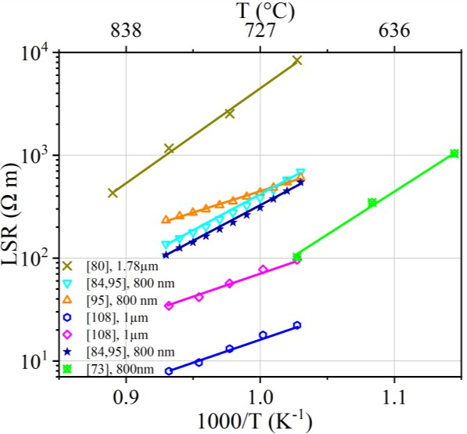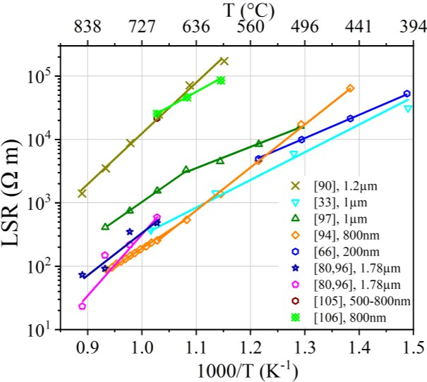
a)
b)
Figure 5.1 – Line specific resistance values from the literature plotted against temperature for Ni/YSZ pattern electrodes heated in a) H2/H2O atmosphere and b) CO/CO2 atmosphere. Electrode thicknesses indicated in legend. Sources:[38, 73, 81, 88, 92, 98, 102-105, 113, 114, 116].
However, the data from studies using nickel pattern electrodes in both H2/H2O atmospheres and CO/CO2 atmospheres, varies by up to two orders of magnitude (Figure 5.1). In the literature, this variation has been attributed to varying gas partial pressures, impurities, and inaccuracy in the reporting of TPB lengths resulting from defects introduced during electrode fabrication (Section 2.4).

In Section 2.4, it was hypothesised that additional sources of TPB length inaccuracy include microstructural changes occurring during testing, and a non-standardised measurement technique. In Chapter 4, 50 nm, 300 nm, and 1 µm thick electrodes were shown to exhibit fluctuation between repeats. Error in polarisation resistance measurements were considered, however the fluctuation was observed to be considerably larger than the calculated error in several cases, indicating additional uncontrolled sources of error. All model electrodes tested in Chapter 4 were found to undergo various microstructural changes at the electrode bulk and

perimeter in H2 and CO based atmospheres, and in many cases repeats of the same test underwent different degrees of microstructural change. These changes are assumed to affect the TPB length and introduce an additional source of error into LSR calculations. In this chapter the error in LSR calculations is considered. The effect of TPB length changes during measurements on the error in TPB length is considered using SEM images. An error range is added to LSR values based on the known sources of error in this study.

Hypothesis and aims:
The hypothesis for this chapter is that by propagating the known sources of error in calculated LSR values, the two orders of magnitude spread in the data reported in the literature can be accounted for.

The following aims are set for this chapter to investigate the above hypothesis:

    - To assess the effect of magnification on calculated TPB length from SEM images, and determine whether the coastline paradox is applicable

    - To evaluate TPB length changes during testing by analysing pre- and post-test SEM images and considering the effect of microstructural changes on the error in TPB lengths used to calculates LSR values

    - To calculate LSR values considering the total known error propagated from each contributing factor

Results:

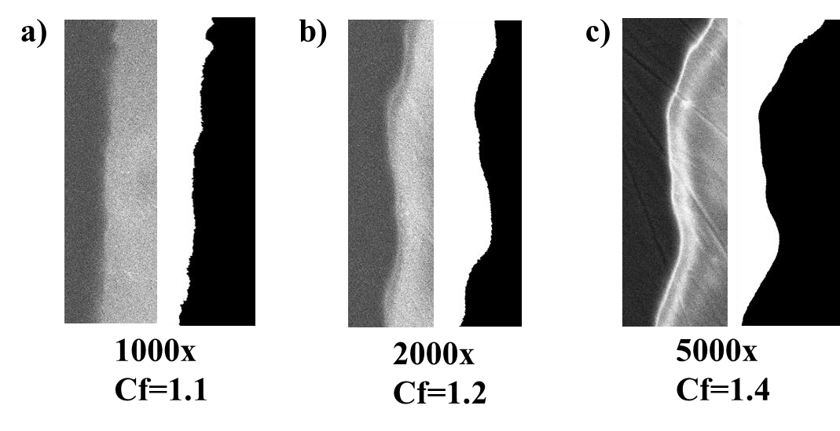
The effect of magnification on TPB length calculated from SEM images

Figure 5.2 – SEM images of the perimeter of a 1 µm nickel electrode pre-heating at a) 1000x

magnification, b) 2000x magnification and c) 5000x magnification. Corresponding binary images after processing in FIJI imaging software (right). Nickel electrode on the right of each image whilst the polycrystalline YSZ substrate is on the left. Calculated correction factors (Cf) are indicated for each image.

To investigate the effect of magnification on the error in TPB length, prior to heating, the perimeter of a 1 µm thick electrode was imaged using SEM at various magnifications (Figure 5.2). Images were processed using FIJI image processing software (Section 3.3.2.1) and the perimeter was measured. This measurement was compared to the length of a straight line running from the top to the bottom of the nickel to obtain a correction factor (Section 3.3.2.2.1). The correction factors were found to increase with increasing magnification from 1.1 to 1.2 and 1.4 as magnification was increased from 1000x to 2000x and 5000x respectively.

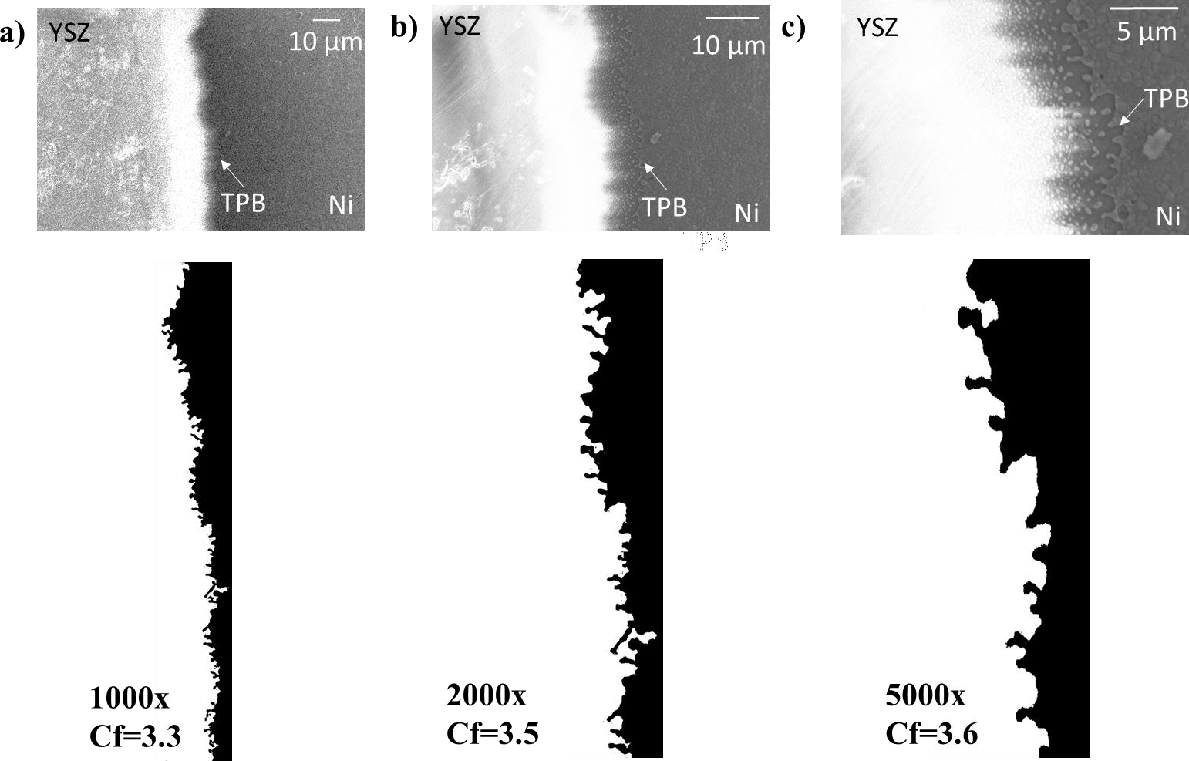

Figure 5.3 –SEM images of the perimeter of a 1 µm nickel electrode post-testing in 10%H2/N2 in an activation energy test at a) 1000x magnification, b) 2000x magnification and c) 5000x magnification. Corresponding binary images after processing in FIJI imaging software (below). 1 µm nickel electrode on the right of each image whilst the polycrystalline YSZ substrate is on the left. Calculated correction factors (Cf) are indicated for each image.

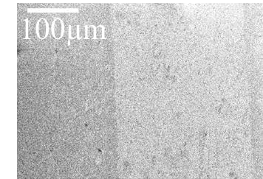
The influence of magnification on correction factor post-testing was analysed using the same 1 µm nickel electrode after heating in an activation energy test in 10%H2/N2 atmosphere (Section 3.2.5.1). At 1000x magnification the correction factor was found to be 3.3, increasing to 3.5 and 3.6 at 2000x and 5000x magnification respectively.

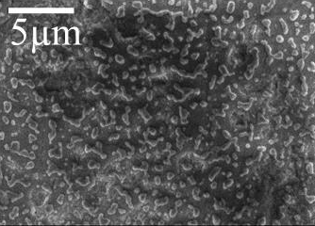
a)
b)

Figure 5.4 – SEM images of the bulk of a 50 nm Ni/YSZ electrode after heating in an activation energy test in 10%H2/N2. a) 200x magnification and b) 5000x magnification

Furthermore, the effect of magnification on the ability to observe microstructural details in the nickel bulk was investigated using a 50 nm electrode after heating in an activation energy test in 10%H2/N2 (Section 3.2.5.1). At 200x magnification, the details of the nickel structure are difficult to discern, however at 5000x magnification the nickel can be seen to have dewet into isolated nano-islands (Figure 5.4).

Quantification of TPB length and effect on electrode performance
The TPB length of the nickel pattern electrodes after deposition and before heating was calculated using low magnification SEM images (25x magnification) (Section 3.3.2.2.1), assuming the edges of the perimeter are straight as has been done in other studies [73, 88, 104, 105, 113]. A total TPB length (for both electrodes) of 0.46 m/cm² was calculated, based on the average of 3 sets of images with a standard deviation of 0.01 m/cm². The total electrode area (for both electrodes) was calculated to be 0.13 cm² based on the average of three sets of images, with a standard deviation of 0.01 cm². These values were used to convert the resistances from the electrochemical testing in Chapter 4 to LSR values. These LSR values are shown as plotted points in the following sub-sections, and are used as a baseline LSR measurement calculated in a similar way to the literature.

These baseline plots are compared with LSR values calculated with error propagated according to Section 3.4. The propagated LSR error can be seen as error bars on the LSR plots in the following sub sections. The propagated error accounts for error in polarisation resistance (error in electrode placement and error in fitting data to an equivalent circuit), standard deviation in the area measurement, as well as the error in the TPB measurement (standard deviation in the TPB measurement from SEM images).

      - 1 µm electrodes
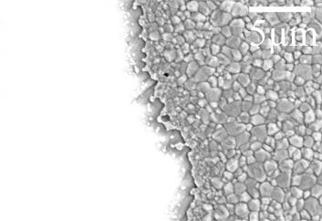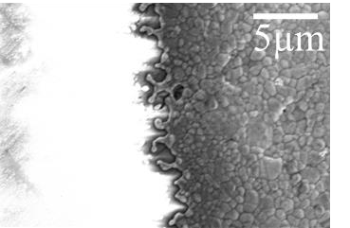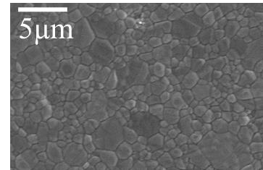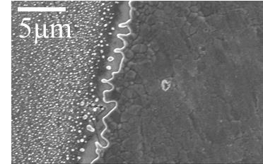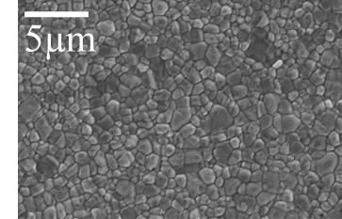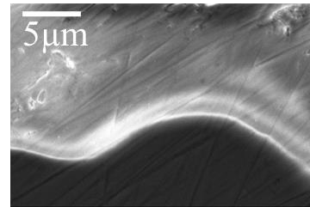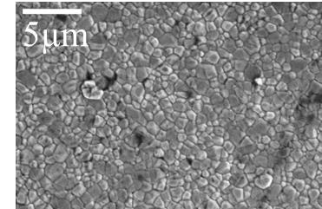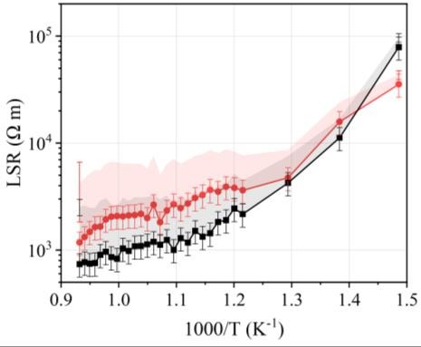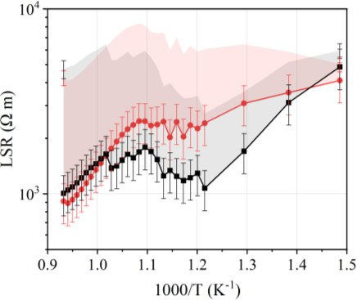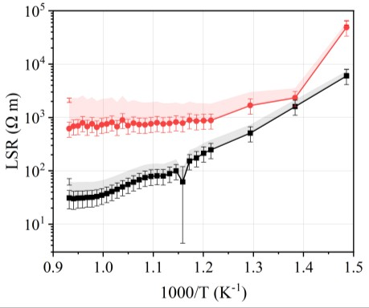a)
d)
e)
f)
g)
h)
i)
j)

- c)

Figure 5.5 – a,b,c) Graphs of LSR vs. temperature for two identical repeats of each test. a,e,h) 10% H2/N2, b,f,i) 3%H2O/10%H2/N2, c,g,j) 5%CO/50%CO2/Ar. Plotted points are LSR values using the TPB length calculated from low magnification images of the perimeter with error propagated as error bars. The shaded areas represent LSR values calculated and extrapolated from 5000x magnification images after cleaning at 400°C (d) and post-test (e-j). Error bars on shaded regions at 400°C and 800°C represent the propagated error.

Table 5.1 – TPB lengths calculated from SEM images at 5000x magnification of 1 µm nickel electrodes
Gas atmosphere | TPB  length from bulk (m/cm2) | TPB length from perimeter (m/cm2) | Standard Deviation (m/cm2) | Total TPB  length (m/cm2) | Standard Deviation (m/cm2)
After cleaning at 400°C | 0 | 0.5 | 0.1 | 0.5 | 0.1
Post-test - 10%H2/N2 | 0 | 2.0 | 0.7 | 2.0 | 0.7
 | 0 | 2.0 | 0.3 | 2.0 | 0.3
Post-test -  3%H2O/10%H2/N2 | 0 | 1.5 | 0.2 | 1.5 | 0.2
 | 0 | 0.9 | 0.1 | 0.9 | 0.1
Post-test -  5%CO/50%CO2/Ar | 0 | 1.5 | 0.9 | 1.5 | 1.5
 | 0 | 1.5 | 0.4 | 1.5 | 0.4

After cleaning a 1 µm electrode at 400°C for 30 minutes and cooling, SEM images at 5000x magnification showed the bulk of the electrode to be dense and therefore not contributing to the TPB length. SEM images of the perimeter at 5000x magnification were processed using FIJI imaging software (Section 3.3.2.2.1) to obtain a total TPB length. Results from three images at different points along the perimeter were averaged for all measurements and the standard deviation in this measurement was calculated. The perimeter was found to be 0.5±0.1 m/cm² (Figure 5.5d) which is increased compared to the value of 0.4±0. 1 m/cm² obtained using low magnification images and assuming edges were straight. After electrochemical testing, post-test SEM images revealed that whilst the bulk of the nickel electrodes remained dense, and therefore not contributing to the TPB length, (Figure 5.5 h,i,j), the perimeter of the electrodes had increased in tortuosity and therefore the total TPB length was extended to 0.9-
2.0 m/cm² (Table 5.1) (Figure 5.5 e,f,g).

The extended TPB lengths after heating to 400°C and 800°C were used to calculate LSR values, which take into account the TPB length changes occurring during testing. These are presented as shaded regions in Figure 5.5 a,b,c, along with error bars which correspond to the error propagated in the LSR measurement according to Section 3.4. Since it was not possible to image the electrode microstructure and calculate a TPB length at intermediate temperatures in this study, the TPB length increase and resultant LSR increase was averaged evenly over the measurement series, shown as the shaded region in Figure 5.5 and subsequent plots.

Analysis of 1 µm electrodes after testing in 5%CO/50%CO2/Ar using SEM of the bulk and perimeter, did not show the bubbling of the metal which was observed visually during testing (Figure 4.11). Therefore, the effect of delamination on TPB length is unaccounted for, and is an additional source of error in the LSR values which is unaccounted for. The bubbles in the electrode are likely to decrease the TPB length by reducing Ni/YSZ contact [89], and therefore accurate LSR values are likely to be lower than those presented in Figure 5.5c.
      - 300 nm electrodes
        - b) c)
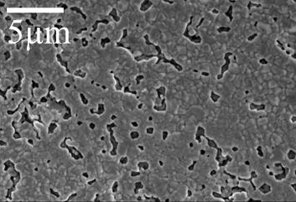
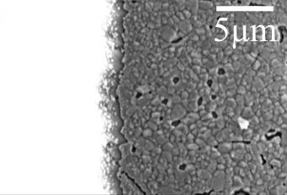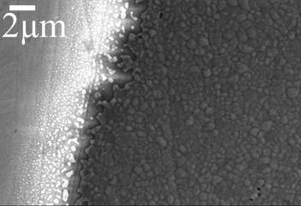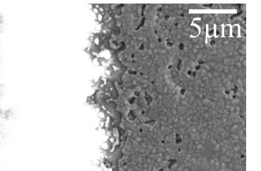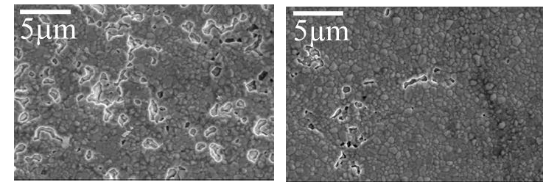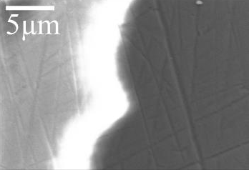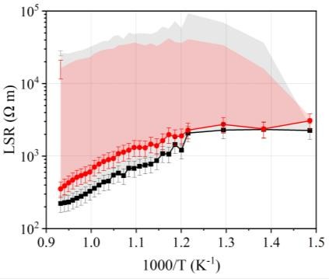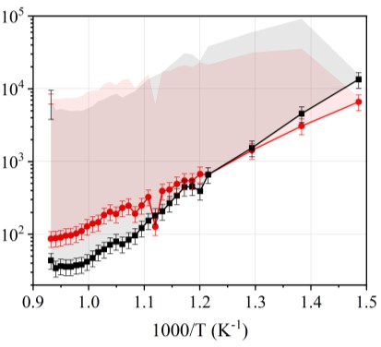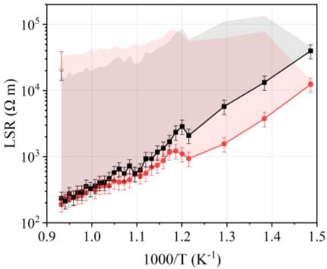
g)
d)
e)
f)
h)
i)
j)

Figure 5.6 – a,b,c) Graphs of LSR vs. temperature for two repeats of each test. a,e,h) 10% H2/N2, b,f,i) 3%H2O/10%H2/N2, c,g,j) 5%CO/50%CO2/Ar. Plotted points are LSR values using the TPB length calculated from low magnification images of the perimeter with error propagated as error

bars. The shaded areas represent LSR values calculated and extrapolated from 5000x magnification images after cleaning at 400°C (d) and post-test (e-j). Error bars on shaded regions at 400°C and 800°C represent the propagated error.

Table 5.2 – TPB lengths calculated from SEM images at 5000x magnification of 300 nm nickel electrodes
Gas atmosphere | TPB  length from bulk  (m/cm2) | Standar d Dev. (m/cm2) | TPB  length from perimeter  (m/cm2) | Standard Deviation (m/cm2) | Total TPB  length (m/cm2  ) | Standard Deviation (m/cm2)
After cleaning at 400°C | 0 | 0 | 0.50 | 0.1 | 0.50 | 0.1
Post-test - 10%H2/N2 | 48.8 | 7.3 | 1.80 | 0.5 | 50.56 | 7.8
 | 17.6 | 5.6 | 2.15 | 0.7 | 19.76 | 6.3
Post-test -  3%H2O/10%H2/N2 | 35.0 | 5.4 | 1.02 | 0.1 | 35.99 | 5.5
 | 61.8 | 31.2 | 3.41 | 0.6 | 65.19 | 31.8
Post-test -  5%CO/50%CO2/Ar | 64.8 | 21.6 | 2.35 | 0.3 | 67.19 | 21.9
 | 30.4 | 5.1 | 0.92 | 0.1 | 31.47 | 5.2

After cleaning a 300 nm electrode at 400°C for 30 minutes and cooling, SEM images at 5000x magnification showed the bulk of the electrode to be dense and therefore not contributing to the TPB length. SEM images of the perimeter at 5000x magnification were processed using FIJI imaging software (Section 3.3.2.2.1) to obtain a total TPB length. Results from three images at different points on the sample were averaged for all measurements and a standard deviation in the measurement was obtained (Table 5.2). The perimeter was found to be extended to 0.5±0.1 m/cm² (Figure 5.6d). After electrochemical testing, post-test SEM images revealed that the bulk of the nickel had developed holes in each of the three gas atmospheres tested, causing additional TPB sites (Figure 5.6 h,i,j). The perimeter of each electrode had also increased in tortuosity (Figure 5.6 e,f,g) compared to the perimeter after cleaning at 400°C. The total TPB length after electrochemical testing was calculated using equation 3.13 (Section 3.3.2.2.2), and was found to be 19.8-67.2 m/cm² (Table 5.2). The standard deviation in each total TPB length measurement was calculated by propagating the standard deviations associated with the TPB length perimeter and TPB length bulk measurements (Table 5.2). The extended TPB lengths after heating to 400°C and 800°C were used to calculate corrected LSR values for each sample which are presented as shaded regions in Figure 5.6 a,b,c. The propagated error in the LSR measurement is plotted as error bars on the shaded regions. The

TPB length increase and the resultant LSR increase was averaged evenly over the entire measurement series.
      - 50 nm electrodes
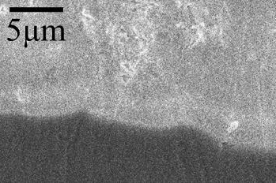
        - b)

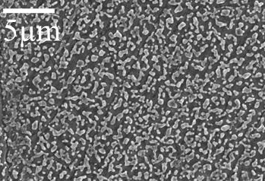
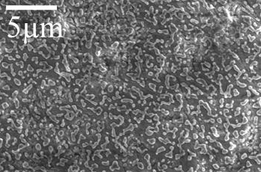
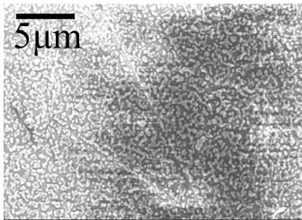
- d) e)

Figure 5.7 – SEM images at 5000x magnification (a, b) after cleaning at 400°C, and (c, d, e) post- testing in c) 10%H2/N2, d) 3%H2O/10%H2/N2 and e) 5%CO/50%CO2/Ar.

  - 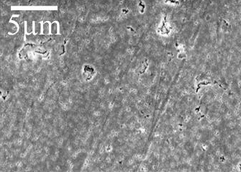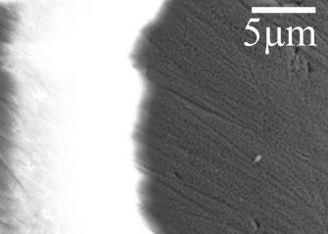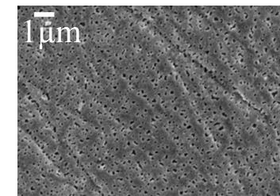b) c)

Figure 5.8 – SEM images a) 50 nm nickel electrode bulk at 5000x magnification b) electrode bulk at 10 000x magnification and c) perimeter of 50 nm nickel electrode at 5000x magnification after heating to 600°C in 10%H2/N2 and cooling.

Table 5.3 –TPB lengths calculated from SEM images at 5000x magnification of 50 nm nickel electrodes
Gas atmosphere | TPB  length from bulk (m/cm2) | Standard Deviation (m/cm2) | TPB  length from perimeter (m/cm2) | Standard Deviation (m/cm2) | Total TPB  length (m/cm2) | Standard Deviation (m/cm2)
After cleaning at 400°C | 0 | 0 | 0.6 | 0.1 | 0.6 | 0.1
10%H2/N2 –  600°C | 501.4 | 47.8 | 1.9 | 0.4 | 503.3 | 48.2

After cleaning a 50 nm electrode at 400°C for 30 minutes and cooling, SEM images at 5000x magnification showed the bulk of the electrode to be dense and therefore not contributing to the TPB length (Figure 5.7a). SEM images of the perimeter at 5000x magnification were processed using FIJI imaging software (Section 3.3.2.2.1) to obtain a total TPB length. Results from three images at different points were averaged for all measurements. The perimeter was found to be extended to 0.6±0.1 m/cm² (Figure 5.7b). After electrochemical testing, post-test SEM images revealed that the nickel had dewet into partially connected nano-islands in all three atmospheres (Figure 5.7 c,d,e). It was no longer possible to assess the amount of nickel still in contact with the current collector and the amount of nickel which still had a percolating pathway as has been reported elsewhere [84]. For 10%H2/N2, an additional sample was heated to 600°C and cooled, to understand the behaviour of the TPB length prior to hole impingement (Figure 5.8). The TPB length after heating to 600°C was found to be 503.3±47.8 m/cm² and therefore considerably larger than the pre-measurement value of 0.6±0.1 m/cm² for samples heated in 10%H2/N2.

Discussion

The influence of magnification on TPB length measurements
As discussed in Section 2.4.3.2, some studies calculate the TPB length of pattern electrodes assuming the mask or etching area used resulted in straight lines [41, 73, 84, 100], whilst other studies used microscopy to assess any deviation of the perimeter from a straight edge [38, 72, 75, 88, 89, 99, 103, 105]. When microscopy is used to measure the TPB length, measurements
are either made before testing [72, 99], or after testing [38, 75, 89, 98, 101-103, 105], with the corrected TPB length applied to all measurement results.

The fractal-like nature of the TPB length at the perimeter of pattern electrodes [99], results in a TPB length which increases with magnification. Figures 5.2 and 5.3 show that the fractal- like nature of the TPB length affects the correction factors calculated from SEM images both pre- and post- testing. The magnification of images of pattern electrode perimeters presented in the literature varies from 50x to 6250x [38, 72, 75, 89, 98-102, 105] and therefore, the accuracy of correction factors calculated in the literature are likely to vary owing to a lack of standardisation in measurement technique.

The majority of studies using nickel pattern electrodes report a microstructure which remains dense and continuous throughout testing [38, 41, 88, 98, 102, 104, 105, 113], with images of the electrode microstructure being presented at magnifications varying between 250x and 50 000x [38, 41, 88, 98, 102, 104, 105, 113]. Several studies have reported obtaining lower resistance values or higher electrode conductivity measurements than expected based on TPB length calculations, and have attributed this to unaccounted for micropores in the presumed dense nickel electrode increasing the TPB length [38, 41]. Figure 5.4 shows that holes in the bulk of nickel electrodes are not fully discernible from 200x magnification SEM images. Therefore an underreporting of TPB sites in the bulk of pattern electrodes, given the spread of magnifications used to present electrode microstructure in the literature, is likely to be a contributing factor in error between studies. Overall, the magnification of SEM images used to analyse TPB length is likely to affect the TPB length measurement and the lack of standardisation in TPB length measurement between studies is likely to be contributing to an error in TPB length measurement. Ideally a standard procedure for measuring TPB length should be used to prevent magnification causing discrepancies between studies owing to the fractal-like nature of the TPB length. In this chapter, all analysis of TPB length at the perimeter and bulk of the nickel pattern electrodes was carried out using SEM images taken at 5000x magnification, to avoid introducing an additional measurement error across samples.

Error in LSR values
In this chapter, LSR values were calculated using two different TPB lengths and errors were propagated. The first was a TPB length based on low-magnification SEM images, and an assumption that the TPB lengths remain straight after testing, as this is often done in the literature. The second TPB length considered microstructural changes at the bulk and perimeter of the electrodes induced during testing. 1 µm electrodes tested in H2/H2O and CO/CO2 atmospheres were all found to be dense after testing, with a perimeter which increased in

tortuosity. This was found to extend the TPB length by 1.7-3.7 times compared to the TPB length calculated from the perimeter at 5000x magnification pre-testing. This contrasts several reports of a decreased TPB length after heating in the literature [38, 98], but correlates with the majority of the reports on TPB length change [89, 101, 102, 105, 115].
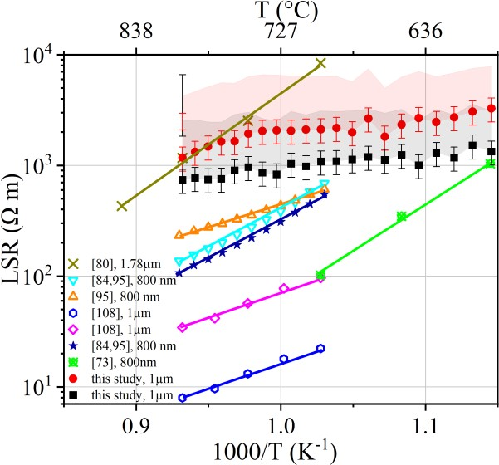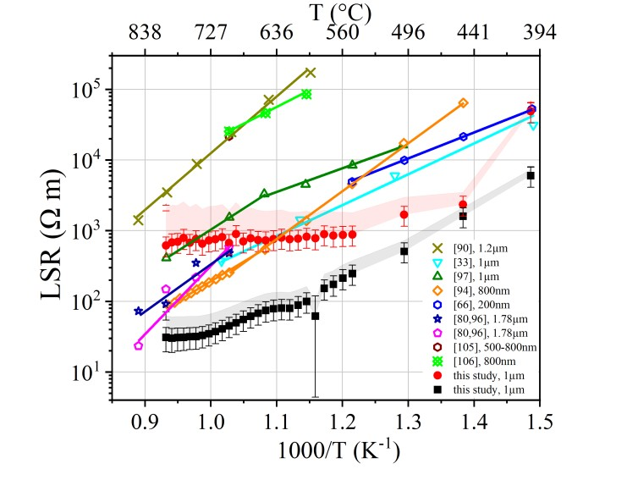
a)
b)
Figure 5.9 – Line specific resistance values from the literature plotted against temperature with results of this study for 1 µm electrodes. Ni/YSZ pattern electrodes tested in a) H2/H2O and b) CO/CO2. Electrode thicknesses indicated in legend. Source: [38, 73, 81, 88, 92, 98, 102-105, 113,
114, 116].

Based on the increased TPB lengths, LSR values were calculated and plotted as shaded regions on the preceding graphs in this chapter. It should be noted that although the shaded regions extend across all measurements in the test, since it wasn’t possible to observe TPB length at intermediate temperatures in this study, the shaded regions at intermediate temperatures are an extrapolation. The propagated error at 400°C and 800°C was also plotted as error bars on the shaded regions. The LSR values with their errors are compared to values found in the literature for H2/H2O and CO/CO2 atmospheres in (Figure 5.9).

The shaded regions in Figure 5.9 represent the difference between calculating TPB length from pre-testing images only, as is often done on the literature [73, 88, 104, 105, 112, 113], and calculating TPB length post-testing. Studies which only calculate TPB length pre-testing are likely to be underreporting LSR values. For 1 µm electrodes heated in both H2/H2O and CO/CO2 atmospheres, the error in LSR values considered in this study does not appear to account for the full two orders of magnitude span in electrode data in the literature. In addition

to a fluctuation between repeats, this points towards additional sources of error contributing to LSR values and electrochemical testing than the sources of error considered in this study. For 1 µm electrodes tested in 5%CO/50%CO2/Ar, the complete TPB length change could not be accurately estimated because it was not possible to view the effect of delamination on TPB length using SEM, and this is likely to be a large source of error which is not accounted for.

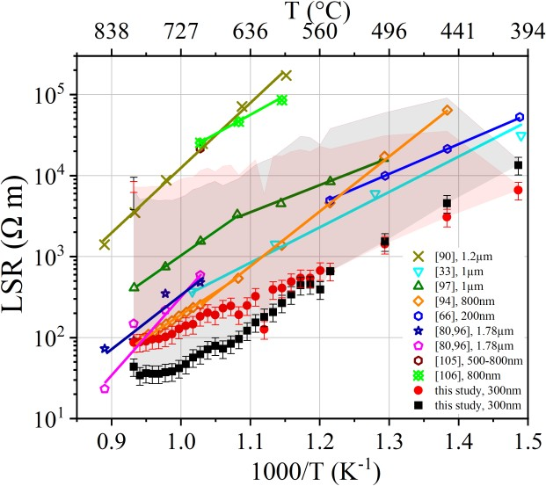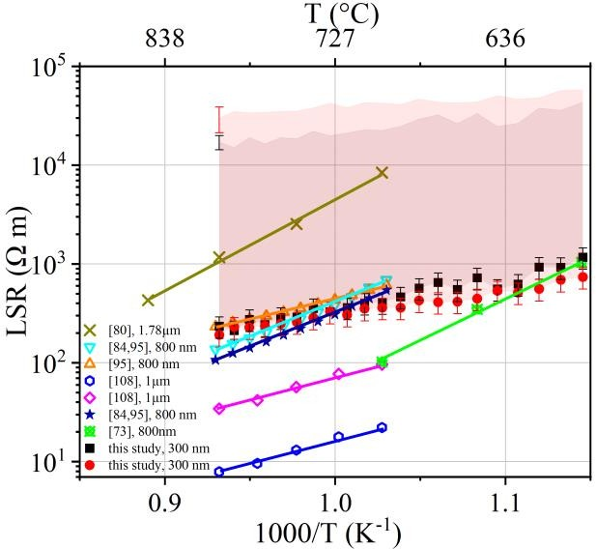
a)
b)
Figure 5.10 –Line specific resistance values from the literature plotted against temperature with results of this study for 300 nm electrodes. Ni/YSZ pattern electrodes tested in a) H2/H2O and b) CO/CO2. Electrode thicknesses indicated in legend. Source: [38, 73, 81, 88, 92, 98, 102-105, 113,
114, 116].

300 nm electrodes heated in both H2/H2O and CO/CO2 atmospheres were observed to develop holes in the electrode bulk during testing, in addition to increasing in tortuosity at the perimeter. This was found to result in an extension of the TPB length by 40-134 times compared to the TPB length calculated from 5000x magnification images pre-heating. This TPB length extension post-testing resulted in considerably larger LSR values. The LSR values and propagated errors were increased by two orders of magnitude (Figure 5.10) when compared to the baseline LSR values calculated using low magnification SEM images and assuming the TPB length remains straight during testing as is done in some studies [73, 88, 104, 105, 112, 113]. Therefore, although 300 nm electrodes are not directly comparable to electrodes of the same thickness used in the literature, several studies use electrodes with thicknesses under 1 µm in both H2/H2O and CO/CO2 atmosphere. Therefore microstructural changes occurring

during testing could be increasing the error in the TPB length considerably, and contributing to a considerable error in reported LSR values.

Conclusions
The hypothesis investigated in this chapter was that by propagating the known sources of error in calculated LSR values, the two orders of magnitude spread in the data reported in the literature could be accounted for. For 1µm electrodes tested in both H2/H2O and CO/CO2 atmospheres, the error in LSR values considered in this study could not account for a two order of magnitude data variation. In addition, fluctuation between repeats also points towards additional, unaccounted for sources of error. Other sources of error include delamination of electrodes observed during testing in CO/CO2 which could not be accounted for using SEM images. For 300 nm electrodes, the dewetting of the nickel electrodes during testing led to a considerable extension in TPB length and calculated LSR values. This led to a two orders of magnitude difference between the LSR values calculated using low magnification SEM images and SEM images at 5000x magnification. Propagation of errors extended LSR values further as well. Additional errors also affected 300 nm tests, as indicated by the fluctuation in repeats. Furthermore, correction factors were shown to vary pre- and post- testing, and therefore given the variation in technique used in the literature, the accuracy of TPB length measurements is likely to vary between studies.

A loss of percolation was observed for 50 nm electrodes tested in this study and led to an inability to quantify TPB length. At the intermediate temperature of 600°C, the TPB length was found to be extended by 825 times compared to the length after cleaning, and this highlights the limitation of pre- and post- test analysis.

Future Work
The range of electrode thicknesses investigated in this study should be extended to include more values between 300 nm and 1 µm, so that the microstructural changes affecting these electrodes during testing and the effect on LSR accuracy can be understood. This would improve the understanding of how the TPB length of more electrodes used in the literature is changing during testing.

In addition, different water concentrations in the fuel should be investigated to span the range used in the literature, since water has been suggested to have a catalytic effect on electrode performance, but this was not observed with the 3% H2O in H2 used in this study.
    - “in-situ”, “in-operando” measurements
TPB length changes and resultant LSR changes were averaged over the entire measurement series because SEM images were taken pre- and post-testing only. Therefore, the shaded LSR values presented in Figures 5.5, 5.6 and 5.7 can only be considered an approximation because the actual TPB length at each temperature is not known. Pre- and post- test analysis of the TPB length is particularly misleading for 50 nm electrodes which dewet into isolated nano-islands during testing (Figure 5.7). The loss of percolation in the nickel film led to the TPB length post-testing being unquantifiable. However, when an additional electrode was heated to 600°C and cooled in 10%H2/N2, small holes were observed in the nickel structure which led to a large increase in TPB length. As holes form and retract by capillary forces [95, 96], there is a point at which TPB length is at a maximum before edge retraction becomes sufficient to enable hole impingement to form isolated nano-islands [96, 97]. It is expected that at the point of impingement, the active TPB length suddenly decreases as a loss of percolation occurs in the nickel film and the quantity of nickel in contact with the current collector is significantly reduced. This correlates with the sudden increase in resistance for 50 nm films observed between 670 and 770°C during activation energy measurements. However, this change was not observable from pre- and post-test analysis alone. Therefore, to improve the accuracy of the results obtained in this study, “in-situ”, “in-operando” SEM would enable the TPB length to be measured throughout the experiment, and the exact point and length of the TPB maxima could be quantified, improving the accuracy of resultant electrode performance data.

Controlling the dewetting process
The aim of using model electrodes to study solid oxide fuel cells is to simplify complex technical cermet electrode geometry so that the TPB length is well-defined. Since the results presented in Chapters 4 and 5 show the TPB length to be dynamic during electrochemical testing, and the error in measurements high, this calls into question the utility of pattern electrodes for simplifying reactions. Several advantages to using pattern electrodes affected by solid-state dewetting can be envisaged. For example, higher TPB densities in partially dewet electrodes compared to in-tact films, makes them more comparable to the TPB densities in technical cermet electrodes. Therefore, the reaction pathways influencing the two systems are

more likely to be comparable [133]. Porous model electrodes could also be used to study gas transport effects in greater detail. However, some of the challenges affecting technical cermet electrodes become applicable to partially dewet pattern electrodes, such as ambiguous porosities and TPB lengths over the entire electrode structure. Therefore, a method for controlling the dewetting process to produce uniform, regular holes would benefit further pattern electrode studies and this is investigated further in chapter 6.

Chapter 6 – Controlling solid-state dewetting in nickel pattern electrodes

Introduction
In Chapter 4, pattern electrodes 50 nm, 300 nm and 1 µm in thickness were shown to degrade to various extents during electrochemical testing. In Chapter 5, the effect of these microstructural changes on the TPB length was investigated, along with other sources of error in LSR calculations. One of the main advantages of using model electrodes to study technical cermet relevant materials, is that in theory the TPB length pre-testing is well-defined.
However, the dynamic TPB length with testing shown in Chapters 4 and 5, renders the use of a well-defined electrode geometry pre-test, redundant. Controlling the dewetting process in thin metal film electrodes is an under-researched subject, although several studies have investigated improving the order of the nano-islands obtained after the dewetting process is complete in SOFC relevant materials [134-137].
Strategies used to stabilise nanoscale catalysts can be classified as either chemical or physical. Chemical strategies involve changing the nature of the catalyst or increasing the interactions between the active phase and support. Examples include alloying electrocatalytically active metals with high melting point metals or functionalising the support. Physical approaches to increase catalyst stability include high surface area supports, increasing interparticle distance or partially covering catalysts [67].
Stabilising large area thin films is well-researched for thin polymer films [138-141]. The dewetting process for thin polymer films on solid substrates occurs through the same processes as for thin metal films; hole formation, accumulation of material around holes, rim thickening, edge retraction, hole growth and eventual impingement to form nano-islands [95, 96, 115, 142- 144]. After pore opening, both metal and polymer films will dewet if the spreading coefficient, S, is negative:
𝑆 = 𝛾_{sg} − (𝛾_{lg} + 𝛾_{ls}) Equation 6.1 [134, 145]

where sg = solid substrate/gas atmosphere interface, lg = thin film/gas atmosphere interface, and ls = thin film/solid substrate interface.

A negative spreading coefficient indicates that it is energetically favourable for the surface of the substrate to be exposed [134, 145]. Therefore, through modification of the thin film/solid interface, it is possible to control the dewetting process by increasing the spreading coefficient [146]. A block copolymer adhesion layer anchored to the substrate has been demonstrated to retard the dewetting process in polymer films via increased interactions along the thin film/substrate interface [147]. The intentional introduction of impurities to polymer films in the form of nano-sized additives is another strategy used to inhibit the dewetting of polymer films. Defects in thin films are usually considered to accelerate the dewetting process, acting as nucleation points for edge retraction [96, 131], however in polymer thin films, there is evidence that nano-additives segregate at the solid surface and can inhibit the dewetting process [140, 148-150].
Therefore, since dewetting can occur through a similar process for some metals and polymer films [95, 96, 115, 142-144] it is hypothesized that dewetting of thin metal films can be controlled using similar strategies.
Diblock copolymers can be used to functionalise large surface areas because of their ability to form self-assembled monolayers. Diblock copolymers consist of two different molecular weight polymer chains, the shorter chain being hydrophilic and the longer chain being hydrophobic. When added to a solvent, diblock copolymers self-assemble into polymer spheres, with the block which is least energetically favourable in the solvent becoming the core, whilst the other chain forms the corona [151, 152]. Polymer spheres suspended in solvent can be deposited onto substrates with a close-packed hexagonal order owing to their spherical shape [152]. Furthermore, diblock copolymer spheres can be used as nano-reactors and filled with metal salt, forming a hexagonally ordered array of nanoparticles across a substrate once the polymer is removed [152].
Diblock copolymers can therefore be used to functionalise large substrate areas with both polymer spheres and nanoparticles, and therefore using diblock copolymers to control the dewetting of thin metal films is the focus of this chapter.

Hypothesis and aims
The hypothesis for this chapter is that the dewetting of thin nickel films on YSZ substrates can be controlled by changing the interactions at the substrate/thin film interface.
The following aims have been set to investigate the hypothesis for this chapter:

    - To investigate the effect of a layer of diblock copolymer spheres across the YSZ substrate on the stability of 50 nm nickel pattern electrodes deposited directly on top of the polymer layer during electrochemical testing

    - To use diblock copolymers to form a layer of nickel nanoparticles across a YSZ substrate

    - To investigate the effect of a nickel nanoparticle layer on the stability of 50 nm nickel pattern electrodes deposited directly on top of the nanoparticles during electrochemical testing.

Results

Polymer sphere layer
The diblock copolymer PS-b-P2VP was added to toluene, and stirred for 3 days to enable equilibration. In apolar solvents PS-b-P2VP is known to self-assemble into spheres with hydrophobic PS block coronas and hydrophilic P2VP cores, reducing energetically unfavourable interactions with the solvent [151, 152].
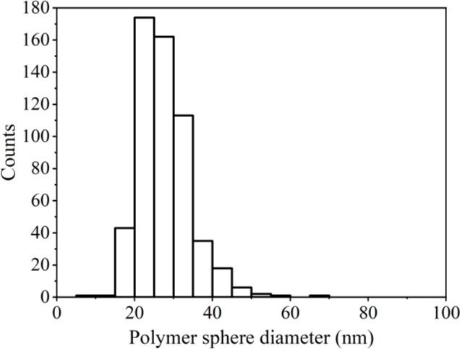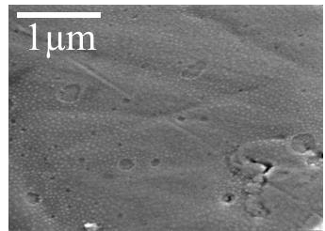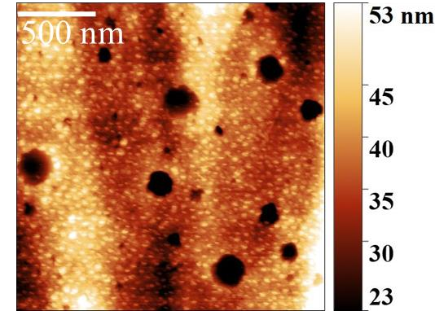a) b)

c)

Figure 6.1 – a) 2 µm x 2 µm AFM image showing polymer spheres deposited on a YSZ pellet b) histogram of polymer sphere diameters from AFM images, total count = 557. c) SEM image at 80 000x magnification showing the polymer spheres under a 50 nm nickel layer.
A layer of polymer spheres was deposited onto polycrystalline pellets via dip-coating (Section 3.1.3.2) (Figure 6.1a). The average polymer sphere diameter was 28±0.3 nm, when polymer spheres were measured from the AFM image using ImageJ software, and the standard deviation in the measurement was calculated. Crater-like holes in the layer were observed across the pellet (Figure 6.1a and c), and are an artefact of the dip-coating process caused by solvent evaporation cooling the substrate and thin film [153]. A 50 nm nickel pattern electrode was deposited directly on top of the polymer sphere layer. SEM images of the resultant electrodes showed that the polymer retained its spherical structure underneath the nickel layer, resulting in a thin film electrode microstructure which mirrored the topography of the underlying polymer layer (Figure 6.1c).

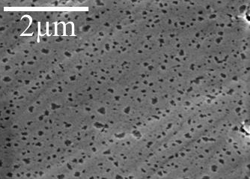
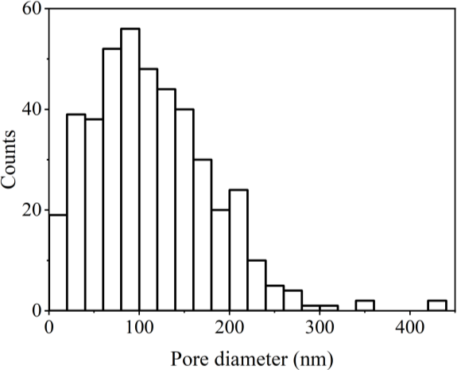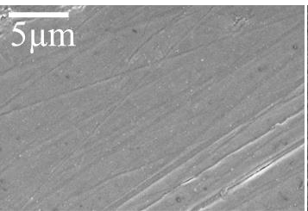a)
b)

c)

Figure 6.2 – a) SEM image at 50 000x magnification showing a polymer sphere modified nickel thin film electrode on YSZ pellet after heating at 400°C for 30 minutes. b) histogram of pore diameters, total count = 435. c) SEM image at 5000x magnification showing an unmodified nickel film after heating at 400°C for 30 minutes.

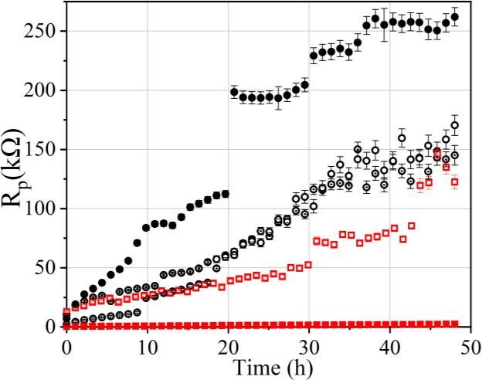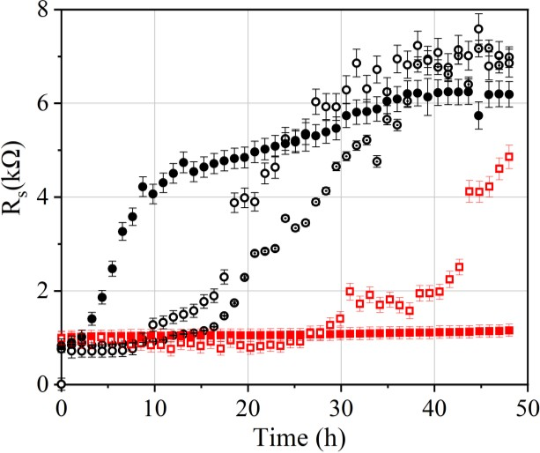After attaching the silver current collectors to the nickel electrodes, samples were heated to 400°C for 30 minutes to remove organic residues. The microstructure of the polymer sphere modified nickel film after this cleaning process was examined using SEM (Figure 6.2a), which showed the film to have developed holes across the surface with an average Feret diameter of 113±3 nm (standard deviation). A nickel pattern electrode without a polymer layer underneath was also examined after the cleaning process and had a dense microstructure (Figure 6.2c).
a)
c)
b)
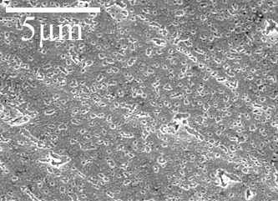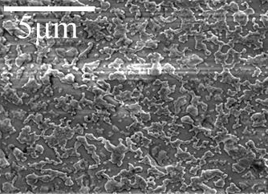

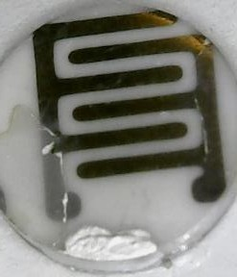
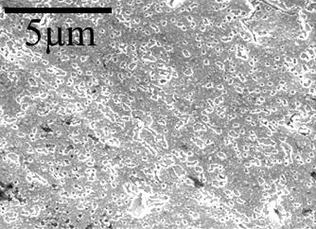
d)

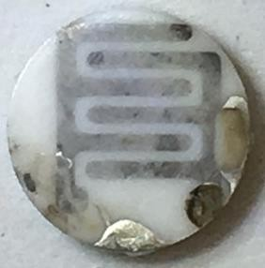
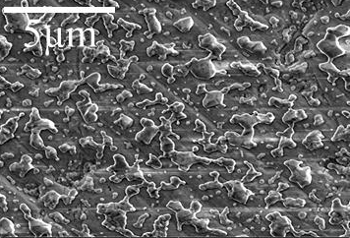
e)

Figure 6.3 – Graphs of resistance vs. time for 50 nm pattern electrodes on polycrystalline YSZ pellets at 600°C in 10%H2/N2 atmosphere. a) polarisation resistance and b) ohmic resistance. Error bars show error in the fitting of the equivalent circuit (Figure 3.9) to the measured data and the sample placement error. Images of the polymer modified electrodes post-testing are presented in c and d), and images of the unmodified electrode post-testing are presented in e). Post-test SEM-images taken at 20 000x magnification.
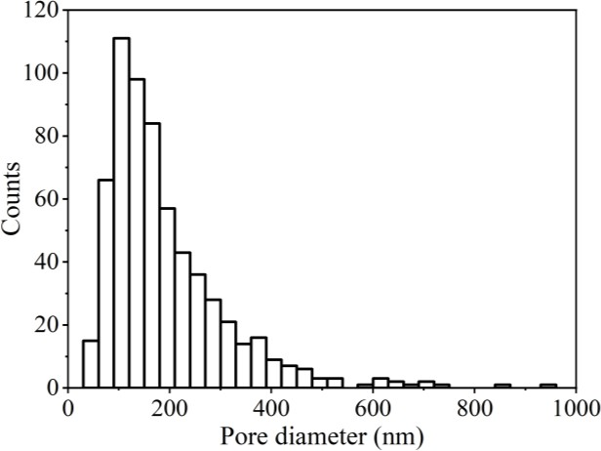
Figure 6.4 – Histogram of pore diameters in polymer modified electrodes post-testing at 600°C for 48 hours in 10%H2/N2 atmosphere, total count = 631.
The electrochemical performance of the electrodes deposited on top of the polymer sphere layer was tested over 48 hours at 600°C in 10%H2/N2 and compared to the performance of the analogous unmodified electrodes. Error in the polarisation resistance and ohmic resistance measurements was calculated as discussed in Section 3.4.3. The error bars in Figure 6.3 and the following subsections represent the error in fitting the electrochemical impedance data to an equivalent circuit, and the error introduced by a possible 1 mm fluctuation in sample placement within the crucible of the Linkam stage. As discussed in Section 4.3.3.1, unmodified 50 nm pattern electrodes on polycrystalline YSZ pellets appear to have three stages of ohmic resistance over time, whilst the polarisation resistance increases more steadily with time. One of the 50 nm nickel electrodes deposited on top of the polymer layers showed almost no change in ohmic and polarisation resistance throughout the 48 hours of testing (Figure 6.3 – red closed square). Final ohmic resistance for this repeat was 5.5 times lower than the average ohmic resistance of the unmodified electrodes, whilst polarisation resistance was 80 times lower than the average polarisation resistance for the unmodified electrodes. This corresponded with the electrode being visually unchanged after testing (Figure 6.3d). A second polymer modified electrode (Figure 6.3 – red open square) had an ohmic resistance which remained stable for 26 hours of heating, whilst polarisation resistance increased gradually over time. After 26 hours,

the ohmic and polarisation resistances showed several stages of rapidly increasing resistance and relative plateaus. At the end of the testing, the ohmic resistance of this second repeat was
  - times lower than the average final resistance of the unmodified electrodes, but 3.4 times larger than the final resistance of the first repeat, and therefore has a wide spread. Final polarisation resistance was 1.4 times lower than the average of the unmodified repeats. Visually, this electrode became dull in areas, particularly around one of the edges of the sample near the current collector, whilst the majority of the nickel remained visually unchanged (Figure 6.3c). The fluctuation between repeats and the difference between the modified electrodes and the unmodified repeats did not appear to be accounted for by the propagated error in resistance measurements.
Post-test SEM of the majority of the electrode area on both polymer modified samples showed the nickel film developed pores with an average Feret diameter of 196±6 nm (standard deviation) (Figure 6.4), but remained intact with no loss in percolation pathway. The analogous unmodified nickel electrode visually dulled after testing (Figure 6.3e), which corresponded to the formation of isolated nano-islands and a loss in percolating pathway. The areas which visually dulled on the sample in Figure 6.3c also corresponded to a partially disconnected microstructure. Analysis of the post-test SEM images revealed that the porous microstructure observed across the majority of the two polymer modified repeats had an average electrolyte exposure of 17±9%, whilst the unmodified repeats had an average electrolyte exposure of 62±4%. Averages were calculated from at least 3 SEM images and standard deviation was calculated.

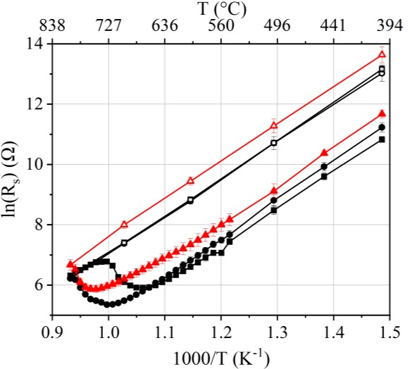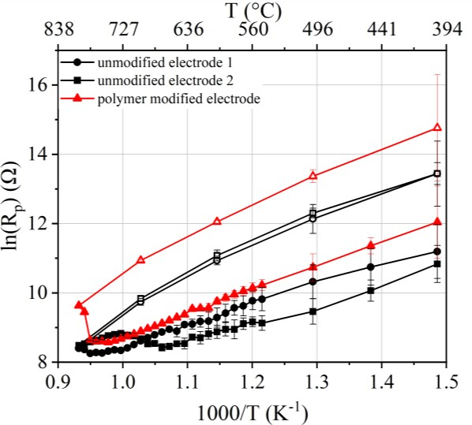
a)
b)

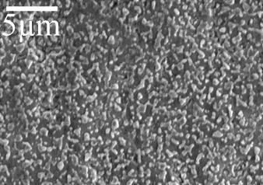
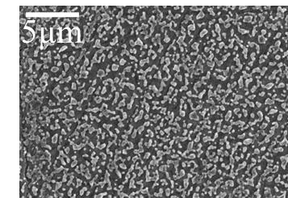d)
c)

Figure 6.5 – Graphs of resistance vs. temperature for 50 nm pattern electrodes on polycrystalline YSZ heated in 10%H2/N2 atmosphere. a) polarisation resistance and b) ohmic resistance. Measurements were taken whilst heating (closed symbols) and whilst cooling (open symbols). Error bars show error in the fitting of the equivalent circuit (Figure 3.9) to the measured data. Post-test SEM images at 5000x magnification show the microstructure of c) unmodified samples and d) electrodes deposited on top of polymer spheres.
Activation energy tests showed the nickel film electrodes deposited on top of polymer spheres behaved similarly to the unmodified electrodes (Figure 6.5). A peak in both ohmic and polarisation resistances was observed at 750-780°C which was discussed in Section 4.3.2.1 to occur as the percolation pathway is lost in the nickel film. Post-test SEM of the polymer modified sample showed the microstructure had dewet into nano-islands (Figure 6.5d), similar to the unmodified electrode microstructure after testing (Figure 6.5c).

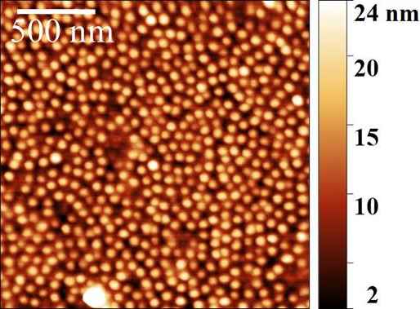
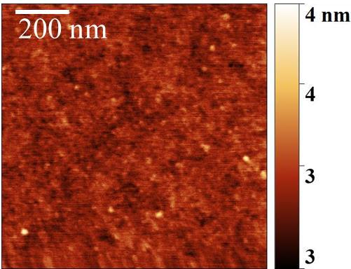
    - b)

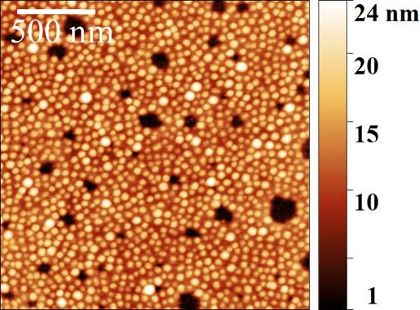
c) d)
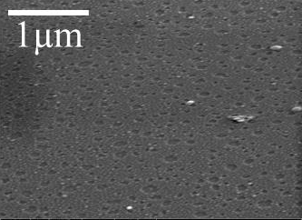

Figure 6.6 – AFM images a) 1 µm x 1 µm showing single crystal YSZ (100) surface after cleaning
    - 2 µm x 2 µm of polymer spheres on single crystal YSZ (100) c) 2 µm x 2 µm of 50 nm nickel film deposited on top of polymer spheres, d) SEM image at 80 000x magnification showing the polymer spheres under the 50 nm nickel layer
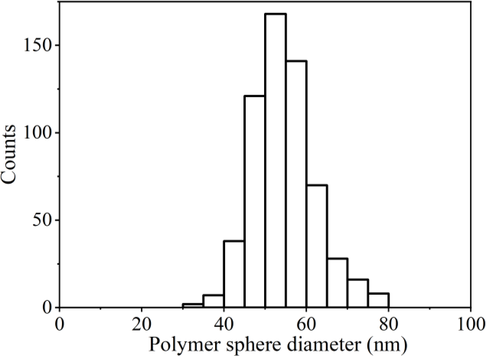
Figure 6.7 – Histogram of polymer sphere diameter on single crystal YSZ (100). Total count = 599.

A layer of polymer spheres was also deposited on the surface of single crystal YSZ (100). The single crystal surface is smoother than the polycrystalline pellets (Figure 6.6a) with a root mean square (RMS) surface roughness of 1 nm compared to 37 nm for polycrystalline pellets, calculated from AFM images. The polymer sphere layer on single crystal YSZ can therefore be imaged using AFM with improved clarity (Figure 6.6b). The mean centre-centre spacing between spheres was 74±1 nm (standard deviation) whilst the diameter of the spheres was found to be 54±0.3 nm (standard deviation) (Figure 6.7). Crater-like holes were still present in the film and are an artefact of the dip-coating process [153]. A 50 nm nickel pattern electrode was deposited directly on top of the polymer sphere layer without loss of the underlying polymer sphere structure (Figure 6.6c and d).
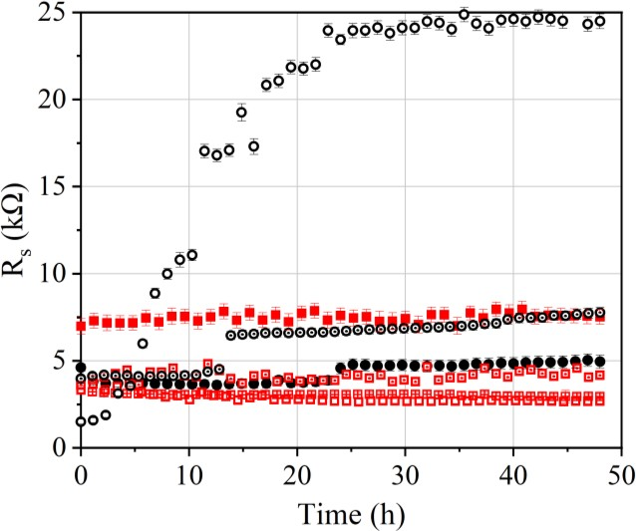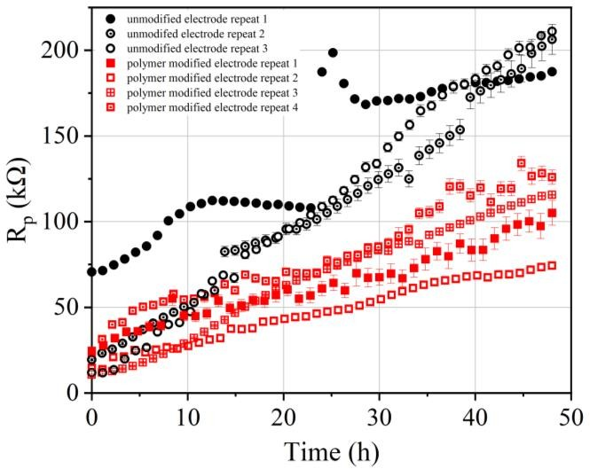
a)
b)
c)

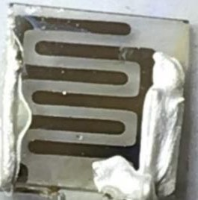
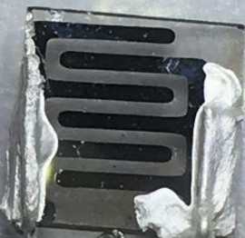
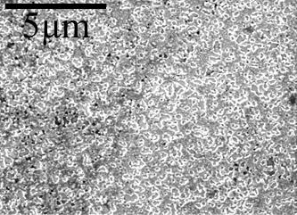
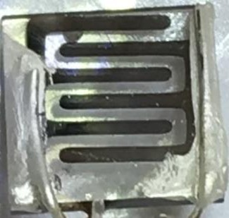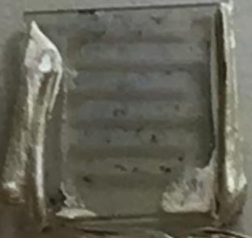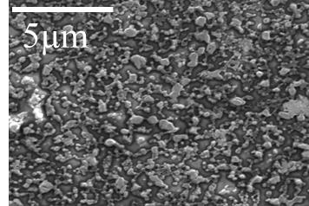d)

Figure 6.8 – Graphs of resistance vs. time for 50 nm pattern electrodes on single crystal YSZ (100) at 600°C in 10%H2/N2 atmosphere. a) polarisation resistance and b) ohmic resistance. Error bars show error in the fitting of the equivalent circuit (Figure 3.9) to the measured data and the sample placement error. c) Images of the polymer sphere modified electrodes pre- and post- testing and post-test SEM image at 20 000x magnification representative of all samples tested. d) Images of the unmodified electrodes pre- and post- testing, and post-test SEM image at 20 000x magnification representative of all samples tested.
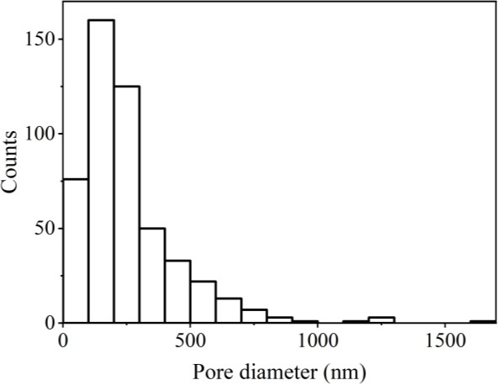
Figure 6.9 –Histogram of pores in polymer modified 50 nm nickel film on single crystal YSZ (100) post-testing at 600°C for 48 hours in 10%H2/N2. Total count = 495.
The electrochemical performance of the nickel films deposited on top of the polymer sphere layer on single crystal YSZ were tested at 600°C for 48 hours in 10%H2/N2. The ohmic resistance for each of the four repeats changed little over time (Figure 6.8b). Three of the four repeats had an ohmic resistance similar or lower than the lowest repeat for the unmodified electrodes on single crystal, and seven times lower than the highest repeat after 48 hours of testing. One of the four repeats (Figure 6.8b – red closed square) started and finished higher in ohmic resistance than the other three repeats, but the resistance still remained stable throughout the 48 hours of testing. The polarisation resistance of all four of the repeats increased at an approximately steady rate over time, with an end resistance 1.5-2.7 times lower than the analogous unmodified repeats on single crystal. All four of the repeats on single crystal were visually unchanged after heating (Figure 6.8c), whilst the unmodified nickel thin films on single crystal YSZ dulled during testing (Figure 6.8d). Post-test SEM images show the nickel film which was on top of the polymer sphere layer developed pores with an average Feret diameter of 254±9 nm (standard deviation) (Figure 6.9). There is no loss in percolation pathway in the film whereas the un-modified nickel pattern electrodes on single crystal dewet into nano- islands after testing (Figure 6.8d).

The fluctuation between repeats and the difference between the modified electrodes and the unmodified repeats did not appear to be accounted for by the propagated error in resistance measurements.
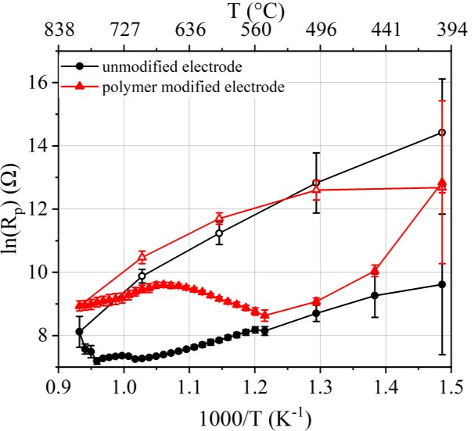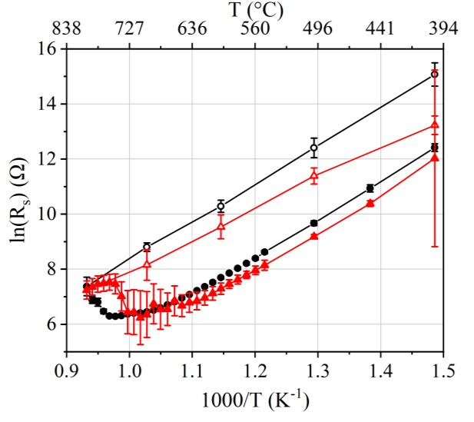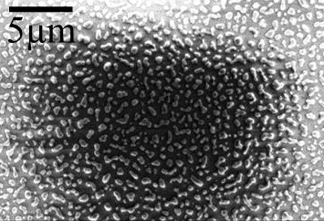
a)
b)
c)

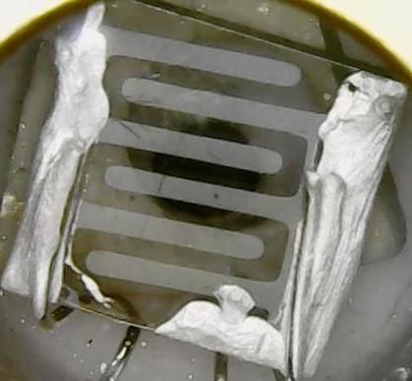
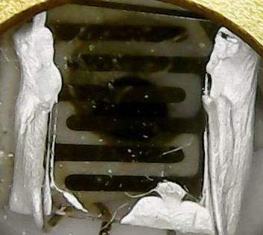
d)

Figure 6.10 – Graphs of resistance vs. temperature for 50 nm pattern electrodes on single crystal
(100) YSZ heated in 10%H2/N2 atmosphere. a) polarisation resistance and b) ohmic resistance. Error bars show error in the fitting of the equivalent circuit (Figure 3.9) to the measured data. Measurements were taken whilst heating (closed symbols) and whilst cooling (open symbols). Post-test SEM images at 5000x magnification show the microstructure of c) electrodes deposited on top of polymer layers and d) unmodified samples.
Activation energy tests with the single crystal YSZ (100) showed the nickel film electrodes deposited on top of polymer spheres to spike in ohmic resistance at 550°C and therefore at a

considerably lower temperature than the unmodified electrodes which peaked at 710-760°C. Polarisation resistance for the polymer sphere modified electrode exhibited a peak at 710- 760°C, similarly to the unmodified electrode. It was discussed in Section 4.3.2.1 that this peak in resistance is presumed to correspond to a loss in the percolation pathway in the nickel film. The error in the fitting of the polymer modified electrode to the equivalent circuit was particularly large for ohmic resistance compared to the unmodified electrode, and the error appears to increase with temperature. This could also be an indication of other processes affecting the electrode, and could be an indication of the loss of connectivity in the film. Post- test SEM of the polymer modified sample showed the microstructure has dewet into isolated nano-islands (Figure 6.10c), whereas the unmodified electrode microstructure remains partially connected after testing (Figure 6.10d). Both samples dulled visually after testing (Figure 6.10c and d).

Nickel nanoparticle layer
      - Nanoparticle fabrication
Diblock copolymer spheres can be used as nano-compartments to produce ordered arrays of nanoparticles on solid substrates [152, 154]. Anionic complexes such as chloride metal salts selectively bind to the protonated P2VP chain in PS-b-P2VP diblock copolymers because of strong electrostatic interactions with the pyridine groups [155]. In an apolar solvent, P2VP are located at the core of the diblock copolymer spheres, and therefore the metal salt becomes immobilised in the core. Subsequent plasma treatment removes the polymer template and transforms the metal salt to a single metal nanoparticle, arranged in a pattern identical to that of the polymer template [152].

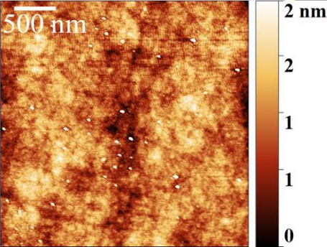
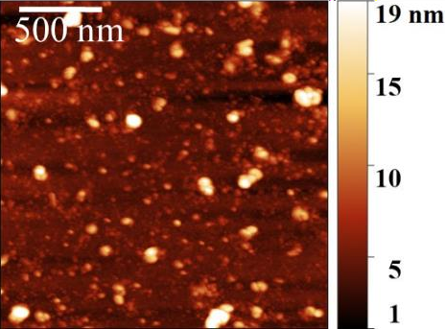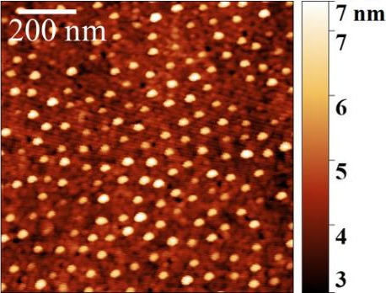a)
b)
d)

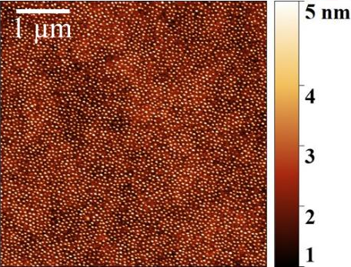
c)

Figure 6.11 – AFM images showing nickel nanoparticles on glass substrate prepared by a) direct loading of diblock copolymer with metal salt, 3 µm x 3 µm b) diblock copolymer loaded with homopolymer-salt complex, 2 µm x 2 µm, c) and d) diblock copolymer post-loaded with aqueous solution of metal salt, c) 5 µm x 5 µm and d) 1 µm x 1 µm. All images taken after plasma cleaning.
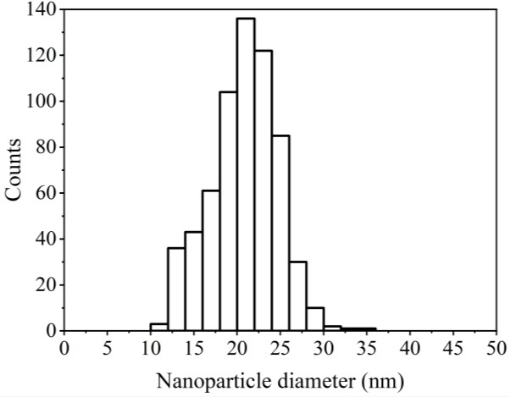
Figure 6.12 - Histogram of diameter of nanoparticles prepared with post-loading technique on glass substrate, total count = 634.
Addition of the metal salt to the diblock copolymer can be carried out using several different methods. Firstly, direct addition of nickel chloride hexahydrate to a solution of diblock copolymer was attempted, followed by stirring for 3 days (Section 3.1.4.1) [152, 155, 156]. However, this technique was unsuccessful in producing nanoparticles (Figure 6.11a) because

the solubility of the salt in toluene was low, and did not selectively bind to the pyridine functional units in the P2VP chains in the sphere core. Low solubility with a direct-loading technique has been observed previously [155].
A second method for metal salt addition to the polymer spheres was attempted using pre- loading of a P2VP homopolymer with the metal salt, followed by subsequent addition to the diblock copolymer in toluene solution (Section 3.1.4.2) [157]. However, the solubility of nickel chloride hexahydrate in the apolar homopolymer solution was again observed to be low, and an array of nanoparticles was not obtained using this technique either (Figure 6.11b).
A third technique involved post-loading the polymer spheres with the metal salt, after the spheres had been deposited on a solid substrate [155, 158]. In this technique, the metal salt is dissolved in an aqueous solvent, overcoming the solubility problems observed in the previous two techniques (Figure 6.11 c and d) [155]. Nanoparticles were measured from AFM images to be 21±0.2 nm (standard deviation) in diameter (Figure 6.12). AFM is known to over-estimate the size of small features by half, owing to tip-sample convolution effects, and therefore nanoparticles could be as small as 10 nm in size [159].
Arrays were not observed uniformly across the entire substrate, and substrates were particularly void of nanoparticles towards the edges. This is a common problem with the dip-coating process [153]. The drying front is sensitive to many factors including the temperature of solution, and the ambient temperature. Unfortunately, it proved unavoidable to carry out the dip-coating in a fume hood because of the use of toluene. The flow of air from the fume hood is also likely to affect the drying front and contribute to a non-uniform film formation. Ideally the dip-coating process should be carried out in a glove box.

      - Nanoparticles on YSZ substrate
A polymer sphere layer was deposited on YSZ pellets and then a subsequent post-loading step was used to fill the polymer spheres with metal salt solution (Section 3.1.4.3). Oxygen plasma treatment was used to remove the polymer and transform the metal salt to nanoparticles. The small (10-20 nm) size of the nanoparticles (Figure 6.12) and the relatively uneven YSZ surface (RMS = 37 nm), meant that nanoparticles could not be observed on the YSZ pellets using AFM or SEM. 50 nm nickel pattern electrodes were deposited onto the assumed nanoparticle layer
on the pellets.
        - 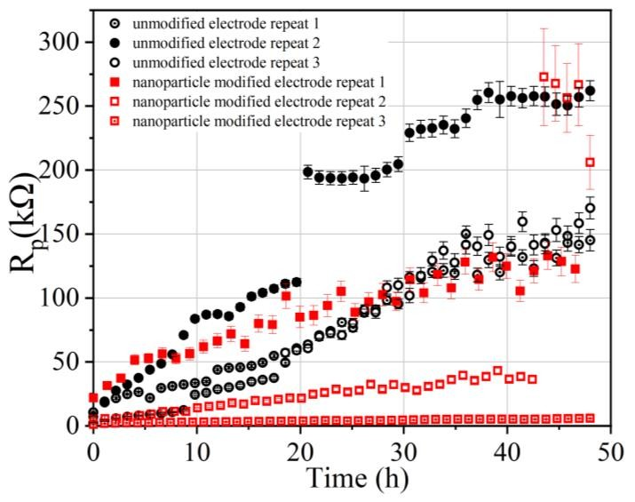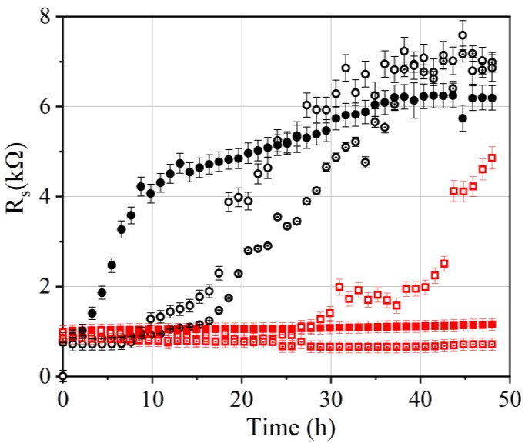b)

c)
d)
e)
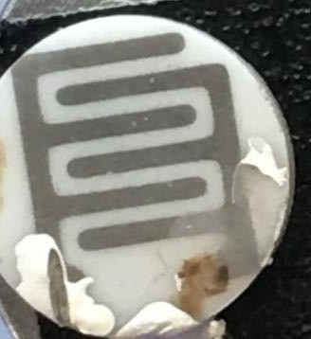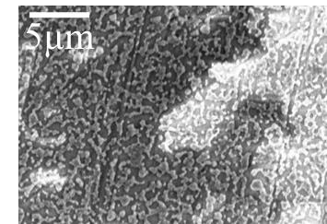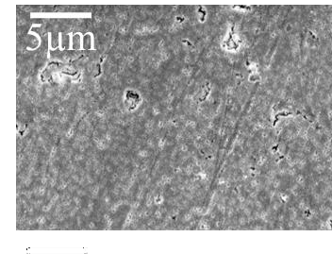

Figure 6.13 –Graphs of resistance vs. time for 50 nm pattern electrodes on polycrystalline YSZ pellets at 600°C in 10%H2/N2 atmosphere. a) polarisation resistance and b) ohmic resistance, Error bars show error in the fitting of the equivalent circuit (Figure 3.9) to the measured data and sample placement error. c) Image of the nanoparticle modified electrode post-test representative of all three samples tested. SEM images at 5000x magnification of d) dull area indicated by arrow and e) representative of the majority of the electrode area.

a) b)
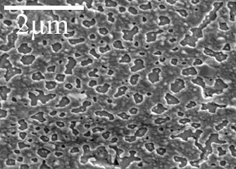
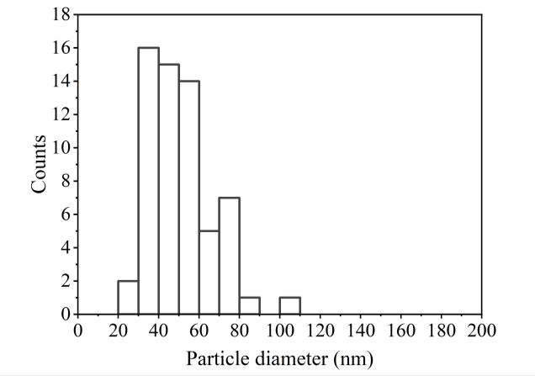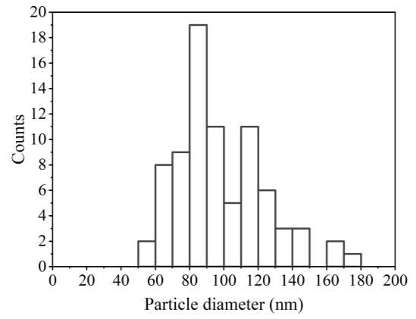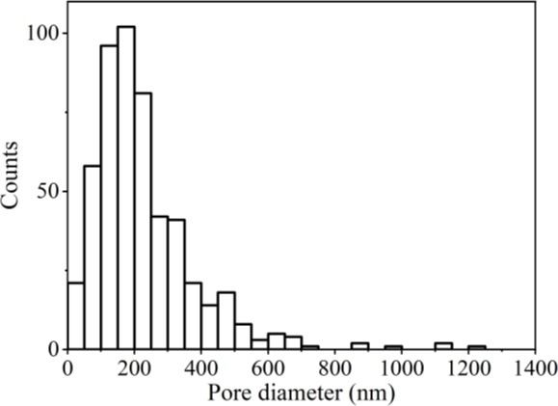
c)
d)
e)

Figure 6.14 – Comparison of electrode microstructures on pellets after 48 hours at 600°C in 10%H2/N2 atmosphere. a) unmodified electrode, SEM image at 20 000x magnification, b) nanoparticle modified film, SEM image at 50 000x magnification c) histogram of small isolated particle diameter from the unmodified electrodes total count = 80, and d) histogram of small isolated particle diameter from nano-particle modified film total count = 61. e) pore diameter from nanoparticle modified electrodes, total count = 517.
The electrochemical performance of the electrodes deposited on top of the nanoparticle layer was tested over 48 hours at 600°C in 10%H2/N2. As discussed in Section 4.3.3.1, for

unmodified 50 nm pattern electrodes on polycrystalline YSZ pellets heated at 600°C in 10%H2/N2, three stages were observed in ohmic resistance, whilst the polarisation resistance increased approximately steadily with time. For the electrodes modified with the nickel nanoparticle layer underneath, two of the three repeats showed almost no change in ohmic resistance throughout the 48 hours of testing (Figure 6.13b – closed and dotted squares) and had a final ohmic resistance 7 times lower than the average ohmic resistance of the unmodified electrodes. The third repeat remained stable up to 25 hours before the ohmic resistance increased, finishing at a resistance value 1.7 times lower than the average final ohmic resistance value of the unmodified electrodes. The error in fitting an equivalent circuit to the electrochemical data and the sample placement error could not account for the fluctuation between repeats.
One of the nanoparticle modified samples showed almost no change in polarisation resistance over time (Figure 6.13a – dotted square) and the final value was 32 times lower than the average final polarisation resistance for the unmodified electrodes. Another repeat (Figure 6.13a – closed square) increased more steadily over time, and finished 1.5 times lower than the average final polarisation resistance for the unmodified electrodes. The third nanoparticle modified repeat (Figure 6.13a – open square) had a polarisation resistance which increased after 44 hours of testing. The final polarisation resistance was 1.9 times higher than the average final polarisation resistance for the unmodified electrodes.
The electrodes modified with a nanoparticle layer remained mostly visually unchanged over the testing period (Figure 6.13c), however small sections at the edges of the electrodes became dull, corresponding to a partially connected microstructure in SEM images (Figure 6.13d). The majority of the electrode microstructure developed pores with an average Feret diameter of 228±7 nm (standard deviation) (Figure 6.14e), without a loss of percolation. Particles could be observed inside the pores which had an average size of 51±2 nm (standard deviation) (Figure 6.14b and d) which were not observed in the porous structure developed with the polymer modified electrodes on YSZ pellets (Figure 6.3c and d). These particles were determined to be smaller than the isolated particles observed in the unmodified samples which had an average size of 97±3 nm (standard deviation) (Figure 6.14a and c), and are presumed to form during the rim-pinch off stage of solid-state dewetting, as has been reported elsewhere [95]. From images of the porous sections, the average exposure of the underlying electrolyte in the nanoparticle modified electrodes was 22±4% after the 48 hours of testing. Averages were calculated from at least 3 SEM images and standard deviation was calculated.

a) b)
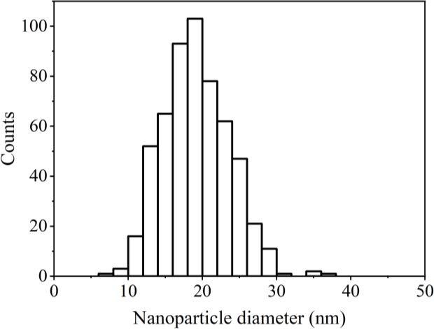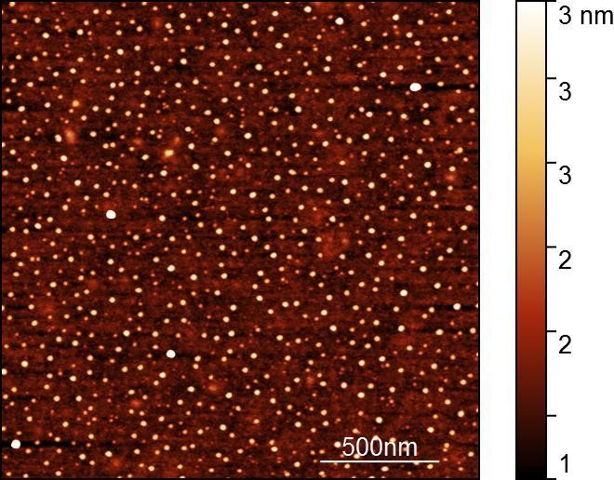

Figure 6.15 – a) 2 µm x 2 µm AFM image of nickel nanoparticles on YSZ single crystal (100) using a post-loading technique, and b) histogram of nanoparticle diameter, total count = 556.
The relatively flat and defect free surface of the single crystal YSZ (100) compared to polycrystalline YSZ pellet, meant the nickel nanoparticle layer could be imaged using AFM. Centre-to-centre spacing was found to be 62±1 nm and the average diameter was 19±0.2 nm (Figure 6.15), and therefore similar to the average size of 21±0.2 nm of nanoparticles on glass substrate. Averages were calculated from at least 3 SEM images and standard deviation was calculated.
However similar to the nanoparticles deposited on glass substrate, the coverage of the nanoparticles was not uniform across the entire substrate surface, with some areas devoid of nanoparticles, whilst others showed nanoparticles in an un-ordered structure. A 50 nm nickel pattern electrode was deposited on top of the nanoparticle layer, but the small size of the nanoparticles meant that they were not visible via AFM or SEM under the nickel film.

a) b)
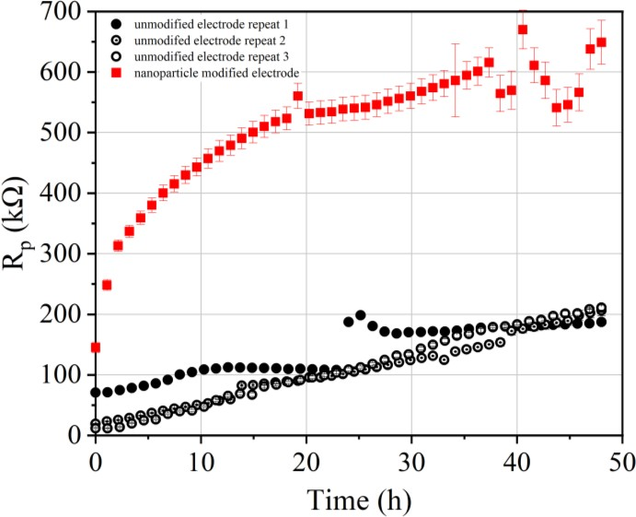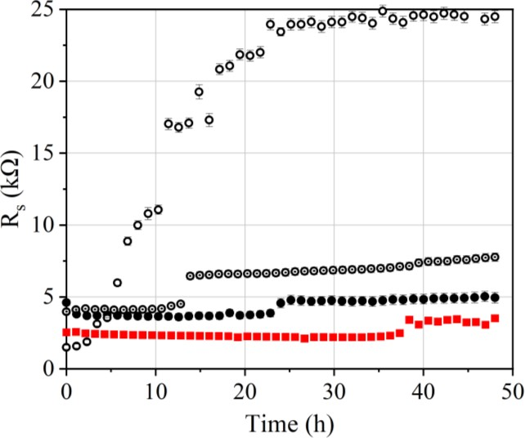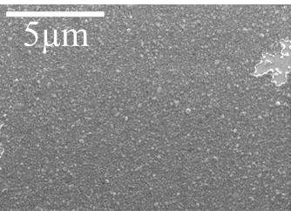
c)
d)

Figure 6.16 – Graphs of resistance vs. time for 50 nm pattern electrodes on single crystal YSZ
(100) at 600°C in 10%H2/N2 atmosphere. a) polarisation resistance and b) ohmic resistance. c) Error bars show error in the fitting of the equivalent circuit (Figure 3.9) to the measured data and the sample placement error. Image of the nanoparticle modified electrode post-testing and
d) post-test SEM image at 20 000x magnification.

The electrochemical performance of the nanoparticle modified electrode on single crystal was tested over 48 hours at 600°C in 10%H2/N2, however only one sample was tested. The ohmic resistance remained relatively low compared to the analogous unmodified electrodes on single crystal, until 38 hours, in which it peaked slightly, before plateauing again. The final ohmic resistance was 3.5 times lower than the average final ohmic resistance for the unmodified electrodes (Figure 6.16b). Polarisation resistance presented a different behaviour to the unmodified electrodes, immediately increasing rapidly before plateauing after 20 hours of heating. After a further 10 hours, a second period of increasing resistance was observed before a final plateau. The end resistance after 48 hours of testing was 2.9 times higher than the average polarisation resistance of the unmodified electrodes (Figure 6.16a). The error in the resistance measurement did not account for the difference between the performance of the

modified and unmodified electrodes. The electrode was visually unchanged after heating (Figure 6.16c). Post-test SEM images showed the majority of the film to be in-tact with a few sporadic holes between 2.7 µm and 200 nm in Feret diameter (Figure 6.16d). Total electrolyte exposure was calculated from three SEM images to be 1±0.2%.

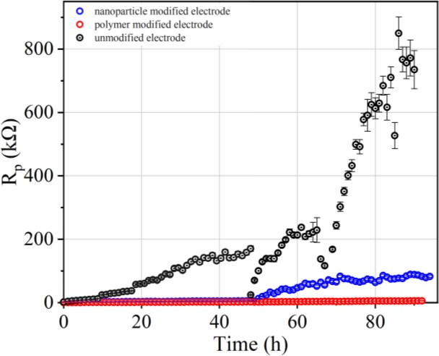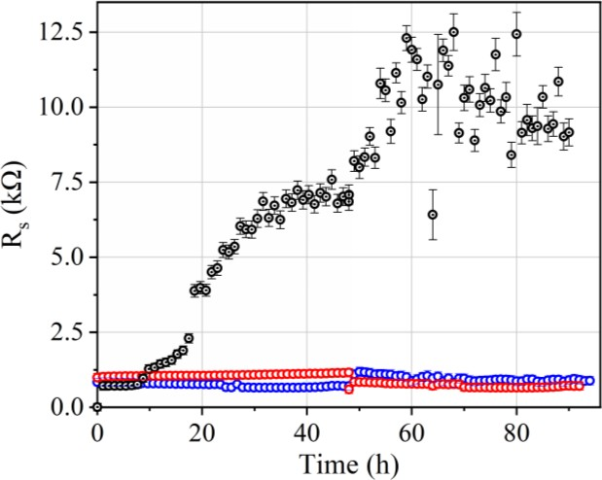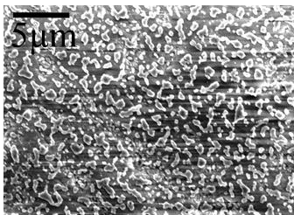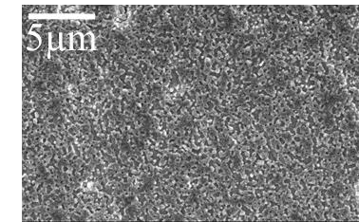7.3.3 Extended testing
a)
b)
c)
d)
e)
Figure 6.17 – Graphs of resistance vs. time for 50 nm pattern electrodes on polycrystalline YSZ pellets at 600°C in 10%H2/N2 atmosphere. Samples cooled, remounted and re-heated to 600°C after 48 hours a) polarisation resistance and b) ohmic resistance. Error bars show error in the fitting of the equivalent circuit (Figure 3.9) to the measured data and the sample placement error. Post-test SEM images c) unmodified sample, 5000x magnification d) polymer sphere modified sample, 10 000x magnification e) nanoparticle modified sample 5000x magnification.
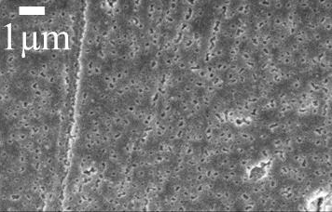
An unmodified sample, a nanoparticle modified electrode sample, and a polymer sphere modified electrode sample, were remounted and re-heated to 600°C for a further 48 hours in

10%H2/N2 atmosphere (Figure 6.17). The ohmic resistance of the unmodified sample increased rapidly upon re-heating to 600°C, before reaching a plateau at 70 hours of testing. The polarisation resistance was 6.6 times lower upon starting than the final resistance recorded after 48 hours, but increased at a faster rate throughout the additional 48 hours of testing. The difference in resistance values after re-mounting is presumed to be a result of re-attaching the current collectors resulting in a different amount of nickel connected to the current collector. The polymer sphere modified sample had an ohmic resistance 1.9 times lower upon re-heating than the final resistance value after 48 hours, but continued to remain relatively stable throughout the 96 hours of heating. Polarisation resistance remained stable throughout the testing period finishing 87 times lower than the unmodified sample. The nanoparticle modified repeat had an initial ohmic resistance 1.5 times higher than the end resistance after 48 hours of heating, and remained approximately stable throughout the 96 hours of operation. Polarisation resistance started very close to the end value after 48 hours upon reheating, but increased over time with the second heating period. Final polarisation resistance of the nanoparticle modified electrode was 8.6 times larger than that of the polymer sphere modified repeat, but 10 times lower than the unmodified final resistance value after 96 hours of heating. The error in the resistance measurements remained low for the modified electrodes throughout testing, and were comparatively higher for the unmodified repeat, particularly towards the end of testing. The calculated error however, did not account for the full breadth of the data. Post-test SEM images showed that whilst the unmodified sample formed partially connected nano-islands after testing (Figure 6.17c), both the polymer and nanoparticle modified electrodes maintained the porous structures observed after 48 hours of testing and did not suffer a loss of percolation pathway even after 96 hours of operation (Figure 6.17d and e).

Discussion

Electrochemical performance

Table 6.1 – Experimental findings after 48 hours at 600°C for samples on YSZ pellets

Sample | Pore diameter ± standard dev. (nm) | Average final polarisation resistance ± standard dev. (kΩ) | Average final ohmic resistance ± standard dev. (kΩ) | Electrolyte exposure ± standard dev.
Unmodified | Loss of percolation | 105±50 | 5±0.3 | 62±4%
Polymer sphere modified | 196±6 | 62±60 | 3±0.2 | 17±9%
Nanoparticle modified | 228±7 | 112±82 | 50±0.3 | 22±4%

Table 6.2 – Experimental findings after 48 hours at 600°C for samples on single crystal YSZ

Sample | Average pore diameter ± standard dev (nm) | Average final polarisation resistance ± standard dev (kΩ) | Average final ohmic resistance ± standard dev (kΩ) | Electrolyte exposure ± standard dev
Unmodified | Loss of  percolation | 204±89 | 12±9 | 39±4%
Polymer sphere modified | 254±9 | 105±45 | 4±2 | 15±2%
Nanoparticle  modified | 850±304 | 649±36 | 3±0.1 | 1±0.2%

The results from all constant temperature tests carried out in this chapter are presented in Tables
6.1 and 6.2. The results show that modification of nickel pattern electrodes with both an underlying polymer sphere layer and an underlying nanoparticle layer, decreased the average electrolyte exposure. Therefore, the hypothesis that dewetting can be controlled in thin nickel films by changing the interactions at the substrate/thin film interface using diblock copolymers appears to be true. Dewetting was found to be controlled to different extents on the different substrates. The best results for limiting dewetting were obtained with nanoparticle modification on single crystal, resulting in a mainly dense microstructure after testing. The dewetting of electrodes on polymer sphere and nanoparticle layers on YSZ pellets, and on polymer spheres on single crystal, was sufficiently controlled to prevent hole impingement, resulting in an average pore diameter of 200-250 nm. In comparison, unmodified electrodes dewet to the point of hole impingement and nano-island formation.

A correlation between the improved microstructural stability obtained for the modified samples and an improved electrochemical performance is not straightforward. For modified samples on YSZ pellets, the microstructure was generally observed to be porous but without a loss in percolation pathway. The porous microstructure creates additional active TPB sites within the bulk of the nickel compared to unmodified electrodes and this correlates with the lower polarisation resistance values for the modified samples on YSZ pellets. On single crystal, nanoparticle modification resulted in only 1±0.2% electrolyte exposure, and therefore few additional TPB sites in the bulk of the nickel, resulting in a resistance almost 3 times higher than for the unmodified electrode. Polymer sphere modification on single crystal resulted in a porous microstructure which increases the TPB length compared to the dense electrode but also compared to the unmodified samples which suffered a loss of percolation pathway from the current collector. Correspondingly, polarisation resistance for the polymer modified, porous electrode was approximately 1.4-4 times lower than for the nanoparticle modified, dense electrode and the unmodified electrode, despite the best dewetting control being observed for the nanoparticles on single crystal sample.
Therefore, whilst nanoparticle modification on single crystal resulted in the best stability and control of the dewetting process, this sample had the highest polarisation resistance after testing. For model electrode studies, for which maintaining an accurately quantifiable TPB length during operation is necessary, nanoparticle modification on single crystal offers the best route to obtaining accurate results, however it is likely resistances obtained through this modification will be significantly higher compared to unmodified pattern electrode studies which observe microstructural changes during testing.

Origin of the stabilising effect
      - Nickel nanoparticle layer

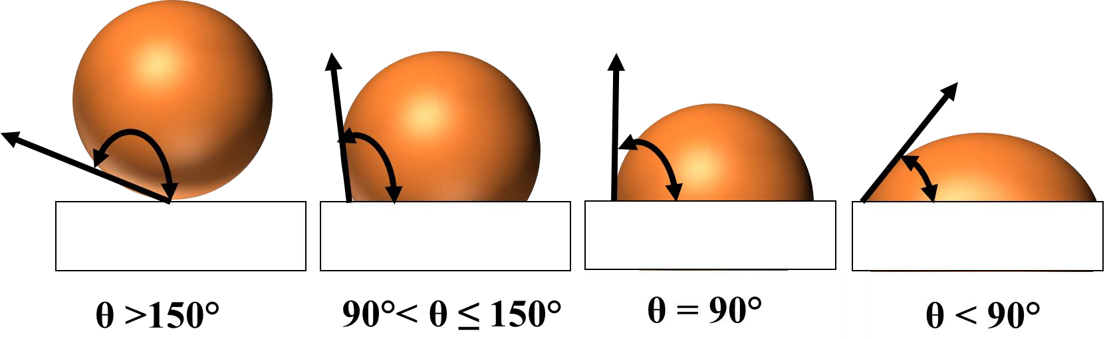
Figure 6.18 – Changing contact angle with wettability on a solid substrate. Source: [160].

Nickel films on YSZ substrates have a contact angle of 121-126° [95, 161], and therefore wet the surface poorly as a result of high interfacial tension between the metal and the substrate (Figure 6.18). Decreasing interfacial tension lowers the contact angle between the metal and the substrate and provides a route to improving the wettability of the metal on the substrate as the spreading coefficient increases (Equation 6.1) [162].
The results presented in this chapter show that coating YSZ substrates with a layer of small (10-20 nm) nickel nanoparticles increased the microstructural stability of the overlying nickel thin film for up to 96 hours of operation (Figure 6.17). On single crystal YSZ, the dewetting process was almost completely inhibited with an electrolyte exposure of just 1±0.2%, after 48 hours of testing whilst on YSZ pellets, dewetting was slowed compared to unmodified electrodes in which holes were sufficiently large as to impinge and cause disconnection in the film. These results are comparable to reports of retarded dewetting kinetics upon addition of nano-additives to thin polymer films [140]. In thin polymer films, porous structures were obtained for low concentrations of nano-additives, whilst dewetting was completely inhibited for higher nano-additive concentrations [140]. For the results obtained in this chapter, concentration of nanoparticle solutions was kept constant for both single crystal and YSZ substrates. However, it is possible that the arrays on single crystal YSZ had an improved uniformity compared to the rougher surface of the YSZ pellets, which could be the cause of the differences in dewetting inhibition observed. Owing to the small size (10-20 nm) of the nanoparticles and the relative roughness of the YSZ pellet substrates (RMS = 37 nm), it was not possible to image the nanoparticle layer on pellets and therefore the integrity of the particles on YSZ pellets is not known.
Introducing defects into the thin films to stabilize them contrasts the widely reported idea that solid-state dewetting is initiated at defect sites, and increased concentrations of defects in thin films increases the dewetting kinetics [138, 162, 163]. However, in thin polymer films, nano- additives have been reported to suppress dewetting through surface roughening, decreasing interfacial tension and through pinning of contact lines between the thin film and the substrate.

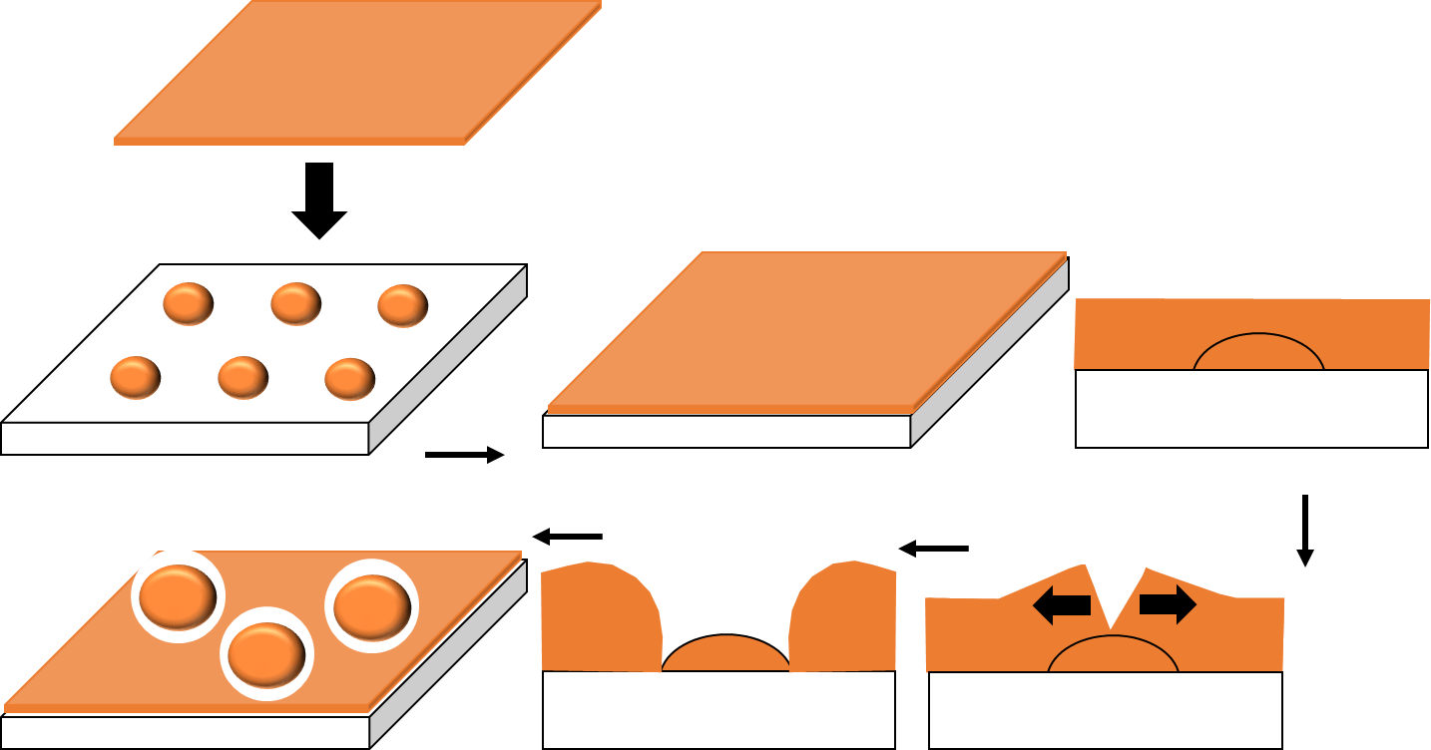
a)
b)
e)
d)
c)

Figure 6.19 – Schematic presenting a possible method for contact line pinning by a nanoparticle layer. a) Nanoparticles deposited onto substrate with 50 nm nickel layer deposited directly on top,
b) top and side view of resultant structure, c) pore formation and edge retraction on the top of a nanoparticle d) pinning of the nickel thin film either side of the nanoparticle e) resultant porous structure after dewetting.
In order for holes to grow, the contact line between the thin film and the substrate must be able to move. Figure 6.19 shows a schematic for a possible method of contact line pinning in the valleys between nanoparticles, and how this could result in the porous structure observed for nanoparticle modified samples on polycrystalline YSZ. The contact line recedes along the downwards slope of the nanoparticle, but has no interaction with the upwards slope and becomes pinned in the troughs created between nanoparticles. A similar effect has been observed for polymer films which dewet on terraced structured substrates and become pinned on the downward steps with no interaction with the upward step [164]. Materials expelled from the dewetted areas are conserved, and so the thickness of the nickel film within the valleys increases slightly, further increasing the stabilizing effect. Particles 51±2 nm were observed post-test in the centre of the pores in the nickel film (Figure 6.14c and d) which corresponds with the film dewetting from the surface of the nanoparticles. The size of the particles compared to the 10-20 nm expected for the nanoparticles pre-testing (Figure 6.15), suggests that agglomeration of the nanoparticles beneath the nickel film is likely to be occurring simultaneously to the dewetting of the overlying film.

Parts of the nanoparticle modified electrodes on YSZ pellets were observed to visually dull after testing, particularly near the edges of the pattern, and this corresponded to a partially disconnected microstructure (Figure 6.13c). Problems with polymer and nanoparticle layer uniformity were observed through AFM characterisation on glass and single crystal YSZ, and have been reported previously, particularly around the film edges as a result of an un-optimised dip-coating process [133, 153]. Therefore, on YSZ pellets it is expected that these dull and dewet parts correspond to sections of the pellet which had a low nanoparticle concentration, or were absent of nanoparticles underneath. In these sections, the contact line between the nickel film and the pellet is not pinned, and the dewetting process occurs as for unmodified samples.
      - Polymer sphere layer
Coating YSZ substrates with a polymer sphere layer was also shown in this chapter to increase the microstructural stability of the overlying nickel thin film after up to 96 hours of operation compared to unmodified electrodes (Figure 6.17). For both single crystal and YSZ pellet samples, the nickel thin film electrodes deposited on top of the polymer spheres were found to have pores 200-250 nm in size across the majority of the film, whilst unmodified samples dewet into partially connected nano-islands.
Block copolymer spheres have been reported to slow the dewetting process in thin polymer films on solid substrates through adsorption of the spheres at the polymer/polymer interface [165]. PS-b-P2VP has a glass transition temperature of 100°C [166] and has been found to reach a thermal degradation maxima just above 400°C [167]. It is therefore likely that after operation at 600ºC for 48 hours, there is no polymer or associated degradation products left beneath the nickel. The pores observed to form after heating the samples to 400°C for 30 minutes (Figure 6.2a), are likely to be caused by the underlying polymer thermally degrading, expanding and building up sufficient pressure to rupture the nickel film. A similar effect has been observed for oxygen built up beneath thin Pt films during operation under polarisation [151].
Since there is unlikely to be polymer spheres on the YSZ surface during electrode operation, the mechanism hypothesised for the stabilisation of nanoparticle films – surface roughening and contact line pinning – is not likely to be affecting the polymer modified samples. Small quantities of impurities in dewetting solids have been theorized to result in grain boundary drag in which grain boundary movement is held back by foreign atoms diffusing behind the boundary and slowing its retraction. If impurities are introduced into the nickel thin film from

the underlying polymer, perhaps as it reaches maximum thermal degradation at 400°C and pushes through the film, then a subsequent stabilization of the pores formed could be occurring through a similar process to grain boundary drag [168].
Stabilisation of the dewetting process did not extend to temperatures above 600°C (Figures 6.5 and 6.10) with polymer modified films performing similarly to unmodified thin films in activation energy tests. It is possible that the increased energy for edge retraction resulting from the increased temperature above 600°C, causes the retracting edge to overtake the diffusing foreign atoms and break away leading to dewetting [168]. An alternative hypothesis is that the polymer layer introduced an impurity into the electrode which is stable at temperatures up to 600°C, and formed at the Ni/YSZ boundary, modifying the wetting angle between Ni/YSZ.
Further investigation into the origins of the stabilisation effect for polymer and nanoparticle modified thin films is required, with full impurity analysis likely to provide additional clarification on the source of the stabilising effect.

Conclusions
In this chapter, it was shown that the solid-state dewetting process in 50 nm nickel pattern electrodes can be changed by depositing a polymer sphere layer or a nickel nanoparticle layer under the thin nickel film.
The nanoparticle modified films are hypothesised to have slowed dewetting kinetics because of a contact-line pinning effect, whilst the polymer-sphere modified layer having a slower rate of dewetting is harder to rationalize because of the operating temperatures far exceeding the volatilization point of the polymer. It is hypothesized that the stabilization could be a result of foreign atoms introduced to the nickel thin film.
In the case of both the nanoparticle and polymer modified films, the stabilising effect lasted as long as 96 hours of testing at 600°C. When the stabilising effect was investigated for polymer modified films at temperatures up to 800°C, no control of the dewetting process was observed.

Future work
The fabrication process for both polymer sphere layers and nanoparticle layers reported in this chapter is imperfect and requires further optimization. Dip-coating has been reported elsewhere to be difficult to optimise [133], whilst spin-coating has been reported to lead to less order than dip-coated films [152]. Heating solutions whilst dip-coating should be tried to eliminate craters in the dip-coated films [153], whilst a mould in which the dip-coated samples are embedded

during the dip-coating process could provide a route to reduce the curtaining effect observed, and improve the films around the edges of the samples.
Different molecular weight polymers should be used to investigate whether the pore sizes and shapes can be tuned through surface patterning. Partially dewet thin nickel films have high TPB densities and are therefore more representative of the TPB densities in technical cermet electrodes [75]. Therefore, if the order of the films obtained in this chapter could be improved, polymer sphere and nanoparticle modification could provide a route to producing uniformly porous model electrodes. Porous model electrodes could be used to investigate the mechanical stability of porous structures and the flow of gasses to and from reaction sites, with a focus on minimising contribution to polarisation resistance [169].
Using a lower molecular weight polymer would decrease polymer sphere spacing and result in an increased concentration of nanoparticles on the surface of YSZ substrates, which could lead to even slower dewetting kinetics as has been observed in thin polymer films [140].
In order to more accurately assess the influence of random defects, a continuous string of SEM images should be collected border to border to effectively image the entire sample, as has been carried out previously for PS beads deposited through spin-coating [133]. In this way, the number and diameter of pores and void regions, the TPB length, and the exposed electrolyte area fraction could be determined with more accuracy.

Chapter 7 – General discussion

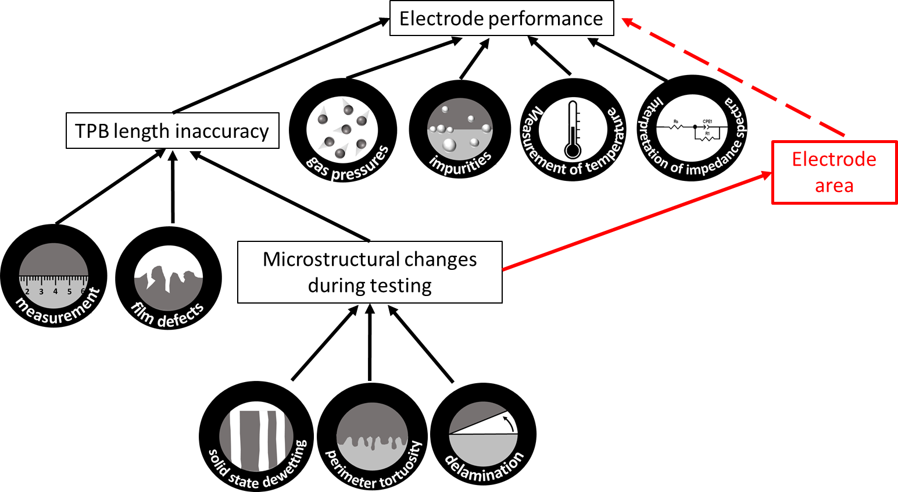

Figure 7.1- Diagram showing factors hypothesised to affect the electrochemical performance of pattern electrodes.
The hypothesis for this thesis was that variation in model electrode performance between similar studies (Section 2.2), is caused by the challenges in obtaining accurate measurements. Inaccuracies in the TPB measurement, contributed to by microstructural changes occurring during the operation of Ni/YSZ pattern electrodes were investigated, as well as a lack of standardisation in the measurement technique.
Other factors were found to contribute to a variation in electrode performance between repeats, including challenges in measuring temperature and interpretation of impedance spectra. These errors could not account for the full range of fluctuation observed in this study, and therefore additional sources of error are affecting the measurements. Some of the factors contributing to variation in electrode performance and key themes in this thesis are outlined in Figure 7.1, and are discussed in more detail in the following sub-sections.

YSZ substrate

    - 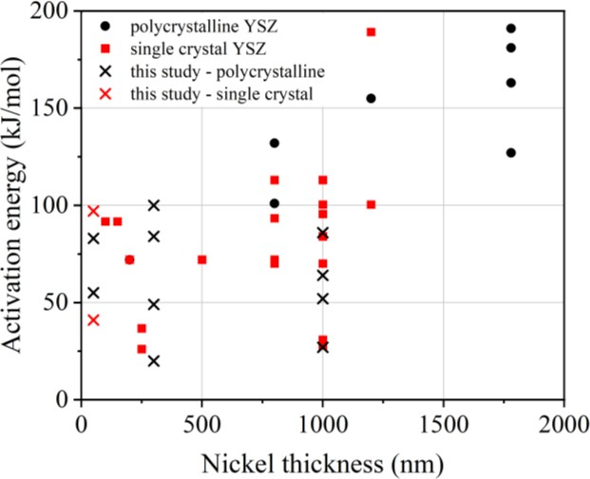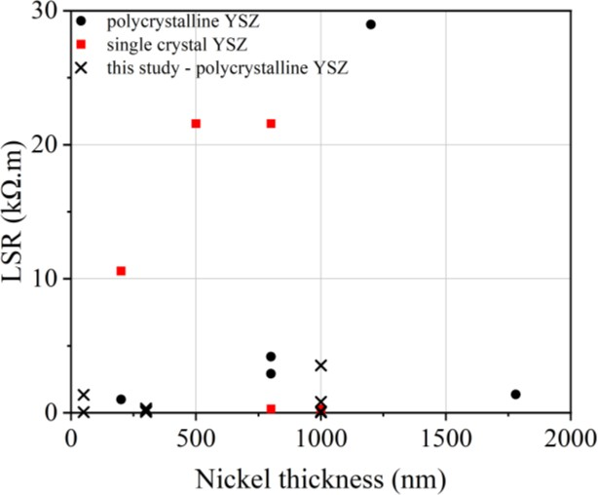b)

Figure 7.2 – a) Activation energy vs. nickel thickness and b) LSR at 700°C vs. nickel thickness compiled from the literature for Ni/YSZ pattern electrodes on polycrystalline and single crystal YSZ substrates, operated in H2/H2O gas atmosphere. Sources: [38, 41, 72, 75, 84, 89, 98-100, 102,
113, 114].

In the literature, nickel pattern electrodes on single crystal YSZ have been reported to have lower activation energies compared to nickel electrodes on polycrystalline substrates, attributed to less micropores on the smoother single crystal substrate [114]. Elsewhere, nickel pattern electrodes on polycrystalline YSZ has been reported to have lower activation energies than nickel pattern electrodes on single crystal YSZ, whilst polarisation resistances on polycrystalline substrate were reported to be an order of magnitude lower than on single crystal YSZ. The different electrode performance between the two substrates was attributed to different impurity levels [73]. Comparing activation energies and LSR values at 700°C from the literature, there is no correlation between electrode performance and electrolyte material (Figure 7.2).
In this study, polarisation resistance was found to be lower for single crystal YSZ (Figure 4.16).

The equivalent circuit used to fit the impedance data did not fit the single crystal data well, particularly at low and high frequencies, as shown in Figure 4.14. A more complicated equivalent circuit improved the data fitting (Figure 4.15). This suggests there could be additional contributing factors to the single crystal impedance.

Activation energies were found to have a larger data spread between identical samples than on polycrystalline pellets, although the accuracy of the activation energies extracted from 50 nm electrodes is limited, because of the peak in resistance observed between 670-770°C. Although all samples were cleaned using the same process (Section 3.1.2), it is possible that different impurity levels exist between the samples as impurity levels were not analysed in this study. Furthermore, surface roughness was found to be considerably different for the two substrates (RMS surface roughness = 1 nm for single crystal, and 37 nm for polycrystalline YSZ), because single crystal was purchased pre-polished, whereas polycrystalline YSZ pellets were ground and polished by hand. Therefore, it is probable that nickel films on the two substrates had different defect levels, which is also likely to be contributing to the different resistances observed for the two substrates.
Therefore, although variation in polarisation resistance between the two substrates was found to be lower than the order of magnitude difference reported in the literature [73], electrolyte material is still likely to be contributing to a varying electrode performance across similar pattern electrode studies, because of the issues of a lack of impurity analysis and quantification of defects in the patterned films.

Non-standardised TPB length measurement
One of the conclusions drawn from Chapter 5 was that the magnification used to measure the TPB length affects the length measured, because of the fractal nature of the TPB length. In the literature, the magnification used to measure the TPB length is not always reported, however images of the electrode perimeter are presented at 50x to 6250x magnification [38, 72, 75, 89, 98-102, 105]. Therefore, it is likely that variation in the magnifications used to measure TPB length are contributing to an overall TPB length inaccuracy across studies.
In Section 5.3.1, it was shown that correction factors calculated pre- and post- test vary as the perimeter increases in tortuosity. Therefore given that some studies calculate correction factors pre-testing [72, 99], whilst others calculate correction factors post testing [38, 75, 89, 98, 101-
103, 105], and some calculate no correction factor at all [41, 73, 84, 100], it is likely a non- standardised measurement procedure is contributing to the varying electrode performance amongst studies by affecting the accuracy of the TPB length measurement.

Microstructural changes during electrochemical testing
In Chapter 4 it was concluded that nickel pattern electrodes 50 nm, 300 nm and 1 µm in thickness undergo various microstructural changes during activation energy tests in both H2 and CO based atmospheres. Whilst all 300 nm and 1 µm electrodes tested increased in tortuosity at the perimeter during testing, 300 nm and 50 nm electrodes also underwent solid- state dewetting to various extents, whilst 1 µm electrodes remained dense. Although 1 µm films did not undergo solid-state dewetting, they were observed to delaminate in 5%CO/50%CO2/Ar atmospheres.
The microstructure of pattern electrodes is the focus of few studies [95, 115]. There is little data available linking the effect of microstructural changes with electrochemical changes. In Chapter 5 the influence of the observed microstructural changes during activation energy tests was estimated on the TPB length and resultant LSR values, alongside an estimation of error. 1 µm electrodes resulted in an LSR adjustment of approximately half an order of magnitude, whilst 300 nm electrodes had a calculated LSR adjustment of approximately two orders of magnitude. Given electrode thickness in the literature varies from 200 nm to 1.78 µm, it is possible that different microstructural changes occurring during electrochemical testing are affecting the measured resistances through different microstructural changes. LSR values and extracted activation energies are affected by microstructural changes, particularly if pores are form during testing.
  - Measurement of temperature and interpretation of impedance spectra
Throughout the thesis the error in resistance measurements was considered. For constant temperature tests, this was propagated from two sources according to Section 3.4.3. The first source of error in resistance measurements was calculated from the error in fitting the impedance spectra to an equivalent circuit. An additional sample placement error was considered owing to a less than optimal equipment set up. In the experimental set up used, the thermocouple was located 6 mm from the surface of the sample, at the base of the crucible. Ideally, a thermocouple should be in contact with the sample surface to provide a true indication of temperature. A possible 1 mm fluctuation in sample placement between samples was accounted for by considering the up to 100°C fluctuation in temperature between the sample surface and the base of the thermocouple (Section 3.2.4). Therefore, a 1 mm fluctuation in

sample placement was estimated to cause a 15°C temperature fluctuation between repeats. From temperature ramp measurements, an average resistance change between 590°C and 610°C was calculated and this error was propagated for each constant temperature measurement (Section 3.4.3.). This enabled a consideration as to whether the large differences observed between the resistance values of repeats was owing to the error in the resistance measurement, including the sample placement error. It was found that the error between repeats exceeded the propagated error in most cases, and therefore additional unaccounted for sources of error are leading to different resistance values for repeats.
The largest source of error in this study is the error in the thermocouple location, which although did not vary between repeats, prevents comparisons to other studies in the literature.

Scatter in identical samples
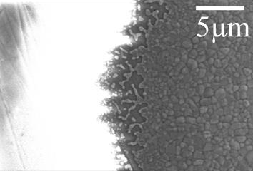
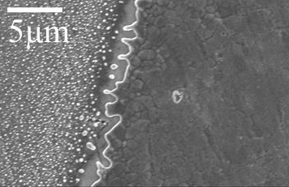
Throughout this thesis, considerable fluctuation in the performance of repeats of the same test was observed.

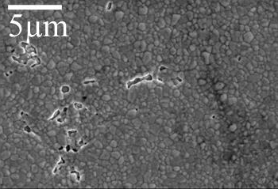
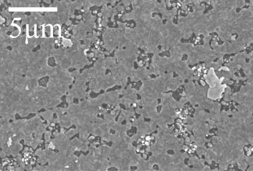
Figure 7.3 – SEM images at 5000x magnification of the perimeter of two 1 µm thick electrodes heated in 3%H2O/10%H2/N2 atmosphere in activation energy measurements.
Figure 7.4 – SEM images at 5000x magnification of the bulk of two 300 nm thick electrodes heated in 3%H2O/10%H2/N2 atmosphere in activation energy measurements.

Analysis of the microstructure of repeats of the same test revealed varying levels of microstructural change. Examples of this are presented in Figures 7.3 and 7.4. Figure 7.3 shows the perimeter of two 1 µm thick electrodes after testing in 3%H2O/10%H2/N2. The TPB length was found to increase in tortuosity for both samples as a result of edge retraction via capillary driven diffusion. Edge retraction occurs at a faster rate at corner sites, compared to at the edges of grains, because of less restrictions on the movement of atoms. Consequently, mass can build up along straight edges at the perimeter which leads to strand formation, and then island formation through rim-pinch off. The shape of the perimeter therefore becomes modified with heating [96]. The repeats shown in Figure 7.3, were found to vary in perimeter length by 2.6 times (Table 5.1), which is unexpected since the thin films were fabricated and heated in identical conditions, and are therefore expected to retract at similar rates with similar amounts of edges and corners in each film. Similarly, for 300 nm electrodes used in activation energy tests in 3%H2O/10%H2/N2, the quantity of holes observed in the electrode bulk of two otherwise identical repeats was considerably different (Figure 7.4), resulting in the TPB lengths varying by 1.8 times between the samples (Table 5.2).

It was discussed in Chapter 4 that two 1 µm electrodes used in activation energy tests in 5%CO/50%CO2/Ar, were visually observed to delaminate during testing (Figure 4.11). However, the delamination affected the identical electrodes to various extents, with one of the electrodes developing bubbles underneath the nickel mainly on the lower nickel stripes of the interdigitated electrode, whilst the identical repeat bubbled over the entire electrode structure.

Variation in the performance of repeats is a problem which has been reported for pattern electrodes in the literature [41, 89, 101]. Reasons suggested to account for this include samples being made in multiple batches [101], different contacting of the pattern electrodes by the current collector [89], and different amounts of defects introduced during electrode preparation [41].

In this study, it was unavoidable to use samples produced in different batches, and although polishing, cleaning and deposition steps were consistent for all samples, slight differences in the mirror finish, as well as small fluctuations in the e-beam deposition rate could have led to different defect levels in nominally identical samples. In addition, although silver current collecting wires were kept approximately the same size, and silver contacting paste was applied with a pin head, the resultant contact area likely fluctuated between samples, therefore affecting

the nickel contacting the current collector directly, which is likely to particularly affect measurements when a loss of percolation occurs throughout the nickel metal.

Furthermore, impurity levels were not analysed in this study, and it is possible that different batches of samples had varying levels of impurities. This could account for the different amounts of microstructural changes observed in the bulk of otherwise identical electrodes, because impurities are known to increase the rate of dewetting in thin films by providing sites for hole formation [96, 131]. The TPB length in model electrodes is susceptible to blocking from silica impurities, which in turn, decreases electrochemical performance [89, 118]. Therefore it is possible that the perimeters shown in Figure 7.3 had different levels of impurities adsorbed, and different rates of dewetting suppression [96].
The lack of consistency between repeats is therefore a challenge for pattern electrode studies, and there are additional factors influencing electrochemical performance than those controlled in this study.

Area scaling pathway
In Section 2.4.4, the area scaling pathway proposed for hydrogen oxidation with nickel pattern electrodes to account for variation away from a solely TPB dependant electrode performance was discussed [72]. In other studies, this variation from solely TPB dependent behaviour has been attributed to inaccuracy in TPB length measurements. Therefore, an additional area scaling pathway could be an additional factor contributing to the variation in electrode performance observed between studies.

Limitations of pre-and post-test analysis
The limitations of pre-and post- test analysis in determining an accurate TPB length were discussed in Section 5.6.1. Solid-state dewetting in 50 nm and 300 nm electrodes could be identified using pre-and post-test SEM analysis, however, the exact temperature and time at which changes occurred during electrochemical measurements, and the TPB length during the microstructural changes could not be gained using pre- and post- test analysis alone. Additional samples used to investigate intermediate times and temperatures, also have a limited accuracy because, cooling samples can also introduce microstructural changes [67]. Therefore, pre- and post- test analysis of electrodes is limited, and measurements should ideally be both “in-situ” and “in-operando”.

Furthermore, in Chapter 4 it was shown that 1 µm electrodes used in activation energy tests in 5%CO/50%CO2/Ar bubbled during testing, but relaxed back down before reaching 800°C. The delamination was not visible using SEM analysis, and the effect on TPB length could not be quantified. Therefore, the ideal technique to measure TPB length would enable a direct measurement of the nickel/YSZ/gas boundary to be made.

Limiting microstructural changes
The microstructural changes during electrochemical testing observed in Chapters 4, 5 and 6 for nickel electrodes, result in a TPB length which is not well-defined throughout testing. Therefore, the advantage of using pattern electrodes to simplify the complex electrode geometry in technical cermet electrodes, is hindered by the lack of stability of the pattern electrodes during testing. In Chapter 6, it was found that by depositing polymer spheres and nickel nanoparticles underneath nickel pattern electrodes, the microstructural stability of the films could be altered in preliminary tests. The propagated error could not account for the full range of this change, although repeats were still observed to fluctuate largely.
With improvement of the order of the partially dewet structures, they could become useful model electrodes themselves. After 96 hours of electrochemical testing at 600°C nanoparticle and polymer modified repeats exhibited an apparent limitation of hole impingement and an apparent increased stability of unmodified repeats. On single crystal, a polymer modified sample exhibited just 1% electrolyte exposure after 48 hours of electrochemical testing, however some sporadic holes in the nickel layer were observed. Modification of the YSZ surface before pattern electrode deposition could offers a route for further research into improving the stability of model electrodes and maintaining a well-defined TPB length during testing.

Chapter 8 – Conclusions and future work
The hypothesis presented for this thesis was that variation in model electrode performance between similar studies is caused by the challenges in obtaining accurate measurements. Efforts were made to investigate several causes of error in electrochemical tests similar to those performed in literatures studies. Microstructural changes occurring during the operation of Ni/YSZ pattern electrodes were considered.
In Chapter 4, it was shown that pattern electrodes 50 nm, 300 nm and 1 µm in thickness undergo various microstructural changes in both H2 and CO based atmospheres during activation energy and longer-term tests. 300 nm and 1 µm electrodes increased in tortuosity at the perimeter during activation energy tests, whilst 300 nm and 50 nm electrodes underwent various degrees of solid-state dewetting. 1 µm electrodes were observed to delaminate in CO/CO2 but not in H2 atmospheres. A large fluctuation between repeats of the same test was observed. Error in resistance measurements was calculated from the error in fitting the impedance data to an equivalent circuit, however could not account for the full error in the data in most cases. The activation energy tests were used to calculate average resistance changes between 590°C and 610°C which in turn was used to propagate a sample placement error for longer term testing measurements. Longer term tests also exhibited large fluctuation between repeats of the same test, and the total propagated error in resistance values did not account for the full degree of this fluctuation. Other sources of error are therefore affecting the measurements.
In Chapter 5, the error in LSR values was propagated based on the error in each of the contributing factors. This included considering the TPB length calculated based on an assumption of a straight perimeter, and calculated from pre-and post- test SEM analysis. The total uncertainty in LSR values calculated from 300 nm thick electrodes covered two orders of magnitude which is a similar size to the data spread from literature studies. For 1 µm electrodes, the error in the measurement was lower, owing to the lesser degree of microstructural change during testing.
Model electrodes are used to study reactions relevant to technical cermet electrodes, because of their simplified geometry and well-defined TPB lengths pre-testing. The dynamic TPB length and challenges in accurate electrochemical testing observed in this study, therefore call into question the utility of pattern electrodes. In Chapter 6, it was investigated whether the degree of dewetting could be limited through modification of the YSZ surface before pattern

electrode deposition. The preliminary results on a limited number of samples offer a route for further research.
Fluctuation in nominally identical samples has been reported throughout this thesis, and points towards additional influencing factors other than those controlled here. One of the causes of the fluctuation could be chemical impurities, and the lack of understanding of how chemical impurities are affecting pattern electrodes requires further research. In addition, optimisation of the experimental design is required as measurements were taken with a 6 mm gap between the sample surface and the thermocouple.
Overall, the many influencing factors contributing to the electrochemical performance of model electrodes points towards a requirement for standardised TPB measurement procedure between studies. The most effective measurement technique would enable the TPB to be monitored “in-situ” and “in-operando”, which is necessary because of its dynamic nature. “in- situ” environmental SEM is one such technique already in use [95], however, it still requires averaging of observations across the entire sample [67]. An ideal technique for accurately determining the TPB length would therefore enable “in-situ”, “in-operando” measurements of the TPB length directly across the whole electrode, and this requires further research. A direct method for measuring TPB length could be achieved by quantifying adsorbed species at the TPB through infra-red spectroscopy. Using CO chemisorption, the TPB length could be chemically quantified through the use of metal geometry characteristic, CO adsorption bands. Applying this technique to pattern electrodes requires further development.

References
- eurostat. Renewable energy statistics. 2019 [cited 2020 21st January]; Available from: ec.europa.eu.
- Frogatt, A., A Comparison of the European Climate and Energy 2020 and 2030 Packages. UK Energy Research Centre. 2015, EPG Working Paper: 1506.
- Barbour, E., et al., A review of pumped hydro energy storage development in significant international electricity markets. Renewable and Sustainable Energy Reviews, 2016. 61: p. 421-432.
- Connolly, D., A review of energy storage technologies. Ireland: University of Limerick, 2009.
- Winter, M. and R.J. Brodd, What are batteries, fuel cells, and supercapacitors? 2004, ACS Publications.
- Badwal, S.P., et al., Emerging electrochemical energy conversion and storage technologies.
Frontiers in chemistry, 2014. 2: p. 79.
- Ehteshami, S.M.M. and S. Chan, The role of hydrogen and fuel cells to store renewable energy in the future energy network–potentials and challenges. Energy Policy, 2014. 73: p. 103-109.
- Khzouz, M., et al., Life cycle costing analysis: Tools and applications for determining hydrogen production cost for fuel cell vehicle technology. Energies, 2020. 13(15): p. 3783.
- Carrette, L., K. Friedrich, and U. Stimming, Fuel cells–fundamentals and applications. Fuel cells, 2001. 1(1): p. 5-39.
- Haile, S.M., Fuel cell materials and components. Acta Materialia, 2003. 51(19): p. 5981-6000.
- Singhal, S.C., Advances in solid oxide fuel cell technology. Solid state ionics, 2000. 135(1-4): p. 305-313.
- Appleby, A.J., Fuel cell handbook. 1988.
- Liu, R.-S., et al., Electrochemical Technologies for Energy Storage and Conversion Vol. 2. 2012: Wiley-VCH, Weinheim, Germany.
- O'hayre, R., et al., Fuel cell fundamentals. 2016: John Wiley & Sons.
- Tu, H. and U. Stimming, Advances, aging mechanisms and lifetime in solid-oxide fuel cells.
Journal of power sources, 2004. 127(1): p. 284-293.
- E4tech. The Fuel Cell Industry Review 2018. 2018 [cited 2020 30th March]; Available from: www.FuelCellIndustryReview.com.
- Biswas, M. and K.C. Sadanala, Electrolyte materials for solid oxide fuel cell. J Powder Metall Min, 2013. 2(117): p. 2.
- Leah, R., N. Brandon, and P. Aguiar, Modelling of cells, stacks and systems based around metal- supported planar IT-SOFC cells with CGO electrolytes operating at 500–600° C. Journal of Power Sources, 2005. 145(2): p. 336-352.
- Attryde, P., et al. Stacks and systems based around metal supported SOFCs operating at 500- 600°C. in Proceedings - Electrochemical Society. 2005.
- De Souza, S., S.J. Visco, and L.C. De Jonghe, Thin-film solid oxide fuel cell with high performance at low-temperature. Solid State Ionics, 1997. 98(1): p. 57-61.
- Hui, S.R., et al., Metal-supported solid oxide fuel cell operated at 400–600° C. Journal of Power Sources, 2007. 167(2): p. 336-339.
- Bi, Z., et al., A high-performance anode-supported SOFC with LDC-LSGM bilayer electrolytes.
Electrochemical and solid-state letters, 2004. 7(5): p. A105-A107.
- Leah, R.T., et al., Development of Highly Robust, Volume-Manufacturable Metal-Supported SOFCs for Operation Below 600°. ECS Transactions, 2011. 35(1): p. 351.
- Singhal, S.C., Solid oxide fuel cells for stationary, mobile, and military applications. Solid State Ionics, 2002. 152: p. 405-410.
- Virkar, A.V., et al., The role of electrode microstructure on activation and concentration polarizations in solid oxide fuel cells. Solid State Ionics, 2000. 131(1): p. 189-198.

- Vohs, J.M. and R.J. Gorte, High‐performance SOFC cathodes prepared by infiltration. Advanced Materials, 2009. 21(9): p. 943-956.
- Kim, Y.J., et al., Thermal cycling of anode supported solid oxide fuel cells under various conditions: Electrical anode protection. International Journal of Hydrogen Energy, 2016. 41(48): p. 23173-23182.
- Vohs, J.M. and R.J. Gorte, High-Performance SOFC Cathodes Prepared by Infiltration.
Advanced Materials, 2009. 21(9): p. 943-956.
- Möbius, H.-H., On the history of solid electrolyte fuel cells. Journal of solid state electrochemistry, 1997. 1(1): p. 2-16.
- Adler, S.B., Factors governing oxygen reduction in solid oxide fuel cell cathodes. Chemical reviews, 2004. 104(10): p. 4791-4844.
- Dees, D., et al., Conductivity of Porous Ni/ZrO2‐Y 2 O 3 Cermets. Journal of the Electrochemical Society, 1987. 134(9): p. 2141-2146.
- Mogensen, M. and S. Skaarup, Kinetic and geometric aspects of solid oxide fuel cell electrodes.
Solid state ionics, 1996. 86: p. 1151-1160.
- Jiang, S.P. and S.H. Chan, A review of anode materials development in solid oxide fuel cells.
Journal of Materials Science, 2004. 39(14): p. 4405-4439.
- Jiang, S. and S. Badwal, Hydrogen oxidation at the nickel and platinum electrodes on yttria‐ tetragonal zirconia electrolyte. Journal of the Electrochemical Society, 1997. 144(11): p. 3777- 3784.
- Kaur, G. and S. Basu, Physical characterization and electrochemical performance of copper– iron–ceria–YSZ anode‐based SOFCs in H2 and methane fuels. International Journal of Energy Research, 2015. 39(10): p. 1345-1354.
- Liu, M., et al., Performance of the nano-structured Cu-Ni (alloy) -CeO2 anode for solid oxide fuel cells. Journal of Power Sources, 2014. 274: p. 730-735.
- Prakash, B.S., S.S. Kumar, and S. Aruna, Properties and development of Ni/YSZ as an anode material in solid oxide fuel cell: a review. Renewable and Sustainable Energy Reviews, 2014. 36: p. 149-179.
- Bieberle, A., L. Meier, and L. Gauckler, The electrochemistry of Ni pattern anodes used as solid oxide fuel cell model electrodes. Journal of the electrochemical society, 2001. 148(6): p. A646- A656.
- Bessler, W.G., J. Warnatz, and D.G. Goodwin, The influence of equilibrium potential on the hydrogen oxidation kinetics of SOFC anodes. Solid State Ionics, 2007. 177(39-40): p. 3371- 3383.
- Wilson, J.R., et al., Three-dimensional reconstruction of a solid-oxide fuel-cell anode. Nature materials, 2006. 5(7): p. 541.
- Mizusaki, J., et al., Preparation of Nickel Pattern Electrodes on Ysz and Their Electrochemical Properties in H2-H2o Atmospheres. Journal of the Electrochemical Society, 1994. 141(8): p. 2129-2134.
- Holzer, L., et al., Quantitative relationships between composition, particle size, triple phase boundary length and surface area in nickel-cermet anodes for Solid Oxide Fuel Cells. Journal of Power Sources, 2011. 196(17): p. 7076-7089.
- Radhakrishnan, R., A.V. Virkar, and S. Singhal, Estimation of Charge-Transfer Resistivity of La0. 8Sr0. 2MnO3 Cathode on Y 0.16 Zr0. 84 O 2 Electrolyte Using Patterned Electrodes. Journal of The Electrochemical Society, 2005. 152(1): p. A210-A218.
- Kenney, B., et al., Computation of TPB length, surface area and pore size from numerical reconstruction of composite solid oxide fuel cell electrodes. Journal of Power Sources, 2009. 189(2): p. 1051-1059.
- Juhl, M., et al., Performance/structure correlation for composite SOFC cathodes. Journal of Power Sources, 1996. 61(1-2): p. 173-181.

- Lynch, M.E., et al., Triple-phase boundary and surface transport in mixed conducting patterned electrodes. Journal of The Electrochemical Society, 2008. 155(6): p. B635-B643.
- Goodwin, D.G., et al., Modeling electrochemical oxidation of hydrogen on Ni–YSZ pattern anodes. Journal of The Electrochemical Society, 2009. 156(9): p. B1004-B1021.
- Ali, A., et al., Geometrical modeling of microstructure of solid oxide fuel cell composite electrodes. Journal of Power Sources, 2008. 185(2): p. 961-966.
- Williford, R.E., et al., Diffusion limitations in the porous anodes of SOFCs. Journal of the Electrochemical Society, 2003. 150(8): p. A1067.
- Song, C., Fuel processing for low-temperature and high-temperature fuel cells: Challenges, and opportunities for sustainable development in the 21st century. Catalysis today, 2002. 77(1): p. 17-49.
- Tucker, M.C., Dynamic-temperature operation of metal-supported solid oxide fuel cells.
Journal of Power Sources, 2018. 395: p. 314-317.
- Chen, X. and S.P. Jiang, Highly active and stable (La 0.24 Sr 0.16 Ba 0.6)(Co 0.5 Fe 0.44 Nb 0.06) O 3− δ (LSBCFN) cathodes for solid oxide fuel cells prepared by a novel mixing synthesis method. Journal of Materials Chemistry A, 2013. 1(15): p. 4871-4878.
- Skafte, T.L., et al. Quantitative review of degradation and lifetime of solid oxide cells and stacks. in 12th European SOFC & SOE Forum. 2016. European Fuel Cell Forum.
- Klemensø, T. and M. Mogensen, Ni–YSZ solid oxide fuel cell anode behavior upon redox cycling based on electrical characterization. Journal of the American Ceramic Society, 2007. 90(11): p. 3582-3588.
- Jiang, S.P., Sintering behavior of Ni/Y2O3-ZrO2cermet electrodes of solid oxide fuel cells.
Journal of materials science, 2003. 38(18): p. 3775-3782.
- Yokokawa, H., et al., Fundamental mechanisms limiting solid oxide fuel cell durability. Journal of Power Sources, 2008. 182(2): p. 400-412.
- Faes, A., et al., Nickel-Zirconia Anode Degradation and Triple Phase Boundary Quantification from Microstructural Analysis. Fuel Cells, 2009. 9(6): p. 841-851.
- Izzo, J.R., et al., Nondestructive reconstruction and analysis of SOFC anodes using X-ray computed tomography at sub-50 nm resolution. Journal of the Electrochemical Society, 2008. 155(5): p. B504-B508.
- Shearing, P.R., et al., Exploring microstructural changes associated with oxidation in Ni–YSZ SOFC electrodes using high resolution X-ray computed tomography. Solid State Ionics, 2012. 216: p. 69-72.
- Simwonis, D., F. Tietz, and D. Stöver, Nickel coarsening in annealed Ni/8YSZ anode substrates for solid oxide fuel cells. Solid State Ionics, 2000. 132(3-4): p. 241-251.
- Khan, M.Z., et al., A simplified approach to predict performance degradation of a solid oxide fuel cell anode. Journal of Power Sources, 2018. 391: p. 94-105.
- Hagen, A., et al., Degradation of anode supported SOFCs as a function of temperature and current load. Journal of the Electrochemical Society, 2006. 153(6): p. A1165-A1171.
- Monachon, C., et al., Rapid Preparation and SEM Microstructural Characterization of Nickel– Yttria‐Stabilized Zirconia Cermets. Journal of the American Ceramic Society, 2008. 91(10): p. 3405-3407.
- Holzer, L., et al., Microstructure degradation of cermet anodes for solid oxide fuel cells: Quantification of nickel grain growth in dry and in humid atmospheres. Journal of Power Sources, 2011. 196(3): p. 1279-1294.
- Mendelson, M.I., Average grain size in polycrystalline ceramics. Journal of the American Ceramic society, 1969. 52(8): p. 443-446.
- Giardina, C.R. and E.R. Dougherty, Morphological methods in image and signal processing. 1988: Prentice-Hall, Inc.
- Goodman, E.D., J.A. Schwalbe, and M. Cargnello, Mechanistic Understanding and the Rational Design of Sinter-Resistant Heterogeneous Catalysts. ACS Catalysis, 2017. 7(10): p. 7156-7173.

- Vassen, R., D. Simwonis, and D. Stover, Modelling of the agglomeration of Ni-particles in anodes of solid oxide fuel cells. Journal of Materials Science, 2001. 36(1): p. 147-151.
- Sehested, J., Four challenges for nickel steam-reforming catalysts. Frontiers in Catalysis: A Molecular View of Industrial Catalysis, 2006. 111(1-2): p. 103-110.
- Sehested, J., J.A.P. Gelten, and S. Helveg, Sintering of nickel catalysts: Effects of time, atmosphere, temperature, nickel-carrier interactions, and dopants. Applied Catalysis A: General, 2006. 309(2): p. 237-246.
- Baumann, F., et al., Quantitative comparison of mixed conducting SOFC cathode materials by means of thin film model electrodes. Journal of The Electrochemical Society, 2007. 154(9): p. B931-B941.
- Doppler, M., et al., Hydrogen oxidation mechanisms on Ni/yttria stabilized zirconia anodes: Separation of reaction pathways by geometry variation of pattern electrodes. Journal of Power Sources, 2018. 380: p. 46-54.
- Rao, M.V., et al., The influence of the solid electrolyte on the impedance of hydrogen oxidation at patterned Ni electrodes. Solid State Ionics, 2010. 181(25-26): p. 1170-1177.
- Wachsman, E.D. and K.T. Lee, Lowering the temperature of solid oxide fuel cells. Science, 2011.
334(6058): p. 935-939.
- Bessler, W.G., et al., Model anodes and anode models for understanding the mechanism of hydrogen oxidation in solid oxide fuel cells. Physical Chemistry Chemical Physics, 2010. 12(42): p. 13888-13903.
- Primdahl, S. and M. Mogensen, Oxidation of hydrogen on Ni/yttria‐stabilized zirconia cermet anodes. Journal of the Electrochemical Society, 1997. 144(10): p. 3409-3419.
- Kuzjukevics, A., S. Linderoth, and J. Grabis, Plasma produced ultrafine YSZ-NiO powders. High Temperature Electrochemistry: Ceramics and Metals, 1996: p. 319-330.
- Bessler, W.G., et al., Model anodes and anode models for understanding the mechanism of hydrogen oxidation in solid oxide fuel cells. Physical Chemistry Chemical Physics, 2010. 12(42): p. 13888-903.
- Vogler, M., et al., Modelling study of surface reactions, diffusion, and spillover at a Ni/YSZ patterned anode. Journal of the Electrochemical Society, 2009. 156(5): p. B663-B672.
- Peters, R., et al., Internal reforming of methane in solid oxide fuel cell systems. Journal of Power Sources, 2002. 106(1-2): p. 238-244.
- Luo, Y., et al., Mechanism for reversible CO/CO2 electrochemical conversion on a patterned nickel electrode. Journal of Power Sources, 2017. 366: p. 93-104.
- Lauvstad, G., R. Tunold, and S. Sunde, Electrochemical oxidation of CO on Pt and Ni point electrodes in contact with an yttria-stabilized zirconia electrolyte-II. Steady-state and impedance measurements. Journal of the Electrochemical Society, 2002. 149(12): p. E506- E514.
- Homel, M., et al., Carbon monoxide-fueled solid oxide fuel cell. Journal of Power Sources, 2010.
195(19): p. 6367-6372.
- Sukeshini, A.M., et al., Electrochemical oxidation of H2, CO, and CO∕ H2 mixtures on patterned Ni anodes on YSZ electrolytes. Journal of the Electrochemical Society, 2006. 153(4): p. A705- A715.
- Graves, C., C. Chatzichristodoulou, and M.B. Mogensen, Kinetics of CO/CO2 and H2/H2O reactions at Ni-based and ceria-based solid-oxide-cell electrodes. Faraday discussions, 2015. 182: p. 75-95.
- Graves, C.R., S.D. Ebbesen, and M. Mogensen, Aspects of Metal-YSZ Electrode Kinetics Studied using Model Electrodes. ECS Transactions, 2009. 25(2): p. 1945-1955.
- Holtappels, P., et al., Reaction of CO/CO2 gas mixtures on Ni–YSZ cermet electrodes. Journal of Applied Electrochemistry, 1999. 29(5): p. 561-568.
- Patel, H., et al., Oxidation of H2, CO and syngas mixtures on ceria and nickel pattern anodes.
Applied energy, 2015. 154: p. 912-920.

- Ehn, A., et al., Electrochemical investigation of nickel pattern electrodes in H2/H2O and CO/CO2 atmospheres. Journal of The Electrochemical Society, 2010. 157(11): p. B1588-B1596.
- Eguchi, K., et al., An Investigation of Anode Material and Anodic Reaction for Solid Oxide Fuel Cell. ECS Proceedings Volumes, 1993. 1993: p. 494-503.
- Costa-Nunes, O., R.J. Gorte, and J.M. Vohs, Comparison of the performance of Cu–CeO2–YSZ and Ni–YSZ composite SOFC anodes with H2, CO, and syngas. Journal of Power Sources, 2005. 141(2): p. 241-249.
- Yurkiv, V., et al., Elementary kinetic modeling and experimental validation of electrochemical CO oxidation on Ni/YSZ pattern anodes. Electrochimica Acta, 2012. 59: p. 573-580.
- Etsell, T. and S. Flengas, Overpotential behavior of stabilized zirconia solid electrolyte fuel cells.
Journal of The Electrochemical Society, 1971. 118(12): p. 1890-1900.
- Endler, C., et al., Time-dependent electrode performance changes in intermediate temperature solid oxide fuel cells. Journal of The Electrochemical Society, 2010. 157(2): p. B292-B298.
- Song, B., et al. , Unveiling the mechanisms of solid-state dewetting in Solid Oxide Cells with novel 2D electrodes. Journal of Power Sources, 2019. 420: p. 124-133.
- Thompson, C.V., Solid-State Dewetting of Thin Films. Annual Review of Materials Research, Vol 42, 2012. 42: p. 399-434.
- Utz, A., et al., Microstructure stability studies of Ni patterned anodes for SOFC. Solid State Ionics, 2011. 192(1): p. 565-570.
- De Boer, B., SOFC Anode. Hydrogen oxidation at porous nickel and nickel/yttria-stabilised zirconia cermet electrodes. The Netherlands: University of Twente, 1998.
- Bieberle, A. and L. Gauckler, Reaction mechanism of Ni pattern anodes for solid oxide fuel cells.
Solid State Ionics, 2000. 135(1-4): p. 337-345.
- Bieberle, A. and L.J. Gauckler, Ni-based SOFC anodes: Microstructure and electrochemistry.
Zeitschrift Fur Metallkunde, 2001. 92(7): p. 796-802.
- Utz, A., et al., Degradation Effects of Ni Patterned Anodes in H2/H2O Atmosphere. ECS Transactions, 2009. 25(2): p. 2013-2021.
- Utz, A., et al., Degradation and relaxation effects of Ni patterned anodes in H2–H2O atmosphere. Journal of The Electrochemical Society, 2010. 157(6): p. B920-B930.
- Utz, A., et al., Studying the CO–CO2 characteristics of SOFC anodes by means of patterned Ni anodes. Journal of Power Sources, 2011. 196(17): p. 7217-7224.
- Patel, H.C., V. Venkataraman, and P.V. Aravind. Nickel pattern anodes for studying SOFC electrochemistry. in Ceramic Engineering and Science Proceedings. 2014.
- Yao, W. and E. Croiset, Stability and electrochemical performance of Ni/YSZ pattern anodes in H2/H2O atmosphere. The Canadian Journal of Chemical Engineering, 2015. 93(12): p. 2157- 2167.
- Basics of Electrochemical Impedance Spectroscopy 30th January 2020]; Available from: https://www.gamry.com/application-notes/EIS/basics-of-electrochemical-impedance- spectroscopy/.
- Yao, W. and E. Croiset, Ni/YSZ pattern anodes fabrication and their microstructure and electrochemical behavior changes in H2-H2O environments. Journal of Power Sources, 2013. 226: p. 162-172.
- Adler, S., Reference electrode placement in thin solid electrolytes. Journal of the electrochemical society, 2002. 149(5): p. E166-E172.
- Weber, A., et al., Electrooxidation of Reformate Gases at Model Anodes. ECS Transactions, 2011. 35(1): p. 1513-1528.
- Habibzadeh, B., et al. CO electrochemical oxidation on Ni patterned anodes for assessing SOFC kinetics. in ECS Transactions. 2008.
- Boulenouar, F., et al., Electrochemical oxidation of CO in a CO-CO2 system at the interface of ni grid electrode/YSZ electrolyte. ECS Proceedings Volumes, 2001. 2001: p. 759-768.

- Yao, W. and E. Croiset, Investigation of H2, CO and Syngas Electrochemical Performance Using Ni/YSZ Pattern Anodes. ECS Transactions, 2013. 53(30): p. 163-172.
- Mizusaki, J., et al., Kinetic studies of the reaction at the nickel pattern electrode on YSZ in H2 H2O atmospheres. Solid State Ionics, 1994. 70: p. 52-58.
- Luo, Y., et al., Reversible H2/H2O electrochemical conversion mechanisms on the patterned
nickel electrodes. International Journal of Hydrogen Energy, 2017. 42(40): p. 25130-25142.
- Utz, A., et al., Microstructure stability studies of Ni patterned anodes for SOFC. Solid State Ionics, 2011. 192(1): p. 565-570.
- Yao, W., Hydrogen and Carbon Monoixde Electrochemical Oxidation Reaction Kinetics on Solid Oxide Fuel Cell Anodes. 2013.
- Patel, H., et al., Ceria electrocatalysis compared to nickel using pattern anodes. International Journal of Electrochemical Science, 9 (7), 2014, 2014.
- Hansen, K.V., K. Norrman, and M. Mogensen, H 2 H 2 O Ni YSZ Electrode Performance Effect of Segregation to the Interface. Journal of The Electrochemical Society, 2004. 151(9): p. A1436-A1444.
- Dizon, A. and M.E. Orazem, On the impedance response of interdigitated electrodes.
Electrochimica Acta, 2019. 327: p. 135000.
- Perl, E.E., et al., Measurements and Modeling of III-V Solar Cells at High Temperatures up to 400${}^{\circ} $ C. IEEE Journal of Photovoltaics, 2016. 6(5): p. 1345-1352.
- Irvine, J.T., D.C. Sinclair, and A.R. West, Electroceramics: characterization by impedance spectroscopy. Advanced Materials, 1990. 2(3): p. 132-138.
- Sinclair, D.C., Characterisation of electro-materials using ac impedance spectroscopy. Boletín de la Sociedad Española de Cerámica y Vidrio, 1995. 34(2): p. 55-65.
- Nečas, D. and P. Klapetek, Gwyddion: an open-source software for SPM data analysis. Open Physics, 2012. 10(1): p. 181-188.
- Schindelin, J., et al., Fiji: an open-source platform for biological-image analysis. Nature methods, 2012. 9(7): p. 676.
- Arganda-Carreras, I., et al., Trainable Weka Segmentation: a machine learning tool for microscopy pixel classification. Bioinformatics, 2017. 33(15): p. 2424-2426.
- Gotro, J. Thermal Interface Materials Part Four: How to Achieve High Thermal Conductivity. 2020 5th March 2020]; Available from: https://polymerinnovationblog.com/page/4/.
- University, H., A Summary of Error Propagation, in Physical Sciences 2. 2007.
- Thydén, K., Y.-L. Liu, and J. Bilde-Sørensen, Microstructural characterization of SOFC Ni–YSZ anode composites by low-voltage scanning electron microscopy. Solid State Ionics, 2008. 178(39-40): p. 1984-1989.
- Shaffner, T. and R. Van Veld, 'Charging'effects in the scanning electron microscope. Journal of Physics E: Scientific Instruments, 1971. 4(9): p. 633.
- Mutoro, E., et al., Electrode activation and degradation: Morphology changes of platinum electrodes on YSZ during electrochemical polarisation. Solid State Ionics, 2008. 179(33-34): p. 1835-1848.
- Wu, Y., Nanoscale metal thin film dewetting via nanosecond laser melting: understanding instabilities and materials transport in patterned thin films. 2011.
- Song, B., E. Ruiz-Trejo, and N. Brandon, Enhanced mechanical stability of Ni-YSZ scaffold demonstrated by nanoindentation and Electrochemical Impedance Spectroscopy. Journal of Power Sources, 2018. 395: p. 205-211.
- Brown, E.C., et al., Polymer sphere lithography for solid oxide fuel cells: a route to functional, well-defined electrode structures. Journal of Materials Chemistry, 2010. 20(11): p. 2190-2196.
- Baumann, N., E. Mutoro, and J. Janek, Porous model type electrodes by induced dewetting of thin Pt films on YSZ substrates. Solid State Ionics, 2010. 181(1-2): p. 7-15.
- Lee, J.-M. and B.-I. Kim, Thermal dewetting of Pt thin film: Etch-masks for the fabrication of semiconductor nanostructures. Materials Science and Engineering: A, 2007. 449: p. 769-773.

- Ye, J. and C.V. Thompson, Templated Solid‐State Dewetting to Controllably Produce Complex Patterns. Advanced Materials, 2011. 23(13): p. 1567-1571.
- Ye, J., Fabrication of ordered arrays of micro-and nanoscale features with control over their shape and size via templated solid-state dewetting. Scientific reports, 2015. 5: p. 9823.
- Xue, L. and Y. Han, Inhibition of dewetting of thin polymer films. Progress in Materials Science, 2012. 57(6): p. 947-979.
- Kerle, T., R. Yerushalmi-Rozen, and J. Klein, Cross-link–induced autophobicity in polymer melts: A re-entrant wetting transition. EPL (Europhysics Letters), 1997. 38(3): p. 207.
- Barnes, K.A., et al., Suppression of dewetting in nanoparticle-filled polymer films.
Macromolecules, 2000. 33(11): p. 4177-4185.
- Sharma, S., et al., Control of dewetting dynamics by adding nanoparticle fillers. Nano Letters, 2001. 1(10): p. 511-514.
- Green, P.F. and R. Limary, Block copolymer thin films: pattern formation and phase behavior.
Advances in Colloid and interface Science, 2001. 94(1-3): p. 53-81.
- Hamley, I., et al., Dewetting of thin block copolymer films. Journal of colloid and interface science, 1999. 209(1): p. 255-260.
- Limary, R. and P. Green, Dewetting instabilities in thin block copolymer films: nucleation and growth. Langmuir, 1999. 15(17): p. 5617-5622.
- Myers, D., Surfaces, interfaces, and colloids. Vol. 358. 1999: Wiley-Vch New York etc.
- Seemann, R., S. Herminghaus, and K. Jacobs, Gaining control of pattern formation of dewetting liquid films. Journal of Physics: Condensed Matter, 2001. 13(21): p. 4925.
- Costa, A.C., R.J. Composto, and P. Vlček, Dewetting of thin film blends containing block copolymer: Effects of nonadsorbing block length and substrate hydrophobicity. Macromolecules, 2003. 36(9): p. 3254-3260.
- Holmes, M.A., M.E. Mackay, and R.K. Giunta, Nanoparticles for dewetting suppression of thin polymer films used in chemical sensors. Journal of Nanoparticle Research, 2007. 9(5): p. 753- 763.
- Xavier, J., et al., Effect of nanoscopic fillers on dewetting dynamics. Macromolecules, 2006.
39(8): p. 2972-2980.
- Mukherjee, R., et al., Stability and dewetting of metal nanoparticle filled thin polymer films: control of instability length scale and dynamics. ACS nano, 2010. 4(7): p. 3709-3724.
- Riess, G., Micellization of block copolymers. Progress in polymer science, 2003. 28(7): p. 1107- 1170.
- Kästle, G., et al., Micellar nanoreactors—Preparation and characterization of hexagonally ordered arrays of metallic nanodots. Advanced Functional Materials, 2003. 13(11): p. 853-861.
- O'Kane, M. Dip Coating: Guide to Troubleshooting Defects. [cited 2019 4th December 2019]; Available from: https://www.ossila.com/pages/dip-coating-defect-troubleshooting.
- Gowd, E.B., et al., Hexagonally ordered arrays of metallic nanodots from thin films of functional block copolymers. Polymer, 2010. 51(12): p. 2661-2667.
- Aizawa, M. and J.M. Buriak, Block copolymer templated chemistry for the formation of metallic nanoparticle arrays on semiconductor surfaces. Chemistry of Materials, 2007. 19(21): p. 5090- 5101.
- Lu, J., et al., Fabrication of ordered catalytically active nanoparticles derived from block copolymer micelle templates for controllable synthesis of single-walled carbon nanotubes. The Journal of Physical Chemistry B, 2006. 110(13): p. 6655-6660.
- Shan, L., et al., Homopolymers as nanocarriers for the loading of block copolymer micelles with metal salts: a facile way to large-scale ordered arrays of transition-metal nanoparticles. Journal of Materials Chemistry C, 2014. 2(4): p. 701-707.
- Krishnamoorthy, S., et al., Tuning the Dimensions and Periodicities of Nanostructures Starting from the Same Polystyrene‐block‐poly (2‐vinylpyridine) Diblock Copolymer. Advanced Functional Materials, 2006. 16(11): p. 1469-1475.

- Biró, L., et al., Scanning tunnelling microscopy (STM) imaging of carbon nanotubes. Carbon, 1998. 36(5-6): p. 689-696.
- Doshi, B., M. Sillanpää, and S. Kalliola, A review of bio-based materials for oil spill treatment.
Water research, 2018. 135: p. 262-277.
- Davis, R., et al., Phase wettability and microstructural evolution in solid oxide fuel cell anode materials. Acta Materialia, 2014. 78: p. 271-281.
- Altomare, M., N.T. Nguyen, and P. Schmuki, Templated dewetting: designing entirely self- organized platforms for photocatalysis. Chemical science, 2016. 7(12): p. 6865-6886.
- Leroy, F., et al., How to control solid state dewetting: a short review. Surface Science Reports, 2016. 71(2): p. 391-409.
- Ondarçuhu, T. and A. Piednoir, Pinning of a contact line on nanometric steps during the dewetting of a terraced substrate. Nano letters, 2005. 5(9): p. 1744-1750.
- Wei, B., et al., Tunable instability mechanisms of polymer thin films by molecular self- assembly. Langmuir, 2006. 22(21): p. 8642-8645.
- Keddie, J.L., R.A. Jones, and R.A. Cory, Size-dependent depression of the glass transition temperature in polymer films. EPL (Europhysics Letters), 1994. 27(1): p. 59.
- Orhan, T. and J. Hacaloglu, Thermal degradation of poly (2-vinylpyridine) copolymers. Polymer degradation and stability, 2013. 98(1): p. 356-360.
- Lücke, K. and K. Detert, A quantitative theory of grain-boundary motion and recrystallization in metals in the presence of impurities. Acta Metallurgica, 1957. 5(11): p. 628-637.
- Ruiz‐Morales, J., et al., A novel approach to engineer the microstructure of solid oxide fuel cell materials. Fuel Cells, 2011. 11(1): p. 144-149.

