Appendix D York Potash Ltd/AngloAmerican (Formerly Sirius Minerals Plc) Core Store Reports

08/12/2016: Visit #1
Core sampled: SM11 Dove’s Nest Bröckelschiefer (EZ5) to base of Fordon Evaporite Formation (EZ2)

06/12/2018: Visit #2
Cores sampled:
- SM4 – 18 samples, predominantly pure-argillaceous halite samples, some mudstones
- SM7 – 10 samples, argillaceous mudstone laminae within carbonates, some pyritic influence
- SM14b – 17 samples, a lot of dark argillaceous halite, and argillaceous mudstones (full core)
- SM11 (resampling with higher precision, filling in gaps from December 2016 sampling) – 50 samples, most varied lithologies and longest core, hygroscopic marl, argillaceous mudstones,

SM4 Gough - Sneaton Halite (EZ4) to top of Fordon Evaporite Formation (EZ2)
SM7 Mortar Hall - Brotherton Formation (EZ3) to Fordon Evaporite Formation (EZ2)
SM14b Woodsmith Mine North Shaft - Brotherton Formation (EZ3) to Fordon Evaporite Formation (EZ2)
SM11 Doves Nest - Sherburn Anhydrite (EZ4) to base of Fordon Evaporite Formation (EZ2)
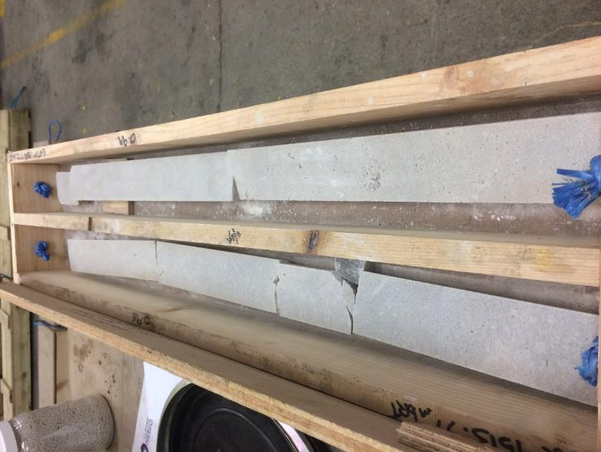
Figure 1. Potash from the Fordon Evaporite Formation (EZ2) (08/12/2016) (SM11 Dove’s Nest).
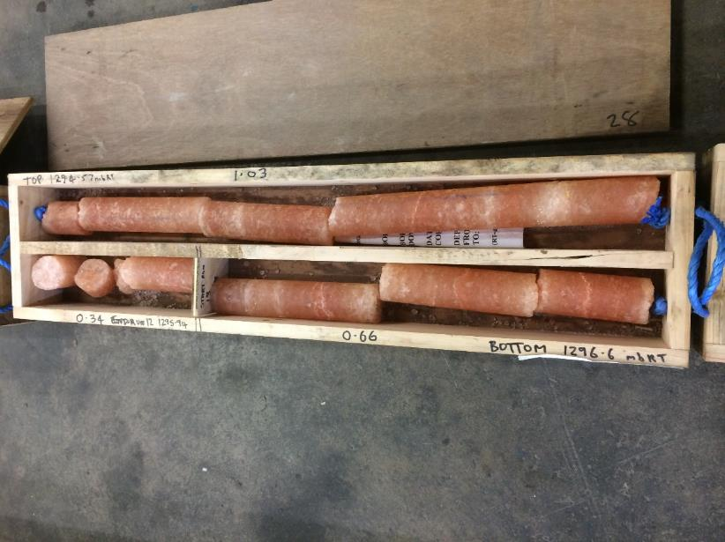
Figure 2. Carnallite and Sylvinite from the Fordon Evaporite Formation (SM11 Dove’s Nest) (08/12/2016).
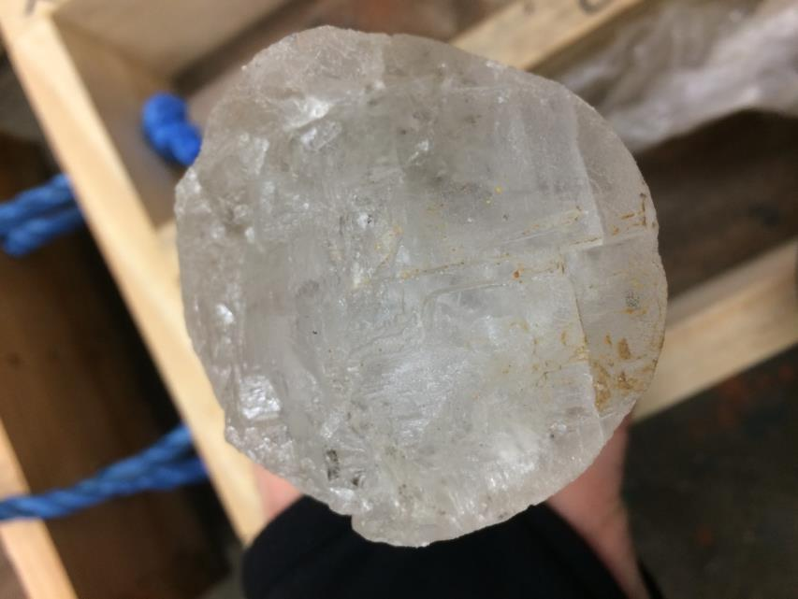
Figure 3. Boulby Halite EZ3 (SM11 Dove’s Nest) (08/12/2016).
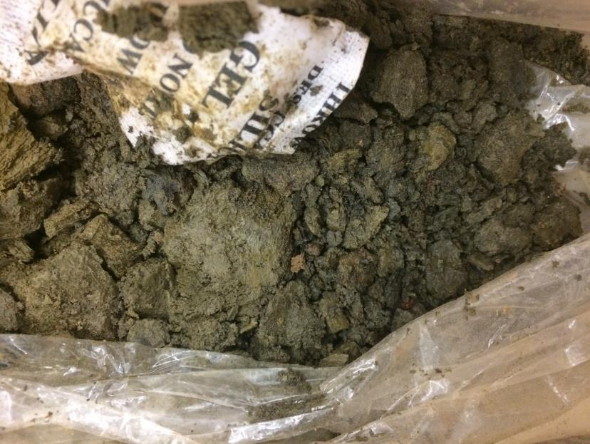
Figure 4. Carnallitic Marl Formation (EZ4) (SM11 Dove’s Nest) (08/12/2016).
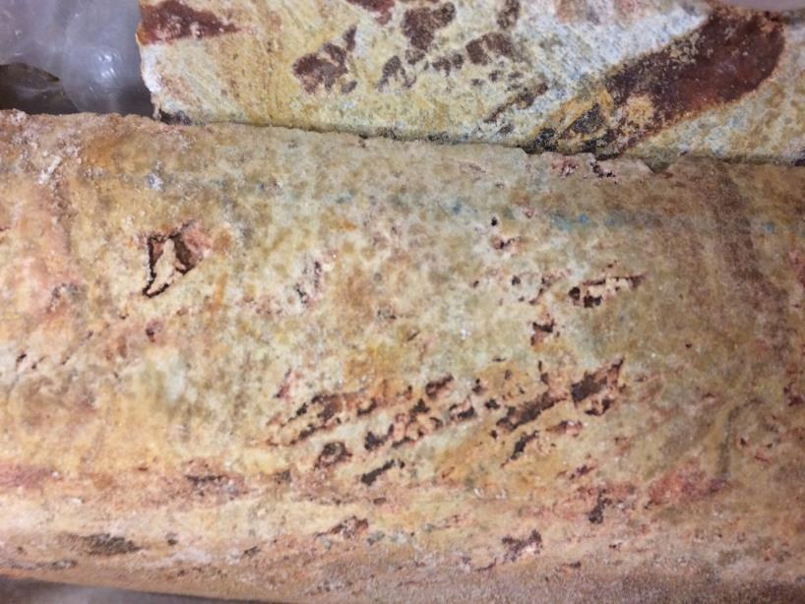
Figure 5. Sherburn Anhydrite (EZ4) (SM11 Dove’s Nest) (08/12/2016).
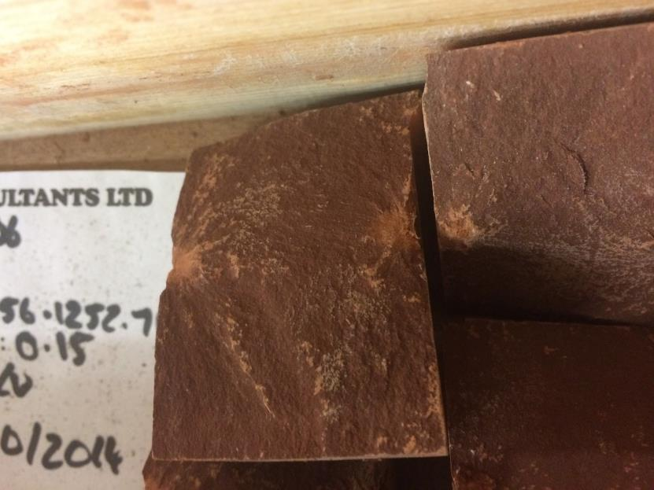
Figure 6. Red mudstone from the Sleights Siltstone (SM11 Dove’s Nest) (08/12/2016).
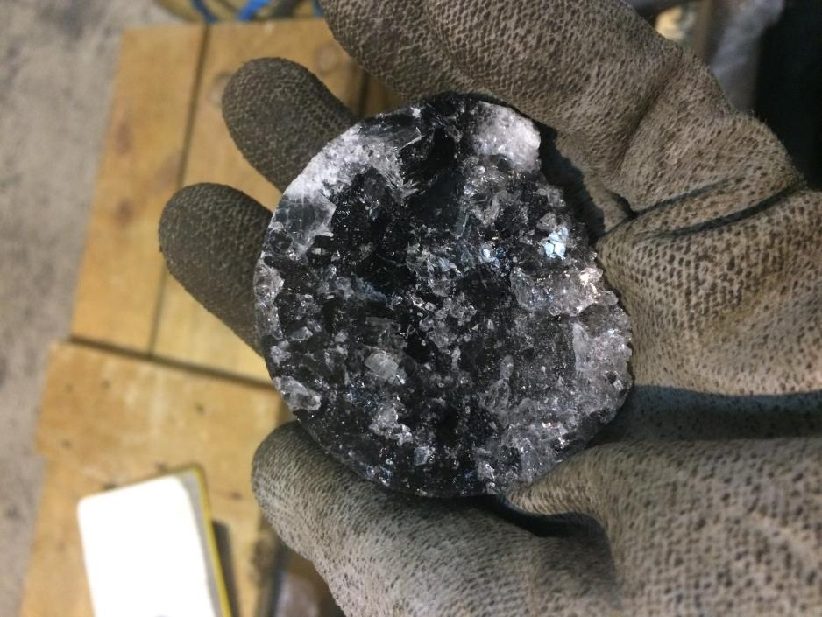
Figure 7. Sample of argillaceous halite (06/12/2018).

