Appendix C: Fieldwork Reports
05/07/2017 Scouting Conisborough Fieldwork Locations: after Downie 1967

Hooton Roberts Quarries GR 472 972: Carboniferous
Owners at the time of publication were Wentworth Estates. At the site a 60ft face is exposed with thin beds of clay that has historically yielded plant remains.

Little Wood Quarry GR 478 983: Carboniferous
60ft face of the Mexborough Rock exposed. Beds of massive sandstone with cross-bed units.

North Cliff Quarry GR 504 992
20ft dolomitized oolite exposed in beds 6 inches to 4 feet thick. Passes into reef masses with rounded chapes up to 10 feet thick. Lower beds are comprised of broken shell limestone partly dolomitized. Fauna similar to Ashfield Brickpit. Sampling was not possible as the site is too overgrown and the rocks are dolomite.

Ashfield Brickpit GR 515 983
Here the Permian rests uncomformably on the Coal measures and a slight angular discordance is visible. Basal bed is a coarse friable gritty sand about 2.5ft thick and contains seams of small pebbles eroded from the Carboniferous, mostly brown ironstone. Above are dark grey clays of marine origin that only yield microfossils. Macrofossils contained in overlying beds which are thin bedded dolomitized broken shell limestones packed with shells. These shell beds are ~16ft thick and extend to the prominent bench in the quarry; face above is composed pf well bedded oolitic and fine grained dolomite with a large reef mass. Other reef limestones can still be found among the fallen blocks on the west side. 1 sample taken at SK 51484 98111±10 – light grey marl, mudstone, clayy and flaky. Taken from a mudstone seam approximately ~1m above the bench height. Possible not too far from location J described in Wall & Downie’s 1963 paper (Figure 1a & b).

New Edlington Brickpit GR 533 987/SK 530 987
40ft face is exposed in a pit to the left of the lane just before the railway bridge. At the top a few inches of thinly bedded dolomite belong to the Upper Magnesian Limestone. Below this are red clays with seams of fibrous gypsum and green clay with a band of green silty sandstone with ripple marks and cross bedding in the lower part of the section.
The site was notified as an exposure of the Edlington Formation, but this is completely obscured by tipping. What remains is a shallow exposure of the overlying Brotherton Formation. Unfortunately, the features of interest are not easily seen and are obscured by vegetation and weathering. This site has previous been assessed as ‘destroyed’ but this is not strictly correct, yet it is not practical to expose it. No sampling undertaken at this site as it is infilled and now a lake.
2 sites near GR 542 009
On the road to Warmsworth, junction with the A630. A few yards east of the crossroads is a hollow floored by Middle Permian Marls and a little farther up, the approach roads to the Doncaster by-pass expose thin bedded pale dolomite of the Upper Magnesian Limestone overlying the Middle Permian Marl. These are the same rocks as seen previously but not approached in the railway cutting on the road to Sprotbrough. Access to these sites was not possible.

Warmsworth Crags GR 536 008
Owned at the time of publication by Brickmarketing Co, now under operation by Sibelco, and now called The Dolomite Quarry. A face nearly 100ft high of fine-grained dolomite is exposed showing large scale cross bedding.

Cawoods Ltd. and the Derbyshire Stone Co. Ltd. Quarries GR 533 105
Derbyshire Stone quarry has a face over 100ft high with reddened dolomite at the top and fine grained dolomitized oolite at the base.

Steetly group quarries around Cadeby GR 522 999
100ft face composed mostly of fine-grained dolomite, but there is a band of green clay 2-4ft thick about 40ft off the floor which has yielded plant material. The face displays reefs features and the bedding dips very gently eastwards. The quarry is now under operation by Grants Precast, and the quarry is now called Cadeby Stone.
Figure 1. Horizon sampled at Ashfield Brick Pit (highlighted in red)
Cadeby road cutting GR 514 003
Here the Dalton Rock is exposed and lies close below the Lower Magnesian Limestone. It caps escarpments in quarries to the left of the road. No access to this site, is it is obscured and overgrown.

24/04/2018 British Geological Survey with Geoff Warrington
Sampling borehole material at the British Geological Survey (BGS) core.

Ash Hill Borehole, near Skyehouse, Yorkshire (BGS Memoir Doncaster 88 pp58)
Registered Borehole Specimen @ 306.63m/919ft. Evident that there was only Carboniferous material available suggested by presence of Lingula. No sampling

Axholme Borehole (BGS Memoir Doncaster 88 pp58)
1000ft of core missing containing the depths for desired sampling i.e. 501.4-530.35m/1645-1740ft + 454.14m/1490ft, therefore no sampling.

Sutton Borehole (BGS East Retford Memoir 101 pp136-138
Sampling desired @ 902, 928, 1060, 1065, and 1080ft. Not enough material to sample from 1060 or 1078ft. No sampling.

Salterford Farm (Oxton) Borehole (BGS Memoir Nottingham 126 pp89)
Desired sampling @ 474-511 ft, and 428-513 ft. 5 samples in that range @ 445, 455, 465 and 475ft, 2 additional samples from Cedric Godwin collections YFP6368 @ 490ft (151.18m) [Cadeby Formation] and YFP6373 @ 506ft. 6 samples total taken at 137.36m, 140.51m, 143.56m, 146.57m, 151.18m and 156.05m

Woolsthorpe Bridge Borehole (BGS Memoir Melton Mowbray 127 pp21)
Sample desired @ 544.45m. Sample was found but is a red fine-grained mudstone and looked very unlikely to yield. 1 sample taken.

02/01/2018 Sunderland Fieldwork with Paul Gibson (NEGS)
Locations are based on Scrutton, C. (1995) Northumbrian Rocks and Landscape A Field Guide. Yorkshire Geological Society, Chapter 13. The Magnesian Limestone between South Shields and Seaham by Smith, D.

Location 1: Cleadon Park Quarry (NZ 385641)
No samples were taken at Cleadon Park Quarry (Figure 2a-c), all carbonates including a 3-5m vertical face that encapsulates the middle of the Concretionary Limestone Formation. The majority of the rock is finely laminated unfossiliferous spherulitic limestone with a few thin graded beds. These thin beds contain the molds of bivalves e.g. Lieba and Schizodus.
The spherulites were formed by the recrystalisation of deeply buried rock and are up to 8cm in diameter. Some have been rotated and fractured by dissolution. There are small patches of buff powdery dolomite inbetween many of the spherulites and in the southeast corner of the face all the limestone passes laterally into soft buff dolostone.
Figure 2. Cleadon Park Quarry a) the cliff face at Cleadon Park, b) the Concretionary Limestone Formation at Cleadon Park Quarry, c) Quarry photograph of a typical radial concretionary structure – radial stellate calcite concretions and remains of the yellow powdery dolomite matric in the upper left hand corner.

These rocks were probably formed on the low-middle part of the basin-margin slope in anoxic conditions, under 120-200m of stratified sea water. The laminites were built up of ?annual couplets of pelagic lime mud in the winter and phytoplankton in the summer. The graded beds are probably turbidites composed of lime mud and lime silt that was originally deposited in oxygenated shallower water on the shelf or higher on the slope and redistributed into the basin by turbidite suspension currents.
The concretions at Cleadon Park Quarry take the form of star-like radiating aggregates of calcite crystals approximately 30mm in diameter. Other forms of concretions include rod-like or finger-like concretions of a radiating form and create fan-like aggregates. All the concretionary structures are composed of almost pure calcite and are surrounded by a matrix of powdery yellow dolomite which is easily weathered away.
The concretionary structures are a result of the de-dolomitisation of the original dolomitic limestone. Calcite has segregated into the hard concretions and the dolomite has formed the softer surrounding matrix. Along the coast these exposures are affected by collapse-brecciation caused by the dissolution of the underlying Hartlepool Anhydrite.

Location 2: Trow Point (NZ 384667) and Frenchman’s Bay (NZ 389662)
No samples were taken here. The well-bedded yellowish dolomitic limstones of the Raisby Formation is exposed at the bottom of the face followed by the Concretionary Limestone Formation. The two formations are separated first by the Trow Point Bed (Figure 3) – grey oolite and oolitic dolomite with radial arrays of columnar stromatolites. And above that, residue of the Hartlepool Anhydrite Formation – dolomitic sandy clay and clayey dolomite. The cliffs are topped by 4-6m of drift composed of wind-blown sand and sparingly pebbly red-brown Pelaw Clay. The Raisby Formation limestones contain numerous cavities after anhydrite nodules.
Around the corner at Frenchman’s Bay (NZ 389 662) several formations are also exposed, including: the basal Permian ‘Yellow’ Sands (Rotliegende Group), the overlying bituminous limestone of the Marl Slate, and the dolomitic limestones of the Raisby Formation. However, these are commonly obscured by rock falls. At Frenchman’s Bay one can see the typical pale greyish collapse-brecciated Concretionary Limestone Formation overlying the pale yellow bedded Raisby Formation limestones. The Basal Permian Sands and Marl Slate croup out at the foot of the cliffs but are completely obscured at high tide by a rock fall.
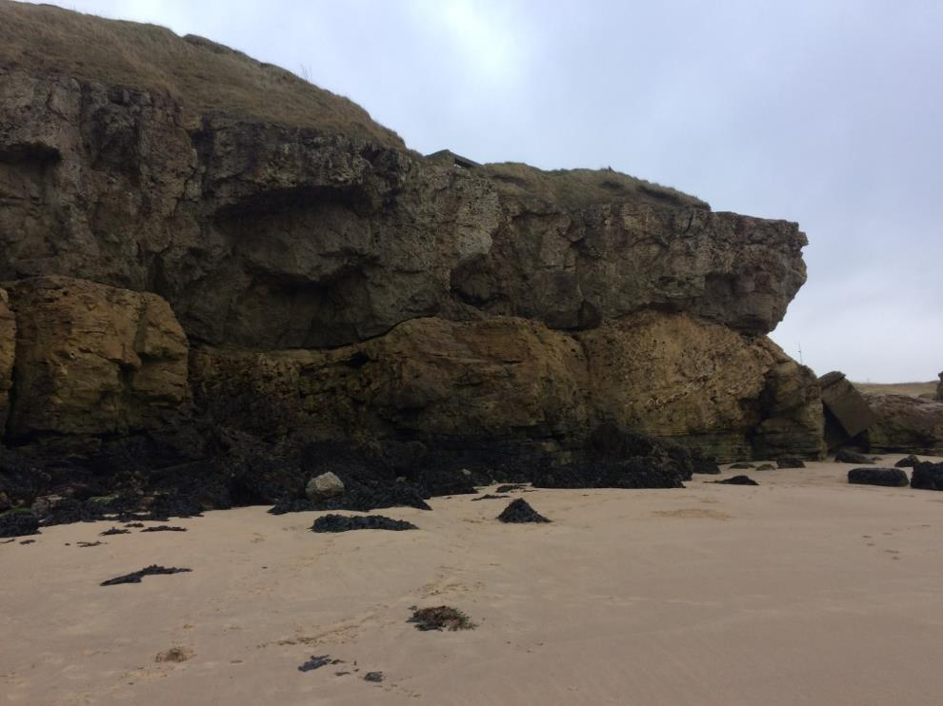
Figure 3. The cliff face at Trow Point. Raisby Formation and Concretionary Limestone Member (of the Fordon Evaporite Formation) clearly visible. Separated by a thin layer of the Ford Formation represented by the Trow Point Bed and residue of the Hartlepool Anhydrite.

Location 3: Marsden Bay (NZ 398651)
The north west end of Marsden Bay is an SSSI, no samples were taken from here. The cliffs at Marsden Bay (Figure 4 & 5) are formed of 16-20m of cream and buff fine-grained dolostone of the Concretionary Limestone Formation. This is one of the best localities in the U.K. for seeing the effects of foundering by the dissolution of underlying evaporites.
All strata have foundered by the same ?60-100m amount – but some areas have been let down gently while others have had a more complex history of subsidence and are intensely fractured, these are known as ‘breccia-gashes’ (Figure 5). After 135m the cliff face exhibits a mixture of finely laminated and unlaminated rock consisting mostly of fine-grained buff dolostone but also some unlaminated oolite. Some of the unlaminated beds including the oolite contain moulds of Lieba, Permophorus and Schizodus, and are graded and some have tight folds and shear-planes caused by downslope slumping and sliding.
Samples
3 sample just at the bottom of the path to the left of the promenade @54.980143, -1.381098 (Figure 4a)
- NZ 39711 65213 bottom shale layer
- NZ 39697 65258 top shale layer
- NZ 39697 65259 middle shale layer
- NZ 39681 65285 low lying layer of shale (Figure 4b)
- NZ 39767 65144 (Figure 4c)
- NZ 36197 57450 Yellow seam above head-height by the caves (Figure 4d)
Figure 4. Marsden Bay a) sampling of the uppermost layer of shale identified along the promenade at Marsden Bay, b) layer of shale sampled at the bottom of the cliffs, c) low lying layer of shale along the bottom of the cliff, unclear whether this layer corresponds to any of the shale layers sampled along the promenade, d) Overhanging layer of pale limestone with what appears to be dark laminations of a possibly biological origin, focusing on a layer of yellowish mudstone.

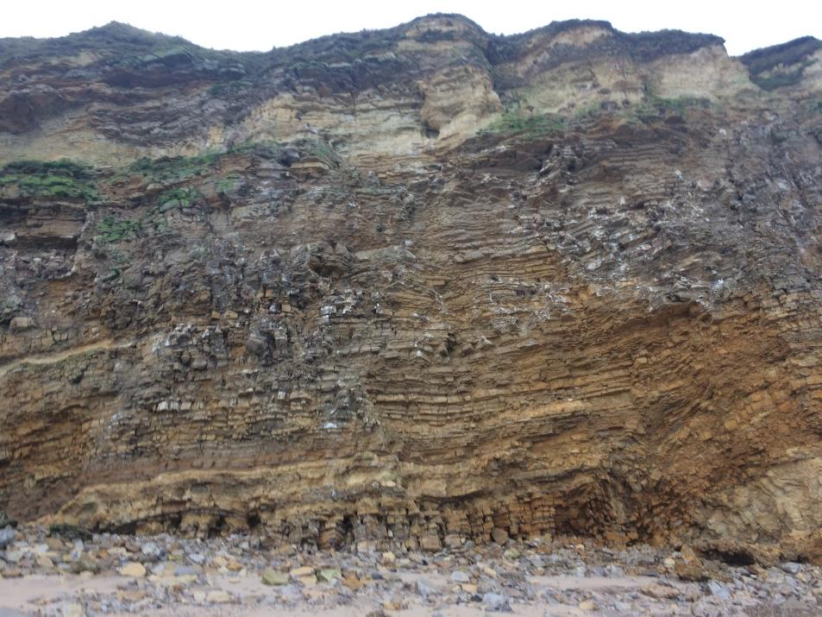
Figure 5. The cliff face at Marsden Bay. Variable foundering of the cliff face visible. Photo illustrates severely collapse-brecciated limestone of the Concretionary Limestone Formation (Photograph by Martha E. Gibson).

Location 4: Whitburn Cliffs, County Durham (NZ 414622)
Cannonball limestone, large concretionary structures. South of Souter Point (Figure 6).
Figure 6. Whitburn a) the ‘Cannon Ball’ limestone at Whitburn Cliffs, b) the face at Whitburn cliffs, clearly showing the cannonball limestone – an exaggerated form of concretionary limestone.

Location 5: Claxheugh Rock (NZ 3657)
Claxheugh Rock (Figure 13) and Ford Quarry (Figure 7) are all part of the same quarry complex and therefore have the same grid reference

Samples
- NZ 36003 57165
- Sample from a layer of shale/clayey material from ~1m above the Kupferschiefer

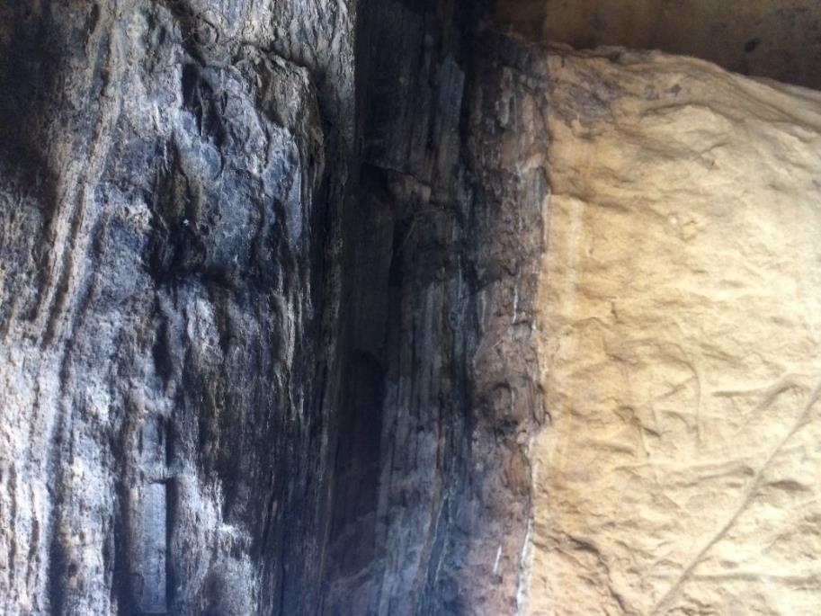
Figure 7. The cliff face at Claxheugh Rock that illustrates the transition between the ‘Yellow’ Sands and the Marl Slate/Kupferschiefer.

Location 6: Ford Quarry (NZ3657)
No sampling at this location. This locality was visited to examine the Ford Formation type locality (Figure 8).
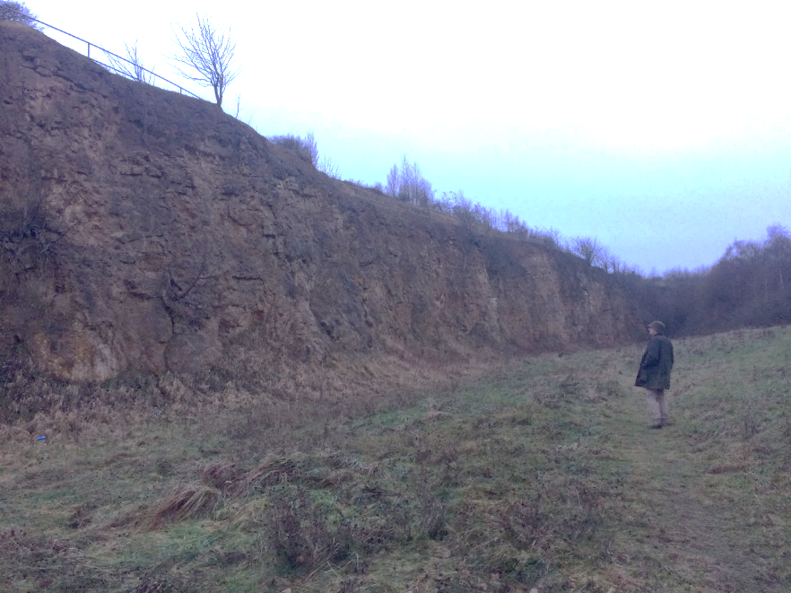
Figure 8. The face of the Ford Formation at Ford Quarry.

14/04/2019 Pot Riding, Levit Haag Hole and Sandal House with Rick Ramsdale of Sheffield Area Geological Trust (SAGT)
Three sites were visited on this excursion, their relative location is illustrated in Figure 21.

Pot Riding (SK527003)
Samples between 7-8 (Mos, 1986), the middle Upper Dolomite. 3 samples taken: 1 in the green band, 1 in the red band, and 1 at the top of the red band where it meets the blocky section (Figure 9 & 10).
Permission acquired from Natural England and Yorkshire Wildlife Trust to sample on this SSSI (see emails for confirmation and proof). This site is located along the disused South Yorkshire Junction Railway in an area known as Pot Riding in the Don Gorge near Doncaster between SK527003 and SK530007. It is within the type area of the Cadeby Formation proposed by Smith et al. (1974). This cutting exposes the Hampole Beds – a thin sequence located at the junction between the lower and upper subdivisions Lower Magnesian Limestone known as the Wetherby and Sprotbrough Members.
At this site 5m of topmost Wetherby Member are exposed (Figure 15). Observed is a transition from cross-bedded to parallel laminated oolitic dolomite and an overall decrease in bed thickness. 30-100cm below the top is a minor erosion surface which is overlain by 20cm of green silts and coarse grained dolomites which are absent in the north, and then overlain by a metre of thinly bedded oolitic dolomite (cross-bedded at the base, parallel laminated at the top) and locally replaced by irregular masses of algal boundstone.
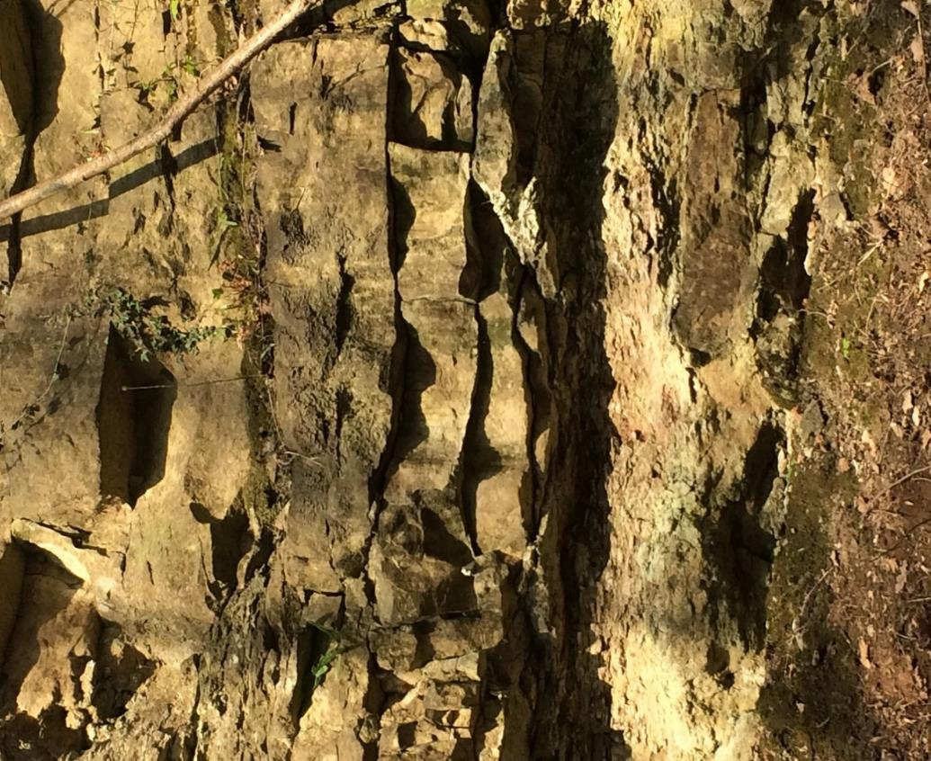
The top of the Wetherby Member here is eroded with the erosion surface undulating up to 2.5m in magnitude – this is the Hampole Discontinuity which undulated up to 30cm elsewhere. Therefore, the erosion at Pot Riding was more severe than elsewhere to produce this large degree of undulation and small cliffs.
Figure 9. Photograph of sampling site at Pot Riding. Green and red band at the base topped with dolomite divided into three blocks, topped with felsitic dolomite.
Figure 10. a) Lithological detail at Pot Riding Cutting (Estwing for scale), b) photography of the Pot Riding Cutting, right is southwards.

The Pot Riding Site was originally logged by Moss in the 1980s, matching the face to his paper was confusing to begin with as he only described particular sections, not the entire sequence. Environmental interpretation is of marine derived carbonate component (originally aragonite and/or calcite) and a combined estuarine and aeolian component derived clastic (quartz, muscovite, clay minerals, small amounts of biotite, garnet, pyroxene, tourmaline, cellophane, some haematite and plagioclase/K-feldspar). A continuous spectrum of environments is depicted representing various degrees of intermixing
Levitt Haag Hole (SE53827 01153) (an old Doncaster Rigg site)
Sample of red mudstone (Figure 11) from a 1m thick band of mudstone at the base of the Brotherton Limestone Formation. Formerly called the Middle Permian Marl, now the Edlington Formation.

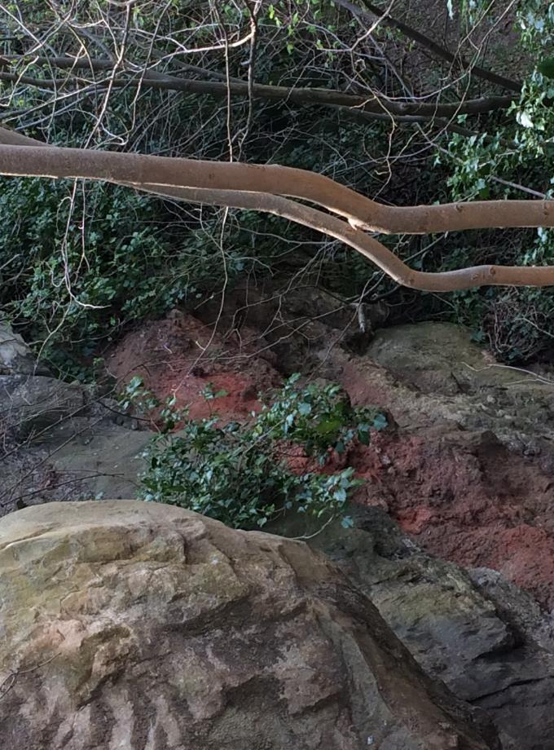
Figure 11. Layer of red mudstone at Levitt Haag Hole. The red mudstone is part of the Edlington Formation.

Sandal House/Sandal Farm (SK51904 8700)
Permission acquired in person from landowners to cross their field to access the exposure at the far end of their property. One sample was taken right underneath the base of the Cadeby Formation (Figure 12).

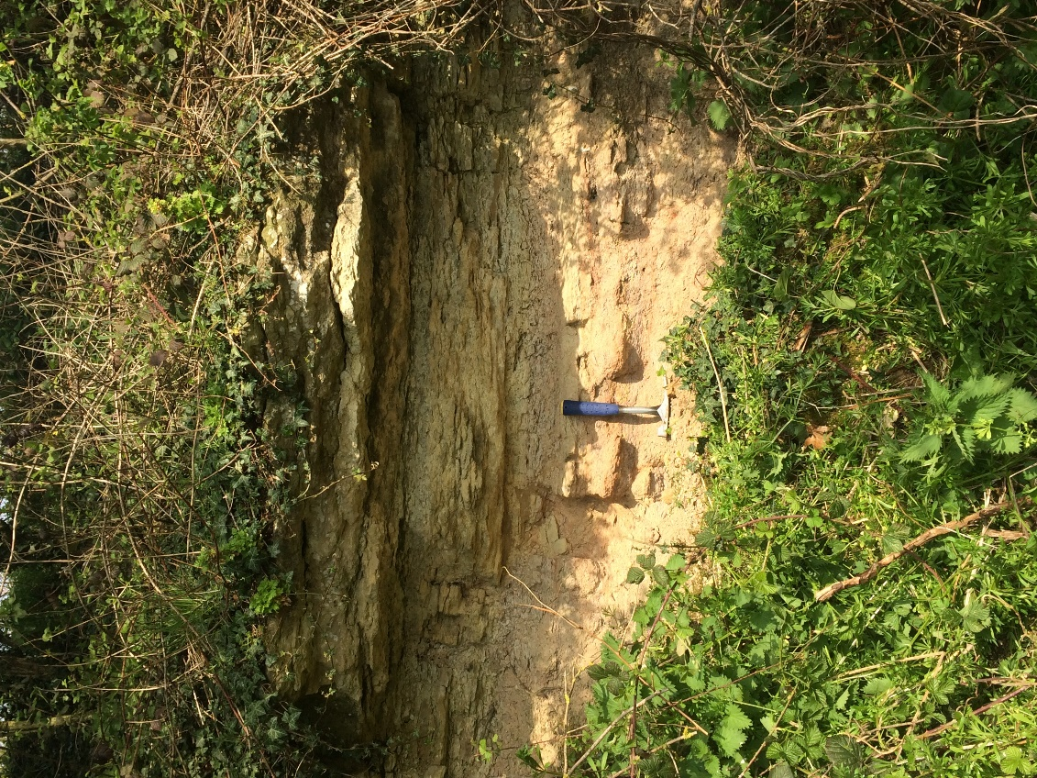

Figure 12. Limestone at the top of the exposure at Sandal House is the beginning of the Cadeby Formation (Estwing for scale).

02/01/2019 Middridge Quarries
No sampling was undertaken here, purely for having a look at Old Towns Quarry (Figure 13) and Middridge Quarry (SSSI) (Figure 13), the famous Lopingian plant collecting locality. The Roker Dolomite is obvious, a clearly laminated, grey-light brown coloured limestone.
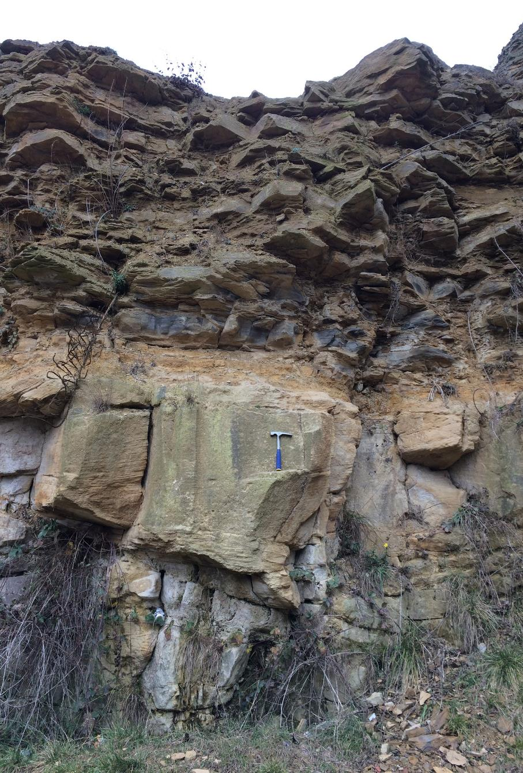

Figure 13. Marl Slate exposed at Middridge Quarry. Estwing for scale.

