Development of Auxetic Polymeric Stent-graft for the palliative Treatment of Oesophageal Cancer

By

Murtaza Najabat Ali



THESIS

Submitted for the degree of
DOCTOR OF PHILOSPHY

in the

Department of Material Science and Engineering,
Faculty of Engineering, University of Sheffield
June, 2012

Dedicated to my Family
Especially
To my Father, my Mother and my Father in-law

Publications

- Ali, M.N. and I.U. Rehman (2011), “An Auxetic structure configured as oesophageal stent with potential to be used for palliative treatment of oesophageal cancer; development and in vitro mechanical analysis”, Journal of Materials Science-Materials in Medicine, 22(11), pp. 2573-2581.

(Publication of a number of Journal Papers has been put on hold because Patent is recently being filed pertaining to the outcome of this research work).

Abstract

Oesophageal cancer is the ninth leading cause of malignant cancer death and its prognosis remains poor, ranking as the sixth frequent cause of death in the world. This research work is aimed to use Auxetic (rotating-squares) geometry, only theoretically predicted and analysed by (Grima and Evans 2000), for the production of a novel Auxetic oesophageal stents and stent-grafts relevant to the palliative treatment of oesophageal cancer and also for the prevention of dysphagia. This study also endeavoured to manufacture a significantly small diameter Auxetic oesophageal stent and stent-graft. In order to easily deploy the Auxetic stent orally using a commercial balloon dilatational catheter, and hence it also obviates the need of an expensive dedicated delivery system. A novel manufacturing route was employed in this research to develop both Auxetic films and Auxetic oesophageal stents, which ranged from conventional subtractive techniques to new generative manufacturing methods.
Polyurethane was selected as a material for the fabrication of Auxetic films and Auxetic oesophageal stents because of its good biocompatibility and non-toxicological properties. The Auxetic films were later used for the fabrication of seamed Auxetic oesophageal stents. The flexible polyurethane tubular grafts were also attached to the inner luminal side of the seamless Auxetic oesophageal stents, in order to prevent tumour in-growth. The scanning electron microscopy (SEM) was used to conduct surface morphology study by using different Auxetic specimens developed from different conventional and new additive manufacturing techniques. Tensile testing of the Auxetic films was performed to characterise their mechanical properties. The stent expansion tests of the Auxetic stents were done to analyse the longitudinal extension and radial expansion of the Auxetic stent at a range of radial pressures applied from the balloon catheter, and to also identify the pressure values where the Auxetic stent fails.
Finite element models of both Auxetic film and Auxetic stent were developed, and the results were compared with experimental results with reasonably good agreement. The tensile testing of the Auxetic polyurethane films revealed that the Poisson’s ratio of the sample ranged between -0.87 to -0.963 at different uniaxial tensile load values. From the stent expansion test, it was found that the Auxetic oesophageal stent radially expanded from 0.5 to 5.73mm and longitudinally extended from 0.15 to 1.83mm at a range of applied pressure increments (0.5 to 2.7 bar) from the balloon catheter.

Table of contents

Acknowledgements 1
Author’s Declaration 2
List of figures 3
List of tables 10
Chapter 1 Introduction 11
  - Outline of the thesis 11
  - Oesophageal cancer 12
  - Auxetics 15
Chapter 2 Literature review 16
2.1 The anatomy and physiology of oesophagus 16
2.1.1 Anatomy of the oesophagus 17
2.1.2 Physiology of the oesophagus 19
2.1.2.1 Oesophageal peristaltic mechanism 20
2.1.3 Investigation of oesophageal motility 23
2.1.4 Estimation of oesophageal peristalsis 27
2.2 Oesophageal cancer 32
2.2.1 Types of oesophageal epithelium malignancies 32
2.2.2 Aetiology of squamous cell carcinoma 34
2.2.3 Dysphagia 36
2.2.4 Diagnosis and staging 37
2.2.5 Stage-specific management of oesophageal cancer 40
2.2.6 Management of oesophageal cancer with palliative intent 41
2.2.7 Palliative treatment modalities 42
2.3 Oesophageal intubation 44
2.3.1 Oesophageal stent insertion procedure 46
2.3.2 Indications and contraindications 50
2.3.3 Limitations in oesophageal stenting 50
2.3.4 Complications and their management 51
2.3.5 Types of oesophageal stents 54
2.3.6 Biodegradable oesophageal stents 61
2.3.7 Coated oesophageal stents 67
2.4 Technical aspects of oesophageal stents 71
2.4.1 Measurement of radial expansive force 74
2.4.2 Measurement of buckling radius 79
2.4.3 Finite element analysis 82
2.5 Auxetic structures 83
2.5.1 Deformation mechanism 85
2.5.2 Properties of Auxetic structures 87
2.5.3 Applications of Auxetic structures 90
2.5.4 Types of Auxetic structures 93
2.5.4.1 Auxetic cellular solids 93
2.5.4.2 Microporous Auxetic polymers 97
2.5.4.3 Molecular Auxetic materials 99
2.5.4.4 Auxetic composites 102
2.5.5 Modelling of Auxetic structures 102
2.6 Polyurethanes (PU) 109
2.7 Processing methods 110
2.7.1 Casting 112
2.7.2 Blow moulding 114
2.7.3 Compression moulding 116
2.7.4 Injection moulding 117
2.7.5 Extrusion 118
2.7.6 Dip coating 119
2.7.7 Inkjet printing 121
2.8 Micro-patterning of polymers 122
Chapter 3 Materials and methodology 127
3.1 Aims and objectives 127
3.2 Material 129
3.3 Development of Auxetic film 130
3.3.1 Lasercutting method 130
3.3.2 Lasercutting of polyurethane film 133
3.3.3 Die casting method 136
3.3.4 Polyurethane casting on a silicone mould 142
3.3.5 Polyurethane casting on an electroplated mould 146
3.3.6 Polyurethane casting on a metal mould 150
3.3.7 Inkjet printing of polyurethane 157
3.4 Development of Auxetic stent 161
3.4.1 Seamless fabrication 161
3.4.1.1 Die casting method 161
3.4.1.2 Vacuum casting 170
3.4.2 Seamed fabrication 177
3.5 Fabrication of Auxetic stent-graft 179
3.6 Topographical characterisation 182
3.7 Mechanical characterisation 183
3.7.1 Tensile testing 183
3.7.1.1 Preliminary test 184
3.7.1.2 Tensile testing of the Auxetic polyurethane films 186
3.7.2 Stent expansion test 188
3.8 Finite element analysis 192
3.8.1 Single-square model 192
3.8.2 Auxetic-ring model 198
Chapter 4 Results and discussion 201
4.1 Analysis of the manufacturing route 204
4.2 Manufacturing of the Auxetic film 204
4.2.1 Lasercutting 205
4.2.2 Lasercut Auxetic polyurethane films 206
4.2.3 Die casting 208
4.2.4 Auxetic polyurethane films developed by silicone mould 209
4.2.5 Auxetic polyurethane films prepared by electroplated mould 210
4.2.6 Fabrication of Auxetic polyurethane films by using titanium mould 212
4.2.7 Inkjet printing of Auxetic (rotating-squares) geometry 213
4.3 Manufacturing of the Auxetic oesophageal stent 214
4.3.1 Preliminary research on die casting 215
4.3.2 Seamless Auxetic stent developed by a collapsible tubular die 216
4.3.3 Fabrication of Auxetic stent by using collapsible titanium die 217
4.3.4 Production of the seamless Auxetic stent by vacuum casting 218
4.4 Surface characterisation of the Auxetic polyurethane stents 220
4.4.1 Surface analysis of the Auxetic polyurethane films 220
4.4.2 Surface analysis of the Auxetic oesophageal stents 223
4.5 A comparative study on the manufacturing techniques 226
4.5.1 Auxetic polyurethane films developed by different methods 227
4.5.2 Auxetic oesophageal stents developed by different methods 228
4.6 Tensile test data 229
4.6.1 Preliminary study results 229
4.6.2 Mechanical behaviour of Auxetic polyurethane films 232
4.7 Auxetic oesophageal stents expansion data 237
4.8 Auxetic film modelling data 244
4.8.1 Physical versus finite element modelling results 252
4.9 Modelling of the Auxetic oesophageal stent 259
Chapter 5 Conclusions and future work 265
References 268
Appendix A I

ACKNOWLEDGEMENTS

I would like to first thank ALLAH (S.W.T) for giving me strength, courage and patience to complete this project. I would also like to express my sincere gratitude to Dr. Ihtesham ur Rehman, my supervisor, for his excellent supervision, valuable suggestions and encouragement in my research and writing. This thesis would have not been possible without the guidance and support of my supervisor. I am greatly indebted to him for his time, understanding, patience and support.

I am also thankful to Dr. James Busfield from Queen Mary University of London, for helping me in Finite Element Analysis and for building up my theoretical knowledge of simulation techniques. My very profound thanks to Smith & Nephew UK, for their in time support to acquire the material. I would take this opportunity to thank Dr. Oliver Lewis of Sheffield Hallam University, for extending all out help.

How can I forget my father Amjad Ali and my father in-law Dr. Wajid Ali on this occasion, who have been a constant source of providing me courage and motivation during the whole project. Their prayers have always been a source of help for me. I am also thankful to my mother for her patience of bearing the pain of staying away from me for such a long period.

Last, but not least, I would like to thank my beloved wife Nida Ali for her understanding, love and sacrifice during the past few years.

Murtaza

AUTHOR’s DECLARATION

The work referred to in this thesis was carried out between November 2009 and January 2012. All data is to the best of my knowledge is original except where explicitly stated. This thesis has not been submitted in whole or in part for a degree in University of Sheffield or any other University.

List of figures

Figure 2.1: A brief atlas of human body 17
Figure 2.2: Schematic showing histological configuration of gastrointestinal tubular organs 19
Figure 2.3: A schematic showing the layered structure of the oesophageal wall 21
Figure 2.4: Manometric tracing showing the oesophageal peristalsis 23
Figure 2.5: Schematic representation of force transducer 27
Figure 2.6: Peristaltic force values are plotted against oesophageal length 29
Figure 2.7: Schematic diagram of the strain gauge apparatus 30
Figure 2.8: The effect of sphere size on peristaltic force 31
Figure 2.9: Oesophagus lumen 33
Figure 2.10: Squamous cell carcinoma in an oesophageal lymphatic system 35
Figure 2.11: Oesophageal cancer stages 38
Figure 2.12: Oesophageal stent placement 44
Figure 2.13: The Delivery system of self-expandable Z- stent 46
Figure 2.14: Fluoroscopic image showing placement of Ultraflex stent 47
Figure 2.15: Schematic showing oesophageal stent deployment mechanism 48
Figure 2.16: Placement of Polyflex stent 49
Figure 2.17: Ultraflex stent placed just below the upper oesophageal sphincter 51
Figure 2.18: Removal of migrated Polyflex stent from the stomach 53
Figure 2.19: The Snare is used to extract oesophageal stent 54
Figure 2.20: Flamingo (Boston Scientific Ltd.) oesophageal stent-graft 55
Figure 2.21: Different types of commercial oesophageal stent-grafts 56
Figure 2.22: Conventional plastic oesophageal stents 57
Figure 2.23: Endoscopic view of Polyflex stent 58
Figure 2.24: Polyflex self-expanding oesophageal stent 59
Figure 2.25: Alimaxx-E oesophageal stent with (anti-migration) struts 60
Figure 2.26: Examples of prototypes of bioabsorbable Wallstent 62
Figure 2.27: Biochemical pathway of the polylactic acid degradation 63
Figure 2.28: Endoscopic findings of the PLLA stent 64
Figure 2.29: The PLLA oesophageal stent 65
Figure 2.30: Model of SX Ella-BD stent showing signs of degradation 67
Figure 2.31: Schematic of the structure of bilayered oesophageal stent coating 70
Figure 2.32: Illustration of stent embedment in the luminal wall over time 71
Figure 2.33: Schematic showing experimental device for measuring radial expansive force 75
Figure 2.34: Expansion pressure values plotted as a function of compression ratio 76
Figure 2.35: Commercial oesophageal stents tested 77
Figure 2.36: Schematic diagram showing apparatus for measuring expansile forces 78
Figure 2.37: Schematic diagram showing application of moments at stent ends 80
Figure 2.38: Radial displacements during the work of the stent-oesophagus system 82
Figure 2.39: Non-auxetic (honeycomb) and Auxetic (re-entrant) structure 84
Figure 2.40: Deformation of Auxetic and conventional materials 85
Figure 2.41: Cell deformation by inclined cell member bending 86
Figure 2.42: Rigid rectangles connected together at their vertices through hinges 86
Figure 2.43: Indentation resistance of non-Auxetic and Auxetic materials 88
Figure 2.44: Saddle-shaped and dome-shaped surfaces 89
Figure 2.45: Dilator employing an Auxetic end sheath 90
Figure 2.46: Piezocomposite device consisting of non-Auxetic and Auxetic components 91
Figure 2.47: Bullet or shell containing Auxetic and non-auxetic components 92
Figure 2.48: Particulate de-fouling capabilities of Auxetic structure 93
Figure 2.49: Re-entrant unit cell 94
Figure 2.50: Thermo-mechanical process for making re-entrant cell geometry 95
Figure 2.51: Various tessellations which can be constructed from “arrows” 97
Figure 2.52: Microporous PTFE having nodules and fibrils 98
Figure 2.53: Arrangement of laterally attached rods 99
Figure 2.54: Unit-cell of a theoretical Auxetic molecular network 100
Figure 2.55: The geometry of the Auxetic “rotating squares” structure 100
Figure 2.56: Rotating parallelogram and variable sized squares geometries 101
Figure 2.57: Packing parameters P_{r} was used to quantify the negative strut curvature 103
Figure 2.58: The colours shown are Mises stress contour plots 104
Figure 2.59: Unit cell of the honeycomb with characteristic dimensions 105
Figure 2.60: Honeycomb with re-entrant cell units 105
Figure 2.61: Different Poisson’s ratios of molecular networks 106
Figure 2.62: 2D representations of various FEM models of flexyne structure 107
Figure 2.63: 2D representations of various FEM models for reflexyne structure 108
Figure 2.64: Material processing families, with subgroups and typical processes 111
Figure 2.65: Production of solvent cast films 114
Figure 2.66: Schematic illustrations of blow moulding process 115
Figure 2.67: Compression moulding process 117
Figure 2.68: Injection moulding process 118
Figure 2.69: Schematic presentation of twin-screw extrusion system 119
Figure 2.70: Process scheme of conventional dip coating 120
Figure 2.71: Schematic diagram of dip coating process 120
Figure 2.72: Schematic illustration of the piezoelectric DOD printhead 121
Figure 2.73: Laser micromachining schematic setup 124
Figure 2.74: Schematic diagram of “hot embossing “procedure 125
Figure 3.1: Key objectives of the research 128
Figure 3.2: The Auxetic “rotating squares” geometry 130
Figure 3.3: AutoCAD 2D Auxetic (rotating-squares) design 131
Figure 3.4: Design specifications of Auxetic film 132
Figure 3.5: lasercut A4 size Auxetic polypropylene film 133
Figure 3.6: A 2D Auxetic (rotating-squares) design on a relatively smaller scale 134
Figure 3.7: Auxetic (2D) design fed into Epilog laser system 134
Figure 3.8: Polyurethane film being cut by CO₂ laser system 135
Figure 3.9: An Auxetic polyurethane film 136
Figure 3.10: 3D designs of both (a) male die plate, and (b) female die plate 137
Figure 3.11: FDM 360mc (rapid prototyping) machine 138
Figure 3.12: Schematic representation of FDM process 139
Figure 3.13: Parts removed from the support material by hand 140
Figure 3.14: Silicone casting on a reverse-Auxetic (female) die plate 141
Figure 3.15: Auxetic (rotating-squares) film acquired from female die plate 142
Figure 3.16: Silicone casting on a male die plate 143
Figure 3.17: Silicone reverse-Auxetic template for casting polyurethane 143
Figure 3.18: Pre-degassing of two part polyurethane material for casting 144
Figure 3.19: Degassed polyurethane material was transferred on a silicone template 145
Figure 3.20: Polyurethane casting done with and without degassing of the casting resin 145
Figure 3.21: ABS plastic reverse-Auxetic substrate (female die plate) 146
Figure 3.22: Electroless nickel plated female die plate 148
Figure 3.23: Polyurethane casting on an electroless nickel plated mould 149
Figure 3.24: Auxetic polyurethane film prepared from electroplated reverse-Auxetic mould 150
Figure 3.25: EBM process showing melting of metal powder 151
Figure 3.26: 3D inverted-Auxetic model for EBM process 152
Figure 3.27: ARCAM EBM S12 system 153
Figure 3.28: Metal powder is being removed from the titanium reverse-Auxetic mould 154
Figure 3.29: Titanium reverse-Auxetic mould made by EBM process 155
Figure 3.30: Pre-degassing and casting of polyurethane on a titanium mould 156
Figure 3.31: Auxetic polyurethane film prepared from metal reverse-Auxetic mould 157
Figure 3.32: Jetlab-4 printing system with demand mode piezoelectric dispensing device 158
Figure 3.33: Bipolar pulse waveform 159
Figure 3.34: Singular droplet formation is achieved by adjusting printing parameters 160
Figure 3.35: Printed 25 successive layers of one unit-cell of Auxetic geometry 161
Figure 3.36: A 3D design of the reverse-Auxetic tubular die 162
Figure 3.37: Reverse-Auxetic tubular die made of ABS plastic 162
Figure 3.38: Reverse-Auxetic tubular die is fixed tightly within TEFLON tube 163
Figure 3.39: Silicone elastomer casted onto a tubular die inside the TEFLON tube 164
Figure 3.40: Auxetic stent removed from the tubular die 164
Figure 3.41: The two halves of the collapsible tubular die made of ABS plastic 165
Figure 3.42: Components of the collapsible tubular die 166
Figure 3.43: Silicone casting into collapsible tubular mould 167
Figure 3.44: Auxetic oesophageal silicone stent (seamless) 168
Figure 3.45: Two halves of the titanium collapsible tubular die 169
Figure 3.46: Auxetic stent is cracked after being released from the collapsible tubular die 170
Figure 3.47: MK Technology basic model SYSTEM-1 171
Figure 3.48: Master model (Auxetic stent) made of ABS plastic by FDM process 172
Figure 3.49: Polyurethane casted into a silicone mould and left for hardening 174
Figure 3.50: Auxetic stent suspended with gates and risers inside the silicone mould 175
Figure 3.51: Metal rod is being separated from the Auxetic stent 176
Figure 3.52: Semi-flexible Auxetic polyurethane stent 176
Figure 3.53: Auxetic polypropylene film wrapped around a wooden rod for welding 177
Figure 3.54: The two ends of the Auxetic film were welded together 178
Figure 3.55: Seamed Auxetic polypropylene stent 178
Figure 3.56: Seamed Auxetic silicone stent 179
Figure 3.57: Welding of the flexible polyurethane graft 180
Figure 3.58: Insertion of a graft into Auxetic oesophageal stent 181
Figure 3.59: Auxetic polyurethane Stent-graft 181
Figure 3.60: Semi-flexible (seamless) Auxetic stent-graft 182
Figure 3.61: Auxetic unit-cells fixed on metal stubs for SEM (gold coated) 183
Figure 3.62: Auxetic polypropylene sample ready for tensile testing 184
Figure 3.63: Tensile testing of Auxetic polypropylene sample 185
Figure 3.64: Polyurethane and Auxetic polyurethane specimens prepared for testing 187
Figure 3.65: Polyurethane specimen is being subjected to uniaxial tensile loading 188
Figure 3.66: (a) Semi-flexible Auxetic stent and stent-graft, and (b) rigid Auxetic stent 189
and stent-graft
Figure 3.67: Auxetic stent with inflation device and balloon catheter 190
Figure 3.68: Semi-flexible Auxetic stent is being expanded by balloon 191
Figure 3.69: Rigid Auxetic stent mounted on a balloon catheter 192
Figure 3.70: Single-square FEA model extracted from the Auxetic film 193
Figure 3.71: Single-square FEA model meshed by quadrilateral elements 194
Figure 3.72: Two nodesets were created at each vertex of the single-square model 195
Figure 3.73: Boundary conditions applied on the single-square model 196
Figure 3.74: (a) Rigid Auxetic polyurethane stent and (b) rigid Auxetic-ring FEA model 198
Figure 3.75: Auxetic-ring model meshed with tetrahedral elements 199
Figure 3.76: (a) un-deformed and (b) deformed Auxetic-ring FEA model 200
Figure 4.1: Schematic showing Auxetic stent deployment in oesophagus 203
Figure 4.2: The manufacturing route used for the production of Auxetic films 205
Figure 4.3: Lasercut Auxetic polypropylene film 206
Figure 4.4: Lasercut Auxetic polyurethane film 207
Figure 4.5: Auxetic silicone film prepared by casting method 209
Figure 4.6: Auxetic polyurethane film by casting with and without pre-degassing 210
Figure 4.7: Electroless nickel plated mould having imperfections 211
Figure 4.8: Auxetic polyurethane film free from air bubbles 212
Figure 4.9: Auxetic one unit-cell (comprising of four squares) printed on a metal stub 213
Figure 4.10: The manufacturing approach adopted for the production of Auxetic Stents 214
Figure 4.11: Auxetic stent having material intact within the diamond-shaped parts 216
Figure 4.12: Seamless Auxetic silicone stent made by casting into a collapsible tubular die 217
Figure 4.13: Auxetic stent fractured after being removed from the collapsible mould 218
Figure 4.14: Seamless Auxetic stent (rigid) made by vacuum casting technique 219
Figure 4.15: SEM micrograph of the sample from the lasercut Auxetic polyurethane film 220
Figure 4.16: Micrographs from the Auxetic film made by casting on a silicone mould 221
Figure 4.17: Micrographs of the third sample 222
Figure 4.18: Micrographs of the fourth sample 223
Figure 4.19: Micrographs from Auxetic stent prepared by titanium collapsible mould 224
Figure 4.20: SEM micrographs of the second sample 225
Figure 4.21: Micrographs of the third sample from the seamed Auxetic stent 226
Figure 4.22: A graph showing plastic deformation 231
Figure 4.23: The sample failed at 27.46N of tensile load 231
Figure 4.24: Nominal stress-strain data of the polyurethane samples with Standard Error 232
Figure 4.25: True stress and plastic strain data calculated with standard error 233
Figure 4.26: Tensile data of the Auxetic polyurethane sample from manual calculations 234
Figure 4.27: Poisson’s ratio of the Auxetic polyurethane sample at different loads 235
Figure 4.28: Graph of the Auxetic polyurethane film sample plotted by the tensile tester 236
Figure 4.29: Graph showing diametrical and length changes of the Auxetic stent 238
Figure 4.30: Auxetic oesophageal stent showing plastic deformation 239
Figure 4.31: Semi-flexible Auxetic stent tested by the small diameter balloon catheter 240
Figure 4.32: A graph showing radial and longitudinal expansion of the stent 241
Figure 4.33: Oesophageal stent exhibiting slight change in size in Test-II 242
Figure 4.34: Expansion data of the rigid oesophageal stent 243
Figure 4.35 rigid Auxetic oesophageal stent failed at 8.3 bar pressure 243
Figure 4.36: Graph showing Reaction force values collected at different mesh densities 246
Figure 4.37: Rotation of the single-square model 249
Figure 4.38: Auxetic film modelling data derived from ‘single-square’ FEA model 251
Figure 4.39: Poisson’s ratio values calculated from the Auxetic film FEA model 252
Figure 4.40: FEA data comparison with physical (both automatic and manual) data 253
Figure 4.41: Extension of the physical and FEA model of the Auxetic film along y-axis 255
Figure 4.42: Graph showing mean load values taken from the physical test and FEA model 256
Figure 4.43: Graph showing Poisson’s ratio values (physical Auxetic film and FEA model) 257
Figure 4.44: Von Mises stress and PEEQ contours of the Auxetic film FEA model 258
Figure 4.45: (a) Auxetic oesophageal stent (physical) and (b) Auxetic-ring FEA model 260
Figure 4.46: Radial displacement applied from the luminal side of the Auxetic stent model 261
Figure 4.47: Von Mises stress and PEEQ contours of the plastically deformed model 262
Figure 4.48: Comparison of physical stent expansion Test-III with Auxetic-ring model 263
Figure 4.49: Von Mises Stress and PEEQ contour legends of the model assumed to be failed 264

List of tables

Table 2.1: Relationship between sphere size and transducer output 28
Table 2.2: Dysphagia score 37
Table 2.3: TNM staging system for oesophageal carcinoma 39
Table 2.4: Classification of complications secondary to oesophageal stent placement 52
Table 2.5: Requirements for an ideal oesophageal stent 59
Table 2.6: Timetable of polylactic acid polymer degradation in vivo 64
Table 2.7: FDA-approved expandable oesophageal stents 72
Table 2.8: Expansile force and buckling radius of the oesophageal metal stents 81
Table 2.9: Characteristics of the fabrication techniques 123
Table 2.10: Analysis of the techniques used in generating micro-patterns 126
Table 4.1: Comparative data of the Auxetic films from different manufacturing techniques 227
Table 4.2: Comparison of the manufacturing techniques in the production of Auxetic stents 228
Table 4.3: Estimation of the Poisson’s ratio values 230
Table 4.4: Semi-rigid Auxetic oesophageal stent expanded by the balloon catheter 237
Table 4.5: Reaction forces acquired from single-square model at mesh densities 245
Table 4.6: Single-square FEA model displacement along x and y axes at different force values 247
Table 4.7: Auxetic polyurethane film data derived from ‘Single-square’ model 250
Table 4.8: Comparison of physical tensile tests and Auxetic film FEA model data 254

Chapter 1 INTRODUCTION

  - Outline of the thesis

Chapter 1 includes a brief background, motivation and objectives of this research work. The feasibility of developing a novel Auxetic oesophageal stent-graft for the palliative treatment of oesophageal cancer has been proposed. Thereafter, the objectives of the study are listed.

Chapter 2 presents a review on the anatomy and physiology of the oesophagus (including oesophageal mechanical behaviour), oesophageal cancer (comprising of types of oesophageal epithelium malignancies, aetiology, dysphagia, diagnosis and staging, stage-specific management and palliative treatment modalities), oesophageal intubation (including types of oesophageal stents, limitations in oesophageal stenting and technical aspects of oesophageal stents), Auxetic structures (their types, deformation mechanisms and properties), Polyurethanes, Manufacturing techniques and micro-patterning of polymers.

Chapter 3 demonstrates the experimental setup and procedures of the novel manufacturing approach (comprising of conventional and new generative production techniques), adopted in this study for the fabrication of Auxetic film and Auxetic oesophageal stents (seamless and seamed). The experimental scheme presented is related to the topographical and mechanical characterisation of the developed Auxetic films and oesophageal stents. A novel finite element technique is introduced which employed both Auxetic film and oesophageal stent models.

Chapter 4 presents the critical analysis of the adopted manufacturing approach which is used for the production of Auxetic films and oesophageal stents (seamless and seamed), to evaluate the efficacy and simplicity of each technique and the quality of the end product. The experimental results presented in this chapter, demonstrates the mechanical behaviour and surface analysis of the tested Auxetic films and oesophageal stents. The conformity of the physical and finite element mechanical data of the Auxetic films and oesophageal stents is presented thereafter.

Chapter 5 summarises the work reported in this thesis and proposes possible future works for the study.

1.2 Oesophageal cancer
The cancer of the oesophagus is the ninth most common malignancy in the world, and ranks the sixth most frequent cause of death over the world (Lam 2000). Oesophageal cancer has a poor prognosis and the diagnosis is made in many cases only in advanced stage owing to the asymptomatic nature of the early disease (McCabe and Dlamini 2005). There are two types of oesophageal cancer, which are squamous cell carcinoma and adenocarcinoma. Squamous cell carcinoma can occur anywhere along the length of the oesophagus because squamous cells cover the entire oesophagus, and adenocarcinoma begins in glandular tissue, which normally does not cover the oesophagus. Before an adenocarcinoma can develop, glandular cells must replace an area of squamous cells, as in the case of Barrett’s oesophagus. This occurs mainly in the lower oesophagus, which is the site of most adenocarcinomas (McCabe and Dlamini 2005).

Both benign and malignant epithelial tumours take place in the oesophagus, and most of the benign tumours are not epithelial in origin and occur from other layers of the oesophageal wall. The oesophageal carcinoma is an aggressive tumour and its cure is difficult (Lamb and Grifﬁn 2006). Dysphagia and its concomitant weight loss are generally considered to be signs of a more advanced stage, by which at least 50% of the oesophageal lumen is compromised and is causing obstruction to the free passage of the alimentary bolus. As a result, dysphagia is considered as a sign of a poor prognosis (Lerut, Stamenkovic et al. 2005). Squamous cell carcinoma is usually cancer of the upper oesophagus and is very aggressive cancer. This cancer of the cervical oesophagus cause a serious complication called dysphagia, which is the difficulty in eating or swallowing and which is indicative of incurability. As a result, a treatment plan is selected which should provide early resumption of an oral diet, restoration of swallowing, and rapid palliation of dysphagia (Tachibana, Kinugasa et al. 2008).

The squamous cell carcinoma and adenocarcinoma, the two predominant types of oesophageal cancer might be totally different diseases with distinct pathogenesis, epidemiology, tumour biology including pattern of lymph node metastasis and prognosis and thereby requiring different therapeutic strategies. The lymphatic channels of the oesophagus run vertically along the axis of the oesophagus and some of them drain into the cervical lymph glands upwards and into the abdominal glands downwards. In fact, the pattern of lymph node metastasis of oesophageal carcinoma is widespread (Tachibana, Kinugasa et al. 2008).

The treatment of oesophageal cancer will depend on selecting the best risk/benefit ratio, adjusted by the patient’s preferences and available professional expertise. Early disease patients (stages 0, I and IIA) are normally treated with surgery alone and endoscopic resection may be curative in stages 0 and I. In advanced oesophageal cancer (stages IIB and III) a combination of surgery, radiation, and chemotherapy are associated with modest prolongation of survival, but with high morbidity and low cure rates. In metastatic disease (stage IV) a variety of endoscopic methods (stenting) can provide palliation of malignant dysphagia, and in some cases radiation or chemotherapy may provide palliation (Lightdale 1999).

Oesophageal stents provide a different number of advantages over other types of palliative treatments particularly for the relief of dysphagia on a more permanent basis. The oesophageal stent acts mechanically by pushing aside the tumour mass; thereby reinstituting a limited oral diet, hence obviating the need for hospitalization which makes it a well-established palliative method. The original stents were plastic and were placed either at laparotomy or endoscopically. Both have a significant procedure related complication rate, including perforation, haemorrhage, pressure necrosis, and aspiration. The major reason for this high serious complication rate is the size and rigidity of the deployment system, which requires balloon dilatation up to 22.5mm. The internal diameter of these stents is relatively small, so patients must be maintained on a modified diet or risk stent blockage. Insertion of a self-expandable metal stent (SEMS) has become a well-established technique over the last decade. The major advantage of stent insertion is that it offers rapid improvement in dysphagia, and SEMS have a relatively low procedure-related complication rate (Lowe and Sheridan 2004).

Immediate complications associated with SEMS placement included problems with stent deployment or expansion, stent misplacement, perforation, and chest pain. Late complications included stent migration (because the covered stent restricts the anchorage of stent mesh with the tissue), occlusion of the stent due to tumour ingrowth and outgrowth (mainly due to uncovered stent), or food impaction. Potentially life-threatening complications may include immediate respiratory compromise, aspiration, fistula formation, sepsis, and procedure-related death. Tumour ingrowth or overgrowth may be treated with Endoscopic laser therapy and re-stenting into the existing stent or balloon dilation. Food impaction can be treated endoscopically, and fistulas can be treated with a covered stent. If a stent migrates, it is replaced by another stent, and attempts are made to remove the stent that migrated. Chest pain in treated with analgesics, including opioids in some cases. Gastroesophageal reflux is treated with proton pump inhibitors. Blood transfusion or radiotherapy may be used for bleeding (Costa and Brophy 2002).

1.3 Auxetics
Auxetic structures as discussed by (Yang, Li et al. 2004), has a counter-intuitive behaviour and exhibit the very unusual property of becoming wider transversely when stretched longitudinally, that is they possess negative Poisson’s ratio. The Poisson’s ratio is defined as the negative ratio of the transverse strain and the axial strain in the direction of loading. All common materials have positive Poisson’s ratio, i.e. the materials contract transversely under uniaxial extension, and expand laterally when compressed in one direction. This process of expansion and contraction is reversed in Auxetic structures.

In recent years several Auxetic structures have been fabricated by modifying the microstructure of existing materials. It was expressed by (Evans and Alderson 2000) that the Auxetic structures have enhanced and improved properties than the conventional materials. Auxetic materials have increased indentation resistance, enhanced shear modulus, good absorption properties like acoustic absorption, and improved fracture toughness as compared to the conventional materials. In all of the Auxetic materials there is a specific microstructure that is vital to creating a negative Poisson’s ratio, deformation mechanism such as rib hinging, bending or stretching and rotating. Their length scale varies from the nanometre for crystal structures to tens of metres for the key-brick structures (Gaspar, Smith et al. 2005).

There are many types of Auxetic structures which are currently present and vary from each other according to their structural difference, deformation mechanism and scale. A range of Auxetic materials have been discovered, fabricated, synthesized and theoretically predicted (Yang, Li et al. 2004). A mechanism to achieve negative Poisson’s ratio was previously introduced by (Grima and Evans 2000), which was based on an arrangement involving rigid squares connected together at their vertices by hinges. As each unit cell contains four squares, each square contains four vertices and two vertices correspond to one hinge.

Chapter 2 LITERATURE REVIEW

2.1 The anatomy and physiology of the oesophagus
The oesophagus is an expandable normally closed muscular tube which connects the pharynx to the stomach and measures about 25-30 cm in the adult. As a conduit its main function is to pass food and fluid, which it propels by antegrade peristaltic contraction. It also serves to prevent the reflux of gastric contents from the stomach whilst allowing regurgitation, vomiting and belching to take place. These functions of the oesophagus are supported by the upper and lower oesophageal sphincters located at its proximal and distal ends. Any oesophageal function impairment can lead to the debilitating symptoms of dysphagia, gastro-oesophageal reflux or oesophageal pain (Lamb and Grifﬁn 2006).

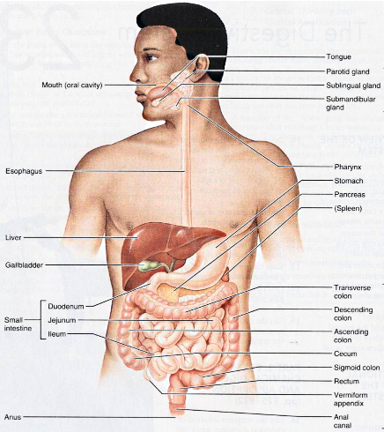
Figure 2.1: A brief atlas of human body (Marieb 2004).

2.1.1 Anatomy of the oesophagus
The oesophagus is an expandable muscular tube which is protected by the upper and lower oesophageal sphincter at its both ends, and it begins as a continuation of the pharynx at the lower border of the cricopharyngeus muscle situated at the sixth cervical vertebra (Lamb and Grifﬁn 2006). The oesophagus covers three anatomic regions by extending from the 6th cervical level (C6) to the 11th thoracic vertebra level (T11). Normal narrowing of the oesophageal lumen occurs at the three areas: at the cricoid; at the left main bronchus and the aortic arch, where it is compressed by these structures; and at the diaphragmatic hiatus (Patti, Gantert et al. 1997).

Oesophagus has a variable luminal diameter and an almost cylindrical shape, which is surrounded by a wall, composed of four main layers of mucosa, submucosa, muscularis externa and adventitia. The mucosal layer is comprised of connective tissue where collagen fibrils are arranged in a loose and random network. For the evaluation of oesophageal wall mechanics the histological analysis of submucosa is essential. Actually, submucosa plays a vital mechanical role in offering strong resistance to the deformation of the wall. Collagen is the key component of submucosa particularly type I and type II collagen. Unlike mucosa which shows very fine collagen fibrils, submucosa has collagen fibrils organized in thick fibres arranged in a criss-cross pattern, where two groups of collagen fibres are present; one is running in a clockwise helix down the oesophagus and the other running in an anticlockwise helix. The fibres of both the groups do not lie in different planes, but intertwine extensively while criss-crossing each other. The muscularis externa mainly consists of smooth and striated muscle and can be subdivided into two layers in accordance with the main direction of the muscular fibres. The orientation of the musculature in the inner layer is circumferential and in the external layer it is axial. The final and outer layer adventitia is a thin layer composed of loose soft connective tissue, which is rich in blood and lymph vessels and adipose tissue and a simple squamous covering epithelium (Natali, Carniel et al. 2009).

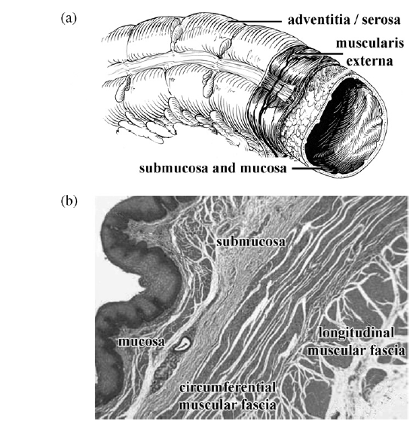
Figure 2.2: Schematic showing histological configuration of gastrointestinal tubular organs (a) and optical microscope picture of an oesophagus (Natali, Carniel et al. 2009).

2.1.2 Physiology of the oesophagus
The oesophageal body is normally relaxed in the fasting state and the upper and lower oesophageal sphincters are contracted to avert gastro-oesophageal reflux and aspiration. In the cervical oesophagus the intraluminal pressure is atmospheric; it becomes negative distally and comes closer to intrapleural pressure (Lamb and Grifﬁn 2006). The information from the histological studies suggests that oesophageal wall from a mechanical point of view can be analysed, as a multilayered anisotropic composite. Due to the specific orientation of reinforcing fibres each layer of the oesophageal wall is characterized by anisotropic behaviour. Additionally, experimental data showed that oesophageal tissues can undergo large strain and displacement phenomena and can be characterised by strongly non-linear mechanical behaviour (Natali, Carniel et al. 2009).

Oesophageal tissue has mechanical properties which are non-linear and anisotropic, and as a composite material its inner mucosal-submucosal layer and outer muscle were found to be considerably different. Furthermore, the residual strain (stress) was observed at the no-load state. Another vital physical feature of the oesophagus is the buckling of mucosa during the active muscle contraction. Additionally, for the propagation of food bolus along with the requirement of intra-luminal pressure, the active contraction force of muscle cells is also needed to compress the inner mucosal layer and to occlude the lumen of the oesophagus (Yang, Fung et al. 2007). During oesophageal wall peristaltic activity, wall tension and cross-sectional area of the oesophagus increases dramatically (Miller, Kim et al. 2004). The contribution of the mucosa in the strength of the oesophagus is negligible until the outer diameter almost becomes doubled, showing that small intra-luminal pressures are held by the muscle layer alone (Goyal, Biancani et al. 1971).

2.1.2.1 Oesophageal peristaltic mechanism
Peristaltic wave moves down the oesophagus, when the food bolus is passed through the upper oesophageal sphincter. Oesophageal movement during peristalsis engages active contraction of both the circular and longitudinal oesophageal muscles. However, during bolus transport both the circular and longitudinal oesophageal musculature acts collectively. Sequential circular muscle contraction helps in the transport of bolus by pushing the bolus toward the stomach (Dooley, Schlossmacher et al. 1989). Sequential circular muscle contraction serves to push the bolus toward the stomach. Longitudinal peristaltic contraction causes the oesophagus to engulf the bolus; to shorten; to pull the bolus toward the stomach; and contributes to the lower oesophageal sphincter opening mechanism (Dodds 1977).

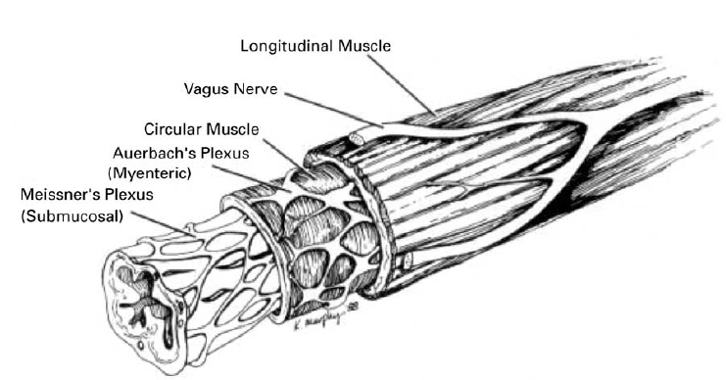
Figure 2.3: A schematic showing the layered structure of the oesophageal wall (Nicosia and Brasseur 2002).

The relaxation of upper oesophageal sphincter depends on the subsequent tongue base and posterior pharyngeal wall contact and pharyngeal wall contraction, which allows the bolus transfer and clearance into the oesophagus (Daniels and Foundas 2001). The peristaltic wave initiated by swallowing is referred to as Primary peristalsis. It begins in the proximal oesophagus following by pharyngeal peristalsis and upper oesophageal sphincter relaxation. The oesophagus becomes shorten initially by the contraction of the longitudinal muscle layer, this is the point where progressive lumen occluding circular muscle contraction proceeds distally through the muscles (both striated and smooth) of the oesophageal wall, preceded by a wave of inhibition. The lower oesophageal sphincter subsequently relaxes and then closes after the bolus with a prolonged contraction (Lamb and Grifﬁn 2006).
Secondary peristalsis results from the stimulation of sensory receptors in the oesophageal body by food not completely cleared by the primary peristaltic waves, or by gastroesophageal reflux (Christensen 1997). These events may also trigger swallowing-induced primary peristalsis in an attempt to clear the oesophagus (Patti, Gantert et al. 1997). The tertiary contractions are the localised non-propagating events of the oesophagus without any link to the swallowing or distension of the oesophagus (Lamb and Grifﬁn 2006).

The act of swallowing initiates the Primary peristalsis, which is the classic coordinated motor pattern of the oesophagus. A rapidly progressing pharyngeal contraction transfers the bolus through a relaxed upper oesophageal sphincter into the oesophagus. Upon closure of the upper oesophageal sphincter, a progressive circular contraction begins in the upper oesophagus and proceeds distally along the striated and smooth muscle portions of the oesophageal body to propel the bolus through a relaxed lower oesophageal sphincter. The lower oesophageal sphincter then closes with a prolonged contraction (Diamant 1997). In the resting state the oesophageal body has no motor activity. A contraction is initiated in the upper oesophagus when food passes through the upper oesophageal sphincter, which progresses distally toward the stomach. Oesophageal peristaltic waves travel at 3 to 4 cm/sec, last between 3 and 4.5 seconds, and reach peak amplitude of 60 to 140 mmHg in the lower oesophagus (Patti, Gantert et al. 1997).

The circular smooth muscle is first inhibited as bolus enters the oesophagus, followed by a sequence of localised contractions whose temporal delay increases with axial distance along the oesophagus. It is this spatio-temporal pattern of inhibition followed by contraction of circular muscle that results in the peristaltic transport of a bolus along the oesophagus. In the mid-oesophagus longitudinal muscle contraction precedes circular muscle contraction by about 1sec and longitudinal muscle contracts for roughly 1.25sec. These investigations suggest that longitudinal muscle contraction prepares the oesophagus for subsequent contraction of the circular muscle by concentrating circular muscle fibres in the contraction zone (Nicosia and Brasseur 2002).

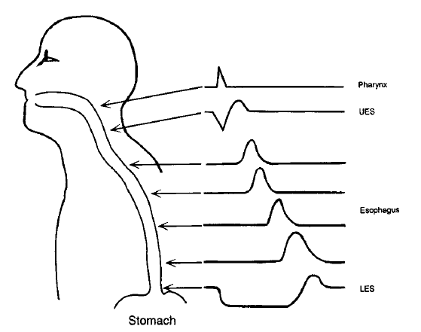
Figure 2.4: Manometric tracing showing the coordinated activity of the upper oesophageal sphincter, the oesophageal body, and the lower oesophageal sphincter (Patti, Gantert et al. 1997).

The oesophagus may have the capacity to change its propulsive force in response to bolus size and neurohumoral agents. The lower oesophageal sphincter can change its strength in response to humoral stimuli and alterations in intra-abdominal pressure (Cohen and Green 1973).

2.1.3 Investigation of oesophageal motility
Manometry is a well recognised method for the study of oesophageal motility. However, this technique only determines the contractile activities of the oesophagus. Videoflouroscopy and scintigraphy are established techniques and bolus transit is visualised through them. Recently multiple intraluminal electrical impedancometry has been introduced as a novel technique with high resolution for the investigation of bolus transport mechanism (Nguyen, Silny et al. 1997).

The bolus head propelled significantly faster than the bolus body and tail. Pharyngeal bolus transit was significantly faster than oesophageal bolus transit. Within the oesophagus, bolus propulsion velocity gradually decreases. Under the experimental conditions used, air was observed to be swallowed together with a bolus and propelled ahead of the bolus. It was previously reported that swallowed air was separated at the head of a bolus while traversing the oesophagus and then accumulated at the ampullary region. The bolus head was injected from the pharynx into the oesophagus with a high velocity up to 37 cm/sec. The bolus body traversed the pharynx with a mean velocity of 9.6 cm/sec., and the results showed that various parts of a bolus have different propulsion behaviour, because the pharynx ejects a bolus into the oesophagus with a high velocity, the pharyngeal bolus transport and the propulsion of the bolus head were proposed to largely result from the chamber pump function of the oropharynx and the high-velocity bolus ejection from the pharynx into the oesophagus (Nguyen, Silny et al. 1997).

On the contrary, mechanisms regulating bolus transport in the oesophagus are more complex, as oesophageal bolus propulsion is induced by a sequence of peristaltic contractions which clears the bolus tail. It can be accelerated in the proximal third by the high-velocity pharyngeal propulsion and slowed down in the distal third by increased abdominal pressure. The proximal oesophagus mainly consists of striated muscle, the distal oesophagus mainly consists of smooth muscle, and a combination of both muscular types occurs in the middle third of the oesophagus. These muscle types show different behaviours related to innervations configuration, response to vagal simulation, neurotransmitters for contraction and mechanisms of peristalsis (Nguyen, Silny et al. 1997).

The manometric studies previously conducted regarding oesophageal fluid bolus transport in humans have generally ignored the hydrodynamic distinction between intra-bolus pressure and pressure within the lumen-occluded, contracting oesophageal segment. Concurrent oesophageal videoflouroscopic and intraluminal manometric recordings in supine normal volunteers using different bolus volumes and viscosities and abdominal compression were obtained. The results clearly showed that intrabolus pressure was elevated with the bolus volume, viscosity, and abdominal compression. There was an increase in oesophageal diameter with larger bolus volumes, and this increase was correlated with the increase in intra-bolus pressure. Intra-bolus pressure was highest in the bolus tail. Peak intra-luminal pressures >20mmHg above basal intra-bolus pressure almost invariably were associated with effective peristalsis, whereas values of this pressure differential <20mmHg were associated with ineffective peristalsis and retrograde bolus escape. Intra-bolus pressure can serve as an important indicator of the forces resisting peristaltic transport and the occurrence of ineffective bolus transport (Ren, Massey et al. 1993).

The manometric measurement of oesophageal motility usually had focused on the peristaltic pressure waveforms that result from the aborad sequence of oesophageal muscle contraction and relaxation. Quantifiable characteristics of this waveform (e.g. amplitude, duration and velocity) have been demonstrated to be affected by alterations in certain physical bolus parameters, such as volume and viscosity, as well as by obstruction to oesophageal outflow. More recent analyses of the relationship between intraluminal manometric findings and peristaltic oesophageal transport of a fluid bolus indicate the importance of considering separately the two pressure domains recorded by manometry: that within the fluid bolus and that within the oesophageal segment whose lumen is occluded and devoid of bolus fluid as a result of oesophageal contractions. Pressures within these two domains are different from one another and are not transmitted between domains when the oesophageal lumen is completely sealed by the oncoming contraction wave. The intrabolus pressure relationship to peak intraluminal pressure allows reliable prediction of effective peristalsis and can suggest the presence of ineffective peristalsis (Ren, Massey et al. 1993).

It has been documented that, a few centimetres below the pharyngoesophageal junction, the peristaltic wave amplitude diminishes sharply and then increases distally. Similarly, contractile duration increases steadily along the length of the oesophagus, and propagation velocity is greatest proximally, slows at the level of the aortic arch, increases in the middle of oesophagus, and then decreases distally. Also, it has established that a liquid bolus as compared with a dry swallow causes a longer, more forceful, and more slowly moving contraction, particularly in the distal oesophagus. With wet swallows, the amplitudes, durations and propagation times of oesophageal contractions are uniformly greater than with dry swallows. Peristaltic amplitudes are also greater throughout the length of the oesophagus in the supine than in the upright position. Therefore, oesophageal peristalsis is significantly altered by body position and is bolus dependent (Kaye and Wexler 1981). Additionally, with a wet swallow the incidence of peristalsis was greater than with a dry swallow (Hollis and Castell 1975).

At the point of contraction, longitudinal muscle contraction brings together the rings of circular muscle fibres and increases the thickness of circular muscle layers which, in turn, increases the force generated by circular muscle. Additionally, the increase in muscle thickness caused by longitudinal muscle contraction reduces the stress on the wall of the oesophagus at the site of contraction in accordance with Laplace’s law (Mittal and Bhalla 2004). According to the recent high-resolution manometry studies, it was seen that oesophageal peristalsis actually comprises two distinct contractile waves, corresponding to the distinct muscle types and neural control mechanisms of the proximal and distal oesophagus. There is a state called transition-zone (TZ) which represents the region of spatiotemporal merger between these two contractile waves. In order to affect uninterrupted bolus transport across the TZ, the proximal and distal contractile waves normally exhibit smooth spatiotemporal coordination (Ghosh, Pandolfino et al. 2008). When all bolus material is cleared into the stomach, peristalsis is considered successful, and when all or some of the bolus material is not cleared into the stomach, peristalsis is believed to be dysfunctional. The peristaltic contraction maintains luminal closure behind the bolus as it traverses the oesophagus, effecting clearance against downstream resistance (Ghosh, Pandolfino et al. 2006).

2.1.4 Estimation of oesophageal peristalsis
Peristaltic propulsive forces in the oesophagus were measured by (Pope and Horton 1972), and they used a force transducer. The transducer was constructed by mercury-in-Silastic strain gauge attached to a plastic sphere (in Figure 2.5). Columns of mercury contained in the Silastic tubing were elongated when propulsive force of the oesophagus exerted on the plastic sphere. This elongation produced an increase in electrical resistance which was recorded and converted to values of force. After the propulsive force has stopped the Silastic tubing elastic extension, it returned the columns of mercury to their resting length.

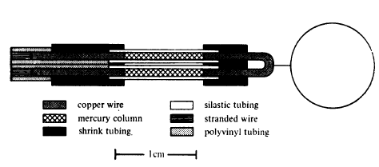
Figure 2.5: Schematic representation of force transducer (Pope and Horton 1972).

The two groups of subjects were taken for oesophageal force measurements, the ‘control group’ which was symptom free and the ‘dysphagia group’ with intermittent dysphagia. Each subject swallowed the transducer assembly into the stomach, where it was electronically balanced. The assembly was then withdrawn until the sphere had passed through the lower oesophageal sphincter. The force values were then obtained by five dry swallows at each 2cm level, from lower oesophageal sphincter to upper oesophageal sphincter. Only deglutitions which produced manometric evidence of peristalsis were counted. Simultaneous contraction of the oesophagus on the gauge caused no output, force values were calculated only when peristaltic contractions occurred. The length of each oesophagus from lower sphincter to upper sphincter was considered to be 100% to facilitate comparison between different subjects (Pope and Horton 1972).

When the transducer assembly was inside the gastric fundus of the stomach, no output was recorded. An increase in force was recorded as the assembly was withdrawn and the sphere encountered the lower edge of the gastroesophageal sphincter. When the transducer was kept at the same level and the subject swallowed repeatedly, variation in output was recorded. Some other factors were identified which influenced transducer output, such as by increasing the size of the sphere from 6.9mm to 10.6mm more than doubled the output (in Table 2.1), and as the sphere was pulled from one end of the oesophagus to the other, certain regional differences became obvious. In the lower one-third of the oesophagus force values obtained were the largest. In the middle one-third of the oesophagus the force values were then declined, and lowest force values were recorded in the upper one-third (in Figure 2.6).

Table 2.1: Relationship between sphere size and transducer output (Pope and Horton 1972).
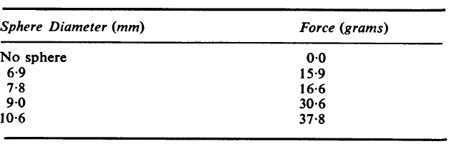

The size of the sphere is a major determinant of the force values obtained during peristalsis. Another variable which might be expected to influence recorded force values is the frictional force between the sphere and the mucosa of the oesophagus. Such frictional forces are difficult to measure, but the observation that ingestion of salad oil caused a marked decrease in force values of subsequent deglutitions would suggest that these frictional forces might be important (Pope and Horton 1972).

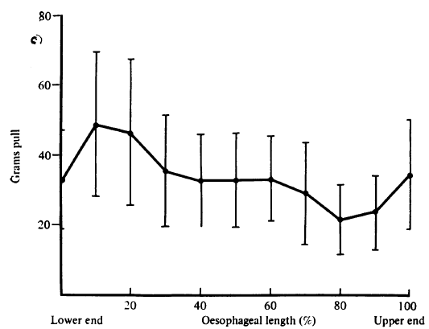
Figure 2.6: Peristaltic force (Pull) values in grams are plotted against oesophageal length (Pope and Horton 1972)

In another study by (Schoen, Morris et al. 1977), oesophageal peristaltic force in man was evaluated and factors which altered peristaltic force values were identified by using an Intraluminal strain gauge. The study was performed in only healthy subjects. Peristaltic force was measured directly using a mercury-in-Silastic strain gauge represented schematically in Figure 2.7. The strain gauge apparatus was used to simultaneously measure peristaltic force and Intraluminal pressure. Polyvinyl spheres of different sizes were attached by stretch-resistant nylon cord to flexible Silastic tubing containing mercury. The electrical resistance of the mercury strain gauge increased as peristalsis moved the sphere aborally, and the electrical impulse was transmitted via a copper wire to the recorder.

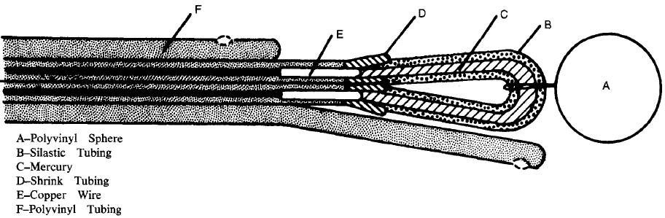
Figure 2.7: Schematic diagram of the strain gauge apparatus (Schoen, Morris et al. 1977).

Each strain gauge was initially calibrated externally in grams by using different weights. The peristaltic force values obtained at three different levels i.e. at 5cm, 10cm, and 15cm above the lower oesophageal sphincter in all subjects are shown in Figure 2.8. Peristaltic force varied directly with sphere size at each level of the oesophagus, and as sphere size was increased peristaltic force rose proportionately. The fundamental basis for this observation is unclear, but a number of possibilities can be considered, such as the bolus (sphere) may simply offer different surface areas for the peristaltic wave to impinge, or the bolus may change the mechanical properties of the muscle during contraction (Schoen, Morris et al. 1977).
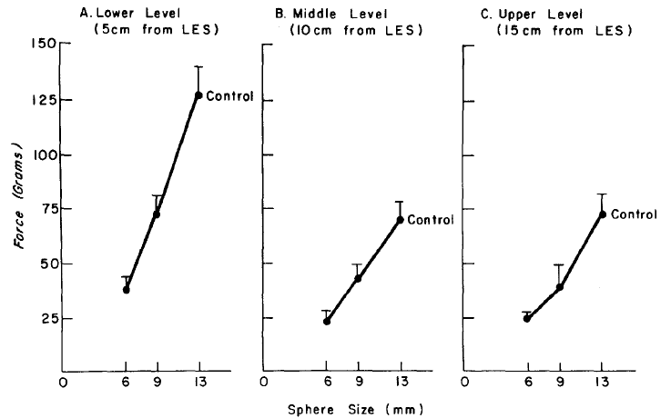
Figure 2.8: The effect of sphere size on peristaltic force at 5, 10, and 15cm above the lower oesophageal sphincter (Schoen, Morris et al. 1977).

It is clear from the above graph that peristaltic force increased directly with sphere size and was greatest at the most distal oesophageal level. Peristaltic force variation at different levels of the oesophagus may be explained by differences in either muscle mass or mechanical properties of the oesophagus. As muscularis mucosa is absent in the proximal oesophagus and normally gains significant thickness distally. Therefore, increase in muscle mass may fairly explain the distal increase in oesophageal peristaltic activity.

2.2 Oesophageal cancer
The cancer of the oesophagus is the ninth most common malignancy in the world, and ranks the sixth most frequent cause of death over the world (Lam 2000). In United Kingdom, the oesophageal cancer is the ninth cause of death due to malignant disease in males with overall 5 year survival from the time of diagnosis of only 5-10% (Lamb and Grifﬁn 2006). It has a poor prognosis and the diagnosis in clinical practice is often reached only in advanced stage owing to the asymptomatic nature of the early lesions (McCabe and Dlamini 2005).

Both benign and malignant epithelial tumours take place in the oesophagus, and most of the benign tumours are not epithelial in origin and occur from other layers of the oesophageal wall. The oesophageal carcinoma is an aggressive tumour and its cure is difficult (Lamb and Grifﬁn 2006).

Oesophageal cancer is found to be a rare cancer relatively as approximately 482,300 cases were reported in 2008 globally, and its incidence rate varies significantly in different regions with the highest rates recorded in Asia including China, Central Asia and in Africa. In USA there are comparatively low incidence rates of oesophageal carcinomas, with roughly 16,640 new cases and 14,500 deaths in 2010 (Martinez, Puc et al. 2011).

2.2.1 Types of oesophageal epithelium malignancies
The wall of the oesophagus composed of four basic layers, and the oesophageal cancer starts from its inner layer and grows outward. Mucosa is the layer that lines inside of the oesophagus (in Figure 2.9). The oesophagus mucosa contains a non-Keratinized stratified squamous epithelium. This abrasion-resistant squamous epithelium at the gastroesophageal junction changes abruptly to the simple columnar epithelium of the stomach which is specialized for secretion. The layer submucosa contains mucus-secreting oesophageal glands. Submucosa compresses these glands when the food bolus passes through the oesophagus, forcing them to secrete mucus that lubricates the oesophageal wall and helps food passage. The muscularis externa is a skeletal muscle and located in the superior third of oesophagus. The outer layer of oesophagus is a fibrous adventitia consists of connective tissue (Marieb 2004).

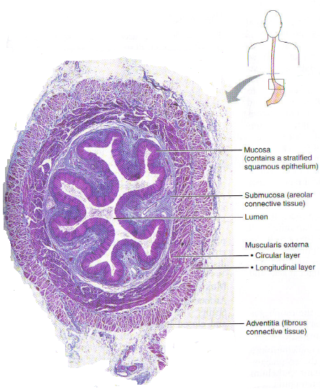
Figure 2.9: Oesophagus lumen (Marieb 2004).

There are two main types of oesophageal cancer: squamous cell carcinoma and adenocarcinoma. Squamous cell carcinoma can occur anywhere along the length of the oesophagus, since the entire oesophagus is normally lined with squamous cells (McCabe and Dlamini 2005). Acid can escape from the stomach into the oesophagus in some people. The medical term for the escape of acid from the stomach back into the oesophagus is reflux or gastro-oesophageal reflux disease (GORD). Reflux in many cases can cause symptoms, for instance heartburn or a burning sensation radiating from the middle of the chest. If the reflux of stomach acid into the lower oesophagus continues for a long time, the acid can cause injury to the lining of the oesophagus. Consequently, the abnormal glandular cells replace the squamous cells that usually line the oesophagus. These glandular cells are more resistant to stomach acid and usually look like the cells that line the stomach. When these glandular cells are observed in the oesophagus, the condition is called BARRETT’s Oesophagus (Enzinger and Mayer 2003). Adenocarcinoma starts in glandular tissue, which normally does not cover the oesophagus. Before an adenocarcinoma can develop, glandular cells must replace an area of squamous cells, as in the case of Barrett’s oesophagus. This occurs mainly in the lower oesophagus, which is the site of most adenocarcinomas (McCabe and Dlamini 2005).

The squamous cell carcinoma and adenocarcinoma, the two predominant types of oesophageal cancer might be totally different diseases with distinct pathogenesis, epidemiology, tumour biology including pattern of lymph node metastasis and prognosis and thereby requiring different therapeutic strategies. The lymphatic channels of the oesophagus run vertically along the axis of the oesophagus and some of them drain into the cervical lymph glands upwards and into the abdominal glands downwards. In fact, the pattern of lymph node metastasis of oesophageal carcinoma is widespread (Tachibana, Kinugasa et al. 2008).

2.2.2 Aetiology of squamous cell carcinoma
Squamous cell carcinoma is almost always cancer of the cervical oesophagus and is very aggressive cancer. The high incidence of multifocal mucosal involvement and the high incidence of submucosal lymphatic spread (in Figure 2.10) are the some of the reasons for the extremely aggressive clinical behaviour of squamous cell carcinomas of the cervical oesophagus. Careful consideration has to be given regarding selection of patients for surgical resection, because of the poor prognosis of these tumours. The treatment plan should provide early resumption of an oral diet and rapid palliation of dysphagia (Weisberger 2005).

Squamous cell carcinoma is the predominant type of oesophageal malignancy. Epithelial dysplasia is the principal precursor lesion of oesophageal squamous cell carcinoma, characterized by an accumulation of atypical cells with nuclear hyperchromasia, abnormally clumped chromatin and loss of polarity. The development of oesophageal squamous cell carcinoma involves the progressive sequence i.e., from mild to severe dysplasia, carcinoma in-situ and finally invasive carcinoma. In the oesophageal epithelium, the tumour present as fungating, ulcerating or infiltrating lesions (Stoner, Wang et al. 2007).

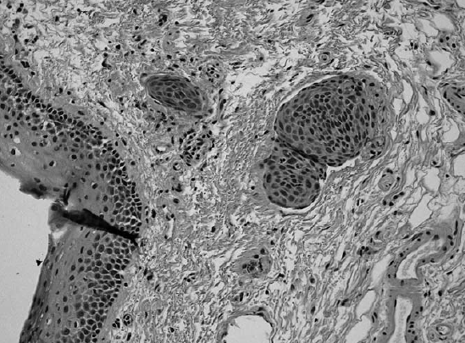
Figure 2.10: Squamous cell carcinoma in an oesophageal submucosal lymphatic system (Weisberger 2005).

Oesophageal cancer is a multi-factorial disease; no single agent has been identified so far as the cause of oesophageal cancer. Methyl alkyl nitrosamines are considered to be the specific inducers of carcinoma of the oesophagus, regardless of its route of administration, and smoked food has a high content of nitrosamines and nitrites. In oesophageal carcinogenesis, smoking is also believed to play a role. Alcohol is also a major aetiological factor in oesophageal cancer. Fungal toxins and spices are believed to have a positive correlation with oesophageal cancer. It is studied that home brewed beers and other spirits cause oesophageal cancer because of the contamination with mycotoxins occurring during preparation. The fungus, Fusarium moniliforme, is believed to play role in the toxicity of maize, and when consumed, these mycotoxins are believed to play a role in the development of cancer. Human papilloma viruses (HPV) have also been found to be associated with the development of the disease. In the initiation and development of oesophageal cancer it is known that tumour suppressor genes, oncogenes, and apoptotic genes are also involved. Apoptosis is a process of programmed cell death, which is very important as cell growth, for the maintenance of homeostasis. When these processes loose integration then uncontrolled cell growth occurs, such as cancer (McCabe and Dlamini 2005).

There are substantial epidemiological evidences suggesting that tobacco, alcohol, diets lacking in vitamins/protective antioxidants, (lack of green leafy vegetables, citrus fruit, micronutrients, zinc, riboflavin, vitamin A), intake of carcinogens (frequent consumption of pickled vegetables) and thermal injuries (preference for hot drinks and soups) are important in the pathogenesis of oesophageal cancers. Many of these factors render the oesophageal mucosa more susceptible to injury by carcinogens including mycotoxins, nitrosyl compounds and possibly viruses. The recent advances and findings in molecular biology particularly in oesophageal squamous cell carcinoma focus on the viral aetiopathogenesis and cancer susceptible genes to chemical carcinogens (Lam 2000).

2.2.3 Dysphagia
The term dysphagia is used clinically to indicate difficulty in passage of solid and liquid boluses through the oesophagus to the stomach, and it literally means difficulty in swallowing or with eating. The Dysphagia is a presenting symptom of oesophageal cancer which is indicative of incurability. The normal oesophageal lumen measures approximately 25mm in functional diameter. When the oesophageal luminal diameter is decreased to 13mm, the patient has solid food or regular diet dysphagia (Boyce 1997).

Dysphagia is usually evaluated on a 5 grade scale (in Table 2.2 below), i.e. 0 – ability to eat a normal diet, 1 – some solid food, 2 – some semisolids only, 3 – liquids only, 4 – inability to tolerate any solid intake (Costa and Brophy 2002).

Table 2.2: Dysphagia Score (Frenken 2001).
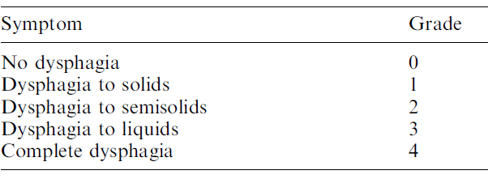

Dysphagia and its concomitant weight loss are generally considered to be signs of a more advanced stage, by which at least 50% of the oesophageal lumen is compromised and is causing obstruction to the free passage of the alimentary bolus. As a result, dysphagia is seen as a sign of a poor prognosis (Lerut, Stamenkovic et al. 2005).

2.2.4 Diagnosis and staging
Although in early-stage disease the survival rate is better, the patients may benefit the most from accurate staging at initial presentation with advanced locoregional disease but no evidence of systemic metastasis (Schrager, Tarpley et al. 2005). Dysphagia, weight loss, gastrointestinal reflux, odynophagia and dyspnea are the most common presenting symptoms of oesophageal cancer. Dysphagia begins with solids and may progress to the point that swallowing liquids (or even saliva) is also difficult. Dysphagia does not occur until the oesophageal lumen is significantly compromised, and this therefore often points to the presence of a relatively larger tumour. Before leading to the discovery of an oesophageal primary tumour, a metastatic lesion is found first occasionally. Early cancers are often asymptomatic and may be discovered as incidental findings at endoscopy, and unfortunately, symptoms generally indicate relatively advanced disease (Lee 2001).

The oesophageal cancer treatment will depend on deciding the best risk/benefit ratio, modified by the available professional expertise and the patient’s preferences. Patients with early disease (stages 0, І, and IIA) are usually cured with surgery alone (in Figure 2.11). In stages 0 and I endoscopic resection or ablation may be curative. In advanced oesophageal cancer (stages IIB and III), surgery, radiation, and chemotherapy in combination are related with modest prolongation of survival, but with high morbidity and low cure rates. In metastatic disease patients (stage IV), radiation and chemotherapy may provide palliation and a variety of Endoscopic methods (stenting) can provide palliation of malignant dysphagia (Lightdale 1999).

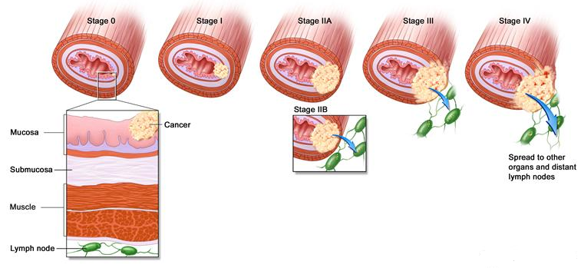
Figure 2.11: Oesophageal Cancer stages (HealthierWays 2010).

Dysphagia for solids is generally due to a mechanical cause and should prompt upper endoscopy. This offers the opportunity for diagnosis, tissue sampling, and in some cases therapy. Biopsy, brush cytology, or a combination of both can be used to perform tissue sampling. A double-contrast barium oesophagogram is an alternative, particular for patients who have dysphagia for solids and liquids equally, and in whom disordered motility is a consideration. Therefore, endoscopy would then be required for confirmation and tissue sampling, if a potential malignancy is found (Elton 2005). A tumour-node-metastases (TNM) classification (in Table 2.3) is used to closely correlate stage and disease prognosis (Layke and Lopez 2006). Staging is performed based on the TNM classification of the American Joint Committee on Cancer and the International Union against Cancer, once an oesophageal cancer is documented. A computed tomography (CT) scan for chest, abdomen, and pelvis should be done to look for evidence of metastatic disease. If none is found, endoscopic ultrasound (EUS) should be performed, as this has been shown to have the highest accuracy for T and N status. Positron Emission Tomography (PET) scanning may be useful in the further staging of oesophageal cancer. It is particularly useful in identifying patients with distant metastasis that was not demonstrated on CT, as this may lead to avoidance of an unnecessary resection of the primary tumour (Elton 2005).

Table 2.3: TNM staging system for oesophageal carcinoma (Elton 2005).
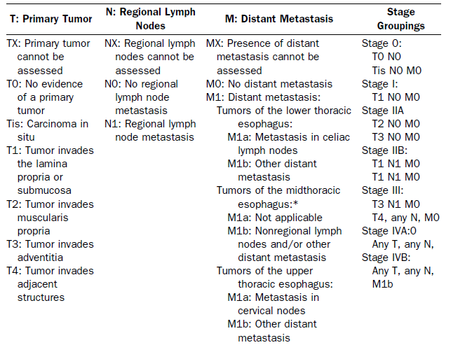
Oesophageal cancer staging is important for evaluating the resectability of the tumour and for assessing the prognosis of the patient. The significance of the stage of the disease is emphasized by the effect that it has on survival. Patients with tumours limited to the wall of the oesophagus without lymph node metastases show a significantly better survival than those with lymph node metastases or wall penetrating carcinomas. The following basic information should be available before pre-operative TNM staging is performed, to complete the knowledge about the malignant lesion, such as tumour site (the location, the degree of stenosis are precisely known and the longitudinal extent of the tumour), and tumour type and grade (the differentiation between squamous cell and adenocarcinoma, the grading of the tumour evaluated by biopsy and the macroscopic appearance of the tumour) (Holscher, Dittler et al. 1994).

2.2.5 Stage-specific management of oesophageal cancer
Surgical resection procedure for stage 0 and stage 1 disease produces a very high cure rate and is the treatment of choice. Endoscopic therapy with mucosal resection or photodynamic therapy is appropriate for the patients who are not operative candidates. Surgical therapy is the standard of care and is often combined with neoadjuvant chemoradiation therapy for stage II and stage III disease. However, in literature the chemoradiation therapy and surgery alone are also recommended as reasonable strategies. For advanced metastatic T4 tumours or stage IV diseases, palliation is the primary goal for the patients with severe or persistent dysphagia, and stent placement, tissue ablation with photodynamic therapy, argon plasma coagulation, laser therapy or alcohol injection are the common options. Placement of a covered oesophageal stent may palliate symptoms for the patients having tracheoesophageal fistula (Elton 2005).

2.2.6 Management of oesophageal cancer with palliative intent
There is only one aim of palliation, which is to improve the quality of life for the limited span of life left to the patient. Whatever therapy is carried out, mean survival in these patients is only 4 to 6 months. The most devastating symptom is dysphagia, and the second frequent symptom requiring palliative therapy is aspiration. These symptoms are either caused by aspiration of saliva as a result of complete dysphagia, or aspiration of food owing to a tracheoesophageal fistula. Pain is third important symptom that demands therapy (Frenken 2001).

The understanding of the term palliative treatment is very important; it can be clearly defined by taking into account a common situation, where a surgeon treating a patient with oesophageal cancer, may only realize intra-operatively that he cannot carry out a complete resection of the tumour including clearance of lymph node metastases, although this was thought to be possible before the operation, and the operation will end up with a residual tumour load left inside the patient. Some surgeons would call this situation a palliative resection. Therefore, as the intention was potentially curative, but this is not a true palliative therapy. However, palliation affects the patient who cannot be cured because of far-advanced local tumour spread, distant metastases or low functional reserves, which rule out major surgery (Frenken 2001).

As most of the patients have incurable oesophageal cancers and live approximately six months, the major goal of the treatment remains relief of dysphagia and closure of tracheoesophageal fistulae (if present) while maintaining quality of life and adequate per oral diet. A combination of less-invasive modalities for the palliation including systemic chemotherapy, radiation therapy and endoscopic techniques has become standard, because of the high morbidity and mortality associated with surgical palliation. Endoluminal stenting is now considered the most effective and widely adopted method of palliation among the available endoscopic therapies (Repici and Rando 2008).

2.2.7 Palliative treatment modalities
A range of nonsurgical palliative techniques are available for the relief of malignant obstruction of the oesophagus. These include palliative chemotherapy and radiotherapy, endoluminal laser therapy, argon beam and bipolar electro-coagulation, ethanol injection, photodynamic therapy, and intracavitary brachytherapy. All methods require several treatment episodes to restore swallowing, and these techniques are only suitable for patients with primary oesophageal carcinoma (Lowe and Sheridan 2004). Other palliative treatment modalities include endoluminal laser treatment (Nd:YAG), dilation, photodynamic therapy (PDT), argon beam or bipolar electrocoagulation therapy, absolute ethanol for tumour necrosis, intracavitary brachytherapy, and external beam radiotherapy and endoluminal stenting (Costa and Brophy 2002).

In the palliative treatment of oesophageal cancer photodynamic therapy (PDT) is a relatively new and effective treatment modality. It involves laser light activation of a photosensitiser with subsequent generation of free radicals and tumour necrosis (Pazurek and Malecka-Panas 2005). Although PDT being a useful palliative treatment for oesophageal cancer, its role compared to currently available techniques is not yet fully established. In a randomized trial PDT was shown to be as effective as Nd:YAG laser for the palliation of oesophageal cancer with less perforations than laser treatment and a better objective tumour response. However, while PDT appears to be pain free and less technically demanding than other ablative techniques, it is thought to be expensive due to the combination of laser technology and high photosensitiser drug costs (O'Donnell, Gray et al. 2007).

Due to high morbidity and mortality as well as prolonged hospitalization involved in the surgical and radiation therapy, these therapies are not used frequently in the palliative treatment of malignant dysphagia. It has been reported that although chemotherapy is not useful when used alone, but it reduced the number of sessions when performed in conjunction with laser therapy. Based on the principle of tumour destruction endoscopic laser therapy with thermal energy, may restore almost normal swallowing with a low complication risk. Although laser procedure-related risk of perforation is very low, therefore, laser therapy has to be repeated periodically (Rozanes, Poyanli et al. 2002).

The minimum side effects and intervention incorporated in the relief of dysphagia, is an objective of high priority in these patients and a variety of palliative procedures have been advocated. Endoscopic placement of self-expandable stents has become the most widely practiced treatment. As a palliative regime a drawback for laser therapy has been the transitory effect on dysphagia and need for repeated interventions, whereas the use of external radiotherapy alone or in combination with chemotherapy has been questioned due to severe side-effects (Bergquist, Wenger et al. 2005).

Palliative resection or palliative bypass surgery may be considered in order to relieve the patient from dysphagia. It is obvious from the earlier data that the median survival in this group of patients is less, and their conclusion was that only those patients who survived for more than 2 years recovered a good quality of life and the surgical palliation is not the best palliation method. It has been revealed that external beam radiotherapy can cause significant shrinkage of an oesophageal cancer, thus improving the quality of life and relieving the patient from dysphagia. However, the response is usually of short duration. The delivery of a very high dose to the luminal aspect of the tumour has been made possible by the advent of intra-luminal brachytherapy, thus rapidly restoring patient swallowing. It can be applied alone or in combination with external beam radiotherapy. Additionally, good palliation with respect to relief from dysphagia is associated with doses above 15 Grey (Frenken 2001).

Brachytherapy in single dose provides gradual improvement in dysphagia, but better long term results than metal stent placement. Similar slow improvement of dysphagia is being observed after external beam radiation. To palliate dysphagia hyperfractionated radiotherapy may be more successful than external beam radiation. When comparing ND:YAG laser ablation technique with stent placement, ND:YAG laser showed better palliation of dysphagia, with lower morbidity for tumours less than 5cm in length (Pazurek and Malecka-Panas 2005).
2.3 Oesophageal intubation
Oesophageal stenting is a well recognized palliative method. Its effectiveness, however, is limited by the fact that it acts purely mechanically by pushing aside the tumour mass as illustrated below in Figure 2.12, and obviating the need for hospitalization. Stenting has now become necessary because of therapeutic failure of other palliative techniques such as photodynamic therapy, laser disobliteration, and local hyperthermia. Stenting is one of the oldest techniques for palliation of oesophageal carcinoma. The open pull-through techniques have been replaced by push-through techniques, which do not require laparotomy. However, gross dilatation of the tumour stenosis is necessary in both techniques to enable the passage of the semi-rigid plastic or rubber tubes. Insertion of a self-expandable metal stent (SEMS) has become a well-established technique over the past 10 years. The major advantage of stent insertion is that it offers fast improvement in dysphagia, and SEMS have a relatively low procedure-related complication rate (Maier, Pinter et al. 1999).

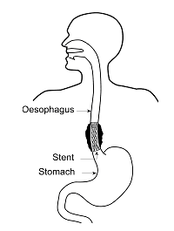
Figure 2.12: Oesophageal stent placement (Trust 2010).
Oesophageal stents have been used and associated with successful relief of dysphagia than other palliative methods. In the past, conventional plastic stents were usually used, and these semi-rigid plastic stents required dilation and were associated with an increase in complication rate. Subsequently SEMS were developed and the advantages of this design included a smaller, more flexible delivery system and increased ease of deployment. Earlier some studies compared conventional plastic stents and uncovered SEMS. Although relief of dysphagia was similar, complications after plastic stent placement were significantly higher and associated with a longer hospital stay. Therefore, despite the higher initial cost of SEMS, it was concluded that SEMS, were most cost effective in the management of unresectable advanced oesophageal cancer, because of lesser complications and a shorter hospital stay (Pennathur, Chang et al. 2008).

The key features of the ideal retrievable oesophageal SEMS should be cost effective, designed to have a small-calibre delivery device with minimal shortening on deployment, and technically easy to place and remove with endoscopy and/or fluoroscopy. Additionally, both stent insertion and stent removal should be associated with minimal complications, and rate of stent migration should also be low (Wong, Adler et al. 2008).

The deployment mechanism of SEMS and self expanding plastic stents (SEPS) is very easy and they are highly effective in rapidly improving dysphagia. They offer a number of advantages, including small delivery systems, large luminal diameters, flexible materials, minimal sedation, minimal oesophageal dilation, ease of insertion, immediate relief of symptoms, and long patency rates (Repici and Rando 2008).

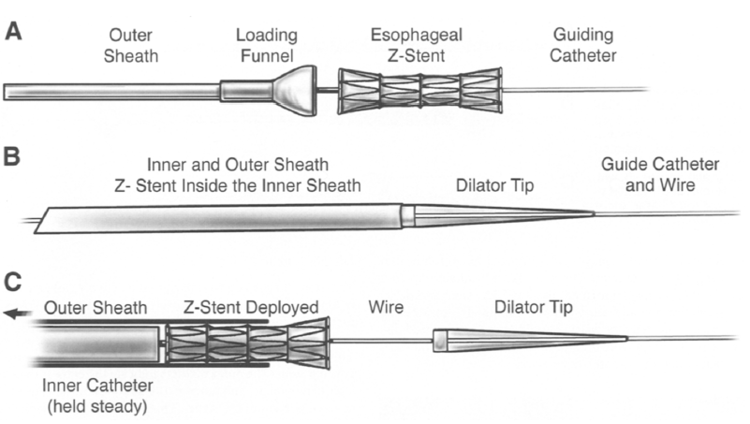.
Figure 2.13: The Delivery system of self-expandable Z- stent (Mohan and Kozarek 2001).

2.3.1 Oesophageal stent insertion procedure
It may be helpful to obtain a barium oesophagogram to define stricture location, length, angulations, and presence of tracheoesophageal fistulas, prior to the placement of the stent (Shim 2004). SEMS can be deployed using endoscopic guidance, fluoroscopic guidance, or a combination of both. With any of the techniques it is helpful to have a contrast swallow (usually water-soluble contrast) to allow an assessment of the site and length of the tumour and whether or not there is any evidence of fistulation into the trachea or bronchi (in Figure 2.14). This information is essential in choosing the type of stent to place (Lowe and Sheridan 2004).

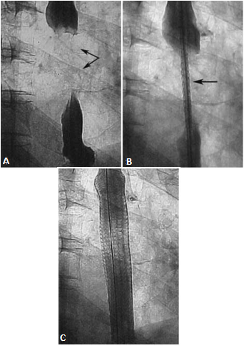
Figure 2.14: (A) Contrast swallow demonstrates complete obstruction, (B) Ultraflex stent delivery system in-situ and (C) satisfactory expansion and deployment of stent (Sabharwal, Morales et al. 2005).

The procedure of stent insertion using fluoroscopic guidance is described by (Lowe and Sheridan 2004), which is performed under conscious sedation. In most cases the addition of analgesia is not required. Oxygen is delivered via nasal cannula and the patient’s pulse and oxygen saturation are monitored throughout the procedure. The patient lies on the x-ray table in the prone position for tumours of the gastroesophageal junction and in the left lateral position for strictures of the more proximal oesophagus. The prone position has the advantage of opening out the GE, which is foreshortened in the left lateral position, allowing accurate positioning of the stent.

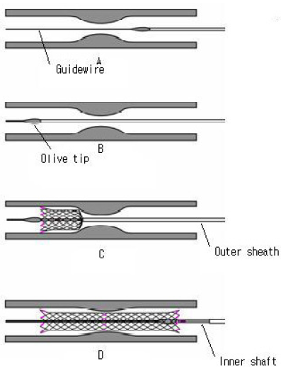
Figure 2.15: Stent deployment, (A) the delivery system is pre-mounted on the guide wire, (B) The end of stent is placed at least 2 cm below the distal margin of the tumour, (C) as the outer sheath retracted, the stent slowly expands and (D) once the stent is fully deployed, the guide wire and delivery device are removed (Shim 2004).

A catheter and guide wire combination is passed over the back of the tongue and into the oesophagus once the patient is sedated. The hydrophilic guide wire and catheter are passed down as far as the proximal end of the stricture, the guide wire is removed, and 10 to 15 ml of a water-soluble contrast material is injected to indicate the proximal extent of the stricture (Lowe and Sheridan 2004). The hydrophilic guide wire is reinserted into the catheter and used to negotiate the stricture. At the distal end of the stricture, a further injection of water-soluble contrast marks the distal extent of the stricture. At this point, radio-opaque markers can be fixed to the patient’s skin as indicators of the stricture length and position. In the case of gastro-oesophageal tumour, once the stricture has been traversed, air is injected into the stomach via the catheter. In the prone position, air fills the fundus of the stomach and the soft tissue mass of the tumour can be readily seen. This avoids having to fill the stomach with contrast medium. The guide wire and catheter are placed as distally as possible, to provide sufficient anchorage for passage of the stent. The catheter is then removed and the stent deployment system is passed over the wire. The stent is placed so that it extends beyond the stricture by at least 2cm at both proximal and distal ends. The stent is then deployed under fluoroscopic control and the catheter and guide wire are removed (Lowe and Sheridan 2004).

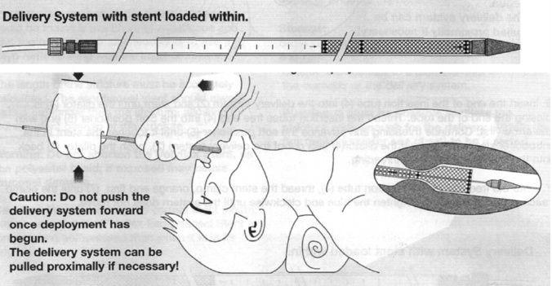
Figure 2.16: Placement of Polyflex stent (Boston Scientific Corp.) (Pyrtle and Obando 2007).

2.3.2 Indications and contraindications
Some indications and contraindications for oesophageal stent placement are represented by (Mohan and Kozarek 2001) which are, palliation of dysphagia in a non-operative patient, stent insertion is indicated when dilation is ineffective, circumferential narrowing caused by tumours, oesophagorespiratory fistulae, and recurrence of tumour after radiation, chemotherapy, laser or surgery. Absolute contraindications are circumstances in which there is no prospect of improving quality of life, and relative contraindications include a soft, non-circumferential stricture preventing anchorage of the stent, angulated strictures and location of stenosis less than 2cm from upper oesophageal sphincter where stent placement may cause odynophagia (Mohan and Kozarek 2001).

2.3.3 Limitations in oesophageal stenting
Difficulty in removing SEMS after placement due to embedment in the oesophageal wall often to the level of the submucosa is the most significant limitation of most available SEMS. A concomitant mucosal hyperplasia often occurs with growth over exposed metal struts, especially in uncoated stents (Wong, Adler et al. 2008). As a result of malignant external compression of the oesophagus, patients with dysphagia are a special problem since surgery is rarely possible even though the dysphagia can be disabling. For external compression endoscopic laser therapy is ineffective because there is no visible tumour tissue to ablate. One more serious problem with these lesions is that there is no shelf of tumour tissue in the lumen of the oesophagus to anchor a stent and no tumour tissue in the lumen in which to embed a stent, as is the case with intrinsic tumours of the oesophagus (Bethge, Sommer et al. 1998).

In case of malignant oesophageal disease self expanding stents are a well-accepted treatment modality. Traditionally, tumours close to the upper oesophageal sphincter are regarded as more difficult to manage because stents in the proximal oesophagus are considered to be associated with an increased risk of complications (Verschuur, Kuipers et al. 2007).

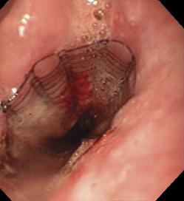
Figure 2.17:Ultraflex stent deployed just below the upper oesophageal sphincter (Verschuur, Kuipers et al. 2007).

2.3.4 Complications and their management
The earlier stents were made of polymers and were placed either laparotomically or endoscopically. Both have a major procedure related complication rate, including perforation, haemorrhage, pressure necrosis, and aspiration. The size and rigidity of the delivery system of these stents which requires balloon dilatation up to 22.5mm, is the major reason for this high serious complication rate. The internal diameter of these stents is relatively small, so patients must be maintained on a modified diet or risk stent blockage (Maier, Pinter et al. 1999). Procedure related complications tended to be higher in patients who had rigid plastic prosthesis than in those who had metallic stents. The procedural complications are perforation, aspiration, haemorrhage, stent migration, and pain. Perforation, haemorrhage, stent migration, pain or sensation of a foreign body, tumour in-growth or over-growth, stent occlusion due to a bolus of food, reflux, oesophagitis, mucous membrane ulceration, fever, fistula development, and sepsis, are the significant post-procedural complications (Sabharwal, Morales et al. 2005).

Problems with stent deployment or expansion, stent misplacement, perforation, and chest pain are the immediate complications associated with SEMS placement. . Late complications included stent migration (because the covered stent restricts the anchorage of stent mesh with the tissue), occlusion of the stent due to tumour in-growth and out-growth (mainly due to uncovered stent), or food impaction. Immediate respiratory compromise, aspiration, fistula formation, sepsis, and procedure-related death are the potential life-threatening complications (Kawasaki, Sano et al. 2003).

The rate of occurrence of the oesophageal tumours in the cervical segment is seven to ten percent, where the spread of the disease occurs more rapidly. Due to possible foreign body sensation and airway compression the Endoscopists may avoid using the plastic prostheses in this area. Foreign-body sensation is a result of the proximity to the cricopharyngeal muscle. Other expected complications of the use of stents in the cervical oesophagus are proximal migration, intractable pain, perforation, and pulmonary aspiration. Due to the anatomy of the upper region of the oesophagus all treatments in this region are difficult (Costa and Brophy 2002). Patients who go through oesophageal stent placement may usually suffer from complications. Most of the complications are not life-threatening and can be managed endoscopically, and others are potentially serious and require vigilance. Complications can be divided in immediate or intra-operative, early if they occur within one week of stent placement and late (in below Table 2.4) (Siersema 2006).

Table 2.4: Classification of complications secondary to oesophageal stent placement (Repici and Rando 2008).
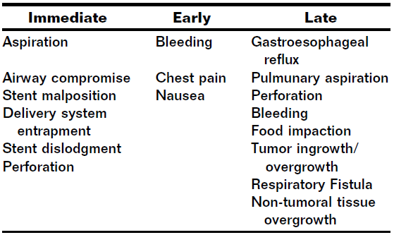

Endoscopic laser therapy and re-stenting into the existing stent or balloon dilation can be useful in treating tumour in-growth or over-growth. Food impaction can be treated endoscopically, and fistulas can be treated with a covered stent. If a stent migrates, it is replaced by another stent, and attempts are made to remove the stent that migrated. Chest pain is treated with analgesics, including opioids in some cases. Gastroesophageal reflux is treated with proton pump inhibitors. Radiotherapy or blood perfusion may be used for the treatment of bleeding (Costa and Brophy 2002). Normally, in the early post-implantation stage the main complication which is encountered is stent migration, especially when covered endo-prosthesis is used and stent dislocation in the follow-up period. The repositioning of the stent using a retroflexed endoscope or a snare may be successful in some cases (in Figure 2.18 and Figure 2.19). Other reason for the removal of the stent is stent dysfunction which includes mucosal strangulation with nearly complete oesophageal obstruction (May, Gossner et al. 1999).

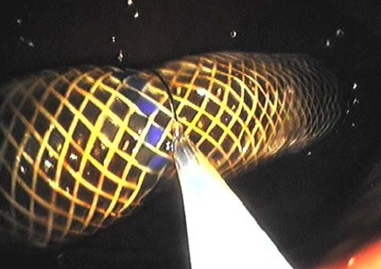
Figure 2.18: Removal of a migrated Polyflex stent from the stomach (Wong, Adler et al. 2008).

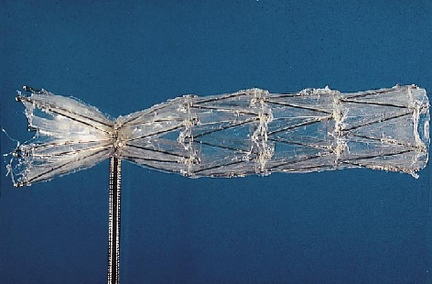
Figure 2.19: The snare is used to mechanically compress the stent adequately during extraction Process (May, Gossner et al. 1999).

Oesophageal intubation with self-expanding plastic or metal covered stents is reported as safe, easy and effective treatment for oesophageal obstructions due to tumour. The oesophageal stents available presently still have problems with high rates of early (i.e. within a week after stenting) and late (i.e. after 7 days) complications (Schoppmann, Langer et al. 2012).

2.3.5 Types of oesophageal stents
According to (Lowe and Sheridan 2004) there is a large range of different SEMS designs available, all have specific advantageous design features as well as specific drawbacks. All are delivered in a compressed form, which allows the delivery system to be of small diameter compared with the final stent diameter. Several types of stents are preloaded onto the delivery system. Both the delivery system and the stent vary in their degree of flexibility. All delivery devices have radio-opaque markers indicating the limits of the compressed stent and some also indicate the expected length of the stent when fully expanded. Some of the stents shorten on deployment.

The features of some of the more commonly used stents are discussed below by (Lowe and Sheridan 2004).

Ultraflex (Boston Scientific Ltd) stent has a knitted Nitinol mesh construction and is available both in covered and uncovered forms. It is the most flexible stent but has the weakest radial force so may require post-deployment balloon dilatation to achieve sufficient expansion. Additionally, because it is constructed from a single wire, the stent can be removed by unravelling the strand. Flamingo Wallstent (Boston Scientific Ltd) has a conical shape (in Figure 2.20); it is constructed from a braided stainless steel alloy and is covered on its inner surface. It is now recommended only for tumours of the lower third of oesophagus.

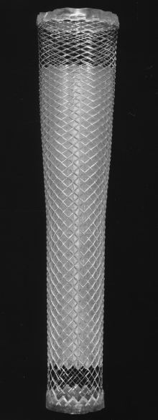
Figure 2.20: Flamingo (Boston Scientific Ltd.) oesophageal stent-graft (Morgan and Adam 2001).

FerX-Ella (Radiologic) is a stainless steel mesh stent and is covered on the inner and outer surfaces with a layer of polyethylene, which also extends distally to act as an anti-reflux valve. The Niti-S Double (Taewong Medical) stent is made from Nitinol and has an inner covering of polyurethane. On the central area of the stent there is a further uncovered mesh placed over the covered part. This combines the advantages of an uncovered stent (very low rate of migration) with the advantages of a covered stent (low in-growth rate). Polyflex (Boston Scientific Ltd.) is removable self-expanding plastic stent, but the drawback is that the stent is radiolucent (in Figure 2.21). Dua AR (Cook) stent is a polyurethane covered stainless steel stent with 7cm polyurethane sleeve attached to the distal end of the stent acts as an anti-reflux valve (Lowe and Sheridan 2004).

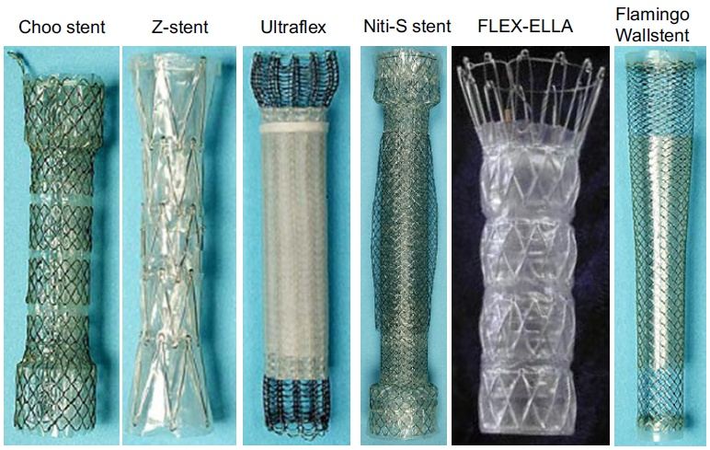
Figure 2.21: Different types of commercial oesophageal stent-grafts (Repici and Rando 2008).

Traditionally, most plastic stents had been made from Polyvinyl (Tygon) tubing (in Figure 2.22) and they were replaced by self-expanding stents. Some of the earlier commercial plastic oesophageal stents are, Wilson Cook stent made of silicone with a stainless steel spine, Key-Med-Atkinson stent composed of silicone with a central nylon spiral, and Eska-Buess stent made of silicone with a spiral steel shaft and with proximal hooks embedded into the funnel which allows stent repositioning or retrieval (Mohan and Kozarek 2001).

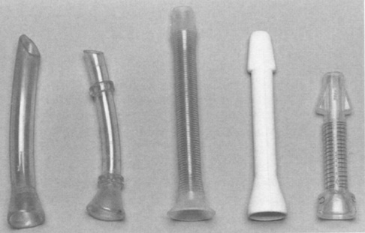
Figure 2.22: Conventional plastic oesophageal stents (from left to right): Tygon tubing, Tygon tubing with retaining rings, Wilson Cook, Atkinson, and Eska stent (Mohan and Kozarek 2001).

Recently, a new development is the use of self-expanding Polyflex stent (Boston Scientific), which is made of polymer with a silicone cover, and is approved for malignant intrinsic or extrinsic oesophageal strictures (in Figure 2.23). This is a woven plastic self-expanding stent made of a polyester mesh that is fully covered with a silicone membrane. Its proximal end has a flare (25% greater diameter than the rest of the stent) to prevent migration, and has a cylindrical shape distally (Pyrtle and Obando 2007).

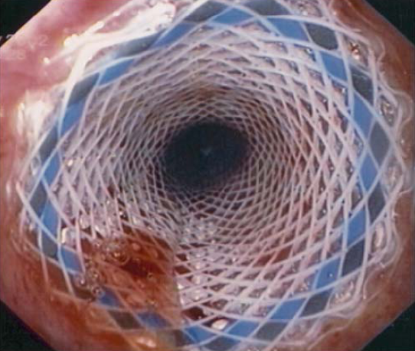
Figure 2.23: Endoscopic view of Polyflex stent (Evrard, Le Moine et al. 2004).

The Polyflex stent seems to be an improvement on rigid metal stents, as the diameter of the introduction device is only 12 to 14 mm. The post-expansion luminal diameter is 16mm to 21mm, and its appealing element is the cost which is only half of metal stents (Lowe and Sheridan 2004). Self-expanding Polyflex stent is approved by United States Food and Drug administration (U.S. FDA) which is for use, in patients with malignant dysphagia (in Figure 2.24). Previous studies of this device demonstrated an improvement in dysphagia that was thought to be comparable with that seen with SEMS, although with a higher migration rate. Rates of migration with this device were reported to be lower in patients with malignant disease when compared with benign disease. Also, Polyflex stent can easily be removed by endoscopy (Adler, Fang et al. 2009).

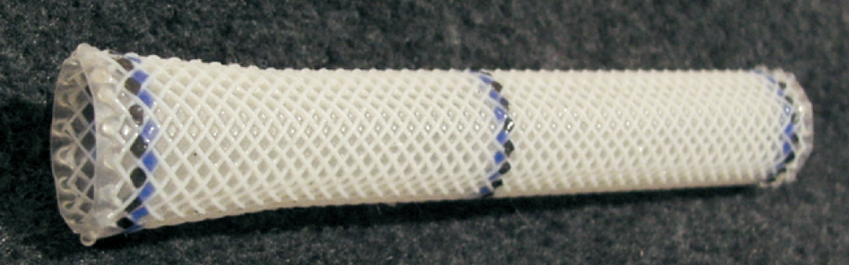
Figure 2.24: Polyflex self-expanding oesophageal stent (Conio, Blanchi et al. 2008).

In the treatment of oesophageal malignancies, the use of self-expanding plastic stents (SEPS) has been shown to have a number of advantages compared with SEMS, such as the absence of a metal mesh and the full covering of silicone membrane reduce hyperplasia at the edges of the stent and allow safe removal, even if the stent has been in place for a few months, and a rough outer surface and high expansive force minimize dislocation (Evrard, Le Moine et al. 2004).

Table 2.5: Requirements for an ideal oesophageal stent (Decker, Lippler et al. 2001).
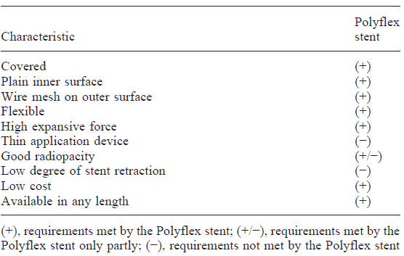
The Alimaxx-E-stent (Alveolus Inc.) is made of Nitinol with a full polyurethane cover to avoid tissue ingrowth. This stent is accepted for use in maintaining lumen patency in oesophageal strictures caused by intrinsic or extrinsic malignant tumours and for occlusion of fistulae. It has 20 struts on the outside to prevent migration, and it has the ability to be placed using two different procedures, i.e. over a guide-wire or by direct vision using a special delivery system with the delivery catheter positioned over a small calibre endoscope (Uitdehaag, van Hooft et al. 2009).

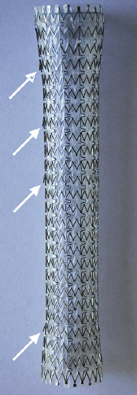
Figure 2.25: Alimaxx-E oesophageal stent with (anti-migration) struts (Uitdehaag, van Hooft et al. 2009).

A design analytical model was created by (Rao, Haycock et al. 2009) and they compared the one year stent-related mortality, health-related quality of life and cost between uncovered and covered self-expanding oesophageal stents. They established that the stent-related mortality was slightly lower in covered stents deployment as compared to uncovered stents placement. Covered oesophageal stents were also more effective and less expensive than uncovered stents.

2.3.6 Biodegradable oesophageal stents
Stents are implantable cylindrical constructions used in the human body to treat pathologies in the tubular ducts. Lumen obstruction or stenosis can be treated by the stents which are generally used as an endoluminal mechanical support. Normally stents are made of metals, plastics, shape-based metal alloys, or biodegradable materials. Their appliance is mechanically more rigid than surrounding oesophageal tissue and prevents the collapse or obstruction of the duct caused by pathological occlusions (Valimaa, Laaksovirta et al. 2002).

It is highly essential to develop a stent that could be kept in the proper position during the repair process and then simply be removed, thus avoiding re-stenosis, and it is important to prevent the incidence of long-term complications associated with permanent oesophageal stents. In other words, if a stent could be constructed from a biodegradable material, then a subsequent stent removal operation would not be necessary. Serious long-term complications can be avoided by the degradable nature of the stent (Saito, Tanaka et al. 2007).

There is great potential of self-expanding stents in the treatment of oesophageal disorders. Benign oesophageal strictures are quite common and sometimes require repeated dilations. Potentially cost-effective and perhaps more effective long-term dilation of the oesophageal lumen might be offered by the self-expanding biodegradable stent (Goldin, Fiorini et al. 1996). There is a great potential for using biodegradable stents as temporary bridge in patients with oesophageal stenosis in whom the diagnosis is uncertain, or resectability is unclear (Freeman 2001).

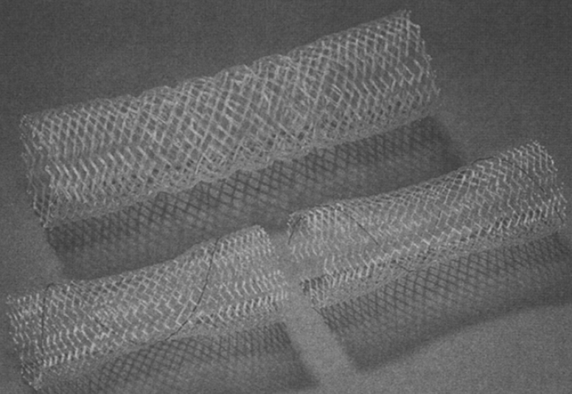
Figure 2.26: Examples of prototypes of bioabsorbable Wallstent for the oesophagus (Freeman 2001).

Self-expanding biodegradable stents have a combination of properties of mesh designs that allows a large diameter lumen and non-permanency attributable to biodegradation (in the above Figure 2.26). Biodegradable stents have various options for biodegradable natural materials such as cat gut collagen, fibrin, and chitosan. However, these materials are of limited utility because of low strength and difficulty with conversion into fibre format. Synthetic materials include polylactic acid and polyglycolic acid. Their advantages are that properties can be tailored to the application, there is lot-to lot uniformity, there are reliable sources of supply, and there are no concerns for immunogenicity. There is also a historical background of using synthetic biodegradable polymers for sutures, wound repair, and orthopaedic surgical implants (Freeman 2001).

The biodegradable Wallstent (Boston Scientific Inc.) has been under clinical investigation by using biodegradable materials like polylactic acid. This polymer is synthesized from lactic acid, which can be derived from sugar beets and is converted in vivo to lactide and H₂O (in Figure 2.27), then catalyzed with heat to poly-l-lactide. On implantation, body heat and water degrade the polymer to lactic acid, then via the Krebs cycle to CO₂ and H₂O (Freeman 2001).

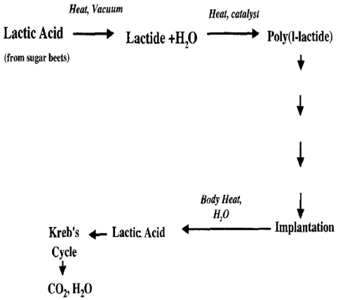
Figure 2.27: Biochemical pathway of the polylactic acid degradation, used for the bioabsorbable Wallstent (Freeman 2001).

This polylactic acid polymer degrades over a scheduled timetable when used in the laboratory in vitro studies that used saline and artificial bile solutions. The in vivo degradation of the polylactic acid polymer used for bioabsorbable Wallstent in a planned time schedule as shown below in Table 2.6, where water absorption occurred from 0 to 6 months, strength reduction in 6 to 18 months, and mass reduction in 18 to 36 months (Freeman 2001).

Table 2.6: Timetable of polylactic acid polymer degradation in vivo for Bioabsorbable Wallstent prototype
(Freeman 2001).
FACTOR | TIME
Water Absorption | 0 to 6 months
Strength Reduction | 6 to 18 months
Mass Reduction | 18 to 36 months

In a recent study, an Ultraflex-type biodegradable stent was developed by knitting poly-l-lactic acid (PLLA) monofilaments together for the treatment of patients with benign oesophageal stenosis. It has generally been found that the biodegradation of PLLA occurs over a few months time, and PLLA has been used for orthopaedic applications in humans. The radial force of this biodegradable stent was comparable to that of commercially available metallic stents (Saito, Tanaka et al. 2007).

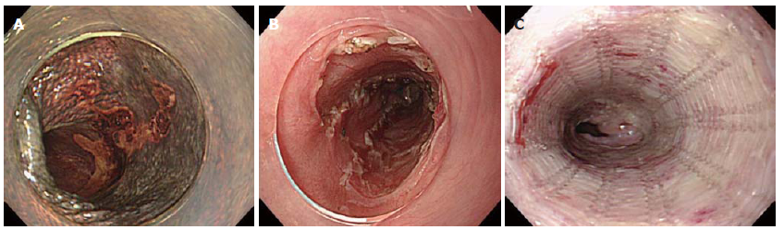
Figure 2.28: Endoscopic findings of the PLLA stent, (A) early oesophageal cancer, (B) The mucosal defect after Endoscopic Submucosal Dissection (ESD), (C) The deployed PLLA Stent (Saito, Tanaka et al. 2007).

This PLLA oesophageal stent is made of a PLLA monofilament (Molecular Mass 183 kDa, and Diameter 0.23mm) with a machine knitted design like an Ultraflex metallic stent (in Figure 2.29). The PLLA stent was fitted over an endoscope and one end of the PLLA stent was tied into a 5mm diameter by silk sutures. The PLLA oesophageal stent was initially fitted over a fiberscope and inserted through the pre-dilated stenotic lesion, and it was released by pulling it out from the fiberscope. The proximal (oral) end of the PLLA stent was then fixed with an oesophageal wall by the help of five endoscopic clips, and the silk suture at the distal end of the stent was then cut by scissor forceps (Saito, Tanaka et al. 2008).

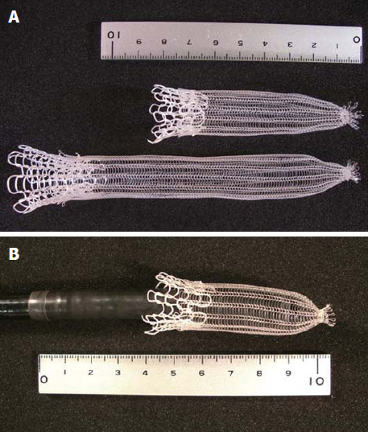
Figure 2.29: The PLLA oesophageal stent, (A) one end of the PLLA stent was tied into a 5mm diameter by silk sutures, (B) The PLLA stent was fitted over an endoscope (Saito, Tanaka et al. 2008).

The features of an ideal stent would be to provide adequate support to the wall of a duct and maintain the patency of the lumen during healing time and after healing biodegrade from the body. While inserting a stent, the outside diameter of the stent should be small because it is usually implanted through small ducts, which are liable to damage during the insertion process, therefore, the property of self-expansion is highly desirable. The outside diameter of an ideal stent is small when it is inserted and after insertion it expands rapidly against the walls of the duct. The migration will not occur due to the stent expansion which fastens the stent. The viscoelastic behaviour of bioabsorbable polymers makes possible the memory effect of the material. Injection moulded polylactide plates have a viscoelastic shape memory, which can be reduced by annealing treatment. Also self-reinforced bioabsorbable stents can be made self-expanding by merit of the viscoelastic memory of the material. Stents are stable at room temperature and expansion occurs at body temperature. Expansion can be rapid or slow depending on the processing method (Valimaa, Laaksovirta et al. 2002).

A new biodegradable stent BD (SX Ella-BD stent) became available recently which is woven in a standard construction from a monofilament of polydioxanone, which is a surgical suture material (in Figure 2.30). It is deployed from an existing delivery system used for metal stents and it is similar in construction to the existing uncovered enteral stent. This stent has a trunk diameter of 25mm with both ends flaring to 31mm. Polydioxanone is degraded by hydrolysis, which is accelerated by a low ambient pH, and has shape memory properties. Half of the mechanical strength of the stent is lost after approximately 3 weeks in the oesophagus, and the stent structure began to disintegrate within 2 months (Stivaros, Williams et al. 2010).

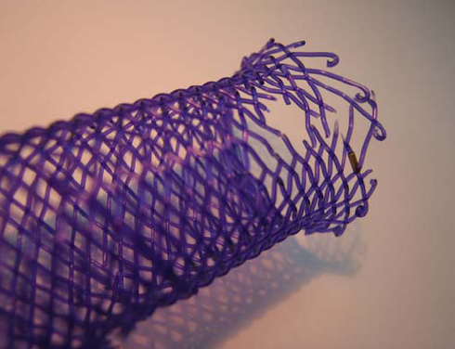
Figure 2.30: Model of SX Ella-BD stent showing signs of degradation after 18 months of exposure to room air (Stivaros, Williams et al. 2010).

A report released after a feasibility study conducted by the manufacturer for BD stents demonstrated promising technical results with only three cases of stent migration, and endoscopic evidence of stent degradation in all cases within 12 weeks and variable relief of symptoms. The major advantage of BD stents over metal or plastic stents is that they do not require removal, even when migrated, thus avoiding further procedures and potential morbidity (Vandenplas, Hauser et al. 2009). Biodegradable stents have one major advantage of temporary stenting over removable metal or plastic stents that, they do not need to be removed, either from their original position or if they have migrated, avoiding the cost of a second procedure and the potential trauma to the oesophagus (Stivaros, Williams et al. 2010).

2.3.7 Coated oesophageal stents
The human trial of drug-eluting oesophageal stents was conducted as a prospective, randomized study with unresectable adenocarcinoma treated with self-expanding stents at Guy’s Hospital London. The vascular Tantalum Strecker stents (Boston Scientific Ltd.) were used in this study, in which eleven patients received a Tantalum Strecker stent covered with Ethylene Vinyl Acetate (EVA) and 33% Paclitaxel, and ten patients had uncoated Strecker stents. The study did not demonstrate that a drug-eluting stent is effective in preventing tumour in-growth and no complications from the stent coating such as ulceration, or stricture/fistula formation were seen, and all the patients died in less than 1 year after stent insertion due to the malignant disease (Machan 2006).

In another in vitro study of the stent coated with Paclitaxel showed, a slight burst phase of drug release in the first few hours followed by a very steady and slow release of Paclitaxel thereafter. Paclitaxel has also been successfully used and incorporated into a polymeric coating suitable for stents. In the palliative management of malignant obstruction of oesophagus, endoluminal stents are being used with increasing frequency. The application of Paclitaxel incorporated polymeric stent coating was pursued due to the frequency of endoluminal stent failure resulting from overgrowth of the device by inflammatory tissue or tumour cells. Paclitaxel-polymer compound coated endoluminal stents could prevent overgrowth and increase the efficacy and duration of clinical effectiveness of the device. Paclitaxel could have a direct cytotoxic effect on the tumour cells in many cases of malignant overgrowth. Furthermore, as tumours are generally unable to grow beyond 2mm in size without an accompanying blood supply, Paclitaxel’s ability to restrain local tumour angiogenesis could prevent any drug-resistant mass growing on the stent surface from obtaining a thickness of greater than 2mm. EVA which is non-degradable copolymer is utilized in the stent coating because it adheres well to the metallic stent surface and its elastic properties allow it to withstand the rigors of compression and expansion required for deployment of the device and subsequent peristaltic movements in situ. A physical barrier to malignant cell in-growth can also be provided by the EVA stent coating. The stents were coated with a polymer-drug combination consisting of 70% EVA and 30% Paclitaxel by weight (Hunter, Burt et al. 1997).

The combination of local drug delivery through medical device has some advantages, like the drug is directly targeted to the oesophageal cancer and its neighbouring tissue, and there is no requirement for systemic high or toxic doses to achieve sufficient local concentrations, and sustained, controlled dosing level can be maintained around the device over the necessary duration. Consequently, improved effective lifespan of the device and suppression of tumour growth could be expected simultaneously (Guo, Guo et al. 2007).

A type of oesophageal stent coatings were developed and evaluated by (Guo, Guo et al. 2007), which were bilaminated films consisting of a drug-loaded layer and a drug-free protective layer. Among the best chemotherapeutic agents, 5-flourouracil (5-FU) has been one of the most effective chemotherapeutic agents with clinical activity against squamous oesophageal carcinoma. Intravenous administration of this drug is currently in clinical use, because of the erratic oral bioavailability. This mode of administration, however, causes severe gastrointestinal, haematological, neural, cardiac, and dermatological toxic effects. Severe systemic toxic effects make this drug particularly suitable to be delivered by the local drug delivery system providing a continuous sustained release. EVA is a stable copolymer which is heat-processable and flexible material. The biocompatibility and safety of EVA copolymer are reflected in its use as a biomaterial for artificial hearts and as an anti-thrombogenic material. In biomedical applications such as in implanted, inserted and transdermal drug delivery devices, EVA copolymers are commonly used as a carrier. The double-layered structure design (which consists of one 5-FU containing EVA layer and one drug free EVA protective layer) was developed and expected to provide drug delivery in a unidirectional fashion to the mucosa and to avoid loss of drug due to wash-out by oesophageal mucus. An oesophageal stent combined with the type of oesophageal stent coating allows drug release at the absorption site for a prolonged period of time. Simultaneously, a controlled dosing level can be maintained around the device over the necessary duration.
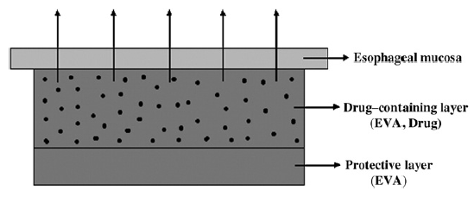
Figure 2.31: Schematic of the structure of bilayered oesophageal stent coating (Guo, Guo et al. 2007).

The sizes of drug particles were measured to be 1-5µm, and 5-FU was micronized by a planetary ball mill. Ni-Ti self-expanding oesophageal stent and EVA copolymer with 30% (w/w) VA content were obtained. The drug-loaded layer was prepared by fully blending 5-FU particles and melting EVA in different ratios and then compressing the blends into films with a heat source. Briefly, 50g of EVA was added into the chamber of HAAKE Rheocord system and heated until it was completely melted. Then a certain amount of the micronized 5-FU was added slowly into the melted EVA and blended at 95ºC. The acquired drug-loaded layers are films of uniform thickness of 100-300 µm. The drug-free EVA layers or films were prepared in the same conditions except no drug was added. One 5-FU containing EVA layer (300 µm) and one drug-free EVA layer (100 µm) were agglutinated by pressing them under the pressure of 0.25 kg/cm² and at 70ºC to produce the stent coating. The coatings were made into the discs for in vitro release kinetics. One disc was placed in a 10 ml vial containing 5ml pH 6.5 Phosphate Buffer Solution (PBS) at 37ºC under constant stirring. At the predetermined time points the disk was removed and placed into another vial with fresh pH 6.5 PBS to maintain sink conditions. The amount of 5-FU released from the discs was measured spectrophotometrically at 266nm. It is established from the solubility tests of 5-FU in pH 6.5 PBS and in EVA film, that 5-FU is EVA insoluble. The cumulative amount of 5-FU diffused through the EVA protective layer is thousands of times lower than that released directly from drug-loaded layer of the stent coating. A very small amount of 5-FU i.e. 2.5 µg/cm² is diffused through the protective layer for 30 days. Therefore, the stent coating definitely provides drug delivery in a uni-directional fashion. The release profiles of the stent coatings with 20-60% of 5-FU in pH 6.5 PBS are characterised by a first faster release phase followed by a decrease in release rate. The release rates depend on the drug content of the coating and are almost constant in the early and late stages (Guo, Guo et al. 2007).

2.4 Technical aspects of oesophageal stents
The self-expanding stents (SEMS) for oesophagus have different characteristics based on type of alloy, lattice width, configuration, degree of shortening with expansion, lengths and diameters, presence of a covering and delivery systems. Uncovered SEMS imbed into the stricture and surrounding tissue (in Figure 2.32) so that over time they become deeply integrated and non-removable. Covered stents have a well established tissue response (Baron 2007).

Figure 2.32: Illustration of stent embedment in the luminal wall over time. The top of the illustration represents the lumen. Note the stent imbeds deeply into the wall (Baron 2007).

The development of covered SEMS was envisaged and covered SEMS have been used to combat tumour in-growth and to close fistulae. However, the covering also prevents imbedding in the tissue so that covered SEMS can be removed and have the potential to be used in benign disease. Unfortunately, with this removability comes an increased risk of migration, because tissue anchoring does not occur. Some of the key features of FDA approved self-expandable oesophageal stents are described below in Table 2.7 (Baron 2007).

Table 2.7: FDA-approved expandable oesophageal stents (Baron 2007).
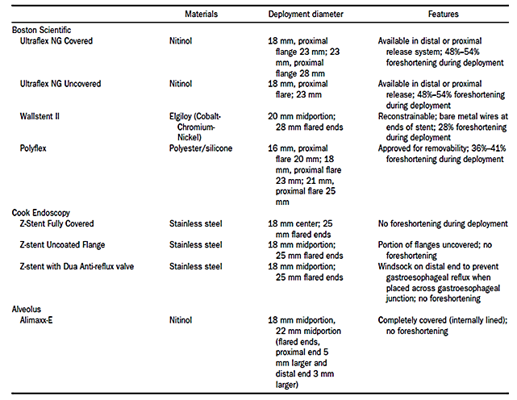

A number of different brands and types of SEMS exist, each with unique features aimed to improve performance and to prevent or reduce complication. These devices differ by the type of alloy, delivery system, type and extent of covering, luminal diameter, degree of shortening after deployment and presence or absence of an anti-reflux valve. Stents are made either from Nitinol, which is a titanium–nickel alloy, or stainless steel; they are compressed into a small calibre introducer system (10–16 Fr). Nitinol has thermal shape memory characteristics that allow the stent to expand at body temperature. Most stents have a proximal flared end to help prevent distal migration (Repici and Rando 2008).

All SEMS are delivered in a compressed form, which allows the delivery system to be of small diameter compared with the final stent diameter. Most of the stents are preloaded onto the delivery system. Some though, require loading immediately prior to the procedure (e.g., the Polyflex and the Dua AR Cook stents). The delivery systems vary in size from 6 mm diameter (Flamingo stent) to 10 mm diameter (Gianturco-Z stent, Ella stent, Dua stent, and Choo stent) and 12mm to 14mm diameter introducer for the new polymer expandable stent (Polyflex). Both the delivery system and the stent itself vary in their degree of flexibility. Some of the stents shorten on deployment, such as the Ultraflex and the Flamingo. All delivery devices have radio-opaque markers indicating the limits of the compressed stent and some also indicate the expected stent length when fully expanded (Lowe and Sheridan 2004).

It was demonstrated by (Chan, Shin et al. 1999) that, the Esophacoil stent was the strongest stent in withstanding compressive and angulation forces when compared with the Wallstent, Ultraflex, Song and Gianturco stents. The Ultraflex stent showed the weakest expansile force but withstood angulation forces better than the Song and Gianturco stents. It is recommended that an uncovered stent, like Flamingo or a Gianturco stents, should be used at the cardia to reduce the risks of distal migration (Chan, Shin et al. 1999).

Some of the key features and technical specifications of various currently available oesophageal stents are mentioned in the following Appendix ‘A’.

In the selection of optimal stents, one of the most important mechanical properties to consider would be expansive pressure. The wall of the narrowed oesophageal lumen exerts compressive pressure on the implanted stent. A stent continues to expand to its limit unless the radial compressive pressure from the diseased lumen is greater than the radial expansive pressure. Occasionally, the expansive pressure is not high enough to overcome the compressive pressure; as a result, an implanted metal stent is not fully expanded. In this case, re-treatment with balloon dilation is often required. On the other hand, if the expansive pressure of the stent is far greater than the luminal compressive pressure, complications such as chest discomfort, bleeding, perforation, and pressure necrosis may take place (Moon, Hong et al. 2001).

Although a very important insight is offered by the previous studies into an understanding of the relationship between expansive and compressive forces, but they were unable to measure radial expansive pressure over the range of radial compression frequently observed in actual clinical environment. There has been no direct correlation between the expansive force properties of stents and oesophageal measurements. Therefore, one can select and design clinically optimal stents by correlating the expansive force measurements of each individual stent with the measured pressure properties of the oesophagus. Additionally, clinicians can conceivably use the extent of pain perception and the compliance data in predicting and preventing the common complications of stent placement such as incomplete expansion, chest discomfort (Moon, Hong et al. 2001).

2.4.1 Measurement of radial expansive force
In the previous study conducted by (Moon, Hong et al. 2001) where they measured radial expansive force of different covered and uncovered stents. A pair of square blocks made of duralumin (aluminium alloy) was used, and in order to maintain a completely cylindrical lumen against various external agitations while installing the stent (in Figure 2.33), the blocks were initially pressed with an adequate amount of preload. The magnitude of preload was 50N, which was far greater than the expansive force of ordinary stents. To allow uniform expansion of the stent in the radial direction, the stent was inserted into the lumen and adjusted manually. A lubricant made of carbon-molybdenum particles was used to minimize friction between the test stent and the blocks. The radial expansive force was measured by a universal tensile testing machine.
Figure 2.33: Schematic diagram of experimental device. Stents are placed within the cylindrical lumen and adjusted to expand uniformly in both radial and longitudinal directions (Moon, Hong et al. 2001).

In the experiment the expansive force was calculated under a quasi-static equilibrium state. This state can be achieved if the two blocks separate very slowly and minimally, such that the two blocks lose contact but still maintain a completely circular shape. To acquire this state, the following procedures were performed: After the stent was carefully installed, the upper block was moved upward while continuously recording the force and displacement. The upward vector sum of the stent’s pure radial expansive force was obtained by subtracting the weight of the upper block from the force measured by a load cell. The expansive forces were measured for six different stents made by various manufacturers. Expansive force values were determined as a function of change in diameter. The change (decrease) in diameter is calculated as the difference between the diameter in the initial (fully expanded) state and the diameter in the compressed state. As expected, expansive force appeared to increase as degree of compression increased. Specifically, in all stents with an exception of Y3E SR, the expansive force increased as stents were radially compressed. It should also be noted that expansive force values at a given level of compression varied greatly among these stents, suggesting a distinct property of a given stent. Additionally, the slopes of the curve differed, demonstrating varying degree of stiffness of stent (Moon, Hong et al. 2001).

The definition of compression ratio is the decrease in diameter divided by the initial diameter, was used to normalize the compression of different sized stents. The curve of each stent differs in the slope and y-axis cutting point (in Figure 2.34). Stents with steep slope exert very large expansive pressure under a high degree of compression (50% or greater), but they exert very small expansive pressure under low degree of compression (20% or less). Covered Y3E SR and uncovered Ultraflex stents have identical expansive pressure values under the compression ratio of 23%. At compression ratio > 23%, the uncovered Ultraflex has a larger expansive pressure than the covered Y3E SR. On the other hand, when the compression ratio was < 23%, the covered Y3E SR has a larger expansive pressure than Ultraflex. Furthermore, the expansive pressure values of covered stents were greater than those of corresponding uncovered ones in all range of compression (Moon, Hong et al. 2001).

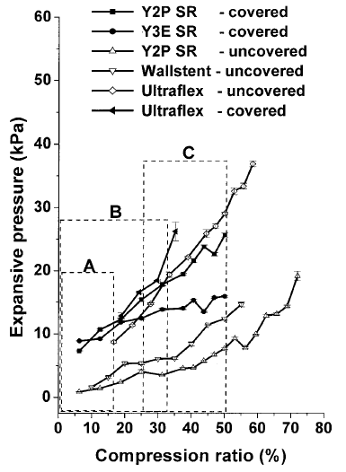
Figure 2.34: Expansion pressure values plotted as a function of compression ratio (Moon, Hong et al. 2001).
There are a variety of different self-expandable oesophageal metal stents commercially available. These stents have their own unique physical properties due to different designs and material, and especially, they will behave differently under tumour compression. However, it would be valuable to compare the physical behaviour of these stents in a controlled in vitro environment, by testing the expansile force and susceptibility to buckling force under stress. Therefore, in another study all of the stents below in (Figure 2.35) were tested for their expansile forces and buckling radii. The length and diameter of the stents were measured; the elasticity of each stent was measured by its expansile stiffness per centimetre length, and its susceptibility to angulation was measured by its buckling radius (Chan, Shin et al. 1999).

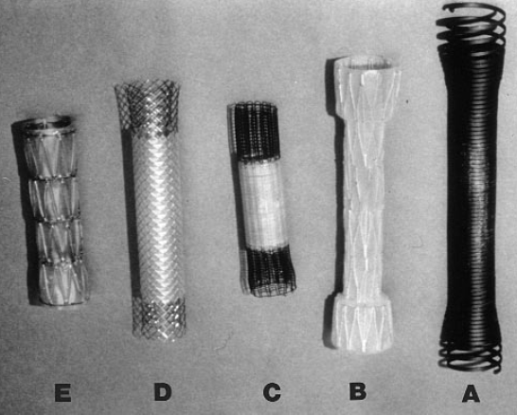
Figure 2.35: Oesophageal stents tested (A) Esophacoil, (B) Song Stent, (C) Ultraflex, (D) Wallstent, (E) Gianturco-Z stent) (Chan, Shin et al. 1999).

A universal mechanical testing machine was used to measure expansile stiffness per unit length of the stent and for recording the load versus the displacement simultaneously. The middle section of a fully expanded stent was subjected to compressive forces of equal magnitude from 4 sides symmetrically, and this was achieved by using a pair of 90⁰-angled brackets of suitable size. The stent was placed on a stationary bracket and force was applied by pressing the movable bracket downward using the crosshead. Both ends of the stents were allowed to move freely during compression (in Figure 2.36). The expansile stiffness of each stent was determined by dividing the applied load in Newtons by the displacement in millimetres recorded for the initial stage of deformation (up to 2 or 3 mm) where a linear relationship between load and displacement was noticeable. To receive the characterization of stent stiffness independent of test length, the expansile stiffness per unit length was calculated by dividing the expansile stiffness of the stent by the test length in centimetres. This value was the expansile force of the stent and was used to assess the relative stiffness of the various stents (Chan, Shin et al. 1999).

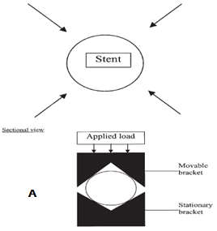

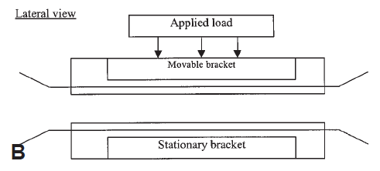
Figure 2.36: (A) Schematic diagram showing application of compression forces and (B) Experimental arrangement for measuring expansile forces (Chan, Shin et al. 1999).
In another investigation by (Inoue and Hirose 1997), a self-expandable biodegradable oesophageal stent which has a 20 mm outer diameter made of a rolled vicryl sheet and a Polydioxanone (PDS) string which runs spirally on the rolled vicryl sheet was evaluated under compression for expanding forces and comparisons were made with Ultraflex stent. Each stent was compressed by a 3cm x 2 cm plate. The expanding force is measured according to the degree of deformity of the compressed stent. Changes in the expanding force of the stent were evaluated in a body-temperature saline solution during incubation. As determined by the in-vitro plate compression test, the expanding force of the new stent was superior to that of the Ultraflex at all levels of compression. Due to the high density of suture the expanding force of a new stent exceeded. During 5 mm compressions the expanding force generated by the new absorbable stent was 335g/6 cm² and the Ultraflex was only 70g/6cm². The stent maintained nearly the same expanding force even when incubated in body-temperature saline for two weeks. The expanding force is created by the coiled PDS string on the rolled sheet and is easily controlled by the density of the spirally sutured PDS string. Therefore, a new stent have a greater expanding force and is less time consuming than Ultraflex which requires about 24 hours for full expansion (Inoue and Hirose 1997).

2.4.2 Measurement of buckling radius
At the ends of the stents bending moments were applied to give a curvature to its cylindrical shape. The moments were carefully applied by hand, ensuring the stent was not also subjected to a tensile or compressive force. A point was reached where the inner curvature showed angulation (in Figure 2.37) when the magnitude of the bending moments was increased progressively. The shape of the stent was traced out on paper just before this limiting point when the inner curvature was still smooth without any buckling. The buckling radius was attained as the radius of the circle from the trace, which fitted this inner curvature. A large buckling radius would indicate that a stent buckled easily after only slight distortion of its configuration (Chan, Shin et al. 1999).
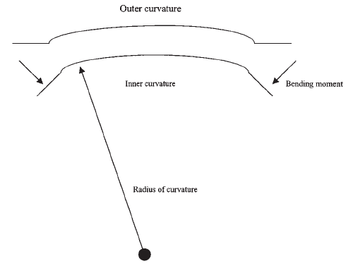
Figure 2.37: Schematic diagram showing application of moments at stent ends (Chan, Shin et al. 1999).

The data acquired by (Chan, Shin et al. 1999) which is mentioned below in the Table 2.8, would be crucial for the endoscopist in selecting a stent for an individual tumour. The important attributes of the metal stent are its expansile force, because this determines whether the stent is likely to expand fully, and the buckling radius which will determine whether the stent can conform to an acutely angulated tumour and yet remain functional.

Table 2.8: Expansile force and buckling radius of the oesophageal metal stents (Chan, Shin et al. 1999).
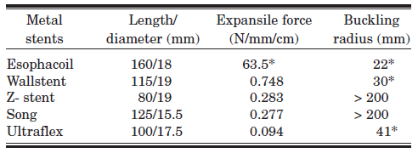

The above outcomes demonstrated that the Esophacoil has a 60-fold greater expansile strength and withstands buckling forces much better than the other stents tested. The expansile forces in the other 4 stents were below 1 N/mm/cm and not considerably different from each other. Ultraflex due to its Elasto-alloy (titanium-based alloy) material was fairly soft. On the other hand, all the stents differed considerably in their resistance to buckling forces. The Song stent and Gianturco-Z stent both had the smallest resistance to buckling force due to their similar layered inter-connected metal wire framework and buckled easily when being angulated. The Wallstent and Ultraflex were significantly better than the Song and Gianturco-Z stents in terms of resistance to buckling force and may be suitable for malignant strictures having a slight degree of angulation. However, these observations correspond to in vitro measurements which may not directly reflect all of the forces on a stent in vivo. The stent in vivo would be subjected to a combination of angulation forces and asymmetric compression forces. In addition to the physical properties of stents, the choice of stent depends on the geometry and the rigidity of the tumour. Ideally, it would be useful to gauge the resistance pressure of the oesophageal stricture endoscopically and then choose a compatible metal stent that has an adequate expansile force (Chan, Shin et al. 1999).

2.4.3 Finite element analysis
Biomechanical analysis of the oesophageal stent (Z-stent) and the oesophageal wall can be carried out with the help of finite element method. But for that a geometrical model of the oesophageal stent was worked out first, and the following parameters were set: the length of the stent l = 120 mm, the length of the reflux valve l_{Z} = 80 mm, the diameter of the stent wire d_{d} = 0.37 mm, the thickness of the plastic layer g = 0.3 mm, the diameter of the stent in the distal part d₁ = 25mm, and the diameter of the stent in the middle part d₂ = 18 mm. These stents were covered with the plastic layer and were made of the austenitic stainless steel. A geometrical model of the oesophagus was also worked out in order to analyze the stent-oesophagus system. The model of the oesophagus was in the form of the thin-walled pipe of the following parameters: the inner diameter d_{wn}= 24 mm, the thickness of the wall g_{sp}= 3 mm, the length of the oesophagus l_{p}= 40 mm (Kajzer, Kaczmarek et al. 2005).

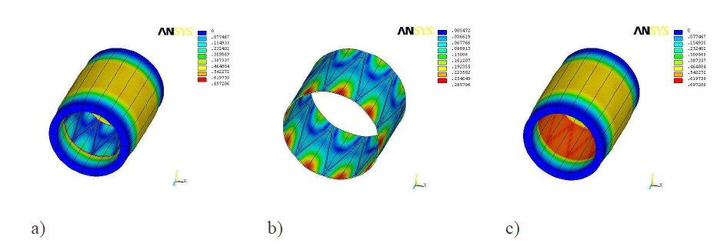
Figure 2.38: Radial displacements [mm] during the work of the system, (a) the stent-oesophagus system, (b) the stent and (c) the oesophagus (Kajzer, Kaczmarek et al. 2005).

During expansion in the oesophagus, the geometrical features of the stent were analyzed. The expansion was realized with the use of the radial displacement, up to the total expansion of the stent. After the total expansion of the stent, the analysis has shown that the radial displacements were in the range of 0 to 0.69 mm. The maximum radial displacements in the stent were equal to 0.2 mm and in the oesophagus were 0.69 mm. The stresses were in the range of 0 to 247 MPa, and the maximum values were localized in the bent region of the metallic segment. The stress distribution in the oesophagus was in the range of 0 to 2.6 MPa (Kajzer, Kaczmarek et al. 2005).

2.5 Auxetic structures
From the daily life experience, when the material is stretched, the material not only becomes longer in the direction of stretch but also becomes thinner in cross-section. The behaviour of the material in this case under deformation is governed by one of the fundamental mechanical properties of material, i.e. the Poisson’s ratio (Ellul, Muscat et al. 2009).

The Poisson’s ratio (v) of a material is the ratio of the lateral contractile strain to the longitudinal tensile strain for a material undergoing tension in the longitudinal direction, i.e. it shows that how much a material becomes thinner when it is stretched. Therefore, most of the materials have a positive v. In case of counterintuitive behaviour of Auxetic material, it undergoes lateral expansion when stretched longitudinally and becomes thinner when compressed (Evans and Alderson 2000).

The network is deformed by hinging of the ribs forming the network in case of honeycomb structure. It is observed that for individual cells having the conventional hexagonal geometry, the cells elongate along the y-axis and close up along the x-axis in response to stretching the network in the y-direction, giving a positive v. By maintaining the same deformation mechanism (rib hinging) but modifying the honeycomb cell geometry to adopt the re-entrant structure, the cells of the network now undergo elongation both along and transverse to the direction of applied load (in Figure 2.39). Hence the re-entrant honeycomb deforming by rib hinging is an Auxetic structure. Generally this structure is anisotropic, i.e., the value of v when loaded along the x-direction (v_{xy}) differs from that when loaded along the y-direction (v_{yx}). The theory of elasticity is scale-independent and so the structure that is deforming may be at a macroscopic or microstructural level, or even at the mesoscopic and molecular levels (Evans and Alderson 2000).

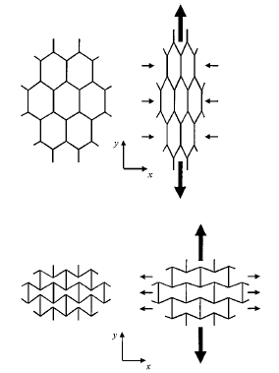
Figure 2.39: Non-Auxetic (honeycomb) and Auxetic (re-entrant) structure deformation mechanism (Evans and Alderson 2000).

All common materials have positive v, i.e. the materials contract transversely under uni-axial extension, and expand laterally when compressed in one direction. For an isotropic material, the allowable range of Poisson’s ratio is from 0 to 0.5. For anisotropic materials, these specific limits do not apply (Wan, Ohtaki et al. 2004).
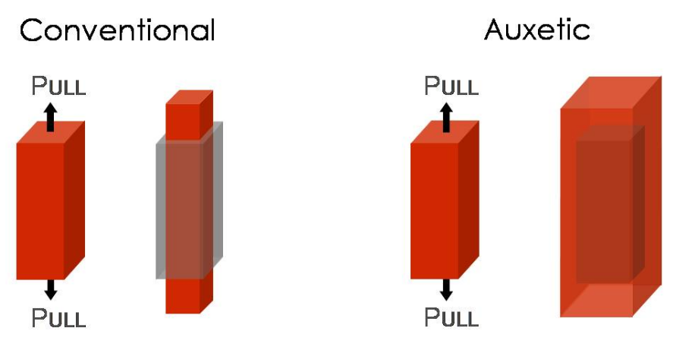
Figure 2.40: Deformation of Auxetic and conventional materials (Malta 2009).

2.5.1 Deformation mechanism
Re-entrant cell geometrical parameters, i.e. H, L, and λ can even change the sign of Poisson’s ratio from negative to positive, when Auxetic honeycombs bears a Y-direction tensile loading or a X-direction compressive loading. Where H is the vertical length of the cell member, L is the inclined length of cell member and λ is the angle between undeformed inclined cell member and X-axis (in Figure 2.41). In other words, the magnitude of Poisson’s ratio decreases significantly at high strain when the Auxetic honeycomb is compressed in X-direction loading or stretched in Y-direction loading, while increases significantly at high strain when the Auxetic honeycomb is stretched in X-direction loading or is compressed in Y-direction loading (Wan, Ohtaki et al. 2004).

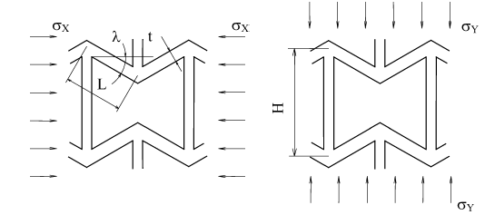
(a) (b)
Figure 2.41: Cell deformation by inclined cell member bending, (a) Loaded in X-direction, (b) Loaded in Y direction (Wan, Ohtaki et al. 2004).

In all of the Auxetic materials there is a specific microstructure that is vital to creating a negative v, deformation mechanism like rib hinging, bending or stretching, and rotating etc. Their length scale varies from the nanometre for crystal structures to tens of metres for the key-brick structures (Gaspar, Smith et al. 2005).

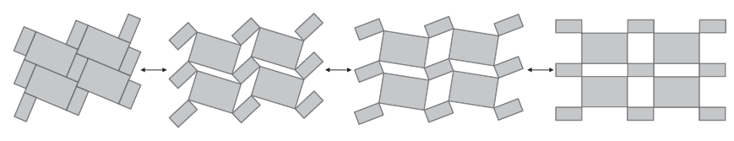
Figure 2.42: Rigid rectangles connected together at their vertices through hinges and deforming by rotating (Grima, Manicaro et al. 2011).

It has been found that the v is a scale independent property, i.e. the deformation mechanism can operate at any scale ranging from the nano-level (molecular level) to the macroscale. In some cases, the presence of Auxetic behaviour in very different systems has been explained by using the same deformation mechanism, for instance “the rotation of rigid units model has been used to account for the Auxetic behaviour in materials ranging from silicates and zeolites (where the Auxetic effect is due to nanostructure of the materials) to polymeric foams (where the Auxetic effect is due to features at the micro-millimetre scale) and macrostructures (Grima, Gatt et al. 2005).

2.5.2 Properties of Auxetic structure
The Auxetic materials offer some unique properties in comparison with the common materials. Classical elasticity theory predicts that Auxeticity of materials should lead to enhancements in certain mechanical properties, such as increased plane strain fracture resistance and increased shear modulus, indentation resistance, fracture toughness, and acoustic response compared to conventional materials (Yang, Li et al. 2004).

Auxetic material are of interest because of the novel behaviour they exhibit under deformation, and also because many other materials properties can be enhanced as a result of having a negative v. In the case of an object impacting a non-Auxetic material, the material immediately below the impact flows away in the lateral direction, leading to a reduction in density and, therefore, a reduction in the indentation resistance of the material. For an Auxetic material, on the other hand, material flows into the vicinity of the impact as a result of lateral contraction accompanying the longitudinal compression due to the impacting object. Hence, the Auxetic material densifies under the impact in both the longitudinal and transverse directions as shown below in Figure 2.43, leading to increased indentation resistance (Evans and Alderson 2000).

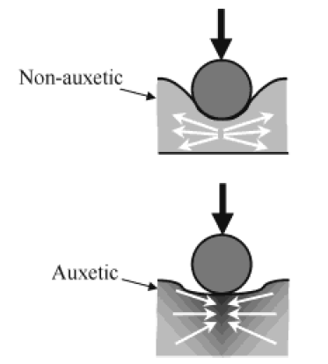
Figure 2.43: Indentation resistance of non-Auxetic and Auxetic materials (Evans and Alderson 2000).

Auxetic ultra high molecular weight polyethylene (UHMWPE) exhibits enhanced indentation resistance by up to a factor of three when compared with conventional UHMWPE, and enhanced attenuation of ultrasonic signals (Evans and Alderson 2000).

Auxetic materials exhibit the very unusual properties of becoming wider when stretched and narrower when squashed, that is they have negative Poisson’s ratios. Apart from the pure scientific interest of having materials showing such an unconventional property, a negative Poisson’s ratio gives material several other beneficial effects such as increased shear stiffness, increased plane strain fracture toughness and an increased indentation resistance. These properties make Auxetics superior to conventional materials for many practical applications (Grima and Evans 2000).

It is observed that Auxetic materials possess attractive acoustic properties, and it is found that at frequencies up to 1600 Hz Auxetic forms of polymeric and metallic foams possess enhanced acoustic absorption when compared with conventional materials. A further study examined the ultrasonic attenuation of the Auxetic UHMWPE compared with a microporous positive v form of UHMWPE of equivalent density and compression moulded UHMWPE (Alderson, Webber et al. 2000).

The Auxetic materials have a natural tendency to form dome-shaped doubly curved (synclastic) surfaces (in Figure 2.44), unlike conventional materials which tend to form saddle-shaped surfaces (Evans and Alderson 2000).

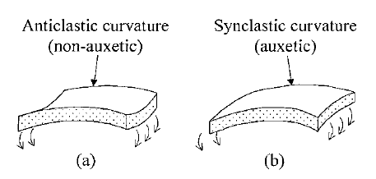
Figure 2.44: (a) Saddle-shaped surface of the conventional material and (b) Auxetic dome-shaped doubly curved surface (Evans and Alderson 2000).

The application of using cork, which is a material with nearly zero Poisson’s ratio, for sealing wine bottles, is well known. Another class of applications of Auxetics is based on the sound absorbing properties of Auxetic materials, which make them interesting for both civil and military applications. Furthermore, several investigations speculate Auxetic behaviour in biomechanics, like for the spongy part of the bones, with obvious implications for the efficient design of prostheses in cork and in skin (Stavroulakis 2005).

2.5.3 Applications of Auxetic structures
In the biomedical field Auxetic microporous and cellular materials have potential, like a dilator for opening the cavity of an artery or similar vessel has been described for use in coronary angioplasty and related procedures (in Figure 2.45). The artery is opened up by lateral expansion of a flexible Auxetic polytetra-flouroethylene (PTFE) hollow rod or sheath under tension (Evans and Alderson 2000).

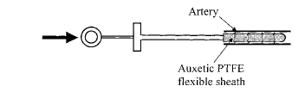
Figure 2.45: Dilator employing an Auxetic end sheath (Evans and Alderson 2000).

An interesting potential application of Auxetic material lies in the manufacturing of smart bandages and smart filters, i.e. one of the properties of Auxetic materials is that one you apply stress to them, when you pull them, their pores become larger. If a filter is made from these Auxetic foams, just by stretching the foam in one direction, the pores become larger. With such uniform enlargement of the pores an adjustable filter can also be made, which can range from very small holes to very large holes. Auxetic foams can also be impregnated with medication which would work as follows: for a swollen wound, the effect of the wound pushing against such a dressing would be to release the medication, and this will happen in a manner on how much it is being pulled (White and Liz 2009).

In sensor and actuator applications functional composite materials are used, like piezoelectric composites consist of piezoelectric ceramic rods within a passive polymer matrix and are used in medical ultrasonic imagers and hydrophone receivers of naval sonar. Recently, they are designed to optimize the performance of these piezocomposite devices have shown that an Auxetic polymer matrix is preferred to a non-Auxetic matrix for several reasons. Firstly, in response to a compressive load exerted on the surface of the device the Auxetic polymer matrix contracts laterally. This allows free lateral expansion of the ceramic rods, leading to enhanced electromechanical coupling of the device, which is crucial for overall device performance. Secondly, for a device designed to respond to hydrostatic pressure, “a non-Auxetic polymer matrix converts a compressive planar stress into a tensile longitudinal stress, which acts to diminish the incident vertical compressive stress. An Auxetic matrix, on the other hand, converts the compressive planar stress into a compressive longitudinal stress and therefore reinforces the incident vertical compressive stress (in Figure 2.46). Another benefit of an Auxetic matrix is due to the concomitantly high shear modulus relative to bulk modulus. This enables efficient conversion of incident stresses on the polymer to lateral stresses acting on the ceramic rods, thereby improving the acoustic-to-electrical energy conversion” (Evans and Alderson 2000).

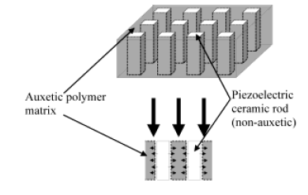
Figure 2.46: Piezocomposite device geometry, consisting of non-Auxetic piezoelectric ceramic rods interspersed within an Auxetic polymer matrix for enhanced device sensitivity (Evans and Alderson 2000).

A number of other technological applications for Auxetic materials are actively being pursued, like a bullet or shell in which one component is made of Auxetic material such that the overall projectile has Poisson’s ratio of zero. In this case the movement of the projectile down a barrel is facilitated by a reduction in lateral expansion due to the Auxetic component under the thrusting force (in Figure 2.47). Auxetic materials have also been identified as candidate materials for use in electromagnetic launcher technology, where a reduction in mass is required in the future for many components, which may be used to propel such projectiles. The intended recipient of the projectile might benefit from a bullet-proof vest and other personal protective equipment formed from Auxetic material due to the impact property enhancements (Evans and Alderson 2000).

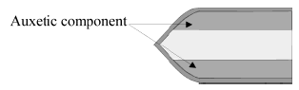
Figure 2.47: Bullet or shell containing Auxetic and non-Auxetic components (Evans and Alderson 2000).

The potential to create filters by polymeric Auxetic structures with an enhanced pore size and with shape tuneability, can offer potential ways of overcoming the problems of filter systems with conventional materials, like reduction in filtration efficiency and the development of a pressure drop across the filter because it becomes blocked. The conventional honeycomb membrane filter pores undergoing uniaxial stretching extend along the stretching direction but close up in the lateral direction. In this case, a particle blocking such a pore cannot be transmitted through the pore when the membrane is stretched since the effective pore size decreases. While the pores of an Auxetic honeycomb membrane filter, open up along both laterally and in the direction of a tensile load applied to the membrane (in Figure 2.48), and therefore particulate de-fouling is possible (Alderson, Rasburn et al. 2001).
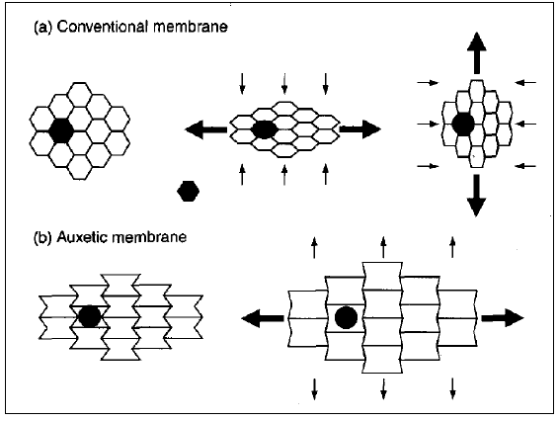
Figure 2.48: Particulate de-fouling capabilities of (a) non-Auxetic honeycomb membrane filters, and (b) filters having Auxetic membrane (Alderson, Rasburn et al. 2001).

2.5.4 Types of Auxetic structures
There are many types of Auxetic structures which are currently present and vary from each other according to their structural difference, deformation mechanism, and scale. A range of Auxetic materials have been discovered, fabricated, synthesized, and theoretically predicted, such as polyurethane and polyethylene foams, microporous polytetra-flouroethylene (PTFE), microporous ultra high molecular weight polyethylene (UHMWPE) and polypropylene (PP), highly anisotropic composites, laminates, and several types of rocks with microcracks. Naturally occurring molecular Auxetic α-cristobalite, zeolites were also predicted to process the counter-intuitive property by calculation or simulation (Yang, Li et al. 2004).

2.5.4.1 Auxetic cellular solids
One stage thermo-mechanical process is used to prepare Auxetic polyurethane foams composed of re-entrant cells, which include tri-axial compression of conventional open cell foam into a mould, heating of the specimen slightly above the softening point of the foam material, and then cooling and relaxation (Yang, Li et al. 2004).
A more controlled multi-stage processing technique was also tried, which separated the transformation process into several stages, by minimising the risk of surface creasing and producing more homogenous specimens (Bianchi, Scarpa et al. 2008). Recently, polyethylene foams were also transformed into re-entrant microstructures through the thermo-mechanical processing, and attained the Auxeticity. “The key to achieve Auxeticity in re-entrant foams lies in their micro-architecture (in Figure 2.49), where the ribs of each Auxetic foams’ cells permanently protrude inward compared with conventional foams’ convex cell structure” (Yang, Li et al. 2004).

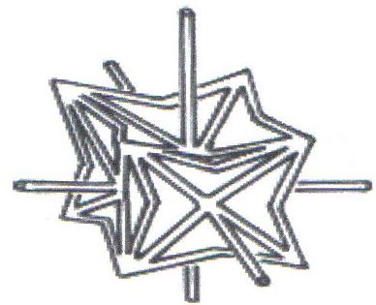
Figure 2.49: Re-entrant unit cell (Yang, Li et al. 2004).

The process by which conventional, reticulated, positive v foams are converted into Auxetic foams, involves volumetrically compressing the foams, heating beyond the polymer’s softening temperature and cooling whilst remaining under compression (in Figure 2.50). This process buckles the cell ribs inwards, creating a re-entrant cellular geometry. It is believed that under tension, the cells unfold outwards towards their original shape, generating an expansion of the bulk specimen and therefore a negative v. This unfolding process reverses under compression. While heating under compression of the foams to convert from conventional to Auxetic foams, the foams are twice temporarily removed from the oven and their containers. Once removed, they are longitudinally stretched by hand and quickly returned to the containers and oven. This stretching episode, typically repeated twice, is just to ensure that the cell ribs do not stick to each other. Inevitably during the volumetric compression of the foams, creases or wrinkles appear in the surface of the foam. It is found that the location of these creases or wrinkles correspond to the more deformable areas noted following conversion to Auxetic behaviour (Smith, Grima et al. 2000).

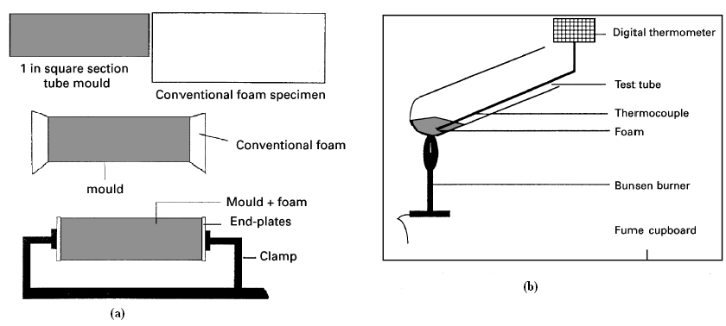
Figure 2.50: (a) 3D compression of conventional foam specimen by inserting into the square section tube, (b) heating of the foam inserted into tube at 200º C (Chan and Evans 1997).

Conventional honeycomb structures can be fabricated into re-entrant structures. The negative v in the cell plane of the re-entrant honeycomb structure has a value that depends upon the re-entrant angle of the cell rib. The honeycomb ceramics with Auxeticity can be produced by the extrusion of ceramic pastes through polymer dies produced by rapid prototyping (selective laser sintering) and designed with CAD technology (Yang, Li et al. 2004). Most of the materials have a microstructure that induces a negative Poisson’s ratio at a macroscale. For instance the microstructure of Auxetic foam is the three-dimensional array of discrete ribs. These ribs interact together so that a statistically large sample (macroscale) displays a negative Poisson’s ratio (Gaspar, Smith et al. 2005).

Laser ablation technique was used recently to fabricate Auxetic polymeric honeycomb membranes with cell dimensions of ~1mm, and these have been proven to provide improved membrane filter cleaning and particulate size selectivity capabilities due to the unique pore variation properties of Auxetic materials. Active and passive smart filters based on Auxetic materials can be envisaged to give improved filtration process efficiency whilst reducing the number and frequency of filters to be replaced, leading to reduced plant down-time and waste minimization in the form of a reduction in the number of spent filters (Evans and Alderson 2000).

It is found that the cell size makes only a minor contribution to the mechanical properties of foam, a much more significant contribution is attributed to the cell shape. For the isotropic properties the cells should be equi-axed. Three different types of foam cell structure; i.e. open cell, closed cell, and reticulated foams. The distinctions between these three foams are that closed cell foams have a membrane of variable thickness covering each face of the cell. In open cell foam, most of these membranes are perforated, and in reticulated foams the membranes are removed by chemical means or by heat treatment (Chan and Evans 1997).

Recently, a new methodology proposed by (Grima, Gatt et al. 2005) which is called “Empirical Modelling Using Dummy Atoms” (EMUDA), which is particularly suitable for studying the properties of two-dimensional hexagonal honeycombs deforming through stretching or hinging of the rib elements, and it correctly predicts the magnitudes of Poisson’s ratios (in Figure 2.51). They presented the potential for Auxetic behaviour of a novel class of structures which can be described as “connected stars” as they contain star-shaped units which are connected together to form two-dimensional periodic structures. A macrostructure which has been studied for its Auxetic properties is the hexagonal re-entrant honeycomb constructed from arrow-shaped building blocks. However, the re-entrant hexagonal honeycomb is not the only tessellate which can be constructed from arrows. Star shaped building blocks which have rotational symmetry of order n = 3, 4 and 6, may be built by connecting n = 3, 4 and 6 arrows in such a way that the arms of the arrows form stars.

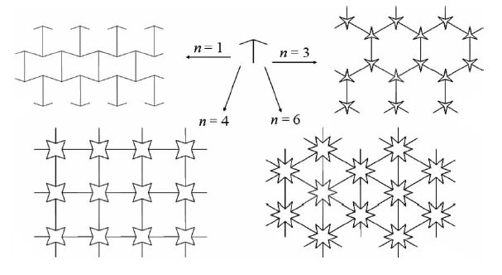
Figure 2.51: Various tessellations which can be constructed from “arrows” (Grima, Gatt et al. 2005).

2.5.4.2 Microporous Auxetic polymers
The microporous PTFE microstructure consists of an interconnecting network of nodules and fibrils, whose cooperative interaction under an applied load produces the Auxeticity (in Figure 2.52). Soon after, UHMWPE and PP were produced through compaction, sintering, and extrusion route or by only sintering and extrusion processing to achieve Auxeticity. Due to cooperative interaction of nodules and fibrils which produces an expansion in the transverse direction and at the same time the fibrils caused the nodules to be pushed apart (Yang, Li et al. 2004).

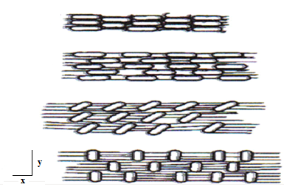
Figure 2.52: Microporous PTFE undergoing tensile loading in the x-direction, tension in fibrils causing transverse displacement of nodes and lateral expansion (Yang, Li et al. 2004).

Morphology studies showed that the Auxetic property in PTFE is due to the microstructure rather than any intrinsic property of PTFE itself. The microstructure consists of nodules interconnected by fibrils. UHMWPE has been processed by a novel processing route developed recently, which has three stages; compaction of UHMWPE powder in heated barrel following by, sintering of the compacted rod and finally, immediate extrusion of the sintered rod through a die (Evans and Alderson 2000).

In microporous polymers Auxetic behaviour was first observed in a particular form of PTFE, and soon after for the fabrication of Auxetic cylinder of UHMWPE, polypropylene (PP), and nylon, thermal routes were used. It was observed that the processing temperature is the most critical parameter governing the presence of Auxeticity, and other parameters such as die geometry, sintering time, structural integrity, and extrusion rates were also shown to have some effect on the Auxeticity of the material. The new form of microporous PP is formed as PP films using the same thermal processing technique involving melt spinning in an extruder and same PP powder, but different die geometry (i.e. from hole orifice to slit orifice, and from circular die-head cross-sectionally to rectangular). Thermal characteristics of PP powder were attained by differential scanning calorimetry (DSC), such as melt onset temperature, peak melting temperature e.t.c. For the characterization of the PP powder in terms of particle size distribution, surface roughness, and shape or dimensions, scanning electron microscopy (SEM) was used. The extruder used was employing an Archimedean screw mechanism, five temperature zones, thermocouples, and die slot with slit orifice. Characterisation of the mechanical properties of Auxetic PP films was carried out by video extensometry to measure the strains across both the length and the width during deformation of the PP films by both Instron tensile testing and Deben microtensile testing equipments (Ravirala, Alderson et al. 2005).

2.5.4.3 Molecular Auxetic materials
Polymers with special microstructures and special inorganic crystals like silicon dioxide, zeolites and elemental metals are the Auxetic molecules. It is a simple molecular design approach based on site-connectivity driven rod re-orientation in main chain liquid crystalline polymers to achieve Auxetic behaviour (in Figure 2.53). Under a tensile force, the extension of the flexible spacers in the polymer main chain will force the laterally attached rods from a position roughly parallel to the tensile axis to a position normal to it and push the neighbouring chains further apart (Yang, Li et al. 2004).

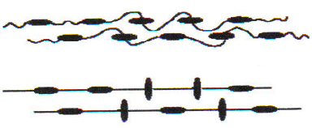
Figure 2.53: Arrangement of laterally attached rods in a main chain liquid crystalline polymer (Yang, Li et al. 2004).

Another molecular network is twisted-chain Auxetics, in which Auxetic behaviour arises due to a soft shear deformation mode for helical polyacetylene chains formed from adjacent chains in a coupled polydiaacetylene chain network (Evans and Alderson 2000).

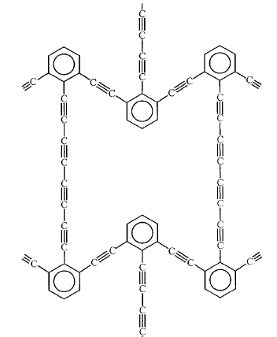
Figure 2.54: Unit-cell of a theoretical Auxetic molecular network (Evans and Alderson 2000).

A mechanism to achieve negative v is based on an arrangement involving rigid squares connected together at their vertices by hinges (in Figure 2.55). As each unit cell contains four squares, each square contains four vertices, and two vertices correspond to one hinge (Grima and Evans 2000).
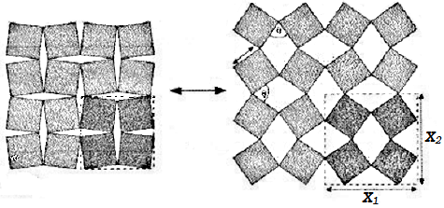
Figure 2.55: The geometry of the Auxetic “rotating squares” structure (Grima and Evans 2000).
It is found that this type of behaviour may also be achieved from the more general case involving hinging parallelograms or in the networks built with different sized squares (Grima and Evans 2000).

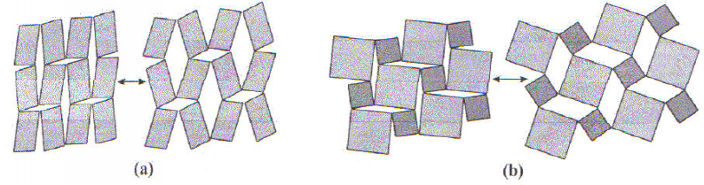
Figure 2.56: (a) a rotating parallelogram structure and (b) a rotating square structure built from different sized squares (Grima and Evans 2000).

As it was reported earlier that the rotating-square geometry may exhibit Auxetic behaviour through rotation of the rigid squares relative to each other. It was recently established that the Auxeticity can also be achieved even if the squares are not completely rigid. In this case, the Poisson’s ratio was reported to be dependent on the extent of deformation of the squares along with the amount of rotation of the squares. Therefore, in this study a combined model was considered which deforms through simultaneous stretching and rotation of the squares. It was found that the mechanical properties of the combined model were dependent on the respective contribution of the individual mechanisms. Also by modifying the relative magnitude of the force constants, the geometry describing the system, the contribution of each of the two mechanisms, the Poisson’s ratio can be adjusted to the prescribed values (Attard, Manicaro et al. 2009).

An important class of polyhedral framework nanostructures are zeolites which are commonly used as molecular sieves because of their availability and their well-defined molecular-sized cavities and pathways. Several idealized zeolitic cage structures are theoretically predicted which possess negative v. In most of these idealized molecular structures, the Auxetic behaviour can be explained through a combination of the framework geometry and simple deformation mechanisms acting within the framework (Grima, Jackson et al. 2000).

2.5.4.4 Auxetic composites
Composites also demonstrate negative v (Donescu, Chiroiu et al. 2009), especially Laminated fibre reinforced composites also show negative v, and the phenomenon is observed by controlling buckling by tailoring laminates with in plane restrained unloaded edges where Poisson’s effect was predominant to the extent that caused premature instability and significant departure from classical behaviour. Composites prepared by laminating unidirectional prepeg tapes of epoxy resin reinforced with continuous carbon fibres, were also shown to be Auxetic for ө in the range between 15 and 30º, which was in accordance with the standard laminate theory. In angle-ply composites made up of unidirectional layers of glass or high modulus carbon fibres within an epoxy resin matrix, arranged such that there are an equal number of layers at an angle to a reference direction, theoretical and experimental investigations showed a large, positive in-plane Poisson’s ratio, and a large negative out-of-plane Poisson’s ratio restricted to a single sample direction. Using the specific values of independent elastic constants in each lamina due to the extension-shear coupling, randomly oriented quasi-isotropic composite laminates were predicted to exhibit negative in-plane Poisson’s ratio by a random statistical analysis (Yang, Li et al. 2004).

2.5.5 Modelling of Auxetic structures
The plastic failure of a 3D Auxetic strut lattice was investigated by (Doyoyo and Hu 2006), under uniaxial and transverse loads to support an on-going research work in miniaturized strut-based sandwich cores. The beams in Figure 2.57 were made up of struts whose curvatures gradually decrease from zero. The plastic failure strength of an Auxetic strut core under uniaxial and shear loads has been determined theoretically by the help of two parameters i.e. packing parameter P_{r} and relative density. The main features of the FEA models were spatial discretisation of struts with single three-noded quadratic beam element, degrees of freedom were constrained at the vertices to avoid rigid body rotation of the strut, and an elasto rigid plastic constitutive model represented the beam material.

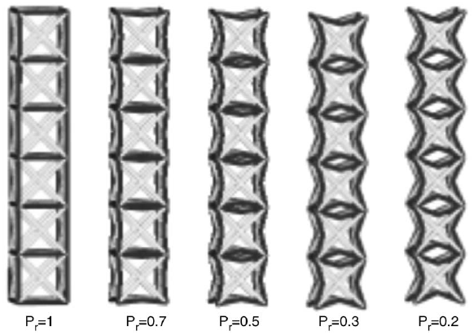
Figure 2.57: Packing parameters P_{r} was used to quantify the negative strut curvature (Doyoyo and Hu 2006).

The conclusions were made by comparing the theoretical data with numerical data obtained from finite element analysis using ABAQUS/standard, and depicted negative Poisson’s ratio effect with lateral contractions and expansions under compressive and tension for the Auxetic cells (Doyoyo and Hu 2006) as shown below in Figure 2.58.

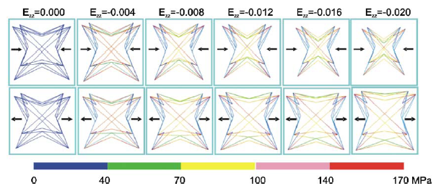
Figure 2.58: The colours shown are Mises stress contour plots and each column shows different configurations at the compressive strains E_{ZZ} (Doyoyo and Hu 2006).

Finite element simulations were used in another study carried out by (Scarpa, Panayiotou et al. 2000), in which the results accomplished a high sensitivity of the mechanical properties for particular ranges of the Auxetic geometric cell parameters. Mechanical property values were acquired by finite element simulations of plain stress uniaxial tests of Auxetic honeycomb models. As it was established earlier that regular honeycombs have isotropic properties, but the unit cells of the cellular structures having a different geometric layout from the regular honeycomb unit cell are anisotropic. In general, the honeycomb unit cells are characterised by cell walls of length h and l, with thickness t and internal cell angle ɵ, and in relation to cellular material theory (CMT) their mechanical properties can be determined by the Young’s modulus E_{c} of the core material, Poisson’s ratio of the core material, the cell aspect ratio α, the relative density β and the internal cell angle (in Figure 2.59).
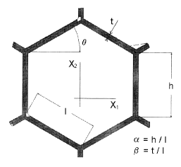
Figure 2.59: Unit cell of the honeycomb with characteristic dimensions (Scarpa, Panayiotou et al. 2000).

Honeycombs which exhibit negative Poisson’s ratio have re-entrant unit cells (in Figure 2.60). It was obvious that the convoluteness of this unit cells layout caused a transverse expansion of the honeycomb when pulled in the perpendicular direction. The cells convoluted because the internal cell angle was negative (Scarpa, Panayiotou et al. 2000).

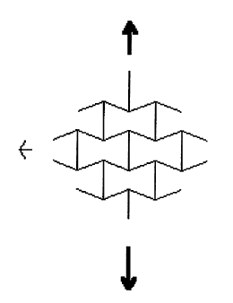
Figure 2.60: Honeycomb with re-entrant cell units (Scarpa, Panayiotou et al. 2000).
To evaluate the in-plane properties of re-entrant cell honeycombs finite element method models were set up. The models were composed of 2508 two-node beam elements having a total of 2131 nodes. The displacements were applied to the nodes and the reaction forces were calculated on these nodes and divided by the initial area to determine the average normal stresses. For the correct plain stress loading condition, the rotations in the X₁X₂ plane of the applied displacement nodes were constrained. The geometric cell parameters played an important role in calculating the in-plane Poisson’s ratio values, like an increase in the cell aspect ratio of the walls determined the rise in the maximum internal cell angle and the decrease in the magnitude of the in-plane Poisson’s ratio (Scarpa, Panayiotou et al. 2000).

A unique molecular network structure which was a combination of acetylene bonds and benzene rings with unusual property of a negative Poisson’s ratio was modelled by (Nkansah, Evans et al. 1994). This hexagonal network structure was named as (n,m)-flexyne, where n is the number of acetylene links on the diagonal branches and m is the number of links on the vertical branches (in Figure 2.61). The values of n and m can be altered to get different structural arrangements that can be either isotropic or anisotropic.

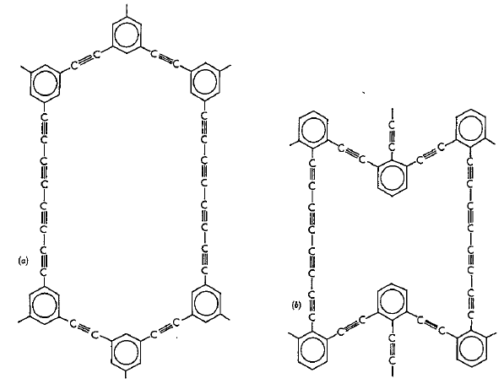
Figure 2.61: Different Poisson’s ratios of molecular networks, (a) (1,4)-flexyne with a positive Poisson’s ratio; (b) (1,4)-reflexyne with a negative Poisson’s ratio (Nkansah, Evans et al. 1994).

The aim of finite element modelling was to replace complex molecular structures by simpler sub-units to simplify calculations, and for that purpose different finite element models were used to investigate which ones gave results closest to those from the molecular model in order to identify the most accurate sub-unit. The two-dimensional representations of the different finite element models for the flexyne structure were shown in Figure 2.62, and for the reflexyne structure in Figure 2.63. A number of models were used in these figures and classified in cases starting from case 1 to case 6 (Nkansah, Evans et al. 1994).

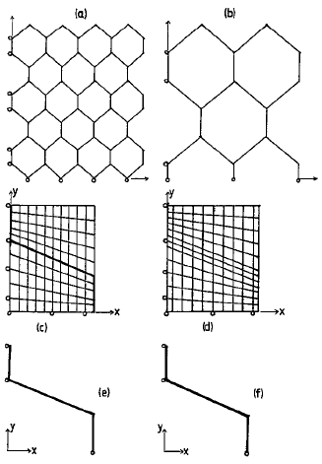
Figure 2.62: 2D representations of various FEM models of flexyne structure; (a) case 1, (b) case 2, (c) case 3, (d) case 4, (e) case 5, and (f) case 6 (Nkansah, Evans et al. 1994).

In case 1 along the free edges the moving constraint boundary condition was used to simulate the same effect of the periodic boundary condition in the molecular model and both two- and three-dimensional beam elements were incorporated in this model. As the y-axis was an axis of symmetry and x-axis was not. Therefore ideal situation was for the axes to be along the middle of the structure, which lead to case 2 which was one quarter of the structural arrangement for case 1. A network of beam elements was used in case 3 with a matrix consisting of quadrilateral elements having a Young’s modulus close to zero, and across each quadratic element a separate beam element was used. Similarly, case 4 was made except that the beam was made up of quadrilateral elements in case 3. Case 5 was used by having two-dimensional beam elements and which was similar to case 3 but without the presence of matrix. In case 6 three-dimensional beam elements were used (Nkansah, Evans et al. 1994).

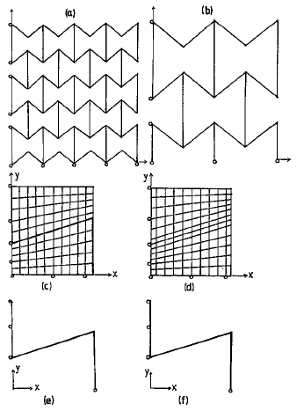
Figure 2.63: 2D representations of various FEM models for reflexyne structure, (a) case 1, (b) case 2, (c) case 3, (d) case 4, (e) case 5, and (f) case 6 (Nkansah, Evans et al. 1994).
The two-dimensional beam elements were used to model a rectangular cross-section with unit depth, while the three-dimensional beam was used to model a circular cross-section resulting from C-C and C≡C links. Moving boundary constraints along the free edges and roller-bearing boundary conditions along the x and y axes were used to give transverse contraction or expansion under loading. In either the x or y direction, pressure loading was applied to one of the two free edges (Nkansah, Evans et al. 1994).

2.6 Polyurethanes (PU)
Polyurethanes (PU) are considered to possess the structural characteristics of both polyesters and polyamides, and generally, the biodegradability of PU was believed to be dependent on whether the prepolymer is polyester or a polyether. The polyether-based PU is resistant to biodegradation whereas the polyester PU is readily attacked. It was observed that by increasing the length of the polyester segment, the degradation rate of PU increases, and it was also found that PU derived from aliphatic diisocyanates are degraded faster than those derived from aromatic diisocyanates (Rehman, Barnardo et al. 1997; Chandra and Rustgi 1998).

Generally, thermoplastic PU are prepared from three materials; a diisocyanates, a chain extender and a macrodiol (or polyol) (Madhavan and Reddy 2006). These three materials react to form linear, segmented copolymers consisting of alternating hard segment and soft segment. Soft segment is derived from polyols such as polyester, while the hard segment is formed from the diisocyanate and chain extender. Physicochemical properties may be modified by changing the ratio of soft segment to hard segment and their respective chemistries to suit the intended application. By the selection of appropriate soft segment chemistries, degradation rate can be tailored from weeks to years. Due to hydrogen bonding involving urethane linkages, the PU hard segment usually provide extra strength to the material (Chandra and Rustgi 1998). The hard segment generally degrades slower than the soft segment predominantly due to urethane bonds being much less susceptible than ester bonds (of the soft segments) to hydrolytic degradation (Tatai, Moore et al. 2007).

PU block copolymer based on poly(dimethylsiloxane) (PDMS) soft segments exhibit improved environmental stability, hydrolytic stability, low moisture permeability, a wide service temperature range due to the low glass-transition temperature of PDMS, and good thermal and oxidative stability when compared with conventional polyether or polyester soft segment (Stanciu, Airinei et al. 1999). Additionally, PDMS-based PU provides variation in the hydrophobic/hydrophilic nature of the surfaces and is of low toxicity, with improved flexibility making these copolymers for potential biomedical applications (Rehman 1996; Madhavan and Reddy 2006).

2.7 Processing methods
In order to convert a material into a useful product with shape, properties and structures, a product has to go through a series of activities like, design, material selection, process selection, manufacture, inspection, evaluation, and feedback. Production of a desired shape in the desired quantity is the main objective of material processing. Shape-producing processes are usually grouped into four families, which are casting, material removal, deformation processes, and consolidation processes as shown below in Figure 2.64 (Black and Kohser 2008).

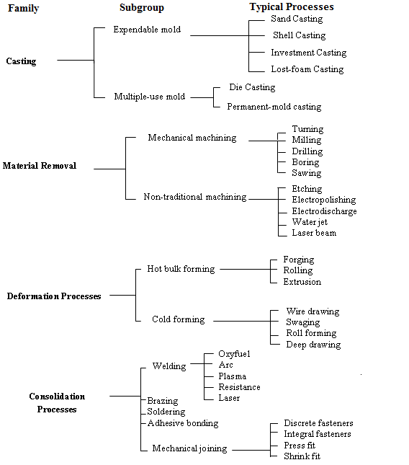
Figure 2.64: Material processing families, with subgroups and typical processes (Black and Kohser 2008).

The fabrication of a successful polymer product involves satisfying a range of mechanical and physical property requirements by the use of the most economical resin or compound that will adequately perform, and joining it with the manufacturing process that is compatible with both the design and the selected material. Taking a decision about the preferred fabrication process depends on the desired size, shape, and quantity, as well as whether the polymer is thermoplastic, thermoset, or elastomer. There are many processes which have been used to shape polymers, such as some of them are casting, blow moulding, compression moulding, transfer moulding, cold moulding, injection moulding, extrusion, thermoforming, machining, inkjet printing, and plasma spraying e.t.c. In order to make most favourable selections, the familiarisation of the shape capabilities of a process as well as how the process affects the properties of the material is very crucial (Black and Kohser 2008).

2.7.1 Casting
It is the simplest of the shape-forming processes because no fillers are used and no pressure is required. There is a range of castable thermoplastics as not all polymers can be cast, and thermoplastic polymer is basically heated and melted at appropriate temperature and the molten liquid is poured into a container having the shape of the desired part. There have been developed several variations of the casting process, for instance small products can be cast directly into shaped moulds, and by the injection of the liquid polymer between two moving belts of highly polished stainless steel and the continuous sheets and films can be produced. The resilient gasket strips are also used on either end of the gap to set and control the width and thickness of the film. By ejecting molten liquid from a gap-slot die onto a temperature controlled chill roll, thin films can be made. For the production of hollow or tubular shapes the molten polymer can also be spun (centrifugal casting) against a rotating mould wall (Black and Kohser 2008).

Cast polymers have a clearly lustrous appearance and are available in a wide range of transparent and translucent colours because they contain no fillers. Fibre or particulate reinforcement can be easily incorporated into the cast product because the product is shaped as a liquid. Due to the lack of costly dies, equipment, and controls, the cast process is comparatively inexpensive. Typical products that can be produced by casting include sheets, plates, films, rods, and tubes, as well as small objects. Dimensional precision of the casting process is quite high, but quality problems can occur due to inadequate mixing, air entrapment, gas evolution and shrinkage (Black and Kohser 2008).

The solvent cast technology is based on the dissolution of a polymer in an organic solvent, and particles primarily salts with specific dimensions are then included into the solution. The mixture is then shaped into its final geometry. When the solvent evaporates it creates a structure of composite material consisting of the particles together with the polymer. A bath is used in Figure 2.65, where the composite material is then placed which dissolves the particles leaving behind a porous structure (Sin, Miao et al. 2010). The solvent cast technology for extremely high quality requirements is becoming more attractive nowadays for the production of films. The main advantages of this technology are the uniform thickness distribution, maximum optical purity and extremely low haze. The films produced by this technique have excellent flatness and dimensional stability as the optical orientation is virtually isotropic, and the cast film can be processed in-line with an optical coating design. Currently, engineering plastics, optical films, medical films, and sheet forming for electronic applications, are being produced by this technique (Siemann 2005).

There are some prerequisites for the raw materials used in the dope making process, such as the polymer must be soluble in a volatile solvent or water, a stable solution should be formed with a reasonable minimum solid content viscosity, and release from the casting support and formation of a homogeneous film must be possible. In order to make available these properties many process tricks are used, for instance co-solvent systems, use of special molecular weight distributions of polymers or co-polymers, dissolution at overpressure, additives like plasticizers, release agents. Water is a common solvent especially for food grade films of biopolymers or polyvinyl alcohol. To achieve specific film properties typical additives used are anti-blocking and anti-static compounds, colours, chelating agents, electrical conductive substance, and pigments e.t.c. (Siemann 2005).

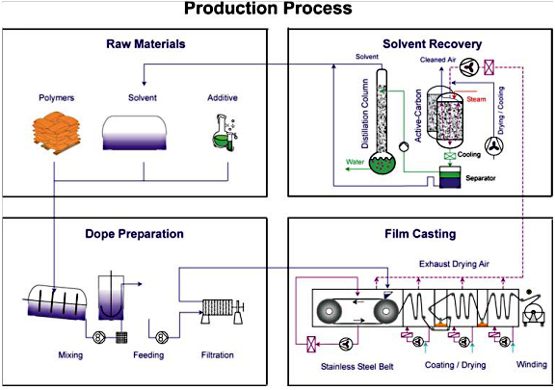
Figure 2.65: Production of solvent cast films (Siemann 2005).

There are few things that should be monitored during process like particle size distribution and filter mesh size should be adjusted during handling. It is noteworthy that in most cases the cast films can be re-dissolved and reused as raw material, and the exposure of the polymer film or solution is mostly with fairly low thermal or mechanical stress throughout the entire production process (Siemann 2005).

2.7.2 Blow moulding
Blow moulding is one of the major polymer processing techniques for the production of a variety of hollow polymer products. It is subdivided into two main groups, i.e. extrusion blow moulding and injection stretch blow moulding (Huang, Li et al. 2006).

A hollow tube with solid bottom, known as a parison, is fabricated from heated polymer by either extrusion or injection moulding. A split mould is used and the heated preform is positioned between the halves of a split mould, once the mould closes the preform is expanded against the mould by air or gas pressure. Then the halves separated by cooling the mould, and the product is removed. Any flash is subsequently trimmed for direct recycling as shown in Figure 2.66 (Black and Kohser 2008).

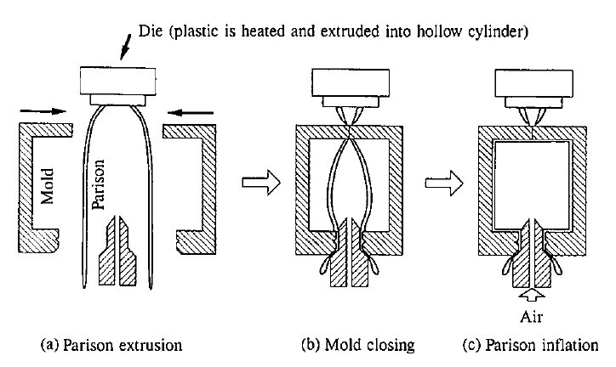
Figure 2.66: Schematic Illustrations of Blow Moulding Process (Imamura and Kushima 1995).

In the blow moulding process as well as in many other polymer moulding operations cooling and solidification is the final stage, and this stage covers 60% or more of the cycle time in the extrusion blow moulding process. Therefore, the productivity and cost of the process is directly influenced by the cooling time. Additionally, the cooling and solidification also affect the properties, like density, crystallinity, shrinkage, residual stresses, mechanical properties, and permeability of blow moulded parts (Huang, Li et al. 2006).

The extrusion blow moulding process has been in use for the production of hollow polymer parts, such as containers, bottles, fuel tanks e.t.c. There are four steps involved in this process; the first step is the extrusion of a molten parison that is a hollow molten polymeric cylinder, the second is the clamping of the mould halves around the parison, thirdly the blowing of air into the part to expand it against the sides of the mould, and then lastly the cooling of the part before ejection. By manipulating operating conditions, machine setup and tooling modifications through experiments, optimal operation or desired part performance can be achieved. Since production is interrupted by number of activities like when quality control tests or tooling changes are performed, therefore, this approach is time consuming and costly. This issue with this technique can be resolved by concurrent engineering (CE) by maintaining reduced part development time as well as final cost (Attar, Bhuiyan et al. 2008).

There have been several variations of blow moulding process developed in order to offer enhanced strength by providing axial and radial expansion of the polymer as well as to produce multilayered products. In one of the designed process, a sheet of heated polymer is placed between upper and lower cavities, and the lower one is having the shape of the product. A non-reactive gas like Argon is used by pressurizing both cavities to 2 to 4 MPa (300 to 600 psi). The gas in the upper segment blows the material into the lower die cavity, when the pressure in the lower segment is vented (Black and Kohser 2008).

2.7.3 Compression moulding
In compression moulding process, solid granules or preformed pellets are placed into an open heated die or cavity, and then pressure is applied by heated plunger which descends to close the cavity. As the material melts and becomes fluid, it is driven into all portions of the cavity till the material has set i.e. cured or polymerized. The mould is then opened and the part is removed (in Figure 2.67). A variety of mould materials and heating systems are used, and in order to produce more than one part in a single pressing, multiple cavities can be placed. This process is very straightforward and simple and is applicable primarily with the thermosetting polymers, although some recent developments also allow the shaping of composites and thermoplastics. By the rate of heat transfer and the reaction or curing rate of the polymer the cycle times of the process are set, and cycle times usually range from within 1 minute to at the most 20 minutes (Black and Kohser 2008).

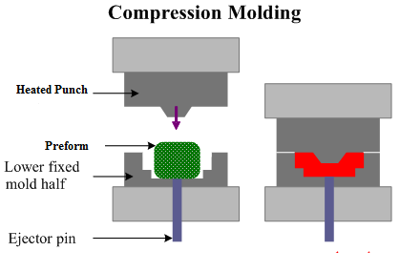
Figure 2.67: Compression moulding process (SubsTech 2010).

In comparison with other processes the tools and machinery costs involved in compression moulding are often lower and it is superior in dimensional precision and surface finish, thus it reduces or eliminates secondary operations. Compression moulding is the most economical process when it is used to small production runs of parts requiring close tolerances, high impact strength, and low mould shrinkage. When the part contains thick sections that means the cure times become quite long or when large quantities are desired, compression moulding process is a poor choice (Black and Kohser 2008).

2.7.4 Injection moulding
Injection moulding process is used for the high-volume production of relatively complex thermoplastic parts and it is the most widely used process. Raw material granules are fed from a hopper by gravity into a cavity that lies ahead of a moving plunger (in Figure 2.68). The material is forced through a torpedo section and preheating chamber as the plunger advances, where the material is mixed, melted, and superheated. A nozzle is also used that seats against a mould and the superheated material is then driven through a nozzle. The molten material is then driven and introduced into one or more closed die cavities by the help of sprues and runners. Since the dies remain cool, the polymer solidifies as soon as the mould is filled (Black and Kohser 2008).
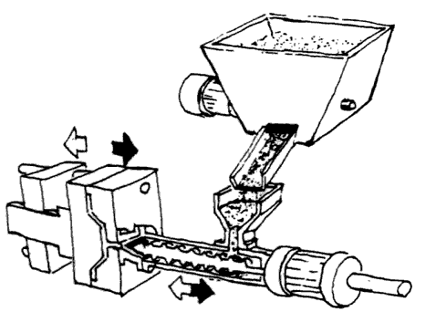
Figure 2.68: Injection moulding process (Rosato, Rosato et al. 2000).

There are other types of injection units that can control the flow of material and generate the injection pressure with screws having both rotation and axial movements or combinations of screws and plungers. Defective parts are usually formed by premature solidification; therefore, the material must be rapidly forced into the mould cavities by pressures in the range of 35 to 140 MPa, which are maintained during solidification. During moulding the mould halves must be tightly clamped together and then easily be separated for part ejection. The coordination of all the functions of the injection moulding process is done by the control system, which even controls the time required for cooling within the mould (Black and Kohser 2008).

2.7.5 Extrusion
Extrusion process is very effective for the fast production of long plastic parts with uniform cross sections. An extruder consists of two different sections; a conveying system is used to transport the material and sends a degree of distributive mixing, and a die system which forms the materials into the required shape (Breitenbach 2002).

A hopper is used to feed thermoplastic pellets or powders into the barrel chamber of a screw extruder (in Figure 2.69). A rotating screw is placed within the barrel chamber which propels the polymer material through a preheating section, where it is heated, homogenised, and compressed, and then forces it through a heated die and onto a conveyor belt. The material is then cooled and properly hardened to preserve its newly imparted shape and this can be achieved by jets of air or sprays of water. It continues to cool as it passes along the belt and is then either cut into lengths or coiled, depending on whether the material is rigid or flexible. This process offers a cheap and rapid method of moulding and is continuous (Black and Kohser 2008).

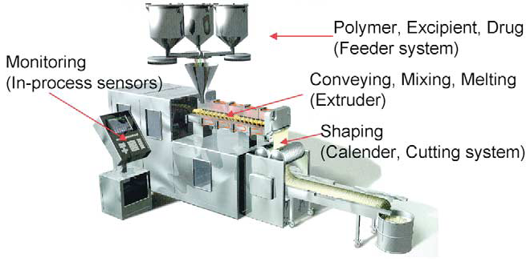
Figure 2.69: Schematic presentation of twin-screw extrusion system (Breitenbach 2002).

2.7.6 Dip coating
It is a simple process for depositing a thin film of solution onto a plate, cylinder, or irregular shaped object. Automation of the dip coating system is easy and has a much higher material yield when compared with spray coating (Goldschmidt and Streitberger 2003).

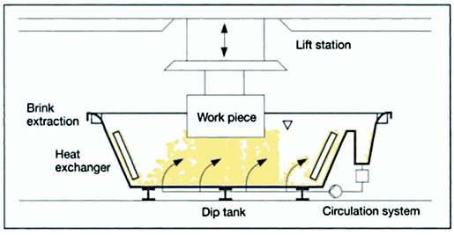
Figure 2.70: Process scheme of conventional dip coating (Goldschmidt and Streitberger 2003).

A distinguishing feature of the dip coating technique is the fact that the geometry of the substrates varies widely. This process involves immersion of a substrate into a reservoir of solution for some time thereby ensuring that the substrate is completely wetted, and then withdrawing the substrate from the solution bath (in Figure 2.71). By the help of two main mechanisms the liquid film formation is achieved, which are gravity draining of liquid solution and evaporation of solvent (Yimsiri and Mackley 2006).

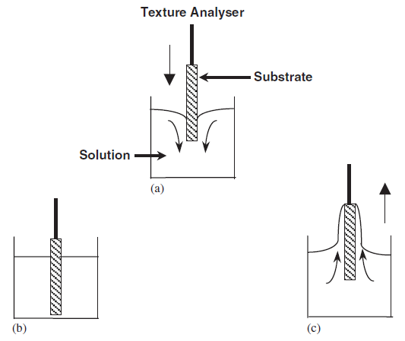
Figure 2.71: Schematic diagram of dip coating process, (a) Immersion, (b) wetting, and (c) withdrawal (Yimsiri and Mackley 2006).
Draining in combination of solvent evaporation has to last long enough to ensure that no surface defects in the form of blisters, pinholing or runs occur (Goldschmidt and Streitberger 2003).

2.7.7 Inkjet printing
Inkjet Printing is a new attractive technology to produce patterns, since this technology has the ability to precisely deposit picolitre volumes of solutions in well-defined geometries. This also referred to as “Direct Write” and is involved computer-controlled translation stages and ink dispensers. The direct write technology is a better option than the conventional mask technique, as it offers efficient use of materials, waste elimination and cost saving. Also, it involves a non-contact based deposition mechanism which prevents the contamination (Tekin, Smith et al. 2008).

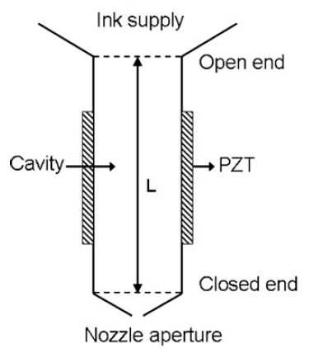
Figure 2.72: Schematic illustration of the Piezoelectric DOD printhead (Tekin, Smith et al. 2008).

The inkjet printing comprises of number steps, such as droplet formation, flight and impact, spreading and uniting (Liu, Pai et al. 2011). The inkjet printhead based on piezoelectric drop-on-demand (DOD) mechanism as shown schematically in the above Figure 2.72, operates by generating the pressure waves as a result of sudden volume changes caused by the voltage applied to the piezoelectric actuator. Fluid is pushed outwards when a positive pressure wave reaches towards the nozzle. When the amount of kinetic energy transferred outwards becomes larger than the surface energy required to form a droplet, a droplet is ejected through the aperture. The velocity of the droplet depends on the amount of this kinetic energy, and initial higher velocity of a droplet is essential to overcome the decelerating action of ambient air. The operation of the piezoelectric printhead at high frequencies normally ends up in chaotic ejection of droplets because of the incomplete decaying of the previous pressure waves, and droplet interaction instead with the next pressure waves to be generated. Droplet ejection rate becomes low when the printhead operates at lower frequencies, and consequently, decreases the production efficiency (Tekin, Smith et al. 2008).

2.8 Micro-patterning of polymers
Micro and nano-fabrication of polymers with precise control over topography, size, and surface micro-architecture remains an important challenge. Considerable efforts have been made in the recent years for the developing of novel micro and nano-fabrication techniques for biodegradable polymers and their characteristics are mentioned in Table 2.9 (Armani and Liu 2000).

Table 2.9: Characteristics of the fabrication techniques (Chen and Lu 2005).
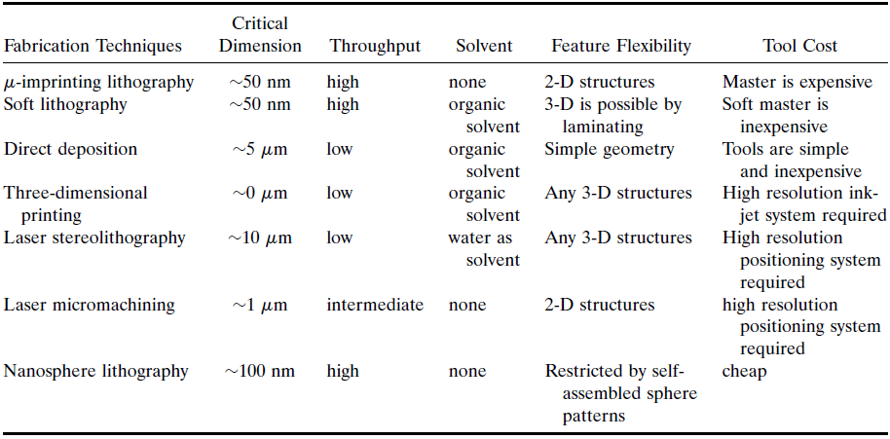

Laser micromachining have made this task possible and easier to pattern polymeric materials on the micro-scale. The non-invasiveness and a single step process feature of the laser irradiation have made this technique very attractive, and photons of the laser light act as “clean particles”. The most popular lasers used for machining stable and biodegradable polymers are the ultraviolet (UV) lasers, including excimer, argon-ion, tripled and quadrupled Nd:YAG, fluorine, helium-cadmium, metal vapour, and nitrogen lasers. As compared to the photothermal process involved in visible and infrared lasers, the photochemical process involved in UV lasers has greatly minimised heat effects. This important feature makes UV laser micromachining very attractive for biodegradable polymer materials, since thermal damage to the non-machined part can be minimised (Chen and Lu 2005).

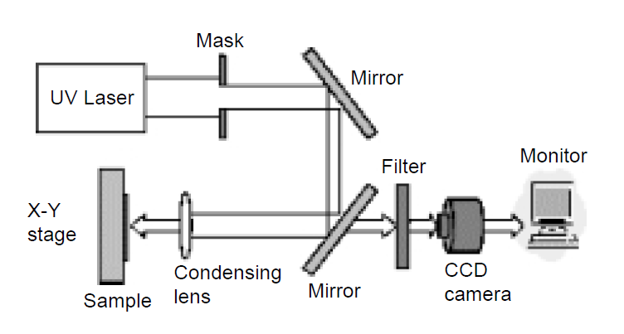
Figure 2.73: Laser micromachining schematic setup (Chen and Lu 2005).

Near-field photolithographic techniques were developed for acquiring nano-scale resolution, by delivering a laser beam through a hollow near-field tip or illuminating the tip of a scanning probe microscope with a pulsed laser. However, this type of near-field nano-lithographic technique has hardly been used in an industrial setting due to its limited throughput, hollow tip blockage, and difficulty in process control. Replication technologies have been proven to be very useful and straightforward for the micro-fabrication of biodegradable polymers. The underlying principle is the replication of a micro-fabricated mould tool, which represents the inverse geometry of the desired polymer structure (Chen and Lu 2005).

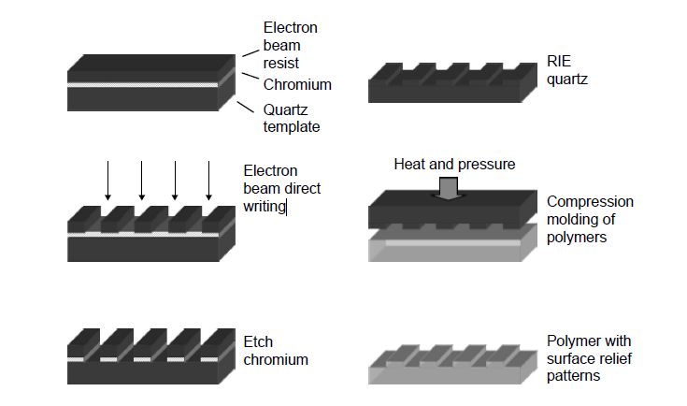
Figure 2.74: Schematic diagram of “hot embossing “procedure (Chen and Lu 2005).

In addition to the cost advantage, replication techniques also offer the benefit of the freedom of design and the master can be fabricated with a large number of different micro-fabrication technologies, which allow various geometries to be realized. Micro-printing also known as “hot embossing” and soft lithography are the types of replication techniques (Chen and Lu 2005).

The advantages and disadvantages of various techniques used in the micro and nano-patterning of polymers are described in Table 2.10.

Table 2.10: Analysis of the techniques used in generating micro-patterns on polymeric materials.
Name of Technique | Pros | Cons | References
Soft Lithography | Soft lithography techniques like micro-contact printing allow rapid manufacturing at a low cost and it is expected that such fabrication techniques will not alter the integrity of the polymers | Soft lithography is still restricted by the development of appropriate masters. | (Chen and Lu 2005) & (Aguilar, Lu et al. 2005)
Photolithography | It has been proven to be a powerful tool for patterning engineering materials with a high resolution. | Yet, the process involves multiple steps that make use of chemical solvents, and the residual chemical agents left on the polymer surface after fabrication could be toxic if implanted. | (Aguilar, Lu et al. 2005)
Atomic Force Microscopy Etching | It is a minimally invasive and rapid technique to pattern polymers on the micro and nano scale. | This technique allows for high precision but it is hindered by the speed of processing and cannot be used efficiently to etch large surface areas. The integrity of the polymeric substrate can be maintained after processing is needed. | (Aguilar, Lu et al. 2005)
Ultraviolet Lasers | UV lasers can modify the surface of a material through direct chemical bond breaking. The emitted photon energy from a UV laser is high enough to break the chemical bonds of the target materials directly, thereby minimizing the heat effects to the surrounding material. |  | (Chen and Lu 2005) & (Aguilar, Lu et al. 2005)
Solid-state Femtosecond Laser | It has gained interest recently because the influence of heat conduction around the machined area can typically be ignored, and this can be accomplished primarily because of the short time scale of laser-material interaction and since the localization of the excitation energy is very confined. |  | (Chen and Lu 2005) & (Aguilar, Lu et al. 2005)

Chapter 3 MATERIALS AND METHODOLOGY

3.1 Aims and objectives
Based on the background covered in the previous chapter, the primary aim of this research is to use Auxetic (rotating-squares) geometry and to make use of its negative Poisson’ ratio property for the production of novel Auxetic oesophageal stents and stent-grafts relevant to the palliative treatment of squamous cell carcinomas of the proximal and mid oesophagus and also for the prevention of dysphagia.

- To adopt a novel manufacturing approach for the production of both seamless and seamed Auxetic stents and stent-grafts.

- To investigate both conventional subtractive and new generative manufacturing techniques.
- To use polyurethane material in the production of Auxetic oesophageal stents and stent-grafts, and to optimise the material properties relevant to the Auxetic stent expansion mechanism.
- To critically analyse the manufacturing route in order to evaluate the efficacy and simplicity of each method and the quality of the end product.

- To manufacture a novel Auxetic oesophageal stent-graft in a significantly small diameter to facilitate its oral insertion by using balloon dilatational catheter and to make it cost-effective by obviating the need of an expensive dedicated delivery device.

- To characterise the mechanical behaviour (i.e. elastic-plastic deformation behaviour and failure mechanism) of the developed Auxetic polyurethane films (which will be used in the fabrication of seamed Auxetic oesophageal stents).

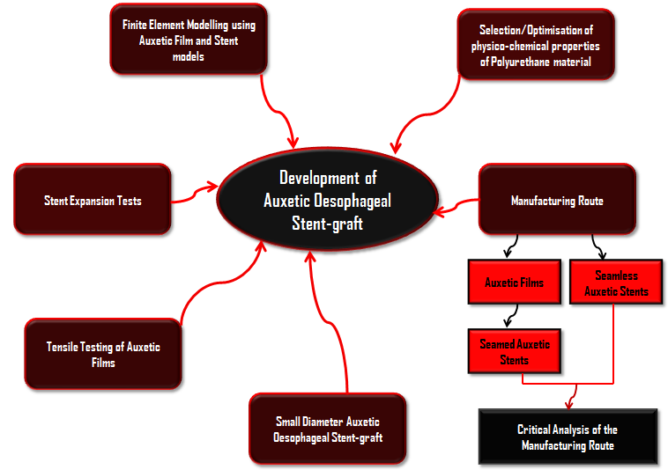
Figure 3.1: Key objectives of the research.
- To explore the radial expansile pressures involved in the elastic-plastic deformation and failure of the Auxetic oesophageal stents.

- To compare the physical tests of the Auxetic polyurethane films and stents with the finite element modelling results of both the Auxetic film and stent simulated models, and to achieve an agreement between the physical and finite element modelling results.

3.2 Material
To develop a polymeric Auxetic (rotating-squares) geometry and to configure it into a film and tubular stent form, polyurethane was selected as a material. Polyurethane due to its biocompatibility and non-toxicity response has been in great use in biomedical applications. Polyurethane is also a material of choice in most of the current commercially available oesophageal self-expanding metal stents, where it is used as an internal graft (covering). Polyurethane is a very attractive choice, as their physicochemical properties can be tailored by changing the ratio of soft segment to hard segment and their respective chemistries to suit the intended application. By changing the hard segment of the polyurethane, their physical properties can be controlled which means the polymer can be made from elastomer to semi-rigid or even rigid plastic. Similarly, by the selection of appropriate soft segment chemistries, polymer can be made either stable or degradable and even degradation rate can also be tailored from weeks to years (Rehman 1996; Tatai, Moore et al. 2007). Additionally, Polydimethylsiloxane PDMS-based polyurethane provides variation in the hydrophobic/hydrophilic nature of the surfaces, which can be useful in making luminal side of the Auxetic stent-graft hydrophobic (Madhavan and Reddy 2006). Therefore, different commercial rigid plastic polyurethane materials were acquired to construct Auxetic (rotating-squares) geometry into a film and tubular stent-graft configuration.

Auxetic (rotating-squares) geometry was selected which was theoretically predicted by (Grima and Evans 2000) by emulating the natural cellular framework of zeolites, shown below in Figure 3.1. Recently, (Attard, Manicaro et al. 2009) derived the analytical model describing its mechanical behaviour to demonstrate that the mechanical properties depend on the relative magnitude of the stretching and hinging constants, the square dimensions and the angle between the squares, and by changing the magnitude of applied force and geometry, the value of Poisson’s ratio can be controlled. Since oesophagus is a large conduit which involved large amount of radial forces, therefore, it was expected that a slightly bulky scaffold such as Auxetic (rotating-squares) stent-graft will be effective for keeping the lumen of the cancerous oesophagus patent.
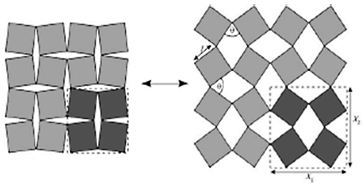
Figure 3.2: The geometry of the Auxetic “rotating squares” structure (Grima and Evans 2000).

The introduced Auxetic (rotating-squares) geometry into a rigid plastic polyurethane material transformed it into fairly flexible material; therefore, this was mainly the reason that rigid plastic polyurethane was selected as a material to have a resulting elastoplastic Auxetic material.

3.3 Development of Auxetic film

3.3.1 Lasercutting method
Initially, in order to check that whether Auxetic (rotating-squares) geometry can be introduced in a polymer film, the lasercutting of commercially available thermoplastic polymer was explored and eventually outsourced to Advanced Plastic Technology Co. (Milton Keynes, UK). Among number of commercially available thermoplastics such as acrylic, Polytetrafluoroethylene (PTFE), and Polypropylene which can be easily processed by lasercutting, polypropylene material was selected. Since polypropylene was easily available, and because of its good handling, inert nature, and low melt related issues, lasercutting of polypropylene film was easily possible.

Lasercutting of polypropylene involved cutting of 0.5mm and 1mm thick A4 size polypropylene films, in an arrangement involving solid squares (i.e. rotating-squares geometry) connected together at their vertices through small hinges as shown above in Figure 3.2, by using computerised numerical control (CNC) guided lasercutting machine.

A two-dimensional (2D) Auxetic (rotating-squares) design was created in Figure 3.3 by the help of AutoCAD Mechanical software 2008 (licensed to School of Engineering & Material Science Queen Mary University of London).

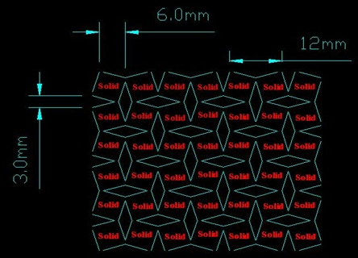
Figure 3.3: AutoCAD 2D Auxetic (rotating-squares) design.

The main reason of using lasercutting technique was that design dimensions and specifications were in millimetres. Therefore, an accurate and precise cutting was required to achieve Auxeticity (negative Poisson’s ratio) in the material as illustrated in Figure 3.4.

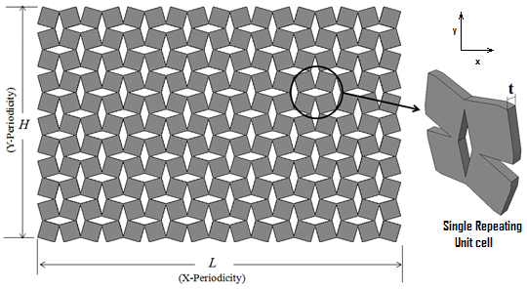
Figure 3.4: Design specifications of Auxetic film.

A laser cutting system typically consists of the beam which is generated in the laser beam source, which determines the wavelength, the beam power, and the beam quality. The beam guiding and shaping system guides the beam from the source to the working position and forms the beam to the desired geometry for cutting application, in which reflective, transmissive, and diffractive optical elements are used (Caiazzo, Curcio et al. 2005). The company used Eurolaser (M-1600) CNC laser cutting machine for the cutting of 1mm thick polypropylene film with CO₂ laser beam having a beam width of 0.3mm and the cutting speed of 100 mm/sec. The laser beam was first focused on the workpiece (i.e. Polypropylene film), which heated it up locally and induced a phase transformation of the material. The material was then blown out of the developing cutting kerf by the normal coaxial gas jet which was added to support the process, i.e. the laser beam developed fusion and the covering gas removed the molten material as shown in Figure 3.5. The CNC handling system produced relative motion between the laser beam and the work piece. The laser control was responsible for the desired output of the beam source.

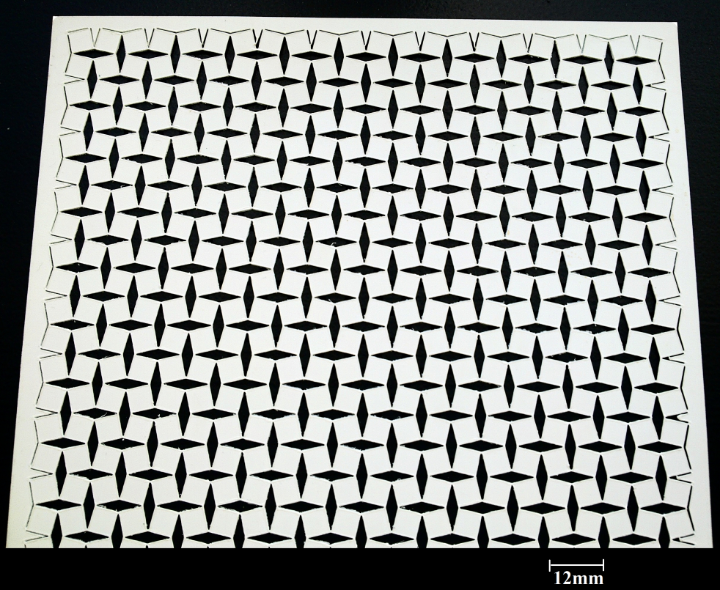
Figure 3.5: lasercut A4 size Auxetic polypropylene film.

3.3.2 Lasercutting of polyurethane film
After the Auxetic (rotating-squares) geometry was effectively introduced in a commercial polypropylene material by lasercutting technique and is shown above in Figure 3.5. Lasercutting of polyurethane films in a reasonably small scale was arranged at Materials and Engineering Research Institute (MERI) Sheffield Hallam University UK. Thermoplastic polyurethane commercially known as “Pellethane” was supplied by Smith & Nephew UK Ltd., which was an aromatic polyether, based polyurethane material and these rigid polyurethane films were manufactured specifically for medical applications. The polyurethane films were 500 microns thick and the hardness of the films was 75 Shore ‘D’. A 2D Auxetic (rotating-squares) design was created by using AutoCAD 2005 software (licensed to the University of Sheffield) as illustrated in Figure 3.6.

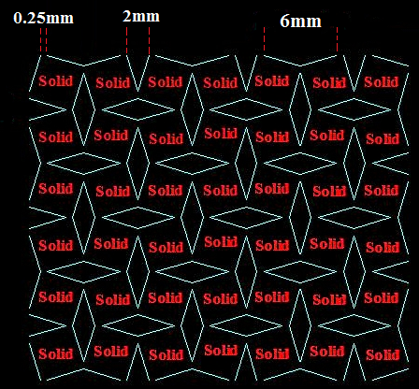
Figure 3.6: A 2D Auxetic (rotating-squares) design on a relatively smaller scale.

For the fabrication of an Auxetic (rotating-squares) polyurethane film, an Epilog laser LEGEND Mini-18 CNC guided system was used as shown in Figure 3.7.

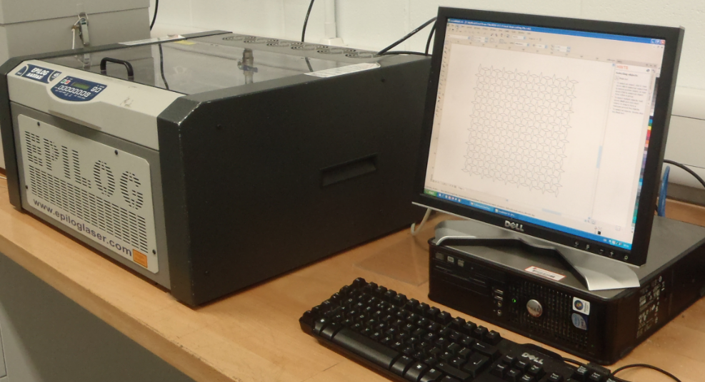
Figure 3.7: Auxetic (2D) design fed into Epilog laser system.

The 2D Auxetic CAD design was fed into Epilog software, and an Epilog Mini-18 laser system emitted optical energy in the form of an invisible infrared beam. The laser system used laser power of around 30 Watts to cut the workpiece material as illustrated below in Figure 3.8.

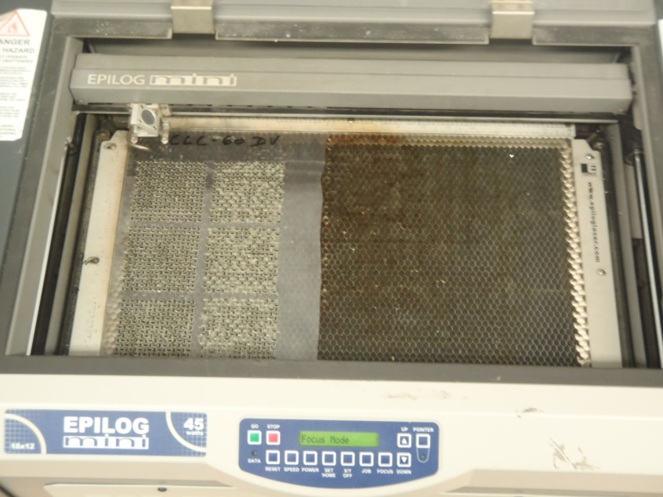
Figure 3.8: Polyurethane film being cut by CO₂ laser system.

A polyurethane thin film of 500 microns thickness with Auxetic (rotating-squares) geometry is shown in Figure 3.9.

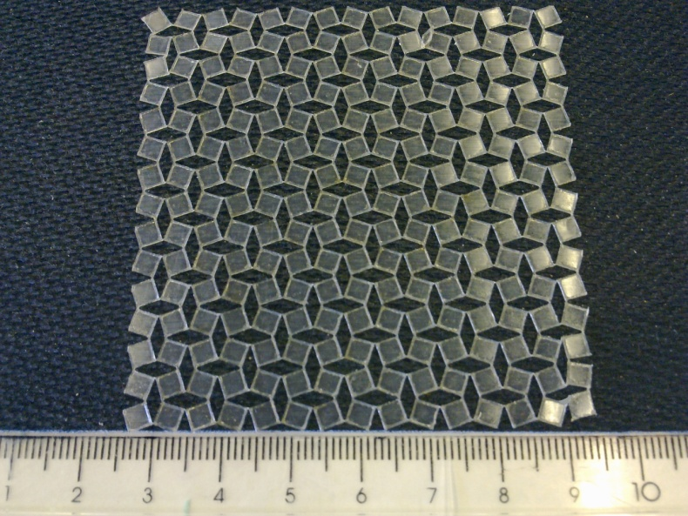
Figure 3.9: An Auxetic polyurethane film.

3.3.3 Die casting method
In this method, two three-dimensional (3D) designs were created by using Autodesk INVENTOR Professional Mechanical software (licensed to School of Engineering & Material Science Queen Mary University of London), which involved male and female die plates. The male die plate was having protruded rotating-squares and recessed diamond-shaped bits, whereas the female plate was having recessed rotating-squares and protruded diamond-shaped parts as shown below in Figure 3.10. Both male and female die plates have 1mm depth of the recessed parts.

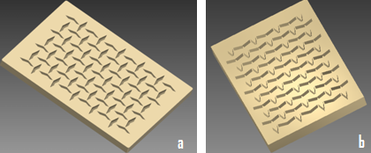
Figure 3.10: 3D designs of both (a) male die plate, and (b) female die plate.

Initially, designs of male and female die plates were selected and were saved in STL file format which is native to the Stereolithography CAD software created by 3D systems, and is widely used in Rapid-Prototyping and computer-aided manufacturing. The male and female die plates were fabricated by Fused Deposition Modelling (FDM) technique which is a typical rapid prototyping process that can build prototypes out of thermoplastic polymers. STRATASYS FDM 360mc machine was used for this purpose which fabricated parts based on deposition of extruded thermoplastic acrylonitrile-butadiene-styrene (ABS) polymer as shown in Figure 3.11.

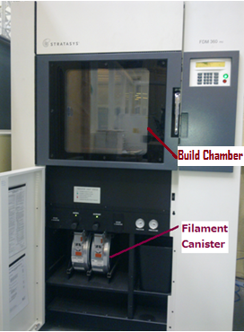
Figure 3.11: FDM 360mc (rapid prototyping) machine having build chamber above and two canisters of the material located in the base of the machine.

In FDM process, initially a 3D model was created by the help of INVENTOR Mechanical software as shown in Figure 3.10. The model was then exported to the FDM INSIGHT software using the Stereolithography (STL) file format. FDM 360mc machine produced thermoplastic ABS part in just 3 steps, which were, (i) File Pre-processing, (ii) Part Production, and (iii) Support Removal.

INSIGHT is the innovative Pre-processing software, and it produces 3D digital files for part production by automatically orienting the model and defining all build parameters. After the design files were processed and sent to the FDM 360mc machine it was then ready to initiate part production. During part production, thermoplastic (ABS) filament was fed from the canister which was located in the base of the machine as shown above in Figure 3.11, through a heating element to the extrusion head. The thermoplastic was liquefied and extruded along precise tool paths creating the shape of each layer. The system extruded both build material and temporary support material layer by layer over acrylic platform sheet by the help of two different nozzles as illustrated schematically in Figure 3.12.

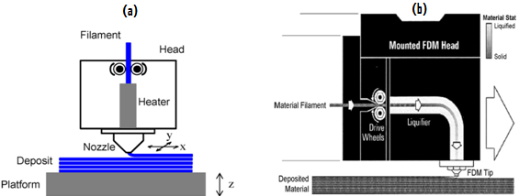
Figure 3.12: Schematic representation of FDM process, (a) spatial orientation of the build material and platform, (b) extrusion of the liquefied material.

Since the material was extruded in a semi-molten state, the newly deposited material fused with adjacent material that had already been deposited. The head moved around in the X-Y plane and deposited material according to the part geometry, and the platform holding the part moved vertically in the Z-plane to begin depositing a new layer on top of the previous one as represented schematically in Figure 3.12(a). The FDM 360mc system repeated the process layer by layer by running unattended until the part is finished. The system oven temperature was maintained at 91⁰C, Model temperature was kept at 314⁰C, and the Support temperature was held at 221⁰C. Once the part production was finished as shown in Figure 3.13, the part was immediately taken out of the build chamber, and then temporary supports were easily broken away by hand.

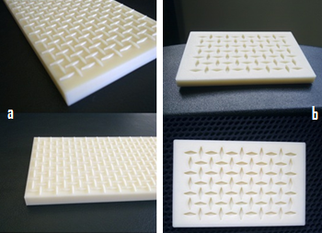
Figure 3.13: Parts removed from the support material by hand, (a) female die plate, and (b) male die plate.

Once the fabrication of male and female die plates was completed by FDM process, the female die plate was selected and used as a template and polymer film casting was initially tried by using Flexil-S RTV material which is a commercial two part silicone elastomer acquired from Jacobson Chemicals Limited. Flexil-S RTV material cures at room temperature and was used with the crosslinker Catalyst-S which is also a room temperature vulcanized system. The green colour Catalyst-S crosslinker (hardening agent) was added into the white colour Flexil-S RTV viscous material by the weight ratio of 10:1, i.e. 7 grams of Catalyst-S was added into 70 grams of Flexil-S RTV material as shown in Figure 3.14(a). The viscosities of Flexil-S and Catalyst-S were 24000cps and 55cps respectively, and the Pot life of Flexil-S after mixing with Catalyst-S was 75mins. The polymer paste was formed by stirring the mixture for some time and then the polymer paste was transferred to the surface of the substrate (i.e. female die plate) by the help of spoon as shown in Figure 3.14(b), and was finely scraped with the doctor blade in order to remove the extra material and to keep the surfaces of the diamond-shaped parts uncovered from the polymer material as illustrated in Figure 3.14(c).

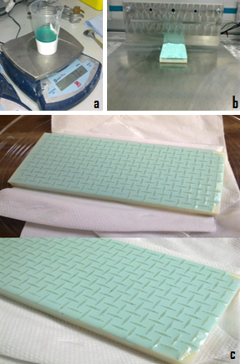
Figure 3.14: (a) Two part silicone elastomer (b) silicone paste is being scraped by Doctor blade and (c) silicone elastomer casted on a female die plate.

The female die plate with casted silicone elastomer as shown in Figure 3.14(c) was subsequently kept in a dry place for curing for two hours. The cured silicone film was then peeled off from recessed rotating-squares parts of the die plate. The removed 1mm thick silicone film was actually an Auxetic (rotating-squares) film and a negative replica of the female die plate as shown in Figure 3.15.
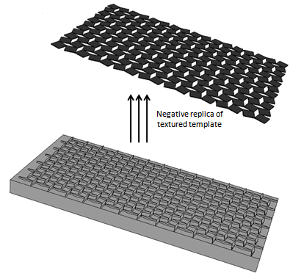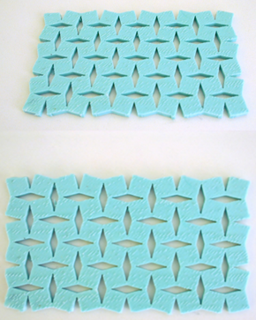
Figure 3.15: Auxetic (rotating-squares) film acquired from casting on female die plate.

3.3.4 Polyurethane casting on a silicone mould
Since the silicone Auxetic film was effectively developed in the previous section, by casting silicone elastomer on a reverse-Auxetic plate (female die plate) made of ABS plastic by FDM process. An inverted Auxetic plate made of silicone was selected for casting polyurethane material to avoid problems related to the separation of the casted polyurethane from the ABS plastic mould. Silicone inverted Auxetic template was then prepared by casting the same two part silicone elastomer on a male die plate on a volume basis of 10:1 as shown in Figure 3.16(b). After having done silicone casting on a male die plate, the die plate was then left for curing for couple of hours. The cured silicone reverse-Auxetic Auxetic template was peeled off from the male die plate after two hours and prepared as a mould for polyurethane casting as shown in Figure 3.17.

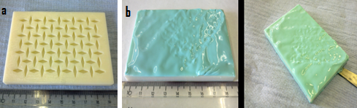
Figure 3.16: (a) Male die plate, and (b) silicone casted on a male die plate.

SmoothCast-60D a commercial semi-rigid two-part polyurethane casting resin was acquired by Smooth-On Inc., and was used for casting on a silicone inverted Auxetic template as shown in Figure 3.18(a).

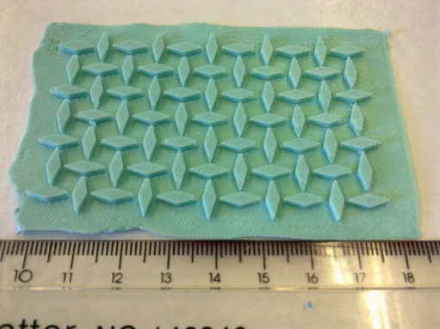
Figure 3.17: Silicone reverse-Auxetic template for casting polyurethane.

Casting of polyurethane material on a silicone inverted Auxetic template was performed with and without degassing process of the two part polyurethane casting resin. In the beginning, polyurethane casting involved degassing of the two part polyurethane material in separate containers in a vacuum chamber at 760mmHg pressure for 15 minutes as shown in Figure 3.18(b), then mixing of the two part polyurethane resin on a volume basis of 1:1, and degassing again the mixture in a vacuum chamber at 760mmHg pressure for 2 to 3 minutes by keeping in view the 5 minutes Pot Life of the polyurethane resin.

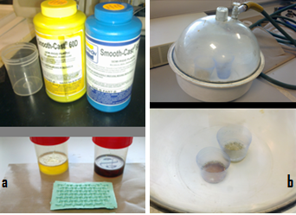
Figure 3.18: (a) SmoothCast-60D two part polyurethane casting resin, and (b) Degassing of two part polyurethane in separate containers in a vacuum chamber.

Once the polyurethane mixture was completely deaerated, it was then transferred on a silicone template and scraping was performed by doctor blade to remove both the extra material as well as the material on the surfaces of the diamond-shaped parts as illustrated in Figure 3.19.

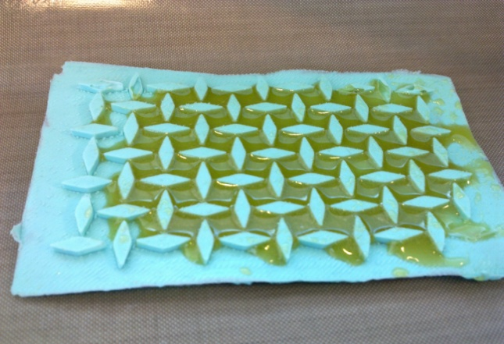
Figure 3.19: Degassed polyurethane material was transferred on a silicone template and scraped by the blade.

The scraping of the extra casted material was properly completed and the silicone template was subsequently left for one hour for curing in a dry place. After one hour 1mm thick polyurethane semi-rigid Auxetic film was easily removed from the silicone template as shown in Figure 3.20(b). The same casting process was repeated afterwards without degassing the two-part polyurethane mixture before casting on a silicone mould as shown in Figure 3.20(c).

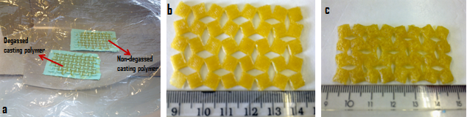
Figure 3.20: (a) Polyurethane casting done with and without degassing of the casting resin, (b) Polyurethane Auxetic film made by deaerated casting polymer, and (c) polyurethane Auxetic film developed by non-degassed casting polymer.

3.3.5 Polyurethane casting on an electroplated mould
Auxetic polyurethane film fabrication was also tried by casting the same SmoothCast-60D two part polyurethane resin and using the previously developed female die plate (having inverted-Auxetic geometry) made of ABS plastic by FDM process. In this approach, the female die plate in Figure 3.21 was initially prepared for casting by means of electroless nickel plating, to avoid adhesion of final casted Auxetic polyurethane film with ABS plastic mould. The electroless nickel plating of the ABS plastic die plate was outsourced to MacDermid plc, which performed plating of the nickel phosphorous alloy onto a substrate (female die plate). Since, the ABS plastic is one of the first few polymers onto which electroless nickel plating has been effectively applied with substantial metal-plastic adhesion (Mallory and Hajdu 1990), therefore, this was the primary reason that electroless nickel plating of an ABS die plate was chosen.

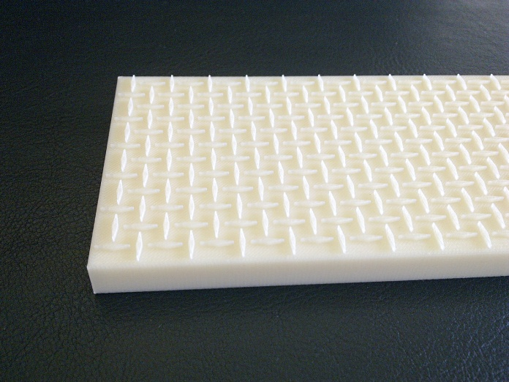
Figure 3.21: ABS plastic reverse-Auxetic substrate (female die plate).

The process of plating nickel phosphorous alloy onto a substrate (ABS die plate) involved initially the cleaning of the substrate with a chromic acid/sulphuric acid based solution to remove any dust particles or grease traces. This process of cleaning was actually pre-etch conditioning of the substrate at 55⁰C for 3 minutes at constant mechanical stirring to avoid temperature layering. The etching of the substrate entailed a high chromic acid based system which operated at 68⁰C for 8 minutes, and that effectively dissolved the butadiene from the polymer matrix. Since, the butadiene or rubber component in ABS material is in the form of particles dispersed in a matrix of styrene acrylonitrile (SAN). The etching procedure not only dissolved out the rubber particles but also slowly softened and dissolved the matrix material. Therefore, as the time and temperature in the etch bath were increasing, there was a progressive degeneration of the original surface. Neutralising of the etched substrate was then carried out by using hydrochloric acid based bath to remove any traces of the remaining chromic acid etch solution, which might contaminate succeeding baths and prevent deposition of electroless nickel. Small particles of palladium were deposited onto the surface of treated substrate by means of activation process. These metal particles normally act as a catalyst for the electroless nickel solution and as a result substantial micro-adhesion takes place which usually holds the particles in place during the subsequent stages. The activation process was mainly based on the bath having palladium activator concentrate in distilled water with constant stirring at 40⁰C for about 4 minutes. Finally, the electroless nickel phosphorous alloy was deposited onto the activated substrate. The electroless solution contained both metal salts and reducers in stable chemical balance and noble metal such as palladium, which initiated the chemical reduction reaction in them. Once the activated substrate was immersed in an electroless solution, palladium particles started to build up a layer of nickel round it. The electroless nickel plating was performed onto an activated die plate with mild stirring at 35⁰C by keeping the pH 9.0 for 5 minutes. The electroless nickel plated reverse Auxetic die plate was then prepared for polyurethane casting by coating it with CilRelease 1812E silicone based mould release agent as shown in Figure 3.22, to prevent adhesion of casted polyurethane film with the mould surface.

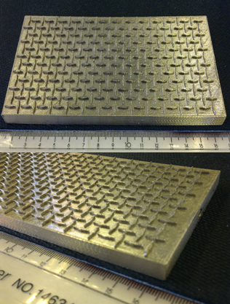
Figure 3.22: Electroless nickel plated female die plate.

SmoothCast-60D a semi-rigid two part polyurethane casting resin was subsequently used for casting onto an electroless nickel plated mould. The two parts of polyurethane resin were initially taken on a volumetric ratio of 1:1 in two separate containers in a vacuum chamber for degassing at 760mmHg pressure for 15 minutes. The degassed Part A and Part B were then mixed together in one container and placed again in a vacuum chamber for degassing at 760mmHg pressure for 3 minutes by taking care of the 5 minutes Pot Life of the casting resin. When the polymer was completely deaerated, it was then dispensed onto an electroless nickel plated mould for casting as illustrated in Figure 3.23(a). The extra material dispensed onto the mould (i.e. on the surfaces of the diamond-shaped parts) was then removed by means of scraping with doctor blade.

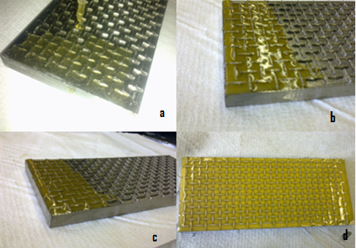
Figure 3.23: (a) Polyurethane poured onto a mould, (b, c) polyurethane casting onto an electroless nickel plated mould, and (d) casted polyurethane left for curing.

The mould was subsequently left for one hour for curing as shown in the above Figure 3.23(d). Once the casted polyurethane film was cured it was carefully peeled off from the mould as shown in Figure 3.24.

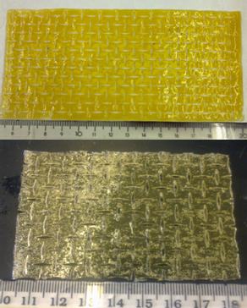
Figure 3.24: Auxetic polyurethane film prepared from Electroplated reverse-Auxetic mould.

3.3.6 Polyurethane casting on a metal mould
Auxetic polyurethane films were made by casting polyurethane on a metal reverse-Auxetic mould fabricated by the Electron Beam Melting (EBM) technique. The EBM process is an additive manufacturing technique capable of producing fully dense titanium alloy parts having extremely complex geometries as shown in Figure 3.25. Initially, a 3D CAD design was created by using Autodesk INVENTOR software, which involved an inverted-Auxetic die plate having the recessed rotating-squares and protruded diamond-shape units. The 3D design involving rotating-squares geometry was prepared in a relatively smaller scale as illustrated in Figure 3.26, and was then sliced into thin layers and transferred to SLiCe (SLC-file) format.

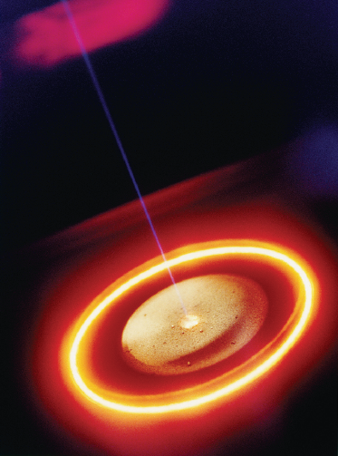
Figure 3.25: EBM process showing melting of metal powder (Christensen, Kircher et al. 2008).

The ARCAM EBM S12 (CAD to Metal) based system as shown in Figure 3.27 was used, which physically reproduced the computer slices by melting metal powder layer by layer. Titanium (Ti6Al4V) metal powder was used which had spherical particles ranging from 45microns to 100microns in diameter.

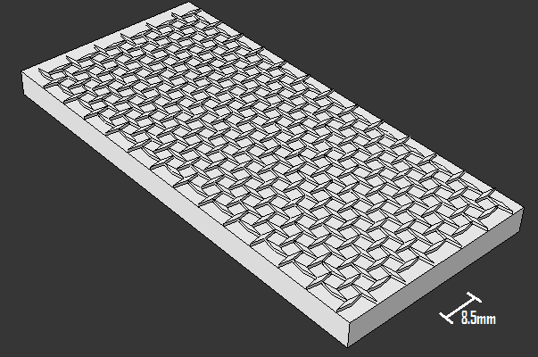
Figure 3.26: 3D reverse-Auxetic model for EBM process.

The ARCAM EBM technology depends on the use of a high power electron beam to provide the required energy to melt powdered titanium alloy in an additive fashion. An electron beam having 4.8kV and 17mA was used to melt the titanium powder into solid metal. This process was executed in a vacuum of approximately 1x10⁻³mbar in the build chamber and around 1x10⁻⁶mbar in the electron beam gun where the electron beam was generated. A 60kV accelerating voltage was supplied to the anode located underneath the electrode, which accelerated the emitted electrons in the desired direction.

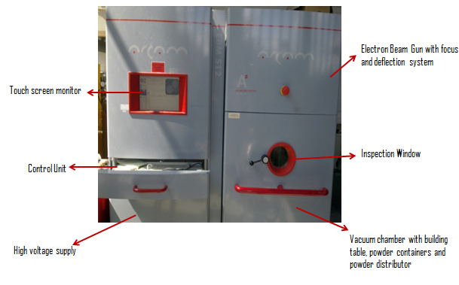
Figure 3.27: ARCAM EBM S12 system.

The electron beam was focused by using electromagnetic coil, and subsequently electromagnetic steering coils were used to deflect the focused electron beam to the desired spot on the powder bed. As there were no moving parts within the system, therefore, the electromagnetic steering coils were able to sweep the focused electron beam at 500 mm/sec speed. The EBM process was initiated by the distribution of a 100 micron thick layer of fine Ti6AL4V powder on a steel platform. Subsequently, an electron beam scanned the areas in x and y axes within the build chamber on the powder bed as defined by the CAD model, and then completely melted the powder in the scanned areas. After which the steel platform was lowered by 100 microns along z-axis, and a new layer of powder was distributed on top of the previously melted layers. The EBM process was running continuously layer by layer until a complete part was produced. The completed titanium part was then inserted into ARCAM Powder Recovery System (PRS) for removing powder that surrounded the part produced in the ARCAM EBM process. The powder recovery method involved minimal dust generation for safe operation, and closed loop material recovery and elimination of fine particles as shown in Figure 3.28.

Figure 3.28: Metal powder is being removed from the titanium reverse-Auxetic mould by means of an Air shower in a closed loop environment.

The surface of the recovered titanium mould appeared to be rough and grained, after cleaning of the mould from the metal powder covering. Therefore, surface roughness of the titanium mould was removed by means of conventional mechanical finish machining method. The titanium mould prepared by CAD to Metal based EBM process, was then finally ready for casting as shown in Figure 3.29.

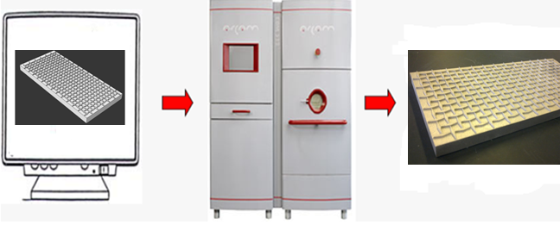
Figure 3.29: Titanium reverse-Auxetic mould made by EBM process.

Subsequently, Auxetic polyurethane films were prepared by repeating the prior casting method which involved, taking the two parts of the SmoothCast-60D polyurethane resin in a volumetric ratio of 1:1, degassing first the two parts separately for 15 minutes in a vacuum chamber at 760mmHg pressure as shown in Figure 3.30(a), mixing the two parts in one container and then degassing again the polyurethane mixture for 3 minutes as shown in Figure 3.30(b), preparing the titanium mould for casting by coating it with CilRelease 1812E silicone based mould release agent as shown in Figure 3.30(c), and finally dispensing the polyurethane onto the titanium reverse-Auxetic mould for casting.
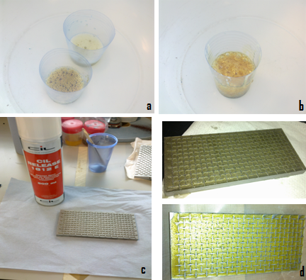
Figure 3.30: (a) Degassing of the two parts of the polyurethane resin, (b) degassing of the mixture in a vacuum, (c) titanium mould coating with CilRelease 1812E mould release agent, and (d) casted polyurethane being scraped by the blade and left for curing.

Scraping was carried out to remove excess material from the surfaces of the diamond-shaped parts in the mould, and then the casted polyurethane was left for curing as illustrated above in Figure 3.30 (d). After two hours the polyurethane Auxetic film was peeled off carefully from the titanium mould as shown in Figure 3.31.
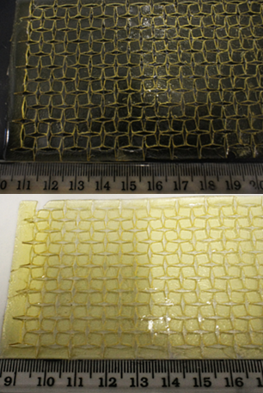
Figure 3.31: Auxetic polyurethane film prepared from metal reverse-Auxetic mould.

3.3.7 Inkjet printing of polyurethane
The fabrication of Auxetic (rotating-squares) geometry as a thin film was tried by Inkjet Printing technique, which is a new patterning technology based on its ability to precisely deposit picolitre volumes of ink solutions in well-defined patterns. The Jetlab-4 tabletop printing system was used for printing polyurethane solution onto a metal substrate. The Jetlab-4 printer is based on piezoelectric drop-on-demand (DOD) printhead system with a stroboscopic video camera to determine the correct conditions for droplet formation (Figure 3.32). In piezoelectric printhead system, a volumetric change in the ink solution is induced by the applied voltage to the piezoelectric actuator. This volumetric change causes pressure/velocity transients to occur in the fluid and these are directed in order to produce a drop that issues from an orifice (Tekin, Smith et al. 2008). This is referred to as drop-on-demand printing system because the voltage is only applied when a drop is required.
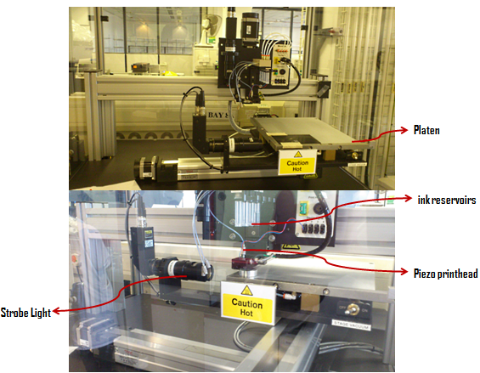
Figure 3.32: Jetlab-4 printing system with demand mode piezoelectric dispensing device.

The 10% polyurethane ink solution was prepared by dissolving 3 grams of Z3A1 polyurethane pellets (acquired from Biomer technology Ltd.) into 30ml of Tetrahydrofuran (THF) solvent (anhydrous ≥ 99.9%, Sigma-Aldrich). The polyurethane ink was then filled into one of the inkjet reservoir by using syringe filter of 0.2µm pore size. A script file was prepared with a print-job program which involved printing 25 layers of one unit cell (comprising of 4-squares) of Auxetic (rotating-squares) geometry. The demand mode piezoelectric printhead operated at 1000Hz and the diameter of the printhead aperture was 30µm. A positive pressure was then applied to draw the ink solution from the reservoir down to the printhead, followed by the application of an instant negative pressure for holding the concave meniscus of the fluid outside the aperture tip. A piezoelectric demand mode dispensing device is driven by the bipolar pulse waveform (trapezoidal) which moves the piezoelectric actuator and returns it to the rest state (Figure 3.33). Prior to the commencement of the actual print job, optimum printing parameters and effective droplet formation were achieved, by changing the bipolar pulse waveform parameters and the time of strobe light, which resulted into a singular droplet formation with no satellite droplets.

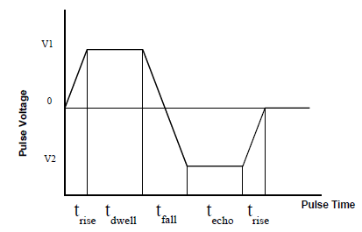
Figure 3.33: Bipolar pulse waveform (Liu, Pai et al. 2011).

The bipolar pulse waveform actually eliminated the unnecessary satellite droplets and asymmetric droplet formation as they are known to skew the droplet trajectory and cause droplet misregistration at designated sites. The bipolar pulse waveform parameters were set to be 15µsec for T_{RISE}, 29µsec for T_{DWELL}, 23µsec for T_{FALL}, and 27µsec for T_{ECHO}. The dwell voltage was 59V and Echo voltage was -29V with 320µsec strobe light time (Figure 3.34(b)).

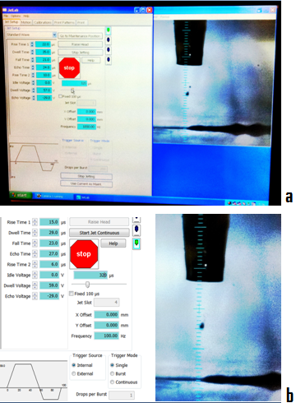
Figure 3.34: (a) Satellite droplets are being removed by adjusting printing parameters and (b) Singular droplet formation is achieved.

Once a singular droplet was obtained by effectively controlling the printing parameters, then a metal stub made of stainless steel was placed and fixed over an inkjet printer platen after adjusting the x and y coordinates. Finally the print job was initiated which printed successively 25 layers of one unit-cell (i.e. 4 squares) of Auxetic (rotating-squares) geometry onto the metal stub (Figure 3.35).

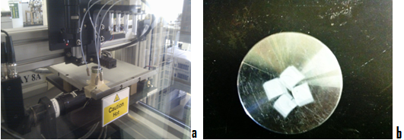
Figure 3.35: (a) Metal stub fixed on a platen, (b) printed 25 successive layers of one unit-cell of Auxetic (rotating-squares) geometry.

3.4 Development of Auxetic stent

3.4.1 Seamless fabrication
Auxetic oesophageal stents were fabricated initially in a seamless fashion, and polyurethane was used as a material.

3.4.1.1 Die casting method
The earlier method of casting polyurethane film on a reverse-Auxetic die plate provided an insight of using a tubular die (having recessed rotating-squares parts and protruded diamond-shaped bits) for casting polyurethane to produce seamless Auxetic stent. A 3D design of the tubular die was created by using INVENTOR Mechanical software, which involved 120mm long tube with an outer diameter of 15mm and the depth of reverse-Auxetic pattern was 2mm (Figure 3.36). The design file was saved as an STL file and exported to the INSIGHT pre-processing software of the STRATASYS FDM 360mc equipment.
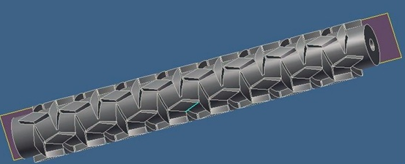
Figure 3.36: 3D design of the reverse-Auxetic tubular die.

Same FDM 360mc equipment was used for the above part production by using thermoplastic acrylonitrile-butadiene-styrene (ABS) material. The system oven temperature was set at 90ºC, Model temperature was 310ºC, and the Support temperature was maintained around 220ºC. Once the part production was completed by FDM process, the part (in Figure 3.37) was taken out of the build chamber and the temporary supports were separated away manually.

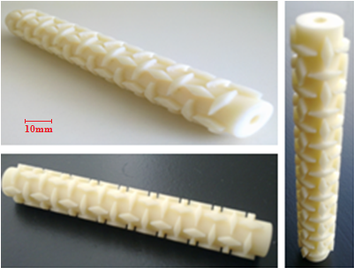
Figure 3.37: Reverse-Auxetic tubular die made of ABS plastic.

For polymer casting into the above developed reverse-Auxetic tubular die, a hollow TEFLON tube was used in a way to tightly enclose the reverse-Auxetic tubular die by pushing out the polymer from the surfaces of the protruded diamond-shaped parts. The internal diameter of the TEFLON (external) tube and the outer diameter of the reverse-Auxetic tubular die were same, in order to achieve friction between the walls of the two tubes as shown in Figure 3.38. The aluminium foil was used with a clamp to close the TEFLON tube from one side (in Figure 3.39(b)).

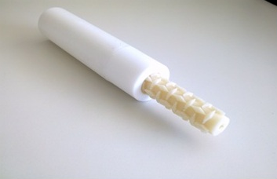
Figure 3.38: Reverse-Auxetic tubular die is fixed tightly within TEFLON tube.

This method was tried by casting the same commercial silicone elastomer Flexil-S along with cross-linker Catalyst-S. The silicone elastomer material was dispensed into the TEFLON tube, and the reverse-Auxetic tubular die was gradually inserted manually into the filled TEFLON tube, leading into pressing out of the extra material from the TEFLON tube (in Figure 3.39(a)). Once tubular die was completely placed inside the TEFLON tube by pressing out all the extra material and by the removal of the material from the surfaces of the diamond-shaped parts, they were kept for curing for two hours as shown in Figure 3.39(b).

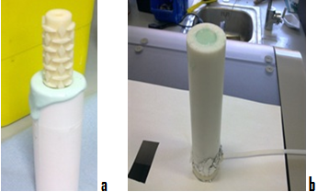
Figure 3.39: (a) Reverse-Auxetic tubular die being pushed inside a TEFLON tube, and (b) silicone elastomer casted onto a tubular die inside the TEFLON tube.

Subsequently, the silicone was completely cured and the aluminium foil was removed. The reverse-Auxetic tubular die was pushed out from one side of the TEFLON tube carefully. The Auxetic stent casted onto a tubular die was then carefully removed, and the material still intact within the hollow diamond-shaped areas of an Auxetic stent was taken away by tweezers (in Figure 3.40(b)). The outer diameter of the Auxetic stent was 13mm and the wall thickness was 2mm.

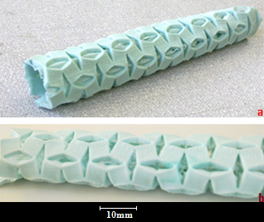
Figure 3.40: (a) Auxetic stent removed from the tubular die with some material intact within the diamond-shaped areas, and (b) material removed by the tweezers.
After experiencing few challenges in casting silicone on a tubular die (above). It was anticipated that the process requires improvement, therefore, it was decided to have a collapsible tubular die and a design was made by using the INVENTOR Mechanical software. The collapsible tubular die was designed in two halves having the same reverse-Auxetic pattern of protruding diamond-shaped bits and recessed rotating-square parts at the luminal side of the collapsible tubular die. The length of the collapsible tubular die was 130mm; the outer diameter was 14mm with 1mm wall thickness. The depth of the recessed rotating-squares units was 1mm; therefore, the inner diameter of the collapsible tubular die was 10mm. The design file was saved as an STL file format and exported to the STRATASYS FDM 360mc machine for part production by using thermoplastic acrylonitrile-butadiene-styrene (ABS) material (in Figure 3.41).

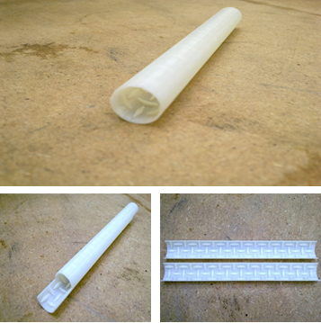
Figure 3.41: The two halves of the collapsible tubular die made of ABS plastic by FDM process.

A solid TEFLON rod having 10mm outer diameter was used for casting purpose (in Figure 3.42(a)), since the inner luminal diameter of the collapsible tubular rod was also 10mm. The method of casting polymer inside the collapsible tubular die involved, joining of the two halves of the collapsible tubular die around the TEFLON rod by the help of plastic rings for closing them tightly around the TEFLON rod. The TEFLON rod was tightly enclosed inside the two halves of the collapsible tubular die and fixed vertically on an aluminium alloy support. A funnel was then fixed on top of the collapsible tubular die, for transferring polymer material into the collapsible tubular die as shown in Figure 3.42(b).

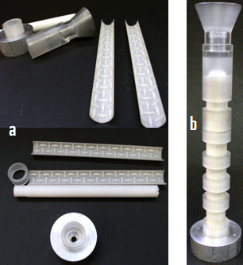
Figure 3.42: (a) Components of the collapsible tubular die, and (b) Collapsible tubular die with funnel on top.

Silicone elastomer material which was prepared in the previous experiment (as mentioned earlier in Section 3.4.1.1) for casting and the silicone paste was obtained by stirring well the two part silicone mixture for few minutes. The silicone paste was then poured into the funnel placed at the top of the collapsible tubular die (Figure 3.43(a)). As paste was viscous therefore constant stirring by the help of pressurized air was done inside the funnel to push the paste into the tubular die area (in Figure 3.43(b)). It was also confirmed that the inner luminal area of the collapsible tubular die was properly filled with the material throughout its length, by checking the flow of the material from the hole left deliberately at the bottom of the aluminium alloy support.

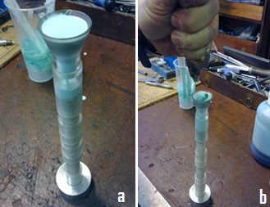
Figure 3.43: (a) Funnel is filled with silicone material, and (b) paste is being pushed into the tubular die by constant stirring.

Once it was also confirmed visibly that the material has reached the bottom of the tubular die, the collapsible tubular die was left for curing for almost 12 hours. The residual material inside the funnel was examined after curing and the funnel was carefully removed. All the plastic rings were also removed carefully from the tubular die, and the two halves of the collapsible tubular die were opened and carefully released from each other, which actually uncovered the residual Auxetic stent mounted on a TEFLON rod. Finally the TEFLON rod was also taken out from the luminal side of the Auxetic stent (in Figure 3.44).

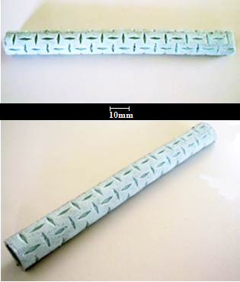
Figure 3.44: Auxetic oesophageal silicone stent (seamless).

The latter method used for the fabrication of Auxetic (flexible) silicone stent found to be a relatively simple and effective technique. Therefore, for the development of Auxetic polyurethane (semi-rigid) stent, the same collapsible tubular die was fabricated by the previously used Electron Beam Melting (EBM) process. The EBM process used titanium (Ti6Al4V) alloy powder for the fabrication of the two halves of the collapsible tubular die (in Figure 3.45(a)). The main point of using titanium collapsible tubular die was, to avoid adhesion of the casted polyurethane with the tubular die material. The components of the collapsible tubular die such as rings, funnel, rod, and a support were then built from stainless steel material (Figure 3.45(b)).
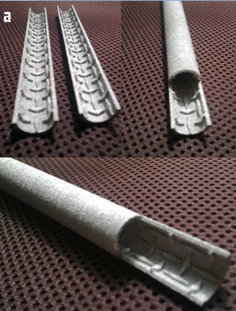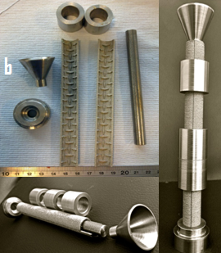
Figure 3.45: (a) Two halves of the titanium collapsible tubular die made by EBM process and (b) the components of the collapsible tubular die made of stainless steel alloy.

The same two part semi-rigid SmoothCast-60D polyurethane resin was used for casting into the metal collapsible tubular die. Consequently, the prior method was repeated which involved, degassing of the polyurethane material, coating of the collapsible tubular die with CilRelease 1812E silicone based mould release agent, and finally dispensing the polyurethane into the funnel located at the top of the tubular die following by the continuous stirring to push the material into the tubular die cavity. When the collapsible tubular die was completely filled with the polyurethane material throughout its length, it was left for curing for about 2 hours. When the polyurethane was fully cured, it was found very difficult to open the collapsible tubular die and to remove the Auxetic stent out of it, mainly because of the reason that the casted polyurethane was very stiff and was not providing any flexibility to open the two halves of the tubular die. Consequently, the Auxetic polyurethane stent when removed from the titanium collapsible tubular die was ruptured at a number of places as shown in Figure 3.46.
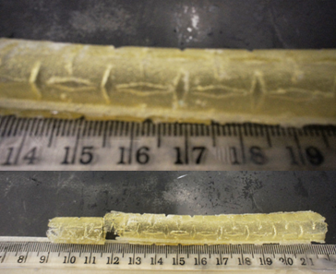
Figure 3.46: Auxetic polyurethane stent is cracked after being released from the collapsible tubular die.

3.4.1.2 Vacuum casting
A new technology known as vacuum casting for producing functional plastic prototypes within a few hours was also investigated to develop seamless Auxetic stent. Vacuum casting process was outsourced to Laserlines Ltd. Company (where I personally paid a visit and collected all the manufacturing data). The company used MK Technology basic model SYSTEM-1, which is perfectly dimensioned for classical prototype production. The advantage of this system is that the door is made of armoured glass allowing an unlimited view inside the whole chamber. All the cups and funnels used in this system are transparent and re-usable. This system comes with a very smart mould lift which helps to adapt the position of the mould exactly to the funnel as shown in Figure 3.47.

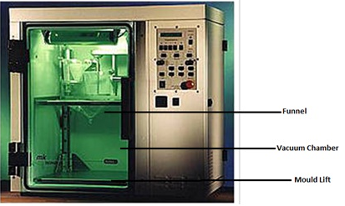
Figure 3.47: MK Technology basic model SYSTEM-1.

A pre-requisite for vacuum casting with the desired polymer material, is a perfect Master model which can be made conventionally or by one of the new generative techniques like stereo-lithography, fused deposition modelling (FDM) or layer laminate manufacturing (LLM). While developing Master model every detail of the actual part should be considered by incorporating every detail into the Master model for instance every scratch, every pore or pattern, and even a finger print, so that the Master model can be duplicated with a desired material by the help of vacuum casting process. The surface of the Master model must be perfect to specifications and free from defects.

A Master model replica of an Auxetic oesophageal stent was developed by using Autodesk INVENTOR software. The 3D design of the Master model had 13mm outer diameter and 120mm length, and was then exported to the FDM INSIGHT software for part production. The part was produced by FDM rapid-prototyping process using acrylonitrile-butadiene-styrene (ABS) material (Figure 3.48).

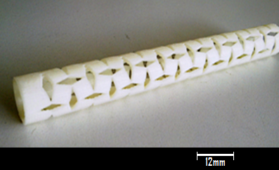
Figure 3.48: Master model (Auxetic stent) made of ABS plastic by FDM process.

In the first step, the mould making process was prepared by determining the required contours and separation lines. For the preparation of the mould, a casting frame is required and was made quickly and inexpensively from Melamine coated chip boards glued together using glue. In the second step, the gates and risers were adjusted and the casting frame must be big enough to allow an all-around covering of the Master model with the silicone layer of at least 2 to 3 cm. Subsequently, the prepared Master model with gates and risers was suspended inside the casting frame, and the solid metal rod of the same dimensions was inserted inside the Master model. The necessary amount of silicone which had been calculated from the mould volume was weighed in a plastic container and 10% hardener was added.

When the silicone and hardener were mixed together for 2 minutes, the mixing time was recorded, as this was the time when the Pot Life of 90 minutes began. For the preparation of mould, the silicone must be completely degassed because the remaining gas particles with in the mould extend under vacuum and that effect the dimensional stability of the cast. For this reason, the liquid silicone was first pre-degassed inside the vacuum chamber. The subsequent evacuating and flooding of the silicone was carried out automatically by the vacuum chamber.

The silicone was carefully poured into the casting frame from one side after degassing. Once the casting frame was completely filled and the Master model was covered by a layer of atleast 2cm of silicone, the casting frame was placed inside the vacuum chamber for the second degassing of the silicone. Generally at room temperature, the silicone becomes hard within 12 to 15 hours; hence, oven was used to temper the silicone setting process at approximately 80ºC which reduced this time to 2 hours. When silicone was hardened, the casting frame was removed from the oven, and the compressed air was blown inside the mould through the gate to remove the Master model evenly from the mould without the metal rod i.e. by leaving inside the metal rod within the casting cavity of the silicone mould.

Subsequently, the mould was then ready for casting polyurethane material. The rigid PX 212 two part polyurethane resin (acquired from Axson UK Ltd.) of 76 shore D hardness was used for part production. Initially, the polyurethane casting resin was pre-degassed for about half an hour. The mould was then placed inside the vacuum chamber on the mould lift, and the polyurethane pre-degassed mixture was poured into the mould through funnel. The chamber was completely evacuated and the mould was taken out of the chamber, and for the quick hardening of the resin the mould was heated at 65 to 70º Celsius for 2 hours. The casted polyurethane within the mould was then taken out of the oven and left for further curing at room temperature for 15 minutes as shown in Figure 3.49.
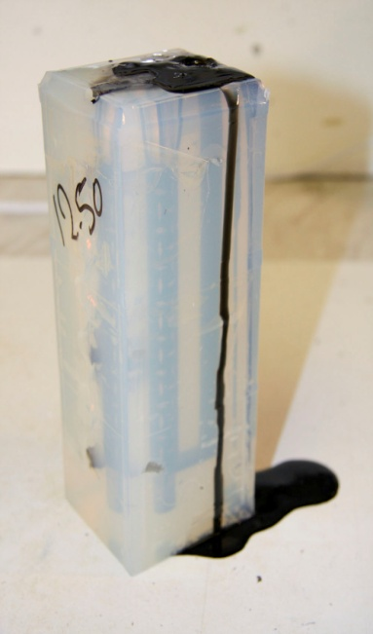
Figure 3.49: Polyurethane casted into a silicone mould and left for hardening at room temperature.

Once the casted polyurethane was completely hardened inside the mould (Figure 3.50(a)), again scalpel and pressurised air were used for effective parting of the mould. The mould was then slightly opened from the side, and the casted polyurethane tube with a metal rod was taken out manually by using pliers as illustrated in Figure 3.50(b).

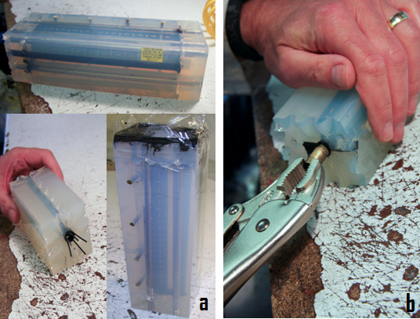
Figure 3.50: (a) Auxetic polyurethane stent suspended with gates and risers inside the silicone mould, and (b) the Auxetic stent and metal rod are being extracted.

The Auxetic stent was finally separated from the metal rod by simply sliding the rod outside (in Figure 3.51(a)). The rigid Auxetic stent was 130mm in length, the outer diameter was 13mm, and the wall thickness was 1mm as shown in Figure 3.51(b).

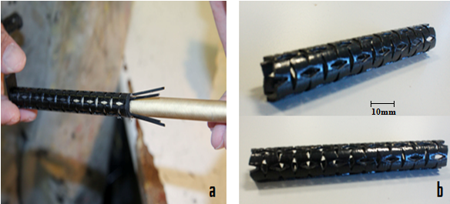
Figure 3.51: (a) metal rod is being separated from the Auxetic stent, and (b) rigid Auxetic Polyurethane stent.

The same vacuum casting process was repeated by using a Master model of different dimensions, i.e. the outer diameter was 10mm, the length was 120mm, and the wall thickness was 0.5mm. The VC-3300 three part polyurethane resin of 95 shore A hardness was used for casting into a silicone mould. Consequently, a semi-flexible Auxetic stent was fabricated which was replicated exactly by the Master model without any defects (Figure 3.52).

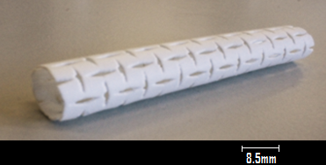
Figure 3.52: Semi-flexible Auxetic polyurethane stent.

3.4.2 Seamed fabrication
The Auxetic seamed stents were also prepared by configuring the previously made Auxetic polymeric films into tubular shape. In order to obtain such configuration, initially the lasercut Auxetic polypropylene film of 1mm thickness was selected, and was wrapped around a wooden rod of 16mm diameter. The wooden rod with wrapped Auxetic polypropylene film was subsequently clamped evenly as shown in Figure 3.53(a), and the adjustable temperature controlled soldering iron was used to weld the ends of the Auxetic polypropylene film (in Figure 3.53(b)). The temperature of the iron was set at 170ºC by keeping in view the melting temperature of polypropylene i.e. 160ºC.

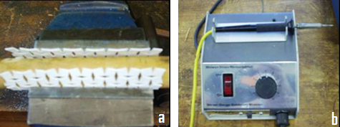
Figure 3.53: (a) Auxetic polypropylene film wrapped around a wooden rod, and (b) adjustable temperature iron was used for welding.

The two ends of the Auxetic film had squares with two vertices. Therefore, the welding of the two ends of the film was carried out in such a manner that the two vertices of each square located at one side of the Auxetic film were joined symmetrically and accurately with the two vertices of the neighbouring square located at the other end of the film (in Figure 3.54(a)). This welding method was actually created hinges between the two adjacent squares located in both ends of the wrapped film.

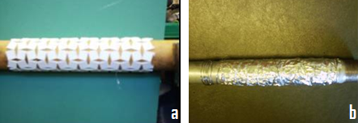
Figure 3.54: (a) The two ends of the Auxetic film were welded together, and (b) Auxetic stent mounted on a metal rod and covered with an aluminium foil for heat treatment.

Finally, annealing of the Auxetic stent was performed to ease up or remove any internal stresses induced by the welding process. Consequently, the Auxetic stent was mounted on a metal rod and covered with aluminium foil to avoid any damages on the surface of the stent as shown in Figure 3.54(b). The Auxetic stent mounted on a metal rod was then placed in an oven, which gradually elevated the temperature from room temperature to 70ºC and came back to room temperature in 17 hours. Subsequently, the seamed Auxetic stent was made which was 120mm long and the outer diameter was 18mm (Figure 3.55).

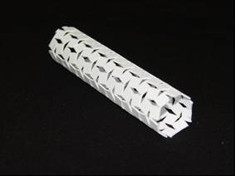
Figure 3.55: Seamed Auxetic polypropylene stent.

The same above welding method was further explored to configure the previously developed Auxetic silicone film into an Auxetic silicone stent, by wrapping the Auxetic silicone film on a wooden rod and welding the two ends of the film symmetrically (Figure 3.56).

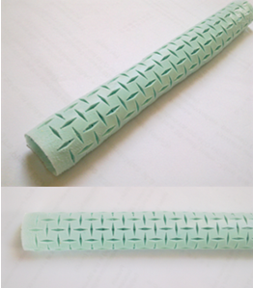
Figure 3.56: Seamed Auxetic silicone stent.

3.5 Fabrication of Auxetic stent-graft
The Auxetic oesophageal stent-graft was developed by adding a flexible tube into the previously developed rigid and semi-rigid Auxetic stents. The underlying mechanism was to integrate a flexible polyurethane tube into both rigid and semi-rigid seamless Auxetic polyurethane stents. Therefore, flexible polyurethane films were acquired from Smith & Nephew UK Ltd., which were 200µm thick. The Auxetic stents used were the same earlier stents which were fabricated by the vacuum casting technique (in the above Section 3.4.1.2).

In the beginning, flexible polyurethane graft was developed by clamping a metal rod of 9mm outer diameter horizontally (in Figure 3.57(a)), and wrapping up tightly the flexible polyurethane film around the metal rod. Subsequently, both ends of the polyurethane film were joined together by applying a localised heat from the adjustable temperature soldering iron. The temperature of the soldering iron was set at 120ºC to soften the polyurethane material without melting it and to achieve effective fusion of the film ends (in Figure 3.57(c)).

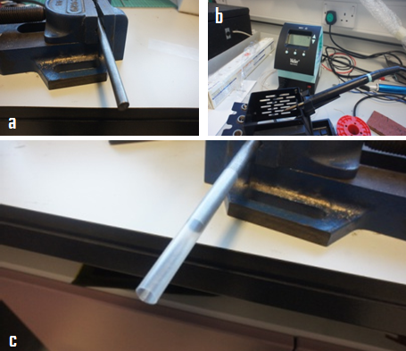
Figure 3.57: (a) Metal rod clamped horizontally, (b) adjustable temperature Soldering iron station, and (c) flexible polyurethane graft is being welded.

As a result, a flexible polyurethane tube was made which was later inserted into an Auxetic stent. Subsequently, a metal rod was taken away and a rigid Auxetic stent was clamped horizontally in such a fashion that a flexible polyurethane tube was inserted into the Auxetic stent smoothly (Figure 3.58(b)).

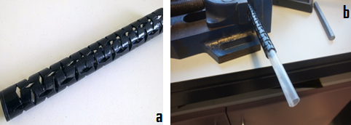
Figure 3.58: (a) Auxetic stent without a graft, and (b) insertion of flexible polyurethane graft into an Auxetic oesophageal stent.

Finally, soldering iron was introduced into the Auxetic stent-graft lumen for effective softening and fusion of the two materials, and the temperature of the iron was set at 120ºC (in Figure 3.59).

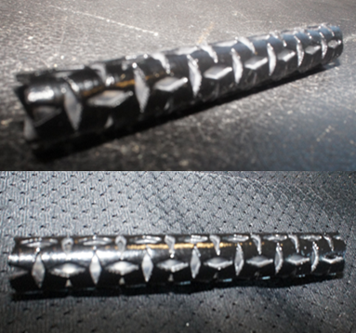
Figure 3.59: Auxetic polyurethane stent-graft.

The previous (above) technique of incorporating a flexible polyurethane graft into an Auxetic stent was subsequently repeated by using the previously developed semi-flexible Auxetic stent (seamless) by vacuum casting process (in Figure 3.60).

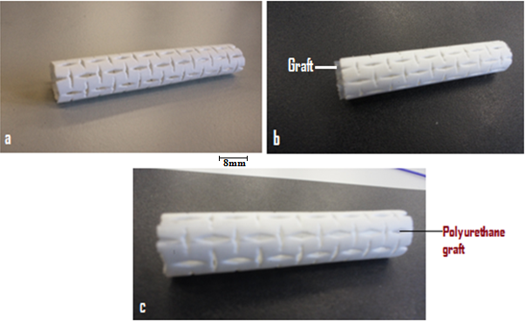
Figure 3.60: (a) Semi-flexible (seamless) Auxetic stent, (b) a flexible polyurethane graft is being inserted into an Auxetic stent by subsequent localised heat fusion of the two materials, and (c) Auxetic polyurethane Stent-graft.

3.6 Topographical characterisation
The topographical characterisation of the Auxetic (rotating-squares) geometry fabricated by different manufacturing techniques was carried out by using Scanning Electron Microscopy (SEM). Single unit-cells (comprising of four rotating-squares) were obtained from the previously made Auxetic films and Auxetic stents, and were used for SEM. Initially, Auxetic unit cells were taken from each fabrication method, and then the single unit-cells were fixed on a circular metal stub for subsequent sputter coating (in Figure 3.61(a)). Sample preparation for SEM analysis warranted conductive properties. To achieve this, all specimens were gold coated by using Emscope SC500 sputter coater in 0.05 Torr vacuum. The coating process of each sample was spanned around 3 minutes at 15mA (in Figure 3.61(b)). Finally, the SEM images were taken at 40 and 80 times magnification using a secondary electron at 1500kV, and these were used to monitor and evaluate production quality of the Auxetic (rotating-squares) geometry from different fabrication techniques.

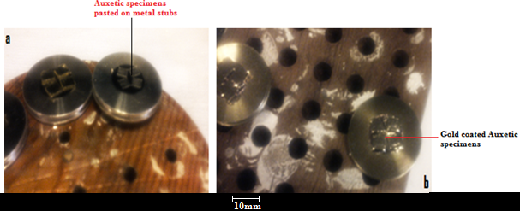
Figure 3.61: (a) Auxetic unit-cells fixed on metal stubs for SEM, and (b) gold coated SEM samples.

3.7 Mechanical characterisation

3.7.1 Tensile testing
Tensile testing of the already developed Auxetic films was performed to characterise their mechanical properties. Initially, a preliminary test was conducted using Auxetic polypropylene films, just to validate the Auxeticity in the films and to observe their elastic-plastic deformation behaviour. Tensile testing of the Auxetic polyurethane films was then carried out to determine their elastoplastic behaviour and mechanical properties, and the mechanical data collected from this test was further used for finite element analysis.

3.7.1.1 Preliminary test
The Auxetic polypropylene films developed above in Section 3.3.1 were employed in the preliminary test. This test involved tensile testing of the Auxetic polypropylene films to determine the axial and transverse strain values under uniaxial tension for the estimation of Poisson’s ratio, and to measure the extension in axial direction with corresponding values of applied load to analyse the elastoplastic deformation behaviour. Initially, the 0.5mm thick Auxetic polypropylene samples were prepared by cutting the A4 size polypropylene film 100mm wide and 20cm long. Mild (low carbon) steel strips 100mm long and 25mm wide were made, and prepared for the adhesive by abrading the surface of the mild steel strips using abrasive paper, so as to achieve a good surface interface with polypropylene film. Then the adhesive was applied on the mild steel strips, and the proximal and distal ends of the polypropylene films (100mm in length, and 25mm wide) were enclosed within the two mild steel strips. Both of the enclosed ends of the polypropylene film were clamped for half an hour to obtain good adhesion of the mild steel strips (in Figure 3.62).

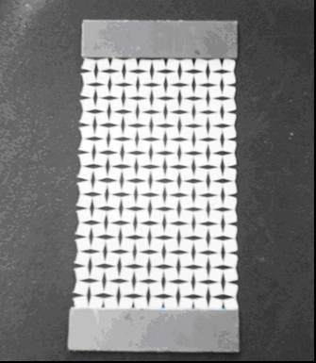
Figure 3.62: Auxetic polypropylene sample ready for tensile testing.

The Instron tensile test equipment was first calibrated and then the Auxetic polypropylene sample was mounted within the grips of the machine. Digital Linear Variable differential Transformer (LVDT) extensometer was also installed to measure the longitudinal extension of the sample (in Figure 3.63). Initially, original length and width of the sample was calculated, and different uniaxial tensile loads were applied. Subsequently, the deformed length and width values were recorded to calculate the Poisson’s ratio. In order to determine the extension and applied load values for the evaluation of elastoplastic deformation of the Auxetic sample, a small tensile load of 500g was applied repeatedly at 5mm/min crosshead speed to the Auxetic sample and the data was recorded. The load was then applied to another Auxetic sample at 5mm/min crosshead speed till the point of its failure, and the stress-strain data was gathered.

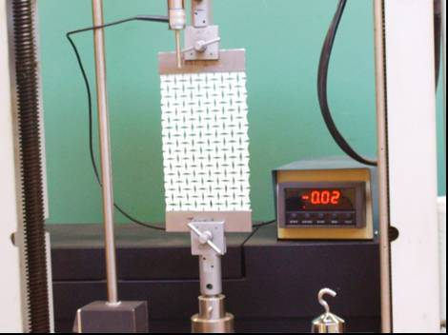
Figure 3.63: Tensile testing of Auxetic polypropylene sample.

3.7.1.2 Tensile testing of the Auxetic polyurethane films
The tensile testing was carried out using the Auxetic polyurethane films developed earlier by lasercutting process (in the above Section 3.3.2). The rigid Auxetic polyurethane films were made out of commercial films (Pellethane) supplied by the Smith & Nephew UK Ltd. First of all, the A4 size polyurethane film was used for preparing the polyurethane strips according to the ISO 527-3 standard, in order to get baseline tensile data of the polyurethane material. Therefore, three non-Auxetic polyurethane specimens were prepared by carefully cutting the A4 size polyurethane film 100mm long and 20mm wide. The steel strips of 25mm length and 20mm width were prepared for the adhesive by abrading the surface of the steel strips to achieve good adhesion with polyurethane specimens. The adhesive was applied on the steel strips, and the two sides of the polyurethane specimen were then enclosed within the two steel strips placed parallel to each other on either sides of the polyurethane specimen. The polyurethane specimen having metal strips on both sides were prepared to get a good grip with the tensile testing machine (in Figure 3.64). Therefore, the gauge length, thickness, and width of the polyurethane specimens were 50mm, 0.5mm, and 20mm respectively. Similarly, three Auxetic polyurethane specimens were prepared by carefully cutting the Auxetic film 80mm long and 31.5mm wide. The T-shaped steel plates were made and subsequently attached to the both sides of the Auxetic polyurethane specimen for enhancing the grip between testing machine and specimen. Therefore, the gauge length, thickness, and width of the Auxetic polyurethane specimens were 50mm, 0.5mm, and 31.5mm respectively.

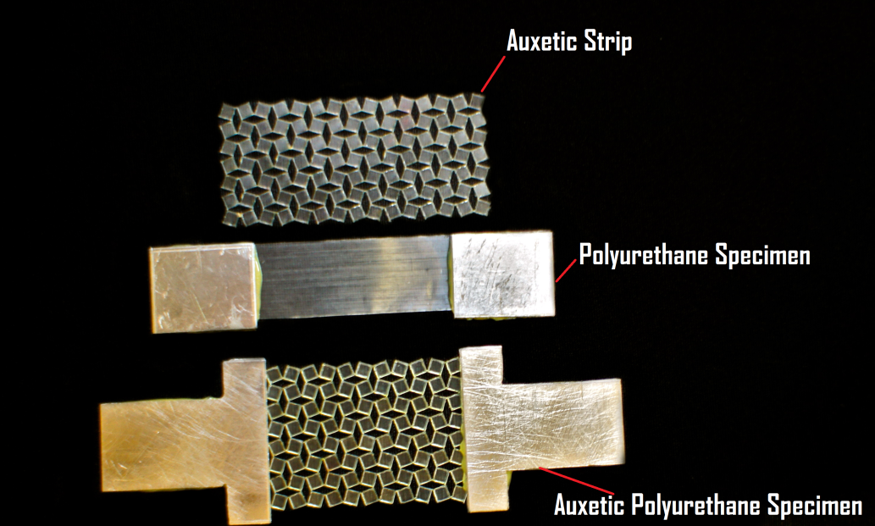
Figure 3.64: Polyurethane and Auxetic polyurethane specimens prepared for testing.

Lloyds Instruments TA500 tensile tester with 500N load cell was used for this study. The equipment was initially calibrated and the polyurethane specimen was mounted tightly between the threaded grips of the tester. The polyurethane specimen was subjected to uniaxial tensile load at 5mm/min crosshead speed till the point of failure (in Figure 3.65(a)). The same test was repeated twice and the mean of the baseline stress-strain data was taken and the acquired True stress and Plastic strain values were used as a prescribed elastic-plastic material data for FEA model. After getting the baseline data, the Auxetic polyurethane specimen was subjected to uniaxial tensile load at 5mm/min cross head speed till the point of its failure (in Figure 3.65(b)). This test was carried out by applying uniaxial tensile load manually to the Auxetic polyurethane specimen in such a fashion that the longitudinal and transverse extensions of the specimen were measured at every load increment till the point of its failure. The longitudinal and transverse extension values of the Auxetic specimens obtained at different loads were used to determine their elastic-plastic deformation behaviour and Poisson’s ratio (v). Another Auxetic polyurethane sample was then subsequently subjected to uniaxial tensile loads at 5mm/min cross head speed till the point of its failure, and the longitudinal extension of the specimen was measured and stress-strain graph was acquired automatically by the tensile tester at different load values.

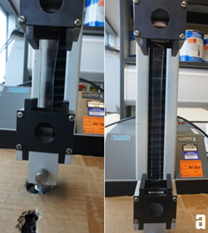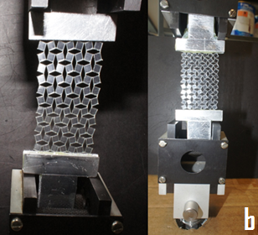
Figure 3.65: (a) Polyurethane specimen is being subjected to tensile loading, and (b) uniaxial tensile load is applied to the Auxetic polyurethane specimen.

3.7.2 Stent expansion test
It was envisaged, that the deployment of the Auxetic oesophageal stent-graft will be without a dedicated delivery system. This will be administered orally into the oesophagus using a small diameter Auxetic stent-graft with a balloon dilatational catheter. The balloon dilatational catheter has already been in use for the pre-dilation of the oesophageal lumen and for the post-dilation of the commercial oesophageal stents. Therefore, the expansion test was conducted which involved expansion of the Auxetic stents and stent-grafts using different sized commercial balloon dilatational catheters. The previously developed semi-rigid and rigid Auxetic stents, made by vacuum casting process (as described in earlier Section 3.4.1.2) and Auxetic stent-grafts (in previous Section 3.5), were employed in the expansion test as shown in Figure 3.66.
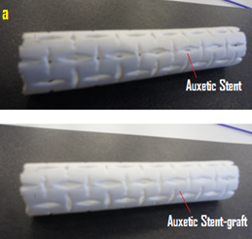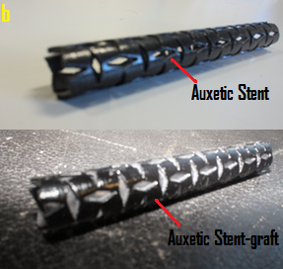
Figure 3.66: (a) Semi-flexible Auxetic stent and stent-graft, and (b) rigid Auxetic stent and stent-graft.

In Test-I, a semi-rigid Auxetic stent; 50mm length, 10mm outer diameter and 0.5mm wall thickness, was investigated using MEDFLATOR-II inflation device (Smiths Medical Deutschland GmbH) and CRE wireguided balloon dilatational catheter (18mm, 19mm and 20mm diametrical range) of 55mm balloon length (supplied by Boston Scientific UK). Initially, the Auxetic stent was mounted on the balloon catheter in such a way that the stent was placed in the middle of the balloon. The inflation device with a built-in manometer was filled with water and was subsequently connected to the balloon catheter. A slight pressure of 0.2bar was initially applied, so that the balloon would hold the stent tightly in place (in Figure 3.67(b)). The test was then initiated by the application of small pressure increments from the inflation device. Subsequently, the radial pressures were randomly increased, and both the axial length and the diameter of the stent were recorded at every pressure increment, till the point of stent failure.

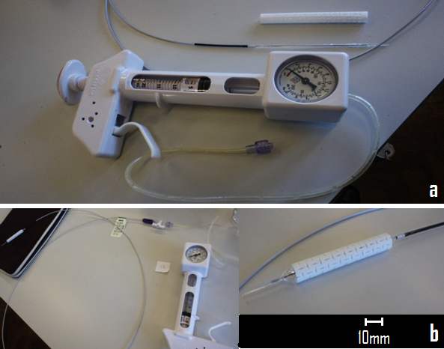
Figure 3.67: (a) Auxetic stent with inflation device and catheter, and (b) balloon held the stent tightly in place by applying a small radial pressure.

In Test-II, the procedure was the same as Test-I; however, the specifications were modified as the semi-flexible Auxetic stent was mounted on a balloon catheter of different size (10mm, 11mm and 12mm diametrical range) having a balloon length of 80mm (supplied by Boston Scientific UK). The Auxetic stent was 68mm in length and the outer diameter was 10mm (in Figure 3.68). The radial pressures were applied in the same way and the changes in length and diameter of the stent were recorded at every pressure increments.
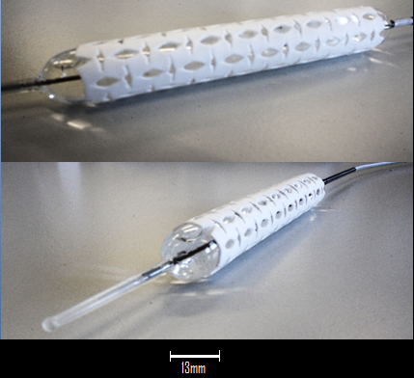
Figure 3.68: Semi-flexible Auxetic stent is being expanded by balloon.

The Test-III involved the same prior procedure, but the specifications were changed as the rigid Auxetic stent was mounted on a balloon catheter (18mm, 19mm and 20mm diametrical range) of 55mm length (provided by Boston Scientific UK). The rigid Auxetic stent used was 49mm long, outer diameter was 13mm and wall thickness was 1mm (in Figure 3.69). The expansive deformation of the stent upon every pressure increment was then recorded till the point of stent fracture.

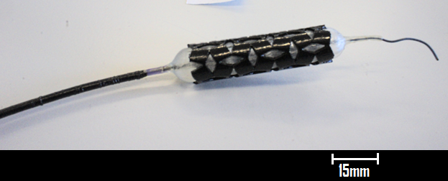
Figure 3.69: Rigid Auxetic stent mounted on a balloon catheter.

3.8 Finite element analysis

3.8.1 Single-square model
The Single-square FEA model was developed by using ABAQUS 6.10-1 (licensed to the University of Sheffield), to validate the acquired physical stress-strain (tensile) data and Poisson’s ratio values of the Auxetic polyurethane film. The FEA model involved the extraction of a square from the Auxetic (rotating-squares geometry) film (in Figure 3.70). A 3D shell plane-stress model of 500 microns thickness was created, containing the geometry of the Auxetic rotating-square. In the designing of the single-square part for the FEA model, great attention was given to each detail of a rotating square in the Auxetic film such as; the angle of a rotating square, size and slope of each slit located at each vertex of the rotating square from where it connects to the adjacent squares of the Auxetic film. The FEA model was also made proportionately since it was emulating a rotating square of the symmetrical Auxetic film.

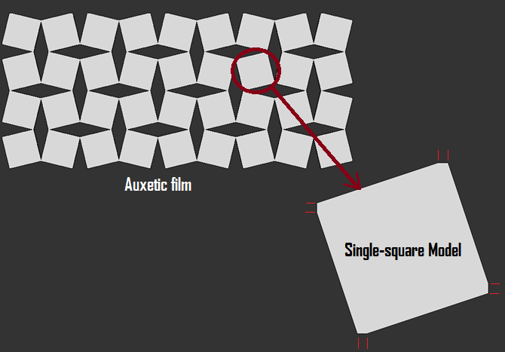
Figure 3.70: Single-square FEA model extracted from the Auxetic film.

Continuum (CPS8R) 8-node biquadratic plane-stress quadrilateral reduced integration elements were used to mesh the single-square part (Figure 3.71). The elastic-plastic material properties for the single-square model such as Elastic modulus, Poisson’s ratio, Yield stress values with relative Plastic strain values, were taken from the physical baseline tensile data of the Polyurethane film (as mentioned in earlier Section 3.7.1.2). Therefore, the polyurethane material having 194.3MPa Young’s Modulus and 0.3 Poisson’s ratio was assigned to the model.

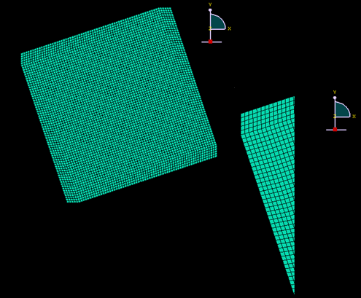
Figure 3.71: Single-square FEA model meshed by quadrilateral elements.

At each slit located at the four vertices of the single-square model, five elements were placed comprising of six nodes. Therefore, two nodesets were created at each slit or vertex of the single-square model. First nodeset was created by assigning one node as a reference node of that vertex, and the second nodeset was formed by joining the remaining five nodes of that vertex. Subsequently, the relative names were given to both nodesets at each vertex of the single-square model. The first nodesets were named as; REFERENCELEFT at the upper-left vertex, REFERENCEBOTTOM at the bottom vertex, REFERENCERIGHT at the lower-right vertex and REFERENCETOP at the upper-right vertex respectively. Similarly, the second nodesets from the upper-left, bottom, lower-right and upper-right vertices of the square were named as LEFT, BOTTOM, RIGHT and TOP respectively (Figure 3.72).
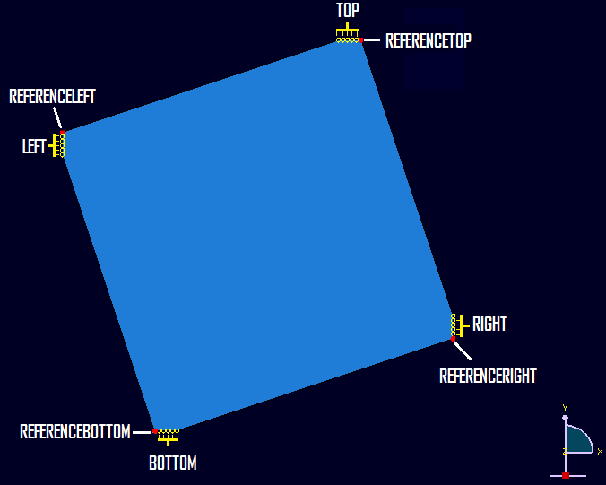
Figure 3.72: Two nodesets were created at each vertex of the single-square model.

The EQUATIONS (multiple-point constraint) were used to connect reference nodesets of each vertex to their neighbouring nodesets in the same vertex. Consequently, REFERENCELEFT nodeset was connected to LEFT nodeset, REFERENCEBOTTOM nodeset was joined with the BOTTOM nodeset, REFERENCERIGHT was connected to RIGHT, and REFERENCETOP was linked up with the TOP nodeset. Then the reference nodesets of all the vertices of the single-square model started controlling the mechanical motion of their neighbouring nodesets, which means that they started controlling the motion of their respective vertices. The symmetry boundary conditions were applied only on the reference nodesets of each vertex of the single-square model. Therefore, the XSYMM (symmetry constraint along x-axis) boundary condition was applied on the REFERENCELEFT nodeset, YSYMM (symmetry constraint along y-axis) was applied on the REFERENCEBOTTOM nodeset, and displacement (U1) in millimetres along x-axis was applied on the REFERENCERIGHT nodeset as illustrated in Figure 3.73.
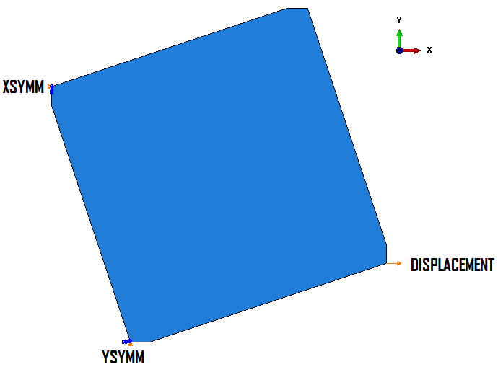
Figure 3.73: Boundary conditions applied on the single-square model.

The mesh convergence test was performed to ensure the accuracy of the finite element model. The convergence test was carried out using different number of elements (mesh densities) or seed sizes. Different reaction force values at REFERENCERIGHT nodeset were acquired by keeping the value of applied displacement at REFERENCERIGHT nodeset constant i.e. 0.1mm. The reaction force values were converged at 4624 number of elements (i.e. 0.05 seed size) and the total CPU time utilised was 90secs.

Consequently, a number of displacement values along x-axis, starting from 0.1mm to 6.5mm, were applied in small increments to the REFERENCERIGHT nodeset. This lead to the rotation of the single-square model which was relative to the applied displacement values. Then the reaction force values at REFERENCERIGHT nodeset and the displacement values along y-axis at REFERENCETOP nodeset were recorded. The reaction force values (along x-axis) at the REFERENCELEFT and REFERENCERIGHT nodesets were the same, and there was zero reaction force value at REFERENCEBOTTOM and REFERENCETOP nodesets (along both x and y axes).
It was noticed that the single-square model was behaving as a mechanical spring. However, single-square model was considered as a mechanical spring in order to calculate the force and displacement values of the Auxetic film having number of rotating-squares in both x and y axes. The following formula (in Eq.1) which was derived from the Hooke’s law, was used to convert the reaction force values of the single-square to the force values of the Auxetic film comprising of number of squares in x and y axes. The number of squares in x and y axes of the Auxetic film, were selected from the gauge length and width of the Auxetic polyurethane film specimen which was physically tensile tested (in earlier Section 3.7.1.2).

$$F=KX$$

Here ‘X’ is the applied displacement along x-axis to the REFERENCERIGHT nodeset, and ‘RF’ is the reaction force acquired from the same nodeset.

$$K=\frac{RF}{X}$$

And M_{x} = number of squares in longitudinal direction (x-axis)
N_{y} = number of squares in transverse direction (y-axis)

Therefore, total force of the Auxetic film was derived from the following expression,

${ F}_{T}=\left(K × \frac{N_{y}}{M_{x} }\right) × \left(X × M_{x}\right)$ Eq.1

Finally, both physical test data and the FEA data derived from the single-square model of the Auxetic polyurethane film were compared at different longitudinal and transverse extension values, and the percentage error was also calculated. The Poisson’s ratios of both physical Auxetic polyurethane film and Auxetic finite element film model, were eventually calculated and compared at a range of extension values along x and y axes.
3.8.2 Auxetic-ring model
The physical rigid Auxetic oesophageal stent was simulated by creating an Auxetic-ring FEA model. The FEA model was structurally the same as the physical polyurethane stent, however, it varied in dimensions as the length of the FEA model comprised of only one unitcell (having four rotating-squares). The outer diameter and wall thickness of the FEA model was same as the physical rigid stent i.e. 13mm and 1mm respectively. The model comprised of only one Auxetic ring in length (in Figure 3.74(b)), since only diametrical changes had to be observed upon various radial displacements.

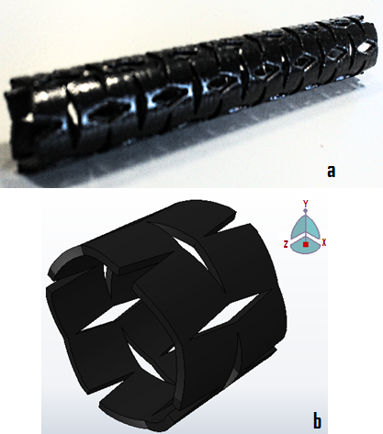
Figure 3.74: (a) Rigid Auxetic polyurethane stent, and (b) rigid Auxetic-ring FEA model.

The other difference between the Auxetic-ring model and the physical oesophageal stent was the polyurethane material. Since, the physical Auxetic stent was made of rigid polyurethane material (PX-212) of 75 shore D hardness. Hence, a different rigid polyurethane material (Pellethane) of 75 shore D hardness was assigned to the FEA model, which was previously tested physically in the Baseline tensile test (in earlier Section 3.7.1.2). The elastic-plastic material properties were taken from the Baseline tensile data of the polyurethane, and material properties i.e. 194.3MPa Young’s modulus and 0.3 Poisson’s ratio were assigned to the FEA model. Four-node tetrahedral elements were used to mesh the model (Figure 3.75), and the total number of elements was 20800 using a total CPU time of 9 minutes.

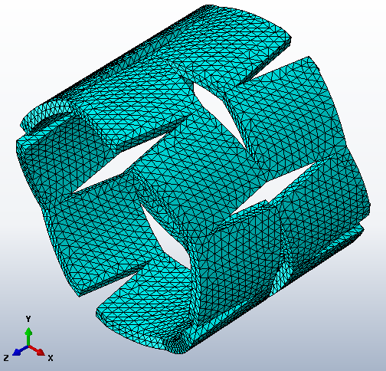
Figure 3.75: Auxetic-ring model meshed with tetrahedral elements.

The Z-SYMM (symmetry constraint along z-axis) boundary condition was applied on the proximal end of the Auxetic-ring model, and the distal end of the model was free to move only in the x and y axes. A range of outward radial displacement values (in millimetres) were applied on the lumen of the Auxetic-ring model. The radial reaction force values were calculated at different radial displacement values applied to the model from the luminal side. The obtained radial reaction force values were then divided by the area of the Auxetic-ring model so as to get radial pressure values. Finally, the calculated radial pressure values at different applied radial displacement values of the model were then tabulated and compared with the data gathered from the physical stent expansion Test-III (in previous Section 3.7.2). Additionally, the stress concentrated areas and weak structures within the radially deformed Auxetic–ring model were identified.

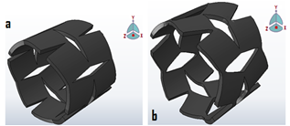
Figure 3.76: (a) un-deformed Auxetic ring FEA model, and (b) deformed at 1mm outward radial displacement.

Chapter 4 RESULTS AND DISCUSSION

The oesophagus is an expandable normally closed muscular tube which has two major functions, that is transport of the food bolus from mouth to stomach and the prevention of retrograde flow of gastrointestinal contents. Oesophageal cancer is the ninth most common malignancy worldwide, and it ranks as the sixth frequent cause of death in the world (Lam 2000). It has a poor prognosis and the diagnosis is made in many cases only in advanced stage owing to the asymptomatic nature of the early disease (McCabe and Dlamini 2005). Among many symptoms in the vast majority of patients suffering from oesophageal cancer, dysphagia is the most crucial symptom. Dysphagia is the inability to swallow food or liquid bolus through the oesophagus to the stomach. Dysphagia does not take place until the oesophageal lumen is significantly compromised, and this indicates the presence of relatively large and aggressive tumour. Oesophageal stents have been in use as a relatively better palliative method for the patients suffering from advanced stage tumour and also for the effective relief of dysphagia (Pennathur, Chang et al. 2008). There are still problems in currently available self-expanding metals and plastic stents, which are associated with high rates of early and late complications. The major early complications reported in oesophageal stents are migration, perforation, and haemorrhage and are noticed in up to 6%, 7% and 6% patients respectively. Whereas long term oesophageal stenting is associated with high rates of bleeding, tumour overgrowth, migration, fistula formation and bolus impaction, and these rates are reported as 19%, 36%, 33%, 5% and 23% respectively (Schoppmann, Langer et al. 2012).

This research work aimed to use Auxetic (rotating-squares) geometry which was theoretically predicted and analysed by (Grima and Evans 2000), for the production of Auxetic oesophageal stents and stent-grafts relevant to the palliative treatment of squamous cell carcinomas of the proximal and mid oesophagus and also for the prevention of dysphagia. This study also endeavoured to manufacture a significantly small diameter Auxetic oesophageal stent and stent-graft. In order to easily deploy the Auxetic stent orally using a commercial balloon dilatational catheter, and hence it also obviates the need of an expensive dedicated delivery system as illustrated below in Figure 4.1.

Polyurethane was selected as a material for the fabrication of Auxetic films and Auxetic oesophageal stents, and a number of manufacturing techniques were explored for the production of both Auxetic films and seamless Auxetic stents. The developed Auxetic films were later used for the fabrication of seamed Auxetic oesophageal stents. The flexible polyurethane tubular grafts were also attached to the inner luminal side of the seamless Auxetic polyurethane stents. The Auxetic films were subjected to tensile testing in order to estimate their longitudinal and transverse extensions, to evaluate their mechanical behaviour and to determine their physical properties.
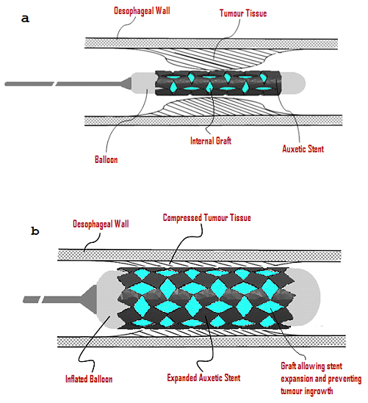
Figure 4.1: Schematic showing Auxetic stent deployment in oesophagus, (a) unexpanded Auxetic stent insertion into constricted oesophageal lumen and (b) expanded Auxetic stent compressing the surrounding tumour tissue.

The stent expansion tests of the Auxetic oesophageal stents were carried out using balloon dilatational catheters, in order to analyse the longitudinal extension and radial expansion of the Auxetic oesophageal stent at a range of radial pressures applied from the balloon catheter. The elastic-plastic deformation and failure behaviour of the Auxetic oesophageal stent was also observed by this test. Finite element modelling of both Auxetic film and stent models was carried out in order to correlate and validate physical test results (from both tensile testing and stent expansion test) with modelling results.

4.1 Analysis of the manufacturing route
Manufacturing route employed in this study to develop both Auxetic films and Auxetic oesophageal stents, ranged from conventional subtractive techniques to new generative manufacturing methods. Polyurethane was used as a material due to its biocompatibility and non-toxicity response. Polyurethane is also a material of choice as its physicochemical properties can be easily tailored to suit the intended application (Tatai, Moore et al. 2007). Hence, in the following section the adopted manufacturing approach will be critically analysed, by appraising the efficacy of each method, the number of process steps involved, complexities (if any), the quality of the end product and the length of time involved.

4.2 Manufacturing of the Auxetic film
For the development of Auxetic film, a number of manufacturing techniques were tried in this study in order to identify the fabrication method which is simple, less time-consuming and offering good quality Auxetic film. The fabrication route for the development of Auxetic films is shown below in Figure 4.2.

Figure 4.2: The manufacturing route used for the production of Auxetic films.

4.2.1 Lasercutting
Initially, in order to check the possibility of introducing Auxetic (rotating-squares) geometry in a polymer film, the lasercutting technique was commercially explored using thermoplastic polypropylene films (as described earlier in Section 3.3.1). It was found that the lasercutting of polypropylene films was simple and a fast way of manufacturing Auxetic films. The cutting of the polypropylene film was the only process step involved in this technique after the 2D CAD design of the Auxetic (rotating-squares) pattern was fed into the equipment. The lasercutting of polypropylene was found to be very consistent in terms of cutting precision and quality, and it produced reproducible results. The Auxetic film produced by this method was good in quality without having melt-related problems (such as melting of the surrounding material or inadequate melting and removal of the material from the cut kerf) and the molten material was easily blown away from the cut kerf (in Figure 4.3).
A very small amount of material in microscale was located within the confines of the diamond-shaped parts of the Auxetic geometry, which was softened by the laser beam and was not effectively melted and blown out from the cut kerf. This softened microscopic polypropylene material densified near the hinges and edges of the solid squares. These hinges (located within the rotating squares) and borders of the squares were found to be the areas where the stress concentration was maximum under load conditions, and these regions were also believed to be more prone to failure (in the following Figure 4.28(c) and 4.49(a)). The densification of the weak areas within the Auxetic network added another key advantage to this fabrication technique. This preliminary novel work of introducing an Auxetic (rotating-squares) geometry into polypropylene films was recently published (Ali and Rehman 2011).

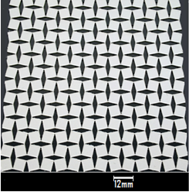
Figure 4.3: Lasercut Auxetic polypropylene film.

4.2.2 Lasercut Auxetic polyurethane films
The successful outcomes of the (above) preliminary study steered this research into further investigation of the lasercutting technique. Therefore, the Auxetic polyurethane films were produced by lasercutting method containing reasonably small unit cells. This was achieved by reducing the size of the squares and adding more squares with their corresponding hinges into the Auxetic polyurethane film (as it was described earlier in Section 3.3.2). The reason for preparing Auxetic polyurethane films with greater number of squares and hinges was to get optimum longitudinal and transverse expansion of the Auxetic film. Since it was established from finite element analysis and physical test results that Auxetic network having greater number of squares and hinges deformed more in x and y axes (as discussed in the following Sections 4.6.2 and 4.7) and this was also reported by (Attard, Manicaro et al. 2009) from their analytical model. It was observed that the cutting of A4 size (i.e. 210mm x 297mm) rigid polyurethane film took approximately 10 minutes, and the quality of the Auxetic polyurethane film was good (in Figure 4.4). Additionally, the edges of both solid squares and their corresponding hinges were found to be densified by lasercutting process, and white densified areas indicating increase in crystallinity. It is well established fact that thermal treatment of polyurethane, affects the hard segment of the polyurethane, which increases crystallinity, ultimately enhancing the Young’s modulus of polyurethane.

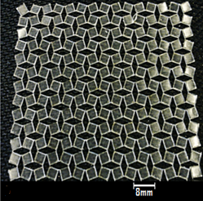
Figure 4.4: Lasercut Auxetic polyurethane film.

4.2.3 Die casting
A preliminary research was done on the production of Auxetic (rotating-squares) polymeric film using a novel fabrication technique. The study employed a new method which initially used silicone elastomer as a casting polymer on a reverse-Auxetic (having recessed rotating-squares and protruded diamond-shaped parts) mould. The aim of this initial research was to check the possibility of having negative replica of the reverse-Auxetic die plate. Therefore, both male (having protruded rotating-squares and recessed diamond-shaped bits) and female (having recessed rotating-squares and protruded diamond-shaped parts) die plates were produced by Fused Deposition Modelling technique using ABS plastic material (as described earlier in Section 3.3.3). The study tried silicone elastomer for casting on a female die plate to avoid unnecessary adhesion between the casting polymer and ABS mould, as this was recently demonstrated by (Chang and Deng 2011). This die casting method was found to be quite straightforward. The female mould making process was considered to be one-off event and it involved three main process steps after the 3D CAD design was supplied to the FDM machine. The casting of the silicone elastomer was found to be a slightly lengthy procedure, which involved further three steps to fabricate an Auxetic film. The production of the female die plate lasted 6 hours and further 150 minutes were required to complete silicone casting. The quality of the Auxetic silicone film was good and it was an exact negative replica of the female mould. It was also established that during casting, the removal of the casted material (from the surface of the protruded diamond-shaped parts) by means of scraping is crucial for the final quality and flatness of the Auxetic film (in Figure 4.5).

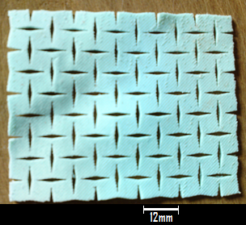
Figure 4.5: Auxetic silicone film prepared by casting method.

4.2.4 Auxetic polyurethane films developed by silicone mould
Once the Auxetic silicone film was effectively prepared by the novel casting technique using female (reverse-Auxetic) mould, the male die plate was subsequently used for the preparation of female silicone mould (as described earlier in Section 3.3.4) and is shown previously in Figure 3.16. The female silicone mould was developed in order to easily cast semi-rigid polyurethane material, and to avoid problems related to the separation of the casted polyurethane from the ABS plastic mould. Thermoplastic polyurethane and ABS plastic materials have good adhesive properties (Demma, Martuscelli et al. 1983; Santos, Bruno et al. 1993). The silicone mould making method involved three main process steps, and casting of the polyurethane entailed additional three steps. The polyurethane casting was carried out with and without pre-degassing of the casting resin. The silicone mould making process took about 2 hours, and polyurethane casting with and without pre-degassing lasted 78 minutes and 60 minutes respectively. The removal of the Auxetic polyurethane films was achieved easily, since there was no adherence between the Auxetic polyurethane film and the silicone mould. The unit-cells of the Auxetic polyurethane film, made by pre-degassing the casting resin, were found to be biconvexed (i.e. bulging from both sides) instead of having flat surfaces (in Figure 4.6(a)). This is due to the fact that scraping was not done effectively due to the soft nature of the silicone mould. Furthermore, the unit-cells of the Auxetic polyurethane film, developed without pre-degassing the casting resin, were not only bulging outwardly but had a significant amount of entrapped air bubbles (in Figure 4.6(b)).

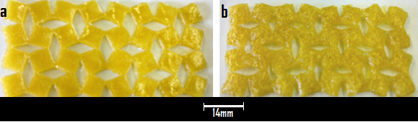
Figure 4.6: (a) Pre-degassed Auxetic polyurethane film having biconvexed surfaces, and (b) Auxetic film made without pre-degassing of the casting resin showing biconvexed surfaces and a large amount of entrapped air bubbles.

4.2.5 Auxetic polyurethane films prepared by electroplated mould
The purpose of this investigation was to solve problems which were experienced in the previous casting technique using a soft silicone (reverse-Auxetic) mould such as (i) improper scraping of the extra material, (ii) biconvexed surfaces (i.e. bulging from both sides) of the unit cells of Auxetic polyurethane film and (iii) significant amount of entrapped air bubbles. Therefore in this approach, the electroless nickel plating was tried on a female die plate made of ABS plastic (mentioned earlier in Section 3.3.5) in order to prevent polyurethane (casted) film adhesion with ABS plastic mould and to perform proper scraping. The casting was subsequently carried out using the same semi-rigid polyurethane resin (as described previously in Section 3.3.5) on an electroless nickel plated female die plate. The electroless nickel plating of the ABS mould involved five major process steps including the final step to prepare the mould for casting by coating it with mould releasing agent. The polyurethane casting was carried out by pre-degassing the casting resin, and casting involved further three steps to obtain an Auxetic film. The electroless nickel plating of the ABS plastic mould took 60 minutes, and polyurethane casting lasted another 60 minutes. The Auxetic polyurethane film was separated very easily from the mould. Although scraping of the extra casted polymer was effectively done, and the unit-cells of the Auxetic polyurethane film were reasonably smooth and flat. However, it was found that due to imperfections (in microscale) present on the surface of the electroplated mould (in Figure 4.7(a)). The final quality of the Auxetic polyurethane film was affected and significant amount of air bubbles were developed due to coarse surface of the mould (in Figure 4.7(b)).

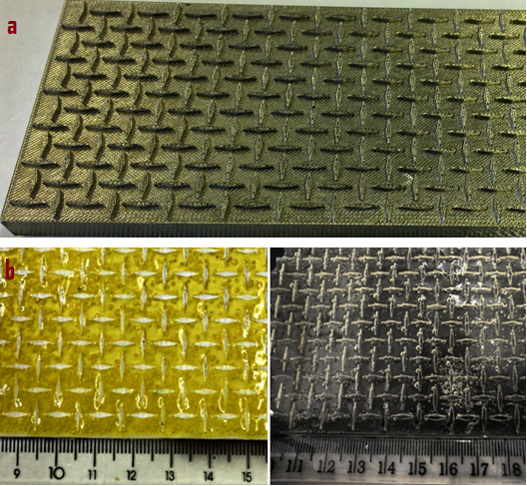
Figure 4.7: (a) Electroless nickel plated (reverse-Auxetic) mould having imperfections on its surface, and (b) Auxetic polyurethane film with entrapped air bubbles.
4.2.6 Fabrication of Auxetic polyurethane films by using titanium mould
A research was conducted due to the problems, which emerged from previous casting method (in Figure 4.7), and as there was a need to refine the casting method or to further investigate the fabrication of Auxetic polyurethane film by die casting method using reverse-Auxetic mould. Therefore, a metal (reverse-Auxetic) die plate was constructed in a novel way by Electron Beam Melting (EBM) technique using titanium alloy powder (as mentioned earlier in Section 3.3.6). The fabrication of the Auxetic polyurethane film was subsequently done by casting polyurethane onto a metal (titanium alloy) reverse-Auxetic mould. The production of the titanium die plate involved three main process steps, followed by three additional steps for casting polyurethane. The casting was done by pre-degassing the polyurethane casting resin. The production of the mould by EBM process lasted 5 hours, which also involved removal of the powder from the fabricated part and preparation of the mould for casting by coating it with mould releasing agent. The Auxetic polyurethane film was separated easily from the die plate. The unit-cells of the final Auxetic polyurethane film were smooth and flat, and were free from entrapped air bubbles (in Figure 4.8).

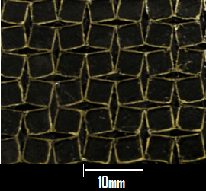
Figure 4.8: Auxetic polyurethane film (free from air bubbles) prepared from titanium mould.

4.2.7 Inkjet printing of Auxetic (rotating-squares) geometry
The development of Auxetic (rotating-squares) network was subsequently investigated by a new generative inkjet printing technique (as described previously in Section 3.3.7). The polyurethane ink solution was used and initially only one unit-cell (comprising of four rotating-squares) was printed onto a metal substrate. The printing process which lasted 3 hours comprised of three main process steps for the printing of 25 successive layers. The thickness of each printed layer was in the range of few microns as it was also previously investigated by (van den Berg, Smith et al. 2007), and the thickness of 25 layers of Auxetic unit-cell was roughly around 50 microns. Since the metal stub was fixed on a printer platen as a substrate, hence, the obtained printed layers of the Auxetic unit-cell were slightly deviated from the actual printing coordinates due to the mechanical vibrations generated on the metal stub by the printer (in Figure 4.9). Therefore, the fabrication of Auxetic polyurethane film was not further continued owing to the technical limitations involved in this particular printing application, such as significantly large number of successive printed layers were needed to achieve the required thickness (500µm) of the film resulting in unnecessary time consumption.

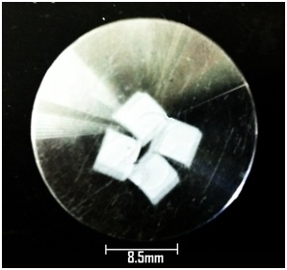
Figure 4.9: Auxetic one unit-cell (comprising of four squares) printed on a metal stub by inkjet printing (DOD) technique.

4.3 Manufacturing of the Auxetic oesophageal stent
The Auxetic oesophageal stents were developed in both seamless and seamed fashion and the manufacturing route is illustrated below in Figure 4.10. The Auxetic seamed stents were prepared by configuring the previously made Auxetic polymeric films into tubular shape. The Auxetic films which were good in quality i.e. lasercut Auxetic polypropylene and die cast Auxetic silicone films, were selected for the development of Auxetic seamed stents. The novel concept of an Auxetic oesophageal stent made of polypropylene material was successfully developed and the work has been published (Ali and Rehman 2011). The seamed Auxetic stents were not employed in the mechanical characterisation study of the Auxetic stents because of having welded joints which makes them weak and more susceptible to failures in loading situation. Therefore, this research work emphasises on the seamless manufacturing of the Auxetic oesophageal stent with a significantly small pre-deployment diameter to facilitate oral insertion and to identify the manufacturing techniques which are simple, less time-consuming, and offering good quality seamless Auxetic oesophageal stent.

Figure 4.10: The manufacturing approach adopted for the production of Auxetic oesophageal stents.
4.3.1 Preliminary research on die casting
In the beginning, preliminary work was done on the seamless production of Auxetic (rotating-squares) polymeric stent using a novel manufacturing approach. This investigation employed a new method which initially used silicone elastomer as a casting polymer into an ABS plastic tubular die (having recessed rotating-squares parts and protruded diamond-shaped parts). The silicone casting into reverse-Auxetic tubular die (shown earlier in Figure 3.38) was carried out by using a hollow TEFLON external tube, which tightly enclosed the tubular die and forced the extra polymer on the surfaces of the protruded diamond-shaped parts of the mould to come out ( as mentioned earlier in Section 3.4.1.1).

The silicone casting on a tubular mould was found to be complex as the manual extraction of the tubular die from the external TEFLON tube was difficult. It was also found difficult when removing the casted Auxetic film from the tubular die, since the Auxetic tube was interlocked between the protruding diamond-shaped parts of the tubular mould. The tubular mould making method involved three main process steps after the 3D CAD model was supplied to the FDM equipment, and silicone casting entailed further four steps to fabricate the seamless Auxetic stent. Although the tubular die making was a one-step process, hence, its production lasted 5 hours, and silicone casting took another 150 minutes. The quality of the final Auxetic oesophageal stent was poor, because removal of the Auxetic stent from the tubular die was detrimental (in Figure 4.11(a)). It was also found that due to the little gap (possibly in microns) between the lumen of the external TEFLON tube and outer surface of the tubular mould, a very thin layer of casted material was present over the surfaces of the diamond-shaped parts of the mould which was not pushed out completely. As a result, the diamond-shaped parts of the Auxetic oesophageal stent were not hollow, and the intact material within the confines of the diamond-shaped bits was subsequently removed by the help of tweezers (in Figure 4.11(b)).

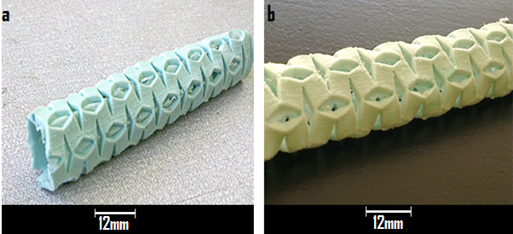
Figure 4.11: (a) Auxetic stent having material intact within the diamond-shaped parts, and (b) Auxetic oesophageal stent with hollow diamond-shaped bits.

4.3.2 Seamless Auxetic stent developed by a collapsible tubular die
The previous (above) seamless manufacturing technique was found to be quite complex and had several drawbacks. Therefore, it was decided to refine the casting method for the development of seamless Auxetic stent. Therefore, a novel collapsible tubular mould mechanism was fabricated by using FDM method (as shown earlier in Figures 3.40 and 3.41). In order to eradicate process complications which were experienced in the previous method, and to develop good quality seamless Auxetic oesophageal stent. The silicone casting was initially tried within the collapsible tubular mould, to avoid unnecessary adhesion between the casting polymer and mould (as described previously in Section 3.4.1.1). The casting process was fairly simple and the collapsible tubular die was easily opened after curing of the silicone. The production of the collapsible tubular mould mechanism involved four main process steps, and silicone casting required additional three process steps. The fabrication of the two tubular halves of the mould took 5 hours, and the preparation of the plastic rings, funnel and aluminium support lasted 2 hours. The casting of the silicone elastomer took further 12 hours. The quality of the final Auxetic oesophageal stent was found to be good (in Figure 4.12). It was also noticed that the collapsible mechanism of the mould was effective and it reduced the wastage of the casted material. Finally, the extraction of the Auxetic silicone stent from the collapsible tubular mould was also found to be quite straightforward.

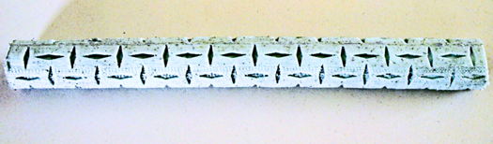
Figure 4.12: Seamless Auxetic silicone stent made by casting into a collapsible tubular die.

4.3.3 Fabrication of Auxetic stent by using collapsible titanium die
Once the Auxetic silicone stent was effectively prepared by the previous novel casting (seamless) technique using reverse-Auxetic collapsible tubular mould made of ABS plastic (as described earlier in Section 3.4.1.1 and in Figure 3.42), a new collapsible tubular mould made of titanium alloy was subsequently produced by EBM technique (as mentioned earlier in Section 3.4.1.1 and in Figure 3.44). The titanium collapsible mould was fabricated to easily cast semi-rigid polyurethane material without having problems related to the separation of the casting polyurethane material with ABS plastic collapsible mould. The same procedure was followed (as mentioned previously in Section 4.3.2) to cast semi-rigid polyurethane into the collapsible titanium mould (also described earlier in Section 3.4.1.1). The casting process was simple and exactly the same as done in the previous method (in Section 4.3.2). It was found very difficult to open the two halves of the collapsible tubular mould mainly due to the reason that the casted polyurethane was stiff and adhered to the rough surface of the mould and was not allowing the two halves of the mould to open. Consequently, the Auxetic stent when removed from the titanium mould was cracked from different places. The production of the titanium collapsible mould mechanism involved four main process steps, and polyurethane casting entailed further three steps. The fabrication of the two titanium alloy halves of the mould lasted 4 hours including the removal of the residual powder from the fabricated parts and preparation of the mould for casting polyurethane by coating it with mould release agent. The preparation of the metal rings, funnel and circular platform took 3 hours, and casting lasted 2 hours. Finally, the Auxetic polyurethane stent made by this technique was ruptured and had rough surface due to the roughness present on the surface of the mould (in Figure 4.13).

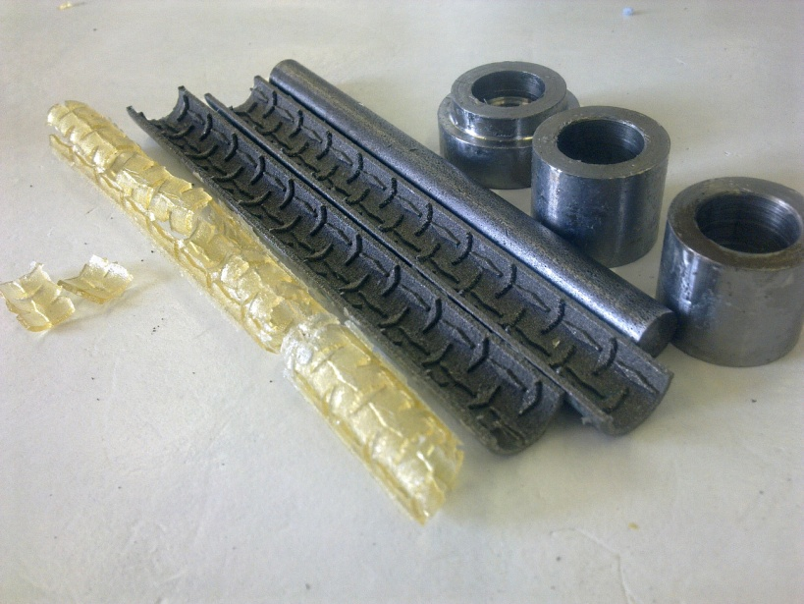
Figure 4.13: Auxetic polyurethane stent fractured after being removed from the collapsible mould made of titanium alloy.

4.3.4 Production of the seamless Auxetic stent by vacuum casting
The production of the seamless Auxetic oesophageal stents was subsequently explored by employing vacuum casting (rapid prototyping) technique. Both rigid and semi-flexible Auxetic polyurethane stents were developed by using this novel manufacturing route (as mentioned earlier in Section 3.4.1.2). A pre-requisite for vacuum casting is a perfect Mastermodel which can be made either by conventional or by new generative manufacturing techniques. Therefore, an ABS plastic Mastermodel was fabricated by using FDM technique, which incorporated every details of the actual Auxetic oesophageal stent (in Figure 3.47), ensuring that it can be duplicated with a desired material by the help of vacuum casting process. The vacuum casting method involved four major process steps ranging from fabrication of the Mastermodel to stent removal from the mould. The first two steps were the onetime processes used in this technique, which involved production of the Mastermodel and silicone mould making process. The casting of the seamless Auxetic polyurethane stent lasted 2 hours and 15 minutes, where as the first two one-off process steps took 7 hours. The vacuum casting method was found to be simple and it produced reproducible results. Additionally, the Mastermodel and silicone mould can be used number of times in vacuum casting method, as it is a one-off investment. Finally, the Auxetic oesophageal stents produced by this technique were exact replica of the Mastermodel as it was reported earlier by (Tang, Tan et al. 2007), and were good in quality (in Figure 4.14).

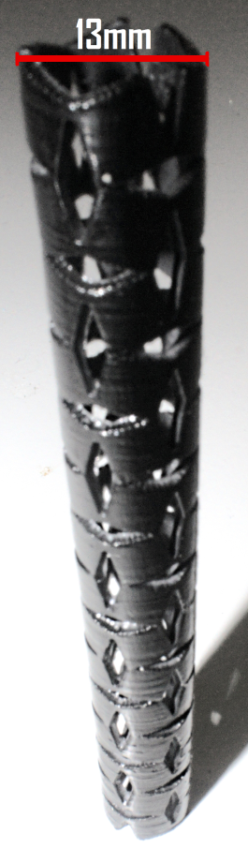
Figure 4.14: Seamless Auxetic polyurethane stent (rigid) made by vacuum casting technique.

4.4 Surface characterisation of the Auxetic polyurethane stents
The SEM was used to characterise the surface morphology of Auxetic (rotating-squares) geometry produced by different manufacturing techniques. This study was actually performed to check the quality of Auxetic unit cells (comprising of four rotating squares) produced by different methods using polyurethane material in both film and tubular stent forms.

4.4.1 Surface analysis of the Auxetic polyurethane films
The purpose of this investigation was to analyse the surface quality of the Auxetic polyurethane films produced by different manufacturing techniques. Therefore, the first sample was selected from lasercut Auxetic polyurethane film for analysis, and initially it was viewed by 40 and 80 times magnifications (in Figure 4.15).

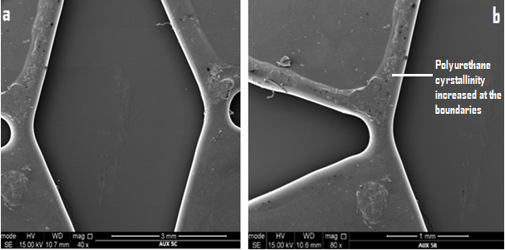
Figure 4.15: SEM micrograph of the sample from the lasercut Auxetic polyurethane film.

From the above micrographs, it was observed that, the material which was melted by the fine laser beam while cutting was removed effectively by the covering (coaxial gas jet with laser beam) gas out of the diamond-shaped kerf. It was found that, the microscopic softened material, which was not blown away from the cut kerf and resided within the confines of the diamond-shaped cut, densified the boundaries of the squares and hinges located in close proximity. It was also established that there were no significant surface irregularities and the edges of the Auxetic unit cell were properly rounded off.

The second sample was taken from the Auxetic polyurethane film made by casting the pre-degassed polyurethane resin on a silicone mould, and it was photographed using 40 and 80 times magnifications (in Figure 4.16).

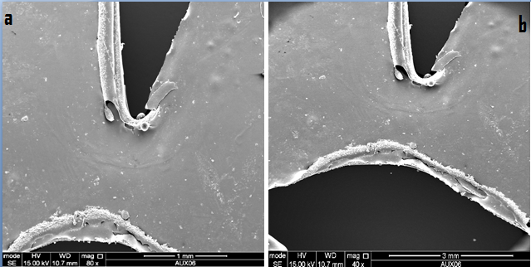
Figure 4.16: Micrographs of the sample taken from the Auxetic polyurethane film made by casting on a silicone mould.

The micrographs in the above Figure 4.16 clearly show that, due to the improper scraping during casting, there was some material left within the confines of the protruded diamond-shaped parts of the silicone mould. Therefore, after casting this extra material covered the boundaries of the squares and hinges in close proximity. It was observed that the squares of this sample were not flat instead they were bulging from their centre from both sides. It was also found that, there were some surface irregularities and the edges of the Auxetic unit cell were not smooth and regular.

The third sample was selected from the Auxetic polyurethane film produced by casting onto an electroless nickel plated mould. The images were taken at 40 and 80 times magnifications. The micrographs in Figure 4.17, clearly exhibit the presence of polyurethane material within the diamond-shaped cuts of the sample. This was due to the improper scraping of the extra material from the mould surface during casting. Since there were also imperfections present on the surface of the electroplated mould, therefore, a significant amount of air bubbles were seen as illustrated in Figure 4.17. The pattern (diagonal lines) from the surface of an electroplated mould was exactly replicated on the surface of the sample (Auxetic unit-cell), and the edges of the sample were sharp.

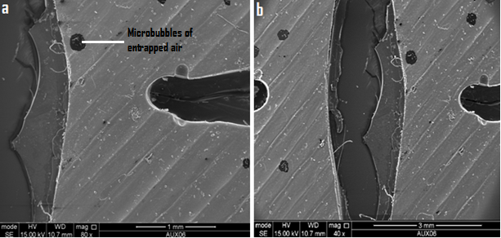
Figure 4.17: Micrographs of the third sample.

The fourth sample was acquired from the Auxetic polyurethane film, developed by casting onto a titanium alloy mould. The micrographs demonstrated that, there was some material still remaining within the diamond-shaped cuts as illustrated below in Figure 4.18. Since, titanium oxide passive layer was created on the surface of the titanium mould due to the high reactivity of titanium with oxygen from the air. Therefore, a significant amount of black microscopic particles appeared on the surface of the Auxetic polyurethane sample. These small particles were actually titanium traces, which adhered to the polyurethane matrix, as this adhesion was recently analysed by (M.Sabzi, Mirabedini et al. 2009). It was found that some of the hinges located within the squares of the sample were either cracked or weak. It was also established that there were some surface irregularities and the edges of the sample were rounded off.

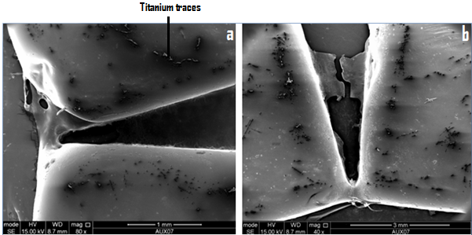
Figure 4.18: Micrographs of the fourth sample.

4.4.2 Surface analysis of the Auxetic oesophageal stents
The quality of the rotating-squares geometry of the Auxetic stents produced by different manufacturing techniques was examined by using SEM micro images. Consequently, the sample of the Auxetic unitcell (comprising of four rotating squares) was selected from the seamless Auxetic polyurethane stent made by casting the pre-degassed polyurethane resin into the collapsible tubular mould made of titanium alloy. The sample was viewed at 40 and 80 times magnifications (in Figure 4.19).

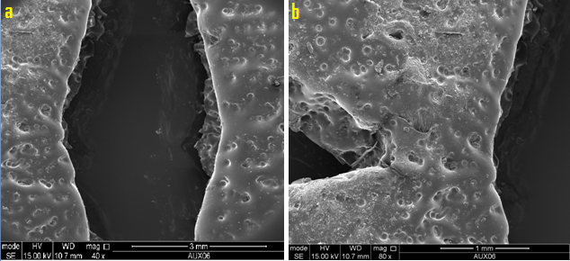
Figure 4.19: Micrographs of the sample taken from the Auxetic polyurethane stent made by casting into the titanium alloy collapsible tubular die.

The micrographs in Figure 4.19 visibly demonstrate that, due to the rough granulated surface of the collapsible tubular mould made of titanium alloy, a significant amount of small dents present on the surface of the Auxetic stent sample. It was also found that the edges were sharp and irregular and the surface irregularities were quite high.

The next sample was taken from the seamless Auxetic polyurethane stent produced by vacuum casting technique (as described earlier in Section 3.4.1.2), and it was viewed at 40 and 80 times magnifications (in Figure 4.20).

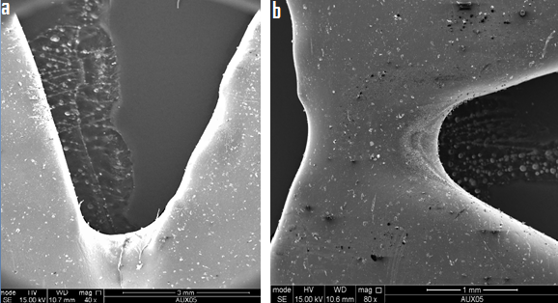
Figure 4.20: SEM micrographs of the second sample.

From the micrographs presented in Figure 4.20, it was observed that the surface quality of the Auxetic sample was good without having any irregularities. It was also found that the edges of the Auxetic unitcell were properly rounded off.

The next sample was taken from the seamed Auxetic polypropylene stent which was constructed (as mentioned previously in Section 3.4.2) by lasercutting of the polypropylene film. This sample was actually used in the preliminary investigation where several novel aspects were explored and checked such as the possibility of, physically introducing the Auxetic (rotating-squares) geometry into polymeric material, attaining longitudinal and transverse extensions in an Auxetic polymer when subjected to uni-axial tensile loads, having negative Poisson’s ratio and achieving good surface morphology of the Auxetic sample (Ali and Rehman 2011). The third sample was viewed at both 11 times and 40 times magnifications (in Figure 4.21).

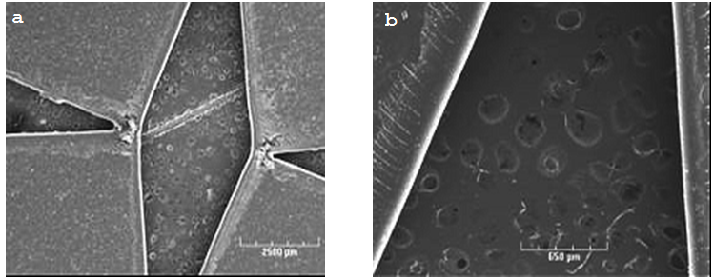
Figure 4.21: SEM micrographs of the sample from the seamed Auxetic polypropylene stent sample.

The micrographs shown in Figure 4.21 clearly revealed that, the fabrication of Auxetic (rotating-squares) geometry by lasercutting method in a polymeric film or tube is an effective manufacturing approach. Since it not only produced good quality Auxetic unit cells but it also strengthened the weak areas (boundaries and joints). It was established that the surface quality of the above Auxetic sample was good without having any irregularities. It was also found that the edges of the Auxetic unitcell were properly rounded off.

4.5 A Comparative study on the manufacturing techniques
A novel manufacturing approach was adopted in this research; for the production of both Auxetic polyurethane films and Auxetic oesophageal stents (as discussed earlier in Sections 4.2 and 4.3). This manufacturing approach was critically analysed in this section by appraising the efficacy of each production technique, the number of process steps involved, complexities (if any), quality of the end product and the length of time involved.

4.5.1 Auxetic polyurethane films developed by different methods
A comparative analysis was carried out based on the aforementioned results (as discussed previously in Sections 4.2 and 4.4), which critically evaluated different manufacturing techniques used in the fabrication of Auxetic polyurethane films. This study was performed to assess the efficacy and simplicity of each method and the quality of the end product.

Table 4.1: Comparative data of the Auxetic films from different manufacturing techniques
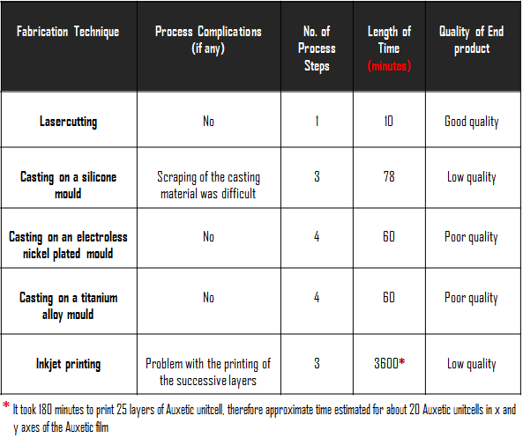

It was established from the above tabulated data that, lasercutting method is an effective and rapid way of producing Auxetic films due to the fact that cutting is the only process step involved in this technique. In addition, this technique not only produced good quality Auxetic polymeric films, but also fortified those regions (edges and hinges) of the Auxetic (rotating-squares) network which were later found to be weak and more prone to failures (in Figures 4.35 and 4.49). The quality of the Auxetic polyurethane film which was developed by casting on a titanium (reverse-Auxetic) mould was comparatively better than the quality of the casted Auxetic films on other moulds. Since the Auxetic film by this method was properly flat and smooth without having surface irregularities or entrapped air bubbles, and the only drawback of this fabrication method was that the titanium traces (microscopic) appeared on the surface of the Auxetic film (in the above Figure 4.18) and the process was slightly lengthy than lasercutting.

4.5.2 Auxetic oesophageal stents developed by different methods
A comparative study was performed based on the earlier results (described in Sections 4.3 and 4.4), which compared manufacturing techniques used in the fabrication of both seamless and seamed Auxetic oesophageal stents (Table 4.2). The comparison was done to highlight the efficacy of each technique and the quality of the final stent.

Table 4.2: Comparison of the manufacturing techniques used in the production of Auxetic stents
Fabrication Technique | Process Complications (if any) | No. of Process Steps | Time Required  (minutes) | Quality of the Final Stent
Welding of the lasercut Auxetic Film | No | 3 | 60 | Good Quality but with welded joints (seamed)
Casting into collapsible tubular mould | Extraction of the stent was difficult | 4 | 150 | Poor Quality
Vacuum Casting | No | 2 | 135 | Good Quality

The quality of the seamed Auxetic stent which was developed by configuring the lasercut Auxetic film into tubular stent form, was good with only one disadvantage of having welded joints (which were more susceptible to mechanical failures). It is envisaged that by lasercutting seamless polyurethane tubes instead of films, not only the problem of having welded joints can be avoided but also the production time can be reduced significantly. The vacuum casting technique was found to be simple but the process time was relatively lengthy than lasercutting method. The Mastermodel and silicone mould can be used number of times in vacuum casting method, as it is a one-off investment. The Auxetic oesophageal stents produced by this technique were of good quality.

4.6 Tensile test data

4.6.1 Preliminary study results
The preliminary tensile test was conducted using the Auxetic polypropylene films to validate the Auxeticity in the films by acquiring negative Poisson’s ratio and to observe their elastic-plastic deformation behaviour (as described earlier in Section 3.7.1.1). The results of this novel study involving mechanical characterisation of the Auxetic (rotating-squares) films has recently been published by (Ali and Rehman 2011). The gauge length and width of the 0.5mm thick Auxetic polypropylene film samples were l_{o}=161.8mm, and w_{o}= 98mm respectively. An experiment was initially conducted to calculate the Poisson’s ratio of the sample by applying different uniaxial loads to the sample, and consequently, Poisson’s ratio was calculated as v = -0.89 ± 0.01 at different load values as shown below in Table 4.3. The second experiment was subsequently carried out to estimate the plastic deformation and examine the deformation behaviour of the Auxetic polypropylene film. The stress-strain curves from the Instron machine plotter formed a closed loop (hysteresis) during repetitive loading and relaxing of the sample. The hysteresis graph in Figure 4.22 (a), clearly shows that under repetitive 4.90N of tensile load, the sample was initially behaving ideally (i.e. coming back to its origin from where the straight line started) and showing elastic deformation. However, after having experienced the same load four times repeatedly, the curved line started to come back away from its origin (i.e. zero), which indicates that the stretch-induced repetitive tensile load prevented the sample from coming back to its original position. As a result, this lead to a plastic (permanent) deformation of the Auxetic polypropylene sample.

Table 4.3: Estimation of the Poisson’s ratio values
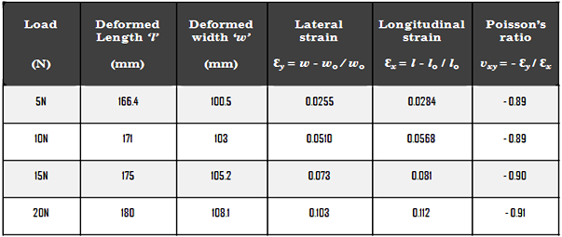

The graph in Figure 4.22(a) showed evidence that under repetitive 4.90N tensile load to a maximum 2.5% strain at 4mm extension, the curved line (forming the closed loop) started to come back away from zero (origin), and the sample’s (rotating-squares) geometry was slightly opened even without any load owing to the plastic deformation (Figure 4.22(b)). Also from the graph in Figure 4.22(a), it is quite obvious that after fourth loading repetition, the sample was not returning back to its origin and was having 1.15mm extension to a maximum of 0.71% strain.

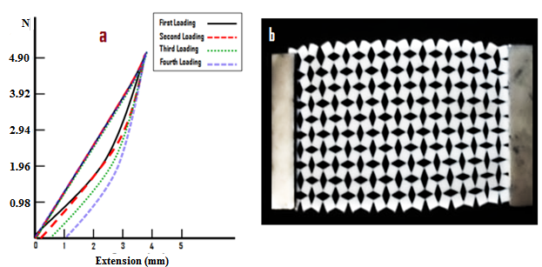
Figure 4.22: (a) A graph showing plastic deformation as the curve is coming away from its origin under successive loading, and (b) plastically deformed Auxetic polypropylene sample.

Finally, the third experiment was performed to load different Auxetic polypropylene sample till the point of its failure, and the sample broke at 27.46N of tensile load to a maximum 10.5% strain and at 16.5mm extension (Figure 4.23).

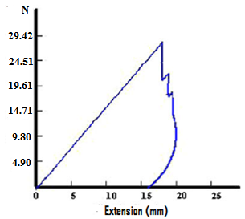
Figure 4.23: The sample failed at 27.46N of tensile load.
4.6.2 Mechanical behaviour of Auxetic polyurethane films
The lasercut Auxetic polyurethane films were selected for mechanical testing because of the comparatively good quality of the Auxetic films. In the beginning, the baseline tensile data was acquired by testing the same rigid polyurethane films used in the fabrication of the Auxetic polyurethane films by lasercutting technique (as mentioned earlier in Section 3.7.1.2). The gauge length and width of the 0.5mm thick polyurethane strip sample were 50mm and 20mm respectively. An experiment was performed by subjecting the polyurethane strip to uniaxial tensile loads, and nominal stress-strain (baseline) data was gathered. The mean of the nominal tensile (baseline) data from different samples was subsequently taken as illustrated in Figure 4.24. The graph in Figure 4.24 clearly shows that the polyurethane sample was yielded at nominal (mean) stress of 31.39MPa to a maximum of 22.17% (mean) strain at 5.33mm extension. The elastic modulus of the polyurethane sample was calculated as 194.3MPa.

Figure 4.24: Nominal (mean) stress-strain data of the polyurethane samples with standard error (S.E= S.D/$√n)$ with x-axis S.E range (0.0003-0.23) and y-axis S.E range (0- 0.81).
The nominal tensile stress-strain data was then converted into True stress and Plastic strain data, which was later used as material (elastic-plastic) data for finite element models as shown below in Figure 4.25.

Figure 4.25: True stress and plastic strain data calculated with standard error (S.E=S.D/$\sqrt{n)}$, x-axis S.E range (0.001-0.022) and y-axis S.E range (0.2-1.6).

A tensile test of the Auxetic polyurethane sample was carried out (as mentioned previously in Section 3.7.1.2), after the baseline tensile data of the polyurethane material was obtained. This test was performed manually as both longitudinal and transverse extension values of the Auxetic sample were calculated at different uniaxial tensile load increments till the point of sample’s failure (in Figure 4.26).

Figure 4.26: Tensile data of the Auxetic polyurethane sample acquired from manual calculation at different loads.

The gauge length and width of the above 0.5mm thick Auxetic polyurethane sample were 50mm and 31.5mm respectively. The Poisson’s ratio of the Auxetic sample was also calculated, which ranged from $-0.87 to-0.963$ at different load values as illustrated in Figure 4.27.

Figure 4.27: Poisson’s ratio of the Auxetic polyurethane sample at different loads.

In another investigation the tensile test of the Auxetic polyurethane sample was carried out automatically by the tensile testing equipment till the point of sample’s failure. It clearly showed in the graph which was created by the software of the tensile tester in Figure 4.28(a)(b). The sample yielded at 1.8N of tensile load and 0.135 MPa of stress to a maximum 0.95% strain and at 0.38mm extension. The Auxetic sample was finally failed at 12.2N of force to a maximum 13.62% strain and at 6.67mm extension (Figures 4.28(a) and 4.28(b)). It was observed after removing the sample from the testing equipment that the Auxetic polyurethane sample was permanently deformed. It was also established that the diamond-shaped spaces (hollow) between rotating squares played a crucial role in the overall expansion of the Auxetic film. The Auxetic film containing wide diamond-shaped spaces between the rotating-squares (i.e. the squares were more angulated) was expanded less, as there was less room left for the rotation of the neighbouring squares. Similarly, the Auxetic film having narrow diamond-shaped spaces (i.e. the squares were less angulated), allowed the neighbouring squares to rotate more, and hence, the Auxetic film expanded more. This was also derived in the analytical model reported previously by (Attard, Manicaro et al. 2009), describing the mechanical behaviour of the Auxetic (rotating-square) geometry and demonstrated that the mechanical properties depend on the relative magnitude of the stretching and hinging constants, the square dimensions and the angle between the squares, and by changing the magnitude of applied force and geometry the value of Poisson’s ratio can be controlled.

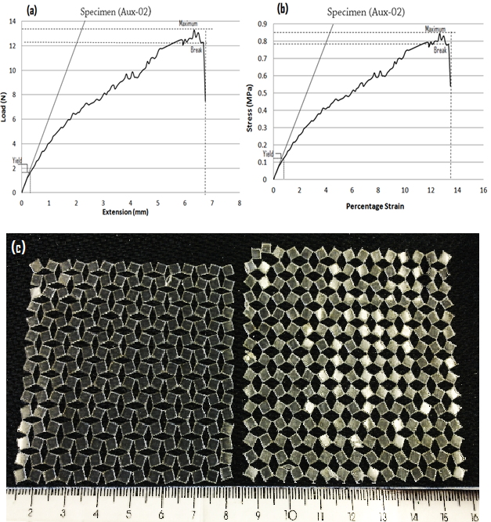
Figure 4.28: Graph of the Auxetic polyurethane film sample plotted by the tensile tester, (a) load versus extension, (b) Stress versus Strain (%) and (c) undeformed and plastically deformed Auxetic polyurethane film.

4.7 Auxetic oesophageal stents expansion data
It was envisaged that the deployment of the Auxetic oesophageal stent will be without a dedicated expensive delivery system. This will be administered orally into the oesophagus using a significantly small diameter Auxetic stent mounted on a balloon dilatational catheter. The balloon dilatational catheter has already been in use for the pre-dilation of the oesophageal lumen and for the post-dilation of the commercial oesophageal stents. Therefore, a number of tests were performed in this investigation by expanding the seamless semi-rigid and rigid Auxetic oesophageal stents made of polyurethane material, using different sizes of balloon dilatational catheters (mentioned earlier in Section 3.7.2). The tests were conducted in order to estimate the diametrical change and longitudinal expansion of the stents at different applied radial pressures, and to also check that at which pressure the stent deformed plastically (permanently) without any recoil. The experiment was initially performed (i.e. Test-I) to investigate the mechanical behaviour of a semi-flexible Auxetic oesophageal stent of 50mm length, 10mm outer diameter and 0.5mm wall thickness.

Table 4.4: Semi-rigid Auxetic oesophageal stent expanded by the balloon catheter
Pressure (bar) from balloon | Stent Diameter (mm) | Stent Length (mm)
0.0 | 10.00 | 50.00
0.5 | 10.50 | 50.15
0.8 | 10.78 | 50.56
1 | 11.50 | 51.22
1.5 | 12.12 | 51.70
1.7 | 12.65 | 51.70
2 | 13.73 | 51.80
2.5 | 15.44 | 51.81
2.7 | 15.73 | 51.83

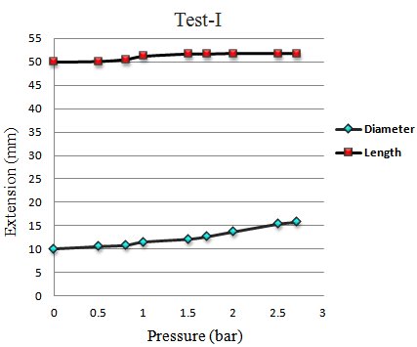
Figure 4.29: Graph showing diametrical and length changes of the Auxetic oesophageal stent.

From the Table 4.4 and in Figure 4.29, it was found that the oesophageal stent radially expanded from 10.5 to 15.73mm and longitudinally extended from 50.15 to 51.83mm at a range of pressure increments from 0.5 to 2.7 bar applied by the balloon. The oesophageal stent was subsequently removed from the balloon, and the diameter and length of the stent were calculated as 14.94mm and 51.8mm respectively. This clearly showed that the Auxetic stent plastically (permanently) deformed at 2.7 bar pressure and it slightly recoiled when removed from the inflated balloon (Figure 4.30). The stent was then mounted again on the balloon catheter and the pressure was applied till the point of stent failure, and the Auxetic oesophageal stent finally snapped at a pressure of 2.86 bar.
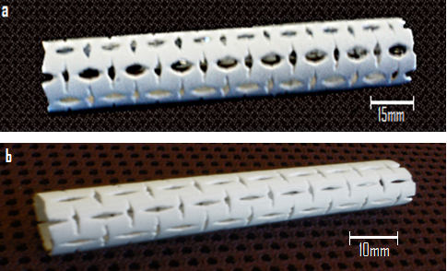
Figure 4.30: Auxetic oesophageal stent expanded by the balloon catheter, (a) plastically deformed (expanded) stent and (b) un-expanded Auxetic stent.

In Test-II, an experiment was conducted to investigate again semi-flexible Auxetic stent at different radial pressures applied by the balloon catheter (as mentioned earlier in Section 3.7.2). The procedure of this experiment was similar to Test-I, however, the specifications were changed as different stent length (i.e. 68mm) and size of the balloon catheter (i.e. 10mm, 11mm and 12mm diametrical range) were used (in Figure 4.31).

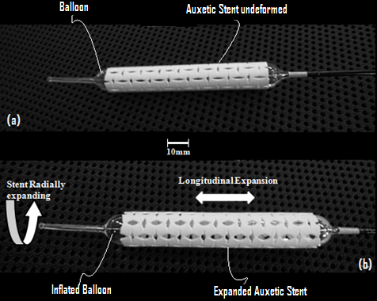
Figure 4.31: Semi-flexible Auxetic stent tested by the small diameter balloon catheter, (a) Auxetic stent mounted on a balloon catheter and (b) expanded Auxetic stent (both in radial and longitudinal directions).

From the test data illustrated in Figure 4.32, it was found that the oesophageal stent radially expanded from 0.1 to 2.8mm and longitudinally extended from 0 to 0.6mm at pressure increments ranging from 0.6 to 7.8 bar applied by the balloon catheter. Since the radial size of the balloon was small, therefore, the same radial and longitudinal displacements of the stent (which were acquired in Test-I) were achieved at significantly higher pressures.

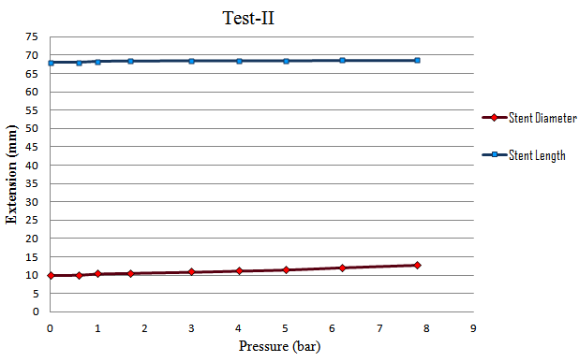
Figure 4.32: A graph showing radial and longitudinal expansion of the stent at different pressure increments.

The test was finally stopped at a pressure of 7.8 bar to avoid exceeding the maximum inflation pressure of the balloon and rupture of the balloon. Hence, due to the small radial size of the balloon, the balloon did not manage to fully expand the stent and to establish reasonable plastic deformation in the stent (Figure 4.33).

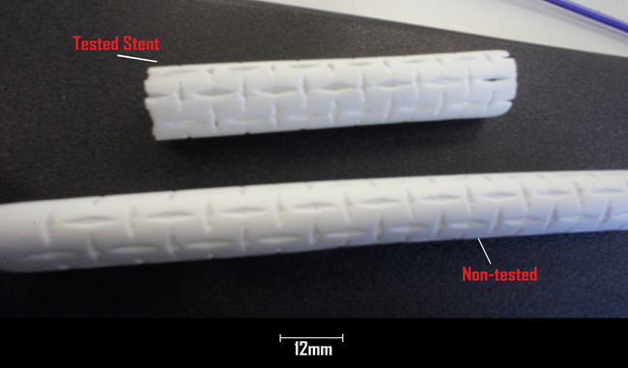
Figure 4.33: Oesophageal stent exhibiting slight change in size, after removing from the balloon in Test-II.

A rigid Auxetic oesophageal stent was examined in Test-III, in which radial and longitudinal expansions of the stent were calculated at a range of radial pressures applied from the balloon catheter (as discussed earlier in Section 3.7.2). The graph in Figure 4.34 clearly shows that, the rigid oesophageal stent radially expanded from 0.4 to 2.2mm and longitudinally extended from 0.1 to 1.14mm at pressure increments ranging from 4 to 8 bar. The Auxetic stent was finally cracked at 8.3 bar pressure as shown in Figure 4.35(c).

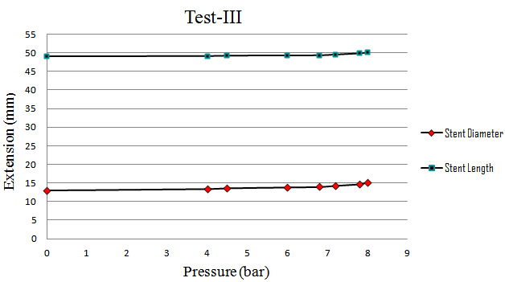
Figure: 4.34: Expansion data of the rigid oesophageal stent.

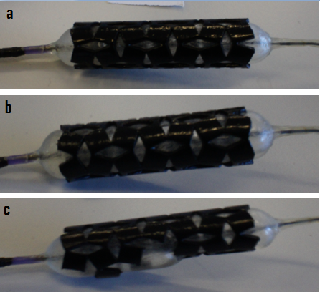
Figure 4.35: (a) Un-expanded rigid Auxetic oesophageal stent, (b) Auxetic stent radially expanded 1.8mm at 7.85bar pressure (c) stent finally broke at 8.3 bar pressure.
It was established from the stent expansion tests using semi-rigid and rigid Auxetic stents that, semi-rigid Auxetic stent tend to expand (both radially and longitudinally) more than rigid Auxetic stent. This is due to several reasons such as; (i) rigid Auxetic stent was stiff and failed early (at small pressure increments), (ii) there were more number of squares with their corresponding hinges (i.e. eight squares or hinges) present circumferentially in semi-rigid Auxetic stent than in rigid Auxetic stent (which was having six squares or hinges circumferentially) and (iii) the diamond-shaped (hollow) spaces of the semi-rigid stent were narrow (i.e.1mm wide) than the spaces in rigid stent (which were 2mm wide). Therefore, it was found from this study that the rotation or hinging mechanism of the individual units and their size or angle, played a vital role in the overall expansion of the Auxetic (rotating-squares) network. This was also derived by (Grima, Farrugia et al. 2008; Attard, Manicaro et al. 2009) in their analytical model that the number of individual units (their size and angle) in Auxetic (rotating-square) geometry controls the mechanical behaviour of the Auxetic network and Poisson’s ratio.

4.8 Auxetic film modelling data
The single-square FEA model involved one square extracted from the Auxetic (rotating-squares) film. Instead of modelling a complex anisotropic Auxetic film (comprised of a number of rotating-squares in both x and y axes), a novel single-square finite element model was developed in order to simplify the modelling technique and to obtain accurate results (as mentioned earlier in Section 3.8.1). The mesh convergence test was performed initially to ensure the accuracy of the results acquired from the finite element model. The convergence test was carried out by obtaining the reaction force values at REFERENCERIGHT nodeset at constant 0.1mm displacement applied on the same REFERENCERIGHT nodeset. The acquired reaction force values were then plotted against different number of elements (i.e. mesh densities) employed in the model. From the graph in Figure 4.36, it is quite clear that the reaction force values were converged at 4624 number of elements (i.e. at 0.05 seed size), and the total CPU time consumed was 90 seconds.

Table 4.5: Reaction force values acquired from “REFERENCERIGHT” nodeset at different mesh densities.
Seed Size | No. of Elements | Total CPU Time | Reaction force (N)
0.2 | 289 | 30 seconds | 0.113099
0.15 | 529 | 35 seconds | 0.099976
0.1 | 1225 | 40 seconds | 0.094433
0.07 | 2401 | 1.0 minute | 0.091966
0.05 | 4624 | 1.5 minutes | 0.090276
0.03 | 12769 | 2.0 minutes | 0.090081
0.01 | 116281 | 6.0 minutes | 0.091303

Figure 4.36: Graph showing reaction force values collected at different mesh densities.

The symmetric rotation of the single-square model was generated (in Figure 4.37(a)) by simulating the actual mechanical behaviour of a physical square in an Auxetic (rotating-squares) geometry. Therefore, different displacement values were applied to the REFERENCERIGHT nodeset along x-axis in small increments ranging from 0.1mm to 6.5mm (as described previously in Section 3.8.1). The reaction force values were then checked at all the REFERENCE nodesets (along both x and y axes). It was found that the reaction force values at both REFERENCERIGHT and REFERENCELEFT nodesets along x-axis were non-zero and same, and the reaction forces at REFERENCEBOTTOM and REFERENCETOP nodesets were found to be zero. The displacement values at REFERENCETOP nodeset were recorded along y-axis at every small increment of the displacement applied to the REFERENCERIGHT nodeset along x-axis (in Table 4.6).

Table 4.6: Single-square FEA model displacement along x and y axes at different force values.
Reaction Force at “ReferenceRIGHT” nodeset (N) | Longitudinal Extension  (d_{x}) ** | Transverse Extension  (d_{y}) ***
0.0899 | 0.10 | 0.090
0.1349 | 0.15 | 0.138
0.1708 | 0.19 | 0.177
0.2338 | 0.26 | 0.243
0.2683* | 0.30 | 0.283
0.3877 | 0.48 | 0.455
0.4199 | 0.54 | 0.510
0.4420 | 0.59 | 0.559
0.4742 | 0.67 | 0.636
0.4982 | 0.74 | 0.705
0.5268 | 0.81 | 0.773
0.5890 | 0.95 | 0.909
0.6236 | 1.02 | 0.976
0.6613 | 1.10 | 1.050
0.8171 | 1.44 | 1.383
0.9297 | 1.70 | 1.630
1.1607 | 2.53 | 2.426
1.4248 | 4.06 | 3.908
1.5317 | 5.04 | 4.850
1.5686 | 5.50 | 5.295
1.6109 | 6.06 | 5.840
1.6376 | 6.50 | 6.280
* Reaction force value from where the analysis became non-linear ** Applied displacement at “ReferenceRIGHT” nodeset (along x-axis) *** Transverse displacement obtained from “ReferenceTOP” nodeset (along y-axis)
The rotation of the single-square model was estimated by arranging both horizontal displacement (i.e. applied displacement in small increments to REFERENCERIGHT nodeset along x-axis) and vertical displacement (calculated displacement values at REFERENCETOP nodeset along y-axis) with a range of reaction force values obtained from REFERENCERIGHT nodeset as shown below in Figure 4.37(b). The displacement contours of the single-square model as shown in Figure 4.37(c), visibly demonstrated the rotation of the model.

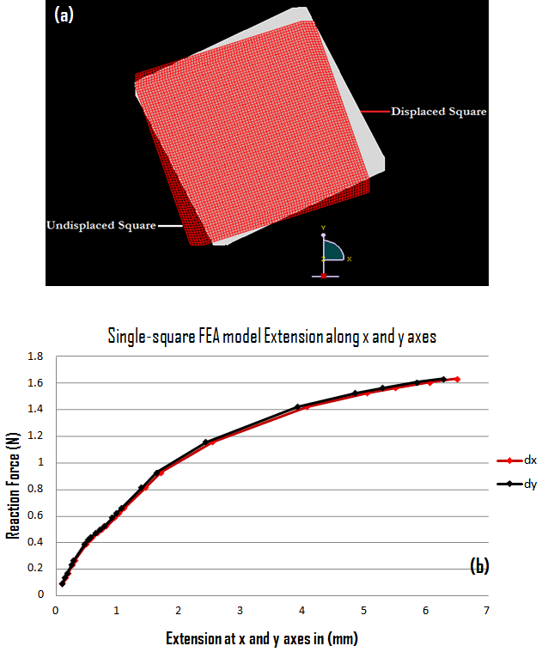
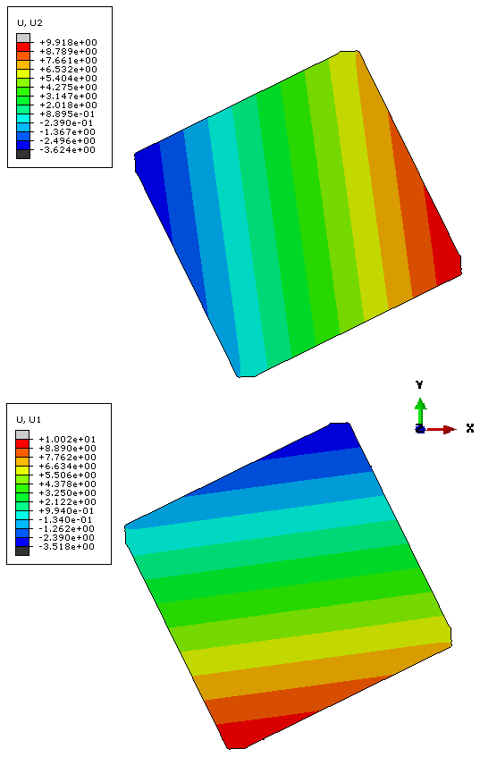
(c)
Figure 4.37: (a) Rotation of the single-square model, (b) a graph showing extension of the model at both x and y axes at different reaction force values, and (c) displacement contours along both x-axis (U1) and y axes (U2), exhibiting rotation of the single-square model.

The Equation (1) in the previous Section 3.8.1, was subsequently used to convert all the above reaction force values of the single-square model into the force values of the Auxetic polyurethane film (having number of squares in x and y axes). The number of squares in x and y axes of the Auxetic film were selected from the gauge length and width of the Auxetic polyurethane film specimen which was previously tensile tested (in the earlier Section 3.7.1.2). The number of squares were selected as M_{x} = 11.8 in x-direction and N_{y} = 7.4 in y-direction.

Table 4.7: Auxetic polyurethane film data derived from ‘Single-square’ model.
Load (N) | Longitudinal Extension (mm) | Transverse Extension (mm)
0.67 | 0.10 | 0.09
1.00 | 0.15 | 0.14
1.25 | 0.19 | 0.17
1.70 | 0.26 | 0.24
1.98* | 0.30 | 0.28
2.82 | 0.48 | 0.45
2.98 | 0.54 | 0.51
3.20 | 0.59 | 0.56
3.50 | 0.67 | 0.64
3.73 | 0.74 | 0.70
3.90 | 0.81 | 0.77
4.12 | 0.95 | 0.91
4.50 | 1.02 | 0.98
4.80 | 1.10 | 1.05
5.92 | 1.44 | 1.38
6.80 | 1.70 | 1.63
8.20 | 2.53 | 2.43
10.40 | 4.06 | 3.91
11.50 | 5.04 | 4.85
11.70 | 5.50 | 5.29
11.94 | 6.06 | 5.84
12.40 | 6.50 | 6.28
* Derived force of the Auxetic film from where the analysis became non-linear
Consequently, a range of force values of the Auxetic polyurethane film (comprising of squares in x and y axes) were derived at a range of displacement values along both x and y axes as shown above in Table 4.7 and in Figure 4.38 below.

Figure 4.38: Auxetic film (extension) modelling data derived from ‘Single-square’ FEA model.

The Poisson’s ratio values of the Auxetic film model were also calculated ranging from -0.9 to -0.96 at a range of displacement (extension) values of the model along both x and y axes as illustrated below in Figure 4.39.

Figure 4.39: Poisson’s ratio values calculated from the Auxetic film model (derived from Single-square model).

4.8.1 Physical versus finite element modelling results
In this analysis, the physical tensile data of the Auxetic polyurethane films obtained from both manual calculations and from the data automatically generated by the tensile tester as shown in the previous Figures 4.26 and 4.28(a), was compared with the finite element modelling results of the Auxetic polyurethane film model (derived from single-square model). The dimensions of the Auxetic polyurethane film, which was physically tested and the Auxetic polyurethane film that was derived from single-square FEA model were the same.

The graph in Figure 4.40(b) showed that, the physical Auxetic film when tested manually yielded at 2.1N load with 0.4mm extension along x-axis and was failed at 13.1N tensile load to a maximum 6.5mm extension. When the physical Auxetic film subjected to tensile loading and calculations were made automatically by the testing equipment the sample yielded at 1.85N with 0.35mm extension along x-axis and it broke at 12.26N force to a maximum 6.7mm extension as shown in Figure 4.40(a).

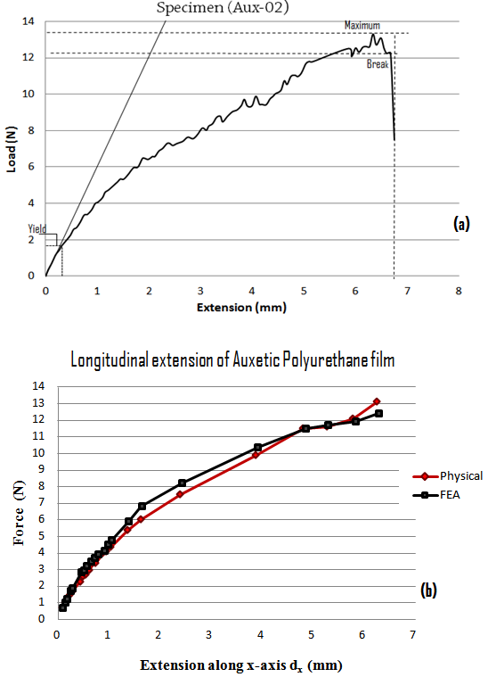
Figure 4.40: (a) Automatically calculated tensile data of the Auxetic film from the tensile tester, (b) manually calculated physical data versus FEA modelling data.
Similarly, the above Figure 4.40(b) showed that, the graph of the Auxetic film (FEA) model became non-linear at 1.9N load with 0.3mm extension along x-axis, which clearly demonstrated that the model yielded at this load. Table 4.8 shows a direct comparison between the physical (tensile tests) and FEA modelling results related to the yielding of the Auxetic polyurethane film. It is worth noticing that the agreement between the physical and FEA model results is satisfactory.

Table 4.8: Comparison of physical tensile tests and Auxetic film FEA model data.
Auxetic Polyurethane Film
 | Tensile Test  (Manual) | Tensile Test (Automatic) | FEA Modelling
Load  (when Yielded) | 2.1N | 1.85N | 1.9N
Extension along x-axis (when Yielded) | 0.4mm | 0.35mm | 0.3mm

Additionally, the stiffness of the finite element model dropped significantly from 6.8N/mm to 1.9N/mm at a range of both displacement values (0.1mm to 6.5mm) applied to the model and reaction force values calculated (0.67N to 12.4N) along x-axis. The decrease in stiffness of the Auxetic film FEA model (i.e. 1.9N/mm) apparently showed that the model plastically deformed at 12.4N force with 6.5mm extension along x-axis. The physical Auxetic film and FEA model also extended in transverse direction (i.e. along y-axis) because of having negative Poisson’s ratio (-v) as shown below in Figure 4.41.

Figure 4.41: A graph showing extensions of the physical Auxetic film and Auxetic film (FEA) model along y- axis.

Since the longitudinal extension values in manual tensile data of the Auxetic film and the displacement values (along x-axis) applied to the finite element model were the same. Therefore, the load values calculated in both physical (manual) tensile test of the Auxetic film and a range of reaction force values obtained from finite element Auxetic film model, were subsequently used to calculate the standard error between the physical and FEA load values (in Figure 4.42).

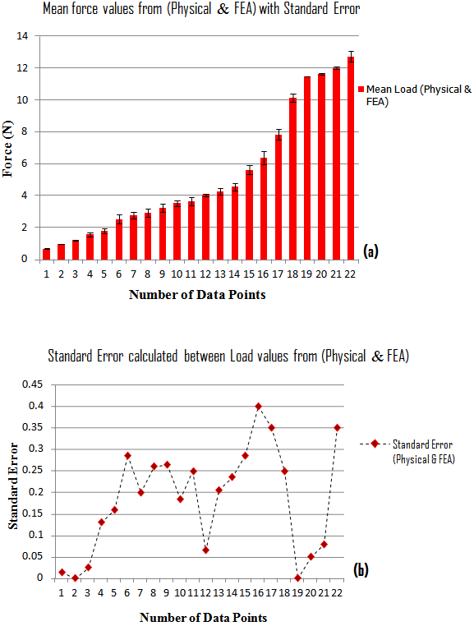
Figure 4.42: (a) graph showing mean load values which were taken from the physical test and FEA model (b) a graph showing standard error between the physical and FEA load values.

The Poisson’s ratio values calculated earlier (in the previous Sections 4.5.2 and 4.7) for both physical Auxetic film and FEA model at different loads, were compared and plotted together as shown below in Figure 4.43(a). A set of mean Poisson’s ratio and load values were taken from the Poisson’s ratio data (from both physical Auxetic film and FEA model), and the standard error was also calculated (Figure 4.43(b)). It is quite obvious from the comparison that, the conformity between the Poisson’s ratio (both physical and FEA) data is acceptable.

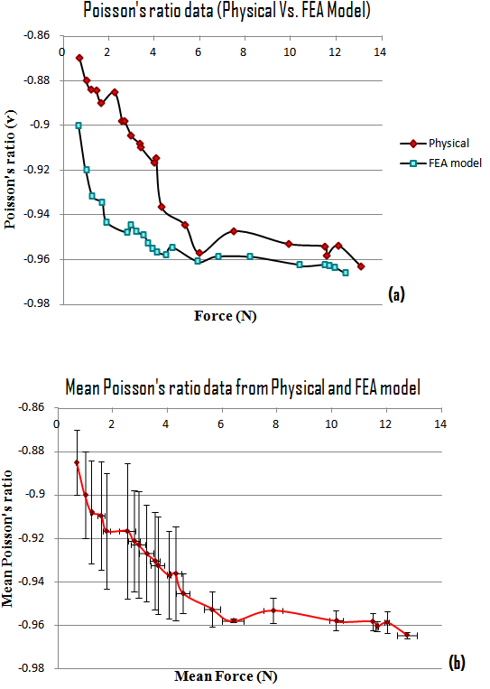
Figure 4.43: (a) A graph showing Poisson’s ratio values taken from both physical Auxetic film and FEA model at different loads, and (b) mean Poisson’s ratio and load values calculated with standard error (S.E= S.D/$√n)$, x-axis S.E. range (0 – 0.4) and y-axis S.E. range (0.0008 – 0.03).
From the previous graphs in Figure 4.28(a) and 4.28(b), it was established that the Auxetic polyurethane film when tested by applying uniaxial tensile loads, it was yielded at 0.35mm extension along x-axis to a maximum 1% plastic strain (i.e. 0.01 plastic strain). Hence, the Auxetic film FEA model which was derived from the single-square FEA model was carefully analysed.

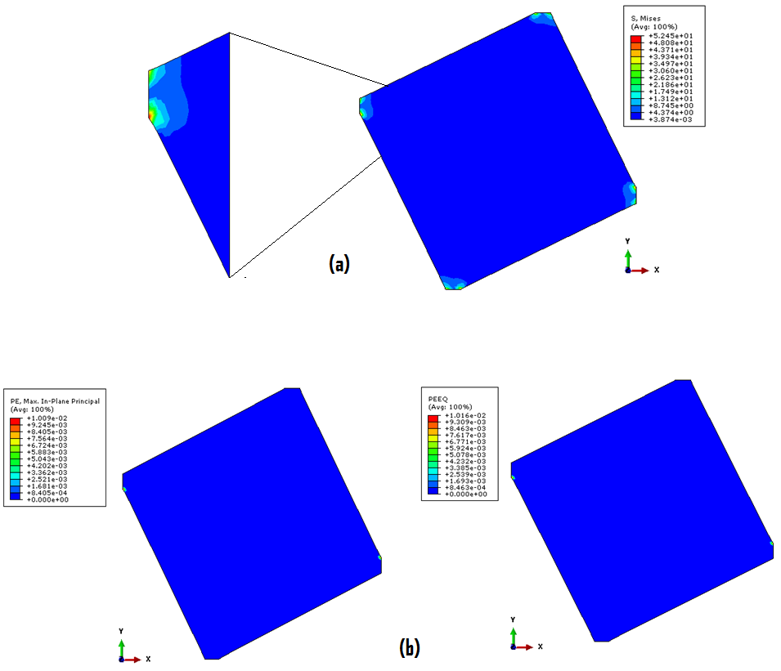
Figure 4.44: (a) Von Mises stress of the FEA model when 0.3mm displacement was applied at the REFERENCERIGHT nodeset of the model, (b) equivalent and in-plane principal plastic strains were taken at the yield point of the model.
As described earlier in Table 4.8 that the FEA model became non-linear when 0.3mm displacement applied to the FEA (Auxetic film) model along x-axis. Therefore, it was noticed that when 0.3mm displacement (extension) applied to the FEA model along x-axis, the Von Mises stress was found to be 52MPa, which was significantly greater than the yield strength (i.e. 38MPa) of the polyurethane material, and the equivalent plastic strain (PEEQ) and in-plane principal plastic strains (PE) reported in the contour legend were 0.01 (i.e. maximum plastic strain was about 1%). This clearly demonstrates that the physical Auxetic film and FEA model yielded at 0.35mm and 0.3mm extensions (along x-axis) respectively, and the plastic strain values of both physical Auxetic film and FEA model were same at the time of yielding (in the previous Figure 4.44).

4.9 Modelling of the Auxetic oesophageal stent
The rigid Auxetic oesophageal stent used earlier in stent expansion Test-III (as discussed in the previous Section 3.7.2), was simulated by an Auxetic-ring finite element model. The FEA model was built with the same structural and dimensional details as the physical Auxetic stent except its length. Therefore, only one unit-cell (comprising of four rotating-squares) was deliberately incorporated into the FEA model. The Auxetic-ring model was created small in length because diametrical changes of the FEA model were the focal point and were only examined in this analysis, and also due to the fact that meshing of the whole Auxetic stent would require more computational resources and time owing to the complex geometry of the Auxetic stent (in Figure 4.45).

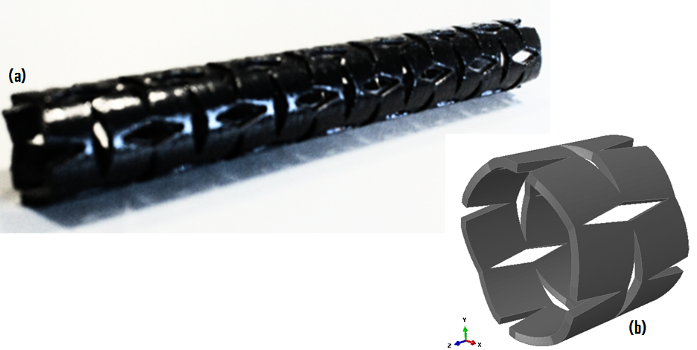
Figure 4.45: (a) Auxetic oesophageal stent (physical), (b) Auxetic-ring FEA model.

The same material (elastic-plastic) data was assigned to the FEA model, which was acquired earlier from the Baseline tensile testing of the rigid polyurethane material of 75 shore D hardness (in the previous Section 3.7.1.2). Radial displacements were applied in small increments outwardly from the inner luminal side of the model instead of radial pressure as shown in Figure 4.46. A range of radial reaction forces (resultant) were collected at small increments of radial displacement applied outwardly from the lumen of the Auxetic-ring model. These reaction forces were subsequently used to calculate pressure values at small increments of radial displacement (extension) of the model. The calculated radial pressure values with their respective radial displacement values of the FEA model were subsequently compared with the results of the physical stent-expansion Test-III.

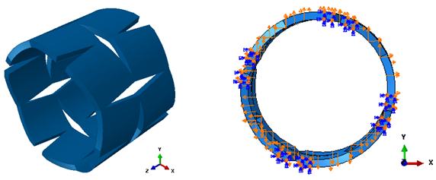
Figure 4.46: Radial displacement applied outwardly from the luminal side of the Auxetic stent model.

It was found from the Von Mises stress and equivalent plastic strain (PEEQ) values that the Auxetic-ring model started yielding or deforming plastically when 0.35mm radial displacement was applied outwardly from the inner lumen of the model and the radial pressure at this point was calculated as 3.24bar. As the Von Mises stress was found to be 38.19MPa, which was slightly higher than the yield strength of the polyurethane material (i.e. 37.5MPa), and the equivalent plastic strain collected from the contour legend was 0.0196 (i.e. maximum plastic strain was about 1.90%) as illustrated in Figure 4.47. The finite element modelling results comprising of a range of radial pressure values calculated at different radial displacement values applied to the model, were subsequently compared with the results of the physical stent expansion Test-III as shown in the Figure 4.48 below.
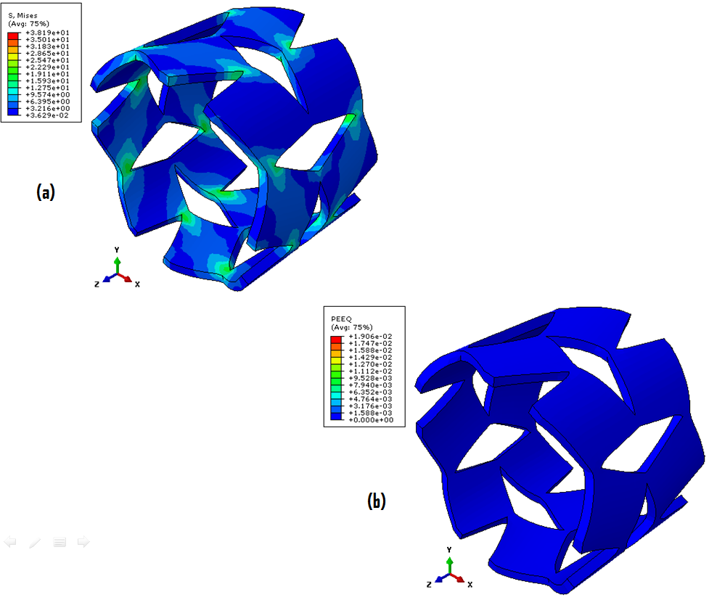
Figure 4.47: (a) Von Mises stress of the plastically deformed Auxetic-ring model,(b) PEEQ of the FEA model when yielded.

Since, it was established previously from the stent expansion Test-III (as discussed earlier in Section 4.7) that the Auxetic oesophageal stent failed at 8.3 bar pressure. Therefore, it was found that when radial displacement of 2.7mm was applied to the model, the radial pressure was calculated as 9.2 bar (from the reaction force values).

Figure 4.48: Comparison of physical stent expansion Test-III with the results of the Auxetic-ring FEA model.

Therefore, the Von Mises stress of the FEA model (at 9.2 bar radial pressure) reported from the contour legend (in Figure 4.49), was 166MPa which was equal to the maximum yield stress or the ultimate tensile strength of the model material (i.e. 166MPa). Consequently, the Auxetic-ring model was theoretically assumed as failed at this point. The equivalent plastic strain (PEEQ) found from the contour legend was 1.136 (i.e. maximum plastic strain was around 113%) as shown in Figure 4.49.
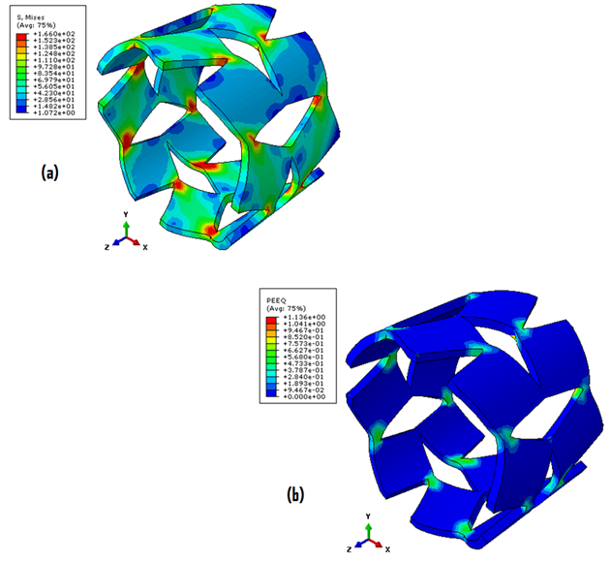

Figure 4.49: (a) Von Mises Stress contour legend of the model where the model is assumed to be failed and (b) equivalent plastic strain of the model.

It was established from the comparative data plotted in the graph in Figure 4.48 that the agreement between the physical stent expansion behaviour and the simulated Auxetic-ring FEA model was satisfactory, even though the rigid polyurethane material used for the fabrication of the physical Auxetic stent and for the Auxetic-ring FEA model was different (as mentioned in the earlier Sections 3.4.1.2 and 3.7.1.2).

Chapter 5 CONCLUSIONS And FUTURE WORK

Oesophageal cancer is the leading cause of malignant cancer death and its prognosis remains poor. Oesophageal stents have been in use as a palliative method for the patients suffering from advanced stage tumour and also for the relief of dysphagia. There is a great need to improve the palliative treatment of oesophageal cancer patients suffering from dysphagia by oesophageal stenting. All the self-expandable metal and plastic stents currently available for the palliation of oesophageal cancer have some early and late complications involved. There are mainly three costs involved in the placement of SEMS or SEPS, (i) endoscopic or fluoroscopic guidance, (ii) dedicated delivery device and (iii) balloon dilatational catheter (for both pre and post-dilation). Furthermore, due to the poor radial strength and being compressed within a low profile delivery system, some SEMS may require few episodes of post-deployment balloon dilatation to achieve sufficient radial expansion.

This research was carried out with the aim to use the unique Auxetic (rotating-square) structure, for the development of novel Auxetic polymeric oesophageal stents and stent-grafts, relevant to the palliative treatment of squamous cell carcinomas of the proximal and mid oesophagus and also for the prevention of dysphagia. This research also endeavoured to manufacture a significantly small diameter Auxetic oesophageal stent and stent-graft. In order to easily deploy the Auxetic stent orally using an inexpensive balloon dilatational catheter, by obviating the need of an expensive dedicated delivery device. One of the key questions that have been addressed in this research is the deployment of the significantly small Auxetic stent-graft without a dedicated delivery device, and to be administered orally into the oesophagus using an inexpensive balloon catheter.

Both Auxetic films (which were used for the seamed production of Auxetic stents) and seamless Auxetic oesophageal stent-grafts were developed by adopting a novel manufacturing approach, which ranged from conventional subtractive techniques to new additive (rapid prototyping) manufacturing methods. It is envisaged that the Auxetic oesophageal stent-graft comprising of semi-rigid polyurethane stent and flexible polyurethane internal graft (covering), will dilate the constricted oesophagus and maintain the luminal patency of the oesophagus. The large post-deployment luminal diameter of the Auxetic stent-graft is useful in solving problems such as food impaction and stent obstruction. The flexible internal graft is useful in allowing the semi-rigid Auxetic stent to expand both in radial and longitudinal directions, and to prevent tumour ingrowth. Additionally, because of the good mesh on the outer surface of the Auxetic stent-graft, the chance of complications such as migration / misplacement might become less.

The outcome of the comparative analysis which was carried out based on the results (obtained from manufacturing data and surface characterisation study), clearly showed that the lasercutting method is an effective and rapid way of producing Auxetic films. It was also established that instead of fabricating seamed Auxetic stent by using lasercut Auxetic film, lasercutting of polyurethane tubes for the production of seamless Auxetic stent, will not only avoid the problem of having weak welded joints but also the production time of the Auxetic stent can be also reduced. The production of seamless Auxetic oesophageal stent by vacuum casting technique was found to be effective and less time-consuming. The results from the mechanical characterisation of the Auxetic films and seamless Auxetic stents; identified the force values which were involved in their elastoplastic deformations, and determined their mechanical properties and plastic (permanent) deformation behaviour. Finite element models of both Auxetic film and oesophageal stent were developed, and compared with the experimental results with reasonably good agreement.
To explore these findings more research work would be required to refine the Auxetic stent-graft for the palliative as well as curative treatment of different non-vascular obstructive diseases. This would be achieved by the design and manufacture of a biodegradable drug coated Auxetic stent-graft, which would be used for the palliative and curative treatment of transient and chronic (benign and malignant) obstructions of natural circulatory pathways that enable the transfer of air, bodily fluids and other substances involved in systemic metabolic and energy exchange, including the gastrointestinal (GI), pulmonary (central airways obstruction), biliary tree and urinary tracts. A further research would be focused on the development of an Auxetic stent-graft made of biodegradable polyurethane material; coated with pharmacological drugs such as immunosuppressive, anti-neoplastic or anti-proliferative agents by means of Inkjet Printing Drop-on-demand (DOD) technology. The biodegradable Auxetic stent-graft would also dispense targeted local chemotherapy directly from the stent surface to the neighbouring malignant tissue instead of painful systemic chemotherapy procedure, by allowing precise and programmable control over spatial and temporal release kinetics of the pharmacological agent. This may be achieved by coating a biological inert agent such as phosphorylcholine which can be used as one component of the polymer-drug coating, in order to make the stent bioactive or to enhance cell attachment in conjunction with the sustained delivery of chemotherapeutic drug. Additional work is also required to program Auxetic stent-graft made of biodegradable polyurethane in a way that it will degrade within a designed time in order to avoid late stent complications and painful re-intervention (stent removal) procedures.

The cyclic fatigue testing and calculation of hoop forces of the current Auxetic oesophageal stent-graft will be carried out in future research. The current Auxetic (rotating-squares) geometry will be refined and tailored in future research, to enable the Auxetic stent-graft to be expanded in a more clinically relevant way.

References
"MK techonolgy GmbH." retrieved 15.07.2010, 2010, from http://www.mk-technology.com/vakuumgiessen.html.
Adler, D. G., J. Fang, et al. (2009). "Placement of Polyflex stents in patients with locally advanced esophageal cancer is safe and improves dysphagia during neoadjuvant therapy." Gastrointestinal Endoscopy 70(4): 614-619.
Aguilar, C. A., Y. Lu, et al. (2005). "Direct micro-patterning of biodegradable polymers using ultravoilet and femtosecond lasers." Biomaterials 26: 7642-7649.
Alderson, D. A., D. J. Rasburn, et al. (2001). "Auxetic polymeric filters display enhanced de-fouling and pressure compensation properties." Membrane Technology 2001(137): 6-8.
Alderson, K. L., R. S. Webber, et al. (2000). "Novel variations in the microstructure of auxetic ultra-high molecular weight polyethylene. Part 2: Mechanical properties." Polymer Engineering and Science 40(8): 1906-1914.
Ali, M. N. and I. U. Rehman (2011). "An Auxetic structure configured as oesophageal stent with potential to be used for palliative treatment of oesophageal cancer; development and in vitro mechanical analysis." Journal of Materials Science-Materials in Medicine 22(11): 2573-2581.
Armani, D. K. and C. Liu (2000). "Micro fabrication technology for polycaprolactone, A biodegradable polymer." IEEE Xplore: 294-299.
Attar, A., N. Bhuiyan, et al. (2008). "Manufacturing in blow molding: Time reduction and part quality improvement." Journal of Materials Processing Technology 204(1-3): 284-289.
Attard, D., E. Manicaro, et al. (2009). "On the properties of auxetic rotating stretching squares." Physica Status Solidi B-Basic Solid State Physics 246(9): 2045-2054.
Baron, T. H. (2007). "Expandable gastrointestinal stents." Gastroenterology 133: 1407-1411.
Bergquist, H., U. Wenger, et al. (2005). "Stent insertion or endoluminal brachytherapy as palliation of patients with advanced cancer of the esophagus and gastroesophageal junction. Results of a randomized, controlled clinical trial." Diseases of the Esophagus 18(3): 131-139.
Bethge, N., A. Sommer, et al. (1998). "Palliation of malignant esophageal obstruction due to intrinsic and extrinsic lesions with expandable metal stents." American Journal of Gastroenterology 93(10): 1829-1832.
Bianchi, M., F. L. Scarpa, et al. (2008). "Stiffness and energy dissipation in polyurethane auxetic foams." Journal of Materials Science 43(17): 5851-5860.
Black, J. T. and R. A. Kohser (2008). Fundamentals of Casting, John Wiley & sons Inc. NJ07030.
Boyce, H. W. (1997). "Palliation of dysphagia of esophageal cancer by endoscopic lumen restoration techniques." Cancer Control Journal 16(1).
Breitenbach, J. (2002). "Melt extrusion: from process to drug delivery technology." European Journal of Pharmaceutics and Biopharmaceutics 54: 107-117.
Caiazzo, F., F. Curcio, et al. (2005). "Laser cutting of different polymeric plastics (PE, PP and PC) by a CO2 laser beam." Journal of Materials Processing Technology 159(3): 279-285.
Chan, A. C. W., F. G. Shin, et al. (1999). "A comparison study on physical properties of self-expandable esophageal metal stents." Gastrointestinal Endoscopy 49(4): 462-465.
Chan, N. and K. E. Evans (1997). "Fabrication methods for auxetic foams." Journal of Materials Science 32(22): 5945-5953.
Chan, N. and K. E. Evans (1997). "Microscopic examination of the microstructure and deformation of conventional and auxetic foams." Journal of Materials Science 32(21): 5725-5736.
Chandra, R. and R. Rustgi (1998). "Biodegradable polymers." Progress in Polymer Science 23(7): 1273-1335.
Chang, D. Y. and C. S. Deng (2011). "Process Parameter Experiments on Vacuum Casting Using a Silicone Rubber Mold for ABS Plastic Parts." Advanced Manufacturing Systems, Pts 1-3 201-203: 1668-1671.
Chen, S. C. and Y. Lu (2005). Micro- and Nano-fabrication of Biodegradable Polymers, American Scientific Publishers.
Christensen, A., R. Kircher, et al. (2008). "Qualification of Electron Beam Melted (EBM) Ti6Al4V-ELI for Orthopaedic Applications." Medical Device Materials Iv: 48-53.
Christensen, J. (1997). "Mechanisms of secondary esophageal peristalsis." American Journal of Medicine 103: 44S-46S.
Cohen, S. and F. Green (1973). "Mechanics of esophageal muscle-contraction - evidence of an inotropic effect of gastrin." Journal of Clinical Investigation 52(8): 2029-2040.
Conio, M., S. Blanchi, et al. (2008). "Self-expanding stents in benign esophageal strictures." Techniques in Gastrointestinal Endoscopy 10: 164-174.
Costa, V. and J. Brophy (2002). "The use of self-expanding metallic stents in a palliation of dysphagia in patients with malignant esophageal strictures", The Technology Assessment unit of the McGill University Health Center (MUHC). 12.
Daniels, S. K. and A. L. Foundas (2001). "Swallowing physiology of sequential straw drinking." Dysphagia 16(3): 176-182.
Decker, P., J. Lippler, et al. (2001). "Use of the Polyflex stent in the palliative therapy of esophageal carcinoma - results in 14 cases and review of the literature." Surgical Endoscopy-Ultrasound and Interventional Techniques 15(12): 1444-1447.
Demma, G., E. Martuscelli, et al. (1983). "Morphology and properties of polyurethane-based blends." Journal of Materials Science 18(1): 89-102.
Diamant, N. E. (1997). "Neuromuscular mechanisms of primary peristalsis." American Journal of Medicine 103: 40S-43S.
Dodds, W. J. (1977). "Current concepts of esophageal motor function - clinical implications for radiology." American Journal of Roentgenology 128(4): 549-561.
Donescu, S., V. Chiroiu, et al. (2009). "On the Young's modulus of a auxetic composite structure." Mechanics Research Communications 36(3): 294-301.
Dooley, C. P., B. Schlossmacher, et al. (1989). "Modulation of esophageal peristalsis by alterations of body position - effect of bolus viscosity." Digestive Diseases and Sciences 34(11): 1662-1667.
Doyoyo, M. and J. W. Hu (2006). "Plastic failure analysis of an auxetic foam or inverted strut lattice under longitudinal and shear loads." Journal of the Mechanics and Physics of Solids 54(7): 1479-1492.
Ellul, B., M. Muscat, et al. (2009). "On the effect of the Poisson's ratio (positive and negative) on the stability of pressure vessel heads." Physica Status Solidi B-Basic Solid State Physics 246(9): 2025-2032.
Elton, E. (2005). "Esophageal cancer." Dm Disease-a-Month 51(12): 664-684.
Enzinger, P. C. and R. J. Mayer (2003). "Medical progress - Esophageal cancer." New England Journal of Medicine 349(23): 2241-2252.
Evans, K. E. and A. Alderson (2000). "Auxetic materials: Functional materials and structures from lateral thinking!" Advanced Materials 12(9): 617-+.
Evans, K. E. and K. L. Alderson (2000). "Auxetic materials: the positive side of being negative." Engineering science and educational journal: 148-154.
Evrard, S., O. Le Moine, et al. (2004). "Self-expanding plastic stents for benign esophageal lesions." Gastrointestinal Endoscopy 60(6): 894-900.
Freeman, M. L. (2001). "Bioabsorbable stents for gastrointestinal endoscopy." Techniques in Gastrointestinal Endoscopy 3(2): 120-125.
Frenken, M. (2001). "Best palliation in esophageal cancer: surgery, stenting, radiation, or what?" Diseases of the Esophagus 14(2): 120-123.
Gaspar, N., C. W. Smith, et al. (2005). "Quantitative analysis of the microscale of auxetic foams." Physica Status Solidi B-Basic Solid State Physics 242(3): 550-560.
Ghosh, S. K., J. E. Pandolfino, et al. (2008). "Oesophageal peristaltic transition zone defects: real but few and far between." Neurogastroenterology and Motility 20(12): 1283-1290.
Ghosh, S. K., J. E. Pandolfino, et al. (2006). "Quantifying esophageal peristalsis with high-resolution manometry: a study of 75 asymptomatic volunteers." American Journal of Physiology-Gastrointestinal and Liver Physiology 290(5): G988-G997.
Goldin, E., A. Fiorini, et al. (1996). "A new biodegradable and self-expandable stent for benign esophageal strictures." Gastrointestinal Endoscopy 43(4): 16-16.
Goldschmidt, A. and H.-J. Streitberger (2003). Coating Technology, BASF Coatings AG.
Goyal, R. K., P. Biancani, et al. (1971). "Mechanical properties of esophageal wall." Journal of Clinical Investigation 50(7): 1456-&.
Grima, J. N. and K. E. Evans (2000). "Auxetic behavior from rotating squares." Journal of Materials Science Letters 19(17): 1563-1565.
Grima, J. N., P. S. Farrugia, et al. (2008). "Auxetic behaviour from stretching connected squares." Journal of Materials Science 43(17): 5962-5971.
Grima, J. N., R. Gatt, et al. (2005). "On the potential of connected stars as auxetic systems." Molecular Simulation 31(13): 925-935.
Grima, J. N., R. Jackson, et al. (2000). "Do zeolites have negative Poisson's ratios?" Advanced Materials 12(24): 1912.
Grima, J. N., E. Manicaro, et al. (2011). "Auxetic behaviour from connected different-sized squares and rectangles." Proceedings of the Royal Society a-Mathematical Physical and Engineering Sciences 467(2126): 439-458.
Guo, Q. H., S. R. Guo, et al. (2007). "A type of esophageal stent coating composed of one 5-fluorouracil-containing EVA layer and one drug-free protective layer: In vitro release, permeation and mechanical properties." Journal of Controlled Release 118(3): 318-324.
HealthierWays. (2010). "Esophageal Cancer." 2011, from http://www.healthierways.com/esophageal-cancer/.
Hollis, J. B. and D. O. Castell (1975). "Effect of dry swallows and wet swallows of different volumes on esophageal peristalsis." Journal of Applied Physiology 38(6): 1161-1164.
Holscher, A. H., H. J. Dittler, et al. (1994). "Staging of squamous esophageal cancer - accuracy and value." World Journal of Surgery 18(3): 312-320.
Huang, H. X., Y. Z. Li, et al. (2006). "Online real-time acquisition for transient temperature in blow molding." Polymer Testing 25(6): 839-845.
Hunter, W. L., H. M. Burt, et al. (1997). "Local delivery of chemotherapy: a supplement to existing cancer treatments - A case for surgical pastes and coated stents." Advanced Drug Delivery Reviews 26(2-3): 199-207.
Imamura, S. and K. Kushima (1995). "Direct Observation and Simulation of Blow Molding Process." Nippon Steel Technical Reoort No. 67: 43-48.
Inoue, H. and T. Hirose (1997). "Absorbable and self-expanding esophageal stent-Design and Experimental Evaluation." Digestive Endoscopy 9(1): 26-28.
Kajzer, W., M. Kaczmarek, et al. (2005). "Biomechanical analysis of stent-oesophagus system." Journal of Materials Processing Technology 162: 196-202.
Kawasaki, R., A. Sano, et al. (2003). "Long-term outcomes and complications of metallic stents for malignant esophageal stenoses." Kobe Journal of Medical Sciences 49(5-6): 133-142.
Kaye, M. D. and R. M. Wexler (1981). "Alteration of esophageal peristalsis by body position." Digestive Diseases and Sciences 26(10): 897-901.
Lam, A. K. Y. (2000). "Molecular biology of esophageal squamous cell carcinoma." Critical Reviews in Oncology Hematology 33(2): 71-90.
Lamb, P. J. and S. M. Grifﬁn (2006). The Anatomy and Physiology of the Oesophagus, Springer London.
Layke, J. C. and P. P. Lopez (2006). "Esophageal cancer: A review and update." American Family Physician 73(12): 2187-2194.
Lee, S. H. (2001). "The role of oesophageal stenting in the non-surgical management of oesophageal strictures." British Journal of Radiology 74(886): 891-900.
Lerut, T., S. Stamenkovic, et al. (2005). "Obsructive cancer of the oesophagus and gastroesophageal junction." European Journal of Cancer Supplements 3(3): 177-182.
Lightdale, C. J. (1999). "Esophageal cancer." American Journal of Gastroenterology 94(1): 20-29.
Liu, Y.-F., Y.-F. Pai, et al. (2011). "Low Temperature Fabricated Conductive Lines on Flexible Substrate by Inkjet Printing." Microelectronics reliability.
Lowe, A. S. and M. B. Sheridan (2004). "Esophageal stenting." Seminars in International Radiology 21(3): 157-165.
M.Sabzi, S. M. Mirabedini, et al. (2009). "Surface modification of TiO2 nano-particles with silane coupling agent and investigation of its effect on the properties of polyurethane composite coating." Progress in Organic Coatings 65: 222-228.
Machan, L. (2006). "Clinical experience and applications of drug-eluting stents in the noncoronary vasculature, bile duct and esophagus." Advanced Drug Delivery Reviews 58(3): 447-462.
Madhavan, K. and B. S. R. Reddy (2006). "Synthesis and characterization of poly (dimethylsiloxane-urethane) elastomers: Effect of hard segments of polyurethane on morphological and mechanical properties." Journal of Polymer Science Part a-Polymer Chemistry 44(9): 2980-2989.
Maier, A., H. Pinter, et al. (1999). "Sef-expandable coated stent after intraluminal treatment of esophageal cancer: A risky procedure!" The Society of Thoracic Surgeons 67: 781-784.
Mallory, G. O. and J. B. Hajdu (1990). Electroless Plating Fundamentals & Applications. Noyes Publications/William Andrew Publishing, USA, American Electroplaters And Surface Finishers Society (AESF).
Malta, U. o. (2009). "Maltese scientists’ work on front cover of leading international scientific journal." 2010, from http://home.um.edu.mt/auxetic/press/.
Marieb, E. N. (2004). Human Anatomy & Physiology, Pearson Benjamin Cummings San Francisco.
Martinez, J. C., M. M. Puc, et al. (2011). "Esophageal stenting in the setting of malignancy." ISRN gastroenterology 2011: 719575.
May, A., L. Gossner, et al. (1999). "Extraction of migrated self-expanding esophageal metal stents." Gastrointestinal Endoscopy 49(4): 524-527.
McCabe, M. L. and Z. Dlamini (2005). "The molecular mechanisms of oesophageal cancer." International Immunopharmacology 5(7-8): 1113-1130.
Miller, L. S., J. K. Kim, et al. (2004). "Mechanics and hemodynamics of esophageal varices during peristaltic contraction." American Journal of Physiology-Gastrointestinal and Liver Physiology 287(4): G830-G835.
Mittal, R. K. and V. Bhalla (2004). "Oesophageal motor functions and its disorders." Gut 53(10): 1536-1542.
Mohan, V. and R. A. Kozarek (2001). "Placement of conventional and expandable stents for malignant esophageal stenosis." Techniques in Gastrointestinal Endoscopy 3(3): 166-175.
Moon, T., D. Hong, et al. (2001). "New approach to radial expansive force measurement of self expandable esophageal metal stents." Asaio Journal 47(6): 646-650.
Morgan, R. and A. Adam (2001). "Use of metallic stents and balloons in the esophagus and gastrointestinal tract." Journal of Vascular and Interventional Radiology 12(3): 283-297.
Natali, A. N., E. L. Carniel, et al. (2009). "Biomechanical behaviour of oesophageal tissues: Material and structural configuration, experimental data and constitutive analysis." Medical Engineering & Physics 31: 1056-1062.
Nguyen, H. N., J. Silny, et al. (1997). "Dynamics of esophageal bolus transport in healthy subjects studied using multiple intraluminal impedancometry." American Journal of Physiology-Gastrointestinal and Liver Physiology 273(4): G958-G964.
Nicosia, M. A. and J. G. Brasseur (2002). "A mathematical model for estimating muscle tension in vivo during esophageal bolus transport." Journal of Theoretical Biology 219(2): 235-255.
Nkansah, M. A., K. E. Evans, et al. (1994). "Modeling the mechanical-properties of an auxetic molecular network." Modelling and Simulation in Materials Science and Engineering 2(3): 337-352.
O'Donnell, C. A., J. Gray, et al. (2007). "A cost comparison of photodynamic therapy and metallic stents in the palliation of oesophageal cancer." Photodiagnosis and Photodynamic Therapy 4: 65-70.
Patti, M., W. Gantert, et al. (1997). "Surgery of the esophagus. Anatomy and physiology." Surgical Clinics of North America 77(5): 959-970.
Pazurek, M. and E. Malecka-Panas (2005). "Photodynamic therapy in the palliative treatment of esophageal cancer." Photodiagnosis and Photodynamic Therapy 2: 73-77.
Pennathur, A., A. C. Chang, et al. (2008). "Polyflex expandable stents in the treatment of esophageal disease: Initial experience." Annals of Thoracic Surgery 85(6): 1968-1973.
Pope, C. E. and P. F. Horton (1972). "Intraluminal force transducer measurements of human esophageal peristalsis." Gut 13(6): 464-470.
Pyrtle, J. and J. Obando (2007). "Endoscopic management of the difficult benign esophageal stricture." Techniques in Gastrointestinal Endoscopy 9: 74-83.
Rao, C., A. Haycock, et al. (2009). "Economic analysis of esophageal stenting for management of malignant dysphagia." Diseases of the Esophagus 22(4): 337-347.
Ravirala, N., A. Alderson, et al. (2005). "Auxetic polypropylene films." Polymer Engineering and Science 45(4): 517-528.
Rehman, I.U. (1996)."Biodegradable Polyurethanes: Biodegradable low adherence films for the prevention of adhesions after surgery." Journal of Biomaterials Applications 11: 182-257.
Rehman, I. Barnardo, C., et al. (1997). "Fourier transform infrared analysis of Poly(ester-urethanes) at low temperature in-situ by using a newly constructed liquid nitrogen cooled sample stage." Journal of Materials Science 32: 2617-2621.
Ren, J. L., B. T. Massey, et al. (1993). "Determinants of intrabolus pressure during esophageal peristaltic bolus transport." American Journal of Physiology 264(3): G407-G413.
Repici, A. and G. Rando (2008). "Expandable stents for malignant dysphagia." Techniques in Gastrointestinal Endoscopy 10: 175-183.
Rosato, D. V., D. V. Rosato, et al. (2000). The Complete Injection Molding Process, Kluwer Academic Publishers.
Rozanes, I., A. Poyanli, et al. (2002). "Palliative treatment of inoperable malignant esophageal strictures with metal stents: one center's experience with four different stents." European Journal of Radiology 43(3): 196-203.
Sabharwal, T., J. P. Morales, et al. (2005). "Esophageal cancer: self-expanding metallic stents." Abdominal Imaging 30: 456-464.
Saito, Y., T. Tanaka, et al. (2008). "Novel biodegradable stents for benign esophageal strictures following endoscopic submucosal dissection." Digestive Diseases and Sciences 53: 330-333.
Saito, Y., T. Tanaka, et al. (2007). "Usefulness of biodegradable stents constructed of poly-/-lactic acid monofilaments in patients with benign esophageal stenosis." World Journal of Gastroenterology 13(29): 3977-3980.
Santos, R. D., J. C. Bruno, et al. (1993). "An etching technique for morphological investigation of tpu abs blends by sem." Polymer Testing 12(5): 393-400.
Scarpa, F., P. Panayiotou, et al. (2000). "Numerical and experimental uniaxial loading on in-plane auxetic honeycombs." Journal of Strain Analysis for Engineering Design 35(5): 383-388.
Schoen, H. J., D. W. Morris, et al. (1977). "Esophageal peristaltic force in man - response to mechanical and pharmacological alterations." American Journal of Digestive Diseases 22(7): 589-597.
Schoppmann, S. F., F. B. Langer, et al. (2012). "Outcome and complications of long-term self-expanding esophageal stenting." Diesease of the Esophagus: 1-5.
Schrager, J. J., J. L. Tarpley, et al. (2005). "Endoscopic ultrasound: impact on survival in patients with esophageal cancer." American Journal of Surgery 190(5): 682-686.
Shim, C. S. (2004). "How i do it, Expandable esophageal stents." Digestive Disease Centre, World Organisation of Digestive Endoscopy OMED: 1-15.
Siemann, U. (2005). "Solvent cast technology- a versatile tool for thin film production." Progr Colloid Polym Sci 130: 1-14.
Siersema, P. D. (2006). "New developments in palliative therapy." Best Practice & Research in Clinical Gastroenterology 20(5): 959-978.
Sin, D., X. Miao, et al. (2010). "Polyurethane (PU) Scaffolds Prepared by Solvent Casting/Particulate Leaching (SCPL) combined with centrifugation." Materials Science and Engineering: C 30(1): 78-85.
Smith, C. W., J. N. Grima, et al. (2000). "A novel mechanism for generating auxetic behaviour in reticulated foams: Missing rib foam model." Acta Materialia 48(17): 4349-4356.
Stanciu, A., A. Airinei, et al. (1999). "Polyurethane/polydimethylsiloxane segmented copolymers." European Polymer Journal 35: 1959-1965.
Stavroulakis, G. E. (2005). "Auxetic behaviour: appearance and engineering applications." Physica Status Solidi B-Basic Solid State Physics 242(3): 710-720.
Stivaros, S. M., L. R. Williams, et al. (2010). "Woven polydioxanone biodegradable stents: a new treatment option for benign and malignant oesophageal strictures." European Radiology 20(5): 1069-1072.
Stoner, G. D., L. S. Wang, et al. (2007). "Chemoprevention of esophageal squamous cell carcinoma." Toxicology and Applied Pharmacology 224: 337-349.
SubsTech. (2010). "Compression molding of polymers." 2010, from http://www.substech.com/dokuwiki/doku.php?id=compression_molding_of_polymers
Tachibana, M., S. Kinugasa, et al. (2008). "Lymph node classification of esophageal squamous cell carcinoma and adenocarcinoma." European Journal of Cardio-Thoracic Surgery 34(2): 427-431.
Tang, Y., W. K. Tan, et al. (2007). "Micro-mould fabrication for a micro-gear via vacuum casting." Journal of Materials Processing Technology 192: 334-339.
Tatai, L., T. G. Moore, et al. (2007). "Thermoplastic biodegradable polyurethanes: The effect of chain extender structure on properties and in-vitro degradation." Biomaterials 28(36): 5407-5417.
Tekin, E., P. J. Smith, et al. (2008). "Inkjet printing as a deposition and patterning tool for polymers and inorganic particles." Soft Matter 4(4): 703-713.
Trust, O. R. H. N. (2010). "Oesophageal Stent." 2010, from http://www.oxfordradcliffe.nhs.uk/forpatients/090427patientinfoleaflets/100618oesophagealstent.pdf.
Uitdehaag, M. J., J. E. van Hooft, et al. (2009). "A fully-covered stent (Alimaxx-E) for the palliation of malignant dysphagia: a prospective follow-up study." Gastrointestinal Endoscopy 70(6): 1082-1089.
Valimaa, T., S. Laaksovirta, et al. (2002). "Viscoelastic memory and self-expansion of self-reinforced bioabsorbable stents." Biomaterials 23(17): 3575-3582.
van den Berg, A. M. J., P. J. Smith, et al. (2007). "Inkjet printing of polyurethane colloidal suspensions." Soft Matter 3(2): 238-243.
Vandenplas, Y., B. Hauser, et al. (2009). "A biodegradable esophageal stent in the treatment of a corrosive esophageal stenosis in a child." Journal of Pediatric Gastroenterology and Nutrition 49: 254-257.
Verschuur, E. M. L., E. J. Kuipers, et al. (2007). "Esophageal stents for malignant strictures close to the upper esophageal sphincter." Gastrointestinal Endoscopy 66(6): 1082-1090.
Wan, H., H. Ohtaki, et al. (2004). "A study of negative Poisson's ratios in auxetic honeycombs based on a large deflection model." European Journal of Mechanics a-Solids 23(1): 95-106.
Weisberger, E. (2005). "Cancer of the cervical esophagus." Oerative Techniques in Otolaryngology 16: 312-320.
White and Liz (2009). "Auxetic foam set for use in smart filters and wound dressings." Urethanes Technology International 26(4): 34-36.
Wong, R. F., D. G. Adler, et al. (2008). "Retrievable esophageal stents for benign indications." Digestive Diseases and Sciences 53(2): 322-329.
Yang, W., T. C. Fung, et al. (2007). "Three-dimensional finite element model of the two-layered oesophagus, including the effects of residual strains and buckling of mucosa." Proceedings of the Institution of Mechanical Engineers Part H-Journal of Engineering in Medicine 221(H4): 417-426.
Yang, W., Z. M. Li, et al. (2004). "On auxetic materials." Journal of Materials Science 39(10): 3269-3279.
Yimsiri, P. and M. R. Mackley (2006). "Spin and dip coating of light-emitting polymer solutions: Matching experiment with modelling." Chemical Engineering Science 61: 3496-3505.

Stent Name | Materials used | Design Configuration | Mechanical Advantages | Mechanical Disadvantages | Other Advantages | Other Disadvantages
Ultraflex stent  (Covered and bare both) | Nitinol alloy with covered layer of Polyurethane | Nitinol alloy woven into a tubular mesh, available in both uncovered and covered (Translucent Polyurethane that covers the mid-section of the stent from outside).  The body diameter is 18mm with a distal flare of 23mm or 28mm. Uncovered stent is made of 0.15inch Nitinol wire. The proximal end is amplified into a 5mm long collar with a diameter of 20mm. | It is the most flexible stent. The high degree of flexibility allows it to adapt to very tortuous strictures and limits the risk of impaction of stent extremities into the oesophageal wall.  It is constructed from a single wire, the stent can be removed by unravelling the strand.  Covered Ultraflex with silicone membrane that contributes to intensify the Expanding force and to decrease the risk of fistula formation.  It can withstand Angulation forces better than the Song stent and Z-stent. | It has lower Radial force.  The degree of shortening after deployment is around 30% to 40%.  Low Expansile force stent like Ultraflex may buckle or fail to fully expand and it is not recommended in the situation of extrinsic compression from adjacent mediastinal nodes or tumours.  Incomplete dilation in the bare Ultraflex stent is frequent due to its insufficient Expanding force compared with bare Wallstent. | Procedure related Mortality and severe persistent pain are less frequent in bare Ultraflex than bare Wallstent.  It is more suitable than other stents for use in the upper region of the oesophagus. | Its low radio-opacity makes the fluoroscopic monitoring of stent deployment difficult unless a high quality X-ray system is used.  If no dilation is preformed it may take several days for the stent to fully (completely) expand.
Wallstent  (Wallstent I and Wallstent II) | They are made from a non-magnetic Cobalt based alloy called “Elgiloy” (which contains Chromium, Nickel and Iron) and are formed in a tubular mesh covered by a polymer membrane called “Permalume”, | Woven in a tubular covered mesh fashion with 2cm of uncovered stent at proximal and distal ends.  The shape of the stent is a straight tube.  Proximal and distal ends of Wallstent II are cuffed to 28mm, and the body is 20mm diameter.  Wallstent I had a Polyurethane cover applied to the outside of the stent. | Wallstent II is more flexible.  Wallstent I has high Expansile force.  Wallstent has the ability of to be recaptured after partial deployment should repositioning be necessary.  Uncovered proximal and distal segments are designed to increase stent anchorage.  The original delivery system for Wallstent has been reduced from 38Fr to 18Fr and made significantly more flexible and user friendly. | Wallstent II has less Expansile force.  Although the proximal and distal ends are uncovered, migration rates are still high. |  | Wallstent I with outside Polyurethane cover produced a smooth outer surface and the stent mesh was unable to embed in the tumor.  A malplaced Wallstent is difficult to reposition because of the risk of exposed wire barbs lacerating the tissue.  Procedure related mortality and severe persistent pain are frequent in Wallstent.
Flamingo Wallstent | Braided Stainless Steel alloy with Polyurethane covering | It has a relatively large diameter at the proximal end with narrower distal end (Conical shape).  The proximal and distal ends are uncovered, and the covering inside the metal mesh.  The Conical design which is covered by the Polymer on its inner surface of the stent has variable braiding angle.  The proximal funnel shaped end is 8-10mm wider in diameter than the barrel. | It has increased proximal radial force.  The conical design and the variable braiding angle of the mesh provide resistance to antegrade peristalsis and help prevent dislodgment.  The uncovered proximal and distal segments are designed to increase stent anchorage.  Flamingo stent is designed with a variable Radial force throughout the length of the stent.  The proximal half exerts greater Radial force for secure fixation in the proximal oesophagus.  The distal half of the stent exerts less Radial force and has greater flexibility to accommodate movement within the gastric cardia. |  | It is now recommended only for tumours of the lower third of the oesophagus.  It has been designed to minimize the incidence of migration with the covering inside the metal meshwork, uncovered segments on both ends of the stent and with a larger proximal end.  Flamingo Wallstent is recommended for use at the Cardia to reduce the risks of distal migration.  Major complications of Flamingo stent are lower than Z-stent. | Gastrointestinal bleeding seems to be the only major drawback of Flamingo Wallstent.
Gianturco-Z-stent  and DUA-stent | Z-stent is made of Stainless Steel (an alloy of Chromium and Iron) and covered with Polyethylene over the entire length.  DUA-stent is a Z-stent modified with Polyurethane covering. | Z-stent is an expandable stent made in a zigzag fashion.  Early designs had flared proximal and distal ends with central sharp barbs to anchor the stent.  Recent versions of this stent have the proximal and distal funnels partially coated to reduce the risk of migration.  The Polyurethane covering in DUA-stent extends 8cm beyond the metal portion of the stent with the intent to reduce Gastrointestinal reflux. This Polyurethane “Windsock” in DUA-stent creates a one-way valve that closes with a rise in intra-gastric pressure by collapsing on itself. | Shortening of this stent is less than 10%.  The Z-stent has a high Expansile force.  Because of the better Expansile force, foreshortening is less on release.  High Radial force stent like Z-stent may be the better option in the situation of extrinsic compression from adjacent mediastinal nodes or tumours. | It is relatively inflexible.  Gianturco-Z-stent and Song stent are weak in withstanding Compressive and Angulation forces than Esophacoil stent. | Migration rates are much lower. | The introduction system is more complex than the other stents and the delivery catheter is larger and rigid making it difficult to advance across very tight strictures.  Central barbs have been associated with serious complications like perforation and haemorrhage.  An uncovered Gianturco-Z-stent is recommended at the cardia to reduce the risks of distal migration
Song stent | It is a modified version of Z-stent, made from Stainless Steel with a Polyurethane covering. | This stent has also been made in a Retrievable form with a single thread attached to the tubular wire configuration. |  | Song stent is weak in withstanding Compressive and Angulation forces than Esophacoil stent.
Song Retrievable (SR) stent | SR stent is a 0.2mm Nitinol stent and is covered with 12% Polyurethane membrane. | 0.2mm Nitinol stent with a tubular configuration and an interlocking diamond-shaped pattern. The stent has two 20mm flared ends, 24 and 22mm in diameter, designed to prevent migration. The middle part is 14-18mm in diameter and 60-160mm long when fully expanded. A drawstring of Nylon filament is attached to the proximal inner margin of the stent to make it retrievable. |  |  |  | Covered SR stents have a higher incidence of migration.  The migration rate was found to be 20% with the SR stent.  SR stent does not seem to be stable in the long term.  Their use is not justified in malignant strictures except for cervical use.
Esophacoil stent | Nitinol wire | This is tightly wound flattened Nitinol wire that is compressed on a delivery rod. | Esophacoil stent is the strongest stent in withstanding Compressive and Angulation forces when compared with the Wallstent, Ultraflex, Song and Gianturco stents. | The spring like deployment of the Esophacoil stent, along with 50% shortening of the pre-deployment length, are factors leading to potential malposition.  Retrieval of Esophacoil stent may require by grasping the proximal end with a snare and pulling the stent through an overtube to prevent tissue damage
Polyflex stent | Composed of woven Polyester monofilament completely covered on the inside with a silicone membrane. | Polyflex stent is a self-expanding Plastic stent made of Polyester netting embedded in silicone. Its wall thickness is 0.45mm and it has radio-opaque markers at both the ends and in the middle. It is available in three diameters with a proximal flared end to prevent stent migration. | This construction provides the necessary Radial force to restore luminal patency and the malleability for atraumatic repositioning or removal.  The continuous inner covering prevents tumour in-growth and provides a smooth inner surface to promote food passage while exposing the rough outer mesh to help with anchoring.  Radial Expansile force is similar to that of metal stents.  This stent is malleable and there are no sharp edges. It can be easily retrievable. |  | Lack of interference with standard imaging modalities because of the metal free design. | High migration rates, possibly because of the complete silicone coverage of the stent.  The diameter of the delivery system is larger than the self-expanding metal stents, and pre-dilation of the stricture is required typically more than SEMS.  A complicated and relatively rigid and thick delivery system.
Evolution stent | Nitinol wire with an internal and external silicone coating, | It is designed from single Nitinol wire, has two flanges, and the body has 24 atraumatic crowns with high density of wires to provide uniform Radial force and minimize concentration of forces at any particular area of tissue.  It has a Stainless Steel lasso at the proximal side which allows the opportunity to reposition the stent. | Dual flanges secure the stent, potentially reducing the risk of migration or stent movement after placement.  Internal and external silicone coating, designed to resist tumor in-growth and enhance the patient’s ability to swallow. |  | The Evolution stent’s reconstrainable delivery system facilitates direct and continuous monitoring of the placement with its “Point-of-no-return” indicator.
Niti-S-Double stent | Nitinol with internal covering of Polyurethane | On the central area of the stent there is a further uncovered mesh placed over the covered part. | Uncovered mesh placed over the covered part, combines the advantages of an uncovered stent (very low migration rate) with the advantage of a covered stent (low in-growth rate).
Refernces

Chan, A. C. W., F. G. Shin, et al. (1999). "A comparison study on physical properties of self-expandable esophageal metal stents." Gastrointestinal Endoscopy 49(4): 462-465.
Kawasaki, R., A. Sano, et al. (2003). "Long-term outcomes and complications of metallic stents for malignant esophageal stenoses." Kobe Journal of Medical Sciences 49(5-6): 133-142.
Lee, S. H. (2001). "The role of oesophageal stenting in the non-surgical management of oesophageal strictures." British Journal of Radiology 74(886): 891-900.
Lowe, A. S. and M. B. Sheridan (2004). "Esophageal stenting." Seminars in International Radiology 21(3): 157-165.
Mohan, V. and R. A. Kozarek (2001). "Placement of conventional and expandable stents for malignant esophageal stenosis." Techniques in Gastrointestinal Endoscopy 3(3): 166-175.
Pennathur, A., A. C. Chang, et al. (2008). "Polyflex expandable stents in the treatment of esophageal disease: Initial experience." Annals of Thoracic Surgery 85(6): 1968-1973.
Repici, A. and G. Rando (2008). "Expandable stents for malignant dysphagia." Techniques in Gastrointestinal Endoscopy 10: 175-183.
Rozanes, I., A. Poyanli, et al. (2002). "Palliative treatment of inoperable malignant esophageal strictures with metal stents: one center's experience with four different stents." European Journal of Radiology 43(3): 196-203.
Sabharwal, T., J. P. Morales, et al. (2005). "Esophageal cancer: self-expanding metallic stents." Abdominal Imaging 30: 456-464.
Wong, R. F., D. G. Adler, et al. (2008). "Retrievable esophageal stents for benign indications." Digestive Diseases and Sciences 53(2): 322-329.

