
AN ANALYTICAL WRINKLING PREDICTION METHOD FOR CONVENTIONAL SPINNING

PhD Student: ZHAOHUA LI

Supervisor: Prof. Hui Long
Dissertation submitted to the Department of Mechanical Engineering, the University of Sheffield in partial fulfilment of requirements for the degree of Doctor of Philosophy
September 2020

ACKNOWLEDGMENTS
No words can adequately express my great appreciation to Prof. Hui Long for her assistance, inspiration, guidance through all the aspects of my PhD research and thesis writing. Her tremendous effort and tireless support make this work possible. It is the greatest honour to work under her supervision.
I am deeply indebted to Mr. Jamie Booth from the department mechanical workshop for providing the technical advice and the supporting of spinning experiments.
I would appreciate to Dr. Hengan Ou from the University of Nottingham and Dr. Bin Lu for the valuable advice on the project of incremental sheet forming and paper publication.
I would like to thank all my friends in the UK and from home for their support and encouragement. I gratefully acknowledge Dr. Sheng Ai and Dr. Gangyao Zhao for their sincere help throughout my FE modelling and theoretical analysis works.
At last, but not least, I would like to express my sincere thanks to My Parents, for their cooperation, support, encouragement and understanding, which makes me fearless and ambitious. Deepest special thanks to My Wife, for her endurance, love and support in every possible way during the entire PhD study.

Abstract
The sheet metal spinning is frequently employed in the sheet metal manufacturing industry due to its great capability to form a wide range of materials for a variety of industrial products. During the sheet metal spinning process, a flat workpiece is rotated at a high speed to enable forming of the final shape of a spun component. The workpiece is deformed by moving a forming tool gradually onto the mandrel surface using either single-pass or multiple-passes. Due to the nature of localised material deformation, the sheet metal spinning has inherent advantages, such as low production costs, high material utilisation, good dimensional accuracy and enhanced mechanical properties. It is suitable for manufacturing light-weight components with flexibility in many manufacturing industries such as for aerospace, automotive, medical equipment applications. Nevertheless, the spinning process design, i.e. toolpath design and selection of forming process parameters, still highly relies on empirical knowledge and trial-and-error practice to obtain correct process setting and hence, avoid the component defects, especially wrinkling failure. Without guidance for the selection of spinning parameters, the manufacturing efficiency and product quality are severely restricted. This study aims to develop an analytical wrinkling prediction model for the first-pass conventional spinning therefore to provide a guidance of parameter setting and to support the process design of spinning.
In this study, the multiple-passes of the forming tool commonly used in the conventional spinning are parameterised by using the forming depth and the radius of workpiece after each pass. The cubic Bézier curve is employed to parameterise a specific toolpath profile including linear path, convex path and concave path. The methods of calculating the control points of the cubic Bézier curve for the final toolpath profile and the first toolpath profile are proposed, respectively. The capability and accuracy of the cubic Bézier curve are examined by comparing the geometrical shapes of different spun components. Furthermore, the contact path created by the tool movement on the workpiece surface is plotted to analyse the effect of the feed ratio on the contact between tool and workpiece.
Wrinkling failure in the first-pass conventional spinning process can be influenced by both process parameters, such as feed ratio and forming depth, and material parameters, such as spin ratio and workpiece thickness. Finite Element (FE) models of the first-pass conventional spinning are developed to analyse the influences of these parameters on wrinkling failure using the convex toolpath profile for the material of mild steel (DC01). The significance and relative significance of these parameters on wrinkling initiation in spinning are investigated by developing FE models using the Taguchi method. The FE results show that the workpiece thickness is the most significant factor affecting wrinkling in the first-pass conventional spinning, followed by the forming depth, the spin ratio, and the feed ratio. A mathematical wrinkling wave function is established considering the features of wrinkling waveform. This is validated by comparing the geometrical features between the model produced by the wrinkling wave function and the wrinkled FE model.
An analytical wrinkling prediction method based on the conservation of energy is established for the first-pass conventional spinning with the convex toolpath profile. The strain energy (internal energy) and work done by the forming tool (external energy) are calculated, respectively. The critical condition of wrinkling occurrence can be determined when the external energy is equal to the internal energy therefore to enable the critical forming depth to be calculated. The influences of various parameters, including spin ratio, feed ratio, and workpiece thickness, on the critical forming depth is systematically investigated by the wrinkling prediction method using the Box-Behnken Design of the analytical models. It is found that the critical forming depth is affected by the spin ratio significantly, followed by the workpiece thickness and the feed ratio.
The experimental testing of the first-pass conventional spinning using the convex toolpath profile is conducted to validate the developed analytical wrinkling prediction model for the material of DC01. A time-domain measurement system using the vibration sensor is employed to record the initiation and development of wrinkling failure during spinning tests. The accuracy of the analytical wrinkling prediction model is validated based on a small range of spinning parameters firstly in the preliminary experiment. Combining the results from the FE models and the full experiment, the developed analytical wrinkling prediction model is further validated under various spinning conditions. The processing map to predict wrinkling failure is produced for the first-pass conventional spinning using the convex toolpath profile.
The contribution to knowledge of this study is an analytical model for the prediction of wrinkles in the first-pass conventional spinning process using the convex toolpath. The efficiency and accuracy of this model have been validated by both experiment and FE modelling approaches. This model has potential to be used in evaluating the effect of the key spinning parameters on wrinkling occurrence thus to provide guidance for the selection of spinning parameters in the actual production of spun components.

PUBLICATION DURING PH.D. STUDY
Lu, B., Li, Z., Long, H., Chen, F., Chen, J. and Ou, H., 2017. Microstructure refinement by tool rotation-induced vibration in incremental sheet forming. Procedia engineering, 207, pp.795-800.
Li, Z and Long, H. Analytical Method for Wrinkling Predication in Conventional Sheet Spinning. To be submitted to International Journal of Mechanical Sciences, under preparation.

CONTENTS

1 Introduction 1
1.1 Research Background 1
1.1.1 Sheet Metal Spinning 1
1.1.2 Component defects of Spinning 4
1.2 Research Gaps and Challenges 7
1.3 Research Aims and Objectives 8
1.4 Thesis Structure 9
2 Literature review 11
2.1 Classification of Sheet Metal Spinning 11
2.1.1 Shear Spinning 13
2.1.2 Novel Spinning 15
2.1.3 Conventional Spinning 17
2.2 Key Considerations in FE Modelling of Spinning Processes 19
2.2.1 Implicit and Explicit Nonlinear Solution Methods 19
2.2.2 Material Plasticity 24
2.2.3 Element Selection 28
2.3 Key Process and Material Parameters 28
2.3.1 Toolpath Design 29
2.3.2 Feed Ratio 33
2.3.3 Material Diameter and Thickness 34
2.4 Wrinkling Failure in Conventional Spinning 35
2.4.1 Wrinkling Failure Mechanics 36
2.4.2 Processing Map to Predict Wrinkling Failure in Conventional Spinning 42
2.4.3 Detection Methods for Initiation of Wrinkling Failure 44
2.5 Material Plastic Deformation 47
2.5.1 Von Mises Yielding Criterion 48
2.5.2 Thin Shell Theory 49
2.6 Summary 55
3 Parameterisation of toolpath profiles 57
3.1 Multiple-passes Parameterisation 58
3.2 Bézier Curve 58
3.3 Control Points for the Final Toolpath Profile 60
3.4 Control Points for the First Toolpath Profile 62
3.5 Application of Spinning Toolpath Design 67
3.5.1 Cubic Bézier curves for different mandrel profiles 67
3.5.2 Accuracy of the First Tool Pass 72
3.5.3 Design of Different Types of First Toolpath Profile 76
3.5.4 Effects of Spinning Process Parameters on Toolpath Profiles 79
3.6 Summary 81
4 Finite element analysis of spinning process 83
4.1 Development of Finite Element Models 84
4.2 Verification of Finite Element Models 89
4.2.1 Mesh Convergence Study 89
4.2.2 Assessment of Mass Scaling Factor 93
4.3 FE Simulation using Taguchi Method 99
4.4 Results and Discussion 102
4.4.1 The Effects of Process Parameters on Wrinkling 102
4.4.2 Geometrical Modelling of Wrinkles using a Wave Function 112
4.4.3 Validation of the Wrinkling Wave Function 117
4.5 Summary 120
5 Development of wrinkling prediction model 122
5.1 Establishment of Wrinkling Criterion 122
5.1.1 Basic Assumptions 122
5.1.2 Boundary Conditions of Wrinkling Prediction Model 123
5.2 Wrinkling Prediction Based on Energy Conservation 129
5.2.1 Strain Energy of Wrinkled Spun Component 129
5.2.2 External Work Done by Forming Tool 132
5.2.3 Wrinkling Limit 142
5.3 Results and Discussion 145
5.3.1 Analysis of Effect of Material Properties on Wrinkling 145
5.3.2 Analysis of Effect of Process Parameters on Wrinkling 149
5.3.3 Significance Analysis of Main Parameters 153
5.3.4 Determination of Wrinkling-free Spinning Diagrams 156
5.4 Summary 159
6 EXPERIMENTAL VALIDATION OF WRINKLING PREDICTION MODEL 161
6.1 Equipment and Experiment Setup 161
6.2 Preliminary Experiment and Results 165
6.2.1 Design of Preliminary Experiment 165
6.2.2 Preliminary experiment results 169
6.3 Experimental Design 174
6.4 Results and Discussion 178
6.4.1 Confirmation of the Effects of First-pass on Wrinkling 178
6.4.2 Processing Map for Wrinkle-Free Spinning 185
6.5 Summary 191
7 Conclusion and future work 193
7.1 Conclusion 193
7.2 Research Novelty 196
7.3 Future Work 196
References 198
Appendices 209
Appendice 1 MATLAB code for Wrinkling Prediction Model 209

LIST OF TABLES
Table 3.1 Different types of first toolpath profile 77
Table 4.1. Material properties of DC01 86
Table 4.2 Coulomb frictional coefficients of three contact pairs 88
Table 4.3 Spinning parameters used in both experiments and simulations 89
Table 4.4 Mesh convergence study 90
Table 4.5 Input parameters used in FE simulation 99
Table 4.6 FE simulation models designed using Taguchi method 100
Table 4.7 Responses obtained from FE simulation models 102
Table 5.1 Material properties of DC01, AA5052 and AA1050 145
Table 5.2 Radius of undeformed workpiece and clamped area 150
Table 5.3 Parameters used in significance analysis 153
Table 5.4 The Box-Behnken design and results for the significance analysis 155
Table 6.1 Process parameters for preliminary experiment 166
Table 6.2 Experimental input parameters used in the preliminary experiment 167
Table 6.3 Experimental tests for first-pass conventional spinning with convex toolpath profile. 167
Table 6.4 Recorded responses during the preliminary experiment 168
Table 6.5 Results of forming depths and edge radius measurements for unwrinkled spun components 174
Table 6.6 Factors and levels used in the experiment 175
Table 6.7 Experimental tests (combinatorial design) 176
Table 6.8 Validation of analytical wrinkling prediction model at a spin ratio of 0.73 188
Table 6.9 Validation of analytical wrinkling prediction model at a spin ratio of 0.80 189

LIST OF FIGURES
Figure 1.1 Typical setup for conventional sheet metal spinning (2) 2
Figure 1.2 Applications of spun components 3
Figure 1.3 Typical types of component defects: (a) wrinkling, (b) circumferential fracture, (c) radial fracture type $I$, and (d) radial fracture type $II$ 5
Figure 2.1 Traditional spinning: (a) shear spinning, (b) conventional spinning 12
Figure 2.2 Spun components produced by novel sheet metal spinning: (a) non-circular cross-section spun component, (b) curved conical spun component (3) 13
Figure 2.3 Examples of typical spun component geometries in shear spinning (5) 13
Figure 2.4 Three deviations from the sine law in shear spinning: (a) over-spinning, (b) true shear spinning and (c) under-spinning (5) 14
Figure 2.5 Definitions of tool force components in shear spinning (31) 15
Figure 2.6 Examples of typical spun component geometries in conventional spinning (5) 17
Figure 2.7 Stress states of the forming region during conventional spinning process (5) 18
Figure 2.8 First iteration in an increment (44) 20
Figure 2.9 Second iteration in an increment (44) 21
Figure 2.10 Illustration of stress-strain curve of elastic-plastic material (49) 25
Figure 2.11 Three loading conditions (51) 26
Figure 2.12 Isotropic strain hardening (52) 27
Figure 2.13 Illustration of toolpath attach-on-mandrel method: (a) point attachment method, (b) segment attachment method 29
Figure 2.14 Illustration of cooperation between forward path and backward path: (a) material deformed by forward and backward paths, (b) material deformed by forward path only 30
Figure 2.15 Illustration of toolpath profiles: (a) linear path, (b) convex path, and (c) concave path 31
Figure 2.16 Circular grid patterns etched onto the workpiece surface 37
Figure 2.17 Wrinkle growth in the first-pass conventional spinning (2) 38
Figure 2.18 Toothed stress pattern along circumferential direction (42) 39
Figure 2.19 Double curved surface model 41
Figure 2.20 Schematic diagram of first-pass conventional spinning using linear toolpath 42
Figure 2.21 Processing map for various feed rates and thicknesses (14) 43
Figure 2.22 Processing map for various spindle speeds and feed rates (17) 43
Figure 2.23 3D processing maps for various hardening exponents, feed ratios, and half cone angle at different thicknesses (a) 1 $mm$, (b) 1.4 $mm$ (23) 44
Figure 2.24 Strain measurement by strain gauges (26) 46
Figure 2.25 Force measurement system (42) 46
Figure 2.26 Fixture of force transducer designed for CNC lathe (77) 47
Figure 2.27 Curvilinear coordinates of the structure’s middle surface (80) 50
Figure 2.28 Infinitesimal element of the doubly curved structure (80) 53
Figure 3.1 Multiple-passes parameterisation 58
Figure 3.2 The Bézier curve shape modification 59
Figure 3.3 Sequence of control points 60
Figure 3.4 Conditions of three types of toolpath profiles 63
Figure 3.5 A convex toolpath with a PC of $2λ$ 64
Figure 3.6 Parameterisation of a circular arc curve using a cubic Bézier curve 65
Figure 3.7 Simplified diagram of a semi-ellipse mandrel profile 68
Figure 3.8 Comparison between a toolpath designed by the cubic Bézier curve and a semi-ellipse mandrel profile (mandrel profile $x2422+y2592=1$, $P0$ $21, 51.1$ and $P3$ $42, 0$) 71
Figure 3.9 Flexibility of the cubic Bézier curve as used to represent a (a) semi-spherical mandrel, (b) conical mandrel, (c) funnel-shaped mandrel, and (d) horn-shaped mandrel 72
Figure 3.10 Comparison between a circular arc and the cubic Bézier curves produced with different zenith angles $φi$: (a) $φi=π3$, (b)$φi=23π$, (c) $φi=π$, and (d) $φi=43π$ 74
Figure 3.11 Curve consistency between the cubic Bézier curve and a circular arc with zenith angles $φi$ 76
Figure 3.12 Schematic diagrams of first toolpath profiles: (a) three convex paths and a linear path; (b) three concave paths and a linear path 78
Figure 3.13 Surfaces formed by the contour lines of toolpath profiles with 2 $mm/rev$ and 0.4 $mm/rev$ feed ratios: (a) Convex-2, (b) Concave-2, and (c) Linear-2 80
Figure 3.14 Springback definition 81
Figure 4.1 Meshed workpiece without the central clamping area 85
Figure 4.2 True stress-strain curve of DC01 86
Figure 4.3 Spinning model: (a) FE model; (b) dimensions of workpiece and tools 87
Figure 4.4 Variations of von Mises stresses in FE models (a) T1, (b) T2, (c) T3, and (d) stress variation along the radial direction 92
Figure 4.5 Comparison of thickness distributions in three FE models 93
Figure 4.6 Evaluation of energy histories of different mass scaling factors: (a) kinetic energy/internal energy, (b) Artificial energy/internal energy 95
Figure 4.7 Comparison between the FE model and experimental results: (a) Experimental spun component, (b) FE formed spun component, and (c) Thickness variation between the FE model and experiment 96
Figure 4.8 Validation of the FE model with workpiece radius of 75 $mm:$ (a) Energy histories, (b) Thickness variation results of FE model and experiment, (c) Spun component obtained in experiment, and (d) Spun component obtained in FE model 97
Figure 4.9 Validation of the FE model with workpiece radius of 100 $mm:$ (a) Energy histories, (b) Thickness variation results of FE model and experiment, (c) Spun component obtained in experiment, and (d) Spun component obtained in FE model 98
Figure 4.10 Toolpath profiles used in FE models: (a) spin ratio of 0.73, (b) spin ratio of 0.8 101
Figure 4.11 Severity of wrinkling in each model: (a) axial displacement along the circumferential direction, (b) STDVs of axial displacement 103
Figure 4.12 Illustration of elastic energy history: (a) wrinkling free model M3, (b) severely wrinkled model M6 105
Figure 4.13 Elastic strain energy history of M7 106
Figure 4.14 WTR of each model 107
Figure 4.15 MTR of each model 107
Figure 4.16 Main effects plot for Means of STDV of axial displacement. 108
Figure 4.17 Main effects plot for WTR 109
Figure 4.18 Main effects plot for MTR 110
Figure 4.19 Response contour plots (a) STDV of Displacement, (b) WTR, and (c) MTR 112
Figure 4.20 Comparison of simulated and experimental wrinkled spun components: (a) top view of simulated workpiece, (b) bottom view of simulated workpiece, and (c) experimental workpiece ($R0=50 mm$, $Rc=20 mm$, $f=1.5 mm/rev$) 113
Figure 4.21 Details of wrinkle trough and crest areas in a wrinkled spun component 113
Figure 4.22 Curvilinear coordinate system of the wrinkling free component middle surface 114
Figure 4.23 Illustration of the geometries of the mathematical models: (a) Wrinkling free model, (b) Wrinkled model, and (c) Location of three cross-sections in both models 115
Figure 4.24 Details of cross-sections: (a) Section A-A, (b) Section B-B, and (c) Section C-C 116
Figure 4.25 Direction and location of circumferential and radial node lists 117
Figure 4.26 Variation of the wave amplitude along the circumferential direction 118
Figure 4.27 Variations of the six wave amplitudes along the radial direction 119
Figure 5.1 Schematic diagram of the wrinkled spun component 125
Figure 5.2 Illustration of the location of an infinitesimal element on the workpiece before and after deformation 133
Figure 5.3 Illustration of stress states of an infinitesimal element on the wrinkling free spun component: (a) location of the infinitesimal element, (b) stresses of this infinitesimal element 136
Figure 5.4 Flow chart of the numerical calculation of the wrinkling limit 144
Figure 5.5 The critical forming depth of first-pass using a convex toolpath profile ($R0=50 mm$, $RC=20 mm$, $t=1.2mm$) 146
Figure 5.6 Illustration of the predicted critical forming depth of three materials ($R0=50 mm$, $RC=20 mm$, $t=1.2mm$) 147
Figure 5.7 Effect of Young’s modulus on critical forming depth ($R0=50 mm$, $RC=20 mm$, $t=1.2 mm$, $K=549.09 MPa$, $n=0.221$) 148
Figure 5.8 Effect of strength coefficient on critical forming depth ($R0=50 mm$, $RC=20 mm$, $t=1.2 mm$, $E=198.2 GPa$, $n=0.221$) 148
Figure 5.9 Effect of the strain-hardening index on critical forming depth ($R0=50 mm$, $RC=20 mm$, $t=1.2 mm$, $E=198.2 GPa$,$K=549.09 MPa$) 149
Figure 5.10 Effect of the workpiece radius on critical forming depth ($t=1.2 mm$) 150
Figure 5.11 The relationship between spin ratio and wrinkling sensitivity ratio ($t=1.2 mm$) 151
Figure 5.12 Effect of workpiece thickness on critical forming depth ($R0=50 mm$, $RC=20 mm$) 152
Figure 5.13 Effect of feed ratio on critical forming depth ($R0=50 mm$, $RC=20 mm$, $t=1.2 mm$) 152
Figure 5.14 Significance coefficients of each input parameter: (a) Critical forming Depth, (b) Wrinkling Sensitivity 156
Figure 5.15 Contour plots of critical forming depth under different spin ratios 157
Figure 5.16 Illustration of the critical forming depth of three spin ratios ($RC=20 mm$, $t=1.7 mm$, $f=1.2 mm/rev$) 158
Figure 6.1 AJAX Premier 200 CNC turning centre 162
Figure 6.2 Experimental setup on CNC turning machine 162
Figure 6.3 The measurement system 163
Figure 6.4 Time-domain vibration amplitude for an unwrinkled spun component 164
Figure 6.5 Response parameters: (a) forming depth deviation and spun component radius deviation, (b) thickness variation measurement points 169
Figure 6.6 Preliminary experimental spun components (T1, T4, and T7 formed with 0.5 $mm/rev$, T2, T5, and T8 formed with 1 $mm/rev$, T3, T6, and T9 formed with 1 $mm/rev$) 170
Figure 6.7 Comparison of groups of preliminary experimental samples: (a)$h=16.8 mm$, (b) $h=19.3 mm$, and (c)$h=14.3 mm$ 171
Figure 6.8 Processing map considering wrinkling 172
Figure 6.9 Wall thickness distribution of unwrinkled spun components 173
Figure 6.10. Three different toolpath profiles 177
Figure 6.11 Workpieces produced by using different toolpath profiles: (a) concave toolpath, (b) linear toolpath, and (c) convex toolpath 179
Figure 6.12 Time-domain vibration amplitudes of workpieces produced using a concave path 180
Figure 6.13 Time-domain vibration amplitude of workpieces produced using a linear path 181
Figure 6.14 Time-domain vibration amplitudes of workpieces produced using a convex toolpath 182
Figure 6.15 Results of forming depth for unwrinkled spun components 183
Figure 6.16 Workpiece swept area under different toolpath profiles 184
Figure 6.17 Schematic diagram of toolpaths in Li et al. (24) 184
Figure 6.18 Workpieces obtained from Tests No. 14 to No. 18, (a) time-domain vibration amplitudes, (b) experimental workpieces 186
Figure 6.19 Validation of wrinkling prediction model at different spin ratios (a) $λ=73$, (b) $λ=0.80$ 187
Figure 6.20 Processing maps to predict wrinkling failure at different spin ratios (a) $λ=0.73$, (b) $λ=0.80$ 191

LIST OF ABBREVIATIONS AND ACRONYMS
ASTM | The Standard Test Methods for Tension Testing of Metallic Materials
CC | Curve consistency
CGA | Circle grid analysis
EDM | Electrical Discharge Machining
FE | Finite Element
FLD | Forming Limit Diagram
MTR | Maximum thickness reduction
PC | Path Curvature
STDV | The standard deviation
WTR | Wrinkling time ratio

LIST OF NOMENCLATURES
$$A,B$$ | Lamé coefficients
$$E$$ | Young’s Modulus ($GPa$)
$$E_{r}$$ | The reduced modules ($MPa$)
$$E_{s}$$ | The secant modulus ($MPa$)
$$E_{t}$$ | The tangent modules ($MPa$)
$$F_{a}$$ | Axial tool force ($N$)
$$F_{r}$$ | Radial tool force ($N$)
$$F_{t}$$ | Tangential tool force ($N$)
$$f$$ | The feed ratio ($mm/rev$)
$$H$$ | Total forming depth ($mm$)
$$h_{c}$$ | Critical forming depth ($mm$)
$$h_{i}$$ | Forming depth of each pass ($mm$)
$$K$$ | Material strength coefficient ($MPa$)
$$L_{w}$$ | The edge perimeter of wrinkled spun component along the circumferential direction ($mm$)
$${L_{w}}^{'}$$ | The edge perimeter of a unit wrinkled model along the circumferential direction ($mm$)
$$m$$ | The number of wrinkles along circumferential direction
$$N_{0}$$ | The total rotation number of spinning process
$$N_{k}$$ | The rotation number for the position of an arbitrary element
$$n$$ | Material strain-hardening index
$$O_{1}$$ | The centre point of the doubly curved shell in circumferential direction
$$O_{2}$$ | The centre point of the doubly curved shell in meridional direction
$$R$$ | The distance between the rotation axis to an arbitrary element in the undeformed blank ($mm$
$$R_{0}$$ | Radius of original blank ($mm$)
$$R_{2}$$ | Radius of workpiece after the first-pass of conventional spinning ($mm$)
$$R_{c}$$ | Radius of blank clamped area ($mm$)
$$r$$ | The principal constant curvature of the workpiece in meridional direction ($mm$)
$$r_{1}$$ | The principal curvature of the workpiece along the direction perpendicular to the rotation axis ($mm$)
$$S$$ | Spindle speed ($rpm$)
$$s$$ | The amplitude of the wrinkle waves ($mm$)
$$T$$ | The external work ($kJ$)
$$t$$ | The thickness of the sheet blank ($mm$)
$$U$$ | The strain energy ($kJ$)
$$U_{min}$$ | The minimum strain energy ($kJ$)
$$u$$ | The displacement along local coordinate $x$ of the curved shell
$$V_{0}$$ | The original volume of deformable material (${mm}^{3}$)
$$V_{1}$$ | The volume of deformable material after the first-pass of conventional process (${mm}^{3}$)
$$v$$ | The displacement along local coordinate $z$ of the curved shell
$$w$$ | The displacement along local coordinate $y$ of the curved shell
$$X,Y,Z$$ | Global cartesian coordinate system
$$x,y,z$$ | Local cartesian coordinate system
$$∆h_{φ}$$ | The amplitude of the wave along $r_{1}$ direction ($mm$)
$$∆h_{θ,c}$$ | The amplitude of wave crest at the edge of the workpiece along circumferential direction (𝑚𝑚)
$$∆h_{θ,t}$$ | The amplitude of wave trough at the edge of the workpiece along circumferential direction (𝑚𝑚)
$$∆l_{φ_{i}}$$ | The length of the wrinkle waves along circumferential direction (𝑚𝑚)
$$ε_{1},ε_{2},ε_{3}$$ | Principal strains
$$ε_{θ}$$ | Circumferential strain
$$ε_{φ}$$ | Meridional strain
$$ε_{t}$$ | Thickness strain
$$\overline{ε}$$ | Equivalent Strain
$$η$$ | The wrinkling sensitivity ratio of ${(R_{0}-R_{C})}/{h_{c}}$
$$θ$$ | The azimuthal angle in the circumferential direction (𝑟𝑎𝑑)
$$κ_{φ},κ_{θ}$$ | The curvatures change of the middle surface of the shell
$$υ$$ | Poisson’s ratio
$$ρ_{w}$$ | The varied radius of wrinkled spun component along the direction perpendicular to the rotation axis (𝑚𝑚)
$${ρ_{w}}^{'}$$ | The varied radius of a unit wrinkled model along the direction perpendicular to the rotation axis (𝑚𝑚)
$$σ_{1},σ_{2}, σ_{3}$$ | Principal stresses (𝑀𝑃𝑎)
$$σ_{θ}$$ | Circumferential stress (𝑀𝑃𝑎)
$$σ_{φ}$$ | Meridional stress (𝑀𝑃𝑎)
$$σ_{s0}$$ | Initial yielding stress (𝑀𝑃𝑎)
$$σ_{s}$$ | Yielding stress (𝑀𝑃𝑎)
$$σ_{t}$$ | Thickness stress (𝑀𝑃𝑎)
$$\overline{σ}$$ | Equivalent Stress (𝑀𝑃𝑎)
$$τ$$ | Spin ratio
$$φ$$ | The zenith angle in the meridional direction (𝑟𝑎𝑑)
$$φ_{c}$$ | The angle related to the radius of clamped area (𝑟𝑎𝑑)
$$φ_{i}$$ | The zenith angle in the meridional direction related with toolpath profile (𝑟𝑎𝑑)
$$χ$$ | The twist of the middle surface
$$ω$$ | Wrinkling wave function

LIST OF APPENDICES

Appendice 1 MATLAB code for Wrinkling Prediction Model 207

declaration
I, the author, confirm that the Thesis is my own work. I am aware of the University’s Guidance on the Use of Unfair Means (www.sheffield.ac.uk/ssid/unfair-means). This work has not been previously been presented for an award at this, or any other, university.

Introduction
The sheet metal spinning is frequently employed in the metal manufacturing industry due to its significant advantages to form a wide range of materials for a variety of industrial products. In this chapter, the sheet metal spinning, as well as corresponding component defects, are introduced in Section 1.1. The research gaps and the challenges associated with the sheet metal spinning are presented in Section 1.2, based on which the research aims and objectives are outlined in Section 1.3. The key novelty in this research is summarised in Section 1.4, and the thesis layout and structure are given in Section 1.5.

Research Background

Sheet Metal Spinning
The sheet metal spinning is one of the oldest known manufacturing methods in metal forming. Reports indicate that the process derives from art of potting clay in the ancient Egyptian by employing a rapidly rotating, manually-powered potter’s wheel (1). In modern times, with the growing demand for lightweight components, sheet metal spinning has been employed in many manufacturing fields.
During the sheet metal spinning, a flat workpiece is rotated at a high speed to enable forming of the final shape of a spun component. The workpiece is deformed by moving a forming tool gradually onto the mandrel surface, and this occurs using either a single pass or multiple passes. The process can be used to form workpiece diameters ranging from 3 $mm$ to 10 $m$, as well as thicknesses ranging from 0.4 $mm$ to 25 $mm$. Based on changes in the thickness of the spun component, the sheet metal spinning can be classified as either shear spinning or conventional spinning. The differences of these two spinning processes are mainly in the toolpath strategy and thickness of the spun component, which will be given in Chapter 2 in detail. This study focuses on the conventional sheet spinning only. Figure 1.1 shows a typical setup for the conventional sheet metal spinning.
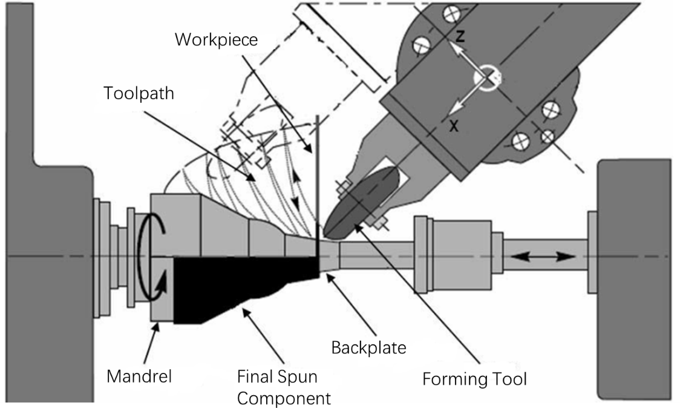
Figure 1.1 Typical setup for conventional sheet metal spinning (2)
When compared to other sheet metal forming processes, including stamping and deep drawing, the sheet metal spinning is associated with several advantages (1, 3, 4). These advantages include the following:
- Low forming forces are required to deform the workpiece during the spinning process due to the nature of localised material deformation under the small contact area between the workpiece and the forming tool.
- Enhanced mechanical strength of the spun component is achieved because of the work hardening effect of the material during spinning.
- Good dimensional accuracy, high material utilisation, good surface finishing, and effective wall thickness uniformity can be achieved for the spun components by simple tooling with low costs.
The axisymmetric high strength-to-weight ratio components can be manufactured in the spinning process with multiple passes, which is suitable for aerospace applications such as jet engines and missile nose cones (1). Due to the advantages arising from the structural integrity and good surface finish of spun components, the enhanced properties of wear resistance, fatigue strength, and corrosion resistance can be achieved, which is suitable for manufacturing containers and pressure vessels in the petroleum and chemical industries (4). Overall, the sheet metal spinning is frequently employed in various industries to manufacture components for medical equipment, aerospace, and military weapons. Several examples of spun components are displayed in Figure 1.2.
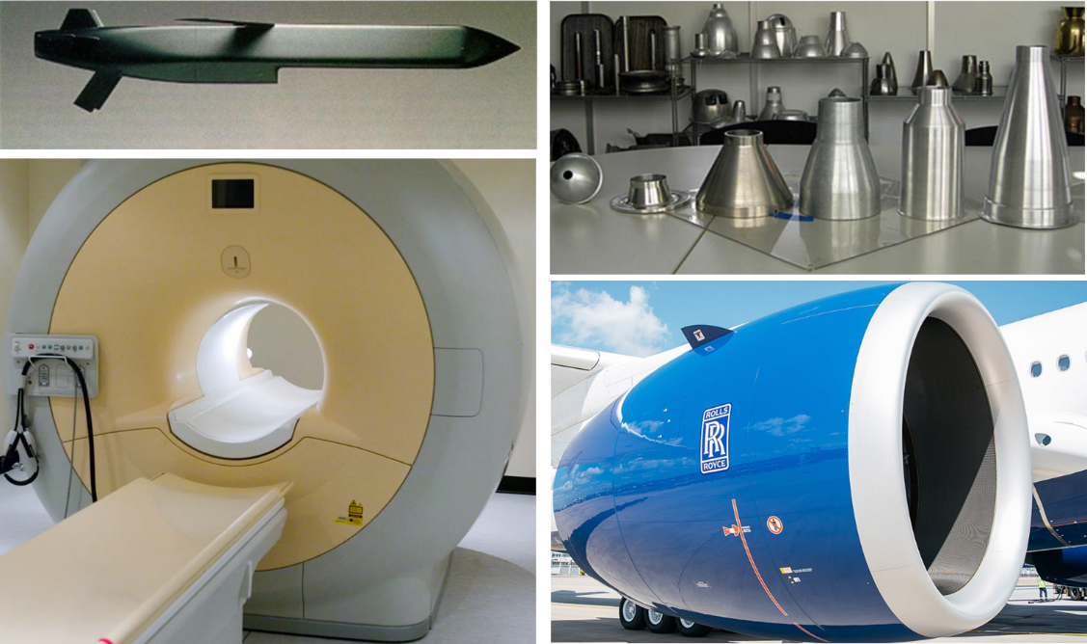
Figure 1.2 Applications of spun components (https://standexetg.com)
To study material deformation and failure mechanisms in the sheet metal spinning process, three investigation methods, namely the analytical method, the experimental method, and the Finite Element (FE) method, have been employed. Among these, the analytical method is the least expensive investigation method. It has the potential to provide guidance on the selection of spinning parameters to avoid component defects from occurring during the deformation process. However, the analytical method relies on many assumptions for the problem simplification, from which it is difficult to obtain detailed results, for example, relating to the stresses and strains that represent the complex material deformation the spinning process. In the experimental method, the output parameters, such as forming forces, strains, and the initiation and development of component defects, can be accurately recorded by the measurement system. Nevertheless, in the spinning experimental tests, various process parameters and material parameters at different levels must be tested, which results in a significant cost in terms of material and equipment usage, and experimental time required. Thus, it is difficult to investigate their effects on the material deformation and failure mechanism for failure prediction.
Finally, the FE method can provide more detailed results compared to the analytical and experimental methods. It has the potential to provide an in-depth understanding of material deformation and failure mechanisms. This method can ideally enable an investigation of all process parameters and material parameters in the spinning process. Therefore, it supports developing guidance in designing the spinning process, ensuring product quality, and enabling failure predictions. However, complex boundary conditions, high non-linearity and large material deformation are involved in the spinning FE models. Therefore, it requires extremely long computational time in the FE simulation for each spinning model.

Component defects of Spinning
Three types of common component defects that may indicate the process failures exist in the sheet metal spinning: wrinkling, circumferential fractures, and radial fractures (1, 5, 6). Generally, high circumferential compressive stresses, which exceed the limit of buckling, are regarded as the main reason for the occurrence of wrinkling failure (1), as shown in Figure 1.3 (a). To avoid wrinkling failure, a balanced combination of radial tensile stresses and circumferential compressive stresses is recommended during the spinning process. This can normally be achieved by employing multiple-passes in the spinning process (5). High tensile stresses along the radial direction and the circumferential direction may induce fractures along the circumferential direction and the radial direction, as shown in Figure 1.3 (b) and (c), respectively. Moreover, another type of fracture failure may also occur, as shown in Figure 1.3 (d), which arises due to a combination of circumferential compressive and bending stresses. This fracture occurs when existing severe wrinkles are continuously worked on (5, 6).
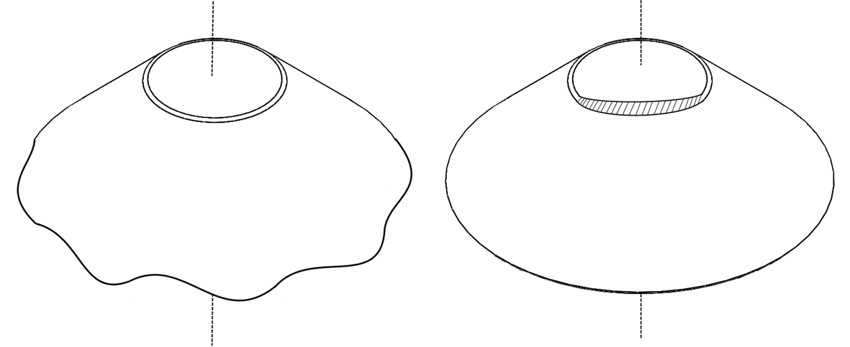
(a) (b)
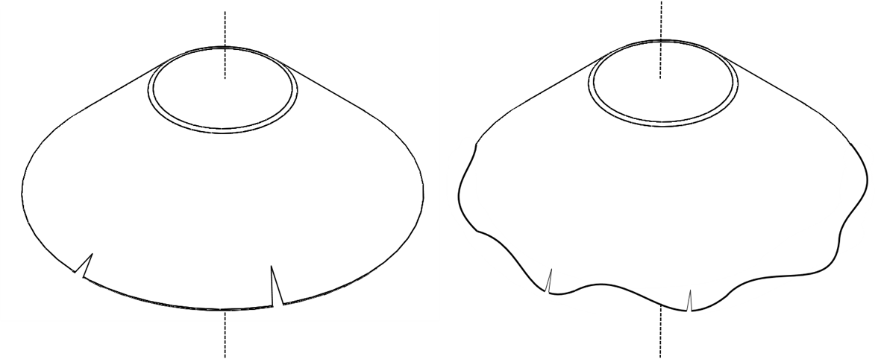
(c) (d)
Figure 1.3 Typical types of component defects: (a) wrinkling, (b) circumferential fracture, (c) radial fracture type $I$, and (d) radial fracture type $II$
Formability has been used in the field of sheet metal forming to quantify the maximum deformation ability of a material before the occurrence of component defects such as fracture or wrinkling (7, 8). The first formability study in the shear spinning process was proposed by Kegg (9). In this study, the formability for various materials was experimentally investigated, which involved spinning the materials onto a hemi-ellipsoidal mandrel until fracture occurred. The formability in the sheet metal spinning was defined as spinnability, which referred to the ability of metal material to undergo the shear spinning without fracture. However, the limitation of this spinnability determination method was reported by Hayama and Tago (10), because it was invalid for other mandrel geometries, such as conical mandrel. Further work also reported to extend spinnability for fracture failure in the spinning process to encompass both fracture and wrinkling failures. Kawai et al. (11) conducted spinnability studies for a die-less shear spinning process, in which a cylindrical mandrel was used to produce both conical and hemispherical spun components.
To investigate the mechanism of wrinkling failure in the conventional spinning process, e.g., the causes of wrinkling and the influence of spinning parameters on wrinkling, various studies have been undertaken using both the experimental and the FE methods. Kobayashi (12) stated that the deformation modes in the conventional spinning process were similar to those of the deep drawing process. Kleiner et al. (2) reported that the dynamic effects seemed to amplify the sensitivity of wrinkling failure during the spinning process. Sebastiani et al. (13) found the toothed pattern of the circumferential stress in the FE model, and stated that this stress patterns in the flange could be the pre-state of wrinkling failure. Xia et al. (14) claimed that wrinkling failure was more likely to occur in spinning processes using a high feed rate and a thin workpiece. Similar results were also reported in the studies of Zhan et al. (15), Essa and Hartley (16), and Wang et al. (17). In addition, the effect of different toolpath profile designs on wrinkling failure in the conventional spinning process were investigated by Hayame et al. (18), who stated that the use of a concave path produced a large diameter workpiece without wrinkling failure. Consistent results were also reported by Liu et al. (19) and Polyblank and Music (20).
The forming limit diagram (FLD) is widely used to define safe and failure regions in various conventional sheet forming processes, for example, the deep drawing process and the incremental sheet forming process (21, 22). Similarly, the processing map has been used in the metal sheet forming process for the same purpose. However, limited research has been conducted to study the processing map in the conventional spinning process. Xia et al. (14) established a processing map considering both fracture failure and wrinkling failure, which considered the effect of the material properties, feed ratio, and drawing ratio in an experiment of one-pass deep drawing spinning. Wang et al. (17) proposed a processing map to predict wrinkling failure by applying different combinations of the feed rate and spindle speed in FE models. Chen et al. (23) presented an analytical method to determine the spinnability based on wrinkling failure in the first-pass conventional spinning process, and linear paths were used. Through these studies, the relationship between spinnability and spinning parameters was identified, and processing maps were proposed to predict wrinkling failure under different spinning conditions. However, these results are still insufficient due to the fact that the above studies focused only on limit spinning parameters and spinning geometries.

Research Gaps and Challenges
Material deformation and failure mechanisms in the shear spinning have been extensively investigated, using both the experimental method and the FE method due to it is a relatively simple and straightforward forming process. Although numerous experimental investigations and FE simulations have been undertaken to study wrinkling failure in the conventional spinning process, wrinkling failure is found to be affected by multiple spinning parameters, including feed ratio, toolpath profile, material properties, workpiece diameter and thickness. Therefore, it is difficult to produce a capable processing map that can predict wrinkling in the conventional spinning process through both the experimental and the FE simulation methods. Currently, there is a lack of corresponding design criteria in the conventional spinning for the selection of spinning parameters, which still relies on empirical knowledge and trial-and-error procedures to avoid component defects, especially wrinkling failure.
As discussed in Section 1.1.2, toolpath profile has strong influence on wrinkling failure in the conventional spinning process. However, most studies on toolpath design still rely on empirical knowledge, aiming to produce target geometries of spun components successfully. Polyblank and Music (20) and Li et al. (24) proposed toolpath parametrisation methods using the quadratic Bézier curve for the first pass toolpath profile in the conventional spinning process. However, these results are insufficient because the capability and accuracy of Bézier curves in these studies have yet to be confirmed.
Identifying the initiation point of wrinkling failure during the spinning process, as well as the severity of wrinkles, is complex. At present, sudden changes and fluctuations in the tool force components, membrane strains, circumferential stresses, and elastic strain energy are taken as signs of the wrinkling initiation point in spinning experimental tests and FE modelling (2, 17, 19, 25–28). It was proposed that the severity of wrinkles can be quantified by calculating the standard deviation of the radial coordinates of element nodes at the edge of the workpiece in FE models (17). However, this method cannot be used to study the severity of wrinkles in spinning experimental tests due to the springback phenomenon and the non-asymmetry of wrinkles in the wrinkled spun component. The empirical method of grading wrinkling failure, which relies primarily on human judgement, is applied to determine the severity of wrinkles during spinning experiments (2, 29). Thus, it is essential to propose a measurement system through which the initiation point of wrinkling failure, along with the development and severity of wrinkles, can be recorded online during spinning experimental tests.
Based on the above considerations, developing an analytical wrinkling prediction method for the conventional spinning process is essential in offering guidance for parameter selection and to support spinning process design. However, unlike the experimental method and FE method, in which wrinkling failure can be detected straightforwardly, wrinkling failure must be defined in the analytical method first. The questions of how to establish an effective wrinkling wave function, which can represent the features of the actual wrinkling waveform, and how to determine the critical condition of wrinkling are challenging problems thus the focus of this study.

Research Aims and Objectives
Given that the first-pass plays an important role during the conventional spinning process (19, 30), the focus of this research focuses on the first-pass in the conventional sheet spinning using a convex path profile. In particular, the research aimed to develop an analytical wrinkling prediction model for the first-pass conventional spinning, thereby offering guidance into parameter selection and supporting spinning process design. The research objectives are:
- To parameterise the multiple-passes involved in the conventional spinning process by using the forming depth and the radius of the workpiece after each pass.
- To develop methods for calculating the control points of the cubic Bézier curve for the first-pass and final-pass toolpath profiles, and to examine the capability and the accuracy of these cubic Bézier curves by comparing the geometrical shapes of different spun components.
- To study the influence of process parameters, such as feed ratio and forming depth, and material parameters, such as spin ratio and workpiece thickness, on the initiation of wrinkling failure in the first-pass conventional spinning process using convex path by FE method.
- To develop and validate a mathematical wrinkling wave function, established by considering the geometrical features of the wrinkled spun component.
- To propose an analytical wrinkling prediction method based on the conservation of energy for the first-pass conventional spinning using convex path, and to study the influence of various spinning parameters on the critical forming depth using the developed wrinkling prediction method.
- To design and to perform an experiment that, combined with the results from the FE models, can be used to validate the developed analytical wrinkling prediction model.
- To produce the processing map for the prediction of wrinkling failure in the first-pass conventional spinning using convex toolpath, based on the developed analytical wrinkling prediction model.

Thesis Structure
This thesis consists of seven main chapters:
In Chapter 1, the research background is introduced and the research gaps are identified. Accordingly, the research aims and objectives of the study are proposed.
In Chapter 2, a literature review is presented, including the classification of the spinning processes, key considerations in developing the FE modelling of spinning process, key process and material parameters, wrinkling failure in the conventional spinning, and the material deformation theories.
In Chapter 3, the methods of parameterisation for the multiple-pass, first-pass, and final-pass in the conventional spinning are described. The accuracy and capability of the parameterised toolpaths based on the cubic Bézier curve are examined. The effect of the feed ratio on the contact between tool and workpiece is analysed.
In Chapter 4, FE models of the first-pass conventional spinning using convex toolpath are developed to study the effects of process and material parameters on the initiation of wrinkling failure. A mathematical wrinkling wave function is established and validated based on geometrical features of the wrinkling waveform.
In Chapter 5, an analytical wrinkling prediction model based on the conservation of energy is presented for the first-pass conventional spinning using convex toolpath. The influences of various parameters on critical forming depth are systematically investigated using the developed analytical wrinkling prediction method.
In Chapter 6, experiment of the first-pass conventional spinning using convex toolpath is conducted to validate the analytical wrinkling prediction method developed. A time-domain measurement system is proposed to record the initiation and development of wrinkling failure online during the experiment. Finally a processing map to predict wrinkling failure is produced based on the analytical wrinkling prediction model.
In Chapter 7, the study is concluded based on which contributions to knowledge is highlighted. The novel aspects of the study are outlined. The considerations of future work are also given.

Literature review
This chapter provides an overview of the prior research that has been conducted and published in the area of sheet metal spinning processes. In Section 2.1, the classification of sheet metal spinning, including shear spinning, novel spinning and conventional spinning are presented. Section 2.2 outlines three key considerations in FE modelling of sheet metal spinning process. Section 2.3 discusses the effects of key process parameters and material parameters, including toolpath design, feed ratio, workpiece diameter and thickness on the material deformation of the spinning process. The material deformation and mechanisms of wrinkling failure, processing maps to predict wrinkling failure and the relevant detection methods in the sheet metal spinning are reviewed in Section 2.4. Commonly used deformation theories i.e. plasticity theory and thin shell theory are reviewed in Section 2.5. A summary of the literature review is presented in Section 2.6.

Classification of Sheet Metal Spinning
Sheet metal spinning can be divided into two broad categories: traditional and novel spinning (5). Traditional spinning refers to a group of three processes: conventional spinning, shear spinning and tube spinning. A common feature of the shear spinning and conventional spinning is that they allow the production of hollow, rotationally symmetrical components. The main difference between the components produced by these two spinning processes, however, is apparent in the wall thickness of the spun component.
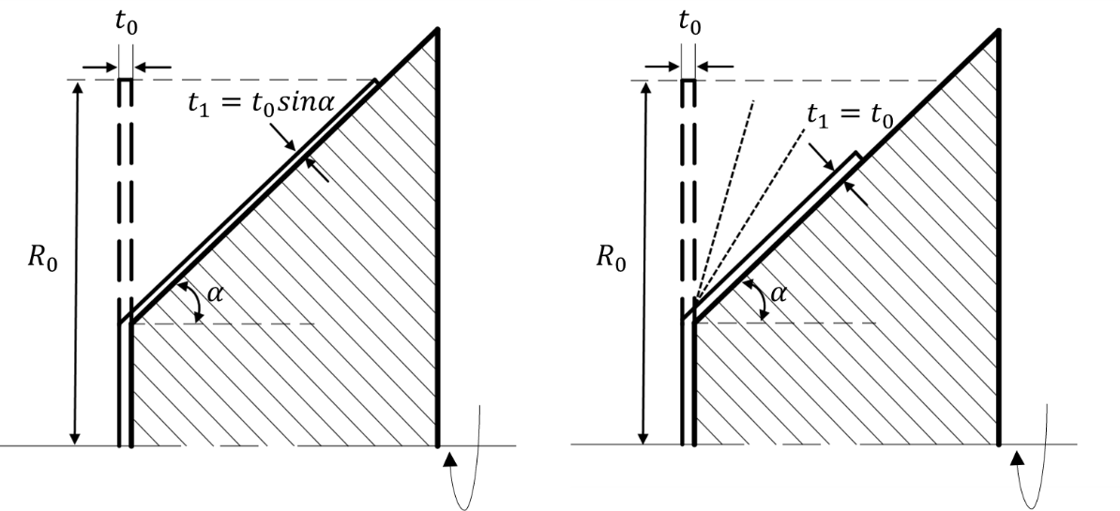
(a) (b)
Figure 2.1 Traditional spinning: (a) shear spinning, (b) conventional spinning
As presented in Figure 2.1, the final wall thickness of the spun component produced by the conventional spinning remains nearly unchanged, but the radius of the workpiece is reduced from the original radius $R_{0}$. In contrast, the wall thickness is reduced deliberately in the shear spinning process and determined by the sine law, while the radius of the workpiece remains unchanged. Moreover, a multiple-pass strategy is required in the conventional spinning process to prevent material failures and to minimise thinning effect. Conversely, in the shear spinning process, the component is deformed by the forming tool with a single pass.
Novel sheet metal spinning processes can be classified into two categories: firstly, processes based on the production of novel geometry for the spun component; and secondly, processes based on the forming temperature during the deformation process. The classification of the production of novel geometry for the spun component can be further divided based on the geometry of the cross-section and the relative position between the workpiece axis and rotation axis (3). These two types of novel sheet metal spinning processes include the non-circular cross-section spinning process and the curved conical spinning process, as shown in Figure 2.2 (a) and (b), respectively. Dissimilar to other spinning processes, which are typically employed to deform thinner material under room temperature, hot spinning is widely used in industrial applications to deform thicker parts using in-process heating.
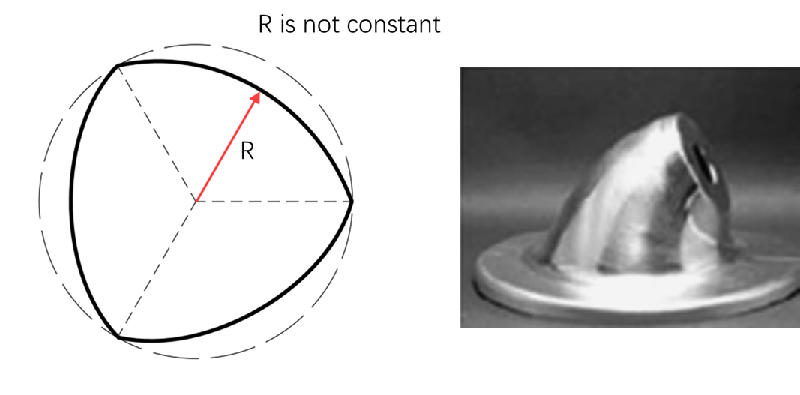
(a) (b)
Figure 2.2 Spun components produced by novel sheet metal spinning: (a) non-circular cross-section spun component, (b) curved conical spun component (3)

Shear Spinning
In the shear spinning, localised shear stress is generated in the workpiece under the deformation zone, which is located at the contact area between the workpiece surface and the forming tool surface. Figure 2.3 shows four typical spun component geometries commonly produced by the shear spinning process.
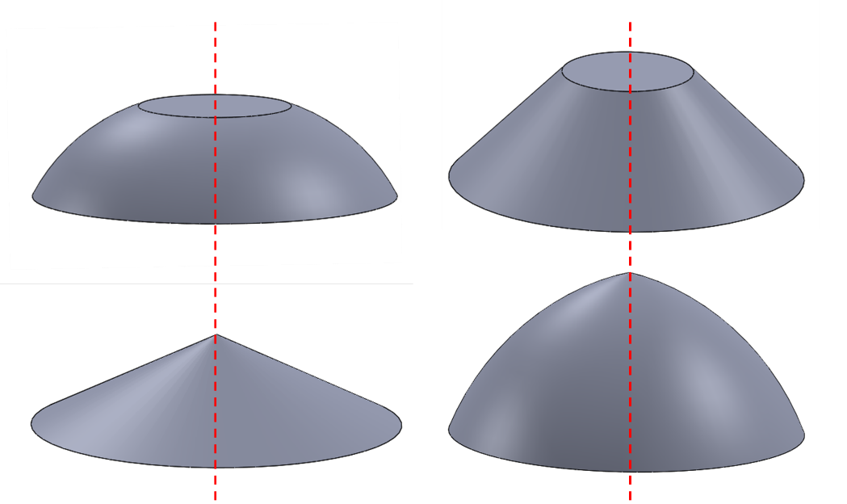
Figure 2.3 Examples of typical spun component geometries in shear spinning (5)
For the component produced in the shear spinning process, thickness is controlled by the clearance between the forming tool and the mandrel. By adjusting this parameter, three forming deviations can be applied, such as, over-spinning, true shear spinning, and under-spinning (5), as shown in Figure 2.4 (a), (b) and (c), respectively. Wall thickness is the main difference among these three conditions. Wall thickness produced under the true shear spinning follows the sine rule, which is favourable for generating components without suffering from component defect (1, 5).
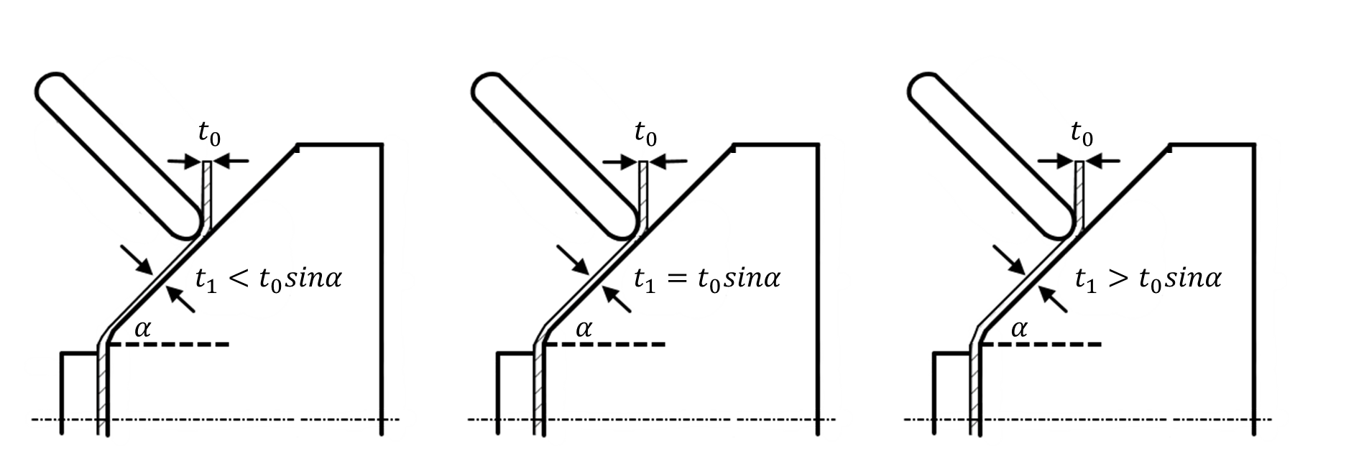
(a) (b) (c)
Figure 2.4 Three deviations from the sine law in shear spinning: (a) over-spinning, (b) true shear spinning and (c) under-spinning (5)
The deformation energy method was used to predict tool forces in the shear spinning process (31, 32). The tool force components were predicted by equating the external work done to the energy required in material deformation. The ideal work assumption was made that external work was completely consumed by material deformation only. The effects of friction and redundant deformation were ignored. Tool force in the shear spinning process normally resolves into three orthogonal components, including axial force $F_{a}$, radial force $F_{r}$, and tangential force $F_{t}$. The directions of these forces are shown by the schematic diagram in Figure 2.5. Calculating the tangential force component is essential because this force component consumes most of the power in the shear spinning process (5). Furthermore, Kobayashi et al. (33) proposed an analytical model to calculate the radial and axial force components by assuming uniform tool contact pressure generated in the contact areas. This model was improved by Kim et al. (34) and Zhang et al. (35) by assuming a combination of bending and shearing deformations to include the calculation of radial and axial force components.
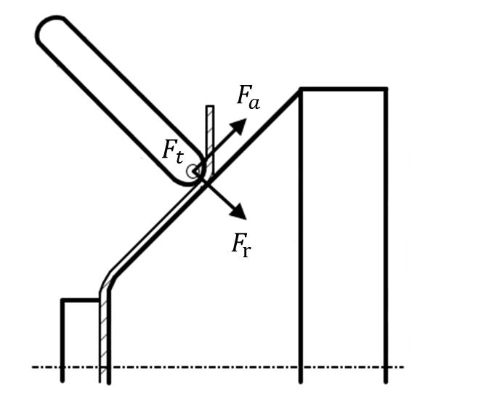
Figure 2.5 Definitions of tool force components in shear spinning (31)
In the shear spinning, the prediction of fracture failure has been developed through studies of spinnability (9). The amount of wall thickness reduction accomplished by a spinning process is known as the reduction ratio, as expressed in Equation 2.1.
$$Reduction Ratio=\frac{t_{0}-t_{1}}{t_{0}}∙100\%$$
Equation 2.1
The component defect of wrinkling involves the formation of wrinkles in the workpiece’s undeformed flange. Wrinkling occurs due to compressive circumferential stress in the flange, which exceeds the buckling stability limit (2, 27, 36). As a result, a significant bending stress in the flange of workpiece is induced, which causes the occurrence of a plastic hinge between the forming tool and the workpiece (36). Wrinkles occur in the flange of the workpiece after the plastic hinge has collapsed (27). In the shear spinning process, wrinkling failure is likely to occur when materials exhibit higher strain hardening coefficients (5). Thus, for materials with higher strain hardening coefficient, a low feed rate is recommended to delay the onset of wrinkling failure.

Novel Spinning
Traditional spinning processes are limited to the production of axisymmetric geometry with thin materials. To overcome this limitation and to extend the processes to other areas of applications, the novel sheet metal spinning processes were developed. These novel methods enable the production of non-axisymmetric components or thick, high-strength materials.
For the non-circular cross-section spun components, the radial distance from the edge of the part to the geometrical centre of the cross-section is a variable (3). Compared to the circular cross-section spinning process, the varied feed rate along the radial direction is required in the non-circular cross-section spinning due to the variable distance from the edge of the part to the geometrical centre. Cheng et al. (37) studied the forming depth of a triangle cross-section spinning process through both the FE simulation and experimental methods. It was reported that wrinkles started to occur when the forming depth was between 1.5 $mm$ and 5.7 $mm$ along the straight-side, which could be caused by the material flowing from both sides of the filleted-corner to the straight-side, thereby generating compressive stresses at the straight-side along the circumferential direction. Additionally, Xia et al. (38) investigated the variation of spinning forces during non-circular spinning, and stated that the maximum of three force components increased with an increase in mandrel rotational speed. These results were in agreement with that reported by Chen et al. (39).
There is an increasing requirement for manufacturing high-strength, lightweight, and corrosion-resistant materials, such as magnesium alloys and titanium alloys, in the aerospace and automobile industries. These materials have limited spinnability at room temperature and high resistance to deformation (40). For the thick workpiece and hard-to-deform material, the hot spinning process with in-process heating of the material was developed to improve spinnability and reduce forming forces. One of the key techniques in the hot spinning is temperature control (5, 40). The control for the forming temperature is closely related to the heating methods used in the practical spinning process. Zhan et al. (40) compared the advantages and disadvantages of eight heating methods currently utilised in industrial spinning applications or experimental procedures. The consideration of thermal effects and appropriate treatment methods for heating boundary conditions in FE analysis for the hot spinning process has also been reported in this literature.

Conventional Spinning
The traditional sheet metal forming process is generally associated with straightforward and predictable material deformation behaviour, including stress distribution and strain states. For instance, in the deep drawing process with a production of cylindrical cup, the material deformation behaviour can be divided into three categories according to the stress distributions or strain states. The material located in the flange area is subject to compressive stress in the circumferential direction and tensile stress along the radial direction. In the rim opening area, the material undergoes bending and tension, while in the straight wall area, the material experiences simple tension in the depth direction.
However, for the conventional spinning process, it is relatively complex to identify the dominant deformation mode that influences deformation behaviour. This is because a combination of tension, bending, compression, and shearing can be found during the forming process (5). It is difficult to identify the stress-strain distributions in the material due to localised plastic deformation in the contact area of the forming tool and workpiece. Therefore, the cylindrical cup geometry, which has been well studied in the deep drawing process, has been adopted to study material deformation and failure mechanisms in the conventional spinning process by many studies(5, 6, 14, 16). Figure 2.6 shows typical spun component geometries commonly produced by the conventional spinning process.
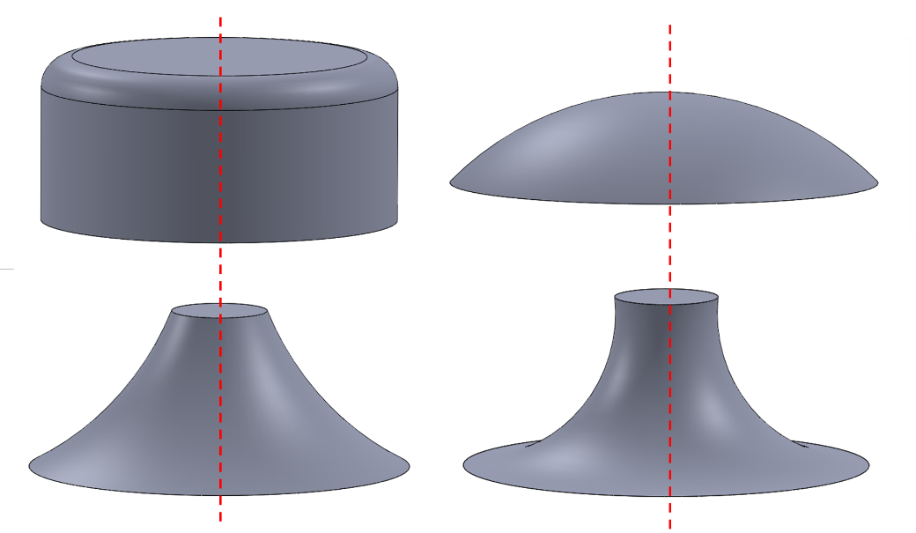
Figure 2.6 Examples of typical spun component geometries in conventional spinning (5)
Analysis of the conventional sheet metal spinning at an early stage generally shows a straightforward and predictable material deformation behaviour. The entire spinning process can be classified according to the movement directions of the forming tool, defined as either forward pass or backward pass. The stress states under these two forming conditions are presented in Figure 2.7. In particular, when the forming tool moves to the edge of the workpiece, tensile radial stress and compressive circumferential stresses are generated in the material. One the other hand, when the forming tool moves towards the mandrel, compressive stresses are generated in both the radial and circumferential directions. However, with the development of the FE method, it has been reported that the stress distributions were much complex and were not only dependent on the direction of tool movement (27, 41–43).
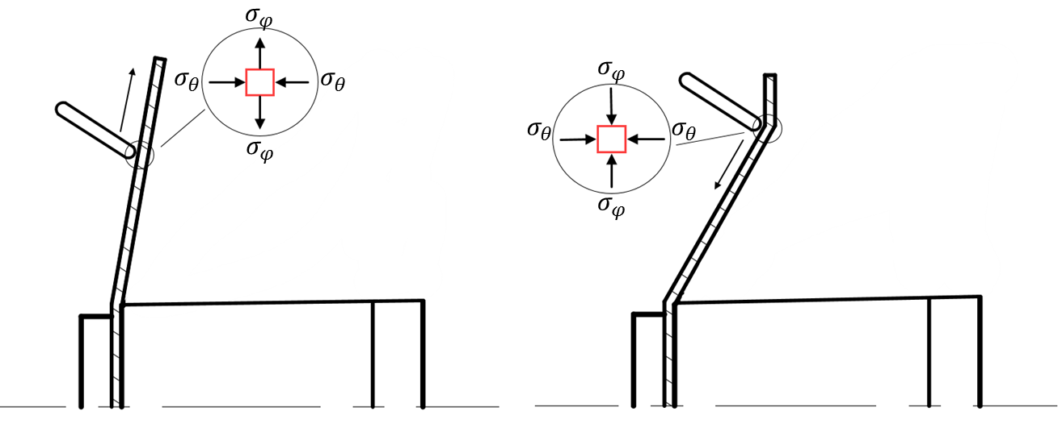
Figure 2.7 Stress states of the forming region during conventional spinning process (5)
Two types of common component defect exist in the conventional spinning process: fracture and wrinkling. Additionally, according to the direction of damage evolution due to fracture, the component defect of a fracture can be classified into two categories: radial and circumferential fracture, as presented in Section 1.1.2. The high tensile stresses that result in the thinning effect of the workpiece is the main cause of fracture failures during the deformation process (5). Although it has been reported that wrinkling failure occurs when high compressive stress along the circumferential direction exceeds the buckling stability limit (17, 23), failure mechanism in the conventional spinning process, especially regarding the prevention and prediction of wrinkling failure, has yet to be investigated systemically.

Key Considerations in FE Modelling of Spinning Processes

Implicit and Explicit Nonlinear Solution Methods
Two nonlinear solutions are provided by the ABAQUS software in simulating material deformation processes, these are the implicit method and the explicit method. In this section, these two methods are compared and summarised.
2.2.1.1 Implicit Method
The solution of the nonlinear equation is expressed as in (44):
$$M\ddot{u}+C\dot{u}+Ku=P$$
Equation 2.2
where $M$ is the mass matrix$, C$ is the damping matrix, $K$ is the stiffness matrix, and $P$ is the load vector.
The plastic deformation process of the sheet metal can be treated as a quasi-static problem, which involves substantial deformation and diverse contact conditions (36). Consequently, the effects of both inertia and damping can be considered negligible. Without taking into account the effect of damping, Equation 2.2 can be further deduced as:
$$M\ddot{u}+I-P=0$$
Equation 2.3
If the inertia forces are neglected, the Newton-Raphson method, as one of the most common procedures for finding a solution, can be used in the non-linear implicit analysis. The equilibrium equation in an iteration of the implicit method can be expressed as in (44):
$$Kc=P-I$$
Equation 2.4
where 𝐼 is the internal force vector, $K=\frac{∂I}{∂u}-\frac{∂P}{∂u}$ is the stiffness matrix of the structure, and c is the displacement correction vector.
The non-linear response of a structure to a small load increment $ΔF$, is shown in Figure 2.8.
Figure 2.8 First iteration in an increment (44)
Based on the configuration of the structure at the initial displacement of $U_{0}$, the initial stiffness matrix of the structure $K_{0}$ can be determined, through which the displacement correction $c_{1}$ can be calculated by:
$$c_{1}={K_{0}}^{-1}∆F$$
Equation 2.5
The structure’s configuration is now formed to a new displacement of $U_{1}$ and a new stiffness of structure, $K_{1}$, respectively. Hence, the internal force $I_{1}$ at this status and the force residual of this iteration,$R_{1}$ can be calculated as:
$$\left\{\begin{aligned}I_{1}=K_{1}U_{1} \\ R_{1}=F-I_{1}\end{aligned}\right.$$
Equation 2.6
In the implicit method, certain convergence criterion is applied to ensure the accuracy of the solution. By default, the tolerance values are set to 0.5% of an average force and 1% of the incremental displacement in the structure for the force residual, $R_{1}$, and the displacement correction, $c_{1}$, respectively. If these two parameters are smaller than the defined tolerance values, which represents that the solution is converged. If the solution from an iteration is not converged at the first iteration, the second iteration is required to bring the external and internal forces into balance, as shown in Figure 2.9.
In the second iteration, the stiffness, $K_{1}$, together with force residual, $R_{1}$, are used to determine the second displacement correction, $c_{2}$. Then, a new force residual of second iteration, $R_{2}$, is calculated. Similarly, $R_{1}$ is compared against the force residual tolerance. The displacement correction for the second iteration, $c_{2}$, is compared with the increment of displacement, $∆U_{2}=U_{2}-U_{0}$. Further iterations may require if necessary.
Figure 2.9 Second iteration in an increment (44)
2.2.1.2 Explicit Method
The nonlinear response in the explicit method is obtained incrementally, which is similar to the implicit method. This method is based on the implementation of an explicit integration rule, $M\ddot{u}=P-I$, together with the use of diagonal element mass matrices. Therefore, the nodal accelerations, $\ddot{u}$, can be calculated by:
$${\left.\ddot{u}\right|}_{\left(t\right)}=M^{-1}{\left.\left(P-I\right)\right|}_{\left(t\right)}$$
Equation 2.7
The acceleration of any node is completely determined by the mass and net force acting on it, thus the computation is efficient and straightforward. The accelerations are integrated using the explicit central difference integration rule, whereby the change in displacement $u$ and velocity $\dot{u}$ can be calculated respectively by:
$$\left\{\begin{aligned}{\dot{u}}^{(t+\frac{1}{2}∆t)}={\dot{u}}^{(t-\frac{1}{2}∆t)}+\frac{{∆t}^{(t+∆t)}+∆t^{(t)}}{2}{\ddot{u}}^{(t)} \\ u^{(t+∆t)}=u^{(t)}+∆t^{(t+∆t)}{\dot{u}}^{(t+\frac{1}{2}∆t)}\end{aligned}\right.$$
Equation 2.8
where superscript $t$ refers to the increment time, and $(t+\frac{1}{2}∆t)$ and $(t-\frac{1}{2}∆t)$ denote middle increment values. The central difference integration rule is explicit in that the kinematic state can be advanced using known values of ${\dot{u}}^{(t-\frac{1}{2}∆t)}$ and ${\ddot{u}}^{(t)}$ from the previous increment. The velocities, as a linear interpolation of the mean velocities, can be calculated as follows:
$${\dot{u}}^{(t+∆t)}={\dot{u}}^{(t+\frac{∆t}{2})}+\frac{1}{2}∆t^{(t+∆t)}{\ddot{u}}^{(t+∆t)}$$
Equation 2.9
The value of the mean velocity ${\dot{u}}^{(-\frac{1}{2})}$ needs to be defined first when applying the central difference rule. The initial values of velocity and acceleration are set to zero unless they are specified. The following condition can be asserted as:
$${\dot{u}}^{(+\frac{1}{2})}={\dot{u}}^{(0)}+\frac{1}{2}∆t^{(1)}{\ddot{u}}^{(0)}$$
Equation 2.10
Substituting Equation 2.10 into 2.9, the definition of ${\dot{u}}^{(-\frac{1}{2})}$ can be expressed as:
$${\dot{u}}^{(-\frac{1}{2})}={\dot{u}}^{(0)}-\frac{1}{2}∆t^{(1)}{\ddot{u}}^{(0)}$$
Equation 2.11
To obtain accurate results from the explicit solution method, many small-time increments are utilised in the explicit procedure integrates. The size of the increment, which is determined by the stability limit, can be expressed in the following way:
$$∆t=min⁡(\frac{L_{e}}{c_{d}})$$
Equation 2.12
where $L_{e}$ is the characteristic element dimension and $c_{d}$ is the current effective, dilatational wave speed of the material, which can be calculated by:
$$c_{d}=\sqrt{\frac{A+2B}{ρ}}$$
Equation 2.13
where A and B are Lame’s elastic constants, and $ρ$ is the material density.
2.2.1.3 Comparison of Implicit and Explicit Methods
The implicit and explicit methods are two FE solution algorithms, which can be classified according to the time integration method. These two methods are similar in terms of element type selection, material constitutive model, stress/strain calculation and material hardening rule. The method of solving the equation, determining the time step, processing the contact conditions, and calculating the springback are different between the solution methods.
In the implicit method, the static equilibrium of each increment can be found iteratively, which means that is can accurately predict springback and residual stresses. Additionally, a convergence criterion is followed throughout the simulation process. This incremental-iterative procedures allows for using large increments. However, large deformations and complex contact conditions are generated in the metal forming process. A substantial number of iterations is required before finding the equilibrium, which results in extremely long computation times. Moreover, computing memory requirements are also high due to the matrix inversion step and accurate integration schemes (45, 46). Another disadvantage of the implicit method is that it is difficult to find the equilibrium if local instability occurs, such as wrinkling (47). Although the Lanczos eigensolver and Riks analysis can be used to eliminate this disadvantage, these are computationally expensive operations (44). Therefore, this method is only suitable for analysing certain 2D models or 3D models under simple boundary conditions.
On the other hand, the explicit solution method is conditionally stable. The explicit central difference integration rule is employed during computation procedures. There are no iterations and no tangent stiffness matrices needed in explicit FE analysis. The diagonal mass matrix is used to solve the accelerations without convergence check. Therefore, the method is preferable for solving the dynamic problem, including the large deformation problem (48). Regarding the wrinkling phenomenon during the spinning process, due to the existence of inertia, unsteady and unstable growth on wrinkles is prevented, and the explicit solution method can still carry on the analysis. Efficiency for a quasi-static problem using the explicit method compared with implicit method would show dramatic improvements for the former.

Material Plasticity
When an elastic-plastic material enters the plastic deformation stage, it deforms permanently due to the application of a loading condition. This plastic deformation cannot be recovered after unloading as plastic strains are not recoverable. As shown in Figure 2.10, there exists a yield stress $σ_{s0}$ for an elastic-plastic material. When a load is applied, the stress is beyond the yield point of the material, and it follows an initial stress-strain curve $\vec{OABD}$. However, after reloading at point $C$, an alternative stress-strain curve is followed $\vec{CBD}$. The stress of re-entering the plastic deformation $σ_{s}$ is higher than the initial yield stress $σ_{s0}$, which is referred to as the work hardening phenomenon (49).
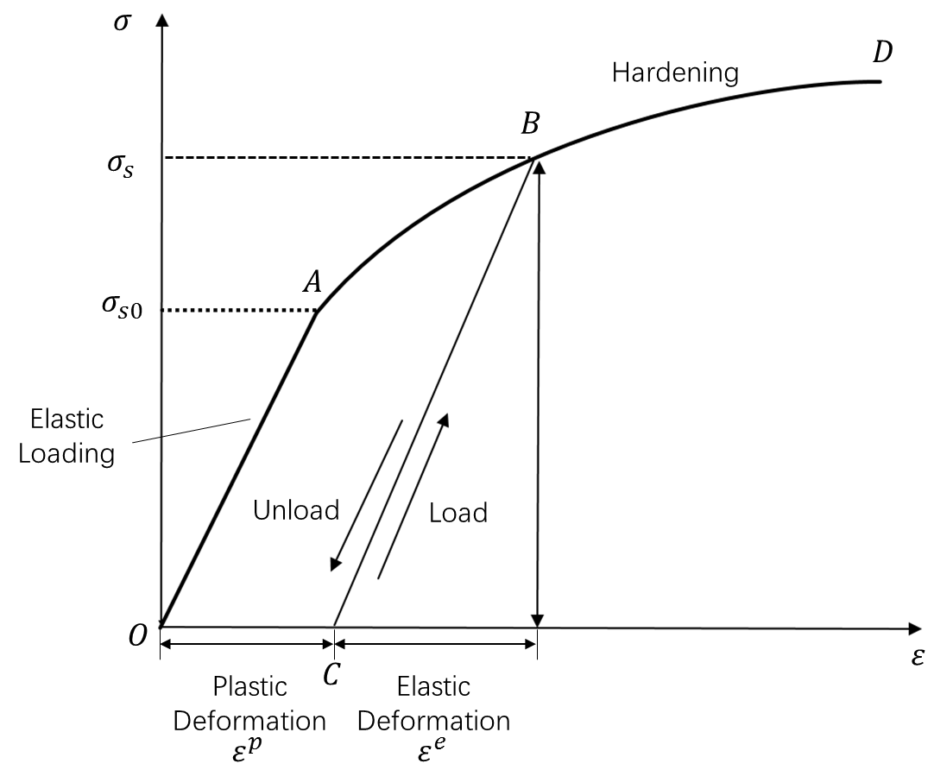
Figure 2.10 Illustration of stress-strain curve of elastic-plastic material (49)
The stress $σ_{s} (>σ_{s0})$ at this stage is the function of the plastic strain $ε^{p}$, and can be expressed as:
$$σ_{s}=σ_{s}(ε^{p} )$$
Equation 2.14
In developing a constitutive equation for a work hardening material, the incremental theory or flow theory, which takes into account the prior history of loading, has been used. In this theory, the strain state that exists in a plastically deformed material is determined by both the existing stress-strain state and the material’s completed loading history. The strain increments are assumed to be decomposed into elastic and plastic deformations, which can be expressed as in (50):
$$dε=dε^{p}+dε^{e}$$
Equation 2.15
When the state of stress is on the boundary of the elastic region and tends to move out of the current yield surface, this results in elastic-plastic deformation accompanied by a configuration change of the yield surface. Therefore, the function of yield surface$f$ is expressed as a loading function of the stress tensor $σ_{ij}$, the plastic strain tensor $ε_{ij}^{p}$, and a hardening parameter $n$. This can be written as follows:
$$f(σ_{ij}, ε_{ij}^{p},n)=0$$
Equation 2.16
At the moment that elastic-plastic deformation takes place, the loading is on the yield surface, and the value of the yield function becomes to zero (i.e., $f=0$). This is expressed in Equation 2.17:
$$df(σ_{ij}, ε_{ij}^{p},n)=\left(\frac{∂f}{∂σ_{ij}}\right)dσ_{ij}+\left(\frac{∂f}{{∂ε}_{ij}^{p}}\right)dε_{ij}^{p}+\left(\frac{∂f}{∂n}\right)dn=0$$
Equation 2.17
There are three loading conditions: loading, unloading, and neutral loading, as shown in Figure 2.11. Each condition is associated with the change of stress state.
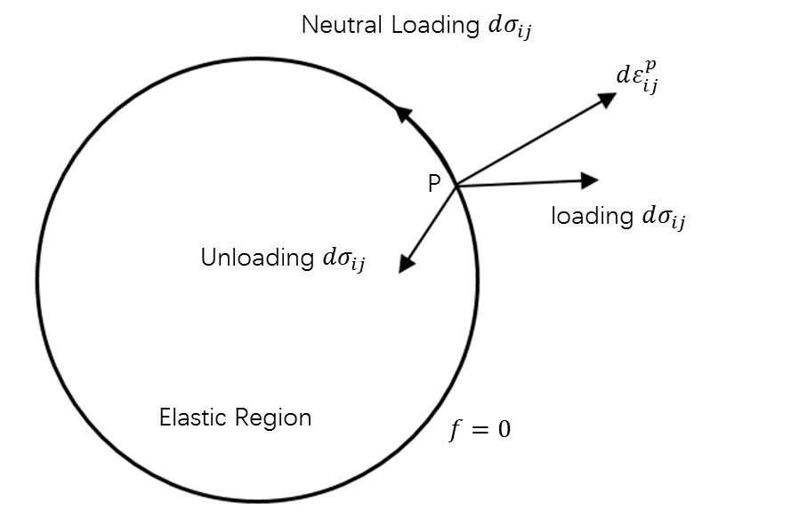
Figure 2.11 Three loading conditions (51)
For an elastic-plastic loading condition, $df>0$ and $\frac{∂f}{∂σ_{ij}}dσ_{ij}>0$; with an elastic unloading from the plastic region, $df=0$ and $\frac{∂f}{∂σ_{ij}}dσ_{ij}<0$; and neutral loading refers to a change of stress state along the yield surface, as presented in Figure 2.9, which gives $df=0$ and $\frac{∂f}{∂σ_{ij}}dσ_{ij}=0$.
The flow rule assumes the existence of a plastic potential function for a plastic loading condition (51). Considering the plastic potential function combined with the yield function $f$, the differential plastic strain tensor $ε_{ij}^{p}$ can be expressed as:
$$dε_{ij}^{p}=dλ\frac{∂f}{∂σ}$$
Equation 2.18
In the present work, isotropic hardening is assumed. The initial yield surface expands uniformly in stress space as a material plastically deforms under an outward loading. Thus, subsequent yield surfaces retain the shape and orientation of the initial surface. When the yield function $f$ follows the von Mises yield function and isotropic hardening rule, it becomes:
$$f=\frac{1}{2}S_{ij}S_{ij}-\frac{1}{3}σ_{c}^{2}({\overline{ε}}_{p})$$
Equation 2.19
where $S_{ij}=σ_{ij}-σ_{m}$ is the stress deviator tensor, and $σ_{c}$ is the current stress, which is the function of equivalent plastic strain ${\overline{ε}}_{p}$. Figure 2.12 illustrates the connection between the isotropic hardening rule and uniaxial hardening curves.
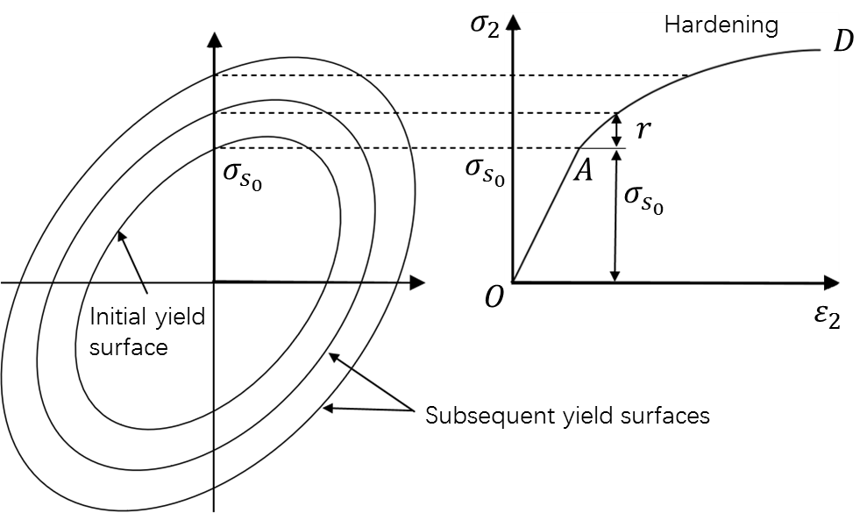
Figure 2.12 Isotropic strain hardening (52)

Element Selection
The type of elements used in a FE model has crucial implications for the accuracy of the FE results. Three types of elements, including solid, shell, and continuum shell elements, are commonly used in the simulation of the sheet metal spinning process. Quigley and Monaghan (53) indicated that the eight-node hexahedral solid elements can be used in the spinning simulation process instead of the conventional shell elements. Due to the fact that the conventional shell elements were developed based on the shell theory, which approximates a thin 3D continuum using a 2D formulation (44). They may not be able to handle contact with both sides of the workpiece with the tool surface and mandrel surface at the same time. Sebastiani et al. (41) stated that the fully integrated shell elements can produce accurate results when comparing the spun component geometries produced between FE modelling and experiments. Long et al. (54) claimed that the FE results of forces and thickness showed good agreement with experimental results when using the continuum shell elements. Furthermore, Wang et al. (17) compared the eight-node reduced integration linear solid elements (C3D8R) and the eight-node reduced integration linear continuum shell elements (SC8R) for wrinkling simulation. They stated that the use of the solid elements of C3D8R could not represent wrinkling failure in the sheet metal spinning process caused by the “hourglass” problem. This was attributed to the fact that only a single integration point was used along the thickness direction of the element. In contrast, multiple integration points can be used along the thickness of the shell elements, SC8R, through which the stresses and strains at each integration point of the shell element can be calculated independently.

Key Process and Material Parameters
In the sheet metal spinning process, the quality of the spun component and the occurrence of component defects are significantly affected by process-related and material parameters. In this section, the effects of two process parameters, such as feed ratio and toolpath profiles, and the material parameters of workpiece radius and thickness are discussed in detail. The above parameters are taken as the key points of considerations given their significant influence on the component defect of wrinkling (2, 14–17).

Toolpath Design
The design of the toolpath, including toolpath profiles and number of passes, plays a crucial role in the quality of spun components produced by the conventional spinning process. Careful design and selection of the toolpath and the number of passes leads to a successful production of a spun component that does not suffer from component defects, such as wrinkles and fractures.
Increasing the number of passes in the conventional spinning process was reported to reduce the wall thinning effect of spun components (5). Abd-Alrazzaq et al. (4) stated that, when the number of passes was less than or equal to 7, the wall thinning effect was pronounced. The deformation rate per pass was high when using a lower number of passes, which resulted in a more substantial thinning effect due to the existence of higher tensile stress along the radial direction. Smaller springback was observed with an increase in the number of passes, and the rate of loading per pass was found to decrease.
Toolpath design strategies can be divided into three categories: firstly, the methods of toolpath attach-on-mandrel; secondly, combined forward path and backward path; and finally, different toolpath profiles.
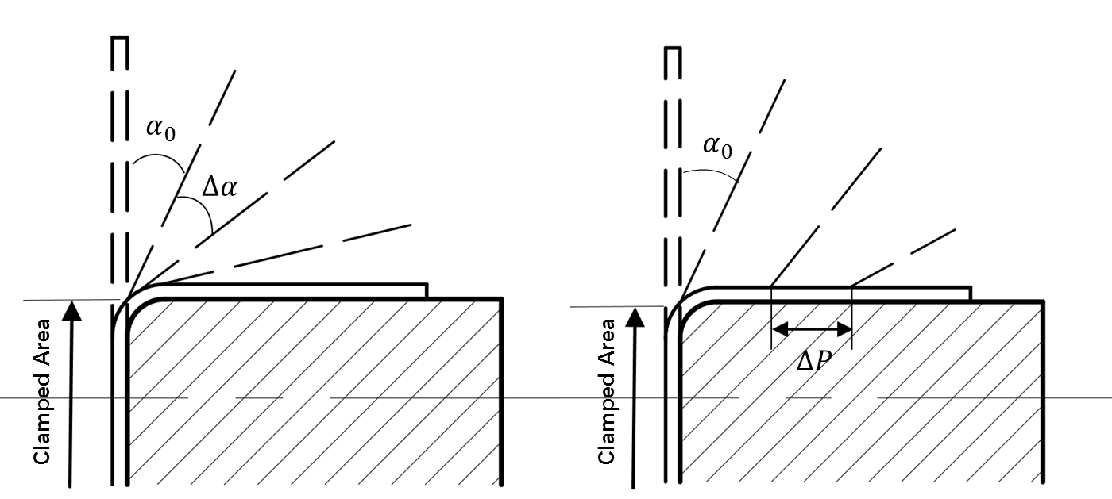
(a) (b)
Figure 2.13 Illustration of toolpath attach-on-mandrel method: (a) point attachment method, (b) segment attachment method
The toolpath attach-on-mandrel methods include the point attachment method and the segment attachment method, as illustrated in Figure 2.13 (a) and (b). In the point attachment method, except for the final pass, the starting point of each pass is approximately the same, i.e., located near the edge of the workpiece clamped area (4, 18, 42, 55). The deformed part of the material remains in the air until deformed by the final pass, which is designed as the section of the mandrel profile. The limitation of this toolpath design strategy is obvious because it is only suitable to produce the spun components with linear section profiles, e.g., conical and cylindrical components. But for the segment attachment method, the material is sectionally deformed onto the mandrel surface by the offset of each pass from each other, $∆P$ (18, 43, 56–58). Therefore, it could be applied to deform the components with curved section profiles, e.g., horn-shaped and hemispherical productions. Hayama et al. (18) stated that, compared to the point attachment toolpath design method, higher forming accuracy can be achieved with the segment attachment toolpath design method. They further reported that, in the multiple-pass conventional spinning process, the first-pass had a significant influence on product quality, this finding that has been supported by other studies (18, 20, 24, 30). Furthermore, wrinkling failure, as one of the most common failure modes, was found to occur mainly during the first-pass in the conventional spinning process (23).
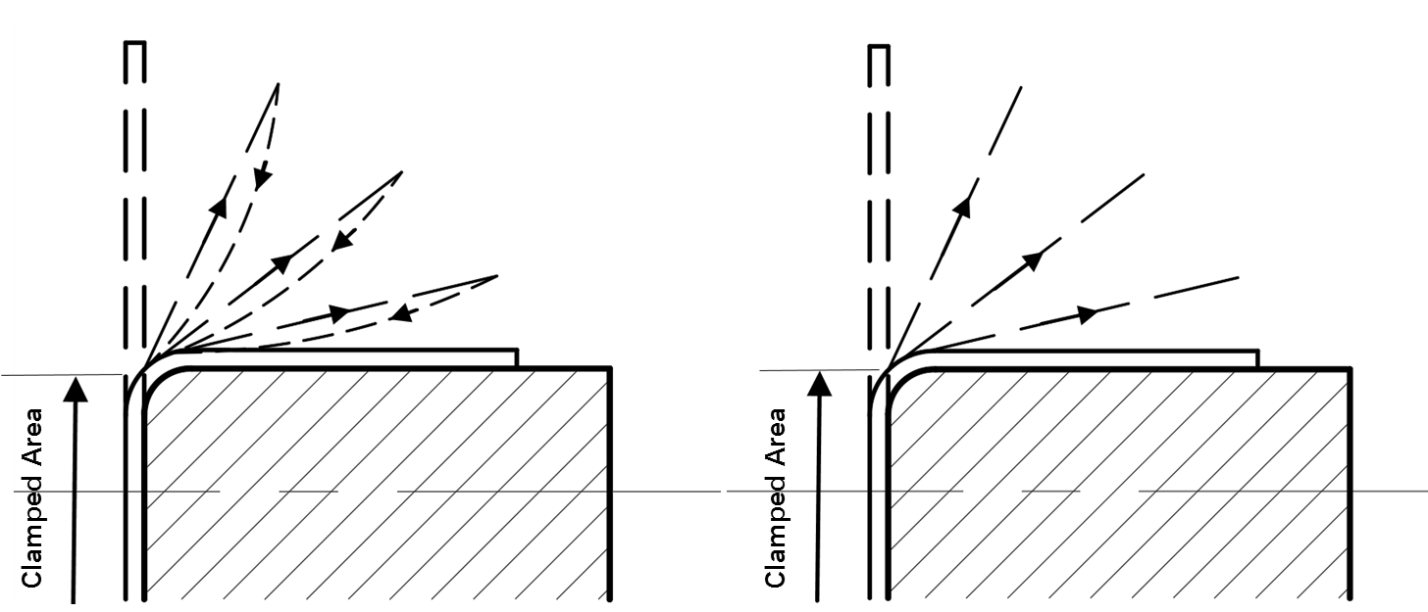
(a) (b)
Figure 2.14 Illustration of cooperation between forward path and backward path: (a) material deformed by forward and backward paths, (b) material deformed by forward path only
Toolpath direction includes forward toolpath (the feeding direction of the tool towards the edge of the workpiece) and backward toolpath (the feeding direction of the tool towards the mandrel). As illustrated in Figure 2.14 (a), the material is deformed by both forward path and backward path. The internal stress states depend on the tool feeding direction (59). In forward toolpath, the compressive circumferential stresses and tensile radial stresses are generated and balanced by each other, leading to a stress state close to pure shear, as illustrated previously in Figure 2.7. Therefore, it is possible to maintain a nearly constant wall thickness. In the backward toolpath, the material builds up in front of the tool, which results in compressive circumferential stresses and compressive radial stresses. Wang and Long (42) stated that, compared to the forward toolpath, the backward toolpath has a smaller effect on wall thinning, and also that it is uncorrelated with wrinkling failure in the conventional spinning. Therefore, in some studies, backward toolpath, as shown in Figure 2.12 (b), has been neglected, thus the material is deformed by the forward toolpath only. A significant correlation has been observed between forward toolpath and wrinkling failure (5, 18, 42, 59). Nevertheless, the limitation of this toolpath design strategy is also obvious in that wall thickness distribution is non-uniform. This comes from the fact that the materials flow towards the rim of workpiece through the forward toolpaths (42, 60).
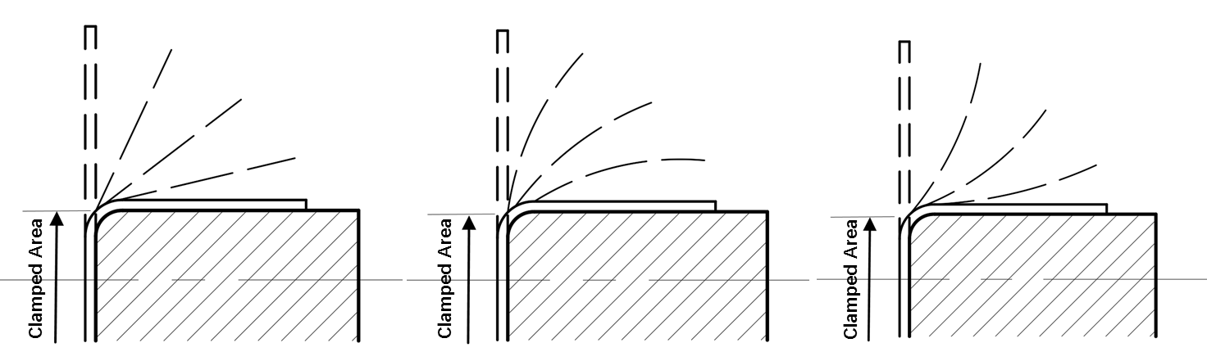
(a) (b) (c)
Figure 2.15 Illustration of toolpath profiles: (a) linear path, (b) convex path, and (c) concave path
The toolpath profile has a strong influence on the quality of the spun component in the conventional spinning process (5, 61). Three types of the toolpath profile commonly employed are linear path, convex path, and concave path, as shown in Figure 2.15. Hayama et al. (18) experimentally studied the effects of these three types of toolpath profile on spinning ratio, paying close attention to material failures. They reported that the involute path, which is a special type of concave curve, can produce the best results in the actual conventional spinning process. This finding was supported by Kang et al. (30) and Liu et al. (19), who also concluded that the linear toolpath profile helps to reveal deformation features due to its fewer complications. Wang and Long (61) studied the effects of different toolpath profiles, including linear path, convex path, concave path, and combined curves, on the magnitude of tool forces, stress and strain distributions, and wall thickness variation using the FE analysis method. It was observed that wall thickness decreased substantially when using a concave toolpath, while it was unchanged when using a convex toolpath. This finding was supported by Peter et al. (58). By developing FE models using the Box-Behnken experiment design method, Watson et al. (27) studied the shape of the ideal involute toolpath for the first-pass conventional spinning process. It was stated that an angle of 40° was optimal for the first-pass in the conventional spinning.
Importantly, the toolpath profiles studied in previous studies were usually only defined qualitatively. Most studies just focused on the effects of different toolpath profiles, and mainly relied on empirical methods to design the toolpaths. For this reason, Li et al. (24) developed a toolpath parameterisation method using the quadratic Bézier curve for the first toolpath in a die-less spinning process, and it was observed that the increase of path curvature (PC) resulted in higher forming forces. The quadratic Bézier curve was also adopted by Polyblank and Music (20), who performed a set of experiments to investigate how tool force, workpiece geometry, and component defects evolved with the change of toolpath parameters during the first-pass conventional spinning process. However, these two studies only focused on the one-pass conventional spinning. For this purpose, Gan et al. (57) numerically investigated the thickness distribution of spherical components based on the two-pass conventional spinning with concave quadratic Bézier curve. It was found that the wall thickness was affected by the material deformation between adjacent passes, the sloping degree of the flange, and the curvature of the Bézier curve. However, the above studies only applied the Bézier curve to produce the first one or two passes, and little attention was paid to the final geometry of the spun components. For a given spun geometry, the establishment of the Bézier curve in the above studies remains unclear. Additionally, the accuracy of the curve produced by the Bézier curve has yet to be assessed. This greatly limits the applicability of previous research results for applications.

Feed Ratio
In sheet metal spinning operations, a parameter referred to as the feed ratio is often used. This parameter is defined as the ratio of the tool feed rate, $F$, to the spindle rotation speed, $S$, which is given by Equation 2.20.
$$f=\frac{F}{S}$$
Equation 2.20
Both the experimental method and the FE method have concluded that, in the sheet metal spinning process, both the feed rate and the spindle rotational speed have substantial effects on the forming forces (14, 61, 62), workpiece thickness (1, 11), surface finish (63), and component defects, including fracture and wrinkling (10, 17). However, as long as these two parameters change proportionally, thereby ensuring a constant feed ratio value, their effects on the above parameters will not be altered significantly. However, it was found that the material deformation rate shows an increasing trend when the spindle speed rate rises. Additionally, for a given feed ratio, there exists an optimal spindle rotational speed, which generates the lowest tangential force (1).
Lower feed ratios were found to be favourable for producing parts with a uniform thickness distribution and low surface roughness. On the other hand, higher forming forces were generally when using higher feed ratios, which can cause wrinkling failures or fracture failure (5). The effect of feed ratio on wall thinning was examined by Zhang et al. (35), they reported that the influence of feed ratio on deformation energy was non-linear. The uniformity of the wall thickness of spun parts can be maintained by using a relatively high feed ratio (14, 17). In contrast, wall thickness of spun parts can be reduced significantly with a low feed ratio (1), which was also reported by Zhan et al (15).
The springback phenomenon in the spinning process is significantly affected by the feed ratio. El-Khabeery et al. (64) measured the cylindrical cup inner diameter formed using different feed ratios, and concluded that growth in the inner diameter, as a measure of springback, was accompanied by an increase in the feed ratio. A significant impact of feed ratio on the severity of springback was observed by Essa and Hartley (16) and Kawai et al. (11). However, Abd-Alrazzaq et al. (4) reported that springback decreased with lubrication as the feed ratio increased due to the lower friction and forming forces.
Feed ratio is one of the most significant factors that influences surface roughness in the spinning process, as reported by Childerhouse and Long (29). Better surface finishing can be achieved by applying low feed ratios, and large tool nose radius under lubricated forming conditions (39, 65). This has also been reported by El-Khabeery et al. (64) and Abd-Alrazzaq et al. (4).

Material Diameter and Thickness
In the spinning process, the effect of material parameters, such as the diameter and thickness of the workpiece, on the tool force components, thickness reduction, springback, and wrinkling failure have been investigated in several studies.
The influence of workpiece diameter and thickness on tool force components in the shear spinning process was investigate by Hayama et al. (66). It was found that all three force components increased with an increase in workpiece diameter and thickness. They stated that there existed a linear and directly proportional relationship between workpiece thickness and the three force components. Similar results were also reported by Chen et al (39). However, the force components showed an increasing trend for workpiece thicknesses of up to 100 $mm$, after which the force was constant. It was suggested that this may be caused by the constraints of the workpiece’s flange.
For the conventional spinning process, Xia et al. (14) observed that the radial and axial forces increased with an increase in workpiece diameter, which was consistent with the findings reported in other studies (5). Essa and Hartley (16) undertook an optimisation study of the material parameters in the conventional spinning of cylindrical cups using the FE simulation method. Based on several spinning models, it was stated that component defects could be avoided when the workpiece diameter and thickness were fixed at 192 $mm$ and 3 $mm$, respectively. They also reported that a large diameter of the initial workpiece resulted in a reduction in wall thickness with large thinning at the cup bottom, agreeable results were also reported by Abd-Alrazzaq et al. (4) and Childerhouse and Long (29).
Adb-Alrazzaq et al. (4) studied the effects of workpiece diameter and thickness on springback in the multi-pass conventional spinning process. The study found that an increase in the workpiece diameter and thickness was accompanied by the growth of springback. In contrast, Childerhouse and Long (29) stated that thicker materials resulted in less springback of the spun components in the shear spinning process, which showed consistency with the findings relating to the incremental sheet forming process (67).
Hayama et al. (26) stated that workpiece diameter and thickness had a significant influence on wrinkling failure in the shear spinning process. Similar results were observed in the conventional spinning process by Kleiner et al. (2), who performed a set of detailed experiments to understand the mechanism of wrinkling failure. According to the analytical investigation for the first-pass conventional spinning process, Chen et al. (23) stated that the effect of workpiece diameter on wrinkling failure were less significant compared to the effect arising from workpiece thickness. In general, thicker and smaller workpieces were more effective at resisting the onset of wrinkling, and they could also be spun at higher feed ratios.

Wrinkling Failure in Conventional Spinning
Wrinkling failure, which is one of the main component defect modes in both the shear spinning and the conventional spinning process, influences both production efficiency and material formability. Due to the lack of in-depth understanding about failure mechanisms, trial-and-error methods and empirical methods are widely used in the spinning industry to avoid wrinkling failure. Several studies have been undertaken to understand the causes of component defect and wrinkling in the spinning process. However, more effective methods for predicting and preventing wrinkling failures, especially by controlling process variables for required material parameters, remain to be developed in the conventional spinning process.

Wrinkling Failure Mechanics
At the first glance, the knowledge of wrinkling failure in deep drawing operations was used for developing sheet metal spinning process. With a deeper analysis of the wrinkling effect in sheet metal spinning process, significant differences have been identified (68). However, a degree of consensus in the mechanics of wrinkling failure has been achieved in relation to the shear spinning and the conventional spinning processes. For example, Childerhouse and Long (29) investigated the wrinkling effect in shear spinning in their experiments. For the selected experiments, it was reported that the feed ratio was the predominant factor affecting wrinkling, and that there existed a limit of feed ratio beyond which wrinkling would be generated. It was also found that thicker materials could resist the onset of wrinkling, and spindle rotation speed had no significant effect on the occurrence of wrinkling failure. These results were consistent with those reported by Wang et al. (17) and Music et al. (5) for the conventional spinning process.
Knowledge about wrinkling failure in the conventional spinning process has been developed through several systematic investigations as outlined below, principally using experimental method and the FE analysis method.
2.4.1.1 Experimental investigation of wrinkling
The grid marking method has been used to study strain distributions in the conventional spinning process. To quantify plastic deformation in the spun component, circle grid analysis (CGA) was applied by Razavi et al. (69) and Beni et al. (70), as shown in Figure 2.16. After the deformation process, the circles are changed into ellipses of varying sizes. Beni et al. (70) reported that wrinkling failure had significant effects on compressive circumferential strain, as well as wall thickness, in various radial paths on the final product compared to that without wrinkling.
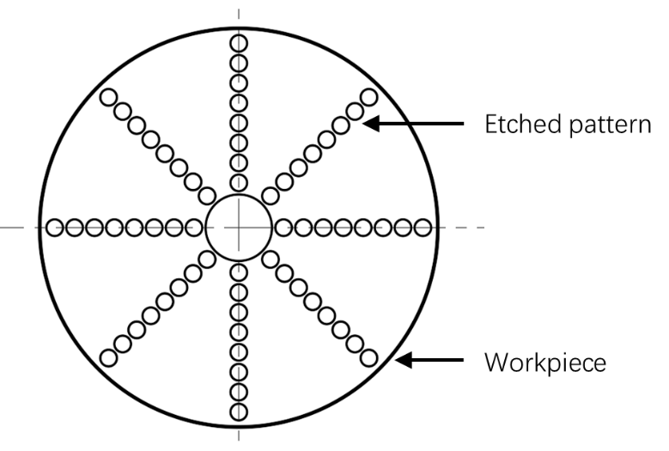
Figure 2.16 Circular grid patterns etched onto the workpiece surface
Hayama et al. (18, 26) compared wrinkling failure in both the shear spinning process and the conventional spinning process. It was reported that the deformation mechanism involved in the conventional spinning process was almost the same as that involved in the shear spinning process. A non-uniform stress distribution caused by tool indentation around the flange was identified in both the conventional and shear spinning processes. After experimentally investigating the critical condition of wrinkling failure in the conventional spinning process, it was found that wrinkling was caused by the critical condition of mean amplitude and the maximum compressive strain in the circumferential direction. This suggested that wrinkling failure could be delayed by using a relatively low feed rate in the spinning process.
Kleiner et al. (2) studied the onset and propagation of wrinkling failure through a set of detailed experimental investigations of the first-pass conventional spinning. The researchers observed the growth of severe wrinkles from minor wrinkles, as shown in Figure 2.17. Based on the experimental results, it was found that material parameters such as dimeter and thickness had a significant influence on wrinkling. If workpiece thickness was reduced or workpiece diameter was increased, the wrinkling failure would increase accordingly. Additionally, the process parameters, including feed ratio and spindle rotational speed, were also identified as having significant effects on wrinkling. It was also reported that wrinkling failure was influenced by both static and dynamic effects.
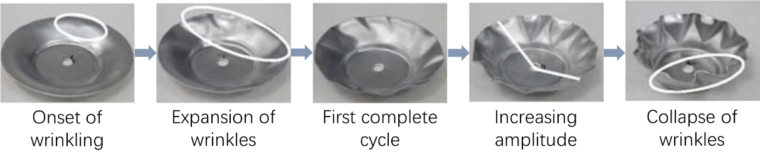
Figure 2.17 Wrinkle growth in the first-pass conventional spinning (2)
Wang et al. (17) studied the effects of feed ratio on wrinkling failure in the multi-pass conventional spinning using both experimental and the FE simulation methods. Based on the experimental results, they noticed that the wrinkles generated in the first forward pass were smoothed out during the second forward pass. It was also reported that the severity of the wrinkles increased with an increase in the feed ratio. Moreover, Wang and Long (71) claimed that in-process wrinkles were generated due to the workpiece could not establish a full contact with the mandrel surface. Therefore, it was proposed to employ a toolpath design involving a tool compensation method for the multi-pass conventional spinning process to prevent component defect of wrinkling.
2.4.1.2 Finite element analysis of wrinkling
In recent years, wrinkling failure has been investigated by using the FE method. As described in Chapters 2.1.1 and 2.1.3, wrinkling was generally attributed to the state of compressive circumferential stress, particularly in terms of the value exceeding a specific equilibrium point of buckling in the material. Therefore, to understand wrinkling failure from this material deformation perspective, it is necessary to investigate the stress distributions and strain states of the workpiece in the conventional spinning process.
Long and Hamilton (72) developed an explicit FE model for a single-path conventional spinning of cups to study strain distribution in the radial, circumferential, and thickness directions. They observed sizeable variation in the wall thickness of the spun component, which was consistent with Xia et al.’s (14) experimental results.
Sebastiani et al. (41) established a conventional spinning model by employing three groups of linear toolpaths: three forward passes and three backward passes. The stress distributions on both side of the workpiece were modelled and it was reported that the local radial bending effects existed in the workpiece during the forward passes. Moreover, it was stated that the toothed stress pattern along the circumferential direction, after the backward pass and component defect of winkling, were related to the dynamic effects involved in the spinning process.
A similar toothed stress pattern along the circumferential direction was observed in the backward pass undertaken by Wand and Long (42), as shown in Figure 2.18. However, according to the FE analysis results, they stated that wrinkling failure was generally generated during the forward passes, and was rarely generated in the backward passes. Moreover, the authors reported that wrinkling failure would occur if the high compressive circumferential stresses around the forming tool contact area did not fully “recover” to tensile circumferential stresses after the forming tool moved away.
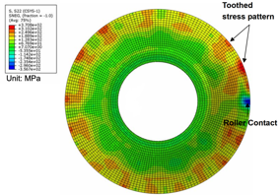
Figure 2.18 Toothed stress pattern along circumferential direction (42)
Music and Allwood (43) developed an FE model to study the wrinkling failure mechanism involved in the conventional spinning. They observed that, in the forward pass, a plastic hinge was generated, combined with non-uniform compressive strains at the edge of the workpiece. Contrastingly, in the backward pass, the plastic hinge gradually vanished, causing uniform compressive strain at the edge of the workpiece. After comparing the strain states of wrinkling failure in the deep drawing process, the authors stated that there were two different modes of wrinkling in the conventional spinning process, depending on the stage and direction of tool movement.
Watson et al. (27) presented an investigation into the wrinkling failure mechanics of the conventional spinning by developing FE models using the Box-Behnken experimental design method. According to the results of the FE models, the authors observed that wrinkling failure was initiated when a plastic hinge appeared between the forming tool and the edge of the workpiece. They stated that the feed ratio had a significant influence on the initiation of wrinkling failure. This is because higher feed ratios were associated with higher bending stresses, thereby contributing to the more rapid formation of a plastic hinge, and, in this way, accelerating wrinkling. Moreover, the authors suggested that the optimum defining angle for the first-pass conventional spinning is around 40° at which the wrinkling failure could be suppressed.
2.4.1.3 Analytical investigation of wrinkling
Limited research has been conducted to establish an analytical model for investigating the component defect of wrinkling. This is due to the non-uniformly distributed stresses in the workpiece and the complicated boundary conditions in the spinning process. In general, there are two common methods, namely the energy method and the equilibrium method, that can be used to determine wrinkling failures in the sheet metal forming process (73). In the energy method, the wave function of the wrinkles for the wrinkled spun component is established, and the potential energies related to this wave function, including internal energy and external energy, are calculated. If the internal energy required for material deformation is greater than the external energy done by the forces acting on the workpiece, the system remains stable. On the other hand, by employing the equilibrium method, the differential equations for the system in equilibrium are established and solved to obtain the critical condition of wrinkling.
Based on the energy method, Senior (73) established an analytical approach to study wrinkling failure in the deep drawing process. In the model, the wrinkling wave form was established based on the assumption of neglecting the radial stresses and the potential energy consumed under wrinkling condition was calculated. The critical condition of wrinkling was obtained when the internal energy of the workpiece, including bending energy and circumferential shrink energy, was equal to the external energy caused by the lateral force. This instability theory for deep drawing process was adopted by Kobayashi (12), who established an analytical model to study the critical condition of wrinkling failure in the conventional spinning of cones. However, this analytical model may not be accurate in determining the critical condition of wrinkling failure in the conventional spinning process. This is due to the negligence of the stresses that exist along the radial direction of the workpiece.
Kong et al. (74) purposed an analytical wrinkling prediction method based on the plastic buckling theory and the energy method for the first-pass conventional spinning of the hemispherical part. A double curved surface model, located at the tool contact zone between the formed part and undeformed flange, was established in this method, as shown in Figure 2.19. However, the method was inefficient due to the fact that the boundary conditions of this analytical model were extracted from the FE simulation results, which demanded multiple time-consuming simulations.
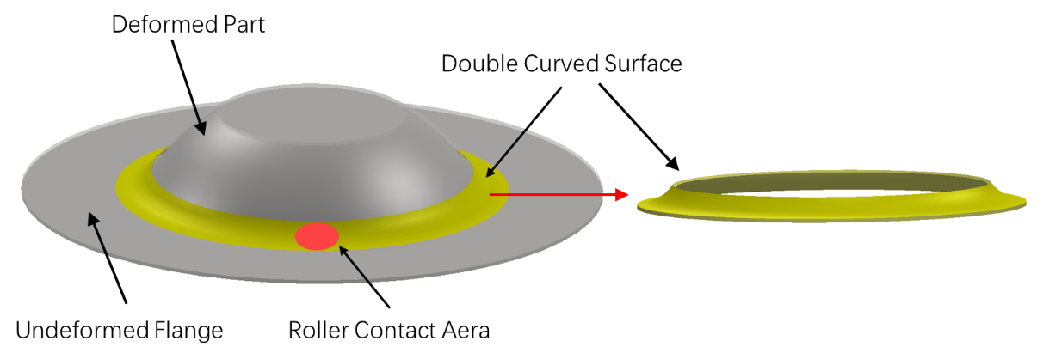
Figure 2.19 Double curved surface model
Based on the equilibrium method, Chen et al. (23) proposed an analytical model to predict wrinkling failure in the first-pass conventional spinning process using linear toolpath. The critical condition of wrinkling was determined by comparing the maximum circumferential stress and the critical circumferential stress. Compared to the analytical model established by Kong et al. (74), two main differences in this model can be identified. One of the differences is that that the stress components are located at the outer edge of the undeformed area, as shown in Figure 2.20, instead of being located at the ring zone of the tool contact area. Another difference is that the relationship between the wrinkling failure and the spinning parameters can be obtained directly without combining with the FE results. Therefore, it is possible to improve the efficiency of the formability determination significantly.
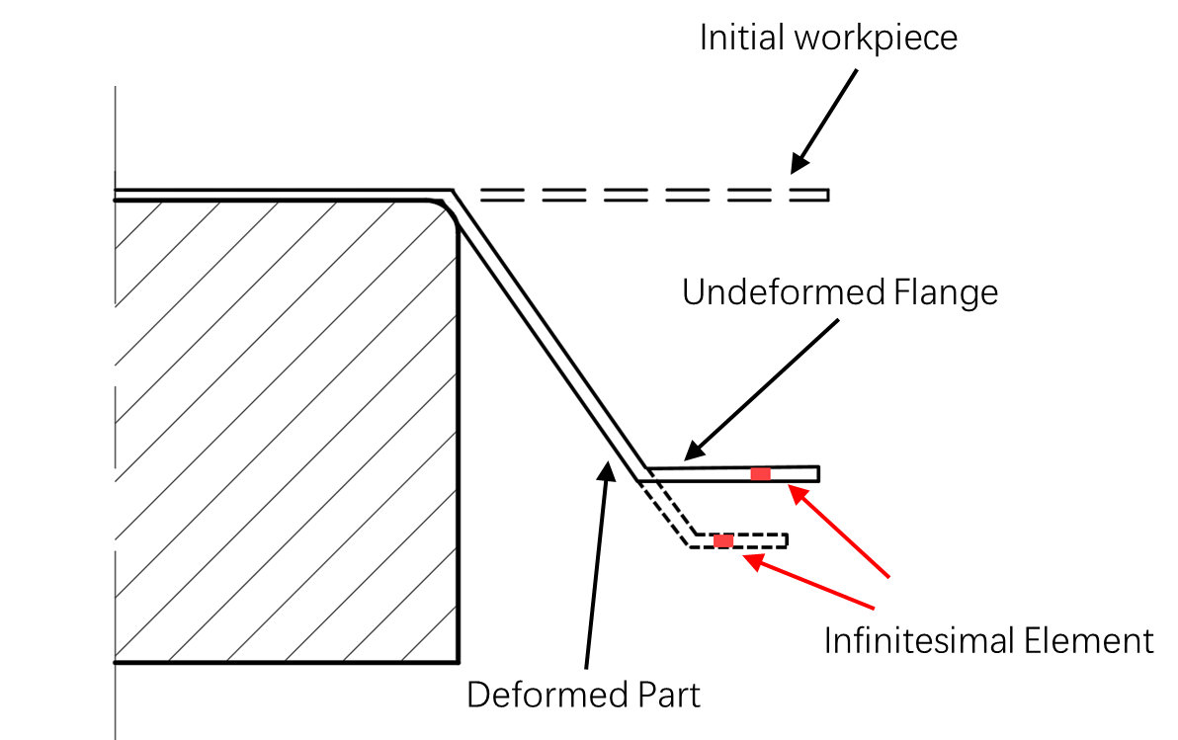
Figure 2.20 Schematic diagram of first-pass conventional spinning using linear toolpath

Processing Map to Predict Wrinkling Failure in Conventional Spinning
In terms of the processing map to predict wrinkling failure in the conventional spinning process, extensive research has been undertaken using the experimental method, FE simulation method, and analytical method.
Xia et al. (14) proposed processing maps considering wrinkling in a one-pass deep drawing spinning process for aluminium material based on the experimental method. A nonlinear interaction between workpiece thickness and feed ratio was identified, as shown in Figure 2.21. The authors stated that wrinkling occurred easily for small thickness and large feed ratio.
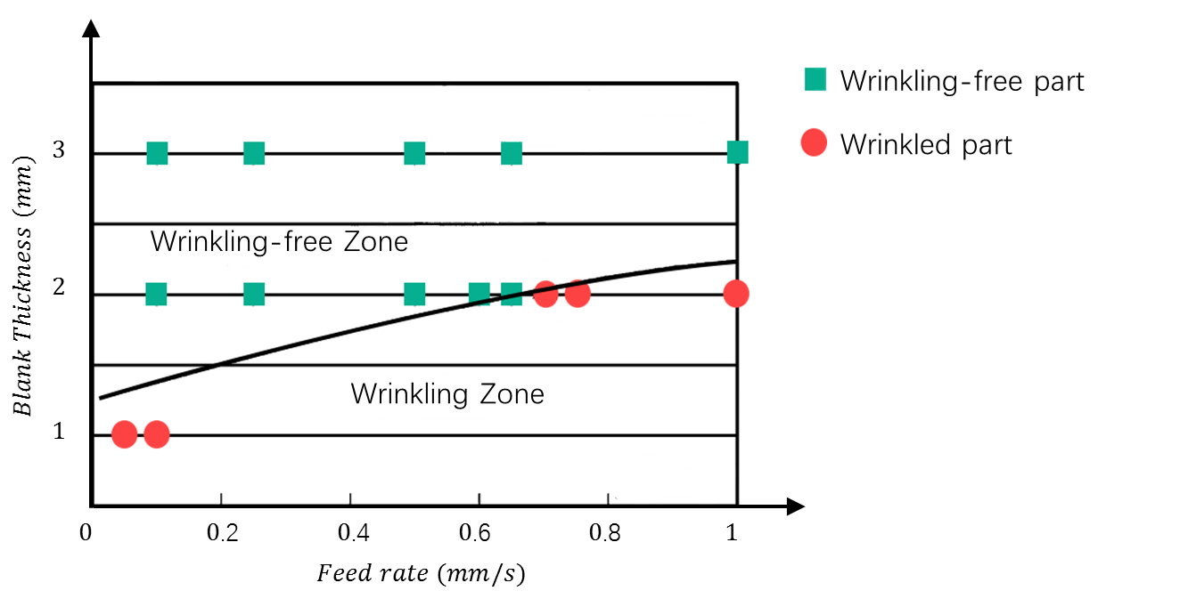
Figure 2.21 Processing map for various feed rates and thicknesses (14)
Based on the FE simulation method, as shown in Figure 2.22, Wang et al. (17) conducted a processing map in terms of feed rate and spindle rotation speed. In this research, a feed ratio of 0.71$mm/rev$ has been found to be the forming limit of wrinkling for the first-pass conventional spinning of a cylindrical cup. The results showed good agreement with the work done by Kawai et al. (11), who stated that there exists a limit of feed ratio beyond which wrinkling failure will occur.
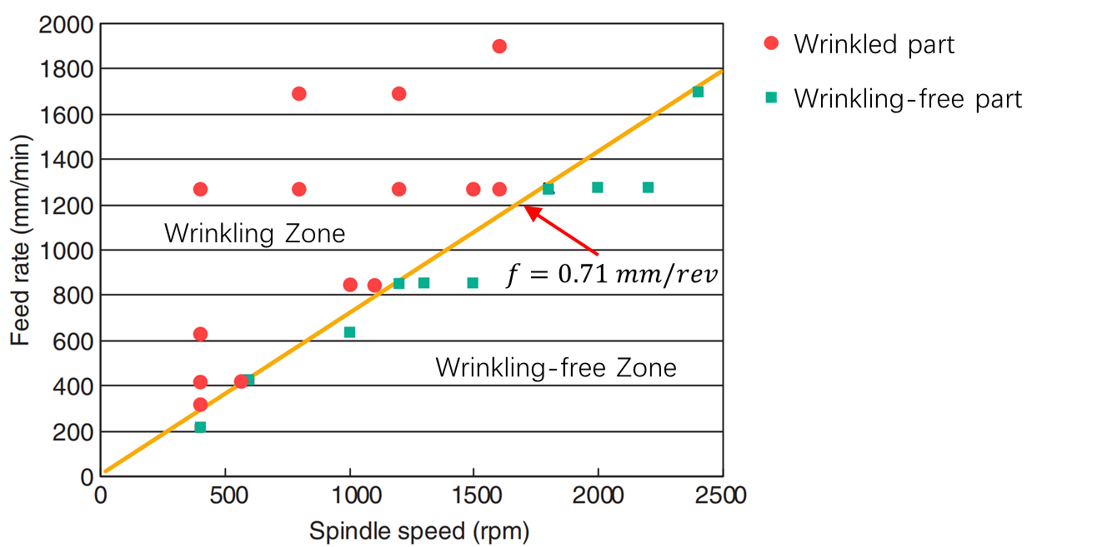
Figure 2.22 Processing map for various spindle speeds and feed rates (17)
Due to the high cost of experiments and the time-consuming nature of FE simulations, only one or two parameters in the conventional spinning process were investigated in the two abovementioned studies to establish the processing map. In contrast, computational efficiency and the ability to examine a greater number of parameters are the major advantages associated with the analytical method. In the analytical model developed by Chen et al. (23), the effects of four parameters, including half cone angle, material hardening exponent, feed ratio, and thickness, on wrinkling failure were investigated. The 3D processing maps were identified based on the proposed analytical model considering wrinkling failure, as shown in Figure 2.23. These processing maps could provide a reference value for determining the spinning parameters needed to avoid wrinkling failure in the first-pass conventional spinning process. However, in this literature, the authors used the visual observation method to determine wrinkling failure in both spinning experiments and FE simulations. The limitations of this detection method of wrinkling failure are given as follow.
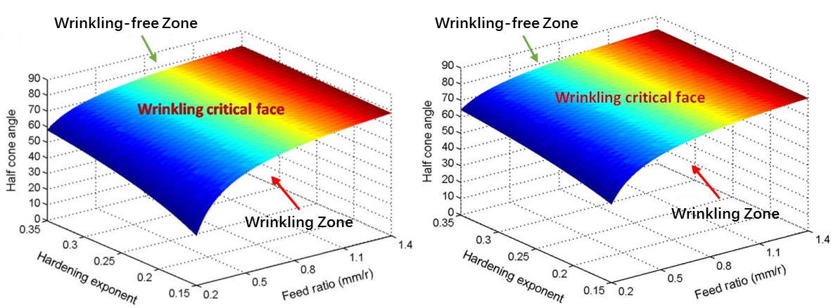
(a) (b)
Figure 2.23 3D processing maps for various hardening exponents, feed ratios, and half cone angle at different thicknesses (a) 1 $mm$, (b) 1.4 $mm$ (23)

Detection Methods for Initiation of Wrinkling Failure
The detection method of fracture failure is relatively straightforward. For example, the initiation of fractures might be observed based on a sudden change in the force in a uniaxial tensile testing process. Moreover, the initiation of fracture failure in conventional sheet forming processes, such as deep drawing, can be detected based on the change of strain values. According to this criterion, the fracture limit of a given material can be defined straightforwardly (75). In contrast, the wrinkling limit is hard to define due to the fact that the initiation of wrinkles is significantly affected by many factors, including the material’s mechanical properties, the workpiece geometry, the feed ratio, the contact conditions, and the toolpath design.
In the sheet metal spinning, most studies simply use the visual observation method to determine the occurrence of wrinkling failure in both experimental process and the FE simulation process (2, 14, 23, 76). There are two main limitations associated with the visual observation method. Firstly, the initiation of wrinkles is difficult to determine during the forming process. On the other hand, slight wrinkles may be easily missed, which lead to a spun component with slight wrinkles to be incorrectly judged as a wrinkling-free spun component. Therefore, it is less reliable if the wrinkling limit diagram is produced using visual observation.
In the limited studies that have examined wrinkling failure in spinning processes, three variables, including strain values, tool force components, and strain energies, have been used to detect the initiation of material wrinkling.
Strain values are obtained by attaching strain gauges to the workpiece surface during the spinning process. Hayama et al. (26) measured the strains along the radial direction and the circumferential direction by attaching the strain gauges to both sides of the workpiece, as shown in Figure 2.24. The periodic variation of curvature and maximum membrane strains along the circumferential direction were evaluated to study the critical conditions of wrinkling. It was noticed that the strain gauges only covered a portion of the workpiece surface. However, due to the difficulties associated with predicting the location of the occurrence of wrinkles, the measurement using strain gauges did not capture the wrinkles generated at the rest surface of workpiece.
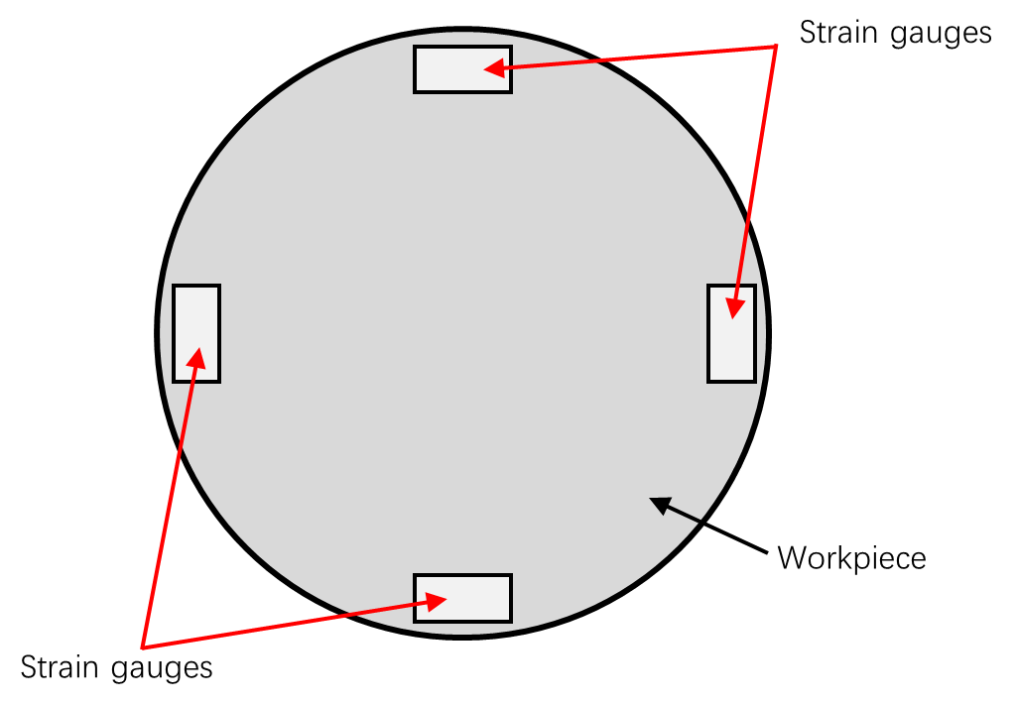
Figure 2.24 Strain measurement by strain gauges (26)
Tool force components were normally measured using the piezoelectric force transducers in the experiments of spinning process (25, 39, 42, 77). A typical force measurement system used in the spinning process is shown in Figure 2.25. Based on the tool force results, Arai (25) took the sudden changes of the axial force and circumferential force as a sign of initiating wrinkling failure in the conventional spinning process. Moreover, this method was adopted by Kleiner et al. (2) and Wang et al. (17) to detect the initiation of wrinkling failure in FE simulations.
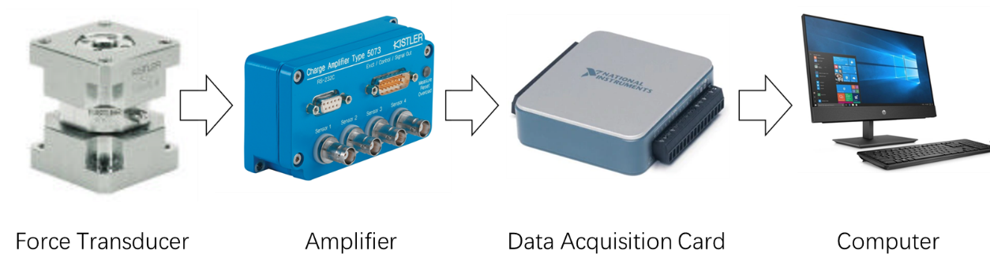
Figure 2.25 Force measurement system (42)
Both the FE method and the analytical method must be validated using corresponding experiments. However, if a normal CNC lathe is used to carry out the spinning experiment, an extra fixture is required to attach the force transducer alignment with the forming tool onto the CNC lathe. Figure 2.26 shows a fixture designed and manufactured by Jagger (77). The cost of the experiments, therefore, increased accordingly.
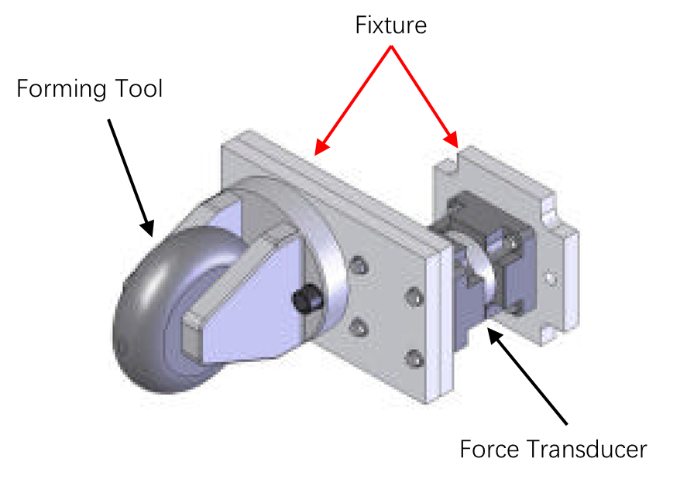
Figure 2.26 Fixture of force transducer designed for CNC lathe (77)
Strain energy observed in FE simulations can be used to study the initiation of wrinkling failure in spinning processes. Liu (28) observed a rapid increase in both strain energy and sliding energy in the FE simulation of a die-less spinning process. Notably, the initiation of wrinkling failure can be determined accordingly. Similarly, based on FE simulations, Watson et al. (27) reported that wrinkling failure occurred when a plastic hinge appeared between the forming tool and the edge of the workpiece. At this moment, the forming tool passed over the bottom of the wrinkle, which resulted in the relieving of the flange and, in turn, a lower amount of stress in the workpiece. Consequently, the level of elastic strain was lower. Based on the above FE simulation results, it was stated that the fluctuation of the elastic strain energy could be used as a sign of the wrinkling failure initiation point in the conventional spinning process.

Material Plastic Deformation
The focus of this study is to predicting wrinkling in the conventional spinning process. Von Mises yielding criteria and thin shell theory, are adopted to establish an analytical wrinkling prediction model. The formulae of the strain energy and the work done by the external forces for the double-curved sheet metal are given in this section.

Von Mises Yielding Criterion
An isotropic elastic-plastic sheet material is widely used in the analytical analysis of the sheet metal forming processes (74, 78). In the material elastic deformation, the principal stress components,$σ_{1}$, $σ_{2}$, $σ_{3}$ , and the principal strain components, $ε_{1}$, $ε_{2}$, $ε_{3}$, can be obtained according to Hooke’s Law:
$$\left\{\begin{aligned}ε_{1}=\frac{1}{E}\left[σ_{1}-υ\left(σ_{2}+σ_{3}\right)\right] \\ ε_{2}=\frac{1}{E}\left[σ_{2}-υ\left(σ_{1}+σ_{3}\right)\right] \\ ε_{3}=\frac{1}{E}\left[σ_{3}-υ\left(σ_{1}+σ_{2}\right)\right]\end{aligned}\right.$$
Equation 2.21
where $E$ is the Young’s Modulus of the given material and $υ$ is the Poisson’s ratio of the material.
The principal plane stress condition is assumed in the analytical model of the conventional spinning process (74, 76, 79). The stress component along the thickness direction, $σ_{3}$, can be neglected. Equation 2.21 can be simplified as:
$$\left\{\begin{aligned}ε_{1}&=\frac{1}{E}\left[σ_{1}-υσ_{2}\right] \\ ε_{2}&=\frac{1}{E}\left[σ_{2}-υσ_{1}\right] \\ ε_{3}&=-\frac{1}{E}υ\left(σ_{1}+σ_{2}\right)\end{aligned}\right.$$
Equation 2.22
After entering the plastic deformation zone, the von Mises criterion should be followed, as expressed in Equation 2.23.
$$\overline{σ}=\sqrt{\frac{1}{2}\left[{\left(σ_{11}-σ_{22}\right)}^{2}+{\left(σ_{22}-σ_{33}\right)}^{2}+{\left(σ_{33}-σ_{11}\right)}^{2}+6\left(τ_{12}^{2}+τ_{23}^{2}+τ_{31}^{2}\right)\right]}$$
Equation 2.23
where $σ_{11}$, $σ_{22}$, and $σ_{33}$ are the normal stresses along three principal directions; and $τ_{12}$, $τ_{23}$, and $τ_{31}$ are the shear stress components. In the case of the principal plane stress condition, $σ_{3}=0$ and $τ_{12}=τ_{23}=τ_{31}=0$. Thus, the von Mises criterion becomes:
$$\overline{σ}=\sqrt{σ_{1}^{2}-σ_{1}σ_{2}+σ_{2}^{2}}$$
Equation 2.24
Additionally, during the plastic deformation process, the volume of the material remains constant. This volume constancy law has been widely employed in analytical models of the sheet metal spinning process (2, 23, 36, 74, 79).

Thin Shell Theory
2.5.2.1 Geometric Equations
During or after the spinning deformation process, if the curved toolpath profile is used, the workpiece’s middle surface can be regarded as a doubly curved shell structure. The flexural properties of this curved structure primarily depend upon the structure thickness. The curved structure can be divided into three categories according to the ratio of $\frac{t}{a}$, where $t$ is the structure thickness and $a$ is a typical dimension of a curved structure, e.g., the radius of curvature of the structure’s middle surface (80–82). If the structure is a circular structure, for example, $a$ could be replaced by the radius $R_{0}$ of the structure. There are several groups of structures: firstly, for thicker structures with ratios $\frac{t}{a}>\frac{1}{20}$; secondly, for membranes with ratios $\frac{t}{a}<\frac{1}{1000}$; and thirdly, for thin structures with ratios $\frac{1}{1000}≤\frac{t}{a}≤\frac{1}{20}$. The sheet metal spinning can form components with diameters ranging from 3 $mm$ to 10 $m$, and thicknesses ranging from 0.4 $mm$ to 25 $mm$ (5). Thus, the workpiece that is deformed in the sheet metal spinning process using a curved toolpath profile can be classified in the category of thin structures. According to the thin shell theory, the middle surface of the structure can be determined based on the Cartesian coordinates of three equations (80):
$$\left\{\begin{aligned}x=f_{1}\left(α_{1},α_{2}\right) \\ y=f_{2}\left(α_{1},α_{2}\right) \\ z=f_{3}\left(α_{1},α_{2}\right)\end{aligned}\right.$$
Equation 2.25
where $f_{1},f_{2},f_{3}$ are definite, continuous, single-valued functions of the two curvilinear coordinates $α_{1}$ and $α_{2}$. Additionally, the ranges of these two coordinates are restricted such that every point located on the workpiece’s middle surface corresponds only to one pair of values of $α_{1},α_{2}$. To meet this criterion, a constant value $r$ and a varied value $r_{1}$ are defined on these two coordinates, respectively. Through this coordinate limitation method, only one curve will pass across each point of the workpiece’s middle surface. Therefore, every point of the surface can be considered as the intersection of two coordinate lines $α_{1},α_{2}$, as shown in Figure 2.27.
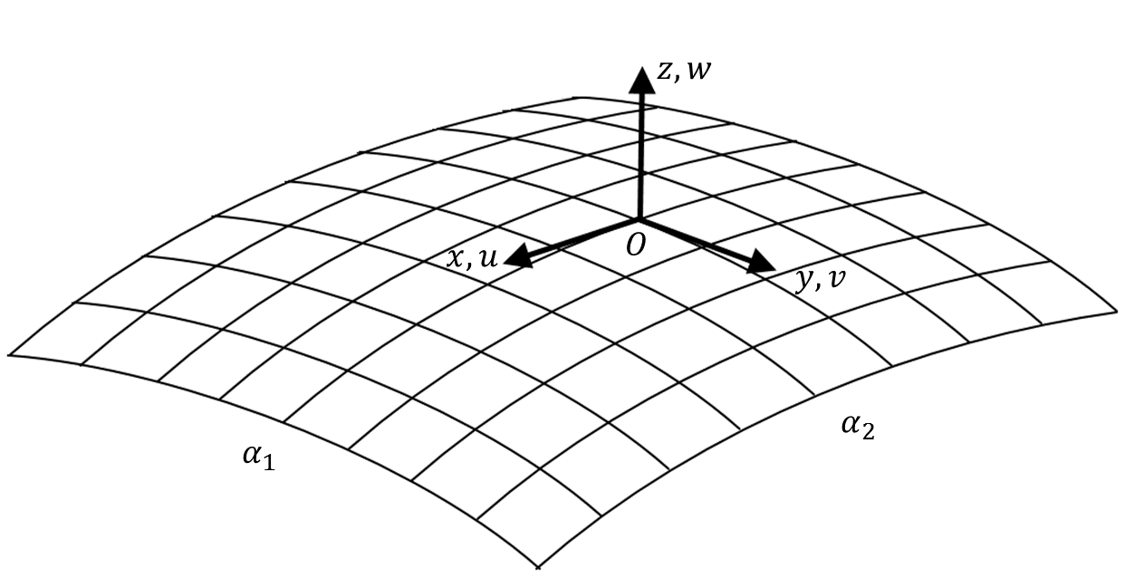
Figure 2.27 Curvilinear coordinates of the structure’s middle surface (80)
Furthermore, the three scalar equations in Equation 2.25 can be written as a single vector equation:
$$\vec{r}=\vec{r}\left(α_{1},α_{2}\right)$$
Equation 2.26
Therefore, the derivatives of $\vec{r}$ with respect to $α_{1}$ and $α_{2}$ can be expressed as:
$$\left\{\begin{aligned}{\vec{r}}_{α_{1}}=\frac{∂\vec{r}}{∂α_{1}} \\ {\vec{r}}_{α_{2}}=\frac{\vec{r}}{∂α_{2}}\end{aligned}\right.$$
Equation 2.27
where ${\vec{r}}_{α_{1}}$, ${\vec{r}}_{α_{2}}$ are the vectors tangential to the $α_{1},α_{2}$ lines, respectively. Since Equation 2.25 is the projection of $\vec{r}$ on the axes $x,y,z$, the square of the length of ${\vec{r}}_{α_{1}}$, ${\vec{r}}_{α_{2}}$ can be expressed as:
$$\left\{\begin{aligned}{\left|{\vec{r}}_{α_{1}}\right|}^{2}=A^{2}={\left(\frac{∂x}{∂α_{1}}\right)}^{2}+{\left(\frac{∂y}{∂α_{1}}\right)}^{2}+{\left(\frac{∂z}{∂α_{1}}\right)}^{2} \\ {\left|{\vec{r}}_{α_{2}}\right|}^{2}=B^{2}={\left(\frac{∂x}{∂α_{2}}\right)}^{2}+{\left(\frac{∂y}{∂α_{2}}\right)}^{2}+{\left(\frac{∂z}{∂α_{2}}\right)}^{2}\end{aligned}\right.$$
Equation 2.28
where the quantities $A, B$ are the Lamé coefficients.
Consequently, the increments of the arc length ${ds}_{1},{ds}_{2}$ along the coordinate lines of $α_{1},α_{2}$, corresponding to the increase of the curvilinear coordinates by ${dα}_{1},{dα}_{2}$, can be expressed respectively as:
$$\left\{\begin{aligned}{ds}_{1}=A{dα}_{1} \\ {ds}_{2}=B{dα}_{2}\end{aligned}\right.$$
Equation 2.29
For an arbitrary point $O$ located on the structure’s middle surface, the position of the point can be determined by the curvilinear coordinates $α_{1},α_{2}$, which are assumed to be the principal coordinates. Due to the deformation process, this arbitrary point $O$ undergoes a displacement. As presented in Figure 2.27, $u$ is the projection of this displacement of the middle surface on the direction of the tangent to the line $α_{1}$ along with the $x$ axis of the local coordinate system. Similarly, $v$ is the projection of this displacement on the direction of the tangent to the line $α_{2}$ along with the $y$ axis. Additionally, $w$ is the projection of this displacement on the direction normal to the middle surface along with the direction of the $z$ axis at the point $O$.
After the deformation process, the increments of the arc length ${{ds}_{1}}^{'},{{ds}_{2}}^{'}$ can be expressed as:
$$\left\{\begin{aligned}{{ds}_{1}}^{'}={A_{1}}^{'}{dα}_{1} \\ {{ds}_{2}}^{'}={A_{2}}^{'}{dα}_{2}\end{aligned}\right.$$
Equation 2.30
where $A^{'}$ and $B^{'}$ are the Lamé coefficients for the deformed middle surface. The relative strains $ε_{1}, ε_{2}$ of a linear element of the middle surface on the directions of $α_{1},α_{2}$ can be determined by:
$$\left\{\begin{aligned}ε_{1}=\frac{{{ds}_{1}}^{'}-{ds}_{1}}{{ds}_{1}}=\frac{1}{A}\frac{∂u}{∂α_{1}}+\frac{υ}{AB}\frac{∂A}{∂α_{2}}+\frac{w}{r} \\ ε_{2}=\frac{{{ds}_{2}}^{'}-{ds}_{2}}{{ds}_{2}}=\frac{1}{B}\frac{∂υ}{∂α_{2}}+\frac{u}{AB}\frac{∂B}{∂α_{2}}+\frac{w}{r_{1}}\end{aligned}\right.$$
Equation 2.31
Additionally, it is possible to write the shear strain component $γ_{12}$, the curvature changes of the workpiece middle surface $κ_{1}$ and $κ_{2}$, and the twist of the middle surface $χ$ in the following way：
$$\left\{\begin{aligned}γ_{12}&=\frac{A}{B}\frac{∂}{∂α_{2}}\left(\frac{u}{A}\right)+\frac{B}{A}\frac{∂}{∂α_{1}}\left(\frac{υ}{A}\right) \\ κ_{1}&=\frac{1}{A}\frac{∂}{∂α_{1}}\left(\frac{u}{r}\right)+\frac{1}{AB}\frac{∂A}{∂α_{2}}\frac{υ}{r_{1}}-\frac{1}{A}\frac{∂}{∂α_{1}}\left(\frac{1}{A}\frac{∂w}{∂α_{1}}\right)-\frac{1}{AB^{2}}\frac{∂A}{∂α_{2}}\frac{∂w}{∂α_{2}}-\frac{ε_{1}}{r} \\ κ_{2}&=\frac{1}{B}\frac{∂}{∂α_{2}}\left(\frac{υ}{r_{1}}\right)+\frac{1}{AB}\frac{∂B}{∂α_{1}}\frac{u}{r}-\frac{1}{B}\frac{∂}{∂α_{2}}\left(\frac{1}{B}\frac{∂w}{∂α_{2}}\right)-\frac{1}{A^{2}B}\frac{∂B}{∂α_{1}}\frac{∂w}{∂φ}-\frac{ε_{2}}{r_{1}} \\ χ&=\frac{1}{r}\frac{A}{B}\frac{∂}{∂α_{2}}\left(\frac{u}{A}\right)+\frac{1}{r_{1}}\frac{B}{A}\frac{∂}{∂α_{1}}\left(\frac{υ}{B}\right)-\frac{1}{AB}\left(\frac{∂^{2}w}{∂α_{2}∂α_{1}}-\frac{1}{A}\frac{∂A}{∂α_{2}}\frac{∂w}{∂α_{1}}-\frac{1}{B}\frac{∂B}{∂α_{1}}\frac{∂w}{∂α_{2}}\right)-\frac{1}{2}\left(\frac{1}{r}+\frac{1}{r_{1}}\right)γ_{12}\end{aligned}\right.$$
Equation 2.32
2.5.2.2 Strain Energy of Deformation
The generalised formula of strain energy calculation can be expressed as in (80, 81, 83):
$$U=\frac{1}{2}\int{\left(σ_{11}ε_{11}+σ_{22}ε_{22}+σ_{33}ε_{33}+σ_{12}ε_{12}+σ_{13}ε_{13}+σ_{23}ε_{23}\right)}dV$$
Equation 2.33
where $σ_{11}$, $σ_{22}$, and $σ_{33}$ are the stress tensors, which are perpendicular to the element faces; $ε_{11}, ε_{22}$, and $ε_{33}$ are the corresponding strain tensors; $σ_{12}, σ_{13}$, and $σ_{23}$ are the shear stress tensors; $ε_{12},{ ε}_{13}$, and $ε_{23}$ are the corresponding shear strain tensors; and $dV$ is the volume of the element.
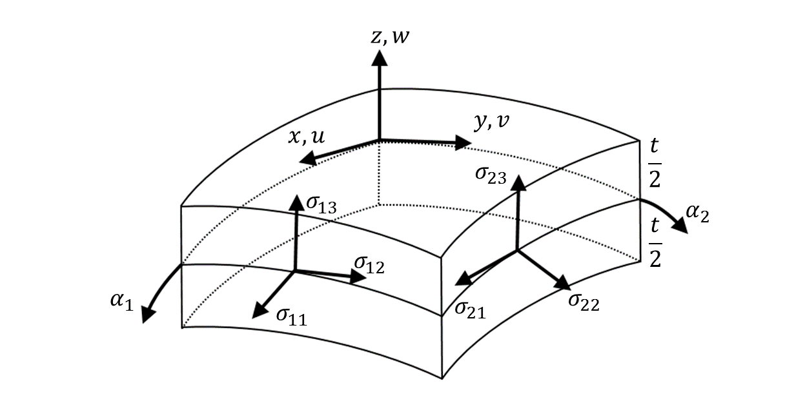
Figure 2.28 Infinitesimal element of the doubly curved structure (80)
As shown in Figure 2.28, an infinitesimal element is separated from the doubly curved structure by four neighbouring cuts perpendicular to the lines $α_{1},α_{2}$ of the middle surface throughout the structure thickness $t$. Thus, the volume of this element can be expressed as:
$$dV=AB\left(1+\frac{z}{r}\right)\left(1+\frac{z}{r_{1}}\right)dα_{1}dα_{2}dz$$
Equation 2.34
According to the Kirchhoff hypotheses (80), the normal stress tensor $σ_{33}$, shear stress tensors $σ_{13}$, $σ_{23}$, and the shear strain tensors $ε_{13},ε_{23}$ are neglected. Hence, the strain energy $U$ follows these hypotheses, and it can be expressed as follows:
$$U=\frac{1}{2}\iiint{\left(σ_{11}ε_{11}+σ_{22}ε_{22}+σ_{12}ε_{12}\right)AB\left(1+\frac{z}{r}\right)\left(1+\frac{z}{r_{1}}\right)dα_{1}{dα}_{2}}dz$$
Equation 2.35
Taking Hooke’s law into account, the stress tensors, $σ_{11}$, $σ_{22}$, and $σ_{12}$, can be expressed in the following way:
$$\left\{\begin{aligned}σ_{11}&=\frac{E}{1-υ^{2}}\left({ε_{1}}^{(z)}+{υε_{2}}^{(z)}\right) \\ σ_{22}&=\frac{E}{1-υ^{2}}\left({ε_{2}}^{(z)}+{υε_{1}}^{(z)}\right) \\ σ_{12}&=\frac{E}{2\left(1+υ\right)}ω^{(z)}\end{aligned}\right.$$
Equation 2.36
where E is the Young’s modulus; ${ε_{1}}^{(z)}$ and ${ε_{2}}^{(z)}$ are the change in length in the direction of $α_{1},α_{2}$, respectively; and $ω^{(z)}$ is the normal displacement. To this order of accuracy, the formulae of these three terms can be expressed as:
$$\left\{\begin{aligned}{ε_{1}}^{\left(z\right)}&=ε_{1}+z\left(κ_{1}-\frac{ε_{1}}{r}\right)-\frac{z^{2}}{r}\left(κ_{1}-\frac{ε_{1}}{r}\right) \\ {ε_{2}}^{\left(z\right)}&=ε_{2}+z\left(κ_{2}-\frac{ε_{2}}{r_{1}}\right)-\frac{z^{2}}{r_{1}}\left(κ_{2}-\frac{ε_{2}}{r_{1}}\right) \\ ω^{\left(z\right)}&=γ_{12}+2z\left[χ-\left(\frac{1}{r}+\frac{1}{r_{1}}\right)\frac{γ_{12}}{2}\right]-z^{2}\left(\frac{1}{r}+\frac{1}{r_{1}}\right)\left[χ-\frac{r^{2}+r_{1}^{2}}{r+r_{1}}\frac{γ_{12}}{rr_{1}}\right]\end{aligned}\right.$$
Equation 2.37
By substituting Equations 2.36 and 2.37 into Equation 2.35, neglecting the higher-order term according to the assumption and letting $z=\frac{t}{2}$, it is possible to write the potential strain energy of deformation of the doubly curved workpiece$U$ in the form (80):
$$U=\frac{t}{2}\iint{\frac{E}{1-υ^{2}}}\left({\left(ε_{1}+ε_{2}\right)}^{2}+2\left(1-υ\right)\left(\frac{1}{4}γ_{12}-ε_{1}ε_{2}\right)\right)ABdα_{1}dα_{2}$$
$$+\frac{t^{3}}{24}\iint{\frac{E}{1-υ^{2}}}\left({\left(κ_{1}{+κ}_{2}\right)}^{2}+2\left(1-υ\right)\left(χ^{2}-κ_{1}κ_{2}\right)\right)ABdα_{1}dα_{2}$$
Equation 2.38
In this formula, the first term represents the potential energy for material deformation (e.g., tension) and the second term represents the energy due to bending and torsion.
In the first-pass conventional spinning process, the workpiece is deformed by the forming tool continuously, following the designed toolpath. According to total strain equation (84, 85), this nonlinear deformation can be modelled with strain-stress relations in which the final or total strains are a function of only the final or total stresses, irrespective of the loading path to reaching that final stress state. The secant modulus is applied instead of Young’s modulus in the first term of Equation 2.38. Additionally, due to the fact that bending occurs during the deformation process, the reduced modulus is employed instead of Young’s modulus in the second term of Equation 2.38, consistent with reduced modulus theory (85, 86). Therefore, Equation 2.38 can be rewritten in the following way:
$$U=\frac{t}{2}\iint{\frac{E_{s}}{1-υ^{2}}}\left({\left(ε_{1}+ε_{2}\right)}^{2}+2\left(1-υ\right)\left(\frac{1}{4}γ_{12}-ε_{1}ε_{2}\right)\right)ABdα_{1}dα_{2}$$
$$+\frac{t^{3}}{24}\iint{\frac{E_{r}}{1-υ^{2}}}\left({\left(κ_{1}{+κ}_{2}\right)}^{2}+2\left(1-υ\right)\left(χ^{2}-κ_{1}κ_{2}\right)\right) ABdα_{1}dα_{2}$$
Equation 2.39
where the double integrals extend over the entire middle surface; $E_{s}$ is the secant modulus; $E_{r}$ is the reduced modulus; and $υ$ is the Poisson’s ratio.

Summary
This chapter started by classifying and briefly describing the sheet metal spinning processes. The two most commonly used non-linear FE solution methods (i.e., implicit and explicit method) were reviewed and compared, and the material plasticity of FE simulation was briefly outlined. Published papers investigating the effects of the process and material parameters on wrinkling in were reviewed in order to understand material deformation in the conventional spinning process. Moreover, a review was conducted to evaluate the available methods for investigating wrinkling failure mechanism, processing maps to predict wrinkling failure, and the wrinkling detection methods. Since the energy method was used to predict wrinkling failure in this research, as presented in Chapter 5, von Mises yield criterion shell deformation theory were also reviewed in this chapter.
The literature review presented in this chapter highlighted three major research gaps:
(a) Toolpath design in most studies has relied on the empirical method and, moreover, it has focused on individual spun part geometry. Currently, the Bézier curve has been applied to parameterise the toolpath, but its study was limited to relatively few investigations that only addressed the first-pass conventional spinning process. Therefore, it is essential to propose a toolpath parameterisation method for multiple-passes. Moreover, the accuracy of toolpaths designed based on the Bézier curve must be evaluated by comparing mandrel profiles for the final pass and target curves for the first-pass, respectively.
(b) Various limitations were identified in existing prediction methods for wrinkling failure in the conventional spinning process. A detailed processing map has yet to be developed. Furthermore, it is essential to investigate how to determine the critical condition of wrinkling failure involving key influential parameters during the first-pass conventional process.
(c) In previous studies, the detection methods used for wrinkling failure in spinning experiments either fail to capture the initiation point of wrinkling accurately or they need to be fitted with extra equipment, such as the fixture of force transducer. Thus, a wrinkling failure measurement system is worthy developing for spinning experiments in order to validate the results for analytical wrinkling prediction models and FE simulation of wrinkling initiation.

parameterisation of toolpath profiles
As reviewed in Chapter 2.3.1, toolpath design for the sheet metal spinning processes is an essential step in manufacturing spun components. The most frequently used toolpath profiles can be divided into three categories: concave toolpath profiles, convex toolpath profiles, and linear toolpath profiles. Most existing research into toolpath design has used empirical methods focused on simplex component geometries, although a few researchers have proposed toolpath parametrisation methods based on the quadratic Bézier curve. Even in these studies, only the first one or two passes are produced and studied, omitting evaluation of the capabilities and accuracy of the proposed toolpaths, and, in particular, no study is conducted in evaluating the final pass for a given geometric shape. To address this, this chapter focuses on the development of a parametric toolpath design strategy that can be applied to generate various toolpath profiles. Multiple-passes of the conventional spinning process are first parameterised based on identifying the forming depth and the radius of the workpiece after each pass, as outlined in Section 3.1. The general expression of the Bézier curve is then presented in Section 3.2, while the methods for calculating the control points of the cubic Bézier curve for the final toolpath profile and the first toolpath profile are reported on in Section 3.3 and Section 3.4, respectively. The toolpath precision and applicability of this design strategy and the effects of process parameters on toolpath profile are investigated in Section 3.5, while a summary of the work covered in this chapter is presented in Section 3.6.

Multiple-passes Parameterisation
In the conventional spinning process, in order to improve spun component quality, including wall thickness uniformity, multiple-passes are utilised during the forming process (5). As illustrated in Figure 3.1, a cylindrical shaped mandrel and a set of tool passes were employed as an example in this work to illustrate the definition of multiple-pass parameterisation. The original workpiece radius and the radius of the clamped area are defined as $R_{0}$ and $R_{c}$, respectively. The spin ratio, $τ$, can therefore be defined as $τ=\frac{R_{0}-R_{c}}{R_{0}}$. The required number of tool passes is ${RP}_{i}$ ($i=1,2, ⋯$). The forming depth and the radius of workpiece deformed after each tool pass are defined as $h_{i}$ and $R_{2,i}$, respectively, while $H$ is used to describe the total forming depth of the workpiece. The type of tool pass profile, whether linear, convex, or concave is not considered at this stage, however. Using only these definitions, the multiple-passes in conventional spinning can be primarily parameterised.
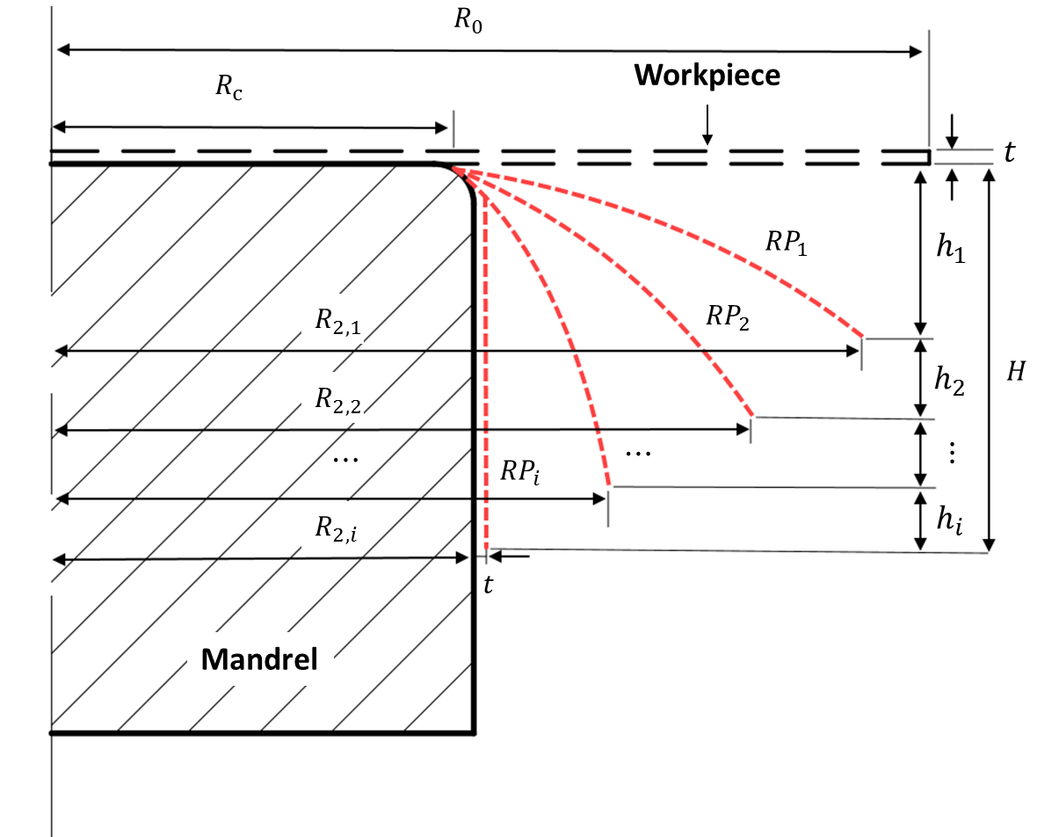
Figure 3.1 Multiple-passes parameterisation

Bézier Curve
The Bézier curve is one of the most widely used parametric polynomial curves, which is utilised in a variety of applications. It offers a continuous curvature as well as easily enabling the curve shape modification based on adjusting its control points, as shown in Figure 3.2.
Figure 3.2 The Bézier curve shape modification
This control point assignment is the main means of generating a path when utilising the Bézier curve, by given the set of control points $\left\{P_{0}\left(x_{0},y_{0}\right),P_{1}\left(x_{1},y_{1}\right),⋯,P_{n}\left(x_{n},y_{n}\right)\right\}$ and the degree of the polynomial $n$, the $n$th-order Bézier curve can be expressed as
$$B\left(t\right)=\sum_{i=0}^{n}{b_{i, n}\left(t\right)P\left(i\right)}$$
Equation 3.1
The polynomials in the set $b_{i,n}\left(t\right)$ are then defined as
$$b_{i,n}\left(t\right)=C_{i}^{n}t^{ i}{\left(1-t\right)}^{n-i}, i=0,1,2…n$$
Equation 3.2
where $b_{i,n}\left(t\right)$ refers to the Bernstein basis polynomials of degree $n$ for $t∈\left[0,1\right]$. The binomial coefficient$,{ C}_{i}^{n}$, is determined by
$$C_{i}^{n}=\frac{n!}{i!\left(n-i\right)!}$$
Equation 3.3
Higher degree Bézier curves offer even higher flexibility in terms of designing shapes; however, during the conventional spinning process, most shapes taken by the spun component are symmetrical and uncomplicated, and thus, based on curve accuracy and ease of application, the cubic Bézier curve was employed to design and parameterise the toolpath profiles in this study.

Control Points for the Final Toolpath Profile
During the conventional spinning process, multiple-passes are generally required. As shown in Figure 3.1, each tool pass is independent and unaffected by the previous passes, with final tool pass profile normally intended to achieve the mandrel profile by the workpiece being deformed onto the mandrel surface. Accordingly, this final tool pass profile can also be parameterised using the cubic Bézier curve. Four control points are required to produce the relevant cubic Bézier curve, and as illustrated in Figure 3.3, these control points can be assigned from either the anticlockwise direction (+) or the clockwise direction (-). The coordinates of these control points can then be calculated along the anticlockwise direction, from $P_{0}$ to $P_{3}$ and along the clockwise direction, from $P_{3}$ to $P_{0}$, respectively. The detailed calculation procedure for the coordinates of the control points of the cubic Bézier curve for the final tool pass is shown below:
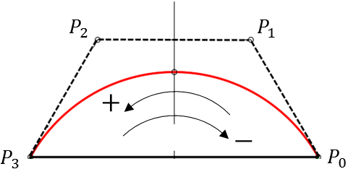
Figure 3.3 Sequence of control points
Based on Equation 3.1, the cubic Bézier curve can be written as
$$B\left(t\right)=\sum_{i=0}^{3}{b_{i,3}\left(t\right)P\left(i\right)}=P_{0}{\left(1-t\right)}^{3}+3P_{1}t{\left(1-t\right)}^{2}+3P_{2}t^{2}\left(1-t\right)+P_{3}t^{3}$$
Equation 3.4
Consequently, the coordinates of four control points of the cubic Bézier curve $\left\{P_{0}\left(x_{0},y_{0}\right),P_{1}\left(x_{1},y_{1}\right),P_{2}\left(x_{2},y_{2}\right),P_{3}\left(x_{3},y_{3}\right)\right\}$ can be expressed as:
$$\left\{\begin{aligned}x_{P}\left(t\right)=x_{0}{\left(1-t\right)}^{3}+3x_{1}{\left(1-t\right)}^{2}t{+3x}_{2}t^{2}\left(1-t\right)+x_{3}t^{3} \\ y_{P}\left(t\right)=y_{0}{\left(1-t\right)}^{3}+3y_{1}{\left(1-t\right)}^{2}t{+3y}_{2}t^{2}\left(1-t\right)+y_{3}t^{3}\end{aligned}\right.$$
Equation 3.5
where $x_{P}$ and $y_{P}$ are the coordinates of the corresponding control points in the Cartesian coordinate system. This equation can then be expanded as:
$$\left\{\begin{aligned}x_{P}\left(t\right)=x_{0}-3\left(x_{0}-x_{1}\right)t+3\left(x_{0}-2x_{1}+x_{2}\right)t^{2}-\left(x_{0}-3x_{1}+3x_{2}-x_{3}\right)t^{3} \\ y_{P}\left(t\right)=y_{0}-3\left(y_{0}-y_{1}\right)t+3\left(y_{0}-2y_{1}+y_{2}\right)t^{2}-\left(y_{0}-3y_{1}+3y_{2}-y_{3}\right)t^{3}\end{aligned}\right.$$
Equation 3.6
From Equation 3.6, based on the relationship between two adjacent control points, the coordinates of $P_{n}$ can be calculated based on the coordinates of $P_{n-1}$. Moreover, due to the first control point, $P_{0} \left(x_{0},y_{0}\right),$ is set as located at the edge of the clamped area of the workpiece and the coordinates of this point are thus known. Accordingly, $P_{1}\left(x_{1},y_{1}\right)$, $P_{2} \left(x_{2},y_{2}\right),$ and $P_{3} \left(x_{3},y_{3}\right)$ can be obtained, as follows:
The coefficients $A_{x}$, $A_{y}$, $B_{x}$,$B_{y}$,$C_{x}$ and $C_{y}$ are defined by $t^{3}$, $t^{2}$ and $t$ respectively. Accordingly, Equation 3.6 can be rewritten as
$$\left\{\begin{aligned}x_{P}\left(t\right)=A_{x}t^{3}+B_{x}t^{2}+C_{x}t+x_{0} \\ y_{P}\left(t\right)=A_{y}t^{3}+B_{y}t^{2}+C_{y}t+y_{0}\end{aligned}\right.$$
Equation 3.7
Thus
$$\left\{\begin{aligned}C_{x}&=3\left(x_{1}-x_{0}\right) \\ B_{x}&=3x_{0}-2x_{1}+x_{2} \\ A_{x}&=x_{3}-3x_{2}+{3x}_{1}-x_{0}\end{aligned}\right.$$
Equation 3.8
and the coordinates of control points $P_{1}\left(x_{1},y_{1}\right)$, $P_{2} \left(x_{2},y_{2}\right)$ and $P_{3} \left(x_{3},y_{3}\right),$ following the anticlockwise direction, can be expressed using
$$\left\{\begin{aligned}x_{1}&=x_{0}+\frac{C_{x}}{3} \\ x_{2}&=x_{0}+\frac{2C_{x}+B_{x}}{3} \\ x_{3}&=x_{0}+C_{x}+B_{x}+A_{x}\end{aligned}\right.$$
and
$$\left\{\begin{aligned}y_{1}&=y_{0}+\frac{C_{y}}{3} \\ y_{2}&=y_{0}+\frac{2C_{y}+B_{y}}{3} \\ y_{3}&=y_{0}+C_{y}+B_{y}+A_{y}\end{aligned}\right.$$
Equation 3.9
If the starting point of the Bézier curve, $P_{3} \left(x_{3},y_{3}\right),$ is known, the coordinates of control points $P_{2} \left(x_{2},y_{2}\right)$, $P_{1}\left(x_{1},y_{1}\right),$ and $P_{0} \left(x_{0},y_{0}\right)$ following in the clockwise direction can be expressed using
$$\left\{\begin{aligned}x_{2}&=x_{3}-\frac{C_{x}}{3} \\ x_{1}&=x_{3}-\frac{2C_{x}+B_{x}}{3} \\ x_{0}&=x_{3}-C_{x}-B_{x}-A_{x}\end{aligned}\right.$$
and
$$\left\{\begin{aligned}y_{2}&=y_{3}-\frac{C_{y}}{3} \\ y_{1}&=y_{3}-\frac{2C_{y}+B_{y}}{3} \\ y_{0}&=y_{3}-C_{y}-B_{y}-A_{y}\end{aligned}\right.$$
Equation 3.10
By following this procedure, the cubic Bézier curve can be produced based on the coordinates of the four control points as calculated, allowing the final toolpath for an arbitrary spinning mandrel to be created.

Control Points for the First Toolpath Profile
For the first-pass conventional spinning process, one of three toolpath profiles is generally utilised; whether a convex path, concave path, or linear path is chosen, this can be parameterised using the cubic Bézier curve. In this study, to produce the three types of toolpath profiles using the cubic Bézier curve, the following boundary conditions were determined. As shown in Figure 3.4, $P_{0}$, $P_{1},$ $P_{2}$ and $P_{3}$ are the control points of the convex toolpath profile produced by the cubic Bézier curve. $\overline{P_{1}P_{2}}$ is parallel to $\overline{P_{0}P_{3}}$ and $P_{0}P_{1}=P_{2}P_{3}=l$. To produce the concave toolpath profile, the control points $P_{0}$ and $P_{3}$ are held in the same position, while ${P_{1}}^{'}$ and ${P_{2}}^{'}$ are symmetrical about $\overline{P_{0}P_{3}}$ with $P_{1}$ and $P_{2}$, respectively. Thus, ${P_{0}}^{'}{P_{1}}^{'}={P_{2}}^{'}{P_{3}}^{'}=l$. In contrast, the linear toolpath profile is produced simply by defining control points $P_{0}$ and $P_{3}$: Point $M$ is defined as the middle point of $\overline{P_{0}P_{3}}$, where $\overline{QM}⊥\overline{P_{0}P_{3}}$ and $\overline{Q^{'}M}⊥\overline{P_{0}P_{3}}$.
Finally, the path curvature, PC, for the convex path or the concave path is defined by
$$PC=±\frac{L_{QM}}{L_{P_{0}P_{3}}}$$
Equation 3.11
where $L_{P_{0}P_{3}}$ is the chord length of the curve and $L_{QM}$ is the chord height of the curve. The use of $"±"$indicates that the path curvature is positive for the convex toolpath profile and negative for the concave toolpath profile. The path curvature is defined by integer multiples of $λ$: $PC=±λ, ±2λ⋯$, and a linear path is produced when the path curvature, PC ($λ=0)$, is equal to zero.
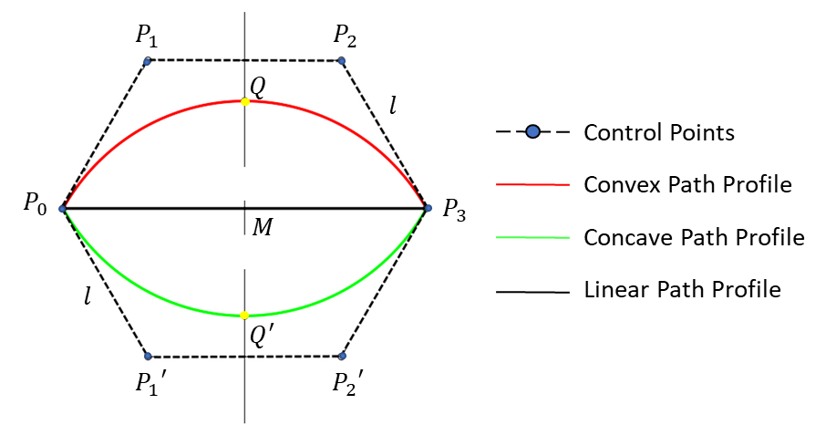
Figure 3.4 Conditions of three types of toolpath profiles
As noted in Chapter 2.3.1, the convex toolpath profile helps to maintain the original thickness of the workpiece during the conventional spinning process (61). Thus, the convex toolpath profile is parametrised by the cubic Bézier curve firstly. The convex toolpath profile can be considered part of a circular arc with a centre, $O_{2}$, located on the mandrel rotation axis $OO^{'}$ with an arbitrary radius $r$, as shown Figure 3.5. For convenience, in both the FE simulation and experimental work for this study, the path curvature of the cubic Bézier curve was defined as $2λ$ under the above conditions. Curves with different PCs could therefore be produced as required.
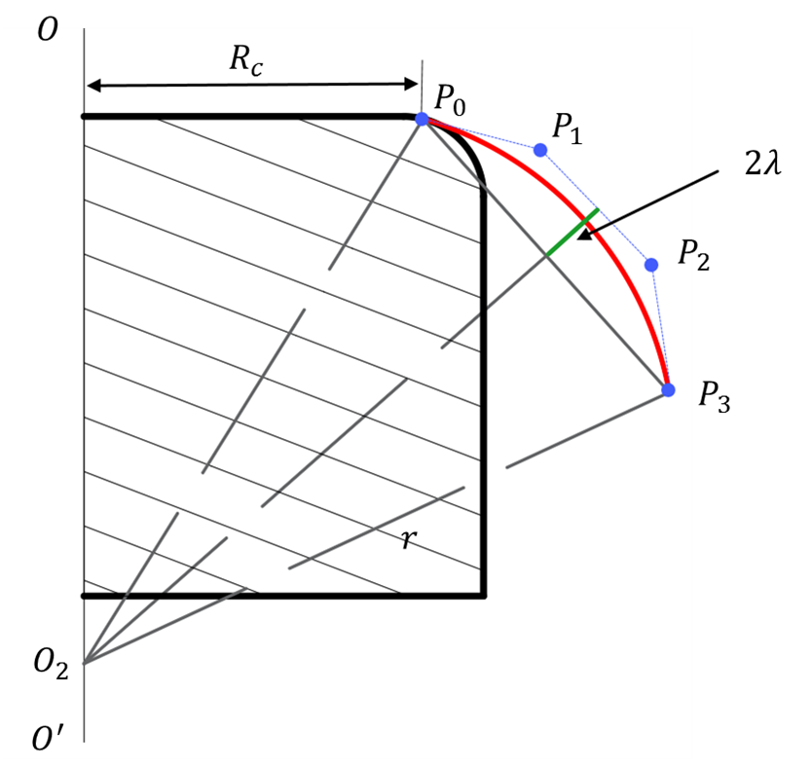
Figure 3.5 A convex toolpath with a PC of $2λ$
Because a convex toolpath can be produced based on defining $PC=2λ$ by using the cubic Bézier curve, the relevant coordinates of the four control points of the cubic Bézier curve can be calculated as follows:
As presented in Figure 3.6, a portion of a circular arc curve with radius $r$ and a zenith angle of $φ_{i}$ is fitted by the cubic Bézier curve. The path curvature of this Bézier curve is defined as $2λ$, and the first control point$, P_{0}$ $\left(rcosφ_{i},rsinφ_{i}\right),$ and the last control point,$P_{3} \left(r,0\right),$ are located on two end points of the circular arc curve. The length between the first two control points $L_{P_{0}P_{1}}$ is defined as being the same as the length between the last two control points $L_{P_{2}P_{3}}$, and $L_{P_{0}P_{1}}=L_{P_{2}P_{3}}=l$. $P_{3}$ is located on the $x$ axis and $P_{2}P_{3}⊥OX$. Thus the coordinates of the second and the third control points can be respectively expressed as$P_{1} (rcosφ_{i}+l∙sinφ_{i},rsinφ_{i}-l∙cosφ_{i})$ and $P_{2} (r,l)$, as presented in Figure 3.5.
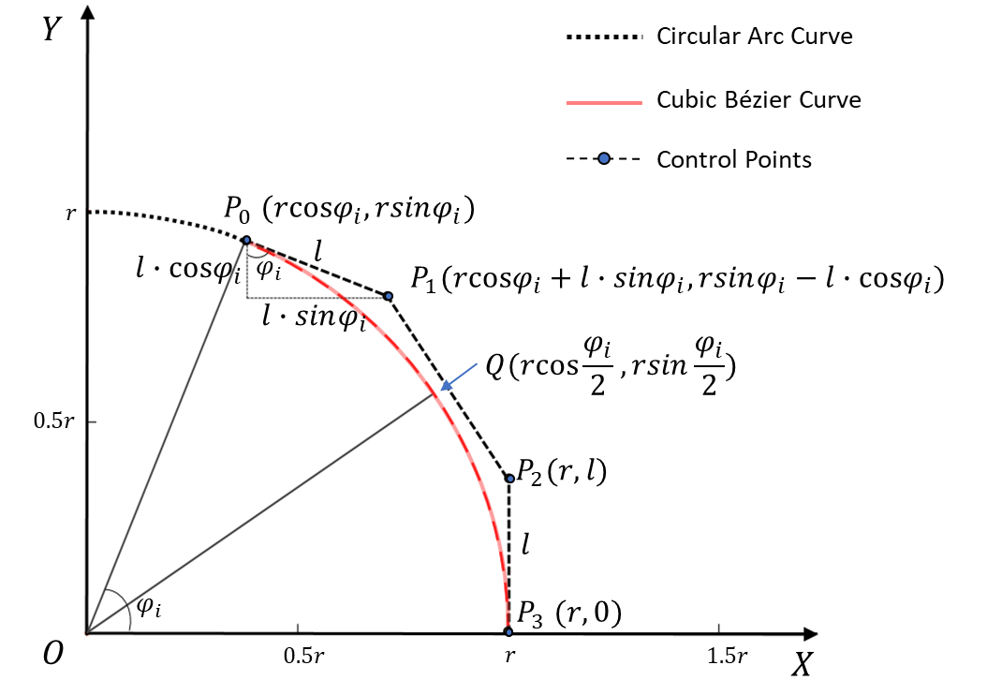
Figure 3.6 Parameterisation of a circular arc curve using a cubic Bézier curve
Considering the symmetrical properties of the cubic Bézier curve, point $Q$ is thus located at $B\left(0.5\right)$. Using Equation 3.4 gives
$$B\left(0.5\right)=P_{0}∙\frac{1}{8}+P_{1}∙\frac{3}{8}+P_{2}∙\frac{3}{8}+P_{3}∙\frac{1}{8}$$
Equation 3.12
and the coordinates of point $Q$ $\left(x_{Q},y_{Q}\right),$ located on the cubic Bézier curve, can be calculated as in Equation 3.13.
$$\left\{\begin{aligned}x_{Q}\left(0.5\right)=rcosφ_{i}∙\frac{1}{8}+\left(rcosφ_{i}+l∙sinφ_{i}\right)∙\frac{3}{8}+r∙\frac{3}{8}+r∙\frac{1}{8}=rcos\frac{φ_{i}}{2} \\ y_{Q}\left(0.5\right)=rsinφ_{i}∙\frac{1}{8}+\left(rsinφ_{i}+l∙cosφ_{i}\right)∙\frac{3}{8}+l∙\frac{3}{8}+0∙\frac{1}{8}=rsin\frac{φ_{i}}{2}\end{aligned}\right.$$
Equation 3.13
Applying trigonometric functions
$$\left\{\begin{aligned}cosφ_{i}=\cos^{2}\frac{φ_{i}}{2}-\sin^{2}\frac{φ_{i}}{2} \\ sinφ_{i}=2cos\frac{φ_{i}}{2}sin\frac{φ_{i}}{2}\end{aligned}\right.$$
Equation 3.14
and by substituting Equation 3.14 into Equation 3.13, and dividing $r$ into both sides of Equation 3.13, this can be written as:
$$\left\{\begin{aligned}\left(\cos^{2}\frac{φ_{i}}{2}-\sin^{2}\frac{φ_{i}}{2}\right)∙\frac{1}{8}+\left(\left(\cos^{2}\frac{φ_{i}}{2}-\sin^{2}\frac{φ_{i}}{2}\right)+\frac{l}{r}∙\left(2cos\frac{φ_{i}}{2}sin\frac{φ_{i}}{2}\right)\right)∙\frac{3}{8}+\frac{1}{2}=rcos\frac{φ_{i}}{2} \\ \left(2cos\frac{φ_{i}}{2}sin\frac{φ_{i}}{2}\right)∙\frac{1}{8}+\left(2cos\frac{φ_{i}}{2}sin\frac{φ_{i}}{2}+\frac{l}{r}∙\left(\cos^{2}\frac{φ_{i}}{2}-\sin^{2}\frac{φ_{i}}{2}\right)\right)∙\frac{3}{8}+\frac{l}{r}∙\frac{3}{8}=sin\frac{φ_{i}}{2}\end{aligned}\right.$$
Equation 3.15
As
$$\sin^{2}φ_{i}+\cos^{2}φ_{i}=1$$
Equation 3.16
by substituting Equation 3.16 into Equation 3.15,
$$\left\{\begin{aligned}\cos^{2}\frac{φ_{i}}{2}+\frac{3}{4}∙\frac{l}{r}∙cos\frac{φ_{i}}{2}sin\frac{φ_{i}}{2}=cos\frac{φ_{i}}{2} \\ cos\frac{φ_{i}}{2}sin\frac{φ_{i}}{2}+\frac{3}{4}∙\frac{l}{r}∙\sin^{2}\frac{φ_{i}}{2}=sin\frac{φ_{i}}{2}\end{aligned}\right.$$
Equation 3.17
Equation 3.17 can then be further simplified by dividing by $cos\frac{φ_{i}}{2}$ and $sin\frac{φ_{i}}{2}$ on both sides, as required:
$$\left\{\begin{aligned}cos\frac{φ_{i}}{2}+\frac{3}{4}∙\frac{l}{r}∙sin\frac{φ_{i}}{2}=1 \\ cos\frac{φ_{i}}{2}+\frac{3}{4}∙\frac{l}{r}∙sin\frac{φ_{i}}{2}=1\end{aligned}\right.$$
Equation 3.18
Finally, the parameter $l$ is given by
$$l=\frac{4r}{3}∙\frac{1-cos\frac{φ_{i}}{2}}{sin\frac{φ_{i}}{2}}$$
Equation 3.19
As shown in the above derivations the coordinates of all four control points of the cubic Bézier curve can be obtained in a relatively straightforward manner, allowing a convex toolpath profile with a path curvature of $2λ$ to be produced.

Application of Spinning Toolpath Design

Cubic Bézier curves for different mandrel profiles
The cubic Bézier curve can also be employed to produce the final toolpath, which is generally designed based on following with the surface of the mandrel profile. Thus, this capability of the cubic Bézier curve must be examined by comparing it with the geometrical shapes of different mandrel profiles. A semi-ellipse mandrel, as one of the typical mandrels used in conventional spinning processes, was employed to examine the use of the cubic Bézier curve in such applications. The required cubic Bézier curve was also produced based on the calculation method for the control points described in Section 3.4.
For an arbitrary semi-ellipse mandrel profile, its symmetry means that only half of the section of the mandrel profile is produced in the first quadrant of the Cartesian coordinate system, as illustrated in Figure 3.7. The radius of clamped area is defined as $R_{C}$ and the curve of this mandrel profile is expressed as $\frac{x^{2}}{a^{2}}+\frac{y^{2}}{b^{2}}=1$. Using this semi-ellipse mandrel profile, the zenith angle $φ_{i}$, which is related to the length of the ellipse curve, can be defined as the angle between ${OP}_{0}$ and ${OP}_{3}$. Four control points are required producing an ellipse curve using the cubic Bézier curve, though the coordinates of the first control point, $P_{0},$ and the last control point, $P_{3}$, of the cubic Bézier curve are defined as the edge of the clamped area and the edge of the mandrel profile, respectively.
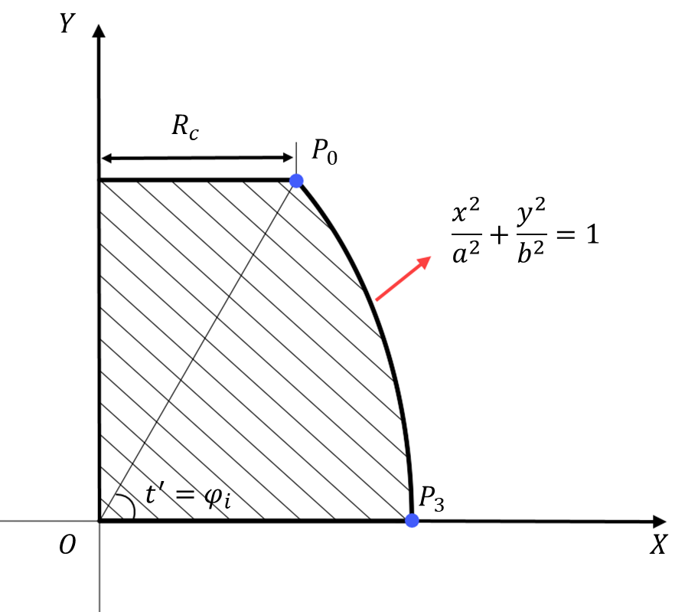
Figure 3.7 Simplified diagram of a semi-ellipse mandrel profile
The profile of the semi-ellipse mandrel can be further expressed in the polar coordinate system as
$$\left\{\begin{aligned}x\left(t^{'}\right)=a∙cos\left(t^{'}\right) \\ y\left(t^{'}\right)=b∙sin\left(t^{'}\right)\end{aligned}\right. 0≤t^{'}≤φ_{i}$$
Equation 3.20
as $t∈\left[0,1\right]$ for the cubic Bézier curve; thus,
$$t=t^{'}/φ_{i} \left(0≤t≤1\right)$$
Equation 3.21
According to Taylor’s expansion:
$$\left\{\begin{aligned}cos\left(t\right)≈1-\frac{1}{2!}t^{2} \\ sin\left(t\right)≈t-\frac{1}{3!}t^{3}\end{aligned}\right.$$
Equation 3.22
and by substituting Equation 3.22 and Equation 3.21 into Equation 3.20, the equation for the semi-ellipse mandrel profile can be written as
$$\left\{\begin{aligned}&x\left(t\right)≈a-\frac{a{φ_{i}}^{2}}{2}∙t^{2} \\ &y\left(t\right)≈-\frac{b{φ_{i}}^{3}}{6}∙t^{3}+bφ_{i}t\end{aligned}\right. \left(0≤t≤1\right)$$
Equation 3.23
According to Equation 3.9, the coefficients of $A_{x}$, $A_{y}$, $B_{x}$,$B_{y}$,$C_{x},$ and $C_{y}$ can be calculated as
$$\left\{\begin{aligned}&A_{x}=0 \\ &B_{x}=-\frac{a{φ_{i}}^{2}}{2} \\ &C_{x}=0\end{aligned}\right.$$
and
$$\left\{\begin{aligned}&A_{y}=-\frac{b{φ_{i}}^{3}}{6} \\ &B_{y}=0 \\ &C_{y}=bφ_{i}\end{aligned}\right.$$
Equation 3.24
As the coordinates of the first and the last control points, $P_{0} \left(x_{0}, y_{0}\right)$ and $P_{3} \left(x_{3}, y_{3}\right),$ are known, to improve the accuracy of fitting of the target curve by the cubic Bézier curve, the coordinates of control points $P_{1} \left(x_{1}, y_{1}\right)$ and $P_{2} \left(x_{2}, y_{2}\right)$ should be calculated for both the clockwise and anticlockwise directions.
For the clockwise direction,
$$\left\{\begin{aligned}{x_{1}}^{'}=x_{0}+\frac{a{φ_{i}}^{2}}{3} \\ {x_{2}}^{'}=x_{0}+\frac{a{φ_{i}}^{2}}{2} \\ {x_{3}}^{'}=x_{0}+\frac{a{φ_{i}}^{2}}{2}\end{aligned}\right.$$
and
$$\left\{\begin{aligned}{y_{1}}^{'}=y_{0}+\frac{{{bφ}_{i}}^{3}}{6}-\frac{bφ_{i}}{3} \\ {y_{2}}^{'}=y_{0}+\frac{b{φ_{i}}^{3}}{6}-\frac{2bφ_{i}}{3} \\ {y_{3}}^{'}=y_{0}+\frac{b{φ_{i}}^{3}}{6}-bφ_{i}\end{aligned}\right.$$
Equation 3.25
while for the anticlockwise direction,
$$\left\{\begin{aligned}{x_{2}}^{''}&=x_{3} \\ {x_{1}}^{''}&=x_{3}-\frac{a{φ_{i}}^{2}}{6} \\ {x_{0}}^{''}&=x_{3}-\frac{a{φ_{i}}^{2}}{2}\end{aligned}\right.$$
and
$$\left\{\begin{aligned}{y_{2}}^{''}&=y_{3}+\frac{bφ_{i}}{3} \\ {y_{1}}^{''}&=y_{3}+\frac{2bφ_{i}}{3} \\ {y_{0}}^{''}&=y_{3}+bφ_{i}-\frac{b{φ_{i}}^{3}}{6}\end{aligned}\right.$$
Equation 3.26
Two sets of coordinates for the middle two control points $P_{1} \left(x_{1}, y_{1}\right)$ and $P_{2} \left(x_{2}, y_{2}\right)$ are thus obtained from the anticlockwise and the clockwise directions, respectively. The average values can then be calculated and used to produce a cubic Bézier curve with improved toolpath accuracy for the final pass.
As illustrated in Figure 3.8, this procedure means that the control points of a cubic Bézier curve for a specific semi-ellipse mandrel profile can be simulated precisely.
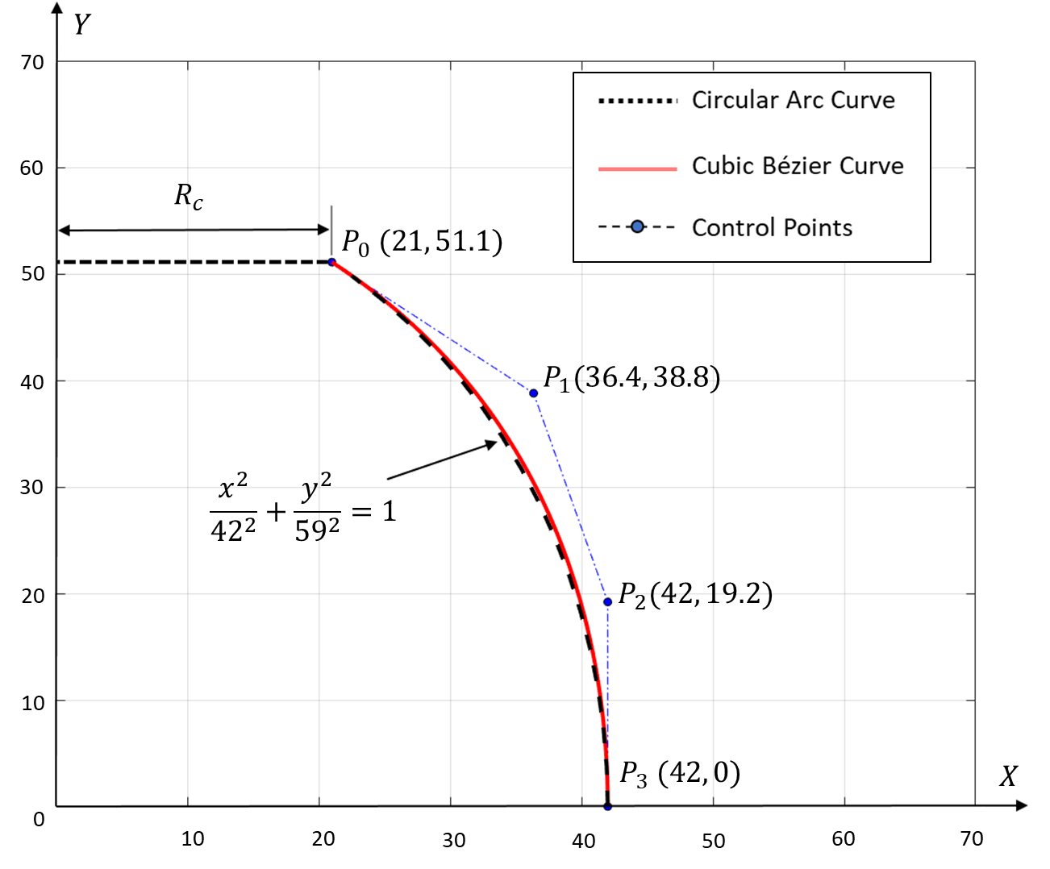
Figure 3.8 Comparison between a toolpath designed by the cubic Bézier curve and a semi-ellipse mandrel profile (mandrel profile $\frac{x^{2}}{{42}^{2}}+\frac{y^{2}}{{59}^{2}}=1$, $P_{0}$ $\left(21, 51.1\right)$ and $P_{3}$ $\left(42, 0\right)$)
Figure 3.9 illustrates sections of some other typical mandrel profiles commonly used in conventional spinning, including semi-spherical, conical, funnel-shaped and horn-shaped mandrel profiles. By applying the control point calculation method developed for the cubic Bézier curve, the individual final toolpaths related to the surfaces of different mandrel profiles can be produced. Figure 3.8 illustrates four examples that show that the cubic Bézier curve has good capability and flexibility in terms of producing the final toolpaths for various mandrel geometries.
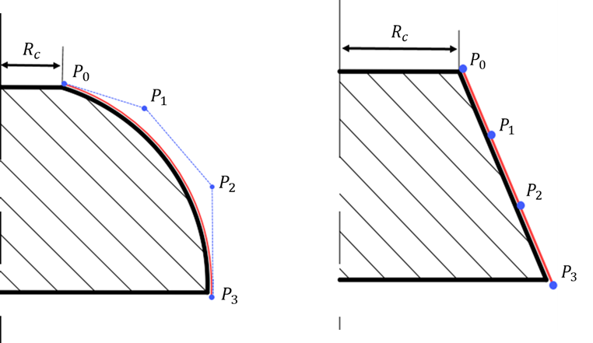
(a) (b)
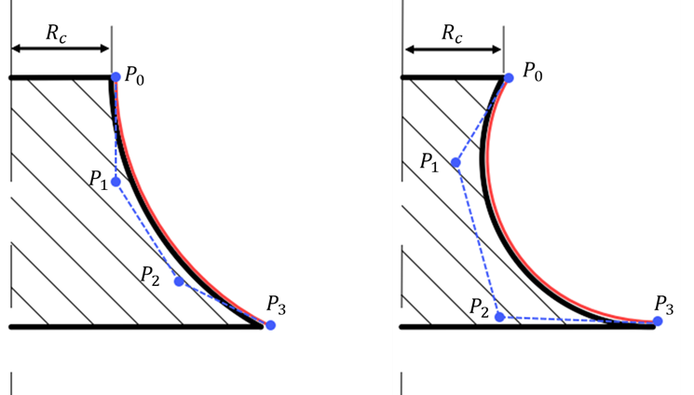
(c) (d)
Figure 3.9 Flexibility of the cubic Bézier curve as used to represent a (a) semi-spherical mandrel, (b) conical mandrel, (c) funnel-shaped mandrel, and (d) horn-shaped mandrel

Accuracy of the First Tool Pass
This subsection examines the first-pass parametrisation using a cubic Bézier curve with a convex toolpath profile and $PC=2λ$. The accuracy of a cubic Bézier curve can be examined by comparing the differences between a Bézier curve established with a varying angle, $φ_{i}$, and a circular arc curve with a radius of 1. Four different angles, $φ_{i}=\frac{π}{3}, φ_{i}=\frac{2π}{3},φ_{i}=π$, and $φ_{i}=\frac{4π}{3}$ were thus chosen and used to produce four specific cubic Bézier curves. The comparison between each Bézier curve and the relevant circular arc curve is illustrated in Figure 3.10. This shows that when the zenith angle is relatively small, as shown in Figure 3.10 (a) and (b), the difference between the Bézier curve and the circular arc curve is small, to the extent of being hardly noticeable in the case of Figure 3.10 (a). In contrast, as the zenith angle increases, the difference between the Bézier curve and the circular arc curve becomes more obvious, which is likely to be unacceptable, as illustrated in Figure 3.10 (c) and (d).
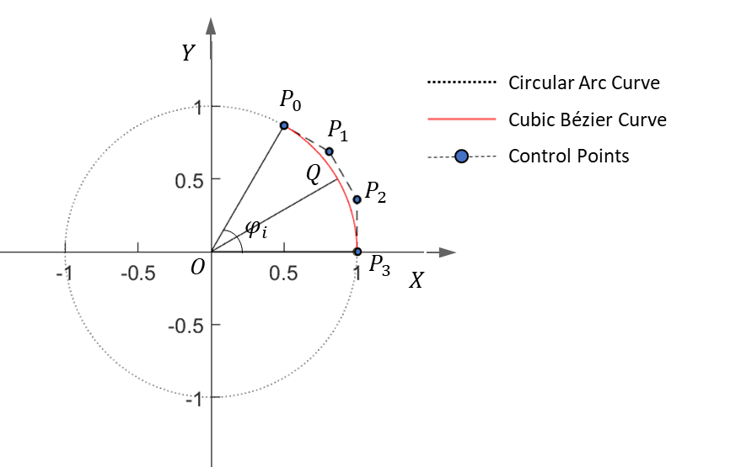
(a)
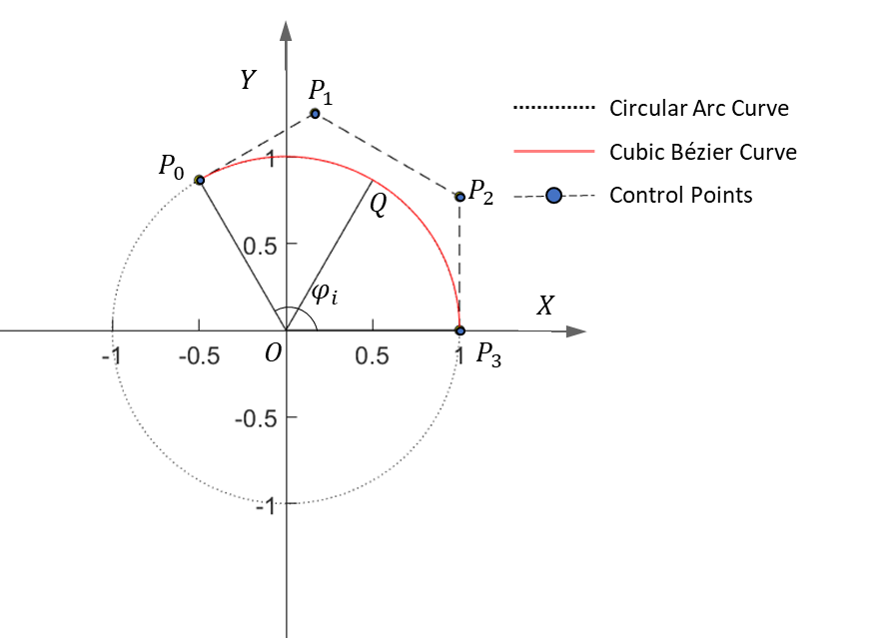
(b)
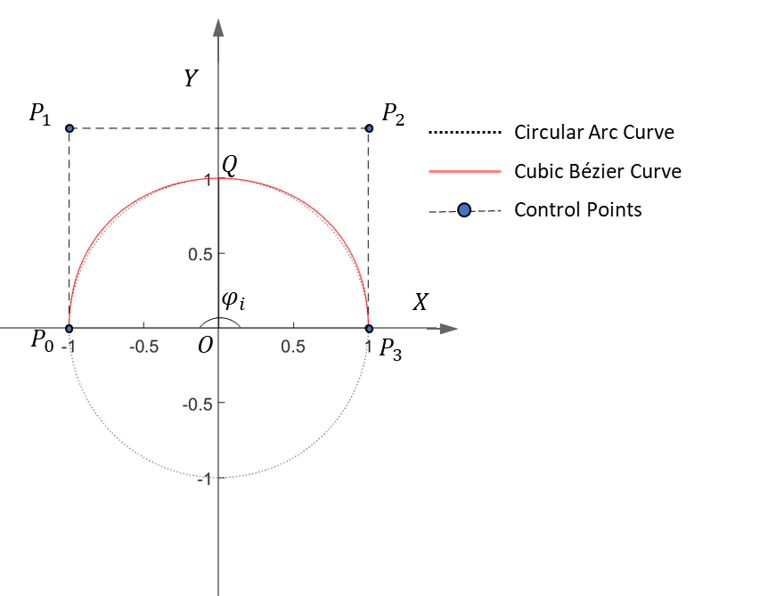
(c)
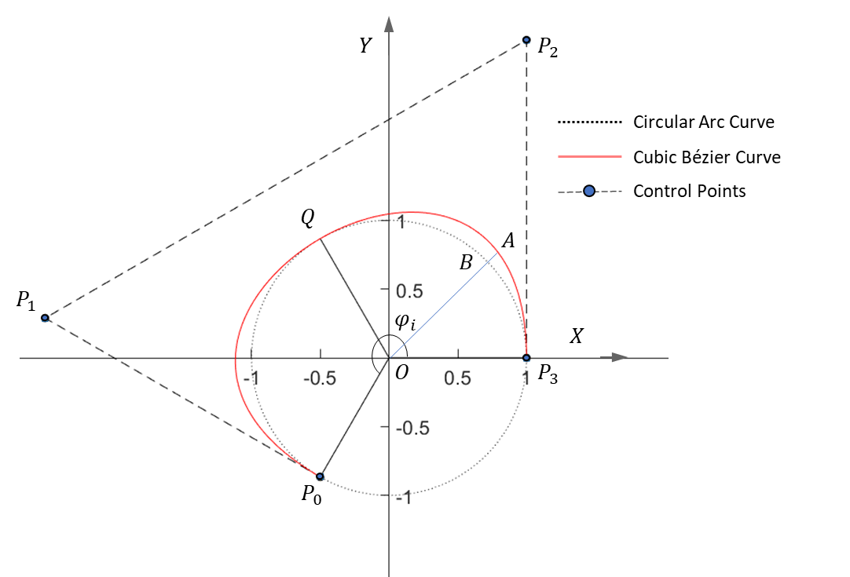
(d)
Figure 3.10 Comparison between a circular arc and the cubic Bézier curves produced with different zenith angles $φ_{i}$: (a) $φ_{i}=\frac{π}{3}$, (b)$φ_{i}=\frac{2}{3}π$, (c) $φ_{i}=π$, and (d) $φ_{i}=\frac{4}{3}π$
Curve consistency (CC) is employed to study the effects of the zenith angle $φ_{i}$ on the consistency between the cubic Bézier curve and the circular arc curve. During the calculation process for this, the zenith angle $φ_{i}$ is divided into $n$ equal segments. Consequently, both the cubic Bézier curve and the circular arc curve are divided into $n$ points. As shown in Figure 3.9 (d), points $A$ ($x_{b}\left(i\right)$, $y_{b}\left(i\right)$), $B$ ($x_{c}\left(i\right)$, $y_{c}\left(i\right)$), and $O$ (0,0) are on the same line, while point A is located on the cubic Bézier curve, point B is located on the circular arc curve, and point $O$ is located at the origin of the coordinates. The ratio of the distance between these two curves, $L_{AB},$ to the radius of the circular arc, $L_{OB},$ can thus be calculated and used to evaluate the curve consistency between the two curves. CC is determined by the measurement of root-mean-square deviation, as expressed in Equation 3.27; where the points located on the cubic Bézier curve are close to the points located on the circular arc curve, the value for curve consistency should be small.
$$CC=\sqrt{\frac{\sum_{n}^{i=1}{{\left(\frac{L_{AB}}{L_{OB}}\right)}^{2}}}{n}}=\sqrt{\frac{\sum_{n}^{i=1}{{\left(\frac{\sqrt{{x_{b}\left(i\right)}^{2}+{y_{b}\left(i\right)}^{2}}}{\sqrt{{x_{c}\left(i\right)}^{2}+{y_{c}\left(i\right)}^{2}}}-1\right)}^{2}}}{n}}$$
Equation 3.27
Figure 3.11 shows how the variation of the zenith angle $φ_{i}$ affects CC between the cubic Bézier curve and the circular arc curve. The zenith angle $φ_{i}$ was varied from $\frac{1}{18}π$ to $\frac{3}{2}π$, and as Figure 3.11 shows, when $φ_{i} ≤π$, the difference between the cubic Bézier curve and the circular arc curve is relatively small. In contrast, when $φ_{i} >π$, the difference between the two curves is significant. Thus, the higher the zenith angle, the great the difference between the cubic Bézier curve and the circular arc curve. To maintain curve accuracy when producing the first pass with a convex toolpath profile with $PC=2λ$, the zenith angle $φ_{i}$ should therefore be less than $π$.
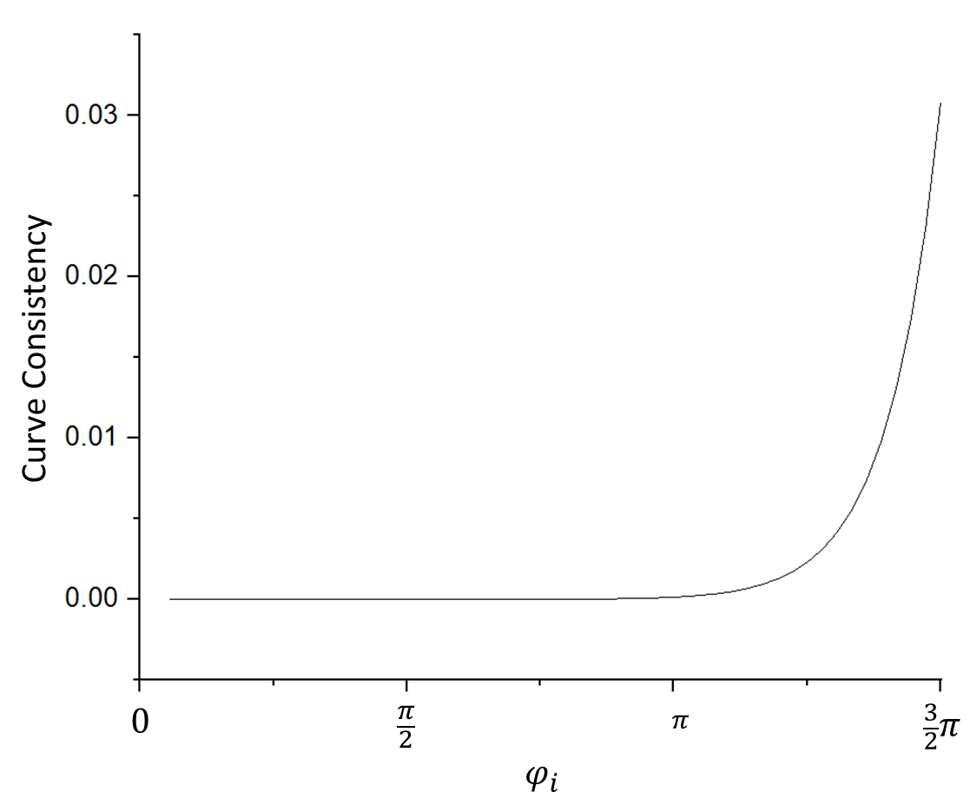
Figure 3.11 Curve consistency between the cubic Bézier curve and a circular arc with zenith angles $φ_{i}$

Design of Different Types of First Toolpath Profile
In addition to generating the final pass of the toolpath profile, the cubic Bézier curve can also be used to produce the toolpath profile for the first-pass in conventional spinning. Once the zenith angle $φ_{i}$ and the forming depth $h$ are determined, the most important parameter for the first toolpath profile is the path curvature. The forming depth is defined by the distance at the edge of the workpiece before and after deformation by the first-pass along the mandrel axial direction, as shown in Figure 3.1. Based on the definition of path curvature, by applying a specific value to the path curvature, the individual toolpath profile, whether convex, concave, or linear, can be produced. The higher the absolute value of the path curvature, the greater the path curvature generated. When the path curvature is equal to zero, a linear toolpath profile is created.

Table 3.1 Different types of first toolpath profile
Toolpath |  | Path Curvature
Convex | Convex-1 | $$3λ$$
Convex | Convex-2 | $$2λ$$
Convex | Convex-3 | $$λ$$
Concave | Concave-1 | $$-3λ$$
Concave | Concave-2 | $$-2λ$$
Concave | Concave-3 | $$-λ$$
Linear | Linear-1 | 0

If the range of path curvature for the first-pass is designated at ranging from $-3λ$ to $3λ$, seven representative toolpaths can be parameterised using the cubic Bézier curve. These include three concave toolpaths, three concave toolpaths, and one linear toolpath, and details of these toolpaths are shown in Table 3.1 and Figure 3.12. The same forming depths $h$ and zenith angles $φ_{i}$ can be applied to all seven toolpaths, with the final position of each toolpath also kept approximately the same.
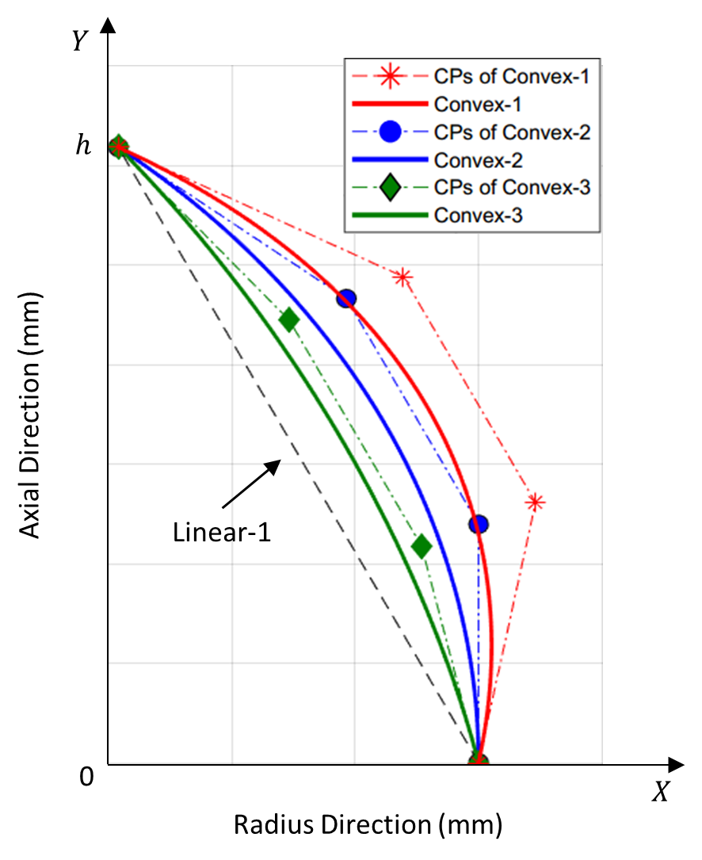
(a)
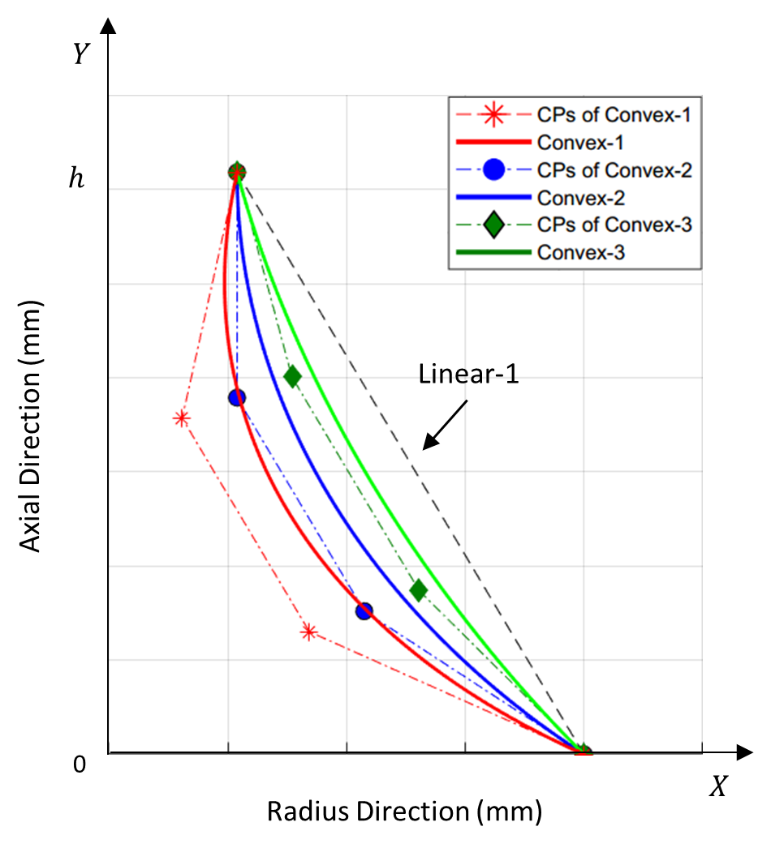
(b)
Figure 3.12 Schematic diagrams of first toolpath profiles: (a) three convex paths and a linear path; (b) three concave paths and a linear path
By applying the seven toolpaths generated by the cubic Bézier curve, the effect of different toolpath profiles on material deformation during first-pass conventional spinning processes can be studied by employing Finite Element analysis and experimental testing of the spinning processes. Moreover, the relationship between the component defect of wrinkling and toolpath profile can be further investigated.

Effects of Spinning Process Parameters on Toolpath Profiles
During the first-pass conventional spinning process, both the tool feed rate and the mandrel rotation speed are important process parameters for programming the CNC spinning operation. In the spinning process, another parameter, referred to as the feed ratio in $mm/rev,$ is also often used; this is the ratio between the feed rate in $mm/min$ to the mandrel rotation speed in $RPM$. In this study, the contour line of the tool movement made by the tool on the workpiece surface was plotted to analyse the effect of the spinning process parameters on the contact between the tool surface and the workpiece surface. By analysing these contour lines and how they vary with changes in the value of the feed ratio, this work thus showed that rougher external surfaces of spun components can be achieved with higher feed ratios. This occurs because higher feed ratios create an increased step over distance for tool contact and more contact indentations on the surface of the workpiece, as reported by Chen et al (65).
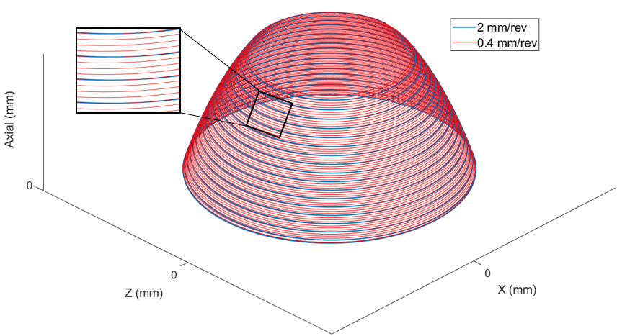
(a)
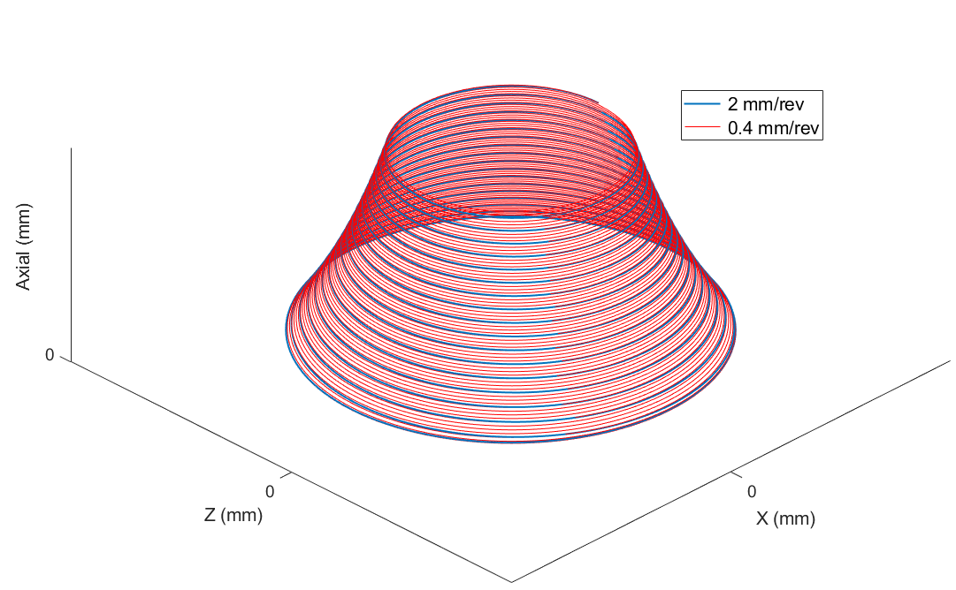
(b)
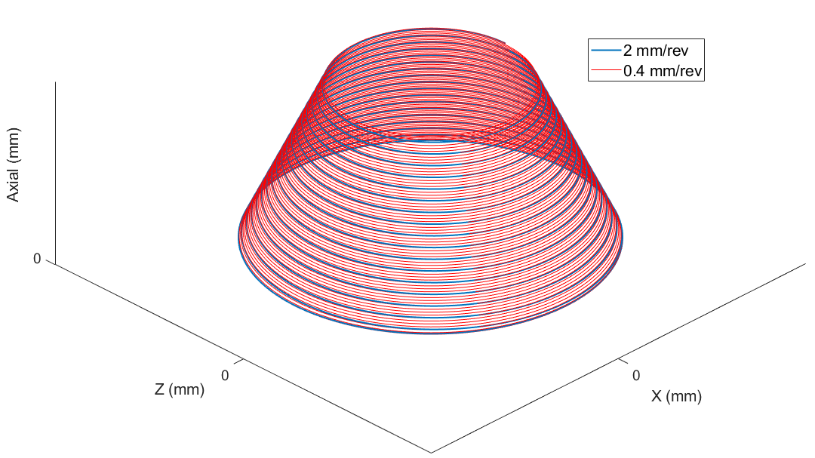
(c)
Figure 3.13 Surfaces formed by the contour lines of toolpath profiles with 2 $mm/rev$ and 0.4 $mm/rev$ feed ratios: (a) Convex-2, (b) Concave-2, and (c) Linear-2
As shown in Figure 3.13, three different types of toolpath profiles using arbitrarily selected feed ratios of 2$mm/rev$ and 0.4 $mm/rev$ were plotted. Variations in the amount of axial workpiece deformation per revolution are visually distinct when different values of feed ratio are used, as the material of the workpiece is deformed within the small contact area between the tool and the workpiece when a higher feed ratio is employed, resulting in higher forming forces as compared with those seen when a lower feed ratio is employed.
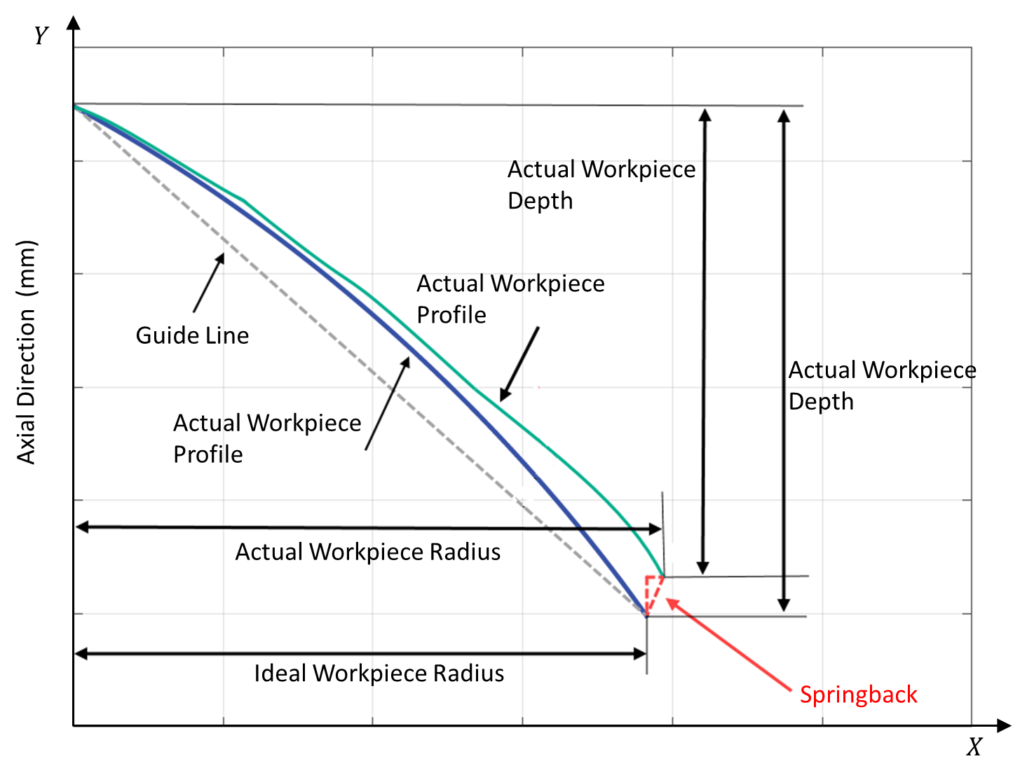
Figure 3.14 Springback definition
Where a spun component is produced from a workpiece without wrinkling or fracture failures, the final inner radius of the workpiece and the depth of workpiece can be measured after the forming process, as shown in Figure 3.14. The deviation between the designed final point and the actual final point of the spun component can then be used to determine the springback. Geometrical shape inaccuracy is defined as the deviation between the designed toolpath and the actual spun component geometry after the deformation process.

Summary
In this chapter, a method was developed for the parameterisation of multiple-passes designs for the conventional spinning. The cubic Bézier curve was employed to parameterise these toolpath profiles, including the first pass profile and the final pass profile. The calculation method for the control points of the cubic Bézier curve for producing both first pass and final pass profiles were developed, and the capability and accuracy of the cubic Bézier curve in terms of representing different types of toolpath were evaluated.
Using the developed toolpath parameterisation method, seven different toolpath profiles were produced for the first pass, including three convex and three concave path profiles and one linear path. Some of these toolpath profiles were then utilised in the FE analysis and experimental testing undertaken in this study. The surfaces formed by the contour lines of such toolpaths were also plotted, allowing the effects of spinning process parameters such as feed ratios on the toolpaths to be compared. Additionally, the springback of the workpiece and the workpiece profile deviation were defined for use in the studies presented in the following chapters.

Finite element analysis of spinning process
As presented in Chapter 1.1.1, the FE method can provide more detailed results and can support to develop guidance in designing the spinning process, and therefore, to predict wrinkling failure. As reviewed in Chapter 2.4, in the FE simulation of spinning process, the initiation time of the wrinkling failure can be determined by using the result of elastic strain energy. The severity of the wrinkles can be quantified by taking the axial displacement at the edge of the workpiece along the circumferential direction. Therefore, the effects of input parameters, such as spin ratio, workpiece thickness, feed ratio, and forming depth on the wrinkling initiation time, severity of wrinkles and the thickness distributions of the spun component can be studied. In addition, the geometrical features of the wrinkles can be studied through the wrinkled FE model, through which the mathematical modelling of the wrinkled spun component can be produced. In this chapter, FE models of the first-pass conventional spinning are developed using ABAQUS software, as presented in Chapter 4.1. The verification of these FE models by conducting a mesh convergence study, evaluating mass scaling factors, and comparing the dimensional results of spun parts with that of the experimental results are reported in Chapter 4.2. The FE simulation runs designed by the Taguchi method considering four input parameters, such as spin ratio, workpiece thickness, feed ratio, and forming depth are presented in Chapter 4.3. Furthermore, the effects of key process parameters on failure by wrinkling and the wrinkle wave function which is established and validated using geometrical modelling of a wrinkled spun component are given in Chapter 4.4, followed by a summary of the work in this chapter in Section 4.5.

Development of Finite Element Models
A simulation model of the first-pass conventional process was developed to be used in ABAQUS. Two FE analysis solution methods are available in ABAQUS to simulate material plastic deformation: ABAQUS/Standard and ABAQUS/Explicit. The ABAQUS/Standard includes static implicit and dynamic implicit methods, in which iterations of each step are implemented to guarantee the equilibrium and convergence of the model achieved. This method is thus most suitable for solving smooth nonlinear problems (48). In contrast, ABAQUS/Explicit employs a central difference integration method by explicitly advancing the kinematic state from the end of the previous time increment. For some highly discontinuous or high-speed dynamic problems, ABAQUS/standard may have difficulty converging due to, contact or material deformation nonlinearity, which can lead to an excessive number of iterations. ABAQUS/Explicit, however, is computationally less expensive and offers good accuracy for solving such problems. The conventional spinning process can be considered as a quasi-static problem with a large displacement, a large membrane deformation, and complex contact conditions; thus, the ABAQUS/Explicit solution method was employed for all FE models developed in this study.
During the first-pass conventional spinning process, the workpiece, which is deformed by the forming tool following the designed toolpath, is the only deformable body. To improve computational efficiency, the other spinning tools, including the forming tool, mandrel, and backplate, were thus modelled as 3-D analytical rigid bodies. Shell elements, rather than a solid elements, were employed to mesh the workpiece, with 8-noded hexahedral continuum shell elements, SC8R, used to represent the three-dimensional stress/displacement elements (87). Compared with 2-D conventional shell elements, these continuum shell elements offer better capability for modelling complex contact conditions and transverse shear deformation, and as reported by Long et al. (54), the SC8R elements can produce more accurate numerical results based on comparisons with experimental and FE simulation processes. Wang and Long (17) also reported that this element type can capture wrinkling failure in FE simulation processes.
As shown in Figure 4.1, the sweep meshing technique was used to mesh the workpiece, though a central area with a radius of 10 $mm$ was neglected. This occurred because this area is clamped between the backplate and the mandrel, allowing almost no deformation to be generated during the spinning process. As computational time can be reduced by reducing the total number of elements and increasing the smallest element size, increasing the size of the smallest element also allowed the limit of the stable time increment to be increased, resulting in a shorter computation time. This procedure of neglecting a certain area of the central workpiece was also investigated by Sebastiani et al. (13), who concluded that the practice had limited negative effects on the numerical results while offering practical benefits.
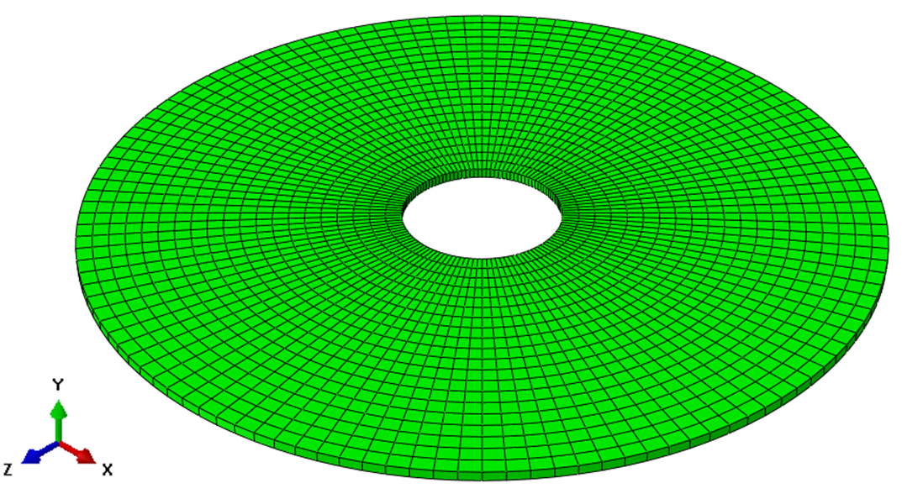
Figure 4.1 Meshed workpiece without the central clamping area
In terms of the thickness direction of the workpiece, nine integration points were used to improve the computational accuracy of the stress state (88). To minimise the “Hourglassing” phenomenon caused by using a reduced number of integration elements, the hourglass control procedure was applied in all FE analysis models.

Table 4.1. Material properties of DC01
Density ($kg/m^{3}$) | Young’s modulus ($GPa$) | Poisson’s ratio
7861 | 198.2 | 0.3

The material of the workpiece, DC01, was assumed to be isotropic and homogenous. More detailed material properties are presented in Table 4.1. The plastic deformation behaviour of the workpiece was modelled using the von Mises yielding criterion and the Hollomon strain-hardening law. During the spinning process, the workpiece is deformed at room temperature, so any temperature dependant effects were neglected in the simulation process; the effect of strain rate was also neglected.
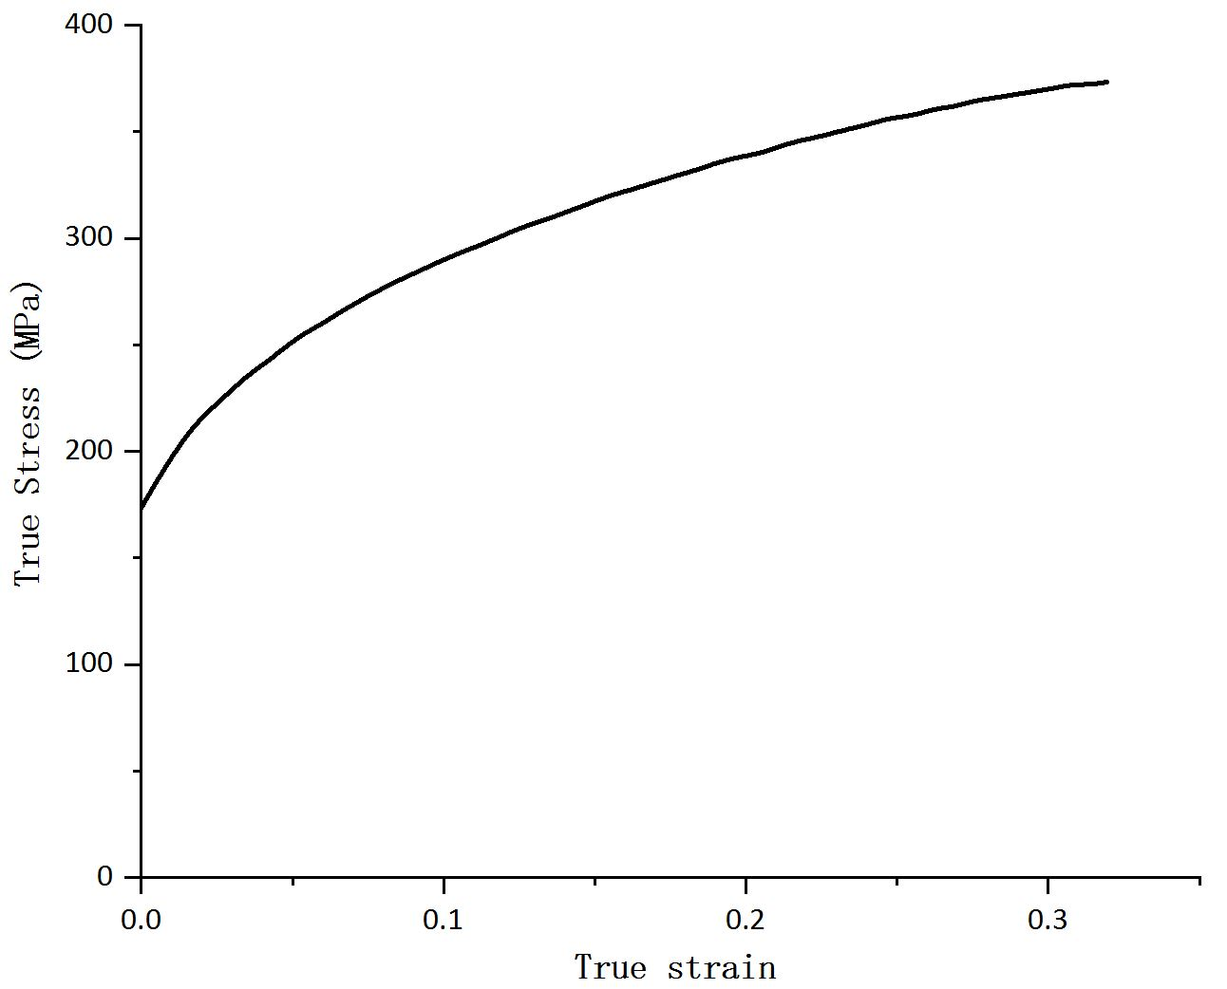
Figure 4.2 True stress-strain curve of DC01
A uniaxial tensile test was carried out for DC01 using a Shimadzu tensile test machine. This test used an extension rate of 1 $mm/min$ at room temperature, and test specimens were manufactured in an orientation parallel to the rolling direction of the workpiece. The dimensions of the specimen were determined according to the Standard Test Methods for Tension Testing of Metallic Materials (ASTM) (89), and the true stress-strain curve of DC01 material was obtained as shown in Figure 4.2.
The schematic diagrams used in both the FE modelling and the spinning experiments in this work are presented in Figure 4.3. Two coordinate systems are employed, the global coordinate system (X-Y) and the forming tool local coordinate system (x-y). The angle between the tool axis and the mandrel axis is 45°, which is the same angle used in the experiments on a CNC machine. In the FE modelling, the tool movement during the spinning process follows its own local coordinate system.
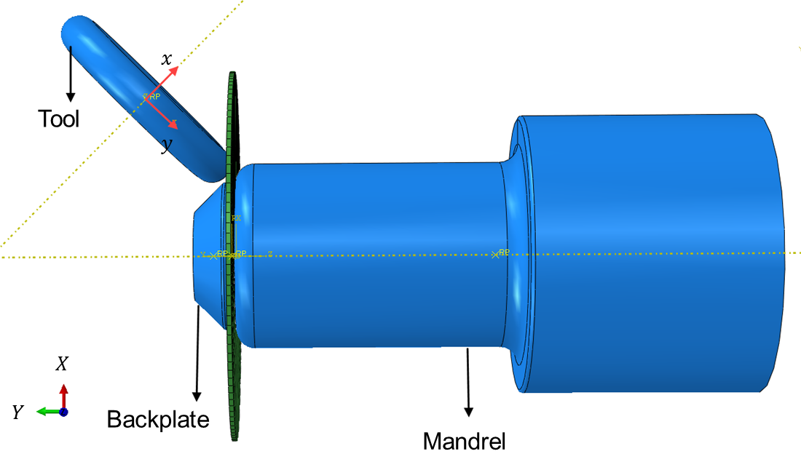
(a)
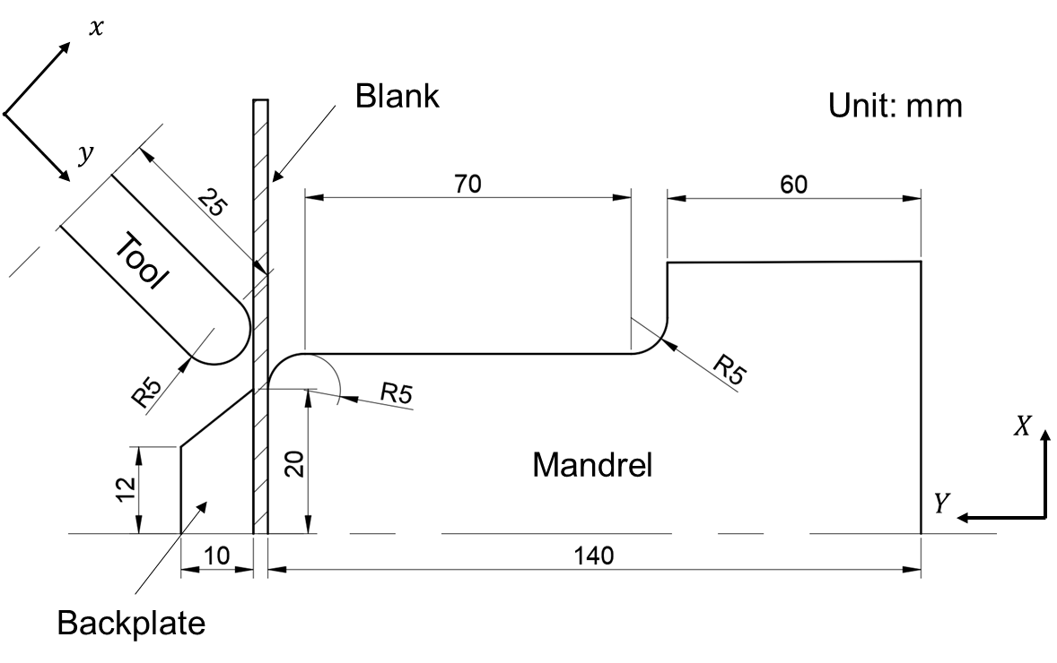
(b)
Figure 4.3 Spinning model: (a) FE model; (b) dimensions of workpiece and tools
The tool movement in the CNC machine was initially developed using the global coordinate system (X-Y); thus, to transfer the tool movement from the CNC program to the tool location coordinate system (x-y), the following equations were employed to calculate tool displacement in terms of the local coordinates:
$$\left\{\begin{aligned}x&=X∙\cos\left({45}^{°}\right)+Y∙\sin\left({45}^{°}\right) \\ y&=-X∙\sin\left({45}^{°}\right)+Y∙\cos\left({45}^{°}\right)\end{aligned}\right.$$
Equation 4.1
where (x, y) represent the tool local coordinates, (X, Y) are the global coordinates used in CNC programs, and 45° is the angle between the Y-axis and X-axis in the experimental setup.
The spinning FE simulation process was divided into three distinct steps. In the first step, a 50 $kN$ force was applied on the backplate to clamp the workpiece between the backplate and mandrel (61). The synchronous rotation movement of the backplate, workpiece and mandrel were then modelled in the second step by applying a rotational boundary condition to the backplate and mandrel along the Y-axis. In the third step, the tool movement was defined using two displacement boundary conditions in the tool local coordinate system (x-y).
Table 4.2 Coulomb frictional coefficients of three contact pairs
Workpiece – Backplate | Workpiece – Mandrel | Workpiece – Tool
0.5 | 0.5 | 0.02

The contact behaviours between the spinning tool surfaces such as the mandrel surface, forming tool surface, and backplate surface, and the workpiece surfaces were modelled using the penalty contact algorithm and Coulomb’s friction law. As presented in Table 4.2, three Coulomb frictional coefficients were assigned to the three contact pairs formed by the spinning tools and the workpiece (61). However, as the tool rotates along its own axis during the spinning process, the frictional coefficient between the tool surface and the workpiece is relatively low (61).
To speed up the FE simulation process, a mass scaling method was adopted in all of the models (42). To account for truncation errors in large deformation, a double precision mode was utilised, and parallel FE analyses were performed with eight processors (E5-2670, 3.0 GHz and 32 GB RAM).

Verification of Finite Element Models
This section evaluates the mesh convergence and the effect of employing mass scaling methods on the maximum von Mises stress and wall thickness distribution in the FE models. The FE simulation results are also compared with the wall thickness variations obtained from preliminary experimental results under the same spinning parameters, as presented in Table 4.3.
Table 4.3 Spinning parameters used in both experiments and simulations
Parameters | Value
Workpiece radius $R_{0}$ ($mm$) | 50
Workpiece thickness $t$ ($mm$) | 1.2
Radius of clamped area $R_{c}$ ($mm$) | 20
Feed ratio $f$ ($mm/rev$) | 0.5
Forming depth $h$ ($mm$) | 14.3
Toolpath profile | Convex
Path curvature | $$+2λ$$

Mesh Convergence Study
A mesh convergence study was carried out on the FE models under the forming conditions listed in Table 4.3. Three FE models with different mesh densities were established, with the details of these models and their corresponding numerical results presented in Table 4.4. The mesh densities used in Model 3 and Model 2 were three times and two times that used in Model 1, respectively.
Table 4.4 Mesh convergence study
Model | Number of Elements | Number of Radial Nodes | Number of Circumferential Nodes | Average Aspect Ratio
T1 | 2400 | 20 | 120 | 2.07
T2 | 4800 | 30 | 160 | 1.58
T3 | 7200 | 40 | 180 | 1.52

Both the von Mises stress distribution and the maximum stress were used to investigate the sensitivity to stress of the mesh density of the FE models. Similar von Mises stress distributions were observed during the first-pass conventional spinning process among the FE models listed in Table 4.4, as shown in Figure 4.4 (a, b, c). The variations in the von Mises stresses for the same radial node path under tool forming zones were thus compared, as presented in Figure 4.4 (d). Good agreement between Model T2 and T3 was obtained, with only 2.7% of the maximum difference in maximum von Mises stress seen in the tool forming zone. However, an obvious discrepancy of 12% of the maximum difference of the maximum von Mises stress in the tool forming zone between T1 and T3 was observed.
(a)
(b)
(c)
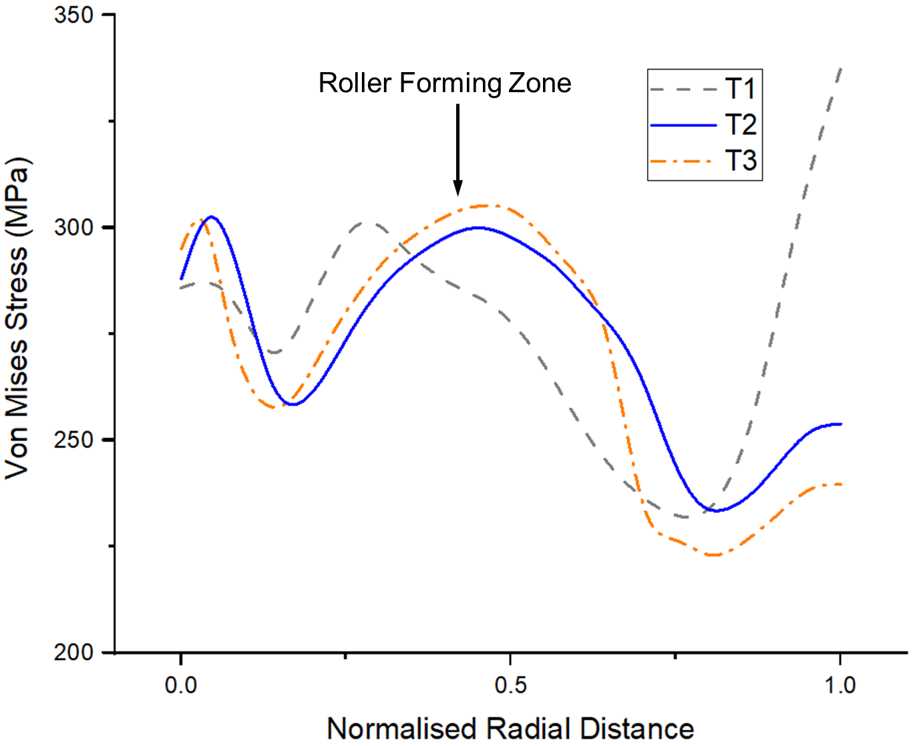
(d)
Figure 4.4 Variations of von Mises stresses in FE models (a) T1, (b) T2, (c) T3, and (d) stress variation along the radial direction
The thickness distributions along the radial direction of three models after the first-pass spinning process were then compared, as shown in Figure 4.5. A considerable difference in thickness distributions along the radial direction was observed between T1 and T3, with the minimum thicknesses being 1.184 $mm$ and 1.178 $mm$, respectively. However, there was a good correlation between the thickness distributions of T2 and T3, with the minimum thickness of T2 being 1.179 $mm$. By investigating the variations of the maximum von Mises stress distribution and the thickness variation along the radial direction using these FE models with different mesh densities, it was confirmed that sufficient mesh convergence was achieved by using the meshing seen in model T2; this mesh density was thus applied to all further FE models in this study.
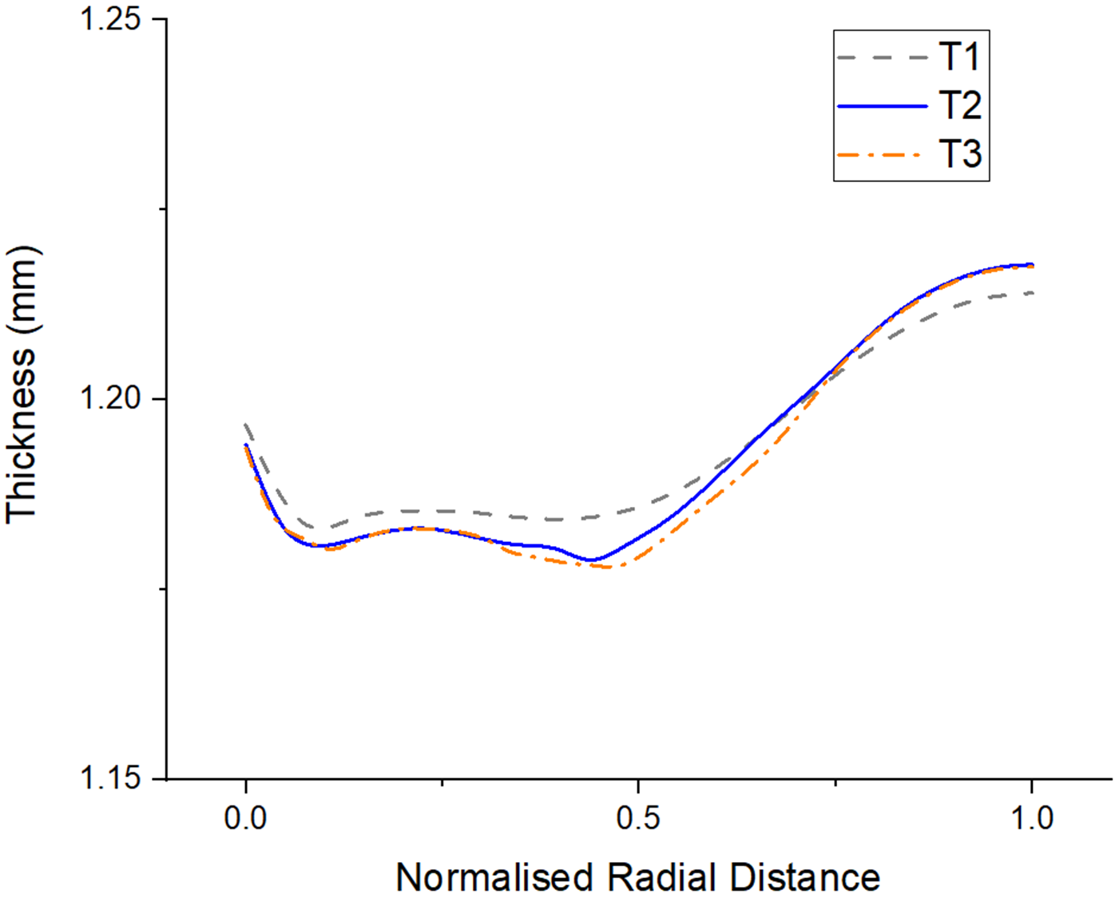
Figure 4.5 Comparison of thickness distributions in three FE models

Assessment of Mass Scaling Factor
The mass scaling method was applied in the first-pass conventional spinning simulation. To enhance computational efficiency and simulation accuracy, two mass scaling factors, 9 and 25, were employed. It was also necessary to ensure that the FE model was reliable, stable and efficient, thus to ensure that the mass scaling factor employed did not significantly affect the simulation results. A model without any scaling was therefore established as a benchmark. Two essential criteria needed to be satisfied. The first was that the ratio of kinetic energy to internal energy did not exceed 10% during the majority of the simulation process. In addition, the ratio of artificial strain energy to internal energy was required to be less than 5%. By meeting these criteria, the hourglass problem was avoided, thus eliminating the shear locking phenomenon and maintaining simulation accuracy ((61).
As shown in Figure 4.6 (a), during more than two thirds of the simulation process, the ratio of kinetic energy to internal energy in the model with a mass scaling factor of 9 remained below 10%. For the model with a mass scaling factor of 25, however, the ratio of kinetic energy to internal energy met this requirement for less than half of the simulation process. In contrast, the ratios of artificial strain energy to internal energy in all three models were below 1% throughout the simulation process. A mass scaling factor of 9 was thus selected for all FE simulation models in this work to ensure sufficient computational accuracy.
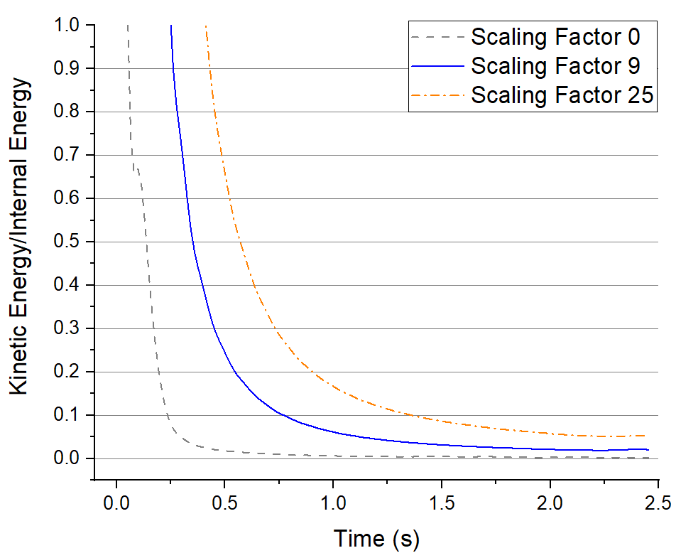
(a)
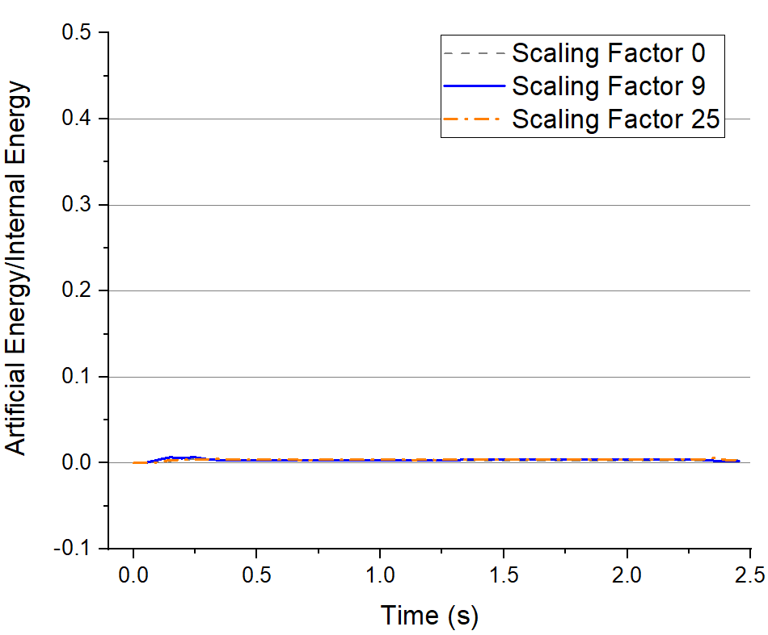
(b)
Figure 4.6 Evaluation of energy histories of different mass scaling factors: (a) kinetic energy/internal energy, (b) Artificial energy/internal energy
The FE model with 4,800 elements and a mass scaling factor of 9 was then verified by comparing simulated wall thickness with that measured in the corresponding experiment. The spun components produced in FE modelling and the corresponding experiment are shown in Figure 4.7 (b) and (a), respectively. As seen in Figure 4.7(c), the maximum deviation of wall thickness between the FE model and the experimental piece is 4.37, suggesting that the FE model established for the first-pass conventional spinning to deform a workpiece with a radius of 50 $mm$ offers sufficient simulation accuracy.
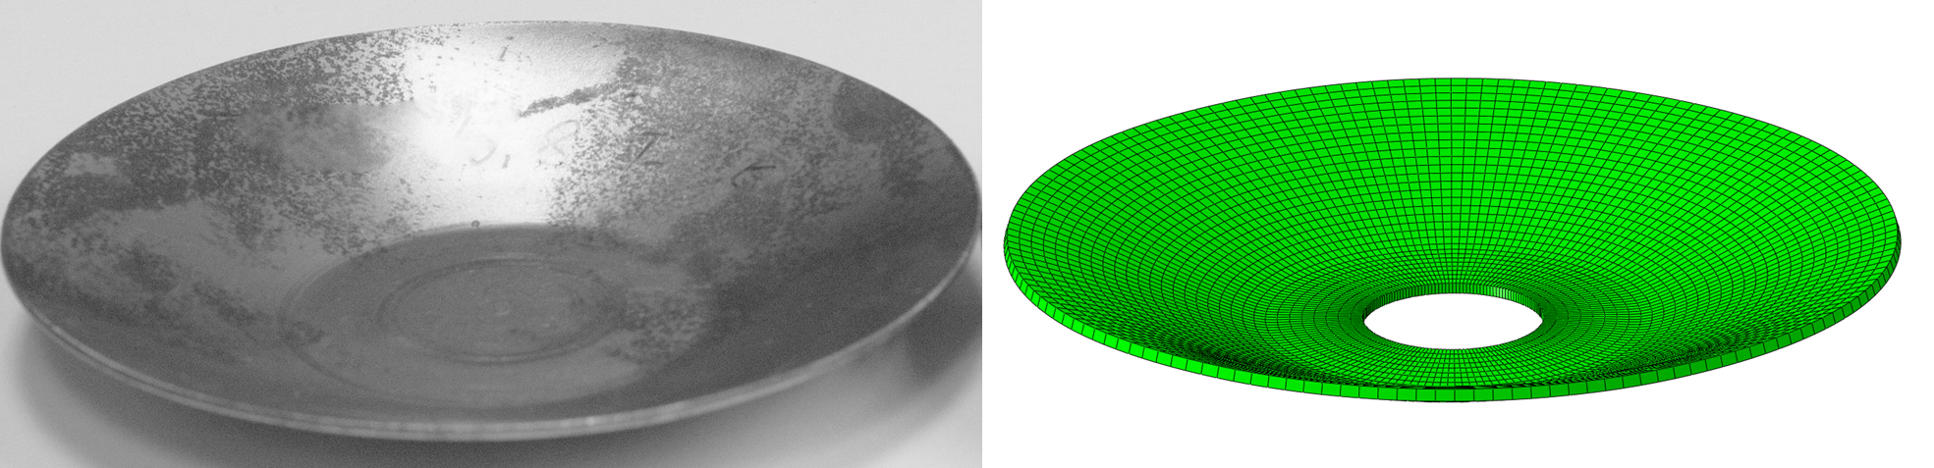
(a) (b)
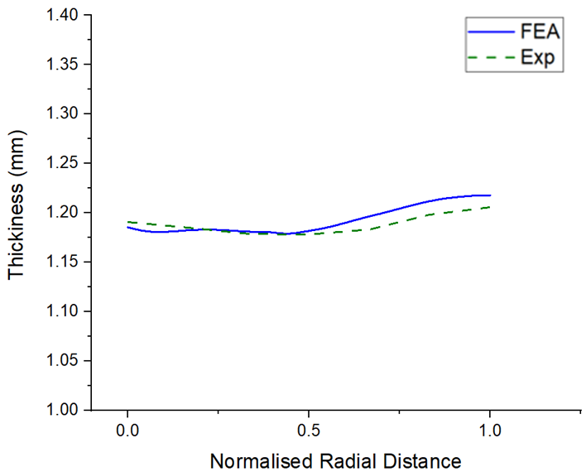
(c)
Figure 4.7 Comparison between the FE model and experimental results: (a) Experimental spun component, (b) FE formed spun component, and (c) Thickness variation between the FE model and experiment
By using the same techniques of FE simulation as described earlier, including the mesh strategy, number of elements, and mass scaling factor, FE models with a thickness of 2 $mm$ and two different workpiece radii, 75 $mm$ and 100 $mm$, were established and validated, respectively. The forming conditions of these two models, including forming depth and feed ratio, were the same as for M3 and M7, as listed in Table 4.6. Figure 4.8 and Figure 4.9 illustrate the energy ratios, thickness variations and geometrical comparison with experimental workpieces for each model.
For both models, during most of the simulation process, the ratios of kinetic energy to internal energy were below 10% and the ratios of artificial energy to internal energy were also below 5%. For the FE model with a radius of 75 $mm$, the maximum error in thickness along the radial direction in terms of experimental measurement and FE analysis is 6.02%, while in contrast, the maximum deviation of thickness for the FE model with a radius of 100 $mm$ was 8.91%. As confirmed by the corresponding experiments, no wrinkles were observed in either model. These results suggest that the FE models offer good correlation with the corresponding experiments.
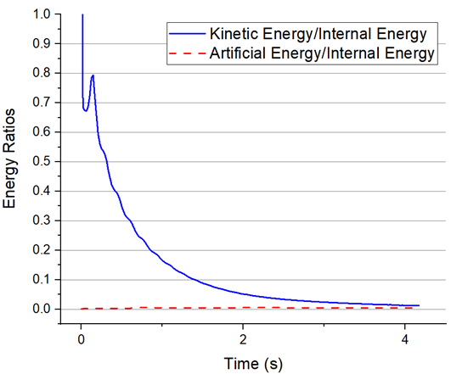
(a)
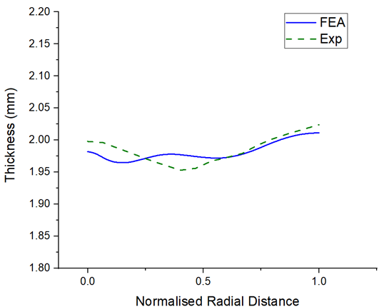
(b)
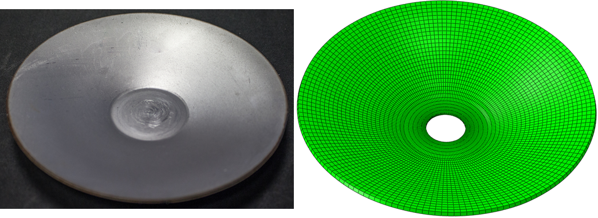
(c) (d)
Figure 4.8 Validation of the FE model with workpiece radius of 75 $mm:$ (a) Energy histories, (b) Thickness variation results of FE model and experiment, (c) Spun component obtained in experiment, and (d) Spun component obtained in FE model
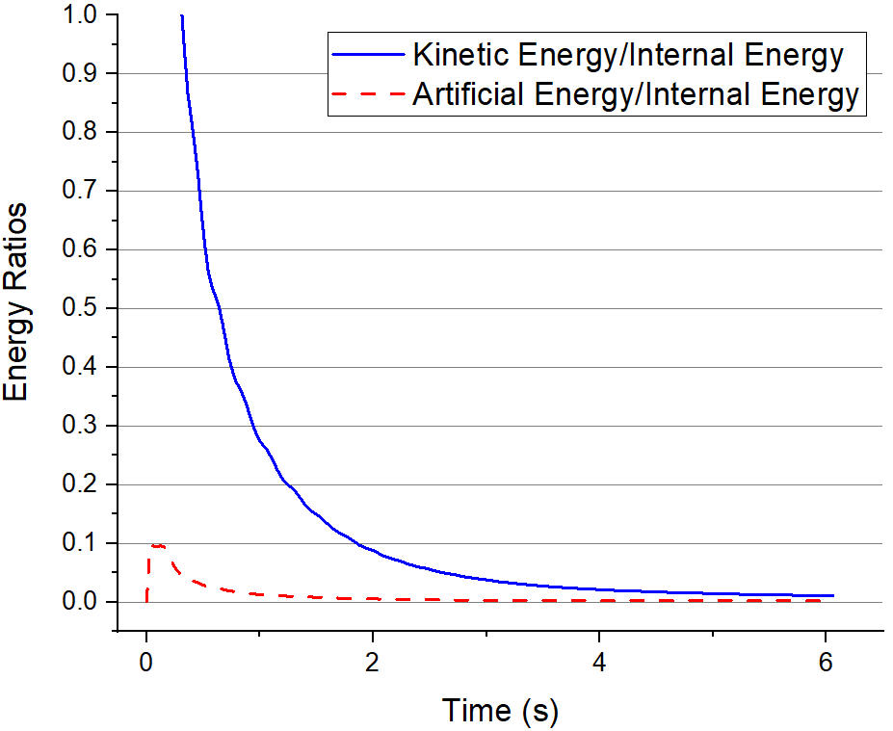
(a)
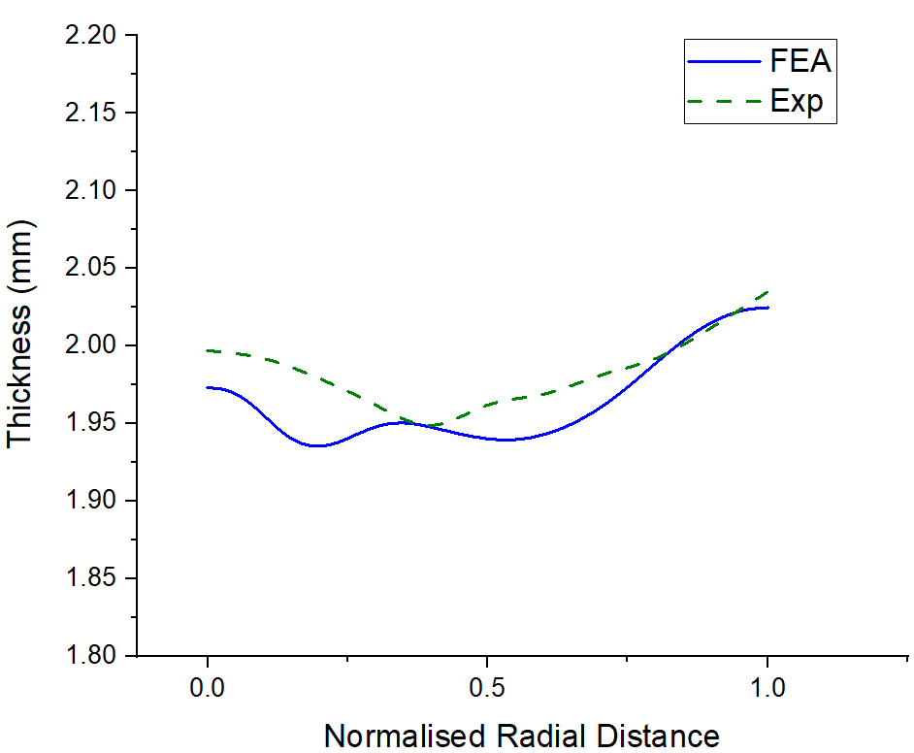
(b)
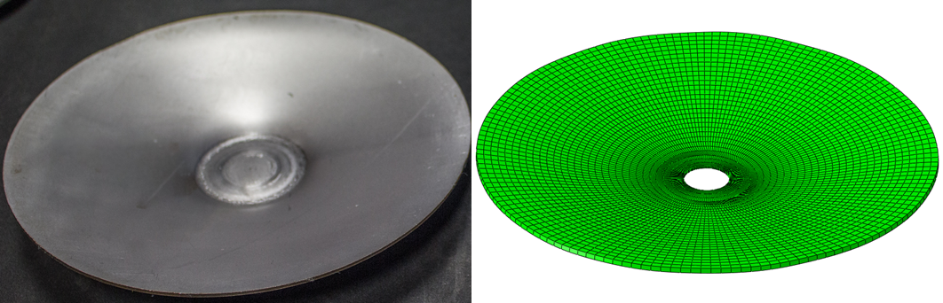
(c) (d)
Figure 4.9 Validation of the FE model with workpiece radius of 100 $mm:$ (a) Energy histories, (b) Thickness variation results of FE model and experiment, (c) Spun component obtained in experiment, and (d) Spun component obtained in FE model

FE Simulation using Taguchi Method
To analyse the influence of the material parameters such as spin ratio and workpiece thickness, and the various spinning process parameters, including feed ratio and forming depth, on wrinkling failure during the first-pass conventional spinning process, the Taguchi method of experimental design was applied to generate FE simulation runs. Each parameter was subject to two levels of variation, and using the statistical analysis software Minitab, an $L8 (2^{4})$ orthogonal array was generated for the simulation runs. An orthogonal array is a technique that only requires a fraction of the full factorial experiment to be conducted while still providing sufficient information to determine the influence of selected input parameters on the modelling response of interest based on applying Analysis of Means (ANOM).
The Taguchi method is a well-known technique for the parameter design of experiments in signal-response systems. The Signal to Noise ratio (S/N) is used to evaluate the response of the system, which measures how the response varies relative to the nominal or target value under different noise conditions (90). Two S/N ratios, the larger the better and the smaller the better, were applied in the current FE analysis of the spinning process.
Table 4.5 and Table 4.6 present the input parameters along with their levels of variation and the FE simulation runs designed by the Taguchi method, respectively. A workpiece of material DC01 with a radius of clamped area $R_{c}=20 mm$ and the convex toolpath profile with a path curvature of $2λ$ were used in all FE models.
Table 4.5 Input parameters used in FE simulation
Input Factor | Spin Ratio $τ$ | Workpiece Thickness $t$ ($mm$) | Feed Ratio $f$ ($mm/rev$) | Forming Depth $h$ ($mm$)
Low (-1) | 0.73 | 1.2 | 1 | 25
High (+1) | 0.8 | 2 | 2 | 40

Table 4.6 FE simulation models designed using Taguchi method
Model Number | Spin Ratio  $$τ$$ | Workpiece Thickness  ($mm$) | Feed Ratio  $(mm/rev$) | Forming Depth  ($mm$) | Toolpath Number
M1 | 0.73 | 1.2 | 1 | 25 | 1
M2 | 0.73 | 1.2 | 1 | 40 | 2
M3 | 0.73 | 2 | 2 | 25 | 1
M4 | 0.73 | 2 | 2 | 40 | 2
M5 | 0.8 | 1.2 | 2 | 25 | 3
M6 | 0.8 | 1.2 | 2 | 40 | 4
M7 | 0.8 | 2 | 1 | 25 | 3
M8 | 0.8 | 2 | 1 | 40 | 4

By employing the toolpath profile generation method developed in Chapter 3, four convex toolpath profiles, listed in Table 4.6, were produced and used in the FE simulation runs. Figure 4.10 (a) and Figure 4.10 (b) represent the toolpath profiles for the FE models with spin ratios of 0.73 and 0.8, respectively. The positions of the final points of these four toolpaths along the axial direction differed, thus leading to different forming depths; the coordinates of the final points are thus also shown in Figure 4.10.
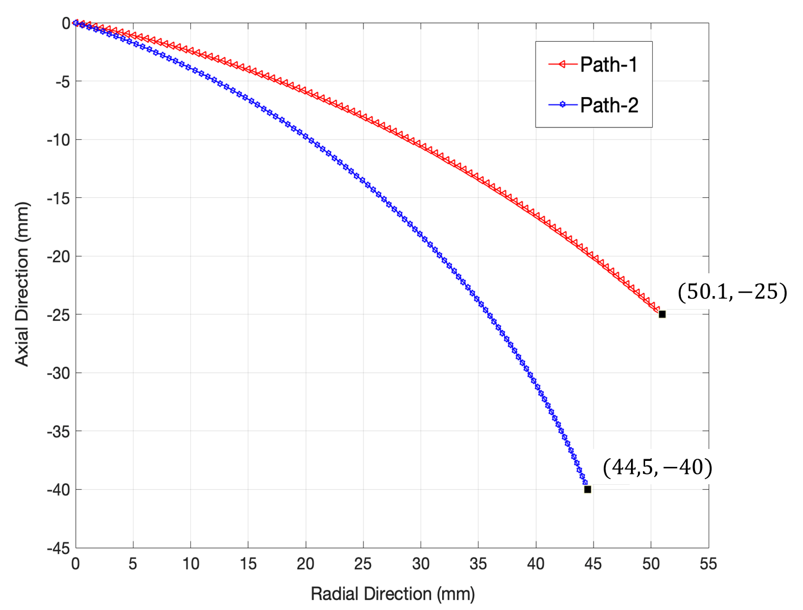
(a)
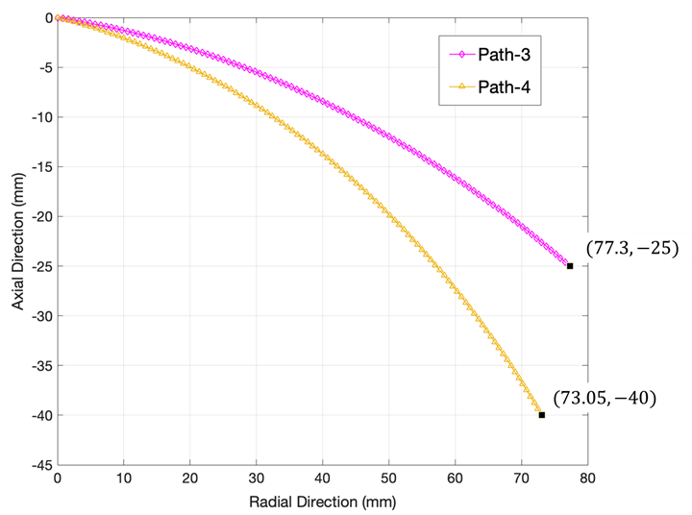
(b)
Figure 4.10 Toolpath profiles used in FE models: (a) spin ratio of 0.73, (b) spin ratio of 0.8
Experimental verification tests were carried out using the same spinning parameters as in Model 3 and Model 7. The thickness distributions along the radial direction obtained from the experimental tests and the FE models were then used to evaluate FE analysis results. The responses in the simulation runs were obtained from each of the FE models, three responses, as given in Table 4.7, were selected to analyse the effects of various input parameters on wrinkling failure. Furthermore, the features of wrinkling waves along the circumferential direction and the radial direction of the spun component were analysed within the wrinkled FE models.
Table 4.7 Responses obtained from FE simulation models
Response Terms | Explanation
STDV of Displacement | The standard deviation of the axial displacement at the edge of the workpiece along the circumferential direction
WTR | The ratio of wrinkling initiation time to total forming time
MTR | The ratio of maximum thickness reduction to the original workpiece thickness

Results and Discussion

The Effects of Process Parameters on Wrinkling
Based on the simulation results for the first-pass conventional spinning, the axial displacements at the edge of the workpiece along the circumferential direction of each model were plotted, as shown in Figure 4.11 (a). The axial displacement result of M3 approximated a straight line, indicating that no wrinkling failure occurred under the forming conditions of M3. Moreover, the displacements of the FE models deformed to a forming depth of 25 $mm$ were more uniform than those for the FE models deformed to a forming depth of 40 $mm$, due to the relatively small deformation generated at a forming depth of 25 $mm$ compared with that required for a forming depth of 40 $mm$.
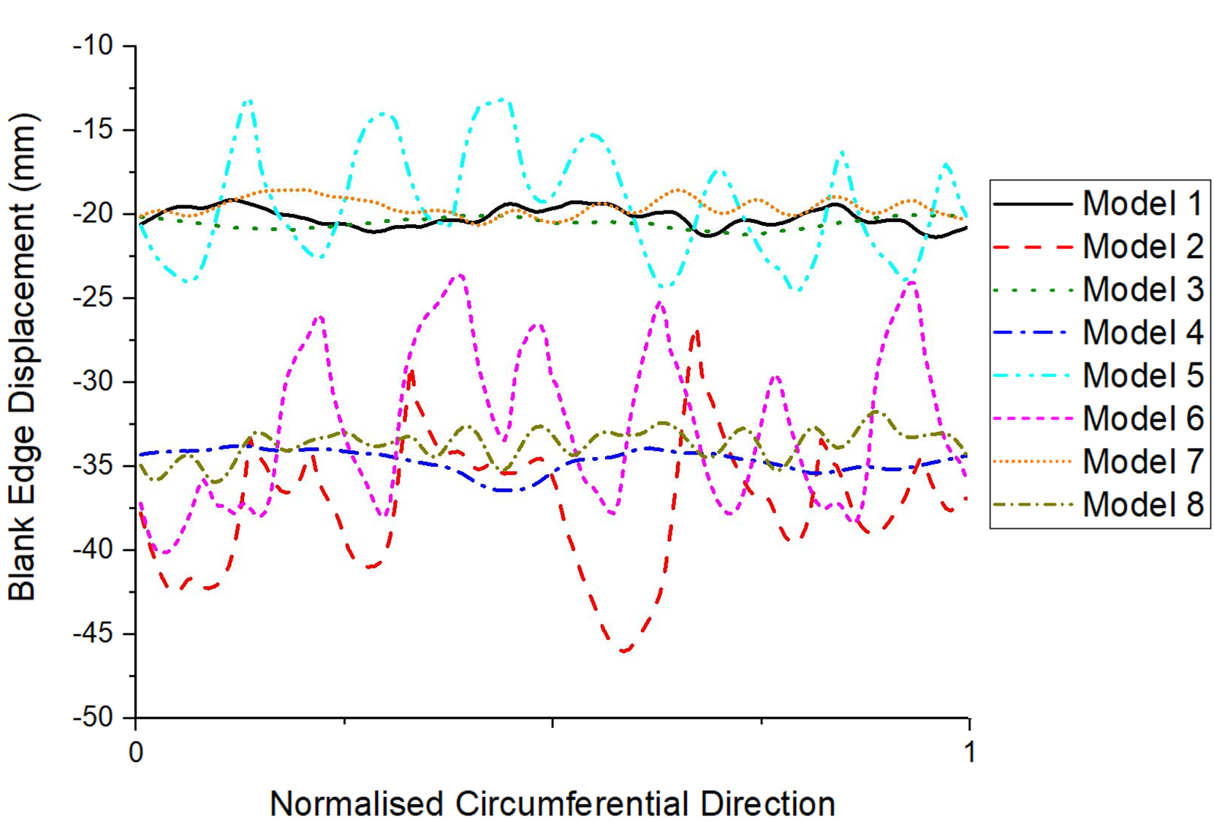
(a)
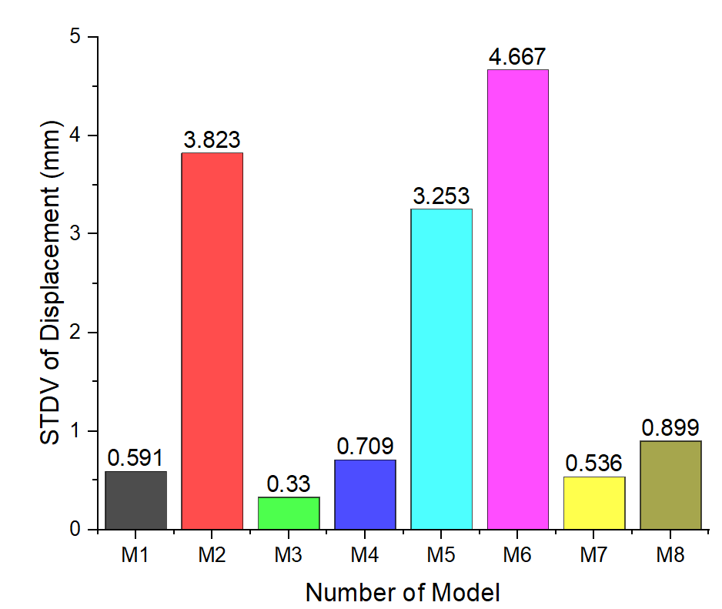
(b)
Figure 4.11 Severity of wrinkling in each model: (a) axial displacement along the circumferential direction, (b) STDVs of axial displacement
The standard deviations (STDV) of the axial displacement along the circumferential direction were calculated in order to quantify the severity of wrinkling failure, as shown in Figure 4.11 (b). By using the STDV of the axial displacement, the occurrence of wrinkling failure in the first-pass conventional spinning was evaluated. Wrinkling failure did not occur under the forming conditions of M3 and M7 in either experimental testing or FE simulation, as confirmed in Figure 4.8 and Figure 4.9. Further, as shown in Figure 4.11 (b), the STDVs of these two models were 0.33 $mm$ and 0.536 $mm$, respectively suggesting, in terms of this research, that if the STDV of a model is smaller than 0.536 $mm$, that model can be regarded as wrinkling-free, while the higher the value of the STVD, the more severe the wrinkling. Based on this criterion, with the exceptions of M3 and M7, wrinkling failure was generated in all FE models.
The elastic strain energy history was used to determine the time at which wrinkles were initiated during the first-pass conventional spinning simulation process (91). The strain energy of two models, M3 and M6, are illustrated in Figure 4.12 (a) and (b), which shows different wrinkling conditions. For a wrinkling free model, such as M3, the magnitude of the strain energy increases steadily and continuously throughout the forming process. In contrast, severe wrinkling was generated in M6, and an obvious reduction in the magnitude of the elastic strain energy can be observed at 1.712s, indicating that wrinkling was initiated at that time.
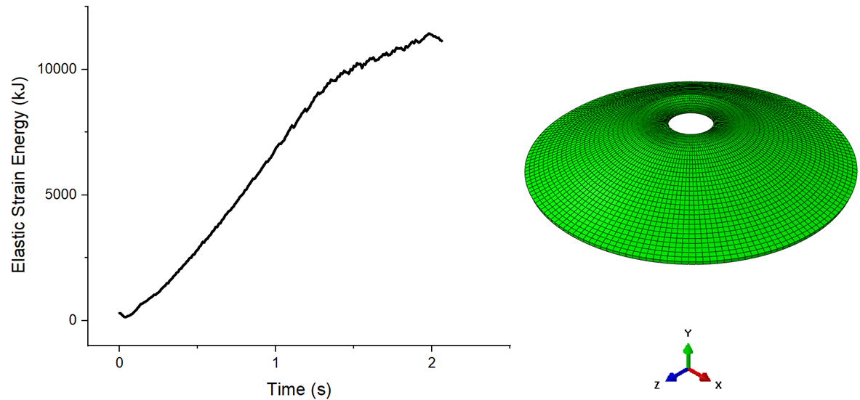
(a)
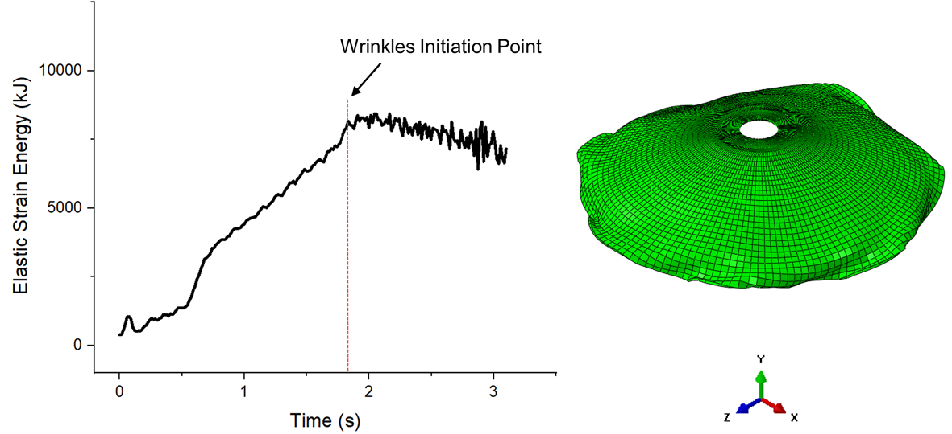
(b)
Figure 4.12 Illustration of elastic energy history: (a) wrinkling free model M3, (b) severely wrinkled model M6
The elastic strain energy during the simulation process is sensitive to these wrinkles. Figure 4.13 plots the elastic strain energy history of M7, where minor wrinkles were generated and a reduction in the magnitude of the strain energy was observed at the 5.61s, close to the end of the forming process. These minor wrinkles generated at that point thus did not have enough time to become further enlarged during the spinning process. A wrinkling time ratio (WTR) was therefore introduced as a secondary wrinkling occurrence criterion in order to determine the true wrinkling condition of a model during the first-pass conventional spinning simulation process.
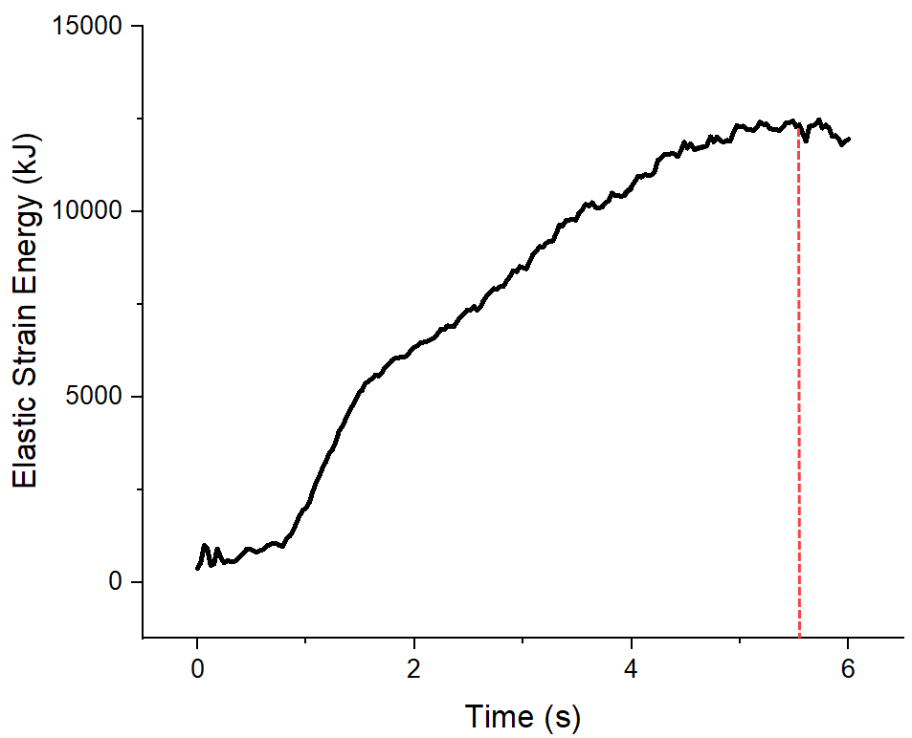
Figure 4.13 Elastic strain energy history of M7
The WTR, the ratio of wrinkling initiation time to total forming time, was used to quantify the severity of wrinkling failure. A relatively low value of wrinkling time ratio indicates that the workpiece under the relevant spinning parameters is inclined to be wrinkled. This was confirmed by the experimental tests, as M3 and M7, the wrinkling-free models, had wrinkling time ratios of 1 and 0.934 respectively, as shown in Figure 4.14. Based on these values, the models in which the WTRs lower than 0.934 were considered wrinkled models, which produced agreement with the results of using the STDV of axial displacement as a wrinkling occurrence criterion.

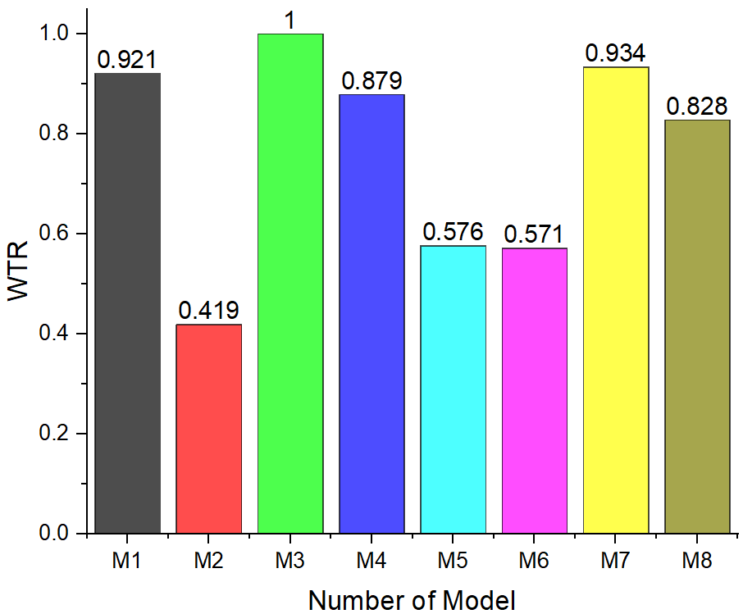
Figure 4.14 WTR of each model
Figure 4.15 presents the ratio of MTR for each model. Those models with a spin ratio of 0.73 were more prone to thinning as compared with those models with a spin ratio of 0.8 under the same forming depth. This occurs because when a small spin ratio is applied, a large tensile stress occurs in the workpiece along the axial direction, which causes wall thinning.
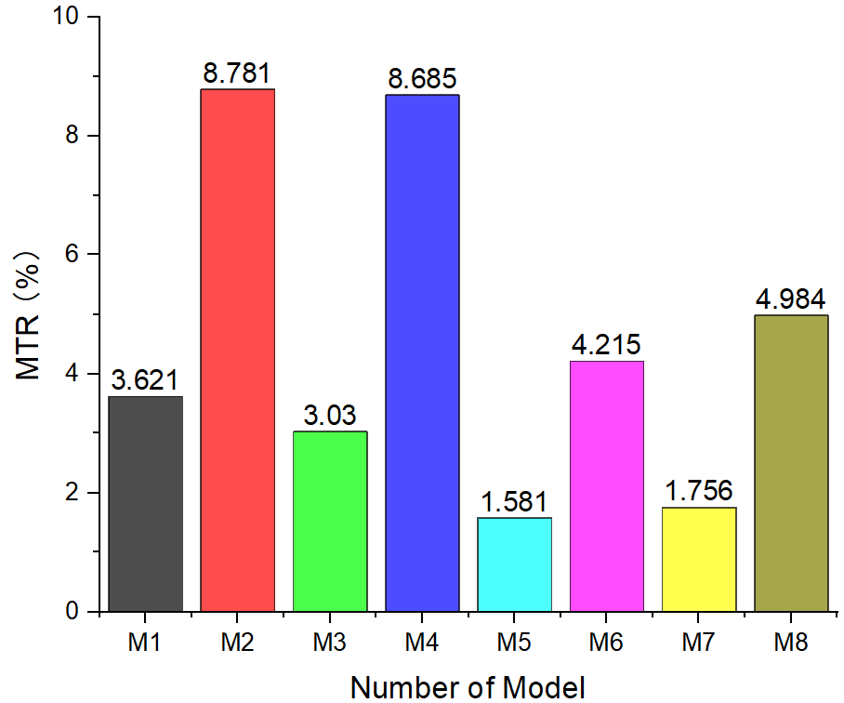
Figure 4.15 MTR of each model
Minitab was used to analyse the effects of four input parameters on the relevant response factors during the first-pass conventional spinning simulation process. Figure 4.16 shows the main effects plot for the means of the STDV of axial displacement and S/N ratios, respectively. This shows that the workpiece thickness and the designed forming depth have relatively strong effects on the STVD of axial displacement at the edge of the workpiece along the circumferential direction, while relatively limited effects are seen between feed ratio and spin ratio. This is because the plastic moment of the thicker workpiece is larger than that of the thinner workpiece, allowing the thicker workpiece to better resist wrinkling. The severity of wrinkles in models with thicker workpieces is thus reduced as compared with that seen for thinner workpieces.
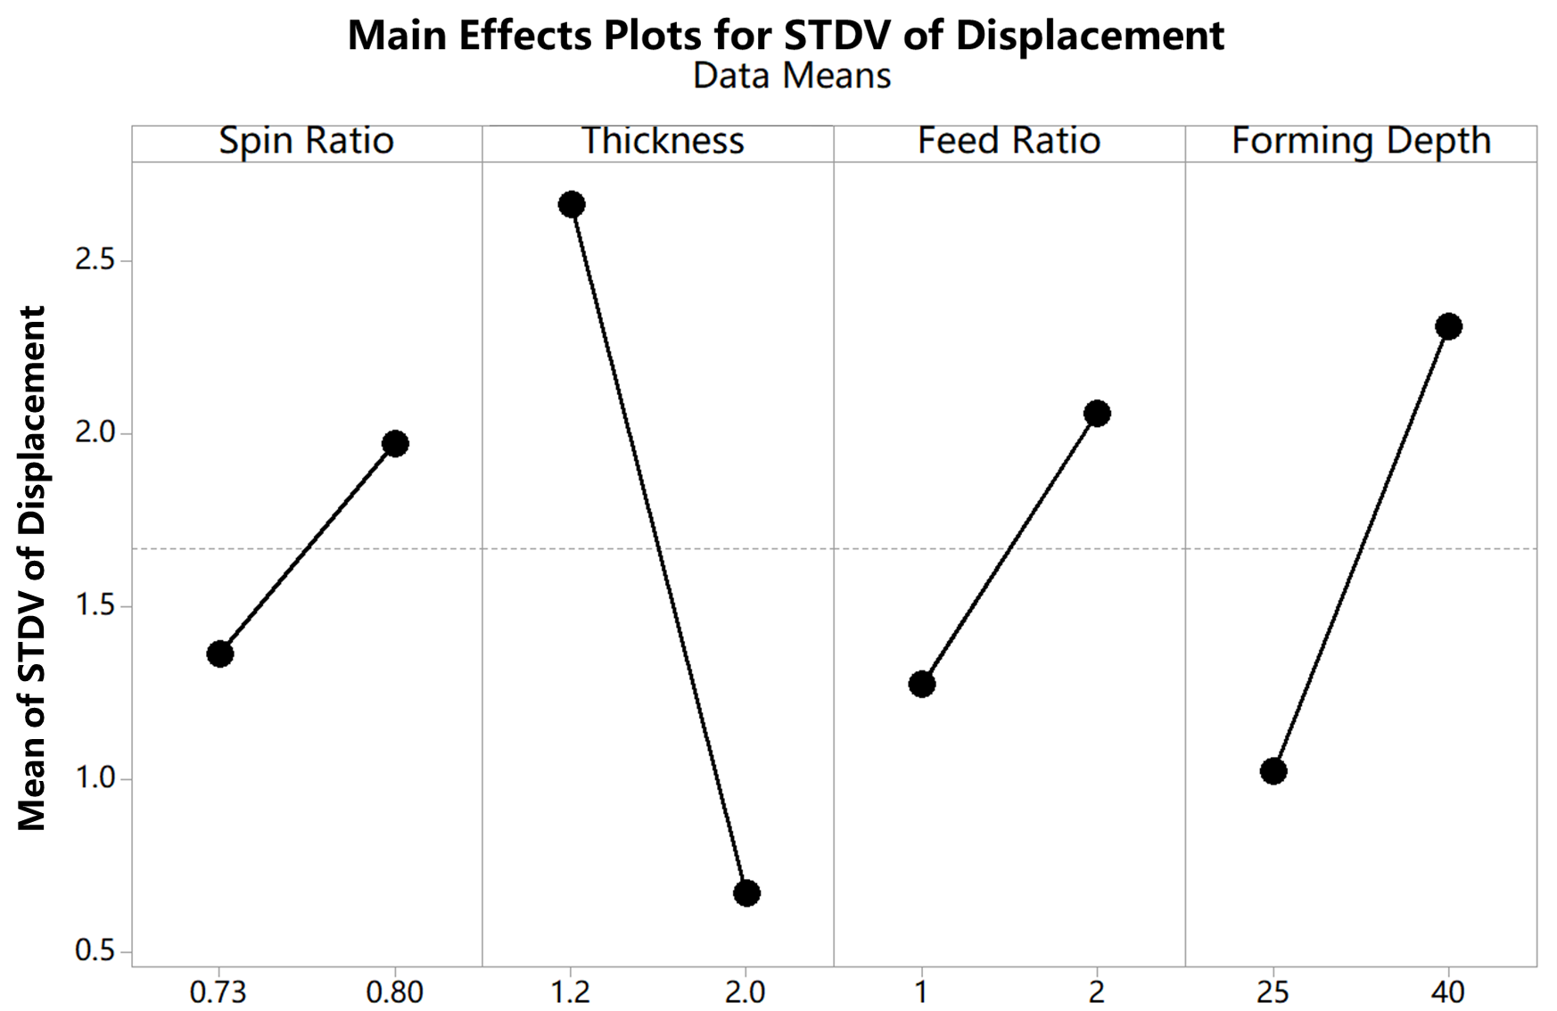
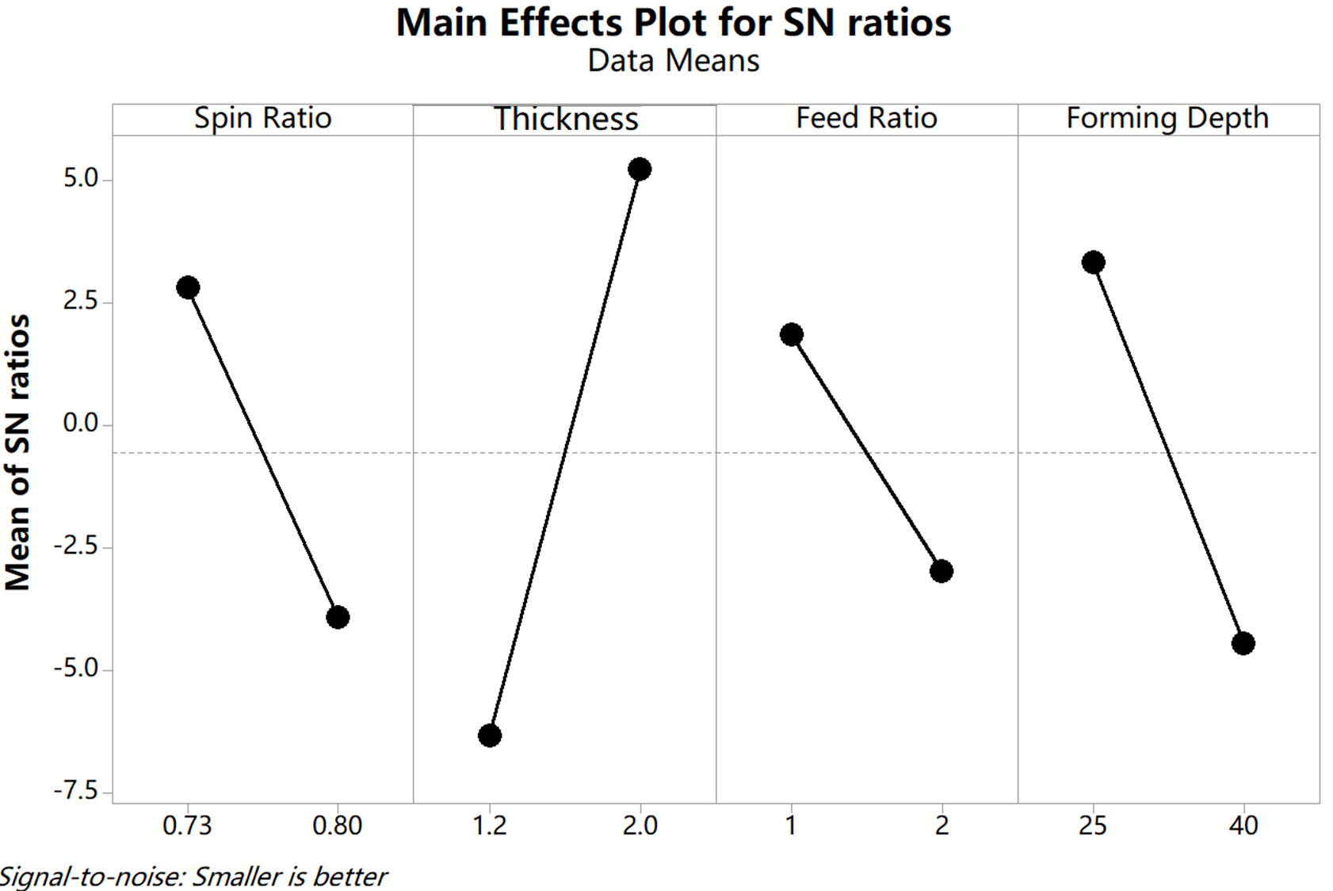
Figure 4.16 Main effects plot for Means of STDV of axial displacement.
As illustrated in Figure 4.17, workpiece thickness has the most significant effect on the mean value and the variation of WTR, followed by the forming depth, the spin ratio, and the feed ratio, respectively. It is clear that wrinkling failure will thus occur at an early stage of the forming process if a relatively deep forming depth is designed for the first-pass conventional spinning, as a large deformation is required to reduce the initial radius of the workpiece to achieve this large forming depth, resulting in a greater level of compressive circumferential stress in the workpiece. This is in agreement with the results obtained by both Quigley and Monaghan (92) and Wang (36).
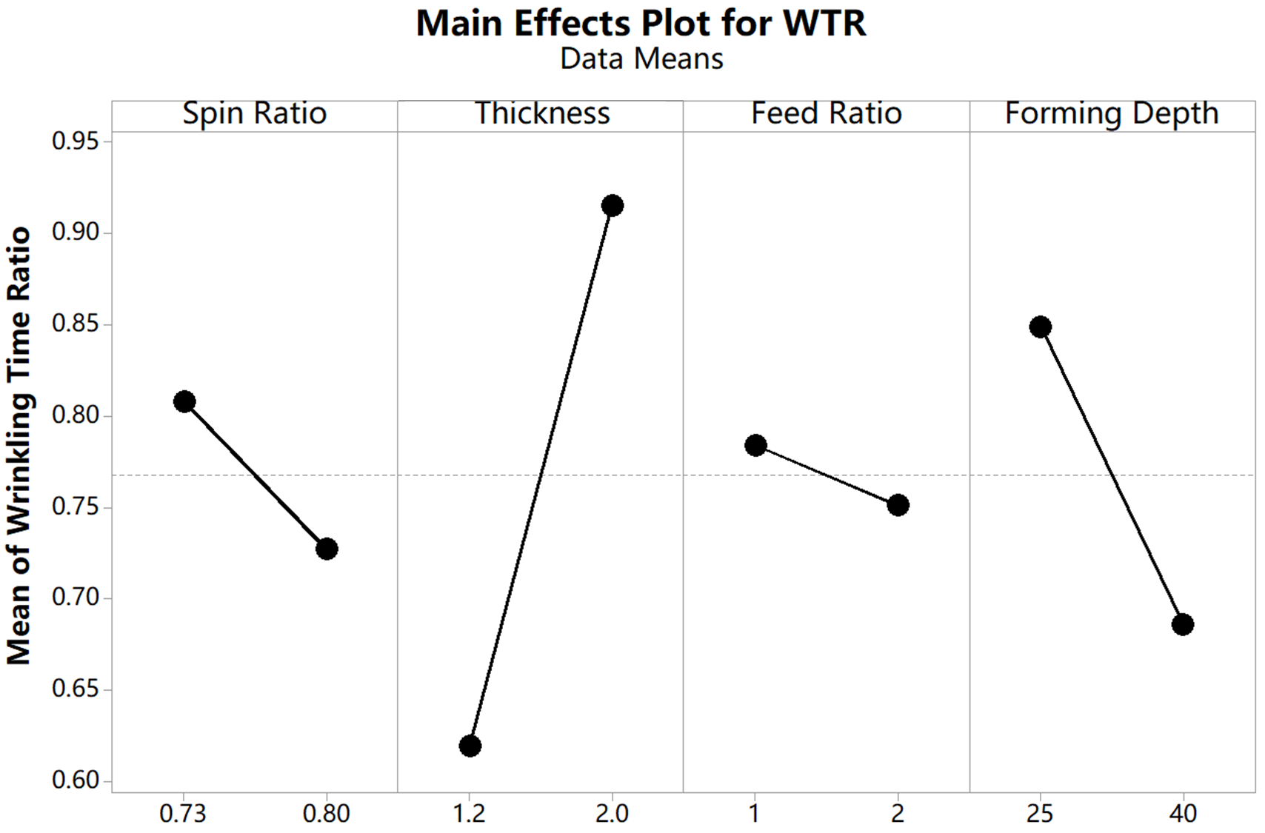
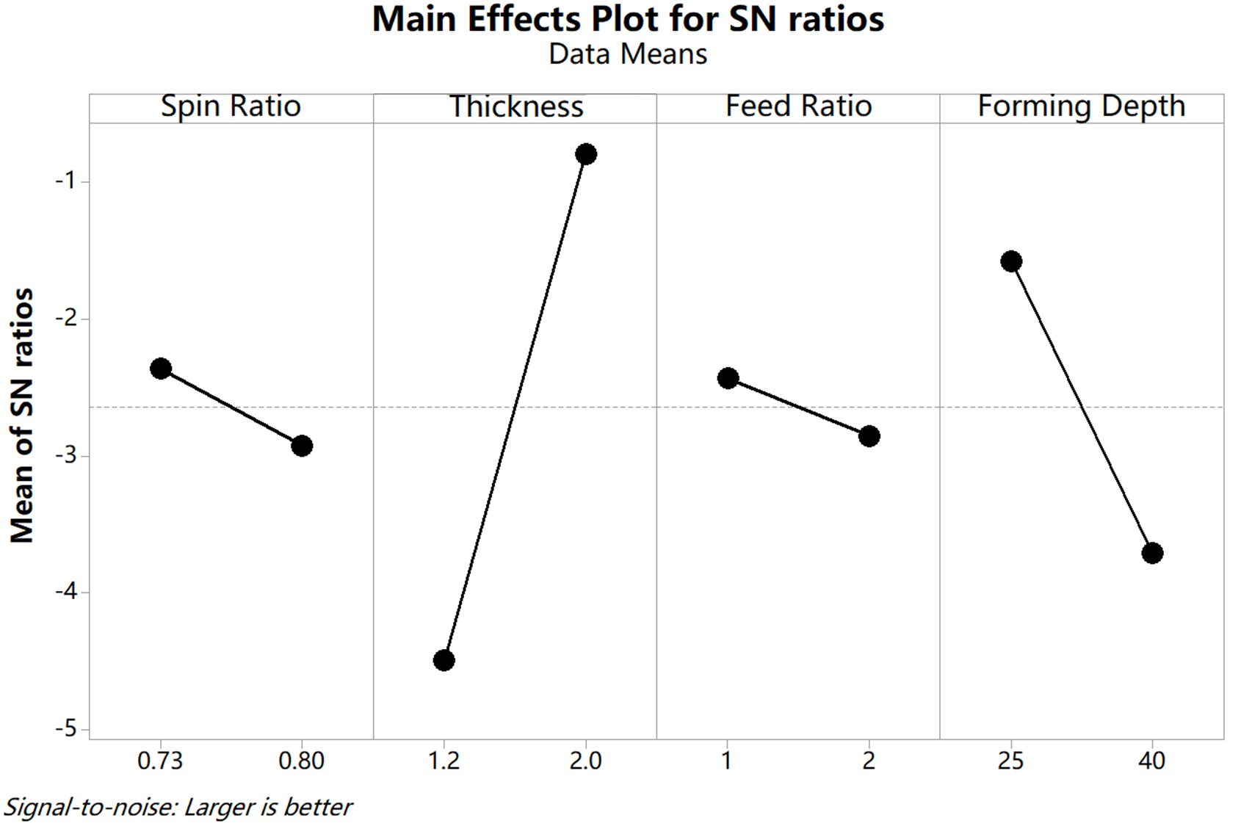
Figure 4.17 Main effects plot for WTR
As seen in Figure 4.18, the spin ratio and the designed forming depth in the first-pass conventional spinning have significant effects on thickness variation, while the original workpiece thickness only has a minor effect. This is because a large spin ratio with a low forming depth leads to a relatively small ratio of depth/radius in tension along the radial direction, resulting in less thinning. Nevertheless, a higher feed ratio remains helpful in terms of maintaining thickness uniformity during the forming process, as it results in a lower number of revolutions being required to complete the forming of the workpiece surface. As a result, the shearing effect is minimised, which produces less reduction in thickness, as illustrated in Figure 3.13.
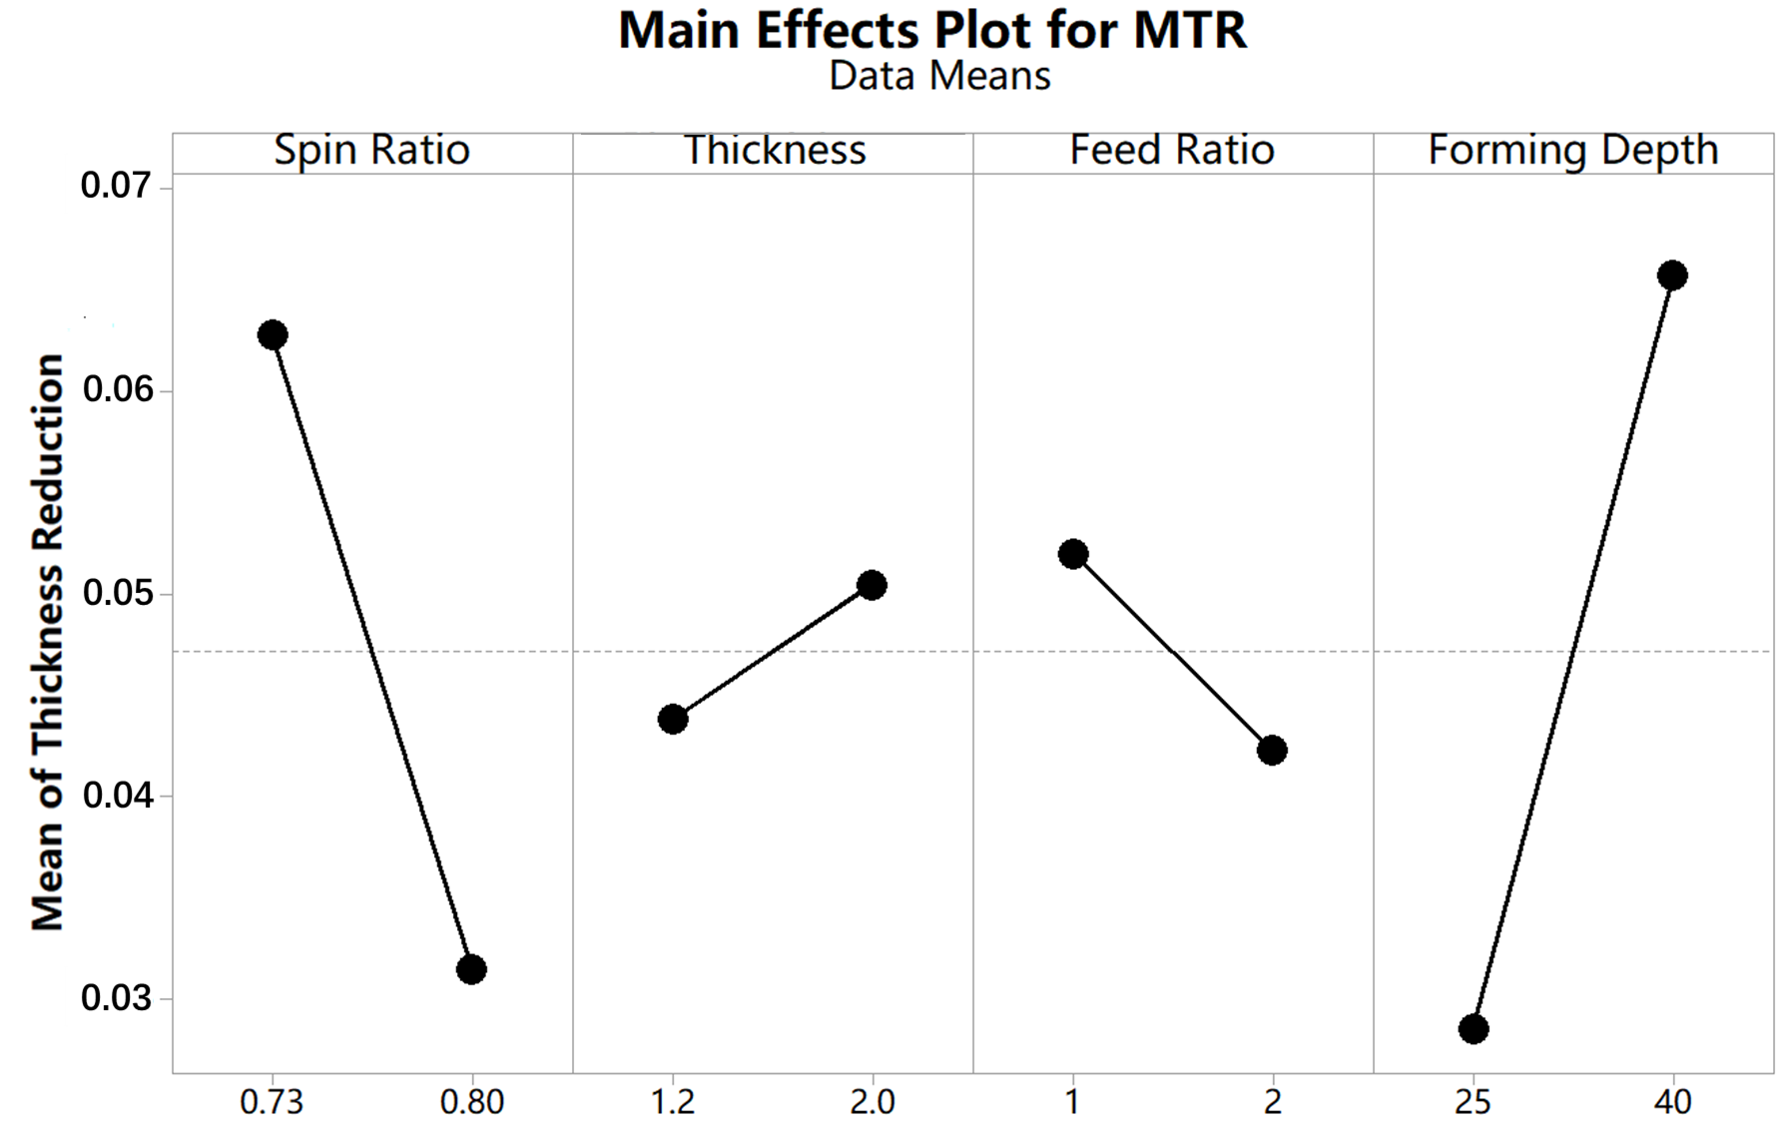
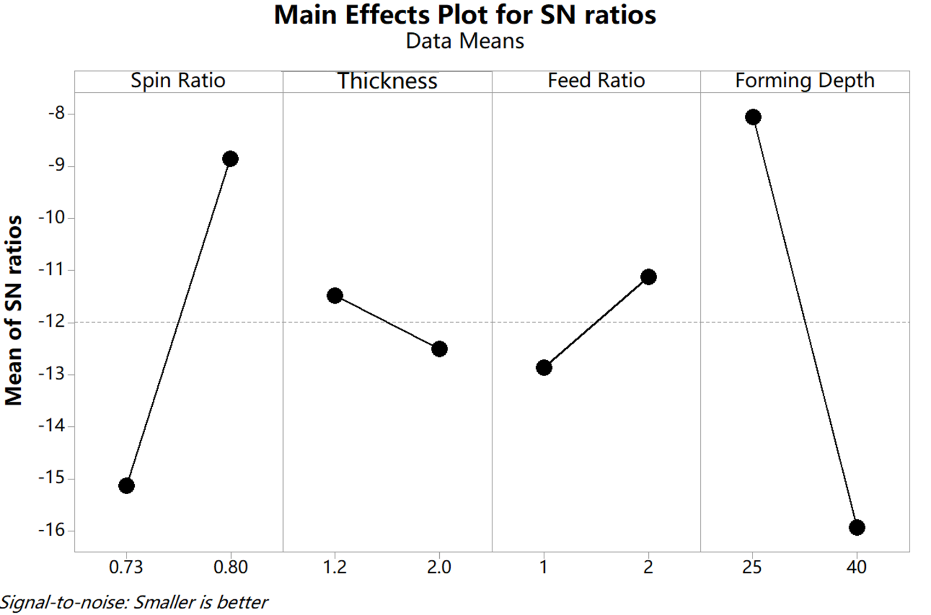
Figure 4.18 Main effects plot for MTR
Figure 4.19 presents the contour plots for the three responses individually, based on the results obtained from FE analysis using MODDE software. The spin ratio and feed ratio have only two levels of variation each, while the workpiece thickness and designed forming depth vary from a low level to a high level. The contour lines of the first two responses, the STDV of the axial displacement and WTR, as shown in Figure 4.19 (a) and (b), are curved due to non-linear interactions between the workpiece thickness and the designed forming depth. In contrast, any interaction effect on the response of MTR must be minimal, as the contour lines in Figure 4.19 (c) are nearly parallel. This is confirmed by the results of the significance analysis performed on FE models using the Taguchi method, as shown in Figure 4.18. The contour plots of Figure 4.19 (a) and (b) indicate that, in the first-pass conventional spinning process, wrinkling failure can be prevented by using a thicker workpiece, even when forming is completed under a relatively high feed ratio.
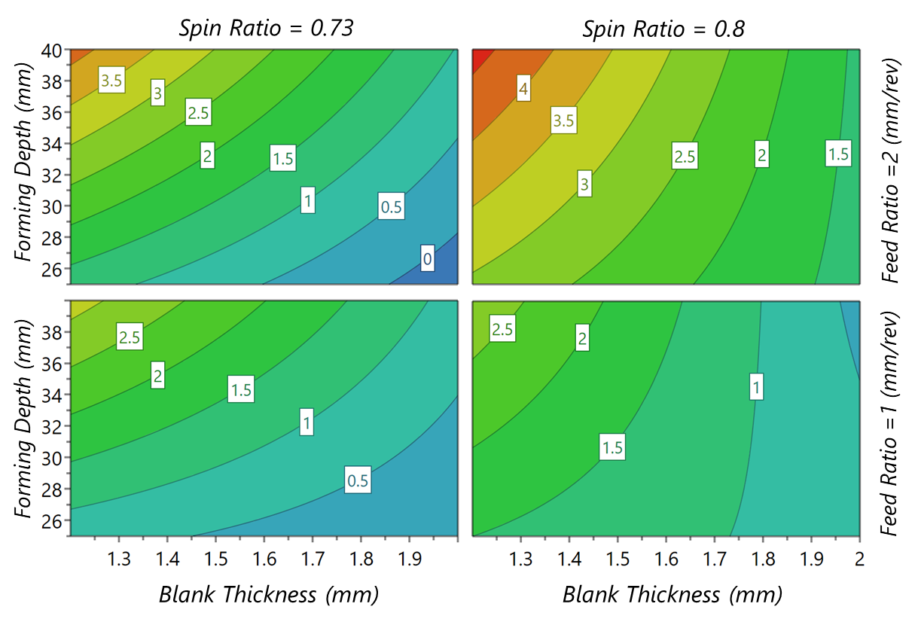
(a)
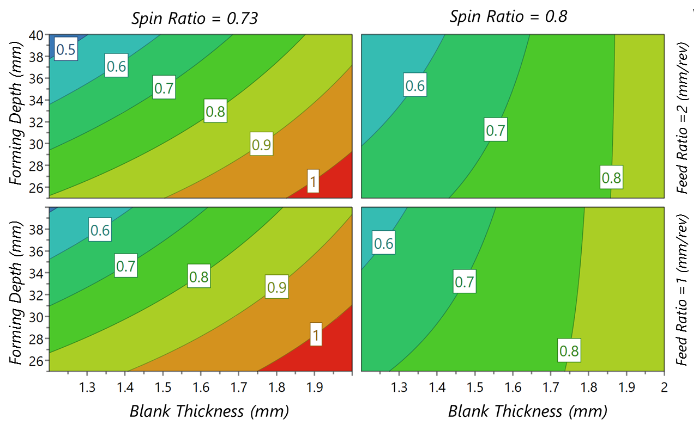
(b)
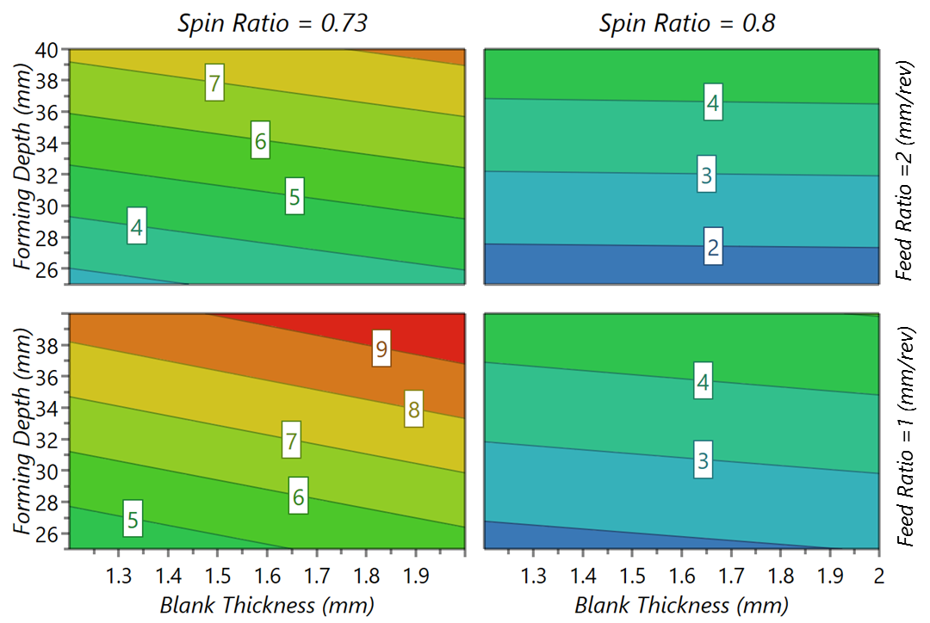
(c)
Figure 4.19 Response contour plots (a) STDV of Displacement, (b) WTR, and (c) MTR

Geometrical Modelling of Wrinkles using a Wave Function
Geometrical comparisons between a simulated component and the corresponding experimental component under the same spinning parameters are shown in Figure 4.20. Wrinkling failure occurred in both the experimental and simulated components, and the waveforms are similar in appearance. In particular, the wrinkle waves along the edge of the workpiece vary periodically in the circumferential direction.
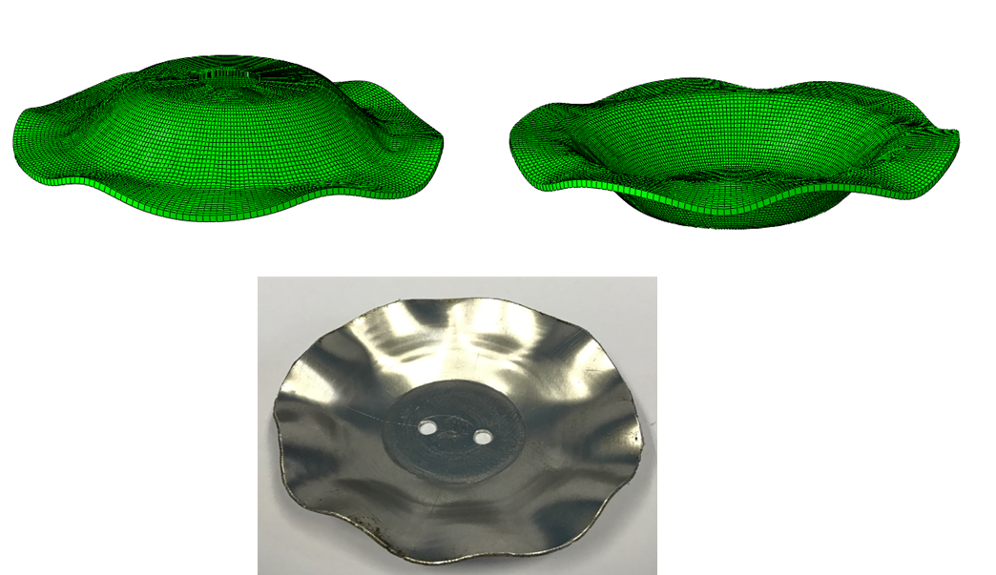
(a) (b)
(c)
Figure 4.20 Comparison of simulated and experimental wrinkled spun components: (a) top view of simulated workpiece, (b) bottom view of simulated workpiece, and (c) experimental workpiece ($R_{0}=50 mm$, $R_{c}=20 mm$, $f=1.5 mm/rev$)
Moreover, the troughs of the wrinkles in both the experimental and simulation components were deformed downward to the mandrel, leading to a loss of contact between the material and the tool in this area. The wrinkle crests, however, remain in contact with the tool and were therefore deformed by the tool movement as it followed the designed tool path. As shown in Figure 4.21, no tool indentation was generated inside the wrinkle trough region, while the material at the wrinkle crest region continued to be deformed under the designed toolpath profile as the wrinkles started to form. The profile of the wrinkle crest can therefore be considered to follow the designed toolpath profile.
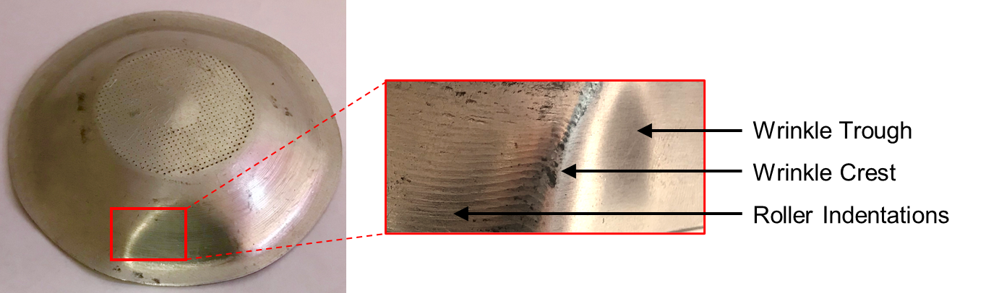
Figure 4.21 Details of wrinkle trough and crest areas in a wrinkled spun component
The geometry of a spun component without wrinkles is defined by the shape of its middle surface and its thickness. The local coordinate system is centred in the middle surface of the wrinkling free spun component, as shown in Figure 4.22, and any point of the shape can be defined by coordinates$x$ and $z$ in the middle surface with coordinate $y$ being normal to the middle surface.
The middle surface of a wrinkled free component is assumed to be a doubly curved shell, as shown in Figure 4.22. Thus, $r$ and $r_{1}$ denote the principal radii of the doubly curved shell along the meridional direction and the circumferential direction in the curvilinear coordinate system, respectively. Here, $r$ is a constant radius of the curvature of the shell along the meridian direction, while $r_{1}$ will always be the varying distance from the shell middle surface to the rotation axis of the workpiece, perpendicular to the rotational axis of the workpiece. This means that $φ$ and $θ$ are the meridional angle and the circumferential angle of the shell, respectively. The coordinates of the middle surface $x$ and $z$ are defined to be coincident with the lines of principal curvature ($1/r and 1/{r_{1}}$) of the doubly curved shell, while $u$ and $v$ are defined as the displacements along the $x$ and $z$ directions, respectively, with $w$ defined as the displacement normal to the middle surface of the curved shell along the $y$ direction.
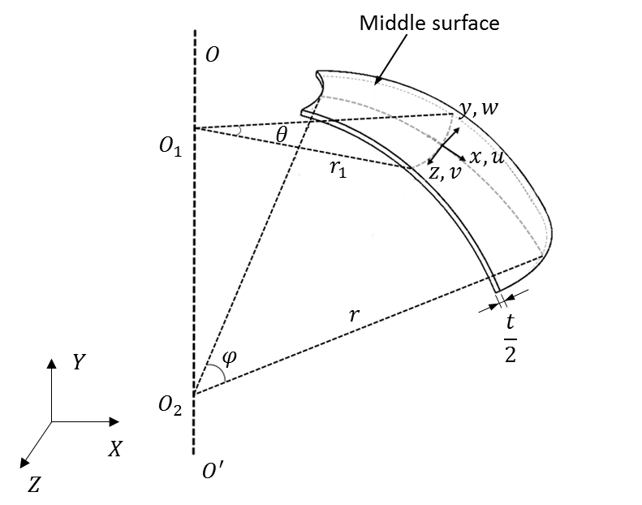
Figure 4.22 Curvilinear coordinate system of the wrinkling free component middle surface
Based on these definitions, a mathematical model of the wrinkling waveform can be defined. One of the wrinkling waveforms along the circumferential direction is assumed to follow the cosine wave function, while the wrinkling waveform along the meridional direction is assumed to follow the sine wave function.
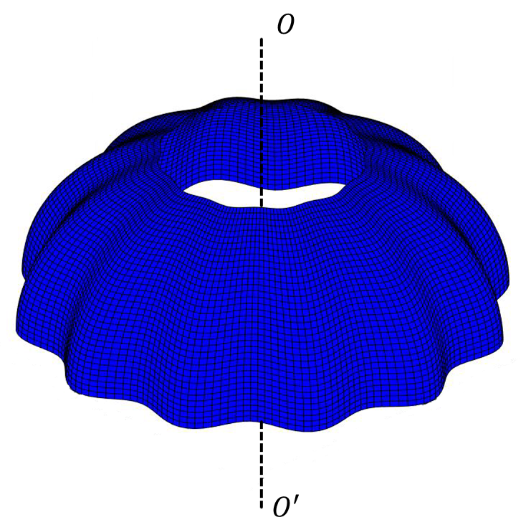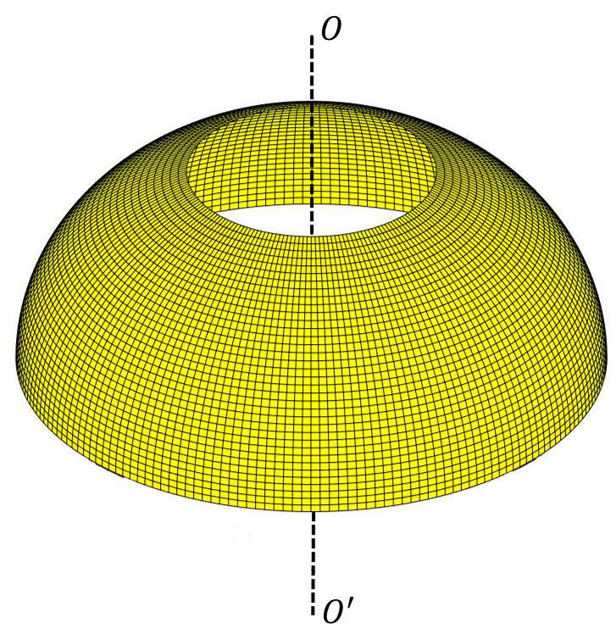
(a) (b)
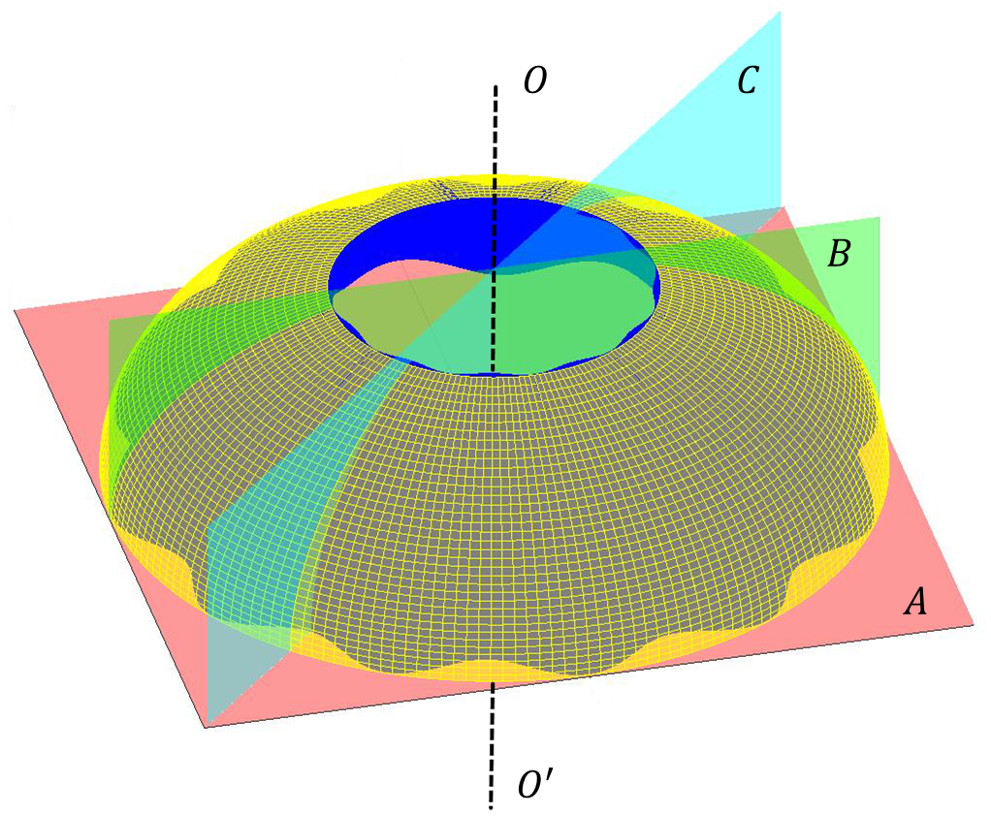
(c)
Figure 4.23 Illustration of the geometries of the mathematical models: (a) Wrinkling free model, (b) Wrinkled model, and (c) Location of three cross-sections in both models
According to the assumptions, models of a wrinkling free spun component and wrinkled spun component were created, as shown in Figure 4.23 (a) and (b), respectively. Figure 4.23 (c) shows three cross-sections, section A-A, section B-B, and section C-C of the mathematical model. Section A-A is the cross-section perpendicular to the rotational axis of the workpiece, located at the bottom of both models, while sections B-B and C-C are the two slices that intersect at the rotational axis of the models, being cut across one of the wrinkle crests and one of the wrinkle troughs, respectively.
The wrinkling waves are assumed to be uniformly distributed waves, and the number of wrinkle crests and wrinkle troughs along the circumferential direction is thus defined by the number of wrinkles, $m$.
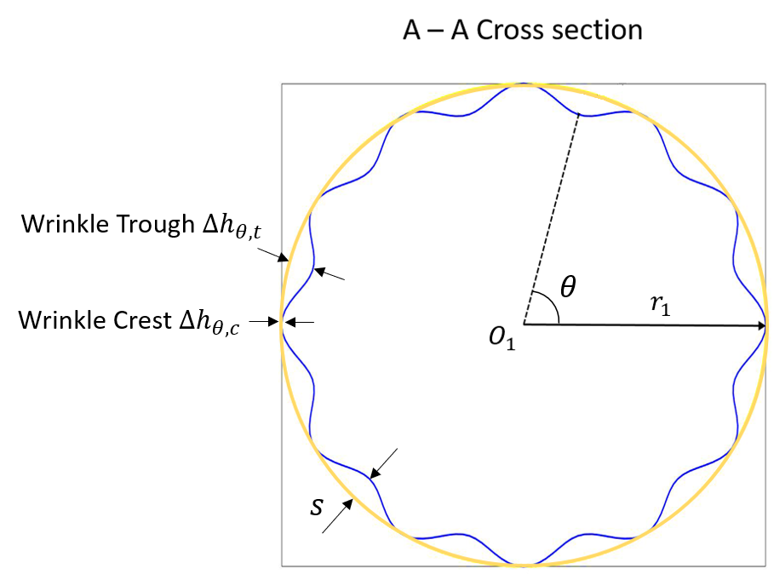
(a)
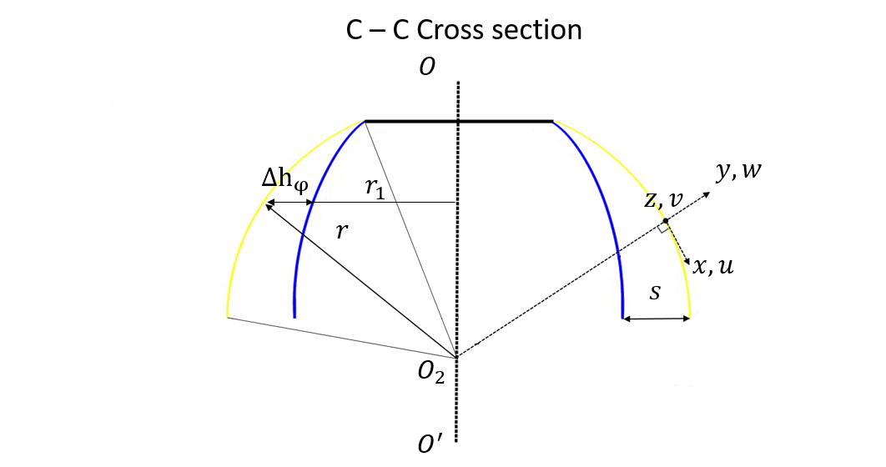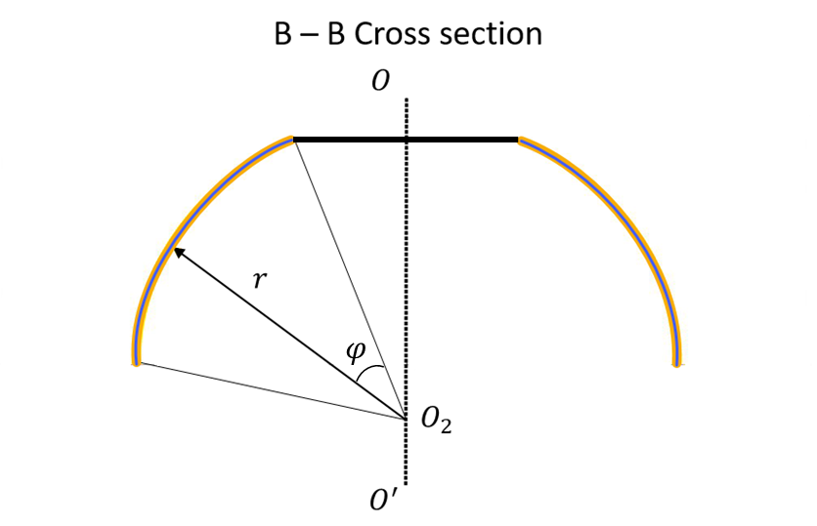 (b) (c)
Figure 4.24 Details of cross-sections: (a) Section A-A, (b) Section B-B, and (c) Section C-C
As shown in Figure 4.24 (a), the amplitudes of wrinkle crests and wrinkle troughs along the circumferential direction, $θ$, are defined as $∆h_{θ,c}$ and $∆h_{θ, t}$, respectively, referring to the distance between the edges of the wrinkling free model and wrinkled model. The clearance between the wrinkling free model and wrinkled model along the $r_{1}$ direction is defined as $∆h_{φ}$, as shown in Figure 4.24 (c). Theoretically, the value of $∆h_{θ,c}$ should be zero, and the wave amplitude, $s$, is thus defined by the distance between the wrinkle crest and wrinkle trough at the edge of the workpiece, as shown in Figure 4.24 (a) and (c). The wave amplitude should be a constant independent of $θ$ and $φ$. Figure 4.24 (b) shows the profile of the wrinkle crest which corresponds to the toolpath profile, as observed in Figure 4.21.

Validation of the Wrinkling Wave Function
The geometry of the mathematical wrinkling wave function was validated in the FE model as wrinkles occurred. The results for wrinkling wave amplitudes along the circumferential direction and radial direction of the workpiece were obtained in the FE analysis for validation purposes, and two node lists were established on the workpiece FE mesh, as shown in Figure 4.25. $R_{c}$, $R_{0},$ and $θ$ correspond to the radius of the clamped area, the radius of the original workpiece, and the circumferential angle, respectively. The circumferential node list $a_{i} \left(a_{1}, a_{2},…a_{n}\right)$ is located at the edge of the workpiece ($R_{0}$), and the radial node list $b_{i} (b_{1}, b_{2},…b_{n})$ ranges from the clamped area to the edge of the workpiece, from $R_{c}$ to $R_{0}$.
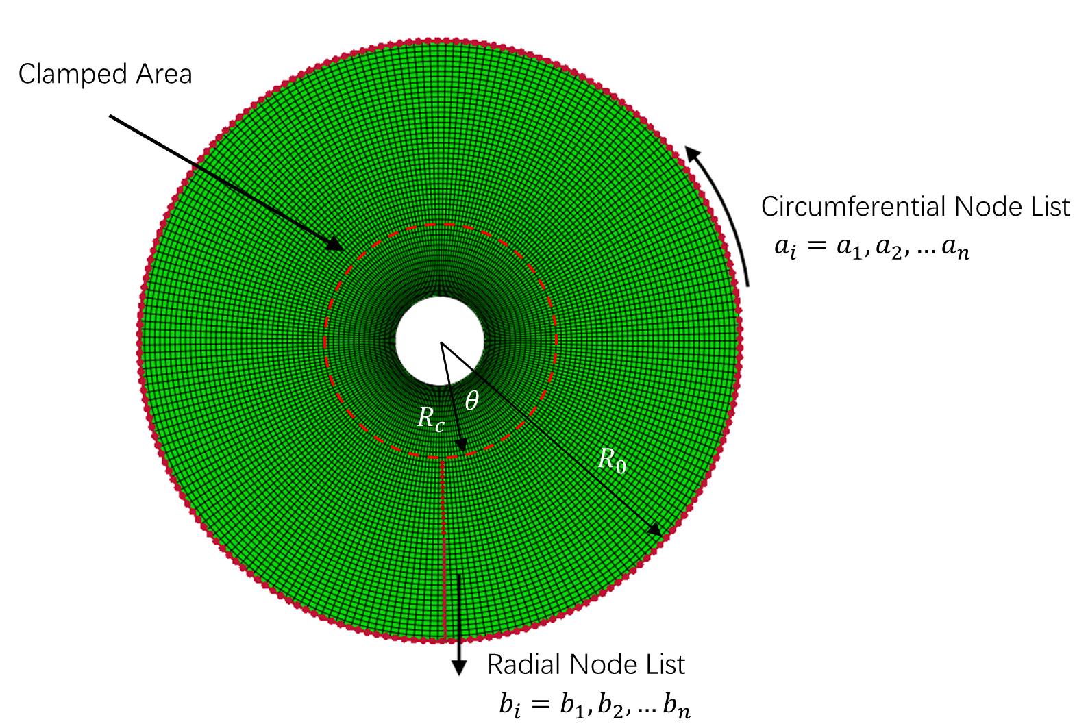
Figure 4.25 Direction and location of circumferential and radial node lists
The results for wrinkling wave amplitude at the edge of the workpiece along the circumferential direction, from node $a_{1}$ to node $a_{n}$, were plotted, as shown in Figure 4.26. Compared with the geometrical model, in which all of the wrinkles were assumed to be uniformly distributed, the wrinkle waveforms obtained from the FE model, were much less uniform. An average value for the wrinkling crests and troughs based on the results of FE analysis was therefore utilised in the validation process.
Several different wave amplitudes were generated at the edge of the workpiece in the circumferential direction, as shown in Figure 4.20 (a) and (b). Defining $∆h_{θ,c}$ as the amplitude of wave crest, $∆h_{θ,t}$ as the amplitude of wave trough, and $s$ as the wave amplitude allows the relationships among these three parameters to be expressed as
$$s=avg.\{∆h_{θ,t}-∆h_{θ,c}\}$$
Equation 4.2
Thus, the higher the wave amplitude $s$, the more severe the wrinkling condition at the edge of the workpiece. Figure 4.26 shows that the amplitude of the wave varies periodically along the edge of the workpiece along the circumferential direction, approximately corresponding to the cosine wave function as shown in the A-A cross-section view and obtained from the mathematical wrinkling model, as presented in Figure 4.24 (a).
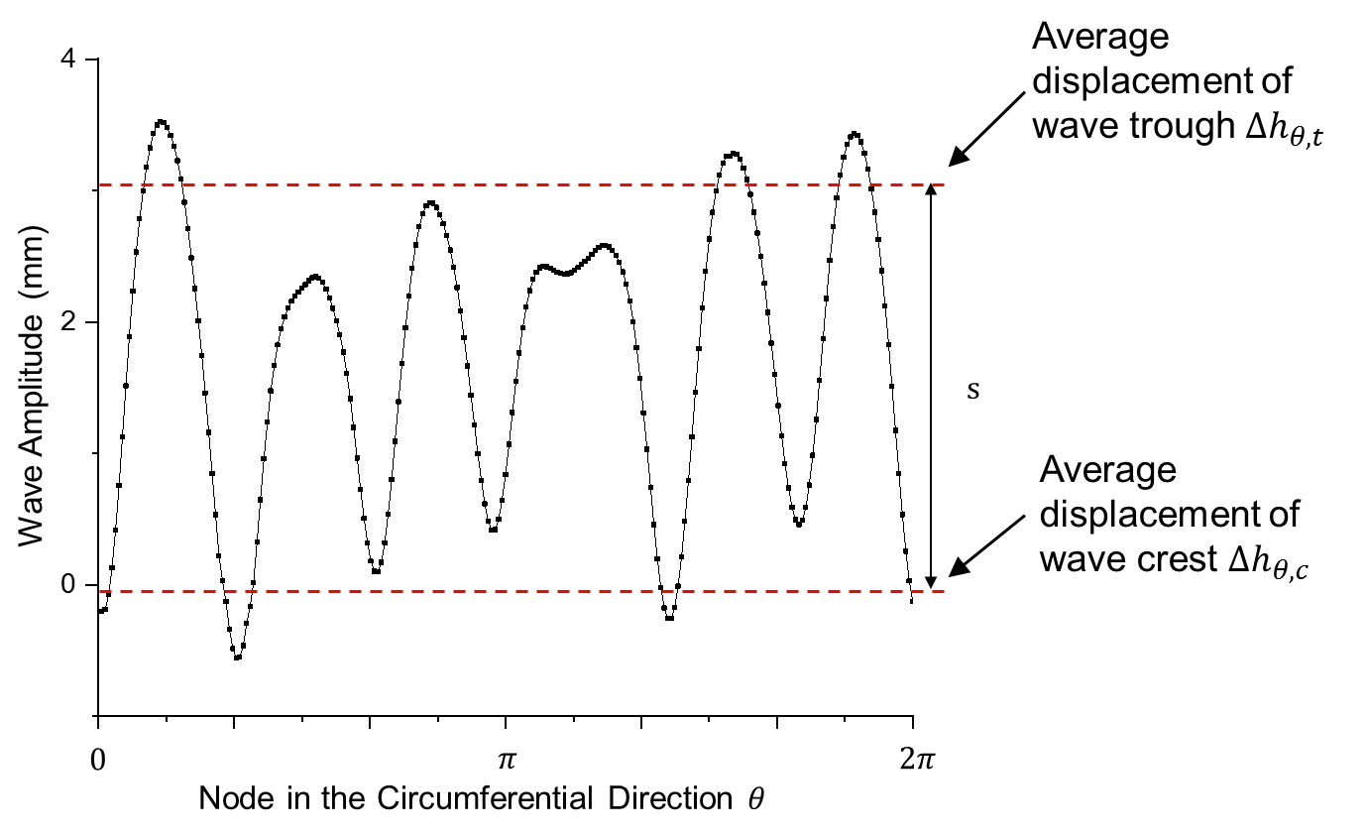
Figure 4.26 Variation of the wave amplitude along the circumferential direction
There are six wrinkle waves in the circumferential direction generated in the FE model, as shown in Figure 4.26. Six radial node lists located on these wrinkle troughs, from node $b_{1}$ to node $b_{n}$, were therefore selected and the wave amplitude, $∆h_{φ},$ between each adjacent wave trough and wave crest along the $r_{1}$ direction, as defined in Figure 4.24 (c), was plotted, as shown in Figure 4.27. The average wave amplitude among the selected node lists was utilised to validate the geometry of the mathematical model.
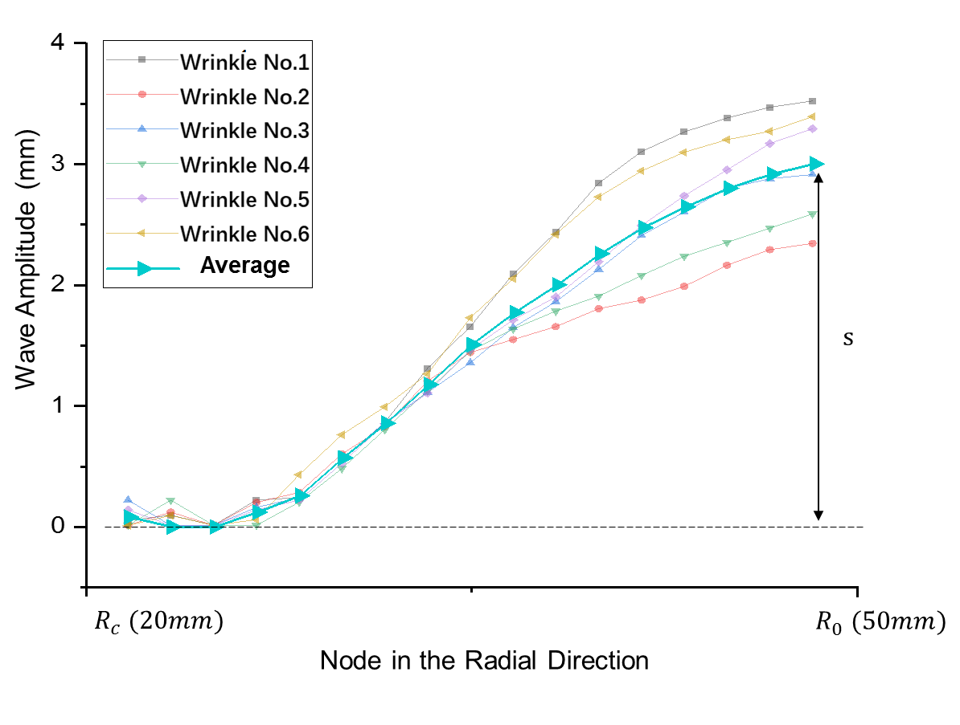
Figure 4.27 Variations of the six wave amplitudes along the radial direction
The average wave amplitude along the meridional direction can therefore be simulated by a quarter of the sine wave function. Additionally, as $m$ is the number of wrinkles along the circumferential direction, by taking the wave amplitudes along the circumferential direction and the radial direction into consideration, an initial wrinkling wave function, $ω$, can be expressed as
$$ω=s∙\left[cos\left(2πm\frac{a_{i}}{a_{n}}\right)-1\right]∙sin\left(\frac{π}{2}∙\frac{b_{i}}{{ b }_{n}}\right)$$
Equation 4.3
By developing this wrinkling wave function, the energy criteria for wrinkling prediction in the first-pass conventional spinning process was developed, which is discussed in Chapter 5.

Summary
In this chapter, the FE models for the first-pass conventional spinning process with different workpiece radii, including 50 $mm$, 75 $mm,$ and 100 $mm$, were developed and verified using a mesh convergence study and evaluation of mass scaling factors and energy ratios, as well as a comparison of wall thickness variations with the corresponding experimental results. The Taguchi method was utilised to analyse the effects of the four main input parameters in spinning (spin ratio, workpiece thickness, feed ratio, and designed forming depth) on the component defects of wrinkling and thickness reduction. By comparing the simulated spun component with the experimental wrinkled spun components, the criteria for determining wrinkling occurrence and wrinkling initiation points were established for FE modelling. The wave function was established according to the features of geometric modelling for wrinkling failure to support the development of theoretical analysis of wrinkling prediction, which is the focus of Chapter 5.
Based on the results of the FE simulation, within the range of the input parameters considered in this chapter, the following key points may be drawn:
- The severity of wrinkles can be quantified by calculating the standard deviation (STDV) of the axial displacement at the edge of the workpiece along the circumferential direction.
- The results of elastic strain energy may be used to identify the exact time when wrinkles are initiated during a first-pass conventional spinning simulation process.
- The workpiece thickness and designed forming depth have significant effects on wrinkling failure. Wrinkling failure can be avoided if a relatively thicker workpiece and/or a low forming depth are used in the first-pass conventional spinning process.
- By employing relatively small feed ratios, wrinkling failure can be prevented. However, a high feed ratio helps to maintain the original workpiece thickness.
- The wave function of wrinkles has been developed based on the geometric modelling of wrinkles, and this in turn can be used to support the development of a wrinkling prediction model, as presented in Chapter 5.

Development of wrinkling prediction model
As reviewed in Chapter 2.4.2, the critical condition of wrinkling in the sheet metal spinning process can be obtained by the analytical method, and therefore to produce the processing map to predict wrinkling failure. The energy method, as an effective method, has been widely used to calculate the critical point of wrinkling during sheet forming processes. In analytical method, the effects of various input parameters, including process parameters and material parameters, on the critical condition of wrinkling can be studied simultaneously at the lowest cost, which is different from the experiment and the FE investigation methods. In this chapter, the analytical wrinkling prediction model based on the conservation of energy is proposed for the first-pass conventional spinning using convex toolpath profile. The wrinkling criterion is established in Section 5.1. The calculations of strain energy (internal energy), work done by the forming tool (external energy) and the wrinkling limit (critical forming depth) are presented in Section 5.2. The effects of material properties, process parameters and the significance analysis of these parameters on wrinkling failure are presented in Section 5.3, followed by a summary of the work in this chapter in Section 5.4.

Establishment of Wrinkling Criterion

Basic Assumptions
The following assumptions are made for prediction of wrinkling failure of the first-pass spinning process by the energy equilibrium criteria:
- The body forces of the workpiece, including gravity and inertial force, are negligible.
- The material is assumed to be homogeneous and isotropic.
- The geometrical shape of the workpiece is defined by the middle plane of the workpiece.
- The material points located initially on a plane normal to the middle surface of the workpiece remain on the plane normal to the middle surface after deformation.
- The stresses along meridional direction and thickness direction can be approximately assumed to be principal stresses and as plane stress condition.
- The strain in the direction of the workpiece thickness direction can be neglected, i.e. the thickness of the workpiece remains unchanged.
- Contact friction between the tooling and the workpiece is negligible.
- At any instant during the spinning process, all elements of the workpiece are assumed to be deforming elastic-plastic.

Boundary Conditions of Wrinkling Prediction Model
The wrinkling waves function was defined in chapter 4.4, where the displacement normal to the middle surface of the deformed workpiece was defined as the normal displacement, $w$. The normal displacement, $w$, must satisfy the following boundary conditions: (A) $w$, is equal to zero at the edge of the clamped area of the workpiece; (B) $w$, is equal to zero on the wrinkle crests. These boundary conditions can be expressed as follows:
$$w=0, \frac{∂w}{∂φ}=0, at φ=0$$
Equation 5.1
$$w=0, \frac{∂w}{∂θ}=0, at θ=\sum_{i=0}^{m}{i∙\frac{2π}{m} }$$
Equation 5.2
Based on these boundary conditions and combining with Equation 4.3, the wave function of the winkled workpiece can be written as:
$$ω=s∙\left[cos\left(mθ\right)-1\right]∙sin\left(\frac{πφ}{2φ_{i}}\right)$$
Equation 5.3
According to the thin shell theory, in sheet metal spinning process, the strain components, $ε_{φ}$, $ε_{θ}$ and $γ_{φθ}$, of the middle surface of the deformed workpiece, the curvature changes of the deformed workpiece, $κ_{φ}$ and $κ_{θ}$, and the twist of the middle surface,$χ$, of the deformed workpiece can be written as (80, 81):
$$\left\{\begin{aligned}&ε_{φ}=\frac{1}{A}\frac{∂u}{∂φ}+\frac{υ}{AB}\frac{∂A}{∂θ}+\frac{w}{r} \\ &ε_{θ}=\frac{1}{B}\frac{∂υ}{∂θ}+\frac{u}{AB}\frac{∂B}{∂φ}+\frac{w}{r_{1}} \\ &γ_{φθ}=\frac{A}{B}\frac{∂}{∂φ}\left(\frac{u}{A}\right)+\frac{B}{A}\frac{∂}{∂θ}\left(\frac{υ}{B}\right) \\ &κ_{φ}=\frac{1}{A}\frac{∂}{∂φ}\left(\frac{u}{r}\right)+\frac{1}{AB}\frac{∂A}{∂θ}\frac{υ}{r_{1}}-\frac{1}{A}\frac{∂}{∂φ}\left(\frac{1}{A}\frac{∂w}{∂φ}\right)-\frac{1}{AB^{2}}\frac{∂A}{∂θ}\frac{∂w}{∂θ}-\frac{ε_{φ}}{r} \\ &κ_{θ}=\frac{1}{B}\frac{∂}{∂θ}\left(\frac{υ}{r_{1}}\right)+\frac{1}{AB}\frac{∂B}{∂φ}\frac{u}{r}-\frac{1}{B}\frac{∂}{∂θ}\left(\frac{1}{B}\frac{∂w}{∂θ}\right)-\frac{1}{A^{2}B}\frac{∂B}{∂φ}\frac{∂w}{∂φ}-\frac{ε_{θ}}{r_{1}} \\ &χ=\frac{1}{r}\frac{A}{B}\frac{∂}{∂θ}\left(\frac{u}{A}\right)+\frac{1}{r_{1}}\frac{B}{A}\frac{∂}{∂φ}\left(\frac{υ}{B}\right)-\frac{1}{AB}\left(\frac{∂^{2}w}{∂θ∂φ}-\frac{1}{A}\frac{∂A}{∂θ}\frac{∂w}{∂φ}-\frac{1}{B}\frac{∂B}{∂φ}\frac{∂w}{∂θ}\right)-\frac{1}{2}\left(\frac{1}{r}+\frac{1}{r_{1}}\right)γ_{φθ}\end{aligned}\right.$$
Equation 5.4
where $u$ and $υ$ are the displacement of the middle surface in the meridional direction and the circumferential direction, respectively; $w$ is displacement on the plane normal to the middle surface. The quantities $A$ and $B$ are the Lamé coefficients corresponding to the curvilinear coordinate system; $r$ and $r_{1}$ are the principal radii of curvature of the middle surface of the deformed workpiece along the meridional direction and circumferential direction, as shown in Figure 4.22. As seen in Figure 5.1, it can be noticed that $r_{1}=r∙sin\left(φ+φ_{c}\right)$; $ε_{φ}$ and $ε_{θ}$ are the principal strain components on the middle surface;$γ_{φθ}$ is the shear strain components; $κ_{φ}$ and $κ_{θ}$ are the curvature change of the middle surface; $χ$ is the twist of the deformed middle surface.
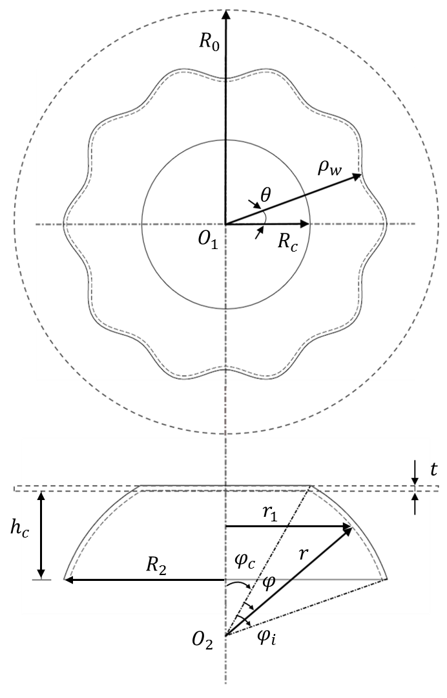
Figure 5.1 Schematic diagram of the wrinkled spun component
According to the simplification of the deformation theory for thin shells proposed by Mushtari-Donnell-Vlazov (80), and considering the displacements of a wrinkling free spun component, the displacements of wrinkled model $u$ and$v$ in the Equation 5.4 representing the changes of curvature and twist are neglected. Therefore, the displacements of wrinkled model of the local coordinate directions are expressed as:
$$\left\{\begin{aligned}u=0 \\ v=0 \\ w=ω\end{aligned}\right.$$
Equation 5.5
The smooth middle surface of the workpiece in the curvilinear coordinate system, as shown in Figure 4.22, can be determined in the Cartesian coordinate system, by the following three equations:
$$\left\{\begin{aligned}&X=r∙sin\left(φ+φ_{c}\right)∙cosθ \\ &Y=r∙cos\left(φ+φ_{c}\right) \\ &Z=r∙sin\left(φ+φ_{c}\right)∙sinθ\end{aligned}\right. \left(φ∈\left[0,φ_{c}\right], θ∈\left[0,2π\right]\right)$$
Equation 5.6
Therefore, the derivatives of$X, Y, Z$ in the global Cartesian coordinates with respect to $r, φ, θ$ in the curvilinear coordinate system can be decomposed into:
$$\left\{\begin{aligned}\frac{∂X}{∂r}&=sin\left(φ+φ_{c}\right)∙cosθ \\ \frac{∂X}{∂θ}&=-r∙sin\left(φ+φ_{c}\right)∙sinθ \\ \frac{∂X}{∂φ}&=r∙cos\left(φ+φ_{c}\right)∙cosθ\end{aligned}\right.$$
$$\left\{\begin{aligned}\frac{∂Y}{∂r}&=cos\left(φ+φ_{c}\right) \\ \frac{∂Y}{∂θ}&=0 \\ \frac{∂Y}{∂φ}&=-r∙sin\left(φ+φ_{c}\right)\end{aligned}\right.$$
$$\left\{\begin{aligned}\frac{∂Z}{∂r}&=sin\left(φ+φ_{c}\right)∙sinθ \\ \frac{∂Z}{∂θ}&=r∙sin\left(φ+φ_{c}\right)∙cosθ \\ \frac{∂Z}{∂φ}&=r∙cos\left(φ+φ_{c}\right)∙sinθ\end{aligned}\right.$$
Equation 5.7
In Equation 5.4, the Lamé coefficients $A$ and $B$ in the curvilinear coordinate system corresponding to $φ$ and $θ$, which can be respectively calculated:
$$A={\left[{\left(\frac{∂X}{∂φ}\right)}^{2}+{\left(\frac{∂Y}{∂φ}\right)}^{2}+{\left(\frac{∂Z}{∂φ}\right)}^{2}\right]}^{-0.5} \\ =r∙{\left[\cos^{2}\left(φ+φ_{c}\right)\cos^{2}θ+\cos^{2}\left(φ+φ_{c}\right)\sin^{2}θ+\sin^{2}\left(φ+φ_{c}\right)\right]}^{-0.5} \\ =r$$
$$B={\left[{\left(\frac{∂X}{∂θ}\right)}^{2}+{\left(\frac{∂Y}{∂θ}\right)}^{2}+{\left(\frac{∂Z}{∂θ}\right)}^{2}\right]}^{-0.5} \\ =r∙{\left[\sin^{2}\left(φ+φ_{c}\right)\sin^{2}θ+\sin^{2}\left(φ+φ_{c}\right)\cos^{2}θ\right]}^{-0.5} \\ =r∙sin\left(φ+φ_{c}\right) \\ =r_{1}$$
Equation 5.8
By substituting Equation 5.3, Equation 5.5 and Equation 5.8 into Equation 5.4, the strain components and parameters of the wrinkled model can be written as:
$$\left\{\begin{aligned}&ε_{φ}=\frac{ω}{r} \\ &ε_{θ}=\frac{ω}{r_{1}} \\ &γ_{φθ}=0 \\ &κ_{φ}=-\frac{1}{r}\frac{∂^{2}ω}{{∂φ}^{2}}-\frac{ω}{r^{2}} \\ &κ_{θ}=-\frac{1}{{r_{1}}^{2}}\frac{∂^{2}ω}{{∂θ}^{2}}-\frac{cos\left(φ+φ_{c}\right)}{rr_{1}}\frac{∂ω}{∂φ}-\frac{ω}{{r_{1}}^{2}} \\ &χ=-\frac{1}{rr_{1}}\frac{∂^{2}ω}{∂φ∂θ}+\frac{cos\left(φ+φ_{c}\right)}{{r_{1}}^{2}}\frac{∂ω}{∂θ}\end{aligned}\right.$$
Equation 5.9
The amplitude of the wrinkling wave, $s$, at the edge of the wrinkled model, is an independent parameter of $φ$ and $θ$. It can be determined by substituting $φ=φ_{i}$ into Equation 5.3. Under this specific condition, the wave function represents the wrinkling waves along the circumferential direction at the outer edge of the workpiece, as shown in Figure 4.24 (a), and the wave function changes into:
$$ω_{{φ=φ}_{i}}=s∙\left[cos\left(mθ\right)-1\right]$$
Equation 5.10
As shown in Figure 5.1, the varied radius, $ρ_{w}$, of the wrinkled model along the direction perpendicular to the rotation axis can be written using:
$$ρ_{w}=R_{2}+s∙\left[cos\left(mθ\right)-1\right]=R_{2}+ω_{{φ=φ}_{i}} \left(ρ_{w}≤R_{2}\right)$$
Equation 5.11
If the circumradius of the wrinkled model is defined as 1, then the varied radius of this wrinkled model, ${ρ_{w}}^{'}$, and the edge perimeter of this unit wrinkled model, ${L_{w}}^{'}$, can be respectively calculated by:
$${ρ_{w}}^{'}=1+\frac{s∙\left[cos\left(mθ\right)-1\right]}{R_{2}}=1+\frac{ω_{{φ=φ}_{i}}}{R_{2}} \left({ρ_{w}}^{'}≤1\right)$$
and
$${L_{w}}^{'}=\int_{0}^{2π}{\sqrt{1+{\left(\frac{1}{R_{2}}∙\frac{∂ω_{{φ=φ}_{i}}}{∂θ}\right)}^{2}}}dθ$$
Equation 5.12
Based on this condition, the edge perimeter of the original wrinkled spun component, $L_{w}$, and the perimeter of the outer edge of the wrinkling free component, $L_{s}$, can be obtained by:
$$L_{w}=\int_{0}^{2π}{R_{2}}\sqrt{1+{\left(\frac{1}{R_{2}}∙\frac{∂ω_{{φ=φ}_{i}}}{∂θ}\right)}^{2}}dθ$$
and
$$L_{s}=\int_{0}^{2π}{R_{2}dθ}$$
Equation 5.13
Therefore, the length of wrinkle waves, $∆l_{φ_{i}}$, at the edge of the wrinkled model along the circumferential direction after the first-pass conventional spinning process can be calculated using:

$$∆l_{φ_{i}}={L_{w}-L}_{s} \\ =\int_{0}^{2π}{R_{2}}∙\sqrt{1+{\left(\frac{1}{R_{2}}\frac{∂ω_{{φ=φ}_{i}}}{∂θ}\right)}^{2}}dθ -\int_{0}^{2π}{R_{2}}dθ$$
Equation 5.14
By utilizing the Taylor equation, Equation 5.14 can be expanded as:
$$∆l_{φ_{i}}≈R_{2}\int_{0}^{2π}{\left[1+\frac{1}{2}{\left(\frac{1}{R_{2}}\frac{∂ω_{{φ=φ}_{i}}}{∂θ}\right)}^{2}\right]dθ-}R_{2}\int_{0}^{2π}{dθ} \\ =\frac{1}{2R_{2}}\int_{0}^{2π}{{\left(\frac{∂ω_{{φ=φ}_{i}}}{∂θ}\right)}^{2}dθ} \\ =\frac{πs^{2}m^{2}}{2R_{2}}$$
Equation 5.15
Furthermore, the difference of the perimeters at the edge of the undeformed model and the wrinkled model is assumed to be equal to $∆l_{φ_{i}}$. The length of the wrinkle waves $∆l_{φ_{i}}$ can be further calculated by:
$$∆l_{φ_{i}}=2πR_{0}-2πR_{2}$$
Equation 5.16
Therefore, the amplitude of wrinkle waves, $s$, can be calculated by combining Equation 5.15 and Equation 5.16:
$$s=\frac{2\sqrt{R_{2}\left(R_{0}-R_{2}\right)}}{m}$$
Equation 5.17

Wrinkling Prediction Based on Energy Conservation

Strain Energy of Wrinkled Spun Component
As reviewed in Chapter 2, the strain energy $U$ required for a workpiece can be calculated by Equation 5.18.
$$U=\frac{t}{2}\iint{\frac{E_{s}}{1-υ^{2}}}\left({\left(ε_{θ}+ε_{φ}\right)}^{2}+2\left(1-υ\right)\left(\frac{1}{4}γ_{θφ}-ε_{θ}ε_{φ}\right)\right)ABdθdφ$$
$$+\frac{t^{3}}{24}\iint{\frac{E_{r}}{1-υ^{2}}}\left({\left(κ_{1}{+κ}_{2}\right)}^{2}+2\left(1-υ\right)\left(χ^{2}-κ_{θ}κ_{φ}\right)\right)ABdθdφ$$
Equation 5.18
where: $t$ is the thickness of the workpiece without considering any thickness variation; $υ$ is the Poisson’s ratio without considering material anisotropic behaviour; $E_{s}$, $E_{r}$ and $E_{t}$ are the secant modulus, reduced modulus and tangent modulus, respectively, as expressed by
$$\left\{\begin{aligned}&E_{s}=\frac{\overline{σ}}{\overline{ε}} \\ &E_{t}=\frac{d\overline{σ}}{d\overline{ε}} \\ &E_{r}=\frac{4EE_{t}}{\left(\sqrt{E}+\sqrt{E_{t}}\right)}\end{aligned}\right.$$
Equation 5.19
As the strain state of the workpiece during conventional spinning is assumed to be plane strain condition, and the material constitutive is followed by the power law. Thus, the equivalent strain and the equivalent stress can be respectively expressed as:
$$\left\{\begin{aligned}&\overline{ε}=\frac{2}{\sqrt{3}}ε_{φ} \\ &\overline{σ}=K{\overline{ε}}^{n}\end{aligned}\right.$$
Equation 5.20
Substituting Equation 5.9 into Equation 5.18 results in:

$$U=\frac{1}{2}\iint{\frac{tE_{s}}{1-υ^{2}}}∙\left(\frac{1}{{r_{1}}^{2}}+\frac{1}{r^{2}}+\frac{2υ}{r_{1}r}\right)ω^{2}r_{1}rdφdθ \\ +\frac{1}{24}\iint{\frac{t^{3}E_{r}}{1-υ^{2}}}{∙\left(\frac{1}{{r_{1}}^{2}}\frac{∂^{2}ω}{∂θ^{2}}+\frac{cos\left(φ+φ_{c}\right)}{r_{1}r}\frac{∂ω}{∂φ}+\frac{ω}{{r_{1}}^{2}}\right)}^{2}+{\left(\frac{1}{{r_{2}}^{2}}\frac{∂^{2}ω}{∂φ^{2}}+\frac{ω}{r^{2}}\right)}^{2}+2υ∙\left(\frac{1}{{r_{1}}^{2}}\frac{∂^{2}ω}{∂θ^{2}}+\frac{coscos\left(φ+φ_{c}\right)}{r_{1}r}\frac{∂ω}{∂φ}+\frac{ω}{{r_{1}}^{2}}\right)∙\left(\frac{1}{r^{2}}\frac{∂^{2}ω}{∂φ^{2}}+\frac{ω}{r^{2}}\right)$$
$$+2\left(1-υ\right)∙{\left(\frac{1}{r_{1}r}\frac{∂^{2}ω}{∂θ∂φ}-\frac{cos\left(φ+φ_{c}\right)}{{r_{1}}^{2}}\frac{∂ω}{∂θ}\right)}^{2}r_{1}rdθdφ$$
Equation 5.21
By substituting Equation 5.3 into Equation 5.21, the strain energy $U$ required for the workpiece to be wrinkled can be written using:
$$U=s^{2}∙\left(K_{1}m^{4}+K_{2}m^{2}+K_{3}\right)$$
Equation 5.22
Where:
$$K_{1}=-\frac{E_{r}π}{48\left(1-υ^{2}\right)}∙\int_{0}^{φ_{i}}{\frac{t^{3}r}{{r_{1}}^{3}}}∙\left[cos\left(\frac{πφ}{φ_{i}}\right)-1\right]dφ$$
$$K_{2}=-\frac{E_{r}t^{3}}{24\left(1-υ^{2}\right)}\int_{0}^{φ_{i}}{\frac{π^{2}(3-2υ)sin\left(\frac{πφ}{φ_{i}}\right)cos\left(φ+φ_{c}\right)}{2{r_{1}}^{2}φ_{i}}+\frac{πr\left[cos\left(\frac{πφ}{φ_{i}}\right)-1\right]\left[1-\left(1-υ\right)\cos^{2}\left(φ+φ_{c}\right)\right]}{{r_{1}}^{3}}+\frac{υπ\left(cos\left(\frac{πφ}{φ_{i}}\right)-1\right)}{r_{1}r}}+ \\ +\frac{π^{3}\left[2(1-υ)\right]\cos^{2}\left(\frac{πφ}{2φ_{i}}\right)-\left(cos\left(\frac{πφ}{φ_{i}}\right)-1\right)}{4r_{1}r{φ_{i}}^{2}}+\frac{υπ\left(cos\left(\frac{πφ}{φ_{i}}\right)-1\right)}{r_{1}r}dφ$$

$$K_{3}= \\ \frac{E_{r}t^{3}}{24\left(1-υ^{2}\right)}\int_{0}^{φ_{i}}{\frac{3π^{3}\cos^{2}\left(\frac{πφ}{2φ_{i}}\right)\cos^{2}\left(φ+φ_{c}\right)+3π\left(cos\left(\frac{πφ}{φ_{i}}\right)-1\right)+3π^{2}v\left(cos\left(\frac{πφ}{φ_{i}}\right)-1\right)}{4r_{1}r{φ_{i}}^{2}}+\frac{3π^{2}sin\left(\frac{πφ}{2φ_{i}}\right)cos\left(φ+φ_{c}\right)}{2{r_{1}}^{2}φ_{i}}-\frac{3πr\left(cos\left(\frac{πφ}{φ_{i}}\right)-1\right)}{2{r_{1}}^{3}}-\frac{3π^{5}r\left(cos\left(\frac{πφ}{φ_{i}}\right)-1\right)}{32{r_{1}}^{3}{φ_{i}}^{4}}-\frac{3πr\left(cos\left(\frac{πφ}{φ_{i}}\right)-1\right)}{2r^{3}}-\frac{3π^{4}vsin\left(\frac{πφ}{φ_{i}}\right)cos\left(φ+φ_{c}\right)}{8r^{2}{φ_{i}}^{3}}}+\frac{3π^{2}vsin\left(\frac{πφ}{φ_{i}}\right)cos\left(φ+φ_{c}\right)}{2r^{2}φ_{i}}-\frac{3πυ\left(cos\left(\frac{πφ}{φ_{i}}\right)-1\right)}{r_{1}r}dφ+\frac{3πE_{s}}{2\left(1-υ^{2}\right)}\int_{0}^{φ_{i}}{tr_{1}r\left(\frac{1}{{r_{1}}^{2}}+\frac{1}{r^{2}}+\frac{2υ}{r_{1}r}\right)\sin^{2}\left(\frac{πφ}{2φ_{i}}\right)dφ}$$
Equation 5.23
When $∂U/∂m=0$, the critical number of waves of the wrinkled spun component, $m_{c}$ can be obtained by
$$m_{c}=\sqrt[4]{\frac{K_{3}}{K_{1}}}$$
Equation 5.24
Therefore, the minimum strain energy for the workpiece to wrinkle, $U_{min}$, can be determined by
$$U_{min}=4R_{2}∙\left(R_{0}-R_{2}\right)∙\left(K_{1}{m_{c}}^{2}+K_{2}+\frac{K_{3}}{{m_{c}}^{2}}\right)$$
Equation 5.25

External Work Done by Forming Tool
During the first-pass conventional spinning process, the diameter of the spun component is continuously reduced resulting in the circumferential compressive stresses of the deformed workpiece. The wrinkles start to appear near the edge of the workpiece, as lack of the contact with roller and mandrel. During the spinning process, the thickness is assumed to remain unchanged.
Considering the principal strain state as plane strain condition, the principal strains and principal stresses of the workpiece can be determined as:
$$\left\{\begin{aligned}ε_{1}=ε_{φ}; ε_{2}=ε_{t}=0; ε_{3}=ε_{θ} \\ σ_{1}=σ_{φ}; σ_{2}=σ_{t}=\frac{σ_{φ}+σ_{θ}}{2}; σ_{3}=σ_{θ}\end{aligned}\right.$$
Equation 5.26
where, $ε_{φ}$, $ε_{θ}$, $ε_{t}$ and $σ_{φ}$, $σ_{θ}$, $σ_{t}$ are the meridional, circumferential, and thickness strains and stresses of an arbitrary point located on the workpiece, respectively.
Figure 5.2 illustrates the deformed geometry of the workpiece after the first-pass conventional spinning. Due to the strain state of the deformed workpiece is assumed to be plane strain condition, and the workpiece shrinking occurs in the circumferential direction after the spinning process, as a result, the length of the workpiece along the meridional direction is elongated compared with the original workpiece radius.
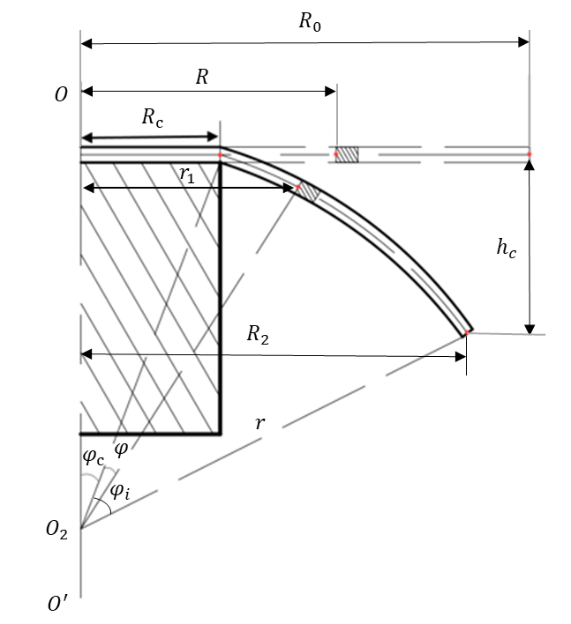
Figure 5.2 Illustration of the location of an infinitesimal element on the workpiece before and after deformation
For an arbitrary infinitesimal element of the workpiece, $R$ and $r_{1}$ which are the distances of this element from the rotation axis to the edge of the element before and after the first-pass conventional process, can be calculated by the following steps: According to the volume consistency, the total volume of the deformed workpiece without the clamed area, $V_{1}$, should be equal to the volume of the workpiece before deformation, $V_{0}$. The volume of the workpiece before deformation can be defined as:
$$V_{0}=t∙\left(π{R_{0}}^{2}-π{R_{c}}^{2}\right)$$
Equation 5.27
For a wrinkling free spun component, after spinning, the flat workpiece is transformed into a truncated cone shape, as shown in Figure 4.23 (a), in which $R_{c}$ donates its top surface radius, while its base radius and the generatrix are defined as $R_{2}$ and $rφ_{i}$, respectively. Because the thickness of the spun component is assumed to remain unchanged throughout the spinning process, the volume of the spun component can be calculated by the thickness of the workpiece, $t$, multiplies with the surface area of the truncated cone, $S_{c}$:
$$V_{1}=t∙S_{c}$$
Equation 5.28
where the surface area of the truncated cone, $S_{c}$, can be calculated by:
$$S_{c}=π(R_{c}+R_{2})∙rφ_{i}$$
Equation 5.29
By substituting Equation 5.29 into Equation 5.28, and let $V_{0}=V_{1}$,
$$rφ_{i}=\frac{{R_{0}}^{2}-{R_{c}}^{2}}{\left(R_{c}+R_{2}\right)}$$
Equation 5.30
Thus, the original radius of the workpiece $R_{0}$ can be obtained as:

$$R_{0}=\sqrt{rφ_{i}∙\left(R_{c}+R_{2}\right)-{R_{c}}^{2}}$$
Equation 5.31
Similarly, for an arbitrary infinitesimal element of the workpiece, after the spinning process, the base radius of this small truncated cone shape becomes to$r_{1}$ and the generatrix of it is defined as $rφ$, while the radius of the top surface remains the same as $R_{c}$. Thus, the location,$R$, from the rotation axis of the workpiece to this element before spinning can be written as:
$$R=\sqrt{rφ∙\left(R_{c}+r_{1}\right)-{r_{1}}^{2}}$$
Equation 5.32
Due to the volume consistency of the workpiece, from Equation 5.26, the relationship between meridional strain and circumferential strain can be written as:
$$ε_{φ}+ε_{θ}=0$$
Equation 5.33
Therefore, the equivalent strain $\overline{ε}$ resulted from the circumferential shrinkage of the workpiece can be written as:
$$\overline{ε}=\frac{\sqrt{2}}{3}\sqrt{{\left(ε_{φ}-ε_{θ}\right)}^{2}+{\left(ε_{θ}-ε_{t}\right)}^{2}+{\left(ε_{t}-ε_{φ}\right)}^{2}}=-\frac{2}{\sqrt{3}}ε_{θ}=\frac{2}{\sqrt{3}}ε_{φ}$$
Equation 5.34
The stresses acting on an infinitesimal element in a wrinkled free spun component are illustrated in Figure 5.3. Due to the thickness stress is perpendicular to the meridional stress $σ_{φ}$ and circumferential stress $σ_{θ}$, the equilibrium condition of the infinitesimal element in the meridional direction can be expressed as presented in Equation 5.35:
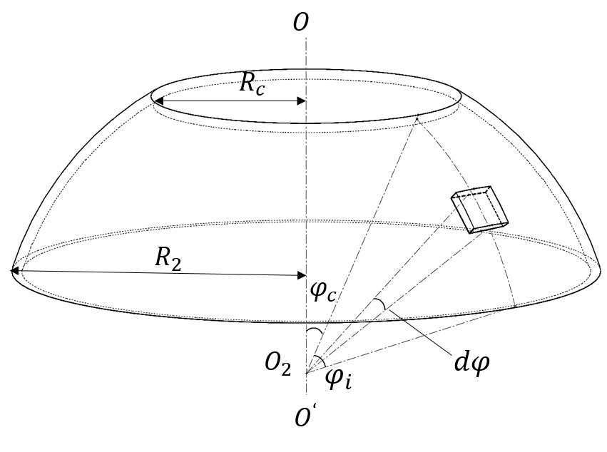
(a)
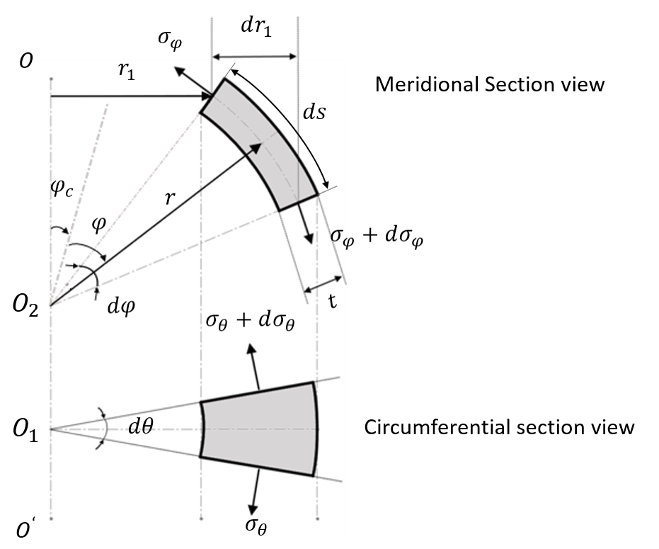
(b)
Figure 5.3 Illustration of stress states of an infinitesimal element on the wrinkling free spun component: (a) location of the infinitesimal element, (b) stresses of this infinitesimal element
$$\left(σ_{φ}+dσ_{φ}\right)∙\left(r_{1}+dr_{1}\right)∙t∙dθ-σ_{φ}∙r_{1}∙t∙dθ-σ_{θ}∙t∙ds∙dθ∙cos(φ+φ_{c})=0$$
Equation 5.35
The length of the element along the meridional direction is $ds=r∙dφ,$ from Figure 5.3 (b), the following geometrical relation can be established:
$$dr_{1}=r∙dφ∙cos\left(φ+φ_{c}\right)$$
Equation 5.36
Taking this into Equation 5.35 and neglecting the higher order terms, Equation 5.35 is reduced to:
$$r_{1}∙dσ_{φ}+\left(σ_{φ}-σ_{θ}\right)∙dr_{1}=0$$
Equation 5.37
Applying the von Mises yield criterion, the equivalent stress is expressed as
$$\overline{σ}=\frac{1}{\sqrt{2}}\sqrt{{\left(σ_{φ}-σ_{θ}\right)}^{2}+{\left(σ_{θ}-σ_{t}\right)}^{2}+{\left(σ_{t}-σ_{φ}\right)}^{2}}$$
Equation 5.38
Considering $σ_{t}=\frac{σ_{φ}+σ_{θ}}{2}$ given in Equation 5.26, therefore:
$$σ_{φ}-σ_{θ}=\frac{2}{\sqrt{3}}\overline{σ}$$
Equation 5.39
By substituting Equation 5.39 into Equation 5.37
$$r_{1}∙dσ_{φ}+\frac{2}{\sqrt{3}}\overline{σ}∙dr_{1}=0$$
Equation 5.40
Therefore
$$dσ_{φ}=-\frac{2}{\sqrt{3}}\overline{σ}∙\frac{dr_{1}}{r_{1}}$$
Equation 5.41
Thus, the meridional stress of the deformed workpiece can be determined by:
$$σ_{φ}=-\frac{2}{\sqrt{3}}\overline{σ}∙\int{\frac{dr_{1}}{r_{1}}}$$
Equation 5.42
By integration, Equation 5.42 can be written as:
$$σ_{φ}=-\frac{2}{\sqrt{3}}\overline{σ}∙\ln{r_{1}}+c$$
Equation 5.43
where $c$ is the integration constant. When $r_{1}=R_{2}$, at the outer edge of the workpiece, as it is a free surface, the meridional stress component can be considered as $σ_{φ}=0$. By taking this boundary condition into Equation 5.43, the meridional stress $σ_{φ}$ for an arbitrary element located in the deformed workpiece can be expressed as:
$$σ_{φ}=\frac{2}{\sqrt{3}}\overline{σ}∙\ln{\frac{R_{2}}{r_{1}}}$$
Equation 5.44
Therefore, by utilizing Equation 5.44 and Equation 5.39, the compressive circumferential stress $σ_{θ}$ component of the deformed workpiece can be drawn as:
$$σ_{θ}=\frac{2}{\sqrt{3}}\overline{σ}∙\left(1-\ln{\frac{R_{2}}{r_{1}}}\right)$$
Equation 5.45
Considering the shrinking effect of the workpiece in circumferential direction during spinning process and the thickness of the workpiece remains the same throughout the deformation process, for an arbitrary element in the deformed workpiece, the circumferential strain, $ε_{θ}$, can be calculated by:
$$ε_{θ}=\ln\left(\frac{r_{1}}{\sqrt{{R_{C}}^{2}+\left(R_{C}+r_{1}\right)∙rφ}}\right)$$
Equation 5.46
According to Equation 5.33, the meridional strain $ε_{φ}$ can be written as:
$$ε_{φ}=\ln\left(\frac{\sqrt{{R_{C}}^{2}+\left(R_{C}+r_{1}\right)∙rφ}}{r_{1}}\right)$$
Equation 5.47
By substituting Equation 5.47 into Equation 5.34, the effective strain can be calculated as:
$$\overline{ε}=-\frac{2}{\sqrt{3}}ε_{θ}=\frac{2}{\sqrt{3}}ε_{φ}=\frac{2}{\sqrt{3}}∙\ln\left(\frac{\sqrt{{R_{C}}^{2}+\left(R_{C}+r_{1}\right)∙rφ}}{r_{1}}\right)$$
Equation 5.48
If the material constitutive equation $\overline{σ}=K{∙\overline{ε}}^{ n}$ is employed in the analysis, by substituting Equation 5.48 into Equation 5.44 and Equation 5.45, then:

$$\left\{\begin{aligned}σ_{φ}=C_{0}∙{\left(\ln\left(\frac{\sqrt{{R_{C}}^{2}+\left(R_{C}+r_{1}\right)∙rφ}}{r_{1}}\right)\right)}^{n}∙\ln{\frac{R_{2}}{r_{1}}} \\ σ_{θ}=C_{0}∙{\left(\ln\left(\frac{\sqrt{{R_{C}}^{2}+\left(R_{C}+r_{1}\right)∙rφ}}{r_{1}}\right)\right)}^{n}∙\left(1-\ln{\frac{R_{2}}{r_{1}}}\right)\end{aligned}\right.$$
Equation 5.49
where $C_{0}={K∙\left(2/\sqrt{3}\right)}^{n+1}$ is a constant for a given material.
The circumferential shrink of the workpiece is considered to be the major cause of wrinkling failure during spinning process. For an infinitesimal element located in the deformed workpiece, as shown in Figure 5.3, the area, $∆S$, of this element on the circumferential direction can be expresses as:

$$∆S=r∙dφ∙t$$
Equation 5.50
The compressive force acted on the surface of this element in the circumferential direction can be calculated by:
$$∆F_{θ}=\left|σ_{θ}\right|∙∆S=\left|σ_{θ}\right|∙r∙t∙dφ$$
Equation 5.51
The distance along the circumferential direction through which the compressive force causes the workpiece to shrink from undeformed state to deformed state can be expresses by:
$$∆L_{θ}=2∙π∙\sqrt{{R_{C}}^{2}+\left(R_{C}+r_{1}\right)∙rφ}-2∙π∙r_{1} \\ =2∙π∙\left(\sqrt{{R_{C}}^{2}+\left(R_{C}+r_{1}\right)∙rφ}-r_{1}\right)$$
Equation 5.52
Therefore, the external work done by the roller during the deformation process of the wrinkling free component can be calculated by:
$$T=\int{∆F_{θ}}∙∆L_{θ} \\ =\int_{0}^{φ_{i}}{\left|σ_{θ}\right|}∙r∙t∙2∙π∙\left(\sqrt{{R_{C}}^{2}+\left(R_{C}+r_{1}\right)∙rφ}-r_{1}\right)dφ \\ =2πr∙t\int_{0}^{φ_{i}}{C_{0}∙\left|{\left(\ln\left(\frac{\sqrt{{R_{C}}^{2}+\left(R_{C}+r∙sin(φ+φ_{c})\right)rφ}}{r∙sin(φ+φ_{c})}\right)\right)}^{n}∙\left(1-\ln{\frac{r∙sin(φ_{i}+φ_{c})}{r∙sin(φ+φ_{c})}}\right)\right|}∙\left(\sqrt{{R_{C}}^{2}+\left(R_{C}+r∙sin(φ+φ_{c})\right)∙rφ}-r∙sin(φ+φ_{c})\right)dφ$$
Equation 5.53
Feed ratio $f$ is one of the important parameters of conventional spinning process. In conventional spinning process using a convex toolpath profile, the roller feed direction is defined as along the designed toolpath profile from clamped area to the edge of the workpiece. Consequently, the distance of roller feed movement during a single rotation of the workpiece can be obtained.
$$f∙1=r∙dφ$$
Equation 5.54
Thus, the total number of rotations of the workpiece, $N_{0}$, for completing the first-pass spinning process, can be calculated by:
$$N_{0}=\frac{r∙φ_{i}}{f}$$
Equation 5.55
Similarly, as shown in Figure 5.3 (b), for an arbitrary element of the deformed workpiece, the number of rotations of the workpiece, $N_{k} (N_{k}≤N_{0})$, which is the required number of rotations to deform the workpiece till the specific location of this element, can be expressed as:
$$\left\{\begin{aligned}N_{k}=\frac{r∙φ}{f} \\ r_{1}=r∙sin(\frac{N_{k}∙f}{r}+φ_{c})\end{aligned}\right.$$
Equation 5.56
Accordingly, the compressive circumferential stress $σ_{θ}$ can be further written as:
$$σ_{θ}=C_{0}∙{\left(\ln\left(\frac{\sqrt{{R_{C}}^{2}+\left(R_{C}+r∙sin(\frac{N_{k}∙f}{r}+φ_{c})\right)N_{k}∙f}}{r∙sin(\frac{N_{k}∙f}{r}+φ_{c})}\right)\right)}^{n}∙\left(1-\ln{\frac{r∙sin(\frac{N_{0}∙f}{r}+φ_{c})}{r∙sin(\frac{N_{k}∙f}{r}+φ_{c})}}\right)$$
Equation 5.57
Thus, the external work done by the roller, Equation 5.53 can be also written as:
$$T=2π∙t∙f∙\int_{0}^{N_{0}}{C_{0}∙\left|{\left(\ln\left(\frac{\sqrt{{R_{C}}^{2}+\left(R_{C}+r∙sin(\frac{N_{k}∙f}{r}+φ_{c})\right)N_{k}∙f}}{r∙sin(\frac{N_{k}∙f}{r}+φ_{c})}\right)\right)}^{n}\right.∙\left.\left(1-\ln{\frac{r∙sin(\frac{N_{0}∙f}{r}+φ_{c})}{r∙sin(\frac{N_{k}∙f}{r}+φ_{c})}}\right)\right|}∙\left(\sqrt{{R_{C}}^{2}+\left(R_{C}+r∙sin(\frac{N_{k}∙f}{r}+φ_{c})\right){∙N}_{k}∙f}-r∙sin(\frac{N_{k}∙f}{r}+φ_{c})\right)dN_{k}$$
Equation 5.58

Wrinkling Limit
Based on the energy method, the minimum strain energy of wrinkled spun component, $U_{min}$, and the external work done by the circumferential compressive force loading on the wrinkling free spun component, $T$, are calculated respectively. If the external work done, $T$, is smaller than the minimum strain energy, $U_{min}$, the equilibrium of the double curve surface is stable, which leads a wrinkling free spun component. Otherwise, the condition is unstable, and wrinkles start to be appeared in the deforming workpiece. Therefore, the critical condition to generate a wrinkling free spun component can be obtained by solving the equation:
$$T=U_{min}$$
$$2πr∙t\int_{0}^{φ_{i}}{C_{0}∙\left|{\left(\ln\left(\frac{\sqrt{{R_{C}}^{2}+\left(R_{C}+r∙sin(φ+φ_{c})\right)rφ}}{r∙sin(φ+φ_{c})}\right)\right)}^{n}∙\left(1-\ln{\frac{r∙sin(φ_{i}+φ_{c})}{r∙sin(φ+φ_{c})}}\right)\right|}∙\left(\sqrt{{R_{C}}^{2}+\left(R_{C}+r∙sin(φ+φ_{c})\right)∙rφ}-r∙sin(φ+φ_{c})\right)dφ=4R_{2}\left(R_{0}-R_{2}\right)\left(K_{1}{m_{c}}^{2}+K_{2}+\frac{K_{3}}{{m_{c}}^{2}}\right)$$
Equation 5.59
Figure 5.4 shows the flow chart illustrating the process of numerical calculation of the critical forming depth, $h_{c}$, at which the wrinkles would not be initiated during the first-pass conventional spinning process using a convex toolpath profile. The Bisection method, which is a root-finding method (93), is employed for the calculation of path curvature, $r$, from the upper limit of path curvature $r_{f}$ and lower limit of path curvature $r_{s}$, when the critical condition of $T=U_{min}$ is met. Therefore, the critical forming depth, $h_{c}$, of the first-pass convention spinning process, as shown in Figure 5.2, can be calculated by:
$$h_{c}=\sqrt{{\left(2∙r∙sin\left(\frac{φ_{i}}{2}\right)\right)}^{2}{-\left(r∙sin\left(φ_{c}+φ_{i}\right)-R_{c}\right)}^{2}}$$
Equation 5.60
The process of calculating the critical condition of wrinkling failure during the first-pass conventional spinning process is outlined in the following steps:
(A) To input the values of material properties, including Poisson ratio $υ$, Young’s Modulus $E$, Strength coefficient $K$ and Strain-hardening index $n$, and the radius of clamped area of the workpiece, $R_{c}$.
(B) To initialise the interval with an upper limit $r_{f}$ and lower limit $r_{s}$ ($r_{s}≤r≤r_{f}$) according to the workpiece dimension.
(C) To calculate the initial value of meridional radius $r={\left(r_{s}+r_{f}\right)}/2$, and to calculate the strain energy $U$ and the external work done by the roller $T$.
(D) To determine if $U-T=0$ is satisfied. If yes, then to output the critical geometrical parameters of the workpiece ($r,φ_{c},φ_{i}$), to calculate the critical forming depth using these parameters and the calculation is ended. If $U-T≠0$, and $∆U>T$, then replace $r_{s}$ with $r$ and return to step (B) to select the subinterval to be used in the next iteration of calculations. However, if $U-T≠0$, and $U<T$, then replace $r_{f}$ with $r$ and return to step (B) to continue the calculation until the convergence is reached.
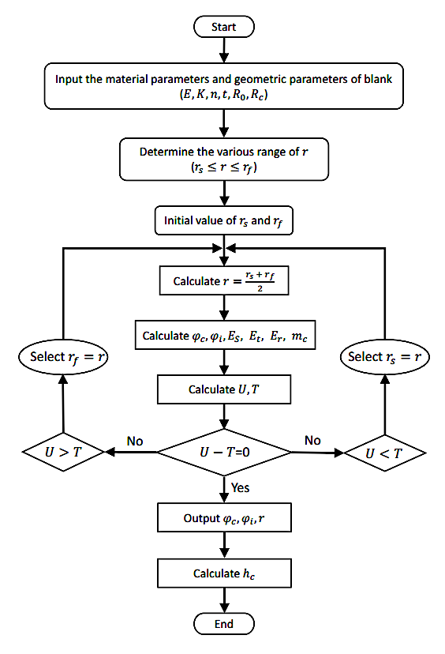
Figure 5.4 Flow chart of the numerical calculation of the wrinkling limit

Results and Discussion

Analysis of Effect of Material Properties on Wrinkling
The workpiece material of the DC01, AA5052 and AA1050 were assumed to be homogeneous and isotropic. The radius and thickness of each material tested in wrinkling prediction model were 50 $mm$ and 1.2 $mm$, respectively. The material parameters are listed in Table 5.1. The material properties were determined by the tensile test using an extension rate of 1.00 $mm/min$. The workpieces were cut from the sheet received using a wire Electrical Discharge Machining (EDM) process. The dimensions of the workpieces were in accordance with the standard test method for tensile testing as detailed in the ASTM standard.
Table 5.1 Material properties of DC01, AA5052 and AA1050
 | DC01 | AA5052 | AA1050
Young’s modulus $E$ ($GPa$) | 198.2 | 70 | 62.19
Poisson ratio $υ$ | 0.3 | 0.33 | 0.33
Strength coefficient $K$ ($MPa$) | 481.7 | 296.12 | 143.67
Strain-hardening index $n$ | 0.217 | 0.118 | 0.061

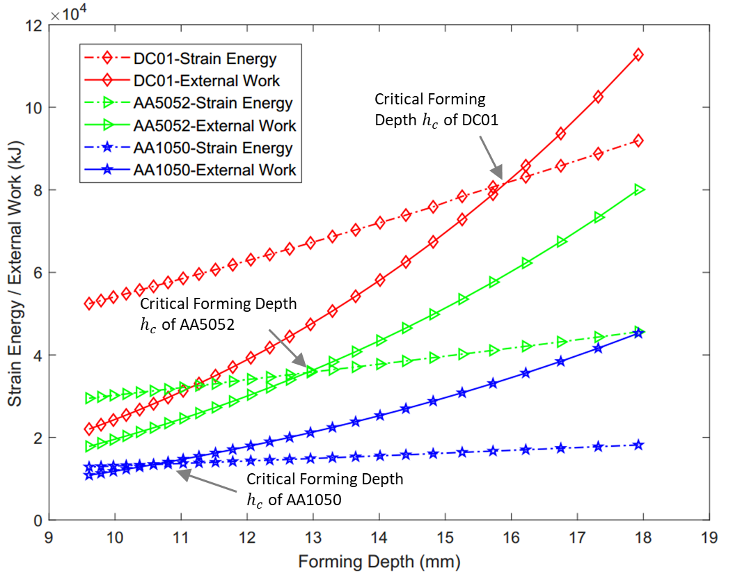
Figure 5.5 The critical forming depth of first-pass using a convex toolpath profile ($R_{0}=50 mm$, $R_{C}=20 mm$, $t=1.2mm$)
As can be seen in Figure 5.5, when the forming depth of the first-pass is increased, both strain energy and external work are increased gradually. The developed MATLAB program can be seen in Appendix 1. The wrinkling failure may occur if the designed forming depth is greater than the critical forming depth $h_{c}$ which results in the required external work done by the spinning roller is greater than the strain energy of material deformation. Moreover, among these three materials, under the same process parameters, using material DC01 can produce the highest critical forming depth, while using AA1050 can produce the lowest wrinkling limit. To illustrate the deformation of the workpiece when reaching the critical forming depth, the geometries of the workpieces using different materials were produced based on the results of the developed wrinkling prediction model, as shown in Figure 5.6. The position of $h_{c,1},h_{c,2}$ and $h_{c,3}$ represents the critical forming depth of the workpiece made by AA1050, AA5052 and DC01, respectively.
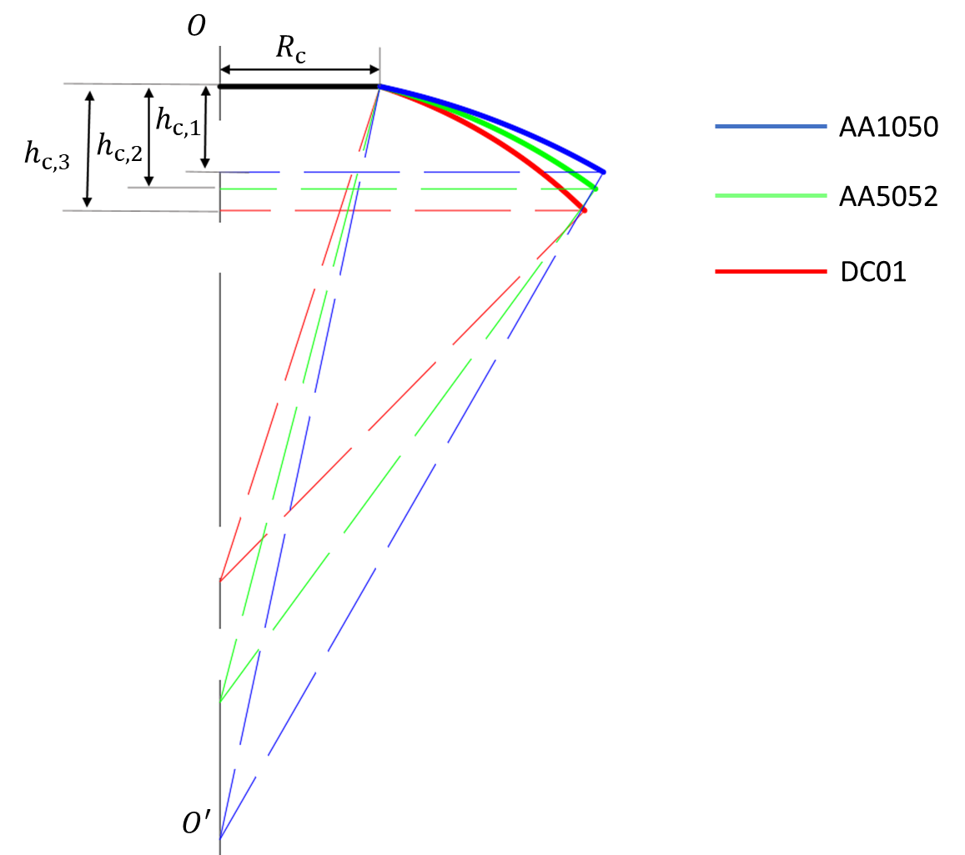
Figure 5.6 Illustration of the predicted critical forming depth of three materials ($R_{0}=50 mm$, $R_{C}=20 mm$, $t=1.2mm$)
The effect of Young’s modulus$E$ on the critical forming depth of the first-pass conventional spinning is presented in Figure 5.7. The Young’s modulus varied from 45 $GPa$ and 220 $GPa$ for some typical metals and alloys, such as magnesium (45 $GPa$), AA1050, AA5052 aluminium alloys (60-70 $GPa$), Titanium alloys (105-120 $GPa$) and DC01 steel (200 $GPa$) (94). Therefore, the value of Young’s modulus $E$ was choose between the range of 45 $GPa$ to 250 $GPa$ for this investigation, under the conditions of $R_{0}=50 mm$, $R_{C}=20 mm$, $t=1.2 mm$, $K=549.09 MPa$ and $n=0.221$. It shows that the critical forming depth only slightly increases with increasing Young’s modulus. Thus, Young’s modulus $E$ has very limited influence on the critical forming depth. The reason is that the $E$ value mainly relates to the elastic deformation rather than the plastic deformation of the material.
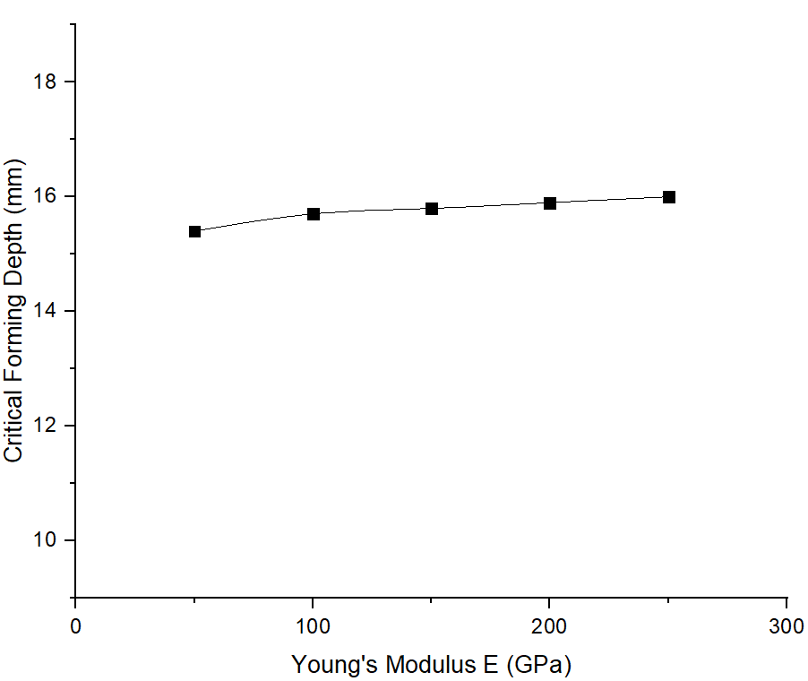
Figure 5.7 Effect of Young’s modulus on critical forming depth ($R_{0}=50 mm$, $R_{C}=20 mm$, $t=1.2 mm$, $K=549.09 MPa$, $n=0.221$)
The effect of the material strength coefficient$K$ on the critical forming depth of the first-pass conventional spinning, under the condition of $R_{0}=50 mm$, $R_{C}=20 mm$, $t=1.2 mm$, $E=198.2 GPa$ and $n=0.221,$ is shown in Figure 5.8. It shows that by increasing the value of strength coefficient $K$, it has minimal influence on the critical forming depth.
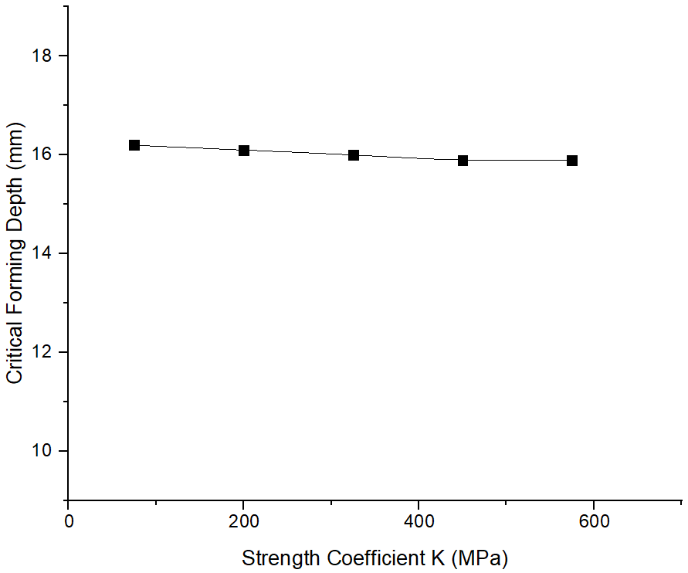
Figure 5.8 Effect of strength coefficient on critical forming depth ($R_{0}=50 mm$, $R_{C}=20 mm$, $t=1.2 mm$, $E=198.2 GPa$, $n=0.221$)
Figure 5.9 shows the effect of the material strain-hardening index, $n$, on the critical forming depth of the first-pass conventional spinning, under the condition of $R_{0}=50 mm$, $R_{C}=20 mm$, $t=1.2 mm$, $E=198.2 GPa$ and$K=549.09 MPa$. For some metal materials, the strain-hardening index, $n$, varies from 0.05 to 0.26, such as Aluminium 6061 (0.05) and low carbon steel (0.26) (95). Therefore, the range of strain-hardening index utilized in this investigation is chosen as 0.05 to 0.3. As can be seen, the critical forming depth significantly increases with an increase of material strain-hardening index $n$. This is because that a larger value of $n$ will generate a greater work hardening effect, which makes the material better in resisting wrinkling. As a result, the wrinkling limit increases.
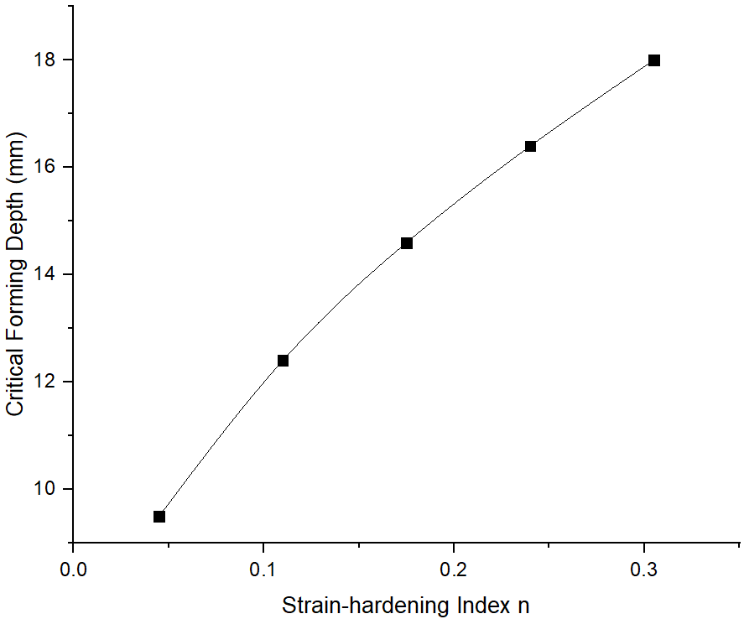
Figure 5.9 Effect of the strain-hardening index on critical forming depth ($R_{0}=50 mm$, $R_{C}=20 mm$, $t=1.2 mm$, $E=198.2 GPa$,$K=549.09 MPa$)

Analysis of Effect of Process Parameters on Wrinkling
The influences of process parameters, such as original radius and thickness of the workpiece, and feed ratio, on the wrinkling failure were studied in this section. The proposed wrinkling prediction model based on energy conservation was applied to calculate the critical forming depth of the first-pass conventional spinning under various process conditions.

Table 5.2 Radius of undeformed workpiece and clamped area
Workpiece Radius $R_{0}$ ($mm$) | Clamped Area Radius $R_{C}$ ($mm$) | Spin ratio $τ$
50 | 20 | 0.6
65 | 20 | 0.69
80 | 20 | 0.75
95 | 20 | 0.79
110 | 20 | 0.82
125 | 20 | 0.84
140 | 20 | 0.86

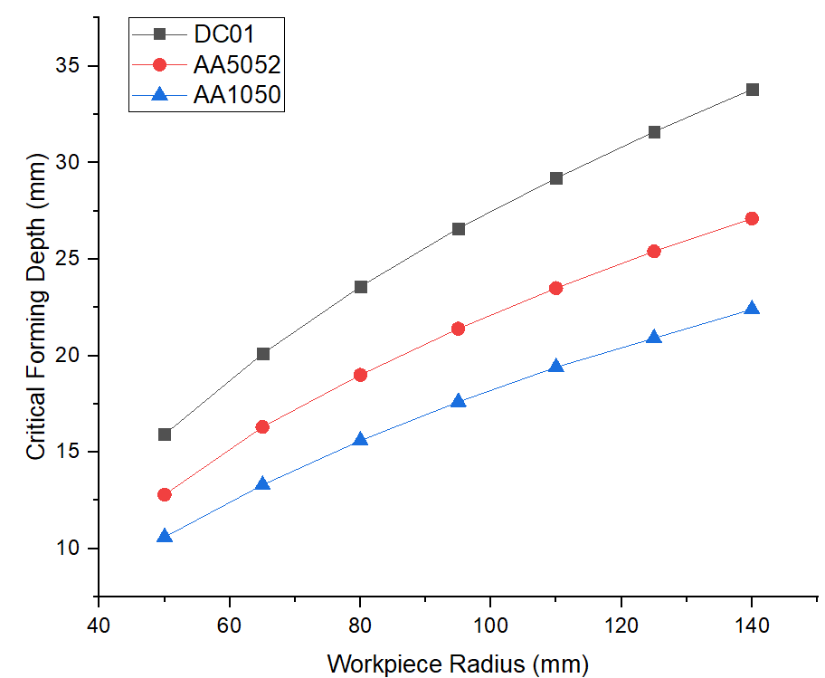
Figure 5.10 Effect of the workpiece radius on critical forming depth ($t=1.2 mm$)
From Table 5.2, the radius of the undeformed workpiece varies from 50 $mm$ to 140 $mm$, while the radius of clamped area remains unchanged. Therefore, higher values of the workpiece radius represent higher spin ratios $τ$ of the spinning process. As shown in Figure 5.10, the value of the critical forming depth shows a clear increasing trend with the increasing radius of the workpiece for all three materials. However, the gradient of increase of the critical forming depth shows a decreasing trend with the increase of the workpiece radius. It is because that the rigidity of workpiece edge reduces with the workpiece radius increases when the clamped area remains the same.
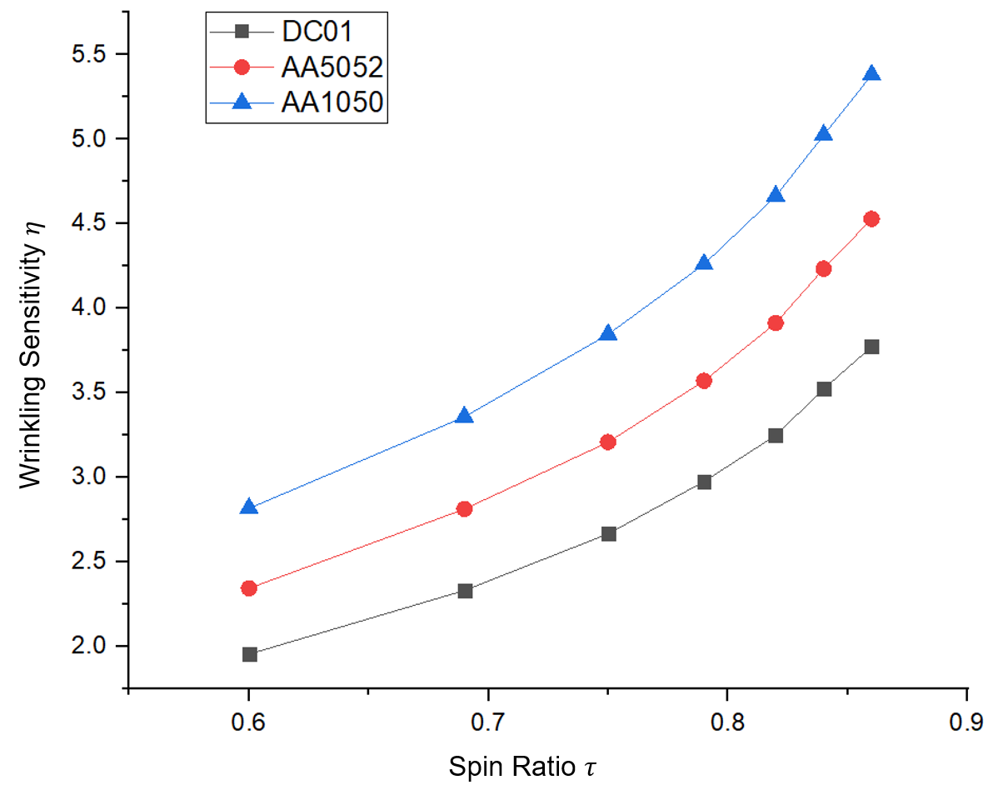
Figure 5.11 The relationship between spin ratio and wrinkling sensitivity ratio ($t=1.2 mm$)
The wrinkling sensitivity ratio $η={(R_{0}-R_{C})}/{h_{c}}$ was introduced to determine the wrinkling sensitivity when a different radius of undeformed workpiece was used during the first-pass conventional spinning using a convex toolpath profile, as shown in Figure 5.11. The higher of the wrinkling sensitivity ratio $η$ is, the greater sensitivity of the material to wrinkling will be. It can be noticed that with the increasing of the spin ratio, the wrinkling sensitivity ratio of $η$ increases dramatically. Therefore, wrinkling failure is sensitive to the size of the unsupported workpiece. Nevertheless, the steel material of DC01 showed a better spin-ability to resist wrinkling failure when compared with the other two aluminium alloys at different spin ratio values studied.
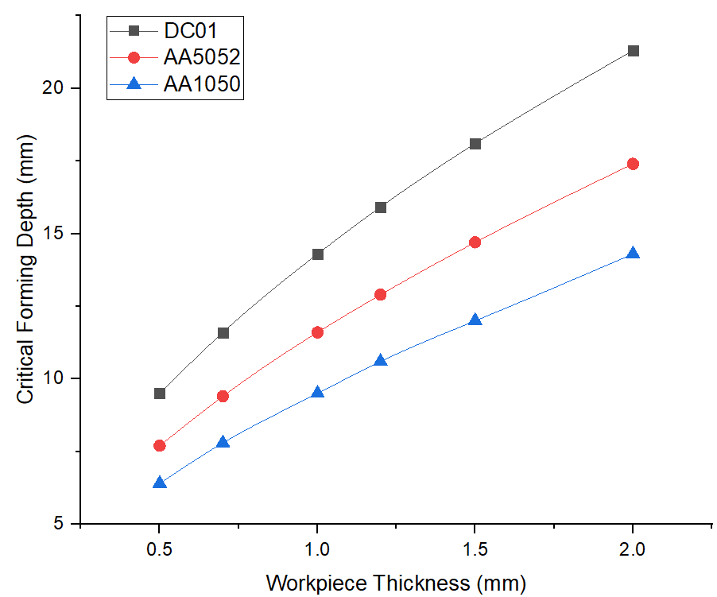
Figure 5.12 Effect of workpiece thickness on critical forming depth ($R_{0}=50 mm$, $R_{C}=20 mm$)
Figure 5.12 shows the effect of workpiece thickness on the critical forming depth. It shows that the use of thicker workpiece leads to the increase of the critical forming depth significantly. This is because that the rigidity of the workpiece resisting wrinkling increases as the workpiece thickness increases. As a result, the wrinkling limit increases.
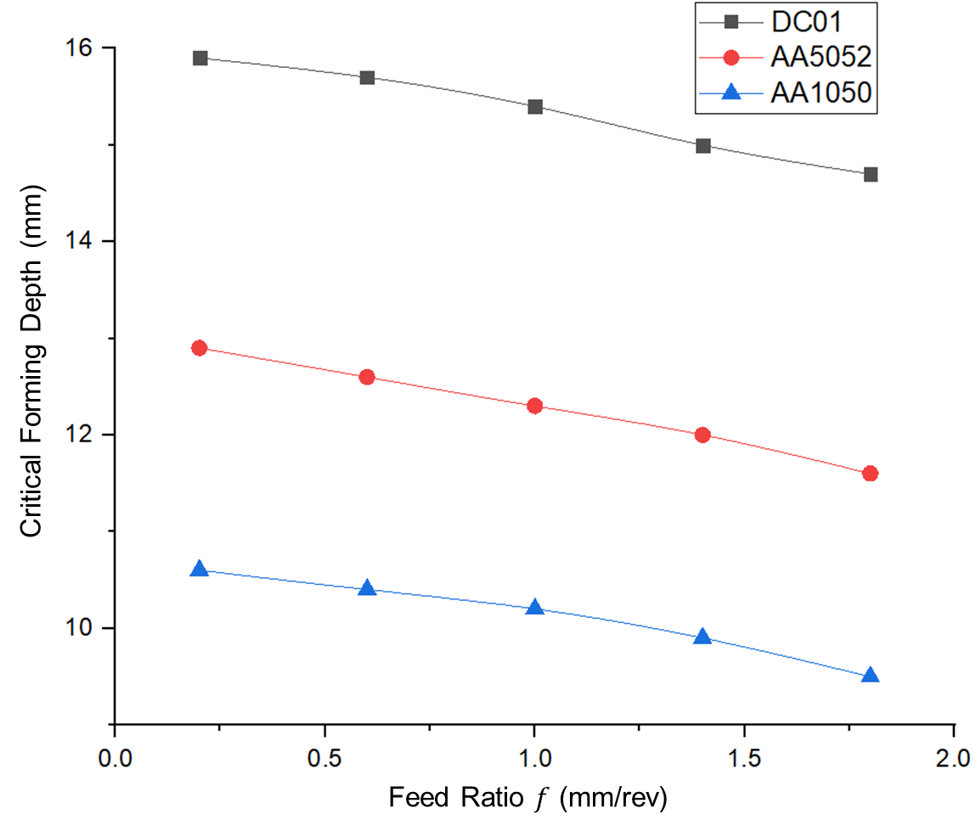
Figure 5.13 Effect of feed ratio on critical forming depth ($R_{0}=50 mm$, $R_{C}=20 mm$, $t=1.2 mm$)
The effect of feed ratio, $f$, on the critical forming depth for three different materials is presented in Figure 5.13. It can be seen that the critical forming depth, $h_{c}$, for three materials decreases with the increase of the feed ratio. This is because the larger the feed ratio, the greater value of the compressive circumferential stress generated, and the greater external work done by the roller produced as calculated from Equation 5.58. The wrinkling failure would occur when spinning using a large feed ratio.

Significance Analysis of Main Parameters
From the above analysis, it can be concluded that, when a workpiece material was decided, the main spinning parameters that affect the spinnability concerning component defect of wrinkling were spin ratio, feed ratio and workpiece thickness, respectively. To identify the significance of each of these parameters, their corresponding high and low limit and intermediate settings are selected, as shown in Table 5.3.
Table 5.3 Parameters used in significance analysis
Parameters | Spin Ratio $τ$ | Workpiece Thickness $t$ ($mm$) | Feed Ratio $f$ ($mm/rev$)
Low (-1) | 0.3 | 1 | 0.5
Intermediate (0) | 0.5 | 1.5 | 1
High (+1) | 0.7 | 2 | 2

To minimise the number of the tests and at the same time to ensure that the results can provide sufficient information into the interactive effects of these parameters as input parameters, Box-Behnken Design of Experiments method was applied to design the analytical tests with the help of MODDE Pro software. Box-Behnken design, which is one of the Quadratic Response Surface Design, requires fewer tests than the full factorial design. The design points are at the midpoints of edges of the design space and at the centre and do not contain an embedded factorial design (96). The critical forming depth and the wrinkling sensitivity were selected as the output parameters as two responses of the analysis, which were calculated by the wrinkling prediction model under individual forming condition as defined in Table 5.3. The analytical tests created by using the Box-Behnken design with three input parameters and two output parameters are illustrated in Table 5.4. For this analysis, the data of each test was fitted using a Multiple Linear Regression (MLR) model to determine the significance of each of the input parameters in terms of their effects on each of the two responses. The MLR model can be expressed by Equation 5.61 (97). Within this model, the relationship between an individual response parameter, $\hat{y}$, and each of the input parameters, $x_{n}$, is determined with a series of regression coefficients, $β_{n}$, to achieve a least squares fit. The term$"ϵ"$ in the equation is the random error component associated with the model.
$$\hat{y}=β_{0}+β_{1}x_{1}+β_{2}x_{2}+β_{11}x_{1}^{2}+β_{22}x_{2}^{2}+β_{12}x_{1}x_{2}⋯+ϵ$$
Equation 5.61

Table 5.4 The Box-Behnken design and results for the significance analysis
Test Number | Spin Ratio $τ$ | Workpiece Thickness $t$ ($mm$) | Feed Ratio $f$ ($rev/mm$) | Critical Forming Depth $h$ ($mm$) | Wrinkling Sensitivity $η$
1 | 0.3 | 1 | 0.5 | 6.89 | 1.306
2 | 0.5 | 1.5 | 0.5 | 14.18 | 1.481
3 | 0.3 | 2 | 0.5 | 9.53 | 0.944
4 | 0.7 | 1 | 0.5 | 18.67 | 2.624
5 | 0.7 | 1.5 | 0.4 | 23.6 | 2.076
6 | 0.7 | 2 | 1 | 27.11 | 1.807
7 | 0.5 | 1 | 1 | 11.29 | 1.860
8 | 0.5 | 1.5 | 1 | 13.68 | 1.535
9 | 0.3 | 2 | 1 | 9.32 | 0.966
10 | 0.3 | 1 | 2 | 6.49 | 1.387
11 | 0.3 | 1.5 | 2 | 8.44 | 1.066
12 | 0.5 | 2 | 2 | 15.51 | 1.354
13 | 0.7 | 1 | 2 | 17.34 | 2.826

In order to interpret the most significant effects of the input parameters, only linear and interaction model terms were considered, higher-order terms were neglected from the model. The coefficient of each parameter, confidence intervals indicating a 95% confidence level were employed. As shown in Figure 5.14, it can be noticed that the most significant parameter affecting the critical forming depth and the wrinkling sensitivity is the spin ratio, followed by the workpiece thickness, the spin ratio-workpiece thickness interaction. However, the feed ratio, the spin ratio-feed ratio interaction and the thickness-feed ratio interaction have relatively less significance.
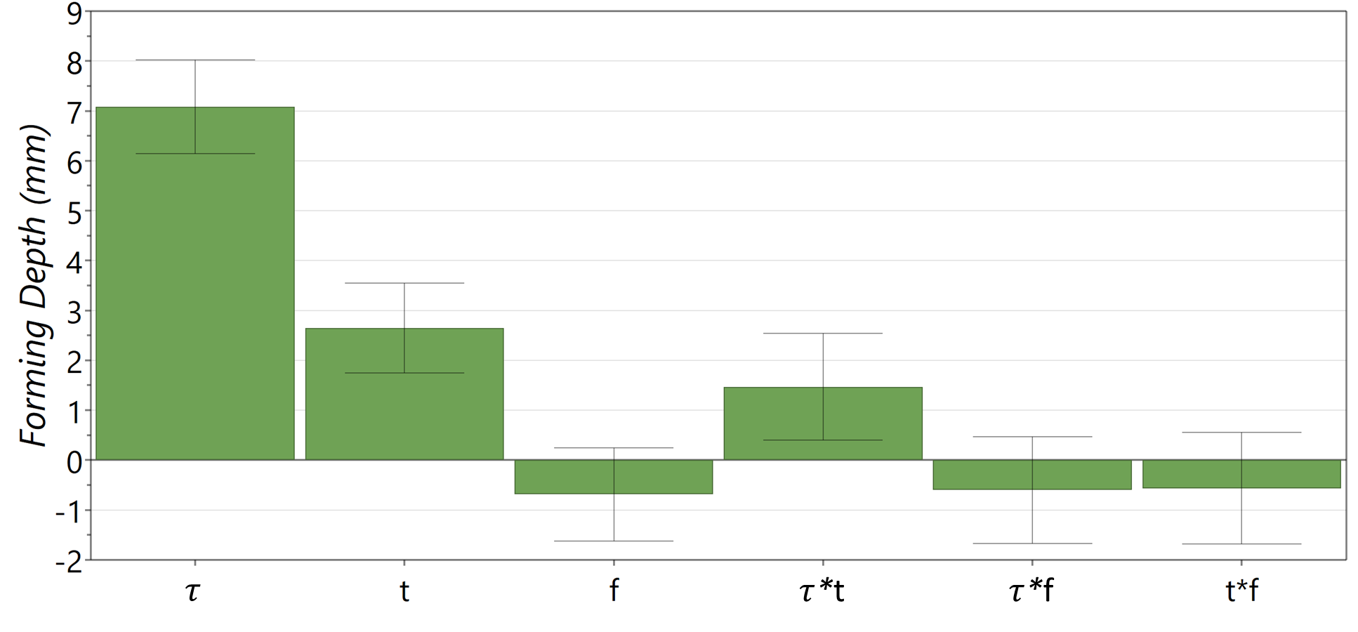
(a)
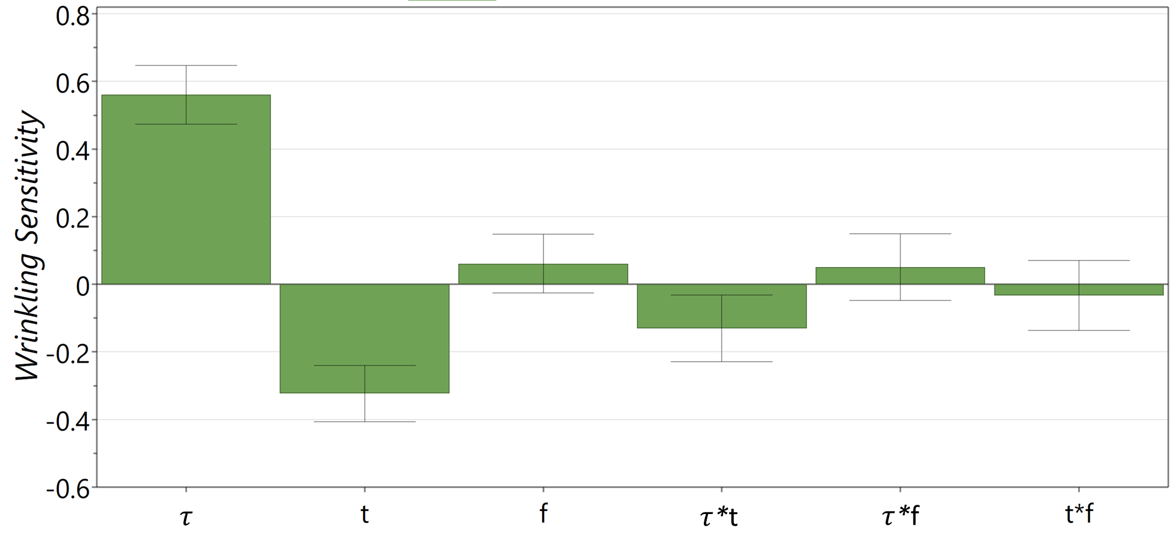
(b)
Figure 5.14 Significance coefficients of each input parameter: (a) Critical forming Depth, (b) Wrinkling Sensitivity

Determination of Wrinkling-free Spinning Diagrams
The regression equations for the responses of critical forming depth and wrinkling sensitivity with the regression coefficients of the input parameters found to be of statistical significance are given by Equation 5.62 and 5.63, respectively.
$$\hat{y_{h}}=-4.119+18.356 τ-0.173 t+3.343 f+14.7 τ∙t-4.001 τ∙f-1.505 t∙f$$
Equation 5.62

$$\hat{y_{η}}=0.19+4.331τ+0.0.115t+0.047f-1.3 τ∙t+0.338 τ∙f-0.089 t∙f$$
Equation 5.63
The contour plot was produced according to the regression equation for the responses of critical forming depths predicted under three different spin ratios with various workpiece thickness and feed ratios, as shown in Figure 5.15. The values on the contour lines represent the critical forming depths with a gap of 2 mm between each contour line. Therefore, the region of critical forming depth can be identified for a pair of workpiece thickness and feed ratio under the same spin ratio. For example, four points from A to D are selected under the spin ratio of 0.7 under the thicknesses of 1 $mm$ and 1.7 $mm$, and the feed ratios of 0.6 $mm/rev$ and 1.6 $mm/rev$, respectively. According to this figure, the region of critical forming depth for point A is between 18 $mm$ to 20 $mm$. Similarly, point B is located in the region from 16 $mm$ to 18 $mm$. Point C and D are located in the regions of (24$mm$, 26$mm$), and (22$mm$, 24$mm$), respectively.
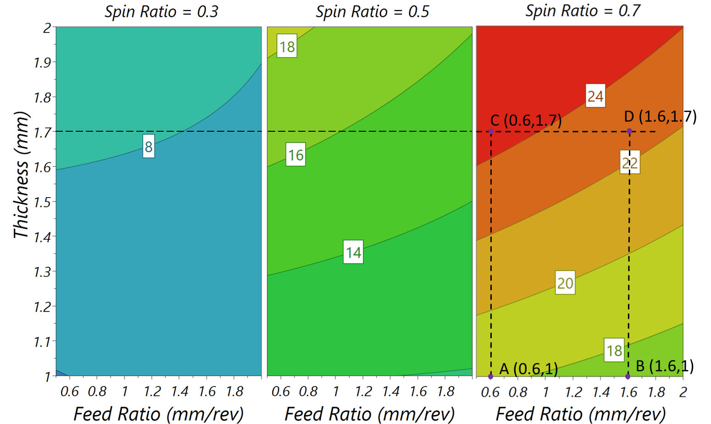
Figure 5.15 Contour plots of critical forming depth under different spin ratios
The critical forming depth obtained under low feed ratio is higher than that achievable with high feed ratio, as shown in Figure 5.15. This means for a higher feed ratio, a smaller value of the forming depth should be selected to avoid wrinkling. Furthermore, a non-linear effect of the feed ratio is observed, which is due to the effect of the two-factor interaction between the feed ratio and workpiece thickness. The contour plots show that for a given spin ratio, a great critical forming depth is achievable if a thick workpiece is deformed under low feed ratios, as confirmed in the FE simulations in Chapter 4. According to Figure 5.15, wrinkling failure can be avoided if the forming depth is smaller than the critical forming depth in the first-pass conventional spinning process.
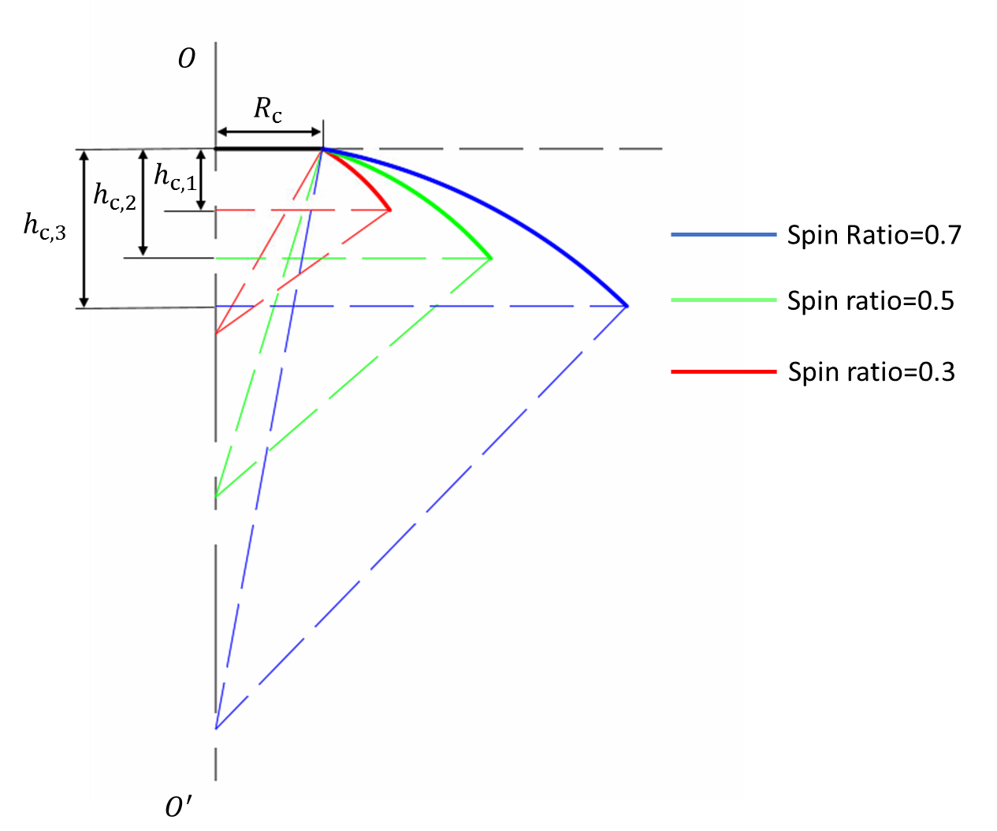
Figure 5.16 Illustration of the critical forming depth of three spin ratios ($R_{C}=20 mm$, $t=1.7 mm$, $f=1.2 mm/rev$)
It can be observed that the critical forming depth increases with the increasing of spin ratio, this is because more material can be deformed with a relatively high spin ratio under the critical condition of wrinkling. As shown in Figure 5.16, for a given spinning condition ($R_{C}=20 mm$, $t=1.7 mm$, $f=1.2 mm/rev$), the highest critical forming depth is achieved with the spin ratio of 0.7, while the lowest is achieved with the spin ratio of 0.3. However, it can be noticed that slope of the first-pass shows an opposite relationship with the spin ratio, where the largest slope of the first-pass is produced with the spin ratio of 0.3. This is because that wrinkling failure is sensitive with the radius of the unsupported workpiece, as discussed in Figure 5.11, less aggressive toolpath helps to avoid wrinkling failure when a large spin ratio is applied. This phenomenon indicates that a greater number of tool passes are required to complete the production of spun component with a relatively large spin ratio compared to that with small spin ratio during the conventional spinning process.

Summary
In this chapter, a wrinkling failure prediction method in the first-pass conventional spinning process is developed. The following key points may be drawn:
- Based on the wrinkling wave function and the elementary plasticity method together with the strain energy and external work calculations, an analytical wrinkling prediction model is established for the first-pass conventional spinning process using a convex toolpath profile.
- The effects of material parameters and process parameters on wrinkling limit have been studied based on the wrinkling prediction model, respectively. The results show that the material of DC01 has a higher wrinkling limit compared with aluminium alloys, AA5052 and AA1050, under the same forming conditions. The wrinkling limit increases with a higher strain-hardening index $n$. The strength coefficient $K$ and Young’s modulus $E$ have limited effect on the critical forming depth of the first-pass conventional spinning.
- The ratio $η={(R_{0}-R_{C})}/{h_{c}}$ is introduced to investigate the wrinkling sensitivity of material when the workpiece has a different radius. It shows that, if the workpiece thickness remains the same, a workpiece with a larger radius is more likely to be wrinkled during the spinning process.
- The thickness of material has a significant influence on the wrinkling limit during the spinning process; a greater thickness increases the wrinkling limit. The feed ratio plays an important role in the occurrence of wrinkling failure. By applying a relatively small feed ratio, wrinkling defect can be avoided during spinning. With low feed ratios, however, it reduces manufacture productivity.
- A wrinkling-free diagram is established, through which wrinkling failure can be avoided during the first-pass conventional spinning process using convex toolpath if the designed forming depth is smaller than the critical forming depth.

EXPERIMENTAL VALIDATION OF WRINKLING PREDICTION MODEL
In this chapter, the experimental testing of the first-pass conventional spinning with convex toolpath profile was carried out in order to validate the analytical wrinkling prediction model established in Chapter 5. The equipment and experimental setup of spinning tests is described in Section 6.1, where a measurement system to record the initiation and development of wrinkling failure is introduced. The preliminary experiment and results for the first-pass conventional spinning are presented in Section 6.2. The design of the full experiment to study the influences of various input parameters, such as spin ratio, workpiece thickness, toolpath profiles, and feed ratios, on wrinkling failure is given in Section 6.3. The obtained results are reported and discussed in Section 6.4. Key conclusions obtained from this study are summarised in Section 6.5.

Equipment and Experiment Setup
The equipment used in the spinning experiments can be divided into two systems, the forming system and the measurement system. In this study, the forming system, which is powered by a CNC lathe, included a forming tool, mandrel, and backplate to form a workpiece into the desired geometry, while the measurement system is employed to study the features of in-process wrinkling failure.
As shown in Figure 6.1, the first-pass conventional spinning experiments were performed using a modified AJAX Premier 200 CNC turning centre that is capable of providing axial and radial feed rates of up to 3,000 $mm/min$ and a spindle speed up to 2,300 $RPM$, well within the parameter ranges of the conventional spinning process.

Figure 6.1 AJAX Premier 200 CNC turning centre
The experimental setup on the CNC machine is shown in Figure 6.2. The mandrel was fixed into the three-jaw chuck of the headstock of the machine, while the tailstock of the machine was set up with a backplate to secure the workpiece onto the mandrel during the spinning process. The forming tool was mounted on a tool holding fixture, which in turn was clamped on the indexable tool holder of the CNC machine.
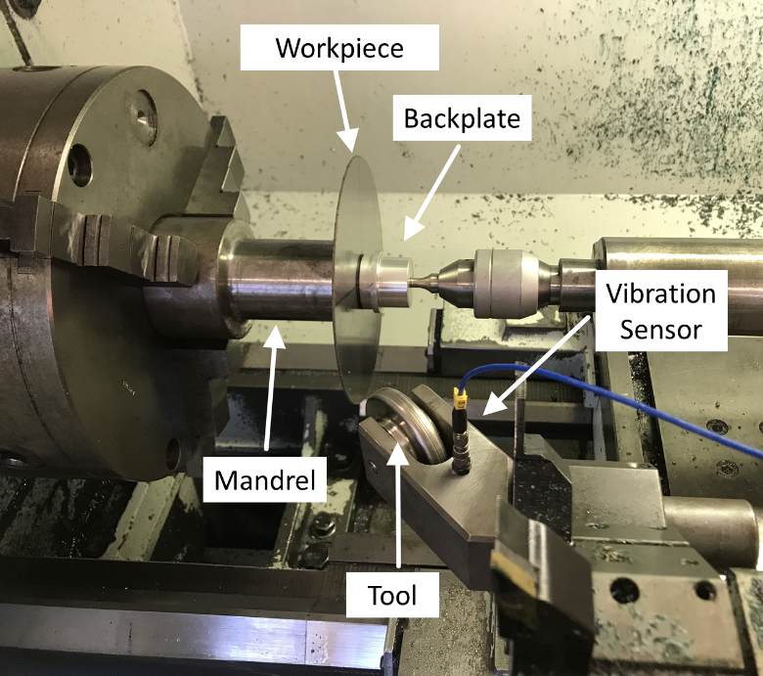
Figure 6.2 Experimental setup on CNC turning machine
A measurement system was then set up to record the initiation and development of wrinkling failure, including the time at which wrinkles first generate and the severity of the wrinkles produced during the first-pass conventional spinning experiment. After the deformation process, all recorded data was converted into a time-domain digital format suitable for analysis. Figure 6.3 illustrates the four key devices of this measurement system.

Figure 6.3 The measurement system
The first two devices in the measurement system were a PCB Piezotronics precision vibration sensor and an ICP® sensor signal conditioner. By attaching the sensor to the tool holder, as shown in Figure 6.2, the vibration signal generated by the contact between the forming tool and the workpiece surface was measured during the test. The PicoScope® 4824 was then employed to extract and convert the vibration signal obtained from the signal conditioner into a digital waveform, and this output data from the oscilloscope was transferred to a computer. The data acquisition software used was the proprietary PicoScope® 6 PC Oscilloscope Software. The vibration signal generated by the contact between the tool and the workpiece surface was thus monitored and recorded continuously during testing, and the time the wrinkles occurred was detectable in the change of fluctuation of the digital waveform. Consequently, the WTR of the wrinkled spun component could be calculated, and the severity of the wrinkles determined based on changes in the amplitudes of the digital waveform.
Figure 6.4 shows the data for the time-domain vibration signal obtained when producing an unwrinkled spun component during the first-pass conventional spinning process. It was vital for this work that the digital waveform was capable of representing the entire spinning process; hence, the measurement system was started to record the vibration data a few seconds ahead of the spinning process commencing and was not stopped until after the tool was moved away from the workpiece.
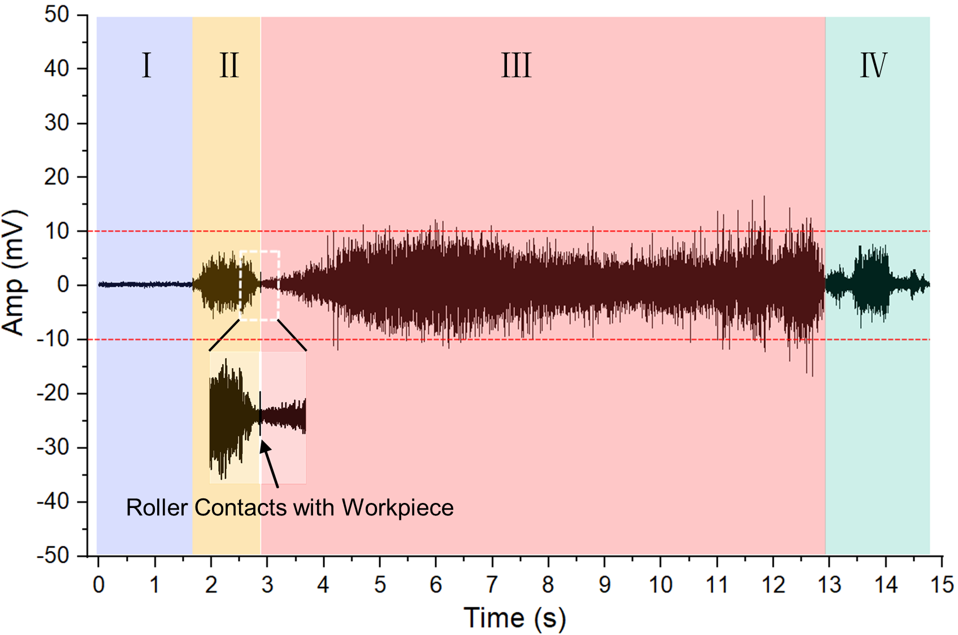
Figure 6.4 Time-domain vibration amplitude for an unwrinkled spun component
The data can be divided into four regions, as shown in Figure 6.4. It should be noted that the data located in region $I$ remains almost unchanged, being close to zero, which represents the period before the CNC machine began running. As the tool started to move toward the designed start point, the three-jaw chuck of the CNC machine came into operation and gradually accelerated from 0 $RPM$ to the target spindle speed. The waveform amplitudes thus increased steadily before stabilising at approximate 5 $mV$ at the beginning of region $II$. After the desired spindle speed was reached and became constant, a decreasing trend in the amplitudes can be observed, as illustrated at the end of this region. As the forming tool made contact with the workpiece surface, a small fluctuation of the digital waveform was generated, representing the initiation of the spinning process. Region $III$ represents the spinning process itself, during which the workpiece was deformed by the tool following the designed toolpath. For the unwrinkled spun component, the amplitudes of the waveform in this region varied smoothly, with the majority of data in the range 10 $mV$ to -10 $mV$. Once the tool moved to the edge of the workpiece and lost contact with the workpiece surface, that is, when the spinning process was completed, a sudden drop of the waveform can be observed at the beginning of Region $IV$. The digital data in this region was mainly generated by the movement of the tool away from the workpiece. As any component defect is generated in Region $III$, however, the other three regions can be ignored in the analysis of results for this research.

Preliminary Experiment and Results
The preliminary experiment had two purposes: (a) to ensure that the experimental setup was functional and workable; and (b) to validate the accuracy of the analytical wrinkling prediction model effectively and efficiently within a limited range of spinning parameters. The full experiment, which contains more input parameters, was deemed appropriate only once the analytical wrinkling model proved able to predict wrinkling failure in the first-pass conventional spinning.

Design of Preliminary Experiment
In the preliminary experiment, the number of parameters to be investigated was reduced in order to validate the analytical wrinkling prediction model more effectively. By reducing both the number of investigated parameters and the number of investigated responses, the workable parameter range was set to the most efficient scheme with the lowest number of required experimental tests.
The workpiece was made of mild steel DC01, and its diameter and thickness were 100 $mm$ and 1.2$mm$, respectively. Within the design of preliminary experiment, several parameters were kept constant and applied in all experimental tests, as listed in Table 6.1. During these experimental tests, the occurrence of wrinkling failure in each test was also recorded and employed as one of the output factors.

Table 6.1 Process parameters for preliminary experiment
Parameters | Value
Workpiece material | DC01
Workpiece radius $R_{0}$ ($mm$) | 50
Workpiece thickness $t$ ($mm$) | 1.2
Clamped radius $R_{c}$ ($mm$) | 20
Tool diameter ($mm$) | 60
Tool nose radius ($mm$) | 5
Spindle Speed $S$ ($RPM$) | 800
Toolpath Profile | Convex
Path Curvature | $$+2λ$$

Under the spinning conditions as listed in Table 6.1, the critical forming depth, calculated from the analytical wrinkling prediction model, was approximately 15.5$mm$ when the feed ratio $f$ was $1 mm/rev$. According to the analytical wrinkling prediction model, the critical forming depth shows an opposite variation trend with the increase of feed ratio in the spinning process. Wrinkling failure is therefore more likely to be generated if high feed ratios or deeper forming depths are applied in the spinning process. These two variables were thus selected as the input parameters for the preliminary experiment, and each experimental factor was given three levels, as listed in Table 6.2.

Table 6.2 Experimental input parameters used in the preliminary experiment
Toolpath profile | Factor | Level
Toolpath profile | Factor | Low (-1) | Intermediate (0) | High (+1)
Convex | Feed Ratio $f$ ($mm/rev$) | 0.5 | 1.0 | 2
Convex | Forming Depth $h$ ($mm$) | 14.3 | 16.8 | 19.3

The Taguchi Method is an effective method for developing multi-factor experimental design. A $L9 (3^{2})$ orthogonal array was therefore employed to generate the experiment tests for the first-pass of conventional spinning with a convex toolpath profile. As shown in Table 6.3, a total of nine experiment tests were planned for the preliminary experiment.
Table 6.3 Experimental tests for first-pass conventional spinning with convex toolpath profile.
Test  Number | Forming Depth $h$  ($mm$) | Feed Ratio $f$  ($mm/rev$)
T1 | 16.8 | 0.5
T2 | 16.8 | 1.0
T3 | 16.8 | 2.0
T4 | 19.3 | 0.5
T5 | 19.3 | 1.0
T6 | 19.3 | 2.0
T7 | 14.3 | 0.5
T8 | 14.3 | 1.0
T9 | 14.3 | 2.0
The output factors for the successful spun components were the deviation of edge radius (${R_{2}}^{'}-R_{2}$), the deviation of forming depth ($h-h^{'}$), and the wall thickness variation, as listed in Table 6.4. These responses were recorded from the spun component after the deformation process, which should have no influence during the spinning process.
Table 6.4 Recorded responses during the preliminary experiment
Response Name | Units
Depth Deviation ($h-h^{'}$) | $$mm$$
Edge Radius Deviation ${{(R}_{2}}^{'}-R_{2})$ | $$mm$$
Wall Thickness Deviation | $$mm$$

As shown in Figure 6.5 (a), the actual forming depth $h^{'}$ and actual radius ${R_{2}}^{'}$ were recorded from the spun component profile, respectively. This was done to assess any spring-back on the spun component after the deformation process, which would result in a geometric deviation from the designed toolpath profile. For the component produced without component defect wrinkling due to the springback phenomenon, the actual forming depth, $h^{'}$, was smaller than the designed forming depth, $h$, resulting in a larger actual edge radius, ${R_{2}}^{'},$ than the designed edge radius $R_{2}$.
The thickness measurement of the spun component was obtained based on measurement points along the radial direction of the workpiece from the edge of the clamped area to the edge of the spun component, as shown in Figure 6.5 (b). The thickness variation of the component was represented by the mean value of the four measurement points at the same contour line.
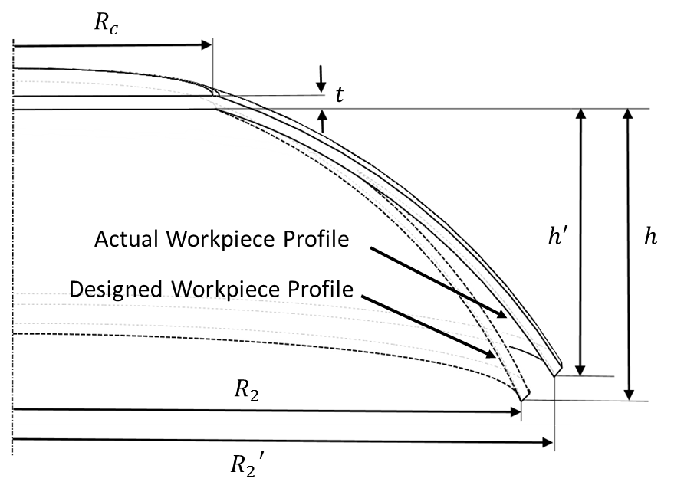
(a)
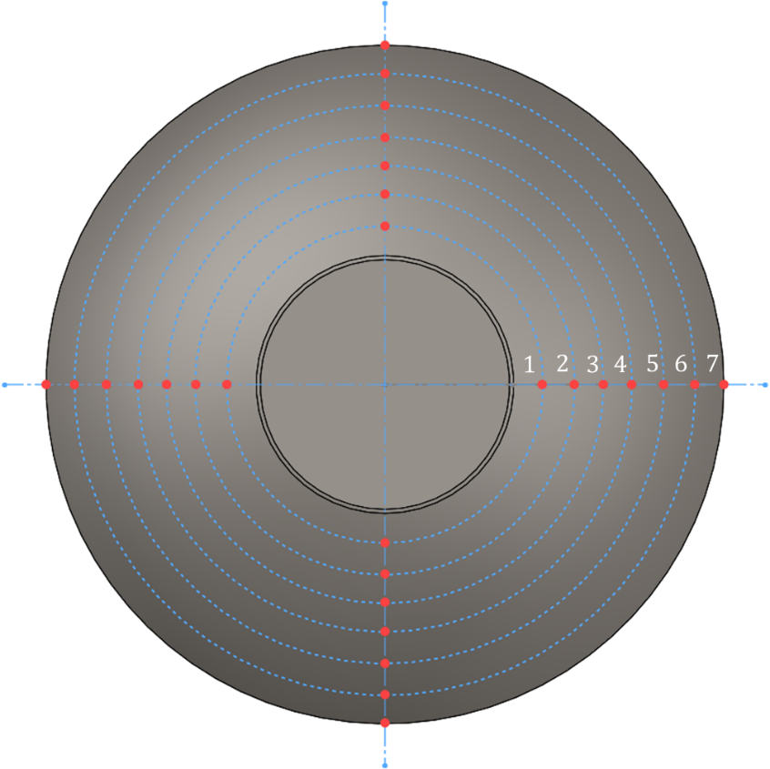
(b)
Figure 6.5 Response parameters: (a) forming depth deviation and spun component radius deviation, (b) thickness variation measurement points

Preliminary experiment results
The spun components produced in the preliminary experiment are shown in Figure 6.6. The gap between each indentation on the surface of the spun components increases with the increase in feed ratio, as higher feed ratios increase the step over distance of the forming tool in terms of contact with the workpiece’s surface. This finding was confirmed by the experimental investigations into shear spinning by Childerhouse and Long (29) and Chen et al (65). Moreover, the tool indentations on a component produced with a high feed ratio (2 $mm/rev$) are more obvious than those on one produced with a low feed ratio (0.5 $mm/rev$), due to the higher forming forces associated with higher feed ratios. Consequently, deeper and clearer tool indentations can be generated at higher feed ratios.
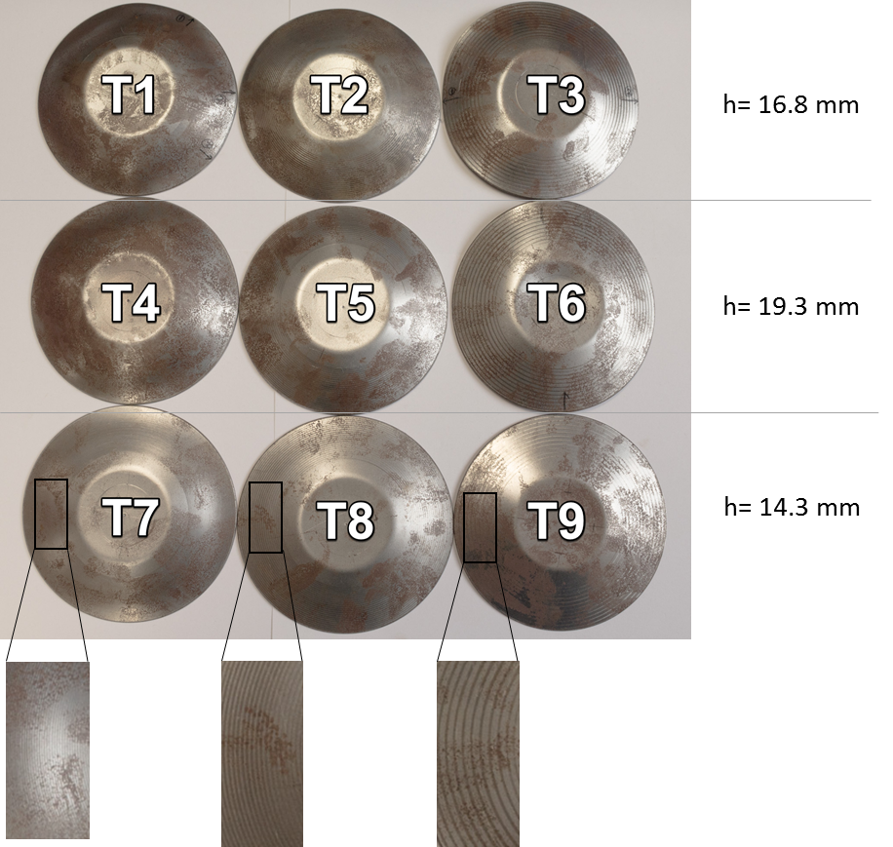
Figure 6.6 Preliminary experimental spun components (T1, T4, and T7 formed with 0.5 $mm/rev$, T2, T5, and T8 formed with 1 $mm/rev$, T3, T6, and T9 formed with 1 $mm/rev$)
Based on the design forming depth, the spun components can be categorised into three groups, as shown in Figure 6.7. The wrinkles generated for the first six spun components are highlighted by red frames as presented in Figures 6.7 (a) and (b). The wrinkling conditions on T3 and T6 are seen to be more severe than those in the other four components. No wrinkling failure was generated on components T7, T8, and T9, as shown in Figure 6.7 (c).
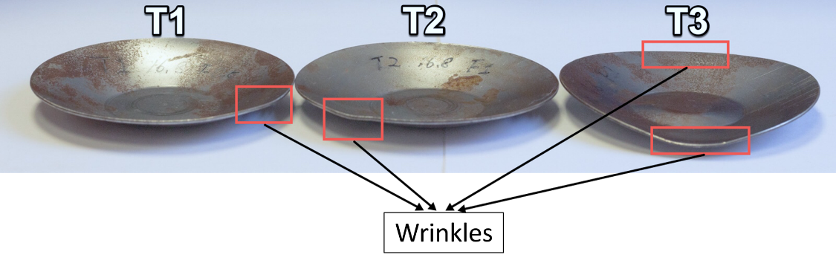
(a)
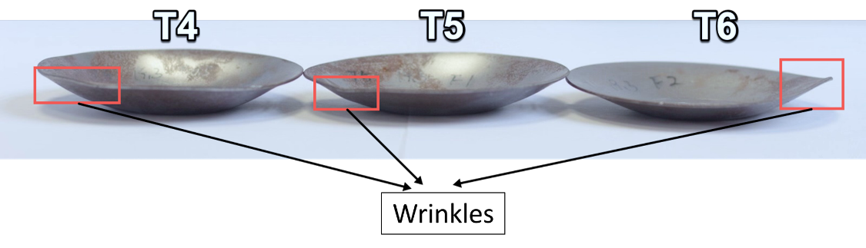
(b)
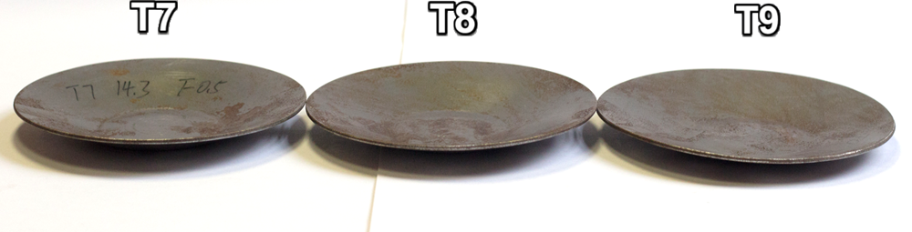
(c)
Figure 6.7 Comparison of groups of preliminary experimental samples: (a)$h=16.8 mm$, (b) $h=19.3 mm$, and (c)$h=14.3 mm$
A 2-D processing map to predict wrinkling was thus produced based on the results of the analytical wrinkling prediction model, as presented in Figure 6.8. This showed that the critical forming depth as calculated from the wrinkling prediction model can be used to divide the processing map into two zones, a wrinkling-free zone and a wrinkling zone, respectively. Through fitting the spinning condition of each component into this processing map at the correspond location, it was confirmed that the unwrinkled components from the preliminary experiment were all located in the wrinkling-free zone, suggesting that the analytical wrinkling prediction model can indeed be employed to predict wrinkling failure during the first-pass conventional spinning process with a convex toolpath profile.
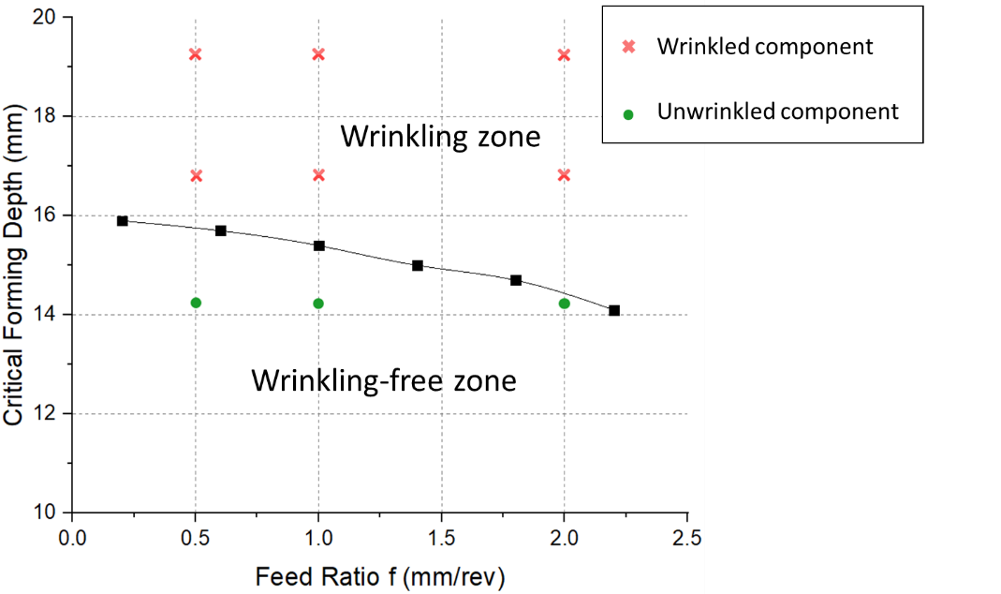
Figure 6.8 Processing map considering wrinkling
For the spun components without wrinkles, (T7, T8, and T9), the wall thickness distributions were measured along the radial directions, between the edge of the clamped area to the edge of the spun component as shown in Figure 6.9. Wall thinning phenomena near the clamped edge were thus observed in these three components due to the radial bending effects in both the clamped area and from the last contact point between the workpiece and mandrel, similar to those reported by Wang and Long (61).
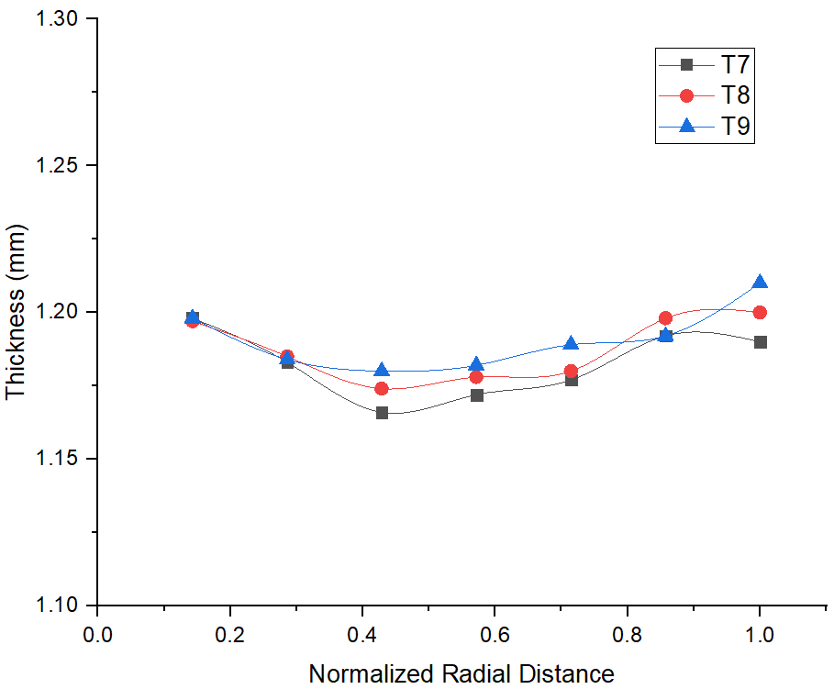
Figure 6.9 Wall thickness distribution of unwrinkled spun components
For the unwrinkled spun components T7, T8 and T9, the actual forming depth $h^{'}$ and actual edge radius ${R_{2}}^{'}$ were measured, and the output factors of deviation of forming depth and deviation of edge radius were thus calculated, as presented in Table 6.5. The main reason for the design geometry not being achieved appears to be springback due to the recovery of elastic strain in the material, as it can be seen clearly that both deviations increase with increases in of feed ratios. Based on Figure 6.6, a large step over distance per revolution occurs when a high feed ratio is employed in the spinning process, and, consequently, a large quantity of material along the radial direction requires deformation in a single revolution, which results a large proportion of workpiece deformation occurring elastically. This effect, with higher feed ratios contributing to more springback, is also consistent with previous work done on the shear spinning (29) and conventional spinning (16).

Table 6.5 Results of forming depths and edge radius measurements for unwrinkled spun components
Factors | T7 | T8 | T9
Designed Forming Depth $h$($mm$) | 14.3
Actual Forming Depth $h^{'}$($mm$) | 13.8 | 12.6 | 10.9
Deviation of Forming Depth $h-h^{'}$ ($mm$) | 0.5 | 1.7 | 3.4
Designed Edge Radius $R_{2}$($mm$) | 47.4
Actual Edge Radius ${R_{2}}^{'}$($mm$) | 48.5 | 48.7 | 49.2
Deviation of Edge Radius ${R_{2}}^{'}-R_{2}$($mm$) | 1.1 | 1.6 | 2.2

Based on the results of the preliminary experiment, the designed forming depth has a significant influence on wrinkling failure in the first-pass conventional spinning processes. Wrinkling failure can thus be supressed by using a relative low forming depth in first-pass conventional spinning. Moreover, the analytical wrinkling prediction model was validated as suitable for use in predicting wrinkling failure in first-pass conventional spinning with a convex toolpath. The effects of feed ratio on springback further suggest that a relatively low feed ratio is beneficial for maintaining geometrical accuracy in the spinning process.

Experimental Design
The convex toolpath profile with a path curvature of $+2λ$ was the only toolpath profile used for both FE analysis and the preliminary experiment. The effect of different toolpath profiles, with various path curvatures, on wrinkling failure thus required further study. Several parameters, including workpiece thickness, feed ratio and path curvature, were selected to be tested in the experiment, and each parameter was subject to three levels of variation, as listed in Table 6.6.

Table 6.6 Factors and levels used in the experiment
Factor Level | Workpiece Thickness ($mm$) | Feed Ratio ($mm/rev$) | Path Curvature $λ$
Low (-1) | 1.2 | 0.5 | $$-2λ$$
Intermediate (0) | 1.5 | 1 | 0
High (+1) | 2 | 1.5 | $$+2λ$$

Based on the number of parameters investigated, a full factorial experiment design with 27($3^{3}$) permutations would potentially be excessively resource and time-consuming. Thus, to minimise the number of the necessary experiments while ensuring the effectiveness of the experimental results in terms of evaluating the interactive effect of the input parameters, a D-optimal Design of Experiments method was applied to these tests with the help of MODDE Pro software. A D-optimal design is a computer-generated option for an experiment design the best subset of experiments from a candidate set formed of the pool of theoretically possible and practically conceivable experiments (98). A total of 13 experimental tests were designed using the D-optimal Design of Experiments method in this case, though five extra experiments with different spin ratios and forming depths were added to validate the effects of spin ratio and designed forming depth on first-pass conventional spinning. A total of 18 experiments was therefore designed, as shown in Table 6.7.

Table 6.7 Experimental tests (combinatorial design)
Test Number | Workpiece Thickness ($mm$) | Feed Ratio ($rev/mm$) | Path Curvature | Spin Ratio | Forming Depth ($mm$)
No.1 | 1.2 | 0.5 | $$-2λ$$ | 0.73 | 25
No.2 | 2 | 1 | $$-2λ$$ | 0.73 | 25
No.3 | 2 | 1.5 | $$-2λ$$ | 0.73 | 25
No.4 | 1.5 | 0.5 | $$-2λ$$ | 0.73 | 25
No.5 | 1.5 | 1 | $$-2λ$$ | 0.73 | 25
No.6 | 2 | 1.5 | 0 | 0.73 | 25
No.7 | 1.2 | 0.5 | 0 | 0.73 | 25
No.8 | 1.2 | 1 | 0 | 0.73 | 25
No.9 | 1.5 | 1.5 | 0 | 0.73 | 25
No.10 | 1.5 | 0.5 | $$+2λ$$ | 0.73 | 25
No.11 | 1.2 | 0.5 | $$+2λ$$ | 0.73 | 25
No.12 | 1.2 | 1.5 | $$+2λ$$ | 0.73 | 25
No.13 | 2 | 0.5 | $$+2λ$$ | 0.73 | 25
No.14 | 1.2 | 1 | $$+2λ$$ | 0.8 | 40
No.15 | 2 | 1 | $$+2λ$$ | 0.8 | 25
No.16 | 2 | 1 | $$+2λ$$ | 0.8 | 40
No.17 | 2 | 1 | $$+2λ$$ | 0.73 | 25
No.18 | 2 | 1 | $$+2λ$$ | 0.73 | 40

The workpiece, made of mild steel (DC01) with a radius of 75 $mm$, was used for the first 13 experiment tests, with a fixed forming depth of 25 $mm$, the same as one of the forming depths used in the FE models discussed in Chapter 4. This forming depth was calculated based on the analytical wrinkling prediction model under conditions of 1.5 $mm$ workpiece thickness and 1 $mm/rev$ feed ratio using a convex toolpath profile with $+2λ$ path curvature. Based on the toolpath parameterisation method developed in Chapter 3, three toolpaths with corresponded path curvatures were produced, as shown in Figure 6.10. It should be noted that the starting point and the ending point of all three toolpaths are exactly the same.
The convex toolpaths used for the experiment tests from No. 10 to No. 18 are same as the toolpaths used with the corresponding FE models in Chapter 4. Path-1, which was employed for FE models M1 and M3, was also used for tests No. 10 to No. 13 and No. 17, while Path-2 and Path-3 were applied in tests No. 18 and No. 15, respectively, and Path-4 was used for tests No. 14 and No. 16.
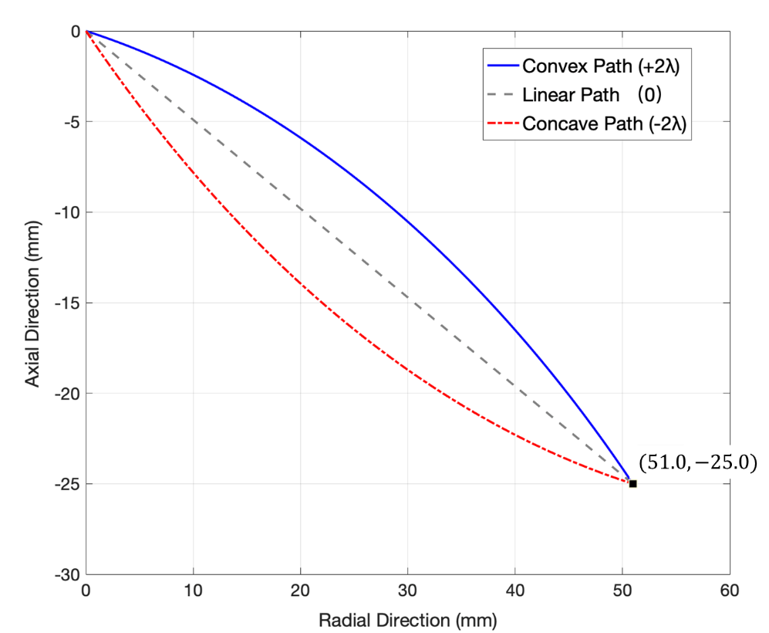
Figure 6.10. Three different toolpath profiles
To ensure repeatability in the experimental results, each test was performed twice to check the robustness of the results. After testing, for unwrinkled components, the actual forming depth was measured individually, while for wrinkled spun components, the time of wrinkling initiation was recorded. Where the discrepancy between the results of both tests exceeded 5%, a third test was conducted to act as a confirmation test.

Results and Discussion
In this chapter, wrinkling failure was studied using an experimental method. The wrinkling condition of each workpiece was determined by assessing the amplitude of the digital waveform obtained from the spinning process, and the forming depth of unwrinkled spun components and wrinkling initiation time for wrinkled spun components were used to study the effect of various toolpath profiles employed in the first-pass conventional spinning process. The wrinkling prediction model built in Chapter 5 was also verified by comparing the wrinkling conditions predicted with the experimental workpieces and the FE model. Processing maps to predict wrinkling failure under different spin ratios were therefore established based on the results of the analytical wrinkling prediction model.

Confirmation of the Effects of First-pass on Wrinkling
The first thirteen experimental tests, as shown in Table 6.7, studied the effect of the first-pass on component defect from wrinkling. The results of these tests, as shown in Figure 6.11, can be divided into three groups based on the type of toolpath profile applied to each test. Wrinkles can be seen clearly on the workpieces in tests No. 11 and No. 12, while no clear trace of wrinkling can be observed on the other workpieces.
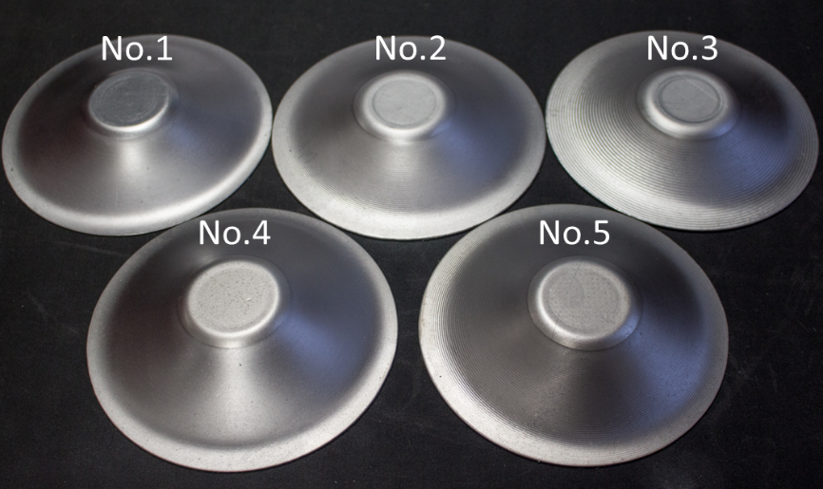
(a)
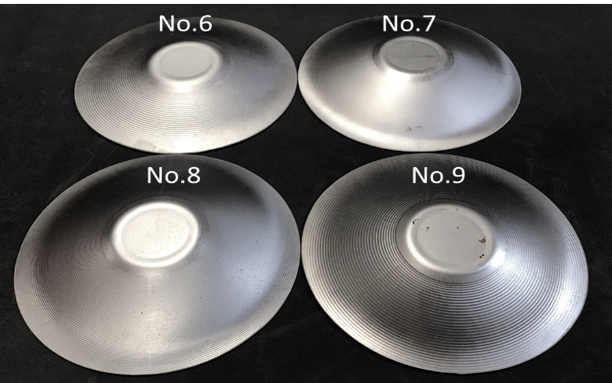
(b)
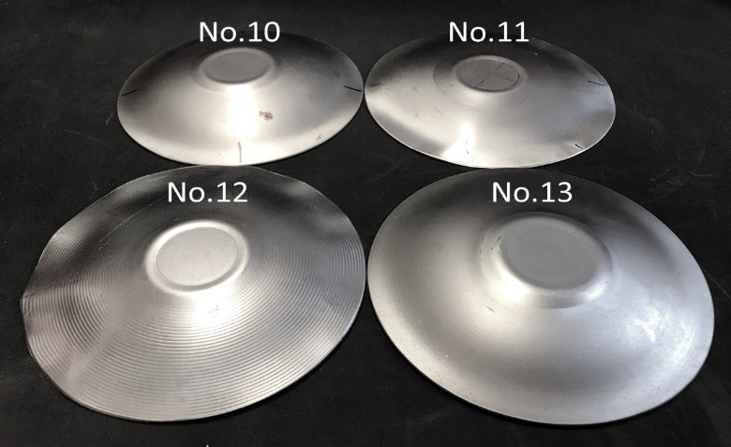
(c)
Figure 6.11 Workpieces produced by using different toolpath profiles: (a) concave toolpath, (b) linear toolpath, and (c) convex toolpath
Figure 6.12 presents the time-domain vibration amplitudes of the workpieces deformed by the concave toolpath profile under different feed ratios and thicknesses. It should be noted that, most of the time, the waveform amplitude of each workpiece recorded is located in a range from -10 to 10 mV, indicating that no wrinkling failure takes place during the spinning process. Moreover, the vibration amplitude measurements for those workpieces deformed under lower feed ratios, (0.5 $mm/rev$ and 1 $mm/rev$), such as No. 1 and No. 2, are smoother than those deformed with relatively high feed ratios (1.5 $mm/rev$), such as No. 3.
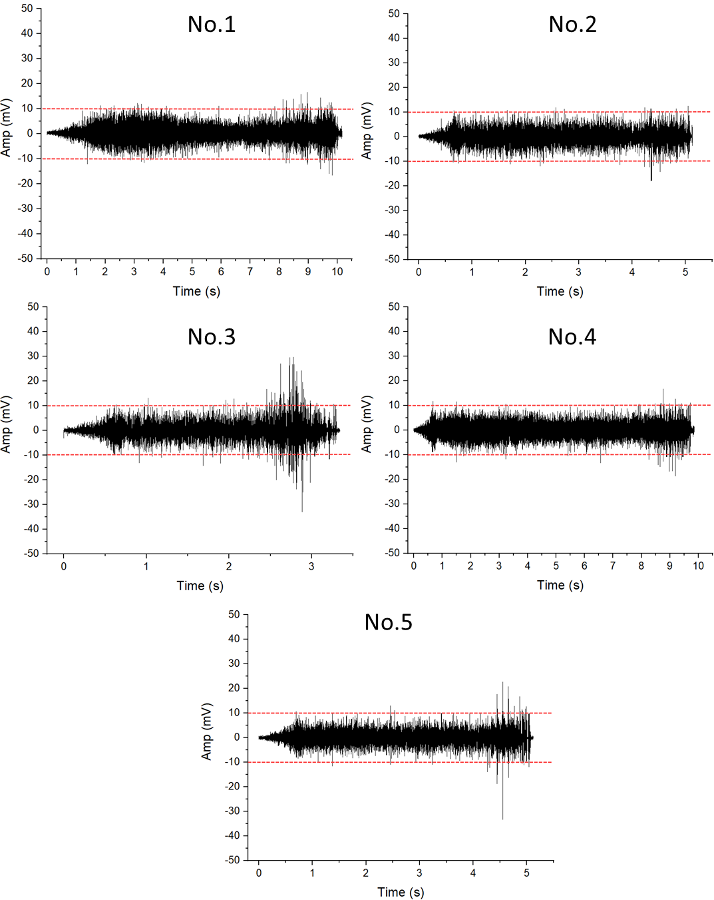
Figure 6.12 Time-domain vibration amplitudes of workpieces produced using a concave path
The time-domain vibration amplitudes for those workpieces deformed by a linear toolpath profile are shown in Figure 6.13. Wrinkling failure was generated under the forming conditions of test No. 9, with wrinkles initiated at 2.9 s during the spinning process; after that, the amplitudes are in the safe region for the majority of the time. The WTR for this workpiece was thus 0.853. In contrast, no wrinkling was observed in the workpiece for Test No. 6, which applied the same forming conditions as those used in Test No. 9 except that a thicker workpiece was used. This suggests that a thick workpiece can suppress the occurrence of wrinkling failure during the spinning process. This accords with both the results obtained from the FE analysis in Chapter 4 and the analytical wrinkling prediction model in Chapter 5.
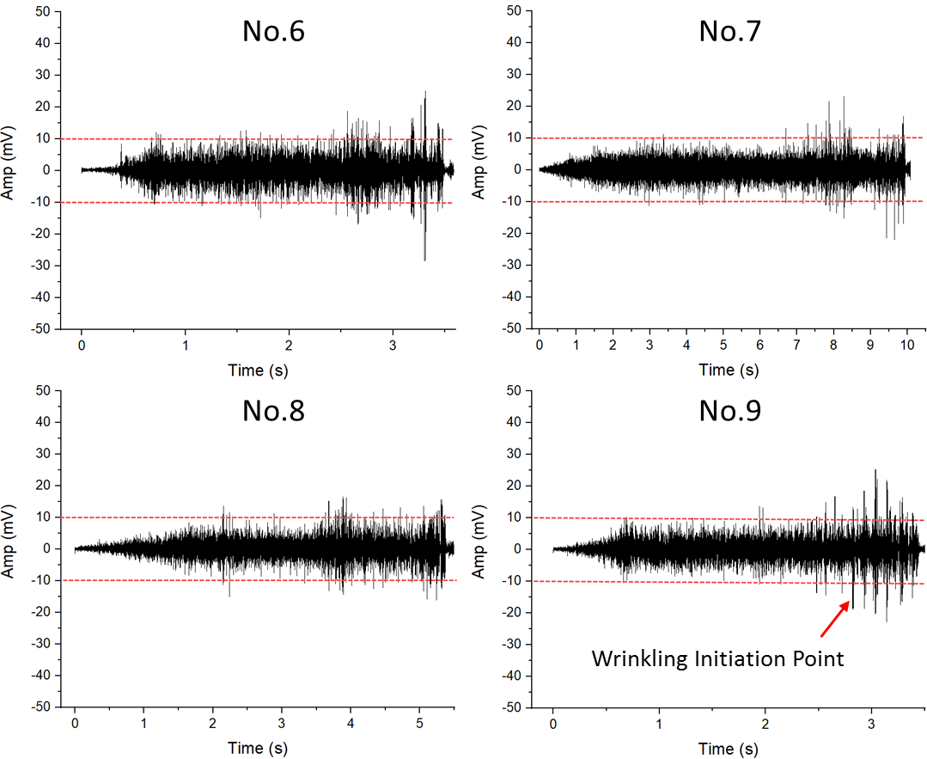
Figure 6.13 Time-domain vibration amplitude of workpieces produced using a linear path
Based on the time-domain vibration amplitudes of the workpieces produced by the convex toolpath profile, as shown in Figure 6.14, wrinkling failure was generated in the workpieces of Tests No. 10, No. 11, and No. 12. The wrinkles for these three workpieces were initiated at 8.9 s, 7.7 s, and 2.1 s through spinning process, respectively, resulting in WTRs of 0.864, 0.748, and 0.618. The largest amplitudes of the waveform are observable for the workpiece produced in Test No. 12, which indicates that the wrinkling failure there was more severe than that seen in the other two wrinkled components, as shown in Figure 6.11 (c). No wrinkling failure occurred in the component produced in Test No. 13 due to a thicker workpiece (2 $mm$) being used during the spinning process.
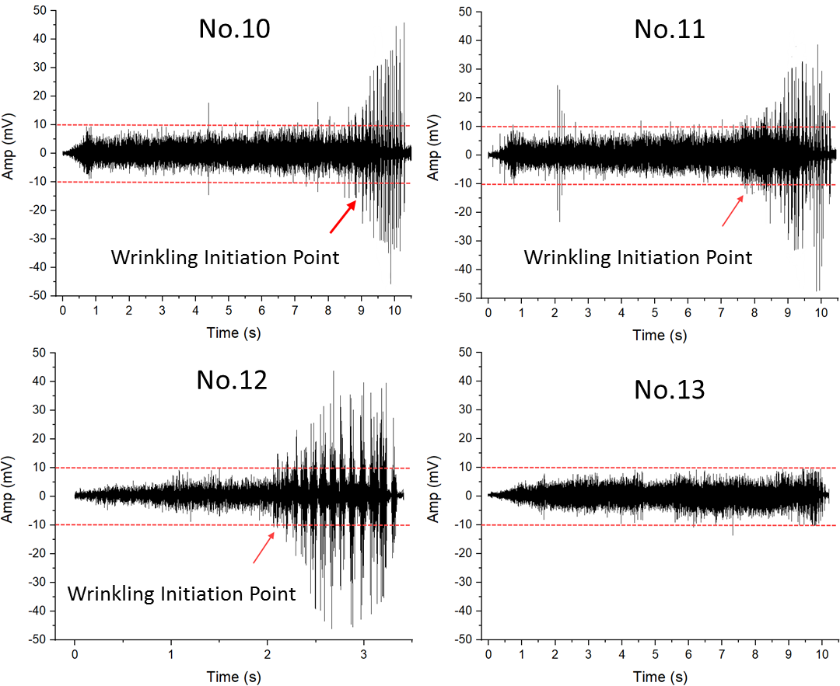
Figure 6.14 Time-domain vibration amplitudes of workpieces produced using a convex toolpath
The achieved forming depth of each unwrinkled component was measured, ad as shown in Figure 6.15, the highest forming depth was 23.57 $mm$ achieved under the forming conditions of Test No. 1. Moreover, comparing the forming depths of the components produced in Tests No. 2 and No. 3, and No. 4 and No. 5, it can be concluded that higher feed ratios lead to lower forming depths, which is further confirmed by a comparison of the components of Tests No. 7 and No. 8. The main reason for not achieving the intended forming depth in an unwrinkled spun component is springback, caused by the recovery of elastic strain being induced in the workpiece after the tool forces are removed at the end of the spinning process (99). This may be because, during spinning at higher feed ratios, as shown in Figure 3.12, a larger portion of the material needs to be deformed per rotation of the workpiece, which results in a larger elastic strain during the spinning process.
Moreover, as presented in Figure 6.15, the average forming depth for the components deformed by the concave toolpath profile is higher than that of those deformed by the linear and convex toolpath profiles; this is in agreement with the results obtained by Hayama et al. (18), who recommended an involute toolpath profile (a special type of concave toolpath profile) to achieve higher forming depth in the conventional spinning process.
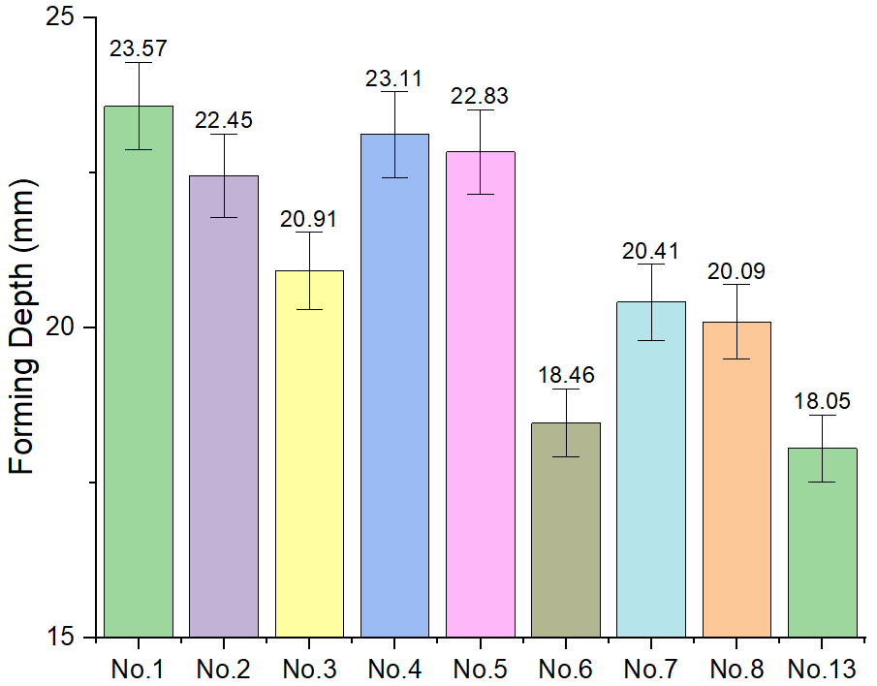
Figure 6.15 Results of forming depth for unwrinkled spun components
Toolpath profiles tend to influence the swept area of the workpiece and consequently to affect the stress and strain distribution. The workpiece swept areas under different toolpath profiles for first-pass conventional spinning process are shown in Figure 6.16. Region $I$ represents the swept area of the workpiece that is deformed in the spinning process using a convex toolpath, with the addition of Region $II$ required for the workpiece deformed using a linear toolpath; the swept area of the workpiece produced using the concave toolpath is the largest, however, including Regions $I$, $II$ and $III$. This suggests that the largest forming forces are generated in the spinning process when using a concave toolpath, which requires a larger deformation area than the other two toolpaths. Consequently, higher stresses and strains are generated in workpieces produced using a concave toolpath, which results in higher wall thickness reduction and less springback. These results are supported by the work of Wang and Long (61), who stated that the concave toolpath produces the highest forming forces, the greatest thickness reduction, and the highest level of stresses and strains among the main toolpath profiles. Consequently, the forming depth achieved using a concave toolpath is higher than that created using the other two toolpath profiles due to the larger plastic strains generated in the spinning process by the concave toolpath.
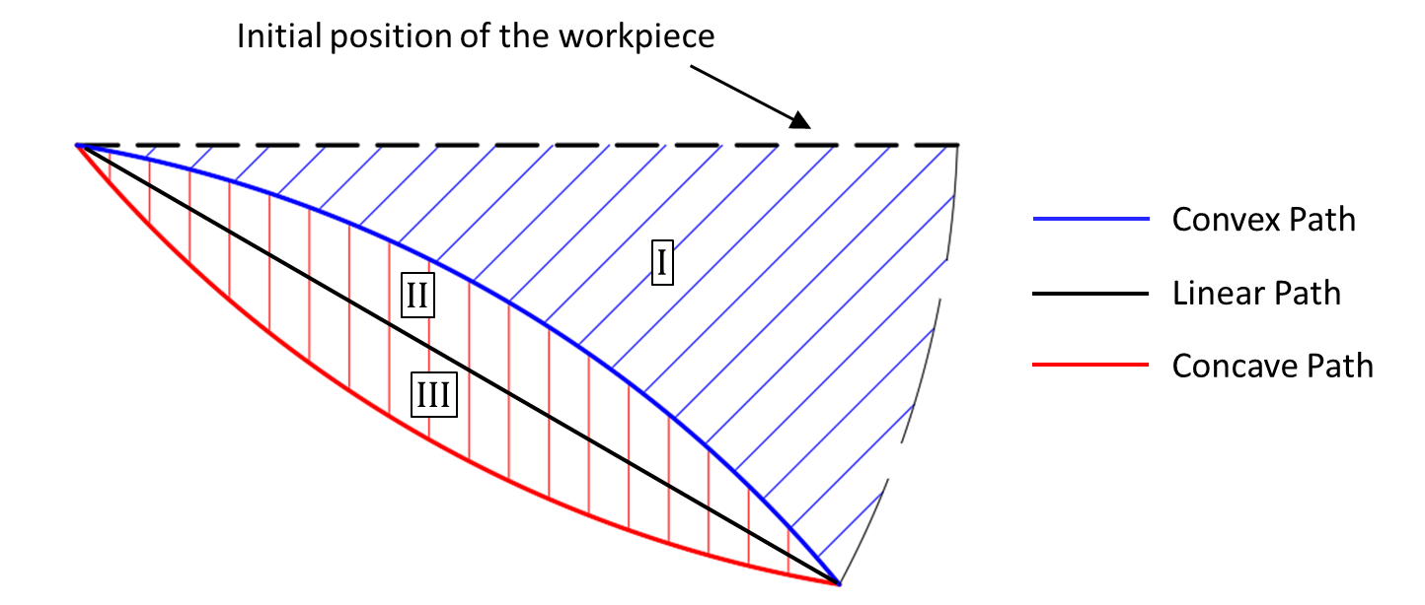
Figure 6.16 Workpiece swept area under different toolpath profiles
However, Li et al. (24) stated that workpieces produced using convex paths suffered higher tool forces and more wall thinning as compared with those produced using linear and concave toolpaths. Typical toolpaths used in that study are shown in Figure 6.17, which confirms that the convex toolpath creates the largest swept area, while the swept area for the concave toolpath is the smallest. This means the required deformation in the spinning process for the convex toolpath is greater than that required for the concave toolpath, resulting in higher forming forces and more thickness reduction being generated in the workpiece produced using a convex toolpath rather than a concave toolpath.
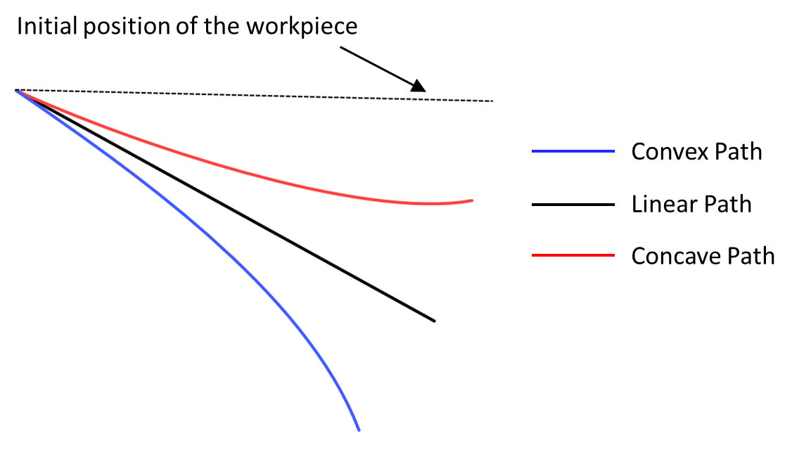
Figure 6.17 Schematic diagram of toolpaths in Li et al. (24)

Processing Map for Wrinkle-Free Spinning
In this subsection, the analytical wrinkling prediction model is validated by examining the experimentally obtained workpieces from Tests No. 9 to No. 18, which were produced under various forming conditions using the convex toolpath profile. Any occurrence of wrinkling failure and the resulting wrinkling time ratios are thus used as response factors for validation purposes, as well as to investigate the effect of designed forming depth on component defect.
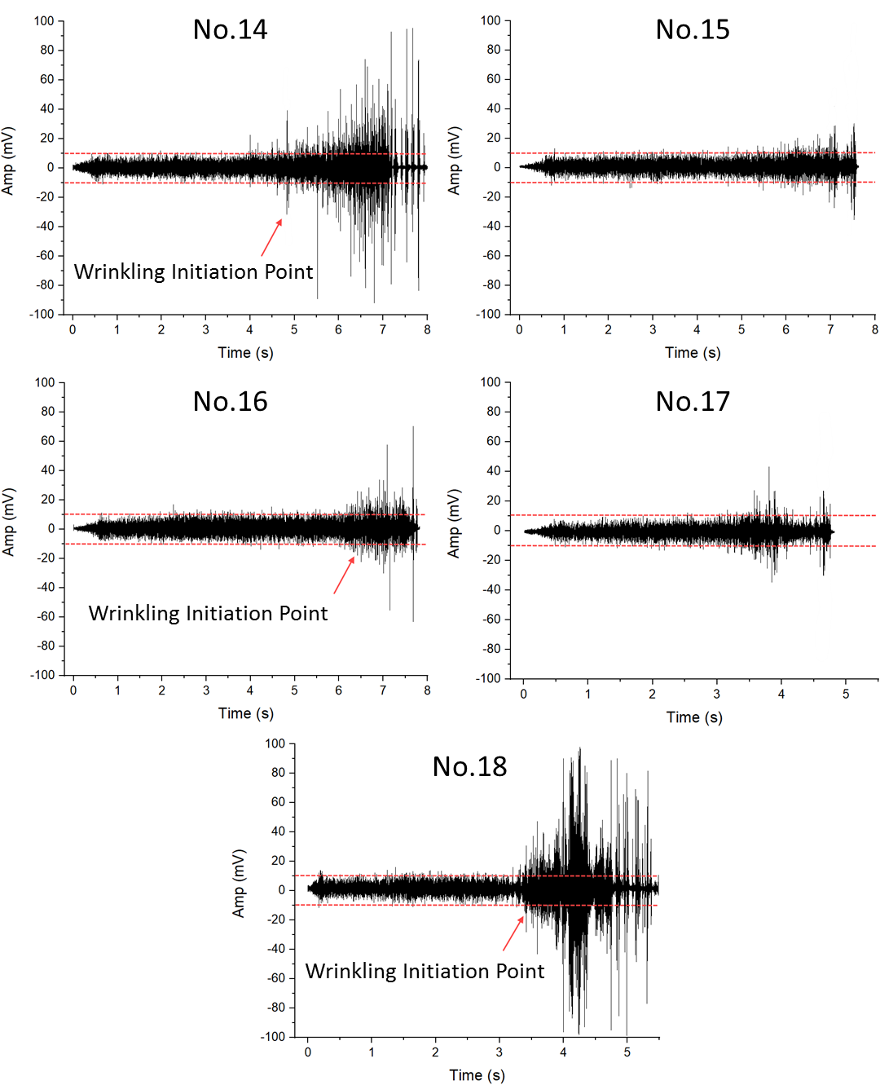
(a)
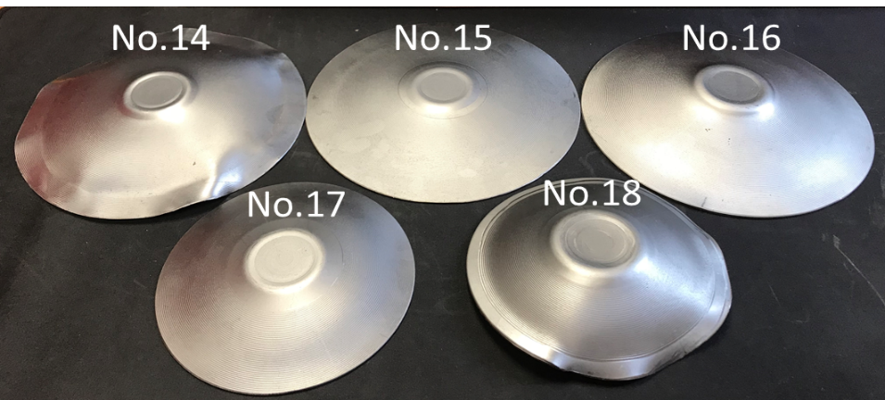
(b)
Figure 6.18 Workpieces obtained from Tests No. 14 to No. 18, (a) time-domain vibration amplitudes, (b) experimental workpieces
Due to the high spin ratios and large forming depths applied in Tests No. 14 to No. 18, severe wrinkles were generated, as shown in Figure 6.18 (b), resulting in large amplitudes of the waveform. The amplitude range of the vibration signal was therefore adjusted from (-50 mV, 50 mV), as used in the first thirteen tests, to (-100 mV, 100mV). As shown in Figure 6.18 (a), wrinkling failure was generated under the forming conditions of Tests No. 14, No. 16 and No. 18, though only minor wrinkles were observed in the workpiece for No. 16. The WTRs of these three workpieces were 0.58, 0.79, and 0.63, respectively. These results indicate that the designed forming depth has a significant influence on both occurrence of wrinkling failure and wrinkle severity, in agreement with the results obtained in the FE analysis. Where a larger forming depth is applied in the spinning process, this results in a larger shrinkage deformation of the workpiece in the circumferential direction, as shown in Figure 4.9. This effect generates additional compressive stresses in the edge of the workpiece in the early stages of the spinning process, which leads to more severe wrinkling failure than that in cases with shallower forming depths.
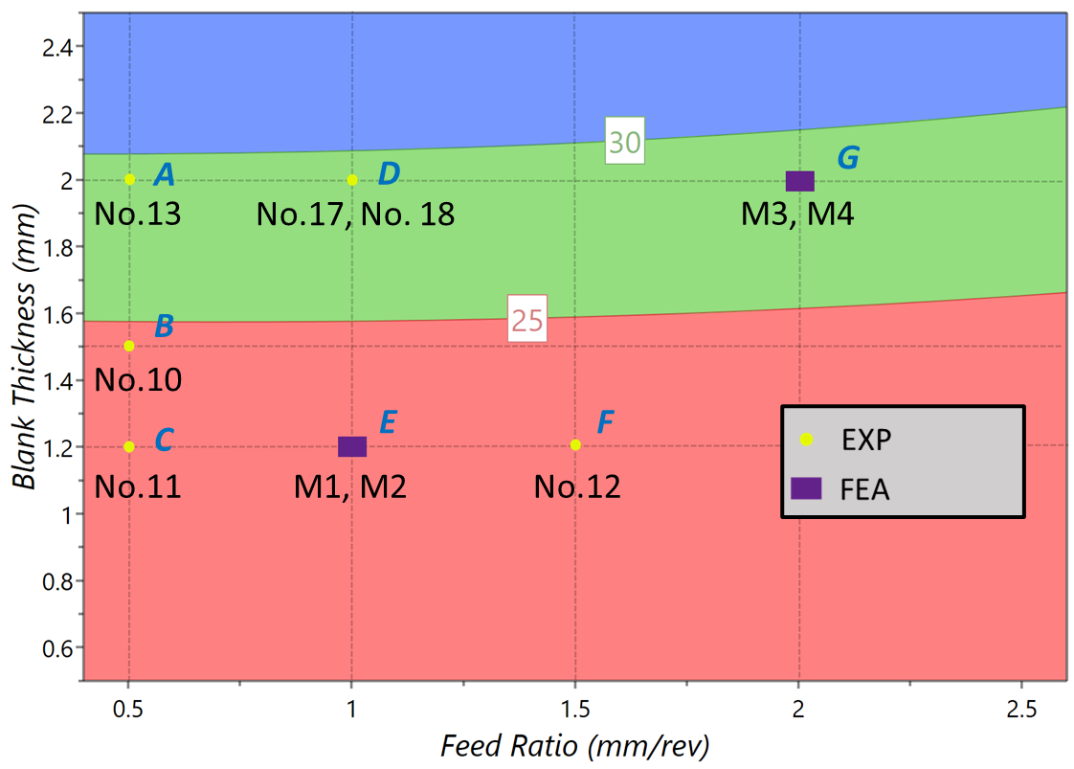
(a)
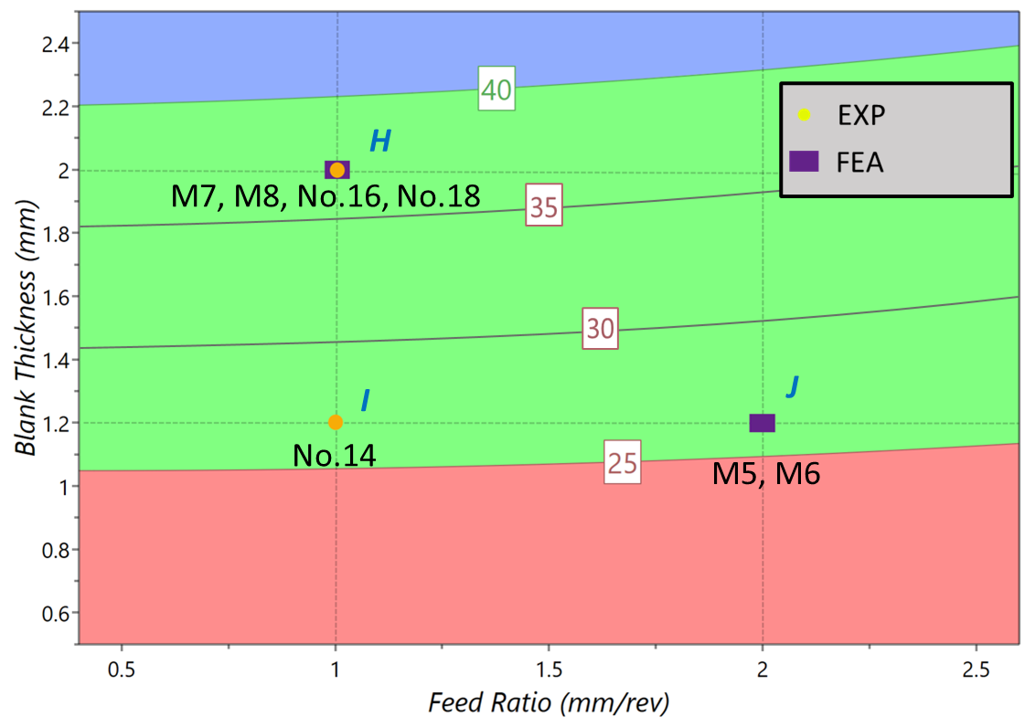
(b)
Figure 6.19 Validation of wrinkling prediction model at different spin ratios (a) $λ=73$, (b) $λ=0.80$
The contour plot results from the analytical wrinkling prediction model are different for the spin ratios, 0.73 and 0.8, as shown in Figure 6.19 (a) and (b), respectively. The contour lines reflect the critical forming depths as calculated under different feed ratios, ranging from 0.4 $mm/rev$ to 2.6 $mm/rev$, with workpiece thicknesses ranging from 0.5 $mm$ to 2.5 $mm$. If the designed forming depth is lower than the critical forming depth, wrinkling failure may thus be avoided. By substituting the spinning parameters of each experimental test and the FE model into these contour plots with the corresponding wrinkling conditions to compare the designed forming depth with the critical forming depth, the wrinkling prediction model is thus validated.
Table 6.8 Validation of analytical wrinkling prediction model at a spin ratio of 0.73
Point Number | Number of Test/Model | Designed Forming Depth ($mm$) | Critical Forming Depth Region ($mm$) | Wrinkling Condition
A | No.13 | 25 | (25,30) | No wrinkling
B | No.10 | 25 | <25 | Wrinkling
C | No.11 | 25 | <25 | Wrinkling
D | No.17 | 25 | (25,30) | No wrinkling
D | No.18 | 40 | (25,30) | Wrinkling
E | M1 | 25 | <25 | Wrinkling
E | M2 | 40 | <25 | Wrinkling
F | No.12 | 25 | <25 | Wrinkling
G | M3 | 25 | (25,30) | No Wrinkling
G | M4 | 40 | (25.30) | Wrinkling

Table 6.9 Validation of analytical wrinkling prediction model at a spin ratio of 0.80
Point Number | Number of Test/Model | Designed Forming Depth ($mm$) | Critical Forming Depth Region ($mm$) | Wrinkling Condition
H | M7 | 25 | (35,40) | No wrinkling
H | M8 | 40 | (35,40) | Wrinkling
H | No.16 | 40 | (35,40) | Wrinkling
H | No.18 | 25 | (35,40) | No Wrinkling
I | No.14 | 40 | (25,30) | Wrinkling
J | M5 | 25 | (25,30) | No wrinkling
J | M6 | 40 | (25,30) | Wrinkling

Tables 6.8 and 6.9 present the designed forming depth and the critical forming depth regions of the workpieces with the corresponding wrinkling conditions as obtained from the experiments and the FE modelling. It can be seen that no wrinkles occur were the forming depth applied is smaller than the critical forming depth as calculated by the wrinkling prediction model under the same conditions, suggesting that the analytical wrinkling prediction model is both reasonably accurate and reliable. However, the critical forming depth observed in the experiments is greater than that obtained in the theoretical prediction model, a fact that can be attributed to two reasons: (A) The ideal critical forming depth is calculated under analytically critical conditions to reject any wrinkling failure, even the most minor. In the experiment, however, micro wrinkles, which are difficult to detect, may be produced during the spinning process. The critical forming depth obtained from the analytical wrinkling prediction model is smaller than that obtained by the experimental method as the latter allows minor errors; and (B) In the first-pass conventional spinning process, the circumferential compressive stress may be reduced by frictional force at the contact interfaces between the forming tool and outer surface of the workpiece. This occurs because the direction of the friction force is opposed to the rolling direction of the forming tool circumferentially. In the analytical prediction model, however, a frictionless condition is assumed, which can cause the external forces to be more significant than those generated in the experiment process.
As the wrinkling prediction model was generally validated by the experiments, three-dimensional processing maps were obtained using feed ratios, workpiece thicknesses, and critical forming depth as variables to evaluate two different spin ratios, as shown in Figure 6.20. The surfaces in the processing maps indicate the wrinkling critical limits, allowing the processing map to be divided into a wrinkling-free zone, located on the lower side, and a wrinkling zone, located on the upper side.
These processing maps can therefore be utilised to select the spinning parameters for actual spinning applications. Where the proposed spinning parameters result in any spinning process within the wrinkling zone according to the processing map, wrinkling will occur during the spinning process, suggesting that the spinning parameters must be changed.
(a)
(b)
Figure 6.20 Processing maps to predict wrinkling failure at different spin ratios (a) $λ=0.73$, (b) $λ=0.80$

Summary
In this chapter, the wrinkling prediction model established in Chapter 5 was validated, firstly by means of a preliminary experiment with a relatively small spin ratio and then by examination of the effects of concave, linear, and convex toolpath profiles on wrinkling failure. The analytical wrinkling prediction model for the first-pass conventional spinning process was then further validated by examination of both experimental workpieces and FE simulated spun parts produced using a convex toolpath profile with two different spin ratios, 0.73 and 0.8. Based on the investigation of the first-pass conventional spinning process, the following key points may be drawn:
- High feed ratios are helpful to maintain the original workpiece thickness, while better geometrical accuracy can be achieved by using low feed ratios.
- Greater forming depth is achieved in workpieces produced using a concave toolpath profile, without wrinkling failure.
- The largest workpiece swept area is generated when using a concave toolpath, which leads to high thickness reduction and large forming forces as compared to those occurred when using a linear toolpath or a concave toolpath.
- The processing maps predicting wrinkling initiation when using the convex toolpath profile under different spin ratios are established as accurate, offering a practical tool for the selection of process parameters in practical spinning applications.

Conclusion and future work
In this chapter, the main conclusions on wrinkling failure in the first-pass conventional spinning and the key contribution to existing knowledge are presented in Section 7.1. The novel aspects of the study are outlined in Section 7.2. Suggestions for future work on the failures of the sheet metal spinning processes are outlined in Section 7.3.

Conclusion
In the field of the conventional sheet spinning processes, the selection of the forming process parameters and toolpath, both of which significantly influence the quality of the spun component, remain highly reliant on empirical knowledge and trial-and-error approach. In this study, an analytical wrinkling prediction model for the first-pass conventional spinning processes and a toolpath parameterisation method was developed to provide guidance to spinning process design. Three investigation methods, an analytical method, an FE analysis, and an experimental investigation method were applied to study wrinkling failure in the first-pass conventional spinning process. A processing map was then produced to predict wrinkling failure for the first-pass conventional spinning using a convex toolpath profile, and the key conclusions on five main aspects of this study are summarised below:
A) Toolpath Profile Parameterisation
In the conventional spinning process, the forming depth and the radius of workpiece after each pass are used to parameterise multiple-pass toolpath profiles. Specifically, the cubic Bézier curve is employed to parameterise each individual tool pass, such as the first-pass and the final pass, enabling the definition of different toolpath profiles, including linear path, concave path, and convex path. The path curvatures for these three toolpath profiles can be defined separately, as the cubic Bézier curve has the ability to produce a final toolpath, which can then be examined by comparing it with the geometrical shapes of different mandrel profiles. To study the accuracy of the first-pass toolpath produced by the cubic Bézier curve, a convex toolpath with a path curvature of $2λ$ was parameterised using the cubic Bézier curve, and the differences between various cubic Bézier curves with a varying zenith angle $φ_{i}$, and a circular arc curve with a radius of 1 were considered. Based on this, it was found that the zenith angle has a significant influence on the accuracy of the convex toolpath produced by the cubic Bézier curve. To maintain high accuracy in a convex toolpath produced by the cubic Bézier curve, the zenith angle, $φ_{i}$, should be less than $π$.
B) Wrinkling Failure
Wrinkling failure in the first-pass conventional spinning process was studied by using both FE analysis and an experimental method. In the FE modelling, the severity of the wrinkles was quantified based on calculating the standard deviation (STDV) of the axial displacement at the edge of the workpiece along the circumferential direction. The wrinkling initiation was determined by fluctuations in the magnitude of the elastic strain energy during the spinning process, allowing the wrinkling time ratio (WTR) to be calculated. In the spinning experiments, a time-domain measurement system using a vibration sensor was employed to record the initiation and development of wrinkling failure. Based on the results of both FE modelling and the spinning experiments, wrinkled spun components and wrinkle-free spun components were identified. In the FE modelling, a spun component was regarded as wrinkling-free model if the STDV was smaller than 0.536 $mm$ and the WRT was greater than 0.934, while in the spinning experiments, a wrinkle-free spun component was produced where the amplitudes of the vibration waveforms were in the range between 10 $mV$ to -10 $mV$for the majority of the data. Based on FE results analysis using the Taguchi method, the workpiece thickness and the designed forming depth have the strongest effects on the severity of wrinkles, followed by the feed ratio. The wave function was proposed and validated based on the geometrical modelling of wrinkles using both FE modelling and experimental tests; this was therefore used to support the development of a wrinkling prediction model.
C) Process Parameters
Analysis of the effects of feed ratio on the contact path created by tool movement on the workpiece surface suggests that higher feed ratios result in rougher external surfaces of the spun component as well as higher forming forces during the spinning process. The spun component produced using the concave toolpath profile was found to achieve a higher forming depth than those produced using the other two toolpath profiles. This is because the concave toolpath produces the largest swept area of workpiece among the three toolpath profiles tested, resulting in the largest set of forming forces, the greatest stresses and strains, and a greater thickness reduction.
D) Analytical Wrinkling Prediction Model
In this study, an analytical wrinkling prediction model based on the conservation of energy was developed for first-pass conventional spinning using the convex toolpath profile. According to the results of the analytical wrinkling prediction model, of the three materials tested, DC01, AA5052, and AA1050, DC01 produces the highest forming depth due to it having the largest strain-hardening index $n$, a factor that has a significant influence on the critical forming depth. In contrast, the strength coefficient $K$ and Young’s modulus $E$ have less influence on the critical forming depth. The critical forming depth as calculated using the analytical wrinkling prediction model can be used in ascertaining toolpath design, as wrinkling failure can be avoided if the designed forming depth is lower than the critical forming depth. Furthermore, the critical forming depth increases but the slope of the toolpath decreases with the increasing of spin ratio, which indicates that more passes are required to form the workpiece with a greater spin ratio. The analytical wrinkling prediction model was validated by the FE models and spinning experiments.
E) Processing Map
The processing map which was established based on the analytical wrinkling prediction model was used to predict wrinkling failure in the first-pass conventional spinning using a convex toolpath profile. The developed processing maps can be used to evaluate the effects of key spinning parameters on the occurrence of wrinkling failure, providing guidance for the selection of spinning parameters in the product of spun components.

Research Novelty
The main novelty of this study is the development and validation of an analytical wrinkling prediction model for the first-pass conventional spinning using convex toolpath. The new contributions are in this study may be outlined as follows:
- Developed a novel method for calculating the control points of the cubic Bézier curve for the first-pass and final-pass toolpath profiles, thereby contributing to the mathematical parameterisation of toolpath design for sheet metal spinning.
- Established a wave function for geometrical modelling of the wrinkles to calculate the strain energy consumption of the wrinkled spun component, thereby establishing the critical conditions of wrinkling failure by the energy conservation method.
- Proposed a processing map to predict wrinkling failure in the first-pass conventional spinning using convex toolpath based on the wrinkling prediction model, thereby providing guidance for spinning parameter selection in the spinning process design.

Future Work
Future work will consider further three investigations into the failures in sheet metal spinning process are identified:
A) Experimental validation of the analytical wrinkling prediction model
In this study, the critical forming depths of three materials, DC01, AA5052, and AA1050, were obtained from the analytical wrinkling prediction model, as shown in Figure 5.5. However, this model was only validated for DC01 in the spinning experiments and FE modelling. Further study on the capability and reliability of this wrinkling prediction model can be conducted for more materials together with additional experimental validations.
B) Analytical Wrinkling Prediction Models Involving More Process Parameters
In this study, the analytical wrinkling prediction model was established and validated with a maximum feed ratio of 2 $mm/rev$. The results showed that it can be used to predict the wrinkling failure successfully under these circumstances. However, the application of this model is thus limited to first-pass conventional spinning processes using a convex toolpath profile. Multiple-passes and different toolpath profiles, such as concave paths and linear paths, are often used in actual conventional spinning processes. Therefore, it is of practical importance to develop the analytical wrinkling prediction model to encompass multiple-passes in conventional spinning involving different toolpath profiles and thereby address wrinkling failure more generally. This could also provide the guidance for spinning process design, such as identifying the critical number of tool-passes and the selection of toolpath profiles to improve the production efficiency of spun components. Future work, including FE modelling and spinning experiments, should attempt to consider more input parameters at various levels (no less than three levels) into account by employing regression modelling or response surface methods, in an attempt to optimise the quality of spun components in the conventional spinning processes.
C) Study of Fracture Failure in Conventional Spinning Process
In the conventional spinning process, fracture failure also significantly affects the quality of the spun component and the production efficiency. However, previous research has focused on fracture failure in shear spinning rather than in conventional spinning. Further research into fracture failure in conventional spinning, possibly through FE simulation, would therefore be beneficial to industrial spinning process design. A suitable material damage model, including damage initiation criteria and damage evolution laws, may be developed using user subroutines based on the FE software platform of ABAQUS in the simulation of fracture failures in the conventional spinning process.

References

1. WONG, C C, DEAN, T A and LIN, J. A review of spinning, shear forming and flow forming processes. International Journal of Machine Tools and Manufacture. 2003. Vol. 43, no. 14, p. 1419–1435.
2. KLEINER, M., GÖBEL, R., KANTZ, H., KLIMMEK, Ch. and HOMBERG, W. Combined Methods for the Prediction of Dynamic Instabilities in Sheet Metal Spinning. CIRP Annals - Manufacturing Technology [online]. 2002. Vol. 51, no. 1, p. 209–214.
3. XIA, Qinxiang, XIAO, Gangfeng, LONG, Hui, CHENG, Xiuquan and SHENG, Xiangfei. A review of process advancement of novel metal spinning. International Journal of Machine Tools and Manufacture [online]. 2014. Vol. 85, no. 381, p. 100–121.
4. ABD-ALRAZZAQ, Mohamed, AHMED, Mahmoud and YOUNES, Mohamed. Experimental Investigation on the Geometrical Accuracy of the CNC Multi-Pass Sheet Metal Spinning Process. Journal of Manufacturing and Materials Processing. 2018. Vol. 2, no. 3, p. 59.
5. MUSIC, O., ALLWOOD, J. M. and KAWAI, K. A review of the mechanics of metal spinning. Journal of Materials Processing Technology. 2010. Vol. 210, no. 1, p. 3–23.
6. HAMILTON, Seth and LONG, Hui. Analysis of conventional spinning process of a cylindrical part using finite element method. Steel research international. 2008. Vol. 79, no. 1, p. 632–639.
7. EMBURY, J D and DUNCAN, J L. Formability Maps. Annual Review of Materials Science. 1981. Vol. 11, no. 1, p. 505–521.
8. EMMENS, Wilko C. Formability: A review of parameters and processes that control, limit or enhance the formability of sheet metal. Springer Science & Business Media, 2011.
9. KEGG, R.L. A New Test Method for Determination of Spinnability of Metals. Trans. ASME, series B, Journal of Engineering for Industry. 1961. Vol. 83, no. B, p. 119–124.
10. HAYAMA, Masujiro and TAGO, Akio. The Fracture of Walls on Shear Spinning: Study on the Spinnability of Aluminium Plates. 横浜国立大学工学部紀要. 1968. Vol. 17, p. 93–103.
11. KAWAI, K, YANG, L-N and KUDO, H. A flexible shear spinning of axi-symmetrical shells with a general-purpose mandrel. Journal of Materials Processing Technology. 2007. Vol. 192, p. 13–17.
12. KOBAYASHI, S. Instability in conventional spinning of cones. Transactions of the ASME, Journal of Engineering for Industry. 1963. Vol. 85, p. 44–48.
13. SEBASTIANI, G, BROSIUS, A, EWERS, R, KLEINER, M and KLIMMEK, C. Numerical investigation on dynamic effects during sheet metal spinning by explicit finite-element-analysis. Journal of materials processing technology. 2006. Vol. 177, no. 1, p. 401–403.
14. XIA, Qinxiang, SHIMA, Susumu, KOTERA, Hidetoshi and YASUHUKU, Daifu. A study of the one-path deep drawing spinning of cups. Journal of Materials Processing Technology. 2005. Vol. 159, no. 3, p. 397–400.
15. ZHAN, Mei, YANG, He, ZHANG, J H, XU, Y L and MA, F. 3D FEM analysis of influence of roller feed rate on forming force and quality of cone spinning. Journal of Materials Processing Technology. 2007. Vol. 187, p. 486–491.
16. ESSA, K. and HARTLEY, P. Optimization of conventional spinning process parameters by means of numerical simulation and statistical analysis. Proceedings of the Institution of Mechanical Engineers, Part B: Journal of Engineering Manufacture. 2010. Vol. 224, no. 11, p. 1691–1705.
17. WANG, L., LONG, H., ASHLEY, D., ROBERTS, M. and WHITE, P. Effects of the roller feed ratio on wrinkling failure in conventional spinning of a cylindrical cup. Proceedings of the Institution of Mechanical Engineers, Part B: Journal of Engineering Manufacture. 2011. Vol. 225, no. 11, p. 1991–2006.
18. HAYAMA, Masujiro, HIROAKI, KUDO and SHINOKURA, Tsuneki. Study of the pass schedule in conventional simple spinning. Bulletin of JSME. 1970. Vol. 13, no. 65, p. 1358–1365.
19. LIU, J H, YANG, He and LI, Y Q. A study of the stress and strain distributions of first-pass conventional spinning under different roller-traces. Journal of Materials Processing Technology. 2002. Vol. 129, no. 1, p. 326–329.
20. POLYBLANK, James A. and ALLWOOD, Julian M. Parametric toolpath design in metal spinning. CIRP Annals - Manufacturing Technology [online]. 2015. Vol. 64, no. 1, p. 301–304.
21. HOSFORD, William F. and DUNCAN, John L. Sheet metal forming: A review. Jom. 1999. Vol. 51, no. 11, p. 39–44.
22. SHIM, Myoung-Sup and PARK, Jong-Jin. The formability of aluminum sheet in incremental forming. Journal of Materials Processing Technology. 2001. Vol. 113, no. 1, p. 654–658.
23. CHEN, S. W., GAO, P. F., ZHAN, M., MA, F., ZHANG, H. R. and XU, R. Q. Determination of formability considering wrinkling defect in first-pass conventional spinning with linear roller path. Journal of Materials Processing Technology. 2019. Vol. 265, p. 44–55.
24. LI, Yong, WANG, Jin, LU, Guo Dong and PAN, Guo Jun. A numerical study of the effects of roller paths on dimensional precision in die-less spinning of sheet metal. Journal of Zhejiang University: Science A. 2014. Vol. 15, no. 6, p. 432–446.
25. ARAI, Hirohiko. Robotic metal spinning-shear spinning using force feedback control. In : Robotics and Automation, 2003. Proceedings. ICRA’03. IEEE International Conference on. IEEE, 2003. p. 3977–3983.
26. M. HAYAMA, T. MUROTA, H. Kudo. Deformation modes and wrinkling of flange on shear spinning. Bulletin of JSME. 1966. Vol. 9, no. 34, p. 423–433.
27. WATSON, M., LONG, H. and LU, B. Investigation of wrinkling failure mechanics in metal spinning by Box-Behnken design of experiments using finite element method. International Journal of Advanced Manufacturing Technology. 2015. Vol. 78, no. 5–8, p. 981–995.
28. LIU, Chun-Ho. The simulation of the multi-pass and die-less spinning process. Journal of materials processing technology. 2007. Vol. 192, p. 518–524.
29. CHILDERHOUSE, Thomas and LONG, Hui. Processing maps for wrinkle free and quality enhanced parts by shear spinning. Procedia Manufacturing [online]. 2019. Vol. 29, p. 137–144.
30. KANG, Da-Chang, GAO, Xi-Cheng, MENG, Xiao-Feng and WANG, Zhi-Hui. Study on the deformation mode of conventional spinning of plates. Journal of Materials Processing Technology. 1999. Vol. 91, no. 1, p. 226–230.
31. AVITZUR, Betzalel and YANG, C T. Analysis of power spinning of cones. Journal of Engineering for Industry. 1960. Vol. 82, no. 3, p. 231–244.
32. KALPAKCIOGLU, Serope. On the mechanics of shear spinning. Transactions of the ASME, Journal of Engineering for Industry. 1961. Vol. 83, p. 125–130.
33. KOBAYASHI, S, HALL, I K and THOMSEN, E G. A theory of shear spinning of cones. Transactions of the ASME, Journal of Engineering for Industry. 1961. Vol. 81, p. 485–495.
34. KIM, Jae Hun, PARK, Jun Hong and KIM, Chul. A study on the mechanics of shear spinning of cones. Journal of Mechanical Science and Technology. 2006. Vol. 20, no. 6, p. 806–818.
35. ZHANG, Shi-Hong, LU, Xin-Yu, LIU, Hai, HOU, Hong-Liang, LI, Zhi-Qiang and ZENG, Yuan-Song. Effects of feeding ratio on flange bending in shear spinning. International journal of material forming. 2011. Vol. 4, no. 4, p. 413–419.
36. WANG, Lin. Analysis of Material Deformation and Wrinkling Failure in Conventional Metal Spinning Process. Phd thesis. 2012.
37. CHENG, X Q, WU, X Y and XIA, Q X. Research on thickness distribution of spun hollow part with four arc-typed cross-section. In : The 10th International Conference on Technology of Plasticity, Aachen, Germany. 2011. p. 560–563.
38. QINXIANG, Xia, XIUQUAN, Cheng, FENG, Ruan and ZHENYUAN, Huang. Research on the forming forces during the 3D non-axisymmetric thin-walled tubes neck-spinning. . 2006.
39. CHEN, M D, HSU, R Q and FUH, K H. Forecast of shear spinning force and surface roughness of spun cones by employing regression analysis. International Journal of machine tools and manufacture. 2001. Vol. 41, no. 12, p. 1721–1734.
40. ZHAN, Mei, YANG, He, GUO, Jing and WANG, Xian Xian. Review on hot spinning for difficult-to-deform lightweight metals. Transactions of Nonferrous Metals Society of China (English Edition) [online]. 2015. Vol. 25, no. 6, p. 1732–1743.
41. SEBASTIANI, Gerd, BROSIUS, Alexander, HOMBERG, Werner and KLEINER, Matthias. Process characterization of sheet metal spinning by means of finite elements. In : Key Engineering Materials. Trans Tech Publ, 2007. p. 637–644.
42. WANG, Lin and LONG, Hui. Investigation of material deformation in multi-pass conventional metal spinning. Materials and Design [online]. 2011. Vol. 32, no. 5, p. 2891–2899.
43. MUSIC, Omer and ALLWOOD, Julian M. Tool-path Design for Metal Spinning. In : Proceedings of the 10th International Confernece on Technology of Plasticity. 2011. p. 542–547.
44. HIBBITT, H D, KARLSSON, B I and SORENSEN, E P. ABAQUS User’s & Theory Manuals, 6.14. Dassault Systèmes Simulia Corp., Providence, RI, USA. 2013.
45. TEKKAYA, A. Erman. State-of-the-art of simulation of sheet metal forming. Journal of Materials Processing Technology. 2000. Vol. 103, no. 1, p. 14–22.
46. YANG, D. Y., JUNG, D. W., SONG, I. S., YOO, D. J. and LEE, J. H. Comparative investigation into implicit, explicit, and iterative implicit/explicit schemes for the simulation of sheet-metal forming processes. Journal of Materials Processing Tech. 1995. Vol. 50, no. 1–4, p. 39–53.
47. ALBERTI, N. and FRATINI, L. Innovative sheet metal forming processes: Numerical simulations and experimental tests. Journal of Materials Processing Technology. 2004. Vol. 150, no. 1–2, p. 2–9.
48. HAREWOOD, F J and MCHUGH, P E. Comparison of the implicit and explicit finite element methods using crystal plasticity. Computational Materials Science. 2007. Vol. 39, no. 2, p. 481–494.
49. CHEN, Wai-Fah and HAN, Da-Jian. Plasticity for structural engineers. J. Ross Publishing, 2007.
50. BELYTSCHKO, Ted, LIU, Wing Kam, MORAN, Brian and ELKHODARY, Khalil. Nonlinear finite elements for continua and structures. John wiley & sons, 2013.
51. REES, David. Basic engineering plasticity: an introduction with engineering and manufacturing applications. Elsevier, 2012.
52. DUNNE, Fionn and PETRINIC, Nik. Introduction to computational plasticity. Oxford University Press on Demand, 2005.
53. QUIGLEY, E. and MONAGHAN, J. Enhanced finite element models of metal spinning. Journal of Materials Processing Technology. 2002. Vol. 121, no. 1, p. 43–49.
54. LONG, H, WANG, L and JAGGER, P. Tool force analysis in multi-pass conventional spinning by finite element simulation and experimental measurement. In : Proceedings of the 10th International Conference on Technology of Plasticity, ICTP 2011. 2011. p. 547–553.
55. ESSA, Khamis and HARTLEY, Peter. Numerical simulation of single and dual pass conventional spinning processes. International Journal of Material Forming. 2009. Vol. 2, no. 4, p. 271–281.
56. LI, Zi Xuan and SHU, Xue Dao. Numerical and experimental analysis on multi-pass conventional spinning of the cylindrical part with GH3030. International Journal of Advanced Manufacturing Technology. 2019. Vol. 103, no. 5–8, p. 2893–2901.
57. GAN, Tian, KONG, Qingshuai, YU, Zhongqi, ZHAO, Yixi and LAI, Xinmin. A numerical study of multi-pass design based on Bezier curve in conventional spinning of spherical components. MATEC Web of Conferences. 2016. Vol. 80.
58. ŠUGÁR, Peter, ŠUGÁROVÁ, Jana and PETROVIČ, Ján. Analysis of the effect of process parameters on part wall thickness variation in conventional metal spinning of Cr-Mn austenitic stainless steels. Strojniski Vestnik/Journal of Mechanical Engineering. 2016. Vol. 62, no. 3, p. 171–178.
59. RUNGE, M. Spinning and flow forming. Leifeld GmbH. 1994.
60. GAN, Tian, YU, Zhong qi, ZHAO, Yi xi, EVSYUKOV, S. A. and LAI, Xin min. Effects of backward path parameters on formability in conventional spinning of aluminum hemispherical parts. Transactions of Nonferrous Metals Society of China (English Edition) [online]. 2018. Vol. 28, no. 2, p. 328–339.
61. WANG, L. and LONG, H. A study of effects of roller path profiles on tool forces and part wall thickness variation in conventional metal spinning. Journal of Materials Processing Technology [online]. 2011. Vol. 211, no. 12, p. 2140–2151.
62. LONG, H, WANG, L and JAGGER, P. Roller force analysis in multi-pass conventional spinning by finite element simulation and experimental measurement. In : Proceedings of the 10th International Conference on Technology of Plasticity, Aachen, Germany. 2011.
63. MA, F, YANG, H and ZHAN, M. Plastic deformation behaviors and their application in power spinning process of conical parts with transverse inner rib. Journal of Materials Processing Technology. 2010. Vol. 210, no. 1, p. 180–189.
64. EL-KHABEERY, M. M., FATTOUH, M., EL-SHEIKH, M. N. and HAMED, O. A. On the conventional simple spinning of cylindrical aluminium cups. International Journal of Machine Tools and Manufacture. 1991. Vol. 31, no. 2, p. 203–219.
65. CHEN, Ming-Der, HSU, Ray-Quan and FUH, Kuang-Hua. Effects of over-roll thickness on cone surface roughness in shear spinning. Journal of materials processing technology. 2005. Vol. 159, no. 1, p. 1–8.
66. HAYAMA, Masujiro, MUROTA, Tadao and HIROAKI, KUDO. Experimental study of shear spinning. Bulletin of JSME. 1965. Vol. 8, no. 31, p. 453–460.
67. GATEA, Shakir, OU, Hengan and MCCARTNEY, Graham. Review on the influence of process parameters in incremental sheet forming. International Journal of Advanced Manufacturing Technology [online]. 2016. Vol. 87, no. 1–4, p. 479–499.
68. RADONS, Günter and NEUGEBAUER, Reimund. Nonlinear dynamics of production systems. Wiley Online Library, 2004.
69. RAZAVI, H, BIGLARI, F R and TORABKHANI, A. Study of strains distribution in spinning process using FE simulation and experimental work. In : Tehran international congress on manufacturing engineering (TICME2005), Tehran, Iran. 2005.
70. BENI, H R, BENI, Y T and BIGLARI, F R. An experimental—numerical investigation of a metal spinning process. Proceedings of the Institution of Mechanical Engineers, Part C: Journal of Mechanical Engineering Science. 2011. Vol. 225, no. 3, p. 509–519.
71. WANG, Lin and LONG, Hui. Roller path design by tool compensation in multi-pass conventional spinning. Materials and Design [online]. 2013. Vol. 46, p. 645–653.
72. LONG, H and HAMILTON, S. Simulation of Effects of Material Deformation on Thickness Variation in Conventional Spinning. . 2008. P. 735–740.
73. SENIOR, B.W. Flange wrinkling in deep-drawing operations. Journal of the Mechanics and Physics of Solids [online]. 1956. Vol. 4, p. 235–246.
74. KONG, Qingshuai, YU, Zhongqi, ZHAO, Yixi, WANG, Hao and LIN, Zhongqin. Theoretical prediction of flange wrinkling in first-pass conventional spinning of hemispherical part. Journal of Materials Processing Technology [online]. 2017. Vol. 246, p. 56–68.
75. KIM, J. B., YOON, J. W. and YANG, D. Y. Investigation into the wrinkling behaviour of thin sheets in the cylindrical cup deep drawing process using bifurcation theory. International Journal for Numerical Methods in Engineering. 2003. Vol. 56, no. 12, p. 1673–1705.
76. KONG, Qingshuai, YU, Zhongqi, ZHAO, Yixi, WANG, Hao and LIN, Zhongqin. A study of severe flange wrinkling in first-pass conventional spinning of hemispherical part. International Journal of Advanced Manufacturing Technology. 2017. Vol. 93, no. 9–12, p. 3583–3598.
77. JAGGER, Paul. Tool force measurement in the metal spinning process. Meng Dissertation, School of Engineering and Cpmputing Sciences, Durham University. 2010.
78. WANG, Xi and CAO, Jian. An Analytical Prediction of Flange Wrinkling in Sheet Metal Forming. Journal of Manufacturing Processes [online]. 2000. Vol. 2, no. 2, p. 100–107.
79. ZHAO, Yixi, WAN, Xumin, GAO, Leitao, KONG, Qingshuai and YU, Zhongqi. Theoretical Prediction of Sheet Metal Wrinkling Based on the Potential Function Analysis. Journal of Manufacturing Science and Engineering. 2018. Vol. 140, no. 10, p. 101012.
80. V.V. NOVOZHILOV. Thin Shell Theory. Ed., 2nd r. Groningen : Groningen : P. Noordhoff, 1964.
81. STEPHEN P TIMOSHENKO; SERGIUS WOINOWSKY-KRIEGER. Theory of Plates and Shells. 2nd Ed. New York : McGraw-Hill, 1959.
82. VENTSEL, E, KRAUTHAMMER, T and CARRERA, E. Thin Plates and Shells: Theory, Analysis, and Applications [online]. New York : Marcel Dekker, Inc, 2002.
83. STEPHEN P TIMOSHENKO; JAMES M GERE. Theory of Elastic Stability. 2nd Ed. New York : McGraw-Hill Book Company, INC., 1961.
84. HILL, Rodney. The mathematical theory of plasticity. Oxford university press, 1998.
85. JONES, Robert Millard. Deformation theory of plasticity. Bull Ridge Corporation, 2009.
86. ZHAO, G. Y., LIU, Y. L., DONG, C. S., YANG, H. and FAN, X. G. Analysis of wrinkling limit of rotary-draw bending process for thin-walled rectangular tube. Journal of Materials Processing Technology [online]. 2010. Vol. 210, no. 9, p. 1224–1231.
87. SYSTÈMES, Dassault. Abaqus 6.14–Analysis Users’s Guide: Volume IV: Elements. Providence, Rhode Island. 2013.
88. KLIMMEK, Christian, GOBEL, Roland, HOMBERG, Werner, KANTZ, Holger and MATTHIAS, Kleiner. Finite Element Analysis of Sheet Metal Forming by Spinning. Proc. of 7th International Conference on Technology of Plasticity. 2003. Vol. 44, no. 507, p. 372–374.
89. STANDARD, Transportation Officials, AMERICAN, An and STANDARD, National. ASTM E8M-13a. . 2014. Vol. i, p. 1–28.
90. ROSHAN JOSEPH, V and JEFF WU, C F. Performance Measures in Dynamic Parameter Design. Journal of Japanese Quality Engineering Society [online]. 2002. Vol. 10, p. 82–86.
91. WATSON, Michael and LONG, Hui. Wrinkling failure mechanics in metal spinning. Procedia Engineering. 2014. Vol. 81, no. September 2016, p. 2391–2396.
92. QUIGLEY, Eamonn and MONAGHAN, John. Metal forming: an analysis of spinning processes. Journal of Materials Processing Technology. 2000. Vol. 103, no. 1, p. 114–119.
93. BURDEN, Richard L, FAIRES, J Douglas and REYNOLDS, A C. Numerical Analysis Prindle. Weber & Schmidt. 1985. P. 28–34.
94. ENGINEERINGTOOLBOX. Young’s Modulus - Tensile and Yield Strength for common Materials. [online]. 2003.
95. SMALL, Katharine B., ENGLEHART, David A. and CHRISTMAN, Todd A. Guide to etching specialty alloys. Advanced Materials and Processes. 2008. Vol. 166, no. 2, p. 32–37.
96. MONTGOMERY, Douglas C. Design and Analysis of Experiments Ninth Edition [online]. 2017.
97. ANTONY, Jiju. Design of experiments for engineers and scientists. Elsevier, 2014.
98. DE AGUIAR, P Fernandes, BOURGUIGNON, B, KHOTS, M S, MASSART, D L and PHAN-THAN-LUU, R. D-optimal designs. Chemometrics and intelligent laboratory systems. 1995. Vol. 30, no. 2, p. 199–210.
99. MARCINIAK, Z., DUNCAN, J.L. and HU, S.J. Mechanics of Sheet Metal Forming. 2002.

Appendices

Appendice 1 MATLAB code for Wrinkling Prediction Model

function data=Critical_depth(R0,Rc,t,n,K,v,E)
%This is the function to calculate the critical forming depth based on the analytical wrinkling prediction model.
%Where:
%R0 is the original workpiece radius;
%Rc is the radius of clamped area;
%t is the workpiece thickness;
%n is the strain-hardening index;
%K is the material strength coefficient;
%v is the Poisson ratio;
%E is the Young's modulus;
r=rs:1:rf;
%Set the interval for the path radius, in which rs and rf are the lower limit and upper limit, respectively.
sn =length(r);
data=zeros(sn,6);
for i=1:1:sn
phic=asin(Rc./r(i));
% To calculate phic under different path radius.
data(i,5)=phic;
phii=double(Calculate_phii(R0,Rc,r(i)));
%To calculate phii accordingly.
data(i,6)=phii;
hc=sqrt((2.*r(i).*sin(phii./2)).^2-(r(i).*sin(phic+phii)-Rc).^2);
%To calculate the forming depth.
x=hc;
data(i,1)=x;
data(i,4)=r(i);
y1=double(Internal_Energy(R0,Rc,t,n,K,r(i),v,E));
data(i,2)=y1;
y2=double(Work_done(R0,Rc,t,n,K,r(i)));
data(i,3)=y2;
end
plot(data(:,1),data(:,2),'-.')
%Plot the curve of internal energy
hold on
plot(data(:,1),data(:,3),'-')
%Plot the curve of external energy
end

function [phii]=Calculate_phii(R0,Rc,r)
%This is the function of calculate $φ_{i}$;
fa=x*pi;
fb=y*pi;
%fa and fb are the lower and upper limit of phi, respectively;
error=0.00001;
% accuracy 10^-5
phic=asin(Rc/r);
f1=double(r*fa*(Rc+r*sin(phic+fa))-R0^2+Rc^2);
f2=double(r*fb*(Rc+r*sin(phic+fb))-R0^2+Rc^2);
while (f1*f2<0)
phi=0.5*(fa+fb);
f=double(r*phi*(Rc+r*sin(phic+phi))-R0^2+Rc^2);
if (f*f1<0)
fb=phi;
f2=double(r*fb*(Rc+r*sin(phic+fb))-R0^2+Rc^2);
else
fa=phi;
f1=double(r*fa*(Rc+r*sin(phic+fa))-R0^2+Rc^2);
end
if(abs(fb-fa)<error)
break
end
phii=0.5*(fa+fb);
end
end

function [U_double,m]=Internal_Energy(R0,Rc,t,n,K,r,v,E)
%This is the function to calculate the internal energy
syms phi
phic=asin(Rc./r);
phii=double(Calculate_phii(R0,Rc,r));
a=r.*sin(phic)+r.*phii;
%a is the blank original length
r1=r.*sin(phii+phic);
f=log(a./r1);
%f is the function of calculation sigma_phi
A=2./sqrt(3).*f;
% Equivalent strain\
B=K.*A.^n;
% Equivalent stress
Es=K.*A.^(n-1);
%secant modulus
Et=n.*K.*A.^(n-1);
%tangent modulus
Er=4.*E.*Et./(sqrt(E)+sqrt(Et)).^2;
%reduced modulus
f1=(sin(pi.*phi./(2.*phii))).^2./r1.^3;

f2=2.*pi.*r.*((cos(pi.*phi./phii)).^2-1)./r1.^3-pi.^2.*sin(pi.*phi./phii).*cos(phi+phic)./(2.*r1.^2.*phii)+v.*pi.^3.*
(sin(pi.*phi./(2.*phii))).^2./(2.*r.*r1.*phii.^2)-2.*v.*pi.*(sin(pi.*phi./(2.*phii))).^2./(r1.*r)+2.*
(1-v).*pi.*(4.*r.^2.*phii.^2.*(cos(phi+phic)).^2.*(sin(pi.*phi./(2.*phii))).^2
+r1.^2.*pi.^2.*(cos(pi.*phi./(2.*phii))).^2
-2.*pi.*r1.*r.*phii.*sin(pi.*phi./phii).*cos(phi+phic))./(4.*r.*r1.^3.*phii.^2);

f3=3.*pi.^3.*(cos(pi.*phi./(2.*phii))).^2.*(cos(phi+phic)).^2./(4.*r1.*r.*phii.^2)
+3.*pi.^2.*sin(pi.*phi./phii).*cos(phi+phic)./(2.*r1.^2.*phii)
+3.*pi.*r.*(sin(pi.*phi./(2.*phii))).^2./r1.^3
+3.*pi.*r1./r.^3.*(sin(pi.*phi./(2.*phii))).^2.*(1-pi.^2./(4.*phii.^2)).^2
+v.*(6.*pi.*(sin(pi.*phi./(2.*phii))).^2./(r1.*r)-3.*pi.^2.*(sin(pi.*phi./(2.*phii))).^2./(2.*r1.*r.*phii.^2)
-3.*pi.^4.*sin(pi.*phi./phii).*cos(phi+phic)./(8.*r.^2.*phii.^3)
+3.*pi.^2.*sin(pi.*phi./phii).*cos(phi+phic)./(2.*r.^2.*phii));

f4=r1.*r.*(1./r1.^2+1./r.^2+2.*v./(r1.*r)).*(sin(pi.*phi./(2.*phii))).^2;

K1= t^3*Er*pi*r/(48*(1-v^2))*int(f1,phi,0,phii);
%Calculate K1
K1_double=double(K1);
K2= Er*t^3/(24*(1-v^2))*int(f2,phi,0,phii);
%Calculate K2
K3= t^3*Er/(24*(1-v^2))*int(f3,phi,0,phii)+3*pi*Es*t/(2*(1-v^2))*int(f4,phi,0,phii);
%Calculate K3
K3_double=double(K3);
c=(K3_double./K1_double).^0.25;
m=ceil(c);
U=4.*r.*sin(phii+phic).*(R0-r.*sin(phii+phic)).*(K1.*m.^2+K2+K3./m.^2);
U_double=double(U);
End

function [f4_double]=Work_done (R0,Rc,t,n,K,r)
%This is the function of calculate the external energy
syms phi
phic=asin(Rc./r);
phii=double(Calculate_phii(R0,Rc,r));
f2=@(phi)abs(2.*pi.*r.*t.*K.*(2./sqrt(3)).^(n+1).* (log(sqrt(Rc.^2+(Rc+r.*sin(phi+phic)).*r.*phi)./(r.*sin(phi+phic)))).^n.*
(1-log((r.*sin(phii+phic))./(r.*sin(phi+phic)))).* (sqrt(Rc.^2+(Rc+r.*sin(phi+phic)).*r.*phi)-r.*sin(phi+phic)));

f4=integral(f2,0,phii);
f4_double=double(f4);

end

