A study of conceptual blendings in Dream Theater songs

Tamás Varga

School of English Literature, Language and Linguistics

Thesis submitted to The University of Sheffield
in partial requirement for the degree of Master of Philosophy
August 2020

TABLE OF CONTENTS
Acknowledgements 5
Chapter One: Introduction 6
1.0 Main Aims 6
1.1 Thesis Outline 7
Chapter Two: Literature Review 8
2.0 Introduction 8
2.1 Psychological Approaches to Musical Meaning 8
2.1.1 Background 8
2.1.2 Referentialist Approaches 9
2.2 Cognitive Poetics 15
2.2.1 Background 15
2.2.2 Conceptual Integration Theory 16
2.2.3 Deictic Shift Theory 22
2.2.4 Schema Theory and Intertextuality 25
2.3 Interdisciplinary Approaches to Song Analysis 28
2.3.1 Musical Stylistics 28
2.3.2 Applications of CIT to Song Analysis 32
2.4 Progressive rock and metal music 35
2.4.1 Background 35
2.4.2 Dream Theater 36
Chapter Three: Methodology 39
3.0 Introduction 39
3.1 Double-scope Integration Networks in Sung Lyrics 39
3.2 Multiple-scope Integration Networks in Music 42
3.3 Double-scope Integration Networks in Song Lyrics 45
3.4 Conclusion 48
Chapter Four: Conceptual Blendings in ‘Pull Me Under’ 49
4.0 Introduction 49
4.1 Sung Lyrics 52
4.1.1 First Verse 52
4.1.2 Second Verse 55
4.1.3 Chorus A 59
4.1.4 Third Verse 60
4.1.5 Chorus B 64
4.1.6 Outro 65
4.1.7 Double-scope network of Sung Lyrics 66
4.1.8 Summary 70
4.2 Music 71
4.2.1 Intro 71
4.2.2 First Verse 73
4.2.3 Interlude 74
4.2.4 Second Verse 75
4.2.5 Chorus 76
4.2.6 Third Verse 77
4.2.7 Keyboard and Guitar Solos 77
4.2.8 Outro 78
4.2.9 The Multiple-scope network of the instrumental music 78
4.2.10 Summary 81
4.3 Conceptual Blendings Between Sung Lyrics and Music 81
4.4 Conclusion 85
Chapter Five: Conceptual Blendings in ‘Take Away My Pain’ 85
5.0 Introduction 86
5.1 Sung Lyrics 87
5.1.1 Verse One 87
5.1.2 Chorus A 92
5.1.3 Verse Two 96
5.1.4 Bridge 100
5.1.5 Third Verse 102
5.1.6 Chorus B 104
5.1.7 Multiple-scope networks of Sung Lyrics 105
5.1.8 Summary 110
5.2 Music 111
5.2.1 Intro/Verses 111
5.2.2 Pre-choruses/Choruses 113
5.2.3 Bridge and guitar solo 115
5.2.4 Outro 116
5.2.5 The Multiple-scope network of the instrumental music 117
5.2.6 Summary 119
5.3 Conceptual Blendings Between Sung Lyrics and Music 120
5.4 Conclusion 125
Chapter Six: Conclusion 126
6.0 Thesis Review 126
6.1 Central Contributions 130
6.2 Future Directions 134
Bibliography 137
Appendix 147
‘Pull Me Under’ Score 147
‘Take Away My Pain’ Score 173

Acknowledgements
Firstly, I would like to thank my primary supervisors Dr Sara Whiteley and Professor Renee Timmers for their invaluable feedback and positivity. I certainly could not have completed this project without their support. Secondly, I would also like to thank Dr Richard Steadman-Jones for joining the team and taking the time to read my drafts in order to offer useful advice occasionally. Thirdly, I am very grateful that I had the opportunity to join the Music Mind Machine Reading Group at the Music Department where I received constructive criticism and encouragement from other fellow PhD students and professors alike.
On a personal level, I would like to thank my Mother, Father and my older Brother for their unconditional love and for always providing me with a place of sanctuary back home in Transylvania, Romania, especially during incredibly stressful and difficult times. Huge thanks to all the fellow hardworking international students for the unforgettable banters, silly jokes and refreshing episodes of flippancy that were always much-needed avenues of escape. Furthermore, words cannot describe how delighted I am to have met some incredibly talented, humble and unfortunately, mostly unknown musicians who have become an invaluable source of friendship, laughter and support. The list of names would be too long to include here, but thank you all for reminding me how much I enjoy practising, performing and writing music – you will always be my family away from home. A heartfelt gratitude also goes to all the lovely ladies who have made me feel like a human being when I needed it the most. Finally, very special thanks to myself for being resilient in the face of crippling rejections and stifling adversity; for choosing to tread upon untrodden trails; for being an avid fan of truth, freedom and authenticity at all costs.
‘Nothing happens to anybody which he is not fitted by nature to bear.’
Marcus Aurelius, Meditations

Chapter One: Introduction

1.0 Main Aims
This research project examines how musical and lyrical elements are interpreted in a musical setting. I argue that songs with lyrics are conceptual blends that involve the interplay between language and music. This interplay between the two different yet similar modes of communication plays a crucial role in influencing listeners’ interpretations of songs.
My research aims to contribute to current understandings of the interplay between these modes during song interpretation. My approach is informed by interdisciplinary work in musicology and music psychology (Zbikowski 1998, 1999, 2002, 2007, 2008, 2009a, 2009b, 2015, 2017, 2018; Eitan, Timmers and Adler 2018; Spitzer 2018) as well as stylistics (Steen 2002; Morini 2013; Neary 2019; Voice & Whiteley 2019) and takes a cognitive approach to the interpretative processes involved in listening, drawing upon the cognitive linguistic model of Conceptual Integration Theory (Fauconnier and Turner 2002; Coulson 2001) as well as research on cross-modal correspondences between sound and sensory perceptions (Langer 1957; Cooke 1959; Seeger 1960; Mazzola 1997; Noth 1984; Tagg 1987; Swain 1997; Cobussen 2002; Saslaw 1996; Brower 2000; Zibkowski 1998, 2002; Aksnes 2002; Johnson and Larson 2003; Spitzer 2004).
The textual focus of this thesis is two songs by progressive rock band Dream Theater, chosen because they are great examples of two main types of interplay between language and music in song lyrics: Analogy and Disanalogy (see Section 2.2.2 in Chapter 2.0). The central research questions underpinning this research include: How do the domains of language and music contribute to the process of meaning construction in certain Dream Theater songs? How can these interpretative processes be modelled and analysed?

1.1 Thesis Outline
My project has taken a theoretical approach to these research questions. Chapter Two provides a brief overview of previous referentialist approaches to music cognition within the field of music psychology as well as useful background information about Cognitive Poetics, Deictic Shift Theory, Schema Theory, Narrative Intertextuality and Conceptual Integration Theory within the field of cognitive linguistics. The chapter also looks at other interdisciplinary approaches to song analysis and concludes with a brief history of progressive rock and progressive metal genres of music followed by a short biography of the band Dream Theater.
The methodology section, detailed in Chapter Three, combines approaches from cognitive linguistics and music psychology in order to examine my own interpretations of two Dream Theater songs: ‘Pull Me Under’ and ‘Take Away My Pain’. In Chapters Four and Five, I integrate Conceptual Integration Theory with research on cross-modal correspondences between music and cognition in my analysis of the two songs and focus on each of the modes in isolation before discussing the implications of blending them together. In Chapter Six, I conclude with the central tenet of my argument which is that during the act of listening, the mental spaces created by language are blended together with those created by music, forming a wide array of complex blended spaces that reflect listeners’ unique interpretations of songs.

Chapter Two: Literature Review

2.0 Introduction
This chapter discusses key theories which have informed my approach to song and meaning interpretation. The theoretical concepts outlined here will be used in the analysis of songs in Chapters 4.0 and 5.0. Section 2.1 focuses on referentialist approaches towards listeners’ interpretations of musical meaning. Section 2.2 discusses the relevance of Cognitive Poetics and its various disciplines in the analysis of song lyrics.

2.1 Psychological Approaches to Musical Meaning

2.1.1 Background
One of the many theoretical discussions within the field of music psychology is about musical meaning. There are two main schools of thought that investigate meaning in music: formalism and referentialism (Antovic 2010: 1). According to the formalist approach, musical elements carry no semantic content, therefore, any forms of discussion of music should deal only with the inherent meaning of its formal relations (see Jackendoff 1983, 1987, 1992; Lerdahl and Jackendoff 1983, 2006; Dennett 1991; Cartlon and MacDonald 2004). Referentialists on the other hand argue that musical meaning arises from the associations listeners may make between sounds and various perceptual/cognitive concepts such as brightness, size, mass and intensity (see Langer 1957; Cooke 1959; Seeger 1960; Mazzola 1997; Noth 1984; Tagg 1987; Swain 1997; Cobussen 2002; Saslaw 1996; Brower 2000; Zibkowski 1998, 2002; Aksnes 2002; Johnson and Larson 2003; Spitzer 2004).
On the one hand, Patel (2008) and Besson, Barbaroux, and Dittenger (2017) have shown that there is a significant overlap between music and language with regard to the ‘the neural systems that subserve them, their use of deliberate and contrastive pitch trajectories, and the use of timing to communicate structural divisions in sound sequences’ (Ashley 2017: 481). Patel (2003) and Koelcsh, Kasper, Sammler, Schulze, Gunter and Friederici (2004) have also discussed parallels in syntax and semantic meaning between language and music.
On the other hand, according to some scholars, music cannot have exactly the same semantic properties as language because unlike words, musical elements lack specific semantic meanings (see Wiggins 1998; McMullen & Saffran 2004; Antovic 2010).

2.1.2 Referentialist Approaches
Referentialists have suggested that musical structures and elements can imply and shape certain perceptual and metaphorical dimensions. Eitan, Timmers and Adler (2018: 2) argue that ‘western music is imbued with conventional mappings of musical features onto aspects of the human and natural world. Some such correspondences have become well-established musical symbols’.
Within the last decade, several studies in the fields of psychophysics, perception and cognition have provided support for mappings between variations in musical elements (i.e. tempo, intensity and pitch) and associations with brightness, size, mass, sharpness and roughness (see Eitan & Granot 2006; Eitan & Rothschild 2011; Eitan & Timmers 2010). It was found that visual brightness in particular corresponds with auditory loudness (louder/brighter), pitch height (higher/brighter), and pitch direction (rising pitch/brighter) (see Eitan and Timmers 2010; Marks 2000, 2004; Spence 2011).
Sound intensity has also been shown to imply a sense of physical distance or proximity:
Acoustically, sound intensity (the main physical determinant of perceived loudness) is the strongest correlate of physical distance, decreasing by approximately 6 dB with the doubling of the distance from a sound source. Another acoustical cue for distance is spectral filtering in the upper spectral regions, which increases with distance (Blauert 1997).
This means that there is a strong correlation between timbre (softer and duller sounds – sounds that possess less energy in the higher spectral regions) and physical distance. This applies to both vocal and instrumental sound as increases in note intensity can emphasise the higher spectral components of sound (see Sundberg 1999 and Melara and Marks 1990 regarding interactions of timbre, loudness, and pitch). These associations can be linked to the tendency in humans beings to hear rising pitch with unchanging intensity as increasing in loudness and approaching (see Neuhoff, McBeath and Wanzie 1999).
Research has also yielded results that reflect a correlation between temporal and spatial distance in perception and cognition. According to Merritt, Casasanto and Brannon (2010) and Walsh (2003), shorter duration is congruent with shorter spatial distance. This means that different degrees of distance can be implied in music through the manipulation of tempo and inter-onset intervals (IOI). For example: slow tempo and longer IOI can imply distance, while fast tempo and short IOI can imply proximity. Furthermore, Lantz and Cuddy (1998) and Smith and Schmuckler (2004) have found that tones with longer duration were more salient cues for listeners’ attention than shorter ones.
These cross-modal mappings between different domains of cognition, such as spatial location and sound, to take one example, demonstrate that pitches in music can have metaphorical meanings which in turn can shape and define the contents of listeners’ conceptual spaces. When listening to songs with lyrics, associations may be drawn between the symbolic meanings that are derived from the musical elements, and the connotations and denotations derived from the linguistic elements as listeners try to make sense of the multimodal text.
Research in music psychology has also shown that there is a direct correlation between musical elements such as slow tempo, low energy (low sound level and soft timbre), falling contours and the experience of less active emotions such as sadness, tenderness and peacefulness (see Cordes 2000; Fónagy 1978; M. Papoušek 1996; Scherer & Oshinsky 1977; Sedláček & Sychra 1963; Eibl-Eibesfeldt 1989; Juslin and Laukka 2003; Vuokoski et al. 2012; Taruffi and Koelsch 2014). According to these studies, the emotions of sadness, tenderness, peacefulness and calmness, also referred to as dimensions of ‘core affect’ (see Barrett & Russell 2015), are often interchangeable in listeners’ responses to musical stimuli.
Table 2.1 below contains information about the cross-modal correspondence findings discussed so far. The Modality column on the far left is comprised of different sensory perceptions that are associated with certain aspects of sound such as slow tempo and notes of longer duration indicated in the second column, and fast tempo and notes of shorter duration indicated in the third column:

Modality | Slow Tempo  Long Duration | Fast Tempo  Short Duration
Movement | Slow | Fast
Size | Large | Small
Spatial Location | Low | High
Weight | Heavy | Light
Width | Thick | Thin
Distance | Remoteness | Proximity
Shape | Smooth | Sharp
Colour | Dark | Bright
Pitch | Low | High
Intensity | Soft | Loud
Energy | Low | High
Valence | Sad/Peaceful | Happy

(Table 2.1: Cross-modal correspondences between sounds, perceptual, kinaesthetic and core affect feature dimensions – adapted from Timmers, 2019)

Although there is considerable interest in examining music-structural aspects and cross-modal correspondences in relative isolation from a cultural context (see Balkwill & Thompson 1999), it is also important to acknowledge the potential relevance of associations that genre expectations as well as cultural bias in sound processing may bring to the interpretation of songs. For instance, certain studies have found a correlation between genre expectations and social behaviour: ‘both lyrical message and purported genre of music affect expectations of the impact of lyrics on behaviour. In addition, purported genre of music affected perceptions of the impact that a song would have on the occurrence of prosocial behavior’ (Ballard, Dodson and Bazzini 1999: 485).
With regards to cultural bias, Zbikowski (2002: 67) points out that ‘Greek theorists of antiquity used oxys (“sharp” or “pointed”) and barys (“heavy”) to characterize pitches’. Another example of an alternative conceptualization of pitch relations is the Kaluli of Papa New Guinea description of melodic intervals based on different features of waterfalls (see Feld 1981). This suggests that in that culture, the conceptual metaphor (see Subsection 2.2.2 below) PITCH RELANTIONSHIPS ARE WATERFALL CHARACTERISTICS is used to capture some aspects of melody but not others. In Bali and Java, the preferred method of describing pitches is size (‘small’ and ‘large’) instead of height (see Van Zanten 1986). The conceptual metaphor used here is PITCH RELATIONSHIPS ARE RELATIONSHIPS OF PHYSICAL SIZE, which is in line with the findings indicated in Table 2.1 above: small things vibrate more rapidly than large things. Finally, another example would be the conceptual metaphor PITCH RELATIONSHIPS ARE AGE RELATIONSHIPS, which is used by the Suyá of the Amazon basin as they conceive pitches as ‘young’ and ‘old’ (see Seeger 1987). This method accurately reflects the cultural beliefs of the Suyá that the pitch of the voice becomes deeper with age.
In the western world, Eitan, Timmers and Adler (2018) reviewed and applied the findings in psychophysics, perception and cognition to a musical context as they conducted an analysis of cross-modal correspondences and affect in a classical piece by the composer Schubert. Throughout their thesis, they investigated the relationship between language and music by outlining the key musical elements that play a crucial role in influencing their interpretation of the lyrics and vice versa. Although their claims were justified by the empirical evidence described above, they highlighted how these cross-modal mappings between different domains of cognition are heavily dependent on context and are not straightforward or linear in any way:
‘While focusing on mappings of low-level psycho-acoustical parameters such as pitch height, tempo, and loudness, it is not our intention to reduce music to such basic properties. Rather, we aim to show the richness of connotations implied even by basic sonic aspects. Nor it is our intention to suggest that mappings are always linear and simple. Even apparently straightforward mappings may heavily depend on context. For instance, slow tempo can suggest relaxation, compared to a faster tempo that preceded it, and thus correspond with positive valence; yet it can also be perceived as depressed in energy, thus suggesting with a negative connotation’ (Eitan, Timmers and Adler 2018: 37; see also Timmers 2007).
Eitan, Timmers and Adler’s work suggests that context in music plays a pivotal role in shaping and influencing the way in which listeners draw associations between different multimodal elements to form their own personal interpretations of a piece. As such, there is a connection to be drawn here with Cognitive Poetics and its emphasis on context in linguistic processing (see Section 2.2). The associations drawn between the modes of language and music within songs with lyrics are influenced by the context in which the listening process occurs.
To summarise, research in the fields of music psychology and cognition suggests that, depending on the cultural context and genre expectations, musical elements such as pitch height, pitch length, rhythm and tempo can be associated with certain perceptual, kinaesthetic and core affect feature dimensions such as space, size, weight and energy, to name a few. Furthermore, it has also been shown that tempo and major/minor modality can influence listeners’ perception of specific feelings and/or emotions. In the context of song lyrics, these cross-modal correspondences between sounds, sensory perceptions and emotions can potentially interact with the semantic content of lyrics through the process of conceptual integration, changing and shaping the way they are interpreted by listeners.

2.2 Cognitive Poetics

2.2.1 Background
Cognitive Poetics is a school of literary criticism that ‘takes context seriously’ (Stockwell 2002a: 4) as it ‘draws external validity from other forms of evidence associated with the general approach of stylistic analysis’ (Stockwell 2009a: 191). Stylistic analysis is ‘concerned with relating linguistic facts (linguistic description) to meaning (interpretation) in as explicit a way as possible’ (Short 1996: 5).
Cognitive Poetics looks at what is known about the mind and brain in the fields of cognitive psychology, cognitive linguistics and cognitive science in order to study acts of interpretation. A cognitive poetic analysis can be applied not only to written literature (see Dancygier 2012; Gibbs 2005; Stockwell 2002a, 2009a, 2019; Tsur 1992, 2017; Turner, 1991 to name a few), but also to multimodal texts such as visual novels and digital literature (see Borkent 2012; Gibbons 2008, 2010a, 2010b, 2012b, 2014b, 2015, 2016a; McIntyre 2008; Bell 2010, 2014; Bell and Ensslin 2011, 2012; Ensslin 2010, 2012a, 2012b, 2014).
A central assumption underpinning this thesis is that the cognitive poetic analysis of songs can give an account of what happens when people listen to music because it takes into consideration the worldly experiences that influence listeners’ interpretations as well as the textual cues which affect these interpretations.
Several cognitive approaches regard sense-making in discourse as involving the creation of conceptual spaces in the mind (see Fauconnier 1994 [1985]; Fauconnier and Turner 2002; Dancygier 2006). Conceptual spaces are ‘small conceptual packets constructed as we think and talk, for purposes of local understanding and action’ (Fauconnier and Turner 2002: 40). These packets that are conceived through discourse can be very specific due to the denotative nature of language. At the same time however, the literature on cross-modal correspondences between music and cognition (see Section 2.1 above) indicates that listeners might also create conceptual spaces (referred to as ‘music spaces’ in Chapter 3.0, 4.0 and 5.0) for the purposes of understanding musical elements.

2.2.2 Conceptual Integration Theory
Conceptual Integration Theory (CIT) (see Fauconnier and Turner 2002; Dancygier 2006) is a cognitive linguistic approach that incorporates the idea of conceptual spaces in the analysis of meaning. The theory developed from Conceptual Metaphor Theory (CMT) (see Lakoff and Johnson 1980; Johnson 1987; Lakoff 1987; Lakoff and Turner 1989 and Turner 1991) which investigates the relationship between target and source domains in metaphors. According to CMT, whenever metaphors are conceptualised, the familiar aspects of source domains play a crucial role in structuring the understanding of the abstract and unfamiliar elements of target domains (see Lakoff and Johnson 1980).
Conceptual Integration Theory developed from these insights and offers a different and more sophisticated explanation as to how metaphors and other packets of information are conceptualised in language. There is no longer a distinction between source and target domains, instead, building conceptual integration networks involves setting up different mental spaces which are essentially ‘small conceptual packets constructed as we think and talk, for purposes of local understanding and action’ (Fauconnier and Turner 2002: 40). These mental spaces are connected to ‘frames’ which are forms of long-term schematic knowledge (see Section 2.2.4).
Once these spaces are set up, the process of conceptual integration involves creating generic spaces that identify shared structures between two or more mental spaces which are referred to as input spaces. Input spaces may have organising frames that specify the nature of the relevant activity, events and participants (Fauconnier and Turner 2002: 104). These frames ‘provide a set of organizing relations among the elements in the space‘ (Fauconnier and Turner 2002: 123). Still, it is important to note that not every input space within a conceptual integration network will necessarily have an organising frame (Fauconnier and Turner 2002: 104). When shared structures between input spaces are identified, certain elements within these are compressed, or in other words, selected, matched and then projected into blended spaces which are essentially mental spaces that have unique emergent structures of their own (Fauconnier and Turner 2002: 131).
Conceptual relations, also known as vital relations, between input spaces define the process of compression. Main examples of vital relations include: Change, Identity, Time, Space, Cause-Effect, Part-Whole, Representation, Role, Analogy, Disanalogy, Property, Similarity, Category, Intentionality (Fauconnier and Turner 2002: 93–102). The process of conceptual integration involves the continual compression and decompression of different combinations of these vital relations into Uniqueness as well as other vital relations within the blended spaces; generic examples of these are discussed in sections 3.1, 3.2 and 3.3 in Chapter Three.
In the context of song lyrics, the vital relations of Analogy and Disanalogy are the most important ones to discuss because they establish key relationships between the domains of language and music. Input spaces that share similar properties will be linked together by Analogy (see Chapter 4). By contrast, input spaces that contain contrasting elements will be linked together by Disanalogy (see Chapter 5).
Overall, three key processes are involved in the creation of emergent structures within a blended space: the composition of elements which ‘makes relations available in the blend that do not exist in the separate inputs’ (Fauconnier and Turner 2002: 42); the completion of the blend itself whereby the new structure is integrated; and finally, elaboration whereby various operations are run within the blend that modify and develop its unique structure further (Fauconnier and Turner 2002: 42-43).
According to Fauconnier and Turner, there are four different types of conceptual integration networks: simplex, mirror, single-scope and double-scope (Fauconnier and Turner 2002: 119). Simplex networks are the simplest forms of conceptual integration because the frame of one input is always compatible with the elements in the other. This means that there are no competing frames or incompatible counterpart elements between the inputs, instead ‘the relevant part of the frame in one input is projected with its roles, and the elements are projected from the other input as values of those roles within the blend’ (Fauconnier and Turner 2002: 120). A basic example in the English language that will prompt the construction of a simplex network would be ‘Paul is the father of Sally’ (Fauconnier and Turner 2002: 120). In this example, the organising frame of human kinship: the family, which includes roles for father, mother, child, is integrated with the elements Paul and Sally. As a result, there is no clash between the input spaces of the father and Paul Sally, because the ‘frame in one input is compatible with the elements in the other (see Fauconnier and Turner 2002: 120-121).
Mirror networks imply that all of the mental spaces (input, generic and blended spaces) within the networks share the same organising frame. As a result, there are no clashes between inputs at the level of the organising frames because these are the same. Still, there may be clashes at more specific levels. Since there is no clear contrast between the input spaces, it is straightforward to perform the compressions over certain vital relations. Fauconnier and Turner use the example of Arthur Koestler’s riddle of the Buddhist Monk as one example of a mirror network (see Fauconnier and Turner 2002: 39-59). According to the riddle, a Buddhist Monk begins his journey of walking up a mountain at dawn one day. He then reaches the top at sunset where he meditates for several days. One dawn, he begins to walk back down and reaches the foot of the mountain at sunset. Without making any assumptions about the monk’s starting or stopping or about his pace during the trips, ‘is there a place on the path that the monk occupies at the same hour of the day on the two separate journeys?’ (Fauconnier and Turner 2002: 39). In this mirror network, both input spaces share the same organising frames: the monk, the journey itself and the day of time (see diagram in Fauconnier and Turner 2002: 41). The clash between the two is at a much more specific level: one of the input spaces shows the monk’s ascent; while the other illustrates the monk’s descent from the mountain.
Single-scope networks contain two input spaces that have different organising frames, but only one of these is projected into the blend. As such, the defining property of these networks is that the organising frames of the blended spaces are extensions of only one of the input spaces. This means that the projections within single-scope networks are highly asymmetric. Unlike simplex networks, single-scope networks contain highly visible conceptual clashes, because the inputs have different frames. Fauconnier and Turner (2002) describe these networks as prototypes of highly conventional source-target metaphors because the inputs that provide the organising frames to the blends essentially act as source domains that are used to gain a better understanding of the inputs that are the focus of understanding, the target domains. These networks suggest a strong asymmetry between the input spaces because one space is giving us insight into the other: ‘the blend brings to bear inferences that are available from the framing input; it brings to bear useful compressions that already exist in the framing input, that feel to us as if they are all-clarifying’ (Fauconnier and Turner 2002: 129).
Fauconnier and Turner provide the example of the boxing CEOS in their discussion of single-scope networks (see Fauconnier and Turner 2002: 126-131). They use the scenario of two men boxing as a compact frame to compress their understanding of two CEOs being in business competition with each other by saying that ‘one CEO landed a blow but the other one recovered, one of them tripped and the other took advantage, one of them knocked the other out cold’ (Fauconnier and Turner 2002: 126). This creates a conceptual integration network where there is cross-space mapping between the boxing input and the business input (see diagram in Fauconnier and Turner 2002: 128). The projection to the blended space is highly asymmetric because only one of the inputs supplies the organising frame: the boxing input.
Similarly to single-scope networks, double-scope networks also contain input spaces that have different organising frames that often clash with one another; however, the organising frames of the blended spaces within these networks include parts of each of the frames of the input spaces. This means that the organising frames of both inputs ‘make central contributions to the blend, and their sharp differences offer the possibility of rich clashes’ (Fauconnier and Turner 2002: 131). This results in highly creative blends that can challenge our imagination. For example, the Computer Desktop interface is a double-scope network. The two input spaces each have different organising frames: ‘the frame of the office work with folders, files, and trashcans, on the one hand, and the frame of traditional computer commands, on the other’ (Fauconnier and Turner 2002: 131). The frame of the blended space draws information from the frames of both of the input spaces: the frame of office work – throwing trash away and opening files; and the frame of traditional computer commands – ‘find’, ‘replace’, ‘save’, ‘print’ (Fauconnier and Turner 2002: 131). In this example, both frames contribute to the process of conceptual blending in ways that are compatible.
Although the blends within double-scope networks always receive projections from both input spaces, sometimes the organising frames of the blended spaces are extensions of the organising frames of only one of the inputs (Fauconnier and Turner 2002: 134). An example of such a double-scope network that they give in the book is the Pope’s competition with an adversary over abortion being portrayed as a boxing match ‘where the Pope is impeded as a boxer by the mitre he is obliged as Pope to wear on ritual occasions’ (Fauconnier and Turner 2002: 134). In this example, the organising frame of the blended space is an extension of the frame of boxing, not of the frame of Pope and Roman Catholicism, but at the same time, the blended space also contains frame-level relations from the Pope input: ‘in the blend, we find all the elements of the frame of boxing plus the heavy and unwieldy mitre on one boxer’s head’ (Fauconnier and Turner 2002: 135).
The concept of double-scope networks that contain blended spaces whose organising frames are extensions of only one of the input spaces is useful to consider when discussing the conceptual blendings between language and music in song lyrics, because it highlights the inherent complexity within the relationship between language and music: they are similar but at the same time different modes of communication that both contribute to the process of meaning-making in song lyrics.
As shown in Chapters 3.0, 4.0 and 5.0, although conceptual integration networks will always contain at least four mental spaces: two input spaces, one generic space and one blended space, conceptual blending can also occur between more than one generic space or several input spaces at once (Fauconnier and Turner 2002: 279). These networks are referred to as multiple-scope integration networks (Fauconnier and Turner 2002: 299–308).
According to Fauconnier and Turner (2002: 25), ‘complex blending is always at work in any human thought or action but is often hard to see. The meanings we take for granted are those where the complexity is best hidden’. In short, they suggest that the process of conceptual integration is natural and ubiquitous. Although they focus primarily on conceptual blendings created through language, they also demonstrate that the theory can be applied to other forms of communication such as drama performances which they argue are ‘deliberate blends of a living person with an identity’ (Fauconnier and Turner 2002: 266). One input space represents the actor who portrays the character; while the other input space represents the identity of the character that is being portrayed. For spectators, the person on the stage is a blend of these two identities: ‘in the blend, the person sounds and moves like the actor and is where the actor is, but the actor in her performance tries to accept projections from the character portrayed , and so modifies her language, appearance, dress, attitudes, and gestures’ (Fauconnier and Turner 2002: 266). The key outer-space relation between the inputs is one of Representation because one character (the actor) represents another (a character in the play).
This application of Conceptual Integration Theory to the analysis of drama performances is central to its extension into the analysis of music performances as well. It is argued throughout this project that similar input spaces can be conceived when listeners attend to the lyrics of songs: one input space represents the singer who uses their voice to portray a character within the song; while the other input space represents the identity of the character that is being portrayed (see Chapter 3.0 for more information).
Due to the flexible nature of Conceptual Integration Theory, various scholars have used it in the study of musical interpretations of song lyrics as well (see Zbikowski 1999, 2002, 2007, 2008, 2009a, 2009b, 2015, 2017, 2018; Thorau 2013; Spitzer 2018). These interdisciplinary approaches are discussed in more detail in Section 2.3 below.

2.2.3 Deictic Shift Theory
In Cognitive Poetics, Deictic Shift Theory (see Galbraith 1995) looks at the ‘capacity that language has for anchoring meaning to a context’ (Stockwell 2019: 45) which is referred to as deixis (a Greek term meaning ‘pointing’). This cognitive approach focuses on the importance of the embodiment of perception. The originating deictic centre or zero-point/origo is the foundation of prototypical deictic categories in speech. The concept of the ‘origo’ and its categories were originally developed by Bühler (1982 [original 1934]), Lyons (1977) and Levinson (1983). Some applications of Deictic Shift Theory to literature include Green (1992) and Semino (1997).
Key examples of different categories of deictic centres would be: the speaker (referred to as ‘I’), place (‘here’) and time of utterance (‘now’). Deictic centres allow ‘us to understand uses of words in context such as ‘come’ and ‘go’, ‘this’ and ‘that’, and egocentrically-determined locatives such as ‘left’ and ‘right’, ‘above’ and ‘below’, ‘in front’ and ‘behind’, and so on’ (Stockwell 2019: 47).
Although deixis is a central concept in the context-dependency of speech, others have argued that ‘the prototypical speech situation can be extended into written language, and applied equally well when our basic cognitive condition is projected into literary or fictional situations’ (Stockwell 2019: 47). According to this view, utterances create worlds and orientate writers and addresses within it, which means that the precision of deictic expressions ‘cannot be verified with reference to an actual world’ (Stockwell 2019: 47).
A fundamental principle of Deictic Shift Theory is that readers, and I would argue listeners as well, take a cognitive stance within the mentally-constructed worlds of texts and songs. This is referred to as a deictic shift ‘which allows the reader to understand projected deictic expressions relative to the shifted deictic centre’ (Stockwell 2019: 50). Throughout texts and songs, listeners’ deictic centre will inevitably shift between different deictic fields (see below). Borrowing from computer science, the directionality of deictic shifts has been described through the use of the terms ‘push’ and ‘pop’ by Galbraith (1995) and Stockwell (2002a). A deictic push ‘involves a cognitive shift to a deictic plane further away from the reader’s reality’ (see Galbraith 1995; Stockwell 2019; Gibbons and Whiteley 2018: 164). A deictic pop in turn is a ‘shift to a deictic level closer to a reader’s reality’ (see Galbraith 1995; Stockwell 2019; Gibbons and Whiteley 2018: 164).
There are six different types of deictic fields in total: spatial deixis, temporal deixis, perceptual deixis, relational/social deixis, textual deixis and compositional deixis (Stockwell 2019: 56–59). Spatial deixis indicates spatial orientation through ‘locatives, spatial adverbs, distal demonstratives, verbs of motion and orientation’ (Stockwell 2019: 49). For example, spatial adverbs such as ‘there’ and ‘here’ imply physical distance (distal spatial deixis) or proximity (proximal spatial deixis) from the position of the deictic centre. Temporal deixis locates the deictic centre in time through temporal locatives, temporal adverbs, tense and ‘aspect in verb forms that differentiate “speaker-now”, “story-now” and “reciver-now” (Stockwell 2019: 49). Relational deixis encodes social relations between participants, authors, narrators and characters through ‘expressions of point of view and focalisation, naming and address conventions, evaluative word-choices and signs of social relationships in register’ (Stockwell 2019: 49). Textual deixis can be identified whenever the texture of a text is foregrounded through ‘explicit signposting such as chapter titles and paragraphing, co-reference to other stretches of text, reference to the text itself or the act of production’ (Stockwell 2019: 49). Finally, compositional deixis also foregrounds the texture of the text, but here, the ‘stylistic choices encode a deictic relationship between author and literary reader, and might include a sense of iconicity, intertextuality, allusion, or generic tradition’ (Stockwell 2019: 49).
When applying Deictic Shift Theory to the analysis of songs, these same shifts and dimensions of deixis can also be identified. Furthermore, I argue that the way in which vocalists sing words can also sometimes initiate perceptual deictic shifts in song lyrics whereby listeners are projected into different deictic centres of characters (see Chapter 5). This means that deictic cues are not specific to language only, but can also be identified through different aspects of vocal performances such as pitch height, intonation, timbre and dynamics.

2.2.4 Schema Theory and Intertextuality
Schema Theory is ‘one of the earliest applications of an approach from cognitive science to literature’ (Stockwell 2019: 92). The earliest form of a cognitively informed version of Schema Theory is Bartlett (1932). Much of the theory’s modern development stems from the AI research of Shank and Abelson (1977), and Shank (1982a, 1982b, 1984, 1986). The use of Schema Theory in literary discussion, or ‘schema poetics’ (Stockwell 2019: 105), is accessible through the works of Cook (1994), Semino (1995, 1997), Culpeper (2001) and de Beaugrande (1980, 1987, 1997) to name a few.
According to the theory, human knowledge is organised into Idealised Cognitive Models (ICMS) which are ‘relatively stable knowledge structures that represent given experiences’ (see Bartlett 1932; Stockwell 2019; Gibbons and Whiteley 2018: 175). These knowledge structures are comprised of schemas which are conceptual structures ‘drawn from memory to assist in understanding utterances’ (Stockwell 2019: 93). Schemas in turn incorporate scripts which ‘provide information about temporally ordered sequences of events’ (Gibbons and Whiteley 2018: 175). Scripts are instantiated by headers which are references within discourse to specific actions and conditions (Stockwell 2019: 94). Scripts also consist of slots which are comprised of props, participants, entry conditions, results and sequence of events (Stockwell 2019: 94).
Another fundamental principle of Schema Theory is that knowledge structures are dynamic and develop throughout written literature (see Green 1992; Semino 1997; Fleischmann 1982, 1990; Stockwell 2000). There are three ways in which schemas evolve: accretion, in which new information is added to existing schemas; tuning, in which information or relations within schemas are modified in some way; restructuring, in which new schemas are created based on old templates (Gibbons and Whiteley 2018: 176). Furthermore, Stockwell also outlines six types of schema management:
- schema preservation – where incoming facts fit existing schematic knowledge and have been encountered previously (world-building in narrative);
- schema reinforcement – where incoming facts are new but strengthen and confirm schematic knowledge (enriching the world in the narrative);
- schema accretion – where new facts are added to an existing schema, enlarging its scope and explanatory range (narrative development, further enrichment);
- schema disruption – where conceptual deviance offers a potential challenge (a puzzle, minor twist or plot development);
- schema refreshment – where a schema is revised and its membership elements and relations are recast (thorough defamiliarisation in literature);
- schema replacement –the creation of new schemas based on old templates (a radical plot twist requiring re-evaluation, or framing as a new genre or sub-genre).
(Stockwell 2019: 96)
When analysing interpretations of song lyrics, Schema Theory can be used to discuss the impact of genre expectations and (non)conformity on sonic meaning as well as how listeners’ knowledge structures potentially develop and change during the act of listening. However, due to the complex nature of the human mind, the limitations of the theory lie in the difficulty to accurately predict which particular schemas will be activated and how they will be managed throughout a song: ‘schemas belong to readers, not texts’ (Stockwell 2003: 269). Then again, one could argue that this provides scholars with a certain degree of flexibility which in turn means that Schema Theory may also be applied to music; for example, musical elements such as ascending or descending melodies, rhythm, tempo, dynamics, duration and chord progressions could also act as headers that instantiate certain image schemas, which can also be referred to as sensory perceptions/perceptual feature dimensions, within listeners’ minds.
Schema Theory can also be used to explain how listeners employ their knowledge structures to draw connections between different songs during the act of listening. According to Mason (2020), individuals possess different degrees of knowledge about the narratives that they have read (i.e. narrative schemas). Points of narrative contact are perceived connections between narrative schemas that prompt narrative interrelations (Mason 2020: 77). Schema theory as such can be used to give a ‘convincing account of the ways in which readers subjectively make narrative interrelations, as well as how they produce, understand and respond to intertextual references’ (Mason 2020: 68).
Mason puts together a narrative interrelation framework that distinguishes four different types of intertextual references:
- generic unmarked intertextual references – reference is clearly being made to other narratives, however, the scope is very general and no established group or genre of texts is specified;
- generic marked intertextual references – a generic group of narratives is indicated; however, that is an established genre or category of texts;
- specific unmarked references – one narrative is indicated, but it is not marked by title and must be recognised as an intertextual reference;
- specific marked references – one narrative is identified in particular, using an established title;
(Mason 2020: 80-85)
Mason also states that ‘readers draw on their knowledge and perception of authors when determining whether they think an intertextual reference is actually present within a text or a connection they have generated themselves’ (Mason 2020: 115). This is a form of authorial mind-modelling (Stockwell 2009a) which is discussed in Chapter 4.0 through the identification of specific unmarked intertextual references in the song lyrics of ‘Pull Me Under’ (see Chapter 4). Specific unmarked intertextual references are also discussed in Chapter 5.0 and although the analysis focuses specifically on the lyrics when identifying the references, the framework could also be potentially used to discuss how certain musical elements can also prompt narrative interrelations between different songs.

2.3 Interdisciplinary Approaches to Song Analysis

2.3.1 Musical Stylistics
The first studies that discussed language and popular music were Trudgill (1983) and Simpson (2000). Although they explore the singing styles adopted by pop and rock musicians from a sociolinguistic perspective, they do not present a rigorous analysis of the background music that accompanies the lyrics. In more recent years, Morini’s article ‘Towards a Musical Stylistics: Movement in Kate Bush’s ‘Running Up That Hill’, which was published in 2013, combines stylistic and musical analysis in order to study the interplay between linguistic and musical modes. Morini offers a musical stylistic analysis of a Kate Bush track. He highlights the difficulty inherent in the combination of musical and linguistic analyses as previous studies of songs have focused mainly on the lyrical or the musical content of songs, but rarely both (Morini 2013: 284). When looking at the pop-rock song ‘Running Up That Hill’, Morini segregates his analysis into three main sections: linguistic, linguistic-musical and musical. The linguistic analysis focuses solely on the lyrics and the meanings derived from the words when they are read. The linguistic-musical analysis looks at the implications of listening to the song lyrics as opposed to reading them; it looks at the words and phrases that are foregrounded by virtue of the accompanying melodic line of the music. Lastly, the musical analysis considers the song in terms of movement by looking at how melody, harmony and rhythm imply a sense of movement within the piece (Morini 2013: 285).
Using Leeuwen’s (1992: 23) three-way distinction model (cited in Morini 2013: 291), he segregates the instruments of the song in terms of Figure (the prominent elements within the song), Ground (audible but not prominent sounds) and Field (which consists of elements that are in the background and can only be heard with close attention – see Van Leeuwen 199:23).
Morini concludes that in the case of the pop-rock song ‘Running Up That Hill’, the music reinforces and contributes to linguistic meaning through the presence of melodic accents that co-occur with certain words; while the lyrics ‘lend more explicit contours to the musical mood’ (Morini 2013: 294-295). Morini’s work is the first stylistic approach to the interaction of music and lyrics, but he does not take a cognitive approach, nor theorise how linguistic and musical cues might be combined in the act of listening.
Voice & Whiteley (2019) develop Morini’s musical-stylistic approach by developing a ‘model of stylistic analysis that considers the role of both lyrics and music in meaning-making and affective responses to songs’ (Voice & Whiteley 2019: 2). They employ a cognitive framework which draws on research in both cognitive linguistics and music psychology to discuss how listeners’ attention is drawn towards certain features of language and music within the song ‘Hey Ya!’ by Outcast. Unlike ‘Running Up That Hill’ by Kate Bush, this song ‘employs a knowing dissonance between the song’s lyrical content and its rhythm and key’ (Voice & Whiteley 2019: 1).
They offer a cognitive linguistic analysis of the lyrics to begin with, followed by a discussion of online listener responses that observe the contrast between the mood of the music and the lyrics (Voice & Whiteley 2019: 9). They point out how ‘the song itself seems complicit in tricking or manipulating the listener’s attention so that the more serious meanings of the verses can be missed in casual listening’ (Voice & Whiteley 2019: 11). In order to explain how listeners’ attention is dynamic and directed throughout the song, they also draw upon the work of Van Leeuwen (1999). Voice & Whiteley (2019: 14) point out how these terms bear ‘comparison to Stockwell’s (2002a: 13-25) adaptation of Figure and Ground from gestalt psychology’.
By finding a common ground between cognitive linguistics and music psychology, they argue that non-lyrical features such as certain parts of the melody are foregrounded throughout ‘Hey Ya!’, making it difficult for listeners to respond and interpret the lyrical content of the song (Voice & Whiteley 2019: 20). They suggest that it is possible for listeners’ attention to be drawn towards the melodic vocal performance in isolation (the Figure) across the track; while the semantic content of the lyrics themselves remain part of the Ground (Voice & Whiteley 2019: 20). .
Another study that takes a cognitive approach to song analysis is Neary’s article on multimodal meaning-making in Radiohead’s ‘Paranoid Android’ (see Neary 2019). She employs Zbikowski’s theory of musical grammar (see Zbikowski 2017 and Section 2.3.2 below) which is grounded in cognitive linguistics as ‘it recognises all aspects of form, regardless of type, as form-function pairings, that is, form, whether linguistic or non-linguistic, has the potential to create meaning’ (Neary 2019: 42). Zbikowski uses the theory to develop a framework that discusses the embodied nature of musical meaning in the rhythmic and harmonic elements of musical texts. Since the ‘same cognitive processes underpin the production and reception of both language and music’ (Neary 2019: 42), the framework can be used to analyse ‘both semiotic modes through recourse to central theories within cognitive linguistics’ (Neary 2019: 42). This thesis also takes a similar approach to the analysis of song lyrics.
Zbikowski coins the term ‘sonic analogs’ (see Zbikowski 2017) to explain how listeners ‘create analogous relationships between musical form and meaning’ (Neary 2019: 43). He draws on Brower’s (2000) cognitive theory of musical meaning according to which listeners process incoming musical information by comparing it to three different types of stored knowledge schemas: schematic knowledge of musical works; schematic knowledge of musical conventions – these sets give rise to ‘intra-domain’ mappings (Brower 2000: 324; italics in original). The third type of knowledge is that of image schemas whereby ‘musical information is compared to non-musical, typically embodied, patterns of existence’ (Neary 2019: 43). According to Brower, the most frequently used image schemas in music comprehension are container, cycle, verticality, balance, centre-periphery and source-path-goal (Brower 2000: 326).
When discussing the multimodal meaning-making in Radiohead’s ‘Paranoid Android’, Neary applies Zbikowski’s theory of musical grammar in four different stages. In the first stage, she divides the song into ‘temporal (rhythm) and tonal (pitch) frameworks’ (Neary 2019: 44). Then, she identifies key ‘syntactic processes’ (Zbikowski 2017: 16) that contribute to meaning such as repetition, sequences of ascending and descending pitches and various groupings of rhythmic patterns.
In the second stage, Neary identifies key sonic analogues created by the temporal and tonal syntactic processes of the song. She argues that fixed pitch ‘draws on Brower’s (2000: 326) cycle and source-path-goal schemas to create a sonic analogue of departure and return’ (Zbikowski 2017: 126 as cited in Neary 2019: 44). She also makes a crucial distinction between ‘ideal’ and ‘real’ listeners, suggesting that real listeners would likely be unaware of the key signature of the song and would thus be unable to identify the locations of the tonic and dominant notes. Instead, she argues that they would ‘instead perceive whether or not a musical phrase returns to its original note’ (Neary 2019: 44).
The third stage involves identifying ‘the sonic analogues created when the rhythmic harmonic syntactic layers interact or coordinate’ (Neary 2019: 45); while the fourth stage ‘considers how music interacts with language to create further sonic analogues’ (Neary 2019: 45).
In the end, she concludes that there are musical and lyrical disparities evident throughout the song and that ‘tying the semiotic threads together is no mean feat’ (Neary 2019: 58). She argues that a construction of a Conceptual Integration Network offers ‘a useful means of identifying how the meanings distilled from the text’s music interact firstly with one another, and subsequently with its language, to create the song’s overall meaning’ (Neary 2019: 58).
However, she also claims that the creation of ‘a sonic or any other type of analogue does not automatically result in a conceptual blend’ (Neary 2019: 58). This thesis disputes this claim by suggesting that the process of associating image schemas (i.e. feature dimensions see Section 2.1) with the auditory perception of sound is in fact a process of conceptual integration comprised of a multiple-scope network that creates a conceptual blend between four different input spaces (see Chapter 3.0 below). As a result, it is argued that the application of Conceptual Integration Theory is very useful in order to provide a thorough musical grammar analysis of song lyrics.

2.3.2 Applications of CIT to Song Analysis
Among music scholars, Zbikowski (1999, 2002, 2007, 2008, 2009a, 2009b, 2015, 2017, 2018) has used Conceptual Integration Theory the most in order to investigate the interaction between language and music in classical pieces of music. He argued that the usefulness of cross-domain mapping lies in its ability to connect musical concepts with concepts from other domains such as language for instance, and by doing so it provides a way to ground our descriptions of elusive musical phenomena in concepts derived from everyday experience (Zbikowski 2002: 64). Building on this idea, he divides ‘input spaces’ into two main groups: ‘text spaces’ and ‘music spaces’ (Zbikowski 2002: 83). The former category of conceptual spaces pertains to the linguistic elements and discourse structures of lyrics; while the latter category encompasses the musical properties and their connotations within songs. Zbikowski then explores how conceptual blendings are conceived between these two modes of discourse through the processes of composition, completion and elaboration identified by Fauconnier and Turner (see Section 2.2.2 and Zbikowski 1999, 2002, 2007, 2008, 2009a, 2009b, 2015, 2017, 2018).
In his book Conceptualising Music, Zbikowski looks at two different musical adaptations of the same poem to show how these produce different conceptual blendings. He argues that there are syntactic correspondences between linguistic and musical discourse (Zbikowski 2002: 254). He also emphasises that conceptual blending between the two input spaces of text and music can only occur if these have a shared topography – ‘commonalities between the syntactic structures of the two media’ (Zbikowski 2002: 265).
Zbikowski also discusses the study of songs throughout history. He highlights how, within the tradition of song analysis, there has been a lack of balance in terms of the ways in which language and music are studied. Some analyses focus solely on lyrics with little or no mention of music; while others look at musical structure in detail, but neglect to mention the importance and the connotations of the accompanying words (Zbikowski 2002: 244; for a similar argument in stylistics see Morini 2013). At the heart of this issue is the fundamental distinction between musical meaning and linguistic meaning: ‘musical meaning is on the whole much less precise than linguistic meaning’ (Zbikowski 2009a: 359). This raises the question whether music can be regarded as a conceptual domain, whether it is possible to talk about musical concepts if these are derived solely from mapping concepts from non-musical domains onto music (Zbikowski 2009b: 88).
Zbikowski points out that ‘one of the main challenges faced by applications of conceptual metaphor theory to music is showing how music can serve not only as a target for cross-domain mappings, but also as a source’ (Zbikowski 2009b: 100). This is very important to consider if one wants to prove that music as a conceptual domain can have a structure that is independent from other domains of thought. Zbikowski has proposed that ‘language excels at capturing objects, events, and relations that hold between them, but is less good at representing dynamic processes; music, by contrast, excels at representing dynamic processes, but represents objects, events, and relations only under the most contrived circumstances’ (Zbikowski 2009b: 100; see also Zbikowski 2008). He coins the term ‘text painting’ (Zbikowski 2008: 512) in order to discuss how the ‘concepts prompted by the text for a musical work (which serves as the source domain) are mapped on to a series of musical events (which serve as the target domain)’ (Zbikowski 2009a: 365-366). He claims that it is possible to identify more conventional conceptual metaphor mappings from language to music, or music to language, as well as more complex conceptual blendings whereby the domains of language and music ‘prompt the construction of two independent but correlated mental spaces’ (Zbikowski 2009a: 375) that both contribute more or less equally to the process of meaning construction.
However, according to Fauconnier and Turner, ‘complex blending is always at work in any human thought or action but is often hard to see. The meanings we take for granted are those where the complexity is best hidden’ (Fauconnier and Turner 2002: 25). In line with this claim, it is argued throughout this thesis that language and music cannot be regarded as either source or target domains at any point and will always prompt the construction of two conceptual integration networks (see Methodology section in Chapter 3.0). As such, the process of cross-domain mapping is not a simple question of how language is mapped onto music or vice versa in certain songs; instead, it is a question of what kind of vital relations (see Section 2.2.2 above) can be observed between the mental spaces of language and music. The analyses of progressive rock songs in Chapters 4.0 and 5.0 discuss two such vital relations: Analogy (Chapter 4) and Disanalogy (Chapter 5).

2.4 Progressive rock and metal music

2.4.1 Background
The genre of progressive rock is a fusion of different styles of music such as pop, jazz, classical and rock that uses pop/rock instrumentation but is characterised by more complex compositional techniques and musical structures than traditional or mainstream genres of music. Progressive rock developed in the United Kingdom and America in the mid-1960s. Bands like The Beatles, The Beach Boys, the Doors and Pink Floyd were the first ones who experimented with musical complexity which paved the way for others and developed the genre of progressive rock later on (Hegarty & Halliwell 2011). This style of music was regarded as a form of art; the term ‘art rock’ has also been used by some musicologists (see Martin 1998) to emphasise the importance of the sophisticated production and recording of sounds within studios. This makes the genre an interesting choice for analytical purposes when considering meaning-construction in songs.
Progressive rock was hugely popular between 1971 and 1976 with the emergence of bands such as King Crimson, Emerson, Lake and Palmer, Yes, Genesis, Pink Floyd and Jethro Tull to name a few (Macan 1997: 3). However, the rise of punk rock in the mid-1970s heralded the gradual decline of progressive rock. Developing experimental music ceased to be a marketing strategy in the late 1970s when record companies were replaced with media institutions that focused on targeting profitable market niches instead (Martin 2002: 108 – 110).
In the late 1980s, the genre of progressive metal emerged with the rise of bands such as Queensrÿche, Fates Warning and Dream Theater. Stylistically, progressive metal is very diverse as it is a fusion of heavy metal on the one hand, which is characterised by loud dynamics, amplified distortions and heavy sounds, and progressive rock on the other, which includes numerous musical styles on its own as mentioned above.
Throughout the years, critics of more progressive styles of music, particularly progressive rock, have branded these as self-indulgent and materialistic: ‘they viewed progressive rock’s classical/rock fusion attempts as elitist, a betrayal of rock’s populist origins’ (Macan 1997: 3). Popular music scholars have largely ignored progressive rock because, according to Macan:
it does not prominently chronicle minority or working-class disaffection in the manner of punk or reggae, and therefore does not easily lends itself to the neo-Marxist interpretations which have been the hallmark of popular music scholarship (Macan 1997: 3).
Within the scholarly literature of music psychology, studies have mainly focused on classical music or pop music when discussing music cognition (see Section 2.1). In order to address the lack of attention given to the genre of progressive rock and metal in popular music studies as well as musicology and music psychology, this thesis focuses on these genres to analyse how conceptual integration networks are conceived during the act of listening. Furthermore, because progressive rock and metal are fusions of different styles of music, I would argue that there is much more lyrical and musical complexity inherent within the songs. This means that the conceptual blendings that are conceived during the act of listening can be very sophisticated and as a result worthy of rigorous study, perhaps more so than in any other genre of music.

2.4.2 Dream Theater
This thesis focuses on two songs by the American progressive band Dream Theater which formed in 1985, initially under the name Majesty. The original founding members were John Petrucci, John Myung and Mike Portnoy. They attended Berkley College of Music in Boston, Massachusetts where they met for the first time. They later on dropped out of their studies and focused on developing the band which officially became known as Dream Theater in 1986 (Portnoy 2015).
The band’s music is heavily influenced by earlier progressive rock bands such as Rush, Yes and Pink Floyd as well as heavy metal bands such as Iron Maiden and Judas Priest. A defining aspect of their style is their virtuosity and the focus on technical proficiency and musical complexity throughout their songs, blending elements of both progressive rock and progressive metal. Furthermore, the individual members of the band have won numerous musical awards. For example, the guitar player John Petrucci was voted ‘The Best Prog Guitarist’ and ‘The Fastest Guitarist of All Time’ (see Munro 2019; Guitar World Staff 2015). In 2019, he also won the SENA Performers European award (SENA 2019).
Dream Theater have released a total of fourteen studio albums so far. Images and Words, which was released in 1992, is to date the band’s highest selling album: it reached number 61 on the Billboard 200 chart (Billboard 2020). Other albums that have entered the charts and have received critical acclaim are Awake (1994), Six Degrees of Inner Turbulence (2002) and Metropolis Pt. 2: Scenes from a Memory (1999). The band has sold over 12 million copies worldwide and has also received two Grammy Award nominations in 2011 and 2013 respectively (Recording Academy 2020). Although most of their albums are very progressive in terms of musical complexity, their fourth studio album Falling Into Infinity (1997) contains songs that are considered to be more mainstream and radio-friendly. Although the drummer Mike Portnoy has said that this was due to the pressure that the band was under at the time to write mainstream music (Portnoy 2012), later in 2014, guitarist John Petrucci said that the label had in fact no influence on the album, and that it was the band’s decision to try a different approach to song writing (Petrucci 2014).
Regardless of what actually happened in the late 90s, I would argue that the breadth of different musical styles visible throughout their albums is what makes Dream Theater stand out from other contemporary progressive metal bands. This has also lead me to choose two very contrasting songs to be analysed in Chapters 4 and 5 respectively.
‘Pull Me Under’ is the first single of the band’s 1992 album Images and Words and is to date their most well-known song. ‘Pull Me Under’ is about Prince Hamlet and his desire to avenge the death of his father at the cost of his own sanity (Dome 2016). There are numerous references to Shakespeare’s play throughout the song, including a direct quote at the very end: ‘Oh that this too/Too sullied flesh/Would melt’ (Shakespeare 2012: 1.2.133). The accompanying progressive background music amplifies the tension and the intensity conveyed by the lyrics, making the song an excellent choice to discuss conceptual blending where the vital relation between the domains of language and music is one of Analogy (see Chapter 4 for more information).
The second song that was chosen is ‘Take Away My Pain’ which is the eighth track of the 1997 mainstream album Falling Into Infinity. Although the subject matter of the lyrics is bereavement and pain, more specifically, the death of guitarist John Petrucci’s father in 1996 (Songfacts 2020), the accompanying background music is very simple, upbeat and light by comparison. This means that the vital relation between the input spaces of the lyrics and music in this song is one of Disanalogy which in turn leads to a unique form of conceptual blend (see Chapter 5 for more information).

Chapter Three: Methodology

3.0 Introduction
The three subsections of this chapter provide a general explanation of how multiple-scope integration networks can be identified in sung lyrics, instrumental music and in songs where lyrics are accompanied by instrumental music. Building on the literature review, I will use Conceptual Integration Theory to map out general examples of meaning-making processes in lyrics and music. In order to do so, it is also necessary to employ knowledge developed from experiments on cross-modal correspondences in a western context that link musical features with various concepts, with special attention to affective and sensory modalities (see Section 2.1).
In order to give a detailed account of how conceptual blendings between language and music can shape listeners’ interpretations of song lyrics where there is Analogy and/or Disanalogy between the conceptual feature dimensions implied by music and the semantic meanings conveyed by language, the two modes need to be analysed separately to begin with. They need to be taken out of context for the sake of analytical scrutiny in order to compare the differences and similarities between the interpretations of sung lyrics on their own, instrumental music on its own and then finally, the two modes blended together (see Morini 2013; Zbikowski 1999, 2002, 2007, 2008, 2009a, 2009b, 2015, 2017, 2018) . Thus, the term ‘sung lyrics’ refers specifically to the oral performance of the lyrics without the accompanying instrumental music; while the term ‘song lyrics’ refers to language that is also accompanied by instrumental music.

3.1 Double-scope Integration Networks in Sung Lyrics
Recorded audio performances of sung lyrics that are not autobiographical, like the ones discussed in this project for example, typically contain blends between two input spaces: one representing the living person, the performer who sings lyrics (see the input space on the far left in Figure 3.1 below); another displaying the identity of a poetic persona evoked by the lyrics (see the input space on the far right) and adopted by the performer.
The reason why these networks are double-scope ones is because the blended spaces have organising frames that include parts of each of the frames of the two input spaces and have an emergent structure of their own: the character has the voice of the singer who employs specific vocal techniques (range, timbre, intensity, intonation) as well as a specific mode of communication (sung lyrics) to convey information; while the singer is a projection of the character (see the Blended space at the bottom in Figure 3.1).
The key vital relation is one of Representation here (Fauconnier and Turner 2002: 97), because the first input space (the one that represents the singer, his voice and the lyrics) corresponds to the elements that represent the second input space (the character). Furthermore, Representation is supported by outer-space Analogy for multiple reasons. Firstly, words of a fictional male character will likely be sung by a male singer for example. Secondly, the intensity levels associated with certain aspects of musical performance will interact with the intensity levels associated with the actions and the personality traits of the represented character. As a result, the generic spaces of these networks will display the common characteristics of the input spaces, namely ‘persona’ and ‘intensity’ (see the Generic Space at the top in Figure 3.1 below).
These key outer-space relations are compressed into Uniqueness within the blended space. As a result, the singer’s delivery of the lyrics is very important in shaping the emergent structure of the blend. Although listeners are presented with a single oral piece, they are simultaneously aware of the vocalist’s performance as well as the mannerisms and actions of the portrayed character.

Generic Space
Persona
Intensity
Input Space
represented character

Blended Space
singing character
performance
sung lyrics

Input Space
vocalist
singing voice
sung lyrics
Figure 3.1 CIT diagram showing generic, input and blended spaces in sung lyrics
Depending on how the lyrics are sung by the vocalist, through these blends, listeners may experience a wide array of emotions and may be totally immersed in the performance to the point where they identify with the portrayed character and feel like they are living inside the blends themselves. As such, even without the presence of instrumental music, lyrics that are sung can potentially create interesting double-scope networks of conceptual blends.

3.2 Multiple-scope Integration Networks in Music
Based on the information indicated in Table 2.1 about cross-modal correspondences between music and sensory perception (see Section 2.1), we can speculate that certain elements of instrumentation evoke associations with other modalities. As a result, instrumental music will likely contain blends between pitch, speed, time, movement, size, spatial location, distance, weight, width, shape, colour, pitch, intensity, energy and emotion. However, it is important to note the significance of cultural bias with these blendings as the associations are specific to a western musical context and might not occur in listeners’ minds who are from a different background.
Each of the examples of blended elements above can be viewed as abstract frames that do not specify activities, events or sequences. This means that compared to sung lyrics, the input spaces that are created during the act of listening to instrumental music will not have specific organising frames. As a result, it is possible to group some of the musical elements above under much broader categories. For example, pitch, speed and time can be referred to as ‘auditory perception of sound’ (see the input space on the far left in Figure 3.2 below). Size, spatial location, distance, width, shape and colour can be classified as ‘perceptual feature dimensions’ (see second input space from the left). Movement and weight can be grouped under ‘kinaesthetic feature dimensions’ (see third input space from the left). Finally, intensity, energy and emotion can be regarded as elements of ‘core affect feature dimensions’ (see input space on the far right). This means that four key input spaces are conceived when listening to music: auditory perception of sound in a western context (which entails genre expectations and cultural bias), perceptual feature dimensions, kinaesthetic feature dimensions and core affect feature dimensions (see Figure 3.2 below).
The networks that are created through these cross-modal mappings are multiple-scope ones because they contain four input spaces instead of two (see above), and because the blended spaces include parts of each of the frames of the input spaces and have an emergent structure of their own: sound is associated with perception, movement properties of the body and emotional experiences.
The Generic Space at the top of the diagram contains information about what all four of the input spaces have in common which is that they portray different types of sensations: sound, perceptual, kinaesthetic and core affect. The key outer-space relation between the input spaces is one of Representation, because the input space of auditory perception of sound (see space on the far left) corresponds to the elements that represent perceptual, kinaesthetic and core affect feature dimensions (see the input spaces in the middle and on the far right).
Within the blended space (see the Blended Space at the bottom in Figure 3.2 above), Representation is compressed into Change (sounds are imbued with different meanings); Time (sounds create impressions of time); Space (sounds imply positions in space); Cause-Effect (sounds are associated with certain feelings/emotions); Disanalogy and Category (contrast between bright/light sounds and dark/heavy sounds) and Uniqueness (auditory, kinaesthetic and perceptual sound) (terms taken from Fauconnier and Turner 2002: 93-102).

Generic Space
sensations

Input Space
auditory perception of sound in a western context
Blended Space
- sounds imbued with meanings
- sounds create impressions of time
- sounds imply positions in space
- sounds are associated with certain feelings/emotions
- contrast between bright/light sounds and dark/heavy sounds
- auditory, perceptual, kinaesthetic, and core affect sounds
Figure 3.2 CIT diagram showing generic, input and blended spaces in instrumental music
Input Space
kinaesthetic feature dimensions

Input Space
core affect feature dimensions

Input Space
perceptual feature dimensions

Figure 3.2 CIT diagram showing generic, input and blended spaces in instrumental music

Based on these ideas, although listeners in a western context are presented with a single piece of music during listening, they are simultaneously aware of multiple auditory, visual, kinaesthetic and core affect dimensions all at once. As a result, instrumental music on its own can create a wide array of complex multiple-scope networks that show how certain sounds can be associated with certain symbolic meanings.

3.3 Double-scope Integration Networks in Song Lyrics
When lyrics and instrumental music are heard simultaneously, the double-scope networks of sung lyrics are blended with the multiple-scope networks of music. As a result, the input spaces that are conceived during the act of listening already contain complex blends that are then projected further into other blended spaces (see Figure 3.3 for a general example).
Furthermore, the input spaces within these networks are highly asymmetric: the ones that represent the lyrics (lyric spaces) as they are performed by the vocalist will likely be more developed and specific; while the ones that represent the instrumental music (music spaces) of the piece will have minimal framing and lack specificity (see Figure 3.3 below).
The Generic Space at the very top of Figure 3.3 shows what all of the input spaces have in common: they describe different processes through which information is communicated to listeners. When the elements in the lyric and music spaces suggest similar feature dimensions, feelings or emotions, the key outer-space relation is one of Analogy. For example, the organising frames of the lyric spaces might specify activities, events and participants that can be associated with higher levels of energy and intensity such as a love affair or an act of vengeance. These modalities might also be present within the music spaces, implied by certain musical elements such as fast tempo, short duration, prevalence of higher pitches and note density.
When there is a contrast between these elements, the key outer-space relation is one of Disanalogy. For example, the organising frames of the lyric spaces might specify activities, events and participants that are associated with sadness and lower levels of energy such as bereavement or heartbreak; while the abstract elements of music by contrast might suggest happiness and higher levels of energy.
The networks that are created in both examples are a specific type of double-scope network. Although the blended spaces receive projections from the lyric and music spaces, the organising frames of the blends themselves are extensions of the organising frames of the lyric spaces only. This is due to the fact that music spaces lack specificity and do not have organising frames to begin with (see Section 3.2).
Through the process of conceptual integration, the vital relations of Analogy and Disanalogy are compressed into Uniqueness and Change within the blended spaces. When the key vital relation is one of Disanalogy, Change becomes much more prominent because the elements that are projected from the music spaces can shape and change certain parts of the organising frames of the lyric spaces (see Chapter 5). As a result, although the organising frames of the blended spaces are still mainly extensions of the organising frames of the lyric spaces, the changes are more noticeable when Disanalogy is compressed.
Input Space
represented character

Music Space
auditory, visual, kinaesthetic and core affect sounds
Generic Space
sensations
Generic Space
Identity
intensity
Generic Space
information
communication
Input Space
auditory perception of sound in a western context

Blended Space
Visual, kinaesthetic and affective song lyrics
different character
Input Space
kinaesthetic feature dimensions
Input Space
perceptual feature dimensions
Input Space
core affect feature dimensions
Lyric Space
singing character
performance
sung lyrics
Input Space
vocalist
singing voice
sung language
Figure 3.3 CIT diagram showing generic, input and blended spaces in song lyrics

3.4 Conclusion
To conclude, songs are multimodal texts that are comprised of multiple complex conceptual integration networks. The outer-space relations between the lyric spaces and music spaces play a very crucial role in the construction of intricate blended spaces which can shape listeners’ inferences and interpretations of song lyrics in a western context. Since the genres of progressive rock and progressive metal focus specifically on developing musical complexity, the conceptual integration networks that are conceived while listening to these styles of music are also shaped by cultural bias and genre expectations. I offer an analysis of two such songs in the following chapters.

Chapter Four: Conceptual Blendings in ‘Pull Me Under’

4.0 Introduction
In this chapter and Chapter 5, I examine a mode of listening that I would call ‘analytical listening’ which aims to make explicit formal properties, relationships between elements and associations that are a likely possibility during interpretation by using technical expertise and relying on genre expectations. In order to do so, a conscious grasp of musical structure is required. Lerdahl and Jackendoff (1983: 3) describe the concept of ‘musical intuition’ as a type of musical knowledge that enables listeners ‘to organise and make coherent the surface patterns of pitch, attack, duration, intensity, timbre, and so forth’. They make a distinction between the experienced listener who uses his or her musical intuitions to construct elaborate conceptualisations and to consider alternative interpretations of music, and the ‘less sophisticated listener, who uses the same principles as the experienced listener in organising his hearing of music, but in a more limited way’ (Lerdahl and Jackendoff 1983: 3). As an experienced listener of progressive rock/metal, I will seek to draw associations between the lyrical and musical content of the songs ‘Pull Me Under’ (Chapter 4) and ‘Take Away My Pain’ (Chapter 5) by Dream Theater in order to better understand the nature of my interpretations.
One form of interaction between language and music in song lyrics can be identified when the music reinforces the semantic meanings conveyed by language. ‘Pull Me Under’ by Dream Theater was chosen because it is a good example of such a song (see Section 2.4). The following table provides information about the overall structure of the song as well as the relationship between sung lyrics and instrumental music:

Sung Lyrics | Music
- | Intro
First Verse | First Verse
- | Interlude
Second Verse | Second Verse
- | Interlude
Chorus A | Chorus A
- | Interlude
Third Verse | Third Verse
- | Interlude
Chorus B | Chorus B
- | Keyboard Solo
- | Guitar Solo
Choruses A & B | Choruses A & B
- | Outro
Table 4: Structure of ‘Pull Me Under’
Section 4.1 discusses language as sung lyrics as opposed to spoken or written lyrics. Language in this form is delivered through the repetition of non-standard intonation patterns as well as more complex variations of pitch height compared to spoken or written lyrics. This is very important to consider in songs such as ‘Pull Me Under’ as well as other ones that are written from a first-person point of view because there is a conflation between the singer, the narrator and the main character. The double-scope network of the sung lyrics will be discussed in Section 4.1.7. If required, the isolated vocal tracks, which are discussed below, are available to listen to here: https://www.youtube.com/watch?v=EBCcAo-MTq8.
Section 4.2 applies basic music theory in its description of musical structure throughout the intro, verses, interludes, choruses, keyboard solo, guitar solo and outro. Bearing in mind genre expectations, it will also map out the conceptual feature dimensions that can be associated with certain musical elements within these parts. Finally, it will look at the multiple-scope network that is created through the process of cross-modal mapping. The instrumental track of the song is available here: https://www.youtube.com/watch?v=b55zR1CzBJQ&t=182s.
Section 4.3 provides a detailed discussion of how the blended spaces of language and music are compressed further into a complex double-scope network when song lyrics and instrumental music are heard simultaneously.
Section 4.1 will now apply Conceptual Integration Theory, Deictic Shift Theory, Schema Theory, concepts of Narrative Interrelation as well as the principles of cross-domain mappings within music (see Chapter 2) in the analysis of the sung lyrics of ‘Pull Me Under’ by Dream Theater.

4.1 Sung Lyrics

4.1.1 First Verse
Verse one is comprised of eight lines in total (see Figures 4 and 4.1 below). There is no grammatical subject in the first line: ‘lost in the sky’. This means that listeners will be unsure of what character or object the verb ‘lost’ is referring to. Long, sustained notes have been shown to be associated with remoteness, heavy weight and largeness in size (see Section 2.1). This may reinforce listeners’ schemas of vastness when they hear the noun ‘sky’ being sung. At this point, both negative and positive connotations may be associated with the verb ‘lost’. Positive connotations will likely imply a theme of freedom or detachment; while negative connotations will likely reinforce a theme of losing control and being overwhelmed. Listeners will require additional information at this point to infer which connotation is more appropriate in this context.
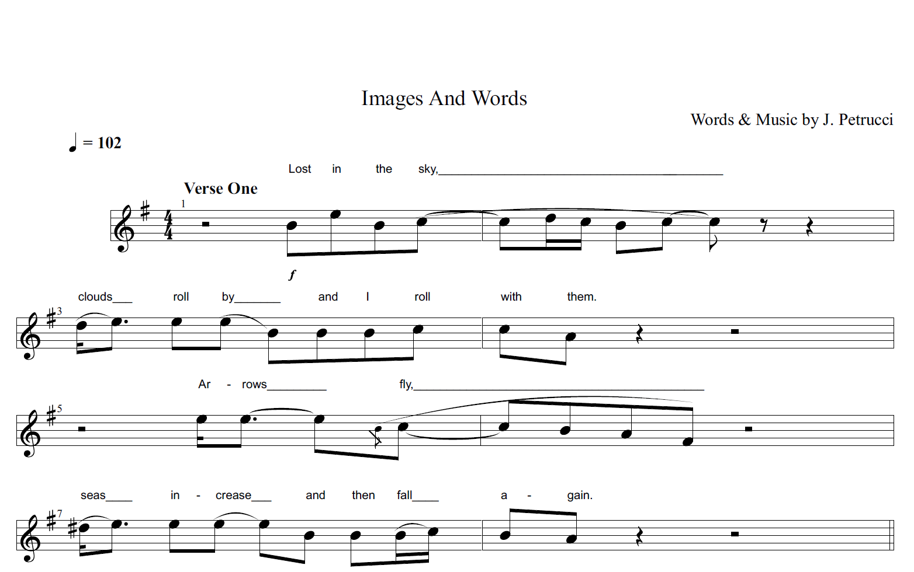
Figure 4 – Pull Me Under – Lines 1-4 of Verse One
The second line of the first verse contains verbs of motion and is comprised of two independent clauses: ‘clouds roll by’ and ‘I roll with them’, which are sung through a succession of eighth notes with little variation in terms of pitch height and note length. Compared to the first line, there are two main subjects here: ‘clouds’ and ‘I’. The schema of SKY is preserved as the word ‘cloud’ is a membership element of the concept ‘SKY’. Although the location that both the clouds and the character are rolling towards is not specified at this point, the second repetition of ‘roll’ is sung within a lower register (A4 compared to E5). This could imply that the main character is falling behind in some sense.
Although the noun phrase ‘arrows’ is in subject position in the third line, the verb of action ‘fly’ is sustained for almost two and a half beats through descending pitch intervals this time (E5 to F#4 – see score). Through the process of cross-domain mapping, the length of the sung monosyllabic word implies that the arrows are very large and heavy; while the descending melody paints the picture of arrows flying up and then gradually falling down with a lot of force.
As the word ‘arrows’ is a header for the schema of WAR, my conceptualisation of the scene being portrayed in the song is enlarged through the introduction of this new element. Not only does ‘arrow’ imply conflict, it also provides additional information about setting. Arrows are projectiles that are launched from bows by archers; they were effective long-distance weapons in the past until the sixteenth century when they were replaced by firearms. Listeners who are familiar with these historical facts may infer that the main character is someone who lived in the past.
There is also a gradual shift away from the clouds and sky in lines one and two to the earth in lines three and four as arrows can only be launched by humans, and seas rest upon the surfaces of planets. The deictic centre of the main character is maintained throughout as they observe these elements within the scene.
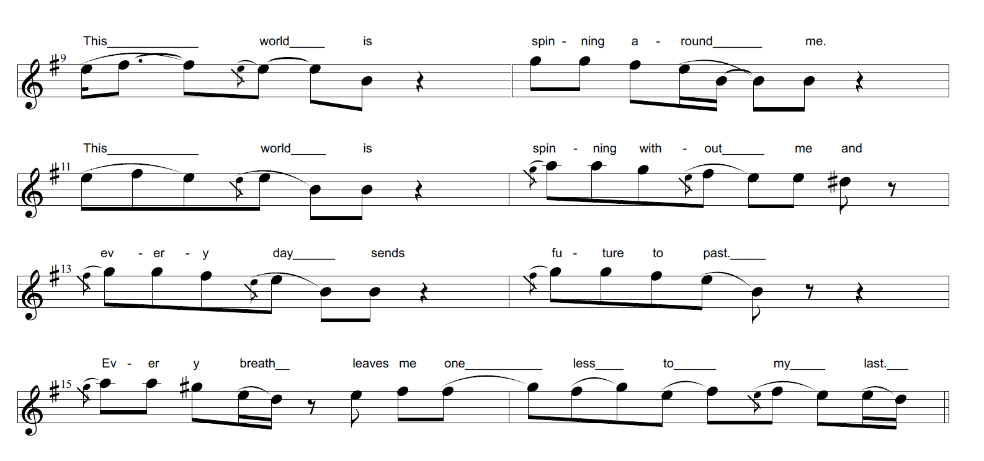
Figure 4.1 – Pull Me Under – Lines 5-8 of Verse One
In lines five to eight (see Figure 4.1 above), there is a descending melody as the words at the beginning of measures are sung in a higher register; while those at the end are sung in a lower register. For example, the determiner ‘this’ is sung in a higher register (F#5) and is sustained for one and a half beats at the beginning of lines one and two. The proximal spatial deixis indicates that there is some form of familiarity, a close connection between the main character and the world that they observe. The juxtaposition between the static position of the character indicated by the preposition ‘without’ and the world, which in turn is in constant motion suggested by the present continuous tense ‘spinning’, implies that the speaker feels disconnected from reality. Although the verb ‘spinning’ can have both positive and negative connotations on its own, the negative modality implied by the preposition ‘without’ in the second line also conveys the idea of isolation: the main character is not part of the world that is constantly in motion.
In lines three and four, the words ‘every’, ‘day’, ‘future’, ‘breath’, and ‘one less’ are sung in a higher register (G4-A4); while words at the end of measures are sung in a lower register (B4-F#5): ‘sends’, ‘past’, ‘leaves’ and ‘last’. In my own listening, this suggests that the main character feels helpless as there is no sense of progression in their life.
Although it is still not clear who the main character is exactly at this point, listeners will likely infer that the main character is a person who feels isolated and lost, and as a result, they are not in a pleasant state of mind.

4.1.2 Second Verse
The first half of the second verse (see Figure 4.2 below) can be divided into two utterances based on the rest that can be heard in the middle of the section: ‘Watch the sparrow falling gives new meaning to it all if not today nor yet tomorrow then some other day’ and ‘I’ll take seven lives for one and then my only father’s son as sure as I did ever love him I am not afraid.’ Within the genres of progressive rock and metal in general, technical proficiency is very important. Here, the vocalist sings these words with a lot of power in a higher register. The pitch range stays consistent throughout (B4-E5), apart from ‘only’ where the melody briefly ascends to D5. The intensity with which the words are sung, especially ‘only’, implies intense feelings of rage and despair. The feeling of rage is further emphasised by the grammatical incoherence within the lyrical lines. The first part of the second utterance ‘I’ll take seven lives for one’ follows the standard syntactic structure of subject (‘I’) followed by predicate (‘will take’) and conveys the idea of vengeance.
The other part of the utterance: ‘and then my only father’s son as sure as I did ever love him I am not afraid’ is difficult to interpret because the adverb of time ‘then’ gives
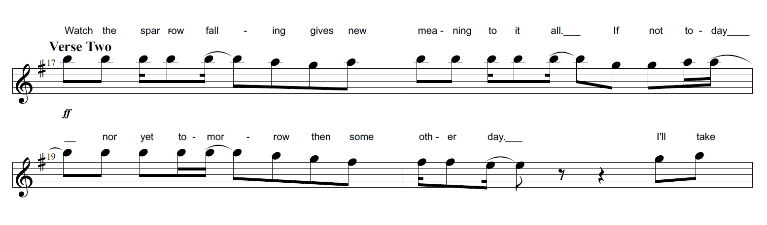
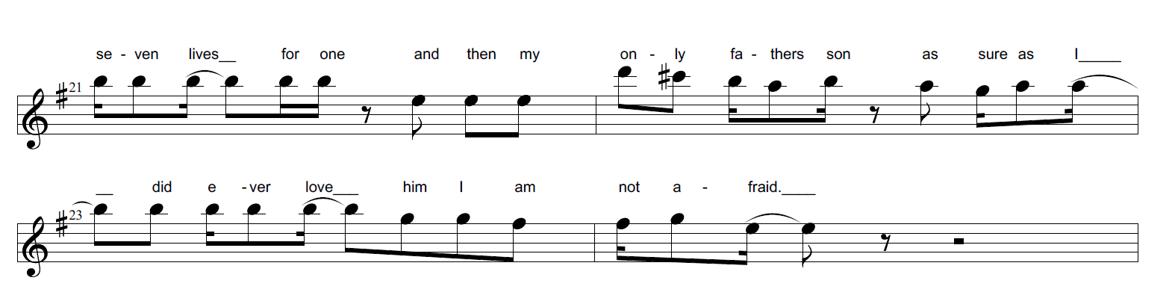
Figure 4.2 – Pull Me Under – Lines 1-4 of Verse Two
the impression that there is a temporal deictic shift here into the future, but this is not the case. In fact, the shift in verb tense from future ‘will’ to the past through ‘did’ indicates that the temporal deictic shift here is into the past instead, but the ordering of the sentence is a bit jumbled. The jumbled syntax might be linked to the emotional intensity of the lines identified above. The main character is suggesting that they are not afraid of dying in their attempt to avenge the death of their father whom they loved very dearly as an only child.
Furthermore, the character’s gender is also revealed through the noun phrase ‘only father’s son’. The word ‘only’, sung with the highest note of the melody, D5, and with a lot of power, emphasises the close relationship that the male character had with their father, as they were an only child. Listeners who are familiar with the genres of progressive rock and metal would have certain expectations in mind while listening to the song; for example, they would expect sophisticated character development and a more complex plot structure to unfold potentially. Through the process of schema tuning, listeners’ understanding of the main character would likely be updated at this point: it is clear that the speaker within the song now has a specific purpose, which is to seek revenge for their father’s death.
In my own listening, the imagery of the sparrow falling in the first line reinforces my WAR schema. Based on my schematic knowledge of birds, they can symbolise peace and freedom. This is an example of an ‘aura effect’ (Stockwell 2019: 72), whereby the instantiation of a schema encourages what would normally be non-membership items to be assimilated and read as if part of that schema. As such, the death of the sparrow foreshadows a coming calamity at an unspecified time in the future which is suggested in the next line: ‘if not today nor yet tomorrow then some other day’.
However, since I possess important schematic knowledge about the genre as well as the main topic of the song (see Section 2.2.4), for me, this part contains numerous specific unmarked intertextual references (Mason 2020: 82) because I know that the author’s intention was to write a song about Hamlet. As such, the line ‘watch the sparrow falling gives new meaning to it all if not today nor yet tomorrow then some other day’ prompts a narrative interrelation through multiple ‘points of ‘narrative contact’ (Mason 2020: 77) with the following lines from Shakespeare’s tragedy: ‘there’s a special providence in the fall of a sparrow. If it be now, ’tis not to come. If it be not to come, it will be now. If it be not now, yet it will come’ (Shakespeare 2012: 5.2.234-236). This association with Shakespeare’s tragedy in turn provides me with more information which I would not have access to otherwise. The presence of the noun phrase ‘providence’ implies that Hamlet is referring to the divine authority of God who controls everything. This seems to reinforce the helplessness of the character who is the slave of his destiny because he cannot change it.
Given the information that listeners have been presented with in the song so far: the plot taking place potentially before the sixteenth century, themes of rage, despair, confusion and revenge, the symbol of the sparrow, and father and son relationship; those listeners who do not possess important schematic knowledge about the song’s genre, topic and main themes might also regard these as unmarked specific intertextual references (Mason 2020: 82). This means that elements listed above can potentially act as headers that instantiate the schema of HAMLET for other listeners as well.
Although musically lines five to eight in the second verse (see Figure 4.3 below) are similar in terms of pitch height and rhythmic structure as the ones discussed in the first verse (see Section 4.1.1), linguistically, there are subtle changes in word choice. While the first and fourth lines stay the same as before, in the second line, the repetition of ‘this world is’ is changed to ‘the whole world keeps’, and the negation ‘without’ is changed to ‘around’. The adjective ‘whole’ emphasises the magnitude of the main character’s isolation; while the predicate ‘keeps’ implies continuity and reinforces the theme of helplessness.
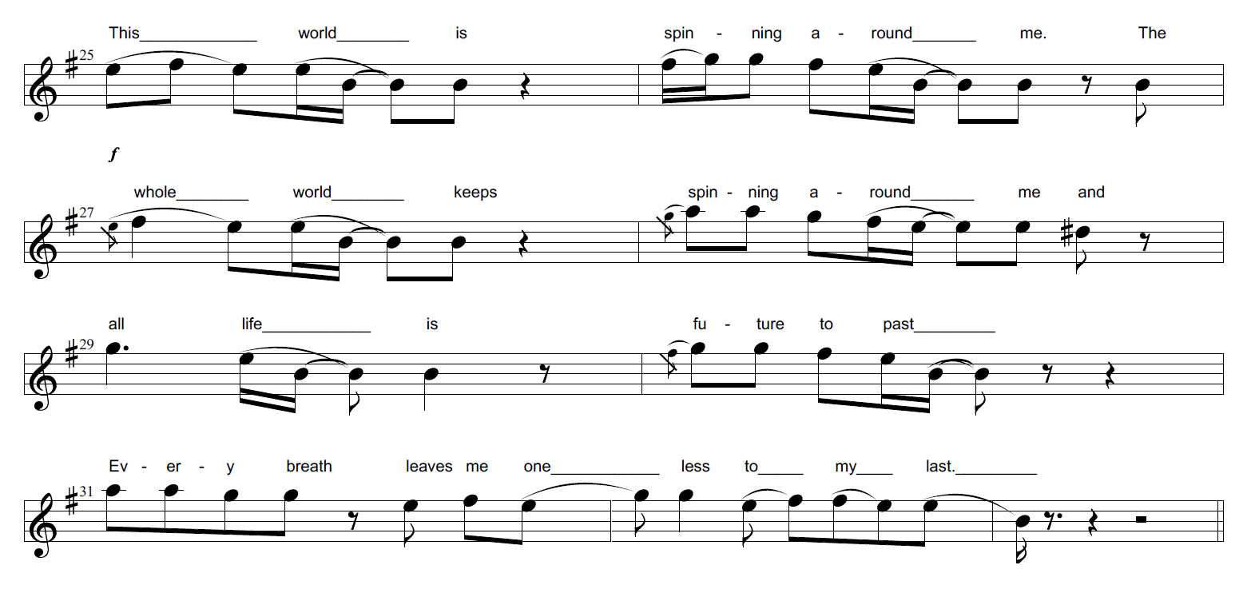 Figure 4.3 – Pull Me Under – Lines 5-8 of Verse Two
In line three, instead of ‘every day sends’, the words read ‘all life is’. Something specific is replaced with something much more general, implying that the main character is generalising their observations about the state of the world. Furthermore, at this point, if the schema of HAMLET has been instantiated within listeners’ minds, the imagery of the world spinning around him could be interpreted as a gradual descent into madness. The act of spinning around creates dizziness whereby the view of world becomes blurred. This in turn would reinforce listeners’ knowledge of Hamlet’s fate: he eventually loses his mind in the original play. By comparison, listeners who do not possess a HAMLET schema may infer that the character feels alienated, helpless and confused within a world that is beyond their control.

4.1.3 Chorus A
The first chorus reinforces this idea of descent into madness through the repetition of the imperative clause: ‘Pull me under’ three times at the start of the section. The melodies of the words are harmonized as there are two vocal parts singing the notes simultaneously. With each repetition, the harmony descends from A5/D5 to G5/C5 and finally to the dissonant intervals of F#5/A4, implying a shift from light to heavy and reinforcing the semantic meanings conveyed by language (see Figure 4.4 below).
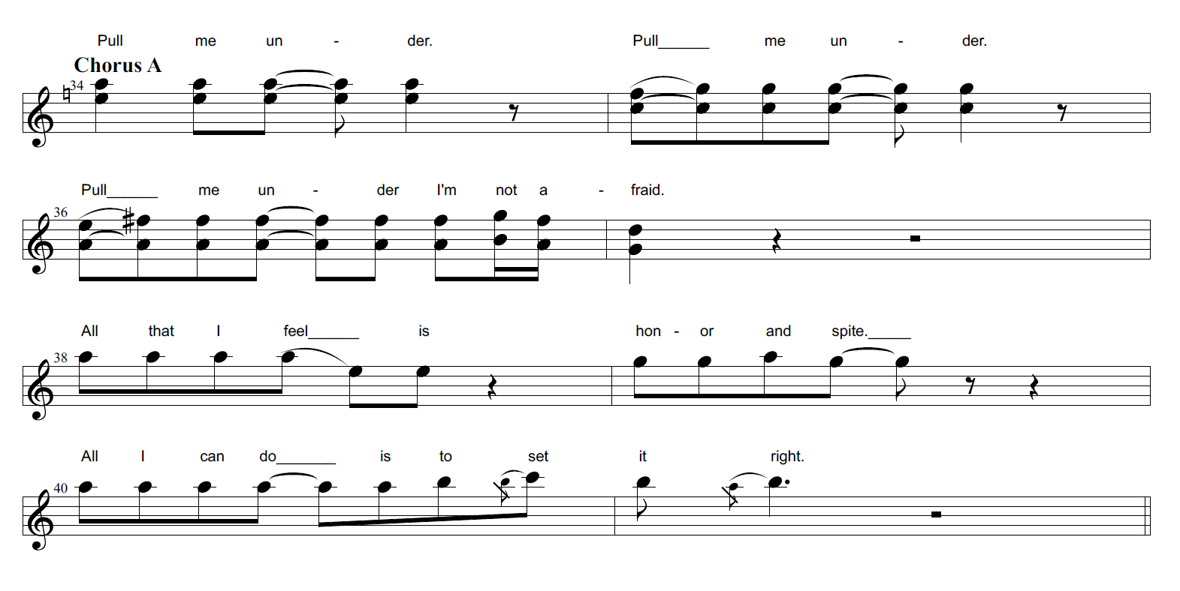
Figure 4.4 – Pull Me Under – Chorus A
The main character is in object position (‘me’) and is the recipient of the action here. These three utterances are examples of direct address; however, it is not clear who or what is being addressed: it could be fate, life or madness itself. The switch from direct address to a declarative sentence at the end of the second line: ‘I’m not afraid’, shows that the main character is aware of their insanity and perhaps even finds refuge within it.
This is further highlighted in the last two lines: ‘All that I feel is honor and spite/All I can do is set it right!’ Through the process of schema accretion, listeners will likely develop a different idea of the character at this point; someone who is not helpless or lost within despair, but rather someone who has accepted their delirium and now rejoices in the prospect of vengeance.

4.1.4 Third Verse
This acceptance of one’s fate is also suggested in some of the lines of the third verse (see Figure 4.5 below). Musically, the rhythmic structure is similar to that of verse one as the syllables of the last words of lines one and three: ‘eyes’ and ‘cry’, are sustained for two and a half beats. There are also similarities with the first verse linguistically as the words in the second line ‘clouds roll by and I roll with them’ are repeated here again. This repetition emphasises the lack of clarity implied in the first line as the character is deprived of their vision: ‘dust fills my eyes’, and the futility of existence conveyed in the second line: ‘clouds roll by and I roll with them’. The sustained verb ‘cry’ at the end of line three: ‘centuries cry’, personifies time, reflecting an image of endless and inevitable suffering that humanity will experience throughout centuries.
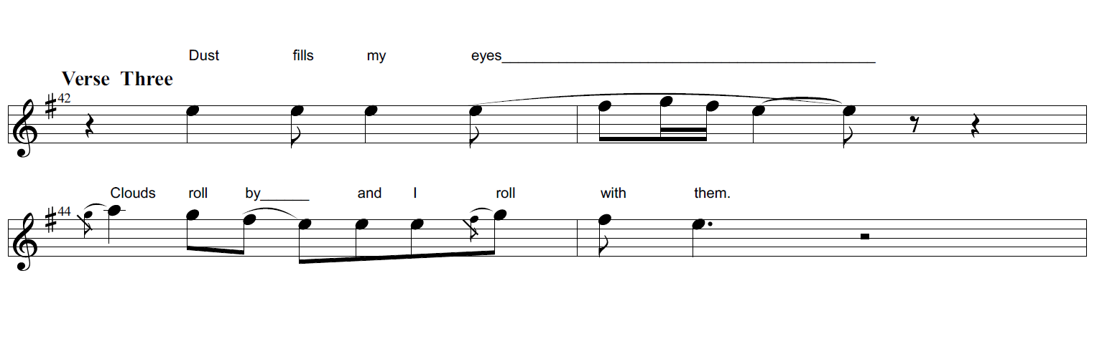
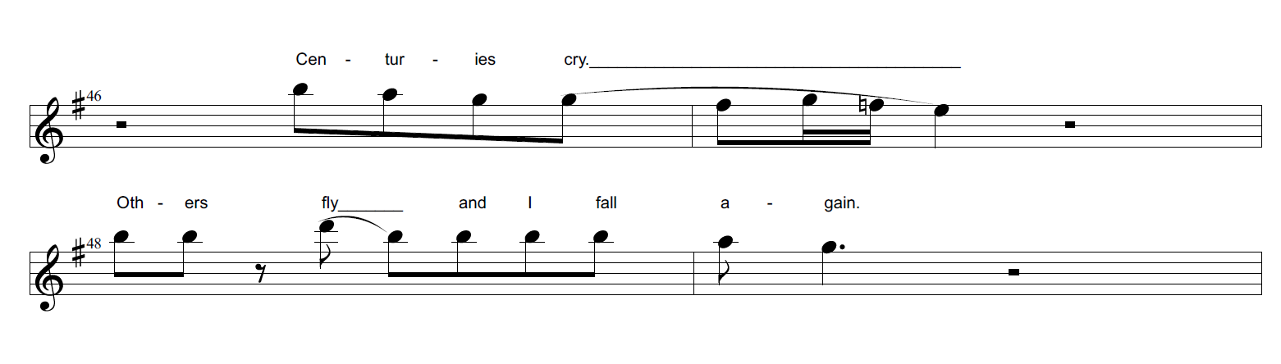
Figure 4.5 – Pull Me Under – Lines 1-4 of Verse Three
Since I possess important schematic knowledge about the author’s intentions when they wrote the lyrics, in my own listening, the first line ‘Dust fills my eyes’ is another example of a specific unmarked intertextual reference to the play of Hamlet. In Act 2 Scene 2 of Shakespeare’s play, Hamlet contemplates the meaning of existence and believes that mortals are nothing but dust. The actual quote reads: ‘And yet, to me, what is this quintessence of dust? Man delights not me. No, nor woman either’ (Shakespeare 2012: 2.2.331-333). Unlike in verse two where the unmarked specific intertextual references contained multiple points of narrative contact between the song lyrics and the play, here, the only perceived connection which prompts a narrative interrelation is the noun phrase ‘dust’. As such, it is highly unlikely that listeners would be able to identify this intertextual reference, unless they are aware of the author’s intentions to begin with. Even for those who are, the connection is very subtle. The imagery of dust filling up Hamlet’s eyes in the song lyrics is much more ambiguous and personal because of the presence of the first person possessive pronoun ‘my’ compared to the rhetorical question he asks in the play about the fragile existence of humanity where the first person plural pronoun ‘we’ is used instead.
In the next line: ‘others fly and I fall again’, the word ‘fly’ is sung with a lot of power and with a very high note (D5), highlighting the sheer rage and insanity of the main character as well as the juxtaposition between ‘fly’ and ‘fall’. The musical performance of these lines in this case would help to create a specific impression of Hamlet’s rage in terms of intensity levels.
Musically, lines five to eight in the third verse of the song (see Figure 4.6 below) are similar to the ones discussed in Sections 4.1.1 and 4.1.2. Linguistically however, in the first two lines, the adverbs of place ‘around’ and the preposition ‘without’ are replaced with a different adverb of place: ‘inside’. This plays a crucial role in developing listeners’ schema of the main character further, as it highlights the progression of their madness; they are no longer an observer of the chaos that was previously bound to the external world; instead, they have become one with their delirium as they experience it from within.
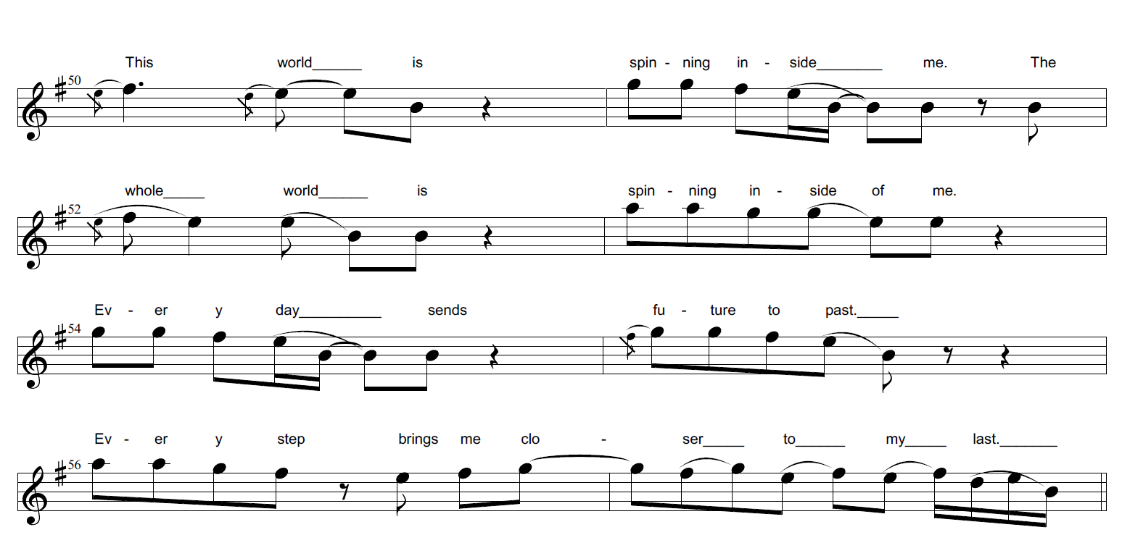
Figure 4.6 – Pull Me Under – Lines 5-8 of Verse Three
While the third line contains the same words as the ones discussed in the first verse: ‘every day sends future to past’, there is deviation in the fourth line. The noun ‘breath’, the verb ‘leaves’ and the adjective ‘last’ from the previous verses have been replaced with ‘step’, ‘brings’ and ‘closer’: ‘every step brings me closer to my last’. Proximity is implied through the verb phrase ‘brings’ and the comparative adjective ‘closer’; while the change from ‘breath’ to ‘step’ highlights physical motion in space. Listeners who are familiar with the fate of Hamlet might infer that this change foreshadows the eventual demise of the main character: Hamlet is mortally wounded with a poisonous blade by Laertes in Shakespeare’s play. However, even listeners who cannot rely on their schemas of the tragedy will likely infer that the main character is getting closer and closer to avenging their father’s death, and that they will pay the price with their own life. Furthermore, this form of gradual character development would also validate listeners’ genre expectations of progressive rock and metal where the characters are dynamic and change throughout the course of songs.

4.1.5 Chorus B
Following the third verse, the chorus is repeated three times. Musically, the rhythm, the melody and the dynamics of the vocal performance stay the same as before. Linguistically however, different words are used in lines three and four in the first and third repetitions (see Figure 4.7 below). Instead of ‘All that I feel is honor and spite/All I can do is set it right’, the words sung are ‘Living my life too much in the sun/Only until your will is done.’
Through the direct address of ‘you’ in the last line, the character addresses the potential victim of their vengeful act directly and implies that the speaker will find clarity and salvation once they have their revenge. In my own listening, because I am constantly making connections with my narrative schema of HAMLET, the line ‘living my life too much in the sun’ prompts a narrative interrelation with the line: ‘Not so, my lord. I am too much i’ the sun’ (Shakespeare 2012: 1.2.69) which Hamlet utters in Act 1 Scene 2 of the play in response to Claudius’ question: ‘How is it that the clouds still hang on you?’ (Shakespeare 2012: 1.2.68). This information helps me to infer that the concept of the sun here represents the conceptual metaphor HAPPINESS IS SUN as Hamlet denies feeling sad which is implied by the conceptual metaphor SADNESS IS CLOUDS.
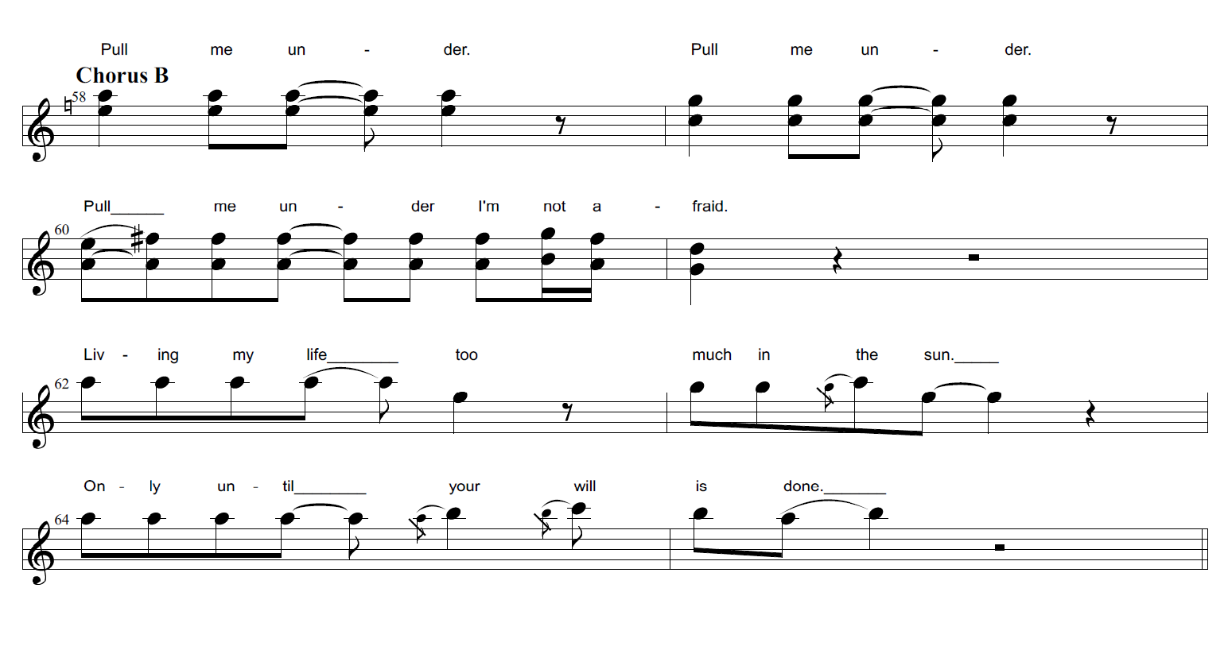
Figure 4.7 – Pull Me Under – Chorus B
The threat implied in ‘only until your will is done’ cannot be considered an intertextual reference to Shakespeare’s tragedy as it is not actually uttered by Hamlet. Still, because of the association with the play in the previous line, I am tempted to think that the personal pronoun ‘your’ in the song lyrics still refers to the character of Claudius, Hamlet’s uncle who murdered his father and who is consequently killed towards the end of the play when Hamlet finally avenges his father’s death.

4.1.6 Outro
The Outro is comprised of three short lines (see Figure 4.8 below) that are specific unmarked intertextual references (Mason 2020: 82) to Shakespeare’s tragedy: ‘Oh that this too/Too sullied flesh/Would melt’ (Shakespeare 2012: 1.2.133). Unlike the narrative interrelations prompted by the intertextual references so far, the points of narrative contact between the song ‘Pull Me Under’ and the play Hamlet have higher a degree of visibility (Mason 2020: 76-77) here than before because the lines are identical to the ones uttered by Hamlet in the play (see Shakespeare 2012). At this point, listeners who possess a very a vivid ‘mental archive’ (Mason 2020: 72) of the tragedy would likely identify the intertextual references in these lines even if they are not familiar with the song or the author’s intentions. Their assumptions about the true identity of the main character would likely be validated. They would consider the song to be a specific interpretation and performance of Hamlet’s contemplations along with his urge to avenge the death of his father at the cost of his own sanity.
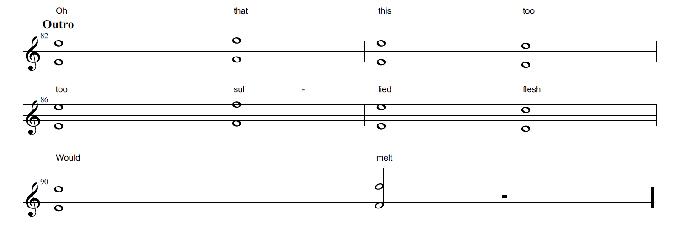
Figure 4.8 – Pull Me Under – Outro
Musically, the words within these lines are harmonized in two octaves. The melody E5/E4, F5/F4, E5/E4 and D5/D4 is repeated twice in the first and second line. In line three, the singing suddenly comes to an abrupt end just before the second beat of the last measure. In terms of timbre, a flanger effect is used to slightly distort the singer’s voice, creating an eerie sound that highlights the character’s final descent into madness. The abrupt ending with the verb ‘melt’ creates an auditory impression of sudden death and oblivion as Hamlet ponders the meaningless existence of humanity.

4.1.7 Double-scope network of Sung Lyrics
The double-scope network that is conceived while listening to the sung lyrics contains a blend of a living person (the performer who is James Labrie in this case) with the identity of a fictional character. This fictional character can be Hamlet for those who possess the necessary schemas to identify him throughout the song.
The input spaces have different organizing frames. One input space represents the singing voice of James Labrie which includes information about the vocal techniques he employs in his performance of the lyrics: high range, descending melodic steps, ascending melodic leaps, high intensity, loud dynamics and vibrato. The second input space may simply represent an unspecified fictional character or the character of Hamlet. As a result, the specificity of the second input space depends largely on listeners’ background knowledge. For the analytical purposes of this thesis, the diagram below only portrays the double-scope network which contains the character of Hamlet, including some of his key personality traits based on pre-existing background knowledge: passionate, unstable, vengeful and confused.
The blended space of this double-scope network has the organising frame of persona and intensity (indicated in the generic space at the top of Figure 4.9 below) that includes parts of each of the frames of the input spaces and has an emergent structure of its own: Hamlet has the singing voice of James Labrie; while James Labrie’s voice is a specific, and unique oral projection of Hamlet who expresses his thoughts and feelings through the act of singing.

Hamlet Space:
- Danish prince
- passionate
- unstable
- confused
- vengeful

James Labrie Space:
- singing voice
- lyrics
- high range
- descending melodic steps
- ascending melodic leaps
- high intensity
- loud dynamics
- vibrato

Sung Lyrics Space:
- Hamlet singing
- unstable
- gradual descent into madness
- loud bursts of anger
- intense confusion

Figure 4.9 CIT diagram showing generic, input and blended spaces of sung lyrics in ‘Pull Me Under’

Generic Space:
Persona
Intensity

The key outer-space relation is one of Representation. The Hamlet input space corresponds to the fictional character; while the James Labrie input space in turn corresponds to the element that represents the character of Hamlet: the oral performance of lyrics. The outer-space relation of Representation is supported by Analogy. Firstly, the words of Hamlet, who is a fictional male character, are represented by James Labrie, a male singer. Secondly, the intensity levels associated with the concepts of passion, vengefulness and confusion are represented by the timbre, dynamics and melodic range of the singer.
The key outer-space relation of Representation is compressed into three main vital relations within the blended space: Change, Identity and Uniqueness. There is a very close connection between each of these vital relations. Firstly, the identity of Hamlet is changed because in the blended space he is now represented by the voice of James Labrie. Secondly, this change also implies Uniqueness because the descending and ascending melodies, the timbre, the dynamics and the intensity with which the performer sings the language all create a unique form of persona that is not conceivable in either one of the input spaces on their own. The instability of the character is represented by the descending and ascending melodic intervals. The descending melodic steps hint towards his gradual descent into madness; while the ascending melodic leaps sung with high intensity signify his sudden bursts of anger and acute confusion.
As such, the singer’s delivery of the lyrics is very important in shaping the emergent structure of the blend. For example, if the words of Hamlet were to be delivered in the form of spoken language as opposed to sung language, a different double-scope network would be conceived, possibly one that would contain elements with lower levels of intensity due to less variation in the intonation patterns of speech. Even so, the key outer-space relation of Representation would still be compressed into Uniqueness within the blended space, because listeners would simultaneously be aware of the vocalist’s speech as well as the mannerisms and actions of the portrayed character, implying a rich shared generic structure between ‘reality’ and ‘fiction’ within the lyrics.

4.1.8 Summary
Overall, genre expectations as well as the narrative of schema of HAMLET play a crucial role in creating a very specific double-scope network of the sung lyrics in an analytical listening of the song. Furthermore, the performance of the lyrics as well as the transition from lyrical ambiguity at the beginning of the song to specific unmarked intertextual references with higher degrees of visibility towards the end also play a very crucial role in shaping the organising frame of the multiple-scope network’s blended space. The next section will discuss the instrumental music of the song.

4.2 Music
The music of ‘Pull Me Under’ can be divided into six sections based on changes in the chord progression. Section 4.2.1 will now describe how the introduction section of the song is gradually developed in terms of melody, harmony and instrumentation.

4.2.1 Intro
The intro starts in the key of e minor at a moderate tempo of 102 BPM (see pages 137-162 in the Appendix Section for the full score). The first instrument that breaks the silence of the background is an electric guitar with no distortion but a strong reverb effect that amplifies the resonance of the notes being played. The entire section is based around the five arpeggios that are played repeatedly by the guitar; these outline the following chord progression: Emadd11(no5), Emadd9(no5), Em6(no5), C (2nd inversion) and D6(no3). Considering the conceptual feature dimensions associated with pitch intervals (see Section 2.1), the descent from the 11th to the 9th to the 6th and then to the lowest note C4 implies a gradual shift from light to heavy and bright to dark just before the chord progression briefly ascends to the D6 chord.
Later, the keyboard starts playing descending chord tones within measure nine, reinforcing the gradual shift from light to heavy and bright to dark implied by the arpeggios. The notes are repeated in measures ten to fifteen with subtle variations at times until measure sixteen, where there is a short repetition of ascending non-chord tones F#4 and G4 that eventually culminates in a melodic leap to the chord tone D5.
From measure seventeen onwards, the bass guitar joins in and starts to play a combination of non-chord and chord tones. The arpeggios played on the guitar are extended with the addition of the missing fifth note B3, played on the high open B string, and the octave of the root E4, played on the high open E string.
However, the keyboard parts also play different notes as well within these measures. Just before the above mentioned ‘extension’ notes of the arpeggios are heard on the third beats of each measure, the keyboard plays long harmonic intervals consisting of B3/E4, A3/D4, G3/C#4 and G3/C4 on the second beats of measures seventeen to twenty-four. These subtle but important variations in pitch and dissonance (the emphasis of C# in the context of e minor) can imply a sense of progression, motion and ambiguity as more and more sounds are layered on top of one another.
This is further emphasised in measure twenty-five when another electric guitar joins in and plays the following power chords throughout: E5, A5, G5, E5, F#5, G5, E5, C#5, G5, E5, B5, C5, D5, B5, C5 and F5. These notes are sustained throughout the next eight measures and are played with a lot of distortion. This intensity is also amplified by the crash cymbals and the kick drums that the drum parts begin to play as well as the change in note density within the bass parts that divide the measures up into a succession of eighth notes and sixteenth notes, mimicking the rhythmic patterns of the drums.
The rhythmic structure of the chord progression changes drastically in bar thirty-three as both measures are divided up into a succession of eighth notes and sixteenth notes in the guitar part. The drums outline the following groove: quarter notes in measures one, three and four and eighth notes in measure two. The keyboard parts join in again in bar fourty-one, dividing the measures up into sixteenth note power chords that outline the same chord progression as the guitar(see above). Furthermore, the drum parts also divide the measures up into sixteenth notes played on the bass drum.
This very high note density is maintained for eight bars until bar fourty-nine when the electric guitar stops playing the chord progression above and starts repeating the tonic E5 power chord. The rhythmic structure of the drum section also changes to a much less dense groove of four groups of dotted eighth notes and sixteenth notes played to the beats. The keyboard and bass parts carry on playing four groups of sixteenth notes to the beats. The former repeats the tonic power chord in first inversion with B4 in the bass and B5 in the high register; while the latter repeats the tonic note E1. This repetition creates suspense and sets up the musical section of the first verse that begins in measure fifty-two (see below).
Overall, there is a gradual development of intensity and energy levels in the introduction section as note density and dynamics increase, which in many ways conforms to my genre expectations of progressive rock and metal in general. There is also a clear shift from higher pitches being played in the form of arpeggios by the first electric guitar to lower pitches being played in the form of power chords with heavy distortion by the second electric guitar. Considering the conceptual feature dimensions associated with pitch intervals, this change in melodic range as well as timbre implies a shift from bright, light and small to dark, heavy and big.
The main purpose of the introduction seems to be to build tension, intensity and discomfort before the first verse. This is evident not only through the conceptual feature dimensions mentioned above, but also through the complexity of the music which is very typical for a progressive rock song.

4.2.2 First Verse
The high note density in the introduction is maintained throughout the first verse as the keyboard and guitar parts carry on playing sixteenth note patterns to the beats. However, the chord progression from before transitions into em9, em9(#5), Esus4, C/E, C(b5)/E in lines one and two, and em9, em9(#5), Esus4, C/E, F(9)/E, F(b5)/E in lines three and four. The tension that was developed in the introduction is further amplified by the dissonance of the step-wise motion in the following chord changes: em9 to em9(#5), C/E to C(b5)/E and F(9)/E to F(b5)/E as well as the harmonic intervals that are played in the higher registers: B4 to C5 being the highest notes.
Because these chords are played with a pick and with heavy distortion on the electric guitar, a very harsh sound is generated which is then further amplified by the keyboard section which outlines the same chord progression in unison. The combination of high note density, louder dynamics, dissonance and higher register create very high levels of energy and intensity.
In the second part of the first verse, note density within the guitar and keyboard tracks decreases significantly as the two instruments start to play whole note harmonic intervals in unison instead of sixteenth note patterns; while note density in the drums and bass tracks increases significantly as they play groupings of sixteenth note patterns to the beats. Furthermore, another electric guitar joins in and starts to play arpeggios of the chord progression (em, Gsus4, G#sus4, G5, B) in tandem with the keyboard and the other electric guitar.

4.2.3 Interlude
Following the first verse, there is a brief instrumental interlude that builds on the tension developed so far. Note density is increased significantly as the distortion guitar also starts playing sixteenth note power chord patterns to the beats, mimicking the rhythmic structure of the drums and the bass. However, more importantly, another electric guitar joins in with sixteenth note scale patterns to the beats in a higher register.
The following chord progression is played in the Interlude section: E5, D5/A, A/C#, C5, E5, F#5, C#(5b), C5, F5 and F(b5). Harmonically, there is more movement and variation through the shifting scale patterns in the higher register compared to the more static layers of power chords played in the lower register. Furthermore, there is also more dissonance than before as nearly half of the chords outlined (A/C#, F#5, C#(5b) and F(b5)) contain the major sixth note C# which is not within the key of e minor, but represents a brief transition into E Dorian. Again, in terms of complexity, this gradual development of tension and dissonance conforms to my own schematic knowledge of progressive rock/metal genre expectations.

4.2.4 Second Verse
At the three minute mark, there is an unexpected cessation of sound for two seconds as the instruments play a couple of notes on the first beat of the measure and then rest on the remaining three beats. The absence at this point could imply that the tension that has gradually developed so far has finally reached its climactic point, a point of no return of some sorts.
However, most of the instruments soon re-join the medley in the second measure. Rhythmically, the drums play eighth note patterns to the beats; while the keyboard parts play whole note harmonic intervals that outline the following chord progression: E5, em, em6 and C/E. The guitar and bass parts play a stream of sixteenth note patterns in unison, using the tonic E as an ostinato throughout to emphasise the chord progression.
It is interesting to see how within the genre of progressive rock/metal, there is so much variation and complexity within the musical structure that the sounds played during each verse and chorus are different, confirming and preserving prior schematic knowledge of the usual complexities inherent within this genre of music. This is not the case with most pop songs for example, where the same musical patterns are more or less repeated throughout the sections. In this song, even the chord progression is different than what it was in the first verse (see Section 4.2.2). This highlights the themes of progression and change that have already been prominent so far.
In the second part of the second verse, instead of playing power chords, the electric guitar and bass play ascending and descending sixteenth note scale patterns that cover a range of two octaves; while the drum parts play eighth note patterns of snares and high hats and sixteenth note patterns of kick drums to the beats, creating a dense and intense sound throughout coming across as very powerful. The keyboard part carries on playing harmonic intervals that outline a more developed chord progression than the one played in the previous verse: em, C/E, A/C#, G, B, em, C/E, A/C#, G, B, E5, F5. This indicates that there is harmonic continuity between the sections: the combination of higher note density and louder dynamics might give the impression that the second repetition of the verse is played at a much faster tempo, implying higher levels of energy.

4.2.5 Chorus
When the chorus begins, note density decreases significantly as the keyboard and the guitar parts only play power chords throughout. Harmonically, the section can be divided into parts. The first part, consisting of the first four measures, is very static and low in energy levels. There is no dissonance as the guitar and keyboard repeat an A5 power chord in the first three measures, and then switch to A5/E, F5, G5 in the last measure. Another electric guitar with a clean effect joins in with the same descending arpeggios as the ones played at the very beginning of the song (see Intro section) but in a higher key. This again implies a gradual shift from light to heavy, bright to dark and small to large just before the chord progression briefly ascends at the very end of the fourth measure. For the first time in the song, there is less tension implied by the music.
The second part however, consisting of the last four measures, is much less static and quickly builds tension through the change of direction from descending power chords and arpeggios to ascending ones: A5, G/B, C5, D5, E5, F5 and Bbsus2. Taking into account my genre expectations, this may suggest a certain degree of sophistication within the musical structure because the first part of the chorus represents a temporary absence of confusion; while the second part represents a relapse into tension and despair.

4.2.6 Third Verse
In verse three that follows, the chord progression is different than the ones discussed in verse one and two: E, C, D5/A and E, C and F5. However, similarly to verse two, there is a lot of motion in the guitar part. The measures contain a combination of short ascending scale fragments comprised of hammer-ons, pull-offs and trills followed by power chords. There is also brief dissonance at the very end of the last measure with the presence of minor second power chord F5.
The guitar part has a very active role in shaping the direction and feel of the music because it plays different chord progressions organised into different rhythmic patterns across the entire song. In terms of weight, tension and energy levels, the music in verse three is lighter and more stable due to the lack of dissonance and lower note density overall. However, although there is less tension and confusion being implied, the music is still high in energy levels overall due to the variations discussed above.

4.2.7 Keyboard and Guitar Solos
After verse three, there is a repetition of the first verse, the interlude and the chorus sections with the same musical structure as discussed above. These parts are then followed by a keyboard and a guitar solo. Overall, the music during the keyboard solo is lighter and less intense as there are fewer layers of sound being heard at once compared to the guitar solo section.

4.2.8 Outro
Following the keyboard and guitar solos, the chorus section is repeated twice with louder dynamics and higher note density in the second iteration, building tension just before the outro section begins.
The conclusion of the song can be divided into four parts: D5 E5 (first part); D5, E5, F5, E5, C(b5), E5, F#5, G5, E5, C5, Bb5(second part); D5, E5, F5, E5, F5, F#5, E5, F#(b5), G5 (third part); D5, E5, D5, C5, E5(fourth part). This indicates that the chord progression is gradually developed, creating more and more dissonance and intensity throughout.
Only the guitar, bass and drums can be heard in the first part, but note density slowly increases when the keyboard part re-joins the medley in the second part, emphasising the chords outlined above with harmonic intervals in the higher registers. Tension develops until an unexpected cessation of all sound occurs. The piece ends abruptly on the third beat of the last measure.

4.2.9 The Multiple-scope network of the instrumental music
Conceptual Integration Theory can be used to illustrate the relationship between cultural context (which entails schematic knowledge of genre expectations), musical elements and conceptual feature dimensions. Three key input spaces can be said to be conceived while listening to the music: auditory perception of sound in a western context, perceptual feature dimensions and affective feature dimensions (see Figure 4.10 below).
The key outer-space relation between the input spaces is one of Representation, because the input space of auditory perception of sound (see space on the far left) corresponds to the elements that represent perceptual, kinaesthetic and core affect feature dimensions (see the input spaces in the middle and on the far right).
Based on the detailed discussion of the song’s musical elements above, the auditory perception of sound input is comprised of the following frame topology: moderate tempo, high note density, loud dissonance, short duration one the one hand; and low note density, consonance, long duration on the other. These elements are divided into two groups in order to emphasise the progression of different sound properties throughout the song: note density gradually increases and then decreases in the bridge section before it increases again until the end.
The perceptual, kinaesthetic and core affect feature dimension inputs contain elements that represent the concepts that are associated with the musical elements listed above. So, moderate tempo, high note density, loud dissonance and short duration are linked with small, high, thin, sharp, bright and proximal perceptual properties as well as with fast movement, lightness, high intensity, tension and high energy affective properties.
Within the blended space, Representation is compressed into Change (sounds are imbued with different levels of intensity, speed, height and weight); Cause-Effect (sounds are associated with high and low energy levels, high and low speeds, high and low positions in space, light and heavy weight); Disanalogy and Category (contrast between high energy and low energy, fast and slow speeds, high and low positions, light and heavy weight) and Uniqueness (visual, kinaesthetic and core affect sound).
As such, in my own listening, the main feature dimensions that are compressed through the vital relation of Representation are the perceptual feature dimensions of height (high and low) and size (small and big); the kinaesthetic feature dimensions of fast and slow bodily movements; and the core affect feature dimensions of intensity and energy levels (high and low) that are all associated with musical elements such as tempo, note density and rhythm (duration of notes).

Perceptual Feature Dimensions:
- small, high, thin, sharp, bright, proximal

- big, low, thick, round, dark, remote

Music Space:
- high intensity, fast, high and small sounds
- low intensity, slow, low and big sounds
- fluctuations between high energy and low energy
- prominence of high energy

Figure 4.10 CIT diagram showing generic, input and blended spaces of instrumental music in ‘Pull Me Under’
Auditory Perception of Sound in a Western Context:
- moderate tempo; high note density; loud dissonance; short duration

- low note density; consonance; long duration

Generic Space:
sensations
Kinaesthetic Feature Dimensions:
- fast movement, light

- slow movement, heavy
Core Affect Feature Dimensions:
- high intensity, tension, high energy

- low intensity, resolution, low energy
Although according to research in music psychology, other forms of perceptual feature dimensions such as width, shape, colour and distance can also be associated with the auditory perception of certain sounds, in my own interpretation of the instrumental music of the song, these are not projected into the blended space as I do not associate sounds with these elements. A possible explanation for this would be that genre expectations can have an impact on the interpretation of sonic meanings. My own schematic knowledge of progressive rock/metal, which entails complex musical structure and constant fluctuations between lower and higher levels of intensity and note density, has been preserved throughout the song. As a result, the blended space of the multiple-scope network includes parts of each of the four input spaces and has an emergent structure of its own: a sonic arc comprised of linear fluctuations between high and low intensity sounds, with an overall prevalence of higher levels of energy throughout.

4.2.10 Summary
Overall, throughout the song, note density, dissonance, tension and energy levels continuously increase and decrease. This conveys the idea of some form of fluctuating, perpetual instability: something starts out as a simple disturbance and then gradually develops into intense turbulence. This cycle of chaos is repeated multiple times until it reaches a point of no return beyond which there is nothing else but silence.

4.3 Conceptual Blendings Between Sung Lyrics and Music
During the act of listening, sung lyrics and instrumental music are heard simultaneously. Throughout the song, there is a distinctive form of analogy between the meanings associated with both the lyrics and the music. The modes work together as they reinforce similar themes and ideas. In the first verse, Hamlet’s contemplates the purpose of his lonely existence and his confusion and despair are accentuated by the very high levels of energy and intensity associated with high note density, louder dynamics, dissonance and higher register in the accompanying background music. The musical interlude that follows this develops the tension further and further until it reaches a breaking point at the three minute mark when a brief cessation of sound occurs.
This unexpected silence just before the second verse marks a turning point in terms of character development as Hamlet’s intense madness is clearly emphasised in both the powerful performance of the lyrics as well the changing chord progression, high note density and loud dynamics of the music.
Hamlet’s inevitable descent into madness is also highlighted by the gradually descending arpeggios in the first parts of the chorus sections that follow verses two and three which are played in tandem with the repetition of the words ‘pull me under’. The lack of dissonance in the background music within the first two lines of the chorus sections (see Subsection 4.2.5 for more detail) represents a form of temporary absence of confusion whereby Hamlet is certain of his dark fate; while the change of direction in terms of pitch height from descending to ascending arpeggios and power chords in lines three and four reinforces Hamlet’s growing malevolent desire to avenge the death of his father, conveyed by the lyrics.
In verse three, the unison between the two modes is somewhat less pronounced as the background music is lighter and much more stable due to the lack of dissonance and lower note density overall. Although it could be argued that this contrasts with the intensity evident in the lyrics as Hamlet contemplates the futility of human existence, overall, the music is still very high in energy levels because of the variations of short ascending scale fragments played on the guitar throughout. As such, I would argue that the main relationship between the two modes is still one of analogy but it is perhaps not as pronounced here as before in the previous parts.
Within the outro section of the song however, the relationship of analogy between the two modes is very strong once again as they work together to emphasise Hamlet’s twisted faith. The flanger effect used to slightly distort the singer’s voice as they sing the lines: ‘Oh that this too/Too sullied flesh/Would melt’ accentuates the character’s plight which is then also amplified by the dissonance and intensity developed throughout the chord progression of the background music. The abrupt cessation of sound after the verb ‘melt’ is sung creates an auditory impression of a sudden death or perhaps a total loss of sanity.
The conceptual integration networks created by language and music (see Subsections 4.1.7 and 4.2.9 above) are projected further into another blended space when the two modes are heard simultaneously (see Figure 4.11 below). The blended input spaces of this new integration network are highly asymmetric. On the one hand, for listeners who possess knowledge schemas about the tragedy of Hamlet, the lyric space on the left of Figure 4.11 would have the organising frame of Singing Hamlet. For those listeners who do not possess such schemas, the organising frame of the lyric space would be something less specific such as Act of Vengeance.
On the other hand, the blended input space that represents the instrumental music on the right of Figure 4.11 will have minimal framing and lack specificity irrespective of what schemas listeners may or may not possess. This is mainly because unlike words within language, musical elements lack specific meanings and are associated with abstract conceptual dimensions instead.

Sung Lyrics Space:
Singing Hamlet
- gradual descent into madness
- loud outbursts of anger
- intense confusion

Blended Song Lyrics Space:
- Singing Hamlet
- fluctuations between high energy and low energy
- highly unstable existence
- very high levels of anger and confusion
Music Space:
- high intensity sounds

- low intensity sounds

- fluctuations between high energy and low energy
- prevalence of high energy

Generic Space:
Information
Communication
Sound
Figure 4.11 CIT diagram showing generic, input and blended spaces of song lyrics in ‘Pull Me Under’

However, overall, the elements in both input spaces suggest similar affective feature dimensions: Hamlet’s gradual descent into madness, loud outbursts of anger and his feelings of intense confusion imply fluctuating high levels of tension and energy. These same feature dimensions are also implied by the musical elements (see the music space on the right). As a result, the key outer-space relation between these inputs is one of Analogy because they are more similar than different.
The network that is created is a specific type of double-scope network: although the blended space receives projections from both input spaces, the organising frame of the blend itself (Singing Hamlet) is an extension of the organising frame of the lyric space only because the music space lacks specificity and does not have an organising frame of its own.
Through the process of conceptual integration, the outer-space relation of Analogy is compressed into Uniqueness and Change within the blended space: The singing Hamlet’s emotions within the blended space are associated with higher levels of energy than in the lyric space. Furthermore, as a result of the projections of key frame topologies from the music space, the unstable nature of Hamlet’s character is also much more pronounced within the blended space. This means that, overall, the elements within the music space play an important role in shaping listeners’ interpretations of the main character.

4.4 Conclusion
To conclude, the conceptual integration networks discussed in this chapter indicate that in songs where there is a clear similarity between the different degrees of intensity implied by language and music, the conceptual feature dimensions associated with certain musical elements can reinforce the specific semantic meanings conveyed by language.

Chapter Five: Conceptual Blendings in ‘Take Away My Pain’

5.0 Introduction
The previous chapter looked at the vital relation of Analogy between lyric and music spaces within the multiple-scope networks of ‘Pull Me Under’. Another form of interaction between language and music in song lyrics can be identified when there is a Disanalogy between the meanings implied by words and the conceptual feature dimensions conveyed by musical elements. ‘Take Away My Pain’ by Dream Theater is a good example of such a song (see Section 2.4). The instrumental track of the song is available here: https://www.youtube.com/watch?v=pFAPwTUa06Q.
The following table provides information about the overall structure of the song as well as the relationship between sung lyrics and instrumental music:
Sung Lyrics | Instrumental music
- | Intro
First Verse | First Verse
Chorus A | Chorus A
Second Verse | Second Verse
Chorus A | Chorus A
Bridge | Bridge
- | Guitar Solo
Third Verse | Third Verse
Chorus B | Chorus B
- | Outro
Table 5: Structure of ‘Take Away My Pain’
Section 5.1 will now apply the cognitive poetic frameworks of Deictic Shift Theory, Schema Theory, the principles of cross-domain mapping as well as Conceptual Integration Theory (see Sections 2.1, 2.2 and 2.3) in its discussion of the sung lyrics of ‘Take Away My Pain’ by Dream Theater.

5.1 Sung Lyrics

5.1.1 Verse One
Verse one is comprised of six lines in total (see Figure 5.1 below). From the very beginning, there is a blend between the singer and the character-narrator of the song through the presence of the first person pronoun ‘I’. This is important to bear in mind when illustrating the double-scope network of the sung lyrics because the melodies with which the words are relayed will inevitably shape how listeners perceive the main character’s emotions and feelings, their state of mind overall (see Figure 5.7).
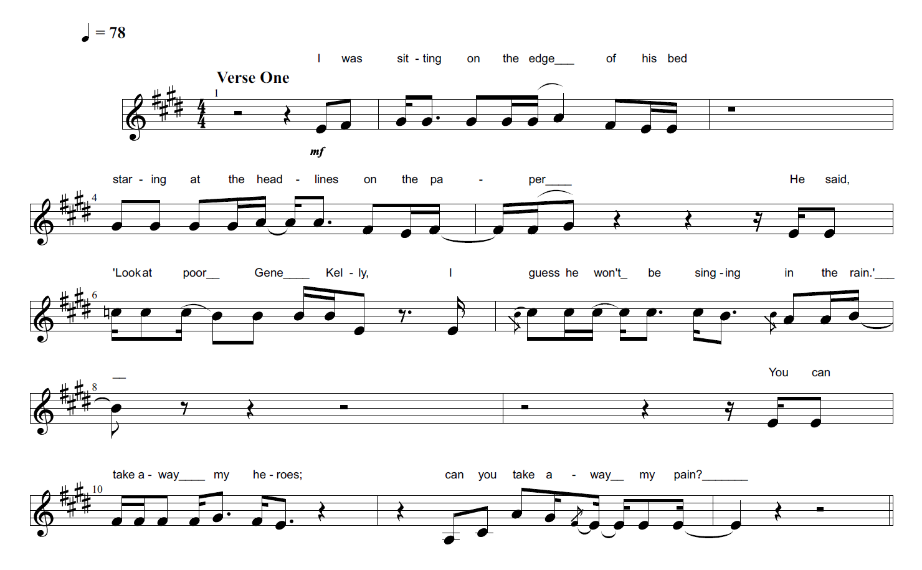
Figure 5.1 – Take Away My Pain – Verse One
The first line (‘I was sitting on the edge of his bed’) contains cues of both perceptual (‘I’ and ‘his’) and spatial deixis (‘on the edge’). The first person pronoun ‘I’ creates a deictic centre comprised of the main character-narrator whose identity is unknown at this point. The presence of the third person pronoun in possessive form ‘his’ indicates that there might be another deictic centre within the song; however, there is no deictic shift, as the second character is viewed through the deictic centre of the main character at this point. The adverbial expression ‘on the edge of his bed’ indicates that there is physical proximity between the two characters.
The present participle verb ‘staring’ as well as the noun phrases ‘headlines’ and ‘thesis’ in the second line (‘staring at the headlines on the thesis’), are also cues of perceptual deixis that provide additional information about the characters’ location in space. Generally, at this point, listeners might start to make inferences about the location of the entities based on the information provided and their background knowledge. In my own listening, headers ‘headlines’, ‘thesis’ and ‘bed’ instantiate the schema of HOSPITAL. ‘Headlines’ in particular denotes a notable or important piece of news which is more likely to be found in a hospital or other more formal settings rather than the bedroom of a house for example.
The direct speech of the character contains reference to a name which will only make sense if listeners possess the schema of GENE KELLY, an American-Irish singer and dancer, among other things. These listeners would use their schema of GENE KELLY in order to make inferences about the spatio-temporal location of the story: twentieth century America.
The deictic push into the deictic field of the second character is also highlighted through the change in pitch height within the melody. The first two lines and the reporting clause at the beginning of the third line are all sung within a lower register (E3 – A3); while the direct speech that is extended through the third and fourth lines is sung within a higher register (mainly A3 – C4), indicating that these lines are spoken by two different characters.
In the third line (‘he said “look at poor Gene Kelly”’), the reporting clause ‘he said’ maintains the deictic centre of the original narrator through the third person pronoun ‘he’. However, there is a perceptual deictic shift away from the narrator’s point of view to the other character’s deictic field through the direct speech that follows the reporting clause: ‘look at poor Gene Kelly’. In Deictic Shift Theory, this would be an example of a ‘deictic push’ (see Section 2.2.3) because listeners are ‘pushed’ deeper into the fictional worlds represented by the song’s lyrics.
This explains why there is no Perceptual Deictic Shift back to the main character’s deictic field at the beginning of the fourth line (‘I guess he won’t be singing in the rain). Although the line begins with the first person pronoun ‘I’, it is sung within the higher register mentioned above, indicating that the deictic centre of the third line is maintained because the ‘I’ here is still referring to the second character’s point of view. This is an example of how the performance of songs, and the way in which words are sung can play a very crucial role in shaping listeners’ interpretations of lyrics.
Grammatically, the fourth line contains perceptual and spatial deictic cues such as the predicate of mental engagement ‘guess’, the pronoun ‘he’, the noun phrase ‘rain’ and the preposition ‘in’. For some listeners, the act of singing in the rain would be a header that would preserve and reinforce the schema of GENE KELLY. Singin’ in the Rain is an American musical-romantic comedy film that was directed and choreographed by Gene Kelly in 1952. The film actually contains a clip of the actor singing in the rain.
The negation through the verb ‘won’t’ as well as the presence of the pre-modifying adjective ‘poor’ implies that the actor has unfortunately passed away at the time of speaking. This is in turn is contextual information that can reveal the temporal location of the song’s main plot: Gene Kelly passed away in early 1996, which is also the same year that the song was written. As a result, compositional deixis is maintained throughout the third and fourth lines as listeners are given information that they can use to infer when the song is set.
In the fifth line (‘you can take away my heroes’), there is a Perceptual Deictic pop back into the deictic field of the main character through the presence of the second pronoun ‘you’. The change in pitch height to the lower register used in the first two-and-a-half lines also indicates that the words are sung by the main character. The referent of the second person pronoun ‘you’ remains ambiguous at this point.
The transitive verb ‘take away’, used in the fifth line with the possessive pronoun ‘my’ and the noun phrase ‘heroes’, implies that this ‘you’ has the supernatural power to end lives. When used in the sixth line (‘can you take away my pain’) with the possessive pronoun ‘my’ and the noun phrase ‘pain’, ‘take away’ suggests that this ‘you’ also has the power to end human suffering. The concept of omnipotence, which is implied in the lines discussed above, is a fundamental part of my knowledge about the JUDEO-CHRISTIAN GOD. As a result, in my own listening, the second person pronoun ‘you’ is referring to God here.
Furthermore, my interpretation of the lyrics is also informed by my knowledge of Dream Theater as a band. For example, I possess the schema of JOHN PETRUCCI, the guitar player of the band who wrote the lyrics of the song, which includes the information that he is a practising Catholic. This schema also contains the information that the guitar player lost his father in early 1996, the same time that Gene Kelly passed away. This knowledge compels me to assume that ‘you’ is referring to the Judeo-Christian God. For me, these two lines are an inner prayer, a monologue that the main character is having with a deity.
As a result, in my own listening there is a conflation between the character-narrator and the person who wrote the lyrics, John Petrucci. The main character-narrator and the dying male character portrayed in the song are fictional versions of the guitar player and his father whose voices are framed through the performance of the singer. The implications of this conflation are discussed in detail in Section 5.1.7 that illustrates the multiple-scope network of the sung lyrics.
By contrast, listeners who do not possess the schema of JOHN PETRUCCI, and do not know who wrote the lyrics of the song, might still infer that ‘you’ is referring to the Judeo-Christian God because of the omnipotence that is implied through the repetition of the transitive verb ‘take away’ as discussed above. These listeners might also regard the last two lines of the first verse as a short prayer, a monologue that the main character is having with God as they ask him for help.
Overall, in the first verse, listeners are introduced to three characters through perceptual deixis: the main character-narrator, a second male character and a third unknown one which could be Judeo-Christian God. Furthermore, listeners are also provided with information about the spatio-temporal location of the song’s plot through temporal and spatial deixis.

5.1.2 Chorus A
The chorus section is an extension of the short prayer from the last two lines of the first verse as the deictic centre of the main character is maintained (see Figure 5.2 below). The first line is a repetition of the words ‘take away my pain’, however, this time the line is no longer phrased as a question as before because the modal auxiliary verb ‘can’ is no longer at the beginning of the line. Furthermore, it is harmonised: one vocal sings the words with a lot of force in a higher register, and another sings them softly in a lower register. This gives the impression that it is an exclamation instead of a question. The imperative mode may suggest that the main character is no longer humble and subservient to God’s will, but rather upset and defiant.
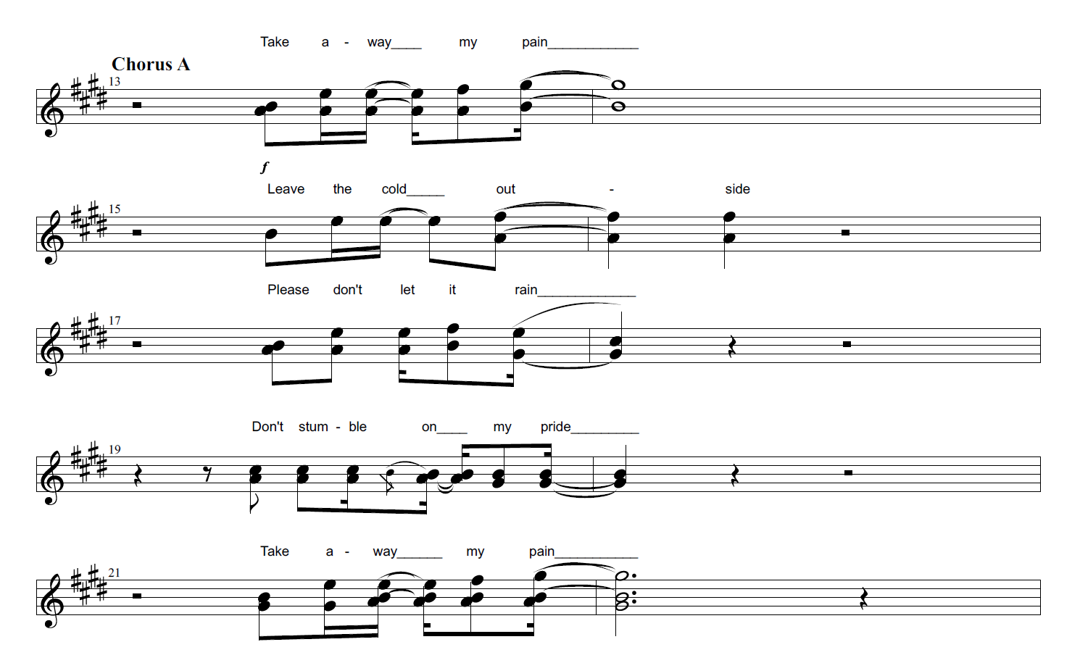
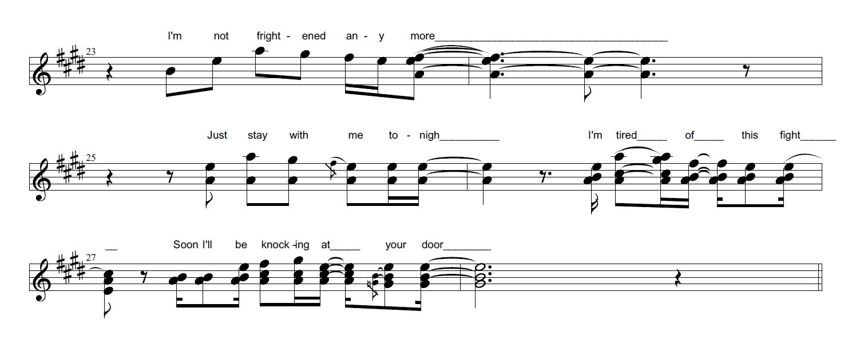 Figure 5.2 – Take Away My Pain – Chorus A
The extended length of the highest note (G#4) falls on the word ‘pain’. This coupled with the power with which it is sung in the higher vocal line, both emphasise the intensity of the pain that the main character is feeling. This tension is further emphasised in the second line of the chorus section through the distal spatial deixis of the adverb ‘outside’ in ‘leave the cold outside’. Pain as such is imbued with physical characteristics as it is portrayed as something that can be taken out from a place and left outside.
In the third line (‘please don’t let it rain’), I interpret that the schema of RAIN is being used in a conventional weather metaphor that represents depression: the source domain WEATHER is used to understand the abstract target domain of MOOD (see also examples in Chapter 4). Furthermore, instead of the imperative mode, the unknown entity is addressed with a more polite tone here, indicated through social deixis: the adverb of politeness ‘please’.
The main character’s emotions change throughout the song. Similarly to the first line, the fourth line of the chorus: ‘don’t stumble on my pride’ emphasises the more defiant nature of the character. The imperative mode is used as the main character is telling God what to do: ‘take away my pain’; ‘leave the cold outside’; ‘don’t stumble on my pride’. The verb phrase ‘stumble on’ suggests that although the main character may appear to be humble and subservient on the surface, there is this hidden quality of pride underneath that is a force to be reckoned with.
The decrease in dynamics within the vocals also implies a transition from pain and instability to defiance and confidence. After the high G#4 note at the very end of the first line, the melody gradually descends in lines two, three and four, ending on the lowest note B3 with ‘pride’ at the end of the fourth line. In my own listening, this creates the impression of a more reserved and less aggressive type of pride that the main character is showing here. Pride can be a positive human quality, but it can also very easily be a flaw if it becomes arrogance. The low intensity with which the words in the fourth line are sung implies that pride is more of a virtue than a vice in this context.
Mid-way through the chorus, there is a brief instrumental break before the words ‘take away my pain’ are repeated again in the fifth line with the same melody as before. In the next line, the deictic centre of the main character is maintained through the pronoun ‘I’ in ‘I’m not frightened anymore’. There is temporal deictic shift here through ‘anymore’ as listeners’ attention is drawn towards the present time, or the temporal location of the song’s plot, further emphasising the character’s progression. It is difficult to tell however, what the main character is not afraid of here.
In the next line the subject ‘you’ is elided in the imperative ‘just stay with me tonight’. The use of the first person pronoun ‘me’ in object position suggests that the deictic centre of the speaker is maintained, but the imperative indicates the presence of an ambiguous addressee once more. On the one hand, the addressee could be God as the main character seeks his presence and help. On the other hand, it could be the other character who was mentioned in the first verse. This blurring of addressees means that the song could potentially be addressing anyone at this point. The ambiguity implies some form of generalisation that might encourage some listeners to identify with the pronoun ‘you’ here themselves. The main character is either asking for God’s help, or they are simply reluctant to let go of their father. In either case, there is a clear juxtaposition here with the previous line (‘I’m not frightened anymore’), because it sounds like the main character is in fact not ready, and actually very frightened of witnessing the death of their beloved one because they need the company of God or their father. Furthermore, the temporal deictic push at the end of the line through the temporal adverb ‘tonight’ creates a sense of immediacy as listeners are pushed further into the present time of the song.
In the next line (‘I’m tired of this fight’), the proximity suggested by ‘anymore’ and ‘tonight’ in the previous lines is further highlighted here through spatial proximal deixis with the determiner ‘this’, which suggests some form of continuity, a lack of closure in terms of conflict and suffering.
It is also interesting to hear the difference in the choice of adjectives attributed to the deictic centre of ‘I’: ‘frightened’ and ‘tired’. By comparison, the addressee of ‘you’ is the implied subject of verb phrases only: ‘take’, ‘leave’, ‘let’, ‘stumble’. This implies that the narrator has more of a passive role in the song so far, as they only observe, pray and feel certain emotions; whereas the addressee ‘you’ is much more dynamic and active.
This pattern changes in the last line however: ‘soon I’ll be knocking at your door.’ Here, the temporal adverb ‘soon’ and the modal verb ‘will’ cue up a temporal deictic push into an unspecified future time. The narrator has a more active role here which is implied by the present participle verb ‘knocking’. Furthermore, the ambiguous second person is maintained through the second person possessive pronoun ‘your’ as it is still not clear whose door the narrator will be knocking on.
In my own listening, the act of knocking on a door in this context is a generic unmarked intertextual reference (Mason 2020: 80) to ‘Knockin’ On Heaven’s Door’, which is a song that was written by Bob Dylan in 1973. Since then, it has spawned multiple covers by artists such as Guns N’Roses, Eric Clapton, Randy Crawford and more. The reference is generic and unmarked because although reference is being made to another song, link between the songs is not specific.
The noun phrase ‘heaven’ instantiates the schema of AFTERLIFE. Still, this schematic knowledge does not help me to decide whose door the narrator will be knocking on. It could be the door that leads to heaven and God himself, or it could be the door that leads to their deceased father, who would also be in heaven. If it is the former, then the defiance of the narrator is accentuated here through the way in which they challenge God and protest against the death of their father. If it is the latter, then their reluctance to accept the death of their father is highlighted here.
Overall, it is clear that the main character is searching for salvation and liberation from their pain, but the ambiguity of the second person pronoun ‘you’ makes it difficult to ascertain the identity of the addressed character at this point which creates an interesting multiplicity of meanings.

5.1.3 Verse Two
In the first line of the second verse (‘she was standing by the edge of his bed’) there is a change of scenery through temporal and spatial deixis here as listeners are returned to an unspecified past time (‘was standing’) and the unspecified space (potentially a hospital room) with a bed in it that was referred to in the first verse. The pronoun ‘she’ introduces a new deictic field.
This deictic centre of the main character-narrator is maintained in the second line in ‘staring at the message on their faces’. The act of staring at a message implies that the fourth female character and the character-narrator who is observing the scene are trying to figure out what this group of people is thinking or saying about the condition of the character who is lying in bed. This might activate or reinforce the schema of HOSPITAL for certain listeners, because it gives the impression that the female character is waiting for a diagnosis from the doctors or the nurses implied by the pronoun ‘their’.
Similarly to the first verse, there is another perceptual deictic push into the deictic centre of the male character who is lying in the bed through the direct speech in lines three and four: ‘what else can you do babe/I guess I won’t be coming home again’. These lines are sung in a higher register, indicating that the personal pronoun ‘I’ in the fourth line is still referring to the hospitalised male character and not the narrator.
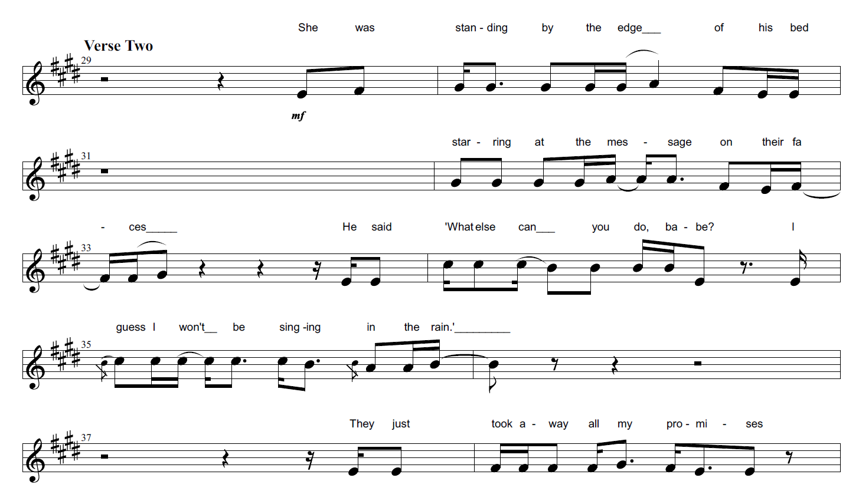
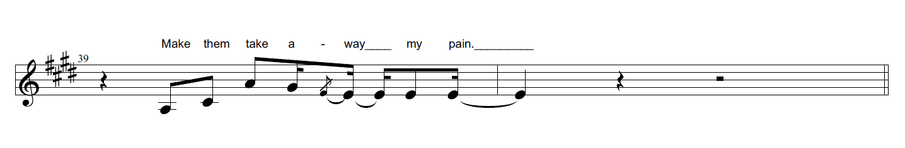
Figure 5.3 – Take Away My Pain – Verse Two
These two lines provide important information about the relationship between the characters. Firstly, there is social deixis in the third line through the colloquial noun phrase ‘babe’, which suggests that the man lying in the bed and the woman standing by his bed know each other quite well and are a couple. Their close relationship is also emphasised through the proximity implied by the present participle verb ‘coming’ in the next line. Using the word ‘coming’ instead of ‘going’ implies that the speaker is projecting his deictic centre into that of the female addressee, because the verb ‘coming’ reflects the deictic centre of the female character who is waiting for the speaker to return home.
Secondly, the potential death of the male character is alluded to through the predicate of mental engagement ‘guess’, the negative modal verb ‘won’t’ and also the negated act of ‘coming home’ in the fourth line. At this point, listeners who are not familiar with the song and do not possess the schemas suggested above would have a clearer understanding of what the song is about overall: the potential loss of a family member and feelings of bereavement as a result. They would also regard the two characters, the male lying in the bed and the female, as a couple and the narrator as possibly another member of the family. So far, it is not clear whether the narrator is a child, a brother or any other relative for that matter.
At the beginning of the fifth line ‘they just took away all my promises’, there is an ambiguity of voices. On the one hand, the words are sung in a lower register once again which can initiate a perceptual deictic push back into the deictic centre of the narrator. On the other hand, the use of the pronouns ‘they’ and ‘my’ can also act as deictic cues that in turn maintain the deictic centre of the patient instead.
There is also a temporal deictic shift in the same line through the change in tense from future (‘won’t’) to past (‘took’), implying perhaps that this group of people (represented through the distal deixis of the third person plural pronoun ‘they’), who are most likely doctors or nurses, had initially promised sometime in the past that the man would recover.
There is also deviance here in the way in which the line is phrased. Usually, verbs such as ‘to keep’ or ‘to break’, when used in conjunction with ‘promise’, suggest that someone did not keep their word: to keep a promise; to break a promise. Using the verb of motion ‘to take away’ instead emphasises the theme of bereavement even more because the promises are not kept or broken, as one might expect, but removed all together, suggesting an obliteration or a loss. Also, using the first person pronoun ‘my’ in possessive form implies that perhaps initially it was the narrator who had promised their loved one that they would survive as an act of hope. Taking away these promises suggests that they have been deprived of hope because the doctors/nurses had bad news to share.
In the last line of the second verse, the deictic centre of the narrator is reinstated through the predicate in imperative mode ‘make’ in ‘make them take away my pain’. Similarly to the last two lines of the first verse, in my own listening, the lower register with which the words are sung implies that this is an interior monologue that the narrator is having with someone. The shift in pitch indicates where the voice of the patient stops and the deictic centre of the narrator is reinstated. Furthermore, the schemas that I possess about the song and the band in general help me to infer that this ‘you’ addressee is probably God.
However, even listeners who do not possess these schemas may come to the same conclusion through the schema of the JUDEO-CHRISTIAN GOD: the implied addressee of the imperative in this line has the power to make the doctors heal the character-narrator’s emotional pain. The character-narrator is blaming the doctors/nurses for their pain instead of God. Furthermore, he is demanding help from God through the imperative ‘make’, implying that there is some form of antagonism and tension between God and the narrator here.

5.1.4 Bridge
The second verse is followed by a repetition of the first chorus section (Chorus A) with the same words and same melodies, highlighting the narrator’s internal pain. The chorus is then followed by the bridge section (see Figure 5.4 below). In my own listening, the noun phrase ‘final scene’ in the first line initiates the schema of PLAY, consequently also creating the conceptual metaphor LIFE IS A PLAY. This metaphor is extended throughout the bridge section through repeated reference to elements in the PLAY domain such as the noun phrase ‘the actor’ and the predicate ‘bows’. The descending melody emphasises the act of bowing, which is a metaphor that also represents death: the actor bows out with dignity and humility after their last performance.
The domain of LIFE is emphasised further through reference to life and time in lines three and four: ‘and all those years/are gone somehow’. In the third line, there is a distal spatial deictic push into an unspecified past through the determiner ‘those’. The predeterminer ‘all’ implies that the narrator is referring to many years here, which in turn means that the actor is somewhat old. The predicate ‘are’ in the fourth line creates a temporal deictic pop back into the present moment of the song where the years of the past are already gone. In the vocal melody, ‘gone’ is sung with a lot of force and a high A4 note, reflecting the intense pain of the narrator.
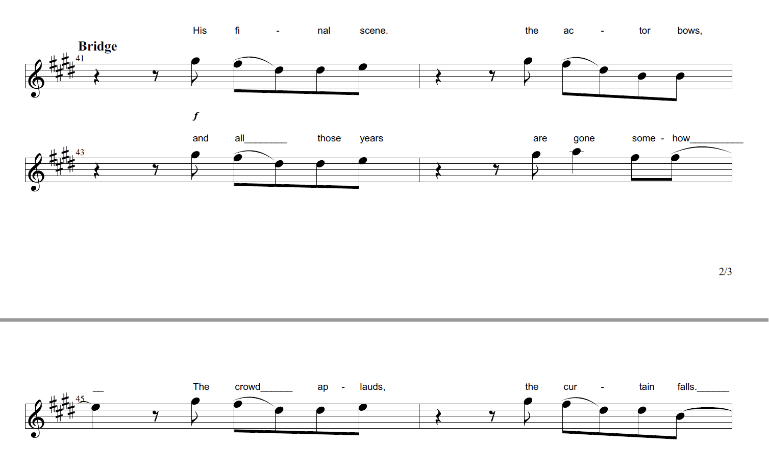
Figure 5.4 – Take Away My Pain – Bridge

The metaphor is extended further in lines five and six: ‘the crowd applauds/the curtain falls’. The predicate ‘applauds’ implies that the crowd is showing respect towards the actor on the stage, suggesting that they had lived a good life. The curtain falling is crucial element of the metaphor because it implies that the end of the play represents the death of the actor.
Overall, in the bridge section, listeners are shifted into a different spatio-temporal location: away from the hospital and onto an unknown stage. The extended metaphor LIFE IS A PLAY perhaps also suggests that life is merely a series of scenes where humans play certain roles that are assigned to them in order to conform and to fit into society (represented by the crowd here). The applause could be interpreted as the world’s recognition of the actor’s performance.

5.1.5 Third Verse
The bridge section is followed by a guitar solo, which is discussed in detail in the Music section (see below). Following the solo, the deictic centre of the narrator is maintained in the first line of the third verse: ‘I was standing by the edge of the water’ (see Figure 5.5 below). Through the temporal deixis of the past continuous verb ‘was standing’, and the spatial deixis of the adverb of location ‘by the edge’, listeners are transported to an unspecified location, away from the more formal settings like the hospital room and the stage to a more natural one that contains water.
The deictic centre of the narrator is maintained in the second line through the predicate of perception ‘I noticed’. Furthermore, there is also perceptual deixis through the presence of the noun phrases ‘reflection’ and ‘waves’, which perhaps suggests that the narrator is seeking solitude in order to reflect upon their loss.
In the third line of verse three: ‘then I saw you looking back at me’, the scene is developed further. The first person pronoun ‘I’ stays in subject position, maintaining the deictic centre of the narrator, while ‘you’ is in object position. It is not clear what character ‘you’ is referring to here. On the one hand, it could be the now deceased character staring back at the narrator from the afterlife, highlighting the strong bond between the two. On the other hand, it could be God instead looking back at the narrator. However, similarly to verses one and two, there is a shift into a higher register in the vocal melody in lines three and four: ‘then I saw you looking back at me/and I knew that for a moment’. Because of the melodic patterns that have been established so far in the previous verses, listeners may associate this change in register with the deceased character instead of God. As such, it is more likely that the ‘you’ here is referring to the father figure. Furthermore, the social deixis in the fifth line: ‘you were calling out my name’, suggests that there is a close bond between the narrator and the ‘you’ mentioned in these lines.
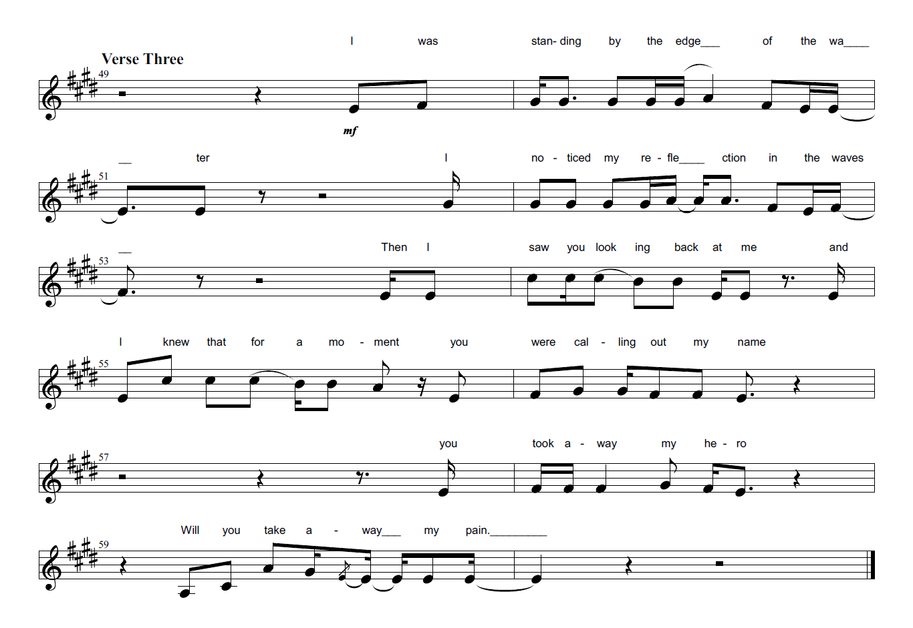
Figure 5.5 – Take Away My Pain – Verse Three
One could argue that because the narrator is very religious, they could also have a very similar, close relationship with God as well. However, in my own listening, the five second rest between the fifth line: ‘you were calling out my name’ and the sixth line: ‘you took away my hero’, as well as the social deictic reference to ‘my hero’, both help me to distinguish the ‘you’ in lines three to five, which refers to the deceased character, from the ‘you’ in lines six and seven, which represents God. Furthermore, the ability to kill or the take away something on demand reinforces the schema of the JUDEO-CHRISTIAN GOD through the concept of omnipotence. This can also help listeners differentiate the two deictic centres being addressed by the main character-narrator.
In the last line of the verse, there is another temporal deictic push through the modal verb ‘will’ in the interrogative line ‘will you take away my pain’. Similarly to the last line of the first verse, where the line sung was ‘can you take away my pain’, the narrator returns to a more subservient and less defiant state whereby they are asking for help instead of making demands as they did with the imperative in verse two.

5.1.6 Chorus B
The last chorus of the song is sung with the same melodies as the first two choruses discussed above, but contains different phrases in certain lines (see Figure 5.6 below). The spatial adverb ‘outside’ is replaced with ‘inside’ here in the second line: ‘let the cold inside’. In my own listening, this juxtaposition makes it difficult to interpret the lines because it disrupts the semantic linearity of the chorus section overall. On one hand, the narrator wants to be liberated from their pain, on the other hand however, they wish to endure the pain: ‘let the cold inside/it’s time to let it rain/there’s nothing left to hide’. Again, the concept of rain is used to represent sorrow and depression here, and the narrator is no longer trying to hide his inner feelings.
In the second part of the chorus section, the ‘you’ in the lines ‘without you in my life/till you come knocking at my door’ no longer refers to God, but to the deceased character, because the lines imply that ‘you’ has passed away. Furthermore, the lines suggest that the narrator is no longer afraid and is going through the process of coming to terms with their loss. This is especially emphasised through the present continuous tense ‘I’m learning’, implying that they have not yet fully accepted the death of their loved one.
In the very last line: ‘till you come knocking at my door’, there is a spatial deictic push through the preposition ‘till’. The schemas of AFTERLIFE and RELIGION are instantiated as listeners’ attention is shifted towards an unspecified time in the future when the roles are reversed and the deceased character is now knocking on the door of the narrator in heaven. The preposition ‘till’ indicates that the line is a dependent clause that is linked to the main clause ‘I’m learning to survive’. This in turn suggests that the narrator will never
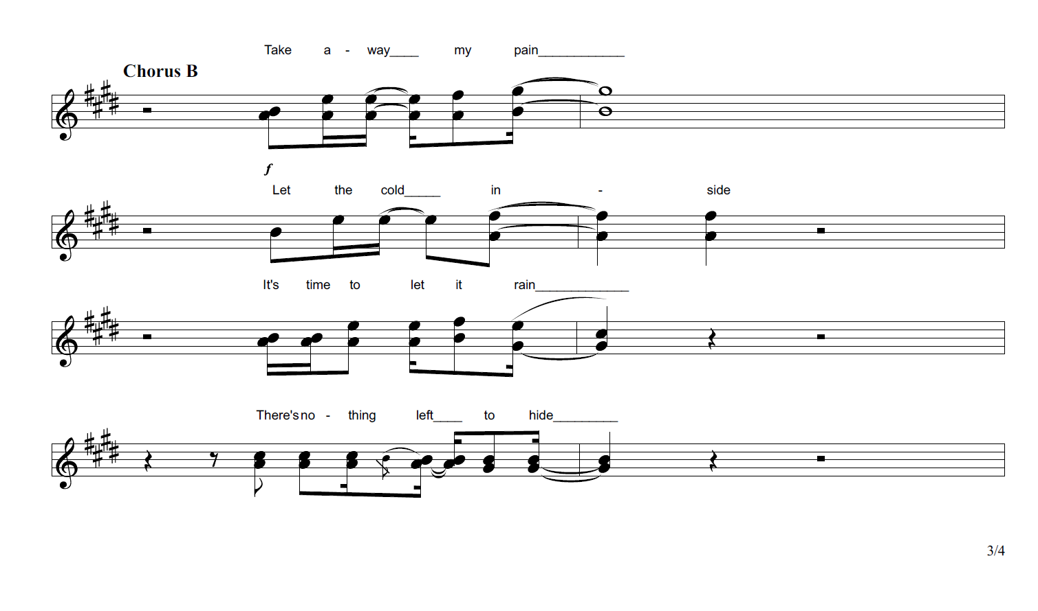
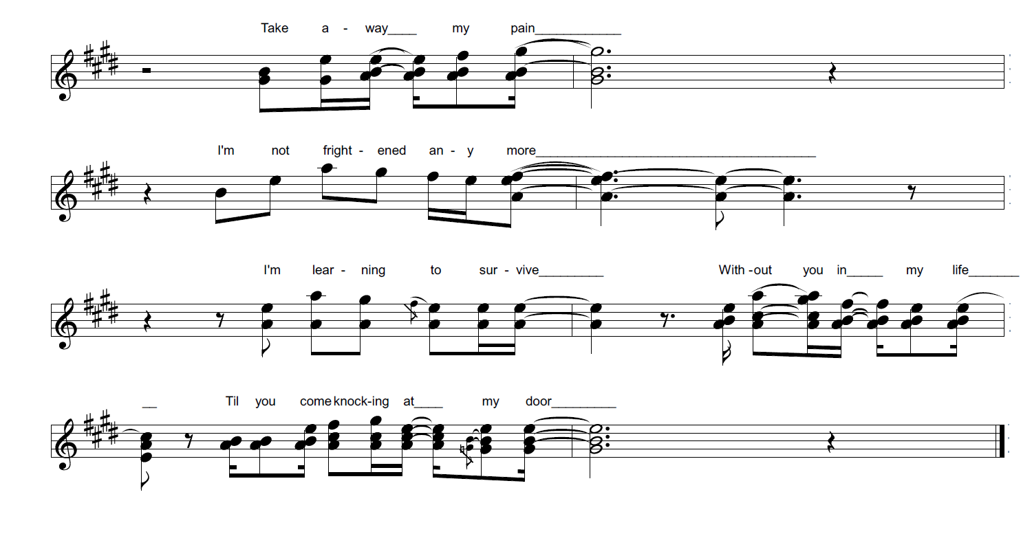
Figure 5.6 – Take Away My Pain – Chorus B
reach the end of this process of coming to terms with their loss as they will carry on learning until the day they die and are reunited with their loved one once again.

5.1.7 Multiple-scope networks of Sung Lyrics
In my own listening, when the lyrics of ‘Take Away My Pain’ are sung, a multiple-scope network is conceived which contains blends of a living person with two different represented characters. The specific identities of the represented characters will vary depending on the schemas that listeners possess. Since it is difficult to account for all the possible variations, the diagram below illustrates one specific type of multiple-scope network: one that contains a blend between James Labrie (the singer of the band), John Petrucci (the guitar player of the band) and John Petrucci’s father.
The input spaces each have different organizing frames. One input space represents the singing voice of James Labrie which includes information about the vocal techniques he employs in his performance of sung lyrics throughout the three key sections of the song: low melodic range, relaxed, soft dynamics in the verses; medium range, descending melody, loud dynamics, tense in the choruses; medium range, loud dynamics, tense in the bridge (see James Labrie Space in Figure 5.7 below). Compared to ‘Pull Me Under’, there is less emphasis on technical proficiency in ‘Take Away My Pain’ as the range covered within the vocals parts of the song is much smaller. This would be an example of nonconformity in terms of genre expectations and could potentially have a big impact on listeners’ interpretations of the lyrics: for example, attention might be shifted away from the lyrical content itself to the unusual and more typical mainstream performance of the song. In my case, since I possess important schematic knowledge about the reasons why the band shifted away from a more progressive style of music (see Subsection 2.4.2), nonconformity with regards to vocal performance has less of an impact on my own interpretations.
For listeners who possess schematic knowledge of John Petrucci and his father, the second and third input spaces would represent the fictional characters who are based on the real-life guitar player John Petrucci and his father (see John Petrucci and Petrucci’s father input spaces in Figure 5.7 below).
The network is a multiple-scope network because the blended space has an organising frame that includes parts of each of the frames of the three input spaces and has an emergent structure of its own: John Petrucci and his father have the singing voice of James Labrie; while James Labrie’s voice is a specific, and unique oral projection of John Petrucci and his father who now express their thoughts and feelings through the act of singing.
The key outer-space relation is one of Representation. The John Petrucci and Petrucci’s Father input spaces correspond to the fictional characters; while the James Labrie input spaces in turn correspond to the element that represents the two fictional characters: the oral performance of lyrics. The outer-space relation of Representation is supported by Analogy: the words of John Petrucci and his father, both of whom are male characters, are represented by James Labrie, a male singer.
The key outer-space relation of Representation is compressed into three main vital relations within the blended space: Change, Identity and Uniqueness. The identities of John Petrucci and his father are changed because they are represented through language and the voice of James Labrie. Furthermore, this change also leads to Uniqueness because the melodic ranges, the dynamics and the intensity with which the performer sings the language all create unique forms of identity that are not conceivable in either one of the input spaces on their own. While the semantic contents of the blended spaces are derived solely from the words that are sung; the moods, feelings and energy levels are in turn associated with both the performance of the melodies as well as the schematic knowledge instantiated by the identity of John Petrucci (i.e. that he lost his father in 1996 and that he is religious).
The blended space contains a summary of specific information conveyed by language: actions (praying to God, asking questions, making demands, paying homage, bereavement), feelings (pain, sorrow), metaphors (LIFE IS A PLAY; FATHER IS AN ACTOR). The diagram also contains information about intensity levels which are in turn

Petrucci’s Father Space:
- life experience
- wisdom
- religious background
Sung Lyrics Space:
Verses: humble man praying to God
- asking questions
- relaxed, repressed pain
- making demands, tense, outburst of pain (Verse Two only)
Choruses: defiant man praying to God
- outburst of pain, tense, making demands, pride, courage, reluctance, bereavement
Bridge: paying homage, tension, sorrow, LIFE IS A PLAY/FATHER IS AN ACTOR
- never coming home
- acceptance of fate

James Labrie Space:
- singing voice
- lyrics
Verses: low melodic range, relaxed, soft dynamics, medium range, tense, loud dyanmics
Choruses: medium range, descending melody, loud dynamics, tense
Bridge: medium range, loud dynamics, tense

John Petrucci Space:
- son who lost his father in 1996
- religious background

Figure 5.7 CIT diagram showing generic, input and blended spaces of sung lyrics in ‘Take Away My Pain’

Generic Space:
Persona
Intensity

attributed to the personas of John Petrucci and his father: relaxed, repressed, outburst, tense, acceptance and peace.
Within the blended space in Figure 5.7, the characters are conveying specific information through sung lyrics while also exhibiting certain moods, feelings, attitudes with different levels of energy. Furthermore, the blended space in the John Petrucci diagram contains other conceptual blends within it such as the LIFE IS A PLAY and the FATHER IS AN ACTOR metaphors. While the conventional metaphor LIFE IS A PLAY implies a single-scope network comprised of a typical source domain (play) and a target domain (life); the FATHER IS AN ACTOR metaphor creates another complex double-scope network where the identity of the father figure is blended with the identity of an actor who is performing their life on a stage.
It is important to emphasise that the diagram above illustrates a very specific example of a multiple-scope network that contains information about the song in its entirety. Furthermore, this network can only be conceived if listeners possess the relevant schemas (i.e. background knowledge about John Petrucci and his father’s death in 1996 as well as the pressure that band was facing at the time to produce more mainstream music or the conscious effort on their part to experiment with a more mainstream genre of music). Without the schemas related to the guitar player’s personal life, the John Petrucci and Petrucci’s Father input spaces would not have specific organising frames; instead, their frames would be much more generic such as Male Character for example. Furthermore, the blended spaces themselves would not contain certain elements such as ‘faith’, ‘God’, ‘prayer’ for instance.

5.1.8 Summary
Overall, the way in which the words are sung by the vocalist plays a crucial role in the creation of the double-scope network presented above. The network contains input spaces that have specific organising frames because I possess schematic knowledge of John Petrucci and his father. Furthermore, within the network, the vital relation of Representation is compressed into Change and Uniqueness within the blended space, as the characters are imbued with unique qualities.
The next section will now analyse the instrumental music of ‘Take Away My Pain’ in order to demonstrate how the contrasting conceptual feature dimensions associated with music can change listeners’ interpretations of the song’s lyrics.

5.2 Music

5.2.1 Intro/Verses
Along with the vocal performance, the musical structure of ‘Take Away My Pain’ is also unusually very simple for a progressive rock song. The simplicity is evident in the fact that there is no musical variation between the three different verses of the song, which is a more common aspect of most pop songs. For listeners’ who are not familiar with the song but have certain genre expectations in terms of musical complexity, this might have an impact on their interpretations of sonic meaning. Since I myself possess important schematic knowledge about the fact that the band was either under enormous pressure from labels to produce more mainstream songs (see Portnoy 2012), or that they were deliberately trying to extend their catalogue with more radio-friendly music (see Petrucci 2015), I am more lenient with my expectations of nonconformity. Furthermore, I do believe that the relationship between the lyrics and the background music is very interesting. The composition of the song as a whole is quite sophisticated, despite its simplicity.
The first sound that listeners will hear at the beginning of the song is that of a percussion instrument called cabasa, which maintains a steady rhythm of four groups of sixteenth note patterns to the bars in 4/4 throughout the intro and all three of the verses (see pages 163-201 in the Appendix Section for the full score).
In the second bar of the intro, the drums join in, dividing the bars into groups of sixteenth note patterns interspersed with pairings of thirty-second notes played on the snare. Although the tempos of the song itself is moderately slow (78 BPM), the repetition of this fast-paced groove throughout all three verses provides a light, consistent and rhythmic foundation to much of the song.
In the fourth bar of the intro, three other instruments join in: keyboard, bass guitar and electric guitar. In one hand, the keyboard plays an E major chord (the tonic chord), which is sustained throughout the remaining four bars of the intro. The other hand plays additional two intervallic notes (the major third G#4 and the fourth A4) on top of the E major chord, outlining an Eadd11th chord. Towards the end of the intro, a D5 power chord is also played on top, outlining an E7add11th chord.
The bass guitar simply plays two intervallic repetitions of the tonic followed by its octave (E1 and E2) in each of the bars. Compared to these two instruments, there is a lot more motion in the guitar part, where the bars are divided into four groups of sixteenth note arpeggios that alternate between E5, E major and Eadd9 throughout the intro.
The combination of all of these sounds together creates an upbeat, fast-paced and repetitive groove, which in turn is usually associated with the conceptual feature dimensions of smallness, lightness and proximity among others (see Chapter 2.0). On top of this, the major chords used here also create a more joyful and relaxed atmosphere.
The reason why the intro of the song is not analysed in a separate section is because it transitions seamlessly into the first verse, where the same musical structure is repeated in the electric guitar and the drum sections all the way through to the chorus. However, there is some variation in the keyboard and bass parts as outlined below.
In the fifth bars of the verses, the subdominant A major chord is played by the keyboard, followed by the dominant B major chord in the sixth bar. The bass guitar also outlines these chords as it plays the notes A1, E1 and E2 in the fifth bars, and B1, E1 and E2 in the sixth bars. This ascending chord progression highlights further the conceptual feature dimensions of smallness, lightness and brightness. Following this, there is a return to the tonic E major chord in bars seven and eight.
In the ninth bars of the verses, the dominant chord is played again in the keyboard parts but with a minor triad instead of a major one this time, creating dissonance through the sound of the D note which is not in the key of E major. This momentary tension is resolved when the subdominant A major is played in the last bars of the verses. Like before, the notes played in the bass section outline the chord transitions.
Overall, there is barely any variation in the musical structure of the verses throughout the ten bars that they cover. Apart from small changes in the keyboard and bass sections, the music stays simple as it creates a very light, casual and pleasant mood that is only briefly disturbed by the tension created by the dissonance of the B minor chords in the ninth bars.

5.2.2 Pre-choruses/Choruses
The verses are followed by two bars that represent the pre-chorus sections. The electric guitar parts carry on playing the same arpeggios as before, while the bass guitar plays simple eighth notes consisting of the tonic E1 and the supertonic F#1 in the first bar, followed by the subdominant A1 and the dominant B1 in the next bar. These notes outline the chord changes in the keyboard parts: E major, F# major, A major and B major. The drum parts also outline a simpler rhythmic groove with variations of two eighth notes or one eight note and two sixteenth notes played to the bar with snares and kick drums.
In the first bars of the choruses, the electric guitar carries on playing the same arpeggios, but this time, two other electric guitars join in. One guitar plays the following chord progression in unison with the keyboard and bass guitar parts: E major in bars one and two, Dsus2 in bars three and four, C# minor chord in bars five, Asus2 in bars six, and E major again in bars seven and eight. The same chord progression is then repeated one more time.
The third electric guitar plays the same four notes in a high register throughout the entire chorus sections: G#4, A4, B4 and E5. Although these notes simply outline an Eadd4 chord, their function and sound changes as the chord progression changes in the background. Initially, they are extensions of the E major chords, but when the Dsus2 chords are played, the B4 and E4 notes augment the chords with sixth and ninth notes, while the G#4 notes create dissonance because they act as tritones that want to resolve up to the A notes.
When the C# minor chords are played, the G#4 and E5 notes act as chord tones because they are already part of the chords; the B4 notes augment the chords with flat sevenths; while the A4 notes create dissonance as they augment the chords with flat six notes which want to resolve down to the fifth G#4.
When the Asus2 chords are played, the A4, B4 and E5 notes act as chord tones, while the G#4 notes on the other hand, create dissonance because they augment the chords with seventh notes which want resolve up to the root A. Finally, the dissonance created by these notes during these chord changes is resolved when the tonic E major chords are played towards the end of the chorus sections.
Midway through the chorus section, another electric guitar joins and repeats the following notes in a high register throughout the remaining four bars: E5, F#5 and G#5. The functions and sounds of the E5 and G#5 notes change the same way as in the other guitar part discussed above. With regards to the F#5 notes, they create less dissonance, as they simply augment each of the chords: the Dsus2 chords with major triads, the C# minor chords with eleventh notes and the Asus2 chords with sixth notes.
These subtle additions to the chord progression increase the note density within the song. This means that the conceptual feature dimensions of smallness, lightness and brightness, identified in the verses, are maintained here as well through the fast-paced, upbeat and repetitive nature of the music. Although there is more dissonance in the chorus sections, the constant repetitions of the same major arpeggios and melodies, played in the higher registers by the guitars, build a solid foundation of consonance for the most part that is occasionally disturbed by the minor chords and the dissonance of the ostinatos. In my own listening, these combinations of conceptual feature dimensions coupled with changes in consonance and dissonance as well as dynamics (louder in the chorus section) imply some form of juvenile joyfulness, an innocence that is momentarily tainted by sorrow and despair at times. Furthermore, the simplicity of the musical structure overall also emphasises my interpretations of youth and innocence, which means that nonconformity to genre expectations is deliberate throughout the song.

5.2.3 Bridge and guitar solo
The bridge section starts after the second repetition of the chorus. There is a sudden shift in the key signature from E major to E minor. Only two of the four electric guitars from the chorus sections carry on playing. One of these outlines two chords: Csus2 and em7[no5], with the following short arpeggios: C3, G4 and D4 in bars one, two and five and six; E3, G4 and D4 in bars three and four. The second electric guitar on the other hand plays harmonic intervals that outline the following two chords in the background: Cmaj7 in bars one, two and five and six, and em7 in bars three and four.
Meanwhile, the bass guitar plays chord tones that reinforce the chords mentioned above, while the drums transition into a simpler rhythmic groove. The keyboard parts play repetitions of fast scale patterns consisting of thirty-second notes played to the beat in the key of e minor. The sound effect that is used makes the notes fade in and out continuously throughout the bridge section, creating a strange ambience while also maintaining the intensity levels from the chorus section at the same time.
In the seventh bar of the bridge section, the guitar solo begins as the chord progression changes to repetitions of em, D and Cadd9, played by two other electric guitars and the bass. Although the same groove is maintained in the drum parts, hihats are used much more often here, amplifying the tension created by the solo.
As far as the guitar solo itself is concerned, it is initially played in a high register (B4 – B5) with a lot of distortion, powerful string bends and high note density (sixteenth note triples and thirty-second notes to the beat), creating a lot of tension. Towards the end (the last two bars), the solo descends into a lower register (B3 – A4) and resolves back to the tonic E3.
When looking at the conceptual feature dimensions implied by the music in the bridge section, smallness, lightness, sharpness, brightness and proximity are all maintained here through the upbeat tempo and the fast scale runs in both the keyboard parts and the guitar solo afterwards. The higher intensity and note density also imply higher levels of energy and tension.
Compared to the verses and the chorus sections however, the minor mode is much more prevalent in the bridge and solo. Although within the field of music psychology, research has shown that minor chords are usually associated with negative emotions such as sadness, other areas of research have indicated that tempo and rhythm can be much more important in shaping listeners’ experiences of certain feelings and emotions; for example, minor chords played at a fast tempo may evoke positive emotions (see Section 2.1).

5.2.4 Outro
Following the bridge section, the key signature changes back to E major as the verse and the chorus sections are repeated one more time. At the very end, the song concludes with the tonic E major chord which is sustained throughout multiple bars in the electric guitars and bass. At times, in the keyboard parts, there are subtle incursions of dissonance in the background, which create a mysterious ambience that is eventually resolved at the very end with the tonic chord.

5.2.5 The Multiple-scope network of the instrumental music
Using Conceptual Integration Theory to illustrate the relationship between musical elements and conceptual feature dimensions within the song means that four key input spaces are conceived while listening to the music: auditory perception of sound in a western context (which entails cultural bias and genre expectations), perceptual feature dimensions, kinaesthetic feature dimensions and core affect feature dimensions (see Figure 5.8 below).
The key outer-space relation between the input spaces is one of Representation, because the input space of auditory perception of sound in a western context (see space on the far left) corresponds to the elements that represent perceptual, kinaesthetic and core affect feature dimensions (see the input spaces in the middle and on the far right).
Based on the detailed discussion of the song’s musical elements above, the auditory perception of sound input (on the far left) is comprised of the following frame topology: moderately slow tempo, high note density, short duration, prevalence of major chords (in the verses and choruses), prevalence of minor chords (in the bridge and the solo), prevalence of consonance and brief dissonance.
The perceptual, kinaesthetic and core affect feature dimension inputs (in the middle and the far right) contain elements that represent the concepts that are associated with the musical elements listed above. So, high note density, short duration, major chords, consonance, minor chords and brief dissonance are linked with small, high, thin, sharp, bright and proximal perceptual properties, with kinaesthetic feature dimensions such as fast movement and lightness and core affect feature dimensions of high intensity, high energy, sustained resolution/happiness as well as brief tension/sadness.

Music Space:
- upbeat/faster tempo
- small, light and high sounds
- high energy and intensity
- happiness, lightness
- brief disruptions

Kinaesthetic Feature Dimensions:
- fast movement, light

Perceptual Feature Dimensions:
- small, high, thin, sharp, bright. proximal

Auditory Perception of Sound in a Western Context:
- moderately slow tempo; high note density; short duration; prevalence of major chords (verses and choruses), prevalence of minor chords (bridge and solo), prevalence of consonance, brief dissonance

Figure 5.8 CIT diagram showing generic, input and blended spaces of instrumental music in ‘Take Away My Pain’

Generic Space:
sensations
Core Affect Feature Dimensions:
- high intensity, high energy, sustained resolution/happiness, brief tension/sadness
Within the blended space, Representation is compressed into Change (sounds are imbued with perceptual, kinaesthetic and core affect dimensions); Time (sounds create the impression of a more upbeat/faster tempo); Space (sounds imply high positions in space); Cause-Effect (sounds are associated with high positions in space, small size, light weight, resolution, the emotion of happiness, high levels of intensity as well as tension and the negative emotion of sadness); and Uniqueness (perceptual, kinaesthetic and core affect sounds).
Similarly to Chapter 4.0, in my own listening of the song, other forms of perceptual feature dimensions such as width, shape, colour and distance are not projected into the blended space as I do not associate sounds with these elements. As a result, the blended space of the multiple-scope network includes parts of each of the frames of the four input spaces and has an emergent structure of its own: a simple but sophisticated, light and happy song with an upbeat tempo and high energy levels.

5.2.6 Summary
Overall, the musical structure of ‘Take Away My Pain’ is very simple throughout. The constant repetitions of the tonic E major chord arpeggios all the way through the verses and the chorus sections imply some form of underlying happiness/lightness that is only occasionally disrupted by the dissonance of sadness. The high note density within the song also gives the impression of a more upbeat tempo despite the fact that the tempo itself is moderately slow. Although the bridge section and the solo are much darker overall because of the dominance of minor chords, the upbeat tempo and the constant motion suggested by the fast scale patterns maintain a sense of underlying lightness within the song. This is surprising, considering the rather heavy, serious and emotional subject matter discussed in Section 5.1. This contrast between the lyrics and the instrumental music facilitates the conceptualisation of complex double-scope networks which are discussed in Section 5.3. below.

5.3 Conceptual Blendings Between Sung Lyrics and Music
Drawing upon the separate analyses of sung lyrics and music in sections 5.1 and 5.2, this section of the chapter discusses the double-scope network of the song ‘Take Away My Pain’ by Dream Theater.
When the lyrics and the background music are heard simultaneously, the relationship between the meanings, feelings and emotions conveyed by the lyrics and the energy levels associated with the musical elements is predominantly one of disanalogy. For example, lyrically, the first two verses discuss the themes of repressed pain, death and bereavement overall. By contrast, the background music sets a very light, casual and pleasant mood through the repetition of major arpeggios throughout. The only time when there is analogy between the two modes is in lines five of verses one and two (‘You can take away my heroes/They just took away all my promises’) when tension is created by the dissonance of the B minor chords played in the background music (see Subsection 5.2.1), which in turn emphasises the emotional pain conveyed in the accompanying lyrics. However, these are only very brief moments of analogy that only last for the length of a single bar as the tension of the background music is soon resolved in the next bars; while the trauma expressed in the lyrics remains unresolved.
The same is true for the first two repetitions of the chorus section. On the one hand, the lyrics suggest that the main character is searching for salvation and liberation from the heavy burden of emotional pain that comes with bereavement. On the other hand, the background music builds a solid foundation of consonance for the most part through the constant repetitions of major arpeggios and melodies, played in the higher registers by the guitars. The fast-paced, upbeat and repetitive nature of the music is also associated with the conceptual feature dimensions of smallness, lightness and brightness. However, similarly as in the verses, this stability is briefly disrupted by the C# minor chords and the accompanying dissonance of the ostinatos in bars five (see Subsection 5.2.2 for more information). Since the chorus sections are comprised of two repetitions of the same chord progression, the minor chords are played over lines three and seven: ‘Please don’t let it rain/Just stay with me tonight’. Here, there is analogy between the two modes as the tension and the dissonance of the background music highlights the main character’s feelings of depression, anxiety and fear. Much like before, these moments of analogy are very brief because the tension of the background music is quickly resolved within the next bars, while the content of the lyrics stays the same.
The bridge section of the song is the only part where the relationship between the two modes is ambiguous in terms of analogy and disanalogy. One the one hand, the emotional significance of the scene where the father is portrayed as an actor who ‘performs’ a play of his life in front of the applauding audience and then bows as he dies is also highlighted by the high note density/intensity as well as the prevalence of minor chords being played in the accompanying background music. On the other hand however, since the chords are played at a relatively fast tempo, it is also possible that the background music could potentially evoke positive emotions in listeners which would clash with the predominantly negative emotions suggested by the lyrics. This would depend on cultural bias and individual listeners’ interpretations of the song.
Finally, towards the end of the song, when the third verse and the last repetition of the chorus section are heard, the relationship between the two modes is predominantly one of analogy instead of disanalogy. This is mainly because there is less tension in the lyrics as the lines highlight the innocence of the main character who is more hopeful and certain about his future and his ability to cope with the death of his father (see Subsections 5.1.6 and 5.1.7). This indicates a certain level of sophistication with regards to the composition of the song as the relationship of disanalogy between the two modes at the start of the song slowly develops and turns into analogy towards the end. In terms of nonconformity to genre expectations, this could suggest that instead of following the advice of the label, the band were deliberately experimenting with more mainstream forms of music while still maintaining their of creative integrity which defined much of their earlier progressive works.
Using Conceptual Integration Theory to explore how the semantic meanings of sung language are blended together with the conceptual feature dimensions of music entails that the network will be comprised of at least four spaces: sung lyric space, music spaces, generic space and the blended song lyric space.
When the sung lyrics and the music are heard together in the context of listening to the whole song, these blends are projected into the new blended space (see Figure 5.9). For listeners who possess knowledge schemas about John Petrucci and his family, the lyric space on the left would have the organising frame of Bereaved John Petrucci.
As established in Section 4.3, the meanings of language have greater specificity than those of music, and therefore there is asymmetry in the conceptual integration network with a more pronounced and developed conceptual sung lyrics space. The key outer-space relations between the inputs in Figure 4.9 are both Disanalogy and Analogy because the input spaces suggest both different and similar affective feature dimensions. The main character’s humble and relaxed demeanour within certain parts of the song is associated with lower levels of energy. This is in contrast with the higher levels of energy implied by musical elements (see music space on the right).

Figure 5.9 CIT diagram showing generic, input and blended spaces of song lyrics in ‘Take Away My Pain’

Blended Song Lyrics Space:
- emotionally unstable, young man trying to cope with the loss of his father
- innocence, reluctance
- innocent man accepting his fate with grace
- joyous past life

Sung Lyrics Space:
Verses: humble man praying to God
- asking questions
- relaxed, repressed pain
- making demands, tense, outburst of pain (Verse Two only)
Choruses: defiant man praying to God
- outburst of pain, tense, making demands, pride, courage, reluctance, bereavement
Bridge: paying homage, tension, sorrow, LIFE IS A PLAY, FATHER IS AN ACTOR
- never coming home, death, acceptance of fate, peace

Music Space:
- upbeat tempo
- high energy
- happiness, lightness
- brief disruptions

Generic Space:
Information
Communication
Sound
Furthermore, the negative emotions associated with repressed pain, bereavement and sorrow are also in contrast with the positive valence of happiness suggested by the upbeat rhythm and the chord progression of the instrumental music. The same is true about the energy levels implied by the father’s peaceful acceptance of death, which is also in contrast with the higher levels of energy associated with the musical elements on the right.
At the same time however, the main character’s outbursts of pain when they are making demands and singing with more tension suggest both high levels energy and negative valence. This means that within certain parts of the song, there is Analogy between the two inputs in terms of intensity (high – high), but at the same time there is also Disanalogy in terms of valence (negative – positive).
Although the blended space in the figure receives projections from both input spaces, the organising frame of the blend itself is an extension of the organising frame of the sung lyric space only (i.e. Bereaved John Petrucci) because the music space lacks specificity and does not have an organising frame of its own.
Through the process of conceptual integration, the outer-space relations of Disanalogy and Analogy are compressed into Uniqueness and Change within the blended space. The positive valence, high levels of energy as well as the conceptual feature dimensions of lightness and smallness associated with the musical elements may shape listeners’ perception of the main character-narrator’s personality overall. Although the lyrics provide insights into some of the character-narrator’s traits: humility, pride, courage, reluctance, it is not clear how old they are for example. Given that youth in general is associated with higher levels of energy, positive valence and lightness, it is possible that the musical elements of the song might suggest that the character-narrator is still young and perhaps not mature enough to cope with the loss of their loved one.
Furthermore, the contrast between the predominantly negative valence implied by the lyrics on the one hand and the positive valence associated with the instrumental music on the other can reinforce the idea of emotional instability: the character is very energetic and perhaps optimistic by nature, but they lack wisdom and experience and their behaviour and emotions are unpredictable as a result. Thus, there is an air of innocence about the character within the Blended Song Lyric Space which is not evident in the Sung Lyric Space.
With regards to the father figure, who is much older than the main character, the happy, light and upbeat quality of the instrumental music can diminish somewhat the severity of the situation he finds himself in. Although he knows he is dying, he is not angry or lost in despair; instead, he is ready to die with grace. Furthermore, the elements within the Music Space could also potentially provide additional information about the character’s past: they had lived a joyous life filled with energy which has not faded away even on the brink of death.

5.4 Conclusion
To conclude, the conceptual integration networks that were discussed in this chapter indicate that the valence, the intensity levels, and the conceptual feature dimensions associated with certain musical elements in a western context can potentially shape the semantic meanings conveyed by language through the process of conceptual blending. In songs where the key outer-space relation between the Lyric Spaces and Music Spaces is one of Disanalogy, the vital relations of Uniqueness and Change are much more interesting and pronounced within the Blended Spaces because they prompt character progression.

Chapter Six: Conclusion

6.0 Thesis Review
Chapter 1.0 outlined the main purpose of this research project as well as the central research questions underpinning it: How do the domains of language and music contribute to the process of meaning construction in certain Dream Theater songs? How can these interpretative processes be modelled and analysed?
Section 2.1 of Chapter 2.0 looked at the psychological approaches to musical meaning in order to discuss how certain elements of music may contribute to the process of meaning construction in songs in general. Referentialist approaches towards cross-modal correspondences between the auditory perception of sounds on the one hand and perceptual, kinaesthetic and core affect feature dimensions on the other were reviewed throughout the subsections. The principles outlined in the key findings of the research became the foundations of theoretical considerations in later chapters.
Section 2.2 provided an overview of Cognitive Poetics, a school of literary criticism that draws on research about the mind and brain in the fields of cognitive psychology, cognitive linguistics and cognitive science in order to study interpretations of language. Different cognitive linguistic approaches such as Conceptual Integration Theory, Deictic Shift Theory, Schema Theory and Intertextuality have been outlined throughout the subsections. The fundamental principles of Conceptual Integration Theory, especially the concepts about the vital relations of Analogy and Disanalogy, were applied to the analysis of song lyrics in later chapters due to the flexible nature of conceptual integration networks. The tenets of Deictic Shift Theory and Schema Theory and Intertextuality were also implemented into the framework in order to explain in more detail how the process of conceptual integration might be shaped in certain songs.
Section 2.3 looked at the interdisciplinary approaches to song analysis. Three key studies within the field of musical stylistics, which combines stylistic and musical analysis in order to study the interplay between linguistic and musical modes in song lyrics, were reviewed in Subsection 2.3.1. It was argued that two of the more recent studies, namely the articles written by Voice & Whiteley 2019 and Neary 2019, took a more cognitive approach by combining research within the fields of cognitive linguistics and music psychology in their discussion of how linguistic and musical cues might be combined in the act of listening. Building on that, Subsection 2.3.1 outlined Zbikowski’s applications of the cognitive linguistic principles of Conceptual Integration Theory (see Zbikowski 1999, 2002, 2007, 2008, 2009a, 2009b, 2015, 2017, 2018) to the analysis of song lyrics. His theory of conceptual integration networks being comprised of text and music spaces which are compressed into blended spaces in the act of listening provided an avenue to combine the referentialist approaches to musical meaning with the cognitive linguistic disciplines of Cognitive Poetics.
Finally, Section 2.4 reviewed relevant background information about the musical genres of progressive rock and progressive metal music, focusing on Dream Theater as an example of a successful, contemporary and versatile band whose musical catalogue is comprised of simple, mainstream songs as well as more complex, progressive pieces of music. This section also discussed the possible reasons why the genres of progressive rock and progress metal have not received much attention from music scholars in general.
In Chapter 3.0, the methodology of the research project was developed based on the information presented throughout the Literature Review in Chapter 2.0. General examples of conceptual integration networks were presented in each of the three subsections of the chapter. In order to give a detailed account of how language and music are blended together in song lyrics during the act of listening, the two modes were discussed separately to begin with.
Section 3.1 looked at the double-scope integration networks of lyrics as they are sung (sung lyrics) without the accompanying background music. It was argued that whenever listeners hear melodies being sung by a singer, they construct double-scope integration networks whereby the persona of the performer and the intensity levels conveyed by the vocal performance itself are blended with the persona and the intensity levels associated with the emotions of the represented character of the song.
Section 3.2 discussed the multiple-scope integration networks of instrumental music on its own. Based on the research conducted within the fields of music psychology on cross-modal correspondences between sounds, perceptual, kinaesthetic and core affect feature dimensions, it was suggested that each of the four modes of feature dimensions represent four separate input spaces which are blended together during the act of listening to instrumental music.
Finally, Section 3.3 provided a general overview of the double-scope integration networks of language (lyric spaces) and music (music spaces) as the two modes are heard simultaneously (song lyrics). It was proposed that in general, two main vital relations can be identified between the lyric spaces and music spaces of these conceptual integration networks: Analogy whereby there is congruity between meanings conveyed by language and music, and Disanalogy whereby there is a contrast between the feature dimensions associated with certain musical elements and the semantic meanings conveyed by the lyrics.
Chapter 4.0 saw a practical application of the methodology outlined in Chapter 3.0 through the analysis of the progressive rock/metal song ‘Pull Me Under’ by Dream Theater. Section 4.1 looked at the double-scope integration network of the sung lyrics only, emphasising the vital relation of Representation between the input spaces of the singer James Labrie and the represented character of Hamlet. It was argued that in the song ‘Pull Me Under’, listeners’ narrative schemas of Shakespeare’s play can be very important in defining the specificity of the organising frame of the represented character as listeners are more likely to make narrative interrelations between the song and the Tragedy of Hamlet. This in turn can shape the way in which different elements of the input spaces are compressed into the blended space during the act of listening.
Section 4.2 discussed the multiple-scope integration network of the instrumental music in ‘Pull Me Under’. Cross-modal correspondences between sounds, perceptual, kinaesthetic and core affect feature dimensions were identified in each of the main sections of the song. Due to the complex musical structure of the piece, all of the different types of feature dimensions associated with musical elements that were discussed in Chapter 2.0 were included in the input spaces, with high levels of energy and intensity being more prominent throughout.
Finally, in Section 4.3, the blended spaces from the conceptual integration networks outlined in Sections 4.1 and 4.2 were considered as input spaces (Sung Lyric Space and Music Space) of a third double-scope integration network. It was argued that this network is conceived when the sung lyrics and the instrumental music are heard simultaneously. The concluding section focused on the vital relation of Analogy between the two inputs spaces, emphasising congruity in terms of energy and intensity levels associated with both the lyrics and the musical elements of the song.
In Chapter 5.0, a different Dream Theater song, ‘Take Away My Pain’, was chosen in order to demonstrate how conceptual integration networks might be conceived while listening to songs where there is a contrast between language and music. Similarly as in the previous chapter, Section 5.1 looked at the double-scope integration network of the sung lyrics only, emphasising the vital relation of Representation between the input spaces of the singer James Labrie and the represented characters of John Petrucci and his father. Again, it was argued that if listeners possess knowledge schemas of the guitar player John Petrucci and the band Dream Theater overall, the organising frame of the represented characters would be much more detailed and specific. Furthermore, this section also discussed the deictic shifts initiated by the oral performance of the lyrics, suggesting that in certain songs the act of singing can lead to ambiguities in listeners’ perceptions of different deictic centres.
Section 5.2 discussed the multiple-scope integration network of the instrumental music in ‘Take Away My Pain’. Compared to ‘Pull Me Under’, fewer cross-modal correspondences between sounds, perceptual, kinaesthetic and core affect feature dimensions were identified in each of the main sections of ‘Take Away My Pain’ due to the simple musical structure of the song. It was argued that there is a clear contrast between the heavy, tense lyrics about bereavement on the one hand and the accompanying light, upbeat instrumental music on the other.
The concluding Section 5.3 discussed this contrast between language and music by emphasising the vital relation of Disanalogy between the Sung Lyric Space from Section 5.1 and the Music Space from Section 5.2. It was suggested that through the process of conceptual blending, the pain of bereavement is portrayed in a more playful and light-hearted manner within the blended space, revealing other personality traits of the represented characters such as youth, innocence and emotional instability which are not conveyed by lyrics on their own.

6.1 Central Contributions
To answer the first question underpinning this research project, depending on the relationship between the semantic meanings conveyed by language and the feature dimensions associated with certain musical elements, two main scenarios were discussed throughout the project: the two modes can either work together in unison through analogy, or there may be a clear contrast between the two modes and the way in which they contribute to the process of meaning construction.
To answer the second research question, Conceptual Integration Theory has been used throughout this project to demonstrate how the domains of language and music contribute to the process of meaning construction in certain Dream Theater songs through the vital relations of Analogy and/or Disanalogy. I argue that conceptual integration networks are useful frameworks to use in order to model and analyse the interpretative processes involved during the act of listening to songs because the vital relations that are established between the input spaces of both language and music in song lyrics allow me to discuss the subtle similarities and differences between the two modes in great detail. At the same time, CIT has also allowed me to map out important cross-modal correspondences between sounds and feature dimensions and to look at language and music separately as two independent modes of communication.
Overall, this thesis contributes to the academic disciplines of musicology, music psychology and stylistics. Although other musicologists (see Zbikowski 1999, 2002, 2007, 2008, 2009a, 2009b, 2015, 2017, 2018; Thorau 2013; Spitzer 2018) have already used the theory to analyse cross-domain mappings within song lyrics, the central contribution of this thesis lies in the more detailed explanation of how multiple-scope networks and conceptual blendings are conceived within the domains of language and music separately before they are integrated together in the act of listening. Furthermore, it is also argued throughout this research project that the vital relations between the input spaces of sung lyrics and instrumental music in certain songs are either Analogy or Disanalogy instead of Representation. The vital relation of Representation is only relevant when the conceptual integration networks of language and music are looked at separately. This is in contrast with Zbikowski’s claim that the two modes can function as source and target domains in certain songs because it suggests that language and music cannot be regarded as either source or target domains at any point and will always prompt the construction of two conceptual integration networks as demonstrated in Chapter 3.0, 4.0 and 5.0. Still, it is important to note that these are only theoretical considerations at this point. There might be specific examples of certain songs where the cross-domain mappings between language and music are linear (i.e. conventional conceptual metaphor mappings from language to music or music to language).
As far as the field of music psychology is concerned, this project has also developed the usual palette of image schemas associated with certain musical elements (see Zbikowski 1999, 2002, 2007, 2008, 2009a, 2009b, 2015, 2017, 2018; and Neary 2019) by incorporating research on cross-modal correspondences between music and cognition. However, arguing that listeners can construct complex multiple-scope integration networks of instrumental music by assigning a small list of conceptual feature dimensions to musical elements poses certain limitations. Firstly, most of the evidence indicating that there are cross-modal correspondences between music and cognition is based on experiments done with isolated pitch intervals whereby listeners were asked to associate sounds with feature dimensions described mainly through a small set of antonym pairings of words. It remains to be seen whether the same results can be replicated while listening to more complex musical sections of songs. Secondly, examining music-structural aspects and cross-modal correspondences in relative isolation from a cultural context indicates a more formalist approach instead of a referentialist one: musical elements are always associated with a small limited set of perceptual, kinaesthetic and core affect feature dimensions. Taking into consideration the cultural contexts of listeners and songs might lead to a less straightforward explanation of musical meaning.
Within the academic field of stylistics, the thesis contributes to work in the relatively new area of multimodal musical stylistics which examines the interplay music and sung language when listening to songs (see Morini 2013; Neary 2019; Voice & Whiteley 2019). This research project goes beyond some of the existing work in this field because it focuses on sung lyrics rather than printed lyrics and examines the impact of performance on meaning from the outset. Furthermore, the application of CIT to the interpretation of song lyrics builds upon and refines the observations of Neary by suggesting that the concept of conceptual integration networks is fundamental when analysing the processes of meaning construction during the act of listening.
Another central contribution of the thesis to the discipline of stylistics is the application of Mason’s Narrative Interrelation Theory (see Mason 2020) to song lyrics for the first time, showing the role of narrative schemas in multimodal text interpretation. The research project highlights some of the complexities involved in meaning-making during listening, which paves the way for further research in this field.
Finally, by discussing songs composed by the progressive rock/metal band Dream Theater, this research project addresses the lack of attention given to the genre of progressive rock in popular music studies as well as music psychology in general. By doing so, it also encourages further study of the versatile music of Dream Theater which is comprised of both mainstream (primarily the album Falling Into Inifnity) and more progressive songs (the rest of their discography). Their musical catalogue contains many other examples of songs suitable for CIT analysis where the vital relations of Analogy and/or Disanalogy can be identified between the input spaces of the sung lyrics and the instrumental music (see ‘Panic Attack’ from the album Octavarium; ‘Hollow Years’ and ‘Anna Lee’ from Falling Into Infinity; ‘Scarred’ from Awake; and ‘About to Crash(Reprise)’ and ‘Solitary Shell’ from Six Degrees of Inner Turbulence just to name a few).

6.2 Future Directions
The principles of Conceptual Integration Theory outlined throughout the thesis work well in order to account for my own interpretation of the selected Dream Theater songs. However, further work could ascertain how useful CIT is in accounting for other listener’s interpretations of song. For example, the concept of ‘organising frames’ could be refined and developed further. According to Fauconnier and Turner, organising frames specify the nature of the relevant activity, events and participants (Fauconnier and Turner 2002: 104) and ‘provide a set of organizing relations among the elements in the space‘ (Fauconnier and Turner 2002: 123). One could argue that the meanings and references associated with musical elements are shaped by a larger cultural context as well as analogies with certain cultural or physical relationships and events. This could potentially mean that certain input spaces within the multiple-scope integration networks of instrumental music could also have their own organising frames. This theoretical consideration implies that the organising frames of the blended spaces of song lyrics would be extensions of the organising frames of both sung lyric spaces and music spaces instead of just the former. However, it is debatable whether analogies with cultural and/or physical relationships and events can actually specify relevant activities and provide a set of organizing relations among the elements of music spaces.
Another future direction would be to compare the theoretical considerations of the project with listeners’ interpretations and experiences. This would entail a practical investigation of whether it is possible to consistently observe the construction of multiple-scope networks in other listeners’ interpretations of songs as well.
One way such empirical work might be conducted is to collect qualitative listener response data to sung lyrics on their own, instrumental music and song lyrics where language and music are blended together. These three separate conditions of data collection would be important to consider because the data could potentially offer invaluable insights into how interactions between language and music can shape listeners’ interpretations of song lyrics.
Two songs would be chosen as part of the empirical research: Song A where the vital relation between the input spaces is one of Analogy; Song B where the vital relation between the input spaces is one of Disanalogy. Participants would be divided into two separate groups: Group A would listen to short excerpts (approximately one minute long) of the sung lyrics, instrumental music and the song lyrics of Song A; while Group B would listen to similar short excerpts from Song B.
Before listening to these excerpts, participants would be asked questions about their cultural background such as their nationality, age, gender, qualifications in language and/or music, musicianship and familiarity with the songs. This would help to determine whether there are other variables to consider beyond the formal structures and elements of language and music within the songs themselves when discussing listeners’ conceptual integration networks. For example, as discussed in Chapters 4.0 and 5.0, schematic knowledge of the chosen songs, or other similar ones for that matter, can play an important role in defining the specificity of organising frames in certain input spaces.
After listening to each excerpt, participants would be asked specific questions about the cross-domain mappings between the following things: the singers and the represented characters in the sung lyric excerpts; the auditory perception of sound and the various feature dimensions associated with these in the instrumental excerpts; the vital relations of Analogy and/or Disanalogy between the lyric spaces and the music spaces in the song lyric excerpts.
The qualitative data would then be analysed in order to determine whether listeners’ conceptual integration networks are similar to the general examples proposed in Chapter 3.0. The results of the empirical research would either challenge or help to refine the basic principles of CIT and its application to the analysis of language and music in song lyrics. If it is possible to clearly map out different examples of specific conceptual integration networks based on listeners’ responses, then CIT can become a very useful interdisciplinary methodology/framework to use when discussing listeners’ interpretations of song lyrics. If it is not possible to clearly identify conceptual integration networks in listeners’ responses, then CIT would remain a theoretical methodology instead of a practical approach to song analysis. However, given the fundamental principle of the theory which is that ‘complex blending is always at work in any human thought or action’ (Fauconnier and Turner 2002: 25), it is difficult to imagine that CIT might have any limitations when it comes to mapping out various conceptual blendings. This is also the most common criticism that CIT has faced over the years, which is that is a ‘theory of everything’, and as such, it can be used to discuss anything. Although this is a valid criticism, another future direction would be to perhaps formulate some potential limitations of the theory by finding specific examples that are not conceptual blends.
In conclusion, by mapping out interesting conceptual integration networks and discussing how the modes of language and music are blended together during the act of listening, this thesis has proposed a theoretical interdisciplinary framework that can be used to discuss listeners’ interpretations of song lyrics. By doing so, the project has contributed to the academic disciplines of musicology, music psychology and stylistics.

Bibliography
Aksnes, H. (2002) ‘Music and its resonating body’, Danish Yearbook for Music
Research, 29: 81-101
Antovic, M. (2009) ‘Towards a Semantics of Music – the 20th Century’, Language and History, 52(1): 119-129

Ashley, R. (2017) ‘Music and Communication’, In: Ashley R. & R. Timmers (eds.) The Routledge Companion to Music Cognition Abingdon: Routledge
Balkwill, L. L. and Thompson, W. F. (1999) ‘A cross-cultural investigation of the perception of emotion in music: Psychophysical and cultural cues’, Music perception, 17(1): 43-64
Ballard E. M., Dodson R. Alan, & Bazzini G. Doris (1999) ‘Genre of Music and Lyrical Content: Expectation Effects’, The Journal of Genetic Psychology, 160(4): 476-487, DOI: 10.1080/00221329909595560

Barrett, L. F. and Russell, J. A. (2015) ‘An introduction to psychological construction’, In: Barrett L. F & J. A. Russell (eds.) The psychological construction of emotion (p. 1–17) Guilford Press
Bell, A. (2010) The Possible Worlds of Hypertext Fiction, Basingstoke: Palgrave Macmillan
Bell, A. (2014) ‘Schema Theory, Hypertext Fiction and Links’, Style, 48(2): 140–61
Bell, A. and Ensslin, A. (2011) ‘“I know what it was. You know what it was”: Second-Person Narration in Hypertext Fiction’, Narrative, 19(3): 311–29
Bell, A. and Ensslin, A. (2012) ‘“Click = Kill”: Textual you in Ludic Digital Fiction’, Storyworlds: A Journal of Narrative Studies, 4: 49–73

Besson, M., Barbaroux M., and Dittinger, E. (2017) ‘Music in the Brain’ In: Ashley R. & R. Timmers (eds.) The Routledge Companion to Music Cognition Abingdon: Routledge.
Billboard. (2020) Dream Theater Chart History Billboard <https://www.billboard.com/music/dream-theater/chart-history> [accessed 14 July 2020]
Blauert, J. (1997) Spatial hearing: the psychophysics of human sound localization, Cambridge, MA: MIT press
Borkent, M. (2012) ‘Illusions of Simplicity: A Cognitive Approach to Visual Poetry’, In: Dancygier, B., Sander, J. & L. Vandelanotte (eds.) Textual Choices in Discourse: A View from Cognitive Linguistics Amsterdam; Philadelphia: John Benjamins, pp. 5–24

Brower, C. (2000) ‘A cognitive theory of musical meaning’, Journal of Music Theory, 44(2): 323-79

Bühler, K. (1982) ‘The deictic field of language and deictic worlds’, In: Jarvella R.J. and W. Klain (eds.) Speech, Place and Action: Studies in Deixis and Related Topics (translated from Sprachtheorie, 1934) Chichester: John Wiley, pp.9-30

Cobussen, M. (2002) Deconstruction in Music, Doctoral dissertation, Department of Art and Culture Studies, University of Rotterdam, The Netherlands

Cook, G. (1994) Discourse and Literature, Oxford: Oxford University Press
Cooke, D. (1959) The Language of Music, Oxford University Press

Cordes, I. (2000) ‘Communicability of emotion through music rooted in early human vocal patterns’, In: C. Woods, G. Luck, R. Brochard, F. Seddon, & J. A. Sloboda (eds.) Proceedings of the Sixth International Conference on Music Perception and Cognition August 2000 Keele, England: Keele University

Coulson, S. (2001) Semantic Leaps: Frame-Shifting and Conceptual Blending in Meaning Construction, Cambridge: Cambridge University Press

Culpeper, J. (2001) Language and Characterisation, London: Longman
Dancygier, B. (2006) ‘What Can Blending Do for You?’, Language and Literature, 15(1): 5–15

Dancygier, B. (2012) The Language of Stories: A Cognitive Approach, Cambridge: Cambridge University Press
de Beaugrande, R. (1980) Text, Discourse and Process: Toward an Interdisciplinary Science of Texts, Hillsdale: Lawrence Erlbaum Associates
de Beaugrande, Robert (1987) ‘Schemas for literary communication’, In: Hálàsz L. (ed.) Literary Discourse: Aspects of Cognitive and Social Psychological Approaches Berlin: de Gruyter, pp.49-99
de Beaugrande, R. (1997) New Foundations for a Science of Text and Discourse, Greenwich: Ablex
Dennett, D. (1991) Consciousness Explained, London: Viking

Dolscheid, S., S. Shayan, A. Majid, and D. Casasanto, (2013) ‘The thickness of musical pitch: psychophysical evidence for linguistic relativity’, Psychological Science, 24: 613–621

Dome. (2016) The Story Behind the Song: Pull Me Under by Dream Theater Loudersound <https://www.loudersound.com/features/the-story-behind-the-song-pull-me-under-by-dream-theater> [accessed 14 July 2020]

Eibl-Eibesfeldt, I. (1989) Human ethology, New York: Aldine

Eitan, Z. and R. Y. Granot, (2006) ‘How music moves: musical parameters and images of
motion’, Music Perception, 23: 221–247

Eitan, Z. and R. Timmers, (2010) ‘Beethoven’s last piano sonata and those who follow crocodiles: Cross domain mappings of auditory pitch in a musical context’, Cognition, 114: 405–422

Eitan, Z. and I. Rothschild, (2011) ‘How music touches: Musical parameters and listeners’ audio- tactile metaphorical mappings’, Psychology of Music, 39(4): 449-467

Eitan, Z., R. Timmers, M. Adler, (2018) ‘The mapping of musical shapes to multiple dimensions’, In: Wilkinson, D.L. & H. Prior (eds.) Music and Shape Oxford: Oxford University Press, pp. 58-86

Ensslin, A. (2010) ‘Respiratory Narrative; Multimodality and Cybernetic Corporeality in “Physio Cybertext”’, In: Page, R. (ed.) New Perspectives on Narrative and Multimodality New York; London: Routledge, pp. 155–65

Ensslin, A. (2012a) The Language of Gaming, Basingstoke: Palgrave Macmillan

Ensslin, A. (2012b) ‘“I want to say I may have seen my son die this morning”: Unintentional Unreliable Narration in Digital Fiction’, Language and Literature, 21(2): 136–49

Ensslin, A. (2014) Literary Gaming, Cambridge, MA: MIT Press

Fauconnier, G. (1994 [1985]) Mental Spaces: Aspects of Meaning Construction in Natural Language, Cambridge: Cambridge University Press

Fauconnier, G. and Turner, M. (2002) The Way We Think: Conceptual Blending and the Mind’s Hidden Complexities, New York: Basic Books

Fairweather, Hugh, & Hutt, S. J. (1972) ‘Sex differences in a perceptual motor skill in children’, In: Ounsted C., & D. C. Taylor (eds.) Gender Differences: Their Ontogeny and Significance Baltimore, MD: Williams and Wilkins Company, pp. 159−175

Feld, S. (1981) ‘Flow Like a Waterfall: The Metaphors of Kaluli Musical Theory’, Yearbook for Traditional Music, 13: 30-31

Fleischman, S. (1982) The Future in Thought and Language: Diachronic Evidence from Romance. Cambridge: Cambridge University Press
Fleischman, S. (1990) Tense and Narrativity: From Medieval Performance to Modern Fiction, London: Routledge
Fónagy, I. (1978) ‘A new method of investigating the perception of prosodic features’, Language and Speech, 21: 34–49

Galbraith, M. (1995) ‘Deictic Shift Theory and the Poetics of Involvement in Narrative’, In: Duchan, J. F., Bruder, G. A. & L. E. Hewitt (eds.) Deixis in Narrative: A Cognitive Science Perspective Hillsdale, NJ: Lawrence Erlbaum, pp. 19–59

Gibbons, A. (2008) ‘Multimodal Literature “Moves” Us: Dynamic Movement and Embodiment in VAS: An Opera in Flatland’, HERMES: Journal of Language and Communication Studies, 41: 107–24

Gibbons, A. (2010a) ‘“I contain multitudes”: Narrative Multimodality and the Book that Bleeds’, In: Page, R. (ed.) New Perspectives on Narrative and Multimodality New York; London: Routledge, pp. 99–114

Gibbons, A. (2010b) ‘Narrative Worlds and Multimodal Figures in House of Leaves: “-find your own words; I have no more”’, In: Grishakova, M. and M.-L. Ryan (eds) Intermediality and Storytelling Berlin: Walter de Gruyter, pp. 285–311

Gibbons, A. (2012b) ‘Multimodal Literature and Experimentation’, In: Bray, J., Gibbons, A. and B. McHale (eds) Routledge Companion to Experimental Literature London; New York: Routledge, pp. 420–34

Gibbons, A. (2014b) ‘Multimodality in Literature: An Analysis of Jonathan Safran Foer’s “A Primer for the Punctuation of Heart Disease”’, In: Norris, S. and C. D. Maier (eds) Interactions, Images and Texts: A Reader in Multimodality Berlin; New York: Mouton de Gruyter, pp. 369–75

Gibbons, A. (2015) ‘Creativity and Multimodal Literature’, In: Jones, R. H. (ed.) Routledge Handbook of Language and Creativity London; New York: Routledge, pp. 293–306

Gibbons, A. (2016a) ‘Building Hollywood in Paddington: Text World Theory, Immersive Theatre, and Punchdrunk’s The Drowned Man’, In: Gavins, J. and E. Lahey (eds) World Building: Discourse in the Mind London; New York: Bloomsbury, pp. 71–89
Gibbons, A. and Whiteley, S. (2018) Contemporary Stylistics: Language, Cognition, Interpretation, Edinburgh: Edinburgh University Press

Gibbs, R. (2005) Embodiment and Cognitive Science, Cambridge: Cambridge University Press
Green, K. (1992) ‘Deixis and the poetic persona’, Language and Literature, 1(2): 121-34
Guitar World Staff. (2015) Need for Speed: The 50 Fastest shred guitarists of all time Guitarworld <https://www.guitarworld.com/magazine/50-fastest-guitarists-all-time> [accessed 14 July 2020]

Hegarty, P. and Halliwell, M. (2011) Beyond and Before: Progressive Rock Since the 1960s, New York: The Continuum International Publishing Group

Jackendoff, R. (1983) Semantics and Cognition, MIT Press

Jackendoff, R. (1987) Consciousness and the Computational Mind, MIT Press

Jackendoff, R. (1992) Languages of the Mind, MIT Press
Johnson, M. (1987) The Body in the Mind: The Bodily Basis of Meaning, Imagination,
and Reason, Chicago: University of Chicago Press
Johnson, M. and Steve L. (2003) ‘Something in the way she moves: metaphors of
musical motion’, Metaphor and Symbol, 18(2): 63-84

Juslin, P. N. and Laukka, P. (2003) ‘Communication of emotions in vocal expression and music performance: Different channels, same code?’, Psychological bulletin, 129(5): 770
Koelsch, S., Kasper, E., Sammler, D., Schulze, K., Gunter, T., & Friederici, A. D. (2004) ‘Music, language and meaning: brain signatures of semantic processing’, Nature neuroscience, 7(3): 302-307

Lakoff, G. and Johnson, M. (1980) Metaphors We Live By, Chicago: University of Chicago Press

Lakoff, G. and Turner, M. (1989) More than Cool Reason: A Field Guide to Poetic
Metaphor, Chicago: University of Chicago Press
Lakoff, G. (1987) Women, Fire, and Dangerous Things: What Categories Reveal about
the Mind, Chicago: University of Chicago Press
Langer, S. (1957) Problems of Art, Macmillan

Lantz, ME. and Cuddy, LL. (1998) ‘Total and relative duration as cues to surface structure in music’, Can Acoust, 26:56–57

Lerdahl, F. and Jackendoff, R. (1983) A Generative Theory of Tonal Music, MIT Press

Lerdahl, F. and Jackendoff, R. (2006) ‘The capacity for music: What’s special about it?’ Cognition, 100: 33-72

Levinson, S.C. (1983) Pragmatics, Cambridge: Cambridge University Press
Lyons, J. (1977) Semantics, Vols I and II, Cambridge: Cambridge University Press
Munro, S. (2019) Prog Awards 2019: Dream Theater, Big Big Train, Hawkwind among this year’s winners Louder < https://www.loudersound.com/news/prog-awards-2019-dream-theater-big-big-train-hawkwind-among-this-years-winners> [accessed 14 July 2020]

Macan, E. (1997) Rocking the Classics: English Progressive Rock and the Counterculture,
Oxford: Oxford University Press

Marks, L. E. (2000) ‘Synesthesia’, In: E. Cardeña, S. J. Lynn, and S. C. Krippner, (eds.) Varieties of anomalous experience: Examining the scientific evidence Washington: American Psychological Association, pp. 121–149

Marks, L. E. (2004) ‘Cross-modal interactions in speeded classification’, In: Calvert, G. A., C. Spence & B. Stein (eds.) The Handbook of Multisensory Processes Cambridge, Massachusetts, London: The MIT Press, pp. 85-105

Mazzola, G. (1997) ‘Semiotic aspects of musicology: semiotics of music’, In: Posner R., K. Robering, T. Sebeok & W. de Gruyter (eds.) A Handbook on the Sign-Theoretic Foundations of Nature and Culture Berlin, pp. 1-110

Martin, B. (1998) Listening to the Future: The Time of Progressive Rock, Chicago: Open Court

Martin, B. (2002) Avant Rock: Experimental Music from the Beatles to Bjork, Chicago: Open Court

Mason, J. (2020) Intertextuality in Practice: Linguistic Approaches to Literature, John Benjamins Publishing Company

McIntyre, D. (2008) ‘Integrating Multimodal Analysis and the Stylistics of Drama: A Multimodal Perspective on Ian McKellan’s Richard III’, Language and Literature, 17(4): 309-34
McMullen, E. and J. R. Saffran, (2004) ‘Music and language: A developmental comparison’, Music Perception, 21(3): 289-311
Melara, R. D. and L. E. Marks, (1990) ‘Interaction among auditory dimensions: timbre, pitch, and loudness’, Perception and Psychophysics, 48: 169-178

Merritt, D. J., D. Casasanto, and E. M. Brannon, (2010) ‘Do monkeys think in metaphors? Representations of space and time in monkeys and humans’, Cognition, 117: 191-202

Morini, M. (2013) ‘Towards a Musical Stylistics: Movement in Kate Bush’s “Running Up That Hill”’, Language and Literature, 22(4): 283-97

Neary, C. (2018) ‘Please could you stop the noise’: The grammar of multimodal meaning-making in Radiohead’s ‘Paranod Android’, Language and Literature, 28(1): 41-60

Neuhoff, J. G., M. K. McBeath, and W. C. Wanzie, (1999) ‘Dynamic frequency change
influences loudness perception: a central, analytic process’, Journal of Experimental Psychology: Human Perception and Performance, 25: 1050–1059

Noth, W. (1984) A Handbook of Semiotics, Indiana University Press

Papoušek, M. (1996) ‘Intuitive parenting: A hidden source of musical stimulation in infancy’, In: Delie´ge I. & J. A. Sloboda (eds.) Musical beginnings: Origins and development of musical competence Oxford, England: Oxford University Press, pp. 89– 112

Patel, A. D. (2003) ‘Language, music, syntax and the brain’, Nature neuroscience, 6(7): 674-681

Patel, A. D. (2008) Music, language, and the brain, New York, Oxford: Oxford University Press

Petrucci, J. (2014) John Petrucci (Dream Theater) interview 2014 (YouTube)
<https://www.youtube.com/watch?v=aLRo9RT539k> [accessed 14 July 2020]

Portnoy, M. (2012) Dream Theater – Falling Into Infinity Mike Portnoy Official Website
<https://www.mikeportnoy.com/aboutmike/faq/answers/31.aspx#339> [accessed 14 July 2020]

Portnoy, M. (2015) Mike Portnoy – Wikipedia: Fact or Fiction (YouTube)
<https://www.youtube.com/watch?v=aLRo9RT539k> [accessed 14 July 2020]

Recording Academy. (2020) Dream Theater Grammy Awards <https://www.grammy.com/grammys/artists/dream-theater> [accessed 14 July 2020]

Saslaw, J. (1996) ‘Forces, containers, and paths: the role of body-derived image schemas in the conceptualization of music’, Journal of Music Theory, 40(2): 217-43

Schank, R.C. (1982a) Dynamic Memory: A Theory of Reminding and Learning in Computers and People, Cambridge: Cambridge University Press
Schank, R.C. (1982b) Reading and Understanding: Teaching from the Perspective of Artificial Intelligence, Hillsdale: Lawrence Erlbaum Associates
Schank, R.C. (1984) The Cognitive Computer, Reading: Addison-Wesley
Schank, R.C. (1986) Explanation Patterns, Hillsdale: Lawrence Erlbaum Associates
Schank, R.C. and Abelson, R. (1977) Scripts, Plans, Goals and Understanding, Hillsdale: Lawrence Erlbaum Associates
Scherer, K. R., & Oshinsky, J. S. (1977) ‘Cue utilisation in emotion attribution from auditory stimuli’, Motivation and Emotion, 1: 331–346

Sedláček, K., & Sychra, A. (1963) ‘Die Melodie als Faktor des emotionellen Ausdrucks [Melody as a factor in emotional expression]’, Folia Phoniatrica, 15: 89–98

Seeger, A. (1987) Why Suyá Sing: A Musical Anthropology of an Amazonian People, Cambridge: Cambridge University Press

Seeger, C. (1960) ‘On the moods of a musical logic’, Journal of the American Musicological Society, 13: 224-61

Semino, E. (1995) ‘Schema theory and the analysis of text worlds in poetry’, Language and Literature, 4(2): 79–108

Semino, E. (1997) Language and World Creation in Poems and Other Texts, London: Longman

Sena. (2019) John Petrucci Winner of the Sena Performers European Guitar Award Sena Performers European Guitar Award <https://sega-award.com/en/john-petrucci-winner-of-the-sena-performers-european-guitar-award-2019/> [accessed 14 July 2020]

Shakespeare, W. (2012) The Tragedy of Hamlet: Prince of Denmark, Illustrated Edition, Simon & Schuster

Short, M. H. (1996) ‘Who is Stylistics?’, In: Short, M. H. (ed) Exploring the language of poems, plays and prose London: Longman, pp. 1-35
Simpson, P. (1999) ‘Language, culture and identity: with (another) look at accents in pop and rock singing’, Multilingua, 18(4): 343–65
Smith, NA., Schmuckler, MA. (2004) ‘The perception of tonal structure through the differentiation and organization of pitches’, J Exp Psychol Hum Percept Perform, 30: 268-286
Songfacts. (2020) Take Away My Pain by Dream Theater Songfacts <https://www.songfacts.com/facts/dream-theater/take-away-my-pain> [accessed 14 July 2020]

Spence, C. (2011) ‘Crossmodal correspondences: a tutorial review’, Attention, Perception and Psychophysics, 73: 971–995

Spitzer, M. (2004) Metaphor and Musical Thought, University of Chicago Press

Spitzer, M. (2018) ‘Conceptual blending and musical emotion’, Musicae Scientiae, 22(1): 24-37

Steen, G. (2002) ‘Metaphor in Bob Dylan's 'Hurricane', In: Semino E. & J. Culpeper (eds.) Cognitive Stylistics: Language and Cognition in Text Analysis Lancaster University: pp. 183-209

Stockwell, P. (2000a) The Poetics of Science Fiction, Harlow: Longman

Stockwell, P. (2000b) ‘(Sur)real Stylistics: From Text to Contextualizing’, In: Bex, T., Burke, M. & P. Stockwell (eds.) Contextualized Stylistics: In Honour of Peter Verdonk Amsterdam: Rodopi, pp. 15–38

Stockwell, P. (2002a) Cognitive Poetics: An Introduction, London: Routledge

Stockwell, P. (2003) ‘Surreal Figures’, In: Gavins, J. & G. Steen (eds.) Cognitive
Poetics in Practice London: Routledge, pp. 13–26

Stockwell, P. (2009a) Texture: A Cognitive Aesthetics of Reading, Edinburgh: Edinburgh University Press

Stockwell, P. (2019) Cognitive Poetics: An Introduction, 2nd edn, London: Routledge

Sundberg, J. (1999) ‘The perception of singing’, In: Deutsch, D. (ed) The Psychology of Music New York: Academic Press, pp. 171–214

Swain, J. (1997) Musical Language, New York: W.W. Norton and Company

Tagg, P. (1987) ‘Musicology and the semiotics of popular music’, Semiotica, 66(1/3): 279-98

Taruffi, L., & Koelsch, S. (2014) ‘The paradox of music-evoked sadness: An online survey’, PLoS One, 9(10): e110490

Thorau, C. (2013) Vom Klang zur Metapher – Perspektiven der musikalischen Analyse, Hildesheim, Germany: Olms

Timmers, R. (2007) ‘Vocal expression in recorded performances of Schubert songs’, Musicae Scientiae, 11: 237–268
Timmers, R. (2019) ‘Cross-modality and embodiment in the communication of musical time and tempo’, Conference thesis, University of Gratz

Turner, M. (1991) Reading Minds: The Study of English in the Age of Cognitive Science,
Princeton, NJ: Princeton University Press

Trudgill, P. (1983) ‘Acts of conflicting identity: the sociolinguistics of British popsong pronunciation’, In: Trudgill P. (ed), On Dialect Oxford: Blackwell, 141–60
Tsur, R. (1992) Toward a Theory of Cognitive Poetics, Amsterdam: North-Holland
Tsur, R. (2017) Poetic Conventions as Cognitive Fossils, Oxford: Oxford University Press
Van Leeuwen T. (1999) Speech, Music, Sound, Basingstoke: Macmillan

Van Zanten W. (1986) ‘The Tone Material of the Kacapi in Tembang Sunda in West Java’, Ethnomusicology, 30: 85

Voice, M. and Whiteley S. (2019) ‘Y’all don’t wanna hear me, you just wanna dance’: A cognitive approach to listener attention in Outkast’s ‘Hey Ya!’, Language and Literature, 28(1): 7-22

Walsh, V. (2003) ‘A theory of magnitude: common cortical metrics of time, space and quantity’, Trends in Cognitive Sciences, 7: 483–488

Wiggins, G. (1998) ‘Music, syntax, and the Meaning of "Meaning"’ Conference thesis, University of Brussels

Zbikowski, L. (1998) ‘Metaphor and music theory: reflections from cognitive science’, Music Theory Online, 4(1): 1-11

Zbikowski, L. (1999) ‘The Blossoms of “Trockne Blumen”: Music and Text in the Early Nineteenth Century’, Music Analysis, 18(3): 307-345

Zbikowski, L. (2002) Conceptualizing Music: Cognitive Structure, Theory, and Analysis, Oxford: Oxford University Press

Zbikowski, L. (2007) ‘Aspects of Meaning Construction in Music: Toward a Cognitive Grammar of Music’, Almen Semiotik, 17: 44-72

Zbikowski, L. (2008) ‘Metaphor and Music’, In: Raymond W. G. Jr. (ed.) The Cambridge Handbook of Metaphor and Thought London: Cambridge: Cambridge University Press, pp. 502–524

Zbikowski, L. (2009a) ‘Music, language and Multimodal Metaphor’, In: Forceville C. & E. Urio-Aparisi (eds.) Multimodal Metaphor Berlin: Mouton de Gruyter, pp. 502-524

Zbikowski, L. (2009b) ‘Musicology, Cognitive Science, and Metaphor: Reflections on Michael Spitzer’s Metaphor and Musical Thought’, Musica Humana, 1(1): 81-104

Zbikowski, L. (2015) ‘Words, Music and Meaning’, In: Brandt A. P. & J. Jr. Roberto do Carmo (eds.) Sémiotique de la musique/Music and Meaning Liege: Presses universitaires de Liege-Sciences Humaines, pp. 143 – 164
Zbikowski, L. (2017) Foundations of Musical Grammar, Oxford: Oxford University Press

Zbikowski, L. (2018) ‘Conceptual blending, creativity, and music’, Musicae Scientiae, 22(1): 6-23

Appendix

‘Pull Me Under’ Score

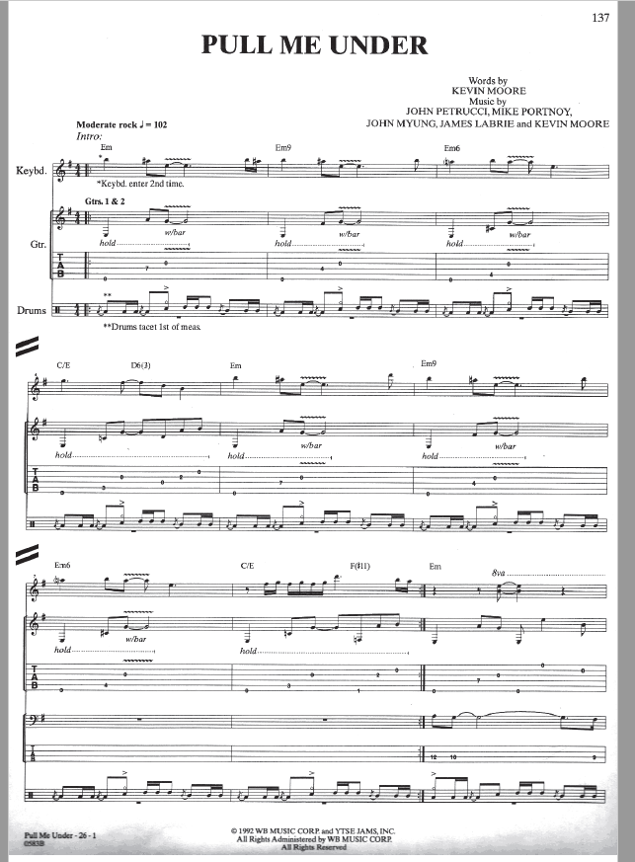

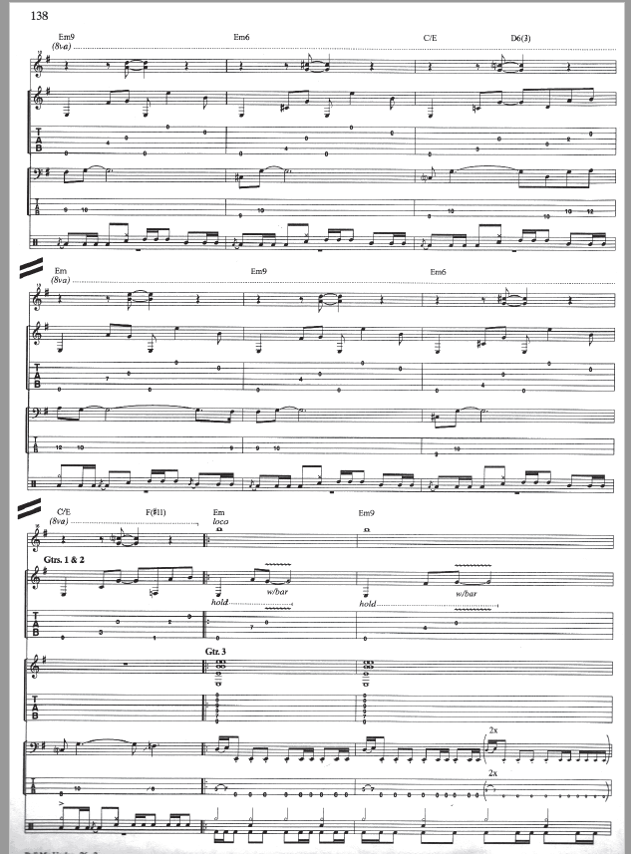
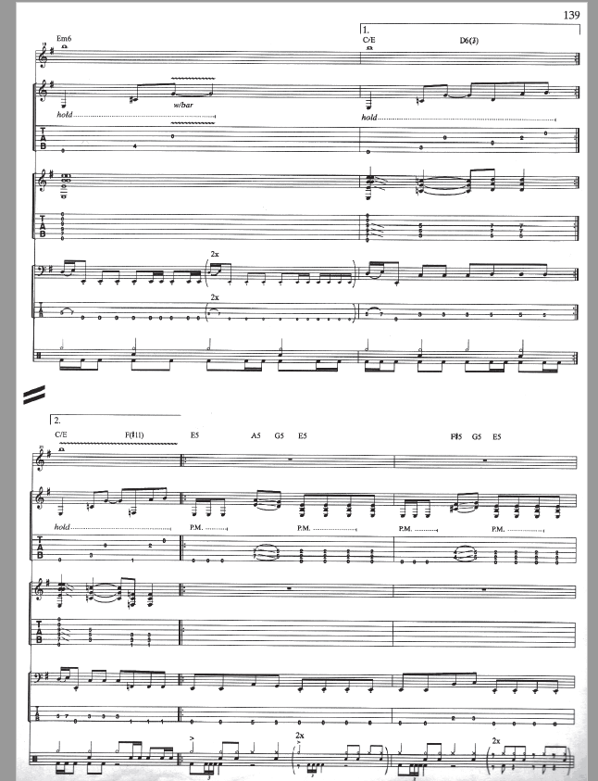
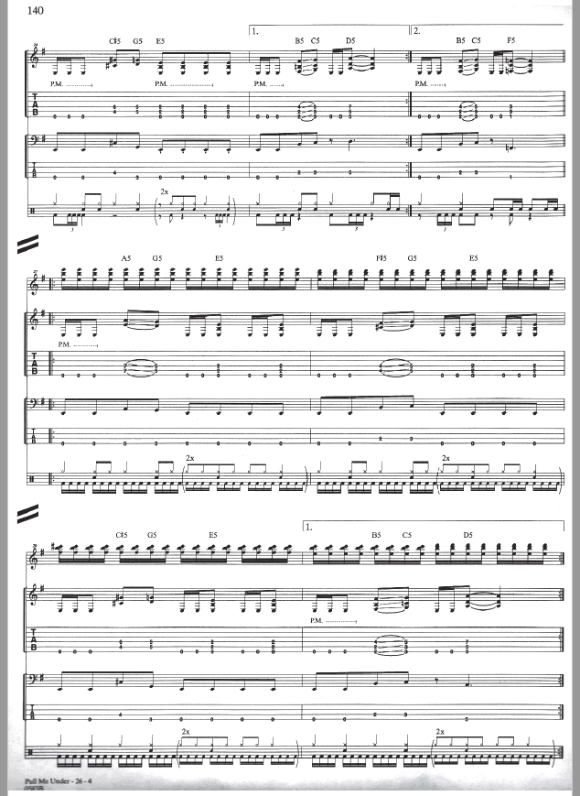
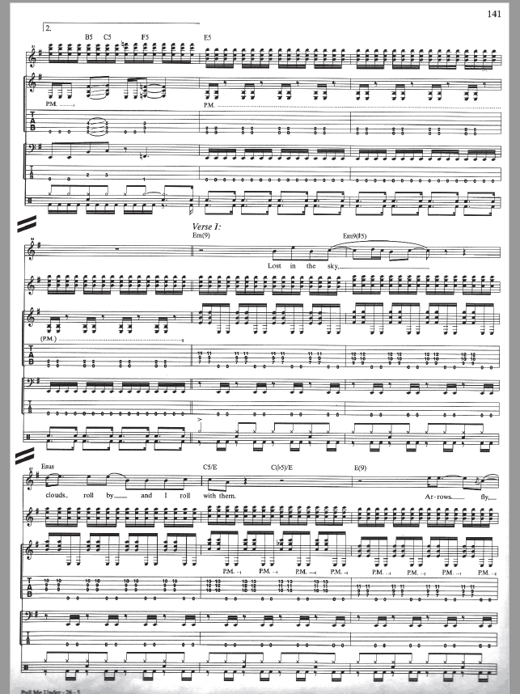
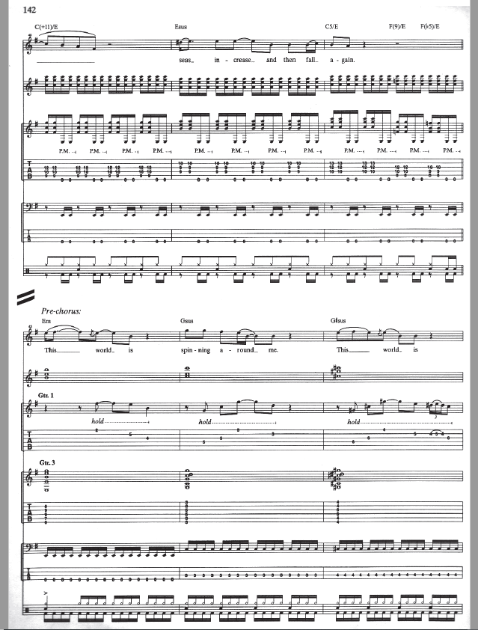
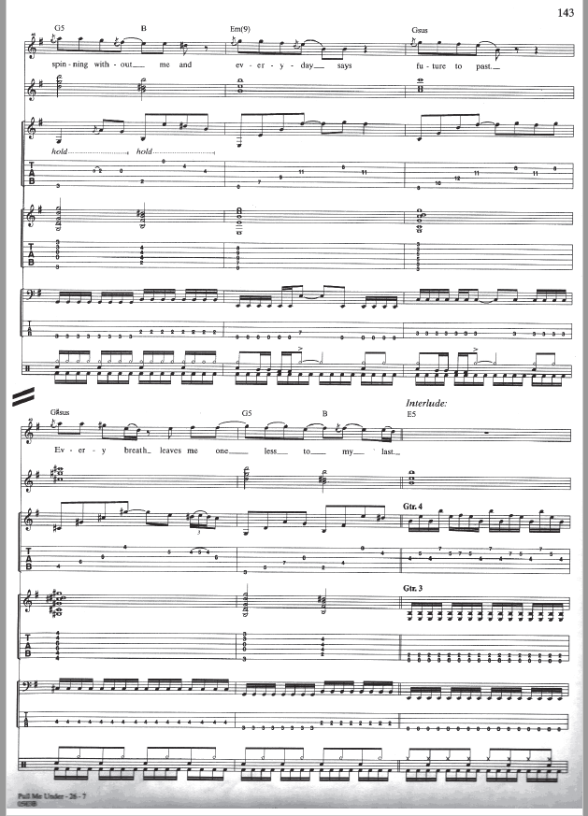
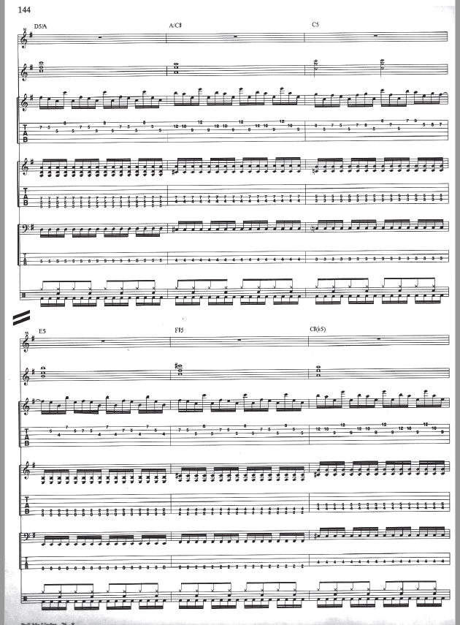

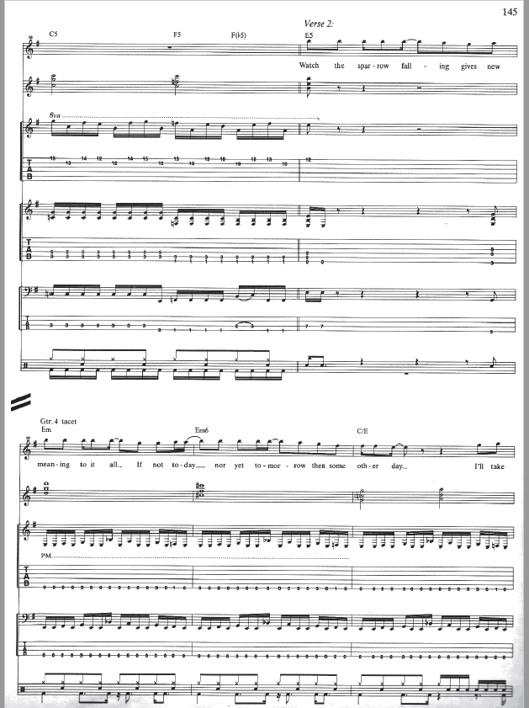

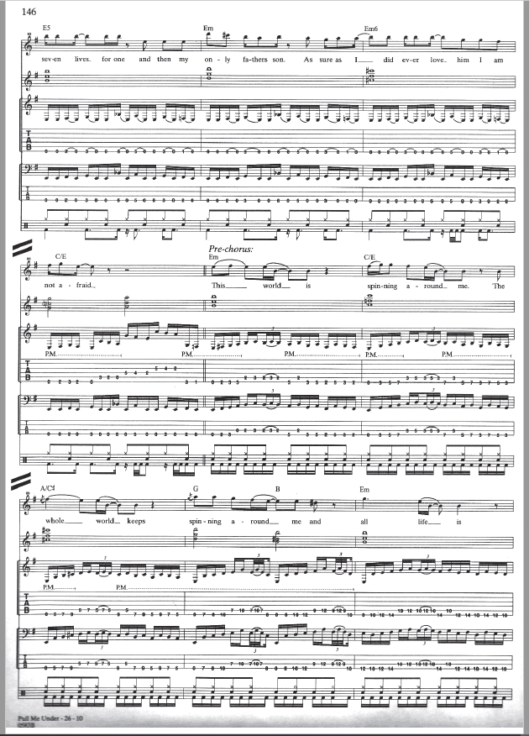

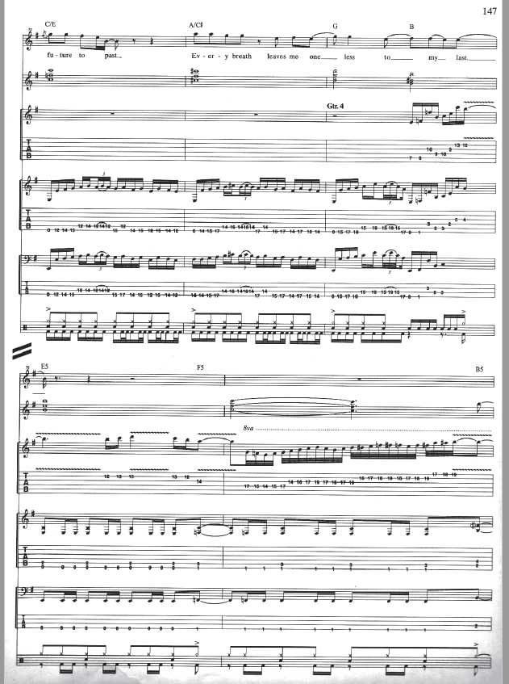

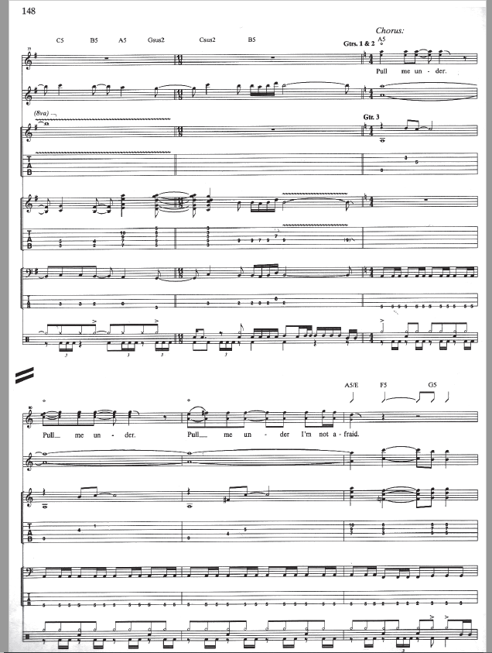

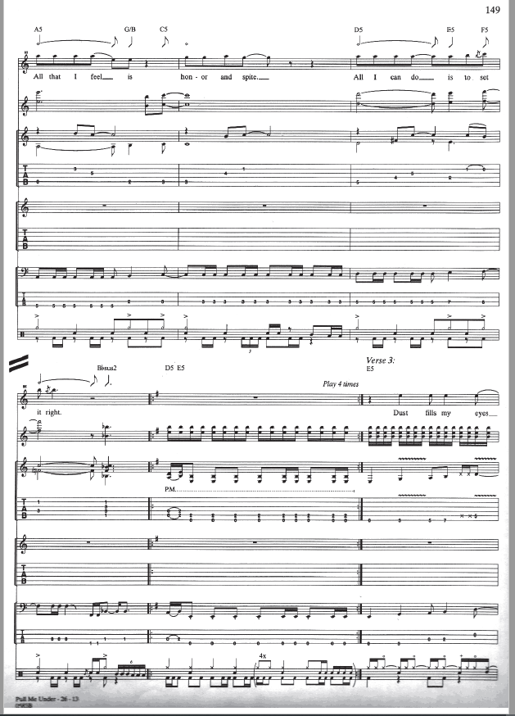

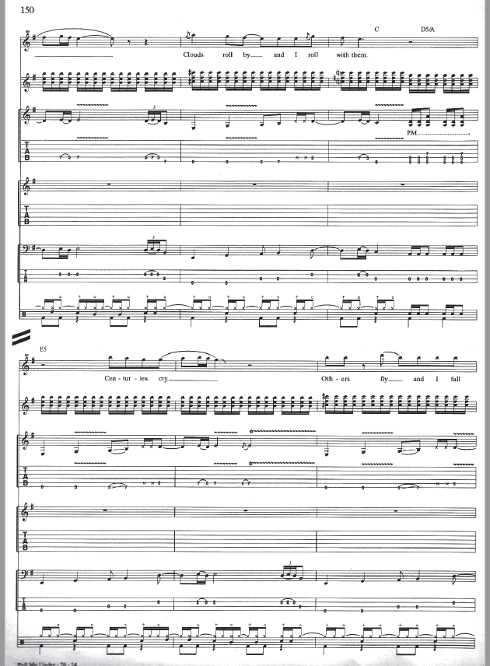

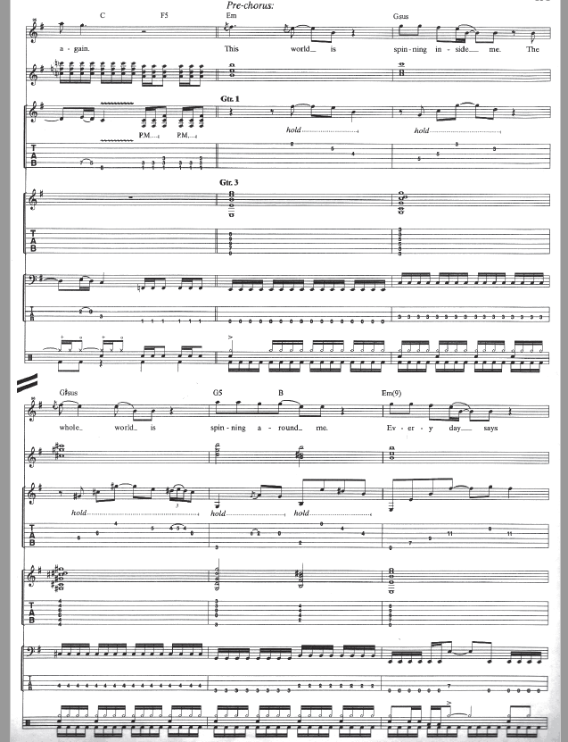

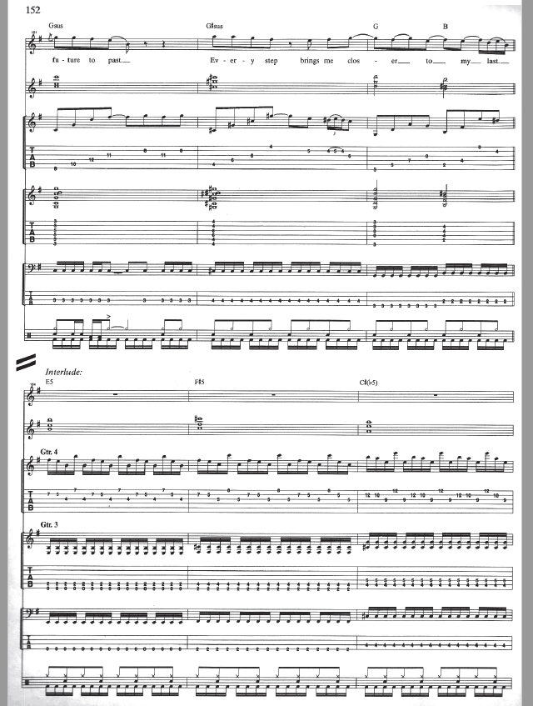

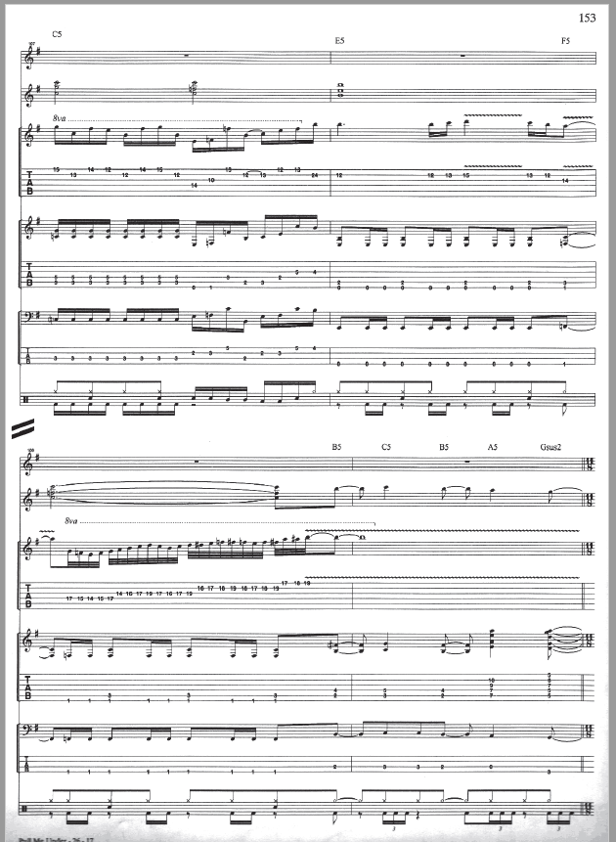

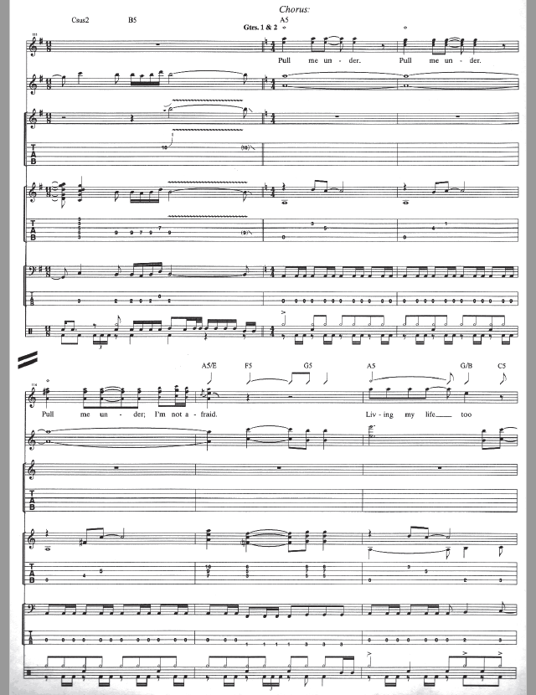

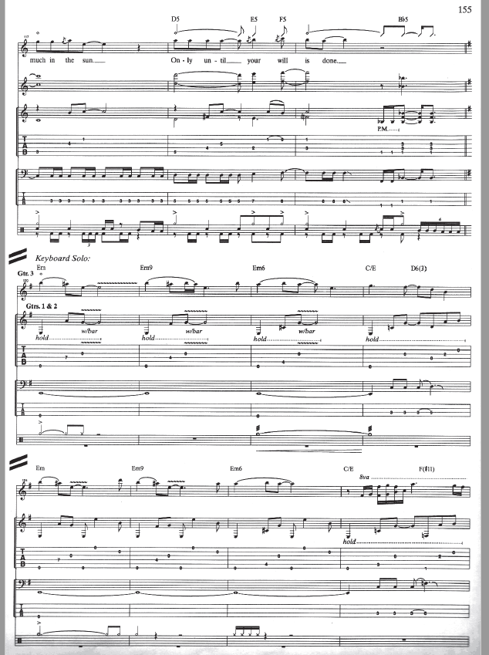

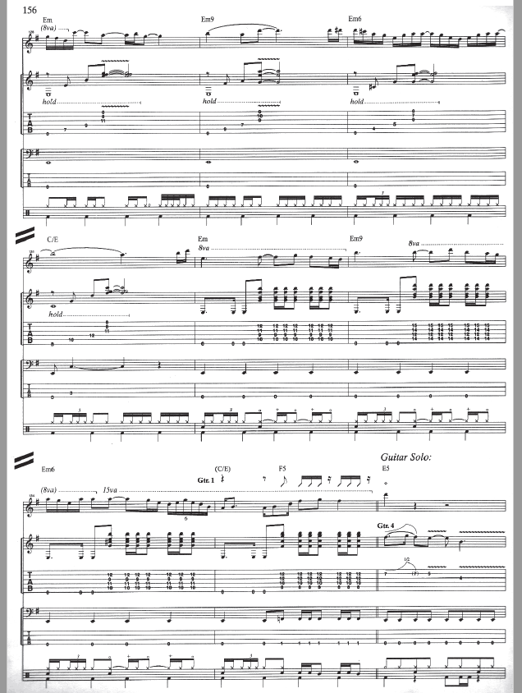

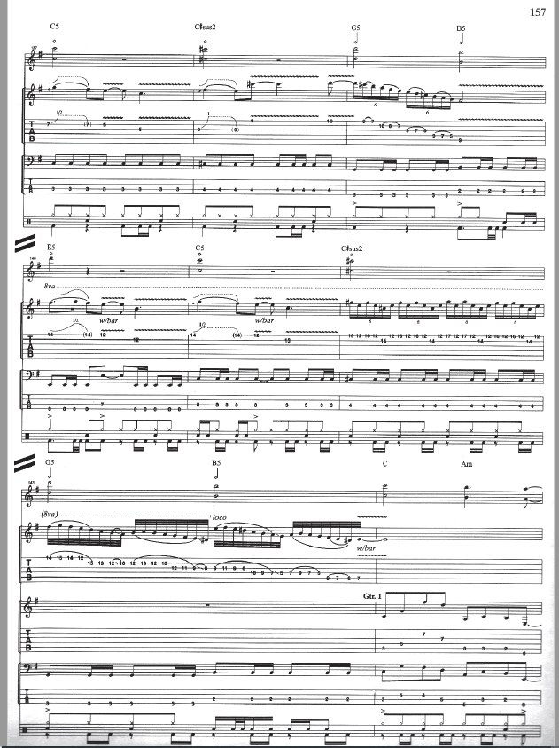

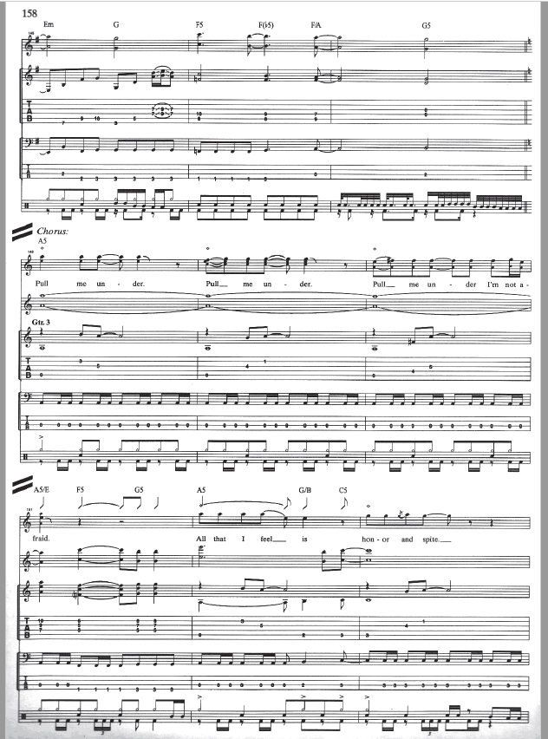

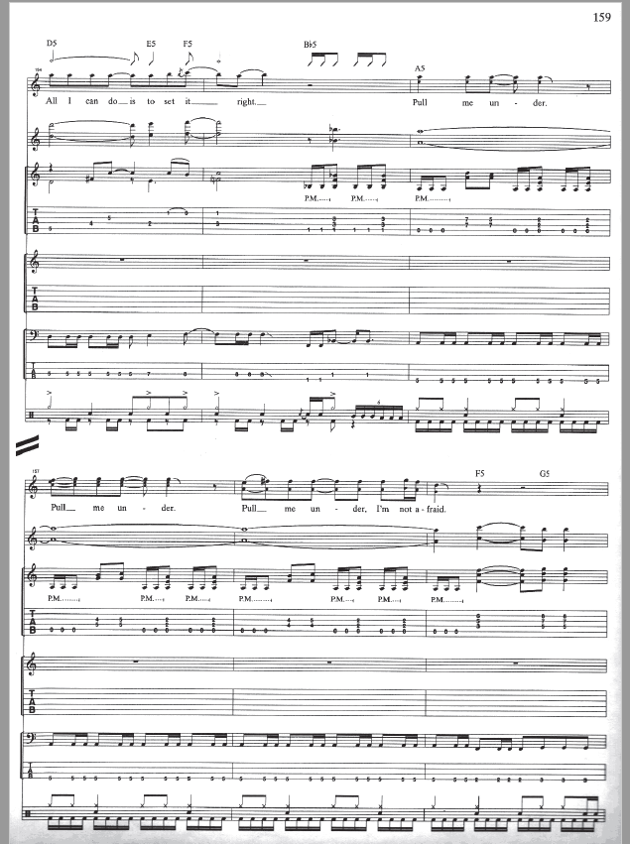

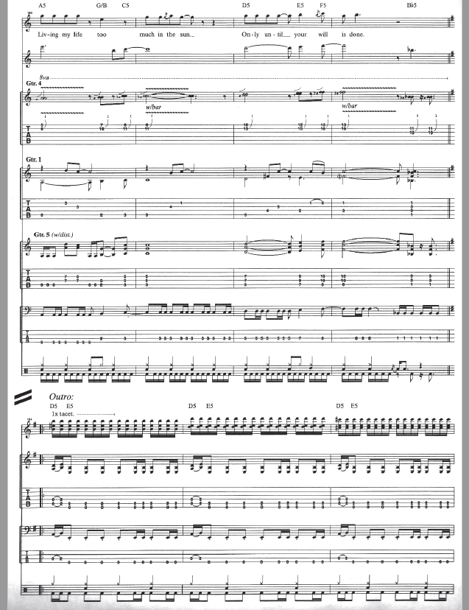

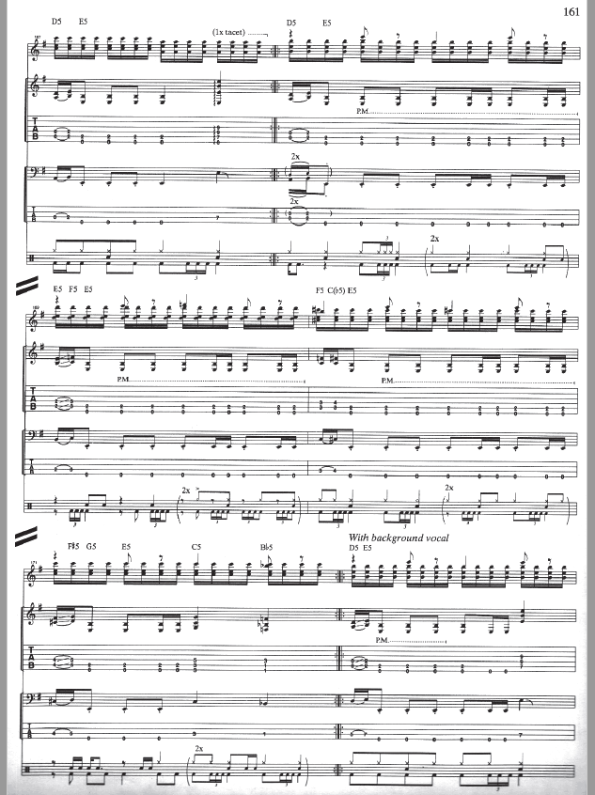

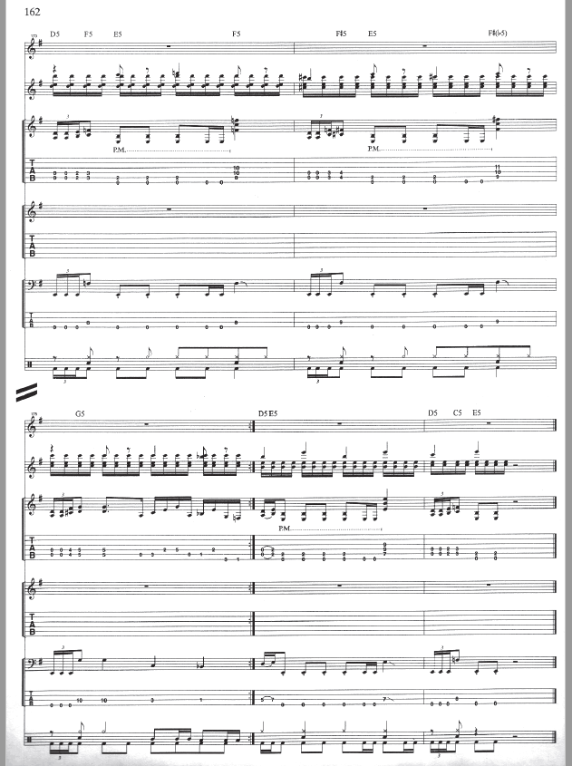

‘Take Away My Pain’ Score

