People Beliefs about Self-control: Moving Beyond the Limited Resources Model

Ahmad A Assinnari

Thesis submitted in partial fulfilment for the degree of Doctor of Philosophy

Department of Neuroscience
The University of Sheffield

March 2020

In the name of Allah, The All-Merciful, The Ever-Merciful

Abstract

The limited resources theory became the prevailing theory in explaining the instances of self-control failure, where the momentary inability to control oneself was termed ego depletion. This thesis originally sought to investigate the neural correlates of ego depletion while manipulating participants’ beliefs about self-control within the mindset theory of willpower. For this purpose, ego depletion had to be replicated first using the consecutive tasks paradigm. Stroop task preceded by the food cues task, where hungry participants were required to spot the differences between two flipped pictures at the top and the bottom of the screen while avoiding looking at a highly tempting food picture situated in the middle. the critical aspects of both tasks were piloted by using eye-tracking and pictures piloting to ensure a high practice of self-control. Nevertheless, neither ego depletion, nor the effect of belief manipulation was replicated.

Next, the thesis investigated whether self-control can be approached away from the limited resources theory. To this end, a belief-based model was theorised based on the alternative explanation to ego depletion that was offered by Baumeister et al. (1998). Through exploratory factorial analysis, a model was created where self-control could be implicitly believed as either: energy, skill or knowledge. The model was validated in two replications using confirmatory factor analysis. Through three studies (two studies in chapter 4, and the first study of chapter 5), the model was found significantly correlating with other reported measures of self-control. Through chapter 5, the model predictability of the behavioural variables was found, if present, very weak.

The following conclusions were reached by the thesis: 1) ego depletion was found hard for replication, 2) the three-belief model of self-control was found significantly predicting other reported measures of self-control; namely, the Brief Self-control Scale, the Short Grit Scale, and the implicit beliefs scale of willpower, whereas the model was not able to meaningfully predict the behavioural outcome of the used self-control tasks; namely the food-cues task, Stroop task, and the e-crossing task. 3) Within the three-belief model, beliefs were not equal in their affinity to predict the other self-control measures as the energy belief was found superior to the other beliefs. The implications of these findings and the future directions were discussed in the final chapter.

To Abdurrahman and Ameena
My lovely parents and the most supportive persons I will ever know
&
To Salwa and Amalia
My lovely family who never stopped believing in me

Acknowledgement
This thesis would have never seen the light without the invaluable guidance and the unlimited support and care that I have been overwhelmed with by my supervisors Dr. Tom Farrow, Prof. Thomas Webb, and Dr. Yael Benn. The ups and downs in the project that we have been through and the gold-worth pieces of advice I received equipped me with valuable lessons that I will keep recalling until the end of my life. From the depth of my heart, thank you so much.

It would have been impossible for me to master the myriad research methodologies adopted in this thesis without the help of many amazing people. I would like to thank Emma Morgan, Tom Benn and Mutaz Abulaila for guiding me to run the eye-tracking study effectively. Special thanks are to Dr. Jonathan Peirce from the University of Nottingham for his great help in Python programming. I am grateful to Prof. Iain Wilkinson and his colleagues in the Department of Academic Radiology for their supporting comments and help in preparing the intended fMRI part of the project. The colleagues at the Department of Finance at the Royal Hallamshire Hospital were generous enough to help in running the behavioural studies. Special thanks are to the IT team in the medical school, Andrew Kirby, and Prof. Annalena Venneri for their great help in sorting out the technical and logistic aspects of running the computerised studies. Many thanks are also to Patrician Stefancin and James Myers for helping in data collection while running their projects. For agreeing to be examiners for the confirmation review, I would like to thank Dr. Tom Stafford and Dr. Chantelle Woods.

I am personally grateful for my lab colleagues: Manmohi Dake, Riccardo Manca, Manuel Varela, Stefania Pezzoli, and Matteo De Marco who always stood beside me and helped to heal my broken soul every time the project prey on me. Wholeheartedly thanks are to my lifetime friends Abdulaziz Aloufi, Fahad Almutairi, and Riyad Alghamdi for their continuous support, discussion, and for being my closest friends. A final acknowledgment is for my mentor and guide Dr. Nuri Eldursi who never stopped believing in me and kept pushing me to sail through the sea of science.

Table of contents

Abstract I
Acknowledgement IV
Table of contents V
List of figures XIII
List of tables XIV
List of abbreviations XVI
Author’s Declaration XVII
List of Publications XVIII
A trajectorial description of the thesis XIX
CHAPTER 1 Introduction and Literature Review 1
Chapter Abstract 2
1.1. General Preface 3
1.1.1. The concepts of self-control and ego depletion 3
1.1.2. Moderators of ego depletion 7
1.1.3. Alternative explanatory models to ego depletion 8
1.1.4. Dweck’s mindset theory 11
1.2. Literature review of using neuroimaging in studying ego depletion 13
1.2.1. EEG/ERP studies 13
1.2.2. Using fMRI to study ego depletion 14
CHAPTER 2 Aims, Hypothesis and Challenges 18
Chapter Abstract 19
2.1. Aim 20
2.2. Hypothesis 20
2.3. Delimitations 20
2.4. Challenges of the project 21
2.4.1. The nature of fMRI studies 21
2.4.2. The replication crisis of ego depletion 22
2.4.3. Lack of reliable cognitive neuroscience studies of mindset theory 23
CHAPTER 3 Building and testing the behavioural paradigm to manifest ego depletion 28
Chapter Abstract 29
3.1. The general design of the study 30
3.1.1. The first self-control task 30
3.1.2. The second self-control task 32
3.1.3. Mindset manipulation 32
3.2. Pilot study 1: Picture piloting 34
3.2.1. Aim 34
3.2.2. Methods 34
3.2.3. Results 35
3.3. Pilot study 2: Eye-tracking 37
3.3.1. Aim 37
3.3.2. Methods 37
3.3.2.1. Participants 37
3.3.2.2. Procedures 37
3.3.2.3. Data acquisition and analysis 38
3.3.3. Results 39
3.3.4. Summary 40
3.4. The Behavioural Study 41
3.4.1. Introduction 41
3.4.2. Methods 43
3.4.2.1. Participants 43
3.4.2.2. Procedures 45
3.4.2.3. Dependent variables 49
3.4.3. Results 51
3.4.3.1. Demographics and Perception of Difficulty 51
3.4.3.2. Mindset Manipulation 51
3.4.3.3. Food cues task: accuracy, self-control, and Manipulation Check 51
3.4.3.4. Ego depletion and Stroop performance 52
3.4.4. Summary 54
3.5. Chapter discussion 56
CHAPTER 4 The three-belief model of self-control 60
Chapter Abstract 61
4.1. Introduction 62
4.2 Study 1 65
4.2.1. Methods 65
4.2.1.1. Participants 65
4.2.1.2. Development of the scale 66
4.2.1.3. Procedures 67
4.2.1.3. Analysis Plan 67
4.2.1.3.1. Factor analysis and its main features 68
4.2.1.3.2. The Factor analysis plan of the study 75
4.2.2. Results 77
4.2.2.1. Factor Extraction and Scale Purification 77
4.2.2.1. Correlational studies 81
4.2.3. Summary 82
4.3. Study 2 84
4.3.1. Methodology 85
4.3.1.1. Participants 85
4.3.1.2. Procedures 85
4.3.1.3. Dependent variables 87
4.3.1.4. Analysis Plan 87
4.3.2. Results 89
4.3.2.1. The dependent and controlling variables 89
4.3.2.2. Confirmatory factor analysis 90
4.3.2.3. Correlational Studies 92
4.3.2.3.1. Assumptions of linear regression 92
4.3.2.3.2. Brief self-control and Grit scores 92
4.3.2.3.3. Accuracy and submission time of FCT 93
4.3.3. Summary 94
4.4. Chapter discussion 95

CHAPTER 5 The behavioural implications of the three-belief model 97
Chapter Abstract 98
5.1. Introduction 99
5.2. Study 1 101
5.2.1. Methods 101
5.2.1.1. Participants 101
5.2.1.2. Procedures 102
5.2.1.2.1. E-crossing task 102
5.2.1.2.2. Stroop task 104
5.2.1.3. The dependent variables 105
5.2.1.3.1. The E-crossing task 105
5.2.1.3.2. The Stroop task 106
5.2.1.4. Analysis Plan 107
5.2.2. Results 109
5.2.2.1. Dependent variables of e-crossing and Stroop tasks 109
5.2.2.2. Demographic data and the implicit beliefs scale about willpower 109
5.2.2.3. Factor analysis & scales scores 110
5.2.2.4. Regression and correlational studies 112
5.2.2.4.1. Basic statistical assumptions 112
5.2.2.4.2. Inter-scale regression (TBM X Implicit) 112
5.2.2.4.3. Correlating both tasks variables 113
5.2.2.4.4. Predicting behavioural performance 114
5.2.2.5. Scoring the three-belief scale 115
5.2.3. Summary 116
5.3. Study 2 118
5.3.1. Methods 118
5.3.1.1. Participants 118
5.3.1.2. Procedures 119
5.3.1.3. The dependent variables 120
5.3.1.4. Analysis Plan 120
5.3.2. Results 121
5.3.3. Summary 122
5.4. Study 3 123
5.4.1. Methods 123
5.4.1.1. Participants 123
5.4.1.2. Procedures 124
5.4.1.2. Analysis Plan 127
5.4.2. Results 128
5.4.2.1. Contextual questions 128
5.4.2.2. Demographic data 129
5.4.2.3. Normality of the dependent variables 129
5.4.2.4. Manipulation check 129
5.4.2.5. Intergroup difference in behavioural practice 130
5.4.2.6. Correlational studies 130
5.4.2. Summary 131
5.5. Chapter Discussion 132

CHAPTER 6 Grneral Discussion 135
6.1. Thesis Summary 136
6.2. Why ego depletion becomes difficult for replication? 137
6.3. What are the implications of the TBM correlational findings? 139
6.4. Future directions 141
6.5. Limitations 143
6.6. Personal Reflections 145

References 146

Appendices of chapter 3 163
Appendix III.I. Mean scores of food pictures obtained in pilot study 1 164
Appendix III.II. The comparison pictures mean submission time in study 1 166
Appendix III.III. The protocol and the accuracy sheets of the eye tracking study 172
Appendix III.IV. The Mean fixations number and duration in the eye-tracking study 176
Appendix III.V. The Final sets of the pictures used in the behavioural study 177
III.V.I. Snacks Pictures 177
III.V.II. Meals pictures 185
III.V.III. Comparison pictures 193
III.V.IV. Control pictures 223
Appendix III.VI. Python code of the behavioural study 239
Appendix III.VII. Participants’ sheet and the protocol of the behavioural study 246
Appendix III.VIII. The biased questionnaire of Job et al. (2010) 248
Appendices of chapter 4 249
Appendix IV.I. The demographic data of study 1 250
Appendix IV.II. The original 30 questions of the TBM used in study 1 251
Appendix IV.III. The descriptions of skill, knowledge, and energy in Baumeister et al. (1998) 254
Appendix IV.IV. Brief self-control and Short Grit Scales 255
Appendix IV.V. The tabular results of the factor analysis (EFA/ML) in study 1 258
Appendix IV.VI. The tabular results of the factor analysis (CFA/PCA) in study 2 263
Appendices of chapter 5 268
Appendix V.I. The JavaScript code of the Stroop task on Qualtrics ® 269
Appendix V.II. Tabular results of study 1 273
Appendix V.III. Tabular results of the factor analysis in study 1 275
Appendix V.IV. Nonlinear curve estimation in study 1 277
Appendix V.V. The JavaScript code in studies 2 and 3 278
Appendix V.VI. Tabular results of study 3 279
Appendices of ethical approvals 281
Appendix VI.I. The ethical approval of the piloting study of the food-cues task 282
Appendix VI.II. The ethical approval of the eye-tracking study 283
Appendix VI.III. The ethical approval of the factor analysis studies 284
Appendix VI.IV. The ethical approval of the belief-manipulation studies 285

List of figures

Figure 1. Flow chart of the original and the modified plan of the thesis chapters XIX

Chapter 1
Figure ‎1.1. The process model of Inzlicht et al. (2014) 10

Chapter 3
Figure ‎3.1. Composition with Yellow, Blue and Red (1937–42) for Piet Mondrian (1872-1944) 31
Figure ‎3.2. The between-group difference in Stroop response time 53

Chapter 4
Figure ‎4.1. A flow chart of the analysis plan of the second study 88

Chapter 5
Figure ‎5.1. An example used to explain the second round of the e-crossing task 104
Figure ‎5.2. The flow chart of the analysis plan of the first study 108
Figure ‎5.3. The regression model of the score of energy belief and the implicit belief scores 113
Figure ‎5.4. The analysis plan of study 2 121
Figure ‎5.5. The mocked up Science paper of the energy model 125
Figure ‎5.6 & Figure ‎5.7. The mocked up Science paper of the skill and knowledge models 126
Figure ‎5.8. The analysis plan of study 3 128

List of tables

Chapter 1
Table ‎1.1. The main trends of research in ego depletion and self-control 5

Chapter 2
Table ‎2.1. A summary of ERP studies of the neural correlates of the growth and fixed mindsets 26
Table ‎2.2. A summary of fMRI studies of the neural correlates of the growth and fixed mindsets. 27

Chapter 3
Table ‎3.1. The inclusion criteria of the behavioural study 44
Table ‎3.2. The flow of the slides and the exact wording used in the study 47
Table ‎3.3. Cohen’s d values of the intergroup differences in the reported self-control 52
Table ‎3.4. A summary of the results against the hypotheses 55

Chapter 4
Table ‎4.1. Adapted from Wieland et al. (2017) to summarise the purification criteria. 73
Table ‎4.2. The justification of purification before performing factor analysis 77
Table ‎4.3. The detailed justification of the purification steps after performing factor analysis 78
Table ‎4.4. The pattern matrix of the final extracted factors 80
Table ‎4.5. The correlation between the extracted factors 81
Table ‎4.6. The pattern matrix of the rotated factors 91
Table ‎4.7. The model details of the linear regression between the extracted factors as the predictors and the scores of the brief self-control and the Short Grit Scales 93

Chapter 5
Table ‎5.1. Shows the pattern matrix that was extracted by PCA 111
Table ‎5.2. Comparison of the implicit belief scores between the energy and the other groups 115
Table ‎5.3. Shows a trend of data towards confirming the manipulation 122
Table ‎5.4. The multiple-choice contextual questions 127
Table ‎5.5. Shows a trend of data towards confirming the manipulation 131

List of abbreviations
AA absolute accuracy (chapter 3)
AA adjusted accuracy (chapter 5)
ACC anterior cingulate cortex
amPFC antero-median prefrontal cortex
BSS Brief Self-control Scale
C control group
CFA confirmatory factor analysis
cm centimetre
ED ego depletion group
EEG electroencephalogram
EFA exploratory factor analysis
ERN error-related negativity
ERP event-related potential
FA factor analysis
FCT food cues task
fMRI functional magnetic resonance imaging
H_{o} null hypothesis
hM harmonic mean
Hz hertz
IB implicit beliefs of willpower scale
IFG inferior frontal gyrus
lPFC lateral prefrontal cortex
LWPC list-wide proportion congruence
M mean
M+ growth mindset group
M- fixed mindset group
Mdn median
min minute
ML maximum likelihood
ms millisecond
N negative
OFC orbito-frontal cortex
ORPS online research participation system
P positive
PAF principal axis factoring
PCA principal component analysis
RA relative accuracy
SD standard deviation
SGS Short Grit Scale
TBM three-belief model
vmPFC ventro-medial prefrontal cortex

Author’s Declaration
I declare that the work of this thesis was carried out independently by the author, including the data collection and analysis under the supervision of Dr. Tom Farrow, Prof. Thomas Webb, and Dr. Yael Benn, at the University of Sheffield.

The work of this thesis was not yet submitted to the University of Sheffield or any other university for examination, except parts from the first three chapters which were adapted from the confirmation review report that was submitted at the end of the first year of PhD.

Part of the data collection of the third experiment in chapter 3 was carried out by James Myers, who was supervised by the author. However, the final analysis which was reported in the thesis was conducted by the author independently.

The second and the third studies in chapter 3 were tested and piloted, under the author’s supervision, on small-sized studies conducted by Patricia Stefancin as part of her Master’s project in Cognitive Neuroscience and Human Neuroimaging at the University of Sheffield. An fMRI mini-replication of the intended project of this thesis was conducted as part of Patricia’s Master’s project.

Despite receiving help from a few colleagues, the core programming code of Python and JavaScript, which can be found in the appendices, were coded by the author independently.

List of Publications
Upon investigating possible reasons for the failed replication of ego depletion in chapter three, a meta-regression was done to study the effect size of ego depletion studies that were published in three meta-analyses (Carter, Kofler, Forster, & McCullough, 2015; Dang, 2018; Hagger, Wood, Stiff, & Chatzisarantis, 2010). A negative correlation was observed between the effect size and the publication date of these studies suggests a trend toward having smaller effect size in ego depletion with the pass of time. This result was achieved using the exact same methodology by another independent researcher in Spain and was published before the submission of this thesis under the title: “Ego depletion may disappear in 2020” (Vadillo, 2019).

A trajectorial description of the thesis
The originally proposed PhD project aimed to investigate the neural correlates of ego depletion using functional magnetic resonance imaging (fMRI). Accordingly, the first three chapters were written to discuss the literature review, the hypothesis, and the practical details of the first three experiments. After two years of research, the obtained results were not in favour of continuing with the original objective of the project. Manifesting ego depletion behaviourally was a prerequisite before starting to collect any fMRI data that requires a large amount of money (circa £500 per participant). Despite testing for each aspect of the study, chapter 3 concluded that ego depletion was not successfully replicated using our design. To avoid any more delay in the project, the trajectory of the original line of investigation was changed. Part of the original project was to study ego depletion while studying the effect of manipulating the implicit beliefs about self-control ability. Yet, other beliefs were not investigated before. The second half of the thesis investigated the effect of adopting different belief models on self-control practice. Figure 1 shows the flow chart of the original and the amended thesis chapters.
Chapter 5:
The Behavioural Implications of the Three-belief Model
Chapter 4:
The Three-belief Model of Self-control
The modified project
Chapter 1:
Introduction & Literature Review
Chapter 2:
Aims, Hypothesis & Challenges
Chapter 3:
Building and Testing the Behavioural Paradigm to Manifest Ego Depletion
Chapter 4:
fMRI Data Acquisition and Analysis
Chapter 5:
General Discussion
The originally proposed project
Figure 1. Flow chart of the original and the modified plan of the thesis chapters

Introduction and

Literature Review

CHAPTER 1

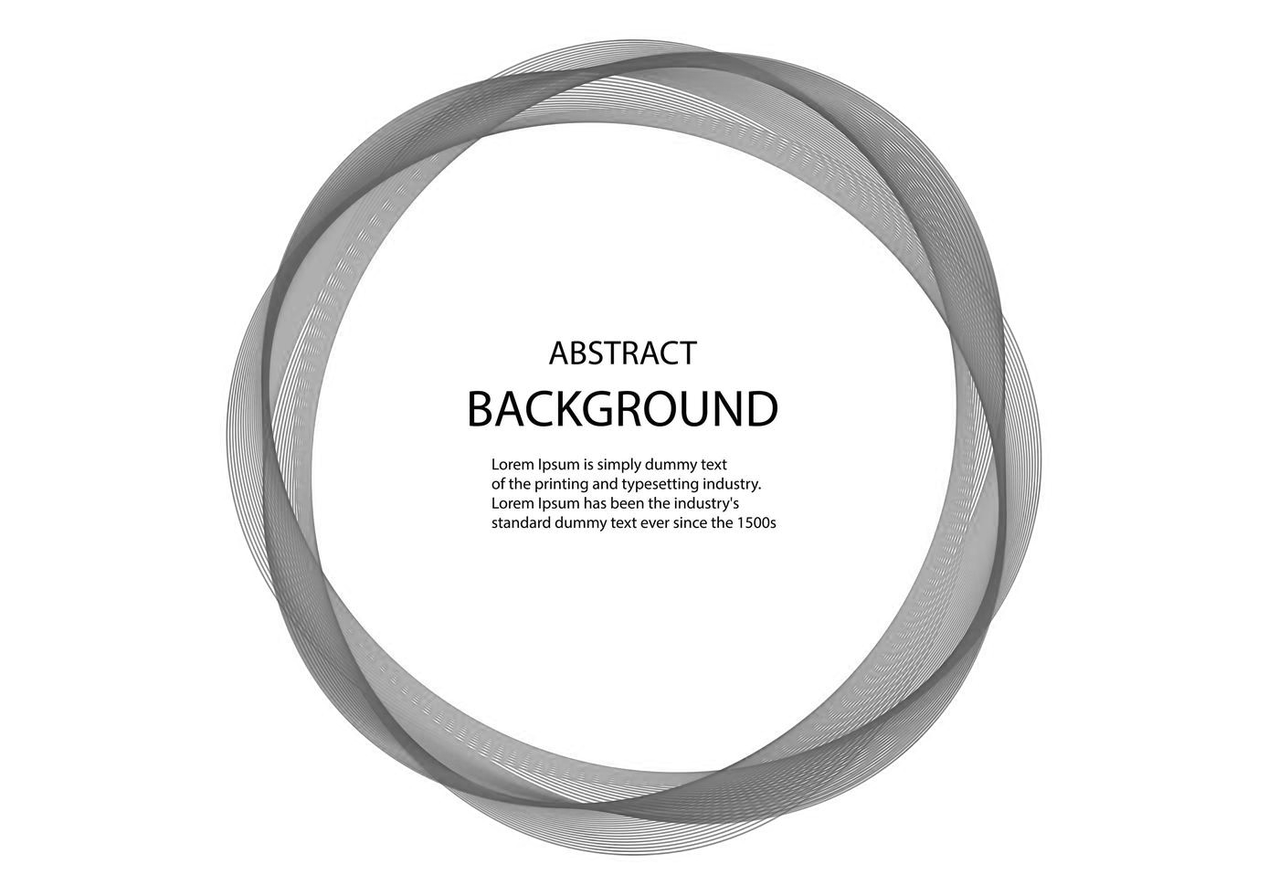

Chapter Abstract

Studying self-control in Psychology is influenced
in a great deal by the limited resources theory. This chapter
sought to discuss the literature that studied this theory and
define its main research trends. Further, as this thesis was
aiming to investigate the neural correlates of ego depletion,
the related neuroimaging literature will be overviewed
and criticised after being sorted into two categories:
EEG/ERP and fMRI studies.

1.1. General Preface

1.1.1. The concepts of self-control and ego depletion
Self-control has been shown repeatedly to be pivotal for our well-being, success, and productivity (Baumeister, Heatherton, & Tice, 1994). It is defined as the ability to override our predominant response tendencies (Schmeichel & Baumeister, 2010, p. 30). To positively reinforce people’s lifestyles, the study of self-control has attracted scientific interest since the early days of modern psychology. One of the earliest studies of self-control was Mischel’s marshmallow experiment, where each of the recruited children was left alone with a plate filled with marshmallows (Mischel, 1974). Then they were told that, if they did not eat any of the presented marshmallows, they would be rewarded a larger amount. Based on their reactions, those who managed to control themselves in the face of the challenge were assumed to have higher self-control than the others. After prospectively monitoring both groups of children, it was found that those with higher self-control showed a greater tendency toward achieving success in their lives. Consequently, Mischel defined self-control conceptually in terms of “delaying gratification”, but without accounting for any mechanical description.

It was Carver & Scheier (1982) who formulated one of the first models of self-control using the analogy of a cybernetic feedback loop in systems theory (Baumeister et al., 1994, pp. 8–9). The model employed a contrast measurement system that compares the current state and an imaginary self-standard. The outcome of this system informs the decision regarding the required behaviour to approach the desired state and the standard self-image. However, the model was largely theoretical and did not describe the internal mechanisms that propel the system.

In contrast, Baumeister and his colleagues formulated a rather simple and elegant model that is more biologically-and psychologically-grounded. In their famous radish experiment, Muraven, Tice, and Baumeister (1998) required two groups of hungry participants to eat either radishes or cake in a room filled with baking aroma. Later, all participants performed a time-dependent task where they were asked to declare when to stop trying to solve an unsolvable anagram. It was found that those who ate radishes withdrew earlier, in solving the anagram than those who ate cake. Baumeister and colleagues concluded that because forcing oneself to eat radishes and continuing to try to solve the anagram both require self-control, our ability to control ourselves draws from a limited set of resources. The term “ego depletion” was coined to indicate the refractory state where our resources are diminished to optimally control ourselves. The so-called “strength model” connotes the limited mental resources for self-control, using the analogy of a muscle fatigued by continuous work but strengthened by repeated training, which is similar to our self-control ability (Baumeister, Vohs, & Tice, 2007; Muraven & Baumeister, 2000; Muraven, Baumeister, & Tice, 1999). The simplicity of the model inspired almost two decades of applied research on self-control, where many educational and health applications have been developed based on the strength model (see Table 1.1). Concurrently, the experimental design of using two consecutive tasks that both require self-control became an established way of investigating ego depletion; which is known as the “dual-task paradigm” (Martin, Wood, Stiff, & Chatzisarantis, 2010)
Table ‎1.1. The main trends of research in ego depletion and self-control, analysed by tracking citation numbers in Web of Science and research trends on SciVal.com.
Table key: SC = self-control, EF = executive functions, ED = ego depletion, SD = sleep disturbance, GM = Growth mindset, DM = decision making.
 | The Trend | Key Studies | Key Conclusions
1 | Understanding the basic interactions of ego depletion with other psychological systems, such as  - Executive functions and attentional control  It also includes  - Meta-analyses  - Failed replications  - fMRI studies  - Challenging models that try to offer different explanations | Schmeichel, 2007; Schmeichel & Baumeister, 2010  Hagger et al., 2010  Murtagh & Todd, 2004  Wagner, Altman, Boswell, Kelley, & Heatherton, 2013  Inzlicht et al., 2014 | SC and EF draw from a limited resource  Moderate to a high effect size of ED  Failed to replicate ED  Reduced functional coupling in ED  Motivation explains limited resources
2 | The effect of ego depletion on the daily school performance was studied from many perspectives, notably  - Students’ performance  - Promoting teaching methodology | Price & Yates, 2010  Vanco & Christensen, 2016 | In the ED, students choose easy math tasks  Higher enjoyment & scores in ED
3 | The highest number of application studies falls into the modification of behaviour, where our abilities to resist impulsive behaviours and failed attempts to manage bad habits were attributed to the limited resources model. The effect was studied on  - Smoking  - Alcohol dependence  - Violence  - Eating behaviour  - Sex  - Sleep disturbances | Muraven, 2010  Muraven, Collins, & Nienhaus, 2002  Finkel, DeWall, Slotter, Oaten, & Foshee, 2009  Friese, Engeler, & Florack, 2015  Gailliot & Baumeister, 2007  Lanaj, Johnson, & Barnes, 2014 | Practicing SC helps to quit smoking  ED facilitate alcohol ingestion  ED reduces control over violent impulses  Overeating is facilitated by ED  ED reduces control over sexual behaviour  SD mediates ED effects on next day job
4 | Application in health promotion, such as  - Explaining patients’ noncompliance with the treatment regimen of chronic conditions such as diabetes  - Designing better health interventional programs | Bernecker & Job, 2015  Friese, Hofmann, & Wiers, 2011 | Higher compliance in GM about SC  Using a combination of SC interventions
5 | Studying the effect of ego depletion on immoral behaviour where overriding immoral impulses require the application of self-control | Gino, Schweitzer, Mead, & Ariely, 2011 | ED promotes impulsive cheating
6 | Promoting management administration by considering how self-control limitation might affect our  - Decision making  - Leadership behaviour | Danziger, Levav, & Avnaim-Pesso, 2011  Joosten, van Dijke, Van Hiel, & De Cremer, 2014 | ED explains variability in judicial rulings  ED promotes unethical leader behavior
7 | A trend, notably in Germany, studying the interactions between limited resources and sports performance | Englert, 2016 | ED explains outstanding sport performance
8 | Studying the economic consequences of ego depletion such as  - Effect on economic decisions  - Control over impulsive buying | Ainsworth, Baumeister, Ariely, & Vohs, 2014  Baumeister, 2002 | ED decreases trust in economic DM  ED could cause impulsive purchasing

1.1.2. Moderators of ego depletion
One could conclude that the critical outcome of the strength model is to avoid the state of ego depletion to successfully control ourselves by resting and repeated training of self-control ability; akin to a muscle. This is true, however, it was found that many other factors play a crucial role in overcoming ego depletion. For example, motivation (Muraven & Slessareva, 2003), positive affects (Tice, Baumeister, Shmueli, & Muraven, 2007), and watching natural scenes (Chow & Lau, 2014), were found effective to replenish the reduced capacity to apply self-control. Similarly, adopting a sequential strategy of behaviour execution in the form of “if-then” rules, termed “implementation intention”, was found powerful to defy ego depletion (Webb & Sheeran, 2003). Furthermore, Gailliot et al. (2007) compared the effect of a glucose drink to that of an artificially sweetened control on the state of depletion. They found that while glucose reduced depletion, the sweetener did not. However, there have been several failed replications of the glucose drink study (Dang, 2016; Lange & Eggert, 2013).

Another moderator of ego depletion was proposed by Martijn, Tenbült, Merckelbach, Dreezens, and de Vries (2002) as they examined whether manipulating participants’ expectations about the consequences of self-control would eliminate the depletion state. Using the dual-task paradigm, they required one of the two depletion groups to read the following statement before practicing the second task: “it was scientifically proven that exerting prior effort facilitates a consequent action of self-control”. The results were consistent with their proposal, as the depletion group that read the message outperformed the other depletion group. Martijn not only concluded that the extent of ego depletion depends on the subjective expectancy of the task difficulty but also extended the argument to suggest that the subjective perception of motivation and learning orientation (mindset) could impact the outcome of the depletion, which was later confirmed (Martijn, Alberts, & de Vries, 2008, pp. 176–177) (see section 1.1.4. Dweck’s mindset theory). The accumulated evidence of self-control improvement with (subjective) motivation was visualised as a violation of the basic assumption of the limited resources theory of strength model (Inzlicht & Schmeichel, 2012). Whether the self-control ability is limited primarily, then it becomes adaptive after motivation, does not change the fact that limited self-control is not hardwired; rather, it is malleable, depending on the subjective perception of either the task difficulty and/or one’s own ability to do it.

1.1.3. Alternative explanatory models to ego depletion
Drawing from the effect of subjectivity on self-control ability, three notable models were postulated. First, Kurzban, Duckworth, Kable, and Myers (2013) proposed the outward limited resources of self-control results from the subjective effort of performing mental cost/benefit computations. They argued that executive functions can process a certain number of tasks simultaneously, which creates an opportunity cost upon processing many tasks at the same time. The computations of the cost and benefits of any given task are resource-demanding on their own. Taken together, the subjective effort to perform a certain task is perceived as the net outcome of both opportunity cost and cost/benefit computations, which affects the deployment of the computational mechanism and consequently reduces performance. Despite the generalisability of the model to explain how efforts interact with performance, the idea was designed to explain the outward limited capacity to apply self-control.

The cost/benefit model is quite similar to the economic proposal of the effect of scarcity perception on self-control. Mullainathan and Shafir (2013) argue that the idea of scarcity has a large natural preoccupation tendency on the mind, as it leaves executive control and cognitive capacity less able to efficiently conduct other cognitive functions, including self-control. In a series of studies, they showed how exposing participants to scarcity-connoting scenarios might negatively affect self-control using a modified Stroop task (Mullainathan & Shafir, 2013, pp. 52–56). They used the term “cognitive bandwidth” to describe the conjoined effect of scarcity on both executive control and cognitive capacity. Using the terms of Kurzban’s model, scarcity yields a feeling of higher subjective effort that reduces performance in the subsequent self-control task. Despite the plausibility of Kurzban’s model to account for the subjective feeling of efforts and energy depletion, it lacks a mechanistic design that would help future studies to explore the brain mechanisms. The proposed computations proved difficult to be accessed within a falsifiable theorem (Friese, Loschelder, Gieseler, Frankenbach, & Inzlicht, 2019), and consequently, objective measurements and clear hypotheses are difficult to be drawn.

A second model of self-control offered a more physiologically plausible model that can be quantified based on the amount of offered incentives. The “process model” of Inzlicht, Schmeichel, and Macrae (2014) proposed that apparent limitations in self-control are by-products of shifting attention and motivation from a target action toward leisure (Figure 1.1). They argue that self-control is a selection process where an individual must choose between the leisure-inducing and target-related behaviours. This process is fuelled by the motivation that is needed to make progress towards the target-related and away from leisure-inducing behaviour. Thus, instead of using the vague term “resources”, Inzlicht and Schmeichel propose that motivation is the resource. Currently, the literature refers to the process and strength models as competing models to explain self-control because of their mechanistic descriptions. However, there is a third model that contrasts all the previously mentioned models, as it emphasizes that self-control does not depend on a limited set of resources; rather, it relies on unlimited ones.

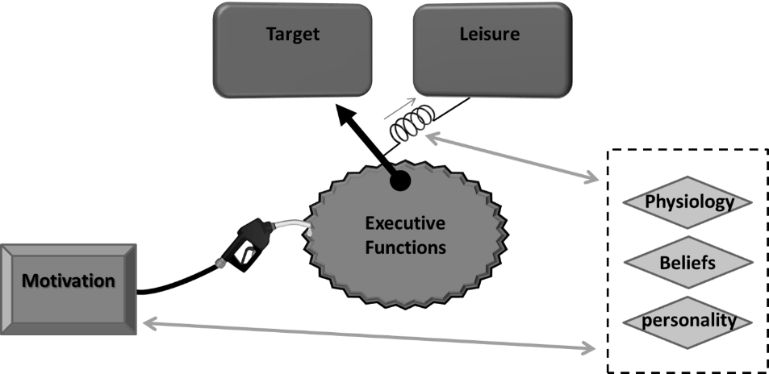
Figure ‎1.1. The process model of Inzlicht et al. (2014) shows self-control as a process of selection between target-related and leisure-related behaviour. It is fuelled by motivation through executive functions. In the figure, the choice mechanism is bound to leisure arbitrary by a spring that is physiologically and psychologically influenced to either support or hinder the selection process.

1.1.4. Dweck’s mindset theory
Notably, Martijn was the first to notice that applying the principles of Carol Dweck’s mindset theory could manipulate the outcome of ego depletion similarly to manipulating participant expectation of self-control in Martjin’s studies (Martijn et al., 2008, pp. 176–177). Dweck proposed that implicit beliefs about the malleability of one’s abilities play a pivotal role in how individuals react to new information (Dweck & Leggett, 1988; Dweck & Molden, 2005). For example, regardless of how smart people might be, upon believing that their intelligence is fixed and cannot be nourished by continuous life experiences, people tend to behave accordingly: self-centred, avoiding challenging situations, reacting sensitively towards criticism, and behaviourally aiming to show one’s own supremacy than seeking improvement. This mentality is termed “fixed” or “entity” mindset. In contrast, those who believe that their intelligence is malleable and expandable seek new challenges to improve their abilities. Consequently, they do not consider criticism a self-related issue, but rather a chance for improvement. This mentality is termed “growth” or “incremental” mindset.

Mindset theory was popularised after offering an explanation of countless instances of successful individuals who refused to capitulate to hardships and continued to overcome any obstacles they encountered in their lives (Dweck & Molden, 2005). Job, Dweck, Walton, and kfelicano (2010) applied the principles of the mindset theory to self-control ability using the dual-task paradigm. Their findings demonstrated that upon implicitly inducing the growth mindset about self-control ability in one of two ego depletion groups, the ego depletion state was overcome, and the induced group outperformed the other. Job et al. (2010) introduced the term “non-limited resources theory” of self-control to contrast the idea of the limited resources theory of the strength model.

The suggestion that prior implicit beliefs about self-control ability have a significant effect on the outcome of self-control was challenged by Vohs, Baumeister, and Schmeichel (2012). They showed that upon creation of an extra level of a demanding task after the second one within the two-task paradigm, even those who were induced into a growth mindset developed a state of depletion. Job, Walton, Bernecker, & Dweck (2013) responded by challenging the results of Gailliot et al. (2007), which illustrated that the instantaneous level of blood glucose can predict the depletion state after practicing self-control. They showed that this relationship depends on the prior implicit beliefs of self-control, being either malleable or fixed. Moreover, in a longitudinal study, students’ daily life was followed to assess their academic and self-regulation behaviour against their mindset orientations (Job, Walton, Bernecker, & Dweck, 2015). As hypothesized, the results were consistent with the non-limited resources theory.

In summary, each of the aforementioned models claims validity and supremacy over the others to explain the instances of self-control failure. There is neither resolution among them nor enough evidence, either physiologically or experimentally, to reject any of them. To help further understanding ego depletion, the neural signals of ego depletion were investigated using different neuroimaging modalities. However, because of many challenges and critical updates that must be considered, only a few number of studies utilised neuroimaging to investigate ego depletion.

1.2. Literature review of using neuroimaging in studying ego depletion
Few psychological models have been given the chance to be validated based on physiological results. For instance, the observed changes in electrical skin conductance upon hearing unattended auditory stimuli made Deutsch and Deutsch (1969) keener to modify the filter theory to include full processing of those stimuli (Eysenck, 1993, pp. 47–48). Similarly, the results of an fMRI study by Müller, Bartelt, Donner, Villringer, & Brandt, (2003) to investigate the visual cortex favoured the zoom-lens theory over the spotlight theory to explain the modality of shifting visual attention (Eysenck & Keane, 2010, pp. 162–163). Thus, to resolve the apparent conflict among the self-control models, physiological findings could potentially offer acceptable guidance. As this thesis aims to investigate the neural signals of ego depletion, this review will focus on studies that used event-related potential / electro-encephalography (EEG/ERP) or functional magnetic resonance imaging (fMRI) to investigate the neural basis of ego depletion.

1.2.1. EEG/ERP studies
To investigate whether brain activity can predict the outcome of a self-control task, error-related negativity (ERN) signals were studied as a potential marker. ERNs are negative deflections in ERP upon committing an error that begins around the event of interest, or slightly before, and peaks within 100ms (Yeung, Botvinick, & Cohen, 2004). The anterior cingulate cortex (ACC) is believed to be responsible for task monitoring and error (conflict) detection and is hypothesized to produce ERN (Benn et al., 2014; Yeung et al., 2004). Legault and Inzlicht (2012) showed that the amplitude of ERN could be applied to predict the success of completing an emotional cognitive control task. The larger the amplitude, the more successful the cognitive control is. Similarly, following the main assumption of the strength model, Inzlicht and Gutsell (2007) investigated whether ERN can predict the state of depletion. They found, upon using ERP to record brain activity during the state of depletion, that ERN amplitude during ego depletion state was lower compared to the control condition, and that it successfully predicted the impaired self-control behavioural outcome. My master thesis sought to replicate this study while introducing another group whose expectations about self-control were manipulated (Assinnari, 2015). The study was unable to replicate neither the ego depletion effect nor the reduced ERN signals. These results were interpreted in the light of the reduced replicability of ego depletion (see chapter 2, section 2.3.2. The replication crisis of ego depletion). Unfortunately, studying electrical brain changes could indicate only how, and roughly where, a cognitive task is phenomenologically interpreted as brain activity. Reference to any dynamics between brain areas cannot be made.

1.2.2. Using fMRI to study ego depletion
fMRI revolutionized our understanding of the link between brain and cognition. Based on the difference in magnetic susceptibility between oxygenated and deoxygenated haemoglobin, fMRI scanners can capture changes in blood oxygenation in different brain areas. The imaged brain is then divided into a grid where each 3-dimensional cell (voxel) is analysed in isolation to build a diagram of changes in blood oxygenation level upon performing a certain task. Brain activity is then inferred from that diagram, using the assumption that oxygen is consumed in areas of brain-activity.

Studying ego depletion using fMRI started from the aforementioned assumption of frontal monitoring. In one of the earliest studies, Richeson et al. (2003) used racial bias and Stroop tasks to establish ego depletion. The fact that they acquired brain images during the first task (before the depletion) differentiated their results. They found increased activity in the lateral prefrontal cortex (LPFC) and the ACC that positively predicted the impaired performance on the Stroop tasks. This result is consistent with the basic assumption of the relationship between conflict detection, ERN, and ACC. This could be explained, as, when ERN amplitude rises upon conflict detection, increased activity in the ACC would be expected. In contrast, Persson, Larsson, and Reuter-Lorenz (2013) found other brain areas involved during ego depletion. They used two consecutive lingual tasks to evoke the state of depletion while acquiring brain images during the depletion state. They found reduced activity in the inferior frontal gyrus (IFG), striatum, and cerebellum in the left hemisphere; at the same time, there was increased activity in the corresponding areas in the right hemisphere during ego depletion. These results show that ego depletion is associated with a reduced prefrontal activity, whereas the lateralisation of the results can be explained by left lingual brain specialization, as all participants were standardly right-handed.

Consistent with these findings, Friese, Binder, Luechinger, Boesiger, and Rasch (2013) studied ego depletion using an emotion suppression task followed by a Stroop task and also reported reduced frontal activity. In addition, they wanted to investigate whether ego depletion could be referred to as one of two self-control operations: conflict detection, which is said to be effortless and sourced from the ACC, or control implementation, which requires attention and is sourced from the lateral prefrontal area. They found that participants in a depletion state show reduced activity in the lateral prefrontal cortical areas; however, no pattern of activity was found correlated to the depletion state in the medial prefrontal areas and the ACC. They concluded that lateral frontal areas might be responsible for the deliberate application of self-control rather than the ACC.

These results were confirmed and supported by Luethi et al. (2016), who used a thought suppression task followed by a Stroop task to elicit ego depletion. However, monetary incentives were added, as the study aimed to validate the process model against the strength model of self-control. Based on the previous studies’ results, they expected ego depletion to reduce the activity of a corresponding certain frontal area (X), without any specification. Then, if the strength model was correct, monetary incentives would supposedly improve Stroop performance concurrently with rebound increased activity in the area (X). Otherwise, if the process model was correct, monetary incentives would improve Stroop performance concurrently with recruiting more brain areas, while no change would be observed in the area (X). Results-wise, besides finding reduced activity in left IFG during ego depletion, no additional areas were recruited, which favours the strength model. The overall outcome of these studies is that ego depletion is associated with reduced frontal activity in areas corresponding to the chosen task during image acquisition. Two of the aforementioned studies used Stroop, while one study used a lingual task. Nevertheless, the reduced frontal activity was consistent among them. Furthermore, in spite of the support that Luethi et al (2016) gave to the strength model, additional studies with different designs are needed to either confirm this result or propose another.

Two other studies used different tasks and obtained different results. Using an emotion suppression task, Wagner and Heatherton (2013) predicted that during ego depletion there would be exaggerated amygdala activity concurrently with reduced recruitment of the LPFC and ventromedial prefrontal cortex (VMPFC), as these areas are associated with emotion perception and control. Their findings were not consistent with their proposal; rather, they found a reduced functional coupling between the VMPFC and the amygdala in the left hemisphere only. It was explained as a failure to engage VMPFC in the process of emotional control. Further, as the left hemisphere is linked with positive emotions (Purves et al., 2012, pp. 662–61), the lateralisation of the results connotes a mild state of emotion dysregulation and loss of positive feelings, which might provide clinical applications for ego depletion in studying neurological and psychiatric disorder such as depression and attention deficit hyperactivity disorder (ADHA). In the second study, Wagner et al. (2013) used the attention control task followed by the food cue reactivity task to elicit ego depletion. They hypothesised that ego depletion would be associated with increased activity in food reactivity-related areas, namely the orbitofrontal cortex (OFC) and ventral striatum, whereas there would be reduced recruitment of the LPFC, which is involved in cognitive control. Although they found increased activity in the OFC, they failed to observe the concurrent reduced frontal activity. However, they noticed reduced functional connectivity between the OFC and IFG. They explained this in terms of frontal failure to control the food perceptive areas and, consequently, decreasing temptation resistance.

Briefly, the last two studies failed to demonstrate conjoined reduced frontal activity with ego depletion; rather, they showed reduced sub-cortico-cortical functional connectivity, depending spatially on the nature of the tasks that were used in the studies, which could partially define self-control as a multi-centric coordination process.

Aims, Hypothesis, and

Challenges

CHAPTER 2

Chapter Abstract

The aim of the thesis and the hypothesis are stated clearly
in this chapter. Moreover, three challenges were identified that
must be considered in designing the study. 1) Running fMRI
studies require certain criteria which affect selecting self-control
tasks. 2) The replication crisis of ego depletion requires a careful
selection of the self-control task. 3) The lack of reliable
neuroimaging studies of the mindset theory requires
a careful drawing of the hypothesis.

2.1. Aim
The current study aims to replicate the effect of ego depletion while investigating its corresponding neural correlates using fMRI. In addition, the study aims to examine the validity of two models of self-control: the strength and the nonlimited resources models. To this end, the study will replicate the design of Job et al. (2010) but with several amendments that aim to overcome the drawbacks and challenges that could affect the findings. Further, the study aims to clarify whether a deliberate act of self-control is associated with activity in either single or multiple cortical areas.

2.2. Hypothesis
Upon (a) using the dual-task paradigm to elicit the state of ego depletion, (b) manipulating participants’ mindset implicitly to overcome the depletion state, and (c) acquiring brain-imaging data during the performance of the second task, we would hypothesize that (1) depleted participants will underperform compared to controls in the second task, (2) reduced frontal activity will be observed in conjunction with ego depletion, (3) additional brain areas will be recruited after mindset manipulation, and (4) whether the frontal areas exhibit rebound increased activity, similar to the results of Luethi et al. (2016), the nature of the interaction between mindset-related areas and the depleted frontal regions can be explained.

2.3. Delimitations
Choosing the scope of the study was delimited in three domains: 1) Theoretically, in spite of the aforementioned wide applications and areas where self-control is studied (Table 1.1), among them is a perspective concerned with studying the basic theory of self-control limitations, which can be exemplified in the pioneer red radish experiment (Baumeister, Bratslavsky, Muraven, & Tice, 1998). The thesis aims to follow this line of investigation by utilising two theories of self-control, the limited and the non-limited resources models, in order to develop a comprehensive understanding of brain activity while being engaged in self-control tasks. Self-control is going to be construed as a feedback cybernetic system (look at page 3), without burdening the study questions with unnecessary philosophical and neo-perspectives in explaining and instantiating self-control. 2) Methodologically, the state-of-art functional brain imaging machine (fMRI) combined with implementing dual-task-paradigm are going to be the main research tools. It is not only to be in the same line with the literature of cognitive neuroscience of self-control, also as other imaging method proved not to be as safe as the fMRI (e.g. Positron Emission Tomography). Statistically, the analysis will be held based on statistical significance calculated in p value, yet, because of the criticism of relying solely on p-value in research practice (Ioannidis, 2005), the effect size shall be used altogether with the p value. 3) In order to have an insight on the normal process of self-control, only healthy subjects will be recruited for the study, out of which the majority are psychology undergraduate students at the University of Sheffield.

2.4. Challenges of the project
So far, three challenges were identified that might have serious inverse effects on designing this study unless they were carefully controlled for 1) the nature of fMRI studies, 2) the replication crisis of ego depletion, 3) the lack of reliable cognitive neuroscience studies of mindset theory.

2.4.1. The nature of fMRI studies
Despite two decades of ego depletion research, only a limited number of fMRI studies were conducted, potentially due to the following practical limitations that are imposed on the study design: 1) fMRI requires participants to minimize their head movements; otherwise, the ration of signal-to-noise in brain images will be too small. 2) The narrow tubal shape of the scanner compartment makes standardizing the experimental tasks difficult. For example, Many ego depletion studies require gross body movements (Webb & Sheeran, 2003) and/or interacting with the researcher (Martijn et al., 2002). Also, only fMRI-compatible materials can be used inside the imaging room, which adds another level of difficulty to run ego depletion studies. Taken together, it is difficult to obtain accurate results while a participant is crammed into a small space trying to stay still. 3) Many successful experimental designs in ego depletion studies require complicated interaction with the participants, which are difficult to perform inside the scanner. 4) To comply with the conditions inside the scanner, the study should be very carefully designed to avoid inducing an unwanted cognitive function that might interfere with the target effect. 5) Most important, it is difficult to ensure the manifestation of ego depletion within these circumstances. This is not only because of the aforementioned conditions inside the scanner but also the delicate phenomenology of ego depletion (see the next section).

2.4.2. The replication crisis of ego depletion
Many failed attempts to replicate ego depletion have demonstrated the delicateness of the phenomenon (Assinnari, 2015; Lurquin et al., 2016; Murtagh & Todd, 2004; Schmeichel, Demaree, Robinson, & Pu, 2006; Xiaomeng Xu et al., 2014). Despite the moderate to the high effect size of ego depletion (d = 0.62) estimated by the meta-analysis of Hagger et al. (2010), Carter & McCullough (2014) re-calculated the effect size after applying publication bias correcting methods and obtained a smaller effect size (d = -0.1, 0.25). The effect size of ego depletion was reassessed in another meta-analysis performed by the same authors obtained effect size values range between non-significant to almost no effect at all (g = -0.27, 0.003) after applying publication bias correcting methods (Carter et al., 2015). Arguably, Inzlicht, Gervais, and Berkman (2015), and supported later by Carter, Schönbrodt, Gervais, & Hilgard (2019), comment that Carter and colleagues largely used untested statistical techniques that could yield misleading results and concluded that a bias-corrected meta-analysis cannot resolve whether ego depletion is phenomenologically genuine. To remove any doubt, more than 30 scientists working within 24 international labs collaborated in a 2,000-participant registered replication report (RRR) study of ego depletion (Hagger & Chatzisarantis, 2016). They used a computer-based crossing out “e” task followed by the ﻿multi-source interference task, which was successfully used before to elicit ego depletion (Sripada, Kessler, & Jonides, 2014). Unexpectedly, the RRR study failed to replicate ego depletion, which seriously shook the grounds beneath more than 8,000 studies produced since 1998. It was commented that the experimenters were not careful enough to establish the habit of crossing out every “e” among the participants before requiring them to cross out every “e” using complicated rules, which requires self-control (Baumeister & Vohs, 2016). Overall, for the current project, countermeasures were adopted in order to maximise the chances to capture ego depletion based on a conceptual revision of self-control (Chapter 3, section 3.1.1. The first self-control task).

2.4.3. Lack of reliable cognitive neuroscience studies of mindset theory
The proposed perspective in the current study is to utilise the mindset theory to study the brain signals of self-control. Unfortunately, very few neuroimaging studies were conducted to explore the neural substrates of the mindset theory; four ERP and two fMRI studies only (Tables 2.1 & 2.2). Some of these studies are highly heterogeneous which could be attributed to the difficulty of studying the implications of the conceptual and epistemological presentations in the brain. The mindset theory is not a description of a mechanistic process where changing a single factor (A) leads to changing factor (B), rather inducing a conceptual idea, a belief or a lay attribution, leading an individual to change his own beliefs about the malleability of his abilities. Theoretically, this process can be studied by searching for brain signals that stand in favour of part or all of these epistemological processes. Second and more importantly, the heterogeneity in the results is caused by a misunderstanding of the principles of the mindset theory.

Despite the applicability of the growth and the fixed mindsets on almost any cognitive or physical ability, it is contextually specific only for that ability (Scott & Ghinea, 2014). For example, one might believe that his physical strength is malleable but not his intelligence. Two of the ERP studies were victims of this misunderstanding, as they induced the growth mindset about intelligence ability while using a response inhibition (the Eriksen flanker task) to look for the brain signals of the mindset manipulation (Moser, Schroder, Heeter, Moran, & Lee, 2011; Schroder, Moran, Donnellan, & Moser, 2014). Both studies’ results were not consistent with their hypotheses except for P3 and Pe which signal information processing and conscious error awareness, respectively (Table 2.1). It cannot be claimed that such a relationship is impossible; however, using an incorrect design based on misunderstanding the mindset theory deeply questions the validity of the study.

In contrast, the other two ERP studies were consistently accurate with respect to the basic assumptions of the mindset theory (Table 2.1). Mangels et al. (2006) used an intelligence-related task to investigate the concurrent ERP signals, which were later analysed based on a post hoc participant grouping. In the same regard, Xiaowen Xu and Plaks (2015) used intelligence-connoted scenarios that support either mindset, growth or fixed, and then asked each participant to read them. Because each participant has his or her own naturally adopted mindset, reading those scenarios will either challenge or support the implicit beliefs about his or her intelligence, which accordingly elicits different ERP signals. Both studies yielded consistent results with the mindset theory but were unable to generate a brain-based explanation of both mindsets.

In contrast with the ERP studies, the fMRI mindset studies were accurately designed and their results were consistent with the assumptions of the mindset theory (Table 2.2). Appelgren and Bengtsson (2015) designed their study to investigate, first behaviourally, whether self-image changed based on two different types of feedback, namely “you are clever” and “your choice was correct”. Next, brain imaging took place while feedback was displayed. The study concluded that a fixed mindset was more correlated with a higher paracingulate activity, which represents a self-focusing process; while the growth mindset was correlated with a higher caudate activity, which represents an internal reward. The second study of Myers, Wang, Black, Bugescu, & Hoeft (2016) employed resting-state fMRI to demonstrate whether Grit is comparable to the growth mindset. The comparison was positively confirmed as both exhibited correlated frontal and striatal activity that signals an internal reward. The study did not address the fixed mindset.

In summary, the aforementioned studies showed brain activity, as captured in fMRI or ERP, supported the assumptions of the mindset theory, and informed guidelines for future studies. Designing studies to investigate beliefs-related theories that lack mechanistic description requires extreme care. The concepts of those theories must be correctly represented in the study’s design, otherwise, the study will end up being similar to Schroder et al. (2014).

Table ‎2.1. A summary of ERP studies of the neural correlates of the growth and fixed mindsets.
The table is read by comparing the hypothesis and the results, as “Found” = rejected null hypothesis (H₀) & “Null” = accepted H₀.
Table key: Fixed = fixed mindset, Growth = growth mindset. Pe, P3, N400, P600, ERN, and N2 are ERP signals. (*) means that classification of participants into groups, based on their mindset type, was done post hoc.
Study | Hypothesis | Methods | Results | Conclusion
Mangels et al., 2006 | - Fixed: higher frontal P3  - Growth: enhanced inferior frontotemporal signals  - Mood, ERN, and anxiety (to be investigated) | - ERP recording  - Questions followed by feedback  - Post-task info. retrieval  - Post-hoc grouping* | - Fixed P3: Found  - Growth: Found (sustained longer)  - Null interaction for depression, ERN, or anxiety | Fixed: higher conflict perception  Growth: higher semantic interaction
Schroder et al., 2014 | - Fixed (compared to growth) will demonstrate  N2: to be investigated  P3: reduced  ERN: no difference  Pe: reduced  Behavioral: underperformance | - ERP recording  - Mindset induction  - Eriksen flanker task | - Fixed (compared to growth):  N2: Null  P3: Found  ERN: Null  Pe: Null  Behavioral: Null | Fixed: processing the response more than the stimulus.  *P3 signals information processing, while Pe signals conscious error awareness. Usually, both signals are consistently recorded.
Moser et al., 2011 | - Growth (compared to fixed) will demonstrate:  ERN: larger  Pe: larger  Behavioural: outperformance | - ERP recording  - Eriksen flanker task  - Post-hoc grouping* | - Growth (compared to fixed):  ERN: Null  Pe: Found  Behavioural: Found | Pe sources from ACC, and is accounted for increased error awareness and consequently better control in Growth
Xiaowen Xu & Plaks, 2015 | - Violating expectancy for both Fixed and Growth will yield an enhanced N400 & P600  for a detailed description see the text on page 18 | - ERP recording  - Reading scenarios consistent with either mindset  - Post-hoc grouping* | - Fixed: Found for N400  - Growth: Found for N400  - P600: Null for both | As N400 signals semantic inconsistency, being found emphasizes the actual presence of mindsets  As P600 signals for social inconsistency, being unfound may indicate the personal nature of mindset

Table ‎2.2. A summary of fMRI studies of the neural correlates of the growth and fixed mindsets.
Table key: aMPFC = anterior medial prefrontal cortex, Rt = right, Lt = left, rACC = rostral anterior cingulate cortex, mPFC = medial prefrontal cortex, dlPFC = dorsolateral prefrontal cortex, dACC = left dorsal anterior cingulate cortex, dStr = dorsal striatum, vStr = ventral striatum.
Study | Hypothesis | Methods | Results | Conclusion
Appelgren & Bengtsson, 2015  Event-related design | - Fixed (compared to growth) for correct trials only:  - Higher activity in an MPFC and paracingulate cortex  - Absent vs present feedback (to be investigated)  - Motivation & mood: lower activity  - Task difficulty (to be investigated) | - Rule-switching task (bivalent vs univalent)  - Mindset induction via feedback manipulation:  Fixed: You are smart  Growth: Your choice is correct | - Paracingulate activity  - Fixed: higher activity: Found  - Growth: Correlated with accuracy  - Caudate activity  - Fixed: Only when feedback is present.  - Growth: Bold activity  - Feedback interaction: Found  - Motivation & mood: Null  - Task difficulty: Null | The paracingulate activity represents a self-focusing process, which is higher in fixed when feedback is present (taken as a personal issue) compared to growth.  The caudate activity represents internal reward perception, which is presented always in growth but only when feedback is correctly for fixed.
Myers, Wang, Black, Bugescu, & Hoeft, 2016  Resting-state fMRI | Growth x Grit:  - Both (Grit & Growth mindset) show enhanced striatal & frontal connectivity  - There will be overlapping in cognitive & behavioural control areas  - They show the dissociation of activity in error monitoring areas | - Grouping via questionnaire for mindset traits  - Resting-state imaging | - Striatal & frontal activity: Found  - Overlapping: Found (for dStr and vStr connectivity)  - Dissociate: Found as:  Grit: Rt: rACC, mPFC & dlPFC.  Growth: Lt: dACC, dlPFC | Striatum activity suggests a reward  Rt Grit-related activity suggests emotional control, delayed gratification, & persistence without reinforcement.  Lt growth-related activity suggests cognitive control, natural lateralization, error monitoring

Building and Testing the Behavioural Paradigm to Manifest Ego Depletion

CHAPTER 3

Chapter Abstract

This chapter describes the steps where the behavioural
paradigm was built. First, the general design of the study is
discussed, including the nature of the consecutive tasks and
the justification for choosing them. To make sure the
paradigm elicits ego depletion; two pilot studies were run to
test the self-control aspects of the paradigm. Upon running
the final paradigm, the results showed insignificant
differences between the experimental groups and the control.
The chapter concludes that the effect of ego depletion
was not replicated successfully and consequently
no fMRI neuroimaging can take place.

3.1. The general design of the study
To implement a functioning ego depletion paradigm, the aforementioned limitations in the previous chapter must be overcome. First, as the basic design follows the dual-task paradigm, both tasks should be fMRI compatible and not require gross body movements. Second, to avoid the mistake of Schroder et al. (2014), who tested and manipulated different domains while studying the neural signals of mindset induction, the exact wording of Job et al. (2010) that manipulated only the implicit beliefs of self-control ability will be used. Third, to avoid replication issues, extra caution should be taken in selecting and designing the self-control tasks, and each of their aspects should be tested.

3.1.1. The first self-control task
The choice of the first task was based on an analysis of the failed registered replication report study of Hagger and Chatzisarantis (2016). The study used the crossing out “e” as the first task that manipulated self-control resources. In a small symposium in Cambridge University, Baumeister explained the failure of replication by claiming that the participants were not given enough time to establish a habit of crossing out every “e” before instructing them to overcome this habit by certain rules, i.e. crossing out “e” based on certain rules (e.g. cross out every “e” letter except any that is adjacent to a vowel letter). Nevertheless, I would propose another explanation. Similar to Fujita (2011), it seems that the process of self-control was oversimplified from a social phenomenon to simple response inhibition. Many studies use response inhibition tasks to practise self-control, and such tasks typically comprise the use of only one or two sensory inputs. In contrast, Baumeister’s radish experiment offered an example where multisensory stimulation was used within a complex social scenario. As such, to maximise the odds to capture ego depletion, the first self-control task should aim to replicate the radish experiment in a way that suits an fMRI study set-up.

To this end, A task derived from the food cues reactivity task of Wagner et al. (2013), was designed for this study. Participants will be asked to consume nothing but water for three hours, prior to taking part. Those who suffer from any health or dietary issues that might interfere with the study will be excluded from taking part. To remove any endeavours toward improving their self-control, the participants will be told that the study is about investigating the effect of fasting on cognitive abilities. The participants will view 30 pairs of mirror-flipped pictures, each presented at the top and the bottom of the screen for 30 seconds. Using the mouse cursor, participants will identify any differences in each pair while avoiding looking at a food picture presented in between. In contrast, because those in the control group should not practise self-control, the exact design will be used without instructing the participants to avoid looking at the pictures in the middle of the screen. Yet, as they are still hungry for three hours and might still be affected by seeing the food pictures, another set of pictures will be used. While the use of natural scenes could interfere with the study (Chow & Lau, 2014), neutral pictures derived from the neoplastic and abstract schools of arts are to be situated between each pair of comparison pictures for the control group, an example can be seen in figure (3.1) while the complete set can be found in Appendix (III.V.IV: Control pictures).
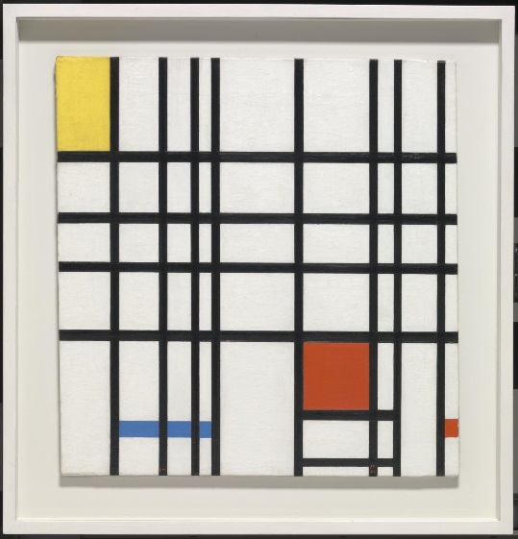
Figure ‎3.1. Composition with Yellow, Blue and Red (1937–42) for Piet Mondrian (1872-1944) is an example of the neoplastic school of arts.

3.1.2. The second self-control task
The second task is a four-color (red, green, yellow and blue) Stroop task where brain imaging and behavioural data will be recorded (Stroop, 1935). Although the Stroop task has been used in two fMRI studies of ego depletion (Friese et al., 2013; Luethi et al., 2016), the decision to use it is for the following reasons. 1) It is a simple, feasible, and computerized task that requires very limited body movement inside the narrow scanner compartment. 2) The neural signals of Stroop tasks have been well studied since the early days of using fMRI (George Bush et al., 1998). 3) Using the Stroop task to study ego depletion has previously revealed an associated precisely located brain reduced activity in the left inferior frontal gyrus (IFG). This could provide a neurophysiological marker to investigate the neural signals of both ego depletion and mindset manipulation, which comes in contrast to the results of Wagner et al. (2013) which were difficult to be generalized because of their reliance on the activity of many brain areas. 4) The Stroop task can be easily manipulated to distinguish different brain activities. For example, a Stroop task designed within blocks, where each block represents one type of congruency, contrasts the conditions of applying and not applying self-control, while using an event-related design contrasts the instantaneous conditions of applying and not applying self-control and consequently the correlated brain activity. To have the advantage of both designs, this study will involve both block-based and event-related designs; mixed design. Further, as establishing a habit depends on the repetition of the target behaviour (Orbell & Verplanken, 2015), a habit of consistently reacting to the congruent trials will be established through two practice rounds: inside and outside the scanner where the majority of the trials will be congruent.

3.1.3. Mindset manipulation
Job et al. (2010) manipulated participants’ implicit beliefs about self-control before practising either the first or the second task, as they were following the methodology of the previous mindset studies. Job and colleagues used a 2x2 design, hypothesizing that the highest performance contrast would be demonstrated among the depleted participants in whom the fixed and the growth mindsets were induced. In contrast, since an fMRI study requires a reference baseline following the subtraction logic to investigate brain activity, a four-group design will be used: a control and three depletion groups. Among the three depletion groups, one group will be manipulated to adopt the growth mindset, while another group will be manipulated to adopt a fixed mindset. We hypothesize that the growth mindset and the control groups would demonstrate a similar comparable performance which significantly contrasts that of the fixed mindset and the depletion groups. Further, despite the comparable behavioural performance between each group, their mindset and consequently their brain state would differ.

Finally, because of the reduced replication odds of ego depletion, and the high expenses of fMRI brain imaging, each aspect of the design should be piloted. First, the food pictures should induce high temptation for the target population of the study, while the comparison pictures should be feasible to be solved within 30 seconds. Second, the whole paradigm should behaviourally manifest the effects of ego depletion and mindset theories.

3.2. Pilot study 1: Picture piloting

3.2.1. Aim
The study aims to select 30 food pictures that are highly tempting for the target participants group. Results would also be used to select 30 pairs of comparison pictures that ensure that it is possible to locate differences between them within 30 seconds, which is the duration of each set in the main study. The study was approved by the Department of Psychology’s Research Ethics Committee (Ref. 010985), which can be found in appendix (VI.I)

3.2.2. Methods
Thirty-five undergraduate psychology students at the University of Sheffield (28 females and 7 males) and three postgraduate students (one female and two males) were recruited by the online research participation system (ORPS). The undergraduate students were promised participation credits while the postgraduates willingly volunteered. Those with any health condition that might be worsened by not eating or drinking anything except water for three hours were asked not to take part in the study (e.g. diabetics). Participants were encouraged to bring snacks with them to overcome the reduced blood sugar as soon as they finished the study.

The study was designed using Qualtrics©, an online questionnaire platform (Qualtrics, Provo, Utah, USA). One hundred high-resolution food pictures were chosen from Google® images, labelled to be reused, and then they were classified into two categories of proper meals or snacks, each containing 50 pictures to allow for equal distribution of tastes. Using a seven-point Likert scale, participants indicated how tempted they were by the depicted food picture (1 = not tempting at all, 7 = great deal). Similarly, 50 cartoon pictures were chosen and modified in different ways to reflect degrees of difficulty, and then the original and amended pictures were arranged into mirror-flipped pairs. Additional five pairs of comparison pictures without any differences were added to control for participants’ accuracy. Within a maximum of 30 seconds, the participants were asked to identify any differences, if present, between each pair. The dependent variables were the accuracy and the completion time for each pair, which was measured from the images’ presentation until participants clicked to submit their decision or until passing the 30 seconds time limit. The tasks were randomized both between and within picture groups and required a mean time of 40 minutes to be completed.

The experiment took place individually in a quiet room in the Royal Hallamshire Hospital. In front of a dedicated computer for the study, each participant was given the chance to read the information sheet, ask questions, and then sign the consent form. After they finished the study, the participants' subjective feedback was noted by the researcher for records, and each student was thanked and sent off.

3.2.3. Results
Both types of food pictures were sorted based on the mean score each picture obtained (Appendix III.I). The top 15 pictures of each category were selected for the main study (Appendices III.V. I & III.V.II). To test for a confounding preference bias between the two groups, the score of the top 15 pictures of each category (meal pictures: M = 4.5, SD = 0.63; snacks pictures: M = 4.41, SD = 0.74) were compared by t-test, which yielded no significant difference (F(58) = 0.936, p = 0.337).

Regarding the comparison pictures, accuracy was first checked to ensure compliance. Most pictures scored above 80% accuracy, with the exception of three pictures because of frequent mouse clicking that was not specified for a certain individual, still, their accuracy was higher than 70%. The pictures were sorted according to the completion time from the fastest (M = 16.53 sec, SD = 7.32) to the slowest at 30 seconds (Appendix III.II). However, it remained unclear whether the pairs of pictures for which it was relatively easy (requiring the shortest time) versus relatively difficult (requiring the longest time) to identify the differences would result in more eye-gaze fixations on the food picture, which would be situated between each pair in the main study. It seems that the relatively easier 30 pairs would result in a lower cognitive load and take participants less time (M = 19.2 sec), leaving them more time to look at the food picture. In contrast, selecting the 30 difficult pairs may force participants to spend more time hovering more frequently over the food picture (M = 25.5 sec), making it more difficult for them to avoid fixating on it. Thus, an eye-tracking study was proposed to answer the following question: Do more and longer fixations occur when the food pictures are placed between the pairs of pictures for which it is relatively easy versus relatively difficult to identify the differences?

3.3. Pilot study 2: Eye-tracking

3.3.1. Aim
This study aimed to determine whether the easy or hard comparison pairs of pictures are more likely to facilitate temptation by food pictures situated between each pair. In an eye-tracking study, a high number of fixations on the food pictures is an indication of high temptation by making it harder to avoid looking at.

3.3.2. Methods

3.3.2.1. Participants
Twenty seven undergraduate psychology students at the University of Sheffield (mean age= 18.88 years, SD = 0.933, 85% females) were recruited by the online research participation system (ORPS) and were promised credits for their participation. Seven participants’ data were excluded from the final analysis for technical reasons. Participants were told the study investigates cognitive changes associated with fasting and were required to avoid eating or drinking anything (except water) for at least three hours prior to the study. Those who were vegetarian, vegan, on a diet, or on long-term medication were asked not to take part in the study. Similarly, those with colour blindness, neurological, psychiatric, or eating disorders or any diseases that prevented them from fasting for three hours were excluded. Ethical approval was granted by the Department of Psychology’s Research Ethics Committee at the University of Sheffield (Ref. 012377), which can be found in appendix (VI.II)

3.3.2.2. Procedures
The study was designed using Experiment Builder 1.6.121 (SR Research Ltd., Mississauga, Ontario, Canada). The ten quickest (easy) and the ten slowest (difficult) comparison pairs, which were obtained from the previous study, were randomly allocated the top five snack and the top five meal pictures. Each participant was randomly assigned to only one condition (easy or difficult) as the isolated effect of either group is the focus of the study. First, participants positioned their head into the “forehead-chin rest” device in front of the high-speed camera of the eye tracker. Second, after reading the instruction slides of the study, the eye movements of each participant were calibrated and validated before starting the actual trials. The instructions entailed that within 30 seconds the differences between each pair, if present, should be defined by the participants using the mouse cursor while avoiding looking at the food picture presented in between each pair. Regardless of how fast the participants were in finding the differences, the pictures remained displayed for 30 seconds. For technical reasons, the accuracy for finding the differences was manually registered by the attending researcher and thus only food pictures were randomized, while quality was assured by following a checklist for each participant (Appendix III.III). After finishing, each participant was debriefed, thanked and sent off.

3.3.2.3. Data acquisition and analysis
Eye-tracking data were recorded using an EyeLink® 1000 Desktop high-speed camera (SR Research Ltd., Mississauga, Ontario, Canada) situated 60 cm in front of the participant’s eye. Sampling for eye movements was done by tracking the position of the pupil centre and the corneal reflection monocularly at a rate of 1,000 Hz. The illuminator power was 50% in conjunction with a pupil threshold between 70 and 120, while the threshold was between 200 and 230 for corneal reflection. The maximum allowed degree of error was one degree, which was validated immediately before data collection for each participant, and before each trial (Blignaut, 2009). As participants had to focus on looking at the middle of the screen for validation before each trial, the first 100ms of each trial were removed to avoid interference with recording fixations on food pictures in the middle of the screen. The threshold of fixation duration was 100ms (Manor & Gordon, 2003). The dependent variables were the duration and the number of fixations on the food picture, positioned between the two flipped images.

3.3.3. Results
To test for participants’ compliance with the request to identify the differences between each pair, first, the data was restructured to reflect the accuracy per a comparison pair, instead of reflecting each participant’s. Then, the accuracy was calculated as the percentage of the total number of correct mouse clicks per comparison pair to the total number of clicks on that pair by all participants. As accuracy was non-normally distributed as determined by Shaprio-Wilk test (W(20) = 0.665, p < 0.001), the non-parametric Mann-Whitney’s test was used to compare the accuracy between the easy and hard groups. The accuracy of the easy group (mean rank = 10.1, Mean = 78.6%, SD = 31.44; Median = 90.45, IQR = 31.1) was found to be non-significantly (U = 46.0, p = 0.761) less than that of the difficult group (mean rank = 10.9, Mean = 90.43%, SD = 9.76; Median = 94.7, IQR = 13.3). In summary, the accuracy was at an acceptable level, and no significant difference in accuracy was identified between the easy and the difficult comparison groups.

The number of fixations and duration were compared across all trials. As the data was not normally distributed for both groups, the Mann-Whitney’s test was used for comparison, which yielded a significantly (U = 6221.5, p < 0.01) more fixations for the easy group (mean rank = 112.72, M = 3.25 fixation/pair) compared with the difficult group (mean rank = 88.28, M = 1.85 fixation/pair) with a medium to large effect size (d= 0.57). A similar result was found for fixation duration, where the easy group showed significantly (U = 6376.5, P < 0.01) longer fixation (mean rank = 114.26, M = 856.32ms) on the food pictures compared with the difficult group (mean rank = 86.74, M = 379.6ms), with a medium to large effect size (d = 0.51). Finally, to examine for mean fixation timing, the time of the first and the last fixations across all trials were mediated and compared for both groups, which showed that the overall fixation timing of the easy group (M = 10173ms, SD = 8365.52) was delayed by 2.82 seconds compared with the difficult group (M = 7345.9ms, SD = 8473.58). Although this was a significant difference (U = 5943, p = 0.021), it exhibited small effect size (d = 0.33). The details of each comparison pairs’ values can be found in Appendix (III.IV).

3.3.4. Summary
This study aimed to investigate whether the easy or the difficult set of comparison pictures were more suitable for maximizing the number of eye-gaze fixations on the food pictures positioned between each pair. The results suggested strongly that the easy stimuli facilitated more fixation and for a longer duration on the food pictures. This can be explained as once the starving participants believed they finished identifying the differences between each pair; they became attracted to look at the highly tempting food picture in the middle of the screen. This explanation is corroborated by the participants’ comments at the end of the study, where many reported being more tempted to look at the food pictures after identifying the differences between the easy comparison pairs. On the other hand, those in the difficult group commented frequently that it was not difficult to avoid looking at the food pictures as they were more engaged with identifying the differences. This might explain the high standard deviation of the easy group accuracy, as participants were more tempted and distracted by the food pictures, compared to the difficult group homogenous accuracy. Furthermore, despite its small effect size, the delayed overall fixation timing of the easy group provides extra support for this explanation that the staring of the easy group at the food pictures took place toward the end of each trial; after finding all the differences.

Finally, one might argue that some easy pairs obtained a very low accuracy despite being labelled as “easy” in the first picture piloting. The counterargument is that the picture piloting was about ranking the easiness of comparisons based on how fast participants were able to identify the differences without introducing a distracting factor, which was the food picture in the eye-tracking study. More importantly, we were looking for a trend in the results in order to decide which is the best stimuli to be included in the main study. The platform now is ready to run the self-control paradigm as was described at the beginning of this chapter. The final set of pictures can be found in the Appendix (III.V).

3.4. The Behavioural Study

3.4.1. Introduction
The fragility and the reduced replication odds of ego depletion encouraged a careful designing process of this project. The design required running a behavioural study to make sure ego depletion manifested as per the experimental manipulation. As a response to Fujita’s paper, which claimed that self-control is more than simply response inhibition (Fujita, 2011), the current study was designed to be similar to Baumeister, Bratslavsky, Muraven, & Tice (1998) radish experiment, where ego depletion was first observed. It was hypothesized that this design might validate ego depletion as a complex cognition-related phenomenon, which might also explain why it gets a smaller effect size upon being replicated with simple response inhibition tasks. Thus, after manipulating participants lay theories about self-control in a similar manner to Job et al. (2010), the first self-control task was designed to include different modalities of self-control. The so-called “Picture comparison – Food cues task”, in short, “Food Cues Task” (FCT) required hungry participants to avoid looking at highly tempting food pictures while being engaged in spotting the differences between mirror-flipped images. The second task was chosen to be a computerized version of the Stroop task. A four-group design was used: a control and three depletion groups. Among the three depletion groups, one group was manipulated to adopt the growth mindset of willpower, while another group was manipulated to adopt the fixed mindset. The hypothesis was consistent with Job et al. (2010) that control and growth mindset groups would demonstrate significantly faster Stroop responses and better FCT accuracy compared with the ego depletion and fixed mindset groups. Likewise, for the manipulation check, it was hypothesized that the control and growth mindset groups would report less application of self-control in the first task compared with the other groups.

Based on piloting sessions of the behavioural study, the paradigm was augmented by introducing a fake eye-tracking element to make participants feel that their eye-movements are being captured, which aimed towards discouraging them from ‘cheating’ and looking at the food pictures whereas reporting they were not doing so. Furthermore, it was discovered that the wordings of the first task instructions were yielding exactly the opposite results of what was expected. The instruction of the first task originally read:

“A third picture will be presented in the middle of the screen, between the two mirror-flipped images. Please DO NOT look at the picture in the middle of the screen – just focus on identifying the differences, if present, between each pair of pictures presented at the top and at the bottom of the screen”

It was hypothesized that the following bit of the instructions was actually facilitating self-control using implementation intention (Webb & Sheeran, 2003):

“… just focus on identifying the differences, if present, between each pair of pictures presented at the top and at the bottom of the screen…”

By removing this part, the trend of the results became consistent with the hypothesis. This incident demonstrates how social psychology experiments are potentially fragile and sensitive to the mere adding or removing of a simple few words.

3.4.2. Methods

3.4.2.1. Participants
134 participants were recruited for this study. The sample size was determined using G*Power version 3.1.9.2 based on the effect size of (Cohen’s d = 0.62) obtained from Hagger, Wood, Stiff, & Chatzisarantis (2010). 122 participants (74 females; 60.7%), mean age = 23.12, SD = 4.157) were included in the final analysis based on the inclusion criteria (Table 3.1). Among those participants, 25 were not native speakers of English (20.4%), and 58 participants were recruited from outside the university (47.54%). The final number of participants per group was 32 in the control group (C), 29 in the ego depletion group (ED), 31 in the growth mindset group (+M), and 30 in the fixed mindset group (-M). The study was advertised as an eye-tracking study to investigate the effect of fasting on cognitive abilities. In return for £7, or research credits for psychology students, all participants were required to not eat or drink anything but water for at least three hours prior to their testing sessions (Mean = 4 hours and 20min ± 58 min). Ethical approval was granted by the ethics committee in the department of psychology at the University of Sheffield (Ref. no. 010985), which can be found in Appendix (VI.I). The Information sheet was distributed to all participants after their online registration.

Table ‎3.1. The inclusion criteria of the behavioural study with the number of participants who were excluded for not meeting those criteria before running the final analysis.
Purpose | Inclusion criteria | Excluded
Stroop | Very fluent in English | 0
 | Age between 18-35 | 1
 | Free of colour blindness and dyslexia | 1
Fasting | Medically fit; no active complaint, no history of diabetes or any neurological, psychiatric, medical conditions or long use of medications | 2
 | Fasting for 3 hours | 1
Food pictures | Should not be vegetarian, vegan or on diet | 0
Experimental design | Have not participated in the same study before. | 0
Technical issues | Stroop Accuracy within 2 Standard deviations to the mean | 2
 | Comparison accuracy within 2 Standard deviations to the mean | 2
 | Free of technical issues | 3
Total |  | 12

3.4.2.2. Procedures
The study was completely computerized using PsychoPy v1.84.2 to test four groups of participants: control (C), ego depletion (ED), ego depletion induced to adopt growth mindset (+M), ego depletion induced to adopt fixed mindset (-M). Participants were assigned to each group in a double-blinded pseudorandomized order. The critical aspects of the Python programming codes of PsychoPy can be found in Appendix (III.VI).

Upon arrival in their individual sessions participants were welcomed and told to keep their mobile phones in a silent mode. Demographic data then were collected before signing the consent form and being given a chance to ask questions. Next, participants were told the webcam in front of them was re-programmed to follow their eye movements and they were left alone in the room until the end of the study when they should ring the researcher using a telephone on the desk beside the computer.

After starting the study, those in +M and –M groups were induced to adopt different mindsets. Following the successful mindset manipulation of Job, Dweck, & Walton (2010), Vohs, Baumeister, & Schmeichel (2012) and others, the same 12 item-biased questionnaire was used, however using a seven-point Likert scale (Appendix III.VIII). Six of the questions lead participants towards adopting a growth mindset about self-control, i.e. the self-control ability is not pre-determined and it could be augmented through frequent use. The growth mindset group (+M) was shown statements such as “When you have been working on a strenuous mental task, you feel energized and you are able to immediately start with another demanding activity”. The other six questions induced adopting a fixed mindset, i.e. the self-control ability is pre-determined and it could not be augmented through frequent use. Those in (–M) group were shown statements such as “Strenuous mental activity exhausts your resources, which you need to refuel afterward (e.g. through taking breaks, doing nothing, watching television, eating snacks)”. No reverse coding was used for either of the two groups of statements as it was not intended to measure the participants mindset, neither could it be done before or after the study, as this would require asking both groups the whole set of 12 questions.

Next, participants in all groups went through a faked eye calibration task, where they were instructed to follow a black spot on the screen that appeared in nine different locations. Each spot lasted for 1.3 seconds on the screen before it turned green for 0.2 sec. This aimed to give the impression that the camera was actually tracking their eye movements. Then, each of the four groups followed a different order of slides (Table 3.2).

Those in ego depletion, +M, and -M groups were introduced to the “Food Cues Task” (FCT), where a pair of mirror-flipped comparison pictures were situated at the top and the bottom of the screen in each trial. Simultaneously, a highly tempting food picture was situated in the middle of the screen between the mirror-flipped pictures. Participants were instructed to spot the differences between each pair of the mirror flipped pictures within 30 seconds whilst avoiding looking at the food picture in the middle of the screen. After going through two practice trials, participants were reminded that their eye movements were being tracked and that they should avoid looking at the food picture in the middle of the screen. The actual task took 15 minutes for 30 trials of randomly presented food and comparison pictures. Food pictures were categorized into two groups of 15 pictures each, ‘proper meals’ and ‘snacks’.

Table ‎3.2. The flow of the slides and the exact wording used in the study
Groups | Control | Ego Depletion | (+) Manipulation | (-) Manipulation
Welcome | Thank you for agreeing to participate in our study, which aims to investigate the effect of fasting on cognitive abilities. Please press the mouse button to continue.
Mindset manipulation | N/A |  | The following questions have been designed to investigate your ideas about willpower. Willpower is what you use to resist temptations, to stick to your intentions, and to remain in strenuous mental activity. There are no right or wrong answers. We are simply interested in your opinions. Please press the mouse button to continue.
 |  |  | Please indicate how much you agree or disagree with each of the following statements by choosing the number that corresponds to your opinion. After clicking on the number that represents your answer, click on the button below the scale to move to the next question. Please press the mouse button to continue.
Faked eye calibration | Before proceeding to next tasks, the camera that is situated in front of you should be calibrated to follow your eye movements. Please adopt a comfortable posture, try to stay still, look at the screen, and use your eyes to follow the black dot on the screen. When you are ready, press the mouse button to start the calibration
 | Your eye movements are calibrated successfully. Please press the mouse button to continue
Food ques, pictures comparison task | In the next task, we would like you to identify any difference(s), if present, between a pair of mirror-flipped images presented at the top and the bottom of the screen. Please press the mouse button to continue.
 | If you identify a difference between the two images, then you should move the mouse cursor over the difference and click. Note that there may be more than one difference between some of the pictures. Please press the mouse button to continue.
 | N/A | A third picture will be presented in the middle of the screen, between the two mirror-flipped images. Please press the mouse button to continue
 |  | Please (DO NOT) look at the picture in the middle of the screen. Be aware that your eye movements are being strictly tracked by the camera that is situated in front of you. Please press the mouse button to continue
 | You will see each set of pictures for 30 seconds. The first two sets of pictures will be for practice. Please press the mouse button to continue.
 | That is the end of the practice. The actual trials start now. Please press the mouse button to continue | That is the end of the practice. The actual trials start now. Remember, you SHOULD NOT look at the picture in the middle of the screen. Please press the mouse button to continue.
Manipulation check | In the next task, please indicate how much you agree or disagree with each of the two following statements by choosing the number that corresponds to your opinion. After clicking on the number that represents your answer, click on the button below the scale to move to the next question. Press the mouse button to continue.
 | I found it hard to avoid looking at the picture in the middle of the screen.
 | I did not look at the picture in the middle of the screen
Stroop Task | In the next task, you will see words describing colours (red, green, blue and yellow) written in four different-coloured fonts (red, green, blue and yellow). Your task is to use the mouse to click on the black word at the bottom of the screen that indicates the colour that the words are written in. Please press the mouse button to continue.
 | Please ignore the meaning of the word and focus only on the colour of the font. So, if you see the word ‘red’ presented in blue, then you would press ‘blue’. You will get feedback on the first five trials only. To practice, please press the mouse button to continue.
 | That is the end of the practice. Remember to indicate the colour that the words are presented in, regardless of their meaning. Please press the mouse button to continue.
 | Be aware that resting slides will be presented in-between the trials. The actual trials start after the countdown. Please press the mouse button to start.
Finish | This is the end of the study. Thank you for participation. The researcher will be coming for you soon

The design of the FCT task was different for the control group as they were instructed only to spot the differences between the comparison pictures without being reminded about the eye-tracking. Further, all food pictures were replaced by random pictures depicting the neoplastic and abstract schools of art, as it was believed this would minimally prime any interfering mindsets or confounding psychological constructs (Appendix III.V.IV). After the FCT task, all groups completed two questions to check for self-control manipulation on a 7-point Likert scale (Table 3.2).

The second self-control task was a computerized version of the Stroop task, where four colours were used: red, green, blue, and yellow on a greyish background. A word semantically representing one of the four colours appeared in the centre of the screen. As this was printed in a colour either congruent or incongruent with its meaning, participants were required to ignore the word’s semantic meaning and respond only to the colour in which the word was printed. For example, if the word “red” was printed in “green”, then participants were required to click on the choice at the bottom that corresponds to green using the computer mouse. The answer choices were four words representing the four colours printed in black and distributed in a circular manner to reduce the time to move the mouse cursor between them.

The Stroop was designed to be suitable for use in an fMRI mixed design. Each trial lasted 2300ms, which represented the period where each Stroop word appeared. Each trial was jittered using a fixation cross slide which was varied to last randomly either 300 or 500ms. Instead of relying on the number of trials to decide the length of the blocks in the mixed design, each block was decided to last only for 30 seconds regardless of the number of trials within the block. Thus, once 30 seconds had passed, the block either ended immediately or waited for the current trial to end. Two types of blocks were created and presented randomly to the participants to contrast self-control: blocks containing only congruent trials, and another where only two-thirds of the trials are congruent. This was not only to avoid habituation but also, to avoid an effect called "List-wide proportion congruence" (LWPC). To mimic the fMRI conditions, the Stroop was designed in two runs; each lasting for 300 seconds (5 min) and ending similar to blocks. As the trials’ length was jittered, the number of trials per block varied between 11-12 trials and further differed based on how fast each participant responded. A five-second resting slide was presented between the blocks, where a white cross sign appeared in the middle of the screen instead of the black one between the trials. Participants were offered 16 practice trials with feedback in five of them before being engaged in the actual trials. The dependent variables were accuracy and response time.

After finishing the study, all participants were asked to rate how difficult they found the three main aspects of the study (fasting, FCT and the Stroop tasks) as easy, middle, or difficult. They were then debriefed and paid their promised money.

3.4.2.3. Dependent variables
As high accuracy was expected, the Stroop task’s dependent variable was the reaction time of the incongruent trials only (Inzlicht & Gutsell, 2007). Regarding the FCT task, upon spotting the differences between the comparison pictures, two types of accuracy were postulated per a comparison pair. First, the absolute accuracy is the percentage of the number of spotted differences to the total number of differences, which was calculated as in equation (1).

AA = $\frac{the number of the spotted differences between a pair by a participant}{number of the actual differences per pair}$ (1)
Second, the relative accuracy is the percentage of the number of mouse clicks over the spotted differences to the total number of clicks on that comparison pairs, which was calculated as in equation (2).

RA = $\frac{the number of the correct clicks on a pair by a participant}{total number of clicks on a pair by the same participant}$ (2)

The relative accuracy was the main interest, as the target of the task was to measure the extent of the disturbance of controlling oneself rather than to spot all the differences, by avoiding the food pictures, on the comparison process for hungry participants. Thus the dependent variable of the FCT task was the relative accuracy.

Regarding the manipulation questions, it was proposed that both questions measure the same quality of self-control. Hence, higher values per participant represent the higher practice of self-control. This will be investigated via the congruence of Cronbach’s alpha values of both questions.

3.4.3. Results

3.4.3.1. Demographics and Perception of Difficulty
To control for possible confounding variables, a non-parametric Kruskal-Wallis test was conducted to compare the four groups for the length of fasting, age, gender, English language ability, and the perception of FCT, fasting, and Stroop difficulty. No significant intergroup differences were found except for the perception of the first task difficulty (H(3) = 12.613, p = 0.006). Consistent with the design, those in the control group (average rank = 45.53) found the FCT task easier than the other three groups (average rank: ED = 63.71; +M = 65.69; -M = 72.07), other pairwise comparisons were insignificant. Further, upon studying the correlation between the length of fasting and the perception of fasting difficulty, the result showed a significant positive correlation (r = 0.192, p = 0.034). Overall, no controlling was needed for any of the demographic or subjective variables.

3.4.3.2. Mindset Manipulation
As the study did not aim to measure participants’ mindset, no pre-assumptions regarding the difference between the two groups were drawn. The target was to expose both groups to the biased questionnaire to induce a certain mindset. Nevertheless, as the mean response scores were found normally distributed using Shapiro-Wilk test (W(68) = 0.0982, p = 0.419), an independent samples t-test was run to compare the mean of both +M and –M groups in answering the biased questionnaire relatively to midpoint 3.5 (1 = strongly disagree, 7 = strongly agree). Significantly, (t (59) = -2.937, p = 0.005) those in –M (M = 4.92, SD = 0.74) agreed more with the biased contents than +M (M = 4.27, SD = 0.94), which was a successful replication of Job et al. (2010).

3.4.3.3. Food cues task: accuracy, self-control, and Manipulation Check
As the scores were not normally distributed, a non-parametric Kruskal-Wallis test was conducted and showed a non-significant difference between the four groups for relative accuracy (H(3) = 5.421, p = 0.143) and absolute accuracy (H(3) = 4.082, p = 0.253).

Regarding the manipulation questions, the two 7-point Likert scale questions obtained a very high alpha value (-2.4), supporting the proposal that both questions measure the same quality. Consequently, both questions scores were collapsed into a single variable.

To compare the groups for reported self-control differences as measured by the manipulation check questions, a non-parametric Kruskal-Wallis test revealed significant intergroup differences (H(3) = 8.354, p = 0.039). Consistent with the hypothesis, it was found that the control (C) (average rank = 46.48) applied the least self-control compared to the other three groups (average rank: ED = 65.84; +M = 68.19; -M = 66.40). Upon calculating the effect size of the differences between every two groups, similar results were obtained. The control group differed from the other groups with a moderate Cohen’s d values, while negligible values for the other intergroup differences were found (Table 3.3). It is, therefore, defendable to claim a significant intergroup difference in the reported self-control as measured by the manipulation check.

Table ‎3.3. Cohen’s d values of the intergroup differences in the reported self-control as measured by the manipulation check questions. The control group differed by a moderate effect size from the other groups congruently with the hypothesis, while other intergroup differences are negligible.
 | ED | +M | -M
C | 0.50 | 0.56 | 0.62
ED |  | 0.02 | 0.06
+M |  |  | 0.02

3.4.3.4. Ego depletion and Stroop performance
It was hypothesized that ego depletion would manifest as a longer RT or lower accuracy for -M and ED compared to C and +M. As the accuracy was high for all groups, ego depletion was re-defined as longer RT for the incongruent trials following Inzlicht & Gutsell (2007). First, the mean RT for correct incongruent Stroop trials was calculated regardless of the number of included trials; some participants solved more trials than the others did. A univariate ANOVA was run and showed a non-significant difference in RT between the four groups (F (3, 117) = 1.169, p = 0.325, ɳ² = 0.029). Nevertheless, the trend of the data is consistent with the hypothesis (Fig 3.2).

Figure ‎3.2. The between-group difference in Stroop response time. Despite being not significant, the trend is congruent with our hypothesis where the control and the growth mindset group are obtained faster RT of the Stroop compared with the ego depletion and the fixed mindset groups.
Mean Stroop Response time

3.4.4. Summary
In summary, table (3.4) summarises the obtained results against what was hypothesized. Ego depletion was not significantly present. However, it could be confirmed tentatively that the manipulation was “subjectively” successful as those in the control group reported less application of self-control compared to the other groups. Also, participants' opinions about how hard they found FCT endorsed similar results where the control group found the task easier compared to the other groups. Demographically, there was not any intergroup difference, and accordingly, there was not any need to control for any of those variables.

Regarding the mindset biased questionnaire, as was observed in Job et al. (2010), a significant intergroup difference was observed and interpreted as a sign of a successful manipulation where either group endorsed the suggested theory. Although I agree with this interpretation, it could be looked at from a different angle. 1) The biased questionnaire was not meant to measure the participants' beliefs about self-control. Accordingly, one would expect that there should be no difference between the two groups in terms of the obtained scores, where either group should not be more agreeable, with biased statements than the other. 2) As two different forms of biased questions were used, a significant difference would suggest that one group was more agreeable with the biased contents than the other; in this case, it is –M group. Taken together, it could be concluded that the participants have a tendency to agree with the fixed mindset contents more than those with a growth mindset. This issue cannot be further processed in the scope of this project, yet, it questions the nature of adopting both mindsets and why one of them is more widespread than the other.

Table ‎3.4. A summary of the results against the hypotheses. Green and red colours indicate whether the results are congruent or incongruent respectively to the hypothesis
Dependent Variables | Direction of Hypothesis  (=) → (non-significant)  (▲▼) → (significant higher or lower) | Were results congruent with the hypothesis  Green: as expected  Red: against what is expected | Effect size | Interpretation
FCT relative accuracy | (C) = (+M) ▲  (EG) = (-M) ▼ | (No)  (C) = (+M) = (EG) = (-M) | N/A | Mindset and experimental manipulation did not affect the first task, despite finding a difference in the manipulation check
Manipulation check  (higher scores = higher self-control) | (C) = (+M) ▼  (EG) = (-M) ▲ | (Yes)  C ▼  EG = -M = +M ▲ | d = 0.61 | successful self-control design for the first task
Response time  (ego depletion) | C = +M ▼  EG = -M ▲ | (No)  (C) = (+M) = (EG) = (-M) | N/A | No ego depletion

3.5. Chapter discussion
The research included in this chapter sought to build and test a self-control paradigm, where ego- depletion behaviourally manifests. If successful then the design would be suitable for use in an fMRI study. In accordance with the ego depletion literature, two sequential tasks were used, which were carefully chosen to adapt to the fMRI study conditions. The food cues task (FCT) was designed to practise self-control with minimum body movements inside the narrow fMRI chamber. Hungry participants were required to spot the differences between mirror-flipped pairs of comparison pictures while ignoring a depicted food picture situated in-between each pair. Each aspect of the FCT was piloted carefully to increase the likelihood of manifesting ego depletion and overcoming the methodological challenges as were highlighted in the ego depletion literature (Chapter 2). First, the comparison and food pictures were chosen from a larger group of pictures according to how they were rated and solved by a sample of students at the University of Sheffield. Second, as the chosen comparison pictures exhibited two levels of difficulty, an eye-tracking study was used to ascertain whether the easy vs difficult comparison pairs would augment practising self-control. Results-wise, the easy pictures were found to be significantly associated with higher rates of distraction when food pictures were situated in-between each pair, and consequently, they were chosen. The self-control study for FCT followed by the Stroop was conducted on a final set of 122 participants. The results revealed no significant effect of ego depletion with neither effect of mindset manipulation.

Given the current state of the literature, it is not unexpected to obtain non-significant results of ego depletion. Accepting the null hypothesis is a multiple-meaning term (Baumeister, 2019), where a closer and careful look must be taken at the three pillars of any study before jumping to a conclusion that a hypothesis is fundamentally mistaken. First, the researcher could be either inexperienced, biased by certain incentives (agencies’ funds), or making errors that passed unnoticed. Second, inappropriate responses exhibited by the participants, being distracted, or not motivated to engage with the task may contribute to the final negative outcome of a study. Further, if the study was not carefully calibrated to the participants’ cultural background or being not environmentally validated then it is not a surprise that many ego depletion studies were not functional. Third, the design must be congruent with the theory while the experimental manipulation must be efficiently delivered before drawing any final conclusions. In light of these criteria, the results will be discussed.

First, as a research team, this is not the first study we ever conducted, nor our first encountering of ego depletion research. We are not defending ourselves against Baumeister’s personal claims, rather, emphasizing a point, like a declaration of conflicting interest. Second, the participants' engagement was assessed in different ways starting from the manipulation check, accuracy, and asking about their overall impression at the end of the study. Generally speaking, the participants were interested in the study with few exceptions. The £7 incentive was decided based on a previous failure in recruiting participants for the same study. Regarding the cultural calibration, we sought to environmentally validate the FCT design through the aforementioned pilot studies. Third, although we could claim that our design was consistent with the theory, our results are not.

As highlighted by Baumeister, the necessity of efficient manipulation is a genuine necessity for ego- depletion research, yet, there is no agreement on an orthodox methodology for the manipulation check (Baumeister, 2019; Baumeister & Vohs, 2016; Inzlicht & Friese, 2019). The basic theory of ego depletion encompassed an inability to practise self-control after utilizing the limited resources in a previous instance of deliberate control. This utilization of the limited resources should be proved behaviourally by creating a significant behavioural contrast in the outcome of the first task between the experimental and control groups. The reported amount of self-control as measured through the manipulation check offers an alternative measure of the extent of the self-control practice and accordingly, the amount of the utilized self-control resources in the first task. Many studies were found not controlling for either measure (Baumeister, 2019), or reporting non-significant intergroup differences, nevertheless, ego depletion was manifested in those studies (Friese, Loschelder, Gieseler, Frankenbach, & Inzlicht, 2019, p. 125, point 3). Consequently, a significant manipulation check either behaviourally or perceptively may not be critical, however, without it ego depletion cannot be argued for or against. Fundamentally, we argue that to report a failed replication, both manipulation measures of the first task; perceptive and behavioural, should be significant before confirming non-significant differences in the second task. In this study, we found a significant intergroup difference in the reported self-control through the manipulation check only, and accordingly, it was concluded that it is not a piece of conclusive evidence against ego depletion. Especially knowing that the trend of the intergroup differences in the Stroop response time in this study was congruent with the basic theory of ego depletion. This last point was used frequently in the literature to defend ego depletion as a reversed data trend was always absent regardless of the significance (Friese et al., 2019).

On the other hand, we were cautious to reduce the error variance, by increasing the study’s power and avoiding the so-called p-hacking practising (Friese et al., 2019). The sample size was decided based on power analysis while data being not peeked during data collection (Sagarin, Ambler, & Lee, 2014). The approach of when to stop data collection was based on validating the inclusion criteria while removing the outliers was kept as minimal as possible. The procedures were standardized by a checklist to be followed by any researcher involved in data collection. Most importantly, through adopting FCT, we followed the notion that self-control is more than just a response inhibition (Fujita, 2011).

In summary, our results are consistent with the most recent attempts to replicate ego depletion. While many studies reported null effect (Emmerling et al., 2017; Lurquin et al., 2016; Xiaomeng Xu et al., 2014), recent studies (Dang, Liu, Liu, & Mao, 2017; Garrison, Finley, & Schmeichel, 2019; Lin, Saunders, Friese, Evans, & Inzlicht, 2019) and big registered replication reports (Dang et al., 2019; Vohs & Schmeichel, 2018) reported significant effect; however, in low to moderate values of effect size compared to Hagger's meta-analysis (2010). The discussion of why ego depletion became hard to replicate will be discussed in the final chapter of this thesis. Nevertheless, for the sake of this project, as no assertion can be offered regarding how the paradigm would behave if another ego depletion paradigm was designed, we decided a moratorium of our endeavours towards replicating ego- depletion, and consequently, we were unable to continue to the fMRI study. A different, but related, line of investigation will be commenced in the next chapter.

The Three-belief Model of Self-control

CHAPTER 4

Chapter Abstract

As an alternative to the limited resources theory of
self-control, the chapter sought to investigate whether self-
control can be explained through a belief-based model of
self-control. Three belief models were derived from the alternative
explanations to the limited resources theory that was offered
by Baumeister et al (1998). Then, through factor analysis of 30
questions, the data were reduced to confirm whether a three-belief
model is suitable to explain the variability in the collected data. The
results supported a three-belief model of self-control through
correlation with other reported measures of self-control. A
second study further supported the model through a direct
replication, however, the model exhibited an
insignificant correlation with any experimental
behavioural outcome.

4.1. Introduction
The previous chapter concluded the endeavour to replicate ego depletion with failure. In part, this could be attributed to the replication crisis of ego depletion. While investigating the aetiology of this crisis is beyond the scope of this project, the question that emerges is whether another model of self-control away from the limited resources model of ego depletion, could be suggested. To answer this question, it is important to look again at the self-control theories presented in Chapter 1.

All models of self-control were designed to address people’s recurrent failures to control themselves. These models can be categorized into two groups: on one hand, there are those theories that referred self-control limitations to linear physiological or psychological limitations. Linear limitations are those that directly correspond to the rate of self-control failure, and can be overcome objectively by resting or eating. Examples of linear theories include: ego depletion theory of Baumeister, Bratslavsky, Muraven, & Tice (1998), and the process model of Inzlicht, Schmeichel, & Macrae (2014). On the other hand, there are those theories that consider self-control limitations as a product of non-linear limitations. Non-linear limitations are those that indirectly correspond to the rate of self-control failure, and can be subjectively overcome by adopting a different mindset or changing the perspective of the perception of one’s own abilities. Examples of self-control theories in this group include the non-limited resources model of Job, Dweck, & Walton (2010), and the perceived efforts model of Kurzban, Duckworth, Kable, & Myers (2013).

To test either of these models, an instance of self-control failure is artificially created while manipulating the experimental variables of the target model. So far, the dual-task paradigm, where practising two consecutive tasks exhausts one’s ability to control oneself, is the prevailing methodology to create that instance of self-control failure, and hence it is used in testing different self-control models. A serious weakness, however, is that utilizing dual-task methods to exhaust self-control comprises an implicit assumption of the linear nature of self-control, i.e. while a self-control model is investigated for being linear vs non-linear, the utilized experimental paradigm presumes a linear nature of self-control. Because of this, for either model of self-control, the linearity is implicitly presumed. As far as the replication is concerned, it could be argued that if the dual-task methods of self-control no longer replicate the results, then this can be attributed to the linearity assumption that was implicitly presumed in most of the studies. Therefore, before hypothesizing or testing any further theories of self-control, self-control needs to be conceptualized far from being considered as a linear model.

Upon hypothesizing ego depletion, Baumeister et al. (1998) outlined three possible models of self-control where each could predict a different experimental outcome. 1) The Schema model: where self-control is a schema that is activated by certain knowledge or information. Once a schema is activated, it facilitates further actions of self-control. 2) The Skill model: where self-control is a skill that is learned over a certain period of time. Once mastered it facilitates any further self-control actions while the level of the skill would “remain roughly constant across repeated trials” (Baumeister et al., 1998, p. 1254). 3) The Energy model: where self-control is an energy that can be depleted upon frequent use and replenishes upon resting. It seems that no study has previously examined the validity of the skill or the schema models as competing models to explain self-control failure. This could be reasoned by the experimental results that stood in favour of the energy model, which is no longer supported thanks to the replication crisis. As this study aims to explore new models of self-control, the skill and the schema models will be “re-considered” as candidates to explain the instances of self-control failure.

To investigate skill and knowledge as potential models of self-control, the critique of linearity, which was discussed above, shall be controlled for. Assuming that self-control is influenced by how it is perceived as an ability (the non-linearity), the next step would be examining how people perceive their self-control ability by measuring the extent to which they believe it as skill, knowledge or energy. This serves the following purposes: 1) stepping back from the linear considerations of self-control; i.e. if self-control is a skill or knowledge, then the extent of believing in either may influence the extent of practicing self-control, 2) a possibility to include new factors by inspecting people’s perception instead of relying on scientists’ intuition, 3) creating a variety of belief models to contrast the literature where the research, to date, has focused only on the extent to which people believe that self-control is energy but not whether they endorse different models of self-control (Martijn, Tenbült, Merckelbach, Dreezens, & de Vries, 2002).

The aforementioned aims shall be achieved through designing a scale which could offer a qualitative assessment tool of people’s beliefs about self-control. Scales that assess people’s beliefs are commonly used in psychology literature, such as self-efficacy (Sherer et al., 1982) and mindset (Job et al., 2010), yet, there could be no direct practical application of these scales unless strong prediction correlation was observable. For example, the second experiment of Martijn et al. (2002) developed a scale to measure people’s beliefs about self-control as being energy vs a state-of-mind. This scale was aiming to investigate whether the limited resources model can be influenced by people’s perspectives and expectancies. In contrary, the self-control trait scale of Tangney et al. (2004) was found highly predicting the outcome of people’s daily activity where self-control is needed. Factor analysis shall be used in order to design this scale using its two main component; the exploratory and the confirmatory analyses. As factor analysis requires a large number of participates, a wide range of healthy participates will be recruited either within or outside the university.

In summary, the current chapter aims to investigate how people perceive their self-control ability by measuring the extent to which people believe that self-control can be viewed as a skill, schema (knowledge) or energy. Further, the chapter investigates whether endorsing either model has consequences on the scores one yields from the reported measures of self-control ability, particularly, the Short Grit Scale (SGS) and Brief Self-control Scale (BSS) (A. L. Duckworth & Quinn, 2009; Tangney et al., 2004). Behavioural consequences of adopting either belief model will be studied as well.

4.2 Study 1
The study investigated whether a model of three beliefs of self-control (energy, skill, and knowledge) can be established. Since it remains unclear whether this model reflects people’s own perception, a factorial analysis will be utilized for a set of questions that represent all three beliefs of self-control. Factor analysis is a statistical method used to describe the variability of an observed correlated set of data using a smaller number of unobserved variables called factors. This means that if the hypothesis that self-control can be viewed by people as three beliefs is correct, then the factor analysis can reduce the obtained data to a smaller number of factors that, more or less, represent our hypothesized three beliefs. The scores of the yielded factors can then be correlated to different measures of self-control to study the ability of the model to predict other established measures of self-control. Therefore we hypothesize that: 1) upon creating a set of questions investigating the extent to which participants endorse self-control to be energy, skill or knowledge, performing the factor analysis on the answers to these questions would yield a three-factor model that corresponds with the three beliefs. 2) The factor score of the yielded model will significantly predict the scores on other reported measures of self-control, particularly, trait self-control and Grit scales.

4.2.1. Methods

4.2.1.1. Participants
A total of 354 participants responded to an invitation through the University of Sheffield volunteer list to take part in the study, in return to entering a draw to win a £30 Amazon voucher. Level one psychology students (invited through the online research participation SONA® Systems Ltd) were given the choice of either entering the draw or to be given research credit for their participation. 308 participants completed the study out of whom no participants were excluded from any further analysis (mean age = 29.3, SD = 11.8, 69.5% are female). The decision to include incomplete trials aimed to increase the chances of detecting a pattern within the collected data in the factor analysis and was taken with the understanding that missing values would not inversely interfere with the factor analysis as they would be excluded pairwise. A summary of the demographic information of participants is summarized in Appendix (IV.I). The study was ethically approved by the ethics committee of the Psychology Department at the University of Sheffield (no. 023662), which can be found in Appendix (VI.III)

4.2.1.2. Development of the scale
To represent the belief models, 30 questions were formulated where every ten questions (also will be referred to as items because some of them are rather statements, not questions) represent one of the three beliefs of self-control as being: energy, skill or knowledge. Martijn et al. (2002) have already designed a 20-item questionnaire to test people’s viewpoint about self-control to be either “self-control as energy” versus “self-control as a state of mind”, where ten items were allocated for each category. Martijn’s ten items of the energy viewpoint were utilized in our scale to test for the energy belief. For the knowledge and skill beliefs, ten items were crafted per belief to investigate each aspect of the model as it was explained by Baumeister et al. (1998). For example, skill, as an alternative explanation of self-control, were described in Baumeister et al. (1998) as follows:

“One model views self-regulation as essentially a skill. In this model, people gradually develop the skill to regulate themselves over long periods of time. On any given occasion, however, skill remains roughly constant across repeated trials (except for small and gradual learning effects), so there should be little or no change in effectiveness of self-control on two successive exertions within a short time.”

The underlined keywords represent the concepts of the skill model, where questions were crafted for each concept. As an example, the following item represents the concept of graduality of the skill model: “People develop the skills needed to control themselves as they grow up”. Some questions were reversed and were given accordingly a reversed scoring. The full set of the 30 items altogether with the quoted descriptions from Baumeister et al. (1998) can be found in Appendices (IV-II & IV.III).

4.2.1.3. Procedures
The preliminary 30 items were introduced to the participants using Qualtrics® as an online study. After reading the information sheet and checking all the boxes of the consent form, participants were then given the choice whether they want to enter the draw by submitting their email addresses, which were collected separately from the experimental data through Google® Sheets to ensure the anonymity. Participants then were forwarded to Qualtrics® where the demographic data were collected before starting filling in the questionnaire. In addition to the 30-item scale, two other scales were used: The 13-item Brief Self-control Scale that measures self-control traits (Tangney et al., 2004), and the 8-item Short Grit Scale (A. L. Duckworth & Quinn, 2009). Both scales can be found in Appendix (IV.IV). The items were randomized either within- and between-scales. Participants were required to indicate how much they agree or disagree with each of the items on a scale from 1 to 5, where 1 means strongly disagree and 5 means strongly agree. It took 10-15 min to answer the questions of all three scales. After finishing data collection, psychology students were given their accredited reward, while the draw winner was contacted and was given the promised voucher.

4.2.1.3. Analysis Plan
The analysis comprises two parts: First extracting the factors using factor analysis, and second performing correlational studies of the extracted factors´ scores with the scores of the other two scales of self-control. Factor analysis is the most critical step as it decides whether a realistic model of three beliefs could be obtained out of the crude 30 questions.

4.2.1.3.1. Factor analysis and its main features
Factor analysis is a statistical method used to describe the variability of an observed correlated set of data using a smaller number of unobserved variables called factors. To explain this method, assuming that a researcher came up with a set of (n) questions (X) he/she believes that their answers (Y) can measure the degree of engagement in a certain social event, but that researcher is not sure whether these questions examine the proposed qualitative features of that event (e.g. enjoyability and cosiness). In this example, the questions (X) and their answers (Y) are the observed set of data, while the qualitative features are the factors (F) which may, in deferent degrees, explain the variability in (Y). What factor analysis does is finding whether the questions (X) can be grouped according to the variability of (Y), assuming the questions that can be grouped together measure similar qualitative features (F), and named accordingly. The definition of factor analysis can be expressed mathematically as follows: for (n) entries of (X’s) that predict a set of outcomes (Y’s), if (N) number of factors (F) were extracted, then it could be concluded that X’s can be categorized into (N) subsets, each represents a certain qualitative feature and can account for the (V%) of the variability in (Y’s). Using the straight-line equation (see equation 1), the former relationship can be expressed in equation (2) as a matrix where each row represents an item in the questionnaire which, in turn, is represented by a straight-line equation, while X, Y & F are as explained in the aforementioned example.
Y = m X + c (1)

Where Y: the outcome on Y axis (Y component)
X: the predicting input on X axis (X component)
c: the standard error and is represented as the intercept on Y axis when X = 0
m: the tangent; correlational value between X and Y

Y₁ = F₁ X₁ + c₁
Y₂ = F₂ X₂ + c₂
(2)
$$⋮$$
Y_{n} = F_{n} X_{n} + c_{n}
Opposite to the linear regression, where finding m is the target to decide the amount of correlation between a single variable of X and another of Y, factor analysis deals with (μ) iterations for each entry of X’s and Y’s where the data is stored in matrixes. This could be instantiated in the former example as asking a (μ) number of participants in the social event to fill in the questionnaire that contains (n) number of questions (X) and then collecting the answers (Y) to measure the degree of engaging. Using equation (2), The answers of the (μ) number of participants can be expressed in equation (3) as matrix of (μ) entries within the matrix of (n) entries.
Y₁ = F₁ X₁ + c₁
Y₂ = F₂ X₂ + c₂
(3)
$$⋮$$
Y_{n} = F_{n} X_{n} + c_{n}

Where n: the number of entries; i.e. the number of questions
μ: the iterated input for each entry of n; i.e. the number of participants
$\left|\begin{matrix}Y_{n,1} \\ \begin{matrix}Y_{n,2} \\ ⋮\end{matrix} \\ Y_{n,}\end{matrix}\right|=$ $\left|\begin{matrix}F_{n,1} \\ \begin{matrix}F_{n,2} \\ ⋮\end{matrix} \\ F_{n,}\end{matrix}\right|$ $×\left|\begin{matrix}X_{n,1} \\ \begin{matrix}X_{n,2} \\ ⋮\end{matrix} \\ X_{n,}\end{matrix}\right|+\left|\begin{matrix}c_{n,1} \\ \begin{matrix}c_{n,2} \\ ⋮\end{matrix} \\ c_{n,}\end{matrix}\right|$

Factor analysis solves the straight-line equation matrix for F through a set of matrix calculations for every two entries of (X) until a matrix of factor loading values is created. This step is called factor extraction and can be achieved using different methodologies. The number of the extracted factors would be equal to the n entries of X. A fewer number of factors will be determined using few methods; worth to mention is using an eigenvalue of 1 as it is the default choice in SPSS. Then upon rotating the factor loading matrix, which contains a fewer number of factors, and looking at it from different angles, the values can be grouped, and the final factors are created in a form of a pattern matrix. The explained variability of each factor would determine the accumulated explained variability of the whole factors model.

It is critical to explain, as the definition sounds, that factor analysis does not utilize the proper values of Y, rather the variability, which can be expressed in different coefficients. Accordingly, there are different styles of factor analysis. By far the most famous measures of variability used in factor analysis are the variance and the covariance. When the covariance is fed as Y then this form of factor analysis is referred to as the Exploratory Factor Analysis (EFA) or is just referred to as Factor analysis (FA), while if the variance is used, it is called Confirmatory Factor Analysis (CFA), which is interchangeably referred to as Principal Component Analysis (PCA) after the extraction method (Ferguson & Cox, 1993). In the literature, there is no consensus on how these analyses are referred to, yet, the methodology is always the same. This disagreement can be extended to include the indication of which test to be used; i.e. researchers in many instances use PCA where EFA is indicated and vice versa. In part, this can be attributed to the qualitative nature of the extracted factors. The sample size and extraction methods are as crucial as the used measure of variability to decide whether the extracted factors are suitable to explain the variability in the observed data. To clarify this, a brief explanation will take place in the following few lines.

- Variance vs covariance
While the variance is a measure of dispersions; the degree of the deviation of data away from the mean, the covariance is a measure of correlation; the joint variability between two or more variables. EFA relies on the covariance where the members of every created group tend to have close correlation values. PCA relies on the variance where the members of every created group show a similar degree of dispersion; deviation from the mean. For example, assuming that factor analysis was performed on the academic performance of a group of school classes. If EFA is performed, then the grouped classes at a certain factor would exhibit a similar trend towards obtaining higher or lower grades (improving vs worsening). If PCA is performed, then the grouped classes at a certain factor would exhibit a similar degree of dispersion in their performance (how close the students’ grades are). In other words, EFA demonstrates the degree of change while PCA demonstrates how this change is coherent among group members; i.e. EFA focuses on a dynamic categorization while PCA focuses on a static one. Thus, if a clear conception is held about a certain phenomenon, then PCA would be favourable, whilst it is the opposite for EFA. Historically, PCA was favoured over EFA because of its easier implementation before the age of the computer. Also, as PCA relies on the variance, it acts better as a method of data reduction where the data is re-categorized to make it more coherent and understandable (Costello & Osborne, 2005). Nowadays, EFA is used more often, and its superiority to PCA is advocated to explain the variability in the observed data. For both types of factor analysis, it is essential to ensure a preliminary level of association between the variables. This is achieved by using the Kaiser-Meyer-Olkin measure of sampling adequacy (should be higher than 0.8) and Bartlett’s Test of Sphericity (p < 0.05).

- Sample size
Ferguson & Cox (1993) emphasized the importance of sample size in factor analysis to determine the degree of factor saturation (the loading of different items into the created factors) which is critical to ensure the stability of the created factorial model. Different researchers suggested different minimum number of participants such as 300 participants in Guadagnoli & Velicer (1988) and 100 participants in Kline (1986). Overall, as described in Costello & Osborne (2005), factor analysis is a large-sample procedure where a higher number of participants is not harmful at all. If limitations over the sample size are needed it will be only to reduce unnecessary efforts (Fabrigar, Wegener, MacCallum, & Strahan, 1999).

- Extraction methods and rotation
In spite of relying on solving the straight-line equation, there are different methodologies for factor extraction. In addition to PCA in CFA, maximum likelihood analysis (ML) and principal axis factoring (PAF) are methods used in EFA with many others. Most of the debate is about the choice of the best extraction methodology in EFA, as PCA principally reduces the data as was explained. Costello & Osborne (2005) argue that compared to many other extraction methods in EFA, ML and PAF will give the best results regardless of the normality of the data. Fabrigar et al. (1999) advocate the use of ML as it allows the computation of the goodness-to-fit indices.

After yielding the factor loading matrix, rotating this matrix is essential as all qualitative characteristics cannot be captured in a single unique solution (Ferguson & Cox, 1993). Inter-factor-correlation-wise, varimax rotation assumes a close-to-zero correlation between the extracted factors, whilst oblique rotation assumes the opposite. Choosing the type of rotation depends on the study’s hypothesis. Alternatively, in SPSS, if the extracted factors in varimax rotation (the default choice) show a higher degree of correlation (> 0.3), then the oblique rotation (Promax) is indicated.

- Scale purification
If the target of using factor analysis is creating a measuring scale, then the purification process is crucial. Scale purification is defined as the process of removing some of the used items/questions to increase the validity and the reliability of the scale (Churchill, 1979; Wieland, Durach, Kembro, & Treiblmaier, 2017; Wieland, Kock, & Josiassen, 2018). Performing factor analysis without purification might produce “garbage items” that have no or small conceptual link with the extracted factors (Churchill, 1979). According to Wieland et al. (2017, 2018), the scale can be looked at through three levels in order to justify the purification: within-item, within-factor, and item-factor levels (Table 4.1). Validity, reliability, and parsimony are checked, within the aforementioned three levels, using statistical and conceptual measures to decide whether an item should be included or removed for further analysis.
Table ‎4.1. Adapted from Wieland et al. (2017) to summarise the purification criteria.
Levels of Purification |  | Reliability | Validity | Parsimony
Statistical | Within-item | - Item-total correlation  - Squared multiple correlation | - Skewness & Kurtosis  - Communalities | - Item length
 | Within-factor | - Cronbach’s alpha per factor | - Correlation Matrix | - Number of items
 | Item-factor | - Total Cronbach’s alpha | - Cross loading  - Factor loading | - Goodness to fit  - Explained variability
Judgmental | Within-item | - Ambiguous wording
 | Within-factor | - Redundancy or repetition of the measured construct
 | Item-factor | -Capturing the construct of the factor

Literature has recommended different systematic parameters and methodologies for sound removal of the garbage items. Here is a conceptual summary of these recommended criteria:

Before performing factor analysis
a. Cronbach’s Alpha (α).
Cronbach’s alpha (α) as a measure of reliability is the most recommended statistical measure to decide which variable or item to be removed or included in a study (Churchill, 1979; Fabrigar et al., 1999; Ferguson & Cox, 1993; Voss, Spangenberg, & Grohmann, 2003; Wieland et al., 2017, 2018). Churchill (1979) defined the purification as an iterating process of (α) calculation after removing each biased item until a satisfactory (α) is reached. The biased items are those that lead to less desirable correlations or exhibit cross-loading in factor analysis (load into more than one factor). Particularly, Voss et al. (2003) recommended removing one item per iteration that has the least “item-total correlation”. Wieland et al. (2018) suggested using “squared multiple correlations” instead, while Fabrigar et al. (1999) suggested a minimum correlation of 0.7 for an item to remain for further analysis, regardless of the type of reliability measure.
b. Skewness and Kurtosis.
Those items that show skewness and kurtosis should be removed if they constitute less than 25% of the total number of items (Ferguson & Cox, 1993). Otherwise, the choice of leaving the items or using advanced transformation methods depends on the nature of the study and the expected outcome.

After performing factor analysis
As a rule of thumb, factor analysis must be iterated after removing each item, while an eye is kept on the amount of the lost or gained “goodness-to-fit” and the “percentage of the explained variability” of the created model upon using ML as an extracted method for EFA. The target is to maximize these measures as possible (Wieland et al., 2018). The initial decision to remove an item is going to be based on the following criteria:

a. Cross-Loading (loading of an item into more than one factor).
Cross-loading is, roughly, an indication for an item to be removed (Churchill, 1979; Wieland et al., 2017, 2018). Ferguson & Cox (1993) argued that cross-loading-based item removal is not absolute, and should depend on the purpose of the created scale, whether to measure pure psychological constructs or to measure the relative differences between many constructs or measurable entities. They further suggested to remove cross-loaded items if the difference between both loading values is (≤ 0.2). If cross-loaded items were decided to remain, one can choose to deliberately load the item into one of them, especially if the target of the study is to investigate factors overlap.

b. Communalities
Communality in factor analysis is a measure of an item’s correlation with all other items. Generally, the higher the communality the better the outcome is. In SPSS, the communality values are generated after factor analysis in a special table. Fabrigar et al. (1999) argued that reporting the communalities is more informative than relying on the reliability alone (Cronbach’s alpha). They argued that the reduced communality can be explained by the reduced reliability (Cronbach’s alpha), which means that an item was unclear to the participants, or it is un-related to the measured domain of interest. Under good conditions, items with communalities (> 0.7) are favourable.

c. Factor loading into the pattern matrix.
Ferguson & Cox (1993) recommended that the accuracy of factor analysis can be improved when the mean communality is high (≥ 0.6) altogether with the number of loaded items per factor (> 6). On the contrary, Fabrigar et al. (1999) consider less loaded items per factor (4-5) as more beneficial for the analysis accuracy. As a matter of compromise, the number of loaded items per factor should not be less than three. On the other hand, under ideal situations, using the loading value of (0.4) is recommended for an item to be loaded to a factor, which proved to be better than using the conventional value of (0.3) (Ferguson & Cox, 1993).

4.2.1.3.2. The Factor analysis plan of the study
Based on the aforementioned recommendations, the factor analysis methodology will consider the following measures: 1) the sample size will be ≥ 300 as it is the highest recommended value and, by many, is considered as a rule of a thump for factor analysis. 2) Since it is not clear whether the extracted factor will reflect our preliminary beliefs of self-control, then EFA methods will be used where the factors will be extracted using ML based on an eigenvalue greater than 1, with oblique rotation chosen in SPSS as Promax. 3) For scale purification, items will be removed according to the following steps:
- Before running the factor analysis:
- Removing items with high kurtosis and skewness
- Removing items to make Cronbach’s alpha as high as possible
- After running the factor analysis:
- Removing items unloaded on any factor
- Removing items loaded to more than one factor (cross-loading).
- If more than one item was found a candidate for removal, only the item with the least communality value will be removed.
- Repeating the factor analysis after removing each item while keeping an eye on the goodness-to-fit and the explained variability to be significant and high, respectively, for any created model on every step.

4.2.2. Results

4.2.2.1. Factor Extraction and Scale Purification
Before running the factor analysis, the items that showed a high value of skewness and kurtosis were removed using a less conservative method of using a cut point of ±1.0 (Table 4.2). No further items were found to affect the preliminary value of Cronbach’s alpha after the items were removed for their normality.

Table ‎4.2. The justification of purification before performing factor analysis
Removal Justification | Limit of Removal | Questions removed | Goodness-to-fit- Test
Skewness & Kurtosis | those items that show kurtosis or skewness (≥ 1) or (≤ -1) | 4, 5, 6, 12, 28 | Chi-Square (165) = 176.997  P = 0.248

Factor loadings were extracted using Maximum likelihood, based on eigenvalue greater than (1) with oblique rotation chosen in SPSS as Promax (Kappa = 4). The missing values were excluded pairwise while the items were sorted in descending order according to their loading values. Both Kaiser-Meyer-Olkin measure of sampling adequacy (higher than 0.8) and Bartlett’s Test of Sphericity (P < 0.001) were adequate. The first extracted model exhibited a non-significant goodness-to-fit test (Table 4.2). The next justification steps were as described in section (4.2.1.3.2), where the extraction was iterated after every step (Table 4.3). An eye was kept on the goodness-to-fit to be significant and the explained variability to be maximum throughout the purification.

Table ‎4.3. The detailed justification of the purification steps after performing factor analysis. Once an item was removed, factor analysis was iterated (FL = factor loading).
Iterating cycle | Justification of |  | Questions to be Removed | Indices of the extracted model
 | repeating the analysis | deciding which item to be removed |  | Goodness-to-fit Test | Explained Variability | No. of factors
1 | Unloaded item  (FL < 0.3) | Item with the smallest communality | 14 | Chi (166) = 194.948, P = 0.062 | 51.8% | 6
2 |  |  | 17 | Chi (148) = 179.156, P = 0.041 | 53.1% | 6
3 | For redundant and conceptually meaningless factors 4, 5 and 6, the analysis is repeated to extract 3 factors only. |  |  | Chi (187) = 347.776, P < 0.001 | 42.6% | 3
4 | Unloaded item  (FL < 0.3) | Item with smallest communality | 2 | Chi (168) = 287.899, P < 0.001 | 44%
5 |  |  | 13 | Chi (150) = 248.140, P < 0.001 | 45.2%
6 | Cross-loading |  | 30 | Chi (133) = 226.303, P < 0.001 | 45.9%
7 | Parsimony purification aims to increase the explained variability as high as possible, ideally (> 50%) | Item with communality ≤ 0.2 | 23 | Chi (117) = 207.026, P < 0.001 | 47.2%
8 |  | Item with loading factor below 0.4 | 8 | Chi (102) = 181.093, P < 0.001 | 48.5%
9 |  |  | 3 | Chi (88) = 158.089,  P < 0.001 | 49.7%
10 |  | Item with lowest communality (0.21) | 15 | Chi (75) = 133.875,  P < 0.001 | 51.4%

The final outcome of the factor analysis was creating a three-factor model, with zero cross-loading and with a minimum factor loading of 0.42 that significantly (Chi-Square(75) = 133.875, p < 0.01) explains 51.4% of the variability in the collected dataset of people’s beliefs about self-control. The extracted factors can be matched qualitatively with the proposed three beliefs of self-control, thus each factor was named after its corresponding belief (Table 4.4). The final scale after the purification includes 16 items with an overall Cronbach’s alpha (0.68) while the subscale alpha values are (Energy = 0.86; Knowledge = 0.68; Skill = 0.63; with a mean of 0.723). The mean communality (M = 0.40, SD = 0.133, Max = 0.66, Min = 0.22) is not ideal (> 0.7), yet it is not under 0.3. The extracted factors exhibited a moderate degree of correlation between the knowledge and the skill factors (-0.468), whereas, other inter-factor correlations are negligible. The full tabular results of the factor analysis can be found in Appendix (IV.V).

Table ‎4.4. The pattern matrix of the final extracted factors. Qualitatively, the extracted factors exhibit a congruency with our three beliefs of self-control. The keywords of each belief (factor) were coloured differently. The question number is for the original 30 questions (Appendix IV.II).
Question Number | Questions | Factor Loading
 |  | Energy | Knowledge | Skill
22 | After trying to control my emotions, I feel tired | .814
27 | If I control myself, this costs me a lot of energy | .761
24 | I get tired when I have to control myself | .760
29 | Controlling intense emotions wears me out | .704
26 | If I try hard my battery runs down: I need a break before I can go on | .660
25 | I have difficulties controlling myself when I am tired | .629
21 | After putting my best foot forward, I need to replenish my reserves | .538
20 | Failing at self-control means lacking the proper knowledge of how to do so |  | .619
18 | Successful self-control is a matter of knowing how to do it |  | .565
19 | Once I know the steps required to control myself, I can succeed in future attempts to do so |  | .532
16 | Exerting self-control is a matter of switching the system on |  | .511
1 | I learned how to resist temptations in a similar way to how I learned to read or ride a bicycle |  | .507
7r | The skill has no effect on self-control |  |  | .691
9r | Self-control is not a skill |  |  | .640
10r | Successfully controlling myself has nothing to do with knowing the nature of self-control |  |  | .457
11r | Successful self-control is not a matter of developing the needed skills to do so |  |  | .420

4.2.2.1. Correlational studies
The second objective of the study is to investigate the correlation between the three-belief model, in the form of the extracted factors scores, and the outcome of the Brief Self-control Scale (BSS) and the Short Grit Scale (SGS). Ideally, a linear regression model would be the top choice to investigate this relationship, where the three belief scores are the predictors and the self-control scores are the dependent variables. However, the non-collinearity assumption of the linear regression is violated as the knowledge and the skill factors are moderately correlated (Appendix IV.V; Table 3. Factor Correlation Matrix). Alternatively, a matrix of Pearson correlation coefficients will be used. The result shows that only the skill and the energy factor scores could positively predict the scores of the BSS significantly (Table 4.5), however, neither belief model was able to predict the SGS scores.

Table ‎4.5. The correlation between the extracted factors. Significant values were marked with *
 |  | Energy | Knowledge | Skills | BSS
BSS | Pearson Correlation | 0.343* | 0.008 | 0.121*
 | Sig. (2-tailed) | 0.000 | 0.893 | 0.033
SGS | Pearson Correlation | 0.085 | 0.010 | 0.027 | 0.237*
 | Sig. (2-tailed) | 0.135 | 0.865 | 0.634 | 0.000

4.2.3. Summary
The aim of the study was to investigate whether a three-belief model of self-control could be established and correlates with other measures of self-control. Derived from Baumeister et al. (1998), three beliefs were assumed to influence the practice of self-control; believing that self-control is: energy that needs replenishing, a skill that needs practice, or knowledge that needs learning. 30 questions were formulated hypothesizing their ability to measure each of the beliefs. Factor analysis was utilized to investigate whether the variability in participants' answers to these questions could be attributed to three factors that correspond to our three beliefs. The results supported the hypothesis and three factors were established and manifested using 16 out of the 30 preliminary questions. Upon studying the correlation between the belief model, in a form of factor scores, and other measures of self-control, namely the BSS and the SGS, only the scores of the energy and the skill beliefs exhibited a significant positive correlation with BSS.

Although the results supported a three-belief model (TBM) of self-control, yet, replicating those results is an important step. This is because obtaining factors out of a group of questions that were designed to measure three factors includes a form of bias called “begging the question”, where the outcome is part of the question’s input. Factor analysis is a valuable method to find a pattern within a set of data, therefore, to avoid unnecessary bias, the results must be validated.

Churchill (1979) argued that there are two ways to validate the results of factor analysis, where the purified items only will be used: 1) randomly diving the study sample into two identical groups and then performing the analysis on each of them. 2) Collecting a new data set and running the study again. We advocate the notion of collecting a different data set and perform the analysis again based on the following two justifications: 1) the purification, which is crucial to increase the reliability of the created score, shadowed the factorial power of the final set of items as data input was noised by unnecessary items that might have primed different constructs to our targets. It is therefore preferable to move away from the noised dataset and collect a new one where only the purified items will be used. 2) If the factor results are replicated and validated, the next question would be whether they are able to predict a behavioural outcome of a self-control task. The design will be updated as a suitable self-control task will be implemented and used as a measure of self-control, in addition to the previously used self-control scales.

4.3. Study 2
This study aims to replicate and validate the results of the first factor analysis study. The predictability of the three-belief model of a self-control task outcome is another objective of the study. Costello & Osborne (2005) strongly recommended using PCA as the factor extraction method to validate results that were obtained via the methods of the EFA such as maximum likelihood (ML) or principal axis factoring (PAF). This can be easily understood considering the differences between EFA and CFA that were explained before. Ideally, the confirmatory factor analysis is to be performed using the structural equation modelling methodology, yet for seeking simplicity, the repeated exploratory factor analysis using PCA will be referred to as the confirmatory analysis. Consequently, the questionnaire part of the first study will be replicated, yet, using the final 16 purified items, after requesting the participants to practise a self-control task.

The current study aims to check whether the extracted self-control-beliefs-factors (energy, skill, knowledge), which showed the potential to successfully predict the scores of the Brief Self-control Scale (BSS), could predict the behavioural outcome of the Food Cues Task (FCT) (Look at Chapter 3), which was designed to be a more complicated self-control task than just being a simple impulse resisting task (Fujita, 2011). We hypothesized that: 1) using PCA as a factor extraction method, on the purified 16 items, in a confirmatory factor analysis will yield the same results as when maximum likelihood was used as a factor extraction method in exploratory factor analysis. 2) The three-factor models, as well as the Brief Self-control Scale, will successfully predict the results of the Food Cues Task in terms of accuracy.

4.3.1. Methodology

4.3.1.1. Participants
499 participants were invited to take part in the study through Prolific Academic®, a private survey website and data collection agency based in the UK. Participants were promised £3 upon completing the study according to the rules of Prolific Academic®. Those with colour blindness were told not to take part, as well as those who are vegetarians and vegans since coloured depicted food pictures will be used for FCT. To make food pictures clear, participants were requested to perform the study only through their personal computers and an automatic filter was programmed on Qualtrics® accordingly. 399 participants completed the study, among them 68 participants were removed from the study based on their performance on FCT as they were found to have zero accuracies by jumping between the trials without engagement. Another two participants, who were found to commit more than two mistakes on answering the five verification questions, were removed (Look at the next section). Further two participants were removed for missing more than one verification question out of five. A total of 329 participants (61.1% males & 38.3% females, mean age = 30.7 years, SD = 10.2) were included in the final analysis. Among them, 35.9% had a secondary school certificate, 40.7% had a bachelor's degree, while 21.3% had higher academic degrees. The study has been approved by the ethics committee in the Psychology Department at the University of Sheffield (no. 023662), which can be found in appendix (VI.III).

4.3.1.2. Procedures
The study was designed in Qualtrics® where an online-adapted version of the FCT was displayed. A significant part of the FCT is to maximize the temptation of the food pictures, ideally, by requiring the participants to avoid eating or drinking anything but water for three hours, however, this is unachievable in the uncontrolled environment of the online studies. Alternatively, participants were instructed to time their participation in the study just before eating any of their daily meals, either before breakfast, lunch or dinner, and to specify that at the beginning of the study. The first few slides were dedicated to welcome the participants, checking their identity to exclude bots, reading the information sheet, signing the consent, and instructing them about the study as follows:

“In the next task, we would like you to identify any difference(s), if present, between a pair of mirror-flipped images presented at the top and the bottom of the screen. If you identify a difference between the two images, then you should move the mouse cursor over the difference and click on either picture. When you finish comparing each pair of the flipped pictures, press next to continue with the task. Note that there may be more than one difference between some of the pictures”

“A third picture will be presented in the middle of the screen, between the two mirror-flipped images. Please (DO NOT) look at the picture in the middle of the screen.”

In keeping with the design of the behavioural study in chapter 3, FCT involved 30 trials each was a slide where a highly tempting food picture was presented in the middle of the screen and a pair of two mirror-flipped pictures situated on the top and the bottom of the screen. The task was to spot the differences between each pair of the mirror-flipped pictures (as instructed above) while avoiding looking at the food pictures in the middle. The participants were given the actual trials after one practising trial, and they were free to submit trials at any time to move on to the next ones without being able to return back. Dependent variables were the accuracy to spot the differences and the submission time of each slide, which was taken to reflect the amount of self-control applied by each participant to avoid being distracted by the food pictures.

After finishing the comparison tasks, the self-control practice was assessed by requiring participants to report how much they agree or disagree with the following two manipulation questions: “I did not look at the pictures in the middle of the screen” and “I found it difficult to avoid looking at the pictures in the middle of the screen”. The study ended by asking participants to report their agreement with the statements of the Brief Self-control Scale, Short Grit Scale and the 16-item scale, which was trimmed using the purification criteria in the first study. Moreover, an extra five verification questions were included to control for participants who answered haphazardly (e.g. out of the choices below, click on the word “contemplation” or choose the number “010100”). Demographic data (age, gender & level of education) were collected at the end of the study to avoid priming unnecessary constructs that might interfere with the study (Dweck, 2007, p. 75; Steele & Aronson, 1995). After submitting the form, the participants were given the completion code and directed automatically to the Prolific Academic® website where the payment was processed anonymously.

4.3.1.3. Dependent variables
Dependent variables are the submission time and the accuracy of FCT, and the scores of the Short Grit Scale (SGS) and the Brief Self-control Scale (BSS). Participants’ responses to the two manipulation questions aimed to measure the extent to which the participants followed our instructions by avoiding looking at food pictures in the middle of the screen. Both questions were mediated and a common score was generated where higher scores indicate higher compliance with our instructions. This variable, as well as the age, gender, and the skipped meal, will be controlled for if found significantly correlating with any of our dependent variables.

4.3.1.4. Analysis Plan
Consistent with the study’s objectives, after calculating the dependent variables, factors will be extracted using PCA and compared with the first study’s results. If the belief factors are replicated and validated, a set of correlational and regressional comparisons will take place to investigate the predictability of the created model of the reported (SGS & BSS) and the behavioural measures (FCT) of self-control.

Yes
No
EFA
Replicated?
Stop
Run PCA for the 16 items
Start
Factor
Scores
IV
DV
Control
Check for regression assumptions
Correlational studies
Demographics
Compliance
Skipped meal
SGS score
BSS score
Accuracy
Submission time
Figure ‎4.1. A flow chart of the analysis plan of the second study

4.3.2. Results

4.3.2.1. The dependent and controlling variables
The accuracy (out of 1.0) of each trial of the FCT task was calculated as the number of the spotted differences by a participant divided by the total number of differences of a comparison pair. The first dependent variable of FCT is the overall accuracy per participant which is the mean accuracy throughout the 30 trials (M = 0.8, SD = 0.119). The second dependent behavioural variable of FCT is the mean submission time through the 30 trials per participant (M = 29.81 sec, SD = 16.2). The scores of both BSS and SGS were calculated as instructed by the authors (Appendix IV.IV). Testing for normality through Shapiro-Wilk test yielded significant results for all variables which indicates that data is not normally distributed (FCT accuracy: W(329) = 0.966, p < 0.001; FCT trial submission: W(329) = 0.90, p < 0.01; BSS: W(329) = 0.988, p = 0.008; SGS: W(329) = 0.991, p < 0.045), and thus correction measures and non-parametric tests were used when needed.

Four variables were investigated to possibly controlling for. 1) Through a matrix of correlational values between the age and the depended variables, significant and positive correlations were found between the age and the scores of the SGS (r = 0.178, p = 0.001), the BSS (r = 0.195, p < 0.001), and the submission time (r = 0.171, p = 0.002). 2) Upon comparing between males and females for the dependent variables using the Kruskal-Wallis test, a significant difference was found for the submission time where males were found faster by 3.86 seconds (H(2)= 6.173, p = 0.046, N = 329). 3) As participants were required to skip a meal before participating, and to indicate this meal to be either: breakfast, lunch, or dinner, it should be ruled out that the choice of the skipped meal does not covariate with any of our variables. Upon dividing the participants meal-wise into groups and comparing between them for the dependent variables, no significant differences were spotted, and accordingly, no need to control for the skipped meal. 4) Regarding the compliance score which measured participants’ compliance with the instructions of FCT, the scores were found significantly and negatively correlating with the submission time only (r = -0.145, P = 0.008). In summary, the age, the gender, and the compliance will be controlled for the submission time; while only the age will be controlled for BSS and SGS scores.

4.3.2.2. Confirmatory factor analysis
First, after recoding the reversed questions, the 16-item scale’s Cronbach’s alpha (0.723) was found outscoring the previous study’s (0.681). Second, factors were extracted using principal component analysis, determined by an eigenvalue bigger than one. Third, because of the moderate correlation that was found between the extracted factors in the first study (Appendix IV.V; Factor correlation matrix table), the oblique rotation was chosen as Promax in SPSS®. Results-wise, sampling adequacy was optimal (Kaiser-Meyer-Olkin = 0.824), as well as the measure of Sphericity (Bartlett’s Chi-square (120) = 1369.73, P < 0.001). Three factors that account for 50.318% of the variability were extracted with zero cross-loading and corresponded exactly to the results of the first study in terms of the included items in each factor, pattern, and factor loading values (Table 4.7). Mean communality (M = 0.5, SD = .08) is significantly higher (t(30) = 2.551, p = 0.016) than that of the first study (M = 0.4, SD = 0.133). Unlike the first study, the extracted factors exhibited a low degree of correlation between the knowledge and the skill factors (0.334), whereas, the energy and the knowledge factor correlated minorly (-0.135) (Appendix IV.VI; Table 2. Component correlation matrix). Factor scores were extracted as regression variables across all participants for each extracted factor. The full tabular results can be found in the Appendix (IV.VI).

Table ‎4.6. The pattern matrix of the rotated factors in Promax shows a direct replication of the first study in terms of the included items and factor loadings. Keywords of each belief (factor) were coloured differently. The question number is for the original 30 questions (Appendix IV.II).
Questions Number | Questions | Factors Loading
 |  | Energy | Knowledge | Skill
22 | After trying to control my emotions, I feel tired | .805
27 | If I control myself, this costs me a lot of energy | .802
24 | I get tired when I have to control myself | .780
29 | Controlling intense emotions wears me out | .761
26 | If I try hard my battery runs down: I need a break before I can go on | .665
25 | I have difficulties controlling myself when I am tired | .653
21 | After putting my best foot forward, I need to replenish my reserves | .601
20 | Once I know the steps required to control myself, I can succeed in future attempts to do so |  | .697
18 | Exerting self-control is a matter of switching the system on |  | .663
19 | Successful self-control is a matter of knowing how to do it |  | .658
16 | I learned how to resist temptations in a similar way to how I learned to read or ride a bicycle |  | .637
1 | Failing at self-control means lacking the proper knowledge of how to do so |  | .623
7r | The skill has no effect on self-control |  |  | .767
9r | Self-control is not a skill |  |  | .710
10r | Successful self-control is not a matter of developing the needed skills to do so |  |  | .681
11r | Successfully controlling myself has nothing to do with knowing the nature of self-control |  |  | .665

4.3.2.3. Correlational Studies

4.3.2.3.1. Assumptions of linear regression
The assumptions of linear regression were revised and checked on all the variables before regressing any. 1) Shapiro & Wilk's (1965) test for normality revealed that the factor scores, behavioural, and self-control variables were found non-normally distributed, which were corrected using Templeton's (2011) Two-step Transformation. 2) Although a significant correlation was found between the extracted factors (knowledge x skill: r = 0.31, p < 0.01; energy x knowledge: r = -0.11, p = 0.03), the assumption of multicollinearity can be advocated of being not violated for the following two reasons. First, the highest correlation between either factor is almost around the value of 0.3, which is used as an estimated cut point in factor analysis to consider whether an inter-factors correlation is high or low. Second, upon examining the Variance Inflation Factor VIF for each regression model created throughout the study, the maximum value was 1.4 for any predictor. VIF is used to investigate whether predictors are collinear to each other as the following: (0-3: none to small collinearity, 3-5: moderate, more than 5: high). 3) The behavioural trials were designed to be independent of each other, consequently, any data point value does not depend on any other value exceeds it (non-auto-correlation assumption). 4) Testing for heteroscedasticity using Breusch-Pagan (1979) and Koenker's (1981) tests revealed none, except for the regression with the SGS scores, which will be corrected using the Process regression model of Hayes & Cai (2007).

4.3.2.3.2. Brief self-control and Grit scores
The scores of both the BSS and the SGS were calculated and then regressed as dependent variables against the scores of the extracted belief factors while controlling for the age and using Hayes & Cai's Process model of regression (2007) for the Grit scores. The generated linear model significantly predicted the scores of the BSS (F(4, 320) = 25.697, p < 0.001, R² = 0.32) and the SGS (F(4, 319) = 33.734, p < 0.001, R² = 0.28). Energy and knowledge factors successfully predicted the scores of both scales; however, unlike the first study, the skill factor did not predict any values (Table 4.8).

Table ‎4.7. The model details of the linear regression between the extracted factors as the predictors and the scores of the BSS and the SGS (significant values are marked with *).
Dependent variables | predictors | Unstandardized Coefficients |  | Standardized Coefficients | t | Sig.
 |  | B | Std. Error | Beta (β)
BSS | Energy | -0.494 | 0.048 | -0.488 | -10.341 | < 0.001*
 | Knowledge | 0.150 | 0.050 | 0.148 | 3.009 | 0.003*
 | Skill | 0.025 | 0.050 | 0.024 | 0.497 | 0.619
SGS | Energy | -0.442 | 0.051 | -0.445 | -8.68 | < 0.001*
 | Knowledge | 0.189 | 0.056 | 0.190 | 3.35 | < 0.001*
 | Skill | -0.027 | 0.057 | -0.027 | -0.474 | 0.622

4.3.2.3.3. Accuracy and submission time of FCT
- Inter-behavioural correlation
While controlling for age, gender and compliance, both behavioural variables (accuracy and submission time) significantly and positively correlate with each other (r = 0.58, p < 0.001), which indicates a trade-off between them. The longer the time taken by the participant to spot the differences between the images, the better the accuracy he/she achieved.

- Prediction of TBM
Neither belief model was able to predict any of the behavioural outcomes (accuracy: F(3, 322) = 0.987, p = 0.399, R² < 0.001; submission time: F(3, 321) = 0.808, p = 0.49, R² = 0.007). SGS and BSS scores were not able to predict any behavioural outcome as well.

4.3.3. Summary
The objective of running this study was to replicate and validate the results of the factor analysis in the first study that was performed using the extraction methods of EFA. Also, the study aimed to investigate whether the three-belief model of self-control has the ability to predict the behavioural outcome of self-control, and to predict other reported self-control measures; SGS and BSS scores. Upon using PCA, the factor model was replicated quantitatively and qualitatively which validates the results of the EFA on a different sample. Despite being correlated with BSS only in the first study, the model was able to predict both the BSS and the SGS scores. Unlike the first study, where the energy and the skill scores correlated significantly with the BSS scores, in the second study, the energy and the knowledge scores were able to predict the BSS and the SGS scores. The energy scores correlated negatively with both measures, while it was the opposite of the knowledge. This indicates that believing in self-control as energy was associated with obtaining lower scores on both scales, and consecutively, less self-control (further discussion can be found in the next section). Nevertheless, the model was not able to predict any of the behavioural outcomes of FCT, even after controlling for possible covariates.

4.4. Chapter discussion
After being unsuccessful in replicating ego depletion in chapter three, the next target was finding another candidate model of self-control away from any implicit assumptions of linearity. Skill, knowledge, and energy were offered as a candidate model of self-control by Baumeister et al. (1998). Since then, the experimental outcomes have favoured the energy model until the experiments became no longer replicable, thanks to the replication crisis of ego depletion. This chapter sought to investigate whether a belief model conceptualizing self-control as energy, skill, or knowledge has the capacity to explain the variability in practising self-control. First, using factor analysis on two stages; exploratory and then confirmatory, the model was found to explain around 50% of the variability in self-control reported scales; namely the SGS and the BSS. Only the knowledge and the energy beliefs were able to correlate with the scores of both scales; positively for the former, and negatively for the later. This indicates the strong correlation between BSS and SGS to account for self-control as was construed at the beginning of the chapter (see footnote on page 65). Second, the model was not able to predict any behavioural outcome upon practising FCT, which is believed to reflect a self-control activity.

The second experiment of Martijn et al. (2002) concluded that people’s ability to perform self-control tasks is strongly influenced by their schemata about self-control. In their second study, they demonstrated that believing in self-control as (energy vs mental-state) could explain the variability in their performance, where those who had the mental-state belief outperformed those who have the energy one. Our results strongly supported this view. Believing in self-control as energy was found to negatively correlate with the extent of applying self-control as measured by reported self-control scales. Moreover, the negative and positive correlations of the energy and the knowledge models with the scales, respectively, could be easily understood within the mindset theory of self-control (Job et al., 2010). As per the growth and the fixed mindsets that were explained in chapter 1, the energy model fits the fixed mindset where energy refers to a pool of power with a pre-determined maximum capacity, yet, compensable upon being used. On the other hand, the knowledge model fits the growth mindset, where there is no maximum capacity as one can continue learning and knowing more about self-control, and consequently, over time, becomes better in practising self-control. Finally, the skill model was not significantly correlated with any reported self-control measure, yet, yielded a non-significant positive correlational value, which could make it a candidate to be situated in one room with the knowledge model as equivalent to the growth mindset. Taken together, the three-belief model (TBM) of self-control could be looked at as a re-expression of the mindset theory where the energy belief represents the fixed mindset, whereas the other two beliefs represent the growth mindset (see study 1 in chapter 5).

Critically, the aforementioned results cannot be extended to the behavioural outcome at all, and are restricted only at the conceptual and the self-reported measures of self-control. Potentially, the model’s failure to predict any behavioural self-control outcome could be attributed to endogenous and/or exogenous reasons. Endogenously, the model could be weak to account for people's actual perception of self-control. This weakness could be in the form of: 1) these beliefs are not fundamental for people’s perceptions about self-control, 2) the developed scale was not asking the correct questions that truly reflect how people perceive self-control. 3) people are not firmly adherent to these beliefs. These possible endogenous weaknesses in the model could be tested experimentally by manipulating participants’ beliefs about self-control within the TBM’s scope, allowing to investigate the potency of these beliefs to influence self-control and whether people adhere strongly to it (see study 2 in chapter 5). Exogenously, the inability to predict the behavioural outcome could be also attributed to using a weak task that is not strong enough to translate participants’ beliefs behaviourally. As only one task was used so far to test TBM, using different tasks is going to be the focus of the next chapter. Hence, to draw an overall conclusion about the model, the behavioural implication of the three-belief model should be researched first.

The Behavioural Implications of the Three-belief Model

CHAPTER 5

Chapter Abstract

This chapter investigates whether the three-belief model
(TBM) is capable of predicting the self-control behavioural
outcome. A consecutive-task experimental paradigm consists
of crossing out “e” followed by Stroop tasks was chosen.
Throughout three studies where TMB was used as a
predictor of the tasks outcomes, the chapter concludes that
TBM has a poor capability to predict self-control behaviour.
Nevertheless, TBM was highly correlating with reported
measures of self-control; namely the implicit beliefs of
willpower and the self-control trait scales.

5.1. Introduction
The previous chapter concluded with validating the three-belief model (TBM) of self-control by replicating the results of the factor analysis. The previous studies showed that the three-belief model could successfully and meaningfully predict the outcome of the Brief Self-control Scale of Tangney, Baumeister, & Boone (2004), as well as the Short Grit Scale of Duckworth & Quinn (2009). However, despite using a complex behavioural self-control task; the food cues task, no significant correlation was found between any of the three beliefs and the behavioural outcome. This chapter investigates whether the behavioural implications of the three-belief model can be established and manipulated experimentally. The first component to study is to select the most suitable behavioural self-control task.

To help in selecting the appropriate behavioural self-control task, three critical questions were formulated: 1) Does the task conceptually reflect self-control? Fujita (2011) argued that denoting resisting impulses as a synonym to self-control is a misleading conception, and self-control is more than that. Nevertheless, adopting close-to-reality complicated experimental tasks, such as the food cues task, did not elicit significant differences in the previous studies. This leads to the second question: 2) how complex the task should be? Either for resisting impulses or for close-to-reality tasks, the task could be made hard by manipulating the instructions, or by implementing more than one task. The dual-task paradigm is an example of the latter. Intuitively, one could believe the more complex the task, the better it reflects self-control, nonetheless, the previous experiments showed it is not always true. 3) How will the task be conducted? Despite being easier to conduct compared with the lab-based studies, online-designed studies lack the appropriate control over the task-practising environment. Further, participants usually look for the reward for their participation in the online studies, and such, their frequent participation potentially made them experts in decoding the actual purpose of the experiments, which makes them more prone to bias. Nevertheless, using online studies proved to be a valuable tool especially if conducted on a large sample. Thus, for the task to be appealing in the selected design it should have specifications with a broad degree of freedom to be customized according to the elements of the three aforementioned questions.
Singh & Göritz (2019) recently published an article claiming of being able to successfully replicate ego depletion using an online-designed study. Their study aimed to replicate Job et al (2010), including replicating ego depletion and the effect of the growth and fixed mindsets on self-control. After participants were assigned to the experimental groups based on a biased questionnaire, they were instructed to practise two consecutive tasks. The E-crossing task was the first, where the participants needed to cross out every “e” letter on displayed texts in two rounds. Participants crossed out every “e” letter in the first round, while in the second they needed to do so according to a certain rule, for example: “cross out all “e” letters except those that are adjacent to a vowel”. The second task was the Stroop task, however, it was minimally modified making it more potent to detect interpersonal differences using a literature-based argument that will be later discussed in the methods section. Although ego depletion is not the scope of this chapter, using the combination of the e-crossing and Stroop tasks in an online-designed study is consistent with answering the three formulated questions in the previous paragraph. Both tasks seem simple, and at the same time difficult, and “together” they have the potential to reflect the essence of self-control, one way or another, whereas conducting them in an online study is doable in the remaining time of the project.

The purpose of this chapter is to investigate whether the extent of believing in either of the three beliefs of self-control (energy, skill, or knowledge) has an effect on practicing either the e-crossing and/or the Stroop tasks. There is no plan to replicate the study of Singh & Göritz (2019), rather, exploiting their design of the depletion group, where participants had to control themselves in both tasks.

5.2. Study 1
The purpose of this first study is to investigate whether TBM is able to predict self-control performance using consecutive tasks derived from Singh & Göritz (2019): e-crossing followed by the Stroop tasks. After practising both tasks, the responses on the TBM scale followed by the scale of the implicit beliefs of willpower (Job et al, 2010) will be collected.

It was construed from the studies of the chapter 4 that the TBM can be understood within the mindset theory of self-control (Job et al., 2010), where the energy model fits the fixed mindset, while the knowledge and the skill models fit the growth mindset (see section 4.4. Chapter discussion). Hence, in accordance with the mindset theory of self-control, it is hypothesised that believing in the energy model might reflect an underperformance in all or one of the behavioural tasks compared with the other two beliefs (skill and knowledge).

5.2.1. Methods

5.2.1.1. Participants
Out of 504 participants, which were invited to participate in this study using the database of Prolific Academic®, 399 participants completed the study, which was advertised as a study to investigate whether personality influences the daily visual activities. The participants were pre-screened to exclude any who have reading difficulties such as dyslexia, and those where English was not their first language. Participants who usually wore glasses were encouraged to keep them on for the duration of the study. By introducing a filter, the study was carried out only on personal computers to reduce the interference of hand movements, notifications, environmental distractors, and using different sizes of smartphones or tablets. For technical reasons, twelve participants were excluded where the e-crossing task was displayed for less than 5 minutes per round. Further two participants were excluded for their wrong answers to the two verification questions that were hidden within the questionnaires at the end of the study to control for participant engagement. A total of 385 participants were included in the final analysis (mean age = 34.52 Years, SD = 12.06, 64.7% females). 42.6% of the participants hold a high school certificate as the highest qualification they obtained, while 39% reported the bachelor's degree as their highest qualification. A minority of 11.7%, 5.5% & 1.3% hold a Master, Diploma & PhD as their highest qualification respectively. In spite of knowing that the online design is more prone to bias, no further participants were excluded from the study based on their performance in either the e-crossing or Stroop tasks. The study was ethically approved by the ethical committee of the Psychology Department at the University of Sheffield (no. 023662), which can be found in appendix (VI.III).

5.2.1.2. Procedures
The participants were required to perform two sequential tasks, the e-crossing followed by the Stroop tasks as were described by Singh & Göritz (2019). The study was designed using Qualtrics© to collect the data online. Qualtrics does not offer direct support of using Stroop on its platform, this was done by writing a JavaScript code, which can be found in Appendix (V.I). The study link was anonymously distributed through Prolific Academic where participants were promised £2 for completing the study according to the rules of Prolific Academic. The study took a mean of 23.8 minutes to be completed by the participants (SD = 4.7 min.). After clicking on the link, the participants were welcomed and were then given a chance to read the information sheet and to sign the consent using their unique Prolific Academic ID number.

5.2.1.2.1. E-crossing task
Participants were given two rounds of e-crossing tasks, each lasted for five minutes and contained a text about advanced statistical applications adapted from Groves (2018) and Udrea, Lumezanu, & Foster (2008) for the first and the second rounds respectively. To cross out an “e” letter, participants were told the following:

“If you find the letter "E" and "e", click on it. A green button "Select" will appear, click on it. The letter will be shaded green. Then move on to find the next letter”

For the first round, participants were required to select all instances of “e” and “E” letters from the displayed text. For the second round, as Singh & Göritz (2019) used a German version of the e-crossing task, participants were shown the instructions as were formulated in the original design of e-crossing task in the study of Baumeister, Bratslavsky, Muraven, & Tice (1998) as follows:

“Select all "E" and "e" letters, except those where: 1) It is adjacent to a vowel letter in the same word (e.g. reign/need). 2) It is one extra letter away from a vowel in the same word (e.g. immediate / dimension)”

Both rounds were preceded by explanations, many coloured examples, and two practice sessions (Fig 5.1).
Figure ‎5.1. An example used to explain the second round of the e-crossing task

5.2.1.2.2. Stroop task
To replicate Singh & Göritz (2019), 36 trials of the Stroop tasks were designed using four colours: red, blue, yellow and green. Half of the trials were incongruent (18), where the written word for each trial at the top of the screen (e.g. red) was inconsistent with the colour used to type it (e.g. yellow). The other half of the trials were congruent (18), where the written word for each trial at the top of the screen (e.g. blue) was consistent with the colour used to type it (blue). In order to indicate the colour that the word on the top was written in, participants were instructed to use a 2X2 grid of buttons randomized for each participant at the bottom of the screen. Each button was labelled by a black-typed word for one of the four Stroop colours. Each trial continued until the participant responded, then it was followed by feedback of whether the response was correct; that lasted for 500ms before the next trial started.

After finishing the Stroop task, participants were directed to fill in the scale of the three-belief model of self-control, followed by the scale of implicit beliefs of willpower (Job et al., 2010). Demographic data collection was left to the end of the study (age, gender, and level of education). Once the study was submitted, participants then were automatically directed to their account on Prolific Academic where their incentive was granted to them after finishing data collection.

5.2.1.3. The dependent variables

5.2.1.3.1. The E-crossing task
There was a total of 223 instances of the letter “e” in the first round which the participants were instructed to cross them out, while there were only 98 instances of the letter “e” in round two that matched the given instructions. The focus of the interest was not the accuracy to find the correct letters in both rounds (absolute accuracy), rather the accuracy to avoid clicking the wrong letter (relative accuracy). The latter is going to be the first dependant variable of the task, and is calculated as in equation (1).
(1)
$$Relative Accuracy (RA)=\frac{correctly crossed letters-incorrectly crossed letters}{correctly crossed letters}$$
Critically, the relative accuracy for both rounds is not enough to measure participants’ performance as a high relative accuracy value could be obtained by clicking a minimum of one correct letter altogether with null wrong clicks. Relative accuracy can indicate the extent of participants’ compliance with the instructions, which is crucial to the study; however, it does not measure the degree of engagement in practising the task, which is critically important in order to establish a habit of crossing out every “e” letter in the first round and to induce the act of self-control in the second round by overcoming that habit. Instead of specifying the minimum number of correct clicks required for that habit to establish, an adjusted accuracy per round is calculated based on the performance of the most engaged participant. We argue that the participant who was the most accurately engaging with the task is the best candidate to establish the habit. The degree of establishing the habit among the others will be decided relative to that participant. The adjusted accuracy is the second dependent variable of the task and is calculated as in equation (2).
(2)
$$Adjusted Accuracy \left(AA\right) =\frac{correctly crossed letters-incorrectly crossed letters}{maximum number of correctly crossed letters}$$

5.2.1.3.2. The Stroop task
The dependent variables for the Stroop task are the accuracy and reaction time. However, we argue to exclude accuracy as a dependent variable for the following two reasons. 1) It is presumed that the mean Stroop accuracy will be very high as unlimited time was allowed for participants to respond. 2) The presence of feedback; knowing whether the response is correct, forces the awareness of one’s own action and increases the accuracy eventually. Thus, reaction time will be the main dependent variable for the correct trials only, however, with a different method of aggregation.

Singh & Göritz (2019) provided a criticism of the classic use of the arithmetic mean to aggregate the Stroop response time and argued that the Response time values, as in the current study, are rarely normally distributed. Ratcliff (1993) ran a series of Monte Carol simulations to find the best measure of central tendency that represents the response time with minimal interference with outliers, which was the harmonic mean (see equation 3). Singh & Göritz (2019) adopted the median, because of its familiarity to most of the researchers, as well as the harmonic mean. For the current study, both the median and the harmonic mean will be used to aggregate the reaction time for the congruent and the incongruent trials.
(3)
$$Harmonic mean=\frac{number of readings (n)}{\frac{1}{x_{1}}+\frac{1}{x_{2}}+\frac{1}{x_{3}}+…\frac{1}{x_{n}}}$$

5.2.1.4. Analysis Plan
Before testing the proposed hypothesis, participants’ performance needs to be assessed in terms of whether they followed the instructions in both rounds of the e-crossing task, where the relative accuracy RA will be the dependent variable. A cut point of 68.2% mean accuracy (one standard deviation) was chosen to decide whether to continue with further analysis. Second, the normal distribution of the collected data will be assessed and corrected for, if required. Third, the necessity to control for the demographic variables will be investigated. Factor analysis will then extract the belief scores from the TBM scale, which are going to be the independent variables throughout the study. The predictability of the behavioural outcome will be studied in two ways: 1) Correlational models will be drawn for different experimental elements, including a linear regression to predict the behavioural outcome. The linear regression assumptions will be checked before calculating any model. 2) The participants will be divided into many groups according to their belief score, then ANOVA will be utilized in order to compare the behavioural outcome (Figure 5.2).

IV
Stop
Check compliance with instructions
Start
Yes
No
More than
68.2% ?
Yes
Factor
Analysis
Regression
Implicit Beliefs
Three-belief Scale
Factor
Scores
E-crossing
Stroop RT
Check for regression assumptions
Demographics
IV
DV
Control
IV
DV
DV
Divide the participants into groups
ANOVA
Behavioural X groups
Figure ‎5.2. The flow chart of the analysis plan of the first study

5.2.2. Results

5.2.2.1. Dependent variables of e-crossing and Stroop tasks
As expected, the relative accuracy (RA), which was the measure of compliance with the instructions, was very high (the mean of round one was RA = 0.99, SD = 0.003 / the mean of round two was RA = 0.90, SD = 0.22). Compared to the adjusted accuracy AA, the mean RA was much higher than the mean AA (the mean of round one was AA = 0.57, SD = 0.15 / the mean of round two was AA = 0.47, SD = 0.2), which indicates the difference between the two measures. Nevertheless, no participant was further excluded from the study based on AA for the following two reasons: 1) In terms of RA, participants were compliant with our instructions even if they had an extreme range of engagement. 2) Extreme values and outliers are valuable to reflect a personal disparity in self-control performance, yet, it is understood that linear regression is sensitive to outliers. This issue, together with the non-normal distribution of AA for both rounds (Shapiro-Wilk’s p < 0.001), was corrected accordingly with the appropriate use of the non-parametric statistics and normality correction methods.

Regarding the Stroop task, consistent with Ratcliff (1993), the reaction time (in millisecond) was aggregated as median (Mdn) and harmonic mean (hM) for both the congruent and incongruent trials and were found to be non-normally distributed (Shapiro-Wilk’s p < 0.001).

5.2.2.2. Demographic data and the implicit beliefs scale about willpower
The necessity to control for age and gender for the linear regression was studied. The bivariate correlational study revealed a significant correlation between the age and all behavioural variables (Appendix V.II; Table 1). Whether gender is needed to control for was investigated using the Mann-Whitney test to compare the behavioural variables between males and females. Results showed a significant difference between males and females for all behavioural variables except for round one adjusted accuracy of the e-crossing task (Appendix V.II; Table. 1). In summary, gender and age were controlled, in any regression models, for the behavioural variables except for round one adjusted accuracy where the control was for the age only.

5.2.2.3. Factor analysis & scales scores
Factor Extraction was carried out on the TMB scale (alpha = 0.76) using the principal component analysis to extract three factors with Promax rotation and values less than 0.3 were suppressed. The extracted three factors (KMO sampling adequacy = 0.837, Sphericity chi (120) = 1767.842, p < 0.001, explained variance = 49%) were consistent with the results of the studies in the previous chapter (Table 5.1). The factor scores were automatically generated as regression scores and were used as predictors in the regression against the behavioural dependent variables. The scores of the implicit belief scale (alpha = 0.82) were calculated (M = 2.878, SD = 0.52) where high values reflect the belief of the non-limited resources theory of self-control (growth mindset). Finally, as the scores of the implicit beliefs of willpower might be used as both dependent and independent variables, age and gender were controlled for (Appendix V.II; Table 1). The full tabular summary of the factor analysis can be found in Appendix (V.III)

Table ‎5.1. Shows the pattern matrix that was extracted by PCA then rotated in Promax. The extracted factors match the previously extracted ones in chapter 4.
 | Component
 | Energy | Knowledge | Skill
I get tired when I have to control myself | .862
After trying to control my emotions, I feel tired | .850
If I control myself, this costs me a lot of energy | .820
Controlling intense emotions wears me out | .740
After putting my best foot forward, I need to replenish my reserves | .682
I have difficulties controlling myself when I am tired | .669
If I try hard my battery runs down: I need a break before I can go on | .649
I learned how to resist temptations in a similar way to how I learned to read or ride a bicycle |  | .683
Failing at self-control means lacking the proper knowledge of how to do so |  | .675
Successful self-control is a matter of knowing how to do it |  | .669
Once I know the steps required to control myself, I can succeed in future attempts to do so |  | .521
Exerting self-control is a matter of switching the system on |  | .497
The skill has no effect on self-control |  |  | .710
Self-control is not a skill |  |  | .687
Successfully controlling myself has nothing to do with knowing the nature of self-control |  |  | .650
Successful self-control is not a matter of developing the needed skills to do so |  |  | .609

5.2.2.4. Regression and correlational studies

5.2.2.4.1. Basic statistical assumptions
The assumptions of linear regression were revised and checked on all the variables before regressing any. 1) Shapiro & Wilk's (1965) test for normality revealed that the factor scores (belief models) were non-normally distributed, which was corrected using Templeton's (2011) Two-step Transformation. 2) Despite the significant inter-correlation between the extracted factors (belief models), the highest Pearson’s coefficient did not exceed 0.21 (Appendix V.III; Table 3. Component correlation matrix). It is assumed that this correlation does not violate the non-collinearity assumption of the linear regression for two reasons: First, the highest correlation between either factor is less than 0.3, which is used as an estimated cut point in factor analysis to consider whether an inter-factors correlation is high or low. Second, upon examining the variance inflation factor (VIF) for each regression model created throughout the study, the maximum value was 1.04 for any predictor. The VIF is used to investigate whether predictors are collinear to each other as the following: (0-3: none to small collinearity, 3-5: moderate, more than 5: high). 3) The behavioural trials were designed to be independent of each other, consequently, any data point value did not depend on any other value that exceeds it (non-auto-correlation assumption). 4) Testing for heteroscedasticity using Breusch-Pagan (1979) and Koenker's (1981) tests revealed none, except for round 2 adjusted accuracy, which was corrected using the process regression model of Hayes & Cai (2007).

5.2.2.4.2. Inter-scale regression (TBM X Implicit)
A linear regression model was calculated using the implicit beliefs IB score as the dependent variable and the score of the three-belief scale as predictors, while controlling for age and gender. As the IB score was found normally distributed using Shapiro-Wilk test (W(385) = 0.993, p = 0.054), no correction method was needed. The created model significantly predicted the IB score (R²= 0.386, F(1, 378) = 23.267, p = 0.038) using the energy (B = -0.315, SE = 0.021, β = -0.59, t = -14.671, p < 0.001 ) and knowledge scores only (B = 0.104, SE = 0.021, β = 0.194, t = 4.82, p < 0.001 ). Hence, the negative correlation of the energy score with the IB denotes endorsing self-control as limited resources (fixed mindset), while the knowledge score positive correlation with the IB denotes endorsing self-control as non-limited resources (growth mindset) (Fig. 5.3).
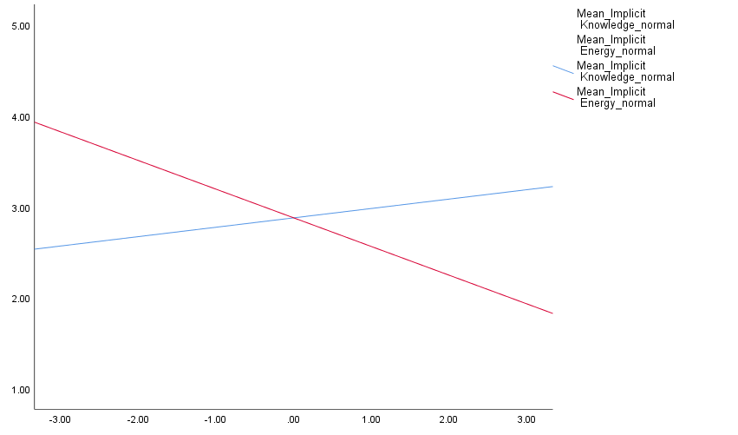
Mean score of implicit belief scale of willpower
Energy belief of TBM
Knowledge belief of TBM
Mean score of the three-belief scale
r = - 0.59, p < 0.001
r = 0.195, p < 0.001
Figure ‎5.3. The regression model (R²= 0.386) shows that the score of energy belief of TBM (red) had a negative correlation with the implicit belief scores, while knowledge (blue) had a positive correlation. TBM Scores were corrected for normal distribution (M = 0, SD = 1)

5.2.2.4.3. Correlating both tasks variables
Before regressing any of the behavioural variables with each other, their correlational web was investigated while controlling for age and gender (Appendix V.II; Table 2). A glimpse at the table indicates a predominant high negative correlation between all Stroop measures and the adjusted accuracy of both e-crossing task rounds (r = -0.4, p < 0.001). This means the higher the accuracy to perform the e-crossing task, the shorter time one needs to interact with the Stroop. It means, higher accuracy in performing the e-crossing task facilitates faster responses on the Stroop. Likewise, the accuracy of both rounds of the “e” task correlates positively (r = 0.42, p < 0.001), which posits that better practice on the first round facilitates better performance on the second.

5.2.2.4.4. Predicting behavioural performance
- The E-crossing task
A linear model was calculated where the TBM scores of each belief were the independent variables to predict the performance of the e-crossing task, and the dependent variable was the adjusted accuracy (AA). While controlling for the age, a regression model for the first round AA was significant (R² = 0.075, F(2, 377) = 13.750, p < 0.001). Only the energy was able to significantly predict the performance on round one (B = 0.115, SE = .05, β = 0.116, t = 2.315, p = 0.021). For round two, both age and gender were controlled for, while the process regression model of Hayes & Cai (2007) was used to correct for heteroscedasticity. In a significant model (R² = 0.055, F(5, 374) = 3.662, p = 0.003) only the energy was able to significantly predict round two performance (β = 0.106, SE = 0.051, t = 2.076, p = 0.038). The implicit belief score was not able to predict the adjusted accuracy of any round of the e-crossing task.

- The Stroop task
A regression model with the factor scores of the TBM as predictors and reaction time as the dependant variable was calculated while controlling for age and gender. Congruent and incongruent median and incongruent hM values were not predicted by any belief score. Only the hM of the congruent trials was predicted significantly (R² = 0.128, F(1, 376) = 4.513, p = 0.034) by the energy score in a negative correlation (B = -.106, SE = .050, β = -.106, t = -2.124, p = 0.034).

5.2.2.5. Scoring the three-belief scale
The scores of the questions of each belief in the TBM were mediated to get a score out of five. The belief that gets the highest score was labelled as the predominant belief for that participant. Thus, participants were grouped according to their predominant beliefs into four groups: energy, knowledge, skill, and the group that endorsed more than one belief were labelled “All”. A one-way ANOVA generated a model of comparison between the 4 groups for the e-crossing task adjusted accuracy, the Stroop response time and, the implicit belief scores. No significant differences were found between any groups in their Stroop performance. However, the model showed a significant difference in the e-crossing task for both the first round (F(3, 380) = 2.705, p = 0.045, d = 0.11) and the second round (F(3, 380) = 2.704, p = 0.045, d = 0.11). Post-hoc multiple comparisons showed significant differences between the knowledge and the energy groups for both rounds, where the energy group outperformed the knowledge in round one (d = 0.32) and round two (d = 0.3) (Appendix V.II: Table 3). Finally, the implicit belief scores were compared between the four groups, which yielded a significant ANOVA model (F(3, 381) = 7.318, p < 0.001, d = 0.11). Only the energy group was significantly lower than the other groups, which denotes endorsing the limited resources theory of self-control (Table 5.2).

Table ‎5.2. Comparison of the implicit belief scores between the energy group and the other three groups. Obtaining higher implicit belief scores denotes higher endorsement of the non-limited resources theory of self-control; growth mindset. The negative effect size denotes the opposite; higher endorsement of the limited-resources self-control; fixed mindset.
 | Mean IB | SD | N |  | Mean IB | SD | N | d
energy | 2.75 | 0.45 | 146 | knowledge | 3.05 | 0.47 | 129 | -0.6
 |  |  |  | Skill | 2.99 | 0.47 | 89 | -0.5
 |  |  |  | All | 3.01 | 0.55 | 21 | -0.5

5.2.3. Summary
The purpose of this particular study was to investigate whether the three-belief model (TBM) is able to predict the behavioural outcome of using two consecutive tasks: the e-crossing and the Stroop tasks. Among the other targets of the study was replicating the extracted factors of the TBM, and studying the relationship with the implicit beliefs scale of willpower IB. The extracted factors were an exact copy of those in the previous studies while the relationship with the IB was congruent with what was predicted that the energy and knowledge scores exhibited significant negative and positive correlations with the IB, respectively (R²= 0.386). Congruent with this correlation, it was hypothesised that the energy score to be negatively correlated with one or both tasks’ performance whilst the opposite for the knowledge. For the Stroop task, the energy was found negatively correlated with the performance of the congruent trials, in terms of harmonic mean, in small effect size (R² = 0.128), denoting that the higher the extent of believing in self-control as energy, the faster one gets in responding to the congruent trials. However, for the e-crossing task, the energy scores positively correlated with the accuracy of round one (R² = 0.075) and round two (R² = 0.055). The knowledge and skill models were unable to predict any behavioural outcome. Taken together, among the three beliefs, only energy was able to significantly predict the behavioural outcome of both tasks, yet, in small effect size and opposite to what was hypothesised.

Upon assigning the participants into groups based on the extent of believing in either belief model, significant behavioural differences were detected only between the knowledge and the energy groups for the e-crossing task. Again, contrary to what was expected, the energy group outperformed the knowledge on round one (d = 0.31) and two (d = 0.30). On the other hand, upon comparing the groups for the IB score, the results were significantly congruent with the hypothesis as the energy group obtained lower IB scores compared with the other groups (d ≥ 0.5) denoting more believing in a fixed mindset.

In summary, the extracted factor scores were replicated. The TBM scores relative to the IB were congruent to the hypothesis in larger effect sizes. The behavioural variables were predicted only by the energy belief; yet in small effect sizes. Against the hypothesis, energy correlated positively with both tasks’ performance; better e-crossing accuracy and faster congruent response time. Taken together, the TBM was better in predicting the performance of the e-crossing task than the Stroop.

As explained by the end of chapter 4, the inability of the TBM to predict the behavioural outcomes could be due to exogenous reasons (e.g. using a weak task) or endogenous ones (e.g. participants were not adherent to their beliefs) (see section 4.4). The current study assumed the model is sound endogenously and sought to investigate the predictability of the TBM by adopting different self-control tasks. Although the model predicted the behavioural outcome of the e-crossing task better than the FCT and the Stroop, the results were poor and against the hypothesis with negligible effect size values. This outcome suggests refusing the aforementioned assumption that the model is sound endogenously. The following explanation of the results can be offered: the participants exhibited small variations in the extent of believing in TBM beliefs that were not translated into significant behavioural differences. This assumption is supported by a side analysis that can be found in Appendix (V.IV). Upon estimating the best nonlinear curve between the energy score and round two accuracies in the e-crossing task, a cubic curve shows the best fit. The cubic function suggests that the predictability of the model depends on the extreme adoption of the energy belief in order to elicit higher behavioural differences. Accordingly, small to medium variations in lay beliefs would not be enough to elicit behavioural differences. We hypothesise that manipulating participants' beliefs towards forcefully adopting either of the TBM beliefs of self-control might create significant behavioural differences between the groups.

5.3. Study 2
The poor prediction of the behavioural results achieved by the TBM model in the previous study was theorized to be due to a reduced overall adoption of either of the three beliefs of the TBM by the participants. To test this explanation the next experiment will actively manipulate participants to adopt either of the TBM beliefs of self-control. The exact behavioural methodology of the first study will be pursued; however, participants will be categorized into 3 groups, each will be shown a different manipulation text to suggest a certain belief of self-control. Instead of recruiting 300-400 participants, which is a rule of thumb for factor analysis, a different methodology will be adopted. Based on a power analysis, a smaller number of participants will be recruited. Instead of running a factor analysis, the scores of the TBM will be calculated as the mean score for each belief item. The TBM scale will act as a manipulation check as we hypothesize that the group that will be shown the manipulation text (e.g. Energy) will get significantly higher scores in the corresponding belief (e.g. Energy). If found, we hypothesize that a significant intergroup comparison for the behavioural outcome of the e-crossing and the Stroop task will yield significant results.

5.3.1. Methods

5.3.1.1. Participants
Out of 123 participants who were invited to participate in this study using the database of Prolific Academic®, 100 participants completed the study, which was advertised as a study to investigate how personality traits influence behaviour. Nine participants were excluded based on their responses to the verification questions that were hidden within the TBM questionnaire at the end of the study. A final set of 91 participants were included in the final analysis (mean age = 34.9 years, SD = 13, 69.2 % are females). While 42.9% of the participants held a high school certificate as their highest qualification, 33% & 23.1% reported having the bachelor and the master’s degrees as their highest qualification respectively. While excluding those who participated in the previous studies, the inclusion criteria were the same as those of the previous study. Ethical approval was granted from the ethical committee of the Psychology Department at the University of Sheffield (no. 030873), which can be found in appendix (VI.IV).

5.3.1.2. Procedures
The methodology of the previous study was followed in this one with few exceptions. First, as the independent variable, participants were randomly and double blindedly assigned into 3 groups (Energy: 30, Skill: 30, and knowledge: 31) according to the manipulation texts they viewed. Thus, an extra-bit of a JavaScript code was used to mark each group (Appendix V.V). The manipulation texts were derived from the second study of Martijn, Tenbült, Merckelbach, Dreezens, & de Vries (2002). The TBM scale was used as a manipulation check at the end of the study and participants were not asked to fill in any other scale. The three texts had a very similar architecture while changing the necessary words for either belief as follows:

Energy: “Effortful tasks are those tasks where active control is needed such as emotional control and resisting impulses. Different strategies are adopted in order to perform well in those tasks; however, scientific investigations prove that a certain strategy is helpful in promoting self-control. Specifically, there is evidence that people need to be well-rested before engaging in effortful tasks. This is because applying active control has been found to be akin to Energy that depletes when used. Thus, performing well in effortful tasks is essentially about ensuring that you have enough energy to perform those tasks”

Knowledge: “Effortful tasks are those tasks where active control is needed such as emotional control and resisting impulses. Different strategies are adopted in order to perform well in those tasks; however, scientific investigations prove that a certain strategy is helpful in promoting self-control. Specifically, there is evidence that people need to acquire proper knowledge about how to perform the effortful tasks before being engaged in. This is because applying active control has been found to be akin to a schema that once learned it becomes fluent to practice. Thus, performing well in effortful tasks is essentially about ensuring that you have enough knowledge to perform those tasks”

Skill: “Effortful tasks are those tasks where active control is needed such as emotional control and resisting impulses. Different strategies are adopted in order to perform well in those tasks; however, scientific investigations prove that a certain strategy is helpful in promoting self-control. Specifically, there is evidence that people need to develop their skills by frequently practicing tasks where active control is needed. This is because applying active control has been found to be akin to a skill that requires some time to develop in the beginning, then it becomes fluent to practice. Thus, performing well in effortful tasks is essentially about ensuring that you have enough skills to perform those tasks”

5.3.1.3. The dependent variables
For the Stroop and the e-crossing tasks, the dependent variables are similar to those of the previous study. Before studying any of these variables, the manipulation must be established first, which will be assessed via comparing the groups for the mean score each group obtained for each belief on the TBM scale (alpha = 0.75). The independent variable is the participants' assigned groups based on the manipulation text they interacted with (energy, skill or knowledge).

5.3.1.4. Analysis Plan
The TBM scores will be compared between the groups as a manipulation check. After testing and correcting for the belief scores’ normality, the comparison test will be chosen to be either MANOVA, for normally distributed data or the Kruskal-Wallis test, for non-normally distributed data. If significant, further analysis will be conducted to test for corresponding intergroup differences in the behavioural outcome of the Stroop and the e-crossing tasks (Figure 5.4).
Calculating the score of each belief
Significant?
Stop
ANOVA/KW
Manipulation X Belief
Groups
ANOVA/KW
Behaviour X Manipulation
Stroop ST
E-Task accuracy
Correlational studies
Yes
No
DV
IV
DV
IV
Figure ‎5.4. The analysis plan of study 2. KW stands for Kruskal-Wallis test.

5.3.2. Results
As the calculated beliefs scores were found non-normally distributed using the Shapiro-Wilk test, the non-parametric Kruskal-Wallis test was used to test for the hypothesis. Results suggest retaining the null-hypothesis for the intergroup differences for either group (Skill: H(2) = 0.815, p = 0.665 / Knowledge: H(2) = 0.402, p = 0.818 / Energy: H(2) = 3.015, p = 0.221).

5.3.3. Summary
This study aimed to manipulate the participants to adopt either of the belief models of self-control and to investigate whether this manipulation would affect their behavioural outcome. Upon checking for the manipulation using the TBM scores, no significant intergroup difference was detected. Despite being non-significant, another look at the mean score each group obtained of each belief revealed a trend that follows our hypothesis, except the knowledge score (Table 5.3). Keeping in mind that the skill and the knowledge were found to be correlated (r < 0.3), there is still an opportunity to detect changes congruent with the hypothesis. Thus, before drawing a final conclusion, a final stronger manipulation paradigm shall be implemented.

Table ‎5.3. Shows a trend of data towards confirming the manipulation regardless of the insignificant between-group differences. Each manipulated group towards a certain belief obtained the highest score in that belief except for the knowledge. There is still a needle-slit chance to detect these differences significantly if a stronger paradigm is implemented.
 | Energy score | Skill score | Knowledge score
Energy group | 3.49 | 3.30 | 3.23
Skill group | 3.31 | 3.48 | 3.36
Knowledge group | 3.22 | 3.46 | 3.32

5.4. Study 3
In this study, stronger manipulation will be used. Inspired from Vohs & Schooler (2008), instead of showing participants texts from an already written book by a Nobel Laureate, an abstract for a scientific journal article will be mocked-up to look like as it was published in Science®. The previously used manipulation texts in study 2 will be used, however, with minor amendments to look like an abstract with introduction, methods, and conclusion. The purpose is to confirm whether the manipulation, in study 2, was not potent to influence participants’ behaviour, mediated by endorsing a different belief model of self-control. The hypothesis of Study 2 stays as it is: the group that was shown the manipulation text (e.g. Energy) will get significantly higher scores in the corresponding belief (e.g. Energy) on the three-belief scale. If found, we hypothesize that a significant intergroup comparison for the behavioural outcome of the e-crossing and the Stroop tasks will yield significant results.

5.4.1. Methods

5.4.1.1. Participants
220 participants were invited to take part in the study which was advertised through Prolific Academic® as a study to investigate how personality traits influence behaviour. Participants were offered £3 upon completing the study within one session. Those with colour blindness and/or dyslexia were filtered out, as well as those who participated in the previous studies and those whose English is not their first language. Participants who usually wear glasses were encouraged to keep them on for the duration of the study. All the participants were informed that the study should be carried out on a personal computer as a filter was used to prevent running the study on other smart devices. 121 participants completed the study within a mean duration of 29.87 min (SD = 9.2 min). Two participants were removed from the final analysis based on their Stroop performance as they got the lowest two accuracies on the incongruent trials (70% & 0%), while the minimum Stroop accuracy was 89% & 100% for the incongruent and the congruent trials, respectively. Three participants were removed for not answering the manipulation questions (see next section). For the e-crossing task, five participants were removed for obtaining negative accuracy on either round of the task. A final set of 111 participants were included in the final analysis (mean age = 35.8 years, SD = 11.37 years, 64% are females). The highest qualification for 39.6% of the participants was the high school certificate. 38.7% of the participants hold Bachelor’s degrees, while 17.1% have higher qualifications. The study was approved by the ethical committee of the Psychology Department at the University of Sheffield (no. 030873), which can be found in appendix (VI.IV).

5.4.1.2. Procedures
Similar to Study 2, participants were pseudo-randomly and double blindedly assigned to either of the three groups (Energy: 35, Skill: 34, Knowledge: 42). In the beginning, the manipulation texts were displayed for as long as needed. The manipulation texts were mocked up to look like abstracts from Science®, each endorsed a belief of the TBM (Fig 5.5, 5.6, 5.7). Next, participants were required to answer a set of four multiple-choice questions about the fabricated abstracts (Table 5.4). These “contextual questions” aimed to make the manipulation more potent and to make sure that those who read it understood the context correctly (e.g. being well-rested/skilful/knowledgeable significantly impacts: a. the ability to perform self-control tasks b. people’s ability to sleep c. wellbeing). Participants had to answer all four questions correctly in order to continue with the study. Those who failed to answer all the questions correctly were directed back to read the manipulation text for at least 30 seconds before they could try answering the questions again. The three choices of each question were ordered randomly every time a participant visited them. For technical reasons, there was an upper limit of 20 trials before the study continued automatically either the questions were answered correctly or not. Only 3 participants passed that limit and they were removed from the final analysis. The rest of the study continued as it was described in Study 1.

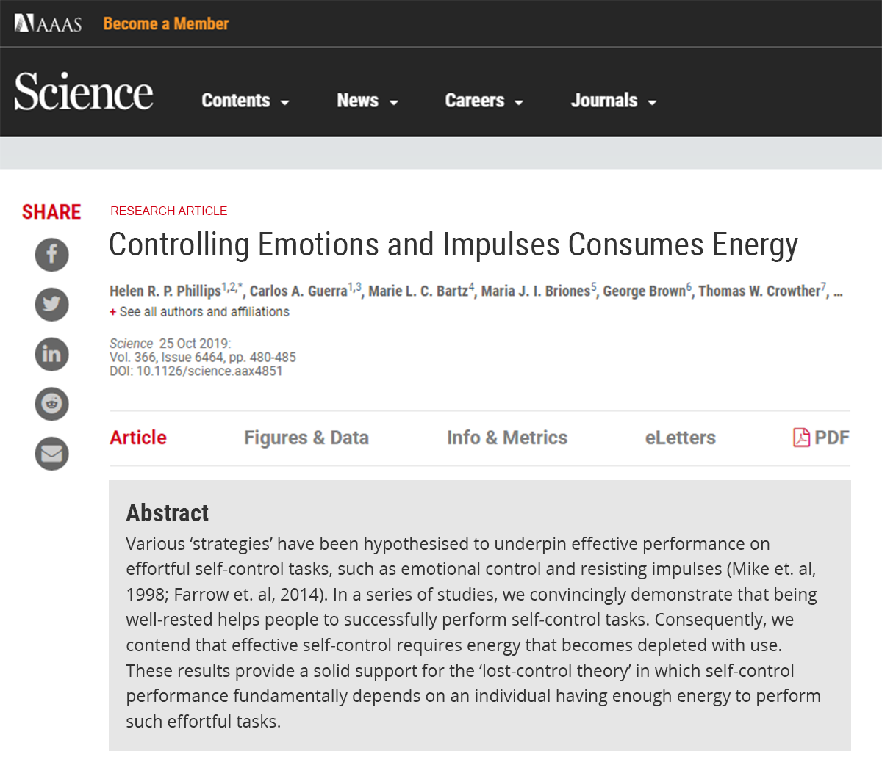
Figure ‎5.5. The mocked up Science paper that was used to manipulates participants’ beliefs towards viewing self-control as energy.
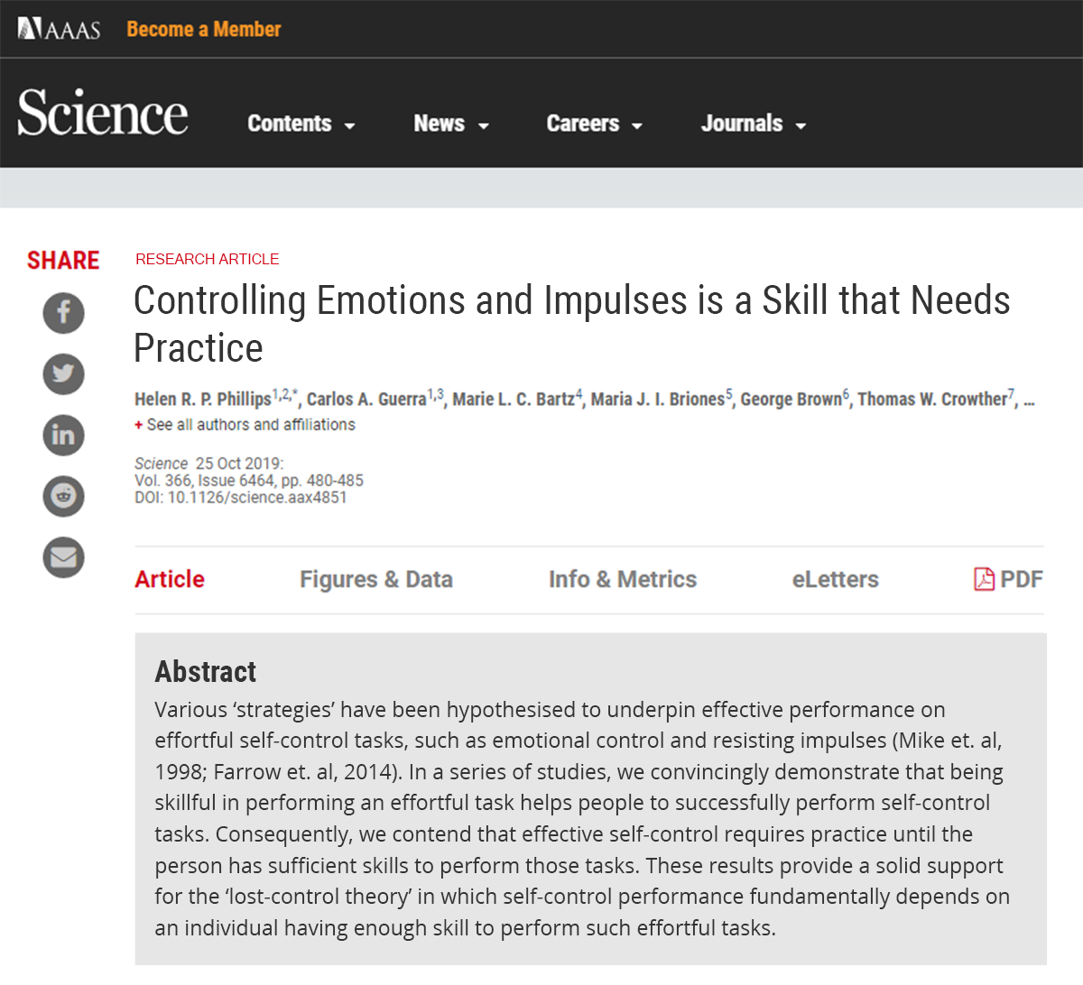
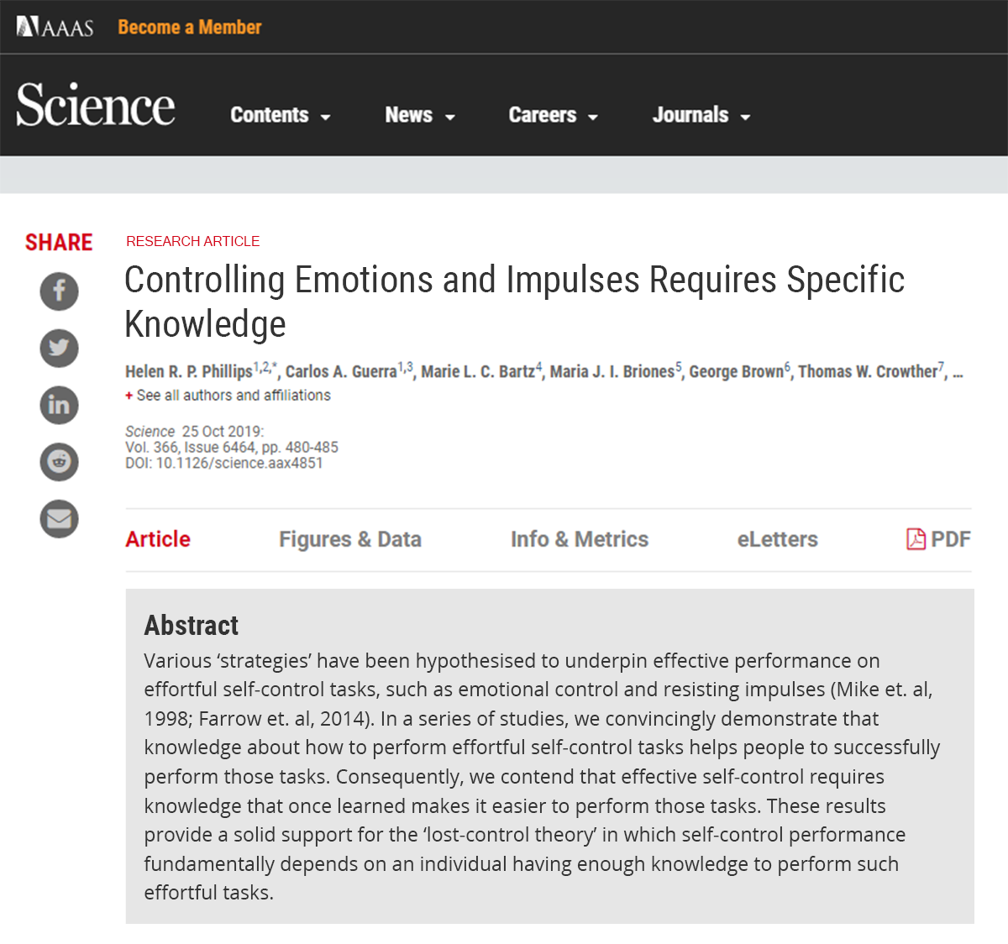
Figure ‎5.6 & Figure ‎5.7. The mocked up Science paper that was used to manipulates participants’ beliefs towards viewing self-control as knowledge and skill respectively.

Table ‎5.4. The multiple-choice contextual questions. that were answered by the participants every time after the manipulation texts were displayed. The words in bold were used according to the intended belief model for that participant.
1 | Out of the various strategies that have been hypothesized to underpin effective performance on effortful self-control tasks, how many were discussed in the abstract?
 | 1 | 2 | 3
2 | Being (well-rested/skilful/knowledgeable) significantly impacts:
 | The ability to perform self-control tasks | People’s ability to sleep | Well being
3 | The paper stated a certain theory where having enough (energy/skill/knowledge) is fundamental to successfully perform self-control tasks. This theory is:
 | Lost-control theory | Active-control theory | Passive-control theory
4 | Having enough (energy/skill/knowledge) is essential to perform:
 | Both self-control & effortful tasks | Effortful tasks | Self-control tasks
.

5.4.1.2. Analysis Plan
The dependant variables are the adjusted accuracy (AA) of the e-crossing task and the median (Mdn) & the harmonic mean (hM) of both congruent and incongruent Stroop trials. The independent variable is the participants' assigned groups based on the manipulation text they interacted with (energy, skill or knowledge). First, as answering the contextual questions is crucial for the manipulation, the need to control for the number of trials to answer these questions will be investigated. Second, the TBM scores (alpha = 0.769) will be calculated, as the mean score of each belief item, and compared between the groups as a manipulation check. After testing for the normality of the data, the consecutive test will be chosen to be either MANOVA, for normally distributed data, or the Kruskal-Wallis test, for not normally distributed data. If significant, further analysis will be conducted to test for corresponding intergroup differences in the behavioural outcome of the Stroop and the e-crossing tasks. Finally, regardless of the outcome, a correlational analysis will investigate whether a relationship is established between the behavioural variables (Figure 5.8).

Calculating the score of each belief
Significant?
Stop
ANOVA/KW
Manipulation X Belief
Groups
ANOVA/KW
Behaviour X Manipulation
Stroop RT
E-Task accuracy
Control for number of trials to answer the contextual question
Correlational studies
Yes
No
DV
IV
DV
IV
?
Figure ‎5.8. The analysis plan of study 3. KW stands for Kruskal-Wallis test.

5.4.2. Results

5.4.2.1. Contextual questions
All participants answered the questions correctly within a mean of 4 trials (SD = 3.1 trials, min = 1 trial, max = 18 trials), while no significant intergroup differences were found (H(2) = 2.129, p = 0.345). In fact, the distribution of the number of trials had a high skewness of 1.76 (SE = 0.224) and a kurtosis of 4.11 (SE = 0.446) toward fewer trials (90% of the participants answered the four questions correctly within 8 trials, while 75% answered correctly within 6 trials). Having a non-significant intergroup difference is an indication that there is no need to control for the number of trials to answer the contextual questions.

5.4.2.2. Demographic data
The necessity to control for the age and the gender for the linear regression was studied. The bivariate correlational study revealed a significant correlation between the age and the Stroop variables (Appendix V.VI; Table 1). Whether gender is needed to control for was investigated using the Mann-Whitney test to compare the behavioural variables between males and females. Results showed a non-significant difference between males and females for all behavioural variables (Appendix V.VI; Table 1). In summary, only the age was controlled for Stroop variables.

5.4.2.3. Normality of the dependent variables
Shapiro-Wilk’s test indicated that skill, knowledge, and energy were not normally distributed (p < 0.01). all together with the behavioural dependent variables of the e-crossing and the Stroop tasks (Shapiro & Wilk, 1965). Consequently, the non-parametric test of Kruskal-Wallis will be used for testing the hypothesis.

5.4.2.4. Manipulation check
Kruskal-Wallis test supported the null hypothesis upon investigating the intergroup difference in skill (D(2) = 0.643, p = 0.752) and knowledge beliefs (H(2) = 1.683, p = 0.431), while rejecting the null hypothesis for energy (H(2) = 7.408, p = 0.025). A controlled pairwise comparison between the groups for the energy belief supported the null hypothesis except for the difference between the knowledge and the energy groups (U = 486, p = 0.011, effect size (ƞ²) = 0.08). Those in the energy group endorsed the energy belief (Mdn = 3.8, IQR = 1.0) higher than those in the knowledge group (Mdn = 3.2, IQR = 1.18). Other intergroup comparisons were non-significant.

5.4.2.5. Intergroup difference in behavioural practice
- The E-crossing task
Similar to study 1, the relative accuracy RA is a measure for compliance with the instructions while the adjusted accuracy AA is a measure for the performance. In both rounds, RA demonstrated very high figures (R1: M = 0.99, SD = 0.0002 / R2: M = 0.92, SD = 0.17), endorsing a high engagement with both tasks. Congruent with study 1, AA was much lower on both tasks (R1: M = 0.54, SD = 0.23 / R2: M = 0.57, SD = 0.16). Insignificant intergroup differences were found using non-parametric tests for both rounds adjusted accuracy (round one AA: H(2) = 3.039, p = 0.219; round two AA: H(2) = 2.929, p = 0.231).

- The Stroop task
Similar to study 1, the Stroop response time was aggregated as Median and harmonic mean for the congruent and the incongruent trials. Hypothesis tests revealed insignificant inter-group differences (Appendix V.VI; Table 2).

5.4.2.6. Correlational studies
Upon correlating the variables of both tasks using Pearson’s coefficient, the AA of both rounds was negatively correlated with both the median and the harmonic mean of both Stroop trials consistent with the results of the first study (r = -0.5, p < 0.001). This suggested that the higher the accuracy in practising both rounds of the e-crossing task, the shorter it takes to respond to either Stroop trials. Likewise, the accuracy of both rounds of the “e” task correlates positively (r = 0.44, p < 0.001), which posits that better practice on the first round facilitates better performance on the second (Appendix V.VI; Table 3). This replicates the result of study 1.

5.4.2. Summary
Study 3 aimed to investigate whether the non-significant effect of our manipulation in Study 2 was because of using an underpowered manipulation method. It was posited that a fabricated Science® abstract, inspired by the design of Vohs & Schooler (2008), could be superior at manipulating participant’s beliefs about the nature of self-control and consequently influence their behaviour. The results show an almost insignificant effect of the manipulation of participants’ beliefs except among those who were manipulated to believe that self-control is energy and those who believe that self-control is knowledge. Their difference was significant only for the energy score with a very small effect size (ƞ²= 0.08), meanwhile, no significant behavioural interaction was found between these two groups. Despite being non-significant, the results trend is in favour of the one-tail hypothesis (Table 5.5).

Table ‎5.5. Shows a trend of data towards confirming the manipulation regardless of the insignificant between-group differences. Each manipulated group toward a certain belief obtained the highest score in that belief except for the knowledge, similar to study 2.
 | E score | S score | K score
Energy | 3.66 | 3.30 | 3.38
Skill | 3.43 | 3.36 | 3.35
knowledge | 3.23 | 3.35 | 3.38

5.5. Chapter Discussion
Throughout three studies, this chapter sought to investigate whether the TBM is able to predict self-control behaviour in two consecutive tasks: the e-crossing and the Stroop tasks. The first study concluded that among the three beliefs (energy, skill, & knowledge), only the energy score was able to predict the behavioural outcome for both tasks with negligible effect sizes, yet opposite to the hypothesis. Upon attributing this result to poor adoption of either belief by the participants, the second study sought to manipulate participants' beliefs about self-control using texts derived from previous studies. As this manipulation method yielded no significant differences in beliefs, which were measured through the TBM scale, the third study implemented another manipulation method by using a mocked-up scientific article to give credibility to the manipulation. Despite obtaining a significant difference in the TBM scale score between the energy and knowledge groups, no corresponding between-group significant behavioural differences were exhibited. In summary, the TBM was found poorly correlated with the outcome of the behavioural tasks chosen to represent the act of self-control.

As discussed at the end of chapter 4, the poor TBM prediction of the behavioural outcome was explained by two possible reasons. 1) Exogenous reasons which include using a weak self-control task. 2) Endogenous reasons which were formulated in three scenarios: a) the TBM beliefs are not fundamental for people’s perceptions about self-control, b) the developed scale was not asking the correct questions that reflect how people perceive self-control, c) people are not firmly adherent to these beliefs. The first study assumed the model is sound endogenously, and adopted a different self-control task, compared with the FCT which was used in chapter 4, and concluded that the TBM poorly predicted the behavioural outcomes. The second and third studies assumed that the model is sound exogenously, but not endogenously as people are not adherent to their adopted beliefs. Accordingly, participants’ beliefs were manipulated to adopt the three beliefs of the TBM, which found negligible manipulation effect, plus no concomitant significant behavioural changes. Nevertheless, the model exhibited a highly significant correlation with other forms of reported self-control measures; namely self-control trait, Grit, and willpower implicit belief scales. The chapter concludes that the model poor prediction of behavioural results can be attributed to both exogenous and endogenous reasons where: 1) exogenously, tasks might not represent self-control as they were theorized to be, 2) endogenously, despite being able to correlate significantly with other reported self-control measures; yet, the model was unable to predict any behavioural outcomes.

From one side, the reduced correlation between the reported and the behavioural measures of self-control can be explained by the extent of scale predictability. In a meta-analysis of the studies that used the Brief Self-control Scale, it was found that the scale had much more predicting power to tasks that can be labelled as “automatic” than those that can be labelled as “controlled” (de Ridder, Lensvelt-Mulders, Finkenauer, Stok, & Baumeister, 2012). Baumeister (2016, p. 11) further clarified that these “automatic” tasks are those that can be described as habits, where long-term self-control practice is taking place, which is completely different to tasks of resisting a momentary temptation or controlling a certain impulse at a certain moment of time such as the Stroop task. The results could be seen from the same angle for the prediction of the Stroop, the FCT and the e-crossing results by the TBM scale.

From another side, the reduced correlation between the reported and the behavioural measures of self-control was demonstrated in many studies (Allom et al., 2016; Dang, King, & Inzlicht, 2020; Saunders, Milyavskaya, Etz, Randles, & Inzlicht, 2018). Saunders et al. (2018) used Bayesian and a mini-meta analysis to demonstrate that the behavioural outcome of self-control tasks; namely the Stroop and Flanker tasks, were found weakly and meaninglessly associated and the reported measures of self-control; namely the self-control trait scale. Three reasons were postulated to explain this mismatch. 1) The definitional and conceptual ambiguity in defining the construct of self-control lead to an operationalization mismatch between the concept and the canonical practice of self-control. 2) The self-reported measures and the experimental tests of self-control assess different underlying processes. 3) If a relationship was found between practising self-control and its reported measures, then one should not take for granted that this result can be generalized. Congruently with these explanations, Dang et al. (2020) offered a critique of the fundamental differences between the self-reported and behavioural measures of self-control in three points. 1) Behavioural measures rely on structured and unusual stimuli that were designed for lab-controlled environments, while psychometric reported measures rely on real-life situations. 2) Behavioural measures are based on actual performance such as reaction time, while self-reported scales are based on subjective perception. 3) Behavioural measures rely on maximum performance, whereas self-report measures are based on typical performance. Such behavioural-construct mismatch was termed as Jingle-Jangle fallacy in literature to describe that things that might sound similar, could in fact differ fundamentally, similar to words jingle and jangle (Saunders et al., 2018). Accordingly, in spite of having a self-control scale, it might in reality measure something that has nothing to do with self-control. This is a hot area of research nowadays.

In a summary, this chapter’s results could be explained as follows: despite having an established relationship between the TBM and the Brief Self-control Scale, this association might not have any meaningful behavioural consequences using short-term self-control tasks such as the Stroop task for the reasons that were explained in the aforementioned paragraph. This argument is extended to include short term ecologically validated tasks such as the FCT and the e-crossing tasks.

General Discussion

CHAPTER 6

6.1. Thesis Summary
The proposed purpose of this project was to investigate the neural correlates of ego depletion in an fMRI study, altogether with manipulating implicit beliefs about willpower (mindset theory of willpower). Three challenges were identified that needed to be overcome before running the study: a) the considerations of designing fMRI studies, b) the reduced replication of ego depletion, and c) the lack of reliable neuroimaging literature in studying the mindset theory. After a preliminary series of studies, aiming to validate the behavioural paradigm, the latter yielded non-significant between-group differences and failed to replicate neither ego depletion, nor the effect of mindset manipulation.

To investigate the concept of self-control away from the limited resources theory, a model was proposed where three beliefs were theorized to shape how people perceive their self-control abilities, and accordingly their behaviour: believing self-control ability is akin to energy, skill, or knowledge. Derived from Baumeister et al. (1998), a list of 30 items representing the three beliefs were tested on a large sample and analysed using the methods of exploratory factorial analysis supported the proposed idea, and a three-belief model (TBM) was established. To avoid biased results, the data were collected again in two different studies and the TBM model was replicated and validated using the methods of confirmatory factor analysis. The TBM correlation with self-reported and behavioural self-control measures was investigated. Four studies concluded that the TBM could highly predict the results of other reported self-control measures; namely the self-control trait, the Grit, and the willpower implicit beliefs scales, yet, the TBM predictability of the behavioural outcome of the implemented self-control tasks (food cues, Stroop, and e-crossing tasks) was heterogeneous and almost non-significant.

The project concludes the following: 1) ego depletion was found hard for replication, 2) A model of three beliefs about self-control exhibited: a) excellent predictability of other reported self-control measures, b) was unable to significantly predict the behavioural results, c) beliefs were not equal in their affinity to correlate with other self-control measures. Each of these conclusions will be discussed.

6.2. Why ego depletion becomes difficult for replication?
Consistent with the literature, the thesis concluded that ego depletion was found hard for replication. Heterogeneous values of effect sizes were postulated in many meta-analyses and their revisions: d =0.62 (Hagger et al., 2010); d = (-0.1, 0.25) (Carter & McCullough, 2014); g = (0.43, -0.27, 0.003) (Carter et al., 2015), d = 0.64 (Blázquez, Botella, & Suero, 2017); ﻿g = 0.24 (Dang, 2018). Preregistered replication reports (RRR) were proposed as a resolution to this conflict and yielded heterogeneous results ranging between close-to-zero to small effect sizes (Dang et al., 2019; Hagger & Chatzisarantis, 2016; Vohs & Schmeichel, 2018). Many small studies continued to obtain heterogeneous results ranging from supporting the null hypothesis (Carruth, Ramos, & Miyake, 2018; Etherton et al., 2018; Lurquin et al., 2016), or refusing the null hypothesis of ego depletion (Dang et al., 2017; Garrison et al., 2019; Sjåstad & Baumeister, 2018), in various effect size values. These results can be attributed to methodological and conceptual explanations.

Methodologically, the inconsistency in obtaining the ego depletion can be explained by the inconsistency in selecting and implementing the self-control tasks and the manipulation measures. The decision to select a task to represent self-control was an arbitrary decision in many studies (Lurquin & Miyake, 2017). In most of the studies, tasks were not culturally and/or ecologically validated (Baumeister, 2019), as ego depletion was found modifiable by cultural differences (Savani & Job, 2017). While most of the studies were designed to capture a between-subject depletion effect, others were designed for a within-subject effect (Lin et al., 2019). As explained in section (3.5) in chapter 3, there is no consensus on how the manipulations are allocated and how the experimental conditions are checked. The length of the tasks, as well as the interval between them, were not standardised, as they were not stated in falsifiable assumptions (Friese et al., 2019).

Another methodological explanation of the reduced replication of ego depletion is running underpowered studies. In a unique study, Vadillo (2019) used the effect sizes of three meta-analyses of ego depletion; namely (Carter et al., 2015; Dang, 2018; Hagger et al., 2010) to run a meta-regression model between the effect sizes and the publication year of their corresponding studies, which were recruited in the three meta-analyses. It was found that the effect sizes of ego depletion were significantly and negatively correlated with the publication year of their corresponding studies. This significant decline effect of ego depletion was explained by the increased power of the consecutive studies due to recruiting more people (increasing the sample size) and relying on preregistration, which reduced the p-hacking practices.

Conceptually, the limited resources theory was criticized, in many studies, for its wholistic, homunculus-based arguments and its lack of falsifiable premises (Friese et al., 2019; Inzlicht & Berkman, 2015; Inzlicht & Friese, 2019; Lurquin & Miyake, 2017). A shared question among all these studies is what is the nature of these limited resources? And whether utilising these resources could be mechanically described in a falsifiable theory, where negative results should be established upon testing the reversed assumptions. Similarly, the logic of the limited resources theory was criticized for suffering from bias such as circular logic and begging the question. As a summary, the theory of limited resources contains the seeds of its perplexed findings. Vigorous methodological and conceptual revisions are required in order to find a fertile line of investigation. The thesis contributed in offering a better way of understanding the concept of self-control from a belief viewpoint.

6.3. What are the implications of the TBM correlational findings?
The overall outcome of correlating the TBM with other self-control measures was the exhibition of a different predicting power by each belief among the TBM. The energy belief was able to predict the other self-control measures better than the skill and knowledge beliefs, yet, in small effect sizes for behavioural measures and bigger for the reported ones. This result cannot be compared with others in the literature as the studies that investigated the effect of beliefs on self-control used a different dualism of beliefs: malleable vs not malleable self-control resources (Job et al., 2010); or believing self-control as energy versus a state-of-mind (Martijn et al., 2002). These studies were heavily influenced by the limited resources model of self-control, which considered self-control akin to energy. Consequently, this shifted the studies away from investigating whether the variability in self-control can be attributed to more than one belief and whether these beliefs would have the same weight to explain this variability; indeed, this was the scope of the studies in chapter 4 and chapter 5.

The superiority of energy to correlate with other self-control measures could be explained as energy yielded the highest factor scores among the other beliefs in the factor analysis, which was replicated twice throughout the last two chapters. So far, two explanations could be offered: a) these high factor scores were due to the contextual formation of the energy questions which were copied from Martijn et al., (2002), b) an innate high influence of the energy-related ideas to affect the behaviour. This last point endorses a similar idea to the scarcity-related scenarios that were described by Mullainathan & Shafir (2013) (see chapter 1). They proposed certain ideas, and perceptions could have a different cognitive bandwidth taxation on the limited attentional processes and, in turn, the behaviour. Consistently, a growing trend in self-control literature started to explain the instances of self-control failure using the idea of the perception of efforts instead of the efforts themselves, where efforts require energy (Baumeister, 2016; Inzlicht & Berkman, 2015; Inzlicht & Schmeichel, 2012; Kurzban et al., 2013; Pattyn, Van Cutsem, Dessy, & Mairesse, 2018).

The perception of efforts as a mediator, among many, of action monitoring and self-control was proposed in three different models. 1) Energy monitoring model proposes that the body watches over the energy expenditure and decides whether to continue burning more fuel or change the burning rate based on: the necessity to perform a certain task, the physiological reserve, and/or how harmful it is to the body such as harsh exercises (Baumeister, 2016; Evans, Boggero, & Segerstrom, 2016). These monitoring functions were referred to the so-called “central governor” (Noakes, Gibson, & Lambert, 2005), which is proposed as a central construct within a general theory to explain the physiological and the psychological types of fatigue in energy monitoring terms. Accordingly, as physiological fatigue occurs when the available energy reserve, in a form of adenosine-tri-phosphate molecules, depletes or is not being able to be utilized for a variety of reasons, the psychological fatigue is construed as a resources allocation process without referring to why some tasks are being “perceived” more effortful than others.

In contrast, another model explains the perception of efforts subjectively as, 2) the taxation of the effort of performing mental cost/benefit computations (Kurzban et al., 2013), which was introduced in chapter 1. Compared to the energy monitoring, the cost/benefit model presumes that the executive functions can process a certain number of tasks simultaneously, and the computations of the cost and benefits of any given task are resource-demanding on their own, without referring to any physiological reserve and/or monitoring. In contrast, 3) the theory of perceived efforts takes into account the perception of efforts, regardless of any concomitant biological and computational processes (Pattyn et al., 2018). The theory was proposed as a general theory to offer an explanation of ubiquitous phenomena starting from self-control, sport, and mental performance. It considers the perception of fatigue independent from any utilised physiological resources (Hutchinson & Tenenbaum, 2006), rather the idea of fatigue has its own innate mental weight away from any computations. As a summary, it can be construed from the TBM correlational finding that beliefs have different taxation weight over the attentional limited window. This idea requires further investigation of its physiological and psychological implications.

6.4. Future directions
The studies described in this thesis covered two main topics: the replication of ego depletion and the implications of belief on self-control. As such, different lines of investigation could be pursued in order to ask original questions and/or following older ones while building a framework to understand the big picture in this area of research.

A line of investigation is studying whether self-control limitations, represented in ego depletion, is a form of fatigue that can be influenced physiologically and/or psychologically. Recently, ego depletion was captured significantly in two studies using an antisaccade task, which demonstrated ego depletion in small to moderate effect sizes: g = 0.48 (Dang et al., 2017), g = 0.12 (Dang et al., 2019). Selecting an antisaccade task encompasses utilizing the easily fatigable eye muscles to examine ego depletion. To investigate the influence of muscle fatigability on ego depletion, other groups of muscles should be used and compared to the eye muscles. Other groups of muscles were utilized before in different ego depletion studies, examples are the handgrip task (Martijn et al., 2002), and standing on one leg task (Webb & Sheeran, 2003). Thus, in 2 X 2 research design, the influence of the physical fatigue on ego depletion shall be investigated (high versus low fatigable muscles X ego versus no ego depletion). The perceived fatigue should be controlled for using the psychometric measures (Hutchinson & Tenenbaum, 2006), whereas the guidelines to minimize the behavioural-reported mismatch should be followed (Dang et al., 2020).

Another possible future direction is following up on the TBM correlation with the reported self-control measures. It was found that the self-control trait scale was better in detecting the outcome of long-term self-control habits than the outcome of short-term self-control tasks (Baumeister, 2016). As the TBM was able to correlate with the Brief Self-control Scale, whether the TBM is able to predict the long term self-control behaviour is a question to be followed.

Another line of investigation is studying the implication of defining a certain belief model. As Wittgenstein (1921) argued that most of the philosophical dilemmas originate from lingual perplexities, likewise, a definition of a certain belief is perplexed by the canonical lingual meaning of that belief. As such, if self-control is viewed as “energy”, similar to the TBM, the next question is: could a synonym of the word “energy” (e.g. power, stamina, or strength) be considered a different belief model, or a part of the same “energy” model. Answering this question will highlight whether there is a finite number of beliefs or constructs that can be established to understand a certain phenomenon. This could be investigated through forming questions reflecting three, or more, possible belief models of self-control, where the synonyms are used to title each model. Factor analysis, similar to chapter 4, would help to realise whether different or similar models could be established.

Referring to the aforementioned decline effect captured in ego depletion (Vadillo, 2019), an orthodox explanation was offered for this decline as bigger sample sizes are recruited and fewer p-hacking practices were adopted. Despite using other explanations, this decline effect was observed in many other areas in psychology, notably in intelligence, and in reaction time (Woodley, Nijenhuis, & Murphy, 2013). This decline was linked with the long-term change in social norms and perspectives. Investigating whether ego depletion was influenced sociologically requires the utilization of non-linear and dynamic modelling methods to correlate ego depletion with different sociological measures meta-analytically. I tried to offer an explanation of the reduced replication of ego depletion caused by an endogenous change in people’s abilities overtime by designing the following thought experiment:

“In 1889 a phenomenon was described called the Rebounded Probabilistic Accuracy (RPA). It describes that the accuracy to perform a test is inversely proportional to the speed of presenting stimuli to participants until 220ms when the relationship is inverted to be directly proportional. This was explained as after that speed the accuracy becomes probabilistic and this increases the chances of accuracy to approach 50 percent. This phenomenon has been proved to be replicable; however, by 1920 it became difficult to be replicated for unknown reasons. Later, it was discovered that upon tracking the historical data there was a fundamental change in people's response time. This should not be an issue if the change took place in a homogeneous rate for all the population, as the rebound will be manifested on a slower speed (e.g. 250ms). Rather, the change in speed was heterogeneous which could markedly reduce the likelihood to obtain higher effect size and significant results. On the other hand, if we assume that people's response time is always changing, then the discovery of the effect was a probability on its own. Further, if the moment of discovering the phenomenon was marked as zero, then the chances to capture the effect will always decrease as moving further away from the moment of discovery”

6.5. Limitations
Although progress was made towards understanding the concept of self-control beyond the limited resources theory, there are nevertheless conceptual and methodological limitations that must be considered upon trying to inform the results to widen the current knowledge.

Conceptually, upon investigating ego depletion in chapter 3, the main conception that shaped selecting the task was viewing self-control as more than just being a response inhibition, which was proposed as a candidate to explain the reduced replication odds of ego depletion. However, the literature identified other critical issues that were discussed earlier in the chapter to explain why ego depletion becomes difficult for replication. Thus, the obtained results are limited by the task choice and the types of beliefs that were manipulated.

Methodologically, upon piloting the food and comparison pictures, the target was to ecologically validating the task to suit the target population of the behavioural study, which was supposed to be the university students. However, as recruiting participants was not an easy-going process, 47.5% of the recruited participants for the behavioural study were from outside the university. Nevertheless, pictures were described as highly tempting by all participants at the end of the study.

Regarding the three-belief model, despite being adapted from the alternative explanations to ego depletion that were offered by Baumeister et al (1998), there is no referral of the original source of these model, except the energy model that was predicted in a previous article (Baumeister & Heatherton, 1996). Also, as the model’s correlation with other self-control measures was confined to reported measures (Brief Self-control scale, Short Grit Scale, & the scale of the implicit beliefs about willpower) and behavioural measures (FCT, Stroop task, e-crossing task) of self-control, meaningful information cannot be informed and generalised without excessive testing with other self-control tasks.

Methodologically, as the TMB was investigated used an online study design, such results are not fully accountable unless another study will be conducted in a controlled laboratory environment. Alternatively, the newly published online platform of PsychoPy would have been an invaluable tool for running behavioural studies as Qualtrics® is not superior in capturing the behavioural data.

Regarding chapter 5, despite implementing powerful studies, the sample size of the second and the third studies was not convenient to carry on factor analysis to extract the factor scores. Instead, the scores were extracted based on calculating the mean score for each belief’s items. Also, many dependent variables were used without a specific and mechanical assumption of which should be focusing on. The modality of correlating all variables against each other to look for significant results is nothing but fishing for p-value. Nevertheless, the exploratory nature of the study would probably legitimise this methodology within the defined purpose.

6.6. Personal Reflections
As a medical doctor, studying self-control has come to be handful to augment my background in dealing with patients and withstanding the long working hours in hospitals. As self-control is defined in most of the literature as a domain that has numerous applications in a wide variety of field, I realised the importance of creating an environment where self-control limitations should be considered in terms of offering enough psychological support, and suitable means of leisure. It might be hard to claim that a certain model of self-control should be adopted, rather, the basic principles of the limitations of our abilities and the effect of people’s adopted mindsets should be respected. These principles greatly and positively influenced my personal life and helped in encouraging the spirit of resilience, and, “keep trying” to face the daily challenges.

Being involved within a hot area of research changed the heavenly utopic depicted picture of science I had. The frontiers of science is a place where new ideas are born and then killed brutally, unless it pass a thick buffer of strict revisions, tests, and a cacophony of conflicting arguments. The quietly flowing stream of scientific facts that can be traced in school books is actually the result of turbulent efforts and a huge amount of work that is hardly appreciated by normal people who usually believe simply that science is a “dogmatic” process that can be easily traced using objective mental deduction that is performed by "cool" individuals called scientists. Indeed, without vigorous investigations, delicate analysis, long working hours, and a lot of luck, nothing can be achieved. Being “cool” is not a quality to survive that kind of environments at all.
References
Ainsworth, S. E., Baumeister, R. F., Ariely, D., & Vohs, K. D. (2014). Ego depletion decreases trust in economic decision making. Journal of Experimental Social Psychology, 54, 40–49. https://doi.org/10.1016/j.jesp.2014.04.004
Allom, V., Panetta, G., Mullan, B., & Hagger, M. S. (2016). Self-report and behavioural approaches to the measurement of self-control: Are we assessing the same construct? Personality and Individual Differences, 90, 137–142. https://doi.org/10.1016/j.paid.2015.10.051
Appelgren, A., & Bengtsson, S. L. (2015). Feedback on Trait or Action Impacts on Caudate and Paracingulum Activity. PLOS ONE, 10(6), e0129714. https://doi.org/10.1371/journal.pone.0129714
Assinnari, A. (2015). Is Ego Depletion All in the Brain? An EEG Study. The University of Sheffield.
Baumeister, R. F. (2002). Yielding to Temptation: Self‐Control Failure, Impulsive Purchasing, and Consumer Behavior. Journal of Consumer Research, 28(4), 670–676. https://doi.org/10.1086/338209
Baumeister, R. F. (2016). Limited Resources for Self-Regulation: A Current Overview of the Strength Model. In E. R. Hirt, J. J. Clarkson, & L. Jia (Eds.), Self-regulation and Ego Control (First, pp. 1–20). London: Elsevier.
Baumeister, R. F. (2019). Self-Control, Ego Depletion, and Social Psychology’s Replication Crisis. PsyArXive, (4 September), 1–13. https://doi.org/10.31234/osf.io/uf3cn
Baumeister, R. F., Bratslavsky, E., Muraven, M., & Tice, D. M. (1998). Ego depletion: Is the active self a limited resource? Journal of Personality and Social Psychology, 74(5), 1252–1265. https://doi.org/10.1037/0022-3514.74.5.1252
Baumeister, R. F., & Heatherton, T. F. (1996). Self-Regulation Failure: An Overview. Psychological Inquiry, 7(1), 1–15. https://doi.org/10.1207/s15327965pli0701_1
Baumeister, R. F., Heatherton, T. F., & Tice, D. M. (1994). Introduction: Self-regulation in context. In R. F. Baumeister, T. F. Heatherton, & D. M. Tice (Eds.), Losing control: How and why people fail at self-regulation (First Edit, pp. 3–13). San Diego: Academic Press, Inc.
Baumeister, R. F., & Vohs, K. D. (2016). Misguided Effort With Elusive Implications. Perspectives on Psychological Science, 11(4), 574–575. https://doi.org/10.1177/1745691616652878
Baumeister, R. F., Vohs, K. D., & Tice, D. M. (2007). The strength model of self-control. Current Directions in Psychological Science, 16(6), 351–355. https://doi.org/10.1111/j.1467-8721.2007.00534.x
Benn, Y., Webb, T. L., Chang, B. P. I., Sun, Y.-H., Wilkinson, I. D., & Farrow, T. F. D. (2014). The neural basis of monitoring goal progress. Frontiers in Human Neuroscience, 8(September), 688. https://doi.org/10.3389/fnhum.2014.00688
Bernecker, K., & Job, V. (2015). Beliefs about willpower are related to therapy adherence and psychological adjustment in patients with type 2 diabetes. Basic and Applied Social Psychology, 37(3), 188–195. https://doi.org/http://dx.doi.org/10.1080/01973533.2015.1049348
Blázquez, D., Botella, J., & Suero, M. (2017). The Debate on the Ego-Depletion Effect: Evidence from Meta-Analysis with the p-Uniform Method. Frontiers in Psychology, 8. https://doi.org/10.3389/fpsyg.2017.00197
Blignaut, P. (2009). Fixation identification: The optimum threshold for a dispersion algorithm. Attention, Perception & Psychophysics, 71(4), 881–895. https://doi.org/10.3758/APP
Breusch, T. S., & Pagan, A. R. (1979). A Simple Test for Heteroscedasticity and Random Coefficient Variation. Econometrica, 47(5), 1287. https://doi.org/10.2307/1911963
Bugg, J. M., Jacoby, L. L., & Toth, J. P. (2008). Multiple levels of control in the Stroop task. Memory & Cognition, 36(8), 1484–1494. https://doi.org/10.3758/MC.36.8.1484
Bush, G, Shin, L. M., Holmes, J., Rosen, B. R., & Vogt, B. A. (2003). The Multi-Source Interference Task: validation study with fMRI in individual subjects. Molecular Psychiatry, 8(1), 60–70. https://doi.org/10.1038/sj.mp.4001217
Bush, George, Whalen, P. J., Rosen, B. R., Jenike, M. A., McInerney, S. C., & Rauch, S. L. (1998). The counting Stroop: an interference task specialized for functional neuroimaging--validation study with functional MRI. Human Brain Mapping, 6(4), 270–282. https://doi.org/10.1002/(SICI)1097-0193(1998)6:4<270::AID-HBM6>3.0.CO;2-0 [pii]
Carruth, N., Ramos, J., & Miyake, A. (2018). Does Willpower Mindset Really Moderate the Ego-Depletion Effect? A Preregistered Direct Replication of Job, Dweck, and Walton’s (2010) Study 1. PsyArXiv, 53.
Carter, E. C., Kofler, L. M., Forster, D. E., & McCullough, M. E. (2015). A Series of Meta-Analytic Tests of the Depletion Effect: Self-Control Does Not Seem to Rely on a Limited Resource. Journal of Experimental Psychology: General, 144(3). https://doi.org/10.1037/xge0000083
Carter, E. C., & McCullough, M. E. (2014). Publication bias and the limited strength model of self-control: has the evidence for ego depletion been overestimated? Frontiers in Psychology, 5(July), 1–11. https://doi.org/10.3389/fpsyg.2014.00823
Carter, E. C., Schönbrodt, F. D., Gervais, W. M., & Hilgard, J. (2019). Correcting for Bias in Psychology: A Comparison of Meta-Analytic Methods. Advances in Methods and Practices in Psychological Science, 2(2), 115–144. https://doi.org/10.1177/2515245919847196
Carver, C., & Scheier, M. (1982). Control theory: A useful conceptual framework for personality–social, clinical, and health psychology. Psychological Bulletin, 92(1), 111–135. https://doi.org/10.1037/0033-2909.92.1.111
Chow, J. T., & Lau, S. (2014). Nature Gives Us Strength: Exposure to Nature Counteracts Ego-Depletion. The Journal of Social Psychology, 4545(December), 1–16. https://doi.org/10.1080/00224545.2014.972310
Churchill, G. A. (1979). A Paradigm for Developing Better Measures of Marketing Constructs. Journal of Marketing Research, 16(1), 64. https://doi.org/10.2307/3150876
Costello, A. B., & Osborne, J. W. (2005). Best Practices in Exploratory Factor Analysis: Four Recommendations for Getting the Most From Your Analysis. Practical Assessment Research & Evaluation, 10(7). Retrieved from https://pareonline.net/getvn.asp?v=10&n=7
Dang, J. (2016). Testing the role of glucose in self-control: A meta-analysis. Appetite, 107, 222–230. https://doi.org/10.1016/j.appet.2016.07.021
Dang, J. (2018). An updated meta-analysis of the ego depletion effect. Psychological Research, 82(4), 645–651. https://doi.org/10.1007/s00426-017-0862-x
Dang, J., King, K. M., & Inzlicht, M. (2020). Why Are Self-Report and Behavioral Measures Weakly Correlated? Trends in Cognitive Sciences, 24(4), 267–269. https://doi.org/10.1016/j.tics.2020.01.007
Dang, J., Liu, Y., Liu, X., & Mao, L. (2017). The Ego Could Be Depleted, Providing Initial Exertion Is Depleting. Social Psychology, 48(4), 242–245. https://doi.org/10.1027/1864-9335/a000308
Dang, J., Zerhouni, O., Imhoff, R., Jia, L., Giacomantonio, M., Sevincer, A., … Schiöth, H. B. (2019). Multi-Lab Replication Reveals A Small but Significant Ego Depletion Effect. PsyArXive, January. https://doi.org/10.31234/osf.io/cjgru
Danziger, S., Levav, J., & Avnaim-Pesso, L. (2011). Extraneous factors in judicial decisions. Proceedings of the National Academy of Sciences of the United States of America, 108(17), 6889–6892. https://doi.org/10.1073/pnas.1018033108
de Ridder, D. T. D., Lensvelt-Mulders, G., Finkenauer, C., Stok, F. M., & Baumeister, R. F. (2012). Taking Stock of Self-Control: A Meta-Analysis of How Trait Self-Control Relates to a Wide Range of Behaviors. Personality and Social Psychology Review, 16(1), 76–99. https://doi.org/10.1177/1088868311418749
Duckworth, A., & Gross, J. J. (2014). Self-Control and Grit. Current Directions in Psychological Science, 23(5), 319–325. https://doi.org/10.1177/0963721414541462
Duckworth, A. L., & Quinn, P. D. (2009). Development and validation of the short Grit Scale (Grit-S). Journal of Personality Assessment, 91(2), 166–174. https://doi.org/10.1080/00223890802634290
Dweck, C. S. (2007). Mindset: The New Psychology of Success (First). Retrieved from https://www.penguinrandomhouse.com/books/44330/mindset-by-carol-s-dweck-phd/9780345472328/
Dweck, C. S., & Leggett, E. L. (1988). A social-cognitive approach to motivation and personality. Psychological Review, 95(2), 256–273. https://doi.org/10.1037/0033-295X.95.2.256
Dweck, C. S., & Molden, D. C. (2005). Self Theories, Their Impact on Competence Motivation and Acquisition. In A. J. Elliot & C. S. Dweck (Eds.), Handbook of Competence and Motivation (2005th ed., Vol. 77, pp. 122–140). Retrieved from http://books.google.com/books?hl=en&amp;lr=&amp;id=B14TMHRtYBcC&amp;oi=fnd&amp;pg=PA3&amp;dq=Handbook+of+competence+and+motivation&amp;ots=sr6Iw7fud4&amp;sig=ZwAJ61x5DZjsJ1Vh3Ndm0JW2Nyo
Emmerling, F., Martijn, C., Alberts, H. J. E. M., Thomson, A. C., David, B., Kessler, D., … Sack, A. T. (2017). The (non-)replicability of regulatory resource depletion: A field report employing noninvasive brain stimulation. PLoS ONE, 12(3), e0174331. https://doi.org/10.1371/journal.pone.0174331
Englert, C. (2016). The strength model of self-control in sport and exercise psychology. Frontiers in Psychology, 7(MAR), 1–9. https://doi.org/10.3389/fpsyg.2016.00314
Etherton, J. L., Osborne, R., Stephenson, K., Grace, M., Jones, C., & De Nadai, A. S. (2018). Bayesian analysis of multimethod ego-depletion studies favours the null hypothesis. British Journal of Social Psychology, 57(2), 367–385. https://doi.org/10.1111/bjso.12236
Evans, D. R., Boggero, I. A., & Segerstrom, S. C. (2016). The Nature of Self-Regulatory Fatigue and “Ego Depletion”: Lessons From Physical Fatigue. Personality and Social Psychology Review, 20(4), 291–310. https://doi.org/10.1177/1088868315597841
Eysenck, M. W. (1993). Principles of cognitive psychology (M. W. Eysenck, S. Green, & N. Hayes, Eds.). Hove, UK: Hove : Lawrence Erlbaum Associates Publishers, 1993.
Eysenck, M. W., & Keane, M. T. (2010). Cognitive psychology : a student’s handbook (6th ed.; M. W. Eysenck & M. T. Keane, Eds.). Hove & New York: Psychology Press, 2010.
Fabrigar, L. R., Wegener, D. T., MacCallum, R. C., & Strahan, E. J. (1999). Evaluating the use of exploratory factor analysis in psychological research. Psychological Methods, 4(3), 272–299. https://doi.org/10.1037/1082-989X.4.3.272
Ferguson, E., & Cox, T. (1993). Exploratory Factor Analysis: A Users’ Guide. International Journal of Selection and Assessment, 1(2), 84–94. https://doi.org/10.1111/j.1468-2389.1993.tb00092.x
Finkel, E. J., DeWall, C. N., Slotter, E. B., Oaten, M., & Foshee, V. A. (2009). Self-Regulatory Failure and Intimate Partner Violence Perpetration. Journal of Personality and Social Psychology, 97(3), 483–499. https://doi.org/Doi 10.1037/A0015433
Friese, M., Binder, J., Luechinger, R., Boesiger, P., & Rasch, B. (2013). Suppressing Emotions Impairs Subsequent Stroop Performance and Reduces Prefrontal Brain Activation. PLoS ONE, 8(4), 13–15. https://doi.org/10.1371/journal.pone.0060385
Friese, M., Engeler, M., & Florack, A. (2015). Self-perceived successful weight regulators are less affected by self-regulatory depletion in the domain of eating behavior. Eating Behaviors, 16, 5–8. https://doi.org/10.1016/j.eatbeh.2014.10.011
Friese, M., Hofmann, W., & Wiers, R. W. (2011). On taming horses and strengthening riders: Recent developments in research on interventions to improve self-control in health behaviors. Self and Identity, 10(3), 336–351. https://doi.org/10.1080/15298868.2010.536417
Friese, M., Loschelder, D. D., Gieseler, K., Frankenbach, J., & Inzlicht, M. (2019). Is Ego Depletion Real? An Analysis of Arguments. Personality and Social Psychology Review, 23(2), 107–131. https://doi.org/10.1177/1088868318762183
Fujita, K. (2011). On Conceptualizing Self-Control as More Than the Effortful Inhibition of Impulses. Personality and Social Psychology Review, 15(4), 352–366. https://doi.org/10.1177/1088868311411165
Gailliot, M. T., & Baumeister, R. F. (2007). Self-regulation and sexual restraint: dispositionally and temporarily poor self-regulatory abilities contribute to failures at restraining sexual behavior. Personality and Social Psychology Bulletin, 33(2), 173–186. https://doi.org/10.1177/0146167206293472
Gailliot, M. T., Baumeister, R. F., DeWall, C. N., Maner, J. K., Plant, E. A., Tice, D. M., … Schmeichel, B. J. (2007). Self-control relies on glucose as a limited energy source: willpower is more than a metaphor. Journal of Personality and Social Psychology, 92(2), 325–336. https://doi.org/10.1037/0022-3514.92.2.325
Garrison, K. E., Finley, A. J., & Schmeichel, B. J. (2019). Ego Depletion Reduces Attention Control: Evidence From Two High-Powered Preregistered Experiments. Personality and Social Psychology Bulletin, 45(5), 728–739. https://doi.org/10.1177/0146167218796473
Gino, F., Schweitzer, M. E., Mead, N. L., & Ariely, D. (2011). Unable to resist temptation: How self-control depletion promotes unethical behavior. Organizational Behavior and Human Decision Processes, 115(2), 191–203. https://doi.org/10.1016/j.obhdp.2011.03.001
Groves, R. (2018). Hermeneutics and Bayesian Statistics. Retrieved from The Provost’s Blog of Georgetown University website: https://blog.provost.georgetown.edu/hermeneutics-and-bayesian-statistics/
Guadagnoli, E., & Velicer, W. F. (1988). Relation of sample size to the stability of component patterns. Psychological Bulletin, 103(2), 265–275. https://doi.org/10.1037/0033-2909.103.2.265
Hagger, M., & Chatzisarantis, N. L. D. (2016). A Multilab Preregistered Replication of the Ego-Depletion Effect. Perspectives on Psychological Science, 11(4), 546–573. https://doi.org/10.1177/1745691616652873
Hagger, M., Wood, C., Stiff, C., & Chatzisarantis, N. L. D. (2010). Ego depletion and the strength model of self-control: a meta-analysis. Psychological Bulletin, 136(4), 495–525. https://doi.org/10.1037/a0019486
Hayes, A. F., & Cai, L. (2007). Using heteroskedasticity-consistent standard error estimators in OLS regression: An introduction and software implementation. Behavior Research Methods, 39(4), 709–722. https://doi.org/10.3758/BF03192961
Hutchinson, J. C., & Tenenbaum, G. (2006). Perceived effort - Can it be considered gestalt? Psychology of Sport and Exercise, 7(5), 463–476. https://doi.org/10.1016/j.psychsport.2006.01.007
Inzlicht, M., & Berkman, E. (2015). Six Questions for the Resource Model of Control (and Some Answers). Social and Personality Psychology Compass, 9(10), 511–524. https://doi.org/10.1111/spc3.12200
Inzlicht, M., & Friese, M. (2019). The Past, Present, and Future of Ego Depletion. Social Psychology, 50(5–6), 370–378. https://doi.org/10.1027/1864-9335/a000398
Inzlicht, M., Gervais, W., & Berkman, E. (2015). News of Ego Depletion’s Demise is Premature: Commentary on Carter, Kofler, Forster, &amp; Mccullough, 2015. SSRN Electronic Journal. https://doi.org/10.2139/ssrn.2659409
Inzlicht, M., & Gutsell, J. N. (2007). Running on empty: neural signals for self-control failure. Psychological Science, 18(11), 933–937. https://doi.org/10.1111/j.1467-9280.2007.02004.x
Inzlicht, M., & Schmeichel, B. J. (2012). What Is Ego Depletion? Toward a Mechanistic Revision of the Resource Model of Self-Control. Perspectives on Psychological Science, 7(5), 450–463. https://doi.org/10.1177/1745691612454134
Inzlicht, M., Schmeichel, B. J., & Macrae, C. N. (2014). Why self-control seems (but may not be) limited. Trends in Cognitive Sciences, 18(3), 127–133. https://doi.org/10.1016/j.tics.2013.12.009
Ioannidis, J. P. A. (2005). Why Most Published Research Findings Are False. PLoS Medicine, 2(8), e124. https://doi.org/10.1371/journal.pmed.0020124
Job, V., Dweck, C. S., & Walton, G. M. (2010). Ego depletion--is it all in your head? implicit theories about willpower affect self-regulation. Psychological Science, 21(11), 1686–1693. https://doi.org/10.1177/0956797610384745
Job, V., Walton, G. M., Bernecker, K., & Dweck, C. S. (2013). Beliefs about willpower determine the impact of glucose on self-control. Proceedings of the National Academy of Sciences of the United States of America, 110(37), 14837–14842. https://doi.org/10.1073/pnas.1313475110
Job, V., Walton, G. M., Bernecker, K., & Dweck, C. S. (2015). Implicit theories about willpower predict self-regulation and grades in everyday life. Journal of Personality and Social Psychology, 108(4), 637–647. https://doi.org/10.1037/pspp0000014
Joosten, A., van Dijke, M., Van Hiel, A., & De Cremer, D. (2014). Being “in Control” May Make You Lose Control: The Role of Self-Regulation in Unethical Leadership Behavior. Journal of Business Ethics, 121(1), 1–14. https://doi.org/10.1007/s10551-013-1686-2
Kline, P. (1986). Handbook of Test Construction: Introduction to Psychometric Design (First Edit). Retrieved from https://www.amazon.co.uk/Handbook-Test-Construction-Introduction-Psychometric/dp/0416394302
Koenker, R. (1981). A note on studentizing a test for heteroscedasticity. Journal of Econometrics, 17(1), 107–112. https://doi.org/10.1016/0304-4076(81)90062-2
Kurzban, R., Duckworth, A. L., Kable, J. W., & Myers, J. (2013). An opportunity cost model of subjective effort and task performance. The Behavioral and Brain Sciences, 36(6), 661–679. https://doi.org/10.1017/S0140525X12003196
Lanaj, K., Johnson, R. E., & Barnes, C. M. (2014). Beginning the workday yet already depleted? Consequences of late-night smartphone use and sleep. Organizational Behavior and Human Decision Processes, 124(1), 11–23. https://doi.org/10.1016/j.obhdp.2014.01.001
Lange, F., & Eggert, F. (2013). Sweet delusion. Glucose drinks fail to counteract ego depletion. https://doi.org/10.1016/j.appet.2013.12.020
Legault, L., & Inzlicht, M. (2012). Self-Determination, Self-Regulation, and the Brain: Autonomy Improves Performance by Enhancing Neuroaffective Responsiveness to Self-Regulation Failure. Journal of Personality and Social Psychology, 105(1), 123–138. https://doi.org/10.1037/a0030426
Lin, H., Saunders, B., Friese, M., Evans, N., & Inzlicht, M. (2019). Strong Effort Manipulations Reduce Response Caution: A Preregistered Reinvention of the Ego-Depletion Paradigm. PsyArXiv, (December), 35. https://doi.org/10.31234/osf.io/dysa5
Logan, G. D., & Zbrodoff, N. J. (1979). When it helps to be misled: Facilitative effects of increasing the frequency of conflicting stimuli in a Stroop-like task. Memory & Cognition, 7(3), 166–174. https://doi.org/10.3758/BF03197535
Luethi, M. S., Friese, M., Binder, J., Boesiger, P., Luechinger, R., & Rasch, B. (2016). Motivational incentives lead to a strong increase in lateral prefrontal activity after self-control exertion. Social Cognitive and Affective Neuroscience, 49(217). https://doi.org/10.1093/scan/nsw073
Lurquin, J. H., Michaelson, L. E., Barker, J. E., Gustavson, D. E., von Bastian, C. C., Carruth, N. P., & Miyake, A. (2016). No Evidence of the Ego-Depletion Effect across Task Characteristics and Individual Differences: A Pre-Registered Study. PLOS ONE, 11(2), e0147770. https://doi.org/10.1371/journal.pone.0147770
Lurquin, J. H., & Miyake, A. (2017). Challenges to ego-depletion research go beyond the replication crisis: A need for tackling the conceptual crisis. Frontiers in Psychology, 8(APR), 568. https://doi.org/10.3389/fpsyg.2017.00568
Mangels, J. A., Butterfield, B., Lamb, J., Good, C., & Dweck, C. S. (2006). Why do beliefs about intelligence influence learning success? A social cognitive neuroscience model. Social Cognitive and Affective Neuroscience, 1(2), 75–86. https://doi.org/10.1093/scan/nsl013
Manor, B. R., & Gordon, E. (2003). Defining the temporal threshold for ocular fixation in free-viewing visuocognitive tasks. Journal of Neuroscience Methods, 128(1–2), 85–93. https://doi.org/10.1016/S0165-0270(03)00151-1
Martijn, C., Alberts, H. J. E. M., & de Vries, N. K. (2008). Maintaining Self-Control: The Role of Expectancies. In Self-Regulation in Health Behavior (pp. 169–191). https://doi.org/10.1002/9780470713150.ch8
Martijn, C., Tenbült, P., Merckelbach, H., Dreezens, E., & de Vries, N. K. (2002). Getting A Grip on Ourselves: Challenging Expectancies About Loss of Energy After Self-Control. Social Cognition, Vol. 20, pp. 441–460. https://doi.org/10.1521/soco.20.6.441.22978
Mischel, W. (1974). Processes in Delay of Gratification. In Advances in experimental social psychology (Vol. 7, pp. 249–292). https://doi.org/10.1016/S0065-2601(08)60039-8
Moser, J. S., Schroder, H. S., Heeter, C., Moran, T. P., & Lee, Y.-H. (2011). Mind Your Errors: Evidence for a Neural Mechanism Linking Growth Mind-Set to Adaptive Posterror Adjustments. Psychological Science, 22(12), 1484–1489. https://doi.org/10.1177/0956797611419520
Mullainathan, S., & Shafir, E. (2013). Scarcity: Why having too little means so much. In New York: Henry Holt and Company, LLC (First Edit). New York, NY.
Müller, N. G., Bartelt, O. A., Donner, T. H., Villringer, A., & Brandt, S. A. (2003). A Physiological Correlate of the “Zoom Lens” of Visual Attention. The Journal of Neuroscience, 23(9), 3561–3565. https://doi.org/10.1523/JNEUROSCI.23-09-03561.2003
Muraven, M. (2010). Practicing self-control lowers the risk of smoking lapse. Psychology of Addictive Behaviors, 24(3), 446–452. https://doi.org/10.1037/a0018545
Muraven, M., & Baumeister, R. F. (2000). Self-regulation and depletion of limited resources: does self-control resemble a muscle? Psychological Bulletin, 126(2), 247–259. https://doi.org/10.1037/0033-2909.126.2.247
Muraven, M., Baumeister, R. F., & Tice, D. M. (1999). Longitudinal improvement of self-regulation through practice: building self-control strength through repeated exercise. The Journal of Social Psychology, 139(4), 446–457. https://doi.org/10.1080/00224549909598404
Muraven, M., Collins, R. L., & Nienhaus, K. (2002). Self-control and alcohol restraint: an initial application of the self-control strength model. Psychology of Addictive Behaviors : Journal of the Society of Psychologists in Addictive Behaviors, 16(2), 113–120. https://doi.org/10.1037/0893-164X.16.2.113
Muraven, M., & Slessareva, E. (2003). Mechanisms of Self-Control Failure: Motivation and Limited Resources. Personality and Social Psychology Bulletin, 29(7), 894–906. https://doi.org/10.1177/0146167203253209
Muraven, M., Tice, D. M., & Baumeister, R. F. (1998). Self-control as a limited resource: Regulatory depletion patterns. Journal of Personality and Social Psychology, 74(3), 774–789. https://doi.org/10.1037//0022-3514.74.3.774
Murtagh, A., & Todd, S. (2004). Self-Regulation: A Challenge to the Strength Model. Journal of Articles in Support of the Null Hypothesis, 3(1), 19–50. https://doi.org/10.1.1.387.3196
Myers, C. A., Wang, C., Black, J. M., Bugescu, N., & Hoeft, F. (2016). The matter of motivation: Striatal resting-state connectivity is dissociable between grit and growth mindset. Social Cognitive and Affective Neuroscience, (February). https://doi.org/10.1093/scan/nsw065
Noakes, T. D., Gibson, A. S. C., & Lambert, E. V. (2005). From catastrophe to complexity: a novel model of integrative central neural regulation of effort and fatigue during exercise in humans: summary and conclusions. British Journal of Sports Medicine, 39(2), 120–124. https://doi.org/10.1136/bjsm.2003.010330
Orbell, S., & Verplanken, B. (2015). The Strength of Habit. Health Psychology Review, 9(3), 311–317. https://doi.org/10.1080/17437199.2014.992031
Pattyn, N., Van Cutsem, J., Dessy, E., & Mairesse, O. (2018). Bridging Exercise Science, Cognitive Psychology, and Medical Practice: Is “Cognitive Fatigue” a Remake of “The Emperor’s New Clothes”? Frontiers in Psychology, 9(SEP), 1246. https://doi.org/10.3389/fpsyg.2018.01246
Persson, J., Larsson, A., & Reuter-Lorenz, P. A. (2013). Imaging Fatigue of Interference Control Reveals the Neural Basis of Executive Resource Depletion. Journal of Cognitive Neuroscience, 25(3), 338–351. https://doi.org/10.1162/jocn_a_00321
Price, D. A., & Yates, G. C. R. (2010). Ego depletion effects on mathematics performance in primary school students: why take the hard road? Educational Psychology, 30(3), 269–281. https://doi.org/10.1080/01443410903563330
Purves, D., Augustine, G. J., Fitzpatrick, D., Hall, W. C., LaMantia, A.-S., & White, L. E. (2012). Neuroscience (5th ed.; D. Purves, G. J. Augustine, D. Fitzpatrick, W. C. Hall, A.-S. LaMantia, L. E. White, … M. L. Platt, Eds.). Sunderland, Mass.: Sunderland, Mass. : Sinauer Associates, c2012.
Ratcliff, R. (1993). Methods for dealing with reaction time outliers. Psychological Bulletin, 114(3), 510–532. https://doi.org/10.1037/0033-2909.114.3.510
Richeson, J. A., Baird, A. A., Gordon, H. L., Heatherton, T. F., Wyland, C. L., Trawalter, S., & Shelton, J. N. (2003). An fMRI investigation of the impact of interracial contact on executive function. Nature Neuroscience, 6(12), 1323–1328. https://doi.org/10.1038/nn1156
Sagarin, B. J., Ambler, J. K., & Lee, E. M. (2014). An Ethical Approach to Peeking at Data. Perspectives on Psychological Science, 9(3), 293–304. https://doi.org/10.1177/1745691614528214
Saunders, B., Milyavskaya, M., Etz, A., Randles, D., & Inzlicht, M. (2018). Reported Self-control is not Meaningfully Associated with Inhibition-related Executive Function: A Bayesian Analysis. Collabra: Psychology, 4(1), 39. https://doi.org/10.1525/collabra.134
Savani, K., & Job, V. (2017). Reverse ego-depletion: Acts of self-control can improve subsequent performance in Indian cultural contexts. Journal of Personality and Social Psychology, 113(4), 589–607. https://doi.org/10.1037/pspi0000099
Schmeichel, B. J. (2007). Attention control, memory updating, and emotion regulation temporarily reduce the capacity for executive control. Journal of Experimental Psychology: General, 136(2), 241–255. https://doi.org/10.1037/0096-3445.136.2.241
Schmeichel, B. J., & Baumeister, R. F. (2010). Effortful Attention Control. In B. Bruya (Ed.), Effortless attention : a new perspective in the cognitive science of attention and action (First Edit, pp. 29–49). Cambridge, Mass.: Cambridge, Mass.
Schmeichel, B. J., Demaree, H. a., Robinson, J. L., & Pu, J. (2006). Ego depletion by response exaggeration. Journal of Experimental Social Psychology, 42(1), 95–102. https://doi.org/10.1016/j.jesp.2005.02.005
Schroder, H. S., Moran, T. P., Donnellan, M. B., & Moser, J. S. (2014). Mindset induction effects on cognitive control: A neurobehavioral investigation. Biological Psychology, 103(1), 27–37. https://doi.org/10.1016/j.biopsycho.2014.08.004
Scott, M. J., & Ghinea, G. (2014). On the Domain-Specificity of Mindsets: The Relationship Between Aptitude Beliefs and Programming Practice. IEEE Transactions on Education, 57(3), 169–174. https://doi.org/10.1109/TE.2013.2288700
Shapiro, A. S. S., & Wilk, M. B. (1965). An Analysis of Variance Test for Normality ( Complete Samples ). Biometrika, 52(3), 591–611. Retrieved from https://pdfs.semanticscholar.org/1f1d/9a7151d52c2e26d35690dbc7ae8098beee22.pdf
Sherer, M., Maddux, J. E., Mercandante, B., Prentice-Dunn, S., Jacobs, B., & Rogers, R. W. (1982). The Self-Efficacy Scale: Construction and Validation. Psychological Reports, 51(2), 663–671. https://doi.org/10.2466/pr0.1982.51.2.663
Singh, R. K., & Göritz, A. S. (2019). Revisiting Ego Depletion: Moderators and Measurement. Basic and Applied Social Psychology, 41(1), 1–19. https://doi.org/10.1080/01973533.2018.1530671
Sjåstad, H., & Baumeister, R. F. (2018). The Future and the Will: Planning requires self-control, and ego depletion leads to planning aversion. Journal of Experimental Social Psychology, 76, 127–141. https://doi.org/10.1016/j.jesp.2018.01.005
Sripada, C., Kessler, D., & Jonides, J. (2014). Methylphenidate Blocks Effort-Induced Depletion of Regulatory Control in Healthy Volunteers. Psychological Science, 25(6), 1227–1234. https://doi.org/10.1177/0956797614526415
Steele, C. M., & Aronson, J. (1995). Stereotype threat and the intellectual test performance of African Americans. Journal of Personality and Social Psychology, 69(5), 797–811. https://doi.org/10.1037/0022-3514.69.5.797
Stroop, J. R. (1935). Studies of interference in serial verbal reactions. Journal of Experimental Psychology, Vol. 18, pp. 643–662. https://doi.org/10.1037/h0054651
Tangney, J. P., Baumeister, R. F., & Boone, A. L. (2004). High Self-Control Predicts Good Adjustment, Less Pathology, Better Grades, and Interpersonal Success. Journal of Personality, 72(2), 271–324. https://doi.org/10.1111/j.0022-3506.2004.00263.x
Templeton, G. F. (2011). A two-step approach for transforming continuous variables to normal: Implications and recommendations for IS research. Communications of the Association for Information Systems, 28(1), 41–58. https://doi.org/10.17705/1cais.02804
Tice, D. M., Baumeister, R. F., Shmueli, D., & Muraven, M. (2007). Restoring the self: Positive affect helps improve self-regulation following ego depletion. Journal of Experimental Social Psychology, 43(3), 379–384. https://doi.org/10.1016/j.jesp.2006.05.007
Udrea, O., Lumezanu, C., & Foster, J. S. (2008). Rule-based static analysis of network protocol implementations. Information and Computation, 206(2–4), 130–157. https://doi.org/10.1016/j.ic.2007.05.007
Vadillo, M. A. (2019). Ego Depletion May Disappear by 2020. Social Psychology, 50(5–6), 282–291. https://doi.org/10.1027/1864-9335/a000375
Vanco, B. M., & Christensen, J. L. (2016). Ego depletion increases regulatory success in educational digital media environments. Computers in Human Behavior, 62, 602–612. https://doi.org/10.1016/j.chb.2016.04.031
Vohs, K. D., Baumeister, R. F., & Schmeichel, B. J. (2012). Motivation, personal beliefs, and limited resources all contribute to self-control. Journal of Experimental Social Psychology, 48(4), 943–974. https://doi.org/10.1016/j.jesp.2012.03.002
Vohs, K. D., & Schmeichel, B. J. (2018). Society for Personality and Social Psychology Conference. Depletion Replication Project.
Vohs, K. D., & Schooler, J. W. (2008). The Value of Believing in Free Will. Psychological Science, 19(1), 49–54. https://doi.org/10.1111/j.1467-9280.2008.02045.x
Voss, K. E., Spangenberg, E. R., & Grohmann, B. (2003). Measuring the Hedonic and Utilitarian Dimensions of Consumer Attitude. Journal of Marketing Research, 40(3), 310–320. https://doi.org/10.1509/jmkr.40.3.310.19238
Wagner, D. D., Altman, M., Boswell, R. G., Kelley, W. M., & Heatherton, T. F. (2013). Self-Regulatory Depletion Enhances Neural Responses to Rewards and Impairs Top-Down Control. Psychological Science, 24(11), 2262–2271. https://doi.org/10.1177/0956797613492985
Wagner, D. D., & Heatherton, T. F. (2013). Self-regulatory depletion increases emotional reactivity in the amygdala. Social Cognitive and Affective Neuroscience, 8(4), 410–417. https://doi.org/10.1093/scan/nss082
Webb, T. L., & Sheeran, P. (2003). Can implementation intentions help to overcome ego-depletion? Journal of Experimental Social Psychology, 39(3), 279–286. https://doi.org/10.1016/S0022-1031(02)00527-9
Wieland, A., Durach, C. F., Kembro, J., & Treiblmaier, H. (2017). Statistical and Judgmental Criteria for Scale Purification. Supply Chain Management: An International Journal, 22(4), 321–328. https://doi.org/10.1108/SCM-07-2016-0230
Wieland, A., Kock, F., & Josiassen, A. (2018). Scale purification: state-of-the-art review and guidelines. International Journal of Contemporary Hospitality Management, 30(11), 3346–3362. https://doi.org/10.1108/IJCHM-11-2017-0740
Woodley, M. A., Nijenhuis, J., & Murphy, R. (2013). Were the Victorians cleverer than us? The decline in general intelligence estimated from a meta-analysis of the slowing of simple reaction time. Intelligence, 41(6), 843–850. https://doi.org/10.1016/j.intell.2013.04.006
Xu, Xiaomeng, Demos, K. E., Leahey, T. M., Hart, C. N., Trautvetter, J., Coward, P., … Wing, R. R. (2014). Failure to Replicate Depletion of Self-Control. PLoS ONE, 9(10), e109950. https://doi.org/10.1371/journal.pone.0109950
Xu, Xiaowen, & Plaks, J. E. (2015). The neural correlates of implicit theory violation. Social Neuroscience, 0919(February), 1–17. https://doi.org/10.1080/17470919.2015.1008647
Yeung, N., Botvinick, M. M., & Cohen, J. D. (2004). The neural basis of error detection: conflict monitoring and the error-related negativity. Psychological Review, 111(4), 931–959. https://doi.org/10.1037/0033-295X.111.4.931

Chapter 3

Appendices of

Appendix III.I. Mean scores of food pictures obtained in pilot study 1

Table 1. Mean scores of the meal pictures sorted in descending order, where higher numbers indicate higher tempting. The chosen pictures are typed in red.
 | Pictures | Mode (most frequent response) | Mean of responses | Standard Deviation
1 | Q229_1 | 7 | 5.53 | 1.54
2 | Q283_1 | 7 | 5.26 | 1.88
3 | Q247_1 | 7 | 5.18 | 2.00
4 | Q163_1 | 7 | 5.16 | 1.73
5 | Q232_1 | 6 | 5.16 | 1.90
6 | Q160_1 | 7 | 5.08 | 1.92
7 | Q277_1 | 7 | 5.03 | 2.03
8 | Q199_1 | 6 | 5.00 | 1.86
9 | Q223_1 | 7 | 4.84 | 2.15
10 | Q235_1 | 7 | 4.82 | 2.33
11 | Q214_1 | 7 | 4.79 | 2.00
12 | Q151_1 | 6 | 4.76 | 1.99
13 | Q166_1 | 7 | 4.76 | 2.15
14 | Q172_1 | 7 | 4.74 | 1.80
15 | Q211_1 | 7 | 4.55 | 2.14
16 | Q256_1 | 5 | 4.55 | 1.78
17 | Q262_1 | 7 | 4.53 | 1.81
18 | Q184_1 | 5 | 4.50 | 1.87
19 | Q205_1 | 7 | 4.47 | 2.21
20 | Q286_1 | 7 | 4.47 | 2.24
21 | Q253_1 | 4 | 4.39 | 1.92
22 | Q280_1 | 6 | 4.32 | 2.13
23 | Q193_1 | 5 | 4.16 | 1.92
24 | Q265_1 | 7 | 4.16 | 2.33
25 | Q148_1 | 2 | 4.11 | 1.98
26 | Q220_1 | 1 | 3.71 | 2.55
27 | Q137_1 | 5 | 3.58 | 1.76
28 | Q190_1 | 1, 3 | 3.53 | 2.05
29 | Q187_1 | 1 | 3.24 | 1.79
30 | Q144_1 | 1 | 2.82 | 1.72

Table 2. Mean scores of the snacks pictures sorted in descending order, where higher numbers indicate higher tempting. The chosen pictures are typed in red.
 | Picture | Mode (most frequent response) | Mean of responses | Standard Deviation
1 | Q359_1 | 7 | 5.71 | 1.64
2 | Q332_1 | 6, 7 | 5.53 | 1.59
3 | Q341_1 | 7 | 5.18 | 1.90
4 | Q434_1 | 7 | 5.13 | 1.79
5 | Q425_1 | 7 | 5.11 | 1.94
6 | Q308_1 | 6, 7 | 5.00 | 1.72
7 | Q401_1 | 7 | 5.00 | 2.04
8 | Q320_1 | 7 | 4.97 | 1.70
9 | Q428_1 | 7 | 4.92 | 1.88
10 | Q290_1 | 7 | 4.89 | 2.19
11 | Q410_1 | 6 | 4.84 | 1.90
12 | Q317_1 | 7 | 4.71 | 1.89
13 | Q365_1 | 5, 6, 7 | 4.63 | 1.78
14 | Q311_1 | 4, 6, 7 | 4.61 | 1.98
15 | Q326_1 | 5 | 4.53 | 1.72
16 | Q302_1 | 5 | 4.50 | 1.81
17 | Q314_1 | 2, 5, 6 | 4.47 | 1.81
18 | Q422_1 | 3, 6, 7 | 4.47 | 1.90
19 | Q353_1 | 4, 6, 7 | 4.45 | 2.01
20 | Q380_1 | 5 | 4.32 | 1.83
21 | Q413_1 | 5 | 4.21 | 1.83
22 | Q350_1 | 6 | 3.97 | 1.98
23 | Q368_1 | 2 | 3.97 | 1.87
24 | Q404_1 | 1, 7 | 3.92 | 2.22
25 | Q419_1 | 2, 5 | 3.71 | 1.90
26 | Q347_1 | 3 | 3.55 | 1.86
27 | Q335_1 | 1 | 3.42 | 2.13
28 | Q383_1 | 1 | 3.26 | 1.97
29 | Q338_1 | 1 | 2.92 | 1.79
30 | Q362_1 | 1 | 2.55 | 1.81

Appendix III.II. The comparison pictures mean submission time in study 1
Table 1. Mean submission time of the comparison pictures, sorted in ascending order. The pictures with faster submission time were labelled (1-25) easy compared to the others (26-50). Accuracy calculated as: ((total clicks per pictures – mistakes)/total clicks). Red-typed pictures are the finally chosen for the comparison task, while blue ones are the control pictures
 | Pictures | Mean page submission time | Differences # | accuracy | Standard Deviation
1 | Q125_Page_Submit | 16.53 | N/A (control) | 94.47 | 7.32
2 | Q81_Page_Submit | 16.68 | 2 | 100.00 | 6.39
3 | Q12_Page_Submit | 17.60 | N/A (control) | 55.22  (participant 7 pressed many times) | 8.12
4 | Q129_Page_Submit | 17.97 | 2 | 85.71 | 7.34
5 | Q103_Page_Submit | 18.05 | 1 | 94.87 | 7.26
6 | Q123_Page_Submit | 18.45 | 1 | 97.78 | 8.04
7 | Q67_Page_Submit | 18.83 | 2 | 94.41 | 7.62
8 | Q77_Page_Submit | 18.83 | N/A (control) | 92.10 | 8.71
9 | Q5_Page_Submit | 19.10 | 1 | 100.00 | 7.26
10 | Q107_Page_Submit | 19.20 | 4 | 99.30 | 8.63
11 | Q111_Page_Submit | 19.63 | 1 | 94.85 | 7.61
12 | Q121_Page_Submit | 19.99 | 2 | 89.47 | 8.28
13 | Q113_Page_Submit | 20.01 | 2 | 92.71 | 7.99
14 | Q65_Page_Submit | 20.18 | 3 | 91.27 | 8.21
15 | Q73_Page_Submit | 20.40 | 3 | 100.00 | 8.31
16 | Q48_Page_Submit | 20.47 | N/A (control) | 23.68  (participant 6 pressed many times) | 7.88
17 | Q75_Page_Submit | 21.05 | 2 | 94.97 | 8.56
18 | Q101_Page_Submit | 21.74 | N/A (control) | 86.84 | 8.06
19 | Q27_Page_Submit | 21.97 | 2 | 84.91 | 8.99
20 | Q33_Page_Submit | 21.99 | 2 | 95.00 | 9.00
21 | Q127_Page_Submit | 22.07 | 1 | 100.00 | 8.60
22 | Q51_Page_Submit | 22.25 | 3 | 97.47 | 7.32
23 | Q133_Page_Submit | 22.38 | 2 | 100.00 | 8.20
24 | Q95_Page_Submit | 22.45 | 2 (6) | 92.00 | 8.43
25 | Q9_Page_Submit | 22.50 | 1 | 100.00 | 8.45
26 | Q30_Page_Submit | 22.55 | 3 | 93.48 | 9.44
27 | Q119_Page_Submit | 22.60 | 2 | 92.59 | 8.31
28 | Q105_Page_Submit | 22.65 | 4 | 94.00 | 9.01
29 | Q85_Page_Submit | 22.98 | 2 | 96.34 | 8.34
30 | Q57_Page_Submit | 23.08 | 2 | 99.09 | 8.02
31 | Q54_Page_Submit | 23.10 | 2 | 91.30 | 8.07
32 | Q21_Page_Submit | 23.12 | 3 | 94.52 | 6.93
33 | Q39_Page_Submit | 23.18 | 2 | 81.58 | 8.62
34 | Q93_Page_Submit | 23.40 | 2 | 70.00 | 8.16
35 | Q99_Page_Submit | 23.69 | 3 | 91.45 | 6.93
36 | Q69_Page_Submit | 23.88 | 3 | 97.92 | 8.51
37 | Q45_Page_Submit | 24.00 | 1 | 83.33 | 9.06
38 | Q60_Page_Submit | 24.17 | 3 | 94.64 | 8.82
39 | Q42_Page_Submit | 24.54 | 2 | 88.04 | 7.62
40 | Q91_Page_Submit | 24.73 | 3 | 97.16 | 7.37
41 | Q79_Page_Submit | 24.82 | 4 | 96.92 | 7.90
42 | Q89_Page_Submit | 24.86 | 4 | 100.00 | 8.52
43 | Q115_Page_Submit | 24.89 | 3 | 92.20 | 8.39
44 | Q117_Page_Submit | 24.96 | 4 | 95.31 | 7.71
45 | Q63_Page_Submit | 25.04 | 2 | 93.83 | 9.38
46 | Q36_Page_Submit | 25.10 | 5 | 97.44 | 8.59
47 | Q109_Page_Submit | 25.50 | 4 | 97.67 | 7.11
48 | Q131_Page_Submit | 26.12 | 3 | 79.63 | 6.78
49 | Q83_Page_Submit | 26.23 | 5 | 90.65 | 7.01
50 | Q24_Page_Submit | 26.74 | 2 | 99.47 | 8.02
51 | Q97_Page_Submit | 26.95 | 2 | 76.00 | 7.09
52 | Q71_Page_Submit | 27.11 | 3 | 98.44 | 6.62
53 | Q87_Page_Submit | 27.78 | 5 | 89.22 | 8.37
54 | Q18_Page_Submit | 29.15 | 5 | 94.85 | 4.44
55 | Q15_Page_Submit | 30.95 | 4 | 97.27 | 4.80

Appendix III.III. The protocol and the accuracy sheets of the eye tracking study
Table 1. Procedure Protocol of Eye-tracking study in a form of checklist.
Time: Date:
Initials: Number: Session: Group:
Age: Gender: “.edf” file:
No. | Task | done
At the beginning
1 | Turn on computers 1 & 2
2 | Connect the mouse of computer 3 to the USB cable of computer 1
3 | Connect the main keyboard to the USB port at the front of computer 1
Randomization and preparation
1 | Open a new python file from the bottom bar
2 | Go to Desktop > Ahmad’s Experiment > randomisation > randomisation code
3 | Line-by-line, copy from the code file and then paste into the python file then press enter for every line
4 | Go to Ahmad’s Experiment > the required group > Dataset > Prepare_Datasource_actual_Eye_Recording_prepare.dat
5 | Copy the generated randomization of “food & “comp” from the python file and paste into the appropriate place at the “.dat” file, then save and close
6 | Rearrange the hardcopy of the pictures in the next participant’s file to match the generated randomization
7 | Open the folder of the required group, minimize the window and close other windows, then wait for the participant
Experimental steps
1 | Welcome the participant
2 | Fill in the protocol
3 | Give him/her the information sheet
4 | Allow for asking a question, then signing the consent
5 | Explain the device and how it works and that it needs calibration, which will be held later. Let the curiosity goes
6 | Fit the chin-rest, let the participant adopt a comfortable position and request no movements
7 | Give him/her the mouse and explain that upon reading the instructions, pressing “left” moves the slides forward, while “right” moves the slides backward
8 | Click on the blue execution file and start the study
9 | Name the results “.edf” file as: (initials_number.session_group)
11 | When the calibration slide appears, press Enter twice in the EyeLink Keyboard to display participant’s eye in front of him/her
12 | If the displayed blue spot does not fall at the pupil centre, correct by clicking on the centre of the required eye. Then, if the eye cannot be seen clearly, shift to the other eye by changing the eye tracker option, then clicking on the required eye on the large display
13 | If the pupil is not clear, then try adjusting focus wheel on the eye tracker camera
14 | Change the illuminator power to 50%
15 | Press auto threshold at the top left corner, and check for corneal reflection to be between (230-200) and for pupil threshold to be between (120-70), if not then do it manually at the top left corner until achieving the required values
16 | Ensure the sampling rate is 1000Hz
17 | Press “C” to start calibration, and then press the space bar frequently to move the black point. If the calibration is not accurate please repeat by clicking on the bottom right option
18 | Press “V” to start calibration, and then press the space bar frequently to move the black point. If the calibration is not accepted please repeat by clicking on the bottom right option
19 | Press “Esc” to exit the validation, and then press “O” to resume the slides.
20 | Press the space bar to move on, starting the study and during the fixation slides, while recording accuracy into the pictures hardcopy. Remind the participant to look at the centre of fixation if the slide refuses to shift
21 | After finishing, draw the participant away from the camera disk, debrief, thank then dismiss him/her

Table 2. Accuracy tracking: as the comparison pictures were not randomized, it was easy to manually track each click done by any participant. Clicks were registered on papers representing the displayed pictures where a correct zone encircled each difference (examples are in the next two pages). Once finished, the clicks were counted and the accuracy was calculated and registered in tables similar to the one at the bottom of this page. The table below is for the hard comparison (Hc).
No. | pictures | Total clicks | Correct clicks | Accuracy
1 | Hc41
2 | Hc42
3 | Hc43
4 | Hc44
5 | Hc45
6 | Hc46
7 | Hc47
8 | Hc48
9 | Hc49
10 | Hc50
total

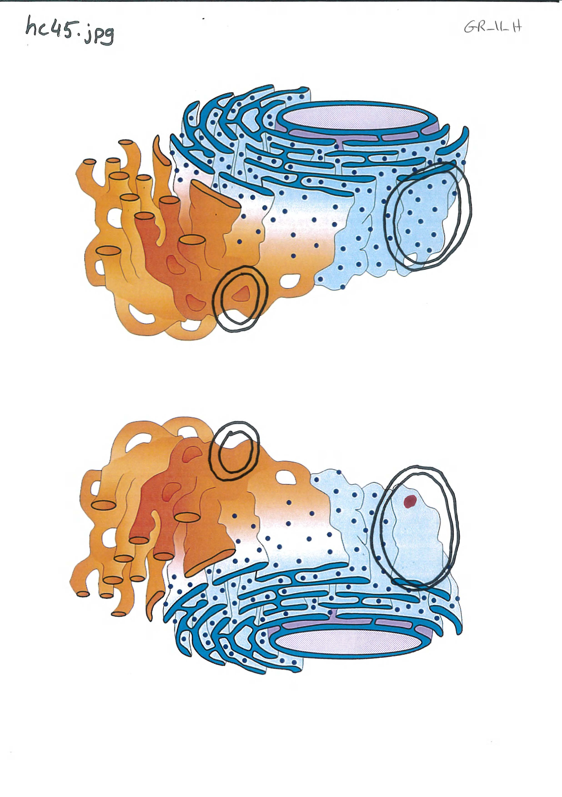
Figure 1. An example of the papers representing the displayed comparison pictures where participants’ clicks were registered. A correct zone encircled each difference
Correct zone: Any click within the encircled area is considered correct

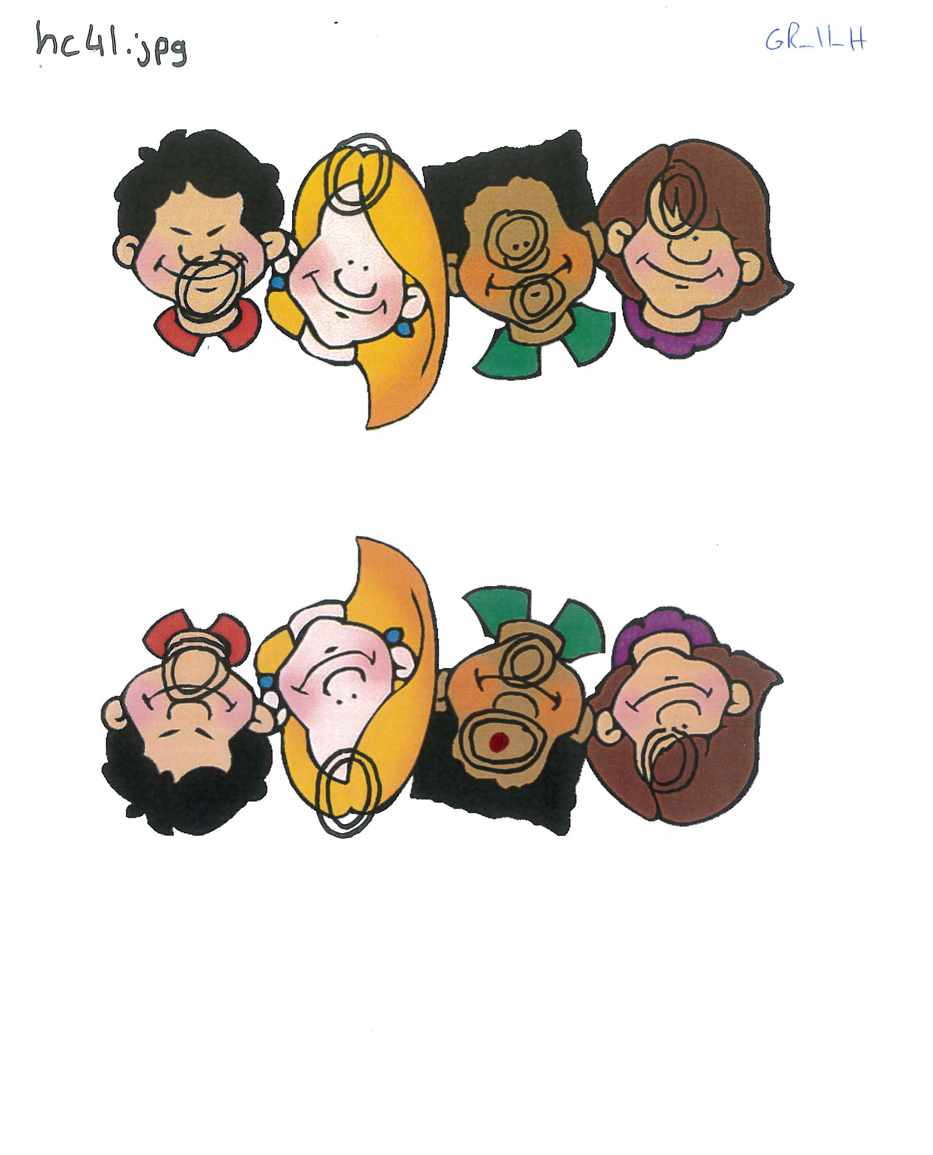
Figure 2. An example of the papers representing the displayed comparison pictures where participants’ clicks were registered. A correct zone encircled each difference
Correct zone: Any click within the encircled area is considered correct

Appendix III.IV. The Mean fixations number and duration in the eye-tracking study

Table 1. The mean number of fixations and duration per comparison pair. The grand mean per group was calculated later and compared with that of the other group in hypothesis testing.
 |  |  | Fixation number |  | Fixation Duration (ms)
 | Groups | Pictures | Mean | SD | Mean | SD
1 | Difficult | hc41.jpg | 1.7 | 1.64 | 446.5 | 546.18
2 |  | hc42.jpg | 2.7 | 2.21 | 543.3 | 517.49
3 |  | hc43.jpg | 1.9 | 1.20 | 432.3 | 306.3
4 |  | hc44.jpg | 1.4 | 1.26 | 240.7 | 273.72
5 |  | hc45.jpg | 1.5 | 1.43 | 272.3 | 273.24
6 |  | hc46.jpg | 1.4 | 0.97 | 243.8 | 189.56
7 |  | hc47.jpg | 1.6 | 1.51 | 242.6 | 296.43
8 |  | hc48.jpg | 2.4 | 1.78 | 583.2 | 662.06
9 |  | hc49.jpg | 1.5 | 1.51 | 230 | 237.48
10 |  | hc50.jpg | 2.4 | 2.17 | 561.5 | 712.69
11 | Easy | sc1.jpg | 3.3 | 4.06 | 860.2 | 1408.45
12 |  | sc2.jpg | 4.5 | 4.81 | 1552.5 | 2424.28
13 |  | sc3.jpg | 3.1 | 2.33 | 686.1 | 540.15
14 |  | sc4.jpg | 3.7 | 4.08 | 1124.8 | 1908.35
15 |  | sc5.jpg | 2.6 | 1.43 | 763.6 | 1026.97
16 |  | sc6.jpg | 2.80 | 2.86 | 612.7 | 601.84
17 |  | sc7.jpg | 3.20 | 1.75 | 659.9 | 349.44
18 |  | sc8.jpg | 2.90 | 3 | 882.5 | 1136.66
19 |  | sc9.jpg | 2.00 | 2 | 390.4 | 440.69
20 |  | sc10.jpg | 4.40 | 3.06 | 1030.5 | 858.6

Appendix III.V. The Final sets of the pictures used in the behavioural study
Images source is Google® images, labelled to be reused (have no copyright restrictions)

III.V.I. Snacks Pictures
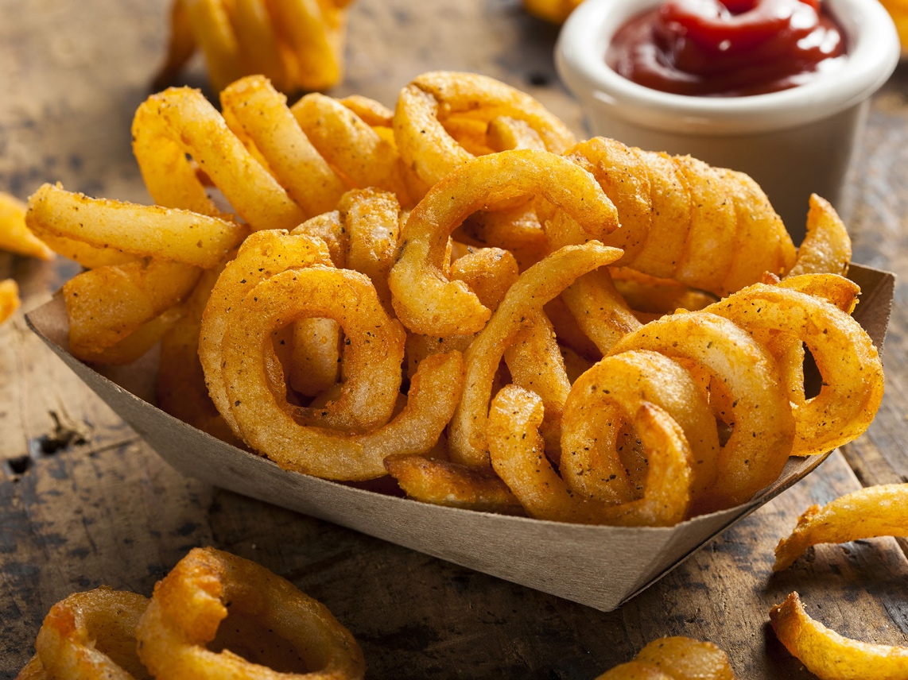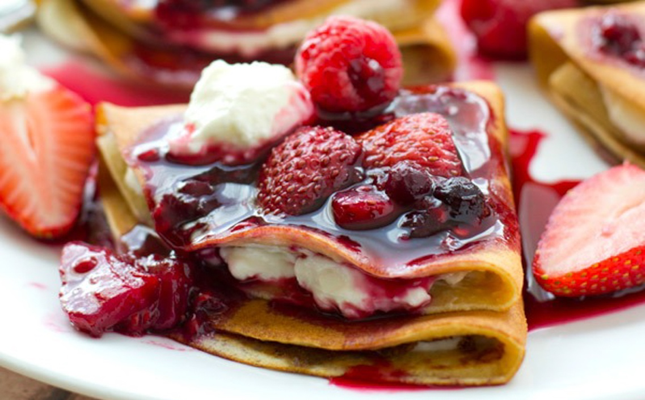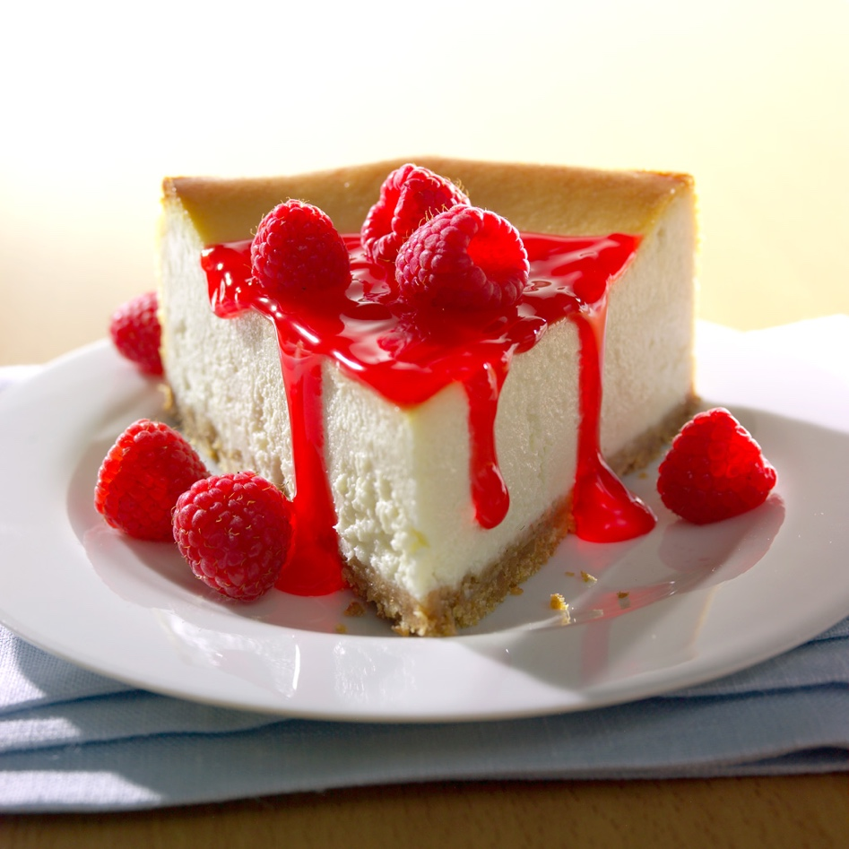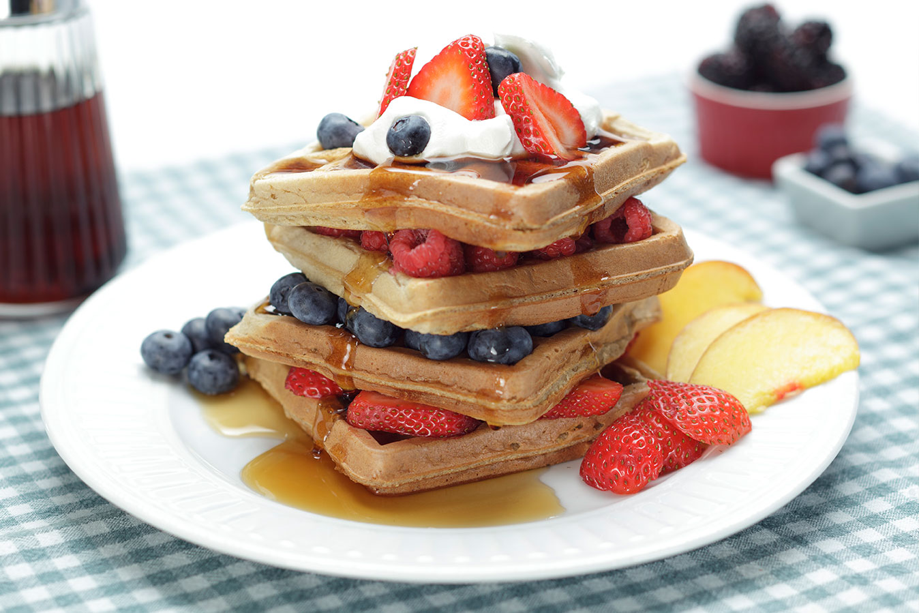
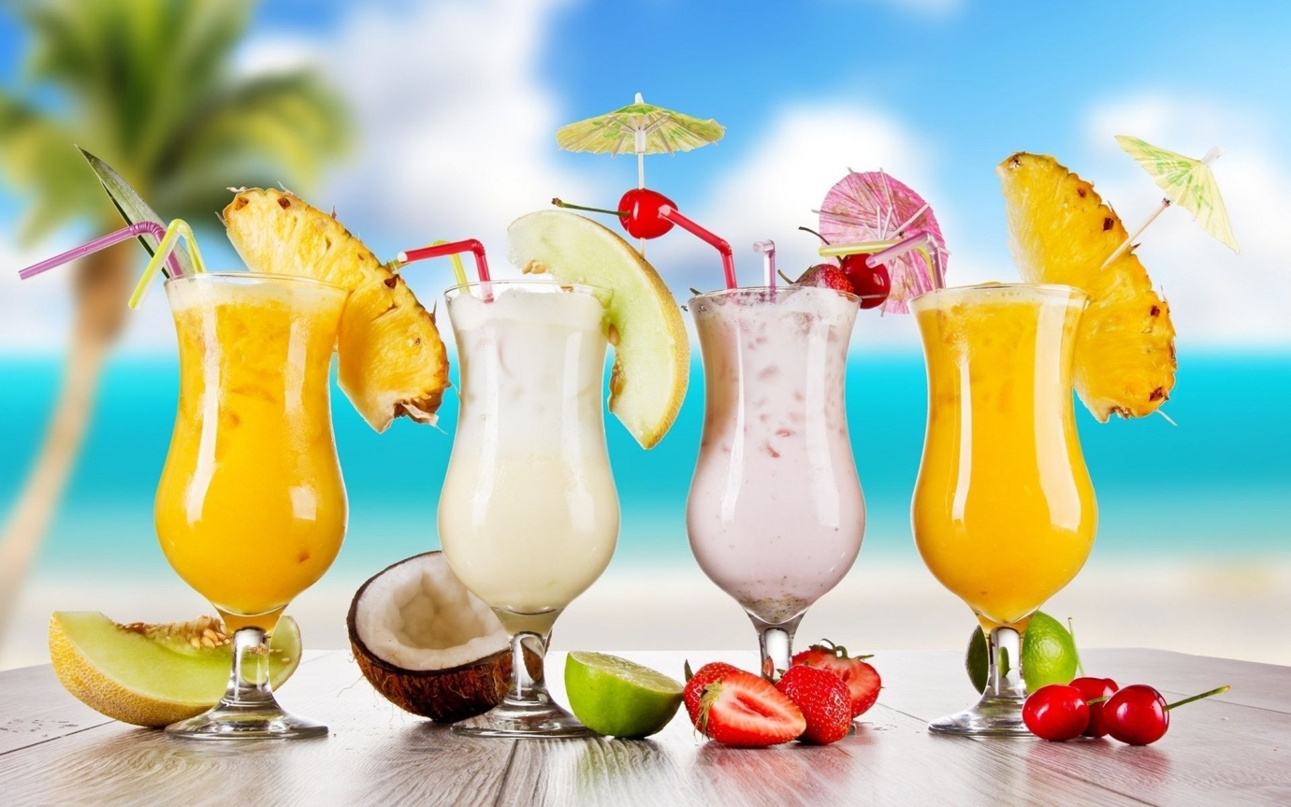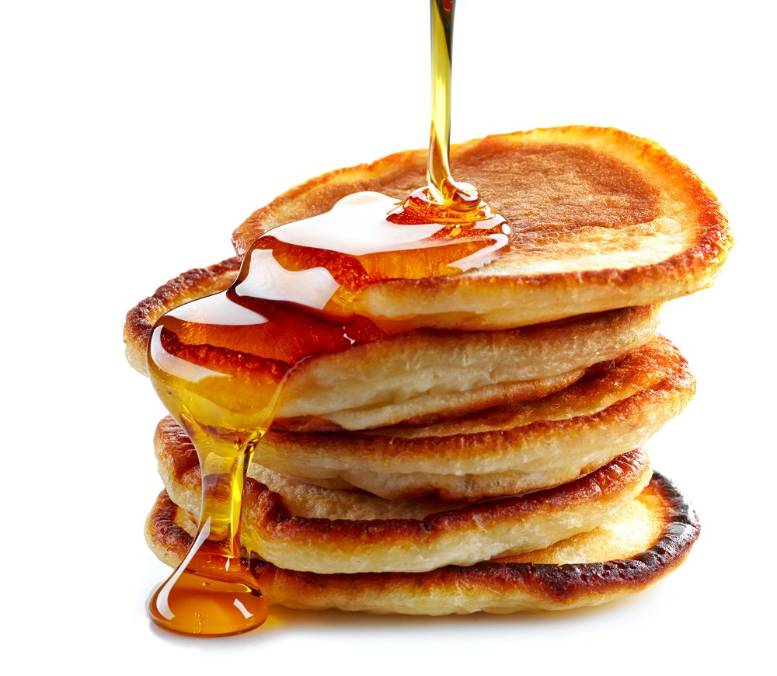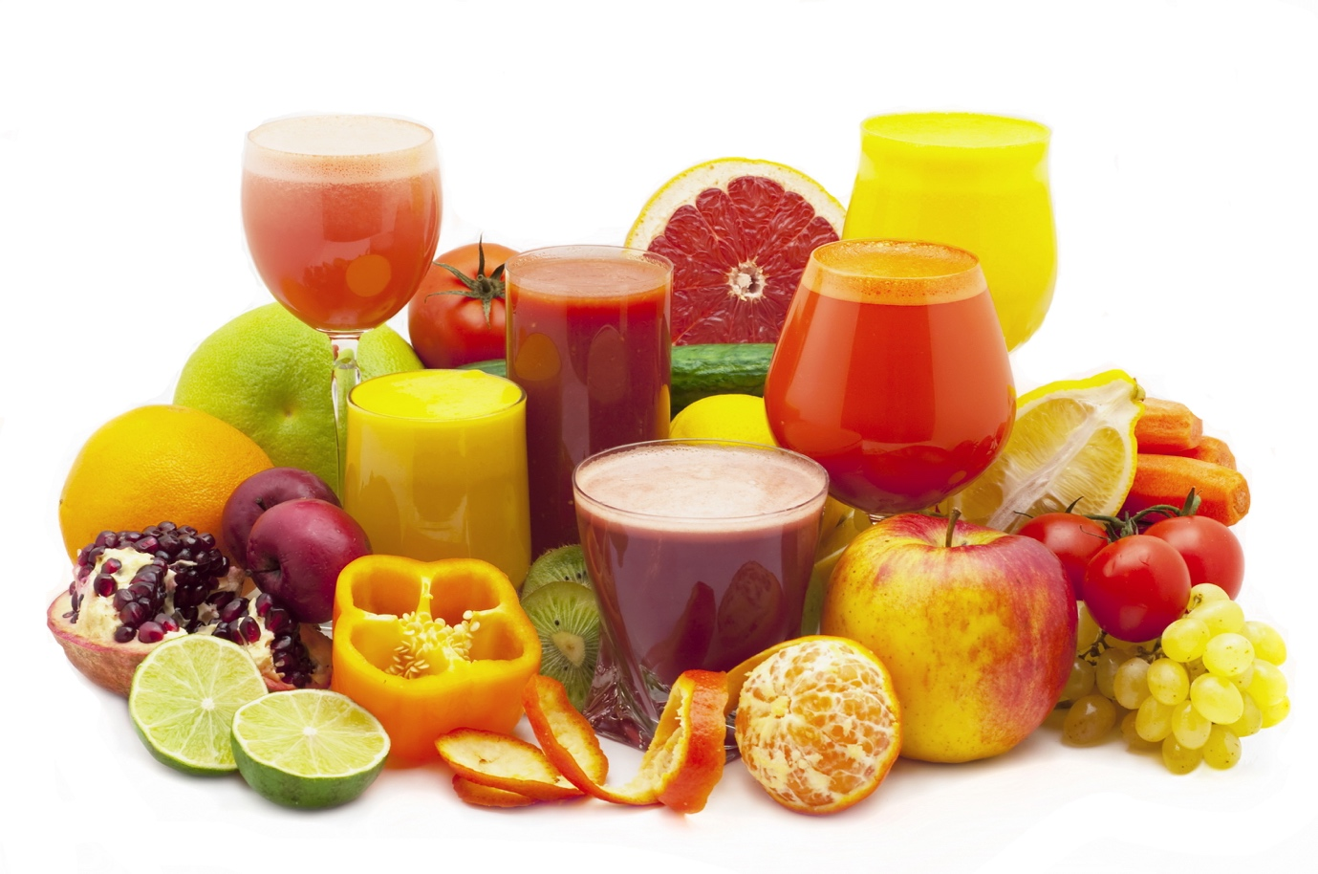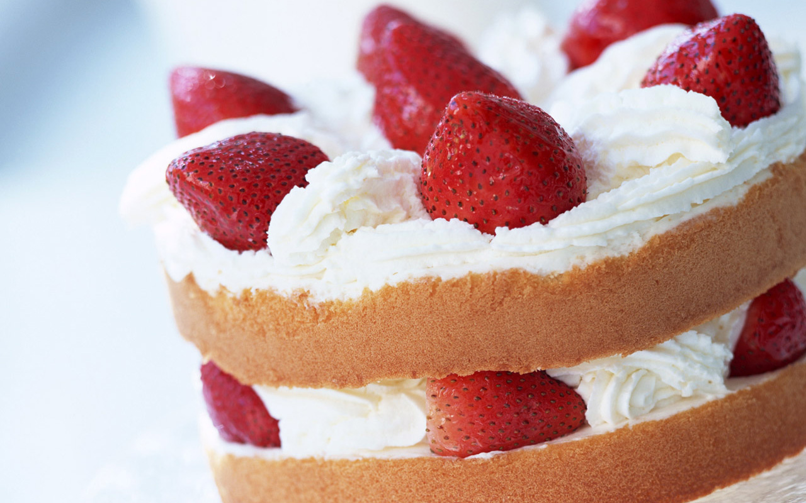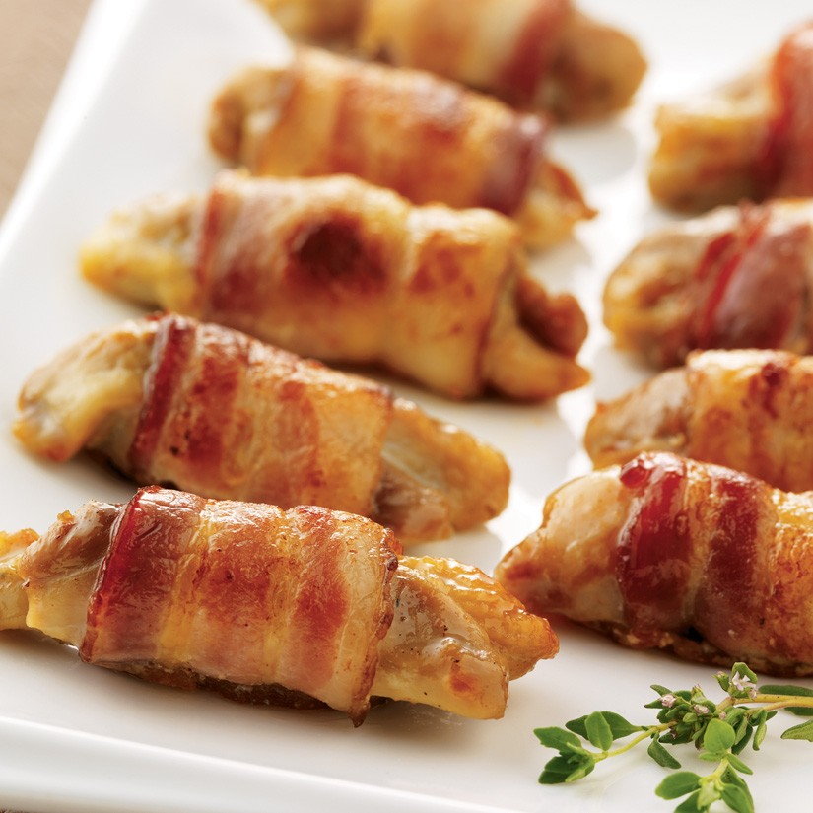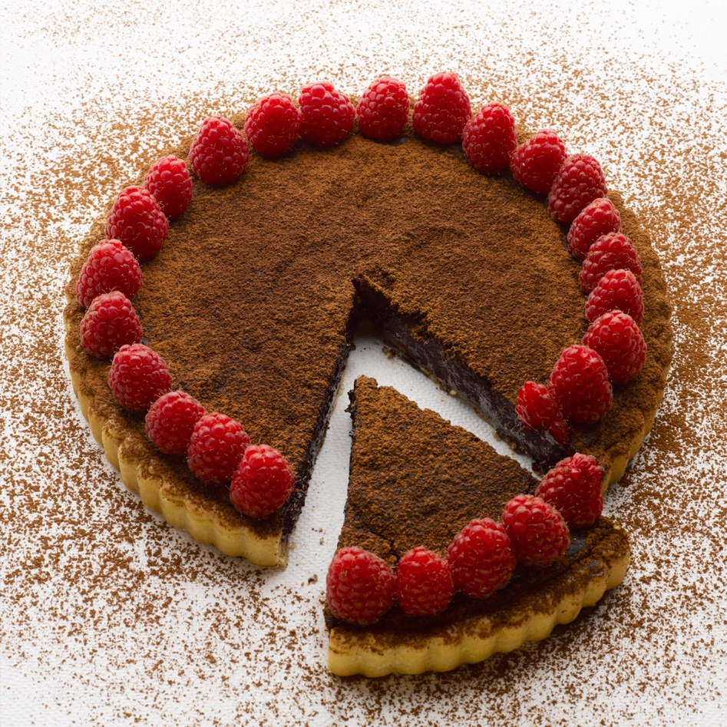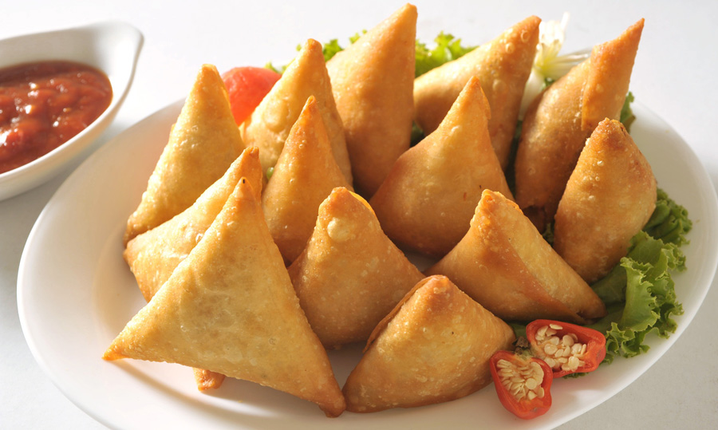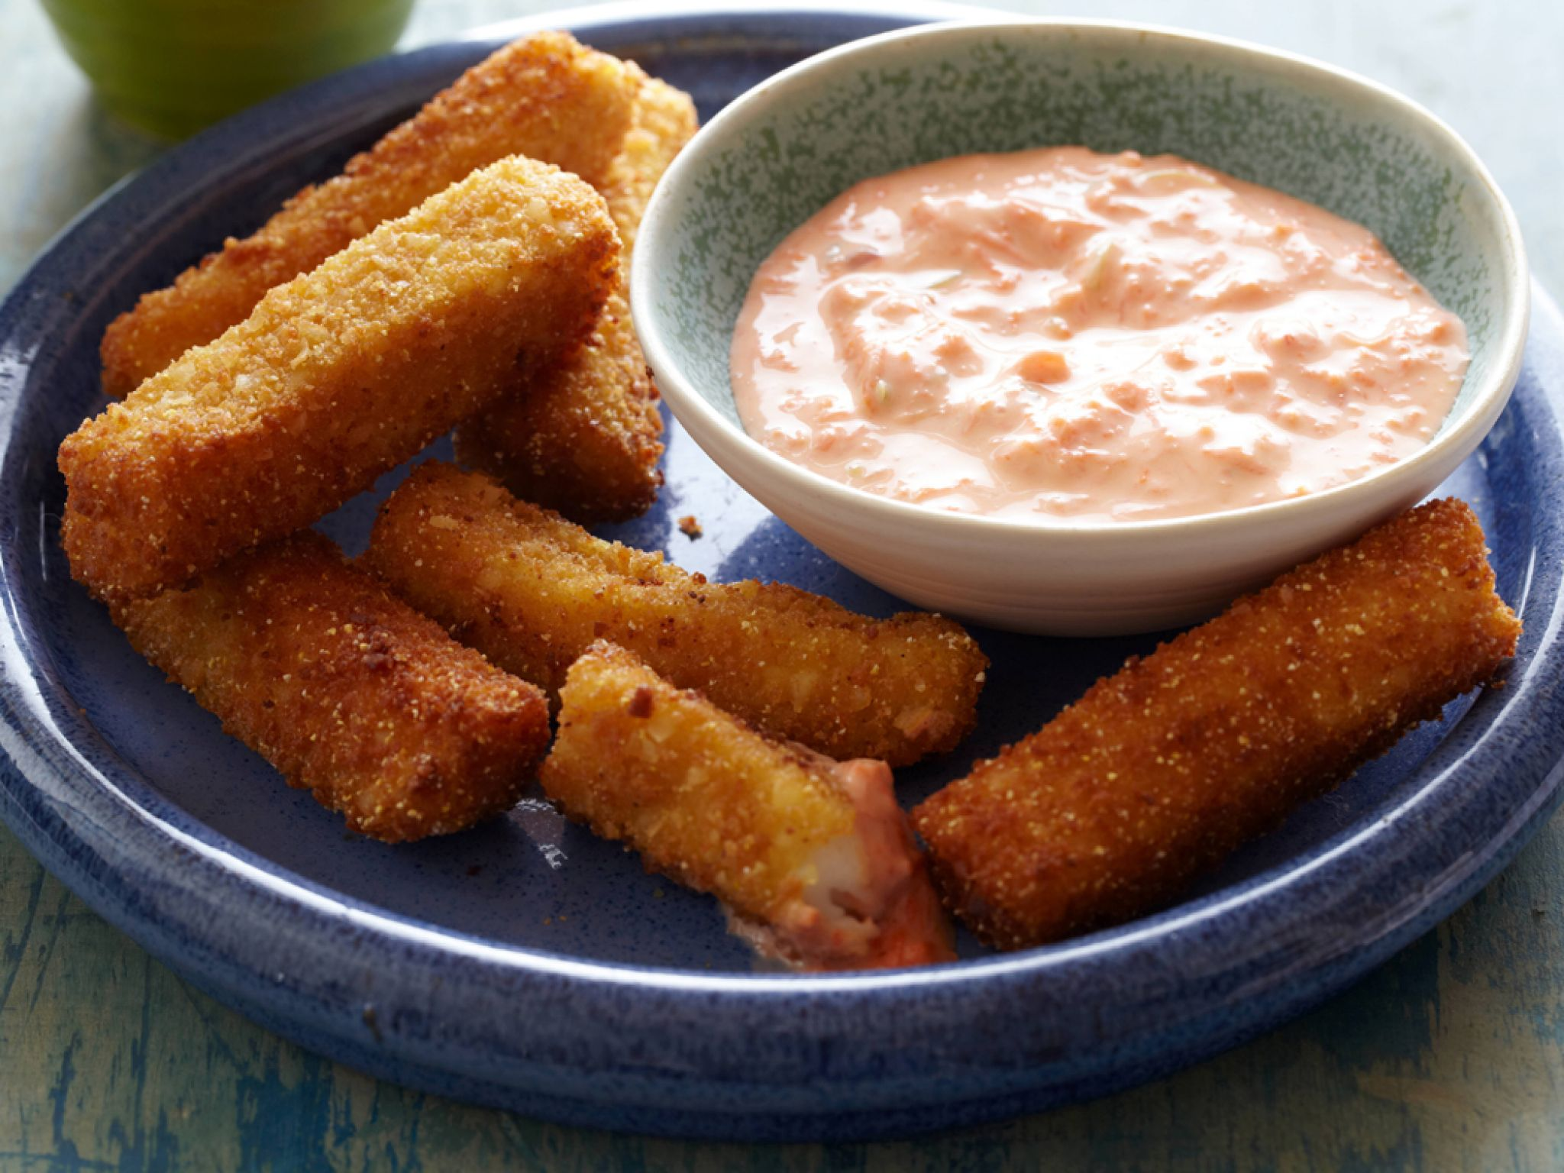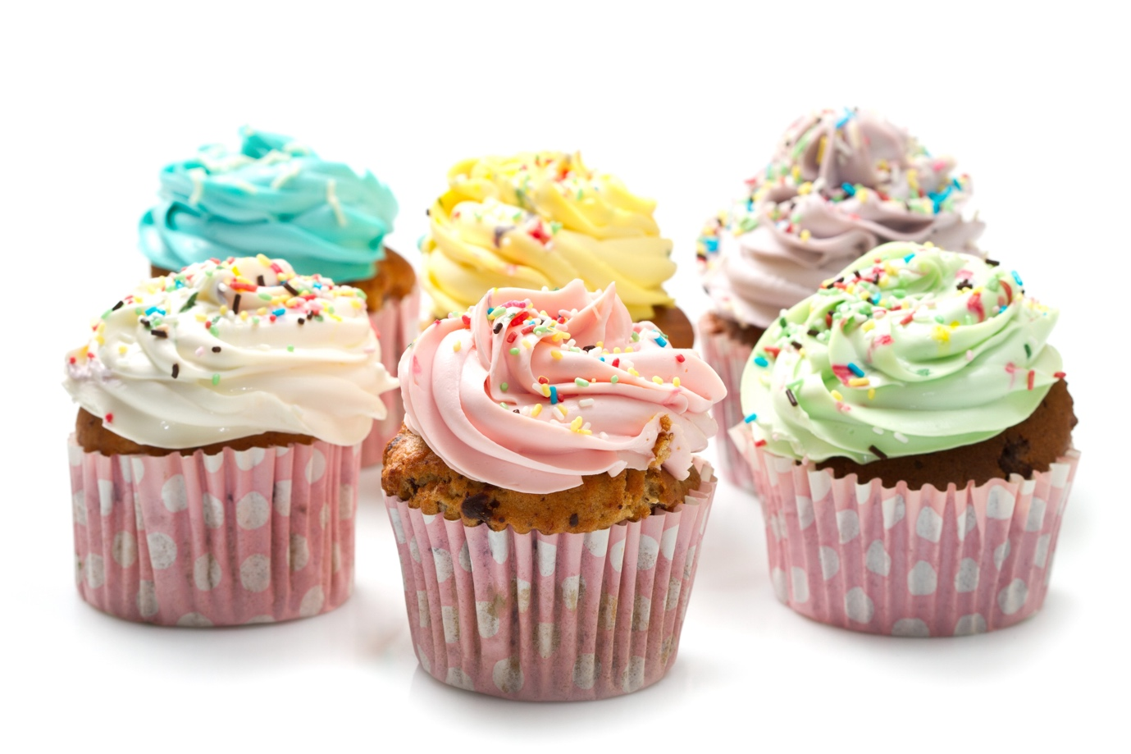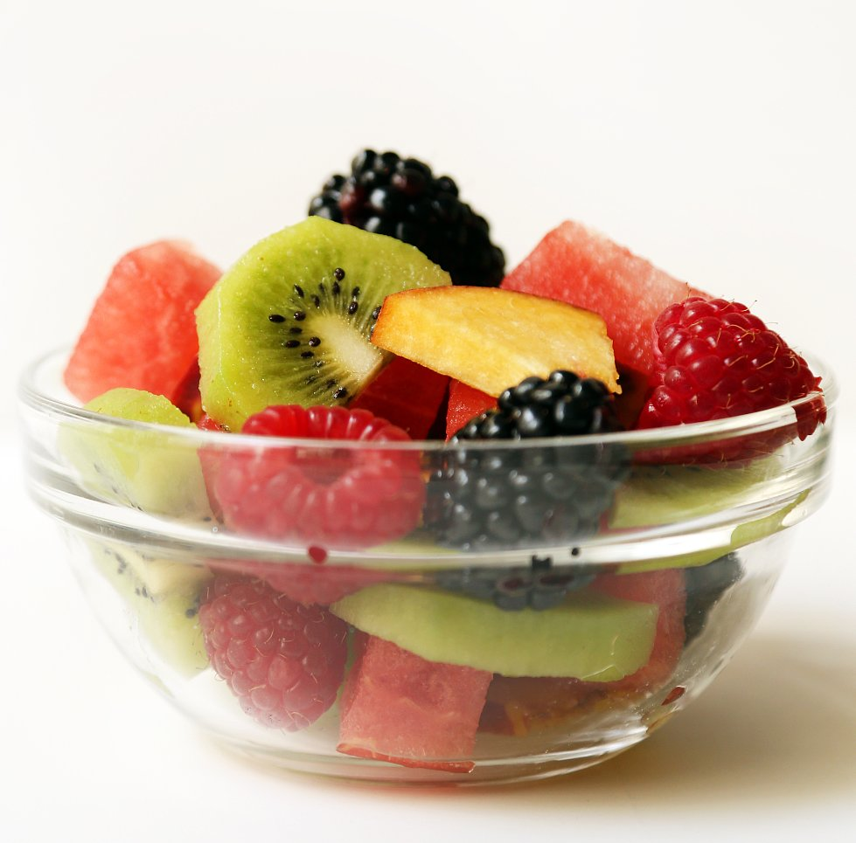

III.V.II. Meals pictures

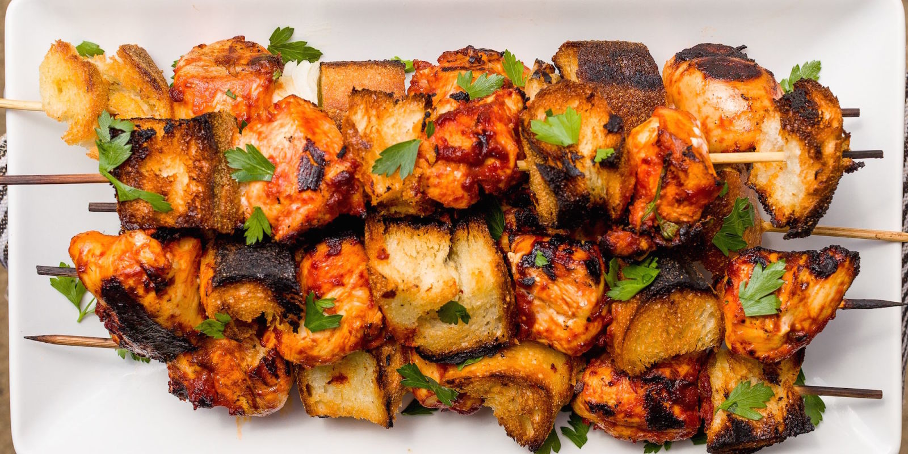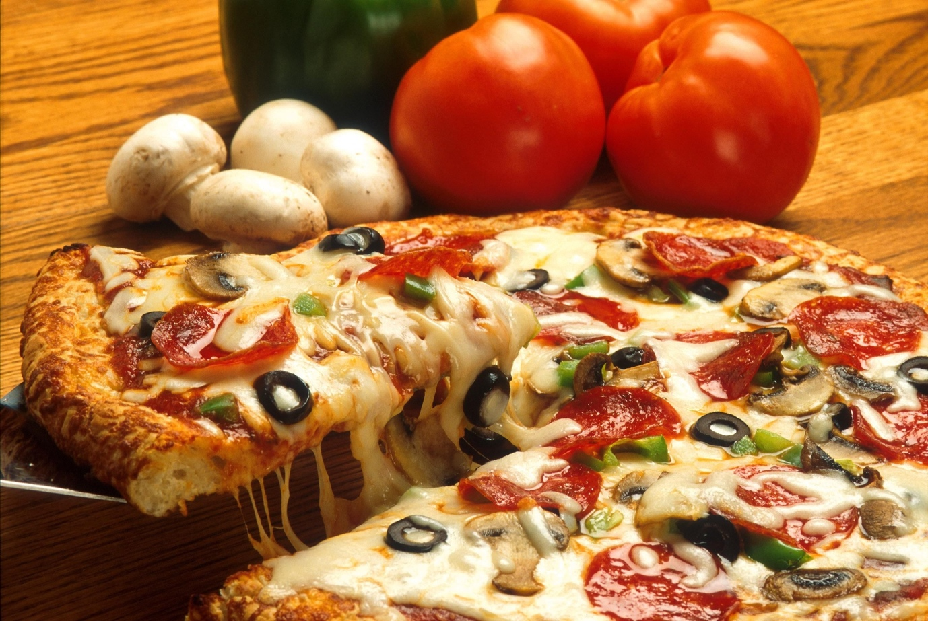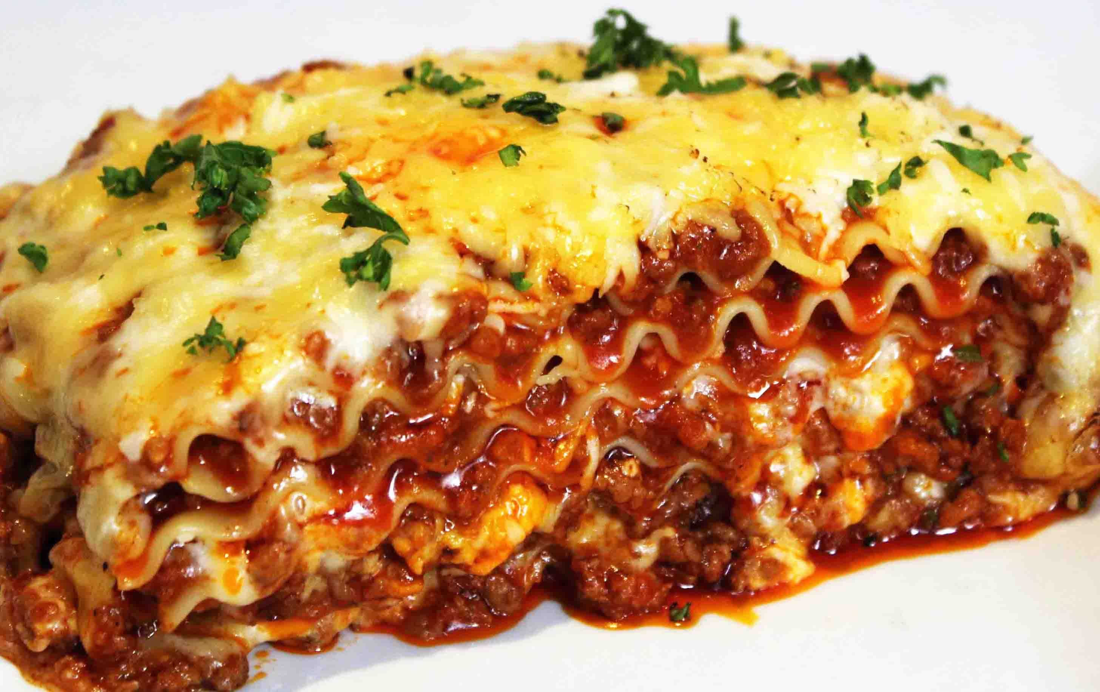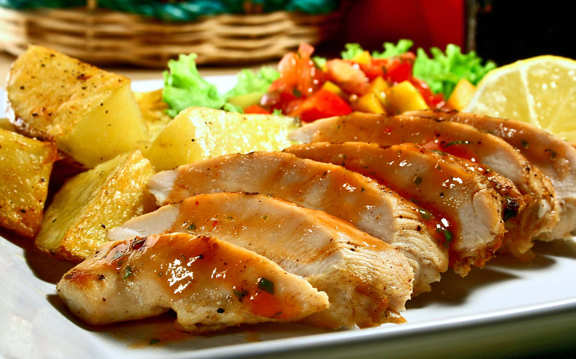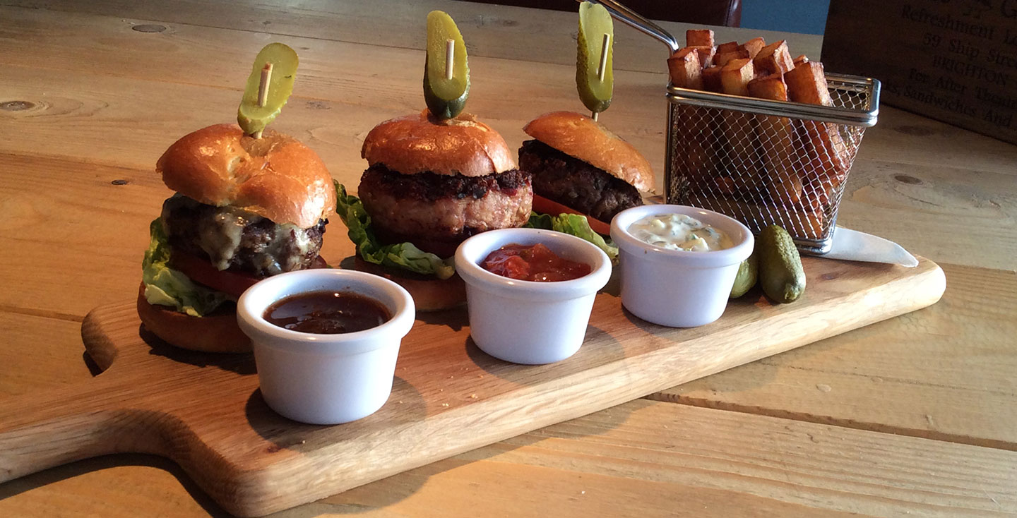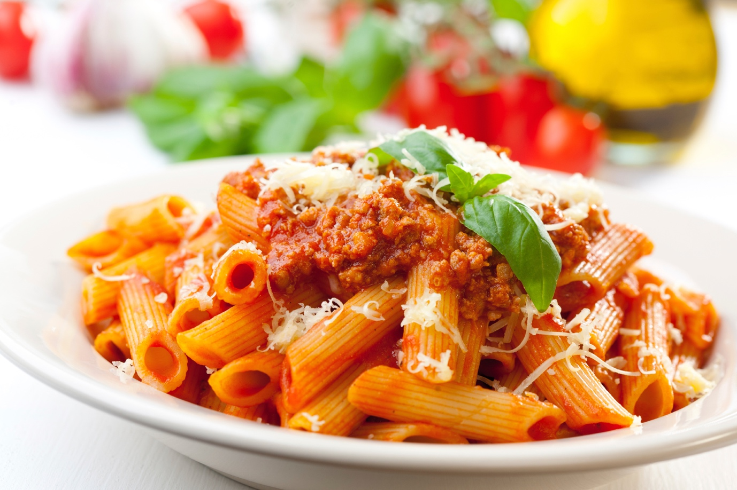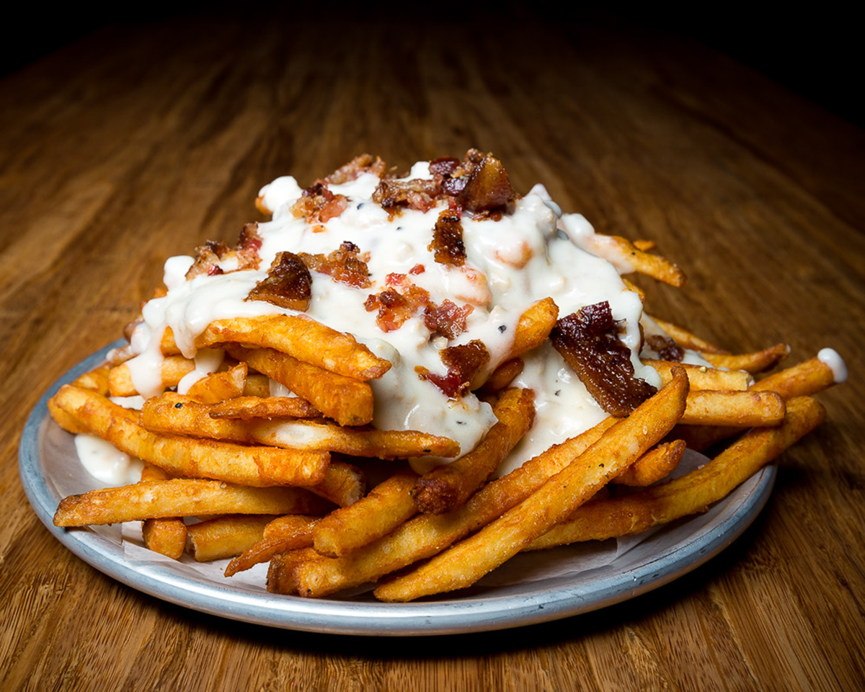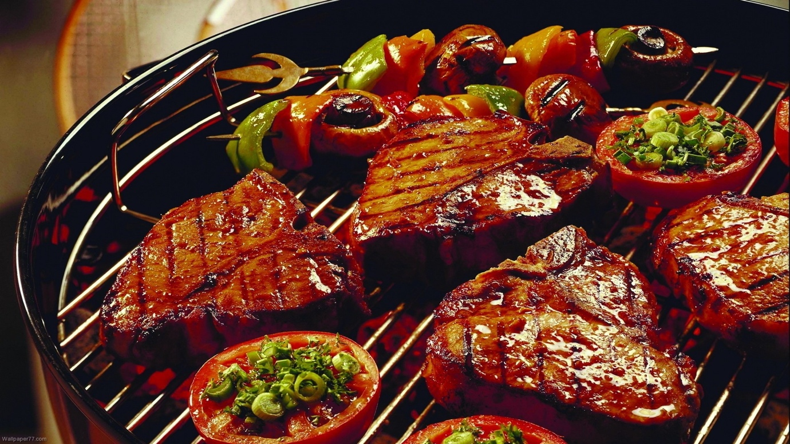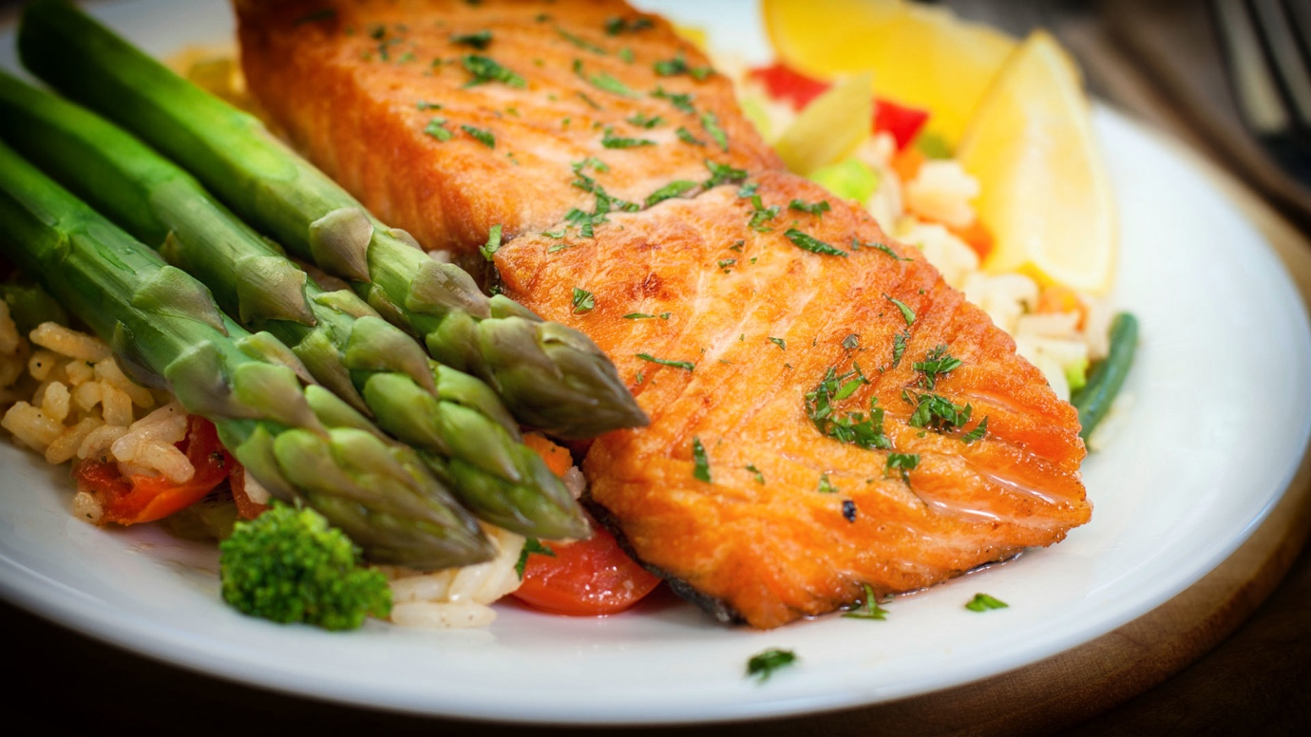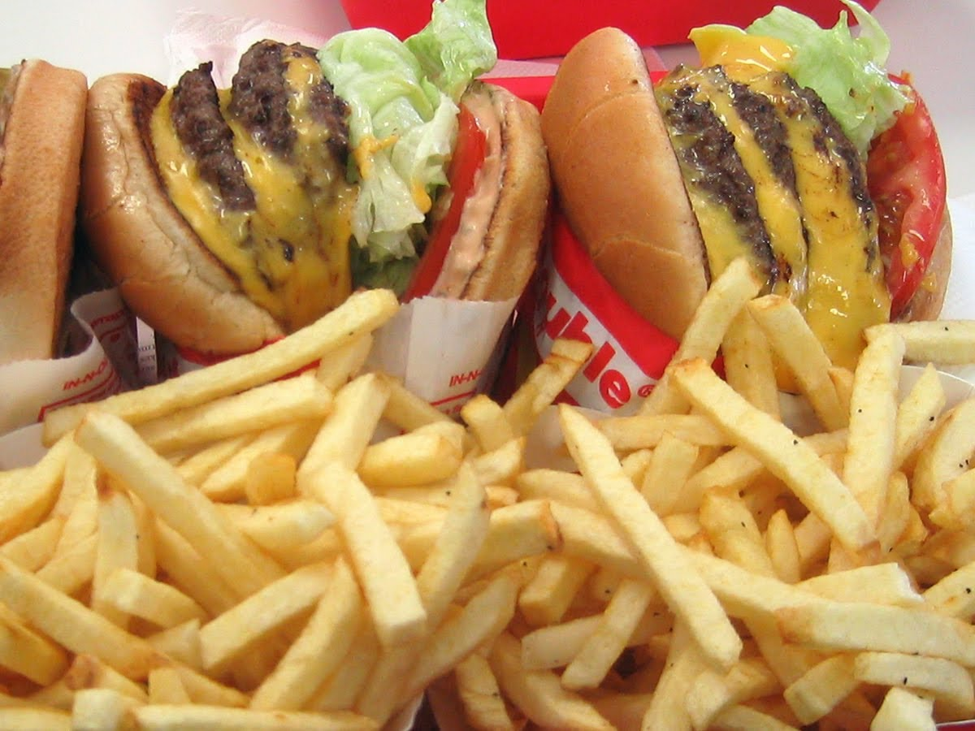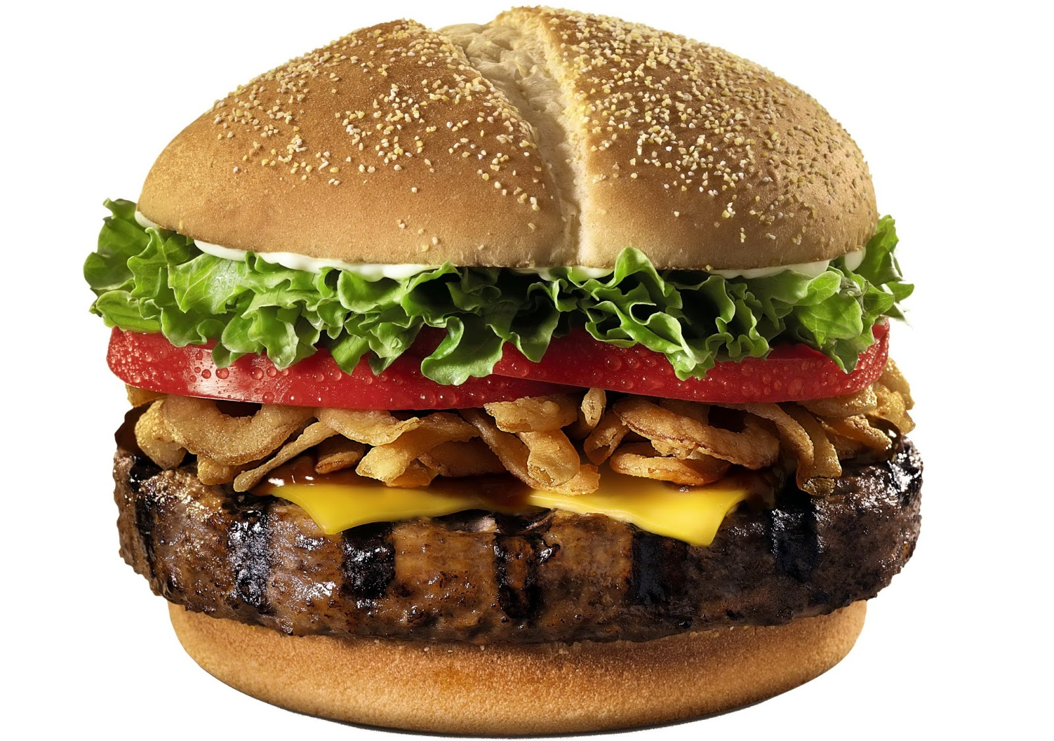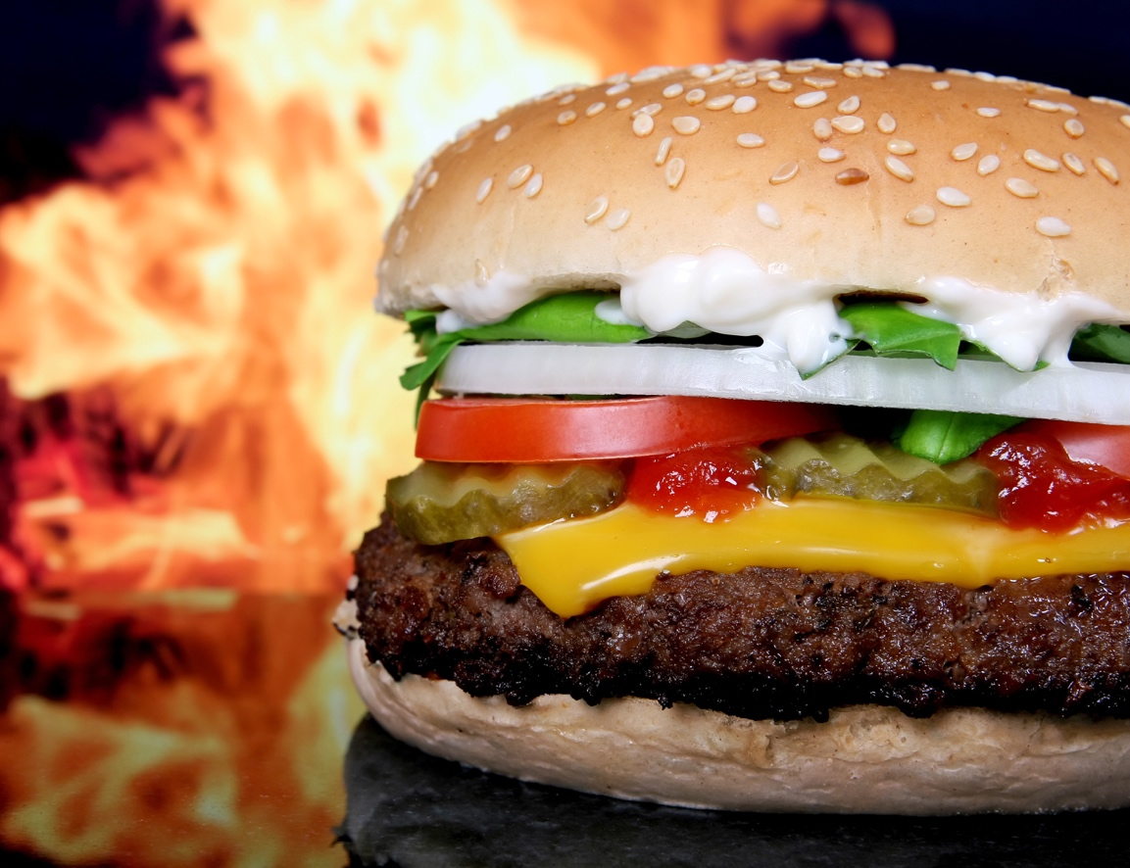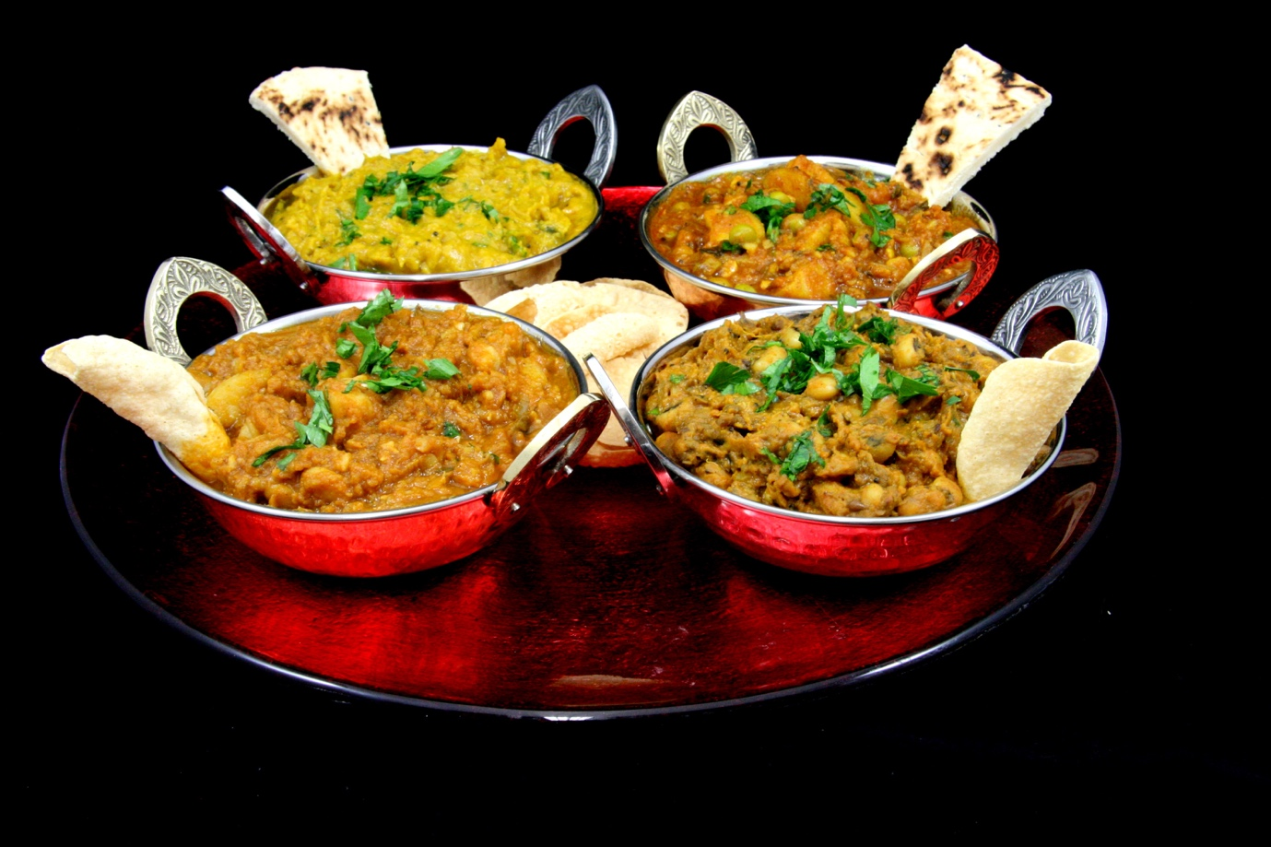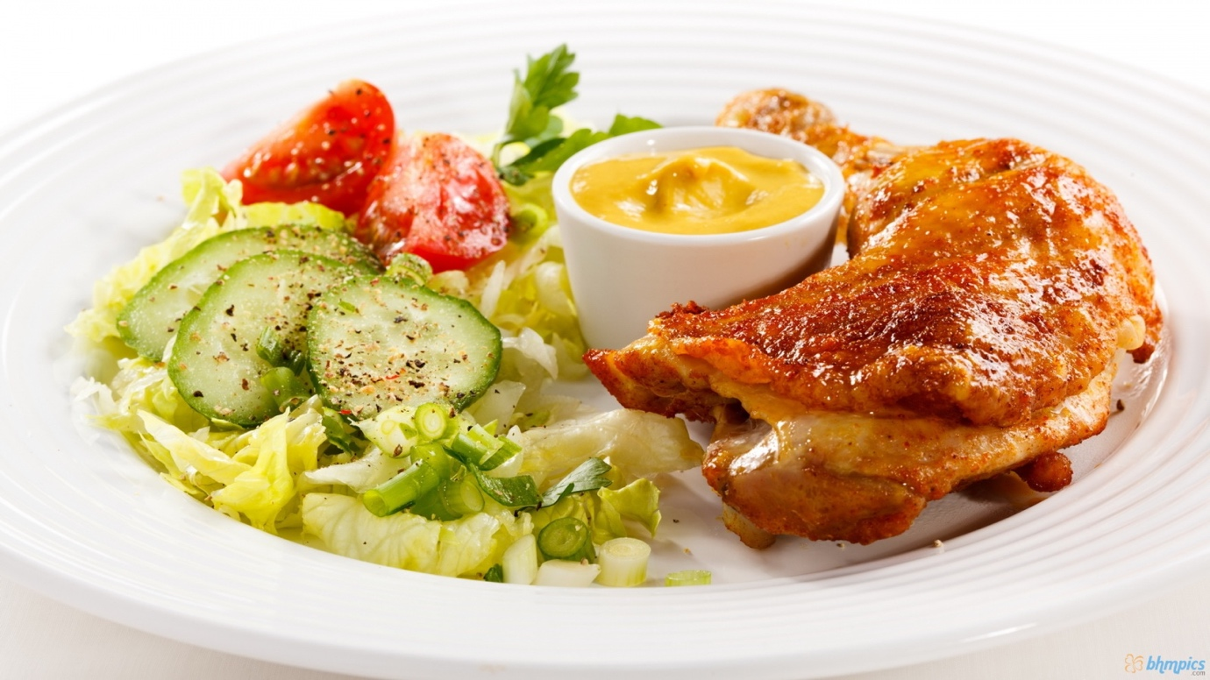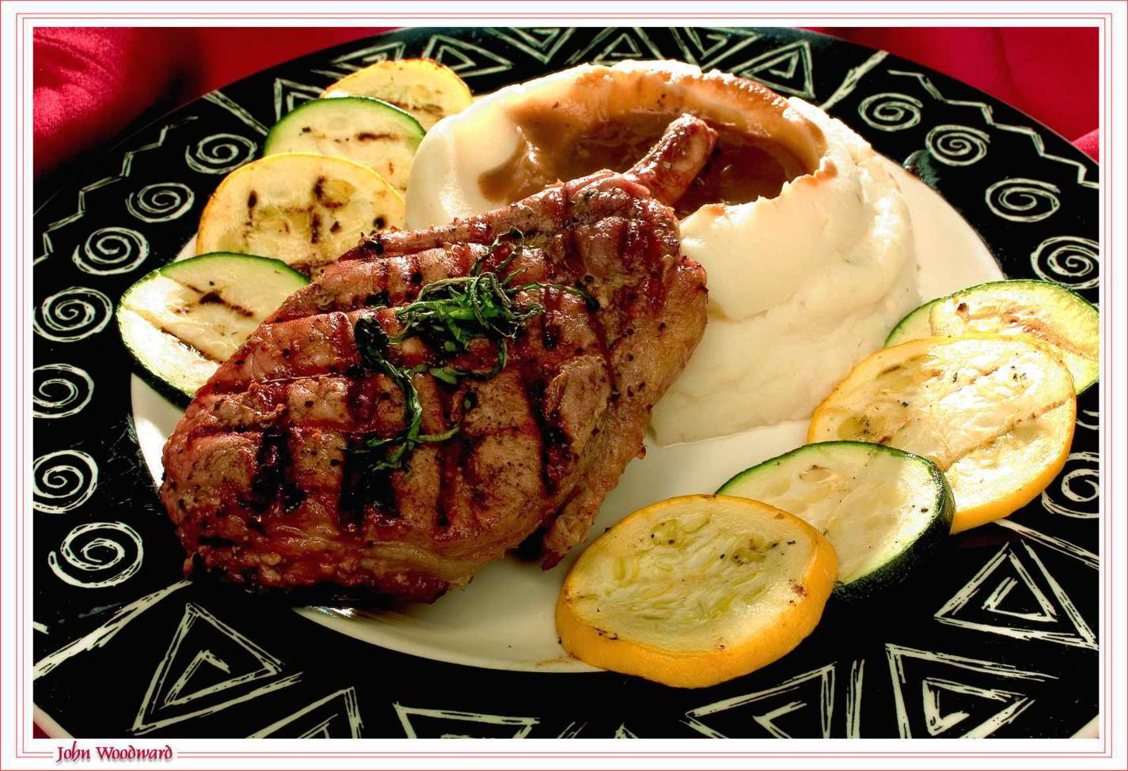

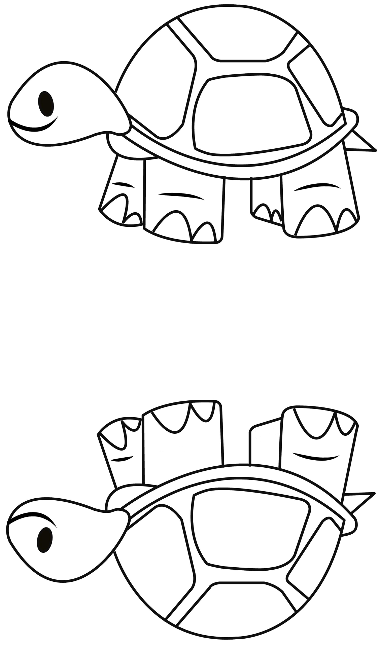
III.V.III. Comparison pictures
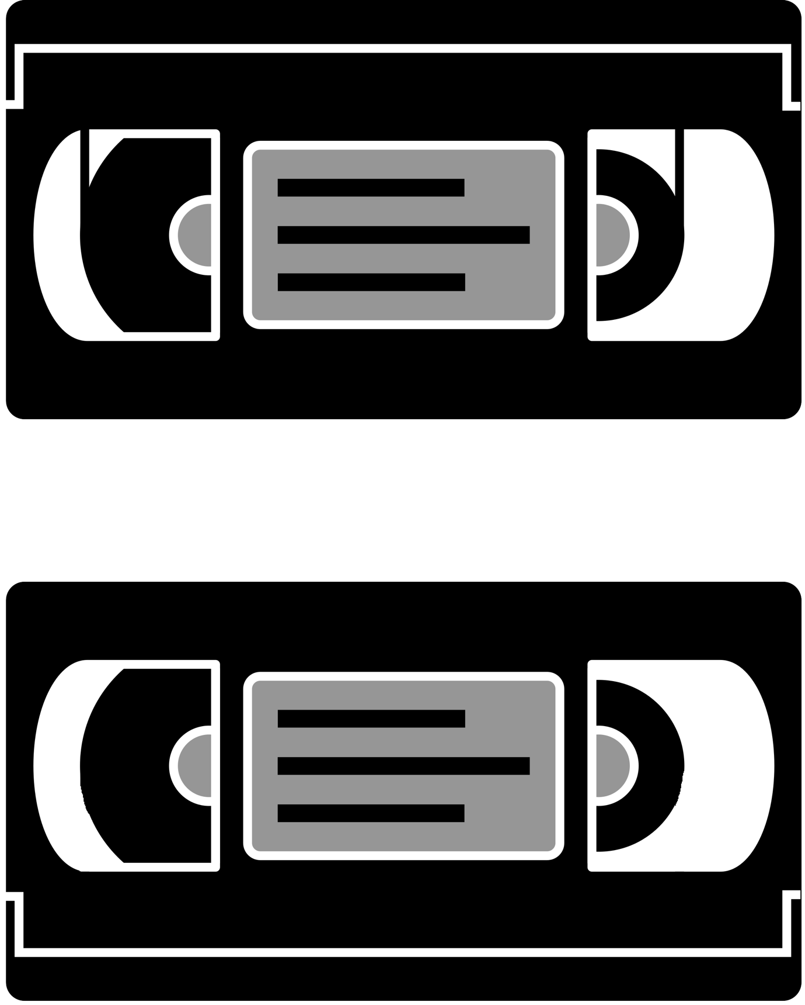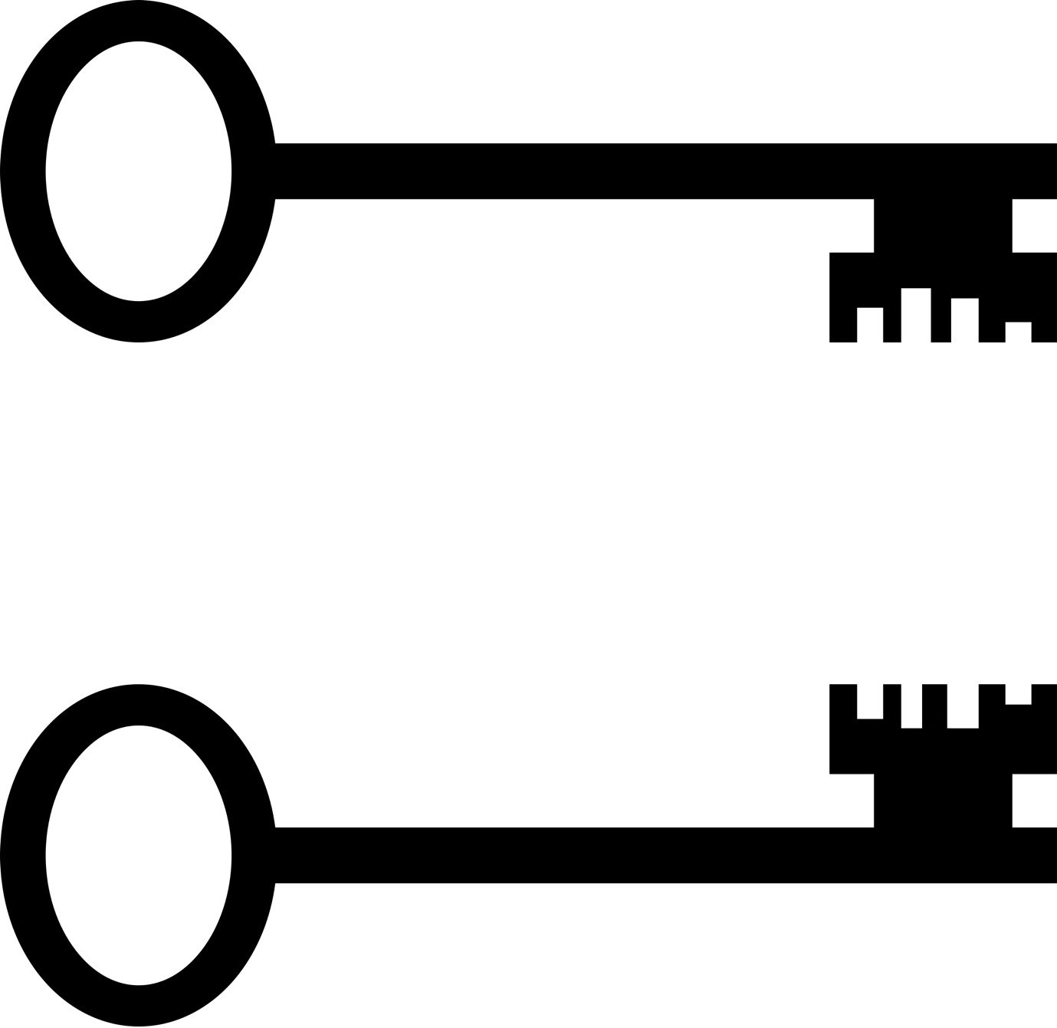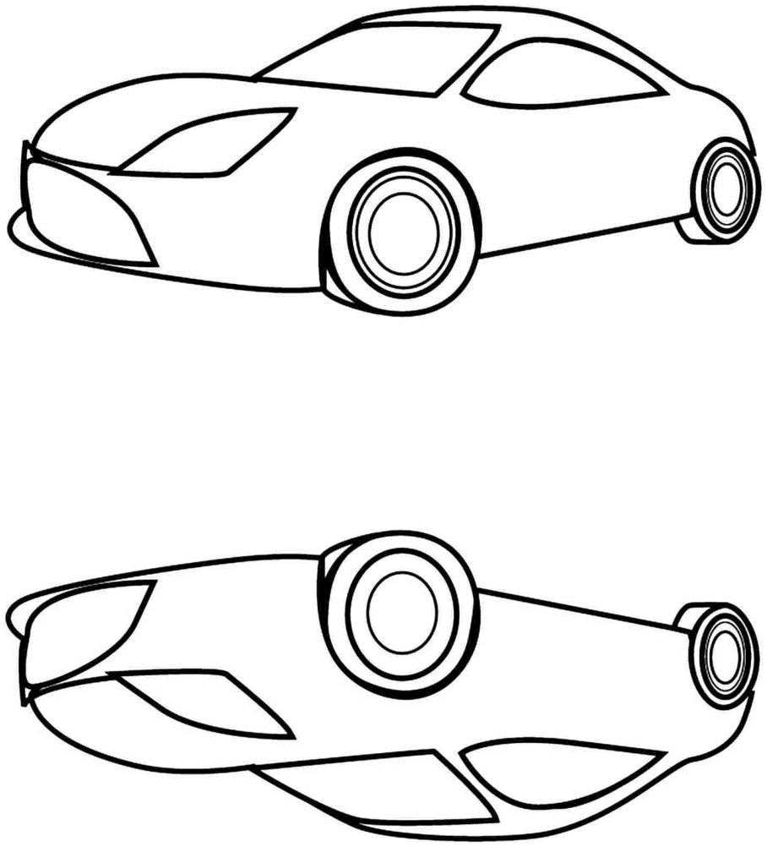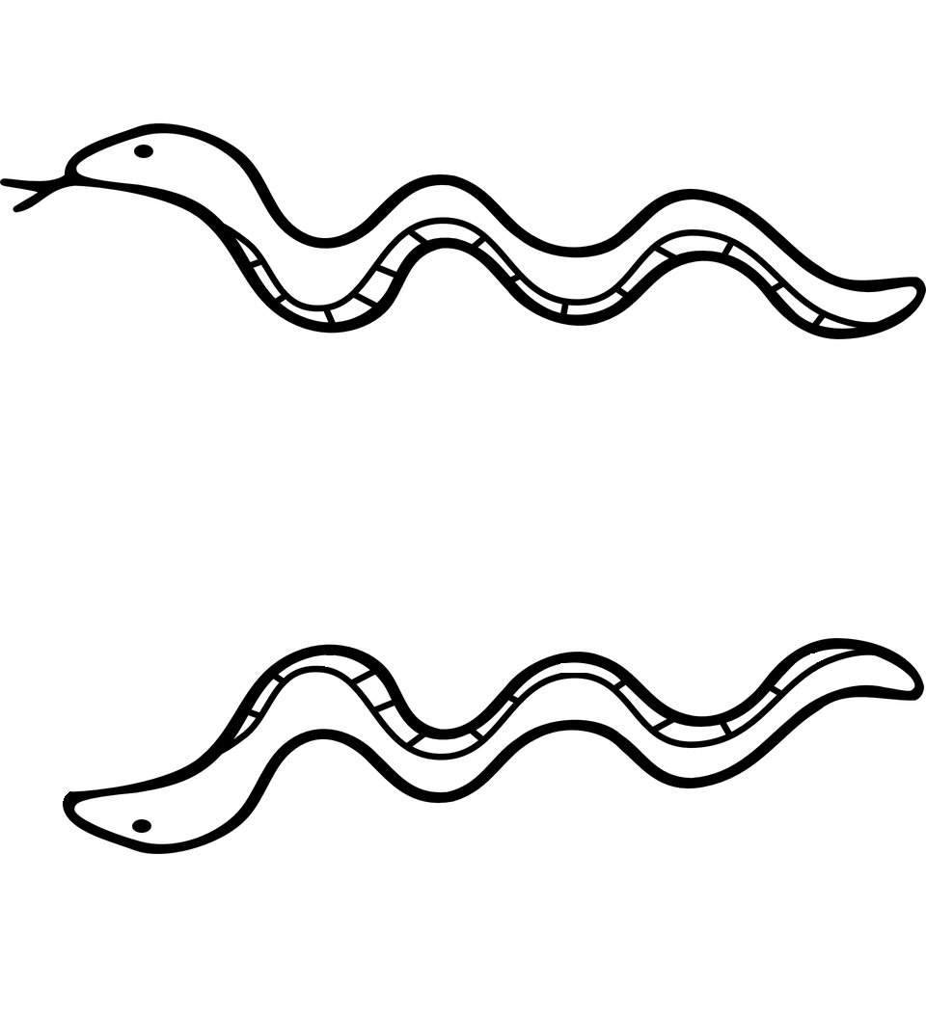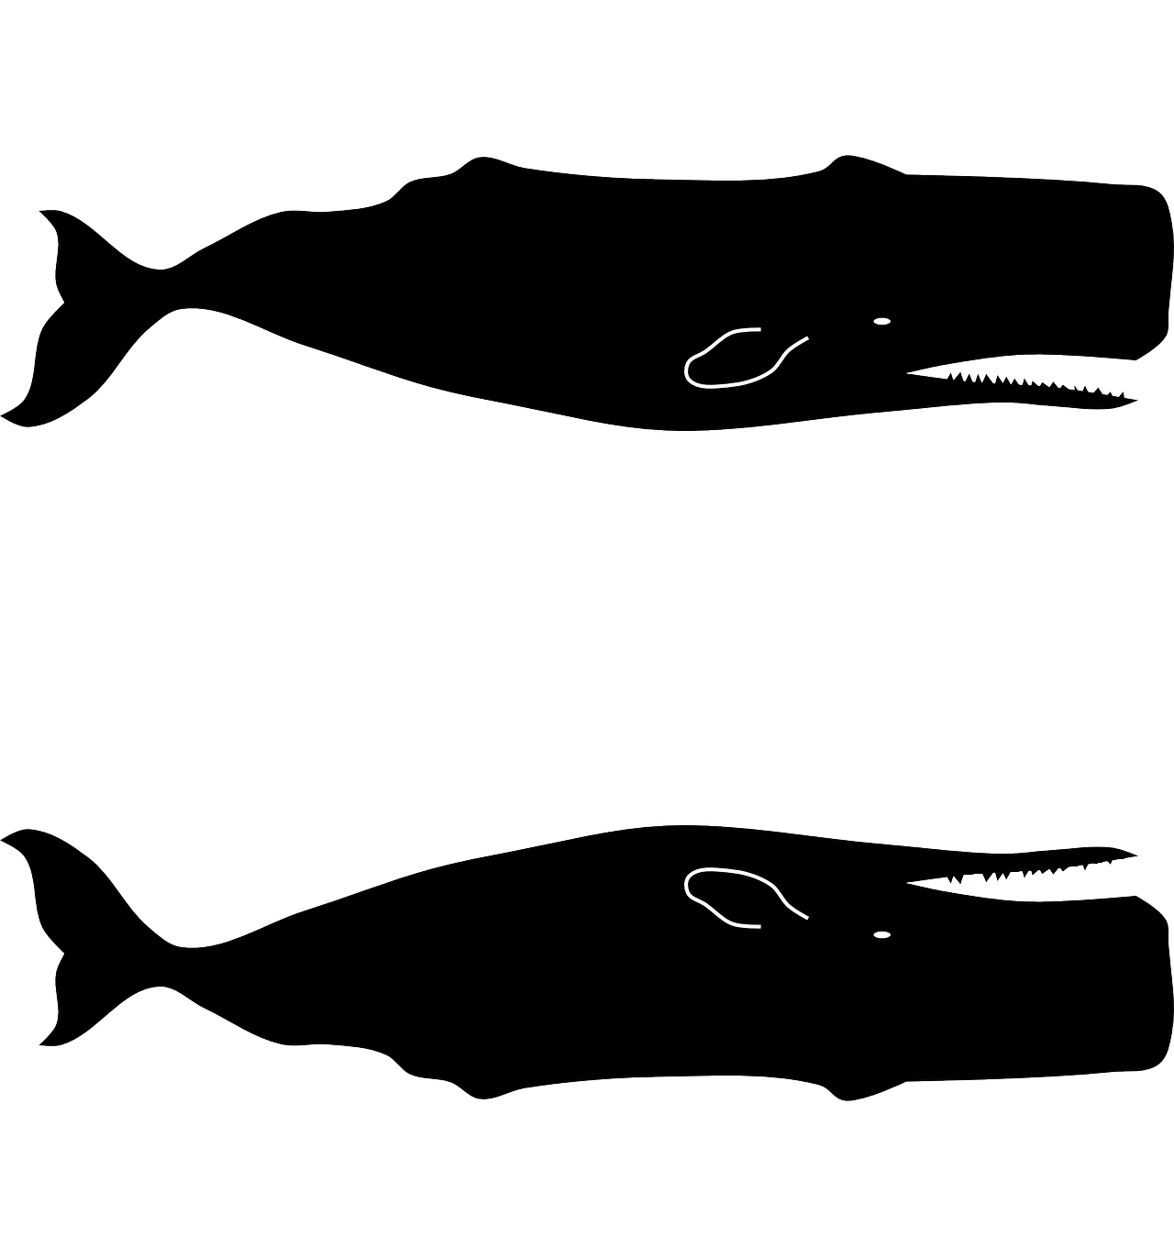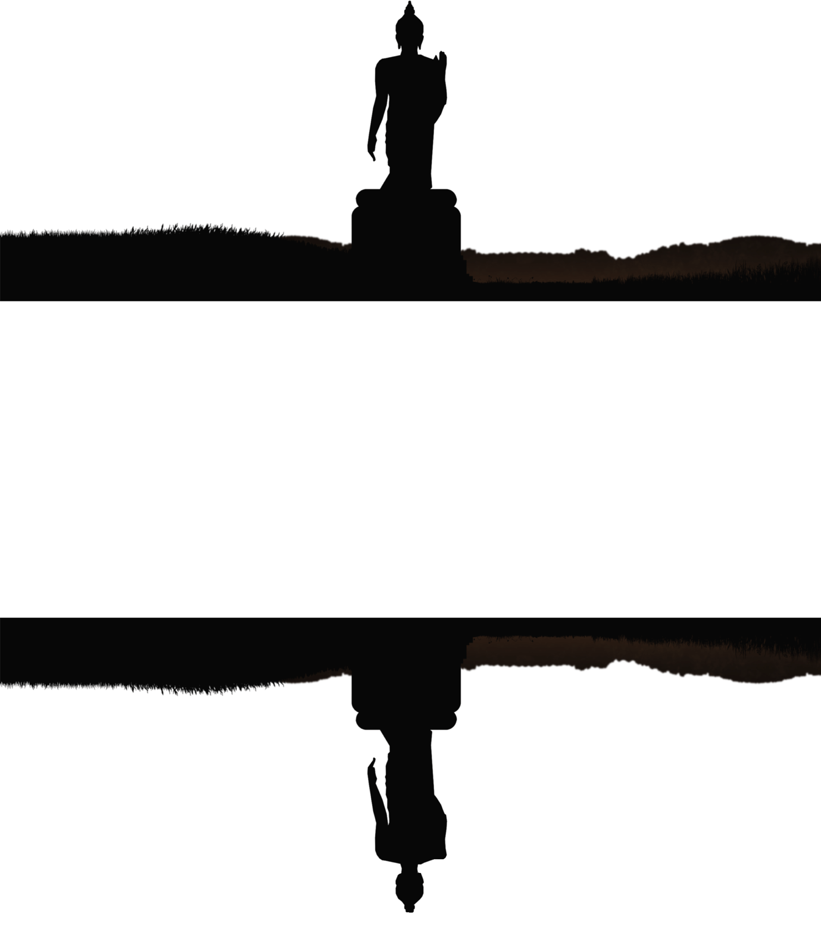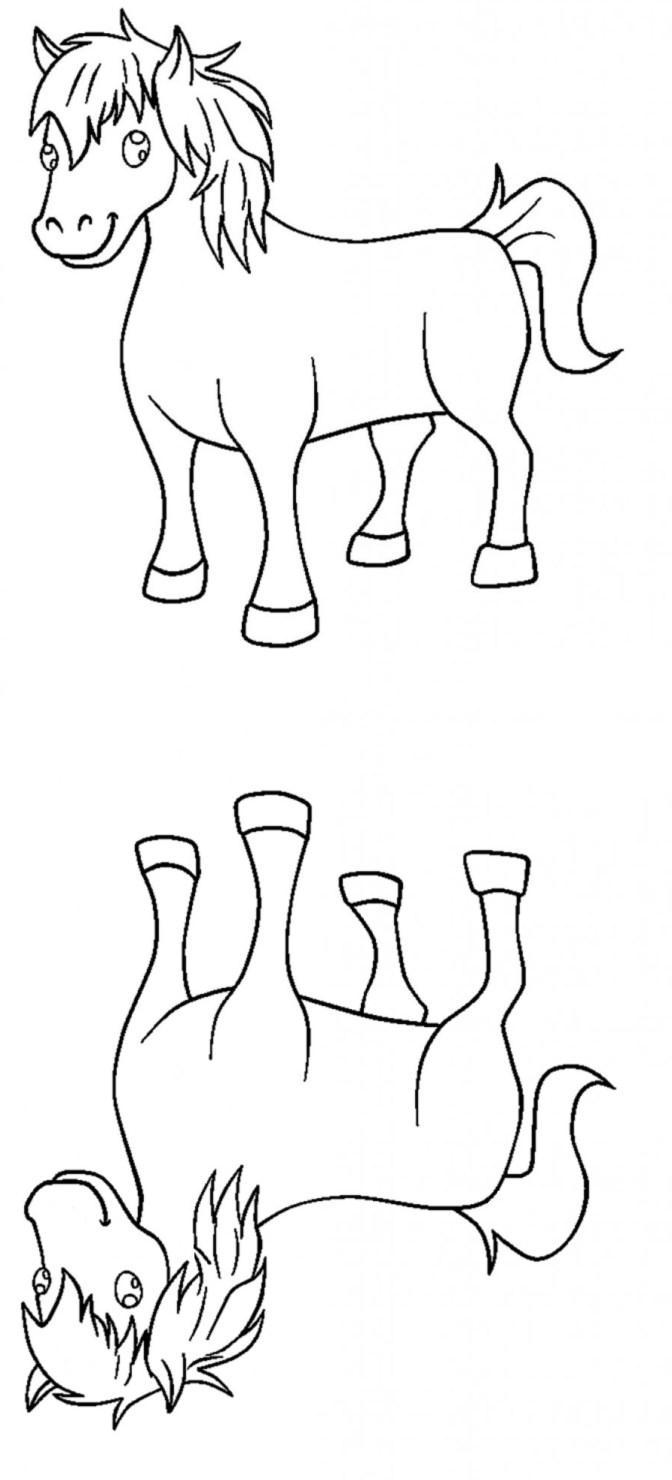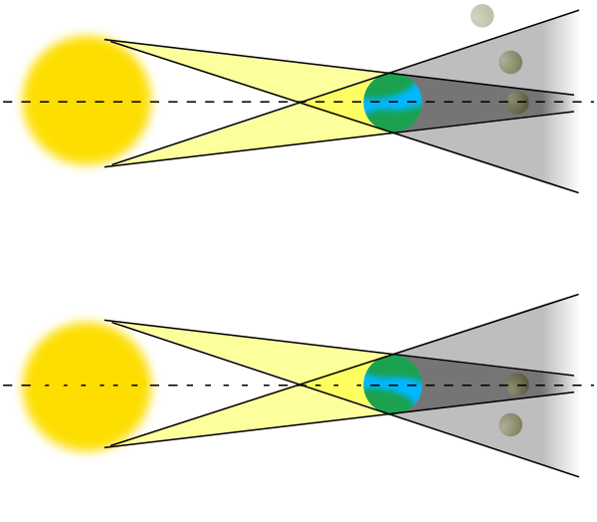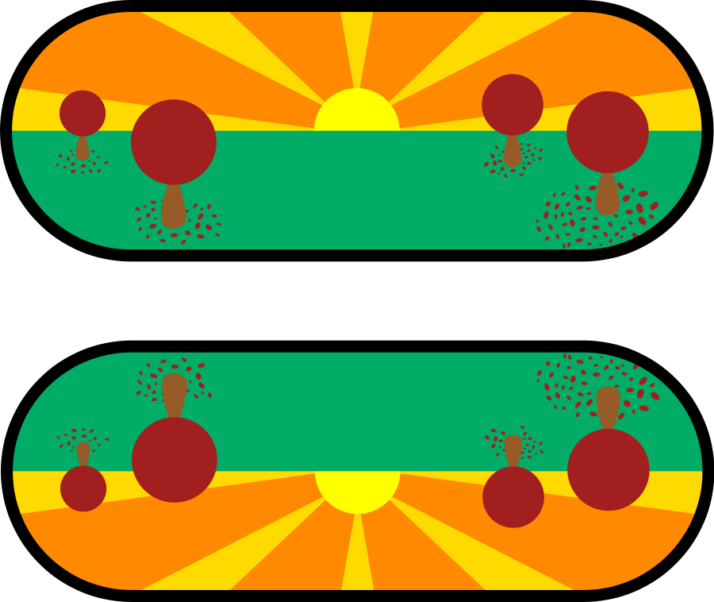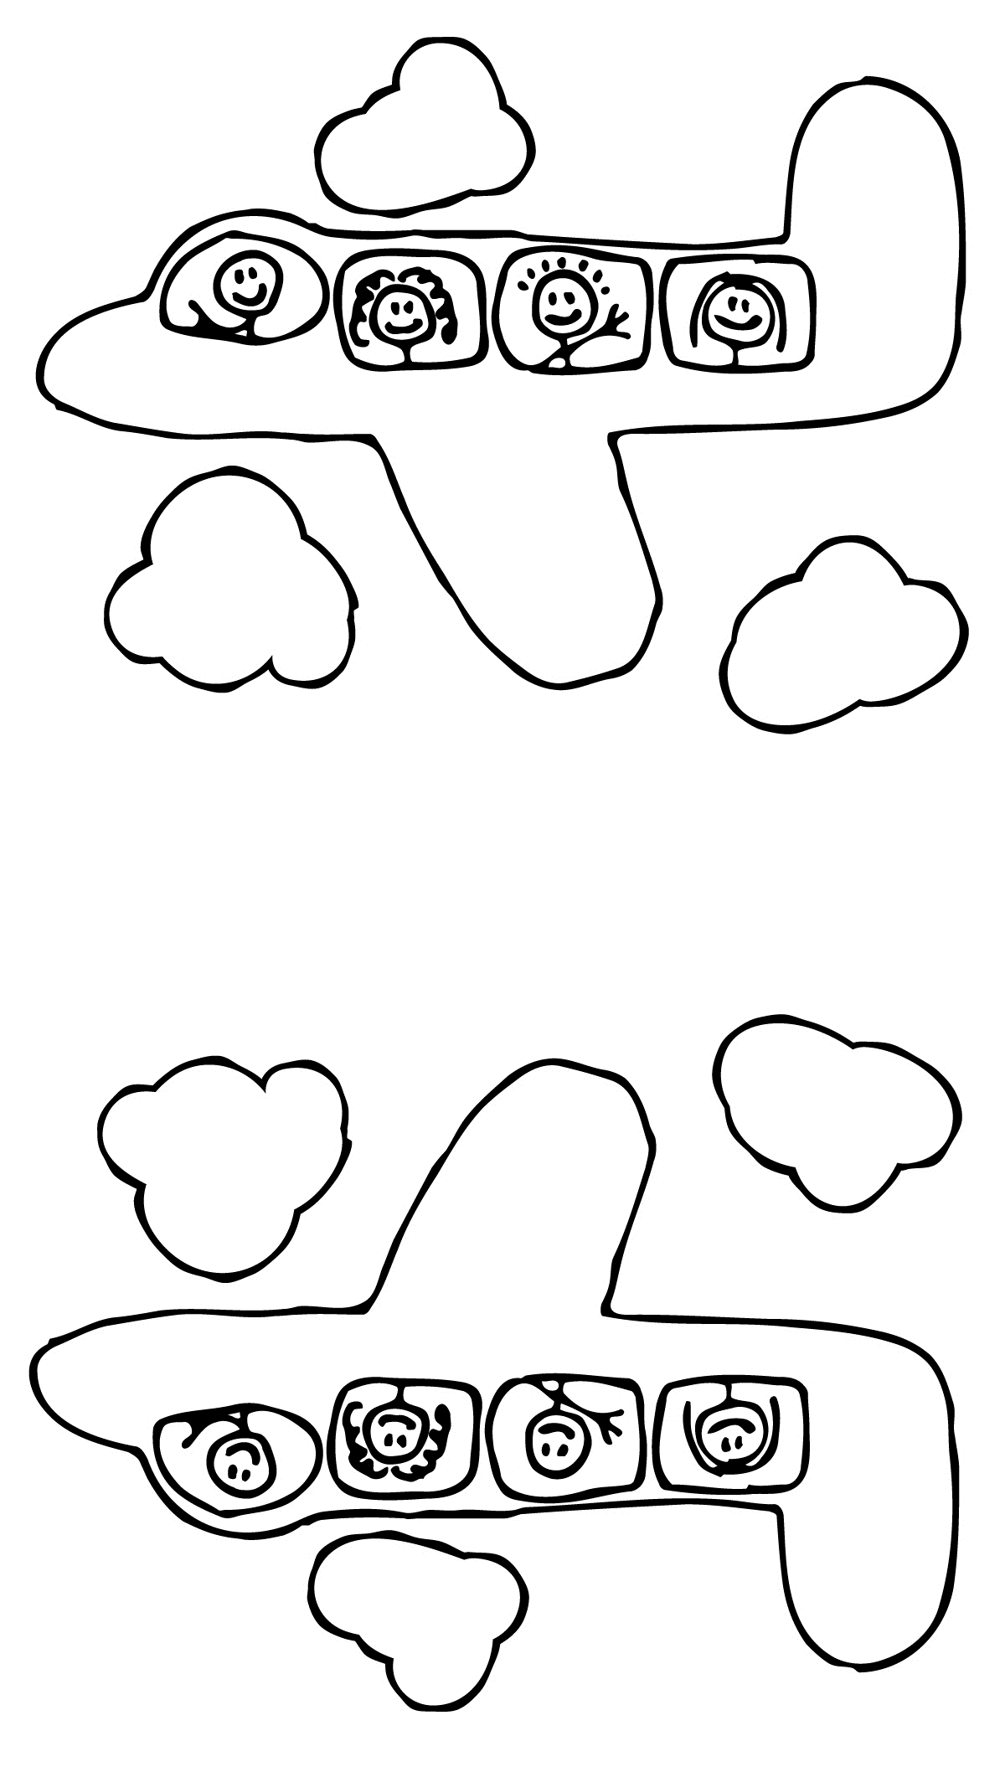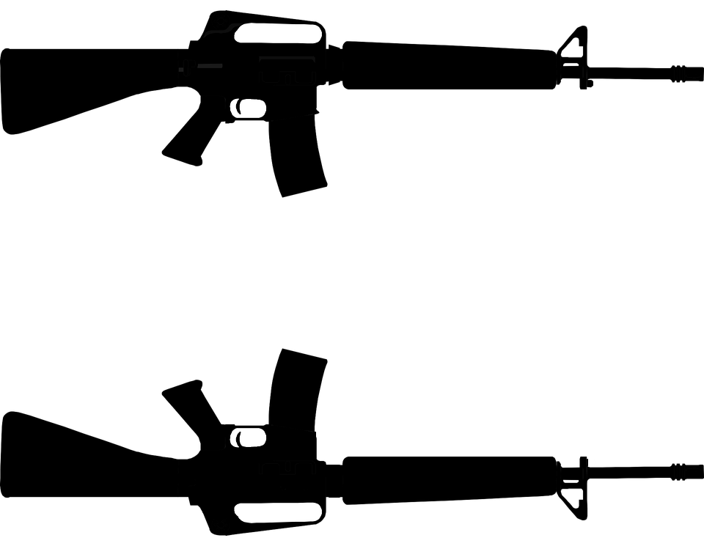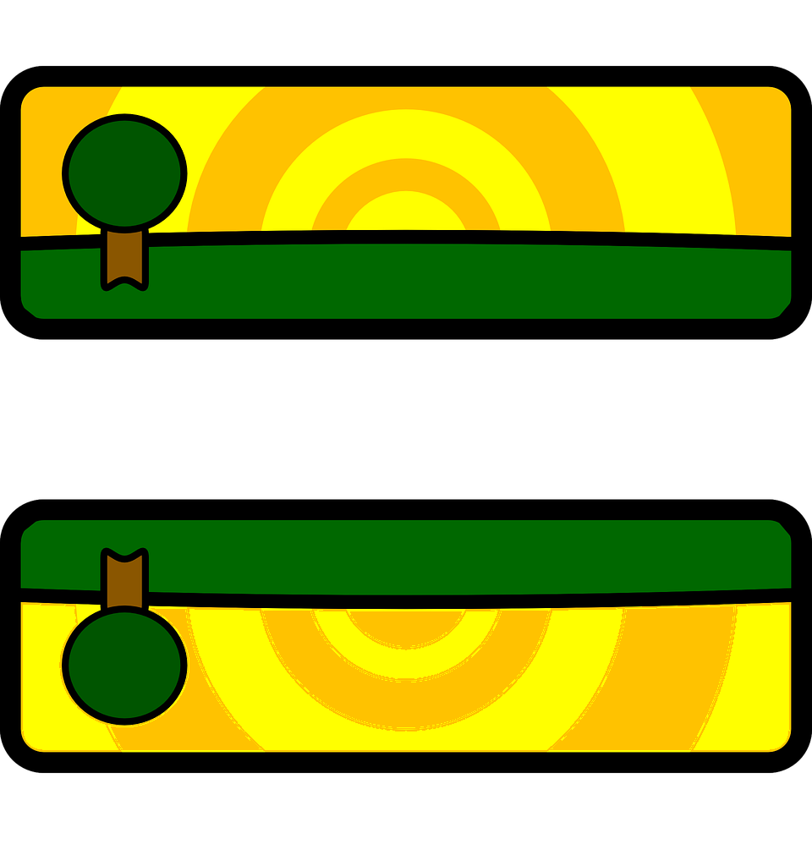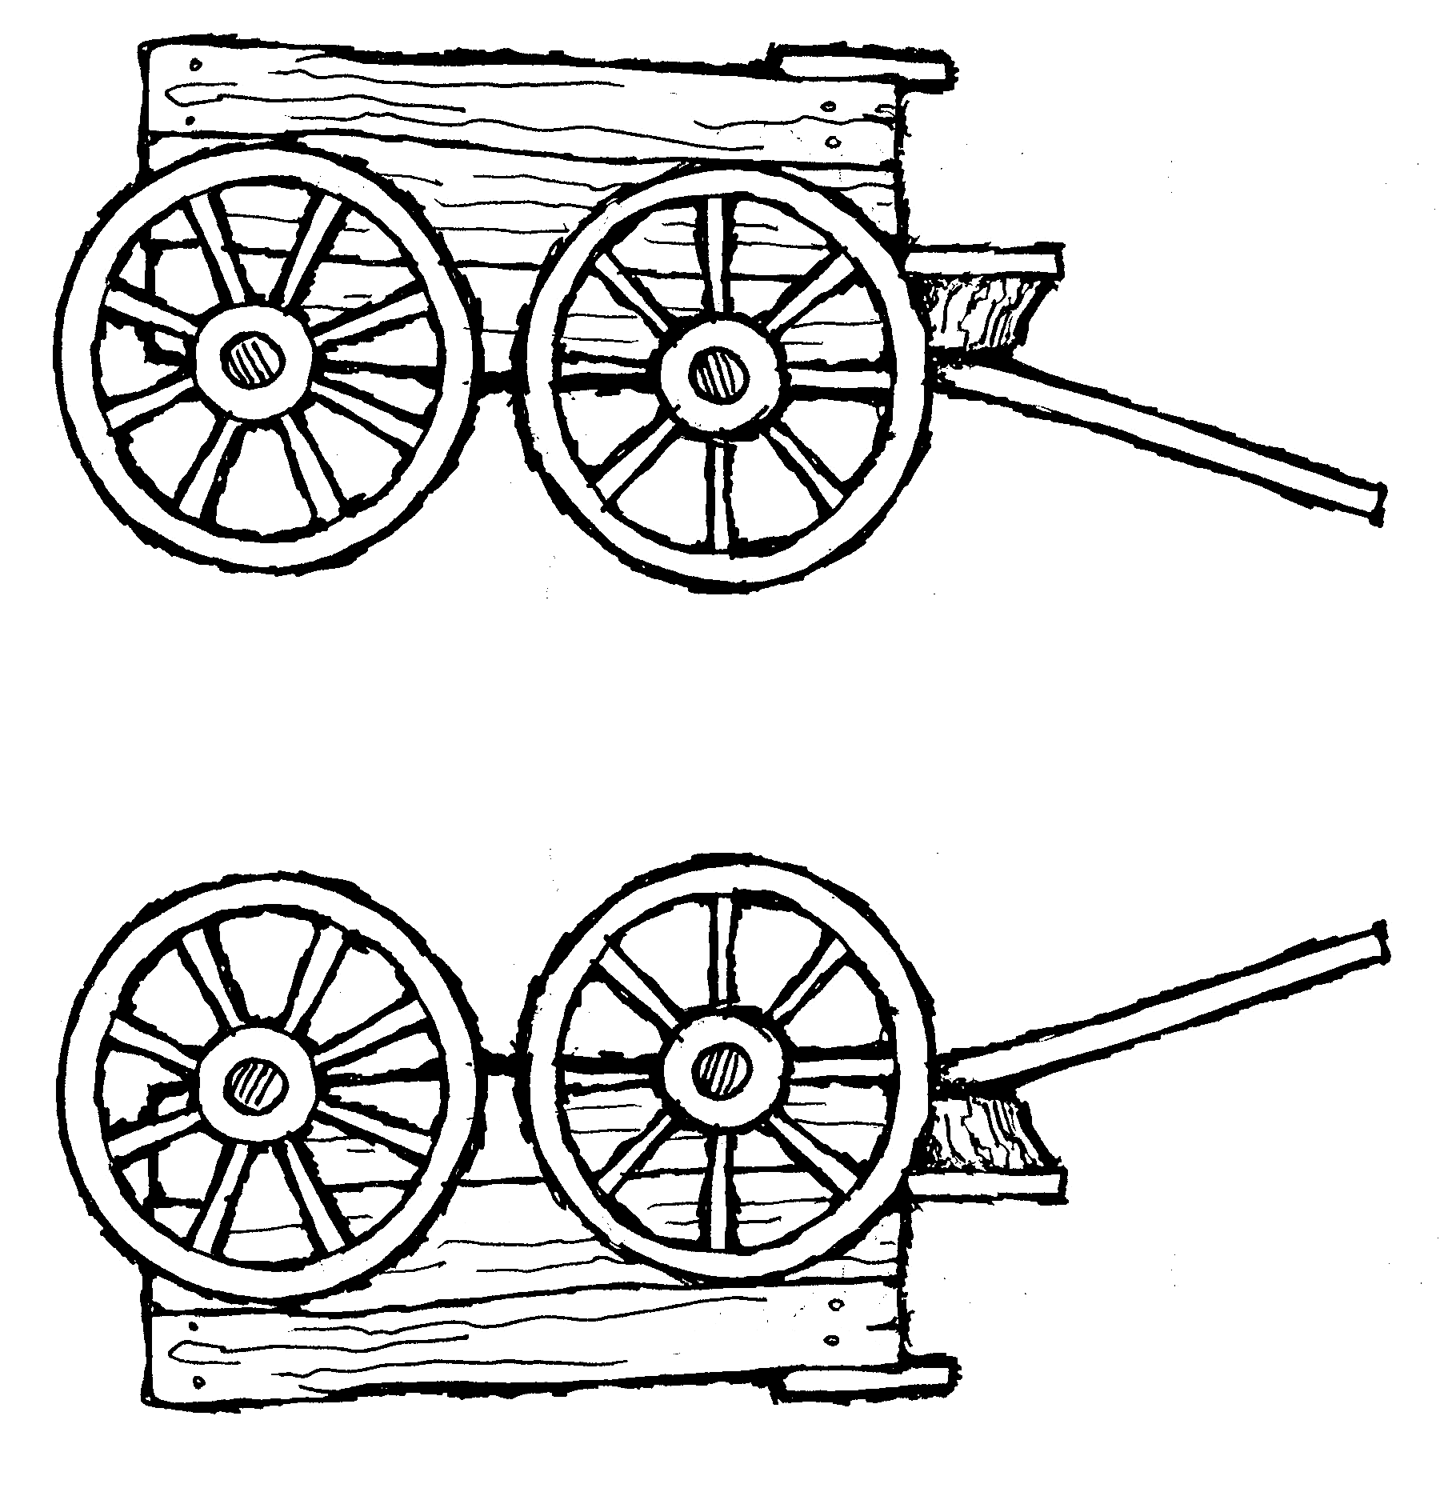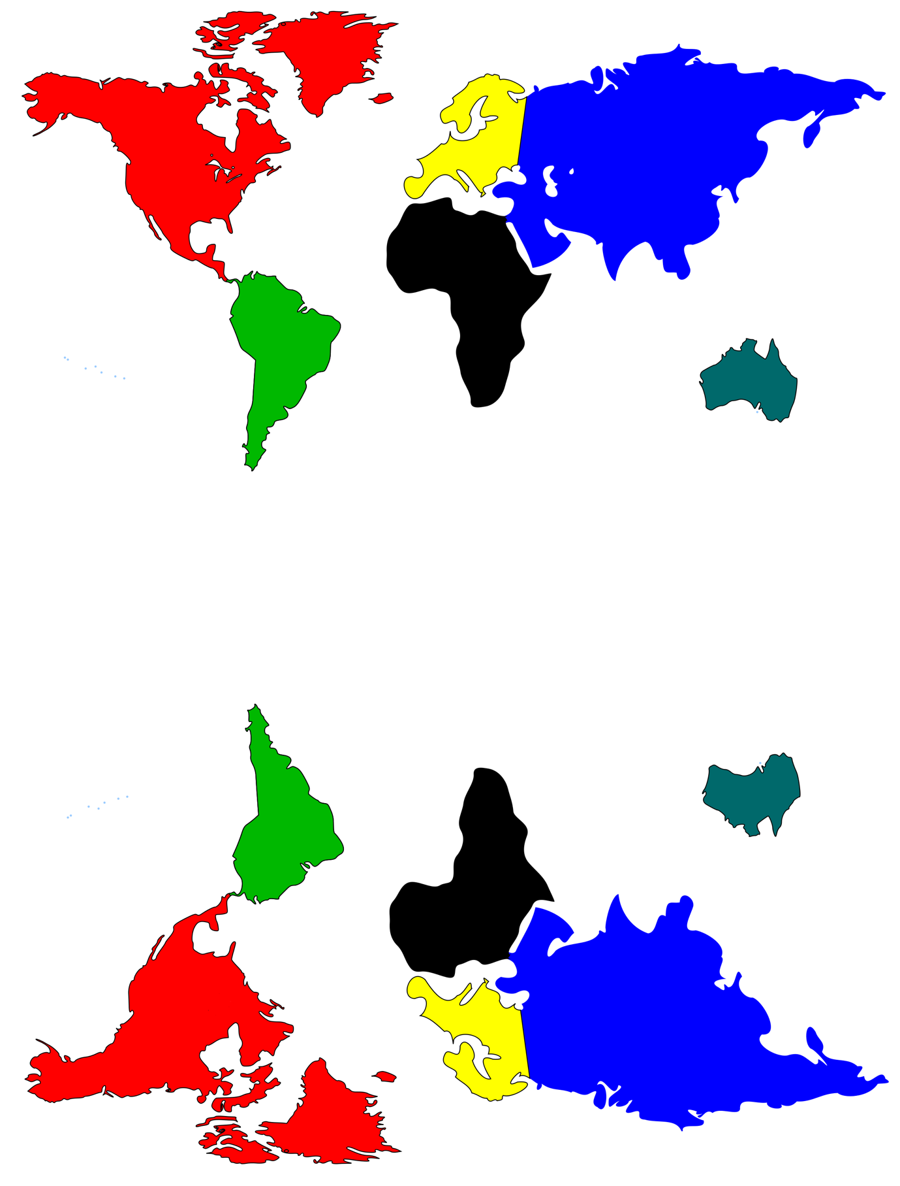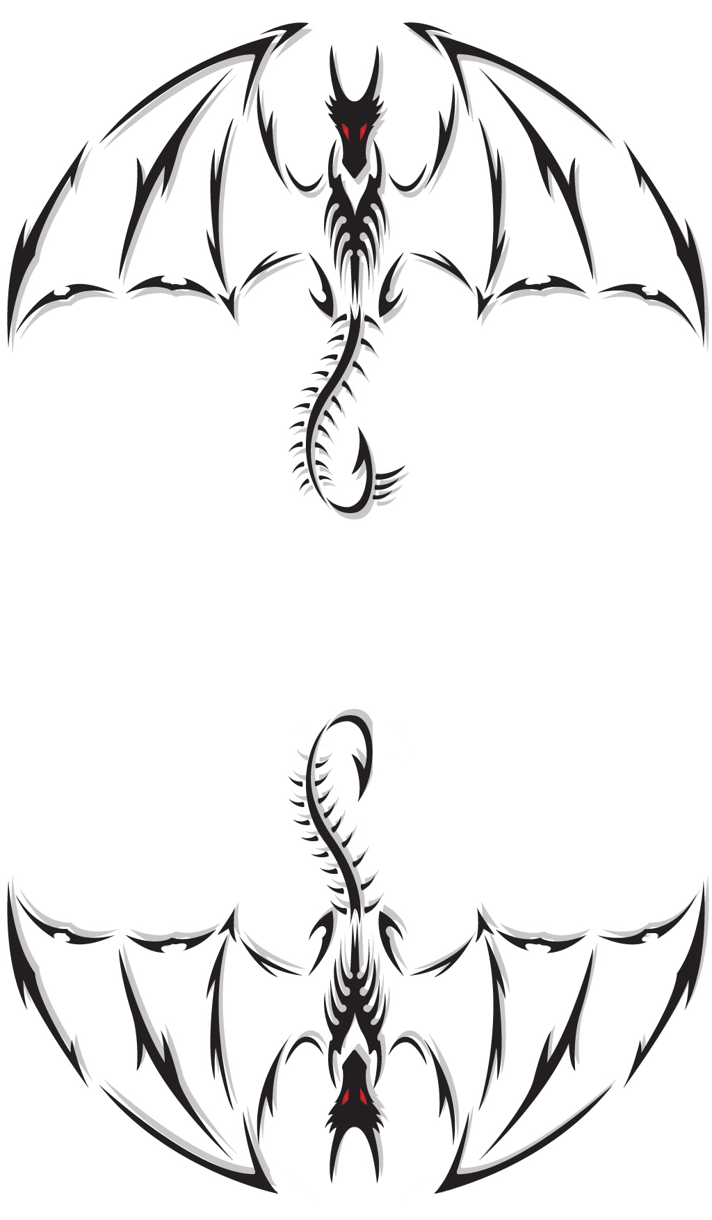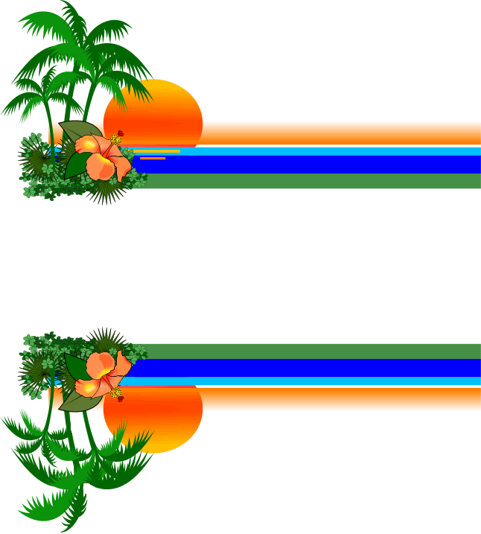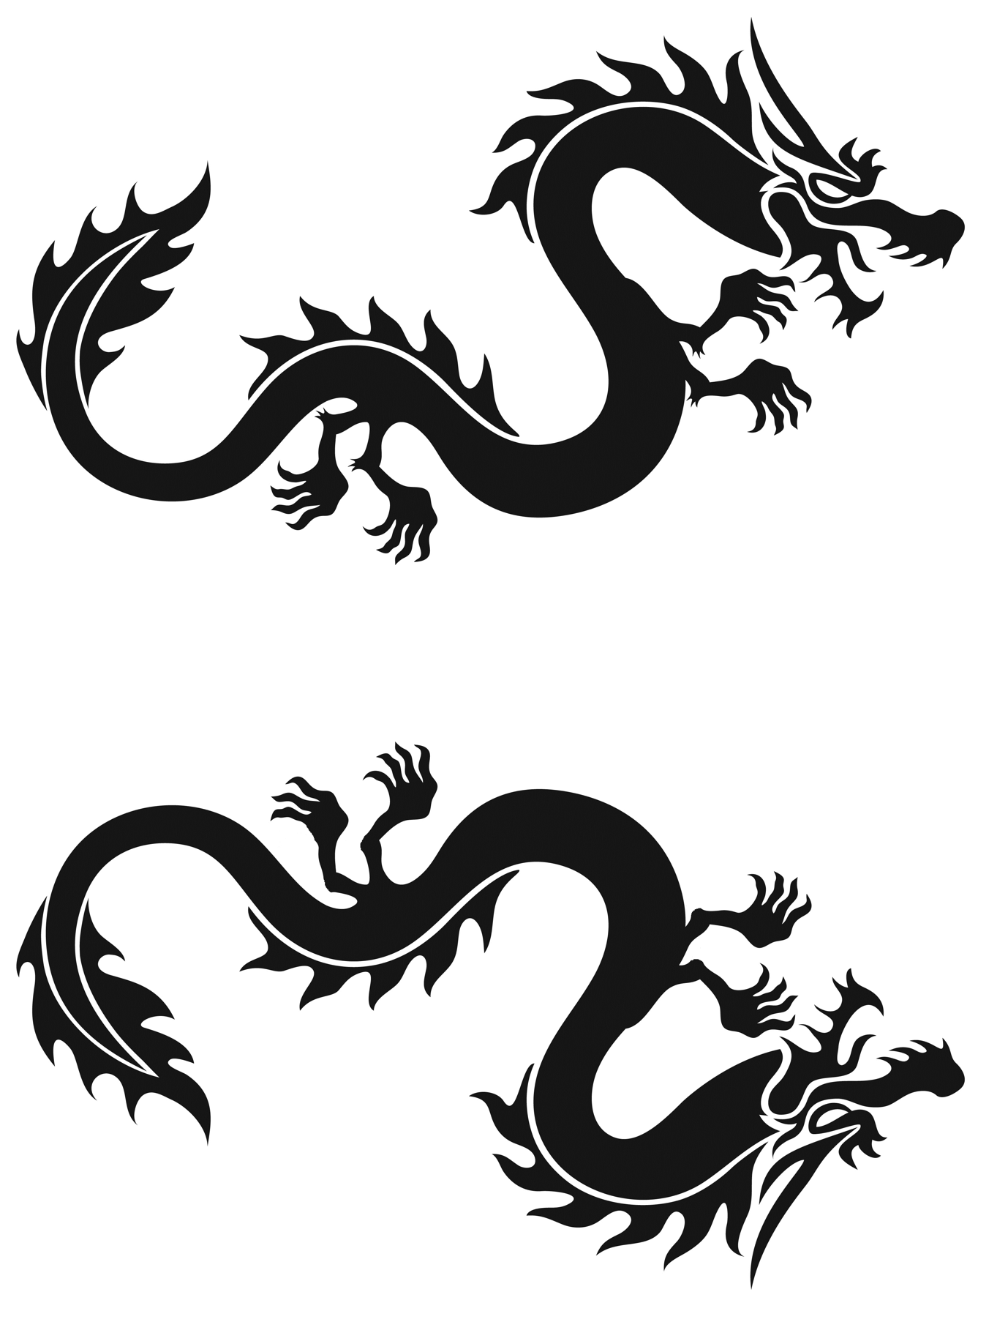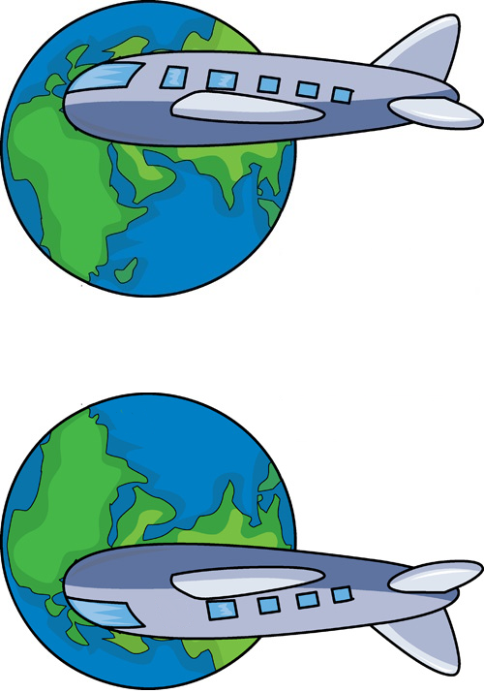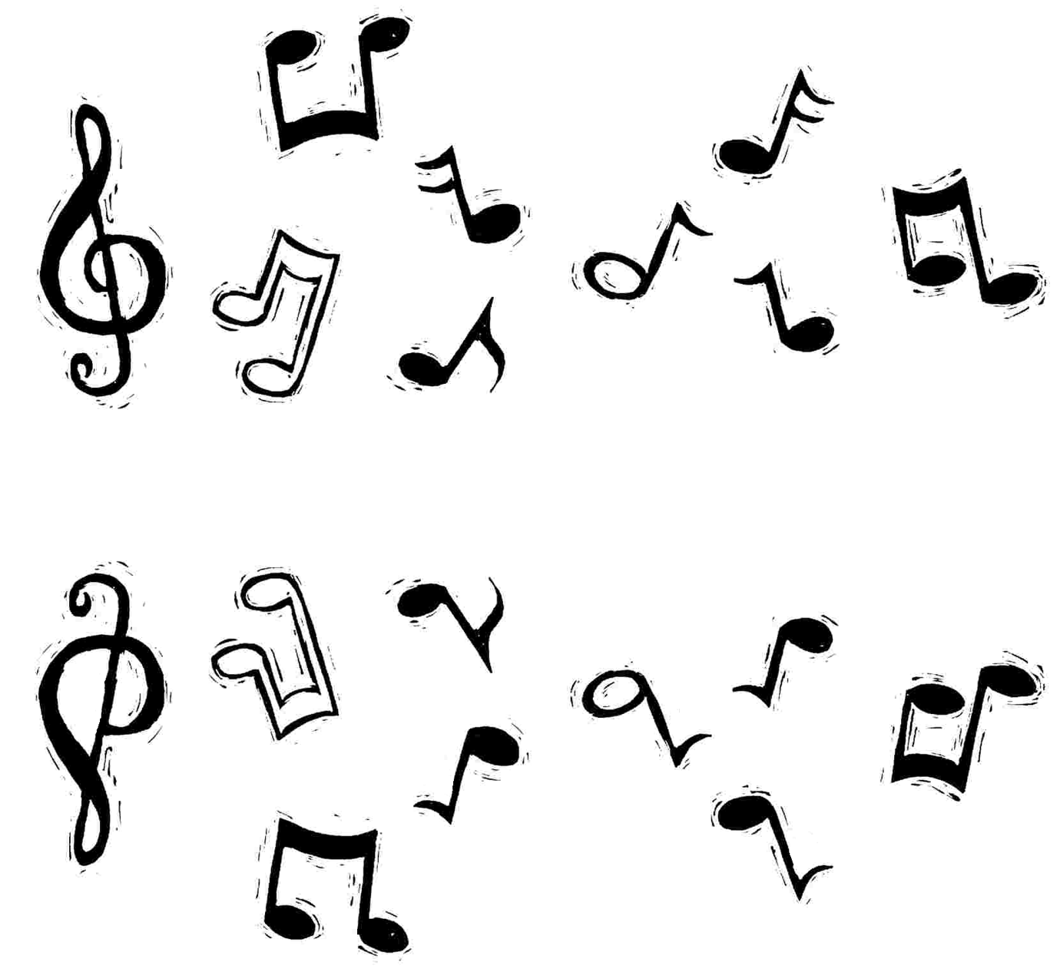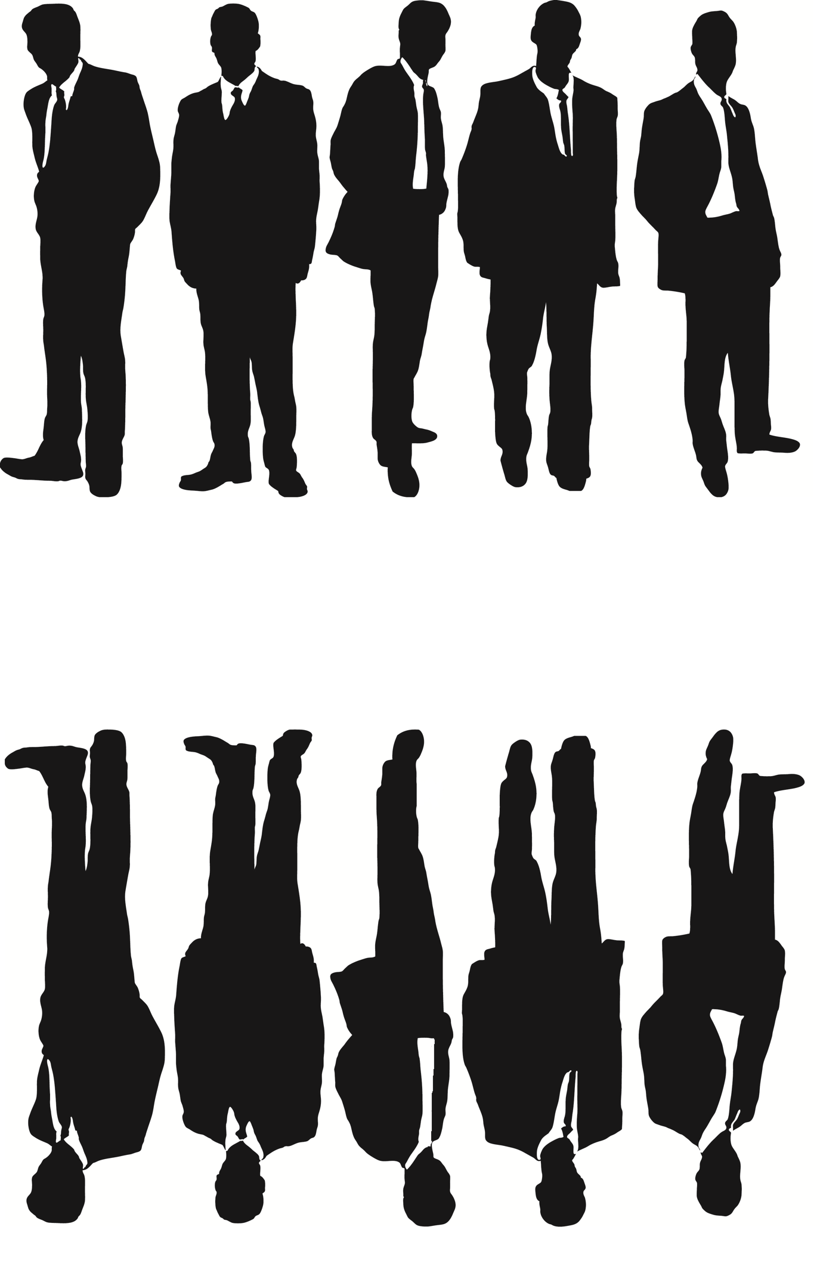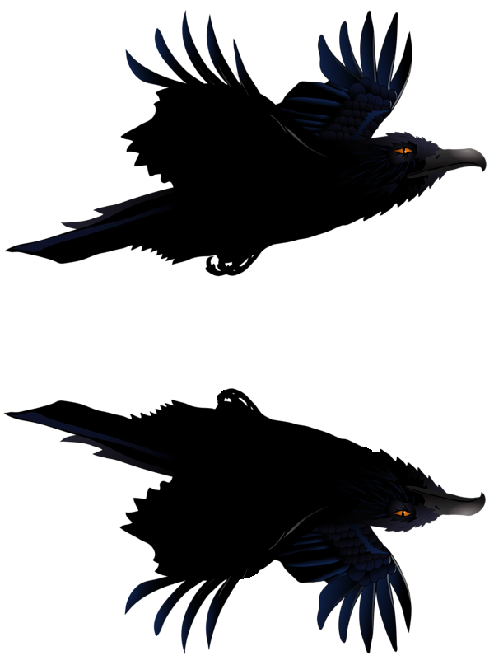

III.V.IV. Control pictures

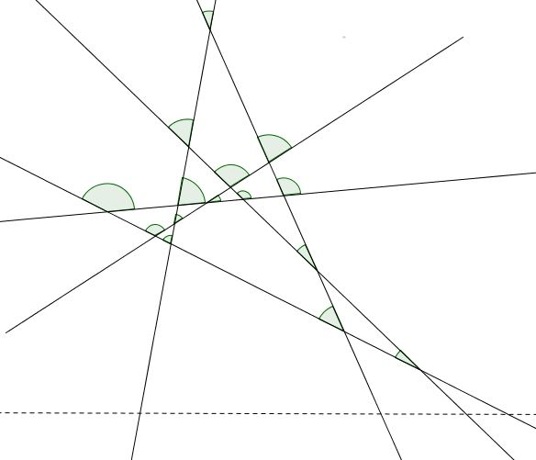

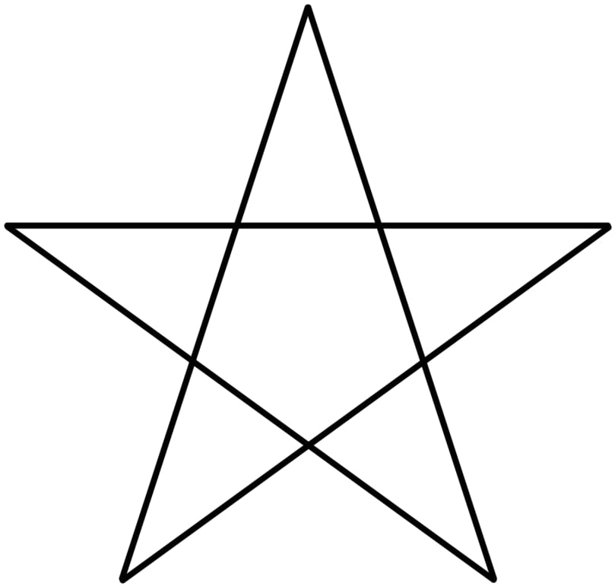

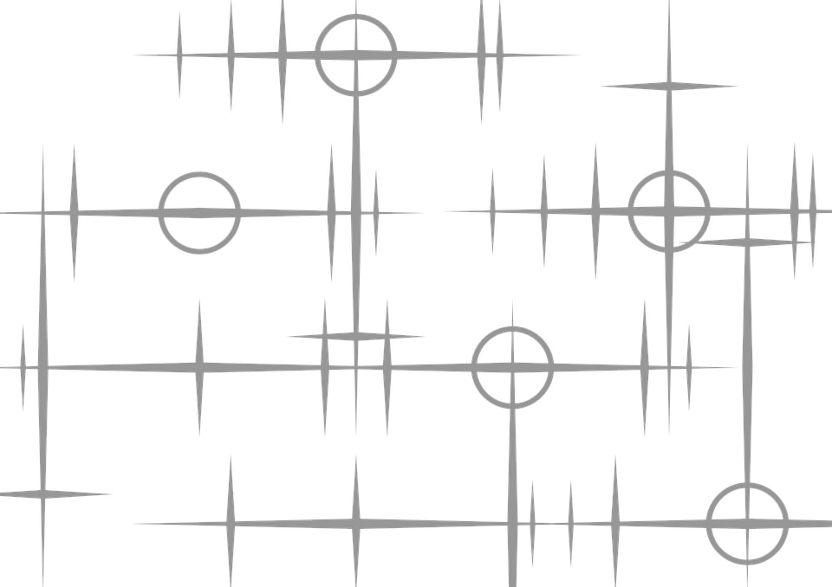

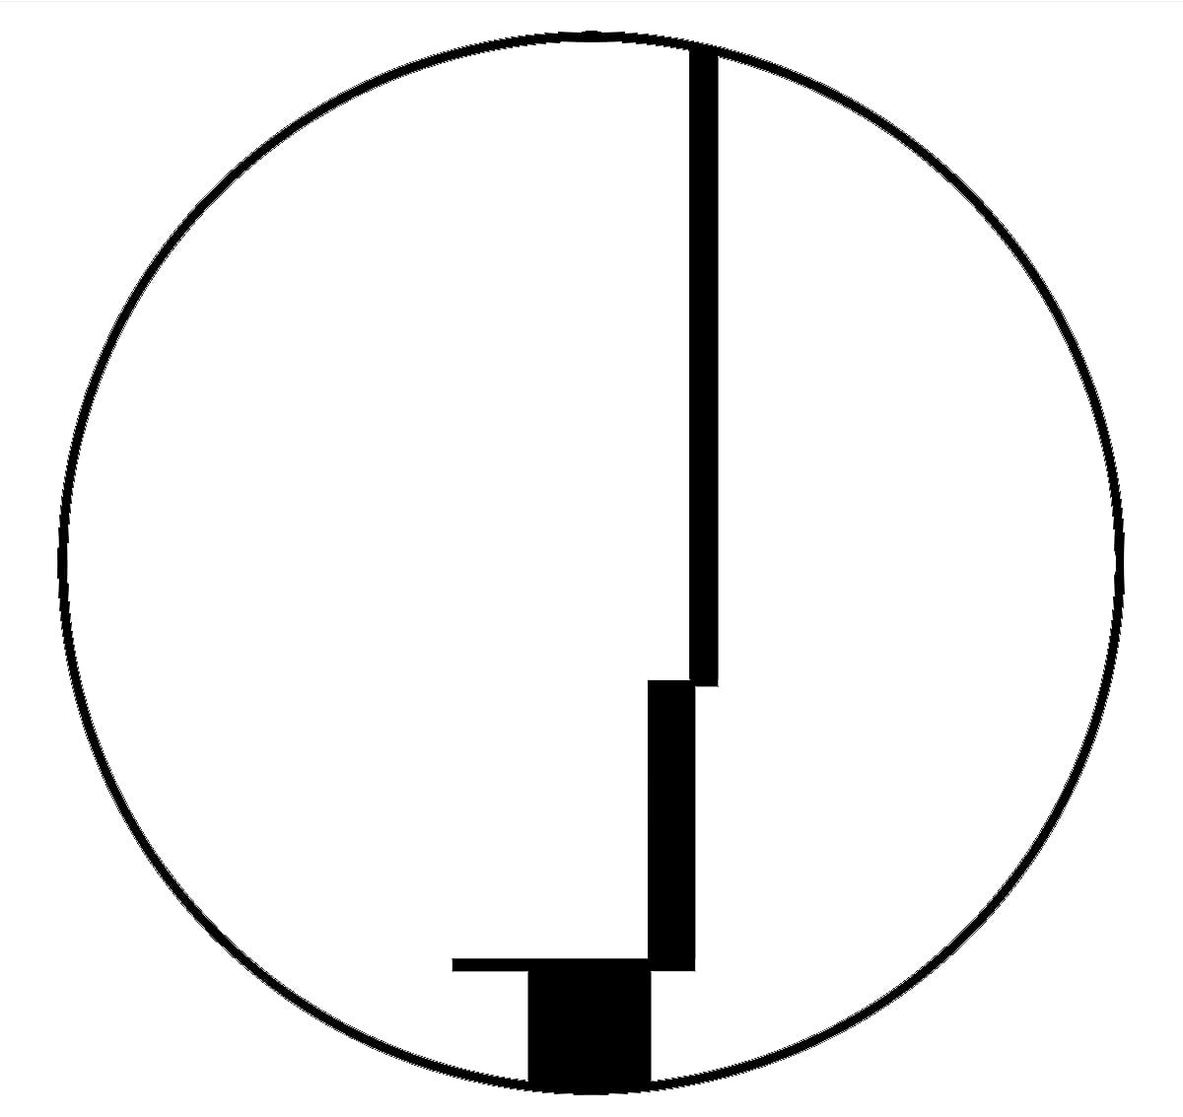

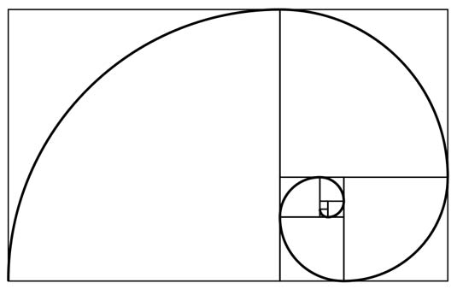

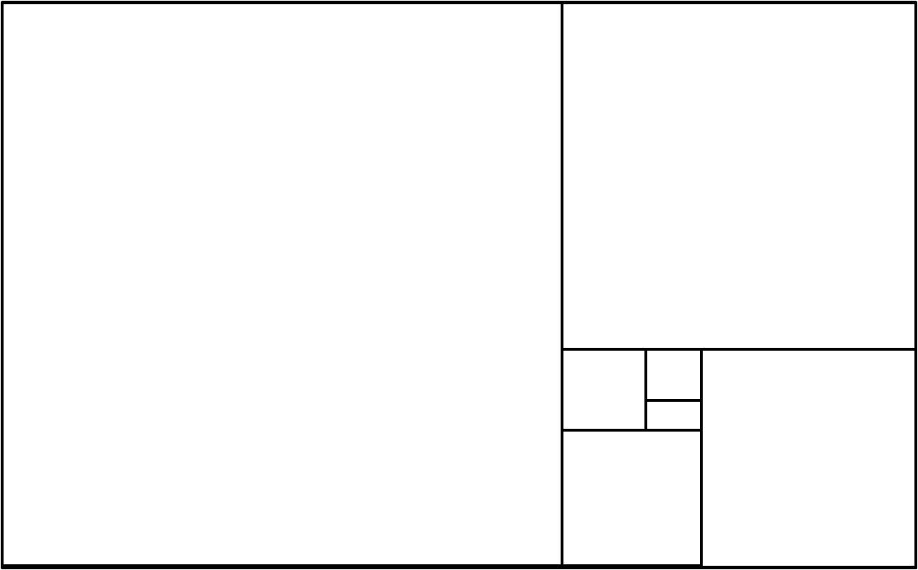

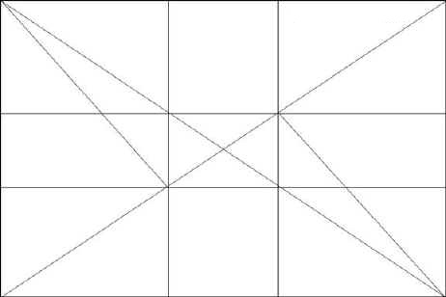

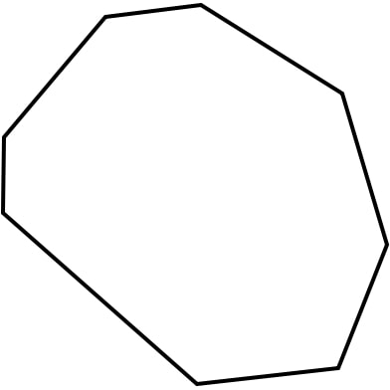

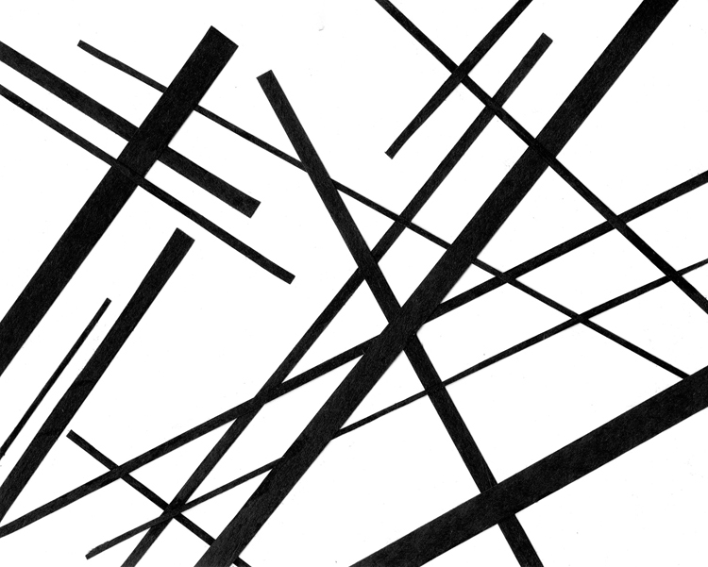

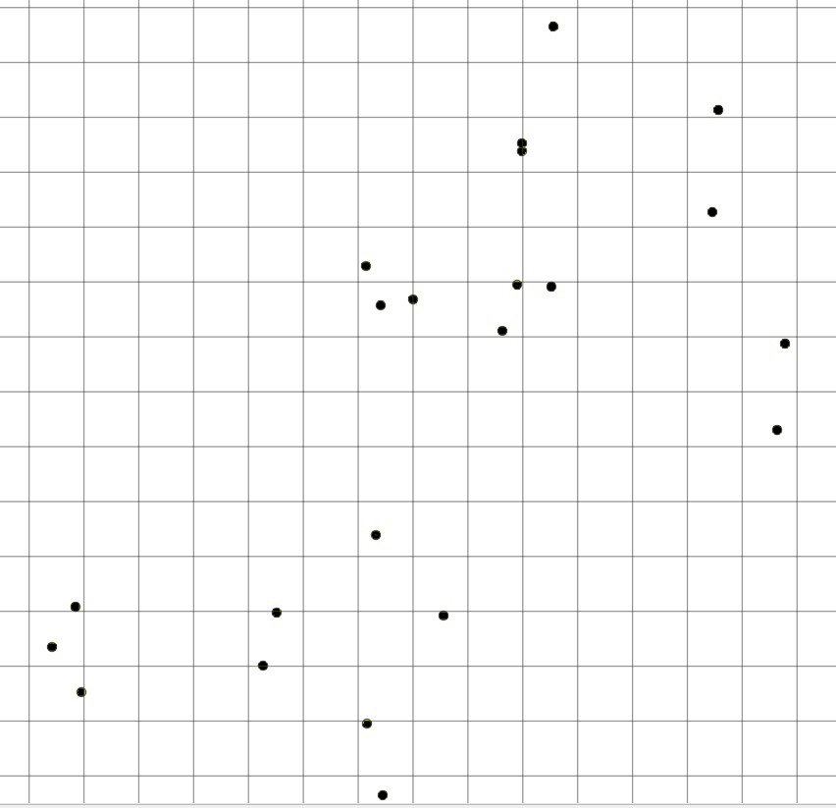

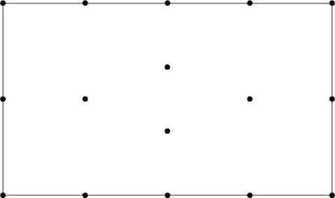

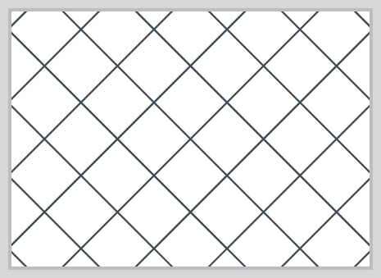
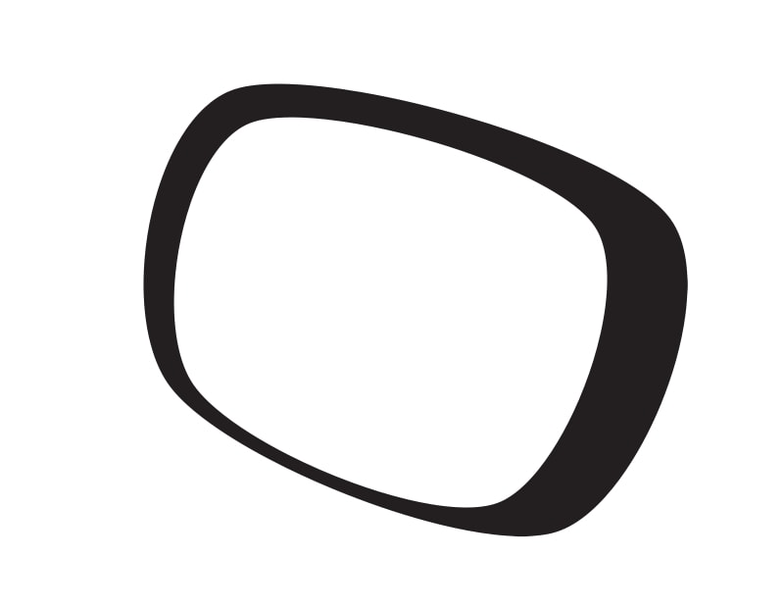
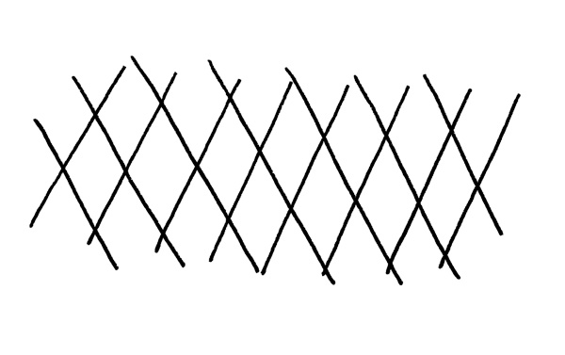

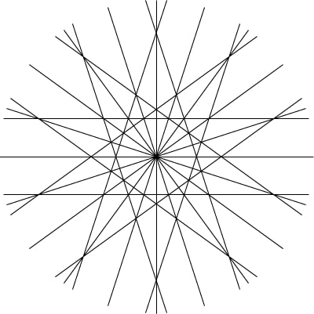

Appendix III.VI. Python code of the behavioural study
The critical aspects of the Python code used in programming the behavioural study:

- The double-blinded pseudo-randomization, at the beginning of the experiment:
import random

## Randomly assign the group
key = ['control', 'egoDepl', '+Manipu', '-Manipu']
Groups = ['1', '2', '3', '4']
thisGroup = random.choice (Groups)

## Check whether used before
with open('groupLog.txt', 'r') as groupRol:
line = groupRol.readline()
if len(line) < 4:
while thisGroup in line:
thisGroup = random.choice (Groups)

## Add used groups into the file
if len(line) < 4:
groupRol = open ('groupLog.txt', 'a')
groupRol.write('%s' %(thisGroup))
groupRol.close
if len(line) == 4:
groupRol = open ('groupLog.txt', 'w')
groupRol.write('%s' %(thisGroup))
groupRol.close

theGroup = int(thisGroup)-1 # Changing the group number to be int (integer)

## Save this study Log (This bit of the text is run once to create a log file were participants’ data are saves)
#gFile = open ('logFile.csv', 'a')
#gFile.write('\n%s,%s,%s,%s,%s,%s,%s'
# %(expInfo['date'],
# expInfo['age'],
# expInfo['gender'],
# expInfo['session'],
# expInfo['number'], str(key[theGroup]),
# expInfo['participant']))
#gFile.close

gFile = open ('logFile.txt', 'a')
gFile.write('\n%s %s %s %s %s %s %s'
%(expInfo['date'],
expInfo['age'],
expInfo['gender'],
expInfo['session'],
expInfo['number'],
key[theGroup],
expInfo['participant']))
gFile.close

## manually changing the group for the seek of testing##
##(do not forget to change the Log file)##
##'control:0, egoDepl:1, +Manipu:2, -Manipu:3##
##theGroup = 3

## Appearance of instructions. Look at table 3.2
if key[theGroup] == 'control':
mindRepeat = 0
food2Repeat = 0

elif key[theGroup] == 'egoDepl':
mindRepeat = 0
food2Repeat = 1

elif key[theGroup] == '+Manipu':
mindRepeat = 1
food2Repeat = 1

elif key[theGroup] == '-Manipu':
mindRepeat = 1
food2Repeat = 1

## Creating a folder for the participant
folderName = _thisDir + os.sep + 'data\\%s\\%s_%s_%s' % (key[theGroup], expInfo['participant'], expName, expInfo['date'])
os.makedirs(folderName)

## Creating an overall file for the participant
overallFileOne = '%s\\overallFile%s_%s_%s.csv' %(folderName, expInfo['participant'], expName, expInfo['date'])
overallFile = open (overallFileOne, 'a')
overallFile.write ('%s_%s_%s' %(expInfo['participant'], key[theGroup], expInfo['date']))

- Food cues task
- At the beginning of the study:

foodSequencer = []
diffAccuracy = []
ClicksAccuracy = []
foodTrialCounter = 0

- At the beginning of the routine

import time
import random

## Lists and variables

visited = [] # Mouse click locations
trialClock = core.Clock() # Timing
lastClickTime = 0 # Calibration of mouse click sign appearance
respClock = core.Clock() # To prevent instantaneous consecutive clicks
mouse = event.Mouse() # Define mouse as an event
corrChosLocations = 0 # Number of correctly defined differences
corrClicks = 0 # Number of correct clicks
thisClicksAccuracy = 0 # defining a variable after 'if'
clickedCircles = [] # Exclude already defined differences
foodTrialCounter += 1

## Randomising the food trials

thisTrial = random.choice(range(1, 31)) # Choosing a random number
while thisTrial in foodSequencer: # Prevent repetition of the number
thisTrial = random.choice(range(1, 31)) # Redrawing in repetition
foodSequencer.append(thisTrial) # Add the chosen number to the list

## deciding the type of middle pictures based on the group

# insert the file name into the variable
if key[theGroup] == 'control':
foodPicture = 'Control Pictures/%i.jpg' %(thisTrial)

# insert the file name into the variable
elif key[theGroup] != 'control':
foodPicture ='food Pictures/%i.jpg' %(thisTrial)

- For each frame

##Useful variables
TempContainer = (0, 0)

##Ceasing autoDrawing and re-draw based on our order of appearance
for obj in [comparison, food]:
if obj.status==STARTED:
obj.draw() #draw manually
obj.setAutoDraw(False)# turn off autodraw draws when flip occurs
obj.status=STARTED # but setting autoDraw(False) sets status=FINISHED

##Timing the mouse clicks and obtaining participant's response
# Clicks only on the pictures
if comparison.contains(mouse) or food.contains(mouse):
timeElapsed = time.time()-lastClickTime
# Control for repeated clicks
if sum(mouse.getPressed()) and timeElapsed>0.5:
# Save clicks locations into 'visited' list
visited.append(mouse.getPos())
# Save clicks locations into the temporary variable for later use
TempContainer = mouse.getPos()
lastClickTime = time.time() # Resetting last click time

##Drawing the mouse clicks

# Online
for thisPos in visited:
difference.pos = thisPos # Apply clicked locations into the sign
difference.draw() # Draw the signs over the clicked location

# Mirrored
for thatPos in visited:
(a, b) = thatPos
OK = (a, -b)
difference.pos = OK # Apply clicked locations into the sign
difference.draw() # Draw the signs over the clicked location

- At the end of the routine
pracComparison.clearTextures()
pracFood.clearTextures()

- Keeping pictures height to width ratio for resolution (1050 x 1680)
- At the beginning of the routine

# For comparison pictures
(cx, cy) = pracComparison.size
dC = cx/cy
pracComparison.setSize(((dC*1040), 1040), units = 'pix')

# For food pictures
(fx, fy) = pracFood.size
dF = fx/fy
pracFood.setSize(((dF*280),280), units = 'pix')

- At the end of the routine

# Resetting pictures' sizes
pracComparison.size = None
pracFood.size = None

- Stroop task
- At the beginning of the routine

## Stroop fixed answers
Answers = ['yellow', 'red', 'blue', 'green']

## Orientation of the displayed answers
ansLocations = [(0,-0.2), (0,-0.8), (0.3,-0.5), (-0.3,-0.5)]

## The marking variable
mark = 0
response = 0
RT = 2.300

# Linear orientation
# ansLocations = [(-0.6,-0.4), (-0.2,-0.4), (0.2,-0.4), (0.6,-0.4)]

## assigning colours and words
if cong == 1: # congruent trials
paint = random.choice(Answers)
word = paint
elif cong ==0: # incongruent trials
paint = random.choice(Answers)
word = random.choice(Answers)
while word == paint:
word= random.choice(Answers)

## Start timing each trial and obtain the onset of the stimuli
strTrialTimer = core.Clock()
onset = runTimer.getTime()
- For each frame

## Drawing the answers and collecting marks
for thisAnsLocation in ansLocations:

# Set the locations
#strAnswer.pos = thisAnsLocation (corrected for memory leak)
StrGetAns.pos = thisAnsLocation

# Matching the text with the circle
C = ansLocations.index(thisAnsLocation)

# Set cursor overlap
if StrGetAns.contains(mouse):
StrGetAns.setOpacity(0.3)
else:
StrGetAns.setOpacity(1)

# Set the text
#strAnswer.setText(Answers[C]) (corrected for memory leak)

# Obtain the response
if StrGetAns.contains(mouse) and sum(mouse.getPressed()):
RT=strTrialTimer.getTime()
if paint==Answers[C]:
mark = 1
response = Answers[C]
continueRoutine = False
elif paint!=Answers[C]:
mark = 0
response = Answers[C]
continueRoutine = False

# Draw the objects
#strAnswer.draw() (corrected for memory leak)
StrGetAns.draw()

- At the end of the routine

## Writing the trial to participant's log file
stroopLog.write ('\n%i, %s, %s, %i, %s, %i, %1.5f, %i, %i, %1.5f'
%(strCases, word, paint, cong, response, mark,
RT, theGroup, runs, onset))

## Writing the trial to overall log file
stroopFinal.write('\n%s, %s, %s, %s, %i, %i, %s, %s, %i, %s, %i, %1.5f, %i, %1.5f' %
(expInfo['participant'], expInfo['date'], expInfo['session'],
expInfo['number'], theGroup, strCases, word, paint, cong,
response, mark, RT, runs, onset))

## Check for the timer to end a run or a block
# If 5 minutes pass or 30 sec pass
if strtimer.getTime() > 300.0 or blockTimer.getTime() > 30.0:
continueRoutine = False # Stop routine
currentLoop.finished = True # Stop the loops
stroopTask.finished = True
- Synchronizing with fMRI
- Jittering the trial lengths

## Counting the trials
strTrialCounter += 1

## Varying the fixation time
strfixTime = random.choice ([0.5, 0.3])

## Start timig the Stroop
if strTrialCounter == 1:
strtimer.reset()
elif strTrialCounter != 1:
None

- Starting fMRI synchronisation

##Defining the serial port
import pandas as pd
import serial
ser = serial.Serial(3, 115200, timeout=1) # open first serial port

##start synchronisation
for line in ser.read():
if 't' or '5' in line or sum(mouse.getPressed()):
runTimer = core.Clock()
continueRoutine = False

- Ending fMRI synchronisation

## End the synchronisation at the end of the run
if strtimer.getTime() > 300.0: # If 5 minutes pass
ser.close() # Stop synchronising with fMRI
continueRoutine = False # Stop the routine
currentLoop.finished = True # Then terminate the loop
stroopBlocks.finished = True

Appendix III.VII. Participants’ sheet and the protocol of the behavioural study
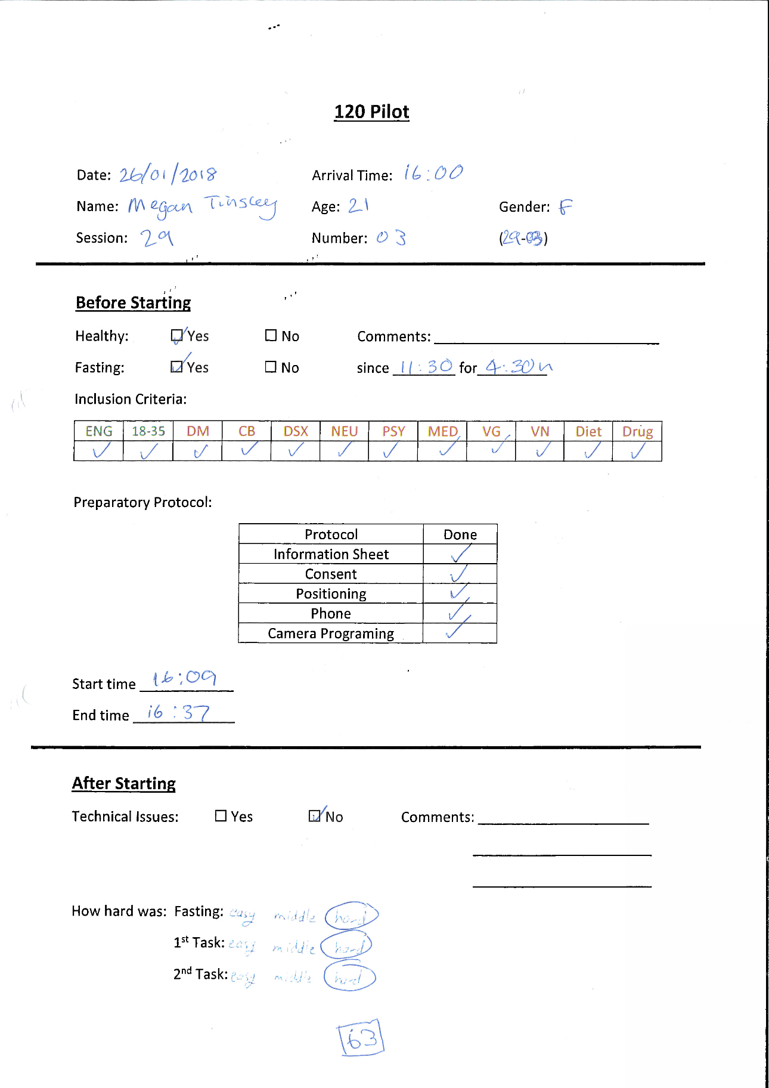

Figure 1. participants’ registration sheet

Figure 2. The protocol of the behavioural study

Appendix III.VIII. The biased questionnaire of Job et al. (2010)

Instruction:

This questionnaire has been designed to investigate your ideas about willpower. Willpower is what you use to resist temptations, to stick to your intentions, and to remain in strenuous mental activity. There are no right or wrong answers. We are interested in your ideas.

Using the scale below, please indicate how much you agree or disagree with each of the following statements by writing the number that corresponds to your opinion in the space next to each statement.

 | 1 | 2 | 3 | 4 | 5 | 6 | 7
 | Strongly disagree | Moderately disagree | disagree | neutral | agree | Moderately agree | Strongly agree
 | Fixed mindset of self-control
1 | Strenuous mental activity exhausts your resources, which you need to refuel afterwards (e.g. through taking breaks, doing nothing, watching television, eating snacks).
2 | After a strenuous mental activity, your energy is depleted and you must rest to get it refueled again.
3 | When you have completed a strenuous mental activity, you cannot start another activity immediately with the same concentration because you have to recover your mental energy again.
4 | Resisting temptations makes you feel more vulnerable to the next temptations that come along.
5 | When situations accumulate that challenge you with temptations, it gets more and more difficult to resist the temptations.
6 | It is particularly difficult to resist temptation after resisting another temptation right before.
 | Growth mindset of self-control
1 | When you have been working on a strenuous mental task, you feel energized and you are able to immediately start with another demanding activity.
2 | Your mental stamina fuels itself. Even after strenuous mental exertion, you can continue doing more of it.
3 | After a strenuous mental activity, you feel energized for further challenging activities.
4 | If you have just resisted a strong temptation, you feel strengthened and you can withstand any new temptations.
5 | Resisting temptations activates your willpower and you become even better able to face new upcoming temptations.
6 | Your capacity to resist temptations is not limited. Even after you have resisted a strong temptation you can control yourself right afterwards.

Chapter 4

Appendices of

Appendix IV.I. The demographic data of study 1

Table 1. The collected demographic data of study 1
Ethnicity | 72.6%  white | 6.8%  Indian, Pakistani, Bangladeshi | 19.2%  others
Religion | 56.2%  no religion | 29.4%  Christians | 13%  Others
Qualification | 40.4%  High school/A-level | 24.6%  Bachelor | 30.8%  Higher education
Annual income | 39.5%  less than £4000 | 13.6%  In-between | 45.4%  more than £10000
Nationality | 64.7%  British | 35.3%  Others

Appendix IV.II. The original 30 questions of the TBM used in study 1
The generated 30 preliminary questions that were hypothesized to represent the three-belief model of self-control. As this page was displayed online, the layout was a little different. Questions marked with capital R are reversed questions.

Please indicate how much you agree or disagree with each of the following statements on a scale from 1 to 5, where 1 means strongly disagree and 5 means strongly agree. There are no right or wrong answers, we are just interested in your opinion.”
strongly disagree strongly agree
1 | 2 | 3 | 4 | 5

Self-control as a skill
1 | I learned how to resist temptations in a similar way to how I learned to read or ride a bicycle
2 | Failing to control myself means that I am not skilful enough in doing so
3 | People can become experts in controlling their actions and resisting temptation
4 | People develop the skills needed to control themselves as they grow up
5 | Self-control improves as people develop the necessary skills
6 | Skill has no effect on self-control | R
7 | Self-control cannot be mastered | R
8 | Self-control is not a skill | R
9 | Successful self-control is not a matter of developing the needed skills to do so | R
10 | Self-control is a skill that can be learnt

Self-control as a schema

1 | Once I have exerted self-control, it becomes easier for me to do so again
2 | Successfully controlling myself has nothing to do with knowing the nature of self-control | R
3 | Being knowledgeable about self-control does not make me better at controlling my desires | R
4 | Exerting self-control is a matter of switching the system on
5 | Knowing and planning are essential for me to exert self-control
6 | Successful self-control is a matter of knowing how to do it
7 | Once I know the steps required to control myself, I can succeed in future attempts to do so
8 | Failing at self-control means lacking the proper knowledge of how to do so
9 | I can apply self-control without any prior knowledge | R
10 | I can control my desires without knowing how I did so | R

Self-control as an energy
1 | After putting my best foot forward, I need to replenish my reserves
2 | After trying to control my emotions, I feel tired
3 | After finishing something I don’t like to do, I feel like letting it all hangout
4 | I get tired when I have to control myself
5 | I have difficulties controlling myself when I am tired
6 | If I try hard my battery runs down: I need a break before I can go on
7 | If I control myself, this costs me a lot of energy
8 | After completing an exacting task, I take some time to relax
9 | Controlling intense emotions wears me out
10 | If I plan to do something that involves self-control, I try to be well-rested

Appendix IV.III. The descriptions of skill, knowledge, and energy in Baumeister et al. (1998)
Below are the quoted descriptions from Baumeister et al. (1998) of the three potential explanations of the experimental results. The underlined key words represent the concepts of the skill and knowledge models, where questions were crafted for each concept.
Skill
“One model views self-regulation as essentially a skill. In this model, people gradually develop the skill to regulate themselves over long periods of time. On any given occasion, however, skill remains roughly constant across repeated trials (except for small and gradual learning effects), so there should be little or no change in effectiveness of self-control on two successive exertions within a short time.”
Knowledge
“Another model portrays self-regulation as essentially a knowledge structure. In this view, self-control operates like a master schema that makes use of information about how to alter one's own responses or states. On the basis of this model, an initial act of self-regulation should prime the schema, thereby facilitating subsequent self-control. Another version of this view would be that the self-regulatory system is normally in a standby or depowered mode until it is pressed into action by one act of self-control. Once activated, the system would remain in operation ("on") for a time, making further acts of self-control easier.”
Energy
﻿“A third model states that self-regulation resembles energy. In this view, acts of self-regulation involve some kind of exertion that expends energy and therefore depletes the supply available. Unless the supply is very large, initial acts of self-regulation should deplete it, thereby impairing subsequent self-control”.

Appendix IV.IV. Brief self-control and Short Grit Scales

Brief Self-control Scale
(Tangney et al., 2004)

Using the 1 to 5 scale below, please indicate how much each of the following statements reflects how you typically are:

not at all like me | A little like me | Somewhat like me | Mostly like me | very much like me
1 | 2 | 3 | 4 | 5

 | type of activity | frequency
1. | I am good at resisting the temptation
2. | I have a hard time breaking bad habits. R
3. | I am lazy. R
4. | I say inappropriate things. R
5. | I do certain things that are bad for me if they are fun. R
6. | I refuse things that are bad for me
7. | I wish I had more self-discipline. R
8. | people would say that I have iron self-discipline
9. | pleasure and fun sometimes keep me from getting work done. R
10. | I have trouble concentrating. R
11. | I am able to work effectively towards long-term goals
12. | sometimes I can’t stop myself from doing something, even if I know it is wrong. R
13. | I often act without thinking through all the alternatives. R

Short Grit Scale
(A. L. Duckworth & Quinn, 2009)

Directions for taking the Grit Scale: Please respond to the following 8 items. Be honest – there are no right or wrong answers!

1. New ideas and projects sometimes distract me from previous ones.
❑ Very much like me
❑ Mostly like me
❑ Somewhat like me
❑ Not much like me
❑ Not like me at all

2. Setbacks don’t discourage me. (Reversed)
❑ Very much like me
❑ Mostly like me
❑ Somewhat like me
❑ Not much like me
❑ Not like me at all

3. I have been obsessed with a certain idea or project for a short time but later lost interest.
❑ Very much like me
❑ Mostly like me
❑ Somewhat like me
❑ Not much like me
❑ Not like me at all

4. I am a hard worker. (Reversed)
❑ Very much like me
❑ Mostly like me
❑ Somewhat like me
❑ Not much like me
❑ Not like me at all

5. I often set a goal but later choose to pursue a different one.
❑ Very much like me
❑ Mostly like me
❑ Somewhat like me
❑ Not much like me
❑ Not like me at all

6. I have difficulty maintaining my focus on projects that take more than a few months to complete.
❑ Very much like me
❑ Mostly like me
❑ Somewhat like me
❑ Not much like me
❑ Not like me at all

7. I finish whatever I begin. (Reversed)
❑ Very much like me
❑ Mostly like me
❑ Somewhat like me
❑ Not much like me
❑ Not like me at all

8. I am diligent. (Reversed)
❑ Very much like me
❑ Mostly like me
❑ Somewhat like me
❑ Not much like me
❑ Not like me at all

ـــــــــــــــــــــــــــــــــــــــــــــــــــــــــــــــــــــــــــــــــــــــــــــــــــــــــــــــــــــــــــــــــــــــــــــــــــــــــــــــــــــــــــــــــــــ

Scoring:
A. For questions 2, 4, 7 and 8 assign the following points:

5 = Very much like me
4 = Mostly like me
3 = Somewhat like me
2 = Not much like me
1 = Not like me at all

B. For questions 1, 3, 5 and 6 assign the following points:

1 = Very much like me
2 = Mostly like me
3 = Somewhat like me
4 = Not much like me
5 = Not like me at all

Add up all the points and divide by 8. The maximum score on this scale is 5 (extremely gritty), and the lowest score on this scale is 1 (not at all gritty).

Appendix IV.V. The tabular results of the factor analysis (EFA/ML) in study 1

Table 1. KMO and Bartlett's Test
Kaiser-Meyer-Olkin Measure of Sampling Adequacy. |  | .832
Bartlett's Test of Sphericity | Approx. Chi-Square | 1413.885
 | df | 120
 | Sig. | .000

Table 2. Goodness-of-fit Test
Chi-Square | df | Sig.
133.875 | 75 | .000

Table 3. Factor Correlation Matrix
Factor | Energy | Knowledge | Skill
Energy | 1.000 | .068 | -.050
Knowledge | .068 | 1.000 | -.468
Skill | -.050 | -.468 | 1.000
Extraction Method: Maximum Likelihood.

Table 4. Communalities
 | Initial | Extraction
I learned how to resist temptations in a similar way to how I learned to read or ride a bicycle | .205 | .258
Skill has no effect on self-control | .250 | .407
Self-control is not a skill | .291 | .424
Successful self-control is not a matter of developing the needed skills to do so | .207 | .254
Successfully controlling myself has nothing to do with knowing the nature of self-control | .205 | .239
Exerting self-control is a matter of switching the system on | .188 | .216
Successful self-control is a matter of knowing how to do it | .325 | .406
Once I know the steps required to control myself, I can succeed in future attempts to do so | .231 | .294
Failing at self-control means lacking the proper knowledge of how to do so | .312 | .417
After putting my best foot forward, I need to replenish my reserves | .340 | .324
After trying to control my emotions, I feel tired | .624 | .660
I get tired when I have to control myself | .522 | .587
I have difficulties controlling myself when I am tired | .395 | .400
If I try hard my battery runs down: I need a break before I can go on | .424 | .445
If I control myself, this costs me a lot of energy | .534 | .584
Controlling intense emotions wears me out | .508 | .498
Extraction Method: Maximum Likelihood.

Table 5. Total Variance Explained
Factor | Initial Eigenvalues |  |  | Extraction Sums of Squared Loadings |  |  | Rotation Sums of Squared Loadingsª
 | Total | % of Variance | Cumulative % | Total | % of Variance | Cumulative % | Total
1 | 3.983 | 24.891 | 24.891 | 3.490 | 21.815 | 21.815 | 3.477
2 | 2.813 | 17.583 | 42.474 | 2.163 | 13.521 | 35.335 | 1.928
3 | 1.430 | 8.935 | 51.409 | .762 | 4.761 | 40.097 | 1.707
4 | .934 | 5.836 | 57.245
5 | .825 | 5.157 | 62.401
6 | .805 | 5.033 | 67.435
7 | .740 | 4.624 | 72.059
8 | .659 | 4.118 | 76.177
9 | .648 | 4.049 | 80.226
10 | .609 | 3.809 | 84.035
11 | .541 | 3.383 | 87.418
12 | .505 | 3.158 | 90.576
13 | .464 | 2.898 | 93.474
14 | .426 | 2.661 | 96.136
15 | .353 | 2.205 | 98.341
16 | .265 | 1.659 | 100.000
Extraction Method: Maximum Likelihood.

Table 6. Factor Matrix
 | Factor
 | 1 | 2 | 3
After trying to control my emotions, I feel tired | .804
I get tired when I have to control myself | .765
If I control myself, this costs me a lot of energy | .760
Controlling intense emotions wears me out | .704
If I try hard my battery runs down: I need a break before I can go on | .662
I have difficulties controlling myself when I am tired | .612
After putting my best foot forward, I need to replenish my reserves | .554
Successful self-control is a matter of knowing how to do it |  | .600
Failing at self-control means lacking the proper knowledge of how to do so |  | .568
Self-control is not a skill |  | -.527 | .359
Once I know the steps required to control myself, I can succeed in future attempts to do so |  | .491
Successful self-control is not a matter of developing the needed skills to do so |  | -.473
I learned how to resist temptations in a similar way to how I learned to read or ride a bicycle |  | .452
Successfully controlling myself has nothing to do with knowing the nature of self-control |  | -.428
Exerting self-control is a matter of switching the system on |  | .328 | .319
The skill has no effect on self-control |  | -.440 | .457
Extraction Method: Maximum Likelihood.

Table 7. Structure Matrix
 | Factor
 | 1 | 2 | 3
After trying to control my emotions, I feel tired | .809
I get tired when I have to control myself | .764
If I control myself, this costs me a lot of energy | .761
Controlling intense emotions wears me out | .704
If I try hard my battery runs down: I need a break before I can go on | .662
I have difficulties controlling myself when I am tired | .620
After putting my best foot forward, I need to replenish my reserves | .548
Failing at self-control means lacking the proper knowledge of how to do so |  | .640 | -.327
Successful self-control is a matter of knowing how to do it |  | .626 | -.394
Once I know the steps required to control myself, I can succeed in future attempts to do so |  | .539
I learned how to resist temptations in a similar way to how I learned to read or ride a bicycle |  | .507
Exerting self-control is a matter of switching the system on |  | .445
Self-control is not a skill |  | -.314 | .648
The skill has no effect on self-control |  |  | .626
Successful self-control is not a matter of developing the needed skills to do so |  | -.336 | .484
Successfully controlling myself has nothing to do with knowing the nature of self-control |  |  | .479
Extraction Method: Maximum Likelihood.

Appendix IV.VI. The tabular results of the factor analysis (CFA/PCA) in study 2

Table 1. KMO and Bartlett's Test
Kaiser-Meyer-Olkin Measure of Sampling Adequacy. |  | .824
Bartlett's Test of Sphericity | Approx. Chi-Square | 1396.734
 | df | 120
 | Sig. | .000

Table 2. Component Correlation Matrix
Factors | Energy | Knowledge | Skill
Energy | 1.000 | -.135 | .085
Knowledge | -.135 | 1.000 | .334
Skill | .085 | .334 | 1.000
Extraction Method: Principal Component Analysis.

Table 3. Communalities values
 | Initial | Extraction
The skill has no effect on self-control | 1.000 | .545
Self-control is not a skill | 1.000 | .501
Successful self-control is not a matter of developing the needed skills to do so | 1.000 | .472
Successfully controlling myself has nothing to do with knowing the nature of self-control | 1.000 | .455
I learned how to resist temptations in a similar way to how I learned to read or ride a bicycle | 1.000 | .366
Exerting self-control is a matter of switching the system on | 1.000 | .386
Once I know the steps required to control myself, I can succeed in future attempts to do so | 1.000 | .520
Successful self-control is a matter of knowing how to do it | 1.000 | .548
Failing at self-control means lacking the proper knowledge of how to do so | 1.000 | .506
After putting my best foot forward, I need to replenish my reserves | 1.000 | .364
After trying to control my emotions, I feel tired | 1.000 | .649
I get tired when I have to control myself | 1.000 | .605
I have difficulties controlling myself when I am tired | 1.000 | .440
If I try hard my battery runs down: I need a break before I can go on | 1.000 | .475
If I control myself, this costs me a lot of energy | 1.000 | .621
Controlling intense emotions wears me out | 1.000 | .596
Extraction Method: Principal Component Analysis.

Table 4. Total Variance Explained
Factor | Initial Eigenvalues |  |  | Extraction Sums of Squared Loadings |  |  | Rotation Sums of Squared Loadingsª
 | Total | % of Variance | Cumulative % | Total | % of Variance | Cumulative % | Total
1 | 3.839 | 23.993 | 23.993 | 3.839 | 23.993 | 23.993 | 3.799
2 | 2.831 | 17.692 | 41.685 | 2.831 | 17.692 | 41.685 | 2.474
3 | 1.381 | 8.633 | 50.318 | 1.381 | 8.633 | 50.318 | 2.390
4 | .916 | 5.727 | 56.045
5 | .876 | 5.477 | 61.522
6 | .780 | 4.875 | 66.397
7 | .740 | 4.624 | 71.022
8 | .666 | 4.165 | 75.187
9 | .659 | 4.118 | 79.305
10 | .644 | 4.028 | 83.333
11 | .555 | 3.471 | 86.804
12 | .521 | 3.253 | 90.057
13 | .504 | 3.147 | 93.205
14 | .438 | 2.740 | 95.944
15 | .363 | 2.268 | 98.213
16 | .286 | 1.787 | 100.000
Extraction Method: Principal Component Analysis.

Table 5. Component Matrix
 | Factor
 | 1 | 2 | 3
After trying to control my emotions, I feel tired | .799
I get tired when I have to control myself | .769
Controlling intense emotions wears me out | .764
If I control myself, this costs me a lot of energy | .758
If I try hard my battery runs down: I need a break before I can go on | .688
I have difficulties controlling myself when I am tired | .657
After putting my best foot forward, I need to replenish my reserves | .581
Successful self-control is a matter of knowing how to do it |  | .675
Failing at self-control means lacking the proper knowledge of how to do so |  | .665
Successfully controlling myself has nothing to do with knowing the nature of self-control |  | .574 | -.355
Self-control is not a skill |  | .572 | -.402
Successful self-control is not a matter of developing the needed skills to do so |  | .565 | -.375
The skill has no effect on self-control |  | .560 | -.481
Once I know the steps required to control myself, I can succeed in future attempts to do so | -.315 | .532 | .371
I learned how to resist temptations in a similar way to how I learned to read or ride a bicycle |  | .415 | .413
Exerting self-control is a matter of switching the system on |  | .374 | .469
Extraction Method: Principal Component Analysis.

Table 6. Structure Matrix
 | Factor
 | 1 | 2 | 3
After trying to control my emotions, I feel tired | .806
If I control myself, this costs me a lot of energy | .780
I get tired when I have to control myself | .778
Controlling intense emotions wears me out | .769
If I try hard my battery runs down: I need a break before I can go on | .683
I have difficulties controlling myself when I am tired | .656
After putting my best foot forward, I need to replenish my reserves | .596
Successful self-control is a matter of knowing how to do it |  | .720 | .405
Once I know the steps required to control myself, I can succeed in future attempts to do so |  | .710
Failing at self-control means lacking the proper knowledge of how to do so |  | .681 | .412
Exerting self-control is a matter of switching the system on |  | .596
I learned how to resist temptations in a similar way to how I learned to read or ride a bicycle |  | .595
The skill has no effect on self-control |  |  | .732
Self-control is not a skill |  |  | .705
Successful self-control is not a matter of developing the needed skills to do so |  |  | .684
Successfully controlling myself has nothing to do with knowing the nature of self-control |  |  | .673
Extraction Method: Principal Component Analysis.

Chapter 5

Appendices of

Appendix V.I. The JavaScript code of the Stroop task on Qualtrics ®
Programming Stroop on Qualtrics® using JavaScript to accommodate the design of Singh & Göritz (2019):
- Randomising the choices for each participant:
- Create a new multiple choices question contains 4 choices: red, yellow, green, & blue which participants will react to as part of Stroop instructions
- To randomize the choices click on then choose “Randomization…”, then “randomize the order of all choices”.

- Building Stroop training
- In a new block, click on “Loop & Merge” from “Block Options”.
- Add Stroop variables for the training as they appear below

- Create a new multiple-choice question that contains 4 choices: red, yellow, green, & blue. (Note down the question ID number as we will need it further ahead).
- Click on the space where the question text should be written, then click on “Rich Content Editor” on the left corner upper blue corner write the following in a red big bold font:
${lm://Field/2}​
It means, on each loop, using the word that is written in field two at the loop table.
<>
- Click on to open the source code, and look for the piece of code that starts with “span style”.
- Change the bit of the code that contains “color:#FF0000;” to be as follows:
"color:${lm://Field/3};"
This allows the color of the text to change as stated in field three at the loop table
- Click on that appears under the question number to open the Advanced Question Options.
- Click on “Add JavaScript…” and add the following code to hide the “Next” button and to allow the loop to proceed to the next trial every time a choice is made.
Qualtrics.SurveyEngine.addOnload(function()

{
$('Buttons').hide();
});

Qualtrics.SurveyEngine.addOnReady(function()

{
var that = this;
this.questionclick = function(event,element){
if (element.type == 'radio') {
that.clickNextButton();
}
}
});

Qualtrics.SurveyEngine.addOnUnload(function()

{
$('Buttons').hide();
});

- From the advanced Question Options, choose “Recode Values” and then use specific values for your 4 choices.
- The last step is to import the order of the displayed choices that was randomized in section A by going back to the first choice and choose “Carry Forward Choices…” from the Advanced Question Options. Export the choices to the target question in the Stroop training block.

- Adding the feedback
- In the Survey Flow, create a variable and name it “Feed” in the Set Embedded Data block.
- Create an empty text question separated by a page break from the Stroop question. Next, add a timing questing below it and then enable auto-advance after 0.1 seconds. This step is crucial as the execution of the feedback codes will not take place if added in either the Stroop or the feedback questions.
- Add the following JavaScript code to the empty question. Instead of “QID71” that appears in the figure below, change 71 to the question number that you noted down in step 5.
Qualtrics.SurveyEngine.addOnload(function()

{
$('Buttons').hide();
});

Qualtrics.SurveyEngine.addOnReady(function()

{
var b = parseInt('${q://QID71/SelectedChoicesRecode}');
var B = parseInt('${lm://Field/1}');
if (b == B){
Qualtrics.SurveyEngine.setEmbeddedData('Feed','Correct');
} else {
Qualtrics.SurveyEngine.setEmbeddedData('Feed', 'Wrong');
}
});

Qualtrics.SurveyEngine.addOnUnload(function()

{
$('Buttons').hide();
});

- Create a new text question and separate it from the timing question by a Page Break.
- In the text space, write the following in a black big bold font:
${e://Field/Feed}
The code will display the feedback according to the correction code that was added in step 15
- End the block by adding another time question and enable the auto-advance after 0.5, which is the time when the feedback will be displayed to a participant.
- Add the following code to both timing questions, making sure that the “Next” button will not show up.
Qualtrics.SurveyEngine.addOnload(function()

{
$('Buttons').hide();
});

Qualtrics.SurveyEngine.addOnReady(function()

{
/*Place your JavaScript here to run when the page is fully displayed*/
});

Qualtrics.SurveyEngine.addOnUnload(function()

{
$('Buttons').hide();
});

- Finally, make sure to create a buffer empty question at the beginning of the next block if the “Next” button is needed.

- To build the actual Stroop trials, repeat the steps from 3 onward on a new block, however, the loop table should include the complete set of Stroop trials. Further, a variable should be created in “Set Embedded Data block” to register each trial’s accuracy. This variable needs to be added and updated twice under each trial outcome in step 15

Appendix V.II. Tabular results of study 1

Table 1. Shows the correlational values between the age and all other behavioural variables that were collected in study 1. The shaded cells show the reporting values of the Mann-Whitney test that compared the behavioural variables between males and females. (AA = adjusted accuracy, hM = harmonic mean, Mdn = median)
 |  | e-crossing |  | Stroop |  |  |  |  |  |  | Implicit beliefs
 |  | R1  AA | R2  AA | Congruent |  |  | Incongruent
 |  |  |  | Mdn |  | hM | Mdn |  |  | hM
Age | Pearson Coefficient | -0.246 | -0.148 | 0.297 |  | 0.304 | 0.257 |  |  | 0.259 | 0.137
 | Significance | P < 0.001 | 0.004 | P < 0.001 |  |  |  |  |  |  | 0.007
Mann-Whitney U test for gender differences | U-statistics | 17944 | 14385.5 | 14654.5 | 14338 |  |  | 14166 | 13860 |  | 20682.5
 | significance | 0.305 | 0.017 | 0.033 | 0.015 |  |  | 0.009 | 0.004 |  | P < 0.001

Table 2. The correlational web of all behavioural variables shows significant high values of the Pearson coefficient, yet with a negative relationship between Stroop and e-crossing measures. Variables were controlled for age and gender. (AA = adjusted accuracy, hM = harmonic mean, Mdn = median)
 |  | E-crossing |  | Stroop
 |  | R1  AA | R2  AA | Congruent |  |  | Incongruent
 |  |  |  | Mdn |  | hM | Mdn |  |  | hM
R1 AA | Pearson Coefficient |  | .429 | -.481 |  | -.469 | -.439 |  |  | -.444
 | Significance |  | P < 0.001
R2 AA | Pearson Coefficient |  |  | -.391 | -.377 |  |  | -.381 | -.377
 | Significance |  |  | P < 0.001

Table 3. Demonstrates the adjusted accuracy differences in round one and round two between the energy (E) and the knowledge (K) groups.
 | Round one adjusted accuracy |  |  | Round two adjusted accuracy
 | Energy | Knowledge | Effect size | Energy | Knowledge | Effect size
Mean | 0.60 | 0.55 | 0.32 | 0.50 | 0.44 | 0.3
SD | 0.14 | 0.17 |  | 0.20 | 0.20

Appendix V.III. Tabular results of the factor analysis in study 1

Table 1. KMO and Bartlett's Test
Kaiser-Meyer-Olkin Measure of Sampling Adequacy. |  | .837
Bartlett's Test of Sphericity | Approx. Chi-Square | 1767.842
 | df | 120
 | Sig. | .000

Table 2. Total Variance Explained
Component | Extraction Sums of Squared Loadings |  |  | Rotation Sums of Squared Loadingsª
 | Total | % of Variance | Cumulative % | Total
Energy | 4.235 | 26.467 | 26.467 | 4.157
Knowledge | 2.319 | 14.492 | 40.960 | 2.047
Skill | 1.427 | 8.917 | 49.876 | 2.239
Extraction Method: Principal Component Analysis.

Table 3. Component Correlation Matrix
Component | Energy | Knowledge | Skill
Energy | 1.000 | -.009 | .219
Knowledge | -.009 | 1.000 | .194
Skill | .219 | .194 | 1.000
Extraction Method: Principal Component Analysis.
Rotation Method: Promax

Table 4. Communalities
 | Extraction
The skill has no effect on self-control | .484
Successful self-control is not a matter of developing the needed skills to do so | .355
I learned how to resist temptations in a similar way to how I learned to read or ride a bicycle | .470
Self-control is not a skill | .521
Exerting self-control is a matter of switching the system on | .271
Once I know the steps required to control myself, I can succeed in future attempts to do so | .302
Successfully controlling myself has nothing to do with knowing the nature of self-control | .483
Successful self-control is a matter of knowing how to do it | .522
Failing at self-control means lacking the proper knowledge of how to do so | .484
After putting my best foot forward, I need to replenish my reserves | .454
I get tired when I have to control myself | .744
If I try hard my battery runs down: I need a break before I can go on | .431
Controlling intense emotions wears me out | .594
After trying to control my emotions, I feel tired | .732
I have difficulties controlling myself when I am tired | .476
If I control myself, this costs me a lot of energy | .657
Extraction Method: Principal Component Analysis.

Appendix V.IV. Nonlinear curve estimation in study 1
In study 1, to investigate the impact of the higher extent of beliefs in self-control as energy on round two accuracy of the e-crossing task, a series of curve estimation trials were run to find a better fitting non-linear curve. The difference in R² was small (R² = 0.03) in favour of a cubic equation compared to the linear regression. Nevertheless, this cubic equation could tell that the trajectory of the curve differs qualitatively on the very high and low values of the energy score. The change in accuracy is no more additive against minor changes in the belief score on higher values.

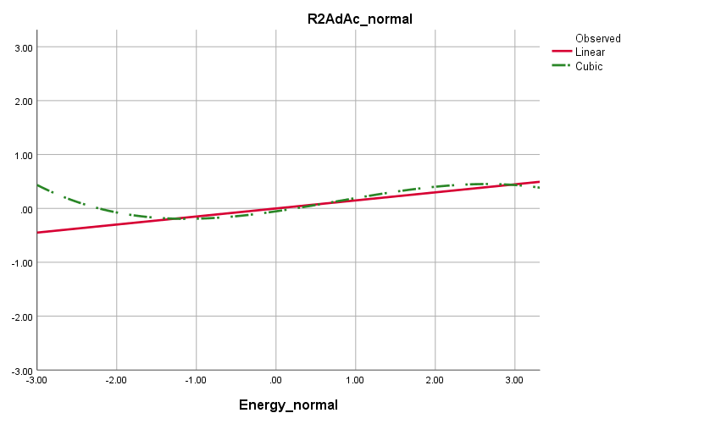
Energy score (M = 0, SD = 1)
“e” task Round 2 accuracy (M = 0, SD = 1)
Figure 1. Shows the estimated curves of the linear and cubic regression of the relationship between the energy mediated scores (after being corrected for normal distribution) and the harmonic mean of congruent trials RT.

Curves of Linear and Cubic regression

Appendix V.V. The JavaScript code in studies 2 and 3
The JavaScript codes used in Qualtrics® to assign participants to their groups according to the manipulation texts they viewed:
- In the Survey Flow, create a variable and name it “Group” in the Set Embedded Data block.
- Create three consecutive blocks for each manipulation text.
- Add the manipulation texts as a question in each block.
- For each question, click on that appears under the question number to open the Advanced Question Options.
- Click on “Add JavaScript…” and add the following code. Change the number for each block and record the key which will be used later in the analysis.
Qualtrics.SurveyEngine.addOnload(function()

{
Qualtrics.SurveyEngine.setEmbeddedData('Group', '1')
});

Qualtrics.SurveyEngine.addOnReady(function()

{
/*Place your JavaScript here to run when the page is fully displayed*/
});

Qualtrics.SurveyEngine.addOnUnload(function()

{
/*Place your JavaScript here to run when the page is unloaded*/
});

Appendix V.VI. Tabular results of study 3

Table 1. Shows the correlational values between the age and all other behavioural variables that were collected in study 3. The shaded cells show the reporting values of the Mann-Whitney test that compared the behavioural variables between males and females. (AA = adjusted accuracy, hM = harmonic, Mdn = median)
 |  | e-crossing |  | Stroop
 |  | R1  AA | R2  AA | Congruent |  |  | Incongruent
 |  |  |  | Median |  | hM | Median |  |  | hM
Age | Pearson Coefficient | -0.097 | -0.05 | 0.37 |  | 0.38 | 0.30 |  |  | 0.32
 | Significance | P = 0.311 | P = 0.6 | P ≤ 0.001
Mann-Whitney U test for gender differences | U-statistics | 1315 | 1551 | 1626.5 | 1634 |  |  | 1649.5 | 1642
 | significance | 0.519 | 0.421 | 0.205 | 0.189 |  |  | 0.159 | 0.173

Table 2. Shows the reporting values of the Kruskal-Wallis test that compared the Stroop variables between males and females. (Mdn = median, hM= harmonic mean)
 |  | Stroop
 |  | Congruent |  | Incongruent
 |  | Mdn | hM | Mdn | hM
Kruskal-Wallis test for Stroop differences | H(2) = | 2.909 | 2.779 | 2.528 | 2.232
 | significance | 0.233 | 0.249 | 0.283 | 0.328

Table 3. The correlational web of all behavioural variables shows significant high values of the Pearson coefficient, yet with a negative relationship between the Stroop and the e-crossing measures. Variables were controlled for age. (AA = adjusted accuracy, hM = harmonic mean, Mdn = median)
 |  | E-crossing |  | Stroop
 |  | R1  AA | R2  AA | Congruent |  |  | Incongruent
 |  |  |  | Mdn |  | hM | Mdn |  |  | hM
R1 AA | Pearson Coefficient |  | .445 | -.53 |  | -.55 | -.55 |  |  | -.53
 | Significance |  | P < 0.001
R2 AA | Pearson Coefficient |  |  | -.42 | -.42 |  |  | -.45 | -.45
 | Significance |  |  | P < 0.001

Ethical Approvals

Appendices of

Appendix VI.I. The ethical approval of the fMRI study and the picture piloting study of the food-cues task

Appendix VI.II. The ethical approval of the eye-tracking study

Appendix VI.III. The ethical approval of the factor analysis studies

Appendix VI.IV. The ethical approval of the belief-manipulation studies

Using “ego depletion” as a search key in Google Scholar yielded more than 8,000 studies.
In a series of studies, the experimental groups were shown different scarcity scenarios that connote shortage in time, money, or resources, while the control groups were shown opposite scenarios of abundance. It was found that upon practicing consecutive tasks, the experimental groups demonstrated underperformance compared to the control ones.
Further discussion of the subjective efforts and self-control was left for the final chapter
The first task was the item recognition task, where participants indicate whether a probe is a member of a previously displayed set of items, in positive and negative trials. For either trial type, the probe could be either recent or non-recent. Recent probe is when it is not a member of the current set, rather a member of the preceding one or two trials. Non-recent probe is when the probe is not a member of neither closely displayed set. For the control group, all negative trials were non-recent, while the ego depletion group dealt with a majority of recent negative trials. The second self-control task, which was performed by all groups, was the verb generation task where participants were required to generate verbs of different uses for two kinds of nouns: high interference nouns (e.g. car: driving, transporting, riding …etc), and low interference nouns (e.g. scissors: cutting). The dependent variable is the difference in verb generation response time between high and low interference trials.
For the attention control task, participants in the experimental group were required to watch a film while ignoring words that appear at the screen margins then moved to the centre of the screen, while those in the control group were instructed just to pay attention to the film. The food cue reactivity task involved asking hungry participants to categorise different pictures, including highly tempted food pictures, for being people, food or nature.
Publication bias is defined as a trend of scientists toward publishing positive results only. In any meta-analysis, the correction of publication bias is a crucial step performed by using many statistical methods. Recent studies recommended abandoning some of these methods for their sever distortion of data (Carter et al., 2019). Thus, single important advice for researchers is to keep publishing whatever the results are.
Each Cohen’s d value was retrieved after applying a different publication bias correction method. Negative effect size indicates a non-significant ego depletion, as the priori hypothesis is a one-tailed hypothesis.
﻿Multi-source interference task was developed by Bush, Shin, Holmes, Rosen, & Vogt (2003) and encompasses combining different executive functions tasks (Stroop, Eriksen and Simon).
Similarly to the contextual and generalised self-efficacy.
These ERP signals are explained in Table (1.2), P and N for any ERP signals stand for positive and negative signals respectively.
Grit is a construct that accounts for the resilience toward achieving goals (A. L. Duckworth & Quinn, 2009). Despite being slightly different to self-control, it is considered equivalent as higher degrees of resilience, which measured by the Short Grit Scale, reflect better self-control as measured in the Self-control Trait Scale (Tangney et al., 2004).
At the beginning of the project, the replication crisis was not fully manifested. Measures that were suggested later by the literature were not as clear as they are now (for further discussion see chapter 6).
The author attended that symposium and discussed the failed replication of ego depletion personally with Roy Baumeister on 17/05/2016
For more details, look at the procedure section (3.4.2.2) of the behavioural study in this chapter.
(Ego depletion versus no ego depletion) x (fixed versus growth mindset)
Consequently, higher temptation by the food pictures
A mini meta-analysis was run as a side project where a significant negative correlation was observed between the effect sizes of ego depletion studies and the temporal order of those studies. A paper with the exact methodology achieved the same results and were published later by another research group (Vadillo, 2019)
A master project by Patricia Stephenson carried out mini behavioural and brain imaging replications of our paradigm.
As the study was conducted by more than one researcher, a study’s protocol and a participating sheet was created to ensure consistency in quality and minimise bias. Both forms can be found in Appendix (III.VII).
The deception was confirmed by the end of the study through interviewing participants about their impression.
Event-related and block designs. The details of Stroop timings were adapted from Luethi et al. (2016).
It was observed that the Stroop effect is worsened for blocks that mostly consist of incongruent trials. LWPC was explained as when many incongruent trials are presented per block, the participants start to shift the control fashion they pursue from being reading-driven to goal-driven (Bugg, Jacoby, & Toth, 2008). Thus, anything that might help participants to adopt a goal-driven control fashion should be avoided in order to ameliorate the Stroop effect.
Further discussion about the beliefs and self-control can be found in chapter 6
The belief of self-control as energy is well studied (Martijn et al., 2002), thus, offers a medium of contrast against the other two models.
Both scales were shown to strongly correlate with self-control (A. Duckworth & Gross, 2014; Tangney et al., 2004), yet, they measure two different domains. While the trait self-control scale measures the extent of applying self-control in order to do a task, the Grit measures one’s resilience toward achieving that task. We aim to explore whether both aspects interact differently with the presumptuous belief models of self-control.
For further details about sample size, look at section (4.2.1.3.1. Factor analysis and its main features).
This was altered in the second study where collecting the demographic data was left until the end of the study. See section (4.3.1.2).
This description of the factor analysis is critical to justify the adopted methodology in the study
Look at section 4.2.1.3.1; number 3: Extraction methods
Sample size is to be a minimum of 300. Look at section 4.2.1.3.1; number 2: Sample size.
According to the rules of Prolific Academic® these participants were reported and were not given their reward.
Two participants chose their gender as “another”.
Look at section 3.4.3.3 at chapter 3
Gender was controlled for as a dummy variable where a binary variable is created for each gender
Upon controlling for Gender, compliance and age, the yielded model was significant only for the controller but not for the belief factors (F(7, 316) = 3.236, p = 0.013, R² = 0.002).
In spite of not using structural equations modelling to confirm the results, obtaining a comparable results using two qualitatively different factor extraction methods would suggest that the model is preliminarily sound, yet, it requires further work towards completion.
Look at section 4.2.1.3.1. Factor analysis and its main features; number 2: Sample size.
Look at section 5.2.2.1.
In contrast to the classic Stroop design where the majority of trials are congruent, in order to avoid the habituation, Singh & Göritz (2019) equally distributed the congruent and the incongruent trials within one block. Based on a notion suggested by Logan & Zbrodoff (1979), if Stroop is designed to encompass 80% incongruent trials, then the congruent trials will be answered slower than the incongruent, which opposes the classic Stroop interference. Consequently, instead of explaining Stroop as a result of the contradiction between the perception of the colour and that of the word meaning, Singh & Göritz (2019) offered another explanation. Consistent with Logan & Zbrodoff's notion, the Stroop effect can be explained by the efforts to overcome the habituation of using one control modality over another. This means, if the majority of Stroop trials are congruent, then participants habituate a read-driven control, where they interact with the word meaning only. Changing this control modality for fewer incongruent trials leads to a slower reaction time for those incongruent trials, where participants interact with the word colour. The other way round, if the majority of Stroop trials are incongruent, then participants habituate to a colour-driven control, where they interact with word colour only. Changing the control modality for fewer congruent trials leads to a slower reaction time for those congruent trials, where participants interact with the word meaning only. (cont. next page) As a result, in a Stroop task, self-control manifests better when participants interact with the minorly presented trial types. Further, presenting both trial types equally and randomly makes it more challenging to shift between the control modalities throughout the study. Consequently, practising self-control could be potentiated throughout the task, instead of being restricted to the least presented trial type. In fact, Singh & Göritz (2019) presumed congruent trials could reflect between-groups differences better than the incongruent trials as the congruent trials are less prone to speed-accuracy trade-off than the incongruent trials.
As expected, it was found later that Stroop accuracy was indeed very high (M = 0.9939, SD = 0.016).
Extraction based on Eigenvalue “one” yielded four factors, the last is redundant and conceptually meaningless.
Appendix III.VIII shows the target scale. Instead of using half of the items to manipulate participants beliefs, as in study 3 in chapter 3, the whole 12 items were used in the current study to measure participants’ implicit beliefs about willpower. The items of the fixed mindset were given reversed scoring.
Despite being beyond the scope of this study, this result opposes the priori hypothesis of ego depletion and casts a doubt on Singh & Göritz (2019) replication of ego depletion.
Calculated based on an estimated effect size of (0.8) derived from the second study of Martijn, Tenbült, Merckelbach, Dreezens, & de Vries (2002)
Knowledge and skill scores were significantly non-normally distributed through Shapiro-Wilk test (p < 0.02), however, energy was found marginally non-significant (p = 0.07); almost normally distributed. Yet, the between-group difference was non-significant even when parametric tests were used.
Power analysis using the effect size obtained from Vohs & Schooler (2008) (d = 1.2) determines that a decent sample size should not be less than 15 participants!
Participants were debriefed at the end of the study
Calculated as $η^{2}=\frac{Z^{2}}{n-1}$ where Z is obtained from Mann-Whitney’s comparison between energy and knowledge groups for their energy score.
The critique was offered for the reported-behavioural mismatch in self-control and in other areas in psychology.
Different values are for different correction methods of the publication bias.
Begging the question is a form of logical bias where an answer was presumed in the question. Circular logic is a form of bias where an answer requires the same asked question in order to be understood.
See the discussion of chapter 5
Capital R marked reversed questions.

