

Synthetic Macromolecules That Can Increase The Aqueous Solubility of Oxygen and Their Application As Possible Volume Expanders and Artificial Blood

Talal Saud Alghassab
PhD Thesis
2020

To Mom and Dad,
Thank you for your endless love

Acknowledgements

First and foremost, I would like to extend my sincere and deepest gratitude to Dr. Lance Twyman whom without his support and guidance, this PhD research would not be possible.
I am also very grateful to be able to meet wonderful individuals within our research group who stood by me during this four years. Special Thanks to Dr Hamza Qasem, Dr Ibrahim Althobaiti, Mr Meng Fan, and Mr Luke Blyth. Highest appreciation goes to Dr Bunian Shareef for his great assistance and friendship throughout the years.
Not to forget King Saud Bin Abdulaziz University for Health Sciences (KSAU-HS) for their financial support throughput the period of my PhD study.
Last but not least, special thanks to my parents who sacrificed a lot to raise me up and made the person I am today, My brothers and sister; Waleed, Abdullah, Yazeed, Rakan, and Salma for their love and prayer, and my close friends; Ghazi Alanazi, Mosaed Alobaidallah for their loyalty, love, support, and words of encouragement.

List of Abbreviations
AIDS | Immune deficiency syndrome
ATRP | Atom transfer radical polymerisation
¹³C NMR | Carbon Nuclear Magnetic Resonance
CMC | Critical micelle concentration
DA | Dalton
Db | Diblock
DCM | Dichloromethane
DMSO  DP | Deuterated Dimethyl Sulphoxide  Degree of polymerisation
DLS | Dynamic light scattering
D₂O | Deuterated Water
ES | Electrospray
ES-MS | Electrospray Ionisation Mass Spectrometry Spectrophotometry G Generation
FeTPP | Iron (III) tetraphenyl porphyrin
FT-IR | Fourier Transform Infrared
GPC | Gel permeation chromatography
Hb | Haemoglobin
HBOC | Haemoglobin (Hb) based oxygen carrier
HBP | Hyper branched polymers
hESC | Human embryonic stem cell
HPG | Hyperbranched polyglycidol
hSPC | Hematopoietic stem and progenitor cell
¹H NMR | Proton nuclear magnetic resonance
iPSC | Induced pluripotent stem cell
K₂CO₃ | Potassium Carbonate
MPEG-Br | Poly(ethylene glycol) methyl ether 2-bromoisobutyrate
NaH | Sodium Hydride
PFC | Perfluorocarbon-Based Oxygen Carrier
PD | Polydispersity
PEG | Polyethylene glycol
PTFEMA | Poly (2, 2, 2-trifluoroethyl methacrylate)
RBC | Red blood cell
RI | Refractive Index Spectroscopy
ROMP | Ring-opening polymerisation
SCM | Surface cross-linked micelles
SCOC | Stem cell-derived oxygen carrier
TEM | Transmission Electron Microscope
THF | Tetrahydrofuran
TPP | Tetraphenyl porphyrin
UV-Vis | Ultraviolet-visible light
WBC | White Blood Cell

List of Figures
Figure 1.1: Haemoglobin structure by Richard Wheeler using PyMOL, 2007. 5
Figure 1.2: A model showing the conformational change of binding of oxygen to the iron-porphyrin group from Chemistry LibreTexts, 2018. 6
Figure 1.3: The skeletal representation of perfluorocarbons perfluorodecalin and perfluorotripropylamine used in Fluosol-Da-20. 12
Figure 1. 4: The two free forms of haemoglobin...................................................................13 Figure1.5: Fe (II) cored hyperbranched polymer....................................................................17

Figure 2.1: DLS trace for PEG-PTFEMA-25 and TEM (insert). 28
Figure 2.2: Comparison of the rate of oxygen equilibration between simple aqueous solution to micelle solution respectively. 29
Figure 2.3: Oxygen release curves at the concentration for PEG−PTFEMA-17, and PEG−PTFEMA-25. 30
Figure 2.4: Oxygen release curves at various concentrations for PEG-PTFEMA-25. 32
Figure 2.5: Insert shows; (A) the dark precipitate that initially forms within the polymer solution after the oxidation reaction and (B) the same solution after 9 hours and filtration. ...............................................................................................................................35 Figure 2.6 UV results from enzyme assay. The data show a stronger absorption for the PEG−PTFEMA-25 solution, indicating a higher oxygen concentration.............................36 Figure 2.7.: Oxygen saturation points in water and 10% w/v PEG aqueous solution. ......37

Figure 3.1:Structural differences between linear and branched polymers. 52
Figure 3.2: Oxygen saturation points in water and PEGs aqueous solutions. 53
Figure 3.3: Oxygen saturation points in water, PEG 2000Mn (10% w/v), and PEG 100k Mn (10% w/v) aqueous solutions. 55
Figure 3.4: Oxygen solubility curves at various concentrations for PEG. 56
Figure 3.5: Oxygen solubility curves at various concentrations of PEG. 58
Figure 3.6: Cis- and trans- proton environments of p-nitrophenol 64
Figure 3.7: Polyglycidol doped with free p-nitrophenol. 65
Figure 3. 8: Oxygen saturation points in water and HPGs aqueous solutions. 70
Figure 3. 9: Oxygen solubility curves at various molecular weights of HPG. 71

Figure 4. 1: Diagram showing micelle formation with an amphiphilic surfactant. 87
Figure 4. 2: Crosslinking of surfactant molecules 'locking' the porphyrin inside a micellar nanocage. 88
Figure 4.3: The UV-vis spectra of two porphyrins, TPP and FeTPP, with an expansion of the Q band region between 450 nm – 750 nm, demonstrating the reduction from 4 to 2 bands on metalation. 92
Figure 4. 4: Graph showing intensity versus wavelength related to reduction in surfactant concentration for the empirical work on pyrene surfactant. 99
Figure 4. 5: Graph showing changes in the ratio of the pyrene peaks I3 and I1 that reflected the 0.17 mM CMC. 100
Figure 4. 6: Surfactant solutions with concentration in the range of 0-40 mM, revealing successful encapsulation beyond CMC of 0.20 mM 101
Figure 4. 7: Graph illustrating the UV-absorption of porphyrin in the Soret region across different concentrations of surfactant, with encapsulation above the CMC, resulting in improved absorption 101
Figure 4. 8: TEM image showing the formation of Micelle. 103
Figure 4. 9: TEM image of the Fe(II)-TPP-SCMs at an initial surfactant concentration of 5 mM. 107
Figure 4. 10: TEM image of concentrated Fe(II)-TPP-SCMs at the higher concentration of 30 mM. 108
Figure 4. 11: UV spectra of the partial reduction of micellar Fe (III) to Fe (II) 40 minutes after the addition of a reducing agent, displaying two peaks of 409 nm and 439 nm respectively. 109
Figure 4. 12: Graph showing the lag or time delay in oxidation caused by excess reducing agent. 110
Figure 4. 13: Graph showing the initial increase in in intensity of Fe(II) absorption over time, followed by a decrease in intensity, clearly demonstrating the reduction and oxidation of the Fe within the porphyrin. When conducted under nitrogen, A stable Fe(II) can be observed. 111
Figure 4.14: The structure of Iron-3,5-dihydroxyphenyl porphyrin (3,5-DHPP) 112
Figure 4.15: Half-life comparison based on the oxidative decay of micellar FeTPP and 3,5-DHPP in water. 113
Figure 4. 16: A hypothetical graph of absorbance at 409 nm and 430 nm of encapsulated Fe(II)-TPP-SCMs , micellar-FeTPP, and against the concentration on dilution with water, respectively. 115

List of Tables
Table 1.1: showing the shelf lives of blood components. 4
Table 1.2: Characteristics of an ideal artificial blood 9

Table 2.1: Molecular weight (GPC/NMR), DP and aggregation data for PEG-PTFEMA polymers. 27
Table 2.2: Oxygen release rates and half-lives for the PEG-PTFEMA polymers 31

Table 3.1: Oxygen release rates and half-lives for the PEG solutions 57
Table 3.2: Effect of PEG solutions on oxygen solubility (37 ºC, 760 mm Hg of O₂). 60
Table 3.3: Comparison of the average molecular weights of p-nitrophenol cored polyglycidol by various spectroscopy techniques 66
Table 3. 4: Oxygen release rates and half-lives for the HPG solutions 72

Table 4. 1: Design and components of some porphyrin-based oxygen-carrying nano-systems. 86
Table 4. 2: A table of concentrations of surfactant made in water for determination CMC. 98
Table 4. 3: The data obtained from the DLS experiments of micellar and SCM FeTPP aggregates to investigate the effects of dilution 106
Table 4.4: Kinitic parameters for the oxidative decay of Fe(II) 3,5,-DHPP within an aqueous solution and encapsulated within the micelle. 114

List of Schemes
Scheme 2.1: Synthesis of MPEG-Br 24
Scheme 2.2: Synthesis of MPEG-PTFEMA 25
Scheme 2.3: Enzyme mediated reaction used to estimate oxygen concentrations in water. Reactions performed using excess glucose. 34

Scheme 3.1: Enzyme-mediated reaction used to estimate oxygen concentration. 59
Scheme 3.2: Synthesis of p-nitrophenol cored hyperbranched polyglycidol 62
Scheme 3.3: The generation of alkoxide/alcohol. 63
Scheme 3.4: Deprotonation of the p-nitrophenol core and initiation through the ring opening reaction with glycidol. 67
Scheme 3.5: Propagation of alkoxide of hyperbranched polymer 68
Scheme 3.6: Deprotonation of glycidol to form the initiator 68
Scheme 3.7:Deprotonation of glycidol to form initiator 69
Scheme 3.8: Water traces may affect the final product 69

Scheme 4.1: The condensation mechanism of benzaldehyde and pyrrole to form TPP. 91
Scheme 4.2: FeTPP formation through TPP metalation. 93
Scheme 4.3: Synthesis of the surfactant 4-(dodecyloxy) benzyl tripropargylammonium bromide. 94
Scheme 4.4: Formation of 4-(dodecyloxy) benzaldehyde 3 through the reaction of substitution of 4-carboxybenzaldehyde 1 and bromododecane 94
Scheme 4.5: Reduction of 4-(dodecyloxy) benzaldehyde 3 to give 4-(dodecyloxy) benzyl alcohol 5 using sodium borohydride. 95
Scheme 4.6: Formation of 4-(dodecyloxy) benzyl bromide 7 through the bromination of 4-(dodecyloxy) benzyl alcohol 5. 96
Scheme 4.7: Formation of 4-(dodecyloxy) benzyl tripropargylammonium bromide 8 through functionalisation of 4-(dodecyloxy) benzyl bromide 7 97
Scheme 4.8: SCM formation via cross-linking of surfactant 8 and cross-linker 104
Scheme 4.9: SCM formation via cross-linking of surfactant 8 and cross-linker 114

Table of Contents
List of Abbreviations ii
List of Figures iv
List of Tables vi
List of Schemes vii
Chapter 1 1
1.0Abstract 2
1.1 Introduction 3
1.2 Mechanism of oxygen binding 5
1.3 Prevention of Heme Autoxidation 7
1.4 Artificial oxygen carriers 9
1.4.1 Volume expander 10
1.4.2 Perfluorocarbon-based carriers (PFCs) 11
1.4.3 Hb-based oxygen carriers (HBOC) 12
1.4.4 Stem cells 15
1.4.5 Haemoglobin mimicry 15
1.5 Conclusion 17
1.5 References 18
Chapter 2 20
2.0 Abstract 21
2.1 Introduction and aims 22
2.2 Results and discussion 24
2.3 Conclusions 38
2.4 Experimental 40
2.5 References 47
Chapter 3 49
3.0 Abstract 50
3.1 Introduction 51
3.2 Results and Discussion 53
3.3 Conclusion 73
3.4 Experimental 75
3.5 References 80
Chapter 4 81
4.0 Abstract 82
4.1 Introduction 84
4.2 Results and discussion 90
4.3 Conclusion 117
4.4 Experimental 120
4.5 References 133

Chapter 1

Approaches towards the synthesis and study of artificial oxygen carriers

1.0Abstract

In blood, which is a fluid connective tissue, living cells flow through a noncellular liquid matrix in suspension. Through blood’s cellular components, gas exchange (RBCs), immune surveillance (WBCs) and haemostatic responses (platelets) take place and, through the non- cellular components (such as proteins and salts), nutrients are delivered to tissues around the body. Any malfunctions or deficiencies in these blood components can cause major tissue morbidity and mortality. As a result, the transfusion of blood or its components is a fundamental and commonplace procedure for treating trauma, surgery, myelosuppression, and congenital blood disorders. At present, there is a shortage of blood products from donors, which has increased demand for such products and type matching. There are high risks of pathogenic contamination, restricted portability, short shelf-life, and many different side-effects. Artificial oxygen carriers are liquid products that have been developed to offer an alternative to blood transfusions. Methods for developing these carriers include the synthesis of materials based on the naturally occurring respiratory pigment, haemoglobin (Hb); production of perfluorocarbon-based carriers (PFCs); and the synthesis of macromolecules that may be used as haemoglobin alternatives. This chapter will review and critically discusses several recent approaches to the synthesis of artificial oxygen carriers.

1.1 Introduction

Blood is a major fluidic component of the circulatory system, which carries a number of important components throughout the body. Blood is comprised mainly of red and white blood cells (RBC/WBCs), platelets, and plasma.¹ On average, the total blood volume for a man is 5.5 litres, with women having an average of 4.1 litres, of which 55% is plasma and the remaining 45% blood cells.² All of the components have various functions such as supporting the immune system, body temperature control, and waste excretion. However, the primary function of blood as a whole is to move oxygen around the body. This vital role is supported by the presence of particular cells known as red blood cells or erythrocytes.³

The transfusion of "packed" red blood cells is a near universal practice across the globe in modern times, and it is a remarkably safe clinical procedure in developed countries. Transfusion is a lifesaving procedure when used for trauma patients and others suffering from a variety of issues. The first blood transfusions occurred in the 1660s, being performed by the English physician, Richard Lower, then by the Frenchman, Jean- Baptiste Denis. The earliest transfusions were between animals, and thereafter blood was moved from animals to humans.⁴ The world wars in the early 20th century increased the demand for blood to preserve life after traumatic wounds, and this inspired scientists to develop improved blood transfusion methods. Despite its modern reliability, blood transfusion is not inherently a safe procedure; even now, it is accompanied by the risk of disease transmission. Furthermore, the provision of blood is not always guaranteed as blood banks do not always hold adequate supplies.

A critical factor in terms of blood donation is the shelf life of whole blood and blood products. Following donation, blood may be separated into constituent parts, which have different storage times, as demonstrated in Table 1.1 Given that the shortest allowable donation interval for an individual giving whole blood is 84 days, it is clear that the shelf lives of 35 and 7 days for RBCs and platelets, respectively, create an on-going requirement for more of these blood components from a wider range of sources.

Table 1.1: showing the shelf lives of blood components.⁵

Component | Shelf life
Packed Red blood cells | 35 days
Platelets | 7 days
Plasma | 3 years

In the developing world, infected blood is a more serious consideration, and potential donors with autoimmune conditions or viral infections are not permitted to donate. In the early 2000s, it was reported that 2% of HIV infections in Kenya occurred as a result of blood transfusions from an infected donor to healthy recipient.⁶ In the west, blood donation screening for HIV antibodies is conducted to prevent transmission of the virus; however, this testing regimen is not available in underdeveloped nations.

In response to the many complex challenges of traditional blood transfusion, artificial oxygen carriers have begun to be developed as alternative to blood transfusion. The aim of this study is to examine the mechanisms of oxygen binding used in these and to review several current approaches to the development of artificial oxygen carriers, thus critically discussing the successes and potential challenges arising in this area.

1.2 Mechanism of oxygen binding

Haemoglobin (Hb), visualised in Figure 1.1, is a protein that is transported in the blood; it is a complex quaternary tetramer, of which four subunits (shown in red and blue in the image) are found internal to red blood cells. The porphyrin ring-containing haem group, shown in green, is firmly bound by the globin fold. An iron atom is located at the centre of each porphyrin ring, and this structure, in association with the associated histidine groups and the surrounding environment, is responsible for selective oxygen binding.
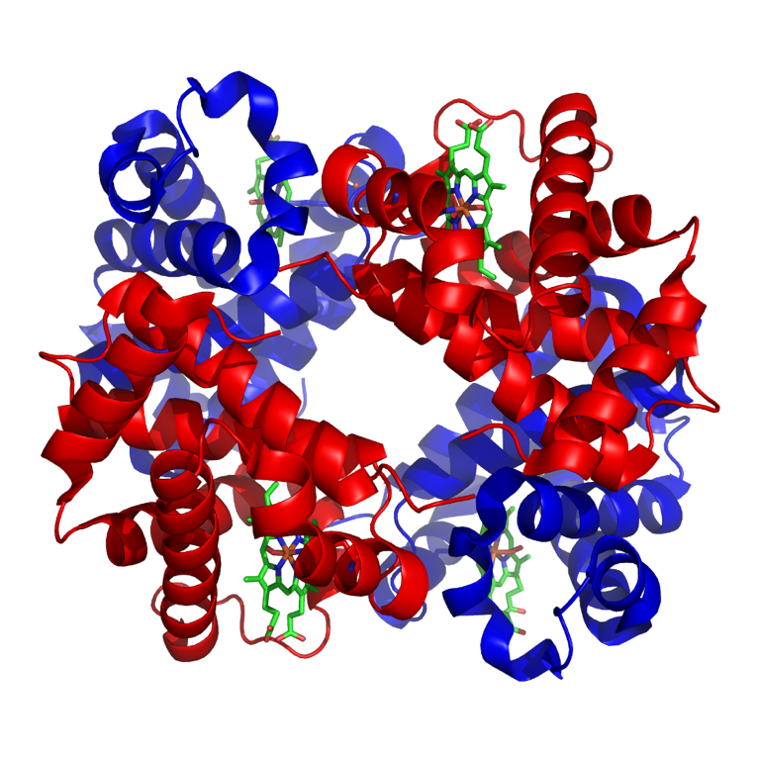
Figure 1.1: Haemoglobin structure by Richard Wheeler using PyMOL, 2007.⁷

Four oxygen molecules can be loaded into each haemoglobin molecule, which has two states, bind and release, which produce oxyhaemoglobin and deoxyhaemoglobin, respectively. These can be further described in crystal structure studies as relaxed (R) and taut (T).⁸ In the T state, the position of the core metal atom is below the porphyrin plane and the iron atom is in a penta-coordinated high spin state. This non-planar position links to the binding of the proximal imidazole of the histidine. In a high-spin state, a single electron is placed into each of the five d orbitals prior to matching. This is performed following Hund’s rule, generating a so-called "high-spin" complex. A transition to the R state occurs upon oxygenation, as the formation of the oxygen adduct leads to the metal moving back to the porphyrin plane. This process generates a six-coordinate low-spin state (Figure 1.2). There is extra repulsion in the high-spin arrangement that causes metal ions to have a slightly bigger radius than that of low-spin ions. For this reason, low-spin Fe_{(II)} can fit into the cavity located in the centre of the porphyrin rings found in both oxymyoglobin and oxyhaemoglobin.

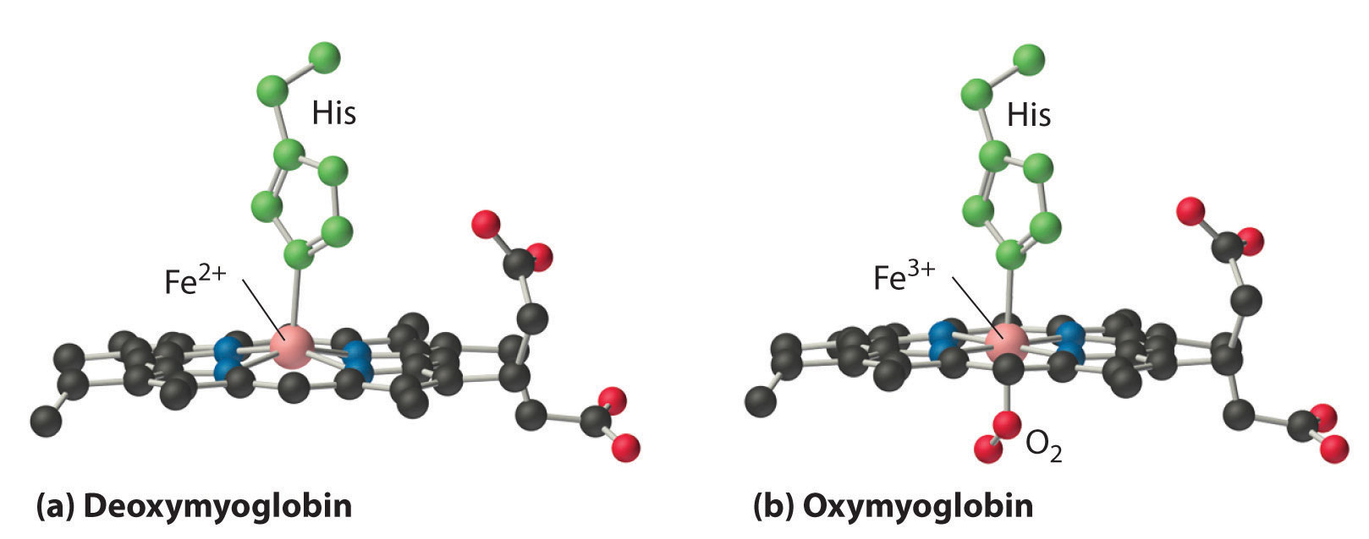

Figure 1.2: A model showing the conformational change of binding of oxygen to the iron-porphyrin group from Chemistry LibreTexts, 2018.⁹

1.3 Prevention of Heme Autoxidation

When oxygen molecules interact and bind to protein free Fe(II) cored porphyrin, a reaction takes place leading to the autoxidation of the metal. As a result of this reaction, μ-oxo dimers form through a μ-peroxo dimer intermediate and Fe(IV) oxo-species. (Equation 1.1) This occurs during the process of rapid biomolecular redox.¹⁰
(Equation 1.1)

In a natural system, six-coordinated O₂. Fe_{(III)}.Imidazole adducts are created when this state is reached. The reacted oxygen travels approximately 4.4 Angstrom (Å) through to the iron core and immediately kills further oxygen-binding mechanisms through a process of irreversible autoxidation.¹¹ However, each haeme unit is surrounded by the protein (globin), which enables reversible oxygen binding to occur. Moreover, the haemoglobin produces a small opening which allows tiny molecules to enter the R state. This starts the process of reversible binding. If the macromolecular protein was absent, then the autoxidation process would occur and the iron core would react with oxygen at room temperature and binding would be irreversible. Thus, the haeme unit is protected from autoxidation due to the steric features of this tertiary protein. The stability of natural haemoglobin is four times that of any free haemoglobin, as tested in ex-vivo settings. In laboratories, autoxidation of simple, non-hindered Fe(II) porphyrin occurs very quickly at a low temperature (although not at human body temperature). What’s more, multiple studies conducted by Baldwin et al. have revealed that the extent of ligand hindrance largely determines the reversibility and stoichiometry of oxygen-binding to porphyrin-containing solutions and complexes.¹¹
Furthermore, if an active iron or resulting oxygen-adduct comes into contact with any type of aqueous solution, a process of proton-drive oxidation takes place, leading to the generation of superoxides species. The proposed mechanism for this proton-driven reaction, where Fe represents haeme and Ax-B refers to the axial base¹², is presented in Equation 1.2:

(Equation 1.2)

In haemoglobin, irreversible oxidation is suppressed because the bulky protein structure of haemoglobin stops two haemes from approaching each other and prevents dimerization. What’s more, the hydrophobic domain of the globular structure blocks water molecules from entering the active centre, which ultimately avoids proton-driven oxidation from taking place.

1.4 Artificial oxygen carriers

Within the body, RBCs perform several additional functions, including acting as a buffer and enabling erythrocyte metabolism.¹³ Given this wide-ranging functionality, it is highly complex to design an artificial compound which compensates for all of these properties. Consequently, any research should more critically target the major function, oxygen transportation. The success of any blood product alternative is a function of the required usage of the product, and a robust artificial blood product should meet all of the criteria in Table 1.2:

Table 1.2: Characteristics of an ideal artificial blood

Characteristics of an ideal artificial oxygen carrier
- Optimum oxygen binding and delivery.
- Free from physiological effect with no toxic side effect.
- Long half-life
- Metabolized and removed by the body.
- Stored and used easily
- Stable
- Low cost.
- Compatible to all blood types.
- Immediately available.

The required use of the product correlates to these properties. In particular, in cases of trauma, artificial blood, such as a volume expander, may only be necessary temporarily to maintain adequate blood pressure until the patient can safely be transported to hospital. However, in cases of cardiac surgery, for example, the replacement blood product is likely to require a greater and more long-term oxygen-carrying capacity. Consequently, a diverse range of blood alternatives have been investigated by scientists.

1.4.1 Volume expander

A volume expander, either crystalloid or colloid, may be used by paramedics in response to an accident situation, as this will temporarily boost the pressure in the circulatory system to accommodate blood loss volume. A colloid expander is a protein solution, generally based on albumin, a standard plasma protein produced by the liver. This albumin is often gathered from blood donations.¹⁴ Colloid expander is homogeneous, and as a result of its longevity, generally conveys longer term benefits than treatment with crystalloid expanders. However, as with all human blood products from donation, there are potential issues with disease transfer, product availability, and stability and storage. Crystalloid and colloid expanders differ in size in terms of molecules that they contain: a crystalloid saline solution, being comprised of water-soluble salts and mineral, diffuse through cells to move rapidly throughout the body. Crystalloid expanders are cheaper, easier to store and result in fewer side effects as compared to colloid expanders. Where trauma results in extensive blood loss, requiring the use of either form of expander, this may result in tissue oedema or over accumulation of fluid.¹⁴ Critically, neither from of expander is capable of transporting oxygen; the useable volume is thus limited by the amount of blood dilution that the patient can withstand. The ability to transport oxygen in such systems would improve trauma patient survival, and thus the addition of such an ability to either colloidal or crystalloid expanders is the main aim of this body of work.

1.4.2 Perfluorocarbon-based carriers (PFCs)

One method for blood substitute creation incorporates the use of perfluorocarbons, which are synthetic, biologically inert compounds that are promising potential oxygen carriers due to the high solubility of oxygen and carbon dioxide.¹⁵ The earliest applications of these molecules were seen in uranium fluoride chemistry,³ as the insoluble nature of perfluorocarbons in aqueous solutions poses a problem for their application as a blood substitute; however, this may be overridden by the creation of an emulsion. As depicted in Figure 1.3, the compound Fluosol-DA-20 is an emulsion of 14% perfluorodealin and 6% perfluorotripropylamine (wt/wt), stabilised by the addition of phospholipid derived from egg yolk. However, this was withdrawn from the market, as its benefits were found to be only marginal and it was not equivalent to RBCs.¹⁶ Fluosol-DA's oxygen-carrying capacity was only 7.2% (v/v) whereas human RBCs can manage 17 to 20% (v/v). Furthermore, Fluosol-DA remained in the human circulatory system for only a short time (approximately 4 to 6 h after injection), and further evidence demonstrated that it could lead to flu-like symptoms upon transfusion.¹⁷ Currently, PFC development is focused on reducing the size of any new emulsions to promote greater stability, which should improve both the circulatory and clearance properties of the compound.

Figure 1.3: The skeletal representation of perfluorocarbons perfluorodecalin and perfluorotripropylamine used in Fluosol-Da-20.

1.4.3 Hb-based oxygen carriers (HBOC)

Haemoglobin based oxygen carriers (HBOCs) are obtained from fresh bovine blood or expired human blood; these are thus subjected to numerous modifications to produce safe and effective oxygen carriers. Hb is found in the protective environment of the interior of the biconcave red blood cells in extremely high concentrations of 300g/L; this operates as a barrier for the oxidative role of Hb, and the presence of the RBC also ensures that the Hb is not subject to early removal from the blood circulation.^{18, 19} The protective effect of the RBC is demonstrated following haemolysis, the rupture of red blood cells and subsequent emptying of their contents into the blood. Once in the plasma fraction, Hb takes one of two forms, a tetrameric form, or two heterodimeric αβ-subunits, as shown in figure 1.4.

α
β
α
Two heterodimeric αβ-subunits
β
α
α
β
β

Tetrameric form

Figure 1. 4: The two free forms of haemoglobin.

Free-Hb reacts with nitric oxide (NO), which causes oxidative stress, and thus scavenging of NO causes vasoconstriction and increased blood pressure. As a result of their size, the two large dimers resulting from the breakdown of the tetramer are processed by the kidneys and lead to higher levels of renal toxicity.²⁰ Additionally, free-Hb is bound in the plasma by the protein haptoglobin, which inhibits the oxidative activity of Hb' as a consequence of its increased molecular weight, this is processed by both the liver and kidneys. This naturally occurring process demonstrates that the inclusion of free-Hb as an oxygen transporter in a colloidal blood substitute demands careful design and modification of Hb to eradicate the multiple negative side effects such as NO scavenging as well as to prevent haptoglobin binding. Some researchers have successfully implemented modifications that have decreased both scavenging effects and renal toxicity whilst increasing circulatory retention times.^{3, 21}

Crosslinked tetrameric Hb

One strategy to inhibit or reduce breakdown of Hb is the introduction of cross linkages between the α and/or β sub units of the tetramer by agents such as glycine, forming a cross-linked tetrameric Hb. The formation of cross-linked Hb increases its lifetime in the circulation and reduces renal toxicity; however, increased blood pressure readings indicate the continuation of NO scavenging. Furthermore, the cross-linked Hb demonstrates a greater affinity for oxygen.²²

Recombinant Hb

Recombinant Hb is produced in bacteria; the sub units are produced separately prior to being combined. The first successful production of recombinant Hb in E-coli was conducted by Kiyoshi et al. in 1985.²² These scientists found that Hb produced in this manner was universally accepted; furthermore, the Hb produced was standardised and demonstrated improved oxygen binding. Recombinant Hb was also produced using yeast in the early 1990s; however, this was a high cost, resource-draining method that was set side as soon as purity issues became apparent.²³

Conjugated Hb

Conjugated Hb involves the use of modified Hb from mammals other than humans. Some sources, such as bovine Hb, can be used without the need for 2,3-diphosphoglycerate or similar chemicals to lower the oxygen affinity and promote the release of O₂.²⁴ Bovine Hb instead uses chloride ions, which are found in the plasma of human blood, to facilitate oxygen release. A major drawback to using bovine Hb is the low retention time in human plasma, however, particularly as its rapid clearance induces renal toxicity, similar to the situations noted above. Conjugating the Hb by coating it in a suitable polymer, such as polyethylene glycol (PEG), increases the retention time of the conjugate in the circulation.²⁵ This has led to the development of multiple high molecular weight HBOC products, including Hemo-life, OxyVita, and Hemospan.²⁶ However, work on these products, despite spanning three decades, has not lead to a UK-approved product.

Encapsulated Hb

Applying nanochemistry and the self-assembly ability of polymers to mimic the protective function of the RBC by encapsulating Hb and associated enzymes in nano-sized polymeric or liposome structures is considered to offer a solution that prevents Hb clearance via the kidneys and leads to a reduction in vasoconstriction.²⁷ However, in rat models, PEG-PLA nano artificial RBCs caused kidney damage, necessitating cross-linking to reduce these damaging effects.²⁸

1.4.4 Stem cells

Recent advances in stem cell technologies mean that stem cell-derived oxygen carriers have been produced from a range of cultured sources by a process that reflects natural human erythrocyte biogenesis.²⁹ This process involves reprogramming, the proliferation, and differentiation of human embryonic stem cells (hESCs), hematopoietic stem and progenitor cells (hSPCs), or induced pluripotent stem cells (iPSCs).^{30, 31} Advanced transdifferentiation
techniques may also be implemented to improve the cultured RBCs and to produce larger quantities. Such stem cell-derived oxygen carriers may help with temporary shortages of blood supply; however, production of cell-based HBOCs from hESC, hSPC, and iPSC sources does not resolve all of the issues associated with conventional blood banking such as shelf-life and cost, and stem cell differentiation also displays low efficiency.

1.4.5 Haemoglobin mimicry

Given restrictions on the acquisition of fresh haemoglobin materials, scientists have focused on mimicking haemoglobin, a process which includes copying the functions of the polypeptide chains surrounding the haem units. Dendrimer-type molecules, known as hyper branched polymers (HBPs), can be produced using just a single step. The synthesis of Fe(II) porphyrins within the globular structure of a highly branched polymer was proposed using a single synthetic step,³² and the resulting shape and size closely match those of the natural haem containing proteins. The porphyrin cored hyperbranched polymers were synthesised as haem protein models (Figure 1.4).³² However, The complex polymer array confers steric protection, in a similar fashion as the naturally occurring globular proteins of Hb. These complex structures are synthetically challenging and provide only modest opportunities for manipulation of the porphyrin environment. Furthermore, from a solubility perspective this system was lacking as it was only soluble in dichloromethane.

Figure 1.5: Fe (II) cored hyperbranched polymer.

1.5 Conclusion

Artificial oxygen carriers are highly sought-after technologies to overcome the many shortcomings associated with the widespread use of natural blood products. Various materials can act as volume replacement systems to preserve osmotic balance (and potentially nutrition), but these have no components that can mimic haemoglobin function. Functional substitutes initially began as perfluorocarbon-based carriers (PFCs), with Hb-based oxygen carriers (HBOC) and Hb-mimicry following. However, these systems have displayed persistent challenges, including cost, optimum oxygen binding, circulation lifetime, Hb degradation, and toxic side effects. Robust research and clinical studies are thus required to develop functional artificial oxygen carriers that may ultimately be used as RBC substitutes.

1.5 References

1. J. Hardwick, ISBT Science Series, 2008, 3, 148-176.
2. T. STRANDELL, Acta Medica Scandinavica, 1964, 176, 219-232.
3. J. G. Riess, Chemical reviews, 2001, 101, 2797-2920.
4. R. Counts, B. Spiess, R. Counts and S. Gould, Perioperative Transfusion Medicine. Philadelphia: Lippincott Williams & Wilkins, 1998, 88.
5. L. Green, S. Allard and R. Cardigan, Anaesthesia, 2015, 70, 3-e2.
6. A. Moore, G. Herrera, J. Nyamongo, E. Lackritz, T. Granade, B. Nahlen, A. Oloo, G. Opondo, R. Muga and R. Janssen, The Lancet, 2001, 358, 657-660.
7. R. Wheeler, Journal, 2007.
8. R. Liddington, Z. Derewenda, E. Dodson, R. Hubbard and G. Dodson, Journal of molecular biology, 1992, 228, 551-579.
9. C. LibreTexts, Transition Metals in Biology, https://chem.libretexts.org/Bookshelves/Inorganic_Chemistry/Modules_and_Websites_(Inorganic_Chemistry)/Descriptive_Chemistry/Elements_Organized_by_Block/3_d-Block_Elements/1b_Properties_of_Transition_Metals/Transition_Metals_in_Biology, (accessed 27th of Jan 2020).
10. D.-H. Chin, J. Del Gaudio, G. N. La Mar and A. L. Balch, Journal of the American Chemical Society, 1977, 99, 5486-5488.
11. J. E. Baldwin, J. H. Cameron, M. J. Crossley, I. J. Dagley, S. R. Hall and T. Klose, Journal of the Chemical Society, Dalton Transactions, 1984, 1739-1746.
12. W. J. Wallace, R. Houtchens, J. Maxwell and W. S. Caughey, Journal of Biological Chemistry, 1982, 257, 4966-4977.
13. I. Sharonov and N. Sharonova, Molekuliarnaia biologiia, 1975, 9, 145-172.
14. J. S. Roberts and S. L. Bratton, Drugs, 1998, 55, 621-630.
15. P. Cabrales and M. Intaglietta, ASAIO Journal (American Society for Artificial Internal Organs: 1992), 2013, 59, 337.
16. A. I. Alayash, Biomolecules, 2017, 7, 2.
17. C. I. Castro and J. C. Briceno, Artificial organs, 2010, 34, 622-634.
18. D. J. Schaer, P. W. Buehler, A. I. Alayash, J. D. Belcher and G. M. Vercellotti, Blood, The Journal of the American Society of Hematology, 2013, 121, 1276-1284.
19. C. Mugabe, R. Liggins, D. Guan, I. Manisali, I. Chafeeva, D. Brooks, M. Heller, J. Jackson and H. Burt, International journal of pharmaceutics, 2011, 404, 238-249.
20. H. F. Bunn, W. T. Esham and R. W. Bull, The Journal of experimental medicine, 1969, 129, 909-924.
21. S. R. Snyder, E. V. Welty, R. Y. Walder, L. A. Williams and J. A. Walder, Proceedings of the National Academy of Sciences, 1987, 84, 7280-7284.
22. A. Wang, S. Singh, B. Yu, D. B. Bloch, W. M. Zapol and R. Kluger, Transfusion, 2019, 59, 359-370.
23. D. Coghlan, G. Jones, K. A. Denton, M. T. Wilson, B. Chan, R. Harris, J. R. Woodrow and J. E. Ogden, European journal of biochemistry, 1992, 207, 931-936.
24. R. E. Benesch, R. Benesch, R. D. Renthal and N. Maeda, Biochemistry, 1972, 11, 3576-3582.
25. C. D. Conover, R. Linberg, K. L. Shum and R. G. Shorr, Artificial Cells, Blood Substitutes, and Biotechnology, 1999, 27, 93-107.
26. A. I. Alayash, Trends in biotechnology, 2014, 32, 177-185.
27. T. Li, X. Jing and Y. Huang, Macromolecular bioscience, 2011, 11, 865-875.
28. Z. C. Liu and T. M. Chang, Artificial Cells, Blood Substitutes, and Biotechnology, 2008, 36, 513-524.
29. S.-J. Lu, Q. Feng, J. S. Park, L. Vida, B.-S. Lee, M. Strausbauch, P. J. Wettstein, G. R. Honig and R. Lanza, Blood, The Journal of the American Society of Hematology, 2008, 112, 4475-4484.
30. S. Doulatov, L. T. Vo, S. S. Chou, P. G. Kim, N. Arora, H. Li, B. K. Hadland, I. D. Bernstein, J. J. Collins and L. I. Zon, Cell stem cell, 2013, 13, 459-470.
31. N. Arora and G. Q. Daley, Cold Spring Harbor perspectives in medicine, 2012, 2, a011841.
32. L. J. Twyman and Y. Ge, Chemical communications, 2006, 1658-1660.

Chapter 2

PEG−Poly- 2,2,2-triﬂuoroethyl Methacrylate Copolymer Micelles Synthesis and Application As Volume Expanders and Artiﬁcial Blood Product

2.0 Abstract

One of the most important functions of blood is to dissolve and distribute oxygen within the body. It is thus vital that this property is safely replicated by any artiﬁcial blood product. This chapter describes the facile synthesis of a series of simple diblock polymers that are capable of self-assembling into micellar structures at concentrations of around 3 × 10⁻³ mg/mL. Using a dissolved oxygen meter, it can be shown that aqueous solutions of these aggregated structures can both retain and appropriately release higher amounts of oxygen into the aqueous bulk phase. The increased oxygen retention was quantiﬁed by measuring the rate of oxygen release and its half-life, which indicated that oxygen retention/binding was dependent on ﬂuorine concentration. Follow-up ¹⁹F NMR experiments on a micellar solution saturated with oxygen showed small upﬁeld shifts in the ﬂuorine peaks, which provided qualitative evidence of oxygen binding occurring within the ﬂuorine region of the polymer aggregates. With the help of a modiﬁed enzyme/glucose oxidation assay, it was thus established that the aqueous oxygen concentrations were 33% higher in the polymer solution.

2.1 Introduction and aims

Oxygen makes up nearly 21% of air and is a useful gaseous reagent used within the chemical industry.^{1,2} Oxygen is also indispensable to the life of all of human tissues and is transported around the body by blood.³ Specifically, oxygen is bound to one of four central porphyrin macrocycles held within the globular protein haemoglobin, which is contained within red blood cells. Blood loss can be fatal and rapid replacement and restoration of oxygen transport is often the first thing required in a medical emergency. Traditionally this is achieved using transfusion of donated blood, but this is expensive, has problems with contamination/storage and is not practical or ideal in a challenging trauma situation, i.e. the scene of an accident, natural disaster or on the battlefield. In these situations, a better solution would be to administer a blood substitute that could bind, deliver and release oxygen. There have been numerous attempts to develop artificial blood; including biological methods that utilize cell free haemoglobin and synthetic methods that mimic the oxygen binding mechanism and oxygen-carrying capacity of haemoglobin.⁴ Examples include simple porphyrin analogues, as well as macromolecular systems that possess porphyrin moieties within their structures.⁵ However, the most successful blood substitutes are the perfluorocarbons, which do not mimic Nature’s oxygen binding mechanism. Instead, perfluorocarbons trap and bind oxygen in the non-polar spaces within their assembled structures. However, perfluorocarbons are not miscible with water and must be prepared as emulsions before use as a blood substitute. In addition, there are major problems associated with their clinical use. Limitations include instability of the emulsions, complicated regimes for preparation, storage and use, and excessively long half-lives in the liver and spleen , which can be as high as 1-2 years.^{5, 6} It has also been observed that around two-thirds of the injected perfluorocarbon becomes trapped within tissue, mainly within the lungs.⁷ In addition, the surfactants used to solubilise the perfluorocarbons have been associated with severe side effects, including myalgia and fever,⁸ a decrease in platelet count ⁹and possible anaphylaxis.¹⁰

Recently, the sequestration of drugs in biocompatible carriers become one approach for oxygen delivery. The recent work is highly focused on liposomes. Liposomes is a lipid bilayer that can be used as a vehicle for drugs or haemoglobin.^{11, 12} However, liposomes showed tendency to aggregate in blood stream. Thus, Surface modification towards liposome with hydrophilic polymers was developed to prevent aggregation. One of the most common Surface modification is using polyethylene glycol (PEG). Since PEG is water soluble and proven to be save, it was widely studied in biomedical area for drug delivery systems.^{13, 14} With such characteristics, the idea of fluorinated oxygen carriers was proposed by synthesising a new fluorinated polymer based on polyaspartamide bearing polyethylene glycol chains.¹⁵ This amphiphilic polymer was synthesised using a polycondensation polymerisation. The resulting self-assembled aggregated in water and were found to increase the oxygen solubility within the water. However, the molecular weight was hard to control using thismethod of polymerization. Our principle aim was to develop a system that could overcome the problems of using small perfluoro compounds that necessitated the use of emulsions. To achieve this, we decided to synthesize and test a series of PEG-polyfluoro diblock copolymers that could form micelles in aqueous media. As such, the self-assembled micellar structures would possess a fluorine rich micellar core that could dissolve oxygen, leading to an increased oxygen concentration in water. A number of fluorine containing polymers and diblock polymers have been reported. These included water-soluble pentafluorophenyl end-capped PEG polymers¹⁵ whose lower critical solution temperatures were sensitive to the gases dissolved within the solution. In other work, fluorine containing polymeric micelles were shown to have distinct CO₂ and O₂ responsiveness in aqueous media.^{16, 17} Specifically, encapsulated molecules were released when CO₂ or O₂ were bubbled through the solution. However, little work has been directed at investigating and quantifying their oxygen binding and release properties.

2.2 Results and discussion

The aim of the project is to acquire a relatively simple and biocompatible oxygen carrier. To achieve this, we designed a diblock polymer that contained a core block that was rich in fluorine. Our plan would involve a solubilizing PEG block as a macroinitiator for an atom transfer radical polymerisation (ATRP) synthesis¹⁸⁻²⁰ using a monomer rich in fluorine. The synthesis starts with the initial functionalization of Me-PEG-2000 with α-Bromoisobutyryl bromide (BIBB) to generate the macroinitiator shown in Scheme 2.1.

Scheme 2.1: Synthesis of MPEG-Br

Poly (ethylene glycol) methyl ether 2-bromoisobutyrate macroinitiator was synthesized by esterification with 2-bromoisobutyl bromide. Azeotropic distillation was initially carried out to remove all traces of water. Triethylamine was added to react with the acid generated during the reaction and prevent ester hydrolysis. Only if water was present, the salt formed was insoluble in toluene and could be easily removed by filtration.

¹H NMR results suggested that the protons of -(CH₃)₂Br were at δ = 1.95 ppm and that the protons of CH₃O- were at δ = 3.40 ppm. The integration results showed that the ratio of these two types of proton was 6:3, which indicated that the synthesis was successful. The new peak at δ = 4.33 ppm also appeared on the spectrum of MPEG-Br. Furthermore, the integration ratio of this peak against the methyl peak was 2:3, which also confirmed complete acylation of MPEG hydroxyl chain end. In addition, the GPC of the macro-initiator also had a single peak with low PDI, which also proved that the macro-initiator was pure. The GPC trace and data were almost identical to the starting material indicating that there is no degradation occurred.

This was then reacted with various amounts of 2,2,2- Trifluoroethyl methacrylate in the presence of CuCl and the ligand N,N,N’,N’’,N’’-Pentamethyldiethylenetriamine (PMDETA), to generate a series of fluorinated polymers (PEG-poly 2,2,2-trifluoroethyl methacrylate/PEG-PTFEMA) with different degrees of polymerization (DP) Scheme 2.2.

Scheme 2.2: Synthesis of MPEG-PTFEMA

Alkyl halide, transition metal halide, ligand, and monomers are crucial components for ATRP. At the beginning of the reaction the macro-initiator, CuBr, monomers and toluene were degassed using freeze-pump-thaw cycles three times. 2,2,2-Trifluoroethyl methacrylate PMDETA ligand was added quickly before raising the temperature. The deep green colour at the beginning of the reaction indicated that a Cu(I) complex had formed with PMDETA. When the reaction tube was opened to the air, Cu(I) was oxidised to Cu(II) and the colour was changed from green to blue.

GPC analysis using RI detection generated chromatograms that showed a degree of bimodal character and higher than expected polydispersities. However, this is typical of diblock polymers that possess polymer blocks with very diﬀerent refractive indices.²¹ For example, Armes et al. also reported bimodal peaks when studying the GPC properties of a series of ﬂuoro-containing diblock polymers.²² In our case the refractive index of the PTFEMA block is 1.41, and this is much lower than the refractive index of poly(ethylene glycol), which is 1.47.²³ This leads to a signiﬁcant underestimation of the ﬂuorinated polymer signal intensity and an exaggeration of the apparent contamination by the PEG macroinitiator.²² The GPC data for our polymers is shown in Table 2.1. ¹H NMR using deuterated chloroform as the solvent confirmed that the targeted DP had been achieved, by comparing the integration value of the PEG peaks at 3.65 ppm with the CH₂ and CH₃ peaks at 4.38 ppm and 3.40 ppm respectively. When the ¹H NMR spectrum of the polymers was repeated in deuterated water, a very different series of spectra was obtained. In these aqueous solutions and at the concentrations studied (1×10⁻³ M), all we could observe were the peaks corresponding to the PEG protons. This is typical behavior for PEG based micellar structures and indicates aggregation of the diblock polymer and congestion within the core. This congestion restricts and slows down any free-motion/rotation of the fluoro monomers, resulting in coalescence (with respect to the NMR timescale).^{24, 25} A similar result was observed for the ¹⁹F NMR, where a strong peak at -73.3 ppm occurred in CDCl₃, but only a very weak signal was visible in the D2O spectrum at -73.1 ppm (1 × 10⁻³ M in both solvents).

Table 2.1: Molecular weight (GPC/NMR), DP and aggregation data for PEG-PTFEMA polymers.

Copolymer | Targeted DP | Actual DP * | Mn (NMR) | Mn (GPC) | PDI | CMC  mg/ml
PEG-PTFEMA-17. | 15 | 17 | 5000 | 5200 | 1.42 | 0.00355
PEG-PTFEMA-25. | 25 | 25 | 6350 | 6500 | 1.55 | 0.00362

Aggregation and micellation were confirmed through critical micelle concentration (CMC) experiments. These were performed using a fixed concentration of pyrene and measuring changes in emission intensity with respect to increased polymer concentrations.²⁶ Plots of polymer concentration vs. changes in pyrene emission were used to obtain the CMC values (Table 2.1), which ranged from 0.002 to 0.003 mg/mL and are typical of those reported for PEG based polymeric micelles.^{27, 28} Dynamic light scattering experiments were also performed and the peaks were shown above and below the CMC. Whilst no significant peaks could be detected below the CMC, solvated particles with an average size of 80-100 nm were observed when the measurements were taken at a concentration above the CMC (0.1 mg/mL). The formation of micelles was confirmed by microscopy (TEM), which showed spherical particles with diameters around 30-50 nm, Figure2.1.

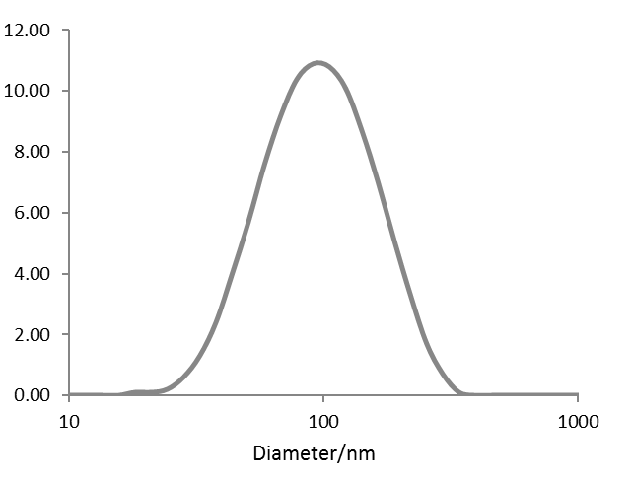
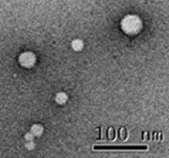

Figure 2.1: DLS trace for PEG-PTFEMA-25 and TEM (insert).

Oxygen incorporation was initially studied using ¹⁹F NMR, which can be used to probe where oxygen binds within the micelle.²⁹ Speciﬁcally, ¹⁹F NMR was used to investigate any eﬀect on the chemical shift of the ﬂuorine groups (of PEG− PTFEMA-25), in the presence and absence of oxygen. To some extent, this was diﬃcult, as the highly restricted mobility within the aggregated micelle results in strong dipolar coupling, leading to a signiﬁcant attenuation of the ¹⁹F NMR signal in D₂O (discussed above in page 27).²⁴ Nevertheless, it was still possible to observe a small peak at -73.1 ppm in the degassed sample. After bubbling oxygen through the same solution, a small but recordable shift of the ﬂuorine peak, to -72.1 ppm, was observed. This represents a shift of 1 ppm, which is similar to the shifts observed for perﬂuoro emulsions under similar aqueous conditions.²⁹ Although this method was qualitative, it did provide some initial encouragement that the oxygen can be encapsulated/bind within the ﬂuorine core/block of the polymeric micelle.

To obtain support that is more conclusive for oxygen binding, we used a commercial dissolved oxygen meter to determine the concentration of oxygen dissolved in an aqueous solution This method involves passing oxygen through a membrane and into a probe to react with a dye inside the probe, resulting in changes in emission. The intensity of this signal is used to measure the concentration of oxygen.³⁰. This technology is fast and offers highly reproducible results. Thus, if we saturate a micellar solution with pure oxygen, we can measure the rate that oxygen in the solution equilibrates with the air, where the concentration of oxygen is much lower (around 20% in air). This rate can then be compared with a simple aqueous solution that does not contain any micelle. Any diﬀerences in rate will be related to the oxygen bound within the micelle, which can only be released when the oxygen dissolved in the saturated aqueous solution returns to the atmosphere (Figure 2.2). This is an established method and has previously been used to measure oxygen content and release from perﬂuoro systems³¹ and ﬂuoropolymers.^{15, 32}
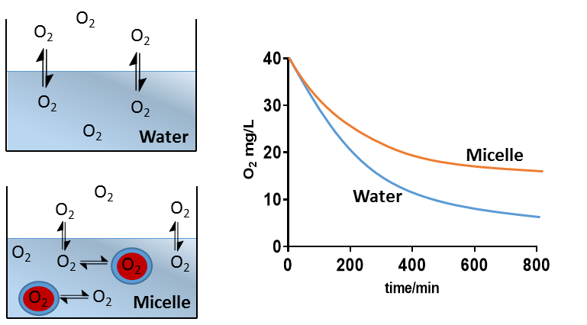

Figure 2.2: Comparison of the rate of oxygen equilibration between simple aqueous solution to micelle solution respectively.

The measurements were carried out using solutions of the micelle at various concentrations. These were stirred vigorously in vials, and pure oxygen was bubbled through the solution for 1 min (until the dissolved oxygen concentration had reached the saturation level of 40 mg/L). The vials were then opened, and the oxygen content was continuously monitored over time. All experiments were carried out using the same volume of water and at the same temperature (24 °C). The oxygen release from water, along with a representative plot for PEG−PTFEMA-17, and PEG−PTFEMA-25 are shown in Figure 2.3.
1:17 (2 mg/mL)
1:25 (2 mg/mL)

Figure 2.3: Oxygen release curves at the concentration for PEG−PTFEMA-17, and PEG−PTFEMA-25.

Initially, the release of oxygen from a saturated aqueous solution was studied (no polymer) at 24 °C. The rate of release and the half-life were calculated from a plot of oxygen concentration vs time, which could be ﬁtted to a ﬁrst-order decay (Figure 2.3). Having established the controls and baseline levels, the experiment was repeated using the PEG−PTFEMA diblock copolymers at various concentrations. The solubility of the polymers was relatively poor and dependent on the length of the ﬂuoro-block, which limited the amount of polymer that could be used. For example, although PEG−PTFEMA-17 was the most soluble, it was hard to solubilize at concentrations above 5.0 mg/mL (Table 2.2).

Table 2.2: Oxygen release rates and half-lives for the PEG-PTFEMA polymers
Polymer System | Concentration- mg/mL | Rate of O₂ release –  ×10⁻³ (mg/mL/min) | Half-life (min)
Water (no polymer) | / | 4.2 | 160
PEG-PTFEMA-25 | 0.5 | 3.9 | 180
PEG-PTFEMA-17 | 0.5 | 4.2 | 165
PEG-PTFEMA-25 | 2.0 | 3.6 | 195
PEG-PTFEMA-17 | 2.0 | 3.8 | 182
PEG-PTFEMA-17 | 5.0 | 2.1 | 325

PEG−PTFEMA-25 solutions could be made to a maximum solubility of 5.0 mg/mL, but over time, a colourless precipitation was noticed. As a result, the solution became turbid during the oxygen release experiments, which limited the reliable data that could be collected. Precipitation was also observed by others when studying similar polymers, where phase changes occurred in the presence of oxygen.^{16, 17} Nevertheless, despite the precipitation of PEG−PTFEMA-25 at the higher concentration (which limited the amount of data that could be collected), it does indicate good oxygen retention/solubility for these polymers at the highest concentration studied (corresponding to the highest concentration of ﬂuorine) (Figure 2.4).

1:25 (0.5 mg/mL)
1:25 (2 mg/mL)

Figure 2.4: Oxygen release curves at various concentrations for PEG-PTFEMA-25.

For all solutions, the change in oxygen concentration was plotted with respect to time and the data ﬁtted to a ﬁrst-order decay.³³ The rate of oxygen release, along with the half-lives for all soluble polymers, are shown in Table 1. The graphs and kinetic data from the polymer solutions clearly show that oxygen is released more slowly, when compared to the rate of oxygen release from the simple aqueous solution (no polymer). This conﬁrms that oxygen has been retained within the micelle and is only released into the aqueous phase when it can replace the dissolved oxygen as it returns to the atmosphere. The process continues until the equilibrium position is reached, which occurs at an oxygen concentration around 9 mg/L at 24 °C.³⁴ At the higher concentrations, longer half-lives and slower rates (of oxygen release) were observed. For example, PEG− PTFEMA-17 at a concentration of 5.0 mg/mL had a half-life that was double the value recorded at 0.5 mg/mL. If we consider all polymers at each concentration, we observe that half-lives and rates of release are dependent on the length of the polyﬂuoro block. Overall, it is clear that the ability to dissolve/bind oxygen is directly related to the amount of ﬂuorine in solution. Although the method is designed in the assumption that a decrease in the rate of oxygen loose was due to oxygen replacement from inside the micelle. However, that might not necessary the case, where maybe there are other factors that slowing down oxygen release. Therefore, we need to support this with another method which measuring oxygen concentration directly.

In a further eﬀort to establish and quantify oxygen binding, we attempted to measure the oxygen concentration using an enzyme-based method. The method was originally developed by Ghosh³⁵ and subsequently reﬁned for Marrucho.³⁶ This method is based on the oxidation of glucose by molecular oxygen and is catalysed by glucose oxidase. Although developed to measure glucose concentration in the presence of excess oxygen, the method has been adapted to measure the concentration of molecular oxygen when glucose is the excess reactant. The reactions are stoichiometric with respect to glucose and oxygen and can be used to measure the oxygen content in solution. The method is well established, and the reagents are available in the form of a glucose assay kit (purchased from Sigma−Aldrich) . As with the published procedures,^{35, 36} air was used instead of oxygen as there is no signiﬁcant diﬀerence in solubility, and it simpliﬁes the experimental procedure.

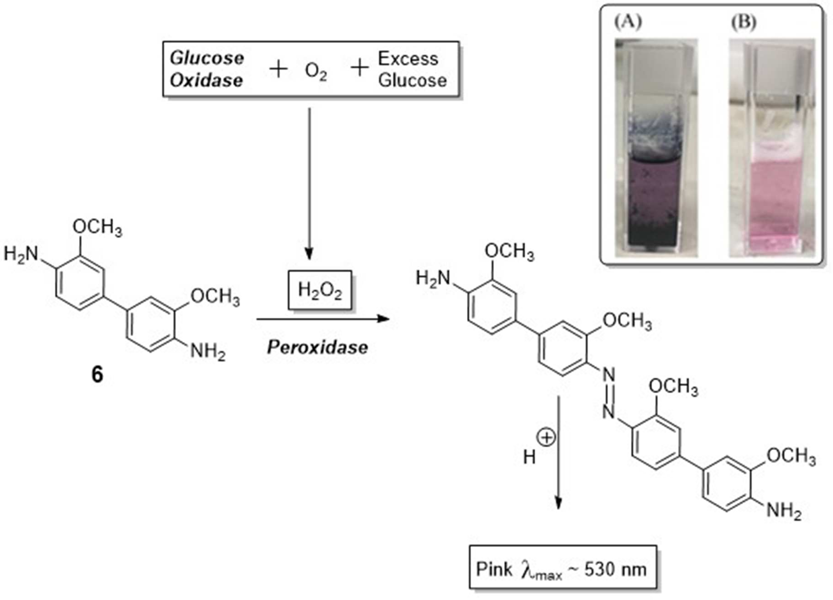

Scheme 2.3: Enzyme mediated reaction used to estimate oxygen concentrations in water. Reactions performed using excess glucose.

The assays were performed at 37 °C, and the reactions are shown in Scheme 2.3. At this temperature, the solubility of oxygen in water is around 6.0 mg/L. As such, a glucose concentration of 55 μg/mL was used (equivalent to 10 mg/L of oxygen) as this was found to be optimum with respect to the experimental conditions. The reaction was initially per- formed in just water to give a good baseline/control reading. However, when the assay was repeated using a 5 mg/mL aqueous solution of PEG−PTFEMA-25, a coloured precipitate formed (Figure 2.5), which precluded an accurate determination of absorption and prevented us from making a comparison with the baseline/control reading. However, ﬁltering or centrifuging the solution resulted in absorptions that were lower than those recorded for water.
* A glucose concentration of 50−60 μg/mL produced absorption peaks that were identical in proﬁle to those obtained in water (see Figure 3). Polymer experiments using higher glucose concentrations produced broad peaks that were of limited usefulness when comparing to the baseline/control spectra.

Figure 2.5: Insert shows; (A) the dark precipitate that initially forms within the polymer solution after the oxidation reaction and (B) the same solution after 9 hours and filtration.

We assumed that the dye was bound or trapped on the precipitate, reducing its concentration in the water. This assumption proved correct, as over time the precipitate settled and the solution’s colour became more intense as the dye was released. Solutions (baseline/control and polymer) were therefore left to settle for 12 h before ﬁltering (see inset, Scheme 2.3). The UV spectrum of the two solutions recorded and the absorption intensity at 540 nm were compared. The result indicates that the polymer solution has an absorption that is higher than the similarly treated aqueous solution (without polymer) (Figure 2.6).
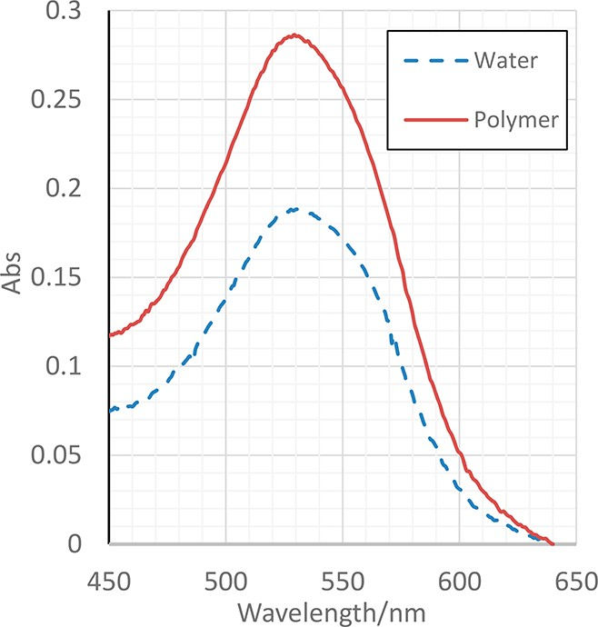
Figure 2.6: UV results from enzyme assay. The data show a stronger absorption for the PEG−PTFEMA-25 solution, indicating a higher oxygen concentration.

Comparing the intensities of the two peaks, we can estimate a minimum oxygen concentration that is 33% higher than that determined for water alone. This increase in absorption intensity corresponds to an oxygen concentration of around 8-9 mg/ L at 37 °C.* Although precipitation caused problems, the enzyme method qualitatively supports the results obtained from the ¹⁹F NMR and dissolved oxygen experiments. Taking all of the results together, we can conclude that the polyﬂuoro micelles can increase the concentration of oxygen within water.
* The oxygen concentration determined in this experiment was close too, but below, the maximum possible oxygen concentration (10 mg/L) that could be recorded for the glucose concentration used (55 μg/mL).
A second control also carried out using just the PEG 2000 Mn component in water. The release of oxygen from the PEG solution was indistinguishable to the aqueous control, producing an identical plot and kinetic data. This conﬁrmed that at the concentration studied (5 mg/mL) the PEG component had no positive eﬀect on the solubilization of oxygen, which is consistent with previous studies on the oxygen solubilization within PEG solutions. However, using higher concentrations of PEG, we noticed something interesting about the process of oxygen saturation. The highest saturation point for a 10% w/v PEG solution was 35 mg/L, which is lower than the maximum possible for water, 40 mg/L (Figure 2.7). We repeated the experiments, but were unable to saturations above 35%. Thus, in an effort to find out why, we decided to further investigate the oxygen solubility in PEG in the next chapter.

Figure 2.7.: Oxygen saturation points in water and 10% w/v PEG aqueous solution.

2.3 Conclusions

The aim of this work was to synthesize and test the oxygen binding potential of a polyﬂuoro amphiphilic micelle. The synthesis involved an ATRP process and was relatively straightforward. Using this method, we were able to obtain a series of polymers possessing a PEG-2000 block and various ﬂuorinated blocks, with degrees of polymerization equal to 17, 25, 33, and 45. With the exception of the polymer with the largest ﬂuoro block, all polymers were soluble in water. At a given concentration, the solubility was inversely proportional to the length of the ﬂuoro block. All of the soluble polymers self-assembled into micellar structures with CMC values around 3 × 10⁻³ mg/mL. DLS indicated that the aggregates had a solvated diameter of 90−100 nm. Micellar structures were conﬁrmed by microscopy, which showed that micellar structures, with a diameter of 30-50 nm, had formed. The aggregates formed were able to bind oxygen as demonstrated by oxygen release kinetics, from an oxygen-saturated aqueous solution. The rates of oxygen release, and hence oxygen binding, were dependent on the amount of ﬂuorine present, with higher concentrations and/or polymers possessing more ﬂuorine, retaining oxygen the longest. This was supported by qualitative ¹⁹F NMR data in D₂O, which showed an upﬁeld shift of the ﬂuorine resonance in the presence of oxygen. As well as supporting oxygen binding, this experiment also indicates that the oxygen has bound within the polyﬂuoro core of the micelle. In addition, the use of an enzyme assay indicated that the polymer could dissolve 33% more oxygen than water alone. However, signiﬁcant loss of dye during the precipitation meant that the concentration of dissolved oxygen could be higher. Taking these results together, we can conclude that aggregates of simple ﬂuorine-containing amphiphilic polymers can increase the concentration of oxygen within an aqueous solution. As such, these polymers (or related systems) have the potential to be applied as a simple artiﬁcial blood product. Although they will never be able to reproduce all of the functions of blood, they may be able to oﬀer a signiﬁcant advantage over standard plasma solutions: whose primary function is to replace the volume of blood lost during bleeding in an emergency or disaster situation. In addition to replacing lost volume, these (or related) polymers will also be able to transport and deliver oxygen. Work is progressing within our laboratory to exploit the oxygen binding properties of these and related polymers for use in medical and related applications.

2.4 Experimental

Reagents and materials
Sigma-Aldrich Chemical Company was the purveyor of every chemical that was employed. Rotary evaporation entails extraction under decreased pressure, while vacuum desiccation involves using a vacuum to dry a solid. Column grade silica was used for column creation.

Instruments
Nuclear magnetic resonance (NMR) spectroscopy
A Bruker Avance DPX 400 device with a BB-¹H probe measuring 5 mm was used for recording ¹H NMR. Internal solvent signal calibrations provided a reference for chemical changes. A Bruker Avance DPX 400 device was employed to derive the ¹³C NMR spectra, whilst NMR data integrations were assessed via TopSpin™. ¹⁹F NMR were recorded at 376 MHz

UV/Vis spectroscopy
An Analytik-Jena SPECORD S600 spectrophotometer was used to obtain the UV-vis spectra. The process involved calibration with a given solvent followed by sample loading into a cuvette made of glass and device scanning within the range 300-800 nm at 0.5 nm resolution.

THF GPC
Samples were loaded onto two PL gel 3 µm MIXED-E columns which were 30 cm in length, with an inner diameter of 7.5 mm. Molecular weights are reported relative to calibrations made using polystyrene standards (Mn 220-1, 1,000,000 Da). THF was employed as both the solvent and the eluent. Samples were injected into the GPC circuit at a temperature of 25 °C at a flow rate of 1.0 mL/min with toluene as an internal standard. Polymer Laboratories, Varian, Inc. (Amherst, MA, USA) software was used for characterisation; then to monitor the sample travelling through the columns, software released by PL DataStream Monitor version 1.2 and Cirrus GPC Online GPC/SEC Software version 3.0 were used.

Dynamic Light Scattering
A Brookhaven ZetaPALS-Zeta Potential and Particle Size Analyser were used to perform dynamic light scattering, with setting of the parameters for recording in water. The results consisted of around five readings each at an interval of 120 seconds. The effective diameter was deemed to be 0 when the count rate was less than 500 kcps.

Fluorescence Emission Spectroscopy
Measurement of the fluorescence emission intensity was undertaken at a 335 nm excitation wavelength, with a Fluoromax-4 fluorescence spectrometer based on FluorEssence software in s mode permitting documentation of each spectrum.

Dissolved oxygen (DO) measurements
Mettler Toledo SG6 SevenGo Pro with an Inlab 605 dissolved oxygen probe. The data was fitted to a first order decay using Graphpad.

Transmission Electron Microscope
The samples were stained with 2% phosphotungstic acid aqueous solution. The Philips CM200 FEG TEM instrument was used to visualise samples.

Infra-red Spectroscopy
A Perkin Elmer Spectrum RX 1 FT-IR spectrophotometer was used to measure every infra-red spectrum. This involved employing dichloromethane to apply the sample to a sodium chloride plate and loading into the device was performed only after dichloromethane evaporation.

Synthesis

Synthesis of macro-initiator mPEG-Br

MPEG-2000 (20 g, 10 mmol) was dried by azeotropic distillation with anhydrous toluene, and then was added to 500 mL double-neck flask with 250 mL dry toluene. The solution was cooled to 0 °C in ice bath followed by addition of triethylamine (2 mL, 14.3 mmol). α-Bromoisobutyl bromide (1.5 mL, 12.1 mmol) was added via syringe over 1 hour. The mixture was stirred at ambient temperature for 24 h and then was filtered under vacuum to remove salt by-product. The filtrated solution was concentrated under reduced pressure and precipitated in diethyl ether. The cream color solid product was yielded by vacuum filtration, followed by recrystallization in absolute ethanol for the further purification to give methyl poly (ethylene glycol) bromide (17 g, 79%) as white solid. ¹H NMR (400 MHz; CDCl₃; ppm) δ 1.95 (s, -CO₂Br(CH₃)₂), 3.40 (s, CH₃O-), 3.66 (s, -OCH₂CH₂O-), 4.34 (m, -CH₂OOCMe₂Br); GPC: Mn = 2891, Mw/Mn = 1.029.

General procedure for the Synthesis of mPEG-Poly-2, 2, 2-trifluoroethanol methacrylate (PEG₋PTFEMA_{n}).
CuBr was purified by washing three times with acetate acid, three times with absolute ethanol and three times with diethyl ether, followed by drying in vacuum oven to get the white powder. Inhibitor of monomer TFEMA was removed by passing the basic aluminium column. mPEG-Br (2.148 g, 1 mmol), 2, 2, 2- trifluoroethanol methacrylate (15, 25, 35 or 45 mmol) and CuBr (0.144 g, 1 mmol) in 30% m/v toluene was prepared in a Schlenk tube. The mixture was degassed by freeze-pump-thaw for three times. Degassed PMDETA (0.251 mL, 1.2 mmol) was added into the Schlenk tube by a degassed syringe. The reaction was carried out under positive N₂ pressure at 70 °C overnight. The solution was opened to the air to stop the reaction and was dissolved in excess toluene. The resulting solid was removed by vacuum filtration. The filtrate was reduced under vacuum to yield green oil which was then flushed through a small basic aluminium column with dichloroform as an eluent to remove the catalyst. The solution was concentrated by rotary evaporator and precipitated from petroleum ether. The sticky product was dried in vacuum oven for 24 hours to yield mPEG-PTFEMA as a white solid.

Synthesis of PEGb-PTFEMA₁₅.

MPEG-2000 (2.148 g, 1 mmol) was reacted with 2, 2, 2-trifluoroethyl methacrylate (2.15 mL, 15 mmol) to give MPEG-b-PTFEMA₁₅ (2.71 g, 58%); ¹H NMR (400 MHz; CDCl₃; ppm) δ 0.80 – 1.19 (d, -CO(CH₃)), 1.86 – 2.22 (m, -CH₂-CO(CH₃)), 3.40 (s, CH₃O-), 3.65 (s, -OCH₂CH₂O-), 4.38 (s, -CH₂CF₃); ¹⁹F NMR (100 MHz; CDCl₃; ppm); δ -73.29; GPC (LMW; THF) Mn = 5200, Mw/Mn = 1.417.

Synthesis of PEG-b-PTFEMA₂₅.
MPEG-2000 (2.148 g, 1 mmol) was reacted with 2, 2, 2-trifluoroethyl methacrylate (3.58 mL, 25 mmol) to give MPEG-b-PTFEMA₂₅ (4.9 g, 41%); ¹H NMR (400 MHz; CDCl₃; ppm) δ 0.80 – 1.19 (d, -CO(CH₃)), 1.85 – 2.20 (m, -CH₂-CO(CH₃)), 3.40 (s, CH₃O-), 3.65 (s, -OCH₂CH₂O-), 4.36 (s, -CH₂CF₃); ¹⁹F NMR (100 MHz; CDCl₃; ppm); δ -73.29; GPC (LMW; THF) Mn = 6500, Mw/Mn = 1.549.

Critical micelle concentration measurement
10⁻⁶ mol/mL pyrene acetone solution was made as a probe of CMC measurement. A series of volumetric flasks were prepared and 0.5 mL of pyrene solution was added to each one. All flasks were left for 24 hours to evaporate acetone.
Meanwhile, 100 mg of mPEG-PTFEMA was dissolved in 10 mL THF, followed by mixing with 100 mL distilled water. The mixture was heated to 55 °C under stirring for 5 hours and transferred to 100 mL volumetric flask to make 1 mg/mL batch solution. A series of solutions with different concentrations from 0.6 mg/ml to 0.0003 mg/mL was made by diluting the batch solution to the volumetric flasks which contain pyrene. Each solution was stirred for 30 mins and left overnight, and then was ready to measure by fluorescence method.

Oxygen solubilization and concentration measurements.
Oxygen solubilization/binding. Dissolved oxygen (DO) measurements were performed through a previously established method. Data were recorded in triplicate for each dispersion in DI water at pH 7.0 at 24 ◦C. Specifically, each dispersion was stirred at 300 rpm for 10 minutes at 24 ◦C. After this time, the vials were continually flushed with a flow of O₂ for 5 minutes. The DO values were then recorded at t = 10 min. Measurements were collected using a Mettler Toledo SG6 SevenGo Pro with an Inlab 605 dissolved oxygen probe. The data was fitted to a first order decay using Graphpad.

Oxygen solubilisation/binding - NMR method. The sample was initially degassed by bubbling nitrogen through the sample directly in the NMR tube (using a long needle that reached the bottom of the tube). The NMR tube was then sealed and the ¹⁹F NMR spectrum recorded immediately. Oxygen was then bubbled through the sample for 2 minutes. The NMR tube was sealed and a second spectrum collected.

Oxygen concentration using an Enzyme oxidation assay.
2 mg/mL of PEG-PTFEMA-25 was dissolved using equal volume of Tetrahydrofuran (THF) and deionized water then THF was removed via rotary evaporator. The glucose (GO) kit was purchased from Sigma-Aldrich. It contains glucose oxidase/peroxidase and o-dianisidine reagents and a glucose standard solution. The assay reagent was prepared by adding 0.8 mL of o-dianisidine to 39.2 mL of glucose oxidase/peroxidase. A 12 normality sulfuric acid solution was prepared in deionized water. To make sure that the kit is accurate, a linear plot was obtained by standard tests (water) using different concentration (20-80 μg). Immediately after bubbling air into the sample, the reaction took place by adding 1 mL of PEG-PTFEMA-25 to 2 mL of the assay reagent and 55 μg glucose/mL in water bath at 37 ºC . The reaction left for 30 mins with magnetic stirrer. The reactions then stopped by adding sulfuric acid. The intensity of the colour was measured using UV against the blank at 540 nm.

2.5 References

1. T. Mallat and A. Baiker, Chemical reviews, 2004, 104, 3037-3058.
2. T. Punniyamurthy, S. Velusamy and J. Iqbal, Chemical Reviews, 2005, 105, 2329-2364.
3. W. J. Rudowski, World journal of surgery, 1987, 11, 86-93.
4. S. P. Klinken, The international journal of biochemistry & cell biology, 2002, 34, 1513-1518.
5. J. G. Riess, Chemical reviews, 2001, 101, 2797-2920.
6. J. G. Riess, Artificial cells, blood substitutes, and biotechnology, 2006, 34, 567-580.
7. Y. Nosé, Artificial organs, 2004, 28, 807-812.
8. K. Lowe, Blood reviews, 1999, 13, 171-184.
9. P. M. Ness and M. M. Cushing, Archives of pathology & laboratory medicine, 2007, 131, 734-741.
10. D. R. Spahn, Advanced drug delivery reviews, 2000, 40, 143-151.
11. G. Gregoriadis, Journal, 2007.
12. L. Djordjevich and I. Miller, Experimental hematology, 1980, 8, 584-592.
13. K. Knop, R. Hoogenboom, D. Fischer and U. S. Schubert, Angewandte chemie international edition, 2010, 49, 6288-6308.
14. M. J. Barthel, T. Rudolph, S. Crotty, F. H. Schacher and U. S. Schubert, Journal of Polymer Science Part A: Polymer Chemistry, 2012, 50, 4958-4965.
15. G. Pitarresi, A. P. Piccionello, R. Calabrese, A. Pace, S. Buscemi and G. Giammona, Journal of Fluorine Chemistry, 2008, 129, 1096-1103.
16. X. Jiang, F. Chun, G. Lu and H. Xiaoyu, Polymer Chemistry, 2017, 8, 1163-1176.
17. Q. Zhang and S. Zhu, ACS Macro Letters, 2014, 3, 743-746.
18. K. Matyjaszewski and J. Xia, Chemical reviews, 2001, 101, 2921-2990.
19. Y. Zhang, J. Chen, G. Zhang, J. Lu, H. Yan and K. Liu, Reactive and Functional Polymers, 2012, 72, 359-364.
20. R. Krishnan and K. S. V. Srinivasan, European polymer journal, 2003, 39, 205-210.
21. M. Yokota, Y. Miwa, H. Ajiro and M. Akashi, Polymer journal, 2012, 44, 301-305.
22. M. Semsarilar, E. R. Jones and S. P. Armes, Polymer Chemistry, 2014, 5, 195-203.
23. N. Binboga, D. Kisakürek and B. M. Baysal, Journal of Polymer Science: Polymer Physics Edition, 1985, 23, 925-931.
24. C. Fu, S. Herbst, C. Zhang and A. K. Whittaker, Polymer Chemistry, 2017, 8, 4585-4595.
25. L. Nurmi, H. Peng, J. Seppälä, D. M. Haddleton, I. Blakey and A. K. Whittaker, Polymer Chemistry, 2010, 1, 1039-1047.
26. J. Aguiar, P. Carpena, J. Molina-Bolıvar and C. C. Ruiz, Journal of Colloid and Interface Science, 2003, 258, 116-122.
27. W. Xie, W. Zhu and Z. Shen, Polymer, 2007, 48, 6791-6798.
28. C. Y. Zhang, Y. Q. Yang, T. X. Huang, B. Zhao, X. D. Guo, J. F. Wang and L. J. Zhang, Biomaterials, 2012, 33, 6273-6283.
29. J. Y. Choi, J. Y. Kim, H. J. Moon, M. H. Park and B. Jeong, Macromolecular rapid communications, 2014, 35, 66-70.
30. J. N. Demas, B. DeGraff and P. B. Coleman, Analytical Chemistry, 1999, 71, 793A-800A.
31. T. Gotoh, G. Mochizuki and K.-i. Kikuchi, Biochemical engineering journal, 2001, 7, 69-78.
32. D. Mandracchia, A. P. Piccionello, G. Pitarresi, A. Pace, S. Buscemi and G. Giammona, Macromolecular bioscience, 2007, 7, 836-845.
33. D. ﬁ. t. a. s.-p. d. u. Graphpad.
34. K. L. Parkhill and J. S. Gulliver, Water Research, 1997, 31, 2564-2572.
35. A. Ghosh, V. Janic and H. A. Sloviter, Analytical biochemistry, 1970, 38, 270-276.
36. M. Freire, A. Dias, J. Coutinho, M. Coelho and I. Marrucho, Fluid phase equilibria, 2005, 231, 109-113.

Chapter 3

The effect of molecular weight and concentration on the oxygen solubility of aqueous solutions of polyethylene glycol and hyperbranched polyglycols.

3.0 Abstract

Polyethylene glycol (PEG) and Hyperbranched polyglycidol (HPG) are non-immunogenic polymers with the potential for application in many medical fields. As indicated in the previous chapter, higher PEG concentrations require a longer time to become saturated with oxygen than water; thus, in this chapter, the oxygen solubility of PEG and HPG solutions are analysed and compared using various molecular weights and different concentrations. Using a dissolved oxygen meter, it can be shown that aqueous solutions of PEG can release oxygen slower than HPG and water. This slow release of oxygen was quantiﬁed by measuring the rate of oxygen release and its half-life, and using a modiﬁed enzyme/glucose oxidation assay, the oxygen in PEG solutions was quantified as being 30% higher than in water.

3.1 Introduction

PEG is water soluble, non-toxic, neutral, not immunogenic, and acts as a ‘stealth molecule’.¹ Plants that have been given PEG solutions show increased root oxygen deficiency.² In addition, by measuring dissolved oxygen in iron corrosion studies, oxygen solubility in such solutions was shown to decrease as the PEG content increased.³ PEG-based solutions have also been used to preserve organs before transplantation, as the results are better than those that are obtained by using conventional static cold storage.⁴ The improvements were thought to be a result of an increased oxygen concentration that ensured sufficient oxygen supply; thereby enhancing energy synthesis, decreasing anaerobic metabolism and intracellular acidosis, ultimately postponing cell damage.⁵ However, there have been no studies to measure directly the amount of oxygen dissolved in these solutions.

Hyperbranched polyglycidol (HPG) is a branched polyether polymer with multiple hydroxyl functionalities. They can be synthesised easily using a ring-opening polymerisation (ROMP) of glycidol. The reaction is relatively easy to control in respect of molecular weight and polydispersity.^{6, 7} It is well known that HPG is compatible with blood, has low viscosity and is non-immunogenic and non-toxic in mice.^{8, 9} This polymer's potential for application in many medical fields has been actively explored, including: restoration of circulatory volume,¹⁰ drug delivery,^{11, 12} and protecting red blood cell (RBC) antigens.¹³

As noted in the previous chapter, high concentrations of PEG required a lengthier duration to become oxygen saturated compared to water and PEG-PTFEMA-25. In addition, high concentrations of PEG showed slower oxygen release. Thus, we decided to study the effect of PEG concentration and molecular weight on the solubility of oxygen in aqueous solutions. In addition, we wanted to study the shape and architecture of the polymer and their impact on the aqueous solubility of oxygen. To do this, oxygen solubilities for solutions of PEG were compared against solutions of its hyperbranched analogue (hyperbranched polyglycidol – HPG). PEG is a linear dynamic polymer, whilst HPG is more compact and less mobile (Figure3.1). Therefore, structural diversity as a factor of oxygen solubility was studied.

Figure 3.1:Structural differences between linear and branched polymers.

Despite some interesting preliminary results, the mechanisms by which PEG and HPG exert their protective actions to moderate the aqueous solubility of oxygen have not been fully elucidated. Thus, the aim of this chapter is to investigate and compare the oxygen solubility of PEG and HPB solutions using different molecular weights and various concentrations.

3.2 Results and Discussion

PEG is known to be a useful molecule for organ preservation. The impact of using PEG has been shown in the heart, liver and pancreas both in experimental models and clinical studies.^{14, 15} In addition, RBCs modified with PEG show oxygen affinity within the normal range.¹⁶ Thus, there are no indications that PEG has a negative effect on oxygen transmission. However, in the previous chapter, we noticed that the saturation point of oxygen in aqueous PEG solutions was not of the same as oxygen in water. Therefore, the maximum oxygen solubility of different concentrations of PEG-2000 in an aqueous solution was investigated; the results are shown below in Figure 3.2.
Figure 3.2: Oxygen saturation points in water and PEGs aqueous solutions.

The saturation points of the PEG solutions were measured using a dissolved oxygen meter; the maximum solubility was compared to a simple aqueous solution with no polymer. Pure oxygen was bubbled through the solutions for 1 min and a reading taken. For water, the reading was 40 mg/L, but the saturation points were only 38 mg/L for the 1.5% w/v solution, 37 mg/L for the 5% w/v solution, and 35 mg/L for the 10% w/v solution. Thus, as the concentration of PEG increased, oxygen saturation was reduced (compared to the control measurement using water). The viscosity of PEG solutions was notably high when the concentrations of PEG increased. Furthermore, PEG has wide range of deformability and the flow of bubbled oxygen may lead PEG to deform and trap oxygen.
For the next experiment, we compared oxygen solubility using PEGs at the same concentration, but with very different molecular weights. This provided information about structural effects on solubility. When studying large and small polymers at the same w/v concentration, the number of polymers in solution will be different, but the number of monomers/repeat units will be identical. As such, if solubility was dependant on the amount of “substance” in solution, we predicted that the solubilities would be equal (i.e. the amount of material/substance is identical). However, if there was a structural effect, then the solubilities might differ. The experiments were carried out using PEG-2000, PEG-100,000 and water as the control. The saturation points at 10% w/v polymer concentrations were recorded and the data are shown in Figure 3.3. The results of the control and PEG-2000 reveal as significant decrease in oxygen solubility for the larger PEG. Specifically, PEG-100,000 can only dissolve 28 mg/l of oxygen, whilst PEG-2000 can dissolve 35 mg/l at the same concentration. This represents a 20% decrease in oxygen solubility and indicates that structure has an effect upon solubility. The mechanisms responsible for this are not clear, but this effect will be discussed further in relation to the effect of using hyper-branched PEGs.

Figure 3.3: Oxygen saturation points in water, PEG 2000Mn (10% w/v), and PEG 100k Mn (10% w/v) aqueous solutions.

Having established the saturation limits for the polymers, the next experiments measured the release of oxygen from these saturated solutions. A commercial dissolved oxygen meter was used to determine the maximum concentration of oxygen dissolved in an aqueous solution. This method involves passing oxygen through a membrane and into a probe to react with a dye inside the probe, resulting in changes in emission. The intensity of this signal is used to measure the concentration of oxygen. As a result, the meter can only measure the oxygen in solution and does not measure any trapped or encapsulated oxygen within the polymer’s structure. However, because oxygen was used rather than air (which only has 20 % oxygen), the oxygen in solution will re-equilibrate to the levels normally found in air – around 9 mg/mL.

All experiments were carried out using the same volume of water (20 ml) and at the same temperature (24 °C). The concentration of oxygen solubilised in water, along with a representative plot for PEG, is shown in Figure 3.4.

Figure 3.4: Oxygen solubility curves at various concentrations for PEG.

For all solutions, the decay of oxygen was plotted with respect to time and the data fitted to a ﬁrst-order decay.¹⁷ The rate of oxygen release, along with the half-lives of all PEG solutions, is shown in Table 3.1. The graphs and kinetic data clearly indicate that oxygen is released more slowly from PEG solutions than from a simple aqueous solution (no polymer). Furthermore, the release of oxygen is slower from higher concentrations of PEG. This seems contradictory, as the maximum amount of oxygen in the PEG solutions is lower than water. This suggest that PEG may modify the properties of water, reducing the solubility of oxygen, but also providing some form of stable environment that binds oxygen, and only releasing it once free oxygen in bulk water is released and re-equilibrated with oxygen in air.

Table 3.1: Oxygen release rates and half-lives for the PEG solutions
 | Concentration- w/v | Rate of O₂ release –  ×10⁻³ mg/mL/min | % Difference | Half-life (min)
Water (no polymer) | / | 5.4 | 0 | 127
PEG 2000Mn | 1.5 | 5.3 | 2 | 129
PEG 2000Mn | 5 | 4.7 | 13 | 147
PEG 2000Mn | 10 | 3.2 | 50 | 215

The next experiment was designed to determine how fast oxygen-free solutions of PEG could re-bind/dissolve oxygen from air, and to establish the presence of a correlation between the binding and release of oxygen. Specifically, the concentrated solutions of PEG rebind oxygen faster than solutions with lower concentrations of PEG or a water control. After degassing the solutions, the oxygen concentration was monitored over time. The results were plotted and are shown in Figure 3.5. As before, the solubility of oxygen was dependent on the concentration of PEG. At a PEG concentration of 1.5 % w/v, and 5 % w/v, the rate was the same as water. However, at 10% w/v, the rebinding of oxygen was around 33 % slower than the rebinding rate in water. These results do not follow our predicted outcomes, which were based on the previous results of oxygen release (Table 3.1 and Figure 3.4). In these earlier experiments, oxygen was released more slowly from concentrated PEG solutions, indicating stronger binding. As such, we expected binding to be faster for these concentrated solutions. However, this was not the case and binding/oxygen uptake was slower for the concentrated solutions. The postulated mechanism for this is the internal regions of the coiled polymer chains provide a good environment for oxygen, but the environment is sterically challenged, limiting oxygen entry and exit. This means that binding and release of oxygen will be slow. In addition, it has been reported that the high viscosity of some PEG solutions can limit the movement of oxygen, (for example, high concentrations or those using high molecular weight PEGs), which may account for the behaviour observed in here. Specifically, PEG solution showed an increased likelihood of oxygen deficiency in the roots of plants² and the poor oxygen solubility observed in PEG solutions during the study of iron corrosion.³
Figure 3.5: Oxygen solubility curves at various concentrations of PEG.

At this stage the oxygen content was indirectly measured, using the re-equilibrium of oxygen back to air. Therefore, to study the oxygen content of PEG solutions using a quantitative method. The previous chapter describes the dissolved oxygen measurement/experiments that used an enzymatic study designed to measure all available oxygen. In these experiments the results were not quantitative due to precipitation of the polymers under investigation. However, solutions of PEG are completely clear, which should allow us to quantitatively measure the concentration of oxygen in solution. This method were discussed in chapter 1 page 26.

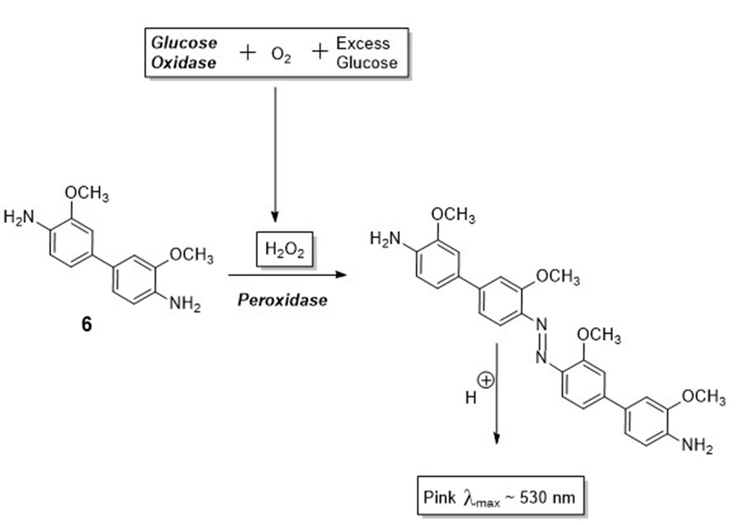

Scheme 3.1: Enzyme-mediated reaction used to estimate oxygen concentration.
The assays were performed at 37 °C, and the reactions involved in the assay are shown in Scheme 3.1. At this temperature, the solubility of oxygen in water is around 7.10 mg/L.¹⁸ A glucose concentration of 55 μg/mL was used (equivalent to 10 mg/l of oxygen) as this was found to be optimal with respect to the experimental conditions.¹⁹ The reaction was initially performed just in water to give a clear baseline/control reading. The UV spectrum of the solutions was recorded and the absorption intensity at 540 nm was compared.

The solubility of oxygen (C*_{ox}) in Table 3.2 was calculated using the following equation²⁴:

C*_{ox} = $\left(\frac{Amax, test}{Amax, ref}\right)$ C*_{ox, w}
Equation 3. 1

- A_{max, test} is the maximum absorption of the PEG solutions at 540 nm.
- A_{max,} _{ref} is the maximum absorption of water at 540 nm.
- C*_{ox, w} value at known pressure and temperature were obtained from literature.¹⁸

Table 3.2: Effect of PEG solutions on oxygen solubility (37 ºC, 760 mm Hg of O₂).

Solution | A_{max, test} /A_{max, ref} | C*_{ox} (mg/L) | % difference
Water | 1 | 7.1 | 0
PEG 2000Mn (1.5% w/v) | 1.06 | 7.55 | 6
PEG 2000Mn (5% w/v) | 1.08 | 7.73 | 8
PEG 2000Mn (10% w/v) | 1.34 | 9.55 | 30

The results indicate that the PEG solutions have absorptions that are higher than similarly treated aqueous solution without polymer. Compared to a simple solution, the 1.5 % w/v PEG-2000 solution was higher, but not significantly so; meanwhile, the 5 % w/v PEG-2000 solution was 8.1 % higher than the baseline value. In turn, the 10 % 2000 showed a 30 % change compared to water. These results were somewhat confusing at first, as they confirm that PEG solutions increase oxygen concentrations in water, which contradicts earlier results indicating a lower solubility for oxygen in PEG solutions. For example, based on the evidence provided by the dissolved oxygen meter, a 10 % w/v solution of PEG-2000 could only dissolve 35 mg/L of oxygen, which is lower than the 40 mg/L possible in water. For the same polymer, the enzyme assay measured a 30 % increase in oxygen solubility, which equates to oxygen concentration of 53 %. This indicates that PEG changes the physical properties of water, resulting in a reduction of the solubility of oxygen in bulk water. However, the findings from our initial binding and release studies show that the polymer can bind/trap and release oxygen (i.e. the rates of oxygen released were slower for the PEG solution). This suggests that there may be relatively high amounts of oxygen trapped inside the polymer matrix, which is only released when free oxygen in the bulk water is re-equilibrated with oxygen in the air. This apparent increase in oxygen concentration was supported by the enzymatic studies, which showed a 30% increase in oxygen concentration for the highest PEG solutions. However, this result needs to be considered in light of the enzyme assay, which used a strong acid to stabilise the colour of the indicator. A consequence of using strong acids is possible degradation of PEG. If this is the case, then the oxygen solubility of the PEG solution may in fact be higher.²⁰

Branched polymers are typically more compact than linear polymers, resulting in smaller hydrodynamic sizes and lower solution viscosities with less flow resistance.^{21, 22} Therefore, we compared the solubility of oxygen in an aqueous solution of PEG to the solubility of oxygen in an aqueous solution of HPG. To achieve this, polyglycidol was synthesised using p-nitrophenol as the core (Scheme 3.2).

Scheme 3.2: Synthesis of p-nitrophenol cored hyperbranched polyglycidol

This core molecule used was an aromatic with a reactive hydroxyl group, enabling the structure to be analysed by ¹H NMR spectroscopy. The molecular weight was estimated by using the aromatic signals and comparing the intensity with the CH₂ region. The use of core has been shown previously to reduce the high poly disparities that are usually associated with HPG; this facilitates molecular weights to be obtained by controlling core to monomer ratios.⁶ The hydroxyl group is deprotonated by base, before propagation occurs via an anionic polymerisation of a glycidol (Scheme 3.3). This monomer is a reactive epoxide and is available commercially. This compound also has a pendant alcohol group, allowing it to behave as a latent monomer AB₂ during polymerisation. That is, as polymerisation occurs, a new/second alkoxide is generated, which results in a branched intermediate and eventually a hyperbranched product. These macromolecules have OH functionalities at the periphery and are water-soluble.^{23, 24}

Scheme 3.3: The generation of alkoxide/alcohol.

A range of different molecular weight HPBs were prepared by varying the core to monomer ratios (1:50, 1:100 and 1:150). To remove all traces of water and to prevent any unwanted side reactions, all glassware was dried in the oven overnight. Para-nitrophenol as the core was added to diethylene glycol dimethyl ether as the reaction solvent, and the mixture was heated to 50 ºC under a nitrogen atmosphere, until complete dissolution of the core was observed. Following this, K₂CO₃ was added and the temperature was increased to 90 ºC. The colour of the mixture changed from colourless to yellow; this was due to the deprotonation of p-nitrophenol to give a nitrophenolate ion. Glycidol was then added drop-wise over a period of 12 hours using a syringe pump. The slow addition of glycidol was crucial to avoid the risk of a rapid reaction and possible explosion, as well to limit any non-core initiated polymerisation.⁶ The resulting polymer was then purified by dissolving the compound in methanol and precipitating into a large volume of acetone, which eliminated unwanted monomer and small oligomers. The purification was repeated twice and the final product was dried to 30 ºC to give a viscous brown polymer.

The structure of the resultant hyperbranched polyglycidol was confirmed by ¹H NMR spectroscopy, which revealed three peaks in the spectrum. Two of the peaks at 8.2 ppm and 7.07 ppm represent the aromatic protons of the p-nitrophenol core. This is shown as H_{a} and H_{b} in the core molecule (Figure 3.6). H_{a} is the most de-shielded due to delocalisation and inductive effects from the electron-withdrawing NO₂ group.

Figure 3.6: Cis- and trans- proton environments of p-nitrophenol

Confirmation of core incorporation was carried out by adding fresh p-nitrophenol to a solution of the synthesised polymer and analysing it by ¹H NMR. The original ¹H NMR spectrum of the polymer and the spectrum of the core-doped polymer are shown in Figure 3.7. The doped polymer shows two additional doublets at 8.1 ppm and 6.75 ppm. Thus, core incorporation within the polymer structure was confirmed. The remaining CH, CH₂ and OH protons within the polymer structure were visible as a broad peak between 3.25 ppm and 4.00 ppm.

Para-nitrophenol incorporated within the polymer
Free Para-nitrophenol

Figure 3.7: Polyglycidol doped with free p-nitrophenol.

To demonstrate successful synthesis and estimate the molecular weight of the hyperbranched polymer aqueous gel permeation chromatography (GPC) was conducted. The average molecular weight (Mn) from the GPC was compared to the Mn calculated using ¹H NMR; this was achieved by comparing the integration ratio of the core peaks to the broad peak of the backbone of the polymer. The calculation of the theoretical average molecular weight was achieved by multiplying the molar mass of the glycidol (74 gmol⁻¹) by the number of monomers and then adding the molar mass of p-nitrophenol (139 gmol⁻¹). This gave 3843 Da, 7547 Da and 15094 Da for the 1:50, 1:100 and 1:150 systems respectively. This data, along with the GPC and theoretical data, is shown in Table 3.3.

Table 3.3: Comparison of the average molecular weights of p-nitrophenol cored polyglycidol by various spectroscopy techniques

HBG | Core: monomer | Mn  Theoretical | Mn  ¹H NMR | Mn  GPC | Mn  (PDI) | % Core Incorporation
HBG-3000 | 1:50 | 3843 | 21500 | 3000 | 2.5 | 14
HBG-30,000  HBG-60,000 | 1:100  1:150 | 7547  15094 | 33500  73500 | 28000  53000 | 3.1  2.6 | 84  72

- Core incorporation estimated from Mn ratios (GPC/NMR)

For GPC, the results did not match the theoretical Mn; this could indicate a lack of core incorporation. However, if there were no core incorporation, then the polydispersity index would have been significantly elevated, with no control over molecular weight; yet this was not observed.

The discrepancy between the GPC and ¹H NMR Mn was due to the different ways these techniques estimate Mn. The underestimation of Mn was due to the GPC readings being based on the size of a polymer and not its molecular weight. Molecular weights are then estimated using linear polymer standards with well-defined and characterised Mn values. HPGs are globular and their sizes are therefore relatively small compared to similarly sized linear polymers. In other words, for HPGs, if linear polymers are used to calibrate the equipment, GPC will always underestimate molecular weight. As such, when comparing the Mn values obtained from NMR and GPC, the latter gives a minimum Mn value, referred to as Mn^{min}. On the other hand, the Mn derived from ¹H NMR was clearly higher than GPC and theoretical values. This is because NMR compares the integration of the core with the main/bulk HPG and the calculation assumes that all polymers have a central core. If this is not the case, then the intensity of the main/bulk HPG will be much higher than expected. Therefore, the ratio will be inaccurate, leading to an overestimation of Mn. Thus, using a core property to calculate Mn, a maximum possible value for Mn is generated and is referred to as Mn^{max}.

The mechanism of polymerisation using p-nitrophenol as an initiator core and glycidol as the latent AB₂ monomer has two steps. The first is the initiation, which occurs after deprotonation of p-nitrophenol by potassium carbonate (K₂CO₃), which then reacts with the first glycidol monomer (Scheme 3.4).

Scheme 3.4: Deprotonation of the p-nitrophenol core and initiation through the ring opening reaction with glycidol.

After initiation, the resulting phenoxide then reacts with a second glycidol monomer and propagation continues via a ring opening mechanism (Scheme 3.5).

Scheme 3.5: Propagation of alkoxide of hyperbranched polymer.

To ensure a high level of core incorporation, a weak base was used to deprotonate the core. K₂CO₃ was used instead of a stronger base, like sodium hydride (NaH). A stronger base can also deprotonate the glycidol monomer and initiate a polymer without a core unit²⁵ (Scheme 3.6).
Scheme 3.6: Deprotonation of glycidol to form the initiator.

The reaction using K₂CO₃ works because the phenolic hydrogen is significantly more acidic than the OH on the monomer/polymer. The acidity of the phenol hydrogen is due to the stability of its conjugate base, which can stabilise the phenolate anion by delocalisation. Occasionally, an unexpected side reaction could take place, where an alkoxide on the growing polymer can deprotonate a glycidol monomer, which can then initiate a core-free HPG (Scheme 3.7). This is the reason that the HPG des not always have a core; it also explains why the molecular weight is not always precisely controlled (with respect to core to monomer ratios). Nevertheless, the trend with respect molecular weight is related to the amount of core. That is, if more core is used, the tendency is to get smaller polymers, as occurred here.
Scheme 3.7:Deprotonation of glycidol to form initiator.

In addition, water can cause problems with polymerisation and core incorporation. For example, the growing polymer could deprotonate water and then initiate a new core-free polymer by reacting with glycidol. This is a problem for two reasons; firstly, a new non-cored HPG is initiated and secondly, deprotonation of water can terminate the ring opening polymerisation of the original HPG. This caused a significant increase in the number of non-cored HPGs, whilst also increasing the polydispersities. (Scheme 3.8).

Scheme 3.8: Water traces may affect the final product.

Having successfully synthesised a range of HPGs with appropriate molecular weights that could be compared with the PEG, the oxygen binding potential of these branched polymers was measured. Firstly, the saturation points of the HPG solutions were measured using a dissolved oxygen meter and the maximum solubility for each polymer was compared to a control solution with no polymer (Figure 3.8). It is important to note that the number next to HGP reflects the Mol Wt as an estimate from the bulk GPC analysis (which underestimates Mn). As before, pure oxygen was bubbled through the solution for 1 min and a reading taken. The saturation points for the HBG-3000 and HBG-30,000 at a concentration of 10 % w/v were 40 mg/L, which was the same as water. The value for the same concentration of larger HBG-60,000 was slightly lower, around 38 mg/L. Unlike the PEG solutions, the HPG solutions were able to dissolve the same amount of oxygen as water, even at the relatively high concentration of 10 % w/v. Hence; HPGs do not modify the property of water, including the ability to solubilise oxygen. As such, when studying oxygen release, higher oxygen solubility may be observed due to binding within the hyperbranched polymer, as it did with PEG experiments.
Figure 3. 8: Oxygen saturation points in water and HPGs aqueous solutions.

In an effort to determine if there was some excess oxygen bound within the HPGs, oxygen release experiments were conducted using the same method used to measure release from the PEG solutions (explained above). All experiments were carried out at 24°C. Plots of oxygen concentration versus time and fit to first-order decay are shown in Figure 3.9. The release rates and half-lives are shown in Table 3.4.

Figure 3. 9: Oxygen solubility curves at various molecular weights of HPG.

The plots and rates of oxygen released from HBG-3000 and HBG-30,000 at a concentration of 10 % w/v were similar to the results obtained from the aqueous control solution (no polymer). However, plots and release data for the larger HBG-60,000 at the same concentration clearly indicate a slower rate of oxygen release compared to the aqueous control solution (no polymer). Therefore, larger HPG displays some ability to bind oxygen. These results show that branched polymers are less resistant to oxygen flow than linear polymers. In other words, globular or more compact polymers are less susceptible to deforming and trapping oxygen.

Having establish some ability to bind oxygen, based on release rates, the amount of oxygen in solution was established using the adapted enzymatic method. This was carried out as before, but the results were inconclusive. Unfortunately, this was due to the small amount of colour present in the HPG solutions, which prevented accurate determination of oxygen concentrations using UV. The colour came from extremely small amounts of residual p-nitrophenol, which is highly coloured. Attempts to remove the remaining p-nitrophenol were not successful. As such, we were unable to determine whether or not the HPGs could bind oxygen, and if so, by how much. In the future, electrochemical methods could be used as an alternative method to follow oxygenation. Nevertheless, the results suggest that large HPGs can bind oxygen in a similar way to the large PEGs and the fluoro micelles discussed in the previous chapter. Trimethylolpropane can be used as a core in the future to obtain colourless HPGs.

Table 3. 4: Oxygen release rates and half-lives for the HPG solutions
 | Concentration- w/v | Rate of O₂ release –  ×10⁻³ mg/mL/min | Half-life  Min
Water  (no polymer) | / | 5.6 | 122
HBG-3000 | 10 | 5 | 136
HPG-30,000 | 10 | 4.6 | 149
HPG-60000 | 10 | 4.1 | 165

.

3.3 Conclusion

The aim of this chapter was to investigate and compare the oxygen solubility of PEG and HPG solutions using different molecular weights and various concentrations. PEGs with molecular weights of 2000 and 1000,000 were acquired commercially and HPGs with molecular weights between 3000 and 60,000 were synthesised using open ring polymerisation. PEG solutions were initially prepared using the same MW (2000 Mn) and different concentrations 10 % w/v, 5 % w/v and 1.5 %w/v respectfully. The saturation points of oxygen in aqueous PEG solutions were slightly lower than the concentration of oxygen in water for concentrations up to 5 % w/v. However, at the higher concentration of 10 % w/v, the oxygen saturation/concentration was more 12 % lower than water alone, indicating that the amount of oxygen in water was reduced by the PEG. However, this was contradicted by indirect oxygen solubility and release studies, which seemed to suggest that additional oxygen was bound within the polymer network. Results using the 10 % w/v PEG solution released oxygen around 50% more slowly than a simple aqueous solution (with no polymer). This suggested that some “extra” oxygen must also be present inside the polymer network (in addition to the free oxygen in bulk water). This trapped oxygen cannot be measured until it replaces the free oxygen in bulk solution as it is re-equilibrates with the oxygen in the atmosphere. These results were supported by an enzyme assay, which can provide a direct measurement of (all) oxygen in solution. This methods showed that a 10 % w/v aqueous PEG solution had around 30 % more oxygen than water alone. As such, the enzymatic results correlate well with the indirect oxygen retention and release studies results. Although our indirect and direct measurements suggested that more oxygen can be bound inside the polymer at 10 % w/v PEG concentrations, the rate of oxygen binding/uptake (to a degassed solution) was 33 % slower than water alone. This is interesting, as it tells us that binding is slowed down by the steric and/or electronic effects generated by the polymeric structure at higher concentrations. On the other hand, HPGs showed no effect on the property of water when saturated with oxygen. In addition, release of oxygen from the HPGs were all similar to water. Unfortunately, an enzymatic measurement of oxygen concentration was not possible as it is essentially a colourimetric analysis and the p-nitrophenol core was also coloured. In future, trimethylolpropane could be used as a core to obtain colourless HPGs. This will lead to results that are more consistent. Linear PEG polymers can deform and trap oxygen more than compact branch polymers.

3.4 Experimental

Reagents and materials
Sigma-Aldrich Chemical Company was the purveyor of every chemical that was employed. Rotary evaporation entails extraction under decreased pressure, while vacuum desiccation involves using a vacuum to dry a solid. Column grade silica was used for column creation.

Instruments
Nuclear magnetic resonance (NMR) spectroscopy
A Bruker Avance DPX 400 device with a BB-¹H probe measuring 5 mm was used for recording ¹H NMR. Internal solvent signal calibrations provided a reference for chemical changes. A Bruker Avance DPX 400 device was employed to derive the ¹³C NMR spectra, whilst NMR data integrations were assessed via TopSpin™.

UV/Vis spectroscopy
An Analytik-Jena SPECORD S600 spectrophotometer was used to obtain the UV-vis spectra. The process involved calibration with a given solvent followed by sample loading into a cuvette made of glass and device scanning within the range 300-800 nm at 0.5-nm resolution.

Infra-red Spectroscopy
A Perkin Elmer Spectrum RX 1 FT-IR spectrophotometer was used to measure every infra-red spectrum. This involved employing dichloromethane to apply the sample to a sodium chloride plate and loading into the device was performed only after dichloromethane evaporation.

Dissolved oxygen (DO)
Mettler Toledo SG6 SevenGo Pro with an Inlab 605 dissolved oxygen probe. The data was fitted to a first order decay using Graphpad.

Synthesis

General procedure
Hyperbranched polymerization was performed in two neck flask fitted with condenser, under nitrogen atmosphere, and equipped with stirrer. At 50 ºC para-nitropehenol was dissolved in diethylene glycol dimethyl ether (Diglyme). After 30 minutes temperature was increased to 90 ºC and potassium carbonate was added and left for 90 minutes. Glycidol was added drop wisely using mechanical syringe pump for 12 hours and left further 5 hours. The reaction was allowed to cool down to room temperature then the solvent was disposed. The product was dissolved in minimum amount of methanol and then precipitated in 400 mL of cold acetone. The mixture left overnight and the solvent was disposed.

1:50 core to monomer ratio
Para- nitropehenol (210 mg, 1.54 mmol), 20 mL of Diglyme, potassium carbonate (210 mg, 1.54 mmol) and Glycidol (5.24 mL, 77 mmol).

Yield 2.51g 44%; ¹H NMR (D2O, 400 MHZ) δH 8.1 (aromatic H), 7.2 (aromatic H), 3.95-3.15 (br m CH + CH2) 2.14 (s OH); ¹³C NMR (D2O, 400 MHZ) δC 62.8, 72.0, 78.0; IR (cm⁻¹): 3351 (OH), 2873 (CH2, CH), 1644 (C=O), 1330 (C-O-C), 1067 (C-O); GPC (HMW, Aq): Mn 3000, PDI 2.5.

1:100 core to monomer ratio
Para- nitropehenol (210 mg, 1.54 mmol), 20 mL of Diglyme, potassium carbonate (210 mg, 1.54 mmol) and Glycidol (10.3 mL, 154 mmol).

Yield 3.8g 33%; ¹H NMR (D2O, 400 MHZ) δH 8.08 (aromatic H), 7.18 (aromatic H), 4.01-3.45 (br m CH + CH2) 2.10 (s OH); ¹³C NMR (D2O, 400 MHZ) δC 62.6, 72.0 79.1; IR (cm⁻¹): 3290 (OH), 2867 (CH2, CH), 1452 (C=O), 1308 (C-O-C), 1024 (C-O); GPC (HMW, Aq): Mn 28000, PDI 3.1

1:150 core to monomer ratio
Para- nitropehenol (210 mg, 1.54 mmol), 20 mL of Diglyme, potassium carbonate (210 mg, 1.54 mmol) and Glycidol (15.4 mL, 231 mmol).

Yield 7.1g 31%; ¹H NMR (D2O, 400 MHZ) δH 8.05 (aromatic H), 7.2 (aromatic H), 4.00-3.42 (br m CH + CH2) 2.10 (s OH); ¹³C NMR (D2O, 400 MHZ) δC 62.6, 71.0, 79.2; IR (cm⁻¹): 3288 (OH), 2869 (CH2, CH), 1450 (C=O), 1308 (C-O-C), 1019 (C-O); GPC (HMW, Aq): Mn 53000, PDI 2.6

Oxygen solubilization and concentration measurements.
Oxygen solubilization, binding. Dissolved oxygen (DO) measurements were performed through a previously established method.¹ Data were recorded in triplicate for each dispersion in DI water at pH 7.0 at 24 ◦C. Specifically, each dispersion was stirred at 300 rpm for 10 minutes at 24 ◦C. After this time, the vials were continually flushed with a flow of O₂ for 5 minutes. The DO values were then recorded at t = 10 min. Measurements were collected using a Mettler Toledo SG6 SevenGo Pro with an Inlab 605 dissolved oxygen probe. The data was fitted to a first order decay using Graphpad.

Oxygen solubilization, uptake. each solution was stirred at 300 rpm for 10 minutes at 24 ◦C. After this time, the vials were continually flushed with a flow of Nitrogen for 5 minute. The DO values were then recorded at t = 10 min. Measurements were collected using a Mettler Toledo SG6 SevenGo Pro with an Inlab 605 dissolved oxygen probe. The data was fitted to a first order decay using Graphpad.

Oxygen concentration using an Enzyme oxidation assay.
2 mg/ml of each sample were dissolved using deionized water. The glucose (GO) kit was purchased from Sigma–Aldrich. It contains glucose oxidase/peroxidase and o-dianisidine reagents and a glucose standard solution. The assay reagent was prepared by adding 0.8 mL of o-dianisidine to 39.2 mL of glucose oxidase/peroxidase. A 12 normality sulfuric acid solution was prepared in deionized water. To make sure that the kit is accurate, a linear plot was obtained by standard tests (water) using different concentration (20-80 μg). Immediately after bubbling air into the sample, the reaction took place by adding 1 ml of each sample to 2 ml of the assay reagent and 55 μg glucose/ml in water bath at 37 Cº . The reaction left for 30 mins with magnetic stirrer. The reactions then stopped by adding sulfuric acid. The intensity of the colour was measured using UV against the blank at 540 nm

3.5 References

1. T. Hauet and M. Eugene, Kidney international, 2008, 74, 998-1003.
2. J. Mexal, J. T. Fisher, J. Osteryoung and C. P. Reid, Plant Physiology, 1975, 55, 20-24.
3. E. Guilminot, F. Dalard and C. Degrigny, Corrosion science, 2002, 44, 2199-2208.
4. T. Hauet, J. M. Goujon, H. Baumert, I. Petit, M. Carretier, M. Eugene and A. Vandewalle, Kidney international, 2002, 62, 654-667.
5. G. Pasut, A. Panisello, E. Folch-Puy, A. Lopez, C. Castro-Benítez, M. Calvo, T. Carbonell, A. García-Gil, R. Adam and J. Roselló-Catafau, World journal of gastroenterology, 2016, 22, 6501.
6. A. Sunder, R. Hanselmann, H. Frey and R. Mülhaupt, Macromolecules, 1999, 32, 4240-4246.
7. D. Wilms, S.-E. Stiriba and H. Frey, Accounts of chemical research, 2010, 43, 129-141.
8. R. K. Kainthan, S. R. Hester, E. Levin, D. V. Devine and D. E. Brooks, Biomaterials, 2007, 28, 4581-4590.
9. R. Chapanian, I. Constantinescu, N. Medvedev, M. D. Scott, D. E. Brooks and J. N. Kizhakkedathu, Biomacromolecules, 2013, 14, 2052-2062.
10. R. K. Kainthan, J. Janzen, J. N. Kizhakkedathu, D. V. Devine and D. E. Brooks, Biomaterials, 2008, 29, 1693-1704.
11. C. Mugabe, R. Liggins, D. Guan, I. Manisali, I. Chafeeva, D. Brooks, M. Heller, J. Jackson and H. Burt, International journal of pharmaceutics, 2011, 404, 238-249.
12. M. Imran ul-haq, J. L. Hamilton, B. F. Lai, R. A. Shenoi, S. Horte, I. Constantinescu, H. A. Leitch and J. N. Kizhakkedathu, ACS nano, 2013, 7, 10704-10716.
13. N. A. Rossi, I. Constantinescu, R. K. Kainthan, D. E. Brooks, M. D. Scott and J. N. Kizhakkedathu, Biomaterials, 2010, 31, 4167-4178.
14. Y. Tokunaga, W. Wicomb, R. Garcia-Kennedy and C. Esquivel, Transplantation, 1992, 54, 756-758.
15. W. Wicomb, J. Hill, J. Avery and G. Collins, Transplantation, 1990, 49, 261-264.
16. J. K. Armstrong, H. J. Meiselman and T. C. Fisher, American journal of hematology, 1997, 56, 26-28.
17. Data ﬁtted to a single-phase decay using Graphpad.
18. G. A. Truesdale, A. Downing and G. Lowden, Journal of Applied Chemistry, 1955, 5, 53-62.
19. A glucose concentration of 50−60 μg/mL produced absorption peaks that were identical in proﬁle to those obtained in water (see Figure 3). Polymer experiments using higher glucose concentrations produced broad peaks that were of limited usefulness when comparing to the baseline/control spectra.
20. H. Trimble and P. Ebert, Journal of the American Chemical Society, 1933, 55, 958-968.
21. G. Lapienis, Progress in Polymer Science, 2009, 34, 852-892.
22. L. J. Fetters, A. D. Kiss, D. S. Pearson, G. F. Quack and F. J. Vitus, Macromolecules, 1993, 26, 647-654.
23. A. Sunder, R. Mülhaupt, R. Haag and H. Frey, Macromolecules, 2000, 33, 253-254.
24. P. Kubisa, Journal of Polymer Science Part A: Polymer Chemistry, 2003, 41, 457-468.
25. Samsudin, PhD, The University of Sheffield, 2015.

Chapter 4
Micellar encapsulation of iron porphyrin as a model towards an artificial oxygen carrier

4.0 Abstract

Global disasters and conflicts, including wars, exert a huge increased demand on blood bank capacity. Currently, in developed countries, the first-responder emergency services are capable of carrying blood; however, there are substantial issues with storage, shelf life, and potential contamination, and a simpler approach would be beneficial. The aim of this study was to establish a simple methodology capable of replicating the oxygen binding and transporting function of haemoglobin. This would be based on a strategy to develop an efficient system that is both easy and inexpensive to produce, by synthesising self-assembled micellar aggregates. The intention is to avoid the solubility and autoxidation issues seen with simple porphyrin derivatives, specifically iron tetraphenyl porphyrin (FeTPP). Towards these aims, the amphiphilic surfactant 4-(dodecyloxy) benzyl tripropargylammonium bromide was synthesised, and a critical micelle concentration of 0.17 mM obtained using encapsulated pyrene and a fluorescence assay. Fe-tetraphenyl porphyrin was encapsulated within only 3 % of the micelles, although low, this ensured that each porphyrin unit was isolated from other units which would avoid dimerization and fixation of any bound oxygen. In addition to the low level of encapsulation, poor solubility prevented its use as a control for future oxygen binding experiments. To overcome this, the water-soluble Fe(II)-3,5-dimethoxyphenyl porphyrin (Fe(II)THPP) was used and by carful control of stoichiometry. After exposing solutions of Fe(II)THPP to air rapid oxidation occurred and half-life of only 13 seconds was noted. However, when encapsulated within the micelle, Fe(II)TPP exhibited significantly improved stability when exposed to air. To prevent the reversible self-assembly process taking place, which can result in loss of porphyrin and complete breakdown of the micelle structure at low when diluted, surface cross linking of the micelles was used to fix the structure of the micelle, resulting in the protection of the porphyrin within a static nanocage. Unfortunately, due to the COVID-19 pandemic, the characterisation of these cross-linked micelles could not be completed in a timely manner. This research does, however, provide evidence to support the use of micelles to eliminate several known challenges associated with solubility, stability, and aggregate formation that are typically observed in the application of simple iron porphyrin complexes as novel oxygen carriers.

4.1 Introduction

Artificial oxygen carriers are solutions synthesised to mimic red blood cells in order to fulfil their functions. These bind and transport oxygen from the lungs to all body tissue, remove damaging oxygen radicals, and carry carbon dioxide (CO₂) from the peripheral tissues to the lungs.¹ The first artificial RBCs were described by Chang in 1964², with the general assumption being that artificial oxygen carriers would be developed when needed. In fact, attention was predominantly concentrated on the advancement of other artificial cells, at the expense of the research into blood substitutes. Consequently, in 1989, when acquired immune deficiency syndrome (AIDS) spread worldwide, blood substitutes were unavailable resulting in many fatalities for patients that received HIV-contaminated donor blood. It is evident that the realisation of the necessity of artificial blood came too late, as this research, like all studies of medicine and disease, requires long term commitment. The intention of artificial oxygen carriers is to overcome the shortcomings of donated human RBC units, such as the need for collecting, storing, testing, and achieving sufficient oxygen delivery. Perfluorocarbon-Based Oxygen Carriers (PFCs), Stem cell-derived oxygen carriers (SCOCs) and haemoglobin (Hb) based oxygen carriers (HBOCs) are three of the most significant developed alternatives to donor RBC units³. Recently, Haemoglobin Mimicry has been developed and utilised to overcome issues regarding the scarcity of haemoglobin materials, and arising complications intrinsic to the haemoglobin modification processes. The natural Hb oxygen-transporting site is the ‘haeme’, consisting of a porphyrin tetra- pyrrole ring surrounding an iron atom. From this blueprint, researchers have produced Fe(II)-bearing porphyrin systems for oxygen transport.^{4, 5} Therefore, a five-coordinate ferrous ‘haeme’ was immobilised within a sterically hindered hydrophobic matrix of the generated ‘picket fence’ Fe(II)- porphyrin molecules, enabling the myoglobin and Hb reversible oxygenation process.⁶
These systems exhibited cooperative oxygen binding similar to natural Hb. However, they were prone to irreversible oxidation in aqueous media. To resolve this issue, a hydrophobic environment was created for these molecules, using liposomes: amphiphilic Fe(II)--porphyrin bearing four alkyl-phosphocholine groups were embedded efficiently into the bilayer of phospholipid vesicles (e.g., Lipid-Haeme).^{7, 8} The resultant vesicles demonstrated reversible oxygen binding and displayed properties similar to natural Hb. In addition, aggregates possessing oxygen-transporting properties equivalent to RBCs were successfully produced by encapsulating the synthetic Fe(II)-porphyrin systems in Human Serum Albumin (HAS) particles. The increase of circulation time and oxidation reduction was further achieved when the surfaces of these particles was modified with PEG.⁹

Another promising porphyrin-based design was HemoCD, comprised of a 1:1 complex of 5, 10, 15, 20-tetrakis (4-sulfonatophenyl), porphinatoiron(II) (Fe(II)-TPPS), and a per-O- methylated β-cyclodextrin dimer having a pyridine linker (termed HaemoCD or Py3CD).⁵ This system displayed oxygen affinity properties similar to natural Hb, but was identified to be gradually autoxidised in aqueous environments via the water molecules’ nucleophilic attack on the O₂–Fe bond. Again, the stability of these systems circulation could be further enhanced by the surface application of PEG-based dendrimers.¹⁰ Table 4.1 demonstrates representative design and nanomaterials used for the various porphyrin-based oxygen carrier systems discussed.

Table 4. 1: Structure and components of some porphyrin-based oxygen-carrying nano-systems.

Synthetic porphyrin based oxygen carriers | Material used
Iron Fe(II)-based porphyrin structure ‘Picked Fence’.⁶ | Ferrous ‘Haeme’ group embedded in a sterically hindered hydrophobic matrix.
Liposomes modified with iron Fe(II)-based porphyrin structure ‘LipidHaeme’.^{7,8} | Amphiphilic Fe²⁺ - porphyrin bearing four alkylphosphocoline groups embedded into the bilayer membrane of phospholipid vesicle
Iron porphyrin trapped within cyclodextran ‘HaemoCD’.⁵ | Fe(II)-porphyrin systems embedded inside the hydrophobic pockets of cyclodextran moieties.
Human serum albumin (HSA) loaded with iron porphyrin ‘HAS-Haeme’.⁹ | Fe(II)- porphyrin systems embedded within HSA microsphere structures.

The hypothesis envisaging drug encapsulation within micelles is an established concept. Micelles are fluid structures, formed spontaneously by amphiphilic molecules organising themselves to minimise unfavourable interactions with the solvent solution. Figure 4.1 shows a schematic representation of micelle formation, using a surfactant that is characterised by a hydrophobic tail and hydrophilic head. In water these surfactants assemble into spherical structures (the micelle), with hydrophobic cores and a hydrophilic surface.

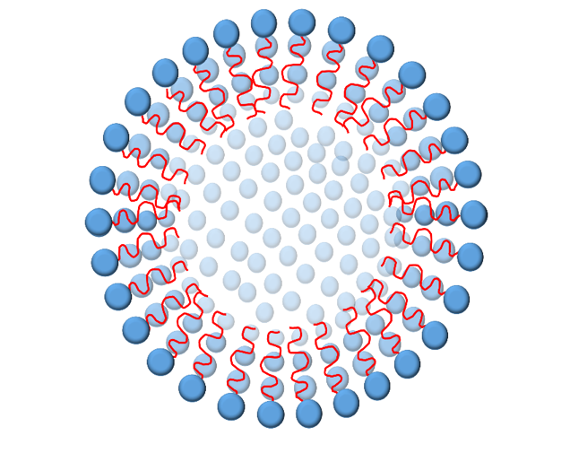
Surfactant

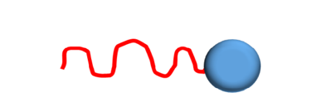
Self-assembly

Figure 4. 1: Diagram showing micelle formation with an amphiphilic surfactant.

These micelles have interesting properties when combined with insoluble species. Insoluble hydrophobic co-molecules can inhabit the interior of the micelles. This property has proven invaluable for the specific role in drug administration and delivery.^{11, 12} Approximately 40% of predicted approved drugs and 90% of drugs in development are either insoluble or poorly soluble in aqueous mediums. Consequently, micelles offer one way for these drugs to be dissolved and carried around the body.¹³ As such, it is possible that an insoluble metalated porphyrin (which represents the simplest construct for the haeme group within any model of Hb), could reside within the micelle’s hydrophobic core. By careful control over stoichiometry, the micelle would act as a protective bubble, solubilising the porphyrin and preventing autoxidation, much like the natural protein structure of haemoglobin. The formation of these thermodynamically stable aggregates occurs above a specific concentration, defined as the critical micelle concentration (CMC). Below this value, the surfactants in solution are free or form pre-micellar structures.¹⁴ This self-assembly and micelle formation can be examined using a solvatochromic dye such as pyrene.^{15, 16} Pyrene is a fluorescent apolar molecule, that can be encapsulated within the micelle’s hydrophobic core. The intensity of its fluorescent signals is affected by the local environment surrounding the pyrene (water or micelle). Specifically, the peak ratios of pyrene’s fluorescence signals are different, depending whether or not it is in water (polar) or micelle (non-polar). Encapsulation characteristics can be ascertained by analysis the fluorescent data at various concentrations. The surfactant molecules within the micelles are highly mobile, rapidly shifting between a free state in a solution to a component of the micellar structures. The aggregates therefore exhibit a relatively low thermodynamic stability. The dynamic nature of micelle structures can be fixed or locked by crosslinking the surface or interior groups, leading to a much more stable entity.

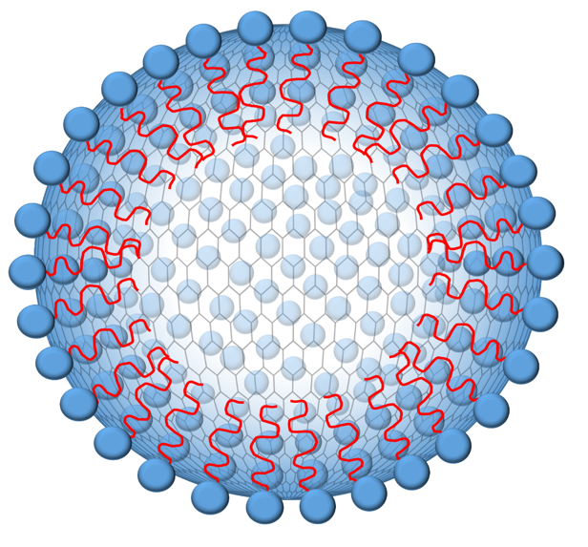
Micellar cross-linking has been demonstrated as early as 1971.¹⁶ Potential applications of surface cross-linked micelles (SCMs) include drug application and selective drug release, where the cross-linker is pH sensitive.¹⁷ A rigid structure is created by the covalent cross-linking at the hydrophilic head-groups of the surfactant. As represented in Figure 4.2, the surfactants lock in place, with the encapsulated species becoming enclosed within the nanocages. This entrapment is intended to prevent micellar breakdown at concentrations below the CMC, an achievement crucial for use as artificial blood.
Surfactant
Self-assembly
Fe
Fe
Cross-linking

Figure 4. 2: Crosslinking of surfactant molecules 'locking' the porphyrin inside a micellar nanocage.

The objective of this project is to provide evidence supporting a human blood alternative, describing an oxygen-carrying model that is unrestricted by the constraints imposed by the requirement of donations from healthy volunteers, and free from disease, high expense, and solubility issues. Creating a water-soluble oxygen binding structure would allow the introduction of colloidal solutions for application in first aid situations. In addition to replacing the lost volume of blood of traditional plasma or “volume expander”, the proposed systems will have the added benefit of delivering oxygen to the body. Due to its established oxygen-carrying properties, the classic Hb porphyrin structure will be applied in this research, together with the encapsulation theory and the protected porphyrin design. The model will be investigated for encapsulation within the hydrophobic pore of a functionalised micelle. Using the micelle’s self-assembling nature, the structure will be cross-linked at the surface to form a nanocage, entrapping a single metalated porphyrin. To improve stability and maintain micelle structures below the CMC, cross-linking of the surface will be carried out. In addition to synthesising these systems, the structural stability of the surface-cross-linked nanoparticles below the CMC will be also be analysed. The Iron (III) at the core of the porphyri (within the micelle) will be reduced to the oxygen-binding iron (II) state before being exposed to air. The electronic stability of the Fe(II) metal will also be examined by measuring the rate of oxidation and comparing this to the rate obtained for the same porphyrin without a micellar superstructure.

4.2 Results and discussion

This chapter will describe the synthesis and characterisation of an oxygen-carrying self-assembled model that can function as an alternative to haemoglobin. The model will include the encapsulation of porphyrin using water-soluble micelle that can be crosslinked so that it maintains its structural stability at all concentrations. The initial studies are based on work reported by Zhang et al. who developed a new multivalent ligand platform by cross-linking the surface of alkynylated surfactant Micelles.¹⁸ This cross-linking was accomplished using click chemistry to ensure group compatibility and reduce the possibility of impurities. These features could offer crucial benefits including cost advantages and synthetic simplicity when compared to other platforms, such as dendrimers. Thus, we adapted this method to encapsulate an iron porphyrin within the micelle for application as a model haemoglobin and a potential oxygen delivering volume expander.

We initiated the study with the synthesis of tetraphenyl porphyrin (TPP), which was chosen as its the simplest porphyrin derivative.^{19, 20} Due to its hydrophobic nature, this porphyrin can be encapsulated inside a hydrophobic micellar environment. Insertion of iron (III) then gives- Fe(III) tetraphenyl porphyrin (FeTPP). The precise method was the one developed by Rothemund and colleagues.²¹ The reaction is straightforward and can be conducted as a one-pot synthesis. In addition, metalation of TPP is easy and can be achieved using a variety of methods.²² The reaction mechanism is illustrated in scheme 4.1. The initial step involves an acid catalysed pyrrole nucleophilic attack of the carbonyl on benzaldehyde 1. A suitable leaving group is produced when the alcohol group is protonated. The carbocation displays a vulnerability to nucleophilic attack from additional pyrrole to give an initial porphyrinogen 2 which is then oxidised in air to give tetraphenyl 3. When pyrrole was added to the refluxing benzaldehyde and propionic acid solution, the initial yellow colour turned to purple, indicating that the reaction and oxidation was complete.

Scheme 4.1: The condensation mechanism of benzaldehyde and pyrrole to form TPP.²³

The UV-vis spectrum of the product is shown in Figure 4.3. The spectra exhibited a large Soret band at 414 nm and four smaller Q-bands (I-IV) in the range 450-700 nm. The Q bands are the result of the porphyrin’s C-2 symmetry.²²
IV
III
II
II
I
I
Figure 4.3: The UV-vis spectra of two porphyrins, TPP and FeTPP, with an expansion of the Q band region between 450 nm – 750 nm, demonstrating the reduction from 4 to 2 bands on metalation.

The two middle N-H protons were observed in the ¹H NMR as a peak at -2.70 ppm. Eight aromatic pyrrole protons were seen as singlet at 8.85 ppm and the twenty phenyl protons at 7.89 and 8.25 ppm.
.
The insertion of iron into TPP was achieved using the method developed by Rothemund and colleagues²¹ and shown in Scheme 4.2. Due to the change is symmetry, successful insertion was confirmed by a reduction in the count of Q bands, which was observed and is shown in Figure 4.3. In addition, insertion of iron increases the molecular weight, which was confirmed by the mass spectrum, which showed a molecular ion peak that was 55 mass units higher than TPP. Overall, the characterization data confirms successful synthesis of Fe(III)-TPP.

Scheme 4.2: FeTPP formation through TPP metalation.

The next target was the synthesis of the surfactant unit required for micelle formation. The micelle must include terminal groups for cross-linking group. Zhang and colleagues reported the synthesis and analysis of 4-(dodecyloxy) benzyl tripropargylammonium bromide, which produced micelles in water and could be easily cross-linked.¹⁸ Moreover, an encapsulation of pyrene within the micelle had also been demonstrated.¹⁷ The synthesis was simple and performed with inexpensive starting materials.
Scheme 4.3: Synthesis of the surfactant 4-(dodecyloxy) benzyl tripropargylammonium bromide.

4-hydroxybenzaldehyde 1 was subjected to alkylation with bromododecane through an S_{N}2 reaction. Initially the alcohol group was deprotonated with potassium carbonate. Potassium carbonate dissolution in anhydrous THF occurred upon heating to 60 °C, leaving a clear solution. 1-bromododecane was then added and the solution heated at 80 °C and left overnight to give a yellow solution. The solution was then cooled to ambient temperature and icy water added, to precipitate the alkylated product 3 as white solid. The mechanism is shown below in Scheme 4.4.
Scheme 4.4: Formation of 4-(dodecyloxy) benzaldehyde 3 through the reaction of substitution of 4-carboxybenzaldehyde 1 and bromododecane

The synthesis was initially confirmed by examination of the infra-red spectrum, which did not contain a broad peak at 3600 cm⁻¹, confirming loss of the alcohol. In addition, the ¹H NMR spectrum had peaks corresponding to the alkyl chain between 1.0 and 1.5 ppm. Similar to Zhang and colleagues, a yield of 81 % was obtained for the alkylated product 3.

Scheme 4.5 shows the mechanism for the next step – the reduction of the aldehyde 3 using sodium borohydride. The reaction proceeded to give the alcohol 4 in a satisfactory 59 % yield. A pronounced absorption at 3200 cm⁻¹ in the IR spectrum was assigned as O-H stretch associated with the alcohol group. Further evidence for the reduction was provided by the fact that the aldehyde proton signal at 10.6 ppm in the ¹H NMR spectrum was not visible. In addition, the success of the reaction was further confirmed by the mass spec signal of 292.

Scheme 4.5: Reduction of 4-(dodecyloxy) benzaldehyde 3 to give 4-(dodecyloxy) benzyl alcohol 5 using sodium borohydride.

The OH was converted into a better leaving group was by substitution to the bromide using phosphorus tribromide. With this method, the weak nucleophile tripropargylamine is initially formed 6, which is then replaced with the bromide generated during the first step. The reaction is shown in Scheme 4.6.

Scheme 4.6: Formation of 4-(dodecyloxy) benzyl bromide 7 through the bromination of 4-(dodecyloxy) benzyl alcohol 5.

The synthesis generated bromide 7 was a viscous yellow liquid. The mass spectrum associated with product 7 exhibited the defining isotopes molecular ion peaks at 354 nm, equivalent to the bromide isotope ⁷⁹Br, and at 356 nm, which was equivalent to the bromide isotope ⁸¹Br. In the ¹H NMR spectrum, the protons adjacent to the bromide experienced a deshielding effect, indicated by a reduction in ¹H NMR signal from 4.62 to 4.51 ppm (compared to the alcohol 3).

The bromide 7 was then converted to the tertiary ammoiniumcation 8 by reaction with tripropargylamine in acetone. The reaction occurred through a S_{N}2 reaction (Scheme. 4.7). The mass spectrum indicated a molecular ion at 406 m/z, providing validation for product 8. The ¹H NMR region also exhibited characteristic peaks for the product, with four doublets in the aromatic region. However, the characterisation data also indicated that some remaining starting material was still present. The separation of 7 and 8 was achieved using the methods described in earlier research.¹⁸ Specifically, flash chromatography using dichloromethane and methanol in a ratio of 20 to 1, was employed to give the pure product 8 in 48 % final yield. The NMR spectrum now showed just two doublets in the aromatic region, which proved sufficient evidence for formation of the final cation product.

Scheme 4.7: Formation of 4-(dodecyloxy) benzyl tripropargylammonium bromide 8 through functionalisation of 4-(dodecyloxy) benzyl bromide 7

We were now in possession of the required surfactant molecule and could begin studies into its self-assembly into micelles. The formation of micelle aggregates in a solution is achieved at specific surfactant concentrations, known as the critical micelle concentration (CMC). As discussed at the start of this chapter, CMC can be determined using a spectroscopic probe such as pyrene^{16, 24} and examining changes in its fluorescence spectra as the concentration of surfactant increases. The ratio of certain peaks is affected by the environment surrounding pyrene (water or the hydrophobic micellar core). Plotting the ratio of these peaks with respect to surfactant concentration generates a plot, with a clear and dramatic change in ratio occurring as the surfactants form into micelles – this is the CMC.

Although previous research¹⁸ had indicated a CMC of 1.4 x 10⁻⁴ M, we repeated the experiment to validate the CMC within our laboratory. An initial pyrene solution in DCM was made up and added to surfactant solutions of various concentrations, are listed in Table 4.2. Among these was the concentration of 1.4 x 10⁻⁴ M specified in the original literature. The DCM was then evaporated, by stirring the solution in air overnight, and fluorescence measurements taken. The change in the ratio of the I₁ peak (at 370 nm) to the I₃ peak (at 395 nm) was measured and the data plotted with respect to surfactant concentration. Figure 4.4 shows the spectra associated with the pyrene/surfactant solutions and Table 4.2 shows the plot.
.

Table 4. 2: A table of concentrations of surfactant made in water for determination CMC.
Sample Number | [DBT] /  1 x 10⁻⁵ M |  | Sample Number | [DBT] /  1 x 10⁻⁵ M
1 | 5 |  | 9 | 13
2 | 6 |  | 10 | 14
3 | 7 |  | 11 | 15
4 | 8 |  | 12 | 16
5 | 9 |  | 13 | 17
6 | 10 |  | 14 | 18
7 | 11 |  | 15 | 19
8 | 12 |  | 16 | 20

III
I
Figure 4. 4: Graph showing intensity versus wavelength related to reduction in surfactant concentration for the empirical work on pyrene surfactant.

The CMC is clearly visible from the break in fluorescence intensity/ratio which occurs at 0.17 mM (Figure 4.5), which was similar to the value of 0.15 mM reported by earlier research¹⁷, which also indicated an aggregation number of 45 (surfactants per micelle). For our encapsulation experiments we selected a surfactant concentration of 0.3 mM, which was high enough to ensure micelle formation even when minor dilution was performed by adding an aqueous reducing agent.

CMC
Figure 4. 5: Graph showing changes in the ratio of the pyrene peaks I3 and I1 that reflected the 0.17 mM CMC.

Evidence for the encapsulation of a hydrophobic substance within the micelles at the CMC was initially demonstrated by adding a concentrated DCM solution of TPP and FeTPP into aqueous surfactant solutions of various concentrations and allowing the DCM to evaporate, with stirring overnight. As the concentration of surfactant in the solutions increase, the solutions show darkening at or around the CMC, indicating dissolution via encapsulation - Figure 4.6. The clarity of the CMC point was more significant with the application of TPP than FeTPP.

Figure 4. 6: Surfactant solutions with concentration in the range of 0-40 mM, revealing successful encapsulation beyond CMC of 0.20 mM

The same solutions were also analysed by UV and the absorptions plotted with respect to surfactant concentration, Figure 4.7. This is similar to the pyrene result, with a jump in absorption occurring at the CMC (the point at which the porphyrins can be encapsulated within the micelle). This method indicated aggregation occurred at a slightly lower CMC, of around 0.15 mM. This is possibly due to a porphyrin assisted aggregation, which would lower the CMC.²⁵ .
CMC
Figure 4. 7: Graph illustrating the UV-absorption of porphyrin in the Soret region across different concentrations of surfactant, with encapsulation above the CMC, resulting in improved absorption

For the oxygen binding studies it is important to ensure that each micelle has no more than one porphyrin encapsulated within its interior. If more than one becomes encapsulated, then porphyrin dimerization involving bridging oxygen(s) occurs, which fixes the oxygen and prevents reversible binding taking place. Therefore, we need to determine the concentration of porphyrin AND micelle. The concentration of porphyrin can be measured using a simple Beer-Lambert analysis. However, as FeTPP is insoluble in water, acetone was used as the solvent. Due to similar polarity, absorptions in acetone and water do not differ significantly. The Beer Lambert analysis determined a correlation between absorption (A) and FeTPP concentration as $A=0.0456(\frac{\left[FeTPP\right]}{{10}^{8}M})$. This can be used to measure the concertation of porphyrin in solution (within the micelle).

To measure the micelles concentration we need to determine the number of surfactants per micelle (N), the number of surfactant molecules necessary for micelle formation (N) has already been measured for this surfactant and was 45.¹⁸ The micelle concentration can be calculated using the equation shown below. This, for a CMC of 0.15 mM the concentration of micelle is 3.3 x 10⁻⁶ M:
$$\left[micelle\right]=\frac{CMC}{N}=3.3 ×{10}^{-6} M$$
Therefore, for the requirement of a single porphyrin for each micelle, we need to establish that the Fe(III)-TPP concentration is no more than of 3.3 x 10⁻⁶ M. Adding an excess amount of Fe(III) a DCM solution to the micelle and allowing the DCM to evaporate generated the porphyrin encapsulated micelles. The excess porphyrin is removed via filtration and the remaining porphyrin concentration determined via the Beer-Lambert analysis. This calculation indicated a porphyrin concentration of just 9.1 x 10⁻⁸ M. As such, the porphyrin is only present in around 3% of the micelles. This low level of encapsulation is due to the fact that Fe(III)-TPP is highly insoluble in water. Nevertheless, although only 3% of the total number of micelles have a porphyrin, it is not necessary for all micelles to be populated with porphyrins. However, to avoid dimerization, it is essential that each micelle contains no more than one porphyrin. Before proceeding to the oxygen binding experiments, we wanted to fully characterize our aggregates and confirm they were micelles and not other forms of aggregates. Conformation of micellar structures was done using TEM, which exhibited spherical particles with diameters around 30-50 nm, Figure 4.8.
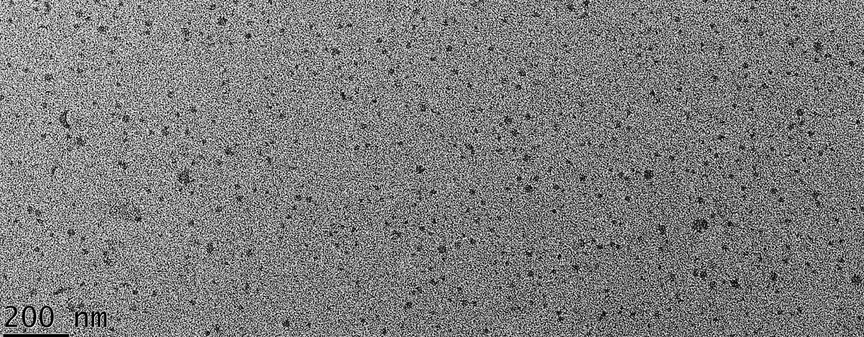
Figure 4. 8: TEM image showing the formation of Micelle.

Micellar cross-linking was subsequently carried out to provide structural stability at all concentrations and prevent any leakage of the porphyrin. Crosslinking was carried out using by encapsulating FeTPP within the surfactant micelle and cross-linking using a diol-diazide linker. The reaction occurred through an azide-alkyne 1,3 dipolar cycloaddition and was catalysed using a small quantity of copper chloride. Sodium ascorbate was also added to avoid oxidative homocoupling products (Scheme 4.8). The reaction was terminated after 24 hours by the addition of propargyl alcohol, which would catch any unreacted azide. Any by-products and species that did not react and premicellar structures were eliminated through dialysis.

Scheme 4.8: SCM formation via cross-linking of surfactant 8 and cross-linker

¹H NMR analysis in D₂O displayed wide polydispersity of the formed structures and it was unclear whether cross-linking had been successful. The mass spectrum provided some support, with an extensive range of m/z values from 700 to 1000. The continued presence of FeTPP was indicated by a significant peak at 668 m/z.

The products were also analysed by dynamic light scattering (DLS), which indicated very large species had formed, with solvated diameters around 700-nm diameter. This increase in size indicates that some intermolecular cross-linking between the micelles had occurred. This is similar to other research, which indicated large increase in a diameter when the same cross-linker was used.²⁶ If micelles had cross-linked perfectly and restricted to intramolecular reactions on the surface of the micelle, then the diameter would be greater than before cross-linking, but not to the extent observed. This bridged micelle network may have evolved from the use of a large initial 1 mM concentration. This higher concentration of surfactants may have resulted in short distances between micelles (resulting in intermolecular cross-linking) or formation of larger aggregated structures. If the increased size was due to different types of aggregates forming at higher concentrations, then these should revert to smaller micelles upon dilution. The next experiment was designed to follow the impact of dilution on the aggregate size was investigated by analysing the DLS measurements. Table 2 shows the results obtained. As a control, the analysis initially focused on the non-cross-linked micellar FeTPP. For the all concentrations above the CMC, particles were present and could be detected. Furthermore, the sizes of the particles remained constant. However, at concentrations below the CMC, no particles could be detected. This is consistent with our earlier CMC measurements, were micelles were only present at concentrations above the CMC. Although particles of consistent diameter were detected, the diameters were significantly larger than those reported in the literature and were also bigger than observed using TEM (30-50 nm). One reason could be due to solvation, which creates an organised shell of water around the micelle, making it appear bigger. Alternatively, due to the way DLS works, it is biased towards small amounts of larger particles in a polydisperse mix. Overall though, these control experiments confirm that particles of a consistent size were present above the CMC.

The dilution experiment was also repeated using the Fe(II)-TPP-SCMs and the data also shown in Table 4.3. The data confirms that no particles can be detected below the CMC. At concentrations above the CMC, very large particles are detected. This is consistent with our previous CMC studies and earlier DLS results. However, as we dilute the samples, whilst keeping the concentration above the CMC, the size also reduces (from 700 – 600 nM). This implies that these larger aggregates are not intermolecularly cross-linked particles, but are aggregates of cross-linked micelles.

Table 4. 3: The data obtained from the DLS experiments of micellar and SCM FeTPP aggregates to investigate the effects of dilution
  Micellar FeTPP | Eff Diameter / nm
  [surfactant] / mM | Eff Diameter / nm
  1.00 | 214
  0.66 | 231
  0.44 | 222
  0.15 | 243
  0.10 | 0
  0.06 | 0
  Fe(II)-TPP-SCMs | Eff Diameter / nm
  [surfactant] / mM | Eff Diameter / nm
  1.00 | 701
  0.66 | 680
  0.44 | 600
  0.15 | 0*
  0.10 | 0*
  0.06 | 0*
* At these concentrations, no particles were detected as the number of particles was below the machines resolution, or there are particles at these concentrations.

To further investigate the size of the Fe(II)-TPP-SCMs, TEM images were recorded using solutions at concentrations much higher than the CMC and also just above the CMC. The TEM image recorded at 5 mM shows spherical particles with diameters around 50-80 nm, Figure 4.9. This is about twice the size of the non-cross-linked micelles, which is appropriate due to the extra cross-linking layer. In addition, these particles look very different and appear more like “hoops”, which could also be due to the cross-linked external layer. When the TEM was repeated at 30 mM, the image showed much larger aggregates, Figure 4.10. This image appears to show much larger structures, which appear to an aggregation of micelles into larger multimicellar structures. One reason for this may be due to the cross-linker, which is not particularly hydrophilic and may encourage aggregation.

In summary, the TEM experiments confirm the results obtained in the DLS dilution experiments, which show that cross-linked micelles are formed that have the ability to further aggregate (reversibly) at higher concentrations. As such, if used at or below the CMC, we have stable cross-linked micelles. The next step is to explore the oxygen binding potential and the oxidative stability of the Fe(II) at the centre of the encapsulated porphyrin.

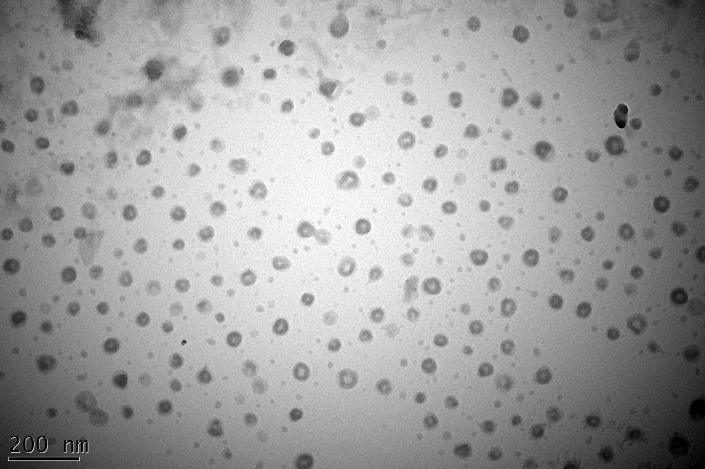
Figure 4. 9: TEM image of the Fe(II)-TPP-SCMs at an initial surfactant concentration of 5 mM.

. .
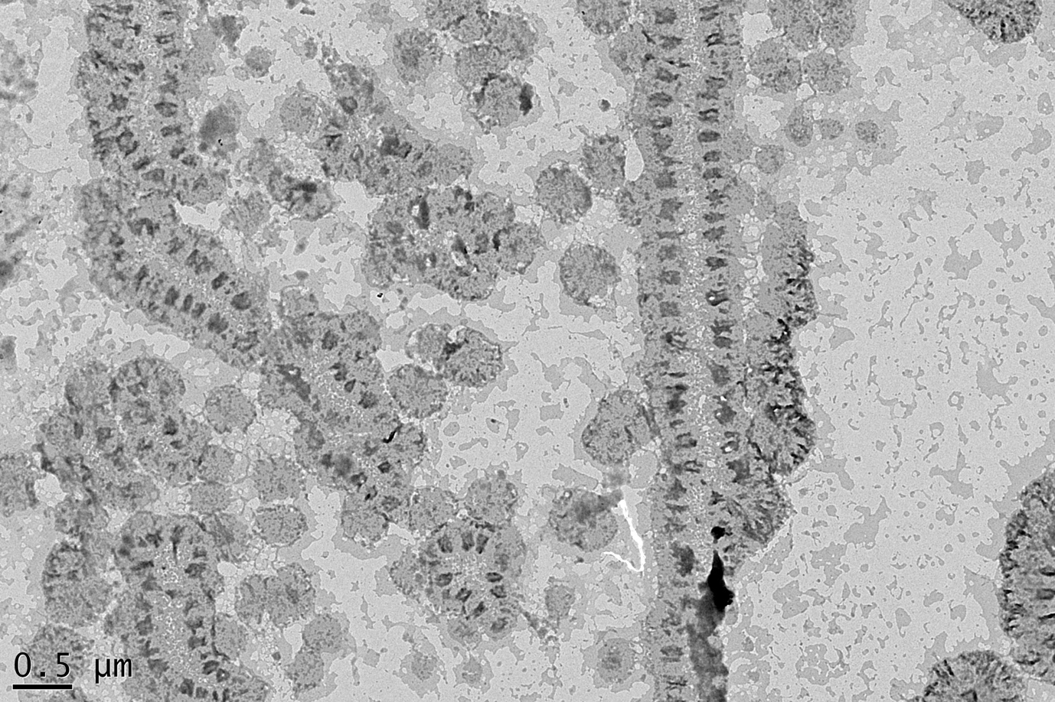
Figure 4. 10: TEM image of concentrated Fe(II)-TPP-SCMs at the higher concentration of 30 mM.

Initially we studied the stability of Fe(II) using UV spectroscopy. The UV spectrum of the Fe(II)-TPP-SCMs were broad, preventing us from observing the reduction clearly. Therefore, we initially studied the non-cross-linked micelle, Fe(II)TPP. To allow the oxygen binding, the Fe(III) must first be reduced to Fe(II). This was achieved using sodium dithionite as the reducing agent. This was used in an earlier study on polymer-protected porphyrins.²⁷ When the metal is reduced, there is change in the Soret band which moves to a higher wavelength (Figure 4.11).

Figure 4. 11: UV spectra of the partial reduction of micellar Fe (III) to Fe (II) 40 minutes after the addition of a reducing agent, displaying two peaks of 409 nm and 439 nm respectively.

Three regions can be seen in the UV spectra shown in Figure 4.11. The spectrum of Fe(III) has a peak around 408 nM. As Fe(III) starts to be reduced to Fe(II), we see a new two peaks. The first is for the Fe(III) peak, but there is a second peak that starts to appear around 445 nM. Upon full reduction, there is a single peak at 445 nM corresponding to the Fe(II). In the presence of oxygen, the Fe(II) peak is oxidized back to Fe(III) and the peak at 445 nM reduces, whilst the peak at 405 nM increases. This rate at which this peak appears can be measured and used to determine the half-life of oxidation and therefore the oxidative stability of the porphyrin.
In order to ensure complete reduction of Fe(III) to Fe(II), an excess of the reducing agent was used. As a consequence, when exposed to air the Fe(II) is oxidized to Fe(III), but is immediately reduced by the excess reducing agent. As such, oxidation cannot be observed until all of the reducing agent has reacted. This results in a lag, or time delay when measuring the rate of oxidation. This is shown schematically in Figure 4.12. This was also evident from our initial studies into the reduction/oxidation of the Fe(III), which is shown in Figure 4.13.
Start measurements here
Figure 4. 12: Graph showing the lag or time delay in oxidation caused by excess reducing agent.

When carrying out UV measurements to follow the reduction and measure the rate of oxidation, we observed some baseline drift in the UV peak from Fe(II). To compensate for this, we recorded the difference in absorption between 439 nm and 450 nm. This removed any increase in absorption due to the baseline drift. Initial experiments using the Fe(III) micelles and reducing agent were carried out in air. These showed an increase in the absorption, due to the oxidation of Fe(III) and confirmed formation of Fe(II). However, when the reducing agent is consumed, the Fe(II) is immediately oxidized back to Fe(III) and a decrease in the absorption of the Fe(II) peak was seen. When the experiment was repeated under nitrogen, we saw the same increase in the Fe(II) peak, but this flattened out when all of the Fe(III) was consumed/reduced and a plateau was observed. When the seal was removed and the system exposed to air, a decrease in the absorption of the Fe(II) peak we observed.

Figure 4. 13: Graph showing the initial increase in in intensity of Fe(II) absorption over time, followed by a decrease in intensity, clearly demonstrating the reduction and oxidation of the Fe within the porphyrin. When conducted under nitrogen, A stable Fe(II) can be observed.

Having demonstrated that Fe(III)-TPP could be reduced inside the micelle, we were ready to carry out quantitative binding and kinetic experiments. The first experiment would be a control using just the Fe(II)-TPP in water, with subsequent experiments looking at the porphyrin encapsulated micelle and cross-linked micelle. Unfortunately, without the micelle, Fe(III)-TPP was completely insoluble. Therefore, the assessment of the oxidative stability of Fe(II)-TPP required alterations to either the solvent or the structure of porphyrin. As the surfactant based systems only formed micelles in water and water would be intended solvent for any artificial blood product, the only option was to use a different porphyrin for the control reaction. As such, Iron-3,5-dihydroxyphenyl porphyrin (3,5-DHPP) (shown in Figure 4.14) was selected and the results would be compared to the Fe-TPP encapsulated within the micelle .

Figure 4.14: The structure of Iron-3,5-dihydroxyphenyl porphyrin (3,5-DHPP)

The control and micellar system were subsequently treated with a slight excess of the reducing agent under nitrogen. When UV confirmed that all of the Fe(III) had been reduced, the seal was removed and UV spectra were recorded every 30 seconds. The difference in absorption between 439 nm and 450 nm was subsequently plotted with respect to time. For the control reaction and the micelle encapsulated system, an initial lag was recorded and time zero was therefore adjusted to start when the initial plateau started to decrease (as shown in Figure 4.13). The plots showing the rate of decay for both Fe(II) species is shown in Figure 4.15. The data points were fitted to a first order decay (using GraphPad) and the half-lifes and rates of decay, for both Fe(II) species, are shown in Table 3. Fe(II)-TPP encapsulated inside the micelle had a half-life of 235 seconds. By contrast, Fe(II) 3,5-DHPP in the absence of the micelle had a half-life of just 25 seconds, identifying that micellar encapsulated system was almost ten times more stable to oxidative decay than the simple aqueous solution (Table 4.4).

Figure 4.15: Half-life comparison based on the oxidative decay of micellar FeTPP and 3,5-DHPP in water.²⁸

Table 4.4: Kinitic parameters for the oxidative decay of Fe(II) 3,5,-DHPP within an aqueous solution and encapsulated within the micelle.

 | Free 3,5-DHPP | Encapsulated TPP | Enhancement in stability
Rate of decay Abs/sec | 0.028 | 0.003 | 9.3
Half-life/sec | 25 | 235 | 9.4

The data discussed above was obtained using the non-cross-linked micelle. Unfortunately, the UV spectra of the cross-linked systems were broad and could not be used for the kinetic analysis. The problem lay with the cross-linker, which was not very hydrophilic, limiting solubility and encouraging intermolecular aggregation. Following these difficulties a more hydrophilic cross-linker 1 was used to perform the cross-linking of surfactant 8 . The reaction took place as previously described¹⁷ (Scheme 4.9). The reaction was terminated after 24 hours through the addition of propargyl alcohol. However, analysis of the products indicated that the reaction was not successful and all of the premicellar molecules were eliminated and lost through dialysis. This was due to the hydrophobic nature of the crosslinker which made reactions in water difficuilt.

Scheme 4.9: SCM formation via cross-linking of surfactant 8 and cross-linker

Due to the COVID-19 pandemic, we were unable to conduct further investigations into the other Fe(II)-THP-SCMs. Hypothetically, if the crosslinking was successful, the DLS data would present more consistent results. In addition, the TEM would exhibit a slight increase in the size with no aggregations. The UV spectrum of Fe(II)-TPP-SCMs would not be broad and would be susceptible to reduction. A half-life based on the oxidative decay of the new Fe(II)-TPP-SCMs would be higher than the micellar FeTPP and 3,5-DHPP in water. The cross-linking was performed to allow the aggregates to exist below the CMC. Thus, the two Fe(II)-TPP-SCMs would be diluted and below the CMC, and the absorbance measured and compared to diluted non-cross-linked micellar FeTPP. The results would exhibit that the SCMs suggest solubility below the calculated CMC, and displayed absorbance corresponding to the Soret band of the porphyrin. Non-cross-linked micellar FeTPP would break down below the CMC (Figure 4.16).

CMC
Figure 4. 16: A hypothetical graph of absorbance at 409 nm and 430 nm of encapsulated Fe(II)-TPP-SCMs , micellar-FeTPP, and against the concentration on dilution with water, respectively.

In contrast, if the crosslinking was unsuccessful, the DLS data would present inconsistent results. TEM would exhibit either an obvious increase in size with notable aggregations, or results similar to non-cross-linked micellar FeTPP. The UV spectrum of Fe(II)-TPP-SCMs would be broad, similar to the initial Fe(II)-TPP-SCMs , would not be capable of reducing, and have an immeasurable half-life.

4.3 Conclusion

The objective of this chapter was to address the various issues (e.g. water solubility, autoxidation, oxidative half-life, synthetic complexity, and molecular size) associated with present endeavours pursuing the discovery of an artificial oxygen carrier. To that end, the study began by solubilising (III) tetraphenyl porphyrin via encapsulation within in a micellar structure formed from functionalised surfactant molecules. Following this, the iron (III)-porphyrin was reduced to iron (II) tetraphenyl porphyrin, which is capable of oxygen binding. Subsequently, oxidative decay could be measured and any oxidative stability provided by the micellar structure be assessed. This would provide a good measure for the assessment of reversible oxygen binding. Furthermore, we demonstrated that the dynamic behaviour of the micellar structures could be suppressed by cross-linking the surface and forming micellar nanocages.

The approach reverted used inexpensive and common reagents and the functionalised surfactant molecule, 4-(dodecyloxy) benzyl tripropargylammonium bromide could be synthesised easily in a four-step. A CMC of 0.15 mM was calculated using the pyrene method, which was similar to the 0.17 mM result obtained by Zhang and colleagues.

FeTPP encapsulation within micelles was effectively achieved through the application of the co-precipitated technique, leading to the solubilisation of the metalated porphyrin. Although the porphyrin unit was only present in 3% of micelles, each porphyrin was separated from other units, which prevented dimnerization and autoxidation. The reduction of Fe(III) to the oxygen-binding active Fe(II) complex was accomplished with excess sodium dithionite, causing the Soret band to shift from 409 to 439 nm. UV was employed to study and quantify the redox chemistry associated with the reduction and re-oxidation of Fe(III). The measurements helped to determine that encapsulated Fe(II)TPP had a half-life of 235 seconds. Although the micelle could be cross-linked, the oxidative stability of these systems could not be measured, due to problems with scattering generating significantly broadened peaks in the UV (caused by aggregation). However, it is anticipated that the stability would remain unchanged. Unfortunately, stability measurements using the non-encapsulated Fe-TPP in water were not possible, due to problems with solubility. As such, the water soluble porphyrin3,5-DHPPwas studied in its place. Analysis showed that this non-encapsulated porphyrin had a half-life of only 25 seconds in water. Additional research to fully explore the binding properties of these cross-linked and non-cross-linked micellar systems is required. Nevertheless, the initial results presented in this thesis provide a sufficient basis for the theory that micelle encapsulation has the potential for application as oxygen carriers in artificial blood colloids.

Further Research
This study has provided a genuine proof of principle and is an important initial contribution to the knowledge regarding micellar oxygen carriers. However, we have also identified a range of issues that must be addressed. As a result of scattering (caused by poor solubility/possible aggregation), broad peaks were observed within the UV spectra of the cross-linked system. This prevented us from studying the complexes associated with the reduction of Fe(III)-TPP to Fe(II)-TPP using UV. To overcome this problem, the electrochemical properties and oxidative stability of the metal complexes could be investigated using cyclic voltammetry, which is a popular electrochemical technique used to investigate reduction and oxidation processes. This will enable the observation and quantification of the of the various oxidation states for the iron with the porphyrin. Furthermore, cyclic voltammetry is also applicable for non-encapsulated porphyrins and can therefore provide comparative data with respect to the UV results already obtained.

With regards to cross-linking and the effect on solubility with respect to the specific cross-linker used, different azide derivatives could be studied. For example, systems cross-linked with hydrophilic azides will have enhanced aqueous solubility, preventing aggregation and making UV analysis simpler. Moreover, multimicellar aggregates would be avoided is more hydrophilic cross-linked micelles were used.

The effective development of synthetic oxygen carriers requires that the iron atom within the porphyrin be oxidatively stable and resistant to several cycles of oxygen binding and release. Future research should also investigate whether or not the stabilities identified in this project can translate to efficient and effective oxygen binding (and release). Specific experiments will repeatedly cycle oxygen and nitrogen through various micellar solutions to see if binding is both reversible and long lived with respect to the number of binding release cycles. If successful, further long term studies regarding biocompatibility and clinical application can be considered.

4.4 Experimental

Reagents and materials
Sigma-Aldrich Chemical Company was the purveyor of every chemical that was employed. Rotary evaporation entails extraction under decreased pressure, while vacuum desiccation involves using a vacuum to dry a solid. Column grade silica was used for column creation.

Instruments
Nuclear magnetic resonance (NMR) spectroscopy
A Bruker Avance DPX 400 device with a BB-¹H probe measuring 5 mm was used for recording ¹H NMR. Internal solvent signal calibrations provided a reference for chemical changes. A Bruker Avance DPX 400 device was employed to derive the ¹³C NMR spectra, whilst NMR data integrations were assessed via TopSpin™.

UV/Vis spectroscopy
An Analytik-Jena SPECORD S600 spectrophotometer was used to obtain the UV-vis spectra. The process involved calibration with a given solvent followed by sample loading into a cuvette made of glass and device scanning within the range 300-800 nm at 0.5-nm resolution.

THF GPC
Samples were loaded onto two PL gel 3 µm MIXED-E columns which were 30 cm in length, with an inner diameter of 7.5 mm. Molecular weights are reported relative to calibrations made using polystyrene standards (Mn 220-1, 1,000,000 Da). THF was emplyoed as both the solvent and the eluent. Samples were injected into the GPC circuit at a temperature of 25 °C at a flow rate of 1.0 mL/min with toluene as an internal standard. Polymer Laboratories, Varian, Inc. (Amherst, MA, USA) software was used for characterisation; then to monitor the sample travelling through the columns, software released by PL DataStream Monitor version 1.2 and Cirrus GPC Online GPC/SEC Software version 3.0 were used.

Dynamic Light Scattering
A Brookhaven ZetaPALS-Zeta Potential and Particle Size Analyser were used to perform dynamic light scattering, with setting of the parameters for recording in water. The results consisted of around five readings each at an interval of 120 seconds. The effective diameter was deemed to be 0 when the count rate was less than 500 kcps.

Fluorescence Emission Spectroscopy
Measurement of the fluorescence emission intensity was undertaken at a 335-nm excitation wavelength, with a Fluoromax-4 fluorescence spectrometer based on FluorEssence software in s mode permitting documentation of each spectrum.

Mass spectroscopy

Tested by the University of Sheffield Mass Spectroscopy department. Electrospray ionisation mass spectrometry, MS(ESI), was carried out using a Micromass Prospec spectrometer with a mass range 2 - 800 Da.

Transmission Electron Microscope
The samples were stained with 2% phosphotungstic acid aqueous solution. The Philips CM200 FEG TEM instrument was used to visualise samples.

Fluorescence Emission Spectroscopy
Measurement of the fluorescence emission intensity was undertaken at a 335-nm excitation wavelength, with a Fluoromax-4 fluorescence spectrometer based on FluorEssence software in s mode permitting documentation of each spectrum.

Synthetic and Experimental Procedures
Tetraphenyl Porphyrin (TPP) Synthesis

Distillation of 30 mL pyrrole at a temperature of 120 °C yielded a 20-ml clear distillate. The next step was addition of 7 mL distillate to a refluxing solution containing 300 mL propionic acid and 10 mL benzaldehyde, which was subjected to 60-minute refluxing. The solution thus obtained was allowed to reach ambient temperature overnight. Vacuum filtration was subsequently performed to obtain a solid of purple colour, which was washed twice with 30-ml ethanol and 30 mL cold water. This yielded a purple solid.

Yield: 3.44 g, 21 %; UV-vis (Acetone)/nm 414, 514, 546, 590, 649; ¹H NMR (CDCl₃, 400 MHz) 8.85 (s, 8H), 8.25 (d, J=7.0 Hz, 8H) 7.89 (m, 12H), -2.70 (s, 2H); ¹³C NMR (CDCl3, 100 MHz) 142.3, 134.1, 127.1, 127, 77.3, 77.1, 76.0; IR v_{max} / cm⁻¹ 3400 (N-H); m/z [MS(ESI)] 615 (MH+).

Iron (III)-TPP Synthesis

FeTPP synthesis involved dropwise addition of 14-g iron (II) chloride in 14 mL 2,6-lutidine to 8 g TPP solution in 150 mL anhydrous THF under a nitrogen atmosphere. This mixture was subjected to 12 hour refluxing, followed by exposure to air for more than 60 minutes to enable it to reach ambient temperature. Vacuum filtration was performed, producing a solid of black colour, which was washed thrice with 1.0 M, 50 mL hydrogen chloride and 50 mL distilled water. After filtering through celite, the filtrate was supplemented with 50 mL methanol and filtration was performed to obtain the precipitate.

Yield 0.85 g, 9%; UV-vis (Acetone) / nm 413, 508, 570; ¹H NMR (CDCl₃, 400 MHz) 7.55 (d, J=8.0 Hz, 8Η), 7.01 (s, 8Η), 6.41 (m, 8Η) 5.32 (s, 4Η); ¹³C NMR (CDCl3, 100MHz) 150.5, 146.0, 144.7, 144.2 127.6, 126.8, 126.1; m/z [ΜS(ΕSI)] 669 (ΜΗ+).

Surfactant Synthesis

First Step: 4-(dodecyloxy) Benzaldehyde Synthesis

The procedure began with dissolution of (3.66 g, 30 mmol) 4-hydroxybenzaldehyde into 100-ml THF, followed by addition of (24.8 g, 180 mmol) potassium carbonate to the solution, which was heated to 60 °C for 60 minutes. The next step was dropwise addition of (8.7 mL, 36 mmol) 1-bromododecane to the solution, which was then heated to 80°C under a nitrogen atmosphere and allowed to rest overnight. After reaching ambient temperature, the reaction was introduced into 300-ml icy water, followed by extraction with ethyl acetate (3 x 100 mL). Two layers were thus produced. The superior layer yielded a further two layers after collection and washing with 100-ml brine. After drying with 10 g magnesium sulphate, the superior layer was subjected to filtering and solvent removal under decreased pressure, yielding an oil of yellow colour. A yellow solid was subsequently obtained by bubbling nitrogen gas through the yellow oil for more than three days.
Yield: 7.45 g, 81%; ¹Η ΝΜR (CDCl₃, 400 ΜΗz) 9.85 (s, 1Η), 7.80 (s, J=9.0 Ηz, 2Η), 7.00 (d, J=9.0 Ηz, 2Η), 4.05 (t, J=6.0 Ηz, 2Η), 1.80 (q, 2Η), 1.50 – 1.20 (m, 18Η), 0.85 (t, J=6.0 Ηz, 2Η); ¹³C NMR (CDCl3, 100MHz) 190.7, 132.0, 114.7, 68.4, 31.9, 29.6, 29.5. 29.3, 29.0, 25.9, 22.7, 14.1; IR v_{max} / cm⁻¹ 2900 (C-H), 1600 (CH=O); m/z [MS(ESI)] 290 (MH+).

Second Step: 4-(dodecyloxy) Benzyl Alcohol Synthesis

The procedure began with dissolution of (10 g, 35 mmol) 4(dodecyloxy) benzaldehyde into 60 mL anhydrous THF, followed by addition to (2.7 g, 70 mmol) sodium borohydride solution in 60 mL anhydrous THF at 0 °C, with stirring overnight. Addition of 5 mL of deionised water to the reaction led to the emergence of two layers, namely, a yellow and clear superior layer and a white inferior layer. This was followed by solution filtering and concentration of the filtrate under decreased pressure. The solid of white colour that was obtained was subjected to dissolution in 50 mL chloroform. 50 mL brine was used to wash the solution thrice, followed by drying with sodium sulphate. A solid of white colour was obtained under decreased pressure.

Υield: 4.59 g, 59%; ¹Η ΝΜR (CDCl₃, 400 ΜΗz) 7.35 (d, 2Η) 8.00 (d, 2Η), 4.62 (s, 2H) 4.00 (t, 2H) 1.75 (q, 2Η), 1.50 – 1.20 (m, 18Η), 0.88 (t, J=6.0 Ηz, 2Η); IR v_{max} / cm⁻¹ 3200 (O-H), 2900 (C-H); m/z [MS(ESI)] 292 (MH+).

Third Step: 4-(dodecyloxy) Benzyl Bromide Synthesis

The procedure began with the dissolution of (3.0 g, 10 mmol) 4-(dodecyloxy) benzyl alcohol in 30-ml anhydrous dichloromethane. This was and stirred and then left to cool to 0°C, before adding (2.0 mL, 20 mmol) phosphorous tribromide to 30-ml anhydrous dichloromethane. The addition of the PBr3 solution to the solution of 4(dodecyloxy) benzyl alcohol was done in a dropwise manner, with stirring overnight. The next step was gradual addition of the created solution to 400 mL water, with five-minute stirring. Chloroform (3 x 50 mL) was employed to conduct an extraction, which yielded an organic layer. After thrice washing with 100 mL brine, the organic layer underwent drying with anhydrous sodium sulphate and filtering. 100 mL chloroform was used to wash the filter paper, followed by collection of an oil of yellow colour under decreased pressure. Bubbling of the yellow oil with nitrogen was performed for more than three days. A vacuum desiccator was used for drying purposes, resulting in a solid of yellow colour.

Υield 1.65 g, 45% ¹Η ΝMR (CDCl₃, 400 ΜΗz) 7.39 (d, 2Η), 6.85 (d, 2Η), 4.51 (s, 2Η), 3.97 (t, 2Η), 1.80 (q, 2Η), 1.50 – 1.20 (m, 18Η), 0.85 (t, J=6.0 Ηz, 2Η);; IR v_{max} / cm⁻¹ 2900 (C-H), 1250 (C-O); m/z [MS(ESI)] 354 (MH+).

Fourth Step: 4-(dodecyloxy) Benzyl Tripropargylammonium Bromide Synthesis

The procedure began with dissolution of (1.45 g, 4 mmol) 4-(dodecyloxy) benzyl bromide into 10 mL acetone, with stirring, followed by addition of (0.5 mL, 5 mmol) tripropargylamine to 10 mL acetone. The addition of the tripropargylamine solution to the solution of 4-(dodecyloxy) benzyl bromide was performed gradually, with stirring for two days. Concentration of the solution was conducted under decreased pressure, yielding an oil that turned to solid when its temperature dropped. A vacuum desiccator was used to dry the solid for 60 minutes. Separation of the end-product was carried out via a silica column with a ratio of chloroform to methanol of 20 to 1. Fractions 12-28 were acquired and solvent removal was conducted under decreased pressure. The product took the form a solid of yellow colour.

Yield 0.60 g, 42%; ¹Η ΝΜR (CDCl₃, 400ΜΗz) 7.69 (d, J=8.0 Ηz, 3Η), 7.43 (s, 2Η), 6.96 (d, J=8.0 Ηz, 2Η), 5.11 (s, 2Η). 4.80 (s, 6Η), 4.00 (m, 2H), 2.88 (t, J=6.6 Hz, 3Η), 1.85 (m, 2H), 1.30 (m, 24Η), 0.85 (t, J=6.5 Ηz, 4H); ¹³C ΝΜR (CDCl₃, 100ΜΗz) 130.1, 114.9, 77.3, 77.0, 76.7, 68.2, 49.4, 33.3, 31.0, 29.7, 29.6, 29.4, 29.3, 29.2. 29.1, 14.2; IR v_{max} / cm⁻¹ 3300 (C≡C-H), 2120 (C≡C); m/z [ΜS(ΕSΙ)] 406 (ΜΗ+).

Synthesis of Crosslinker 1.

Sodium azide (3.9 g, 60 mmol) was added to a solution of p-xylylene dibromide (4.0 g, 15 mmol) in dry acetone (20 mL). The reaction mixture was heated to reflux under N2 for 12 h. The solid was removed by filtration and the filtrate was concentrated in vacuo to give a yellow oil (2.40g, 85%). 1H NMR (400 MHz, CDCl3, δ): 7.32 (s, 4H), 4.37 (s, 4H).

Synthesis of Crosslinker 2.

Sodium azide (2.52 g, 38.7 mmol) was added to a solution of 2,2'-bioxirane (0.5 mL, 6.45 mmol) in water (10 mL). After 12 h at room temperature, the reaction mixture was extracted with ethyl ether (3 × 50 mL). The combined organic phase was washed with brine (3 × 20 mL), dried over anhydrous Na2SO4, and concentrated in vacuo to give a colorless oil (0.55 g, 50%). 1H NMR (400 MHz, D2O, δ): 3.70-3.63 (m, 2H), 3.30 (d, J = 5.6 Hz, 4H)

Measurement of the Critical Micelle Concentration
The procedure began with the addition of 1 mL (1 x 10⁻⁶ M) of a solution of pyrene-acetone to 16 sample tubes labelled 1 to 16, which were allowed to undergo evaporation overnight. This was followed by dissolution of 0.0202-g DBT in 1 mL DCM and subsequent addition to 10 mL water with stirring for 120 minutes. Removal of the rest of DCM was conducted under decreased pressure. The next step was dilution of the water-surfactant solution in water to obtain 16 samples. After agitation of the solutions for 120 minutes, a Fluoromax-4 was employed to examine them.

Single Porphyrin Encapsulation
Addition of 1 mL (3.3 x 10⁻⁵ M) solution of porphyrin in DCM to 100 mL (0.2 mM) solution of surfactant in water resulted in a solution that was subjected to 120 minute stirring. Removal of the rest of DCM was conducted under decreased pressure.
Beer-Lambert Plot
A 1 x 10⁻⁴ M solution was obtained by dissolving 0.0067-g FeTPP in 10 mL acetone. Acetone was diluted and subjected to UV-vis spectrometry at 414 nm to obtain the concentrations below.
[FeTPP] / x 10⁻⁸ M | Absorbance at 414 nm
1.0 | 0.0575
2.5 | 0.1379
5.0 | 0.2678
7.5 | 0.3375
10.0 | 0.4500
15.0 | 0.6720

Concentrations of FeTPP in acetone at 414 nm used to measure the encapsulated porphyrin concentration

Fe(III) Reduction and Fe(II) Stability
100 mL water was subjected to degassing under decreased pressure in an ice bath, followed by flushing with nitrogen gas. The next step was rapid addition of 0.6 g sodium dithionite to the solution and degassing was performed again. Absorption discrepancy at 439 nm and 450 nm enabled calculation of half-life.

Degassed System
Identical to the sodium dithionite system, degassing was performed on a sample of encapsulated metalated porphyrin with 0.3 mM concentration of surfactant (FeTPP-30SF). After being flushed with nitrogen gas, a quartz cuvette with stirrer was sealed. Following addition of 2 mL FeTPP-30SF, the cuvette was introduced in a backgrounded UV spectrometer, with further addition of 1-ml sodium dithionite. Recording of spectra was conducted at 15 second intervals.

Exposure of the System to Air
After addition of 2 mL FeTPP-30SF to a quartz cuvette, the latter was introduced in a backgrounded UV-vis, with further addition of 1 mL sodium dithionite. Recording of the spectra was conducted at 15-second intervals.

Preparation of SCMs.
(2.8 mg, 0.02 mmol) of the cross linker was added to , CuCl2 (10 μL of 6.7 mg/mL aqueous solution, 0.5 μmol), and sodium ascorbate (10 μL of 99 mg/mL aqueous solution, 5 μmol) then added to a micellar solution of 1-mM surfactant and 1-ml (3.3 x 10⁻⁴ M) FeTPP in 2-ml water). The reaction mixture was stirred slowly at room temperature for 24 h before propargyl alcohol (0.6 μL) was added. After another 12 h, the mixture was dialysed against deionized water using a 500 Da molecular weight cut-off tubing.

4.5 References

1. S. P. Klinken, The international journal of biochemistry & cell biology, 2002, 34, 1513-1518.
2. T. M. Chang, Science, 1964, 146, 524-525.
3. Z. Tao and P. P. Ghoroghchian, Trends in biotechnology, 2014, 32, 466-473.
4. J. P. Collman, J. I. Brauman, E. Rose and K. S. Suslick, Proceedings of the National Academy of Sciences, 1978, 75, 1052-1055.
5. K. Kano and H. Kitagishi, Artificial organs, 2009, 33, 177-182.
6. J. P. Collman, R. Boulatov, C. J. Sunderland and L. Fu, Chemical reviews, 2004, 104, 561-588.
7. T. Kakizaki, K. Kobayashi, T. Komatsu, H. Nishide and E. Tsuchida, Artificial Cells, Blood Substitutes, and Biotechnology, 1994, 22, 933-938.
8. M. Yuasa, K. Aiba, Y. Ogata, H. Nishide and E. Tsuchida, Biochimica et Biophysica Acta (BBA)-Biomembranes, 1986, 860, 558-565.
9. A. Sen Gupta, Wiley Interdisciplinary Reviews: Nanomedicine and Nanobiotechnology, 2017, 9, e1464.
10. K. Karasugi, H. Kitagishi and K. Kano, Bioconjugate chemistry, 2012, 23, 2365-2376.
11. A. V. Kabanov, V. Chekhonin, V. Y. Alakhov, E. Batrakova, A. Lebedev, N. Melik-Nubarov, S. Arzhakov, A. Levashov, G. Morozov and E. Severin, FEBS letters, 1989, 258, 343-345.
12. A. Müllertz, A. Ogbonna, S. Ren and T. Rades, Journal of pharmacy and pharmacology, 2010, 62, 1622-1636.
13. S. Kalepu and V. Nekkanti, Acta Pharmaceutica Sinica B, 2015, 5, 442-453.
14. N. C. Maiti, S. Mazumdar and N. Periasamy, The Journal of Physical Chemistry B, 1998, 102, 1528-1538.
15. L. Piñeiro, M. Novo and W. Al-Soufi, Advances in colloid and interface science, 2015, 215, 1-12.
16. K. Ananthapadmanabhan, E. Goddard, N. Turro and P. Kuo, Langmuir, 1985, 1, 352-355.
17. S. Zhang and Y. Zhao, Journal of the American Chemical Society, 2010, 132, 10642-10644.
18. S. Zhang and Y. Zhao, Macromolecules, 2010, 43, 4020-4022.
19. C. Li, Q. Wang, B. Shen, Z. Xiong and C. Chen, Journal of Chemical & Engineering Data, 2015, 60, 2834-2842.
20. M. Vermathen, E. A. Louie, A. B. Chodosh, S. Ried and U. Simonis, Langmuir, 2000, 16, 210-221.
21. P. Rothemund and A. R. Menotti, Journal of the American Chemical Society, 1941, 63, 267-270.
22. Z.-C. Sun, Y.-B. She, Y. Zhou, X.-F. Song and K. Li, Molecules, 2011, 16, 2960-2970.
23. R. De Paula, M. A. Faustino, D. C. Pinto, M. G. Neves and J. A. Cavaleiro, Journal of Heterocyclic Chemistry, 2008, 45, 453-459.
24. I. Mielke and H. Ringsdorf, Die Makromolekulare Chemie: Macromolecular Chemistry and Physics, 1972, 153, 307-322.
25. N. C. Maiti, S. Mazumdar and N. Perisamy, Journal of Porphyrins and Phthalocyanines, 1998, 2, 369-376.
26. L. Blyth, unpublished work.
27. E. Tsuchida, K. Honda and H. Sata, Inorganic Chemistry, 1976, 15, 352-357.
28. A. B. Zabidi, University of Sheffield 2015.

