Exploring ESG shareholder activism in the UK

By:
Olaposi Olumuyiwa OLATUBOSUN

A thesis submitted in partial fulfilment of the requirements for the award of degree of Doctor of Philosophy

Sheffield University Management School

University of Sheffield

August 2019

Declaration

I confirm that this research is the result of my own work, and that I have not submitted it for any other award anywhere else. All the other people’s materials used in this work have also been fully acknowledged.

Ethical clearance for this research was duly approved.

I declare that the word count is: 112,840

Name: Posi Olatubosun

Signature:

Date: August 9, 2020.

Acknowledgements
The last seven years has been quite eventful and enjoyable. I am very grateful for the opportunity to carry out this work at both Henley Business School and the Sheffield University Management School. I got very useful feedbacks at the various GARI conferences in 2014 and 2015; OIKOS conference in Zurich 2016; SUMS annual doctoral conferences in Sheffield 2017, 2018 and 2019.

I am also grateful to the respondents, especially members of the UK shareholder Association for their unrelenting efforts in getting their views across through interviews and attendance at various investors’ relations meetings in the UK over the years.

I am also extremely thankful to my supervisors, Professor Jill F. Atkins and Professor Jim Haslam for their kind help and guidance in this journey. Without them, this work wouldn’t have been possible. Jill has particularly been helpful in encouraging me to publish some of my work. She facilitated many of the other conferences that I have been attending since 2012: ACCA conferences, ICAEW conference, and the various BAFA Conferences.

I thank Professor (now Lord) Prem Sikka, Dr David Ewers, and Dr Federica Doni for their helpful feedback during the 2019 BAFASIGCG conference in Sheffield. I also thank colleagues such as Mira Lieberman, Dr Christoph Frederic, Dr Tariq Almontaser, Dr Michael Oyelere, Dr Michael Dzandu, and Dr Ekililu Salifu, Dr Longxiang Zhao, Dr Syed Mohammad, and Dr Toyin Adisa for all their technical advises at the write-up stage.

I also wish to thank Professor Frank Birkin and Professor Bruce Burton the internal and external examiners respectively during my viva voce for their helpful and positive feedback, all of which I have now accepted and included in this revised work.

Finally, I wish to thank my wife and best friend, Dr Omolabake, and my Pastor, Justin Koranteng for their support throughout this journey. I appreciate you all.

Publications and Conferences that were carried during the period of this research

Journal Articles Published
1. Olatubosun, P., Nyazenga, S. (2020). Greenwashing and Responsible Investment Practices. Empirical Evidences from Zimbabwe. Qualitative Research in Financial Management. Vol.12. DOI: 10.1108/QRFM-12-2017-0125.

Book Published
1. Olatubosun, P., Atkins, J.F. (2020) Shareholder Activism in the UK. De Gruyter Series in Corporate Governance 2. De Gruyter Oldenbourg (Forthcoming).

Book Edited and Chapters Published
- Olatubosun, P. Nyazenga, S. (2019). The Value of Ubuntu - Moral, and Governance Case for Responsible Investment in Southern Africa. In Ogunyemi, K. (ed). African Virtue Ethics Tradition for Business Management. Business Expert Press. New York.

- Olatubosun, P., and Koseoglu, S.D. (2020). Valuation Challenges in Stranded Asset Scenarios: A Risk Discourse of Evidence from the UK. In Koseoglu et al. (eds), Valuation Challenges and Solutions in Contemporary Businesses. IGI Global Publication. Hershey, Philadelphia, USA. DOI: 10.4018/978-1-7998-1086-5.ch009.

- Koseoglu, S.D., Goker, O., Liu, T., Olatubosun, P., Tsopanakis. A. (eds) (2020). Valuation Challenges and Solutions in Contemporary Businesses. IGI Global. USA. DOI: 10.4018/976-1-7998-1086-5.

Working Papers Published
1. Olatubosun, P. (2013). Investigation of Institutional Investors’ Responsible Investment Practices in the UK. Regent’s Working Papers in Business & Management 2013. Working Paper 1306: RWPBM1306.

2. Olatubosun, P., Nyazenga, S. (2019). Critical Assessment of the Responsible Investment Practices of Institutional Investors in Zimbabwe. OIKOS. University of Zurich

A selection of some conference papers presented
1. Olatubosun, P., Atkins, J. (2018). ESG by Necessity and the Conflicted Roles of Proxy Advisors. SUMS 2nd PGR Conference Wednesday 12th September 2018

2. Olatubosun, P., Atkins, J. (2018). Longitudinal Analysis of UK Investors’ Meetings: 2014-2017. BAFA Doctoral Colloquium 10th September 2018.

3. Olatubosun, P. (2017) ESG Induced Activism in the UK. Evidences from Shareholder Resolutions. SUMS 1st PGR Conference. University of Sheffield.

4. Olatubosun, P., Nyazenga, S. (2017). Critical Assessment of the Responsible Investment Practices of Institutional Investors in Zimbabwe. OIKOS. University of Zurich. OIKOS Conference. September 4, 2017.

5. Olatubosun, P. (2013). Investigation of Institutional Investors’ Responsible Investment Practices in the UK. GARI Conference, Henley Business School, September 11-12, 2013.

Abstract
Due to a combination of factors such as environmental risk awareness and enhanced shareholder rights, there has been a noticeable increase in interest in how prepared corporate organisations are, in addressing climate change and other environmental hazards. There has also been a remarkable rise debate surrounding the role of asset owners and how they engage with investee companies. Many previous researchers have focused on the roles of Pension Funds with less focus on the emerging powers of Proxy Advisors, Shareholders Associations and Social Investors, all with differing goals.

Fiduciary responsibility to integrate ESG issues into asset ownership is an area that is yet to be fully clarified in English Law, and there are diverse interpretations and widespread variations in the understanding and application by economic agents in the investment chain, even as many asset owners, especially Pension Funds now appoint proxy advisers on governance matters.

This work therefore investigates the role of asset owners, proxy advisors and shareholders’ associations in the UK, in entrenching ESG shareholder activism. One rationale underlying this study is the limited existing research focused on shareholder activism around emergent ESG risk in the UK. The focus on the UK is due to the propensity to produce new corporate governance codes. Moreover, the UK is seen as a net exporter of corporate governance globally (Black and Coffee, 1994).

This thesis has adopted a qualitative approach integrating diverse data collection methods. This research contributes to the body of knowledge by deepening the understanding of ESG shareholder activism which may have practical implications for corporate governance in other jurisdictions, as many research findings from the UK have been replicated in other jurisdictions in the past.

Keywords: Active Investment Ownership, Corporate Governance, ESG, Shareholder Activism, Responsible Investment.

Table of Contents
Title page………………………………………………………………………......................i
Declaration…………………………………………………………………………………...ii
Acknowledgements………………………………………………………………………….iii
Publications and conferences carried out during the period of this research………………..iv
Abstract………………………………………………………………………………………v
Table of contents…………………………………………………………………………vi - x
List of Figures xi
List of Tables xii
List of Abbreviations xiii

Chapter 1: Introduction 1
- Introduction 1
  - Background to the problem 1
  - The broad aim and objectives of the Research 3
  - Research Questions 4
1.4 Historical Perspective on Shareholder Activism and RI 4
1.4.1 Foundation Stage 8
1.4.2 Development Stage 9
1.4.3 Transition Stage 10
1.4.4 Expansion of RI and the Institutionalisation of Shareholder Activism 11
    - Mainstreaming of RI (the future) 13
  - Justification for this Research 15
  - Organisation of the Research work 17
  - Thesis Overview 19
  - Summary of Chapter 1 20

Chapter 2: Literature Review 21
2.1 Introduction to Shareholder Activism 21
2.2 Forms of Shareholder Activism 23
2.2.1 “Wall Street Walk” and Voice activism 25
2.2.2 Financially drive and socially driven activism 27
2.2.3 Offensive and Defensive activism 28
2.2.4 Active and Passive Shareholder activism 29
2.3 Shareholder Activism and Shareholder Wealth 29
2.4 Shareholder Activism Practice in the UK 31
2.4.1 Shareholder Activism Antecedents 32 2.4.2 Studies on Shareholder Activism Processes 33
2.4.3 Shareholder Activism, Climate Change, Stranded Assets and Biodiversity 36
2.5 The Role of the Investment Community 42
2.5.1 Institutional Investors 42
2.5.2 Pension Funds 44
2.5.3 Private Equity and Hedge Funds 45
2.5.4 Sovereign Wealth Funds 47
2.5.5 Proxy Advisory Firms 49
2.6 Investment Relations and Dialogue in Shareholder Engagement 50
2.7 Shareholder Proposals 53
2.7.1 ESG Shareholder Proposals 53
2.7.2 Some High-profile Shareholder Activism Cases 58
2.7.3 Blocking Corporate Merger or Take-over 58
2.7.4 Forcing a Change in Strategy 59
2.7.5 Imposing ESG and CSR policies on an Investee Company 60
2.7.6 Limiting Directors pay and firing under-performing directors 61
2.8 Summary 63

Chapter 3: Theoretical Perspectives on Investment Risk: Applying a Becksian Lens 64
3.1 Introduction 64
3.2 Becksian Theory and the concept of ‘manufactured risk’ 66
3.3 Becksian Theory and the concept ‘trust’ 69
3.4 Becksian Theory and the impact of environmental risk on investment 71
3.5 Becksian Theory and risk reporting 75
3.6 RI logic as a re-embedding mechanism 77
3.7 Becksian Theory: conclusions, justification and criticisms 82
3.8 Summary 84

Chapter 4: Research Methodology and Methods 85
4.1 Introduction 85
4.2 Research Philosophy: Paradigm, Ontology and Epistemological considerations85
4.3 Research Approach 89
4.4 Research Design 89
4.4.1 Quantitative Research Design 90
4.4.2 Qualitative Research Design 90
4.4.3 Multi-method Research Design 90
4.5 Population of the Study 91
4.5.1 Sample Size 91
4.5.2 Sampling Techniques 91
4.5.3 Convenience Sampling 92
4.5.4 Snowball Sampling 92
4.6 Data Collection 95
4.6.1 Archival Data Collection method 95
4.6.2 Observations at Investors Relations Meetings 97
4.6.3 Semi-structured interviews 100
4.7 Data Quality Issues 104
4.7.1 Generalisability 104
4.7.2 The Issues of Bias 105
4.7.3 Time Horizon 106
4.7.4 Ethical Concerns 106
4.8 Data Analysis 106
4.9 Conclusion 107
Chapter 5: Analysis of Shareholder Proposals and Resolutions [2007-2017] 108
5.1 Introduction 108
5.2 Analysis of Period 2007 – 2010 108
5.3 Patterns observed between 2011 and 2017 112
5.4 Analysis of Major Proposal: Environmental 115
5.5 Analysis of Major Proposal: Social 118
5.6 Analysis of Major Proposal: Governance 120
5.7 Proxy Advisors and How They Voted on ESG Proposals: [2011 – 2017] 122
5.8 Summary of Findings through the lens of ‘manufactured risk and trust
Re-embedding mechanism 124

Chapter 6: Analysis of UKSA members’ views on ESG shareholder activism 127
6.1 Introduction 127
6.2 Usefulness of Sustainability Reports for Shareholder Engagement 127
6.3 Shareholders or Shareowners? 133
6.4 Shareholder engagement gap 136
6.5 Engaging Investee Companies on ESG issues 137
6.6 Views on Collaboration and Collective Shareholder proposals 142
6.7 Binding V Non-Binding Vote on Executive pay 147
6.8 Future role of UKSA in deepening ESG Shareholder Activism 149
6.9 Summary of Findings through the lens of ‘manufactured risk and trust
Re-embedding mechanism 153

Chapter 7: Analysis of Institutional Investors’ views on ESG Shareholder Activism 156
7.1 Introduction 156
7.2 Understanding asset owners’ investment philosophy 156
7.3 Engagement policies of Asset Owners with investee companies 160
7.4 Engagement policies of Asset Owners on ESG 164
7.5 Engaging Proxy Advisory agencies on ESG issues 169
7.6 Awareness of relevant publications amongst Asset Owners 172
7.7 Views on Mandatory Voting 174
7.8 Views on Sustainability Reports for ESG Engagement 176
7.9 Barriers to Institutional ESG Engagement 177
7.10 Summary of Findings through the lens of ‘manufactured risk and trust
Re-embedding mechanism 182

Chapter 8: Analysis of Proxy Advisors’ views on ESG Shareholder Activism 185
8.1 Introduction 185
8.2 How Proxy Advisory Agencies Work 185
8.3 Policy Development and Influence of others 187
8.4 ESG Policies 190
8.5 Most Challenging Governance Risk of the 21st Century 192
8.6 Voting Policy 194
8.7 Conflict of Interest and Transparency Issues 196
8.8 Recommendations of How to Entrench ESG in the Investment Chain 199
8.9 Summary of Findings through the lens of ‘manufactured risk and trust
Re-embedding mechanism 200

Chapter 9: Longitudinal Analysis of Observations at IR meetings [2014 – 2017] 204 9.1 Introduction 204 9.2 Summary of IR Meetings attended [2014 – 2017] 204
9.3 Analysis of Meetings: Agribusiness 206
9.4 Analysis of Meetings: Military Hardware Business 211
9.5 Analysis of Meetings: Construction and Facilities Management Business 214
9.6 Analysis of Meetings: Financial Services Business 217
9.7 Analysis of Meetings: Healthcare and CDMOs 220
9.8 Analysis of Meetings: Manufacturing, Transport, Telecom & Technology 222
9.9 Analysis of Meetings: Extractive Industries 224
9.10 Summary of Findings through the lens of ‘manufactured risk and trust
Re-embedding mechanism 227

Chapter 10: Consolidation of Research and Discussing Findings 232
10.1 Introduction 232
10.2 Contribution to the understanding of the Becksian Risk Society theory 232
10.3 Becksian Risk Society theory and ESG shareholder activism 233
10.4 How useful are Sustainability Reports in UK Shareholder Activism 235
10.5 From Sustainability Reporting to ‘ESG Risk’ or ‘Value Reporting’ 240
10.6 How do individual shareholders, institutional shareholders and proxy advisors influence ESG policies in investee companies? 246
10.6.1 Individual Shareholders 246
10.6.2 Institutional Asset Owners 247
10.6.2.1 Pension Funds 247
10.6.2.2 Sovereign Wealth Funds 248
10.6.2.3 Hedge Funds 249
10.6.2.4 Social Investors 250
10.6.3 Proxy Advisors ‘ESG by Necessity’ 251
10.7 What are the Issues Driving ESG Shareholder Activism in the UK? 254
10.8 What are the Observed Developments in ESG Shareholder Activism? 256
10.8.1 Growth of Dialogue 256
10.8.2 Concerns for Climate Change Risk 257
10.8.3 Changing Forms of IR Meetings 259
10.8.4 Growth in Collaborative Shareholder Engagement 263
10.8.5 Attitude towards executive pay 267
10.8.6 ESG Activism or Survival Activism? 268
10.9 Barriers to ESG-Activism 271
10.9.1 Mandatory Voting 271
10.9.2 The Need for More Collaborative Engagements 271
10.9.3 Legal Constraints 272
10.9.4 Shareholder Rights and RI Education 272
10.10 How shareholder activism and shareholder proposals mirror the concept
of re-embedding mechanism in the sense of risk society theory 273
10.11 Comparing and contrasting Data Collection methods used 274
10.12 Summary 276

Chapter 11: Summary of Findings, Conclusions and Recommendations 277
11.1 Introduction 277
11.2 Summary of Findings 277
11.2.1 Findings on the Attitude of Investors towards SR
Based on the Views of Shareholders 277
11.2.2 Findings on How Investors and Proxy Advisors Influence
ESG policies in Investee Companies 278
11.2.3 Findings on the Issues Driving ESG Shareholder Activism 280
11.2.4 Findings on the Observed Developments in ESG Shareholder
Activism 280
11.2.5 Findings on How ESG Shareholder Activism Can Be Deepened 281
11.2.6: Findings on How Shareholder Activism Mirror the Concept of
Re-embedding mechanisms in the sense of Risk Society 282
11.3 Contribution of this Study 282
11.4 Theoretical Contribution 282
11.5 Policy implications and other recommendations 283
11.5.1 Regulation of Proxy Advisory 283
11.5.2 Shareholders Associations 284
11.5.3 Sustainability Reporting and Investors Relations meeting 284
11.5.4 Future Accounting Education, ESG shareholder Activism and
RI logic 284
11.6 Limitations of the Study 286
11.7 Suggestions for Future Research 287
11.8 Concluding Statement 287

References 288
Footnotes 323

Appendices
Appendix 1: Example of email/letter to UKSA members 328
Appendix 2: Example of email/letter to UKSA members 329
Appendix 3: Example of email/letter seeking permission to observe IR meetings 330
Appendix 4: Example of consent form (Interviews) 331
Appendix 5: Example of consent form (Questionnaire) 332
Appendix 6: Example of consent form (to observe IR meetings) 333
Appendix 7: Interview Questions 334
Appendix 8: Proxy Insight Subscription Agreement 336
Appendix 9: UKSA Confidentiality Agreement 340

List of Figures
Figure 1.1 Thesis Overview 19
Figure 2.1: Shareholder Activism Processes and Outcomes 24
Figure 2.2 Spectrum of Corporate Engagement 26
Figure 2.3 Process Model for Non-Financial Shareholder Activism 36
Figure 2.4 Comparative number of shareholder revolts USA and the UK 43
Figure 2.5: Proxy Advisors: Perceived Influences and Effects 50
Figure 2.6 Procedure for Submitting Shareholder Proposal 56
Figure 3.1 PRI Signatories and AUM (US$Tr) [2006 – 2019] 76
Figure 3.2 RI Logic 78
Figure 3.3 Risk Society Theory: Conceptual Model 81
Figure 4.1 Paradigms in the Analysis of Social Theory 86
Figure 5.1 Shareholder Proposals Filed [2011 – 2017] 112
Figure 5.2 Percentage Votes in Favour of ESG Proposals PX01/ PX02 [2011 – 2017] 123
Figure 10.1 Researcher’s Contribution to the Understanding of the Becksian Risk
Society Theory 232
Figure 10.2 ESG Shareholder Proposals either won or withdrawn for Dialogue 257
Figure 10.3 Process of ESG Shareholder Activism in the UK 262
Figure 10.4 Major global institutional investor collaborations 266
Figure 10.5 UKSA Policy on Executive Pay 267

List of Tables
Table 1.1: Companies Act 2006 provisions encouraging shareholder activism 5
Table 1.2 Summary History of Drivers of Shareholder Activism in the UK 6
Table 1.3 Brief History of Responsible Investment in the UK 7
Table 1.4 Main Drivers of ESG Shareholder Activism 14
Table 2.1 Forms of Shareholder Activism in the UK 27
Table 2.2: The Waves of Stranded Assets Divestment Campaign 39
Table 2.3 Some Reports Highlighting the Dangers of Climate Change on Investment 40
Table 2.4 Executive Pay Voting Adoption by Country 44
Table 2.5 Shareholders Proposals filed by Shareholders in the UK [2000-2006] 54
Table 2.6 Typical ESG Issues 57
Table 3.1 Previous theoretical approaches within the shareholder activism literature 65
Table 3.2 Progression of Reflexive Modernisation 68
Table 3.3 Typology of Environmental Related Risks 74
Table 4.1 Research Outline 94
Table 4.2 Classification of membership roles in participant observation setting 100
Table 4.3 List of individual shareholders (UKSA members) interviewed 102
Table 4.4 List of Pension Fund and SWF (Asset Owners) interviewed 102
Table 4.5 List of Hedge Fund Managers (Asset Owners) interviewed 102
Table 4.6 List of Social Investors (Asset Owners) interviewed 103
Table 4.7 List of Proxy Advisors interviewed 103
Table 4.8 List of analyst-type Investors Relations meetings attended 103
Table 5.1 Shareholder Proposal Votes [2007 – 2010] 110
Table 5.2 Analysis of Shareholder Proposals filed [2011 – 2017] 114
Table 5.3 Shareholder Proposals filed based on UK Economic Sector [2011-2017] 115
Table 5.4 Top 6 Environmental Issues in UK Shareholder Proposals [2011 – 2017] 117
Table 5.5 Top 6 Social Issues in UK Shareholder Proposals [2011 – 2017] 119
Table 5.6 Top 6 Governance Issues in UK Shareholder Proposals [2011 – 2017] 121
Table 5.7 Analysis of Votes in Favour of ESG Proposals and Percentage of Success 123
Table 7.1 Summary of How Asset Owners Engage Proxy Advisors 170
Table 7.2 Awareness of Key Publications on Climate Change 173
Table 8.1 Number of Resolutions Voted by ISS in 2017 on Behalf of Top
Mutual Funds 188
Table 8.2 Mutual Funds Alignment with ISS and Glass Lewis Recommendations 189
Table 9.1 Summary of Meetings Attended [2014 – 2017] 206
Table 9.2 ESG Issues in Agribusiness 209
Table 9.3 ESG Issues in Military Business 213
Table 9.4 ESG Issues in Construction, Facilities, & Property Management Business 216
Table 9.5 ESG issues in Financial Services 219
Table 9.6 ESG issues in Healthcare and CDMOs 221
Table 9.7 ESG issues in Manufacturing, Transport, Telecom and Technology 223
Table 9.8 ESG issues in Extractive Industries 226
Table 10.1 Stewardship Gaps in Reporting Based on Industry Classification 242
Table 10.2 Indicators in Assessing Companies Risk Exposure to Climate Change 244
Table 10.3 Comparative Analysis of How UK Compares with Certain Jurisdictions
In Meeting the TCFD Reporting Requirements 245
Table 10.4 Major Global Institutional Investor Collaborations 266
Table 10.5 UKSA Policy on Executive Pay 267
Table 10.6 Evidence of Greenwashing rather than corporate environmentalism 270

List of Abbreviations
<IR>: Integrated Reporting
AGM: Annual General Meeting
AUM: Assets under Management
CalPERS: The California Public Employees’ Retirement System
CCOT: Cumulative Changes Overt Time
CDP: Carbon Disclosure Project
CIR: Corporate Internet Reporting
ESG: Environmental Social and Governance
ETFs: Exchange Traded Funds
Fintech: Programs used to aid banking and other financial services
FTSE: Financial Times Stock Exchange
GHG: Greenhouse Gas
GRI: Global Reporting Initiative
IMA: Investment Management Association
IPCC: Intergovernmental Panel on Climate Change
IR: Investors Relations
ISS: Institutional Shareholder Services
LAPFF: Local Authority Pension Funds Forum
LSE: London Stock Exchange
LTIP: Long-term Incentives Performance Share Plan
NYCERS: New York State Common Retirement Fund
PIE: Public Interest Entity
PIRC: Pensions & Investment Research Consultants
RfP: Request for Proposals
RI: Responsible Investment
RQ: Research Question
ShareSoc: Individual Shareholders Society
SR: Sustainability Report
SRD II: Shareholder Directive 2
SWF: Sovereign Wealth Funds
TCFD: Financial Stability Board Taskforce Climate-Related Financial Disclosure
TSR: Total Shareholder Return
UNCBD: UN Convention on Biological Diversity
UKGI: UK Government Investments
UKSA: UK Shareholders Association
WCED: World Commission on Environment and Development

Chapter 1: Introduction
1.0 Introduction
The purpose of this first chapter is to discuss the background to the problem being addressed in this research work, illustrate the thesis overview, set out the aims, objectives and the research questions, explain the justification of this research, and how this research work has been organised in the subsequent chapters.

1.1 Background to the problem
Since the development of the concept of ‘Triple Bottom Line’ which argued rather normatively that businesses should account for and manage their social and environmental impacts alongside economic impacts (Elkington, 1997), many more concepts such as ‘sustainability’ ‘corporate social responsibility’ and more recently ‘environmental social and corporate governance’ for investors have developed. However, the underlying premise of the TBL concept continues to resonate due to scientific evidence on climate change and biodiversity risks. In 2006 when the power to issue shareholder proposals have been liberalised via the Companies Act, shareholders have continued to hail it as a powerful tool that would increase shareholder engagement in the UK. These powers were tested in the 2012 and 2013 corporate voting season which had been dubbed Shareholder Spring I and II (Morphy, 2012; and Farrell, 2012). By mid-2017, due to a combination of concerns for the environment and the newly acquired powers to hold directors to account, 925 shareholder proposals have now been filed on matters bothering on ESG issues ^{1a}. 2015 alone witnessed the submission of over 175 shareholder proposals bothering on climate change, GHG emission, scenario based GHG targets etc. (see table 5.4) submitted by interest groups. Many of them were however unsuccessful. Since 2006, over twenty thousand shareholder proposals have been submitted in the UK, but less than a thousand concerned with ESG issues. Although the number of ESG resolutions are relatively small, how they were drafted, submitted, passed as a resolution and the procedure in accepting or rejecting them ultimately has serious implications for shareholder engagement in the UK.

Secondly, there seems to be growing interest by UK based individual shareholders’ associations in ESG matters, as the two main existing ones (UKSA and ShareSoc) have policies on Responsible Investment, they do attend investors relations’ (IR) meetings where they engage directors on matters bothering on ESG risk and others, and they have also jointly submitted a failed shareholder proposal promoting governance^{1b}. Most of the literature in this area has focused on the role of shareholders associations outside of the UK. For instance, Uche and Atkins (2014) which extensively explored ritualization theory in analysing the role that shareholders’ association play in maintaining corporate harmony and conflict reduction was based on the case study of a non-EU country, and the investment environment dynamics are dissimilar with the UK. e.g., individual shareholders in such country can vote directly without going through nominee accounts which is a source of irritation to shareholder associations in the UK (BIS, 2016; ShareSoc, 2016). Thirdly, proxy Advisors such as Glass Lewis, Share Action, ISS, PIRC and LAPFF became prominent in UK shareholder activism after the Shareholder Spring I and II, and many of them now issue governance alert to asset owners^{1c}. Choi et al., (2010) explored the influential powers of proxy advisors, especially on institutional investors and concluded that ISS and Glass Lewis are quite influential globally. But how do proxy advisors recommend voting on ESG matters? How competent are they? Are they aware of legal, ethical and professional pronouncements of climate change and its importance to corporate investment of their clients? Proxy advisory in the UK are relatively new phenomena which were unforeseen in many previous academic works prior to 2006 when the new Companies Act came into force^{1d}. As a consequence of concern for ESG implementation, growth of Proxy Advisory and legal pronouncement easing submission of shareholder proposals, there has been a remarkable increase in their use by activist shareholders. Many existing works on shareholder proposals reviewing effect of board decision on shareholder proposal implementation (Ertimur et al., 2010), market reaction to shareholder support (Thomas and Cutter, 2007), effects of shareholder proposals as a governance device (e.g. Buchanan et al., 2010; Rubach, 1999; Gillian and Starks 2007), have mainly focused on the USA. The work of Buchanan et al. (2010) examined the impact of proxy rules by comparing findings both in the US and the UK over a seven-year period up to 2006. However, the work was focused on the impact of shareholder proposals on firms’ performance from a positivist point of view.

It is widely believed that asset owners, due to their relatively large equity holdings in investee companies have a fiduciary duty to use the powers attached to their shareholding to ensure good management of their investee companies (Mallin, 1997; McNulty and Nordberg, 2016). According to Mallin (2011), they are best positioned to positively influence ESG initiatives and the implementation of corporate governance reforms, but despite the abundance of research focusing on specific manifestations of activism (Brav et al., 2018; Chung and Talaulicar, 2010; Cheffins and Armour, 2011), there is a dearth of literature treating shareholder activism from the point of view of attitude towards ESG risk in the UK. Therefore, this work is being carried out to plug the identified gaps discovered thereby deepening the understanding of the risk society theory as regards the asset owners, proxy advisors and shareholders associations and how they play their fiduciary role in entrenching ESG risk issues. It is widely believed that asset owners (whether institutional or individuals), due to their voting powers in investee companies have a fiduciary duty to use the powers attached to their shareholding to ensure good management of their investee companies^{1e}. They are best positioned to positively influence RI initiatives and the implementation of corporate governance reforms to cope with climate change^{1f}. Shareholder activism is a growing area of corporate governance but despite the abundance of research focusing on specific manifestations of activism (see table 2.1), there is a dearth of literature treating activism as a collection of engagement methods, intervention strategies, and attitude towards shareholder activism, by the various categories of asset owners. Therefore, this topic was chosen by the researcher in order to plug the identified gaps discovered in the existing literature in the area of investor engagement by asset owners, as well as how they influence investee companies’ RI strategies. This research work will contribute to the debate on the role of the various asset owners in shareholder activism thereby deepening the understanding of the Becksian risk society theory, as regards the attitude of the various asset owner groups to responsible investment. It will also contribute to literature by expanding knowledge on how the various asset owners differ in their engagement with investee companies.

1.2 The broad aim and objectives of the Research
Given the above background, the broad aim of this research is to gain an understanding of responsible investment and shareholder activism, and then investigate the role of asset owners in entrenching ESG-induced shareholder activism in the UK from a Becksian perspective. In order to achieve this broad aim, the specific objectives of the thesis are to:
- Explore views of individual shareholders on how they can influence ESG policies in their investee companies
- Examine shareholder proposals submitted in the UK from 2007 to 2017 in order to ascertain the content, and how ESG issues are being incorporated.
- Ascertain how individual investors use sustainability reports the way they do
- Explore the views of individual, proxy advisors and institutional asset owners on their perceptions of ESG policies in investee companies.
- Gain a rich perspective on shareholder activism through participating in investors meetings
- Make recommendations on how ESG policies can be entrenched in UK companies

1.3 Research Questions
In order to achieve the above research objectives, the following specific research questions are addressed:
- How decision useful are Sustainability Reports in UK shareholder activism? (RQ1)
- How do individual shareholders, institutional shareholders and proxy advisors influence ESG policies in investee companies? (RQ2)
- What are the issues driving ESG shareholder activism in the UK? (RQ3)
- What are the observed developments in ESG shareholder activism in the UK? (RQ4)
- How can ESG shareholder activism be deepened in the UK? (RQ5)
- How does shareholder activism and shareholder proposals mirror the concept of re-embedding mechanisms in the sense of risk society theory? (RQ6)

1.4 Historical Perspective on the emergence of Shareholder Activism and RI
Black and Coffee (1994) argued that the UK is an ideal institutional setting for shareholder activism because its legal environment provides the necessary tools for intervention by shareholders. Also, in their study of shareholder activism at Hermes UK Focus Fund, M Becht et al. (2009) found, amongst others, that the legal environment in the UK is more supportive of shareholder activism when compared to the USA. La Porta et al, (1999) have argued that Anglo-American legal system places the equity shareholders in a pivotal position within the corporate governance structures. This contrasts with the situation in continental Europe which is largely stakeholder based. It is necessary to trace the history of how legal constraints have shaped the development of shareholder activism as well as how corporation evolved from fusion of business and owners to the divorce of ownership and control and all the agitation for more disclosures. One of the reasons why the incidence of shareholder activism increased significantly in the last decade can be traced to the UK Companies Act 2006, which aims to promote effective shareholder engagement and enhance long term performance through several new provisions (see table 1.1).

Table 1.1: Companies Act 2006 provisions encouraging shareholder activism
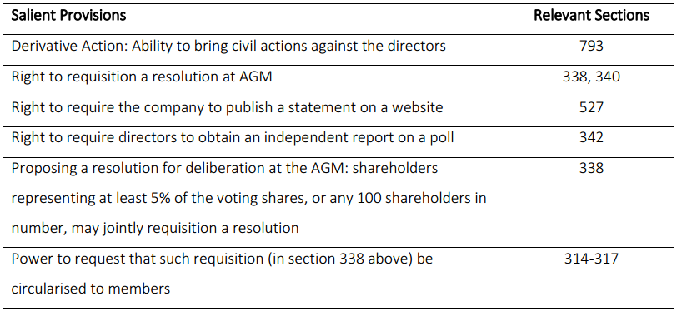
Source: Companies Act (2006)

On the other hand, RI is a concept that had evolved over the years, from the early 18th century when Christian preachers advised against certain investment, till now when the RI idea tends to be moving into the mainstream. The following stages have been identified: the foundation, development, transition, expansion and mainstream. There are various motivations for engaging in responsible investment, and they range from the need to avoid profiteering from immoral behaviour in the 18th century, to the need to integrate corporate governance in the modern era. Sievanen et al. (2013) investigated the drivers of RI amongst European Pension Funds based on a survey of more than 250 pension funds in 15 EU countries in 2010. They suggest that one of the main drivers of the growth of Responsible Investment is the shift from shareholder-centric to stakeholder culture by Pension Funds who hold investment in truest for a great population of beneficiaries. This is in agreement with the evidence from the shift in the current provisions of the Companies Act (2006) which recognises the growing influence of stakeholders in the investee company in the duties of directors.

Table 1.2 Summary History of drivers of Shareholder Activism in the UK
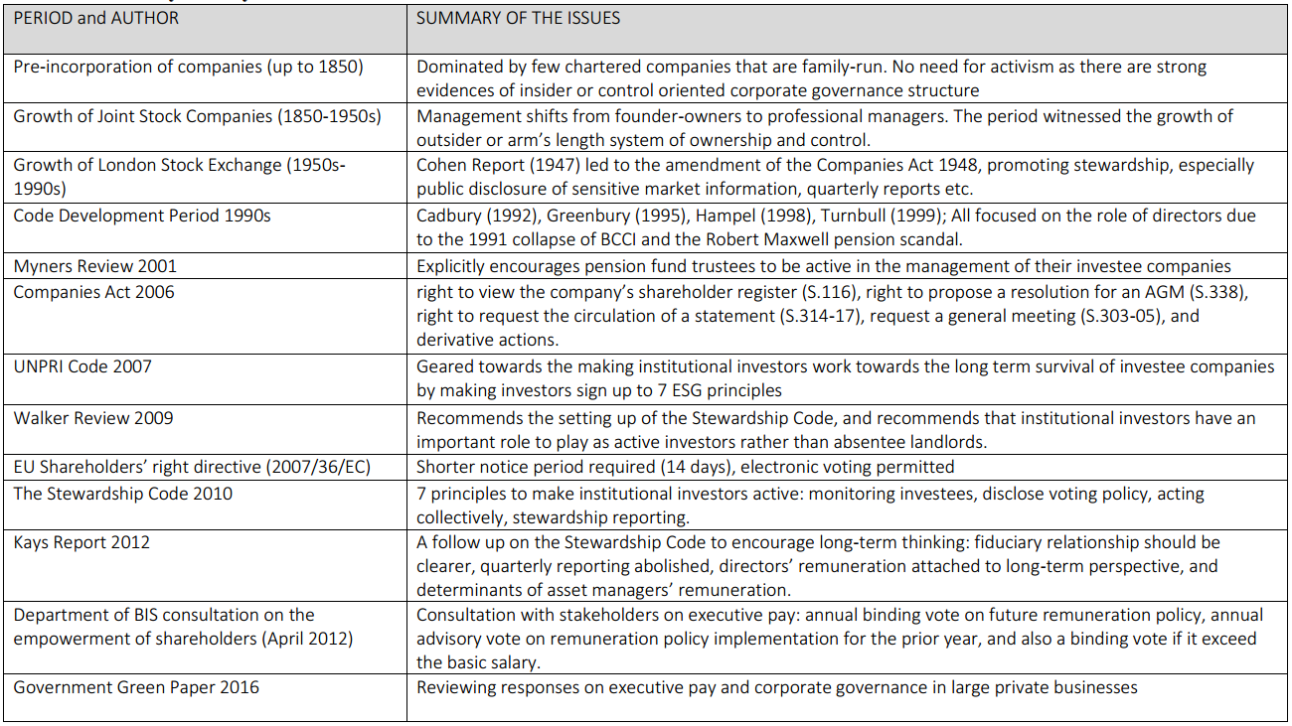
Source: Researcher’s findings

Table 1.3: Brief History of Responsible Investment in the UK
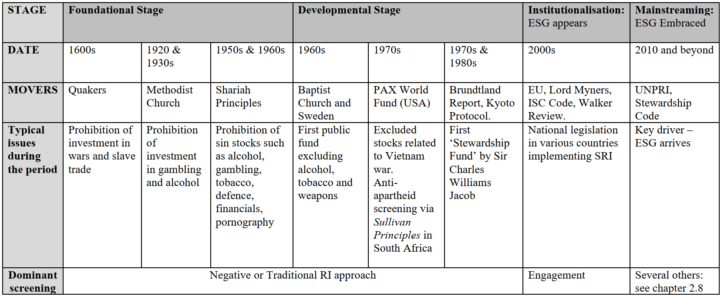 Source: Researcher’s findings
1.4.1 Foundation Stage
This stage was typified by protests and Christian preaching. For example, there was a religious movement that set out to boycott the sale of shares in Dutch East India Company in 1602 until the company eliminate violence from its business operations (Taylor 2011, p10). The earliest responsible investment activists were Christian organisations who were campaigning against investment in unethical organisations or what they termed ‘sin stocks.’ In the UK, the earliest adopter of the responsible investment tenets was John Wesley, the co-founder of the Methodist Church (Goranova and Ryan, 2014). He consistently preached against unethical businesses like tanning, gambling, tobacco, liquor, and chemical production that damages the health of workers and damages the environment. In the mid-18th century, a conservative Christian denomination known as “The Quakers” or Religious Society of Friends barred its members from slave trade transactions. There were no records of any practical steps taken by the religious organisation in the UK to set up an ethically focused fund during this period. Having hitherto taken stock market as another form of gambling, the Methodist Church in USA started its investment arm, applying positive and negative screening of stocks (Cheffins, 2008). ‘The Quakers’ also followed suit with avoidance of ‘sin stocks’, but it was in 1928 that Philip L. Caret established the first mutual fund based on ethical values, known as the Fidelity Mutual Trust, and it is the third oldest mutual fund established in the USA (Cheffins, 2008).

Clark and Hebb (2004) likened this period to the “first stage of capitalism” where entrepreneurs are the main actors in the running of a private corporation. This was the period prior to the enactment of the Companies Act. Therefore, there were no legal pronouncements or laws that encourage shareholder activism. This explains why shareholder activism was unreported during the period. This period was typified by the existence of very few chartered companies. The first reported conflict between ordinary shareowners and managers of publicly traded corporations can be traced back to the eighteenth century when the Crown had the exclusive right to grant Royal Charter of incorporation. Marens (2002) traced the first of such conflicts to the era of English East India Company, one of the companies set up by Royal Charter in 1602. It is not clear what the sources of the conflicts were. However, there is a view that these conflicts originated from regulatory and legal constraints emanating from populist political pressures (Davis and Thompson, 1994) because management’s control of the companies were contingent on rules that are determined externally by the state and the allocation of corporate control depends on political struggles among management, capital providers and various governmental bodies.

Another company, the South Sea company set up by Royal Charter in 1711 was estimated at its peak to be worth £500m (twice the value of all lands in England in the 18th century). A huge speculation in the affairs of this company, fuelled by fraudulent claims led to a massive investment frenzy which ended catastrophically (Taylor, 2011, p10). Just as Enron prompted the Sarbanes-Oxley Act in the USA, the UK government passed the so-called ‘Bubble Act’ in in 1720 to prevent further fraudulent activity (Armstrong and Francis, 2008). During this period, activist investors endeavour to get information out of firms that otherwise would not be there, for instance, the disclosure of profit or loss figure, and valuation of assets. In Britain, according to Chandler (1990:26) early 19th century was a period of personal capitalism where simplistic, primitive managerial structures were the norm due to the continuing prominence of family-run businesses. Throughout the nineteenth century and into the twentieth, ownership and management remaining virtually the same. This is in line with Gourvish (1987) assertion that corporate change in Britain before 1914 was more of legal and financial than managerial, as most family businesses were still being managed by insider family members. Due to the high prevalence of family-run businesses during this period, there was little need for activism on the part of the shareholders as there were strong evidences of insider/control oriented corporate governance and therefore low agency control costs and absence of free-rider issues. Other motivations for shareholder activism like political and environmental issues did not emerge until the work of Berle & Means appeared in the 1930s, where they noticed the prevalence of strong managers and weak owners.

1.4.2. Development Stage (1960s – 1990)
The period starting from the 1960s up to 1990 marked the period of pronounced activism by RI advocates on a large scale, as well as the growth of ethical investment funds. For instance, in 1977, ‘End Loans to South Africa’ a UK-based organisation introduced at Midland Bank plc., a dissenting shareholder resolution forcing the company to act responsibly on the issue of Apartheid in South Africa. In 1979, Sir Charles Williams Jacob, who is known as the father of UK ethical investment - after three separate rejections by the department of trade between 1973 and 1979 - succeeded in setting up ‘Stewardship Fund’ (also known as “The Friends Provident Stewardship Unit Trust”) that is focused on ethical investment. The success of the ‘Stewardship Fund’, despite the initial reluctance of the department of trade because of the initial doubts on the level of demand for ethical funds, helped the development of the sector, and there are over 80 such funds in the UK. The effect of this success was replicated in Europe as several such investment companies, such as the Triodos Bank in Netherlands were established during this period.

This is the period when the arm’s length system of corporate governance became entrenched as opposed to the control-oriented system that is prevalent in continental Europe. Various writers (Franks et al, 2006; Florence,1953; 1961; and Channon, 1973) have identified the nineteen fifties and sixties as the twilight decades of ‘family capitalism’ in the UK. The period recorded increased request for additional disclosures by limited companies. Based on the recommendations of the Cohen Report, the Companies Act was comprehensively amended in 1948 and were further toughened up by 1967, especially on the financial disclosure through financial reports. In 1947, the Exchange combined the rules governing new issues and the one governing quoted limited liability companies. The objective was to entrench accountability to shareholders and the investing public by periodic disclosure of financial information. For the first time, listed companies were required to communicate market sensitive information to the stock exchange as soon as they become available. These disclosures further deepened interest in public trading of equity shares in the secondary market as transparency gaps were plugged. In the 1960s quarterly returns for listed companies were introduced in addition to the existing annual returns. In recent times, this had been cited in the Kay report (2012) as a source of the short-termism. There is also an argument that shareholder activism emerged in the mid-twentieth century and gained momentum in the early seventies due to the emergence of advocates of social issues (Solomon 2010; Marens 2002).

1.4.3 Transition stage (1990s – 2000)
This period witnessed the evolution of a new form of responsible investing with focus on the impact of environmentally sustainable development on business. This was largely encouraged by the Brundtland Report (WCED, 1987) which emphasised the concept of sustainability, and the Kyoto protocol (UNFCCC, 1997) on climate change. In 1989, as a result of the oil spill in Alaska, the CERES 10-point code principles on corporate environmental conduct was produced and later endorsed by over 50 companies. ‘Green funds’ that focus on environmentally friendly investments started to emerge. For ethical investors, this was a period of transition from negative screening/avoidance of certain investments, to positive screening offering sustainable and environmental investments. In 1990, the Domini 400 stock index for social and environmental excellence was launched, and this is the first RI index ever maintained (Cheng, 2007).

Codes of corporate governance were developed in the 1990s as a response to financial scandals at that time (Gong, 2011). Since then, there have been series of reports on corporate governance in the UK. After 1990, there seems to be an ‘official endorsement’ of shareholder activism in the UK based on the twin factors of the various provisions the Companies Act 2006 on one hand, and the number of committees that have been set up between 1992 and 2010 to implement or review the ways in which companies were directed and controlled. Britain produced the first corporate governance report in 1992 and has subsequently produced more than any other country to date (Trickler, 2009:146) which agrees with the views of Solomon (2009:8) that the UK is a net exporter in the area of corporate governance. All the corporate governance codes and guidelines produced to date recognised the importance of the role of institutional investors due to their growth in size over the years. Many of the existing literature have focused more on the role of Pension Funds to the detriment of other asset owners. Clark and Hebb (2004) for instance have argued that 21st century governance should be centred around the role of Pension Fund, thereby neglecting the role of SWFs and other asset owners.

1.4.4 Expansion of RI and the Institutionalisation of Shareholder Activism
Interest in responsible investment in the year 2000 and beyond can be attributed to the direct intervention by the UK government through the UK Pension Disclosure Act mandating all private sector pension funds to include voting right as well as environmental and social issues in their investment criteria. The year 2000 is therefore seen by many as a turning point in the practice of responsible investment in the UK. This law has helped in raising the profile of ESG considerations in the UK investment community. It is widely believed that this law is capable of moving ESG issues to the mainstream of investment decision making due to the large capital being mobilised via pension funds (Boatright, 2010:408). Many European countries have adopted similar disclosure regulation in addition to the EU Accounts Modernisation Directive. The GRI reporting framework (2002) for sustainability reporting on people, planet and profit, arising from the failure of current governance structures to respond to changes in the global economy, also expanded the focus on responsible investment.

With these developments, ethical or responsible investment principles began to find acceptance amongst mainstream investment practitioners, and therefore, responsible investments are now being viewed as a commercially viable business (Déjean et al, 2004). The FTSE4Good index was set up in July 2001 to measure the performance of companies that meet universally recognised standards, and also encourage investment in such companies. Analysis of performance indicates that the FTSE4Good has consistently outperformed the FTSE-100 index since the first-half of 2003. By 2005, the UNPRI was set up by international group of institutional investors to promote adoption and the implementation of six principles promoting environmental, social and governance issues in investment practice. As at August 2019, 59 UK asset owners, 299 asset managers and 52 professional service providers are now signatories to the PRI scheme.

Shareholder activism in the UK became institutionalised 2001 when Myners Report raised concerns on the value lost to institutional investors through the reluctance of fund managers to actively engage with companies in which they have holdings on issues such as strategy, personnel and other potential causes of corporate underperformance. It encouraged the need to intervene in companies by voting or otherwise where there is a reasonable expectation that doing so might raise value of investment. Cheffins (2010) noted that immediately following the 2001Myners Report there was something of a surge in activism by institutional shareholders, which is partly due the publication of the ISC Code in 2002. In response to the recommendations of Lord Myners (2001), the Institutional Shareholders’ Committee (ISC), which is the umbrella body for the NAPF, the ABI, the IMA and the AITC, produced a statement of principles on activism for institutional shareholders encouraging more active shareholding on 21st October 2002. It was produced as a voluntary code in an attempt to avert a threat of government legislation requiring greater active investment by institutional investors.

In February 2009 Sir David Walker was asked by the Prime Minister to review corporate governance in UK banks in the light of the experience of critical loss and failure throughout the banking system. The Report’s analysis and recommendations focused mainly on financial institutions. It observed that a duty of stewardship was a logical consequence for institutional investors, i.e. shareholders with significant equity holdings. It recommended the need for institutional investors to take more active and effective role in monitoring directors. The Report recommended that the FRC issue a separate Code entitled “principles for Stewardship” that the fund managers should voluntarily commit themselves to on a “comply or explain” basis (Walker Review 2009:14). In response to the recommendations of the Walker Review, FRC issued a consultation document on the proposed launch of the Stewardship Code in January 2010. By July of the same year, the Stewardship Code was launched, adopting the principles of the ISC code on the Responsibilities of Institutional Investors. While some stakeholders like the TUC have argued that the Stewardship Code provides the last chance for a corporate governance system that relies so heavily on shareholder engagement as an essential part of the monitoring system of corporate Britain, others like Cheffins (2011) have argued that the stewardship code is merely a re-stated ISC Code that had made no real difference because it has no force of law behind it.

According to Simon Wong (2010) conflict of interest at investment firms arise at three levels (institutional, individual and group) all of which can impede their willingness and ability to engage investee companies actively on corporate governance matters. Resolving these conflicts requires strong remedies, ranging from their elimination to outsourcing voting decisions to independent third parties to establish the right organisational culture. If the existing conflicts of interests are left unchecked, efforts to promote institutional investor stewardship will falter and the ‘absentee landlords’ share ownership model will likely prevail in which case, current efforts to promote active, long-term oriented stewardship behaviour will hit the brick wall. Fund managers are more interested in trading decisions and are therefore incapable of acting as owners, and that as custodians of others’ funds, they would avoid being ‘locked in’ by a policy of intervention but rather look for opportunity to off-load underperforming assets as quickly as possible where the need arises.

1.4.5 Mainstreaming of RI (the future)
Many writers like Louche & Lyndenberg (2011) It is expected that as integration of governance into the investment decision-making process continues to gain ground, it may become the global standard. This is further strengthened by the In October 2011, The European Commission formally invited all asset managers and asset owners domiciled within the EU area to sign up to the PRI code. However, there will be need for the governance criteria to become standardised using transparent and robust models. Institutional investors will be expected to take a lead in this area. It is believed that if asset managers fully accept governance as part of the universal investment criteria, then the portfolio managers will be competed to integrate them into their decisions too.

Table 1.4: Main Drivers of ESG Shareholder Activism
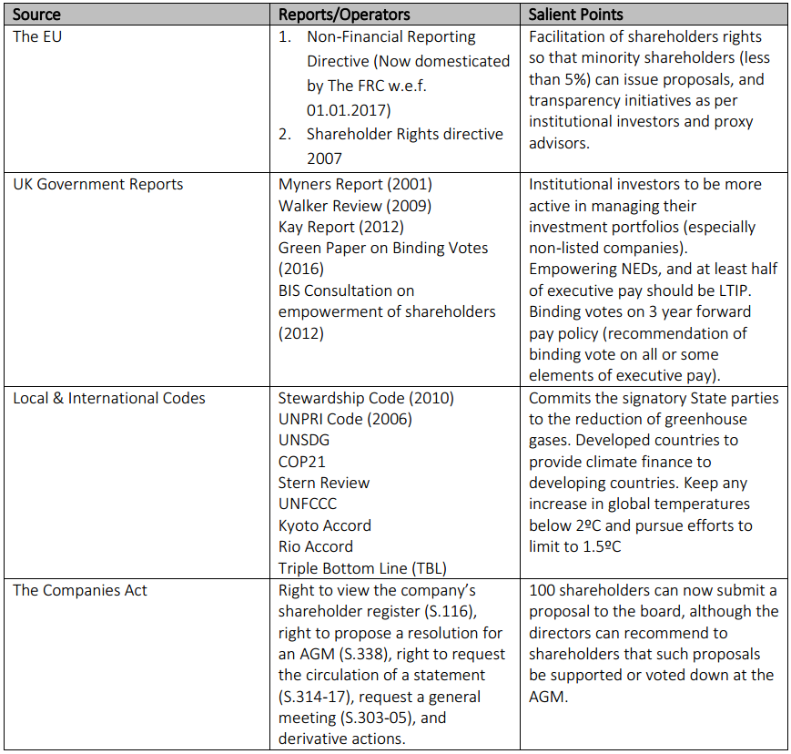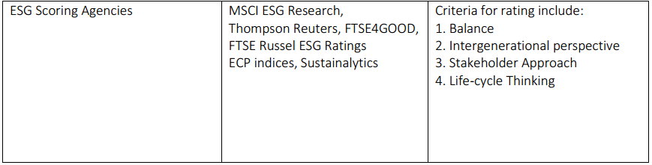
Source: Researcher’s findings

1.5 Justification for this research work
This research contributes significantly to the literature on shareholder activism by providing empirical findings relating to shareholder activism in response to the research questions established above. Further, this research interprets the findings through the lens of the risk society theory. The thesis also investigates the role of asset owners in the investment community in ESG shareholder activism by using multiple methods to gather relevant data, unlike most studies in the existing literature. Secondly, Euler (2013) and Ghahramani (2013) have observed growing interest in the role of foreign owned institutional investors (SWFs) operating globally, especially on their capability to strengthen good corporate governance. In the UK, it has been noticed that personal ownership of shares has fallen to an all-time low, whilst SWF ownership of shares have quadrupled between 1963 and 2010^{1g}. Moreover, SWFs are not under any obligation to comply with the requirements of the published Stewardship Code. Despite their growing size and influence, there is little evidence in existing literature of the investigation of their role in engaging the management of the investee companies. This study takes the views of SWF asset owners into consideration as they now represent more than forty percent of UK equity shares.

This work also contributes to the debate on how the professional advisers are deepening shareholder activism in the UK, as well as the clarification of fiduciary responsibility roles in the investment chain. Many asset owners now make use of independent professional advisers on corporate governance e.g. some of them do issue voting alert to UK Pension Fund clients, became prominent for their role in the 2011-12 ‘spring I and II’. Since then, they have continued to wield more powers in the investment chain, especially on proxy advisory matters. In recent times, agitation to impose CSR policies on businesses has become one of the reasons for investor activism, particularly the need to integrate governance into the investment decision making of asset owners. Writers like Louche and Lydenberg (2011) have argued that based on the recent developments, Responsible Investment is on the way to becoming the mainstream. Responsible Investment practitioners like Soros (2008) and Gifford (2010a), agree that the failure of the current financial model and the inadequacy of disclosure regulation and risk management tools to price risk are forcing stakeholders to ask questions about the systemic shocks posed by the failings to integrate governance factors and sustainability into company valuations. Despite a significant growth in the number of the UK based PRI signatories, many of the existing literature that have explored integrating corporate governance in investment decision making (Amaeshi and Grayson, 2009; Bourghelle et al, 2009; Hoepner et al, 2013) have concentrated on fiduciary issues, identification and removing barriers preventing asset owners, complexity and power relations inadequate management systems. Little attention has been paid to the investigation of the various RI strategies applied by the various categories of asset owners in order with a view to deepening the understanding of the risk society theory. Many writers have focused attention on performance and returns (Sparkes, 2002; Domini, 2001, Krosinsky and Robins 2008), environmental risks (UN Global Compact, 2011) and ethical dilemmas (Louche and Lydenberg, 2011) as aspects of UK Responsible Investment. However, little attention has been paid by scholars to the investigation of the Responsible Investment strategies, especially shareholder activism applied by Asset Owners in managing their investments. A recent survey by UNPRI (2013) found that there are still many barriers that limit the use of RI strategies by portfolio managers, and that Asset Owners are still concerned about how to apply the information generated by specialist providers for decision-making purposes. There is therefore a case for increasing the body of literature and the current debate on the strategies applied by asset owners in factoring governance into investment decision making in the UK.

Finally, and importantly, fiduciary responsibility in the investment chain is yet to be fully codified in law, and this is currently one of the major impediments to investment screening based on recent findings^{1h}. From a qualitative perspective, this work widens the breadth of current literature on shareholder activism and deepen the understanding of the theory of shareholder activism and the heterogeneity of the various institutional investor groups by exploring the roles of different asset owners in engagement with investee companies, intervention strategies, motives for activism and barriers to shareholder activism. It also expands the understanding of the theory of Responsible Investment in terms of the strategies used by asset owners. This study provides regulators and shareholder groups with a broader understanding of the issues facing the various institutional investor groups within the context of the current corporate governance practice in the UK. Therefore, the output of this work increases the volume of current knowledge and skills available to various UK regulators, Investment Professional Associations and their advisers in the area of Corporate Governance and Responsible Investment e.g. Financial Reporting Council, UK Shareholders Association, FTSE4, The UNPRI etc. On the international level, the empirical findings derived from this work will enrich corporate governance practice in other jurisdictions worldwide as the UK has been described variously as the net exporter of corporate governance practice worldwide.

1.6 Organisation of the Research work.
This chapter has provided a detailed background to ESG and responsible investment in the UK with an exposition of the historical context and an identification of gaps in the existing literature in order to establish a rationale for the research questions. It has also identified and discussed the aims and research questions that are to be addressed in order to achieve the identified research objectives. In summary, the justification for this study, the thesis overview, the nature of ESG activism and its historical emergence, as well as the overall organisation of this work have been outlined and discussed.

Chapter 2 presents a literature review, where ESG and shareholder activism are carefully defined, and the existing literature on the forms of shareholder activism, relationship between shareholder activism and shareholder wealth, shareholder activism and climate change, the nature of shareholder proposals, and some cases in shareholder activism were reviewed. Also, the concept of ESG and some historical perspective on shareholder activism and responsible investment, and the roles of asset owners in responsible investment were also reviewed.

Chapter 3 explores the theoretical explanation of why a Becksian risk society theoretical lens, a postmodern theory, is most appropriate to underpin this work. It avers that responsible investment logic is a shareholder activism cover (or insurance) for their investment in a world that is being typified by risk and uncertainties that is induced by environmental, social and governance (ESG) factors.

Chapter 4 outlines the overview of the research process and the research design including the research philosophy, methodology and methods. The chapter also describes and justifies its ontology, epistemology and axiology. Being rooted in interpretivism, the researcher avers that shareholder activism is a socially constructed development, which means that it would be difficult to scientifically objectify this research work.

Chapter 5 involves analysis of archival materials, i.e. analyses of shareholder proposals and resolutions focusing on ESG matters, filed in the UK between 2007 and 2017. This chapter shows how the fifth and sixth research questions were answered in order to achieve the fifth and sixth research objectives.

Chapter 6 analyses the views of individual investors interviewed (mainly UKSA members) on ESG-induced shareholder activism. This chapter shows how the first and second research questions were answered in order to achieve the first and second research objectives.

Chapter 7 analyses the views of institutional asset owners interviewed (i.e. SWFs, pension funds, and social activists) on their role in entrenching ESG-induced shareholder activism. This chapter shows how the second and third research questions were answered in order to achieve the second and third research objectives.

Chapter 8 analyses the views of proxy advisors interviewed on ESG-induced shareholder activism. This chapter shows how the second and fourth research questions were answered in order to achieve the second and fourth research objectives.

Chapter 9 involves a longitudinal analysis of observations at investors meetings attended between 2014 and 2017. This chapter shows how the second and fifth research questions were answered to achieve the second and fifth research objectives.

Chapter 10 provides a discussion and synthesis of all the empirical chapters (i.e. chapters 5 to 9) to present a holistic picture of the findings of the study, including the discussion through the lens of the risk society theory with greater emphasis on the concept of ‘manufactured risk’ and the ‘concept of trust as a re-embedding mechanism’. The chapter also provided linkages with the literature reviewed in chapter 2.

Chapter 11 summarises the findings, draws conclusions, highlights the limitations in this study, and makes recommendations on the future developments of ESG induced shareholder activism in the UK, as well as providing some suggestions on the areas for future research.

1.7 Thesis Overview
A graphical overview of the thesis is provided below:

Figure 1.1: Thesis Overview

Chapter 1: Introduction
Exploration

Chapter 4: Methodology
Establishes broad understanding of context and the research questions

Chapter 3: Becksian Theory
Chapter 2: Literature Review

Chapter 5: Analysis of ESG Shareholder Proposals

Chapter 6: Analysis of interviews (UKSA members)
Chapter 8: Analysis of Interviews
(Proxy Agents)
Chapter 7: Analysis of Interviews
(Asset Owners)

Chapter 9: Observation of IR Meetings

Chapter 10: Comparing and Contrasting Findings

Chapter 11: Consolidation of Research and Conclusion

1.8 Summary of Chapter 1
This chapter provided a detailed background to the problem that is being researched in this work. It also discusses the aims, research questions that are planned to be addressed in order to achieve the identified research objectives. The justification for this study, the thesis overview, the nature of ESG activism and its historical emergence, as well as the overall organisation of this work was also discussed.

Chapter 2: Literature Review on Shareholder Activism and a historical perspective of shareholder activism cases

2.1 Introduction to Shareholder Activism
The techniques for engaging in shareholder activism continues to be subject of scholarly debate amongst social movement theorists, with some (e.g. Vogel, 1983) holding the opinion that shareholder activism is a subversion of the AGM, and those who have typified them as extra-institutional tactics (e.g. Reid and Toffel, 2009; Eesley and Lenox, (2006) that stakeholders apply in getting their way, either by complementing internal processes or as an existential or survivalist technique when engagement within the corporation fails. Tilly (1978) and McAdam (1982) have argued that shareholder activism are consequences of social movements arising from boycotts and protests that are likely to be effective as a result of the threats to corporate reputation due to media coverage. Vasi and King (2012) also argue that shareholder activism can be effective depending on how the social action is viewed as reputational threats or an investment risk. According to McNulty and Nordberg (2016), the last global financial crisis has increased the quest to interrogate the existing economic system, including how institutional investors engage with investee companies, thereby bringing the issue of shareholder activism to the forefront of corporate governance discourse.

Shareholder activism or active ownership (according to Goranova and Ryan, 2014; and McNulty and Nordberg, 2016) are a conglomeration of actions taken by shareholders to put pressure on the board of directors, through the intervention by shareholders in the running of a company by activist shareholder using equity stake in a corporation with the explicit intention of influencing corporate actions, policies and practices. Black (1998) also defined it as “proactive efforts to change firm behaviour or governance rules.” The goals of activist shareholders range from short –term financial returns (Chung and Talaulicar, 2010; Butu, 2013; Cheffins and Armour 2011) to change in corporate behaviour (Roberts et al, 2006; Mallin, 2006). It is a broad description for the various actions undertaken by investors to influence corporate management and boards to make changes in CSR or improve financial outcomes (Chung et al. 2010). Shareholder activism “voice engagement” instruments include: voting at AGMs, collaborating with other investors to form a consensus, having representatives on the company’s board, engaging in quiet diplomacy with Investee company’s management through writing of letters, attempting to take-over the investee company, lobbying other shareholders via press campaign, the use of focus list and shareholder proposals. In public corporations, shareholder proposals are often employed by activist investors such as social groups, individuals, and institutional investors to direct attention, raise awareness and challenge managers to enhance their firms’ social or financial performance^{2a}.

Shareholders in public limited companies are widely dispersed with many of them holding insignificantly small shares. Because of this, and the high transaction costs, it is virtually impossible for them to hold the directors to account^{2b}. However, asset owners, i.e. institutional investors due to their high relatively high stakes are able to hold the investee company to account through various ‘voice’ activism strategies. Shareholder activism is one of the consequences of agency, free riding and incentive problems^{2c}. Gillian and Starks (1998) have argued that the growing conflict of interest between managers and shareholders have resulted in the increased importance of shareholder activism. Black (1998) argued that shareholder activism is predominantly effective through asset owners such as hedge funds, mutual funds, insurance companies, and investment companies as they own substantial shares, and are able to collaborate and vote majority at meetings. In the existing literature, the role of Pension Fund and the increased use of their “voice engagement” to challenge corporate, social and environmental standards of their investee firms’ long-term performance have been stressed by Clark and Hebb (2004). They argue that “Pension Fund corporate engagement hold answers to aligning company managers’ decisions with both shareholders and stakeholders through raised standards of firm behaviour” as they have begun to use governance tools to influence and increase transparency and accountability and to raise standards of corporate behaviour. Their findings were based on interviews both in the USA and the UK. They also argue that the world is in a “fifth stage capitalism” or “Pension Fund Capitalism” on a global scale based on their observation of changing investment chain. It can however be argued now that we have subsequently entered a new stage in the relationship between Asset Owners and their investee companies where Sovereign Wealth Funds size in the UK is now more than double the size of Pension Funds. Therefore, there is a case for an expansion of literature, as well as the widening of debate on active ownership by institutional investors. Useem (1996) in support for the debate in active ownership have argued that the decisions made by asset owners affect in their investee firms affect lots of lives, and yet they were seemingly unaccountable to any economic agent. He reasoned that their large equity holding, and the growth of indexing as a major investment strategy, have prevented the ready selling of underperforming companies. Therefore, institutional investors are now more likely to “voice out” rather than “cash out” thereby making a case for shareholder activism.
2.2 Forms of Shareholder Activism
Shareholder activism has assumed a variety of forms, depending on the motive and the institutional investor. There is need to deepen the literature in this subject area. The majority of the existing work on asset ownership activism (see McNulty and Nordberg, 2016; Wong, 2010) have equated Pension Fund activism with the totality of Asset Owners, thereby neglecting the homogeneity of the various groups in terms of their attitude to shareholder activism. Graves et al (2001) and Admati and Pfleiderer et al. (2006) acknowledges the expectation gap between what shareholder activism really is, and the public expectation of shareholder activism which is sometimes confrontation with management. However, an activist shareholder is able to use wide array of instruments to engage with the directors of the company, with some of them not open to the public (see Graves et al., 2001). Public shareholder activism involves confrontation with the directors of the company via press releases, court cases, public demonstrations and sending shareholder proposals (Shareholder proposals formally and visibly signal discontent over an issue concerning the strategic direction of the company). However, shareholder activism is not limited to such cases. Evidence from Buchanan et al., (2010), and Renneboog and Szilagyi (2010) indicates that writing shareholder proposal is a popular way of engaging the investee companies, and the usual process involved is described in figure 2.1. Rehbein et al., (2004) found that large companies are likely to be targeted with shareholder proposals than small ones due to their relative importance to the society. The various activisms have been identified and discussed with their various perspectives, highlighting the need to enrich literature in this area of body of knowledge:

Figure 2.1: Shareholder Activism Processes and Outcomes
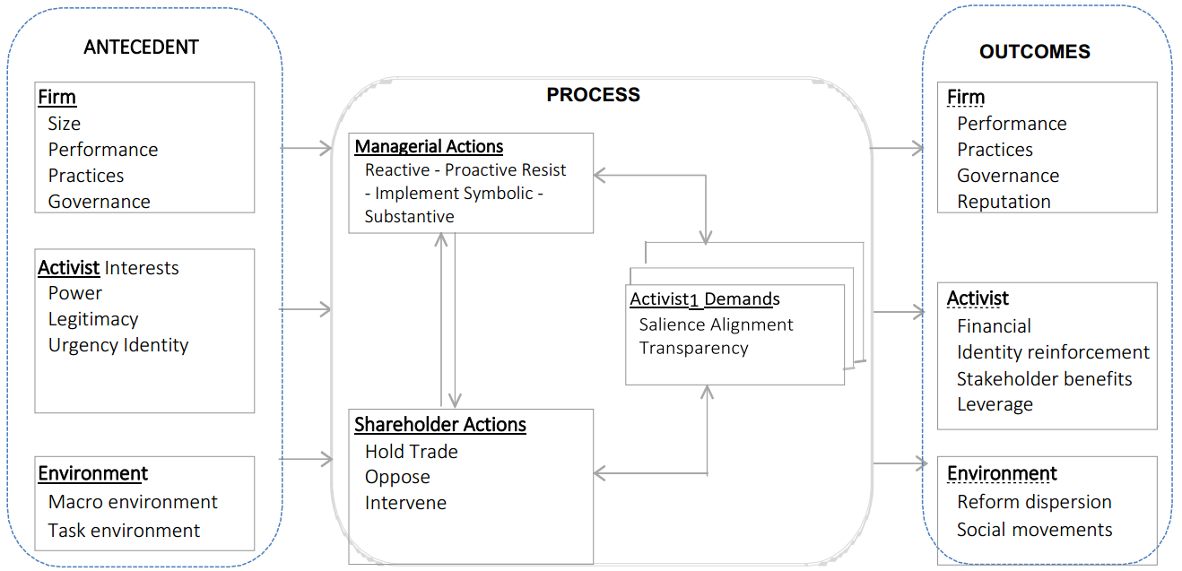

Adapted from: Goranova and Ryan (2014)

2.2.1 “Wall Street walk” and Voice activism
Hirschman’s (1970) view is that shareholders have two choices in responding to unsatisfactory performance of companies: “exit” or “voice.” Exit philosophy (also known as the “Wall Street Walk”) is predicated on realising shareholding and moving on. This is the simplest form of shareholder activism and it sums up the approach of most small investors who are unsatisfied with corporate performance. The aim is to discipline corporate management by divesting from underperforming company (Sjöström, 2008; Gillan and Starks 2007). Admati and Pfleiderer (2006) argued that large shareholder exit often has a disciplinary impact since market value is depressed, but the effectiveness of this mechanism can be quite different depending on whether the agency problem involves a desirable or an undesirable action from shareholders’ perspective. This is why the threat of selling shares can also be seen as a “Wall Street Walk activism” because of the likely effect on share price depression immediately the announcement is made, especially if the threat comes from an institutional investor with substantial shareholding. Based on findings using a quantitative model using private information, Admati and Pfleiderer (2006) found that a credible threat of exit often reduces agency costs. Empirical evidence from the USA (Goranova and Ryan, 2014) also indicates that an institutional investors’ well-planned exit strategy can be used to push an investee company towards a merger or acquisition, the objective being the acquisition of the investee company at a cheap price. Rubach (1999:46) however opined that exit strategy is prevalent by institutional investors when ownership size is small. Rubach (1999) reasoned that exit from an investee company becomes unviable as the equity ownership size of the institution in the investee rises. In which case, voice activism becomes the only other alternative. This is based on the analysis of portfolio performance and shareholder activism style of 118 institutional investors in the USA in the 1990s. There is however no evidence of how they are influenced by proxy advisors to take exit strategy.

Many now see voice strategy as a long-term corporate governance strategy and a better alternative to “Exit” (See Mallin, 2006; Camilleri, 2015; and McNulty and Nordberg, 2016). Mallin (2006) for instance have described the role of Pension Funds and their ability to use voice activism i.e. ‘jawboning’ with investee company directors to influence management of the investee company as “stewardship” which maximises value in the long run. Rather than simply suffering in silence or waiting endlessly for a corporate saviour in the form of a bidder or doing the “Wall Street Walk”, they can hold the stocks and exercise their rights as shareholders to voice their concern about the company’s poor performance and campaign for change i.e. they become ‘active’ campaigners for change (Sudarsanam, 2009). ‘Voice’ activism involves engaging in continuous dialogue with management, issuing shareholder resolutions, or building shareholder coalitions, accruing additional voting rights and takeovers etc.

Figure 2.2: Spectrum of Corporate Engagement
Escalation routine: Typical shareholder activism options available to investors
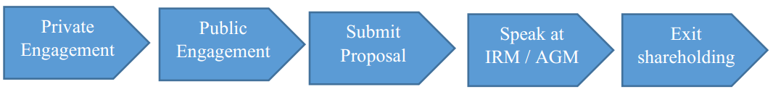
SOURCE: Researchers’ findings

Secondly, the structure of share ownership in public companies has changed significantly from the 1970s when the work of Hirschman first appeared. In the USA, while individuals controlled 80% (and institutions: 20%) of equity shares in 1970, institutions now control over 70%. During the same period, institutional share ownership in the UK has grown from less than 20% to over 90% in 2018 (ONS, 2018). Pivotal to this growth in institutional investment is the various pension reforms which requires that they hold substantial equity assets, and the falling cost of fund management which is attributable to the rise of passive investments such as the ETFs. The CEO of Blackrock once said: “When I am able to increase margins and increase market share through price cuts, I am going to do that. The key element is scale”.
“Voice” activism, which comes under corporate governance engagement may range from private meetings other than the AGM and email exchanges, to press interview. Figure 2.2 is a typical escalation routine from “voice to Exit”. A typical escalation policy is described by the Head of ESG Investment at Aberdeen Standard Investment thus:
“In certain cases, we shall consider escalating our engagement on a particular issue. The tactical aspects of escalation are determined on a case-by-case basis. Consideration is likely to be given to engaging with the chairman, the senior independent director, the independent director, the company’s adviser, and if appropriate, the company’s regulator. At all stages of engagement escalation, we seek to ensure our views are represented by those who have appropriate seniority and experience. Where we feel it is appropriate to do so, we will also make our views known through public statement which may be at a company’s AGM.”^{2d}

Table 2.1: Forms of shareholder activism in the UK
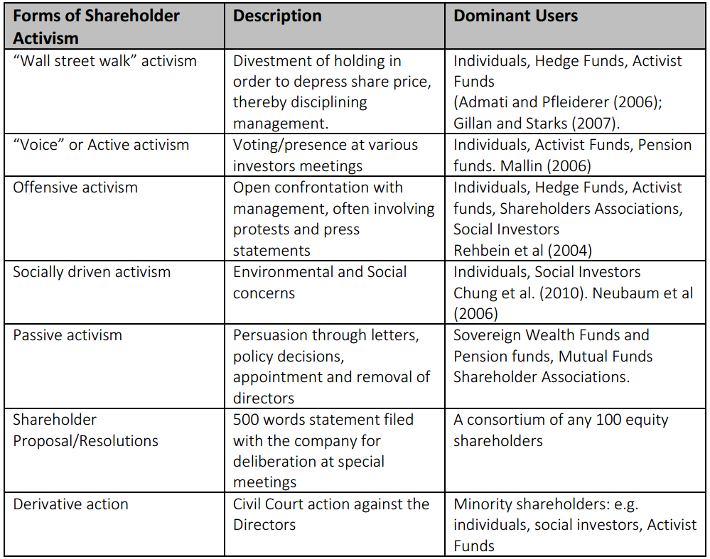Source: Researcher’ findings

2.2.2 Financially driven and socially driven
Chung et al (2010) categorised shareholder activism research into two main streams: financially driven and socially driven. Majority of shareholder activism literature had focused on the financial outcome of activist initiates, as they have more compelling effects on a company’s results (Gillan and Starks, 2007). These types of activism became prominent with the increase in institutional share ownership (Thomas and Cotter, 2007) perhaps due to the need to generate long-term financial returns for their beneficiaries. For instance, the period of 1990s witnessed increase in governance related proposals sponsored by pension funds due to the expectations that good governance leads to better financial performance (Romano, 2001, Lipton, 2007; and Aggrawal, 2012). This finance related governance activism later encompassed the traditionally reticent mutual funds (Brandes et al., 2008). However there appears to be a growing body of research on shareholder activism for corporate social and environmental responsibility (e.g., David et al., 2007; Logsdon & Van Buren, 2008; Neubaum & Zahra, 2006). In general, socially-driven activist investors pursue such matters for principle-based reasons, while financially-driven activist investors tend to be motivated by economic incentives. However, writers such as Brav et al 2008a; Clifford 2008 have argued that the short-term pay structure of hedge Funds are the principal motives that drive their activism. Gilson & Milhaupt (2008) for instance have argued in their working paper essay that SWFs have motives other than financial in the pursuit of their investment. There is therefore a case for the investigation of the main drivers of shareholder activism amongst the various asset owner groups in the UK in order to deepen understanding of the motives of the various asset owners.

2.2.3 Offensive and defensive activism
Offensive activism, in the views of Bebchuk et al., (2015) and Pacces (2018) is a consequence of misalignment of the principal and agency relationship in the theoretical agency theory. The principal (the hedge fund activists) therefore goes on the offensive in order to return the relationship to default setting (see Edmans et al., 2013; Karpoff et al., 1996 and Greenwood and Schor, 2009). Accordingly, hedge funds demonstrated offensive activism through activities (e.g. recapitalisation or buybacks; business strategy, asset sale et al.) that are geared towards immediate returns, and sometimes removal of the board. The existing literatures have limited perspectives on the categorisation of investor activism by the various asset owners. Cheffins (2010) typified as offensive activism, proactive actions taken by institutional investors to protect investments by initiating actions to remove management of investee companies that are turning out poor financial results, while open confrontation between corporate executives and institutional investors are characterised as defensive activism. Cheffins and Armour (2011) described hedge fund-style activism “offensive” as they acquire shares based on the assumption that under-valuations will be corrected subsequent to putting pressure on management, and then shareholders wealth would be maximised. Offensive shareholder activism in the UK can be traced to the early 1990s when hedge funds and private equity firms began aggressive acquisition of companies in what was termed ‘public-to-private’ buyouts, by taking substantial equity interest in companies that had fallen on hard times agitating for change, before shaking up the top management (Steele, 1999:1). The UK Focus Fund established in 1998 also engaged in offensive activism when it started targeting underperforming companies that have great turnaround potentials (Sudarsanam, 2009). The objective of defensive shareholder activism on the other hand is to protect already held shares through intervention in policies of the investee company. This trend was observed by Kahan and Rock (2009:35) when they described mutual and pension fund activism as intermittent and ‘ex-post’ as opposed to ‘ex-ante’ actions by hedge fund managers.

2.2.4 Active and passive shareholder activism
Active activists acquire investment in a firm with the aim of pressing for a change. They analyse the financial performance of the investee companies with sole aim of turning around the fortunes of the company that is currently identified as underperforming or their shares undervalued. They often swing into action by making move to sack the board of directors (Kahan and Rock, 2007; Greenwood and Schor, 2009; Cheffins and Armour, 2011). This was the often employed by hedge fund activists in the UK in the late 1980s and 1990s. This was the style applied by Hermes Fund, and Philips & Drew in influencing the removal of chief executives of FTSE companies like the Mirror Group, Marks & Spencer, Reckit & Coleman and Barclays Bank between 1998 and 1999 (Steele, 1999). These investors often hit the ground running with confrontation with management, and their other tools include the use of litigation e.g. derivative action, sending shareholder proposal and maintaining a focus list once they acquire a significant equity holding in their target company (Companies Act, 2006). Some investors start with a passive approach and then become activists if it is discovered that the management is unyielding (Cheffins and Armour, 2011). More often than not however, active activists do not become passive in their approach as the communication bridge would have been severed at inception. In order to enrich literature on this subject, there is a case for investigation into the degree of active and passive instruments applied by the various asset owners, especially in the UK.

2.3. Shareholder Activism and Shareholder Wealth
The works of (Del Guercio and Hawkins, 1999; Smith, 1996; Wahal et al., 1996) sufficiently demonstrated some the positive relationship between shareholder engagement and shareholder wealth. However, they concentrated on the role of the biggest Pensions Funds like the CAlPERs in the United States. There is little empirical evidence on the effect of shareholder activism by other Asset Owners on the performance of the investee company. The work of Smith (1996) was based on the quantitative study of data collected from 51 investee firms targeted by CAlPERs for a period of 7 years covering 1987-1993. The study concluded that performance of the investee firms improved significantly due to CAlPERs activism. The effectiveness of shareholder activism continues to be an important debate with a number of surveys (e.g. Black 1998 Gillian & Starks 2007; Nelson, 2006; Romano, 2001) on the impact of shareholder activism in the US coming up with conflicting results. Dimson et al (2012) is the most recent and conclusive work that demonstrates a positive correlation between governance through successful engagement and operating performance. The work, which revealed a positive impact averaging a premium of 4.4% in annual returns, was based on extensive quantitative database of US companies’ corporate governance engagements between 1999 and 2009.

The only significant UK evidence on the impact of shareholder activism on performance is the “evidences from a clinical survey of the Hermes UK Focus Fund” a dedicated activist pension fund management company. (Becht et al, 2009). In contrast to much of the previous literature on effects and benefits associated with shareholder activism, Brecht et al (2009) reported substantial effects and benefits associated with shareholder activism in the form of private engagements by an activist fund. There is however a limited scope in an activist Fund, which may be unrepresentative of all UK institutional investors. Also, because Hermes is a dedicated Fund, it could be argued that it has more resources than other institutional investors to engage with their investee companies. In the US Gillian and Starks (2007) conclude that while some studies have found positive short-term market reactions to announcements of certain kinds of financial activism, there is little evidence of improvement in the long-term financial performance of the targeted companies. Karpoff et al, 1996 (based on the quantitative analysis of 522 proposal events in 269 US based companies between 1986 and 1990); Wahal, 1996 (based on the quantitative analysis of proposals sent to over 140 investee firms over a 5 year period, linking them to stock price reactions); Del Guercia & Hawkins, 1998 (based on the quantitative analysis of 125 firms receiving shareholder proposals from the largest and most active funds from 1987 to 1993 in the USA); Prevost & Rao, 2000 (based on quantitative sample of shareholder proposals obtained from IRRC checklist covering 1988-94 in the USA) all concluded that activism by shareholder proposals may trigger an adverse stock market reaction, thus resulting in fall in market value.

Sudarsanam (2009) argued that the market perceives activism by shareholder proposals as possible sign that target company management has not previously cooperated with attempts to find mutual solutions to the company’s problems. In all these studies based on USA case study, failures to link activism to performance have been blamed on inadequate monitoring due to free riding, as well as legal and institutional obstacles. On the other hand, Akhigbe et al, 1997 (based on a sample of all publicly traded firms for which there was a wall street announcement related to shareholder activism between 1985 and 1992); Opler & Sokobin, 1997 (based on 96 firms appearing on a focus list of CII’s underperforming portfolios in the USA); and English et al (2004) however concluded that activism through focus list or private negotiation often leads to value creation. In general, the repeated failure to link activism to performance could be caused by inadequate monitoring due to free riding, incentive problems as well as legal and institutional obstacles to activism (Becht et al, 2009). Friede et al. (2015)’s work, a meta-study, based on a conglomeration of the findings of over two thousand articles that have been published on ESG, concluded that there is a positive correlation between ESG integration and financial performance. Dimson et al. (2015), based on an extensive study of US based public corporations, found that successful engagements with investee companies likely to lead to improved performance in profits and in governance.

In summary, it is observed that the evidence earlier works measuring performance against ESG criteria were inconclusive (Hamilton et al., 1993; Sauer, 1997). However, recent research has shown that there is a positive relationship between holding ESG portfolio or ESG engagement leads and long term financial performance using mixed methods (Eccles et al, 2014) meta-analysis (Wallis and Klein, 2015), and quantitative methods (Friede et al., 2015). Ioannou et al., (2016) using quantitative data from 1,127 companies in 35 countries, also found that setting high targets coupled with monetary incentives, is an effective means of achieving carbon reduction.

2.4 Shareholder Activism in practice in the UK
Generally, literature has shown that shareholder activism is driven by the need to empower owners for the purpose of solving perceived agency problems that arises. Given the imperative of publicly listed companies in modern societies, there are two key corporate governance questions that continues to agitate the mind of researchers. i.e. why do corporations exist (Sikka and Stittle, 2018; and Sundaram and Inkpen, 2004, 2005)? And who should benefit from their existence (Fiss and Zajak, 2004; and Sikka and Stittle, 2018)? The attempt to answer these questions has influenced the growth of the practice of shareholder activism over the years. In the words of Goranova and Ryan (2014):
“while market for corporate control has declined in recent years, the importance of shareholder activism and the market for corporate influence has escalated.” (p.1241)
In this literature review attempt was made to understand shareholder activism antecedents, processes and outcomes and the relationship between shareholder activism and climate change, which is a new phenomenon.

2.4.1 Shareholder Activism Antecedents
The literature in this area can be segmented into firm-level activist level and environmental antecedents. At firm level, existing literature have been consistent that shareholder activists are likely to specifically target companies if they are big in size (Smith, 1996, Faleye, 2004; Cai and Walkling, 2011), as their activities are likely to be much more visible that relatively smaller ones (Rehbein et al., 2004) due to the belief that they are likely to be more susceptible to perceived agency problems (Jensen and Meckling, 1976), and the need to achieve economies of scale in doing so (Del Guercio and Hawkins, 1999). On the other hand, hedge funds are unlikely to target large companies because they are unlikely to get a majority shares (Edmans et al., 2013), and secondly, other asset owners are likely to work against their interest (Brav et al., 2008; and Klein and Zur, 2009). It is expected that offensive or public activism targeted at large companies have a greater chance of capturing the media public attention which would have a material trickledown effect on correctional corporate governance on companies in the same industry (Ferri and Sandino, 2009; Marcus and Goodman, 1991; and Brandes et al., 2008).

Activist investors (except hedge funds) are likely to target companies with relative sub-optimal stock market performance (Brav et al., 2008; Bradley et al., 2010), and companies with operating performance that is considered better than their peers are relatively unattractive to activist investors (Renneboog and Szilagyl, 2011; Ertimur et al., 2011; and Karpoff et al., 1996). Meanwhile, hedge fund activists operate in the opposite as they are likely to target profitable or potentially profitable companies (Brav et al., 2008 and Klein and Zur, 2009). Previous research has also demonstrated that there is a positive correlation between the prevalence of asset owners and shareholder activism due to the need to ensure good corporate governance as a means of stewardship (Ferri and Sandino, 2009; Smith, 1996; Cai and Walking, 2011). The social and environmental antecedents in shareholder activism is a relatively new phenomena (Camieri 2017) relative to the previous literature paying substantial attention to governance issues. Trends in shareholder activism literature shows that environmental issues are becoming prevalent due to the perceived risk of loss of legitimacy as well as operating income and asset value (Goranova and Ryan, 2014, King and Atkins, 2016; and Camieri, 2017) arising from material financial and non-financial concerns, which had culminated into the attention being paid to ESG (Gifford, 2010a; 2010b; Friede et al., 2015). This has therefore necessitated the need for understanding of the fiduciary duties of institutional investors in understanding the environmental and governance risks (UNEPFI, 2016), thereby leading to the growth of RI perspective and logic (Eichholtz et al., 2010; Camieri, 2017).

2.4.2 Shareholder Activism Processes
The process involved in shareholder activism is an aspect that is least researched because there is no uniformity in the various forms of shareholder activism and their objectives (Goranova and Ryan, 2014; NcNulty and Nordberg, 2016). For instance, private and public shareholder activism may have the same desired outcomes such as gaining access to valuable information for decision making through IR meetings (see chapter 9), the desire to change business strategy and risk management, blocking merger or demerger and imposing ESG or CSR policies on investee companies (see cases in pages 58 – 63). However, they may not necessarily go through the same process especially due to the type of ownership (e.g. pension funds shareholders are likely to engage privately than being confrontational with management (Cheffins and Amour, (2011, p87)) the weight of ownership (i.e. substantial equity ownership are likely to collaborate privately than being confrontational with management (Rehbein et al, 2004)) and the available options (e.g. institutional shareholders have more options to engage with management than individual shareholders (Goranova and Ryan, 2014; see also figure 10.3, p257). Based on existing research (e.g. Goranova and Ryan, 2014; NcNulty and Nordberg, 2016, Cheffins, 2008, 2010) it is unclear whether there is evidence of material difference between the process involved in shareholder activism with social or financial objectives. The process may be commenced by managers or shareholders, and it could take private or public form, and is likely to pass through the process illustrated in figure 2.1, whether by individual shareholder activists (Cundill et al., 2018; and Matthews, 2015) or institutional investors like CalPERS (see Barber, 2007). This can therefore be likened to the process that a typical ESG activism would pass through since is it mainly non-financial in nature. This process is also subject to industry and company context as well as the motivation, changes in the regulatory environment, and the ESG issues involved (Kock and Min, 2016; Rutterford, 2012).

In terms of how shareholders intervene through activism instruments, divestment or negative screening approach (Hirschman, 1970; Nooteboom, 1999; Sparkes and Cowtons, 2004; and Eccles and Viviers, 2011) are used to send signal to managers about dissatisfaction and also to whip management into line having been influenced by Codes (e.g. the Stewardship Code), regulators, or coalition of likeminded investors. However, where divestment is impracticable or uneconomical, for instance the case of passive investors following a specific weighted index (see Wen, 2009; and Gifford, 2010b), or where shareholders acquired holding deliberately in order to influence ESG policies, engagement of management through dialogue and shareholder proposals may be inevitable. According to O’Rourke (2003), dialogue and shareholder proposals are not mutually exclusive, they are complementary and sometimes iterative in nature. How effective is dialogue as a means of intervention? Evidences from Wen, 2009; Rehbein et al., 2013 and Mallow and Sethi, 2016 suggest that due to lack of public documentation, it will always be difficult to answer this question effectively. For instance, Clark and Hebb (2005) illustrated how dialogue was employed by USS (a pension fund) in the case of two companies, and how the effect of such dialogue in the positive outcome was never acknowledged (see also, Dhir, 2012).

Intervention through the use of shareholder proposal for ESG purposes in the UK grew sporadically after 2007 due to the new provisions of the Companies Act (2006) which empowers shareholders to engage with investee companies (see table 1.4). Various levels of effectiveness of shareholder proposals have been recorded in boosting management legitimacy (Proffitt and Spicer, 2006), and effecting changes in company strategy (Reid and Toffel, 2009). However, such ESG shareholder proposals are unlikely to get majority votes required to pass them because such issues are not considered to be mainstream (Haigh and Hazelton, 2004) therefore lacking legitimacy, and therefore fails to become binding resolutions. Many writers (see Briscoe and Safford, 2008; Reid and Toffel, 2009; and King and Haveman, 2008) have offered a social movement theory explanation as the underlying influence of ESG shareholder activism. There is however a growing risk perception that is giving rise to urgency to change existing business strategy (not necessarily on the part of management as illustrated in figure 2.4), but on the part of the business owners themselves due to the fear of loss of income, assets and credibility (Sullivan and Pfeifer, 2008; Solomon et al., 2011).

Are shareholder proposals effective in ESG shareholder activism? Some case studies (see Emel, 2002; Clark and Hebb, 2005; Dhir, 2012) demonstrated improved ESG performance after the implementation of shareholder resolution. O’Rourke (2003) however opined that shareholder proposal may not be effective except when it is applied with other interventions such as dialogue with management.

Figure 2.3: Process Model for Non-Financial Shareholder Activism
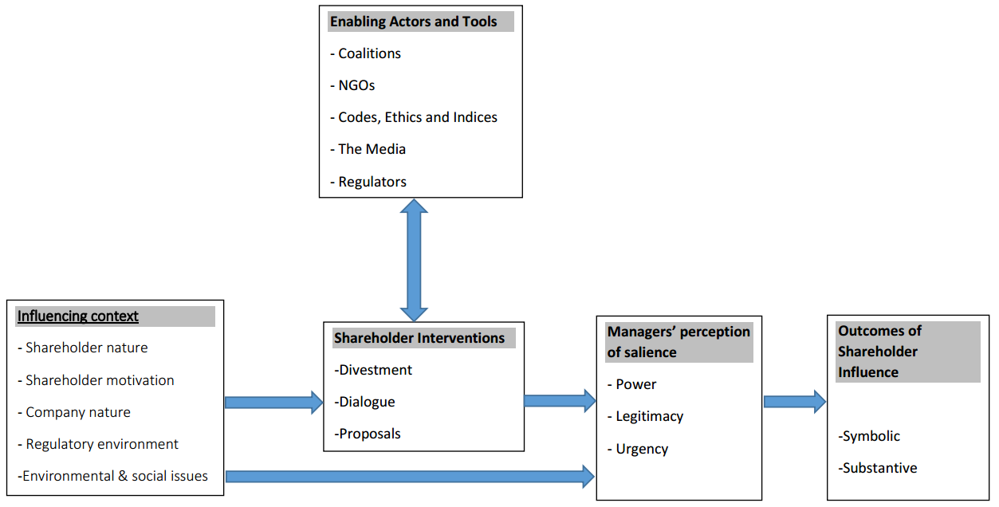

Source: Adapted from Cundill et al., 2018.

2.4.3 Shareholder Activism, Climate Change, Stranded Assets and Biodiversity
The rise of ESG shareholder activism is not only redefining legitimacy in principal-agency relationship, but also attitude to going concern risk awareness (Henderson et al., 2018; Goranova and Ryan, 2014; McNulty, 2016; Ferraro and Beunza, 2018) as pressure continues to mount on companies to change their strategies and corporate behaviour to reduce emissions. These pressures are multi-layered as they come from media and regulators (Ballou et al., 2006), conglomeration of institutional investors protecting their interests from going concern risks (Reid and Toffel, 2009; Camilleri, 2017), international pressures arising from treaties (e.g. Kyoto Protocol, 1997 Paris Accord, 2015), as well as other credible published reports (see table 2.3). All these reports continuously highlight the risk arising from large scale climate change to the long-term survival of business organisations, as well as the opportunities to promote new technologies to ease the effect through reduction of greenhouse gas (GHG) emission (Henderson et al., 2018). There is however extensive divergence on how to combat climate change. Whilst some believe that it is uneconomical to stop climate change considering the costs outweighing the benefits, some have rejected the scientific consensus altogether (Henderson et al., 2018). Based on the quantum of recent shareholder proposals being submitted worldwide addressing social and environmental risks posed to business (ProxyInsight, 2016), the issue of climate change is increasingly becoming important. According to Solomon (2009), Solomon et al., 2011; Stern (2006:304), and Ceres (2010), climate change will have serious risk implications for many industries especially the finance sector, one of which will include recapitalisation. Many reports have been published in recent times highlighting the importance of climate change (e.g. Spence and Gray, 2007; ACCA, 2007) especially from the perspective of the institutional investors due to their fiduciary responsibility. However, a research carried out by Solomon (2009) revealed that there is low awareness as regards the risks posed by the effects of climate change on the investments held in the pension fund.

Empirical evidence from practice has shown the wave of divestment from stranded assets moving from the fringes of the activities religious groups in the 1980s, to the mainstreaming stage affecting the whole market in recent times (See figure 2.2 for examples). The wider market dimension to divestment from stranded assets has been traced to the need to avoid uninsurable risks of biblical proportions (Jones and Solomon, 2013; Ansar et al., 2013; and Caldecott et al., 2013). Such risks and uncertainties influenced a group of investors (see figure 10.5) to launch a divestment 2013 campaign (named 350.org) which encourages institutional investors to “immediately freeze any new investment in fossil fuel companies and divest from ownership and commingled funds that include fossil fuel public equities and corporate bonds within 5 years” (Ansar et al., 2013). The works of Armantier et al., 2010; Ghoul et al., 2011, Durand et al., 2013; and Vergne, 2012 showed that there is a growing awareness of institutional investors about ‘stranded assets’ thereby calling for their global divestment from ‘sin stocks’ or assets that are considered socially irresponsible. Caldecott et al., (2013; 2018) have attributed the stranded assets phenomenon to the Schumpeterian “creative destruction” theory, and the self-destructive tendencies that typifies capitalism whereby latest innovations or techniques render old ones redundant, as well as the need to mitigate environment and social-related risks. Schumpeterian risks presuppose the loss of income and assets due to devaluation and diminution in value. The earliest literature promoting divestment campaign on stranded assets can be traced to Arnold and Hammond (1994) which used case study methodology to analyse the adherence of South African institutional investors to the Sullivan Principles, whereby they recommended the development of acceptable social accounting monitoring models to ensure that investments are socially responsible. Another work focusing on South Africa during the same period (Wright and Ferris, 1997) using longitudinal event study methodology covering 1984 to 1990, reviewed the corporate divestment programmes of companies, and found that divestment from stranded assets has negative effect on share price of the investee companies. This view resonates with Roberts et al., (2006a), reinforcing the disciplining powers of shareholders. Vergne (2012)’s work focusing on the arms industry, used mixed methods consisting of interviews and regression to collect data relating to the top 210 global weapon system providers. Vergne (2012) found that association with a negatively branded category of investment does not necessarily result in the application of native screening due to the existence of a polarised or overlapping multiple interests of shareholder groups. Such straddling governance interests result in “positive evaluations being assessed as less positive and negative evaluations being assessed as less negative”, thereby preventing divestment from stranded assets. On the other hand, Durand et al., (2013)’s work, using quantitative techniques based on over 58,000 observations classified as either saints or sinner (alcohol, tobacco and gaming) found that social norms exerts influence (positive or negative) on investment policies.

Table 2.2: The Waves of Stranded Assets Divestment Campaign
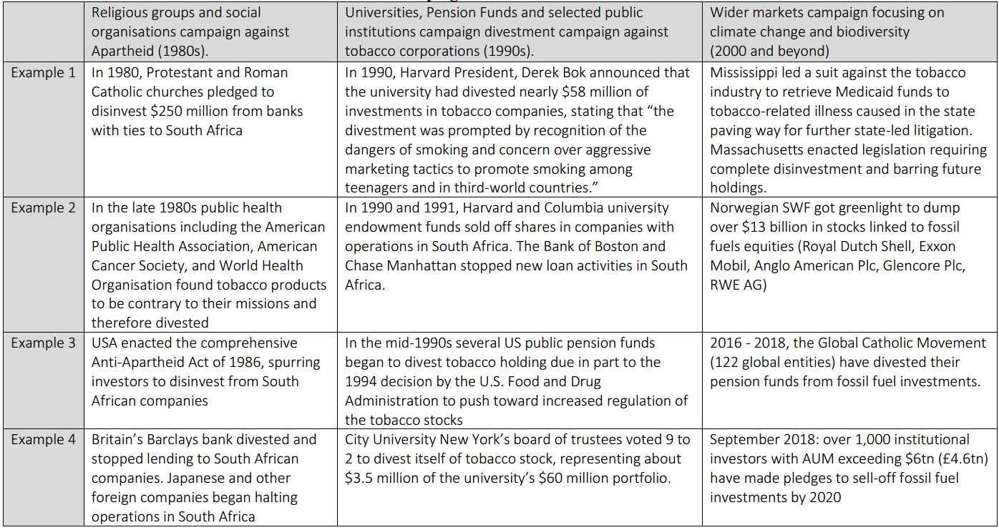Source: researcher’s findings

Table 2.3: Some reports highlighting the dangers of climate change on investment
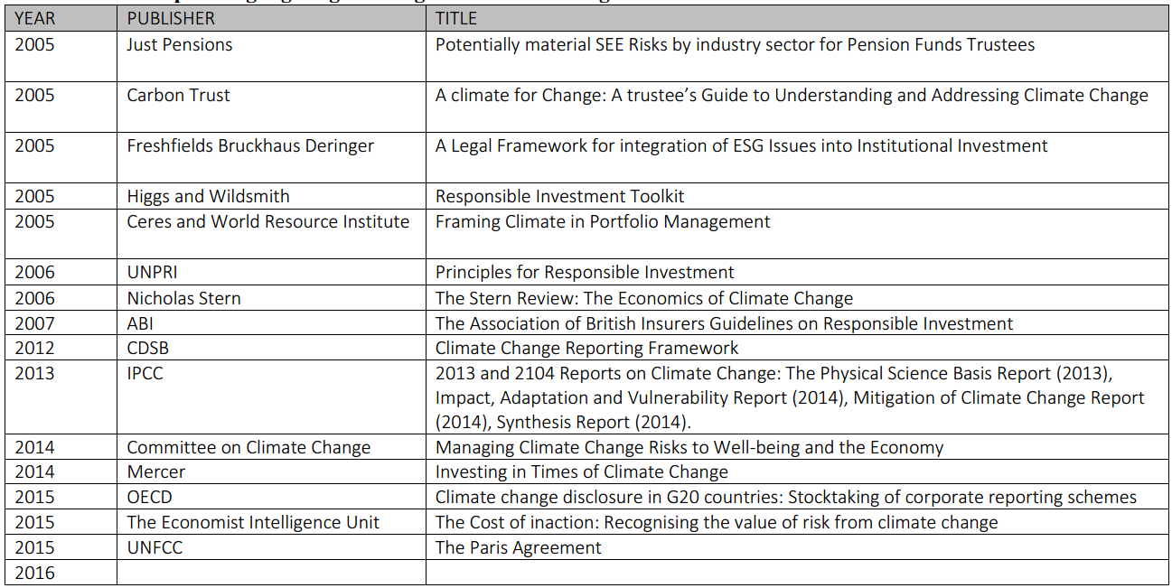Adapted from: Solomon (2009)

As the effect of climate change risks on business continues to grow, it is believed that academic can apply the emancipatory powers of accounting to point the attention of the policymakers to the risk arising from the loss of biodiversity due to the role played by biodiversity in the economic development through the production of flora and fauna which is the main source of raw materials for many industries (Jones and Solomon, 2013). According to Jones and Solomon (2013), it is essential that the benefits accruing from biodiversity resources for human bell-being are properly accounted for. There is however little had been paid to this issue hitherto due to the non-definition of the appropriate philosophical perspective to biodiversity (deep ecology or anthropocentric?), the perception of biodiversity as being cost-free (Jones and Solomon, 2013), and the difficulty in the monetisation of biodiversity (Davidson, 2005; Elad and Herbohn, 2011). However, the declining state of stocks of flora and fauna has however led to surge in the call for the regulation and pricing of biodiversity (Hardin, 1998; Chapman and Blockley, 2009). Previous work on biodiversity has focused on inventory based on hierarchical criticality (Jones, 1996; Siddiqui, 2013) which took anthropocentric perspectives, and deep ecology approach (Houdet, 2008 and Houdet et al, 2009; Tregidga, 2013).
The work of Rimmel and Jonall (2013) based biodiversity reporting in Sweden highlighted the low level of biodiversity reporting in Europe, and the need to extensively increase biodiversity reporting in the developed world. These findings are in tandem with the conclusions of Grabsch et al., 2012 based on a comparative study of biodiversity reporting in Germany and the UK. As integrated reporting is becoming mandatory in some jurisdictions (Solomon and Maroun, 2012), and as professional bodies (ABI, 2012; IIRC 2011, CDSB, 2012) increase their reporting interest in the risks posed by climate change and declining biodiversity to all parts of the society, it is expected to lead to increased fiduciary interest on the part of institutional investors that worry about going concern of their investee companies. Jones and Atkins (2013) have therefore proposed a decision-making approach to the issue of climate change and biodiversity reporting for corporations, as it had been variously applied in Georgakopoulos and Thomas (2005) and Solomon and Thompson (2009).
Consequently, the CDSB (2102) has released a disclosure framework on greenhouse gas emissions reporting, setting out reporting guidelines of the content of such sustainability report. Bachoo et al., (2013) in reviewing corporate sustainability reports has however criticised reporting guidelines for being optional with inconsistencies in performance metrics, time frames and non-uniformity of practices within industries. He also argued that such reports is capable of being used to obfuscate profitability which owners are most interested in. Bachoo et al., (2013) then concluded that the current sustainability reporting path is a “feel good” initiative, and therefore recommended boycotts, a form of “wall-street walk” activism. It has been observed that the CDSB (2012) framework has not addressed the root problem of environmental reporting due to its inability to address the issue of independence assurance (Jones and Solomon, 2010) and how to keep and publish relevant biodiversity data, its focus, e.g. flora, fauna, or habitat (Jones, 2003; Houdet et al., 2009).

2.5 The Role of the Investment Community
2.5.1 Institutional Investors
It is believed that asset owners, due to their relatively large equity holdings in investee companies, have a fiduciary duty to use the powers attached to their shareholding to ensure that beneficiaries have a voice, consulted before taking actions with long-term effects, and apply professional care, skills and diligence in managing the affairs of the assets held in trust (Mallin, 2012). They are therefore best placed to implement corporate governance reforms for the good of the investee companies (Waitzer and Sarro, 2014; Mallin, 2006). This suggests the reason why Useem (1996) concluded that the concentration of shares, and hence power, into a relatively small number of hands has enabled institutional investors to directly challenge management on issues of concern. These views are reflected in many of the recommendations of several committees set up to review corporate governance in the UK between 1991 and 2012^{2e}. In recent times, there has been concerns that the failure of these asset owners to live up to expectations in the wise use of their votes and holding directors to account have contributed to the series of corporate collapses witnessed in recent times, hence the increasing focus on how they exercise the powers attached to their shareholding. This has made concerned stakeholders on UK corporate governance to advise those who own equity in companies listed on the stock market to take a much ‘hands on’ role in corporate affairs ^{2f}. It has been argued in many quarters (Cheffins 2010, Solomon 2009, Mallin 2010) that if shareholders step forward to take their role as ‘owners’ of companies seriously, this will do a great deal to keep agency costs in check. Despite their important role in the UK economy, little was known about the governance of UK pension funds except the importance of their fiduciary duties (see Evans et al., 2008; Clark, 2004) and almost none about the governance of Sovereign Wealth Funds except the Norwegian Funds which are reputed to be the hallmark of transparency (Clark and Monk, 2010). However, this has changed considerably after the Stewardship Code (2010) which requires them to play active role in the affairs of their investee companies^{2g}.

Figure 2.4 Comparative number of shareholder revolts USA and the UK

*Revolts are classed as 20% or more opposition to executive pay
SOURCE: Proxy Insight, 2020.

The overall level of voting against executive pay by investors in the UK FTSE All share have been steadily increasing since the Shareholder Spring I and II, and now surpassing the US’ S&P 500 (See figure 2.4). Although the number of companies experiencing revolts from shareholders of non FTSE-100 companies have remained less than 10 since 2015, the number of FTSE-250 or FTSE-350 companies witnessing revolts have continued to increase thereby suggesting dissatisfaction in the investment community with the current government policy on remuneration reporting and the non-alignment of the reported pay to long-term strategy and performance (see table 2.4) thereby forcing some executives to resign as a facing saving measure (FT, 2020). This increase in the awareness of the powers to vote against executive remuneration reports is partly due to the requirement of the Stewardship and PRI Codes which encourages engagement, and the law amendment on the hitherto non-binding votes on executive pay. However, it has been observed that despite the growing percentage of ownership by foreign investor groups, their voting patterns are not made public, and there is little accountability in this area (Mallin 2011). What are their voting patterns on matters relating to ESG matters from 2007-2017, and how have they been influenced by their proxy adivsors during that period? There is also a noticed trend in making executive pay binding globally (see table 2.4), although some have argued that making votes executive pay binding is synonymous with the ascension of left-wing parties in political power (Thomas and Elst, 2015). As new proposals demanding integration of ESG into executive pay is rising (see chapter 3), it is envisaged that this will further enhance shareholder engagement globally. This research work will expand the literature in this area by gathering data about the proxy advisor’s philosophy in issuing voting directives, their voting patterns, and engagement with investee companies on matters relating to ESG.

Table 2.4: Executive Pay voting adoption by country
Adoption Year Country Voting type
2004 Netherlands Binding and mandatory vote, but can be delegated
2005 Australia Advisory (non-binding) but mandatory
2005 Japan Binding “say on pay”, and mandatory vote
2005 Sweden Binding and mandatory, but may become non-binding soon
2007 Denmark Binding and mandatory vote
2007 Finland Binding and mandatory vote
2007 Norway Binding and mandatory vote
2009 South Africa Non-binding but mandatory vote
2009 Germany Advisory (non-binding) and voluntary
2011 Italy Non-binding but mandatory vote
2011 Spain Non-binding but mandatory vote
2011 USA Non-binding but mandatory
2012 Belgium Advisory (non-binding) and voluntary
2012 Canada Advisory (non-binding) and voluntary
2013 UK Binding vote*
2014 France Advisory, but mandatory if pay exceeds €450K
Source: Researcher’s findings
*According to the UK Department of Business Innovation and Skills Report (2013) with effect from October 1, 2013, shareholders now have a binding vote on a resolution to approve the directors’ remuneration policy. The policy must outline how the company proposes to pay directors, including all element of remuneration that a director will be entitled to, and how such entitlement helps in achieving the company’s long-term strategy and performance, as well as details of the company’s proposed recruitment and loss of office compensation. Companies must put the remuneration policy to a shareholder resolution at least every three years. Companies are also expected to produce an annual implementation report on how the approval pay policy has been implemented, including a single figure for the total pay directors received that year. Shareholders will also have an annual advisory vote on a resolution to approve the implementation report.

2.5.2 Pension Funds
Private pension funds in the UK represent a substantial part of the financial markets and they are an essential contributor to savings and economic growth. They are valued at approximately two-thirds of the GDP in 2012. In order to spread risks, their investments are diversified and spread onto many channels including listed equities. Unlike hedge funds that are on pressure to earn huge fees, or private equity that wants to take the investee company off the public listing, or SWFs that may harbour underlying political interests, pension funds are relatively free from conflict of interest. These are some of the reasons why Coffee (1991) argued that pension funds are relatively superior to other institutional investors and are therefore in the best position to enforce good corporate governance through active ownership due to their freedom from conflict of interest and long-term investment horizon. This is in agreement with the conclusions of Karpoff (2001) that a positive correlation exists between shareholder activism and good corporate governance. However, empirical evidence from the works of Del Guercio and Hawkins (1999); English et al., (2004) suggests that there is limited evidence to support this theory. Result of a survey by NAPF (2010) concluded that majority of UK pension funds are active investors as over 90% of the UK pension funds delegate engagement work to investment manager or other consultants. A recent investigation by parliament^{2h} revealed that over 95% of the top 25 pension funds in the UK, with £561.82b AUM discusses the effect of climate change risks on their portfolio and are involved in TCFD reporting. In the Shareholder Spring I and II, many pension funds were active and, in many cases, recommended that shareholders vote against executive pay reports (see figure 2.4). Unfortunately pension funds ownership of UK quoted shares has fallen from its peak of over 30% in 1989 to less than 20% in 2018 due to the surge of SWFs.

2.5.3 Private Equity and Hedge Funds
Hedge funds activism takes its root in the agency theory which stresses the principal-agent relationship, whereby investors need to monitor and motivate managers so that they can maximise shareholders wealth (Beatty and Zajac, 1994; Brav et al., 2008; and Edmans et al, 2013). Based on this theoretical perspective, hedge funds activists are perceived to be expressing dissatisfaction, either with financial performance, corporate governance or specific performance (Becht et al., 2009). Whilst the objective of the traditional shareholder activism is to shrink agency problems (Chen, 2004) in order to improve the long-term performance of the investee companies (Becht et al., 2009) or any other highlighted governance issues, actions or improvements of existing internal processes (Gillian and Starks, 2007), hedge funds activism are interested in driving share price either upwards or downwards in order to reap the accruing benefits now rather than later (Gantchev, 2013; Edmans et al., 2013). This explains why the offensive shareholder activism was applied by hedge funds and private equity firms sponsoring private buyouts of public companies became prominent in the UK after 1990 (Cheffins, 2008). Hedge Funds are privately organised investments administered by professional managers with performance-based reward, and these investments are not available to the general public (Brav et al., 2008). The pay reward structure encourages risk taking and therefore induces value-creating activism. Hedge fund managers make their money in two ways: by charging average annual fee of 2% on the value of assets being managed and 20% return as performance fees (Clifford, 2008). Due to the lack of regulation hitherto, hedge funds were able to take big risks by taking a leveraged position in their target companies. In addition, they are not compelled to diversify their investment portfolio (Pacces, 2017). The objective of hedge fund activists is to arbitrage in the market where there are inefficiencies in order to maximise returns. For example, buying an underperforming company and selling for a profit thereafter (Paccess, 2016).

Although Clifford (2008) argued that hedge funds are formidable threats to their target companies due to their offensive activism style, Pacces (2012, 2017, and 2018) demonstrates that the threats similar to hostile takeovers possessed by hedge-funds, are in-built disciplinary mechanism that keep management on their toes. This is however capable of driving these companies towards short-termism. Unlike other institutional investors adopting defensive activism (e.g. pension funds), they can threaten to buyout their target company and this may force the directors to reach a compromise with them. The main motivation therefore, for a hedge funds activist is the promised short-term rewards. According to Pacces (2018), a hedge fund manager engages in activism if the benefit accruing from the intervention exceeds the cost by screening the market for underperforming entities that could be bought and turned around relatively quickly. This pressure to profit from short-term change are likely to exacerbate market failure since pressure from hedge fund owners may put management under pressure to pursue short-term returns rather than long-term value creation. Brav et al., (2008) found that hedge fund activism “generates large positive abnormal returns for both shareholders in the target companies and those in the activist hedge funds”. Although the objective is to maximise wealth of the hedge fund (and not those of the target companies), the professed motives include geared capital structure, business strategy, asset stripping, sale of target-company, and few governance issues (Pacces, 2012, 2017). The short-termist motives above are some of the reasons why Coffee and Palia (2016) and Paccess (2018) cannot find any evidences of ESG activism being sponsored by hedge fund activists, making them to recommend the neutralisation of hedge fund activism through anti-activist poison tools, ownership disclosure, shareholder identification and engagement by non-hedge fund shareholders in order to crowd out hedge funds equity shares.
Although ESG awareness amongst private equity and hedge funds managers is increasing due to the publication of the ‘Guidelines for Responsible Investment’ by the Equity Council in the USA (now replicated in the UK by the BVCA), there is a still a scarcity of literature presently on how hedge funds incorporate ESG issues into its investment process, which the work desires to plug.

2.5.4. Sovereign Wealth Funds
SWFs are government owned funds that are invested globally in equity and other instruments as a by-product of government budget surpluses and that have accumulated due to favourable macroeconomic indicators like oil sales. Bergsten (2009) argued that SWFs are particularly in a position of strength because they have high tolerance for risks, and that they exhibit the tendencies to engage in countercyclical investment behaviour. For instance, they can be used as a fiscal buffer stock to keep spending relatively high when there is a shortfall in revenue in times of recession. However, SWFs are trapped between financial and political imperatives as they are now attracting attention from corporate governance scholars due to their rapid pace of asset accumulation, the relative size of funds and the underlying political interests that they represent (Karametaxas, 2017). For instance, top 81 SWFs now control $8trillion AUM as at August 2019^{2i}. Three factors have influenced the increasing attention is being paid to the role of SWFs to act as responsible investors. Firstly, due to the quantum of the size of their investment in equities, SWFs are seen as key in “2030 Agenda for Sustainable Development” which requires additional US$2.5 trillion per year in order to achieve the SDGs^{2j}. Secondly, over 40% of the equities on the London Stock Exchange are now held by SWFs which are not being held to the same regulatory standards as the pension and mutual funds. Thirdly, a group of SWFs committed to the ESG framework was set up in 2017^{2k}. Gilson and Milhaupt (2008) re-echoed the opinion of critics of SWFs growing influence in the USA and the perceived risk that they may ultimately transform from foreign investors into an instrument of political intervention and industrial espionage. For instance, Qatar and Dubai SWFs together own about one-third of the London Stock Exchange^{2l}. Gilson and Milhaupt (2008) therefore argued that SWFs may become channels for promoting state capitalism to the detriment of free market principles, and they should therefore be subjected to restrictive regulatory policies because they harbour political interests that are capable of damaging business. This view is supported by the opinion that they are responsible for blurring the lines between international economics and geopolitics^{2m} Gilson and Milhaupt (2008) therefore proposed the cancellation of the SWFs shareholder voting powers unless they transfer those holdings to non-state actors. Although this is a simplistic corporate governance fix that insulates SWFs from political power, it can elicit retaliatory moves that may have into unintended consequences.

On the other hand, Avendaño and Santiso (2009) attempted to shed light on the concerns of Gilson and Milhaups (2008), and the found, based on 14,000 observations of holdings comparing mutual funds and SWF, that their investment principles and decisions do not differ materially. They therefore recommended that SWFs should be held to the same governance standards as other institutional investors. In the same vein, Truman (2010) also rejected the arguments that SWFs pose threats to international economic competitiveness, but then proposed a stronger accountability and transparency that neutralises any political motivations. The Santiago Principles was therefore developed to entrench transparency and standardise governance based on a body of voluntary code. However, the implementation of the code had been left to the individual funds, and there has been uneven commitment to the implementation based on the Santiago Compliance Index, although Norwegian Funds’^{2n} ethical investment model is seen as models worthy of emulation for other SWFs (Halvorssen, 2011; Reiche, 2010; Clark and Monk, 2010b).

Though SWFs are not subject to fiduciary duty in a formal legal sense, the international community informally holds them accountable as fiduciary investors (Clark and Monk, 2010a). Clark & Knight (2011) acknowledge the function of some SWFs to provide intergenerational equity and give consideration to longer-term investment horizon that requires the inclusion of non-financial factors like climate change into investment decision-making. Most existing studies focus on traditional fiduciary investors (e.g. McNulty and Nordberg, 2016), and there are few studies on governance frameworks for responsible investments as regards SWFs. This may be due to the degree of ambiguity in governance framework which Clark and Knight (2011) argued, may be permissible due to the political objectives of the country sponsoring the funds. However, Avendaño and Santiso (2009 thought that heavy political coloration may affect the weight that the SWFs attach to certain ESG issues since they cannot be divorced from their political context. SWFs may therefore exclude ESG from the investment process without any explanations to the beneficiary owners if the local laws do not demand such explanations. For fiduciary investors such as pension funds, such exclusion will have to be explained since as trustee performance is conditioned by a legal obligation to their beneficiaries and current legal interpretation of fiduciary duty is based on conventional investment practice (Woods, 2011).

Furtherance to evidence from existing literature (Gompers et al, 2003; Orlitzky et al, 2003; Donald and Taylor, 2008) that reveals that integrating ESG factors lead to superior performance in the long run, Hawley and William (2007) through qualitative empirical data, found that large universal owners adopting effective RI strategy can generate material value because it is the success of the economy (dependent on ESG factors) rather than individual corporations that is of consequence to these asset owners. Since SWFs are also universal owners, it is expected that the same principles can be applied to them, and that RI can serve to reconcile financial and political imperatives of SWFs if it is supported by governance framework that is transparent and encourages accountability.

2.5.5 Proxy Advisory Firms
According to (Larcker et al, 2013) proxy advisory, although relatively new in the corporate governance world, have massively increased their influence on the voting process as they now provide services such as issuing voting guidelines, handling the workings of the voting procedure, issuing governance advisory, as well as offering recommendations on how to vote for or against a proposal. It was apparent that the role of proxy advisors became prominent in the UK due to the requirement of the Stewardship Code (FRC, 2010) which requires active ownership on the part of asset owners. It is now becoming a norm for some institutional investors to outsource entire proxy issues to them in order to free up time for other investment activities (Choi et al., 2010). According to the works of Larcker et al. (2015), Brossy (2012), Cai et al. (2009), the outsourcing of the proxy process has created new phenomena as proxy advisors themselves became powerful, which was an unintended consequence. Secondly, conflicts of interests arose whereby the proxy advisors (the agents in the investment chain) themselves may be interested in the investee companies, and this interest may not be in tandem with those of the institutional investors (i.e. the principal). As a result of these two aforementioned factors, there is the fear that the quality of the advice received from the proxy advisors may be compromised, thereby harming the long-term shareholder value (refer to figure 2.4).

Figure 2.5: Proxy Advisors: Perceived influences and Effects.
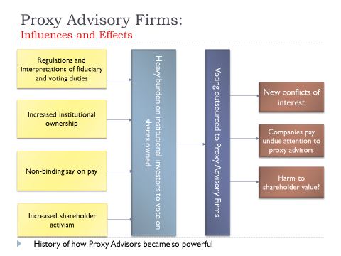
Source: Olatubosun (2018)

This is why they are considered by Larcker et al. (2015) as being a powerful force in the emergent investment value chain. ISS and Glass Lewis are considered to have the largest global client base, as according to views from Kim Clark^{2o}, Bethel and Gillian (2002) and Eckstein and Hannes (2018). ISS alone is able to influence up to a third or more of the shareholder votes. The activities of these proxy advisors came to the front burner in 2012 when CEOs of WPP and AVIVA resigned as their executive pay reports were voted down 60% and 58% respectively based on the recommendations of these agents in the investment chain (although the votes were non-binding in nature). Practitioners have also noticed growth in the work of proxy solicitors who are in the business of helping directors defend proxy contests amongst others. It could be argued that the increase in voting by institutional investors and nominee account holder could be attributed to them. However, little have been written on this area.

2.6 Investment relations (IR) and Dialogue in Shareholder Engagement
Generally the body of literature on IR can be segregated into two: voluntary disclosure and firm visibility or promotion (Brennan and Tamarowski, 2000). However, this literature review will concentrate on the former. Researchers have previously applied methods in examining directors’ motives in voluntary disclosure of private information. For instance, Grossman and Hart (1980), and Grossman (1981) concluded that voluntarily disclosed information are likely to be factual if there is no cost burden on the directors, in which case, full disclosure would be optimal. They also concluded that full disclosure is an optimal policy because partial or non-disclosure is likely to send the wrong signal to investors, which will ultimately affect share value. In practice however, directors do not disclose all information to investors because costs are involved, especially when motivated by market competition (Darrough and Stoughton, 1990; Dye, 1986; Verrecchia, 2001; Newman and Sansing, 1993). This literature suggests therefore, that directors are motivated to voluntarily disclose information if it is likely to impact positively on the value of the firm or reduce the cost of capital (Easley and O’Hara (2004). In 2010, The London Stock Exchange published a practical guide on investors relations (IR) identifying the interested parties and the suggested content of such meetings with accompanying case studies, with recommendations to public limited companies to implement the policy (see figure 2.5). The earliest research in IR practice in large UK companies was carried out by Marston (1996) based on an exploratory survey of the largest 500 companies listed on the London Stock Exchange. The work found that only 51.2% of companies have a dedicated department for IR, and that executive directors dedicate up to 36.5 working days in a year to IR. A repeat of the survey in 2002 amongst other findings (see Marston and Polei, 2004) revealed that 93% of companies now have a department dedicated to IR. Other studies (Barker, 1998; Holland 1998a; 1998b) reveals that IR meetings possess the ability to benefit both the investors and the directors since the company will understand the mandate of the shareholders, and the investors improves their knowledge of the investee companies’ corporate strategy. Both PRI and Stewardship codes have encouraged companies to use IR in their engagements.

In terms of “firm visibility”, Merton (1987) developed a model of capital market equilibrium which hypothesised that investors are only informed about a sub-set of the universe of securities and that expected returns decrease with the degree of investor recognition, i.e., firms with larger investor bases have lower expected returns. The model therefore “provides a justification for incurring expenses on advertising about the firm that is targeted for investors and on public relations designed to generate stories about the firm in the financial press (1987, p501). The core of Merton’s (1987, p506) theory is that investors only invest in the securities which they “know about”. This assumption is grounded in the behavioural finance literature and is also consistent with the use of heuristics in investment decision making, which is associated with the art of reducing the complex task of assessing risks of future occurrence and the prediction of future investment values to simpler judgment procedures. An example of the use of heuristics is demonstrated by the rule of the thumb explained in Goldstein and Gigerenzer (2002, p76) thus: “if one of two objects is recognised and the other is not, then infer that the recognised object has the higher value with respect to the criterion”.

The Merton’s theory has been supported by Falkenstein (1996) which found that institutional investors generally prefer to invest in firms that (1) have acquired lots of goodwill from many years of operation, (2) regularly enjoys press coverage, and (3) demonstrates high level of shares liquidity and security. These findings have also been supported by works of Dahlquist and Robertsson, 2001; Gervais et al., 2001; Barber and Odean, 2005) which suggest that engaging in investors relations (IR) meetings increase firm visibility, and therefore likely to enhance shareholder value.

IR meeting is a means through which shareholder salience is promoted. For shareholders to be noticeable to the directors, power and legitimacy must be exercised. According to Mitchell et al, (1997), these two are intertwined, and must be exercised in such a way as to get directors to heed their mandate. Unlike the AGM which comes once in a year, IR connotes urgency since it is based on the premise that certain issues call for immediate attention, and could be addressed now, rather than waiting till the next twelve months. James and Gifford (2010); Mitchell et al., (1997); and Agle et al., (1999); all argued that shareholder salience has a positive correlation with power, legitimacy and urgency, thereby giving credence to a facilitation such as IR, which provides opportunity for directors and shareholders to urgently address matters bothering on business strategy and business value, especially when the going concern of the company is at stake. Strickland et al. (1996) found that IR meetings are avenues for dialogue with directors. This view also tallies with Roberts (et al, 2006b) that also found, using empirical qualitative research, that attendance at IR meetings is advantageous to both management and shareholders as they provide avenue for dialogue that douses investor sentiments and management reassurance. Uche and Atkins (2015) also using empirical qualitative research, found that participation in shareholders’ association’s meetings play a crucial role in conflict reduction and sustaining accord between management and shareholders.

Many research outputs confirm the benefits engagement and dialogue between management and shareholders, such as the provision of enabling environment to discuss strategy issues and understand respective parties’ limitations (Logsdon and Van Buren, 2009). More attention is now being paid to dialogue due widespread use by practitioners (PWC, 2018).
Ferraro and Beunza (2018) contributed to the understanding of shareholder engagement by examining how collaboration can emerge from engagement with shareholders, based on a case study of the series of interactions between a faith-based investor and an investee company. They then recommended integrative communicative system that starts with strategic action and ends with communicative action, an iterative process which passes through three stages: i.e. dialogue, framing and deliberation, such that, as the process moves from strategy to dialogue, there is more communication and less of strategic planning. Ferraro and Beunza (2018)’s work builds on Cornelissen et al. (2015)’s literature on communicative institutionalism, which study organisations’ “application of symbolic interactions as potential formative institutional reality” (p10). However, little has been written on the analysis of the matters being discussed at IR meetings, especially after the publication of both PRI and Stewardship Codes, to explore the issues being discussed at such meetings.

2.7 Shareholder Proposals
2.7.1 ESG Shareholder Proposals
Grewal et al. (2016) confirmed that the use of shareholder proposal as an engagement method has grown substantially. Using quantitative method showed the number of shareholder proposals filed within a 15-year period (1999 and 2013) had doubled to a total of 2,665, with 40% of the total figure being submitted in 2013 alone, although the research cannot confirm whether these filing led to an increase in the sustainability performance and the shareholders wealth of the entities. They also found a high prevalence of ESG proposals being withdrawn before AGM, suggesting the increasing use of dialogue, which agrees with Ertimur et al., (2011) and Bauer et al (2015). Grewal et al., (2016) also found material improvements in ESG performance after the proposal has been withdrawn. In addition, the research was based on the case study of the USA, thereby making a case for the investigation of shareholder proposals filed in the UK. The significant increase in the number of UK based PRI signatories between 2006 and 2016 notwithstanding, a large proportion of the existing literature has explored integrating corporate governance in investment decision making (Amaeshi and Grayson, 2009; Juraville and Lewis, 2008; 2009; Bourghelle et al., 2009; Hoepner et al., 2013) have concentrated on fiduciary issues, identification and removing barriers preventing asset owners, complexity and power relations inadequate management systems. Little attention has been paid to the investigation of the various ESG issues filed through shareholder proposals in the UK, how they were eventually disposed of. Perhaps this may be due to the high costs involved in accessing such databases. Buchanan and Netter (2010) compared the shareholder proposal system in the UK and the USA, analysing based on sponsors and shareholder classification. However, due to the changing shareholding terrain and the factors driving shareholder activism has changed over since the Buchanan et al., (2010), there is a case for a new research concentrating on the ESG shareholder proposals filed by the investment community in the UK.

Buchanan et al., (2010) revealed that the issue of ESG was at infancy stage in the UK between 2000 and 20101, due mainly to legal constraints. But a noticeable spike was noticed once the constraint was removed through the Companies Act 2006 which enabled minority shareholders to file such proposals. Table 2.5 shows that ESG issues was marginal due to the perceived value attached to ESG, and due to non-understanding of the link between engagement and shareholder value. A recent survey by UNPRI (2016) found that there are still many barriers that limit the use of RI strategies by Asset Owners. What are the latest drivers of ESG activism, and why are they changing? There is therefore a case for increasing the body of literature and the current debate on the strategies applied by asset owners in factoring governance into investment decision making in the UK.

Table 2.5: Shareholder Proposals filed by shareholders in the UK (2000-2006)
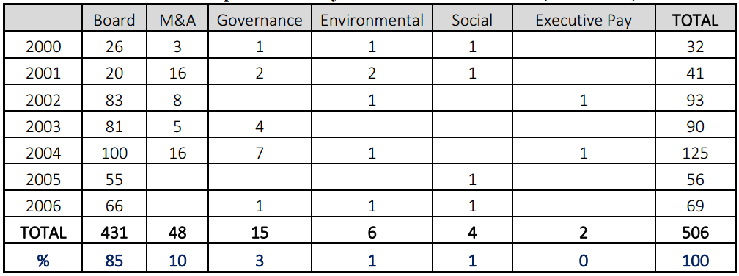Source: Buchanan and Netter (2010)

Table 2.5 above as captured in Buchanan and Netter (2010) was scanty because the period between 2000 and 2006 was not covered under the Companies Act 2006 which took effect in 2007 because the fact that a conglomeration of a hundred shareholders can submit a proposal, irrespective of the value of their holdings, began to elicit interest of activist shareholders only after 2007. In effect, what Buchanan and Netter termed as “shareholder proposals filed by shareholders in the UK from 2000 – 2010 was in effect covering 2007 - 2010. Secondly there were few recorded shareholder proposals concerned with ESG during the period 2007 to 2010 perhaps because ESG issues were not considered as mainstream (see Haigh and Hazelton, 2004), and such issues were only being promoted by social activist investors, and the directors are likely to recommend voting against such proposals as seen in the case of BP in April 2000 (see page 57). Thirdly, the Companies Act 2006 was relatively new, and there was lack of awareness of the material relevance of ESG risks by company directors and how to manage them.

Figure 2.6 Procedures for submitting a Shareholder Proposal
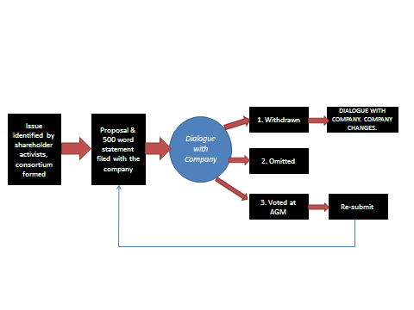
Simplified schema of the typical outcomes of a shareholder resolution process.
SOURCE: A. O’Rourke, 2002.

Table 2.6 Typical ESG Issues
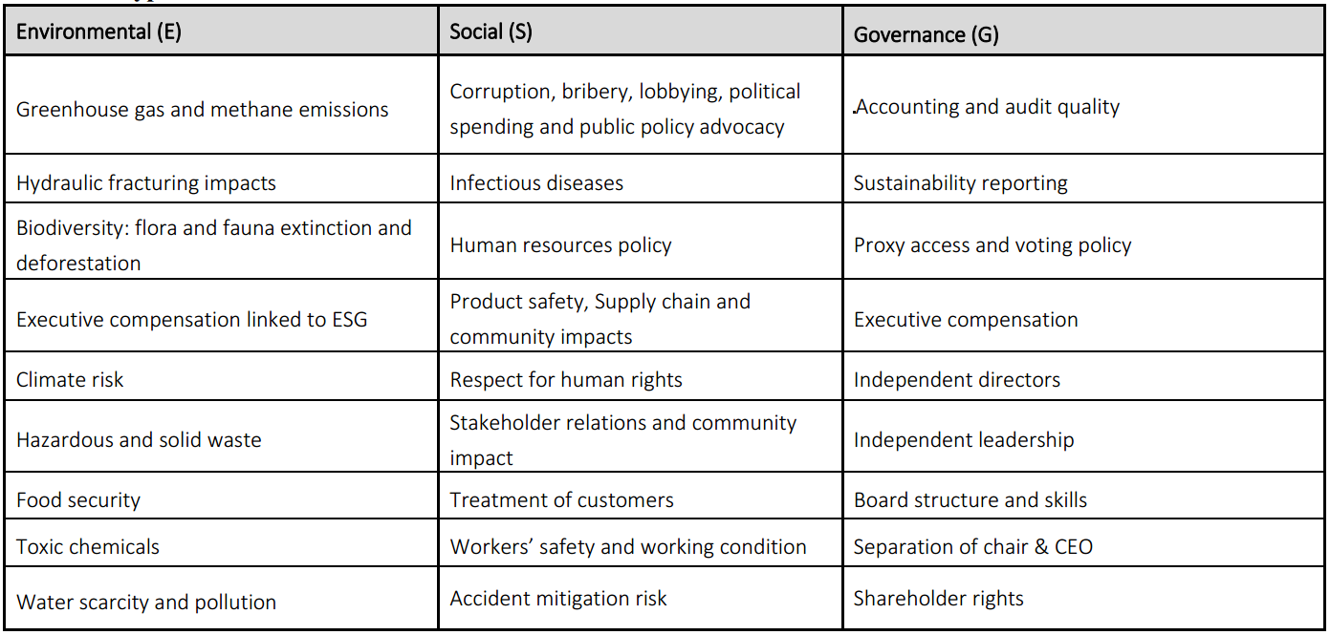Source: Olatubosun (2013)
2.7.2. Some High-Profile Shareholder Activism Cases
Some high-profile cases in shareholder activism are discussed below.
2.7.3. Blocking corporate merger or take-over or limit the price at which they occur.
- Prudential Plc.
The company launched a £24 billion takeover attempt for AIA, the Asian insurance unit of the government-controlled US insurer, AIG. The deal failed after major shareholders indicated their unwillingness to back the rights issue to fund the deal because price tag is seen as unrealistic. This subsequently left the company with £377m in wasted advisory fees. A group of City institutions, outraged by this seemingly irresponsible management, decided to consult each other to take a unified action against management. The action failed after a high-profile campaign the fund manager, Neptune Investment Management advised the institutional investors who are company’s biggest investors not to back the deal (FT, 2009). This is seen as a big breakthrough in shareholder activism as UK institutions are not culturally accustomed to working together to bring about change. ‘It is hard to get institutions to agree on anything. It is a bit like herding cats’ When shareholders come together-which is unusual- they carry more weight (FT, 2009).
At the AGM, the directors were questioned for almost three hours on the failed deal. Some shareholders then called for the resignation of the CEO Tidjane Thiam and the chairman Harvey Mc-Grath. The action also failed because they had the backing on the major investors.

- Fred Goodwin & Sir McKillop at RBS
Institutional investors and other major shareholders overwhelmingly accepted the takeover of ABN-Amro, a Dutch bank in August 2007. The bid received almost 95% of shareholders voted in favour of the bid, although some shareholders were concerned that the deal was risky and overpriced. A business editor described the deal as “the handmaidens of reckless, greed, corruption, and destruction”.
During the first half of 2008, RBS declared a loss of £691 million after taking £5.9 billion worth of write-downs and had to carry out a £12 billion rescue rights issue. Legal & General Investment Management (LGIM) an active shareholder, responded by lobbying privately for the dismissal of chief executive Mr Fred Goodwin and the chairman Sir Tom McKillop. In August 2008, RBS tried to address investor concerns by appointing 3 new NEDs but said nothing about Goodwin and McKillop. LGIM, not satisfied, sought to engage RBS subsequently but the duo only stepped down when the UK government took effective control of the bank a few months later in return for a massive injection of capital.

    - Forcing a change of strategy:
- Forcing a change in strategy and risk management culture at HSBC
KVAMC, an activist hedge fund successfully pressed the board of directors of HSBC to conduct a wholesale strategic review of its business including an examination of its corporate governance procedures for management risks. HSBC had suddenly increased its appetite for risky investments especially in the emerging markets. For instance, in September 2007 the bank paid $6.3 billion for a 51% equity shares in Korea Exchange Bank. In 2006, the bank had to set aside £1.7 billion as provision to offset the bad loans incurred its US operations. That was the first time in its history that a profit warning is being issued. The loss, coupled with the need to improve its capital adequacy, led to the bank’s launch of the £12.85 billion rights issue in March 1989, which was a record in British history.
Behind the scenes, Knight Vinke Asset Management Company (KVAMC), which owns less than 1% of the equity shares, claimed it had written several letters to the chairman of the HSBC group before deciding to go public by publishing its position in the newspapers. By June 2009, Legal & General Investment Management which is the bank’s largest shareholder (with 3.23% share) and other majors like Barclays Global Investors and Saad (a foreign investor) gave public support to the lobby for the change of strategic direction.

- Vodafone (by Efficient Capital Structures lobbying for a change in strategy),
Efficient Capital Structures (ECS) are activist shareholder group that holds 210,000 shares in Vodafone which is less than 1% of the equity shares – 0.0004% of the 52.9 billion issued shares of the company. ECS proposed four resolutions to be presented to shareholders at the AGM on 24 July 2007. One of the proposals include the return of £38 billion cash back to shareholders due to perceived overcapitalisation, through the issuance of a new £35 billion shareholder bonds. This equates to an amount of between 33p and 73p per equity share in issue. Another proposal is demerger of Vodafone’s 45% interest in Verizon Wireless, a US joint venture. ECS argued that the issuance of the new bonds would allow Vodafone to restructure its dividend payment in a tax efficient manner which would lead to a reduction of £600 million in the annual tax bill, i.e. an overall NPV to shareholder of £6 billion was calculated.
As it is bona fide shareholder having support of over 100 other shareholders, it is legally eligible to have its proposals put to vote at the AGM. ECS tried to get the support of the institutional shareholders. ECS also mandated Salisbury Associates to target more than seven thousand institutional investors who are either having shares in or managing funds for Vodafone. The proposals failed as the votes were not carried. However, Vodafone’s share price significantly out-performed the FTSE index as prospective investors focused on the value story. The demand for change led to a temporary surge in Vodafone price due to speculations that the company may eventually be broken up into two different companies.

    - Imposing ESG policies on investee companies
- British Petroleum
13½% of shareholders in BP Amoco voted ‘YES’ for the agenda on ‘strategic positioning over climate change’ on April 13, 2000. The agenda requests BP to stop the development of the Northslope field in Alaska and redistribute the investment to the BP Solarex division. The proposal was sponsored by the PIRC and supported by other environmental activists like Greenpeace, US Public Interest Research group, Trillium Asset Management Company, and the SRI rating agency, Innovest. Prior to the Annual Meeting, a campaign website www.sanebp .com containing the proposal as well as background information about the company was created.
Although the proposal failed in 2000, another proposal was launched in 2001 asking BP to ‘outline how it plans to move away from fossil fuels to renewable energy’. The 2001 resolution was supported by more than one hundred and thirty shareholders holding over eleven million equity shares, but BP ruled out the resolution on a legal technicality.
In 2002, WWF spearheaded the campaign, and paid for adverts in the Washington Post and Financial times to sensitise the shareholders before the Annual Meeting. The WWF resolution required BP to disclose how it plans to mitigate the environmental risks and its impact on shareholder value. The result of the 2002 campaign showed 11% voting ‘YES’ plus additional 9% abstentions which was seen by environmental campaigners as a big success.
In recent times, shareholder activism against BP has been concerned with the issue of executive pay. In 2012, the ABI issued an “amber top” alert to its fellow institutional investors, to look at the issues surrounding bonuses exceeding £100,000 awarded to two EDs in charge of finance and downstream – Byron Grote and Iain Conn. These payments were seen by RI practitioners as unethical because they were proposed on the heels of the environmentally damaging oil spills in the Gulf of Mexico.

- Lonmin Group
Lonmin is a company listed as a Responsible Investment on both the FTSE4Good and the JSE SRI indices. On 16th August 2012, the tragic event at Lonmin group’s Marikana platinum mine threw into stark relief, the simmering safety and employee relations problems at the FTSE-250 listed firm. The company rose to international attention after the Marikana miners’ strike in which 36 employees were killed and 78 wounded by the Police in South Africa. It is claimed that some investors were aware of the labour risks at Lonmin long before the disaster happened, but they failed to do anything about it because the issues were not considered material enough to affect shareholder value. For example, the ESG analysis carried out by an ethical fund manager, Alquity Investment Management in 2010 had flagged up poor labour relations in the company.
If the main investors needed convincing of the potential materiality of ESG issues, the Marikana disaster should have convinced them. Nearly 19% was wiped off Lonmin’s market capitalisation in the days following the disaster, and by end-2012 the stock had fallen by more than 60%. In November 2012, the company posted a loss before tax of $698m for the 2011/2012 financial year, a massive reversal from the $293m profits declared in 2010/2011, forcing the company to consider a rights issue to raise $817m to recapitalise. The consolidated result of the new Glencore Xstrata as at May 2013 indicated that $7.7 billion had been written off its mining assets. This led to increased pressures for the removal of the Lonmin CEO Ian Farmer who was seen by some RI practitioners as the chief culprit in destroying shareholder value.
With benefit of hindsight, Xstrata, a FTSE-100 company, and the largest shareholder in the Lonmin group with 25% equity stake should have been proactive in adopting engagement approach with Lonmin by influencing positive corporate behaviour on the volatile labour relations issues via one-on-one meetings or by collective engagement with other investors.

    - Limiting directors pay and firing under-performing directors:
Most of the recent high-profile confrontation between executive boards and institutional shareholders in 2012 and 2013 hovered around the issue of executive pay. The public fury at executive pay encouraged by the statistics in the newspapers which indicates that despite the economic downturn, average executive remuneration rises by 12% p.a., and that the total remuneration of a FTSE boss is £4.8 million which is 200 times the typical £24,000 average private sector wage.
Despite much opposition by shareholders to executive pay reports of FTSE-100 companies in 2012, only two executive pay reports were defeated. Since the non-binding advisory vote on executive pay was introduced under section 439 of the Companies Act 2006, only 18 remuneration reports had received a protest vote greater than 50%. Many shareholders are now advocating that the ‘say on pay’ should carry a binding vote.
The issue of executive remuneration reporting has made a case for proactive reporting to gain the support of the stakeholders in line with the arguments of Tilling (2004), who has argued for “extended legitimacy”. This should go beyond the remuneration report by integrating ESG criteria. At Lonmin group in 2011/2012, ESG criteria such as safety, loss of production and rising costs due to labour strike were applied by the remuneration committee which scored the board 46.3%. Consequently, performance bonuses were not paid because minimum targets were not achieved.

Implications of the cases:
The above indicates the diverse issues driving shareholder proposals (Grewal et al., 2016), the importance of institutional investors (Mallin 2012), and the marginal importance of ESG proposals (Buchanan et al., 2010). However, with the new companies Act 2006 providing new opportunities to minority shareholders to file shareholder proposals, and with renewed interest by social activist investors in how corporations are run, coupled with new research showing a link between ESG and shareholder value (Dimson et al., 2012; Friede et al., 2015) there is a case for new research on shareholder proposals filed in the UK. Although these cases revealed that shareholder activism may arise from five main sources, the empirical chapters of this thesis is only interested in exploring shareholder activism arising from imposing ESG policies on investee companies.

It is instructive to note that the main empowerment behind the increase in the number of ESG resolutions being filed by shareholders at Annual General Meetings (AGMs) can be traced to the Section 338 of the Companies Act 2006, which provides that shareholders with 5% of the voting equity shares, or at least 100 members who have a right to vote on the resolution at the AGM and hold equity shares with nominal value of at least £100 each. Once this requirement is met, the shareholders is required to complete the “Requisition for shareholder resolution: Registered shareholders” form, which states that the (i.e. the shareholders) have met the requirements of sections 314 and 338 of the Companies Act 2006. This became attractive to activist shareholders because according to ShareAction (2019), this process cheaper than litigation which may attract the Court order of payment of the costs of the winning party. Some also believe that once the resolution is in the public domain, it attracts press’ attention thereby putting pressure on the company, especially if it relates to ESG issues because they are capable of attracting public sympathy (Davids and Kitcat, 2019). However, some believe that it may take of between 3 and 12 months to complete shareholder resolutions from cradle to grave, thereby consuming time and other resources (Davies et al, 2019). Although minority equity shareholders have been empowered to file these resolutions, in the future, the success or failure of these resolutions may still rest on the shoulders of the majority shareholders who are almost always likely to be institutional investors with no common investment philosophy with the minority shareholders.

2.8 Summary
This chapter reviewed the relevant literature with a view to uncovering the various gaps in the existing literature. For instance, since the change in the Companies Act (2006) empowering shareholders to file shareholder proposals, little has been done by prior researchers to analyse the legal effects on ESG proposals. Secondly, asset owners are as diverse as the shareholder activism methods that they tend to apply. In addition, many of them have outsourced some of their stewardship role (including ESG) to the proxy advisors. There is a case for the understanding of how they use these methods and their fiduciary role in ESG activism. Lastly, this chapter reviewed shareholder activism in motion (i.e. empirical cases) and literature on shareholder activism practice in the UK, covering the antecedents, processes and the latest concerns for the issue of climate change, stranded assets, and biodiversity and their effects on the ability of the investee companies to generate future cash flows, thereby justifying this research. These reviews revealed preliminary evidence of the prevalence of an atmosphere of distrust between asset owners and the directors, the fear of loss of assets and income arising from uncertainties attached to the future. This influenced the proposal of a theoretical framework which captures these concerns, and this would be extensively discussed in the next chapter.

Chapter 3: A Theoretical Framework: Applying a Becksian Lens
3.1 Introduction
Risk society can be defined as the means through which modern societies organise themselves in managing risk and has been associated with postmodern sociologists like Anthony Giddens and Ulrich Beck. According to Caplan (2000), the ‘risk society’ expression was created in the 1980s and it became popular in the 1990s due to the growing environmental concerns that was prevalent during the era. Preliminary evidence demonstrating diminishing trust in the agency relationship between management and shareholders on the impact of the environment on share value (see subsection 2.75), and the expression of fear of loss of future income at IR meetings due to future risks and uncertainties emanating from unmitigated environmental damage (see chapter 9) influenced the choice of the risk society theory. Concepts such ‘manufactured risk’, trust, risk reporting dis-embedding and re-embedding mechanisms were also considered relevant, and were reviewed in this chapter.

The main aim of this chapter is to attempt to suggest a theory that can be used to explain and interpret shareholder activism, especially at it relates to ESG risk. It is important to state however, that no one theory completely captures the totality of shareholder activism because it is a social construction which continues to evolve based on passage of time. Even the Corporate Governance Codes that have been developed were usually responses to immediate political concerns. Since it is impossible to halt diverse governance practices for theories to develop, it is expected that theories would continue to emerge (Clarke, 2004:25), e.g. the Sarbanes- Oxley Act in the USA that was passed into law in 2002 after the Enron saga. This perhaps informs Tricker (1994:2-3)’s assertion that the widening of gap between the contributions of theory on one hand, and the interest of practitioners on another hand will always motivate the suggestion of alternative paradigms to explain strands of corporate governance phenomena. In justifying active shareholding for promoting ESG agenda, past research works have applied variety of theories such as stakeholder theory explaining the complexity of managing social capital and social relationship of corporations with interested parties (Gray et al.,1996; Kay,1997; Handy, 2002), agency theory explaining contractual relationship between owners and managers (Eisenhardt, 1989; Meckling, 1976; Jensen and Meckling, 1976; Eccles, 1985) stewardship theory (Donaldson and Davis, 1991; 1994) and legitimacy theory (Tilling, 2004; Deegan et al., 2002) analysing the social contract between the public corporation and the society (see table 3.1). All these theories are interested in the growth of the business organisation for the owners and the society, preventing collapse of the business unit, leading to loss of earnings or assets accruing to the stakeholders. These theories are limited in the evaluation emerging and dynamic risks that organisations face because of the societal evolution and modernisation from industrial to a one that is faced with ‘manufactured’ global risks. Moreover, they do not address the fear of going concern that emerging phenomena such as environmental crises, global financial crises and terrorism impose on the corporate organisation.

Secondly, shareholders in business have important roles to play in stewardship and accountability (whether financial or otherwise). Various theories based on the relationship between these stakeholders and their expected behaviour in a corporate setting, have been developed largely from empirical studies. There is an inherent difficulty in establishing an overall theory of shareholder activism in corporate governance due to the inherent complexity of the subject, and the global diversity of the engagement processes and systems. For example, national corporate governance codes and forms in the UK and elsewhere have been influenced by cultural and historical backgrounds, and business forms. One characteristic corporate complexity is that it conglomerates economic and social roles.

Table 3.1 Previous theoretical approaches within the shareholder activism literature
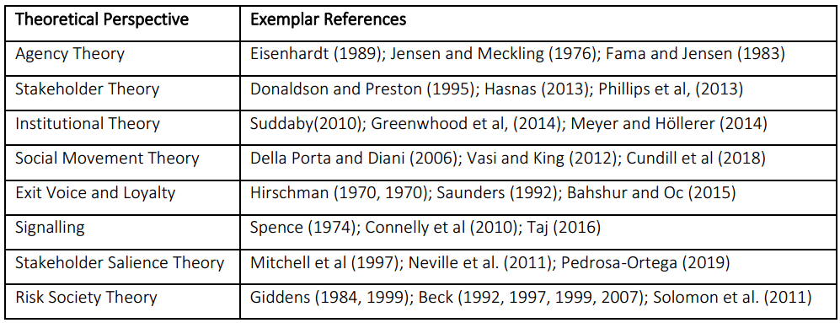Source: Researcher’s findings

Thirdly, because ESG induced shareholder activism is a relatively new discipline that was rarely mentioned before the 1990s, writers have varied extensively in where they draw the frontier of the subject. In its narrowest sense, shareholder activism arises as a result of the failure of the formal system of accountability of senior management to shareholders, and at its most extensive sense, it is stretched to include the formal and informal relations involving the corporate sector and the consequences for the society in general (Keasey et al 1997: 2). This explains why most of the existing theories offer a single lens view of the problem which can hardly explain the multifaceted and changing phenomena. Therefore, each of the theories being critically analysed cannot encompass the whole essence of shareholder activism as a whole but can only shed some light on some aspect of corporate governance, though limited to that aspect alone. In other words, there is no single theoretical basis for the totality of shareholder activism. Clarke (2004: 9) opined that the trusteeship model which addresses the stewardship and accountability question of a corporate organisation is perhaps as the nearest we yet have to a general governance theory since it addresses the basic question of corporate purpose in relation to society. However, Abdullah and Valentine (2009) and Judge et al (2010) concluded that the combination of institutional theory and agency theory are the most effective underpinning theories of shareholder activism. The continuously changing world of shareholder activism as a subset of corporate governance discipline cannot be explained through only one theory but can be conveyed by gathering and reflecting on a range of theoretical perspectives to assist us in its understanding. This understanding must go beyond the immediate apparatuses and establishments of corporate governance, to consider greater questions of how organisations allocate scarce resources and give returns to stakeholders, and how these organisations contribute towards national and global economic development.
Finally, given that ESG shareholder activism as a discipline is a process in motion, and the focus of the interested activists is to avoid or reduce loss of future earnings and assets in the investee companies given the various uncontrollable future risks and uncertainties, a theory grounded in risk and how society organises and responds to it in the postmodern era is found most appropriate in underpinning this research work. Therefore, this study explores the Becksian risk society theory as offering the best initial theoretical explanation justifying ESG shareholder activism.

3.2 Becksian Risk Society Theory and the concept of ‘Manufactured’ Risk
An important contribution of Giddens (1984, 1991, 1987, 1994, 1998) and Beck (1992, 1997, 1999, 2007) to the Risk Society debate is the concept of theory of risk and responsibility, which distinguished between the risk attributable to the industrial era, and the ‘manufactured risk’ which is a consequence of the postmodern era typified not by wealth distribution of the industrial era, but risk and how it could be managed. The origin of the Risk Society can be traced to two fundamental transformations which are connected to the end of modernity, and therefore the beginning of postmodernism: (1) end of nature and (2) end of tradition (Giddens, 1999: 2). By “end of nature”, Giddens refer to a period typified by the prevalence of science and technology, and the period when society no longer worry about what nature could do them (volcanic activity, famine etc.), but rather the damage that society inflicts on nature (e.g. global warming). “End of tradition” on the other hand coincides with the postmodern era when traditional lifestyle ceases to exist (Beck, 1992:97). This is referred to as the individualisation process (2007:47). Giddens however carefully distinguished between the use of hazards and dangers (which typified the modernity period) and risks (typifying the postmodern period). In the middle ages, hazards are viewed as part of daily life occurrences or through act of God. However, the idea of risk is futuristic, with individuals and organisations preoccupied with safety and prevention of dangers and hazards. Two types of risks were identified: external and ‘manufactured’ risks. External risks are those that catches entities unaware although they are insurable and predictable and typifies the industrial society. These external risks apply to private and public entities. Reduction of external risks for instance has been the focus of the welfarist political left after the Second World War with a view to achieving income redistribution and social justice (Beck, 1999:72). This external public risk is managed based on the private insurance model based on actuarial assumptions.

However, a considerable amount of energy was devoted to the understanding of the concept of ‘manufactured risk’, which comes with postmodernism and the developments in science and technology, and because they are novel, there are no previous experiences to leverage on in the management of such risks (Giddens, 1999:4). This is a world “where one can no longer simply rely on tradition to establish what to do in a given range of contexts, and people have to take a more active and risk-infused orientation to their relationship and involvements.” (Giddens, 1999). Since manufactured risks are unquantifiable with no precedents to leverage on, it is impossible to attach probabilities and accurate monetary value to them. The more society develops in the path of science and technology, the more additional manufactured risks are created. As risk problems are solved through science and technology, more risks would be created. According to Beck (1997:2) manufactured risks expand due as we journey into the risk society, which creates a new riskiness to risk.
The above ‘manufactured risk’ therefore calls for the development of new social and political agenda and the presumption of a new reorientation of values and the strategies relevant to pursuing them. There is no risk which can ever be described without reference to a value, e.g. preservation of flora and fauna. However over or under-estimation manufactured risk due to inherent uncertainties makes risk accurate pricing impossible (Giddens, 1999:5). This does not however preclude the positive and negative sides of ‘manufactured risk’ to opposing parties in the society, thereby leading to clash of values, giving rise to reflexive modernisation (see table 3.2), unlike the old-type unilinear modernisation associated with the industrialisation period. It is not uncommon therefore, that these positive and negative sides will have political affiliates supporting their own sides of the debate (Beck et al., 1994:37). This development therefore elicits a well-developed dialogical engagement with science and technology because “the more science and technology intrudes into our lives the higher the need to have engaged relationship with information management with stakeholders.” (Giddens, 1999:6).

Interestingly, Giddens (1999:8) also found that as risk is related to security and safety concerns, it has also given rise to the concept of responsibility which connotes accountability and ethical behaviour. Responsibility is seen as a consequence of the decision-making process, and it is also seen as a tool for reducing ‘manufactured risk’ which has one of the major reasons for considering the possibility of Becksian theory to underpin this research work.

Table 3.2: Progression of Reflexive Modernisation
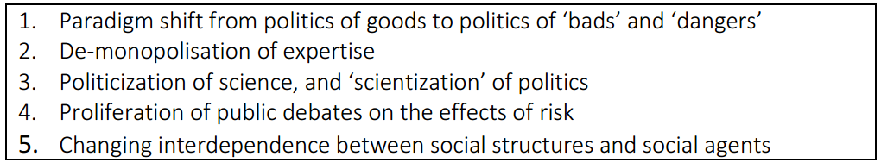Adapted from: Bulkeley (2001)

Giddens and Beck were able to offer the consequences, of the concept of ‘manufactured risk’, but not solutions to it, as follows:
- The emergence of what described as ‘organised irresponsibility (Beck et al., 1994:29) which arises as a result of the diverse humanly created risks for which ‘responsible’ entities (e.g. tree felling and fossil fuel companies) are not held socially accountable (e.g. biodiversity and climate change) through social institution (e.g. taxes and penalties).
- Secondly, due of the non-awareness of the change in the social era, significant amount of social interrogation of risk and responsibility are still through the lens of external risk occurring in the modernity era where risks are predictable based on past trends, rather than concentrating on ‘manufactured risk occurring in the postmodern era. This misalignment according to Giddens (1999:8) will make finding the solution to be further remote into the future.
- Giddens (1999:9) and Beck et al. (1994:37) also noted the rising trend in the adoption of the ‘precautionary principle’ as a means of addressing manufactured risk. Social actors do this to avoid over- or under estimating risk costs, or because of the expectation that the risk would materialise is remote. This involves avoidance of frontal confrontation of risk because negativity could be hidden or unnoticeable, or because social actors are unable to accurately calculate the cost and benefits incidental to risk. Beck (1992:37) noted that this approach sometimes suffers “boomerang effects” (e.g. environmental damage by BP in 2010; cost of emission scandal at Volkswagen in 2017). This term first arose in during the ecological debates in the 1980s due to the uncertainty of the costs attached to environmental damage.
- There is need to carefully manager the politics of risk through effective responsibility (or ethical) theme that must be able to address the positive and negative sides of risk in order integrate and address the concern for the two opposing sides of risk. Both the upside and downside of risk are important because the two sides of the debate are equally thrilled to support their arguments (Bernstein, 1996:120), and the politics is likely to be marked by a “push and pull between accusations of scaremongering on one hand, and cover-up on the other hand”, So, that rather than ignoring the ‘negative’ argument, Beck (2007) proposes engagement politics rather than screening off.

Some of the consequences of manufactured risk above are tangential to the RI logic. For instance, the notion of investment logic which arises from ethical background, engagement with investors rather than screening off, and the fact that the solution to these manufactured risks are unknown. What then are the impacts of environmental risks on investment? These are discussed in section 3.4 below.

3.3 Becksian Theory and the concept of ‘Trust’ in dis-embedded systems
Peck (2013) based on the works of Karl Polanyi (1944) described dis-embedded systems as those abstract mechanisms that functions rationally and independently of the society based on their own distinctive economic model or logic, as opposed to the functioning of embedded systems in non-market systems. This Polanyian ideology has been widely adopted in sociology, influencing Giddens (1991) definition of dis-embedding mechanism as those relationships with physical or abstract systems (such as the financial systems, legal systems) that enable social entities to function across time and space. However, some economic sociologists (e.g. Granovetter (1985) have argued that not all economic activities are totally dis-embedded from economic models in capitalist economies.
Trust is a pivotal element the construction of Giddens’ modern society which is similar to the structuration theory^{3a}. According to Giddens (1990:34) “trust is the confidence in the reliability of a person or system, regarding a given set of outcomes or events, where that confidence expresses a faith in the probity or love of another, or in the correctness of abstract principles technical knowledge.” Giddens (1991:80) also distinguished between trust in “dis-embedded abstract systems based on faceless commitments” as an integral part of the consequences of modern social life, and the “traditional system of trust which is influenced by physical and social interactions.” The former concerns the development of faith in symbolic tokens or dis-embedded expert systems known as abstract systems which enables people and systems to interact seamlessly as opposed to the traditional systems where trust is based on “facework” (Giddens, 1994:89). The functioning of proliferated and complex dis-embedded systems that facilitates the complex social and human interactions in modern societies are based on generalised trust without which they would not be able to operate hitch-free. E.g. the financial and accounting systems.

The issue of risks is so pervasive in risk society such that when risk is tangibly reduced, social entities divert their focus to the residual risks. This engenders a state of fears “increasingly endemic sense of insecurity” in a risk society (Beck, 1992). This makes the concept of trust to be of importance in risk discourse. Giddens (1990:34) defines trust as the level of confidence reposed in an entity or a system. The concept of risk and trust are closely related, and a negative relationship exists between the two (Sztompka, 1999; Ekberg, 2007; Lash, 2000), such that relatively low levels of trust exists in an atmosphere typified by proliferation of high volume of knowledge, and vice versa. In addition, the more a society shifts from tradition into modernity, the lower the level of trust remaining. According to Giddens and Pierson (1998:108), trust and knowledge are mutually exclusive because knowledge “offers security in the face of future eventualities.” Risk society is typified by the prevalence of unending search for expert knowledge, but nevertheless, knowledge is inconclusive, unending, inadequate, and they keep changing with the passage of time. This erodes trust in specialists. It is puzzling therefore, that risk society is characterised by both increasing dependence on specialists at the same time, declining trust in experts and social institutions. Another key factor increasing the climate of fear is the traditional and the social media. Although both Giddens and Becks provided little empirical evidences to support the role of media in their work, these media are today source of knowledge dissemination on both external and ‘manufactured’ risks.

Risk society is future oriented. There is a breakdown of tradition, traditional communities and traditional certainties. Instead of being caught up in the old ways, risk society is very oriented towards understanding and controlling the future. Giddens (1991) proposed dis-embedding mechanism and re-embedding mechanisms and ways of addressing the trust in a risk society. Giddens (1991) noted that the more social entities embrace modernity, the less they trust these entities. The traditional insurance system has the twin purpose of avoiding damage and avoiding fear. But the absence of insurance allows floating fears to fester (Beck 2009:139). Giddens (1991) therefore proposed re-embedding mechanism, which is an adaptive mechanism to the issue of risk as a means through which community addresses the declining trusts in social systems. The investment system is complex with many layers of advisers and investors having diverse objectives. In addition to this, the investment environment is filled with ‘manufactured risks’ (see figure 3.3), creating grounds for the collapse of trust to fester, thereby making a case for the use of re-embedding mechanisms.

3.4 Becksian Theory and the Impact of Environmental Risks on Investment
Postmodern theorists (Giddens and Beck etc.) were not pessimistic that 1989 which marked the end of the cold war will birth the beginning of the greatness of capitalism. Rather they put forward the Schumpeterian (see page 52) argument that capitalism is designed to self-destruct because “its (capitalism’s) demise is not perceived to emanate from its breaking down under weight of economic failure, rather, its very success undermines the social institutions which protect it, inevitably creating conditions in which it will not be able to live, in which case, capitalism is killed by its own achievements” (Beck et al. 1994, p.3). This expected self-destruction of an industrialised society is expected to be a new western modernisation which undercuts existing modernity, in order words, reflexive modernisation. This reflexive modernisation which is a feature of a ‘risk society’, is expected to be typified by new social forms and movements, reorganisation, reforms, and scientific re-evaluations, of for instance, ecological risks and uncertainties on the society (see figure 3.3). In this self-concept of risk society, society becomes reflexive, i.e. a theme and a problem for itself, due to problematisation of risks having ambiguous solutions. In other words, risk society is a self-critical society where for instance, safety engineers contradict insurers, and scientists contradicts politicians on matters of ecological risks. Risk societies are also expected to be typified by impression management (see Solomon et al, 2013; Bowen, 2014:25) whereby “what the tongue says might contradict what the hand does.” (Beck et al., 1994:11-13). There is now virtually an unanimity in the scientific community that human and industrial activities such as burning of fossil fuels, emitting GHG and heat the atmosphere are the main causes of global warming. UNFCCC report (1994), Kyoto Protocol (1997), The Stern Review (Stern, 2006), research by the UN (IPCC, 2007) the Copenhagen Summit 2009, Paris Agreement 2015 have all catapulted climate change to the forefront of international public policy. According to Solomon et al (2011), “climate change, as an emerging and dominant phenomenon in society, represents one of the greatest risks to the survival of all life on earth”. Sociologists like Beck (1992, 1997, 1999), Giddens (1990), Luhmann (2005) and Lupton (1999) have devoted substantial attention to theorising the change in global society arising from the emergence of high consequence risks such as global warming and climate change, showing how modernity may be viewed as a risk society, characterised by fear of risks with potentially apocalyptic consequences. As a result of societal anxiety surrounding climate change risk, businesses, as primary producers of GHG emissions, are being called to account for their detrimental impact on our natural environment. Companies are starting to disclose information on climate change impacts through public climate change reporting. Institutional investors, as primary financial stakeholders of corporations, are thought to be turning their attention to ways in which climate change affects investment return. “… institutional investors are now deciding that it is prudent to consider the potential impact on their investments of climate change (Gore, 2006).

Therefore, investments in sectors typified by large fixed assets, such as agricultural, tourism, water, property, construction, energy and infrastructure, are considered especially vulnerable to climate change-induced effects such as erosion and damage (Sullivan et al., 2008). One estimate suggests that losses from climate change-induced disasters could exceed US$1 trillion in a single year by 2040 (UNEP FI, 2006, quoted in Sullivan et al., 2008). The corporate and investment communities are becoming increasingly aware of potentially devastating consequences of climate change. Sustainability reporting, and now integrated reporting represent responses to calls for greater corporate accountability for environmental impacts and have experienced rapid growth over the last 30-40 years. Academic research into sustainability reporting has grown exponentially since the 1980s and is now an established field of accounting research abounding with competing theoretical frameworks and contradictory empirical evidence (Gray et al., 1995, 1996; Hopwood, 2009; Mathews, 1997; Thomson, 2007). It is now common to see a whole segment of sustainability report dedicated to addressing how a corporation plans to cope with the effects of climate change, especially now, given the recent crystallisation of scientific consensus surrounding global warming and resultant climate change. Existing research has focused on sustainability and climate change reporting (Friedman and Miles, 2001; Solomon and Darby, 2005; Solomon and Solomon, 2006), with a few focusing on the engagement of the investors on the risks that climate change and other social and governance issues pose to the going concern of long-term investments. There are increasing incidence of stranded assets which are regular features of changing economic systems (Reinert and Reinert, 2006; When assets are classified as stranded, it means that their ability to generate future cashflows are impaired, and therefore valuation reduced Caldecott, B.L., 2013; 2014). Some of the environmental features causing stranding of assets are illustrated in table 3.3 below.
Since 1980s, and particularly from 2000, many scholars on sustainability have acknowledged the likelihood of climate policy and regulations negatively influencing value and profitability of fossil fuel companies to the point that the assets could be impaired (IPCC, 2018; World Energy Outlook, 2018).

Table: 3.3: Typology of Environmental-related risk
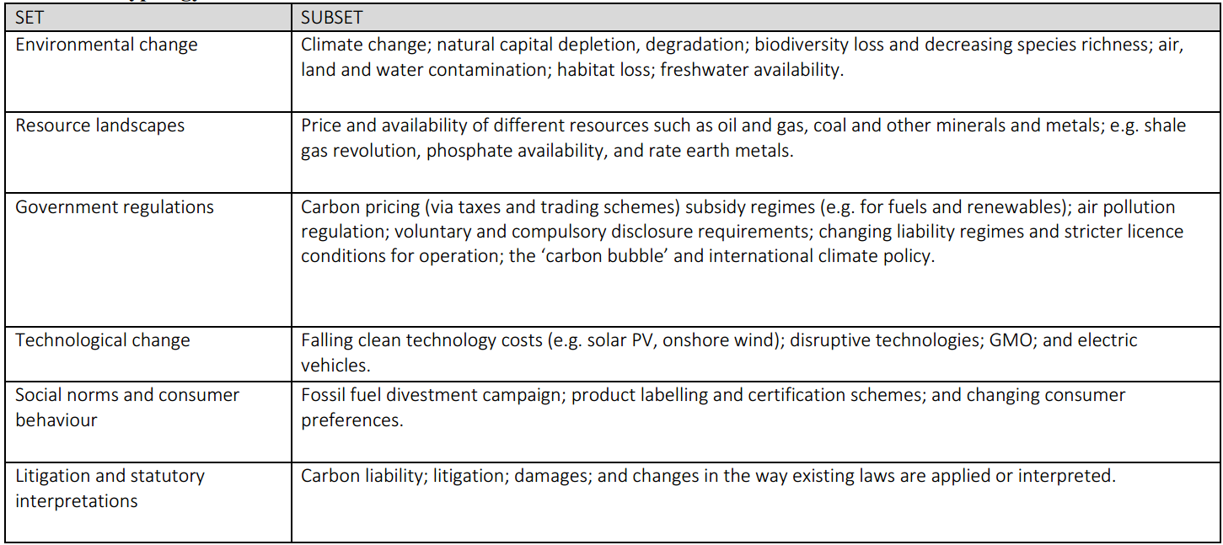Source: Researcher’s findings
3.5 Becksian Theory and Risk Reporting
Traditionally, the annual financial report is a good source of information for decision-making (Chang et al., 1983; Gniewosz, 1990). However, Gray et al., (2014) argued for a shift in perspective from stewardship to shareholders, to a more all-inclusive accountability model for accounting in a neo-pluralist world (p29), like the views of Lev and Gu (2015). These views were partly influenced by the accountability movement (Gray, 2002; Adam, 2006) seeking for a new reporting system that is not limited to shareholders’ stewardship, as the current system fails to financialise environmental and social costs. This suggests that the existing financial reporting system may not include all the information required for estimating future cash flows and valuation. The heightened concerns for reported global warming and biodiversity concerns (Rimmel and Jonall, 2013; Atkins et al., 2015), and extinction of flora and fauna as a moral and business imperative (Atkins and Maroun, 2018) have now added another layer of concerns for shareholders who now demand a new form of reporting as the world is evolving.
The world risk society theory recognises that modernisation will go together with uncontrollable and uninsurable hazards such as climate change and global warming with associated negative effect on corporate going concern assumption. According to Beck (1992, 1999), the global society is continually evolving to one where the side effects of industrialisation are increasingly becoming an integral part of human daily lives with the attendant proliferation of their catastrophic effects. For instance, threat of extinction of flora and fauna as a result of greenhouse gas emissions is one of the greatest threats to planet earth (Jones and Solomon, 2013), diminishing bee populations and other important pollinators over the past 60 years, thereby putting a strain on future food supply chain (Atkins and Atkins, 2016). Beck also opined that the global society is now at a junction where the quantum of environmental risks now outweighs quantifiable and calculable risks (1999, p.3), and this view is shared by WWF (2013), and Wheeler et al. (2012), that have raised concern at the rate species extinction reported globally. Moreover, the Markowitz (1952) (cited in Herb et al., 2007) Modern Portfolio Theory (MPT) on diversification of non-systematic risk through the combination of non-correlated assets did not take modern environmental risks into consideration, which according to Beck (1992) are consequences of new reflexive modernity. In which case, MPT, a consequence of ‘simple modernity’ may be insufficient in todays’ reflexive or risk society that is constantly witnessing not just constant structural changes, but also changes in the interplay between social agents and social structures.

Figure 3.1 PRI Signatories and AUM (US$Tr) 2006 - 2019

SOURCE: UNPRI, 2020.

This, according to Le Maux et al., (2004) and Clow (1999) justifies the SRI screening by portfolio managers, and therefore a failure of the MPT. The growth in the awareness of these environmental risks has also necessitated paradigm shift in corporate reporting, necessitating environmental or sustainability report which helps users of financial reports in understanding and evaluating non-financial risks as it affects their long-term investments, as well as the need for investments held by asset owners to be seen as a ‘responsible portfolio’. This may have influenced the yearly increase in the number of signatories to the PRI charter and the value of assets under management classified as responsible investment (see figure 3.1). Biehl and Atkins (2016) opined that due to the need to manage risks attached to loss of investment, ESG issues have now moved to the mainstream of investment decision-making from the fringes of responsible investment in which it used to be classified. Also, Van Duuren et al., (2015) noted the emerging pivotal effect of ESG issues in investment appraisal whereby institutional investors use them as pre-screening mechanism that are applied prior to the carrying out the traditional investment appraisal techniques. Shareholder activism is seen therefore as a re-embedding mechanism addressing collapse of trust in the investment chain. Investors are naturally concerned about risks – and shareholder activism offers opportunity for questioning risk management. According to Beck (2007:130), although modern forms of risk management have learnt to maximise mathematical precision, they have to a large extent, systematically underestimated the chances of occurrence of the unforeseen and the improbable, and they totally ignore impossible occurrences in terms of both their frequency and the extent of the damage they cause. This therefore creates an ‘insecurity trap’ into which corporate organisations fall.

However, the seeming insufficiency of corporate reports (financial and non-financial) have necessitated the evolving active role played by the investors who feared the loss of their investment. Again, the changing investment process means that new paradigms are being witnessed. e.g. the power of proxy solicitors for which there is limited literature on. Also, the nature of activism exercised by institutional investors and shareholders’ associations are changing, and they have not been extensively captured in the existing body of literature. In addition, the changing nature of business processes using internet has reduced the use of paper-based and increased the desire for Corporate Internet Reporting (CIR) which can be accessed by multiple stakeholders thereby increasing accountability through timely “instantaneous two-way communication and provide direct linkages between different disclosures” (Burton et al, 2018). However, empirical evidence shows that there is an increase in the incidence of CIR, but they are not being produced and made available online on annual basis, but they are not being updated on real-time basis. This demonstrate the “juggernaut of modernity” argument where misalignment in the risk society makes the government and regulators to play catch-up game with the pace of change in the environment (Giddens, 1991:139).

According to Luhmann (2005), modifications to the otherwise direct relationship between corporate stakeholders and corporate controllers is seen as one of the consequences of global risks in modern societies, and perhaps one of the drivers of shareholder activism. The investment chain has changed considerably over the years with institutional investors outsourcing governance issues to proxy advisors like Glass Lewis, LAPPF, ISS etc. There is limited literature on the role of these proxy advisors. Also, individual shareholding has plummeted considerably, and many shares are now held in nominee account, and it is the nominee who exercise the rights attached to beneficial ownership. How are these rights exercised? Are the individual shareholders delighted with this change, and how are they coping with this change?

3.6 RI logic and ESG activism as a trust re-embedding mechanism
Giddens (1991:88) defined re-embedding as the “process by means of which faceless commitments are sustained or transformed by facework.” In other words, it is a means of re-assuring the users of the products or services emanating from the abstract systems. In the case of the complex investment system coupled with a dynamic environment that changes often. Re-embedding through the adoption of RI logic and ESG activism can serve as a vehicle for “anchoring trust in the trustworthiness and integrity of the system. Re-embedding therefore connects confidence in abstract systems to their reflexive mobile nature, as well as providing encounters and rituals which sustain collegial trustworthiness.” This is even more imperative especially where the investor as a trustee holds fiduciary responsibility for several beneficiaries that care about how their resources are deployed, giving rise to the consideration of ESG values in the pursuit of financial and economic value (see figure 3.2). To this end, Giddens (1991:8) sees “responsibility processes” and “responsibility products” as the counterpoise to social activities that Beck (2009:27) referred to as “organised irresponsibility” whereby law-abiding citizens and institutions wilfully encourage the destruction of the ecosystem without any attribution or punishments. This is the reason why RI is seen as holding the key to re-embedding trust in the investment community, and thereby a likely key to reducing mistrusts which pervades the investment environment as seen in figure 3.3.

The concept of RI holds that Investors should, when taking investment decisions in investee companies, appraise ethical and social criteria in selecting portfolio investments (Cowtons, 1994), and that investors should demonstrate long-term, stakeholder and governance perspectives Louché & Lydenberg (2011). Over the years, the definition has been widened to include like governance, environment, human rights, and ethical factors as the model of market pricing is inefficient as it failed to consider governance (Soros 2008, Gifford 2010). The field of RI has been characterised by debate on what should be included in the definition. Some refer to it as ethical investing, while others call it SRI. Over the years, the various stakeholders have promoted variants of responsible investing, and this is reflected in its evolution and the many names by which it is known.

Figure 3.2: RI logic
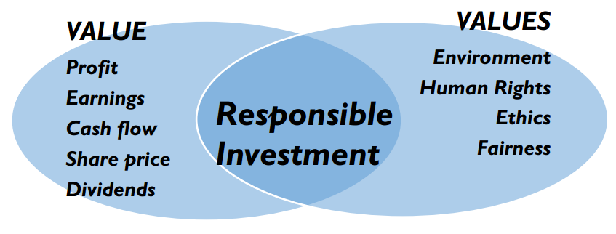
SOURCE: UNPRI

For example, religious organisations call it ethical investing, human rights community call it socially responsible investing, and those in favour of governance call it ESG investing. From 2012, there is a consensus by academic writers to refer to investments that factor in non-financial criteria as Responsible Investment (Sievänen et al., 2012). Irrespective of the vocabulary used, the main objective is to discourage short termism and encourage societal and governance perspectives in rewards measurement and valuation (Louché & Lydenberg, 2011). The metrics that owners and managers use for measuring business success (shareholder value) differs from how the society appraises business effectiveness (social, ethical and economic values). It is believed that the long-term interests of the business unit are to create and maximise economic value while the society views the business through the ethical environmental and human rights paradigms. Responsible Investment is concerned with the consideration of value and values perspectives (figure 3.2) in arriving at investment decisions by owners.

RI logic is one of the drivers of shareholder activism as it can be seen from the cases illustrated earlier (see 58-63) where activist investors seek to impose ESG and CSR policies on investee companies. Activist investors are concerned with the need to integrate governance issues alongside the traditional profit maximisation requirements into investment decisions. Many writers like Louché & Lydenberg 2011, De Graaf (2009) Amaeshi and Grayson 2009, Juravle and Lewis 2009 have contributed extensively to debate on how to move the responsible investment theme into the mainstream. However, little has been written on the different responsible investment strategies used by the various asset owner groups.

The figure 3.3 below shows the various risks that the investment community is confronted with when investing in a company, many of which had been discussed extensively in chapter 3.1 to 3.6. What is absent in the figure 3.3 are the ESG activism mechanisms which could be applied as trust re-embedding mechanism in order to manage the various risk inherent in the business environment.

Figure 3.3: Risk Society Theory: Conceptual Model
Applying a Becksian Lens to institutional investment
Stranded Assets

Contributors to the understanding of this theory
- Caldecott et al. (2014, 2018)
- Jones and Solomon (2013)
- Solomon et al. (2011) Politics of risk
Ecological disasters
- Beck (1992, 1997, 1999, 2007)
- Giddens (1984, 1999)
- Ekberg (2012) Different
understandings
of risk
The Investment Community with multiple investment objectives
Risk and trust
Investee Companies

Natural & tech risks
Reflexive orientation Omnipresence
to matters of risk of risk
Socially constructed risks
Proliferation
of risk definitions
Visible, invisible, virtual risks
Social risks

Actual and perceived risks

Borderless risks
Biodiversity risks
Source: Researcher’s findings
Governance risks

3.7 Becksian Theory: Conclusion, Justification and Criticisms
The preceding discussions from views of practitioners in the UK investment community on their attitude towards risks pertaining to investment, provides the context for risk discussion, thereby offering clarifications on why Becksian theory is the most appropriate underpinning for this research.
“It is very likely that over 50% of the observed increase in temperature from 1951 to 2010 was anthropogenic induced, thereby increasing GHG concentrations. We are however alarmed at the nonchalance attitude to the effects of these on businesses” - UKSA, 2019^{3b}

“Emissions management is no longer sufficient to stabilise the climate. Full decarbonisation is necessary in order to avoid the notorious 2ºC temperature rise above pre-industrial levels – the internationally agreed threshold to avoid the most dangerous effects on global warming.” – IPCC (2018:698).

“Companies should protect the environment and treat workers with dignity and respect. Inability to build this into business strategy would put the long-term profits for shareholders at risk – The Business Roundtable, 2019^{3c}

“Can we expect BP, in the near future, to indicate a date by which it is planning to achieve net-zero emissions across its operations and products, and can we expect this date to be within the range of 2050 – 2070.” – Head of Responsible Investment C. of E. Pensions Board, 2019^{3d}

“it is unwise to own fossil fuels companies long-term and the products of these companies are harmful to human health by producing dangerous air pollution and contributing to global climate change.” - Arabella Advisors, investment advisors to the UK Royal College of General Practitioners, 2018^{3e}

The common theme in all the above practitioners’ views are reflexive orientation to risk discourse due to knowledge of science and technology, and the fear of loss of investment due to risks which pertains to the future. The IPCC Assessment Report for instance agrees with the transition to “end of nature” view of Giddens (1999) whereby we need to worry more about what we are doing to nature, and not the other way around. As the IPCC report bridges information gap, it is also at the same time creating risk problems, thereby requiring the need for further scientific advancements to solve climate change problems. This is in line with Beck’s view (1992:155) on demonolopisation of science and reflective scientization. There is also a noticeable “omnipresence of risk discourse” where business practitioners increasingly demonstrate ‘manufactured risk’ awareness. Secondly, “the push and pull between accusations and scaremongering on one hand, and cover-up on another typifying politics and decision-making” (Ekberg, 2007; Giddens, 1999) is now prevalent in the relationship between institutional shareholders and directors. This is because of non-alignment in their respective attitudes to risk. The management seems to assume that tackling the observed business risk is not urgent, whereas the investors believe otherwise. Giddens (1999:6) believe that scaremongering may be a veritable tool for addressing perceived risks if they are successful. However, because there are no metrics against which this risk perception could be measured aside the scientific reports, management face being accused of cover-up and inefficiency. This therefore justifies the need for dialogical engagement with management.

There is also noticeable proliferation in ‘manufactured’ risk (e.g. environmental, social and governance risks strands discussed above) thereby agreeing with (Strydom, 2002, Beck (1994:135) that living in a risk society induces susceptibility to proliferation of risks, and the uncertainty about the elusiveness of risk itself. domination of business strategy with ecological enlightenment, whereby uninsurable losses arising from environmental damage, future health and safety as well as discussions on whether businesses are ‘responsible’ or ‘irresponsible’ are beginning to overshadow profits and wealth maximisation. This sense of vulnerability to uninsurable risks, according to Lash (1994b) gives rise to insecurity which a feature of reflexive modernity, which in turn likely to influence a new tenet of a risk culture. This new level of enlightenment leads to calls for social and institutional reforms in order to accommodate the new realities (Beck, 2007:196).

Even as useful as the Becksian risk society theory is, there are a few criticisms of the theory. For instance, Rose (2000) has argued that the notion of risk is not totally new to human beings, especially in the use of technologies, and that migrating from old technologies does not reduce or remove those risks inherent in them. Unlike the Becksian view on a societal changeover from industrial to postmodern era, Rose (2000) also noted that racism and violence against children and women still exists. Another criticism is that the risk society failed to explain the effects of running a fully risk-averse society. Scott (2000) is of the view that such society is likely to be stagnant and uninteresting. This research aim is therefore to gather useful and relevant data from the investment community in the UK on how their attitude to ESG shareholder activism. This will then help to assess whether the Becksian theory can offer explanatory power to the operation of ESG shareholder activism in the UK.

3.8 Summary
Given that theorisation is socio-economic context cannot be value-neutral, this chapter discussed the justification of an acceptable theory that explains the rationale for engaging in ESG shareholder activism and a critical discussion of some practitioners concerns justifying the Becksian risk society theory as well as a discussion of the ‘manufactured risk’, trust and re-embedding mechanism concepts. This chapter was able to demonstrate the importance of risk reporting, the relationship between risk and trust, and RI logic as means of re-embedding trust in an atmosphere where there is proliferation of ‘manufactured risk’. It is believed that understanding and implementing the ESG principles in the investment environment is a means of re-embedding trust in a dis-embedded financial system. Imbibing RI logic in the investment chain has influenced responsible acts such as investor dialogue, convening of IR meetings, investor collaboration, integrated risk reporting, lobbying to effect changes in investment laws and filing of shareholder proposals. Ingraining RI logic nonetheless requires time and skills for it to evolve into the mainstream investment practice. This chapter also reviewed some justifications and criticisms of the risk society theory. The preliminary evidence justifying the choice of the risk society theory was influenced by the review some shareholder activism case study in chapter 2, as well as the outward expression of the risk of loss of assets if management fail to take urgent steps to prevent catastrophic effects of environmental damage on investment (see chapter 9). In addition to the seminal works of Ulrich Beck and Anthony Giddens, this chapter also reviewed the works of some contributors such as Caldecott et al. (2014, 2018); Jones and Solomon (2013); Solomon et al. (2011); and Ekberg (2012) thereby providing some explanatory basis to support the use of the theory.

Chapter 4: Research Methodology and Methods

4.1 Introduction
This chapter examines, discusses and argues for the appropriate methodology for the research work, and also the appreciation of the wider philosophical context of enquiry. This chapter also examines the overall research strategy, research design, the issues to be addressed in the survey research and the various ways of analysing the kind of quantitative and qualitative data that will be generated by the survey via the use computer software. Also, practical issues arising in social surveys such as ethical principles, data management, reciprocity and trust as well as conflict of interest were identified and fully addressed. Zikmund et al. (2013:60) describes research methodology as data collection methods, sampling design and statistical techniques used for data analysis. However, Mason (2006) widens the remit of research methodology to include research philosophies, theories and judgment on research process and procedures that are capable of influencing the quality of outcomes. The main aims of this research methodology are to outline steps in carrying out the research project, as well as identifying and explaining the underlying methodologies and philosophies. The methodologies described in this work have helped to prepare this work in a systematic manner to follow protocols and standards that are acceptable to the scholarly community, and in a language that is scholarly. The research methodologies have followed clear procedures to make the understanding of this work scientific. The methodology to be adopted in this work will be influenced largely by approaches adopted by scholars that have carried out earlier studies in shareholder activism.

4.2 Research Philosophy: Paradigm, Ontology and Epistemological considerations
The researcher’s philosophical stance is the paradigm of fundamental beliefs and assumptions regarding perception of reality, consisting of ontology and epistemology (Saunders et al., 2016).
Research paradigm is a very essential element in research data collection and analysis, and therefore ought to be understood in order to conduct a reliable and successful research. According to Collins (2018:38), research paradigm can be thought of as a lens through which we view the world, our assumptions about the nature of the world, the ways in which we understand it. This bring into effect the issue of research philosophy. Thus, research paradigm comprises of research philosophies and research methods (Williams, 2007). Paradigm in research is a lens through which the researcher views the world. Two main methodological approaches can be identified (i.e. quantitative and qualitative, with each having its own ontology, i.e. perspective about what reality is). And each methodological approach has research methods that can be applied to carry out research. For example, interpretivist paradigm’s research approach may be qualitative in nature, and data collected and analysed using grounded theory, ethnography and case study methods. Burrell and Morgan (2016) and Saunders et al., (2007) explored a fourfold classification of paradigms that embody the main belief systems of management and business researchers based on their ontological stance (see figure 4.1). These paradigms help in clarifying assumptions about reality, and in plotting one’s route in research.

Figure 4.1: Paradigms in the Analysis of Social Theory
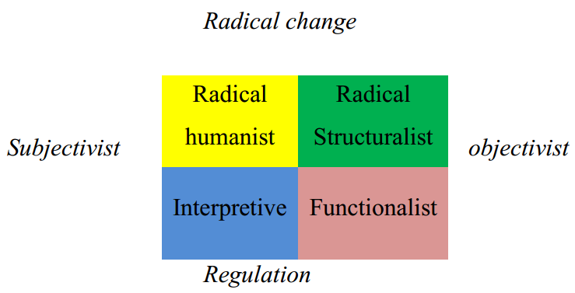
Source: Saunders et al, 2007

Since the goal of social research is to understand and construct reality from one’s subjective perspective, this researcher’s philosophical position is the interpretive paradigm. What is considered as reality is relative because world can be perceived differently depending one’s subjective view. Therefore it is possible to have multiple construction of reality, and this changes with effluxion of time. Interpretive paradigm focuses on the understanding and not the accuracy or objectivity of the body of knowledge since knowledge is seen as contextualised, value-dependent and subjective.

The ontological stance will help in determining the research approach and strategy since it points the attention of the researcher to basic perceptions about the social entities and the social actors about which data are to be gathered and analysed. According to Marsh and Furlong (2002), ontology is concerned with nature of reality and the people’s view on reality. It therefore means that whatever ontological assumptions and commitments held will influence research aims and questions, as well as how research is carried out. Bryman and Bell (2011:21) identified the two ontological stances as objectivism and constructionism, also referred to as constructivism. They explained ontology as the theory of the nature of social entities that is concerned with either of two issues; i.e. the issue of whether social entities should be considered as objective entities that have a reality external to social actors (objectivism), or whether they should be considered as social constructions built up from the insights and actions of social actors (constructionism). Objectivism is based on ontological view that there is an expected or pre-determined standard of behaviour, and that the actual output or performance can be measured against this pre-set standard. It is an “ontological position that asserts that social phenomena and their meanings have an existence that is independent of social factors” (Bryman and Bell, 2011:22). In other words, objectivist ontology assumes that there exists a set of objective measurement criteria for a phenomenon and therefore, an investigation can be carried out to measure variations from this. This researcher believes subjectivity is appropriate to this research as there are globally accepted standard of the form that shareholder activism should take, as well as how its effectiveness could be measured in investee companies.

On the other hand, constructivist ontological stance asserts that human beings construct knowledge from existing body of knowledge and prior experience. Unlike objectivists who compare performance against set of criteria, constructivists create their own realities to fit their own situation or circumstances. Constructionists believe that reality is a social construction based on a compromise and agreements arising from own understanding of reality that is influenced by values and experience, and another people’s interpretation. According to Fisher (2007:21), constructivist research is categorised as gnostic because it does not admit the reality of a generally accepted or orthodox interpretation of any phenomenon, but instead emphasises relativism, diversity and complexity. This is why reflexive critique skills are required for interpreting constructionist research findings as the findings are normally influenced by assumptions, values, and prejudices. It is observed that constructivism is compatible with Gnosticism. This is why constructivist approach to research is most ideal where “facts are subjective, language is equivocal, and truth can only be gained through personal struggle” (Fisher, 2007:16).

Social constructionist ontology approach was adopted for this research because reality in the field of shareholder activism is continuously evolving and there are no globally accepted standards for good or bad shareholder activism. Therefore, to gain insight into the truths in this field, the researcher has to engage with directors and managers in charge of governance and investment in asset owner companies, individual and institutional shareholders through interviews and observation at IR meetings. This offered an excellent perspective of the views of the key stakeholders in shareholder activism in the UK.

Epistemology is the researcher’s view about what should constitute knowledge and how to find what is. Epistemological considerations would therefore involve deciding what kind of knowledge is suitable for being studied in a discipline, and how to approach the path to obtaining the knowledge. Whatever epistemological view adopted will have a profound effect on the research approach conclusions. Is the researcher interested in an accurate and objective measurement of result that is free of any human bias (through independent observations of variables and facts), or is the research in a social context where multiple studies and reviews on the same issues can be taken from different perspective (construction via social interactions)? According to Saunders et al. (2016:134), a researcher who collects and analyses facts represented by objects considered to be real are embracing positivist philosophy, whilst a researcher carrying analysing presentation in narratives form is adopting the interpretivist philosophy. Proponents of positivist theory argue that research is carried out in a value-free, and independently verifiable way, and the researcher is value neutral (Crotty, 1998; Saunders et al., 2016:134). Gill and Johnson (2010) also argue that a positivist is likely to use a well-structured methodology that will facilitate easy replication of knowledge. However, the main criticism of the positivist philosophy is that the social world is complex and would therefore be inappropriate to develop general rules or hypothesis applicable to several situations.
Interpretivism advocates the need for understanding the actors and the reality being studied as well as the theory. In other words, we cannot divorce the ‘social actors’ from actions, and that “links between understanding and action is mediated through people’s thinking, values and relationship with each other”. In interpretive research, the relationships between interpretations are considered dialogic. This is the reason why a social researcher will try to map out a range of positions and views on a phenomenon. It has been argued that a complex understanding of a phenomenon is realised via a close association with the subject being investigated. This explains why interpretivist researchers approach their work in an open manner.

4.3. Research Approach
In terms of research approach, three main theories have been identified, i.e. inductive, deductive and abductive theories. These theories can be differentiated mainly based on logical reasoning, generalisability assumptions, and how data collected are used (Saunders et al., 2016:144). Deductive reasoning involves working from the top down by starting with a general theory or general notion, and then working through tentative hypothesis, patterns in data and then confirm conclusion through observation. It is the most popular way to carry out scientific research. On the other hand, deductive reasoning starts with some observations (e.g. looking at social realities by taking notes) and then work towards generalisation. There is a vague idea on what is to be studied, but there are no preconceptions on what is likely to be found. Also, there are preconceptions about the hypothesis which is left to unfold as the research activities goes on. Abduction theory combines induction and deduction. It involves gathering hypotheses and then working forth into likely outcomes and back to the general theory or notion. Abductive reasoning is most logical where only one hypothesis would best explain the truths. e.g. diagnosis of sickness in medicine, or forensic analysis.

According to Ghauri & Gronhaug (2002:13), inductive theory is built on empirical evidence whilst deductive theory is built on logic. The degree to which a researcher is clear about these theories at the start of a research raises an important question about the methodological choices and research strategies. Generally, inductive theory is interconnected with qualitative research method while deductive theory is interconnected with quantitative research method. However, Bryman (2008:8) argues that deductive theory contains some elements of inductive theory and vice versa. The theory adopted in this work is inductive as this researcher is starting with an open mind, though with some knowledge of a few background theories, but with the objective of explaining shareholder activism as it pertains to institutional investors.

4.4 Research Design
This is the general plan developed by the researcher to answer the research question. To do this, the research objectives and scope, the methods to be employed and the constraints to data gathering have to be clear. This also involves detailed planning on how to access the data, whether it could be completed within a time frame, where to get the data, and financial constraints. Creswell et al., (2007) also recommended a clear understanding of the underlying research philosophy, nature of what constitutes reality (ontology), how to access this reality (epistemology), ethics of the researcher (axiology), and the nature and techniques employed in the research process (methodology). Research design could be qualitative, quantitative or multiple method based. Research design can also be classified by the purpose that they serve: i.e. exploratory, evaluative, descriptive and/or explanatory.

4.4.1 Quantitative research design: This is a research design that collects data with the aim of analysing large quantity of numerical data without considering the emotional insight of the participants. It is usually applied when the focus is to measure or confirm the relationship between variables, to obtain scientifically verifiable results that can be generalised, or to test existing theories (Saunders et al., 2016). Data collection is structured, and the method is compatible with the positivist philosophy and the deductive approach. Quantitative research design is not applicable in this research as shareholder activism is not based on objective paradigm.

4.4.2 Qualitative research design: This research design is used when the focus is to collect subjective but rich data that would help in developing or modifying existing theories. This research design is associated with social constructionism and the inductive approach to research, and the data collection is largely unstructured. Qualitative design attempts to answer the ‘what’ ‘where’ ‘why’ ‘how’ questions. It is usual for qualitative research design to start with a broad idea and end up focusing on more specific and focused as the research work advances and becomes clearer through iterative process of refining the research question (Saunders et al., 2016). One great advantage of the qualitative research design is its flexibility and adaptive nature that enables the researcher to change the course of its direction, especially as new facts emerge. For instance, at the start of this research, proxy advisors’ role was not considered until the asset owners kept referring to them. Also, the insight gained one interviewee may likely shape the next stage of the research activity.

4.4.3 Multi-methods research design: This is the use of several qualitative research methods in exploring or investigating a phenomenon. This method allows the researcher to study a complex phenomenon holistically, especially where it is impossible to obtain good understanding from the use of mono methods (i.e. qualitative or quantitative research designs). According to Roller and Lavrakas (2018), multi-method research design is recommended where “permissions may be required to gain access to observation venues, activities and documents; and the researcher possesses ability to surrender control of the direction of the research process by allowing the case or narrative to steer the direction of the investigation”. However, in order to use a multi-method approach, the researcher must have expertise in various qualitative methods such as observation, content analysis, case study, interview, and historiography. Multi-method method research design has been adopted in this research because this method overcomes the defects associated with mono method research design as a wide spectrum of data is collected and analysed

4.5 Population of the Study
In order to achieve the aim of investigating the roles of the various asset owners and their governance advisers in ESG shareholder activism, primary data will be collected from the universe of Asset Owners such as homogenous groups like the SWFs, Pension funds; Social investors; Shareholders Associations and Proxy Advisors. These five key stakeholder groups have been selected based on their role in the investment value chain, as well as their accessibility to the researcher. The perception of Asset Owners in this research project is crucial as they represent ownership interests that are diverse. Also, they hold an important position in the investment chain as their shareholder activism and responsible investment perspectives and mandates are to be followed by fund managers, professional advisors and ultimately, the investee company. Data was gathered from members of senior management of the various Asset Owners in order to shed light on how their various UK organisations engage in shareholder activism. Proxy Advisors would be surveyed to provide primary data that would help in addressing research questions 3, 4 and 5. Social investors were included in the population because of their style of activism which is sometimes confrontational, and also due to their key interest in pushing ESG issues to the front burner of governance discourse.

4.5.1. Sample Size
Thirty-nine (39) respondents consisting of: Individual shareholders (20), Pension funds Asset Owners (6), Hedge Funds Asset Owners (4), Sovereign Wealth funds Asset Owners (2), Social Investors (5), Proxy Agencies (2) have been selected for data collection. Although the original plan was to interview equal size (of ten) from each sub-group, but some asset owners declined interviews, and the researcher had to make use of convenience sampling.

4.5.2 Sampling Techniques
Non-probability sampling is a technique that allows samples to be systematically gathered for research, and does not give all the population members, equal chance of being selected. This technique was be used to select the sample size in this work because it allows the researcher to include knowledgeable respondents that can enrich the study in the sample. Shareholder activism is concerned with human behaviour, therefore descriptive explanations and interpretations about the Asset Owner groups are desired, rather than getting a representative sample. According to Small (2009), non-probability sampling is more suitable for descriptive and in-depth qualitative research where focus is often geared towards the understanding of complex social phenomena. Bryman and Bell (2011:190) recommends non-probability sampling as most appropriate where the opinion of individuals is being sought to represent those of organisations is being surveyed as a means of finding out about the organisation. In this case, individual members of UKSA were interviewed in their own capacity as shareholders, as well as senior executives representing SWFs, pension funds, hedge funds social investors and proxy agencies. Also, it is impracticable to use any of the probability sampling methods on all asset owner groups in the UK as their actual continues to change from time to time, even as social actors are unpredictable. Most importantly, it is cheap and convenient to use this method when compared to probability sampling. The non-probability sampling techniques used in this research work are convenience sampling and snowball sampling, and the rationale for their use are discussed below.

4.5.3. Convenience Sampling
Convenience sampling is a non-probability sampling technique where the respondents are systematically selected because of their convenient accessibility and proximity to the researcher (Saunders et al., 2016). The method is being used in this case in order to maximise the access to Senior Officials of the organisations being surveyed who are readily available to the researcher. Access to some respondents, especially the Sovereign Wealth Funds which are not UK based, were facilitated through rapport with former work colleagues at PwC and ACCA professional colleagues. This helped in guaranteeing a good response rate. According to Denzin and Lincoln (1994) convenience sampling, also referred to as opportunity sampling are sometimes the only accessible sources of collecting data from senior business executives who have a high demand on their time, and where a high level of trust of the researcher is required for sensitive business information to be disseminated. The respondents have therefore been selected based on their availability for the research study, and it saves time and effort.

4.5.4. Snowball Sampling
Snowball, also known as chain referral is a non-probability sampling technique where according to Bryman & Bell (2011), the researcher makes the initial contact with a small group of people who are relevant to the research topic, and then use these to establish contact with others. This sampling method is being used in this research work to widen access to participants as some of them, especially the corporate governance managers at SWFs and pension funds organisations are difficult to reach. Participants are difficult to access but contact was facilitated by interviewees who share features that make them eligible for inclusion in the research study (David & Morgan, 2008). For instance, after interviewing HF01 who is a managing director (MD) in his own hedge fund, I was then introduced to 7 other MDs who are members of the same umbrella association of hedge fund owners. However, only additional 3 were interviewed due to their busy schedule. Same procedure was applied in accessing the UKSA members, although it was relatively easier accessing these members when compared to the other groups. A general email was sent to all association members on my behalf by the secretary of the association. Thereafter, the members who were interested in the research dropped their contact details with the secretary who then forwarded them to me. Although 37 members were interested in participating in the research, the researcher stopped when the limit of 20 was reached due to knowledge saturation.

Table 4.1: Research outline
Research activity | Analysis Chapter | 2014 | 2015 | 2016 | 2017
Analysis of ESG shareholder proposals filed | 5 | 977 shareholder proposals filed in the UK analysed, covering the period 2007 - 2017
Interview of members of the investment community
- UKSA Members | 6 |  | 20
- Pension Funds and SWFs | 7 |  |  | 3 | 5
- Social Investors | 7 |  |  | 2 | 3
- Hedge Funds | 7 |  |  | 2 | 2
- Proxy Advisors | 8 |  |  |  | 2
Cumulative total of interviews: |  |  | 20 | 27 | 39
Observation of Investors Relations meetings: | 9 | 20 | 19 | 18 | 17
Average duration is 90 minutes
Cumulative total of meetings observed: |  | 20 | 39 | 57 | 74

4.6. Data Collection
Research data, according to Saunders et al., (2016) can be classified into primary and secondary. Primary data include those collected via participant observations, interviews and survey questionnaires. Secondary data include those already collected, and readily made available through other sources e.g. archives, libraries, government departments, etc.
To achieve the research objectives, a mix of primary and secondary data collection methods were used, and these methods were applied in order to answer the various research questions. In terms of the chronology of data collection over the 4-year period, table 4.1 explains the sequence followed in collecting the data, although there were overlaps in these research activities. For instance, the data collection started with the observation of investors relations meetings which started in 2014 and lasted till 2017 (a four-year period). This was followed by the longitudinal interview of the investors’ community, starting with individual shareholders in 2015, and lasted till 2017. The fact that the observation of IR meetings commenced a year earlier than the interviews afforded me the opportunity to engage with the investment community and find out the issues which should shape the potential questions which would be asked during the interviews. From 2017 up to 2019, all the ESG proposals filed in the UK were analysed.

4.6.1. Archival data collection
Archival data can be defined as analytic endeavour which is interested in gaining knowledge about a phenomenon through an organised interrogation of a wide empirical materials extracted from documents, artefacts, texts and records held with government agency, public and online libraries, press organisations etc. (Saunders et al., 2016). According to Giddens (1987), written texts has historically associated with, and used in demonstrating administrative powers. Also, Ventresca, and Mohr (2002), documented writings were conceived in order to provide opportunity for us to keep record which can enable us to count or survey or control activity and also learn from history. These written documents are history in retrospect, and an embodiment of accumulated communication over an era. Where events have been observed to be cyclical in nature, they can help to planning and making decision about the future Ventresca, and Mohr (2002). According to Zald (1993), archival materials provides verifiable evidence to support debates, as well as justification for defining aims and objectives in research. Ventresca, and Mohr (2002) identified three approaches to archival research was identified: historiography, ecological analysis and qualitative analysis method. Two streams of historiographic research were noticed: those who analyse historical organisational materials as a means of explaining emergence of new institutions, and those use of archival materials as a means of explaining business history combined with ethnographic study (Chandler, 1962, 1977 and 1990). Also, archival data collection method was common with ecological studies focusing on demographic distribution based on a survey of Administrative Science Quarterly published between 1970 and 1998^{4a}.

Bloomfield et al. (2016) surveyed all papers published in top academic journals^{4b}, and concluded that archival studies account for the lion’s share of the data collection methods used in publications between 2003 and 2013. They opined that “this portion is even higher for governance research that benefits from archives of proxy resolutions, SEC filings…” (p.345). More importantly, when archival data is analysed, it should be able to operationalise theories where observable abstract constructs are causally related. The result of such analyses must also be applicable, by using what was learnt as a means of either predicting the future or help in building a theory.

As this research aims to investigate the roles of asset owners in ESG shareholder activism, it is pertinent to unravel the how institutional investors have voted in the past on ESG shareholder proposals. This will then be analysed using various dimensions in order to help in the deeper understanding of what has transpired in the past and compare with any other data being collected from other sources. This can help in deepening the understanding of ESG activism, including the strengths and weaknesses of the existing proposals system as a corporate governance instrument. This would, in addition to interviews and observation of meetings, help in developing theory on the role of asset owners. Specifically, archival data on shareholder activism held in public domain are the various reported shareholder proposals filed in the UK and elsewhere and stored in the records of various licenced database operators. The researcher therefore signed an agreement with Proxy Insights Limited, a licenced database operator, to permit access to the database for a fee, for a 12-month period (See appendix 8). This enabled the researcher to access all the shareholder proposals filed from 2007 up till 2017. With this, the researcher was able to compare the number of proposals filed with historical landmarks (e.g. the passing of the Companies Act 2006), the subdivision of the proposals into the three components of ESG, how proxy advisors voted, and the top ESG issues based on the proposals filed. These were all examined and analysed in order to determine the observed patterns of shareholder proposals in the UK, how the classes of asset owners voted, how they were influenced by proxy advisors, the result obtained, and the lesson learnt from why the method succeeded or failed.

According to Bloomfield et al. (2016), archival data collection method must be able to meet certain goals for them to be effective data analysis method. Firstly, archival data should be able to give life to the various abstract constructs and causal relationship between concepts that makes up theories. Accessing archival data was able to operationalise ESG shareholder activism in action, as the issues driving shareholder activism (RQ3), observed developments in ESG activism (RQ4) and recommendations for future developments (RQ5) became apparent. This method is also being used to collect data for this doctoral research because the findings from the qualitative analysis of the findings from past reported cases in shareholder activism was used to complement the raw data collected from interviews in order to increase the validity of the research findings. Although the database cost money to access, the richness of the data has enhanced the quality of this research. Researchers in the field of corporate governance have successfully collected and analysed data from archival sources in recent times. For instance, Buchanan et al. (2010), analysed and compared the shareholder proposals submitted in the USA and the UK; Proffitt and Spicer (2006) analysis of shareholder activism agenda on global issues over a period of 35 years; as well as Gong (2011)’s research work the comparative study of the institutional activism in the UK and China were based on archival data collection method.

4.6.2. Observations at Investor Relations meetings
According to DeWalt and DeWalt (2011), participant observation is a data collection which allows the researcher to participate in the periodic rituals and interactions with a view to learning the explicit and tacit of their routines and culture. The explicit routines and culture may be general knowledge, whereas the tacit ones may remain largely undocumented and unknown to the non-members. Participant observation may be the only way to gain access to data especially where membership of the group is secret or regulated (Brymer, 1998), in which case, only long-term membership and participation in the rituals can allow researcher to gain confidence and trust of members. According to DeWalt and DeWalt (2011), the repetitive re-evaluation of the original research question in light of new findings during observation enables the development of new research questions as new insights occur, making the iterative nature of the participant observation activity to be similar to the grounded theory approach (Strauss and Corbin, 1998). DeWalt and DeWalt (2011) identified 4 ways to be a participant observer which ranges from non-participation (e.g. observing group activities via TV) to complete participation (e.g. ethnographer becoming a member of the jazz club in order to study jazz) (see table 4.2). In order to ensure that the research questions were tackled most comprehensively, the researcher decided that data from IR meeting should be collected through the observation as a participant. Therefore, the researcher acquired full membership of the UK Shareholders’ Association (UKSA), and paid annual membership dues, and thereby got all the rights and privileges that members are derive, which included access to periodic magazine, invitation to the AGM of the association, and most importantly, invitation to meetings and minutes of such meetings. Although the researcher gets invited to IR meetings and attend such meetings, the researcher never asked any question during the 4-year period because he took a spectator role as an ‘observer as participant’ (See Gill and Johnson, 2010). This is due to the need to put other members at ease and douse any pressure that they may be under as a result of the researcher being around them. Prior to the commencement of attendance of IR meetings as an observer, the researcher signed an agreement with the UKSA that the confidentiality of their members would be protected, and that none of the members would be individually identified with any data generated. Carrying out overt longitudinal research as ‘observer as participant’ enabled the researcher to observe the conduct of the meetings and the types of questions being asked for an extended period of time without any interference in operations of such meetings.

What are the things that were observed in the IR meetings? DeWalt and DeWalt (2011) recommended that ethnographers should be armed with writing devise and record everything that is recordable. Although the minutes of every meeting attended were sent to the researcher within one month of attendance, the researcher also took a note of the rituals, the ritualization process and the unusual occurrences, the sitting environment, how questions were framed and how directors responded. The researcher also noted all references to items published in the news which relates to ESG risk affecting the company in order to affirm or refute them. This is in line with the good practice on data collection and analyses in ethnography espoused by Wild et al. (2019) when they said: “…each time we obtain data from these sources…. we compare them against a number of contrasting primary sources, with a caveat that there is possibility of potential bias existing in them” (p.8). DeWalt and DeWalt (2011) opined whatever the ethnographer choses to observe is a function of their background training or interest which may influence their level of bias. The researcher is a trained chartered accountant and a university teacher, and therefore may likely be bias towards issues involving financial risk and the need to acquire more knowledge on how IR meetings. Therefore, the researcher is likely to be observing the meeting proceedings from his own epistemological paradigm which is subjective. DeWalt and DeWalt (2011) also noted that if observation is being carried out for theoretical purposes, then the researcher ought to develop a plan for systematic observation, including an estimate of how many observations would be enough. The researcher therefore structured the observations to cover as many sectors of the economy as possible (see table 9.1). Time constraints and meeting venues were also considered in deciding whether or not to attend these meetings. For instance, meetings took place all over the UK, but the researcher only attended the ones held in the South East of the UK due to cost constraints.
Observation is useful because it provided opportunity to compare what asset owners say they do, and what they actually do, and it also as a basis for validating data collected via archives and interviews. This data collection method helped in partly answering the research questions 2 and 5 (see chapter 8). The IR meeting attendance was a good opportunity for the researcher to see, through first-hand experience, record the questions asked by shareholders, and therefore view shareholder activism in motion, and record the issues driving individual ESG perspectives. Specifically, the researcher participated in the chosen meetings and took note of the issues being discussed at the meetings for analysis, in order to understand shareholders’ perspective to ESG issues. Observation also permitted the researcher the opportunity to see shareholders discuss, engage, and ask vital questions ‘in motion’ i.e. in a state of flux, which will have afforded the researcher the opportunity to compare findings with data gathered from other sources. Therefore, the essence of this action research is to avoid tampering with the nature of accelerated movements, and record the world in motion as it is, rather than in static position, which is seen as a subjective view. Uche and Atkins (2016) had used the observation method at shareholders meetings to gather data that helped in validating their findings on the extent of rituals and ritualization at shareholders meetings. By the time all the 74 meetings were observed over the 4-year period, the researcher had reached saturation point as there were no more fresh insights in addressing the research questions.

Table 4.2: Classification of membership roles in participant observation setting
Continuum of participation Membership Roles
Non-participation No membership role
Passive participation No membership role
Moderate participation Peripheral membership
Active participation Active membership
Complete participation Full membership
Source: DeWalt and DeWalt, 2011

4.6.3. Semi-structured interviews
Semi structured face-to-face and telephone interviews were held with various classes of Asset Owners and their proxy advisors (see tables 4.3 – 4.7). The objectives are to help in deepening the knowledge of the researcher on ESG induced shareholder activism, and also help in addressing research questions 1 to 5. An interview is a purposeful discussion between two or more people for gathering valid and reliable data that are relevant to the research objectives (Saunders et al., 2007). Interviews provide a greater breadth than other types, given its qualitative nature. Semi-structured interview was used to collect the data because of the need to explore identified themes like fiduciary interest, proposed legislative and regulatory changes in the investment chain and the future of RI. All these issues cannot be properly captured using any other method of data collection apart from interview. All the parties interviewed have their operational base in the UK, and they provided useful information which would not have been gained via observation and archival sources. Secondly, semi-structured interview is was used in data collection as it allowed the researcher opportunities to probe the interviewees about the identified themes, thereby expanding the understanding of the existing theories. They are also phenomenological in nature as they shed light on the nature of the work of the proxy advisors and proxy agents. In most cases, the same questions are asked from the same set of interviewees, although the learnings from one interviewee do shape the follow-up questions which would be asked. The researcher assumes that the interviewees have some background knowledge in corporate governance (appendix 1 – 6) but not necessarily in shareholder activism. Therefore, interviewing them in a semi-structured way is a great opportunity to tap into their wealth of knowledge and experience which has greatly enriched this research work. Semi-structured interview in this case has allowed spontaneous response and the opportunity to probe any issues that requires clarification from the respondents and allowing them to freely express themselves. Semi-structured interview is less rigid and allows the researcher to explore fresh facts or data within the research topic (Bryman and Bell, 2011; Saunders et al., 2016). Many recent studies in the area of corporate governance that seek to investigate into the quality of shareholder activism and responsible investment practices (Euler, 2013; KPMG 2015, 2016), risk discourse and reporting (Solomon et al., 2011) have used the interview method successfully. The opinion of the various classes of asset owners in shareholder engagement and ESG integration are important as they set the mandate for the investment managers who in turn invest in target companies. They are the apex entities in the investment chain, and whatever policies and procedures put in place by them will likely affect all other entities up to the investee companies. The proxy advisors can influence the asset since ‘he who pays the piper dictates the tune’ and also due to the considerable reliance currently being placed on investment consultants especially on governance issues.

The researcher recorded all the interviews with a portable electronic recording devise. 11 of the interviews were done face-to-face (Proxy Advisors:2; Hedge Funds MDs, 4; UKSA members: 5) and the remaining 28 were carried out via telephone. 5 of those interviews took place after completing IR meetings in the London area, and they had to be repeated thrice with the same respondents due to the need to clarify some of the issues mentioned by them. After ensuring adherence to the ethical procedures but before the interview proper, the researcher always let the interviewees know that the whole process is more of a discussion and dialogue as I am also interested in expanding my knowledge of the subject of shareholder activism. All the interviews were on one-to-one basis. Saunders et al., (2016) identified some issues that must be considered at qualitative interviews’ research design stage, and they include proper dressing, proper framing of opening statement, appropriate wording of probing questions, exhibiting confidence, avoiding long or leading questions, and the ability to manage challenging interviewees. The researcher ensures that he is formally dressed in all of the 11 face-to-face interviews and that he is familiar with the questions to be asked by typing them out on a sheet of paper as an aid to memory. Some of them wanted me to tell them a little bit more about why I am carrying out this research, and that was an excellent opportunity to get them excited and get even more information from them. On one instance, the interviewee wanted the researcher to assure him that the information will not be used to penalise his organisation. The researcher reassured him of the confidentiality that was promised in the consent form, and that he can withdraw anytime during the interview. By the time all the 39 interviews were completed over a 3-year period, the researcher had reached saturation point as there were no more fresh insights in addressing the research questions.

Table 4.3: List of individual shareholders (UKSA Members) interviewed

Table 4.4: List of Pension Fund and SWF (Asset Owners) interviewed
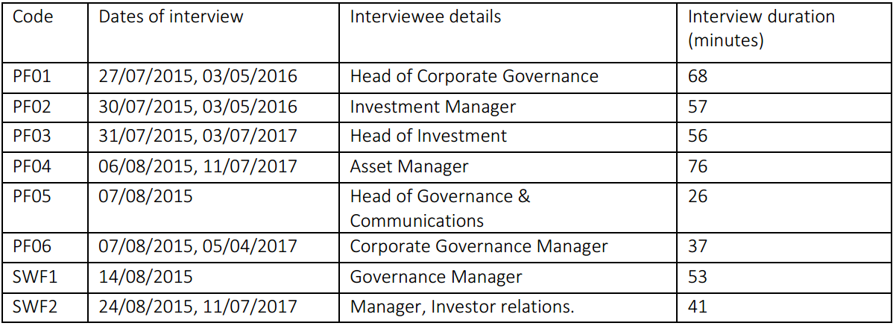

Table 4.5: List of Hedge Fund Managers (Asset Owners) interviewed
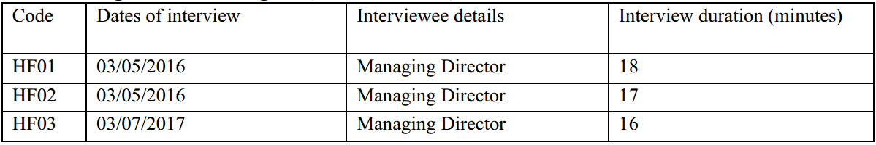

Table 4.6: List of Social Investors (Asset Owners) interviewed
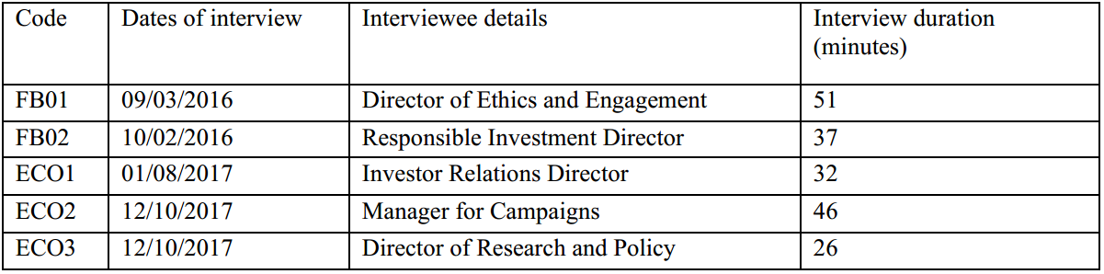

Table 4.7: List of Proxy Advisors interviewed
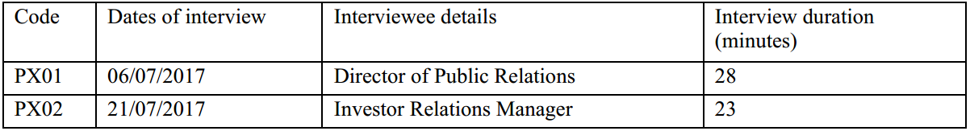

Table 4.8: List of analyst-type investors meetings attended
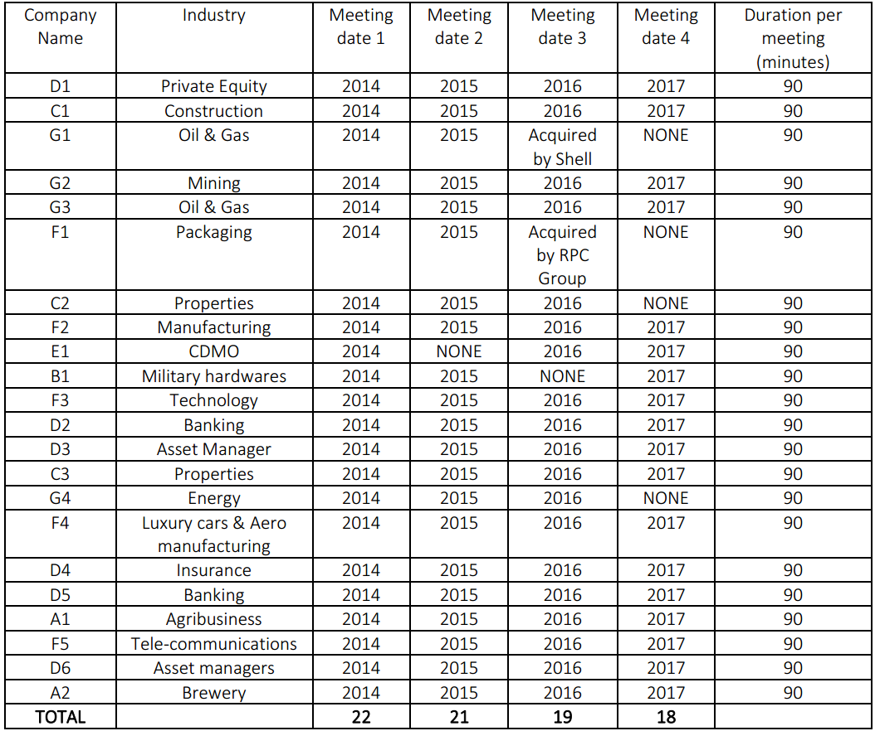

4.7 Data Quality Issues
Generally, data quality issues affecting qualitative research design include issues bothering on bias, reliability, generalisability and validity. Reliability is concerned with whether another researcher applying the same methods is likely to arrive at the same conclusion. This is closely related to the forms of bias of which there is interviewer’s bias, interviewee or response bias or participation bias. Generalisability refers to the extent to which the research findings is applicable in other settings. Also, validity is the degree to which the researcher has gained access to the participants’ knowledge and experience and is able to infer meaning from them which the participants intends to reveal. These issues are discussed below:

4.7.1 Generalisability
The issue of generalisability is not applicable in this research work because qualitative methods were used in gathering the data. Therefore, the data that have been gathered are not proposed to be generalised since they are not quantitative. It is assumed that the more the research findings are linked to theoretical underpinnings, the more the researcher can show that the findings have broader theoretical significance.

4.7.2 The Issues of Bias
Bias can be defined as “an inclination or prejudice for or against one person or group, especially in a way that is considered unfair (Oxford Dictionaries, 2018). Issues that may lead to bias in research include level of knowledge of the researcher, level of information supplied to the interviewees and the interview location. According to Smith and Noble (2017), some level of bias exists in all research, across research designs and is difficult to eliminate. Secondly. Bias can occur at each stage of the research process, and thirdly, bias impacts on the validity and reliability of study findings. Saunders et al., (2016) opined that credibility, validity and reliability are important issues that ought to be addressed to avoid bias in data collection.
In terms of the level of knowledge expected of the researcher, a thorough review of the literature was done to have a good grasp of the underlying knowledge of shareholder activism. The need to deepen knowledge and skills in shareholder activism made the researcher to join the UK Shareholder Association, in order to get the opportunity to attend investors’ relations meetings. Also, the researcher had attended several conferences on the subject matter in and outside of the UK, over the last six years. In addition to this, the researcher had worked as a practicing professional accountant, a stockbroker and an investment banker. He is therefore in a good position to interpret practical and academic terms and jargons during interview as well as during data analysis.

In terms of the level of information supplied to the researcher during the data collection process, the researcher ensures that only people who are skilled and knowledgeable about the subject matter were contacted for interview. Also, prior to the actual interview, the interviewees were informed of the broad topic they will be interviewed on, so that they can adequately prepare for it. Not only that, the individual investors interviewed are members of the UKSA, which means that they are investors who are versed in shareholder rights issues. Also, majority of the interviewees in the institutional investor organisations are people in charge of governance, and therefore they are skilled and experienced in the issues that are being researched on. All the interviews took place within the UK. Some were held on the phone, and many were held at the offices of investee companies shortly before or after Investors Relations meetings. These were the steps taken to ensure validity, credibility and reliability of the data gathered through interviews.

4.7.3 Time horizon
Data used in this work are both longitudinal and cross-sectional. The interview data was derived from a cross-section of asset owners with equity investment in the UK, whilst the shareholder proposals filed in the UK between 2007 and 2017 (a retrospect longitudinal study) as well as the observation of IR meetings (a cohort study) are longitudinal in nature. The longitudinal changes allowed the researcher to observe and analyse changes over a period, and it also provided opportunity for comparing and contrasting with findings obtained through the interview.

4.7.4 Ethical Concerns
The University where this researcher registered as a student have robust procedures in place on ethical standards, and that doctoral researchers must obtain an approval of the Ethics Committee before the researcher can collect primary data. There were no adverse ethical concerns in the process of obtaining the University’s ethical approval. The procedure laid out by the Sheffield University Management School was duly complied with. For instance, consent was obtained prior to data collection, and the researcher made sure that anonymity was maintained in analysing interview data.

4.8 Data Analysis
This involves the interpretation and discussion of the data collected within the understanding of the researcher. According to Corbin and Strauss (2008), the concepts derived from the data represent the overall understanding of the participants’ experiences, spoken words, actions, interactions, problems and issues expressed. The various data collected was analysed using the thematic approach whereby data containing similar themes are grouped together (otherwise referred to as ‘codes’) before they are reorganised into groups of findings.
Thematic analysis is being used to analyse the data collected in this research because it is considered to be the most suitable for most qualitative research that do not specifically prescribe precise analytical procedure such as the grounded theory, discourse analysis, content analysis. According to Saunders et al., (2016), thematic analysis can be used to induce theory when qualitative methods are involved in the data collection.
The starting point in thematic analysis is the coding, which is a process of identifying and allocating a code to a unit of data within large data (say a transcript) which conveys that unit’s meaning (Saunders et al., 2016). This is the reason why a code extract of data is referred to as a unit of data, which could be as small as a word or as big as a paragraph.
Coding prepares each unit of data that the researcher is interested in, for further analysis. This may be necessary because these units of qualitative data due to its inherent nature may contain colorations such as ‘actions, behaviours, beliefs, conditions, events, ideas, interactions, outcomes, policies, relationships, strategies’ which may give meaning to the data being analysed (Saunders et al., 2016). Therefore, analyses of data become difficult without proper coding. The codes generated are the main ideas for discussion. After collection of the data, it was manually transcribed and reviewed for any themes which reflects the researcher’s questions. Related themes were grouped together for ease of discussion and analysis in a mind map. This mind-map enabled the researcher to view all the major themes arising from the data gathered, so that they could be further streamlined where necessary. With the mind map now coded into themes and the data organised into these themes, the researcher was then able to bring the maps together and search for common expressions. These common expressions were identified and separated particularly for developing and analysing the various findings. Although common themes were drawn from the data gathered, the findings are presented with the recognition that each interviewee is unique in his or her own expression, which is a concept supported by social constructivism (see Rutherford, 2003)

4.9 Conclusion
This chapter gave a full account of the research methodology applied in carrying out the empirical research reported in chapters 5 – 9. This is done by clarifying the epistemological and ontological assumptions underpinning this work, as well as the research approach, research design, data collection methods and how the data collected was analysed. The research process has been enjoyable especially the interviews and the longitudinal observations stretching over 3- and 4-year periods respectively. Each of the data collection methods used were complementary to each other. For instance, the archival studies could not answer all the research questions, and neither could IR observation. However archival studies and observation were able to address the 5 research questions. These then served as a basis for comparing data generated from interviews which were designed to cover all the 5 research questions.
Chapter 5: Analysis of Shareholder Proposals and Resolutions [2007 – 2017]
5.1 Introduction
This chapter presents analyses of shareholder proposals that UK shareholders submitted between the period of 2007 and 2017. The objectives are to gain a rich perspective on shareholder activism through the examination of shareholder proposals submitted since the Companies Act passed into law in 2006, and then became effective in 2007. This will lead to a good understanding of the issues in ESG induced shareholder activism, and will therefore help in answering the following research questions:

- What are the issues driving ESG shareholder activism in the UK? (RQ3)
- What are the observed developments in ESG shareholder activism in the UK? (RQ4)
- How can ESG shareholder activism be deepened in the UK? (RQ5)
- How does shareholder activism and shareholder proposals mirror the concept of re-embedding mechanisms in the sense of risk society theory? (RQ6)

The analysis in this chapter covers the following: analysis of period 2007 – 2010 (5.2); patterns observed between 2011 and 2017 (5.3); analysis of major proposal: Environmental (5.4); analysis of major proposal: Social (5.5); analysis of major proposal: Governance (5.6); proxy advisors and how they voted on ESG proposals: 2011 – 2017 (5.7); and the summary of findings through the lens of manufactured risk and trust re-embedding mechanism (5.8).

5.2 Analysis of Period 2007-2010
Apart from the shareholder resolution unsuccessfully sponsored by some social investors against BP in April 2000 (see page 57), there were few recorded shareholder proposals concerned with ESG during the period 2007 to 2010. This is perhaps because they are not considered as mainstream issues (see Haigh and Hazelton, 2004), or due to the newness of the Companies Act 2006 that took effect in 2007, or the lack of awareness of the material relevance of ESG risks. The fact that a conglomeration of a hundred shareholders can submit a proposal, irrespective of the value of their holdings, began to elicit interest of activist shareholders. Activist investors^{5a}, presented sixteen ESG proposals in total during the period, and they were targeted at Oil and Gas companies (11), Mining companies (4) and Electrical power companies (1) (see table 5.1). The issues raised in these proposals bothered mainly on environmental matters, such as demanding for environmentally sustainable strategic plan, reduction of greenhouse gas emission, hydraulic fracturing impacts. Out of the sixteen proposals presented during the period, seven of them called for new forms of sustainability reports that bothers on governance (e.g. coal risk mitigating report) and social issues (accident mitigating report). The votes for these proposals ranged from 4.8% to 20.8%. None of the proposals was unable to achieve the fifty percent threshold, as the main institutional investors holding the majority shares did not support them.

Most of the proposals requesting for Sustainability Reports followed the same formats. For instance, the proposal usually start with the definition of what a sustainability report is as it relates to their business, explaining why such reports are necessary, and some statistics about the companies that are currently issuing such annual reports. For instance, at Dana Petroleum Company Plc in 2010, the proposal requesting for a published sustainability report stated thus:
“Investors are increasingly seeking disclosure of companies’ social and environmental practices in the belief that they impact shareholder value because investors believe that such companies are likely to generate stronger financial returns, better respond to emerging issues, and enjoy long-term business success. Globally, over 2,600 companies issued sustainability reports in 2007, and a recent survey found that 80% of Global Fortune 250 companies now release corporate responsibility data, which is up from 64% in 2005… Department of Energy data book reports that industrial sector are accountable for 21% of CO₂ emissions in 2008, and we feel that it is imperative for our company to develop clear policies and programmes that address the impacts of its operations on the environment and on the society.” (2010:97)

It then stresses the fact that their company is yet to issue such reports, with a plea for their fellow shareholders to support the proposal, to become a binding resolution.

“We shareholders request that the Board of Directors prepare a sustainability report describing corporate strategies to reduce greenhouse gas emissions and addressing other environmental and social impacts such as building material use, water conservation, waste management and employee community relations. The report should include the company’s definition of sustainability and a company-wide review of company policies, and metrics related to long-term social and environmental sustainability. We recommend that the company use the Global Reporting Initiative’s Sustainability Reporting Guidelines to prepare the report.” (2010:101)

Table 5.1 ESG Shareholder Proposal Votes [2007-2010]
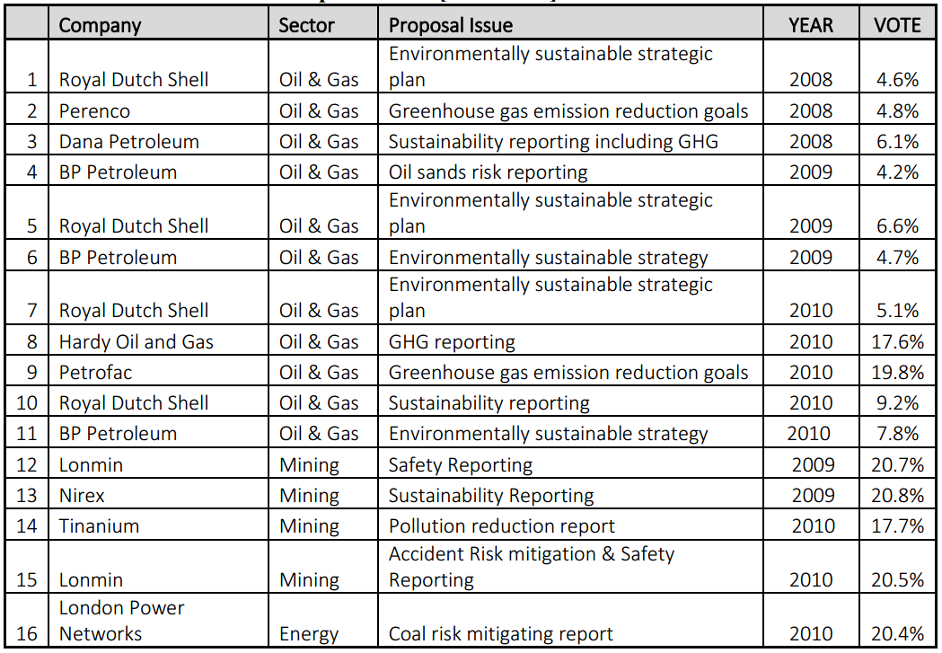Source: Researcher’s findings derived from database hosted at www.proxyinsight.com, 2018

One of the distinguishing features of such resolutions is that the directors usually recommend that the shareholders should vote against such proposals based on the premise that such reports impose additional burden on them, and that such report are not recommended by any regulatory authorities.

Apart from the demand for reduction in GHG, proposals issued to Oil and Gas companies was mainly demanding for a change in strategy from oil based to renewable energy. Despite being voted down on each occasion, the same proposals were being presented to the major oil and gas companies in 2008 up until 2010. In 2010 for instance, twenty-five shareholder proposals were presented to BP Plc’s shareholders at the AGM, and one of them is a proposal sponsored by Fair Pensions and Greenpeace, demanding for a change of strategy. The proposal highlighted the operational and market risks of continuing with oil thus:

“Concerns regarding (i) the carbon intensity of the Sunrise Project at a time of anticipated regulation and pricing of greenhouse gas emissions, (ii) forecasted carbon prices, (iii) the limitations and cost of emissions mitigation, and (iv) local environmental and livelihoods issues, mean that shareholders require assurances regarding the assumptions made by the company in deciding to proceed with the Sunrise Project about (i) future carbon prices; (ii) oil price volatility; (iii) demand for oil; (iv) anticipated regulation of GHG emissions and (v) other legal and reputational issues. – (Notice of BP AGM, 2010: p4)

“At a time of growing international consensus regarding the need to regulate and price GHG emissions, there is a risk of significant costs arising from Sunrise Project. It involves a method of oil production that is among the most energy and carbon intensive of any used in the oil industry producing on average three times the GHG emissions of conventional production” – (Notice of BP AGM, 2010: p23)

“Oil price volatility, resulting from both the economy’s low tolerance to high prices and the drive to constrain oil demand to prevent climate change and enhance energy security, threatens the profitability of the Sunrise Project. Shareholders require assurances regarding the assumptions underpinning the Sunrise Project.”
– (Notice of BP AGM, 2010: p24)

Interestingly, the directors not only placed this proposal at number twenty-fifth out of a total of twenty-five presented, but also requested the shareholders to vote against the proposal through a carefully crafted board response opposing the operational risks, market risks, oil price volatility and the GHG reduction arguments in the proposal. The proposal was voted down as only 7.8% of the shareholders supported it. The frustrations emanating from the failure of these proposals made the social investors to add physical protests at the sites of the respective companies, especially after the Gulf of Mexico oil spillage disaster^{5b}. Some of the lessons learnt during this period was that, a conglomeration of one hundred shareholders, although it is a statutory provision, would not be enough to convert a proposal into a resolution. Therefore, joint effort with institutional investors having substantial holdings, rather than confrontation with them, will be required to win on matters relating to ESG.

The major oil spill in April 2010 involving BP may have had some effects on the attitude of shareholders to ESG matters, as there was significant increase in the number of coalition of shareholders now voting for ESG proposals. Rather than seeing such proposals as a distraction or a mere shouting march by marginal shareholders, some shareholders and directors began to see ESG issues as existential, and the directors changed their tone, to support such proposals, providing reasons such as “risk management”, and “long-term interest of the Company.” ^{5c}.

These proposals were drafted and filed by social activist investors, and none was credited to institutional shareholders during this period. The act of targeting the big corporations with these proposals despite not having meaningful shareholding suggests a deliberate action that is likely to elicit public awareness about the issues global warming through CO₂ emissions, environmental degradation because of the direct actions of the companies operating in the extractive sector.

5.3 Patterns observed between 2011 and 2017
Nine hundred and twenty-five (925) proposals categorised as environmental social or governance in nature were filed between 2011 and 2017. The level of awareness created by the social activist investors, coupled with the Stewardship Code published in 2010^{5d} after the Walker Review of 2009 may have contributed to the surge in the number of resolutions concerned with ESG within this period. In 2011, CCLA an investment management firm representing mainly charities and religious organisations convened the “Aiming for A” coalition, and this was the point where many institutional investors joined the quest to entrench and promote ESG induced shareholder proposals in the UK^{5e}. Their interests comprised of five main issues bothering on long-term performance and survival of their investee companies^{5f}:
- operational emissions management
- Asset portfolio resilience post 2035-scenario
- Low carbon energy R&D and investment strategies
- Strategic KPIs and executive incentives
- Public policy interventions

The above aims are related to ESG issues, and this explains the interest of the “Aiming for A” coalition in voting to support responsible investment especially targeted at the top Stock Exchange listed companies in extractive and utilities sectors. According to their website:
“We believe that supportive but stretching shareholder resolutions can play a positive stewardship role in the UK. They could amplify the need to balance the short and long-term aspects of shareholder value creation.”

Figure 5.1 Shareholder Proposals Filed [2011 – 2017]
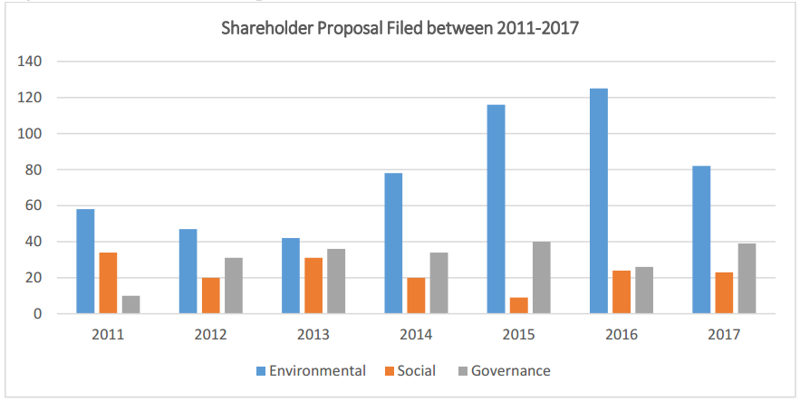
Source: Researcher’s findings derived from database hosted at www.proxyinsight.com, 2018

Between 2010 and 2017, over seventy percent of all the proposals submitted were aimed at companies operating in the extractive industries, power and manufacturing sectors. This is in line with the aims of the “Aiming for A” coalition (see table 10.4) due to their belief that ESG policies in these companies will ultimately have trickle-down effect on matters concerning economic transformation and long-term survival of all other companies operating in the UK and beyond. This view also aligns with the thoughts from previous research (Cai and Walkling, 2011; Smith, 1996; and Faleye, 2004) that big firms are likely to be targeted as they are more visible than smaller ones, and due to economies of scale considerations by the activists. From the graph shown in Figure 5.1, environmental issues took the lion’s share of all the proposals filed between 2011 and 2017. This concerted effort by investors yielded good results in 2011 as three resolutions bothering on Sustainability Reporting was passed in Tullow Oil plc (52.7%) Fugro Consulting Ltd (92.8%) 2H Offshore Engineering Company (86.2%) which are oil and gas companies^{5c}. Based on the records available, the year 2015 has the highest number of ESG resolutions won (25), which then dropped to ten in 2016. No win was recorded in 2017 but the spike in the number of proposals withdrawn because the respective companies have promised to address the ESG issues contained therein, may be seen as a good development as they tend to promote continuous dialogue and goal congruence between directors and the institutional investors. It ought to be noted however, that winning ESG resolutions in the UK is particularly difficult because unlike ordinary resolutions that require fifty percent vote to pass, special resolutions require seventy-five percent vote. This disadvantage through legal classification is a source of worry for many shareholders who see this as a setback for shareholder empowerment. In the USA for instance, a fifty percent vote is enough to pass such resolutions.

However, a noticeable trend in these shareholder proposals is the increase in the number of proposals withdrawn after being filed, because the targeted company made a commitment to address the ESG issues raised. Withdrawing a resolution should not be surprising since in many cases, the condition for suspending or withdrawing the proposal would have been stated in the original document filed. Withdrawals ending in dialogue is encouraging because it is part of the continuous engagement process being encouraged by the PRI (2006) and the Stewardship Code (2010). Nevertheless, the process may run in futility if the filer is confrontational in nature, or if the original purpose of the proposal is to expose goings on within the company.

Table: 5.2: Analysis of shareholder proposals filed [2011 – 2017]
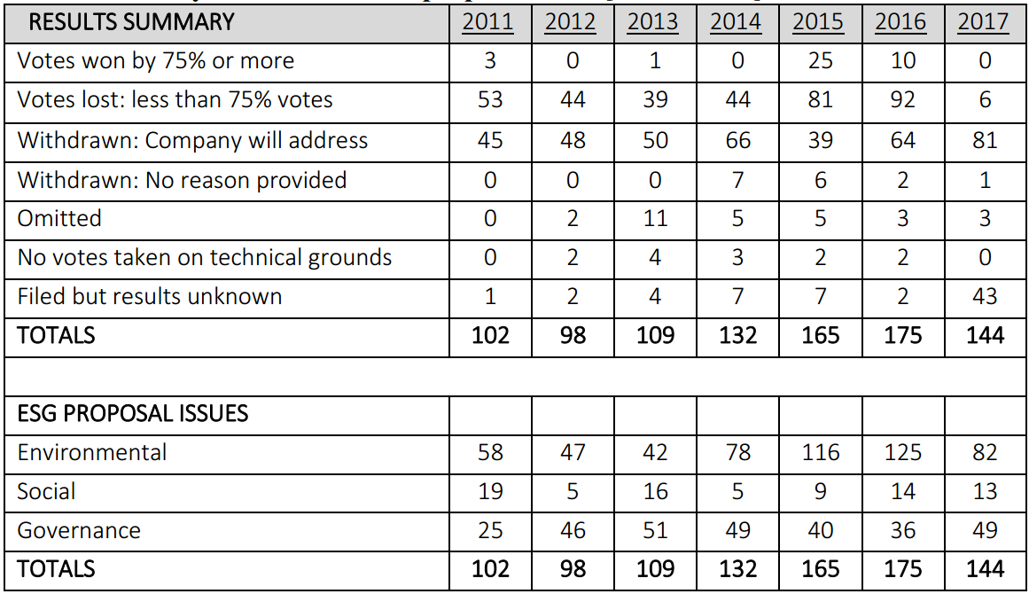Source: Researcher’s findings derived from the database hosted at www.proxyinsight.com, 2018

The number of proposals withdrawn grew from 45 in 2011 to 81 in 2017, which is a 34% annualised growth. Effectively this is a win for the filer since the purpose of filing is accomplished. It is used as a means of steering the direction of the company towards systemic risk management and long-term thinking perspective, given that both parties are hopeful for a meaningful change, and they are both flexible. In the opinion of the researcher, dialogue between the filer and the Board may be painstakingly slow and sometimes iterative thereby wasting time and other resources. This conforms to the views of O’Rourke (2003) that dialogue and shareholder proposals do run hand-in hand, making the whole process repetitive, and the views of Bauer (2015) that withdrawn proposals lead to dialogue which may or may not lead to ESG performance. A further analysis of the withdrawn proposals showed that majority of them are seeking public disclosure of investor-useful information, especially sustainability reporting on ESG risks and opportunities. A few of them relates to GHG goals set for products and operations.

The increase in the winning trends in 2015 and 2016 suggests that the various Boards of the investee companies were trying to be proactive on ESG proposals by recommending that the shareholders should vote in favour of these proposals. This accounts for winning votes of 98.1% in Glencore plc (a mining and resource company), Shell and BP (see page 112) of over 98% each. These board actions were described as “completely unprecedented”^{5g} as it relates to environmental concerns.

Table: 5.3: Shareholder proposals filed based on UK economic sector [2011 – 2017]
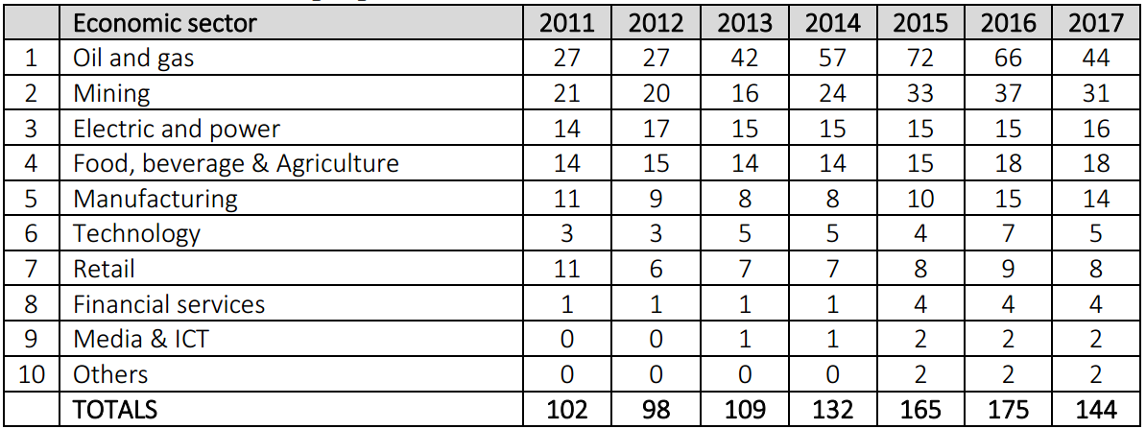Source: Researcher’s findings derived from database hosted at www.proxyinsight.com, 2018

5.4 Analysis of a major proposal: Environmental
The “Aiming for A” coalition submitted two identical shareholder proposals at BP and Shell in accordance with its aim of targeting top companies in the UK. The proposal, in accordance with the coalition’s five main aims, requested for the widening of the reporting scope of the disclosures made in the sustainability report and annual reports. These proposals demanded for enhanced disclosure on the following:

- Steps being taken by the two companies to move from ‘B’ rating in carbon performance, to A (based on an A-E scale) based on the CDP investor initiative on the provision of standardised climate change information;
- Steps being taken to ensure that operational assets are diversified in order to cope with post-2035 scenario when carbon-related assets would be banned in the EU region;
- Post 2015 R&D plans for low carbon energy;
- Evolving plans to link executive incentives to a low carbon performance; and
- The companies’ medium-term plans on low carbon economy in the 2015-2020 policy-making period.

The aim of this proposal suggests the prevalence of fear of loss of future income and assets as the motivation behind the renewed attention being paid to ESG matters (see King and Atkins, 2014; Gifford, 2010; Friede et al, 2015; and Camieri, 2017). Ultimately, these resolutions achieved 98.3% votes and 98.9% votes at BP plc and Royal Dutch Shell plc AGMs respectively, exceeding the 75% threshold required for success. The positive influence of the two major proxy advisors, i.e. ISS and Glass Lewis contributed to the success because they also recommended that institutional shareholders should vote for the proposal. More importantly, prior to the two AGMs, the “Aiming for A” coordinators directly contacted and lobbied the top one hundred institutional shareholders in both companies and got their backing through a pre-declaration initiative, which involves affirming their commitment to the vote for the five resolutions. In both cases, the Boards of Directors, for the first time, recommended that the shareholders vote for these resolutions perhaps influenced by many institutional investors making declarations on their websites prior to the AGMs. This demonstrated the powers of institutional shareholders to hold companies to account if they work together (Çelik and Isaksson 2014; Mallin, 2010).

Comparatively in 2016, a similar effort named Carbon Asset Risk Programme [CARP] was coordinated in USA by the CERES organisation, to present nine resolutions on climate change disclosure and impacts at the Exxon Mobil AGM. However, in this case the board rejected all the proposals as only thirty-eight [38%] percent voted for it. It is curious that some of the institutional investors that voted in favour of the BP and Shell resolutions now opposed them at Exxon Mobil. In 2017, the proposal was re-presented at Exxon Mobil. This was after two hundred and fifty-five largest asset owners in the world with AUM worth US$30 trillion launched the Climate Action 100+^{5h} earlier in the year, with a specific aim of pressurising companies to adhere to the Paris agreement on climate change. Sixty-two [62%] percent majority was achieved, which is higher than the fifty percent legally required to pass such votes in the USA. The Climate Action 100+ coalition also launched similar resolution at Occidental Petroleum Investment Company, another US based company, and was again able to achieve majority vote.

Table 5.4: Top 6 Environmental issues in UK shareholder proposals 2011-2017
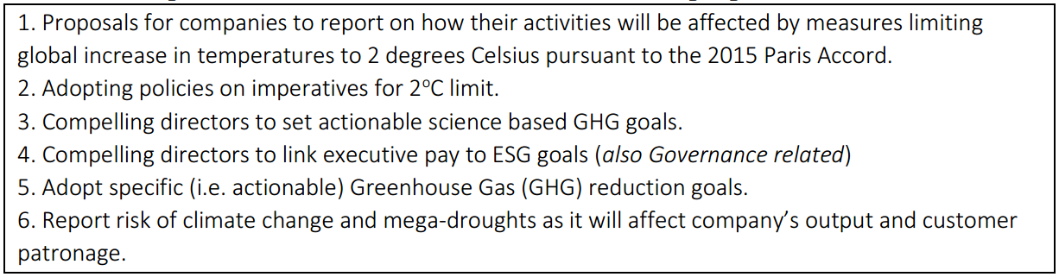Source: Source: Researcher’s findings derived from database hosted at www.proxyinsight.com, 2018

Subsequent to the 2015 rounds of success, data suggests that the winning streaks recorded on ESG matters have tapered off as activists’ investors try to build on their success on enhanced Sustainability Reporting resolutions in 2015. The “Aiming for A” coalition for instance, prepared an ambitious proposal seeking to align the goals of BP and Royal Dutch Shell to the Paris Accord. i.e. binding the two companies to the GHG emission limits of 2ºC. The proposals have been filed thrice, i.e. in 2016, 2017 and 2018, and unfortunately, the respective Boards of directors have continued to oppose these proposals, and the votes achieved each time, are far less than the 75% threshold.

Analyses of the resolutions at BP plc and Royal Dutch Shell plc offered some interesting perspectives on shareholder proposals bothering on environmental issues. Firstly, the pre-declaration initiative is likely to influence the board to either support or reject a shareholder proposal. The boards always read the body language of the institutional shareholders working together (Mallin, 2010). Therefore, the boards are likely to avoid clash of interest with the institutional shareholders especially where they are likely to get a majority vote. Secondly, institutional shareholder engagement has started having meaningful impacts, especially when they work together in engaging the investee companies. Thirdly, shareholder proposal bothering on environmental issue is starting to have impacts, although these impacts are insignificant. For instance, the institutional shareholders were able to back the proposals at BP and Shell in 2015 because enhanced Sustainability Reporting is unlikely to impact on the profit reported in the short term.

In addition, no independent assurances were issued on such reports, and so it is convenient for management to back such proposals even after being compelled to do so. On the other hand, aligning the oil companies’ businesses to the “2º scenario” is likely to involve diversification from activities that are currently yielding high profits and dividends, and therefore, some institutional shareholders are not ready to take a risk, sacrificing existing profits that seems certain, for uncertain future possibilities. Both BP and Royal Dutch Shell plc, through the response to the various shareholder proposals, have demonstrated efforts geared towards diversification from fossil fuel, albeit at a slower pace than some investors’ desire. Finally, perhaps with pre-declaration of voting intentions prior to AGMs, investor associations like PRI expelling members who fail to disclose their voting intentions, and regulators compelling institutional investors to vote (rather than withholding them) on ESG matters, it is likely that there would be enhanced transparency in voting on matters relating to climate change risks.

5.5 Analysis of a major proposal: Social
Generally, shareholder proposals bothering on social issues within the period under review are not popular, evidenced through the fewer than ten percent filed. Also, the legal intervention by government through the Bribery Act [2010] and the Modern Slavery act [2015], had greatly reduced the incidence of activism in this area since many raging social issues have effectively been addressed through these Acts. For instance, illegal acts committed under these two Acts cane be enforced in the UK courts. Overall, an important trend noticed in the shareholder proposals filed in the UK and elsewhere, is the likelihood of such proposals being withdrawn between the filing and the AGM dates due to Boards’ agreement to address the issues raised. The case of Lonmin plc, a mining company illustrates this fact.

A conglomeration of LAPFF shareholders holding minority shares in Lonmin plc filed this proposal in 2013. The objective of the proposal is to get a commitment from the directors on matters of accident risk mitigation and the issue of health and safety of workers. The proposal made reference to two separate incidences on the company’s sites in which killing of several unarmed staff members of the company was carried out by the South African security forces. This act contributed to a significant fall in the value of the company’s shares in 2012. The proposal pointed attention of the directors to the likely financial risks of the unfortunate incidence to the company, as well as the need for the company to develop a new policy on staff welfare. The proposal also highlighted the need for payment of living wages, and the need for an up to date policy on health and safety to govern mining operations in the various sites. Practical recommendations on how to mitigate such risks in the future (like periodic meeting with the community, the need for additional insurance cover) were also recommended in the proposal. After holding series of engagement meetings with the LAPFF shareholders, the board agreed to address the issues contained in the proposal, and it was thereafter withdrawn.

Table 5.5: Top 6 Social issues in UK shareholder proposals 2011-2017
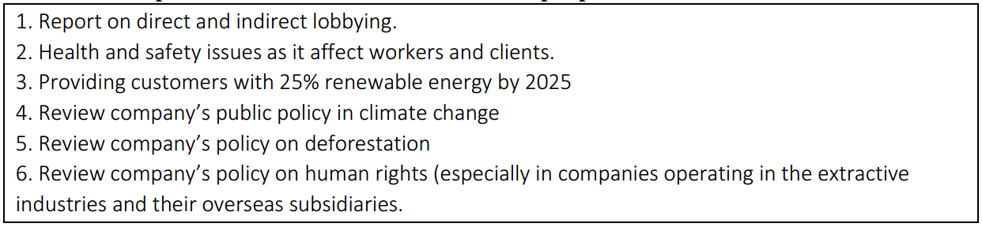Source: Researcher’s findings derived from database hosted at www.proxyinsight.com, 2018

Since this proposal will be treated as a special resolution requiring a seventy-five percent vote to pass, it is doubtful that it would have succeeded if presented at the AGM. However, this proposal is likely to embarrass the management, as it will further expose the negative treatment of employees within the company. Such news is likely to affect the share price negatively and that may have contributed to the decision of both parties to engage on the issue, leading to the withdrawal. Incidentally Xstrata plc, which owns majority shares in the company was not part of the coalition. This proposal brings out the issues of risks imposed via the operation of a foreign subsidiary. It is also unclear, whether Xstrata plc and other major shareholders were engaged in other ways with the board on this issue.

Similar trends in corporate behaviours have been noticed in the USA where similar proposals forcing Whole Foods Market Inc. requesting change in how they manage food waste, and their oil palm sourcing policy, was jointly filed Clean Yield Asset Management and Trillium Asset Management companies in 2016. The proposal highlighted issues bothering on living wage and wellbeing of the company’s staff members. The proposal was withdrawn, with the company promising to address the issues highlighted, perhaps because some of the issues related to potential human rights abuses in foreign operations, which could cast the company in bad light, were highlighted. Between 2011 and 2016, CalPERS and CALSTRS have jointly filed proposals demanding living wage, human rights, public policy, assessing supply chain impacts on deforestation against food and beverages companies in the USA. Most of them were also withdrawn with management promising to address the issues raised.

These trends demonstrate how interest in social issues have evolved from individual sponsored protests demanding social responsibility, to becoming matters of interest to institutional shareholders. In the cases highlighted above, it is likely that the Boards and the institutional shareholders took a risk management approach to the matter, by taking proactive steps to save their jobs and the value of their investments respectively. These findings are in agreement with earlier research carried out by Logsdon and Buren III (2009) in the USA where shareholder activists filing proposals focusing on wage issues and violation of human rights are likely to end up with dialogue rather than public confrontation. These trends also show that dialogue can be used to align the long-term interest of the shareholders and directors at minimal agency cost. Although they have been under-reported in literature because of the difficulty in gathering data in this area, dialogue with shareholder activists is common where social issues are involved.

5.6 Analysis of a major proposal: Governance
An emergent governance issue which is being championed by the UKSA, UKISS and ShareSoc^{5i} is the proposal to establish a Shareholder Committee by public limited companies, which will function as part of the existing governance framework in building trust between the company and the shareholders. They proposed that the Shareholder Committee should be made up of stakeholders and shareholders’ representatives, to oversee ESG risk issues, board remuneration policies, business strategy from shareholders and stakeholders’ perspectives, and providing voting recommendations to the board and the shareholders.

The request for this proposal is justified by several factors. Firstly, there is a noticeable rise in the incidence of ‘ownerless companies’ due to fragmented shareholding. Secondly, about twelve percent of all UK company shares are held by retail investors who hardly vote in meetings^{5j}. Thirdly, there is a noticeable rise in executive pay which is not matched by performance. For instance, the average executive pay has risen by 100% to £6 million p.a. in ten years, representing 150 times the wage of an average worker (see Deloitte 2018; Edmans et al., 2017, p26). They propose that such shareholder committee will have powers to ratify executive pay recommended by the remuneration committee, and make the board respond to strategic issues on social, environmental, and governance risks and opportunities as they relate to the company’s business, rather than wait for shareholders to file proposals before directors will act.

Table 5.6: Top 6 Governance issues in UK shareholder proposals 2011-2017
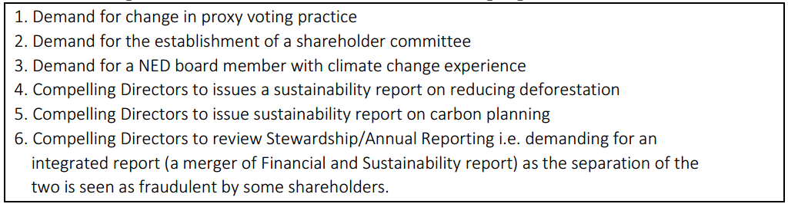Source: Researcher’s findings derived from database hosted at www.proxyinsight.com, 2018

Due to the requirements to have one hundred shareholders backing the proposal, three shareholders associations (UKSA, UKISS and ShareSoc) decided to collaborate in order to get the minimum number required. The proposal was filed for the first time in 2016 with the directors of Royal Bank of Scotland with the aim of filing it in all major public limited companies thereafter. RBS was probably chosen to launch the proposal for two reasons. Firstly, the company is a good case study in excessive pay awards due to the award to its former executive board led by then Sir Fred Goodwin, which was later opposed by the shareholders by a 90.4% vote. The company was later bailed out by government to the tune of £45 billion after it almost collapsed due to financial losses arising from excessive risk taking^{5k}. Secondly as the bank is now seventy-two percent [72%] owned by the government, it is an opportunity to bind the hands of the Treasury to back the spirit of the government Green Paper on Corporate Governance.

Although the proposal was filed with the board of Royal Bank of Scotland in 2016, it was not presented to the shareholders at the AGM for some undisclosed legal reasons. However, by 2018, the proposal filed again at RBS, and the directors, this time around, put it forward to the shareholders, but recommended that the shareholders should vote against the proposals. Only 1.35% of the shareholders supported the proposal, which means that the Government voted against the proposal – against the spirit of its own published Green Paper on Corporate Governance. It is unlikely that the proposal would succeed at RBS if the support of the government were not gained. The UKGI^{5l}, in opposing the proposal, explained that they are not convinced that the committee would be in the best interest of the taxpayers, as it may result in duplication of executive functions.

There are three main criticisms of this proposal. Firstly, the directors have argued that the work of the proposed committee is will be duplicating the ones already being performed by existing committees such as remuneration and risk committees. Secondly, such committee members will, by the nature of their work, be privy to price sensitive information and this may be counter-productive except the management create other expensive firewalls within the organisation. Thirdly, the system is akin to the Swedish-type governance system which is some directors are opposed to. The loss of support for this proposal on governance reinforces the trend noticed in filing proposals bothering on environmental issues (section 5.3), that such proposals are unlikely to succeed where the key institutional shareholders and the board of directors are opposed to it. In this case, the UKGI controls the board as well as the financial and operating policy decisions of RBS, and their support was key. It could be argued that the government was being hypocritical by not supporting a proposal that goes to the root of a proposal made by themselves. The government opposition to this proposal is in line with its refusal to support binding votes on executive pay, which is a general trend noticed in Europe amongst right wing governments^{5m}. However, if there are immediate existential governance issues that imposes going concern risks on the company, it is likely that the largest shareholders, the UKGI in this case, will vote for it. For instance, the takeover of RBS to prevent liquidation is a very good example. Also, the ‘special resolution’ tag on ESG proposals which requires a seventy-five percent [75%] vote is a major impediment for ESG induced shareholder engagement.

In many other companies, there is a significant growth in the number of shareholder proposals requesting that the directors appoint both executive and non-executive directors with ESG experience onto the board, as well as proposals demanding for executive remuneration to be linked to ESG performance. Incidentally none of such proposals have won in the UK, but fundamentally it is an ongoing recognition and, in some degree,, the intensification of focus on ESG due to the perceived positive impact on financial performance, and the conviction that having a board member with ESG skills will put premium on how boards respond to ESG issues.

5.7 Proxy Advisors and how they voted on ESG proposals: 2011 – 2017
The voting records of the two proxy advisors interviewed in chapter 7, on the proposals submitted by their clients between 2011 and 2017 were compared. PX01 is a subsidiary of a private equity firm, and PX02 is run collaboratively by local government pension funds. From the analysis in table 5.7 PX02 is aligned with ESG issues as their recommendation to members to vote in favour of ESG proposals range from 89% to 100%.

Figure 5.2: Percentage votes in favour of ESG proposals by PX01 and PX02: 2011 - 2017
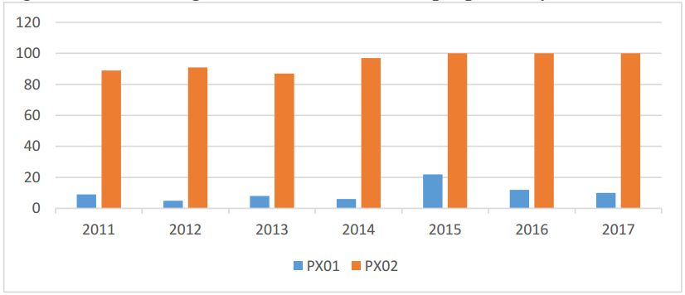
Source: Researcher’s findings derived from database hosted at www.proxyinsight.com, 2018

This voting pattern synchronises with the data gathered from the interview (see chapter 7) where PX02 demonstrated their grounding in RI logic. On the other hand, PX01 seldom recommends ‘vote for’ ESG proposals. However, PX01 had won 100% each time it makes such recommendation. PX01 with low appetite for ESG proposals, is able to influence institutional investors with up to £6.9 trillion in AUM, whereas PX02 is only able to influence seventy-three pension funds with £230 billion in AUM.

Table 5.7: Analysis of votes in favour of ESG proposal and the percentage of success
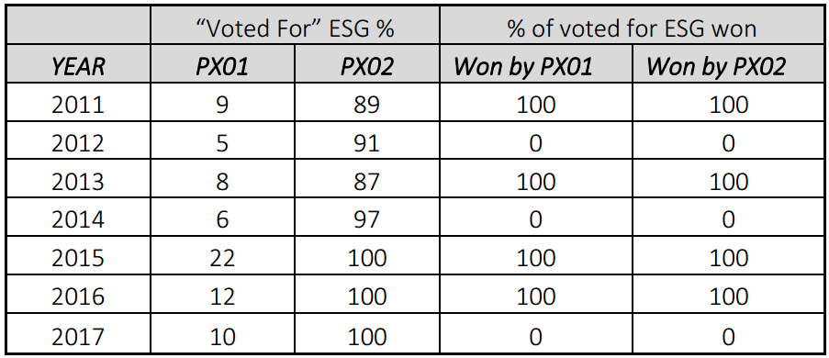Source: Researcher’s findings derived from database hosted at www.proxyinsight.com, 2018

PX01, despite its dismal voting records in favour of ESG, has elaborate policy on responsible investment on its website. Both organisations claim to issue these votes for recommendations only after carrying out research that back up their positions. However, PX02 usually post such qualitative discussion on its page, whereas no such information is made available on PX01’s webpage.

5.8 Summary of findings through the lens of manufactured risk and trust re-embedding mechanism
In this chapter, issues arising from shareholder proposals submitted to UK companies between 2007 and 2010 were analysed. Therefore, issues driving shareholder activism in the UK, such as climate change, executive pay, social and governance issues, Paris accord, and proxy advisors were analysed, and they can be summarised under two headings: fear of investment losses, and the growing knowledge of RI (see subsection 10.7). The trends in UK shareholder activism were also discussed. At the inception of the Companies Act 2006, the awareness about the new powers of shareholder to requisition a shareholder proposal was not well known, but this changed with the publication of the Stewardship Code (2010). The period 2007 – 2010 analogous with the adoption of the ‘precautionary principle’ that typified the first emergence of sustainability debates in Germany in the 1980s as described by Giddens (1999:9), whereby uncertainty was helpless about the appropriate response to be made by social activist. This perhaps provides the sociological explanation to the ‘do nothing’ attitude of the major institutional shareholders during the period. However, the awareness created, coupled with the 2010 disaster on BP oil platform brought the issue of uninsurable ‘manufactured risk’ to the fore. That period has since given way to a perceived attitude of ‘responsibility’ whereby the shareholders holding opposing views on the going concern risks facing their companies, especially the ones operating in the extractive industry, have started engaging each other after series of publications of scientific reports, government intervention (e.g. passage of Bribery Act and the Modern Slavery Act 2015) and EU directives, that has energised both sides of the debate. Another interesting observation is the disciplining powers of shareholders on management (see Robert et al, 2006) via failed proposals which facilitates dialogue, otherwise, it could be resubmitted (Bauer, 2015; Grewal et al, 2016). Although the 75% winning vote threshold is still a problem which, if not handled imaginatively by government, may frustrate shareholders, and then (according to Giddens, 1999) make activist shareholders to go litiginous on their investee companies. This has not been noticed in the UK but has been proposed in other commonwealth jurisdictions.

Shareholder proposals mirror the concept of re-embedding mechanism through the promotion of goal-congruence whereby the management being agents are reminded of the sovereign rights of ownership vested in the shareholders, and the ability of shareholders to put self-interest of directors in perpetual check (Roberts et al., 2005:281). According to Giddens (1990) due to “time space distanciation” trust in abstract systems may waver due to lack of direct physical contact, thereby necessitating the need to re-embed probity. Review of the ESG proposals in this chapter revealed some interesting findings about how the re-embed trust. The fact that these ESG proposals may eventually become binding resolutions can cause restraint in the implementation of management policies so that they are not at variance with the shareholders’ goals. When ESG proposals become resolutions, it asserts the supremacy of the authority of the shareholders. However where such ESG proposals are unable to gain the 75% vote threshold for them to become binding resolutions, they send warning signals to management, especially where the issues in question are continuously being debated in the press, or where they have been successfully implemented as a correctional corporate governance initiative in other companies in the same industry (see Brandes et al., 2008; Ferri and Sandino, 2009; and Goodman, 1991. There were noticeable instances where both directors and shareholder jointly agree that the ESG proposals be withdrawn before the AGM date because directors have agreed to implement them. Although Roberts et al. (2005) sees this as a means of whipping management into line, it is also a means of re-embedding trust in the agency relationship which exists between the two parties. Perhaps because filing of shareholder proposals was relatively new in the UK, there was noticeable reluctance on the part of some managements to accept ESG proposals filed between 2007 and 2010 as an integral part of RI logic which is not at variance with long-term maximisation of shareholder value. This may be because they were filed by environmental and social activists with no substantial shareholdings. Nevertheless, the lack of trust diminished due to the partly to the codification of the Walker Review (2009) recommendations as well the UNPRI Code. But the greatest turnaround in the use of shareholder proposals to embed trust, is the unfortunate BP catastrophe (see page 107) which forced managements to have a rethink on ESG proposals. This chapter showed a noticeable growth in the rate collaboration by mainstream institutional investors to engage management via ongoing dialogue and sometimes with ESG shareholder proposals.

The use of shareholder proposals as a means of re-embedding trust in investment ownership is however not totally without “framing” to “take in” lay investors through portrayals which are not supported with substantive RI practice (Solomon et al., 2011) or greenwashing through selective acceptance or disclosure of RI practice in cases where the management is sure that the shareholder are likely to reach a consensus binding the hands of management to do the right thing (Bowen, 2014). For instance, through the review of ESG proposals and voting patterns between 2011 and 2017, not all institutional investors are in agreement on divestment of stranded assets due to the uncertainties attached to the future income accruable to their beneficiaries in the immediate term. There is a noticeable hypocrisy in the voting patterns amongst the institutional investors, with many PRI signatories voting against agreed RI commitments. A very good example is the climate shareholder proposal in ExxonMobil where 45% of the largest asset owners who are also signatories to the PRI Code voted against the climate resolution^{5n}. However, such asset owners’ annual reports readily flaunt their adherence to RI logic on their websites in what Giddens (1990:88) referred to as care for “access points” rather than symbolic “re-embedding action” in agreement with Solomon et al. (2011) and Bowen, (2014). This is because they know that through “access points”, confidence and trust can be marred as they are critical junctions where third parties are influenced.

Chapter 6: Analysis of UKSA members views on ESG Shareholder Activism

6.1 Introduction
This chapter presents the views of individual shareholders who are members of the UKSA on responsible investment or ESG induced shareholder activism. UKSA has a policy on responsible investment, and the body actively encourages members to contribute their part in entrenching these policies^{6a}. Their answers have helped in addressing the following research questions:
- How useful are Sustainability Reports in UK shareholder activism? (RQ1)
- How do individual shareholders, institutional shareholders and proxy advisors influence ESG policies in investee companies? (RQ2)
- What are the issues driving ESG shareholder activism in the UK? (RQ3)
- What are the observed developments in ESG shareholder activism in the UK? (RQ4)
- How can ESG shareholder activism be deepened in the UK? (RQ5)
- How does shareholder activism mirror the concept of re-embedding mechanisms in the sense of risk society theory? (RQ6)

The analysis in this chapter covers the following: usefulness of sustainability reports for shareholder engagement (6.2); shareowners or shareholders? (6.3); shareholder engagement gap (6.4); engaging investee companies on ESG issues (6.5); views on collaborations and collective shareholder proposals (6.6); binding V non-binding vote on executive pay (6.7); future role of UKSA in deepening ESG shareholder activism (6.8); summary of findings through the lens of manufactured risk and trust re-embedding mechanism (6.9).

6.2 Usefulness of sustainability reports for shareholder engagement
The purpose of this section is gain insight into the awareness of the shareholders use of sustainability report, and whether the information in such report influence their ESG awareness and engagement decisions. From the interview responses, all the individual shareholders demonstrated awareness of the sustainability report, but their attitude to its perceived usefulness differs.

Individual shareholders’ opinion here can be classified into two categories: those who agree that sustainability report adds value and that they are useful in their engagement activities, and those who do not. All the shareholders interviewed are aware of the existence of the burgeoning sustainability reporting system in UK plc and PIEs. Many agree that sustainability reporting plugs the gap between the market value and book value by providing missing narratives as the existing valuation systems are insufficient for forecasting the value of a business enterprise given the multitude of environmental risks that businesses must cope with. They remarked:

“as you know that we now live in a dynamic and unpredictable, sometimes volatile environment. You really can’t predict with reasonable certainty, what will happen in the future these days. BP suspended dividends for three quarters in 2009/10. For pensioners like me, that was unexpected. What in the financial statement would have warned me about pending dangers? But looking back now, an environmental report, even with insubstantial information would have provided the information that I needed to sell off the shares…” (UKSA6)

“I inherited these shares from my parents, and I believe I have a responsibility to nurture it and bequeath them to the next generation. It is to this end that I make sure that I use the sustainability reports…. Would the investment outlive me…? Although there are no useful parameters in them, I use the information reported in making my own decision on whether to buy or sell. ….. I only want to hold shares in companies that are likely to be around in the next 50 years, or companies that are not polluting the environment.” (UKSA10)

“I only read the sustainability reports of the companies in manufacturing and extractive industries because they guide me in buying and selling decisions. If their report aligns with legal steps being taken by government, then I will continue to retain ownership. For instance, certain vehicles will not be allowed to come into the UK and the EU after 2040…., and toxicity charge is being levied on certain cars in London now. Why should I continue to invest in such companies? Why should I retain shares in oil companies that are not diversifying into new technologies?” (UKSA11)

However, there are shareholders who do not see any usefulness in sustainability reporting. The most profound opinion on the non-usefulness of sustainability reports is that businesses should be busy with what they how to do best, which is the maximisation of shareholders wealth. They remarked as follows:
“.... That environmental reports are useful? No, I do not think so. In terms of deepening engagements of companies? Again, I disagree. Firstly, corporate social responsibility is something I think companies don’t have any responsibilities to do, my views are very much the same as reporting it. Which is that responsibility of a company is to behave well in relations to its employee, its suppliers, its customers etc. The company should exist for pure financial reasons because if it behaves well, it will do business most successfully and other than that, the purpose of the company is to make money for its shareholders, the purpose of a company is not to make the world a better place. That is a by-product. When Apple started making iPhones, they transformed the lives of hundreds of millions of people for the better, but the purpose of making an iPhone is not to make lives better, the purpose is to make money while selling iPhones.” (UKSA19)

“The company is there to maximise wealth, so the non-financial report looks like a distraction to me and many other people that I know. The majority of investors, probably if they are institutional, are going to be more aware of the typical needs of profit maximization of the shareholder value, because they too [probably referring to directors], may be rewarded, and performance assessed on that basis. So there are a lot of structural incentives for the business to focus on profits and not environmental reports which to be honest, is a distraction.” (UKSA 2)

“In my opinion …. businesses can’t survive without profits and cash flows, and that’s what we should concern ourselves with. Not reporting on sustainability which I think is best left to governments”. (UKSA7)

The opposing views above demonstrate Bernstein’s (1996) view about the need to carefully manage two opposing sides to the issue of risks in a postmodern society. According to Bernstein (1996), both the upside and the downside of risk are important because the two sides of the debate are equally thrilled to support their arguments, which justifies the reason why, in applying Beck’s (2007) reasoning, the two opposing shareholder views ought to be fully engaged.

Some of the shareholders, having been made aware of the integrated reporting system in other jurisdictions, and are putting pressure on corporations and regulators in the UK through platforms such as this one provided by the UKSA, to encourage them to adopt the same standards. However, these shareholders are confusing EU directive on disclosure of non-financial information (which came into force on January 1 2017, and targeted at Plc’s and PIEs), with the integrated reporting system which the FRC is currently opposed to^{6b}. The FRC is of the view that IIRC still has a long way to go in pushing the narrative reporting agenda into the mainstream. FRC believes that not many companies are using IR and is therefore too early to compel companies to adopt it except there is a business case to do so. FRC recent survey on business model reporting’ also indicates that investors and companies believe that IR is burdensome. Those members have this to say:

“Yes, I do read them. At the last FRC meeting, (Paul) George informed us that the whole reporting spectrum will witness a massive change in 2017 when the EU directive on non-financial reporting becomes law in the EU region. Perhaps we may have a truly compact corporate report that will contain all the information required by prospective investors. As of now, as you can see, it is not compulsory, and nobody cares.” (UKSA4)

“Yes, I am aware of sustainability reports and use the information. They may be scanty, but they do point my attention in the right direction most times. Certainly, I pay attention to the content and I look forward to 2017 when UK corporations will migrate to a fusion of financial and environmental reports all in one single narrative reporting document.” (UKSA12)

It is interesting to note that concerns about how corporations cope with the dangers of climate change seems to be an important ESG reason why individual investors analyse sustainability reports. UKSA members engage the company through voting, attendance at meetings, or campaigns by juxtaposing reported information with world best practices:

“As an environmentalist, I have made it a point of duty to continually assess corporate organisations response to the decennial earth summits, especially the agenda 21 (I mean the Rio SDGs), though non-binding action plan, but we have a role to play more so 178 countries signed up to it. Each time annual report is sent to me, I make a point of duty to check the amount of progress we’re making, especially the impact or rather the footprints of large organisations like Shell, BP, British American Tobacco, Nestle and so on. Apart from profits, I am interested in the impacts of these big organisations on climate change, depletion of animal and fishes, poverty alleviation, healthcare, ethical working conditions…. that corporations are made aware of sustainability issues and are being made to report on their impacts annually is enough progress for me. We are making progress.” (UKSA16).

Some shareholders believe that the negative consequences of climate change influence corporations to change through their action of selling off their shares in them, thereby depressing the share prices. But how many shareholders are knowledgeable enough to view long-term effects, and how many are able to see through destructive core business models? It is not clear whether this viewpoint has become pervasive.

“Survival of corporations due to climate change is becoming an important issue now more than ever, and this issue is central to the continued existence of extractive industries. Where will such companies be in 25 years’ time? Yes, environmental reports are beneficial because although such reports are not detailed, we can differentiate between those who care about the environment based on their business model, and those who don’t. I can therefore decide to divest from stranded assets.” (UKSA17)

Another interesting finding that emerged from the interviews was that some shareholders have just started gaining interest in such report, not only because of their conviction that the climate change reporting by some corporations can aid understanding of the financial report, and that such report also provide vital information about long-term sustainability.

“I have only started paying attention to these reports for two reasons. Firstly, a few of the companies in which I have interest have published a report on how they plan to mitigate climate change risks for the first time. That counts for something isn’t it? Secondly, I noticed that most of my colleagues are asking vital questions at the (investors) meeting from them these reports. I’ve read various reports on how to manage climate change risks for a few companies. Although the reports are not consistent year on year, they help me understand the future outlook of the company in which I have shares.” (UKSA18).

“I do read them now. I just started really. Not only that, I go beyond what is reported in such sustainability reports. I want to know what their plans are, I want to know if government policies are likely to be adverse or favourable in the future. Look at all corporations, all closing their high street branches because they are operating in an uneven field with the online stores. There is also uncertainty on the next step when we leave the EU. The sustainability reports provided me with inkling into what the future holds in these entities. However, in the future, I will prefer a single corporate report with financial and non-financial information in one place.” (UKSA9).

These responses demonstrate that individual investors using non-financial reports are mostly those who are well grounded in financial and environmental knowledge and skills, which other shareholders do not possess. They are actively interested in the long-term survival of the corporate entities in which they hold investment. It was also gathered through interaction, that some of them are also environmentalists who joined UKSA solely for pushing climate change agenda to the front burner of the active ownership discourse.

Other shareholders are of the opinion that such report are prepared on a perfunctory basis by company managements who are only trying to meet the minimum regulatory requirements, but are miles ahead of the regulators. This re-echoes the views of Jones and Solomon (2010) and Simmett et al. (2009) on the need for uniformity, standardisation and assurance certifications of sustainability reports globally to avoid doubts on reliability. Some of their views are as follows:

“Do you really think anyone is reading those ones? No, ……. I wouldn’t even waste time on them because many that I have seen are repetitive. It’s boiler plate reporting basically” (UKSA1)

“I have interests…., but I don’t actually understand what the company is trying to communicate about it because it’s nearly always boring so it’s not worth my time” (UKSA3)

“The short answer to your question is no. There are instances of subtle confusion and repetition and inconsistencies in those reports. There was a time when I attempted to compare these reports across companies. What I found unfortunately was confusing and uncoordinated reporting. I think it is a deliberate devise for the directors to distract us. Maybe the FRC should develop a standard to address this issue.” (UKSA8)

“…. those are boiler plate reports. I will not waste my time reading them.” (UKSA12)

“I don’t. But I will start reading them in the future, if and when they are certified by independent auditors. Don’t misconstrue my opinion, I am not trying to say that the reports are useless. But in the era where even audited financial reports contain glaring omissions and misstatements, why should I trust or rely on uncertified non-financial report? It is easy to jump on the bandwagon of non-financial reporting since it is unregulated.” UKSA13

It is evident from the responses that although there is divided opinion on the usefulness of sustainability reports, some UKSA members are convinced that the report provides useful information basis for their active engagement, especially in reinforcing their responsible investment logic. It is also expected that exposure of many more investors to narrative reports such as the integrated reporting system is likely to increase the call for companies to adopt it, even when it seems like the FRC is not yet ready to do so^{6c}. It is also apparent from the interviews that although shareholders look out for climate change information in sustainability report, they are particularly concerned about the extent of how those issues affect their long-term investments in some companies, and nothing more. This suggests that investors with short-term perspective may not be interested in sustainability report (see chapter 7 on the perspective of hedge fund owners). Enlightened shareholders see a positive relationship between voluntary sustainability reporting and future profitability in line with the findings of Ameer and Othman (2012), and Clarkson et al (2013). As enlightened shareholders are the ones promoting the use of sustainability reporting, education of shareholders may hold the key to the future mainstreaming of narrative reporting.

6.3 Shareowners or Shareholders?
Although the incentives for taking active role amongst UKSA members are quite diverse, one common theme is the quest by these shareholders to resolve perceived agency conflicts inherent in their relationship with investee companies. This however opposes the views of Roe (1990), who opined that diffusion of ownership, rather than the agency problems occasioned by the separation of ownership and control is the main source of the agency problems. Many members are interested in clawing back their shareholder rights that have been taken away through the operations of the nominee accounts system, and are critical of the intermediate shareholding model, and they doubt if the system could be relied upon to deepen the shareholder engagement that the government craves. Many believe that they are able to promote ESG agenda better that the institutional investors if their voting powers are returned. The member who explained thus captures the frustration on their inability to vote:

“I am doing all I can to protect BP plc from the destructive effects of the 2-degree scenario, but then again it counts for little. I attend most of the analyst type meetings which I am entitled to attend. But we cannot compel them to change their products or processes to environmentally sustainable ones. As you probably are aware, I am unable to vote since all my shares are held in nominee account. I complete the ‘supplemental form of direction’ on how I plan to vote and then send it back on time for the broker to vote on my behalf. I get no other tangible information from the nominee account brokers on directions on how to vote, and I suspect that an awful lot of shareholders are like me, they’ve been influenced by tax consideration and others into shoving all their hands. I am afraid am not an active shareholder”. UKSA10

Although the rights attached to share ownership ought to include voting, the frustration emanating from inability to vote is one of the reasons why many believe that rights are being eroded. Although shareholders who own shares through nominee accounts of a stockbroker are regarded as beneficial owners, they are not listed in the register of members, and are therefore excluded from voting. In theory, it is the stockbroker that can exercise the power to vote although there are practical ways of side-stepping this.

“I am a mere shareowner and not a shareholder as I am unable to vote at AGMs. In principle engagement is a good thing as the directors are kept on their toes, but I’m not empowered to do so. I get dividends, yes. I get to see the financial reports, oh yes. Can I sell my share if I want to? Absolutely. But am I able to vote? Unfortunately, no. Suddenly we woke up to see our powers had been taken away by this broken system influenced by a bunch of power grabbing institutional shareholders. The only semblance of ‘say’ that we have now, is the annual meeting with the directors where they analyse the facts behind the published financial report.” (UKSA5)

“Unlike before, we now have limited ways of doing so. We have no influence now since all the shares are held by brokers who vote for us anonymously. Real owners like us have no influence and have delegated the influence to people who have no personal stake in the companies.” (UKSA4)

“The belief that individual shareholder can control what the companies do, not delegate the responsibilities to anonymous directors is a thing of the past I’m afraid. In effect a lot of shareholders like me have been effectively forced to give up their rights to influence their companies because we have been overcrowded by the big pension funds. When all these started, we were deceived to accept it as a practical and monetary and tax efficient policy. We are now in a position where we get no rights whatsoever and nobody is likely to offer you them even if you ask.” UKSA14

Some believe that the disenfranchisement of shareholders is not only precarious to the lawful claim of shareholders but is also undermining their rights as investors. In addition to the transfer of their voting powers to nominee account holders, many shareholders believe that their holdings are too insignificant to make any meaningful impact, in which case, the institutional investors will “do the right thing” on their behalf.

“I am never active. Not that I am yellow bellied, but the reason being first of all my holdings are very small and therefore their voting weight is immaterial and also not likely to affect anything. That means the management appointed by the institutions with the lion share can play active role on my behalf. On top of that I also avoid going to management presentations because I am conscious that management have already made up their mind on what to do”. UKSA15

“My view is that the majority institutional investors are probably much more aware of the typical needs of profit maximization and enhancing shareholders value. They have the means and the resources to do so, and they will be rewarded handsomely. There are lots of structural incentives for the business to focus on profits.” UKSA1

The above views demonstrate two things. One is the demonstration of the progression of reflexive modernisation whereby there is a continuous change in the interdependence between social structures and social agents (Bulkeley, 2001). The loss of the traditional individual shareholder voting rights to the institutional investors and the nominee accounts managers has caused a misalignment in shareholding and share ownership whereby the two no longer have the same meaning in a risk society. A second noticeable reflection is the “juggernaut of modernity” in which Giddens (1990:139) sees a never-ending journey in the adjustment of social structures.

It is noteworthy that the UKSA policy on responsible investment which every member strives to promote greatly influences the opinion expressed here, which might not be universal. For instance, whilst UKSA vigorously campaigns for the restoration of voting rights lost to brokers managing their nominee accounts, some brokers are of the opinion that retail the investors exhibit limited appetite to vote^{6d}. Although the confidence reposed by UKSA members interviewed agrees with the positions of Huddart (1993), Gillian and Starks (2005) Shleifer and Vishny (1986) on the fiduciary role of large investors because of their perceived stronger incentives, which makes them better motivated to monitor investee companies. Gordon and Pound (1993) however argued that engagement would depend on the sole interest of the sponsor, which makes generalisation precarious.

6.4 Shareholder engagement gap
There seems to be a confusion as to what constitutes shareholder engagement, which in theory is a subset of responsible investing. To some members, public show of engagement is shareholder activism whilst private activism is not. When asked why they take active role as shareholders, not all members understand that their attendance at shareholder meetings and supporting shareholder proposals on encourage responsible investing constitute activism. Others who are involved in private activism, but do not believe that they are active shareholders, understand active role to mean public activism, i.e. protesting at AGM against executive pay, or protesting corporate carelessness at extractive companies or jointly writing press statements. This exemplifies the expectation gap between what engagement is expected to be, and what it actually is.

“…so sometimes I vote and sometimes I don’t, although my votes don’t count, but I sometimes deliberately and consistently do so just to make a point. I have actually just recently taken to consistently voting just to make a point in particular cases where the corporation is taken steps that is against my conscience. For instance, huge executive pay. I have written a couple of articles, which you will find on my website in the finance section on this generally. But I don’t see myself as being engaged in activism.” UKSA 7

“I personally have not taken part in any shareholder activism except a little bit through the organisations I belong to, I belong to UK shareholders association, I also belong to ShareSoc and recently there was a combined effort by both of this organisations to put a resolution to the board of the Royal bank of Scotland plc to create a shareholder committee which the resolution received quite a number of signatures to at least go on the agenda but the directors of the company refused to put it unto the agenda although they never so far clarify their precise legal right not to put it on to the agenda but apart from that, I basically not really taken part in any shareholder activism.” UKSA19

These opinions exemplify some of the underlying reasons for the splitting of the UKSA and ShareSoc, although steps are currently being taken to reconcile and merge the two associations to present a common front on governance matters as recently recommended by the Department of Business Innovation and Skills^{6e}. Some members equate public confrontation with shareholder activism thereby failing to recognise other engagement activities in which they are engaged to hold management to account. For instance, UKSA and ShareSoc were involved recently in jointly submitting a shareholder-requisitioned resolution to RBS plc asking for the setting up of a shareholder committee, but which was strongly opposed by the Board because of the fear that it may usurp its powers to direct and control the company^{6f}.

6.5 Engaging investee companies on ESG issues
Reasons why UKSA members engage their investee companies can be divided into three: ensuring and promoting governance, fear of losing investment due to climate change and promoting negative screening. In terms of governance, the members want the company to adopt best corporate governance culture to avoid going burst. They want the board to be balanced based on global best practices, they want them to avoid unnecessary risks that could jeopardise the future of the company. UKSA members who understand what engagement is about, also understand why management should be kept on their toes, mainly to ensure governance

“As stated already, namely giving individual owners the rights to influence how the companies behave. I’m interested in governance…, making sure that they (investee companies) are not robbed of their assets. Mind you, governance is continually evolving. As evidences of best practices elsewhere become evident, without resting on our oars we need to put pressure on UK boards to follow suit, otherwise we may be left behind in the corporate world.” UKSA12

“Well in effect, saving company from going burst for instance is one important reason why I am interested in engaging companies where I have shares. I don’t want them taking excessive risks like borrowing to pay dividends like what happened at BHS or investing in environmentally unsustainable projects which may be frowned upon by government and customers. Nurturing companies is like planting trees you see. If the managers forget pruning and watering change tactics as season changes, it is not a bad idea if we help them since they don’t have the wisdom of Solomon. Some of us have managed big enterprises before, and that is why we wouldn’t just simply sit back, doing nothing.” UKSA19

“…… (we are) passionate about having effective control of the directors of a company, the shareholders are people who should exercise that control and that’s why I think it’s extremely important, as without our control you’ll get some of the difficulties and inefficiency’s that you see today, but for some reasons imposed on us by the government, shareholder control is weak”. UKSA16

The above underlies the general reasons why they are engaged as shareholders, although the general theme is that individual shareholders possess insignificant powers. When asked about the specific ESG issues that they are passionate about, there was no doubt that the fear of climate change takes the lion’s share. They worry about coping mechanisms put in place by companies to prevent sudden shutdown, not only in extractive companies, but also non-extractive businesses. The ‘2º scenario’ is one very important issue that is influencing members’ engagement. Attitude to climate change is also affecting how members view all the ESG issues:

“I worry about climate change and every discerning shareholder today must be worried. I want them to appoint an expert on the board that understands the importance and risks of climate change, I want them to develop new products that are environmentally sustainable, and I want the communities where they operate to see us as partners in progress.” UKSA1

“Basically, I am interested more than anything else in how we can influence our companies to avert the dangerous consequences of unabated climate change whenever they are exhibiting snail speed or if they are not already doing so. You can see that oil companies are doing so – they are planning for 2040, textile industries are trying to do so, and we are going to force pharmaceutical companies to do so whether they like it or not. There is no other planet for us to go if we destroy this one”. UKSA6

There are also evidences of climate change calibrating ESG thinking. Similar views are being expressed by others, especially the ones who use ESG information to guide active analysing equity shares:

“…But what I really want to see is whether or not companies are really up to date, whenever there is a change to say structure, a change in CEO, how is the data going to come out, so I will give you a clear example RSA Insurance who publish their ESG on a yearly basis, Apple is also one who does on a yearly basis so I like how they are doing their reports. …… They are looking at environmental issues, they are looking at their product as to how it impacts on the environment involved and all that stuff.” UKSA20

“So what I have been seeing more and more often is transparency in the market place so, more and more companies have opted to provide data and analytical statistics based on the ESG, so they are actually publishing on a yearly basis which is ESG, what are they doing in terms of ESG and that is quite an optimistic way to view things although there could be things that could be done better so different firms have different standards of sustaining their ESG. I have seen some that would publish it quarterly, I have seen some firms who publish yearly, not so well, but at least they are trying hard.” UKSA9

Some are interested in entrenching ESG matters in general but governance in particular at a level that is head and shoulder above any prescribed legal or regulatory minimum in order to prevent future shock which is likely to be occasioned by changes in regulations.

“I would say I like to invest into companies that know what their direction is, for example, companies with their own specific KPIs, these are companies that have something I hold dearly, and I like to see the companies that are deliberately engaged in ESG. So, whenever I invest I look at this key criteria and I want to make sure that the board of directors are also in that direction. So executive pay is another thing.” UKSA7

Whether the director or CEO is making the right decision depending on what sort of company it is, as well as whether the company is doing more than just abiding by rules and regulations, that they are they working on creating a culture that is more than just regulations because the way I see things, regulations is just the bare minimum. But if you have a company that have their own clear governance structure, then whenever it is being challenged by regulations which is asking for that and that, it usually gives investors a more stable mind-set.” UKSA4

There are others who are interested in company-specific ESG activism, depending on the recommendations obtained from UKSA through bulletins, policy communications, symposia or voting directives on proposals especially on executive pay.

“I really don’t have a specific ESG issue that I champion. It really comes down to different companies for different seasons. For example, if it is a company that is for waste management, that would put a higher factor on environmental and social issues for me. But if is a company that is like a conglomerate, that really comes down to the best practices, then I would look at governance as the most important thing to engage with. As we all know that big companies, not because they don’t operate well rather negligence in government, is one of the reasons it fails. I think one of the biggest companies, Kodak, is a clear example of the really large firms that governance has been deteriorating, that led to really big companies like BHS falling apart.” UKSA14

“I’m interested in social socially issues. Are they hiring proper labour or are they using cheap labour or child labour that is against the rules? But here is the thing, whenever it comes down to ESG issues, apart from being fearful of social action against the company in which I have interest because such actions can damage goodwill irreparably, I always wait for whatever UKSA directive is because I don’t know it all. UKSA17

Some members have no interest in ESG issues at all but they are ready to tow whichever path that UKSA stirs them towards, perhaps justifying their membership of the association and the annual membership subscription?

“I suspect that none, because as I said I have given up. I used to hold share certificate which gave me the right to all reports and the possibilities of going to AGMs but since there is virtually no Scottish public companies left, the chance of going to local AGMs is pretty slim even if you do hold the shares certificate. However, I will always follow whatever directive I receive from UKSA concerning ESG issues as I believe that those are professional advice.” UKSA2

“Although I don’t take active role as an individual shareholder, I do whatever I am advised to do by UKSA concerning ESG matters. I would not think that my activism would make a difference though because of the institutional investors who now exercise all the powers for most shareholders.” UKSA5

“I don’t know of any, they probably say a lot of good things on their report, and they are still trying to extricate themselves from the financial crises so I suspect that environmental and social issues are not top on their agenda, governance issues, given if its banking shares, they may well be regulated on that more than have choices over it”. UKSA9

Although members engage in many diverse ways as recommended by UKSA, many equate negative screening with responsible ownership. UKSA members have conflicting views on screening of companies engaged in fossil fuel, weapons, nuclear, tobacco, fur, alcohol, gambling and pornography. Negative screening is popular with individual investors as extra resources are not required to pursue the option. Although exclusionary approach is justifiable in theory on practical, legal, ethical or financial grounds (Celine and Louche, 2011), some UKSA members adopt negative screening on ethical grounds.

“One of the things I realised ……, after many decades of investing, I realised that I have never bought a share in a Tobacco company, not by taking conscious decisions about not buying shares in the Tobacco company but I realised that my own personal ethical values because I’m a non-smoker. But my ethical values about the smoking industry had subconsciously even without me being aware of it, has restrained me from buying share in tobacco companies. More explicitly about twenty years ago, I bought what I thought was a reasonable investment in a company that owned a portfolio of shares of alcohol companies, my wife went ballistic, and after that I sold it straightway and since then I never bought any shares in a company in the alcohol business, and never contemplated buying shares in the gambling companies. UKSA18

“The only areas which I avoid consciously are companies involved in consumer credits directed at low income individuals like Wonga plc. The company was one of my clients when I was with PwC and I was quite happy to give them tax advice because I couldn’t buy shares in them…. and even in retirement when I’m no longer subject to those restrictions, ….and then I would never dream of buying shares in Providence financials or similar lenders because (I believe) that they exploit low income individuals to spend more money than they should be spending. So, I have some ethical considerations (for investing). Conversely, I have no problems at all with buying share with defence companies, British airspace, BAE systems and I have no problems with the financial industries generally. UKSA10

“I don’t take a look at the environmental aspect of what those companies do because I believe that it’s up to the government and the law to take care of the environmental issues by penalizing dumping of waste, air pollution, etc. But I do have views on the type of companies that I will not invest in, I’m an ethical investor in a way if you see what I mean”. UKSA11

Although diverse views are held on how investee companies should be engaged and the role of shareholders in holding management to account, they are unified in entrenching best practices, and the need for shareholders to be vigilant as best practices continue to evolve. It is interesting that some members define negative screening of investments in the way that suits their logic and references, thereby demonstrating their own biases in line with the findings of Baker and Ricciardi (2014), Baker and Nofsinger (2010:647).

6.6 Views on collaborations and collective shareholder proposals
Shareholder democracy is one of the major campaign programmes at UKSA. In March 2017, 160 members of UKSA and ShareSoc jointly presented a shareholder proposal to RBS plc, which if successful, will force the company to accede powers to a shareholder committee, and give individual investors on executive pay and other governance issues. Many are in support of the proposal. However, many are of the opinion that UKSA should either merge with ShareSoc in order to present a common front, or at least, collaborate with them. None of the UKSA members is opposed to collective actions, but a few are justifiably frustrated by the powerlessness of shareholders due to the erosion of their voting powers by the institutional investors. One interesting view that is gaining prevalence is that since it is impossible to reverse the institutional ownership trends, such institutional investors should get annual voting mandate from their clients on investee companies. These investors are pointing to a successful trial of such schemes at CalPERS and CalSTRS in the USA:

“In my own view, I think the world is going into a trend where more and more investors are not investing themselves but rather through fund managers like blackrock, Vanguard, or structured ETF etc. With regards to ESG issues and the Company Act I think there should be large emphasis on the different buy side ones like Blackrock to represent the shareholders, in reflecting the voice during these meetings. But here is the strange thing, if you are buying into ETFs, do you own the shares of the companies? My understanding is that for a lot of the buy side companies and ETFs, you don’t really get any say on the shareholding activities. So, it’s really necessary that the buy side firm represents more towards your clients rather than towards buying into companies. Buy side entities should have a fiduciary responsibility representing the investors who are paying money being managed by firms like Blackrock etc. So Blackrock should be representing the investors and not representing the companies that they invest in. The buying side have to provide the proper channels for the investors in the ETFs to voice their opinions and concerns in a fairly transparent manner.” UKSA6

Some support collective action only if supported by trusted Social Activists who are interested in utilitarian non-profit agenda, whilst others queue behind any agenda supported prominent Shareholder Activists, even when the individual is promoting a short-termist agenda.

“I think it is very important, I mean, firstly, in the US, where I have some direct shareholding in some American companies, it’s much more common to have resolutions for votes at the AGM which has been proposed by groups of shareholders. One of my company is Boeing. You regularly see resolutions about arms sales etc. On a personal level I don’t vote very often but what I do, in general I always vote against such resolutions because they are always put forward by ‘do-gooders’ who are not interested in companies finances but simply trying to change the world by changing corporate behaviours. But the principle of shareholders being able to take collective actions especially if they are not happy with the management direction of the company is a principle I support quite strongly.” UKSA 8

“It is a very delicate and difficult topic to talk about because firstly you don’t want individual investors to have too much power that would disrupt the company’s way of management, we have seen a lot of active investors who have exercised a little too much power. I will name one, Bill Ackman and the way he handled Herbalife bet may not have been the best way. Bill Ackman of the Herbalife disaster fame is one of the active investors who have a variation of companies called Herbalife, so I understand he has done all his research and analysis and the company, maybe on a downward spiral, and therefore encouraged other investors to take a short position. That is not how to invest? Investment is supposed to be long-term. Unfortunately, many other investors believed or had faith in him and it is a shame really. Herbalife is a good example of how not to collaborate with other short-termist investors.” UKSA19

Promoting public campaigns can bring a matter to the attention of the public thereby binding the hands of management on it. This view presupposes that individual shareholders are powerless and will therefore only succeed on any resolution that is sanctioned by the big investors. Dwindling individual shareholding is a fait accompli and may ultimately go out of fashion. Therefore, the investment community should simply adapt to the new realities.

“By proposing resolutions, they can bring matters to public attention, they can speak in the media. That is the main way I think they can influence the behaviour of large institutional shareholders. One of the things I have been quite pleased to see is that in the last ten years is that more and more institutional shareholders are voting. In the past they tended not to vote but they more automatically give their property to skilled management, and I think that trend will continue.” (UKSA13)

“What is quite interesting is the growth of passive index funds like the Vanguard 5000. Research had shown that up to 20% of investments by UK pensions funds are in passive index funds. Surely this will continue to grow and successfully crowd out individual investors who prefer to buy real properties. And also, because these index funds are holding enormous amounts of money, the cost of running a governance unit is no longer a major cost for them in terms of basic cost on their overall volume of investments that they manage. So I think that trend is going to continue.” (UKSA20)

A radical but interesting perspective on how to engender collective action was the change in the voting arrangement to remove the weight attached to institutional investors due to their tendency to promote short-term corporate agenda. A good perspective on change in profit retention policy being egged on by pressure to make profit and distribute profits to large investors.

“Let’s be realistic. What can 100 shareholders achieve compared to a few institutional investors? I don’t see it getting anywhere except the voting weight is changed to reflect one man one vote, one institution one vote. Institutions will not grow companies, but individuals will. In the 1960s and 70s when individuals own majority shares in corporations, they plough back up to 40-50% of profits. Now what do you have? They barely retain up to 10% a year because of the large insatiable mouths of these hedge funds that specialises in running corporations aground. We shouldn’t be surprised therefore, that corporations are folding up which is a shame. Now back to issue of individuals taking collective actions to promote good governance and ESG, only individuals and social organisations with vested interest in societal development can have long term views of corporate organisations. I haven’t actually heard of individuals and social actors achieving anything so far. But I would strongly support and approve them if they did.” (UKSA 18)

In terms of collaboration, both UKSA and ShareSoc have collaborated in jointly sponsoring the RBS resolution demanding for a shareholder committee, and also lobbying the UKFI (the government arm which controls 71% of RBS shares) to support the decisive vote. The two organisations were one and the same until they split in 1992 due to difference in activism methodology. The two organisations may still come together in due course. Some members believe in private engagement like attendance at analyst-type meetings, whilst other prefer confrontational methods like press releases, press briefings, carrying placards, etc. The view of one of the officials on their modus operandi is as follows:

“I would like for UKSA to succeed in getting more members and that requires more visibility and more visibility for the achievements for what we have achieved. The role that we do play is strategic, although most people don’t know we exist and even the people who know that we exist are members, and unless we tell them we are doing this or doing that for you, they will not be in a position to be advocates and carrying the UKSA message to other people that they talk to. But I think there is a growing recognition of the importance of individual shareholders. I think the situation now in some ways is much better than what it was ten to fifteen years ago which I think is an impressionistic comment. Even the FRC consults on periodically on shareholder rights issues. We get mentioned in the media reasonably often, in Financial Times, Chronicles, magazine etc. We are never going to be in the daily mail or the red tabloids.” (UKSA4)

“But I can elaborate right now the two-investor organisation like UKSA and the other organisation called ShareSoc have jointly collected a hundred shareholders and submitted a resolution to the royal bank of Scotland the resolution is for the bank to investigate setting up a shareholders committee under very general terms and the process has been extremely difficult and actually quite technical. It’s been handled by an extremely competent guy who in professional life is a remuneration advisor who knows a lot about the way companies work. And it has failed, and the company has rejected the resolution. You can actually read all about this in the UKSA magazine when you get it. The company has rejected the resolution, on extremely frivolous terms and these terms can only be challenged by engaging lawyers to do it. We can’t afford lawyers, so in effect the company has blocked a perfectly reasonable approach by a hundred shareholders. So in our opinion provisions of the Companies Act (i.e. sections.153 and S338) may have been well intentioned, but the practice is just too absurd to the institutions which allows them to say there is an option for private shareholders to have influence and in fact it isn’t.” (UKSA17)

Both PRI Code, FRC Stewardship Code actively recommend collaborative engagement as it reduces free rider incidences. These and many more like the Kay’s Report and the recent Government’s Green paper on Corporate Governance Reforms have largely influenced the activities of the UKSA members in active engagement. Perhaps due to effluxion of time, this does not agree with the historical views of Cheffins (2008) that typical UK shareholders are a passive investor, who is “ignorant, business-shy or too busy, and tend to wait for others to step forward and free ride off the efforts of those that happen to do so.” However, UKSA members’ main frustration is mainly due to their inability to vote majority at shareholders meetings and non-acceptance of proposals to reduce directors’ powers through the introduction of shareholder committee in public limited companies. This, they believe, will also reduce the executive pay^{6g}.

6.7 Binding V Non-binding vote on Executive Pay
Should executive pay be made binding or not? This is one issue that most individual shareholders are passionate about discussing and seeking powers to accomplish. Nearly all members want a definitive binding vote on executive pay. Since 2012 when this issue came to the front burner in Shareholder Spring I, the government has not been decisive on this issue. A careful observation at continental Europe shows that there is a positive link between a left-wing party in government and sponsoring an Act on binding executive pay^{6h}. The latest government green paper on executive pay suggests that annual binding votes is only applicable to some, and not all companies^{6i}.

“Of course, they should be made binding. The reason why pay is out of control is because there is no control from the people to whom the directors report which is the shareholders, very simple and obvious. If you open a cookie jar for a child he puts his hands and takes them out, and you want the child to return the cookie? It is very human. It’s obvious that it should be made binding.” UKSA20

“I suspect it is a double-edged sword because, well, it will be very interesting to see if what the requirements consultant say is true, and that people will just walk away to go work somewhere else, they might do. There may be executive pay packets around the world and opportunities to do that. Binding or non-binding? I guess this may be like the turkey voting for Christmas for me. I cannot categorically say a yes or no.” UKSA13

“Probably yes, it seems logical if you don’t have a vote. It is toothless and meaningless and most public company directors seem to ignore the interest of shareholder lightly because they know there is no comeback. UKSA7
“Just to point out that in my case all my shares are in the ISA run by trust in Alliance trust and Barclays wealth that it may even be able to vote my shares if they don’t like it may even sell my shares which I very much doubt, and if they did, they haven’t consulted me about doing so. Anyway, that may be irrelevant.” UKSA1

Whilst some UKSA members are sceptical that this may lead to brain-drain, referring copiously to the case of WPP, others felt that a balance should be stuck between creating value and skills they bring in. So, if the value creation argument holds, the critical question therefore is: what should be the ceiling on executive pay?

“Do shareholders understand executive pay? Well, if it is really the institutional investors who make a difference and not the individual shareholders, which I suppose I have just said, then the institutional investors can probably understand the pay packets of the executives but I suspect that whatever the pay packets are, the directors will work to achieve the ends that gives them the money they want.” UKSA2

“So should non-binding votes be binding, I suspect that it would just be double edged, if you make it binding then in 5 or 10 years’ time things will happen and the comments will be that it is because we made it binding and now we are realising that this is happening because we can’t change things and company directors are making all the money and binding pay contract.” UKSA5

“I agree with you, they might go elsewhere and will be losing talents which may be the effect if we make votes on executive pay to be binding because we have previously seen situation where it is not binding, companies like WPP, where the managing director decided to leave because 54percent of the shareholders and said he is earning too much”. UKSA8

“…I mean it depends on what is in the binding contract which links it is to earnings per share, which can be manipulated. What if it is linked to shareholder value? I am sure that cannot be easily manipulated for long. So many things are being manipulated by directors or through directors actions these days. One would have thought that these companies should be better off somehow, having more flexibilities in the pay packages such that they can be amended in the light of the directors’ actions, I mean if you have a pay packet set for 3 to 5 years, maybe you might be best to be able to review it and that gives the owners interesting powers, you know, you can always increase earnings per share in the process …… I can’t remember, how to increase net earnings per share is to go on increasing executive pay without a corresponding increase in long-term performance.” UKSA10

UKSA as a body sees excessive executive pay as a responsible investment issue that must be addressed, and this is one the reasons for demanding and shareholder committee^{6j}. For most members, the need to address the public outrage in their investee companies is the main driver for a binding vote, although many are disillusioned by their disenfranchisement because their shares are held by brokers who may not represent their interest. Interestingly some members fear that such powers may lead to loss of skilled directors who may move elsewhere.

6.8 Future role of UKSA in deepening ESG Shareholder Activism?
There is unity in agreeing that directors of companies should do all they can to adapt best governance practices, and cope with climate change. However, members are divided on the future of activism and how to collaborate with institutional to deepen responsible investing. Some believe that individual shareholding will be extinct soon, while others strongly hold the view that they are the last bastion for entrenching responsible investment. There is also no agreement on the most effective way to engage company directors.

“Firstly, UKSA provides input into the activities of regulatory bodies like the London Stock Exchange, the FRC, the EU especially on shareholder rights. Secondly, we are interested in responsible business and responsible shareholding. We are interested in nurturing companies that will survive centuries and not just twenty first century. This is why the regulators must listen to us. Profitability is not the same as growing businesses sustainably. Maximisation societal of wealth is only possible when large percentages of profits are retained year on year. You can’t eat your cake and have it. But most importantly, if we don’t prepare to stem the tide of deleterious consequences of the 2-degree scenario, then most of the businesses will disappear before you know it.” UKSA13

“Individual shareholding is waning, not only in the UK. We need to accelerate our merger with ShareSoc so that our voice can be respected by the Government and the corporate world, otherwise nobody will hear our voice again” UKSA17

The above demonstrates the failure of trust in the existing social system that ensures accountability and stewardship of the directors to the shareholders, thereby necessitating the need for re-embedding mechanism (Giddens, 1991:88) through the adoption of RI logic and ESG activism as a form of insurance that mitigates the risks of loss of investment.

Members feel motivated that UKSA will continue to be relevant in shaping decisions on regulations especially as it relates to shareholder rights in the future, which would have been impossible if the regulators are influenced by large investors.

“The FRC in the UK are the designating governmental powers to set out standard of good corporate governance and good reporting standards and by taking part in those consultations and working parties, our voice, our opinion is being heard. We cannot go to directors because he who pays the piper dictated the tune. When we are around the table with FRC, although we don’t have a vote at these things, but I feel excited to think about being involved in shaping the future of financial reporting and shareholding which will bound management. So probably UKSA through their groups can have real meaningful input into the making of governance standards, corporate behaviour standards, accounting and reporting standards etc.” UKSA9

“Over the years individual shareholders have declined and we have witnessed the rise in pension funds, hedge funds, mutual funds and others now owning majority shares in the UK companies. Certainly, I don’t see the practicality of UKSA collaborating with them. Apart from pension funds, I am not convinced of the part the others are playing or are likely to play in the future responsible investing. Recently UKSA was able to represent a proposal at RBS. If the proposal succeeds, it is likely that other companies will copy that good practice. The big investors never supported the resolution. But we have a chance now because government owns more than seventy percent of RBS. So that is just an example out of many where UKSA is pioneering good governance and responsible investing, despite the impediments laid in our path by big investors who ought to see us as partners in progress rather than competitors.” UKSA15

Although individual shareholding is insignificant, some UKSA members believe in creating and influencing public awareness will eventually force the hands of the large investors to imbibe the spirit of responsible investing. But, will such campaign always work if there is no legal coercion, or the issue is in the perceived interest of the large investors?

“The most important thing that we need is the financial resources which we haven’t got at the moment. Talking about UKSA we are short of the resources necessary to create the sort of campaigns we need to run. We need to double the number of volunteers. But assuming we’ve got resources, what do resources do? Well they should provide monies for campaigns. That means responding to government consultation documents, just to gather formal positions - to get your name in front of them, agitate on specific issues by writing to the newspapers, doing press releases, by using social media, by writing to and making news to ourselves, the regulators and the other regulatory bodies. To get a public position behind your question will cost money. What I’m saying applies to environmental issues in particular, let’s say in an oil company. The only effective way of doing anything about it is to cause them enough trouble to make them change their ways. That means campaigning. It will eventually bind their hands when the public kept talking about it.” UKSA6

“Institutional investors will only cooperate or collaborate with us where the issue is in their short-term interest. Look at executive remuneration. Individual shareholders are the reason why opposition to remuneration reports get up to 30% votes – just enough to embarrass executives to resign. Why can’t institutional investors support such votes? They won’t because they appoint the executives, and they are unconcerned if executives fleece the companies.” UKSA18

Some will prefer that in the future, corporate governance culture migrate to rules based through the instrumentality of the Companies Act, to impose responsible investing culture.

“The Companies Act needs to be amended in such a way that institutional shareholders will not crowd-out individual investors. If that is not possible, let the individuals behind these institutions, I mean the beneficial owners, be given voting rights.” UKSA2

“The law needs to change. I am referring to the Companies Act. Responsible investing has to be obligated, otherwise we will be playing catch-up with climate change. It is the only thing that can work effectively. If we are serious, ‘comply or explain’ has to be suspended until we get a hang of climate change effects on businesses because it is like being in war or desperate times.” UKSA16

It is perceived that the UKSA and the ‘institutional social investors’ are aligned on the use of public activism, and they see themselves as partners in progress in championing responsible investing. It is not surprising therefore, that UKSA members also have affiliations with social investors. However, they suffer the same fate: insignificant ownership of equity shares.

“It is frustrating. If you take a company like BT where they have hundreds of thousands of shareholders like you and I having about 20 or 50 or even 100 share points and then we have a big institutional investor having like 25 percent. Will they listen to us? Many of them see our proposals on responsible business as offensive. Another example is BP. What can FoE or WWF do to make them change their way? If they wouldn’t listen to WWF, what will UKSA do better? At the end of the day it might look like a noise in the market place. So that is my reason for asking for what can be done as individual shareholders. Although the law has said that we can collaborate to submit proposals, but how can we influence them? Institutional investors is not ready to share powers or concede to us, and they are unlikely to be interested in what we are passionate about.” UKSA11

“The institutional investors are now so powerful that their response to us is: you shape in or ship out. If you don’t like it here, you can sell the shares. I’m not entirely sure how as individuals you can achieve anything in these sorts of things. If there could be more requirements for more types of votes to be held at AGMs and more requirements for companies to take notes of those votes at meetings. But the only way that is possibly going to happen is through new regulations.” UKSA19

Members are concerned that in view of the declining share ownership by individuals, the two main bodies representing their interests need to merge in order to give a loud voice. The need to preserve the powers of individual shareholders have pushed the need to weigh individual and corporate share ownership onto the front burner. Some have also called for the individuals who are beneficial owners of the pension funds to get voting rights, all in the quest to increase the engagement powers of individual investors.

6.9 Summary of findings through the lens of manufactured risk and trust re-embedding mechanism
This chapter analysed the views of UKSA members who are individual shareholders on how they use sustainability reports in their quest to entrench RI logic in their investment, as well as the documentation of their struggles and challenges about inability to enforce their rights as shareholders, and how this is affecting their quest to implement ESG policies in UK companies in which they have equity interest. Interview data suggests that environmental risk discourse is influencing share ownership, and the UKSA-imposed RI logic may be influencing this, which conforms to Beck (1992)’s view of wealth distribution giving way to risk society (Curran, 2013). Interview data also suggests that UKSA members believe that the future of share ownership cannot be separated from the debate on stewardship and voting rights, and this is giving rise to demands for a new form of reporting that satisfies the decision-making needs of the individual shareholders because of the changing environmental risks. In their belief, the traditional reporting system based on stewardship assumptions, is inadequate to satisfying the growing need for public accountability. UKSA members and others are making a case for corporate law reform on matters of shareholder rights and shareholder empowerment. This view aligns with Giddens (1999:8) view that the social interrogation of risk and responsibility will reveal the seeming misalignment in the social order, thereby justifying the need for change in the existing systems.

Although the size of individual shareholding is plummeting, there are growing range of combinations and variables entering the fray, thereby making a definitive projection about the future to be uncertain. UKSA members are also concerned about their inability to voice their say due to the crowding out by institutional shareholders, as well as disenfranchisement constraints imposed by brokers. This had led to the alignment of individual shareholders with social investors, which seems insufficient in combined shareholding, and the resultant frustrations influencing increased incidence of public confrontation with management. Interview data also reveals that executive pay and the effects of climate change on investment are the main ESG issues that are of concern to UKSA members. The Greenbury report (1995) building on the previous Cadbury report (1992), which merely recommended controlling executive pay, recommended linking pay to performance. However, UKSA members are concerned about pay complexity, especially the ones with large LTIPs; insufficiently demanding executive performance targets; insufficient link between executive pay and climate change targets; and the need for the shareholder to be in control of executive pay through a binding vote to block any disproportionate pay. UKSA members also demonstrated their concerns about the loss of their investment and streams of future cash flow to the effects of climate change due to publicly available scientific reports. This reflects the Becksian argument about the intensification of risk knowledge and awareness, thereby “creating a new riskiness to risk.” (Beck, 1997:2).

This chapter also demonstrated the gaps in RI practice from the UKSA members’ perspective. Based on interviews, their trust in long-term investment can be re-embedded through mandatory voting system, transparent IR meetings, decision-useful sustainability reports, and the re-instatement of their voting rights which had been eroded through the use of nominee accounts. Their ability to articulate these shortcomings is primarily influenced by their grounding in RI logic based on the UKSA policy on RI^{6d} which may differ from the opinion of non-members. It is therefore unsurprising that many were able to use shareholder activism as a means of re-asserting themselves as shareholders rather than just shareowners, albeit with awareness that these activities were inadequate in holding management to account. This is the reason why they demand for a new engagement system which would enable institutional investors to mandatorily collate beneficiaries’ vote and then cast vote in investee companies reflecting the aspirations of beneficiaries as a means through which their trust in the investment process can be re-embedded. They fear that the investee companies through pension funds and SWFs are not representing the interests of the ultimate beneficiaries unlike the CalPERS and NYCERS that have demonstrated policies of voting against boards of investee companies by taking sides with workers who are pension funds beneficiaries (see Webber, 2018:7-10). UKSA members believe that legally binding mandatory (as opposed to the existing non-binding, non-mandatory) voting system can be effective in controlling excessive executive pay which has been fingered by Prof Prem Sikka^{6k} as one of the leading causes of corporate collapse being witnessed in recent times. UKSA members are also demanding for a sustainability reporting system that is decision-useful in online real-time basis. Inability of management to satisfy these requirements drive shareholder activism and the need for individual shareholders to re-embed trust. The need to re-embed trust in long-term investment is supposed to be continuous, especially due to changes in social order (e.g. change in laws or culture) and update in knowledge through the media. This supports Giddens (1990:89) call for increase in trust re-embedding mechanisms where there is “prevalence of ignorance or knowledge vacuum in order to prevent breeding grounds for scepticism and doubt.”

Chapter 7: Analysis of institutional investors’ views on ESG Shareholder Activism

7.1 Introduction
This chapter presents the views of institutional investors on responsible investment or ESG shareholder activism in the UK. Institutional investors interviewed are mainly asset owners which included pension funds, sovereign wealth funds, hedge funds and social activist investors. Their responses have helped in answering the following research questions:

- How useful are Sustainability Reports in UK shareholder activism? (RQ1)
- How do individual shareholders, institutional shareholders and proxy advisors influence ESG policies in investee companies? (RQ2)
- What are the issues driving ESG shareholder activism in the UK? (RQ3)
- What are the observed developments in ESG shareholder activism in the UK? (RQ4)
- How can ESG shareholder activism be deepened in the UK? (RQ5)
- How does shareholder activism mirror the concept of re-embedding mechanisms in the sense of risk society theory? (RQ6)

The analysis in this chapter covers the following: understanding asset owners’ investment philosophy (7.2); engagement policies of asset owners with investee companies (7.3); engagement policies of asset owners on ESG (7.4); engaging proxy advisory agencies on ESG issues (7.5); awareness of relevant publications amongst assets owners (7.6); views on mandatory voting (7.7); views on sustainability reports for engagement (7.8), barriers to institutional ESG engagement (7.9).

7.2 Understanding asset owners’ investment philosophy
There are three key reasons why understanding the investment values of the asset owner is key to appreciating their attitude to ESG issues. Firstly, the asset owners are the custodians and trustees’ beneficial ownership. Secondly, because of ownership, they give mandate to other parties like portfolio managers and proxy or governance advisors in the investment chain based on engagement with investee companies. Thirdly and most importantly, a good understanding of what responsible investing entails by the asset owners is likely to accelerate the mainstreaming of ESG issues. Perhaps this explains the reason why regulators believe effectiveness of responsible investing rests on the philosophy of the asset owners^{7a}. SWFs (2), pension funds (6) and social activist funds (5) interviewed exhibited passive investment styles. However, they exhibit different strands of active engagement styles with investee companies, which is largely influenced by immediate ROI on one hand, and pressures imposed by from beneficiaries, regulators, and belief systems on another hand.

SWFs interviewed tend to focus on generating returns to fund government budgets. They are likely to be under pressure by parliament or government in their home countries, to increase immediate returns to fund critical projects^{7b}.

“We were established in the early 80s. Although we started off investing exclusively in fixed income then, we now hold a balanced portfolio consisting of roughly 50% equities, 30% bonds and 20% others. If you look at the composition of our current AUM, you would see that half is invested in the local economy and the other half is foreign. We now invest in life science, robotics, etc. We contribute on average, 17% to the annual government operating budgets, and we continually work hard in delivering the outcomes imposed on us by parliament and the government ministry overseeing our agency. We also see ourselves as long-term equity investors” SWF2

The pressure to generate even more returns is accentuated by another SWF that hinted on future change of focus. If this aggression to fund government budgets continually influences investment philosophy and strategy, then long-term thinking may be sacrificed on the altar of ROI increase, thus making some SWFs to look like a hedge fund or private equity firm:
“We currently have consolidated AUM of close to $200b and our annual ROI is something like 4%. Between 2020 and 2025 we expect our AUM to climb to $500b and our ROI increased to 8%. By that time, government will be expecting us to invest heavily in private equity firms. As you know, some of them are yielding up to 40% per annum. We are not saying that we plan to get that much, but we are changing.” SWF1.

Although none of the two SWFs interviewed referred to Santiago Principles or PRI as influencing their guiding principles and investment philosophies on equity investment, they both mentioned that they are interested in good governance and long-term survival of their investee companies. However, the pressure to fund short or medium-term budgets may hinder that focus in the future.
Pension fund owners interviewed on the other hand seem to be guided by the need to generate long-term returns on the assets held for the benefit of their members. All the interviewees are conscious of the Stewardship Code and are signatories to the PRI Code, and are therefore aware of the importance of collaboration with other institutional investors. They all exhibit knowledge of responsible investing thus:

“Our philosophy is the long-term funding of our plan in such a way that they will generate sustainable future benefits for our members. In terms of our equity investment therefore, we hold passive positions, although we engage management actively.” PF02

“Our investment strategy is iteratively linked with the survival of businesses and the communities in which our members live, which in turn guarantees the ability of the fund to provide future pension for our members. Because we invest heavily in businesses locally and elsewhere, it is our belief that if business is sustainable, future pension payments will be sustainable.” PF05

The social investors interviewed include faith based (2) and environmental campaign organisations (3). Apart from indicating passive investment and active engagement strategy, their investment philosophy is largely influenced either by their religious belief system or social objective. For instance, one of the religious organisations interviewees has this to say:
“Our philosophy is grounded in theological philosophy. One of the things that is distinctive and unique about our approach to responsible investing is that we begin with our biblical, theological and Christian understandings of the issues under concern. So that with regards to climate change for instance, we are looking particular at the creation stories in the bible, the way in which human being are placed in creation to care from the natural order to act as stewards, and in particular through theology and the bible to care for the poor, the vulnerable and the weakest. And then we’ve moved from that into a careful scientific understanding of what’s happening in the world based on our interaction with the academics, to be able to see, what we can do, to try and fulfil our God given talent to care for the planet, and to care for the poor and the vulnerable.” FB01

The above view resonates Williamson (2010)’s view on the social influences of religious beliefs in explaining certain behavioural finance patterns that cannot be explained through price mechanism, and that such “cosmological beliefs” which was vital in the rise of the West, may again be crucial in the progression of RI logic. The above demonstrates the rise of the proliferation of debates in a risk society where trust in existing system collapses, and investors look for alternative views as a re-embedding mechanism (Giddens, 1991:88) through the adoption of RI logic and ESG activism as a form of insurance that mitigates the risks of loss of investment. On the other hand, the environmental campaign organisations indicated their interested in promoting public good through campaigning for increased disclosures, and mainstreaming of SDGs thus:

“Our investment philosophy is that responsible investing is very important in ensuring a prosperous world. We believe that responsible investing ensures sustainable markets, which in turn leads to a prosperous world for all. To this end our aim is to increase transparency in the investment chain, by advocate for more disclosure around ESG risks, especially from the part of institutional investors and investee companies.” ECO3.

“Our philosophy is to promote the alignment of investment goals in the companies in which we have interest with the sustainable development goals, in order to help create a sustainable financial system for all. We believe that it is only when RI becomes mainstream, that we would be able to achieve this.” ECO1

“Since the 1990s we have been engaging with corporations, asking them to identify with positive investing, which is reducing their greenhouse gas emissions, to disclose climate change risks, to invest in new technologies, to have socially friendly strategic business plans which are sustainable. This is quite consistent with the aim of our organisation which is to make the earth continually habitable.” ECO2

This suggests that these environmental campaign organisations understand the role of management in shareholder wealth maximisation and have rejected the Friedman (1962)’s argument that ethical issues should be left to government and individuals. This philosophy resonates with the views of Hart and Zingales (2017) that pursuance of shareholder welfare which is synonymous with the RI logic, is superior to Friedman’s shareholder value proposition.
However, the hedge funds asset owners interviewed were not ready to provide elaborate information on their investment philosophy or strategy, and none of the interviewees referred to sustainability as influencing their investment philosophy. Rather the investment alpha, and their ability to spot short term inefficiencies in the market that the funds can profit from was the common theme:
“Investment is less complicated than you think, that I can tell you…. We use our comparative knowledge of the market to identify unique investment opportunities wherever they exists” HF01

“We aim to earn decent returns on funds entrusted to us over the long term. In doing so, we engage talented individuals with track records of experience and performance that aligns with our expectations.” HF02

“We aim to diversify our investment across different systematic risks by constructing portfolios that is likely to guarantee success based on our experience in the trade.” HF04

The above supports the findings of Ramadorai (2010) and Brunnermeier and Nagel (2004) that hedge funds would rather seize the opportunity to arbitrage on market mispricing than taking long-term position on equities thereby confirming their propensity to reject RI logic. Based on the above therefore, it would be erroneous to assume that all institutional investors are interested in long-term wealth maximisation only. Also, institutional investment philosophy is likely to be shaped by multiple factors including religious and cultural beliefs and values (Greif, 1994:814).

7.3 Engagement policies of asset owners with investee companies
Asset owners tend to differ based on how they engage investee companies. Due to quantum of their equity interest, engagement is likely to have impact on achieving the investment objectives of the asset owners. So how do asset owners engage with investee companies?
“We believe that engagement is at the heart of long-term value creation. It is important for us to do so continuously. We are interested in how the company run, who is on the board, how the board runs itself, how they evaluate themselves in terms of compensation and how the structure supports value creation. Our engagement doesn’t start and stop with the seasonal recommendations of proxy advisors because when there is vote solicitation, although it is part of what we do with our companies, but as long-term owners of companies. We are interested in more broadly understanding the connection between governance and value creation.” PF02

There are others who also engage in private, but publishes outcomes of such meetings and other good practices on their website without mentioning names of the investee companies being referred to:

“We have engagement guidelines which we follow, and we also publish on our website ‘engagement commentaries’ which is a quarterly report highlighting our engagement activities and our stewardship with companies in which we have equity interest.” PF04

Others communicate on issue-specific matters:

“We’ve been communicating with the companies that we invest in basically on principles level. We communicate to with the CEOs of each individual companies on specific issues. Earlier this year we reached out to 50 of our largest companies to engage directly with us. We see engagement and how we communicate strategy to our companies as important issue going forward.” SWF1

However, there are pension funds that sees ‘over-engagement’ as a problem and tries to make engagement a two-way communication rather than an opportunity to impose the views of the asset owner on the investee company.

“Typically, we view engagement with directors as escalation. Therefore, we do not frequently request meetings with directors. We found it appropriate to meet with directors only when there is some conflict such a contentions executive compensation issue or a related party transaction, or where the current engagement systems seems not to be working. That said, we do see the value in establishing a channel of communication of a longer term with the board. We are also increasingly hearing from corporate directors who wish to meet with us as part of their relationship building exercise. They communicate their first-hand views on corporate governance to us investors. In effect to us, engagement is a two-way affair” PF01

It is noticed that all the hedge fund owners have the same modest views on engagement. They all have in-house compliance officers who advises the MD/CEO on engagement, perhaps because the sizes of the AUM is less than £10m each. The compliance officer ensures that they meet all legal requirements. Although they do meet investee companies at least once a year, they are of the opinion that active engagement will increase their costs, and they do not plan to set up an active engagement department in the near future:

“We have a compliance officer whose primary obligation it is to look at the compliance issues and that will be part of his remit. Active engagement on our equities will add to our costs and we don’t think that is necessary. The big firms like Blackrock and Vanguard of this world is already doing that wherever they have interest. It is not our area of specialty and we don’t have any economy of scale advantage. Sadly, it seems that investment firms like us have an obligation and to look into these issues, but I’m afraid we are not doing so for now.” HF03

“We meet at least once a year, sometimes twice. It could be more often if necessary. Bear in mind that the investment is by a firm, so we hardly do direct investments. So, we meet the investment managers who then will meet with these companies on a regular basis.” HF04

Social investors, whether faith or environmental based, are open to all forms of engagement available, whether private or public that will enable them implement or push ESG issues to the front burner. For some of the environmentally based asset owners, engagement is structured, and starts with voluntary disclosure, failure of which will lead to private engagement, and then filing proposal, before considering other forms of public confrontation:

“For us engagement approach begins with our team of in-house analysts who focus on specific sectors who are well versed in those sectors and the best practices in those sectors in term of governance, sustainability reporting, disclosures, and focus on what we think are the most material issues from sustainability perspective. In our review process, we categorise them into leading and lagging categories, i.e. the ones with good ESG scores, and the companies which have room to improve. Generally, we have good relationship with companies that we engage in. We do have open line of communication in all cases. In the cases where we don’t, because we’ve been frustrated over time, we go the investor relations route, and we follow up by filing a proposal to get thing started.” ECO1

“Companies are public property and therefore must be transparent. Disclosure helps the public understand what the key risks are, and how companies are acting to address those. We also believe that it has the added benefit of bringing all this information out to the market so that all stakeholders can see how these issues affect future operations, corporate performance and the environment and we believe that will lead to overall improved performance by the market which will now be able to see clearly how sustainable these companies are. Although we have open line of communication with these companies, it is the failure to engage that triggers other internal procedures, failure of which leads to writing proposals.” ECO3

For faith-based investors, their engagement process also starts with demand for disclosure and transparency, failure of which leads to public engagement and divestment.
“Our engagement process starts by demanding three levels of reporting. The first being full and frank mandatory reporting which include EU directive on Non-Financial reporting which requires large companies to disclose environmental policies, risks and impacts in annual reports. Secondly and on top of that, we demand voluntary reporting highlighting how they plan to cope with climate change for instance, and then finally integrated reporting, because we want them to report on strategy and material ESG factors that affect the entity. There are many issues with disinvestment. Even more important is our working and engaging with companies. Disinvestment is our last resort. We are involved in shareholder resolution with BP, we’ve been voting against high salary packages in more than two third of the companies that were invested in. Although engagement is crucial, if you won’t change, then we would disinvest.” FB01

“Well engagement is at the heart of our approach to ethical investment and it’s really at the core of this policy. We are committed to intensifying and step up on our engagement with the companies that we invest in. We are already doing an awful lot of engagement on climate change issue. An example of this is the shareholder resolutions that we filed at the Shell and BP AGMs this year. The BP resolution is already being considered by shareholders and the enhanced disclosure requirement ordered by resolution and supported by 98% of the company’s shareholders. I think it is an indication of what we are able to achieve through engagement. We’ll be doing more of this in the years ahead and we’ll be very keen to have an impact as investors on corporate involvement in the transition to the low carbon economy.” FB02

Engagement tends to depend primarily on the resources of the asset owners and their core investment philosophy. The larger the asset owners’ AUM, the higher the likelihood of them setting up an engagement department or partial or complete outsourcing of engagement activities. There was also evidence to support the notion that relatively smaller institutional investors are likely to engage in freeriding on governance (see Rubach, 1999:49) because they believe that the larger institutional investors would protect everyone’s interest.
All the pension funds communicate on monthly basis with asset managers through structures reporting system. Some pension funds engage in private shareholder activism involving meeting the directors frequently and voting in collaboration with other investors on common governance issues. The growing importance of meetings other than the AGM as a means for reinforcing good governance was also demonstrated, even where there are no specific agenda, or new issues to be discussed, which depicts ritualization (see Uche and Atkins, 2014).

7.4 Engagement policies of asset owners on ESG
There is a fragmentation of views amongst asset owners on engagement of investee companies on ESG issues. All the asset owners are aware of ESG issues, but not all of them are convinced of the need to make ESG the basis for engagement on equity investment. All the pension fund, social investors and one of the SWFs interviewed have policies on how to engage based on ESG issues, and they are well publicised on their website. All the hedge funds and the other SWF interviewed do not have specific policies on engagement on ESG. The faith-based investors clarified that they used to have large investments in sin stocks, but they have now divested from them due to public outcry and advice received from their governance advisors. It is noticed that when private engagement fails, faith-based investor is likely to apply negative screening, whereas the social activist funds switches to public activism:

“We’ve divested from 13 companies, from the church commissioners, it is about £9m of shareholding, and from the pension’s board, it is about £3m of shareholdings and these are companies that are in the highest carbon fossil fuels. These involved in thermal coal mining and oil sands extraction. We decided on the advice of the IAG to make this move because these are the highest carbon fossil fuels that are making the greatest contribution to climate change and because these companies are specialist in these areas. We don’t thing well be able to have productive engagement with them. And also, we don’t feel that this is the right place for church investment body to have their money.” FB01

“We’ve been increasing our investment in sustainable themes over the recent years. The church commission now have over 4% portfolio in forestry. We are the largest private owner of forestry in the UK, which is quite a significant development in the UK in recent years. We’ve got investment in an invest trust that specialises in environmental solutions. We invest in green buildings in South East Asia. We are also pleased to be one of the backers of an investment management firms co-founded by Al-Gore called generation investment management LLP based in London, which integrates ESG into all its investment decisions.” FB02

“This is something we have been working with in conjunction with the World Wildlife Fund (WWF). We call it sustainability quotient. All our investee companies must pass all four independent filters to be considered a responsible investment. So that when we make the investment upfront, is the investment ricking the boxes from the financial, social impact, environmental and governance? By financial we mean the ability to generate returns on investment. By governance we mean adherence to governance best practices to ensure transparency and accountability, by environmental impact we mean commitment to protecting the environment and respecting the natural capital of a region, and social impact we mean opportunity to provide transformative social benefits in partnership with the local population.” ECO1

“We consider ourselves to be responsible investors. The types of companies that we’ve been investing in since 2004 gives credence to this. They have good ESG profiles and led by good people. About a year ago, to up our game we decided to and fully integrate ESG considerations into our investment process. i.e. we meet the companies, we meet the board… we meet the board, we carry out ESG diagnostics, we identify the risks, and we ensure that only forward-looking assets are invested in.” PF05

“We invest on behalf of thousands of employees and their beneficiaries in fixed income, equities, real estate. A large proportion of our equities over 80 percent is passively managed. And so, for us, the integration of ESG and sustainability is the way we make sure that in our quest to generate returns for our beneficiaries, we’re not sacrificing the ability of the future generations to have those returns. So, we have always been an active shareholder. A few years ago, we turned the lenses upon ourselves. We thought we’ve reached an advanced stage in mainstreaming RI in the UK especially in the companies that we invest int. We then decided to branch out to equities in developing economies to spread the acts of RI to them. We then created our index. And we subscribe to PRI and their principles guide how we invest, to further confirm our sustainability credentials.” PF01

“We focus on renewable energy sector and we energy efficiency with our asset management company, we have moved to north Africa now to give additional returns to our investors. We are super conservative. Our funds yield average of 5% annually and the demand is much higher.” PF02.

One of the hedge funds interviewed understand ESG or responsible investing not to go beyond buzzwords. He also opined that hedge funds investment horizon is an impediment to paying attention to ESG issues:

“I think I’m tired of talking about responsible investing because in a lot of ways it has become a buzzword. There are so many portfolio managers in the market today that professes responsible investing whereas they are not. In terms of the capital that goes into it, is it something that would still be yielding returns 30-40 years down the line? As I’ve mentioned to you before, we only invest in efficient stocks, you know what I mean?” HF02

Another opined that the only assurance to the asset owners that they are engaged in responsible investment is where all investments are done through in-house portfolio managers, as independent portfolio managers may not totally heed asset owners’ mandate, perhaps due to fees and performance considerations:

“Of course, we are aware of the ESG greenwashing in the marketplace. I am afraid we are not a part of that. I am not sure most of the asset owners are knowledgeable enough to decipher the deception that their portfolio managers are subjecting them to. Don’t be deceived. On a deeper cursory look, you will find that not all the assets constructed for the asset owners are responsible investments.” HF01

Although the pension fund owners are interested in ESG issues as explained above, they seem to be fearful of the consequences of climate change as this resonates in all their communications and engagements. Is climate change the main driver of their ESG engagement? Why is climate change so important to pension fund asset owners, and why do asset owners equate ESG engagement with climate change?

“Climate change is a key challenge of our time. There is a moral imperative that we all act as part of the transition to the low carbon economy. We are playing a key role in that transition using a wide range of techniques in order to increase our influence.” PF05

Again, this is a demonstration of faith-based investors typical engagement method, which is likely to result in negative screening where all else fails.

“Today we’re delighted that …. is announcing its new policy on climate change as result of consultation advisory group on investment. And we’re divesting from any corporation that generates more than 10% of their revenues from tar sands and thermal coal. This is right in our view for the time being. We have a policy on climate change which was first published in 2010 and we constantly reviewing. This is a major step forward. This well lead to further engagement. I expect to continually review the policy so in effect were in a transition to a lower carbon economy.” FB02
Investors demonstrated aware of the direct and indirect consequences of climate change on their businesses and the communities which host them. This awareness suggests investors’ linkage of sustainability with the going concern assumption of these investee businesses:

“Some of the most serious issues facing the world today as identified by the world economic forum global risk report 2017, include climate change conflict, forced labour, and widening economic inequality. These issues are creating material risks for investors like us. We can see a direct assault on businesses looming if we keep playing ostrich” PF02

“Climate change is having a devastating effect on our planet. Outdoor pollution ranking amongst top 10 killers on earth. By 2025 almost 2 billion people would be living in the areas of water scarcity. Conflict is forcing many of the world poorest to leave their homes. We have a fiduciary responsibility to reverse these ugly trends which would be costly to humanity, otherwise, who would buy our products in 10 years’ time? What if these companies run out of raw materials?” PF04

Another investor demonstrates the awareness of the climate change risks to mutate, which is one of the features of a ‘risk society’.

“We continually monitor how companies are affected or how they might be affected by climate change and what they can do to reduce the impact going forward. It is important that we see things like low carbon emission, recycling materials, reducing energy consumption and waste and reducing environmental costs going forward. We are interested in seeing business models that will encourage sustainable development, and we always reflect on these issues in board memo board memos. But again, please note that these are current risks that businesses face. We will change our dynamics of engagement once the material risk that our company face changes.” ECO2

Evidence of mutation of climate change risks into other societal problems like inequality which is threatening survival of businesses was demonstrated by this investor:

“Climate change is leading to mass migration. Look at farmers and herdsmen clash in sub-Saharan Africa. This mass migration and lack of accountability in our financial system is taking resources from the people who needs it most. Over $100b is lost in unpaid tax every year. According to Oxfam, just 8 men owns the same wealth as 3.6 billion people. We as investors have a critical role to play in making resources go around for everyone and ensuring that responsible investing becomes the norm everywhere.” ECO1

Interview data suggests growing awareness of RI and the grounding of the RI logic amongst institutional investors. But what is driving this? Fear of climate change seems to suggest anxiety on likelihood of loss of investment and streams of future cash flows if status quo remains. As at 2018, almost 1,700 asset owners representing $70trillion AUM, roughly half of the world’s institutional investment, have become PRI signatories. Will this fast-track the RI mainstreaming process?

7.5 Engaging proxy advisory agencies on ESG issues
The investment chain has the asset owners and the investee companies on both ends. However, there are many other participants in the middle e.g. portfolio managers, governance advisors, proxy advisors etc. For those asset owners with policies on responsible investing, how do they engage proxy advisors? Do they specifically include ESG in the RfPs? How do they review and performance of proxy advisors?

The practice that had been noticed is that the asset owners are likely to appoint an advisor that has similar strategic aim, which suggests that the Proxy Advisors are providing tailor made services (see chapter 8). It is surprising to note that the all the asset owners interviewed do not periodically evaluate performances of Proxy Advisors, possibly due to lack of in-house expertise or the wrongful assumptions that the Proxy Advisors are masters of their profession. But are there likely to be elements of conflicts of interests in the work of the Proxy Advisors?

Table 7.1: Summary of how asset owners engage proxy advisors
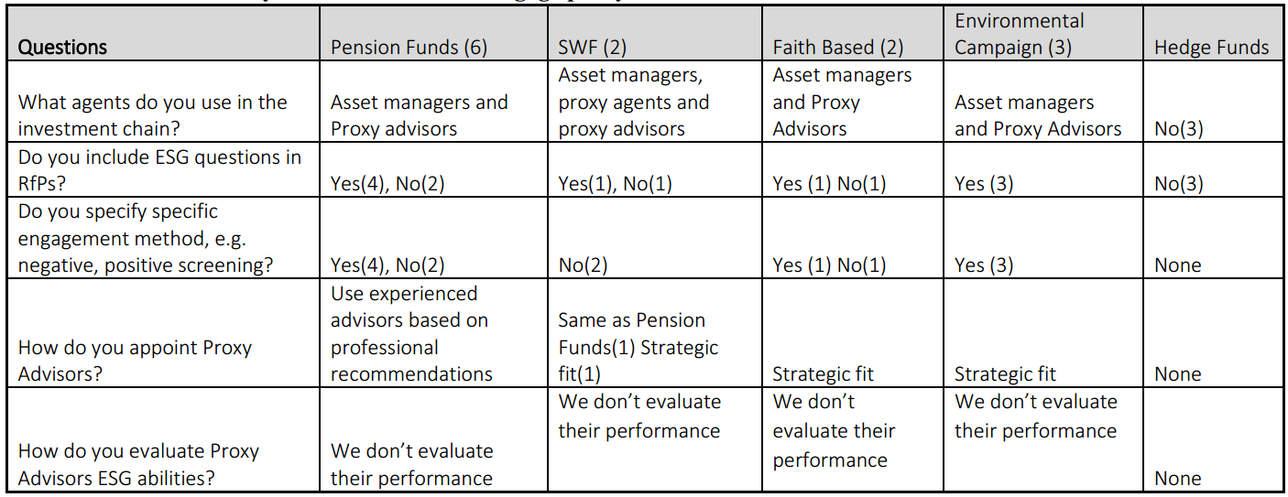Source: Researcher’s findings
For those that appoint their Proxy Advisors based on their antecedent on their attitude to promoting responsible investing, they do a lot of due diligence to ensure that there is a strategic fit:

“A lot goes into the due diligence process for every single manager and advisors that we appoint. There is a tendency for the Advisor to have stellar track record and performance over the last three years, and then when you appoint them, they sit on their oars, or they themselves change their core objective. We’ve seen many examples of these anecdotes and examples. The focus is on the investment process and we draw deep and hard into the investment process: what do they stand for? Do they apply the same style that we are comfortable with?” PF02

Others simply appoint Proxy Advisors based on the recommendation of their asset managers:
One of the SWFs appointed a Proxy Advisor on the recommendation of the PRI. However due to lack of internal expertise, there are no set parameters against which their performances are measured:

“One of the recommendations that we got from PRI last year is that we must operate an independent governance arm. We have done that already…. we don’t measure their performance because they are experts in their own fields….and moreover we are international investor organisation. We do not currently have a high level of competence in this area which seems novel to me.” SWF1

Evidence of free-riding by hedge fund investors is being reinforced again as earlier noticed in section 7.3. It is surprising to note however, that only the environmental activists that specifically mandate the appointed proxy advisors to engage on ESG, whilst the others a mix result was obtained on whether they specifically order them to apply specific engagement method. This may be due to lack of knowledge and skills on the part of the institutional investors. Some also confess to appointing proxy advisors because it was recommended by the regulators, and the regulators are not clear on what they are to do use them.

7.6 Awareness of relevant publications amongst Asset Owners
Although this thinking that there exists positive correlation between ESG engagement and long-term corporate financial performance has been supported by over 2,000 separate studies^{7c}, there is a mixed level awareness of some important publications either on the effect of climate change on business, or the ones linking ESG with performance.
Apart from the officers of the social activist funds interviewed that demonstrated very good knowledge of key publications linking ESG engagement to long term performance, many of the other officers interviewed demonstrated shallow knowledge. Perhaps this may not be generalised because there may exist other officers or executives within the organisation with good awareness of these publications. It is expected that educating key officers on these issues may raise awareness to a higher level and increase the level of discourse.

Although table 6.5 suggests an improvement in the level of awareness of asset owners when compared with the findings of Solomon (2009), two important factors were noticed. Firstly, it takes time for the asset owners to be aware of these publications. In other words, the higher the age of the publication, the higher the likelihood of the asset owner being aware of the publication. Perhaps this explains why all the key publications after 2010 were virtually unknown as at the time of carrying out these interviews (2015 and 2017). Also, in many cases, the trustees interviewed are only aware of the publication in name, but unaware of the content or salient conclusions or recommendations. In all, the PRI and Stewardship Code are the only publications known to all the trustees interviewed.

Despite the number of publications linking ESG engagement to long-term financial performance, some hedge funds trustees are still unconvinced of such findings, or are too impatient to invest long-term:

“…… I don’t think there’s enough research available and I don’t know of any research that would actively show that active engagement will lead to increased returns. Obviously, there are some activist firms, and some with activist funds department which is a small fraction of their operations. In fact, some of our colleagues do operate specialist activist funds. When you compare their performance with us, I am afraid there is no significant difference otherwise I should have known.” HF03

Table 7.2: Awareness of key publications on climate change
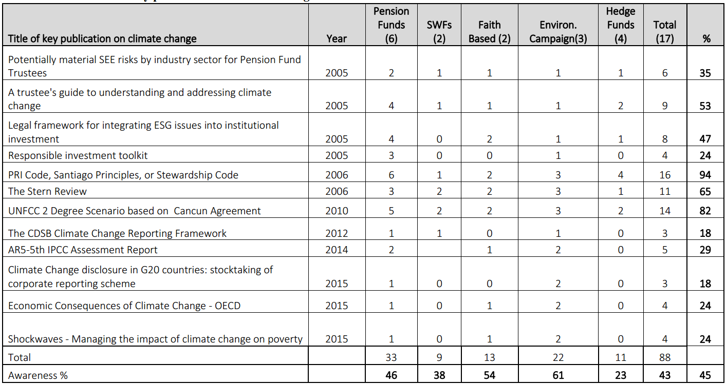Source: Researcher’s findings
Pressure to earn short-term returns is incompatible with hedge funds philosophy, and therefore may make ESG engagement incompatible:

“I have not seen any reliable research that will actively prove it. But I can tell you for free, that, ESG investing is too theoretical to integrate into our work. We may not earn enough return if we go that route.” HF01

7.7 Views on Mandatory Voting
The evident increase in the level of UK institutional investment has also given rise to higher demand institutional shareholder to play active role in engagement^{7d}. The views of trustees interviewed are divided along category lines, with the faith based and environmental campaign-based funds expressing unified views in support, and the others venting fragmented views.
The faith-based investors argue that compulsory voting deepen transparency and public accountability, and will help them express their views on their ethical stance on topical issues such as excessive executive pay and climate change, although they don’t have their way due to non-alignment of views despite their subscription of pension funds to the PRI code:

“Our position is that no institutional investor should be allowed to sit on the fence on issues bothering on how companies are run. We stand in a fiduciary position and we must play it well to best of our ability and good conscience. Serious issues like executive pay for instance deserves serious attention and that is why our view is unambiguous on it. It must be made binding without any exemptions.” FB01

“Yes, votes should be compulsory and should be made binding. Voting on how corporations are run are matters of public importance public and must be put in the public domain. Look at the result on voting on Shell resolution on climate change for instance. You can see the hypocrisy of the big firms. Now we know who is in favour of climate change resolution and who’s not.” FB02

Environmental campaign firms argue that compulsory voting is important for accountability purposes for the use beneficial ownership’s decision-making purposes:

“We believe that all votes ought to be compulsory and binding not only that, it should be compulsorily published and disseminated as widely as possible so that the public can be made aware of the views of their trustees on public issues. That’s accountability.” ECO2

“I believe that we have gone past the stage of non-binding votes now. Non-binding votes is not in alliance with the spirit of the EU policy on shareholder rights. Our policy is that voting must be binding, and all institutional investors must vote, especially on matters affecting the long-term survival of their companies.” ECO3

On the other hand, all other asset owners interviewed, i.e. pension funds, SWFs and hedge funds argue that the spirit of the EU directive on voting is that it should not be made compulsory. They also argue that compulsory voting has resource implications for them.

“We need to be cautious in analysing issues such as this. There is no one size fits all answer to this. There are no economies of scale advantage for small firms to vote compulsorily.” PF03

“My own opinion is that practicality and accountability should be the guiding principle in making that decision. I don’t think voting should be made compulsory. To do otherwise will create revenue for proxy agencies at costs to everyone else.” SWF2

“We are happy with non-binding vote on executive pay, and I counsel that the government should leave it the way it is since there’s no business case to do otherwise. Maybe in the future, but not now.” HF02

The issue of whether the government should make votes on executive pay binding or not, have overshadowed the bigger issue of mandatory voting. Investors are generally divided on this issue, with faith based and environmental activist investors being categorical that the votes must be binding and compulsory, whereas some pension funds are interested in the benefits and costs of this engagement method. The hedge funds owners interviewed are not interested in the issue due to the resource implications for their operations. This again reiterates the Beck’s (2007) view on the existence of pull and push debates on the dangers and benefits of manufactured risks in a risk society as investors have opposing views on the issue of risks and how they ought to be addressed.
7.8 Views on Sustainability Reports for ESG engagement
Institutional investors interviewed do not have a unified view on this matter. But one issue that is common to all the responses is that the report is historical in nature, which makes them outdated for decision making. They would prefer to view an updated version of such SR much more frequently – similar to the quarterly financial reports sent to the London Stock Exchange (LSE) for financial analysts to deliberate upon.

“Sustainability Reports presented to us are always too little too late, but half bread is better than none. They are useful as a starting point, but not very useful...…… We are not experts on sustainability issues. However, we belong to investment associations that provide us with guidelines and directives on what to look out for. These issues sustainability issues keep changing all the time. We would continue to heed their counsel as regards these issues.” FB01

“The report do contain some useful information, especially on the environmental footprints, and not for decision making about the future…. but I tell you, they are usually reported late. Not until lately, they aren’t reported comparatively, and even when they do, unlike profit and loss accounts and balance sheets, they have no beginning and no end. Such reports should come with measurable guidelines, and there ought to be an independent agency like the FRC in charge of its verification.” EC02.

For the pension funds, there is no unified position. Some of them look forward to it, whilst others don’t see any usefulness in it:

“Our organisation is interested in holding our equity on long term basis, and therefore interested in all issues that are capable of affecting the value of our holdings. ……Usually all such issues are appraised with the aid of all the reports that we receive, and the recommendations from our fund managers.” PF01

“…. there are other means for us to obtain such information [i.e. sustainability related] …. (Also) we’d rather pay more for an auditor-certified integrated report, than waste my time on a stand-alone sustainability report” PF02

“It is difficult to use the sustainability reports for and decisions about long-term decisions. They [Sustainability Reports] are not presented in a user-friendly. They [investee companies] are not disclosing the kind of sustainability information that we require. I think my own opinion is universal.” PF05

The hedge funds both admitted that they don’t see any usefulness in it because they are historical in nature, and therefore not useful for future decision-making.

“No, we don’t… because by the time they are published, they are already outdated.” HF01

“We rarely use that information, and I don’t know of anyone in our sector who does.” HF03

All the social investors and some of the pension funds have interests in such reports. The social investors see them as a necessary tool in gauging the extent of the compliance of their investee companies on environmental matters. They acknowledged however, that because they only look out for the environmental aspects because of the guidelines that they have received from PRI and other associations that they belong to, asking them to put pressures on their investee companies in that regard.

7.9 Barriers to institutional ESG engagement
Issues such as finding middle ground for collaboration, unending disclosure or governance requirements, problems of codifying fiduciary, conflict of interests, and likelihood of increase in future risks, increasing costs, resource requirements and conflict of interest were identified as barriers to institutional engagement.
The existence of sustainability director in the investee company is likely to ensure that both investors and investees are working on the same pedestal. Some investors even hold the opinion that ideas on improving governance can emanate from either end of the spectrum:

“Many of the companies in which we invest in do not have sustainability director. This is something that they need to work on as we move into the future. I want governance to be a universal thing. Recommendations on best practice can come from either end. It should be a dialogue rather than a monologue.” PF02

So, should ESG engagement be viewed as additional costs to the investors or a long-term business strategy that boosts profits and reaps social and economic dividends? Do investors see long-term cost savings or short-term additional costs?

“We need to employ expertise or appoint consultants who would liaise with these companies on ESG matters as these are unique skills. The end justifies the means though, but it is quite expensive. We can say however, that spreading the additional costs over several years may make it justifiable eventually. Pressure to perform is making many of us not to look at the big picture.” PF05

“…Between 2011 and 2016, we have had to double the money budgeted under ‘governance cost’ heading. We have been lucky in defending these budgets with the government department that oversees our agency because we impress it on them that it is a first line charge, otherwise we would have run into some regulatory problems with the UK authorities. Those who oversee our department do not understand these things.” SWF02

Still on costs, some pension funds believe that there will likely be an increase in engagement risks if the government proposal to make pension funds invest in start-ups is implemented after Brexit⁶. Will the act help in deepening ESG awareness amongst SMEs, or will it increase the costs to trustees?

“Currently we are not allowed to invest our beneficiaries’ funds in risky ventures even though that may change soon. Government is still working out the modalities, but if they should go ahead with the plan, it will have massive effect on ESG costs. It’s easier to manage businesses than small ones.” PF02

The Stewardship Code and the PRI code encourages investors to work together for the good of the investee company. This is also reinforced by directives published by PLSA and IMA recommending that engagement must be instituted by investors, and that there must be ongoing dialogue amongst institutional investors. However, are they likely to work together on ESG issues?

“The relevant Codes are clear on how we should engage on ESG. The law is also clear on this. But making institutional investors to collaborate amongst themselves is akin to herding cats. We disagree on every little issue, sometimes political, sometimes hypocrisy, leading to unnecessary waste of time in the process. The problem is the word institutional investors which I think is too generic nowadays.” PF05

“I will tell you based on practice that it is unlikely to work. It is like saying that sedentary farmers and nomadic pastoralist herders should work together and cohabit peacefully. A party has green vegetation and the other has animals that wants to feed on the vegetation. They are working at cross purposes.” FB02

There has however been some level of success in collaborative engagement in the UK, based on the examples mentioned by an interviewee below. Perhaps some investors with deep ecology perspective desire aggressive and accelerated action on some ESG issue, and the inability to have their way makes them to conclude that investors are not collaborating? Perhaps also, some engagement methods are more effective than others?

“We have had quite a number of good examples of collaboration in the industry in recent times, courtesy of actions being coordinated by ShareAction. For instance, the Wokrforce Disclosure Initiative (WDI) involving 102 investors managing over $11.5 trillion. We also have the Investor Decarbonisation Initiative (IDI) involving 64 investors with $1.2 trillion assets under management. There is also collaboration for the living wage in the UK. There is very strong evidence in the UK that corporate decisions to be ambitions on decarbonisation was very much long my investor engagement by coordinated letter writing, AGM questions, and so many other activities involving investors using their influence with companies.” ECO1

Another issue giving investors concern is the seemingly disruptive activities of Proxy Advisory firms in proxy fights and increasing incidences of US-style legal threats which are relatively new in the UK:

“I am worried about proxy advisory business, and I think it is high time government steps in to regulate that part of governance business. Many of them engage in activities that are clearly unethical. For instance, they recommend how to vote on executive pay, and at the same time, take up the job of defending the management in a proxy fight. These incidences are quite new in the UK. The same thing is happening to shareholder resolutions. It is all being muddled up by these intermediaries.” PF04

However, another investor disagrees with the disruptive views of Proxy Advisors. Rather they should be watchdogs and not a witch-hunt.

“What they do is basically using their size and ability to reach shareholders by proposing best practices and corporate governance standards to corporations. It is the failure to comply or accept or adopt those governance standards that results in the advisory firms sending letters to shareholders inciting them to vote against management on it, thereby putting the directors in bad light. We’ve seen many of their actions on executive pay, election of directors, and climate change policy in recent times.” ECO2

They are also worried that the volume of work involved in disclosure is increasing especially where ESG engagement is managed in-house:

“Disclosure is never ending. We like what we do no doubt. But the regulatory requirements are increasing our costs. I am worried that it may get out of hand soon.” SWF1

Not only do they worry about large disclosure requirements, some are also worried that what investors need is not massive data, but relevant ones. Some practitioners think however, that as the key ESG factors are known for every industry, ESG data generation may become streamlined:

“I think there is a role still for the regulators to think about how they can help the industry itself create comparable data because the more that we can see information that we can process, that is comparable, concise, and agreed as an industry or by regulation, the more we can use that data and know what it means because there is still the problem of how to interpret information when the creation of the information was not always the same per company per country per investor.” PF03

“While the ESG discussion is becoming much more professionalised and we see demand increasing from our retail and institutional investors, there are certainly role for our academics community to continue to do research on the key factors, and I think there is a role also for the regulators to ensure that the level playing field that had been done in financial sector in general around comparable data is also done on this area of ESG data so that we are all looking for the same information.” ECO1

“We always say as investors that it’s not that we need lots of information as investors but the right information that is comparable. So, one of the things that we’ve been working is that we would prefer to have 3 to 4 variables with everybody in our companies. So, these key variables are good starting points to look across sectors across countries. You cannot stop there but it’s a good way to get signals that helps you to understand management quality and that management quality understanding helps inform a decision and a judgment about investment. So, from information provision perspective we are looking for specific criteria and not everything.” ECO2

Another barrier to ESG engagement is perceived misalignment of incentives between trustees, asset managers and employed individuals within those organisations. In effect, conflict of interest can be three layered. Any misalignment in corporate objectives at these three levels may cause one or more of the parties to work against the achievement of ESG engagement aims:

“I have seen strained relationship between a corporate manager who votes for the firm on ESG issues and the portfolio manager who manages corporate investment decisions degenerating and thereby misaligning engagement. But the most dangerous one is the ones that I have noticed in big hedge funds, who have taken a short position on stocks because the management is inefficient and is to be voted against, but the proxy advisors have made recommendations that the board be voted against. So, what happens then?” ECO1

Perhaps the need to avoid conflict of interest explains why some of the Asset Owners interviewed base their decision on the appointment of Proxy Advisors on strategic fit? (See chapter 8).

Another important barrier to ESG engagement is the fiduciary responsibility gap. Two of the hedge funds owners interviewed appear to be either mixing up ESG engagement with CSR by reminding me of the famous statement by Milton Friedman that the social responsibility of a business is to make profit^{7e} or shifting the responsibility for ESG engagements to investors with larger AUMs. This brings to the fore, the issue of free riding, and the low level of awareness of what fiduciary duty ought to be for a well governed company:

“…I have always held the position that the key business of businesses is to maximise profits, and not to care or worry about corporate social responsibilities, which ought to be the responsibility of governments. That is why we pay hefty taxes. As a finance organisation, we cannot be pursuing profits and CSR at the same time without being stuck in the middle of nowhere” HF03

“The size of our AUM is pretty less than £10m. ESG engagements will impose extra monitoring costs on us…. and that is why it is the privilege of large pension funds to do this on our behalf.” HF02

The two statements above bring into focus, some of the consequences of ‘manufactured risk’ whereby “organised irresponsibility” which arises as a result of the diverse humanly created risks for which the entities which create the costs are not held to account, thereby leading to increased taxes and penalties being paid by non-offending corporations (Beck et al., 1994:29). There is still a long way to go in the understanding of the RI logic as this would impact the way investors view engagement costs and the associated benefits. Some investors are still unclear as to what constitutes fiduciary and who should be responsible for protecting investee against exposure to ESG risk. The issue of costs and benefits of ESG engagement is a major consideration with pension funds, whereas environmental activists and faith-based organisations views financial costs incurred as their own contribution to societal wellbeing.

7.10 Summary of findings through the lens of manufactured risk and trust re-embedding mechanism
This chapter analysed the views of various asset owners such as pension funds, sovereign wealth funds, hedge funds, environmental activists and faith-based organisations on the issues driving shareholder activism in the UK, their attitude and therefore their influence on ESG engagements in their investee companies. Unlike the case of UKSA members who are well grounded in the RI logic based on interview data, institutional investors are influenced by diverse philosophies. Interview data suggests for instance, that SWFs are influenced by government policies and budgetary pressures, and environmental activists and faith-based asset owners are influenced by social objectives, and pension funds are interested in long-term performance of their investee companies since the maturity of their members’ liabilities are futuristic. It means therefore that bringing institutional investors together under a unified investment philosophy is akin to herding cats.

The agency relationship that is expected to exist between asset owners (principal) and the proxy advisor (agent) is misunderstood by some asset owners in terms of fiduciary duties, and some asset owners are not knowledgeable enough to demand periodic stewardship from the proxy advisors. This relatively new relationship, which is a manifestation of reflexive modernity or risk society that is constantly changing, not only in structure, but in the relationship between social agents (Beck, 1992). Although the EU shareholder directive (2018) offer some recommendations on proxy advisory, regulatory clarifications and promulgation of acts of parliaments may be required here, especially in managing the seeming conflicting interests that environmental activists have noticed when dealing with proxy advisors. Interview data also suggests that the views of the various institutional investors on mandatory voting is linked to their subscription to the RI logic, which explains the reason why hedge funds owners interviewed are indifferent about the subject.

Giddens (1990:119) viewed friendship and personal ties as means of re-embedding trust in traditional systems. However in modern societies with prevalence of manufactured risk, he suggested the upgrading of friendship to “relationship built on trust”, where such trust is not assumed but continuously built through a process of “a mutual process of self-disclosure”, so that “where trust cannot be controlled by fixed normative codes, trust has to be won, and the means of doing this is demonstrable warmth and openness”. Similar views were expressed by
Beck (1987:153) that” the most intimate – say, nursing child – and the most distant, most general – say a reactor accident in the Ukraine, energy politics – are now suddenly directly connected. Beck (1987:153) was therefore suggesting that accelerated globalisation has “intensified the intimacy of relationship between personal lives of individuals and dis-embedded systems”, thereby necessitating the need for a new form of intimacy that engenders trust in the 21st century. The application of such concern is the relationship between management and investors who are separated through “time and distanciation”, yet so close through the prevalence of information technology such as the internet.

Interview data suggests good grounding in RI logic by pension funds asset owners through the practice of the PRI and Stewardship Codes which encourages continuous engagement akin to Giddens (1990:121) “relationship built on trust and a mutual process of self-disclosure”. All the pension funds asset owners interviewed also have very good knowledge of their fiduciary responsibilities which includes ESG concerns. This explains the reason why some of the major institutional investors interviewed do not see inability of sustainability reports to meet decision usefulness as a problem, because they are able to source all the information required for long-term decision-making through other means, which may include their board representatives. The SWFs interviewed on the other hand, are quite opaque in their engagement and it is apparent that they have not yet imbibed the RI logic as the short-term financial returns to fund national budgets take precedence over all other things. However, since the social activist investors do not have access to representatives on the board, their quest to have “relationships built on trust” with management is predicated on having access to up-to-date financial and sustainability reports and the ability to attend and interact at IR meetings. The inability of management to present sustainability reports that are certified by auditors, and useful for decision-making reduces trust, thereby igniting the process of shareholder activism.

Chapter 8: Analysis of proxy advisors views on ESG Shareholder Activism

8.1 Introduction
This chapter presents the views of proxy advisors on responsible investment or ESG induced shareholder activism in the UK. Two proxy advisors were interviewed, i.e. PX01 and PX02. Their responses have helped in answering the following research questions.

- What are the issues driving ESG shareholder activism in the UK? (RQ3)
- What are the observed developments in ESG shareholder activism in the UK? (RQ4)
- How can ESG shareholder activism be deepened in the UK? (RQ5)
- How does shareholder activism mirror the concept of re-embedding mechanisms in the sense of risk society theory? (RQ6)

The analysis in this chapter covers the following: how proxy advisory agencies work (8.2); policy development and influence of others (8.3); ESG policies (8.4); most challenging governance risk of 21st century (8.5); voting policy (8.6); conflict of interests and transparency issues? (8.7); recommendations on how to entrench ESG in the investment chain (8.8); summary of findings through the lens of manufactured risk and trust re-embedding mechanism (8.9).

8.2 How Proxy Advisory Agencies work
Understanding the how, and the scope of their work will deepen the understanding of likely attitude towards ESG issues, and this is why they have been asked to describe what they do. Proxy advisors interviewed see the growth in the demand for their services as a consequence of the changing dynamics of the investment chain, thereby giving rise to specialisation and outsourcing of governance services, voting in particular. An institutional investor with equity interests in several companies will require advisor on corporate governance on several fronts which they may not be able to accomplish effectively without involving additional external experts in the investment chain:

“We are known by several names depending on who you’re talking to. Some call us Proxy Adviser, Proxy Voting Agency, Vote service provider, or shareholder voting provider. Our main role in the corporate governance world is the provision of services to institutional investors on how to vote their shares at shareholders meetings of public limited companies. These services include provision of research data, developing voting policies, voting administration, voting execution, voting recommendations on management research proposals. If you like, we are an outsourced corporate governance arm of global institutional investors.” PX01

Some believe that voting is an important governance responsibility that the institutional investor should be performing and therefore should not be subcontracted due to the possibility of creating agency problems which may arise due to misaligned interests with cost implications for the institutional investors (Jensen and Meckling, 1976; Fama and Jensen, 1983). But then the question arises as to how institutional shareholders limit the discretional powers of the proxy agents who are not directly regulated in the UK. It is not apparent that regulators periodically certify that principles applied by proxy advisors promotes shareholder primacy.

In a corporate governance world that keeps changing, it is unsurprising for proxy advisors to see themselves as standard setters and watchdogs, especially in a principles-based system being operated by the UK:

“Our work involves working on behalf of the institutional shareholders to increase information disclosures and increase access to proxy materials, something that is relatively new in the UK. As the Board controls much of the board process and the nominating process, we use our ability to reach remote shareholders who are often busy with non-governance issues. We therefore also propose corporate governance standards to corporations. Failure to comply or accept or adopt those governance standards often result in the sending of notice to shareholders, informing them of directors’ failure to adhere to the governance practices. This can shed bad light on individual directors, and in some cases, the whole board. We may even recommend for or against the election of a director due to their failure to comply with certain governance requirements. The essence of this is to ensure that directors adhere to higher corporate governance standards proposed by us” PX02

Three distinct issues are clear from the above. Firstly, it is apparent that apart from the fact that the practice grew in the US through regulatory demands by SEC, the observed rise in the services of proxy advisors can be attributed to increase in the demand for stewardship by shareholders, and the economy of scale advantage of outsourcing, being a cost-effective means of satisfying fiduciary and stewardship obligations. However, some have suggested that unbiased report is unlikely to spring from credit agencies and proxy advisors as they have minds of their own to pursue short-term profit maximisation agenda which may conflict with the long-term objectives of their principals (Larcker et al, 2015; Eckstein, 2017).

Secondly is the growing influential powers to set public policies on stewardship, even where they are seemingly in a vacuum^{8a}, although PX01 disagree that they are corporate governance standard setters, but standard takers (see 8.5 below). Thirdly, and this agrees with the reflection of PX01, that there is no evidence that proxy advisors are held to any fiduciary standards either by institutional shareholders that they represent, or the FRC, to demonstrate that their recommendations are in the long run interest of the trustees or the beneficial owners.

8.3 Policy development and influence of others
It is important to understand who controls or influences proxy advisors as this may impact on their policies. Principally, leading proxy advisors like ISS and Glass Lewis have been known to be influential on how others vote (Choi et al., 2010). Both ISS and Glass Lewis have between them as clients, almost 3,000 of the world largest asset owners consisting of pension funds, hedge funds, and mutual funds representing trillions dollars of AUM, who have outsourced their corporate governance to these two firms^{8b}. Genstar Capital, a US based private equity firm owns ISS whilst Glass Lewis is a subsidiary firm of pension funds Ontario Teachers’ Pension Plan (OTPP) and Alberta Investment Management Corporation (AIMCo) based in Canada. Both ISS and Glass Lewis have extensive policies on Responsible Investment on their websites. Since many investors rely on IS and Glass Lewis for voting recommendations, a negative recommendation from them can have adverse effect on the proposal’s voting outcome.

Given the above, the next question is, how thorough and professional is the work of these leading agencies? Do they have the requisite in-house skills to execute the shareholder proposals? In table 8.1 for instance, one could see that ISS executed over a million votes for top 3 mutual fund clients in 2017.

Table 8.1: Number of resolutions voted by ISS in 2017 on behalf of top mutual funds:
Source: Proxy Insight Data

Although the services include proxy voting, governance research, and voting execution services, the details of their usage of external consultants was unclear. However, given the technicality involved in drafting shareholder proposals, not forgetting the fact that a large number of them are written in legal terms, and also in languages other than English, there are several questions begging for answers. How much resources in time and costs is dedicated to examining these proposals before recommendations are made? How many staff members do ISS employ worldwide in its ‘Stewardship Department’ that will help in accomplishing this feat? Does ISS also outsource its voting functions too? The volume of research that ought to go into writing a proposal and the quality expected, especially ESG ones which are inter-disciplinary in nature is quite high. This resonates with the views of a former VP at TIAA-CREF^{8c}. Do they have requisite skills to properly analyse all companies in all sectors? Perhaps regulators should licence sectoral proxy advisors?

All these had to be borne in mind when analysing their influence on shareholder resolutions voted upon, and on other agencies in the investment chain. It was observed that the voting records on resolutions in the top 3 mutual funds have a high correlation with the recommendations given by ISS, followed by Glass Lewis (see Table 8.1). Also, all the resolutions where OTPP and AIMCo were aligned, agreed 100% with Glass Lewis, although none of those resolutions are ESG related.

On the usage of consultants, the two interviewees agree that they make use of outside experts in many areas:

“Yes, we make use of external experts in all fields including seeking advice from academics and leading practitioners.” PX01

“We do not pretend to have all the business technical know-how. We consult external experts where necessary.” PX02
Usage of external consultants may partly explain the reason why the ISS was able to record performance highlighted in 8.1. However, there is still a big question mark on the expertise of those consultants on shareholder resolutions, especially on ESG issues which require higher levels of interdisciplinary skills.

Table 8.2: Mutual Funds alignment with ISS and Glass Lewis Recommendations

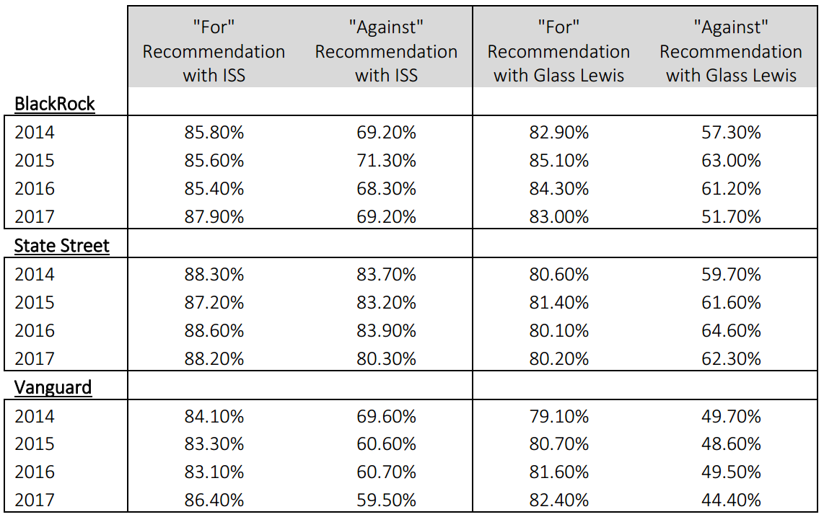Source: Proxy Insight Data

Although my interviewees are aware of the influential powers of ISS and Glass Lewis on the global investment chain, they both disagree on the degree to which it affects their own corporate governance advisory services. The first interviewee dismissed the comparison of their work with the two leading firms as the handiwork of the media and researchers.

“They [ISS and Glass Lewis] play little interest in what we do. We are competitors in the same industry. It is up to the press and researchers like you to compare our activities, or benchmark against what they say or do.” PX01

The other interviewee tried to differentiate their organisation from the leading proxy advisory firms due based on business model, ESG exclusivity and their pioneering role in promoting social issues in corporate governance.

“We have never consulted them on anything we do here. We are not driven by profits but good governance and long-term investment. We represent seventy-three pension funds in the UK with over £230 billion of assets under management. I think researchers should benchmark against us and not against them because in 1997 long before Glass Lewis and ISS became prominent in the UK, we recommended that all our members should submit shareholder proposal to Royal Dutch Shell demanding for human rights and moving away from environmental degradation in Nigeria. Within few months of submitting this shareholder proposal, most of our resolution criteria were met by the management of Shell. I must tell you that that shareholder proposal was the first on UK social issue. Can you see why we are not in the same class?” PX02

PX01 is owned a consortium of investment managers with up to £6.9 trillion in AUM, whilst PX02 is owned by 73 pension funds with over £230 billion AUM, which means that PX01 is likely to be more influential. All these owners are signatories to PRI and Stewardship Codes, and they have policies on ESG integration. PX01 is not ready to disclose the number of vote recommendations provided over the past 5 years, whilst pension fund members of PX02 all voted 100% in support of all recommendations that have been issued. Although they denied being influenced by ISS and Glass Lewis, this can neither be asserted nor refuted.

8.4 ESG Policies
There is evidence of high awareness of proxy advisors interviewed on ESG matters based on the structuring of their Request for Proposal (RfPs), although their strategy differs. PX02’s strategy is aligned to imposing ESG in RfPs, whereas PX01 believe that it should be tailor made, which is in consonance with the strategy applied by ISS and Glass Lewis.
For instance, PX02 has ‘policy principles’ which details policy on climate change and GHG emission in engagement documents which is applicable to all members, and which guides their response to ESG issues:

“As I have mentioned to you earlier, long-term investment is at the heart of everything that we do at XXX. It is intricately linked to ESG. Number one, we enlighten our members on an on-going basis on what constitutes long-term ownership through bulletins and trainings. Secondly, we issue voting alerts and quarterly engagement reports to, not only our members, but to the public. You can see therefore, that ESG is at the heart of our advisory services”. PX02

The view of PX01 is that the management of their client companies are best suited to know their peculiar circumstance, which means that it is tailor made, rather than ESG-centric. This aligns with the views of ISS and Glass Lewis of “Board knows best.”^{8d}

“We have adopted the ABI guideline on responsible investment which takes cognisance of the EU directives, the PRI Code, the Pension Act, the Steward Code, and Companies Act, that provide that ESG must be integrated into engagements. But then we tailor our services to the needs of our clients. We no longer overly prescribe to clients especially on GHG emissions” PX01

Both PX01 and PX02 have identical policies on promoting, setting and defending ESG agenda. However, they differ in terms of how they are voted upon (see 8.5 below). Whilst PX01 make recommendations to institutional investors who have subscribed to their services, being a member of PX02 suggests that you must follow their recommendation and therefore vote accordingly.

On the issue of placing managers on bonuses in order to drive ESG issue to the front burner as suggested by some practitioners^{8e}, they are also both in agreement that it may be counter-productive.

“We need to be careful on the issue of putting officers on incentives to do their job. My personal opinion is that it is likely to work against our long-term interest of serving the long-term survival of corporations. From my experience, the issue of incentives may become a distraction with other evils such as conflict of interests coming in. I wouldn’t want us to go down that route I’m afraid.” PX02
The view expressed by PX01 is in line with their views on their engagement being based on ‘what clients want’.

“Not at all. We do not attach any incentives to it, possibly because ESG is now at the centre of corporate governance, and corporate governance is what we do here.” PX01

These responses suggest that ESG is now firmly in the mainstream as far as proxy advisors interviewed are concerned, and it demonstrates too, how ESG issues, which used to be considered in the margins in less than a decade ago, have progressively become important.

8.5 Most challenging governance risk of 21st century
The two interviewees were unanimous that the main risk to corporate governance in the 21st century is environmental risk, specifically those of climate change.

“There is no doubt that climate change is the most important issue at this time. Firstly, the nature of the risks is dynamic and it affects not only economic sectors, but also the way we produce and consume resources, migrate, government taxation systems, our procreation, our survival or extinction, and those of plants and animals. Secondly, we woke up late on climate change. If half of the efforts and resources spent on pursuing or defending shareholder proposals on executive pay had been channelled towards reversing 2-degree scenario, the business world would have been better off. Sadly, we are in a state of flux on this. Apart from the fragmented approaches here and there, I am yet to see a coherent governmental response on the issue worldwide. On our part, we issue two annual reports on climate change: ‘spending against change’ and the ‘50-50 report’. I believe that coherent response at the governmental level will be more effective.” PX02
The issue mentioned above helps in reminding us of the dangers of adopting the “precautionary principle” as a means of addressing manufactured risks, which effectively means ‘doing nothing’ because of the false expectation that the risks will somewhat disappear due to the effluxion of time (see 1999:9; and Beck et al., 1994:37).

“Based on the surge in the number of shareholder resolution since 2015, surely it is environmental and social issues, and the most important one seems to be tackling climate change. It [Climate change] risk seems to have many strands, more like 8 arms of an octopus, straddling the whole gamut of ESG. Even the big mutual funds like BlackRock are making pronouncement that companies should henceforth serve social purposes, which is a departure from what we are used to. Unlike the resolutions on executive pay which is an up-front governance issue, we’ve seen a whole lot of climate change resolutions straddling social issue, environmental and even governance. Investors believe that climate change is no longer debatable, and so it is better to get on with it.” PX01
This brings into focus, Beck’s (2007) assertion that the discussion of risk will affect decision making in the risk society, and the need for re-embedding through responsible investment logic (Giddens 1999). In agreement with the views of PX01, many strands of climate change resolutions have been observed with links governance and social issues, especially in the period 2015-2017 (see chapter 8). Meanwhile, they are also both in agreement as to why there is a surge in climate change resolutions, which is going concern risks:

“I think the investors are now seeing the likelihood of fall in value of their own assets if stringent actions are not taken early. Take 2-degree scenario for instance, many of our clients now clearly understand the urgency to act and be their brothers’ keeper. Last year [2016], nearly all of our clients now back climate change resolutions. These are resolutions which rarely received majority backing years back.” PX01

The above statement confirms the defeat of the collaboration of Greenpeace et al group on climate change resolution at BP in 2010 (see page literature review, pages 112-114). When contrasted with the situation as hand now, one may conclude that it is surprising that pension funds and mutual funds are the ones now championing these resolutions having consistently voted against such moves previously.

“Previous supports for climate change resolutions average 20% in the past. It may be attributed to Paris Accord that used to be rhetoric, for the first time almost all the countries of the world agreeing on tackling carbon emission and rising temperatures.” PX02

On the matter of how they plan to confront these risks, they both opined that there are many uncertainties ahead as the resolutions are mainly targeted at this stage at corporations in the extractive sector:

“Two-degree scenario is the main one now, so any company that is caught within that bracket is likely to get a resolution. But many companies are changing before investors take action. Honestly, I cannot say what the future holds. Nonetheless, each board must, through its risks committee, comprehensively define the risk specific to their operation and how they plan to address it. For instance, the peculiar risks being faced by extractive companies differs from those of financial institutions.” PX02

According to Giddens (1999) the inability to predict the future with some level of certainty is an important feature of the risk society due to the rapid level of continuous changes in the society thereby preventing or hampering adequate planning.

“As I have mentioned earlier, there are many variations of resolutions to combat
climate change which are coming up. However, they may take another turn depending on regulatory and investors response.” PX01

Many of the resolutions on climate change demand for additional reporting frameworks, e.g. spending reports, climate assessment reports, greenhouse gas reduction targets, migration from fossil fuel, tying executive pay to carbon emission reduction etc. (see chapter 5).

8.6 Voting policy
Institutional investors depending on their form, are likely to have different view on ESG issues. They both expressed their views on their voting policies being influenced by policies issued by the local regulatory agencies and those of the EU. PX02 opined that policies are contingent upon ESG issue and that its underlying guiding principle is the long-term survival of its members:

“It is impossible to have a comprehensive voting policy that possibly covers every possible governance scenario especially where governance is continually evolving. We however have voting policy on some specific emergent governance issue like executive pay, gender pay gap, M&A, two-degree scenario, capital structure, share buy-back, board structure. They are all available on our website. The emergence of these policies has strongly influenced by our stewardship principles which had been subscribed to by all pension funds under our umbrella. We are also influenced by policies issued by regulators such as IMA, FRC, PRI and ESMA. Unlike others, we publicly disclose our stand on corporate governance and how we desire that our members should vote on those issues. Voting alerts are issued and communicated to the members and the public. We also track all voting by our members annually and the report is available on our website.” PX02

The above is akin to the use of “facework” such as the subscription to PRI etc as a demonstration of RI logic, as well as engagement via voting (see Giddens, 1994:89) in order to increase the confidence of the investing public.

“We believe that an important norm of shareholder democracy is the principle of ‘one share, one vote.’ We are guided by the Article 3J of the European Shareholder Directive 2017 which stipulates that we should disclose on our website, the Codes that we follow in reaching our voting recommendations. We also have a stewardship department that manages proxy issues in-house. This department is at the core of our operations. They have expertise in diverse disciplines. They develop our voting policies. As an independent agency, we do not set any governance standards, but our job is to advice our clients on how to vote based on world best practices. As you probably know, it is up to our clients to accept our recommendations. That’s where our mandate ends.” PX01

The principle of ‘one share, one vote’ mentioned above contrasts with the views of some UKSA members (see chapter 6) who recommended ‘equality of shareholders’ rather than equality of votes. What is largely absent in the two views above, are descriptive specifics of how corporate governance principles like accountability, transparency, stewardship, objectivity etc. are transformed into policy development.

On the issue of whether voting should be mandatory on executive pay, and the publication of remuneration report, PX02 supported these without any reservations:

“We are in support of the annual publication of a mandatory remuneration report in as much details as the public wants, and we want the votes to be mandatory and binding. We see excessive remuneration by the executives as another means of misappropriating shareholders’ funds.” PX02

Although PX01 also supported the idea of disclosure and shareholder vote, it is with reservation, especially as it might lead to ‘brain drain’ which is counter-productive:

“This is a tricky bit. My personal view, and not those of …. is that voting on remuneration report may be destabilising on the corporation. It may turn the board into a revolving door. But our view is that shareholders in public companies must be able to vote on executive remuneration annually, even though the suggestion is not as straightforward as it may appear.” PX01

The above view on mandatory reporting and voting on executive pay aligns with the views of majority of investors in the EU^{8f}. It is instructive to note that executive pay disclosure and binding and mandatory voting is partially the case in the UK.

8.7 Conflict of Interests and Transparency Issues?
It is improbable that all institutional investors that procure the services of proxy advisory firms will adhere exclusively to their recommendations, but possibly a substantial number of institutions will do so. But how independent are these recommendations, and how transparent and independent is the process? Although proxy advisors are registered as investment advisors in the UK, there is no evidence that the FRC or any other governmental agency does provide an organized supervision over their work, which means that they are largely self-regulating. There have been previous allegations of usage of inaccurate data and conflict of interests from many quarters (e.g. Klöhn and Schwarz, 2013; Li, 2016), and others have opined that proxy advisors “profit from consistently moving the goalpost in order to justify charging lucrative consulting fees arising from newly changed ratings criteria.” (IGOPP, 2013). Information revealed from information filed at the EU Corporate Governance and Financial Crime Unit by ISS revealed thus^{8g}:

“…there is a potential conflict of interest between the services we provide to institutional clients and the services, including our Compensation Advisory Services, provided to clients of the ISS Corporate Services subsidiary. For example, when we provide corporate governance services to a corporate client and at the same time provide proxy vote recommendations to institutional clients regarding that corporation’s proxy items, there may be a perception that the ISS team providing research to our institutional clients may treat that corporation more favourably due to its use of our services.”

In 2013, SEC fined ISS $300,000 for revealing non-public information in respect of clients’ proxy votes^{8h}. Although no fines have been levied on Proxy Advisory firms in the UK till date, some practitioners, policy makers and regulators like ESMA and CSA are concerned that certain activities in proxy advisory business-like conflict of interest are aggravated by limited competition in the industry. There are however some evidences that the leading proxy advisory firms are aware of and are taking steps to address some of these issues. For instance, Glass Lewis now have an independent group of industry experts which operates outside of its organisation structure, and reports directly to the board^{8i}, and the ISS now have a similar policy on disclosure of significant relationships^{8j}. But will they be enough combat conflict risks inherent in their business? Perhaps the proxy advisors themselves recognises the restrictions imposed by their internal processes and policies based on the above-mentioned information filed with the EU:

“The conflict of management safeguards that we have implemented may not be adequate to manage these apparent conflicts of interest, and clients or competitors may question the integrity of our services. In the event that we fail to adequately manage perceived conflicts of interest, we could incur reputational damage, which could have a material adverse effect on our business, financial condition and operating results.”

Conflict of interests here, according to the works of Giddens (1990:54) is one of the unintended consequences of sudden changes or misalignment in social structures whereby the solution to a societal risk problem creates another social phenomenon. This according to Beck (1994), may continue to escalate until the society finds the will to reflexively confront the issue.

Although the revised 2017 EU directive on shareholder rights^{8k} also requests proxy advisors to disclose conflict of interests and steps taken to ameliorate it, some researchers (Larcker et al., 2013) and practitioners (IGOPP, 2013) have criticised its lack of punitive measures, thereby increasing scepticism on the inherent conflicts of interest and lack of transparency^{8l}. One of the interviewees confirmed the awareness of the possibilities of conflict of interest in their operations, and their readiness to address them on a case-by-case basis:

“We have a code of conduct that addresses conflict of interest issues which is in line with European guidelines and best practices. We also have internal processes to address such conflicts wherever they should arise. I am not sure anything of sort had occurred in the recent past…. In terms of transparency, our research processes and methodologies are always made available to the public where necessary, and we will continue to be honest to our clients on our research and due diligence processes.” PX01

The above suggests a terse statement which is no detailed enough. No further details were provided and there were no examples provided on how such issues had been tackled hitherto. The response of the other interviewee exposes the concern about the possibility of conflict of interest in the operations of some proxy advisors:

“We are totally committed to serving the interests of members on governance and allied matters. We are not profit oriented, and therefore such issues have never arisen. None of our members have ever raised an eyebrow on how we work since the whole process is powered by them. Since we always present a unified position on governance matters, why will such issue arise? …. we will address such issues head-on if they should arise in the future.” PX02

The above demonstrates at least two classes of proxy advisor models: co-operative model and profit oriented model. If the claims above are true, then the co-operative model is insulated from conflict of interest bug. Profit motive, non-unified voting recommendations to investors and even inconsistency in recommendations^{8m}, seem to be some of the reasons why the public is sceptical about the operations of proxy advisors even though many of them publish detailed analytical framework and vote recommendations based on publicly available information. All these may not augur well for long-term investing. But despite these issues, the two-business model seems unimpeded.

Based on the ownership structures observed in ISS and Glass Lewis which are both subsidiary companies, three potential conflicts may occur: the holding companies may seek to influence the policies within ISS or Glass Lewis because of share ownership control. Secondly their parent companies being private equity and mutual funds have conceptually different approaches to governance which may impact on the private equity firms. Thirdly, corporate clients may hire proxy firms to influence institutional investors. These threats are minimal when compared to PX02 which operates a cooperative model.

8.8 Recommendations on how to entrench ESG in the investment chain
It was discoursed that direct political action by government can make this problem disappear totally through a carbon emission ban rather than taxes which may not be as effective. It is expected that at the current trends, around 20% of global energy would come from renewables by 2030, which means that 2-degree scenario may still be unachievable because fossil fuels may be cheaper. Political economy solutions lie in proposals with political economy perspectives having elements of punishment and rewards was proposed which is line with Nordhaus (2015) argument that cluster countries should set uniform carbon prices to serve as a basis for rewarding or punishing members.
“There is little we can do in the process apart from making recommendations. The greatest threat to governance now is climate change. It is only governments that can fix these problems through direct actions like bans and not taxes. Take a look for instance at congestion charge which was a government tax. Did that reduce the number of cars moving into central London? Perhaps not. However, a direct ban on cars to take effect from 2040 is already sending the right signal to the manufacturers. Another thing that could be done is this idea of making countries form groups that would voluntarily pursue carbon reduction and within themselves, penalise erring members.” PX02

“It is expected that shareholder rights directive on transparency of proxy advisors will address many of the issues you raised on transparency. Member countries are now expected to domesticate these directives. It is hoped that the directive will lead to a great increase in voting disclosures by European institutional investors. But bear in mind that change is a continuous thing. We shall continue to address governance issues as they arise.” PX01

The shareholder directive is principles based, and therefore unlikely to achieve full compliance. Historically, directives are followed partially by EU member states^{8n}. Besides there are no proxy advisory industry standards perhaps because they are few.

They also both agree that institutional investors must work together in order to achieve tangible results:

“It is more cost effective for institutional owners to engage collaboratively so that companies in which they invest can get the fruit of good governance on time, and without in-fighting. It is also good to add that ESG integration in the investment chain isn’t cheap. Our research indicate that close relationship between institutional owners and company directors will not only generate long-term profits, but also make the company to have long-lasting societal impact.” PX01

“The PRI Code and all the other Codes that our members subscribe to, clearly encourages them to collaborate on the issue of governance, and we have been doing that notwithstanding the fact that we [institutional investors] have different goals.” PX02

The form of institutional investors may prevent them from collaborating. For instance, some SWFs are planning to change their investment strategy to imitate Private Equity, whilst some investors exhibit behaviour suggesting inherent short-termism (See chapter 6). Making all institutional investors to collaborate might be akin to herding cats.

8.9 Summary of findings through the lens of manufactured risk and trust re-embedding mechanism
The analysis in this chapter covered issues such as: understanding how proxy advisors work, their policy development and influences, ESG policies, opinion on the most challenging risks to governance, voting policy, conflict of interest, and their recommendation on how to improve ESG integration in the investment chain. Existing academic literature on proxy advisors have not paid enough attention to discussing the perceived conflict of interest that their activities generate in the investment chain, as well as discussing the basis for reaching the decisions upon which they issue recommendations to or engage on behalf of asset owners on ESG risk matters. This chapter is therefore a significant contribution to RI literature on proxy advisory especially on the understanding of the transparency and conflict of interest issues inherent in the UK proxy advisory system. The analyses revealed issues bothering on manufactured risks and trusts in long-term investment, and these have been discussed below:

Ownership structure and motive
Based on interview data, ownership is likely to have influence on the philosophies of the proxy advisors. Interview data revealed two types of ownership models: the profit oriented (PX01) and the collaboration model (PX02), and the two of them are different in their orientation and their RI logic perception. RI logic is well grounded in PX02 based on their operations and how they collaborate with the companies within their forum, whereas PX01 offers tailor made services to institutional investors without consideration for RI logic. The size of the AUM in companies subscribed to PX02 is £200 whereas the AUM in companies subscribed to PX01 is over £40 trillion. This suggests that more must be done for RI logic to become mainstream. Since existing literature suggests that ESG shareholder activism is influenced by RI logic, interview data suggests weak RI practice as the proxy advisors representing most of the investors are themselves driven by profit motive with little evidence of transparency. “Reflexive appropriation of knowledge” (Giddens, 1990:53) in the investment chain means that in due course, asset owners may make beneficiaries of the various investee companies to question the competence of these proxy advisors, thereby weakening the trust in the agency relationship between the institutional investors and the proxy advisors.

Conflict of interest
Interview data suggests that there are two ways by which proxy advisors could engage in activities that indicate conflict of interest. The proxy advisors’ holding company may seek to ‘control’ (where they hold more than 50% equity shares) or ‘significantly influence’ (where they hold between 20 and 50% equity shares) the operating policies within the proxy organisation with a view to effecting certain policy decisions that would ultimately affect the kind of recommendations that the proxy advisors offer to other asset owners. Secondly, there is growing evidence of proxy advisors engaging in ‘double dipping’ practice whereby they represent the investor in offering voting advice, and at the same time, being hired by the investee companies to defend such shareholder proposals. One of the two interviewees declined to rule out such practice, but simply gave an assurance that they have put in place, internal procedures to ensure that they are not infringing any laws or business regulations. Conflict of interests is akin to Giddens (1990:54) impact of unintended consequences in social life, whereby the solution to a risk society problem creates another social phenomenon. This also agrees with the views of Beck (1994:177) that “reflexivity of modernity can lead to reflection on the self-dissolution and self-endangerment of industrial society, but it need not do so” as this will create more manufactured risks in uncharted terrains. Until it is fully addressed through the operation of the law, this would be a cause for shareholder revolt and would cast shadows on recommendations provided by such proxy advisors, even when they have put all the necessary procedures in place to avoid conflict of interest.

ESG by necessity
Both interviewees agree that based on the number of recommendations given to clients in recent years, proxy issues regarding climate change is increasing, and may overtake executive pay in the coming years. PX01 (proxy advisor built on profit model) has now recognised the need for RI logic to underlie their engagement with institutional investor clients due to the late realisation that ESG issues are going concern related, rather than a mere attempt to engage in greenwashing. This is likely to have implications for how the understanding of ESG risk and its management in the future. The issue of executive pay continues to cause trust wane between management and activist shareholders because executive pay reporting does not satisfy their needs, and the amounts being reported as generally viewed as unfair (see table 10.5), thereby creating information gaps which induces ESG shareholder activism (see figure 10.3). The realisation of the need for PX01 to now imbibe RI logic may be a good development. However, it is not based on autochthonous philosophy, but imposed by necessity – something that may prevent them from making profits. The implication of this is that this objective may also change in the future if they (PX01) are persuaded by another reasoning which would make them change, considering their profit motive.

Transparency issues and calls for regulation
The two proxy advisors interviewed consult on ESG matters. However, one of them (PX02) clearly demonstrate transparency by explaining on its website, the basis upon which it reaches its recommendations to clients. Also, the website has a list of all the resolutions that they have handled since 2007. On the other hand, PX01 which has 200 times as much as PX02’s clients, cannot justify the basis upon which their proxy recommendations are reached. For instance, ISS, a company with built on a model like PX01, boasts of helping its “1,700 institutional investor clients to execute over 7 million ballots representing 2.7 trillion shares with fewer than 700 employees”^{8o}. As this sounds like an impossibility, it has succeeded in attracting practitioners and regulatory scrutiny to the operations of proxy advisors (IGOPP, 2013). Meanwhile, the EU shareholder directive regulating the operations of the proxy advisors does not specify any penalties for unethical practices^{8k}. So, the question therefore is, how can proxy advisors that contravenes provisions of the laws be duly punished? The need to address this has become more urgent now due to the evidence of fines being imposed on the contravention of conflict of interest provisions against ISS in the USA.

Interview data suggests that the issue of transparency of the proxy advisors is inherently linked to their ownership structure and whether they pursue profit motive or collaborative in nature. The relationship existing between PX02 using the collaborative model and asset owners from where it derives its mandate is akin to “friendship and personal ties” relationship which typifies traditional era (Giddens (1990:119). In this case, it is expected that incidence of trust would be high since the “relationship is built on trust nurtured through a mutual process of self-disclosure.” On the other hand, an agency relationship that exists between investors and PX01 suggests that it is built on “normative codes”, in which case, trust has to be won through the “demonstration of warmth and openness”. Interview data suggests that transparency is low in the model operated by PX01, and therefore, low level of trust is expected. This is another driver of shareholder dissatisfaction.

Chapter 9: Longitudinal Analysis of observation at IR Meetings [2014 – 2017]

9.1 Introduction
This chapter presents analysis of research findings through observations at various investors meetings attended over a four-year period, i.e. 2014 – 2017. The objective was to gain rich perspective on shareholder activism through participating in investors meetings, and to explore how investors can influence ESG policies in their investee companies. How they participate in these meetings, and the kind of questions they asked, have helped in answering the following research questions:

- How useful are Sustainability Reports in UK shareholder activism? (RQ1)
- How do individual shareholders, institutional shareholders and proxy advisors influence ESG policies in investee companies? (RQ2)
- What are the issues driving ESG shareholder activism in the UK? (RQ3)
- What are the observed developments in ESG shareholder activism in the UK? (RQ4)
- How can ESG shareholder activism be deepened in the UK? (RQ5)
- How does shareholder activism mirror the concept of re-embedding mechanisms in the sense of risk society theory? (RQ6)

The analysis in this chapter covers the following: summary of IR meetings attended 2014–17 (9.2); analysis of meetings: agribusiness (9.3); analysis of meetings: military business (9.4); analysis of meetings: construction and facilities management business (9.5); analysis of meetings: financial services business (9.6); analysis of meetings: healthcare and CDMOs (9.7); analysis of meetings: manufacturing, transport, telecom and technology (9.8); analysis of meetings: extractive industries (9.9); summary of findings through the lens of manufactured risk and trust re-embedding mechanism (9.10).

9.2 Summary of IR Meetings Attended 2014-17
Giddens (1990:88) described access points as “points of connection between lay individuals or collectives and the representatives of abstract systems. They are places of vulnerability for abstract systems, but also junctions at which trust can be maintained or built up.” This explains the amount of attention paid to IR meetings as it hosted exclusively by the top management – the highest decision-making body of the company, i.e. the executive board. The meetings usually start with either the ED finance or the MD analysing the performance of the company, purely from the financial point of view, for between 20 and 30 minutes. Members of UKSA get the opportunity to attend analyst type investors meetings, which usually take place in the premises of the company and tend to last for 90 minutes. Thereafter the shareholders usually averaging 25 (except for oil and gas and extractive industry where attendance is usually quite large) were permitted to ask their questions, and answers provided over a period of one hour. Over a period of four years (i.e. 2014 – 2017), seventy-nine of such meetings were attended. Although the UKSA provided opportunities to attend even more of such meetings, these ones were chosen due the need to ensure spread across industries, as well as the researcher’s availability.

Such meetings are opportunities for individual investors to meet senior management and ask questions bothering on the performance of the previous year. The meeting is also perceived as a means of reducing perceived discrimination against individual shareholders, since they do not receive, or get access to the same detailed information that other market specialists have access to. E.g. quarterly returns. Therefore, the essence of these meetings, according to the UKSA is to avail the private investors (mainly individuals) the price-sensitive information that market analysts and the institutional investors also have access to.
Invitational emails are sent to all UKSA members who are up to date with their subscription and are therefore eligible to attend, notifying them of the details of the meeting. Due to the limited space made available by the company, confirmation of invitation operates on first come, first served basis. After the meeting, light refreshments are served, and the shareholders can exercise the opportunity to have informal discussions with the board members present.

These meetings themselves suggest evidence of “social evolutionism” whereby history can be put together via “story line” that narrates or describes human happenings over a period of time (Giddens, 1991:5). Therefore, over the period of carrying out this longitudinal research, the “social evolutionary narrative” of questions asked and the nature of answers provided at IR meetings not only help to clarify the task of analysing modernity, but also helps in refocusing part of the debate about the so-called post-modernism (Giddens, 1991:5).

Table 9.1: Summary of meetings attended 2014-2017
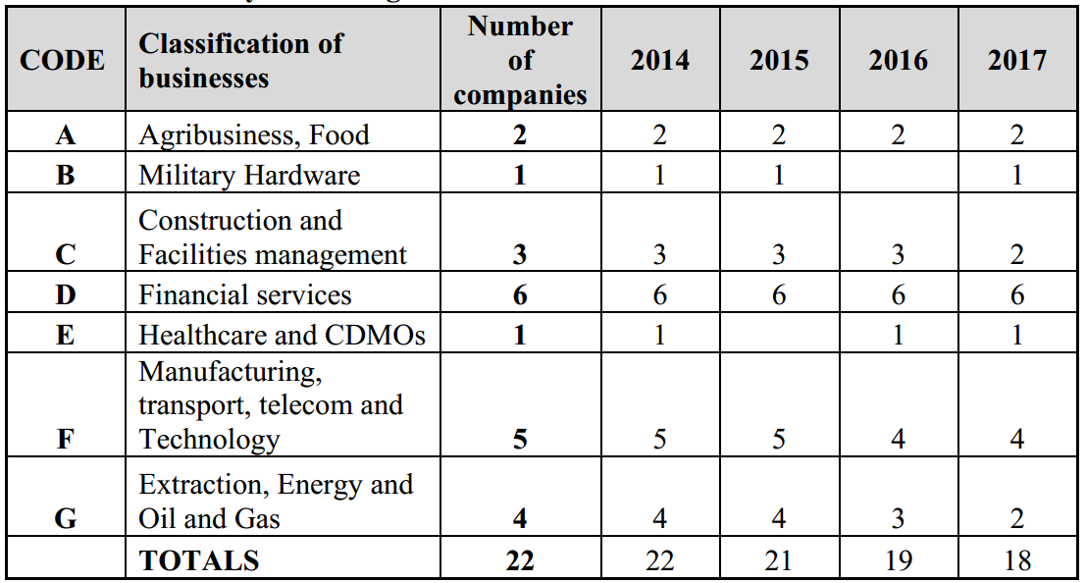Source: Researchers’ findings

9.3 Analysis of meetings: Agribusiness
Two companies A1 and A2 classified as agribusinesses were observed during the period. Over the period of observation, there was a noticeable increase in the number of questions concerning on loss of biodiversity and executive pay matters, and at the same period, a sharp decline in questions relating to the how the businesses plan to manage scarce resources like water, land and energy in food production. Shareholders referred to publications such as the FAO (2009) report, which reported declining crop yield from 3.2% to 1.5% over a 40-year period. They are also interested in how agribusinesses are channelling their efforts towards R&D to reduce food wastage with reference to a UNEP report (2012)^{9a} which estimated that between 50% and 67% of agricultural produce are wasted before they get to the consumers. They also referred to how businesses could take advantage of the WRAP report (2012)^{9b} which suggests that almost one-fifth of foods and drinks with retail value of over £12 billion is wasted annually. A marginal increase in such questions were noticed which suggests that managements’ responses were unsatisfactory. This supports the expectation of a negative relationship between the prevalence of mistrust where there is high proliferation of knowledge (Sztompka, 1999; Ekberg, 2007; Lash, 2000), and the assertion of Giddens and Pierson (1998:108) that trust and proliferation of “knowledge is mutually exclusive as knowledge offers security in the face of future eventualities.” Therefore, the increase in research knowledge freely available may be influencing the increase in the level of pressure being brought to bear on management of agribusinesses to consider the effect of ESG on the long-term survival of their businesses through the concerns of the shareholders.

For A2, which is Europe’s largest sugar cane producer of sugarcane, issues concerning child labour concerning one of the companies was widely reported in the press in 2013. The shareholders demonstrated concerns on the likely effect on their company, and the seeming inadequate quantification of the risks on the company. Although the MD narrated how the company sources its inputs directly from KSL Group, a company based in Thailand, and that A2 is not directly involved in slavery or child labour, the shareholders were concerned that the KSL Group has been accused severally of sourcing its own inputs from Cambodia through land expropriation and encouragement of violent acts. According to a newspaper^{9c}, children as young as nine years of age work on those sugar plantations. In 2013, two hundred Cambodian families brought a civil liability case against A2 Company. By October 2014, the case was no longer listed for hearing in London – which might indicate that the case had been settled out of court. As the case had been effectively disposed of, the matter was no longer of concern at shareholders’ meetings. Since A2 now has a company policy on anti-slavery, which was influenced by the Modern Slavery Act of 2015, the incidence of such concerns from shareholders had waned completely.

By 2017, the shareholders of both A1 and A2 increased concerns about business strategy because of Brexit and how the managements plan to address the issue. The system of quotas imposed on A2 by the EU means that it cannot produce beyond certain limit in order to guarantee a certain price, and shareholders demonstrated apprehension because the planned removal of such limits will likely lead to fall in the price of sugar, and therefore a fall in profits is likely to hit future dividends hard. It is expected that issues concerning operating an appropriate Brexit strategy is likely to dominate future meetings until such a time when the shareholders are satisfied that the adopted strategy is working effectively.

Prior to Brexit, management’s general response to strategy issues in A1 is that demand for food and agricultural products will rise by over 70% over the next 30 years based on UNEP estimates, driven largely by population growth. However, this had fuelled concerns about future deforestation and a large-scale biodiversity loss leading to climate change effects such as droughts, flooding and increase in water usage. Unfortunately, there seems to be no coherent plans to address these issues based on the answers from management of A1 since laws in their operations jurisdiction are not in opposition. For Company A2, shareholders want management to replicate the innovative idea brought about by John West in 2008 whereby customers can find out the origin of their tuna. They expect that digital traceability technology will ensure that fishing quota is obeyed. Shareholders also want to know the procedures that management have put in place in order to avoid falling foul of the laws in other jurisdiction where their raw materials come from, thereby hurting future profits. For instance, the Thai law that makes it mandatory for vessels to provide satellite communication on-board. Management’s response is that they will continue to invest in new technologies and R&D that support customers and workers, and that, there are now procedures in place for staff members to independently lodge complaints, thereby enhancing transparency.

For executive pay, the needs of the shareholders keep changing form. Over the years, it had metamorphosed from asking why the pay is exorbitantly high, to linking to pay to performance, comparison of executive pay to the average in the company and linking pay to ESG risks like loss of biodiversity (see Rimmel and Jonall, 2013; and Atkins et al., 2015). The seeming lack of concrete solution of the issue partly accounts for the cumulative increase over time that had been noticed in this case. The increase in awareness about executive pay suggests reflexive modernity (Giddens, 1991:37) such that policies and regulations on one hand, and actions and performances, are continuously being reflected upon, which may sometimes be unsettling to the executive directors whose performance are being subjected to such appraisal. This is not to suggest that such performance appraisal are bad, but because the measurement criteria continues to change as the basis for appraisal “rests upon shifting sands” (Giddents, 1991:39).
Table 9.2: ESG issues in Agribusiness 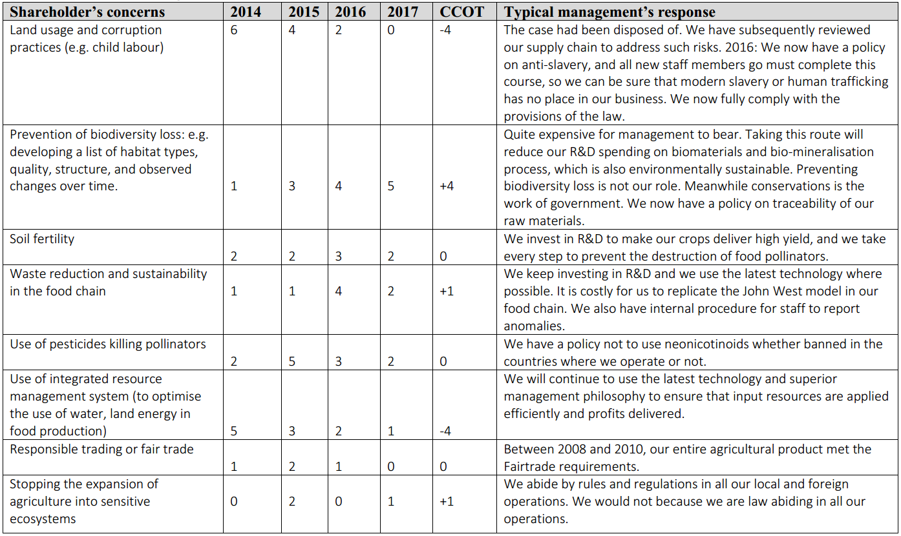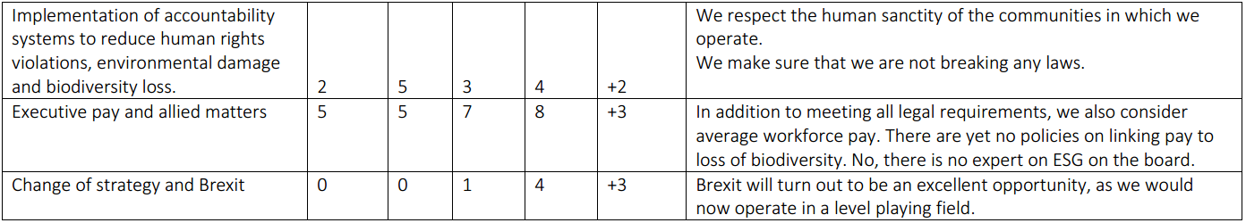

There is no material difference in the egoistic outlook of A1 and A2 on biodiversity matters which are seen only from the paradigm of their immediate profit needs, thereby bringing into focus the consequences of the tragedy of the commons. There doesn’t seem to be a unified consensus amongst industry operators as a body to address the issue because of lack of legal obligation to do so, and principally due to the general anthropocentric view to biodiversity matters. Increasing desire for biodiversity reporting in agribusiness by individual investors was seen by directors as both additional responsibility and unnecessary diversion from stewardship reporting since biodiversity is an issue which is not limited to their companies alone. The directors do not see non-reporting as a morally intense act which is capable of inducing harm to majority of the people, especially their shareholders. It seems therefore that a regulatory compliance system that is eco-centric in nature will have the moral motivation to entrench diversity will bring the issue to the front burner.

9.4 Analysis of meetings: Military Hardware Business
Only one company B1 was observed during the period. Many of the ESG issues raised by individual shareholders apart from the need to reduce political influence were not satisfactorily addressed during the period, thereby increasing the incidence of concerns expressed. As a result, the Norwegian SWF reputed to be the largest in the world decided to negatively screen off its equity investments in B1 from its portfolio because they cannot in good conscience be promoting responsible investing, and at the same time investing in military hardware corporations or any other corporations producing cluster bombs.^{9d}.

The issue of political influence was addressed during the period by sovereign governments agreeing to reduce their aggregate holdings to 27.06%. By 2014 a ‘new corporate governance arrangement’ with policies about shareholding were put in place. For instance: limiting holdings to maximum of 15%, grandfathering rights to sovereign shareholders and shareholder communication policy. These reforms were able to reduce the governance concerns expressed by some shareholders who blamed the overbearing influence of a State shareholder as the reason why the merger with BAE, which could potentially increase earnings synergy was frustrated. Although the management have rules out a merger, some individual shareholders still ask questions on whether there is a possibility of a future merger and the effect on their shares. Management’s response is that it would be difficult to meet the requirements of the UK government and those of France and Germany for the merger to take place, in which case the two companies have decided to go their separate ways. Since one of the requirements of BAE was a significant reduction in the controlling shares held by sovereign states for the merger to proceed, it is believed that the merger could be revisited in the future. So, the decline in questions raised in this area suggests satisfaction until another round of governance issue is raised.

On social issue the CCOT was neutral within the period. Corporate corruption cases reported in the Press in between 2010 and 2012 were being repeatedly referred to by the shareholders who desire to quantify the effects on profits and dividends, and steps being taken to curb them. In 2014 for instance, alleged violations of WTO rules involving improper receipt of government subsidies by way of reduced interest on government loan was raised. The effect of the criminal investigation launched by the UK Special Fraud Office on the alleged luxury car gifts to Saudi officials in exchange for renewal of contracts worth more than £2b was also raised. There were also repeated questions being raised about the effect of series of bribery allegations involving South African officials, and insider trading allegations against former B1’s co-CEOs. The decline in this aspect in the last two meetings suggests satisfaction of shareholder on the apologies offered by management and the non-repeat of such issues in the Press in recent times.

However, concerns grew in respect of the effect of the B1’s business on the environment, thereby justifying the divestment decision of responsible investors. Concerns over air pollution, destruction of arable land, and quest for women representation on the board grew substantially during the period, largely because B1 does not have internal policies on these issues. It is expected that the pressures will continue to mount until they are addressed.

Reduction in defence spending continues to put pressure on management to consider radical change in strategy. The UK and the US defence budgets are reducing significantly over time and the same goes for many EU countries. The shareholders worry that this may affect the going concern of EADS and other military hardware manufacturers. They also raised the divestment by Norwegian funds at meetings to put pressure on the company to become a responsible corporation. They refer to the Shell and BP energy diversification strategies to back up their quest for B1 to evolve a new business model that will be useful in the future.

Table 9.3: ESG issues in Military Business
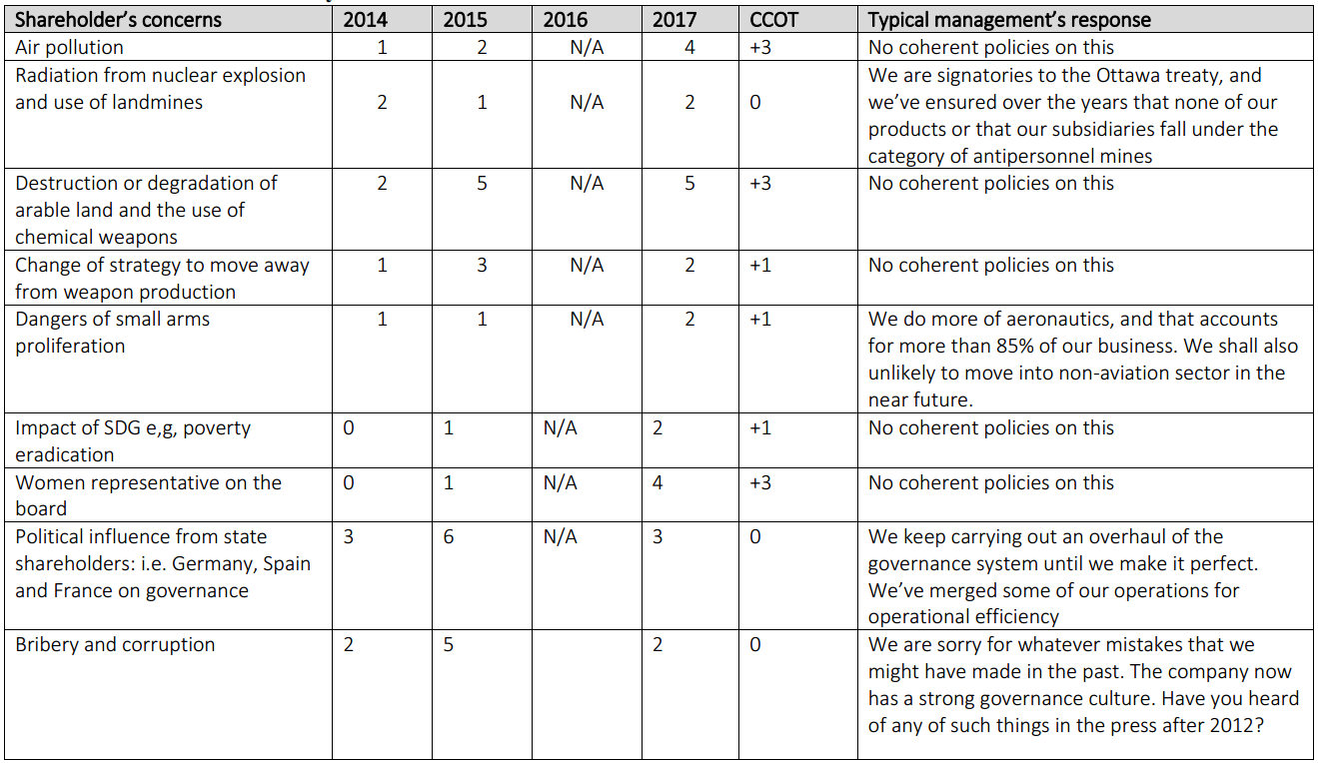Source: Researchers’ findings

9.5 Analysis of meetings: Construction and Facilities Management Business
Eleven meetings at C1, C2 and C3 were attended during the period. Concerns on work related accidents is driven by the annual reports by the HSE which continues to show that construction industries continue to get the lion’s share (ranging between 38-40%) of all reported fatal injuries in the UK between 2013 and 2018^{9e}. In addition to sound H&S guidelines, management response that UK has the second-best record in the EU after Finland of 0.51 per 100,000 employees, which is also far better than the EU average of 1.29. Management also responded that average annual fatalities in the UK had fallen from 600 in the early 1980s to 141 in 2013/14. Although none of the companies observed reported fatalities in their annual reports, shareholders desire to know what the likely costs of such would likely be on the future financial performance of the companies. By 2017, C2 started including H&S in the annual report, with statistics on Accident Frequency Rate and Major Injury Rate.

Shareholders also noted that construction wastes are not accounted for in annual reports despite being material. Annually, around 90 million tonnes representing a third of all wastes generated in England and Wales^{9f}. How much waste was recycled is of particular interest to shareholders but none of the companies observed are reporting on waste management at the moment. By 2016, questions relating to how the C1 and C2 plan to achieve goal 15 of the SDG 2030 agenda^{9g} had begun to emerge. All the three companies have chapters on sustainable business in their annual report covering issues such as carbon emission targets and assurances and how they meet set industry standards on sustainability^{9h}. There are however no reference to waste (or recycling) and biodiversity yet in the annual reports currently, but it is expected that the pressure from shareholders will likely make this happen in the future.

In 2015 and 2016, there were reported increase in the number of companies signing up to pay a living wage in the UK^{9i}, and this had influenced the quest for shareholders for more information on this. All the companies observed subscribed to the living wage and was well reported in their report. However, shareholders are also interested in companies’ investment in training, apprenticeship, their policies on living wage where materials are sourced from overseas contractors, and also gender pay gap. By 2017 all of the 3 companies are now publishing an annual pay gap report which is separate from the annual report highlighting why there is a gender gap and steps being taken to close the gap, only because there is a statutory requirement to do so^{9j}.

Brexit risks such as higher costs of inputs due to fall in exchange rate, ‘passporting’ of professional services and possible loss of funding were highlighted in 2017 because of their likely negative effect on future profits. It is expected that these will continue to grow as the exit date approaches.

The concerns of the shareholders on executive pay range from the large gaps in average workers’ pay, to easy-to-meet targets thereby imposing large wage bills on the companies.

The above demonstrate the view of Lev and Gu (2015) and those of Gray et al. (2014) that argued for a shift in perspective in accountability reporting to a more all-inclusive accountability model for accounting in a neo-pluralist world. The thirst for a new form of reporting being influenced by change in environmental requirement may continue to take mutate because the reporting systems fail to include material environmental and social costs (Gray, 2002; Adam, 2006). The changing laws leading to the demand for a new form of environmental reporting system explains Beck’s (1992) notion of pervasiveness of risks in postmodern societies whereby the subject of risk pervades the environment thereby driving the need for more reports on the subject of risks.

Table 9.4: ESG issues in Construction, facilities and property management business
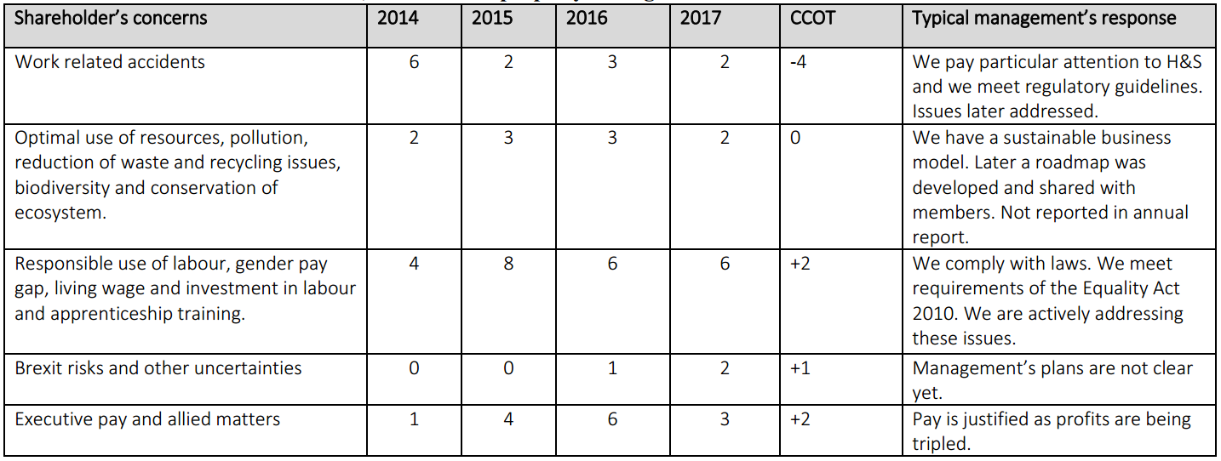Source: Researchers’ findings

Surprisingly, no questions on greenhouse gas emission was asked during the period of observation, despite reports showing that building emissions accounted for over 35% of greenhouse gas emissions in the UK^{9k}. Perhaps government direct efforts to reduce emissions in newly built residential homes to zero is taken for granted^{9l}, making shareholders not to demand reports on how they affect strategy.

9.6 Analysis of meetings: Financial Services business
Six meeting were attended each year over the four-year period, making twenty-four in total at D1, D2, D3 and D4.
Issues surrounding fines for misconduct after the financial crises and how to avoid them, was one of the major issues that shareholders were concerned about. Three of the financial institutions observed, D1, D5 and D6 paid fines to regulatory agencies during the period for rigging the market to the tune of £2 billion to the UK, American and Swiss regulators for misconducts involving foreign exchange and LIBOR rigging, mortgage and PPI mis-selling. There were also criminal investigation and prosecution against D1 and D5. After a running battle, D1 agreed to pay £270m to French financial regulators in the “Swiss Bank Tax Evasion and money laundering” scandal. The questions being asked by shareholders bother on how the financial institutions can improve their internal control systems, and how to win back their tarnished reputation. Although management kept promising to tighten control and risk management procedures, the repetition of these cases had kept the issue on the front burner. The fall in the number of questions concerning reputational issue suggests shareholders satisfaction with the level of new controls being put in place to prevent future occurrence. There is also evidence of saturation on the part of the shareholders due to the quantum of reputational issues reported under ‘pending litigations’ annually.

In 2016, it was reported in the Press that a certain high street bank (not related to D1 – D4), recorded security breaches which prevented many customers from accessing their accounts, and resulted in large scale fraud and therefore huge cost to the bank.

Shareholders ask questions bothering on the readiness of management to change their business strategy to support SDG initiatives, and reduce the incidence of their exposure to the extractive industries in order to avoid the wrath of regulatory agencies. Shareholders demanded for additional reports highlighting loans and advances, investment portfolio, cash reserves and deposits exposure to climate change risks. The argument by shareholders is that since not all the assets are held in the UK, threats of extreme weather and resource scarcity will impact the value of these assets. Managements of D1, D5 and D6 are sceptical about the practicability of such extra reports. However, over the years, banks in other jurisdictions have started reporting on risks and opportunities pertaining to climate change as part of the Climate Disclosure Project ^{9m}.

Unlike other organisations observed during the period where dissatisfaction on excessive executive pay were high based on the number of questions asked, the reference to executive pay were surprisingly insignificant. These issues were sometimes referred to in passing, partly because so much time had been spent on analysing profitability and risk issues, and partly due to the waiving of executive bonuses by directors because of fines imposed by the regulators.

There seems to be a disagreement on shareholders’ perception of Brexit as none of the financial institutions had set up a separate chapter in their annual report on it. The shareholders consider Brexit as a major risk whilst the financial institutions consider it a minor risk since their operations are international and are not limited to the UK, although their headquarters is in the UK. Before the appearance of Brexit risks in 2016, there was a major concern by two shareholders at DD4 that Europe’s longstanding commercial/retail banking model is coming under threat of disappearance due to the evolving financial technology, also known as ‘fintech’. They identified two main strands: the growth of electronic wallets and the emergence of pseudo-banks. The response of the directors at D4 was two-fold the volume of business handled by these institutions are insignificant, and that as a result, traditional banking is not materially threatened. However, by 2016 shareholders have started exhibiting growing fears that except the banks adapt quickly, new business models may make the banks to find themselves in ‘the Kodak situation’ which will be too late. According to shareholders evolving business models threating the future existence of financial institutions were identified as: independent aggregators, P2P lenders and borrowers, and tech giants like Google and Apple may start rivalling financial institutions by leveraging on their low entry costs and IT advantage.
Apart from the issue of proliferation of risks which drive risk reporting for decision-making, (see Gray et al., 2014; Lev and Gu, 2015) proliferation of knowledge in the environment is also reducing trusts in dis-embedded financial systems (Peck, 2013).

Table 9.5: ESG issues in Financial Services
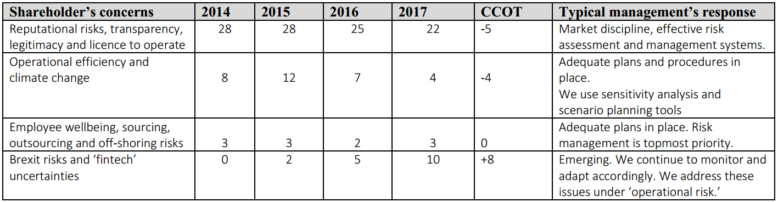Source: Researchers’ findings

9.7 Analysis of meetings: Healthcare and CDMOs
Three meetings were held with the management of E1 during the four-year period, and issues around executive pay and the need to include female members on the board dominated the questions raised. The board had no female member until a non-executive board member was appointed in 2015. Subsequently two more female executive directors have been appointed – one in 2016 and the other in 2017. This issue was presented as one of the development highlights in 2017. The form of questions asked in 2017 meeting has now changed from non-inclusion of female on the board to the need to have a balanced board. The board insists that they do not plan to have a board diversity policy, and that they would continue to appoint deserving persons on merit.

In the case of executive remuneration, a 400 percent increase was witnessed between 2009 and 2017, whereas the FTSE healthcare sector increased by 280 percent during the same period. The arguments of the directors are that there was a significant improvement in financial performance, with a substantial part of the executive pay being LTIPs based on TSR and EPS. There is now growing call for a departure from using financial performance to other qualitative criteria like development of innovative products.

Over the period, shareholders demonstrated satisfaction with the E1’s policy on the continuous development of new and innovative products. However, in 2014, they demanded for more information on strategy and marketability of the existing and prospective products for the future. Shareholders’ argument was that such report is necessary, as the company is distinct from other as it makes most of its profit from introducing new products rather than selling existing ones. The company now publishes a chapter on ‘strategy by market’ under its annual report accounts, and this suggests the reason for the decline in number of questions under this topic.

Questions on how the company identifies and evaluates its impact on biodiversity, whether they have a commitment on deforestation, policy on responsible sourcing of materials, and whether their products meet the requirements of the UN Convention on Biological Diversity. Questions on how company meets the requirements of the UNCBD was asked for the first time in 2017, and the directors were never prepared for it. It is expected that the future SRs would report on how the company is meeting these criteria.

Table 9.6: ESG Issues in Healthcare and CDMO
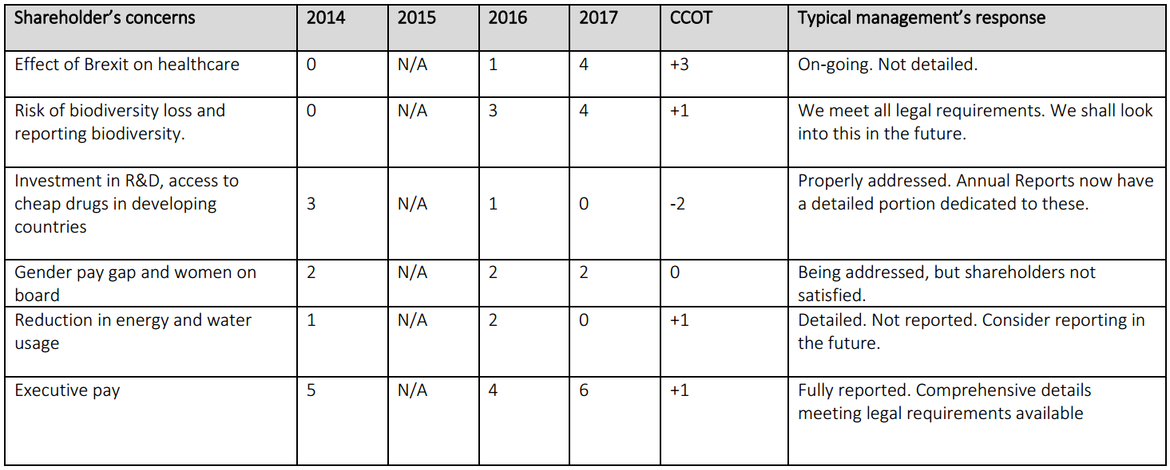Source: Researchers’ findings

9.8 Analysis of meetings: Manufacturing, transport, telecom & technology
Meetings in five companies were observed, reducing to four in 2016 and 2017.
On climate change, some shareholders refer to a UN Report that world’s top 3000 firms cause £2.2tn of environmental damage through dust and particles, water abstraction, industrial waste nutrient and organic pollutants, and that many of them operates in the UK^{9n}. Some refer to the various sections of the Stern Review’s summary of findings, and therefore need to transition businesses, especially manufacturing concerns, to low-carbon economy. Shareholders fear that inability to self-regulate may attract the attention of government in the form of regulations and fines, thereby imposing additional costs and loss of future value. Shareholders concerns include: depleting raw materials like rare earth metals, need to increase investment in R&D to create alternative products, reduction in water usage, and transition from fossil fuel energy.
On human rights, legal costs associated with damage to reputation, fines, and ban from operating in foreign countries were the concerns of shareholders. Shareholders also referred to some UK companies that hire Syrian refugees in their garment factory in Turkey. All the companies observed demonstrated their sound policies and internal control on human right issues. This suggests the decline in the questions asked under this subject over the years.
Because of the need to reduce taxes, cost of quality, compliance and manufacturing costs, shareholders wanted more information on the sustainability of input costs. Although plausible answers were provided, these concerns have continued to grow. In view of the incidence of Brexit, it is likely that this will increase in the future.

Again, the issue of inadequacy of reporting due to residual manufactured risks as a result of increased knowledge, thereby reducing the level of trusts in dis-embedded systems (Giddens, 1991) was well reflected here. Since according to Giddens (1991) risk society is future oriented, the investment community are concerned about the effects of these risks on the value of their investment, hence the demand for increased reporting so that the certainty of the streams of future cash flows can be predicted with some degree of predictability.

Table 9.7: ESG Issues in Manufacturing, transport, telecom & technology
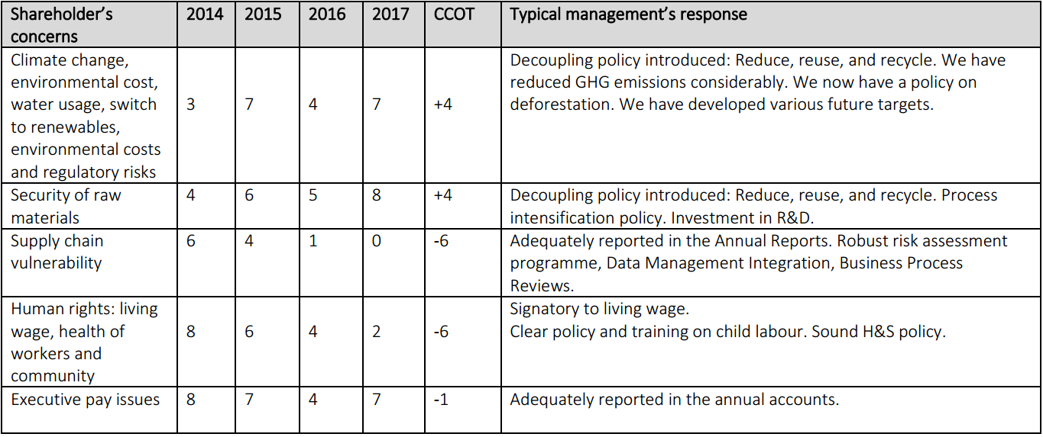Source: Researchers’ findings

9.9 Analysis of meetings: Extractive industries
Aside executive pay, the main ESG concern by shareholders based on questions raised at investors meetings are centred on the need for alternative business strategy and transparency. Traditionally the oil and gas companies have expectations of future cash flows on the expectation that future demand for energy will continue to grow into the foreseeable future. In 2014, the quest for energy companies to diversify was based on the need to avoid disasters like the oil spillage which occurred in the Gulf of Mexico in April 2010, which negatively affected share prices and prevented dividend payment. In April 2000, some activist investors had filed a failed shareholder proposal at BP, calling for the stoppage of its planned offshore operations, and asking the company to divert the investment to renewable energy sources. This call was being re-echoed in every meeting, and then dominated questions being asked at investors meetings in 2015 and 2016. However, from 2017, there is a noticeable decline in the ESG concerns arising from business strategy as most of the corporations publish global outlook and sustainability reports indicating material diversification into renewables. Moreover, the global outlook published by oil majors indicate that the oil and gas business model will remain strong till 2050 as fossil fuel demand will remain strong. Some shareholders believe that enough is not being done to limit temperatures to 2 degrees in fulfilment of the Paris Accord, and move away from low-carbon economy as new technologies in renewables may make their investment in oil and gas redundant sooner than 2040.

Questions bothering on transparency in reporting payments to foreign governments and communities was quite high in 2014, which was the time of passing the Act^{9o}. Since then there has been a decline in the number of questions or concerns perhaps due to the satisfaction of the level of transparency resulting from the publication. Shareholders concerns bothered on the level of compliance expected, the level of inclusion of foreign operations, and the penalties for false declaration or non-compliance. Shareholders also demanded to know the level of compliance of the governments of the countries in which they operate, especially the ones where inadequate progress are being made with a view to divest from them^{9p}. The ESG concerns of shareholders are now shifting to concerns around unreported embezzlements and bribes paid to government officials, undocumented payments to political parties, non-disclosure of the true beneficial owners, anti-money laundering activities, and the increasing poverty reported in oil producing countries, thereby threatening the ‘social licence’ or legitimacy of the companies. However, directors are quick to point to the substantial CSR activities that they are engaged in within the local communities where they operate.

Fears that anthropogenic rise in GHG attributed to fossil fuel is causing responsible investors to consider negative screening of their oil and gas portfolio. There are claims that almost 600 institutions companies with $3.4 trillion AUM have fully or partially negatively screened investments in oil and gas^{9q}. Neo-Schumpeterian argument that investments are likely to follow the Kondratiev wave because of the coming of age of an existing technological revolution partly explains the gradual stranding of oil and gas assets^{9r}.

In this case, it seems like the process is being accelerated by the planned government ban on fossil fuel vehicles between 2030 and 2040. As a direct consequence of the governmental action, all the major oil and gas companies are now projecting a decline in oil exploration and drilling after 2040, although they still project to continue oil exploration in developing jurisdictions thereafter because of expected surge in energy needs which is unlikely to be met via available energy supplies. After 2040, renewables are projected to represent on average, 25% of the world total energy mix which is considered insignificant to accelerate material stranding of oil and gas companies.

In analysing IR meetings of companies in extractive industries attended over the period of this research, the issue of inadequacy of reporting which meets the needs of public accountability as demanded by Lev and Gu (2015), and the need to include financialised environmental and social costs, especially as it relates to transparency, stranding of oil and gas assets due to environmental damage to flora and fauna and even their extinction etc. (see Gray, 2002; and Adam, 2006). Also, the issue of diminished trusts arising from reflexive modernisation such as the proliferation of public debates on the effects of environmental risks (Bulkeley, 2001), the call for public naming and shaming of companies involved in environmentally damaging activities, e.g. tree felling and fossil fuel, Beck et al., 1994: 29), and the perception of diminution in value of investment as a result of loss of streams of future cash flow from investment in oil and gas companies, seems to have influenced the questions being asked at the IR meetings. The collapse of “trust in faceless commitments” in the existing financial reporting system has therefore increased the need for re-embedding through the use of “access points” such as the IR meetings, thereby restoring “facework commitments” which restores the integrity of the management team.

Table 9.8: ESG Issues in Extractive Industries
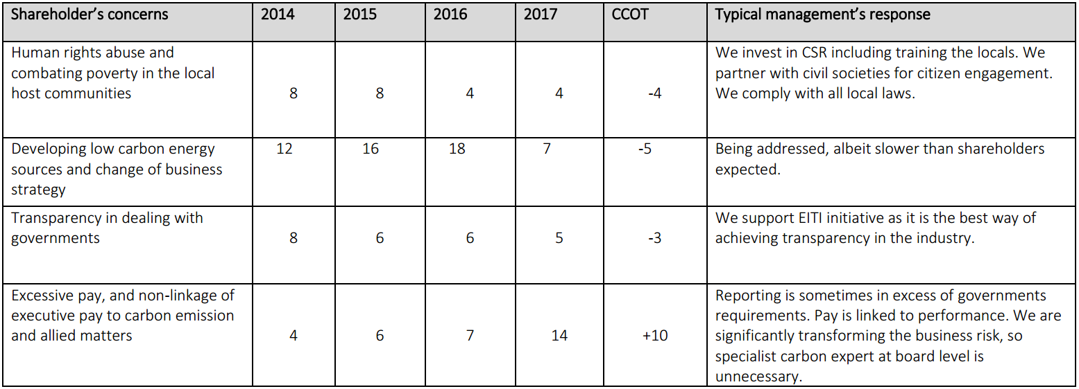Source: Researchers’ findings

9.10. Summary of findings through the lens of manufactured risk and trust re-embedding mechanism

Existing academic literature on RI have shown that little attention has been paid to the use of dialogue and IR meetings in shareholder activism. This chapter is therefore a significant contribution to RI literature in this regard. The following were the salient findings arising from this longitudinal research over a 4-year period.

Greenwashing to corporate environmentalism
Based on the Giddens (1990:80) the IR meetings were designed as an “access point” to re-embed trust and also supplement the “faceless commitments” which shareholders place in abstract systems in which they have invested on long term basis. Attendance at meetings revealed growing dialogical engagement with the subject of manufactured risk as a result of access to up to date scientific information influences shareholders to discuss the issues at IR meetings like they are experts in the area (Giddens, 1999). This has continued to put management on the spot, catching them unawares most times. Numerous activist investors attending the IR meetings are of the view that inadequate attention is being paid to the issues of future risks in the companies’ annual reports, and this is making the owners to ask questions relating to risk in IR meetings. There were few evidences of shareholders pointing the attention of management to a risk issue, e.g. the need to meet the UNCBD requirements was brought to the attention of the management of Company E1 in 2017, and by 2018 the published SR provided some information on UNCBD. This indicates that management is playing a catch-up game and involved in greenwashing. Activist shareholders are interested in understanding the strategies that have been developed by companies to address the likelihood of future asset or income losses arising from ESG risks. Some investors view inadequate reporting of risks as evidencing short-term profit thinking which only seek to cope with minimum legal reporting requirements. Directors of certain companies with minimal SR are often accused of seeking to demonstrate ESG compliant policies because such reports confer some immediate economic advantages or help them in coping with legal reporting requirements. e.g. there is a general dissatisfaction with executive pay despite the annual report on executive pay which shareholders would prefer to be prepared on a relative basis using shareholder wealth maximisation indicators, rather than the absolute basis, which is the minimum legal requirement. To these shareholders, good ESG performance and little communication about it to shareholders, is as bad as little communication and good environmental performance. These thoughts resonate with the findings of KPMG^{9s}, Ramus and Montiel (2005), Solomon et al. (2013) and Bowen (2014:76) which suggest that greenwashing rather than entrenched corporate environmentalism is likely to attract punitive rebuke when the shareholders are grounded in RI logic.

The need to make information publicly available
Giddens (1990:80) argued that the interaction of dis-embedded mechanism through the supplementing of “faceless commitments” with “facework commitments” through “access points” devices such as IR meetings can end up serving as a two-edged sword, which could make or mar the “abstract system”. IR meetings were originally developed as an engagement technique to facilitate communication on matters relating to access to capital, liquidity and fair valuation (LSE, 2010:7). However, empirical evidence from longitudinal participant observation between 2014 and 2017 revealed a growing appetite for a new form of reporting. The IR meetings are therefore satisfying the need for engagement as required by the London Stock Exchange, whilst also revealing the gaps between shareholders’ and directors’ information needs, thereby driving shareholder activism (see figure 10.3). UKSA has been in the forefront of the call for companies to make the outcomes of these meetings available to the public in the spirit of transparency and accountability. Their argument is that a fairer and more unbiased information distribution, especially the narrative ones will help in a better understanding and analysis and their decision-usefulness. In addition, they also want the financial reporting system to implement a risk reporting framework, upon which a real time online risk reporting system categorising ESG risks by way of severity. Currently, the minutes are distributed to members via email. Although the occurrence of these IR meetings is mentioned in the respective website of the companies, the details showing the analyses of the ESG issues discussed are never mentioned, perhaps because future risk issues are believed to be market sensitive. This thinking is grounded in the belief that since the value of a company is likely to be influenced by the present value of the streams of future cash flows, awareness of unmitigated future risks inherent in a company may repress share prices and therefore put the managements’ job at risk.

Stewardship gap
Participant observation of IR meetings revealed stewardship gaps between what directors’ term as ‘shareholders information’ and what shareholders actually demand, which causes breakdown of trust in the existing financial reporting system. The financial reports are historical in nature whereas risks inherent in dis-embedded abstract systems that is being reported upon are future oriented, thereby making a case for a re-embedding mechanism (Giddens, 1991). The shareholder activism is likely to continue until there are efforts which shows that the stewardship gap is being addressed. For instance, there were evidence in this chapter that each time an ESG issue is addressed either through new laws or management action, such questions would no longer be asked at IR meetings (see tables 9.4, 9.5 and 9.7). In many cases, strategic, governance and financial reports are published on companies’ website as shareholders report. However, the attitude of shareholders suggests that they require some form of narrative report which will could convert future risks into actual estimates that can help them reach conclusion on whether the company will survive the future occurrence of ESG risk. There is a noticeable spike in the demand for the narration of the effect of climate change and biodiversity reporting since 2015. They may therefore dominate the discussions in future IR meetings. This may have been influenced by the Paris Accord (2015) and the plethora of scientific reports that have been issued since then, warning of the dangers of environmental warming. As a result, they are now asking for companies to change their strategies in order to cope with the changing environment. The attitude of many of the management team in most of the IR meetings attended has been that of the adoption of ‘precautionary principle’ (see Giddens, 1999:8) since they are unable to gauge the extent of future risks themselves, and they cannot offer any solution to issues that seems uncertain.

Chief Value Officer and Value Reporting?
Based on the need for enhanced transparency and the stewardship gaps observed above, the operationalisation is partly dependent on the need for skilled individuals who are trained in the articulation of sustainability reporting accountability that would be decision useful by investors and available real time. Gray (1992:415) opined that trust could be enhanced through “accountability which increases the transparency within organisations”, and this emanates from financial and non-financial disclosures”. The need for transparency through real time reporting is akin to Roberts (2009:962) argument that that “technology is accounting and its capacities to allow us to see behind or within the corporate entity…. in the literal sense the preparation and publication of accounts can be seen as accountability for, as transparency, all that accountability requires is laying bare or making visible of ‘what is’”.

In view of the dynamic business environment, there is growing desire for the board to appoint an expert in risk reporting and accountability who would help in understanding the interplay between strategy and value. CFOs remit is limited to financial aspects (stewardship) and not accountability. Implementation of a CVO rather than (or in addition to) a CFO will depend on the institutional owners who own majority shares. Although the IR meetings are usually attended by the MD, CFO and the Director in charge of governance, it is noticeable that questions bothering on future risks are at best, usually not well addressed or at worst, depicts management as unprepared for them. There may therefore be a case for the creation of the office of Value or Risk Director, or the issue of risks may be brought under the portfolio of a governance director. This proposed new order of corporate reporting may take the form of integrated reporting, or real time reporting system that could be accessed much more frequently that the annual financial report. According to King and Atkins (2016), focusing on the historical financial report tends to lose focus of the information about the future business strategies upon which future assets and earnings are based. By failing to disclose material component for the determination of value which is risk profile, capability to accurately estimate future value is lost. In addition to the existing historical stewardship system, Individual shareholders tend to demand for a forward looking rather than a historical statement because of their fixated anxiety about future expectations. On the other hand, directors remind the shareholders where possible that forward-looking statements carry elements of risks and uncertainties because their occurrence are dependent upon future events which are subject to change.

Executive Pay
Based on the number of times that they are mentioned; the issue of executive pay is easily the most discussed issue at every IR meeting. Most individual shareholder are unsatisfied with the growing executive remuneration that is not matched by above inflation growth in the long-term value of the company. The displeasure at executive pay is line with the equally high incidence of executive pay being voted down at AGM, although the votes may be non-binding on management. The consequence has been a reported 13% fall in FTSE 100 executive pay in 2018 (FT, 2019). Demands on executive pay are multi-faceted. For instance, there has been recorded demand for balance in pay between male and female, linking pay to ESG goals, and demand that executive pay is clawed back for failure to build ESG risk into business strategy. Due to the high incidence of the propensity to vote down executive pay at AGM in order to embarrass top management, there is a noticeable trend whereby directors seek a select number of institutional shareholders, and not individual shareholders (since they hold majority shares) to confirm whether they are approving their pay structure before they are presented for votes at AGM. This is being done to prevent or reduce high incidence of negative votes on executive pay. In many cases, activist shareholders have frowned at this practice that marginalises them, but the practices are continuing.
The IR meeting was the perfect avenue for investors to vent their mistrust on management since they are unable to veto a non-binding vote on executive pay at AGMs. Accountability and transparency on the issue of executive pay is a major cause of distrust based on observation data. Roberts (2009:968) argued that “I do not think that we can manage without transparency – it is an important check on local collusion and as such an essential source of confidence for distant others.” However, there is a noticeable political dimension to the wider issue of executive pay legislation in Europe depending on whether the government in power right or left wing is (Ertimur et al., 2010).

Chapter 10: Consolidation of Research and Discussing Findings

10.1 Introduction
The essence of this chapter consolidates all the findings in a coherent manner and then discuss the differences and similarities in attitudes to ESG-induced shareholder activism that have been noticed in the investment community through the interviews carried out, observation at investors meetings, and the record of all the shareholder proposals submitted between 2007 and 2017. The chapter therefore discusses the findings in chapter five to nine within the context of the Becksian risk society theory, and in such a way as to demonstrate how the following research questions have been answered in this work:

- How useful are Sustainability Reports in UK shareholder activism?
- How do individual shareholders, institutional shareholders and proxy advisors influence ESG policies in investee companies?
- What are the issues driving ESG shareholder activism in the UK?
- What are the observed developments in ESG shareholder activism in the UK?
- How can ESG shareholder activism be deepened in the UK?
- How does shareholder activism and shareholder proposals mirror the concept of re-embedding mechanism in the sense of risk society theory?

10.2 Contribution to the understanding of the Becksian risk society theory
This research work has demonstrated that the members of the investment community apply shareholder activism arising from RI logic such as dialogue, IR meetings, investor collaboration, shareholder resolution, and risk reporting as re-embedding mechanism in managing the issues of low level of trust in the investment chain. This is given that the investee company exists within a reflexive risk modernity that is surrounded by proliferation of ‘manufactured risks’ such as climate change, biodiversity risks, stranded assets, social and governance risks and ecological disasters (see figure 10.1). The detailed discussion of how this work has contributed to the understanding of this Becksian risk society theory is contained in sub-sections 10.3 to 10.9 of this chapter.

10.3 Becksian risk society theory and ESG shareholder activism
In chapter three this research proposed the Becksian risk society that can help in explaining why shareholders engage in ESG activism. In general, evidence gained from chapters 5 to 9 of this research work suggests that the fear of manufactured risks (see figure 10.1 on page 239) on the future value of investment is the main driving force behind the investment community’s development of the investment logic, and the application of shareholder activism as a re-embedding mechanism in managing manufactured risk. This reinforces Giddens (1991:124) view that “risk thinking, and risk assessment is a more or less ever-present exercise, of a partly imponderable character.” Similar view was expressed by Adam and Loon (2000:3) when they opined that “one cannot observe a risk as a thing-out-there, risks are necessarily constructed. The immateriality and invisibility of the threats that suffuse the ‘risk society’ mean that all knowledge about it is mediated and as such dependent on interpretation.” How they use instruments such as investor dialogue, IR meetings, investment collaboration and shareholder resolutions as a re-embedding mechanism are diverse, and these have been demonstrated in the subsections 10.2 to 10.8. This may not however apply to hedge funds activists who are able to maximise their own wealth by strategically taking a long or short position on equity investment.

In chapter five, shows how the Companies Act 2007 has influenced a relatively new form of shareholder engagement by social entities with insignificant number of shares. The analyses of shareholder proposals submitted in the UK between 2007 and 2017 demonstrated growing awareness of the usefulness of shareholder proposals in demanding social accountability. The use of shareholder proposal increased significantly after 2010 partly due to the BP’s oil spillage in the Gulf of Mexico resulting in environmental damage costing more than $17.2^{10a}. The fact that such proposals can be resubmitted multiple times, and by so doing, attract public attention and scrutiny, has increased public discourse of the subject of RI logic as the number. There have been cases where management agreed that the proposal be withdrawn in order to avoid public attention, which means that the issuance of the proposal in itself possesses disciplining powers. Large institutional investors are forming coalitions so that their voices can be heard (see table 10.3). These are all manifestations of “political decision-making and dialogical engagement on the subject of risk outside of parliamentary politics (Giddens, 1999:5).

In chapter six, evidence from the analysis of chapter demonstrates that due to their association with the UKSA, which is an organisation grounded in RI logic, individual shareholders are knowledgeable in the issues of principles of RI. UKSA members discussing and proffering solutions about risk is one of the manifestations of reflexive modernisation (see table 3.2) as well as reflexive orientation to the subject of risk. Unfortunately, however, individual shareholding is declining in the UK. Many of the shareholders also worry that they are mere shareowners since they are unable to vote at AGMs as shares attributable to them are now held in nominee accounts. This is a structural change that the individual shareholders are struggling to accept, thereby making them to form unsuccessful alliances with social activist investors. Their combined shares are insignificant meaning that they are unable to make meaningful impact. Perception of risk and how to address them might have informed their adoption of public confrontation rather than private dialogue with management. According to Kasperson et al. (1988), perception of risk may “intensify under over-representation in the mass media… with capacity to stoke debates or clashes or expose high profile issues.” There is also a demand for a new social order whereby equal weights are attached to shares held by individuals and institutions CalPERS and CalSTRS have trialled such schemes within their fund, whereby the beneficiaries of the trust are offered the powers to vote, and this is then aggregated and put forward by the Trustees. Although this is an expensive proposition, they are expected effects of the expected negative correlation between risks and trust driven by fear of loss of income and assets (see Giddens and Pierson, 1998: 108; and Lash, 2000).

Chapter 7 demonstrated the diverse philosophies from various institutional investment groups, indicating the impossibility of having a unified position about risk, and this also affects trust. These diverse philosophies of the asset owners influence diverse attitudes to RI, and this affects views on a range of other issues like mandatory voting, mandate to proxy advisors, executive pay, addressing climate change (e.g. whether to use phased changeover or direct changeover in strategy from stranded assets). Whilst pension funds and SWFs prefer gradual divestment from stranded assets because it may hamper their ability to meet members’ future pension or governmental obligations through dividends, the environmental activists are however interested in direct changeover in order to save the planet without delay. This shows differing attitudes to risk due to difference in understanding and therefore sensitivity to the political and sociological consequences, which is a feature of reflexive risk society (Giddens, 1998; Lupton, 1999). The differing attitudes in the understanding of risk also affects the understanding of who has fiduciary duty over ESG issues. This relatively new relationship between institutional investors and proxy advisors in the investment chain is responsible for this, and this is a manifestation of reflexive society that is constantly changing in structure and in relationship (Beck, 1992). Perhaps by the time the institutional investors fully understand that they are the true custodian of the fiduciary powers, there might be another change in the social structure that totally alters the current one, indicating “juggernaut of modernity” (Giddens, 1990:139).

Chapter 8 reinforces the reflexive nature of attitudes to risk and the inverse relationship existing between risk and trust, and the politics or risk. Firstly, non-clarification of which social entity ought to play the fiduciary role, influences how the proxy advisors implement their mandate. This is a catch 22 situation whereby the proxy advisors are waiting on the asset owners, and the asset owners are also waiting on the proxy advisors. Secondly the RI logic is not well institutionalised amongst the proxy advisors. One of them is dedicated to RI whilst the other operates a tailor-made engagement based on the orders received from the asset owners. The issue of conflict of interest by proxy advisors is an unintended consequence of shareholder engagement, which is a problem that arises as a result of solving a corporate governance problem. For this, Beck (2009:115) demands for the understanding of the sociology of non-knowledge as this arises from manufactured non-knowledge risk. Finally, interview data suggests a new pattern of ‘ESG by necessity’ by proxy advisors who are hitherto not subscribed to RI logic because, according to them, the ESG issues are existential.

Chapter nine shows an increasing engagement with management on the issue of risk, which is a confirmation of the idea that as trust takes pre-eminence where the environment is saturated with risk and high-risk consequences (Lash, 2000; and Ekberg, 2007). This growing dialogical engagement with the subject of risk has influenced the discussion of risk rather than analysis of financial statements at IR meetings, thereby putting management on the spot and catching them unawares. This had led to growth in the quest for real time risk information to be made available online, or a quarterly risk report like the ones being presented at analyst type meetings hosted at the London Stock Exchange.

10.4 How useful are Sustainability Reports in UK shareholder activism?
Evidences provided in this section came from interview of individual investors and asset owners and the observation of IR meetings in chapters 6, 7 and 9 of this research. Interview of individual shareholders and the observation of IR meetings (chapters 6 and 9) reveal a noticeable growth in the quest for some narrative reporting that is futuristic in nature, especially the ones demanding for some information that would aid investors in appraising the going concern of the investee companies, not the least the companies operating in the extractive industries. This emerging quest for sustainability reporting was particularly noticeable in companies exposed to the risk of climate change risks, especially companies operating in the extractive industries. There are many empirical evidences on sustainability reporting that were derived from chapters six and seven. Firstly, it was noted that individual and social investors interviewed who were interested in getting some information on long-term investment performance, crave for sustainable reports to gain some form of assurance that the present value of the future cash flows attributable to their assets are not impaired (Abhayawansa et al., 2015). However, many did not find them adequate for decision-making, and may have to look elsewhere for relevant non-financial data (Barker and Imam, 2008), and when all else fails, trigger the process of public shareholder activism (see figure 10.3). On the other hand, most institutional investors do not find them useful because of their boiler plate nature of such reports do not meet their changing needs, and because they could obtain the information required from internal sources (private activism). These results, which agrees with previous studies on non-financial reporting (Brown et al., 2009; Palenberg et al., 2006; GRI, 2015), that individuals and social activists are more interested in sustainability reports than the mainstream investors. These findings also suggest that although the existing financial reporting is insufficient for large institutional shareholders decision-making, especially on long-term ownership, they can obtain any additional information required from the investee companies through other means, which makes sustainability reports irrelevant to them. However, evidence from attendance at investors meetings suggest that the individual and social investors who crave sustainability reports are being frustrated by its insufficiency for the purposes of risk evaluation and societal dialogue on sustainable business practice, especially where the companies hold substantial ‘stranded assets’ or material intangible assets whose value are dependent on one or more uncertain future events (Aboody and Lev, 2000). In many cases, sustainability issues that were raised by shareholders at investors’ relations meeting (see chapter 6 and 9) were either not reported in the sustainability reports or too little because they were not appraising the risks desired by management, or they were new risk issues that management do not deem them necessary for reporting purposes.

Secondly, attitudes of investors suggest some influence of responsible investment logic imposed on them in demanding SR, even if they themselves are not convinced of the rationale for such reports. All the UKSA members, social activist organisations, and institutional shareholders with PRI and other RI-promoting organisations interviewed, believe that they derive some value from published SRs because these bodies gave them guidelines or directives instructing them to look out for environmental footprint issues in the extractive industries and excessive executive pay, or issues tangential to them. There was evidence in chapter 9, of investors taking the directors of investee companies to account on the issues reported in the SR as well as items reported in the press. This view, that leading logics within professions or organisations, rather than self-awareness, may draw social actors’ attention to these logics, and then assumes consensus amongst its operators, is influencing a gravitation towards the RI logic (Atkins et al., 2015; Gifford, 2014). Many scholars (like Lounsbury, 2002; Thornton, 2002; Haveman and Rao, 1997) have reported the power of change in institutional logic on conceptual and behavioural changes in the field of finance, from market logic to craft logic, to regulatory logic, then back to market logic, and now responsible investment logic (Atkins et al., 2015; Dunn and Jones, 2010). It seems therefore, that due to the insatiable quest for more current and future risks information which the SRs are not addressing, another form of reporting that addresses these risks from the point of view of the shareholders, is likely to emanate.

Thirdly, evidences from chapters 6, 7 and 9 suggest that dissatisfaction with the SR due to information gap, is always likely to trigger the commencement of ESG shareholder activism (see figure 10.2). Social investors interviewed typically look out for evidences of non-alignment with their investment philosophy in SRs, failure of which will make them resort to engagement. For instance, FB01 said: “our engagement process involves demanding three levels of reporting……, we demand environmental policies, which voluntarily reports how they cope with climate change etc… Also, in IR meetings, it is typical of individual shareholders to refer to certain pages of the SRs as being inadequate in addressing ESG issues. Moreover, demand for all sorts of sustainability reports, especially in the extractive industries, have triggered many of the shareholder proposals analysed in chapter 5, many of them requesting for information bothering on the effect of climate change on the business unit or vice versa (see chapter 5).

The above findings demonstrate increasing interest in sustainability information and at the same time, a dissatisfaction with the existing SR system because they are outdated and are unreliable because they are not certified by independent professionals. This agrees with the views of Hodge et al., 2009 and Pflugrath et al., 2011) on the powers of that audit is able to provide independent assurance on the credibility of SRs. From a theoretical point of view, the issue of lack of trust resonates the opinion of Giddens and Pierson, 1998:105-108; Ekberg, (2007) and Lash, 2000) that an atmosphere which is saturated with risk discourse reduces the level of trust amongst social actors. Evidences from previous research (Fonseca, 2010; Hodge, 2004, Wilson, 2003 and Cohen et al., 2015) all suggest that standardisation and independent external audit will increase the level of trust. Yet, as the varieties of risks threatening the going concerns of corporations continued to multiply, it is likely that the cost of issuing an acceptable SR may rise steeply

Figure 10.1 Researcher’s contribution to the understanding of the Becksian Risk Society Theory
Social risks
IR meetings
Investor dialogue
Investor collaboration
Stranded Assets

Ecological disasters
Omnipresence
Shareholder Activism being applied as a re-embedding mechanism to manage ‘manufactured’ risks and the collapse of trust in the investment environment.
The Investment Community
of risk
Responsible Investment logic
Climate
Change
Risk and Trust Politics of risk
Investee Companies

Reflexive Proliferation socially constructed risk
orientation of risk of risk Visible, invisible, virtual risk
Different Natural & tech risks
understanding Actual and perceived risks
of risk Borderless risks

Governance risks
Biodiversity risks
Shareholder proposals and resolutions
Integrated risk reporting
Lobby to effect changes in laws
10.5 From ‘Sustainability Reporting’ to ‘ESG Risk’ or ‘Value Reporting’?
The risk society theory presumes that the risks facing the society are uncertain in nature, which suggests that the reporting system ought to be dynamic. This partly explains the seemingly continuous changes in the requirements of the content and form of the SR since the GRI framework was introduced in 2002, thereby eliciting calls for more imaginative ESG reporting system (See Gray 2002, 2006; Adams, 2004). Based on observations at IR meetings, investors are paying more attention to future dynamics that are likely to affect the business in order to gauge how these businesses plan to cope with ESG risks. Although the investors desire profits and dividends, many of them continue to express anxieties about the preparedness of the directors to cope with likely future changes which the business have no control over, especially as regards the environment, economy, society, and how the business run, and whether the strategies being applied in dealing with these are appropriate. In the words of King and Atkins (2016):

“By focusing only on the financial statements, the CFO and the user are ignoring important information about the business……. Without the company’s long-term strategy being disclosed and showing that the sustainability issues material to the business of the company have been embedded into its strategy, the decision of investing in the equity of that company by just relying on earnings is an uninformed one.” (King and Atkins, 2016, p97).

This is because the existing backward-looking annual reporting system does not take into consideration, the predictability of the future performance of the organisation, given the complexities that the businesses do not have control over. This explains why some have called for experimentation with new methods of reporting with a radical departure from the existing system (Lev and Gu, 2016). The observation at IR meetings suggest that investors prefer to get reports real time online by taking advantage of the internet technology. By so doing, they would be able to gauge how their investee companies are coping or adapting to the risks that they have no control over. This therefore is a case for narrative reporting system. This is in agreement with Caldecott and Kruitwagen (2016) that sustainability reporting system is evolving from a form which is company centric, voluntary, and reputation driven, to a regime where the users of such reports are concerned about the quality of the income and assets, and how sustainable they are. Many of the investors interviewed are interested in how ESG disclosures will impact on the future performance. However, there were four main problems that these investors want their ideal reporting system to address based on the data gathered in chapters 6-9:

- A coherent framework that can predict the ability of their investee companies to generate future profits and dividends based on the ESG constraints being faced by these businesses.
- Quantification and annual reporting of ESG risks in a coherent and comparable manner across companies operating in industries.
- Availability of ESG information on real time basis.
- Regulation and auditing of the above in the same ways as financial information.

Some of the recent developments, like the TCFD^{10a} has put forward some recommendations for improving climate related disclosures in sustainability reports, whether they be quantitative or qualitative. Again these disclosures are meant to be voluntary, and they cover issuance of two core disclosures: climate related financial disclosures and climate related scenarios. The climate related financial disclosures cover elements of core ESG issues namely risk management, strategy, governance and KPIs, whilst the scenario report addresses the organisation’s climate resilience strategies. They are also recommending scenario analysis that enables companies to think about the future as per climate change with range of outcomes since the effect of climate change is uncertain. The TCFD scenario analysis is similar in concept to the ‘what if’ model developed by Petkov et al, (2016) to report climate change risks indicators. These reports are meant to help investors understand how the organisation assess risks and opportunities relating to climate change. This is likely to help investors to appraise the resilience build into their portfolio. These two reports are also in tandem with Integrated Reporting <IR> which views capital from an accountability rather than a stewardship point of view. In addition, <IR> do not adequately connect financial reporting and environmental risks (Atkins et al., 2015; Carels et al., 2013; Solomon and Maroun, 2012) as there is no incentives for the monetisation of environmental costs. Comparatively, the UK fares better than other jurisdictions in the quest to meet the TCFD requirements, although only four out of seven requirements have been met to date (see table 10.2). However, again these does not meet all the four requirements listed above, especially the need to certify these reports independently by an auditor. In the IR meetings, investors have raised concerns over the non-certification of SRs, and this is confirmed via interviews of UKSA members in chapter 5. The accounting profession and the financial reporting regulators are sluggish in making narrative reporting or <IR> compulsory, which may frustrate any gains made through the TCFD initiative.

Attendance at IR meetings provided opportunity to appraise the gaps in the SR requirements for each sector from the shareholders’ point of view. Table 10.1 below provides a summary of the various gaps identified. This agrees with some views (Adams, 2004; Gray, 2006) stressing the need for an overhaul of the existing reporting system, and the need for new innovative and imaginative ideas where ESG reporting can serve as a proxy for risk management. For instance, biodiversity reporting is a relatively new development, calls are being made to include material biodiversity costs in the annual reports of companies (see Rimmel and Jonall, 2013; Atkins et al., 2015). The usual response from directors of these companies is that there are no accounting standards on this, and that it imposes additional costs on the reporting entity. Nevertheless, the quest for going concern information in this area may quickly transform the reporting landscape in the near future to coincide with the timeliness requirement recommended by Burton et al (2018) if sustainability reporting becomes available on real time basis.

Table 10.1 Stewardship gaps in reporting based on industry classification
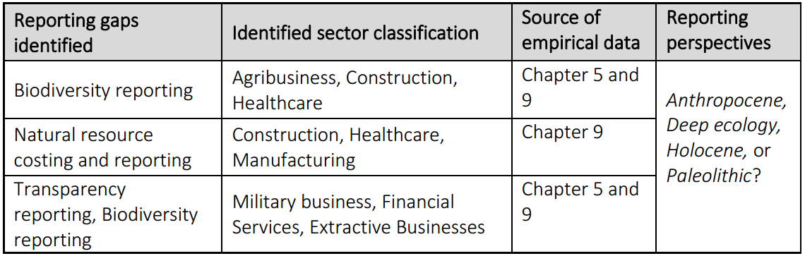Source: Researcher’s findings

With climate change persistently appearing on the agenda of investors, information on the quality of income and assets based on the environmental risks is likely to continue to increase. Unfortunately, the existing accounting standards either on valuation, or the systematic writing off of assets over their economic useful lives, are inadequate as they do not foresee effects of climate change which is able to alter the value income or assets disproportionately. In recent times however, some organisations such as S&P Global Ratings have developed “management and Global” criteria for measuring ESG risks, although such universal criteria capturing income and assets exposure to ESG risks are yet to be applied in reporting by companies. All these are evidences of the transition that the accounting profession is in right now, and climate change is playing an important role. Burton et al. (2018) have opined that the increasing demand for CIR due to the increased number of users worldwide will lead to a greater market efficiency. This also agrees with the views of Debreceny et al. (2001) and Ahmed et al. (2017). From a theoretical point of view, reflexivity whereby new knowledge development serves as catalyst for social reform and updating existing processes where new knowledge becomes available (Giddens, 1990) is influencing the need for development of new reporting system that meets the requirement of activist shareholders.

Table 10.2: Indicators in Assessing companies’ risk exposure to climate change.
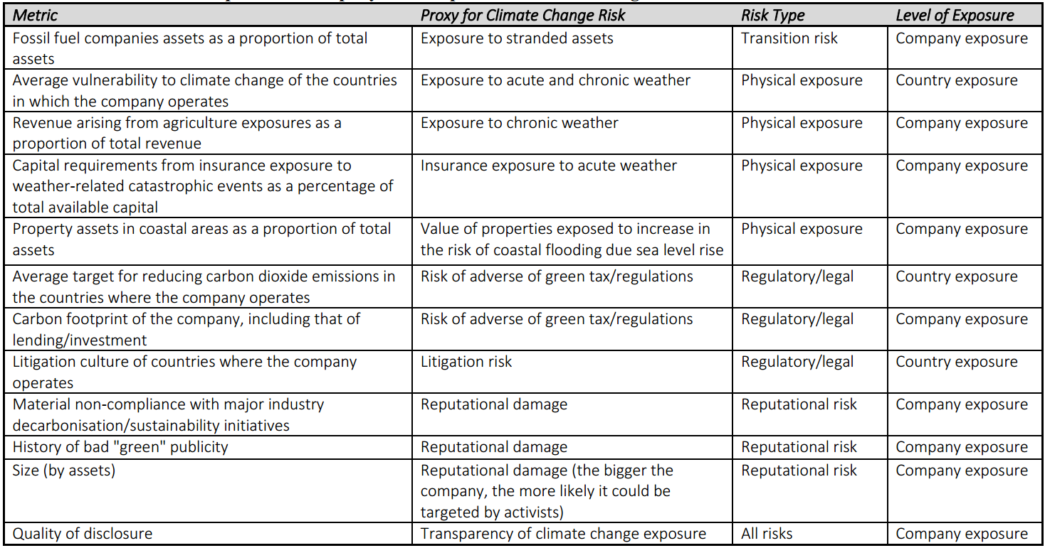Source: Reseacher’s findings, adapted from Petrov et al., (2016)

Table 10.3: Comparative analysis of how UK compares with certain jurisdictions in meeting the TCFD reporting requirements
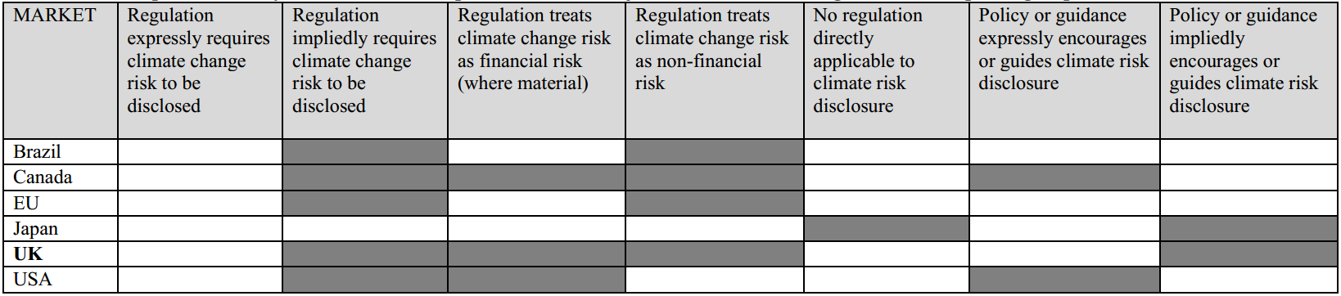Source: Researcher’s findings derived from www.unpri.org/policy-and-regulaations/tcfd, 2018

10.6 How do individual shareholders, institutional shareholders and proxy advisors influence ESG policies in investee companies?
This view is based on the interview evidence from of the members of the investment community such as individual shareholders (UKSA members), many of whom have long-term holding perspective (chapter 6), trustee of assets owners such as SWF, pension funds, faith-based organisations and social activists, hedge funds an proxy advisors (chapter 7), as well as attendance at IR meetings (chapter 9).

10.6.1 Individual shareholders
Based on the evidence from interview of UKSA members, individual investors are seemingly frustrated about their lack of power to vote at AGMs as many of them are now held in nominee accounts, whose voting rights reside in the broker. This partly accounts for the call for weighted voting system to reduce institutional investors’ votes. Some are also calling for the empowerment of beneficiaries of pension funds so that they can directly vote, rather than the funds’ trustees doing this on their behalf. A similar system was once tried at CalPERS whereby the beneficiaries themselves will have powers to dictate to the pension funds, the exact voting mandate. These are all consequences of reflexive modernism where society continually reforms, and misalignment in social reforms cause social disorder and loss of trust in abstract systems, thereby warranting another level of reforms (Giddens, 1990). Loss of voting power however, has made many UKSA members to find solace in attending IR meetings where they are able to discuss their views on ESG risks with the executive directors as a form of re-embedding mechanism (Giddens, 1990). Although the relative weight of shares owned by individuals in UK listed companies is small, which means that they are unlikely to be able to meaningfully control or influence financial and operating policy decisions regarding ESG matters, attendance and engagement with directors continues to evidence passive activism which the stewardship Code encourages. On few occasions, some UKSA members were able to exit companies that are not compatible with their risk philosophies. This agrees with the views of researchers that such meetings enhance the communication channel between investor and the investee (Holland, 1998; Dolphin, 2003). Observation evidence suggest that UKSA members are using the meeting as an opportunity for the individual shareholders to discuss their ESG risk perception with directors, and also get a first-hand response on whether or not these issues are being dealt with. Given that many of such UKSA members are also affiliated with social activist organisations with passion for the environmental issues, failure to address such issues internally are likely to be taken up by the social activist organisations that they belong to, thereby escalating same into a public shareholder activism. For instance, the directors of RBS at IR meetings, have previously dismissed the likelihood of setting up a shareholder committee before the UKSA organisation coordinated the writing and submission of a shareholder proposal on it.

UKSA has a comprehensive policy on responsible investment which has been communicated to members through their website. They do encourage their members to engage their investee companies through the principles contained therein. They have also been at the forefront in the lobbying for an Act of parliament on binding executive pay, and the need to attach executive remuneration to environmental performance were consistently being raised in all IR meetings by their members. In order to make their voice stronger on ESG matters, the UKSA proposed to their members in their AGM to merge with the ShareSoc based on the recommendation proposed to them by the FRC. However, the shareholders rejected the bid because of difference in their shareholder activism philosophy. ShareSoc prefers confrontation and public activism, whereas UKSA prefers private engagement. This explains the reason why ShareSoc members are not invited to IR meetings. Although the two bodies are still working as independent organisations, they are collaborating on the RBS shareholder proposal, as well as scheduling workshops and seminars with FRC and other government agencies such as the department of Business in the enlightenment of their members on matters of shareholder rights. Based on interviews with members, there are no evidence of the UKSA collaborating with social activist organisations like the Greenpeace, FoE, WWF, etc. on submission of shareholder proposals, nor asset owners like pension funds. The inability of these parties to collaborate is the manifestation of Giddens (1990) risk society which inspires an atmosphere of politics typified by push-and-pull, scaremongering and cover-up as the parties rarely agree on how to tackle manufactured risks due to the demonstration of knowledge and counter superior knowledge.

10.6.2 Institutional Asset Owners
10.6.2.1 Pension Funds
Prevalence of RI logic is evident in pension fund asset owners interviewed, and they attribute this to the professional affiliations and legal pronouncements in the UK. Climate change resonates in the engagement with investee companies, and they all have made it clear that they get directives to this effect from their professional affiliations.
The government consultation papers as well as the various Pension Acts^{10b} clarifies the duties of trustees regarding stewardship in ensuring that “financially material ESG considerations to be taken into account in selecting, retaining and selling investments”, and also “monitoring and engaging with investee companies on matters such as strategy, performance, risk, capital structure, corporate governance, culture and remuneration.” It is also mandatory for pension trustees to have Statement of Investment Principles which includes policies on voting, engagement and monitory investee companies. All the interviewees are aware that most of the best practices that have been developed in the last 2 decades have been targeted at them, and they have kept pace with these requirements as they are mostly legal in nature. There are evidences of application of range of RI screening methods in actively managing investee companies, especially engagement with directors of investee companies.

But the critical question is, despite the high level of awareness of ESG risks, why are ESG shareholder proposals being voted down? One of the answers is that pension funds account for less than 20% of UK shareholder base. Perhaps regulations on stewardship ought to be targeted at mutual funds and SWFs. Secondly, although fiduciary responsibility on ESG has been clarified as being those of the asset owners, some pension funds are still outsourcing governance roles to proxy advisors without properly clarifying the responsibility for ESG in the governance request for proposals (RfP). Just like the SWF, some asset owners readily accept whatever recommendations that they get from the proxy advisors without subjecting it to a second test. This is evident in the fact that pension asset owners do receive varying recommendations on ESG matters thereby resulting in confusing decision on stewardship. Thirdly, some pension asset owners are uncertain about generating short-term dividends for their retiring members, they are fearful of the consequences of committing wholeheartedly to a direct changeover of business strategies from fossil fuel to a sustainable one, or even out rightly divest from fossil fuel companies that pays above market rate dividends. This “precautionary principle” (Giddens, 1990) has however led to a massive loss due to substantial decline in the value of stranded assets held in their portfolio as at August 2019 (Olatubosun and Koseoglu, 2019).

10.6.2.2 Sovereign Wealth funds
How SWFs influence ESG policies is opaque as the ones interviewed neither discuss their performance with the public, nor post engagement information on their website. Unlike the pension funds, there are no mandatory guidelines or directives guiding SWFs on ESG, although it is expected that SWFs would voluntarily comply with the Stewardship Code and the Santiago Principles. Two executives of SWFs were interviewed, and the findings were mixed. One important finding is that the expectation that fiduciary responsibility to consider ESG, which is accepted as long-term investment value driver, is not well understood by SWF trustees interviewed. One of the SWF interviewees demonstrate lack of clarity about what active ownership entails. Although proxy advisors and portfolio managers are appointed, these are being done as part of ‘tick-box’ measures only. The appointed proxy agents are not provided with clear mandates on ESG engagement. An interviewee is aware of the existence of the Santiago Principles, the Santiago Compliance Index, and the Stewardship Code but cannot explain what they are about, and how relevant they are to their fiduciary duties. Fiduciary duty to consider ESG issues investment decision making is the duty of the asset owner, although this could be outsourced to others in the investment chain (UNEPFI, 2015; Hawley et al., 2014; Kay, 2012; Law Commission, 2014). This suggests therefore that RI logic may not be prevalent amongst the interviewees since premium is placed on short term financial returns. ESG considerations always come second due to the governmental pressure to generate profits to fund annual budgets in their home country. This perhaps makes one of the interviewees to compare themselves to a private equity firm yielding high returns, which suggests that their philosophy is to maximise government return on investments and not necessarily ESG concerns. This confirms the challenging risk preferences and the disposition effect in the psychological biases that investors do face (Kent and Nofsinger, 2002). Secondly none of the SWFs interviewed have in-house experts on ESG matters as they rely on their portfolio managers on such issues. Since they are not actively involved in developing policies on coping with ESG risks, and they don’t include RFP on ESG when hiring portfolio managers, it can be assumed that ESG is not a primary concern for them. SWFs need to be held to the same governance standards as pension funds (Avendano and Santiso, 2009) or even higher regulatory standards due to the implicit political interests in their investment policies (Gilson and Milhaupt, 2008). This however may not be the general practice in the market as the Norwegian SWF is reputed to have a policy on responsible investment. Given that over forty percent of all UK equities are held by the SWFs, there is need for a tighter regulation of, and streamlining of their activities with those of the pension funds as regards ESG. Due to their relatively large holding, mainstreaming of ESG shareholder activism may rest on the change of attitude of SWF from precautionary attitude to the acceptance of RI logic.
10.6.2.3 Hedge Funds
Based on their philosophy, the executives of the hedge funds interviewed are not interested in long-term engagement with investee companies, or at best, very little or neutral ESG engagement. These findings are largely in line with the conclusion of Kahan and Rock (2007), that in contrast to pension funds, hedge fund activism is executed “strategic” and “ex-ante”. The active investment style that all the interviewees adopted is antithetical to long-term engagement in the spirit of RI. Unlike the conclusions reached in Riviere (2011) as well as Cheffins and Amour (2011), there were no evidences of use of offensive activism by the executives interviewed possibly because of the insignificant stakes that they have in the investees. Unlike other institutional investors interviewed, hedge funds are interested in taking long or short position, which will accrue benefit from short-term under or over-valuation of equities. For instance, as pension funds engage investees with a view to reducing or removing perceived ESG risks, hedge funds take transactional position which benefits it, even if it enhances such risks in the target company. They also do not make use of asset managers and proxy advisors, possibly due to the planned duration and size of their holdings, and they do not attend IR meetings.

10.6.2.4 Social Investors
The faith based, and environmental campaign asset owners interviewed are similar to pension funds in their awareness of RI practices, and in their belief in actively engaging management whenever the opportunity arises whether privately and publicly. However, they do differ in activism methods being used. For instance, the environmental campaign organisations interviewed, prefer using offensive and public activism, making use of the press and public protests to drive home their point, whilst the members of the faith-based groups prefer to participate in IR meetings rather than protesting publicly. They both complained that shareholder activism is costly for them relative to the benefits that they derive due to diseconomies of scale. However, they take solace in their investment philosophies which are aligned with RI logic. The social investors interviewed actively campaign in support of climate change initiatives by aligning with other social activists, which is similar to the trends witnessed in shareholder proposals filed between 2007 and 2010. According to one of them:

“…we haven’t joined up with “The Aiming for A” movement for strategic reasons. We simply don’t have the number [of equity shares] required to be an effective investor in that terrain [shareholder proposal]. We think it is better for us to concentrate on campaigns, and we shall continue to provide them with technical supports when and where necessary.” ECO1

The two faith-based asset owners interviewed confirmed that they both decided to set up a separate department overseeing governance and responsible investment in 2015 based on recommendations received from the PRI. They also wanted to avoid public embarrassment depicting hypocrisy which pitches their practices at variance with the religious preaching that the organisation stands for.
The Faith based asset owners interviewed confirmed that they are still holding equity shares in BP and royal Dutch Shell because these companies have diversified significantly from fossil fuel. This may be due to representativeness bias, cognitive dissonance or familiarity bias (Baker and Nofsinger, 2002), or a genuine effort to abide by their RI philosophy of putting pressure on these companies to diversify away from environmentally damaging products (Kock and Min, 2016; Rutterford, 2012), or because divestment is uneconomical (Wen, 2009; Gifford, 2010). However, they have sold off shares in certain companies that are at variance with their religious beliefs based on the reports available on their website. Apart from negative screening of oil and gas assets, they confirmed that they engage with their investee companies’ directors on various social issues. Public records showed that all the social investors interviewed voted in favour of shareholder proposals relating to ESG.

10.6.3 Proxy Advisors ‘ESG by necessity’
Proxy advisors influence ESG policies by providing governance advice to institutional investors. The two interviewees proxy advisors operating in the UK can be classified into two: profit-oriented model (PX01) and collaboration-oriented model (PX02). The first is owned by a private equity, and the other is a confederation of pension funds. These forms of ownership and long-term corporate goal are likely to influence the ESG and voting policies of proxy advisors which are remarkably different based on the voting recommendations in chapter 9. It was noticed that PX01 operates ‘ESG on demand’ services (whereby they consult for investors if they wish to vote on ESG proposals) whereas PX02 have a long-standing operating policy on ESG evidenced by public voting record. This is an important finding on proxy advisory in the UK. The two interviewees confirmed that in the past decade, the main ESG issue that have dominated their proxy fights has been issues around executive pay, and that the most prominent ESG issue now attracting shareholder proposal is climate change. But do proxy advisors possess internal skills or outsourced external experts who advise them on these issues considering the volume of proposals that they receive annually? Are their recommendations based on scientific research? Findings from chapter 7 suggest that PX02 meet these requirements. Due to its opaque nature, it is doubtful whether it is the same for PX01. Although PX02 prides itself as always aligning with the environmental and social policies, PX01 has also just developed a full-fledged policy on supporting environmental shareholder proposals with effect from 2015, and this has been replicated by most of the others in the industry. The policy focuses on reduction of CO₂ emissions, especially in extractive industries because of their conviction that there is a link between environmental sustainability and long-term financial performance.

Apart from ownership and profit motive, the issue of conflict of interest, and transparency also influence how proxy advisors influence ESG in investee companies. It was found that conflict of interests (see chapter 7) inherent in the profit-oriented model may emanate in three dimensions:
- The holding company, which is a private equity firm, may seek to influence the policies within the proxy advisory company through ownership control.
- As a result of the ownership highlighted above, parent company may have a conceptually distinct approach to governance which may impact on the proxy advisory firms.
- Corporate clients, i.e. investee companies may hire proxy firms to influence institutional investors, making them agents of both principal and agent in the investment chain. There are no regulatory deterrents in place to prevent this from happening.
Although executive at PX01 showed the researcher internal policies that have been put in place to prevent the above from occurring, there are public documents that shows that the practice is widespread^{10c}. Since PX02 does not have a profit motive, the ESG policies are autochthonous from member pension funds rather than being imposed by the parent company. This explains why the threats of conflicts of interests are minimal in the collaboration model.

How the ESG voting recommendations are arrived at are at best opaque in PX01. The basis is unknown and are not shared with the public. Not only that, the recommendations issued do change between the times of issuance, and shortly before the AGM where the matter would be voted upon. This contrasts with PX01 where detailed discussions on each issue is exhaustively discussed on its website, with details of the effect of each proposal on the company and the wider economy. However, PX01 has more influence as most of the asset owners in the UK are its client. If ESG is to become entrenched, both PX01 and PX02 should work together to issue recommendations that are not conflicting, all in favour of ESG proposals. Another option is for the operations of proxy advisory to be regulated by independent body similar to the FRC and ensure that proxy advisors have a charitable rather than profit objective since ESGs are in public interest. The behaviours of the PX01 proxy advisor that have been observed is akin to ESG by necessity. That is, they tend to recommend that their clients should vote in favour of ESG proposals where there is already a collaboration by an overwhelming majority, which means that the proxy advisors are simply working towards an obvious answer, or rather, tailor made recommendations based on need rather than based on rational facts.

PX01’s acknowledgement of the fact that time has been wasted in the past on executive pay rather than environmental issues may yet indicate a likelihood of a realisation by proxy advisors that everyone loses in climate change matters, having stressed the fact that climate change is the most important ESG issue because of the existential effect on businesses. With the biggest mutual funds in the world (Blackrock) now having a policy on ESG (July 2018), it is likely to influence other mutual funds, and ultimately, all proxy advisors to embrace climate change. However, the objective of their owners is likely to continue to have overbearing influence on whatever they do.

Except for hedge funds, all of the asset owners interviewed have proxy advisors who manage their voting engagements for them. Surprisingly, none of them have policies on evaluating the performances of these proxy advisors because they believe that the proxy advisors are experts in their own field. Not only that, they assume that having a proxy advisor helps in meeting regulatory requirements on fiduciary responsibility on good governance. Although all the institutional investors interviewed do not measure periodic performances of their proxy advisors on how they meet their ESG objectives in their investee companies, an interesting finding is that some pension funds and all the faith-based, and environmental campaign asset owners interviewed confirmed that they usually consider ‘strategic fit’ in appointing a proxy agent. That is, they will usually contract a proxy advisor who is perceived to be an expert based on skills and past performances on ESG matters.

Another major finding is the non-clarification of fiduciary responsibility on ESG engagement in investee companies. Is it the responsibility of the institutional investor or the proxy advisor? The reason why institutional shareholders hire proxy advisors is that they are expected to offer recommendations based their skills on governance matters, which means that effectively, such matters are being outsourced. It was revealed that the fiduciary responsibility for considering ESG issues resides in the institutional investor, and this ought to be properly communicated to the proxy advisor. Given that some SWFs for instance are not aware of these responsibilities since they are not mandating the proxy advisors to specifically do this on their behalf, it is partly responsible for the slow pace in the mainstreaming of the RI logic in the UK investment chain. ESG is a relatively new development, and findings suggest that proxy advisors, especially the operators using profit model, may not have the requisite skills upon which recommendations may be provided to investors.

10.7 What are the issues driving ESG shareholder activism in the UK?
These views are based on the data generated from all the empirical chapters based on analyses of archival data (chapter 5), interview (chapters 6, 7 and 8), and observation at IR meetings (chapter 9). What was noticed throughout this research process is that the perceived gap between the information provided by directors, and those required by investors, especially in risk decision-making, is likely to be the starting point for ESG shareholder activism (see figure 10.3). Some investors see SRs as evidence of greenwashing and impression management because oftentimes, they don’t meet the decision-making needs of investors who get the needed information elsewhere. It is likely that if those gaps exist, shareholder activism will always fester. ESG issues that were raised at IR meetings were influenced by UKSA members’ knowledge, influenced by their organisations’ policy on RI. Over the period of four years in which this research was carried out, the issue of excessive executive pay was paramount. When interviewed, most of the members also believe that the law ought to be amended to give shareholders power for a binding vote on executive pay (see chapter 5). In recent times, they have upgraded the campaign to the need for a shareholder committee for executive pay and ESG risks issues to be properly tackled. Apart from the quest for shareholder committee, ESG issues that are likely to have immediate or long-term negative impact on the value of the investee company is likely to be raised at IR meetings. As these issues are being tackled either by the company or by the instrumentality of the law (for instance, social issues via Bribery Act, 2010 and the Modern Slavery Act 2015), the issue disappears, and new ones appear (such as fears of Brexit, biodiversity loss). The ESG issues are also sector-specific. For instance, the effect of pollution was of concern in agribusiness and military hardware businesses whereas reputational risks, and ‘fintech’ induced uncertainties were of concern in financial services due to the likelihood of future loss of assets and revenue if they are not properly addressed.

Environmental issues, particularly climate change concerns are influencing going concern agitation amongst shareholders. Generally, the concerns are that if the issues are not tackled in-house, it may attract punitive legislation in due course. Unlike social issues that are attracting legal enactments, findings suggest that environmental issues like the prevention of biodiversity losses (in agribusiness), degradation of arable land (in military business), and water usage (in healthcare and manufacturing businesses) does not seem to be attracting enough attention from the regulators, and this accounts for the surge in the number of occasions that they are being raised at IR meetings. Environmental issues have also dominated the shareholder proposals that have been submitted between 2011 and 2017. The patterns noticed is that due to the pressure on the directors to deliver financial returns, they are unlikely to support climate change proposals because they are likely to impose change in strategy with uncertain consequences. For instance, in Royal Dutch Shell plc and BP plc, the activist investors prefer a wholesome direct changeover from fossil fuel to green technologies by 2035.However, the directors prefer an incremental changeover that offer some opportunities to exploit existing oil and gas assets in order to avoid their stranding. Research findings suggest that the reason why environmental resolutions are likely to be targeted at extractive industries, is the collaborative efforts of the “Aiming for A” group in the UK.

Surely, the fear of climate change is a major driver of ESG activism by shareholders. Major scientific reports are projecting increased GHG emissions meaning that continual rise in temperature is inevitable (IPCC,2018), and as these rises, it would be impossible for investors to disregard the effect of climate change on the assets and liabilities held in investee companies. Geneva Association (2018) and Climate Wise ^{10d} both reported that a growing number of Europe based insurance companies are turning down insurance cover for companies in the extractive sector. In 2018, the DWP^{10e} published a directive empowering UK pension fund trustees to sell shares hitherto invested in oil and gas companies. This may accelerate what researchers have termed the ‘stranding’ of such oil and gas assets or make the directors of these entities to change their strategies in favour of green energies (Caldecott, 2018; Hedegaard, 2015; Greenpeace, 2018). These fears are confirmed in interviews with proxy advisors who opined that climate change may cause diminution of their assets, hence the change of strategy by investee companies to reduce or out rightly sell investment in ‘stranded assets’.

The change in law in 2007 was a major influence, as this empowered minimum of 100 shareholders to draw up and submit a proposal on ESG issues. Research shows that these issues were not prominent in UK corporate governance prior to the Companies Act 2006. Practitioners are however asking that the law be amended so that the directors are expressly mandated to consider ESG risks. Some have asked for laws to be passed to ban fossil fuel rather than tax it. A case in point is the ‘congestion charge’ which was only able to raise taxes for government rather than banning high emission cars. Some believe that a ban through the instrumentality of law, rather than raising carbon taxes is more efficient. This may be true as child labour, bribery in foreign subsidiaries etc. practices are likely to be eradicated or reduced since UK companies are avoiding investment in jurisdictions with high incidence of these social vices.

10.8 What are the observed developments in ESG shareholder activism in the UK?
These views are based on the data generated from all the empirical chapters based on analyses of archival data (chapter 5), interview (chapters 6, 7 and 8), and observation at IR meetings (chapter 9).

10.8.1 Growth of Dialogue
Logsdon and Buren III (2009) noted that the use of dialogue is being under-reported in academic literature on shareholder activism, and this has been supported by conclusions from others research which showed that the reward for dialogue is not being properly acknowledged (see Dhir, 2012). However, given that directors prefer private engagement to public confrontation with investors due to the attendant negative publicity attached to it, it is can be assumed that the practice of private engagement with directors is here to stay, and may become the norm in due course. Data gathered confirmed that IR meetings are offering shareholders the opportunity to engage with directors and keeping them abreast with corporate strategy. This is capable of shifting boards’ prejudice for shareholder engagement from reactive to proactive. This proves the objective of both the Stewardship Code (2010) and the PRI Code (2012) on shareholder engagement which is “to enhance the quality of engagement between institutional investors and companies to help improve long-term returns to shareholders and the efficient exercise of governance responsibilities.” An important finding is that whilst the Code is aimed at institutional investors, many companies are also extending the practice to individual shareholders.
Equally, it is noted that failed or withdrawn shareholder proposals do end up dialogue. A sizeable percentage of ESG shareholder proposals filed between 2011 and 2017 are withdrawn because the directors agreed to address them are also cascading into dialogue with directors (see figure 10.2). Agreeing to withdraw a resolution after being filed is often seen as a victory for they are typically withdrawn when observable steps have been taken towards meeting the shareholders’ demands (see O’Rourke, 2002; Graves et al., 2001). This is an important development as dialogue with shareholders is recommended by the stewardship and PRI code.

Figure 10.2: ESG shareholder proposals that were either won or withdrawn for dialogue [%]
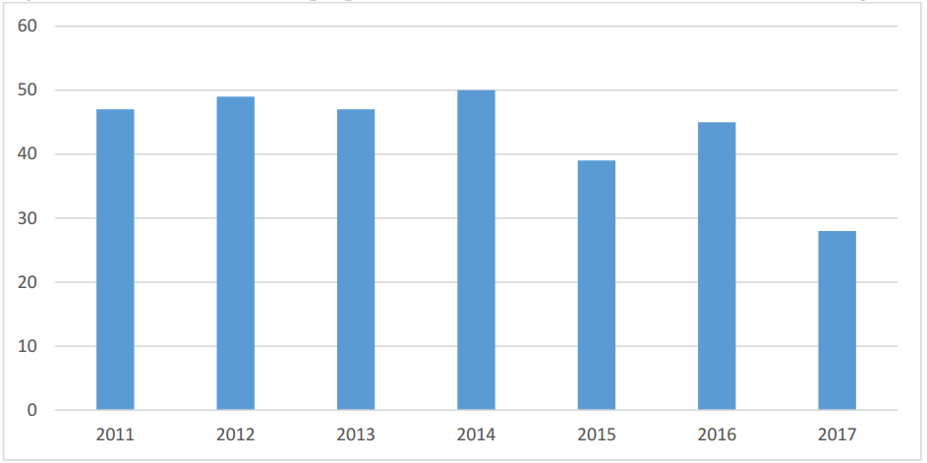
Source: Researcher’s findings derived from www.proxyinsight.com, 2018

Since the proposals are being withdrawn with a view to implementing the contents, it could be argued that they are as effective as the ESG votes won. It is a win-win because the ESG proposal is implemented, both parties avoid the embarrassment of losing the vote at the AGM, and the company avoids the likelihood of a bad press and a depression in share price. Figure 10.1 therefore illustrates the positive effect of dialogue in ESG risk discussion.

10.8.2 Concerns for climate change risk
Giddens (2010) hypothesis about the negative correlation between risk and trust is playing out in the investment community. Compared to what obtains before 2011, there is a growing awareness of the dangers of climate change based on the data gathered from shareholder proposals, meetings observation and interviews. The Paris Accord in 2015 coincided with unprecedented number of ESG wins in proposals in the UK for the first time. Based on the number of shareholder proposals submitted between 2011 and 2017, environmental issues take the lion’s share, and the number is growing. This demonstrates a better awareness than what obtains before year 2000 when such proposals are few and rarely wins (see O’Rourke, 2002; Gifford, 2010; Buchanan et al., 2010). Shareholders and proxy advisors are progressively starting to recognise the threat that climate change poses to their investment. In spite of this development, shareholder proposals on climate change is likely to fail because the major institutional investors are not working together. The resolutions filed on climate change over the years are generally two types:

- Those asking for companies, especially those operating in the extractive industries, to disclose their climate change risks in sustainability reports. These proposals largely demand more information on how climate change will impact on the value of these assets and future income.
- Those calling for the adoption of 2º scenario^{10f} in accordance with the Paris Agreement.

Number 1 is influenced largely by the need to close the information gap on the preparedness of investee companies to cope with climate change. Over four hundred disclosure schemes such as the TCFD report, Carbon Pricing Leadership report, etc. have been developed over the past decade, and over ninety percent of FTSE – 100 companies participate in at least one of these^{10g}. Climate change resolutions based on number one has witnessed some success especially after 2014. Number two has not been successful. Progress were made on the ‘2º scenario resolutions’ in 2016 and 2017 based on the average vote outcomes which rose from 23% to 38%. Within the same period, similar proposals filed against US corporations attracted votes of 33% in 2016 and 2017. Generally, the former has been more successful than the latter because some investors fear loss of income as a result of a direct changeover to a green economy. The lack of attention to adoption of adoption of ‘2º scenario’ policies supports Marshall (2014)’s arguments that in dealing with climate change, investors’ decisions are more likely to be directed by cognitive biases - a set of inbuilt and largely intuitive metal shortcuts.

Climate change issues also top the chart in the volume of questions asked at IR meetings in certain sectors. The first important finding here is that out of the three main risks analysed in chapter 8, environmental risks recorded the highest cumulative changes over time (CCOT), largely because the issues raised are not being addressed. Secondly, unlike the observed patterns between 2007 and 2010 when environmental activists are likely to sponsor proposals on environmental risks, institutional investors are now sponsoring such proposals, which suggests protective steps against going concern threats. However, the same cannot be said about proxy advisors, whose attitude to ESG risks are dependent on the model they operate, and it is likely those operating a collaborative model are likely to have expertise on climate change than the ones operating a profit model.

Whilst climate change awareness continues to grow, especially in the two categories highlighted above, an insignificant number of asset owners identified as social investors consider climate impact strategies (i.e. investing with the aim of generating social or environmental impact) in their investment process. Most asset owners who recognise the likely dangers of climate change only take action to mitigate the impact on the investee company with little attention paid to the system because they believe that such are the responsibilities of the government. FB01 operates climate impact strategies which involves:
- Identifying businesses with unrealised climate-related potential or opportunities and those whose product or processes are likely have positive effect on the environment and the society, with a view to investing in them.
- Appointing an in-house specialist on RI with veto-powers on the investment selection process.
- Setting timeline to divest from investment in environmentally damaging assets if engagement with directors fail to yield meaningful results.
- Maintaining a ‘ban list’ ruling out investment in companies whose strategies are not aligned to the ‘2º scenario.’

FB01 agrees that the above policy on climate change engagement has deprived it considerable financial returns, but that they take solace in the expectation that long-term performance will compensate for the short-term financial losses. None of the other interviewees operate an exemplar policy such as this.

10.8.3 Changing forms of IR meetings
Concerns for the issue of risk tends to influence the importance of IR meetings as a re-embedding mechanism. Originally, the IR meetings are designed to enhance flow of information about access to capital, liquidity and fair valuation between investors, between the company on one hand and the investors, analysts and the media on another hand^{10h}. Investors are now using these meetings to attempt to access non-financial that were not disclosed in the annual reports. The attendance and observation of such meeting in the UK over a four-year period, i.e. 2014-2017, offered an opportunity to review the ESG issued discussed in such meetings, and how the investors use the information derived therefrom. Using content analysis, details of the questions and typical answers received have been summarised in chapter 8. Through IR meetings, shareholders are able to put their views on the ESG issues that they are passionate about to the directors. A surprising finding is that the IR meeting was not designed as a platform for risk dialogue, and perhaps that explains the ninety minutes duration assigned for it. Nevertheless, activist shareholders are seizing the opportunity offered to table questions on how the companies plan to mitigate hazards that are ESG in nature (see chapter 8), which synchronises with the view of Uche and Solomon (2015) in the ability of the IR meeting to sustain high level of understanding between shareholders and management. These are ESG risks that are likely to alter the future value of reported assets and the ability of the company to generate future cash flows. The variety of risks arising on yearly basis clearly depicts the inadequacies of the current reporting system. For instance, in the construction industry, issues around work related accident (social risk) is raised, and then addressed, and then shareholders move to gender pay gap, and then executive pay, and then to pollution, and then to Brexit risks. Some have openly demanded for a sweeping change from the historical reporting to risk based narrative reporting, and the agitation is on-going. In many cases, the response to these questions validate the need to have board members who experts in RI and ESG risks matters.

Secondly, the outcomes of the IR meetings with individual shareholders are not published on the companies’ website. None of the companies visited over the four-year period (referred to in chapter 9) have agreed to make the minutes of such IR meetings available on their website. Meanwhile, the call for this practice to change keep growing. Some of the shareholders that attended have this to say:
- “…for the sake of transparency, I don’t see why our deliberations cannot be made available online.” (UKSA member at D4, 2015)
- “I sometimes reflect of the recommendations put forward here, how they are initially ignored, and then became important because the laws made them mandatory…” (UKSA member at F1, 2016)
- “Your quarterly returns with institutional investors are posted on your website,… what’s good for the goose is good for the gander” (UKSA member at G2, 2017)

Other shareholders have pointed out that non-disclosure of IR meeting details publicly may be a disadvantage to others because non-financial information that are not available in the annual reports may have been disclosed at such meeting. For instance, reported inaccuracies in the SRs evaluation of climate change risks were often pointed out by activist shareholders, to which directors usually respond that they are immaterial since the reports were unaudited. Perhaps directors are worried about the negative consequences of the risk discussions on the value of shares in line with the findings that perception of such activities may possess market sensitive value (Godfrey et al., 2009), and that privileged shareholders attending such meetings may trade on such news emanating from management, whether good or bad (Cheng and Lo, 2006).

The trends noticed is that once the issues have been addressed by management, or by an Act of Parliament, it ceases to be of interest in subsequent IR meetings. For instance, in A1 and A2 which are companies engaged in agribusiness, concerns on unethical land usage and child labour in a foreign associated company was prevalent in IR meetings up to 2016. However, since the passage of Bribery Act and the Modern Slavery Act with jurisdiction covering foreign operations, the issues were no longer raised in IR meetings as they have been fully addressed. Also, if the risk is general and not specific to the investee company, directors are likely to avoid addressing the issue. For instance, in the IR meetings involving military business (B1), management have no policies on destruction or degradation of arable land because they do not have any immediate impact on profits. Despite shareholders raising these concerns over the years, these concerns continue to grow, and the issues are not being addressed. This is akin to the ‘do nothing’ strategy applied in the case of Lonmin Group until the situation spiralled out of control (see chapter 2.75). Giddens (1991) opined that such policy usually boomerangs with costly consequences.

The IR meeting offers satisfaction to shareholders because they believe that it offers them opportunity to interact with directors and are also helping to shape the future of these investee companies (see James and Gifford, 2010; and Strickland et al.,1996). Some UKSA members also opine that the reduction of some of the companies’ exposure to fossil fuel evidenced through recent published Oil Global Outlook reports can be attributed to the pressure arising IR meetings.

Figure 10.3 Process of ESG shareholder activism in the UK

END RESULT

Obtain information for decision making (e.g. exit)

Change business strategy and risk management

Blocking merger or demerger

Imposing ESG or CSR policies on investee companies

More engagements

Information obtained

IR Meetings

Letters to Management
Private Activism
(Passive)

Focus list
Proposals
Public Activism (Offensive)
Information gap
Demand for ESG risk information

Public Protests

Press Briefing /Advertorial
Lobbying & Policy advocacy

Litigation
Legal

Private Activism
(Dialogue)

Source: Researcher’s findings based on the empirical data chapters 5 – 9.
10.8.4 Growth in collaborative shareholder engagement
Collaborative initiatives have increased tremendously after 2010, firstly due to the failures of the confrontational activism applied without success by social activist investors between 2007 and 2010, and secondly due to the publication of the Stewardship Code (2010) which encouraged collaborative actions amongst institutional asset owners. Chapter 9 demonstrated the effectiveness of working collaboratively amongst investors. The prevalent collaborative methods applied between 2012 and 2014 was more of policy advocacy, campaigns and plea for more disclosure (see table 10.4). Quest for more disclosure is seen as a major trigger for ESG activism (see table 10.3). However, the 2015 ‘Aiming for A’ shareholder resolutions were ground-breaking as over ninety percent votes were achieved for the first time on ESG resolutions thereby reinforcing the power of collaborative efforts in enforcing shareholder rights, demonstrating a move away from the ‘absentee owners’ position that was blamed for the corporate failures of the early 1990s (Sykes, 1994). The trend noticed in the mode of operation of institutional collaborators after 2015 is the likelihood to use shareholder proposals (see table 10.5), perhaps due to its effectiveness since a withdrawn proposal for management to address is as good as a win. However, a major impediment in the use of this method in the UK is the uphill task of getting an absolute majority of seventy-five percent. This contrasts with the USA where ESG issues require a simple majority of fifty percent of equity votes to win. With benefit of hindsight, if asset owners had chosen not to work collaboratively on ESG proposals, then such ESG themes may stand no chance at all.

Apart from shareholder resolutions, interview data revealed that asset owners are collaborating on many issues such as share buy-back, and executive pay action. This growing practice in the investment community is a radical departure from the tendency by institutional investors to sell stakes in underperforming companies rather than bearing the cost of intervention to turn such companies around (Short and Keasey, 1997). However, such long-tern perspective is likely to be exhibited if the investor is a signatory to the PRI principles. For instance, some interviewees confirmed using the PRI clearinghouse as a platform for collaborative engagement on key ESG themes. Through the clearinghouse, asset owners do gain access to a large database on ESG, and they are assigned an experienced and knowledgeable executive who will help in facilitating the appropriate investor-company dialogue. This facility however, is unavailable to non-PRI members, making investors to call for the operation of a similar clearinghouse managed by UK investors.

It was noticed that collaborative engagement was able to bind the hands of the proxy advisors in the “Aiming for A” coalition, such that the leading proxy advisors (Glass Lewis and ISS) were unable to make recommendations that were at variance with the majority opinion. This confirms the opinion of Sandberg (2011), and UNEPFI (2009), that fiduciary responsibility to integrate ESG resides in the shareholders rather than the various agents in the investment chain.
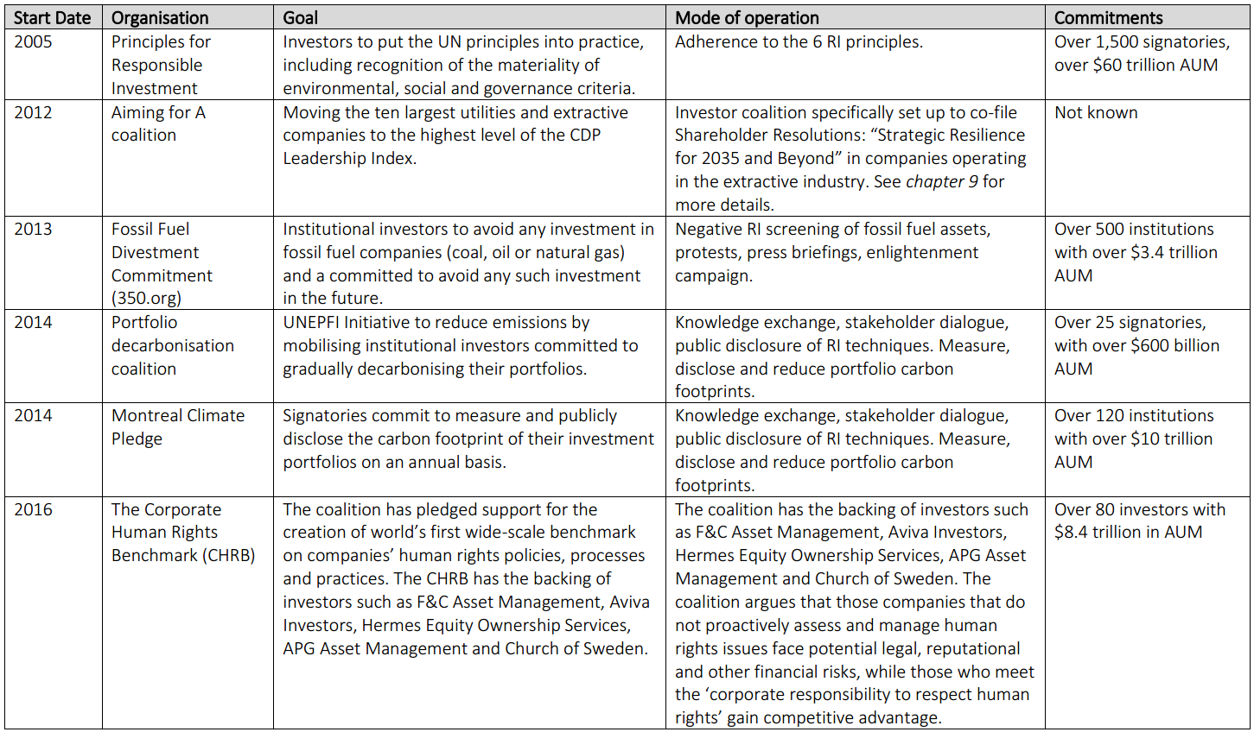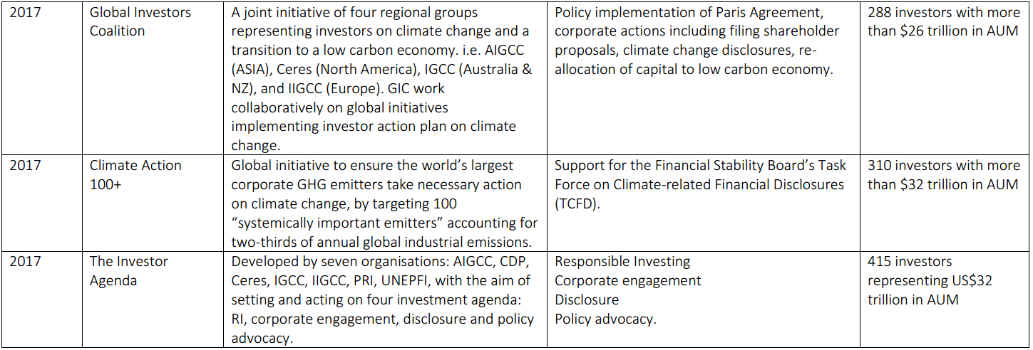Table 10.4: Major global institutional investor collaborations

Source: Researcher’s own findings
10.8.5 Attitude towards executive pay
Based on the interview data gathered, as well as attendance at IR meetings, executive pay information in the form desired by activist shareholders is an important trigger that drives ESG activism (see table 10.3), and this agrees with the views proxy advisors interviewed, that executive pay issues had dominated their advisory work since 2011. It is noteworthy that UKSA’s policy on executive pay, influences the concerns being raised IR meetings (see table 10.5). Based on Giddens hypothesis on the relationship between risk and trust, the fear of loss of earnings through bloated executive pay structure is one of the factors increasing going concern risk fears, thereby instigating disappearance of trust reposed in management. Again, in agreement with Beck (1992), the issue of executive pay has also increased the incidence of politics of scaremongering and blackmailing.

Table 10.5: UKSA policy on executive pay
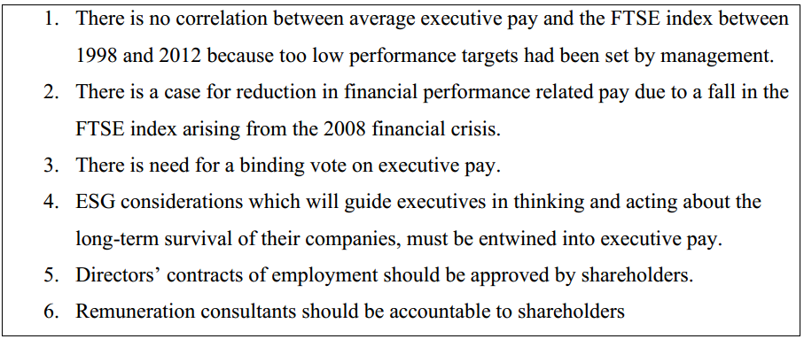Source: The Private Investor Magazine – Issue 182

Interview data suggests that the UKSA members’ dissatisfaction is not with the existing executive pay reporting system, but with the justification of executive pay itself, reputed to be the highest in Europe^{10i}, the way in which it is reported, and their seeming helplessness in curbing it. This brings to the fore, the need to revise the Greenbury Report (1995) as well as the legal requirement to publish executive remuneration report which seems to be inadequate (see table 10.5). Forty-eight percent of FTSE-250 companies have reduced their executive pay by more than ten percent between 2016 and 2018^{10j}. With the increase in the incidence of institutional investors forming collaborations to vote down ESG resolutions, it is possible that the surge in the incidence of voting down executive pay which occurred during the Shareholder Spring I and II, thereby forcing many executives to resign their appointments, may re-occur in the near future if the incidence of dissatisfaction with executive pay continues. However, the planned implementation of the EU directive (Shareholder Directive II) in 2019 may make all votes on executive pay to be binding on all companies in the future. Many executive pay reports were voted down during Shareholder spring I and II since only fifty-one percent votes are required, and the same trend may be witnessed in 2019 and beyond. This explains the reason why activists are demanding that the ESG issues should be downgraded to an ordinary resolution whenever the Companies Act is amended in the future as it empowers them to curb executive’s excesses.

As per the influence of proxy advisors on executive pay, not all the interviewees base their recommendation on transparent and scientific basis. For instance, some interviewees provided past instances in which proxy advisors gave recommendations on how to vote on executive pay at WPP in 2012, only for them to change their mind, and then issue a fresh recommendation shortly before the AGM without providing a valid basis. Not all proxy advisors are transparent on their voting policy on executive pay and none of the proxy advisors interviewed have internal experts on executive pay, suggesting widely held believe that they base their recommendations on the advice provided by ISS and Glass Lewis.

Another noticeable trend is the growing incidence of the use of shareholder proposal to demand the inclusion of ESG factors in executive remuneration KPIs (see table 9.4 in chapter 9), thereby putting pressure on management to adopt responsible investment tenets. This practice correlates with the recent findings by Xavier Baeten^{10k} which reveals that sixty-one percent [61%] of UK listed companies include ESG incentives as part of executive remuneration, compared to twelve percent [12%] in German firms, thereby making UK firms European leaders in the consideration of ESG in setting remuneration of executives.

10.8.6 ESG-activism or survival activism?
Investors interviewed have different perceptions of financial returns and ESG risks. This interest and the relative level of their power influences their perception to engagement. The directors on the other hand are under pressure to deliver financial returns. Except ESG performance is expressly written into their contract, the non-alignment on ESG risks between institutional investors and proxy advisors may continue to fester. Based on the data gathered, it is noted that institutional investors, social investors and individual investors have different investment philosophy. For instance, SWFs ranks financial returns higher than reducing the ESG risks in their investee companies, whereas the social activists interviewed are more interested in reducing environmental governance risks than earning financial returns. The pension funds however weigh profits and long-term survival equally due to the regulation of the industry. Also, over the three-year period under observation, it has been noted that the pressure put on management through questioning do yield some results. For instance, the persistent demand for diversification into renewable energy is yielding results at BP, as the company now (2017) plan to generate 50% of its sales from renewable sources by 2025. Prior to the gulf oil catastrophe of 2010, there has been sustained campaign by activists to make BP diversify to renewable energy sources (see table 10.6). One of the arguments then was that the market was unsustainable. However, the board now have a change of heart, perhaps due to the subtle pressure from the shareholders, but mainly due to the ‘post 2035 scenario’.

It can be summarised therefore, that an important driver of ESG shareholder activism amongst many shareholders as observed is the fear of loss of investment rather than the love for the environment. Over the four-year period (2014-2017) there were evidence of noticeable resistance to low-carbon economy on the part of directors of investee companies at IR meetings (see chapter 9). Some executives have argued that switching to low-carbon forms of production requires heavy investment which is not a priority. Moreover, there are no laws compelling that change. This perhaps explains why there is inconsistency in attitudes to ESG risks is noticeable in companies operating in multiple locations, whereby the executives seek to comply with laws governing their businesses on jurisdictional basis. For instance, non-implementation of laws that expressly requires climate change risk disclosure in the UK is a major impediment to the implementation of the TCFD guidelines (see table 10.3). However, with the level of progress being made in the UNFCC negotiations, it is expected that climate policies and laws will be passed at an accelerated rate, so that the mainstreaming of ESG risks are universal, and not dictated by survival disposition.

One of the proxy advisors interviewed (see chapter 7) summed up climate change activism as a necessity because it is driven by the fear of loss of investment, only to the extent that it affects their investment. This pattern is also noticeable in table 10.6 (see below) and this also agrees with previous literature on the general attitude of economic agents to corporate governance, which has been typified by ‘fire brigade’ approach rather than being proactive (see Bivot and Gendron, 2011; Malsch and Gendron, 2011).

Table 10.6: Evidence of Greenwashing rather than corporate environmentalism
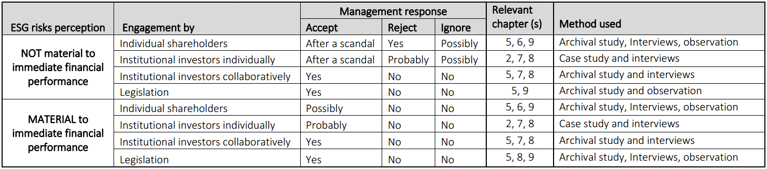Source: Researcher’s findings based on chapters 5-9 of this work

10.9. Barriers to ESG-activism
The investment community interviewed will want the following issues to be addressed in order to strengthen ESG induced activism in the UK.

10.9.1. Mandatory voting
Although the proportion of shares held by individuals are insignificant, there is need for the system to avoid the discrimination currently preventing some individual shareholders from exercising their rights. In the existing system, the shares are domiciled in a nominee account and the trustees of the account (from the shareholders account) may be averse to ESG values. According to a BIS paper^{10l},

“When company shares are held on your behalf by a Broker, they are held in a nominee account. This also include any individual shares that are part of a SIPP or a Stock and Shares ISA. Because the shares are not technically held in your own name, this means that you do not automatically have any shareholder rights such as being able to vote at the AGMs. Some stockbrokers pass these rights back to the individual shareholders, but many do not” (emphasis are mine).

Individuals holding shares in nominee accounts effectively have their shareholder rights ceded to the broker who operates such account. This is because it is the brokers’ name that appears on the company register, except if the broker willingly makes the investors’ name visible. This is a grey area that ought to be clarified for individual shareholders to get back their voting powers which existed when shares were in paper form. The loss of voting rights as a result of domiciling the shares in nominee account as stated above is a source of concern for shareholders. This is perhaps the reason why they place premium on IR meetings where their ideas can be communicated directly to directors.

Some have proposed that the beneficiaries of the pension and mutual funds should also be given powers to vote directly in the equities that the trustee hold on their behalf.

10.9.2. The need for more collaborative engagements
SWFs own more than forty percent of all the equity shares listed on the LSE. Despite this, there is no evidence that a SWF asset owner has sponsored or collaborated with others to sponsor a resolution bothering on ESG, nor to effect a strategic change in an investee company between 2011 and 2017 based on the votes analysed. This is also in agreement with the interview data collected. However, there is a growing incidence of effective collaboration amongst pension funds and social activist investors since 2015 (e.g. Climate Action 100+, and the “Aiming for A” coalition) (see chapter 9). The low incidence of engagement with the investee companies by SWFs amongst the interviewees suggests non-prioritisation of engagement on ESG issues. The lack of meaningful collaboration between SWFs and Pension Funds engagement with investee companies in accordance with the Stewardship and the PRI Code is a major impediment to the mainstreaming of RI. It is also important to note that ESG activism was focused on big corporations operating in the extractive industries. It is expected that other companies that may be involved in environmental pollution like cow herding and ranching would attract the attention of the collaborative investors.

10.9.3 Legal constraints
The Companies Act currently classify ESG issues as special resolutions, thereby requiring a seventy-five percent vote [75%] for them to be passed. Interview data demonstrate the frustration of shareholders in this area. Requesting a seventy –five percent vote has made the likelihood of changing strategy swiftly an impossible task. The few shareholder resolutions that were able to achieve the seventy-five percent threshold were only made possible via collaboration. Secondly, some social activists explained that litigation rules and costs had prevented them from taking legal actions against perceived environmental degradation culprits. The litigation rules under the English Court system empowers the Judge to award costs against the losing party, and has prevented interested parties, especially shareholder activists from approaching the court to seek redress, thereby frustrating the likelihood of shareholders taking derivative actions against the directors of the company (see literature review). This finding agrees with the opinion of Cheffins (2008) on the weakness of litigation in UK shareholder activism. The social activists interviewed therefore prefers to buy shares in companies, and thereafter go on offensive shareholder activism, rather than engage in expensive legal battle.

10.9.4 Shareholder rights and RI Education
Some of the complaints by the investment community in chapters 5 to 9. For instance, not all individual shareholders can vote at AGM because their shares have been domiciled with brokers in a nominee account. Secondly, the non-binding vote on executive pay is also as disenfranchising since shareholders cannot do anything about it. The non-binding vote rule has been likened by one of the interviewees in chapter 5 to “allowing a child to access cookies but preventing the child from eating it.” Thirdly, there is no evidence of transparency in the activities of the proxy advisors. There are currently no rules compelling them to disclose the basis upon which they arrived at their recommendations. Fourthly, although institutional investors are mandated to disclose their voting policy on their website, there is no existing policy on the disclosure of their investment strategy.

It is expected however, that the implementation of the EU directive (Shareholder Directive II) by mid-2019 will address all the above issues, thereby increasing transparency at all levels of institutional asset ownership. SRD II is likely to enhance shareholder engagement because in addition to addressing all the above, shareholders holding 0.5% or more in investee companies will be publicly disclosed, which may have implications for enhanced shareholder engagement. The Brexit uncertainty may however prevent all these from happening.

10.10 How does shareholder activism and shareholder proposals mirror the concept of re-embedding mechanism in the sense of risk society theory?
Giddens (1990:80) argued that whilst “facework commitment” was an important technique for maintaining social connections as well as screening off strangers in traditional era, “faceless commitment” is expected in maintaining relationship with abstract systems since they are totally dis-embedded as they are expected to be trustworthy, function normally and seamlessly without emotions. E.g. the workings of the banking system. However, Giddens (1990:84). However, Giddens (1990) recommended the use of re-embedding actions in order to reinforce a high level of trust in the dis-embedded systems. Throughout the empirical chapters of this research, the issue of dwindling trust because of heightened prevalence of ‘manufactured risk’ was evident, thereby necessitating the use application of re-embedding techniques to reinforce trust in the investment process. The empirical chapters (5 to 9) was able to demonstrate how shareholder activism mirror the concept of re-embedding mechanism. The respective issues were highlighted at the end of each chapter under the summary headings. Shareholders were able to re-embed trust by using shareholder activism techniques, which are subsets of RI logic, such as collaboration with other investors to present shareholder proposals, holding investors dialogue either independently or in addition to shareholder proposals, attendance at IR meetings, demand for integrated risk reporting, and lobby to effect changes in existing laws and regulations

Shareholder resolutions: Shareholder proposals are being used by shareholders as a means of demonstrating shareholder primacy and a means of re-establishing control in an atmosphere filled with distrust. With shareholder activism through shareholder proposals, directors are put under control so that they don’t stray from the need to achieving the goal congruence. However, the fact that ESG proposals failed will not remove the shareholders influence as they can still be escalated in the press, thereby putting management in bad light (Brandes et al., 2008; Ferri and Sandino, 2009).

Lobby to effect changes in laws and regulations: Again, due to the lack of trust in management doing the right thing on their own, the activist investors, including the UKSA sees confrontational shareholder activism as a means of campaigning for changes in laws and regulations. A good example was the governance proposal filed at RBS by UKSA (see chapter 5). Although it has been defeated twice, the fact that the proposal was voted down will likely continue to cast the government in bad light as they own 72% shares through UKGI in RBS. The lobby to pass the requisite Act of parliament to regulate the profession of the proxy advisors paid off as The Proxy Advisors (Shareholders’ Rights) Regulations Act 2019 was passed into law recently.

Attendance at IR meetings: Giddens (1990:80) argument that “access points” into dis-embedded systems may make or mar relationship with the social systems accessing them, was confirmed via the IR meeting deliberations. The meetings were not originally designed for ESG discussions. However, the growing dialogical engagement with the subject of ‘manufactured risk’ such as biodiversity loss, change of strategy and even executive pay, were being discussed. Whilst the meeting provided opportunity for management to clarify issues of gaps in reporting, it also becoming a source of dissatisfaction with management as much of the information required for long-term decision-making were unavailable through such meetings. Detailed discussion of the engagement including growth in dialogue, and the changing forms of IR meetings have been discussed in subsection10.8.

10.11 Comparing and contrasting data collection methods used
Neither the observation nor the archival data collection method would have been adequate in rigorously addressing research questions 1 – 5 as they would have offered partial view of the answers being sought. However, they provided means of checking and verifying the data collected via interviews. For instance, archival studies offered little explanation about SRs. There were a few shareholder proposals demanding for SRs. But because the wordings of the shareholder proposal in the database is limited to 100 words, it was difficult to capture the essence of it. That was however complemented through observation of IR meetings where what they wanted were being described in detail. By the time the interview data were compared with the data from archives and observation, it was clear that the traditional institutional investors are not the demanding for additional information on SRs, but the UKSA members and the social investors, because the investors can get the information that they need from their representatives on the board of directors. Another examples of how these methods complement each other is the role of proxy advisors. The archival data analysed in chapter 5 only provided information on the votes on ESG without attributing them to any proxy advisors. Also, the archival data provided no information on the ownership structures of these firms and the kinds of services they render (for instance there is a difference between proxy advisors representing the institutional investors, and proxy agents defending proxy votes) and the clarification of their ‘double dip’ role in the investment chain. The inkling was first provided by the UKSA members interviewed and later confirmed by social investors, which made the researcher to confront the Proxy Advisors with the question framed to clarify this issue. Therefore, the fact that this research work revealed new facts and offered recommendations would not have been possible without the use of multi-method data collection methods which provided opportunity for checking and cross-checking of findings.

The risk society theory became apparent as the most ideal theoretical underpinning after it became clear that the facts gathered were complementing each other as it relates to risk matters. The archival materials clearly demonstrated that the number of environmental shareholder proposals submitted exceed the ones under the category of social and governance but little evidence was provided in justifying why this is so other than the influence of the SDG and Paris Accord in 2015. However, interview data from IKSA members and institutional investors confirmed clearly that going concern risk leading to loss of investment is the chief reason behind the move. This was further confirmed through the interview of Proxy Advisors and attendance at IR meetings where these issues were being discussed. On the other hand, there were contrasting outcomes from the data analysed. For instance, the issue of executive pay which was also dominating discussions at IR meetings as well as interviews with UKSA members, institutional investors and Proxy Advisors, was limited from the archival data. This is because 75% vote is required to pass such proposals to become a binding resolution.

The interview of Proxy Advisors was phenomenological in nature as it enabled the researcher to understand their role in the investment chain since little had been written on the subject as it is a recent phenomenon. However, the researcher was unable to observe Proxy Advisors in operation to clarify some of the issues raised (e.g. objectivity in issuing recommendations).
The interview of investors allowed the researcher to set aside any previous notions misconceptions held about themes. For instance, on SR, the interview allowed the researcher to hear the views of the relevant investors themselves. Also, these interviews took place during attendance at IR meetings where analyses of SRs are taking place, allowed the researcher to contextualise the usefulness of these reports and visualise the type of reporting system being envisaged, supporting Finlay (2005:27)’s view that interview allows the researcher to demonstrate “reflexivity and empathy”. Observation at the IR meetings as a participant-observer allowed the researcher to identify the unpublished social and political interactions on the SR through first-hand experience, as Dhir (2012) and Rehbein (2013) have suggested that shareholder dialogue, although important are largely undocumented instruments of ESG shareholder activism. Therefore, the evidences obtained from the interview and the observation of IR meetings were complementary to each other and were instrumental in the researcher’s reflections shown in this chapter on the various re-embedding mechanisms. The issues driving ESG shareholder activism and the observed trends were partly answered through the archival data on shareholder proposals filed in the UK [2007 – 2017] because social entities say one thing, and then do another (Arnould and Wallendorf, 1994), thereby justifying the need to complement the interview data with documentations of what was done, thereby providing insights into motives and patterns observed in the investment community. However, as the archival data is historical in nature, it may not be representative of future behaviour due to environmental changes.

10.12 Summary
This chapter discussed the findings derived from the analysis chapters within the context of the theory and the relevant literature, as well as comparison and contrasting of the multiple methods used in gathering these data. This discussion demonstrated the link between the Becksian risk society theory and ESG shareholder activism, as well as the variety of engagement methods used by the investment community as re-embedding mechanisms.

Chapter 11 Summary of Findings, Conclusions and Recommendations

11.1 Introduction
This chapter summarises the various findings of the study that have already been analysed in the empirical chapters (i.e. chapters 5 - 9), as well as the discussion chapter (i.e. chapter 10) based on the sequence of the research questions. This chapter also discusses the contributions of this study to the understanding of responsible investment and shareholder activism. It also discusses the theoretical contributions, policy implications arising from this work, the future of ESG induced shareholder activism, limitations of this study, and some suggestions for future research.

11.2 Summary of Findings
Six research questions were presented at the beginning of this work. The data gathered subsequently using interviews (chapter 5, 6, and 7), content analysis based on attendance at IR meetings (chapter 8), and analysis of archival materials (chapter 9) have been analysed in order to answer these research questions.

11.2.1 Findings on the attitudes of investors towards SR based on the views of shareholders
The first research question sought to gather information about the usefulness of SR to investors in shareholder activism. The information was gathered through the interview of individual shareholders who are members of UKSA (chapter 6) and various institutional investors (chapter 7) and attendance at IR meetings. It was found that investors do not find the various SR reports adequate for their decision-making activities. It was found that RI logic drives the quest for additional SR information as those investors who do not care about RI are not likely to demand SR information. It was also found that demand for SR is likely to trigger ESG shareholder activism as seen in the attitudes of individual shareholders are IR meetings, and the attitudes of the ‘Aiming for A’ institutional investors who demanded for the disclosure of more information on their resilience in post-fossil fuel ban period, from extractive companies. The demand for ESG to plug apparent information gaps in SRs is in line with the theoretical lens espoused in chapter 3 where investors are of the view that the financial and non-financial information emanating from the existing stewardship systems are inadequate, and would therefore exercise power, legitimacy and urgency in preventing the stranding of their investment. The inadequacy of the existing stewardship system from an ESG risk paradigm is driving the need for another form of reporting which satisfies the investment communities’ ESG risk appetite.
From a theoretical point of view, Beck (2007) opined that the cycle of new developments serves to transform unpredictable risks into calculable risks, and in the process, gives rise to new cycle of unpredictability, forcing us to reflect upon risks again. Through this ‘reflexivity’ of uncertainty, indeterminability of risk becomes fundamental for society, thereby presenting a case to “overhaul our concept of society and the conceptual apparatus of social science.” (p15). Many of the ESG risks that investee companies are facing are unforeseen by many of the existing models of stewardship, thereby giving rise to demand for a new form of reporting which is useful for the assessment of value investee companies. Beck (1992:33) distinguished between “existing destructive consequences” and the “potential elements” of risk. The “potential elements” is partly due to the uncertainties arising from likelihood of future damages, and partly due to declining trust. It is this urgency to protect future assets and income from these potential elements that drives the quest for a new form of SR, and the inability to access them, in many cases, is the beginning of ESG shareholder activism (see table 10.3).

11.2.2 Findings on how investors and proxy advisors influence ESG policies in investee companies.
Generally, individual investors have limited holding in investee companied, thereby limiting the level of their influence on ESG policies. However, UKSA members get invited to IR meetings where they can interact with management. Shareholders can demonstrate their persuasive power and the urgency of their risk concerns in such meetings. The publication of a guideline on the operation of IR meeting by the London Stock Exchange suggests the mainstreaming of the idea which Marston (2004) indicated as a growing phenomenon. However, it was observed that there is a misalignment between the original purpose of IR meetings, and the ESG risk discussions which now dominate its discussions. This resonates with the views of Darrough and Stoughton, 1990; Dye, 1986; Verracchia, 1983; Newman and Sansing, 1993; that investors perceive that the IR meetings are not providing enough opportunities for the full disclosure of material risks that investors may use for making decisions. This partial or non-disclosure is either because the directors believe that there are no legal or professionally imposed obligations to do so, or due to the perception that the market and the competitors may use the availability or otherwise of such information against the company, thereby depressing their market value (see Godfrey et al., 2009; and Cheng and Lo, 2006). This persuasive activism is however not shared by ShareSoc members who are not invited to IR meetings, supposedly because of their preference for confrontational shareholder activism method.

The “Aiming for A” coalition was able to reverse the previously held view that institutional shareholders cannot work together due to the differences in their ownership structure (Çelik and Isaksson, 2014), by championing successful ESG resolutions in extractive companies. The coalition was successful in pushing for resolutions demanding for investee companies to disclose their strategy post-2035 period. However, there was a crack in the coalition when subsequently there were demand on the fossil fuel investee companies to directly changeover to renewable energy. Some institutional investors fear that the strategy may hurt their cash flow obligations to their beneficiaries. Even though such shareholder proposal was defeated, many of the investee companies now have a transition programme to change to a green economy, thereby confirming the view of Roberts et al (2006), Sparkes and Cowtons (2004) and Eccles & Viviers (2011), on the capability of such proposals to whip management into line.
How the proxy advisors influence ESG policies in investee companies depends on its own ownership structure. This has effect on their voting policy, transparency, and whether they will actively avoid conflict of interest. Clarification of fiduciary responsibility of asset owners is still required especially in respect of the foreign based SWFs. It was noted that affiliation to local investment association (IMA) and the UNPRI has increased the incidence of investment logic amongst institutional investors. However, because the SWFs are owned by foreign government agencies or ministries, they are not under any pressure to subscribe to such organisations. In was unsurprising therefore, that their knowledge of RI is poor. Also, the non-clarification of the roles of proxy advisors is making the tail to wag the dog in the in the investment chain. The non-awareness on the part of some asset owners interviewed about the non-specification of the ESG engagement in the RfPs, as well as the non-measurement of the performance of proxy advisors have made them de-facto experts in ESG matters, which is not supposed to be so.

From a theoretical point of view, the “juggernaut” nature of the risk society is being demonstrated (Giddens, 1990:139). Some institutional investors, especially SWFs, are still struggling to understand that their fiduciary duty includes giving mandates to proxy advisors on ESG matters partly due to their non-subscription to investment associations grounded in RI logic. In a fast-changing world. By the time they are ready to subscribe to the PRI, perhaps another level of complexity might have been added to the investment chain.

11.2.3. Findings on the issues driving ESG shareholder activism
The information that helped in answering these questions were gathered through analyses of archival data (chapter5), interviews (chapter 6 and 7) and attendance at IR meetings (chapter 9). Two main drivers of ESG activism were noticed: RI logic and the fear of loss of investment. Collaborative engagement by institutional shareholders to present shareholder proposals is an RI principle common to both PRI and Stewardship Codes. RI logic is based on knowledge and skills are expected to reduce risks. According to Beck (1992:35), “Education and attentiveness to information open up new possibilities of dealing with and avoiding risk….wealth (in income, power, or education) can purchase safety and freedom from risk.” This conforms with my contribution to theory that RI logic drives ESG shareholder activism whereby investors use it as a re-embedding mechanism. All the individual investors interviewed explained that their attitude to engagement was shaped by the UKSA policy on RI, and all the institutional investors with policies on ESG engagement are members of the PRI.
The fear of loss of asset and income in the future due to uninsurable losses is another driver of ESG shareholder activism. Individual investors believe that their voting rights have been eroded and are therefore seeking alternative avenues (e.g. collaboration with social activists at IR meetings) to pressurise management into changing operating strategies. The same goes for institutional investors submitting shareholder proposals demanding change in operating strategies and sale of stranded assets. In the opinion of Beck (2009:139), insurance have a twin function of neutralising losses and fears. However, the absence of insurance in this regard breeds floating fears.

11.2.4. Findings on the observed developments in ESG shareholder activism
The information that helped in answering these questions were gathered through analyses of archival data (chapter5), interviews (chapter 6 and 7) and attendance at IR meetings (chapter 9). Firstly, there is a growing, but not universal awareness and operationalisation of RI logic in the UK investment chain. This awareness drives increase in the level of engagement with investee companies through IR meetings and the use of shareholder proposals. Addressing climate change and other environmental risks is the most is the most popular ESG issue now, and this is also becoming multifaceted. e.g. linking climate change with executive pay, climate change resilience, divestment from stranded assets etc. It was also noted that IR meetings are evolving, as the issue of risks to future performance and future value dominates discussions at such meetings, rather than analyses of past performance which it was designed for. There is also a growing tendency for investors, especially the institutional ones to collaboratively issue shareholder proposals or on other ESG issues (see table 10.4). Even when such proposals fail, they are likely to be re-presented, thereby putting management under pressure and public scrutiny (see figure 10.2). A pattern of greenwashing rather than corporate environmentalism was also noticed (table 10.6) whereby management is not proactive but would likely to respond to and ESG risk where there is a collaboration amongst institutional investors, only after the occurrence of a major scandal. This is a manifestation of the application of the “precautionary principle” (Giddens, 1999:9) which is susceptible to suffering “boomerang effects” resulting in losses.” (Beck, 1994:37).

11.2.5. Findings on how ESG shareholder activism can be deepened.
Individual shareholders want their voting rights to be restored, and also give voting rights to beneficiary members of the pension and mutual funds. They also want a binding vote on all executive pay issues. They also want IR meetings to be institutionalised and the minutes made available on company websites so that the public can access them for decision-making. The views of the institutional investors are however diverse, but largely influenced by their investment philosophy. For instance, social activist investors believe that the most effective way to increase awareness in environmental risks is through direct intervention. E.g. banning environmentally harmful operations. e.g. the ban on fossil fuel cars by 2040 and cooperation with other international agencies. This had made the oil giants like BP and Shell to start changing their business strategy. In the last investors meeting attended in July 2017, BP forecasts to generate 50% of their global revenues from renewable by 2040. In 2009-10, environmentalists like WWF, Friends of the Earth etc. had put pressure on BP to consider a change in strategy through shareholder proposals, but they were defeated.

Secondly, social activist investors have called for financial regulators need to increase their interest in the affairs of the proxy advisors. Unlike Pensions Funds and other institutional investors, their interest on ESG matter is unclear, and many of them tailor-make their advisory roles based on the needs of directors who consult them. There are also ethical concerns in their roles in proxy fights.

11.2.6. Findings on how shareholder activism mirror the concept of re-embedding mechanisms in the sense of risk society theory
According to Sztompka, 1999; Ekberg, 2007 and Lash, 2000; negative relationship exists between the prevalence of manufactured risk and trust. That is, the higher the risk the lower the trust. Empirical data confirms this through the development of RI initiatives by shareholders to source for useful but undisclosed information and engage management on a continuous basis (see figure 10.1). There is a noticeable growth in the use of dialogue with management either on its own, or in conjunction with other mechanisms such as failed shareholder proposals on the need to change strategy in due to the threats of climate change. It was also found that IR meetings now provide opportunity to dialogue on ESG matters and continuously have a say on executive pay, although they remain non-binding at AGMs. It was also found that inability to provide information required to shareholder is an important driver of shareholder activism (see figure 10.3). It was also found that there is growing incidence of collaboration amongst institutional investors although they do not have a consensus on negative screening of fossil fuel assets and diversification strategy as a means of addressing climate change, despite their subscription to the PRI Code. Finally, some investors who are unable to access non-financial information useful for decision making due to their non-representation on the board of directors, have proposed a value reporting system which can be made available online and in real time.

11.3. Contributions of this study
The study makes several contributions to the body of knowledge in several ways. For instance, it expands the understanding of shareholder activism from the RI angle. This work also offers theoretical contributions by underpinning this work through the lens of the risk society. Finally, there are other wider contributions as well as policy implications and recommendations arising from the various findings.

11.4 Theoretical contribution
By suggesting the Becksian risk society theory, this work has made a theoretical contribution towards the clarification of how and why shareholder activists use certain instruments such as dialogue, collaborative engagement, proxy advisory (see chapter 10) as re-embedding mechanism to manage manufactured risks and trust (see figure 10.1). Throughout the empirical chapters of this research, the issue of dwindling trust as a result of heightened prevalence of ‘manufactured risk’ was evident, thereby necessitating the use application of re-embedding techniques to reinforce trust in the investment process. As earlier explained in chapter 3, previous researchers have used various theoretical approaches (see table 3.1) in explaining shareholder activism. This research was able to demonstrate that the proliferation of risk discourse and waning trust (chapter 5 and 9), push and pull politics of risk (6 and 7), effects of reflexive modernisation (chapter 8), and the fear of loss of future income and assets resonating in chapters 5 – 9, are the axiomatic drivers of ESG shareholder activism in the UK investment community. The finding on the fear of loss of income and assets resonates with Solomon et al. (2011) that concluded that “the institutional investment community fearing the impending impact of climate change, are reacting in the only way they know how, by attempting to quantify and manage the unmanageable and unquantifiable….” Previous studies such as Vasi and King (2012) and Solomon et al., (2011) have applied social movement theory in explaining stakeholder activism, and climate change reporting respectively. However, this study is unique, being the first to apply the Becksian risk society in explaining motivation driving ESG shareholder activism.

11.5 Policy implications and other recommendations
The findings in chapters 5 to 9 contained many salient findings that regulators would find interesting. All the issues that require the attention of policymakers, especially at the governmental level, are contained in chapter 10 under section 7. They include shareholder rights issues, legal constraints on votes on executive pay (non-binding votes) and the special resolution status on ESG shareholder proposals, the need to enhance RI education to shareholders, and the recommendations on the need for more regulations on the activities of proxy advisors.

11.5.1 Regulation of Proxy Advisory
This study revealed that the two dominant ownership models amongst Proxy Advisors, social and profit models have influence on their attitude on how RI logic influences their voting policy and dealings with investee companies. Just as this research is being completed, the UK government has passed The Proxy Advisors (Shareholders’ Rights) Regulations (2019) into law with effect from 10th June 2019. Some of the transparency and conflict of interest issues raised in chapter 8 have now been addressed in the new Act. The activities of Proxy Advisors are now regulated by the Financial Conduct Authority (FCA), and there are stipulated penalties for non-adherence to the provisions on transparency and conflict of interest. However, the Act did not address the need to provide rationale for the recommendations issued to institutional investors operating under the ‘profit model’ (see chapter 8).

11.5.2 Shareholders Associations
This study shows that the RI logic is a major driving force behind ESG shareholder activism amongst individual shareholders who are members of shareholders associations. However, the two main shareholder association bodies in the UK do not agree on a unified activism method. The UKSA believes in the use of private dialogue, whereas ShareSoc believes in public confrontation. This has caused the two associations to demerge, although they have collaborated on many occasions (e.g. the RBS governance proposal). The two bodies have since raised committees to bring about a merger of the two bodies by 2020 in order to further entrench RI logic and provide a stronger voice to industry. Since individual shareholding has waned due to increased institutional ownership of equity shares, the possibility of granting voting rights to individual members of mutual and pension funds may increase the relevance of the shareholders associations.

11.5.3 Sustainability Reporting and IR meetings
This study also revealed through interview of individual shareholders (chapter 6) and attendance at IR meetings (chapter 9) that sustainability information is relevant for, but inadequate for shareholder decision-making on the issue of ESG risks. This has implications future transformation of sustainability reporting form and assurance. As the number of FTSE – 350 companies submitting quarterly returns continue to fall based on the recommendations of the Kay Report (2012), the IR meeting continues to fill the information gap created. Value reporting system is proposed, and this would have implications for future accounting education. The volume and type of issues being discussed as IR meetings suggest that the sustainability reports are inadequate and needs to be reformed to capture real time risk reporting to make them useful for valuation purposes.

11.5.4 Future Accounting Education, ESG shareholder activism and RI logic
- The study showed that ESG issue is likely to be of continuing importance for a long time as it is linked to the achievement of SDGs. This is encouraging the entrenching of RI logic, and there is a possibility of ESG becoming mainstream issue in the future. IR meetings are not originally designed for risk dialogues, but for discussing information about liquidity, access to capital and valuation. However, because ESG risk keep dominating most of the observed IR meetings, there is a case for ESG risk meetings, either with shareholders or with other stakeholders, as a useful responsible investment tool. As a result, understanding the changing environment, and the need to extend the frontiers of sustainability reporting to include real time information about strategy and risks would have implication for future accounting education, so that future accountants are equipped with the appropriate skills that serves the needs of the users of accounting information.

- SRD II which is planned to take effect from June 2019 depending on Brexit scenario, is likely to further deepen shareholder activism due through the introduction of new transparency initiatives on executive pay, disclosure by institutional investors and their proxy advisors on their policy on long-term performance and making voting possible for all shareholders. It is also likely that the works of proxy advisors may come under additional scrutiny by the financial regulators, thereby making the likelihood of their regulation likely. This will effectively address many of the barriers to shareholder activism that have been highlighted in chapter 10.

- Legal intervention through derivative actions are currently rare in the UK due to the nature of the legal system whereby the party that loses is made to pay the litigation costs of the winning party. This may change in the future as some social investors interviewed are considering the possibilities of raising funds through crowdfunding in the future to challenge UK based companies that are contributing to global warming. This may be like the barrage of legal actions taken against tobacco companies in the 1960s in the USA.

- It is expected that as the year 2040 draws near, institutional shareholders in companies operating in the extractive sector will find ways to compel change in their business strategies, thereby increasing the likelihood of confrontation with directors, all in a way to safeguard the going concern of the companies. Currently, ESG shareholder activism is focused on large companies listed on the London Stock Exchange, the focus may change if the expected change in pension investment regulation allows trustees to invest pension funds in non-listed companies.

- Although integrated reporting system is growing, it is possible that activists may demand for a ‘unified reporting system’ which addresses ESG risks. This may also have wider effect on the training of future accounting professionals.

- Traditionally, pension funds are not permitted to hold equity shares in private companies because such investments are considered by investment policymakers to be speculative. Nonetheless the UK Government industrial strategy white paper published in 2017 recommended that UK pension funds should be allowed to investment in companies that are not listed on the LSE. Coupled with the publication of the Wates Corporate Governance Code Principles for Large Private Companies in 2018, it is expected that such changes in pension funds investment guidelines will encourage pension funds to foist long term perspective in UK companies. This may expand the scope of ESG induced activism in the future.

- Finally, since it has been seen that demand for shareholder information sparks ESG drives shareholder activism, and literature indicates that corporate governance principles or rules arise as a result of crises, it is likely that such trends may continue in the future.

11.6 Limitations of the study
This study provides a rich set of data from interview, observation and archival studies in the UK. This is necessary because shareholder activism involves human behaviour. Therefore, studying the subject from more than one perspective reveals its richness and complexity, thereby bringing out an unbiased picture of shareholder activism as well providing a means of verifying the truthfulness of the data obtained from other sources. This has increased helped to increase the validity and credibility of the data gathered from the UK investment community. However, the views presented via the interviews may not be representative of all asset owners in the UK and their agents. The shareholder proposals submitted covered a limited period, i.e. 2007 to 2017 only, and the observed pattern may change substantially after the dates covered due to changes in laws and other factors. It is important to note also, that this research work is interpretive in nature, which means that the paradigms may have been influenced by the researchers experience as a practicing accountant and a teacher. In which case, the data analysis and the interpretation of facts contained in this research, being interpretive, is influenced by the researcher’s background. Nevertheless, all the necessary ethical steps that are supposed to be taken in carrying out a research of this magnitude have been adhered to.

11.7 Suggestions for future research
This study is exploratory in nature as it investigates the role of certain asset owners and their advisors, i.e. proxy advisors in entrenching ESG induced shareholder activism in the UK based on longitudinal observation data (2014-2017), interview data (2014 – 2017) and archival sources (2007 – 2017) in the UK. This kind of qualitative research is required to deepen understanding of shareholder activism from RI perspective, which is a growing phenomenon. Future studies may explore to understand the roles of other asset owners such as mutual funds, as well as the roles of other professional advisors e.g. portfolio managers and the regulators in deepening shareholder activism in the UK. Their roles were not covered in this research. Since ESG activism is not confined to the UK, future research may also be carried out to explore developments in other jurisdictions, especially in the developing countries. This research was also viewed from the point of view of risk society, which is a postmodern theory, to broaden the scope of knowledge in this area, particularly from the investors’ perspective. Future research may consider exploring the understanding of ESG shareholder activism by applying other theoretical perspectives of their own choosing.

11.8 Concluding statement
ESG shareholder activism has operated in the fringes for many years until a change in the Companies Act 2006 triggered its growth. The emergence of this phenomena may continue amongst asset owners as RI knowledge moves to the mainstream, especially as we approach the year 2040 when the expected ban on fossil fuel kicks in. Researching in this field over the last six years have deepened the researcher’s knowledge and skills in this area of knowledge which is still at infancy stage. This work has also allowed the researcher to grow his research skills that would enable him to carry out independent research of this magnitude in the future.

REFERENCES
Abdullah, H., and Valentine, B (2009). Fundamental and Ethics Theories of Corporate Governance. Middle Eastern Finance and Economics. 4 (2009)

Aboody, D., and Lev. B. (2000). Information Asymmetry, R&D, and Insider gains. Journal of Finance. Vol. 55, 2747 – 2766.

Abhayawansa, S., Aleksanyan, M., and Bahtsevanoglou, J. (2015). The Use of Intellectual Capital Information by Sell-side Analysts in Company Valuation. Accounting and Business Research. Vol. 45, 1 – 28.

ACCA (2007). Improving Climate Change Reporting, an ACCA and FTSE Group Discussion Paper, ACCA, London.

Adams, C. (2004). The Ethical, Social and Environmental Reporting-performance Portrayal Gap. Accounting, Auditing and Accountability Journal. Vol. 17(5), 731 – 757.

Adam, B., and Van Loon, J. (2000). The Risk Society and Beyond. Critical Issues for Social Theory. SAGE Publishing

Adler, A. and Adler, P. (1994). Observation Techniques, in Denzin N.K. & Lincoln Y.S. (Eds). Handbook of Qualitative Research. Chapter 23; 377-393. London. Sage Publishers.

Admati, A.R., P. Pfleiderer, and J. Zechner, (1994) "Large Shareholder Activism, Risk Sharing, and Financial Market Equilibrium", Journal of Political Economy 102: 1097-1130.

Admati, A R. and Pfleiderer, P C., (2006), "The 'Wall Street Walk' as a Form of Shareholder Activism" Journal of Economic Literature

Agle, B.R., Mitchell, R.K., and Sonnenfeld, J.A. (1999). Who Matters to CEOs? An Investigation of Stakeholder Attributes and Salience, Corporate Performance and CEO Values. Academy of Management Journal. 42 (5), 507 – 525.

Aggrawal, A.K. (2012). Corporate Governance Objectives of Labour Union Shareholders: Evidence from Proxy Voting. Review of Financial Studies. 25: 187 – 226.

Ahmed, H.A., Burton, B. and Dunne, T. (2017). The Determinants of Corporate Internet Reporting in Egypt: An Exploratory Analysis. Journal of Accounting in Emerging Economies. Vo. 7(1), 35 – 60.

Akhigbe, A., Madura, J., and Tucker, A.L. (1997).Long-term valuation effects of shareholder Activism”. 1997. Applied Financial Economics, 7(5): 567-573.

Alasuutari, P (1998). An Invitation to Social Research. Sage Publishers. Wiltshire.

Amaeshi, K. and Grayson, D. (2009). The Challenges of Mainstreaming Environmental, Social and Governance (ESG) issues in Investment Decisions, a Survey of Practitioners’ Report – EABIS Research Project. Working Paper, Cranfield.

Ameer, R. and Othman, R. (2012). Sustainability Practices and Corporate Financial Performance: A Study Based on the Top Global Corporations. Journal of Business Ethics. Vol. 108, 61 – 79.

Ansar, A., Caldecott, B., and Tilbury, J (2013). Stranded Assets and the Fossil Fuel Divestment Campaign: What Does Divestment Mean for the Valuation of Fossil Fuel Assets? Stranded Assets Programme. Smith School of Enterprise and Environment. University of Oxford.

Armstrong, A., and Francis, R. (2008). Loss of Integrity: The True Failure of the Corporate Sector. Journal of Business Systems. Governance and Ethics. Vol. 3(3), 1 – 13.

Armantier, O., Ghysels, E., Sarkar, A. and Shrader, J. (2010). Siscount Window Stigma During the 2007-2008 Financial Crisis. Journal of Financial Economics. Vol.118(2), 317 – 335.

Arnold, P. and Hammond, T. (1994). The Role of Accounting in Ideological Conflict: Lessons from the South African Divestment Movement. Accounting, Organisations and Society. Vol.19(2), 111-126.

Arnould, J., and Wallendorf, M. (1994). Market-Oriented Ethnography: Interpretation Building and Marketing Strategy Formulation. Vol. 31(4), 484 – 504.

Atkins, J., and Atkins, B. (2016). The Business of Bees. An Integrated Approach to Bee Decline and Corporate Responsibility. Greenleaf Publishing.

Atkins, J., Atkins, B.C., Thomson, I., Maroun, W. (2015). “Good News from Nowhere: Imagining Utopian Sustainable Accounting. Accounting, Auditing and Accountability Journal. Vol 28(5), 651 – 670.

Atkins, J; and Maroun, W. (2018). Integrated extinction accounting and accountability: building an ark. Accounting, Auditing and Accountability Journal, 31(3) 750-786.

Atkins, J.F;, Maroun,W;, Atkins, B; and Barone, E. (2018). From the Big Five to the Big Four? Exploring extinction accounting for the rhinoceros. Accounting, Auditing and Accountability Journal, 31(2) 674-702.

Avendaño, Rolando and Javier Santiso (2009). Are Sovereign Wealth Funds’ Investments Politically Biased? Comparison with Mutual Funds. OECD Development Centre, Working Paper, 283.

Bachoo, K., Tan, R., and Wilson, M. (2013). Firm Value and the Quality of Sustainability Reporting in Australia. Australian Accounting Review. Vol. 23(1), 67 – 87.

Bahshur, M.R. and Oc, B. (2015). When Voice Matters: A Multi-level Review of the Impact of Voice in Organisations. Journal of Management. Vol. 41, 1530 – 1554.

Bainbridge, S.M. (2006). Director Primacy and Shareholder Disempowerment. Harvard Law Review. 119, 1735 – 1758.

Bainbridge, S.M. (2012). Corporate Governance after Financial Crisis. Oxford University Press. New York.

Baker, H.K., and Ricciardi, V. (2014). How Biases Affect Investor Behaviour. Finance Insight. European Financial Review. Available at: file:///C:/Users/oolatubosun/Downloads/TEFR_FebMar2014-HowBiasesAffectInvestorBehaviour.pdf

Baker, H.K., and Nofsinger, J.R. (2010). Behavioural Finance: Investors, Corporations and Markets. Robert. Kolb Series in Finance. John Wiley & Sons. Ney Jersey.

Ballou, B., Heiteger, D.L., and Landes, C.E. (2006). The Future of Corporate Sustainability Reporting. Journal of Accountancy. Vol. 202(6), 65 – 74.

Barber, B.M. (2007). Monitoring the Monitor: Evaluating CALPERS’ Activism. Journal of Investing, 16, 66 – 80.

Barber, B.M., Odean, T., and Zheng, L. (2005). Out of Sight is Out of Mind: The Effects of Expenses on Mutual Funds Flows. The Journal of Business. 78(6), 2095 – 2120.

Barker, R.G. (1998). The Market for Information – Evidence from Finance Directors, Analysts and Fund Managers. Accounting and Business Research. Vol. 29(1), 3 – 21.

Barker, R., and Imam, R. (2008). Analysts’ Perceptions of Earnings Quality. Accounting and Business Research. Vol. 38, 313 – 329.

Barnett, M.L., and Salomon, R.M. (2012). Does it Pay to be Really Good? Addressing the Shape of the Relationship Between Social and Financial Performance.. Strategic Management Journal. 33, 1304 – 1320.

Bauer, R., Moers, F., and Viehs, M. (2015). Who Withdraws Shareholder Proposals and Does It Matter? An Analysis of Sponsor Identity and Pay Practices. Corporate Governance. Vol. 23, 472 – 488.

Beatty, R.P., and Zajac, E.J. (1994). Managerial Incentives, Monitoring and Risk Bearing: A Study of Executive Compensation, Ownership, and Board Structure in Initial Public Offerings. Administrative Science Quarterly. 39, 313 – 335.

Bebchuck, L.A. (2005). The Case of Increasing Shareholder Power. Harvard Law Review. 118, 833 – 917.

Bebchuk, L.A. (2007). The Myth of the Shareholder Franchise. Virginia Law Review. 93, 675 – 732.

Bebchuk, L.A., Brav, A., Jiang, W. (2015). The Long-term Effects of Hedge Fund Activism. National Bureau of Economic Research. Working Paper No. 21227.

Bebchuk, L.A. and Jackson, R.J. Jr (2012). The Law and Economics of Blockholder Disclosure. Harvard Business Law Review. (2), 40 – 60.

Bebchuk, L.A., Weisbach, M.S. (2010). The State of Corporate Governance Research. The Review of Financial Studies. Vol. 23 (3), 939 – 961.

Becht, M., Franks, J., Mayer, C., & Rossi, S. (2009). Return to shareholder activism: Evidence from a clinical study of the Hermes UK Focus Fund. Review of Financial Studies, 22: 3093-3129.

Beck, U. (1987). The Anthropological Shock: Chernobyl and the Contours of the Risk Society. Berkeley Journal of Sociology. Vol. 32(1), 153 – 165.

Beck, U. (1992). Risk Society: Towards a New Modernity, London.

Beck, U. (1997). Sub-politics: ecology and the disintegration of institutional power”, Organization and Environment, 10 (1), 52-65

Beck, U. (1999). World Risk Society. Blackwell Publishers, Cambridge.

Beck, U. (2007). Beyond Class and Nation: Refraiming Social Inequalities in a Globalised World. The British Journal of Sociology. Vol 58 (4).

Beck, U. (2009). World at Risk. Polity Press. Cambridge.

Beck, U., Giddens, A., Lash, S. (1994). Reflexive Modernization: Politics, Tradition and Aesthetics in the Modern Social Order. Stanford University Press. California.

Bergsten, F. (2009). The Dollar and the Deficit. Foreign Affairs, November. Available at: https://www.foreignaffairs.com/articles/united-states/2009-10-15/dollar-and-deficits

Bernstein, P.L. (1996). Against The Gods. The Remarkable Story of Risk. John Wiley. Chichester.

Berle, A.A., and Means, G.C. (1932). The Modern Corporation and Private Property. Macmillan. New York.

Bethel, J.E., and Gillian, S.L. (2002). The Impact of the Institutional and Regulatory Environment on Shareholder Voting. Financial Management. Vol. 31(4), Winter.

Biehl, C., and Atkins, J. (2016). Responsible Investment in the UK (Eds. Hebb, T., Hawley, P., Hoepner, G.F., Neher, A.L., Wood, D) The Routledge Handbook of Responsible Investment. Routledge Taylor & Francis Group. London and NY.

BIS (2016). Exploring The Intermediate Shareholding Model. BIS Research Paper No. 261. Department for Business Innovation and Skills. http://www.uksa.org.uk/sites/default/files/BIS_RP261.pdf

Black B (1998): “Shareholder Activism and Corporate Governance in the United States”, in Peter Newman, ed., 3. The New Palgrave Dictionary of Economics and the Law 459-465

Black, Bernard S., and Coffee, C.J. (1994). Hail Britannia? Institutional investor behaviour under limited regulation, Michigan Law Review 92, 1997-2087.

Bloomfield, R., Nelson, M.W., Soltes, E. (2016). Gathering Data for Archival, Field, Survey and Experimental Accounting Research. Journal of Accounting Research. Vol 54(2), 341 – 395.

Boatright, J.R. (2010). Ethics in Finance. 2, 39 – 65. Blackwell Publishing.

Bourgelle, D., Jemel, H., and Louche, C. (2009) The Integration of ESG Information into Investment Process: Toward an Emerging Collective Belief? file:///Users/positubosun/Downloads/aa43ee88-6aa9-e011-8a89-005056a635ed[1].pdf

Bowen, F. (2014). After Greenwashing: Symbolic Corporate Environmentalism and Society. Cambridge University Press. Cambridge.

Bradley, M., Brav, A., Goldstein, I., Jiang, W. (2010). Activist Arbitrage: A Case Study of Open-ending attempts of Closed-end funds. Journal of Financial Economics. 95, 1 – 19.

Brandes, P., Goranova, M., & Hall, S. 2008. Navigating shareholder influence: Compensation plans and the share- holder approval process. Academy of Management Perspectives, 22: 41-57.

Brav, A., Jiang, W., Partnoy, F., and Thomas, R. (2008). The Returns to Hedge Fund Activism. ECGI Working Paper Series in Law. No.098/2008

Brav, A., Jiang, W., Partnoy, F., and Thomas, R. (2008). Hedge Fund Activism. Corporate Governance, and Firm Performance. Journal of Finance. 63, 1729 – 1775.

Brav, A., Wei, J., Song, M., Xuan, T. (2018). How Does Hedge Fund Activism Reshape Corporate Innovation? Journal of Financial Economics. Vol. 130(2), 237 – 264.

Brennan, J.M. and Tamarowski, C. (2000). Investor Relations. Liquidity and Stock Prices. Journal of Applied Corporate Finance. Vol 12(4), 26 – 37.

Briscoe, F., and Safford, S. (2008). The Nixon-in-China Effect: Activism, Imitation and the Institutionalisation of Contentious Practices. Administrative Science Quarterly. Vol. 53(3), 460 – 491.

Brivot, M., and Gendron, Y. (2011). Beyond Panopticism: On the Ramifications of Surveillance in a Contemporary Professional Setting. Vol. 36(3), 135 – 155.

Brown, H.S., De Jong, M., Levy, D.L. (2009). Building Institutions Based on Information Disclosure: Lessons from GRI’s Sustainability Reporting. Journal of Clean Production. 17 571-580)

Bryman, A., and Bell, E. (2011) Business Research Methods 3rd Edition. OUP

Brymer, R. (1998). Hanging Out with the Good ‘Ole Boys, Gangsters, and Other Disreputable Characters. In Doing Ethnography: Fieldwork Settings. Grills, S. (eds). 143 – 162. Sage Publications. Thousand Oaks. CA.

Buchanan, B., Netter, J.M. and Yang, T (2010). Proxy Rules and Proxy Practices: An Empirical Study of US and UK Shareholder Proposals. Oxford-Yale Corporate Governance Conference. file:///Users/positubosun/Downloads/SSRN-id1474062.pdf Accessed June 30, 2016.

Buhr, N (2007). Histories of and Rationales for Sustainability Reporting, in Unerman, J., Cooper, S.M. and Owen, D.L. (Eds), Corporate Social Reporting and Stakeholder Accountability: The Missing Link. Pp 649-667 Routledge. Oxford.

Bulkeley, H. (2001). Governing Climate Change: The Politics of Risk Society? Transactions of the Institute of British Geographers. Wiley Online Library. http://cstpr.colorado.edu/students/envs_4800/bulkeley_2001.pdf

Burton, B., Dunne, T., Ahmed, A., Mardini, G. (2018). Is Internet Reporting Useful? Journal of Applied Accounting Research. Vol 19(4), 574 – 591.

Burrell, G. and Morgan, G. (2016). Sociological Paradigms and Organisational Analysis. Routledge. Abingdon.

Butu, M. (2013). Shareholder Activism by Hedge Funds: Motivations and Market Perceptions of Hedge Funds Interventions. Diplomica Verlag GmbH. Hamburg.

Cai, J., Garner, J.J. and Walking, R. (2009) Electing Directors. Journal of Finance (64), 2389-2421.

Cai, J., and Walkling, R., 2011. Shareholders Say on Pay: Does it Create Value?. Journal of Financial and Quantitative Analysis 46, 299-339.

Caldecott, B., Howarth, N., and McSharry, P (2013). Stranded Assets in Agriculture: Protecting Value from Environment-Related Risks. Stranded Assets Programme. Smith School of Enterprise and Environment. University of Oxford.

Caldecott, B., and McDaniels, J. (2014). Stranded Generation Assets: Implications for European Capacity Mechanisms, Energy Markets and Climate Policy. Stranded Assets Programme. Smith School of Enterprise and Environment. University of Oxford.

Caldecott, B., and Kruitwagen, L. (2016). How Assets Level Data Can improve the Assessment of environmental Risk In Credit Analysis. S&P Global Ratings. 4.

Caldecott, B. (2018). Stranded Assets and the Environment. Risk, Resilience and Opportunity. Routledge Explorations in Environmental Studies. Routledge.

Camilieri, M.A. (2015). Environmental, Social and Governance Disclosures in Europe. Sustainability Accounting, Management and Policy Journal. 6(2), 224 – 242.

Camilieri, M.A. (2015). Valuing Stakeholder Engagement and Dustainability Reporting. Corporate Reputation Review. 18(3), 210 – 222.

Camilieri, M.A. (2017). Socially Responsible Responsible and Sustainable Investing: A Review and Appraisal. University of Malta, Department of Corporate Communication. Working Paper. 2017-01.

Caplan, P. (2000). Risk Revisited. London and Sterling. Pluto Press. VA.

Carels, C., MAroun, W. and Padia, N. (2013). Integrated Reporting in the South African Mining Sector. Corporate Ownership and Control. Vol. 11(1), 957 – 971.

CDSB (2012). Climate Change Reporting Framework. Advancing and Aligning Disclosure of Climate Change-related information in Mainstream Reports. Available at: https://www.cdsb.net/sites/cdsbnet/files/cdsb_climate_change_reporting_framework_edition_1.1.pdf

Çelik, S., and Isaksson, M. (2014). Institutional Investors and Ownership Engagement. OECD Journal: Financial Market Trends. Vol. 2013/2.

Ceres (2010) Investors Analyse Climate Risk and Opportunities: A Survey of Asset Managers’ Practices, Investor Network on Climate Risk. Available at: http://www.ceres.org/Document.Doc?id=519

Chandler, A. (1962). Strategy and Structure. MIT Press. Cambridge. MA.

Chandler Jr, A. (1990). Scale and Scope: The Dynamics of Industrial Capitalism. Harvard Univesity Press. Cambridge, MA.

Chang, L.S., Most, K.S., and Brain, C.W. (1983). The Utility of Annual Reports: An International Study. Journal of International Business Studies. Vol. 14, 63 – 84.

Channon, D. (1973). The Strategy and Structure of British Enterprise. Macmillan.

Chapman, M.G., and Blockley, D.J. (2009). Engineering Novel Habitats on Urban Infrastructure to Increase Intertidal Biodiversity. Conservation Ecology. Vol. 161(3), 625 – 635.

Chefins, B. R (2008). Corporate Ownership and Control: British Business Transformed

Chefins, B. R (2010). The Stewardship Code’s Achilles Heel

Cheffins, B.R., and Amour, J. (2011). The Past, Present and Future of Shareholder Activism by Hedge Funds. Journal of Corporation Law. 37, 51 – 102.

Chen, M.A. (2004). Executive Option Repricing, Incentives and Retention. Journal of Finance. 59, 1167 – 1199.

Chen, H., Noronha, G., and Singal, V. (2004). The Price Response to S&P 500 Index Additions and Deletions: Evidence of Asymmetry and a New Explanation. The Journal of Finance. 59 (4), 1901 – 1929.

Cheng. J.F. (2007). Domini Social Investments: A CSR Case Study. Graduate School of International Relations and Pacific Studies. University of California. San Diego. Available at: http://irps.ucs.edu/assets/020/8411.pdf

Cheng, Q., Lo, K. (2006). Insider Trading and Voluntary Disclosures. Journal of Accounting Research. 44(5), 815-848.

Chung, H., and Talaulicar, T. (2010). Forms and Effects of Shareholder Activism. Corporate Governance: An International Review. Vol 18(4), 253 – 257.

Cho, C.H., Guidry, R.P. Hageman, A.M. and Patten, D.M. (2012). Do Actions Speak Louder Than Words? An Empirical Investigation of Corporate Environmental Reputation. Accounting, Organizations and Society. 37, 14-25.

Choi, S., Fisch, J.E., and Kahan, M. (2010). The Power of Proxy Advisors: Myth or Reality? Emory Law Journal. Vol 59: 869-918.

Clark, G. (2004). Pension Fund Governance: Expertise and Organizational Form. Journal of Pension Economics and Finance. Vol. 3(2), 233 – 253.

Clark, G.L. and Hebb, T. (2004). Pension Fund Corporate Engagement: The Fifth Stage Capitalism. Industrial Relations, 59, 142 – 171.

Clark, G.L. and Hebb. T (2005). Why Should They Care? The Role of Institutional Investors in the Market for Corporate Global Responsibility. Environment and Planning. 37, 2015 – 2032.

Clark, G.L. and Knight, E.R.W. (2011) Temptation and the Virtues of Long-term Commitment: The Governance of Sovereign Wealth Fund Investment. Asian Journal of International Law, 1: 321-348.

Clark, G., & Monk, A. (2009). The Oxford survey of sovereign wealth funds' asset managers.

Clark, G., & Monk, A. (2011). Partisan Politics and Bureaucratic Encroachment: The Principles and Policies of Pension Reserve Fund Design and Governance. Rotman Journal of International Pension Fund, 4(2), 18-25.

Clark, G.L and Monk, A.H.B (2010). The Legitimacy and Governance of Norway’s Sovereign Wealth Fund: The Ethics of Global Investment. Environment and Planning. Vol. 42(A), 1723 – 1738.

Clarke, T. (2004). Theories of Corporate Governance. The Philosophical Foundations of Corporate Governance.

Clarkson, P.M., Fang, X., Li, Y., and Richardson, G. (2013). The Relevance of Environmental Disclosures: Are Such Disclosures Incrementally Informative? Journal of Accounting and Public Policy. 32, 410 – 431.

Chung, H.and Talaulicar, T. (2010). Forms and Effects of Shareholder Activism. Corporate Governance: An International Review, 18(4): 253–257.

Clark and Hebb, (2005). Why Should They Care? The Role of Institutional Investors in the Market for Corporate Global Responsibility. Environment and Planning. Vol. 37(11), 2015 – 2031.

Clow, R. (1999). Money that grows on trees. Institutional Investor, 212-215.

Clifford, C.P. (2008). Value Creation or Destruction? Hedge Funds as Shareholder Activists. Journal of Corporate Finance. 14, 323 – 336.

Coffee, J.C. (1991). Liquidity versus Control: The Institutional Investor as Corporate Monitor, Columbia Law Review, Vol.91, No.6, 1278-1363

Coffee, J.C., Palia, D. (2016). The Wolf at the Door: The Impact of Hedge Fund Activism on Corporate Governance. Ann Corporate Governance 1 (1): 1-94.

Cohen, J.R., Holder-Webb, L. and Zamora, V.L. (2015). Nonfinancial Information Preferences of Investment Professional Investors. Behavioural Research in Accounting, 27, 127-153.

Collins, H. (2018). Creative Research: The Theory and Practice of Research for the Creative Industries. Second Edition. Bloomsbury Visual Arts. London.

Companies Act (2006). Legislation.gov.uk. Chapter 46: [online]. Available at: http://www.legislation.gov.uk/ukpga/2006/46/pdfs/ukpga_20060046_en.pdf

Connelly, B.L., Certo, S.T., Ireland, R.D., and Reutzel, C.R. (2010). Signalling Theory: A Review and Assessment. Journal of Management. 37, 39 – 67.

Core, J.E., R.W. Holthausen, and D.F. Larcker. (1999). Corporate Governance, Chief Executive Compensation and Firm Performance. Journal of Financial Economics 51: 371-406.

Cornelissen, J.P., Durand, R., Fiss, P.C., Lammers, J.C., and Vaara, E. (2015). Putting Communication from and Centre in Institutional Theory and Analysis. Academy of Management Review. Vol. 40, 10 – 27.

Cowan v Scargill [1985] 1 Ch 270; [1984] 2 All ER 750

Cowtons, C. J., (1994). The Development of Ethical Investment Products. In Ethical Conflicts in Finance. Blackwell Publishing. 213 – 232. Oxford.

Creswell, J.W., Hanson, W.E., Plano, V.L.C. and Morales, A. (2007). Qualitative Research Designs Selection and Implementation. The Counselling Psychologist. Vol. 35, 236 – 264.

Crotty, M. (1998). The Foundations of Social Research. SAGE Publication. London.

Cuckston, T. (2013). Bringing Tropical Forest Biodiversity Conservation into Financial Accounting Calculation. Accounting, Auditing and Accountability Journal. Vol 26 (5), 688 – 714.

Cundill, G.J., Smart., P., Wilson, H.N. (2018). Non-Financial Shareholder Activism: A Process Model for Influencing Corporate Environmental and Social Performance. International Journal of Management Reviews Vol 20, 606 – 626.

Dahlquist, M. and Robertsson, G. (2001). Direct Foreign Ownership, Institutional Investors and Firm Characteristics. Journal of Financial Economics. Vol.59(3), 413 – 440.

Darrough, M.N. and, Stoughton, N.M. (1990). Financial Disclosure Policy in an Entry Game. Journal of Accounting and Economics. Vol. 12, 219 – 243.

David, P., Bloom, M. and Hillman, A.J. (2007). Investor Activism, Managerial Responsiveness, and Corporate Social Performance. Strategic Management Journal. 28, 91 – 100.

David, L., Morgan (2008). The SAGE Encyclopedia of Qualitative Research Methods. SAGE Publications, Inc. pp. 816–81

Davids, E, and Kitkat, R. (2019). The Shareholder Activism Right and Activism Review on South Africa. Law Reviews. Edition 4. London.

Davidson, S. (2005). Sustainable Use of Native Animals: A great Debate. Ecos. Vol 34. 123.

Davis, G., Mulley, G., and Bardell, M. (2019). The Shareholder Activism Right and Activism Review on The United Kingdom. Law Reviews. Edition 4. London.

Davis, G.F. and Thompson, T.A. (1994). A Social Movement Perspective on Corporate Control. Administrative Science Quarterly. 39, 141 – 173.

Debreceny, R., Gray, G.L. and Mock, T. (2001). Financial reporting Web Sites: What Users Want in Terms of Form and Content. The International Journal of Digital Accounting Research. Vol 1(1), 1 – 23.

Deegan, C., M. Rankin and J. Tobin (2002). An Examination of the Corporate Social and Environmental Disclosures of BHP from 1983-1997: A Test of Legitimacy Theory. Accounting, Auditing and Accountability Journal, Vol. 15, No. 3, pp. 312 - 343.

De Graaf. F.J., and Slager, A. (2009). Guidelines for Integrating Socially Responsible Investment in the Investment Process. The Journal of Investing. Vol. 18(3).

Dejean, F., Gond, J., and Leca, B. (2004). Measuring the Unmeasured: An Institutional Entrepreneur Strategy in an Emerging Industry. Human Relations. Vol. 57(6), 741 – 764.

Del Guercio, D., and J. Hawkins (1999). The Motivation and Impact of Pension Fund Activism. Journal of Financial Economics 52:293–340.

Della-Porta, D., and Diani, M. (2006). Social Movements: An Introduction. Blackwell Publishing.

Deloitte Academy (2018). Directors Remuneration in FTSE 100 Companies: Your Guide. Deloitte.

Denzin N.K. and Lincoln Y.S (1994). Handbook on Qualitative Research (eds) page 413. London. Sage Publishing.

Department for Business Innovation & Skills (2013). Directors’ Remuneration Reforms: Frequently Asked Questions. BIS/13/727. London.

Derwall, J., Koedjik, K. and Ter Horst, J (2011). A Tale of Values-Driven and Profit-Seeking Social Investors. Journal of Banking and Finance. Vol 35 (8), 2137-2147

DeVaus, D.A. (2002) Surveys in Social Research (5th Edition), London, Routledge.

DeWalt, K.M., and DeWalt, B.R. (2011). Participant Observation: A Guide For Fieldworkers. Altamira Press. Plymouth, UK.

Dhir, A. (2012). Shareholder Engagement in the Embedded Business Corporation: Investment Activism, Human Rights and TWAIL discourse. Business Ethics Quarterly. 22, 99 – 118.

Dimson, E, Karakaş, O. and Li, X. (2012). Active Ownership. Available at: http://www.sfs.org/PaperforCavalcadewebsite2013/Active%20Ownership.pdf Accessed August 28, 2016.

Dimson, E, Karakaş, O. and Li, X. (2015). Active Ownership. The Review of Financial Studies. Vol.28(12), 3225 – 3268.

Doh, J.P., Howton, S.D., Howton, S.W., and Siegel, D.S. (2010) Does the Market Respond to an Endorsement of Social Responsibility? The Role of Institutions, Information and Legitimacy. Journal of Management. Vol 36 (6), 1461 – 1485.

Dolphin, R.R. (2003). Approaches to Investor Relations: Implementation in the British Context. Journal of Marketing Communications. Vol. 9, 29 – 43.

Domini, A.L. (2001). Socially Responsible Investing: Making a difference in Making Money. Chicago. Dearborn Trade.

Donald, M. S., & Taylor, N. A. J. (2008). Does" sustainable" investing compromise the fiduciary duties owed by superannuation trustees? Australian Business Law Review, 36(1), 47-61.

Donaldson L and Davis, J.H. (1991). Stewardship Theory or Agency Theory: CEO governance and shareholder returns. Australian Journal of Management, 16: 49-64.

Donaldson, L. and Davis, J.H. (1994). Boards and Company Performance – Research Challenges the Conventional Wisdom. Corporate Governance: An International Review, 2: 151-160.

Donaldson, T., and Preston, L.E. (1995). The Stakeholder Theory of the Corporation: Concepts, Evidence, and Implications. The Academy of Management Review. Vol. 20(1), 65 – 91.

Dunn and Jones (2010). Institutional Logics and Institutional Pluralism: The Contestation of Care and Science Logics in Medical Education, 1967 – 2005. Administrative Science Quarterly. Vol. 55(1), 114 – 149.

Durand, R.B., Koh, S.K., and Limkriangkri, M. (2013). Saints Versus Sinners. Does Morality Matter? Journal of International Financial Markets, Institutions and Money. Vol. 24(C), 166 – 183.

Dye, R.A. (1986). Proprietary and Non-proprietary Disclosures. The Journal of Business. Vol. 59(2), 331 – 366.

Easley, D., and O’Hara, M. (2004). Information and the Cost of Capital. Journal of Finance. Vol.59(4), 1553 – 1583.

Eccles, R. (1985). Transfer Pricing as a Problem of Agency. Principal and Agents. The Structure of Business (151-186). Boston, MA: Harvard Business School.

Eccles, R.G., Ioannou I., and Sarafeim, G. (2014). The Impact of Corporate Sustainability on Organizational Processes and Performance. Management Science 60(11): 2835–2857.

Eccles R.G. & Krzus M.P. (2010). One Report. Integrated Reporting for a Sustainable Strategy, p93-94, Wiley

Eccles, N.S. and Viviers, S. (2011). The Origins and Meanings of Names Describing Investment Practices that Integrate a Consideration of ESG issues in the Academic Literature. Journal of Business Ethics. 104, 389 – 402.

Eckstein, A., and Hannes, S. (2018). A Long/Short Incentive Scheme for Proxy Advisory Firms. Harvard Law School Forum on Corporate Governance and Financial Regulation. Available at: https://corpgov.law.harvard.edu/2018/01/30/a-long-short-incentive-scheme-for-proxy-advisory-firms/

Edgley, C., Jones, M.J. and Atkins, J. (2015). The adoption of the materiality concept in social and environmental reporting assurance: A field study approach. British Accounting Review, 47(1) 1-18.

Edmans, A., Fang, V. W., & Zur, E. (2013). The effect of liquidity on governance. Review of Financial Studies, 26: 1443-1482.

Edmans, A., Gabaix, X., Genter, D. (2017). Executive Compensation: A Survey of Theory and Evidence. Discussion Paper No. 767. London School of Economics.

Eesley, C. and Lenox, M.J. (2006). Firm Response to Secondary Stakeholder Action.Strategic Management Journal. Vol. 27(8), 765 – 781.

Eichholtz, P., Kok, N., and Quigley, J.M. (2010). Doing Well by Doing Good? Green Office Buildings. American Economic Review. 100, 2494 – 2511.

Eisenhardt, K (1988) Agency and Institutional Explanations of Compensation in Retail Sales. Academy of Management Journal, 31, 488-511.

Eisenhardt, K. (1989). Agency Theory: An Assessment and Review. Academy of Management Review, 14, 57-74

Ekberg, M. (2007). The Parameters of The Risk Society: A Review and Exploration. Current Sociology. Vol. 55(3), 343 – 366.

Elad, C. and Herbohn, K. (2011). Implementing Fair Value Accounting in the Agricultural Sector. Institute of Chartered Accountant of Scotland (ICAS). Edinburgh.

Elkington, J (1997). Cannibals with Forks: The Triple Bottom Line of 21st Century Business. Capstone, Oxford.

Emel, J. (2002). An Inquiry into the Green Disciplining of Capital. Environment and Planning. 88, 827 – 843.

Emerson, R.M., Fretz, R.I., and Shaw, L.L. (2011). Writing Ethnographic Fieldnotes. The University of Chicago Press. London.

English, Philip C., Thomas I. Smythe, and Chris R. McNeil, (2004): The "CalPERS effect" revisited, Journal of Corporate Finance 10, 157-74

Ertimur, Y., Ferri, F., Stubben, (2010). Board of directors' responsiveness to shareholders: evidence from shareholder proposals. Journal of Corporate Finance. (16), 53-72.

Ertimur, Y., Ferri, F., and Muslu, V. (2011). Shareholder Activism and CEO Pay. Review of Financial Studies. 24, 535 – 592.

Euler, D. (2013). Impact Investment: Sovereign Wealth Funds, Corporate Governance & Stock Markets. Available at SSRN: http://ssrn.com/abstract=2265165 or http://dx.doi.org/10.2139/ssrn.2265165.

Evans, J., Orszag, M., Piggot, J. (2008). Pension Fund Governance. Elgar Publishing. Cheltenham.

Faleye, O. (2004) Cash and Corporate Control. Journal of Finance. 59, 2041 – 2060.

Falkenstein, G.E. (1996). Preferences for Stock Characteristics as Revealed by Mutual Fund Portfolio Holdings. The Journal of Finance. Vol. 51(1), 111-135.

Fama, E.F. and Jensen, M.C. (1983). Separation of Ownership and Control. Journal of Law and Economics. 301 – 325.

Farrell, M. (2012) Shareholder Spring is Now Silent Summer. CNN Money, August 20. Available at: https://money.cnn.com/2012/08/20/investing/say-on-pay-citigroup/index.html

Fernandez-Martinez, M, Sardans, J., Chevallier, F., Ciais, P., Obersteiner, M., Vicca, S., Canadell, J.G., Bastos, A., Friedlingstein, P., Sitch, S., Piao, S.L., Janssens, I.A., Penuelas, J. (2019). Global Trends in Carbon Sinks and Their relationships with CO2 and Temperature. Nature Climate Change, 9, 73-73.

Ferraro, F., and Beunza, D. (2018). Creating Common Ground: A Communicative Action Model of Dialogue in Shareholder Engagement. Organisation Science. 29(6), 1187 – 1207.

Ferri, F. and Sandino, T. (2009). The Impact of Shareholder Activism on Financial Reporting and Compensation. : The Case of Employee Stock Options Expensing. Accounting Review, 84, 433 – 466.

Finlay, L. (2005). The Body of Disclosure in Phenomenological Research. Qualitative Research in Psychology. Vol. 3(1), 19 – 30.

Fisher, C. (2007). Researching and Writing a Dissertation: A Guidebook for Business Students. 2nd Edition. Pearson Education. Harlow.

Fiss, P.C. and Zajac, E.J. (2004). The Diffusion of Ideas Over Contested Terrain: The (Non)Adoption of a Shareholder Value Creation Among German Firms. Administrative Science Quarterly. 49, 501 – 534.

Florence, P.S. (1953). The Logic of British and American Industry. Routledge and Kegan Paul. London.

Florence, P.S. (1961). Ownership, Control and Success of Large Companies: An Analysis of English Industrial Structure and Policy 1936 – 1951. Sweet and Maxwell. London.

Fonseca, A. (2010). How Credible are Mining Corporations’ Sustainability Reports? A Critical Analysis of External Assurance Under the Requirements of the International Council on Mining and Metals. Corporate Social Responsibility and Environmental Management. 17, 355-370. Wiley

Foucault, M. (1979). Discipline and Punish. Penguin. Harmondsworth

Franks, J., Mayer, C., and Rossi, S. (2006). Ownership: Evolution and Regulation. ECGI Finance Working Paper No. 09/2003, 19-20.

Friedman, M. (1962). Capitalism and Freedom. University of Chicago. Chicago.

Friedman, A. L. and Miles, S. (2001). Socially Responsible Investment and Corporate Social and Environmental Reporting in the UK: An Exploratory Study. British Accounting Review. Vol. 33(3), 523 – 548.

Friede, G., Busch, T. and Bassen, A. (2015). ESG and Financial Performance: Aggregated Evidence from more than 2000 empirical studies. Journal of Sustainable Finance & Investment. Vol 5 (4); 210 – 233.

FT (2020). UK Businesses prepare to face off with shareholders over pay. Available at: https://www.ft.com/content/33fe6698-58a3-11ea-a528-dd0f971febbc

Gallhofer, S., and Haslam, J. (2003). Accounting and Emancipation: Some Critical Interventions. Routledge. London.

Gantchev, N. (2013). The Cost of Shareholder Activism: Evidence from a Sequential Decision Model. Journal of Financial Economics. 107. 610 – 631.

Geneva Association (2018). Climate Change and the Insurance Industry: Taking Action as Risk Managers and Investors. Available at: https://www.genevaassociation.org/sites/default/files/research-topics-document-type/pdf_public/climate_change_and_the_insurance_industry_-_taking_action_as_risk_managers_and_investors.pdf

Gervais, J., Bollen, L., and Hassink, H. (2003). Investor Relations on the Internet: A Survey of the Euronext Zone. The European Accounting Review. Vol.12(3), 567 – 579.

Georgakopolus, G., and Thomson, I. (2005). Exploring Social, Financial and Ecological Risks of the Scottish Salmon Industry. Accounting Forum. Vol 29 (1) 49 – 75.

Ghahramani, S. (2013). Sovereign Wealth Funds and Shareholder Activism: Applying the Ryan-Schneider Antecedents to Determine Policy Implications. Corporate Governance. Vol.13 No.1. Page 58-69. Emerald Publishing.

Ghauri, P. and Grønhaug, K (2002) Research Methods in Business Studies: A Practical Guide, 2nd Edition, Harlow, Essex: Financial Times Prentice Hall.

Ghoul, S., Guedhami, O., Kwok, C.C.Y., and Mishra, D. (2011). Does Corporate Social Responsibility Affect the Cost of Capital? Journal of Banking and Finance. Vol. 35 (9), 2388 – 2406.

Giddens, A. (1987). Social Theory and Modern Sociology. Stanford University Press. California.

Giddens, A. (1990). The Consequences of Modernity. Stanford University Press. Stanford California.

Giddens, A. (1991). Modern and Self-Identity: Self and Society in the Late Modern Age. Blackwell Publishing. Cambridge.

Giddens, A. (1992). The Transformation of Intimacy: Sexuality, Love, and Eroticism in Modern Societies. Stanford University Press.

Giddens, A. (1994). Living in a Post-Traditional Society. In Beck, U., Giddens, A., and Lash, S. (eds), Reflexive Modernisation: Politics, Tradition and Aesthetics in the Modern Social Order. 56 – 109. Polity. Cambridge England.

Giddens, A. (1998). Risk Society: The Context of British Politics. In Franklin, J. (eds). The Politics of Risk Society Order. Polity Press. Cambridge.

Giddens, A. (1999). Risk and Responsibilities. The Modern Law Review. Vol. 62(1), 1 – 10.

Giddens, A., and Pierson, C. (1998). Conversations with Anthony Giddens: Making Sense of Modernity. Polity Press. Cambridge.

Gifford, E.J.M. (2010). Effective Shareholder Engagement: The Factors that Contribute to Shareholder Salience. Journal of Business Ethics. 92, 79 – 97.

Gifford, J (2010): How Stockholders Can Effectively Engage with Companies. Available at: http://www.qfinance.com/asset-management-best-practice/how-stockholders-can-effectively-engage-with-companies?page=1.

Gifford J (2013): Responsible Investment1. Leading Lights in SA. Today’s Trustee http://www.myvirtualpaper.com/doc/EarthPig-today-trustee/september-november-2013/2013082502/#46 Accessed August 28, 2016.

Gill, J. and Johnson, P. (2010). Research Methods for Managers. 4th Edition. Sage Publication. London.

Gillian, S.L., and Starks, L.T. (1998). Corporate Governance and Shareholder Activism: The Role of Institutional Investors. Working Paper. University of Texas.

Gillian, S.L, and Starks L.T. (2000).Corporate Governance proposals and shareholder activism: the role of institutional investors. Journal of Financial Economics, 57: 275-305.

Gillian, S.L, and Starks L.T. (2007).Corporate Governance, corporate ownership, and the role of institutional investors: A global perspective. Journal of Applied Corporate Finance, 13(2): 4-22.

Gillian, S.L, and Starks L.T. (2007).The evolution of shareholder activism in the United States. Journal of Applied Corporate Finance, 19(1): 55-73.

Gilson, R.J., and Milhaupt, C.J. (2008). Sovereign Wealth Funds and Corporate Governance: A Minimalist Response to the New Merchantilism. Stanford Law and Economics Olin Working Paper No.355.

Gniewosz, G. (1990). The Share Investment Decision Process and Information Use: An Exploratory Case Study. Accounting and Business Research. Vol. 20, 223 – 230.

Godfrey, P.C., Merrill, C.B., Hansen, J.M. (2009). The Relationship between Corporate Social Responsibility and Shareholder Value: An Empirical Test of the Risk Management Hypothesis. Strategic Management Journal. 30: 425-445.

Goldstein, D.G., and Gigerenzer, G. (2002). Models of Ecological Rationality: The Recognition Heuristic. Psychological Review. Vol 109(1), 75-90.

Gompers, P.A., Ishii, J.L., Metrick, A. (2001). Corporate Governance and Equity Prices. Quarterly Journal of Economics. 118(1), 107 – 155.

Gong, Bo (2011) Understanding and Augmenting Institutional Shareholder Activism: A Comparative Study of the UK and China. Doctoral thesis, Durham University.

Goranova, M., Dharwadkar, R. and Brandes, P. (2010). Owners on Both Sides of the Deal: Mergers and Acquisitions and Overlapping Institutioal Ownership. Strategic Management Journal. 31, 1114 – 1135.

Goranova, M. Ryan, L.V. (2014). Shareholder Activism: A Multidisciplinary Review. Journal of Management. 40 (5), 1230 – 1268.

Gore, A. (2006). An Inconvenient Truth. Rodale. New York.

Gourvish, T.R. (1987). British Business and the Transition to a Corporate Economy: Entrepreneurship and Management Structure. Business History. Vol 29(4), 18 – 45.

Granovetter, M. (1985). Economic Action and Social Structure: The Problem of Embeddedness. The American Journal of Sociology. Vol 91(3), 481 – 510.

Graves, S. B., Rehbein, K., and Waddock, S. (2001). Fad and Fashion in Shareholder Activism: The Landscape of Shareholder Resolutions, 1988–1998. Business & Society Review, 106 (4), 293-314.

Grabsch, C., Jones, M.J., Solomon, J.F. (2012). Accounting for Biodiversity in Crisis: A European Perspective. Working Paper, Kings College London. Available at: https://www.researchgate.net/profile/Jill_Atkins2/publication/267401939_Accounting_for_biodiversity_in_crisis_A_European_Perspective/links/56b5c75208ae44bb3306e36a.pdf

Gray, R. (1992). Accounting and Environmentalism: An Exploration of the Challenge of Gently Accounting for Accountability, Transparency and Sustainability. Accounting, Organisations and Society. Vol. 17(5), 399 – 425.

Gray, R.H. (2002). The Social Accounting Project and Accounting Organisations and Society: Privileging Engagement, Imaginings, New Accountings and Pragmatism over Critique. Accounting Organisations and Society. Vol. 27(7), 687 – 708.

Gray, R. (2006). Social, Environmental and Sustainability Reporting and Organisational Value Creation? Whose Value? Whose Creation? Accounting, Auditing and Accountability Journal. Vol. 19(6), 793 – 819.

Gray, R.H., Kouhy, R. and Leavers, S. (1995). Corporate Social and Environmental Reporting. A Review of the Literature and a Longitudinal Study of UK Disclosure. Accounting, Auditing and Accountability Journal. Vol. 8(2), 78 – 101.

Gray R.H., Owen, D.L., and Adams, C. (1996). Accounting and Accountability: Changes and Challenges in Corporate Social and Environmental Reporting, Prentice Hall, London.

Gray, R.H., Adams and Owen. (2014). Accountability, Social Responsibility and Sustainability: Accounting for Society and the Environment. Pearson Education Limited. Harlow, UK.

Graves, S.B., Waddock, S., Rehbein, K. (2001). Fad and Fashion in Shareholder Activism: The Landscape of Shareholder Resolutions, 1988 – 1998. Business and Society Review. Vol. 106(4), 293 – 314.

Greenpeace (2018). GreenPeace International Annual Report 2018. Available at: https://storage.googleapis.com/planet4-international-stateless/2019/07/11d5a6b1-greenpeace_international_annual_report_2018.pdf

Greenwood, R. and Schor, M. (2009). Investor Activism and Takeovers. Journal of Financial Economics. 92, 362 – 375.

Greenwood, R., Hinings, C.R. and Whetten, D. (2014). Rethinking Institutions and Organizations. Journal of Management Studies. Vol. 51, 1206 – 1220.

Greif, A. (1994). Cultural Beliefs and Organisation of Society: A Historical and Theoretical Reflection on Collectivist and Individualistic Societies. Journal of Political Economy. Vol 102(5), 912 – 950.

Grewal, J., Sarafeim, G., and Yoon, A. (2016). Shareholder Activism on Sustainability Issues. Harvard Business School Working Paper. No. 17 – 003.

GRI (2002). Global Reporting Initiative. Sustainability Report. Available at: https://www.globalreporting.org/resourcelibrary/GRI-Sustainability-Report-2008-2009.pdf

GRI (2015). Moving Beyond Disclosure: Leveraging Sustainability Reporting to Drive Change. A Study of Sustainability Reporting Trends in India. Available at: https://www.globalreporting.org/resourcelibrary/TCS%20GRI%20Study%202015.pdf

Grossman, S.J. (1981). The Informational Role of Waranties and Private Disclosure about Product Quality. Journal of Law and Economics. Vol 24(3), 461 – 483.

Grossman, S.J., and Hart, O.D. (1980). Disclosure Laws and Takeover Bids. The Journal of Finance Vol.35(2), 323 – 334.

Haigh, M., and Hazelton, J. (2004). Financial Markets: A Tool for Social Responsibility? Journal of Business Ethics. Vol. 52(1), 59 – 71.

Halvorssen, M. (2011). Using the Norwegian sovereign wealth fund’s ethical guidelines as a model for investors, be they private or government-owned’, European Company Law (8) 2/3: 88-93.

Hamilton, S., Jo, H., and Statman, M. (1993). Doing Well While Doing Good? The Investment Performance of Socially Responsible Mutual Funds. Financial Analysts Journal, 49(6), 62-66.

Handy, C. (2002). The Hungry spirit. Arrow. Hutchinson.

Hardin, G. (1998). Extension of “The Tragedy of the Commons”. Essay on Science and Society. Vol. 280(5364), 682 – 683.

Hart, O., and Zingales, L. (2017). Companies Should Maximise Shareholder Welfare Not Market Value. ECGI Finance Working Paper No. 521/2017.

Hasnas, J. (2013). Whither Stakeholder Theory? A Guide for the Perplexed Revisited. Journal of Business Ethics. Vol. 112(1), 47 – 57.

Haveman, H., and Rao, H. (1997). Structuring a Theory of Moral Sentiments: Institutional and Organisational Coevolution in the early thrift industry. American Journal of Sociology, 102, 1606-1651.

Hawley, J., Hoepner, A., Johnson, K., Sandberg, J. and Waitzer, E. (eds.) (2014). Cambridge Handbook of Institutional Investment and Fiduciary Duty (Cambridge University Press, Cambridge)

Hawley, J.P., and Williams, A.T. (2007). Universal Owners: Challenges and Opportunities. Corporate Governance: An International Review, Vol. 15, No. 3, pp. 415-420
Handy, C. (1997). The Citizen Corporation, Harvard Business Review, 75 (5), 26-28.

Harries v The Church Commissioners for England [1992] 1 WLR 1241

Henderson, R.M., Reinert, S.A., Dekhtyar, P. Migdal, A. (2018). Climate Change in 2018: Its Implications for Business. Harvard Business School Review. 9 – 317 – 032.

Hedegaard, C. (2015). Divestment Divestment and Stranded Assets in the Low-Carbon Transition – Chair’s Summary. OECD’s 32nd Roundtable on Sustainable Development, October 28.

Herb, C.S. (2007). The Moral and Financial Conflict of Socially Responsible Investing. Graziado Business Review, (10) 1.

Hirschman, A. (1970). Exit, Voice and Loyalty: Responses to Decline in Firms, Organisations and States. Harvard University Press. Cambridge. Massachusetts.

Hodge RA. (2004). Mining’s seven questions to sustainability: From mitigating impacts to encouraging contribution. Episodes 27 (3): 177–184.

Hodge, K., Subramaniam, N., and Stewart, J. (2009). Assurance of Sustainability Reports: Impact on Report Users’ Confidence and Perceptions on Information Credibility. Australian Accounting Review. Vol. 19, 178 – 194.

Hoepner, A.G.F., Rezec, M., and Siegl, S. (2013). Does Pension Funds’ Fiduciary Duty Prohibit the Integration of Environmental Responsibility Criteria in Investment Processes? A Realistic Prudent Investment Test. Available at: https://papers.ssrn.com/sol3/papers.cfm?abstract_id=1930189

Holland, J. (1998a). Private Disclosure and Financial Reporting. Accounting and Business Research. Vol.28(4), 255 – 269.

Holland, J. (1998b). Private Voluntary Disclosure, Financial Intermediation and Market Efficiency. Journal of Business Finance and Accounting. Vol.25(1-2), 29 – 68.

Holland, J. (2006). A Model of Corporate Financial Communications. The Institute of Chartered Accountants of Scotland. Edinburgh.

Hopwood, A.G. (2009). Accounting and Environment. Vol. 34(3-4), 433 – 439.

Houdet, J. (2008). Integrating Biodiversity into Business Strategies. The Biodiversity Accountability Framework. FRB – Orée. Paris.

Houdet, J., Pavageau, C., Trommetter, M. and Weber, J. (2009). Accounting for Changes in Biodiversity and Ecosystem Services form Business Perspective: Preliminary Guidelines Towards a Biodiversity Framework. Working Paper, Ecole Polytechnique: Centre Nationale De La Recherche Scientifique. Department d’Economie, Paris. France. Cahier No. 2009-44.

IGOPP (2013). The Troubling Case of Proxy Advisors: Some Policy Recommendations. Policy Paper No. 7. Montreal, Quebec.

IIRC (2011). Towards Integrated Reporting: Communicating Value in the 21st Century. IIRC, London.

Ioannou, I., Li, S.X., and Serafeim, G. (2016). The Effect of Target Difficulty and Incentives on Target Competition: The Case of Reducing Carbon Emissions. The Accounting Review. Vol. 91(5), 1467 – 1492.

IPCC (2007). Climate Change 2007: Impacts, Adaptation and Vulnerability. 4th Assessment Report. Available at: https://www.ipcc.ch/site/assets/uploads/2018/03/ar4_wg2_full_report.pdf

IPCC (2018). Global Warming of 1.5 degrees. Technical Summary. Available at: https://www.ipcc.ch/site/assets/uploads/sites/2/2018/12/SR15_TS_High_Res.pdf

IPCC(2018). Anthropogenic and Natural Radiative Forcing. Available at: https://www.ipcc.ch/site/assets/uploads/2018/02/WG1AR5_Chapter08_FINAL.pdf

James, E., and Gifford, M. (2010). Effective Shareholder Engagement: The Factors that Contribute to Shareholder Salience.

Jensen, M.C. and Meckling, W.H. (1976). Theory of the Firm, Managerial Behaviour, Agency Cost and Ownership Structure, Journal of Financial Economics, 305-360

Jones, M.J. (1996). Accounting for Biodiversity. British Accounting Review. Vol.28 281-303.

Jones, M.J. (2003). Accounting for Biodiversity. Operationalising Environmental Accounting. Accounting, Auditing and Accountability Journal. Vol 16 (5), 762- 789.

Jones, M.J. (2010). Accounting for the Environment: Towards a Theoretical Perspective for Environmental Accounting and Reporting. Accounting Forum. Vol 34 123-138.

Jones, M.J. and Matthews, J. (2000) Accounting for Biodiversity: A Natural Inventory of the Elan Valley Nature Reserve. ACCA Research Report. London.

Jones, M. J., and Solomon J.F. (2013). Problematising Accounting for Diversity. Accounting, Auditing & Accountability Journal, 26 (5), 668-687.

Judge, W.Q., Gaur, A., and Muller-Kahle, M. (2010). Antecedents of Shareholder Activism in Target Firms: Evidence from a Multi-Country Study. Corporate Governance: An International Review. Vol. 18(4), 258 – 273.

Juravle, C. and Lewis, A. (2008). Identifying Impediments to SRI in Europe: A Review of Practitioner and Academic Literature. Business Ethics: A European Review. Vol. 17(3), 285 – 310.

Juravle, C. and Lewis, A. (2008). The Role of Championship in the Mainstreaming of Sustainable Investment (SI): What Can We Learn from SI Pioneers in the United Kingdom? Organisation & Environment. Vol. 22(1), 75 – 98.

Kahan, M., and Rock, E.B. (2007). Hedge Funds in Corporate Governance and Corporate Control. University of Pennsylvania Law Review. Vol. 155(5), 1021 – 1093.

Karametaxas, X. (2017). Sovereign Wealth Funds as Socially Responsible Investors. In Adinolfi et al., esd. International Economic Law. Springer International Publishing Switzerland.

Karpoff, J.M., Malatesta, P.H., and Walkling, R.A. (1996). Corporate Governance and Shareholder Initiatives: Empirical Evidence. Journal of Financial Economics, 42, 365-395

Karpoff, J.M. (2001). The Impact of Shareholder Activism on Target Companies: A Survey of Empirical Findings. Available at SSRN: http://ssrn.com/abstract=885365 or http://dx.doi.org/10.2139/ssrn.885365

Kasperson, R., Renn, O., Slovic, P., Brown, H., Emel, J., and Goble, R. (1988). The Social Amplification of Risk: A Conceptual Framework. Risk Analysis. Vol. 8, 177 – 187.

Kay, J. (1997). The Stakeholder Corporation (in Kelly, G., Kelly, D., and Gamble, A.) Stakeholder Capitalism, Macmillan, London.

Kay Review (2012). UK Equity Markets and the Competitiveness of UK Business. Available at: http://companyandfinanciallaw.co.uk/2011/06/23/uk-equity-markets-and-the-competitiveness-of-uk-business-review-announced/ Accessed October 30th 2016.

Keasey, K., Thompson, S. and Wright, M. (1997). Introduction: The Corporate Governance Problem: Competing Diagnoses and Solutions. In Keasey, K., Thompson, S., and Wright, M. (eds). Corporate Governance: Economics, Management and Financial Issues. Oxford University Press. Oxford, UK.

Kent, B.H., and Nofsinger, J.R. (2002). Psychological Biases of Investors. Financial Services Review. Summer 2002.

King, M., and Atkins, J. (2016). The Chief Value Officer: Accountants Can Save the Planet. Greenleaf Publishing. Saltaire, UK.

King, M., and Atkins, J. (2016). Chief Value Officer: Accountants Can Save the Planet. Greenleaf Publishing.

King, M., and Haveman. H. (2008). Antislavery in America: the Press, the Pulpit and the rise of Antislavery Societies. Administrative Science Quarterly. 53(3), 492 – 528.

King, N., Horrocks, C. (2010). Interview in Qualitative Research. Sage Publications. London.

Khalid, S.M;, Atkins, J: and Baron, E. (2018). Sartrean bad-faith? Site-specific social, ethical and environmental disclosures by multinational mining companies. Accounting, Auditing & Accountability Journal., 32(1) 55-74.

Klein, A., & Zur, E. (2009). Entrepreneurial shareholder activism: Hedge funds and other private investors. Journal of Finance, 64: 187-229.

Klein, A., & Zur, E. (2011). The impact of hedge fund activism on the target firm’s existing bondholders. Review of Financial Studies, 24: 1735-1771

Klöhn, L., and Schwarz, P. (2013). The Regulation of Proxy Advisors. Capital Market Law Journal. Vol. 8(1), 90 – 107.

Kock, C.J. and Min, B.S. (2016). Legal Origins, Corporate Governance, and Environmental Outcomes. Journal of Business Ethics, 138, 507 – 524.

Koh, S., Durand, R.B., and Limkriangkrai, M. (2014). The Value of Saints and the Price of Sin. Pacific-Basin Finance Journal. Vol 35 (A), 56 – 72

KPMG (2015). European Responsible Investing Fund Survey. Available at: https://assets.kpmg/content/dam/kpmg/pdf/2015/04/Brochure-European-Responsible-Investing-Fund-Survey-20150402.pdf

KPMG (2016). European Responsible Investing Fund Survey. http://www.kpmg.com/LU/en/IssuesAndInsights/Articlespublications/Documents/European-Responsible-Investing-Fund-Survey-2016.pdf

Krosinsky, C., and Robins N (eds.) (2008). Sustainable Investing: The Art of Long-Term Performance Earthscan. London.

La Porta, R., Lopez-De-Silanes, and Shleifer, A. (1999). Corporate Ownership around the World. Journal of Finance. Vol 54 (2), 471 – 517.

Larcker, D.F., McCall, A.L. and Tayan, B. (2013). And Then Miracle Happens! How Do Proxy Advisory Firms Develop Their Voting Recommendations? Rock Centre for corporate Governance at Stanford University Closer Look Series: Topics, Issues and Controversies in Corporate Governance and Leadership. No CGRP – 31.

Larcker, D.F., McCall, A.L., Ormazabal, Gaizka (2015). Outsourcing Shareholder Voting to Proxy Advisory Firms. Journal of Law and Economics, Vol. 58. 173-203.

Lash, S. (1994). Risk Culture, in Adam, B., Beck, U., and Van Loon, J. (eds). The Risk Society and Beyond: Critical, Issues for Social Theory. Sage. London.

Lash, S. (1994). Reflexivity and its Doubles: Structure, Aesthetics, Community, in Beck, A., Giddens, and Lash, S. (eds). Reflexive Modernisation: Politics, Tradition and Aesthetics in the Modern Social Order. Cambridge. Polity. Press.

Lash, S. (2000). Risk Culture, In Beck, U. (2000). Risk Society Revisited. In Adam, B., Beck, U. and Van Loon, J. The Risk Society and Beyond: Critical Issues for Social Theory. Sage. London.

Law Commission (2014). Fiduciary Duties of Investment Intermediaries (HMSO, London).
http://www.lawcom.gov.uk/wp-content/uploads/2015/03/lc350_fiduciary_duties.pdf

Le Maux, J., Le Saout, E. (2004). The Performance of Sustainability Indexes. Finance India, 737-750.

Lev, B., and Gu, F. (2016). The End of Accounting and Path Forward for Investors and Managers. Wiley. New Jersey.

Li, T. (2016). Outsourcing Corporate Governance: Conflicts of Interest Within the Proxy Advisory Industry. Management Science. Vol. 64(6), 2473 – 2972.

Lipton, M. (2007). Shareholder Activism and the “Eclipse of the Public Corporation.” The Corporate Board, May/June: 1 – 5.

Logsdon, J. M., & Van Buren, H. J. (2008). Justice and large corporations: What do activist shareholders want? Business & Society, 47: 523-548

Louché, C. and Lydenberg, S. (2011). Dilemmas in Responsible Investment, 27-44. Greenleaf Publishing.

Lounsbury, M. (2002). Institutional Transformation and Status Mobility: The Professionalisation of the Field of Finance. Academy of Management Journal. 45, 255-266
Luhmann, N. (2005). Risk: A Sociological Theory, Transaction Publishers, New Brunswick, NJ

LSE (2010). Investors’ Relations: A Practical Guide. London.

Lupton, D. (1999). Risk. Routledge, New York.

Lynn, T., and Mulgrew, M (2008). Preliminary evidence from monitoring activities by pension funds and investment managers and attitudes towards shareholder activism by pension funds’, Corporate Ownership and Control, 6, 2, Winter.

Mallin, C. (1997). The Role of Institutional Investors in the Corporate Governance of Financial Institutions: the UK Case. Corporate Governance, Financial Markets and Global Convergence. Vol 33, 217 – 234.

Mallin C (2006). The Role of Institutional Investors in Corporate Governance. Available at: http://www.oup.com/uk/orc/bin/9780199289004/mallin_chap06.pdf.

Mallin A. C. (2010). The Role of Institutional Investors in Corporate Governance. Corporate Governance. 4, 104-126. OUP

Mallin A. C. (2011). Institutional and Other Shareholders, in Corporate Governance. Wiley 391-408

Mallin (2012). Corporate Governance. 4th Edition. Oxford University Press. Oxford.

Mallow, M.J. and Sethi, J. (2016). Engagement: The Missing Middle Approach in the Bebchuk-Strine Debate. University Journal of Law and Business. 12, 385 – 406. New York.

Malsch, B., and Gendron (2011). Reining in Auditors: On the Dynamics of Power Sorrounding an “Innovation” in the Regulatory space. Vol. 36(7), 456 – 476.

Marcus, A.A. and Goodman, R.S (1991). Victims and Shareholders: The Dilemmas of Presenting Corporate Policy During a Crisis. Academy of Management Journal, 34, 281 – 305.

Marens, R. (2002). Inventing Corporate Governance: The Mid-Century Emergence of Shareholder Activism. Journal of Business and Management, 8, 365 – 389.

Marsh, D., and Furlong, P. (2002). Theory and Methods in Political Science. Palgrave MacMillan. Basingstoke.

Marshall, G. (2014). Don’t Even Think About It. Why Out Brains are Wired to Ignore Climate Change. Bloomsbury. London.

Marston, C. (1996). The Organisation of the Investor Relations Function by Large UK Quoted Companies. Omega. Vol. 24(4), 477 – 488.

Marston, C., and Polei, A. (2004). Corporate Reporting on the Internet by German Companies. International Journal of Accounting Information Systems. Vol. 5(2004), 285 – 311.

Mason, J. (2006). Mixing Methods in a Qualitatively Driven Way. Qualitative Research. Vol. 6(1), 9 – 25.

Mathews, M.R. (1997). Twenty-five Years of Social and Environmental Accounting research: Is There a Silver Jubilee to Celebrate? Accounting, Auditing and Accountability Journal. Vol. 10, 481 – 531.

Matthews, C. (2015). Rising Energy Cost, Outages Threaten ArcelorMittal. BusinessDay, 28 May.

Milne, M.J., Tregidga, J.H. and Stork, N.E. (1995). Assessing Extinction Rates. In Lawton, J.H. and May, R.M. (Eds). Extinction Rates. 1-24. OUP. Oxford.

McAdam, D. (1982). Political Process and the Development of Black Insurgency. 1930 – 1970. University of Chicago Press. Chicago Illinois.

McNulty, T., and Nordberg, D. (2016). Ownership, Activism and Engagement: Institutional Investors as Active Owners. Corporate Governance: An International Review. 24 (3), 346 – 358.

Meckling, W.H. (1976). Values and the Choice of the Model of the Individual in the Social Sciences, Shweizerische Zeitschrift fur Volkswirtschaft und Statistik.

Merton, C.R. (1987). A Simple Model of Capital Market Equilibrium with Incomplete Information. The Journal of Finance. Vo. 42. (3), 483 – 509.

Meyer, R.E. and Hollerer, M.A. (2014). Does Institutional Theory Need Redirecting? Journal of Management Studies. Vol. 51(7), 1221 – 1233.

Mitchell, R.K, Agle, B.R., and Wood, D.J. (1997). Towards a Theory of Stakeholder Identification and Salience: Defining the Principle of Who and What Really Counts. Academy of Management Review 22 (4), 853-886.

Monks R.A.G and Minow N (2003). Corporate Governance, John Wiley, England 132-177

Morphy, E. (2012). Yahoo CEO Succumbs to Shareholders’ Spring. Forbes, May 13. Available at: https://www.forbes.com/sites/erikamorphy/2012/05/13/yahoo-ceo-succumbs-to-shareholders-spring/

Myners Report (2001). Institutional Investment in the UK. Available at: http://webarchive.nationalarchives.gov.uk/+/http://www.hm-treasury.gov.uk/media/1/6/31.pdf.

Nelson, James M., (2006). The "CalPERS effect" revisited again. Journal of Corporate Finance Vol 12, 187-213

Newman, P., and Sansing, R. (1993). Disclosure Policies with Multiple Users. Journal of Accounting Research. Vol.31(1), 92 – 112.

Neubaum, Donald O. & Zahra, Shaker A. (2006). Institutional ownership and corporate social performance: The moderating effect of investment horizon, activism and coordination. Journal of Management.

Neville, B.A., Bell, S.J., and Whitwell, G.J. (2011). Stakeholder Salience Revisited: Refining, Redefining and Refuelling an Underdeveloped Conceptual Tool. Journal of Business Ethics. Vol. 102, 357 – 378.

Nordhaus, W. (2015). Climate Clubs: Overcoming Free-riding in International Climate Policy. American Economic Review, 105 (4): 1339 – 1370.
Nooteboom, B. (1999). Voice – and Exit-Based forms of Corporate Control. Anglo-American, Eurpean, and Japanese. Journal of Economic Issues. 33, 845 – 860.

O’Rourke, A (2002). A New Politics of Engagement: Shareholder Activism for Corporate Social Responsibility. The Centre for the Management of Environmental Resources Working Paper 129. INSEAD. France.

O’Rourke, A. (2003). A New Politics of Engagement: Shareholder Activism for Corporate Social Responsibility. Business Strategy and the Environment. 12, 227 – 239.

Olatubosun, P (2013). Investigation of Institutional Investors’ Responsible Investment Practices in UK. Regent’s Working Papers in Business & Management. Working Paper 1306, RWPBM1306.

Olatubosun, P. (2018). ESG by Necessity and the Conflicted Role of Proxy Advisors. University of Law Business School Working Paper.

Olatubosun, P., and Koseoglu, S.D. (2019). Valuation Challenges in Stranded Asset Scenarios: A Risk Discourse of Evidence from the UK. In Koseoglu, S.D., and Olatubosun, P., eds. Valuation Challenges and Solutions in Contemporary Businesses. IGI Global Publication. Hershey, Philadelphia, USA.

Opler, Tim C., and Jonathan Sokobin, (1997) Does coordinated institutional activism work? An analysis of the activities of the council of institutional investors. Ohio State University working paper.
Orlitzky, M., Schmidt, F.L. and Rynes, S.L. (2003). Corporate Social and Financial Performance: A Meta-Analysis. Organisation Studies. 24, 403 – 441.

Pacces, A.M. (2012). Rethinking Corporate Governance: The Law and Economics of Control Powers. Routledge. Abington.

Pacces, A.M. (2016). Exit, Voice and Loyalty from the Perspective of Hedge funds Activism in Corporate Governance. Erasmus Law Review. 9 (4): 199-216.

Pacces, A.M. (2017). Hedge Fund Activism and the Revision of Shareholder Rights Directive. The European Corporate Governance Institute. Law Working Paper No. 353/2017.

Pacces, A.M. (2018) Hedge Fund Actibism in Corporate Governance. In: Marciano, A., and Ramello, G.B. (eds). Encyclopedia of Law and Economics. Springer Science and Business Media.

Palenberg, M., Reinicke, W., and Witte, J.M. (2006). Trends in Non-Financial Reporting. Paper Prepared for the United Nations Environment Programme, Division of Technology, Industry and Economics (DTIE). Global Public Policy Institute.

Peck, J. (2013). Disembedding Polanyi: Exploring Polanyian Economic Geographies. Environment and Planning A. Volume 45, 1536 – 1544.

Pedrosa-Ortega, C., Hernandez-Ortiz, M.J., Garcia-Marti, E., and Vallejo-Martos, M.C. (2019). The Stakeholder Salience Model Revisited: Evidence from Agri-Food Cooperatives in Spain. Sustainability. Vol. 11, 574 – 587.

Petkov, M., Birry, A. And Wilkins, M. (2016). Policymakers Play a Role in Preparing Financial Systems for Climate Change Risk. S&P Global Ratings. London.

Pflugrath, G., Roebuck, P., Simnett, R. (2011). Impact Assurance and Assurer’s Professional Affiliation on Financial Analysts’ Assessment of Credibility of Corporate Social Responsibility Information. Auditing: A Journal of Practice and Theory. Vol. 30, 239 – 254.

Phillips, R., Freeman, R.E., and Wicks, A.C. (2003). What Stakeholder Theory Is Not. Vol. 13(4), 479 – 502.

Polanyi (1944). The Great Transformation. Beacon Press. Boston MA.

Prevost, A.K., and Rao, R.P. (2000). Of What Value are Shareholder Proposals Sponsored by Public Pension Funds? Journal of Business. Vol. 73 (2), 177 – 204.

Prevost, A.K., Wongchoti, U., and Marshall, B.R. (2016). Does Institutional Shareholder Activism Stimulate Corporate Information Flow? Journal of Banking and Finance. 70(2016), 105 – 117.

Proffitt W. T. And Spicer A (2006). Shaping the shareholder activism agenda: institutional investors and global social issues. Journal of Strategic Organisation. 4(2): 165-190. Sage Publications.

PWC (2018). Director Dialogue with Shareholders: What You Need to Consider. Available at: http://www.shareholderforum.com/access/Library/20131010_PwC-Weil.pdf

Rao, H. Sivarkumar, K. (1999). Institutional Sources of Boundary-Spanning Structures: The Establishment of Investor Relations Departments in the Fortune 500 Industrials. Organization Science. 10, 27 – 42.

Rehbein, K., Brammer, S., Logsdon, J., and Van Burren, H.J. (2009). Corporate Responses to Shareholder Activism: An Institutional Perspective. Academy of Management Proceedings, 2009 (Meeting Abstract Supplement): 1 – 6.

Rehbein, K., Logsdon, J., & Buren, H. (2013). Corporate Responses to Shareholder Activists: Considering the Dialogue Alternative. Journal of Business Ethics. 112 (1), 137-154

Rehbein, K., Waddock, S., and Graves, S.B. (2004). Understanding Shareholder Activism: Which Corporations are targeted? Business and Society. 43, 239 – 267.

Reiche, D. (2010). Sovereign wealth funds as a new instrument of climate protection policy? A case study of Norway as a pioneer of ethical guidelines for investment policy. Energy, 35(9), 3569-3577.

Reid, E.M. and Toffel, M.W. (2009). Responding to Public and Private Politics: Corporate Disclosure of Climate Change Strategies. Strategic Management Journal. 30, 1157 – 1178.

Reinert, H., and Reinert, E.S. (2006). Creative Destruction in Economics: Nietzsche, Sombart, Schumpeter. Springer. (in Backhaus, J.G. and Drechsler, W. (eds) Friedrich Nietzche (1944 – 1900). EHES series. Volume 3.

Renneboog, L., and Szilagyi, P.G. (2010). The Role of Shareholder Proposal in Corporate Governance. Journal of Corporate Finance. 17, 167 – 188.

Rimmel, G., and Jonall, K (2013), Biodiversity Reporting in Sweden: Corporate Disclosure and Preparers’ View. Accounting, Auditing and Accountability Journal. Vol 26 (5), 746 – 778.

Riviere, A. (2011). The Future of Hedge Fund Regulation: A Comparative Approach: United States, United Kingdom, France, Italy and Germany. Vol. 10(3), 263 – 343.

Roberts, J. (2009). No One is perfect: The Limits of Transparency and an Ethic for ‘intelligent’ accountability. Accounting, Organisations and Society. Vol. 34(2009, 957 – 970.

Roberts, J., Sanderson, P., Barker, R. and Hendry, J. (2006). In the Mirror of the Market: The Disciplinary Effects of Company Fund/Fund Manager Meetings. Accounting, Organisations and Society. 31, 277 – 294.

Roller, M.R. and Lavrakas, P.J. (2018). A Total Quality Framework Approach to Sharing Qualitative Research Data: Comment on DuBois et al. (2018). Qualitative Psychology. Vol. 5(3), 394 – 401.

Romano, R. (2001). Less Is More: Making Shareholder Activism a Valuable Mechanism of Corporate Governance. Yale Journal on Regulation. 18, 174 – 251.

Rose, H. (2000). Risk, Trust and Scepticism in the Age of New Genetics: In Adams, B., Beck, U., and Van Loon, J. (eds). The Risk Society and Beyond: Critical Issues in Social Theory. Sage Publications. London.

Rubach, M. J. (1999) Institutional Shareholder Activism: The Changing Face of Corporate Ownership. Garland Publishing Inc. London.

Rutherford B (2003). The social construction of financial statement elements under private initiative schemes. Accounting, Auditing and Accountability Journal 16 (3) 372-396

Rutterford, J. (2012). The Shareholder Voice: British and American Accents, 1890 – 1965. Vol.13(1), 120 – 153.

Sandberg (2011). Socially Responsible Investment and Fiduciary Duty: Putting the Freshfields Report into Perspective. Journal of Business Ethics. Vol. 101(1), 143 – 162.

Sauer, D.A. (1997). The Impact of Social-Responsibility Screens on Investment Performance: Evidence from Domini 400 Social Index and Domini Equity Mutual Fund. Review of Financial Economics, 6(2), 137-149.

Saunders, M., Lewis, P., and Thornhill, A. (2007). Research Methods for Business Students, 4th Edition. Harlow, Essex. Financial Times Prentice Hall.

Saunders, M.N., Saunders, M., Lewis, P. and Thornhill, A. (2016). Research Methods for Business Students. Seventh Edition. Pearson Education. Essex.

Saunders, D.M. (1992). Introduction to Research on Hirschman’s Exit, Voice and Loyalty Model. Employee Responsibilities & Rights Journal. Vol. 5(3), 187 – 190.

Scott, A. (2000). Risk Society or Angst Society? Two Views of Risk, Consciousness and Community. In Adam, B., Beck, U., Van Loon, J. (eds). The Risk Society and Beyond. Critical Issues for Social Theory. 33 – 46. SAGE. London.

ShareAction (2019). UK Guide to Shareholder Resolutions. CRIN Resources. Charities Responsible Investment Network. London.

ShareSoc (2016). Nominee Accounts: Attending and Voting at AGM is you are in a Nominee Account. https://www.sharesoc.org/investor-academy/advanced-topics/nominee-accounts/

Short, H., and Keasey, K. (1997). Institutional Shareholders and Corporate Governance in the UK. In Keasey, K., Thompson, S., and Wright, M. (eds), Corporate Governance. Economic, Management and Financial Issues.18-51. Oxford University Press.

Siddiqui, J. (2013). Mainstreaming Biodiversity Accounting: Potential Implications for a Developing Economy. Accounting, Auditing and Accountability Journal. Vol 26 (5), 779 - 805

Sievanen, R., Rita, H., Scholtens, B. (2013). The Drivers of Responsible Investment: The Case of European Pension Funds. Journal of Business Ethics. 117, 137 – 151.

Sikka, P., and Stittle, J. (2018). Debunking the Myth of Shareholder Ownership of Companies: Some Implications for Corporate Governance and Financial Reporting. Critical Perspectives on Accounting. 1045 - 2354

Simmet, R., Vanstraelen, A., and Chua, W.F. (2009). Assurance on Sustainability Reports: An International Comparison. American Accounting Association. The Accounting Review. Vol. 84(3), 937 – 967.

Sjöström, E. (2008): Shareholder activism for corporate social responsibility: What do we know? Sustainable Development, 3: 141-154.

Small M. L. (2009). “How Many Cases Do I Need?” On Science and The Logic of Case Selection In Field-Based Research”. Ethnography 10: 5-38

Smith, J., Noble, H. (2017) Bias in Research. Evidence Based Nursing. https://pdfs.semanticscholar.org/c49e/2f596d13b868421034ef9636ca925bbfecfd.pdf

Smith, M.P. (1996). Shareholder Activism by Institutional Investors: Evidence from CalPERS. The Journal of Finance. Vol. L1 (1). http://www.msu.ac.zw/elearning/material/1333027004shareholder%20activism%20by%20institutional%20investors.pdf

Solomon, J.F. (2009). Directions of Corporate Governance, ACCA Research Monograph for Corporate Governance and Risk Management Committee, pp.5-26.

Solomon, J (2009) Pension Fund Trustees and Climate Change. Research Report 106. ACCA

Solomon, J.F. (2010). Corporate Governance and Accountability. Chichester. Wiley,3, 196.

Solomon, J.F., and Darby, L. (2005). Is Private Social, Ethical and Environmental Reporting Mythicizing or Demythologizing reality? Accounting Forum. Vol. 29, 27 – 47.

Solomon J.F and Maroun, W. (2012). Integrated Reporting: The Influence of King III on Social Ethical and Environmental Reporting. ACCA Research Report. London.

Solomon, J.F., and Solomon, A. (2006). Private, Social, Ethical and Environmental Disclosure. Accounting, Auditing and Accountability Journal. Vol. 19(4), 564 – 591.

Solomon, J.F. and Thomson, I (2009). Satanic Mills? An Illustration of Victorian External Environmental Accounting. Accounting Forum. Vol 33, 74 -87

Solomon, J.F, Solomon, A., Joseph, N.L. and Norton, S.D. (2011). Private Climate Change Reporting: A Disclosure of Risk and Opportunity? Accounting, Auditing and Accountability Journal. Vol 24 (8), 1119 – 1148.

Soros, G (2008): The Crisis and What to do about It. Available at:http://www.nybooks.com/articles/archives/2008/dec/04/the-crisis-what-to-do-about-it/?pagination=false

Sorensen, M. P. (2018). Ulrich Beck: Exploring and Contesting Risk. Journal of Risk Research. Vol. 21(1), 6 – 16.

Sparkes, R (2002). Socially Responsible Investment, A Global Revolution. UKSIP Series. John Wiley & Sons, Chichester UK

Sparkes, R., and Cowton, C.J. (2004). The Maturing of Social Responsible Investment. A Review of Developing Link with Corporate Social Responsibility. Journal of Business Ethics. 52, 45 – 57.

Spence, A.M. (1974). Market Signalling: Informational Transfer in Hiring and Related Screening Processes. Harvard University Press. Cambridge MA.

Spence, C., and Gray, R. (2007). Social and Environmental Reporting and Business Case. ACCA Research Report. No. 98. Certified Accountants Educational Trust. London.

Steele, M. (1999). The Rise of Shareholder Activism. Management in Focus. Issue 12. Cranfield Business School.

Stern, N. (2006). The Economics of Climate Change. The Stern Review. Cambridge University Press. Cambridge.

Stoknes, P.E., Eliassen, K. A. (2015). Science Based Activism. Fagbokforlaget.

Strauss, A. and Corbin, J. (1998). Basics of Qualitative Research. Techniques and Procedures for Developing Grounded Theory. Sage Publications. Thousand Oaks, CA.

Strickland, D., Wiles, K.W., Zenner, M. (1996). A Requiem for the USA. Is Small Shareholder Monitoring Effective? Journal of Financial Economics. Vol. 40(1996), 319 – 338.

Strydom, P. (2002). Risk, Environment and Society: Ongoing Debates, Current Issues and Future Prospects. Open University Press. Buckingham.

Sudarsanam S et al (2009). Does Shareholder Activism Help or Hinder Shareholder Value Enhancement?: Empirical Evidence from the UK

Suddaby, R. (2010). Challenges for Institutional Theory. Journal of Management Inquiry. Vol. 19(1), 14 – 20.

Sullivan, R. and Pfeifer, S. (2008). Public Policy, Institutional Investors and Climate Change. A UK Case Study. Climatic Change. Vol 89(3-4), 245 – 262.

Sundaram, A.K., and Inkpen, A.C. (2004). The Corporate Objective Revisited. Organisation Science. 15, 350 – 363.

Sundaram, A.K., and Inkpen, A.C. (2005). Stakeholder Pressure on MNEs and the Transfer of Socially Irresponsible Practices to Subsidiaries. Academy of Management Journal, 56, 549 – 572.

Sykes, A. (1994). Proposals for a Reformed System of corporate Governance to Achieve Internationally Competitive Long-term Performance, in N.Dimsdale and M. Preverzer (eds), Capital Markets and Corporate Governance. 111-127, Clarendon Press. Oxford

Sztompka, P. (1999). Trust: A Sociological Theory. Cambridge University Press. Cambridge.

Taj. S.A. (2016). Application of Signalling Theory in Management Research: Addressing Major Gaps in Theory. European Management Journal. Vol. 34, 338 – 348.

Taylor, (2011). Forensic Accounting. FT Prentice Hall. London.
Tilling M.V. (2004). Refinements to Legitimacy Theory in Social and Environmental Accounting. Commercial Research Paper Series. No.04-6. ISSN: 1441-3906. Flinders University, South Australia.

Thomas, R.S., and Cutter, J.F. (2007). Shareholder Proposals in the New Millennium: Shareholder Support, Board Response, and Market Reaction. Journal of Corporate Finance. Available at: file:///Users/positubosun/Downloads/SSRN-id868652%20(1).pdf.

Thomas, R.S., and Van Der Elst, C. (2015). Say on Pay Around the World. Washington University Law Review. Vol 92 (3).

Thomson, I. (2007). Mapping the Terrain of Sustainability Accounting. In Unerman, J., Bebbington, J., and O’Dwyer, B. (eds), Introduction to Sustainability Accounting and Accountability. Routledge Taylor Francis. London.

Thornton, P.H. (2002). The Rise of The Corporation in a Craft Industry: Conflict and Conformity in Institutional Logics. Academy of Management Journal, 45, 81-101
Haveman and Rao, 1997

Tilly, C. (1978). From Mobilisation to Revolution. Random House. New York.

Tregidga, H. (2013). Biodiversity Offsetting: Problematisation of an Emerging Governance Regime. Accounting, Auditing and Accountability Journal. Vol 26 (5), 806 – 832.

Tregidga, H. and Milne, M. (2006). From Sustainable Management to Sustainable Development: A Longitudinal Analysis of a Leading New Zealand Environmental Reporter. Business Strategy and the Environment. Vol 15 219 -241.

Tricker, R. I. (1994). Editorial, Corporate Governance: An International Review, 2, 2-3.

Tricker, B (2009). Corporate Governance, Principles, Policies and Practices. OUP, 2, 146-155

Truman E. M. (2010). Sovereign Wealth Funds: Threat or Salvation? Peterson Institute for International Economics, pp 69-120

Uche, O.C. and Atkins, J.F. (2014). Accounting for Rituals and Ritualization: The Case of Shareholders’ Associations. Accounting Forum. Vol 39. 34-50. Elsevier Ltd

Van Loon, J. (2000) Virtual Risks in Age of Cybernetic Reproduction. In Adam, B., Beck, U., and Van Loon, J. (eds). The Risk Society and Beyond: Critical Issues for Social Theory. Sage. London.

UNEPFI (2005). Fiduciary Responsibility. Legal and Practical aspects of integrating Environmental, Social and Governance issues into Institutional Investment. Available at: http://www.unepfi.org/fileadmin/documents/fiduciaryII.pdf

UNEPFI (2005). Fiduciary Duties in the 21st Century http://www.unepfi.org/fileadmin/documents/fiduciary_duty_21st_century.pdf

UNEPFI (2009). Fiduciary Responsibility. Legal and practical aspects of integrating environmental, social and governance issues into institutional investment. AMWG.

UNEPFI (2010). Translating ESG into Sustainable Business Value: Key Insights for Companies and Investors, 18-25. WBCSD.

UNEPFI (2016). Fiduciary Duty in the 21 St Century. Global Statement on Investor Obligations and Duties. Available at: https://www.unepfi.org/fileadmin/documents/FiduciaryDutyStatement.pdf

Unerman J., et al (2007): Sustainability Accounting and Accountability. Routledge,2-3.

UNFCCC (1997). Kyoto Protocol to the United Nations Framework Convention on Climate Change. Available at: https://unfccc.int/resource/docs/1997/agbm/misc01a03.pdf

UNPRI (2010). Global Investor Statement on Climate Change: Reducing Risks, Seizing Opportunities & Closing the Climate Investment Gap. Available at: http://d2m27378y09r06.cloudfront.net/viewer/?file=wp-content/uploads/Globalinvestorstatement1.pdf Accessed January 29th, 2016.

UNPRI (2013) Building the Capacity of Investment Actors to Use Environmental, Social and Governance Information. Available at: http://d2m27378y09r06.cloudfront.net/viewer/?file=wp-content/uploads/Capacity_Building_2013.pdf

UN Global Compact (2004). “Who Care Wins”: One Year On. http://www.ifc.org/wps/wcm/connect/4e189d0048855299ac14fe6a6515bb18/Who%2BCares%2BWins_One%2BYear%2BOn.pdf?MOD=AJPERES&CACHEID=4e189d0048855299ac14fe6a6515bb18 Accessed 06 April, 2016

Useem (1996). Investor Capitalism – How Money Managers Are Changing The Face of Corporate America, pp176 BasicBooks, HarperCollins, New York

Useem, M. (1998). Corporate Leadership in a Globalising Equity Market. Academy of Management Executives 12 (4) 43-59

Van Duuren, E Plantinga, A. & Scholtens, B. (2015). ESG integration and the Investment Management Process. Fundamental Investing Reinvented. Journal of Business Ethics, 1-9.

Vasi, I.B., and King, B. (2012). Social Movements, Risk Perceptions and Economic Outcomes: The Effect of Primary and Secondary Stakeholder Activism on Firms’ Perceived Environmental Risk and Financial Performance. American Sociolofical Review. 20(10), 1-24.

Ventresca, M.J. and Mohr, J.W. (2001). Archival Research Methods. In Baum, J.A.C. (eds). Companion to Organisations. Blackwell Publishers.

Verrecchia, R.E. (2001). Essays on Disclosure. Journal of Accounting and Economics. Vol 32(1-3), 97 – 180.

Vergne (2012). Stigmatized Categories and Public Disapproval of Organizations: A Mixed Methods Study of the Global Arms Industry (1996 – 2007). Academy of Management Journal 55 (5), 1027 – 1052

Vogel, D. (1983). Trends in shareholder activism: 1970-1982. California Management Review, 25(3): 68-87.

Vogel, D. 2004. Tracing the American roots of the political consumerism movement. In M. Micheletti, A. Follesdale, & D. Stolle (Eds.), Politics, products and markets: Exploring political consumerism past and present. New Brunswick, NJ: Transaction Publishers.

Waddock, S., & Graves, S. 1997. The corporate social performance-financial performance link. Strategic Management Journal, 18: 303-319.

Wahal, S. 1996. “Pension Fund Activism and Firm Performance.” Journal of Financial and Quantitative Analysis 31: 1-23.

Walker Review (2009). A Review of Corporate Governance in UK Banks and Other Financial Industry Entities. Available at: http://webarchive.nationalarchives.gov.uk/+/http:/www.hm-treasury.gov.uk/d/walker_review_261109.pdf.

Waitzer, E.J. and Sarro, D. (2016). Protecting Reasonable Expectations: Mapping the Trajectory of the Law. Canadian Business Law Journal. Vol. 57(3), 285 – 313.

Wallis, M.V., and Klein, C. (2015). Ethical Requirement and Financial Interest: Literature Review on Socially Responsible Investing. Business Research. Vol. 8(1), 61 – 98.

Webber, D. (2018). The Rise of Working-Class Shareholder: Labour’s Last Best Weapon. Harvard University Press. London.
Wen, S. (2009). Institutional Investor Activism on Socially Responsible Investment: Effects and Expectations. Business Ethics: A European Review. 18, 308 – 333.

Westphal, J.D., and Bednar, M.K. (2008). The Pacification of Institutional Investors. Administrative Science Quarterly. 53, 29-72.

Westphal, J.D., and Zajac, E. J. (1994). Substance and Symbolism in CEO’s Long-Term Incentive Plans. Administrative Science Quarterly, 39, 367 – 390.

WCED (1987). Our Common Future. World Commission on Environment and Development. Oxford University Press.

Wheeler Q.D., Knapp, S. Stevenson, D.W., Stevenson, J. Blum, S.D., Boom, B.M., Borisy, G.G. Buizer, J.L., De Carvalho, M.R., Cibrian, A. (2012). Mapping the Biosphere: Exploring Species to Understand the Origin, Organisation and Sustainability of Biodiversity. Systematics and Biodiversity 10: 1-20.

Wild, A., Lockett, A., and Currie, G. (2019). Position taking and field level change: Capability Brown and the Changing British Landscape. Human Relations. Vol 1, 1 – 27.

Williams, C. (2007). Research Methods. Journal of Business & Economic Research. Vol. 5(3), 65 – 72.

Williamson, R. (2010). The Role of Culture in Finance. In Baker, H.K., and Nofsinger, J.R. (eds) Behavioural Finance: Investors, Corporations and Markets. Kolb Series in Finance. John Wiley & Sons. Canada.

Wilson M.J. (2003). Independent assurance on corporate sustainability reports. University of Calgary: Calgary.

Wong, S.C.Y (2010). Why Stewardship is proving elusive for institutional investors. Butterworths Journal of International Banking and Finance Law. 25, 406 – 412.

Woods, C. (2011). ‘Funding Climate Change: How Pension Fund Fiduciary Duty Masks Trustee Inertia and Short-Termism’, in J. Hawley, S. Kamath and A. T. Williams (eds.), Corporate Governance Failures: The Role of Institutional Investors in the Global Financial Crisis, Chapter 11 (University of Pennsylvania Press, Philadelphia).

World Energy Outlook (2018). World Energy Outlook: The Gold Standard of Energy Analysis. Available at: https://www.iea.org/weo2018/

Wright, P., and Ferris, S.P. (1997). Agency Conflict and Corporate Strategy: The Effect of Diverstment on corporate Value: Strategic Management Journal. 18(1), 77 – 83.

WWF (2013). Living Planet Report. Biodiversity, Biocapacity and Better Choices

Yoshimori, K (1995). Whose Company is it? The Concept of the Corporation in Japan and the West. Long Range Planning 28 (4), 33-44.

Zald, M.N. (1993). Organisation Studies as a Scientific and Humanistic Enterprise: Toward a Reconceptualization of the Foundations of the Field. Organisation Science. Vol.4(4), 513 – 528.

Zikmund, W.G., Babin, B.J., Carr, J.C., and Griffin, M. (2013). Business Research Methods. Ninth Edition. Cengage Learning. Mason Ohio.

Zogning, F., (2017). Agency Theory, A Critical Review. European Journal of Business and Management. 9 (2).

FOOTNOTES
Chapter 1
1a. Available via shareholder proposals database at: www.proxyinsight.com

1b. Shareholder Proposal jointly submitted to the management of Royal Bank of Scotland by UKSA and ShareSoc in 2016. https://www.sharesoc.org/wp-content/uploads/2018/03/RBS-2018-AGM-Special-Resolution-.pdf

1c. James R. Copeland and Margaret M. O’Keefe https://www.proxymonitor.org/pdf/pmr_09.pdf

1d. Joerg – Markus Hitz and Nico Lehmann. 11th Workshop on Corporate Governance in St.Gallen, Switzerland, October 2014. https://efmaefm.org/0EFMAMEETINGS/EFMA%20ANNUAL%20MEETINGS/2015-Amsterdam/papers/EFMA2015_0125_fullpaper.pdf.

1e. Fiduciary responsibility: Legal and practical aspects of integrating ESG issues into institutional investment. https://www.unepfi.org/fileadmin/documents/fiduciaryII.pdf

1f. UN calls on investors to align investment portfolios with Paris Agreement. https://unfccc.int/news/un-calls-on-investors-to-align-portfolios-with-paris-agreement

1g. Posi Olatubosun (2013,p3). Trends in sectoral share ownership in the UK. Available at: https://www.regents.ac.uk/sites/default/files/2018-11/RWPBM1306-Olatubosun-P.pdf

1h. ESG and Stewardship: A practical Guide to Trustee Duties:
https://www.plsa.co.uk/Portals/0/Documents/Policy-Documents/2019/ESG-and-Stewardship-A-practical-guide-to-trustee-duties-2019-v2.pdf

Chapter 2
2a. Luc Hoffman Institute. Shareholder Activism: Standing up for sustainability? https://luchoffmanninstitute.org/wp-content/uploads/2018/04/Shareholder-activism-report-.pdf

2b. Kay Report. Structure of UK shareholding, p29. https://assets.publishing.service.gov.uk/government/uploads/system/uploads/attachment_data/file/253454/bis-12-917-kay-review-of-equity-markets-final-report.pdf

2c. Dennis Leech. Incentives to Corporate Governance Activism. http://fmwww.bc.edu/repec/res2003/Leech.pdf

2d. Euan Stirling. Global Head of Stewardship and ESG Investment. Aberdeen Standard Investment: https://www.aberdeenstandard.com/docs?editionId=d6554a67-91be-4125-b1d3-515ca5db0ab2

2e. This included: Cadbury (1992), Greenbury (1995), Hampel (1998), Turnbull (1999), Myners (2001), Kay (2012).

2f. Lord Myners on absentee Landlords: https://www.ft.com/content/c0217c20-2eaf-11de-b7d3-00144feabdc0

2g. The 7 principles of the Code are similar to the PRI Code: Public disclosure of governance policy, engagement of investee companies, clear guideline on protecting shareholder value, collaboration amongst institutional investors for governance purposes, policy on voting, and periodic reporting on stewardship and accountability.

2h. Report of Committee on Environmental Audit of Pension Funds: https://www.parliament.uk/documents/commons-committees/environmental-audit/Pension%20fund%20letters/table-pension-fund-responses.pdf

2i. SWF Institute: https://www.swfinstitute.org/fund-rankings/sovereign-wealth-fund
2j. In order to achieve the 17 SDGs, total annual investment of $3.9 trillion is required until 2030. Only £$1.4 trillion is being spend or invested annually, thereby leaving an annual shortfall of $2.5 trillion. http://www.gsi-alliance.org/members-resources/global-sustainable-investment-review-2014/ and https://www.bcgperspectives.com
2k. The group is interested in accelerating commitments to the ESG framework, accelerate efforts in integrating financial and risk opportunities related to climate change. https://www.nzsuperfund. co.nz/news-media/joint-communiqu%C3%A9-one-planet-sovereign-wealth-fund-working-group

2l. Qatar: Small State with a big fund buys British: https://www.telegraph.co.uk/finance/economics/2792380/Qatar-Small-state-with-a-big-fund-buys-British.html

2m. Bob Davis: How Trade Talks Could Tame Sovereign Wealth Funds. Wall Street Journal. October 29, 2007.

2n. Government Pension Fund – Global (GPF-G), and Government Pension Fund – Norway.

2o. Kim Clark: Reading Proxies for Fun and Profits. US News and World Report. May 22, 2006, which described Glass Lewis’ “growing clout”.

Chapter 3
3a. Structuration Theory explains the duality of structures (rules and resources) and the procreation of social systems based on the relationship between agents and structure with ascribing superiority to either.

3b. UKSA IR meeting presentation at Intercontinental Hotels Group on Tuesday 17th September, 2019. Available at: file:///C:/Users/oolatubosun/Downloads/IHG%20flyer%201.pdf

3c. FT August 19, 2019. Business Roundtable urges companies to consider environment and workers. Available at: https://www.ft.com/content/e21a9fac-c1f5-11e9-a8e9-296ca66511c9

3d. Head of RI Church of England Pensions Board on BP’s failure to meet emissions targets. Available at: https://www.churchofengland.org/more/media-centre/news/finance-news/church-commissioners-england-address-bp-annual-general-meeting

3e. Arabella Advisors, justifying UKRCGP’s divestment from stranded assets. Available at: https://www.theguardian.com/environment/2018/sep/10/fossil-fuel-divestment-funds-rise-to-6tn

Chapter 4
4a. The 4 papers analysed are: Journal of Accounting Research, The Accounting Review, Journal of Accounting and Economics and Accounting, Organisations and Society, covering the period 2003 – 2013.

4b. The number of articles using archival method in ASQ 1970 – 1998 rose from roughly 10% in the 1970s to almost 80% between 1992 and 2000.

Chapter 5
5a. These investors included Fair Pensions coalition (later known as Share Action), collaborating with the likes of WWF, FoE, and Greenpeace.

5b. https://www.theguardian.com/environment/2010/may/20/greenpeace-activists-scale-bp-building-roof

5c. Database is available via www.proxyinsight.com

5d. The fifth principle of the Code provides that institutional investors must be willing to act collectively with other investors where appropriate.

5e. The “Aiming for A” coalition includes Client Earth, Share Action, The Church Investor Group, LAPFF, Charitable Foundations, and many other asset owners mainly based in the UK, and their overseas collaborators.

5f. See: www.uk.mercer.com/newsroom/climate_change_scenarios.html, and www.carbontracker.org/our-work/

5g. https://www.theguardian.com/environment/2015/apr/28/bps-activist-resolution-triumph-for-environmentalists-or-was-it
5h. The Climate Action 100+ is perhaps the largest conglomeration of institutional investors that have ever been put together to pile pressure on investee companies, to cut GHG by 80% by the year 2050.

5i. UK Shareholders Association, UK Individual Shareholders Society and the Shareholders Society are shareholders associations consisting of individual members in the UK with over five thousand members. They have all been advocating for the establishment of a shareholders’ committee for several years.

5j. The Government Green Paper on Corporate Governance, published in November 2016.

5k. https://www.theguardian.com/business/2009/apr/03/fred-goodwin-pension-rbs-agm

5l. UK Government Investments [UKGI] is the subsidiary department of The Treasury that manages nationalised investments on behalf of the taxpayers.

5m. Thomas, R.S. and Van Der Elst, C (2014) Say on Pay around the World. Law & Economics. Working Paper Number 14-10.

5n. Top 10 Asset Owners and PRI signatories that voted against the ExxonMobil shareholder proposal and the % shareholding: Vanguard (6.63%), BlackRock (4.93%), State Street Global Advisors (4.51%), Bank of New York (1.44%), Bank of America Corporation (1.34%), Northern Trust (1.30%), Wellington Management Company (1.25%), Geode Capital Management (0.84%), JP Morgan Chase & Co. (0.78%), T. Rowe Price Associates (0.76%).

Chapter 6
6.a http://www.uksa.org.uk/sites/default/files/responsible_investing_2010_members.pdf

6b. https://www.frc.org.uk/getattachment/6bc59d4d-180f-471b-bd07-f200aa92a633/FRC-Response-to-IIRC-Consultation.pdf

6c. Same as above

6d. http://www.uksa.org.uk/sites/default/files/BIS_RP261.pdf

6e. Same as above

6f. https://investors.rbs.com/~/media/Files/R/RBS-IR/results-center/letter-to-shareholders-2018.pdf

6g. Same as above

6h. https://www.ft.com/content/d2f39716-b598-11e6-961e-a1acd97f622d

6i. https://openscholarship.wustl.edu/cgi/viewcontent.cgi?article=6133&context=law_lawreview

6j. Same as 8 above.

6k.Prof. Prem Sikka opined that excessive executive pay is the primary cause of the collapse of Thomas Cook, BHS, Carillion, Maplin, Bernard Matthews, Patisserie Valerie and the collapse of many banks in 2007-08. Available at: https://leftfootforward.org/2019/09/theres-a-grimly-familiar-story-behind-thomas-cooks-collapse/?fbclid=IwAR0axccbCEWa3euYgM2zCvUyP-VXTo5U9w0ufF99sLJP5tvjYZRe4C8nrZ4

Chapter 7
7a. https://www.unpri.org/download?ac=1398

7b. https://www.ft.com/content/7590a0b8-3b04-11e7-ac89-b01cc67cfeec

7c. https://www.tandfonline.com/doi/pdf/10.1080/20430795.2015.1118917

7d. http://uksif.org/wp-content/uploads/2012/12/MYNERS-P.-2004-Myners-principles-for-institutional-Investment-decision-making-review-of-progress.pdf

7e. file:///C:/Users/oolatubosun/Downloads/rprnts.iabsproceedings.2006.pdf

Chapter 8
8a. Article 3J. https://eur-lex.europa.eu/legal-content/EN/TXT/?qid=1531308925112&uri=CELEX:32017L0828
8b. Timothy Doyle: http://accfcorpgov.org/wp-content/uploads/2018/05/ACCF_The-Conflicted-Role-of-Proxy-Advisors.pdf
8c. http://www.glasslewis.com/assets/uploads/2013/12/2015_GUIDELINES_Shareholder_Initiatives.pdf
8d. Same as above
8e. http://www.unepfi.org/fileadmin/documents/translatingESG.pdf
8f. http://ec.europa.eu/internal_market/company/docs/ecgforum/studies/comply-or- explain-090923_en.pdf (Page 163), which shows that 95% of responding investors favour enhanced rights to vote on remuneration.
8g. http://ec.europa.eu/internal_market/consultations/2011/corporate-governance-framework/individual-replies/iss_en.pdf Letter from ISS to the Director General Internal Market Services on Governance and Financial Crime Unit of the EU.
8h. https://www.sec.gov/news/press-release/2013-2013-92htm
8i. http://www.glasslewis.com/conflict-of-interest/
8j. https://www.issgovernance.com/file/duediligence/significant-relationships-disclosure.pdf
8k. Article 3J. https://eur-lex.europa.eu/legal-content/EN/TXT/?qid=1531308925112&uri=CELEX:32017L0828
8l. Timothy Doyle: http://accfcorpgov.org/wp-content/uploads/2018/05/ACCF_The-Conflicted-Role-of-Proxy-Advisors.pdf
8m. https://www.institutionalinvestor.com/article/b16pv90bf0zbj8/the-mysterious-private-company-controlling-corporate-america Michelle Celarier provided several instances of inconsistencies in ISS recommendations and concluded that historically, ISS tend to side with activists trying to boost shares prices, which should not come as a surprise since institutional investors are bulk of its clients.
8n. http://ec.europa.eu/internal_market/company/docs/directors-remun/com-2010-285-2_en.pdf
8o. James R. Copland and Margaret M. O’Keefe. Proxy Monitor, page 17.

Chapter 9
9a. UNEP (2012). Global Economic Outlook (GEO5)
9b. WRAP (2012). Estimate for Household food and drink waste in the UK. Waste and Resource Action Programme
9c. https://www.theguardian.com/business/2013/jul/09/tate-lyle-sugar-child-labour-accusation
9d. Council of Ethics Annual Report for the Norwegian government Pension Fund. http://etikkradet.no/files/2017/02/Etikkraadet_annual_report_2016_uu.pdf
9e. http://www.hse.gov.uk/statistics/pdf/fatalinjuries.pdf
9f. https://www.bre.co.uk/filelibrary/pdf/rpts/waste/Roadmap_8-page_low-res-1.pdf
9g. SDG Goal 15: Halting the loss of biodiversity, eliminating poverty, waste management.
9h. Such standards and certifications include: BREEAM, BEAM, CEEQUAL, ESTIMADA, Green Mark, LEED.
9i. Accredited Living Wage Employers, by the Living Wage Foundation: https://www.livingwage.org.uk/accredited-living-wage-employers
9j. Gender Pay Gap Information Regulations 2017 imposes an obligation on employers with 250 or more employees to publish information relating to the gender pay gap in their organisation.
9k. HM Government, 2017
9l. Same as above
9m. Carbon Disclosure Project: https://www.pwc.com/gx/en/services/sustainability/publications/carbon-disclosure-project.html
9n. https://www.theguardian.com/environment/2010/feb/18/worlds-top-firms-environmental-damage
9o. The Report on Payments to Governments Regulations Act 2014, which was a UK implementation of an EU directive on Public Accounting
9p. In 2017, EITI reported that inadequate progress towards transparency is not being made in Central African Republic, Niger, Iraq, Armenia, and Azerbaijan.
9q. Go Fossil Free Report 2016. Available at: https://gofossilfree.org/uk/press-release/report-fossil-fuel-divestment-doubles-in-size-as-institutions-representing-5-trillion-commit-to-divest/
9r. Schumpeter (1942) coined the term ‘creative destruction’, and implicit in his ‘essential fact about capitalism’ (Schumpeter 1942, p. 83) is the idea that value is created, as well as destroyed, and that this dynamic process drives forward innovation and economic growth. Schumpeter built on the work of Kondratiev (1926) and the idea of ‘long waves’ in the economic cycle also known as ‘techno-economic paradigms, (TEPs) (Perez 2010).
9s. KPMG International Survey on Corporate Sustainability Reporting: based on the study of top 250 of the Global Fortune 500 and top 100 companies in 19 countries that had adopted sustainability as a policy because they believed it enhances business performance through:
- Reduction in operating costs and efficiency improvements
- Developing innovative products and service for access to new markets and
Reducing liabilities through integrated risk management.

Chapter 10
10a. The Financial Stability Board set up an industry-led Task Force on Climate-related Financial Disclosures (TCFD) to make recommendations for consistent and voluntary company disclosures that will help financial markets participants understand their climate related risks. The Task force published its final report in June 2017.

10b.https://assets.publishing.service.gov.uk/government/uploads/system/uploads/attachment_data/file/716949/consultation-clarifying-and-strengthening-trustees-investment-duties.pdf

10c. https://ec.europa.eu/info/sites/info/files/file_import/corporate_governance-2011_07_20_en_0.pdf

10d. ClimateWise is the Cambridge Institute for sustainability Leadership. https://www.cisl.cam.ac.uk/business-action/sustainable-finance/climatewise

10e. Refer to 64 above

10f. Climate change scenarios are used by public and private sector bodies as a basis for policy decisions and economic planning. Financial institutions can develop their own scenarios, but many will find it easier to adapt those used by expert bodies, such as the Intergovernmental Panel on Climate Change (IPCC). Climate change scenarios are often described in terms of post-industrial temperature rises (e.g. “a 2°C scenario” or “a 4°C scenario”), but are properly defined by both probabilities and temperatures. For example, the IPCC’s Representative Concentration Pathway 2.6 (RCP 2.6) offers a 50% chance of limiting global warming to 2°C.

10g. Mark Carney, “Breaking the Tragedy of the Horizon – climate change and financial stability” speech given at Lloyd’s of London, 29 September 2015
10h. https://www.londonstockexchange.com/companies-and-advisors/main-market/documents/investor-relations.pdf

10i. Xavier Baeten’s CEO Reminueration Study, 2018. https://executivefinance.nl/wp-content/uploads/2018/12/Rapport-salarissen-ceo.pdf

10j. Same as above

10k. Same as above

10l. BIS research paper number 261, published by the Department of Business Innovation and Skills.

Appendix 1

Date:
Dear Sir/Madam
INTERVIEW ON SHAREHOLDER ACTIVISM
I am currently conducting a research into the roles of investors and advisors in UK shareholder engagement process. This is in fulfilment of the PhD degree requirement in the area of corporate governance. To this end, I shall be conducting interviews to gather data that would help in the deeper analysis, and therefore understanding of the subject.
Your contributions would be very beneficial in the research and academic scholarship in this area, specifically on the UK. You can request for a summary of the overall findings, which will be made available at the end of this research.
Therefore, I would be honoured to have you participate in this research through interviews.

Kind regards,

Posi O. Olatubosun B.Sc., MSc., FCCA, ACSI, FHEA
Researcher in Corporate Governance & Accountability
School of Management
University of Sheffield

Glossary:
Shareholder activism is the same thing as investor activism
Corporate governance: The monitoring and influence on the way companies are governed.

Appendix 2

Date:
Dear Sir/Madam
QUESTIONNAIRE SURVEY ON SHAREHOLDER ACTIVISM
I am currently conducting a research into the roles of investors and advisors in UK shareholder engagement process. This is in fulfilment of the PhD degree requirement in the area of corporate governance. To this end, I shall be administering questionnaires to gather data that would help in the deeper analysis, and therefore understanding of the subject.
Your contributions would be very beneficial in the research and academic scholarship in this area, specifically on the UK. You can request for a summary of the overall findings, which will be made available at the end of this research.
Therefore, I would be honoured to have you participate in this research through questionnaire survey.

Kind regards,

Posi O. Olatubosun B.Sc., MSc., FCCA, ACSI, FHEA
Researcher in Corporate Governance & Accountability
School of Management
University of Sheffield

Glossary:
Shareholder activism is the same thing as investor activism
Corporate governance: The monitoring and influence on the way companies are governed.

Appendix 3
Date:
Dear Sir/Madam
OBSERVATION OF MEETING AS PART OF MY RESEARCH ON SHAREHOLDER ACTIVISM
I am currently conducting a research into the roles of investors and advisors in UK shareholder engagement process. This is in fulfilment of the PhD degree requirement in the area of corporate governance. To this end, I shall be observing the next investors meeting taken place at …………………………………….in order to gather data that would help in the deeper analysis, and therefore understanding of the subject.
Your cooperation in this regard would be very beneficial in the research and academic scholarship in this area, specifically on the UK. You can request for a summary of the overall findings, which will be made available at the end of this research.
Therefore, I would be honoured to if you would permit me to observe the next investors’ meeting.

Kind regards,

Posi O. Olatubosun B.Sc., MSc., FCCA, ACSI, FHEA
Researcher in Corporate Governance & Accountability
School of Management
University of Sheffield

Glossary:
Shareholder activism is the same thing as investor activism
Corporate governance: The monitoring and influence on the way companies are governed.

Appendix 4
CONSENT FORM – CONFIDENTIAL DATA (INTERVIEW)
I understand that my participation in this project will involve an interview on shareholder activism in the UK which will require up to 30 minutes of my time.

I consent to the interview being audio recorded.

I understand that participation in this study is entirely voluntary and that I can withdraw from the study at any time without giving me a reason.

I understand that I am free to ask any question at any time. If for any reason I experience discomfort during participation in this project, I am free to withdraw or discuss my concerns with Professor Jill Atkins (j.f.atkins@sheffield.ac.uk) or the Research Manager, Rebecca Roberts (r.e.roberts@sheffield.ac.uk).

I understand that the information provided by me will be held confidentially, such that only the Experimenter can trace this information back to me individually. Information will be retained up to five years and will then be deleted subsequently. I understand that I can ask for the information I provide to be deleted at any time and, in accordance with the Data Protection Act, I can have access to the information at any time.

I also understand that at the end of the study I will be provided with additional information and feedback about the purpose of the study.

I, ___________________________ (name) consent to participate in the study conducted by Posi O. Olatubosun of Sheffield University Management School, University of Sheffield, under the supervision of Prof. Jill Atkins.

Signed:____________________

Appendix 5

CONSENT FORM – CONFIDENTIAL DATA (QUESTIONNAIRE SURVEY)
I understand that my participation in this project will involve an interview on shareholder activism in the UK which will require up to 30 minutes of my time.

I understand that participation in this study is entirely voluntary and that I can withdraw from the study at any time without giving me a reason.

I understand that I am free to ask any question at any time. If for any reason I experience discomfort during participation in this project, I am free to withdraw or discuss my concerns with Professor Jill Atkins (j.f.atkins@sheffield.ac.uk) or the Research Manager, Rebecca Roberts (r.e.roberts@sheffield.ac.uk).

I understand that the information provided by me will be held confidentially, such that only the Experimenter can trace this information back to me individually. Information will be retained up to five years and will then be deleted subsequently. I understand that I can ask for the information I provide to be deleted at any time and, in accordance with the Data Protection Act, I can have access to the information at any time.

I also understand that at the end of the study I will be provided with additional information and feedback about the purpose of the study.

I, ___________________________ (name) consent to participate in the study conducted by Posi O. Olatubosun of Sheffield University Management School, University of Sheffield, under the supervision of Prof. Jill Atkins.

Signed:____________________

Appendix 6

CONSENT FORM – CONFIDENTIAL DATA (OBSERVATION OF MEETINGS)
I understand that I am giving my consent for the Experimenter (Posi Olatubosun) to observe the whole duration of investors meeting in which I will be participating.

I understand that participation in this study is entirely voluntary and that I can withdraw my consent at any time without giving me a reason.

I understand that I am free to ask any question at any time. If for any reason I experience discomfort during participation in this project, I am free to withdraw or discuss my concerns with Professor Jill Atkins (j.f.atkins@sheffield.ac.uk) or the Research Manager, Rebecca Roberts (r.e.roberts@sheffield.ac.uk).

I understand that the information provided by me will be held confidentially, such that only the Experimenter can trace this information back to me individually. Information will be retained up to five years and will then be deleted subsequently. I understand that I can ask for the information I provide to be deleted at any time and, in accordance with the Data Protection Act, I can have access to the information at any time.

I also understand that at the end of the study I will be provided with additional information and feedback about the purpose of the study.

I, ___________________________ (name) consent to participate in the study conducted by Posi O. Olatubosun of Sheffield University Management School, University of Sheffield, under the supervision of Prof. Jill Atkins.

Signed:____________________

Appendix 7
ESG – Shareholder Activism in the UK
List of Interview Questions

Individual Investors/Shareholders
- What drives your passion for taking active role as a shareholder?
- Which particular ESG issue are you passionate about?
- What steps have been taken by your investee company in recent times to address the ESG issues that you’re passionate about?
- Do you particularly look out for sustainability report section of annual reports? If not, why?
- What is your opinion about shareholders taking collective actions, and submitting a shareholder proposal as required by the Companies Act 2007?
- How can individual shareholders through UKSA or ShareSoc collaborate, and take advantage of the shareholder proposal (above) influence the institutional shareholders
- What role should the Association (UKSA) play in deepening shareholder engagement?

Pension Funds & SWF Owners
- How do your institution monitor compliance with your formal voting policy, if any?
- How often does your institution meet with senior executives of investee companies
- What sort of issues are discussed at such meetings
- In engaging with investee companies, which tools do you use? (exit, voting in collaboration with other investors, holding meeting with management in collaboration with other investors, hostile engagement, etc)
- How do you perceive engagement on ESG issues (do you actively engage in this area)?
- Do you think there is a positive link between active engagement on ESG and corporate performance
- Will your institution support mandatory voting by institutional investors in UK plcs?
- What in your opinion, do you consider to be major barriers to institutional investor engagement with UK investee companies?

Hedge Fund Owners
- How do your institution monitor compliance with your formal voting policy, if any?
- How often does your institution meet with senior executives of investee companies
- What sort of issues are discussed at such meetings
- In engaging with investee companies, which tools do you use? (exit, voting in collaboration with other investors, holding meeting with management in collaboration with other investors, hostile engagement, etc.)
- How do you perceive engagement on ESG issues (do you actively engage in this area)?
- Do you think there is a positive link between active engagement on ESG and corporate performance?
- Will your institution support mandatory voting by institutional investors in UK plcs?
- What in your opinion, do you consider to be major barriers to institutional investor engagement with UK investee companies?

Social Investors (Environmental activists and Faith based)
- How do your institution monitor compliance with your formal voting policy, if any?
- How often does your institution meet with senior executives of investee companies
- What sort of issues are discussed at such meetings
- In engaging with investee companies, which tools do you use? (exit, voting in collaboration with other investors, holding meeting with management in collaboration with other investors, hostile engagement, etc)
- How do you perceive engagement on ESG issues (do you actively engage in this area)?
- Do you think there is a positive link between active engagement on ESG and corporate performance
- Will your institution support mandatory voting by institutional investors in UK plcs?
- What in your opinion, do you consider to be major barriers to institutional investor engagement with UK investee companies?

Proxy Advisors/Agencies
- How often do you consider ESG issues in proxy advisory for clients (do you consider ESG requisite of fiduciary duty)?
- How do you evaluate ESG competence for proxy advisory mandates?
- Do you routinely include ESG questions in all RFPs (request for proposals)?
- Do you managers’ typical timeframes for internal review discourage ESG integration (do managers’ incentive structures affect ESG strategies)?
- Should ESG legal language be incorporated into contracts between institutional investors and managers?
- Do you rely on the recommendations of third-party advisory firms to assist them in voting the proxy (if yes, explain the process involved)?
- How can proxy advisory, especially on ESG issues be improved in the UK?

