Design and investigation of deformation mechanisms involved in IVB element based multi-principal component alloys

By:

Yuhe Huang
A thesis submitted in partial fulfilment for the degree of Doctor of Philosophy

The University of Sheffield
Faculty of Engineering
Department of Material Science and engineering
15th October 2019

Abstract
Refractory high-entropy alloys (RHEAs) are a promising new class of multi-principal component alloy systems that have attracted extensive interest from researchers owing to their impressive structural and mechanical properties at high temperatures. However, the real-world applications for RHEAs are restricted, due to the low strain hardening capability and resultant poor ductility at ambient temperatures. In comparison with the ‘3d transitional group’ face-centred cubic (FCC) HEAs, the low ductility and strain hardening exhibited by RHEAs is mainly attributed to the lack of closely-packed planes and relatively high critical resolved shear stress, which is necessary to activate the slip systems in the body-centred cubic (BCC) structure. Recent research has shown that twinning-induced plasticity (TWIP) and transformation-induced plasticity (TRIP) effects were successfully engineered in the ‘3d transitional group’ HEAs (possessing main components of V, Cr, Mn, Fe, Co, Ni, Cu) through the tuning of phase stability. Hence, inspired by these developments, a new design strategy for IVB element-based ductile RHEAs was proposed and investigated in the current research.
The mechanical performance of RHEAs is known to be sensitive to intrinsic elasticity (isotropy or anisotropy), energetically favouring the formation of a BCC structure at ambient temperatures. Through the application of the semi-empirical and ab initio methods, a primary screening procedure for ductile equiatomic RHEAs was presented and tested. The dependence on the amount of β (BCC) phase stabilising elements on the deformation mechanism was investigated for the TiZrHfTa system. With the reduction of Ta additions, the deformation mechanism was found to evolve initially from (i) dislocation glide; to (ii) dislocation glide cooperating with mechanical twinning; followed by (iii) dislocation glide with stress-induced martensitic phase transformation and mechanical twinning. As a result, strength and ductility were observed to changed accordingly. As a result of the complex and cooperative deformation mechanism (dislocation motion, mechanical twinning in the β matrix and martensite twinning), the strain hardening capability of TiZrHfTa_{0.5} was found to achieve 6GPa. Also observed to occur were the unusual type II orthorhombic (α’’) {351}<-211>_{α’’} martensite twinning mode, together with abnormal cooperation between self-accommodation (SA) {111}_{α’’} type I and {011}_{α’’} compound twinning modes. In contrast with previous reportedly simultaneously activated TRIP and TWIP alloys, whose TWIP-effect mainly occurs in the martensite phase, this newly discovered deformation mechanism was termed Transformation-Twinning Induced Plasticity (TTIP) and characterised by utilising the SA twinnings in the martensite phase resulting from TRIP. This deformation mechanism triggers and cooperates with the lattice corresponding mechanical twinning (TWIP) in the austenite phase, enabling a continuous strain hardening capability throughout the deformation process.
Through the application of the infinitesimal deformation approach (IDA) and the theory of the crystallography of deformation twinning, the origin and activation sequence of different TTIP-type twinning modes was successfully simulated. By following the magnitude of atomic shuffle displacement and twinning shear vectors, the origin of {351}<-211>_{α’’} type II SA twinning, SA {111}_{α’’} type I and {011}_{α’’} compound twinning modes were determined. Determined as being sensitive to the phase stability, the TTIP effect was observed to achieve a peak when the Ta content was reduced to 13 at. %. Through carefully controlled heat treatments, (TiZrHf)₈₇Ta₁₃ was found to achieve significant mechanical performance, producing an ultimate tensile strength of 1310MPa, in addition to an elongation of 25.3% and a strain hardening rate of 12.6 GPa. Microstructural analyses utilising electron backscatter diffraction (EBSD) and transmission electron microscopy (TEM) techniques were undertaken on (TiZrHf)₈₇Ta₁₃ samples that were tensile tested to different strains. The findings of these analyses aided in determining the importance of the TTIP effect in optimising the microstructure evolution of the sample. It was observed that a three-stage TTIP effect occurred comprising of (i) SA {351}<-211> _{α’’} twinning; to (ii) mechanical {351}<1-12> _{α’’} and {332}<11-3>_{β} twinning; then to (iii) Secondary {111}_{α’’} type I and {011}_{α’’} compound twinning. The dense martensitic twinning laths enabled by the TTIP effect were concluded to be the main contributing factors to the dramatically increased mechanical performance described.
Therefore, the importance and novelty of the research reported in the current work has produced important findings in two key areas: The determination of a new strategy to enable the design of ductile RHEAs via tailoring the stability of the β phase, as well as research that has provided a transition pathway between the TRIP and TWIP mechanisms. Furthermore, this work has the opportunity to aid the broadening of the design window for a variety of metallic materials that exhibit the β to α’’ athermal phase transformation during the deformation process.

Acknowledgement
I would like to extend my gratitude to Professor Iain Todd for his continuous encouragement, instructive advice, extreme patience and vigorous support over the past four years. His forbearance allowed me to use all my effort to pursue the star in the sky and his illuminating guidance always lead me back to the right route when I get lost. I would also like to express my gratitude to Professor W Mark Rainforth, whom lit my way to the world of microcosmos. Without his comprehensive knowledge and creative advice, this work will be produced.
I also appreciate the valuable suggestions given freely by Dr Russell Goodall and Dr Richard Thackery in the internal assessment for the annual report, which broadened my research in various perspectives. My sincere gratitude is extended to Dr Gao Junheng, Dr Leong Zhaoyuan and Dr Guan Dikai, from aided in g building the experiment plans and transformed the deductions in the mind to rigorous data on paper. Many thanks to my friends and colleagues. In no special order, Dr Phil Mahoney, Dr Nan haotian, Dr Xu Yidong, Dr Jacob Corteen, Dr Everth Hernández-Nava. Thanks for thefruitful discussions which made the tedious melting and TEM sessions shine. The timely help and general advice from you made PhD life much simpler. The help from technical staff in the department and Sorby centre was also excellent and invaluable, which aided the success of these experiments. I would like to express my sincere thanks to Neil Hind and Dean, for their timely help in rolling, heat-treatment and mechanical testing. Without their help, I could not complete this thesis to time. I would also like to express my gratitude to Dr Peter Korgul, Dr Peng Zeng, Dr Le Ma, Dr Cheryl Shaw and Dr Ian Ross in the Sorby centre for their training of various ‘expensive’ equipment, fruitful discussion and timely help when needed.
Finally, I would like to dedicate this thesis to my family, who have provided me with a solid basis to pursue this doctoral degree. Without their love, patience and tolerance, I could not finish this work. Their love fuelled me and become the axiom of all formula.

Table of contents

Abstract i
Acknowledgement iii
Table of contents iv
List of Figures vii
List of Tables xix
Chapter 1 Introduction 1
Chapter 2 Literature review 6
2.1 Background 6
2.2 Definition and classification of HEAs 7
2.3 Phase prediction of multi-components alloys 10
2.3.2 Semi-empirical methods 18
2.3.3 Ab-initio methods 23
2.4 Prediction of mechanical performance of HEAs by empirical and ab initio methods. 34
2.5 Strengthening strategy and deformation mechanisms in HEAs. 39
2.5.1 Precipitate strengthening 40
2.5.2 TRIP, TWIP and other strengthening strategies 43
2.6 Possibility to design high-performance RHEAs 48
2.6.1 Stress-induced athermal phase transformation 49
2.6.2 Self-accommodation structure and TWIP 51
2.7 Summary 56
2.8 References 58
Chapter. 3 Experimental methods 72
3.1 Alloy synthesis 72
3.1.1 Arc melting 72
3.1.2 Suction casting 73
3.2 Sample preparation and mechanical testing 73
3.2.1 Compression testing 73
3.2.2 Tensile test 74
3.3 Characterisation methods and sample preparation 75
3.3.1 X-ray diffraction 75
3.3.2 Scanning Electron Microscopy (SEM) and Electron Back Scattered Diffraction (EBSD) 76
3.3.3 Transmission electron microscopy (TEM) and High Resolution TEM (HRTEM) 76
3.4 References 78
Chapter 4: Design of ductile BCC stable RHEAs 79
4.1 Preface 79
4.2 Analysis of the relationship between semi-empirical parameter: Mixing/formation enthalpy standard deviation, VEC. 80
4.3 Phase constitution and mechanical performance of TiZrNbTa and TiZrHfTa. 85
4.4 Discussion 89
4.5 Conclusions 91
4.6 References 93
Chapter 5 Introduction of TWIP and TRIP effect into RHEAs by metastable engineering 96
5.1 Preface 96
5.2 Phase constitution and mechanical performance of TiZrHfTa_{x(x=0.5-1.0)} 98
5.3 Deformation mechanism evolution of TiZrHfTa_{x(x=0.5,0.7,0.9)} 101
5.4 Discussion 117
5.5 Conclusions 118
5.6 References 120
Chapter.6 Transformation twinning induced plasticity 124
6.1 Preface 124
6.2 General solution of potential lattice invariant strain (LIS) type SA twinning and mechanical twinning in orthorhombic martensite 125
6.3 Identification of TTIP twinning modes and potential shuffle mechanisms 132
6.4 Discussion and conclusions 136
6.5 References 139
Chapter.7 TTIP effect in (TiZrHf)₈₇Ta₁₃ 141
7.1 Preface 141
7.2 Mechanical response and microstructure evolution 143
7.3 Deformation mechanism evolution 147
7.3.1 Identification of type II {351}<-211>_{α’’} SA twinning 147
7.3.2 Evolution of type II {351}<-211>_{α’’} SA twinning 151
7.3.3 Atomic configuration of transformed {351}<-211> _{α’’} type II twin 157
7.4 Discussion 160
7.4.1 Effect of TWIP/TRIP-enabled gradient structure on deformation heterogeneity 160
7.4.2 Microstructural evolution of TTIP {351}<-211> _{α’’} type II SA twinning 162
7.5 Conclusions 164
7.6 References 166
Chapter. 8 Conclusions 169
Chapter. 9 Future works 172
Chapter 10 Appendix 173
Determination of Twinning elements for martensite twinning 173
References 178

List of Figures
Figure 2-1 Classification of HEAs by component elements (a) 3d transitional metal composed HEAs, refractory metal composed HEAs and 4f group transition metal composed HEAs; and (b) Light metal complex composed HEAs, precious metal complex composed HEAs and brasses and bronzes complex composed HEAs. The heights of the classification boxes in (a) are proportional to the number of reported alloys in the two major groups [21]. 9
Figure 2-2 Biplot of atomic size difference ($δ$) against Ω. Solid solution, intermetallic, complex and amorphous phases are represented by cubic, circle, triangle and nabla symbols, respectively. [33] 12
Figure 2-3 Topological close-packed HEAs phase stability dependence with electronegativity difference value. Closed polygons for TCP solid solution phases; open polygons for simple single solid solution phases; and half closed polygons for dual-phase solid solution phases. [40] 15
Figure 2-4 Biplot of temperature against the electron concentration and phase formation tendency of various alloys showing apparent dependence on e/a. [34] 16
Figure 2-5 Phase stability (BCC, FCC) dependence with VEC value. Closed polygons for single FCC solid solution; open polygons for single BCC solid solution; and half closed polygons for dual-phase simple solid solution phases. [50] 17
Figure 2-6 Biplot of mixing enthalpy against the atomic size difference. [54] 20
Figure 2-7 Biplot of μ against the atomic size difference. [42] 21
Figure 2-8 Biplot of principal component analysis (PCA), showing principal component one against principal component two. Phases appear best fit with the lines representing VEC and mixing enthalpy. [55] 22
Figure 2-9 2-D plot of VEC against mixing enthalpy with clear separation between simple and complex phases. [55] 23
Figure 2-10 Phase diagram of Ti–X (X=Sc~Hg) binary system. HCP, BCC and omega phase are presented in yellow, red and blue shading, respectively [76]. 30
Figure 2-11 Comparison of the simulated result and experimental result for CCFN-X (X=Pd, Al, V,Ti) HEAs. With increasing alloying contents, (a) 2-D plot of polarised band energy difference against VEC (b) ground state energy difference and (c) XRD patterns of corresponds compositions. The joint part of transition point between BCC-FCC, BCC-Intermetallic and intermetallic-FCC phases were denoted by x(i-iii) [23]. 32
Figure 2-12 Comparison of simulated result with various experimental results (a) biplot of equilibrium volumes against Al contents in CoCrFeNi-Al_{x} HEAs. The Biplot of equilibrium volume and ground state energy difference of FCC and BCC against Al contents, respectively. (b) The Biplot of simulated FCC and BCC Gibbs free energy against Al content which is represented by y=x/(4+x) with x equal to the atomic fraction of Al [83]. 33
Figure 2-13 (a)The formation enthalpy matrix. The energy of binary system formation enthalpy is calculated for the most stable structure of binary compounds with the lowest energy state. Numbers possessing light colours from white and green, represent compounds with the solid solution phase as the most stable structure; and (b) a phase prediction table of two ternary alloy FeCoNi-XY and NbMoTaXY HEAs, with the fourth and fifth principal components listed on the X and Y axis. Diagonal entries on these axes indicate the quaternary system and the other compositions are five component HEAs. The green triangles and red circles correspond to the solid solution phase and complex phase with intermetallic phases, respectively. The ticked denote experimentally verified compositions with relative element addition. [84] 34
Figure 2-14 (a) Separation of RHEA ductile/brittle transition by VEC; and (b) a schematic showing ductile BCC solid solution dependent with three semi-empirical parameters, atomic size difference, mixing enthalpy and VEC. [86] 35
Figure 2-15 (a) HEA solid solution phase formation distribution against the value of VEC; (b) a Biplot of HEAs hardness against weighted VEC; and (c) the hardness as a function of atomic size difference δ.[87]. 36
Figure 2-16 (a) Ideal BCC structure without loading along [001]_{BCC}; (b) with tensile strain along [001]_{BCC}, where the deformed structure is expressed in the BCT structure; and (c) a Biplot of simulated tensile stress against ideal tensile strain for four RHEAs [89] . 37
Figure 2-17 (a) DOS of pure Ti, Zr, V, Nb, Mo BCC elements; TDOS and PDOS of BCC TiZrVNb, TiZrNbMo and TiZrVNbMo.; and (b) Correlation between the bulk (B), shear (G) moduli and Pugh ratio (B/G ratio) of TiZrNbMoV_{x (x=0–1.5)} and VEC. [90] 38
Figure 2-18 Compositional dependence of three elastic constants (Poisson's ratio, Cauchy pressure and Pugh's ratio) with Al addition in CoCrFeNi. Simulated stabilised structures are shaded in different colors (orange for FCC, cyan for dual-phase and purple for BCC) [83]. 39
Figure 2-19 (a) An illustration of the microstructure evolution during heat-treatment, with precipitates selection showing distinct dependence with ageing temperature; (b) a 2-D plot of phase fraction against ageing temperature. With different dependence on ageing temperature, the formation of γ’ phase suppressed the formation of Heusler phase; (c) the tensile performance of materials possessing different ageing. Inset reveals the coexistence of both precipitates; and (d) HRTEM image showing coherent γ’ precipitates in the FCC matrix [100]. 41
Figure 2-20 Microstructure of Al_{0.5}Cr_{0.9}FeNi_{2.5}V_{0.2} and element distribution. (a) a HRTEM image of L1₂ precipitates in the FCC matrix, inset showing IFFT spot, corresponding to L1₂ and the FCC structure; (b) the lattice plane spacing; (c-d) atom probe tomography revealing elemental distribution for L1₂ and the FCC phase; and (e-f) component concentrations varying against distance, indicating a diffuse gradient between precipitates and matrix [13]. 42
Figure 2-21 Illustration of the high-performance L1₂ precipitates strengthened (FeCoNi)₈₆-Al₇Ti₇ and (FeCoNi)₈₆-Al₈Ti₆. (a) The design strategy of L1₂ high entropy intermetallic reinforced HEAs; (b-f) microstructure of the synthesized target alloy, consisting of nano L1₂ precipitates in the FCC matrix; and (g-h) the tensile properties of (FeCoNi)₈₆-Al₇Ti₇ and (FeCoNi)₈₆-Al₈Ti₆. The mechanical response outperforms most known advanced alloy systems [92]. 43
Figure 2-22 TEM investigation of grain size effect on a deformation mechanism (a) a bright field image with a grain size of 503 nm; (a1-a2) the deformation microstructure captured within the grain; (b-d) the microstructures of samples with different grain size. Deformation products such as twinning were observed within the primary grain (d1). Inset is a selected area diffraction pattern showing the corresponding orientation relationship (d2).; (e) the tensile properties of the alloy with different grain size; and (f) an illustration of deformation mechanisms dependence with grain size [118]. 45
Figure 2-23 Microstructure evolution of metastable TRIP/TWIP HEAs (a) EBSD image showing the phase fraction as a function of increasing tensile strain; (b) an ECCL image of deformation products; (c) a schematic of the evolution of both microstructure and deformation mechanisms as a function of increasing tensile strain; (d) the tensile properties of target alloy possessing different grain sizes; and (e) the strain hardening properties of the materials [93]. 48
Figure 2-24 Microstructure evolution of metastable Ti-Nb β alloy (a) XRD phase analysis of the material at room temperature. (b) an ECCI image of deformation products. (c) a TEM bright field image of {112}_{β} mechanical twinning laths. (d) phase analysis by SADP. A special orientation relationship between martensite twinning and matrix were coloured with cyan and red, respectively. (e-f) dark field images of α’’ twinning variant and embedded ω phase laths. [140] 51
Figure 2-25 Illustration of {112}_{β} twinning growth in BCC metallic materials (a-b) the activation of 1/6<111> partial dislocation through merging 1/2<111> dislocation into 1/3<111> zonal dislocation; (c-f) repetition of the process shown in (a-b) enabled thickening of the twinning boundary; and (g-h) remnants of 1/6<111> partial dislocation accumulated at a twinning boundary [142]. 52
Fig 2-26 A schematic of {332}<11-3>_{β} and {130}<-310>_{α’’} mechanical twinning under single and double lattice structures. (a) (1-10)_{β} projection of {332}<11-3>_{β} mechanical twinning under single lattice BCC structure. Closed and open circles represent atoms below and upon 0.707$a$ ($a$ is lattice parameter of the BCC cell) of the projection plane. Red and green arrows indicate the shear and shuffle needed to move the lattice into the correct position, respectively; and (b) (001)_{α’’} projection of {130}<-310>_{α’’} mechanical twinning under double lattice BCT structure (with displacement along<011>_{β} =$a$/$12√2$). Closed and open circles represent atoms below and upon 0.707$a$ ($a$ is lattice parameter of the BCC cell) of the projection plane. Red and green arrows indicate the shear and shuffle required to move the lattice into the correct position, respectively. Blue lines and arrows represent motif units and shear needed to accommodate the motif units into the correct position [150]. 54
Figure 2-27 Illustration of self-accommodation twinning modes involved in metastable β-Ti (a-d) bright field images and correspond SADP of type I {111}_{α’’} twinning; (e-f) bright field images and corresponding SADP of compound {011}_{α’’} twinning; (g) SA twinning relationship among different martensite variants; and (h-i) SA morphology forming a triangle structure with three martensite variants related by type I twinning [151,154,155]. 55
Figure 3-1 Edmund Buhler MAM 1 arc-Melter with the main components presented. The water-cooled copper melting and casting hearths are clearly displayed. 72
Figure 3-2 Schematic of dog-bone tensile sample for metallic materials following ASTM E8/E8M-13. 74
Figure 3-3 XRD Rietveld refinement by TOPAS for as-cast TiZrNbTa HEAs 75
Figure 3-4 HRTEM image before and after processing. (a) Raw HRTEM image of martensite structure. Orthorhombic structure taken along [112]_{α’’} zone axis; and (b) Wiener filtered HRTEM of martensite structure. Orthorhombic structure taken along [112]_{α’’} zone axis. 77
Figure 4-1 (a) biplot of mixing enthalpy deviation towards VEC; bottom panel is PDF of BCC, FCC, intermetallic and Al contained HEAs. (b) biplot of formation enthalpy deviation towards VEC; bottom panel is PDF of BCC, FCC, intermetallic and Al contained HEAs. (c) biplot of mixing enthalpy deviation against deformation during compression testing (RHEAs tested until failure) and deformation during tensile testing (3d transition HEAs tested until failure); and (d) biplot of formation enthalpy deviation against deformation during compression testing (RHEAs tested until failure) deformation during tensile testing (3d transition HEAs tested until failure). 83
Figure 4-2 Miedema mixing enthalpy standard deviation $σ∆Hmixing$ and formation enthalpy (ab initio) standard deviation $σ∆Hformation$of 9 selected RHEAs compositions. 85
Figure 4-3 Microstructure of as-cast TiZrNbTa and TiZrHfTa. (a-b) XRD patterns and Rietveld refinement of as-cast condition equal-molar TiZrNbTa and TiZrHfTa, respectively. Peaks are marked with Miller indices of BCC phase. Inset in (a) shows two BCC phases indexed for TiZrNbTa; (c) backscattered electron image of TiZrNbTa with composition segregation observed; and (d) backscattered electron image of TiZrHfTa with composition segregation also identified. Insets show needle-like structures observed at dark regions of the image. 87
Figure 4-4 Microstructure and chemical analysis of as-cast TiZrNbTa and TiZrHfTa (a) Backscattered image and EDX composition maps of as-cast TiZrNbTa sample. (b)Brightfield image and corresponding SADP of as-cast TiZrNbTa. (c) Backscattered image and EDX composition maps of as-cast TiZrHfTa. (d) Brightfield image and corresponding SADP of as-cast TiZrHfTa, two different structures, α’’ and β are marked with cyan and red colour respectively. 88
Figure 4-5 Compression testing results of TiZrNbTa and TiZrHfTa. The engineering stress and engineering strain curve of TiZrNbTa, showing yield stress and ultimate compressive stress marked with blue solid and dashed lines, respectively; and the engineering stress and engineering strain of TiZrHfTa, showing yield stress and ultimate compressive stress marked with blue solid and dashed lines. 89
Figure 4-6 The density of states (DOS) of different BCC structure materials (a-b) total and partial density of states of pure BCC metallic Ti, Zr, Hf, Nb, Ta; and (c-d) total and partial density of states for BCC TiZrNbTa and TiZrHfTa refractory HEAs. Fermi energy level is marked with a vertical pink dash line. 90
Figure 5-1 XRD patterns and corresponding mechanical performance obtained during compression testing of TiZrHfTa_{x(x=0.5-1)} series. (a) the X-ray diffraction patterns of as-cast TiZrHfTa_{x(x=0.5-1)}; and (b) the true strength and true strain curves during compressing testing of TiZrHfTa_{x(x=0.5-1)} series. The error bar was calculated as standard error of strength at different strain. Inset presents curves of the work hardening rate (dσ_{T}/dε_{P}) against true strain for each composition of TiZrHfTa_{x(x=0.5-1)}. 99
Figure 5-2 EBSD images of the 5% deformed TiZrHfTa_{0.8} (a) Phase constitution map with β and α’’ phases marked with red and blue respectively. (b) An Euler angle map showing grain orientation of grains. Inset is a partially indexed twinning boundary where both {332}[11-3]_{β} and {112}<11-1>_{β} twinning boundaries exist marked with yellow and red lines respectively. 102
Figure 5-3 EBSD image of 5% deformed TiZrHfTa_{0.6} and TiZrHfTa_{0.5} (a) an Euler angle map showing grain orientation of β and α’’ phases in TiZrHfTa_{0.6.}; (b) phase constitution map for TiZrHfTa_{0.6.}, β and α’’ phases were marked with red and blue, respectively; (c) an Euler angle map showing grain orientation of β and α’’ phases in TiZrHfTa_{0.5}. The twinning boundary of {111} type I <211>type II and {011} compound martensitic self-accommodation twinning boundaries are marked with yellow red and green lines, respectively, where the misorientation profiles are listed in (i-iii). 103
Figure 5-4 TEM image of mechanical twinning observed in 5% deformed TiZrHfTa_{0.8} (a) Bright field image of the twinning like feature. Inset is a selected area diffraction pattern (SADP) derived from the twinned feature, β, twinned β and α’’ phases diffraction patterns are marked with red cyan and orange respectively. The twinning plane is marked with a red circle and indexed as the (-211)_{β} plane. (c) Dark field image of a β matrix grain. (d) Dark field image of the β twinned structure. (e) Dark field image of martensite phase, the structure is observed to form within the β and twinned β grain boundary. 105
Figure 5-5 TEM images of mechanical twinning in 5% deformed TiZrHfTa_{0.8} (a) a bright field image of an interesting twinning-like feature; (b) a SADP at the twining boundary. Β and twinned β diffraction patterns are marked with red and green, respectively. The {332}_{β} twinning plane was marked with a red circle; (c) a dark field image of a β matrix grain; and (d) a dark field image of β twinned variant. 106
Figure 5-6 TEM images of mechanical twinning in 5% deformed TiZrHfTa_{0.6.} (a) a bright field image of entangled {332}_{β} and {112}_{β} twinning; (b) a SADP derived from a {332}_{β} twining boundary. β, twinned β diffraction patterns are marked with green and red, respectively. The {332}_{β} twinning plane is marked with a red circle; (c) a SADP derived from a {112}_{β} twining boundary. β matrix and twinned β grain’s diffraction patterns are marked with green and blue lines, respectively. The {112}_{β} twinning plane is marked with a red circle; (d-f) dark field images of β matrix grain, {332}_{β} twinned variant and {112}_{β} twinned variant, respectively. 108
Figure 5-7 TEM images of type I {111}_{α’’} SA twinning in 5% deformed TiZrHfTa_{0.6}. (a) a bright field image of the feature; (b) a SADP derived from a twinned feature, where α’’ and twinned α’’ diffraction patterns are marked with red and yellow, respectively. The {111}_{α’’} twinning plane is highlighted; (c) a dark field image of a twinned α’’ grain. A corrugated APB like stacking fault feature is marked with red arrow; (d) a dark field image of a α’’ matrix grain, with the same corrugated APB-like stacking fault feature also observed and marked with a red arrow. 109
Figure 5-8 TEM images of APB like stacking fault feature in 5% deformed TiZrHfTa_{0.6}. (a) a bright field image of the feature, inset shows the SADP derived from the martensite feature; (b) a dark field image of the APB like stacking fault structure observed in the two beam condition; (c) a bright field image of a band-like α’’ grain. Corrugated APB like stacking fault feature discovered in previous feature shows a leopard print-like pattern; and (d) higher magnification dark field image APB-like stacking feature within the martensite grain. 110
Figure 5-9 TEM images of SA twinning feature in 5% deformed TiZrHfTa_{0.6}. (a) a bright field image of the feature, with a special triangle of SA martensite laths observed to form a complex polygon structure; (b) a SADP along the [110]_{α’’} zone axis, with three martensite variants coloured with red, yellow and blue, respectively; (c-e) dark field images of {111}_{α’’} related martensite variants V1-V3; and (f) a schematic of the triangle SA morphology formation, where the habit plane was identified as {775}_{α’’} and the three twinning planes were identified as {111}_{α’’}. 111
Figure 5-10 TEM images of SA twinning feature in 5% deformed TiZrHfTa_{0.6}. (a) a bright field image of thefeature, with highly entangled martensite laths forming complex polygon structure; (b) a dark field image of {111}_{α’’} related to martensite variant one; (c) a dark field image of {111}_{α’’} related martensite variant two; (d) a dark field image of {111}_{α’’} related martensite variant three; (e) a HRTEM image of the feature involving all three martensite variants. The grain relationship is marked in the FFT image shown inset. The three martensite variants are marked with red, cyan and yellow, while the {111}_{α’’} twinning plane formed a classical triangle self-accommodation morphology, as highlighted by red, cyan and yellow lines. 112
Figure 5-11 TEM images of {011}_{α’’} compound SA twinning feature in 5% deformed TiZrHfTa_{0.6}. (a) a bright field image of the feature; (b) a SADP derived from the twinned feature. α’’ and twinned α’’ diffraction patterns are marked with green and red, respectively. The {011}_{α’’} twinning plane is highlighted; (c) a dark field image of a α’’ matrix grain; and (d) a dark field image of the α’’ twinned grain observed within a primary martensite grain. 113
Figure 5-12 TEM images of [-211]_{α’’} compound SA twinning feature in 5% deformed TiZrHfTa_{0.5}. (a) a bright field image of the feature; (b) a SADP derived for a twinned feature. α’’ and twinned α’’ diffraction patterns are marked with blue and red, respectively. The {351}_{α’’} twinning plane is highlighted with a red circle; (c) a dark field image of a α’’ matrix grain; (d) a dark field image of α’’ twinned grain; and (e) an IFFT HRTEM conducted on the twinned feature. Inset shows the FFT of the twin structure. Twinning boundary shift and a high density of dislocations were found next to the twinning boundary. 114
Figure 5-13 TEM images of SA twinning feature in 5% deformed TiZrHfTa_{0.5}. (a) a bright field image of the feature; (b) a SADP derived from the twinning entanglement feature. Four martensite variants are marked with green, yellow, red and blue, respectively; (c-e) show dark field images of {111}_{α’’} related to martensite variants M1-M3,; and (f) a dark field image of {111}_{α’’} related to martensite variant M4, which is not related to {111}_{α’’} type I twinning with the other variants. 115
Figure 5-14 TEM images of {011}_{α’’} and {111}_{α’’} SA twinning cooperation feature of 5% deformed TiZrHfTa_{0.5}. (a) a dark field image of {011}_{α’’} related to martensite variant one (M1); (b) a dark field image of {011}_{α’’} related to martensite variant two (M2); (c) a SADP derived from the twinning entanglement feature. Four martensite variants (M1-M4) are marked with cyan, red, green and yellow, respectively. (d) a dark field image of {111}_{α’’} related to martensite variant three (M3); (e) a dark field image of {111}_{α’’} related to martensite variant four (M4); and (f) a stereo projection figure of the lattice correspondance of the untransformed β phase for M1 to M4. The orientation relationship was identified as {2-3-3}_{β1}//{-233}_{β2}, [311]_{β1}//[311]_{β2} and [111]_{β1}//[100]_{β2}. 116
Figure 6-1 Lattice correspondence of six martensite variants in BCC matrix. 126
Figure 6-2 A schematic of the atomic shuffle mechanism with q=1 and 4 in the double lattice structure [11,16]. (a) the possible mechanism for rearrangement of motif unit with q=1 is shown in (i) and (ii) for type I twinning and type II twinning, respectively; (b) rearrangement and disruption of motif unit with q=4 are shown in (iii)-(iv) and (v)-(vi) for type I and type II twinning, respectively. Atoms represented by open and closed circles lie above and below; (c) the modulated structure for the orthorhombic lattice, with the red arrow indicating the displacement of atoms in the (0-11)_{β} plane along the [011]_{β} direction. The green dashed line represents the motif units for the double lattice structure. 134
Figure 6-3 Motif unit selections for modes 1,2,4. (a) motif unit λ selected for mode I mechanical twinning. (b) motif unit λ selected for mode II mechanical twinning; (c) motif unit κ selected for mode IV mechanical twinning; (d) motif unit λ selected for mode I SA twinning; (e) motif unit λ selected for mode II SA twinning; and. (f) motif unit κ selected for mode IV SA twinning. All motif unit vectors are coloured with black, while brown atoms are the modulated structure along the {0-11}_{β} plane. 135
Figure 7-1 mechanical properties of (TiZrHf)₈₅Ta₁₅ and (TiZrHf)₈₇Ta₁₃. (a) tensile properties. The true stress and true strain curves of (TiZrHf)₈₅Ta₁₅ (blue) and (TiZrHf)₈₇Ta₁₃ (red) are shown in the top panel. The inset shows the comparisons of normalised work hardening rate ((dσ_{T}/dε_{P})/G) as a function of fractured strain between our alloys and other high-performance titanium alloys and TWIP steels. The blue and green groups represent high strength Ti alloys, TWIP steels [9–11] and TRIP-DP-HEA [12–14], respectively. Work hardening rate (WHR) curves of (TiZrHf)₈₅Ta₁₅ (blue) and (TiZrHf)₈₇Ta₁₃ (red) are shown in the middle panel. Four deformation stages are divided by the green dash line. In the bottom panel, the dynamic change of the work hardening exponents (WHE) indicates three main deformation stages attribute to the effect of TRIP, TTIP and TWIP, respectively; and (b) XRD patterns and EBSD maps of (TiZrHf)₈₇Ta₁₃ subjected to x% deformation (where x=0, 3, 6, 9% true strain). θ is the Bragg angle. The effect of TRIP is directly related to the extent of strain. Indexed martensite phase’s euler angle maps for 3%, 6% and 9% strain are presented while the β phase is characterized with red. (scale bars = 20μm). 143
Figure 7-2 Noise-reduced EBSD maps of (TiZrHf)₈₇Ta₁₃ subjected to 3% deformation. (a) Euler map of the deformed sample, the indexed martensite phase constitution was confirmed to be 11.2%; (b) Euler map of the martensite phase. Inset shows an interesting feature which involves SA twinning within a primary martensite grain; (c) OR of martensite variants. The crystal orientation data was acquired at the red spot. The stereo-projection figure was generated following the pole acquired from orientation data. The normal axis was [31-1]_{α’’} and [132]_{α’’} for primary and secondary martensite, respectively; and (d) OR of martensite variants. The crystal orientation data was measured at the red spot. The stereo-projection figure was formed following the pole acquired from the orientation data. The normal axis was [621]_{α’’} and [253]_{α’’} for primary and secondary martensite, respectively. 145
Figure 7-3: Noise-filtered EBSD maps of (TiZrHf)₈₇Ta₁₃ and (TiZrHf)₈₅Ta₁₅ subjected to 6% deformation. (a) Euler angle map of the deformed sample. The inset highlights martensitic misorientation profile used for twinning indexation. (b) Euler angle map of martensite phase. (c) Orientation relationship of martensite variants from the red box in (a). The crystal orientation data is acquired at the red spots. Stereographic projections are generated from the orientation data. The normal axes are (i) [3-1-5]_{α’’} for α’’ matrix, (ii) [503]_{α’’} for {111}_{α’’} type I twinned variant (iii) [315]_{α’’} for α’’ {351}<1-12>_{α’’} compound twinned variant. (d) Euler angle map of the deformed sample. The inset highlights martensitic twinning misorientation profile used for twinning indexation. (e) Euler angle map of martensite phase. Scale bars, 10μm. 146
Figure 7-4 Noise-reduced EBSD maps of (TiZrHf)₈₇Ta₁₃ subjected to 20% deformation. (a) Euler map of the martensite phase, with the four martensite variants annotated with black, green, purple and pink. In addition to the previous misorientation profile which represents type I and type II SA twinning, the misorientation angle <011> _{α’’}~85° was applied to index the {011}_{α’’} compound twins; and (b) OR of the martensite variants. The crystal orientation data were acquired at the red spots. A stereo-projection figure was formed following the pole acquired from orientation data. The normal axes was determined as [436]_{α’’}, [401]_{α’’} and [513]_{α’’} for V1, V2, and V3, respectively. 148
Figure 7-5 TEM images of {351}_{α’’} twinning in the specimen deformed to 6% strain. (a) a bright field image of the target area; (b) SADP taken along the [1-12] zone axis of the twinning boundary, matrix and twinning set DP are marked with green and red circles, respectively; i. DFI of the matrix and ii. of the twin; iii. antiphase boundary appearing similar to stacking faults observed in two-beam condition. iv. an enlarged feature within twin boundary. HRTEM images of the {351}_{α’’} twinning boundary; (c) SADP taken along the [100]//[011] zone axis of the twinning boundary, matrix and twinning set DP are marked with green and red circles, respectively; (d) DFI of the primary type II twin. (e) DFI of the secondary type I twin. Scale bars are 200nm. 149
Figure 7-6 TEM image of {351}_{α’’} martensite twin. (a) a SADP of {351} twinning and BCC matrix acquired from [001]_{α’’} //[2-11]_{α’’}//[1-10]_{β} zone axis with BCC matrix; (b) bright filed image of the selected area; (c) a simulated DP of the denoted zone axis; (d) overlapped DP of [001]_{α’’} //[2-11]_{α’’}//[1-10]_{β} and can be compared with (a); and a schematic stereo projection figure is acquired from the [001] _{α’’} and [2-11] _{α’’} zone axe. 151
Figure 7-7 TEM showing the microstructure evolution of SA type II {351}<-211>_{α’’} twins. (a) BFI of the transformed SA {351}_{α’’} twins after 9% strain. (b-c) SADP taken next to the twin boundary (red circle) along the [10-1]_{α’’V1}//[-110]_{α’’V2}//[-112]_{α’’V3&V4} and [2-11]_{α’’V1-3}//[001]_{α’’V4} zone axis respectively. (d-f) DFI of four α’’ variants imaged in Fig. 3b. (g-i) DFI of three α’’ variants imaged in Fig. 3c. All scale bars are 50nm. 152
Figure 7-8: SADP comparison of {351}<-211>_{α’’} type II and {351}<1-12>_{α’’} compound twinning under different zone axis. (a) Type II SA {351}_{α’’} twinning in a specimen deformed to 6% strain. i. BF image. ii-iv Corresponding SADPs taken next to the twinning boundary (red circle) along the [1-12]_{α’’V1&V2}//[1-31]_{β} and [2-11]_{α’’V1}//[001]_{α’’V2}//[1-10]_{β} zone axis respectively. (b) Compound {351}<1-12>_{α’’} twin in a specimen deformed to 9% strain. i. BF image. ii-iv Corresponding SADPs taken next to the twin boundary (red circle) along the [-101]_{α’’V1}//[-110]_{α’’V2}//[-112]_{α’’V4}, [2-1-1]_{α’’V1}//[2-1-1]_{α’’V3}//[001]_{α’’V4}; yellow area in (c) along [10-1]_{βM}//[10-1]_{βT} zone axis respectively. (c) Low magnified BF image of the twinning feature observed in (b). Red circled area is the feature in (b). (ii-iii) DFIs of the matrix and twinning, taken from reflection observed in b(iv). Scale bar in a, 200nm. Scale bar in b, 50nm. Scale bars in c (i-iii), 500nm. 153
Figure 7-9 TEM images of the {111}_{α’’} and {011}_{α’’} twin microstructure after deformation to 8% strain. (a) a bright field image of the target area; (b) a SADP acquired along the [100]_{α’’}//[011]_{α’’} zone axis of the twin boundary, four martensite variants are marked with red, blue, green and yellow circles and divided into M and V groups for the {111}_{α’’} and {011}_{α’’} twinning systems; (c-f) dark field images of four twin variants. Insets in (c) and (e) are twin boundary SADPs for M and V groups, respectively; and (g-h) sereographic projections were constructed along [011]_{α’’} for M variants and [100]_{α’’} for V variants. The OR was determined to be M{351}_{α’’}//V{351}_{α’’}, which indicated the OR of M and V may be related to {351}_{α’’} twinning. 155
Figure 7-10 HRTEM images of transformed {351}<-211>_{α’’} twin boundary (a) Low mag HRTEM image of transformed {351}<-211>_{α’’} type II twinning in a specimen strained to 9%. Insets are FFTs of highlighted areas. (b) Magnified image of the highlighted area in (a) shows partially transformed {351}<-211>_{α’’} type II twin structure. FFTs of three martensite variants are shown in insets which exhibit reflections of [-101]_{α’’V1}, [-110]_{α’’V2} and [-112]_{α’’V3}. (c) Fully transformed {351}<-211>_{α’’} type II twin ({351}<1-12>_{α’’} type I twin structure). FFTs of two martensite variants are shown in the insets which exhibit reflections of [-101]_{α’’V1} and [-112]_{α’’V3} zone axes. (d). HRTEM image of same area in (c), acquired from [-211]_{α’’} zone axis. FFT of two martensite variants are shown in insets which exhibit reflections of [2-1-1]_{α’’V1} and [2-1-1]_{α’’V3}. (e)Schematic of {351}<2-1-1>_{α’’} type II twin to {351}<1-12>_{α’’} type I twin transformation. i-ii. projection of the type II (351)[2-1-1]_{α’’} and type I (351)[1-12]_{α’’} twin structure viewed along [2-1-1]_{α’’} and [1-12]_{α’’} directions respectively. iii. Lattice arrangement of the (351)[2-1-1]_{α’’} type II twin. iv. Lattice arrangement of the (351)[2-1-1]_{α’’} twin after shear along the [1-12]_{α’’} direction. Scar bar in (a), 20nm. Scar bars in (b-d), 2nm. 157
Figure. 7-11. OR analysis of {351}<1-12>_{α’’} compound twin (a) SADP of {351}<1-12>_{α’’} compound twin (same as Figure.3(b)) taken along the [-101]_{α’’V1}//[-110]_{α’’V2}//[-112]_{α’’V3&V4} zone axis. (b-d) Simulated diffraction pattern of [-101]_{α’’V1}, [-110]_{α’’V2} and [-112]_{α’’V3&V4}. (e) Simulated SADP whose DPs arrangement is following the FFT of Fig. 7-10. Showing (111)_{α’’V1}//(111)_{α’’V2} and (110)_{α’’V2}//(110)_{α’’V3}. (f-h) Stereographic projections of V1-V3, generated from the orientation data in (e). The special lattice correspondence: (351)[1-12][2-1-1]_{α’’V1}//(351)[1-12][2-1-1]_{α’’V2&v3} are highlighted. 158
Figure. 7-12. Twin and martensite distribution analysis. Scale bar 20μm. (a-c) KAM map of (TiZrHf)₈₇Ta₁₃ for samples deformed during tensile testing to 3%, 6% and 9% strain; (d-f) KAM map of (TiZrHf)₈₅Ta₁₅ for samples deformed during tensile testing to 3%, 6% and 9% strain; (g) variation of martensite volume fraction and GND density of (TiZrHf)₈₇Ta₁₃ (solid) and (TiZrHf)₈₅Ta₁₅ (hollow) from 3% > 6% > 9% strain; and (h) variation of (TiZrHf)₈₇Ta₁₃ and (TiZrHf)₈₅Ta₁₅ twin thickness from 3% > 6% > 9% strain. 160
Figure 7-13 Schematic representation of TTIP analysis. (a) I. Initial formation of α″ (red). II. SA type II {351}<-211>_{α″} SA twinning (green) generated adjacent to the primary α″. III. mechanical {351}<1-12>_{α″} twins (orange) nucleate within SA twinned α’’ variants and further overtake the SA twinned α’’ variants. (b) Schematic representation of atomic movements associated with {351}<-211>_{α″} to {351}<1-12>_{α″} evolution. Blue and brown dots indicate atoms at matrix and shuffled with (001)<010>_{α’’} displacement, respectively. From left to right are projections of type II twin {351}<-211>_{α″} along <1-12>_{α″} and <2-1-1>_{α″} , type I twin {351}<1-12>_{α″} along <2-1-1>_{α″} directions respectively. 163
Figure 10-1 Schematic of the iterative procedure to determine basis vectors on ($h k l$) plane. 173
Figure 10-2 A schematic of three parallel lattice planes. Plane 1 the mirror reflection of parent lattice Plane -1 with respect to the twinning Plane 0. Black points denote parents lattice on Plane 1 and Plane -1 while hollow blue points on Plane 0 and Plane 1 represent the invariant lattice and twin lattice respectively. 176
Figure 10-3 Schematic of the (351) martensite twin. The atomic model of the twinned crystal structures. The solid circles indicate the atoms in the plane of the figure, while the open circles show the atoms below the plane of figure. 177

List of Tables
Table 5-1 The compressive properties determined for TiZrHfTa_{x(x=0.5-1)}. 99
Table 6-1 Lattice correspondence of the BCC structure with the Martensite structure. 129
Table 6-2 Potential TTIP twinning modes in α’’ martensite and lattice correspondence in the body-centric β phase. s represents the shear vector, while K_{SA}, η_{SA} and K₁, K₂, η₁ η₂ are twinning elements of SA twinning and mechanical twinning, respectively. The value q represents shuffle complexity. 131
Table 6-3 Potential TTIP twinning modes with shuffling mechanism complexity. 132
Table 6-4 Potential motif units in orthorhombic coordinates. 133
Table 6-5 Shuffle mechanisms of potential mechanical TTIP twinning modes and SA twinning modes. Group i represents the solution for SA twinning and Group ii are the solutions for mechanical twinning situations. 135
Table 6-6 Energetically favoured shuffle mechanism of group i and ii modes twin. With $d\{hkl\}$ and $l<uvw>$ representing the lattice spacing of the {$hkl$} planes and lattice vector of <$uvw$>. $cosφHKL\sim hkl$ is the crystal plane angle between the {$HLK$} planes and the {$hkl$} planes. σ is the magnitude of atomic displacement along {0-11}<011>_{β}. 136
Table 7-1 Main Zone axis and corresponding zone axis after specific deformation. 150

Chapter 1 Introduction
Conventionally, alloy design strategy focuses on the single principal component alloy (at%>50%). Through optimising the alloying content with minor additions of metallic or non-metallic elements, various properties of the alloy can be tuned considerably, whilst the main mechanical properties of the base element are retained. This alloy design strategy has been effective in designing metallic materials, for example from bronzes to stainless steels. However, it appears that the strategy is reaching its limits after centuries of application.
Regarding the limits of traditional alloy design strategy and inspired by the multi-principal components concept in designing bulk metallic glass (BMG), Cantor and Yeh proposed the concept of high entropy alloys (HEAs) [1,2] composed of multiple principal components. A decreased Gibbs free energy prevents the generation of ordered complex brittle intermetallic phases, which are attributed to the configurational entropy maximisation. These intermetallic phases are replaced by simple disordered solid solution phases (BCC, FCC and hexagonal close packed (HCP) structures) and enhance the ductility of the alloy system. HEAs have intrinsic advantages in high-temperature environments. The entropic effect will be increased by temperature and enable the ductile disordered solid solution phase to be stabilised. In particular, refractory HEAs (RHEAs), a family of HEAs composed of refractory elements, show the exceedingly stabilised BCC phase, and satisfactory ductility and strength up to 1873K [3]. These results set precedence for further research into these materials. However, their current limitations including, poor ductility and low-strain hardening capability at ambient temperatures, render them unsuitable for practical usage [4,5]. Substantial attempts have been made to explore an efficient method to design ductile RHEAs [6]. Currently, there are limited reported data revealing RHEAs exhibiting satisfactory performance in both strength and ductility [7,9–12], owing to their sensitivity to intrinsic elasticity (isotropy or anisotropy) [7][8].
In order to overcome the limitation on mechanical performance at room temperature, it appears necessary to design RHEAs with a ductile BCC matrix. Considering theoretical elasticity of RHEAs, this limitation can be removed through tailoring the mechanical yield mode under tension along the [100]_{BCC} direction [6]. A number of works have been conducted to investigate the relationship between the elastic properties and mechanical performance of RHEAs [6-12]. A comparison of the ab initio simulation and experimentation results shows that elastically isotropic RHEAs were predicted to be more ductile than elastically anisotropic RHEAs [13–15]. It was reported [13–15,18,19] from ab initio investigations that the mechanical performance of BCC RHEAs was directly related to their electronic structures as a fraction of the localisation bond. This could be further analysed from the electron density of states, hence profoundly affecting the anisotropy of elasticity in RHEAs. Using the EMTO-CPA method, several ductile elastically isotropic RHEAs (including TiZrNbMo0.8V0.5[16] and TiVNbMoAl0.4[17]), were successfully predicted and subsequently tested with experiments. Moreover, the strategy of utilising metastable engineering to introduce multi-deformation mechanisms in RHEAs, including twinning-induced plasticity (TWIP) and transformation-induced plasticity (TRIP), could also be considered. By tailoring the content of Mn in CoCrFeNiMn, the metastable engineering strategy was successfully demonstrated for the ‘3d transition group’ HEAs. These works revealed that a lowering of stacking fault energy, in addition to FCC matrix phase stability, activated a joint triggering of TWIP and TRIP effects [20–23]. As a consequence of the dynamic Hall-Petch effect and strain hardening capability enabled by TWIP and TRIP, the metastable Fe₅₀Mn₃₀Cr₁₀Co_{10,} exhibited impressive mechanical properties compared with the other equiatomic FCC HEAs [21]. Similarly, using TRIP-assisted β-Ti biomedical alloys as a reference, TRIP was also introduced in BCC based metastable RHEAs [24-25], indicating the opportunity to introduce simultaneously activated TWIP and TRIP in RHEAs.
Following the alloy design strategy and opportunities in enhancing RHEAs mentioned, the current research focuses on developing a practical alloy design strategy, in an attempt to maximise the effect of TWIP and TRIP in RHEAs to achieve enhanced ductility. Chapter 2 presents background information on three keys areas to achieve this, namely (i) HEA phase formation prediction through semi-empirical and ab initio methods; (ii) strengthening methods and deformation mechanisms for HEAs; and (iii) the possibility to design ductile TWIP/TRIP-assisted RHEAs. In Chapter 3, detailed information is given with regard to experimental and modelling methods for alloy synthesis, mechanical testing and characterisations. The ductile base RHEAs selection, by conducting mixing/formation enthalpy deviation and DOS analysis on 67 existing RHEAs systems are detailed in Chapter 4. In Chapter 5, an investigation reveals the evolution of compositional-dependent deformation mechanisms, where various experimental methods have been applied to illustrate the activation of TWIP and TRIP. Chapter 6 proposes the concept of transformation-twinning induced plasticity (TTIP), focusing on the coherent link between the effects of TWIP and TRIP, where the theoretical basis for activating TTIP is elucidated using IDA and the shuffle modulation mechanism. The experimental evidence of the TTIP effect is acquired in Chapter 7, which discusses a detailed analysis of co-operation between various self-accommodating twinning and martensitic mechanical twinning. In Chapters 8 and 9, the conclusions have been described, as well as the possibility of future work arising for this research. The determination of twining elements for martensite twining via different calculations is shown in the appendix in Chapter 10.
References
[1] B. Cantor, I.T.H. Chang, P. Knight, A.J.B. Vincent, Microstructural development in equiatomic
multicomponent alloys, Mater. Sci. Eng. A. (2004). doi:10.1016/j.msea.2003.10.257.
[2] J.W. Yeh, S.K. Chen, S.J. Lin, J.Y. Gan, T.S. Chin, T.T. Shun, C.H. Tsau, S.Y. Chang, Nanostructured
high-entropy alloys with multiple principal elements: Novel alloy design concepts and outcomes,
Adv. Eng. Mater. (2004). doi:10.1002/adem.200300567.
[3] O.N. Senkov, G.B. Wilks, J.M. Scott, D.B. Miracle, Mechanical properties of Nb25Mo25Ta25W25
and V20Nb20Mo20Ta20W20 refractory high entropy alloys, Intermetallics. (2011).
doi:10.1016/j.intermet.2011.01.004.
[4] C.C. Juan, M.H. Tsai, C.W. Tsai, C.M. Lin, W.R. Wang, C.C. Yang, S.K. Chen, S.J. Lin, J.W. Yeh,
Enhanced mechanical properties of HfMoTaTiZr and HfMoNbTaTiZr refractory high-entropy alloys,
Intermetallics. (2015). doi:10.1016/j.intermet.2015.03.013.
[5] Y. Zou, H. Ma, R. Spolenak, Ultrastrong ductile and stable high-entropy alloys at small scales, Nat.
Commun. (2015). doi:10.1038/ncomms8748.
[6] L. Qi, D.C. Chrzan, Tuning ideal tensile strengths and intrinsic ductility of bcc refractory alloys,
Phys. Rev. Lett. (2014). doi:10.1103/PhysRevLett.112.115503.
[7] S. Sheikh, S. Shafeie, Q. Hu, J. Ahlström, C. Persson, J. Veselý, J. Zýka, U. Klement, S. Guo, Alloy
design for intrinsically ductile refractory high-entropy alloys, J. Appl. Phys. (2016).
doi:10.1063/1.4966659.
[8] X. Li, S. Schönecker, J. Zhao, B. Johansson, L. Vitos, Ideal strength of random alloys from first
principles, Phys. Rev. B - Condens. Matter Mater. Phys. (2013). doi:10.1103/PhysRevB.87.214203.
[9] Y. Zou, S. Maiti, W. Steurer, R. Spolenak, Size-dependent plasticity in an Nb25Mo25Ta 25W25
refractory high-entropy alloy, Acta Mater. (2014). doi:10.1016/j.actamat.2013.11.049.
[10] C.C. Juan, K.K. Tseng, W.L. Hsu, M.H. Tsai, C.W. Tsai, C.M. Lin, S.K. Chen, S.J. Lin, J.W. Yeh, Solution
strengthening of ductile refractory HfMoxNbTaTiZr high-entropy alloys, Mater. Lett. (2016).
doi:10.1016/j.matlet.2016.03.133.
[11] Y.D. Wu, Y.H. Cai, T. Wang, J.J. Si, J. Zhu, Y.D. Wang, X.D. Hui, A refractory Hf 25 Nb 25 Ti 25 Zr 25
high-entropy alloy with excellent structural stability and tensile properties, Mater. Lett. (2014).
doi:10.1016/j.matlet.2014.05.134.
[12] G. Dirras, L. Lilensten, P. Djemia, M. Laurent-Brocq, D. Tingaud, J.P. Couzinié, L. Perrière, T.
Chauveau, I. Guillot, Elastic and plastic properties of as-cast equimolar TiHfZrTaNb high-entropy
alloy, Mater. Sci. Eng. A. (2016). doi:10.1016/j.msea.2015.12.017.
[13] P. Cao, X. Ni, F. Tian, L.K. Varga, L. Vitos, Ab initio study of AlxMoNbTiV high-entropy alloys, J.
Phys. Condens. Matter. (2015). doi:10.1088/0953-8984/27/7/075401.
[14] F. Tian, L.K. Varga, N. Chen, J. Shen, L. Vitos, Ab initio design of elastically isotropic TiZrNbMoVx
high-entropy alloys, J. Alloys Compd. (2014). doi:10.1016/j.jallcom.2014.01.237.
[15] F. Tian, L. Delczeg, N. Chen, L.K. Varga, J. Shen, L. Vitos, Structural stability of NiCoFeCrAlx high-
entropy alloy from ab initio theory, Phys. Rev. B - Condens. Matter Mater. Phys. (2013).
doi:10.1103/PhysRevB.88.085128.
[16] Y. Zhang, X. Yang, P.K. Liaw, Alloy design and properties optimization of high-entropy alloys, JOM.
(2012). doi:10.1007/s11837-012-0366-5.
[17] S.Y. Chen, X. Yang, K.A. Dahmen, P.K. Liaw, Y. Zhang, Microstructures and crackling noise of
AlxNbTiMoV high entropy alloys, Entropy. (2014). doi:10.3390/e16020870.
[18] F. Tian, L.K. Varga, J. Shen, L. Vitos, Calculating elastic constants in high-entropy alloys using the
coherent potential approximation: Current issues and errors, Comput. Mater. Sci. (2016).
doi:10.1016/j.commatsci.2015.09.058.
[19] F. Tian, L.K. Varga, L. Vitos, Predicting single phase CrMoWX high entropy alloys from empirical
relations in combination with first-principles calculations, Intermetallics. (2017).
doi:10.1016/j.intermet.2016.12.007.
[20] Z. Li, C.C. Tasan, H. Springer, B. Gault, D. Raabe, Interstitial atoms enable joint twinning and
transformation induced plasticity in strong and ductile high-entropy alloys, Sci. Rep. (2017).
doi:10.1038/srep40704.
[21] Z. Li, K.G. Pradeep, Y. Deng, D. Raabe, C.C. Tasan, Metastable high-entropy dual-phase alloys
overcome the strength-ductility trade-off, Nature. (2016). doi:10.1038/nature17981.
[22] Z. Li, C.C. Tasan, K.G. Pradeep, D. Raabe, A TRIP-assisted dual-phase high-entropy alloy: Grain size
and phase fraction effects on deformation behaviour, Acta Mater. (2017).
doi:10.1016/j.actamat.2017.03.069.
[23] Y. Deng, C.C. Tasan, K.G. Pradeep, H. Springer, A. Kostka, D. Raabe, Design of a twinning-induced
plasticity high entropy alloy, Acta Mater. (2015). doi:10.1016/j.actamat.2015.04.014.
[24] L. Lilensten, J.P. Couzinié, J. Bourgon, L. Perrière, G. Dirras, F. Prima, I. Guillot, Design and tensile properties of a bcc Ti-rich high-entropy alloy with transformation-induced plasticity, Mater. Res. Lett. (2017). doi:10.1080/21663831.2016.1221861.
[25] H. Huang, Y. Wu, J. He, H. Wang, X. Liu, K. An, W. Wu, Z. Lu, Phase-Transformation Ductilization of Brittle High-Entropy Alloys via Metastability Engineering, Adv. Mater. (2017). doi:10.1002/adma.201701678.

Chapter 2 Literature review

2.1 Background
From the Stone Age to the Iron Age, it has been proven in many circumstances that discovery made in relation to the development and use of metallic materials has aided the evolution of society. Research pursues the enhancement of the performance of metallic materials through various methods, these are alloying, rolling, forging and heat-treatment. The design of the metallic materials may be optimised by tailoring the additions of various metallic and non-metallic elements, in addition to processing the alloy under different conditions. These enhancements have often led to the significant increase in the performance of metallic materials in recent decades. Presently, through investigating the microstructure evolution and deformation mechanisms, researchers have developed various strategies to design alloys that can satisfy increasing industrial requirements. Examples of alloy usage in industries are: TRIP and TWIP steel for vehicles; reversible shape memory Ni-Ti alloys in aerospace and medicine; precipitation reinforced Ni- and Co-based superalloys for turbines; amorphous Fe bulk metallic glass for voltage transformers. On the other hand, the rate of development of new high-performance alloy systems has slowed. It appears as though traditional alloy design strategies have reached this limits. A new design strategy is required to assist researchers in developing new alloys for the future. These alloys could utilise the best aspects of the traditional systems, in addition to the incorporation of recent progress in understanding deformation mechanisms in advanced alloy systems.
Traditional design strategies for structural alloys generally has focused on one principal component system (possessing >50% elemental content) with additions of minor metallic or non-metallic elements. Typical examples are the numerous varieties of steels and superalloys. The main constituent of steel is Fe, whilst superalloys possess Co, Ni, or Fe as principal constituents. In contrast, Cantor and Yeh proposed the concept of multi-component alloy systems known as HEAs[1,2], by considering the limits of the traditional alloy design strategy from the use of the Hume-Rothery rule. Through the introduction of multi-principal components (5~35 at.%), this new alloy system tended to form simple solid solution phases, due to the maximisation of mixing entropy. The high configurational entropy effect prevents the formation of brittle intermetallic phases, which are then replaced by ductile solid solution phases. This results in effectively making the designed alloy system more ductile.
However, the fundamentals of simple phase formation rules in HEAs, have not yet been thoroughly researched. There are still disagreements regarding how much influence the mixing entropy has on the solid solution phase formation tendency. According to recent research on the well-known CoCrFeNi and CoCrFeNiMn equimolar HEA systems, instead of a single FCC disordered solid solution phase, the phase composition of these alloys was identified as comprising multiple FCC phases possessing close lattice parameters[3]. Previously regarded as one of the most stable HEA compositions, CoCrFeNiMn was predicted to remain structurally stable under high-temperature conditions[1]. In fact, after a long heat-treatment, new complex phases were observed to have precipitated next to its grain boundaries[4]. Similarly, even in the completely miscible TiZrNbTa HEAs system, multiple simple BCC phases were observed after homogenisation[5]. Thus, the old alloy design strategy, which only considers the entropy effect as the main contribution to the single solid solution phase forming tendency in HEAs, is not precise and hence cannot be treated as the only guidance to design new HEAs. Although the entropy model is not ideal in explaining the phase-forming tendency in multi-component alloys, most HEAs tend to form simple solid solution phases instead of complex intermetallic phases. In order to investigate the underlying mechanisms and aim to develop an effective semi-empirical prediction model, the Hume Rothery rules, thermodynamic methods and ab initio methods were combined[6]. Moreover, to enhance the mechanical performance of HEA systems, the concept of multi-component alloys was further extended and developed, resulting in the development of a series of new HEAs. In addition to the successful introduction of traditional strengthening mechanisms, including precipitation strengthening and fine grain strengthening, TWIP and TRIP type HEAs were also successfully designed [10-11]. It is clear that building on the promising recent developments into these materials, further novel research is required, in order to design and investigate new high performance HEAs for future applications.

2.2 Definition and classification of HEAs
The multi-principal components idea was first applied to design bulk metallic glass (BMG)[1,7], whereby multi-principal component metallic systems may favour possessing disordered states during the cooling process in comparison with the complex structure. Upon further study of the multi-component strategy, researchers started to notice that in some multi-component alloy systems, simple solid solution phases were forming instead of an amorphous phase or complex intermetallic phases [1,2,7,8]. Yeh[9] first determined that this simple solid solution phase formation tendency in multi-component alloys was attributed to the effect of high configurational entropy and subsequently named this series of simple solid solution phases in multi-component alloys as HEAs[2]. The definition of HEAs was described as alloys composed of five or more principal components in equimolar ratio, this was undertaken to maximise the effects of configurational entropy. There was a focus on the use of the high configuration entropy effect to explore the possibility of designing the disordered simple solid solution phase alloy. With the development of HEAs and to expand the applicability of the HEAs concept, the definition further extends to principal elements with a concentration of each element varying from 5 to 35 at%[2,8]. Minor alloying in HEAs has also been reported, providing further extension of the boundary of HEAs[10–13]. In general, the definition of HEAs can be expressed by the magnitude of configurational entropy of the selected HEAs system. This is calculated by eq. 1:
$∆S_{mix}=-R\sum{c_{i}lnc_{i}}$ (1)
where R is Boltzmann constant and $c_{i}$ is the atomic content of the element $i$. It is known that the most commonly used criterion for phase stabilisation is Gibbs free energy, which is expressed in eq. 2. Phases with large ΔS (ideal mixing configurational entropy of the system) will result in lower Gibbs free energy, which gives an advantage that these phases form and remain stable at equilibrium. Therefore, the magnitude of mixing entropy is also used for the classification of HEAs. According to the magnitude of mixing configurational entropy, HEAs were classified into high entropy alloys (ΔS> 1.61$R$), medium entropy alloys (1.61$R$ > ΔS> 0.69$R$) and low entropy alloys (0.69$R$ > ΔS)[14]. It should be noted, that the magnitude of the configurational entropy is calculated on an ideal system, based on the assumption that every atom in the selected alloy system can randomly occupy a lattice site. Such a pre-condition can only be satisfied by representing the alloy system in a perfect solid solution state at a high temperature or liquid states. These strict assumptions therefore emphasise the restrictions of this classification and definition[15]. With progressive research, hundreds of HEA compositions have been designed and developed for different purposes. Miracle and Senkov[16] reviewed a significantly large dataset of over four hundreds HEA compositions and created a system for classifying existing HEAs into seven groups (Fig. 2-1). HEAs comprised of elements of the 3d transitional metallic group and refractory elements have attracted most attention.
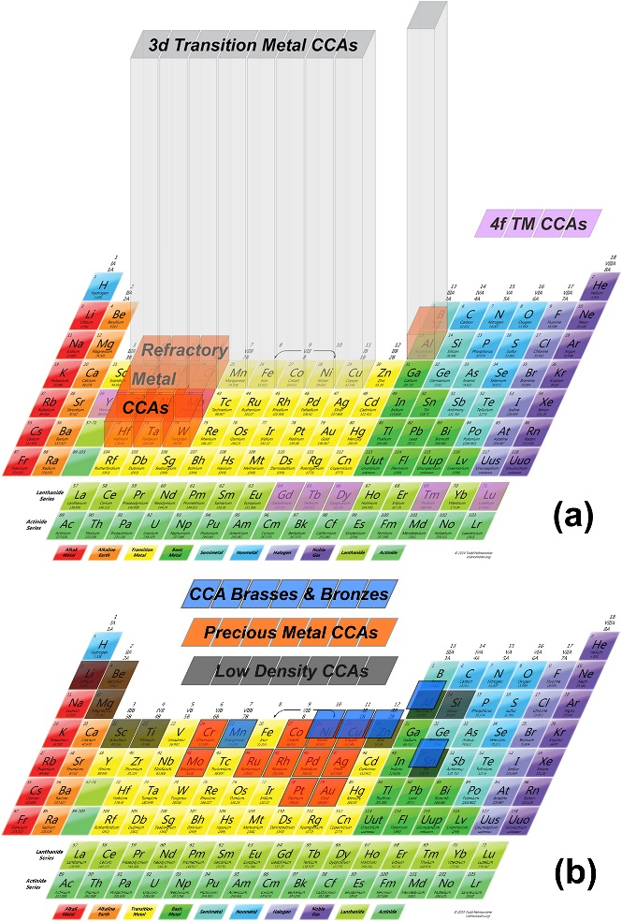
Figure 2-1 Classification of HEAs by component elements (a) 3d transitional metal composed HEAs, refractory metal composed HEAs and 4f group transition metal composed HEAs; and (b) Light metal complex composed HEAs, precious metal complex composed HEAs and brasses and bronzes complex composed HEAs. The heights of the classification boxes in (a) are proportional to the number of reported alloys in the two major groups [21].
Owing to the nature of intrinsic high configurational entropy, HEAs prefer to form simple disordered solid solution phases with BCC, FCC and HCP structures. The two HEAs groups most frequently reported in the literature, as shown in Fig. 2-1, are also the HEA groups observed to most often have simple solid solution phases. The CoCrFeNiMn system originally developed by Cantor and mainly composed of a FCC phase, was shown to exhibit excellent mechanical performance at cryogenic conditions. Based on the stable FCC matrix, with the addition of elements such as Al and Cu, various FCC dominated HEAs were synthesised[10,17–19]. The BCC structure and sigma phases were detected in this series of HEAs and described as reinforcing precipitates in the matrix of both CoCrFeNi and CoCrFeNiMn[4].
Another highly researched multi-component system presented in Fig. 2-1(a) is mainly composed of elements from IVB group to VIB group. As a result of their high melting points, this class of HEAs was grouped as RHEAs[20]. Inheriting the mechanical properties of their principal components, they display high yield strength under high-temperature conditions. Ductility, strength, Young’s modulus and various other mechanical properties were tested while tailoring the alloying components in RHEAs. Most RHEAs can remain phase stable and exhibit good mechanical performance at high temperatures.

2.3 Phase prediction of multi-components alloys
The utilisation of the HEAs concept in designing advanced high-performance alloys allows the principles to be used for further research. With the development of the HEA definition, the ratio of components of HEAs is no longer restricted to equimolar, hence greatly increasing the boundary for the design of new HEAs. However, with many newly designed HEAs possessing equimolar compositions and constitutions with the highest configurational entropy, the tendency of phase formation changed from the formation of a single solid solution phases to that of multiple solid solution phases[5,21]. After these alloys were annealed, some equimolar HEAs where reported to form complex brittle intermetallic compound phases[12,22]. It is the influence of the formation of multiphases in HEAs and their resultant effect on mechanical performance, which has placed increasing importance on phase formation prediction in these materials.
Under the ideal disordered solid solution model, HEAs have high configurational entropy. This indicates that under high-temperature conditions, the Gibbs free energy of the simple solid solution phases will be significantly reduced, as expressed in eq.2.
$∆G=∆H-T×∆S$ (2)
The simple solid solution phase will become easier to form, in comparison with complex intermetallic compounds at high temperatures. However, the effect of mixing enthalpy cannot be neglected in phase selection, especially at low-temperature conditions. The competition between mixing enthalpy and mixing entropy determines the final stable states in HEAs. Several works have been conducted to ascertain the effects of entropy and enthalpy in HEA phase formation. Early works were conducted on CoCrFeNi FCC HEAs. Known as FCC-stable HEA, various elements were added into CoCrFeNi to examine the phase formation tendency in CoFrFeNi+X (where X is the fifth components) Unsurprisingly, despite the well-known CoCrFeNiMn system comprising simple solid solution phases, once Mn is replaced with other elemental substitutions, the phase constitution will change significantly as a result of the difference in mixing enthalpy. An example of this is Ti, whose mixing enthalpy with Co, Cr, Fe and Ni is -28 kJ/mol, -7 kJ/mol, -17 kJ/mol and -35 kJ/mol, respectively. When substituting Mn with Ti, the simple solid solution FCC phase was observed together with intermetallic phases [8,23,24]. Similar observations have been described for CoCrFeNi-Mo[25], CoCrFeNi-V[26] and CoCrFeNi-Al[12,22,27]. Possessing exactly the same configurational entropy, the different phase formation brings about the assumption that high configurational entropy will stabilise the simple solid solution phase but is insufficient to explain the phase formation tendency of HEAs. When considering the mixing enthalpy factor which directly relates to the competition between complex intermetallic phases and simple solid solution phases, it is possible to predict the Gibbs free energy of different phases enabling the determination of the final stabilised phase states [4,32]. As mixing enthalpy or formation enthalpy represents the magnitude of interaction between component pairs, the prediction parameters have expanded to the electrical field and thermodynamic field.
Assuming the HEA system as a complex pseudo-binary alloy system, the Hume Rothery rules which describe the necessary conditions for solid solution phase formation in binary metallic materials, were first employed as guidance to aid in designing HEAs[28]. According to the Hume Rothery rules, the three major phase formation prediction criteria are atomic size difference, electronegativities and valence electron concentration (VEC). The atomic size difference was expressed as a dimensionless unit in eq.3, where r is the atomic radius of components i and $\overline{r}$ is the weighted average atomic radius of all elements.
$δ=\sqrt{\sum_{i=1}^{n}{c_{i}(1-\frac{r_{i}}{\overline{r}})^{2}}}×100$ (3)
One of the Hume Rothery rules proposed that once the difference in atomic size of components is larger than 14%, significant lattice distortion will increase local strain energy and form an inhomogeneous structure[29]. Regarding the effect of significant lattice distortion and corresponding increased strain energy, Darken and Gurry[30] showed the relationship of solid solubility with strain energy and proved that solubility can also be greatly affected by temperatures. It was found that a high strain energy mismatch existed between solute and solvent lattice, which prevented the accommodation between solute and solvent atoms during cooling. The increased strain energy in the alloy system will further lead to nucleation of other phases, hence affecting the type of deformation mechanisms involved during deformation[31]. The selection of the type of atomic radius type, is also related to the effectiveness of phase formation prediction. Generally, five types of atomic radius are considered, these being Van der Waals radius, Ionic radius, Covalent radius, Metallic radius and Bohr radius. Apart from the Bohr radius, the other four atomic radii are defined as half the distance between the atom and the nearest bonding atom, with the only difference being the bonding state. The metallic radius is more suitable for the application in phase formation prediction of HEAs, as these materials tends to form the simple solid solution phase. In most cases, besides atomic radius difference, other parameters were required to increase the precision of the phase forming prediction of HEAs. Zhang proposed a new parameter $Ω$ by transformation of eq. (2), setting the equivalent states at G=0[11,32] as expressed in eq. (4):
$Ω=\frac{T_{m}{ΔS}_{conf}}{\left|{ΔH}_{conf}\right|}=\frac{T_{m}}{T_{crit}}$ (4)
$T_{m}$ is the approximate melting temperature of the alloy by a sum weighted average of the melting temperatures of the components. $T_{crit}$ is defined as $T_{crit}=\frac{\left|{ΔH}_{conf}\right|}{{ΔS}_{conf}}$ and ${ΔH}_{conf}$ is the ideal mixing enthalpy which is calculated by applying the Miedema model which will be discussed in the following section. Following the biplot in Fig. 2-2, which compares the atomic size difference ($δ$) and $Ω$ values of HEAs, a clear tendency of simple solid solution phases evolving to complex intermetallic phases was observed. As observed in Fig. 2-2, with an increase in atomic size difference, the system favours the formation of amorphous or solid solution phases instead of complex intermetallic phases. Such a phenomenon is mainly attributed to the large mismatch of atomic size, which prevents the diffusion of solute atoms and further isolates their movements. Thus, amorphous and solid solution phases which are thermally stable at high temperatures, can be retained to low temperatures. A range of values to form solid solution phases is summarised as Ω≥1.1 and $δ$≤6.6% and used to guide the design of HEAs.
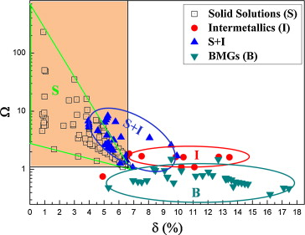
Figure 2-2 Biplot of atomic size difference ($δ$) against Ω. Solid solution, intermetallic, complex and amorphous phases are represented by cubic, circle, triangle and nabla symbols, respectively. [33]
Although the tendency to form complex phases and simple solid solution phases is distinguished in the biplot in Fig. 2-2, there still exist large intersections between complex phases and simple phases. Several factors may need to be considered to influence the accuracy of the prediction. Regarding the atomic radius difference is a comprehensive effect of the electronic structure together with the coordination number, bond type and atom number. A semi-empirical parameter that correlates to electronic structure may be more effective in predicting the phase formation of HEAs.
Owing to the nature and limits of utilising atomic radius difference, the electronegativity was taken into consideration in phase formation predictions of HEAs. According to a generally accepted assumption in metallic materials, that the electronic structure which is determined by electronic interactions between different components, can be approximately deduced from their electronegativity[34]. Pauling electronegativity difference was first taken into consideration, to approximate the interation between solute and solvent elements in binary alloy systems. Pauling electronegativity is a comprehensive measure which considers both ionisation energy and electron affinity[35]. For low electronegativity difference, the two pairing atoms have a similar attraction to the bonding pair electrons; the bonding does not exhibit high polarisation. For high electronegativity difference, the tendency to attract a bonding pair electron is increased and will result in a high polarisation of the chemical bond between pairing atoms. In such cases, the relationship between electronegativity and bond type becomes clear. For metallic materials, the metallic bond always refers to a less polarised linkage between bonding pair atoms, which relates to relatively lower electronegativity. In instances of high electronegativity, however, the chemical bond becomes more polarised owing to increased polarisation among components of the chemical bond, which indicates the formation of intermetallic phases. Pauling presented the first version of electronegativity which was mainly used to describe the formation of covalent bonds, through the calculation of the dissociation energy of two bonded atoms[35]. As a dimensionless measure of electronegativity, the limitation of Pauling’s version of electronegativity is clear. Taking H-Br 3.79 as reference, the Pauling method requires data for at least three bond types, AA AB and BB among two elements A and B as shown in eq. (5), to determine the calculation.
$X_{pauling}=(eV)^{-1/2}\sqrt{E_{d}\left(AB\right)-[E_{d}\left(AA\right)+E_{d}\left(BB\right)]/2}$ (5)
Here $E_{d}$ is dissociation energy and $(eV)^{-1/2}$ is a factor to ensure the dimensionless result. Regarding the limitation of Pauling’s electronegativity, Mulliken[36] proposed a new method to measure atom electron attraction. Mulliken electronegativity is an independent value used to describe the ability of an atom to attract electrons to form of chemical bonds, deduced by the arithmetic average of the first ionization energy (E_{i}) and electron affinity (E_{ea}). It is generally accepted as an absolute form electronegativity as presented in eq. (6). To some extent, Mulliken electronegativity can also be regarded as negative chemical potential and used to present approximation of electronic energy[37].
$μ\left(Mulliken\right)=-X_{Mulliken}=-(E_{i}+E_{ea})/2$ (6)
While Mulliken focused on the first ionisation energy of the atom, Allred and Rochow focussed on the influence of the charge of the atom on the atom surface, which correlates to the atom radius. Using average charge on the atom surface area to measure electronegativity, Allred and Rochow postulated that with a higher nuclear charge, the atom forms a tendency to attract more electrons[38]. As shown in eq. (7), the parameters involved in this method are the valence electron and atomic radius, here $Z_{eff}$ is effective nuclear charge and $r_{cov}$ is the covalent radius.
$X_{Allred-Rochow}=3590\frac{Z_{eff}}{r_{cov}^{2}}+0.744$ (7)
In contrast to the methods of Mulliken and Allred-Rochow, Allen reported that the energy of a valence electron that is involved in forming bonds may have greater influence on the electron attraction ability of the atom[39]. Thus, the average energy retained by a valence electron was calculated to represent the electronegativity of the atom. The advantage of the method proposed by Allen, is that electronegativity can be derived from a single dataset measured from experimental spectroscopic data. As shown in eq. (8), only the valence electron of s and p orbital are taken into consideration. Here, $E_{s,p}$ are the energies of a single electron in a free s and p orbital of the free atom and $n_{s,p}$ are the numbers of electrons in s and p orbitals. However, though the advantages of Allen’s method of electronegativity are clear, so to are its limitations, that is, when considering transition elements whose valence electrons may include electrons in the d orbital, the weight factor of electrons in the d orbital remains unclear.
$X_{Allen}=\frac{n_{s}E_{s}+n_{p}E_{p}}{n_{s}+n_{p}}$ (8)
Based on the different type of electronegativity parameters discussed above, it is apparent that these electronegativities either can be concluded as an absolute value, or relative value depending on the calculation method and definition. The usage of different types of electronegativity depends on their definitions. Considering the metallic system for which the electron in the d-orbital plays an essential role in forming a chemical bond, electronegativities which only consider valence electrons on s and p orbitals may be insufficient.
Early attempts at utilising electronegativity on the phase formation predictions of HEAs, focussed on considering the solid solution phase stability between different lattice structures, for example FCC and BCC）[32,47,49,50]. Yong proposed the effectiveness of using Pauling electronegativity difference to predict the formation tendency of topological close-packed (TCP) phases[40] as shown in Fig.2-3. In comparison with mixing enthalpy, valence electron concentration (VEC) and atomic difference, the TCP phase formation tendency is more distinguishable when plotted against the electronegativity difference. As shown in Fig. 2-3, TCP phases appear to form when the electronegativity difference ΔX> 0.133. The clear boundary between the solid solution phase zone and TCP zone is denoted by the dashed line at 0.133 in Fig.2-3. Moreover, owing to the limitations of Δ$X_{pauling}$ and Δ$X_{allen}$, which cannot precisely express the delocalised electronic environment of transitional metal elements, $X_{Mulliken}$ which is a good approximation of the electronic chemical potential, was considered as a better absolute scale to distinguish the phase formation tendency of HEAs [41]. Using $X_{Mulliken}$ to represent the stability of the phases at ground states, Leong et al. [41] compared ${ΔX}_{Pauling}$, $ΔX_{Allen}$ and ${ΔX}_{Mulliken}$ against mixing enthalpy for a significantly large dataset (617) of HEA compositions. From the biplot and distribution function results, $ΔX_{Mulliken}$ is concluded as more accurate in distinguishing the formation of complex and simple phases, which indicates new possibilities for research into the design of HEAs. However, most research on the viability of using electronegativity to predict HEA phase formation tendency, focused on HEAs composed of 4th and 5th period transitional group element. Investigations of HEA systems focused on Al, Si, Ga or 6th period group elements additions are still requiring further research.
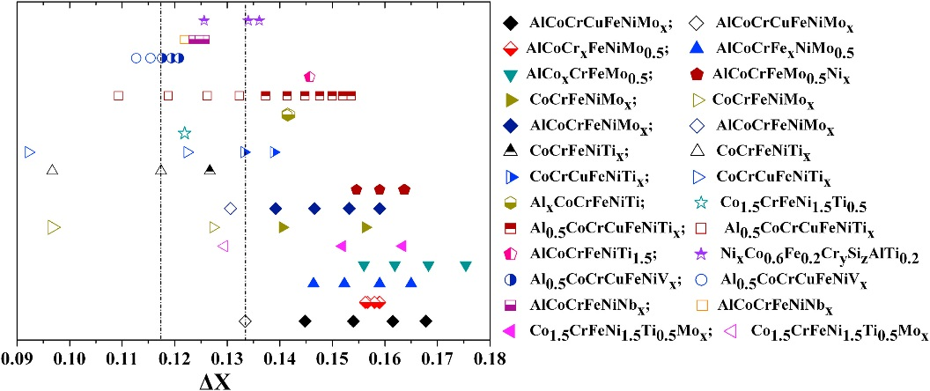
Figure 2-3 Topological close-packed HEAs phase stability dependence with electronegativity difference value. Closed polygons for TCP solid solution phases; open polygons for simple single solid solution phases; and half closed polygons for dual-phase solid solution phases. [40]
VEC has been used as another variable to predict phase formation under the Hume-Rothery rules, with regard to the importance of electronic structure in predicting phase formation in metallic materials. VEC is defined as the electrons in the outer shell of an atom, which are involved in forming bonds in a stabilised structure. VEC is more relevant to phase formation in comparison with the differences in atomic size and electronegativity [34]. The observed phase formation tendency with temperature directly relates to the electron concentration (known as the e/a ratio) in different elements as shown in Fig. 2-4. Although the definition and scale are changed, the e/a ratio can be regarded as an approximation of the magnitude of VEC. In the specific e/a ratio range, the lattice tends to stabilise in different structures so as to minimise the total energy. To some extent, VEC can be used to describe the electronic structure of alloys, as compared with the e/a ratio. Moreover, according to the band theory, VEC includes the electrons involved in the valence band, which is a key parameter to simulate the precise electronic structure by the first principle method. According to molecular orbital theory and electronic band theory, when atoms form a crystal, the ionised, isolated valence electrons appear to be shared by neighbouring atoms and occupy discrete energy levels (0K). These are determined by solving the Schrodinger equation under certain periodicity conditions. Depending on the coordination number, the magnitude of sharing valence electrons directly relates to the degree of bond delocalisation.
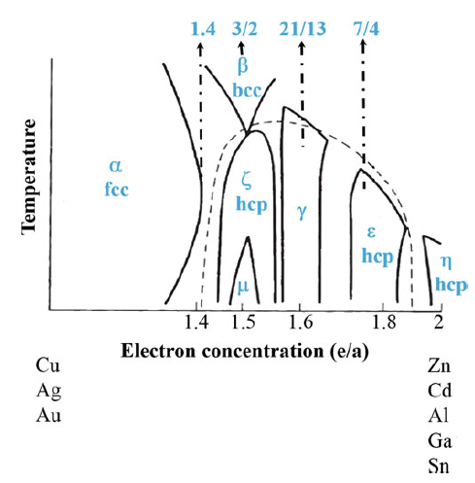
Figure 2-4 Biplot of temperature against the electron concentration and phase formation tendency of various alloys showing apparent dependence on e/a. [34]
Therefore, the VEC number can be considered to predict the stable lattice structure from the approximate energy state. While in different lattice structures the periodicity condition is different, leading to a difference in the solution of energy states for valence electrons. Thus, by comparing phase stability, the phase formation tendency can be derived[42]. Realising the relationship of VEC with phase stability, previous research has produced various experiments and theoretical simulations based on density functional theory (DFT), in order to aid the explanation of phase formation tendency dependent on VEC in certain alloy systems[43–45]. Successful examples have included the martensite phase transformation tendency in α (HCP)-β (BCC) Ti alloy[21,46–48], as well as the phase transition in NiMnGa shape memory alloys[49]. Early works [28,50] on applying VEC in predicting phase stability of HEAs mainly focussed on HEAs composed of 4th period elements and proved an effective tool to depict the stabilities of BCC and FCC phases, as presented in Fig. 2-5. In multi-component alloys, with the assumption that HEA phases are mainly composed of ideal disordered solid solution phases, the VEC of HEA systems were approximated as the weighted average VEC values of different components. In addition, they were solely considered to judge the phase stability of different HEA systems, as shown in Fig. 2-5.
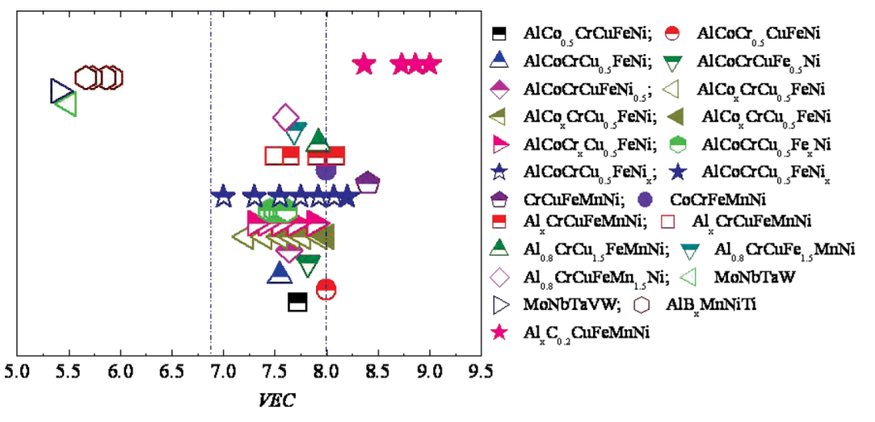
Figure 2-5 Phase stability (BCC, FCC) dependence with VEC value. Closed polygons for single FCC solid solution; open polygons for single BCC solid solution; and half closed polygons for dual-phase simple solid solution phases. [50]
Guo [50] utilised previous research on traditional alloy systems that incorporate the e/a ratio in phase formation predictions, to determine phase formation predictions through VEC. By superimposing dashed lines in Fig. 2-5, three separate zones, are apparent and the formation tendency of FCC and BCC can be distinguished. In the left zone with lower VEC value, the HEAs form single BCC solid solution phases, as is represented by open symbols; while in the right zone, the closed symbols represent HEAs with single FCC solid solution phases; and HEAs listed in the middle zone are compositions with mixed BCC and FCC solid solution phases. In general, for transitional group HEAs, the lattice structure may favour being stabilised in the FCC structure when VEC>8, mixed phases including BCC/FCC and intermetallic sigma phase when 8> VEC >7 and BCC dominant if 7>VEC. The range of VEC listed above is not dependent on component composition, which indicates the potential of using VEC as a universal tool to guide the design of HEAs. However, in the mixed phase zone, the tendency of mixed phases formation is not linear with the VEC number, which may be attributed to the influence of different component elements[50]. This may be associated with the change of electronic structure that determines chemical bond properties.

2.3.2 Semi-empirical methods
The Hume-Rothery rules are empirical methods and parameters to estimate phase stability or ground state energy of a system. With the use of Hume-Rothery rules and thermodynamic parameters, the phase formation tendency of certain alloy systems becomes clearer. In the previous discussion, the high entropy effect is fundamentally based on thermodynamics, which indicates enthalpy also plays a very important role in varying phase free energy, in addition to the entropy term. Miedema [51] constructed a new model to predict the formation enthalpy of ideal solid solution phases in binary alloys, based on empirical parameters derived from experimental results. The electronic redistribution necessary in forming new bonds of new lattice structures was presented, by considering the electronic charge density difference at the Wigner-Seitz boundary ${∆n}_{WS}^{1/3}$. Thus, the formation enthalpy of an ideal binary solid solution system was expressed as:
$∆H=\frac{f(c)P(c_{A}V_{A}^{2/3}+c_{B}V_{B}^{2/3})}{(n_{WS}^{-1/3})_{average}}×[- (∆σ)^{2}+\frac{Q}{P} ({∆n}_{WS}^{1/3})^{2}-\frac{R}{P}]+c_{B}∆H_{Btrans}$ (9)
Here $σ$ is an experimental variable which was used to replace electronegativity; P, Q and R are constants which depend on valence electrons of components A and B; $c_{x}$ is atomic concentration of element x; $V_{x}$ is the molar volume of components x; and $∆H_{Xtrans}$ is the transition energy required to transfer components x to the metallic state. While $f (c)$=$c_{A}^{S}c_{B}^{S}$= $c_{A}V_{A}^{\frac{2}{3}}c_{B}V_{B}^{\frac{2}{3}}/ (c_{A}V_{A}^{\frac{2}{3}}+c_{B}V_{B}^{2/3})$ is a function used to approximate the contact surface of components A and B. The model is successfully applied in calculating formation enthalpy of binary metallic systems and aids in the prediction of the formation of solid solution, intermetallic and amorphous phases in various traditional alloy systems. To extend the application into complex alloy systems, the potential of utilising the Miedema model in predicting phase formation tendency of binary alloys should be considered. Akira and Akihisa [52,53] further developed the formation enthalpy calculated by the Miedema model to multi-component alloy systems. This was achieved by calculating mixing enthalpy as shown in eq. 10 to aid the understanding of the formation tendency of the amorphous phase. The application of using mixing enthalpy in predicting phase formation tendency was then applied to HEAs. In simple solid solution phases, the configurational enthalpy is approximated by using the binary formation enthalpy data derived from the Miedema model and shown as:
$∆H_{mix}=\sum_{i=1,i≠j}^{n}{H_{ij}c_{i}c_{j}}$ (10)
where $H_{ij}=4∆H_{ij}^{mix}$ represents a normalised melting interaction parameter and equals to four times the mixing enthalpy of component i and j. $c_{i}$ is the mole fraction of component i.
Zhang [54] proposed a 2-D plot (Fig. 2-6) of mixing enthalpy against atomic radius difference, which was first used in multi-component alloys to aid in determining the formation tendencies of the amorphous and simple solid solution phases. In the plot, delta is a refined dimensionless parameter to represent atomic size difference in multi-component alloy systems. The judgement becomes evident after the phases of selected alloy systems are classified into different groups as shown in Fig. 2-6. Owing to relatively positive mixing enthalpy, the compositions located in Zone S and S’ tend to form solid solution phases instead of intermetallic phases, within which the mixing enthalpy and atomic size difference range from 5 to 20 and 0 to 6, respectively. The reason for this result is due to the energy required to form stable localised bonds which are always lower than delocalized (metallic) bonds. However, with relatively lower mixing enthalpy and higher atomic size difference, in zone S’ the ordered solid solution phase precipitated. This indicated that large atomic size difference may prevent the random substitution of component atoms, whilst mixing enthalpy is negative enough to form more localized bonds, hence forming an ordered lattice structure. The amorphous zone was divided into B1 and B2. B1 are mainly compositions with Cu and Mg as the principal component, whereas B2 is mainly based on Zr.
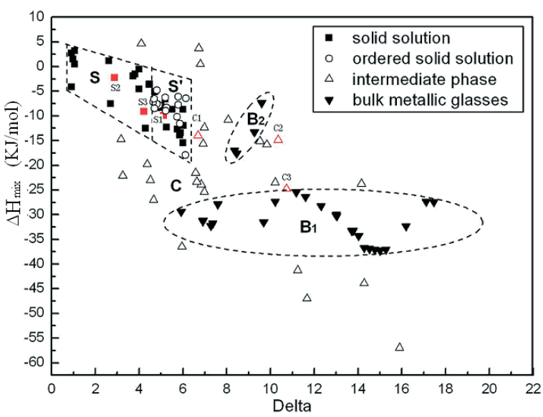
Figure 2-6 Biplot of mixing enthalpy against the atomic size difference. [54]
It is evident that the compositions in zone B have more negative mixing enthalpy (B2) or higher atomic size difference (B1 & B2). Zone C represent compositions with intermetallic phases, though the atomic size difference has not changed significantly, a more negative mixing enthalpy can be regarded as an indication for the extensively localised bond and results in the formation of complex intermetallic phases. The judgement of phases cannot be explained by only considering mixing enthalpy and atomic size difference, but as the boundary where the simple solid solution and intermetallic phase zones overlap. As shown in Fig. 2-6, in some cases the trend of forming a complex intermetallic phase still exists with smaller atomic size difference and positive mixing enthalpy.
Poletti [47] proposed a new parameter μ together with retaining atomic size difference as a variable, to aid in the determination of the phase formation tendency as shown in Fig. 2-7. The parameter μ was defined as:
$μ$=$T_{m}/T_{SC}$ (11)
where $T_{m}$ is the approximated melting point of the alloy system and defined as:
$T_{m}=(\sum{{∆H}_{i}^{f}c_{i}})/(\sum{{∆S}_{i}^{f}c_{i}})$ (12)
where ${∆H}_{i}^{f}$ and ${∆S}_{i}^{f}$ represents fusion enthalpy and entropy; $c_{i}$ is the concentration of components i: and $T_{SC}$ is the temperature of the transform point for mixing free energy. HEAs possessing solid solution phases favour formation in the high $μ$ area and a similar phenomenon has also been observed in the formation of BCC HEAs. Beyond the clear phase formation tendency observed, the most important contribution of this work considers HEA systems as a non-ideal solid solution phase, utilising the parameter μ for phase formation prediction. Under such consideration, research can show the limitations of using simple thermodynamic parameters, as a semi-empirical method derived from the Hume-Rothery rule, to predict the phase formation tendency of HEAs. Further research was conducted in an attempt to take the nature of phase formation in HEAs into consideration and the importance of considering electronic structure was recognised.
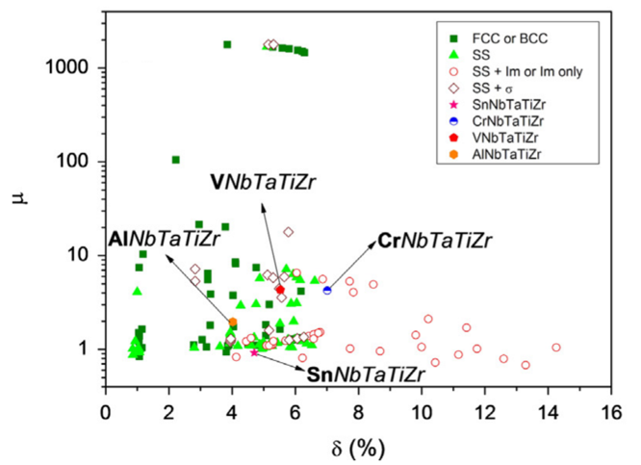
Figure 2-7 Biplot of μ against the atomic size difference. [42]
To determine the best relative parameter to predict the phase formation tendency of HEAs, Dominguez et al. [55], conducted a principal component analysis (PCA) on the five most reported semi-empirical parameters. These being mixing enthalpy, configurational entropy, electronegativity difference, VEC and atomic size difference. As shown in the biplot of the first two principal component variables (Fig. 2-8), the single FCC phase zone concentrates next to VEC, while the single BCC phase mainly locates around the axes of mixing enthalpy and electronegativity difference. Intermetallic phases, multiple BCC phases and multiple FCC phases were observed next to the entropy of mixing and VEC.
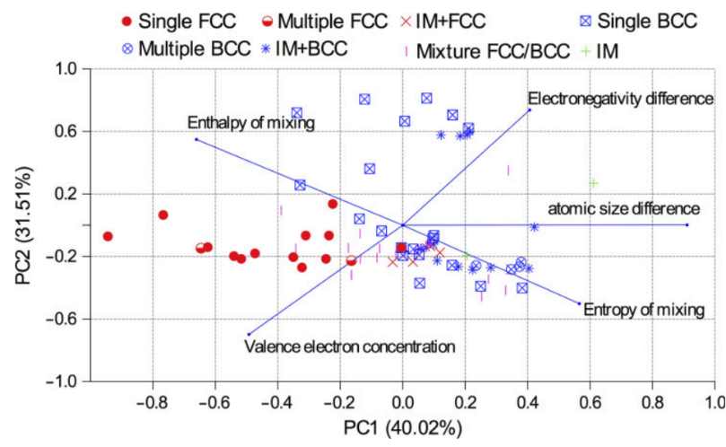
Figure 2-8 Biplot of principal component analysis (PCA), showing principal component one against principal component two. Phases appear best fit with the lines representing VEC and mixing enthalpy. [55]
According to the PCA result, VEC and enthalpy of mixing were considered as two more relevant variables to distinguish between simple and complex phase formation tendency. In the biplot of VEC against mixing enthalpy, the boundary between simple FCC and BCC is evident and the location between simple cubic phases and complex phases can also be distinguished (Fig.2-9). The range of forming simple solid solution phases were concluded as -5> ΔH_{mix} >0, 6> VEC >3 and 11> VEC >8 for the BCC and FCC structures, respectively. The effectiveness of using mixing enthalpy and VEC in predicting phase formation tendency of HEAs indicated the importance of considering electronic structure and interaction between multi-components. From the Miedema model, mixing enthalpy is approximated from the redistributed density of electrons, which participate in forming bonds at the Wigner Seitz radius. VEC is the integrated density of states of electrons in the valence bond. Both variables are parameters considering the effect of valence electrons. The nature of mixing enthalpy is energy expended in the redistribution of electron density, to accommodate the respective component’s Wigner radius to form a new bond. In accordance with the empirical method discussed and under the assumption that most HEAs are likely to form the ideal solid solution phase, the nature of the semi-empirical prediction of phase formation tendency in HEAs has focused on determining the lowest energy state in different solid solution phases. However, it is evident there is no single semi-empirical parameter, that can be used as a comprehensive approximation of the alloys electronic structure to make the prediction. For example, the VEC method is more reliable for predicting the lattice structure of a designed metallic system, while in contrast, the mixing enthalpy is more effective in predicting whether a metallic system will form a simple solid solution phase or complex intermetallic phase. When considering the atomic size difference, as expressed in Fig. 2-8, this mostly serves as a modifying factor to refine the predictions made by comparing the VEC or mixing enthalpy of a designated metallic system. Thus, owing to the lack of consideration regarding the comprehensive effect raised by multiple electron interaction, the semi-empirical phase formation predictions only show satisfactory accuracy for the system composed mainly of elements from the transition group with similar VEC values. When two or more components from different groups of elements with large VEC difference were included, the precision of the semi-empirical prediction method decreases significantly. Therefore, with the development of new HEA systems, particularly those possessing non-equimolar components (such as TRIP HEAs and eutectic HEAs), there is an increasing demand for a more precise phase formation prediction method. In order to satisfy the requirement for a more precise phase formation prediction method, a bottom-up design strategy based upon ab initio density functional theory (DFT) was developed and sets precedence for further research.
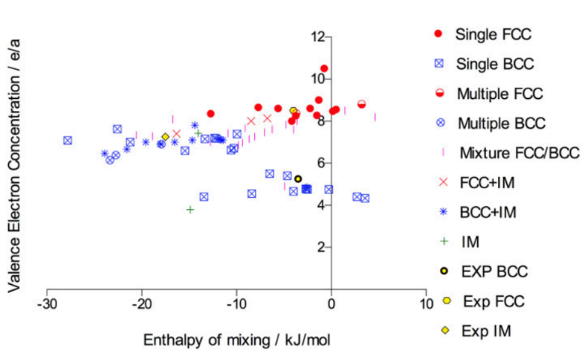
Figure 2-9 2-D plot of VEC against mixing enthalpy with clear separation between simple and complex phases. [55]

2.3.3 Ab-initio methods

2.3.3.1 From the Schrödinger Equation to density functional theory
The cornerstone of modern quantum physics, the Schrödinger equation was first proposed as a basic assumption of quantum mechanics. Combining the concept of matter wave (de Broglie wave[56]) and wave equations, which were derived from Maxwell’s equations, the form of the Schrödinger equation was presented as[57]:
$-\frac{ℏ}{2m}∇^{2}Ѱ\left(r,t\right)+V(r)Ѱ\left(r,t\right)=iћ\frac{∂Ѱ\left(r,t\right)}{∂t}$ (13)
The time-independent form can be further expressed as:
$-\frac{ℏ}{2m}∇^{2}ψ\left(r\right)+V(r)ψ\left(r\right)=Eψ\left(r\right)$ (14)
By using the Hamiltonian operator, expressed as:
$\hat{H}=-\frac{ℏ^{2}}{2m}∇^{2}+V$ (15)
The general form of Schrödinger equation is shown as:
$iℏ\frac{∂}{∂t}Ѱ=\hat{H}Ѱ$ (16)
The equation was proposed to describe the energy and movement state of a single particle under the potential field V(r) by substituting different critical conditions. The Schrödinger equation provides a mechanism to allow researchers to predict the electronic structure of an atom, owing to its effectiveness in the prediction of the movement states of electrons surrounding the nuclei[57,58]. By defining the potential term in the equation, through considering the surrounding electronic environment, the solutions can be derived. The solutions can then be normalised through setting periodic conditions. In such cases, however, the equation can only be solved under specified conditions, for example a single free electron under the potential field of a hydrogen atom. In order to describe the properties of complex systems, the solutions of eq.13 for many electrons are required and the many-body interaction effect must be taken into consideration for both electrons and nucleus. Using the stationary form of the Schrödinger equation as a starting point, the general form of many-body Schrödinger equations with the N-electron system can be expressed as:
$\hat{H}Ѱ\left(r_{1},…,r_{N},R_{1},…,R_{M}\right)=EѰ\left(r_{1},…,r_{N},R_{1},…,R_{M}\right)$ (17)
where $r_{i}$($i$=1,, N) is the space coordinates of electron $i$ and $R_{j}$($j$=1,…, M)) is the coordinate of nuclei $j$. The Hamiltonian operator can be further expanded as:
$\hat{H}=-\frac{ℏ^{2}}{2m_{e}}\sum_{i}{∇_{r_{i}}^{2}}-\frac{ℏ^{2}}{2}\sum_{j}{\frac{∇_{R_{j}}^{2}}{M_{j}}}-\sum_{i}{\sum_{j}{\frac{e^{2}Z_{j}}{\left|r_{i}-R_{j}\right|}}}+\frac{1}{2}\sum_{i≠j}{\frac{e^{2}}{\left|r_{i}-r_{j}\right|}}+\frac{1}{2}\sum_{i≠j}{\frac{e^{2}Z_{i}Z_{j}}{\left|R_{i}-R_{j}\right|}}$ (18)
where the electron mass was represented by $m_{e}$, the charge and mass of nuclei j in the many-body system was represented by $Z_{j}$ and $M_{j}$, respectively. The concise form can be further expressed as:
$\hat{H}={\hat{T}}_{E}+{\hat{V}}_{en}+{\hat{V}}_{ee}+{\hat{V}}_{nn}$ (19)
Here ${\hat{T}}_{E}$ represents the first two terms in eq. (18), which gives the total kinetic energy of the many-body system; the potential energy induced by the Coulomb interaction between particles was separated into the last three terms; ${\hat{V}}_{en}$ represents the interaction energy between electrons and the nucleus; ${\hat{V}}_{ee}$ represents the interaction between electron and electron; and ${\hat{V}}_{nn}$ represents the interaction between nucleus and nucleus. Solving eq. (19) without any approximation is impossible. On determining this, Born and Oppenheimer proposed a fundamental approximation which focused on the second and last term of eq. (19)[59,60]. Comparing the movement of electrons with nuclei under the same timescale, the reasonable consideration of the state of the nuclei as static state and the positions of nuclei can be approximated as a constant. The mass of nuclei is one thousand times greater than that of an electron, indicating all electrons in the system can react to the movement of the nuclei instantaneously. Considering the approximation above, the kinetic energy of the nuclei term can be neglected and the interaction term between nuclei and nuclei can be regarded as a constant. This is due to the approximately static states. Thus, the many-body Hamiltonian is simplified into a more compact form, as only three terms were considered:
$\hat{H}={\hat{T}}_{E}+{\hat{V}}_{en}+{\hat{V}}_{ee}$ (20)
This equation is known as the Born-Oppenheimer approximation. By conducting the
Born-Oppenheimer approximation, the complex wave function was simplified and separated into two independent terms, electronic wave function and a constant representing simplified nuclei effects, which in turn reduce the complexity of solving eq. 18. The Density functional theory originates from the Thomas-Fermi method and as an approximation method to solve the many electrons Hamiltonian [61,62]. The electron density is shown as:
$n\left(r\right)=\frac{∆N}{∆V}=\frac{8π}{3h^{3}}p_{F}^{3}(r)$ (21)
This was used to solve the energy term in eq. 18 instead of the wave function. Considering the expression of Fermi energy:
$E_{F}=\frac{{p(r)}^{2}}{2m}+V\left(r\right)$ (22)
The electron density can be further expressed as:
$n\left(r\right)=\frac{8π}{3h^{3}}[2m\left(E_{F}-V\left(r\right)\right)]^{3/2}$ (23)
Using the Fermi energy as a parameter, the relationship between the potential term and electron density was proposed. Thus, the simplified form of eq. 20 can be formulated. Taking the fraction of electrons at position r as:
$F_{r}\left(p\right)=\frac{dN}{dp}=\frac{4πp^{2}}{\frac{4}{3}πp_{F}^{3}(r)}$ (24)
The kinetic energy of an electron at position r can be expressed as:
$t\left(r\right)=\int{n\left(r\right)}\int{\frac{p^{2}}{2m_{e}}}F_{r}\left(p\right) dpdr$=$\frac{3h^{2}}{40m_{e}}(\frac{3}{π})^{2/3}n(r)^{5/3}$ (25)
For the system, the kinetic energy of all electrons can be expressed as:
$T\left(r\right)=\int{t(r)dr}=\frac{3h^{2}}{40m_{e}}(\frac{3}{π})^{2/3}\int{n(r)^{5/3}}d^{3}r$ (26)
Similarly, for the interaction between electrons and nuclei, the potential energy can be expressed as:
${\hat{V}}_{en}=-Z_{total}n(r)\int{\frac{e^{2}}{r}d^{3}r}$ (27)
The interaction between electron and electron can be expressed as:
${\hat{V}}_{ee}=\frac{e^{2}}{2}\int{\frac{n(r)n(r')}{\left|r-r'\right|}d^{3}rd^{3}r'}$ (28)
Thus, the expression of eq. 20 can now be transformed to:
$\hat{H}={\hat{T}}_{E}+{\hat{V}}_{en}+{\hat{V}}_{ee}=\frac{3h^{2}}{40m_{e}}(\frac{3}{π})^{\frac{2}{3}}\int{n(r)^{\frac{5}{3}}}d^{3}r-Z_{total}n\left(r\right)\int{\frac{e^{2}}{r}d^{3}r}+\frac{e^{2}}{2}\int{\frac{n(r)n(r')}{\left|r-r'\right|}d^{3}rd^{3}r'}$ (29)
In comparison with eq. 18, the Thomas Fermi approximation has simplified the expression significantly. However, the idea of utilising the density of electrons to represent system energy, instead of wave functions, leads to the evolution of density functional theory. To prove a solid base for the application of using the density of electrons, to represent the energy of a condensed matter system instead of the wave function, Hohenberg and Kohn proposed two new theorems[63]:
- In a many-body system, under certain external potential fields, the interactions and exchange between electrons cannot be neglected. Through the electron density, the ground state energy and Hamiltonian can be uniquely determined.
- The variational principle, similar to the variational optimisation of orbitals used in the Hartree-Fock (HK)[64] method, is proposed to determine the wave function and the energy of many-body systems in a stationary state. Here for any many-body systems, an exact electron density $n_{0}(r)$ exists, which minimises the energy function to the ground state as:
$E\left[n_{0}\right]=\int{n_{0}(r){\hat{V}}_{en}dr}+E_{ee}[n_{0}]+T[n_{0}]$=$\int{n_{0}(r){\hat{V}}_{en}dr}$+$F_{HK}[n_{0}]$ (30)
Analogous to the previous Born-Oppenheimer approximation, the expression for the energy can be separated into two parts, as the first term in eq. 20 (the term required to be solved) and the other terms can be regarded as a universal value, independent of the system, which can be calculated by electron density. However, it is difficult to calculate the last two terms in eq. 20 under the HK theorem.
Considering $F_{HK}[n_{0}]$ is always expressed as:
$F_{HK}\left[n_{0}\right]=\frac{1}{2}\iint{\frac{n(r)n(r')}{\left|r-r'\right|}}drdr^{'}+E_{xc}[n_{0}]+T[n_{0}]$ (31)
Here, the first two-terms include all electron interactions; Coulomb repulsion between electrons which is known as the Hartee energy $E_{xc}[n_{0}]$, represents the non-Coulombic electron-electron interactions and includes the exchange and self-interaction corrections of electrons. The last term is the kinetic energy of electrons. To solve the problem of exchange and correlation functional $E_{xc}[n_{0}]$, Kohn and Sham(KS)[65] proposed an approximation to solve the complex electron-electron interactions. The density of electrons can be expressed as the expectation value of the electron wave function of KS orbitals as:
$n\left(r\right)=\sum_{i}^{N}{{\left|ψ_{i}(r)\right|}^{2}}$ (32)
Here, $ψ_{i}(r)$ is a single electron wave function of KS orbitals. Thus substituting eq. 32 into eq. 31, the expression of the ground state can now be transformed as:
$F_{HK}\left[n\right]=\frac{1}{2}\iint{\frac{n(r)n(r')}{\left|r-r'\right|}}drdr^{'}+E_{xc}[n]+\sum_{i=1}^{N}{\int{drψ_{i}^{*}(r)(-\frac{ℏ^{2}}{2m_{e}}∇^{2})ψ_{i}(r)}}$ (33)
The potential of exchange-correlation (xc) term can be derived by derivation of the $E_{xc}[n]$ as:
$V_{xc}\left[n\right]=\frac{δE_{xc}[n(r)]}{δn(r)}$ (34)
The exchange and correlation potential $V_{xc}$ and the corresponding exchange and correlation energy $E_{xc}$ is not known, however, compared with the original form. The KS approximation has simplified the equation and includes all unknown variables in the HK functional into the xc term. To solve the only unknown term in the KS theorem, several approximations were proposed. Two key approximations are the local density approximation (LDA)[66,67] and generalised gradient approximation (GGA)[68]. Depending on the electronic environment of condensed matter, the variation of electron density is vastly different. For a delocalised system, the uniform electron gas model is applied. The exchange-correlation function is considered to be determined by a dozen uniformly distributed electrons with the same electron density as:
$V_{xc}^{LDA}=V_{xc}^{electron gas}[n(r)]$ (35)
This is known as LDA. In some systems with localised bonds, such as covalent bonds where the electron density varies rapidly and the variation of the density of electrons requires consideration in the expression of exchange and correlation function. Such approximation is noted as GGA:
$V_{xc}^{GGA}=V_{xc}[n\left(r\right),∇n(r)]$ (36)
Currently, the most generally accepted mathematical description of the GGA method was proposed by Perdew [68] and exhibited high performance in balancing the accuracy of the result and time. For particular conditions in which the interaction effect within electrons is strongly correlated, a Hubbard correction term is required to be added to the equation[69,70]. This correction term is known as LDA+U and GGA+U. Another important parameter that should be considered in the application of DFT is Pseudopotentials. With the help of the KS method in a many body system, the solving process of eq. 18 is simplified. However, to obtain the energy of the whole system, the calculation becomes very complex when solving the KS equation for all electrons. A simple approximation considers valence electrons as an effective charge for the interaction within electrons, while the other electrons were assumed to remain fixed (normally the core electrons will remain unchanged during bonding and de-bonding in condensed matter). By freezing core electrons and only allowing valence electrons to remain active during the calculation, the process can be simplified significantly. The potentials used to represent the charge of core electrons and valence electrons are named pseudopotentials [71]. A well-known method of generating pseudopotentials is the projector-augmented wave (PAW) method [72]. Compared with the results calculated by using full-electron potentials, the application of pseudopotentials in DFT has similar precision and accelerates the calculation process considerably.
In the application of DFT to solve problems in real condensed matter systems, the first step is to simulate the environment of the real system. A periodic boundary condition is needed to perform the calculation. Depending on the structure of the system, which can be further represented by their primitive cell vector, the wave function that satisfies Bloch’s theorem can be expressed as:
$ψ_{k}\left(r\right)=e^{ikr}u_{k}(r)$ (37)
Here, $u_{k}(r)$ is a periodic function with the same periodicity of the primitive cell and $e^{ikr}$ is an arbitrary phase factor, by expanding the periodic function $u_{k}(r)$ using plane wave functions as a Fourier series:
$u_{k}\left(r\right)=\sum_{G}{e^{iGr}c_{G,k}}$ (38)
While G represents the reciprocal lattice vector of the primitive cell in real space and $c_{G,k}$ are complex Fourier coefficients. Thus eq. 38 can now be expressed as:
$ψ_{k}\left(r\right)=\sum_{G}{e^{i(G+k)r}c_{G,k}}$ (39)
Two parameters need to be considered when solving eq. 39. First is the selection of k points. Though the expression of eq. 39 which represents integrations over all k in the Brillouin zone allowing the most precise result, there exists the best point to balance the time usage and precision of the result when selecting k points. A convergence is needed to select the best k points number. Similarly, another term is the selection of G. According to eq. 39, the sum of the plane wave set is over all possible G vectors, but it is impossible to do the summation over infinite G. However, considering $c_{G,k}$ becomes smaller as ${\left|G\right|}^{2}$ becomes larger, it is possible to find the best G to solve eq. 39. Making an approximation of the kinetic energy term in eq. 20, the energy term can be expressed as:
$E\left(k\right)=-\frac{ℏ^{2}}{2m_{e}}\int{ψ_{i}^{*}\left(r\right)∇^{2}ψ_{i}\left(r\right)}d^{3}r≈\frac{ℏ^{2}}{2m_{e}}{\left(k+G\right)}^{2}∝\frac{ℏ^{2}}{2m_{e}}G^{2}=E_{cut}$ (40)
Thus, the cut-off energy, $E_{cut}$, is proposed. When calculating eq. 20 only plane waves whose energies are smaller than $E_{cut}$ were considered. After a convergence process, both k points and $E_{cut}$ can be determined, following this the ground state energy can be derived. Currently, there are a number of software packages developed to solve this problem, VASP[73], CASTEP[74], EMTO-CPA [75].

2.3.3.2 Predictions of HEAs phase stability by DFT
The phase stabilities of a designated alloy system can be represented by the formation energy, derived by calculating the ground state energy of the system. Once the lattice structure and alloy components are determined, the formation energy can be calculated. By comparing the formation energy of different possible lattice structures, the relative phase stability of targeted phases over other structures can be derived. The effectiveness and precision of using DFT to predict phase formation has been proven in several binary alloy systems. An example is shown in Fig. 2-10 for 30 Ti-X (X=Sc~Hg) alloy systems. Not only was the formation of the simple solid solution phase with BCC and HCP structure predicted, the isothermal omega phase (with space group P3m1) was also determined in this energy based phase diagram [76].
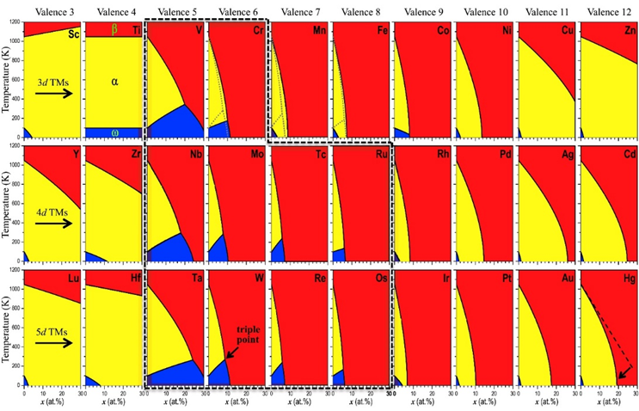
Figure 2-10 Phase diagram of Ti–X (X=Sc~Hg) binary system. HCP, BCC and omega phase are presented in yellow, red and blue shading, respectively [76].
The application of DFT to binary systems was quite successful, however, the limits of using DFT on multi-component HEAs or any multi-component alloy system with components >3 is evident. Firstly, to predict the relative phase stability of certain compositions, the calculation of selected phases with corresponding lattice structures are required. This is to determine those possessing with the lowest formation energy as the most stable phase. For a multi-component system, the candidate phases may vary significantly depending on the elements involved. For example, although the matrix phase of CoCrFeNi is FCC, by alloying with Al, the precipitated phases can be BCC, HCP, omega, FCC to L12[11,12].
Secondly, for a designated lattice structure, even if the lattice parameter is given, the precise occupancy of a state by different components is difficult to simulate. This is especially relevant for HEAs, as the ultimate objective is to simulate a disordered simple solid solution phase. For binary systems, it is possible to simulate a disordered solid solution phase, through substituting the components into an equivalent position of the primitive cell. However, as the number of components is increased, the number of occupied states will increase, hence significantly increasing the difficulties of finding the correct structure with the lowest energy states.
To solve the first limitation, the current solution depends on the thermodynamic method such as CALPHD. The use of CALPHD has been proven effective in predicting potential phase formation tendency in multi-component alloys [77]. From the phase diagram of simulated multi-component systems, the possible structures can be selected as candidates for further investigation by the ab initio method. For lattice parameter convergence, currently the most utilised method applies experimental results as reference to simulate similar composition lattice parameters of HEAs. The most complex problem is simulating a disordered solid solution lattice with multi-principal components, where the occupancy sequence of the components is the most important concern. Considering the periodicity condition involved when using the DFT method, it is possible to create a primitive cell with a relatively disordered structure. However, due to the repeating atomic arrangements in the primitive cell, it is impossible to simulate a real disordered structure. Through the creation of a supercell containing several primitive cells with relatively disordered atomic site occupancy, the disordered state can be approximated. Commonly used methods include virtual crystal approximation [78], and semi-empirical supercell methods. Regarding application with HEAs, the most widely applied methods are the special quasi-random structures (SQS) [79] and the coherent potential approximation method (CPA) [80–82].
As illustrated above, the use of DFT is always combined with empirical models to simplify the total calculation process, the rigid bond model, SQS, etc. Leong et al. [23] discussed the potential of using VEC in predicting the structural stability of the majority phase in magnetic HEAs by comparing simulated results with experimental results as shown in Fig. 2-11. Through the application of the
ab initio method with rigid bond approximation, the relationship of valence electron concentration and phase stabilities in HEAs were demonstrated. Integrated from polarised energy states, the number of VEC is a more precise value, compared with the empirical concept which only considered the electrons located on the outer shell. The effectiveness of this prediction method has been proven, as presented in the experimental results the phase separation point is located at n<7.6 for sigma phase in CCFN-V, n<8.1 for B2 phase in CCFN-Al and n<7.7 for C14 phase in CCFN-Ti. Using this method, a new magnetic CoFeNiV HEA was developed. The corresponding phase formation was explained by the simulation result and further evidenced through experimental results.
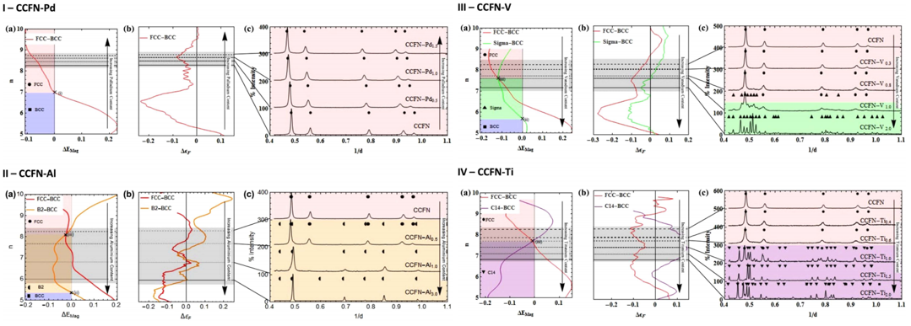
Figure 2-11 Comparison of the simulated result and experimental result for CCFN-X (X=Pd, Al, V,Ti) HEAs. With increasing alloying contents, (a) 2-D plot of polarised band energy difference against VEC (b) ground state energy difference and (c) XRD patterns of corresponds compositions. The joint part of transition point between BCC-FCC, BCC-Intermetallic and intermetallic-FCC phases were denoted by x(i-iii) [23].
Several approaches were conducted by employing the Exact Muffin-Tin Orbitals (EMTO)-CPA method to investigation of HEA phase formation. Tian [83] simulated the CoCrFeNi-Al_{x(x=0-2)} HEAs, by comparing the energy difference between BCC and FCC. The phase formation tendency is differentiated in Fig. 2-12(a). By adding magnetic entropy and configurational entropy, the Gibbs free energy is calculated for temperatures of 0K, 300K and 600K. In this work, it was proposed that with the increase of temperature, the relative phase stabilities of the FCC phases were reduced with the addition of Al. Furthermore, the relation between VEC and phase stability was also calculated at 300K, where it was shown that the FCC phase remains stable when VEC$≥$7.57, whilst the BCC phase was stable when VEC$≤$7.04. In comparison with the experimental results of VEC range for stable FCC and BCC phases
(FCC: 7.67-7.88, BCC: 7.06-7.29), with those derived from the empirical method developed by Guo [28] (FCC:8.0, BCC:6.87), the VEC range calculated by the EMTO-CPA method for stable FCC and BCC phases at room temperature was more accurate than the results derived from the empirical method. The accuracy of the EMTO-CPA method was well detailed in this work.
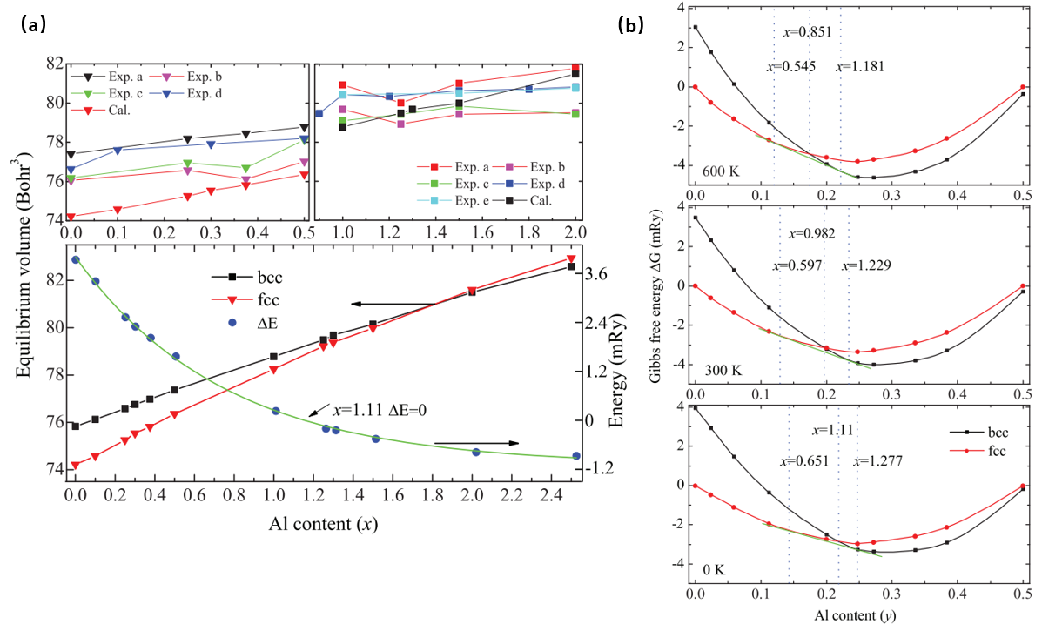
Figure 2-12 Comparison of simulated result with various experimental results (a) biplot of equilibrium volumes against Al contents in CoCrFeNi-Al_{x} HEAs. The Biplot of equilibrium volume and ground state energy difference of FCC and BCC against Al contents, respectively. (b) The Biplot of simulated FCC and BCC Gibbs free energy against Al content which is represented by y=x/(4+x) with x equal to the atomic fraction of Al [83].
Regarding the accuracy of the DFT method, research has started to apply the DFT method to improve the accuracy of the empirical method. Considering the time cost of the DFT method when applied to HEA systems, it is credible to develop a better semi-empirical method to help in the selection of candidates to predict phase formation. By collecting substantial data and high throughput DFT calculated formation enthalpy of binary alloy systems, Troparevsky [84] proposed a new dataset for formation enthalpy derived from the DFT method (Fig. 2-13(a)). In this work, two ternary alloy based HEA systems were assessed for phase formation tendency, by using the simulated formation enthalpy as the main factor and applying the simple criteria method. As presented in Fig. 2-13(b), the simulated results correlated well to the experimental results for phase formation prediction. Through the assistance of DFT results, the accuracy of the semi-empirical method can be improved when predicting HEA phase formation.
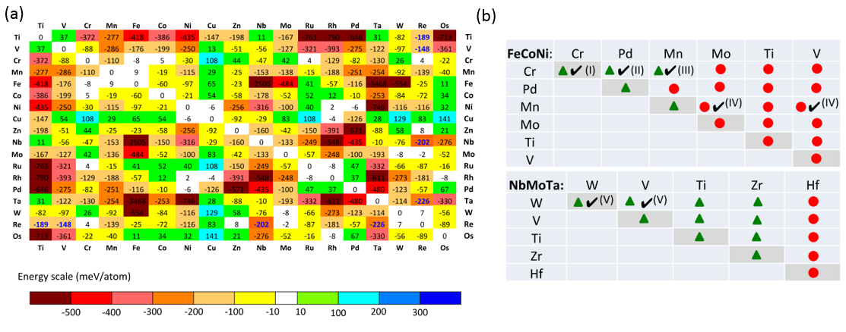
Figure 2-13 (a)The formation enthalpy matrix. The energy of binary system formation enthalpy is calculated for the most stable structure of binary compounds with the lowest energy state. Numbers possessing light colours from white and green, represent compounds with the solid solution phase as the most stable structure; and (b) a phase prediction table of two ternary alloy FeCoNi-XY and NbMoTaXY HEAs, with the fourth and fifth principal components listed on the X and Y axis. Diagonal entries on these axes indicate the quaternary system and the other compositions are five component HEAs. The green triangles and red circles correspond to the solid solution phase and complex phase with intermetallic phases, respectively. The ticked denote experimentally verified compositions with relative element addition. [84]

2.4 Prediction of mechanical performance of HEAs by empirical and
ab initio methods.
The success of applying semi-empirical and ab initio methods in HEA phase formation predictions, has inspired research in a direction to develop predictions of mechanical performance of potential HEAs. This is particularly related to the design of RHEAs for which most have reported a lack of ductility at ambient temperatures. Unlike FCC HEAs which have 12 slip systems, BCC HEAs (most of which are RHEAs) possess 48 slip systems and are expected to exhibit better plasticity during deformation. However, in FCC materials, the 12-slip systems consist of four {111}_{FCC} planes and six <110>_{FCC} directions (common to two {111}_{FCC} planes). This indicates the activation of slip systems in FCC only requiring stress to exert along {111}<110>_{FCC}. In terms of BCC alloys whose 48 slip systems can either be {110}<111>_{BCC}, {211}<111>_{BCC} and {321}<111> _{BCC}, without a close-packed slip plane and requiring much higher critical resolved shear stress to activate, the 48 slip systems cannot be activated simultaneously. This results in obstruction for dislocation to slip and results in relatively poor ductility. Thus, for BCC RHEAs, the mechanical performance is more sensitive to the intrinsic elasticity (isotropy or anisotropy) [85]. Early works focussed on using VEC as a guide to find ductile RHEA candidates. Through the ab initio method, Qi [85] concluded that the theoretical elasticity of BCC structure in RHEAs is dependent on the mechanical yield mode under tension along [100]_{BCC} direction, which can be tuned by tailoring VEC of refractory alloys through alloying. Following this strategy, Sheikh et al. [86] reported that the addition of alloying group V and group IV elements into existing RHEAs will result in intrinsically ductile RHEAs as presented in Fig. 2-14. Following this strategy, a ductile RHEA, Hf_{0.5}Nb_{0.5}Ta_{0.5}Ti_{1.5}Zr was developed possessing a mechanical performance of 903 MPa yield stress, 990 MPa fracture stress and 18.8% elongation, consequently outperforming most of reported RHEAs.
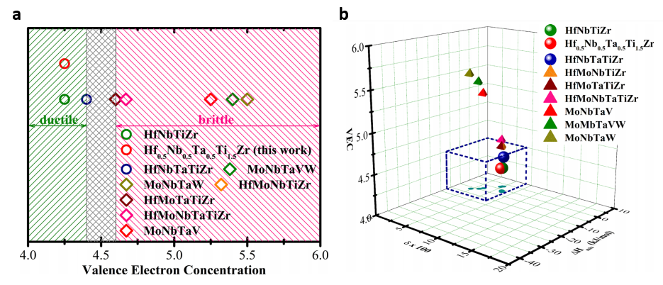
Figure 2-14 (a) Separation of RHEA ductile/brittle transition by VEC; and (b) a schematic showing ductile BCC solid solution dependent with three semi-empirical parameters, atomic size difference, mixing enthalpy and VEC. [86]
VEC also exhibits a relationship with other mechanical properties of HEAs, including hardness. The work of Tian [87] explored over 100 FCC and BCC HEAs to investigate the underlying relationship between VEC, and atomic size difference with hardness and phase formation. Similar to previous research, VEC was effective in separating the phase formation tendency of HEAs as shown in Fig. 2-15(a). The FCC structure is likely to form when 7.8< VEC < 9.5 and for BCC when 4.33< VEC < 7.55. The hardness value also revealed a clear dependence on the VEC value and atomic size difference δ (Fig. 2-15(b-c)). It is evident that the value of hardness varied monotonically with increasing atomic size difference δ, which may be a result of the severe lattice distortion. Although there is a lack of experimental results to explain the relationship between semi-empirical parameters and mechanical properties, researchers can apply these findings for primary screening when designing HEAs for certain usage.
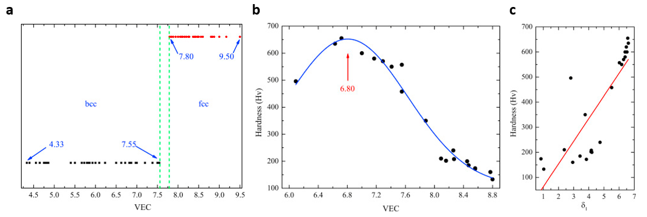
Figure 2-15 (a) HEA solid solution phase formation distribution against the value of VEC; (b) a Biplot of HEAs hardness against weighted VEC; and (c) the hardness as a function of atomic size difference δ.[87].
With the development of the ab initio method for phase formation prediction in HEAs, the utilisation of the first principal method in designing high-performance HEAs enables further research. With better precision in solving the complex many-body problem with multi-components, the application of the
ab initio method in predicting elasticity and phase transformation of HEAs has become widely used. In the previous discussion, the theoretical elasticity judgement is mainly dependent on the mechanical yield mode under tension along the [100]_{BCC} direction, which can be tuned by tailoring the VEC of HEAs. To find a theoretical explanation for this empirical method, Li et al. [88] simulated the ideal [100]_{BCC} tension strain for various RHEAs. Presented in Fig. 2-16, HfNbZr, HfNbTiZr, NbTiVZr and HfNbTiVZr were simulated under BCT lattice. Applying the structure energy difference between BCC and FCC structure [89], which was employed as a criterion to determine the intrinsic ductility of HEAs, Li et al. [88] correlated the ideal tensile strength with the d-band filling. Furthermore, importance of d-band filling in materials strength prediction was highlighted, revealing the reason for which VEC is effective in predicting ductile RHEAs.
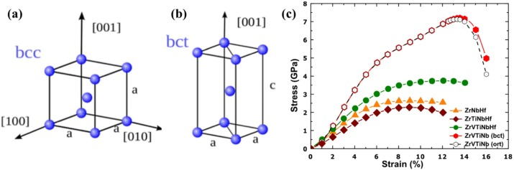
Figure 2-16 (a) Ideal BCC structure without loading along [001]_{BCC}; (b) with tensile strain along [001]_{BCC}, where the deformed structure is expressed in the BCT structure; and (c) a Biplot of simulated tensile stress against ideal tensile strain for four RHEAs [89] .
In ab initio simulations, the value of VEC is derived from the integration of valence band density of states (DOS). Correlating DOS with VEC, Tian et al. [90] discussed the effect of the addition of V in TiZrNbMo, and the resultant mechanical performance of TiZrNbMoV_{X (x=0-1.5)}. Denoting the DOS peak split as a sign of lattice distortion and employing the Fermi energy level as a reference, the DOS peak splitting shifts were used to determine whether the solid is stable against particular lattice deformation (which correlates to the elastic constants). As shown in Fig. 2-17(a), compared with Ti and Zr the additional valence electrons from V and Nb shift the Fermi energy level towards a descending DOS and finally into the characteristic DOS minimum in Mo. This indicated the BCC structure in Mo is most stable. Similarly, by comparing the total DOS of TiZrVNb, TiZrNbMo and TiZrVNbMo, the peak next to the Fermi energy shifted to the descending zone when Mo was replaced with V, which characterises Mo addition as an aid to stabilise the BCC structure when compared with V. According to this discussion, Tian et al. [90] further related the VEC with the changes of the metallic bonds and to the changes of polycrystalline elastic moduli. In Fig. 2-17(b), the correlation between the bulk and shear moduli of TiZrNbMoVx and the VEC is evident. With VEC varying as a result of the V addition, the bulk (shear) modulus and B/G ratio (used to represent intrinsic brittleness) were observed to change significantly. The inverse VEC dependence of B and G result in a higher B/G ratio which helps in explaining the enhanced ductility results from the addition of V.

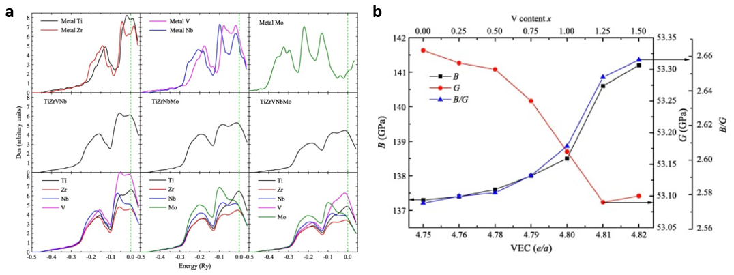
Figure 2-17 (a) DOS of pure Ti, Zr, V, Nb, Mo BCC elements; TDOS and PDOS of BCC TiZrVNb, TiZrNbMo and TiZrVNbMo.; and (b) Correlation between the bulk (B), shear (G) moduli and Pugh ratio (B/G ratio) of TiZrNbMoV_{x (x=0–1.5)} and VEC. [90]
The same approach was also applied to investigate the change of elastic constants against phase formation. With the addition of Al in CoCrFeNi, known for high FCC stabilisation among the existing HEAs, the stabilised phase will favour forming BCC instead of FCC. Tian et al. [83] investigated the effect of Al addition on the elastic constants (Poisson's ratio, Cauchy pressure and Pugh's ratio) of CoCrFeNi-Al_{x=0-2.0} . Shown in Fig. 2-18, the elastic constants exhibited different compositions and were dependent on Al in different phases. Although all three elastic constants showed linear dependence with the addition of AI, in different lattice structures, the constants vary positively with the addition of AI in the FCC structure. However, in the BCC structure, the constants vary negatively with the addition of AI. This variation indicated the application of the semi-empirical method in predicting the mechanical performance of HEAs may need to consider the stabilised phase as a key factor.
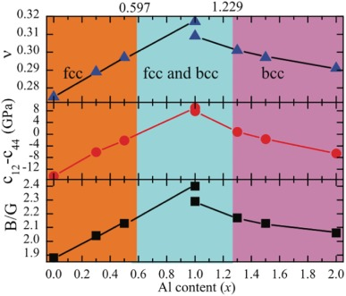
Figure 2-18 Compositional dependence of three elastic constants (Poisson's ratio, Cauchy pressure and Pugh's ratio) with Al addition in CoCrFeNi. Simulated stabilised structures are shaded in different colors (orange for FCC, cyan for dual-phase and purple for BCC) [83].

2.5 Strengthening strategy and deformation mechanisms in HEAs.
In recent years, HEAs have been highly developed on account of their impressive mechanical performance and structural stability at high-temperature conditions [91–94]. In comparison with traditional alloy systems, HEAs exhibit advantages in mechanical properties such as strength, ductility and fracture toughness and in addition, are also resistant to corrosion and irradiation [95–97]. It is established that HEAs possess already favourable properties and therefore the opportunity exists for further metallurgical development for use of the alloys in unique applications. As such, further attempts have been made to enhance and extend the scope of mechanical performance and application of these materials. This has been achieved through the introduction of traditional deformation mechanisms and strengthening strategies. In the following sections, the successful introduction of deformation mechanisms and strengthening strategies will be discussed. These include fine grain strengthening, precipitation strengthening, solid solution strengthening and dynamic Hall-Petch effect (also known as dynamic work hardening). These strategies mainly contribute to the activation of twinning induced plasticity (TWIP) and transformation induced plasticity (TRIP).

2.5.1 Precipitate strengthening
Generally accepted as the most famous quaternary HEA system, CoCrFeNi (CCFN) is well known for its high phase stability and excellent mechanical performance, particularly, the unique fracture toughness response in a cryogenic environment when adding Mn as a fifth principal component [91,98,99]. However, as a result of its low yield strength, the application of the CCFN system is limited. With the development of the semi-empirical method and ab initio method for predicting phase constitution during the design of HEAs, researchers have started to achieve the ability of introducing as a second precipitating phase in the FCC matrix of the CCFN system. Thus, to enhance the strength of CCFN-based HEAs, varieties of elements have been added to promote the second reinforcing phase. Carefully controlling the alloying addition and heat-treatment conditions precipitate reinforcement and grain size refinement can also be achieved. Using the thermodynamic method, He et al. [100] developed the (CoCrFeNi)_{100-x-y}Ti_{x}Al_{y}(at%) system with two different types of the second phases as a reinforcement. The phase prediction enabled by CALPHAD conforms to the experimental results. Nanosized precipitates L1₂-Ni₃(Ti, Al) and L2₁-(Ni, Co)₂TiAl were observed within FCC grains next to the grain boundaries. By conducting a series of heat-treatments, it was concluded that the phase fraction of both precipitates increased with the addition of Ti and Al. However, the temperature dependence of the phase stability of both precipitates is very different. Through careful control of the heat-treatment process, the formation of L2₁-(Ni, Co)₂TiAl was prevented, whilst L1₂-Ni₃(Ti, Al) precipitates remained within the FCC grain. As shown in Fig. 2-19, the strength of the CCFN-based alloy was enhanced significantly through the addition of small amounts of Ti and Al. This is attributed to the coherent precipitated L1₂-structure in the FCC matrix, which resembles the γ(FCC) and γ’(L1₂) precipitates in the Ni-based superalloy.
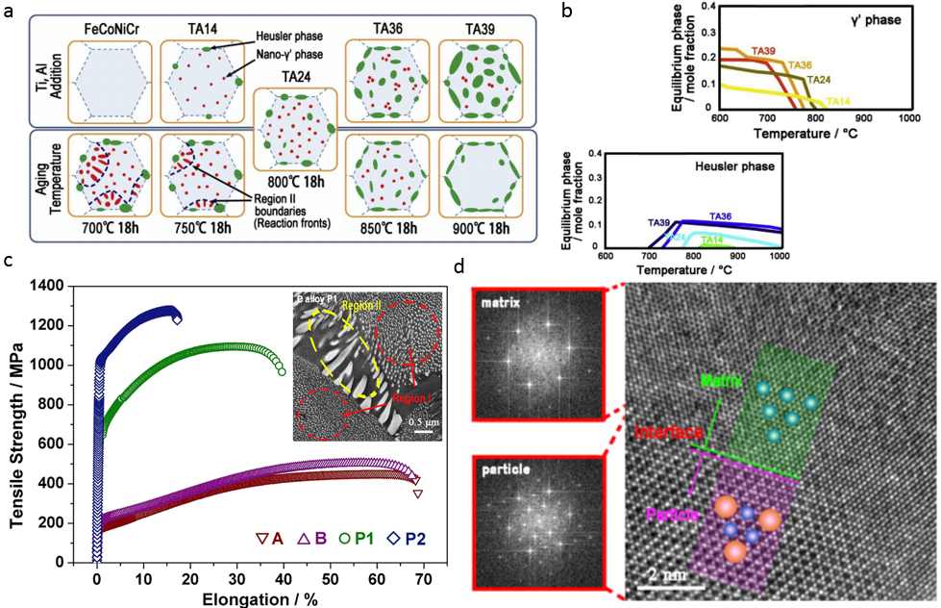
Figure 2-19 (a) An illustration of the microstructure evolution during heat-treatment, with precipitates selection showing distinct dependence with ageing temperature; (b) a 2-D plot of phase fraction against ageing temperature. With different dependence on ageing temperature, the formation of γ’ phase suppressed the formation of Heusler phase; (c) the tensile performance of materials possessing different ageing. Inset reveals the coexistence of both precipitates; and (d) HRTEM image showing coherent γ’ precipitates in the FCC matrix [100].
With regard to the effectiveness of precipitates resulting in hardening in HEAs, recently Liang [13] developed Al_{0.5}Cr_{0.9}FeNi_{2.5}V_{0.2} with isotropic spinodal nanoprecipitates. As with the strategy proposed by He et al. [100] which employed the γ phase as the matrix and introduced γ’ Ni-Al rich precipitates as the strengthening phase, it was found that the precipitates formed coherently within the γ matrix as shown in Fig. 2-20. This resulted in the enhancement of strength. Using different heat-treatment conditions, the mechanical performance of the alloy can be tailored in a large range (strength range from 270 MPa to 1900 MPa and elongation of approximately 40%). Through the activation of the low-misfit isotropic γ’ precipitates, impressive strength (~1.5 GPa) with acceptable ductility (~9% elongation) was achieved. In summary, most reported precipitate hardened HEAs concentrate on ‘3d transitional group HEAs’ with a FCC as the matrix. Unlike precipitates such as B2, Laves and the sigma phase, precipitate with the most strengthening potential in this series of HEAs is γ’, which forms in a low misfit coherent manner in the CC matrix, where the strengthening effect is maximised and the loss of ductility is prevented.
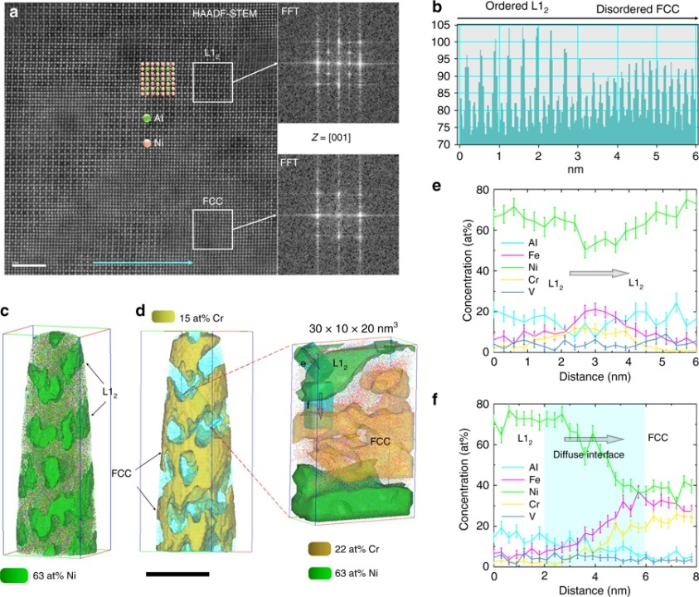
Figure 2-20 Microstructure of Al_{0.5}Cr_{0.9}FeNi_{2.5}V_{0.2} and element distribution. (a) a HRTEM image of L1₂ precipitates in the FCC matrix, inset showing IFFT spot, corresponding to L1₂ and the FCC structure; (b) the lattice plane spacing; (c-d) atom probe tomography revealing elemental distribution for L1₂ and the FCC phase; and (e-f) component concentrations varying against distance, indicating a diffuse gradient between precipitates and matrix [13].
The strategy of utilising coherent ductile intermetallic precipitate strengthening of FCC based-HEAs has been researched extensively. By using FeCoNi [101] as a base alloy, Yang developed (FeCoNi)₈₆-Al₇Ti₇ and (FeCoNi)₈₆-Al₈Ti₆ high-performance HEAs[92]. For dense L1₂ phase precipitated alloys, the yield strength and ultimate tensile strength were increased to the GPa level. In addition, over 50% tensile elongation was achieved whilst also obtaining high strength levels as mentioned, which can be attributed to the coherent nature of the L1₂ phase with the FCC matrix. The L1₂ precipitates show clear dependence with the addition of Al and Ti, which is identical to the reports previously discussed. The carefully tailored composition resulting in an innovative multi-stage work hardening phenomenon is shown in Fig. 2-21(g). Furthermore, through conducting atom probe tomography (APT) analysis and DFT simulations on the L1₂ precipitates, the lattice occupancy of L1₂ was identified as partially occupied by ordered, multi-principal components. The chemical composition of the L1₂-type precipitates is identified as (Ni_{43.3}Co_{23.7}Fe₈)₃(Ti_{14.4}Al_{8.6}Fe₂), which made a major contribution to the impressive mechanical response of (FeCoNi)₈₆-Al₇Ti₇.
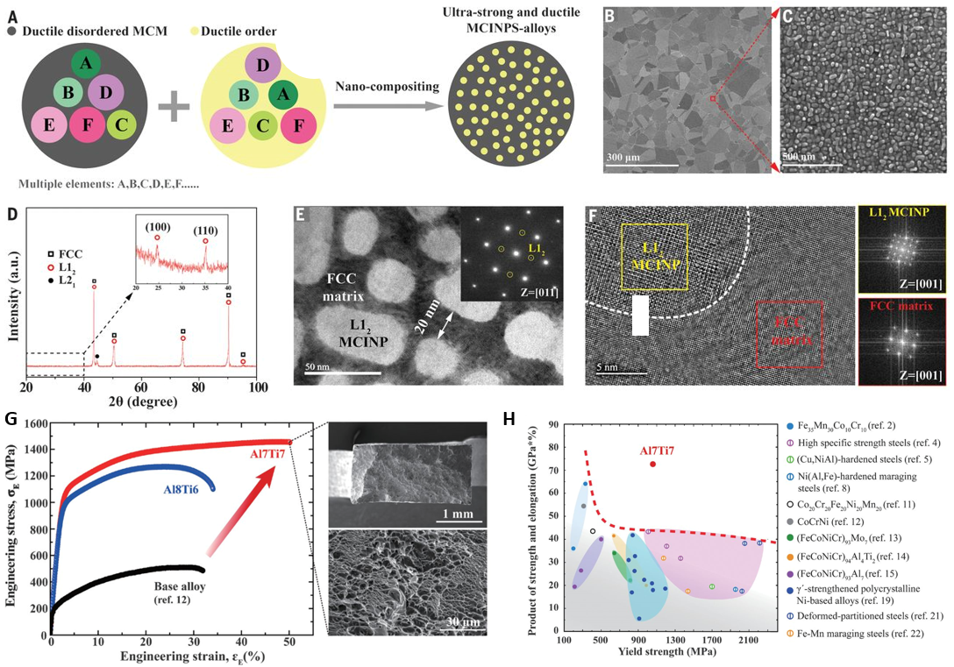
Figure 2-21 Illustration of the high-performance L1₂ precipitates strengthened (FeCoNi)₈₆-Al₇Ti₇ and (FeCoNi)₈₆-Al₈Ti₆. (a) The design strategy of L1₂ high entropy intermetallic reinforced HEAs; (b-f) microstructure of the synthesized target alloy, consisting of nano L1₂ precipitates in the FCC matrix; and (g-h) the tensile properties of (FeCoNi)₈₆-Al₇Ti₇ and (FeCoNi)₈₆-Al₈Ti₆. The mechanical response outperforms most known advanced alloy systems [92].

2.5.2 TRIP, TWIP and other strengthening strategies
Twining induced plasticity (TWIP) has attracted great interest in recent years, owing to its effectiveness in solving the strength-ductility trade-off. As a deformation mechanism with virtually no misfit between deformation products and matrix lattice, the strength of TWIP alloys is maintained by the dynamic Hall-Petch effect; while the ductility is enabled by continuously formed mechanical twinning, which acts to alleviate the defect accumulation, hence avoiding early crack formation. The critical condition to introduce TWIP into selected metallic materials, is mainly determined by the magnitude of stacking fault energy (SFE). The deformation mechanism follows a sequence of activations, (i) dislocation glide domain; (ii) dislocation glide and mechanical twinning domain; and (iii) dislocation glide and phase transformation domain. An interesting discovery summarised from previous experimental results, is that the tuning of SFE will affect the activation of TWIP and the activation of TRIP, which indicates the underlying mechanism to induce TWIP is similar to the one to activate TRIP [102–105]. Detailed investigations have been conducted on steel with a high Mn content to explore the influence of SFE on the selection of deformation mechanisms through varying the content of Mn [102,106,107]. In HEAs, the TWIP effect was first discovered in the CCFN-Mn system during tensile testing at cryogenic temperature [91]. Owing to the high density of nano-sized mechanical twinning, this five component equiatomic HEA exhibited excellent tolerance to crack growth and outperforms most traditional alloy systems in fracture toughness under the same low temperature environment. Similar to the origin of mechanical twinning in high Mn steels, the nanotwinning generated in the CCFN-Mn system was observed to originate from the growth of stacking faults, which result from dissociation of perfect dislocations and 1/2<110> into 1/6<112> Shockley partials [108]. Thus, the effect of SFE on the activation of TWIP should also potentially work for CCFN-based HEAs using the 3d transitional group and can be utilised to tailor the effects of TWIP. Realising the possibility of using SFE as a reference to maximise the TWIP effect,
Deng et al. [109] developed a non-equal molar Fe₄₀Mn₄₀Co₁₀Cr₁₀ HEA. Based on DFT and experimental results simulated SFE for CCFN-Mn(~25mJ/m²), the Ni content was lowered to reduce stacking fault energy in the target alloy. Yet the lack of Ni addition results in the formation of Cr rich intermetallic sigma phase, which will reduce the mechanical performance of the alloy. Thus, the Cr addition was also reduced, and the final composition was determined as Fe₄₀Mn₄₀Co₁₀Cr₁₀ (at%), to maintain the effect of TWIP and remove the influence of the sigma phase. By successfully introducing the TWIP effect, the refined HEAs possessing four principal components, exhibit similar performances to CCFN-Mn but with cheaper elemental additions.
The introduction of the TWIP effect presents the improvement of plasticity of the base alloy. On the other hand, the introduction of the transformation induced plasticity (TRIP) effect, is well known for promoting strength in metallic materials [110–115]. The transformed phase is generally accepted as martensite phase (stable at low temperatures), while the metastable matrix phase is austenite (stable at high temperatures). During deformation, TRIP acts as a comprehensive dynamic hardening effect, since the martensite phase is formed randomly within the matrix as a function of deformation. As such, consideration must be given to interfacial hardening, second phase hardening and the dynamic Hall-Petch effect simultaneously. In contrast with the precipitate-strengthening strategy discussed previously, the athermal phase transformation included in TRIP indicates there is no chemical composition difference between matrix and the second phase. Therefore, without differences in chemical composition the comparatively lower energy barrier between austenite and stress-induced martensite phase allows the second phase strengthening to take effect dynamically. This profoundly improves the work hardening capability of the matrix. In conventional alloy systems, the applications of TRIP have been well studied in developing high-performance steels and β-Ti alloys [112,115–117].
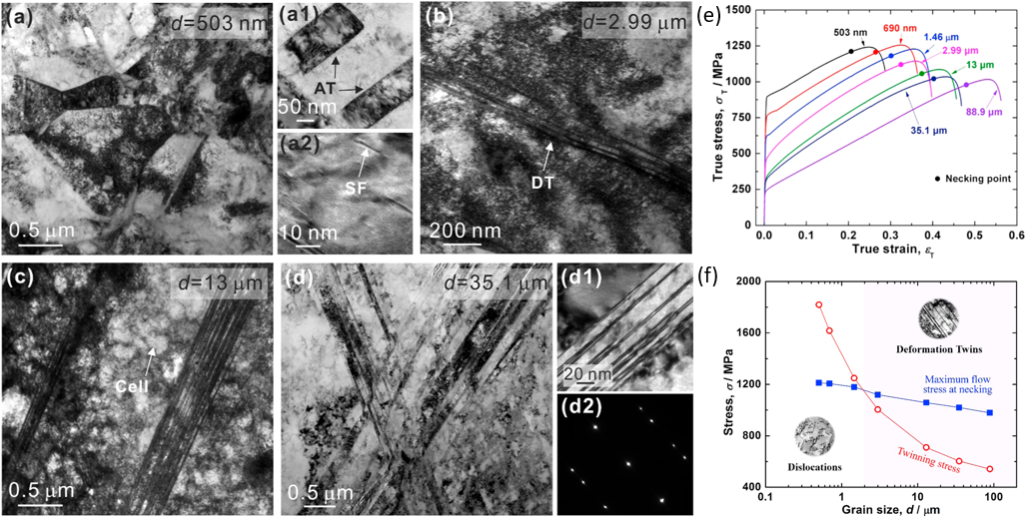
Figure 2-22 TEM investigation of grain size effect on a deformation mechanism (a) a bright field image with a grain size of 503 nm; (a1-a2) the deformation microstructure captured within the grain; (b-d) the microstructures of samples with different grain size. Deformation products such as twinning were observed within the primary grain (d1). Inset is a selected area diffraction pattern showing the corresponding orientation relationship (d2).; (e) the tensile properties of the alloy with different grain size; and (f) an illustration of deformation mechanisms dependence with grain size [118].
The activation of the TRIP effect can be satisfied by tuning the austenite phase stability, which in turn reduces the energy barrier between the austenite and stress-induced martensite phases. Recently, by using high-Mn TRIP steel as an example, the TRIP effect was successfully introduced into the 3d transitional group HEAs by lowering γ phase stability [93,119]. The work was conducted on the basis of non-equiatomic TWIP HEA Fe₄₀Mn₄₀Co₁₀Cr₁₀ [109]. Through tuning the Fe and Mn ratio in Fe₅₀Mn₃₀Co₁₀Cr₁₀, the TRIP effect was successfully activated and stress-induced γ to ε (HCP) phase transformation was observed during deformation [93]. The dynamic coherent grain refinement enabled by the γ to ε phase transformation, resulted in the formation of dense laths of hard ε phases within the soft γ matrix and further prevented the movement of dislocations. Additional hardening was observed in Fe₅₀Mn₃₀Co₁₀Cr₁₀ which enabled a good balance between strength and ductility during tensile testing shown in Fig. 2-23b. Similarly, using TRIP-assisted β-Ti biomedical alloys as an example, the TRIP effect was also introduced in BCC-based metastable refractory HEAs Ti₃₅Zr_{27.5}Hf_{27.5}Nb₅Ta₅ and TiZrHfTa_{0.4}[120,121]. β to α’’ (BCC to orthorhombic) and β to α (BCC to HCP) dynamic phase transformation was observed in these compositions, respectively.
Notably, the effect of Mn addition in CCFN based HEAs exhibits similar influence on mechanical performance as in high-Mn steel. In high-Mn steel, the effect of Mn addition is mainly placed on the resultant SFE. From various experimental results (synchronous XRD), calculations concluded that different deformation mechanisms were activated depending on the magnitude of the SFE [105,122]. When the SFE is lower than 20 mJ/m², martensitic transformation will be activated; whereas for SFE around 20-40 mJ/m², mechanical twinning will be activated during deformation [123]. Moreover, for high SFE steel, only dislocation glide was observed as the predominant deformation mechanism. An example of similar observations for the 3d transitional group FCC HEAs, CoCrFeNiMn possesses a SFE of approximately 25mJ/m² [109]. When varying the content of Ni to Fe₄₀Mn₄₀Co₁₀Cr₁₀ in order to reduce SFE, the TWIP effect was activated. Further reduction of SFE was undertaken by varying Fe and Mn contents in Fe₅₀Mn₃₀Co₁₀Cr₁₀, where in addition to the activation of TWIP, the activation of TRIP was found to occur[93]. The reason for activating mechanical twinning is the same both in HEAs and traditional alloy systems. These results indicate the traditional strengthening strategy can also be applied to HEAs to enhance work hardening capability to break the strength-ductility trade-off. It is well known that the performance of deformation mechanisms (TWIP or TRIP) are highly dependant on the average grain size of selected alloy systems. Ei-Danaf [124] investigated the influence of grain size on deformation twinning in FCC alloys. The grain size effect strongly affects the early stage deformation of low SFE FCC material. Based on this grain size effect, by carefully controlling the heat treatment conditions, Gutierrez [125] undertook work on TWIP steel with grain size of 3 and 50 µm. The substructure of dislocations regulated the density of twinning nucleation at grain boundaries and thus affects the evolution of twinning throughout the deformation process. This is a result of twinning which may nucleate from a series of dislocation dissociations when the dislocations are crossing the grain boundary. Theoretical proof for the positive effect of grain refinement on deformation twinning was proposed by Meyers [126–128]. These works indicated that the critical resolved shear stress during twinning is inversely proportional to mean grain size. A detailed investigation of the effect of grain size on the mechanical performance was conducted by Sun[118] on the CoCrFeNiMn HEA system. This work employed a grain size ranging from 88.9 µm to 503 nm. As shown in Fig. 2-22, with a decreasing grain size of γ phase, the ductility of CoCrFeNiMn reduced at the expense of increasing strength. The reduction of elongation in this material appears to be a result of grain refinement. This was similar to the effects of grain refinement in steel, where the critical stress of twinning was negative and correlated with the refined grain size to prevent the generation of mechanical twinning during deformation [118]. In Fig. 2-22, TEM analysis revealed the activation of deformation mechanisms that have a dependence with grain size, including mechanical twinning, stacking fault and dislocations that were activated in large grain samples; while in contrast, dislocations and stacking faults are refined in small grain samples. The distribution of the mechanical twinning in grain refined CoCrFeNiMn was similar to high-Mn Steel [122]. This adds promise by indicating the possibility of allowing TWIP and grain refinement to occur to find an optimal processing method for designing high performance HEAs. Recently, to achieve the mix of deformation mechanisms discussed, careful control of the heat treatment parameters was applied to Fe₅₀Mn₃₀Co₁₀Cr₁₀, resulting in a TWIP-TRIP assisted HEA being developed [93]. It was found that both the strength and ductility of Fe₅₀Mn₃₀Co₁₀Cr₁₀ increased when compared to the equimolar HEA base alloy CoCrFeNiMn. This was directly attributed to the activation of stress induced γ (FCC) to ε (HCP) martensitic phase transformation, in addition to the TWIP effect. An increase in strain hardening with further grain refinement can be seen in Fig. 2-23(d) and was due to the dynamic Hall-Petch effect limiting the movement of dislocation glide. Another investigation was conducted to determine the influence of grain size and phase fraction on the mechanical performance of TRIP-TWIP Fe₅₀Mn₃₀Co₁₀Cr₁₀ HEAs [129]. Using both EBSD and ECCL as shown in Fig. 2-23(a-b), multiple deformation mechanisms were observed in this dual phase HEA during tensile deformation. These included stacking fault and dislocation slip in both γ and ε phase, as well as mechanical twinning in ε phase at the later stages of deformation. With similar grain size, and increased ε phase fraction, the strength and ductility of the material was enhanced. Therefore, in contrast to research undertaken on CoCrFeNiMn equal-molar HEAs, it is evident that with grain refinement the strength and ductility of TRIP-TWIP HEAs increase. Moreover, contrasting observations for strength and ductility as a function of grain refinement for the equiatomic CoCrFeNiMn and Fe₅₀Mn₃₀Co₁₀Cr₁₀, may be attributed to the activation of TWIP and TRIP mechanisms in the dual phase TRIP-TWIP HEAs.
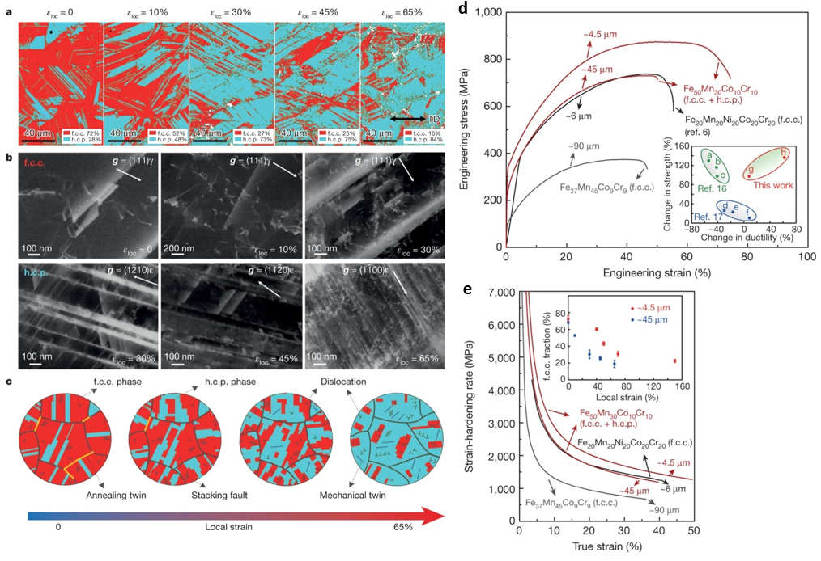
Figure 2-23 Microstructure evolution of metastable TRIP/TWIP HEAs (a) EBSD image showing the phase fraction as a function of increasing tensile strain; (b) an ECCL image of deformation products; (c) a schematic of the evolution of both microstructure and deformation mechanisms as a function of increasing tensile strain; (d) the tensile properties of target alloy possessing different grain sizes; and (e) the strain hardening properties of the materials [93].

2.6 Possibility to design high-performance RHEAs
To satisfy the increasing demands of structural materials to operate at higher temperatures during service, it is imperative to design new alloys which do not possess the inherent shortfalls of traditional high-temperature alloys. As an example, Ni and Co-based superalloys exhibit excellent mechanical properties under loading up to 1273K and have been widely applied in the aerospace industry. However, their application is limited when considering operational temperatures between 1773K-2273K, in part due to the melting temperatures of the key elemental components. The consideration of utilising the HEA strategy to develop a high-performance, refractory multi-components alloy was therefore proposed. The first attempt was undertaken by Senkov [20], by selecting components from refractory elements including W, Nb, Mo, Ta, V. As a result, equiatomic HEAs WNbTaMo and WNbTaMoV were synthesised and characterised as simple solid solution alloys. These RHEAs exhibited a good level of strength at room temperature and a high level of strength was retained at elevated temperatures up to 1873K[130,131]. Currently, RHEAs have been developed to possess over 100 compositions. The general classification of RHEAs depends on the principal components which mainly comprises refractory elements including Ti, Zr, Hf, V, Nb, Ta, Cr, Mo, W. Non-refractory elements such as Si may be added as a strengthening element. However, although most RHEAs show satisfactory mechanical properties during loading at elevated temperatures, only a small number possess similar mechanical property levels at ambient temperatures. At ambient temperatures, machining of these materials is also difficult. With these disadvantages, their applications are clearly limited. In the following sections, the possible strengthening methods and deformation mechanisms which can be introduced into RHEAs will be detailed, in an attempt to reduce the inherent limitations already discussed.

2.6.1 Stress-induced athermal phase transformation
According to Senkov [130], most RHEAs form BCC solid solution phase. The fact that the principal components of RHEAs are composed of IVB-VIB group elements, indicates the primary phase formation prediction of RHEAs can be achieved by using the pseudo-binary phase diagram as a reference. Without the addition of IVB group elements, the phase diagram of binary alloys that are composed of V and VIB group elements exhibit solely BCC phase formation. Once IVB elements are added, the HCP phase started to form as a stabilised phase at low temperatures [76]. The temperature difference between stabilisation of BCC and HCP phases, resembles the phase transformation in high Mn TRIP steel, where the HCP phase is more stabilised than HCP phase at low temperatures. This indicates the possibility to activate the TRIP effect in RHEAs. Using the same strategy from TRIP-assisted β-Ti alloy [123], the TRIP effect was successfully activated in metastable TiZrHfTa_{0.4} (BCC to HCP) and Ti₃₅Zr_{27.5}Hf_{27.5}Nb₅Ta₅ (BCC to orthorhombic) RHEAs. In both reported TRIP RHEAs, a large amount of IVB element addition was observed as the critical condition for activating stress-induced BCC to HCP/orthorhombic phase transformation. Therefore, the physical and mechanical background to activate TRIP effects in β-Ti alloy can be used in designing TRIP RHEAs.
For β-Ti alloy stress-induced phase transformations includes BCC to α’(HCP) martensite phase, BCC to α’’(orthorhombic) martensite phase and BCC to ω (close-packed hexagonal) phase [132–134]. The various TRIP effects are mainly tailored through tuning of β-phase stability, which can be expressed by Molybdenum Equivalency (MoE), bond order (Bo) and metal d-orbital energy level (Md) [135]. Generally, with increasing phase stability, the phase transformation follows the activation sequence of α’ $→$ α’’ $→$ ω. Currently, owing to their significant influence on alloy strength, ductility and strain hardening, the most widely investigated stress-induced phases in β-Ti alloys are the orthorhombic α’’ and ω hexagonal phases [136]. Starting with the α’’ martensite phase, this nucleates within the BCC matrix and grows as thin laths. In the same way that the phase fraction of Fe₅₀Mn₃₀Co₁₀Cr₁₀ can be tuned by heat treatment, the α’’ martensite phase fraction can also be tailored before loading by varying heat treatment conditions [120,121]. The effects of TRIP take effect at the early deformation stage and result in enhancement of strain hardening capability. Once the α’’ martensite phase transformation has saturated, other deformation mechanisms start to take effect including the stress-induced ω phase and mechanical twinning.
Previous discussion considered BCC to α’’ phase transformation, however, the stress-induced ω phase transformation has recently started to interest researchers. This is due to its effectiveness in tailoring strength, ductility and strain hardening capacity of β-Ti alloys and Zr-based alloys [137]. Depending on the critical conditions for the formation of ω phase, the phase can be either transformed from the β matrix via athermal or isothermal conditions. Unlike the isothermal ω phase which possesses high hardness, a distinct chemical difference with the β matrix and benefits from low lattice misfit, the athermal ω phase was commonly accepted as a more effective phase to reinforce the β matrix. The stress-induced ω phase has been observed in many β-Ti alloys, most of which formed a plate-like structure within the sample and favoured nucleating next to the interface between the β and α’’ phase [134,138]. Owing to the high strength and coherent linkage with the β matrix, several investigations explored the possibility of utilising the stress-induced ω phase as a deformation mechanism [133,134,139,140]. With the aim to activate the athermal ω phase transformation, the relationship of stress-induced ω phase and β phase stability was explored by varying the β stabiliser content in Ti-V binary alloys [139]. It was found that with the increase in V addition for high V content Ti-alloy, the deformation mechanism activation was determined as stress-induced α’’ phase transformation, mechanical twinning, then to stress-induced ω phase formation. This resulted in the significant enhancement of yield strength, which was directly attributed to the activation of the stress-induced ω phase transformation. As the stress-induced ω phase was found to nucleate within twinning boundaries and interfaces between the α’’ phase and β matrix, there is potential to use the ω phase formation as a strengthening mechanism to prevent dislocation motion. In the work of Zhang [140], stress-induced cooperating deformation mechanism including {-211}<111>_{β} twinning and reversible martensite transformation was observed. It is shown in Fig. 2-24 that a well-refined laths structure formed, due to shear loading along {-211}<111>_{β} during α’’ phase transformation. The interfacial stress-induced ω phase possessed perfect lattice correspondence with the β matrix and primary and secondary α’’, which resulted in a low misfit planar complexion between β- α’’ interface.
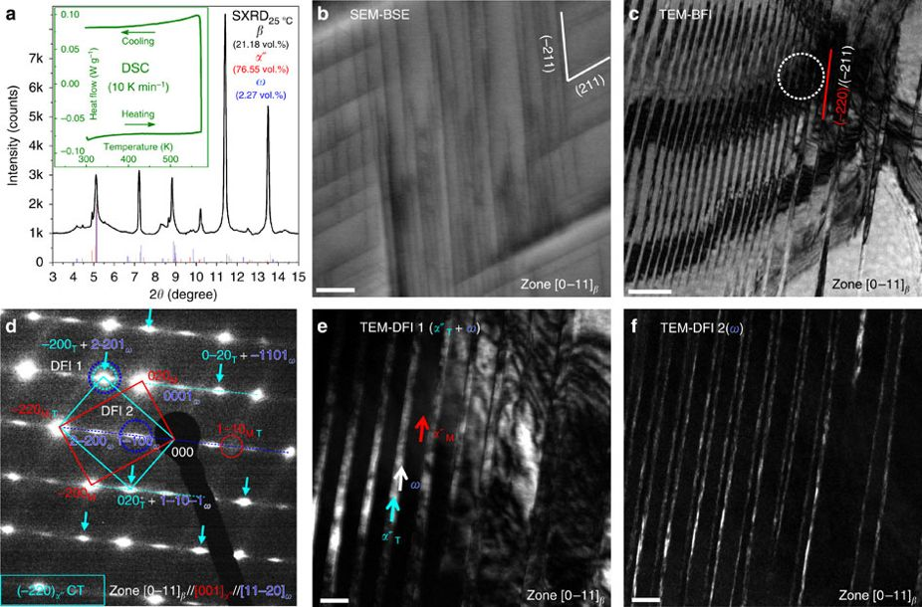
Figure 2-24 Microstructure evolution of metastable Ti-Nb β alloy (a) XRD phase analysis of the material at room temperature. (b) an ECCI image of deformation products. (c) a TEM bright field image of {112}_{β} mechanical twinning laths. (d) phase analysis by SADP. A special orientation relationship between martensite twinning and matrix were coloured with cyan and red, respectively. (e-f) dark field images of α’’ twinning variant and embedded ω phase laths. [140]

2.6.2 Self-accommodation structure and TWIP
Slip is the most common mechanism to accommodate deformation in a crystal. According to the theoretical work first reported by Von Mises [141], to activate crystallographic slip in certain crystal lattices, five available independent slip systems are essential. FCC structures have 12 slip systems and BCC structures possess 48 slip systems while the close-packed HCP structures have only 3-6 slip systems, which limits the ductility of HCP-structured alloys (Mg and Ti alloys). An alternative deformation mechanism to slip is mechanical twinning, which results in the enhancement of ductility for these materials. In current RHEA systems, unlike the stable β phase, the stress-induced martensite phases which include α (HCP), α’ (near HCP) or α’’ lack slip systems. Therefore, mechanical twinning would potentially have an important role in enhancing their mechanical performance. When considering these points, it is evident that involving mechanical twinning in RHEA materials possessing both BCC and martensite phases, could significantly increase their strain hardening and strength.
With highest crystal symmetry, deformation is generally accommodated by dislocation slip in the β phase. Moreover, deformation twinning has proved effective in improving the strength and ductility of FCC metallic materials, moreover, it is considered as a very important deformation mechanism to improve the mechanical properties of β-phase alloys. The most widely reported deformation twinning system in BCC structured metals (α-Fe, β-Ti and other V, VI group alloys) is {112}<111>_{β} twinning. This may need to be taken into consideration for the activation of the TWIP effect in RHEAs. The origin of this twinning system is considered quite similar to the {111}<112>_{γ} mechanical twinning in FCC alloys, which is activated by collective slide Shockley dislocations with the same burger vector on the continuous twinning plane [142]. A detailed illustration of the formation of {112}<111>_{β} twinning is shown in
Fig. 2-25.
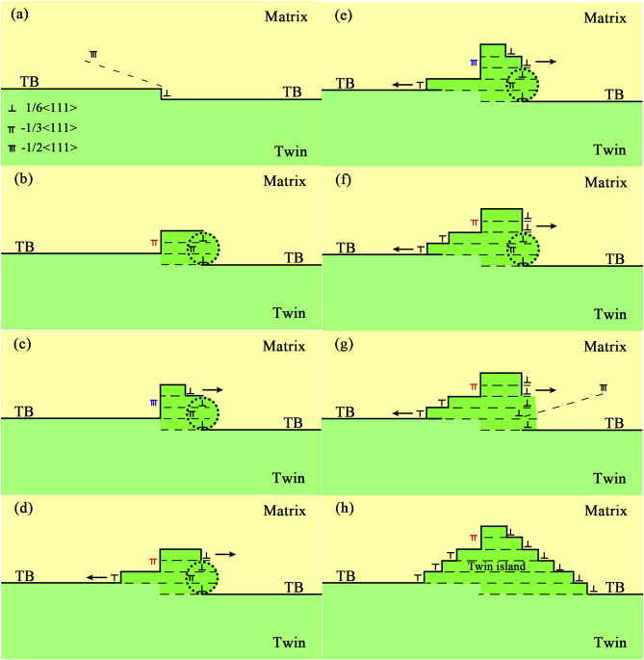
Figure 2-25 Illustration of {112}_{β} twinning growth in BCC metallic materials (a-b) the activation of 1/6<111> partial dislocation through merging 1/2<111> dislocation into 1/3<111> zonal dislocation; (c-f) repetition of the process shown in (a-b) enabled thickening of the twinning boundary; and (g-h) remnants of 1/6<111> partial dislocation accumulated at a twinning boundary [142].
In comparison with {112}<111>_{β} twinning systems in BCC, the {332}<113>_{β} twinning system found in metastable β-Ti alloy has attracted great interest from researchers due to its effectiveness in solving the strength-ductility trade-off [143]. Crocker [152] investigated the possible deformation twinning systems in α-Fe (BCC) by using the theory of the crystallography of deformation twinning, where {332}<113>_{β} twinning was not listed as a shear favourable deformation twinning system in the BCC structure [144]. Unlike {112}<111>_{β} twinning, which can be achieved crystallographically by simple shear on continuous twinning planes possessing certain displacements, simple shear along twinning directions on invariant planes will only move one-and-a-half of the matrix lattice to their correctly twinned lattice sites under the {332}<113>_{β} mechanical twinning mode. This indicates the requirement of additional atomic shuffle for the formation of the {332}<113>_{β} twin structure. Accordingly, {332}<113>_{β} twinning is not energetically favoured in comparison to {112}<111>_{β} twinning. Nonetheless, in most reported work investigating TWIP β-Ti alloys, the observations of {332}<113>_{β} mechanical twinning was most widely detailed, rather than {112}<111>_{β} mechanical twinning. {332}<113>_{β} mechanical twinning was determined to be the main contributor to the enhancement of mechanical performance. However, by lowering β phase stability to a critical value, {332}_{β} twinning and {112}_{β} twinning can be activated simultaneously to optimise strength and ductility of β-Ti. This strategy can therefore be adopted to introduce and maximise the effect of TWIP in RHEAs.
To clarify the origin of this specific twinning system, substantial works have been conducted. Taking the origin of {112}<111>_{β} twinning and {111}<112>_{γ} twinning as references, early works [145–147] described the origin of {332}<113>_{β} twinning by utilising dislocation dissociation and association. Partial dislocation mechanisms were taken into consideration in many reports, with continuous partial dislocation movements along the <113>_{β} direction on successive {332}_{β} twinning planes leading to the formation of {332}<113>_{β} twinning structures. To date no {332}_{β} planes and <113>_{β} directions have been detected, as arranged in a close-packed lattice form [147]. Therefore, {332}<113>_{β} twin activation remains energetically unfavourable.
The reports of {332}<113>_{β} twinning are detailed for the metastable β-Ti alloys and more recently extended to shock-loaded α Fe alloys[148,149]. Similarities exist between all BCC phases of these alloys, for which the BBC matrix is relatively unstable, hence allowing further transformation to HCP or orthorhombic martensite phase under certain conditions such as heat treatments or upon loading. With regard to this, attempts have been undertaken to explain the origin of {332}<113>_{β} twinning in view of BCC phase lattice instability. The most reasonable explanation has been proposed by Tobe [150] when considering BCC lattice instability at <011>_{β} as shown in Fig. 2-26. Through a double lattice structure model, the BCC structure was understood to be a modulated structure of the BCT structure involving lattice instability. This was attributed to the displacement along <011>_{β}. In this model, {332}<113>_{β} twinning originated from a lattice and corresponded to {130}<310>_{α’’} deformation twinning with a small magnitude atomic shuffle movement (Fig. 2-26(b)). In situ experimental results reported for {332}<113>_{β} twinning [151,152] also provide solid evidence of the relationship between the stress-induced α’’ martensite phase and {332}<113>_{β} twinning. Many reports have attempted to use EBSD results to identify its existence, whilst the Kikuchi lattice patterns in the zone axis of β and α’’ do share great similarities which may have confused the observation of {332}<113>_{β} twinning and {130}<310>_{α’’} twinning. A direct proof is, to date lacking of direct evidence for the existence of {130}<310>_{α’’} deformation martensite twinning has been obtained from the diffraction pattern obtained by TEM.
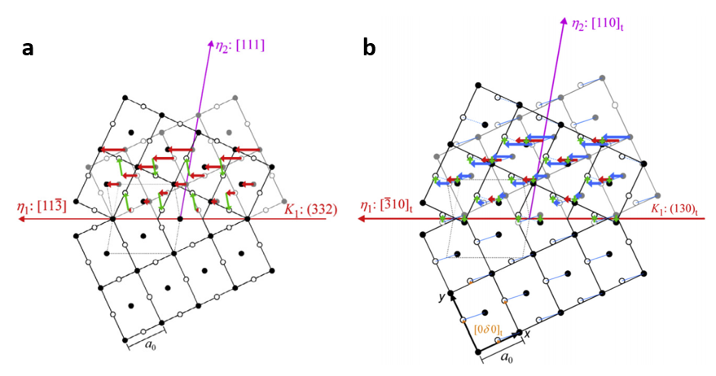
Fig 2-26 A schematic of {332}<11-3>_{β} and {130}<-310>_{α’’} mechanical twinning under single and double lattice structures. (a) (1-10)_{β} projection of {332}<11-3>_{β} mechanical twinning under single lattice BCC structure. Closed and open circles represent atoms below and upon 0.707$a$ ($a$ is lattice parameter of the BCC cell) of the projection plane. Red and green arrows indicate the shear and shuffle needed to move the lattice into the correct position, respectively; and (b) (001)_{α’’} projection of {130}<-310>_{α’’} mechanical twinning under double lattice BCT structure (with displacement along<011>_{β} =$a$/$12√2$). Closed and open circles represent atoms below and upon 0.707$a$ ($a$ is lattice parameter of the BCC cell) of the projection plane. Red and green arrows indicate the shear and shuffle required to move the lattice into the correct position, respectively. Blue lines and arrows represent motif units and shear needed to accommodate the motif units into the correct position [150].

The α’’ phase is known as the metastable intermediate phase between BCC-HCP phase transformation. The lattice structure can either be arranged as a distorted BCT lattice or near hexagonal structure (also known as α’). Specific physical properties of athermal α’’ phase, shape memory effect and pseudoplasticity, are enabled in various metastable Ti-X alloy systems (X=Fe, V, Cr, Mo, Nb, Ta) [153]. As an extension of α’’ martensite phase transformation, self-accommodation twinning plays an important role in accommodating the overall volume change during phase transformation. This role is due to the importance of stress-induced α’’ phase transformation, in tailoring mechanical performance of metastable Ti-alloys. As a deformation product, self-accommodation twinning should be promoted, in order to refine the microstructure when designing high-performance RHEAs.
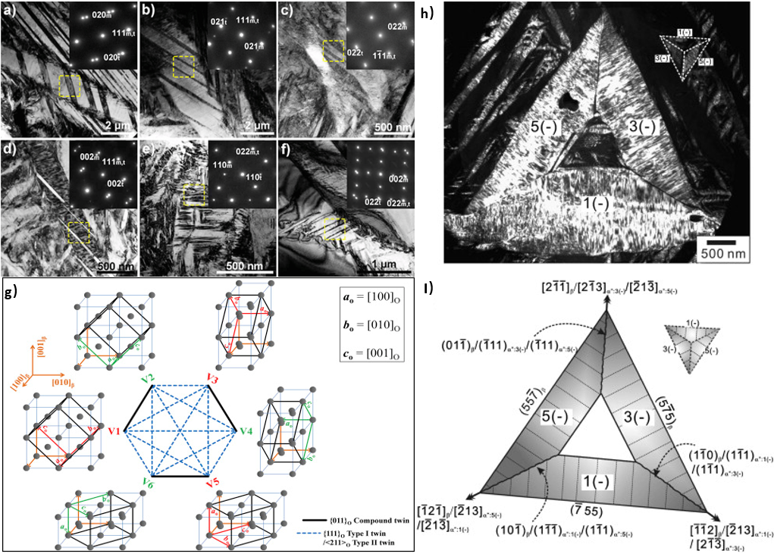
Figure 2-27 Illustration of self-accommodation twinning modes involved in metastable β-Ti (a-d) bright field images and correspond SADP of type I {111}_{α’’} twinning; (e-f) bright field images and corresponding SADP of compound {011}_{α’’} twinning; (g) SA twinning relationship among different martensite variants; and (h-i) SA morphology forming a triangle structure with three martensite variants related by type I twinning [151,154,155].
Inamura [156] applied the phenomenological theory of martensite crystallography (PTMC) to calculate possible self-accommodation twinning systems. These are capable of serving as a lattice invariant shear (LIS) for the β to α’’ phase transformation in a Ti-Nb binary system. The SA twinning selection is shown to be highly dependent on the content of Nb. This dependence directly reflects the sign of a certain lattice deformation strain η₃ (η₃=$(a_{α’’}-\sqrt{2}a)/\sqrt{2}a$). Positive η₃, type I {111}_{α’’} and type II <-211>_{α’’} twinning serves better as LIS, while compound {011}_{α’’} twin better serves when η₃ is negative. In most cases the cooperation of SA twinning modes were restricted within type I {111}_{α’’} and type II <-211>_{α’’} twinning as shown in Fig. 2-27(g). Yet observations of compound {011}_{α’’} twinning together with type I and type II twinning were also reported [157,158]. The critical condition for activating SA type I {111}_{α’’} and SA compound {011}_{α’’} twin was different: lattice corresponds to {10-11}_{α} and {10-12}_{α} mechanical twinning. The activation of these two twinning structures may be ascribed to the shear stress exerted along the [10-12]_{α} direction. Also, {011}<0-11> _{α’’} compound twinning, whose lattice corresponding mechanical twinning mode in α phase is {10-12}<10-12>_{α} shares the same twinning direction with the {10-11}<10-12>_{α} (lattice correspond to SA type I {111}_{α’’} twin) twinning mode. The driving force for the cooperation of type I {111}_{α’’} and compound {011}_{α’’} may not only originate from the volume change caused by phase transformation, but also the shear stress exerted along the <01-1>_{α’’} direction [159]. Accordingly, it is plausible to deduce that both type I {111} _{α’’} and compound {011}_{α’’} twinning can be regarded as potential mechanical twinning modes in the α’’ phase and can be further utilised to improve the TWIP effect. The self-accommodation morphology can also contribute to the grain refinement, with special polygon shape type I twin and type II twin related lath structures. This contribution to grain refinement profoundly complicates the microstructure and prohibits dislocation glide across the grain boundary as shown in Fig 2-27(h). Together with the cooperation of TWIP effect and TRIP effect, this series of SA twinnings has the potential to provide an additional strengthening source for existing RHEAs.

2.7 Summary
Research has been undertaken into HEAs through both advanced and semi-empirical methods. In particular, experiments have been carried out to identify the underlying mechanism for simple solid solution phases forming in this series of alloy systems. Both semi-empirical and ab initio methods are effectively developed in predicting the mechanical properties of HEAs. Moreover, greater precision has been achieved in predicting phase formation. Such developments offer researchers a reliable tool to screen desired HEAs from thousands of candidates.
Inspired by these findings, conventional alloy strengthening was successfully achieved in the ‘3d-transitional group’ HEAs by TWIP/TRIP and resulted in increasing the mechanical performance. However, there remains another essential group of HEAs whose components are mainly composed of refractory elements (RHEAs), which exhibit limited mechanical response at ambient temperatures.
In order to promote strength and ductility in RHEAs under ambient temperatures, the focus of this current thesis concentrates on the development of a new strengthening strategy of RHEAs. The strategy will introduce and detail several different approaches, in an attempt to promote mechanical performance of RHEAs at room temperature. The most effective may be the coherent deformation mechanisms of TRIP and TWIP, in addition to metastable engineering and self-accommodation morphology. These will be described in successive chapters.

2.8 References
[1] B. Cantor, I.T.H. Chang, P. Knight, A.J.B. Vincent, Microstructural development in equiatomic multicomponent alloys, Mater. Sci. Eng. A. (2004). doi:10.1016/j.msea.2003.10.257.
[2] J.W. Yeh, S.K. Chen, S.J. Lin, J.Y. Gan, T.S. Chin, T.T. Shun, C.H. Tsau, S.Y. Chang, Nanostructured high-entropy alloys with multiple principal elements: Novel alloy design concepts and outcomes, Adv. Eng. Mater. (2004). doi:10.1002/adem.200300567.
[3] U. Dahlborg, J. Cornide, M. Calvo-Dahlborg, T.C. Hansen, Z. Leong, L. Asensio Dominguez, S. Chambreland, A. Cunliffe, R. Goodall, I. Todd, Crystalline structures of some high entropy alloys obtained by neutron and X-ray diffraction, in: Acta Phys. Pol. A, 2015. doi:10.12693/APhysPolA.128.552.
[4] E.J. Pickering, R. Muñoz-Moreno, H.J. Stone, N.G. Jones, Precipitation in the equiatomic high-entropy alloy CrMnFeCoNi, Scr. Mater. (2016). doi:10.1016/j.scriptamat.2015.10.025.
[5] S.P. Wang, J. Xu, (TiZrNbTa)-Mo high-entropy alloys: Dependence of microstructure and mechanical properties on Mo concentration and modeling of solid solution strengthening, Intermetallics. (2018). doi:10.1016/j.intermet.2018.01.017.
[6] Y. Ikeda, B. Grabowski, F. Körmann, Ab initio phase stabilities and mechanical properties of multicomponent alloys: A comprehensive review for high entropy alloys and compositionally complex alloys, Mater. Charact. (2018). doi:10.1016/j.matchar.2018.06.019.
[7] B. Cantor, K.B. Kim, P.J. Warren, Novel Multicomponent Amorphous Alloys, Mater. Sci. Forum. (2002). doi:10.4028/www.scientific.net/MSF.386-388.27.
[8] J.W. Yeh, S.K. Chen, J.Y. Gan, S.J. Lin, T.S. Chin, T.T. Shun, C.H. Tsau, S.Y. Chang, Formation of simple crystal structures in Cu-Co-Ni-Cr-Al-Fe-Ti-V alloys with multiprincipal metallic elements, Metall. Mater. Trans. A Phys. Metall. Mater. Sci. (2004). doi:10.1007/s11661-006-0234-4.
[9] F. Tian, Y. Wang, D.L. Irving, L. Vitos, Applications of coherent potential approximation to HEAs, in: High-Entropy Alloy. Fundam. Appl., 2016. doi:10.1007/978-3-319-27013-5_9.
[10] J.Y. He, H. Wang, H.L. Huang, X.D. Xu, M.W. Chen, Y. Wu, X.J. Liu, T.G. Nieh, K. An, Z.P. Lu, A precipitation-hardened high-entropy alloy with outstanding tensile properties, Acta Mater. (2016). doi:10.1016/j.actamat.2015.08.076.
[11] T. Yang, S. Xia, S. Liu, C. Wang, S. Liu, Y. Fang, Y. Zhang, J. Xue, S. Yan, Y. Wang, Precipitation behavior of AlxCoCrFeNi high entropy alloys under ion irradiation, Sci. Rep. (2016). doi:10.1038/srep32146.
[12] Z. Tang, M.C. Gao, H. Diao, T. Yang, J. Liu, T. Zuo, Y. Zhang, Z. Lu, Y. Cheng, Y. Zhang, K.A. Dahmen, P.K. Liaw, T. Egami, Aluminum alloying effects on lattice types, microstructures, and mechanical behavior of high-entropy alloys systems, JOM. (2013). doi:10.1007/s11837-013-0776-z.
[13] Y.J. Liang, L. Wang, Y. Wen, B. Cheng, Q. Wu, T. Cao, Q. Xiao, Y. Xue, G. Sha, Y. Wang, Y. Ren, X. Li, L. Wang, F. Wang, H. Cai, High-content ductile coherent nanoprecipitates achieve ultrastrong high-entropy alloys, Nat. Commun. (2018). doi:10.1038/s41467-018-06600-8.
[14] J.-W. Yeh, J.W. Yeh, Jien-Wei Yeh, " Recent Progress in High-entropy Alloys " RECENT PROGRESS IN HIGH-ENTROPY ALLOYS, Ann. Chim. – Sci. Des Mater. (2006).
[15] I.A. Tomilin, S.D. Kaloshkin, ‘High entropy alloys’—‘semi-impossible’ regular solid solutions?, Mater. Sci. Technol. (2015). doi:10.1179/1743284715Y.0000000028.
[16] D.B. Miracle, O.N. Senkov, A critical review of high entropy alloys and related concepts, Acta Mater. (2017). doi:10.1016/j.actamat.2016.08.081.
[17] D. Li, C. Li, T. Feng, Y. Zhang, G. Sha, J.J. Lewandowski, P.K. Liaw, Y. Zhang, High-entropy Al0.3CoCrFeNi alloy fibers with high tensile strength and ductility at ambient and cryogenic temperatures, Acta Mater. (2017). doi:10.1016/j.actamat.2016.10.038.
[18] Z.G. Zhu, K.H. Ma, Q. Wang, C.H. Shek, Compositional dependence of phase formation and mechanical properties in three CoCrFeNi-(Mn/Al/Cu) high entropy alloys, Intermetallics. (2016). doi:10.1016/j.intermet.2016.09.003.
[19] M. Beyramali Kivy, C.S. Kriewall, M. Asle Zaeem, Formation of chromium-iron carbide by carbon diffusion in AlXCoCrFeNiCu high-entropy alloys, Mater. Res. Lett. (2018). doi:10.1080/21663831.2018.1449767.
[20] O.N. Senkov, G.B. Wilks, D.B. Miracle, C.P. Chuang, P.K. Liaw, Refractory high-entropy alloys, Intermetallics. (2010). doi:10.1016/j.intermet.2010.05.014.
[21] F. He, Z. Wang, Q. Wu, J. Li, J. Wang, C.T. Liu, Phase separation of metastable CoCrFeNi high entropy alloy at intermediate temperatures, Scr. Mater. (2017). doi:10.1016/j.scriptamat.2016.08.008.
[22] N.D. Stepanov, D.G. Shaysultanov, M.S. Ozerov, S. V. Zherebtsov, G.A. Salishchev, Second phase formation in the CoCrFeNiMn high entropy alloy after recrystallization annealing, Mater. Lett. (2016). doi:10.1016/j.matlet.2016.08.088.
[23] Z. Leong, J.S. Wróbel, S.L. Dudarev, R. Goodall, I. Todd, D. Nguyen-Manh, The Effect of Electronic Structure on the Phases Present in High Entropy Alloys, Sci. Rep. (2017). doi:10.1038/srep39803.
[24] T.T. Shun, L.Y. Chang, M.H. Shiu, Microstructures and mechanical properties of multiprincipal component CoCrFeNiTi x alloys, Mater. Sci. Eng. A. (2012). doi:10.1016/j.msea.2012.06.075.
[25] S. Praveen, B.S. Murty, R.S. Kottada, Effect of Molybdenum and Niobium on the Phase Formation and Hardness of Nanocrystalline CoCrFeNi High Entropy Alloys, J. Nanosci. Nanotechnol. (2014). doi:10.1166/jnn.2014.9441.
[26] G.A. Salishchev, M.A. Tikhonovsky, D.G. Shaysultanov, N.D. Stepanov, A. V. Kuznetsov, I. V. Kolodiy, A.S. Tortika, O.N. Senkov, Effect of Mn and v on structure and mechanical properties of high-entropy alloys based on CoCrFeNi system, J. Alloys Compd. (2014). doi:10.1016/j.jallcom.2013.12.210.
[27] J.C. Rao, H.Y. Diao, V. Ocelík, D. Vainchtein, C. Zhang, C. Kuo, Z. Tang, W. Guo, J.D. Poplawsky, Y. Zhou, P.K. Liaw, J.T.M. De Hosson, Secondary phases in AlxCoCrFeNi high-entropy alloys: An in-situ TEM heating study and thermodynamic appraisal, Acta Mater. (2017). doi:10.1016/j.actamat.2017.03.066.
[28] S. Guo, C.T. Liu, Phase stability in high entropy alloys: Formation of solid-solution phase or amorphous phase, Prog. Nat. Sci. Mater. Int. (2011). doi:10.1016/S1002-0071(12)60080-X.
[29] K.M.C.E. W. Hume-Rothery, G.W. Mabbott, The Freezing Points, Melting Points, and Solid Solubility Limits of the Alloys of Silver, and Copper with the Elements of the B Sub-Groups, Philos. Trans. R. Soc. Math. Phys. Eng. Sci. 233 (1934) 1–97.
[30] M.B.B. L.S. Darken, R.W. Gurry, Physical chemistry of metals, 2002.
[31] D. Kashchiev, Nucleation --- Basic Theory with Applications, 2003. doi:10.1088/0031-9120/15/2/102.
[32] Y. Zhang, X. Yang, P.K. Liaw, Alloy design and properties optimization of high-entropy alloys, JOM. (2012). doi:10.1007/s11837-012-0366-5.
[33] X. Yang, Y. Zhang, Prediction of high-entropy stabilized solid-solution in multi-component alloys, Mater. Chem. Phys. (2012). doi:10.1016/j.matchemphys.2011.11.021.
[34] U. Mizutani, Hume-Rothery rules for structurally complex alloy phases, MRS Bull. (2012). doi:10.1557/mrs.2012.45.
[35] L. Pauling, The nature of the chemical bond. IV. The energy of single bonds and the relative electronegativity of atoms, J. Am. Chem. Soc. (1932). doi:10.1021/ja01348a011.
[36] R.S. Mulliken, A New Electroaffinity Scale; Together with Data on Valence States and on Valence Ionization Potentials and Electron Affinities, J. Chem. Phys. (1934). doi:10.1063/1.1749394.
[37] Z. Leong, I. Todd, R. Goodall, Structural dependency of some multiple principal component alloys with the Thomas-Fermi-Dirac electron density, Scr. Mater. (2018). doi:10.1016/j.scriptamat.2017.11.002.
[38] A.L. Allred, E.G. Rochow, A scale of electronegativity based on electrostatic force, J. Inorg. Nucl. Chem. (1958). doi:10.1016/0022-1902(58)80003-2.
[39] L.C. Allen, Electronegativity Is the Average One-Electron Energy of the Valence-Shell Electrons in Ground-State Free Atoms, J. Am. Chem. Soc. (1989). doi:10.1021/ja00207a003.
[40] Y. Dong, Y. Lu, L. Jiang, T. Wang, T. Li, Effects of electro-negativity on the stability of topologically close-packed phase in high entropy alloys, Intermetallics. (2014). doi:10.1016/j.intermet.2014.04.001.
[41] Z. Leong, Y. Huang, R. Goodall, I. Todd, Electronegativity and enthalpy of mixing biplots for High Entropy Alloy solid solution prediction, Mater. Chem. Phys. (2018). doi:10.1016/j.matchemphys.2017.09.001.
[42] M.G. Poletti, G. Fiore, B.A. Szost, L. Battezzati, Search for high entropy alloys in the X-NbTaTiZr systems (X = Al, Cr, V, Sn), J. Alloys Compd. (2015). doi:10.1016/j.jallcom.2014.09.145.
[43] A.T. Paxton, M. Methfessel, D.G. Pettifor, A bandstructure view of the Hume-Rothery electron phases, Proc. R. Soc. A Math. Phys. Eng. Sci. (1997). doi:10.1098/rspa.1997.0080.
[44] D.G. Pettifor, Theory of the crystal structures of transition metals, J. Phys. C Solid State Phys. (1970). doi:10.1088/0022-3719/3/2/018.
[45] D. Nguyen-Manh, D.G. Pettifor, Electronic structure, phase stability and elastic moduli of AB transition metal aluminides, Intermetallics. (1999). doi:10.1016/S0966-9795(99)00040-0.
[46] L. You, X. Song, A study of low Young′s modulus Ti-Nb-Zr alloys using d electrons alloy theory, Scr. Mater. (2012). doi:10.1016/j.scriptamat.2012.03.020.
[47] L. You, X. Song, First principles study of low Young’s modulus Ti-Nb-Zr alloy system, Mater. Lett. (2012). doi:10.1016/j.matlet.2012.01.145.
[48] Q. YAO, J. SUN, H. XING, W. yuan GUO, Influence of Nb and Mo contents on phase stability and elastic property of β-type Ti-X alloys, Trans. Nonferrous Met. Soc. China (English Ed. (2007). doi:10.1016/S1003-6326(07)60287-8.
[49] M. Kök, Y. Aydoǧdu, Electron concentration dependence of phase transition and magnetic properties in NiMnGa alloys, J. Supercond. Nov. Magn. (2013). doi:10.1007/s10948-012-1849-x.
[50] S. Guo, C. Ng, J. Lu, C.T. Liu, Effect of valence electron concentration on stability of fcc or bcc phase in high entropy alloys, in: J. Appl. Phys., 2011. doi:10.1063/1.3587228.
[51] A.R. Miedema, The electronegativity parameter for transition metals: Heat of formation and charge transfer in alloys, J. Less-Common Met. (1973). doi:10.1103/PhysRevB.54.11169.
[52] A. Takeuchi, A. Inoue, Calculations of Mixing Enthalpy and Mismatch Entropy for Ternary Amorphous Alloys, Mater. Trans. JIM. (2000). doi:10.2320/matertrans1989.41.1372.
[53] A. Inoue, Stabilization of metallic supercooled liquid and bulk amorphous alloys, Acta Mater. (2000). doi:10.1016/S1359-6454(99)00300-6.
[54] Y. Zhang, Y.J. Zhou, J.P. Lin, G.L. Chen, P.K. Liaw, Solid-solution phase formation rules for multi-component alloys, Adv. Eng. Mater. (2008). doi:10.1002/adem.200700240.
[55] L.A. Domínguez, R. Goodall, I. Todd, Prediction and validation of quaternary high entropy alloys using statistical approaches, Mater. Sci. Technol. (2015). doi:10.1179/1743284715Y.0000000019.
[56] L. De Broglie, The wave nature of the electron, Nobel Lect. Phys. 1922-1941. (1929).
[57] E.J.S. Villaseñor, Introduction to Quantum Mechanics, in: AIP Conf. Proc., 2008. doi:10.1063/1.2958160.
[58] J. Manning, An Introduction to Theoretical Chemistry, Mater. Res. Bull. (2003). doi:10.1016/S0025-5408(03)00183-1.
[59] M. Born, R. Oppenheimer, Zur Quantentheorie der Molekeln, Ann. Phys. (1927). doi:10.1002/andp.19273892002.
[60] M. Born, K. Huang, M. Lax, Dynamical Theory of Crystal Lattices, Am. J. Phys. (1955). doi:10.1119/1.1934059.
[61] E. Fermi, Statistical method to determine some properties of atoms, Rend. Accad. Naz. Lincei. (1927). doi:10.1007/BF01351576.
[62] L.H. Thomas, The calculation of atomic fields, Math. Proc. Cambridge Philos. Soc. (1927). doi:10.1017/S0305004100011683.
[63] P. Hohenberg, W. Kohn, Inhomogeneous electron gas, Phys. Rev. (1964). doi:10.1103/PhysRev.136.B864.
[64] D.R. Hartree, The Wave Mechanics of an Atom with a Non-Coulomb Central Field. Part II. Some Results and Discussion, Math. Proc. Cambridge Philos. Soc. (1928). doi:10.1017/S0305004100011920.
[65] W. Kohn, L.J. Sham, Self-consistent equations including exchange and correlation effects, Phys. Rev. (1965). doi:10.1103/PhysRev.140.A1133.
[66] P.A.M. Dirac, Note on Exchange Phenomena in the Thomas Atom, Math. Proc. Cambridge Philos. Soc. (1930). doi:10.1017/S0305004100016108.
[67] P. Blanchard, E. Brüning, Density functional theory of atoms and molecules, in: Prog. Math. Phys., 2015. doi:10.1007/978-3-319-14045-2_37.
[68] J.P. Perdew, K. Burke, M. Ernzerhof, Generalized gradient approximation made simple, Phys. Rev. Lett. (1996). doi:10.1103/PhysRevLett.77.3865.
[69] S. Dudarev, G. Botton, Electron-energy-loss spectra and the structural stability of nickel oxide: An LSDA+U study, Phys. Rev. B - Condens. Matter Mater. Phys. (1998). doi:10.1103/PhysRevB.57.1505.
[70] A.I. Liechtenstein, V.I. Anisimov, J. Zaanen, Density-functional theory and strong interactions: Orbital ordering in Mott-Hubbard insulators, Phys. Rev. B. (1995). doi:10.1103/PhysRevB.52.R5467.
[71] P. Schwerdtfeger, The pseudopotential approximation in electronic structure theory, ChemPhysChem. (2011). doi:10.1002/cphc.201100387.
[72] P.E. Blöchl, Projector augmented-wave method, Phys. Rev. B. (1994). doi:10.1103/PhysRevB.50.17953.
[73] G. Kresse, Ab initio molecular dynamics for liquid metals, J. Non. Cryst. Solids. (1995). doi:10.1016/0022-3093(95)00355-X.
[74] M.D. Segall, P.J.D. Lindan, M.J. Probert, C.J. Pickard, P.J. Hasnip, S.J. Clark, M.C. Payne, First-principles simulation: Ideas, illustrations and the CASTEP code, J. Phys. Condens. Matter. (2002). doi:10.1088/0953-8984/14/11/301.
[75] L. Vitos, Computational Quantum Mechanics for Materials Engineers: The EMTO Method and Applications, 2007. doi:10.1007/978-1-84628-951-4.
[76] L.F. Huang, B. Grabowski, J. Zhang, M.J. Lai, C.C. Tasan, S. Sandlöbes, D. Raabe, J. Neugebauer, From electronic structure to phase diagrams: A bottom-up approach to understand the stability of titanium–transition metal alloys, Acta Mater. (2016). doi:10.1016/j.actamat.2016.04.059.
[77] C. Zhang, F. Zhang, S. Chen, W. Cao, Computational thermodynamics aided high-entropy alloy design, JOM. (2012). doi:10.1007/s11837-012-0365-6.
[78] L. Bellaiche, D. Vanderbilt, Virtual crystal approximation revisited: Application to dielectric and piezoelectric properties of perovskites, Phys. Rev. B - Condens. Matter Mater. Phys. (2000). doi:10.1103/PhysRevB.61.7877.
[79] A. Zunger, S.H. Wei, L.G. Ferreira, J.E. Bernard, Special quasirandom structures, Phys. Rev. Lett. (1990). doi:10.1103/PhysRevLett.65.353.
[80] P. Soven, Coherent-potential model of substitutional disordered alloys, Phys. Rev. (1967). doi:10.1103/PhysRev.156.809.
[81] F. Yonezawa, K. Morigaki, Coherent Potential Approximation, Prog. Theor. Phys. Suppl. (1973). doi:10.1143/PTPS.53.1.
[82] J.S. Faulkner, G.M. Stocks, Calculating properties with the coherent-potential approximation, Phys. Rev. B. (1980). doi:10.1103/PhysRevB.21.3222.
[83] F. Tian, L. Delczeg, N. Chen, L.K. Varga, J. Shen, L. Vitos, Structural stability of NiCoFeCrAlx high-entropy alloy from ab initio theory, Phys. Rev. B - Condens. Matter Mater. Phys. (2013). doi:10.1103/PhysRevB.88.085128.
[84] M.C. Troparevsky, J.R. Morris, P.R.C. Kent, A.R. Lupini, G.M. Stocks, Criteria for predicting the formation of single-phase high-entropy alloys, Phys. Rev. X. (2015). doi:10.1103/PhysRevX.5.011041.
[85] L. Qi, D.C. Chrzan, Tuning ideal tensile strengths and intrinsic ductility of bcc refractory alloys, Phys. Rev. Lett. (2014). doi:10.1103/PhysRevLett.112.115503.
[86] S. Sheikh, S. Shafeie, Q. Hu, J. Ahlström, C. Persson, J. Veselý, J. Zýka, U. Klement, S. Guo, Alloy design for intrinsically ductile refractory high-entropy alloys, J. Appl. Phys. (2016). doi:10.1063/1.4966659.
[87] F. Tian, L.K. Varga, N. Chen, J. Shen, L. Vitos, Empirical design of single phase high-entropy alloys with high hardness, Intermetallics. (2015). doi:10.1016/j.intermet.2014.10.010.
[88] X. Li, F. Tian, S. Schönecker, J. Zhao, L. Vitos, Ab initio-predicted micro-mechanical performance of refractory high-entropy alloys, Sci. Rep. (2015). doi:10.1038/srep12334.
[89] X. Li, S. Schönecker, J. Zhao, B. Johansson, L. Vitos, Ideal strength of random alloys from first principles, Phys. Rev. B - Condens. Matter Mater. Phys. (2013). doi:10.1103/PhysRevB.87.214203.
[90] F. Tian, L.K. Varga, N. Chen, J. Shen, L. Vitos, Ab initio design of elastically isotropic TiZrNbMoVx high-entropy alloys, J. Alloys Compd. (2014). doi:10.1016/j.jallcom.2014.01.237.
[91] B. Gludovatz, A. Hohenwarter, D. Catoor, E.H. Chang, E.P. George, R.O. Ritchie, A fracture-resistant high-entropy alloy for cryogenic applications, Science (80-. ). (2014). doi:10.1126/science.1254581.
[92] T. Yang, Y.L. Zhao, Y. Tong, Z.B. Jiao, J. Wei, J.X. Cai, X.D. Han, D. Chen, A. Hu, J.J. Kai, K. Lu, Y. Liu, C.T. Liu, Multicomponent intermetallic nanoparticles and superb mechanical behaviors of complex alloys, Science (80-. ). (2018). doi:10.1126/science.aas8815.
[93] Z. Li, K.G. Pradeep, Y. Deng, D. Raabe, C.C. Tasan, Metastable high-entropy dual-phase alloys overcome the strength-ductility trade-off, Nature. (2016). doi:10.1038/nature17981.
[94] Z. Lei, X. Liu, Y. Wu, H. Wang, S. Jiang, S. Wang, X. Hui, Y. Wu, B. Gault, P. Kontis, D. Raabe, L. Gu, Q. Zhang, H. Chen, H. Wang, J. Liu, K. An, Q. Zeng, T.G. Nieh, Z. Lu, Enhanced strength and ductility in a high-entropy alloy via ordered oxygen complexes, Nature. (2018). doi:10.1038/s41586-018-0685-y.
[95] S. qin Xia, Z. Wang, T. fei Yang, Y. Zhang, Irradiation Behavior in High Entropy Alloys, J. Iron Steel Res. Int. (2015). doi:10.1016/S1006-706X(15)30084-4.
[96] W.Y. Chen, X. Liu, Y. Chen, J.W. Yeh, K.K. Tseng, K. Natesan, Irradiation effects in high entropy alloys and 316H stainless steel at 300 °C, J. Nucl. Mater. (2018). doi:10.1016/j.jnucmat.2018.08.031.
[97] P.K. Liaw, Radiation Behavior of High-Entropy Alloys for Advanced Reactors, (Project Rep. Abstr. (2014).
[98] K.V.S. Thurston, B. Gludovatz, A. Hohenwarter, G. Laplanche, E.P. George, R.O. Ritchie, Effect of temperature on the fatigue-crack growth behavior of the high-entropy alloy CrMnFeCoNi, Intermetallics. (2017). doi:10.1016/j.intermet.2017.05.009.
[99] S.Q. Xia, M.C. Gao, Y. Zhang, Abnormal temperature dependence of impact toughness in AlxCoCrFeNi system high entropy alloys, Mater. Chem. Phys. (2018). doi:10.1016/j.matchemphys.2017.06.021.
[100] J.Y. He, H. Wang, Y. Wu, X.J. Liu, H.H. Mao, T.G. Nieh, Z.P. Lu, Precipitation behavior and its effects on tensile properties of FeCoNiCr high-entropy alloys, Intermetallics. (2016). doi:10.1016/j.intermet.2016.09.005.
[101] Z. Wu, H. Bei, G.M. Pharr, E.P. George, Temperature dependence of the mechanical properties of equiatomic solid solution alloys with face-centered cubic crystal structures, Acta Mater. (2014). doi:10.1016/j.actamat.2014.08.026.
[102] D.T. Pierce, J.A. Jiménez, J. Bentley, D. Raabe, C. Oskay, J.E. Wittig, The influence of manganese content on the stacking fault and austenite/ε-martensite interfacial energies in Fe-Mn-(Al-Si) steels investigated by experiment and theory, Acta Mater. (2014). doi:10.1016/j.actamat.2014.01.001.
[103] A. Dumay, J.P. Chateau, S. Allain, S. Migot, O. Bouaziz, Influence of addition elements on the stacking-fault energy and mechanical properties of an austenitic Fe-Mn-C steel, Mater. Sci. Eng. A. (2008). doi:10.1016/j.msea.2006.12.170.
[104] L. Chen, Y. Zhao, X. Qin, Some aspects of high manganese twinning-induced plasticity (TWIP) steel, a review, Acta Metall. Sin. (English Lett. (2013). doi:10.1007/s40195-012-0501-x.
[105] S. Allain, J.P. Chateau, D. Dahmoun, O. Bouaziz, Modeling of mechanical twinning in a high manganese content austenitic steel, Mater. Sci. Eng. A. (2004). doi:10.1016/j.msea.2004.05.038.
[106] G. Frommeyer, U. Brüx, P. Neumann, Supra-Ductile and High-Strength Manganese-TRIP/TWIP Steels for High Energy Absorption Purposes., ISIJ Int. (2003). doi:10.2355/isijinternational.43.438.
[107] B.B. He, H.W. Luo, M.X. Huang, Experimental investigation on a novel medium Mn steel combining transformation-induced plasticity and twinning-induced plasticity effects, Int. J. Plast. (2016). doi:10.1016/j.ijplas.2015.11.004.
[108] Z.J. Zhang, M.M. Mao, J. Wang, B. Gludovatz, Z. Zhang, S.X. Mao, E.P. George, Q. Yu, R.O. Ritchie, Nanoscale origins of the damage tolerance of the high-entropy alloy CrMnFeCoNi, Nat. Commun. (2015). doi:10.1038/ncomms10143.
[109] Y. Deng, C.C. Tasan, K.G. Pradeep, H. Springer, A. Kostka, D. Raabe, Design of a twinning-induced plasticity high entropy alloy, Acta Mater. (2015). doi:10.1016/j.actamat.2015.04.014.
[110] Transformation induced plasticity, Adv. Mater. Process. (2005). doi:10.1115/1.3101930.
[111] D.M. Norfleet, P.M. Sarosi, S. Manchiraju, M.F.X. Wagner, M.D. Uchic, P.M. Anderson, M.J. Mills, Transformation-induced plasticity during pseudoelastic deformation in Ni-Ti microcrystals, Acta Mater. (2009). doi:10.1016/j.actamat.2009.04.009.
[112] S. Turteltaub, A.S.J. Suiker, Transformation-induced plasticity in ferrous alloys, J. Mech. Phys. Solids. (2005). doi:10.1016/j.jmps.2005.03.004.
[113] P.J. Jacques, Transformation-induced plasticity for high strength formable steels, Curr. Opin. Solid State Mater. Sci. (2004). doi:10.1016/j.cossms.2004.09.006.
[114] I. Tamura, Deformation-induced martensitic transformation and transformation-induced plasticity in steels, Met. Sci. (1982). doi:10.1179/030634582790427316.
[115] F.D. Fischer, G. Reisner, E. Werner, K. Tanaka, G. Cailletaud, T. Antretter, New view on transformation induced plasticity (TRIP), Int. J. Plast. (2000). doi:10.1016/S0749-6419(99)00078-9.
[116] M. Marteleur, F. Sun, T. Gloriant, P. Vermaut, P.J. Jacques, F. Prima, On the design of new β-metastable titanium alloys with improved work hardening rate thanks to simultaneous TRIP and TWIP effects, Scr. Mater. (2012). doi:10.1016/j.scriptamat.2012.01.049.
[117] M. Ahmed, D. Wexler, G. Casillas, D.G. Savvakin, E. V. Pereloma, Strain rate dependence of deformation-induced transformation and twinning in a metastable titanium alloy, Acta Mater. (2016). doi:10.1016/j.actamat.2015.11.026.
[118] S.J. Sun, Y.Z. Tian, H.R. Lin, H.J. Yang, X.G. Dong, Y.H. Wang, Z.F. Zhang, Transition of twinning behavior in CoCrFeMnNi high entropy alloy with grain refinement, Mater. Sci. Eng. A. (2018). doi:10.1016/j.msea.2017.12.022.
[119] Z. Li, C.C. Tasan, H. Springer, B. Gault, D. Raabe, Interstitial atoms enable joint twinning and transformation induced plasticity in strong and ductile high-entropy alloys, Sci. Rep. (2017). doi:10.1038/srep40704.
[120] H. Huang, Y. Wu, J. He, H. Wang, X. Liu, K. An, W. Wu, Z. Lu, Phase-Transformation Ductilization of Brittle High-Entropy Alloys via Metastability Engineering, Adv. Mater. (2017). doi:10.1002/adma.201701678.
[121] L. Lilensten, J.P. Couzinié, J. Bourgon, L. Perrière, G. Dirras, F. Prima, I. Guillot, Design and tensile properties of a bcc Ti-rich high-entropy alloy with transformation-induced plasticity, Mater. Res. Lett. (2017). doi:10.1080/21663831.2016.1221861.
[122] J.S. Jeong, Y.M. Koo, I.K. Jeong, S.K. Kim, S.K. Kwon, Micro-structural study of high-Mn TWIP steels using diffraction profile analysis, Mater. Sci. Eng. A. (2011). doi:10.1016/j.msea.2011.09.060.
[123] S.L. Wong, M. Madivala, U. Prahl, F. Roters, D. Raabe, A crystal plasticity model for twinning- and transformation-induced plasticity, Acta Mater. (2016). doi:10.1016/j.actamat.2016.07.032.
[124] E. El-Danaf, S.R. Kalidindi, R.D. Doherty, Influence of grain size and stacking-fault energy on deformation twinning in fcc metals, Metall. Mater. Trans. A Phys. Metall. Mater. Sci. (1999). doi:10.1007/s11661-999-0272-9.
[125] I. Gutierrez-Urrutia, D. Raabe, Grain size effect on strain hardening in twinning-induced plasticity steels, Scr. Mater. (2012). doi:10.1016/j.scriptamat.2012.01.037.
[126] M.A. Meyers, O. Vöhringer, V.A. Lubarda, The onset of twinning in metals: A constitutive description, Acta Mater. (2001). doi:10.1016/S1359-6454(01)00300-7.
[127] E.N. Hahn, M.A. Meyers, Grain-size dependent mechanical behavior of nanocrystalline metals, Mater. Sci. Eng. A. (2015). doi:10.1016/j.msea.2015.07.075.
[128] Y.T. Zhu, X.Z. Liao, X.L. Wu, J. Narayan, Grain size effect on deformation twinning and detwinning, in: J. Mater. Sci., 2013. doi:10.1007/s10853-013-7140-0.
[129] Z. Li, C.C. Tasan, K.G. Pradeep, D. Raabe, A TRIP-assisted dual-phase high-entropy alloy: Grain size and phase fraction effects on deformation behavior, Acta Mater. (2017). doi:10.1016/j.actamat.2017.03.069.
[130] O.N. Senkov, D.B. Miracle, K.J. Chaput, J.P. Couzinie, Development and exploration of refractory high entropy alloys - A review, J. Mater. Res. (2018). doi:10.1557/jmr.2018.153.
[131] J. Chen, X. Zhou, W. Wang, B. Liu, Y. Lv, W. Yang, D. Xu, Y. Liu, A review on fundamental of high entropy alloys with promising high–temperature properties, J. Alloys Compd. (2018). doi:10.1016/j.jallcom.2018.05.067.
[132] J. Tran, Titanium by design: Trip titanium alloy, ProQuest Diss. Theses Glob. (2009).
[133] M.J. Lai, T. Li, D. Raabe, ω phase acts as a switch between dislocation channeling and joint twinning- and transformation-induced plasticity in a metastable β titanium alloy, Acta Mater. (2018). doi:10.1016/j.actamat.2018.03.053.
[134] H. Xing, J. Sun, Mechanical twinning and omega transition by 〈111〉 {112} shear in a metastable ß titanium alloy, Appl. Phys. Lett. (2008). doi:10.1063/1.2959183.
[135] M. Morinaga, H. Yukawa, Alloy design with the aid of molecular orbital method, Bull. Mater. Sci. (1997). doi:10.1007/BF02747420.
[136] C. Lin, J. Yu, G. Yin, A. Zhang, Z. Zhao, S. Huang, Y. Zhao, L. Guo, Omega Phase Transformation in Titanium Alloys: A Review, Cailiao Daobao/Materials Rev. (2017). doi:10.11896/j.issn.1005-023X.2017.05.012.
[137] B.S. Hickman, The formation of omega phase in titanium and zirconium alloys: A review, J. Mater. Sci. (1969). doi:10.1007/BF00550217.
[138] G.K. Dey, R. Tewari, S. Banerjee, G. Jyoti, S.C. Gupta, K.D. Joshi, S.K. Sikka, Formation of a shock deformation induced ω phase in Zr 20 Nb alloy, Acta Mater. (2004). doi:10.1016/j.actamat.2004.07.008.
[139] X.L. Wang, L. Li, W. Mei, W.L. Wang, J. Sun, Dependence of stress-induced omega transition and mechanical twinning on phase stability in metastable β Ti-V alloys, Mater. Charact. (2015). doi:10.1016/j.matchar.2015.06.038.
[140] J. Zhang, C.C. Tasan, M.J. Lai, A.C. Dippel, D. Raabe, Complexion-mediated martensitic phase transformation in Titanium, Nat. Commun. (2017). doi:10.1007/s00117-017-0224-0.
[141] R. V. Mises, Mechanik der plastischen Formänderung von Kristallen, ZAMM ‐ J. Appl. Math. Mech. / Zeitschrift Für Angew. Math. Und Mech. (1928). doi:10.1002/zamm.19280080302.
[142] B. Jiang, A. Tu, H. Wang, H. Duan, S. He, H. Ye, K. Du, Direct observation of deformation twinning under stress gradient in body-centered cubic metals, Acta Mater. (2018). doi:10.1016/j.actamat.2018.05.061.
[143] S. Hanada, O. Izumi, Correlation of tensile properties, deformation modes, and phase stability in commercial β-phase titanium alloys, Metall. Trans. A. (1987). doi:10.1007/BF02825707.
[144] A.G. Crocker, Twinned martensite, Acta Metall. (1962). doi:10.1016/0001-6160(62)90056-1.
[145] V.S. Litvinov, A.A. Popov, O.A. Elkina, A. V. Litvinov, Deformation twins of the {332}〈113〉 type in β-phase titanium alloys, Phys. Met. Metallogr. (1997).
[146] T. Kawabata, S. Kawasaki, O. Izumi, Mechanical properties of TiNbTa single crystals at cryogenic temperatures, Acta Mater. (1998). doi:10.1016/S1359-6454(97)00475-8.
[147] V.S. Litvinov, G.M. Rusakov, Twinning on the {332}<113> system in unstable β titanium alloys, Phys. Met. Metallogr. (2000).
[148] L.M. Dougherty, G.T. Gray, E.K. Cerreta, R.J. McCabe, R.D. Field, J.F. Bingert, Rare twin linked to high-pressure phase transition in iron, Scr. Mater. (2009). doi:10.1016/j.scriptamat.2009.01.014.
[149] S.J. Wang, M.L. Sui, Y.T. Chen, Q.H. Lu, E. Ma, X.Y. Pei, Q.Z. Li, H.B. Hu, Microstructural fingerprints of phase transitions in shock-loaded iron, Sci. Rep. (2013). doi:10.1038/srep01086.
[150] H. Tobe, H.Y. Kim, T. Inamura, H. Hosoda, S. Miyazaki, Origin of {3 3 2} twinning in metastable β-Ti alloys, Acta Mater. (2014). doi:10.1016/j.actamat.2013.10.048.
[151] M.J. Lai, C.C. Tasan, D. Raabe, On the mechanism of {332} twinning in metastable β titanium alloys, Acta Mater. (2016). doi:10.1016/j.actamat.2016.03.040.
[152] P. Castany, Y. Yang, E. Bertrand, T. Gloriant, Reversion of a Parent 310 α′′ Martensitic Twinning System at the Origin of {332 } 113 ©β Twins Observed in Metastable β Titanium Alloys, Phys. Rev. Lett. (2016). doi:10.1103/PhysRevLett.117.245501.
[153] A. Biesiekierski, J. Wang, M. Abdel-Hady Gepreel, C. Wen, A new look at biomedical Ti-based shape memory alloys, Acta Biomater. (2012). doi:10.1016/j.actbio.2012.01.018.
[154] B. Sun, X. Meng, Z. Gao, W. Cai, Crystallography Study on the Internal Twinning of Ti–Nb-Based Shape Memory Alloys, Cryst. Res. Technol. (2018). doi:10.1002/crat.201800067.
[155] Y.W. Chai, H.Y. Kim, H. Hosoda, S. Miyazaki, Self-accommodation in Ti-Nb shape memory alloys, Acta Mater. (2009). doi:10.1016/j.actamat.2009.04.051.
[156] T. Inamura, J.I. Kim, H.Y. Kim, H. Hosoda, K. Wakashima, S. Miyazaki, Composition dependent crystallography of α″-martensite in Ti-Nb-based β-titanium alloy, Philos. Mag. (2007). doi:10.1080/14786430601003874.
[157] E. Bertrand, P. Castany, Y. Yang, E. Menou, T. Gloriant, Deformation twinning in the full-α″ martensitic Ti-25Ta-20Nb shape memory alloy, Acta Mater. (2016). doi:10.1016/j.actamat.2015.12.001.
[158] B. Sun, X.L. Meng, Z.Y. Gao, W. Cai, Martensite structure and mechanical property of Ti-Nb-Ag shape memory alloys for biomedical applications, Vacuum. (2018). doi:10.1016/j.vacuum.2018.07.029.
[159] S. Lee, C. Park, J. Hong, J. taek Yeom, The Role of Nano-domains in {1–011} Twinned Martensite in Metastable Titanium Alloys, Sci. Rep. (2018). doi:10.1038/s41598-018-30059-8.

Chapter. 3 Experimental methods

3.1 Alloy synthesis

3.1.1 Arc melting
All alloys involved in the current work were synthesised using a small-scale compact arc melting device (Edmund Buhler MAM 1 arc-melter) shown in Fig. 3-1. Apart from the generator and chamber, two water-cooled copper crucible hearths were used for melting and casting work, respectively. The samples were prepared with weighed raw materials possessing 99.9% purity. The overall measuring accuracy was set as 0.01 g. The raw materials were cleaned in an ultrasonic cleaner for approximately 5 to 10 min with isopropanol to remove possible contamination. The raw materials were then placed into water cooled copper crucibles separately. After the chamber was sealed, the vacuum was pumped to 1.5×10⁻¹ Pa with a roughing pump and then flushed with argon (BOC, research grade argon 99.9995% minimum purity) to 0.5×10⁻¹ Pa. This process was repeated three times. The vacuum of the chamber was further pumped to 1×10⁻⁵ Pa with a turbo pump. Before melting, high purity argon was refilled into the chamber to 0.5×10⁻¹ Pa to act as a protecting atmosphere. After the activation of the power supply, the arc was first conducted to melt a Ti-getter in the centre crucible, which served to remove the residual oxygen. In order to thoroughly melt the sample, high melting point components (e.g. Ta, Hf) were selected with mid-melting point components (e.g. Zr, Nb). The binary alloys were then melted with other components in the copper hearth. Following these procedures, all melting was repeated more than three times on upside down samples in order to melt the sample thoroughly.
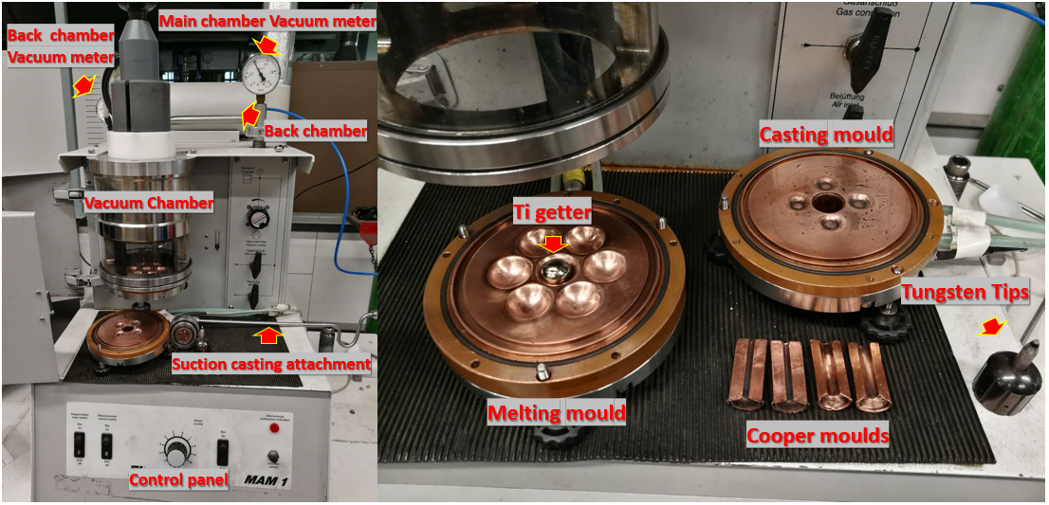
Figure 3-1 Edmund Buhler MAM 1 arc-Melter with the main components presented. The water-cooled copper melting and casting hearths are clearly displayed.

3.1.2 Suction casting
The suction casting set up shown in Fig. 3-1 (right) was used to prepare rod samples for the compressive and tensile tests. Prior to sealing the chamber, a back (secondary) vacuum chamber and copper mould with a designated shape was attached to the casting copper hearth. The back chamber was pumped down to a vacuum of 1×10⁻¹Pa, followed by the pumping of the main chamber. After closing the valve for the back chamber, the vacuum procedure for the main chamber was exactly the same as that chosen for melting. Before casting, high purity argon was refilled into the chamber to 0.3 to 0.7×10⁻¹ Pa (0.3 for low melting point samples, 0.7 for refractory samples) to enable suction casting driven by the pressure difference between the main chamber and secondary chamber. A Ti getter was melted primarily to remove residual oxygen. The arc was then conducted to the sample and the sample was thoroughly melted. Once the sample was in its molten state, the valve for the back chamber was opened to allow the suction of the sample into the water-cooled cooper mould.

3.2 Sample preparation and mechanical testing

3.2.1 Compression testing
All compression and tensile tests were performed on a ZWICK Z050TH materials testing system. For the compression test, samples were prepared from an as-cast rod, which was cast using a 3 mm diameter copper mould. The rods were then sectioned into 6 mm lengths following ASTM E9-89A which set the length-to-diameter ratio for cylindrical metallic bulk compression samples as 2.0 $±$ 0.05. To ensure the surface subjected to the applied stress was vertical to the loading direction, both ends of the sectioned samples were carefully polished using a specific cubic mould and measured with a digital Vernier calliper with accuracy up to 0.005 mm. A 50kN load cell was selected to conduct the compression testing using a strain rate of 1×10⁻⁴ s⁻¹. Crosshead displacement was recorded during testing to calculate the strain occurring on the samples, machine compliance was subtracted from the data to correct the error brought by the machine. For each composition, at least three samples were tested to provide statistical reproducibility of the compressive properties obtained. The engineering stress and engineering strain curves were then converted into true stress and true strain by using the following formulae for compression.
$σ_{tc}=σ_{E}(1-ε_{E})$ (1)
$ε_{tc}=Ln(1-ε_{E})$ (2)
where $σ_{E}$ and $ε_{E}$ are engineering stress and engineering strain, $σ_{tc}$ and $ε_{tc}$ are true stress and true strain for compression test.

3.2.2 Tensile test
For tensile testing, samples were prepared from an as-cast rod cast by using a 4 mm × 5 mm copper mould. These rod samples were encapsulated in quartz tubing with an oxy-acetylene gas torch under a vacuum of 1×10⁻⁵ Pa. The capsules were then homogenised at 1473 K for 2 h in a vacuum furnace pumped to 1×10⁻⁵ Pa. After homogenisation, the samples were quenched with room temperature water. The surfaces of the samples were then ground to remove oxidisation formed during the quenching process. The samples were then rolled with a 70% reduction, after which samples were re-encapsulated and annealed at 1123K for 0.5 h followed by quenching. After grinding their surfaces, samples were then machined following ASTM E8/E8M-13 (subsize) as shown in Fig. 3-2. A 20kN load cell was selected to conduct tensile testing using a strain rate of 1×10⁻⁴s⁻¹. The strain was determined using by a digital camera, by tracking the displacement of two pins which were stuck on the surface of the tensile sample. For each composition, at least three samples were tested to provide statistical reproducibility of the tensile properties obtained. The engineering stress and engineering strain curves were then converted into true stress and true strain by using following formulae for tension[1].
$σ_{tt}=σ_{E}(1+ε_{E})$ (3)
$ε_{tt}=Ln(1+ε_{E})$ (4)
Where $σ_{E}$ and $ε_{E}$ are engineering stress and engineering strain, $σ_{tt}$ and $ε_{tt}$ are true stress and true strain for tensile testing. 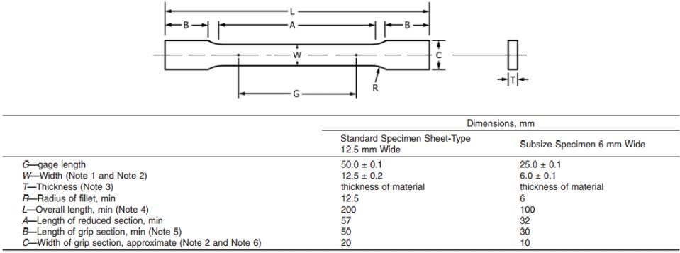
Figure 3-2 Schematic of dog-bone tensile sample for metallic materials following ASTM E8/E8M-13.

3.3 Characterisation methods and sample preparation

3.3.1 X-ray diffraction
X-ray diffraction (XRD) was used for primary determination of the phase constituents for all HEAs tested. As-cast samples were sectioned into 3 mm diameter x 1 mm thickness disks (for compression) or 4 mm × 3 mm x 1 mm coupons (for tension) for XRD analyses. The post-test samples were sectioned into 3 mm diameter x 1 mm thick disks (for compression) or 3 mm × 2 mm x 1 mm thick coupons (for tension) for XRD analyses. All samples were polished up to 1 μm using diamond suspension. XRD tests were conducted on a Bruker D2 Phaser and Siemens D5000 device with Cu radiation. Primary phase identification was conducted on the Bruker D2 Phaser with a 1° /min scan rate and a 0.1° step size; further detailed XRD was performed on the Siemens D5000 with a slower scan rate 0.2° /min and a 0.02° step size. Samples with diffraction angle (2θ) were acquired from 20° to 100° for indexing. The characterisation of XRD for the primary phase was first performed by Buker DIFFRAC.EVA software. This software applied the phase detail obtained from the Crystallography Open Database (COD). TOPAS [2] code was then utilised for Rietveld refinement to identify accurate lattice parameters and phase constituents. It should be noted, that the limits of the current XRD (low intensity) may affect the accuracy in identifying low content phases. This indicates the XRD results in the current work may be more appropriately treated by the qualitative analysis method for phase identification.
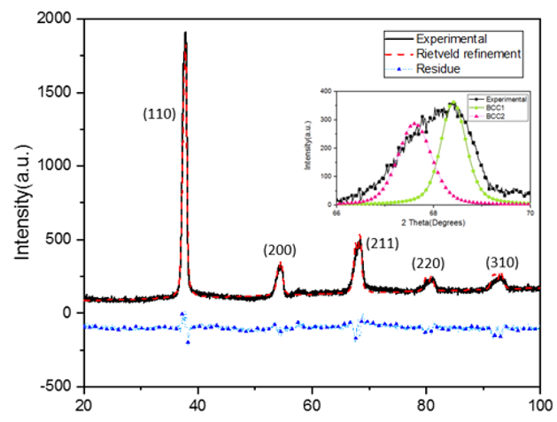
Figure 3-3 XRD Rietveld refinement by TOPAS for as-cast TiZrNbTa HEAs

3.3.2 Scanning Electron Microscopy (SEM) and Electron Back Scattered Diffraction (EBSD)
All samples for scanning electron microscopy (SEM), electron back scattered diffraction (EBSD) and energy-dispersive X-ray spectroscopy (EDS) were prepared by mechanical polishing. Coarse grinding was undertaken with silicon carbide grinding paper ranging from P120 to P4000. Water-based diamond suspension with sizes from 9 μm to 1 μm were used for primary polishing. Fine polishing was conducted with 0.06 μm alumina suspension with H₂O₂ (30% solution) addition with the ratio of 1:20. All samples were then ion polished with a Gatan PECS II ion polishing system under a 3keV condition for 10 minutes to remove possible contamination and residue chemical suspension. The microstructural characterisation of the as-cast samples and deformed samples were performed on a FEI Inspect F50 FEGSEM using a 10 kV accelerating voltage in back scattered mode, while sample surface microstructures were investigated by a second electron detector using a 15 kV accelerating voltage. Twinning identification and phase constituents of deformed as-cast samples were determined on the same FEG-SEM, which fitted with an Oxford Instruments EBSD detector. An accelerating voltage of between 20 kV to 25kV and a spot size of 5.0 was used and quantitative processing was completed using HKL’s Channel5 EBSD post-processing software. Qualitative component analysis for all samples was conducted on Philips XL 30 SEM with an EDS detector. A cobalt standard sample with 99.99% purity was used for calibration before EDS analyses. EDS results were analysed using Oxford Instruments INCA Energy EDS system.

3.3.3 Transmission electron microscopy (TEM) and High Resolution TEM (HRTEM)
The deformation mechanisms and microstructural evolution of samples were analysed by transmission electron microscopy (TEM). For compression tested samples, TEM samples were prepared by sectioning the compression samples into 3 mm diameter x 1 mm thickness disks, grinding the disk to 90 μm thickness, followed by twin-jet electropolishing. For tensile tested samples, TEM samples were prepared by sectioning tensile samples into 3 mm × 3 mm × 1 mm sections and grinding to 90 μm thickness followed by twin-jet electropolishing. The electropolishing was performed by the Struers TenuPol-5 twin-jet electropolishing system with a solution of 5% perchloric acid, 35% 2-butoryethanol and 60% methanol at 233K. The samples were then put into a Gatan Precision Ion Polishing (PIPS II) system for a final clean at 0.3 kV for 5 min to remove possible contamination. Various TEM instruments were utilised to investigate the microstructure and deformation mechanisms evolution of the tested samples. For low magnification imaging and selected area diffraction patterns (SADP), a Philips EM 420 TEM with an accelerating voltage of 120kV and a FEI Tecnai 20 TEM with an accelerating voltage of 200kV were used. For nano-scale characterisation, a JEOL-2010F high-resolution TEM (HRTEM) with an accelerating voltage of 200kV were used. High-resolution microstructural characterisation was performed on a Titan 80/300 HRTEM with a Cs aberration (image) corrector. This characterisation performance gave 70 pm for the information limit and JEOL-R005 Cs aberration corrected HRTEM with an accelerating voltage of 300kV (~90pm). All TEM images were primarily post-processed with Gatan digital micrograph software. Various filter scripts were applied to reduce imagine noise as shown in Fig. 3-4 before and after processing of an HRTEM image. The SADP indexation was accomplished with CrysTBox[3], PTCLab[4] and MATLAB.
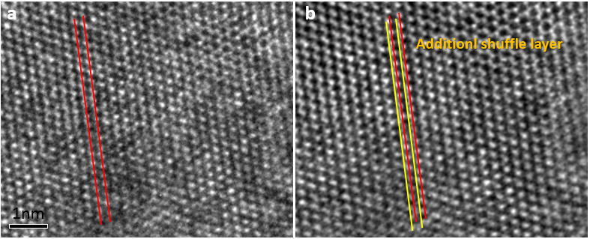
Figure 3-4 HRTEM image before and after processing. (a) Raw HRTEM image of martensite structure. Orthorhombic structure taken along [112]_{α’’} zone axis; and (b) Wiener filtered HRTEM of martensite structure. Orthorhombic structure taken along [112]_{α’’} zone axis.

3.4 References
[1] Z.L. Zhang, M. Hauge, J. Ødegård, C. Thaulow, Determining material true stress-strain curve from tensile specimens with rectangular cross-section, Int. J. Solids Struct. (1999). doi:10.1016/S0020-7683(98)00153-X.
[2] J. Perl, J. Shin, J. Schümann, B. Faddegon, H. Paganetti, TOPAS: An innovative proton Monte Carlo platform for research and clinical applications, Med. Phys. (2012). doi:10.1118/1.4758060.
[3] M. Klinger, A. Jäger, Crystallographic Tool Box ( CrysTBox ): automated tools for transmission electron microscopists and crystallographers , J. Appl. Crystallogr. (2015). doi:10.1107/s1600576715017252.
[4] X.-F. Gu, T. Furuhara, W.-Z. Zhang, PTCLab : free and open-source software for calculating phase transformation crystallography , J. Appl. Crystallogr. (2016). doi:10.1107/s1600576716006075.

Chapter 4: Design of ductile BCC stable RHEAs

4.1 Preface
HEAs are characterised by equimolar multi-principal components which had leaded to their unique structural and functional properties. As such, these materials have attracted significant attention over the past decades [1–4]. The ductile solid solution phases present in HEAs are thought to be stabilised at high temperatures as a function of their intrinsically high configurational entropy. In particular, a group of HEAs which primarily consist of group IV, V and VI refractory elements, were observed to be stable and ductile at temperatures over 1873K and have been given the sub-class of RHEAs [5–7]. In contrast to Ni-based superalloys (operational temperature ranges of 873-1073K) and HEAs whose principal components are mainly from group VI-XI elements, the lattice structure of most RHEAs are body-centric cubic (BCC) instead of face-centred cubic (FCC)[7]. As a precondition for deformation, at least five independent slip systems are required for ductility in a polycrystalline material [8,9]. When compared to the 12 slip systems present for the FCC structure, the BCC structure possesses 48 slip system. However, due to the lack of close-packed planes, the critical-resolved shear stress (CRSS) required to activate slip systems in BCC materials is much higher than that required in FCC materials, α(BCC)-iron and γ-iron. As a result, for RHEAs possessing mainly BCC phases, limited ductility at room temperatures was observed, hence limiting their application [7]. Therefore, in order to overcome this limitation and produce RHEAs with increased ductility, there is a requirement to design RHEAs with a ductile BCC matrix.
In general, the mechanical performance of certain alloys can be directly reflected through their elastic constants. Main works have been conducted to investigate the elastic properties of RHEAs and subsequently used to predict their mechanical performance. From the comparison of ab initio simulated results with experimental results, elasticity isotropic RHEAs were predicted to have greater ductility than elastically anisotropic RHEAs [10–12]. Using the EMTO-CPA method, several ductile elastic isotropic RHEAs including TiZrNbMo_{0.8}V_{0.5} [13] and TiVNbMoAl_{0.4} [14], were successfully designed and tested. However, as previously discussed in the literature review, even with the use of the EMTO-CPA method, the selection and optimisation of RHEAs composition is difficult when conducted on a range of candidates where over 30 elements can be chosen as components. Therefore, a simple semi-empirical method is required for the primary selection of RHEAs, prior to optimisation by ab initio methods. There are a number of parameters that can be applied as semi-empirical criteria, for the predictions of mechanical performance of certain RHEAs. Findings from previous ab initio investigations revealed that the mechanical performance of BCC RHEAs is directly related to their electronic environment. This is due to the fraction of localised bonding, which may be determined by electron density of states (DOS), that affects the elasticity in RHEAs [10–12,15,16]. Moreover, in the work of Dominguez et al.,[17], principal component analysis (PCA) was used to obtain the most effective variables to determine phase formation of HEAs. These were reported as mixing enthalpy, valence electron concentration (VEC) and electronegativity. The mixing enthalpy was acquired by using the Mediema model and involves a variety of fusion effects. These include volumetric interaction between solute and solvent atoms, electron charge redistribution at the Wigner-Seitz radius and total chemical potential change for an electronic charge. The determination of these variables results in the effectiveness of predicting the localisation level of chemical bonding within the material [18,19]. The bond localisation extent is directly related to the mechanical performance of metallic materials and a new parameter was proposed as a refinement of mixing enthalpy, in order to assist in the prediction of phase formation and mechanical performance of potential HEAs. The method was also applied through a binary formation enthalpy dataset (derived from ab initio calculations) to obtain a comparison with the semi-empirical mixing enthalpy deviation. By conducting a biplot of mixing enthalpy and formation enthalpy standard deviation against VEC, the relationship between these parameters and their effects on RHEAs phase formation are discussed in the following sections. Two ductile quaternary equimolar RHEAs TiZrNbTa and TiZrHfTa were developed and assessed by both experiments and ab initio calculations, to prove the effectiveness of this method in predicting phase formation.

4.2 Analysis of the relationship between semi-empirical parameter: Mixing/formation enthalpy standard deviation, VEC.
Currently, to satisfy the application requirements and balance cost of production, most HEA systems possess alloying elements including Al, Sc, Ti, V, Cr, Mn, Fe, Co, Ni, Cu, Y, Zr, Nb, Mo, Hf, Ta, W, and Re. Meanwhile, for reinforcement, minor additions of Si and C were reported to enable precipitate strengthening and interstitial strengthening in HEAs[7]. However, in the current work, together with the rare elements, to reduce the number of possible HEAs candidates, these non-metallic elements and precious metallic elements were excluded due to the considerations previously outlined. With the removal of these elements, the number of possible alloy combinations is still large, as four principal component HEAs enable 2,380 equimolar combinations; and for five components, these combinations increase to 6,188. To distinguish phase formation and predict mechanical performance of candidate HEAs, criteria are required to describe the extent of localisation bonding. The Miedema method is based on the Pauling method, whereby formation enthalpy is taken to be proportional to the square of electronegativity difference. By taking the electron charge density redistribution at the Wigner-Seitz boundary into consideration, the extent of localisation bonding of a certain alloy system may be determined by the value of mixing enthalpy. This was shown to be effective in predicting the phase formation in binary and ternary alloy systems in the last decades. Moreover, it was extended to predict amorphous phase formation in multi-component bulk metallic glass (BMG). However, the successful application of this method reaches a boundary, due to the contraint on the experimental work function used to calculate charge transfer. The constraint on the experimental work function was summarised as being a result of the differences in the component’s valence d-electrons, as reported by Pettifor [20]. Applying a tight binding approximation, the phase formation of binary alloys is linked to the deviation in the ratio between theoretically derived mixing enthalpy, difference in the number of valence d-electrons squared and mean number of valence d-electrons. By substituting the mixing enthalpy derived from the tight binding approximation as a variation of the average Pauling electronegativity value with a correction factor, Leong et al. [21] described the success of utilising a mixing enthalpy and VEC biplot in the prediction of phase formation in HEAs. Based on previous work regarding the influence of mixing enthalpy on the prediction of phase formation of HEAs, the outcome was to minimise the effect of this term and refine the accuracy of the prediction of phase formation for HEAs. Thus, focusing on the mixing enthalpy, to represent the overall localisation extent of the system the mixing enthalpy deviation is taken into consideration.
In the current work, to concisely evaluate the electronic environment of the potential HEA candidates and further investigate the influence of mixing enthalpy deviation on the mechanical performance of the HEAs investigated, a new parameter called enthalpy standard deviation ($σ$) was determined. This parameter was used to describe the extent of bonding localisation of HEA candidates, as:
$σ=\sqrt{\frac{\sum_{i=1}^{n}{(H_{i}-\overline{H})^{2}}}{n-1}}$ (1)
where, n is the number of binary combinations of principal components, $H_{i}$ is the mixing/formation enthalpy value of the i^{th} binary element combination and $\overline{H}$ is the mean mixing/formation enthalpy value among n combinations. By substitution of mixing enthalpy or formation enthalpy values into eq. 1, the overall deviation in the extent of bonding localisation is calculated by the value of $σ$. The difference of mixing enthalpy within every two components in current equimolar HEAs systems, refers to the difference in electronegativity which directly determines the type of bonding involved. By judging the mixing enthalpy dispersion in the system, the extent of localisation bonding can be approximately determined. A higher degree of mixing enthalpy dispersion results in a more localised electronic environment, to attract electrons to form complex phases (intermetallic phases) rather than simple phases (solid solution phases) [22–24]. Considering previous work where VEC was used to predict phase formation in HEAs, utilising both empirical and quantum-mechanics methods, the latter showed a higher precision in determining phase formation through the simulation of electronic environment [25]. Accordingly, both classical mixing enthalpy derived from the Miedema model [26] and ab initio formation enthalpy dataset [27] were substituted into eq. 1 to compare the classical Miedema model and high throughput first principals method in predicting the electronic environment of potential HEAs systems. In Fig. 4-1(a-b), the biplots of mixing enthalpy deviation ($σ_{∆H_{mixing}}$) and formation enthalpy deviation ($σ_{∆H_{formation}}$) against VEC were constructed to clarify the phase formation of 65 reported equal-atomic HEAs. It is evident that the simple solid solution BCC phase of RHEAs is concentrated at the low enthalpy deviation zone between 4 < VEC < 5.5 for both the mixing and formation enthalpy datasets. For simple solid solution FCC 3d transition group HEAs, the range was 7.6 < VEC < 9.5. Noteworthy, for both refractory HEAs and 3d transition HEAs, regardless of the lattice structure, the simple solid solution phase had a preference to form in the low mixing/formation enthalpy deviation zone which indicated the mixing/formation enthalpy deviation was helpful in clarifying the formation of solid solution phases and complex intermetallic phases. Meanwhile, in the bottom panel of Fig.4-1 (a-b) a smoothed probability density distribution (PDF) function of the distribution of mixing enthalpy deviation and formation enthalpy deviation were calculated using ‘Kernel mixture Distribution function’ by MATLAB following the expression:
${\hat{f}}_{h}\left(x\right)=\frac{1}{nh}\sum_{i=1}^{n}{K(\frac{x-x_{i}}{h})}$ (1)
where x_{1~n} are random data from an unknown distribution, n is the data size while K is the Kernel smoothing function, and h is the bandwidth which is estimated by mean of Sliverman’s normal distribution approximation as:
$h=1.06 \hat{σ}n^{-0.2}$ (2)
where $\hat{σ}$ is the standard deviation of the dataset. The calculated bandwidth for the mixing enthalpy deviation and formation enthalpy deviation were determined as 2.0978 and 38.4 respectively. In the two PDF landscapes exhibited in Figure. 4-1(a-b) bottom panel, the PDF determined independently of VEC, the simple solid solution FCC phase and BCC phase HEAs distributions exhibited significant overlap and partially overlapped with the distribution area of the complex intermetallic phases HEAs. In comparison with the PDF-mixing enthalpy deviation landscape, in the PDF-formation enthalpy deviation biplot, the highlighted simple solid solution phase (FCC and BCC) HEAs distribution is more concentrated and only has limited overlapped area with the complex intermetallic HEAs distribution areas. Showing the formation enthalpy deviation value is more effective in determining phase complexity of HEAs, which in turn proved the ab-initio simulation is more effective as a method to optimise the precision of the empirical method. Overall, with the boundary between complex intermetallic phases and simple solid solution phases being 5.94 for mixing enthalpy deviation and 104.7 for formation enthalpy deviation, both the PDF of mixing and formation enthalpy deviation maps showing obvious discrimination between simple solid solution and complex intermetallic phases. This is in agreement with the previous discussion that described the potential of using mixing/formation enthalpy as an empirical parameter to predict the bond localisation extent of HEAs candidates.
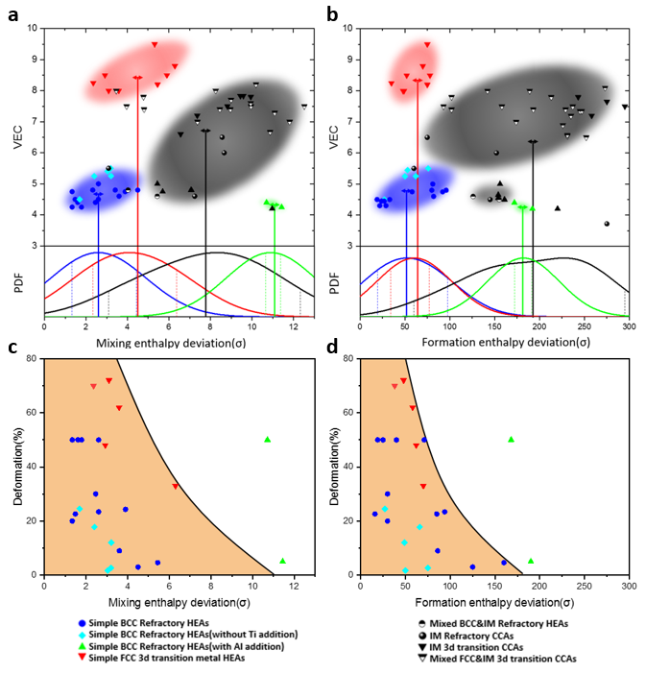
Figure 4-1 (a) biplot of mixing enthalpy deviation towards VEC; bottom panel is PDF of BCC, FCC, intermetallic and Al contained HEAs. (b) biplot of formation enthalpy deviation towards VEC; bottom panel is PDF of BCC, FCC, intermetallic and Al contained HEAs. (c) biplot of mixing enthalpy deviation against deformation during compression testing (RHEAs tested until failure) and deformation during tensile testing (3d transition HEAs tested until failure); and (d) biplot of formation enthalpy deviation against deformation during compression testing (RHEAs tested until failure) deformation during tensile testing (3d transition HEAs tested until failure).
When comparing σ with VEC, it appears VEC is more useful in predicting the overall lattice structure formation in Fig. 4-1(a-b). In Fig. 4-1(a-b), the distribution of simple solid solutions and complex intermetallic phases may be more evident in Fig. 4-1(b), where formation enthalpy deviation was derived by ab initio methods, in comparison with Fig. 4-1(a) where the mixing enthalpy deviation was determined by the empirical Miedema model. As the extent of bond localisation directly influences the mechanical performance of certain HEAs, 24 compositions (from the original 65) with their mechanical performance data are further analysed in order to distinguish the effects of mixing/formation enthalpy deviation in mechanical performance of HEAs. In Fig. 4-1(c-d) biplots of the compressive strain deformation against mixing/formation enthalpy deviation were constructed for 19 RHEAs and 5 3d transition HEAs. As discussed previously, elastic isotropy is very important in determining the mechanical performance of HEAs. Thus, HEAs with low localised bonding electric structures may have a preference to form a more ductile material, in comparison with HEAs possessing high localised bonding electronic structures [11]. As observed in Fig. 4-1(c-d), the overall trends show that HEAs possessing low mixing/formation enthalpy deviation have greater ductility. Although this criterion is useful, it is thought that there are other parameters interplaying which contribute to the observed trends and current enthalpy deviation can only be applied as a primary screening criterion for selecting simple solid solution HEA compositions. As shown in Fig. 4-1(c-d) and listed in the figure legend, the trend of distribution of deformation strain against mixing/formation enthalpy deviation is more defined when considering each group of HEAs by their components. When isolating each particular group of materials (3d transition HEAs, RHEAs with Ti addition, RHEAs with Al addition and RHEAs with only 4d and 5d elements), the trend of mixing/formation enthalpy deviation appears to be approximately linear. Interestingly, this indicates that an effect of periodicity in deviations may also be evident when determining the mechanical performance of HEAs.

4.3 Phase constitution and mechanical performance of TiZrNbTa and TiZrHfTa.
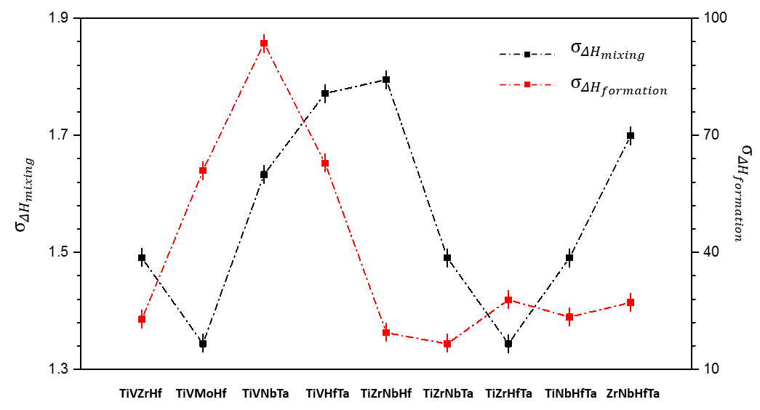
Figure 4-2 Miedema mixing enthalpy standard deviation $σ_{∆H_{mixing}}$ and formation enthalpy (ab initio) standard deviation $σ_{∆H_{formation}}$of 9 selected RHEAs compositions.
Primary screening of stable BCC RHEAs candidates was conducted through applying the critical criteria of 4 < VEC < 5.5, $σ_{ΔH_{mixing}}$ < 3 and $σ_{ΔH_{formation}}$< 100. By restricting the principal components to the elements Al, Sc, Ti, V, Cr, Mn, Fe, Co, Ni, Cu, Y, Zr, Nb, Mo, Hf, Ta, W, and Re, only 9 compositions were selected from 2380 possible quaternary compositions that satisfy the preconditions listed above. Both values of $σ_{ΔH_{mixing}}$ and $σ_{ΔH_{formation}}$ were calculated for the 9 screened compositions in Fig. 4-2. Among them, both TiVNbTa and TiZrHfNb compositions [3,28] were previous reported to be stable BCC RHEAs with good ductility (ε > 20%) and high strength (UTS > 1GPa) which suggests the potential discovery of novel ductile RHEAs within the 9 compositions. Of these, to verify the effectiveness of utilising $σ_{ΔH_{mixing}}$ and $σ_{ΔH_{formation}}$ in selecting ductile RHEAs with equiatomic compositions, two quaternary RHEAs were chosen for development: The first was TiZrNbTa which possessed the smallest formation enthalpy deviation among all possible quaternary HEA combinations; the second was TiZrHfTa (substituting Nb with Hf) which had the smallest mixing enthalpy deviation. These RHEAs were synthesised via arc-melting and the as-cast samples of TiZrNbTa and TiZrHfTa were characterised by XRD and SEM to determine the phase formation as detailed in Chapter 3.
Fig. 4-3(a-b) presents XRD patterns of TiZrNbTa and TiZrHfTa, respectively. As can be observed, only the BCC phase was identified, and this indicated that using formation enthalpy deviation to predict the phase formation was effective for these RHEAs. When comparing the diffraction patterns of both materials, the XRD peak of TiZrNbTa showed asymmetry and broadening (see Fig 4-3 (a) and inset). By conducting Rietveld refinement, the similar lattice parameters of two BCC phases were indexed forTiZrNbTa. These were BCC1 with a = 0.3359nm and BCC2 with a = 0.3394nm. In Fig. 4-3 (b) only the single BCC phase was indexed for TiZrHfTa. With the substitution of Nb (r_{Nb}=0.147nm) with Hf (r_{Hf}=0.159nm), the lattice expands slightly from a = 0.3394nm (TiZrNbTa) to a=0.3441nm (TiZrHfTa), while the resultant phase formation does not change. Although Ti, Zr and Hf are all HCP stabilising elements at room temperature, it is evident that with Ta addition, the phase formation is BCC instead. Such a phenomenon is similar to the effect of β stabilisers in metastable β Ti alloys. Therefore, it can be postulated that the mechanical and physical properties of this RHEA may also be tunable, as observed in metastable β-Ti alloys. The microstructure of TiZrNbTa and TiZrHfTa materials imaged by SEM are shown in Fig. 4-3(c-d). Both TiZrNbTa and TiZrHfTa exhibit equiaxed dendritic microstructures, however, from backscattered electron images, compositional segregation is evident in both the as-cast TiZrNbTa and TiZrHfTa. In addition, a needle-like structure was observed in the dark regions of TiZrHfTa in Fig. 4-3(d). This may indicate the formation of a new phase during solidification, for microstructures possessing heavier elements (Hf or Ta). As no visible peak was detected in Fig. 4-3(a-b), the phase composition of this new phase appears to be very low.
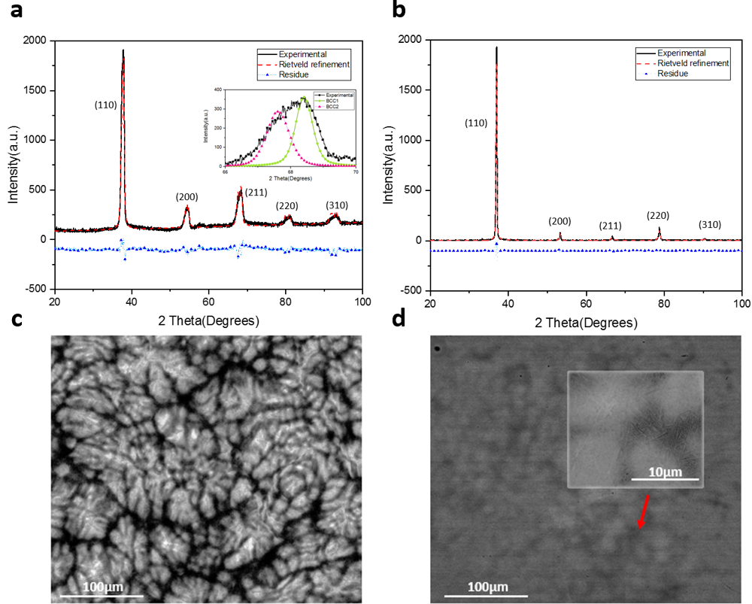
Figure 4-3 Microstructure of as-cast TiZrNbTa and TiZrHfTa. (a-b) XRD patterns and Rietveld refinement of as-cast condition equal-molar TiZrNbTa and TiZrHfTa, respectively. Peaks are marked with Miller indices of BCC phase. Inset in (a) shows two BCC phases indexed for TiZrNbTa; (c) backscattered electron image of TiZrNbTa with composition segregation observed; and (d) backscattered electron image of TiZrHfTa with composition segregation also identified. Insets show needle-like structures observed at dark regions of the image.
In order to identify the formation of this new phase and the possible composition segregation in TiZrNbTa and TiZrHfTa, TEM and EDX were conducted on both as-cast samples. In Fig. 4-4(a) the TiZrNbTa EDX shows chemical variance, while the dark region was identified as rich in Zr and low in the heavy element Ta. While in the TiZrHfTa EDX, the dark region was identified as rich in Zr and Ti. When examining the TEM image of TiZrNbTa in Fig. 4-4(b), it is evident that only the BCC phase was detected. When replacing Nb with Hf the overall phase constitution remains as BCC, however, phase separation was observed in the EDX map as shown in Fig. 4-4(c). The needle-like structure found in the dark regions of TiZrHfTa is low in Ta and Hf. This chemical difference may result in geneartion of a new phase, as indexed from the TEM image of TiZrHfTa in Fig. 4-4(d). The selected area diffraction pattern (SADP) of the BCC phase was observed along the [0-11]_{β} zone axis and an additional set of DP was also found. When considering TiZrHfTa, elements including Ti, Zr and Hf are all IVB elements; whilst only Ta is a VB element. Such an arrangement is quite similar to metastable β Ti alloys. Whereby, it has been detailed previously that through tuning the additions of β stabilisers, usually the VB and VIB elements, the metastable martensite phase may form [29–31].
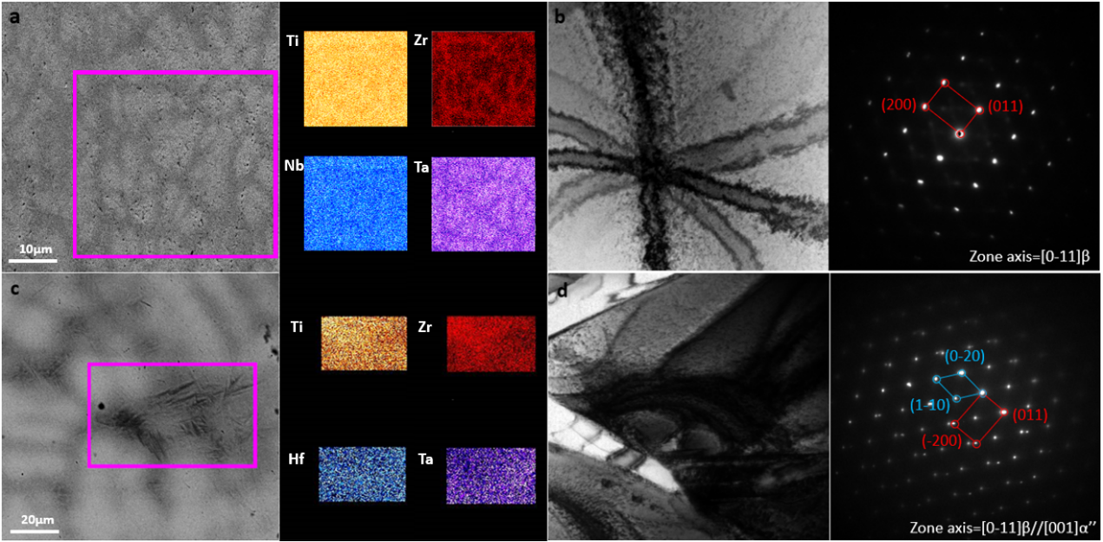
Figure 4-4 Microstructure and chemical analysis of as-cast TiZrNbTa and TiZrHfTa (a) Backscattered image and EDX composition maps of as-cast TiZrNbTa sample. (b)Brightfield image and corresponding SADP of as-cast TiZrNbTa. (c) Backscattered image and EDX composition maps of as-cast TiZrHfTa. (d) Brightfield image and corresponding SADP of as-cast TiZrHfTa, two different structures, α’’ and β are marked with cyan and red colour respectively.
The SADP in Fig. 4-4(d) was recorded at the needle-like microstructure of deformed as-cast TiZrHfTa and in addition to the BCC structure, an orthorhombic structure was indexed. Therefore, it appears that with a reduction of Ta content, the martensite phase formed in these RHEAs. The mechanical performance of both quaternary RHEAs were characterised via compression testing. Both TiZrNbTa and TiZrHfTa exhibited high yield strengths of 1002MPa and 996MPa and good compressive ductility of 44.2% and 22.8% (Fig. 4-5). The solid solution strengthening is not obvious after the substitution of Nb by Hf. Both Nb and Hf can be regarded as a solutes in the pseudo-TiZrTa matrix and with the obvious difference in atomic size, the substitution does not activate distortion elastically within the lattice [28]. Without this lattice distortion, the formation of the local stress field induced by distortion was not expected and this was evidenced by the similar values measured for yield strength and ultimate compressive strength. However, with the substitution of Nb by Hf, the increase in formation enthalpy deviation has corresponded to an approximate 50% loss of ductility compared with TiZrNbTa. This observation appeared to correspond to the proposed use of formation enthalpy deviation as shown in Fig. 4-1, showing the potential effectiveness of using this method to select ductile RHEAs.
Another interesting observation shown in Fig. 4-5, is the increase in strain hardening capability for TiZrHfTa compared with TiZrNbTa. After substitution of Nb with Hf, it was evident that the rate at which stress increases from yield stress to ultimate compressive stress was greater than TiZrNbTa, indicating the increase in strain hardening. Therefore, when considering the indexing of the martensitic phase in Fig. 4-4 and the potential influence this has appeared to have on the compressive properties (high strain hardening, lower ductility), it appears that this could be attributed to the activation of transformation induced plasticity in TiZrHfTa. This finding may aid in the introduction of more deformation mechanisms in RHEAs, through subtle elemental changes and can be further used to design ductile RHEAs.
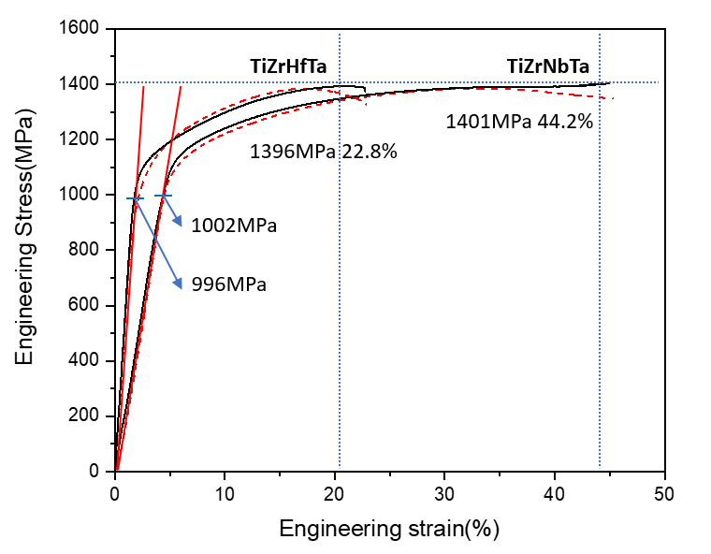
Figure 4-5 Compression testing results of TiZrNbTa and TiZrHfTa. The engineering stress and engineering strain curve of TiZrNbTa, showing yield stress and ultimate compressive stress marked with blue solid and dashed lines, respectively; and the engineering stress and engineering strain of TiZrHfTa, showing yield stress and ultimate compressive stress marked with blue solid and dashed lines.

4.4 Discussion
This discussion aims to understand the underlying mechanism that has led to the difference in mechanical performance during compressive loading as observed between TiZrNbTa and TiZrHfTa. The electronic structure of both RHEAs is shown in Fig. 4-6 and the electronic density of states (DOS) of pure BCC Ti, Zr, Hf, Nb and Ta are observed. In contrast with Nb and Ta, whose stable phase is BCC at room temperature (RT), the stable structure for Ti, Zr and Hf at RT is HCP and the peak of the DOS at the Fermi level (E_{f}) for these three elements remains higher compared with BCC stable elements. Considering the total density of states (TDOS) of TiZrNbTa and TiZrHfTa, to determine the stabilisation of their lattice structure, the peak split around E_{f} is an important feature. The peak split induced by lattice distortion may shift states to a higher energy level, which results in a decrease of single electron energy [11,16].
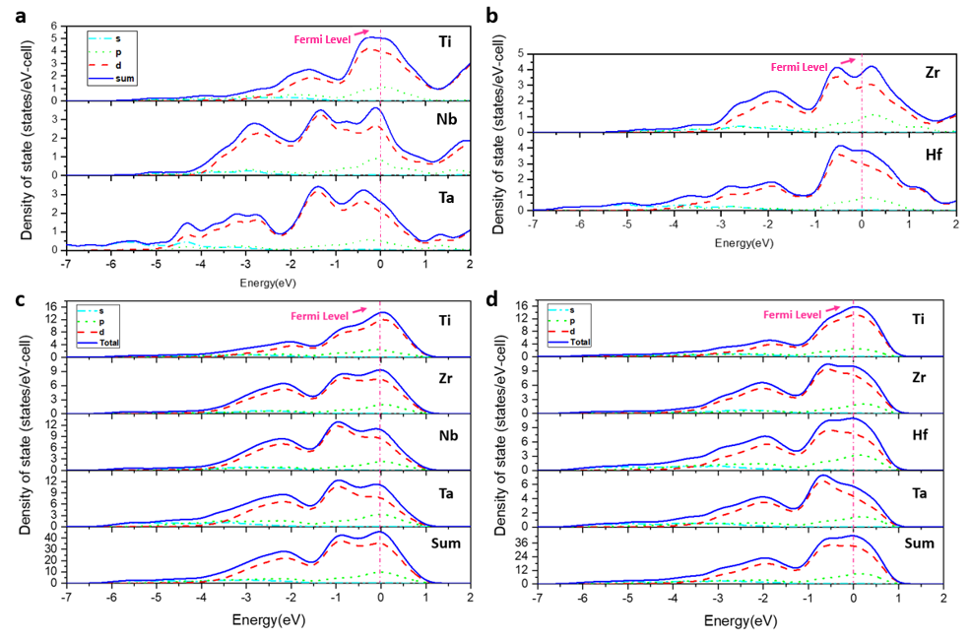
Figure 4-6 The density of states (DOS) of different BCC structure materials (a-b) total and partial density of states of pure BCC metallic Ti, Zr, Hf, Nb, Ta; and (c-d) total and partial density of states for BCC TiZrNbTa and TiZrHfTa refractory HEAs. Fermi energy level is marked with a vertical pink dash line.
The pseudogap is used to describe the partial energy gap possessed by the Fermi surface of a system. This was used to determine the phase stabilisation of the selected system, since the Fermi surface is derived by the consideration of periodicity and symmetry. This energy balance can be further extended to determine the relation between the energy change of the electrostatic energy and kinetic energy, which can also be used to inform the stability of the lattice structure. Following this, when analysing the TDOS and PDOS of TiZrNbTa, TiZrHfTa and their pure components, in contrast with IVB elements (Ti, Zr Hf) the trends in DOS at the Fermi level for Nb and Ta are shown to decline with the increase of energy. In comparison with the DOS of pure components, the DOS of TiZrNbTa and TiZrHfTa are smoothed over by chemical disorder of HEAs which indicates that the effect of lattice distortion may not be useful in the current RHEAs systems. Reviewing the PDOS of TiZrNbTa and TiZrHfTa components and comparing these with the DOS of their pure components, the shape of PDOS of Ti, Zr, Hf ,Ta changed most in TiZrHfTa, whilst the DOS of Ti, Zr, Nb, Ta were similar to the PDOS in TiZrNbTa. In contrast with TiZrNbTa whose d electrons contributed most to the DOS peak at the Fermi level, for TiZrHfTa the p states also contribute to the peak near to the Fermi level as a result of Hf substitution and are considered as the main factor to cause the shift in the peak to the Fermi level. As shown in Fig. 4-6(c-d) for both TiZrNbTa and TiZrHfTa the PDOS of Ti and Zr contributed most to the peak of the TDOS at the Fermi level. However, with the replacement of Nb by Hf, the Fermi level shifts from the descending zone to the peak when compared with TiZrNbTa. This ultimately leads to structural instability of TiZrHfTa.
This observation may also correlate with the activation of the martensite phase in TiZrHfTa, as the origin of orthorhombic martensite is induced by instability towards deformation on the {011}_{β} plane (smaller C’=(C₁₁-C₁₂)/2) [29]. Considering the Fermi energy level represents the highest kinetic energy of a particle at zero K condition (chemical potential), the change of Fermi level will partially reflect the variation of the electronic structure in the system at zero K. While in previous research, using the tight binding approximation, Pettifor [32] rearranged the consideration of Miedema's mixing enthalpy with deliberation relating to band filling of d-electrons and attractive and repulsive contributions. Leong et al. [21] further extended the theory by approximating the expression of mixing enthalpy with Pauling electronegativity, which correlated the meaning of mixing enthalpy and electronegativity. Thus, the meaning of mixing/formation enthalpy standard deviation can be summarised as a value to help inform the electronic environment in a selected system, where the extent of localisation bonding can be approximated when comparing this parameter. In conclusion, with smaller formation enthalpy deviation, the PDOS of each component inherited the characteristics of the DOS of their pure elements for TiZrNbTa. The PDOS of both Nb and Ta at the Fermi level is located at the descending zone for TiZrNbTa. Hence this results in higher structural stability compared with TiZrHfTa. For TiZrHfTa, the substitution of Nb with Hf not only increased the formation enthalpy deviation, but also resulted in the decrease of lattice stability towards deformation.

4.5 Conclusions
In this chapter, a new empirical parameter mixing/formation enthalpy deviation was introduced, which can be applied to distinguish the formation of simple solid solution phases and complex intermetallic phases of HEAs. The relationship of VEC and mixing/formation enthalpy deviation against phase formation were analysed through 67 (65+2) Cantor-type equal-molar multi-components HEAs. After analysing the phase formation of these HEAs against mixing/formation enthalpy deviation, two RHEAs (TiZrNbTa and TiZrHfTa) were synthesised to help understand the relationship between mixing/formation enthalpy deviation and mechanical performance (compressive properties). Both TiZrNbTa and TiZrHfTa exhibited a satisfactory combination of strength and flexibility. Using XRD, SEM, EDX and TEM, the microstructure of as-cast TiZrNbTa and TiZrHfTa were analysed. In contrast with BCC stabilised TiZrNbTa, through the substitution of Nb by Hf, a martensitic phase was discovered in TiZrHfTa. To understand the underlying mechanism of transformation occurring to produce this martensite phase, using ab initio tools (CASTEP and ATAT), the electronic structure of TiZrNbTa and TiZrHfTa were simulated and analysed. The DOS analyses enabled the tuning of the phase stability of RHEAs by tailoring specific components. This aided in determining the effectiveness of using formation enthalpy standard deviation in the design of BCC stable RHEAs. In a similar fashion to the effect of β stabiliser in metastable Ti alloy, multi-deformation mechanisms may be introduced into RHEAs to increase their mechanical performance. Hence, with the use of semi-empirical parameter of formation enthalpy deviation in concert with ab initio tools, a new series of RHEAs possessing TRIP and TWIP characteristics may potentially be designed.

4.6 References
[1] B. Gludovatz, A. Hohenwarter, D. Catoor, E.H. Chang, E.P. George, R.O. Ritchie, A fracture-resistant high-entropy alloy for cryogenic applications, Science (80-. ). (2014). doi:10.1126/science.1254581.
[2] T. Yang, Y.L. Zhao, Y. Tong, Z.B. Jiao, J. Wei, J.X. Cai, X.D. Han, D. Chen, A. Hu, J.J. Kai, K. Lu, Y. Liu, C.T. Liu, Multicomponent intermetallic nanoparticles and superb mechanical behaviors of complex alloys, Science (80-. ). (2018). doi:10.1126/science.aas8815.
[3] Z. Lei, X. Liu, Y. Wu, H. Wang, S. Jiang, S. Wang, X. Hui, Y. Wu, B. Gault, P. Kontis, D. Raabe, L. Gu, Q. Zhang, H. Chen, H. Wang, J. Liu, K. An, Q. Zeng, T.G. Nieh, Z. Lu, Enhanced strength and ductility in a high-entropy alloy via ordered oxygen complexes, Nature. (2018). doi:10.1038/s41586-018-0685-y.
[4] Z. Li, K.G. Pradeep, Y. Deng, D. Raabe, C.C. Tasan, Metastable high-entropy dual-phase alloys overcome the strength-ductility trade-off, Nature. (2016). doi:10.1038/nature17981.
[5] O.N. Senkov, G.B. Wilks, D.B. Miracle, C.P. Chuang, P.K. Liaw, Refractory high-entropy alloys, Intermetallics. (2010). doi:10.1016/j.intermet.2010.05.014.
[6] J. Chen, X. Zhou, W. Wang, B. Liu, Y. Lv, W. Yang, D. Xu, Y. Liu, A review on fundamental of high entropy alloys with promising high–temperature properties, J. Alloys Compd. (2018). doi:10.1016/j.jallcom.2018.05.067.
[7] O.N. Senkov, D.B. Miracle, K.J. Chaput, J.P. Couzinie, Development and exploration of refractory high entropy alloys - A review, J. Mater. Res. (2018). doi:10.1557/jmr.2018.153.
[8] A.H. Cottrell, Theory of dislocations, Prog. Met. Phys. (1953). doi:10.1016/0502-8205(53)90018-5.
[9] M.A. Meyers, O. Vöhringer, V.A. Lubarda, The onset of twinning in metals: A constitutive description, Acta Mater. (2001). doi:10.1016/S1359-6454(01)00300-7.
[10] P. Cao, X. Ni, F. Tian, L.K. Varga, L. Vitos, Ab initio study of AlxMoNbTiV high-entropy alloys, J. Phys. Condens. Matter. (2015). doi:10.1088/0953-8984/27/7/075401.
[11] F. Tian, L.K. Varga, N. Chen, J. Shen, L. Vitos, Ab initio design of elastically isotropic TiZrNbMoVx high-entropy alloys, J. Alloys Compd. (2014). doi:10.1016/j.jallcom.2014.01.237.
[12] F. Tian, L. Delczeg, N. Chen, L.K. Varga, J. Shen, L. Vitos, Structural stability of NiCoFeCrAlx high-entropy alloy from ab initio theory, Phys. Rev. B - Condens. Matter Mater. Phys. (2013). doi:10.1103/PhysRevB.88.085128.
[13] Y. Zhang, X. Yang, P.K. Liaw, Alloy design and properties optimization of high-entropy alloys, JOM. (2012). doi:10.1007/s11837-012-0366-5.
[14] S.Y. Chen, X. Yang, K.A. Dahmen, P.K. Liaw, Y. Zhang, Microstructures and crackling noise of AlxNbTiMoV high entropy alloys, Entropy. (2014). doi:10.3390/e16020870.
[15] F. Tian, L.K. Varga, J. Shen, L. Vitos, Calculating elastic constants in high-entropy alloys using the coherent potential approximation: Current issues and errors, Comput. Mater. Sci. (2016). doi:10.1016/j.commatsci.2015.09.058.
[16] F. Tian, L.K. Varga, L. Vitos, Predicting single phase CrMoWX high entropy alloys from empirical relations in combination with first-principles calculations, Intermetallics. (2017). doi:10.1016/j.intermet.2016.12.007.
[17] L.A. Domínguez, R. Goodall, I. Todd, Prediction and validation of quaternary high entropy alloys using statistical approaches, Mater. Sci. Technol. (2015). doi:10.1179/1743284715Y.0000000019.
[18] M.X. Ren, B.S. Li, H.Z. Fu, Formation condition of solid solution type high-entropy alloy, Trans. Nonferrous Met. Soc. China (English Ed. (2013). doi:10.1016/S1003-6326(13)62557-1.
[19] H.A. Murdoch, C.A. Schuh, Estimation of grain boundary segregation enthalpy and its role in stable nanocrystalline alloy design, J. Mater. Res. (2013). doi:10.1557/jmr.2013.211.
[20] D.G. Pettifor, A Quantum-Mechanical Critique of the Miedema Rules for Alloy Formation, Solid State Phys. - Adv. Res. Appl. (1987). doi:10.1016/S0081-1947(08)60690-6.
[21] Z. Leong, Y. Huang, R. Goodall, I. Todd, Electronegativity and enthalpy of mixing biplots for High Entropy Alloy solid solution prediction, Mater. Chem. Phys. (2018). doi:10.1016/j.matchemphys.2017.09.001.
[22] D.J. Thouless, Electrons in disordered systems and the theory of localization, Phys. Rep. (1974). doi:10.1016/0370-1573(74)90029-5.
[23] U. Häussermann, S. Wengert, P. Hofmann, A. Savin, O. Jepsen, R. Nesper, Localization of Electrons in Intermetallic Phases Containing Aluminum, Angew. Chemie Int. Ed. English. (1994). doi:10.1002/anie.199420691.
[24] D. Nguyen-Manh, D.G. Pettifor, Electronic structure, phase stability and elastic moduli of AB transition metal aluminides, Intermetallics. (1999). doi:10.1016/S0966-9795(99)00040-0.
[25] Z. Leong, J.S. Wróbel, S.L. Dudarev, R. Goodall, I. Todd, D. Nguyen-Manh, The Effect of Electronic Structure on the Phases Present in High Entropy Alloys, Sci. Rep. (2017). doi:10.1038/srep39803.
[26] A. Takeuchi, A. Inoue, Classification of Bulk Metallic Glasses by Atomic Size Difference, Heat of Mixing and Period of Constituent Elements and Its Application to Characterization of the Main Alloying Element, Mater. Trans. (2006). doi:10.2320/matertrans.46.2817.
[27] M.C. Troparevsky, J.R. Morris, P.R.C. Kent, A.R. Lupini, G.M. Stocks, Criteria for predicting the formation of single-phase high-entropy alloys, Phys. Rev. X. (2015). doi:10.1103/PhysRevX.5.011041.
[28] X. Yang, Y. Zhang, P.K. Liaw, Microstructure and compressive properties of NbTiVTaAlxhigh entropy alloys, in: Procedia Eng., 2012. doi:10.1016/j.proeng.2012.03.043.
[29] J. Tran, Titanium by design: Trip titanium alloy, ProQuest Diss. Theses Glob. (2009).
[30] C. Leyens, M. Peters, Titanium and Titanium Alloys: Fundamentals and Applications, 2003. doi:10.1002/3527602119.
[31] S. Ankem, C.. Greene, Recent developments in microstructure/property relationships of beta titanium alloys, Mater. Sci. Eng. A. (1999). doi:10.1016/S0921-5093(98)01170-8.
[32] D.G. Pettifor, Theory of the crystal structures of transition metals, J. Phys. C Solid State Phys. (1970). doi:10.1088/0022-3719/3/2/018.

Chapter 5 Introduction of TWIP and TRIP effect into RHEAs by metastable engineering

5.1 Preface
In Chapter 4, the method of screening HEAs based on the semi-empirical parameters $σ_{∆H_{mixing}}$, $σ_{∆H_{formation}}$ and VEC was used. Accordingly, two simple phase BCC quaternary RHEAs, TiZrNbTa and TiZrHfTa, were developed. These materials were shown to exhibit good levels of ductility under compressive loading with over 40% and 20% strain achieved for TiZrNbTa and TiZrHfTa, respectively. However, as observed for most ductile RHEAs, the outstanding mechanical performance exhibited during compression loading was not shown in tensile loading for both of TiZrHfTa and TiZrNbTa [1,2]. This was attributed to an inherent lack of strain (work) hardening, attributed to the tension-compression-asymmetry phenomenon found in many metallic materials [3–7]. This clearly reduces the applicability of these materials. Hence, realising this limitation, there is a requirement for further deformation mechanisms to be introduced into these alloy systems, to aid in sustaining strain and hence increasing work hardening to maintain strength during deformation.
It is well accepted that the most efficient method to promote mechanical performance in metallic systems, lies in utilising stress-induced phase transformations and mechanical twinning as deformation mechanisms (as these increase the work hardening capability) [8–15]. Examples are high-Mn Steel and Ti-based biomedical alloys. By tuning phase stability and stacking fault energy (SFE), deformation mechanisms can be tailored such as dislocation glide to TWIP and TRIP cooperation[16–18]. Using SFE as an example, for high-Mn steel, the value of SFE is tunable by varying the addition of Mn in steel [16]. When examining the change from high to low additions of Mn in these steels, a reduction in SFE was detected and resulted in the deformation mechanisms changing from (i) dislocation glide; to (ii) dislocation glide cooperating with stress-induced martensitic phase transformation; then finally to (iii) dislocation glide together with mechanical twinning. Originating from the effects of stacking fault energies, the generation of mechanical twinning shares similar activation mechanisms with stress-induced martensitic phase formation, which thus enables the occurrence of TWIP and TRIP in these materials to be tuned by this single parameter [16,19]. There are also two different pathways for TRIP formation in steels with varying Mn content, namely (a) the transformation path which transforms FCC austenite to a BCC or body centric tetragonal (BCT) structure [20,21]; and (b) with increasing content of Mn, the stress-induced martensitic phase transformation favours transformation of FCC austenite to HCP structure as opposed to transformation to BCC structure. It should be noted that between deformation mechanisms stage (ii) and (iii), there should be a certain range of Mn addition that allows TRIP and TWIP to cooperate simultaneously. By lowering the Mn content, the SFE was reduced to a particular level which enabled TWIP and TRIP to be simultaneously activated in 25% Mn content steel. Furthermore, the metastable engineering method was applied to HEA systems to aid in promoting good mechanical properties for the most well-known ‘Cantor’ CoCrFeNiMn HEAs[22–25]. When increasing Mn content in the CoCrFeNiMn system (hence lowering SFE and FCC matrix phase stability), joint activation of TWIP and TRIP occurred in a metastable TRIP-assisted dual-phase HEA [22,23].
A similar effect was observed for a metastable β-Ti alloy, where mechanical twinning and stress-induced phase transformation (from BCC to orthorhombic phase (β>>α’’)) were also found to occur simultaneously by adjusting β phase stability [12,17,26,27]. The quantification of β phase stability was represented by the e/a ratio (valence electron per atom) or valence electron concentration [28] and this indicated that the phenomenon is tuneable by varying elemental additions of components. The variation of elemental additions that promote the stabilisation of β phase, allows the phase stability of corresponding metallic systems to be tailored to activate specific deformation mechanisms [4,11,29–32]. Following these methods and findings on other material systems described, it is postulated that the possibility of introducing TWIP and TRIP into RHEAs may be achieved, through tuning β stabilising content and its effect on varying β phase stability. In Chapter 4, ab initio simulations were used to analyse and discuss the electronic structure of two body centric single solid solution phase RHEAs (TiZrHfTa and TiZrNbTa). A particularly important finding was that from the analysis of their corresponding density of states (DOS) and partial density of states (PDOS), the influence of group IV elements (Ti, Zr and Hf) destabilise the BCC structure of TiZrNbTa and TiZrHfTa. Together with the athermal martensitic phase formation observed in as-cast TiZrHfTa, the substitution of Nb by Hf resulted in the destabilisation of the BCC structure. This showed that the tuneability of BCC phase stability in RHEAs is fundamentally similar to those displayed for metastable β-Ti alloys. To reduce the influence of these variables, with only one component of non-group IV elements, TiZrHfTa was selected to conduct the methodology of tuning the BCC structure stability via varying β phase stabilisers, in an attempt to introduce TWIP and TRIP in this material.
In this chapter, the aim was to understand and discuss the relationship between phase stability and TWIP-TRIP activation for TiZrHfTa_{x (x = 0.5-1)}. A range of experimental tools were employed, including TEM, XRD and EBSD (electron backscatter diffraction), to reveal and subsequently discuss the significant insights found.

5.2 Phase constitution and mechanical performance of TiZrHfTa_{x(x=0.5-1.0)}
For the equimolar TiZrHfTa RHEA system, Ta was selected to investigate its influence on destabilisation of the β phase through varying its amount. The TiZrHfTa_{x} RHEAs possessing x = 0.5, 0.6, 0.7, 0.8, 0.9 and 1 were investigated and subsequent mechanical performance and phase formation were examined. The as-cast samples of these six compositions were prepared by suction casting in the small-scale arc-melter. Phase constitution of these six compositions were characterised by XRD to determine if the lowering of β phase stability was achieved. Representative XRD patterns for the six as-cast samples are presented in Fig 5-1(a). As is evident, only β phase peaks were indexed for as-cast TiZrHfTa. It was determined that with a reduction of Ta addition, the relative content of Ti, Zr and Hf were found to increase. This resulted in expanding of the BCC lattice from 3.44 Å (TiZrHfTa) to 3.45 Å (TiZrHfTa_{0.5}), since the atomic radius of Ta (1.47 Å) is close to Ti (1.46 Å) and smaller than Zr (1.6 Å) and Hf (1.59 Å), respectively. The β phase stability was also lowered which resulted in the formation of a second phase within TiZrHfTa_{0.5} revealed in Fig. 5-1(a). As a consequence of the apparent peak shift observed in the (200)_{β} peak, the second phase was primarily indexed as another BCC phase in the TiZrHfTa_{0.8-0.9} sample. For TiZrHfTa_{0.6}, another small peak was identified next to the (110)_{β} peak. The indexation of the new phase was achieved for TiZrHfTa_{0.5} which possessed the lowest β phase stability in this series. TiZrHfTa_{0.5} revealed additional peaks around the (110)_{β} peak and this is depicted in Fig. 5-1(a) inset. In Chapter 4, the martensitic phase was observed in TiZrHfTa and described to be a result of the destabilisation of the β phase. Thus, substituting the peak value into the orthorhombic structure of the martensitic phase, the new phase was indexed as orthorhombic α’’ phase with lattice parameters of a = 3.22Å, b = 5.15Å, and c = 4.92Å and a cmcm space group. The occurrence of the orthorhombic α’’ phase found in TiZrHfTa_{0.5} shows that the introduction of the metastable engineering strategy was successfully achieved by lowering Ta content in TiZrHfTa_{x} RHEAs.
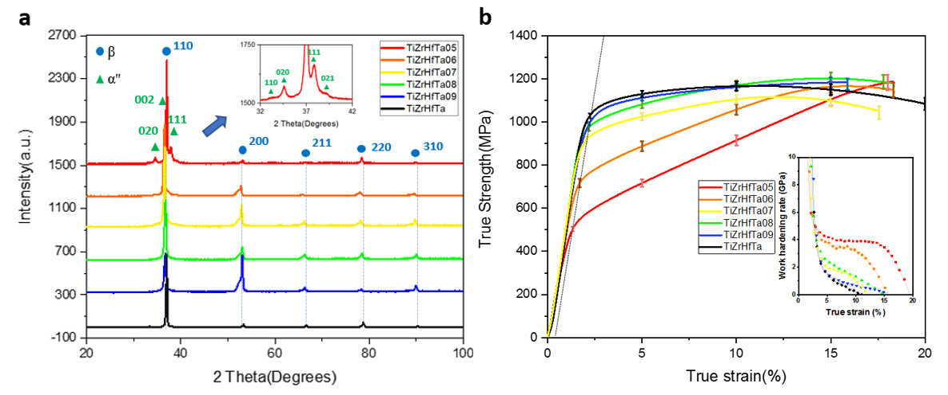
Figure 5-1 XRD patterns and corresponding mechanical performance obtained during compression testing of TiZrHfTa_{x(x=0.5-1)} series. (a) the X-ray diffraction patterns of as-cast TiZrHfTa_{x(x=0.5-1)}; and (b) the true strength and true strain curves during compressing testing of TiZrHfTa_{x(x=0.5-1)} series. The error bar was calculated as standard error of strength at different strain. Inset presents curves of the work hardening rate (dσ_{T}/dε_{P}) against true strain for each composition of TiZrHfTa_{x(x=0.5-1)}.
The mechanical response of the TiZrHfTa_{x(x=0.5-1.0)} series was then obtained via compression testing (for each composition, two samples were prepared and tested). The true stress- true strain curves and work hardening rate curves are shown in Fig. 5-1(b) for the series and this aids in distinguishing the existence of TRIP and/or TWIP activation with the reduction of Ta content. In addition, the compressive properties are presented in Table 5-1. Fig. 5-1(b) shows a clear variation of yield stress and work hardening rate during compressive deformation. For the TiZrHfTa equiatomic composition, which possessed the highest yield strength and most stable β phase, the work hardening rate was found to rapidly diminish after yield. This indicated that the deformation mechanism involved was predominantly dislocation glide. On the other hand, a gradual reduction in yield strength was observed as the content of Ta was reduced and this corresponded with enhanced work hardening.
Table 5-1 The compressive properties determined for TiZrHfTa_{x(x=0.5-1)}.
Composition | σ_{0.2}(MPa) | σ_{UTS}(MPa) | ε_{compress} (%) | η_{5%} (GPa) | η_{10%} (GPa)
TiZrHfTa | 978 | 1072 | >30% | 1.24 | 0.13
TiZrHfTa_{0.9} | 943 | 1124 | 16.7% | 1.27 | 0.73
TiZrHfTa_{0.8} | 867 | 1117 | 18.2% | 2.42 | 1.23
TiZrHfTa_{0.7} | 814 | 1037 | 17.9% | 2.13 | 1.14
TiZrHfTa_{0.6} | 667 | 1142 | 18.5% | 3.86 | 3.46
TiZrHfTa_{0.5} | 458 | 1189 | 18.5% | 4.17 | 3.92
Depending on the behaviour exhibited for the work hardening curve, the series of compositions were divided into two groups which possessed distinctive properties. These were: Group I (TiZrHfTa_{x(x=0.8-1)}) where the work hardening rate was found to monotonically decrease from 5% to 10% strain after yield; and Group II (TiZrHfTa_{x(x=0.5-0.7)}) for which the work hardening rate exhibited a plateau from 5% to 10% strain after yield. For Group I, the work hardening rate at 5% strain (η_{5%}) was found to increase from 1.24GPa (TiZrHfTa) to 2.42GPa (TiZrHfTa_{0.8}). This may be attributed to the activation of a new deformation mechanism which is influenced by the variation in Ta content. Following increasing levels of strain, the work hardening capability of Group I compositions rapidly diminished from 1-2 GPa at 5% strain to 0-1 GPa at 10% strain. This rapid loss of work hardening ability can be ascribed to the elastic-plastic transition, where dislocation glide solely accommodates the increasing stress [1,33].
Comparing the behaviour with Group II materials, when firstly considering TiZrHfTa_{0.7}, this composition exhibited non-linear evolution of work hardening rate under compression. The work hardening capacity was maintained after 5% strain in Group II as shown in Table. 5-1. The difference in work hardening rate between 5% strain and 10% strain remained smaller than 1GPa. A distinct plateau can be observed in the work hardening curve after yield and extends the effective hardening capacity to 20% strain in TiZrHfTa_{0.5}. Based on the transition of the work hardening curve, two hardening steps can be derived for Group I and Group II for the TiZrHfTa_{x} series. In the equal-molar TiZrHfTa sample, dislocation glide was responsible for accommodating an increase in stress. With a reduction of Ta, new deformation mechanisms were introduced into the series as result of β phase destabilisation and this subsequently increased the work hardening performance in Group I TiZrHfTa_{x} where x varied from 1 to 0.8. For Group II, with a further reduction in Ta, the β phase stability was further lowered and resulted in the activation of additional deformation mechanisms which were directly responsible for the plateau observed after yield in TiZrHfTa_{x(x = 0.5, 0.6, and 0.7)}. It should be noted that with a reduction in the content of Ta, the work hardening range extended from 11.2% to 19.7% strain as shown in Fig. 5-1(c). This is evidence that the metastable engineering strategy had successfully introduced multiple deformation mechanisms to enhance the mechanical performance of TiZrHfTa_{x}. The work hardening properties determined for TiZrHfTa_{0.5} were greater than those measured for the most well-known high-performance TWIP and TRIP alloys. The maximum work hardening rate for TiZrHfTa_{0.5} was 4GPa, whilst the maximum values of 2GPa and 3GPa were reported for TWIP-TRIP steel and for TWIP-TRIP metastable β Ti alloys [12,27,34,35], respectively. This pronounced work hardening capability may indicate that besides TRIP and TWIP, additional deformation mechanism may also take effect in TiZrHfTa_{0.5}.

5.3 Deformation mechanism evolution of TiZrHfTa_{x(x=0.5,0.7,0.9)}
The β phase stability was successfully reduced by tuning the Ta content which had resulted in the formation of the martensitic phase. As previously described, when analysing the variation in work hardening behaviour for TiZrHfTa to TiZrHfTa_{0.5}, it was evident that the behaviour may potentially be influenced by the activation of a number of different deformation mechanisms. In order to identify and correlate the deformation mechanisms involved in Group I and Group II TiZrHfTa_{x} alloys which clearly influenced the behaviour displayed in their work hardening curve (Fig. 5-1(c)), samples of TiZrHfTa_{0.8}, TiZrHfTa_{0.6} and TiZrHfTa_{0.5} strained to 5% were prepared for EBSD and TEM characterisation. With the reduction of Ta, the work hardening was first found to increase from TiZrHfTa_{0.9}. Apart from the generally accepted dislocation glide, new deformation mechanisms may activate and contribute to the enhancement of work hardening capacity in TiZrHfTa_{0.8-0.9}.
The primary characterisation was conducted by EBSD and is shown in Fig. 5-2, where needle-like deformation products were observed in the TiZrHfTa_{0.8} sample. The needle-like structures were not fully indexed, whilst the matrix regions of the sample were identified as β phase. The edges of the needles were partially indexed as β phase and revealed a different grain orientation in comparison with the matrix. With regard to the metastable β-Ti alloy, the two most frequently observed mechanical twinning modes are {332}[11-3]_{β} twinning and {112}[11-1]_{β} twinning [17,36]. Thus, the misorientation of these twinning systems were selected and substituted into the raw data of Fig. 5-2. The twinning constitution is displayed in Fig. 5-2(b) and twinning system was observed in TiZrHfTa_{0.8}. The needle-like structures were initially identified as {332}[11-3]_{β} twins. Considering the reports of {332}[11-3]_{β} being related to metastable TWIP β-Ti alloy, the appearance of {332}[11-3]_{β} may not only be a sign of the activation of TWIP but related to the reduction of β phase stability and martensitic transformation. Through the addition of the crystal information of the orthorhombic martensitic phase, as determined by the previous XRD pattern, the unindexed needle-like structures were then identified as the α’’ martensite phase.
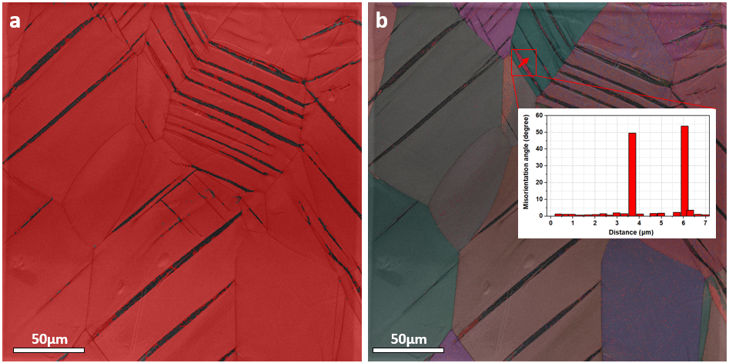
Figure 5-2 EBSD images of the 5% deformed TiZrHfTa_{0.8} (a) Phase constitution map with β and α’’ phases marked with red and black respectively. (b) An Euler angle map showing grain orientation of grains. Inset is a partially indexed twinning boundary where both {332}[11-3]_{β}twinning boundaries exist, the misorientation angle distribution is highlighted with the red arrow and shown in inset.
In contrast with the monotonic decrease in the work hardening curve found for Group I with compositions of TiZrHfTa_{x (x=0.8-1)}, a further decrease in Ta content resulted in the occurrence of a plateau in the work hardening curve after yield for Group II compositions TiZrHfTa_{x (x=0.5-0.7)}. This change in the work hardening behaviour may be due to the introduction of new deformation mechanisms and these findings will now be detailed for Group II. In Fig. 5-3(a-b), the microstructure of TiZrHfTa_{0.6} strained to 5%, was indexed as β together with α’’. Unlike the needle-like structure observed for Group I (Fig. 5-2) which could not be fully indexed, the needle-like laths in Fig. 5-3 were fully identified as martensite phase and appeared in a specific zig-zag arrangement. This arrangement of the martensitic phase may be a reason for the occurrence of the plateau in the work hardening curve behaviour of Group II. Further lowering of β phase stability resulted in an increased amount of α’’ compared with TiZrHfTa_{0.8} as shown in Fig. 5-3(b) and resulted in a fully indexed martensite structure in TiZrHfTa_{0.5} (Fig. 5-3(c)).
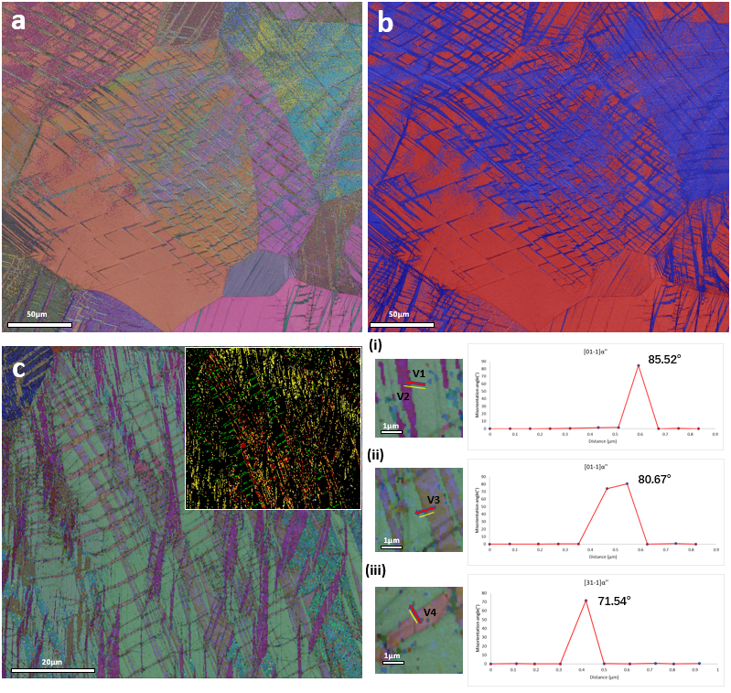
Figure 5-3 EBSD image of 5% deformed TiZrHfTa_{0.6} and TiZrHfTa_{0.5} (a) an Euler angle map showing grain orientation of β and α’’ phases in TiZrHfTa_{0.6.}; (b) phase constitution map for TiZrHfTa_{0.6.}, β and α’’ phases were marked with red and blue, respectively; (c) an Euler angle map showing grain orientation of β and α’’ phases in TiZrHfTa_{0.5}. The twinning boundary of {111} type I <211>type II and {011} compound martensitic self-accommodation twinning boundaries are marked with yellow red and green lines, respectively, where the misorientation profiles are listed in (i-iii).
The as-cast TiZrHfTa_{0.5} possessed the highest work hardening capacity in the TiZrHfTa_{x(x=0.5-1)} series and was identified in Figure 5.1 (a) as a dual phase alloy. A number of deformation mechanisms appeared to have been activated and this resulted in a complex microstructure that is shown in Fig. 5-3(c). In the fully indexed martensite grain shown in Fig. 5-3(c), substantial martensite variants were discovered. These arranged themselves in either zig-zag or highly entangled structures. Such arrangements of these variants of martensite in the primary grain may be twinning related, having been activated via the stress-induced martensite phase transformation [37–39]. In metastable-β Ti alloys, the reports of martensite twinning were first discovered from Ni-free β Ti shape memory alloys formed during the B2 to B19 phase transformation. This was known as self-accommodation twinning, where the structure was originally formed to overcome the volume change caused by martensitic phase transformation [39]. Similarly, in β to α’’ phase transformation, SA twinning was also generated and concluded as compensation of martensite phase transformation induced shape change. Applying the infinitesimal deformation approach (IDA), taking the phase transformation induced lattice strain equals to the required strain for activation of martensite twinning related variants conversion, the possible SA twinning modes of six α’’ lattice correspondence variants were mapped [38]. According to the twinning elements, the SA twinning modes were divided into three different types; type I {111}_{α’’} twinning, type II <-211>_{α’’} twinning and {011}_{α’’} compound twinings. By substitution of the misorientation relationship of the above twinning modes [40] in Fig. 5-3(c), the orientation relationship within 4 martensite variants were identified and presented in Fig. 5-3(c i-iii). The twinning boundaries of type I {111}_{α’’} twinning, type II <-211>_{α’’} twinning and {011}_{α’’} compound twinning was identified and marked with yellow, red and green lines, respectively. The SA twinning modes selected are composition dependent, hence related to the β phase stability [38]. As determined by the phase transformed lattice strain η₃=$(c_{α''}-\sqrt{2}a_{β})/a_{β}$, the critical point was set as η₃ = 0, whilst when η₃ > 0 the martensite twin variant is favoured to arrange into type I and type II twins. With further reduction in β phase stability, η₃ > 0 martensite variants are favoured to be related by type I and type II twins, in order to compensate for the stress that has been induced by the phase transforming lattice strain. {011}_{α’’} compound twinning which lattice corresponds to the {10-12} twin in a hexagonal structure, is more likely to accommodate the overall volume change when η₃ < 0. Thus, the cooperation of SA twinning observed in this work for the TiZrHfTa_{0.5} composition is clearly quite abnormal in comparison with the SA twin modes reported for other metastable-β Ti alloys [37,41]. In Fig. 5-3(c), the arrangement of type I {111}_{α’’} twins exhibits a V-shaped structure, which was identical to the self-accommodation twinning morphology observed in metastable β phase Ti-alloys and Zr-alloys [37,39]. However, the arrangement of type II [-211]_{α’’} and compound {011}_{α’’} SA twinning was similar to mechanical twinning, showing an octothorpe structure. To further identify the microstructural evolution and particular deformation products, TEM was undertaken on TiZrHfTa_{0.8}, TiZrHfTa_{0.6} and TiZrHfTa_{0.5}, all of which were subjected to 5% compressive strain.The mechanical twinning system {112}[11-1]_{β} was observed (Fig. 5-4) in TiZrHfTa_{0.8} which exhibited the highest work hardening capacity in Group I TiZrHfTa_{x}. In addition, analysing the SADP diffraction pattern, the orthorhombic martensite phase was indexed as shown in Fig. 5-4(b). Parallel to the (-211)_{β} twinning plane, the (1-10)_{α’’} plane of two martensite variants shows a similar twin relationship, which corresponds to the martensite observed in the dark field image presented in Fig. 5-4(e). The activation of stress-induced martensite formation within the {112}[11-1]_{β} twinning boundary indicated that TRIP effect had started in addition to TWIP. However, although only one set of martensite diffraction patterns were indexed (Fig. 5-4(b)), from the dark field image of identified martensite within the twinning boundary in Fig. 5-4(e), martensite possessing two different orientations were observed within both the {112}[11-1]_{β} matrix and β twin variant grain. A similar occurrence was also observed in metastable β-Ti alloys [29] and this was identified as a special (1-10)_{α’’} mechanical martensite twinning, whose lattice corresponded to {112}[11-1]_{β} mechanical twinning.
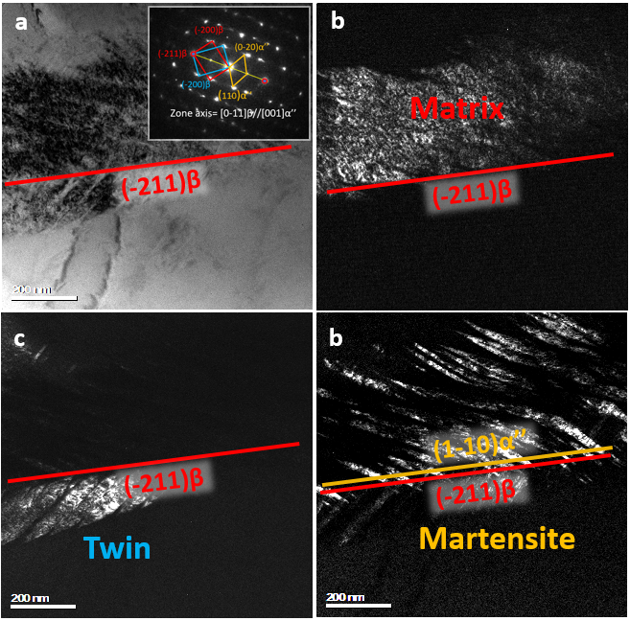
Figure 5-4 TEM image of mechanical twinning observed in 5% deformed TiZrHfTa_{0.8} (a) Bright field image of the twinning like feature. Inset is a selected area diffraction pattern (SADP) derived from the twinned feature, β, twinned β and α’’ phases diffraction patterns are marked with red cyan and orange respectively. The twinning plane is marked with a red circle and indexed as the (-211)_{β} plane. (c) Dark field image of a β matrix grain. (d) Dark field image of the β twinned structure. (e) Dark field image of martensite phase, the structure is observed to form within the β and twinned β grain boundary.
Further analyses on the same composition revealed that, in addition to the {112}_{β} mechanical twinning which generally occurs in BCC stable metallic materials, {332}[11-3]_{β} mechanical twinning was also observed. In Fig. 5-5 a typical {332}_{β} mechanical twinning feature is presented and the orientation relationship of the twinning structure was derived by the SADP. However, apart from the diffraction spot, which corresponded to the β phase, a similar additional diffraction spot was indexed in Fig. 5-4(b). This was found at 1/2{332}_{β} position in Fig. 5-5(b) and may relate to martensite phases.
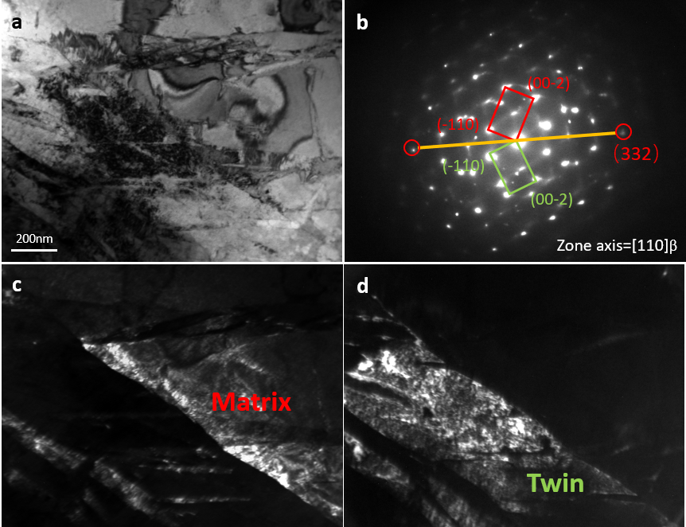
Figure 5-5 TEM images of mechanical twinning in 5% deformed TiZrHfTa_{0.8} (a) a bright field image of an interesting twinning-like feature; (b) a SADP at the twining boundary. Β and twinned β diffraction patterns are marked with red and green, respectively. The {332}_{β} twinning plane was marked with a red circle; (c) a dark field image of a β matrix grain; and (d) a dark field image of β twinned variant.
As observed for the microstructure evolution determined by EBSD analyses for TiZrHfTa_{0.8}, TEM analyses revealed that both {112}[11-1]_{β} and {332}[11-3]_{β} twinning systems were identified and found to serve as the main twin modes for TWIP. In addition to TWIP, the activation of TRIP was observed to initialise in TiZrHfTa_{0.8}, as martensite variants were found in β twinned features and correlated with a further enhancement of the mechanical performance of TiZrHfTa_{0.8}. When comparing the observations of Group I sample with Group II, although the promotion of work hardening capacity occurs after the activation of TWIP, the underlying mechanisms relating to the abnormal enhancement and the plateau in work hardening rate remain unclear. In order to determine these mechanisms, an investigation was conducted on Group II samples.
For the TiZrHfTa_{0.6} composition, which was found to exhibit a plateau in the work hardening curve after yield, it is clear from Fig. 5-6 that TWIP occurred with both {332}_{β} and {112}_{β} mechanical twinning being observed. Next to the {332}_{β} twinning variant, the {112}_{β} twinning variant was indexed. Identical to the feature captured by EBSD in TiZrHfTa_{0.8} at Fig. 5-2(b), this special entangled {332}_{β} and {112}_{β} twinning feature was observed in various β Ti-alloys [42,43], resulting in significantly increased work hardening of the material. The effect of TRIP became more obvious in TiZrHfTa_{0.6} and resulted in the activation of self-accommodation twinning, as indexed in Fig. 5-7. Type I {111}_{α’’} twinning is commonly observed in most TRIP metastable β-Ti alloys [37,39,41]. The antiphase boundary (APB)-like stacking fault was also observed and is highlighted in Fig. 5-7(c-d) [44,45]. To further identify if the corrugated structure is a minor defect, the sample was re-tilted to the [110]_{α’’} zone axis and the dark field image of this feature is shown in Fig. 5-8 and exhibiting a different appearance. The leopard print-like structure did not show a trackable arrangement, which indicated the formation may not manifest itself by specific stress and strain.
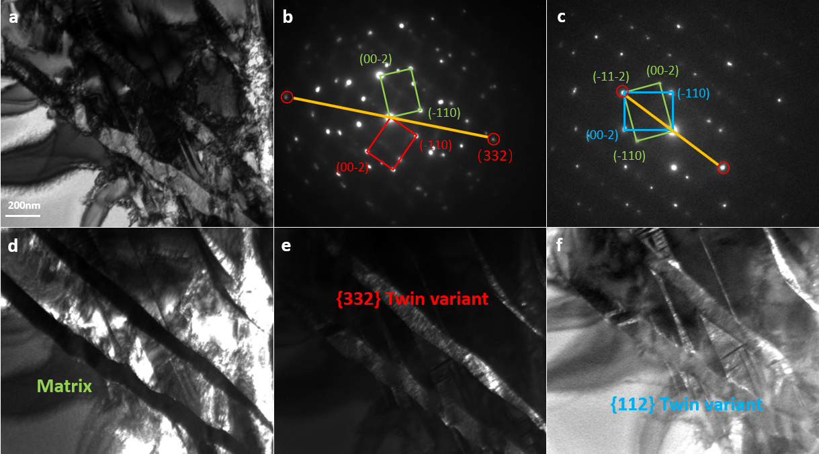
Figure 5-6 TEM images of mechanical twinning in 5% deformed TiZrHfTa_{0.6.} (a) a bright field image of entangled {332}_{β} and {112}_{β} twinning; (b) a SADP derived from a {332}_{β} twining boundary. β, twinned β diffraction patterns are marked with green and red, respectively. The {332}_{β} twinning plane is marked with a red circle; (c) a SADP derived from a {112}_{β} twining boundary. β matrix and twinned β grain’s diffraction patterns are marked with green and blue lines, respectively. The {112}_{β} twinning plane is marked with a red circle; (d-f) dark field images of β matrix grain, {332}_{β} twinned variant and {112}_{β} twinned variant, respectively.
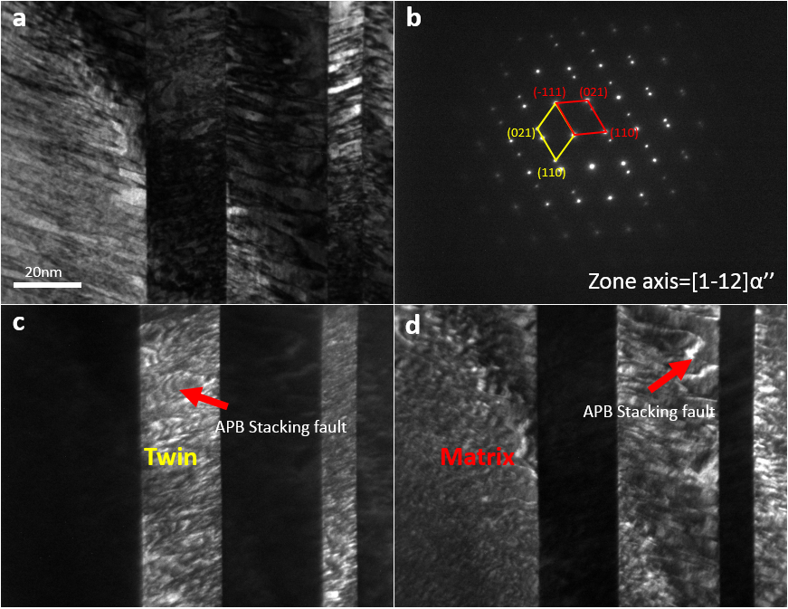
Figure 5-7 TEM images of type I {111}_{α’’} SA twinning in 5% deformed TiZrHfTa_{0.6}. (a) a bright field image of the feature; (b) a SADP derived from a twinned feature, where α’’ and twinned α’’ diffraction patterns are marked with red and yellow, respectively. The {111}_{α’’} twinning plane is highlighted; (c) a dark field image of a twinned α’’ grain. A corrugated APB like stacking fault feature is marked with red arrow; (d) a dark field image of a α’’ matrix grain, with the same corrugated APB-like stacking fault feature also observed and marked with a red arrow.
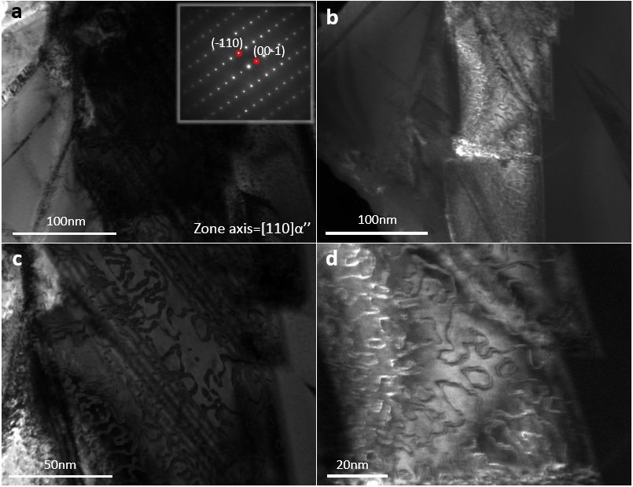
Figure 5-8 TEM images of APB like stacking fault feature in 5% deformed TiZrHfTa_{0.6}. (a) a bright field image of the feature, inset shows the SADP derived from the martensite feature; (b) a dark field image of the APB like stacking fault structure observed in the two beam condition; (c) a bright field image of a band-like α’’ grain. Corrugated APB like stacking fault feature discovered in previous feature shows a leopard print-like pattern; and (d) higher magnification dark field image APB-like stacking feature within the martensite grain.
The observation of the APB-like stacking fault, which is accepted as an iconic feature that can be observed in the α’’ orthorhombic martensitic structure [37,39], provides solid evidence for the activation of TRIP in TiZrHfTa_{0.6}. With the observed TRIP effect in TiZrHfTa_{0.6}, the type I SA twinning can exhibit a special self-accommodating morphology forming a polygon twinning structure. In Fig. 5-9, a triangular microstructure formed by three martensite variants were found.
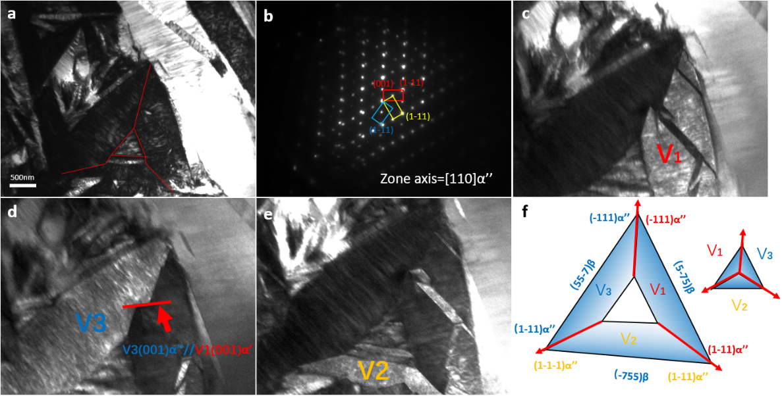
Figure 5-9 TEM images of SA twinning feature in 5% deformed TiZrHfTa_{0.6}. (a) a bright field image of the feature, with a special triangle of SA martensite laths observed to form a complex polygon structure; (b) a SADP along the [110]_{α’’} zone axis, with three martensite variants coloured with red, yellow and blue, respectively; (c-e) dark field images of {111}_{α’’} related martensite variants V1-V3; and (f) a schematic of the triangle SA morphology formation, where the habit plane was identified as {775}_{α’’} and the three twinning planes were identified as {111}_{α’’}.
The orientation relationship between every two of the three martensite variants were all identified as type I {111} _{α’’} SA twinning. The three {111}_{α’’} twin related martensite variants were found to arrange themselves into a triangular structure to accommodate the stress and strain accumulated during phase transformation. The habit plane of all three martensite variants involved in the trangular SA structure were indexed as {775}_{β} plane group. This was determined to be identical to the habit plane reported for Ti-Nb metastable β-Ti alloys [37]. The {001}_{α’’} plane defects are easy to activate next to the twinning boundary as highlighted in Fig. 5-9(f). An illustration of the SA triangular morphology formation is shown in Fig. 5-9(f). Nucleating from a special defect that occurs during phase transformation, (001)_{α’’} plane defects in V1 were parallel to the {111}_{α’’} plane of V2 and V3 and the accumulated dislocation slides will result in activation of the SA twinning along {111}_{α’’} plane on V2 and V3. After the formation of the triangle twinned martensite nucleus, with further deformation the secondary SA twinning is favoured to form next to the triangular martensitic nucleus and forming a larger triangular {111}_{α’’} twinning entanglement.

Instead of the triangular morphology, highly entangled martensite laths which formed polygonal structures were also observed in Fig. 5-10. Compared with the IFFT figure derived from Fig. 5-10(e), the grain boundary angle between any two of these martensite variants was identical to the angle between the (1-11)_{α’’} plane of the corresponding martensite variants. As highlighted in Fig. 5-10(e), the nucleation of this triangular structure indeed formed a nano-size triangular structure. This indicated the origin of this structure may be a result of the evolution of certain defects lead by the TRIP effect.
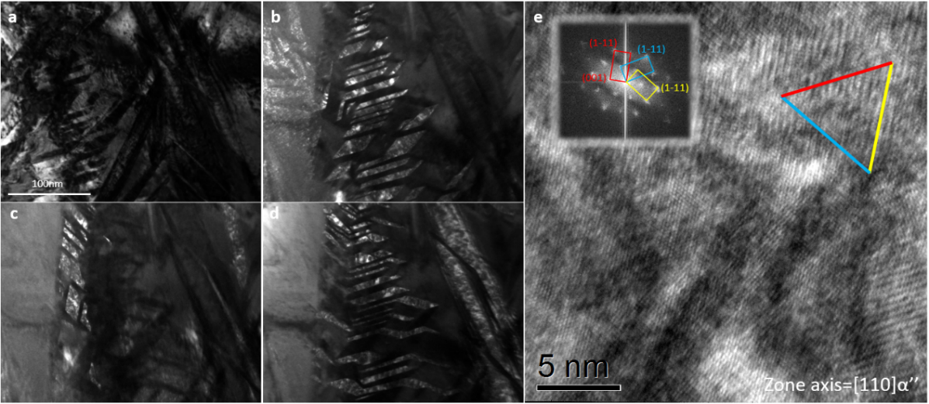
Figure 5-10 TEM images of SA twinning feature in 5% deformed TiZrHfTa_{0.6}. (a) a bright field image of thefeature, with highly entangled martensite laths forming complex polygon structure; (b) a dark field image of {111}_{α’’} related to martensite variant one; (c) a dark field image of {111}_{α’’} related martensite variant two; (d) a dark field image of {111}_{α’’} related martensite variant three; (e) a HRTEM image of the feature involving all three martensite variants. The grain relationship is marked in the FFT image shown inset. The three martensite variants are marked with red, cyan and yellow, while the {111}_{α’’} twinning plane formed a classical triangle self-accommodation morphology, as highlighted by red, cyan and yellow lines.

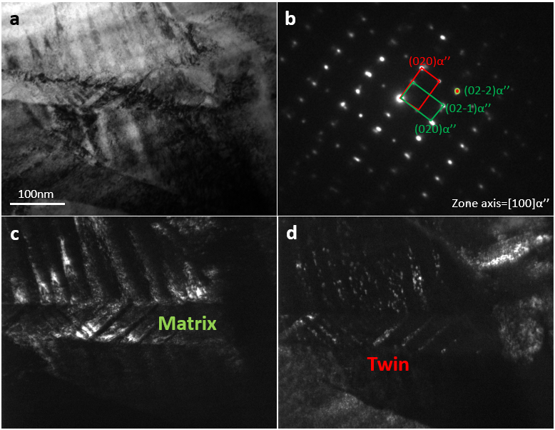
Figure 5-11 TEM images of {011}_{α’’} compound SA twinning feature in 5% deformed TiZrHfTa_{0.6}. (a) a bright field image of the feature; (b) a SADP derived from the twinned feature. α’’ and twinned α’’ diffraction patterns are marked with green and red, respectively. The {011}_{α’’} twinning plane is highlighted; (c) a dark field image of a α’’ matrix grain; and (d) a dark field image of the α’’ twinned grain observed within a primary martensite grain.
In addition to the observation of type I SA twinning, {011}_{α’’} compound SA twinning was also found in TiZrHfTa_{0.6}. The twinning plane was identified as (01-1)_{α’’} and highlighted in Fig. 5-11(b). According to the previous discussion, which indicated the selection of SA twinning is composition dependent, the type I {111}_{α’’} and {011}_{α’’} compound twinning can’t together serve as SA twinning for current alloys. Regarding α’’ phase as a mesophase between β to α phase transformation, sharing similar lattice arrangements with the HCP structure, the {011}_{α’’} compound twinning may be sharing the same origin with the lattice corresponded {10-12}_{α} HCP mechanical twinning[38]. When deformed to 5% strain, the TiZrHfTa_{0.5} exhibited the highest work hardening performance and it is evident that this material contained more complex deformation products when compared with other compositions investigated in this work. All three martensitic SA twinning modes were indexed by EBSD as shown in Fig. 5-3(d). The entanglement of martensite variants in TiZrHfTa_{0.5} may indicate the activation of an unknown deformation mechanism apart from TRIP and TWIP. TEM findings relating to a new type II [2-11]_{α’’} SA twinning may provide evidence of these postulations. In Fig. 5-12(a) the bright field image reveals that the whole grain is indexed as martensite, which corresponded to the high content of α’’ phase shown in as-cast condition XRD and fully indexed 5% deformed martensite structure of TiZrHfTa_{0.5} in Fig. 5-1 to Fig. 5-3. SADP of the twinning was acquired along the [1-12]_{α’’} zone axis. Generally, for type II twinning modes, the Miller indices of the twinning plane do not remain as an integer which prevent the further deformation of type II twins. However, the twinning plane of this type II twinning was highlighted and indexed as {351}_{α’’} plane (Fig. 5-12(b)). For the IFFT HRTEM image shown in Fig. 5-12(e), the lattice distortion and shifted twinning plane were observed. However, the resolution of HRTEM are presently not adequate to aid in determining the precise value of the magnitude of the burgers vector. The gradually shifted twinning grain boundary contributed to dense dislocations, which were accumulated next to the twinning grain boundary. The dislocations were mainly activated by the burgers vector, which were observed to be vertical to (-111)_{α’’}, (021)_{α’’}, (110)_{α’’} and (351)_{α’’} planes. In addition to dislocations, stacking fault like structures are also seen in Fig. 5-12(e) and circled with a yellow line. The extrinsic stacking fault is enabled by the insertion of the additional (-111)_{α’’} lattice plane.
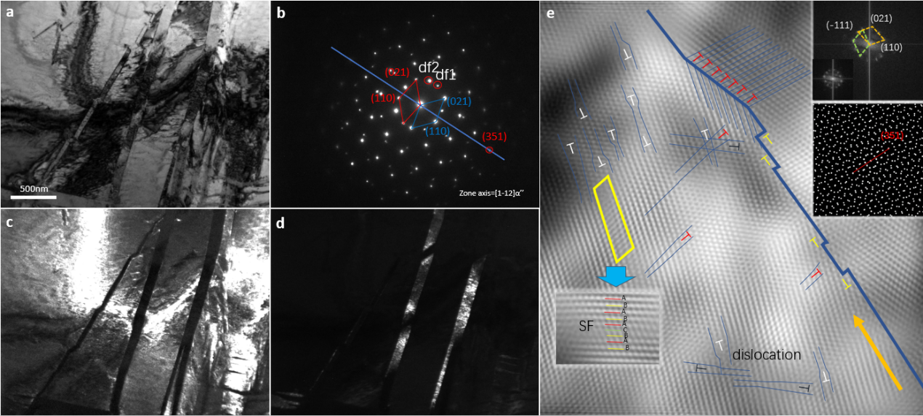
Figure 5-12 TEM images of [-211]_{α’’} compound SA twinning feature in 5% deformed TiZrHfTa_{0.5}. (a) a bright field image of the feature; (b) a SADP derived for a twinned feature. α’’ and twinned α’’ diffraction patterns are marked with blue and red, respectively. The {351}_{α’’} twinning plane is highlighted with a red circle; (c) a dark field image of a α’’ matrix grain; (d) a dark field image of α’’ twinned grain; and (e) an IFFT HRTEM conducted on the twinned feature. Inset shows the FFT of the twin structure. Twinning boundary shift and a high density of dislocations were found next to the twinning boundary.
With reducing the Ta content even further to TiZrHfTa_{0.5}, the self-accommodation morphology observed in TiZrHfTa_{0.6} was found to continue to evolve (Fig. 5-13). For this composition, the previously observed triangle twinned type I twinning martensitic structure can primarily be identified as the same type of feature through the SADP shown in Fig. 5-13(b). However, on top of the diffraction patterns of the three martensite variants that are annotated as M1, M2 and M3, another set of martensite diffraction pattern was captured and denoted as M4. Coinciding with the diffraction spots of M1, M2 and M3 which were obtained along the [110]_{α’’} zone axis, the orientation relationship of M4 with M1, M2 and M3 was identified as [110]_{α’’M1,M2,M3}//[1-1-2]_{α’’M4}. Referring to Fig. 5-13 (c-f), by comparing dark field image of M1, M2, M3 and M4, respectively, the M4 grain is sharing a grain boundary with the three other martensite variants. This indicated there may be a new type of twinning mode which has enabled the formation of this special four martensite variants feature.
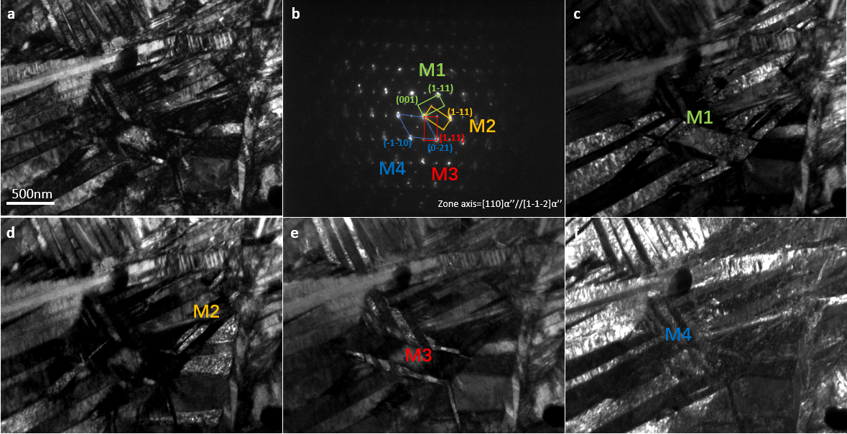
Figure 5-13 TEM images of SA twinning feature in 5% deformed TiZrHfTa_{0.5}. (a) a bright field image of the feature; (b) a SADP derived from the twinning entanglement feature. Four martensite variants are marked with green, yellow, red and blue, respectively; (c-e) show dark field images of {111}_{α’’} related to martensite variants M1-M3,; and (f) a dark field image of {111}_{α’’} related to martensite variant M4, which is not related to {111}_{α’’} type I twinning with the other variants.
The four martensite variants SA feature was also captured along a different zone axis. In Fig. 5-14 an abnormal cooperation of type I {111}_{α’’} twinning and {011}_{α’’} compound twinning was captured. Although the whole feature is seemingly generated within one martensite matrix, the SA martensite twinned variants are linked by two different SA twin modes. According to the twin relationship, the four martensite variants were divided into two groups, type I {111}_{α’’} twinning related martensite variants group A; and {011}_{α’’} twinning related martensite variants group B. It should be noted that the boundary of A and B group variants also shared the same boundary as observed in Fig. 5-13. However, the underlying mechanism promoting the observations remains unclear. To aid in the understanding of the orientation relationship between group A and group B variants, the stereo projection figures of the lattice correspondance to the β matrix for group A and group B martensite variants were plotted in Fig. 5-14(f). Surprisingly, group A and group B lattice correspondance to the β matrix are related by {332}[11-3]_{β} mechanical twinning. Thus, a plausible explanation is that there exists an unknown twinning mode, or deformation mechanism, which enables the martensite SA variants to arrange themselves into a special orientation relationship, which corresponds to the {332}[11-3]_{β} mechanical twin modes in the β phase.
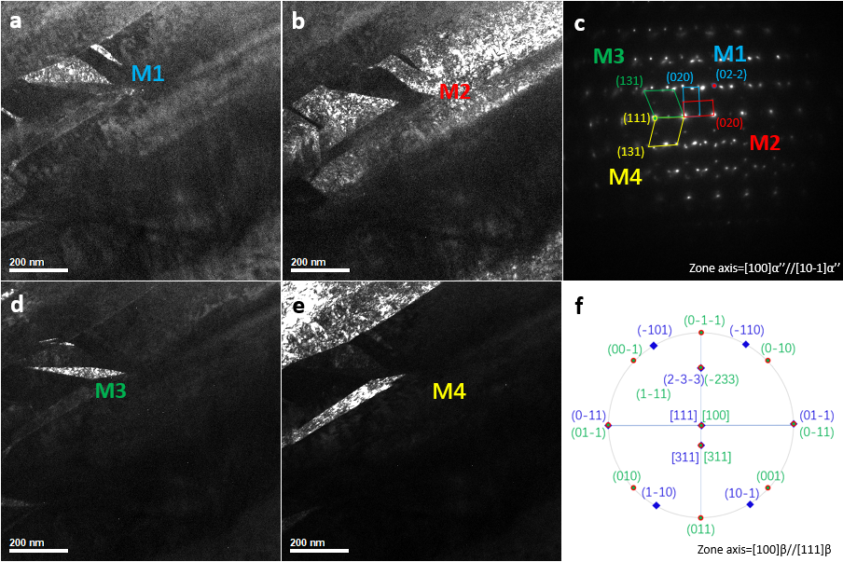
Figure 5-14 TEM images of {011}_{α’’} and {111}_{α’’} SA twinning cooperation feature of 20% deformed TiZrHfTa_{0.5}. (a) a dark field image of {011}_{α’’} related to martensite variant one (M1); (b) a dark field image of {011}_{α’’} related to martensite variant two (M2); (c) a SADP derived from the twinning entanglement feature. Four martensite variants (M1-M4) are marked with cyan, red, green and yellow, respectively. (d) a dark field image of {111}_{α’’} related to martensite variant three (M3); (e) a dark field image of {111}_{α’’} related to martensite variant four (M4); and (f) a stereo projection figure of the lattice correspondance of the untransformed β phase for M1 to M4. The orientation relationship was identified as {2-3-3}_{β1}//{-233}_{β2}, [311]_{β1}//[311]_{β2} and [111]_{β1}//[100]_{β2}.

5.4 Discussion
In this work, by tuning the β phase stabilising element Ta, the stability of the six different compositions of TiZrHfTa_{x(x=0.5-1)} β phases were successfully tailored. This has resulted in the introduction of both TRIP and TWIP effects, which further promote the work hardening ability of TiZrHfTa_{x}. The mechanical performance evolution has shown a dependence on Ta content, particularly with regard to the yield strength and work hardening capacity during compressive loading. On the one hand, decreasing the Ta content promoted the formation of the stress-induced martensite phase and subsequently lowered the yield strength; on the other hand the reduction of β phase stability resulted in the both TWIP and TRIP taking effect, which in turn gradually increased the work hardening capacity of the materials. The activation of TWIP was first observed to take effect in TiZrHfTa_{0.8}, reflecting in the increased work hardening rate when compared to the equal-molar TiZrHfTa composition. Multiple β mechanical twinning was identified with both EBSD and TEM (Figs. 5-2 to 5-6), including {332}[11-3]_{β} and {112}[11-1]_{β} twinning modes. Stress-induced martensite formation was also captured within the β mechanical twinning boundary. This indicated that the TRIP effect initiated and cooperated with TWIP simultaneously, hence further increasing work hardening ability. However, the origin of the partially indexed {332}[11-3]_{β} twin band in Fig. 5-2 remained unclear. When considering previous research [4,42,46,47], the origin of the {332}[11-3]_{β} twining may have a direct relationship with the stress-induced martensite formation. This is in agreement with the TiZrHfTa_{0.8} where stress induced martensite was observed within the primary β twinned grain (Fig. 5-4 and 5-5).
According to the EBSD analyses presented, TRIP is concluded as being the main deformation mechanism which resulted in the plateau observed after yield in the work hardening curve for TiZrHfTa_{0.5-0.7}. With increasing deformation, to overcome the overall volume change caused by the phase transformations, SA martensitic twinning was formed [39]. Accordingly, martensite variants formed different SA structures, which served to compensate for TRIP-induced stress and strain. A number of deformation products were discovered with respect to the SA morphology in TiZrHfTa_{0.5-0.7}. APB-like stacking faults were found in the martensite phase, as observed in Figs. 5-7 to 5-8 and these were a result of the occurrence of phase transformation, as reported in reference [44]. With further deformation, the APB-like defects appear to work as nucleation sites for secondary SA twinning and result in a complex SA morphology (Figs. 5-9 to 5-10). A particularly interesting finding is shown in Fig. 5-9, whereby {011}_{α’’} compound SA twinning was observed. It was initially considered that the formation of this feature may contribute to the fast cooling rate in the current as-cast sample, which was reported as being commonplace in most metastable β-Ti alloys [38,41,48]. However, the underlying mechanism was much more complicated as was shown in the work conducted on TiZrHfTa_{0.5}. TiZrHfTa_{0.5} was the composition with the lowest Ta content, which exhibited the highest work hardening in the series of metastable RHEAs examined in this work. The derived work hardening rate was greater than those observed for most TRIP and TWIP-assisted metastable β-Ti alloys [12,26,27,43,49]. By conducting EBSD and TEM analyses, all three SA twinning modes type I {111}_{α’’}, type II [-211]_{α’’} and {011}_{α’’} compound twins were identified. A noteworthy observation was the capture of a special type II [-211]_{α’’} SA twin with {351}_{α’’} twinning plane as was highlighted in Fig. 5-12. Due to the operation of the different twinning elements, the direct observation of an integer miller indices twinning plane, of a type II twinning is unusual [50]. Highly entangled SA structures involving more than 4 martensite variants were found for TiZrHfTa_{0.5}. In contrast with the SA morphology shown in Figs. 5-9 to 5-10 which was only related by type I {111}_{α’’} SA twinning, the orientation relationship (<1-12>_{α’’}//<110>_{α’’}) of the fourth martensitic variant with the rest of the martensitic variants observed in Fig. 5-13 remained unclear until the particular feature in Fig. 5-14 was captured. Abnormal cooperation of SA {011}_{α’’} compound twins and {111}_{α’’} type I twins were identified in Fig. 5-14(c) where each martensite variant was found to share a twinning boundary with the other variants. Thus, the underlying orientation relationship between the {011}_{α’’} compound twin related variants and {111}_{α’’} type I twin related variants, was determined to be linked by another twinning mode. The orientation relationship was finally derived by stereo-projection as {332}[11-3]_{β} twinning as shown in Fig. 5-12(f) and this was achieved by firstly reversing the {011}_{α’’} compound twin related variants M1&M2 and {111}α’’ type I twin related twin variants M3&M4 back to their lattice correspond β phase, then dividing into group A and group B. This discovery provided essential evidence that there was another deformation mechanism in addition to TWIP and TRIP that manifested itself during compressive deformation of TiZrHfTa_{0.5}. This particular deformation mechanism may aid in linking the simultaneous occurrence of TRIP and TWIP through one particular martensitic twinning whose lattice correspondence structure is also a mechanical twinning mode in β phase. It was determined that this key feature was located on the {332}[11-3]_{β} twinning structure and whose origin is postulated to have a direct relationship with the stress-induced α’’ martensite transformation.

5.5 Conclusions
In this chapter, the possibility of utilising metastable engineering to introduce both the TRIP and TWIP effect into RHEAs was explained. The relatively ductile and unstable composition TiZrHfTa was selected from the screened results in Chapter 4. According to the analysis of formation enthalpy deviation and electronic environment result of TiZrHfTa in Chapter 4, the Ta content was chosen as the key factor to conduct the metastable engineering. TiZrHfTa_{x(x=0.5-1)} possessing 6 different compositions were designed and synthesized by vacuum arc-melting and suction casting. The phase constitution and mechanical performance during compressive deformation revealed that metastable engineering is effective in introducing multiple-deformation mechanisms which subsequently enhance the work hardening capacity of the material. TWIP was successfully activated and observed in TiZrHfTa_{0.8}, where {112}[11-1]_{β} twinning occurred and served as the main mechanical twin mode in stable BCC metallic materials. The observation of stress-induced α’’ martensite and β mechanical twinning in TiZrHfTa_{0.5-0.8} indicated there may a certain Ta content range which could potentially allow both TRIP and TWIP to cooperate simultaneously. The identification of the phase constitution for TiZrHfTa_{x(x=0.5,0.6,0.8)} as a result of compressive loading was obtained, where it was identified that the martensite phase transformation observed belonged to an Au-Cd type cubic to orthorhombic transformation. The effect of TRIP gradually increased with a reduction of Ta content and an increase in the density of SA martensitic twinning was reported. Entanglement of SA twinning may further contribute to the work hardening capacity, by preventing dislocation glide.
The unusual martensite twinning modes {351}<-211>_{α’’} together with the abnormal cooperation of {111}_{α’’} type I and {011}_{α’’} compound twinning modes, indicated the existence of a new deformation mechanism which was identified as being linked through {332}[11-3]_{β} twinning. This new deformation mechanism may be considered to be the main reason for the extraordinary work hardening performance in TiZrHfTa_{0.5}. This deformation mechanism linked both the deformation products of TRIP and TWIP and in addition, not only promoted the refinement of the microstructure but also allowed the potential of further enhancement of the RHEA system investigated. This work leads to the following chapter, where the origin and details of this new deformation mechanism will be discussed. Following this, by utilizing the newly discovered mechanism, RHEAs with ultrahigh work hardening response will be designed and tested.

5.6 References
[1] H. Huang, Y. Wu, J. He, H. Wang, X. Liu, K. An, W. Wu, Z. Lu, Phase-Transformation Ductilization of Brittle High-Entropy Alloys via Metastability Engineering, Adv. Mater. (2017). doi:10.1002/adma.201701678.
[2] S.P. Wang, J. Xu, (TiZrNbTa)-Mo high-entropy alloys: Dependence of microstructure and mechanical properties on Mo concentration and modeling of solid solution strengthening, Intermetallics. (2018). doi:10.1016/j.intermet.2018.01.017.
[3] E. Ma, Nanocrystalline materials: Controlling plastic instability, Nat. Mater. (2003). doi:10.1038/nmat797.
[4] S. Hanada, O. Izumi, Correlation of tensile properties, deformation modes, and phase stability in commercial β-phase titanium alloys, Metall. Trans. A. (1987). doi:10.1007/BF02825707.
[5] Y.L. Hao, S.J. Li, S.Y. Sun, C.Y. Zheng, Q.M. Hu, R. Yang, Super-elastic titanium alloy with unstable plastic deformation, Appl. Phys. Lett. (2005). doi:10.1063/1.2037192.
[6] S. Banerjee, U.M. Naik, Plastic instability in an omega forming Ti-15% Mo alloy, Acta Mater. (1996). doi:10.1016/1359-6454(96)00012-2.
[7] H.K. Kim, W.J. Kim, Microstructural instability and strength of an AZ31 Mg alloy after severe plastic deformation, Mater. Sci. Eng. A. (2004). doi:10.1016/j.msea.2004.06.055.
[8] S. Turteltaub, A.S.J. Suiker, Transformation-induced plasticity in ferrous alloys, J. Mech. Phys. Solids. (2005). doi:10.1016/j.jmps.2005.03.004.
[9] I. Tamura, Deformation-induced martensitic transformation and transformation-induced plasticity in steels, Met. Sci. (1982). doi:10.1179/030634582790427316.
[10] Transformation induced plasticity, Adv. Mater. Process. (2005). doi:10.1115/1.3101930.
[11] J. Tran, Titanium by design: Trip titanium alloy, ProQuest Diss. Theses Glob. (2009).
[12] M. Marteleur, F. Sun, T. Gloriant, P. Vermaut, P.J. Jacques, F. Prima, On the design of new β-metastable titanium alloys with improved work hardening rate thanks to simultaneous TRIP and TWIP effects, Scr. Mater. (2012). doi:10.1016/j.scriptamat.2012.01.049.
[13] B. Qin, P.H.K.D.H. Bhadeshia, Crystallography of TWIP Steel, Grad. Inst. Ferr. Technol. (2007). doi:10.1002/bmb.15.
[14] B.C. De Cooman, O. Kwon, K.-G. Chin, State-of-the-knowledge on TWIP steel, Mater. Sci. Technol. (2012). doi:10.1179/1743284711Y.0000000095.
[15] B.C. De Cooman, Y. Estrin, S.K. Kim, Twinning-induced plasticity (TWIP) steels, Acta Mater. (2018). doi:10.1016/j.actamat.2017.06.046.
[16] D.T. Pierce, J.A. Jiménez, J. Bentley, D. Raabe, C. Oskay, J.E. Wittig, The influence of manganese content on the stacking fault and austenite/ε-martensite interfacial energies in Fe-Mn-(Al-Si) steels investigated by experiment and theory, Acta Mater. (2014). doi:10.1016/j.actamat.2014.01.001.
[17] M. Ahmed, D. Wexler, G. Casillas, D.G. Savvakin, E. V. Pereloma, Strain rate dependence of deformation-induced transformation and twinning in a metastable titanium alloy, Acta Mater. (2016). doi:10.1016/j.actamat.2015.11.026.
[18] S.L. Wong, M. Madivala, U. Prahl, F. Roters, D. Raabe, A crystal plasticity model for twinning- and transformation-induced plasticity, Acta Mater. (2016). doi:10.1016/j.actamat.2016.07.032.
[19] O. Grässel, L. Krüger, G. Frommeyer, L.W. Meyer, High strength Fe-Mn-(Al, Si) TRIP/TWIP steels development - properties - application, Int. J. Plast. (2000). doi:10.1016/S0749-6419(00)00015-2.
[20] B.B. He, H.W. Luo, M.X. Huang, Experimental investigation on a novel medium Mn steel combining transformation-induced plasticity and twinning-induced plasticity effects, Int. J. Plast. (2016). doi:10.1016/j.ijplas.2015.11.004.
[21] L. Bracke, G. Mertens, J. Penning, B.C. De Cooman, M. Liebeherr, N. Akdut, Influence of phase transformations on the mechanical properties of high-strength austenitic Fe-Mn-Cr steel, Metall. Mater. Trans. A Phys. Metall. Mater. Sci. (2006). doi:10.1007/s11661-006-0002-5.
[22] Z. Li, C.C. Tasan, H. Springer, B. Gault, D. Raabe, Interstitial atoms enable joint twinning and transformation induced plasticity in strong and ductile high-entropy alloys, Sci. Rep. (2017). doi:10.1038/srep40704.
[23] Z. Li, K.G. Pradeep, Y. Deng, D. Raabe, C.C. Tasan, Metastable high-entropy dual-phase alloys overcome the strength-ductility trade-off, Nature. (2016). doi:10.1038/nature17981.
[24] Z. Li, C.C. Tasan, K.G. Pradeep, D. Raabe, A TRIP-assisted dual-phase high-entropy alloy: Grain size and phase fraction effects on deformation behavior, Acta Mater. (2017). doi:10.1016/j.actamat.2017.03.069.
[25] Y. Deng, C.C. Tasan, K.G. Pradeep, H. Springer, A. Kostka, D. Raabe, Design of a twinning-induced plasticity high entropy alloy, Acta Mater. (2015). doi:10.1016/j.actamat.2015.04.014.
[26] F. Sun, J.Y. Zhang, M. Marteleur, T. Gloriant, P. Vermaut, D. Laillé, P. Castany, C. Curfs, P.J. Jacques, F. Prima, Investigation of early stage deformation mechanisms in a metastable β titanium alloy showing combined twinning-induced plasticity and transformation-induced plasticity effects, Acta Mater. (2013). doi:10.1016/j.actamat.2013.07.019.
[27] F. Sun, J.Y. Zhang, M. Marteleur, C. Brozek, E.F. Rauch, M. Veron, P. Vermaut, P.J. Jacques, F. Prima, A new titanium alloy with a combination of high strength, high strain hardening and improved ductility, Scr. Mater. (2015). doi:10.1016/j.scriptamat.2014.09.005.
[28] G.P. Tiwari, R. V. Ramanujan, Relation between the electron to atom ratio and some properties of metallic systems, J. Mater. Sci. (2001). doi:10.1023/A:1004853304704.
[29] J. Zhang, C.C. Tasan, M.J. Lai, A.C. Dippel, D. Raabe, Complexion-mediated martensitic phase transformation in Titanium, Nat. Commun. (2017). doi:10.1007/s00117-017-0224-0.
[30] L.F. Huang, B. Grabowski, J. Zhang, M.J. Lai, C.C. Tasan, S. Sandlöbes, D. Raabe, J. Neugebauer, From electronic structure to phase diagrams: A bottom-up approach to understand the stability of titanium–transition metal alloys, Acta Mater. (2016). doi:10.1016/j.actamat.2016.04.059.
[31] M. Ahmed, D. Wexler, G. Casillas, O.M. Ivasishin, E. V. Pereloma, The influence of β phase stability on deformation mode and compressive mechanical properties of Ti-10V-3Fe-3Al alloy, Acta Mater. (2015). doi:10.1016/j.actamat.2014.10.043.
[32] J.Y. He, H. Wang, Y. Wu, X.J. Liu, H.H. Mao, T.G. Nieh, Z.P. Lu, Precipitation behavior and its effects on tensile properties of FeCoNiCr high-entropy alloys, Intermetallics. (2016). doi:10.1016/j.intermet.2016.09.005.
[33] A.H. Cottrell, Theory of dislocations, Prog. Met. Phys. (1953). doi:10.1016/0502-8205(53)90018-5.
[34] L. Chen, Y. Zhao, X. Qin, Some aspects of high manganese twinning-induced plasticity (TWIP) steel, a review, Acta Metall. Sin. (English Lett. (2013). doi:10.1007/s40195-012-0501-x.
[35] A.A. Salem, S.R. Kalidindi, R.D. Doherty, Strain hardening of titanium: Role of deformation twinning, Acta Mater. (2003). doi:10.1016/S1359-6454(03)00239-8.
[36] Q.Y. Sun, S.J. Song, R.H. Zhu, H.C. Gu, Toughening of titanium alloys by twinning and martensite transformation, J. Mater. Sci. (2002). doi:10.1023/A:1015456026919.
[37] Y.W. Chai, H.Y. Kim, H. Hosoda, S. Miyazaki, Self-accommodation in Ti-Nb shape memory alloys, Acta Mater. (2009). doi:10.1016/j.actamat.2009.04.051.
[38] T. Inamura, J.I. Kim, H.Y. Kim, H. Hosoda, K. Wakashima, S. Miyazaki, Composition dependent crystallography of α″-martensite in Ti-Nb-based β-titanium alloy, Philos. Mag. (2007). doi:10.1080/14786430601003874.
[39] K. Bhattacharya, Self-accommodation in martensite, Arch. Ration. Mech. Anal. (1992). doi:10.1007/BF00375026.
[40] X. Zhang, W. Wang, J. Sun, Formation of {332}〈113〉βtwins from parent {130}〈310〉α″plastic twins in a full α″ Ti-Nb alloy by annealing, Mater. Charact. (2018). doi:10.1016/j.matchar.2018.09.034.
[41] E. Bertrand, P. Castany, Y. Yang, E. Menou, T. Gloriant, Deformation twinning in the full-α″ martensitic Ti-25Ta-20Nb shape memory alloy, Acta Mater. (2016). doi:10.1016/j.actamat.2015.12.001.
[42] M.J. Lai, C.C. Tasan, D. Raabe, On the mechanism of {332} twinning in metastable β titanium alloys, Acta Mater. (2016). doi:10.1016/j.actamat.2016.03.040.
[43] J. Gao, Y. Huang, D. Guan, A.J. Knowles, L. Ma, D. Dye, W.M. Rainforth, Deformation mechanisms in a metastable beta titanium twinning induced plasticity alloy with high yield strength and high strain hardening rate, Acta Mater. (2018). doi:10.1016/j.actamat.2018.04.035.
[44] T. Inamura, H. Hosoda, H. Young Kim, S. Miyazaki, Antiphase boundary-like stacking fault in α″-martensite of disordered crystal structure in β-titanium shape memory alloy, Philos. Mag. (2010). doi:10.1080/14786435.2010.489889.
[45] T. Inamura, H.Y. Kim, H. Hosoda, K. Wakashima, S. Miyazaki, ANTIPHASE BOUNDARY LIKE DEFECT INSIDE a " -MARTENSITE IN Ti-Nb-Al SHAPE MEMORY ALLOY, Tms. (2009). doi:10.2466/PMS.110.1.257-264.
[46] H. Tobe, H.Y. Kim, T. Inamura, H. Hosoda, S. Miyazaki, Origin of {3 3 2} twinning in metastable β-Ti alloys, Acta Mater. (2014). doi:10.1016/j.actamat.2013.10.048.
[47] X.L. Wang, L. Li, W. Mei, W.L. Wang, J. Sun, Dependence of stress-induced omega transition and mechanical twinning on phase stability in metastable β Ti-V alloys, Mater. Charact. (2015). doi:10.1016/j.matchar.2015.06.038.
[48] H.S. Kim, S.H. Lim, I.D. Yeo, W.Y. Kim, Stress-induced martensitic transformation of metastable β-titanium alloy, Mater. Sci. Eng. A. (2007). doi:10.1016/j.msea.2006.02.329.
[49] L. Lilensten, J.P. Couzinié, J. Bourgon, L. Perrière, G. Dirras, F. Prima, I. Guillot, Design and tensile properties of a bcc Ti-rich high-entropy alloy with transformation-induced plasticity, Mater. Res. Lett. (2017). doi:10.1080/21663831.2016.1221861.
[50] B.A. Bilby, A.G. Crocker, The Theory of the Crystallography of Deformation Twinning, Proc. R. Soc. A Math. Phys. Eng. Sci. (1965). doi:10.1098/rspa.1965.0216.

Chapter.6 Transformation twinning induced plasticity

6.1 Preface
The strategy of utilising TRIP and TWIP has been widely applied in order to balance the trade-off between strength and ductility in designing high-performance metallic materials [1–5]. In most cases, the effects of TRIP and TWIP are adjusted primarily by varying the content of certain alloying elements. This influences the stacking fault energy, critical resolved shear stress (CRSS) for slip and twinning [2,4,6,7], in addition to differences in phase stabilities between austenite and martensite [4,8,9]. Two examples include the Mn content in TRIP/TWIP steel and β stabilisers in β-Ti alloys. However, in most cases, the effects of TRIP and TWIP do not balance particularly well and thus result in distinct plastic instability. This holds true for metastable β-Ti alloys, where high levels of work hardening occur as a result of TRIP during the early stages of deformation; however, as deformation proceeds, the level of work hardening diminishes [8,9]. Investigations have been conducted to activate TWIP and TRIP simultaneously, to enable the work hardening capacity to be sustained by the activation of TWIP. However, in most TWIP/TRIP alloys, due to differences in crystallographic structure and mechanical properties between the primary phase and transformed phase, it is difficult for TWIP to occur in both the martensite phase and austenite phase simultaneously. Therefore, a new strategy is required to overcome this limitation and hence maximise the effects of TWIP and TRIP to aid in the design of high-performance structural alloys.
On reviewing the experimental results discussed in Chapter 5, by lowering the content of Ta, the β phase stability of TiZrHfTa_{x (x=0.5-1.0)} series RHEA alloys was successfully decreased and resulted in simultaneously activated TWIP and TRIP. The enhanced strain hardening capacity observed for TiZrHfTa_{0.5} indicated the existence of an unknown deformation mechanism, which appeared to heavily influence this enhancement of strain hardening. The cooperation of type I {111}_{α’’} with {011}_{α’’} compound self-accommodation (SA) twin features observed in the deformed sample through TEM, aided in determining the underlying deformation mechanism. By conducting the stereo-projection on the recorded TEM result in Fig. 5-12, the lattice corresponded to a β matrix orientation relationship (OR) between type I {111}_{α’’} and the {011}_{α’’} twinned martensite variant was identified as {332}<11-3>_{β} twinning whose origin has presented a historical problem for metastable β-Ti alloys[10,11]. Coincidentally, for the deformed TiZrHfTa_{0.5} sample, a novel type II {351}<-211>_{α’’} SA twinning was identified, whose lattice corresponded to a twinning mode in the β phase along the {332}_{β} plane. Thus, considering the results observed in Chapter 5, a new deformation mechanism was proposed, utilising the existing SA twin from TRIP and coherently cooperating with the lattice corresponding to the β phase mechanical twin along the favoured shear direction. This new dynamic strength mechanism was here termed as Twinning Transformation Induced Plasticity (TTIP).
In this chapter, the special twinning systems which satisfy the activation conditions of TTIP were derived, through the infinitesimal deformation approach (IDA) [12,13] and the theory of the crystallography of deformation twinning [14,15]. Utilising the modulated structure model [11,16], the origin and activation sequence of TTIP were simulated by following the magnitude of atomic shuffle displacement and twinning shear vectors. As a result of the accommodation process of type II <-211>_{α’’} SA twin, these results explained the development of abnormal {112}<11-1>_{β} and {332}<11-3>_{β} twinning cooperation which was reported in Chapter 5 (Fig. 5-2 and Fig. 5-6) and which coherently linked the twin structure between the BCC lattice of β phase with the orthorhombic lattice of α’’ phase.

6.2 General solution of potential lattice invariant strain (LIS) type SA twinning and mechanical twinning in orthorhombic martensite
In order to activate TTIP, the required conditions are a perfect lattice crystallographic correspondence between specific martensite SA twinning and austenite mechanical twinning. Identified as a specific BCC mechanical twinning mode, where the corresponding lattice structure in the orthorhombic martensite phase is also a possible mechanical twinning system, the activation of {332}<11-3>_{β} twin in metastable β-Ti alloys follows the subsequent sequence: (i) during the early stages of deformation, α’’ phase transformation occurs first; (ii) then the α’’ {130}<3-10>_{α’’} mechanical twinning is activated within the primary α’’ band; (iii) lastly, during the unloading process, the α’’ phase will transforms back to β matrix, while the {130}<3-10>_{α’’} twins transform back to the lattice corresponding β {332}<11-3>_{β} twins [10,11,17,18]. Although in previous reports, the activation of {332}<11-3>_{β} twins wasn’t detailed as relating to any SA twins, the activation sequence of {332}<11-3>_{β} twinning satisfies the requirement of the TTIP concept. Moreover, considering the newly observed type II {351}<-211>_{α’’} SA twin’s twinning plane is the lattice corresponding to the {332}<11-3>_{β} twin’s {332}_{β} plane, possibilities exist for a new originating regime of {332}<11-3>_{β} twinning to satisfy the requirement of twinning transformation. During the phase transformation from BCC to orthorhombic structure, six martensite variants were involved. This is shown in Fig. 6-1 and increases the probability of activating multiple SA twinning systems [12,13] to serve as TTIP twin candidates. Thus, in the current section, the twinning elements of potential twinning modes for both SA martenstite twins and β mechanical twins will be calculated and compared. Potential twinning candidates which can enable twinning transformation between austenite and martensite phase will be further determined and discussed.
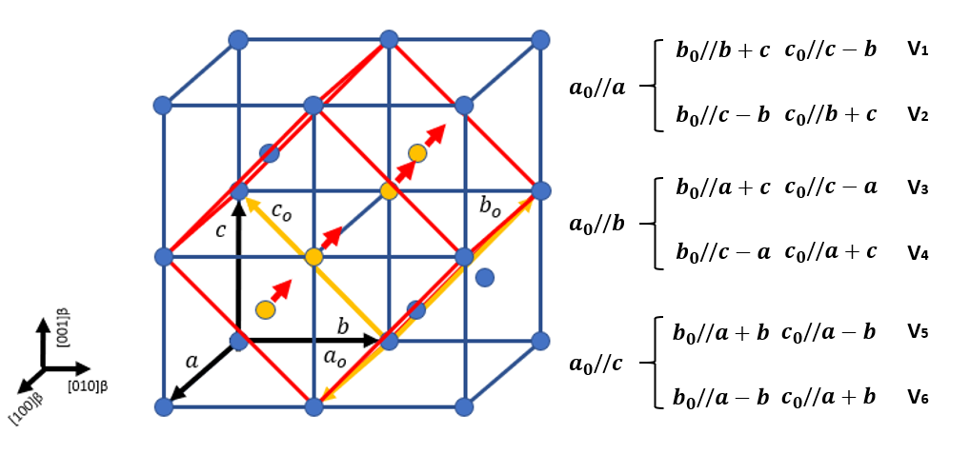
Figure 6-1 Lattice correspondence of six martensite variants in BCC matrix.
As a product of phase transformation, the self-accommodation (SA) twinning which occurs from the rearrangement of martensite variants [19], have the potential to correlate TRIP and TWIP coherently. During austenite to martensite transformation, the variants of martensite arrange themselves in a microstructure to reduce the overall strain caused by macroscopic shape change, which results in the activation of the self-accommodation (SA) twinning system. Similar to most mechanical twinning modes in metallic materials, the interfaces between these martensite SA twined plates always remain coherent [12,20]. This enables the utilisation of their twinning plane, as an invariant plane for deformation twinning, to accommodate the mechanical shear. In recent work, the infinitesimal deformation approach (IDA) was applied to calculate the possible SA twining modes for the orthorhombic martensite structure [21]. The approach was successfully applied in predicting possible twinning relationships among monoclinic SA variants during cubic to monoclinic phase transformation in Ti-Ni shape memory alloy [22,23]. The method was then corrected for application on cubic to orthorhombic transformation [12]. Three twin modes, type I {111}_{α’’}, type II <-211>_{α’’} and {011}_{α’’} compound twins were derived as potential SA structures for cubic to orthorhombic transformation. Here, the aim was to determine the possible SA twin modes to serve as TTIP candidates and IDA together with the theory of the crystallography of deformation twinning [15] were used to find potential TTIP-type twins.
First, the orientation relationships among the six variants with the β matrix is derived following the provision introduced by Liberman [13] as shown in Fig. 6-1. The main transformation (in martensite coordinates) strain is given as :
$μ_{1}=\frac{a_{0}-a}{a}$ (1)
$μ_{2}=\frac{b_{0}-\sqrt{2}a}{\sqrt{2}a}$ (2)
$μ_{3}=\frac{c_{0}-\sqrt{2}a}{\sqrt{2}a}$ (3)
The lattice parameter of the β matrix is $a$ and for the α’’ martensite are $a_{0}$,$b_{0}$ and $c_{0}$, where ($a_{0}$<$c_{0}$<$b_{0}$). The relationship of the deformation matrix between the martenstic variants and β matrix can be represented as:
$ε^{(1)}=\left(\begin{matrix}μ_{1} & 0 & 0 \\ 0 & \frac{μ_{2}+μ_{3}}{2} & \frac{μ_{2}-μ_{3}}{2} \\ 0 & \frac{μ_{2}-μ_{3}}{2} & \frac{μ_{2}+μ_{3}}{2}\end{matrix}\right)$ $T^{(1)}$=$\left(\begin{matrix}1 & 0 & 0 \\ 0 & 1 & -1 \\ 0 & 1 & 1\end{matrix}\right)$ (4)
$ε^{(2)}=\left(\begin{matrix}μ_{1} & 0 & 0 \\ 0 & \frac{μ_{2}+μ_{3}}{2} & -\frac{μ_{2}-μ_{3}}{2} \\ 0 & -\frac{μ_{2}-μ_{3}}{2} & \frac{μ_{2}+μ_{3}}{2}\end{matrix}\right)$ $T^{(2)}$=$\left(\begin{matrix}-1 & 0 & 0 \\ 0 & -1 & 1 \\ 0 & 1 & 1\end{matrix}\right)$ (5)
$ε^{(3)}=\left(\begin{matrix}\frac{μ_{2}+μ_{3}}{2} & 0 & \frac{μ_{2}-μ_{3}}{2} \\ 0 & μ_{1} & 0 \\ \frac{μ_{2}-μ_{3}}{2} & 0 & \frac{μ_{2}+μ_{3}}{2}\end{matrix}\right)$ $T^{(3)}$=$\left(\begin{matrix}0 & 1 & 1 \\ 1 & 0 & 0 \\ 0 & 1 & -1\end{matrix}\right)$ (6)
$ε^{(4)}=\left(\begin{matrix}\frac{μ_{2}+μ_{3}}{2} & 0 & -\frac{μ_{2}-μ_{3}}{2} \\ 0 & μ_{1} & 0 \\ -\frac{μ_{2}-μ_{3}}{2} & 0 & \frac{μ_{2}+μ_{3}}{2}\end{matrix}\right)$ $T^{(4)}$=$\left(\begin{matrix}0 & 1 & 1 \\ -1 & 0 & 0 \\ 0 & -1 & 1\end{matrix}\right)$ (7)
$ε^{(5)}=\left(\begin{matrix}\frac{μ_{2}+μ_{3}}{2} & \frac{μ_{2}-μ_{3}}{2} & 0 \\ \frac{μ_{2}-μ_{3}}{2} & \frac{μ_{2}+μ_{3}}{2} & 0 \\ 0 & 0 & μ_{1}\end{matrix}\right)$ $T^{(5)}$=$\left(\begin{matrix}0 & 1 & -1 \\ 0 & 1 & 1 \\ 1 & 0 & 0\end{matrix}\right)$ (8)
$ε^{(6)}=\left(\begin{matrix}\frac{μ_{2}+μ_{3}}{2} & -\frac{μ_{2}-μ_{3}}{2} & 0 \\ -\frac{μ_{2}-μ_{3}}{2} & \frac{μ_{2}+μ_{3}}{2} & 0 \\ 0 & 0 & μ_{1}\end{matrix}\right)$ $T^{(6)}$=$\left(\begin{matrix}0 & -1 & 1 \\ 0 & 1 & 1 \\ -1 & 0 & 0\end{matrix}\right)$ (9)
$ε^{(i)}$ represents the deformation matrix of the i th variant’s with respect to the standard coordinate of the β matrix. While T^{(i)} is the concise representation of the corresponding lattice axis direction for the
i th martenstic variant in the β matrix. The nth (n=1,2,3) column of $T^{(i)}$ represents the correspondance axis direction in the orthohombic lattice through cubic coordinate. The twin relationship among SA martensite variants has been explored by Liang [21] for a cubic-monoclinic transformation, by calculating the compensation of the orthorhombic α″ martensite transformation induced local strain through the generation of different self-accommodation twined martensite along lattice invariant plane. Similarly, for the current orthorhomobic structure, the distortion of an invariant plane strain (IPS) $γ$ was represented via the cross product of the invariant plane $n$ and displacement b vector as:
$γ_{ij}=b_{i}n_{j}$ (10)
Then, considering the symmetric part of the distortion, $ε_{ij}^{(twin)}$as:
$ε_{ij}^{(twin)}=\frac{(b_{i}n_{j}+b_{j}n_{i})}{2}$ (11)
The distortion strain between the$n$th variant and$m$th variant was represented by the difference between $ε^{(n)}$ and $ε^{(m)}$:$∆ε^{(m-n)}$. By subsitituting the $ε^{(m-n)}$ through twinning deformation along twining plane $n$ and twinning direction $b$, the twinning elements for the possible SA twin modes can be derived. First, the trasnformation strain between 1st and 2^{ed} SA martensite variants , $∆ε^{(2-1)}$ is shown as:
$∆ε^{(2-1)}=ε^{(2)}-ε^{\left(1\right)}=\left(\begin{matrix}0 & 0 & 0 \\ 0 & 0 & μ_{3}-μ_{2} \\ 0 & μ_{3}-μ_{2} & 0\end{matrix}\right)$ (12)
For $∆ε_{ij}^{(2-1)}$, when identical to eq.11, to solve:
$∆ε_{ij}^{(2-1)}=ε_{ij}^{(twin)}$ (13)
Whereas, for $b_{i}$ and $n_{i}$:
$b_{i}$=($x_{i}$, $y_{i}$, $z_{i}$) $n_{i}$=($h_{i}$ $k_{i}$ $l_{i}$) (14)
Substituting eq.11 into eq.13 with the replacement of $b_{i}$, $n_{i}$, $b_{j}$, $n_{j}$ expressed as eq.14, the expression was further transformed into eq.15, where $q=μ_{2}-μ_{3}$:
$\left(\begin{matrix}0 & 0 & 0 \\ 0 & 0 & -q \\ 0 & -q & 0\end{matrix}\right)=\frac{(b_{i}n_{j}+b_{j}n_{i})}{2}$=$\left(\begin{matrix}x_{i}h_{j} & x_{i}k_{j} & x_{i}l_{j} \\ y_{i}h_{j} & y_{i}k_{j} & y_{i}l_{j} \\ z_{i}h_{j} & z_{i}k_{j} & z_{i}l_{j}\end{matrix}\right)$/2+$\left(\begin{matrix}x_{j}h_{i} & x_{j}k_{i} & x_{j}l_{i} \\ y_{j}h_{i} & y_{j}k_{i} & y_{j}l_{i} \\ z_{j}h_{i} & z_{j}k_{i} & z_{j}l_{i}\end{matrix}\right)$/2 (15)
Considering$n$ is the twinning plane and $b$ is the twinning direction then:
$n_{i}∙b_{j}$= $n_{j}∙b_{i}$=$x_{j}h_{i}$+$y_{j}k_{i}$+$z_{j}l_{i}$=$x_{i}h_{j}$+$y_{i}k_{j}$+$z_{i}l_{j}$=0 (16)
By solving eq.15 and eq.16$, n$ and $b$ were obtained as (vectors were represented in cubic coordinates):
$b$=[0, -2q, 0]_{β} $n$=(0 0 1)_{β} or $b$=[0, 0, -2q]_{β} $n$=(0 1 0)_{β} where q=$ε_{2}-ε_{3}$.
By converting the twinning plane into orthorhombic lattice coordinates, the solution for two lattice invariant planes (001)_{β} and (010)_{β} corresponds to the (011)_{α’’V1} and (0$\overline{1}$1) _{α’’V2} compound SA twining, respectively. The above solution was defined as compound twinning {011}_{α’’}. Similarly, $∆ε_{ij}^{(3-1)}$ and $∆ε_{ij}^{(5-1)}$ can be represented as:
$∆ε^{\left(3-1\right)}$=$\frac{1}{2}\left(\begin{matrix}μ_{2}+μ_{3}-{2μ}_{1} & 0 & μ_{2}-μ_{3} \\ 0 & {2μ}_{1}-μ_{2}-μ_{3} & μ_{3}-μ_{2} \\ μ_{2}-μ_{3} & μ_{3}-μ_{2} & 0\end{matrix}\right)= \frac{1}{2}\left(\begin{matrix}-p & 0 & q \\ 0 & p & -q \\ q & -q & 0\end{matrix}\right)$ (17)
where p=${2μ}_{1}-μ_{2}-μ_{3}$, the solution of eq.17 is:
$b$ =$\frac{1}{\sqrt{2}}$(-p, -p, 2q) $n$ =$\frac{1}{\sqrt{2}}$ (1 -1 0) or $b$ =$\frac{1}{\sqrt{2}}$ (1, -1, 0) $n$ =$\frac{1}{\sqrt{2}}$ (-p -p 2q) (18)
and for $∆ε^{\left(5-1\right)}$:
$∆ε^{\left(5-1\right)}$=$\frac{1}{2}\left(\begin{matrix}μ_{2}+μ_{3}-{2μ}_{1} & μ_{2}-μ_{3} & 0 \\ μ_{2}-μ_{3} & 0 & μ_{3}-μ_{2} \\ 0 & μ_{3}-μ_{2} & {2μ}_{1}-μ_{2}-μ_{3}\end{matrix}\right) = \frac{1}{2}\left(\begin{matrix}-p & q & 0 \\ q & 0 & -q \\ 0 & -q & p\end{matrix}\right)$ (19)
where the solution is expressed as:
$b$ =$\frac{1}{\sqrt{2}}$(p, -2q, p) $n$ =$\frac{1}{\sqrt{2}}$ (-1 0 1) or $b$ =$\frac{1}{\sqrt{2}}$ (-1, 0, 1) $n$ =$\frac{1}{\sqrt{2}}$(p -2q p) (20)
As expected, due to the symmetry of the BCC lattice, the solution of $b$ and $n$ for $∆ε^{\left(3-1\right)}$, $∆ε^{\left(4-1\right)}$, $∆ε^{\left(5-1\right)}$, $∆ε^{\left(6-1\right)}$ is general, and all expressed in the form of:
$b$ =$\frac{1}{\sqrt{2}}$[p, -2q, p] $n$ =$\frac{1}{\sqrt{2}}$ (-1 0 1) or $b$ =$\frac{1}{\sqrt{2}}$ [-1, 0, 1] $n$ =$\frac{1}{\sqrt{2}}$(p -2q p) (21)
To transfer the Miller indices of $b$ and $n$ from cubic to orthorhomobic (BCC to martensite) coordinates, the following lattice correspondence relationship derived from V1 were taken (through undeformed base centred orthorhombic coordinates):
Table 6-1 Lattice correspondence of the BCC structure with the Martensite structure.
Body centric cubic | a [1 0 0] | b [0 1 0] | c [0 0 1]
Orthorhombic | a₀ [1 0 0] | b₀ [0 ½ -½] | c₀ [0 ½ ½]
Substituting a, b, c by a_{0,} b_{0,} c₀ in eq.(21) and deleting the common coefficient, the simple integer ratio expression of $b$, and $n$ is determined. To transform the cubic Miller indices of lattice plane ($h k l$)_{β} into orthorhombic ($h' k' l'$)_{α’’}, the following transformation is used. Considering $n$=($h k l$) in a center cubic structure, the general expression can be written as: $h$x +$k$y +$l$z + D = 0; the intersection points A, B, C of the ($h k l$)_{β} plane with the orthorhombic primitive lattice vectors a₀, b₀ ,c₀ are obtained via the following relations:
$\left\{\begin{aligned}hx + ky + lz + D=0, x=x^{'}, y=0,z=0; \\ hx + ky + lz + D=0, x=0, y=z; \\ hx + ky + lz + D=0, x=0, y=-z; \end{aligned}\right.$ $\left\{\begin{aligned}A=(\frac{-D}{h},0,0) \\ B=(0,\frac{-D}{k+l},\frac{-D}{k+l}) \\ C=(0,\frac{-D}{k-l},\frac{D}{k-l})\end{aligned}\right.$ (22)
The intersection points A, B, C can be further written in orthorhombic coordinates as:
$\left\{\begin{aligned}A=(\frac{-D}{h},0,0) \\ B=(0,\frac{-D}{k+l},0) \\ C=(0,0,\frac{-D}{k-l})\end{aligned}\right.$ (23)
While by removing the common factor D in eq.(23), the ($h k l$)_{β} plane in BCC coordinates can now be transformed as:
($h' k' l'$)_{α’’}=($h k+l l-k$)_{β} (24)
Thus, eq.21 may be written in orthorhombic coordinate as:
$b$ = [p, -q+p/2, q+p/2] $n$ = (-1 1 1) or $b$ = [-2 1 1] $n$ = (p p-2q p+2q) (25)
While n represents the twinning plane and b is the twinning direction. The first solution is not hard to conclude as an expression for {111}_{α’’} type I twinning; whilst the second solution may not only represent a single solution for type II <211> twinning. By comparing the solutions of eq.25, additional type II twinning modes may exist, as indicated by [2-11](p p-2q p+2q)_{α’’}, which reflects the extra arithmetic solution for eq.25. The possibility exists of various type II <-211>_{α’’} twin modes, which enable the variants to accommodate the phase transformation volume change along different lattice invariant planes. The SA twinning modes solutions derived from eq.25 were listed in the Table. 6-1 and further discussed under the theory of the crystallography of deformation twinning [15], in order to assess the potential of utilising them as lattice invariant planes for mechanical deformation.
Table 6-2 Potential TTIP twinning modes in α’’ martensite and lattice correspondence in the body-centric β phase. s represents the shear vector, while K_{SA}, η_{SA} and K₁, K₂, η₁ η₂ are twinning elements of SA twinning and mechanical twinning, respectively. The value q represents shuffle complexity.
Mode | s | Orthorhombic α’’ martensite
 |  | $$K_{1/SA}$$ | $$K_{2}$$ | $$η_{1}$$ | $$η_{2}$$ | $$η_{SA}$$
I | 0.3536 | {1 1 3} | {3 -5 1} | <1-10> | <1 1 2> | <-2 -1 1>
II | 0.3536 | {3 5 1} | {1 -1 3} | <1-12> | <1 1 0> | <-2 1 1>
III | 0.6124 | {1 1 1} | {-5 19 3} | <-110> | <5 1 2> | <-2 1 1>
IV | 0.7071 | {1 3 1} | {-1 1 3} | <-101> | <1 1 0> | <-2 1 -1>
V | 0.7071 | {1 1 3} | {-1 3 1} | <-110> | <1 0 1> | <-2 -1 1>
Mode | s | β body-centric
 |  | $$K_{1/SA}$$ | $$K_{2}$$ | $$η_{1}$$ | $$η_{2}$$ | $$η_{SA}$$
I | 0.3536 | {1,2,1} | {3,-2,3} | <1-11> | <1 3 1> | <1 0 -1>
II | 0.3536 | {3,2,3} | {1,-2,1} | <1-31> | <1 1 1> | <1 0 -1>
III | 0.6124 | {1,0,1} | {-5,8,11} | <-101> | <5 -1 3> | <1 0 -1>
IV | 0.7071 | {1,1,2} | {-1,-1,2} | <11-1> | <1 1 1> | <1 -1 0>
V | 0.7071 | {1,1,2} | {-1,-1,2} | <11-1> | <1 1 1> | <1 -1 0>
Mode III represents type I {111}_{α’’} SA twinning while the rest of the twinning modes indicate possible solutions for type II <-211> _{α’’} SA twinning. The existence of mode II, which utilises {351}_{α’’} plane as an invariant lattice plane, was experimentally determined in Fig. 5-12 in Chapter 5. Observations of mode IV, which utilise {131} _{α’’} as the lattice invariant plane for type II SA twinning, was aslo reported in a Ti-Nb metastable β Ti alloy [24]. When transforming the potential TTIP twin candidates into lattice corresponding mechanical twin modes in body-centric lattice in Table 6-2, modes I, IV, V are concluded to relate to the {112}<11-1>_{β} mechanical twin, whilst mode II related to {332}<11-3> _{β} mechanical twinning.
For the lattice corresponding to the {332}_{β} plane, the {351}_{α’’} lattice invariant plane in mode II <-211>_{α’’} SA twinning can coherently link the {332}<11-3>_{β} twinning structure in both the β phase and the α’’ phase by accommodating extensive stress along the {351}<1-12>_{α’’} direction. This discovery is in agreement with the experimental results detailed in Chapter 5, where the origin of {332}<11-3>_{β} was proposed. In addition to this, for the abnormal cooperation between {332}<11-3>_{β} mechanical twinning and {112}<11-1>_{β} mechanical twinning, a new explanation is proposed. This is described as a result of the inheritance from the existed SA twinning structure resulting from TRIP. Here, the grain prefers to utilise existing lattice invariant planes to accommodate extensive mechanical deformation once the loading was released, due to the nature of athermal phase transformation in metastable IVB elements-based alloy. In the study of the TiZrHfTa_{x(x=0.5-1)} system, depending on the difference in β phase stability, with a higher β phase stability (TiZrHfTa_{x=0.6-0.8}) the existing mode I, IV, V and II TTIP SA martensitic twinning will reverse to the lattice corresponding {112}<11-1>_{β} and {332}<11-3> _{β} twin modes, respectively; whilst for TiZrHfTa_{x=0.5}, which possessed a lower β phase stability, the martensite twin structure is favoured to remain steady, hence enabling the observation of mode II twinning as discussed in Chapter 5. However, in the current calculations, the lattice instability which is determined by the displacement of atoms along {011}_{β} during β to α’’ phase transformation was not involved. To further investigate the favoured TTIP twinning modes and preferred activation sequence among modes I to IV twins, the lattice instability was considered by applying a modulated structure and atomic shuffle mechanisms in the following section.

6.3 Identification of TTIP twinning modes and potential shuffle mechanisms
The reduction of shear modulus c’((c11-c12)/2) in the atomic displacement along the {01-1}<011>_{β} direction is a result of the destabilization of the β phase and further activation of the β to α’’ phase transformation [11,25]. When taking the destabilisation of β phase into consideration, the lattice instability and atomic shuffle [11,16] were found to aid in distinguishing the energetically favourable activation sequence of potential TTIP twin modes presented in Table 6-2. The value of q is defined by the number of lattice planes parallel to the twinning plane ($K_{1}$), that are intersected by a primitive lattice vector in the conjugate twinning direction ($η_{2}$), This was used to describe the shuffling mechanism complexity [16] and listed in Table. 6-3. This measure of shuffle complexity was considered to interrelate with the feasibility of activating TTIP type twinning. The shuffling modulation mechanisms for both the SA and mechanical twinning modes were then examined by applying a double lattice structure with different motif units [16].
Table 6-3 Potential TTIP twinning modes with shuffling mechanism complexity.
Mode | s | Orthorhombic α’’ martensite
 |  | $$K_{1/SA}$$ | $$K_{2}$$ | $$η_{1}$$ | $$η_{2}$$ | $$η_{SA}$$ | $$q$$
I | 0.3536 | {1,1,3} | {3,-5,1} | <1-10> | <1 1 2> | <-2 -1 1> | 4
II | 0.3536 | {3,5,1} | {1,-1,3} | <1-12> | <1 1 0> | <-2 1 1> | 4
III | 0.6124 | {1,1,1} | {-5,19,3} | <-110> | <5 1 2> | <-2 1 1> | 4
IV | 0.7071 | {1,3,1} | {-1,1,3} | <-101> | <1 1 0> | <-2 1 -1> | 2
V | 0.7071 | {1,1,3} | {-1,3,1} | <-110> | <1 0 1> | <-2 -1 1> | 4
Primary selection was conducted by comparing the magnitude of the shear vector, as well as the shuffling mechanism complexity, in order to simplify the calculation process. Applying the theory of mechanical deformation twinning, the shear vectors of five modes SA twinning were calculated. With conjugate twinning direction η_{C} vertical to the SA twinning direction η_{SA}, in the non-deformed base-centred model shown in Fig. 6-1, no macroscopic shear is needed for the formation of type II <-211>_{α’’} SA twinning. This explains why SA twinning is the most energetically favoured deformation product in TiZrHfTa_{0.5} at the early stage of martensite phase transformation. Thus, to distinguish the activation sequence of the SA twinning modes listed in Table. 6-3, the lattice instability is considered. Regarding mode I and mode V, these share the same lattice invariant plane, while the magnitude of the shear vector for mode I is near half of mode V. Thus, only mode I-IV SA twins were considered with double lattice structure. For the mechanical twinning of modes I-V, only modes I and II possessed the smallest shear vector, which is of primary concern for the activation sequence. However, mode IV possesses the simplest shuffle complexity. Therefore, together with the mode I and II, the mechanical twinning for mode I, II and IV were considered under a double lattice structure.
Table 6-4 Potential motif units in orthorhombic coordinates.
Unit | a | b | c | Unit | a | b | c
$$κ_{1}$$ | 1/2 | σ | 1/2 | $$ν_{1}$$ | 1/2 | σ -1 | 1/2
$$κ_{2}$$ | 1/2 | σ | -1/2 | $$ν_{2}$$ | 1/2 | σ -1 | -1/2
$$κ_{3}$$ | -1/2 | σ | 1/2 | $$ν_{3}$$ | -1/2 | σ -1 | 1/2
$$κ_{4}$$ | -1/2 | σ | -1/2 | $$ν_{4}$$ | -1/2 | σ -1 | -1/2
$$λ_{1}$$ | 1 | σ -1/2 | 1/2 | $$ξ_{1}$$ | 0 | σ -1/2 | 1/2
$$λ_{2}$$ | 1 | σ -1/2 | -1/2 | $$ξ_{2}$$ | 0 | σ -1/2 | -1/2
$$λ_{3}$$ | -1 | σ -1/2 | 1/2 | $$ρ_{1}$$ | 0 | σ +1/2 | 1/2
$$λ_{4}$$ | -1 | σ -1/2 | -1/2 | $$ρ_{2}$$ | 0 | σ +1/2 | -1/2
$$θ_{1}$$ | 1 | σ +1/2 | 1/2 | $$ψ_{1}$$ | 1/2 | σ +1 | 1/2
$$θ_{2}$$ | 1 | σ +1/2 | -1/2 | $$ψ_{2}$$ | 1/2 | σ +1 | -1/2
$$θ_{3}$$ | -1 | σ +1/2 | 1/2 | $$ψ_{3}$$ | -1/2 | σ +1 | 1/2
$$θ_{4}$$ | -1 | σ +1/2 | -1/2 | $$ψ_{4}$$ | -1/2 | σ +1 | -1/2
In comparison with the original BCC matrix, the transformation to orthorhombic martensite is attributed to atomic displacement σ[011]_{β} along the {0-11}_{β} plane as a result of the low shear modulus
c’((c₁₁-c₁₂)/2)[11,25]. For the orthorhombic double lattice structure, there are seven crystallographically distinct pairs of atoms that may be used to represent the motif unit [11]. These were termed as κ, λ, θ, ν, $ξ$, ρ and $ψ$. A schematic of the motif units in this modulated double lattice structure is given in
Fig. 6-2(c). The possible motif units are listed in Table. 6-4 in orthorhombic coordinate with a, b, and c primitive lattice vectors.
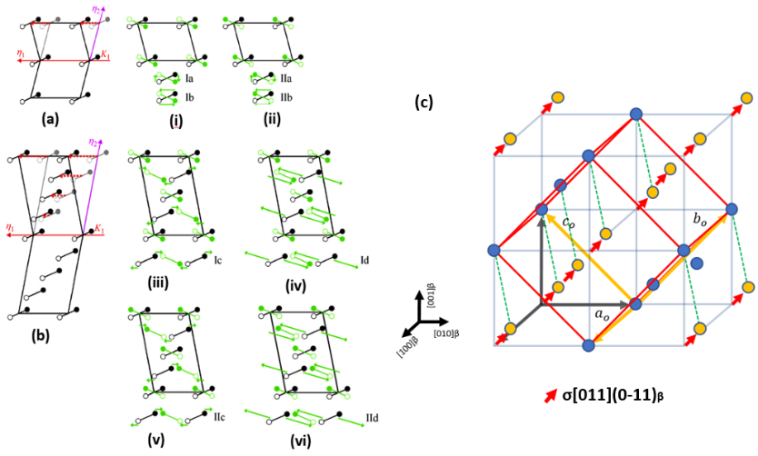
Figure 6-2 A schematic of the atomic shuffle mechanism with q=1 and 4 in the double lattice structure [11,16]. (a) the possible mechanism for rearrangement of motif unit with q=1 is shown in (i) and (ii) for type I twinning and type II twinning, respectively; (b) rearrangement and disruption of motif unit with q=4 are shown in (iii)-(iv) and (v)-(vi) for type I and type II twinning, respectively. Atoms represented by open and closed circles lie above and below; (c) the modulated structure for the orthorhombic lattice, with the red arrow indicating the displacement of atoms in the (0-11)_{β} plane along the [011]_{β} direction. The green dashed line represents the motif units for the double lattice structure.
The selection of motif unit towards different twinning systems follows the premise that the unit is small and approximately parallel to the twining plane $K_{1}$, which results in small shuffle movements [14,16]. The illustration of possible shuffle mechanisms were derived in Fig. 6-2, for the condition of q=1 and 4. The projection of the selected motif for mode I, II and IV mechanical twins on the {-111}_{α’’} plane are shown in Fig. 6-3(a-c), whilst for the corresponding SA twins, the motif selections are shown in Fig. 6-3(d-f).
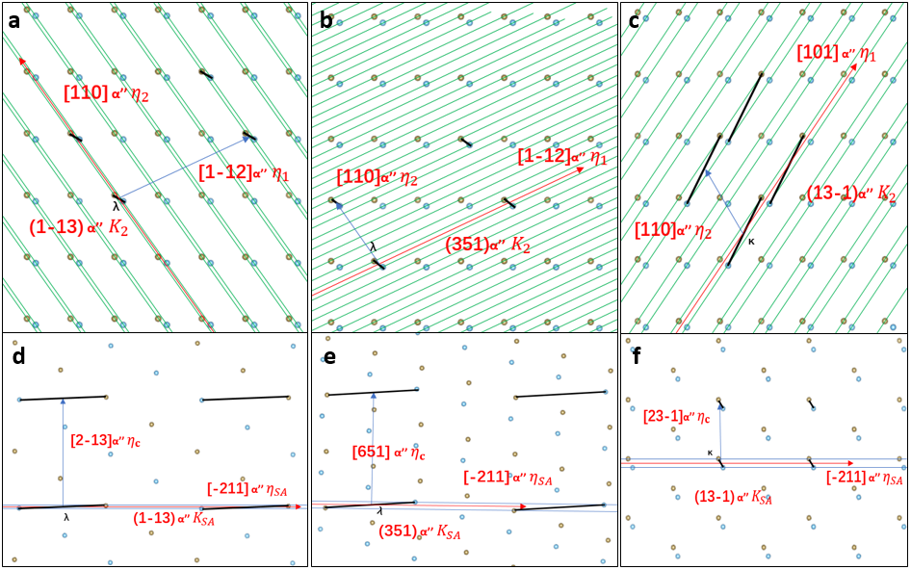
Figure 6-3 Motif unit selections for modes 1,2,4. (a) motif unit λ selected for mode I mechanical twinning. (b) motif unit λ selected for mode II mechanical twinning; (c) motif unit κ selected for mode IV mechanical twinning; (d) motif unit λ selected for mode I SA twinning; (e) motif unit λ selected for mode II SA twinning; and. (f) motif unit κ selected for mode IV SA twinning. All motif unit vectors are coloured with black, while brown atoms are the modulated structure along the {0-11}_{β} plane.
The possible atomic shuffle mechanisms for mode I, II and IV mechanical and SA type II twinning are all listed in Table. 6-5. For the SA twin situation, only the type II twin mode was considered. Including mode III {111}<-211>_{α’’} type II twinning, the solution of all four SA twin modes showed that shuffle mechanisms are proportional to the magnitude of the atomic displacement σ as shown in Table. 6-6.
Table 6-5 Shuffle mechanisms of potential mechanical TTIP twinning modes and SA twinning modes. Group i represents the solution for SA twinning and Group ii are the solutions for mechanical twinning situations.
Group i |  |  | Orthorhombic α’’ martensite |  |  |  |  |  |  |  |  |  |  |  |  | Mechanism
 |  |  | $$K_{SA}$$ |  |  | $$K_{c}$$ |  |  | $$η_{SA}$$ |  |  | $$η_{c}$$ |  | $$unit$$ | $$q$$ |  | Type II
I |  |  | {1,-1,3} |  |  | {1-1-1} |  |  | <-2 1 1> |  |  | <2-13> |  | λ | 4 |  | IIa-IIc
II |  |  | {3,5,1} |  |  | {1-1-1} |  |  | <-2 1 1> |  |  | <651> |  | λ | 4 |  | IIa-IIc
III |  |  | {1,1,1} |  |  | {-111} |  |  | <-2 1 1> |  |  | <211> |  | ξ | 1 |  | IIb
IV |  |  | {1,3,-1} |  |  | {1-1-1} |  |  | <-2 1 1> |  |  | <23-1> |  | κ | 2 |  | IIb
Group ii |  | s |  |  |  |  |  | Orthorhombic α’’ martensite
 |  |  |  |  | $$K_{1/SA}$$ |  | $$η_{1}$$ |  |  | $$unit$$ | $$q$$ |  | Mechanism
 |  |  |  |  |  |  |  |  |  |  |  |  | Type I |  | Type II
I | 0.3536 |  |  | {1,-1,3} |  |  | <110> |  |  | λ | 4 |  | Ia-Id |  | IIb-IIc
II | 0.3536 |  |  | {3,5,1} |  |  | <1-12> |  |  | λ | 4 |  | Ia-Id |  | IIb-IIc
IV | 0.707 |  |  | {1,3,-1} |  |  | <101> |  |  | κ | 2 |  | Ia |  | IIa
When compared with the experimentally derived results detailed previously, the findings here were identical. With the smallest magnitude of atomic shuffle displacement, the {111}<-211> _{α’’} type II twin was found to be the most energetically favoured SA twin mode of the four modes SA twins, which also relate to the solution for the type I {111} _{α’’} SA twinning. However, without requiring large atomic displacement to shuffle, other SA type II <-211> _{α’’} twinning modes are also easily activated. Although reports have been limited, the observation of mode IV type II <-211> _{α’’} was described for Ti-Nb metastable β alloys [24]. This observation of mode II SA twinning was also found and discussed for TiZrHfTa_{0.5} in Chapter 5. The solutions for mechanical mode I and II twins are presented in Table. 6-6 also indicate the possibility of SA twinning to mechanical twinning transformation.
Table 6-6 Energetically favoured shuffle mechanism of group i and ii modes twin. With $d_{\{hkl\}}$ and $l_{<uvw>}$ representing the lattice spacing of the {$hkl$} planes and lattice vector of <$uvw$>. ${cosφ}_{HKL\sim hkl}$ is the crystal plane angle between the {$HLK$} planes and the {$hkl$} planes. σ is the magnitude of atomic displacement along {0-11}<011>_{β}.
Mode | q | Motif units | Shuffle mechanism | Magnitude of atomic shuffle per atom
i I {1-13}<-211> | 4 | λ | IIa-IIc | 0.683σ
i II {351}<-211> | 4 | λ | IIa-IIc | 0.683σ
i III {111}<-211> | 1 | ξ | IIb | 0.5σ
i IV {13-1}<-211> | 2 | κ | IIb | 0.5σ
ii I {1-13}<110> | 4 | λ | IIb-IIc | 3$d$₀₁₋₁(1-cosφ_{(1-13)~(111)})/2-$\left|l_{<110>}\right|$/4
ii II {351}<1-12> | 4 | λ | IIb-IIc | $\left|l_{<112>}\right|$/4-3$d$₀₁₋₁(1-cosφ_{(351)~(111)})/2
ii IV {13-1}<101> | 2 | κ | Ia | 0.86 σ

6.4 Discussion and conclusions
The infinitesimal deformation approach (IDA)[12] was applied to calculate possible SA twinning modes, for six α’’ lattice correspondence variants, in order to map out the potential mechanical twinning modes. In the current work, the base centred tetragonal structure was used to represent the un-transformed orthorhombic martensite lattice. This structure was utilised to calculate the compensation of the orthorhombic α″ martensite transformation-induced local strain, through the generation of different self-accommodated twinned martensite along the lattice invariant plane. In addition to the solution corresponding to SA {111}_{α’’} type I twinning and {011}_{α’’} compound twinning, as reported in previous theoretical work [12], it was discovered that there may be the existance of more than one twinning mode for the solution of SA <211>_{α’’} type II twinning, to utilise different lattice planes as the invariant lattice plane.
When considering lattice instability to distinguish the energetically favourable activation sequence, potential shuffle mechanisms were derived which minimised the required modulation as shown in Table 6-5. Considering no macroscopic shear is necessary to form SA type mode I~IV twins, the observation frequency fitted the energetically favoured activation sequence of mode I~IV SA type II <-211>_{α’’} twins well. Mode III corresponding to the {111}_{α’’} SA type I twins required the smallest magnitude of shuffle and identified as the most probable SA twinning mode to activate. The other three modes SA twin atomic modulation were proportional to the magnitude of displacement along <010>_{α’’} and therefore allowed to generate as SA type twinning during martensite phase transformation. Modes I and II, whose corresponding mechanical type twinning requires smallest shear vector, were further examined for potential mechanical twinning shuffle modulation. As mechanical twinning mechanisms which require complex shuffles, both mode I and II mechanical twinning need the rearrangement and disruption of the motif unit to complete the shuffle modulation, whilst no complicated shuffle mechanism was required for mode IV mechanical twin. Another interesting finding from the above calculation was that in I, II and IV three mechanical modes, the mechanical twinning direction η₁ was vertical to the SA twinning direction η_{SA}. Furthermore, the primitive vector of corresponding invariant lattice planes for mode I, II and IV were determined to be along η₁ and η_{SA}. This indicated the possible slip direction that the twinning mode lattice invariant plane is along which were either η₁ or η_{SA}. This discovery also provided solid evidence for the activation of SA twinning to mechanical twinning transformation.
Thus, a reasonable prediction of TTIP in the current system is without the requirements of large atomic shuffle modulation and shear. During early-stage deformation when the TRIP effect occurs, the SA type mode I~V twin are energetically favoured to form first in order to compensate stress and strain along η_{SA} direction. At the later stages of deformation, when the TRIP effect reduces, the existing SA twinnings are favoured to compensate the increasing stress and strain along η₁ instead of the η_{SA} direction. Therefore, deformation products such as mechanical twinning or secondary SA twinning may be activated on the existing SA twinning structure. Considering the abnormal cooperation of {332}<11-3>_{β} and {112}<11-1>_{β}, {011}_{α’’} compound twin and {111}_{α’’} type I twin observed in Chapter 5, the Mode I and II SA twins corresponding mechanical twinning mode required smallest shear vectors in both martensite phase and corresponding β phase, which was believed to responsible for this process. The TTIP effect is postulated to be the main contributor to the strengthening of TiZrHfTa_{0.5}. , as a result of the coherently linked SA twinning and mechanical twinning in α’’ and β phase, respectively. According to the atomic shuffle mechanism results calculated, the activation of mode I and mode II SA twins were mainly dependant on the magnitude of displacement σ{001}<010>_{α’’} which relates to the β phase stability. Through the understanding that the tuning of Ta content is effective in tailoring β phase stability, the Ta content in TiZrHfTa₀₅ is believed to be situated in an effective zone where the experimental results of TTIP can be observed. Based on the TiZrHfTa_{0.5}((TiZrHf)₈₆Ta₁₄ (at.%)) system in which mode II TTIP twinning was first observed, the current work aims to provide evidence for and demonstration of the activation of TTIP by empirical means. This will be discussed in Chapter 7, for which (TiZrHf)₈₅Ta₁₅ (at.%) and (TiZrHf)₈₇Ta₁₃ (at.%) were selected, synthesised, heat-treated and subsequently tested and analysed.

6.5 References
[1] Z. Li, C.C. Tasan, H. Springer, B. Gault, D. Raabe, Interstitial atoms enable joint twinning and transformation induced plasticity in strong and ductile high-entropy alloys, Sci. Rep. (2017). doi:10.1038/srep40704.
[2] B.B. He, H.W. Luo, M.X. Huang, Experimental investigation on a novel medium Mn steel combining transformation-induced plasticity and twinning-induced plasticity effects, Int. J. Plast. (2016). doi:10.1016/j.ijplas.2015.11.004.
[3] M. Marteleur, F. Sun, T. Gloriant, P. Vermaut, P.J. Jacques, F. Prima, On the design of new β-metastable titanium alloys with improved work hardening rate thanks to simultaneous TRIP and TWIP effects, Scr. Mater. (2012). doi:10.1016/j.scriptamat.2012.01.049.
[4] G. Frommeyer, U. Brüx, P. Neumann, Supra-Ductile and High-Strength Manganese-TRIP/TWIP Steels for High Energy Absorption Purposes., ISIJ Int. (2003). doi:10.2355/isijinternational.43.438.
[5] Z. Li, K.G. Pradeep, Y. Deng, D. Raabe, C.C. Tasan, Metastable high-entropy dual-phase alloys overcome the strength-ductility trade-off, Nature. (2016). doi:10.1038/nature17981.
[6] M.A. Meyers, O. Vöhringer, V.A. Lubarda, The onset of twinning in metals: A constitutive description, Acta Mater. (2001). doi:10.1016/S1359-6454(01)00300-7.
[7] S.L. Wong, M. Madivala, U. Prahl, F. Roters, D. Raabe, A crystal plasticity model for twinning- and transformation-induced plasticity, Acta Mater. (2016). doi:10.1016/j.actamat.2016.07.032.
[8] A.A. Salem, S.R. Kalidindi, R.D. Doherty, Strain hardening of titanium: Role of deformation twinning, Acta Mater. (2003). doi:10.1016/S1359-6454(03)00239-8.
[9] H.S. Kim, S.H. Lim, I.D. Yeo, W.Y. Kim, Stress-induced martensitic transformation of metastable β-titanium alloy, Mater. Sci. Eng. A. (2007). doi:10.1016/j.msea.2006.02.329.
[10] M.J. Lai, C.C. Tasan, D. Raabe, On the mechanism of {332} twinning in metastable β titanium alloys, Acta Mater. (2016). doi:10.1016/j.actamat.2016.03.040.
[11] H. Tobe, H.Y. Kim, T. Inamura, H. Hosoda, S. Miyazaki, Origin of {3 3 2} twinning in metastable β-Ti alloys, Acta Mater. (2014). doi:10.1016/j.actamat.2013.10.048.
[12] T. Inamura, J.I. Kim, H.Y. Kim, H. Hosoda, K. Wakashima, S. Miyazaki, Composition dependent crystallography of α″-martensite in Ti-Nb-based β-titanium alloy, Philos. Mag. (2007). doi:10.1080/14786430601003874.
[13] D.S. Lieberman, M.S. Wechsler, T.A. Read, Cubic to orthorhombic diffusionless phase change - Experimental and theoretical studies of AuCd, J. Appl. Phys. (1955). doi:10.1063/1.1722021.
[14] A.G. Crocker, Twinned martensite, Acta Metall. (1962). doi:10.1016/0001-6160(62)90056-1.
[15] B.A. Bilby, A.G. Crocker, The Theory of the Crystallography of Deformation Twinning, Proc. R. Soc. A Math. Phys. Eng. Sci. (1965). doi:10.1098/rspa.1965.0216.
[16] A.G. Crocker, The crystallography of deformation-twinning in alpha-plutonium, J. Nucl. Mater. (1971). doi:10.1016/0022-3115(71)90077-8.
[17] E. Bertrand, P. Castany, Y. Yang, E. Menou, T. Gloriant, Deformation twinning in the full-α″ martensitic Ti-25Ta-20Nb shape memory alloy, Acta Mater. (2016). doi:10.1016/j.actamat.2015.12.001.
[18] P. Castany, Y. Yang, E. Bertrand, T. Gloriant, Reversion of a Parent {130}<310>alpha’’ Martensitic Twinning System at the Origin of {332 } <113>beta Twins Observed in Metastable beta Titanium Alloys, Phys. Rev. Lett. (2016). doi:10.1103/PhysRevLett.117.245501.
[19] K. Bhattacharya, Self-accommodation in martensite, Arch. Ration. Mech. Anal. (1992). doi:10.1007/BF00375026.
[20] Y.W. Chai, H.Y. Kim, H. Hosoda, S. Miyazaki, Self-accommodation in Ti-Nb shape memory alloys, Acta Mater. (2009). doi:10.1016/j.actamat.2009.04.051.
[21] Y. Liang, H. Kato, M. Taya, T. Mori, Infinitesimal approach to the crystallography of martensitic transformation: application to Ni-Ti, Scr. Mater. (2000). doi:10.1016/S1359-6462(00)00465-6.
[22] Microstructure of martensite: why it forms and how it gives rise to the shape-memory effect, Choice Rev. Online. (2013). doi:10.5860/choice.41-6554.
[23] M. Kato, M. Shibata-Yanagisawa, Infinitesimal deformation approach of the phenomenological crystallographic theory of martensitic transformations, J. Mater. Sci. (1990). doi:10.1007/BF00544207.
[24] H. Tobe, H.Y. Kim, T. Inamura, H. Hosoda, T.H. Nam, S. Miyazaki, Effect of Nb content on deformation behavior and shape memory properties of Ti-Nb alloys, J. Alloys Compd. (2013). doi:10.1016/j.jallcom.2012.02.023.
[25] J. Tran, Titanium by design: Trip titanium alloy, ProQuest Diss. Theses Glob. (2009).

Chapter.7 TTIP effect in (TiZrHf)₈₇Ta₁₃

7.1 Preface
Utilising metastable engineering to introduce TRIP and TWIP via lowering β phase stability, TRIP and TWIP were successfully activated simultaneously in TiZrHfTa_{x (x=0.5-0.8)}. The effect of TRIP and TWIP in TiZrHfTa_{x (x=0.5-0.8)} was found to be composition dependent with reduction of the β stabiliser Ta. However, as a result of the differences in the activation conditions and subsequent effects between TRIP and TWIP, the imbalance between strength-ductility and plastic instability will ultimately affect application of these materials. During investigations on the mechanical response and microstructure evolution of
TiZrHfTa_{x (x=0.5-0.8)} through compression testing, high levels of work hardening were observed and the interaction of abnormal twinning cooperation in TiZrHfTa₀₅ was found. Based on the experimental results derived from TiZrHfTa_{x (x=0.5-0.8)} compression tests, in addition to the observation of {332}_{β} mechanical twinning, massive martenstic self-accommodation (SA) twinning was found in deformed TiZrHfTa_{0.6} and TiZrHfTa_{0.5}. SA twinning was generally accepted as a product of phase transformation, resulting from the rearrangement of martensite variants [1], as was thought to promote the effect of TRIP and TWIP coherently. During the transformation from austenite to martensite, the variants of martensite arranged themselves in a microstructure to reduce the overall strain of macroscopic shape change, which inevitably resulted in the activation of the self-accommodation (SA) twinning system. Similar to mechanical twinning, the interfaces between these martensite plates are always coherent [2,3]. This enables the use of their twinning plane as an invariant plane for deformation twinning to accommodate mechanical shear. Utilising the existing SA twin from TRIP, corresponding orientation related mechanical twin products may activate along the favoured shear direction in later stages of deformation. This new dynamic strengthening mechanism was here termed Twinning Transformation Induced Plasticity (TTIP). Evidence of the concept of this new plasticity mechanism was further analysed through the application of the theory of the crystallography of deformation twinning and infinitesimal deformation approach (IDA). The special SA {351}<-211>_{α’’} type II twinning mode which corresponds to {332}_{β} twinning was predicted by applying the IDA and subsequently identified as the key to activate TTIP. Through the activation of this specific type of self-accommodation (SA) twinning, large deformation could be sustained by partially transformed SA twinning into mechanical deformation products in this IVB element based HEA.
In Chapter 6, two SA twinning modes {351}<-211>_{α’’} and {113}<-211>_{α’’} type II twin were predicted as the most likely candidates for TTIP activation. According to the calculated results described in Chapter 6 and in previous research, the selection of SA twinning modes was mainly determined by the β phase stability, which was tuned through varying Ta addition in the current work. Thus, in a similar fashion to metastable β-Ti alloys, the careful control of heat-treatment conditions and addition of β stabiliser, may profoundly influence the effect of TTIP. Based on the discovery outlined in Chapter 5, two compositions (TiZrHf)₈₅Ta₁₅ and (TiZrHf)₈₇Ta₁₃ were selected to verify the activation of TTIP.
By carefully tailoring the β phase stability, TTIP activation was enabled in the metastable multi-component alloy (TiZrHf)₈₇Ta₁₃. The mechanical performance displayed exceptional multi-stage work hardening (10 GPa), enabled by a combination of TRIP from the stress-induced orthorhombic α” martensite phase, TTIP via activation of SA type {351}_{α’’} twins and TWIP through the formation of nanometre-scale interpenetrating twisted mechanical twinning laths on {351}_{α’’} SA twin. The resulting short mean glide path for any subsequent dislocation motion further contributed to the enhancement of the work hardening capacity.
The observed TTIP mechanism involved a previously undiscovered SA type twins working as mechanical twinning. The deformation products activated on TRIP induced SA twin were enabled by preferential shear along the corresponding austenite mechanical twin direction. Massive self-accommodating microstructure was found to be embedded into a matrix of austenite coherently and without introducing macroscopic stresses during phase transformation. This enables the {351}_{α’’} twinning plane, which was originally formed as coherent SA type twins, to further mediate the strain accommodation by shifting the SA shear direction to the favoured mechanical shear direction. A variety of TTIP products, including {351}_{α’’} deformation twins and {011}_{α’’} compound SA twins, were observed. Thus, TTIP was found to produce a super-refined nano-laminate structure of α'' (orthorhombic) martensite bounded with multi-type SA twins. The ultimate benefit from this special dynamic refinement mechanism was that it unlocks the constraint between TRIP and TWIP. Hence, allowing an enhancement of mechanical performance of newly designed alloys. The enhanced mechanical performance, made possible by the TTIP mechanism, enables the design of low-density β-Ti structural materials with exceptional impact resistance. This type of material could perform well in such applications as lightweight safety systems in the transportation sector.
To investigate the evolution of the deformation mechanism of TTIP, the following experimental results and discussions describe the development and testing of the multi-component TTIP alloys (TiZrHf)₈₅Ta₁₅ and (TiZrHf)₈₇Ta₁₃. Employing a range of experimental tools including TEM, HRTEM, XRD and EBSD, substantial findings were revealed with regard to the crystallography of the structural transformation responsible for the TTIP twinning mechanism.

7.2 Mechanical response and microstructure evolution
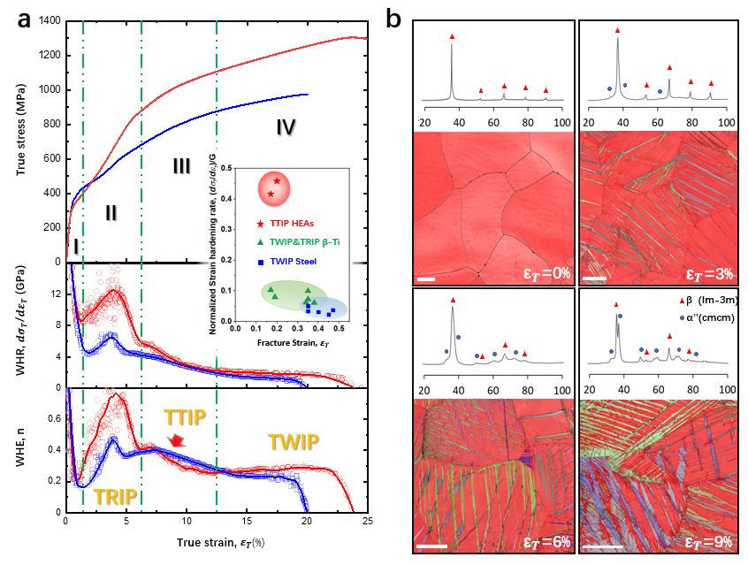
Figure 7-1 mechanical properties of (TiZrHf)₈₅Ta₁₅ and (TiZrHf)₈₇Ta₁₃. (a) tensile properties. The true stress and true strain curves of (TiZrHf)₈₅Ta₁₅ (blue) and (TiZrHf)₈₇Ta₁₃ (red) are shown in the top panel. The inset shows the comparisons of normalised work hardening rate ((dσ_{T}/dε_{P})/G) as a function of fractured strain between our alloys and other high-performance titanium alloys and TWIP steels. The blue and green groups represent high strength Ti alloys, TWIP steels [9–11] and TRIP-DP-HEA [12–14], respectively. Work hardening rate (WHR) curves of (TiZrHf)₈₅Ta₁₅ (blue) and (TiZrHf)₈₇Ta₁₃ (red) are shown in the middle panel. Four deformation stages are divided by the green dash line. In the bottom panel, the dynamic change of the work hardening exponents (WHE) indicates three main deformation stages attribute to the effect of TRIP, TTIP and TWIP, respectively; and (b) XRD patterns and EBSD maps of (TiZrHf)₈₇Ta₁₃ subjected to x% deformation (where x=0, 3, 6, 9% true strain). θ is the Bragg angle. The effect of TRIP is directly related to the extent of strain. Indexed martensite phase’s euler angle maps for 3%, 6% and 9% strain are presented while the β phase is characterized with red. (scale bars = 20μm).
The representative mechanical response during tensile deformation for (TiZrHf)₈₅Ta₁₅ and (TiZrHf)₈₇Ta₁₃ are shown in Fig. 7-1(a). Both samples demonstrated a combination of high strength and high ductility. Compared with (TiZrHf)₈₅Ta₁₅, the reduction of Ta addition to 13% (TiZrHf)₈₇Ta₁₃) further lowered the β phase stability and resulted in an increase in UTS to 1310 MPa and an elongation of 25%. This notable increase was attributed to the excellent work-hardening (dσ_{T}/dε_{P}) displayed by (TiZrHf)₈₇Ta₁₃ (Fig. 7-1(a)). While the maximum theoretical value of dislocation density enabled the normalised work hardening rate to be predicted from the Kocks–Mecking model as 0.05G (where G is the bulk shear modulus) [9], the normalised work hardening rate ((dσ_{T}/dε_{P})/G) of (TiZrHf)₈₇Ta₁₃ reached 0.47G, which outperforms most well-known high-performance TWIP and TRIP polycrystalline alloys. To investigate the microstructural evolution, the phase constitution and microstructure of (TiZrHf)₈₇Ta₁₃ was examined at 0%, 3%, 6% and 9% tensile strain levels. Representative XRD patterns and EBSD images are shown in Fig. 7-1(b). Together with the mechanical response curve in Fig.7-1(a), three-stage work hardening was observed for (TiZrHf)₈₅Ta₁₅ and (TiZrHf)₈₇Ta₁₃ alloys as shown in Fig.7-1. Stage I is known as the elastic-plastic transition stage, whereby the work hardening rate drops dramatically after the yield. At this stage, only β phase peaks were indexed using XRD. This indicated that the quenched sample comprised mostly a single phase, where solely dislocation glide accommodated the applied stress, as the critical resolved shear stress (CRSS) was not high enough to activate other deformation mechanisms [4,15]. With the increase in deformation from 1.3% to 6% (Stage II) strain, a rapid rise in work hardening rate can be seen. TRIP was activated (strain = 2%) and needle-like α’’ martensite phase started to form within the β grains (Fig.7-1(b)). A small peak related to (020)_{α’’} was detected in the corresponding XRD spectrum. The intensity of α’’ reflections increased, which demonstrated further promotion of martensitic phase transformation. This confirms that the desired instability of the β phase was successfully introduced by tuning the Ta content and subsequently resulted in the introduction of stress-induced martensite and SA morphology. This leads to the visible rebound of work hardening rate in this stage. At Stage III, starting at 6% strain, the early strengthening effect subsided, while dislocation glide and other deformation mechanisms continue to accommodate the extensive strain which maintained the continuous strengthening to higher strain levels. In contrast with (TiZrHf)₈₅Ta₁₅, the work hardening curve of (TiZrHf)₈₇Ta₁₃ (bottom panel of Fig.7-1(a)) was found to slowly increase after 12.5% (stage IV). This indicated a new deformation mechanism may have activated, hence resulting in the sustainment of working hardening following this strain.
Detailed microstructural analysis was then undertaken to aid in distinguishing the evolution of the underlying deformation mechanism in (TiZrHf)₈₅Ta₁₅ and (TiZrHf)₈₇Ta₁₃. A noise reduced EBSD image of (TiZrHf)₈₇Ta₁₃ subjected to 3% deformation is given in Fig. 7-2(a). The indexed phase constitution of martensite was 11.2%, while primary SA twinning starts to form as marked in Fig. 7-2(b). In Fig. 7-2(c), a secondary martensite variant was identified within the original martensite matrix. The misorientation profile between the secondary martensite variant and primary martensite, was measured as <331>_{α’’}~64°, which is not related to any known martensite twinning system. Applying the stereo-projection figures, the OR between two variants was identified as a <-211>_{α’’} type II twinning system with (-113)_{α’’} as the twinning plane. Another SA twin system was also captured in the same sample. In Fig. 7-2(d), the misorientation angle of <311>_{α’’}~71° was acquired between the martensite matrix and the twinned variant. After applying the stereo-projection figure, the OR between the twinned martensite variant and matrix was determined to be (-111)_{α’’} type I SA twinning.
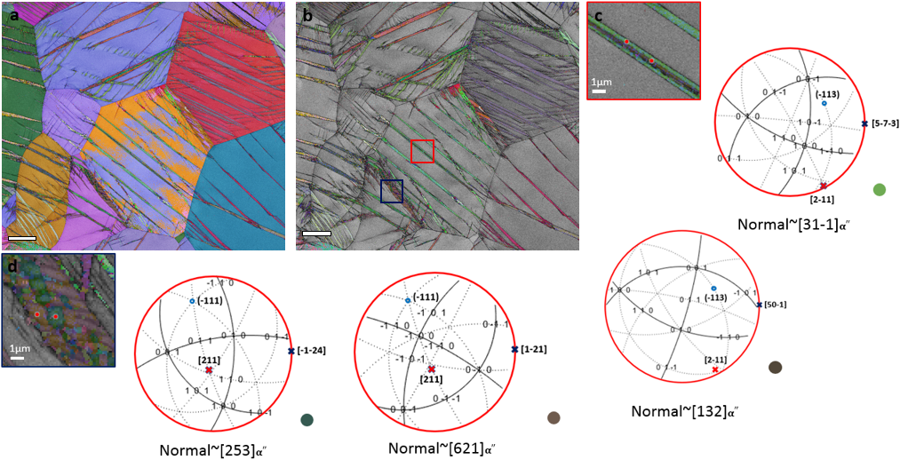 Figure 7-2 Noise-reduced EBSD maps of (TiZrHf)₈₇Ta₁₃ subjected to 3% deformation. (a) Euler map of the deformed sample, the indexed martensite phase constitution was confirmed to be 11.2%; (b) Euler map of the martensite phase. Inset shows an interesting feature which involves SA twinning within a primary martensite grain; (c) OR of martensite variants. The crystal orientation data was acquired at the red spot. The stereo-projection figure was generated following the pole acquired from orientation data. The normal axis was [31-1]_{α’’} and [132]_{α’’} for primary and secondary martensite, respectively; and (d) OR of martensite variants. The crystal orientation data was measured at the red spot. The stereo-projection figure was formed following the pole acquired from the orientation data. The normal axis was [621]_{α’’} and [253]_{α’’} for primary and secondary martensite, respectively.
Further deformation was found to successfully enhance the magnitude of the TRIP effect while the martensite volume fractions come to 31% and 24% for Ta 13 and Ta15, respectively. The increased α’’ fraction encourages the martensite variants to arrange themselves into a more complex martensitic SA twinned structures, in order to accommondate the increasing volume misfit which occurred by the progressive β to α’’ phase transformation. The classical zig-zag SA morphology of martensite can be observed clearly in the sample deformed to 6% strain, where the formation of a mechanical type I twins have been observed in both alloys. A special case is confirmed in Fig. 7-3 where the misorientation angle of the {111}_{α’’} type I twinned α’’ variant is <032>_{α’’}~70° with the {351}<1-12>_{α’’} type I twinned variant. With <211>_{α’’} in Fig. 7-3c(ii) superimposed on Fig. 7-3c(iii), this misorientation relationship was considered as a special type II <211>_{α’’} twins which activated as secondary twins on primary type I twined variants. The resultant average width of martensite plates comes to 0.67μm for Ta13, while for Ta15, the average width is 0.97μm at 6% strain. This confirms that the desired instability of the β phase enables the formation of lamellar stress-induced martensite plus various SA twins and martensitic mechanical twins, which contributes to the notable peak of work hardening rate at stage. II.
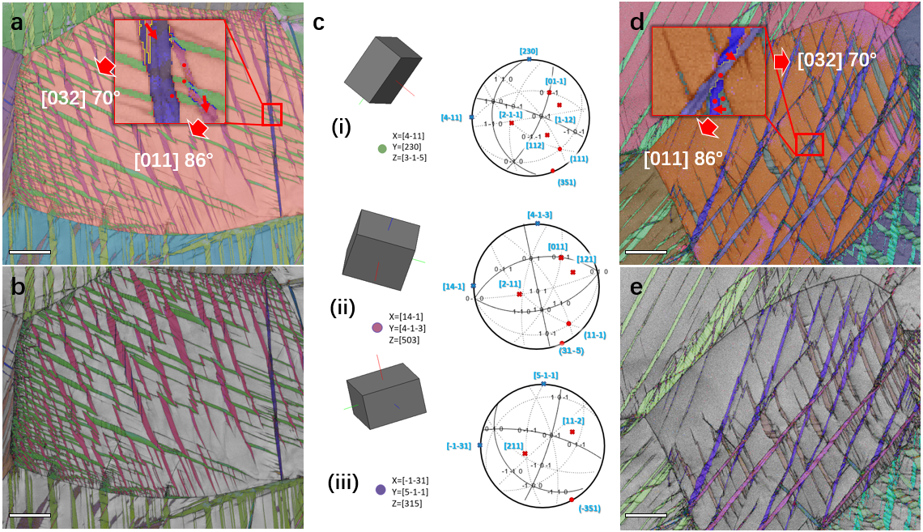
Figure 7-3: Noise-filtered EBSD maps of (TiZrHf)₈₇Ta₁₃ and (TiZrHf)₈₅Ta₁₅ subjected to 6% deformation. (a) Euler angle map of the deformed sample. The inset highlights martensitic misorientation profile used for twinning indexation. (b) Euler angle map of martensite phase. (c) Orientation relationship of martensite variants from the red box in (a). The crystal orientation data is acquired at the red spots. Stereographic projections are generated from the orientation data. The normal axes are (i) [3-1-5]_{α’’} for α’’ matrix, (ii) [503]_{α’’} for {111}_{α’’} type I twinned variant (iii) [315]_{α’’} for α’’ {351}<1-12>_{α’’} compound twinned variant. (d) Euler angle map of the deformed sample. The inset highlights martensitic twinning misorientation profile used for twinning indexation. (e) Euler angle map of martensite phase. Scale bars, 10μm.
To keep compensating for the overall volume change and accommodating the increased local stress, formation of massive SA twins was observed in the sample deformed with 9% strain. Increasing the strain to 9% (stage III) leads to the volume fractions of α’’ further rise to ~43% and ~34% in Ta13 and Ta15 respectively, whilst the primary β grains were divided into separated smaller grains (about 2~3μm) from ~80μm after recrystallization. Although the volume fraction of α″ phase increased in Ta13 and Ta15 at ε_{T}=9%, the martensite transformation rate in both alloys dropped, meaning that the effect of TRIP may have saturated upon further loading. However, a small hump is observed in the work hardening exponent curve of both samples at 6-9% strain, indicating the activation of new deformation mechanism. Beyond 12% strain(stage IV), the work hardening exponent of Ta15 alloy decreases gradually and fractured at 20% strain with a strength of 980MPa. Whereas, for the Ta13 with higher β phase instability, the work hardening exponent n exhibits a liner increase from 0.22 at 12% strain to 0.31 at 20% strain, suggesting an additional strengthening mechanism occurred. While in the noise reduced EBSD image of 20% deformed Ta13, nearly 90% of the phase constitution was indexed as martensite phases. This revealed that the phase transformation-induced lattice distortion and atomic shuffle may influence the accuracy of EBSD indexing. Three SA twinning systems were indexed within one martensite grain as shown in Fig.7-4. The indexed SA twin in Fig. 7-4(a) includes an unusual combination of SA type I {111}_{α’’}, type II <211>_{α’’} and {011}_{α’’} compound twins, which are difficult to activate simultaneously, as previously reported [3]. When substituting the misorientation relationship acquired from EBSD analysis into the four martensite variants (V1-V4) shown in Fig. 7-4, in addition to the type I {111}_{α’’}, type II <211>_{α’’} SA twin, a new misorientation profile was observed between V2 and V4 and determined as <011>_{α’’}~85°. The {011}_{α’’} compound twinning in α″ has a lattice corresponding with {10-12}<10-11>_{α} twinning in α and possesses the misorientation profile <10-11>_{α}~86°. By taking α’’ phase as the intermediate phase between the β and α phases, the lattice correspondence between <011>_{α’’} and <10-11>_{α} can be derived. Thus, the OR between V2 and V4 was identified as {011}_{α’’} compound twinning [16]. Previous reports described that the {011}_{α’’} compound twinning can serve as self-accommodation twinning, however, it can also act as deformation twinning [3]. Therefore, the exact reasons for the activation of {011}_{α’’} compound twinning in the current alloy system are unclear. Interestingly, by using the stereo-projection figure, the OR between V2 and V1 was identified as being related to type II SA <211>_{α’’} twinning (Fig. 7-4(b)). This indicates that the cooperation of type I {111}_{α’’} and {011}_{α’’} compound twinning may be activated as TTIP deformation products on the existing type II SA <211>_{α’’} twinning structures during the later stages of deformation.
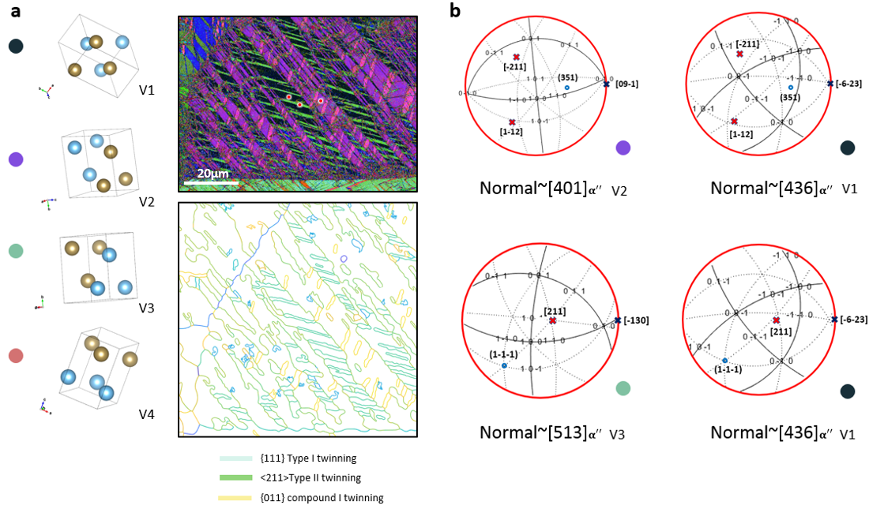
Figure 7-4 Noise-reduced EBSD maps of (TiZrHf)₈₇Ta₁₃ subjected to 20% deformation. (a) Euler map of the martensite phase, with the four martensite variants annotated with black, green, purple and pink. In addition to the previous misorientation profile which represents type I and type II SA twinning, the misorientation angle <011> _{α’’}~85° was applied to index the {011}_{α’’} compound twins; and (b) OR of the martensite variants. The crystal orientation data were acquired at the red spots. A stereo-projection figure was formed following the pole acquired from orientation data. The normal axes was determined as [436]_{α’’}, [401]_{α’’} and [513]_{α’’} for V1, V2, and V3, respectively.

7.3 Deformation mechanism evolution

7.3.1 Identification of type II {351}<-211>_{α’’} SA twinning
In Chapter 6, by application of the IDA approach and crystallography of deformation twinning mechanisms, the type II {351}<-211>_{α’’} SA twin system was determined as the key deformation structure that occurs during TTIP. By conducting stereo-projection figures on V1 and V2 (Fig. 7-3(c)), the observation of {351}<-211>_{α’’} was first captured by EBSD for (TiZrHf)₈₇Ta₁₃ deformed to 6% strain. However, it was difficult to identify whether the observed twinning is related to the type II twinning. V1 and V2 shared the same lattice vector of [-211]_{α’’} and [1-12]_{α’’} along the (351)_{α’’} plane, which are twinning directions of type II SA and mechanical twinning modes. To further identify if the twinning elements of SA twinning observed belong to the mode II TTIP type twinning derived in Chapter 6, TEM was conducted on specimens deformed to 6% strain. In addition to the widely observed type I {111}_{α’’} twin, mode II SA {351}<-211>_{α’’} twinning was also imaged (Fig. 7-5(a)) along the [1-12]_{α’’}//[1-31]_{β} zone axis for the sample deformed to 6% strain (the following lattice correspondences are used in the present chapter: β→α″: [100]_{α’’}–[100]_{β}, [010]_{α″}–[011]_{β}, [001]_{α″}–[0–11]_{β}). Two dark-field images in Fig. 7-5b(i-ii) were obtained using (-111)_{α’’} and (-111)_{α’’T} reflections from the SADP in Fig. 7-5(b). The wavy band features indicate other deformation products may exist in this {351}_{α’’} twinned α’’ variant. The image in Fig. 7-5 b(i-ii) shows that the twinning plane is exactly perpendicular to the g vector of (351)_{α’’}, which coincides with (351)_{α’’T} as indicated by the blue arrow. To clarify the feature observed within the twinned α’’ variant, double-beam condition (g*=110) was applied on the same twinning. Instead of dislocations, an antiphase boundary (APB) like stacking fault structures were captured within the twin boundary in Fig. 7-5 b(iii-iv). Known as products of martensitic transformation [17], the nano-domain observed in Fig. 7-5(b) may serve as a nucleation site for new martensite variants and enable TTIP deformation products to generate within primary {351}_{α’’} twinned variant [18].
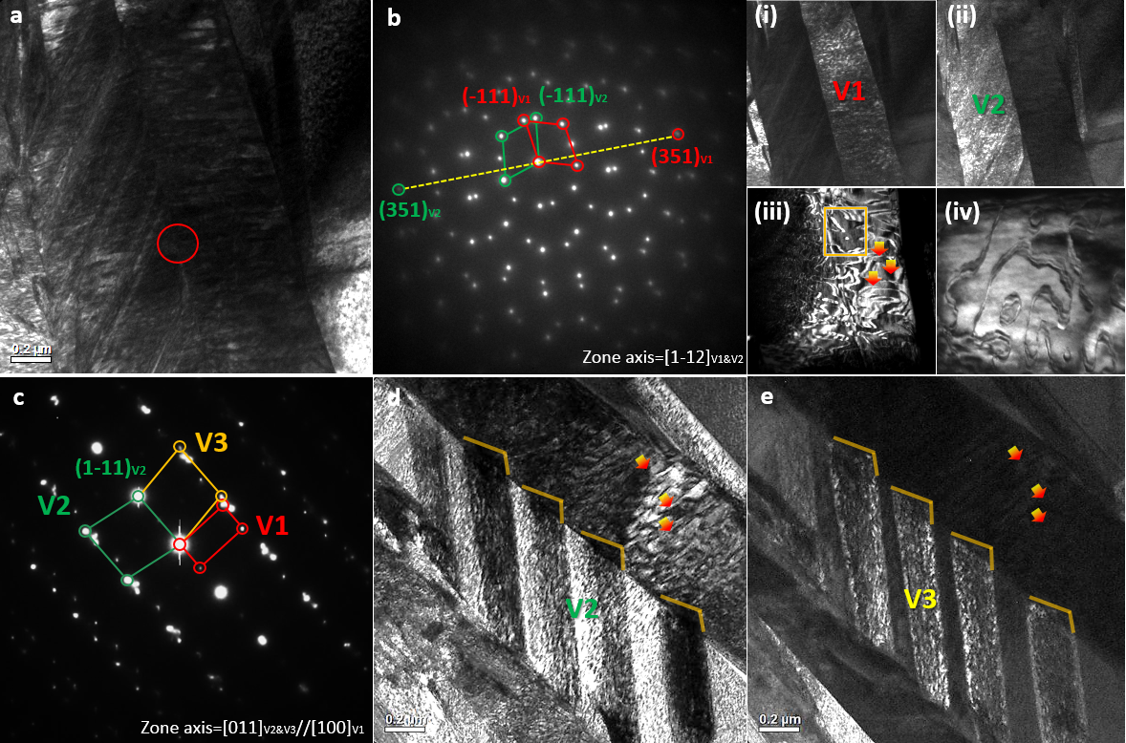
Figure 7-5 TEM images of {351}_{α’’} twinning in the specimen deformed to 6% strain. (a) a bright field image of the target area; (b) SADP taken along the [1-12] zone axis of the twinning boundary, matrix and twinning set DP are marked with green and red circles, respectively; i. DFI of the matrix and ii. of the twin; iii. antiphase boundary appearing similar to stacking faults observed in two-beam condition. iv. an enlarged feature within twin boundary. HRTEM images of the {351}_{α’’} twinning boundary; (c) SADP taken along the [100]//[011] zone axis of the twinning boundary, matrix and twinning set DP are marked with green and red circles, respectively; (d) DFI of the primary type II twin. (e) DFI of the secondary type I twin. Scale bars are 200nm.
An additional SADP (Fig. 7-5c) acquired along [011]_{α’’}//[100]_{α’’T} was used to confirm whether the twinning observed belonged to <-211>_{α’’} type II twinning. By transferring the lattice vector of V1 into {351}_{α’’} twinned V2, the lattice correspondence between V1 and V2 for {351}<-211>_{α’’} type II and {351}<1-12>_{α’’} mechanical twinning are listed in Table 7-1. Accordingly, since the [011]_{α’’V1}//[100]_{α’’V2} lattice correspondence can only be realised by (351)<2-1-1>_{α’’} twinning, the {351}_{α’’} twinning observed in Fig. 7-5 was identified as type II twinning. Moreover, the OR between secondary twinned α’’ variant V3 and primary twinned V2 was identified as type I {111}_{α’’} in Fig. 7-5(c); while the dense laths observed across V1 and V2 α’’ bands corresponded to the anti-phase boundary (APB)-like stacking fault features observed through conducting DFI under double beam conditions at g*=110 in Fig. 7-5(b).
Table 7-1 Main Zone axis and corresponding zone axis after specific deformation.
Coordinate system | Main target zone axis correspondence
(351)<2-1-1>_{α’’} matrix | <100> | <001> | <10-1> | <1-12> | <2-11> | <1-10>
(351)<2-1-1>_{α’’} twinned variant | <011> | <-21-1> | <1-10> | <-11-2> | <001> | <10-1>
(351)<1-12>_{α’’} twinned variant | <0.36 1.3 0.3> | <11-4> | <1-1-2> | <1-12> | <-99-5> | <3-10>

A further SADP was acquired along [001]_{α’’V1} //[2-11]_{α’’V2} as shown in Fig. 7-6, as another analysis to ascertain if the lattice vector correspondence between the matrix and {351}_{α’’} twinned variant followed the {351}<-211>_{α’’} type II twinning relationship. The OR between V1 and V2 was derived from the result shown in the stereo-projection figure at Fig. 7-6(d). The lattice correspondence [001]_{α’’V1} //[2-11]_{V2} can only be satisfied by the {351}<-211>_{α’’} type II twinning mode as presented in Table 7-1, which reconfirmed the {351}_{α’’} twinning feature observed in Fig.7-5 belonged to {351}<-211>_{α’’} type II twinning. Of note is the diffraction pattern shown in Fig. 7-5(a), where it is seen that great similarities were evident for the diffraction pattern of the {332}_{β} mechanical twinning acquired along the <1-10>_{β} zone axis. Considering the {351}_{α’’} plane lattice corresponds to the {332}_{β} plane, such similarity in diffraction patterns may not be a coincidence, but rather indicates some unknown relationship between {351}<-211>_{α’’} type II
and {332}<1- 13>_{β} mechanical twinning.
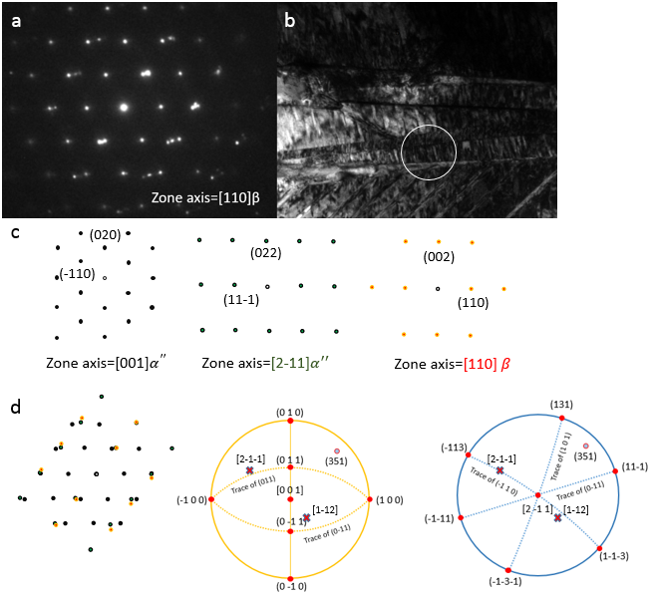
Figure 7-6 TEM image of {351}_{α’’} martensite twin. (a) a SADP of {351} twinning and BCC matrix acquired from [001]_{α’’} //[2-11]_{α’’}//[1-10]_{β} zone axis with BCC matrix; (b) bright filed image of the selected area; (c) a simulated DP of the denoted zone axis; (d) overlapped DP of [001]_{α’’} //[2-11]_{α’’}//[1-10]_{β} and can be compared with (a); and a schematic stereo projection figure is acquired from the [001] _{α’’} and [2-11] _{α’’} zone axe.

7.3.2 Evolution of type II {351}<-211>_{α’’} SA twinning
With further deformation to 9% strain, the primary SA twinned α’’ variants arrange themselves in a more complicated structure due to the increased strain. In Fig. 7-7, TEM BFI shows a transformed type II {351}<-211>_{α’’} SA twin structure, with the four involved martensite variants designated as V1-4. SADPs taken from the origin and transformed {351}<-211>_{α’’} twin boundary along <112>_{α’’} and <2-1-1>_{α’’} are shown in Fig. 7-7(b-c) for comparison to illustrate the twinning structure evolution. The diffraction spots of α’’V1 variant are first observed in Fig. 7-7(b) where the lattice correspondence [10-1]_{α’’V1}//[-110]_{α’’V2}//[-112]_{α’’V3&V4} is identified. While the OR between V3 and V4 can be easily identified from SADP as type II (35-1)[2-11]_{α’’}, to establish the origin of the V1 and V2, DFIs were taken from diffraction spots of the three α’’ variants as shown in Fig. 7-7(d-f). Clearly, the DFIs presented in Fig. 7-7(d, e) indicate that the main α’’ bands belong to V1, V3 and V4 respectively, while the thin laths separating them correspond to V2. The sample was then tilted to the [2-1-1]_{α’’V1} zone axis to acquire further lattice correspondence information, as shown in Fig. 7-7(c). Interestingly, there are only three sets of DPs indexed in Fig. 7-7(c), while the V2’s DP was missing. From current DPs in Fig. 7-7(c), the lattice correspondence between V1, V3 and V4 was first confirmed from SADP as [2-1-1]_{α’’V1}//[2-1-1]_{α’’V3}//[001]_{α’’V4} and (351)_{α’’V1}//(351)_{α’’V3}//(130)_{α’’V4}. Clearly, the OR between V1 and V3 can be identified as type of {351}_{α’’} twinning, when taking [10-1]_{α’’V1}//[-112]_{α’’V3} into consideration, the OR between V1 and V3 can be confirmed as {351}<1-12>_{α’’} type I twinning which is lattice correspondent with {332}<11-3>β mechanical twinning and possesses the same magnitude of shear vector[37]. With V2 observed between V1 and V3, checking the possible lattice correspondence of martensite twinning in supplementary table I, identified the OR between V1 and V2 as type II (351)[-211]_{α’’} twinning which helps explain why the DP for V2 is missing in Fig. 7-7(c) (Type II twinning operation: rotate 180 degree along [-211]_{α’’}, DP of V2 overlap with DPs of V1).
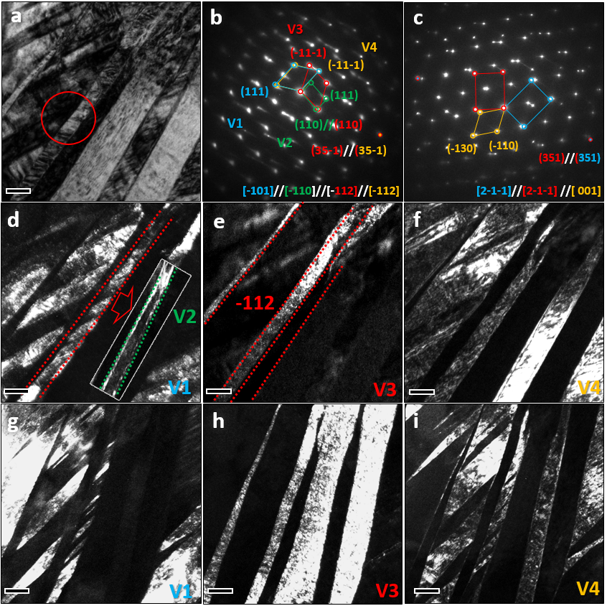
Figure 7-7 TEM showing the microstructure evolution of SA type II {351}<-211>_{α’’} twins. (a) BFI of the transformed SA {351}_{α’’} twins after 9% strain. (b-c) SADP taken next to the twin boundary (red circle) along the [10-1]_{α’’V1}//[-110]_{α’’V2}//[-112]_{α’’V3&V4} and [2-11]_{α’’V1-3}//[001]_{α’’V4} zone axis respectively. (d-f) DFI of four α’’ variants imaged in Fig. 3b. (g-i) DFI of three α’’ variants imaged in Fig. 3c. All scale bars are 50nm.
Moreover, in same area of the specimen, this planar feature propagates through the adjacent α’’-β interface and extends into the remnant β grain (Fig.7-8 yellow circled area). Most interestingly, the SADP obtained from the elongated laths in the β grain indicates that the coherently inherited α’’ twin structure results in the formation of a {332}<11-3>_{β} mechanical twin-like structure (Fig. 7-8) in the β phase where the (332)_{β} planes have a lattice correspondence with (351)_{α’’}.
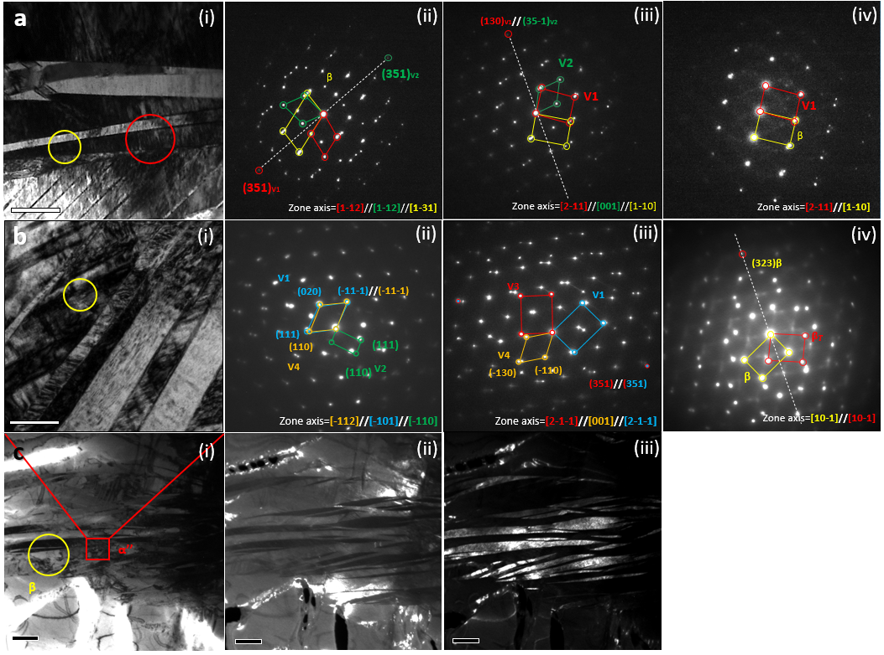
Figure 7-8: SADP comparison of {351}<-211>_{α’’} type II and {351}<1-12>_{α’’} compound twinning under different zone axis. (a) Type II SA {351}_{α’’} twinning in a specimen deformed to 6% strain. i. BF image. ii-iv Corresponding SADPs taken next to the twinning boundary (red circle) along the [1-12]_{α’’V1&V2}//[1-31]_{β} and [2-11]_{α’’V1}//[001]_{α’’V2}//[1-10]_{β} zone axis respectively. (b) Compound {351}<1-12>_{α’’} twin in a specimen deformed to 9% strain. i. BF image. ii-iv Corresponding SADPs taken next to the twin boundary (red circle) along the [-101]_{α’’V1}//[-110]_{α’’V2}//[-112]_{α’’V4}, [2-1-1]_{α’’V1}//[2-1-1]_{α’’V3}//[001]_{α’’V4}; yellow area in (c) along [10-1]_{βM}//[10-1]_{βT} zone axis respectively. (c) Low magnified BF image of the twinning feature observed in (b). Red circled area is the feature in (b). (ii-iii) DFIs of the matrix and twinning, taken from reflection observed in b(iv). Scale bar in a, 200nm. Scale bar in b, 50nm. Scale bars in c (i-iii), 500nm.
The microstructure evolution becomes even more complicated when the strain is further increased to stage IV. As shown in the previous EBSD of the Ta13 sample deformed to 20% strain in Fig. 7-4, the highly-tangled type I {111}_{α’’} and {011}_{α’’} compound twinning feature started to form. In difference with type I {111}_{α’’} and type II <-211>_{α’’} SA twinning, the critical activating condition for SA {011}_{α’’} compound twinning requires negative strain to exert along the [001]_{α’’}[22] direction, which complicates the origin of the observed {011}_{α’’} compound twinning during this deformation stage. Nevertheless, by conducting TEM on a sample deformed to 20% strain, it was found that the network structure with twisted type I {111}_{α’’} and {011}_{α’’} compound twins occurred and may be play a crucial role in maintaining the hardening capacity in deformation stages IV. The bright field image in Fig. 7-9(a) shows the highly entangled network structure. From this feature, the SADP taken along [011]_{α’’M}//[100]_{α’’V} indicates both the previously observed SA {111}_{α’’} twinning and SA {011}_{α’’} compound twinning were involved. To identify the OR between both twinning systems (for conciseness, the two martensite variants which form {111}_{α’’} twins are labelled as ‘M’ group, while variants forming {011}_{α’’} twins are denoted by ‘V’), the four martensite variants are named as M1, M2 and V1, V2 as shown in Fig. 7-9(c-f). The linked boundary between M1 and V1 indicated a potential OR may exist between M and V group martensite variants. By applying the derived lattice correspondence, [011]_{α’’M}//[100]_{α’’V} and (1-11)_{α’’M}//(00-1)_{α’’V}, the stereographic projection figure of M and V group variants was constructed in Fig. 7-9(g-h) in order to determine this OR. The analysis shows that M1 and V1 exhibit the {351}_{α’’} twinning relationship, since the {351}_{α’’M1} reflection overlapped with {351}_{α’’V1}. It should be noted that the zone axis correspondence in Fig. 7-9(b) between M group and V group was identical to the one captured in SADP shown in Fig. 7-5(c). Although both features are identified as {351}<2-1-1>_{α’’} type II twins, with increased strain the zone axis correspondence acquired in Fig. 7-9(b) (<100>_{α’’}//<011>_{α’’}) did not show perfect compatibility as shown in Fig. 7-5(c). This may be attributed to the lattice distortion or increased stress activation on the primary {351}<2-1-1>_{α’’} type II twinning. Therefore, this analysis has indicated that the network structures of twisted SA {111}_{α’’} and SA {011}_{α’’} twinnings may activate as secondary deformation products to compensate the strain accumulation in primary SA {351}_{α’’} twinning. This occurrence results in a highly twisted nano-laminate microstructure, which presents a maze-like route for the dislocations to glide.
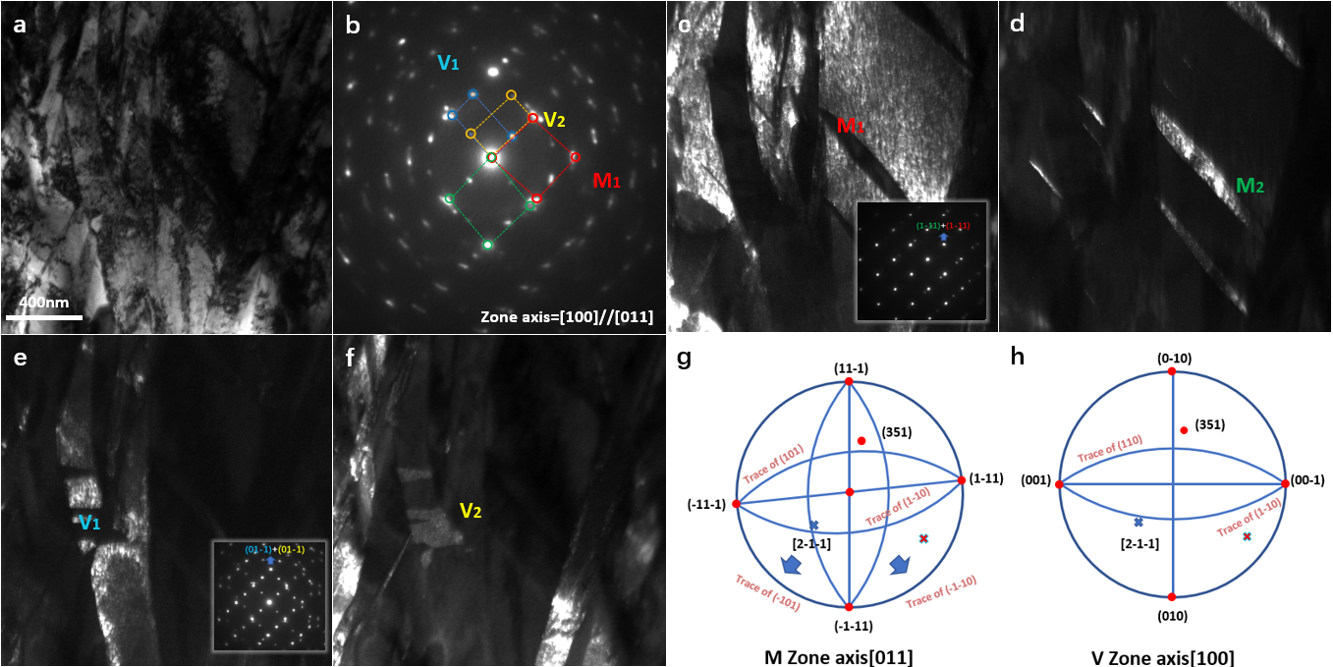
Figure 7-9 TEM images of the {111}_{α’’} and {011}_{α’’} twin microstructure after deformation to 8% strain. (a) a bright field image of the target area; (b) a SADP acquired along the [100]_{α’’}//[011]_{α’’} zone axis of the twin boundary, four martensite variants are marked with red, blue, green and yellow circles and divided into M and V groups for the {111}_{α’’} and {011}_{α’’} twinning systems; (c-f) dark field images of four twin variants. Insets in (c) and (e) are twin boundary SADPs for M and V groups, respectively; and (g-h) sereographic projections were constructed along [011]_{α’’} for M variants and [100]_{α’’} for V variants. The OR was determined to be M{351}_{α’’}//V{351}_{α’’}, which indicated the OR of M and V may be related to {351}_{α’’} twinning.
7.3.3 Atomic configuration of transformed {351}<-211> _{α’’} type II twin
From the above analysis, a double twinning like crystallography operation was deduced from the deformation product observed in Fig. 7-7. This was attributed to the special lattice correspondence in the {351}<-211>_{α’’} type II and {351}<1-12>_{α’’} type I twinning, where the {351}_{α’’} plane of the α’’ matrix can also serves as lattice invariant plane for the twinned variant. Different with the TRIP induced SA {111}_{α’’} type I and <-211>_{α’’} type II twinning observed in early deformation stage which transformed primary martensite into twinned variants to accommodate the overall volume change, from the OR analysis of Fig. 7-7, the {351}<-1-12>_{α’’} twin mode was observed as part of the conversion mechanism for the first time, which transformed the primary {351}<-211>_{α’’} type II twinned α’’ variant into {351}<1-12>_{α’’} type I twinned variant along same (351)_{α’’} plane. To help understand this conversion mechanism, the feature in Fig. 7-7 was further analysed using HRTEM to characterise the underlying twinning transformation mechanism. Imaged along [-112]_{α’’} zone axis, three sets of martensite variant diffraction reflections were captured from Fast Fourier transform (FFT) analysis of Fig. 7-10(a). The lattice correspondence [-101]_{V1}//[-110]_{V2}//[-112]_{V3} (identified in Fig. 7-10(b)) was used to simulate the stereographic projection figure within the three variants (Fig. 7-11). The thin laths of V2 can be clearly observed in Fig. 7-10(b) located within the narrow interfacial area between V1 and V3. With the spots of (351)[1-12][2-1-1]_{α’’V1} superimposed on the (351)[1-12][2-1-1]_{α’’V2} and (351)[1-12][2-1-1]_{α’’V3} (Fig. 7-11), the (351)_{α’’} plane was identified as a lattice invariant plane between V1, V2 and V3. While the OR between V1 and V2, V1 and V3 were confirmed as (351)[2-1-1]_{α’’} type II twin and (351)[1-12]_{α’’} type I twin, the OR between V2 and V3 can be deduced. Illustrated by Fig. 7-10(e), considering a crystallographic operation rotate V1 along [2-1-1]_{α’’} direction 180 degree against the (351)_{α’’} plane result in a type II (351)[2-1-1]_{α’’} twinned variant V2(Fig. 7-10e(i)) while another crystallographic operation produce mirror symmetry (351)[1-12]_{α’’}type I twinned variant V3 of V1 against (351)_{α’’} plane (Fig. 7-10e(ii)). The lattices of V2 and V1 only exhibit mirror symmetry when viewed along the [1-12]_{α’’} zone axis (nearly perpendicular to [-211]_{α’’}), which indicates that only twinning shear is required to transform V2 to V3 (Fig. 7-10e(iii-iv)). Supported by Fig. 7-10(d), in the same feature, when tilted to [-211]_{α’’V1}//[-211]_{α’’V2}//[-211]_{α’’V3}, the boundary between V1 and V2 vanished, whilst V1 and V3 exhibiting mirror symmetry against (351)_{α’’} plane. Consequently, driven by the increasing stress, the {351}<2-1-1>_{α’’} twinned V2 was progressively sheared into {351}<1-12>_{α’’} twinned V3, where only a small number of type II twinned α’’ laths is left as planar complexion structures between V3 and V1. The transformation of the primary type II twinned {351}<2-1-1>_{α’’} variant to type I twinned {351}<1-12>_{α’’} variants suggests that a coherent twinning inheritance mechanism exists to enable the continuous deformation accommodation, and may have acted as an additional work hardening source.

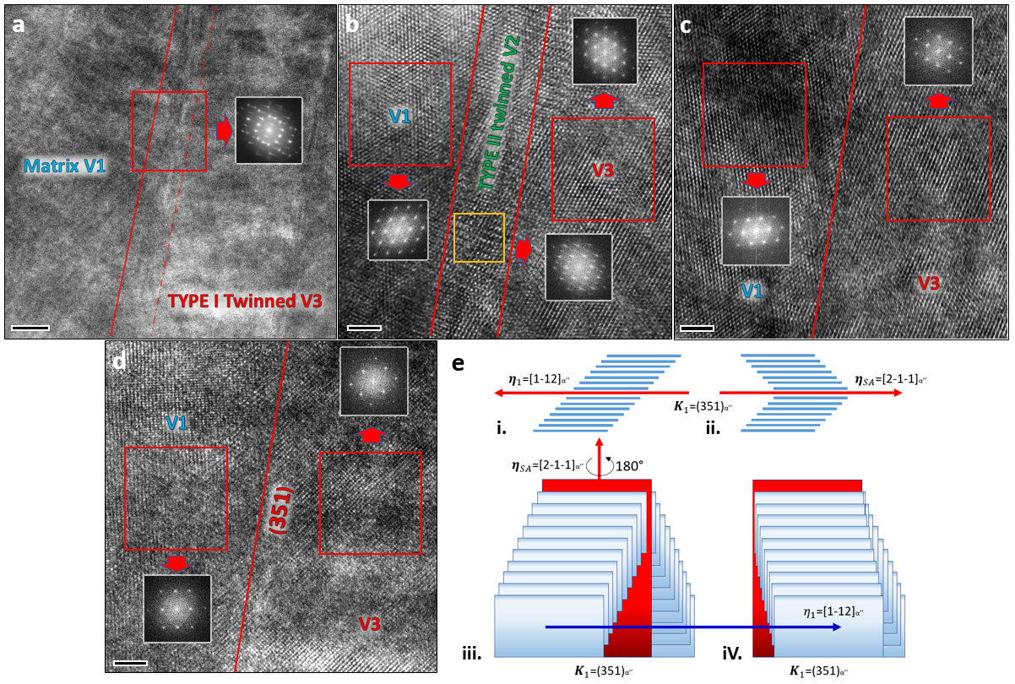
Figure 7-10 HRTEM images of transformed {351}<-211>_{α’’} twin boundary (a) Low mag HRTEM image of transformed {351}<-211>_{α’’} type II twinning in a specimen strained to 9%. Insets are FFTs of highlighted areas. (b) Magnified image of the highlighted area in (a) shows partially transformed {351}<-211>_{α’’} type II twin structure. FFTs of three martensite variants are shown in insets which exhibit reflections of [-101]_{α’’V1}, [-110]_{α’’V2} and [-112]_{α’’V3}. (c) Fully transformed {351}<-211>_{α’’} type II twin ({351}<1-12>_{α’’} type I twin structure). FFTs of two martensite variants are shown in the insets which exhibit reflections of [-101]_{α’’V1} and [-112]_{α’’V3} zone axes. (d). HRTEM image of same area in (c), acquired from [-211]_{α’’} zone axis. FFT of two martensite variants are shown in insets which exhibit reflections of [2-1-1]_{α’’V1} and [2-1-1]_{α’’V3}. (e)Schematic of {351}<2-1-1>_{α’’} type II twin to {351}<1-12>_{α’’} type I twin transformation. i-ii. projection of the type II (351)[2-1-1]_{α’’} and type I (351)[1-12]_{α’’} twin structure viewed along [2-1-1]_{α’’} and [1-12]_{α’’} directions respectively. iii. Lattice arrangement of the (351)[2-1-1]_{α’’} type II twin. iv. Lattice arrangement of the (351)[2-1-1]_{α’’} twin after shear along the [1-12]_{α’’} direction. Scar bar in (a), 20nm. Scar bars in (b-d), 2nm.

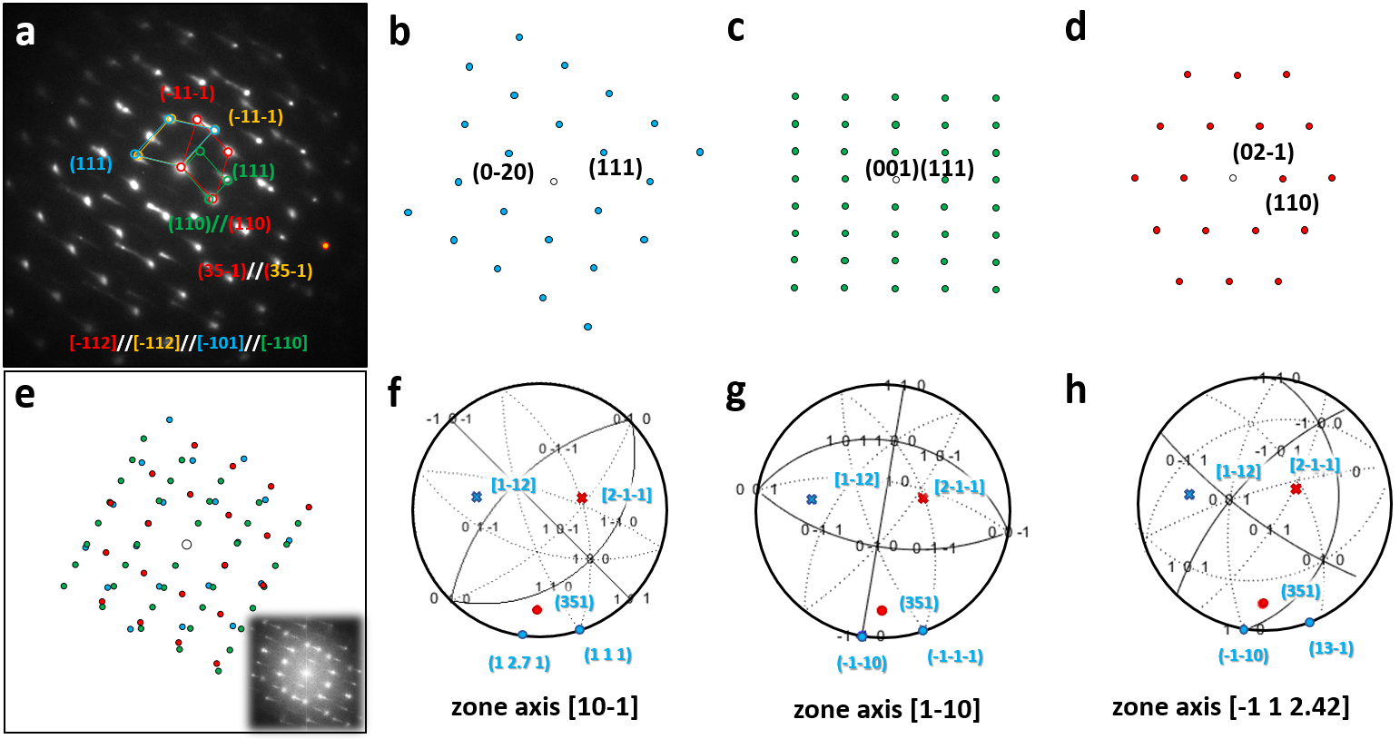
Figure. 7-11. OR analysis of {351}<1-12>_{α’’} compound twin (a) SADP of {351}<1-12>_{α’’} compound twin (same as Figure.3(b)) taken along the [-101]_{α’’V1}//[-110]_{α’’V2}//[-112]_{α’’V3&V4} zone axis. (b-d) Simulated diffraction pattern of [-101]_{α’’V1}, [-110]_{α’’V2} and [-112]_{α’’V3&V4}. (e) Simulated SADP whose DPs arrangement is following the FFT of Fig. 7-10. Showing (111)_{α’’V1}//(111)_{α’’V2} and (110)_{α’’V2}//(110)_{α’’V3}. (f-h) Stereographic projections of V1-V3, generated from the orientation data in (e). The special lattice correspondence: (351)[1-12][2-1-1]_{α’’V1}//(351)[1-12][2-1-1]_{α’’V2&v3} are highlighted.

7.4 Discussion

7.4.1 Effect of TWIP/TRIP-enabled gradient structure on deformation heterogeneity

In the current alloy system, the aim was to enable TTIP type SA twinning to mechanical twinning transformation. It has been shown that the critical condition for the occurrence of TTIP is satisfied by the activation of {351}<-211> _{α’’} type II SA twinning, which is enabled by lowering the β phase stability by tailoring Ta content. In agreement with the designing purpose, reducing the Ta content further from (TiZrHf)₈₅Ta₁₅ to (TiZrHf)₈₇Ta₁₃, resulted in the lower Ta composition possessing optimised work-hardening performance during tensile testing, which was attributed to the close cooperation between TRIP, TTIP and TWIP.
The moderate volume difference between the BCC and orthorhombic structures drives the α’’ phase to arrange into various twinning related variants. This acts to minimise the overall shape change caused by the phase transformation. When progressively reduced β phase stability, from (TiZrHf)₈₅Ta₁₅ to (TiZrHf)₈₇Ta₁₃, such behaviour causes dynamic refining of the primary coarse grain into a heterogeneous hierarchical structure composed of different types of α’’ SA twinning. This effectively strengthens the material through TTIP enabled features which span from the μm scale primary α’’ variant to the nm scale with SA and mechanical α’’ twinned variants. Consequently, this results in the formation of abundant coherent nanoscale interfaces, which can effectively strengthen the materials. The heterogeneous deformation between larger and smaller grains is also beneficial to the high work hardening rate. The TTIP resultant strain gradient and fluctuation of stress states which in turn activate geometrically necessary dislocations (GND) and encourage the pile up of dislocations [23–26]. This is evidenced in the increased GND density (Fig. 7-12) as a function of increasing tensile strain [23,27,28]. Known as long range stress which results from GND pile up, back stress was accepted as crucial to strengthening the gradient structure. Through comparing the GND density of different strain level, the magnitude of the back strengthening can be evaluated. With a rapid increase from 0.97(10¹⁴/m²) at 3% strain to 13(10¹⁴/m²) at 9% strain, the GND density variation shares the similar increasing trend as the twinning density and martensite phase fraction, as shown in Fig. 7-12g. Therefore, it is concluded that the back-stress hardening is another contributor to the ultra-high work hardening capacity observed in (TiZrHf)₈₇Ta₁₃.
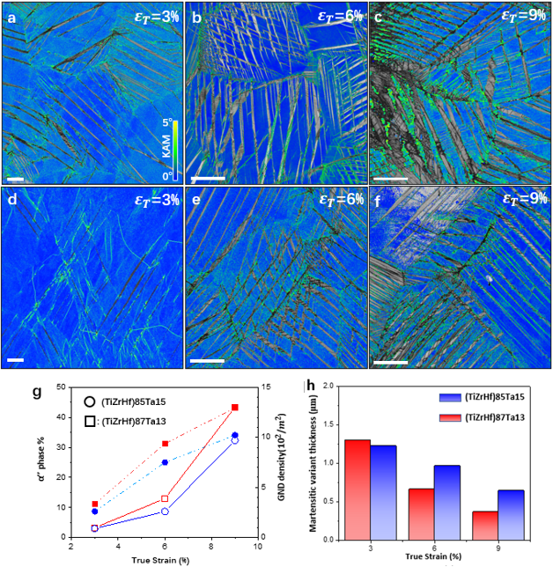
Figure. 7-12. Twin and martensite distribution analysis. Scale bar 20μm. (a-c) KAM map of (TiZrHf)₈₇Ta₁₃ for samples deformed during tensile testing to 3%, 6% and 9% strain; (d-f) KAM map of (TiZrHf)₈₅Ta₁₅ for samples deformed during tensile testing to 3%, 6% and 9% strain; (g) variation of martensite volume fraction and GND density of (TiZrHf)₈₇Ta₁₃ (solid) and (TiZrHf)₈₅Ta₁₅ (hollow) from 3% > 6% > 9% strain; and (h) variation of (TiZrHf)₈₇Ta₁₃ and (TiZrHf)₈₅Ta₁₅ martensitic variant thickness from 3% > 6% > 9% strain.
The microstructural origin of this large back stress hardening is the dynamical-reinforced hierarchical twinning structure enabled by TTIP. This is evident through the comparison of twinning density and total work hardening rate at different strain level shown in Fig. 7-1(a) and Fig. 7-12(a-f). Following the second deformation stage which was summarised previously, the first increase in work hardening exponent was observed in Fig. 7-1(a), where the SA martenstic twinning density of (TiZrHf)₈₇Ta₁₃ deformed to 6% strain is 35% higher than the (TiZrHf)₈₅Ta₁₅ deformed to the same strain. This clearly demonstrates that the TRIP and transformation twinning in (TiZrHf)₈₇Ta₁₃ are effective in strengthening the grain and account for the increase of GND density at 6% strain. In subsequent deformation stages, when the TRIP effect was exhausted, the extensive activated mechanical α’’ twinning together with primary um-scale and secondary nm-scale SA α’’ twinning, hence provided abundant dense coherent low-misfit interfaces minimising the TRIP-induced strain accumulation. This hierarchical planar facilitation ultimately leads to an enlarged back stress hardening effect and accounted for the main total stress strengthening in deformation stages III-IV.

7.4.2 Microstructural evolution of TTIP {351}<-211> _{α’’} type II SA twinning
In Chapter 6 it was predicted that the {351}<-211> _{α’’} type II SA twinning plays a key role in the mechanism of TTIP. In the current work, the {351}<-211> _{α’’} type II SA twinning was observed to serve as a key structure for the twinning evolution in (TiZrHf)₈₇Ta₁₃. The main twinning transformation process is presented schematically in Fig. 7-13, to aid in the understanding of the twinning evolution process during different deformation stages. After yield, the β$→$α’’ martensite phase transformation (TRIP) is activated as the primary deformation mechanism (Step I). Mechanical twinning requires large critical stress to be exerted along specific lattice directions to activate. To get over the overall volume change and balance the local stress, in contrast, SA type twinning can be easily activated by phase transformation-induced stress and is predominant during this deformation stage (step II). Thus, the high density of martensite variants formed via type I {111}_{α’’} and II {-211}_{α’’} SA twinning was concluded as being the main contribution to the first increase in work hardening rate during the second deformation stage shown in Fig. 7-1(a).
During Step II, a special TTIP SA {351}<-211>_{α’’} type II twin was activated as the main precursor for the start of Step III, whereby TTIP starts and facilitates the transition between TRIP and TWIP. After the TRIP effect subsides as a result of further loading on SA {351}<-211>_{α’’} type II twin, the TWIP effect is successfully activated by {351}<1-12>_{α’’} type I mechanical twinning in primary (351)[-211] _{α’’} type II twining (Fig. 7-8). Due to the special lattice correspondence of (35-1) plane between the matrix and twinned variants as highlighted in Fig. 7-11 (f-h), the energetically favoured mechanical twin transformation occurs in primary (351)[-211] _{α’’} type II twins is along (351)[1-12] _{α’’} to accommodate further deformation. Although the shear vector required to complete the (351)[-211] _{α’’} type II to (351)[1-12] _{α’’} type I twinning transformations is the same as (130)[3-10] _{α’’} twinning[29]; considering the magnitude of the atomic shuffle as shown in Fig. 7-13(b), the (351)[-211] _{α’’} type II to (351)[1-12] _{α’’} type I twinning shear route require no atomic shuffle which is more energetically favourable and thus explains the transformation in Fig. 7-8. The special lattice correspondence allows the SA to undergo mechanical twin transformation activate within the primary type II twinned variant along {351}<1-12>_{α’’} and partially transform the type II twinned variant into {351}<1-12>_{α’’} type I twinned variant. With lattice correspondence to {332}_{β} mechanical twinning, the twinning structures possess potential to propagate the planar character into the adjacent β phase in the form of {332}_{β} mechanical twinning (Fig. 7-8(b-c)). This further alleviates the accumulated local stress at phase boundary in a coherent manner.
Beyond 12% strain, in the final deformation stage, the work hardening exponent of Ta15 decreases gradually till fracture (Fig. 7-1(a)), while for Ta13, the work hardening exponent $n$ increases slightly, leading to higher facture strength and larger ductility. The increase of $n$ at later deformation in Ta13 is attributed to the formation of intricate networks consist of profuse secondary SA and {011}_{α’’} compound mechanical twins, which further contribute to the strength enhancement because of dynamic Hall-Petch effect (α’’ grain refinement down to 0.21μm). The origin of this twisted {111}_{α’’} type I twinning and {011}_{α’’} compound twinning is deduced by OR analysis using stereographic projection on the four α’’ variants. The analysis shows that the {111}_{α’’} type I and {011}_{α’’} compound twins are the secondary twinning activated in the primary {351}<-211>_{α’’} type II twins. This observation indicates that, with further straining, the twisted {111}_{α’’} type I and {011}_{α’’} compound twins are activated as secondary deformation products to compensate the strain accumulation in primary SA {351}<-211>_{α’’} type II twins. As determined by the phase transformed lattice strain⁵³, the {011}_{α’’} compound twinning should be accepted as mechanical twins in current states which explains its appearance in the later deformation. In Ta15, ascribed to the relatively weaker TRIP effect and SA twinning formability, a relatively low fracture strength (900MPa) is observed, which is inadequate to activate complex SA microstructures (intersected martensite laths). Consequently, the {011}_{α’’} compound twins were only found in primary α’’ grains at the necked region in Ta15 instead of twinned α’’ laths, so the resulting work hardening capacity was insufficient to maintain a stabilised plastic deformation. The four twinning transformation steps described above found the mechanism of TTIP.
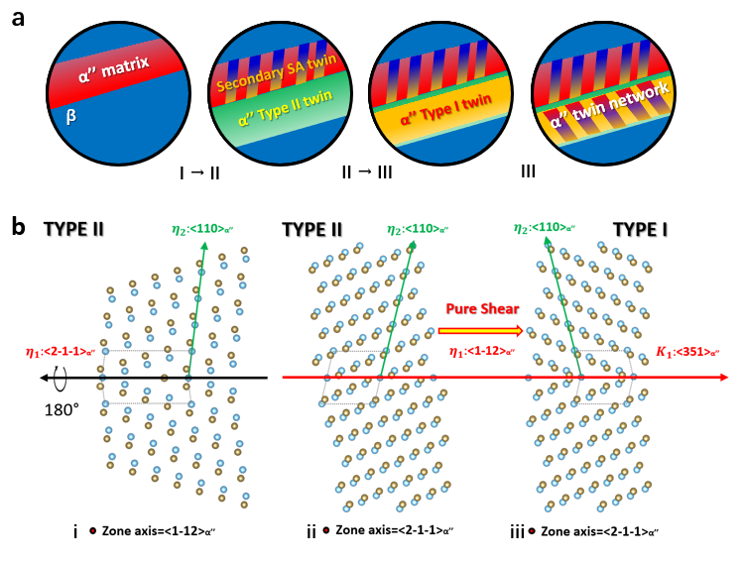
Figure 7-13 Schematic representation of TTIP analysis. (a) I. Initial formation of α″ (red). II. SA type II {351}<-211>_{α″} SA twinning (green) generated adjacent to the primary α″. III. mechanical {351}<1-12>_{α″} twins (orange) nucleate within SA twinned α’’ variants and further overtake the SA twinned α’’ variants. (b) Schematic representation of atomic movements associated with {351}<-211>_{α″} to {351}<1-12>_{α″} evolution. Blue and brown dots indicate atoms at matrix and shuffled with (001)<010>_{α’’} displacement, respectively. From left to right are projections of type II twin {351}<-211>_{α″} along <1-12>_{α″} and <2-1-1>_{α″} , type I twin {351}<1-12>_{α″} along <2-1-1>_{α″} directions respectively.

7.5 Conclusions
Through the careful tuning of β phase stability by reducing the Ta content, the TRIP effect was increased for (TiZrHf)₈₇Ta₁₃ in comparison with (TiZrHf)₈₅Ta₁₅. Superior mechanical properties were achieved for (TiZrHf)₈₇Ta₁₃, as ultimate ductility and strength were found to increase in addition to a significant high work hardening capability, which may be attributed to the activation of various deformation mechanisms (TWIP and TTIP). Detailed experimental analysis has provided evidence of the activation of TTIP whose concept was first proposed in the previous chapter as a continuous linkage between TRIP and TWIP. To help distinguish the underlying mechanism for TTIP, substantial EBSD and TEM results were used to demonstrate the microstructural and deformation mechanism evolution in (TiZrHf)₈₇Ta₁₃. Various types of martensitic TRIP SA twinning and TWIP mechanical twinning were observed at different deformation stages, resulting in the formation of a highly entangled microstructure. These maze-like microstructures were formed by abnormal cooperation between type I, II and {011}_{α’’} compound twinning, together with the {351}<1-12>_{α’’} shear-induced twinning transformation on primary {351}<-211>_{α’’} SA twinning. This resulted in a double twinning-like structure which owes a lattice correspondence of {351}_{α’’}// {332}_{β} between the matrix and the double-twinned variant. Due to this special lattice correspondence, the observed planar features can coherently propagate the α’’-β boundary and result in a lattice corresponding {332}_{α’’} twinning-like feature. The multimodal twinning enabled heterogeneous hierarchical structure, which further restricted the available path for the glide of dislocations and activates a dynamic Hall-Petch effect in (TiZrHf)₈₇Ta₁₃. The continuous concentrated strain resulting from previous twinning transformation drives the activation of secondary {111}_{α’’} type I and {011}_{α’’} compound twinning. This results in further refining of the grain and contributes to the enhanced work hardening capacity. Through this coherent strengthening enabled by TTIP, the increased work hardening capability during the TRIP process in deformation Stage II can be successfully maintained at Stage III and extensively increased the ultimate strength and ductility.
In summary, the concept of TTIP has been experimentally evidenced. A significant work hardening capability was enabled through the activation of the TTIP effect via {351}<-211>_{α’’} type II SA twinning system. The importance of TTIP is self-evident. This new deformation mechanism activated by tailoring β phase stability, not only enabled a continuous work hardening capability optimising mechanical performance, but importantly provided a transition pathway between the TRIP and TWIP mechanisms. Therefore, this broadens the design window for a variety of metallic materials which exhibit the stress-induced BCC to HCP athermal phase transformation including steels, Mg alloys, Zr alloys and others.

7.6 References
[1] Microstructure of martensite: why it forms and how it gives rise to the shape-memory effect, Choice Rev. Online. (2013). doi:10.5860/choice.41-6554.
[2] Y.W. Chai, H.Y. Kim, H. Hosoda, S. Miyazaki, Self-accommodation in Ti-Nb shape memory alloys, Acta Mater. (2009). doi:10.1016/j.actamat.2009.04.051.
[3] T. Inamura, J.I. Kim, H.Y. Kim, H. Hosoda, K. Wakashima, S. Miyazaki, Composition dependent crystallography of α″-martensite in Ti-Nb-based β-titanium alloy, Philos. Mag. (2007). doi:10.1080/14786430601003874.
[4] L. Lilensten, J.P. Couzinié, J. Bourgon, L. Perrière, G. Dirras, F. Prima, I. Guillot, Design and tensile properties of a bcc Ti-rich high-entropy alloy with transformation-induced plasticity, Mater. Res. Lett. (2017). doi:10.1080/21663831.2016.1221861.
[5] C. Brozek, F. Sun, P. Vermaut, Y. Millet, A. Lenain, D. Embury, P.J. Jacques, F. Prima, A β-titanium alloy with extra high strain-hardening rate: Design and mechanical properties, Scr. Mater. (2016). doi:10.1016/j.scriptamat.2015.11.020.
[6] X. Ji, S. Emura, X. Min, K. Tsuchiya, Strain-rate effect on work-hardening behavior in β-type Ti-10Mo-1Fe alloy with TWIP effect, Mater. Sci. Eng. A. (2017). doi:10.1016/j.msea.2017.09.055.
[7] F. Sun, J.Y. Zhang, M. Marteleur, C. Brozek, E.F. Rauch, M. Veron, P. Vermaut, P.J. Jacques, F. Prima, A new titanium alloy with a combination of high strength, high strain hardening and improved ductility, Scr. Mater. (2015). doi:10.1016/j.scriptamat.2014.09.005.
[8] M. Ahmed, D. Wexler, G. Casillas, O.M. Ivasishin, E. V. Pereloma, The influence of β phase stability on deformation mode and compressive mechanical properties of Ti-10V-3Fe-3Al alloy, Acta Mater. (2015). doi:10.1016/j.actamat.2014.10.043.
[9] H. Mecking, U.F. Kocks, Kinetics of flow and strain-hardening, Acta Metall. (1981). doi:10.1016/0001-6160(81)90112-7.
[10] Y. Ma, W. Song, W. Bleck, Investigation of the microstructure evolution in a Fe-17Mn-1.5Al-0.3C steel via in situ synchrotron X-ray diffraction during a tensile test, Materials (Basel). (2017). doi:10.3390/ma10101129.
[11] O. Grässel, L. Krüger, G. Frommeyer, L.W. Meyer, High strength Fe-Mn-(Al, Si) TRIP/TWIP steels development - properties - application, Int. J. Plast. (2000). doi:10.1016/S0749-6419(00)00015-2.
[12] Z. Li, C.C. Tasan, H. Springer, B. Gault, D. Raabe, Interstitial atoms enable joint twinning and transformation induced plasticity in strong and ductile high-entropy alloys, Sci. Rep. (2017). doi:10.1038/srep40704.
[13] Z. Li, C.C. Tasan, K.G. Pradeep, D. Raabe, A TRIP-assisted dual-phase high-entropy alloy: Grain size and phase fraction effects on deformation behavior, Acta Mater. (2017). doi:10.1016/j.actamat.2017.03.069.
[14] Z. Li, K.G. Pradeep, Y. Deng, D. Raabe, C.C. Tasan, Metastable high-entropy dual-phase alloys overcome the strength-ductility trade-off, Nature. (2016). doi:10.1038/nature17981.
[15] H. Huang, Y. Wu, J. He, H. Wang, X. Liu, K. An, W. Wu, Z. Lu, Phase-Transformation Ductilization of Brittle High-Entropy Alloys via Metastability Engineering, Adv. Mater. (2017). doi:10.1002/adma.201701678.
[16] B. Wang, J. Shi, P. Ye, L. Deng, C. Wang, J. Chen, X. Yang, Q. Li, In-situ investigation on nucleation and propagation of {10-12} twins during uniaxial multi-pass compression in an extruded AZ31 Mg alloy, Mater. Sci. Eng. A. (2018). doi:10.1016/j.msea.2018.06.043.
[17] T. Inamura, H. Hosoda, H. Young Kim, S. Miyazaki, Antiphase boundary-like stacking fault in α″-martensite of disordered crystal structure in β-titanium shape memory alloy, Philos. Mag. (2010). doi:10.1080/14786435.2010.489889.
[18] S. Lee, C. Park, J. Hong, J. taek Yeom, The Role of Nano-domains in {1–011} Twinned Martensite in Metastable Titanium Alloys, Sci. Rep. (2018). doi:10.1038/s41598-018-30059-8.
[19] E. Bertrand, P. Castany, Y. Yang, E. Menou, T. Gloriant, Deformation twinning in the full-α″ martensitic Ti-25Ta-20Nb shape memory alloy, Acta Mater. (2016). doi:10.1016/j.actamat.2015.12.001.
[20] P. Castany, Y. Yang, E. Bertrand, T. Gloriant, Reversion of a Parent {130}<310>alpha’’ Martensitic Twinning System at the Origin of {332 } <113>beta Twins Observed in Metastable beta Titanium Alloys, Phys. Rev. Lett. (2016). doi:10.1103/PhysRevLett.117.245501.
[21] X. Zhang, W. Wang, J. Sun, Formation of {332}〈113〉βtwins from parent {130}〈310〉α″plastic twins in a full α″ Ti-Nb alloy by annealing, Mater. Charact. (2018). doi:10.1016/j.matchar.2018.09.034.
[22] H. Tobe, H.Y. Kim, T. Inamura, H. Hosoda, T.H. Nam, S. Miyazaki, Effect of Nb content on deformation behavior and shape memory properties of Ti-Nb alloys, J. Alloys Compd. (2013). doi:10.1016/j.jallcom.2012.02.023.
[23] X. Wu, M. Yang, F. Yuan, G. Wu, Y. Wei, X. Huang, Y. Zhu, Heterogeneous lamella structure unites ultrafine-grain strength with coarse-grain ductility, Proc. Natl. Acad. Sci. (2015). doi:10.1073/pnas.1517193112.
[24] M.F. Ashby, The deformation of plastically non-homogeneous materials, Philos. Mag. (1970). doi:10.1080/14786437008238426.
[25] H. Gao, Y. Huang, Geometrically necessary dislocation and size-dependent plasticity, Scr. Mater. (2003). doi:10.1016/S1359-6462(02)00329-9.
[26] H. Gao, Y. Huang, W.D. Nix, J.W. Hutchinson, Mechanism-based strain gradient plasticity - I. Theory, J. Mech. Phys. Solids. (1999). doi:10.1016/S0022-5096(98)00103-3.
[27] M. Yang, Y. Pan, F. Yuan, Y. Zhu, X. Wu, Back stress strengthening and strain hardening in gradient structure, Mater. Res. Lett. (2016). doi:10.1080/21663831.2016.1153004.
[28] X. Wu, Y. Zhu, Heterogeneous materials: a new class of materials with unprecedented mechanical properties, Mater. Res. Lett. (2017). doi:10.1080/21663831.2017.1343208.
[29] H. Tobe, H.Y. Kim, T. Inamura, H. Hosoda, S. Miyazaki, Origin of {3 3 2} twinning in metastable β-Ti alloys, Acta Mater. (2014). doi:10.1016/j.actamat.2013.10.048.
[30] Q. Sun, X. Fang, Y. Wang, L. Tan, X. Zhang, Changes in misorientations of {10 1 ¯ 1} twin boundaries in deformed magnesium alloy, J. Mater. Sci. (2018). doi:10.1007/s10853-018-2068-z.
[31] M. Lentz, M. Risse, N. Schaefer, W. Reimers, I.J. Beyerlein, Strength and ductility with {10 11}-{1012} double twinning in a magnesium alloy, Nat. Commun. (2016). doi:10.1038/ncomms11068.

Chapter. 8 Conclusions
The aims of this thesis were to discover new approaches to aid in the design of strong and ductile refractory HEAs (RHEAs). This work explored several novel concepts resulting in improvement of the mechanical performance of IVB group element-based RHEAs. The key conclusions of this work are listed as follows.
In chapter 4, a new empirical parameter of mixing/formation enthalpy deviation was proposed, which was applied in order to distinguish the formation of simple solid solution phases and complex intermetallic phases. Following the summary of phase formation which was determined by the comparison of VEC and mixing/formation enthalpy deviation from a number of existing Cantor-type HEAs, two RHEAs with composition of TiZrNbTa and TiZrHfTa were synthesised. These aided in developing an understanding of the relationship between mixing/formation enthalpy deviation, phase stability and mechanical performance. Through DOS analyses of TiZrNbTa and TiZrHfTa, the possibility of tuning phase stability of RHEAs by tailoring specific elemental additions was discussed.
The strategy of utilising metastable engineering to introduce multi-deformation mechanisms (TWIP and TRIP) into RHEAs was proposed in Chapter 4 and applied to TiZrHfTa equal-molar system in Chapter 5. The phase constitution and mechanical performance of TiZrHfTa_{x}(x=0.5-1) RHEA samples subjected to compression testing, revealed that metastable engineering was effective in introducing multiple-deformation mechanisms and enhancing strain hardening capacity of the materials. While TWIP was successfully activated and observed in TiZrHfTa_{0.8}, in addition to the {112}[11-1]_{β} twinning mode, {332}[11-3]_{β} twinning was also observed. The effects of TRIP and TWIP gradually increased with the reduction of Ta content. Entanglement of SA twinning structures further contributed to the enlarged strain hardening capacity by limiting the free path of dislocation glide. The unusual type II martensite twinning modes {351}<-211>_{α’’} together with the abnormal cooperation between {111}_{α’’} type I and {011}_{α’’} compound twinning modes were first observed in TiZrHfTa_{0.5}. This indicated the existence of an un-discovered deformation mechanism. Identified as lattice corresponding to {332}[11-3]_{β} twinning, the {351}<-211>_{α’’} type II twinning was the main contributor to the extraordinary strain hardening performance observed in TiZrHfTa_{0.5}. Combining both the deformation products of TRIP and TWIP, the newly discovered deformation mechanism may not only aid in refining the microstructure, but also have the potential to be applied in further enhancement of current RHEA systems.

To explain the driving force for the formation of newly discovered {351}<-211>_{α’’} twinning, the possible self-accommodation (SA) twinning system was calculated, through the application of the infinitesimal deformation approach (IDA) on an undistorted orthorhombic lattice structure in Chapter 6. Through formation of different self-accommodation twinned martensites along the lattice invariant plane, the orthorhombic α″ martensite transformation-induced local stress and strain were compensated. In addition to the solution for SA {111}_{α’’} type I twinning and {011}_{α’’} compound twinning as reported in previous theoretical work, more than one invariant plane was discovered to exist, in order to serve as a twinning plane for SA <211>_{α’’} type II twinning. Double lattice structure was applied to include lattice instability of the α’’ phase. Together with the theory of the crystallography of deformation twinning, potential shuffle mechanisms were derived to investigate energetically favoured activation sequences of different SA type II <-211>_{α’’} twinning modes. In proportion with the magnitude of atomic displacement along the <010>_{α’’} directions, all SA type II <-211>_{α’’} twinning modes required simple atomic shuffles and were activated with ease during phase transformation. Modes I ({113}_{α’’} invariant plane) and II
({351}_{α’’} invariant plane), whose corresponding mechanical type twinning required the smallest shear vector, were further examined for potential mechanical twinning shuffle modulation. The concept of transformation twinning induced plasticity (TTIP) was proposed for the first time and was based on calculated results. Without the requirement of large atomic shuffle modulation and critical shear, in the early-stage deformation when TRIP take effects, SA twinning were energetically favoured to form first, as compensation for phase transformation-induced stress and strain. Meanwhile, in later deformation stages when the TRIP effect subsides, the existing SA twinnings were favoured to compensate for increased stress and strain along corresponding lattice invariant planes. Therefore, deformation products including mechanical twinning or secondary SA twinning have the possibility of being activated on existed SA twinning structures and subsequently results in a dynamic Hall-Petch effect.
According to the atomic shuffle mechanism results calculated in Chapter 6, the activation of TTIP-type twinning was mainly dependent on the magnitude of atomic displacement σ on <010>_{α’’}, which was determined by the β phase stability and the magnitude of deformation strain. Thus, to provide evidence for the demonstration of the activation of TTIP, (TiZrHf)₈₅Ta₁₅ (at.%) and (TiZrHf)₈₇Ta₁₃ (at.%) were selected, synthesised, carefully heat-treated and subjected to tensile deformation in Chapter 7. Enhanced mechanical properties were achieved for (TiZrHf)₈₇Ta₁₃, including with an ultimate tensile stress of 1310 MPa, an elongation of 25.3% and an ultra-high strain hardening rate of 12.6 GPa. The experimental results acquired successfully proved the activation of TTIP, which was proposed as possessing coherent linkages between TRIP and TWIP. Various types of martensitic SA twinning and TWIP mechanical twinning were observed at different deformation stages, which resulted in the formation of the highly entangled bulk microstructure. {351}<-211>_{α’’} type II SA twinning to {351}<1-12>_{α’’} mechanical twinning transformation was responsible for the facilitation of accumulated strain. The concentrated strain which occurred as a result of TRIP and TTIP, was deduced as the driving force for the activation of secondary {111}_{α’’} type I and {011}_{α’’} compound twinning. Through the coherent strengthening enabled by TTIP, the increased hardening capacity obtained during the TRIP process in deformation Stage II was successfully maintained at Stage III. This contributed to the extensive increase in ultimate strength and ductility.
To summarise, in Chapter 4, to design ductile refractory HEAs, the possibility of applying metastable engineering in introducing the TRIP effect into RHEAs was investigated by conducting the mixing/formation enthalpy deviation and DOS analysis on 67 existing RHEAs systems. Through conducting metastable engineering in TiZrHfTa, by tuning Ta addition in Chapter 5, TWIP and TRIP were successfully activated in the TiZrHfTa RHEA system. Focusing on coherently linking the effects of TWIP and TRIP, the concept of transformation twinning induced plasticity (TTIP) was presented. The theoretical basis for activating TTIP was elucidated using IDA and the shuffle modulation mechanism in Chapter 6. By carefully tailoring the β phase stability by reducing Ta content, experimental evidence of the TTIP effect was acquired for (TiZrHf)₈₇Ta₁₃ in Chapter 7. The outstanding strain hardening capacity was attributed to the activation of the TTIP effect via the newly discovered {351}<-211>_{α’’} type II SA twinning system. Highly tangled maze-like microstructures enabled by abnormal cooperation between type I, II and {011}_{α’’} compound twinning, together with the {351}<1-12>_{α’’} shear-induced twinning transformation on primary {351}<-211>_{α’’} SA twinning was observed. This resulted in the restriction of the available paths for the glide of dislocations. The importance of TTIP is self-evident. This new ductile RHEA design strategy not only allows tuning of alloy performance in HEAs, but also provides a transition pathway between TRIP and TWIP mechanisms. This importantly broadens the design window for a variety of metallic materials that exhibit the BCC to HCC athermal phase transformation during deformation.

Chapter. 9 Future works
The current work presented in this thesis provides a new strategy to design high strength and ductile HEAs with refractory elements as components. The newly discovered TTIP effect not only offers an ideal mechanism to coherently link TRIP and TWIP, but also is a valuable aid for designing novel high performance structural metallic materials. Some considerations are listed to aid in utilising the discoveries in potential future works as follows: a
1. In addition to the stress-induced orthorhombic martensite phase and TWIP effect, other deformation mechanisms including stacking faults, stress-induced omega phase could also be considered as potential reinforcement methods for strengthening. The heat treatment procedures could be optimised to achieve better grain refinement.
2. High-resolution scanning transmission electron microscopy (HRSTEM) and in situ HRTEM could be conducted to aid in the investigation of the twinning evolution process of TTIP in the current materials.
3. The current martensite lattice model applied in Chapter 6 is based on a BCT lattice built using lattice parameters derived from general XRD data. To increase the simulation precision, the orthorhombic lattice could be introduced with precise lattice parameters derived from synchrotron XRD results of deformed RHEAs.
4. In accordance with the theoretical and experimental results presented in chapter 6 and 7, a critical phase stability zone should exist to activate the TTIP effect in similar metastable metallic materials (β Ti-alloy and α-Fe. etc). For the current RHEAs system, the TTIP-effect zone was evaluated by varying Ta contents from 25% to 13% (atomic percentage) and the best performance was observed when the Ta content was reduced to 13%. Thus, a new model could be proposed to evaluate this range to aid in simplifying the optimal composition. Key factors for TTIP activation presented in Chapter 6, including atomic displacement σ in the <010>_{α’’} directions and lattice strain of η₃, should be involved to develop this model. Ab initio calculations of the deformed orthorhombic lattice stability should also be considered as a comparison to increase the accuracy of the prediction.
5. As similar self-accommodation morphologies were observed in various metastable alloy systems, different systems (Ti-Ni, B2>>B19, etc) could be investigated using similar procedures to those presented in Chapter 6 to determine other potential TTIP mechanisms.

Chapter 10 Appendix

Determination of Twinning elements for martensite twinning
To confirm the twinning elements for various SA and mechanical type twinning which occurred during plastic deformation, the calculations were conducted as follows.
- Determination of two reduced basis vector (a general solution)
The twinning plane was firstly derived from TEM. Following this, the twinning direction$η_{1}$ can be derived, which is the minimum shear direction that moves the parent lattice to the correct twin positions. Accordingly, the two dimensional primitive vector on the twinning plane is necessary to determine the correct lattice position (all calculations conducted in the primitive lattice of the parent phase). Once the lattice plane ($h k l$) was determined, a basis vector $u$($u v w$) can be found on the plane which satisfies:
$hu+kv+lw=0$ (1)
Considering the greatest common factor |gcd($h,k$)|=$d$; |gcd($l,d$)|=1, two general solutions for basis vectors which satisfy eq.(1) can be derived as [1]:
$u_{1}$=($-\frac{k}{d},\frac{h}{d},0$), $u_{2}$=($-lu_{0},-lv_{0},d$) (2)
($\frac{h}{d}$)$u_{0}$+($\frac{k}{d}$)$v_{0}$=1 (3)
With extended euclidean algorithm, $u_{0}$ and $v_{0}$ can be calculated.
By selecting any two of the basis vectors from above, the reduced basis vector can be derived by an iterative process as a simplified two dimension algorithm [1]:
Considering the necessary condition for the simplified vector $i$ and $j$ which can be regarded as a primitive vector:
- Let $i$ be the shorter vector (|$i$|$≤|j|$). Then $j∙i≤i∙i/2$
- The sum of the length of vector $i$ and $j$ is the minimum value among any two vector’s sum derived from selected basis vector $e_{1}$ and $e_{2}$
Firstly, select the vector, $e_{1}$, which has minimum length from the solution of $u_{2}$ eq.(2).
By substituteing eq.(3) into $u_{2}$, to find the solution which has minimum length the extremum point should be considered as a reference:
$u_{min}$=$\frac{b^{2}dh}{a^{2}k^{2}+b^{2}h^{2}}$ (4)
The integer solution of $u_{0}$ for $e_{1}$ is the one nearest to eq.(4).
Once $e_{1}$ was determined, to calculate $e_{2}$, considering a lattice plane $L$ which contains vector $e_{1}$ and $e_{2}$, where $|e_{1}$|$≤|e_{2}|$. Let $e_{2}$ OA projection on $e_{1}$ be OA’ , by linking the nearest point B to A, a new vector is generated.
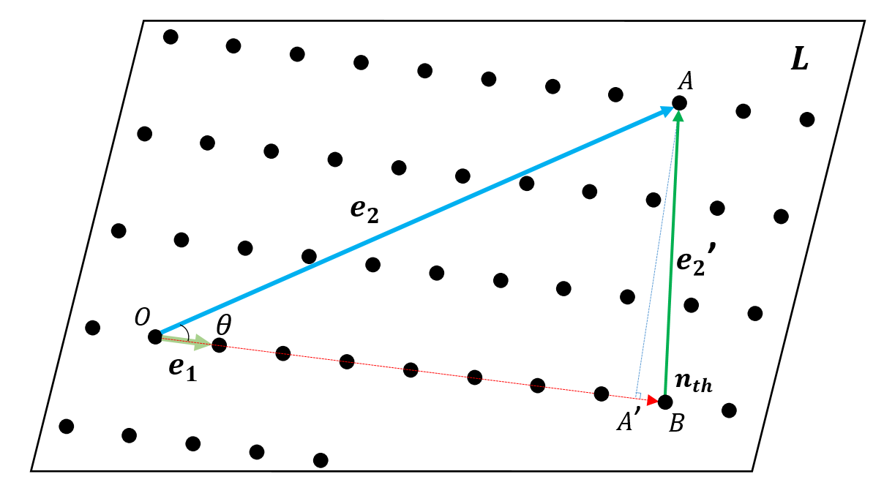
Figure 10-1 Schematic of the iterative procedure to determine basis vectors on ($h k l$) plane.
By iterative procedure, let a new base vector:
$e_{1}'$=$e_{1}$, $e_{2}'$=$e_{2}-αe_{1}$. (5)
Test the value of $α$ every loop,
$α$=$\frac{e_{1}∙e_{2}}{e_{1}∙e_{1}}$ (6)
Only if $α≤$0.5 the procedure stops, otherwise take $α$=$n$ ($n$ represents the multiple of the distance from origin point $O$ to $B$, while $B$ is the nearest lattice to the end of $OA$ projection on $e_{1}$ direction $OA'$) and continue until $α≤$0.5. The final check in the procedure is:
After checking $α≤$0.5, and obtaining:
$e_{1}'$=($A,B,C$),$e_{2}'$=($D,E,F$), let $e_{3}$=($D-A,E-B,F-C$). (7)
If gcd|($D,E,F$)|= gcd|($D-A,E-B,F-C$)|=$±1$, then $e_{1}'$=($A,B,C$),$e_{2}'$=($D,E,F$) are the primitive basis vectors. Otherwise, if gcd|($D,E,F$)|=$n$, gcd|($D-A,E-B,F-C$)|=$m$ ($1≤n$,$1≤m,n,≠m$), compare $|e_{2}'|/n$ and $|e_{3}|/m$, chose the smaller one as new $e_{2}$ then repeat (5)(6), until for the new generated $e_{2}'$, gcd|($D,E,F$)|= gcd|($D-A,E-B,F-C$)|=$±1$. However, in real situations, most Bravais lattice structure of crystals are not their primitive cell, ie., body centred structure primitive cell is a simple rectangular structure. To solve this and extend the above solution, a simple coordinates transformation should be conducted. For any Bravais lattice whose basis vector are $a b c$ we have the expression for the primitive cell:
$\left\{\begin{aligned}a_{1}=x_{1}a+y_{1}b+z_{1}c \\ b_{1}=x_{2}a+y_{2}b+z_{2}c \\ c_{1}=x_{3}a+y_{3}b+z_{3}c\end{aligned}\right.$ (8)
By solving eq.8 the basis vector $a b c$ can be represented by $a_{1}{ b}_{1}{ c}_{1}$ as:
$\left\{\begin{aligned}a=X_{1}a_{1}+Y_{1}b_{1}+Z_{1}c_{1} \\ b=X_{2}a_{1}+Y_{2}b_{1}+Z_{2}c_{1 } \\ c=X_{3}a_{1}+Y_{3}b_{1}+Z_{3}c_{1}\end{aligned}\right.$ (9)
Thus, the lattice plane ($h k l$) can be represented in $a_{1}{ b}_{1}{ c}_{1}$ as:
($h k l$)=($hX_{1}+kX_{2}+lX_{3}$,$hY_{1}+kY_{2}+lY_{3},hZ_{1}+kZ_{2}+lZ_{3}$) (10)
By taking eq.(10) as input and repeating eq.(1)-(7), the primitive basis vector $e_{1}$ and $e_{2}$ on the ($h k l$) plane can be determined. For convenience, $e_{1}$($u_{1},v_{1},w_{1}$) and $e_{2}$($u_{2},v_{2},w_{2}$) can always be represented by Bravais lattice basis vector $a b c$ by subsitituting eq.(8) as:
$\left\{\begin{aligned}e_{1}(u_{1}x_{1}+v_{1}x_{2}+w_{1}x_{3},u_{1}y_{1}+v_{1}y_{2}+w_{1}y_{3},u_{1}z_{1}+v_{1}z_{2}+w_{1}z_{3}) \\ e_{2}(u_{2}x_{1}+v_{2}x_{2}+w_{2}x_{3},u_{2}y_{1}+v_{2}y_{2}+w_{2}y_{3},u_{2}z_{1}+v_{2}z_{2}+w_{2}z_{3})\end{aligned}\right.$ (11)
To calculate the primitive basis vector for the (3 5 1) plane of martensite, firstly consider the primitive cell as a face centred tetragonal structure. The primitive cell vector can be represented by basis vectors $a b c$ as:
$\left\{\begin{aligned}a_{1}=1/2(b+c) \\ b_{1}=1/2(a+c) \\ c_{1}=1/2(a+b)\end{aligned}\right.$ (12)
Taking (3 5 1) and 2|$a^{2}|$=|$b^{2}|$=|$c^{2}|$ as input, the solution of the primitive vector $e_{1}$ and $e_{2}$ is:
$\left\{\begin{aligned}e_{1}(\frac{1}{2},-\frac{1}{2},1) \\ e_{2}(1,-\frac{1}{2},-\frac{1}{2})\end{aligned}\right.$ (13)
- Calculation of shear vector $t$
Once the basis vectors $e_{1}$ and $e_{2}$ were identified, to obtain the twinning direction along the shear direction $t$, the minimum shear direction which moves the parent lattice to the correct twin positions can be calculated. As shown in Fig. 10-2, let Plane 0 represent the invariant twinning plane K₁($h k l$) and Plane -1 represent one of the parallel planes which satisfy the distance between Plane 0 and Plane -1 equal to n$d_{hkl}$(n=1-n). Plane 1 is a mirror reflection of Plane -1 with repect to twinning plane Plane 0. By selecting any lattice vector which starts from $O$ and ends at Plane 1 at A, then by substituting the position of A, a set of parent lattice positions were determined. If Plane 1//Plane 0//Plane -1, the vector which starts at $O$ and ends at the mirror reflection of $O$ on Plane -1 on $O$’ which is perpendicular to K₁. Thus, according to the definition of twinning, by substituting the position of $O$’ and reduced basis vectors, the twin lattice position can be identified. The minimum shear vector is that which joins $O$’ to the nearest parent lattice point N on Plane 1.
To calculate the shear vector on a base centred tetragonal structure ($h k l$) plane, the vector $OA$ must first be determined. By defining $O$ as origin, a point on {$h k l$} plane can be found:
M=($kl,0, 0$) or ($0,hl,0$) or ($0,0,hk$) (14)
Taking M as the intersect point of $OA$ with Plane 0, then $OA=2OM$.
Considering$O'$ is a mirror projection of origin $O$ with respect to Plane 0, the coordinate of $O'$ can be found. From the discussion previously described, on Plane 1, $O'$ is surrounded by four points N P Q R. While AN=α$e_{1}$+β$e_{2}$, NP=$e_{1}$, NQ=$e_{2}$, NR=$e_{1}$+$e_{2}$ (α&β$∈Z$). Comparing the length of NO’ PO’ QO’ RO’, the minimum length vector is shear vector $t$.
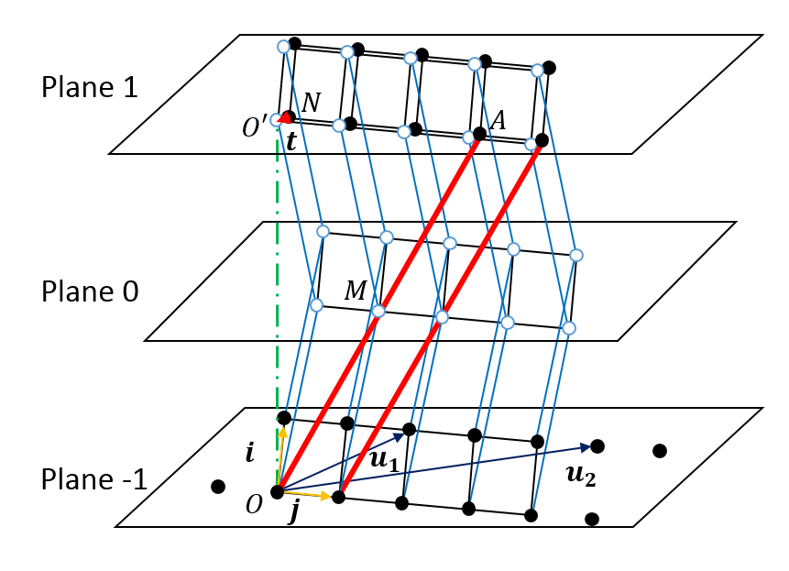
Figure 10-2 A schematic of three parallel lattice planes. Plane 1 the mirror reflection of parent lattice Plane -1 with respect to the twinning Plane 0. Black points denote parents lattice on Plane 1 and Plane -1 while hollow blue points on Plane 0 and Plane 1 represent the invariant lattice and twin lattice respectively.
- Calculation of twinning element $K_{2}$ and $η_{2}$
With $K_{1}$ and $η_{1}$ determined, $K_{2}$ and $η_{2}$ may be calculatedby using according to [2], where $K_{1}$ (351) and $η_{1}$(1-12), $K_{2}$= (1-13) $η_{2}$(110) is shown in Fig. 10-3.
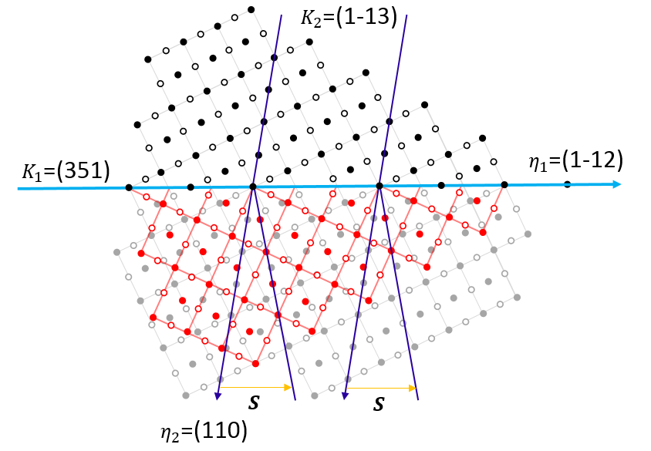
Figure 10-3 Schematic of the (351) martensite twin. The atomic model of the twinned crystal structures. The solid circles indicate the atoms in the plane of the figure, while the open circles show the atoms below the plane of figure.

References
[1] L. Zuo, J. Muller, M. ‐J Philippe, C. Esling, A refined algorithm for the reduced‐cell determination, Acta Crystallogr. Sect. A. (1995). doi:10.1107/S0108767395006672.
[2] B.A. Bilby, A.G. Crocker, The Theory of the Crystallography of Deformation Twinning, Proc. R. Soc. A Math. Phys. Eng. Sci. (1965). doi:10.1098/rspa.1965.0216.

