

Investigating the role of tissue-engineered fibroblast-derived extracellular matrix in oral squamous cell carcinoma progression

Amy Leigh Harding

A thesis submitted in partial fulfilment of the requirements for the degree of Doctor of Philosophy

The University of Sheffield
Faculty of Medicine, Dentistry and Health
School of Clinical Dentistry

September 2019

Acknowledgements

First and foremost, I would like to express my sincere gratitude to both my supervisors Dr. Helen Colley and Professor Daniel Lambert for their continued support and encouragement, whilst undertaking this study. Helen, my genuine thanks for being both a mentor and a friend. You have been such a massive support, and your guidance during this process was unwavering. I cannot thank you enough for encouraging me and helping me progress with my career ambitions, in particular your support with applications, lab visits and opportunities to present; these are experiences I will never forget. I couldn’t have asked for a better supervisor through-out this, and you’ve made this whole experience fun and worth the stresses at times. I am so glad I got to be your first primary supervisee and I hope you’ve enjoyed your time on this project as much as I have. Your door was always open, and the tea was always waiting! I will always be grateful to you.
Dan, you were my first ever supervisor for my MSc (Res) project, and the reason I applied to work at the dental school. You are both kind and supportive and incredibly enthusiastic. With your support and leadership, you helped me understand the value of great colleagues and more importantly what great supervisors should be, and because of this, I thoroughly enjoyed my time undertaking this work with you. I will always be in awe of just how much you do for the students (including myself) within the dental school. Once again, thank-you.
Thanks to the fabulous technicians Brenka and Jason, you are both awesome. Always helpful, always good fun and remain the pillars of a great lab environment, the Dental school is lucky to have you both. I would like to acknowledge Colin Gray for teaching me SHGM, and Chris Hill for assistance with SEM.
Thanks, must be shown to the University of Sheffield and the Dental School, without both, this work would not have been achievable. Some of this work would not have been possible without other colleagues and collaborators. Thank-you to my fellow students in particular Hannah and Sven, meeting you both and spending time with you is by far one of the best things about this PhD. Professor Keith Hunter, thank-you for always providing sound advice and answers to my many pathology questions. Dr. Daniel Frankel, for allowing me to visit you and undertake projects which have opened my eyes to the importance of collaborative work in research. Finally, I would like to extend my gratitude to my incredible family.

This thesis is dedicated to the memory of Grampa Bill.
(William Alfred Hopkins 1925-2016)

Oral presentations

‘Novel tissue-engineered constructs to elucidate the role of fibroblast-derived ECM in OSCC progression.’ British Society of Oral and Dental Research (BSODR), Plymouth, UK (2017).
‘Investigating the role of the ECM in OSCC progression using novel primary fibroblast-derived tissue-engineered ECM constructs.’ BACR, Birmingham, UK (2017).
‘Novel tissue-engineered constructs to elucidate the role of fibroblast-derived ECM in OSCC progression.’ SCRC, Sheffield, UK (2017).
‘Fibroblast-derived oral mucosa equivalent models and their uses to investigate the ECM in OSCC progression.’ BiTEG, Leeds University, UK (2017).
‘Generating fibroblast-derived 3D native scaffolds to examine the role of the extracellular matrix in oral cancer progression’. TCES, Keele University, UK (2018).
‘Novel primary fibroblast-derived 3D constructs to examine the role of the extracellular matrix in oral cancer progression’. TERMIS Kyoto, Japan, (2018).
‘The role of the ECM in oral cancer’ IADR Hatton-Unilever prize, Vancouver, Canada, (2019).

Poster presentations

‘Novel tissue-engineered constructs to elucidate the role of fibroblast-derived ECM in OSCC progression.’ BiTEG, Durham, UK (2016).
‘Tissue-engineered models to study extracellular matrix: tumour interactions in oral cancer’. TCES, Nottingham, UK (2019).
‘The role of the ECM in oral cancer’ IADR, Vancouver, Canada (2019).

Prizes

‘First Prize; oral presentation for School of clinical Dentistry PGR day’ The University of Sheffield, UK (2016).
‘People’s choice for best oral presentation’ 19th Annual White Rose, Biomaterials and Tissue Engineering Group. Leeds University, UK (2017).
‘Oral Medicine and Oral Pathology Prize for Oral presentation.’ BSODR Annual Scientific Meeting, Plymouth, UK. (2017).
‘BSODR Senior Colgate Prize.’ IADR, London, UK (2018).
‘Poster competition (2nd prize), 3D BioNet, The University of Sheffield, UK (2019).

Manuscripts

KYFFIN JA, Sharma P, Leedalec J, Colley HE, Murdoch C, Harding AL, Mistry P, and Webb SD (2019). ‘Characterisation of a functional rat hepatocyte spheroid model’. Toxicology in vitro; 55:160-172.
LEEDALE, JA, Kyffin, JA, Harding AL, Colley, HE, Murdoch C, Sharma, P, Williams DP, Webb SD and Bearon RN (2020). ‘Multiscale modelling of drug transport and metabolism in liver spheroids.’ Interface focus,10: 20190041.
MARIÑO-CRESPO Ó, Cuevas-Álvarez E, Harding AL, Murdoch C, Fernández-Briera A, and Gil-Martín E (2019). ‘Haptoglobin expression in human colorectal cancer.’ Histol Histopathol. 34(8):953-963.

Table of contents

Acknowledgements II
Oral presentations IV
Poster presentations IV
Prizes IV
Manuscripts V
List of tables - 16 -
Abbreviations - 17 -
Abstract - 20 -
Chapter 1 - 22 -
Introduction - 22 -
1.1 The clinical challenge; oral cancer - 23 -
1.1.1 The hallmarks of cancer - 23 -
1.2 The extracellular matrix - 24 -
1.2.1 Oral tissue and the ECM in homeostasis - 24 -
1.2.2 Biochemical roles of the ECM - 25 -
1.2.3 Mechanical roles of the ECM - 26 -
1.2.4 ECM physical components; structure, function and interactions - 27 -
1.3 The role of the ECM in oral cancer - 32 -
1.3.1 Cancer-associated fibroblasts; the story - 33 -
1.3.1.1 Definition, origin, and activation - 33 -
1.3.1.2 Role in cancer fibrosis- the desmoplastic reaction - 35 -
1.3.1.3 CAF phenotype and heterogeneity - 36 -
1.3.1.4 Epigenetic regulation of CAF - 37 -
1.3.1.5 CAF in tumorigenesis - 37 -
1.3.1.6 Fibroblast senescence and CAF Phenotype - 38 -
1.3.2 The ECM and sustaining proliferative signalling - 39 -
1.3.3 ECM mechanical function in cancer - 39 -
1.3.4 Biophysical roles of the ECM in cancer - 42 -
1.3.5 The ECM in resisting cell death - 42 -
1.3.6 The ECM in enabling replicative immortality - 43 -
1.3.7 The ECM and sustained angiogenesis - 43 -
1.3.8 The ECM and evasion of growth suppressors - 44 -
1.3.9 The ECM in aiding invasion and metastasis - 44 -
1.3.10 ECM impact on the emerging hallmarks; evading immune destruction and deregulating cellular energetics - 46 -
1.3.11 ECM signalling in cancer - 46 -
1.4 Modelling the oral stroma in vitro - 47 -
1.4.1 Monolayer cultures - 47 -
1.4.2 Three-dimensional models - 48 -
1.4.2.1 Patient-derived xenograft models - 48 -
1.4.2.2 Tumour Spheroids - 49 -
1.4.2.3 Scaffold-based tissue-engineered 3D tumour models - 50 -
1.4.2.3.1 Natural scaffolds - 50 -
1.4.2.3.2 Cell-derived matrices - 52 -
1.4.2.3.3 Tissue-derived matrices - 53 -
1.4.2.3.4 Synthetic scaffolds - 54 -
1.4.3 Further tissue-engineered in vitro approaches for modelling oral carcinoma - 55 -
1.4.3.1 Fibroblast-derived matrices - 55 -
1.5 Concluding remarks and study rationale - 57 -
1.5.1 Hypothesis - 58 -
1.5.2 Aims and objectives - 58 -
Chapter 2 - 60 -
Materials and Methods - 60 -
2.1 Materials - 61 -
2.1.2 Growth factors and inhibitors - 62 -
2.1.3 Kits - 62 -
2.1.4 Consumables - 63 -
2.1.5 Equipment - 64 -
2.1.6 Software - 66 -
2.1.7 Web-links for major suppliers - 66 -
2.2 Methods - 67 -
2.2.1 Cell culture - 67 -
2.2.2. Culture media - 67 -
2.2.2.1 Preparation of cell culture media for oral fibroblasts - 67 -
2.2.2.2 Preparation of serum free media and transport media - 68 -
2.2.2.3 Preparation of cell culture media for fibroblast-derived matrices - 68 -
2.2.2.4 Preparation of cell culture media for oral keratinoctyes - 69 -
2.2.3 Cell types - 70 -
2.2.3.1 Isolation of normal and cancer-associated fibroblasts - 70 -
2.2.3.2 Cells used in this study - 70 -
2.2.4 Cell maintenance - 71 -
2.2.4.1 Cell passaging - 71 -
2.2.4.2 Counting cells - 72 -
2.2.4.3 Freezing cells for cryo-preservation - 72 -
2.2.4.4 Thawing cells - 72 -
2.2.5 Fibroblast analysis - 72 -
2.2.5.1 Fibroblast differentiation protocol - 72 -
2.2.5.2 Drug assay development on 2D fibroblast cultures - 73 -
2.2.6 Development of tissue-engineered models - 74 -
2.2.6.1 Generation of fibroblast-derived matrices - 74 -
2.2.6.2 Generation of fibroblast-derived matrices for large organotypic inserts - 76 -
2.2.6.3 Generation of full thickness fibroblast-derived matrix oral mucosa equivalents using fibroblast-derived matrices - 78 -
2.2.7 Molecular analysis - 80 -
2.2.7.1 Isolating RNA - 80 -
2.2.7.1.1 RNA extraction on monolayers - 80 -
2.2.7.1.2 RNA extraction on fibroblast-derived matrices - 81 -
2.2.7.2 Real time quantitative polymerase chain reaction protocol - 81 -
2.2.8 Histology - 82 -
2.2.8.1 Fixing 3D tissue engineered models - 82 -
2.2.8.2 Histological analysis of matrices - 83 -
2.2.9 Protein analysis - 85 -
2.2.9.1 Preparation of cell lysates - 85 -
2.2.9.2 Immunoblotting - 85 -
2.2.9.3 Densitometric analysis of immunoblots - 87 -
2.2.9.4 Immunofluorescence of αSMA staining - 87 -
2.2.9.5 Immunohistochemical analysis - 88 -
2.2.9.6 DAB staining optical density quantification using ImageJ - 89 -
2.2.9.7 Zymography - 90 -
2.2.9.7.1 Gel preparation - 90 -
2.2.9.7.2 Gel washing and staining - 91 -
2.2.10 Matrix characterisation - 92 -
2.2.10.1 Trans-epithelial electrical resistance - 92 -
2.2.10.2 PrestoBlue® cell metabolism assay - 94 -
2.2.10.3 Fibroblast-derived matrices thickness measurements - 94 -
2.2.10.4 The effects of stromal inhibitors on FDM - 95 -
2.2.11 Microscopy - 95 -
2.2.11.1 Light microscopy - 95 -
2.2.11.2 Scanning electron microscopy - 95 -
2.2.11.3 Second harmonic generation microscopy - 96 -
2.2.11.4 Atomic force microscopy - 96 -
2.2.11.5 Live-cell imaging microscopy - 98 -
2.2.12 Statistical and computational analysis - 98 -
Chapter 3 - 100 -
Phenotyping oral fibroblasts in vitro - 100 -
3.1. Introduction - 101 -
3.3.1 Molecular analysis of normal oral fibroblasts - 104 -
3.3.1.1 Short-term differentiation of normal oral fibroblasts - 104 -
3.3.1.1.1 αSMA expression by RT-qPCR - 105 -
3.3.1.1.2 FN1-EDA expression by RT-qPCR - 106 -
3.3.1.1.3 COL1A1 expression by RT-qPCR - 107 -
3.3.1.1.4 VCAN expression by RT-qPCR - 108 -
3.3.1.1.5 TNC expression by RT-qPCR - 109 -
3.3.1.2 Long-term differentiation of normal oral fibroblasts - 110 -
3.3.1.2.1 αSMA expression by RT-qPCR - 111 -
3.3.1.2.2 FN1-EDA expression by RT-qPCR - 112 -
3.3.1.2.3 COL1A1 expression by RT-qPCR - 113 -
3.3.1.2.4 VCAN expression by RT-qPCR - 114 -
3.3.1.2.5 TNC expression by RT-qPCR - 115 -
3.3.1.4 Normal oral fibroblast protein abundance analysis - 116 -
3.3.1.4.1 αSMA protein abundance in normal oral fibroblasts - 117 -
3.3.1.4.2 FN1-EDA protein abundance in normal oral fibroblasts - 118 -
3.3.1.4.3 COL1A1 protein abundance in normal oral fibroblasts - 119 -
3.3.1.4.1.4 VCAN protein abundance in normal oral fibroblasts - 120 -
3.3.1.4.2 Long-term protein abundance in normal oral fibroblasts - 121 -
3.3.1.4.2.1 αSMA protein abundance in normal oral fibroblasts - 121 -
3.3.1.4.2.2 FN1-EDA protein abundance in normal oral fibroblasts - 122 -
3.3.1.4.2.3 COL1A1 protein abundance in normal oral fibroblasts - 123 -
3.3.1.4.2.4 VCAN protein abundance in normal oral fibroblasts - 124 -
3.3.2 Molecular analysis of cancer-associated fibroblasts - 125 -
3.3.2.1 RT-qPCR analysis of myofibroblast and ECM markers short-term in CAF - 125 -
3.3.2.1.1 αSMA expression by RT-qPCR - 126 -
3.3.2.1.2 FN1-EDA expression by RT-qPCR - 127 -
3.3.2.1.3 COL1A1 expression by RT-qPCR - 128 -
3.3.2.1.4 VCAN expression by RT-qPCR - 129 -
3.3.2.1.5 TNC expression by RT-qPCR - 130 -
3.3.2.2 RT-qPCR analysis of myofibroblast and ECM markers long-term in CAF - 131 -
3.3.2.2.1 αSMA expression by RT-qPCR - 131 -
3.3.2.1.2 FN1-EDA expression by RT-qPCR - 132 -
3.3.2.2.3 COL1A1 expression by RT-qPCR - 133 -
3.3.2.2.4 VCAN expression by RT-qPCR - 134 -
3.3.2.1.4 TNC expression by RT-qPCR - 135 -
3.3.4 Analysis of oral cancer associated fibroblast ECM component protein abundance - 136 -
3.3.4.1 Short-term ECM protein abundance in CAF - 136 -
3.3.4.1.1 αSMA abundance in CAF short-term - 136 -
3.3.4.1.2 COL1A1 abundance in CAF short-term - 137 -
3.3.4.1.3 FN1-EDA abundance in CAF short-term - 138 -
3.3.4.1.4 VCAN abundance in CAF short-term - 139 -
3.3.4.2 Long-term ECM protein abundance in patient oral CAF - 140 -
3.3.4.2.1 αSMA abundance in CAF with long-term TGFβ-1 treatment - 140 -
3.3.4.2.2 COL1A1 abundance in CAF long-term - 141 -
3.3.4.2.3 FN1-EDA abundance in CAF long-term - 142 -
3.3.4.2.4 VCAN abundance in CAF long-term - 143 -
3.3.5 Immunofluorescent analysis of αSMA stress fibres in oral fibroblasts - 144 -
3.3.5.1 Immunofluorescence analysis of αSMA stress fibres in normal oral fibroblasts - 145 -
3.3.5.2 Immunofluorescence analysis of αSMA stress fibres in cancer-associated fibroblasts - 146 -
3.3.6 Investigation of the effects of stromal modifying drugs on myofibroblast phenotype in 2D monolayers - 147 -
3.3.6.1 αSMA gene expression in NOF and CAF in response to treatment with stromal-targeting drugs - 147 -
3.3.6.2 αSMA abundance in NOF and CAF in response to stromal-targeting drugs - 149 -
3.3.6.3 FN1-EDA expression in NOF and CAF in response to stromal-targeting drugs - 151 -
3.3.6.4 FN1-EDA abundance in NOF and CAF in response to stromal-targeting drugs - 153 -
3.3.6.5 COL1A1 expression in NOF and CAF in response to stromal-targeting drugs - 155 -
3.3.6.6 COL1A1 abundance in NOF and CAF in response to stromal-targeting drugs - 157 -
- 158 -
- 158 -
3.3.7 Summary tables of NOF and CAF phenotyping in 2D - 159 -
3.4 Discussion - 160 -
Chapter 4 - 170 -
Development and characterisation of tissue-engineered fibroblast-derived matrix from normal and cancer-associated oral fibroblasts - 170 -
4.1 Introduction - 171 -
4.2 Materials and methods - 173 -
4.3 Results - 175 -
4.3.1 Design methodology for generation of tissue engineered fibroblast-derived matrices - 175 -
- 177 -
- 177 -
- 177 -
- 177 -
4.3.1.1 Analysing fibroblast-derived matrix thickness - 178 -
4.3.1.2 Tissue-engineered fibroblast-derived matrix viability - 180 -
4.3.1.2.1 Testing the integrity of developing tissue-engineered fibroblast-derived matrices - 180 -
4.3.1.2.2 Analysing fibroblast-derived matrix metabolism - 181 -
4.3.2 Tissue-engineered fibroblast-derived matrix characterisation - 182 -
4.3.2.1 Ultrastructure analysis of fibroblast-derived matrix architecture - 182 -
4.3.2.2 Matrix composition - 184 -
4.3.2.2.1 ECM protein abundance in fibroblast-derived matrices - 184 -
4.3.2.2.1.1 αSMA protein abundance in fibroblast-derived matrices - 185 -
4.3.2.2.1.2 FN1-EDA protein abundance in fibroblast-derived matrices - 186 -
4.3.2.2.1.3 VCAN protein abundance in fibroblast-derived matrices - 187 -
4.3.2.2.1.4 COL1A1 protein abundance in fibroblast-derived matrices - 188 -
4.3.2.2.1.5 LAMB-5 (γ-2) protein abundance in fibroblast-derived matrices - 189 -
4.3.2.3 Understanding fibroblast-derived matrix biomechanics and structure - 190 -
4.3.2.3.1 Identifying modified collagen-fibre signatures in fibroblast-derived matrices - 190 -
4.3.2.3.2 Soft matter properties of fibroblast-derived matrices - 192 -
4.3.2.3.2.1 Measuring stiffness of fibroblast-derived matrices by atomic force microscopy - 192 -
4.3.2.4 ECM remodelling in fibroblast-derived matrices - 194 -
4.3.2.4.1 MMP-2 and MMP-9 activity in fibroblast-derived matrices - 194 -
4.3.2.5 Investigation of the effects of stromal targeting drugs on oral fibroblast-derived matrices - 195 -
4.3.2.5.1 The effect of Scriptaid and Batimastat on αSMA expression in NOF-and CAF-DM - 195 -
4.3.2.5.2 The effect of Scriptaid and Batimastat on αSMA abundance on NOF- and CAF-DM - 197 -
4.3.2.5.3 The effect of Scriptaid and Batimastat on FN1-EDA expression in NOF- and CAF-DM - 199 -
4.3.2.5.4 The effect of Scriptaid and Batimastat on FN1-EDA abundance in NOF- and CAF-DM - 201 -
4.3.2.5.4 The effect of Scriptaid and Batimastat on COL1A1 expression in NOF-and CAF-DM - 203 -
4.3.2.5.5 The effect of Scriptaid and Batimastat on COL1A1 abundance on NOF- and CAF-DM - 205 -
4.4 Discussion - 207 -
Chapter 5 - 215 -
Development and characterisation of three-dimensional in vitro normal mucosa and oral cancer models utilising human fibroblast-derived matrices - 215 -
5.1 Introduction - 216 -
5.2 Materials and methods - 218 -
5.3 Results - 220 -
5.3.1 Characterisation of normal and cancer cell behaviour on fibroblast-derived matrices - 220 -
5.3.1.1 Adhesion of normal and OSCC cells on NOF- and CAF-DM - 220 -
5.3.1.2 Analysing keratinocyte proliferation on NOF- and CAF-DM - 222 -
5.3.1.3. Migration of normal and cancerous epithelial cells on NOF- and CAF-DM - 223 -
5.3.1.5 Evaluation of NOF- and CAF-DM ability to support keratinocyte cell growth over-time - 226 -
5.3.2 Generation of tissue-engineered full-thickness oral mucosa models - 228 -
5.3.2.1 Generation of a tissue-engineered full-thickness normal oral mucosa model - 228 -
5.3.1.2 Generation of a tissue-engineered, full-thickness atypical oral mucosa model - 230 -
5.3.1.3 Generation of a tissue-engineered, full-thickness oral squamous cell carcinoma model - 232 -
5.3.1.4 Analysis of the structural integrity of tissue-engineered oral mucosa models - 234 -
5.3.3 Characterisation tissue-engineered oral mucosa models - 235 -
5.3.3.1 Immunohistochemical analysis of epithelial markers in TENOM, TEAOM, and TESCCM - 235 -
5.3.3.1.1 E-cadherin - 235 -
5.3.3.1.2 AE1/3 - 237 -
5.3.3.1.3 Cytokeratin-14 - 239 -
5.3.3.2 Immunohistochemical analysis of ECM and stromal-cell markers - 241 -
5.3.3.2.1 Tenascin-C - 241 -
5.3.3.2.2 Vimentin - 243 -
5.3.3.2.3 Fibronectin - 245 -
5.3.3.2.4 αSMA - 247 -
5.3.3.2.5 Versican - 249 -
5.3.3.2.2 Collagen type 1 - 251 -
5.3.3.3 Immunohistochemical analysis of basal cells and basement membrane components - 253 -
5.3.3.3.1 Integrin α6β4 - 253 -
5.3.3.3.2 Ki-67 - 255 -
5.3.3.3.3 Collagen type IV - 257 -
5.3.2.2 Matrix remodelling tissue-engineered oral mucosa models - 259 -
5.4 Discussion - 261 -
Chapter 6 - 267 -
General discussion, future concepts and conclusion - 267 -
6.0 General discussion - 268 -
6.1 The ECM in cancer progression - 268 -
6.2 Assessing oral myofibroblastic phenotype - 269 -
6.3 Mimicking properties of the ECM in OSCC - 270 -
6.3.1 Geometrical properties of FDM in OSCC - 271 -
6.3.2 Physical and mechanical properties of FDM in OSCC - 271 -
6.3.3 Biochemical properties of FDM - 273 -
6.4 FDM as three-dimensional platforms for drug screening - 273 -
6.5 Generating full-thickness oral mucosa models in OSCC progression - 275 -
6.5.1 Dysregulation of ECM molecules and remodelling in OSCC progression - 275 -
6.6 Future work - 276 -
6.7 Clinical significance - 278 -
6.8 Conclusion - 278 -
Chapter 7 - 280 -
Appendix - 280 -
References - 287 -

List of figures
Figure 1.1 Schematic of the cell layers found in the oral mucosa……………………………-25-
Figure 1.2. Major connective tissue protein constituents and annotated
Diagrams…………………………………………………………………………………………...-31-
Figure 1.3. Diagram depicting the intertwined roles of the ECM in tumour
Progression………………………………………………………………………………………...-32-
Figure 1.4 Flow diagram depicting the roles of CAF in OSCC disease progression…….....-35-
Figure 1.5. Diagram of collagen cross-linking and subsequent effects………………………-41-
Figure 1.6 Schematic showing ECM impact on the hallmarks of cancer……………………-45-
Figure 2.1 Fibroblast differentiation protocol……………………………………………………-73-
Figure 2.2 Schematic of fibroblast-derived matrix development……………………………..-75-
Figure 2.3 Schematic of fibroblast-derived matrix development for large organotypic
Inserts……………………………………………………………………………………………...-77-
Figure 2.4 Schematic of the generation of full thickness oral mucosa models……………...-79-
Figure 2.5 Schematic of TEER analysis set-up………………………………………………...-93-
Figure 2.6 Measuring the effective Young’s modulus of fibroblast-derived matrices
using AFM…………………………………………………………………………………………-97-
Figure 3.1 Schematic of the materials and methods utilised in this chapter………………..-103-
Figure 3.2 Short-term expression data for the myofibroblast marker αSMA in NOF
with and without TGFβ-1 stimulation…………………………………………………………..-105-
Figure 3.3 Short-term expression data for the glycoprotein FN1-EDA in NOF with
and without TGFβ-1 stimulation……………………………………………………………….-106-
Figure 3.4 Short-term expression data for ECM protein COL1A1 in NOF with and
without TGFβ-1 stimulation…………………………………………………………………….-107-
Figure 3.5 Short-term expression data for the matrix marker VCAN in NOF with and
without TGFβ-1 stimulation…………………………………………………………………….-108-
Figure 3.6 Short-term expression data for the myofibroblast marker TNC in NOF with
And without TGFβ-1 stimulation…………………………………………………………........-109-
Figure 3.7 Long-term expression data for the myofibroblast marker αSMA in NOF with
And without TGFβ-1 stimulation………………………………………..……………………..-111-
Figure 3.8 Long-term expression data for the myofibroblasts marker FN1-EDA in NOF
with and without TGFβ-1 stimulation……………………………………………………………-112-
Figure 3.9 Long-term expression data for the ECM marker COL1A1 in NOF with and
without TGFβ-1 stimulation……………………………………………………………………..-113-
Figure 3.10 Long-term expression data for the ECM marker VCAN in NOF with and
without TGFβ-1 stimulation……………………………………………………………………..-114-
Figure 3.11 Long-term expression data for the ECM marker TNC in NOF with and
without TGFβ-1 stimulation…………………………………………………………………..…-115-
Figure 3.12 Immunoblotting for αSMA abundance in NOF with and without TGFβ-1
stimulation………………………………………………………………………………………...-117-
Figure 3.13 Immunoblotting for FN1-EDA abundance in NOF with and without
TGFβ-1 stimulation………………………………………………………………………………-118-
Figure 3.14 Immunoblotting for COL1A1 abundance in NOF with and without
TGFβ-1 stimulation ……………………………………………………………………………..-119-
Figure 3.15 Immunoblotting for VCAN abundance in NOF with and without
TGFβ-1 stimulation………………………………………………………………………………-120-
Figure 3.16 Immunoblotting for αSMA abundance in NOF with and without
TGFβ-1 stimulation………………………………………………………………………………-121-
Figure 3.17 Immunoblotting for FN1-EDA abundance in NOF with and without
TGFβ-1 stimulation………………………………………………………………………………-122-
Figure 3.18 Immunoblotting for COL1A1 abundance in NOF with and without
TGFβ-1 stimulation………………………………………………………………………………-123-
Figure 3.19 Immunoblotting for VCAN abundance in NOF with and without
TGFβ-1 stimulation………………………………………………………………………………-124-
Figure 3.20 Short-term expression data for the myofibroblast marker αSMA in
CAF with and without TGFβ-1 stimulation……………………………………………………..-126-
Figure 3.21 Short-term expression data for the myofibroblast marker
FN1-EDA in CAF with and without TGFβ-1 stimulation……………………………………….-127-
Figure 3.22 Short-term expression data for the myofibroblast marker
COL1A1 in CAF with and without TGFβ-1 stimulation…………………………...................-128-
Figure 3.23 Short-term expression data for the myofibroblast marker
VCAN in CAF with and without TGFβ-1 stimulation…………………………………………..-129-
Figure 3.24 Short-term expression data for the myofibroblast marker
TNC in CAF with and without TGFβ-1 stimulation…………………………………………….-130-
Figure 3.25 Long-term expression data for the ECM marker αSMA in
CAF with and without TGFβ-1 stimulation……………………………………………………..-131-
Figure 3.26 Long-term expression data for the ECM marker FN1-EDA
in CAF with and without TGFβ-1 stimulation…………………………………………………..-132-
Figure 3.27 Long-term expression data for the ECM marker COL1A1
in CAF with and without TGFβ-1 stimulation…………………………………………………..-133-
Figure 3.28 Long-term expression data for the ECM marker VCAN in CAF
with and without TGFβ-1 stimulation…………………………………………………………..-134-
Figure 3.29 Long-term expression data for the ECM marker TNC in CAF
with and without TGFβ-1 stimulation……………………………………………………………-135-
Figure 3.30 Immunoblotting for αSMA abundance in CAF with and without
TGFβ-1 stimulation………………………………………………………………………………-136-
Figure 3.31 Immunoblotting for COL1A1 abundance in CAF with and without
TGFβ-1 stimulation………………………………………………………………………………-136-
Figure 3.32 Immunoblotting for FN1-EDA abundance in CAF with and without
TGFβ-1 stimulation ………………………………………………………………………………-137-
Figure 3.33 Immunoblotting for VCAN abundance in CAF with and without
TGFβ-1 stimulation………………………………………………………………………………-138-
Figure 3.34 Immunoblotting for αSMA abundance in CAF with and without
TGFβ-1 stimulation………………………………………………………………………………-139-
Figure 3.35 Immunoblotting for COL1A1 abundance in CAF with and without
TGFβ-1 stimulation………………………………………………………………………………-141-
Figure 3.36 Immunoblotting for FN1-EDA abundance in CAF with and without
TGFβ-1 stimulation………………………………………………………………………………-142-
Figure 3.37 Immunoblotting for VCAN abundance in CAF with and without
TGFβ-1 stimulation………………………………………………………………………………-143-
Figure 3.38 αSMA stress-fibre formation in normal oral fibroblasts in vitro……...............-144-
Figure 3.39 αSMA stress-fibre formation in oral cancer-associated fibroblasts
in vitro…………………………………………………………………………………................-146-
Figure 3.40 αSMA gene expression in NOF and CAF in response to Scriptaid
and Batimastat treatment with and without TGFβ-1 stimulation……………………………..-148-
Figure 3.41 Immunoblotting for αSMA abundance in NOF and CAF in response to
Scriptaid and Batimastat treatment with and without TGFβ-1 stimulation…………………..-150-
Figure 3.42 FN1-EDA gene expression in NOF and CAF in response to Scriptaid and
Batimastat treatment with and without TGFβ-1 stimulation………………………………….-152-
Figure 3.43 Immunoblotting for FN1-EDA abundance in NOF and CAF in response
to Scriptaid and Batimastat treatment with and without TGFβ-1 stimulation……………….-154-
Figure 3.44 COL1A1 gene expression in NOF and CAF in response to Scriptaid and
Batimastat treatment with and without TGFβ-1 stimulation………………………………….-156-
Figure 3.45 Immunoblotting for COL1A1 abundance in NOF and CAF in response
to Scriptaid and Batimastat treatment with and without TGFβ-1 stimulation……………..-158-
Figure 4.1 Schematic of materials and methods……………………………………………...-174-
Figure 4.2 Morphology of NOF and CAF tissue-engineered fibroblast-derived-
matrices under different culture conditions…………………………………………………….-177-
Figure 4.3 Variations in fibroblast-derived matrix thickness…………………………………-179-
Figure 4.4 Transepithelial electrical resistance of developing fibroblast-derived
matrices…...………………………………………………………………………………………-180-
Figure 4.5 Metabolic activity of fibroblasts in TE-FDM over 28 days……………………..…-181-
Figure 4.6 SEM micrographs of oral fibroblast-derived matrices……………………………-183-
Figure 4.7 αSMA abundance in fibroblast-derived matrices………………………………..-185-
Figure 4.8 FN1-EDA abundance in fibroblast-derived matrices…………………………….-186-
Figure 4.9 VCAN abundance in fibroblast-derived matrices………………………………...-187-
Figure 4.10 COL1A1 abundance in fibroblast-derived matrices……………………………-188-
Figure 4.11 Analysis of LAMB-5 (γ-2) abundance in fibroblast-derived matrices…………-189-
Figure 4.12 Automated segmentation and quantification of collagen fibre length,
alignment and width……………………………………………………………………………...-191-
Figure 4.13 Mechanical mapping and topography of fibroblast-derived matrix……………-193-
Figure 4.14 MMP-2 and -9 activity in FDM…………………………………………………….-194-
Figure 4.15 αSMA gene expression in NOF- and CAF-DM in response to Scriptaid
and Batimastat treatment with and without TGFβ-1 stimulation……………………………..-196-
Figure 4.16 Immunoblotting for αSMA abundance in NOF- and CAF-DM in response
to Scriptaid and Batimastat treatment with and without TGFβ-1 stimulation………………-198-
Figure 4.17 FN1-EDA gene expression in NOF- and CAF-DM in response to Scriptaid
and Batimastat treatment with and without TGFβ-1 stimulation…………………………….-200-
Figure 4.18 Immunoblotting for FN1-EDA abundance in NOF- and CAF-DM in response
to Scriptaid and Batimastat treatment with and without TGFβ-1 stimulation……………….-202-
Figure 4.19 COL1A1 gene expression in NOF- and CAF-DM in response to Scriptaid
and Batimastat treatment with and without TGFβ-1 stimulation……………………………..-204-
Figure 4.20 Immunoblotting for COL1A1 abundance in NOF- and CAF-DM in response
to Scriptaid and Batimastat treatment with and without TGFβ-1 stimulation………………..-206-
Figure 5.1 Schematic of materials and methods used in this chapter………………………-219-
Figure 5.2 Keratinocyte adhesion onto NOF- and CAF-derived matrices………………….-221-
Figure 5.3 Assessment of the proliferation of H357 and FNB6 cells on NOF- and
CAF-DM…………………………………………………………………………………………..-222-
Figure 5.4 Rose plots of keratinocyte cell trajectories on NOF- and CAF-DM……………..-223-
Figure 5.5 Keratinocyte cell behaviour on NOF- and CAF-DM……………………………..-225-
Figure 5.6 Analysis of tissue-engineered oral mucosa model metabolism in vitro………..-227-
Figure 5.7 Histological analysis of tissue-engineered normal oral mucosa (TENOM)
model generated using NOF-DM……………………………………………………………….-229-
Figure 5.8 Representative H&E images of tissue-engineered atypical oral mucosa
(TEAOM) model…………………………………………………………………………………-231-
Figure 5.9 Representative H&E images of tissue-engineered oral squamous cell
carcinoma mucosa model (TESCCM)………………………………………………………….-233-
Figure 5.10 Analysis of tissue-engineered oral mucosa model integrity in vitro…………..-234-
Figure 5.11 Immunohistochemical analysis of E-cadherin in tissue-engineered
oral mucosa models……………………………………………………………………………..-236-
Figure 5.12 Immunohistochemical analysis of AE1/3 in tissue-engineered oral
mucosa models………………………………………………………………………………….-238-
Figure 5.13 Immunohistochemical analysis of cytokeratin-14 in tissue-engineered
oral mucosa models……………………………………………………………………………...-240-
Figure 5.14 Immunohistochemical analysis of tenascin-c in tissue-engineered oral
mucosa models…………………………………………………………………………………..-242-
Figure 5.15 Immunohistochemical analysis of vimentin in tissue-engineered oral
mucosa models…………………………………………………………………………………..-244-
Figure 5.16 Immunohistochemical analysis of FN1-EDA in tissue-engineered oral
mucosa models……………………………………………………………………………….….-246-
Figure 5.17 Immunohistochemical analysis of αSMA in tissue-engineered oral mucosa
models ……………………………………………………………………………………………-248-
Figure 5.18 Immunohistochemical analysis of versican in tissue-engineered oral
mucosa models………………………………………………………………………………….-250-
Figure 5.19 Immunohistochemical analysis of COL1A1 in tissue-engineered oral
mucosa models………………………………………………………………………………….-252-
Figure 5.20 Immunohistochemical analysis of integrin α6β4 in tissue-engineered oral
mucosa models………………………………………………………………………………….-254-
Figure 5.21 Immunohistochemical analysis of Ki-67 in tissue-engineered oral mucosa
models……………………………………………………………………………………………-256-
Figure 5.22 Immunohistochemical analysis of COLIV in tissue-engineered oral
mucosa models…………………………………………………………………………………..-258-
Figure 5.23 MMP-2 and MMP-9 activity in tissue-engineered oral mucosa models………-260-
Figure 6.1 ECM remodelling during cancer progression……………………………………..-268-
Figure 6.2 Mimicking properties of tumour ECM……………………………………………..-270-
Figure 7.1 CAF contraction in TE-FDM………………………………………………………..-281-
Figure 7.2 Keratinocyte adhesion onto NOF- and CAF-DM…………………………………-282-
Figure 7.3 Assessment of the proliferation of H357 and FNB6 cells on NOF- and
CAF-DM …………………………………………………………………………………………..-283-
Figure 7.4 Histological analysis of tissue-engineered normal oral mucosa (TENOM)
model generated using NOF-DM……………………………………………………………….-284-
Figure 7.5 Variations in epidermal thickness in tissue-engineered oral mucosa models…-285-
Figure 7.6 Immunohistochemical analysis of COLIV in tissue-engineered atypical oral
mucosa model………………………………………………………………………………….-280-

List of tables

Table 1.1 Quiescent fibroblasts vs activated fibroblasts……………………………………….-34-
Table 1.2 Advantages and disadvantages of in vitro techniques………………………..........-56-
Table 2.1 Preparation of oral fibroblasts growth media………………………………………..-67-
Table 2.2 Preparation of fibroblast-derived matrix culture media………………………….-68-69-
Table 2.3 Preparation of oral keratinocyte media (Green’s media)………………………-69-70-
Table 2.4 Cell lines and primary cells cultured …………………………………………………-71-
Table 2.5 Thermocycling schedule for cDNA synthesis………………………………………..-80-
Table 2.6. Thermal cycle schedule……………………………………………………………….-82-
Table 2.7. Primer sequences……………………………………………………………………..-82-
Table 2.8 Automatic tissue processing schedule……………………………………………….-83-
Table 2.9 H&E staining schedule………………………………………………………..……-84-85-
Table 2.10 Antibodies for immunoblotting…………………………………………………...-86-87-
Table 2.11 Antibodies and antigen retrieval conditions……………………………………-88-89-
Table 2.12 A 5x non-reducing sample buffer (pH 6.8)…………………………………………-91-
Table 2.13 7.5% acrylamide gel reagents……………………………………………………….-91-
Table 2.14 Washing buffer (pH 7.5)……………………………………………………………..-92-
Table 2.15 Incubation buffer (pH 7.5)……………………………………………………………-92-
Table 2.16 Coomassie staining solution…………………………………………………………-92-
Table 2.17 De-staining solution…………………………………………………………………..-92-
Table 3.1 Myofibroblast marker analysis ………………………………………………………-159-
Table 3.2 NOF and CAF responses to stromal-targeting drugs …………………………….-159-

Abbreviations
μg microgram
2D Two dimensional
3D Three dimensional
Ab Absorbance
AFM Atomic force microscopy
ANOVA Analysis of variance
αSMA Alpha- smooth muscle actin
bFGF Basic fibroblast growth factor
BSA Bovine serum albumin
CAF Cancer associated fibroblast (s)
CAF-DM Cancer associated fibroblast-derived matrix
CNTRL Control
COL1A1 Collagen type 1 alpha 1
cT Cycle threshold
DAB 3,3’-Diaminobenzidine
DAPI 4', 6-diamidino-2-phenylindole
DMEM Dulbecco’s modified eagle’s medium
DMSO Dimethyl sulfoxide
DNA Deoxyribonucleic acid
ECM Extracellular matrix
EDTA Ethylenediaminetetraacetic acid
EGF Epidermal growth factor
FAC Focal adhesion complex
FAP Fibroblast activating protein
FB Fibroblast (s)
FDM Fibroblast-derived matrix
FBS Foetal bovine serum
FN1-EDA Fibronectin 1 (Splice variant)
FSP-1 Fibroblast specific protein-1
GAG Glycosaminoglycan
HA Hyaluronic acid
HCl Hydrochloric acid
HDAC Histone deacetylases
HDACi Histone deacetylases inhibitors
H&E Haematoxylin and eosin
Hhg Hedgehog signalling
HRP Horseradish peroxidase
h Hour (s)
hTERT Human telomerase
HABP Hyaluronic acid binding protein
IDA Industrial methylated spirit (denatured alcohol) 99%
IHC Immunohistochemistry
L Litre
LCIM Live-cell imaging microscopy
L-G L-Glutamine
LIF Leukaemia inhibitory factor
LOX Lysyl oxidase
MALDI matrix-assisted laser desorption ionization
mL millilitre
mM Millimolar
MMP Matrix meltalloproteases
MyoFB Myofibroblast
ng Nanogram
NOF Normal oral fibroblast (s)
NOF-DM Normal oral fibroblast-derived matrix
NOK Normal oral keratinocyte (s)
OSCC Oral squamous cell carcinoma
P/S Penicillin/ streptomycin
PBS Phosphate buffered saline
PCR Polymerase chain reaction
pH Potentiometric hydrogen ion concentration
PET Positron emission tomography
qPCR Quantitative polymerase chain reaction
RNA Ribonucleic Acid
RS Raman spectroscopy
RTP Room temperature and pressure
RT-qPCR Real time- quantitative polymerase chain reaction
SD Standard deviation
SEM Scanning electron microscopy
SHGM Second harmonic generation microscopy
SDF-1 Stromal cell-derived factor 1
TBS-T Tris-buffered saline-tween
TCP Tissue culture plastic
TE Tissue-engineering
TEAOM Tissue-engineered atypical oral mucosa
TEER Transepithelial electrical resistance
TE-FDM Tissue-engineered fibroblast-derived matrix
TENOM Tissue-engineered normal oral mucosa
TEOM Tissue-engineered oral mucosa
TESCCM Tissue-engineered oral squamous cell carcinoma model
TGFβ-1 Transforming growth factor beta-1
TP53 Tumour protein 53
VCAN Versican

Abstract

Introduction: Communication of cells with the surrounding extracellular matrix (ECM) is the foundation that regulates tissue homeostasis (Walker et al., 2018). During cancer progression this regulation is determined by interactions between tumour cells, stromal cells (such as fibroblasts and leukocytes) and other components of the microenvironment including the ECM (Weaver and Gilbert, 2017). The ECM in oral squamous cell carcinoma (OSCC) forms its own tissue-specific microenvironment capable of eliciting biochemical and biophysiological cues, playing key roles in cancer progression (Pantanker et al., 2016, Kumar and Hema, 2019). This architectural change is associated with increased ECM deposition, known as desmoplasia, predominantly generated by cancer associated fibroblasts (CAF) activated from resident fibroblasts by signals such as TGFβ-1 and SDF-1 secreted by OSCC cells (LeBleu and Kalluri, 2018, Calon et al., 2014). Although considerable evidence exists demonstrating a role for CAF in OSCC, little is known about their influence tumour: ECM interactions. These complex interactions are not recapitulated in 2D culture and therefore effort is required to tissue-engineer more complex models of the oral mucosa to study the behaviour of oral cancer cells in response to the CAF desmoplasia observed in OSCC progression.

Objective: The aim of this research was to generate novel tissue-engineered 3D constructs using normal oral fibroblast (NOF) and CAF derived ECM, as native scaffolds and utilise these to develop full-thickness oral mucosa models that accurately model tumour: ECM interactions in models of OSCC progression.

Methods: Responses of NOF and CAF to TGFβ-1 were assessed in short- and long-term cultures using qPCR, immunofluorescence and Western blotting. Culture conditions were optimised within a transwell culture system to stimulate production of native NOF- and CAF-derived ECM deposition. The composition and physical properties of the ECM was assessed by histology, Western blotting, transepithelial electrical resistance (TEER), scanning electron microscopy (SEM), and metabolism assays. Collagen width, linearisation and elongation in NOF- and CAF-derived matrices (DM) were also analysed using second harmonic generation microscopy (SHGM). Mechanical alterations were assessed using atomic force microscopy (AFM). The adhesion, migration and proliferation of cancer cells (H357) were assessed by live-cell imaging microscopy. Stromal-targeting drugs; Scriptaid (HDAC inhibitor) and Batimastat (MMP inhibitor) were used to investigate NOF and CAF responses in 2D and as NOF- and CAF-DM. Full-thickness oral mucosa models were produced by culturing normal (FNB6) or OSCC (H357) cell lines seeded onto 28-day developed fibroblast-derived matrices (FDM).

Results: TGFβ-1 stimulation of NOF and CAF elicited elevated αSMA, FN1-EDA, COL1A1, and VCAN abundance up to 14 days in vitro, with CAF expression showing superior amplification of transcripts and protein abundance compared to NOF. CAF constitutively expressed αSMA observable for at least 7 days in vitro. Optimisation of conditions supported the long-term deposition of ECM by NOF and CAF over a 28-day culture period. NOF generated an organised matrix with a thickness of 109 ± 24.08 µm compared to CAF which produced a significantly thicker (370 ± 13.44 µm 350 µm) highly irregular matrix (p <0.05). Immunoblotting for αSMA, FN1-EDA, VCAN, COL1A1, and LAMB-γ5 was significantly increased in CAF-DM compared to NOF-DM (p <0.001). The physical features of the ECM, assessed by SHGM, showed significant increases in collagen width, length, and linearisation in CAF-DM compared to NOF-DM (p <0.01). H357 cancer cells, exhibited elevated migration, proliferation and reduced adhesion on CAF-DM compared to NOF-DM. The suitability of fibroblast-derived matrices (FDM) was assessed to test the effects of stromal-targeting drugs and validated their use as model systems to further assess CAF/ECM modifications. Full-thickness oral mucosa equivalents were generated by culturing FNB6 and H357 cells seeded onto the 28-day developed FDM, resulting in models histologically resembling normal and cancerous tissue ex vivo and are the first of their kind all human-cell derived oral mucosa equivalent models, supported by native ECM substrates. Immunohistochemical analysis revealed differential expression of various ECM components; evidence of altered matrix proteomics during disease progression in OSCC.

Conclusion: Using tissue-engineering techniques it is possible to model fibroblast-mediated ECM deposition providing a novel, physiologically relevant in vitro tool to study tumour: ECM interactions in OSCC.

Chapter 1

Introduction

1.1 The clinical challenge; oral cancer

Oral cancer is an epithelial malignancy which encompasses cancer of numerous anatomical sub-sites including lip, oral tongue, floor of mouth, buccal mucosa, upper and lower gingivae, retromolar trigone and hard palate (Montenero and Patel, 2015). The majority of oral cancers (over 90%) are classified as oral squamous cell carcinomas (OSCC) (Cancer Research, UK, 2011), predominantly instigated by epithelial exposure to alcohol and tobacco (Zygogianni et al., 2011). There are a reported 600, 000 new cases of OSCC reported annually and is considered the 15th most common cancer world-wide (Bagan and Scully, 2008). Globally mortality rates for OSCC are correlated to the socio-economic status for that country with the higher incidences occurring in parts of the world such as India (American cancer society, 2011). Over 60% of patients diagnosed with OSCC clinically present with a late stage carcinoma; with both nodular spread and metastasis, leaving limited treatment options that may include highly disfiguring surgical resections of tumour tissue (Centelles et al., 2012).

The hallmarks of cancer

OSCC tumourigenesis is both a complex and dynamic multi-step process that is caused by genetic aberrations, forming the underlying instability associated with malignant transformation. These genotypic changes are considered the manifestations of six alterations in cellular physiology and dictate the extent of malignant growth (Hanahan and Weinberg, 2000). These characteristics of cancer include sustained angiogenesis, evasion of apoptosis, and self-sufficiency in growth factor signalling, ability for limitless replicative potential, evasion of anti-growth signals, and the proficiency to invade and metastasise. Further research into theorising this dynamic process has led to the addition of two more emerging hallmarks; the reprogramming metabolic energy needs and evading immune destruction. However, whilst it’s understood that tumour cells possess these qualities and are the fundamental drivers of tumourigenesis, there are also a plethora of cell types that contribute to a malignant phenotype. These cells are known to interact and influence the cancer cells either directly or in-directly causing tumour progression. These cells and cellular influences are collectively termed the tumour microenvironment, consisting of endothelial cells, pericytes, leukocytes and the fibroblasts (Hanahan and Weinberg, 2011). A major part of this tumour niche in epithelial cancers is the associated stroma. This stroma consists of fibroblasts and the extracellular matrix (ECM), which provide mechanical and biochemical support for tumours and contributes to the hallmarks of cancer and a tumour-permissive environment (Pietras and Ostman, 2010, Walker et al., 2018).

The extracellular matrix

Oral tissue and the ECM in homeostasis

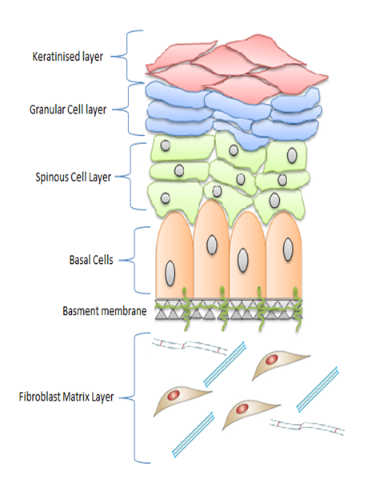
The oral mucosa is descriptive of the tissue that lines the inside of the mouth. Normal oral mucosa has the following defining features; a stratified squamous epithelium with distinctive cell layers, which directly interacts and is supported by an underlying basement membrane, overlying a connective tissue component (Figure 1.1). Cells directly adjacent to the basement membrane are termed basal keratinocytes. These have “stem cell-like” properties such as a high proliferative capacity and act to repair and replenish the cells within the epithelium. Supra-basal cells; normally found above the basal cell layer are partially differentiated keratinocytes that also have the propensity to proliferate. The next layer consists of the stratum spinosum, also known as the prickle cell layer. The common feature of cells within this layer is that they are joined by desmosomes; intracellular junctions that allow strong adhesion points. The most superficial layer comprises the terminally differentiated keratinocytes. Most areas within the oral cavity have only a para-keratinised outer layer, here keratin is deposited, and cells appear flattened in morphology with little or no nuclei present (Squier and Kremer, 2001). The connective tissue component of the oral mucosa is known as the ECM; a three dimensional (3D) macromolecular meshwork composed of distinctive non-cellular networks (Cox and Erler, 2011). Initially the ECM was considered primarily for its supportive properties, acting as a scaffold to aid the integrity of tissue structure (Badylak et al., 2009), but it is now appreciated for its critical role in providing biochemical and biomechanical cues that are required for tissue morphogenesis, differentiation and homeostasis (Lu et al., 2012, Walker et al., 2018).
Para-keratinised layer

Figure 1.1 Schematic of the cell layers found in the oral mucosa

Biochemical roles of the ECM

The responsiveness of cell types within the microenvironment is dependent on specific and highly complex signalling events allowing cells to ‘sense’ their environment. For this reason, the ECM surface is functionally adapted to express a variety of receptors including integrins, transmembrane proteoglycans and discoidin domain types that can influence cellular events (Hynes, 2009). Integrins are versatile in structure and can bind numerous protein types (fibronectin, laminin and collagen). The ECM acts as a binding reservoir for various growth factors and cytokines that are released once the ECM molecules are degraded or during alterations in matrix rigidity (Lukashev & Werb 1998). This is due to it being a highly charged meshwork due to abundant polysaccharide modifications and can bind a plethora of growth factors including but not limited to fibroblast growth factors (FGF), morphogenic proteins, and ligands such as Hhg and Wnt (Lu et al., 2012). The release of matrix metalloproteases (MMP) proteolytically cleave proteins to produce biologically active signalling fragments that too can cause changes in cell behaviour (Sternlicht and Werb, 2001). Decorin (collagen-associated proteoglycan) acts as a depot for transforming growth factor-β (TGF-β), matrix degradation by MMP makes TGF-β available to implement its biologic functions (Imai et al. 1997). One such function is to provide a negative feed-back loop by inhibiting the expression of several MMP genes.

Mechanical roles of the ECM

Compliance-dependent cellular behaviour is observable in mesenchymal cell populations and the ECM can respond to neighbouring cells that subject it to their isometric forces. The ECM exhibits biomechanical properties such as responding to changes in elasticity to help perceive and sense external forces, thus providing key environmental cues (Lu et al., 2012). Focal adhesion complexes (FAC) act as mechanosensors; consisting of integrin receptors, multi-complex adaptors and signalling proteins. Adaptors such as Talin and p13Cas undergo conformational changes. This function is a consequence of the applied force against them and are capable of sensing elastic changes (Wang et al., 2011). ECM stiffness is therefore a sustained isometric force exhibited at a nanoscale level. An increase in ECM protein production causes elevated matrix cross-linking and a subsequent reorganisation of matrix fibrils in the stromal matrix (Wells, 2008). This tissue stiffening alters the availability of growth factors and can alter the migratory status of cells. This refinement explains the heterogeneity of mechanical compliance in varying tissues including the lung, kidney, muscle myotubes, tendons and skin (Lu et al., 2012). Collagen type 1 superfamily are the greatest contributors to the mechanical properties of tissues as their fibrillary structure allows the greatest resistance to tensile, shear and compressive forces (Depalle et al., 2015). Such ECM-regulated processes are modified by specialised endoproteinases known as lysyl oxidase (LOX) enzymes which catalyse the intermolecular cross-links of elastin and collagen which in turn promotes increased matrix stiffness, strength and deposition. This is a fundamental regulatory process that maintains the appropriate mechano-responsive compliance of tissues.

ECM physical components; structure, function and interactions

The ECM is a complex meshwork of proteins and sugars, differing from tissue to tissue; with individual properties that are both supportive and integral to tissue functionality (Figure 1.2). The first such proteins that are discussed are proteoglycans (PG). They are important structural and functional macromolecules that reside within tissues; structurally they consist of a core protein in which glycosaminoglycan (GAG) side chains can attach (Iozzo, 1998). The high density of negative charges on the repeated disaccharide chains creates swelling pressure that allows the matrix to withstand compressive forces (Walker et al., 2018). As well as providing structural support, PG interact with an abundance of growth factors, cytokines and chemokines as well as other ECM molecules both from their internal protein core or by way of their many GAG side-chains. This allows for a functional involvement in biochemical signalling, proliferation, migration differentiation and cellular adhesion. The structure of hyaluronan has a linear GAG formation, consisting of a repetition of D-glucuronic acid on its disaccharide units. It allows appropriate binding to its own synthase or to cellular receptors (Fevert and Sannes, 2005). Accumulation of hyaluronan is found during development and tissues undergoing reorganisation. Hyaluronan’s role in reorganisation is mainly due to the ability to retain water molecules, which supports tissue plasticity (Comper and Laurent, 1978). PG found in the extracellular space are known as the hyalectans (aggrecan, versican, neurocan, and brevican). Versican is found in the ECM of almost all tissues and organs (Wu et al., 2005). The large domain consists of two smaller GAGα and GAGβ subunits which can undergo alternative splicing resulting in four splice variants; V0-V4. Homeostatic regulation of PG’s promotes tissue stability by providing additional structural support to the protein lattice that encases it, as well as regulating cell adhesion, proliferation, migration and inflammation (Wight 2002).
The most abundant fibrous proteins within interstitial ECM, constituting 30% of all human protein are the collagens. They are a large family of triple-helical proteins with at least 28 members which are classified based on their common domain homology. Within human tissues they form higher order structures such as fibres and sheets; providing the resilience required for hierarchical structure alignment. They interact with other ECM molecules to aid in this supportive scaffold functionality (Heino et al., 2009). The archetypal collagen found ubiquitously expressed amongst tissues is collagen type 1. It has heterodimeric helices which self-assemble into characteristic fibrils, thus providing structural elements in tissue, bone and tendinous areas (Heino, 2007). It consists of three polypeptide chains; 2α₁ and 1α₂, which result in a nearly 200 nm triple helical structure with an entangled tropo-collagen (Depalle et al., 2015). Tropo-collagen triple helices are capable of self-assembly and form myofibrils. Covalent cross-linking of these larger fibrils is further stabilised by LOX largely contributing to the enhanced mechanical properties (Shoulders et al., 2009, Walker et al., 2018). It is not uncommon for fibrils and high order structures to associate with other collagen types thereby expanding their range of properties allowing for functional multi-potency. For example, some unique collagens such as COLXVII to have long interruptions in the transmembrane spanning portion of the protein and this confers homeostatic signalling and adhesion capabilities (Kadler et al., 2007). The main function of the fibrillary collagens (Types I, II, III, V, XI, XXIV and XXIVII) are to confer tensile strength and are found abundantly expressed in tissues. However, their scaffold structure also acts as a signalling platform affecting numerous cellular functions including cellular adhesion, migratory phenotypes, tissue development and repair (Kadler et al., 2007).
The large ECM fibres that provide the necessary resilience of tissues in response to the stretching forces are the elastins. They are largely insoluble, hydrophobic, amorphous and extensively cross-linked (Debelle and Alix, 1999). Elastic tissue exists in a network of two components; the elastin molecules, which confer the majority of the structure (70-90%) and the rest consisting of tubular microfibrillar protein (Oxlund et al., 1988). This glycoprotein co-localises with fibrillin 1 on the periphery of the fibre and provides the necessary scaffolding to aid alignment and cross-linking (Wagenseil et al., 2007). The precursor of elastin molecule is tropo-elastin encoded by a single ELN gene and is considered the fundamental building block of elastin. Within the hydrophobic regions of elastin, two structures give the protein its elastic recoil functionality. In relaxed conformations the elastin tends to favour an unordered structure and so the chains are considered to be highly mobile. If stretched, during swelling, the tropo-elastin unfolds, and the chains are pulled uniformly in one direction; that of the stretching force. This encourages hydrogen bonds to form and the structure favours a more ordered conformation thus resulting in a more restrained structure (Debelle and Alix, 1999).
Ubiquitously expressed in the ECM of all vertebrates is fibronectin, responsible for connecting cells to the ECM (Hynes, 1986, Mouw and Weaver, 2004, Walker et al., 2018). Although encoded by a single gene, alternative splicing accounts for 20 isoforms to be present within human ECM. The solubility of fibronectin allows it to be categorised into soluble plasma fibronectin and cellular fibronectin. The latter is more heterogeneous and varies in different tissues. In vivo fibronectin functions in its fibrillary state. The molecular composition is capable of forming into super-molecular fibres that can be tens of micrometres in length, providing a vast structural support network in developing tissues (Larsen et al., 2006). Fibronectin is also capable of binding other ECM components; the multi-domain protein complex can be involved with fibrin, which aids adhesion/migrations in clot formation. Binding of fibronectin together with cells is achieved primarily through integrin and syndecan receptors. Fibronectin is continually synthesised to maintain the pre-existing fibronectin matrix (Sottile and Hicking, 2002).
The laminins are considered major constituents of the basal lamina, specifically the basement membrane; a highly organised area of the ECM that provides an interface with a variety of cell types including endothelial and epithelial cells, surrounding nerves, muscles, and adipose tissue (Walker et al., 2018). As well as allowing cellular communication it also provides mechanical support and stability, allowing for structural compartmentalisation and a physical reservoir for cellular growth factors (Tzu and Marinkovich, 2008). There are 16 known laminin glycoprotein isoforms, but each has a defined structure; they are large (400-900 kDa), cross-shaped and heterotrimeric; each heterotrimer consists of 1α, 1β and 1γ chain each encoded by its own gene (Aumailley et al., 2005). Each chain has specific domains which are capable of interacting with integrins and various ligands and therefore has a role in maintaining architectural assembly and integrity of the basement membrane (Yurchenco and Wadsworth, 2004). They interact with various cell types to impact behavioural responses such as proliferation, adhesion, migration as well as differentiation in normal pathways (Theocharis et al., 2016).
Laminins are incorporated into the ECM by interactions with other proteins including collagen (IV), fibulin and other laminins. Laminin migration and adhesion provide critical signalling cues to surrounding cells to aid in directing cellular motion and dynamics. The processing of laminin-332 α and γ chains play a role in cellular migration, alternative binding of these chains in a different domain (LG3-LG4) allows the binding of integrin α6β4, this increases the formation of hemidesmosomes aiding cell-cell adhesion and inhibiting cellular migration (Hintermann and Quaranta, 2004). γ chain processing causes the release of a DIII fragment which binds erbB1. This initiates the ERK1/2 pathway and phosphorylates integrin α2β4 causing hemidesmosome disassembly, and hence aids migration. Erb1 also has the capability to activate MMP2, which aids the γ chain processing further and allows for migration (Schenk et al., 2003).

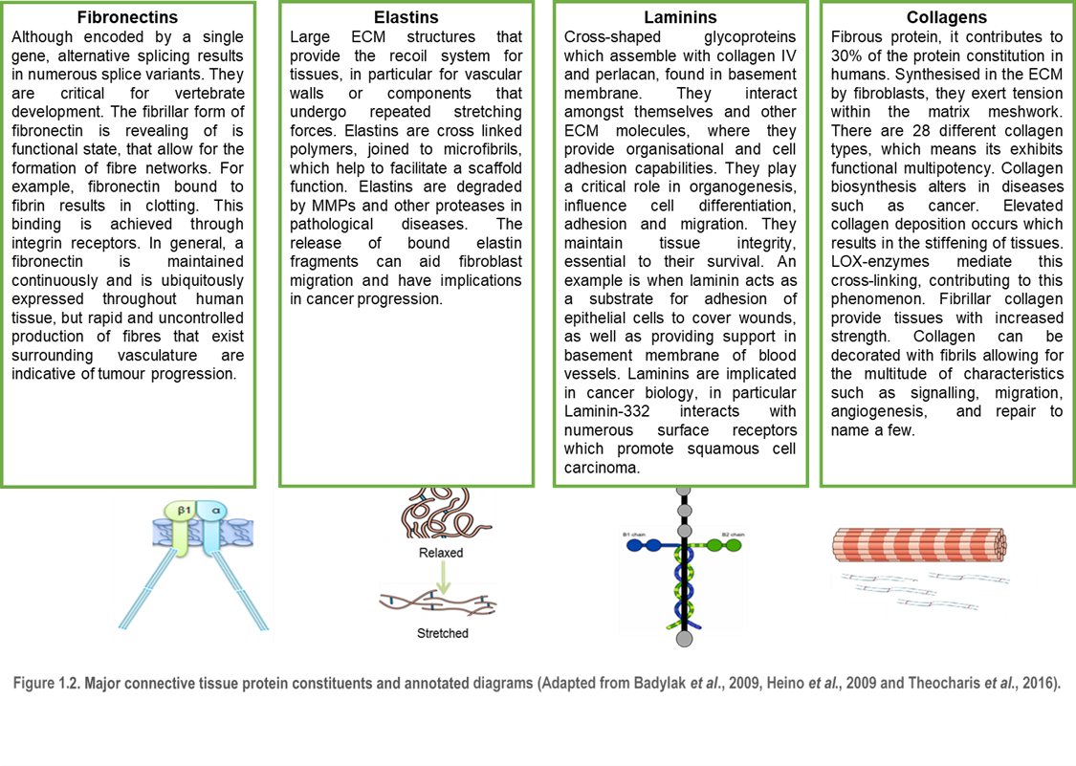

The role of the ECM in oral cancer

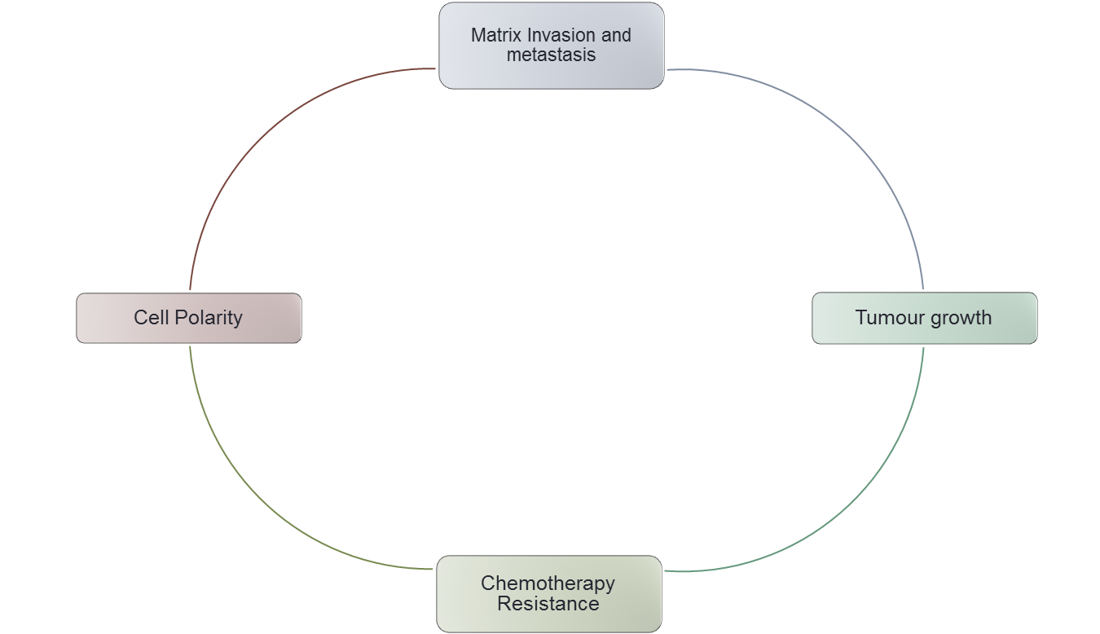
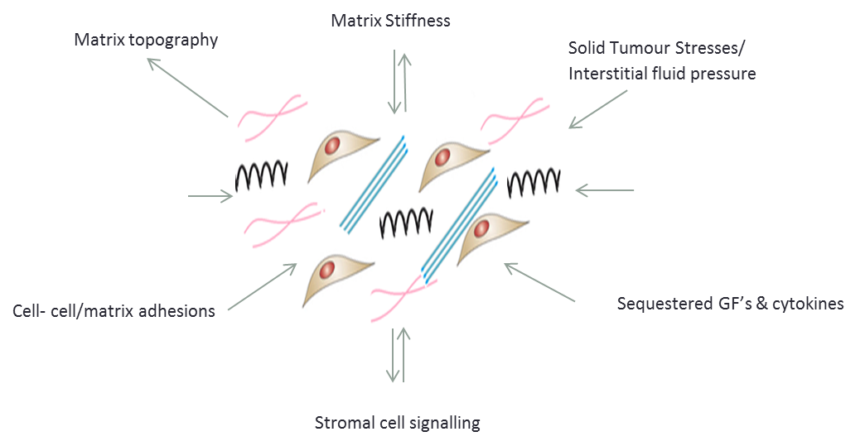
Tumours can initiate the activation of the host stroma via the desmoplastic response; a fibrotic state that is characterised by an altered organisation and composition of ECM proteins (Lu et al., 2012, Bonnans et al., 2014). It is now imperative that our understanding of cancer progression considers the effects of this altered tissue-specific microenvironment, which impacts cancer progression by supporting cellular transformation and metastasis, facilitates sustained angiogenesis and maintains a pro-inflammatory response, leading to the generation of a tumorigenic microenvironment (Friedl and Wolf, 2008) (Figure 1.3). Understanding the role of the ECM in oral cancer progression requires knowledge of the matrix-producing cells- the fibroblasts.

Figure 1.3. Diagram depicting the intertwined roles of the ECM in tumour progression
Matrix stiffness due to elevated collagen cross-linking generates a mal-perfusion barrier conferring chemotherapeutic drug resistance and the sequestering of growth factors and cytokine release causing tumour growth. This also induces invasive signalling cascades in stromal cells providing a feedback loop for fibroblast activation and further pathological ECM deposition. This alters the structural components of tissues and leads to the formation/degradation of adhesive sites changing matrix topography influencing the phenotypic behaviour of the stromal cells.

Cancer-associated fibroblasts; the story

The dominant cell type within the stroma are the fibroblasts, and those associated within the tumour microenvironment are termed cancer-associated fibroblasts (CAF). Although relatively easy to isolate and culture in vitro, they have remained an enigmatic cell type. The pleiotropic actions of these cells are becoming uncovered and further research will highlight their capabilities for functional plasticity in cancer biology (Kalluri, 2016, Bhowmick et al., 2004).

Definition, origin, and activation

Basic microscopic analysis of human tissue revealed the fibroblasts as being the synthesisers of collagen and after isolation in granulation tissue, their regulatory importance in force production for tissue remodelling was assessed (Manjo et al., 1971). Within normal tissue, they are normally single cells found within the fibrillary ECM interstitium and have no physical association with the basement membrane. They are non-immune and non-epithelial and are of mesenchymal origin (Kalluri, 2016, LeBleu and Kalluri, 2018). They exhibit classic fusiform morphology with considerable planar polarity. Fibroblasts are considered at large to be indolent with little metabolic activity; and their transcriptome is quiescent in nature (Table 1.1).
Activation of indolent fibroblasts was first described in wound healing and tissue regeneration (Gabbiani et al., 1971). Morphologically active and stellate in appearance these ‘activated’ cells were termed myofibroblasts (myoFB) due to their similar appearance to smooth muscle cells (Darby et al., 2014). MyoFB are associated with a variety of distinct features and can regulate connective tissue restructuring by the combined production of an activated and dynamic secretome, producing ECM components (Desmoulieré et al., 2004) (Table 1.1). MyoFB have a prominent contractile apparatus capable of exerting physical forces that modify tissue architecture. Primarily they are characterised by de novo synthesis of alpha-smooth muscle actin (αSMA), as well as other markers such as fibroblast activating protein (FAP) and platelet-derived growth factor receptor (PDGFR), however their heterogenous nature has made it impossible to define them by marker expression alone (Suigmoto et al., 2006). They also have characteristic stress fibres; which contribute to a greater force generated for contractibility. These morphological traits also exert traction forces that exhibit greater longevity than their smooth muscle cell counterparts, with effects active for months (Kalluri, 2015). In vitro analysis has shown that myoFB use a ‘ratchet mechanism’ with cyclical contractile features to aid motility and contractility. Such strong long wave contracture events are signalled by the Ras homolog gene family, member A (RhoA) kinases, whereas shorter wave contractures are produced by fluxes of calcium concentrations intracellularly allowing these cells to have greater migratory capabilities (Kole et al., 2005). There are conditional factors which contribute to the induction of these activated myoFB. In general, a build-up of mechanical resistance within the ECM combined with the actions of TGFβ-1 (a pro-fibrotic growth factor) is enough to stimulate the differentiation into myoFB (Kalluri, 2016). Once ECM stiffness has reached a threshold during the remodelling of tissues, the cells produce an actin-cytoskeletal contractile apparatus that transduces mechanical stimuli into biochemical signals activating gene expression pathways for autocrine contractility (Huang et al., 2012, Stempien-Otero et al., 2016). The origins of these mesenchymal cells are both controversial and heterogeneous but can largely be explained by the different origins of precursor fibroblasts such as mesenchymal stem cells (MSC), endothelial cells, pericytes, bone-marrow derived cells and epithelial cells (Kalluri and Ziesberg, 2006).
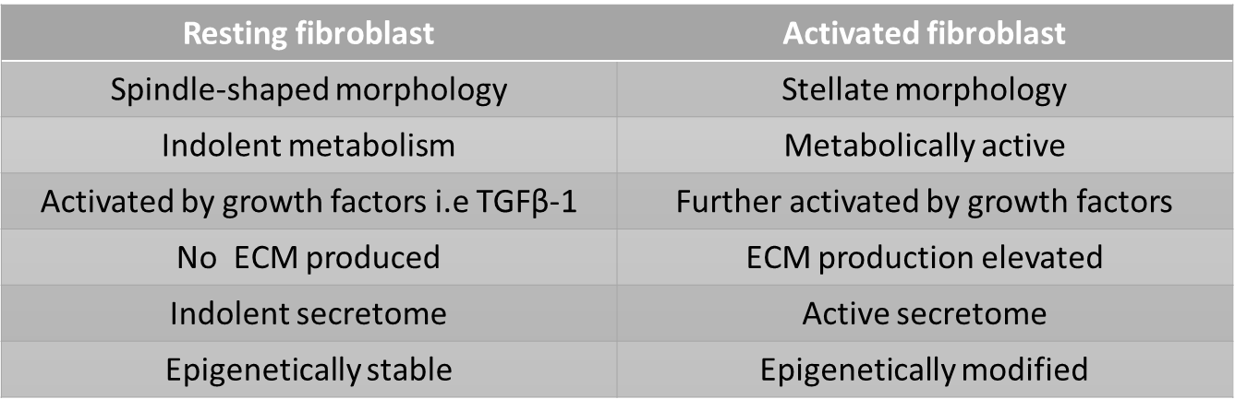

Table 1.1 Quiescent fibroblasts vs activated fibroblasts

Role in cancer fibrosis- the desmoplastic reaction

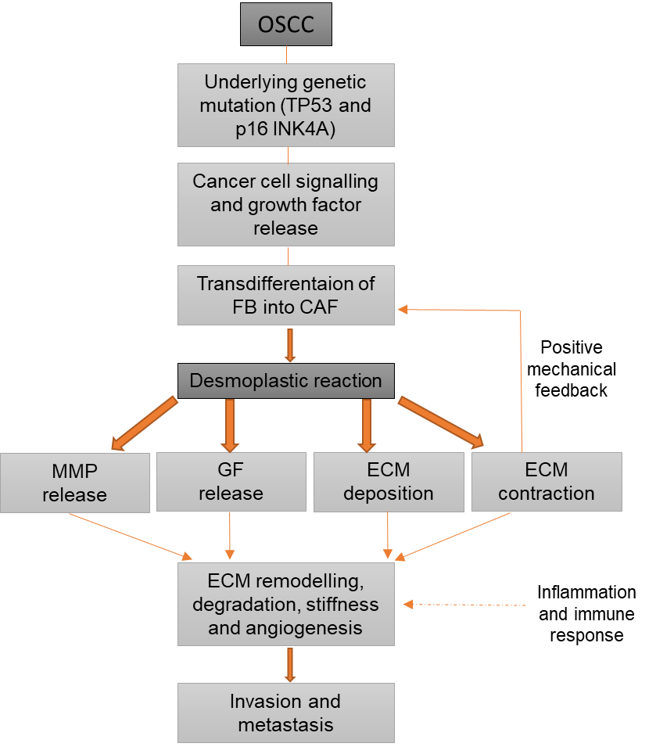
Genetic injury to the functional parenchyma that occurs during cancer also triggers a chronic tissue repair response by fibroblasts, hence why cancers are termed, ‘wounds that do not heal’ (Dvorak, 1986). The recruitment of CAF is largely the result of growth factor release by cancer cells. TGFβ, PDGF, SDF-1 and fibroblast growth factor (FGF) are the prominent mediators for the recruitment of activated CAF in cancer tissue injury (Figure 1.4). TGFβ-1 has been observed to induce fibroblast proliferation and invasion both in vitro and in vivo as well as exhibiting an upregulation of matrix proteins and growth factors (Lui et al., 2019, Lohr et al., 2010, Melling et al., 2018).

Figure 1.4 Flow diagram depicting the roles of CAF in OSCC disease progression
Genetic instability within the epithelial layer of the oral mucosa provides the initial trigger for pathological demise. These genetic aberrations cause irreversible change to underling stromal components. Exogenous growth factor release (i.e TGFβ-1) signal to initiate fibroblast to CAF transdifferentiation and activation as well as increasing vascular sprouting and angiogenesis. CAF activation confers changes in MMP and growth factor behaviour causing the degradation of matrix components leading to cellular invasion and metastasis. CAF increase the contractibility of the ECM, which also triggers signalling cascades that further activate CAF phenotype. These factors all contribute to tumour progression in OSCC.

1.3.1.3 CAF phenotype and heterogeneity
CAF morphologically have a more prominent rough endoplasmic reticulum (ER) and Golgi apparatus, a more distinctive fibronexus and exert a greater force of contracture than the myoFB population and are found in larger quantities accumulated in pathological stroma (Kalluri, 2016, Lui et al., 2019). It is well established that cancerous epithelial cells within the oral cavity can have paracrine effects on neighbouring myoFB to promote transdifferentiation into CAF. The complexity of CAF has also been highlighted by single-cell RNA-sequencing analyses (Li et al., 2017, Bernard et al., 2018, Lambrechts et al., 2018). Single-cell RNA-sequencing analyses revealed novel CAF subsets (CAF-A and CAF-B). CAF-B cells expressed cytoskeletal genes and markers of activated myofibroblasts, while CAF-A cells expressed genes related to ECM remodelling, including the TGF-β activator MMP2 (Li et al., 2017). Other studies have obsefrved that activated fibroblasts express the markers; fibroblast-specific protein 1 (FSP-1), vimentin, αSMA, FAP and PDGF (Kraman et al., 2010). FSP-1/S1004A is a reliable marker for detection of quiescent fibroblast (Ki67 negative, non-proliferative) but this is not specific for fibroblasts (Strutz et al., 1995). Two murine models of cancer the Rip1Tag2 pancreatic cancer model and the orthotopic 4T1 breast cancer model have been used to study six mesenchymal markers. FSP-1 identified a unique population representatively derived from bone marrow cells with minimal overlap with αSMA, PDGFR, and neuron-glial antigen 2 (NG2) as well as a sub-set of αSMA+ and NG2+ fibroblasts found in surrounding tissues, primarily from an adipose origin (Kidd et al., 2012, Sugimoto et al., 2006).
Since some CAF subtypes share transcriptional signatures across multiple cancers, future work should be directed at determining whether they also possess similar functional capabilities. In light of our current knowledge of CAF heterogeneity and the presence of CAF subtypes found at single-cell resolution it’s essential to develop protein markers unique to each CAF population, and to compare the stromal representation found at primary tumours as well as in metastases.

1.3.1.4 Epigenetic regulation of CAF
Within the tumour microenvironment the phenotypic characteristics of CAF can be induced by TGFβ-1 but more recent data suggests epigenetic mechanisms regulate the irreversible activity of the CAF phenotype (Li et al., 2015, Mrazek et al., 2014, Kalluri, 2016). Leukaemia inhibitory factor (LIF) has been known to enhance and mediate the pro-invasive activation of stromal fibroblasts (Albrengues et al., 2014). TGFβ produces this stability by activating LIF production which mediates actomyosin contractility and ECM remodelling; both processes increase carcinoma invasion in vitro and in vivo. Collagen fibre organisation and upregulation have been noted in carcinomas with high LIF expression. This process is the result of complex signalling through the JAK/STAT pathway and specific JAK inhibitors for example Ruxolitinib has been observed to counteract the effect of LIF-mediated pro-invasion (Albrengues et al., 2014). The long-term implications of exogenous recombinant LIF treatment has yet to be established in pro-invasive OSCC CAF but could be useful in the understanding of epigenetic signalling mechanisms that provide pro-invasive signalling in long-term viable models of OSCC. Fibrogenesis in the kidney is also determined by methylated activation of fibroblasts. Hypermethylation of the Ras protein activator like 1 (RASAL1) and subsequent downregulation of the protein leads to a de novo activation of Ras in fibrotically-activated fibroblasts but not fibroblasts isolated in normal tissue (Betchel et al., 2010).

1.3.1.5 CAF in tumorigenesis

Mechanical stimuli from tumour tissue remodelling also maintains and actively recruits CAF. Within OSCC there is a distinct chain of events that involve CAF differentiation, cancer progression and elevated matrix stiffness (Figure 1.4). In vitro and transgenic in vivo analysis confirmed that CAF in epithelial carcinomas exhibited and increased proliferative capacity and enhanced migratory behaviour (Schor et al., 2000). Irradiation of fibroblasts transplanted into the fat pads of mice saw an increased incidence of breast tumour in comparison to those non-irradiated fibroblasts (Barcellos-Hoff et al., 2000). As well has having the same mechanical properties as myoFB they produce an abundance of soluble factors and proteins due to an elevated secretome activity capable of initiating and developing pathological response in tumorigenesis. Such implicated growth factors include fibroblast-growth factor (FGF), insulin-like growth factor (IGF), epidermal growth factor (EGF), hepatocyte growth factor (HGF) and TGFβ. Most cause sustained proliferation and therefore contribute to cancer progression in that way. Yes-associated protein (YAP1) activation in CAF enhance ECM stiffening and cancer cell invasion by regulating the expression of cytoskeletal regulators (Calvo et al., 2013).

1.3.1.6 Fibroblast senescence and CAF Phenotype

Another fibroblast phenotype that can contribute to the CAF population is the senescent fibroblast (Campisi and Fagagna, 2007). These are cells that are in a permanent growth arrest in stage G0 of the cell cycle, although remaining metabolically active. They maintain a myoFB-like secretome and are termed senescence associated secretory phenotype (SASP) and can therefore impact on the surrounding ECM (Coppe et al., 2009 and Kabir et al., 2016). Senescence can be induced by numerous factors, such as, chemotherapeutic and DNA damaging agents, ageing, and irradiation exposure. Replicative senescence, which is caused by numerous cycles of cellular division; this phenotype is inducible in culture. The senescent response to stress by CAF may be important in-patient outcomes and useful for diagnostics, so a further understanding may result in important clinical therapies. CAF from genetically unstable OSCC initiated by DNA damage by reactive oxidative stress (ROS) secrete TGFβ-1 and this combined with MMP-2 can induce epithelial to mesenchymal transition (EMT) in tumour cells, causing the loss of adhesive molecules and promoting epithelial invasion (Prime et al., 2016). Mellone et al., found that fibroblasts induced to senesce developed molecular, ultrastructural and contractile features typical of myoFB but not all CAF subtypes had the ability to generate an organised collagenous ECM.

The ECM and sustaining proliferative signalling

In order for carcinomas to transform and progress tumour cells need to continually proliferate. Proliferation is controlled by the ligation of growth factor receptors that activate and promote intracellular signalling to enhance cell cycle progression. The G1/S cell cycle checkpoint is responsible for this regulatory control. For transition to occur there must be cellular adhesion to the ECM and this facilitates the release of growth factors that activate RAS; a key GTPase that acts through extracellular-signal related kinase (Erk) signalling and promotes G1/S transition (Xiong et al., 2013). Many transformed cells that are considered malignant secrete their own ECM ligands are able to evade proliferative suppression allowing for survival in inhospitable environments. These cancer cells actively secrete their own ECM proteins and are highly metastatic (Naba et al., 2014). Activated Erk signalling also promotes anchorage independence for growth and survival also expresses and syntheses ECM proteins (Pattabriaman et al., 2010). Cells which are able to interact with a stiffened matrix cause phosphorylation of Erk again accelerating the transition through the cell cycle. This indicates a distinctive role of the ECM in maintaining proliferative signalling in cancer progression.

ECM mechanical function in cancer

A growing area of research in ECM biology is the contribution of biomechanical properties of the matrix in cancer progression. ECM elasticity can range from compliant, to stiffer to increasingly rigid, and can contribute to the development of disease. The elasticity plays a part in how the cells are capable of responding to external forces including hydrostatic pressure, shear stress and compression/tension forces, which in turn alters cell behaviour and remodels the surrounding microenvironment (Butcher et al., 2009). Mechanoreciprocity; a process by which the ECM cells sense forces through mechanoreceptors produced forces, a key process during disease progression. Focal adhesion complex (FAC) containing integrins, signalling proteins and various cellular adaptors acts as a mechanosensor provide the pathway between the ECM and the acto-myosin cytoskeleton. Forces can directly interfere with components of FAC (Talin) and cause conformational changes impeding normal functioning (Wang et al., 2011). The dynamic role of the ECM and force generation; and in particular by collagen, within the tumour microenvironment has been implicated in many solid tumours to promote tumour progression including breast and HNSCC (Hu et al., 2015).
Translation of this understanding has already become of use in clinical prognostics in the US. ‘Under new US law, radiologists are to inform women undergoing routine mammography screening if they appear to have a high mammographic density (measure of the relative ratio of ECM collagen to adipose cell volume), as their nationwide statistics suggests that for those screened the density is a predictor of a 2-6-fold higher risk of breast cancer’ (Huo et al., 2015).
Within the ECM, collagen generates considerable tensile forces that impact dynamically on epithelial signalling networks (Figure 1.5). Fibril-forming collagen type 1 and cartilage collagen type 2 create large structures which interconnect with other cell types leading to a dynamic 3D structure. The molecular structures of these collagens contribute to the tensile strength of ECM-rich tissues. There has been a link between tumour progression and matrix stiffness that has been characterised in breast, prostate, HNSCC, and lung carcinogenesis (Hanley et al., 2016. The characteristic upregulation of LOX-mediated collagen cross-linking provides the stiffness capabilities by production of focal adhesions due to elevated P13 kinase activity and growth factor signalling (Levental et al., 2009).
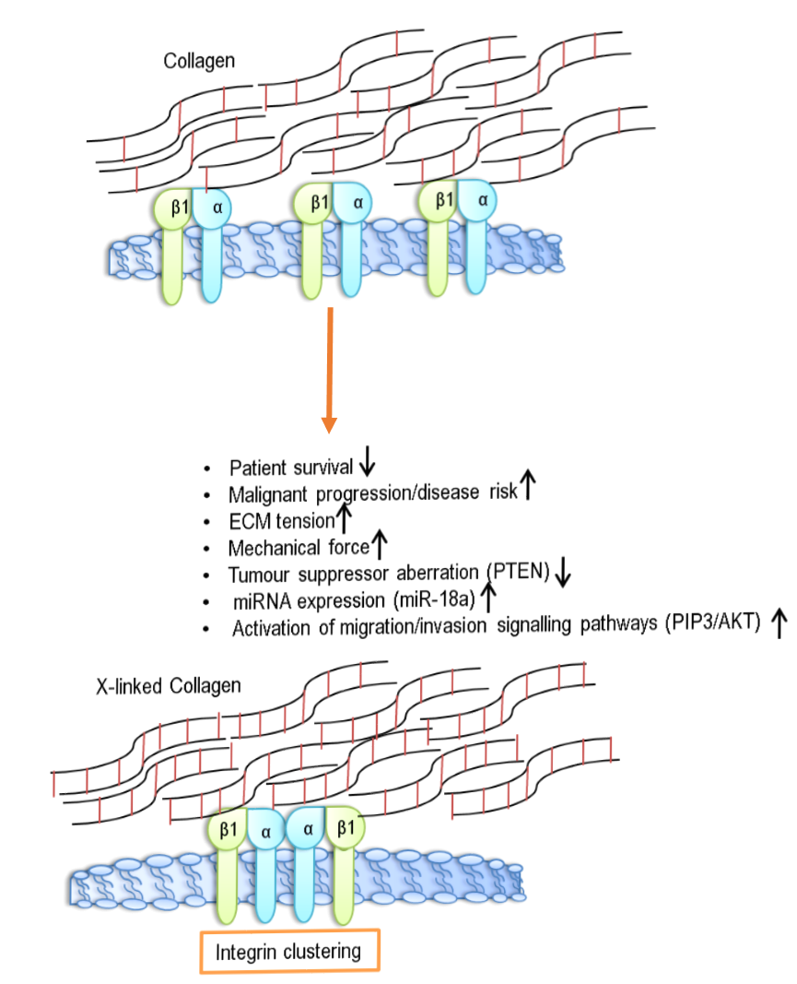
Alterations in stiffness are the result of molecular changes that act via signalling pathways. This causes the up regulation of miRNA (miR-18a in breast carcinoma) which activates invasive phenotypes. Expression of miR-18a has inhibitory effects on tumour suppressor proteins like PTEN; which directly promotes cell cycle progression and survival (Seewaldt, 2014). In vivo mice studies have also implicated a role for the impact of matrix stiffness directly on the behaviour of cancer cells. It’s been shown that cancer cells preferentially invade along a stiffer collagen meshwork into adjacent stromal tissue. This stiffer fibre network is also an established identifier of focal sites indicative of breast cancer cell micro-invasion. This matrix interacts and binds one-another as well as cell receptors which are capable of a diverse signalling repertoire. Such signalling can influence an array of cellular functions such as pro-survival queues, proliferation, migration and cellular differentiation.

Figure 1.5. Diagram of collagen cross-linking and subsequent effects
X-linked collagen promotes the clustering of β1-integrin subunits. This in-turn provides the necessary activation of signalling cascades known to promote pronounced malignant progression of solid tumours. Resulting in mechanical forces and increased matrix tension. Molecular alterations such as miRNA activation and the reduced gene expression of tumour suppressors such as PTEN/BRCA1 also negatively correlate with pro-invasive and migratory phenotypes.

Biophysical roles of the ECM in cancer

Another role the ECM plays in disease progression, are the effects of fluid pressure changes with the tumour microenvironment. Bulk deposition of non-soluble ECM proteins during stromal remodelling, such as collagen, results in alterations of tumour stromal fluid flow and increased solid-tumour stress. This mal-perfusion can act as a barrier to chemotherapeutic reagents and result in resistance and inefficiency to certain drug therapies. OSCC’s are notoriously aggressive and metastatic and in-turn have a resistance to treatment options. The desmoplastic response of the ECM is influenced by CAF activity and ECM deposition. Immunohistochemical analysis of pancreatic tumour sections revealed staining for the deposition of proteins which are all up-regulated in desmoplastic stroma including collagen, GAGs, mucins, hyaluronic acid binding protein (HABP) and hyaluronic acid (HA) and αSMA stress fibre formation (Provenzano and Hingorani, 2013).
Activated stromal CAF alter the physical structures of developing tumours through this reaction mechanism. Deposition of ECM, which includes dense collagen and mucins (fluid-trapping mucopolysaccahrides) reduce the diffusion of soluble concentration gradient driven molecules, which affects fluid pressure and the convection of flow rates through porous membranes. This is most apparent in the tumour bed, which appears vastly mal-perfused and represents an under-researched area of disease resistance. The role of vascular collapse in OSCC has yet to be investigated to draw specific conclusions, but studies of vascular collapse in other cancer-types indicates this could be an influential mechanism for resistance. The effects of interstitial fluid pressure have been shown to alter fibroblast responses to TGFβ and could indicate a mechanism by which mechanical response differs to release of fluid-mediated chemical signals in vivo (Nithiananthan et al., 2017).

The ECM in resisting cell death

Cell death is often circumvented during malignant transformation and is assisted by the ECM. The cleavage of caspases and release of bound pro-apoptotic proteins e.g. cytochrome C by mitochondria is tightly regulated by the B-cell lymphoma-2 (BCL2) family (Brown and Attardi, 2005). The tumorigenic stroma promotes anchorage-independent survival is a result of an overexpressed tyrosine-kinase receptor erythroblastic oncogene B (Erbb2/HER2). Cellular adhesion to the ECM effectively inactivates pro-apoptotic molecules e.g. Bax and induces BCL2 expression in order to promote cell survival (Gilmore et al., 2000). Anchorage-independent survival is also stimulated by laminin ligation of α6β4 integrin. This results in EGFR activation and stimulates NF-κβ and resists cellular demise in mammary tumour tissue. This ligation also enhances a tumour cell’s capability to resist apoptotic degradation in response to chemotherapeutic intervention (Zahir et al., 2003).

The ECM in enabling replicative immortality

Tumours exhibit uncharacteristic growth rates which are largely unrestrained. Normal growth rates are limited due to the relative shortening of telomeres; non-coding nucleotide sequences found at the end of chromosomes. DNA polymerases are unable to replicate the entire strand and so the telomeres at the end of the chromosome shorten progressively during cellular division. In cancer, cells are capable of activating telomerases, subsequently lengthening the telomeres overcoming replicative senescence. The ECM has been shown to be implicated in the replicative behaviour of cells where large deposition of ECM proteins occurs, and tissue stiffness is prominent, there are often elevated levels of telomerase and this is indicative of ECM adhesion having an influence in aiding immortality (Yu et al., 2009).

The ECM and sustained angiogenesis

Angiogenesis and vessel sprouting are common phenomena in tumour progression and are stimulated by a multitude of growth factors such as vascular endothelial growth factor (VEGF) and FGF, as well as recruiting endothelial cells and pericytes to allow for vessel assembly (Bergers and Benjamin, 2003). The ECM acts as the primary supplier for this pool of pro-angiogenic growth factors and ensures the survival of these newly recruited endothelial cells (Hynes, 2007). As previously stated, a stiffened matrix can cause a multitude of environmental changes that directly aid angiogenesis (Figure 1.6). It permits endothelial migration by inducing GATA2; transcription factor to upregulate VEGFR2 which in turn promotes cell survival (Montesana, 1983).

The ECM and evasion of growth suppressors

Tumour suppressors work by limiting cell cycle progression in G1-S phase of the cell cycle. TGFβ mediated phosphorylation of smad and p53 induces p21 and p27 which subsequently inhibits cyclin-dependent kinases (CDK) (Massague et al., 2012). These are essential for cell cycle progression and therefore suppress cell growth. Where cells ligate to the ECM, this can modify the activity of many tumour suppressor pathways and override this growth suppression mechanism. BRCA1 tumour suppressor function is inhibited by ECM adhesion and this interferes with cell cycle regulation (O’Connell and Martin, 2000). The tumour cell- ECM adhesion evades growth suppression pathways to allow malignant transformation. This is indicative of ECM interactions directly causing a growth advantage (Figure 1.6).

The ECM in aiding invasion and metastasis

For malignancy to occur, transformed cells must have acquired an invasive phenotype to be able to invade into the underlying parenchyma. In order for such movement invadopodia; actin protrusions that use integrin-mediated adhesion are able to direct such migration by localising MMP degradation of the matrix (Wang and McNiven, 2012). Again, tumour stiffness enhances this invadopodia formation via an upregulation of focal adhesion assembly which drives cell invasion. From this parenchymal invasion metastasis is dependent on intravasation into the circulatory system (blood and lymph) to eventually extravade into a secondary site to colonise (Figure 1.6). This movement is favoured by EMT; a process activated by the release of TGF-β from the degradation of stroma (Annes et al., 2003). Increased matrix stiffness, which fosters integrin-dependent cell adhesion can directly stimulate cancer cell metastasis and favours this TGFβ-induced EMT pathway (Leight et al., 2012).

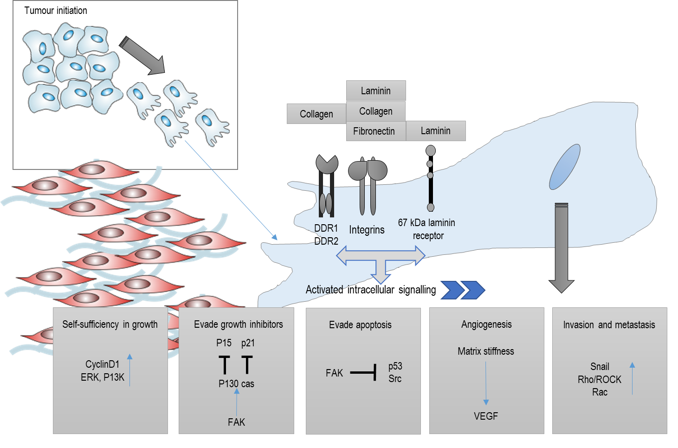

Figure 1.6 Schematic showing ECM impact on the hallmarks of cancer
During the process of cancer progression, the ECM has the capability to influence each of the hallmarks of cancer (Hanahan and Weinberg, 2000). ECM components are capable of biding and activating intracellular signalling pathways through ERK and P13K allowing sustained growth. Cells develop an insensitivity to growth inhibitors through the inhibition of p15 and p21 caused by FAK signalling. FAK also inhibits p53 and therefore evades apoptotic regulation. EMT and pro-migratory pathways are stimulated by the biophysical capabilities of the cell and is induced by RhoA/Rac signalling as well as TGFβ signalling. Increased collagen deposition and elevated matrix stiffness induces VEGF signalling to promote an angiogenic response.

ECM impact on the emerging hallmarks; evading immune destruction and deregulating cellular energetics

Tumour formation is meticulously prevented by an active immune surveillance from the adaptive immune system. The ECM is capable of compromising this repose by inhibiting T-cell proliferation (cells capable of destroying foreign antigens). This is achieved through type 1 collagen ligation of leukocyte-associated immunoglobulin-like receptor 1 (LAIR1) receptors and T-cell activation (Meyarrd, 2008). Tumour induced ECM stiffening can impede T-cell activation by impairing CD3 and CD28 and IL-2 production; these are necessary for the correct activation of T-cells (O’Conner et al., 2012). The ECM is of paramount importance in permitting the uptake of nutrients as well as functional ATP. Tumour cells exhibit a form of metabolic reprogramming known as the Warberg effect; where there is a shift toward anaerobic glycolysis. The ECM can directly signal to tumour cells via focal adhesion signalling pathway which activates P13K and increases glycolysis (Vander Heiden et al., 2009). Tumours that are associated with stiff matrices show elevated P13K signalling which is suggestive of tissue tension directly regulating tumour metabolism (Elstrom et al., 2004).

ECM signalling in cancer

Regulation of both the receptor and the cues that result from receptor aberration can propel distinctive functional changes that can influence tumour progression. This altered signalling into the interior of tissue-specific cells can cause loss of regulatory control of the cytoskeleton, enhance pro-survival cues, cause differentiation and alter gene expression profiles. CAF in particular have enhanced capabilities to promote tumour angiogenesis, cellular proliferation and suppression of normal anti-tumour processes. These functions make them ideal candidates for anti-cancer targeted therapies. CAF signalling has been associated with an increase in invasive phenotypes (Gaggioli et al., 2007). OSCC is often metastatic despite treatment and this is a reflection on the plethora of molecular signals that are pro-invasive e.g. brain-derived neurotrophic factor (BDNF), HGF, IGF, bone morphogenic protein 4 (BMP4), and chemokine (C-C motif) ligand 7 (CCL7). Proteases are also secreted in the form of MMP which aid invasion by digestion of ECM, allowing metastatic spread.
Cancer cells can provide crosstalk to parenchymal tissues through the release of soluble factors such as TGF-β, IL-1α, and TNFα. The latter factor is responsible for the upregulation of BDNF which in turn promotes EMT a regulator of a migratory and invasive phenotype leading to the initiation of cancer metastasis. This process is characterised by an upregulation of EMT marker such as vimentin and a loss of e-cadherin in vitro. Further experimental analysis of signalling has identified that the TNFα antibody infiximab can effectively inhibit CAF invasion activated by OSCC cells. It is essential to highlight that these signalling events are mutually re-enforcing between the stromal compartment, in particular CAF, and the cancer cells.

Modelling the oral stroma in vitro

Appreciating the dynamic heterogeneity of the tumour microenvironment in OSCC and knowledge of the interactions of both stromal and tumour cells within the ECM is an under-researched area, hindered by a lack of physiologically relevant in vitro models that capture the complexities of the in vivo situation. Current techniques have been described in the subsequent section, highlighting simplistic 2D systems to more complex 3D tissue constructs.

1.4.1 Monolayer cultures

Traditionally, standard cell culture applications for studying cancer in two-dimensions (2D) has utilised established cancer cell-lines that have adapted to in vitro conditions. This method has been useful in our understanding of the basic molecular changes in cancer. For certain cancers, such as colorectal cancer (CRC), the analysis of the mutation and gene expression status of over 100 human CRC cell-lines, revealed that they contained the complete variety of molecular and transcriptional subtypes, as previously described in CRCs in vivo (Marisa et al., 2013, Medico et al., 2015). EGFR inhibition of these cell-lines also resulted in the range of drug responses from sensitivity to resistance, thus evidencing their uses for many CRC research applications. It is also possible to evaluate the behaviour (migration and remodelling capabilities) of cell-types in response to released factors by cancer cells. The expression of the protease; urokinase plasminogen activator (uPA), which has a distinctive role in ECM remodelling is found upregulated in a 2D co-culture system of stromal fibroblasts cultured alongside cancer cells (Noskova et al., 2009). These culturing methods are suitable for high throughput screening arrays, offering standardised and reproducible results. However, cells cultured as monolayers on flat surfaces experience a decidedly non-physiological environment, largely due to the rigidity of the culture surface, and exposure to a uniform gradient of nutrients. Cell lines are also normally generated using aggressive tumours and therefore are not representative of the heterogeneity of tumour ECM (Hidalgo et al., 2015). To date, very few studies have directly and comprehensively compared signalling pathways in 2D vs 3D culture, in the presence or absence of ECM and/or stromal cells, or upon treatment with inhibitors (Pickl and Ries, 2009), Luca et al., 2013 and Ekert et al., 2014).

1.4.2 Three-dimensional models

3D tissue culture models are invaluable tools to study tumour biology and are becoming more complex in design. There are a number of advantages and disadvantages for each model system which has been described in Table 1.2 (Kim 2005, Gill and West 2014, Knight and Przyborski 2015, Lü et al., 2014, Fischbach et al., 2007).

1.4.2.1 Patient-derived xenograft models

Patient-derived xenograft (PDX) models are generated by direct implantation of resected patient tumours into immunocompromised mice in the absence of any in vitro culture and have been shown to preserve tumour heterogeneity (Fong et al., 2017). Xenograft models of head and neck cancer have been reported since the 1980’s. Braakhuis et al., observed models of head and neck cancers by the implantation of 130 head and cancers from human into nude mice. More recently Myers et al., generated models of oral tongue carcinoma using human OSCC cell-lines implanted into the tongue of an orthotopic murine model, carcinoma cell-lines. PDX models have also been established for other cancers. Direct injection of a fresh surgical specimen of medulloblastoma (MB) and glioma tissues into immuno-deficient mouse brains generated xenograft models that were patient specific, replicated the histopathologic, immuno-phenotypic, metastatic, and major genetic abnormalities of the original tumours (Shu et al., 2008). Alternatively, the effects of cancer drugs have also been assessed using PDX models. For example, bevacizumab showed anti-tumour activity in an OSCC xenograft model by decreasing micro-vessel density that significantly inhibited tumour growth in the HSC-3-bearing nude mouse model (Yoshida et al., 2018). PDX cells can also be used in conjunction with other 3D technologies. Fong et al. demonstrated the use of semi-synthetic hyaluronan hydrogels functionalized with integrin-binding RGD motifs and matrix metalloprotease-sensitive substrates as a platform that supported the co-culture of osteoblastic cells with PDX prostate cancer cells which recreated the prostate cancer–osteoblast interaction in bone metastasis in vitro. The major limitation in using PDX models to study tumour: ECM interactions is that for the majority of the well-established cancer models there is a substitution the human stroma by murine stroma. It has been observed that there is a rapid replacement of the human stroma by the animal’s own native ECM and stromal cells, through-out tumour growth, thereby limiting the interpretation and suitability of such models to study human native ECM in tumour progression (Junttila et al., 2013).

1.4.2.2 Tumour Spheroids

Currently, tumour spheroids are the most commonly employed 3D cancer model, made of cellular aggregates that form when non-adherent conditions are used, to culture transformed cells. Spheroids recapitulate the in vivo tumour architecture more closely than 2D monolayer cultures by supporting a 3D cellular architecture and in vivo–like cell–cell contacts. Indeed, spheroids have been reported to reflect the cell morphology (Colley et al., 2011), growth kinetics, signalling pathways, and drug response of solid tumours (Lawlor et al., 2002) including head and neck cancers. Spheroids derived from the murine colon carcinoma cell line CT26 embedded in a biomimetic collagen I matrix have been utilised to study the effect of contractile forces. Kopanska et al., showed that contractile forces act immediately after seeding and can deform the ECM, generating tensile radial forces within the matrix, and could be relaxed by cutting the collagen indicating that tensile forces in the ECM facilitate invasion. Cell-matrix remodelling has also been investigated using spheroids (Moss et al., 2009). In one such study the proliferation of epithelial ovarian cancer cells embedded within MMP-sensitive hydrogels was 50% enhanced compared to MMP-insensitive hydrogels and within MMP-sensitive hydrogels this was significantly reduced through inhibition of MMP activity through a broad-spectrum MMP-inhibitor (GM6001) (Loessner et al., 2010). Tumour spheroids are advantageous to study cancer as they are amenable to high through-put screening methodologies, have observable tumour: ECM interactions, as well as a relatively simplistic experimental design (Kim, 2005). The latter can also be disadvantageous, as a simplistic design and architecture insufficiently captures ECM dynamics. These systems have inefficient diffusion gradients and nutrient transfer, and many develop necrotic cores during culture.

1.4.2.3 Scaffold-based tissue-engineered 3D tumour models

Utilising tissue-engineering techniques, more complex 3D tumour models can be engineered with control over matrix composition, density, stiffness, and spatial positioning of different cell types. Thus, creating a more physiological relevant structure which enables cells cultured in vitro to replicate more closely the gene and protein expression observed in vivo (Lee et al., 2008, Abbott, 2003). As well, European chemical legislative drivers have identified the requirement for representative in vitro models to reduce in vivo model experimentation (Lilienblum et al., 2008).

1.4.2.3.1 Natural scaffolds

Typically, scaffolds, when seeded with fibroblasts, form the basis of the lamina propria and is composed mainly of collagen protein. Therefore, most commercially or lab-generated scaffolds consist of bovine or rat-tail collagen, usually owing to the ease of generating it. Models generated using these techniques are largely composed of an animal-ECM scaffold and this raises concerns regarding the physiological relevance of the material (Wolf et al., 2009). One such biologically derived scaffold systems was generated during the culture of murine Engelbreth-Holm-Swarm (EHS) tumour cells. The deposited basement membrane proteins including laminin, collagen IV and perlecan were collected and a form of that matrix is available commercially as Matrigel® and is now widely used for cancer studies (Kleinman et al., 1986, and reviewed extensively in Kleinmann and Martin 2005). Matrigel® promotes cell-matrix interactions and can affect the behaviours of cancer cell proliferation and migration. A rapid proliferation index was demonstrated in Matrigel® using human HT1080 fibrosarcoma cells (Kramer et al. 1986). More recently, cancer cells types of interest have been embedded, observing migration in 3D (Hughes et al., 2010) by combining Matrigel® with microfluidic devices, the migration phenotypes of H1299 lung adenocarcinoma cells were assessed in varying invasive microenvironments (Anguiano et al., 2017). Other commercially available products include Cultrex® basement membrane extract containing hyaluronic acid.
Other natural scaffolds include hydrogels consisting of either collagen or hyaluronan. An in vitro organotypic breast cancer model used a mixed population of cells: epithelial cells (either normal or cancerous), myoepithelial cells, and fibroblasts derived either from normal or tumour stroma (Holliday et al., 2009). Within this hydrogel set up, these cells orientated themselves mimicking in-situ tissue. The addition of CAF to this set-up, unlike normal fibroblasts, disrupted the epithelium. This study describing a 3D in vitro model, which uses three cell types, demonstrates convincingly the pivotal role of tumour stromal fibroblasts in cancer progression. Hyaluronic acid (HA) -based hydrogels are another example of a natural scaffold. HA a constituent of both normal ECM but is also found in abundance in malignant tumours and has been known to promote cancer cell proliferation (Gurski et al., 2009). HA-based hydrogels were used to test chemotherapeutics; camptothecin, docetaxel and rapamycin, demonstrating the gradient action of these drugs on prostate cancer cells; with the outer cells being affected first, followed by the cells located inside. Evidencing that drugs do not readily penetrate through the cancer cluster, as they do through the hydrogel. The effects of heparin; an inhibitor of hyaluronidases (HAse; hyaluronan degrading enzymes) have also been studied on the invasiveness of 13 human cancer cell lines (David et al., 2004). Heparin significantly inhibited invasiveness of HAse-producing cancer cell lines (brain and hepatic metastases), which has indicated the use of heparin for cancer therapeutics.

1.4.2.3.2 Cell-derived matrices

The first report of using cell-derived matrices (CDM) dates back to 1989; in which fibroblasts were manipulated to synthesise ECM components in vitro in long-term cultures with the mechanical properties and proteomic composition altered by exogenous application of ascorbic acid and growth factor supplementation (Grinnell et al., 1989, Throm et al., 2009). CDM’s capture many in vivo-like characteristics and have been functionally studied as an informative platform for stromal cell: ECM interactions. They act as a de-cellularised matrix scaffolds capable of signalling crosstalk and reciprocal signalling cascades. Their ease of manipulation allows them to function as biological assay systems (Hermann et al., 2014). The maintenance of cell-adhesion molecules and receptors that are mimics of in vivo composition provide a useful application to study adhesion and migration in a culture setting (Throm et al., 2010).
An alternative approach is to mimic native ECM production by providing culturing conditions for fibroblasts to produce their own ECM equivalent over time. These matrices have been generated by coating surfaces with gelatin (for improved tissue culture plastic binding) allowing fibroblasts to produce ECM over 9 days in culture (Franco-Barraza et al., 2016). These have been effective as a proof-of-concept for the use as novel platforms for drug activity assessment and drug response (Serebriiskii et al., 2008). For example, human tumour cells exhibit altered behavioural traits, such as enhanced proliferation, and respond to drug treatment differently in fibroblast-derived matrices (FB-DM) than in 2D culture systems. PANC-1 (a pancreatic cancer cell line) were treated with high doses of paclitaxel (50-100 nM) on cell culture plastic and/or on FB-DM. It was found that cells grown on culture plastic underwent apoptosis 3-5-fold higher than those treated on the 3D matrix (Serebriiskii et al., 2008). This ECM-driven reduction in apoptosis may be responsible for increased drug resistance, which may mean the approach to treatment options for this cancer may effectively change. Another alternative mechanism investigating stromal involvement of drug resistance, may account for the synthesis of ECM proteins known to regulate resistance through the activation of β1- integrin pathways. FN1-EDA and Collagen 1 can induce paclitaxel resistance and has been verified in 2D. In 3D matrix mimetics, blockade of β1- Integrin by mAB13 reversed the induced paclitaxel resistance. Drug resistance is commonly associated with inefficient stromal regulation and it has been observed that cells that respond to mesenchymal stroma for their control of growth and morphology, in general, also respond to drug treatments. This highlights a potential area of importance of understanding these tumour resistance and drug interactions in 3D.

1.4.2.3.3 Tissue-derived matrices

Tissue derived material (TDM) from patient biopsy that has undergone a decellularisation procedure to produce matrix scaffolds and have also been commercialised for tissue engineering modulation. Examples include, heart, blood vessels, lung, small intestine submucosa, skin, kidney, bladder, trachea, adipose tissue, cartilage ligament, and heart valves (Hoshiba et al., 2010). ECM-derived matrices are adhesive scaffold platforms as well as having the capability to exhibit signalling cues; both of which might be manipulated by altering the conditioned media or introducing tumour associated cell-types (Herrmann et al., 2014). Using de-epidermised dermis (DED) which is a human equivalent model as well as alternative tissue engineering by adding cells of interest is also been used to study cancer invasion (Colley et al., 2011). However, these are limited by the non-homogenous disparity in thickness and inadequate native architecture (Wolfe et al., 2009).
Improvements over the mouse Engelbreth-Holm-Swarm (EHS) sarcoma-derived products, such as Matrigel®, are currently sort after due to its non-human origin as well as its molecular composition not accurately simulating human TME. Salo and her group have pioneered a gelatinous leiomyoma matrix, named Myogel as a human alternative (Salo et al., 2015). This tissue which by nature contains a variety of cell types including endothelial cells, lymphoctyes, macrophages and extracellular matrix components to model the native TME and are suitable for numerous solid cancer-related in vitro assays (migration, invasion, radiation or drug testing).

1.4.2.3.4 Synthetic scaffolds

Synthetic scaffolds, the majority of which are polymers, are typically mechanically stronger than the natural scaffolds with an advantage that their material properties can easily be adjusted by altering pH and temperature during production. Synthetic scaffold technologies have been used to investigate surface modifications and cell bioactivity. Some examples include polylactide (PLA), polyglycolide (PGA), co-polymers (PLGA, PLG) and poly-ethylene glycol (PEG). These have the advantages of being highly reproducible with standardised mechanical and physical properties. PEG hydrogels can be functionalised with peptide sequences to enhance cell-cell and cell-ECM interactions (Villanueva et al. 2009). PEG hydrogels can also be modified with MMP- or plasmin-sensitive peptide sequences to mimic specific degradability of the ECM (Raeber et al. 2005).
In order for 3D cell culture to be rapidly adaptable and reproducible, commercially available scaffolds have been generated that allow a 3D geometry that provides a suitable environment in which cells can grow, differentiate, and function to form close relationships with adjacent cells generating the equivalent of thin tissue layers in vitro (Knight et al., 2011). The Alvetex® scaffold have been utilised to produce a fully humanised 3D skin equivalent comprising a stratified, terminally differentiated epidermis and a dermal compartment consisting of fibroblast-generated extracellular matrix (Hill et al., 2015). However, as with other systems there are limitations associated with using synthetic materials; they have limited bioactivity compared to naturally derived biomaterials and therefore, do not always naturally support cellular attachment and proliferation and synthetic scaffolds are often harder to dissociate to isolate cell populations for further analysis (Gill and West, 2014, Weigel et al., 2006).

1.4.3 Further tissue-engineered in vitro approaches for modelling oral carcinoma

The structure and function of skin are similar to the oral mucosa and many oral mucosa models are based off our understanding of the first organotypic skin model, which was developed in the early 1980’s (Bell et al., 1981a, Bell et al., 1981b, Fusenig et al., 1983). Tissue-engineered oral mucosa (TEOM) models have since been adapted for use in the study of oral carcinogenesis. In vitro models of oral carcinogenesis, to recapitulate premalignant, dysplastic and cancerous lesions have previously been developed using both clinically isolated (Gaballah et al., 2008) and established cell lines (Costea et al., 2005, Hansson et al., 2003 and Colley et al., 2011). These full-thickness oral mucosa tissue-engineering techniques are based on the co-culture of oral and dysplastic keratinocytes seeded on top of an oral fibroblast-containing matrix, which may be natural or synthetic in design (Colley et al., 2011, Moharamzadeh et al., 2012, Dongari-Bagtzoglou and Kashleva 2006). The addition of fibroblasts within these cultures are essential for the differentiation of the epithelial compartment (Costea et al., 2013). There are caveats in these models. They have a limited viability period in culture, restricting the longer-term investigations that are applicable to OSCC disease progression. Generation of full thickness OSCC models require an ECM scaffold, which can have a number of advantages and disadvantages, these are summarised in table 1.2.

1.4.3.1 Fibroblast-derived matrices

The replacement of animal derived collagen in organotypic models by human FDM have been utilised for the production of 3D skin equivalent models. These have been shown to display more natural capabilities and tissue architecture than established human skin equivalents that use non-human dermal components e.g. rat/bovine collagen. (Ghalbzouri et al., 2008). Alternative approaches of using FDM have been developed for in vitro models of human skin and skin cancer equivalents using transwell or scaffold technique (Berning et al., 2015, Hill et al., 2015). These displayed similar biochemical, mechanical and structural components relatable to human skin. The transwell technique offers further advantages to study disease progression as FDM maintained their normal morphology for 24 weeks (Berning et al., 2015). The skin keratinocyte cell line, HaCaT was used to generate models to investigate mesenchymal and epithelial cell-to-cell interactions by monitoring invasion and progression; reduction in E-cadherin and the distribution of integrin α-6. MMP expression within the models were compared to MMP identified (MMP-1, -3, and -9) in a cDNA microarray of human cSCC tumours and found that the MMP secretion profile correlated with the epithelial tumour cell invasion phenotypes, suggesting a contributing role of MMP for tumour cell invasion and use
Technique | Advantage | Disadvantage
Tissue culture plastic | -Standardised,  -Reproducible | -Lack of 3D environment,  -Uniform concentration of nutrient,  -Static conditions.  -Cells are highly plastic on the harder surface substrate.
Spheroids | -Simple,  -Mimics ECM; cell interactions,  -Compliant with high through-put screening,  -Co-culture ability,  -Necrotic core | -Size variability,  -Necrotic core,  -Limited diffusion,  -Simplistic architecture,
Natural scaffolds | -Biodegradable  -Biocompatible  -Human ECM component | -Biodegradable,  -Batch-to-batch variability,  -Limited mechanical properties  -Radical cross-linking via UV can have detrimental impact on cells.  -Short culture periods
Synthetic scaffolds | -Defined chemical composition,  -Tuneable degradability,  -Controllable,  -Reproducible  -Commercialised solid scaffolds overcome the impracticalities and variation associated with user-prepared scaffold materials.  -Free of animal-based components,  -Sterile and ready to use, and - High quality control in manufacturing | -Expensive compared to 2D  -Degradation issues and leaching of chemical components  -Some components lack cell-anchorage molecules and require coating  -Biomechanical properties aren’t always physiological
of these skin models for studying ‘ECM-tumour interactions’.
Table 1.2 Advantages and disadvantages of in vitro techniques

Table 1.2 Advantages and disadvantages of in vitro techniques

Concluding remarks and study rationale

To summarise, CAF: stromal crosstalk is imperative in the onset and progression of epithelial cancers. In order to better comprehend this complex interaction, our culturing systems must continually improve in both design and understanding. Reviewing the pros and cons of many of these model systems and tissue-engineering techniques (summarised in table 1.2), our tissue-engineering requirements will be based on the generation of an oral-fibroblast derived matrix model system that contains all human cells. Although developed and characterised for skin, to date there are no published reports of an all human oral FB-DM for generation of oral mucosa in either the study of structure and function in oral health or disease. Based on this gap in our understanding, we sort to generate a novel culture system to elucidate the contributions of oral CAF in the on-set and progression of pathogenic stroma in OSCC. The main advantages of this system are that we can assess the native ECM production, understand whether oral fibroblasts vary in phenotype in OSCC, as well as improve the long-term culture capabilities of these models thereby, improving the physiological relevance. To account for the fact cancer progression is a dynamic multi-step process, tissue-engineering mucosa models from various stages of the OSCC disease process, would provide novel information on the influences of pathogenic stroma as the result of CAF-deposited ECM. A further requirement would be the that these model systems can be maintained long-term which further attests to their suitability as a model system, in particular to observing progressive changes in tissue functionality in OSCC.

1.5.1 Hypothesis

In vitro fibroblast-derived matrices that can be cultured long-term and generated from primary normal oral fibroblast (NOF) and oral-derived cancer associated fibroblast (CAF), can be used as physiologically relevant tissue-engineered models mimicking changes in ECM in OSCC progression.

1.5.2 Aims and objectives

The first results chapter will discuss the phenotypic responses of primary NOF and CAF will be assessed at the gene and protein level in response to treatment with the pro-myofibroblastic stimuli TGFβ-1.
- Analysis of NOF and CAF differentiation in culture into a myofibroblastic phenotype both short (24-72 h) and long-term (24 h- 72 h +14 days) will be assessed by for myoFB expression markers, ECM protein deposition by immunoblotting, RT-qPCR, and their ability to form αSMA positive stress fibres in culture by immunofluorescence.
- The matrix-secreting phenotype of NOF and CAF will be investigated (RT-qPCR and immunoblotting) in response to stromal-targeting drugs Scriptaid and Batimastat in 2D monolayers.

Assessment of the perturbation of fibroblasts for tissue-engineering the extracellular matrix of oral mucosa. The ability of NOF and CAF to deposit an ECM equivalent, with characteristic properties resembling the lamina propria of the oral mucosa will be investigated using patient-isolated fibroblasts.
- Various conditions and design methodology will be evaluated in order to maximise the ECM deposition from each cell type.
- Fibroblast-derived matrices will be characterised by analysis of their structure (histology, SEM), thickness, viability (TEER, presto blue), function (live cell microscopy), biomechanical properties by atomic force microscopy (AFM) and remodelling capabilities (MMP zymography) as well as assessing the role of collagen fibre orientation and structural differences: second harmonic generation microscopy (SHGM) in NOF- and CAF-derived matrices.
- The matrix-secreting phenotype of NOF and CAF at the gene (RT-qPCR) and protein level (immunoblotting) will be investigated in response to stromal-targeting drugs Scriptaid and Batimastat in 3D cell derived matrices.

The final results chapter will determine if NOF- and CAF-DM, with their native ECM scaffold can form the support for the construction of full thickness oral mucosa equivalents. These will be generated to represent the oral mucosa at three stages of progression ranging from normal, through to atypical, and then a model of OSCC using keratinocyte cell lines generated from normal buccal mucosa and OSCC to generate the epithelial component.
- Characterisation of mucosal models will investigate changes in disease by assessing morphology (histology, IHC), protein composition (immunoblotting), cell behaviour (Live-cell-imaging), and remodelling capabilities (MMP zymography).

Chapter 2

Materials and Methods

2.1 Materials

The following materials have been used in this study. Cell types have been described in detail in the methodology section 2.2.3.
2.1.1 Chemicals/reagents
Acetic acid (Fisher Scientific, UK)
Amphotericin-B (Sigma Aldrich, UK)
β-mercaptoethanol (Sigma Aldrich, UK)
Dispase (Corning, USA)
DMEM (low glucose) (Sigma Aldrich, UK)
DMEM (high glucose) (Sigma Aldrich, UK)
Foetal bovine serum (Sigma Aldrich, UK)
Formaldehyde (Genta Medical, UK)
Ham’s F-12 (Sigma Aldrich, UK)
Industrial methylated spirit (ThermoFisher Scientific, UK)
Isopropanol (Fisher Scientific, UK)
L-glutamine (Sigma Aldrich, UK)
Nitrocellulose membrane (Millipore, UK)
NuPAGE® tris Acetate gel (Life-Technologies, UK)
Methanol (Sigma, UK)
Paraffin wax (Paraplast, UK)
Penicillin/ streptomycin (Sigma Aldrich, UK)
Poly-L-lysine Solution (0.01%) (Sigma Aldrich, UK)
PrestoBlue® Cell Viability reagent (Life technologies, UK)
Primers (Sigma Aldrich, UK)
Prolong gold DAPI containing mountant (ThermoFisher Scientific, UK)
Protein-free blocking solution (Dako, Denmark)
Roche Complete Protease Inhibitor (Sigma Aldrich, UK)
Tri-reagent (Sigma Aldrich, UK)
Tris-acetate running buffer (Life-Technologies, UK)
Trypsin/EDTA (Sigma Aldrich, UK)
Re-Blot Plus Western Blot Strong Antibody Stripping Solutions (Millipore, Merck, UK)

2.1.2 Growth factors and inhibitors

Batimastat (Sigma-Aldrich, UK)
Basic fibroblast growth factor (bFGF) (Invitrogen, UK)
Epidermal growth factor (EGF) (Invitrogen, UK)
Scriptaid (Sigma-Aldrich, UK)
TGFβ-1 (R&D systems, UK)

2.1.3 Kits

The following kits were used in accordance to manufacturer’s instructions:
Bicinchoninic acid (BCA) assay kit (ThermoFisher Scientific, UK)
3,3'-Diaminobenzidine (DAB) Peroxidase (HRP) Substrate (Vector Laboratories Ltd, UK)
Enhanced chemiluminescent (ECL) Western Blotting Substrate (Pierce, UK).
EZ- PCR mycoplasma kit (GeneFlow, UK)
High Capacity cDNA Reverse Transcription kit (Applied Biosystems, UK)
RNA isolation kit (RNeasy kit, Qiagen, UK)
Vecstastain® Elite ABC (Vector Laboratories Ltd, UK)

2.1.4 Consumables

Cell scrappers (CytoOne®, Starlabs, UK)
Centrifuge tubes (15 and 50 mL) (Becton Dickinson, UK)
Centrifuge tubes (Greiner Bio-One GmbH, Germany)
Glass microscope slides (SuperFrost® Plus) (VWR International, UK)
Coomassie Brilliant Blue R-250 Dye (ThermoFisher Scientific, UK)
Cryovials (Greiner Bio-One GmbH, Germany)
Histology cassettes (Wheaton, UK)
Large (polytetrafluoroethylene) PTFE organotypic inserts (Millicell®, UK)
Microscope coverslips (VWR International, UK)
Microtome blade; S35 type (Feather, Japan)
MMP-2 and MMP-9 recombinant proteins (Sigma Aldrich, UK)
Nalgene™ Cryo 1°C freezing container (Nalgene Co., US)
Polyethylene terephthalate (PET) hanging cell culture inserts (Greiner Bio-One GmbH, Germany)
Surgical blades (Swann-Morton, UK)
Syringe filters (0.22 µM, PVDF, sterile) (Starlabs, UK)
Tissue culture flasks (T25, T75 cm²) (Greiner Bio-One GmbH, Germany)
Tissue culture treated petri dishes (35 x10 mm) (CytoOne®, Starlabs, UK)
Tissue-culture plates (6- well and deep 12-well) (Greiner Bio-One GmbH, Germany)
Tissue embedding sponge (Deltalab, Spain)
Vivaspin-500 spin columns (Sartorius, UK)
Weigh boats (5 mL) (Starlabs, UK)
X-ray films (ThermoFisher Scientific, UK)

2.1.5 Equipment

7900HT fast Real Time-PCR system (Applied Biosystems, UK)
Class II laminar flow hoods (Walker Safety Cabinets, UK).
CO2 incubator (Scientific-Lab Supplies, UK)
Cooling plate, Leica EG1150C, (Leica Microsystems, UK)
Compact X4 Developer (Xograph Imaging Systems, UK).
Electronic balance (Fisher Scientific, UK)
Embedding machine; Leica EG1160 (Leica Microsystems, UK)
Epithelial Volt Ohm Meter (EVOM) (World Precision Instrument, Inc. US)
Freezer/Fridge (Proline, UK)
iBlot transfer system (Bio-Rad, UK).
Leica EG1160H embedding centre and hot plate (Leica Microsystems, UK)
Leica TP1020 benchtop tissue processor (Leica Microsystems, UK)
Microcentrifuge (Fisher Scientific, UK)
Microplate reader; TECAN Infinite M200 Pro (Tecan Trading AG, Switzerland)
Microscope Axioplane 2 fluorescent light microscope (Zeiss, UK)
Microscope Leica DM18 inverted light microscope (Leica Microsystems, UK)
Microscope (Olympus BX51 microscope and Colour view IIIu camera with associated Cell^D software) (Olympus soft imaging solutions, GmbH, Germany)
Microtome machine; Leica RM2235 (Leica Microsystems, UK)
Mount water bath (Grant Instruments Ltd, UK)
NanoDrop 1000 spectrophotometer (Fisher Scientific, UK)
Neubauer haemocytometer (Weber Scientific International, UK)
Peltier Thermal cycler (MJ Research, UK)
POLARstar® Galaxy spectrophotometer (BMG LABTECH, UK)
Rotor-gene Q 5plex (Qiagen,UK).
Scanning electron microscope (SEM) (Philips XL20) Electron Microscopy Unit, Department of Biomedical Science, (University of Sheffield, UK)
Silicon cantilevers (PPP-CONTR, Nanosensors, Switzerland)
Staining machine (Automated) Department of Pathology, School of Clinical Dentistry, University of Sheffield (Shandon linear UK)
Ti-sapphire laser (Chameleon, Coherent, US)
Transmission electron microscope (TEM) (FEI Tecnai G2 Spirit) Electron Microscopy Unit, Department of Biomedical Science, (University of Sheffield, UK)

2.1.6 Software

CurveAlign and CT -FIRE software (LOCI, US)
GraphPad software INC (US)
ImageJ (LOCI, US)
SPIP software (Image Metrology, Lyngby, Denmark)
Tracking Tool™ PRO software (Gradientech, Sweden)

2.1.7 Web-links for major suppliers

www.aligent.com
www.sigmaaldrich.com
www.merckmillipore.com
www.gbo.com
www.thermofischer.com
www.corning.com
www.gentamedical.co.uk
www.qiagen.com
www.vectorlabs.com
www.starlabgroup.com
www.bdbiosciences.com

2.2 Methods

2.2.1 Cell culture

Cabinets, equipment and reagents used during cell culture practice were sterilised using industrial methylated spirit (IMS) 70% in dH₂O (v/v) or utilising autoclave based sterilisation. Media was changed within the cell culture protocols every three days unless otherwise stated. Cultures were incubated at 37°C in a 5% CO₂ humidified incubator. Primary cells were cultured and passaged up to and including passage 10. Cells were passaged when reaching a state of between 80%-90% confluency. Cell lines were periodically tested for mycoplasma infection on conditioned media collected from confluent cultures.

2.2.2. Culture media

2.2.2.1 Preparation of cell culture media for oral fibroblasts

DMEM (low glucose) was supplemented with 10% foetal bovine serum (FBS), 100 I.U/mL penicillin, 100 µg/mL streptomycin and 2 mM L-glutamine (Table 2.1). Amphotericin-B (0.625 µg/mL) was added to initial P0 cultures but removed in later cultures.

Table 2.1 Preparation of oral fibroblasts growth media
Constituent | Vol/stock sol^{n} (mL) | Concentration
DMEM (low glucose) | 440 | 88%
Penicillin/ streptomycin | 5 | 100 I.U/mL penicillin,  100 µg/ml streptomycin
FBS | 50 | 10%
L-glutamine | 5 | 2 mM

2.2.2.2 Preparation of serum free media and transport media

Serum free media consisted of DMEM (low glucose) supplemented with L-glutamine (2 mM). Biopsies were stored in transport media consisting of DMEM (low glucose) supplemented with L-glutamine (2 mM) and penicillin-streptomycin (100 I.U/mL /100 µg/mL).

2.2.2.3 Preparation of cell culture media for fibroblast-derived matrices

DMEM (high glucose) /Nutrient Mixture F-12 Ham (3:1 ratio; v/v) was supplemented with 10% FBS, 100 I.U/mL penicillin, 100 µg/mL streptomycin, 2 mM L-glutamine and 0.625 µg/mL Amphotericin-B, 5 µg/mL human insulin, supplemented with 200 mg/mL 2-phospho-l-ascorbic acid (added fresh). Additional recombinant human proteins were also supplemented every two days: TGFβ-1 (1 ng/mL), EGF (10 ng/mL), bFGF (5 ng/mL). All reagents were sterile filtered prior to use (Table 2.2).

Table 2.2 Preparation of fibroblast-derived matrix culture media

Constituent | Vol/stock sol^{n} | Final Con^{c}
DMEM (high glucose)/F-12 HAM (3:1 Mixture) | 443.75 mL | 88.75%
FBS | 50 mL | 10%
Penicillin/ streptomycin | 5 mL of 10,000 i.u./mL  penicillin and 10,000 μg/mL streptomycin | 100 i.u./mL penicillin and 100 μg/mL streptomycin
Amphotericin-B | 1.25 mL of 250 μg/mL | 0.625 μg/mL
2-phospho-L-ascorbic acid | 10 g | 200 µg/mL
L-Glutamine | 5 mL | 2 mM
TGFβ-1 | 20 µg/mL | 1 ng/mL
EGF | 50 μL of 100 μg/mL | 10 ng/mL
bFGF | 100 µg/mL | 5 ng/mL
Human Insulin | 1 mg/mL | 5 µg/mL

2.2.2.4 Preparation of cell culture media for oral keratinoctyes

The maintenance of keratinocyte cultures (FNB6 and H357) as well as full thickness oral mucosa models were cultured in flavin- and adenine enriched media (Allen-Hoffmann and Rheeinwald, 1984); consisting of DMEM (high glucose) and Ham’s F12 medium in a 3:1 (v/v) ratio supplemented with 10% (v/v) FBS, 0.1 mM cholera toxin, 10 ng/mL EGF, 0.4 μg/mL hydrocortisone, 0.18 mM adenine, 5 μg/mL human insulin, 5 mg/mL transferrin, 2 mM glutamine, 0.2 nM triiodothyronine, 0.625 μg/mL amphotericin B, 100 I.U/mL penicillin, and 100 μg/mL streptomycin and will be referred to as Green’s media (Table 2.3).

Table 2.3 Preparation of oral keratinocyte media (Green’s media)
Constituent | Vol/stock sol^{n} | Final Con^{c}
DMEM (high glucose) | 330 mL | 66%
Ham’s F-12 | 108 mL | 21.60%
FBS | 50 mL | 10%
Penicillin/ streptomycin | 5 mL of 10,000 i.u./mL  penicillin and 10,000 μg/mL streptomycin | 100 i.u./mL penicillin and 100 μg/mL streptomycin
Amphotericin B | 1.25 mL of 250 μg/mL | 0.625 μg/mL
Hydrocortisone | 80 μL of 2.5 mg/mL | 0.4 μg/mL
EGF | 50 μL of 100 μg/mL | 10 ng/mL
Cholera Toxin | 500 μL of 8.47 μg/mL | 8.47 ng/mL
Human Insulin | 2.5 mL of 1 mg/mL | 5 µg/mL
Adenine | 2 mL of 6.25 μg/mL | 0.025 µg/mL
T-T | 0.5 mL of 1.36 μg/mL T3 and 5 mg/mL Apo-T | 1.36 ng/mL T3 and  5 µg/mL Apo-T

2.2.3 Cell types

2.2.3.1 Isolation of normal and cancer-associated fibroblasts

Human primary NOF were isolated from buccal tissue donated by healthy volunteers with written, informed consent and was approved by The University of Sheffield Ethics Committee or from the connective tissue of biopsies obtained from the gingival oral mucosa from patients during routine dental procedures with written, informed consent and approved by Sheffield research Ethics committee (Ref 09/H1308/66). Isolation of human primary CAF were isolated from patient OSCC tumour tissue, obtained during surgical procedures with written, informed consent under approval by Sheffield Research Ethics Committee (Ref 13/NS/0120). Biopsies were collected and stored in transport media (section 2.2.2.2) at 4ºC until processing. Samples were minced finely using a scalpel before being incubated in 10 mL of collagenase type 1A extracted from clostridium histolyticum (0.25% (w/v) dissolved in DMEM, 100 I.U/mL penicillin, 100 µg/mL streptomycin and amphotericin-B (0.625 µg/mL) for 3 h at 37°C in 5% CO₂. The sample was then centrifuged at 2000 rpm for 10 minutes. The supernatant was carefully removed and the cellular pellet (including undigested tissue) re-suspended in 5 mL of fibroblast growth media. The resultant cell suspension was seeded into a T25 culture flask.

2.2.3.2 Cells used in this study

Human cells and cell lines used in this study and their source are summarised in table 2.4.

Table 2.4 Cell lines and primary cells cultured
Cell name | Tissue site origin/ description | Source
NOF316 | Normal gingival fibroblast | Charles Clifford Dental Hospital, The University of Sheffield, UK.
NOF803, -804, -805, -806 | Normal buccal fibroblasts | UREC ethics Reference Number 003463.  The University of Sheffield, UK.
CAF002, -003, -004 | Floor of the mouth, gingiva, and lateral tongue fibroblasts | Charles Clifford Dental Hospital, The University of Sheffield, UK.
FNB6 | hTERT atypical immortalised buccal keratinocyte cell line | Beatson Institute for cancer research, UK (McGregor et al., 2002)
H357 | OSCC tongue keratinocyte cell line | Health protection agency culture collections, Salisbury, UK (Yeudall et al., 1993).

2.2.4 Cell maintenance

2.2.4.1 Cell passaging

When confluent, all primary cells were passaged using trypsin/EDTA. Cultures were washed twice with PBS, and an appropriate amount of trypsin/EDTA was added according to the flask size 2 mL for T175, 1.5 mL for T75, 600 μL for T25 and incubated at 37°C in 5% CO₂ for 5 minutes. Light microscopy was used to confirm cell detachment. Cells were re-suspended in media containing FBS (10%), in order to neutralise the enzymatic action of the trypsin/EDTA. The suspension was centrifuged at 1000 rpm for 5 minutes, re-suspended in fresh culture media and the appropriate volume added to a fresh culture plate.

2.2.4.2 Counting cells

Cell counts was performed using a modified Neubauer haemocytometer. The number of cells in four 1 mm² (volume 1 x 10⁴ mL) squares of the grid were counted and the average taken. Cell number was calculated as follows:
Average Nº cells counted per 1mm² x dilution factor = cells/mL

2.2.4.3 Freezing cells for cryo-preservation

For cryopreservation cultures were treated as for passaging (methodology 2.2.3.1). However, rather than re-suspending the cellular pellet in media, cells were re-suspended into cryopreservation media (90% FBS, 10% di-methyl sulfoxide (DMSO). The pellet was re-suspended to give a cell count number of 1 x10⁶. This cell suspension (1 mL) was transferred into cryovial and placed in a Cryo 1°C freezing container with 250 mL isopropanol in a -80 °C freezer for 24 h. After this time vials were transferred into a liquid nitrogen dewar (196 °C) for long-term storage.

2.2.4.4 Thawing cells

Cryovials were removed from liquid nitrogen using appropriate safety precautions and lab safety protocols and quickly thawed in a 37 °C water bath. The cell solution was diluted in cell culture medium appropriate to the cell type and centrifuged at 1000 rpm for 5 minutes. The supernatant was discarded, and the cellular pellet re-suspended in cell culture medium.

2.2.5 Fibroblast analysis

2.2.5.1 Fibroblast differentiation protocol

Oral fibroblasts were seeded at 2.5 x10⁵ cells/well in a 6-well plate in fibroblast growth media for 24 h. Media was changed to serum free DMEM and incubated for a further 24 h before being subsequently treated with 5 ng/mL recombinant human TGF-β1 reconstituted in 4 mM HCl containing BSA (1 mg/mL) for the relative experimental time points (Figure 2.1). Vehicle controls used were 4 mM HCl containing BSA (1 mg/mL) at the same volume as treated cultures.


24 h
48 h
72 h
5 ng/mL TGFβ-1/ vehicle control
SFM
24 h
+ 14 days
2 ng/mL TGFβ-1/ vehicle control
DMEM 10% FBS
DMEM 5% FBS

Figure 2.1 Fibroblast differentiation protocol
Schematic showing the experimental protocol used for short- and long-term differentiation experiment. RNA/protein lysate was extracted after each time point indicated.

2.2.5.2 Drug assay development on 2D fibroblast cultures

The effects of stromal inhibitors Batimastat and Scriptaid was assessed on 2D NOF and CAF cultures. 2.5 x 10⁵ oral fibroblast were seeded in 6-well plates in fibroblast-growth media for 24 h. Media was changed to serum free DMEM and incubated for a further 24 h before being subsequently treated with either a vehicle control (4 mM HCl containing BSA (1 mg/mL)), 10 ng/mL TGFβ-1, 10 ng/mL scriptaid, or 10 ng/mL Batimastat or the drugs in combination with TGFβ-1 for 48 h. RNA and protein was collected from all samples for further analysis of ECM expression and composition (Sections 2.27 and 2.29)

2.2.6 Development of tissue-engineered models

2.2.6.1 Generation of fibroblast-derived matrices

Human NOF or CAF were seeded in a three-step seeding process by seeding 5 x10⁵ cells on days 1, 3, and 5 resulting in 1.5 x10⁶ cells in total onto a 12-well translucent insert with high-density 0.4 mm pores (culture surface 113.1 mm²) cultured in 12-deep-well plates. Cells were seeded in 500 µL of fibroblast-derived matrix (FDM) media onto the insert membrane and incubated for 1 h. A further 5 mL media was added to the well beneath the insert and allowed to equilibrate. Two different culture mediums were used to optimise the matrix densities and ECM compositional capabilities; media 1 (DMEM) described in section 2.2.1.1 and media 2 (FDM) described in section 2.2.1.3. Media 2 (FDM media) was used as the primary media for culturing matrices. The media was replaced every three days with additional renewed human recombinant proteins (TGFβ-1 (1 ng/mL), EGF (10 ng/mL), bFGF (5 ng/mL) and 200 µg/mL 2-phospho-L-ascorbic acid in order to limit degradation. Matrices were maintained for 4 weeks at 37°C in 5% CO₂ (Figure 2.2).

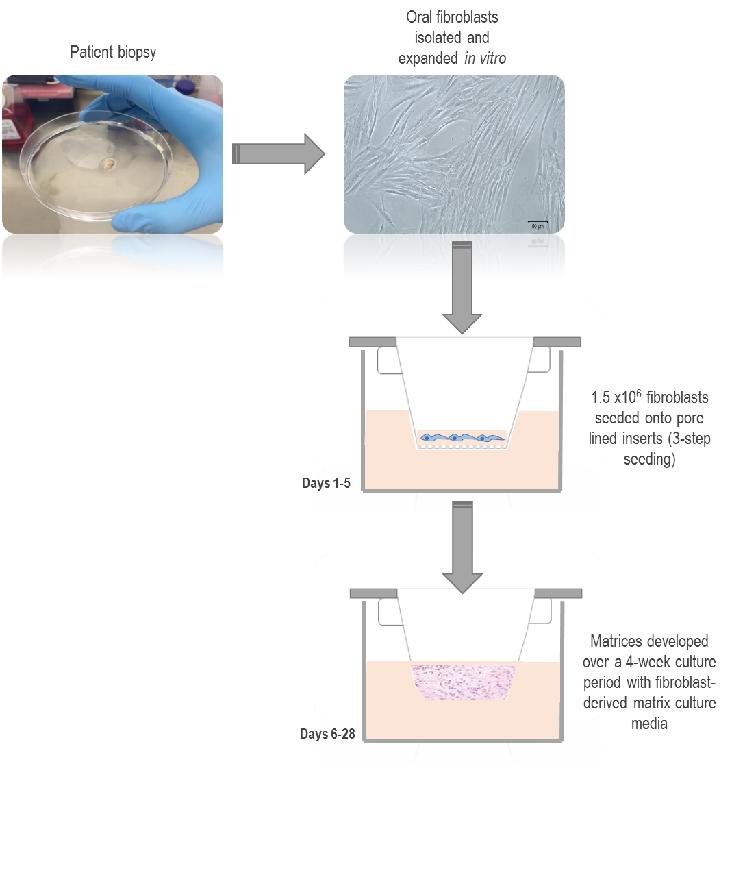

Figure 2.2 Schematic of fibroblast-derived matrix development
NOF/ CAF isolated from patient biopsies. Once expanded, the cells were seeded (1.5 x10⁶ total) onto pore lined inserts and those inserts maintained in deep-well plates for efficient long-term culturing. Fibroblast-derived growth media with/without the addition of growth factors was added to the outer well of plate and to insert up to day 7. From day 7 to 28, media was added to the outside well only. Media was changed every 3 days. Scale bar = 50 µm.

2.2.6.2 Generation of fibroblast-derived matrices for large organotypic inserts

To generate matrices which could be adapted to live-cell imaging capabilities and for atomic force microscopy; matrices were developed on large, sterile organotypic inserts 0.4 μm, 20 mm diameter, PTFE and placed into either a 35 x10 mm petri or a 6-well plate These inserts are optically transparent, so have a low protein binding surface. In order for matrices to remain attached to the insert, prior to seeding, 168 μL of poly-L-Lysine solution (0.1% w/v), was added to the insert and rocked gently to ensure an even coating and incubated at 37 ºC for 30 minutes. These were washed with dH₂O and left to dry overnight at room temperature. The same seeding protocol and media described in section 2.2.6.1 was used and scaled up for these larger inserts. Cell number was increased to a total of 5.5 x 10⁶ due to the increase in insert surface area. The volume of media was adjusted for the larger inserts with 1.2 mL of media added to the outside of the insert surface and was changed daily (Figure 2.3).

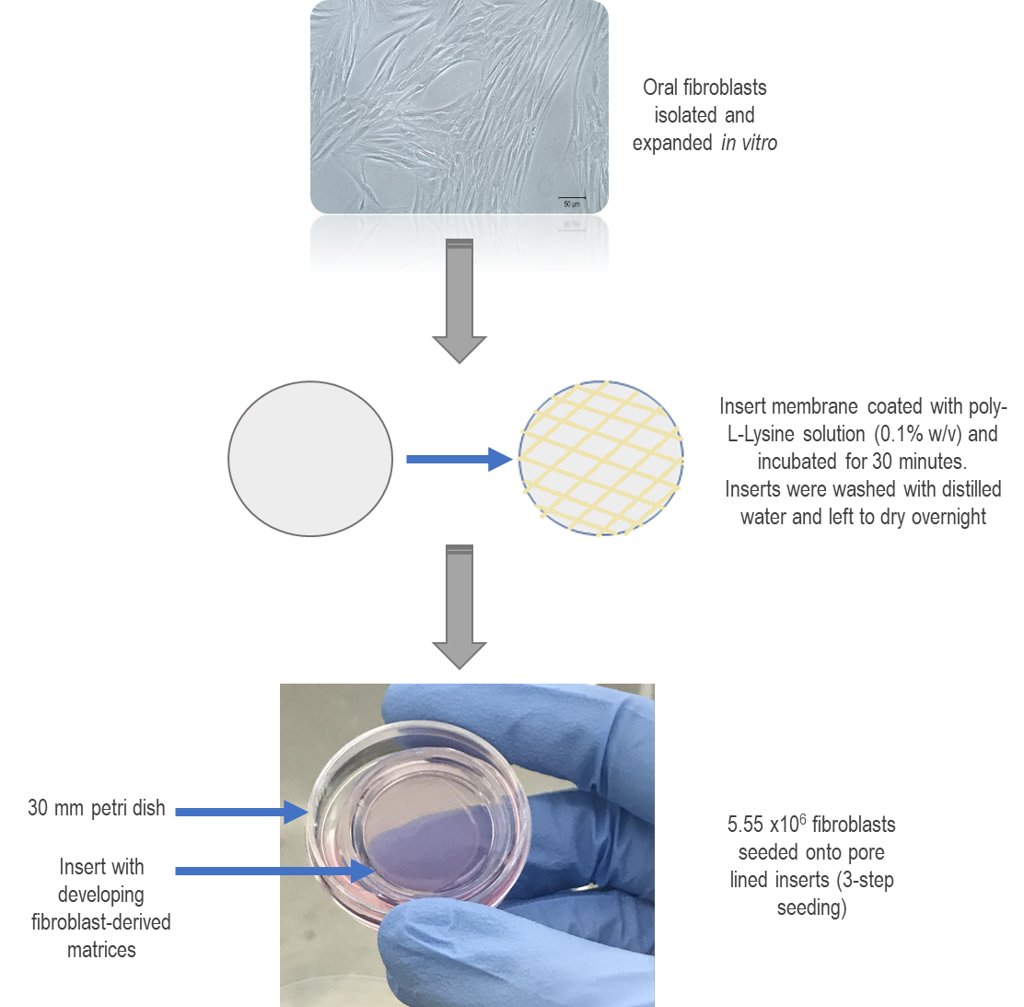

Figure 2.3 Schematic of fibroblast-derived matrix development for large organotypic inserts
NOF/ CAF isolated from patient biopsies. Organotypic inserts were prepared by coating insert surface with poly-L-Lysine solution (0.1% w/v) and incubated @ 37ºC for 30 minutes. The inserts were washed with dH₂O and dried overnight. Cells were then seeded (5.55 x10⁶ total) onto coated inserts and maintained in 35 x10 mm petri dishes or 6-well plates. Fibroblast-derived growth media with/without the addition of growth factors was added to the outer well of plate and to insert up to day 7. From day 7 to 28, media was added to the outside well only. Media was changed every day for long-term culturing Scale bar = 50 µm.

2.2.6.3 Generation of full thickness fibroblast-derived matrix oral mucosa equivalents using fibroblast-derived matrices

After the 28-day development of fibroblast-derived matrices (FDM), normal immortalised oral keratinocytes (FNB6) or OSCC keratinocytes (H357) were seeded on to the surface at a density of 2.5 x10⁵. These cells were kept submerged for two days in Green’s media, before lifting the models to an air-to-liquid interface (ALI) for a further 12 days in culture. Submerging the cells in the first instance is important in providing conditions appropriate for epithelial proliferation and the capability to produce a confluent monolayer across the matrix; and time to ensure adhesive connections are formed with the fibroblast-matrix below. Lifting the models to an ALI allows differentiation to ensue and time for the distinct stratification of cell layers, from the basal compartment through to a para-keratinised surface layer. The media (Green’s) was changed every two days (Figure 2.4).

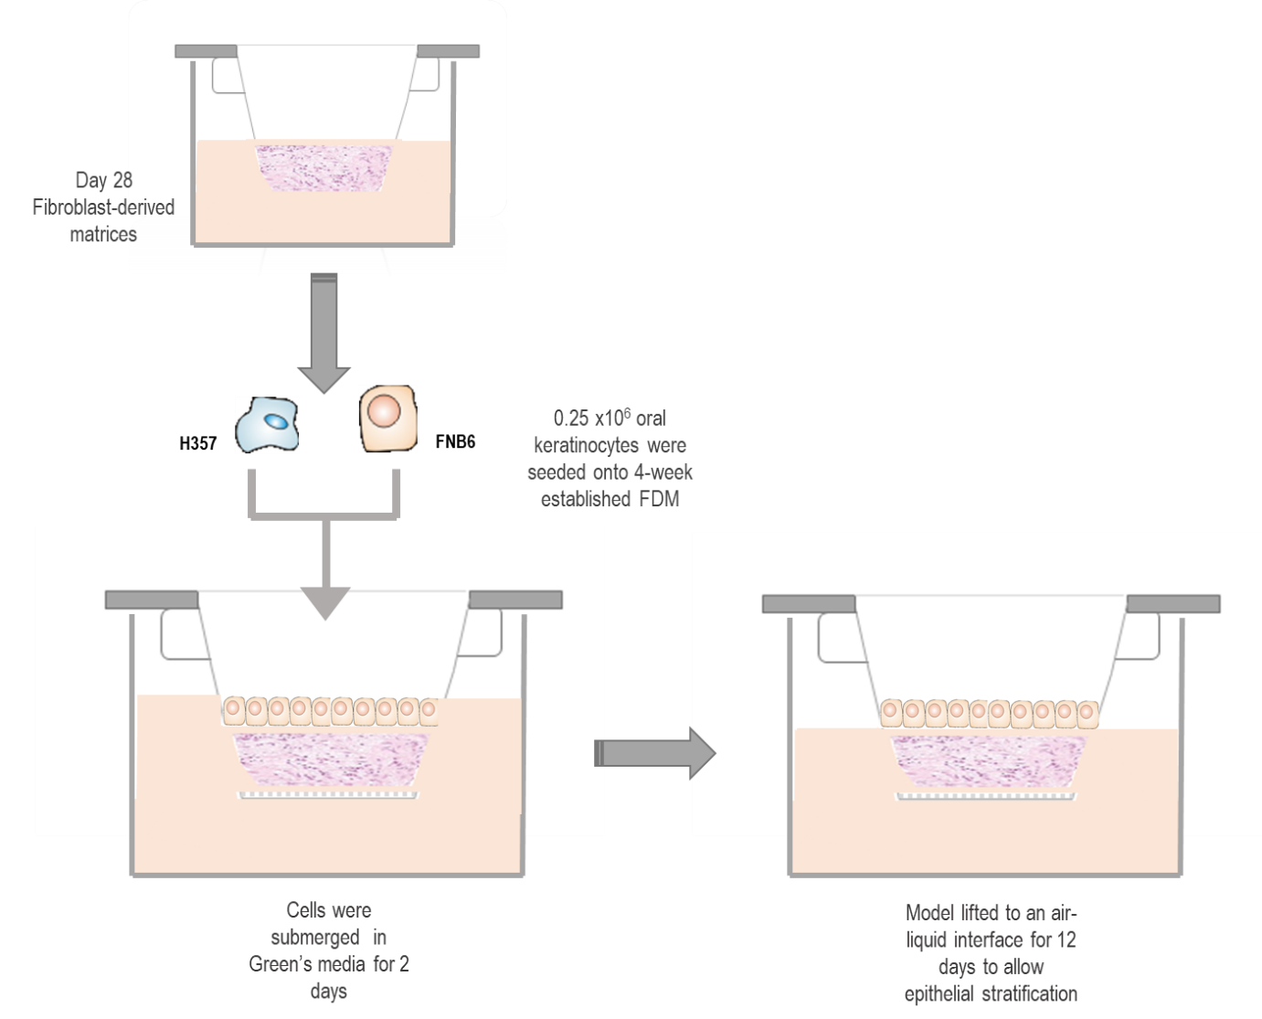

Figure 2.4 Schematic of the generation of full thickness oral mucosa models
After a 28-day growth period native fibroblast-derived ECM was deposited over-time. The addition of 2.5 x10⁵ of either OSCC keratinoctyes; H357 and/or normal, immortalised oral keratinocytes FNB6 were added to the established matrices. The media was changed to Green’s media to support keratinocyte proliferation. Cells were submerged in media for two days, then raised to an air-to-liquid interface for a further 12 days. Media was changed every two days.

2.2.7 Molecular analysis

2.2.7.1 Isolating RNA

2.2.7.1.1 RNA extraction on monolayers

Media was aspirated, and cells washed twice in PBS, 350 µL of RNA lysis buffer (RLT lysis buffer) containing β-mercaptoethanol (10 µL/mL) was added and cells harvested by using a cell scraper. The collected RNA suspension was kept on ice until purified or kept at -80 ºC for long-term storage. Total RNA was purified using the RNeasy mini kit according to the manufacturer’s instructions. RNA concentrations were calculated using a spectrophotometer. RNA was reverse transcribed to synthesise cDNA using 100 ng RNA as a template according to the manufacturer’s instructions. A non-enzyme control was also created for each experiment where the reaction contained no reverse transcriptase, but additional nuclease free water. cDNA generation was completed by using a thermal cycler with the thermocycling schedule as shown in Table 2.5.

Table 2.5 Thermocycling schedule for cDNA synthesis
 | Step 1 | Step 2 | Step 3 | Step 4
Time | 10 mins | 120 mins | 5 mins | ∞
Temp (ºC) | 25 | 37 | 85 | 4

2.2.7.1.2 RNA extraction on fibroblast-derived matrices

All media was removed from the matrices. Dipase (15 U;300 μL), was added to the matrix surface and was incubated at 37 ºC for 2 h to ensure matrix dissolution. The matrix solution was gently pipetted up and down to disperse the cell solution. The mixture was then transferred to a new sterile centrifuge tube. The action of the dispase was then stopped by diluting with PBS. Cells were centrifuged at 8000 g for 3 minutes and washed with PBS. Tri-reagent (300 μL), was added to the cell pellet and again centrifuged at low speed (8000 g) for 3 minutes. The RNA supernatant was removed, and the RNA purified using the RNeasy kit, according to the manufacturer’s instruction.

2.2.7.2 Real time quantitative polymerase chain reaction protocol

cDNA (100 ng) was used in real time quantitative polymerase chain reaction (RT-qPCR) reactions using SYBR green as a reporter dye in either a 7900HT fast Real Time-PCR system or a Rotor-gene Q 5plex. The standard thermal cycle protocol used can be found in table 2.6. Sequences of primers used for SYBR analysis are shown in the Table 7. Primers were researched and then verified using primer blast. Gene expression was quantified using a delta delta CT method (2-ΔΔCT) as described by Livek and Schmittgen, 2001. The CT value correlates to the thermal cycles at which the fluorescence reaches a detectable threshold. It corresponds to the amount of template at the start of the reaction.

2-ΔΔCt =ΔCT (test) - ΔCT (calibrator)

ΔCT= Ct (target) – Ct (Reference gene)

Table 2.6. Thermal cycle schedule

 | Step 1 | Step 2 | Step 3  (Repeated for 40 cycles) | Step 4
Time | 2 mins | 10 mins | 15 secs, 1 min | 0.15 sec, 0.15 secs
Temp (ºC) | 50 | 95 | 95, 60 | 95, 60

Table 2.7. Primer sequences

Gene | Forward primer | Reverse primer
U6 | 5’ CTCGCTTCGGCAGCACA 3’ | 5’ AACGTTCACGAATTTGCGT 3’
αSMA | 5’ GAAGAAGAGGACAGCACTG 3’ | 5’TCCCATTCCCACCATCAA 3’
FN1-EDA | 5’ TGGAACCCAGTCCACAGCTATT 3’ | 5’ GTCTTCTCCTTGGGGGTCACC 3’
COL1A1 | 5’GTGGCCATCCAGCTGACC 3’ | 5’AGTGGTAGGTGATGTTCTGGGAG3’
VCAN | 5͛CTGATAGCAGATTTGATGCCTACTGC 3͛ | 5͛ GTGGTTCTTTGGATAAACTGGGTGA  TG 3͛
TNC | 5’ ACCATGCTGAGATAGATGTTCCAAA 3’ | 5’ CTTGACAGCAGAAACACCAATCC 3’

2.2.8 Histology

2.2.8.1 Fixing 3D tissue engineered models

Fibroblast-derived matrices were washed in PBS and the whole tissue culture insert containing the fibroblast-derived matrices or the full thickness oral mucosa equivalent models were placed directly into 10% neutral- buffered formalin for 24 h. Samples were kept at room temperature before histological processing.

2.2.8.2 Histological analysis of matrices

PTFE membranes were cut from the tissue-culture inset using a surgical blade and placed in a histology cassette lined with sponges to keep the sample in place. Samples were processed overnight using an automatic benchtop processor using the standard processing schedule (Table 2.8).
Table 2.8 Automatic tissue processing schedule
Solution | Processing Time
70% alcohol | 1 h
80% alcohol | 1 h
90%alcohol | 1 h 30 minutes
Absolute alcohol I | 1 h 30 minutes
Absolute alcohol II | 1 h 30 minutes
Absolute alcohol III | 2 h
Toluene I | 1 h 30 minutes
Toluene II | 2 h
Xylene | PASS
Wax I | 2 h
Wax II | 2 h
 | Total Time= 16 h

After processing samples were bisected and embedded in molten paraffin wax using an embedding centre; dispenser and hot plate. Samples were embedded perpendicular to the lower surface of the mould, for correct orientation. Samples were left to set on a cooling plate. Prior to sectioning, samples were cooled on ice and sectioned using a microtome. Blocks were trimmed at 10 µm thickness until the sample became visible, placed on ice for further cooling before 5-7 µm thick sections were cut and transferred to a water bath set at 38 °C. Sections were mounted onto microscope slides and oven dried for 20 minutes at 60 ºC. Haematoxylin and eosin (H&E) histological staining of sections was performed using an autostainer followed the staining schedule outlined in table 2.9.
Table 2.9 H&E staining schedule
Bath nº | Solution
1 | Xylene
2 | Xylene
3 | Xylene
4 | 99% IDA
5 | 99% IDA
6 | 70% IDA
7 | Distilled water
8 | Distilled water
9 | Harris’ haematoxylin (Shandon)
10 | Harris’ haematoxylin (Shandon)
11 | Harris’ haematoxylin (Shandon)
12 | Harris’ haematoxylin (Shandon)
13 | Running tap water
14 | 0.1% acid alcohol
15 | Running tap water
16 | Scott’s Tap water substitute
17 | Running tap water
18 | Eosin Y- aqueous (Shandon)
19 | Eosin Y- aqueous (Shandon)
20 | Eosin Y- aqueous (Shandon)
21 | Running tap water
22 | 99% IDA
23 | 99% IDA
24 | 99% IDA
25 | Xylene
26 | Xylene
27 | Xylene
28 | Xylene

Slides were mounted with distyrene, a plasticizer, and xylene (DPX) mountant and coverslips placed on the top of the sample. The DPX was left to set, and once dried slides were imaged.

2.2.9 Protein analysis

2.2.9.1 Preparation of cell lysates

Cells/ matrices were lysed using radio immunoprecipitation assay (RIPA) buffer (50 mM HEPES, 150 mM NaCl, 1.5 mM MgCl₂, 1 mM EDTA, 1% Triton, 10% glycerol, 25 mM sodium deoxycholate, 0.1% SDS) supplemented with a protease inhibitor cocktail and samples scrapped using cell scrappers.

2.2.9.2 Immunoblotting

Protein concentrations were calculated using a BCA assay and BSA standards to generate a standard curve. Absorbance of standards and test samples was measured at 595 nm by spectrometry. 10 μg of total protein was loaded for each sample and resolved by a 3–8% (w/v) tris-acetate gel using gel electrophoresis (SDS-PAGE) in tris-acetate SDS running buffer. Timings and conditions followed for runs were as recommended by the manufacture. The protein was transferred onto a nitrocellulose membrane using an iBlot transfer system. Membranes were blocked with 5% (w/v) milk in tris buffered saline with 0.05% (v/v) Tween 20 (TBS-T) to prevent non-specific binding for 1 h. Primary antibodies (table 2.10) were diluted in appropriate blocking solution and incubated at 4ºC overnight. The membrane was washed three times at ten-minute intervals with TBS-T. Membranes were incubated with secondary antibody conjugated with horseradish peroxidase (HRP) antibody diluted in above blocking solution at recommended concentration, for 1 h at room temperature. The membrane was then washed 3 times in TBS-T at five-minute intervals, and detection of HRP was achieved using enhanced chemiluminescence (ECL). Activity of the HRP was exposed on an x-ray film and developed. Nitrocellulose membranes were stripped of antibodies by incubation in 10 mL of Re-Blot Plus Western blot strong antibody stripping solutions at room temperature for 10 minutes. The membranes were washed three times with TBS-T and blocked and re-probed using the above methodology.

Table 2.10 Antibodies for immunoblotting
Name | Company | Clone | Dilution | Final Con^{C} (µg/mL)
αSMA | Sigma-Aldrich, UK | Mouse, Clone 1A4 | 1:1,000 | 0.2
β-Actin | Sigma-Aldrich, UK | Mouse, Clone AC-74 | 1:4,000 | 0.8
GAPDH | Sigma-Aldrich, UK | Rabbit | 1:7,500 | 0.9
VCAN | R&D systems, UK | Goat | 1:1,000 | 0.2
COL1A1 | Cell Signalling Technologies, UK | Rabbit | 1:1,000 | 0.2
FN1-EDA | Abcam, UK | Mouse | 1:2,000 | 0.8
Laminin-5 (γ2 chain) | Millipore, UK | Mouse, Clone D4B5 | 1:1,000 | 1
anti-rabbit IgG | Cell Signalling Technologies, UK | - | 1:5000 | Not known
anti-mouse IgG | GeneTex, USA | - | 1:3000 | 0.726

2.2.9.3 Densitometric analysis of immunoblots

ImageJ analysis software was used to compare the density of bands on immunoblots. The scanned blots were made into grayscale by converting to 8-bit image and equal-sized rectangular boxes drawn around each sample band and numbered according to the protein sample lane. The area of each plot was calculated and adjusted to the size of loading control to give relative fold change in density.

2.2.9.4 Immunofluorescence of αSMA staining

Cells were seeded at 3 x10⁴ cells onto glass coverslips in a 12-well plate and allowed to adhere for 24 h in fibroblast growth media. Cells were washed with PBS and then SFM media added for another 24 h. Cells were treated with or without 5 ng/mL TGFβ-1 for 48 h and longer-term for up to 7 days. After this time, cells were fixed in 100% methanol/ 4% paraformaldehyde for 15 minutes and permeabilised with 4 mM sodium deoxycholate for 15 minutes. Coverslips were blocked with 2.5% BSA/PBS at room temperature for 1 h on an orbital shaker, and then incubated with anti αSMA-FITC conjugated antibody (1:100) at 37ºC for 1 h following three washes with PBS. The glass coverslips were inverted and mounted onto glass slides with DAPI containing mountant (15 µL) and stored at 4ºC and shielded from light until imaging. Imaging was performed by fluorescent light microscope and imaged at x40 magnification.

2.2.9.5 Immunohistochemical analysis

Paraffin-embedded tissue sections (6 μm) were dewaxed, rehydrated and endogenous peroxidase was neutralised with 3% hydrogen peroxide for 20 minutes. An antigen retrieval step was undertaken using a pressure cooker and conditions outlined in table 2.11. Sections were blocked using protein-free blocking solution for 30 minutes at room temperature before incubation with primary antibody (diluted in PBS) for 1 h at room temperature or overnight at 4ºC (Table 13 details the antibodies used). Secondary antibody and avidin-biotin complex (ABC) provided with Vectastain Elite ABC kit were used in accordance with the manufacturer’s instructions. Finally, 3,3-diaminobenzidine tetrahydrochloride (DAB) was used to visualise peroxidase activity and the sections were counterstained with haematoxylin, dehydrated and mounted in DPX and imaged by light microscopy. IgG controls matched to host species were used as negative controls for each sample and antibody expression analysed.

Table 2.11 Antibodies and antigen retrieval conditions
Marker | Antibody  Clone | Dilution | Final conc  (mg/mL) | Antigen Retrieval | Source
Ki67 | MIB-1 | 1:50 | Not known | 0.01M Sodium citrate buffer | Dako, Denmark.
AE1/3 | AE1/3 | 1:100 | Not known | 0.01M Sodium citrate buffer | Dako, Denmark
E-Cadherin | EP700Y | 1:500 | Not known | 0.01M Sodium citrate buffer | Abcam, UK.
Integrin β4 | EPR17517 | 1:250 | Not known | Tris/EDTA buffer pH 9.0 | Abcam, UK.
FN1-EDA | IST-9 | 1:100 | 0.8 | 0.01M Sodium citrate buffer | Abcam, UK.
COL1A1 | COL1A1 | 1:100 | 0.2 | 0.01M Sodium citrate buffer | Cell Signalling Technologies, UK.
Vimentin | RV202 | 1:100 | Not known | Tris/EDTA buffer pH 9.0 | Abcam, UK.
αSMA | 1A4 | 1:100 | 0.2 | 0.01M Sodium citrate buffer | Sigma-Aldrich, UK.
CK-14 | LL002 | 1:1000 | 0.1 | Tris/EDTA buffer pH 9.0 | Thermo-Scientific, UK.
COLIV | COL-94 | 1:500 | Not known | 0.01M Sodium citrate buffer | Sigma-Aldrich, UK.

2.2.9.6 DAB staining optical density quantification using ImageJ

Immunohistochemically stained sections were imaged at x40 magnification and further analysed by ImageJ. All images were converted into 8-bit colour images and colour deconvolution performed using the DAB and haematoxylin settings. For each image a region of interest (ROI) was created. The size of the ROI was kept consistent w= 402 pixel, h= 402 pixel, unless an area was smaller due to protein tissue-expression; where the ROI was halved to w=201 pixel, h= 201 pixel. Mean grey values were set for each image, and intensity measured for the image. These intensity values were then converted to an optical density (OD) score. For images the main optical density range is normally between 0.5-1.25 (where 0 is no density and 1 is considered black). The following calculation was used:
OD= Log (max intensity)
(Mean intensity)

To limit bias, each image was assessed by studying three separate areas, and the average of each image taken (mean intensity), three biological repeats were analysed with 2 slides analysed for each protein of interest. Results were converted and analysed for statistical significance using unpaired T -Tests in Graphpad prism software.

2.2.9.7 Zymography

Gelatin zymography was used to detect activity of two gelatinase enzymes, the matrix metalloproteinases (MMP) MMP-2 and MMP-9. This protocol was optimised for detecting secreted MMP-9 and MMP-2 activity in conditioned media. Matrices were cultured in FDM media in inserts (5 mL/well). After 3 weeks of growth, the matrices were washed cells twice with PBS and were developed for a further 1 week in low-serum (1%) FDM media. The collected conditioned media was then centrifuged at 1000 g for 5 minutes to eliminate dead cells. Conditioned media was then concentrated using spin columns with a molecular cut off point of 5 kDa by centrifugation at 10,000 rpm for 15 minutes.

2.2.9.7.1 Gel preparation

The conditioned media was adjusted in all samples to the same protein concentration. For each sample, a low protein concentration (5 µg/mL) and a high protein concentration (10 µg/mL) was tested. A 5x non-reducing sample buffer was added to samples (Table 2.12). A 7.5% acrylamide gel was used containing gelatin (Table 2.13). Using 1 mm thickness plates. Samples were loaded to each well (10 μL protein per well). A protein molecular weight marker was added in one well. The gel was run at 150 V until a good band separation was achieved.

Table 2.12 A 5x non-reducing sample buffer (pH 6.8)
Final concentration | For 250 mL
4% SDS | 10 g
20% glycerol | 50 mL of 100%
0.01% bromophenol blue | 0.025 g
125 mM Tris-HCl | 4.91 g
H₂O | 200 mL

Table 2.13 7.5% acrylamide gel reagents
Separating gel (7.5 % acrylamide) |  | Stacking gel
1.5 M Tris pH 8.8 | 2 mL | 0.5 M Tris pH 6.8 | 1.25 mL
30% acrylamide | 2 mL | 30% acrylamide | 0.67 mL
H₂O | 2 mL | H₂O | 3.08 mL
4 mg/mL gelatin | 2 mL | 10 % SDS | 50 μL
10% SDS | 80 μL | 10 % APS | 50 μL
10% APS | 80 μL | TEMED | 10 μL
TEMED | 10 μL

2.2.9.7.2 Gel washing and staining

Once run, the gel was washed twice for 30 minutes with washing buffer to remove any residual SDS (Table 2.14) before a further rinse for 10 minutes in incubation buffer at 37°C with gentle agitation (Table 2.15). Fresh incubation buffer (contains the cofactors necessary for the gelatinase reaction to occur) was then added and the gel incubated for 24 h at 37°C (table 2.16). The gel was then stained with Coomassie blue staining solution (table 2.17) for 1 h before being rinsed with dH₂O. Finally, the gel was incubated with de-staining solution (table 2.18) until the bands were clearly visible. Areas of enzyme activity appear as white bands against a dark blue background.

Table 2.14 Washing buffer (pH 7.5)
Final concentration | For 250 mL
2.5% Triton X-100 | 6.25 mL of 100%
50 mM Tris HCl | 12.5 mL of 1 M stock
5 mM CaCl₂ | 625 μL of 2 M stock
1 μM ZnCl₂ | 2.5 μL of 0.1 M stock
H₂O | 228 mL + 2 mL 2% NaN₃

Table 2.15 Incubation buffer (pH 7.5)
Final concentration | For 250 mL
1% Triton X-100 | 2.5 mL of 100%
50 mM Tris-HCl | 12.5 mL of 1 M
5 mM CaCl₂ | 625 μL of 2 M
1 µM ZnCl₂ | 2.5 μL of 0.1 M
H₂O | 233 mL + 2 mL 2% NaN₃

Table 2.16 Coomassie staining solution
 | For 100 mL
Methanol | 40 mL
Acetic acid | 10 mL
H₂O | 50 mL
Coomassie Blue | 0.5 g

Table 2.17 De-staining solution
 | For 1 L
Methanol | 400 mL
Acetic acid | 100 mL
H₂O | 500 mL

2.2.10 Matrix characterisation

2.2.10.1 Trans-epithelial electrical resistance

Cell matrix integrity was confirmed by trans-epithelial electrical resistance (TEER); a method of measuring the resistance produced by cell barrier formation, detected by a dual electrode positioned in both the apical and basolateral compartments of the developing fibroblast-derived matrices and full thickness oral mucosa equivalents (Figure 2.5). The electrodes were washed with ethanol and the developing matrices were washed with PBS and 300 μL and 500 μL was added to the inner and outer well of the cell culture system, respectively. The TEER values were measured using an EVOM² voltmeter at three locations per matrix/model, and the average of these values was used. The change of resistance was analysed over time for a total of 41 days. A blank resistance measurement of the insert plus PBS was also measured for preconditioning. The following calculation was used to accurately measure resistance:
R _{total}= x¹
R _{blank}= x²
R _{blank} +R _{true tissue}= R _{total}
R _{true tissue}= R _{total} – R _{blank}
R _{true tissue}= x¹- x² = Ans (Ω)

TEER Reported = Resistance (Ω) X effective membrane (cm²).

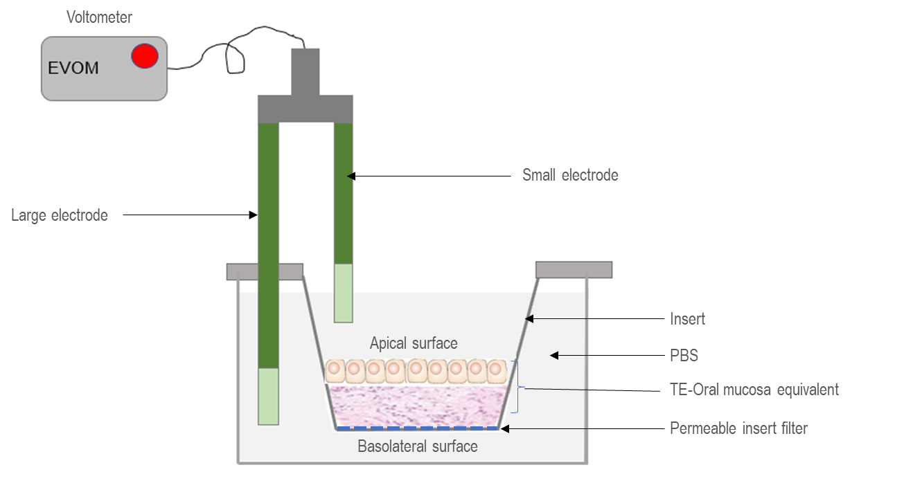

Figure 2.5 Schematic of TEER analysis set-up

2.2.10.2 PrestoBlue® cell metabolism assay

In order to quantitatively assess fibroblast proliferation and viability in the developing matrices a PrestoBlue® Cell Viability reagent (50 μL) (Life technologies, UK) was added directly to the matrix culture medium (500 μL). The PrestoBlue® assay is based on resazurin which functions as a cell metabolism indicator. Resazurin; which is weakly fluorescent, is reduced to resorufin in viable cells in the process of cellular respiration and acts as an electron acceptor from the following sources: NADPH, FADH, FMNH, NADH and cytochromes. This reduction causes PrestoBlue® to change from its weak-fluorescent form to strong fluorescent form. This fluorescent conversion is then directly proportional to the number of metabolically active cells. To quantify this change, fluorescence measurements can be evaluated using a form of spectrometer. The solution was incubated for 30 mins at 37ºC, according to manufacturer’s instructions. In living cells this reagent produces a colour change due the reducing environment of metabolising cells. To correct for background, a control well was included with only cell culture media and all samples normalised to this. The colour change was assessed by a fluorescence spectrum recorded by spectrometry at an excitation of 535 nm (25 nm bandwidth) and emission of 615 nm (10 nm bandwidth). Triplicates were taken for each sample investigated and repeated samples were taken over the 41 days of the developing matrices and oral mucosa models.

2.2.10.3 Fibroblast-derived matrices thickness measurements

To assess changes in the bulk deposition of ECM for NOF/CAF matrices; their thickness was measured after a 4-week culture period. Matrices embedded perpendicularly in paraffin-blocks were sectioned (6µm), stained with H&E and analysed by Cell^D software or ImageJ. Triplicate cultures were imaged at x40 magnification in three regions across the matrix. Measurements were taken at three locations per region.

2.2.10.4 The effects of stromal inhibitors on FDM

NOF/CAF-derived matrices were developed for three weeks as described in 2.2.6.1 without the addition of growth factors. Day 21 the matrices were treated with either a vehicle control (4 mM HCl containing BSA (1 mg/mL)), 10 ng/mL TGFβ-1, 10 ng/mL Scriptaid, 10 ng/mL Batimastat, or with the drugs in combination with TGFβ-1 for a further 7 days in low serum containing media (5%). RNA and protein were collected and analysed as described in sections 2.2.7 and 2.2.9.

2.2.11 Microscopy

2.2.11.1 Light microscopy

During routine tissue culture, cell morphology was consistently observed, as well as qualitatively assessing cell health. Cell detachment during passaging was observed by light microscopy at x10 magnification.

2.2.11.2 Scanning electron microscopy

Matrices were fixed in fresh 2.5-3% glutaraldehyde in 0.1 M phosphate buffer, overnight at 4ºC then washed in 0.1 M phosphate buffer twice with 30-minute intervals at 4ºC. Secondary fixation was carried out in 2% OsO₄ for 2 h at room temperature and pressure and again washed in 0.1 M phosphate buffer. Dehydration of the matrices was performed through a graded ethanol series to allow the infiltration of propylene oxide/Araldite resin (1:1 v/v). Matrices were embedded in araldite epon for 6-8 h at room temperature and then placed in fresh araldite epon for a further 48-72 h at 60ºC. Ultrathin sections (90 nm) were cut using an ultramicrotome and stained in 3% aqueous uranyl acetate and Reynold’s lead citrate for 5 minutes. Sections were examined using a scanning electron microscope at an accelerating voltage of 80 Kv.

2.2.11.3 Second harmonic generation microscopy

Fibrillar collagen was imaged using an upright multi-photon laser scanning microscope (LSM). A laser at 950 nm was focused onto the sample using a 40x/0.8 dipping lens objective (Nikon S Fluor) using non-descanned detectors. All images were acquired using LSM Image browser, which is also compatible with ImageJ. Collagen fibre analysis from SHG images was performed using CurveAlign (CurveAlign, LOCI, version 3.0, 2017) and CtFIRE (Bredfeldt et al., 2014). 512 × 512 pixel images (457 μm² area) were analysed. For collagen fibre angle, length and alignment measurements, CurveAlign analysis was performed using default parameters. For each sample, five areas were imaged; taking a 100-image z stack (1 μM increments) for each area.

2.2.11.4 Atomic force microscopy

Matrices were prepared as described in section 2.2.6.2 (FDM for large organotypic inserts). For all experiments the matrices the culture media was removed, and matrices washed and stored in PBS during analysis. All images were obtained on an Agilent 5500 microscope equipped with close loop scanners. Contact mode imaging was employed for topographic imaging using silicon tips having a nominal force constant of between 0.02-0.77 N/m. Forces were minimized during scanning at a level below 1 nN. Scan rates were between 0.5–1 kHz and all images were recorded at 512-pixel resolution. Measurements were carried out in PBS at room temperature (~20°C). Processing and analysis of images was performed using version 6.3.3 of SPIP software. Indentation measurements were taken using the same cantilevers used for imaging, silicon cantilevers with a manufacturer specified tip radius of less than 7 nm. Determination of the cantilever spring constant was achieved using thermal K method using the equipartition theorem as proposed by Hutter and Bechhoefer (Figure 2.6). For all indentation experiments curves were taken along fibres and different fibres. Experiments were repeated using different sample preparations and using three different AFM cantilevers (nm).

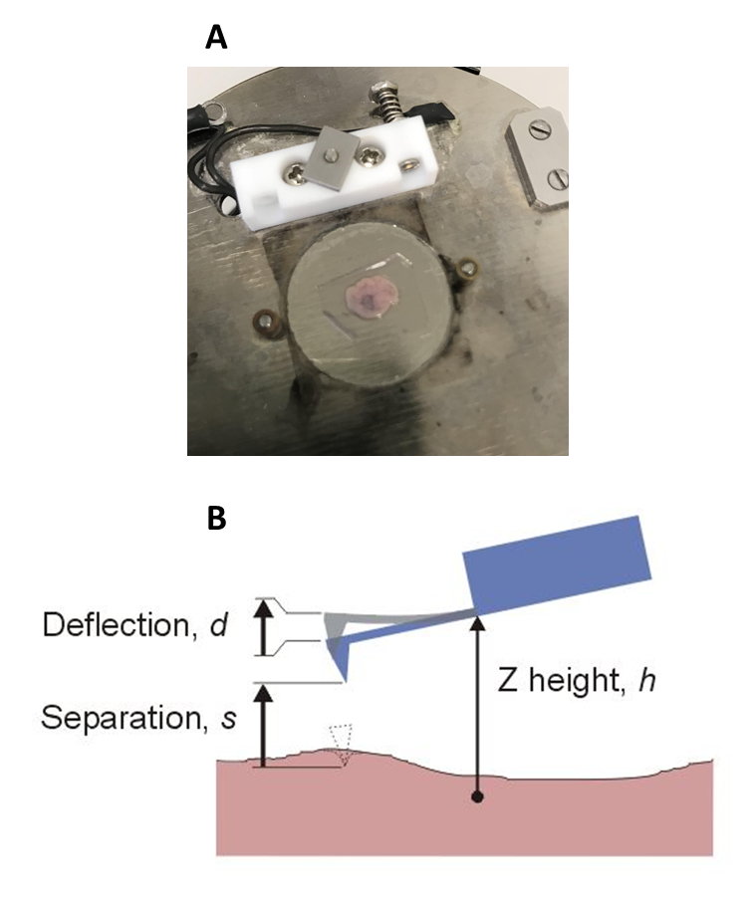

Figure 2.6 Measuring the effective Young’s modulus of fibroblast-derived matrices using AFM
Fibroblast-derived matrices need to be immobilised and centrally placed on sample holder and were analysed ‘wet’ in PBS (A). A schematic representation of AFM and the mechanical variables using a nanoindentation technique with a pyramidal probe head for indentation (B).

2.2.11.5 Live-cell imaging microscopy

An inverted transmitted- light microscope and environmental chamber was used to analyse cell behavior. Matrices were developed on large optically transparent inserts as described in section 2.2.4.2. After a 4-week culture period 50 x10⁵ FNB6 or H357 were seeded onto the fibroblast-derived matrices, and after 24 h, a live time-lapse experiment was performed for a further 24 h in keratinocyte growth media (1% FBS) without EGF. The environmental chamber was maintained at 37ºC, and 5% CO₂ humidity. The microscope was set for phase-contrast microscopy. For each insert; three positions were set for analysis and were image-captured at each position in 10-minute intervals. All images were taken at x20 magnification. After 24 h the images were compiled into full frames and analysed for adhesion, cell migration and proliferation using a Tracking Tool™ PRO software. This is a manual tracking software that allows individual cells to be tracked per image. For each biological repeat, 20 cells were counted in order for a total of 60 cells to be used in the final analysis. Rose plots were calculated from the cell trajectories mapped for each analysis. For proliferation calculations the total number of cells were counted in three positions at the start of the time-lapse experiment. Cells were excluded if they had any region out of the frame. After 24 h the cells were counted in the same positions and proliferation rates calculated as a percentage increase or decrease.

2.2.12 Statistical and computational analysis

Data is represented graphically and where applicable was analysed using a two- tailed Student’s T-test to test for statistical significance. The Student’s t-test was either paired or unpaired depending on the data sets being studied. Paired Student’s t-tests were used when the same patient cells were used in the same experiment but treated differently i.e. TGFβ-1 treatment. Unpaired was used when the data derived from RNA extracted from different primary cell culture. For multiple data sets; a Shapiro-Wilk normality test was conducted and datasets which were normally distributed were further analysed by ordinary one-way ANOVA and multiple comparisons were corrected for variance with Dunnett’s test. Those data sets not normally distributed where analysed by a non-parametric Kruskal-Wallis test with Dunn's multiple comparisons test. All data is presented as mean values with error bars showing the standard deviation (SD), unless otherwise stated. For experimental repeats ‘N’ followed by a number denotes the number of biological repeats for each experiment, whereas ‘n’ denotes the number of technical repeats and clearly stated in the figure legends. All graphical data and analysis were performed using Graphpad prism software (Versions 6.0-8.0). P-values were assigned to quantify the notion of statistical significance and the following symbols were used graphically to report p values in a decimal format (ns for p>0.05, * for p≤0.05, ** for p≤0.01, *** for p≤0.001 and **** for p≤0.0001.

Chapter 3

Phenotyping oral fibroblasts in vitro

3.1. Introduction

Within the tumour microenvironment epithelial cancer cells release various inflammatory growth factors including TGFβ-1 and SDF-1 (Calon et al., 2104). These promote tumour progression by activating signalling cascades causing the differentiation of resting resident fibroblasts into a metabolically active fibroblast subtype known as the myofibroblast or cancer-associated fibroblast (CAF). This activation triggers a desmoplastic response (Elenbaas and Weinberg, 2001). Desmoplastic response is characterised by a reconstruction of ECM functionality, architecture, and composition. The latter two characteristics being altered by an increased deposition of fibronectin, collagen and proteoglycans contributing to a tumour permissive microenvironment (Kalluri, 2014, Alexander and Cukeirman, 2016, and Hanley et al., 2016). Myofibroblastic differentiation of resting oral fibroblasts can be replicated in vitro by exogenous application of the growth factor TGFβ-1 and is associated with a de-novo synthesis of αSMA, which is considered to be a reversible phenotype (Desmoulière et al., 1993, Elmusrati et al., 2017, Melling et al., 2018). CAF are considered to have an irreversible myofibroblastic phenotype based on their epigenetic instability (Kalluri, 2016). However, activated NOF or primary oral CAF have not been assessed for their myofibroblastic phenotype in longer cultures conditions in vitro.
This deposition of ECM components contributes to the increased therapeutic resistance caused by compressive stresses (Northcott et al., 2018) and accounts for the many cancer drugs that exhibit cytotoxic behaviour on cancer cells in vitro but loose efficacy in vivo. To address this, improvements must be made in the models used to study tumour-drug responses. NOF- and CAF-derived ECM generated in monolayer cultures may respond to stromal-targeting drugs and reduce the desmosplasia observed in OSCC. Therefore, stromal modifying drugs Scriptaid and Batimastat were assessed for their ability to inhibit the myofibroblastic phenotype in 2D. Scriptaid is a pharmacological inhibitor with selectivity for histone deacetylase (HDACs) 1, 3, and 8, has previously been shown to reverse the phenotypic and functional capabilities of CAF in human and murine cell culture models (Kim et al., 2018, Barter et al., 2010, Guo et al., 2009). Batimastat (BB94), a low molecular weight collagen peptide-based hydroxamic acid was the first MMP inhibitor evaluated in cancer patients. This compound is potent but relatively nonselective for MMP-1, -2, -3, -7, -8, -9 and -14 inhibition (Hidalgo and Eckhardt, 2001, Ziober et al., 2001).
3.2 Materials and methods
Oral fibroblasts NOF and CAF (NOF804, NOF806, NOF316 and CAF002, CAF003 and CAF004) were isolated as described in section 2.2.3.1 and their response profile to TGFβ-1, a known myofibroblastic stimuli, was investigated in 2D by various molecular techniques. This differentiation status will be examined by the addition of 5 ng/mL of TGFβ-1 to both short (24-72 h) and long-term (24+ 14 days- 72+14 days) NOF/CAF cultures. Phenotypic markers of transdifferentiation include the splice variant of fibronectin (FN1-EDA), alpha smooth muscle actin (αSMA) and tenascin-C (TNC), collagen α1 (COL1A1) and versican (VCAN) and will be assessed by RT-qPCR, Western blot technique (section 2.2.9.1-3) as well as the ability of NOF/CAF to form αSMA positive stress fibres in culture by immunofluorescence analysis (section 2.2.9.4). In order to reduce stromal burden, the response profile to treatment with stromal–targeting drugs (Scriptaid and Batimastat) was assessed in NOF and CAF in presence and absence of TGFβ-1. This was assessed by RT-qPCR (section 2.2.5.2) and immunoblotting (section 2.2.9.1-3) for αSMA, COL1A1 and FN1-EDA in response to stromal-targeting drugs Scriptaid and Batimastat in 2D monolayer cultures. The following experimental procedures described in this chapter and the corresponding materials and methods used are further outlined in Figure 3.1.

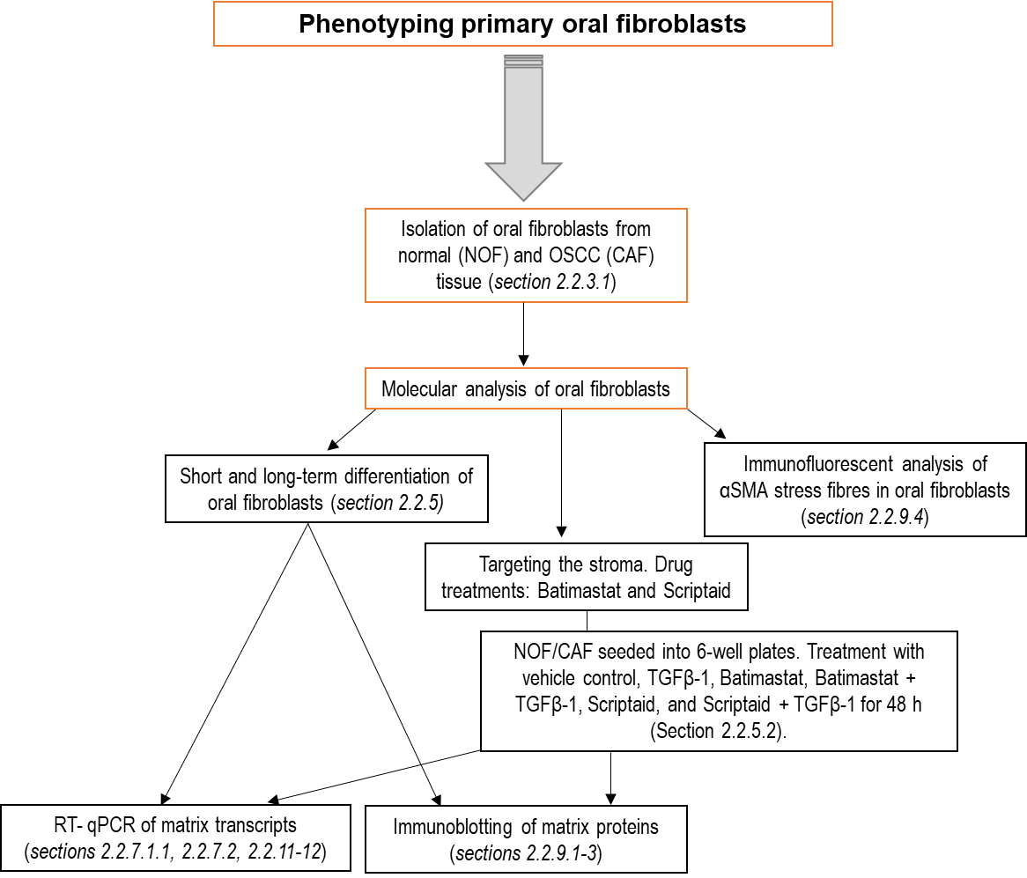

Figure 3.1 Schematic of materials and methods
2 Stewart DA, Cooper CR, Sikes RA. Changes in extracellular matrix (ECM) and ECM-associated

3.3 Results

3.3.1 Molecular analysis of normal oral fibroblasts

3.3.1.1 Short-term differentiation of normal oral fibroblasts

NOF were stimulated with 5 ng/mL of TGFβ-1 and/or vehicle control (HCL/PBS). TGFβ-1 dosage at 5 ng/mL was previously established as the optimal concentration to induce differentiation in oral and dermal fibroblasts by previous doctoral students (Abidin 2017, The University of Sheffield, Melling et al., 2018). TGFβ-1 and/or vehicle control treatments were supplemented in a time course experiment for 24 h, 48 h and 72 h. Quantitative PCR was conducted to observe relative fold changes in expression of various fibroblast differentiation marker transcripts; αSMA, COL1A1, FN1-EDA, VCAN and TNC relative to endogenous U6 expression in three biological samples; NOF316, NOF804 and NOF806. ΔΔCt analysis for each experiment was relative to the 24 h vehicle control treated sample as this was considered the basal level expression for each of the transcripts investigated.

3.3.1.1.1 αSMA expression by RT-qPCR

Quantitative RT-PCR for the myofibroblast marker αSMA was conducted following treatment with 5 ng/mL of TGFβ-1 (Figure 3.2). No change was observed at 24 h with TGFβ-1 treatment, but a significant increase in expression was exhibited at 48 h, with a mean fold change of 24.79 ± 22.97 (p <0.0001) compared to 24 h control samples. No significant differences were observed at 72 h treatment with TGFβ-1, with a 5.96 ± 7.11-fold change.

Figure 3.2 Short-term expression data for the myofibroblast marker αSMA in NOF with and without TGFβ-1 stimulation
NOF 2D monolayers were treated with 5 ng/mL TGFβ-1 up to 72 h and the gene expression for aSMA determined by qPCR. Data is expressed as fold change relative to housekeeping gene U6, with mean ± SD. ****denotes p <0.0001 analysed by ordinary one-way ANOVA with Dunnett’s multiple comparison. (N=3, n=3).

3.3.1.1.2 FN1-EDA expression by RT-qPCR

At all time-points, TGFβ-1 treatment induced a significant increase in FN1-EDA transcript expression compared to the 24 h control sample (Figure 3.3). For 24 h TGFβ-1 treatment average fold change was 5.50 ± 0.70, compared to 24 h control samples, p=0.0022. At 48 h TGFβ-1 treatment exhibited a 6.35 ± 1.58-fold change (p=0.0002). The greatest fold change with TGFβ-1 treatment was observed at 72 h with an 11.24 ± 5.79-fold increase (p <0.0001) compared to 24 h control samples.

Figure 3.3 Short-term expression data for the glycoprotein FN1-EDA in NOF with and without TGFβ-1 stimulation
NOF 2D monolayers were treated with 5 ng/mL TGFβ-1 up to 72 h and the gene expression for FN1-EDA was determined by qPCR. Data is expressed as fold change relative to housekeeping gene U6, with mean ± SD. ** denotes p <0.01, *** p <0.001 and **** p <0.0001 as analysed by ordinary one-way ANOVA with Dunnett’s multiple comparison. (N=3, n=3).

3.3.1.1.3 COL1A1 expression by RT-qPCR

Treatment of NOF with 5 ng/mL of TGFβ-1 resulted in an increase in COL1A1 transcript levels compared to vehicle control (Figure 3.4). A significant increase was observed at 48 h with TGFβ-1 treatment with a mean fold-change of 62.11 ± 41.48 (p <0.0001) compared to 24 h vehicle control. No significant differences in COL1A1 were observed at 24 or 72 h, with mean fold changes of 17.26 ± 9.22 and 7.66 ± 3.25, respectively, compared to 24 h vehicle controls.

Figure 3.4 Short-term expression data for ECM protein COL1A1 in NOF with and without TGFβ-1 stimulation
NOF 2D monolayers were treated with 5 ng/mL TGFβ-1 up to 72 h and the gene expression for COL1A1 was determined by qPCR. Data is expressed as fold change relative to housekeeping gene U6, with mean ± SD. **** denotes p <0.0001 as analysed by ordinary one-way ANOVA with Dunnett’s multiple comparison. (N=3, n=3).

3.3.1.1.4 VCAN expression by RT-qPCR

Examination of VCAN transcript levels in response to TGFβ-1 revealed a significant increase (Figure 3.5) at 48 h, with a mean fold increase of 16.74 ± 6.34 (p <0.0001) being observed. No significant change in VCAN expression was observed after 24 h or 72 h TGFβ-1 treatment with mean fold changes of 2.14 ± 1.02 and 3.84 ± 2.33, respectively, compared to 24 vehicle control groups.

Figure 3.5 Short-term expression data for the matrix marker VCAN in NOF with and without TGFβ-1 stimulation
NOF 2D monolayers were treated with 5 ng/mL TGFβ-1 up to 72 h and the gene expression for VCAN was determined by qPCR. Data is expressed as fold change relative to housekeeping gene U6, with mean ± SD. **** denotes p <0.0001 as analysed by ordinary one-way ANOVA with Dunnett’s multiple comparison. (N=3, n=3).

3.3.1.1.5 TNC expression by RT-qPCR

The target transcript TNC increased with the addition of 5 ng/mL of TGFβ-1 compared to 24 h vehicle control groups (Figure 3.6). A significant increase in transcript expression was exhibited at 48 h, with a mean fold change of 13.54 ± 9.40 (p <0.0001) compared to 24 h control samples. At 24 h and 72 h, TGFβ-1 treatment resulted in no significant changes in TNC expression.

Figure 3.6 Short-term expression data for the myofibroblast marker TNC in NOF with and without TGFβ-1 stimulation
NOF 2D monolayers were treated with 5 ng/mL TGFβ-1 up to 72 h and the gene expression for TNC was determined by qPCR. Data is expressed as fold change relative to housekeeping gene U6, with mean ± SD. **** denotes p <0.0001 as analysed by ordinary one-way ANOVA with Dunnett’s multiple comparison. (N=3, n=3).

3.3.1.2 Long-term differentiation of normal oral fibroblasts

To examine the effect of longer-term exposure to TGFβ-1, which would be necessitated in the establishment of fibroblast-derived matrices (FDM) in subsequent work (Chapter 4), samples were treated as in the above short-term experiment with either 5 ng/mL TGFβ-1 or vehicle control. These cultures were then maintained for a further 14 days in DMEM supplemented with lower serum (5% FBS), supplementing the media daily with either 2 ng/mL TGFβ-1 or vehicle control after the 72-h time point. RNA and protein were isolated for each time point to examine the expression of myofibroblasts marker expression using RT-qPCR and immunoblotting.

3.3.1.2.1 αSMA expression by RT-qPCR

No significant differences in αSMA transcript expression was observed in NOF cultures following long-term exposure to TGFβ-1 (Figure 3.7).

Figure 3.7 Long-term expression data for the myofibroblast marker αSMA in NOF with and without TGFβ-1 stimulation
NOF 2D monolayers were treated with 2 ng/mL TGFβ-1 up to 72 h + 14 days and the gene expression for αSMA was determined by qPCR. Data is expressed as fold change relative to housekeeping gene U6, with mean ± SD. NS was observed in analysis by ordinary one-way ANOVA with Dunnett’s multiple comparison. (N=3, n=3).

3.3.1.2.2 FN1-EDA expression by RT-qPCR

A significant increase in FN1-EDA transcript was observed at the 24 h- and 48 h + 14 days’ time points upon TGFβ-1 treatment (Figure 3.8). At 24 h + 14-day a mean fold change of 1.59 ± 0.34 (p=0.0054) was observed compared to 24 h control samples. At 48 h +14-day TGFβ-1 treatment exhibited the largest fold change in transcript expression with a mean of 1.72 ± 0.61, (p=0.0006) compared to 24 h + 14-day vehicle control groups. No significant changes in expression were observed for NOF treated at with TGFβ-1 at 72 h + 14 days.

Figure 3.8 Long-term expression data for the myofibroblasts marker FN1-EDA in NOF with and without TGFβ-1 stimulation
NOF 2D monolayers were treated with 2 ng/mL TGFβ-1 up to 72 h + 14 days and the gene expression for FN1-EDA was determined by qPCR. Data is expressed as fold change relative to housekeeping gene U6, with mean ± SD. ** denotes p <0.01 and *** p <0.001 as analysed by ordinary one-way ANOVA with Dunnett’s multiple comparison. (N=3, n=3).

3.3.1.2.3 COL1A1 expression by RT-qPCR

For COL1A1 transcript expression the 48 h + 14-day control samples showed a significant increase in COL1A1 expression with a mean fold change of 1.5 ± 0.53, p=0.0408 compared to 24 h + 14-day control groups (Figure 3.69). At 72 h +14-day NOF controls exhibited a significant ~11-fold decrease with a mean of 0.09 ± 0.04 (p <0.0001). A significant decrease in COL1A1 expression was also observed with TGFβ-1 treatment at 24 h + 14 days with an ~4-fold decrease (0.21 ± 0.24), p=0.0004 compared to 24 h + 14-day control samples. No significant differences in COL1A1 expression were observed at 48 h- and 72 h + 14 days with TGFβ-1 treatment.

Figure 3.9 Long-term expression data for the ECM marker COL1A1 in NOF with and without TGFβ-1 stimulation
NOF 2D monolayers were treated with 2 ng/mL TGFβ-1 up to 72 h + 14 days and the gene expression of COL1A1 was determined by qPCR. Data is expressed as fold change relative to housekeeping gene U6, with mean ± SD. * denotes p <0.05, *** p <0.001, and **** p<0.0001 as analysed by ordinary one-way ANOVA with Dunnett’s multiple comparison. (N=3, n=3).

Relative fold change of COL1A1 expression was decreased with treatment of 2 ng/ml TGFβ-1 at 24 h + 14 days (p <0.001) in NOF populations compared to 24 h + 14 days vehicle controls analysed by ordinary one-way ANOVA with Dunnett’s multiple comparison. Graph shows mean and SD (N=3, n=3).

3.3.1.2.4 VCAN expression by RT-qPCR

No significant changes were observed in VCAN transcript expression upon long-term TGFβ-1 treatment of NOF cultures (Figure 3.10).

Figure 3.10 Long-term expression data for the ECM marker VCAN in NOF with and without TGFβ-1 stimulation
NOF 2D monolayers were treated with 2 ng/mL TGFβ-1 up to 72 h + 14 days and the gene expression for VCAN was determined by qPCR. Data is expressed as fold change relative to housekeeping gene U6, with mean ± SD. NS was observed when analysed by ordinary one-way ANOVA with Dunnett’s multiple comparison. (N=3, n=3).

No significant fold change of VCAN expression was observed with treatment of 2 ng/ml TGFβ-1 long-term in NOF compared to 24 h + 14 days vehicle control group analysed by ordinary one-way ANOVA with Dunnett’s multiple comparison. Graph shows mean and SD (N=3, n=3).
Figure. Long-term expression data for for myofibroblasts markers and ECM components in NOF316 by RT-qPCR
Schematic showing the experimental protocol used for long-term differentiation experiment. RNA was extracted after each time point indicated (A).
Relative fold change of α-SMA expression is increased marginally long-term in all TGFβ-1 treated groups for each time-point compared to vehicle control samples. Statistical analysis using a paired Student’s t-test confirmed that no significance was reached in all TGFβ-1 treated samples compared to their corresponding vehicle control treated samples (B).
Relative fold change of FN1-EDA expression is increased with treatment of 2 ng/ml TGFβ-1 long-term. All treated samples show an increase fold change in FN1-EDA compared to control with 72 h + 14 Days showing the highest average increase in fold change ~1.9. Statistical analysis was performed on all control samples against treated samples for the same time points and statistical significance was reached in the 72 h +14 Days samples with a *p value <0.0373 (C).
Error bars show standard deviation. (N=3, n=3).

3.3.1.2.5 TNC expression by RT-qPCR

Increased TNC expression was observed in NOF with long-term TGFβ-1 treatment (Figure 3.11). Significant increases in TNC transcript expression were detected at both 24 h- and 48h + 14 days TGFβ-1 treatment groups, with mean fold changes of 4.67 ± 1.24, p=0.0002 and 3.63 ± 2.35, p=0.0097 respectively, compared to 24 h + 14-day vehicle control samples. No significant differences in fold-change was observed with TGFβ-1 treatment at 72 h + 14-day time point.

Figure 3.11 Long-term expression data for the ECM marker TNC in NOF with and without TGFβ-1 stimulation
NOF 2D monolayers were treated with 2 ng/mL TGFβ-1 up to 72 h + 14 days and the gene expression for TNC was determined by qPCR. Data is expressed as fold change relative to housekeeping gene U6, with mean ± SD. ** denotes p <0.01 and *** p <0.001 as analysed by ordinary one-way ANOVA with Dunnett’s multiple comparison. (N=3, n=3).

TNC expression increased with treatment of 2 ng/ml TGFβ-1 up to 48 h + 14 days in all NOF compared to 24 h vehicle control group with a significance fold-change observed for 24 h- and 48 h + 14 days’ time points (p <0.001 and p <0.01 respectively, analysed by ordinary one-way ANOVA with Dunnett’s multiple comparison. Graph shows mean and SD (N=3, n=3).

3.3.1.4 Normal oral fibroblast protein abundance analysis

Having established the effect of short and long-term exposure to TGFβ-1 on the levels of myofibroblast marker gene transcripts, we next sort to characterise the corresponding protein expression. To analyse the effects of on protein expression in NOF, immunoblotting was used to assess semi-quantitatively the abundance of fibroblast markers and ECM proteins.

3.3.1.4.1 αSMA protein abundance in normal oral fibroblasts

αSMA was detected by immunoblotting in both vehicle control and TGFβ-1 treated samples up to 72 h (Figure 3.12 A). Band densitometry indicated that αSMA protein abundance significantly increased upon TGFβ-1 treatment compared to 24 h vehicle control group (Figure 3.12 B) with treatment at 72 h having the highest fold-change compared to control; with a 6.68 ± 0.67-fold increase (p <0.0001). A statistically significant increase (p <0.0001) was also observed at 24 h, with a mean of 4.32 ± 0.44 and at 48 h with a mean of 4.76 ± 0.52 upon TGFβ-1 treatment compared to 24 h control samples.

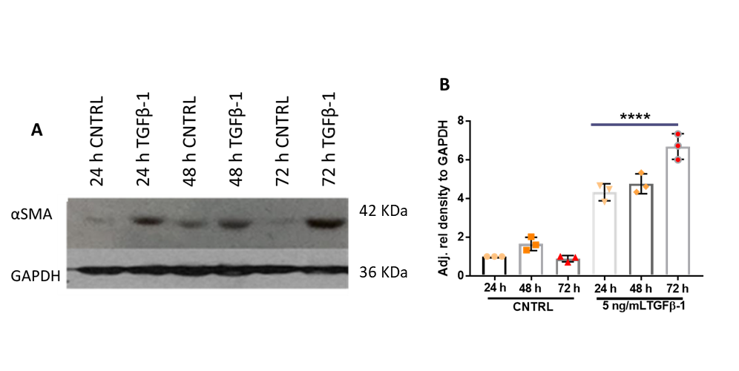

Figure 3.12 Immunoblotting for αSMA abundance in NOF with and without TGFβ-1 stimulation
NOF 2D monolayers were treated with TGFβ-1 (5 ng/mL) for up to 72 h with αSMA protein levels determined using immunoblotting (A). Densitometry of the resultant bands were measured using ImageJ and the intensity measured relative to GAPDH controls (B). Data is expressed as relative fold change, with mean ± SD, N=3, n=2, **** denotes p <0.0001 analysed by Kruskal-Wallis test with Dunn’s multiple comparison test.

Total protein isolated from NOF treated with either 5 ng/mL TGFβ-1 or vehicle control, separated by gel electrophoresis and blotted. A representative immunoblot showing αSMA present in all samples (A). Densiometric analysis of immnoblot conferred a significant increase of αSMA in all TGFβ-1 treated samples p <0.0001 and analysed by ordinary one-way ANOVA with Dunnett’s multiple comparison. Graph shows mean and SD (N=3, n=3) (B).

3.3.1.4.2 FN1-EDA protein abundance in normal oral fibroblasts

Immunoblotting indicated FN1-EDA was present in all control and TGFβ-1 treated samples up to 72 h (Figure 3.13 A). Band densitometry indicated that FN1-EDA protein increased upon TGFβ-1 treatment compared to 24 h vehicle control samples (Figure 3.13 B). 72 h TGFβ-1 treatment resulted in the greatest fold change compared to control samples; with a 5.35 ± 0.31-fold increase (p <0.0001). A significant fold change was also seen at 48 h with a fold- increase of 2.27 ± 0.07, p <0.0001.
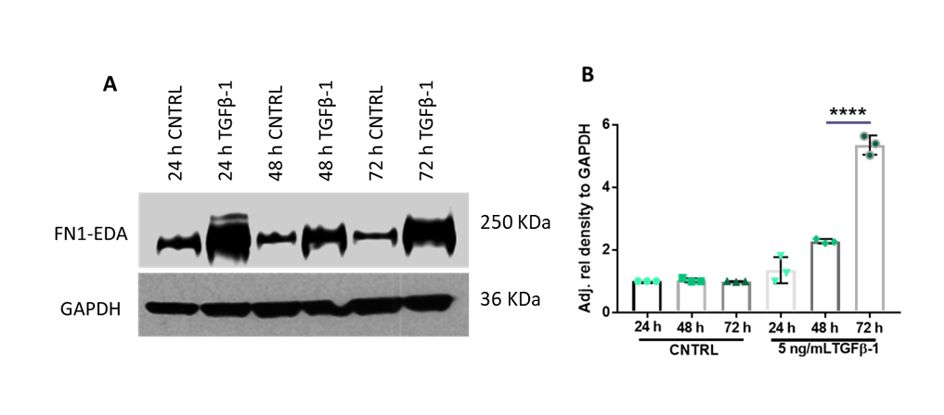

Figure 3.13 Immunoblotting for FN1-EDA abundance in NOF with and without TGFβ-1 stimulation
NOF 2D monolayers were treated with TGFβ-1 for up to 72 h with FN1-EDA protein levels determined using immunoblotting (A). Densitometry of the resultant bands were measured using ImageJ and the intensity measured relative to GAPDH controls (B). Data is expressed as relative fold change, with mean ± SD, N=3, n=2, **** denotes p <0.0001 analysed by Kruskal-Wallis test with Dunn’s multiple comparison test.

3.3.1.4.3 COL1A1 protein abundance in normal oral fibroblasts

COL1A1 protein was present in both control and TGFβ-1 treated samples up to 72 h in vitro (Figure 3.14 A). Analysis of band intensity indicated that COL1A1 significantly increased with TGFβ-1 treatment at 72 h (1.66 ± 0.09-fold increase) compared to 24 h control group, p=0.0064 (Figure 3.14 B). No significant increase in protein abundance was observed for both 24 h and 48 h with TGFβ-1 treatment compared to 24 h control samples.

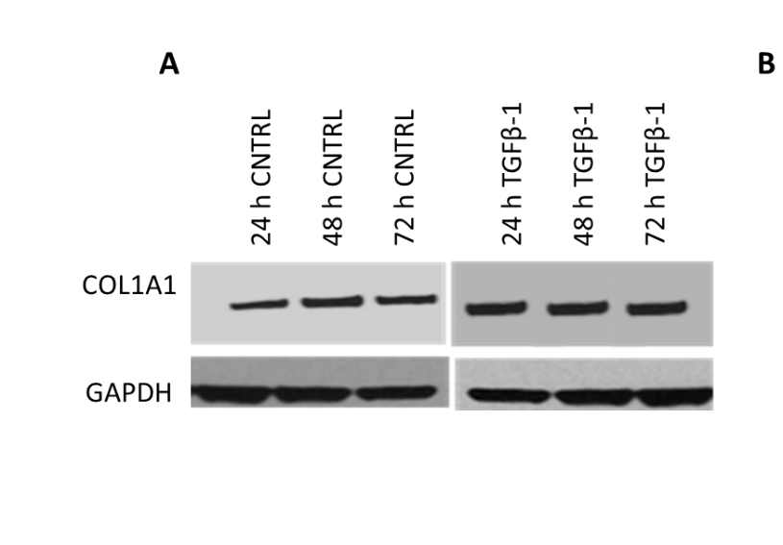

200 KDa
36 KDa

Figure 3.14 Immunoblotting for COL1A1 abundance in NOF with and without TGFβ-1 stimulation
NOF 2D monolayers were treated with TGFβ-1 for up to 72 h with COL1A1 protein levels determined using immunoblotting (A). Densitometry of the resultant bands were measured using ImageJ and the intensity measured relative to GAPDH controls (B). Data is expressed as relative fold change, with mean ± SD, N=3, n=2, * denotes p <0.05, *** p <0.001 and **** p <0.0001 analysed by Kruskal-Wallis test with Dunn’s multiple comparison test.

3.3.1.4.1.4 VCAN protein abundance in normal oral fibroblasts

VCAN protein was observable in all TGFβ-1 treated samples compared to vehicle controls (Figure 3.15). Multiple bands present on the immunoblots is characteristic of variable glycosylation but has been previously observed in VCAN immunoblots using the methodology (Melling et al., 2016) (Figure 3.15 A). The relative density of VCAN abundance increased with treatment of TGFβ-1 in a time-dependent fashion (Figure 3.15 B). No significant difference was observed at 24 h with TGFβ-1 treatment. At both the 48 h and 72 h, TGFβ-1 treatment significantly increased VCAN abundance, with a mean increase of 5.00 ± 0.55 (p <0.0001) at 48 h and a greater increase at 72 h, with a mean of 8.55 ± 1.03 (p <0.0001) compared to 24 h control samples.
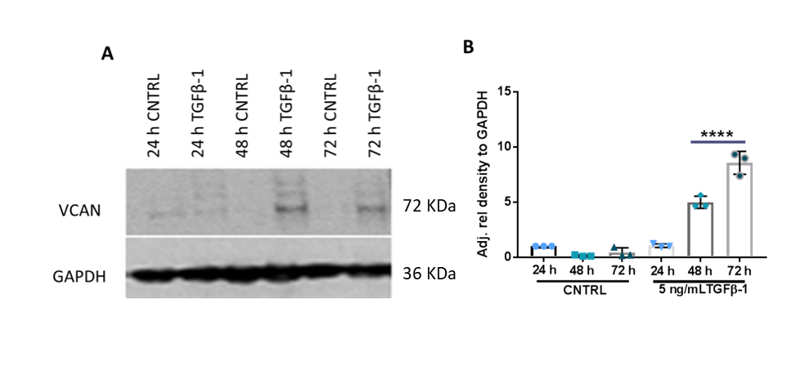

Figure 3.15 Immunoblotting for VCAN abundance in NOF with and without TGFβ-1 stimulation
NOF 2D monolayers were treated with TGFβ-1 for up to 72 h with VCAN protein levels determined using immunoblotting (A). Densitometry of the resultant bands were measured using ImageJ and the intensity measured relative to GAPDH controls (B). Data is expressed as relative fold change, with mean ± SD, N=3, n=2, **** denotes p <0.0001 analysed by Kruskal-Wallis test with Dunn’s multiple comparison test.

3.3.1.4.2 Long-term protein abundance in normal oral fibroblasts

NOF were treated with exogenous TGFβ-1 long-term (24 h-72 h + 14 days) as described in section 2.2.5.1 and αSMA, FN1-EDA, COL1A1 and VCAN abundance investigated by immunoblotting (Figures 3.16-3.19).

3.3.1.4.2.1 αSMA protein abundance in normal oral fibroblasts

Long-term treatment with TGFβ-1 increased the abundance of αSMA in all NOF populations up to 72 h + 14 days in vitro (Figure 3.16 A + B). Densitometric analysis of immunoblots indicated that αSMA abundance was significantly increased at 48 h + 14 days with TGFβ-1 treatment with a mean increase in intensity of 15.97 ± 2.18, p <0.0001. Both 24 h- and 72 h + 14 days TGFβ-1 treated NOF showed increased relative intensity of αSMA with mean increases of 10.05 ± 2.10 and 13.48 ± 1.25, respectively (p <0.0001). Vehicle control treated samples showed a time-dependent increase in αSMA abundance, at 72 h + 14 days a significant increase in αSMA abundance was observed with a 5.98 ± 0.36-fold increase compared to 24 + 14-day control samples, p=0.0029.
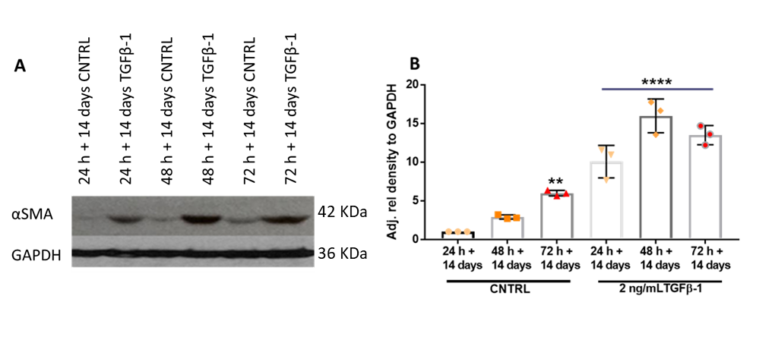

Figure 3.16 Immunoblotting for αSMA abundance in NOF with and without TGFβ-1 stimulation
NOF 2D monolayers were treated with TGFβ-1 for up to 72 h + 14 days with αSMA protein levels determined using immunoblotting (A). Densitometry of the resultant bands were measured using ImageJ and the intensity measured relative to GAPDH controls (B). Data is expressed as relative fold change, with mean ± SD, N=3, n=2, **** denotes p <0.0001 analysed by Kruskal-Wallis test with Dunn’s multiple comparison test.

3.3.1.4.2.2 FN1-EDA protein abundance in normal oral fibroblasts

FN1-EDA protein was detectable long-term in all vehicle control and TGFβ-1 treated samples (Figure 3.17 A). TGFβ-1 treatment significantly increased FN1-EDA abundance in NOF (Figure 3.17 A+B). At 24 h + 14 days, TGFβ-1 treatment induced a 65.24 ± 11.24-fold increase in intensity over 24 h + 14-day control, (p <0.0001). At 48 h + 14 days TGFβ-1 treatment increased with a mean of 33.25 ± 3.73, p=0.0002. 72 h + 14 days TGFβ-1 treatment produced the greatest increase of 123.80 ± 9.22, p <0.0001 compared to 24 h + 14-day control samples.

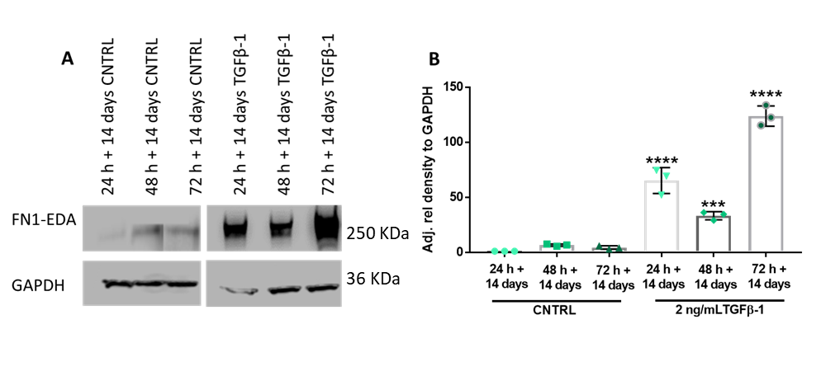

Figure 3.17 Immunoblotting for FN1-EDA abundance in NOF with and without TGFβ-1 stimulation
NOF 2D monolayers were treated with TGFβ-1 for up to 72 h + 14 days with FN1-EDA protein levels determined using immunoblotting (A). Densitometry of the resultant bands were measured using ImageJ and the intensity measured relative to GAPDH controls (B). Data is expressed as relative fold change, with mean ± SD, N=3, n=2, *** denotes p <0.001 and **** p <0.0001 analysed by Kruskal-Wallis test with Dunn’s multiple comparison test.

3.3.1.4.2.3 COL1A1 protein abundance in normal oral fibroblasts

COL1A1 was present in all samples long-term with and without TGFβ-1 treatment (Figure 3.18 A). A time-dependent increase was observed for both controls and TGFβ-1 treated NOF (Figure 3.18 B). At 72 h + 14 days, controls and TGFβ-1 treated NOF significantly increased COL1A1 abundance. COL1A1 increased 2.09 ± 0.01-fold, p <0.0001 in 72 h + 14 days control and increased 2.78 ± 0.20-fold, p <0.0001 in 72 h + 14 days TGFβ-1 treated NOF.

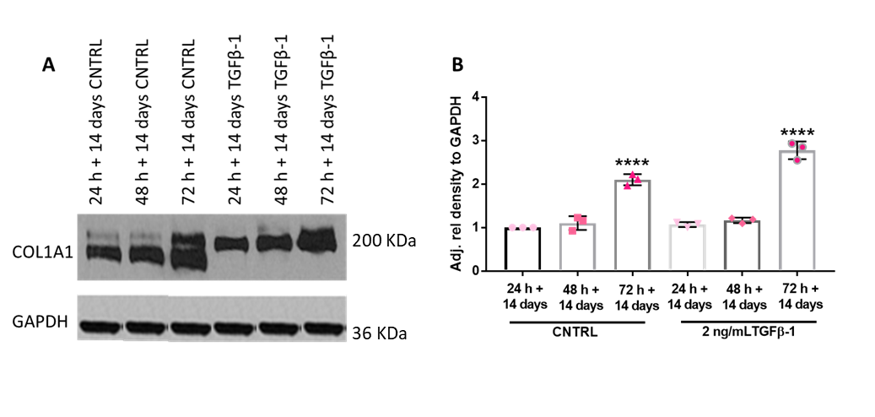

Figure 3.18 Immunoblotting for COL1A1 abundance in NOF with and without TGFβ-1 stimulation
NOF 2D monolayers were treated with TGFβ-1 for up to 72 h + 14 days with COL1A1 protein levels determined using immunoblotting (A). Densitometry of the resultant bands were measured using ImageJ and the intensity measured relative to GAPDH controls (B). Data is expressed as relative fold change, with mean ± SD, N=3, n=2, **** denotes p <0.0001 analysed by Kruskal-Wallis test with Dunn’s multiple comparison test.

3.3.1.4.2.4 VCAN protein abundance in normal oral fibroblasts

VCAN protein was present in all NOF samples with and without TGFβ-1 treatment (Figure 3.19 A). A significant increase in VCAN was observed at 48 h + 14 days with TGFβ-1 treatment of 2.06 ± 0.25, p <0.0001 compared to 24 + 14-day control. The 48 h + 14 days control samples also showed a significant increase, with a 1.57 ± 0.07-fold change, p=0.0038. A significant ~1.5-fold decrease, with a mean of 0.60 ±0.22, p=0.0369 in VCAN abundance was observed at 72 h + 14 days in TGFβ-1 treated samples compared to 24 h+ 14-day control.
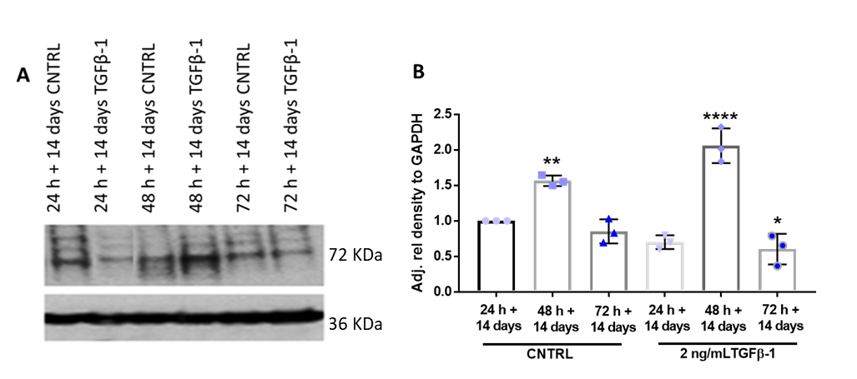

Figure 3.19 Immunoblotting for VCAN abundance in NOF with and without TGFβ-1 stimulation
NOF 2D monolayers were treated with TGFβ-1 for up to 72 h + 14 days with αSMA protein levels determined using immunoblotting (A). Densitometry of the resultant bands were measured using ImageJ and the intensity measured relative to GAPDH controls (B). Data is expressed as relative fold change, with mean ± SD, N=3, n=3, * denotes p <0.05, ** p <0.01 and **** p <0.0001 analysed by Kruskal-Wallis test with Dunn’s multiple comparison test.

3.3.2 Molecular analysis of cancer-associated fibroblasts

To compare CAF responses to exogenous application of TGFβ-1 to NOF, three primary CAF cultures were isolated from patients with OSCC as described in section 2.2.3.1. As for NOF, patient CAF were analysed for their matrix secreting phenotypes and ability to maintain these phenotypes long-term in vitro.

3.3.2.1 RT-qPCR analysis of myofibroblast and ECM markers short-term in CAF

The short-term (24 h-72 h) responses of CAF to 5 ng/mL TGFβ-1 treatment was assessed by RT-qPCR by analysing the expression of the target transcripts; αSMA, FN1-EDA, COL1A1, VCAN and TNC (Figures 3.20- 3.24).

3.3.2.1.1 αSMA expression by RT-qPCR

The αSMA transcript was expressed in all samples investigated and high basal level expressions indicated that αSMA is associated with CAF phenotype regardless of TGFβ-1 supplementation (Figure 3.20). The addition of 5 ng/mL of TGFβ-1 to CAF samples, increased the relative expression of the αSMA transcript at 48 h with a fold increase of 22.25 ± 25.50, p=0.002 compared to 24 h control samples.

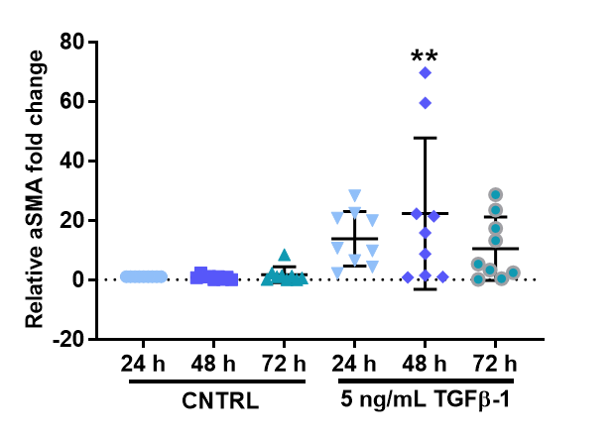

Figure 3.20 Short-term expression data for the myofibroblast marker αSMA in CAF with and without TGFβ-1 stimulation
CAF 2D monolayers were treated with 5 ng/mL TGFβ-1 up to 72 h and the gene expression for aSMA determined by qPCR. Data is expressed as fold change relative to housekeeping gene U6, with mean ± SD. ** denotes p <0.01 analysed by ordinary one-way ANOVA with Dunnett’s multiple comparison. (N=3, n=3).

3.3.2.1.2 FN1-EDA expression by RT-qPCR

FN1-EDA expression levels were analysed short-term in CAF populations in the presence and absence of TGFβ-1 (Figure 3.21). No significant differences in FN1-EDA expression were observed at 24 h and 72 h in response to TGFβ-1. A significant increase in FN1-EDA was observed at 48 h with TGFβ-1 treatment, with a fold-increase of 20.06 ± 21.20, p=0.0006 compared to 24 h control samples.

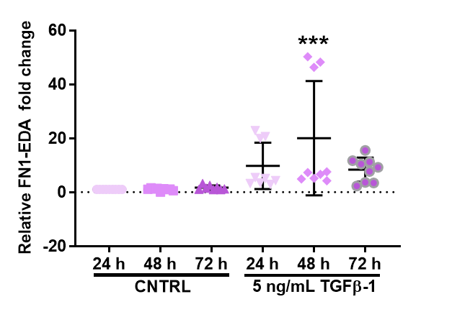

Figure 3.21 Short-term expression data for the myofibroblast marker FN1-EDA in CAF with and without TGFβ-1 stimulation
CAF 2D monolayers were treated with 5 ng/mL TGFβ-1 up to 72 h and the gene expression for FN1-EDA determined by qPCR. Data is expressed as fold change relative to housekeeping gene U6, with mean ± SD. *** denotes p <0.001 analysed by ordinary one-way ANOVA with Dunnett’s multiple comparison. (N=3, n=3).

3.3.2.1.3 COL1A1 expression by RT-qPCR

With the addition of TGFβ-1 a significant increase in COL1A1 transcript expression was detected at 48 h with a 6.36 ± 7.88-fold increase, p=0.0115 (Figure 3.22). No significant differences were observed at 24 h and 72 h with TGFβ-1 treatment.

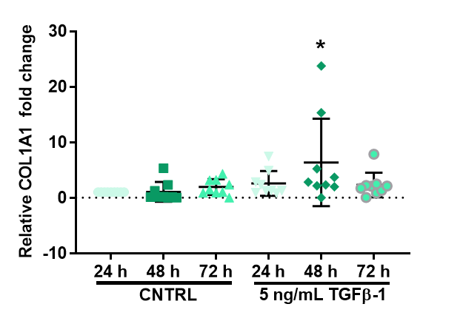

Figure 3.22 Short-term expression data for the myofibroblast marker COL1A1 in CAF with and without TGFβ-1 stimulation
CAF 2D monolayers were treated with 5 ng/mL TGFβ-1 up to 72 h and the gene expression for COL1A1 determined by qPCR. Data is expressed as fold change relative to housekeeping gene U6, with mean ± SD. * denotes p <0.05 analysed by ordinary one-way ANOVA with Dunnett’s multiple comparison. (N=3, n=3).

3.3.2.1.4 VCAN expression by RT-qPCR

Short-term evaluation of VCAN transcript expression in response to TGFβ-1 treatment showed a significant increase in expression at 72 h (Figure 3.23). No significant changes were observed at 24 h and 48 h with TGFβ-1 treatment, with a mean fold-changes of 1.84 ± 1.04 and 1.48 ± 0.98 respectively. A significant increase in VCAN expression was observed at 72 h with TGFβ-1 treatment with a 3.61 ± 3.32-fold change, p=0.0004, compared to 24 h control samples.

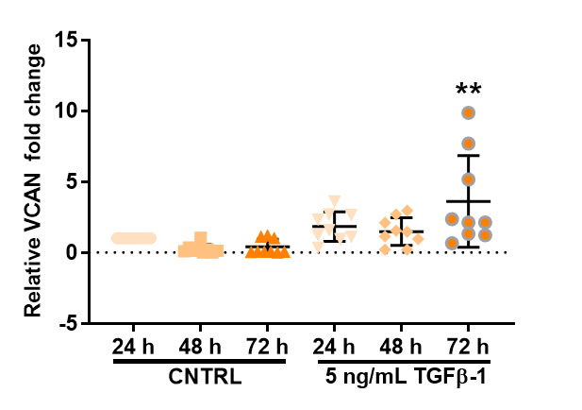

Figure 3.23 Short-term expression data for the myofibroblast marker VCAN in CAF with and without TGFβ-1 stimulation
CAF 2D monolayers were treated with 5 ng/mL TGFβ-1 up to 72 h and the gene expression for VCAN determined by qPCR. Data is expressed as fold change relative to housekeeping gene U6, with mean ± SD. ** denotes p <0.01 analysed by ordinary one-way ANOVA with Dunnett’s multiple comparison. (N=3, n=3).

3.3.2.1.5 TNC expression by RT-qPCR

Increased expression of TNC was observed in CAF on addition of TGFβ-1 in CAF at 24 h (4.62 ± 2.66-fold-change compared to vehicle control samples (p=0.0023)) and 72 h 5.19 ± 3.32, p=0.0004, compared to 24 h control samples (Figure 3.24). No significant difference was observed at 48 h with TGFβ-1 treatment.

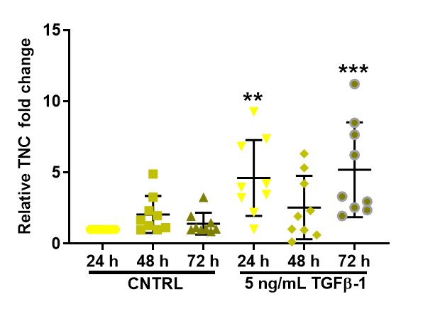

Figure 3.24 Short-term expression data for the myofibroblast marker TNC in CAF with and without TGFβ-1 stimulation
CAF 2D monolayers were treated with 5 ng/mL TGFβ-1 up to 72 h and the gene expression for TNC determined by qPCR. Data is expressed as fold change relative to housekeeping gene U6, with mean ± SD. ** denotes p <0.01 and *** p <0.001 analysed by ordinary one-way ANOVA with Dunnett’s multiple comparison. (N=3, n=3).

3.3.2.2 RT-qPCR analysis of myofibroblast and ECM markers long-term in CAF

The expression of target transcripts in response to long-term treatment with and without TGFβ-1 treatment was assessed in CAF, using the same TGFβ-1 treatment protocol used in section 2.2.5.1 (Figures 3.25-3.29).

3.3.2.2.1 αSMA expression by RT-qPCR

CAF maintain αSMA transcript expression long-term with TGFβ-1 treatment (Figure 3.25). A significant increase was observed at 24 h- and 48 h- + 14 days, with 13.30 ± 2.59 and 5.23 ± 1.97- fold increases respectively, compared to 24 h control samples (p <0.0001). No significant difference was observed at 72 h + 14 days with TGFβ-1 treatment.

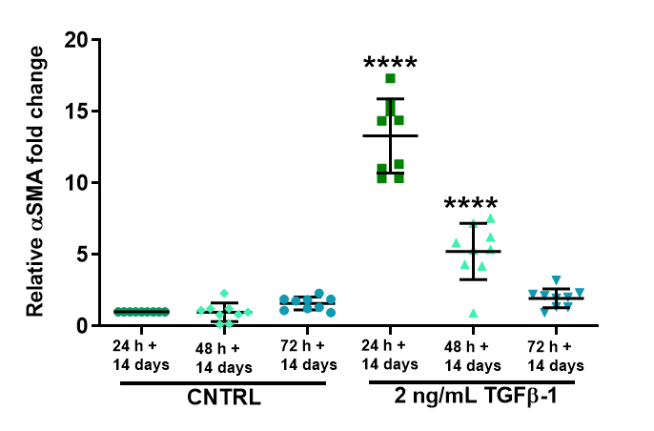

Figure 3.25 Long-term expression data for the ECM marker αSMA in CAF with and without TGFβ-1 stimulation
CAF 2D monolayers were treated with 2 ng/mL TGFβ-1 up to 72 h + 14 days and the gene expression for αSMA was determined by qPCR. Data is expressed as fold change relative to housekeeping gene U6, with mean ± SD. **** denotes p <0.0001 as analysed by ordinary one-way ANOVA with Dunnett’s multiple comparison. (N=3, n=3).

3.3.2.1.2 FN1-EDA expression by RT-qPCR

A significant increase in FN1-EDA transcript expression was seen with TGFβ-1 treatment at 24 h + 14 days, with an increased fold-change of 6.72 ± 2.20, compared to 24 h + 14-day vehicle control samples, p <0.0001 (Figure. 3.26). No significant differences were observed at 48 h– and 72 h- + 14 day with TGFβ-1 treatment.

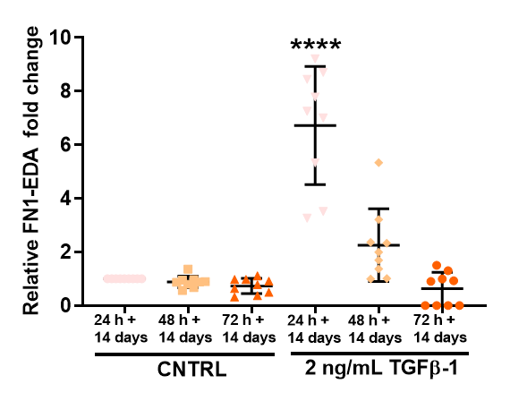

Figure 3.26 Long-term expression data for the ECM marker FN1-EDA in CAF with and without TGFβ-1 stimulation
CAF 2D monolayers were treated with 2 ng/ml TGFβ-1 up to 72 h + 14 days and the gene expression for FN1-EDA was determined by qPCR. Data is expressed as fold change relative to housekeeping gene U6, with mean ± SD. **** denotes p <0.0001 as analysed by ordinary one-way ANOVA with Dunnett’s multiple comparison. (N=3, n=3).

3.3.2.2.3 COL1A1 expression by RT-qPCR

COL1A1 transcript expression was variable for both vehicle controls and TGFβ-1 treated samples (Figure 3.27). Significant increases in COL1A1 transcript expression were observed at the 48 h + 14-day for both vehicle control samples, with a mean 1.50 ± 0.53-fold increase (p=0.0005) as well as with TGFβ-1 treatment, with an increase of 1.88 ± 0.21, p <0.0001 compared to 24 h + 14 day control samples. Significant decreases in transcript expression were seen for the 72 h + 14 -day vehicle control groups; mean decrease of 0.09 ± 0.04 and for the 24 h + 14-day TGFβ-1 treated CAF with a fold decrease to 0.16 ± 0.11 (p <0.0001).

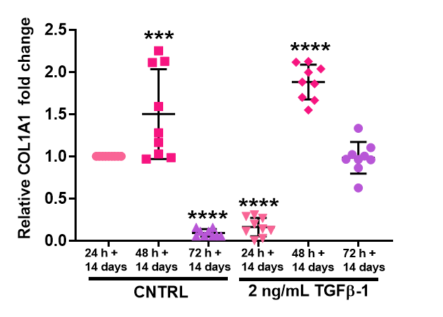

Figure 3.27 Long-term expression data for the ECM marker COL1A1 in CAF with and without TGFβ-1 stimulation
CAF 2D monolayers were treated with 2 ng/ml TGFβ-1 up to 72 h + 14 days and the gene expression for COL1A1 was determined by qPCR. Data is expressed as fold change relative to housekeeping gene U6, with mean ± SD. *** denotes p <0.001 and **** p <0.0001 as analysed by ordinary one-way ANOVA with Dunnett’s multiple comparison. (N=3, n=3).

3.3.2.2.4 VCAN expression by RT-qPCR

VCAN transcript expression was maintained long-term in CAF cultures with TGFβ -1 (Figure 3.28). At 48 h + 14-days in vehicle controls, a significant reduced expression of VCAN was observed with a ~2.85-fold decrease (0.35 ± 0.40) compared to 24 h + 14-days control samples, p=0.0010. Significant increases in VCAN transcript expression were observed in all TGFβ-1 treated samples. At 24 h + 14-days a 1.81 ± 0.23-fold increase, p <0.0001, compared to control samples. Both at 48 h- and 72 h- +14-day TGFβ-1 treated samples increased, with a mean of 1.70 ± 0.40 compared to control samples p=0.0004.

Figure 3.28 Long-term expression data for the ECM marker VCAN in CAF with and without TGFβ-1 stimulation
CAF 2D monolayers were treated with 2 ng/mL TGFβ-1 up to 72 h + 14 days and the gene expression for VCAN was determined by qPCR. Data is expressed as fold change relative to housekeeping gene U6, with mean ± SD. **** denotes p <0.0001 as analysed by ordinary one-way ANOVA with Dunnett’s multiple comparison. (N=3, n=3).

3.3.2.1.4 TNC expression by RT-qPCR

TNC transcript expression was variable in CAF long-term with both control and TGFβ-1 treated samples expressing TNC up to 72 h + 14-days in vitro (Figure 3.29). A significant reduction in TNC occurred at 48 h + 14-day in vehicle control samples with a mean fold-change of 0.38 ± 0.52, p=0.0012. No significant differences were observed for TNC expression with exogenous application of TGFβ-1.

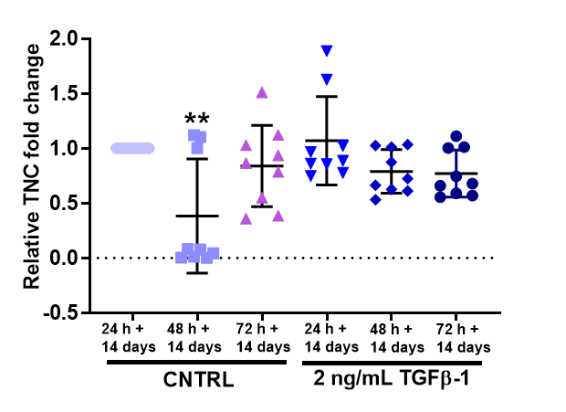

Figure 3.29 Long-term expression data for the ECM marker TNC in CAF with and without TGFβ-1 stimulation
CAF 2D monolayers were treated with 2 ng/mL TGFβ-1 up to 72 h + 14 days and the gene expression for TNC was determined by qPCR. Data is expressed as fold change relative to housekeeping gene U6, with mean ± SD. **** denotes p <0.0001 as analysed by ordinary one-way ANOVA with Dunnett’s multiple comparison. (N=3, n=3).

3.3.4 Analysis of oral cancer associated fibroblast ECM component protein abundance

3.3.4.1 Short-term ECM protein abundance in CAF

3.3.4.1.1 αSMA abundance in CAF short-term

αSMA protein was detectable in CAF samples with and without TGFβ-1 supplementation (Figure 3.30 A). A significant increase in αSMA abundance was observed at 72 h with TGFβ-1 treatment compared to 24 h control samples with a mean band intensity of 1.92 ± 0.26, p=0.007. (Figure 3.30 B).
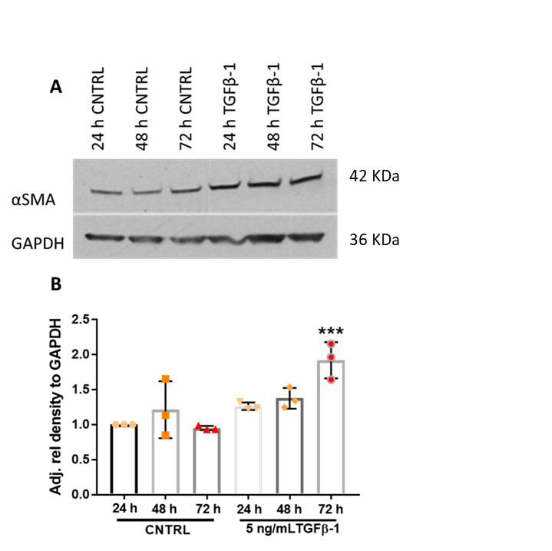

Figure 3.30 Immunoblotting for αSMA abundance in CAF with and without TGFβ-1 stimulation
CAF 2D monolayers were treated with TGFβ-1 for up to 72 h with αSMA protein levels determined using immunoblotting (A). Densitometry of the resultant bands were measured using ImageJ and the intensity measured relative to GAPDH controls (B). Data is expressed as relative fold change, with mean ± SD, N=3, n=2, *** denotes p <0.001 analysed by Kruskal-Wallis test with Dunn’s multiple comparison test.

3.3.4.1.2 COL1A1 abundance in CAF short-term

COL1A1 was found expressed in CAF with and without TGFβ-1 stimulation (Figure 3.31 A). Densiometric analysis of immunoblots of COL1A1 revealed no significant differences in the band density of COL1A1 at 24 h and 72 h in CAF in response to short-term treatment with TGFβ-1. A significant increase was observed at 48 h with TGFβ-1 treatment, with a 2.43 ± 0.72-fold increase (p=0.0389) compared to 24 h control samples (Figure 3.31 B).
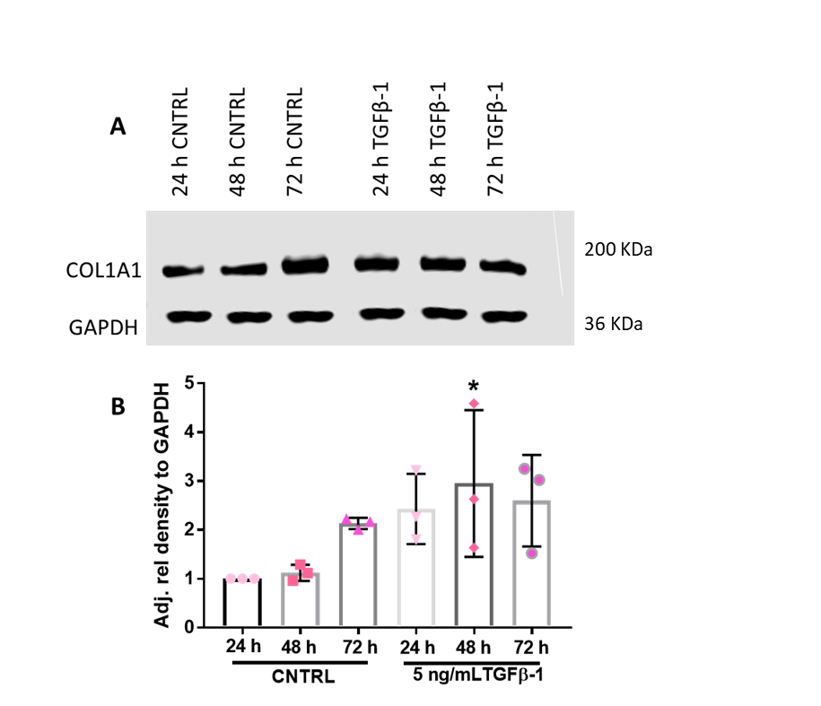

Figure 3.31 Immunoblotting for COL1A1 abundance in CAF with and without TGFβ-1 stimulation
CAF 2D monolayers were treated with TGFβ-1 for up to 72 h with COL1A1 protein levels determined using immunoblotting (A). Densitometry of the resultant bands were measured using ImageJ and the intensity measured relative to GAPDH controls (B). Data is expressed as relative fold change, with mean ± SD, N=3, n=2, * denotes p <0.05 analysed by Kruskal-Wallis test with Dunn’s multiple comparison test.

3.3.4.1.3 FN1-EDA abundance in CAF short-term

FN1-EDA was detectable in all CAF cultures in the presence and absence of TGFβ-1 up to 72 h in vitro (Figure 3.32 A). Analysis of band intensity indicated a significant increase in FN1-EDA at 72 h control samples with a mean increase of 3.28 ± 0.34, p=0.0012. TGFβ-1 treatment at 24 h – 72 h induced a significant increase in FN1-EDA abundance with a mean increase of 3.86 ± 0.40, p=0.0002 at 24 h, mean increase of 2.90 ± 0.93, p=0.0051 at 48 h and a mean increase of 2.92 ± 0.30, p=0.0046at 72 h compared to 24 h control samples (Figure 3.32 B).
FN1-EDA
GAPDH
24 h CNTRL

48 h CNTRL

72 h CNTRL

24 h TGFβ-1
48 h TGFβ-1
72 h TGFβ-1
A
B

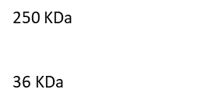

Figure 3.32 Immunoblotting for FN1-EDA abundance in CAF with and without TGFβ-1 stimulation
CAF 2D monolayers were treated with TGFβ-1 for up to 72 h with FN1-EDA protein levels determined using immunoblotting (A). Densitometry of the resultant bands were measured using ImageJ and the intensity measured relative to GAPDH controls (B). Data is expressed as relative fold change, with mean ± SD, N=3, n=2, ** denotes p <0.01 and ** p <0.001 analysed by Kruskal-Wallis test with Dunn’s multiple comparison test.

3.3.4.1.4 VCAN abundance in CAF short-term

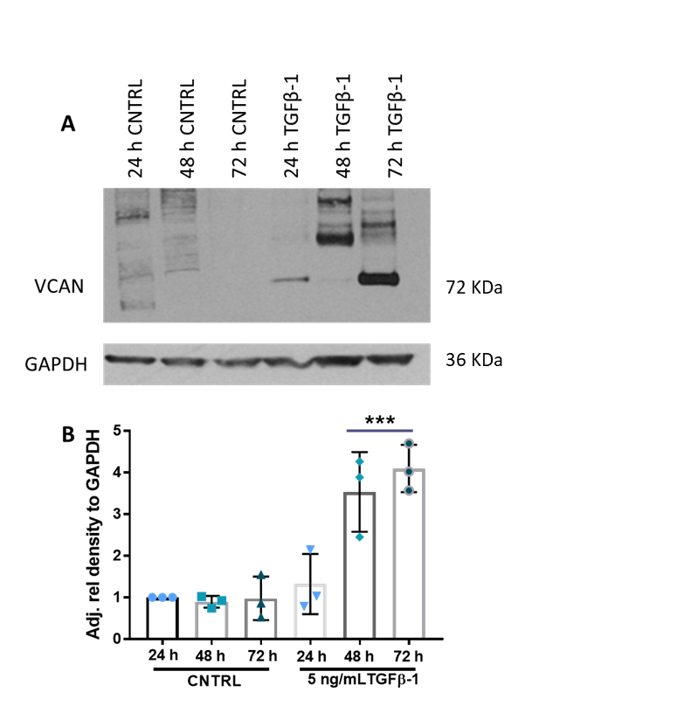
Immunoblotting of VCAN protein in CAF populations, showed multiple bands in all control and all TGFβ-1 samples, and could be due to post translational modifications (PTM) of VCAN in CAF samples (Figure 3.33 A). Analysis of VCAN abundance indicated that VCAN increased in all TGFβ-1 treated samples (Figure 3.33 B). A significant increase in VCAN abundance was observed at 48 h and 72 h upon treatment with TGFβ-1 treated samples with a mean band intensity of 4.14 ± 0.80, p=0.0261 compared to 24 h control samples.

Figure 3.33 Immunoblotting for VCAN abundance in CAF with and without TGFβ-1 stimulation
CAF 2D monolayers were treated with TGFβ-1 for up to 72 h with VCAN protein levels determined using immunoblotting (A). Densitometry of the resultant bands were measured using ImageJ and the intensity measured relative to GAPDH controls (B). Data is expressed as relative fold change, with mean ± SD, N=3, n=2, *** denotes p <0.001 analysed by Kruskal-Wallis test with Dunn’s multiple comparison test.

3.3.4.2 Long-term ECM protein abundance in patient oral CAF

To assess whether CAF were capable of maintaining their phenotype long-term in vitro, protein abundance was analysed by long-term exogenous application of TGFβ-1 (Figures 3.34-3.47).

3.3.4.2.1 αSMA abundance in CAF with long-term TGFβ-1 treatment

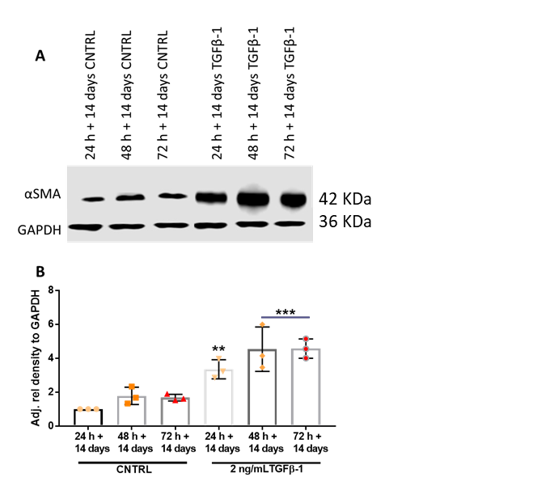
CAF are capable of producing αSMA protein up to 14 days in culture with and without TGFβ-1 treatment as evidenced by immunoblot (Figure 3.34 A). Densitometric analysis of immunoblot bands revealed a significant increase in αSMA with TGFβ-1 treatment compared to 24 h + 24-day controls (Figure 3.34 B). At 24 h + 14-day αSMA increased in density to 3.35 ± 0.57, p=0.0042. At 48 h + 14- day, TGFβ-1 treatment increased band intensity to 4.53 ± 1.31, p=0.0001. The greatest increase in αSMA protein was seen at 72 h + 14-day in TGFβ-1 treated CAF, with an increase of 4.57 ± 0.57, p=0.0001 compared to control samples.

Figure 3.34 Immunoblotting for αSMA abundance in CAF with and without TGFβ-1 stimulation
CAF 2D monolayers were treated with TGFβ-1 for up to 72 h + 14 days with αSMA protein levels determined using immunoblotting (A). Densitometry of the resultant bands were measured using ImageJ and the intensity measured relative to GAPDH controls (B). Data is expressed as relative fold change, with mean ± SD, N=3, n=2, ** denotes p <0.01 and *** p <0.001 analysed by Kruskal-Wallis test with Dunn’s multiple comparison test.

3.3.4.2.2 COL1A1 abundance in CAF long-term

CAF expressed COL1A1 long-term in vitro with and without TGFβ-1 supplementation (Figure 3.35 A). Longer-term treatment with TGFβ-1 increased COL1A1 abundance, detectable multiple bands were also present. Densitometry analysis showed the greatest abundance of COL1A1 at 48 h + 14-day with TGFβ-1 treatment with an increase of 19.42 ± 6.69, p <0.0001, compared to 24 h + 14-day vehicle control samples (Figure 3.35). A significant increase in COL1A1 abundance was also seen at 24 h + 14 day with treatment, 9.59 ± 2.51, p=0.0284, and at 72 h + 14-day in TGFβ-1 treated CAF samples, with a fold-increase of 18.50 ± 1.57, p=0.0001.
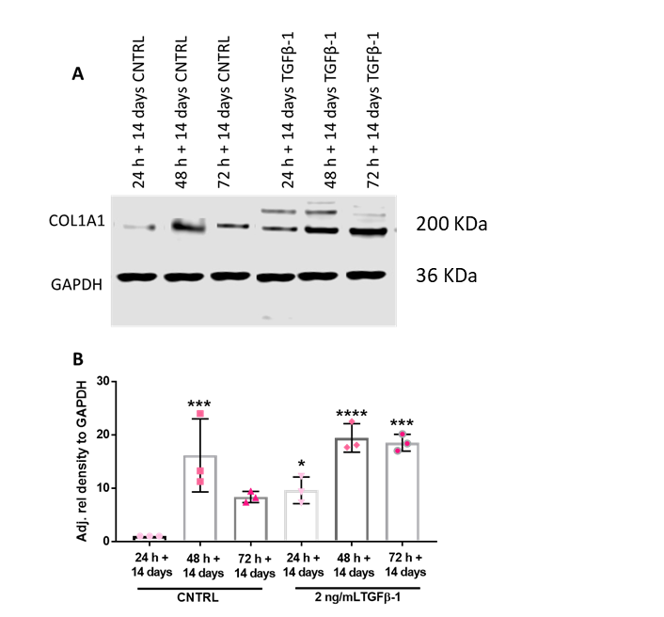

Figure 3.35 Immunoblotting for COL1A1 abundance in CAF with and without TGFβ-1 stimulation
CAF 2D monolayers were treated with TGFβ-1 for up to 72 h + 14 days with COLA1 protein levels determined using immunoblotting (A). Densitometry of the resultant bands were measured using ImageJ and the intensity measured relative to GAPDH controls (B). Data is expressed as relative fold change, with mean ± SD, N=3, n=2, * denotes p <0.05, *** p <0.001 and **** p <0.0001 analysed by Kruskal-Wallis test with Dunn’s multiple comparison test.

3.3.4.2.3 FN1-EDA abundance in CAF long-term

FN1-EDA was detectable in both vehicle control treated and TGFβ-1 treated samples long-term, with positive bands at 250 kDa for all samples analysed (Figure 3.36 A). Abundance of FN1-EDA varied in TGFβ-1 treated CAF populations but a significant increase in FN1-EDA protein was detected at 72 h + 14-day samples, with an increase of 4.54 ± 2.30, p =0.0133, compared to 24 h + 14-day vehicle control treated samples (Figure 3.36 B).
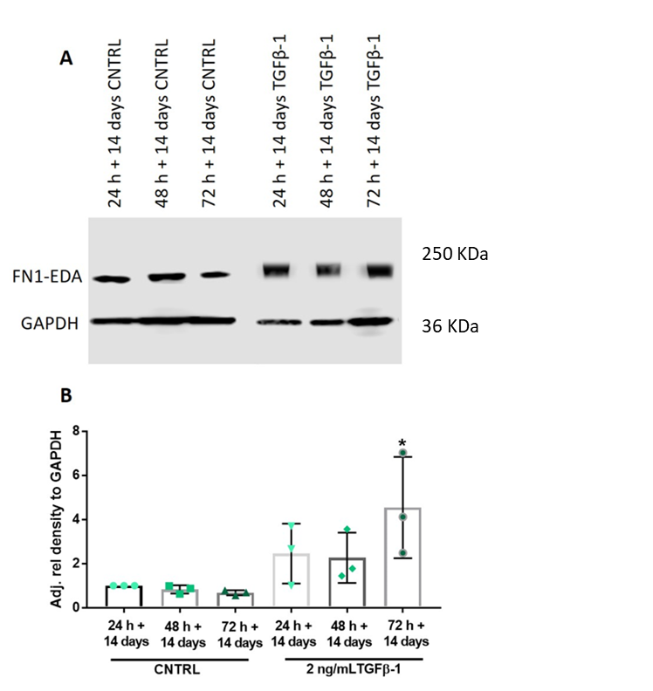

Figure 3.36 Immunoblotting for FN1-EDA abundance in CAF with and without TGFβ-1 stimulation
CAF 2D monolayers were treated with TGFβ-1 for up to 72 h + 14 days with FN1-EDA protein levels determined using immunoblotting (A). Densitometry of the resultant bands were measured using ImageJ and the intensity measured relative to GAPDH controls (B). Data is expressed as relative fold change, with mean ± SD, N=3, n=2, * denotes p <0.05 analysed by Kruskal-Wallis test with Dunn’s multiple comparison test.

3.3.4.2.4 VCAN abundance in CAF long-term

Relative VCAN abundance was increased in CAF with the treatment of TGFβ-1 long-term in vitro (Figure 3.37 A). Densitometry of VCAN bands indicated that with TGFβ-1 treatment a significant increase in VCAN was observed with the greatest abundance at the 24 h + 14-day with TGFβ-1, with an increase of 9.53 ± 2.74, p=0.0005 compared to 24 h + 14-day control samples. Significant increases were also observed at 48 h- and 72 h- + 14-day with TGFβ-1 treatment, of 8.56 ± 1.74, p=0.0014, and 7.41 ± 2.28, p=0.0051 respectively (Figure 3.37 B).
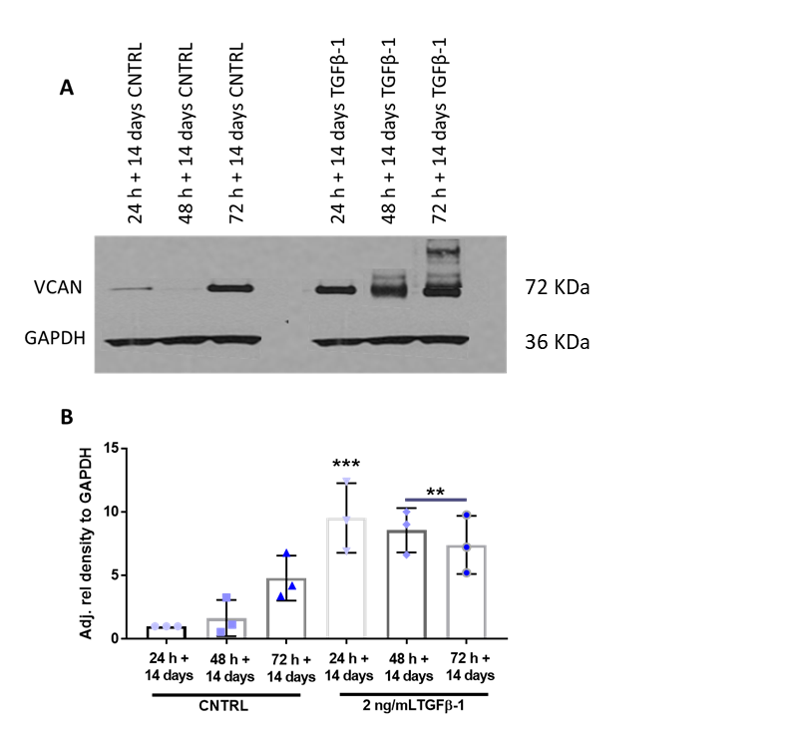

Figure 3.37 Immunoblotting for VCAN abundance in CAF with and without TGFβ-1 stimulation
CAF 2D monolayers were treated with TGFβ-1 for up to 72 h + 14 days with VCAN protein levels determined using immunoblotting (A). Densitometry of the resultant bands were measured using ImageJ and the intensity measured relative to GAPDH controls (B). Data is expressed as relative fold change, with mean ± SD, N=3, n=2, ** denotes p <0.01 and *** p <0.001 analysed by Kruskal-Wallis test with Dunn’s multiple comparison test.

3.3.5 Immunofluorescent analysis of αSMA stress fibres in oral fibroblasts

Myofibroblasts can be identified in vitro by visualising their prominent cytoskeletal αSMA stress-fibres using immunofluorescence (IF). IF was performed on NOF and CAF isolated from patients and treated with 5 ng/mL of TGFβ-1 or vehicle control at 48 h and after 7 days in vitro. Oral fibroblasts were seeded onto coverslips and then fixed with either methanol or 4% paraformaldehyde, permeabilised and then stained for αSMA using a FITC-conjugated antibody. Negative controls contained no αSMA FITC-conjugated antibody to check for background-fluorescence within the samples.

3.3.5.1 Immunofluorescence analysis of αSMA stress fibres in normal oral fibroblasts

NOF showed minimal expression of αSMA in vehicle control treated groups at both 48 h (Figure 3.38 A) and after 7 days (Figure 3.38 C). The addition of TGFβ-1 induced formation of αSMA stress fibres after 48 h, indicative of NOF trans-differentiation to myofibroblast (Figure 3.38 B). After 7 days of TGFβ-1 treatment, NOF were still able to induce stress fibre formation, however in general, positive staining was not exhibited for all fibroblasts in a culture (white arrows: Figure 3.38 D).
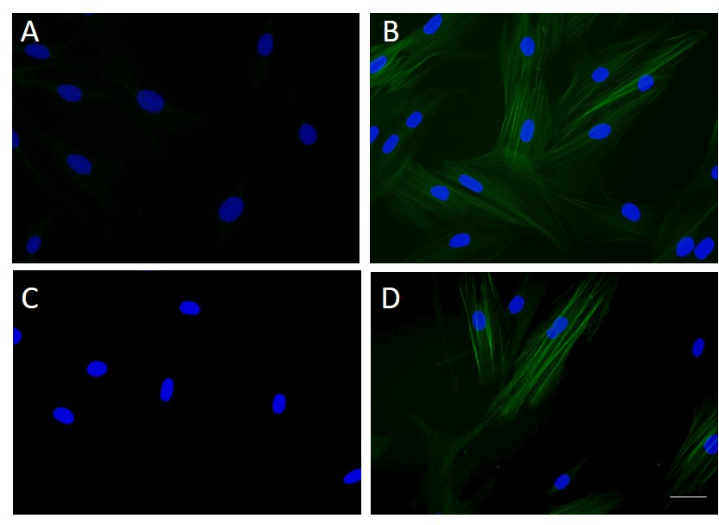

Figure 3.38 αSMA stress-fibre formation in normal oral fibroblasts in vitro
The expression of FITC-conjugated aSMA stress-fibre formation was analysed in vitro with the addition of vehicle control at 48 h and 7 days (A + C) and with TGFβ-1 at 48 h and 7 days (B + D) by immunofluorescence analysis in patient NOF. Arrows showing NOF without stress-fibre formation. Scale bar = 20 µm.

3.3.5.2 Immunofluorescence analysis of αSMA stress fibres in cancer-associated fibroblasts
Figure 3.42 VCAN protein abundance in CAF long-term
A representative immunoblot of VCAN protein abundance in CAF long-term with and without TGFβ-1 p to 72 h + 14-days in vitro (A). Densitometry of VCAN showed a significant increased abundance with treatment of 2 ng/mL TGFβ-1 up to 72 h + 14 days compared to basal level expressions in CAF populations (B). (N=2, n=2).

In contrast to NOF, CAF expressed readily detectable basal level of αSMA stress fibre formation and prominent elongation of filaments, both in the vehicle control groups (Figure 3.39 A + C) and with TGFβ-1 supplementation (Figure 3.39 B + D) at both 48 h and 7 days in vitro (Figure 3.39 A-D). This emphasises their myofibroblastic phenotype without the requirement for additional growth factor supplementation.

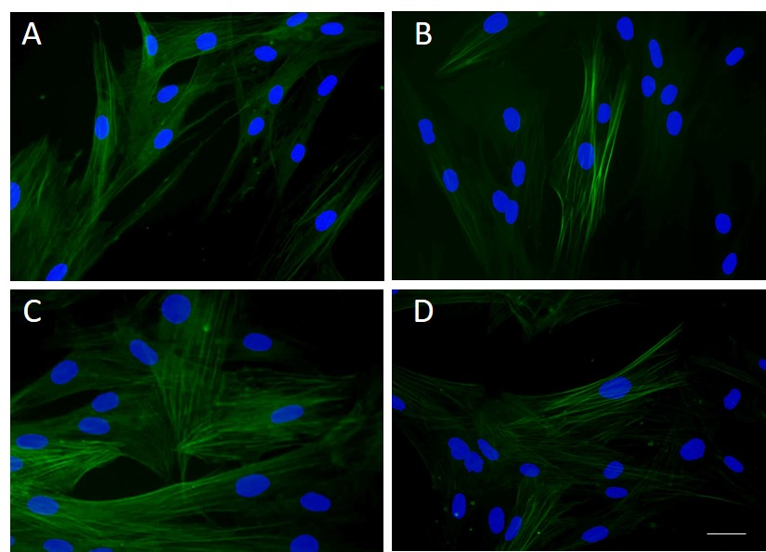

Figure 3.39 αSMA stress-fibre formation in oral cancer-associated fibroblasts in vitro
The expression of FITC-conjugated aSMA stress-fibre formation was analysed in vitro with the addition of vehicle control at 48 h and 7 days (A + C) and TGFβ-1 at 48 h and 7 days (B + D) by immunofluorescence analysis in patient CAF. Scale bar = 20 µm.

3.3.6 Investigation of the effects of stromal modifying drugs on myofibroblast phenotype in 2D monolayers

The effects of stromal targeted therapeutics, Scriptaid; a HDAC inhibitor and Batimastat; a broad spectrum MMP inhibitor, alone and in combination with TGFβ-1 were investigated to examine their role in inhibiting myofibroblast phenotype in 2D monolayers of NOF and CAF at 48 h. This inhibition was analysed by performing qPCR and immunoblotting for three key markers (αSMA, COL1A1 and FN1-EDA) previously shown in this chapter to be significantly upregulated in response to TGFβ-1 in vitro, and indicative of a myofibroblastic phenotype. This analysis here will provide a preliminary assessment of drug response in 2D, before further testing on fibroblast-derived matrices (FDM), developed and discussed in the subsequent chapter. The concentration of TGFβ-1 used was 10 ng/mL, the same concentration used in other studies using these inhibitors (Kim et al., 2018, Brown, 2009). Fold changes were relative to the housekeeping gene U6 and normalised relative to 48 h vehicle control treated samples.

3.3.6.1 αSMA gene expression in NOF and CAF in response to treatment with stromal-targeting drugs

In NOF cultures, Scriptaid or Batimastat treatment for 48 h in the absence of TGFβ-1 caused no difference in αSMA expression compared to vehicle control treated NOF (Figure 3.40 A). Scriptaid in combination with TGFβ-1 abrogated αSMA expression with a ~2-fold reduction (19.72 ± 10.86) compared to TGFβ-1 alone (45.67 ± 21.87), p=0.0263. A significant ~7-fold reduction in αSMA expression was observed for NOF treated with Batimastat and TGFβ-1 (6.18 ± 5.84) in combination therapy, p=0.0016. In contrast to NOF, CAF cultures treated with Scriptaid in combination with TGFβ-1, induced no significant changes in αSMA expression compared to TGFβ-1 treatment alone (Figure 3.40 B). Batimastat in the presence of TGFβ-1 (0.66 ± 0.34, reduced αSMA expression by 7-fold, compared to CAF cultures treated with TGFβ-1 alone (1.28 ± 0.39), p=0.0141.
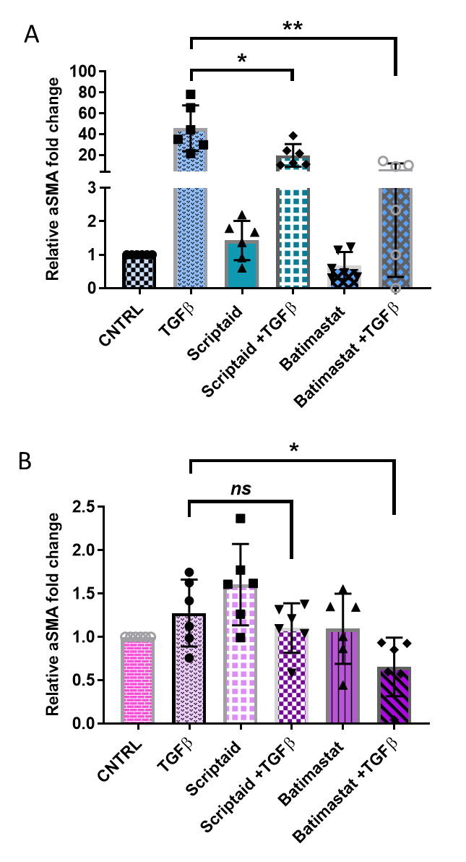

Figure 3.40 αSMA gene expression in NOF and CAF in response to Scriptaid and Batimastat treatment with and without TGFβ-1 stimulation
NOF (A) and CAF (B) 2D monolayers were treated with the inhibitors Scriptaid and Batimastat (10 ng/mL) in the presence or absence of TGFβ-1 for 48 h and the gene expression for aSMA determined by qPCR. Data is expressed as fold change relative to housekeeping gene U6, with mean ± SD, N=3, n=2, * denotes p <0.05, and **p <0.01 analysed by unpaired student’s T-test.

3.3.6.2 αSMA abundance in NOF and CAF in response to stromal-targeting drugs

Scriptaid treatment in combination with TGFβ-1 in NOF cultures induced a significant ~2-fold reduction in αSMA protein abundance (2.44 ± 0.43), compared to TGFβ-1 treated NOF (5.25 ± 0.83), p=0.0063 (Figure 3.41 A i + B ii). Batimastat in combination therapy with TGFβ-1 also exhibited a significant reduction in αSMA abundance (3.10 ± 0.39) compared to TGFβ-1 treated NOF.
In CAF cultures, treatment with Scriptaid in combination with TGFβ-1 did not alter αSMA abundance compared to TGFβ-1 treatment alone (Figure 3.41 A i + B ii). Only Batimastat in combination with TGFβ-1 caused a significant ~4-fold reduction in αSMA abundance, with a mean fold-change of 1.01 ± 0.57 compared to TGFβ-1 alone, 4.47 ± 1.01, p=0.0157.

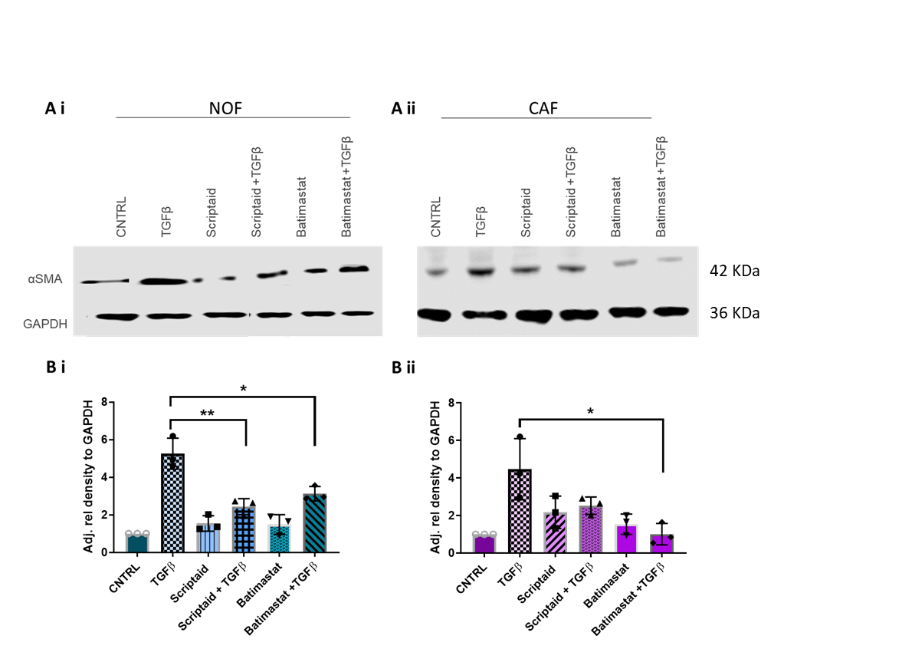

Figure 3.41 Immunoblotting for αSMA abundance in NOF and CAF in response to Scriptaid and Batimastat treatment with and without TGFβ-1 stimulation
NOF (A) and CAF (B) 2D monolayers were treated with the inhibitors Scriptaid and Batimastat in the presence or absence of TGFβ-1 for 48 h and aSMA protein levels determined using immunoblotting. Densitometry of the resultant bands were measured using ImageJ and intensity measured relative to GAPDH controls. Data is expressed as relative fold change, with mean ± SD, N=3, n=2, * denotes p <0.05 and ** p <0.01 analysed by unpaired Student’s T-test.

3.3.6.3 FN1-EDA expression in NOF and CAF in response to stromal-targeting drugs

Treatment of NOF cultures with Batimastat alone significantly reduced the expression of FN1-EDA by ~3-fold (0.31 ± 0.37) compared to NOF vehicle control samples, p=0.0010. Scriptaid in combination with TGFβ-1 reduced FN1-EDA expression (3.92 ± 2.25) compared to TGFβ-1 treatment alone at 48 h, p=0.0008 (Figure 3.42 A i + B i). However, Batimastat in combination with TGFβ-1 induced no significant changes in FN1-EDA expression compared to TGFβ-1 treatment alone.
In CAF cultures the addition of Scriptaid or Batimastat alone had no significant effects on FN1-EDA expression at 48 h when comparing to control. However, in combination therapy with TGFβ-1, a significant ~2-fold and ~3-fold reduction in FN1-EDA expression was observed with means of 0.79 ± 0.61, p=0.0463 for Scriptaid + TGFβ-1 and 0.50 ± 0.27 for Batimastat and TGFβ-1, p=0.0029 compared to TGFβ-1 treated cultures (Figure 3.42 A ii + B ii).

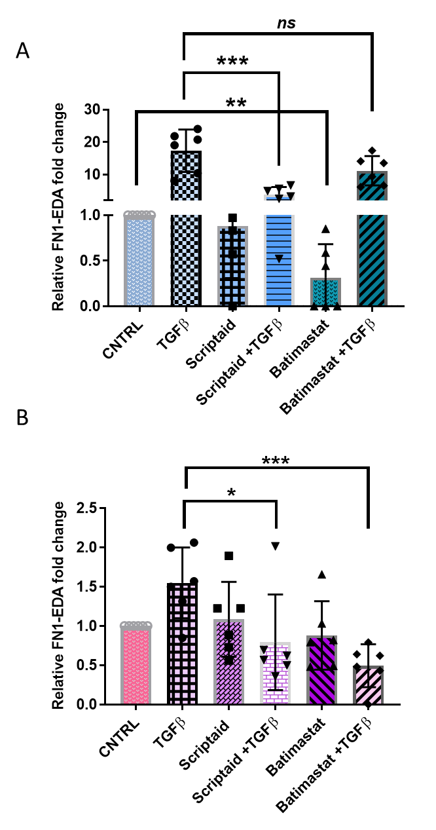

Figure 3.42 FN1-EDA gene expression in NOF and CAF in response to Scriptaid and Batimastat treatment with and without TGFβ-1 stimulation
NOF (A) and CAF (B) 2D monolayers were treated with the inhibitors Scriptaid and Batimastat in the presence or absence of TGFβ-1 for 48 h and the gene expression for FN1-EDA determined by qPCR. Data is expressed as fold change relative to housekeeping gene U6, with mean ± SD, N=3, n=2, * denotes p <0.05, ** p <0.01, and *** p <0.001 analysed by unpaired Student’s T-test.

3.3.6.4 FN1-EDA abundance in NOF and CAF in response to stromal-targeting drugs

In NOF cultures, Scriptaid treatment alone did not induce any significant changes in FN1-EDA abundance compared to control (Figure 3.43 A i + B i). The addition of Batimastat to NOF cultures for 48 h significantly reduced FN1-EDA protein by ~7-fold (0.16 ± 0.07), p=0.0003, compared to control samples. Both Scriptaid and Batimastat in combination with TGFβ-1 significantly reduced FN1-EDA protein by ~12-fold, (0.98 ± 0.53, p=0.0008), and ~22-fold (0.56 ± 0.49, p=0.0006), respectively, compared to TGFβ-1 treatment alone (12.56 ± 2.10). (Figure 3.43 A i + B i).
In contrast to NOF, CAF cultures treated with Scriptaid, showed a significant~2-fold reduction in FN1-EDA protein (0.44 ± 0.33) compared to control CAF cultures, p=0.0443 (Figure 3.43 A ii + B ii). Both Scriptaid and Batimastat in combination with TGFβ-1 showed significant ~11-fold (0.71 ± 0.55, p=0.002) and ~7-fold (1.1 ± 1.0, p=0.035) reduction, respectively, in FN1-EDA protein abundance when compared to TGFβ-1 treatment alone, (8.04 ± 1.70) (Figure 3.43 A ii + B ii).

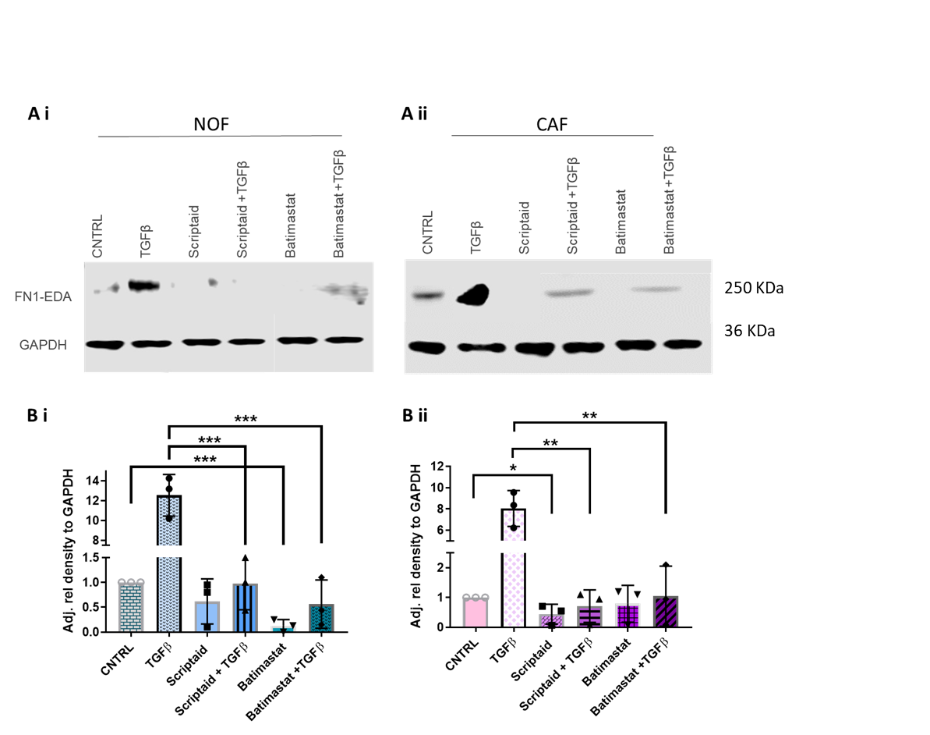

Figure 3.43 Immunoblotting for FN1-EDA abundance in NOF and CAF in response to Scriptaid and Batimastat treatment with and without TGFβ-1 stimulation
NOF (A) and CAF (B) 2D monolayers were treated with the inhibitors Scriptaid and Batimastat in the presence or absence of TGFβ-1 for 48 h and FN1-EDA protein levels determined using immunoblotting. Densitometry of the resultant bands were measured using ImageJ and the intensity measured relative to GAPDH controls. Data is expressed as relative fold change, with mean ± SD, N=3, n=2, * denotes p <0.05, **p <0.01, and p <0.001 analysed by unpaired Student’s T-test.

3.3.6.5 COL1A1 expression in NOF and CAF in response to stromal-targeting drugs

Scriptaid treatment alone had no effect on COL1A1 expression in NOF cultures compared to vehicle control NOF (Figure 3.44 A). However, a significant decrease in COL1A1 expression was observed with Batimastat treatment (0.55 ± 0.36) compared to vehicle control NOF, p=0.0122. Scriptaid in combination with TGFβ-1, induced a ~2-fold reduction in COL1A1 expression compared to TGFβ-1 treatment alone (4.97 ± 3.20), p=0.0490. Batimastat and TGFβ-1 treatment also significantly reduced COL1A1 expression, with a ~11-fold reduction observed, (0.45 ± 0.50), compared to TGFβ-1 treatment alone (4.97 ± 3.20), p=0.0064.
No differences in COL1A1 transcript expression were observed in CAF populations, when treated with Scriptaid and Batimastat alone compared to vehicle control CAF cultures, or in combination therapy with TGFβ-1 compared to TGFβ-1 treatment alone (5.68 ± 11.32) (Figure 3.44 B).

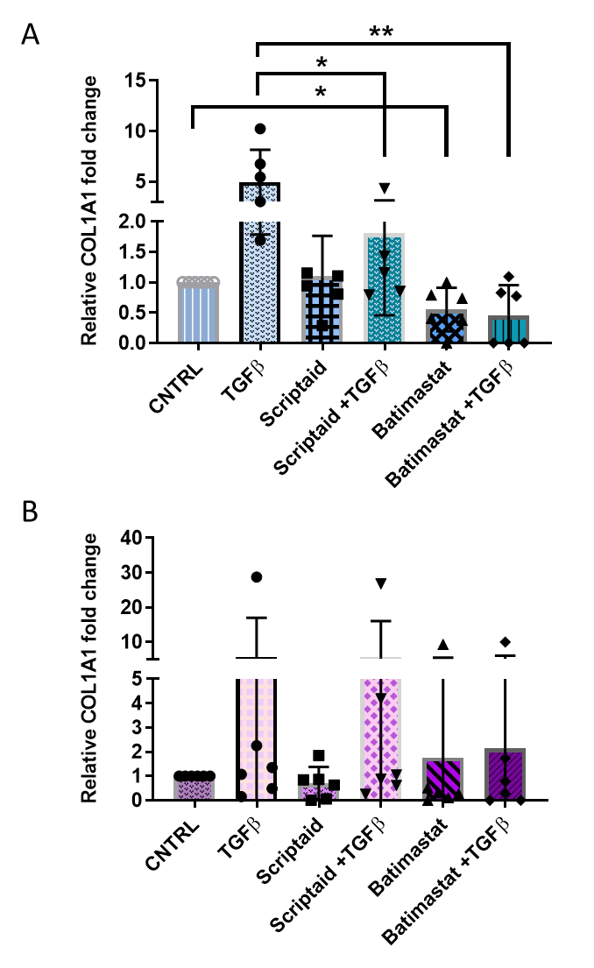

Figure 3.44 COL1A1 gene expression in NOF and CAF in response to Scriptaid and Batimastat treatment with and without TGFβ-1 stimulation
NOF (A) and CAF (B) 2D monolayers were treated with the inhibitors Scriptaid and Batimastat in the presence or absence of TGFβ-1 for 48 h and the gene expression for COL1A1 was determined by qPCR. Data is expressed as fold change relative to housekeeping gene U6, with mean ± SD, N=3, n=2, * denotes p <0.05, and **p <0.01 as analysed by an unpaired student’s T-test.

3.3.6.6 COL1A1 abundance in NOF and CAF in response to stromal-targeting drugs

In NOF cultures, Batimastat had no effect on COL1A1 protein abundance compared to vehicle control samples (Figure 3.45 A i- B i). A ~3-fold reduction in COL1A1 protein abundance was observed in NOF cultures in response to Scriptaid (0.27 ± 0.16) compared to vehicle control NOF cultures, p=0.0013. In combination therapy with TGFβ-1, no significant differences in COL1A1 abundance were observable. Batimastat in combination therapy with TGFβ-1 (1.27 ± 0.25) produced no significant difference in COL1A1 abundance compared to the effects of TGFβ-1 treatment alone (1.32 ± 0.37) (Figure 3.45 A i + B i)
In CAF cultures, the addition of Scriptaid and Batimastat alone resulted in no significant differences in COL1A1 protein, at 48 h, compared to vehicle control cultures (Figure 3.45 A ii + B ii). Scriptaid (0.94 ± 0.12, p=0.0193) and Batimastat (0.26 ± 0.15, p=0.0010) in combination with TGFβ-1, significantly reduced COL1A1 abundance, compared to TGFβ-1 treatment alone.

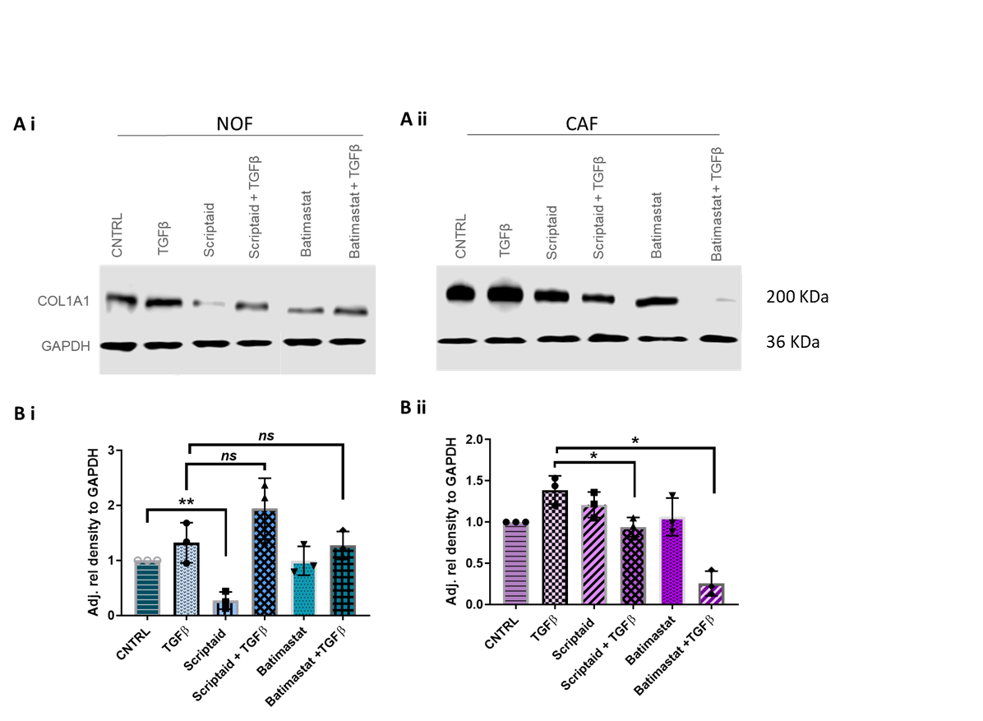

Figure 3.45 Immunoblotting for COL1A1 abundance in NOF and CAF in response to Scriptaid and Batimastat treatment with and without TGFβ-1 stimulation
NOF (A) and CAF (B) 2D monolayers were treated with the inhibitors Scriptaid and Batimastat in the presence or absence of TGFβ-1 for 48 h with COL1A1 protein levels determined using immunoblotting. Densitometry of the resultant bands were measured using ImageJ and the intensity measured relative to GAPDH controls. Data is expressed as relative fold change, with mean ± SD, N=3, n=2, * denotes p <0.05 and **p <0.01 as analysed by an unpaired student’s T-test.

3.3.7 Summary tables of NOF and CAF phenotyping in 2D

Findings for key gene and proteins expression changes for myofibroblast markers in NOF and CAF 2D cultures in response to TGFβ-1 (Table 3.1). NOF respond to TGFβ-1 up to 2 weeks in culture, with a reduced transcriptional regulation of myofibroblast markers long-term. CAF responded to TGFβ-1, but also showed elevated basal expression of all markers both short and long-term without exogenous stimulation.
Stromal-targeting drugs were successful in significantly reducing myofibroblast marker expression for both NOF and CAF 2D cultures when treated with TGFβ-1 (Table 3.2). CAF cultures treated with either Scriptaid/Batimastat in combination with TGFβ-1 showed a significantly reduction of FN1-EDA, COL1A1 and αSMA protein compared to untreated controls. Providing preliminary evidence for their use as possible OSCC therapeutics.
Table 3.1 Myofibroblast marker analysis
 |  | NOF |  | CAF
 | Marker | Gene | Protein | Gene | Protein
 | αSMA | **** | **** | ** | ***
Short-term TGFβ-1  Treatment | FN1-EDA | **** | **** | *** | ***
 | COL1A1 | **** | ** | * | *
 | TNC | **** | - | *** | -
 | VCAN | **** | **** | ** | ***
 |  | NOF |  | CAF
 | Marker | Gene | Protein | Gene | Protein
 | αSMA | ns | **** | **** | ***
Long-term TGFβ-1  Treatment | FN1-EDA | *** | **** | **** | *
 | COL1A1 | ns | **** | **** | ****
 | TNC | *** | - | ns | -
 | VCAN | ns | **** | **** | ***
Table 3.2 NOF and CAF response to stromal-targeting drugs
 |  | NOF |  | CAF
 | Marker | Gene | Protein | Gene | Protein
 | αSMA | ** | * | * | *
Batimastat +TGFβ-1 | FN1-EDA | ns | *** | *** | **
 | COL1A1 | ** | ns | ns | *
 |  | NOF |  | CAF
 | Marker | Gene | Protein | Gene | Protein
 | αSMA | * | ** | ns | ns
Scriptaid +TGFβ-1 | FN1-EDA | *** | *** | * | **
 | COL1A1 | * | ns | ns | *

3.4 Discussion

Understanding the phenotype of normal oral fibroblasts may provide evidence on the origins of CAF, how they are formed, and to what extent their transdifferentiation from resident fibroblasts may be regulated in the early stages of tumourigenesis (Lui et al., 2019, Alphonso and Alahari, 2009). In the tumour microenvironment CAF are the most abundant cell type and have been shown to aid malignancy and have pro-invasive capabilities that encourage tumour progression (Kalluri, 2016, Kalluri and Zeisberg, 2006). Their characteristics of promoting tumour progression are numerous and include, but are not limited to the following; ECM remodelling, compositional and mechanical alterations (topography and matrix stiffening), increased cellular invasion and migration, as well as a whole signalling repertoire that provides autonomous signalling feedback loops capable of altering the tumour microenvironment (LeBleu and Kalluri, 2018, Kalluri, 2016). Within OSCC, the presence of myofibroblast-like CAF are indicative as predictors of mortality in comparison to alternative prognostic characteristics including the tumour stage, the tumour grade and the lymph node status (Marsh et al., 2011). Their genetic stability makes them an attractive therapeutic target and understanding the roles they play in conferring stromal therapeutic resistance is of potential clinical benefit.
Resident fibroblasts found in normal tissue are considered indolent, have negligible metabolic and transcriptomic activity, sharing many similarities with mesenchymal stem cell precursors (Kalluri, 2016). In cancer, these fibroblasts are activated and are collectively known as CAF. Signals that activate fibroblasts into CAF in the tumour microenvironment are abundant and diverse. They are also dynamically modulated in various cancer types, thus generating difficulty in understanding to what effect this would have on CAF phenotype in vivo. Some of these common fibroblast-activating ligands include the TGFβ superfamily (Calon et al., 2014).
This chapter focussed on the molecular analysis of oral fibroblasts and evaluated the changes in the ECM deposited by both NOF and CAF, as well as establish markers of the activated fibroblast phenotype in response to TGFβ-1, a growth factor known to play a key role in CAF formation (Calon et al., 2014). Effects of TGFβ were examined in the short-term (24 h -72 h) and longer-term (up to 72 h + 14 days) to inform optimisation of conditions to generate biomimetic natural matrices reflecting different fibroblast phenotypes in subsequent chapters. In addition, the influence of potential stromal modifying drugs on the myofibroblast and CAF phenotypes were assessed to inform subsequent perturbation of biomimetic models.
Previous research has indicated that TGFβ-1; a growth factor that supports the differentiation of fibroblasts in vitro, as well as a deposition of fibrotic ECM proteins effectively assists in the initial stages of tissue remodelling, wound healing, and fibrosis (Chipev and Simon, 2002, Melling et al., 2018, Desmoulieré et al., 1993, Nithiananthan et al., 2017). In agreement with additional findings on growth factors responsible for the transdifferentiation of NOF to myofibroblast (myoFB); TGFβ-1 treatment induced an oral myoFB phenotype in vitro (Melling et al., 2018, Sobral et al., 2011, Desmoulieré et al., 1993). The ability of TGFβ-1 to induce myofibroblast transdifferentiation up to 72 h in vitro in primary human fibroblasts has previously been examined by Melling et al., using markers of the myofibroblast phenotype including αSMA, VCAN (V0 isoform) and FN1-EDA transcripts in which a time-dependent increase was observed in all transcripts analysed and corresponded to an increase in αSMA at the protein level as well as the appearance of αSMA-rich stress fibres. In agreement with these findings we also observed a significant up-regulation of the mRNA of target genes FN1-EDA, COL1A1, TNC, VCAN and αSMA in primary NOF treated with TGFβ-1. However, in this investigation, we also assessed the ability of NOF to maintain their phenotype in longer-term cultures.
In this study the expression of αSMA was significantly increased in NOF at 48 h with 5 ng/mL TGFβ-1 proving the optimal treatment for this cell type in culture. Cytoskeletal αSMA was also visualised by immunofluorescent analysis of NOF in vitro. Stress fibre formation was induced in TGFβ-1 treated NOF at 48 h and at day 7. A reduced stress-fibre formation was also observed longer term at day 7, although this was not quantified, it is likely a reflection of a sub-population of NOF reverting to a more indolent phenotype within long-term culture and could be due to reduced sensitivity to TGFβ-1 in vitro (Kalluri, 2016). No significant changes in αSMA expression were observed with long-term TGFβ-1 treatment, but αSMA protein remained detectable up to 72 h + 14 days in culture. This long-term proteomic expression may mean that αSMA protein may be upregulated to produce a more contractile phenotype over-time.
Myofibroblasts are major constituents of granulation tissue, and in wound healing a particular splice variant of fibronectin, the ED-A splice variant, is expressed ubiquitously (Serini et al., 1998). In vitro TGFβ-1 elevates the mRNA levels of fibronectin by increasing the expression of the EDA- isoform (Borse et al., 1990). In NOF the short-term supplementation of this cell type with TGFβ-1 elevated FN1-EDA expression. The expression of FN1-EDA and the protein equivalent remained higher in the TGFβ-1 treated groups long-term compared to control treated groups suggesting that NOF retained some capacity to respond to growth factors up to two weeks in vitro.
COL1A1 expression was upregulated in NOF with TGFβ-1 treatment; with basal levels expression of COL1A1 higher in longer-term cultures compared to short-term. COL1A1 protein deposition was significantly upregulated with time, and as the major protein contributor to ECM composition, this myofibroblast-derived collagen production is essential for the regulation of tissue architecture. However pathological deposition can lead to matrix stiffness, a contributory factor to tumour progression, which makes this an ECM protein of interest for its relevance in OSCC development (Discher et al., 2005, Seewaldt, 2009, Hinz, 2009, Coughlin et al., 2013 and Chaudhuri et al., 2014).
TNC is not abundantly expressed in normal tissue however a de novo deposition of has been observed in OSCC in situ and is a result of an invasive carcinoma cell phenotype (Hindermann et al., 1999 and Berndt et al., 2015). In NOF the TNC transcript was significantly increased with TGFβ-1, suggesting that TGFβ-1 induced some of characteristic features of CAF expression, which is an elevation in TNC expression. No protein was detected by immunoblotting with 10 µg of protein lysate (blots not shown) and therefore no further protein analysis for TNC was investigated in this phenotyping study.
Another protein marker used for analysis in NOF was the large proteoglycan VCAN. Previous reports have observed the expression of VCAN in dermal, gingival and mammary fibroblasts (Melling et al., 2018 and Thaŝiangela et al., 2007). Within the ECM it provides structural stability and support and sequesters growth factors. VCAN abundance and activity is exacerbated in disease physiology thereby, having a dual role in cellular adhesion, cellular proliferation, cell migration and cell matrix assembly (Yueng et al., 2013, Riccardelli et al., 2009). Within NOF samples, the short-term protein abundance of VCAN was highest with TGFβ-1 treatment at 72 h. However, this abundance increased up to 24-72 h + 14 days and was visible in both controls and TGFβ-1 treated samples, which might be reflective of a fibrotic response long-term in 2D with this particular cell type. In the literature it is known that VCAN expression is upregulated in lung fibrosis and in cancer; In vitro data has implicated VCAN expression inhibits the deposition of elastin long-term (Huang et al., 2006).
To confirm, NOF can be transdifferentiated into activated fibroblasts, by exogenous TGFβ-1 treatment with a phenotypic response that can be maintained up to 2 weeks in vitro, which is validation for the use of these NOF to develop native ECM scaffolds that represent normal ECM characteristics in the successive chapter.
To ascertain whether a similar or different response were observed for native CAF, primary CAF were isolated from OSCC tumour tissue and their responses to short and long-term exogenous TGFβ-1 treatment (5 ng/mL) also analysed. CAF are implicated to be a heterogeneous cell type, making them difficult to phenotypically characterise (Kalluri, 2016, Sugimoto et al., 2006). This provides researchers with a significant caveat for replicating the in vivo phenotype of such a diverse stromal cohort. This further emphasises that research should focus on advancing in single cell isolation techniques in order to refine the ‘selection’ of markers in CAF (Lui et al., 2019). Tabib et al., 2018 performed single-cell transcriptome analysis of cells obtained from whole skin. Two major fibroblast populations were identified by the expression of secreted-frizzled related protein-2 (SFRP2/DPP4) and (Flavin-containing monooxygenase-1 (FMO1/LSP1) markers and minor fibroblast populations were also acknowledged using COL1A1, PRG4, ANGPTL7, and SFRP4. This scRNA-seq data highlights the heterogeneous picture of fibroblast composition and functionality in the human dermis, but questions still remain as to how these subpopulations of fibroblasts react to the tumorigenic process in OSCC and how do oral fibroblasts evolve into myofibroblasts or CAF.
Analysis of αSMA expression in CAF populations showed a significant difference at 48 h with treatment of TGFβ-1 however basal expression levels of αSMA was high in all CAF controls. This was not comparable to NOF, were basal expression was lower; the presence of αSMA protein in NOF controls, may be indicative of de novo activation cascades by culture conditions (Kalluri, 2016). αSMA protein was present in all samples in the presence or absence of TGFβ-1 and this was confirmed by immunofluorescence staining for αSMA. These αSMA+ fibres were observable in CAF in both untreated controls as well as with TGFβ-1 treatment at 48 h and at day 7; suggesting that stress fibre formation is a common phenotypic trait in un-stimulated CAF as they are constitutively active in vitro. Long-term RT-qPCR analysis indicated that in the presence of TGFβ-1 both the gene expression and protein abundance of αSMA was increased in these samples. It is plausible, that this is due to a rapid translation of the target transcript into protein long-term, thus aiding a more contractile phenotype, which is in agreement with other studies on CAF contractility in tumour progression (Albrengues et al., 2015 and Kalluri, 2016).
Fibronectin has been shown to play a central role in processes associated with tumour progression. The increase in cellular fibronectin is indicative of CAF phenotype (Kalluri 2016, Melling et al., 2018, Klinberg et al., 2018) and can promote the invasiveness of cancers; fibronectin-rich cell-derived matrices (CDM) isolated from CAF cultures, but not normal fibroblast (NF) cultures, have been shown to exhibit aligned fibre organisation and which promoted directional cancer cell migration (Erdogan et al., 2019). We observed that the expression of FN1-EDA was increased in CAF basal controls compared to NOF, indicating discrete phenotypic differences in the NOF and CAF investigated in vitro. In the long-term analysis, the protein abundance of FN1-EDA reduced in NOF controls but remained detectable in CAF controls and this long-term protein expression could be associated with a long-term fibrotic response by CAF. FN1-EDA expression in dermal normal fibroblasts and CAF has been associated with acting as a storage reservoir for TGFβ-1 as it immobilises latent TGF-β-binding protein-1 (LTBP-1) (Klinberg et al., 2018). This mechanism could also be applicable to the phenotype of the oral CAF described here.
Collagen type 1 is the most widely expressed protein in humans, responsible for maintaining the structural integrity of the cells (Ralston et al., 1997). During cancer where a desmoplastic response is triggered and mediated by CAF, the deposition of collagen is elevated (Provenzano and Hingorani, 2013, Kalluri, 2016, Hanley et al., 2016). In vitro molecular analysis of COL1A1 expression in CAF shows only a significant change in COL1A1 short-term with 48 h TGFβ-1 treatment and a high basal expression of this sub-type of collagen in all vehicle control treated samples, suggesting a ubiquitous expression of the target in all CAF populations. This was also observed for protein abundance short-term, where there was no statistical difference in COL1A1 protein with TGFβ-1 treatment, and prominent banding for the protein in all CAF samples. Long-term expression analysis was highly variable, but again the protein was visible in all CAF samples suggesting that COL1A1 deposition in a phenotypic feature of CAF in culture regardless of exogenous stimuli.
Tenascin-C expression in CAF is observed upregulated in pathological stroma with a previous study in salivary glands tumours, showed TNC expression to be heterogeneous with the highest expression associated with poorly differentiated and malignant features (Raitz et al., 2003, Berndt et al., 2015). TNC, expression was therefore analysed at the transcript level. Within CAF, controls exhibit high gene amplification and the expression was maintained long-term with and without TGFβ-1 treatment. One explanation could be that CAF universally express TNC. This active transcription by CAF populations differs to our observation in NOF; where TNC transcript expression only increased with the addition of TGFβ-1. Evidence for the active translation of TNC would be a beneficial observation in our CAF samples. No TNC protein was detectable at a protein concentration of 10 µg. This may be due to the susceptibility of TNC to degradation by MMP and therefore immunoblotting for degraded fragments may also be indicative of transcribed protein in CAF samples.
VCAN plays a role in proliferative signalling, evasion of growth suppressor signalling, promotion of tissue invasion and metastasis, angiogenesis, and resistance to cell death by interacting with growth factors and cytokines to modify their activity and involvement in the cancer response (Wight, 2002). VCAN expression was observed in both CAF controls and significantly upregulated long-term with TGFβ-1 treatment. This was also reflected in the translation into its protein equivalent with its abundance increased in CAF samples both shot and long-term. This is in agreement with the current literature indicating an aberrant VCAN functionality and indicative of activated CAF phenotype in OSCC (Melling et al., 2018, Pukkila et al., 2002 and Mulini et al., 2017).
To confirm, CAF were capable of maintaining a myofibroblastic phenotype for up to 72 h + 14 days in culture in the absence and presence of TGFβ-1, with increased expression and abundance of all myofibroblast markers. The molecular differences detectable between the NOF and CAF cultures studied here, although from un-matched patient tissue, provide evidence for the distinct phenotypic changes observed between NOF and CAF. Evidence that the oral fibroblasts studied here, are capable of depositing ECM in long-term cultures, thus, validating their suitability to be further engineered into scaffolds, formed by deposition of their native ECM.
Mechanisms of drug resistance in cancer conferred by the stroma is the result of the modulation of pathways involving cancer cell-ECM interactions, CAF-ECM adhesions as well as CAF signalling (Kalluri, 2016). Therefore, targeting the pathways or processes that lead to the activation of fibroblasts into a myofibroblast phenotype, could be an effective therapeutic target. The conversion of non-CAF into CAF is an irreversible process that occurs through the corresponding action of transcriptional activators/repressors, as well as a repertoire of genome-wide epigenetic reprogramming mediated by miRNAs and DNA/histone modifying enzymes including histone deacetylases (HDACs) (Kim et al., 2018, Kalluri, 2016, Zeisberg and Zeisberg, 2013, Mrazek et al., 2014, Li et al., 2015). Scriptaid, a HDAC inhibitor selective for HDAC 1, 3 and 8 has been shown to reverse human CAF-features, including their enhanced contractility, abundant ECM expression, and TGFβ pathway activation (Kim et al., 2018), but the effect of Scriptaid on reversing the myofibroblastic phenotype in oral fibroblasts has not previously been reported. Batimastat, a broad spectrum MMP inhibitor, has shown efficacy in reducing the stromal burden in tumourigenesis by inhibiting MMP activity in vitro and in vivo (Zobier et al., 2001, Brown and Giavazzi, 1995, Sledge et al., 1995, Low et al., 1996). The effects of which, have not been investigated in oral CAF.
Here we have used NOF and bona fide oral CAF to explore the epigenetic pathways that promote non-CAF to CAF conversion, as well as the effect of inhibiting native proteases in the presence and absence of TGFβ-1. No significant differences in expression or abundance was observed for the myofibroblast markers in NOF cultures treated with Scriptaid. This evidences that the NOF studied here are epigenetically stable cells, with a reduced sensitivity to the HDACi. In culture at 48 h NOF showed sensitivity towards treatment with Batimastat, where FN1-EDA and COL1A1 transcript expression were significantly reduced (p <0.05). Batimastat targets MMPs and the reduced FN1-EDA protein observed with TGFβ-1, implicates its role in providing regulatory activity (Margulis et al., 2009). COL1A1 protein abundance did not significantly alter in response to inhibitor treatment in combination with TGFβ-1, but Scriptaid in combination with TGFβ-1 significant reduced FN1-EDA and αSMA protein in NOF cultures compared to TGFβ-1 treatment alone, evidencing myoFB as targets.
In contrast, 2D CAF cultures, showed sensitivity to Batimastat in combination with TGFβ-1, in which αSMA, FN1-EDA, and COL1A1 protein abundance, reduced significantly, compared to CAF in the presence of TGFβ-1 alone. The role of TGFβ-1 in MMP regulation has been well established (Jabłońska-Trypuc et al., 2016), and therefore in the presence of TGFβ-1, Batimastat may be exhibiting an inhibitory effect. Scriptaid treatment did not significantly alter transcript expression in CAF cultures at 48 h. FN1-EA protein significantly reduced in its presence, as well as reducing when the HDACi was used in combination therapy with TGFβ-1. This was also observable for COL1A1 protein, which also visibly reduced. These preliminary results indicate that, Scriptaid and Batimastat may be reversing some CAF phenotypic traits in 2D at 48 h and should be further investigated. Some of the non-significant changes in protein abundance in CAF as a result of Scriptaid treatment may be improved with altering the time-course of treatment. Longer-term treatment time-points would give additional information on the permanency of these results and their application for dosage regimens in in vivo studies. Further work into targeting the stroma will be analysed the subsequent chapter.
Although, similarities and differences in phenotype have been assessed for NOF and CAF, these samples were isolated from different patients and therefore, these investigations can only direct our understanding of very broad differences in phenotype. Future work assessing patient matched NOF and CAF would allow directly comparable analysis of changes in gene transcripts and would help distinguish molecular pathways involved in NOF to CAF conversion. Another caveat of the above experimental analyses on NOF and CAF is that these in vitro studies are hampered by the susceptibility of alterations in gene expression caused by culture conditions and therefore understanding the phenotypic changes between NOF and CAF would benefit from more physiological in vitro model systems. Therefore, investigating the molecular profile of these cells and their ‘secretome’ in a 3D environment is a much more relevant culture system and forms the foundation of the next chapter.
In summary, TGFβ-1 stimulates the transdifferentiation of patient NOF into myofibroblasts in vitro and is characterised by upregulation of myofibroblasts markers (αSMA, FN1-EDA, TN-C, COL1A1, VCAN) indicative of a role for TGFβ-1 as a potential paracrine growth factor capable of inducing phenotypic change in resident NOF in OSCC. Analysis of these transcripts in patient CAF shows a distinct phenotypic expression in which higher levels of myofibroblasts markers and ECM transcripts were observed without the requirement for exogenous stimulation, this in contrast to NOF, suggesting a that the ‘secretome’ of CAF is fundamentally altered to exhibit the desmoplastic response observable in OSCC. As CAF showed sensitivity to treatment with inhibitors in 2D, the potential for stromal targeting, will be further investigated on the fibroblast-derived matrices generated in the next chapter.

Chapter 4

Development and characterisation of tissue-engineered fibroblast-derived matrix from normal and cancer-associated oral fibroblasts

4.1 Introduction

The premise of tissue engineering is the development of regenerative and growth techniques for whole organs and/or connective tissues using a combination of both cells and a scaffold-based material (Kim et al., 2016). These engineering methods require an adequate environment and geometry for cells to be grown and functionalised. Scaffold technology provides the foundation support for cells and can be generated using an array of methods including polymer chemistry (Villanueva et al. 2009, Weigel et al., 2006, and Knight et al., 2011) as well as using human/animal-derived ECM (Holliday et al., 2009, Kleinman et al., 1986, Berning et al., 2015, Salo et al., 2015). This structural support along with the addition of growth factors provide a suitable 3D environment for cells and aid the construction of tissues.
Of these scaffolds, human-derived ECM, which contains a native heterogeneous connective network, composed of fibrous proteins, glycoproteins, glycosaminoglycans and smaller interacting molecules would be the most suitable. Providing adequate physiological, biochemical, biophysical, and mechanical support for tissue homeostasis (Walker et al., 2018). Tumour activation of host stroma occurs via the desmoplastic response; a fibrotic state that is characterised by an abnormal organisation and composition of ECM proteins (Lu et al., 2012). This desmoplasia affects cancer progression by supporting cellular transformation and metastasis, facilitates sustained angiogenesis and maintains a pro-inflammatory response, leading to the generation of a tumour permissive microenvironment (Gkretsi and Stylianopoulos, 2018). Chapter 3 provided evidence of NOF and CAF-deposited ECM in 2D, however the extent to which oral CAF can deposited ECM for the use as an oral mucosal scaffold in cancer has yet to be determined. Therefore, generation of an all human-CAF derived ECM would be an advantageous scaffold type to study tumour: ECM interactions in an OSCC tumorigenesis model.
This chapter describes the development of a novel methodology for constructing oral fibroblast ECM equivalent, describing the development and characterisation of NOF- and CAF-derived matrices (NOF/CAF-DM). This will establish their usefulness as cell-derived ECM scaffolds, and evaluate their potential use as a scaffold to generate full thickness oral mucosa equivalents in the subsequent chapter.
The specific sub-aims of this chapter are as follows:
- Using NOF and CAF, develop novel tissue-engineered in vitro human ECM mimetics to examine differences in the matrix produced by both cell types.
- Characterise these fibroblast-derived matrix (FDM) using immunoblotting, histology, immunohistochemistry and second harmonic generation microscopy.
- Examine the ultrastructure features of FDM using scanning electron microscopy (SEM).
- Investigate the mechanical properties of the ECM using atomic force microscopy (AFM).
- Investigate FDM remodelling capabilities by examining MMP activity using zymography.
- Stroma targeted drug screening platforms by investigating the effects of drugs Batimastat and Scriptaid, on reversing the phenotype of pathological stroma in CAF-DM and the use of FDM as.

4.2 Materials and methods

To stimulate native ECM production by NOF and CAF in 3D, various culture techniques will be evaluated to produce maximum ECM deposition, analysed by matrix thickness measurements (section 2.2.10.3) and assessment of structure by H&E (section 2.2.8). The use of a transwell system and various media conditions, outlined further in results section 4.3.1, will describe the novel design methodology for these natural cell-produced scaffolds. To assess the viability of FDM cultures long-term, fibroblast metabolism over-time will be assessed by standardised presto blue assay (section 2.2.10.1). Matrix integrity will be investigated by transepithelial electrical resistance, measured across matrix surface (section 2.2.10.2). Characterisation methodology of FDM will be assessed using various microscopy techniques. Biomechanical properties of FDM will be evaluated using atomic force microscopy to measure stiffness (section 2.2.11.4). Collagen structure will be achieved using laser-scanning second harmonic generation microscopy and the fibrillar structure analysed by CureAlign, LOCI, and CtFIRE software (section 2.2.11.3). Ultrastructure of FDM will be assessed by analysis using SEM (section 2.2.11.2). The protein composition of FDM will be characterised using Western blot methodology for αSMA, COL1A1, FN1-EDA, VCAN and LAMB-5 (sections 2.2.9.1-4). The remodelling capabilities of NOF- and CAF-DM will be achieved through analysis of the enzymatic activity of MMP-2 and MMP-9 by zymography (2.2.9.7). The NOF- and CAF-DM response profile, after a 21-day culture period, to treatment with stromal–targeting drugs (Scriptaid and Batimastat) will be analysed in presence and absence of TGFβ-1 by RT-qPCR (section 2.2.7.11-12) and immunoblotting (section 2.2.9.1-3) for αSMA, COL1A1 and FN1-EDA. The following experimental procedures described in this chapter and the corresponding materials and methods used are further outlined in Figure 4.1.

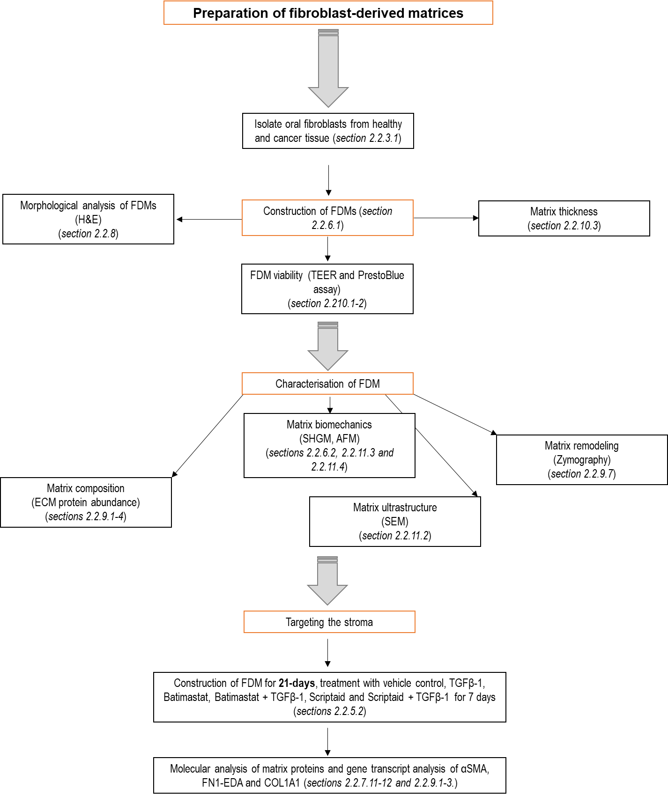

Figure 4.1 Schematic of materials and methods
3 Stewart DA, Cooper CR, Sikes RA. Changes in extracellular matrix (ECM) and ECM-associated

4.3 Results

4.3.1 Design methodology for generation of tissue engineered fibroblast-derived matrices

To effectively tissue-engineer a human stromal compartment that resembles the ECM found in normal oral and cancer tissue, three batches of human primary NOF and CAF were isolated and fully characterised as described in chapter 3. In order to maintain them in a long-term culture required for matrix deposition, a transwell culture set-up was optimised; providing an ideal system for effective nutrient transfer.
Firstly, FDM were generated by culturing NOF and CAF in oral fibroblast media (10% DMEM) in submerged conditions for 28 days with 2-phospho-L-ascrobic (200 µg/mL) supplemented at every media change. H&E analysis revealed that this media alone was insufficient to produce matrices of a thickness greater than a few cell-layers, and only a small abundance of ECM deposition was observed by eosin staining (Figure 4.2 A-B).
In an attempt to increase ECM deposition from oral fibroblasts, the media was further supplemented with TGFβ-1 (1 ng/mL); shown to induce ECM deposition in vitro, as evidenced in chapter 3, as well as 2-phospho-L-ascorbic (200 µg/mL). Cells were submerged for the entire culture period. After 28 days, H&E staining indicated that although cell monolayers were intact across the insert surface for both NOF and CAF, they failed to exhibit ECM deposition more than a few cell-layers thick (Figure 4.2 C-D).
In order to improve FDM thickness, an alternative nutrient enriched FDM media was investigated which consisted of DMEM: F-12 mix supplemented with 10% FBS, and insulin. After seeding, cells were kept submerged for 7 days, after which the media within the insert was removed and the cell monolayer raised to an ALI for a further 21 days. The effects of further media supplementation with the growth factors TGFβ-1 (1 ng/mL), EGF (2.5 ng/mL) and bFGF (5 ng/mL) was also assessed. After a 28-day culture period in FDM culture media matrix development by both NOF and CAF was assessed histologically by H&E staining (Figure 4.2 E-H). The amount of tissue-engineered (TE)-FDM deposited using these culture conditions was enhanced with a sufficient level of ECM deposition that formed consistently across the whole insert (with some limited contraction exhibited in CAF matrices (Appendix Figure 7.4) and with evidence of viable fibroblasts dispersed throughout the matrices (Figure 4.2 E-H).
NOF matrices were consistent in their appearance with and without the addition of growth factors; they appear highly regular and intact, with fibroblasts distributed through-out the section (Figure 4.2 E+F). The CAF matrices exhibited a more disordered architecture and showed a denser distribution of ECM; highlighted by the eosin staining (Figure 4.2 G-H). Fibroblasts tended to reside at the apical and basal surfaces (Figure 4.2, black arrows).

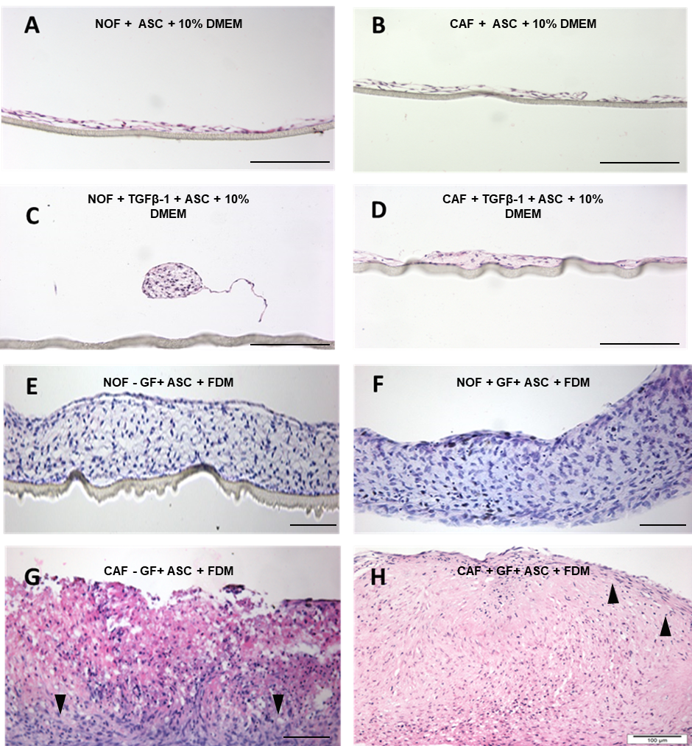

Figure 4.2 Morphology of NOF and CAF tissue-engineered fibroblast-derived matrices in different culture conditions
Using different culturing media and techniques TE-FDM deposition was assessed by H&E staining. After a 28-day culture period in oral fibroblast media (10% DMEM) with 2-phospho-L-ascorbic acid (ASC) for NOF (A) and CAF (B). Oral fibroblast media with 2-phospho-L-ascorbic acid supplementation and addition of TGFβ-1 alone to the media did not improve long-term deposition in NOF (C) or CAF (D). Enriched media sustained the long-term development of NOF-DM without growth factors (E) and NOF-DM with growth factors (F). Enriched media sustained the long-term development of CAF-DM without growth factors (G) and CAF-DM with growth factors (H). Scale bars= 100 µm (N=3, n=3).

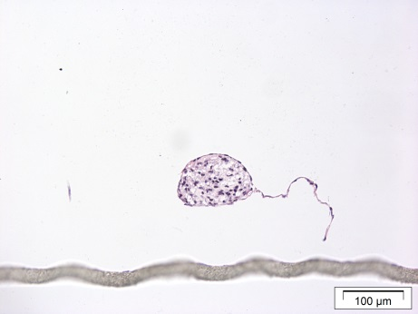
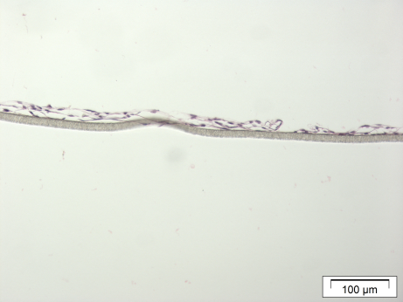
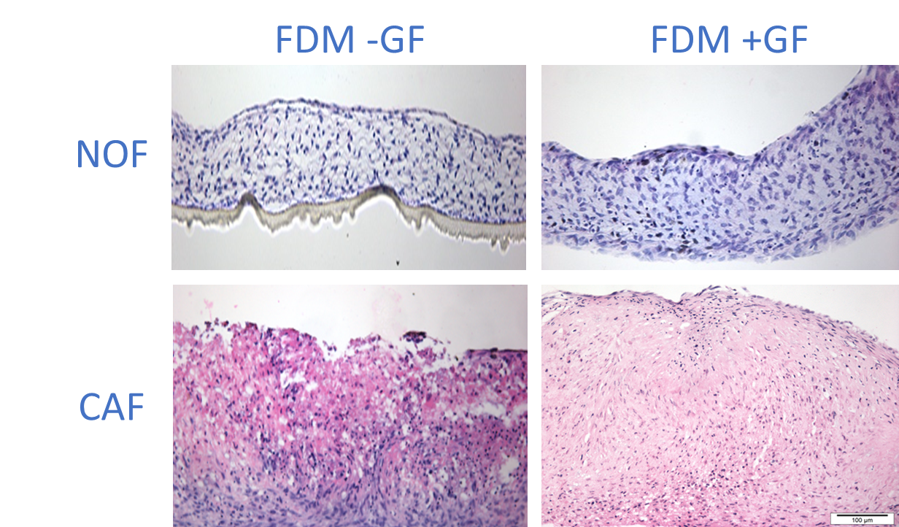
4.3.1.1 Analysing fibroblast-derived matrix thickness
A
B
C
D
E
F
G
H

To quantitatively assess matrix deposition and reproducibility of TE-FDM developed, ECM thickness was measured after 28 days and differences in thickness between NOF and CAF with and without growth factors supplementation was compared. Analysis of matrix thickness using ImageJ measurement software on H&E stained images of 28-day FDM showed a significant difference in thickness between NOF and CAF matrices (Figure 4.3).
NOF-DM without growth factors had a mean thickness of 109 ± 24.08 µm. On addition of growth factors NOF-DM thickness increased to an average of 146 ± 48.38 µm. CAF-DM without growth factors were nearly double the thickness of NOF-DM without growth factors with a mean of 202 ± 10.92 µm, p=0.0177 and an increase in matrix thickness with a mean of 370 ± 13.44 µm, p=0.0128 when supplemented with growth factors (Figure 4.3).
As CAF ECM deposition in TE-FDM without the requirement of growth factors was significantly increased compared to NOF without growth factors matrices, growth factor supplementation for CAF matrices was not used in further experimentation.

Figure 4. Micrographs of fibroblast-derived matrices
Micrographs from SEM analysis evidence that both the NOF/CAF-derived matrices formed an intact matrix layer with surface proteins dispersed among the topographic landscape and evidence of ECM deposition (A-F). Fibroblasts populate the matrix as well as reside on the external surface of the developed matrices (Broken white square B). Dense webs of fibrillar ECM and meshwork is found through the constructs (Solid white boxes, C-D). Larger fibres are also present suggesting that mature collagen complexes are also able to be formed (White arrows, D). Images taken at 1000x (A-B) and 6000x magnification (C-F). (N=3, n=2).

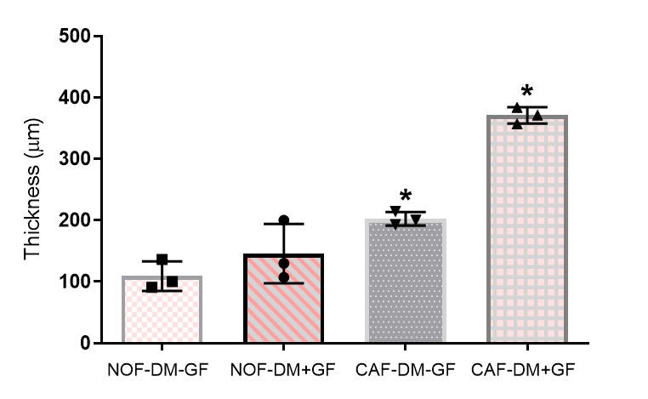

Figure 4.3 Variations in fibroblast-derived matrix thickness
The thickness of FDM deposition was measured using ImageJ measurement plug-in after 28 days for NOF-DM-GF, NOF-DM+GF, CAF-DM-GF and CAF-DM+GF. Data presented shows mean ± SD (N=3, n=3) and analysed using a non-parametric one-way ANOVA with a post-hoc Dunnett’s comparison test comparing to NOF-DM-GF, * denotes p <0.05.

4.3.1.2 Tissue-engineered fibroblast-derived matrix viability

4.3.1.2.1 Testing the integrity of developing tissue-engineered fibroblast-derived matrices

The transepithelial electrical resistance (TEER) of the developing matrices was measured every 2 to 3 days for a period of 28 days to monitor TE-FDM integrity under the different culture conditions investigated. Three areas across the developing models were measured and the average resistance calculated for each sample. A blank insert measurement was calculated and subtracted from readings to obtain the true tissue resistance. NOF-DM without growth factors (-GF) had an average resistance of 43.27 ± 8.07 Ω.cm² which increased to 55.80 ± 10.95 Ω.cm² with the addition of growth factors (+GF). In comparison, CAF-DM without growth factors displayed a similar average resistance of 52.73 ± 11.94 Ω.cm². These trends showed that the developing matrices with and without growth factors produced an intact monolayer 24 h after seeding and consistent resistance readings with no significant differences in TEER for each FDM up to 28 days; which supports that cultures are able to maintain a form of resistance barrier irrespective of cell type and treatment (Figure 4.4).
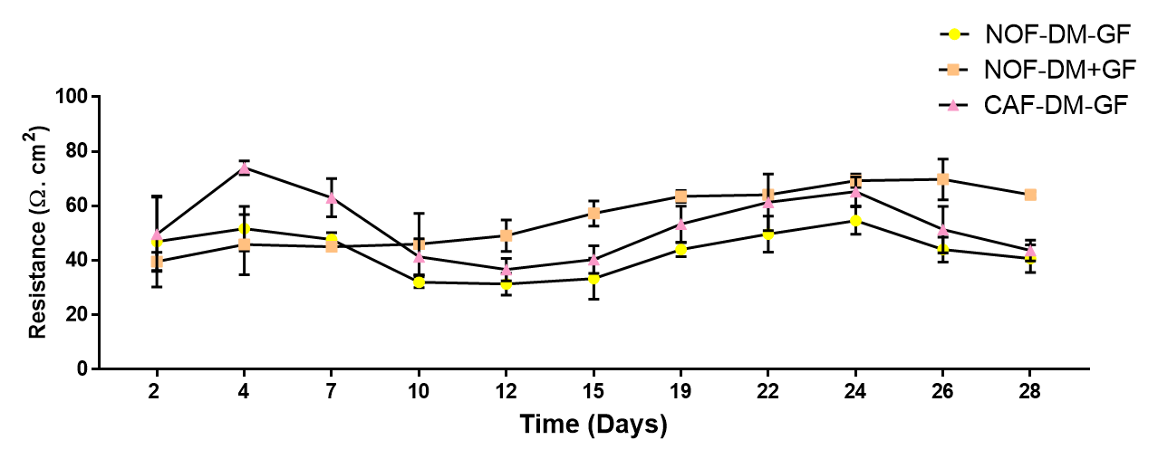

Figure 4.4 Transepithelial electrical resistance of developing fibroblast-derived matrices
Transepithelial electrical resistance was calculated over a 28-day period on developing matrices. Circle denotes NOF-DM-GF, Orange Square denotes NOF-DM+GF and pink triangle denotes CAF-DM-GF. Data is presented as mean ± SD (N=3, n=2) and was ns as analysed by ordinary one-way ANOVA with Dunnett’s multiple comparison.

4.3.1.2.2 Analysing fibroblast-derived matrix metabolism

Using a resazurin based assay, a time-course experiment to analyse metabolic changes of the developing matrices over 28 days was completed and was used as an indirect measure of cell number to assess whether the change in matrix deposition was a result of differing cell numbers overtime. Readings were taken every 2-3 days for NOF-DM-GF, NOF-DM+GF and CAF-DM-GF after incubation with PrestoBlue® (Figure 4.5).
All cultures metabolised consistently during the time course with no significant differences between the groups investigated. From day 2 to 8 a slight increase was observed in the cell metabolism in NOF and CAF and was likely a result of proliferation before cells experience contact inhibition. We observed that NOF-DM-GF had a mean fluorescence of 37507 ± 4937 a.u, and the addition of growth factors caused an increase in metabolism with a mean fluorescence of 40753 ± 4386 a.u.
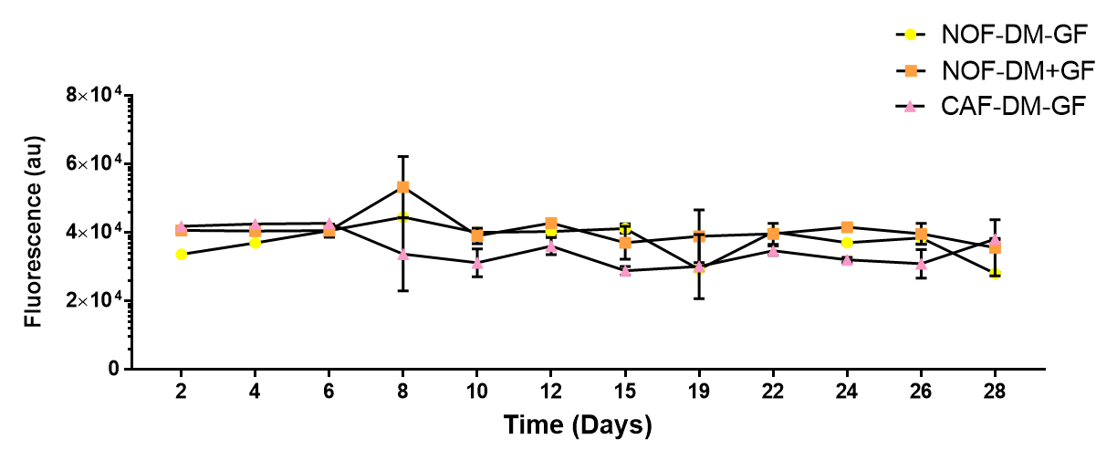
Interestingly, the CAF-DM metabolised at a lower rate with a mean intensity of 35206 ± 5016 a.u. These results indicate that the fibroblasts depositing the matrices remain metabolic for up to 28 days in culture with no significant increase in cell number (Figure 4.5).

Figure 4.5 Metabolic activity of fibroblasts in TE-FDM over 28 days
Cell metabolism was calculated over a 28-day period from different fibroblast cultures used to generate matrices using resazurin-reduction assay measured spectrometrically. A steady metabolism was calculated over 28-days in culture for NOF-DM-GF (yellow circle), NOF-DM+GF (orange square) and CAF-DM (pink triangle) Data is presented as mean ± SD (N=3, n=2) and was ns as analysed by ordinary one-way ANOVA with Dunnett’s multiple comparison.

4.3.2 Tissue-engineered fibroblast-derived matrix characterisation

4.3.2.1 Ultrastructure analysis of fibroblast-derived matrix architecture

In order to visualise the native ECM on the microscale; SEM was used. This technique highlighted matrix microstructure and topographical development after a 28-day development time for both NOF-DM and CAF-DM (Figure 4.6). At 1000x magnification there was no visible difference in the surface topography of NOF-DM and CAF-DM, as displayed in the micrographs (Figure 4.6 A+D). There is evidence of intact layer structure with dense ECM deposition (Figure 4.6 A-F).
Even after a 28-day culture period there remains evidence of oral fibroblasts populating the matrix and surface protein structures clearly visible (Figure 4.6 D). Magnified micrographs at 6000x showed prominent matrix structures which have formed a dense web of ECM material (Figure 4.6 B, C + E). Intact meshwork of microfibres as well as larger fibrillar structures are also present, suggesting that higher order protein structures are present within TE-FDM (Figure 4.6 E).

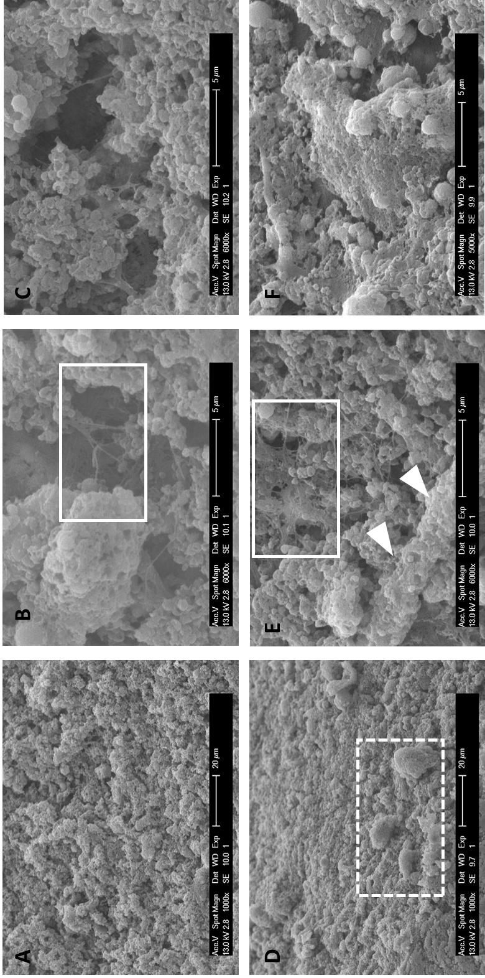

Figure 4.6 SEM micrographs of oral fibroblast-derived matrices
SEM micrographs evidence that both the NOF-DM and CAF-DM formed an intact matrix layer with surface proteins dispersed among the topographic landscape and evidence of ECM deposition (A-F). Fibroblasts populate the matrix as well as reside on the external surface of the developed matrices (Broken white square D). Dense webs of fibrillar ECM and meshwork is found throughout the constructs (Solid white boxes, B+E). Larger fibres are also present suggesting that mature collagen complexes are also able to be formed (White arrows, E). Images taken at 1000x (A+D) and 6000x magnification (B, C, E+F) (N=3, n=2).

4.3.2.2 Matrix composition

4.3.2.2.1 ECM protein abundance in fibroblast-derived matrices

Although the SEM and histochemical staining revealed evidence of protein deposition, to further analyse the composition of the matrix, the matrices were solubilised and analysed by Western blot was conducted to identify a number of key ECM proteins including those shown to be detectable in 2D NOF and CAF cultures (evidenced in chapter 3). αSMA, FN1-EDA, VCAN, COL1A1 and LAM-5 (γ-2 Chain) abundance was investigated from protein lysates isolated from NOF-DM-GF, NOF-DM+GF, and CAF-DM. This analysis of ECM constituents provides evidence of FDM components and how these alter with disease in OSCC.

4.3.2.2.1.1 αSMA protein abundance in fibroblast-derived matrices

αSMA is expressed by myofibroblasts and CAF making it an indicator of fibroblast transdifferentiation; and is upregulated in the stroma of OSCC. The presence of αSMA, detected as a band of 42 kDa, were observed in all samples (Figure 4.7 A). Densitometry revealed that αSMA abundance was 7.01 ± 2.55-fold higher in the NOF-DM when growth factors were added (p=0.0290) and significantly increased in CAF-DM with a 28.17 ± 2.90-fold increase in αSMA abundance was observed when compared to NOF-DM-GF (p <0.0001) (Figure 4.7 B).
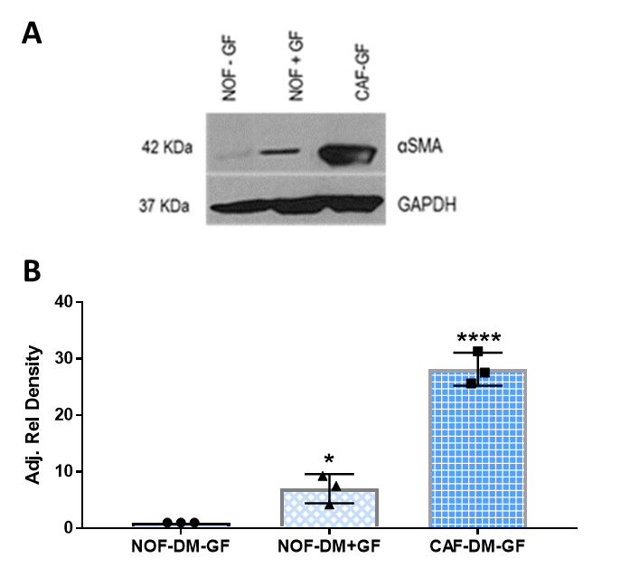

Figure 4.7 αSMA abundance in fibroblast-derived matrices
A representative immunoblot shows that αSMA is detectable in all FDM, with a reference weight of 42 kDa (A). Densitometry of the resultant bands were measured using ImageJ and the intensity measured relative to GAPDH controls (B). Data is expressed as relative fold change, with mean ± SD, N=3, n=2, * denotes p <0.05 and **** p <0.0001 analysed by Kruskal-Wallis test with Dunn’s multiple comparison test. (N=3, n=2). .

4.3.2.2.1.2 FN1-EDA protein abundance in fibroblast-derived matrices

FN1-EDA is an integrin-binding protein and largely associates with collagen type 1 and is upregulated in OSCC. The representative immunoblot shows evidence of bands at 250 kDa in all samples, corresponding to the predicted molecular weight of FN1-EDA (Figure 4.8 A). FN1-EDA protein was most abundant in CAF-DM-GF compared to NOF-DM with and without growth factors. No significant difference in FN1-EDA abundance was observed with the addition of growth factors to NOF-DM but a significant increase to 3.37 ± 0.40 was observed in the CAF-DM, when compared to NOF-DM-GF (p=0.0007) (Figure 4.8 B).
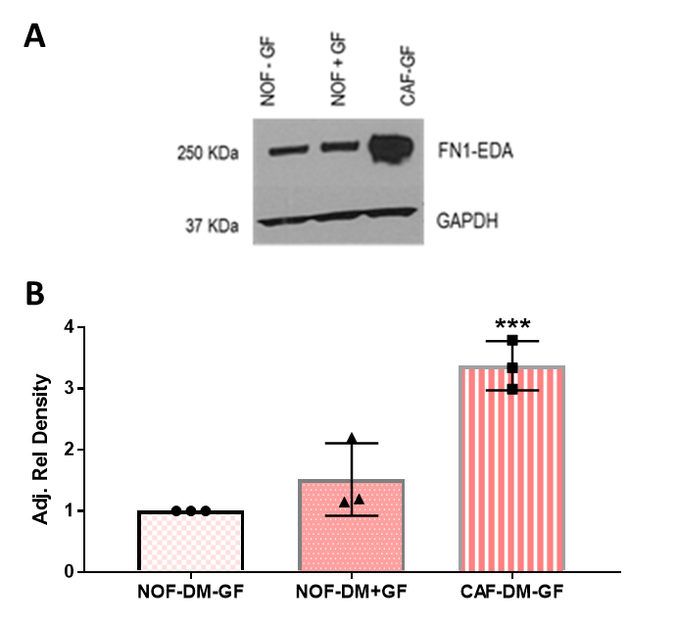

Figure 4.8 FN1-EDA abundance in fibroblast-derived matrices
A representative immunoblot showing FN1-EDA protein present in all FDM, with a reference weight of 250 kDa (A). Densitometry of the resultant bands were measured using ImageJ and the intensity measured relative to GAPDH controls (B). Data is expressed as relative fold change, with mean ± SD, N=3, n=2, *** denotes p <0.001 as analysed by Kruskal-Wallis test with Dunn’s multiple comparison test.

4.3.2.2.1.3 VCAN protein abundance in fibroblast-derived matrices

VCAN, a large proteoglycan acts as an anti-adhesion protein and regulates the hydration status of the matrix meshwork within tissues and shows increased abundance in OSCC. A discrete band at 72 kDa was detected in FDM using an anti-VCAN antibody (Figure 4.9 A). No significant differences were observed in VCAN protein abundance in NOF-DM with the addition of growth factors (8.69 ± 1.50-fold change) (Figure 4.9 B). A significant change was observed for VCAN abundance in CAF-DM; where a 56.57 ± 10.07-fold increase was observed compared to NOF-DM-GF (p <0.0001) (Figure 4.9 B).
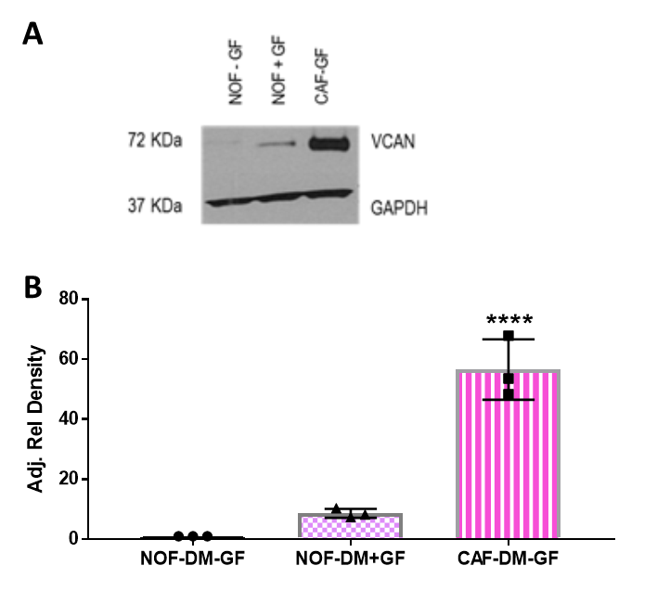

Figure 4.9 VCAN abundance in fibroblast-derived matrices
A representative immunoblot of VCAN protein found in all FDM, with a reference weight of 250 kDa (A). Densitometry of the resultant bands were measured using ImageJ and the intensity measured relative to GAPDH controls (B). Data is expressed as relative fold change, with mean ± SD, N=3, n=2, **** denotes p <0.0001 analysed by Kruskal-Wallis test with Dunn’s multiple comparison test.

4.3.2.2.1.4 COL1A1 protein abundance in fibroblast-derived matrices

The most abundant protein in the ECM of humans is collagen type 1. Collagen type 1, alpha 1 is a large fibrillar collagen important maintaining tissue rigidity, elasticity and overall structural integrity. In all FDM analysis, COL1A1 was found readily detectable with bands visible at 200 kDa (Figure 4.10 A). No significant differences were observed in COL1A1 in NOF-DM with the addition of growth factors (7.32 ± 1.98-fold change), but a significant increase in COL1A1 was observed for CAF-DM-GF with a 24.11 ± 5.97-fold increase compared to NOF-DM-GF (p=0.0004) (Figure 4.10 B).
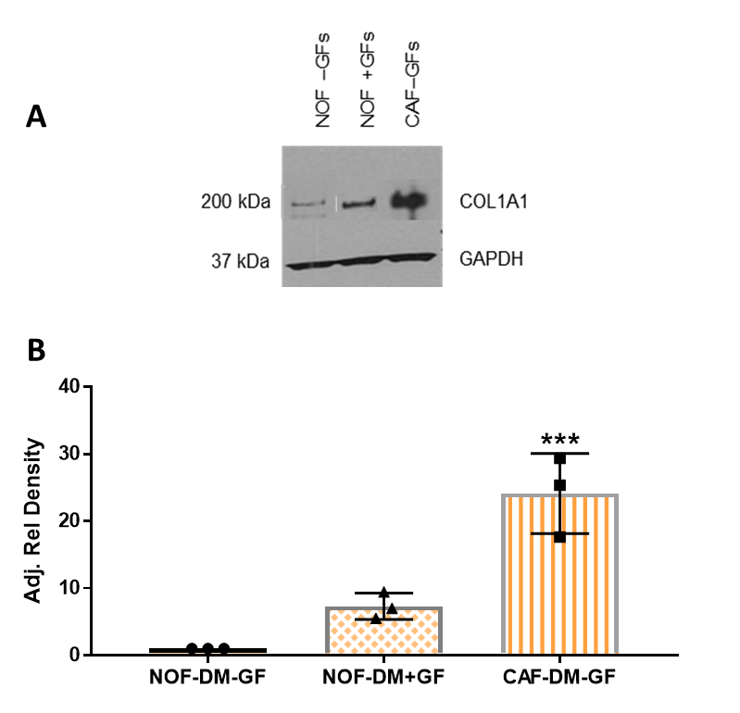

Figure 4.10 COL1A1 abundance in fibroblast-derived matrices
A representative immunoblot of COL1A1 protein was observed in all FDM, with a reference weight of 200 kDa (A). Densitometry of the resultant bands were measured using ImageJ and the intensity measured relative to GAPDH controls (B). Data is expressed as relative fold change, with mean ± SD, N=3, n=2, *** denotes p <0.001 as analysed by Kruskal-Wallis test with Dunn’s multiple comparison test.

4.3.2.2.1.5 LAMB-5 (γ-2) protein abundance in fibroblast-derived matrices

Laminin and its sub-types are glycoproteins that form the major non-collagenous constituents of the basement membranes of epithelia. Functionally they are implicated in many biological processes including but not limited to cell adhesion, differentiation, migration, signalling, and metastasis. LAMB-5 (γ-2) protein was only present in CAF-DM-GF matrices and the representative immunoblot shows evidence of dual bands at both 130 kDa and 95 kDa; representing the mature and precursor forms of laminin (Figure 4.11 A). Band intensity increase 24.21 ± 5.84-fold compared to the NOF-DM with and without growth factors (p=0.0003).
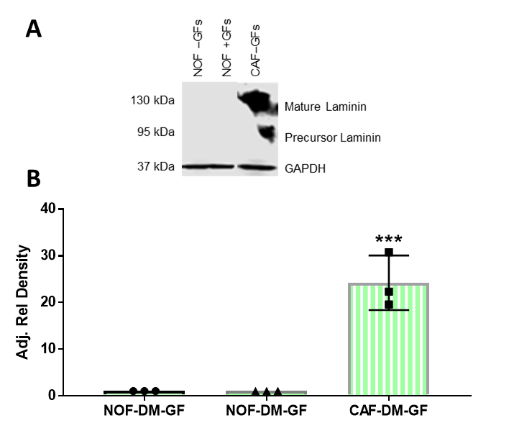

Figure 4.11 Analysis of LAMB-5 (γ-2) abundance in fibroblast-derived matrices
A representative blot showed that LAMB-5 was only visible in the developed CAF-DM-GF matrix, with a dual band indicating the mature form (130 kDa) And the precursor form (95 kDa) (A). Densitometry of the resultant bands were measured using ImageJ and the intensity measured relative to GAPDH controls (B). Data is expressed as relative fold change, with mean ± SD, N=3, n=2, *** denotes p <0.001 as analysed by Kruskal-Wallis test with Dunn’s multiple comparison test.

4.3.2.3 Understanding fibroblast-derived matrix biomechanics and structure

4.3.2.3.1 Identifying modified collagen-fibre signatures in fibroblast-derived matrices

To determine whether it was possible to optically image fibrillar collagen in unfixed FDM and to investigate whether the different cell phenotypes produced matrices with altering collagen signatures second harmonic generation (SHG) microscopy was employed.
NOF-DM with and without growth factors and CAF-DM without growth factors were imaged at day 28 with representative images shown in Figure 4.12. Pseudo-colouring of all images was added for improved visualisation. Distinct collagen fibres could be observed in all of the FDM studied (Figure 4.12 A-C). Quantification of fibres from these images analysed; collagen fibre length, diameter and alignment.
Collagen length was shortest for NOF-DM-GF with an average of 53.33 ± 1.06 μm (Figure 4.12 D). The addition of growth factors to the NOF-DM caused significant increase in fibre length with a mean value of 64.62 ± 0.89 μm, p=0.0013. CAF-DM-GF showed the greatest collagen fibre length with a mean of 77.25 ± 3.50 μm, significantly longer than NOF-DM without growth factors, p <0.0001 (Figure 4.12 D).
Collagen fibre alignment was assessed on a scale of 0 to 1 (Figure 4.12 E). With a value of zero indicating no alignment, and 1 scoring absolute alignment. NOF-DM-GF matrices had a mean alignment value of 0.89 ± 0.004. NOF-DM+GF showed a significant increase, in alignment with a mean value of 0.90 ± 0.0005 (p=0.0008). CAF-DM-GF matrices were shown to be the most aligned and were significantly more so than the NOF-DM-GF, with a mean value of 0.92 ± 0.002 (p <0.0001) (Figure 4.12 E).
Fibre diameter was also assessed (Figure 4.12 F). NOF-DM-GF matrices had a mean width of 0.76 ± 0.04 μm. Upon the addition of growth factors this significantly increased to 0.87 ± 0.01 μm, p=0.0035 and fibres were similar for CAF-DM-GF with an average fibre width of 0.87 ± 0.02 μm (p=0.0026).

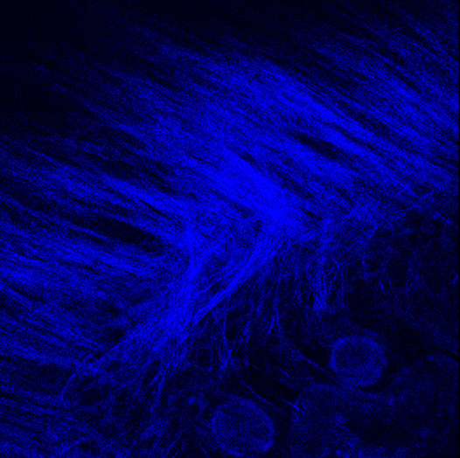
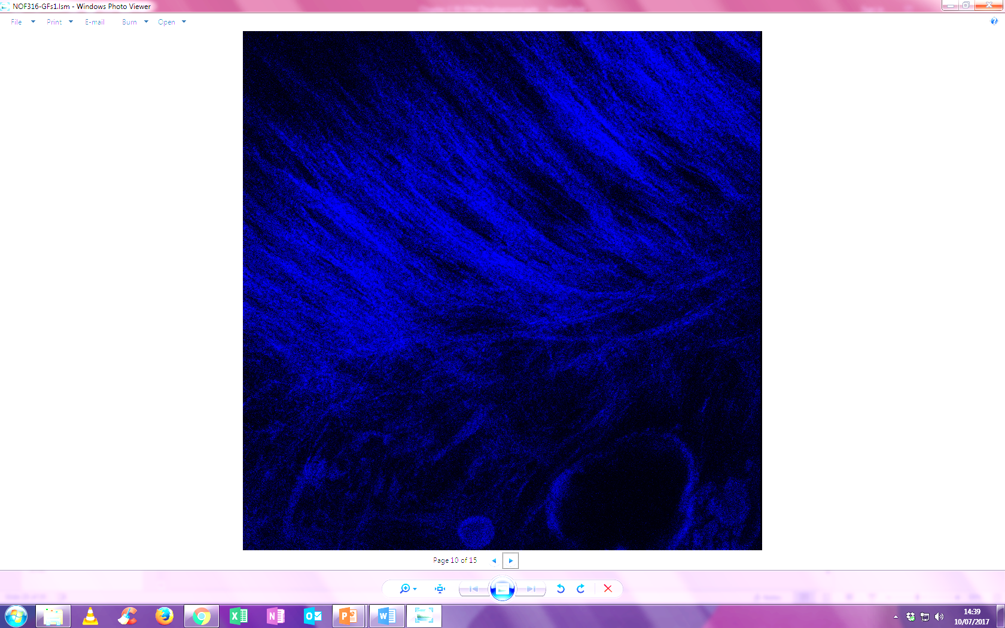
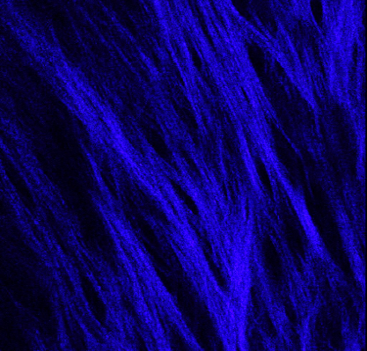
A
B
C

D
E
F
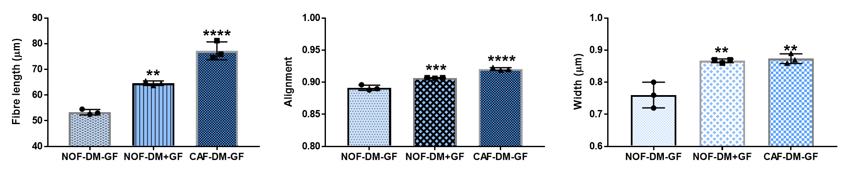

Figure 4.12 Automated segmentation and quantification of collagen fibre length, alignment and width
Representative SHG microscopy images of NOF-DM-GF (A), NOF-DM+GF (B), and CAF-DM-GF (C). Using curvelet transformation (CT) and fibre extraction (FIRE) algorithms collagen fibre length (D), alignment (E) and width (F) was investigated from extracted images. Data is expressed as mean ± SD, N=3, n=3, ** denotes p <0.01, *** p <0.001 and **** p <0.0001 as analysed by Kruskal-Wallis test with Dunn’s multiple comparison test. Image scale bar =20 μm.

4.3.2.3.2 Soft matter properties of fibroblast-derived matrices

4.3.2.3.2.1 Measuring stiffness of fibroblast-derived matrices by atomic force microscopy

Preliminary studies were conducted to assess whether the mechanical properties of FDM could be quantified using AFM. Both NOF- and CAF-DM were analysed for their soft matter properties and to assess if stiffness altered with pathological ECM deposition. Force indentation curves were generated, and the Young’s elastic modulus calculated as a measure of stiffness. The Young’s moduli calculated were 4.25 MPa and 5.82 MPa for NOF-DM and CAF-DM, thus, preliminary analysis indicates the matrix produced by CAF-DM to be stiffer (Figure 4.13 A).
Using AFM, it is also possible to collate the force distance curves of a given area and thereby generate a stiffness map. The CAF-DM map indicates variances of ECM stiffness across the matrix, which may correspond to differences in stiffness between ECM components as well as the embedded fibroblasts (Figure 4.13 B). Topographical images of the ECM structures also generated for CAF-DM showed a non-uniformed distribution in ECM structure across the section (Figure 4.13 C).

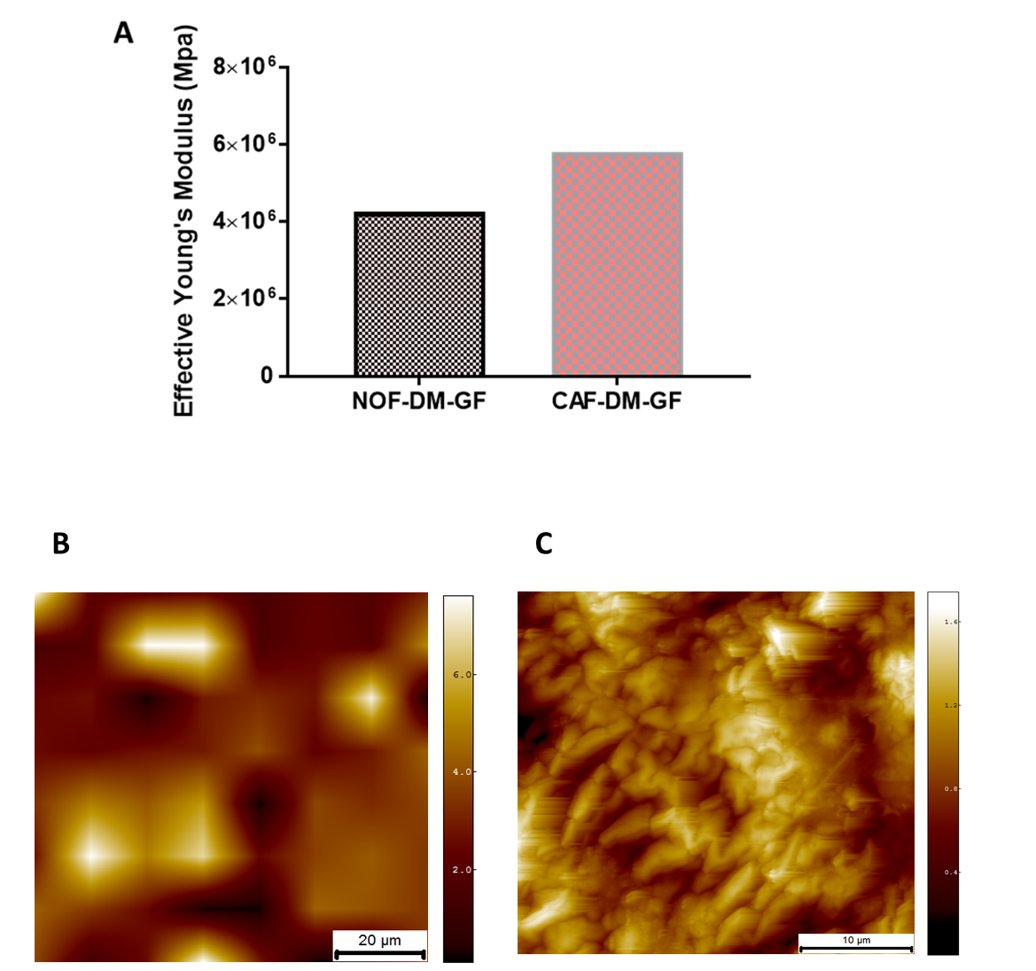

Figure 4.13 Mechanical mapping and topography of fibroblast-derived matrix
Force indentation curves were produced using AFM and the effective Young’s modulus calculated for NOF- and CAF-DM (A) Data is presented as mean (N=2, n=2). Topographical analysis of CAF-DM show variations in stiffness calculated across the FDM slice (B). Further aspect analysis of the CAF-DM surface indicates the presence of ECM structures and the heterogeneity of stiffness attributed to ECM compositional differences (C). (N=2, n=2).

4.3.2.4 ECM remodelling in fibroblast-derived matrices

4.3.2.4.1 MMP-2 and MMP-9 activity in fibroblast-derived matrices

In order to establish if FDM are capable of remodelling the ECM in vitro a zymography assay was used to measure the activity of two well characterised matrix metalloproteases; MMP-2 and MMP-9 activity was observed in OSCC (Kato et al., 2005). Gelatin zymography was used to measure MMP-2 and MMP-9 activity in NOF and CAF-DM. Imaging of the gel revealed detectable bands for both MMP-2 and MMP-9 activity from supernatants collected from NOF-and CAF-DM (Figure 4.14 A). The intensity of the MMP bands was quantified further using ImageJ software. No significant difference was observed in MMP-2 activity between the NOF- and CAF-DM (Figure 4.14 B). MMP-9 activity was also observable from matrices deposited by both cell types, but these were not significantly different (Figure 4.14 C).
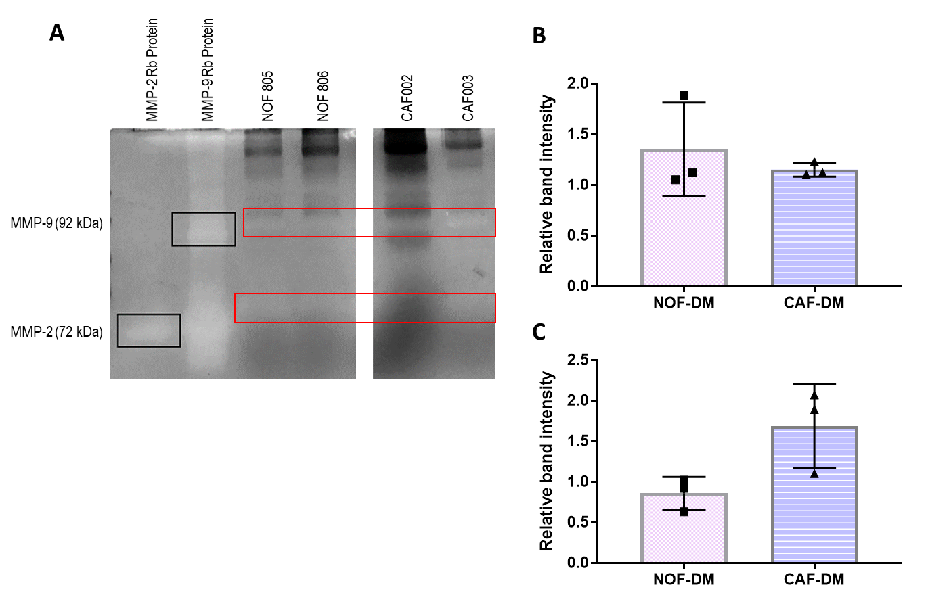

Figure 4.13 MMP-2 and -9 activity by gelatin zymography
Detection of MMP-2 and MMP-2 activity was confirmed by the presence of white bands at specific molecular weights in FDM using gelatin zymography (A). Quantification of MMP activity by densitometry revealed NOF-DM expressed higher levels of MMP-2 than CAF-DM (B). MMP-9 activity was elevated in CAF-DM compared to NOF-DM. Densitometry was relative to recombinant protein control band. (N=2, n=2).

Figure 4.14 MMP-2 and -9 activity in FDM
Detection of MMP-2 and MMP-9 activity confirmed by the presence of white bands at specific molecular weights in FDM using gelatin zymography (A). Densitometry of the resultant bands were measured using ImageJ for MMP-2 (B) and MMP-9 (C). Data is expressed as relative fold change, with mean ± SD, N=3, n=2, as analysed by unpaired Student’s T-test.

4.3.2.5 Investigation of the effects of stromal targeting drugs on oral fibroblast-derived matrices
After showing efficacy in 2D, Scriptaid and Batimastat treatment analysed on FDM, to assess their potential use as drug screening platforms for stromal targeting in vitro. All fold changes were analysed relative to vehicle control samples. Matrices were developed as previously described, then treated with the inhibitors for 7 days.

4.3.2.5.1 The effect of Scriptaid and Batimastat on αSMA expression in NOF-and CAF-DM

No significant changes in αSMA expression were observed for NOF-DM, treated with Batimastat for 7 days compared to vehicle control treated NOF-DM (Figure 4.15 A). Treatment of NOF-DM with Scriptaid significantly increased αSMA expression (2.43 ± 0.66) compared to vehicle controls, p=0.0003 (Figure 4.15 A). Scriptaid treatment in combination with TGFβ-1 (14.65 ± 15.82) reduced αSMA expression by ~3-fold compared to NOF-DM treated with TGFβ-1 alone (55.99 ± 15.23, p=0.0010). Batimastat in combination therapy with TGFβ-1 also significantly reduced αSMA expression, with an observable ~13-fold reduction (1.39 ± 0.71) compared to NOF-DM treated with TGFβ-1 alone (55.99 ± 15.23, p <0.0001).
In comparison, CAF-DM treated with Batimastat alone, showed a reduced expression of αSMA transcript (0.31 ± 0.30) compared to vehicle control treated CAF-DM, p=0.0002, and treatment with Scriptaid incited no observable change in αSMA expression, compared to vehicle controls (Figure 4.15 B). No significant changes in αSMA expression were observed for treatment of the inhibitors in combination therapy with TGFβ-1 compared to CAF-DM treated with TGFβ-1 alone (Figure 4.15 B).

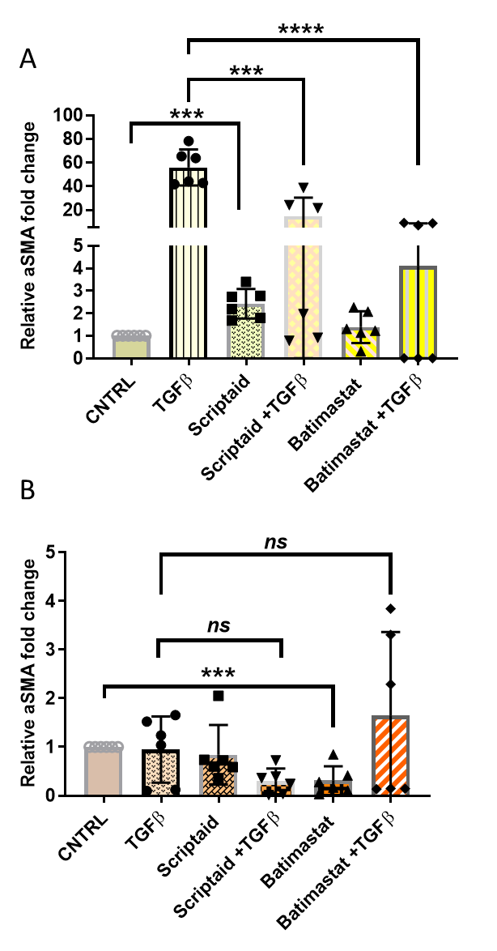

Figure 4.15 αSMA gene expression in NOF- and CAF-DM in response to Scriptaid and Batimastat treatment with and without TGFβ-1 stimulation
NOF- (A) and CAF- (B) DM were treated with the inhibitors Scriptaid and Batimastat in the presence or absence of TGFβ-1 for 7 days and the gene expression for aSMA determined by qPCR. Data is expressed as fold change relative to housekeeping gene U6, with mean ± SD, N=3, n=2, *** denotes p <0.001 and ****p <0.0001 analysed by students T-test.

4.3.2.5.2 The effect of Scriptaid and Batimastat on αSMA abundance on NOF- and CAF-DM

No significant difference in αSMA protein abundance was observed with the addition of Scriptaid or Batimastat alone compared to vehicle control treated NOF-DM (Figure 4.16 A i+ii). The addition of Scriptaid in combination with TGFβ-1, significantly reduced αSMA protein by ~18-fold (0.54 ± 0.70) compared to TGFβ-1 alone (9.75 ± 4.78), p=0.0296 (Figure 4.16 A i). This trend was also observed for NOF-DM treated with Batimastat in combination therapy with TGFβ-1. A significant ~19-fold reduction in αSMA abundance was detectable, compared to TGFβ-1 alone, p=0.0291.
In contrast, for CAF-DM, αSMA protein was visibly reduced with the addition of Scriptaid (0.89 ± 0.05) compared to vehicle control treated CAF-DM, p=0.0228 (Figure 4.16 B i+ii). Similarly, treatment with Batimastat alone (0.83 ± 0.05) also reduced αSMA abundance by ~4-fold compared to controls, p=0.0189. Batimastat in combination with TGFβ-1 significantly reduced αSMA protein with an intensity of 0.37 ± 0.54 compared to TGFβ-1 alone (1.78 ± 0.58, p=0.0368) (Figure 4.16 B ii). Scriptaid in combination therapy with TGFβ-1 showed no significant changes in αSMA protein abundance, compared to TGFβ-1 treated CAF-DM.

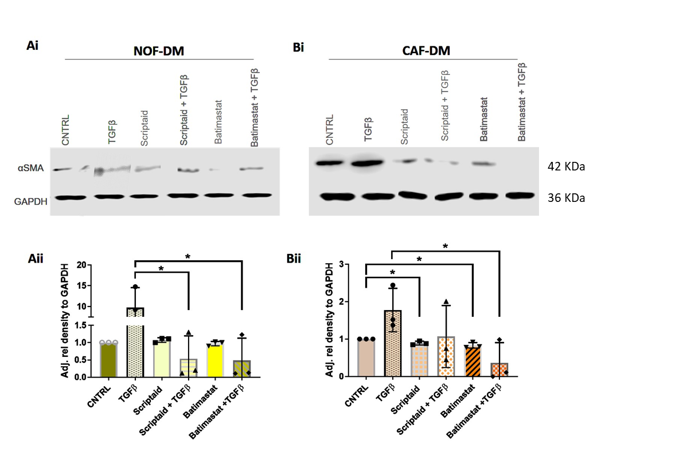

,

Figure 4.16 Immunoblotting for αSMA abundance in NOF- and CAF-DM in response to Scriptaid and Batimastat treatment with and without TGFβ-1 stimulation
NOF- (A) and CAF-DM (B) were treated with the inhibitors Scriptaid and Batimastat in the presence or absence of TGFβ-1 for 7 days with αSMA protein levels determined using immunoblotting. Densitometry of the resultant bands were measured using ImageJ and the intensity measured relative to GAPDH controls (A ii and B ii). Data is expressed as relative fold change, with mean ± SD, N=3, n=2, * denotes p <0.05 analysed by student’s T-test.

4.3.2.5.3 The effect of Scriptaid and Batimastat on FN1-EDA expression in NOF- and CAF-DM

No significant changes in FN1-EDA expression were observed for NOF-DM treated with Scriptaid or Batimastat alone compared to vehicle control treated samples (Figure 4.17 A). Treatment of Scriptaid in combination with TGFβ-1 (1.07 ± 0.21) significantly reduced FN1-EDA expression by ~3-fold, compared to TGFβ-1 treatment of NOF-DM (4.14 ± 1.92), p=0.0073. No significant changes in FN1-EDA expression were observed for NOF-DM treated with Batimastat in combination with TGFβ-1, compared to TGFβ-1 treatment alone.
CAF-DM treated with Batimastat, significantly reduced FN1-EDA transcript (0.59 ± 0.44) compared to vehicle control treated CAF-DM, p <0.0001 (Figure 4.17 B), but in combination with TGFβ-1 (19.82 ± 17.01) a significant increase in FN1-EDA expression was observed, compared to CAF-DM treated with TGFβ-1 alone (2.61 ± 2.33), p=0.0339. Scriptaid treatment with or without TGFβ-1 caused no significant difference to FN1-EDA levels, compared to their relative controls (Figure 4.17 B).

,
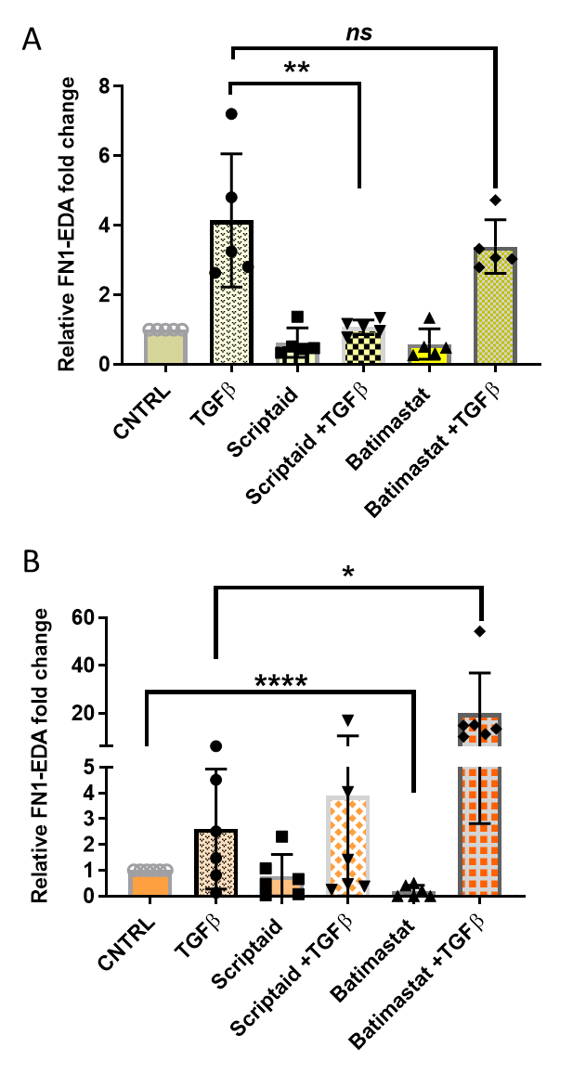

Figure 4.17 FN1-EDA gene expression in NOF- and CAF-DM in response to Scriptaid and Batimastat treatment with and without TGFβ-1 stimulation
NOF- (A) and CAF- (B) DM were treated with the inhibitors Scriptaid and Batimastat in the presence or absence of TGFβ-1 for 7 days and the gene expression for FN1-EDA determined by qPCR. Data is expressed as fold change relative to housekeeping gene U6, with mean ± SD, N=3, n=2, * denotes p <0.05, **p <0.001 and ****p <0.0001 analysed by student’s T-test.

4.3.2.5.4 The effect of Scriptaid and Batimastat on FN1-EDA abundance in NOF- and CAF-DM

No significant difference in FN1-EDA protein abundance was observed in NOF-DM treated with either Scriptaid or Batimastat compared to vehicle control treated NOF-DM (Figure 4.18 A i+ii). However, Scriptaid and Batimastat in combination with TGFβ-1 treatment, significantly reduced FN1-EDA protein abundance, with a ~22-fold, (0.36 ± 0.42) and ~8-fold, (0.95 ± 0.35), respectively, compared to TGFβ-1 treatment alone (8.16 ± 2.23), p=0.0040, and p=0.0052.
No significant differences were observed in FN1-EDA protein abundance in CAF-DM, treated with Scriptaid in the presence and absence of TGFβ-1 (Figure 4.18 B i+ii). Batimastat significant reduced FN1-EDA protein (0.56 ± 0.25) compared to vehicle control treated CAF-DM, p=0.0391. Batimastat and TGFβ-1 in combination therapy, showed no significant difference in detectable FN1-EDA protein (1.29 ± 0.60) compared to TGFβ-1 treatment alone (1.61 ± 0.41).

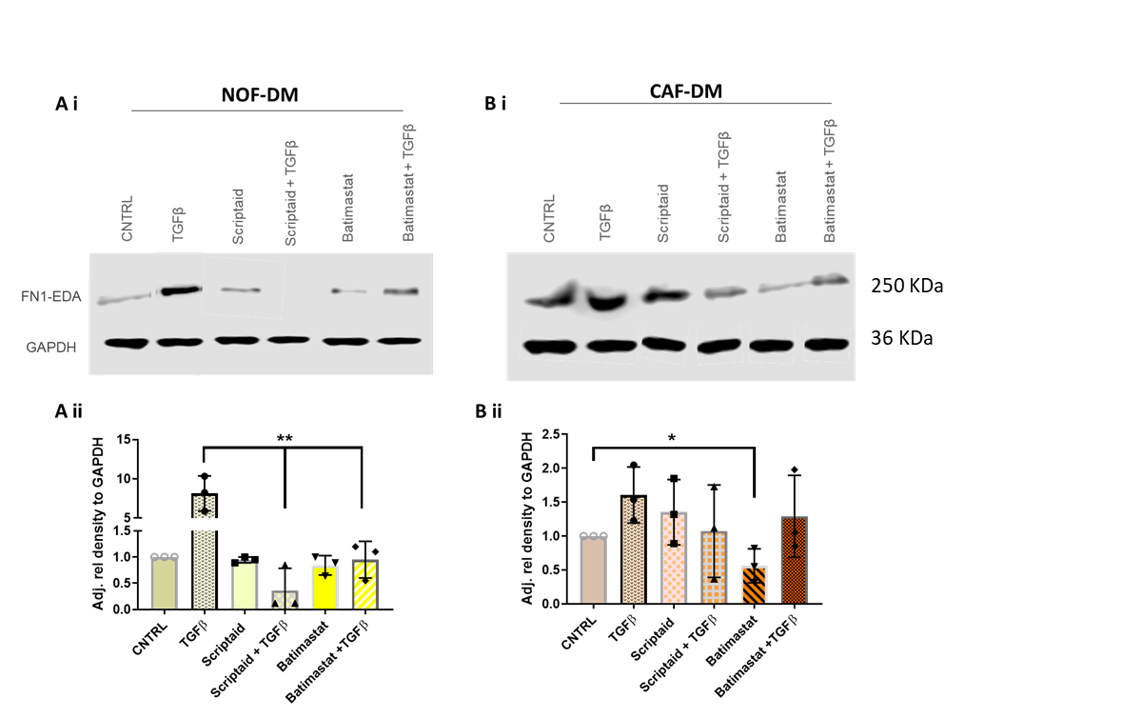

Figure 4.18 Immunoblotting for FN1-EDA abundance in NOF- and CAF-DM in response to Scriptaid and Batimastat treatment with and without TGFβ-1 stimulation
NOF- (A) and CAF-DM (B) were treated with the inhibitors Scriptaid and Batimastat in the presence or absence of TGFβ-1 for 7 days with FN1-EDA protein levels determined using immunoblotting. Densitometry of the resultant bands were measured using ImageJ and the intensity measured relative to GAPDH controls (A ii and B ii). Data is expressed as relative fold change, with mean ± SD, N=3, n=2, * denotes p <0.05 and **p <0.01 analysed by unpaired student’s T-test.

4.3.2.5.4 The effect of Scriptaid and Batimastat on COL1A1 expression in NOF-and CAF-DM

Scriptaid and Batimastat treatment in the absence of TGFβ-1 caused no significant difference in COL1A1 transcript expression compared to vehicle control treated NOF-DM (Figure 4.19 A). These inhibitors in combination with TGFβ-1, significantly reduced COL1A1 expression compared to TGFβ-1 treated NOF-DM. Scriptaid in combination with TGFβ-1 showed a ~4-fold reduction (3.23 ± 2.41, p=0.0371) in COL1A1 expression and Batimastat in combination with TGFβ-1 caused a ~2-fold decrease compared to TGFβ-1 alone (13.72 ± 10.41, p=0.0471).
No significant differences in COL1A1 expression were observed in CAF-DM with the addition of Scriptaid in presence or absence of TGFβ-1 compared to their comparative controls (Figure 4.19 B). Batimastat treatment caused a ~3-fold reduction in COL1A1 expression (0.30 ± 0.44) compared to vehicle control treated CAF-DM, p=0.0030. No significant differences were observed when CAF-DM were treated with Batimastat in combination with TGFβ-1 (Figure 4.19 B).

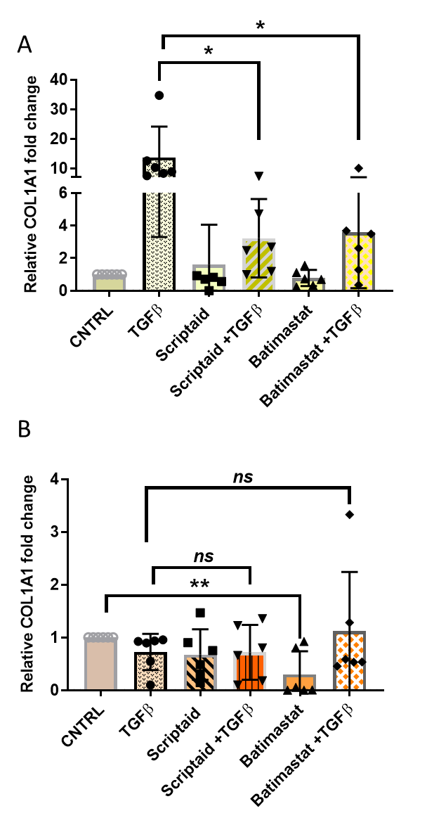

Figure 4.19 COL1A1 gene expression in NOF- and CAF-DM in response to Scriptaid and Batimastat treatment with and without TGFβ-1 stimulation
NOF- (A) and CAF- (B) DM were treated with the inhibitors Scriptaid and Batimastat in the presence or absence of TGFβ-1 for 7 days and the gene expression for COL1A1 determined by qPCR. Data is expressed as fold change relative to housekeeping gene U6, with mean ± SD, N=3, n=2, * denotes p <0.05 and **p <0.01 by Kruskal-Wallis test with Dunn’s multiple comparison test.

4.3.2.5.5 The effect of Scriptaid and Batimastat on COL1A1 abundance on NOF- and CAF-DM

In NOF-DM cultures treated with Scriptaid and Batimastat alone, no significant differences in COL1A1 protein was detected, compared to the levels of COL1A1 protein found in vehicle control treated NOF-DM (Figure 4.20 A i+ii). Scriptaid in combination with TGFβ-1 (16.20 ± 3.26), significantly reduced COL1A1 protein compared to TGFβ-1 treated NOF-DM (42.44 ± 9.53) p=0.0107. Batimastat treatment in combination with TGFβ-1 (8.80 ± 6.37) also significantly reduced COL1A1 protein abundance, compared to NOF-DM treated with TGFβ-1 alone, p=0.0071.
In CAF-DM, Scriptaid or Batimastat treatment alone or in combination with TGFβ-1, didn’t induce any significant change in COL1A1 abundance compared to vehicle control treated NOF-DM cultures (Figure 4.20 B i+ii).

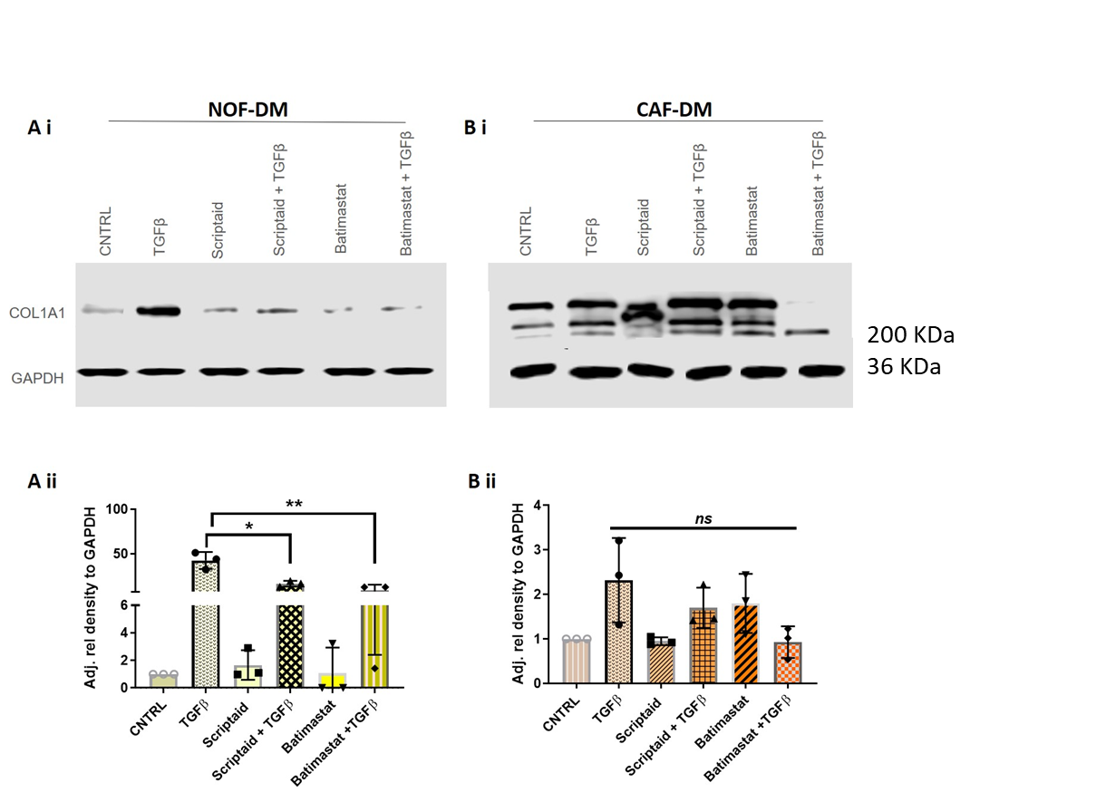

Figure 4.20 Immunoblotting for COL1A1 abundance in NOF- and CAF-DM in response to Scriptaid and Batimastat treatment with and without TGFβ-1 stimulation
NOF- (A) and CAF-DM (B) were treated with the inhibitors Scriptaid and Batimastat in the presence or absence of TGFβ-1 for 7 days with COL1A1 protein levels determined using immunoblotting. Densitometry of the resultant bands were measured using ImageJ and the intensity measured relative to GAPDH controls (A ii and B ii). Data is expressed as relative fold change, with mean ± SD, N=3, n=2, * denotes p <0.05 and **p <0.01 analysed by student’s T-test.

4.4 Discussion

Stromagenesis is a connective tissue response to cancer cell interaction and is the driving force of the permissive microenvironment that primes tumour progression (LeBleu and Kalluri, 2018, Alexander and Cukierman. 2016). Mesenchymal fibroblasts are responsible for the production and regulation of most ECM components (Kalluri, 2016, Bonnans et al., 2014). Currently, there is a lack of suitable, physiologically relevant, experimental systems that can examine stromal: tumour interactions and therefore, the mechanisms that incite, and support OSCC tumour progression are poorly understood (Amatangelo et al., 2005, Bregenzer et al., 2019). Here we introduce a novel tissue-engineering approach to generate an in vitro human-ECM scaffold mimetic that is a reproducible methodology for primary fibroblasts isolated from patients and could be used to further investigate the stromal impact in contributing to OSCC disease progression.
Construction of these FDM have been based on principles that rely on the culturing requirements of these cells for long-term support and nourishment; as well as the ability to remain viable for an extensive culture period. Adequate characterisation ensured that these FDM would be suitable for further downstream applications. Isolated patient-FDM are indicative of normal ECM matrix (NOF-DM without growth factors), myofibroblastic (NOF-DM +GF) matrix, and cancer-associated fibroblast matrix (CAF-DM) that resembles normal, activated and cancer ECM respectively. The generation of these matrices was optimised by culturing primary cells on commercially available tissue culture inserts in deep-well plates. These porous inserts are capable of supporting basolateral nutrient transfer and are commonly used to support 3D, long-term cultures (Berning et al., 2015, Chen et al., 2015). What was apparent from the construction of these FDM, was that oral fibroblast media alone (DMEM, 10 %) with the addition of TGFβ-1 failed to support the long-term development of these matrices. Therefore, choice of media and media supplementation with exogenous growth factors became an important consideration for matrix generation. Ascorbic acid is an essential cofactor for lysyl hydroxylase, an enzyme vital for collagen biosynthesis, has been supplemented in media for cell cultures for decades (Pinnell, 1985). For this reason, phospho-L-ascorbic acid (a more stable salt form of ascorbic acid) was added to aid collagen synthesis in these developing FDM. A more enriched media with/without growth factors was then tested for its ability to promote long-term growth and development of FDM with greater success. These various growth factors and their effects on FDM generation was also assessed, these include TGF, EGF and bFGF. The ability of TGF to control synthesis of collagen and fibronectin, was first described in 1986 by Ignotz. Mechanistically, TGF and its associated isoforms have been found to increase the mRNA levels for most of the matrix proteins examined and results in increased secretion of the protein (Roberts et al., 1992, Melling et al., 2018). However, the longer-term deposition of matrix proteins has only been assessed with oral fibroblast media up to 2 weeks in culture. This is evidenced in chapter 3 of this thesis; where the effects of TGF stimulation of fibroblasts were investigated and demonstrated elevated mRNA levels and increased protein deposition of ECM components in NOF and CAF 2D cultures. FGF a potent mitogenic factor has been implicated in a wide range of developmental processes and along with EGF their supplementation to media is known to aid proliferation and ECM production from cells in culture (Nunes et al., 2016, Ahlfors and Billiar et al., 2007, and Gharibi and Hughes, 2012). The long-term application of these growth factors along with ascorbic acid supplementation in FDM increased ECM deposition and the overall thickness of the matrices that could be developed and maintained in long-term cultures.
The development of these FDM was also assessed by identifying matrix morphology and ECM deposition by H&E analysis and thickness measurements. After a 28-day development period, H&E staining indicated the presence of evenly distributed fibroblasts in both NOF and CAF-derived matrices surrounded by a native matrix meshwork. CAF-DM showed significantly more ECM deposition than NOF-DM, and this was quantified by measuring the thickness of the FDM generated. Evidence of altered ECM deposition in CAF-DM, further supports the notion of altered ECM deposition in OSCC progression (Ishii et al., 2016). CAF without the addition growth factors still deposited a significantly bulkier ECM and this indicates that CAF deposited matrices may be the result of phenotypic and metabolic changes of the cell rather than just the addition of exogenous growth factors (Kalluri, 2016). To what extent this could be further analysed would depend on distinct molecular profiling of CAF upregulated ECM genes. Chakravarthy et al., has identified a distinct set of ECM genes upregulated in cancer (C-ECM) and dysregulation of this C-ECM transcriptional programme correlated with the activation of TGF-β signalling in CAF and is linked to immunosuppression in otherwise immunologically active tumours.
ECM barrier functionality is also an important component of generating an ECM mimetic and the resistance and permeability of the ECM can impact on the delivery of drug therapeutics (Netti et al., 2000). TEER analysis of the developing TE-FDM indicated that a stable electrical resistance was produced across the matrices in culture. No significant differences in mean TEER (Ω. cm²) was observed in all matrices studied suggesting that functional barriers were formed across all membrane inserts.
Over the past two decades, research in the field of cancer biology has begun to focus on the role of ECM constituents during cancer progression. Once TE-FDM were established their characteristic features were assessed. Altered ECM composition was analysed by immunoblotting for ECM proteins of interest (FN1-EDA, VCAN, COL1A1, αSMA and LAMB-γ5). These transcripts showed a statistically significant increase in abundance for CAF-DM compared to NOF-DM; evidencing the potential roles for these ECM proteins in OSCC pathophysiology, affecting cell proliferation, migration, adhesion and invasion (Kumar and Hema, 2018). Along-side understanding the composition of FDM, their microarchitecture was assessed using SEM. Ultrastructural properties of both NOF-DM and CAF-DM showed intact matrix formation across the insert and evidence for ECM deposition in the form of a fibrillar meshwork further evidencing their advantageous characteristic features as in vivo mimetics of oral stroma.
Altered ECM compositions and construction directly translates to altered biomechanics within tissue; of which cell behaviour is acutely dependent on (Egebald et al., 2010 and Kaukonen et al., 2017). Previous research has described that the ECM in the stroma of premalignant and tumour tissues exhibits an increased stiffness when compared with normal tissues (Levental et al., 2009, Cox et al., 2011, and Egebald et al., 2010). Compacted and stiff ECM results in tissue compression, which then activates cell migration pathways via integrin mediated signalling (Gkretsi and Stylianopoulos, 2018). This stiffness is largely associated with the deposition of collagen and this has been proposed as the major ECM component that is remodelled in tumour tissues, and predominantly accounts for a tumour’s mechanical features (Brauchle et al., 2018). The amount and density of collagen fibres and their crosslinking degree has been suggested to be able to determine the rigidity of tumours. A random isotropic arrangement of fibrillar ECM is indicative of normal or homeostatic parenchyma and a more organised, anisotropic arrangement of collagen, with relatively linear fibres is a hallmark of pathological microenvironment; correlated with poor patient prognosis; as aligned fibres in vivo serve as natural trails on which cancer cells migrate (Pavithra et al., 2017). These tumour-associated collagen signatures (TACS); were first described by Provenzano et al., in which they visualised collagen fibre linearisation in murine models of cancer progression.
With collagen acting as the driving force for matrix biomechanics we focussed on the identification of collagen fibre signatures and the effects of CAF-mediated collagen stiffness. SHGM illustrated the importance of CAF-DM in manipulating ECM architecture and contributing towards the OSCC tumour microenvironment as evidenced by the formation of elongated collagen fibres. The increased collagen length, width and linearisation of fibrillary collagen identified in this study could be an essential factor controlling OSCC tumour cell invasion and migration in the same way previous studies have emphasised the importance of collagen structure and track-dependent migration of cancer cells (Conklin et al., 2011, Pavithra et al., 2017, Hanley et al., 2016 and Provenzano et al., 2006). The novel collagen signatures identified within these FDM, warrants further investigation into collagen signatures observed in OSCC, and how they may be used for HNSCC prognostics.
Developing on this, ECM stiffness has been related to deposition of collagen and its cross-linking capabilities which can disrupt tissue morphology contributing to metastatic progression (Bonnans et al., 2015), therefore, the soft matter properties of these fibroblast-embedded matrices were also analysed using AFM. The effective Young’s elastic modulus of CAF-DM indicated a difference in stiffness compared to NOF-DM; suggesting that CAF-mediated deposition of ECM components could directly contribute to OSCC progression via mechanical alterations of the stromal compartment. This in also in agreement with other studies implicating ECM-related stiffness in tumour metastasis for cancers such as breast and prostate (Kumar and Weaver, 2009, Provenzanno et al., 2008 and Stuart et al., 2004). Further analysis on this altered stiffness in the FDM developed here is currently underway.
The ECM is a dynamic structure and is continually undergoing remodelling. This process of assembly and degradation is vital for normal developmental processes as well as during differentiation and wound repair; therefore, aberrant remodelling is associated with disease and tissue abnormalities (Daley et al., 2008 and reviewed by Bonnans et al., 2015). It is the 3D microenvironment that regulates the assembly and cellular tension through integrins of the ECM and in response to signals and ECM-modifying enzymes like the matrix metalloproteases (MMP); the ECM can be effectively remodelled. Aberrant MMP-2 and MMP-9 activity and expression has been observed in OSCC (Vicente et al., 2005, and Ikebe et al., 1999). In this investigation both MMP-2 and MMP-9 activity was present in NOF-DM and CAF-DM suggesting that fibroblast secreted ECM is capable of degrading this meshwork for remodelling purposes, however, no significant differences were datable for NOF-DM compared to CAF-DM. Further investigation will look into the effects of normal and OSCC epithelial cell-interaction with FDM and the effect this has on MMP activity.
Many cancer drugs exhibit cytotoxic behaviour on cancer cells in vitro but losing efficacy in vivo, this poorly understood chemoresistance, is conferred by the tumour microenvironment. To address this, we have attempted to treat FDM with two drugs that function to normalise the tumour microenvironment. Batimastat and Scriptaid are drugs used to target fibroblasts and the proteases they secrete in an attempt to reverse the abnormal ECM deposition generated by myofibroblasts and CAF (Kim et al., 2018, and Brown, 1999). In the tumour microenvironment, CAF are genetically stable cells, but there is evidence that CAF are epigenetically unstable. For this reason, exploring the epigenetic pathways that promote non-CAF to CAF conversion or diminishing the phenotypic and functional properties of CAF would be of use in a clinical setting (Gasche and Goel, 2012). Scriptaid; has been shown to reverse the phenotypic and functional capabilities of CAF in human and murine cell culture models (Kim et al., 2018, Barter et al., 2010, Guo et al., 2009); including CAF enhanced contractility, reduced abundant ECM expression, and TGFβ pathway activation. Scriptaid has been observed to antagonise TGFβ-mediated CAF gene expression, which resulted in a diminished ECM deposition, reduced contractility and ECM stiffness, and delayed tumour growth in vivo; thus, Scriptaid was chosen to investigate its effects on NOF- and CAF-derived ECM in vitro. Another stromal-targeted drug was also assessed; Batimastat (BB94), a low molecular weight collagen peptide-based hydroxamic acid. This was the first MMP inhibitor evaluated in cancer patients. This compound is potent but relatively nonselective for MMP-1, -2, -3, -7, -8, -9 and -14 inhibition (Hidalgo and Eckhardt, 2001, Ziober et al., 2001). The drug’s mode of action is to bind zinc ions in collagen substrate that the MMP would normally bind therefore acting as a reversible competitive inhibitor. Initial in vitro investigations into Batimastat showed that it had cytostatic effects against a variety of cancer cell lines including breast, ovarian, liver and head and neck cancer and was not cytotoxic in orthotropic tumour xenografts model, inhibition of metastasis in experimental metastasis models, and suppression of ascites formation in ovarian cancer models, but its effects have not been characterised in inhibiting oral CAF characteristics (Original investigations: Low et al., 1996, Wylie et al., 1999, Sledge et al., 1995, and Macaulay et al., 1999).
In NOF-DM, treatment with Scriptaid and Batimastat had no effect on αSMA, FN1-EDA and COL1A1 transcript expression. There were also no observable differences in these myofibroblast markers at the protein level. In combination with TGFβ-1 these inhibitors significantly reduced all targets at both the gene and protein level compared to TGFβ-1 treatment alone, implicating TGFβ-1 has an integral role in the NOF- to myofibroblast differentiation (p <0.05).
In comparison, Scriptaid treatment of CAF-DM for 7 days, induced no significant changes in gene expression for αSMA, FN1-EDA and COL1A1 compared to CAF-DM treated with vehicle controls. This was not observed in murine and breast CAF treated with Scriptaid (Kim et al., 2018). Therefore, further investigation into increasing the Scriptaid concentration may be plausible, to observe significant changes. Further to this, a significant reduction in αSMA (p <0.05) protein was detectable in the presence of Scriptaid and reduced COL1A1 bands were detectable, but did not reach significance, indicating there may be potential inhibitory effects still emerging. Further investigation into the effects of Scriptaid on FDM morphology could be implemented to see if the stromal burden is reduced, verified by histological analysis. Multiple bands detected for collagen in CAF-DM are indicative of the monomer (130 kd), the pro-collagen (170 kD) and the dimer (270 kD) forms of COL1A1 suggesting that targeting collagen requires knowledge of its modifications and sub-types in vitro. In contrast, treatment of CAF-DM with Batimastat for 7 days significantly reduced all gene transcripts compared to vehicle control. In combination with TGFβ-1, a reduction in αSMA protein was detectable. This was also observed for FN1-EDA but did not reach significance. It cannot be dismissed that some of the variability of response to Batimastat in 3D could be due to the presence of natural MMP inhibitors as well as unregulated cytokine behaviour. TGF-β1 been shown to modulate the mRNA and protein levels of MMPs (MMP-2 and MMP-9) as well as their inhibitors (TIMP-2 and RECK), which describes a multifaceted role for TGF-β1 signalling and its potential as an OSCC therapeutic target (Gomes et al., 2012).These preliminary results indicate FDM are suitable as stromal-targeting drug screening platforms and warrants their application to further investigate the therapeutic benefits of targeting CAF and CAF: ECM interaction in OSCC.

To summarise, TE-FDM represent self-assembled collagen fibre meshwork filled with a diverse array of human native proteoglycans and glycoproteins, which in their structural geometry and characteristic features, largely resembling the matrix of normal and cancer human tissue; making them suitable in vitro ECM mimetics. Elevated ECM deposition, altered structural geometry, and the preliminary evidence for altered matrix mechanics in CAF-DM support the notion that CAF desmoplasia can be suitably modelled and highlights a potential anti-cancer target in OSCC. In terms of oral cancer, this data proposed here highlights that stromal-targeting drugs may be beneficial as a possible adjuvant to chemo- and radiotherapy as but discrepancies in CAF-DM investigation warrants further investigation into dosage and scheduling.

Chapter 5

Development and characterisation of three-dimensional in vitro normal mucosa and oral cancer models utilising human fibroblast-derived matrices

5.1 Introduction

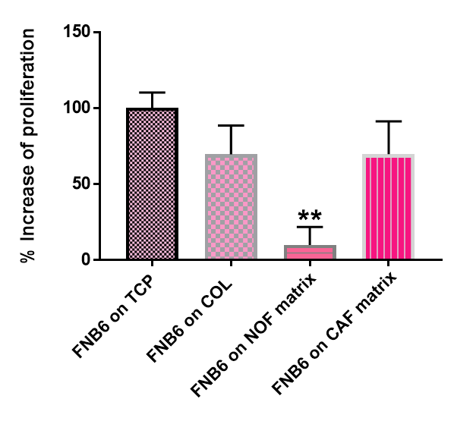
Structurally, tissues consist of a population of cells that interact with each other and with non-cellular components such as the ECM (Walker et al., 2018). In normal oral mucosa, this tissue is comprised of two distinct compartments: 1) the epithelium; a layer of tightly joined, polarised epithelial cells known as oral keratinocytes existing in four well-defined layers: the basal layer, spinous layer, granular layer and the superficial layer, that reside on a basement membrane, and 2) the lamina propria; an ECM-rich stroma that contains the fibroblasts (Moharamzadeh et al., 2007). As previously described; the stroma both physically supports the keratinocytes and interacts through soluble signals from the ECM. To recreate this in vitro the correct environment must be engineered, of which the scaffold that supports the epithelium being the most important feature.
In chapter four the development and characterisation of normal and cancerous oral fibroblast-derived matrices was described. These human-fibroblast derived ECM scaffolds, representative of normal and cancer ECM respectively, and will be used in the generation of full thickness oral mucosa models to investigate ECM; tumour cell interaction in a 3D in vitro model. Previously, in vitro models of oral carcinogenesis that are representatives of various stages of malignant transformation have been developed by isolating normal oral epithelial cells, immortalised/dysplastic and neoplastic cell lines cultured as spheroids, seeded on rat-tail collagen scaffolds or on cadaver de-epidermised dermis; the latter being a human dermis substitute (Colley et al., 2011, Jennings et al., 2016). However, an all human-oral-cell derived tissue-engineered model of OSCC progression has yet to be established.
To overcome some of the non-human elements of previous OSCC models, the generation of an all human-cell-derived oral mucosa equivalents will be achieved by adding epithelial cells, known as oral keratinocytes, isolated from normal tissue (FNB6) and keratinocytes isolated from cancer tissue (H357) to obtain a full thickness oral epithelium with an associated fibroblast-matrix layer. These will be crucial in our understanding of how these models can act as in vitro mimetic of both a normal stratified oral epithelium and models that represent OSCC disease progression.
The aim of this chapter is to generate full thickness oral mucosa equivalents using fibroblast-derived matrices (FDM) as scaffolds to replicate different stages of oral carcinogenesis.
The specific aims of this chapter are to:
- Determine cell behavior in response to NOF- and CAF-derived matrices (DM).
  - Compare normal and cancer cells adherence, proliferation and migration on established NOF- and CAF-DM using live cell imaging microscopy.
- Investigate if FDM can support the generation of full-thickness oral mucosa models in long-term culture.
  - NOF-DM for the support of tissue-engineered normal oral mucosa (TENOM) model.
  - CAF-DM for the support of tissue-engineered atypical oral mucosa (TEAOM) model.
  - CAF-DM for the support of tissue-engineered OSCC model (TESCCM). Mucosa model viability monitored by Presto blue and TEER.
- Determine morphological and protein expression changes in the stroma of NOF-DM to a CAF-DM in tissue-engineered oral mucosa (TEOM) models.
  - Histological appearance of the overlying epithelium by H&E with the addition of oral keratinocytes (normal and cancer).
  - Evaluate if CAF-DM can support OSCC growth to model cancer progression by investigating expression of proteins involved in OSCC progression using key epidermal and ECM markers.

5.2 Materials and methods

Assessment of cell behaviour on NOF- and CAF-DM was analysed using live-cell imaging microscopy of normal (FNB6) and oral cancer (H357) cells (sections 2.2.6.2, 2.2.11.5, 2.2.12). The effect on keratinocyte growth will be monitored in culture by TEER and Presto Blue over a 14-day period (Sections 2.2.10.1-2). The generation of full-thickness oral mucosa models will be constructed using FNB6 and H357 seeded on to NOF- and CAF-DM with a 12-day air-to-liquid culture period (Section 2.2.6.3). To assess whether models morphological resemble oral mucosal tissue, immunohistochemical analysis by H&E staining of these constructed models will be undertaken (sections 2.2.8.2 and 2.2.11.1). Further characterisation of tissue-engineered models will be assessed by staining for the following proteins of interest E-Cadherin, AE1/3, Cytokeratin-14, (epithelial markers), TNC, Vimentin, FN-EDA, αSMA, VCAN, COL1A1 (ECM markers) as well as Integrin α6β4, KI-67, and COL-IV. The remodelling capabilities of NOF- and CAF-DM will be achieved through analysis of the enzymatic activity of MMP-2 and MMP-9 by zymography (2.2.9.7).

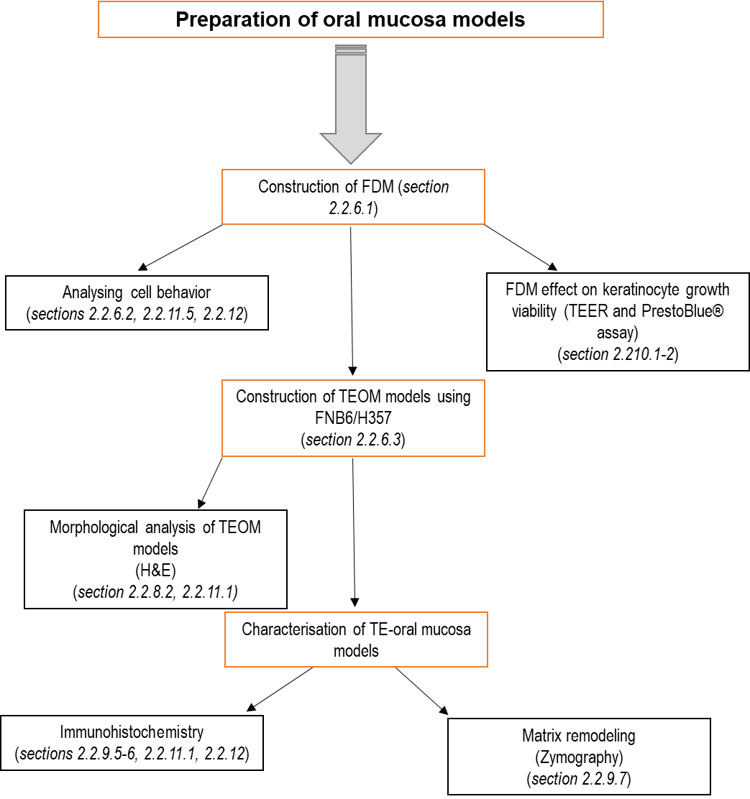

Figure 5.1 Schematic of materials and methods used in this chapter
4 Stewart DA, Cooper CR, Sikes RA. Changes in extracellular matrix (ECM) and ECM-associated

5.3 Results

5.3.1 Characterisation of normal and cancer cell behaviour on fibroblast-derived matrices

Cell migration, adhesion and proliferation are strongly influenced by ECM architecture and rigidity and this interaction is a crucial aspect of many physiological processes. The aim of this section was to assess changes of the adhesion, proliferation and migration rates of normal FNB6 cells and cancer H357 cells using FDM as scaffold substrates.

5.3.1.1 Adhesion of normal and OSCC cells on NOF- and CAF-DM

To determine if epithelial cells were able to adhere to developed NOF- and CAF-DM, an adhesion assay was performed to determine the percentage of cells that remained adherent after 24 h using live-cell imaging microscopy. After 24 h FNB6 adhered to NOF-DM with a mean percentage of 97.94 ± 1.30%. No significant changes in adhesion were observed when FNB6 were seeded on a CAF-DM of 80.91 ± 11.86%.
A lower percentage of H357 adhered onto the NOF- and CAF-DM, compared to FNB6 cells, however there was no significant difference between H357 on the two different cell derived matrices with a mean percentage of 77.61 ± 5.77% and 68.16 ± 11.86% cells adhering to the NOF- and CAF-DM, respectively.
Analysis of adherence between cell types was also investigated with a significant decrease in adherence observed for H357 on CAF-DM compared to FNB6 on NOF-DM, p=0.0197. Results shown in appendix Figure 7.2.

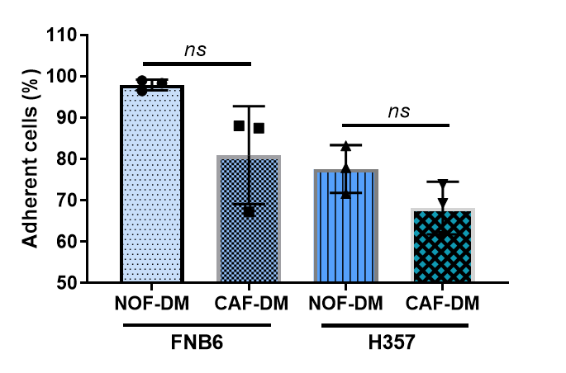

Figure 5.2 Keratinocyte adhesion onto NOF- and CAF-derived matrices
Normal (FNB6) and OSCC (H357) keratinocytes were seeded onto NOF- and CAF-DM and the % of adherent cells after a 24 h determined. Data is presented as mean ± SD (N=3, n=3) as analysed by Student’s T-test.

5.3.1.2 Analysing keratinocyte proliferation on NOF- and CAF-DM

To assess keratinocyte proliferation on FDM the percentage of FNB6 and H357 cells which had doubled after 24 h was determined using time-lapse microscopy. FNB6 proliferation was lowest on the NOF-DM with an increase of 9.94 ± 11.92% (Figure 5.3). However, when FNB6 cells were added to CAF-DM their doubling capacity increased significantly by 7-fold to 69.70 ± 21.65% (p=0.0138). After 24 h 53.35 ± 15.65% of the H357 cell population had doubled and a significant increase in proliferation was observed with H357 seeded on CAF-DM of 115.60 ± 13.41% (p=0.0064), showing the greatest rate of proliferation.
Increased proliferation was observed between different cell types. H357 on NOF- and CAF-DM were significantly increased compared to FNB6 proliferation on NOF-DM, with a p=0.0268 for H357 on NOF-DM and p=0.001 for H357 on CAF-DM, analysis and results are shown in appendix Figure 7.3.
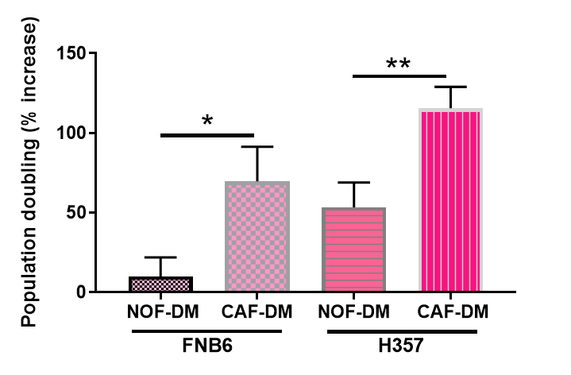

Figure 5.3 Assessment of the proliferation of H357 and FNB6 cells on NOF- and CAF-DM
Percentage doubling was calculated at 24 h for both FNB6 and H357 cells on NOF- and CAF-DM using live-cell imaging microscopy. Data is presented as mean ± SD (N=3, n=3). * Denotes p <0.05, and ** p <0.01 analysed by Student’s T-Test.

5.3.1.3. Migration of normal and cancerous epithelial cells on NOF- and CAF-DM

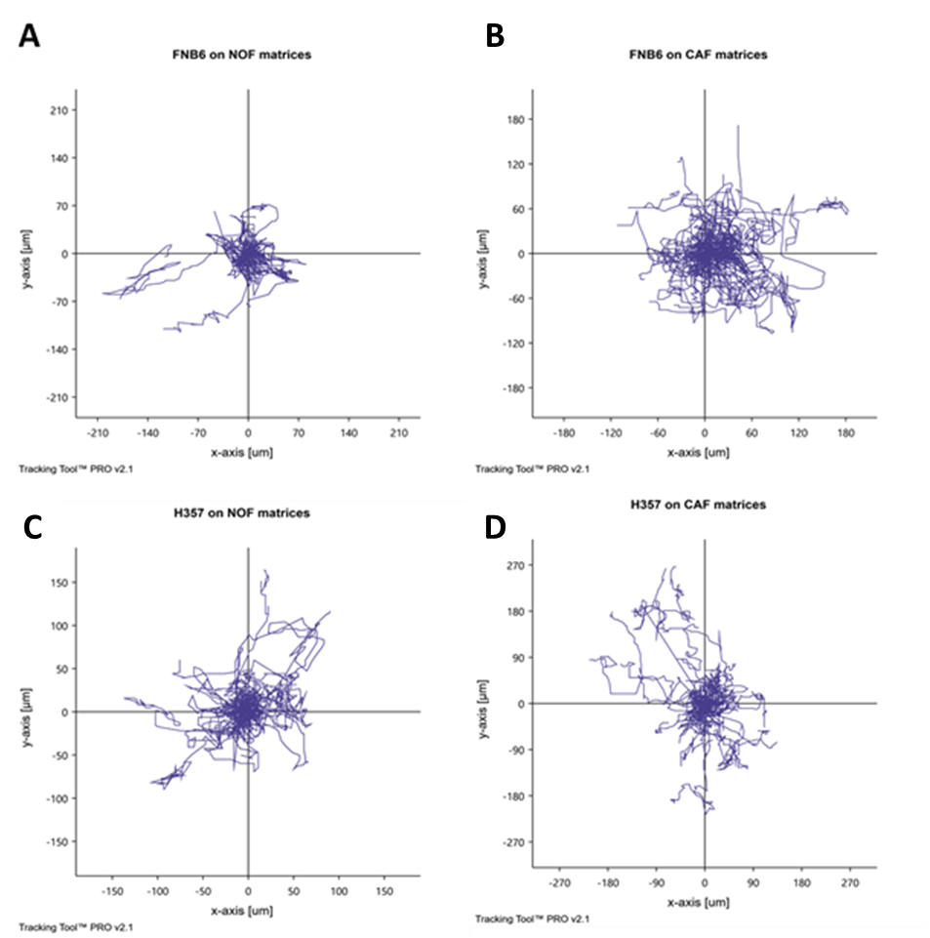
Cell migration can be graphically displayed over time by tracking individual cells using live cell time-lapse imaging and computational plotting of their movement overtime. Rose plots were generated to summarise cell trajectories on NOF- and CAF-DM and to show spatial and directional movement of cells (Figure 5.4). The plots revealed that FNB6 cells movement appears more clustered on the NOF-DM (Figure 5.4 A) compared to CAF-DM; where a much greater movement was exhibited by the cells (Figure 5.4 B). H357 cells show similar cell trajectories on both NOF- and CAF-DM (Figure 5.4 C-D).

Figure 5.4 Rose plots of keratinocyte cell trajectories on NOF- and CAF-DM
Representative trajectories were plotted for H357 and FNB6 cultured on NOF- and CAF-DM following a 24 h live-cell time-lapse experiment (N=3, n=3).

Further quantitative analysis of the rose plot trajectories was performed to determine four migration parameters; accumulated distance, Euclidian distance, velocity and the directness of migrating cells (Figure 5.5 A). FNB6 cells migrated the least on the NOF-DM with a mean accumulated distance of 184.30 ± 62.98 µm. For FNB6 cells on CAF-DM, the distance of migration was significantly increased by 2-fold with a mean accumulated distance of 429.20 ± 58.56 µm (p=0.0079). The same trend was also observed for the H357 cells and they migrated further than FNB6 cells on NOF-DM. H357 migrated on NOF-DM with a mean distance 260.50 ± 62.20 µm compared to 329.10 ± 97.70 µm on the CAF-DM.
In order to assess the point to point distance of migration in any one direction the Euclidian distance was analysed (Figure 5.5 B). The Euclidian distance was least for the FNB6 cells on NOF-DM (26.83 ± 4.20 µm) but almost doubled when cells were cultured on CAF-DM; (61.97 ± 15.61 µm, p=0.0197). H357 on NOF-DM migrated on NOF-DM, with a distance of 34.07 ± 4.31 µm. Euclidian distance was greatest for H357 on CAF-DM (74.30 ± 22.99 µm) and was significantly greater than H357 on NOF-DM, p=0.0408.
The speed and direction of migrating cell types was conferred on the various FDM (Figure 5.5 C). Regardless of cell type, the velocity of migrating cells was greatest on CAF-DM. FNB6 velocity was the highest recorded at 0.33 ± 0.05 µm/min on CAF-DM which was significantly increased when compared to FNB6 on NOF-DM, p=0.0132. H357 migration velocity on CAF-DM was also significantly increased compared to on NOF-DM (p=0.0161) with a mean velocity of 0.33 ± 0.06 µm/min.
FNB6 migrating on NOF-DM showed the greatest mean directness of 0.35 ± 0.03. The least direct migration was exhibited for FNB6 on CAF-DM (0.14 ± 0.02) and this was significantly less direct than on NOF-DM (p=0.0009). H357 directness was similar to the directness of FNB6 on CAF-DM with a mean directness of 0.15 ± 0.05. A significant increase in directness was observed for H357 on CAF-DM with a mean of 0.25 ± 0.02, p=0.0257 compared to H357 on NOF-DM. (Figure 5.5 D).

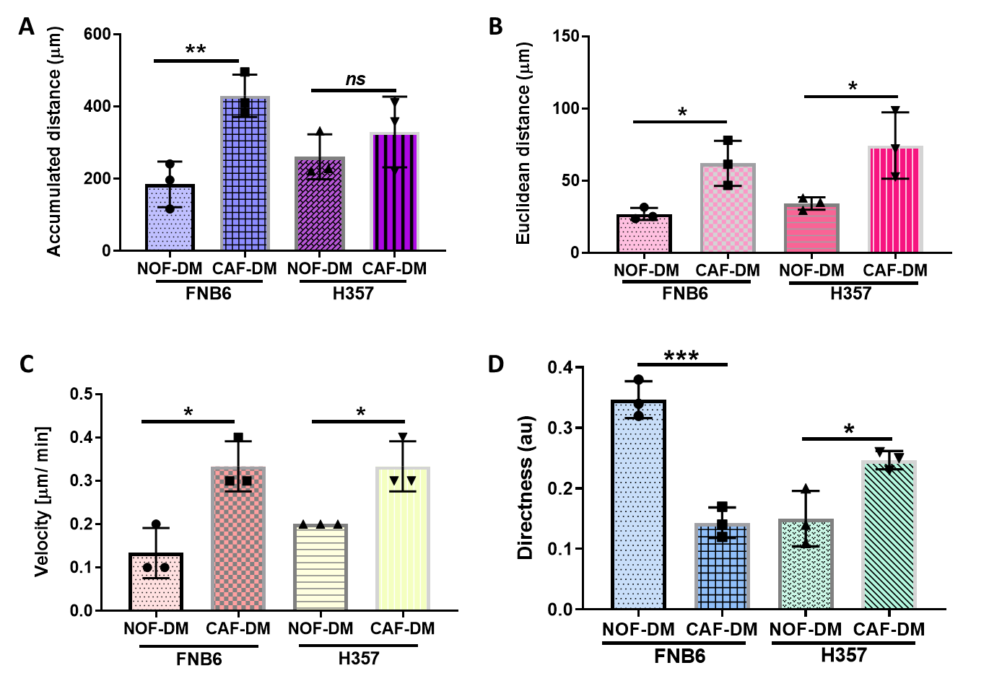

Figure 5.5 Keratinocyte cell behaviour on NOF- and CAF-DM
The migration capacity, speed and directness of normal (FNB6) and OSCC (H357) keratinocytes analysed during a 24 h time-lapse experiment. Cells were manually tracked, and accumulated distance (A), Euclidean distance (B), velocity (C), and directness (D) computationally calculated using Tracking tool™ PRO. Data is presented as mean ± SD (N=3, n=3) as analysed by unpaired Student’s T-Test. * denotes p <0.05, ** p <0.01, and *** p <0.001.

5.3.1.5 Evaluation of NOF- and CAF-DM ability to support keratinocyte cell growth over-time

H357 cultured on NOF-DM as a full-thickness model isn’t indicative of what is observed in vivo. Therefore, we didn’t investigate this model further. Prior to assessing whether oral keratinocytes can be used for full-thickness oral models; a PrestoBlue® assay was used to quantify the metabolic activity of different cell types (FNB6 and H357) as an indirect assessment of the ability of NOF- and CAF-DM to support keratinocyte cell growth over a 12 day growth period.
The addition of epithelial cells, regardless of cell-type, onto the developed FDM showed an increase in the metabolic activity of the models (Figure 5.6). The addition of FNB6 cells to a NOF-DM saw the greatest increase in metabolism at day 2 (72747.75 au). For a further 10 days the mean fluorescence was 67802 ± 7682 au. FNB6 cells were added to CAF-DM over the 12 days had a mean fluorescence of 69696 ± 7011 au. The metabolism of H357 on FDM was also assessed. There was an increased trend in cell metabolism when H357 carcinoma cells were added to the developed CAF-DM, where the mean fluorescent intensity over 12 days was the highest at 74301 ± 2290 au, although this was not significantly different (Figure 5.6).

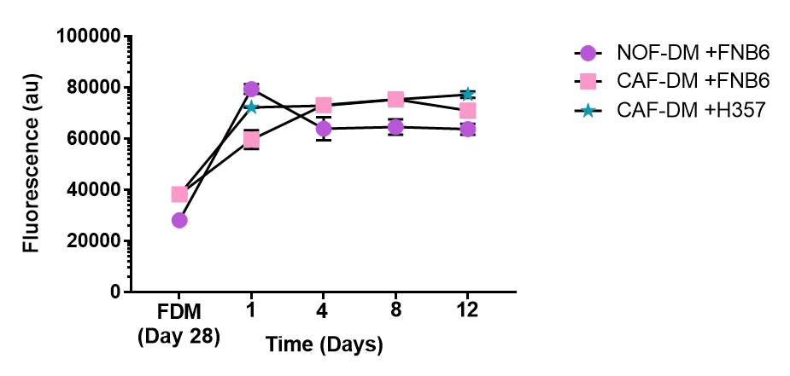

2

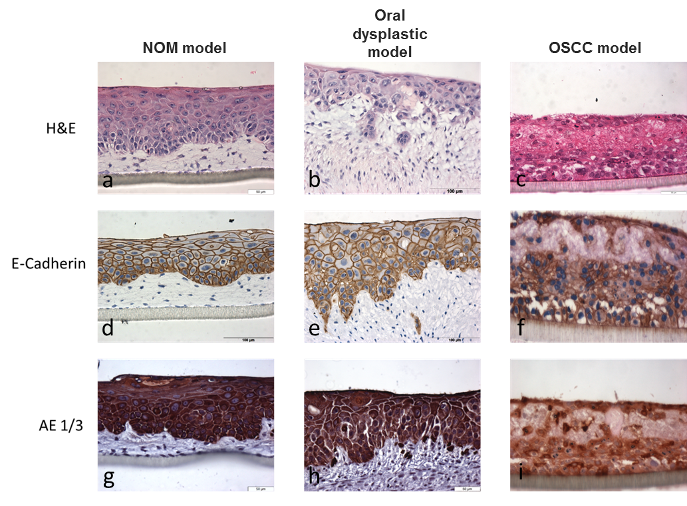

Figure 5.6 Analysis of tissue-engineered oral mucosa model metabolism in vitro
Metabolism of normal (FNB6) and OSCC (H357) keratinocytes was assessed over-time in tissue-engineered full thickness models for 12 days in vitro (circle= TENOM model, square = TEAOM model, star= TESCCM) Data is presented as mean ± SD (N=3, n=2).

5.3.2 Generation of tissue-engineered full-thickness oral mucosa models

5.3.2.1 Generation of a tissue-engineered full-thickness normal oral mucosa model

To investigate if FDM could support the development of full thickness tissue-engineered normal oral mucosa (TENOM) models, NOF-DM were generated over a 28-day culture period before the addition of normal FNB6 cells to the surface. The FNB6 models were initially cultured submerged for two days in Green’s media, before lifting the models to an air to liquid interface for a further 10 days and subsequently sectioned and stained with H&E (Figure 5.7).
Histological staining showed that the normal oral keratinocytes (FNB6) proliferated and migrated over the entire dermis as evident from the complete layer seen in a cross-section analysis across the whole insert (Figure 5.7 A). The resultant TENOM model demonstrated a fully stratified epithelium present on top of a fibroblast populated connective tissue component with well-defined layers. The basal cell compartment consisted of densely packed squamous, polarised cells lining the ECM compartment. There were distinct changes in epithelial cell morphology and density in the supra-basal compartment where the cell shape becomes more polyhedral and exhibits a broader, flattened morphology as the upper spinosum layers are reached (Figure 5.7 B). The surface layers contain flattened, non-nucleated cells with no evidence of keratinisation. In the prickle cell layer ‘spikey’ projections can be seen between epithelial cells which are desmosome attachments; made visible due to cell shrinkage during processing (Figure 5.7 C (iii, black arrows)). Rete ridges were also visible as epithelial projections in TENOM and visible across the model (appendix, Figure 7.4).

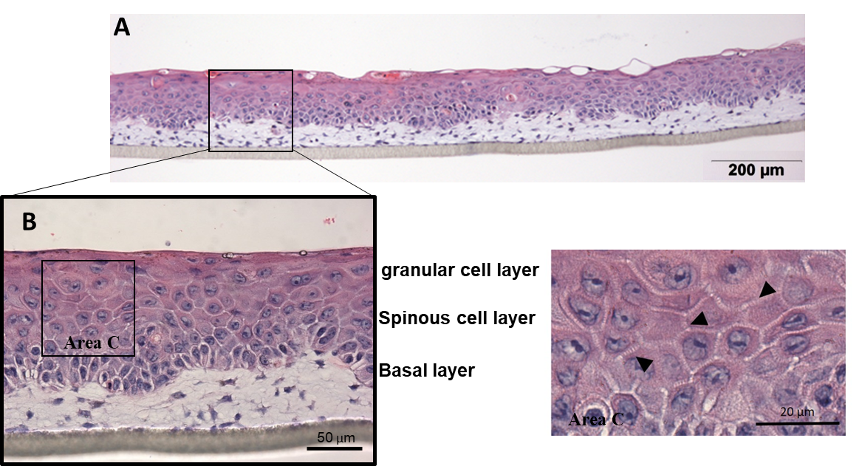

Figure 5.7 Histological analysis of tissue-engineered normal oral mucosa (TENOM) model generated using NOF-DM
After a 28-day NOF-DM development the addition of FNB6 cells produced a full-thickness stratified epithelium with evidence of the distinct cell layers (A +B) over a further 14 days. H&E analysis shows evidence of a basal cell layer; epithelial cell polarity and a distinct stratification of layers (B). Desmosome attachments can be seen in Area C between epithelial cells in the prickle layers of epithelium (iii, black arrows) (N=5, n=3).

5.3.1.2 Generation of a tissue-engineered, full-thickness atypical oral mucosa model

To investigate if culturing normal oral keratinocytes on CAF-DM altered the histological morphology of the resulting epithelium, models were established by culturing FNB6 cells on CAF-DM using the same culture conditions defined for generation of the TENOM models. Histological analysis revealed that FNB6 cells, when cultured on CAF-DM produced a tissue-engineered atypical oral mucosa (TEAOM) that morphologically resembles features of an oral epithelium with mild dysplasia (Figure 5.8 A). Despite a much thicker connective tissue, the epithelia layer produced was not as thick; 98.08 ± 22.59 µm thick for the TEAOM and 116.60 ± 15.95 µm thick for the TENOM (results shown in appendix, Figure 7.5) in TEAOM models and there was an apparent lack of defined cell layers within the epithelia. H&E analysis revealed the loss of a defined basal compartment as seen in the TENOM model and loss of polarisation. Keratin pearls were observed, indicating abnormalities in epithelial cell differentiation (Figure 5.8 A-B; red boxes). Invasion into the matrix layer below was evident (Figure 5.8 B; blue arrow) as well as tumour ‘islets’ formation beginning to develop (Figure 5.8 B: black arrows).


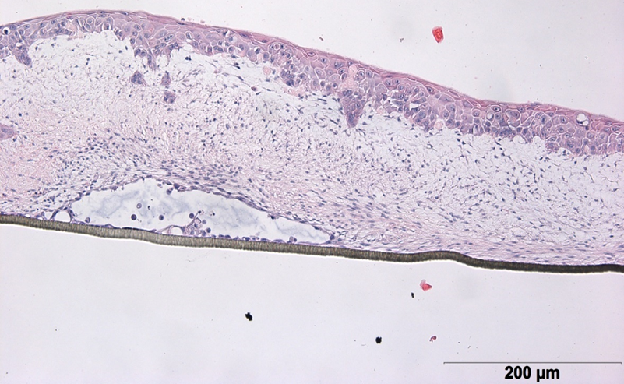

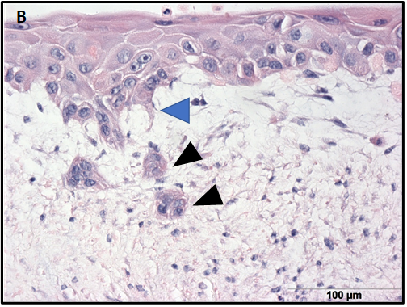

Figure 5.8 Representative H&E images of tissue-engineered atypical oral mucosa (TEAOM) model
The addition and culture of FNB6 cells on CAF-DM produced an atypical oral mucosa. H&E staining demonstrated a loss of a defined basal layer (A), evidenced by lack of densely packed oval shaped cells lining the matrix layer below, as well as keratin pearls (red boxes) Scale bar =200 µm. Invasion into the matrix layer below is evident (blue arrow) and tumour ‘islets’ formed (black arrows) (B) Scale bar =100 µm (N=3, n=3).

5.3.1.3 Generation of a tissue-engineered, full-thickness oral squamous cell carcinoma model

To investigate if CAF-DM could support OSCC growth to model cancer progression an H357 were cultured on 28-day CAF-DM. The resultant tissue-engineered OSCC model (TESCCM) demonstrated a CAF-rich populated dense matrix, with CAF orientation altering in proximity to the epithelial cells (Figure 5.9 A). More fusiform cells are seen closer to the epithelia surrounded by linear stromal fibres running parallel to the elongated cells and more rounded CAF appearance is evident with greater distance from the H357 cells (Figure 5.9 C; black dashed box). Histologically, H357 cells exhibited a highly disorganised epithelia with no stratification as seen in the TENOM and to a lesser extent the TEAOM models, and there was a distinct lack of cellular polarisation with cell invasion visible (Figure 5.9 B; red box). There is evidence of atypical mitosis (Figure 5.9 C; black box), loss of epithelial cell cohesion and an increase nucleus to cytoplasmic ratio.

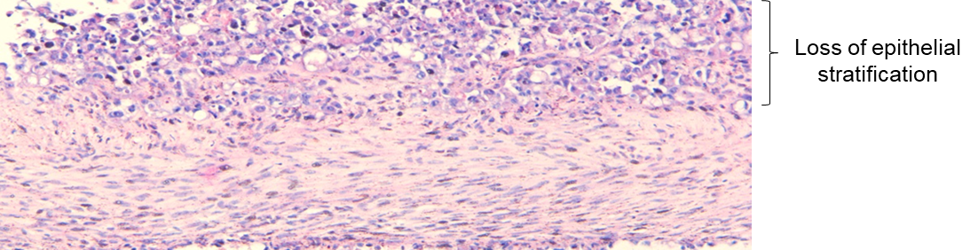
A

200 µm


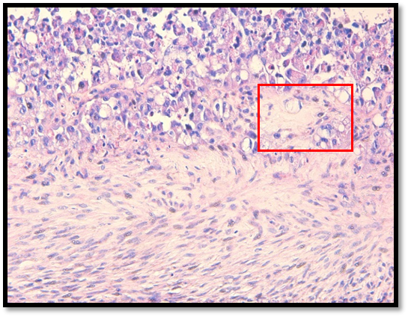
B

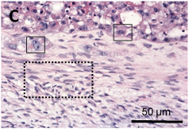

100 µm

Figure 5.9. Representative H&E images of tissue-engineered oral squamous cell carcinoma mucosa model (TESCCM)
The addition of H357 cells to CAF-DM produced a disordered OSCC model (A); highlighted by loss of a defined basal compartments in most areas, loss of cell polarisation, increased mitotic index (C- black boxes) and epithelial cells invading into the matrix layer below (B, red box). CAF morphology becomes more elongated when in close proximity to OSCC epithelial cells (C black dotted box) (N=3, n=3).

5.3.1.4 Analysis of the structural integrity of tissue-engineered oral mucosa models

TEER analysis was used to assess changes in barrier function in the different models generated (TENOM, TEAOM, and TESCCM). The addition of FNB6 drastically increased the resistance found in the FDM derived from both NOF and CAF (Figure 5.10). TENOM models incorporating NOF-DM with FNB6 averaged a resistance of 155.83 ± 10.57 Ω.cm² throughout the culture time, which is over double the resistance calculated for just the NOF-DM alone. The TEAOM model with CAF-DM and FNB6 in comparison had an average resistance of 129.67 ± 22.03 Ω.cm².
The integrity of the TESCCM generated by the culture of the OSCC cell-line H357 on CAF-DM, was also investigated (Figure 5.10) initially showed an increase in tissue resistance as expected compared to CAF-DM alone to 117.5 ± 11.03 Ω.cm². However, there was a reduction in resistance to 86.50 ±13.84 Ω .cm² by day 4 which decreased further to 68.3 ± 2.87 Ω.cm² by day 12. Overall ANOVA with Dunnett’s multiple comparison, indicated that the mean TEER for TESCCM was significantly lower (p=0.0004) than for TENOM, with a mean TEER of 86.48 ± 22.05 Ω.cm² indicating a loss in integrity of the epithelium in the TESCCM.
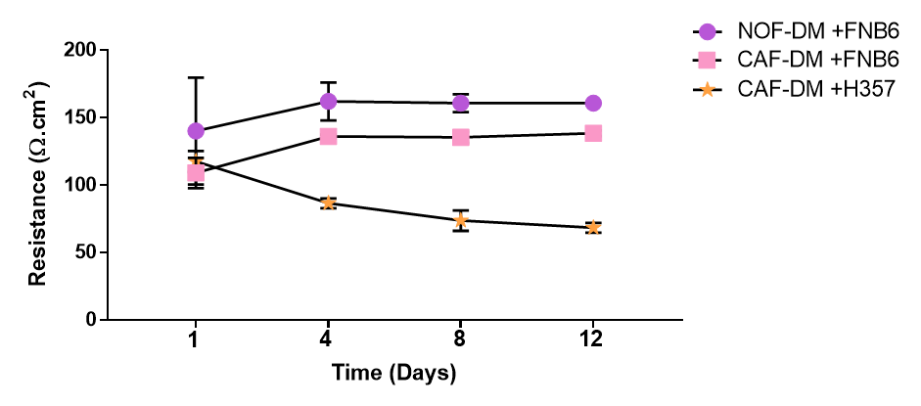
Figure 5.10 Analysis of tissue-engineered oral mucosa model integrity in vitro
Tissue resistance was calculated with the addition of keratinoctyes to established FDM by measuring the transepithelial electrical resistance over 12 days. Data presented in TENOM (circle), TEAOM (square) models and TESCCM (star) over 12 days (N=3, N=3).

5.3.3 Characterisation tissue-engineered oral mucosa models

5.3.3.1 Immunohistochemical analysis of epithelial markers in TENOM, TEAOM, and TESCCM

5.3.3.1.1 E-cadherin

An anti-E-cadherin antibody stained for epithelial cadherin (E-cadherin); a cell-cell adhesion glycoprotein found throughout the normal oral mucosa with lack of expression and function linked to cancer progression. In the TENOM staining was clearly evident in the cell-cell junctions throughout the epithelium and most prominently found in the basal layer (Figure 5.11 A). In the TEAOM model, although staining was evident throughout the epithelium the staining was less clearly defined as compared to the TENOM (Figure 5.11 B) and even more so in the TESCCM where there was a distinct loss of defined staining at the cell-cell junctions (Figure 5.11 C). Semi-quantitative analysis of TEAOM stained sections (0.18 ± 0.01) supported the loss of staining in these models compare to TENOM 0.29 ± 0.07, a statistically significant decrease in intensity was observed in the TESCCM (0.14 ± 0.03, p=0.0176) compared to TENOM models (Figure 5.11 D).

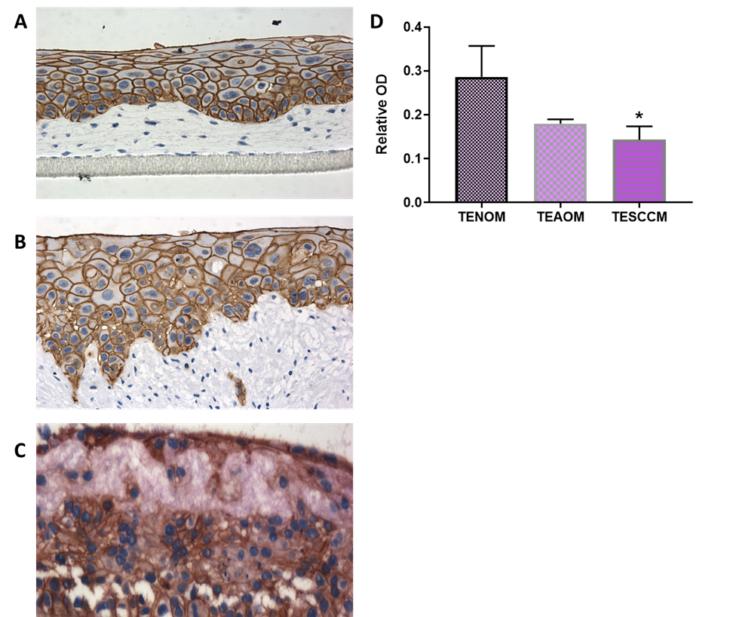

Figure 5.11 Immunohistochemical analysis of E-cadherin in tissue-engineered oral mucosa models
Full thickness tissue-engineered models were produced on FDM and cultured for 12 days at an air-to-liquid interface before being subjected to histological processing and immunohistochemical staining for E-cadherin (brown) and haematoxylin counterstain (blue). Representative images of TENOM (A), TEAOM (B) and TESCCM (C) and semi-quantitative analysis of the optical density of staining intensity (D). Data shows mean ± SD (N=3, n=2). * p <0.05, compared to TENOM as analysed by Kruskal-Wallis test with Dunn’s multiple comparison. Scale bar = 50 µm.

5.3.3.1.2 AE1/3

The pan-cytokeratin antibody anti-AE1/3 detects CK1 - 8, 10, 14 - 16 and 19, but does not detect CK17 or CK18. Staining was exhibited throughout the thickness of the TENOM model with increased intensity in the lower third of the epithelium (Figure 5.12 A). In the TEAOM model AE1/3 staining was also visible throughout the epithelium, with a mean intensity of 0.70 ± 0.04 (Figure 5.12 B). This staining was less diffuse and displayed prominent gaps between cells; evidence of loss of junctional complexes and a ‘leaky’ epithelium. No significant difference is staining was detected for AE1/3 in TESCCM, with a mean staining intensity of 0.63 ± 0.13 (Figure 5.12 C +D).

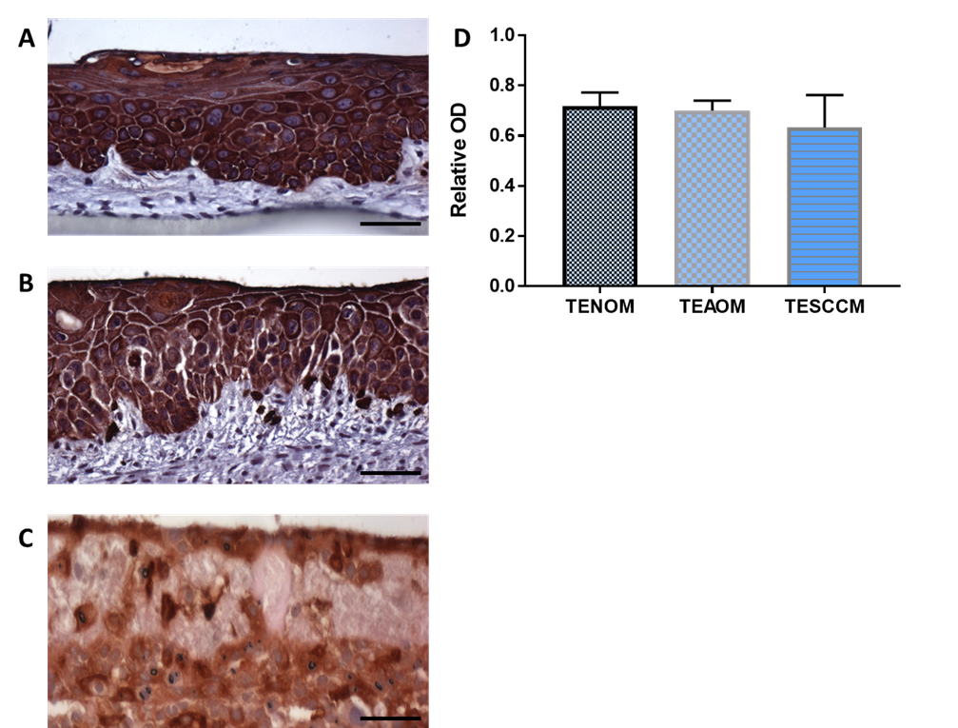

Figure 5.12 Immunohistochemical analysis of AE1/3 in tissue-engineered oral mucosa models
Full thickness tissue-engineered models were developed on FDM and cultured for 12 days at an air-to-liquid interface before being subjected to histological processing and immunohistochemical staining for AE1/3 (brown) and haematoxylin counterstain (blue). Representative images of AE1/3 staining observed in TENOM (A), TEAOM (B) and TESCCM (C) and semi-quantitative analysis of the optical density of staining intensity (D). Data shows mean ± SD (N=3, n=2). ns compared to TENOM as analysed by Kruskal-Wallis test with Dunn’s multiple comparison. Scale bar = 50 µm.

5.3.3.1.3 Cytokeratin-14

Anti-cytokeratin-14 (CK-14) stained for intermediate filaments; known to present in essentially all epithelial cells and in the neoplasms derived from them. Staining of anti-CK-14 was found exclusively in the epithelium for all models (Figure 5.13). Staining was more pronounced in the basal compartment of the TENOM (Figure 5.13 A), with more obvious gaps in expression in the basal cell of the TEAOM model (Figure 5.13 B). Again, the TESCCM showed staining in all epithelial cells but the expression was more diffuse (Figure 5.13 C). Quantification of CK-14 intensity indicated no significant difference in CK-14 between models (Figure 5.13 D).

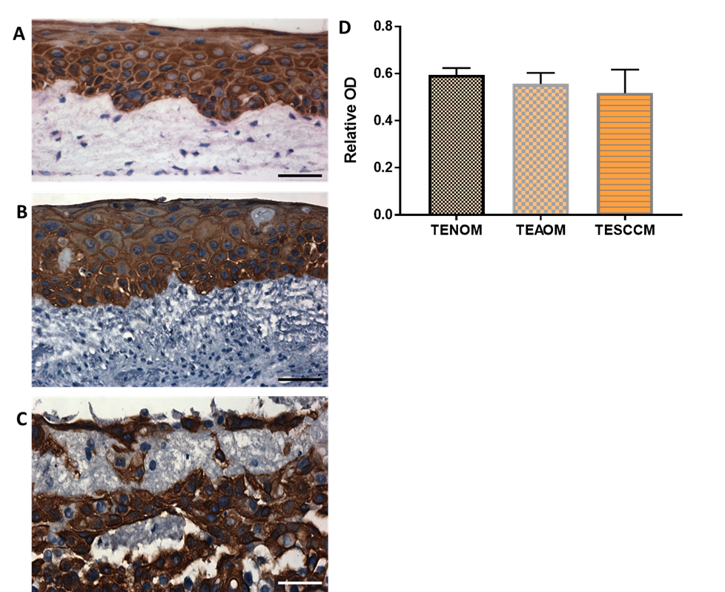

Figure 5.13 Immunohistochemical analysis of cytokeratin-14 in tissue-engineered oral mucosa models
Full thickness tissue-engineered models were developed on FDM and cultured for 12 days at an air-to-liquid interface before being subjected to histological processing and immunohistochemical staining for CK-14 (brown) and haematoxylin counterstain (blue). Representative images of CK-14 staining observed in TENOM (A), TEAOM (B) and TESCCM (C) and semi-quantitative analysis of the optical density of staining intensity (D). Data shows mean ± SD (N=3, n=2). ns compared to TENOM as analysed by Kruskal-Wallis test with Dunn’s multiple comparison. Scale bar = 50 µm.

5.3.3.2 Immunohistochemical analysis of ECM and stromal-cell markers

5.3.3.2.1 Tenascin-C

Tenascin-C is a large extracellular matrix glycoprotein is associated with various cellular mechanisms such as adhesion modulation, motility, proliferation and differentiation. In the TENOM model; staining of TNC was found localised to the basement membrane only; where the protein it is known to bind fibronectin (Figure 5.14 A, black arrows). The staining pattern changes dramatically in TEAOM model; where staining is clearly visible throughout the whole stromal compartment, mean intensity was 0.37 ± 0.10 (p=0.015) (Figure 5.14 B +D) compared to the TENOM model, mean of 0.08 ± 0.02. For the TESCCM, the expression of TNC was observed within the matrix layer and not defined to the basement membrane but was not significantly altered compared to TENOM models (Figure 5.14 C + D).

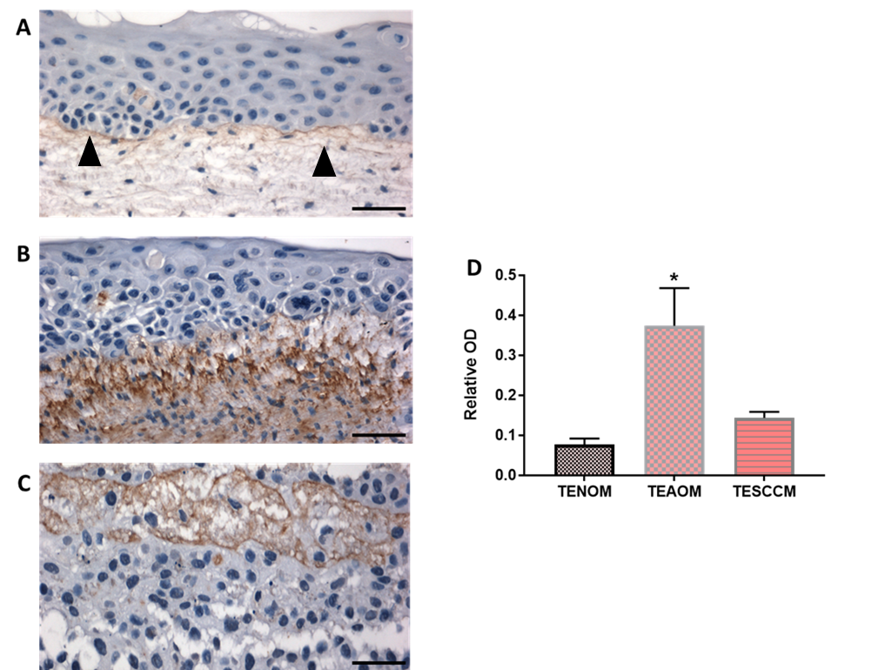

Figure 5.14 Immunohistochemical analysis of tenascin-c in tissue-engineered oral mucosa models
Full thickness tissue-engineered models were produced on FDM and cultured for 12 days at an air-to-liquid interface before being subjected to histological processing and immunohistochemical staining for TNC (brown) and haematoxylin counterstain (blue). Representative images of TENOM (A). Black arrows indicate prominent staining at basement membrane. TEAOM (B) and TESCCM (C) and semi-quantitative analysis of the optical density of staining intensity (D). Data shows mean ± SD (N=3, n=2). * p <0.05, compared to TENOM as analysed by Kruskal-Wallis test with Dunn’s multiple comparison. Scale bar = 50 µm.

5.3.3.2.2 Vimentin

Vimentin is a 57 kDa protein and is a major constituent of the intermediate filament (IF) family of proteins. It is ubiquitously expressed in normal mesenchymal cells such as fibroblasts and this protein functions to maintain cellular integrity and provide resistance against stress. The expression of vimentin in tissue-engineered (TE) models was localised to fibroblasts found within the matrix layer (Figure 5.15 A+B). There was an increased intensity of staining of vimentin in the TEAOM model, with a mean of 0.14 ± 0.03 specifically in the fibroblasts found in close proximity to the epithelium (Figure 5.15 B). The TESCCM showed a distinct increased staining with a mean increase to 0.19 ± 0.02 compared to TENOM (p=0.0323) (Figure 5.15 C-D).

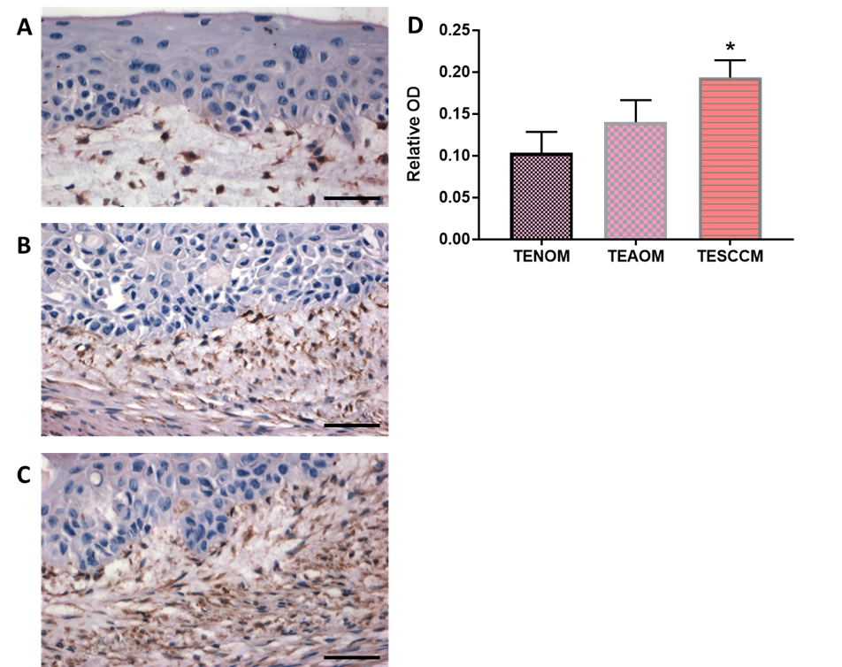

Figure 5.15 Immunohistochemical analysis of vimentin in tissue-engineered oral mucosa models
Full thickness tissue-engineered models were produced on FDM and cultured for 12 days at an air-to-liquid interface before being subjected to histological processing and immunohistochemical staining for vimentin (brown) and haematoxylin counterstain (blue). Representative images of TENOM (A), TEAOM (B) and TESCCM (C) and semi-quantitative analysis of the optical density of staining intensity (D). Data shows mean ± SD (N=3, n=2). * p <0.05, compared to TENOM as analysed by Kruskal-Wallis test with Dunn’s multiple comparison. Scale bar = 50 µm.

5.3.3.2.3 Fibronectin

The ECM related protein fibronectin is a high molecular weight glycoprotein (440 kDa) that binds integrins (membrane spanning receptors). It is capable of binding various ECM components including collagen and proteoglycans. In these TEOM models weak staining was observed in the ECM nearest to the epithelium for TENOM model (Figure 5.17 A). In the TEAOM model (Figure 5.16 B) and in TESCCM (5.16 C) more intense staining was visible and found through-out the whole ECM compartment, suggest this protein changes with disease progression. There was a significant increase in staining intensity of FN1-EDA in the TESCCM model, with a mean optical density of 0.16 ± 0.01, p=0.0288 (Figure 5.16 D).

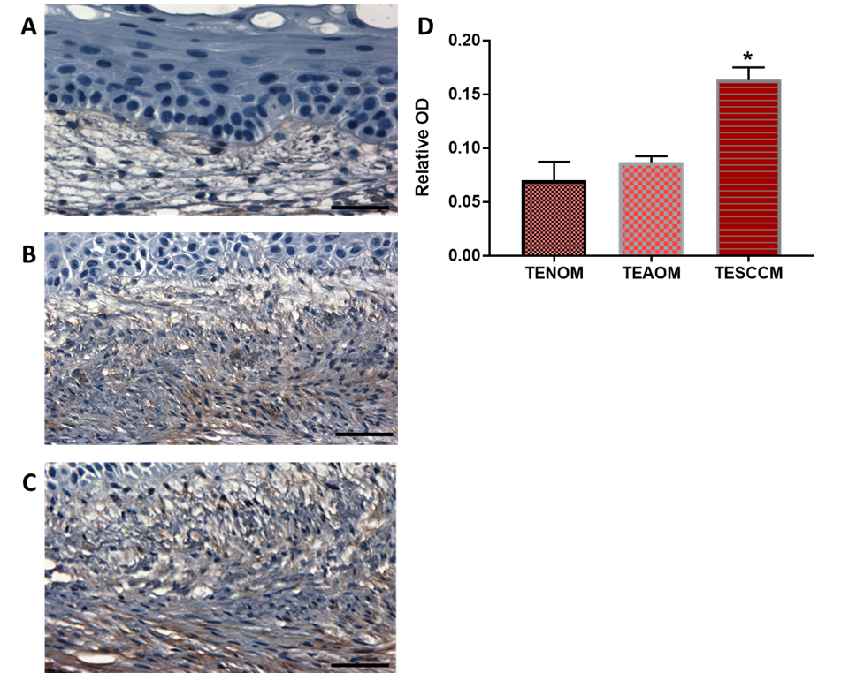

Figure 5.16 Immunohistochemical analysis of FN1-EDA in tissue-engineered oral mucosa models
Full thickness tissue-engineered models were developed on FDM and cultured for 12 days at an air-to-liquid interface before being subjected to histological processing and immunohistochemical staining for FN1-EDA (brown) and haematoxylin counterstain (blue). Representative images of TENOM (A), TEAOM (B) and TESCCM (C) and semi-quantitative analysis of the optical density of staining intensity (D). Data shows mean ± SD (N=3, n=2). * p <0.05, compared to TENOM as analysed by Kruskal-Wallis test with Dunn’s multiple comparison. Scale bar = 50 µm.

5.3.3.2.4 αSMA

Another marker of stromal cells is αSMA. This is also a marker of activated fibroblasts in vitro and in vivo. Staining intensity of αSMA was altered when comparing TENOM models with TEAOM models and TESCCM (Figure 5.17). Weak staining in was observed in the stroma of TENOM models, as well as the nucleus of fibroblasts within this layer. Dense, visible staining was also observed within the matrix layers of the TEAOM with a non-significant increase in staining from 0.07 ± 0.01 to 0.35 ± 0.06 (Figure 5.17 B +D). There is also staining in the nuclei of epithelial basal cells which could indicate a phenotypic EMT-like change in the epithelial cells. In the TESCCM, αSMA staining was significantly increased to 0.45 ± 0.10 (p=0.0219) (Figure 5.17 C+D). Previous work has indicated that αSMA expression is also negatively associated with prognosis and an indicator of disease progression in OSCC and therefore consolidates these models as in vitro mimetics for OSCC disease development.

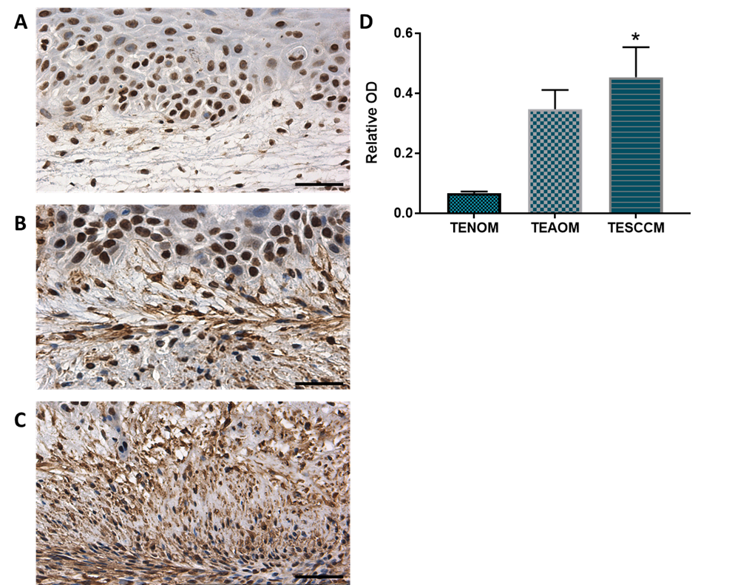

Figure 5.17 Immunohistochemical analysis of αSMA in tissue-engineered oral mucosa models
Full thickness tissue-engineered models were developed on FDM and cultured for 12 days at an air-to-liquid interface before being subjected to histological processing and immunohistochemical staining for αSMA (brown) and haematoxylin counterstain (blue). Representative images of TENOM (A), TEAOM (B) and TESCCM (C) and semi-quantitative analysis of the optical density of staining intensity (D). Data shows mean ± SD (N=3, n=2). * p <0.05, compared to TENOM as analysed by Kruskal-Wallis test with Dunn’s multiple comparison. Scale bar = 50 µm.

5.3.3.2.5 Versican

The large chondroitin sulphate proteoglycan VCAN has roles in aiding ECM assembly, anti-adhesion, cell proliferation, migration and ECM remodelling. The expression of VCAN was observed in all TEOM models analysed and its staining localised to the ECM as well as H357 cells (Figure 5.18 A-C, black arrows). VCAN staining was significantly increased throughout the stroma of TEAOM model (p=0.0386) and had a mean staining intensity of 0.56 ± 0.05 (Figure 5.18 B+D). No statistically significant increase in VCAN staining was observed in the TESCCM, mean of 0.46 ± 0.13, compared to the TENOM model which had a mean of 0.30 ± 0.01 indicating that VCAN abundance may change in OSCC disease progression.

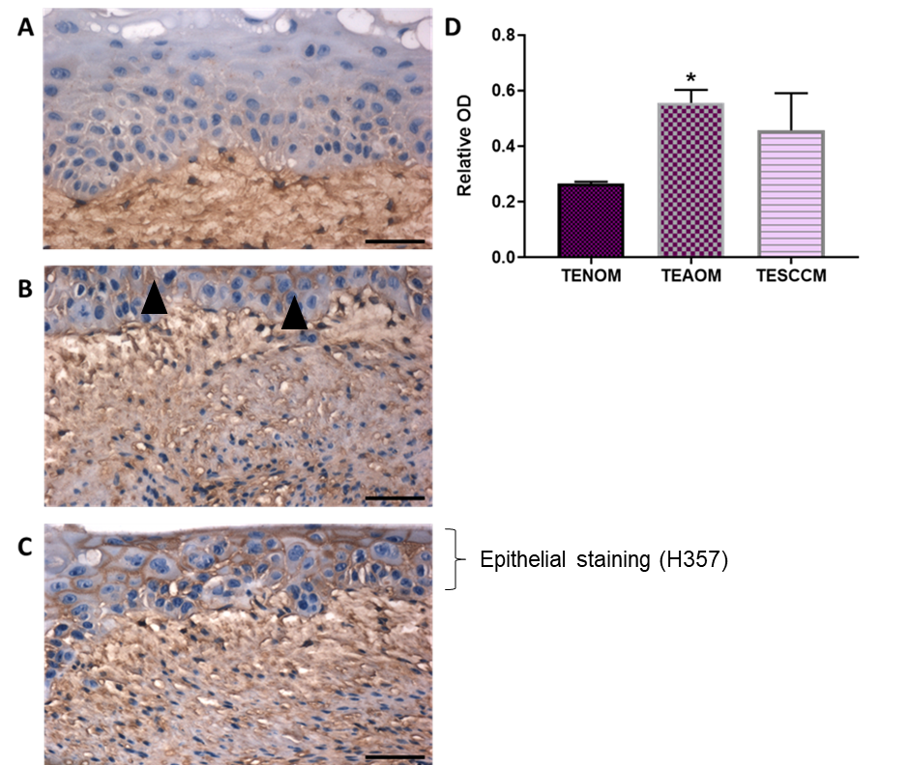

Figure 5.18 Immunohistochemical analysis of versican in tissue-engineered oral mucosa models
Full thickness tissue-engineered models were developed on FDM and cultured for 12 days at an air-to-liquid interface before being subjected to histological processing and immunohistochemical staining for VCAN (brown) and haematoxylin counterstain (blue). Representative images of TENOM (A), TEAOM (B) and TESCCM (C) and semi-quantitative analysis of the optical density of staining intensity (D). Black arrows show prominent staining in epithelial compartment. Data shows mean ± SD (N=3, n=2). * p <0.05, compared to TENOM as analysed by Kruskal-Wallis test with Dunn’s multiple comparison. Scale bar = 50 µm.

5.3.3.2.2 Collagen type 1

The most abundant protein found within the ECM is Collagen type 1. The staining of the subtype COL1A1 was analysed. Staining was clear in the basement compartment of TENOM (black arrows) and was also observed in the fibroblast matrix layer, with a mean intensity 0.14 ± 0.02 (Figure 5.19 A+D). In the TEAOM model there appears a more densely stained pattern throughout the stromal compartment with a mean intensity of 0.30 ± 0.01 with a loss of basement membrane definition (Figure 5.19 B+D). The TESCCM also exhibited staining throughout the ECM meshwork with a mean intensity of 0.30 ± 0.02 (Figure 5.19 C+D) indicating COL1A1 expression changes in an OSCC progression model.

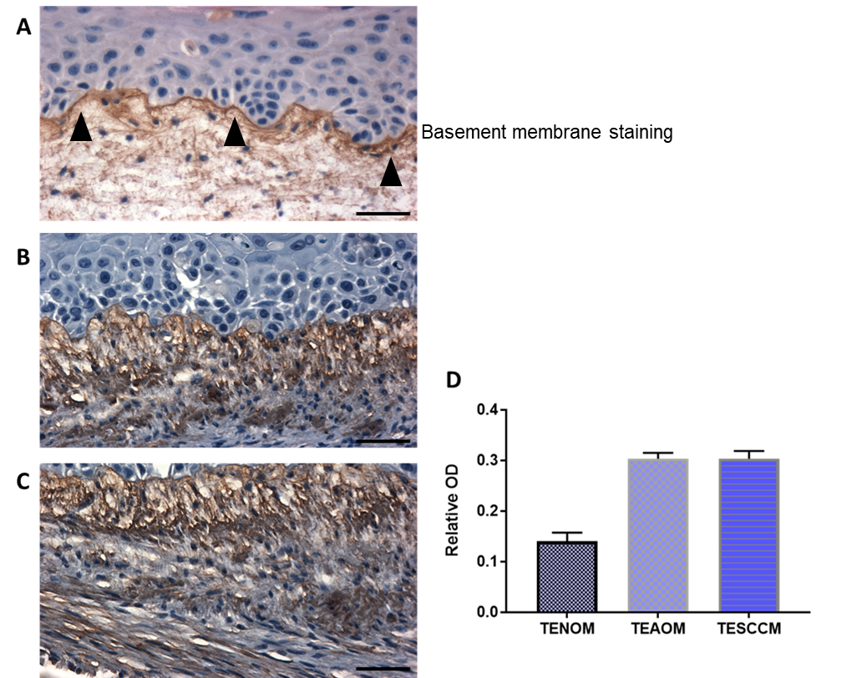

Figure 5.19 Immunohistochemical analysis of COL1A1 in tissue-engineered oral mucosa models
Full thickness tissue-engineered models were developed on FDM and cultured for 12 days at an air-to-liquid interface before being subjected to histological processing and immunohistochemical staining for COL1A1 (brown) and haematoxylin counterstain (blue). Representative images of TENOM (A), TEAOM (B) and TESCCM (C) and semi-quantitative analysis of the optical density of staining intensity (D). Prominent staining observed in basement membrane of TENOM (black arrows) and in the stroma of TEAOM and TESCCM. Data shows mean ± SD (N=3, n=2). ns compared to TENOM as analysed by Kruskal-Wallis test with Dunn’s multiple comparison. Scale bar = 50 µm.

5.3.3.3 Immunohistochemical analysis of basal cells and basement membrane components

5.3.3.3.1 Integrin α6β4

Integrin α6β4 has been identified as a major adhesion receptor of the integrin family and nucleates the formation of hemidesmosomes in oral stratified squamous epithelium primarily expressed in the basal aspect of basal cells. The integrins of epithelial cells have been shown to mediate cell-cell and cell-extracellular matrix adhesions. Using IHC the expression of the α6, β4 subunits of integrins were analysed for each model. In the TENOM model, staining was evident within the basal and suprabasal layers of the oral epithelium (Figure 5.20 A). In particular, staining was exhibited on the junctions between cells on their basal aspects; indicating their potential importance in providing communicating adhesions with the ECM below. In the TEAOM model integrin α6β4 staining was significantly reduced with a mean of 0.36 ± 0.05, p=0.0225 compared to the TENOM and was found in the basal compartment as well as some proliferating cells and cells within the additional layers of the oral epithelium (Figure 5.20 B+D). In the TESCCM, there is a distinct loss of the basal compartment and therefore, the staining was ubiquitously expressed in all epithelial cells and localised and more-so in those cells in contact with the ECM. (Figure 5.20 C+D).

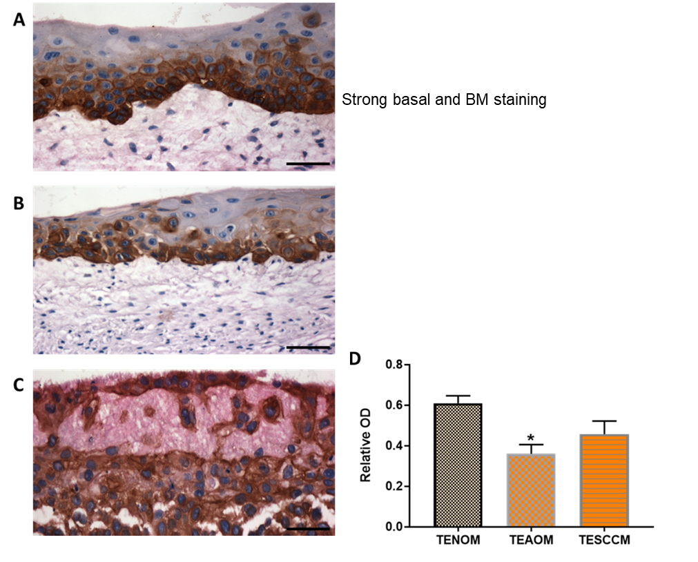

Figure 5.20 Immunohistochemical analysis of integrin α6β4 in tissue-engineered oral mucosa models
Full thickness tissue-engineered models were developed on FDM and cultured for 12 days at an air-to-liquid interface before being subjected to histological processing and immunohistochemical staining for integrin α6β4 (brown) and haematoxylin counterstain (blue). Representative images of TENOM (A), TEAOM (B) and TESCCM (C) and semi-quantitative analysis of the optical density of staining intensity (D). Data shows mean ± SD (N=3, n=2). * p <0.05 compared to TENOM as analysed by Kruskal-Wallis test with Dunn’s multiple comparison. Scale bar = 50 µm.

5.3.3.3.2 Ki-67

The proliferative marker Ki-67 stains positive in the nuclei of diving cells and is typically found in the basal cells of normal epithelium and throughout the epithelium un dysplastic and cancerous tissue. Evidence of positive staining was found in all TEOM models (Figure 5.21). A proliferation index of roughly 1 in 6 basal nuclei staining positively was observed in the TENOM, with some cells also staining positive in the parabasal layers (Figure 5.21 A). Parabasal staining was more prominent in the TEAOM models (Figure 5.21 B). For the TESCCM, a significant increase in proliferative cells was observed (p=0.0396) with a mean staining intensity of 0.41 ± 0.02 compared to 0.11 ± 0.01 for TEAOM and 0.10 ± 0.02 for TENOM. In the TESCCM staining was not confined to singular cell layers and nearly all invading cells stained positive for Ki-67. (Figure 5.21 C+D).

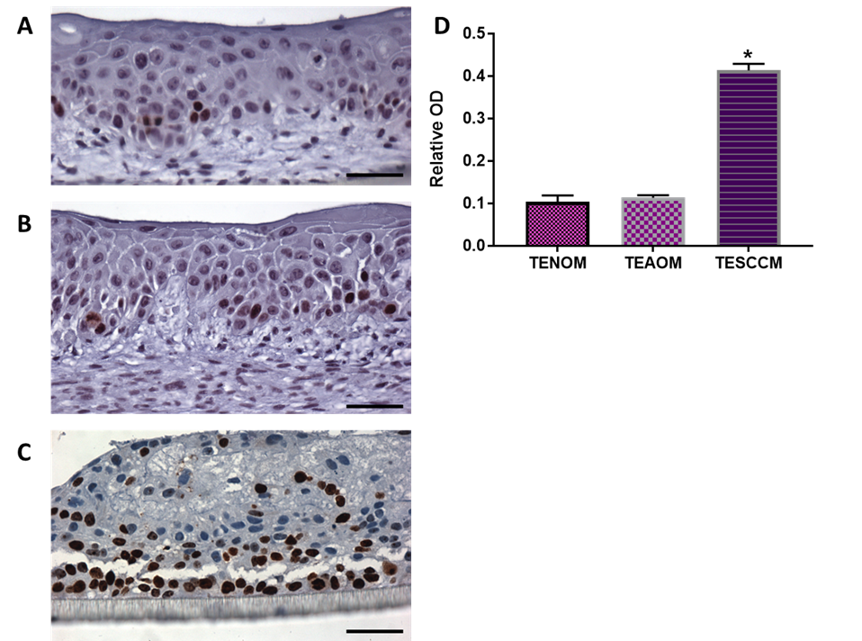
Figure 5.21 Immunohistochemical analysis of Ki-67 in tissue-engineered oral mucosa models
Full thickness tissue-engineered models were developed on FDM and cultured for 12 days at an air-to-liquid interface before being subjected to histological processing and immunohistochemical staining for Ki-67 (brown) and haematoxylin counterstain (blue). Representative images of TENOM (A), TEAOM (B) and TESCCM (C) and semi-quantitative analysis of the optical density of staining intensity (D). Data shows mean ± SD (N=3, n=2). * p <0.05 compared to TENOM as analysed by Kruskal-Wallis test with Dunn’s multiple comparison. Scale bar = 50 µm.

5.3.3.3.3 Collagen type IV

Collagen type IV is largely a component of the epithelial basement membrane. During metastasis the integrity of the basement is compromised, and so incomplete basement membrane formation alters with disease progression. Weak staining of COLIV was found in exclusively in the basement membrane (BM) of TENOM (Figure 5.22 A). In TEAOM models staining was intermittently observed in the BM, with a mean staining intensity of 0.01 ± 0.002 (Figure 5.22 B), however some expression was also visible in the ECM (appendix, Figure 7.6). Expression of COLIV was absent or significantly reduced in TESCCM (Figure 5.22 C+D) and this reduction intensity of staining was calculated with a mean of 0.003 ± 0.001, p=0.0262 compared to TENOM models, with a mean staining of 0.02 ± 0.01 (Figure 5.22 D).

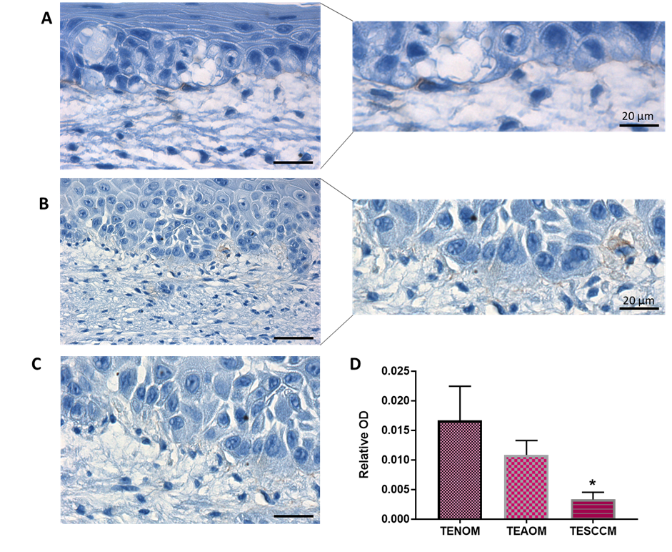

Figure 5.22 Immunohistochemical analysis of COLIV in tissue-engineered oral mucosa models
Full thickness tissue-engineered models were developed on FDM and cultured for 12 days at an air-to-liquid interface before being subjected to histological processing and immunohistochemical staining for COLIV (brown) and haematoxylin counterstain (blue). Representative images of TENOM (A), TEAOM (B) and TESCCM (C) and semi-quantitative analysis of the optical density of staining intensity (D). Data shows mean ± SD (N=3, n=2). * p <0.05 compared to TENOM as analysed by Kruskal-Wallis test with Dunn’s multiple comparison. Scale bar = 50 µm.

5.3.2.2 Matrix remodelling tissue-engineered oral mucosa models

To analyse the remodelling capabilities of keratinocytes from in response to FDM scaffolds; the enzymatic activity of MMP-2 and -9 was assessed and recombinant (Rb) MMP 2 and 9 used as positive controls. Positive MMP-2 and MMP-9 activity was confirmed by gelatin zymography of cell culture supernatants for all TEOM models (Figure 5.23). MMP-9 activity was greatest in TESCCM (Figure 5.23 B). Densitometric analysis indicated that TESCCM had a mean band intensity of 39.93 ± 2.02, p=0.0068 and was significantly increased compared to TENOM which had a mean band intensity of 22.32 ± 3.00. A significant increase in MMP-9 activity was also observed for TEAOM with a mean intensity of 36.18 ± 1.25, p=0.0135 compared to TENOM models. MMP-2 activity was detectable in all TEOM models, but no significant differences were observed between the models generated (Figure 5.23 A+C). MMP-2 activity gave a mean band intensity of 2.81 ± 0.83 in TESCCM, 1.15 ± 0.11 for TEAOM and 1.61 ± 0.09 for TENOM models. This suggests that both FNB6 and H357 are capable of promoting ECM remodelling.

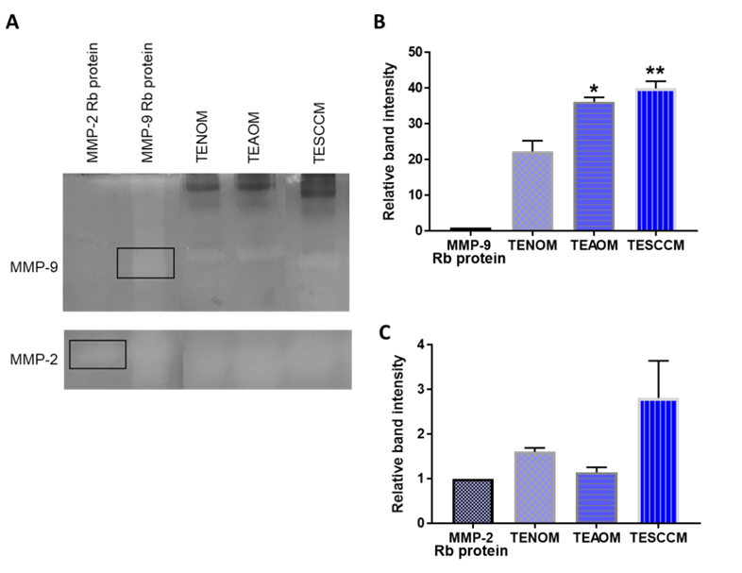

Figure 5.23 MMP-2 and MMP-9 activity in tissue-engineered oral mucosa models
MMP-2 and MMP-9 activity in TEOM models was assessed by gelatin zymography (representative images) (A). Densitometry of the resultant bands were measured using ImageJ and the intensity measured relative to Rb protein only controls (B). Data is expressed as relative fold change, with mean ± SD, N=3, n=2, * denotes p <0.05 and ** p <0.01 analysed by one-way ANOVA with Dunnett’s multiple comparison test. (N=3, n=2).

5.4 Discussion

Tumours are characterised by the disordered structure of ECM and unregulated cancer cell growth. Cancer cells have the ability to interact in a paracrine fashion as well as with ECM components (Lee et al. 2007). Currently, there is a lack of suitable 3D tissue-engineered approaches that mimic complex tumour cell: ECM interactions that may dictate the way OSCC progresses. This chapter has described novel methodologies for developing full thickness oral mucosa models that are representative of normal oral tissue, atypical oral mucosa, and OSCC by culturing stable immortalised buccal keratinocytes; FNB6 and oral cancer cells; H357 with the established 28-day fibroblast-derived matrices previously developed in chapter 4. By providing appropriate conditions, is has been possible to replicate some of the in vivo cell-cell and cell-ECM interactions resulting in novel full thickness oral mucosa equivalent models.
The gold standard for the construction of tissue-engineered oral mucosa models has utilised primary oral keratinocytes and cultured on top of primary fibroblast-embedded collagen and has been shown to be physiologically and histologically comparable to native oral mucosa (Yamada and Cukierman, 2007; Griffith and Swartz, 2006). However, there are disadvantages to using this methodology to analyse ECM and OSCC interactions. The collagen scaffold is typically derived from animals and therefore does not possess the human ECM framework. Primary keratinocytes are not always available, as often tissue biopsies are in limited supply. Generating suitable cultures also requires large numbers of cells, which have limited proliferative capabilities and often exhibit patient-to-patient heterogeneity (DongariBagtzoglou and Kashleva, 2006). To counteract these drawbacks, immortalised normal (FNB6) were used. These oral keratinocytes derived from healthy buccal mucosa are hTERT immortalised, and have the advantages of having a longer culture lifespan, reproducibility of results and are easy to culture.
Histological examination of the TENOM model revealed that FNB6 proliferated to produce a stratified squamous epithelium several layers thick, consistent with previously published reports (Jennings et al., 2016, Colley et al., 2011). However, here we show for the first time that the morphology, integrity and behaviour of FNB6 alters when these cells reside on human CAF-DM. Histological analysis of the TEAOM revealed that morphologically there was a loss of epithelial stratification and evidence of invasion. A lack of stratification was confirmed by TEER analysis, where there was a loss in tissue resistance compared with the TENOM model; which is indicative of a reduction in the basolateral compartmentalisation of the epithelium. CAF morphology was observed to be altered when they were in contact with the epithelium above; appearing more flattened and exhibiting an elliptical shaped nuclei which is evidence of a more migratory phenotype such as the phenotype found in wound healing and in CAF observed in peritumour aggregates (Karagiannis et al., 2012). The generation of an OSCC model was achieved by adding H357 onto CAF-DM, which contained features representative of oral carcinoma in vivo. H357 invaded through the ECM meshwork, and there was little to no evidence of epithelial stratification. This invasion is in part the result of interactions with CAF residing within the matrix layers below. This is in agreement to what was observed by Marsh et al., 2011; where, in a simpler collagen-based model increased invasion of OSCC cells was observed in the presence of CAF.
Further to diagnostic use, immunohistochemical markers show great potential for helping to predict prognostic outcomes and response to therapy; even in early tumour development (Bancroft, 2002). Therefore, in this study, a number of common markers known for detecting changes in oral cancer malignancy were assessed. Comparisons between epithelial, ECM and basal cell markers revealed considerable reorganisation of the epithelium and deposition of fibrillar stroma in these TEOM models. In OSCC, focal or extensive loss of basement membrane components and of integrins has been reported (Thomas et al., 2017). Investigations of OSCC patient biopsies show integrin α6β4, released from hemidesmosomes; where they partake in signalling that facilitates tumour cell proliferation, tumour invasion and metastasis and has been (Downer et al., 1993, Thomas et al., 2005). In this investigation, integrin α6β4 was observed to be reduced in the transition from normal to cancer oral mucosa. Expression in TENOM was observed on the basal aspect of basal cells, whereas a more diffuse pattern in the epithelium in TESCCM was detected, replicating the in vivo situation.
Abnormalities in cell adhesion molecule expression and regulation are known to play an important role in invasion and metastasis of cancer cells through the loss of cell-to-cell adhesions. E-cadherin (E-CAD) is a transmembrane glycoprotein essential for the binding of epithelial tissues (Kudo et al., 2004). Its cytoplasmic domain binds to the actin cytoskeleton through critical interactions with catenins. The loss of this interaction by down-regulation in E-CAD is exhibited in many cancers including OSCC (Zhou et al., 2015). A non-significant decrease in E-CAD staining was observed in TEAOM models with more obvious staining pattern seen in the basal aspect of basal cells which evidences that E-CAD is important in providing adhesion between cells as well as to the ECM below. A significant loss of E-CAD was observed in TESCCM which agrees with other reported findings as its loss enables metastasis by disrupting intercellular contacts (Onder et al., 2008). This also allows cells to adopt mesenchymal-like features, providing them with the capability to leave the primary tumour and colonise other locations, as seen in mouse breast and pancreatic cancer models; thus, enabling early step metastatic dissemination (Rhim et al., 2008 and Yutong et al., 2019).
Cell proliferation is a biological process vital to all living organisms. Proliferative control is lost in cancer and many studies have reported that abnormal cell proliferation appears to be a precursor and possibly predictor of OSCC tumorigenesis (Mayoung et al., 2006). In OSCC, Ki-67 a cellular marker for proliferation has been shown to be reliable marker for the estimation of the growth fraction in both normal and malignant human tissue (Tumuluri et al., 2002, Dwivedi et al., 2013, and Lopes et al., 2017). Here we show typical intermittent positive staining of polarised basal cells in the TENOM models, reflecting a normal proliferation index (Colley et al., 2011). However, in contrast, the TEAOM exhibited more supra-basal positive staining of Ki-67. A significantly high proliferation index with large numbers of Ki-67-positive cells was observed in the TESCCM consolidating findings that this increased proliferative capacity may also be attributed to the CAF-DM in which the cells reside.
Three ECM proteins were found to be differentially expressed in disease progression. The proteoglycan versican promotes tumour growth by destabilising focal cell contacts, which repress cell adhesion, stimulate cell proliferation and regulate angiogenesis. Increased levels of versican have been reported in several cancer types including adenocarcinomas, and squamous cell carcinomas (Pukkila et al., 2007). VCAN staining in TEOM models reflected this pattern; in the TEAOM model the expression increased significantly and was located throughout the stromal compartment as well as by H357 cancer cells. Extracellular cell adhesion modulating proteins like the tenascins also play critical roles in modulating cancer cell behaviours; these adhesion proteins modulate ECM properties toward a more flexible and migration promoting state by generating a) new cell-matrix interactions via integrins and b) generating new interactions with other stromal proteins by modulating their functions and 3D organisation (Berndt et al., 2015). TNC staining was most evident for the TEAOM model; where the staining altered from being exclusively between stromal-epithelial junctions, to exhibiting staining through-out the whole stromal compartment. This pattern of staining was also observed though-out the stroma of the TESCCM, further evidencing the importance of this glycoprotein in OSCC progression. COL1A1 staining was observed in all TEOM models. In agreement with SHGM data shown in chapter 4; collagen fibre density altered with disease progression. COL1A1 has been shown to have a strong correlation with OSCC disease compared to normal controls (Chen at al., 2008). Both in the TEAOM model and in the TESCCM; heavy COL1A1 staining was located in the stromal compartment of the models.
Mesenchymal markers VIM and αSMA were also shown to have positive staining in TEOM models. Positive staining of cytoskeletal protein VIM was altered in the OSCC progression models. Found exclusively in mesenchymal cells, the expression of VIM significantly increased in TESCCM and was mainly located with the CAF that resided in close proximity to the epithelial cells above. This has also been described in histochemical analysis of OSCC tissue samples (Zhou et al., 2015). VIM, also a marker of EMT, has been strongly associated with increased metastatic potential, shown by high lymph node metastases and poor overall survival in IHC analysed of OSCC patients (Lui et al., 2016). αSMA; a marker of ‘activated fibroblasts’ has also been positively correlated with OSCC disease progression in OSCC (Vered et al., 2009, and Bharak et al., 2014, Marsh et al., 2011). Positive staining was detectable in the stroma of all TEOM models, with significant increase in staining index observed in TESCCM which suggests that these models also mimic the changes seen in the in vivo tumour microenvironment.
Cancer cells migration is a key step in the dissemination of cells from a primary tumour site through the stromal compartment and associated ECM during cancer metastasis. Therefore, understanding cancer cell behaviour including the migration patterns influenced by the stromal compartment is of paramount importance in OSCC disease progression. Migrating cells are capable of both proteolytic- and force-mediated matrix remodelling and this allows the formation of cleared pathways or ‘tracks’ within the ECM (Gaggioli et al., 2007, Friedl and Gilmour, 2009 and Giampieri et al., 2009). As ECM remodelling is a crucial step in allowing cancer cells to invade into the stroma and is associated with increased MMP activity in these tissues. We sort to assess the activity of MMP-2 and -9 in our model systems, with both showing active enzymatic activity in vitro. A significant increase in MMP-9 activity was noted in both the TEAOM and TESCC models suggesting an elevation in tissue remodelling. This is in agreement with observations in both the histoarchitecture and protein composition of mucosa models representing various stages of the OSCC disease phenotype as well research showing increased MMP activity has been shown to degrade the basement membrane in cancer (Kleinmann and Martin, 2005). Metastatic cancer cells invade by using diverse migration strategies that are microenvironment dependent. Therefore, physical and biochemical cues instigated from the ECM can directly influence cellular behaviour (Friedl and Wolf, 2003). We have provided evidence that exploits human FDM can be used as a tool for investigating the biological outcome of cancer interactions. Here we have shown an enhancement of the migration and directness of H357 cancer cells as well as normal FNB6 cells on the CAF-DM and a normalised cell migration when cancer cells reside on normal FDM substrates; suggesting that CAF-deposited matrix provides a tumour permissive environment and is directly relatable to the migration of cells in vitro (Kaukonen et al., 2017). Adhesion was reduced on CAF-DM as well as an increase in both normal and cancer cell proliferation on CAF-DM. This is also observed in the histological analysis of the TESCCM showing evidence of H357 cells invading through the ECM compartment. The directional persistence of migratory cells is indicative of a preference for certain cell tracks, from previous work using SHGM (chapter 4) on these FDM, the likely tracks could be collagen fibres; fluorescently staining collagen fibres and cancer cells within these models may be of use to investigate this hypothetical form of movement as the ECM is a contributing substrate suitable for cell motility, with its topography dynamically controlling cell behaviour (Grinnell et al., 2010).
To summarise, the fully human 3D tissue-engineered oral mucosa models described here combine the advantages of in vitro generated models of high reproducibility, availability, and adjustability with a representative ECM geometry derived from both NOF and CAF. As such, they provide model systems to examine the influence of physiological and pathological ECM compositions, and therapeutic perturbations of these on OSCC cell behaviour. In addition, it can be used to study 3D migration and invasion processes or decipher further tumour–stroma interactions of OSCC cells and their surrounding fibroblasts.

Chapter 6

General discussion, future concepts and conclusion

6.0 General discussion

6.1 The ECM in cancer progression

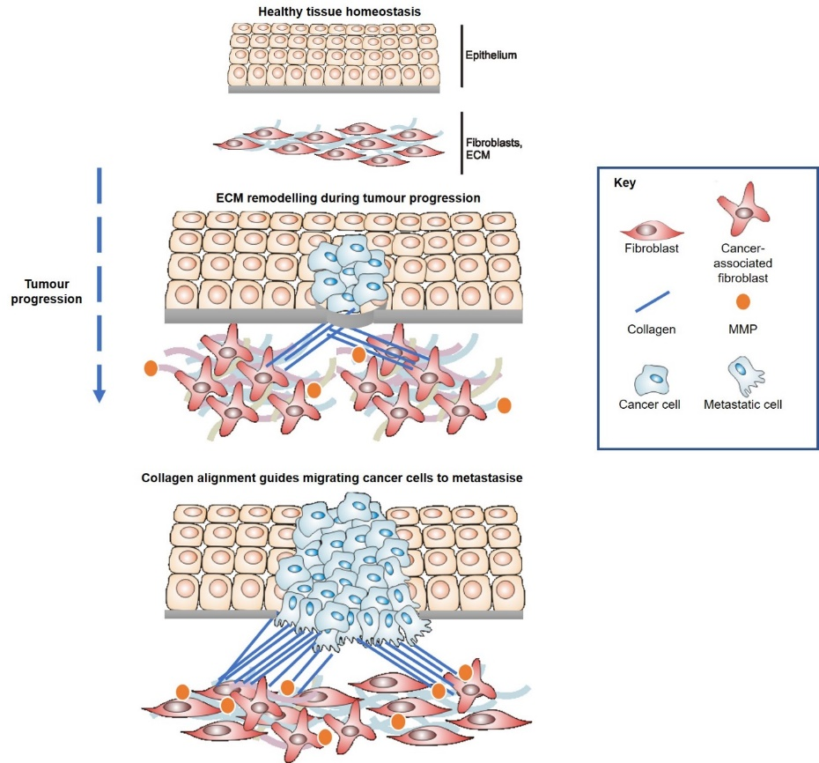
Long after development, the ECM is constantly being deposited, degraded and modified, acting as a highly dynamic structure that maintains tissue homeostasis (Lu et al., 2011). An imbalance in either cell or ECM leads to a disruption in homeostasis which can have catastrophic implications for the functionality of tissues and ultimately leads to diseases such as fibrosis and cancer (Cox and Erler, 2011, Bonnans et al., 2014). Our traditional perspective of cancer has now shifted to reflect the significance of the ECM in the regulation of cell phenotypic behaviour (Figure 6.1).

Figure 6.1 ECM remodelling during cancer progression
Tissues are under strict regulatory control during homeostasis. Epithelial cells in the mucosa become neoplastic and proliferate rapidly, inducing strain on the basement membrane. Soluble factors released from neoplastic cells cause phenotypic changes in resident fibroblasts in the stroma resulting in increased deposition of ECM components predominantly collagen, causing the ECM to stiffen as it cross-links. Once cancer cells have disrupted the basement membrane, they migrate along collagen tracks and metastasise to other locations (Images courtesy of D. Lambert).

To what extent the role of CAF-deposited ECM composition and abundance, as well as how physiological changes in the ECM can impact OSCC risk and development has yet to be fully elucidated. Although several in vivo models for studying OSCC none are without design caveats and often produce varying results in culture. This raises queries about the genetic differences between humans and animals, and whether xenograft or chemically induced tumour models are really representative of human oral cancer (Kim, 2009). Therefore, this study aimed to describe and characterise how tissue-engineered fibroblast-derived matrices (FDM) can be developed from primary NOF and CAF to develop ECM scaffolds which can be utilised to generate physiological relevant models of the oral mucosa, thereby mimicking changes in the stroma in OSCC.

6.2 Assessing oral myofibroblastic phenotype

The soluble factor, TGFβ-1 released by cancer cells into the microenvironment has been shown to induce the differentiation of fibroblast into myofibroblasts such as CAF (Calon et al., 2014). Our investigation verified that NOF were capable of transdifferentiating into a myofibroblastic phenotype in culture with a significant upregulation of αSMA, FN1-EDA, VCAN, TNC, and COL1A1 gene transcripts at 48 h. This is in agreement with other studies indicating TGFβ-1 as a growth factor is responsible for the upregulation of ECM components in vitro (Melling et al., 2018). The maintenance of this gene expression longer-term up to 14 days was only observed for FN1-EDA and TNC. The subsequent protein equivalents for all except TNC (which was not detectable by immunoblotting in any samples) also showed increased abundance with TGFβ-1 treatment that was maintained long-term.
In comparison CAF, showed an elevated expression of all transcripts, with a higher basal expression of target transcripts than in NOF. In contrast with NOF, CAF were able to maintain their phenotype long-term at the gene level, with significant expression of transcripts for all except TNC. This was not due to a reduced amplification, but because basal expression was considerably high, and TGFβ-1 treatment had no further effect. Other differences in phenotype were observed by the analysis of αSMA stress fibre formation in culture. NOF were only capable of producing stress fibres in the presence of TGFβ-1, however CAF produced de novo αSMA stress fibre formation without TGFβ-1 treatment for up to 7 days in vitro. This research indicates that CAF isolated from the reactive environment of OSCC exhibit a “myofibroblastic” differentiation status that is conserved in vitro and was accompanied by a higher sensitivity to TGFβ-1 (Kunz-Schughart et al., 2003).To further improve this investigation, the isolation of patient matched NOF and CAF samples would be beneficial. Therefore, directly comparable transcriptomic analysis could further decipher differences in the molecular phenotype of these stromal cells. For example, single-cell analysis of breast fibroblasts and their tumour-activated counterparts demonstrated molecularly distinct cell types defined by differential expression of characteristic mesenchymal and fibroblast activation markers (Busch et al., 2017).

6.3 Mimicking properties of the ECM in OSCC

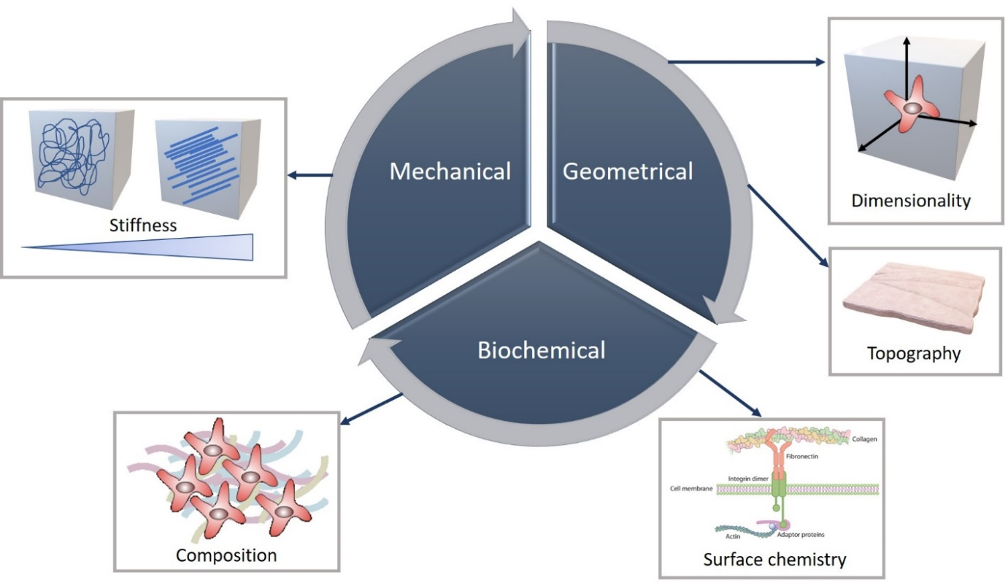
The ECM has unique physicochemical features, all of which specifically regulate cancer cell activity. In order to reconstitute native ECM using tissue-engineering techniques, the correct geometry, mechanics, and biochemical properties had to be established in this study (Figure 6.2).

Figure 6.2 Mimicking properties of tumour ECM.
Schematic illustration of the three principle properties (mechanical, geometrical and biochemical) governing engineered microenvironments.

6.3.1 Geometrical properties of FDM in OSCC

Appreciating that the stiffness of tissue culture plastic is within the gigapascal range and is considered far stiffer than even the stiffest living tissue, the oral fibroblasts are being cultured on a decidedly non-physiological mechanical environment (Caliari and Burdick, 2016). This emphasises concern that many of the baseline behaviors we attribute to cells cultured in vitro on plastic—from cytoskeletal organisation to proliferation and differentiation status—may be artifactual. This warrants the use of more physiological relevant systems to recapitulate oral fibroblast-deposited ECM and how this alters in OSCC disease progression. Fibroblast-derived matrices (FDM) which have a more complex composition and have the ability to provide adherent cells with mechanosensitive cues that could impact the way cancer cells behave on surface substrates (Holen et al., 2015). Adopting the correct geometrical properties, NOF and CAF self-assembled into stromal equivalents with their specific FDM over a 4-week culture period. Optimisation of conditions was necessary to ensure that fibroblast viability and ECM deposition was maintained for a long culture period. A transwell culture system proved optimum for the correct culture conditions; as evidenced by stable metabolism, maintained permeability as well as the formation of native fibrillar ECM. Analysis at both the gene and protein level confirmed that NOF-DM and CAF-DM were representative of both normal and cancer ECM as reported in the literature and remained stable in long-term culture conditions. CAF-DM deposition was distinct in both the thickness and composition, which is in agreement with other investigations (Malik et al., 2015, Lui et al., 2019). Solubilising the NOF- and CAF-DM and immunoblotting for the ECM components FN1-EDA, VCAN, LAMB-γ5, COL1A1 and the cytoskeletal filament αSMA all exhibited an increased abundance for each protein of interest in CAF-DM compared to NOF-DM indicating that the deposition of ECM components is fundamentally altered in OSCC disease progression.

6.3.2 Physical and mechanical properties of FDM in OSCC

As previously described, abnormal ECM composition, architecture and stiffness play integral roles in cancer progression and in all steps of metastasis. Much of the mechanical properties of the ECM are attributable to the fibrillar structure of collagen, which resists compressive stresses at the periphery of a tumour (Gkretsi and Stylianopoulos, 2018). As an elevated expression of COL1A1 was observed in both 2D investigations as well as in CAF-DM, the role of collagen was further investigated as a protein of interest in OSCC progression. Further justification for this is that collagen remodelling has been shown to significantly affect the biological behaviour of OSCC tumours by making them more aggressive in nature (Kumari et al., 2016). Collagen can be visualised by routine histology or by more advanced optical techniques. In this study second harmonic generation microscopy was adopted to study the native collagen structure in FDM. This was favoured over histology as it could be performed on unfixed tissue and could be quantifiable (Chen et al., 2012). Therefore, it was possible to generate label-free images of collagen structures and assess the re-organisation of collagen in NOF- and CAF-DM. Further quantitative analysis of collagen fibres revealed significant differences in collagen length, alignment and diameter in CAF-DM compared to NOF-DM. This first of its kind study on a tissue-engineered oral CAF-DM and suggests that collagen may indeed play an integral role in modifying the OSCC tumour profile as well as validating FDM as stromal models to study architectural changes in vitro. Although reported in the literature by Hanley et al., for OSCC and Provenzano et al., in breast carcinoma, a comparison study of OSCC patient material to conclude whether this trend is also observed in explant tissue would have been beneficial.
With the role of collagen cross-linking and subsequent stiffening of the ECM, this increased rigidity is well established in the progression of solid tumours (Tilghman et al., 2010 and Chaudhuri et al., 2014). Mechanical stress can directly affect tumour growth and progression, by placing cells in a unique physiological environment. Atomic force microscopy was conducted to decipher solid stress differences between NOF- and CAF-DM. Preliminary evidence indicated that CAF-DM produced a stiffer native ECM than NOF-DM which is in agreement with other investigations (Stylianou et al., 2018, Lui et al., 2019). Further experimental repeats are necessary to fully conclude whether CAF-DM stiffness contributes to an altered cancer cell phenotype.

6.3.3 Biochemical properties of FDM

Cell behaviour and response to the ECM is regulated by a complex set of environmental cues, including ECM ligand availability and stiffness (Kaukonen et al., 2017). ECM composition has been shown to influence the proliferation and migration of normal and cancer cells (Bomo et al., 2106). Live-cell imaging microscopy was employed to assess the effects of NOF- and CAF-DM on the behaviour of H357 and FNB6 cells. Both normal and cancer cells showed a significant increase in proliferation when they resided on CAF-DM, and overall H357 on CAF-DM exhibited the greatest rate of proliferation, which demonstrates the suitability of these FDM to study cancer cell proliferation in vitro, which is another alternative to other 3D methods for example spheroid-formation assays (Kaukonen et al., 2017). Using the models, it is also possible to assess variations in migration when these cells reside on NOF- and CAF-DM in a more in-vivo-like microenvironment. Elevated migration rates were observed for H357 on CAF-DM with increased speed and directness. This is also observable for other cancer cells in vitro and in vivo indicated the use of such FDM to assess the role of a pathway/protein or compound and the effects of these on migration (Rainero et al., 2012, Jacquemet et al., 2017, Paul et al., 2015). Evidence for tumour reactive stroma having a tumorigenic effect on epithelial cells.

6.4 FDM as three-dimensional platforms for drug screening

Tumours are highly complex, and this poses many limitations in the delivery of proper and effective doses of chemotherapeutic drugs to specifically target CAF, this is in part due to the abnormal structure of tumour tissues, thereby compromising the major routes of drug delivery (Egebald et al., 2010). The major abnormalities that are recapitulated in the models developed here are a highly dense ECM accumulation by CAF that acts as barrier to interstitial transport. The implications of treatment with Scriptaid and Batimastat were assessed in 2D cultures and in 3D, as FDM scaffolds. Preliminary results have indicated similarities and differences in responses to drug therapies between 2D and 3D cultures. Scriptaid treatment alone induced no significant changes to gene levels for NOF and CAF, however a significant decrease was observed for αSMA and FN1-EDA protein in CAF. CAF-DM response to Batimastat treatment indicates there could be therapeutic benefit, but discrepancies suggests that there may be compensatory pathways having an effect or that CAF heterogeneity means responses to treatments vary in culture. Other caveats in this stromal-targeting investigation suggest these findings are in their infancy regarding our understanding into the complete picture for the reversing pathological ECM deposition. Previous work has demonstrated that this epigenetic regulation via Scriptaid may not be permanent and that Scriptaid-treated CAF can revert back to their tumour-supportive functions when treatment is absent (Kim et al., 2018). There are also potential off-target effects of drug treatment, such as further downstream targets or the known affect that Scriptaid has on reducing CAF proliferation. Another limitation to this study is that the tumour microenvironment contains a diverse collection of cells and protein components and therefore the impact of Scriptaid and Batimastat could alter with the presence of this dynamic milieu. Alternative approaches could investigate the contractile phenotype of CAF, measured by AFM. Measuring CAF stiffness and assessing pathological changes with inhibitor treatment, would also provide further evidence for CAF-DM acting as a permissive environment in OSCC. There were notable differences in the phenotypic response of CAF in 2D and 3D to these drugs. One explanation could be due to the presence of serum derived growth factors supplemented in the long-term culturing of these oral fibroblast- derived matrices, as 2D cultures were analysed in serum free conditions. Foetal bovine serum (FBS) can contain a high level of latent TGFβ-1. In order to maintain the FDM long-term, serum is an essential media supplement, therefore it was not possible to remove this in cultures. In order to improve this, one method that could be adopted is to dialyse the FBS to remove growth factors then assay for background levels. Also, the use of an anti-TGF, anti- EGF and anti-FGF blocking antibody to media which may establish clearer results.

6.5 Generating full-thickness oral mucosa models in OSCC progression

The advantages and disadvantages of various 3D tumour models have been discussed within the introduction chapter of this study. In order to combat some of these, we sort to generate heterologous 3D tumour models of the oral mucosa that had an all human-cell component to model OSCC progression. The addition of human stable immortalised epithelial keratinocyte cell line; FNB6 on a NOF-DM facilitated the establishment of a well-stratified and differentiated oral epithelium, with all the necessary features of a healthy mucosa (Moharamzadeh et al., 2007). However, the addition of same FNB6 cells to a CAF-DM showed abnormal epithelial cell morphology, reduced stratification, and evidence of invasion into the CAF-rich stroma, generating a model of atypical mucosa, with evidence of some ‘dysplastic’ like features. This model could contain vital information for evidencing further the ‘seed and soil’ hypothesis described by Paget in the 1800’s, in which the CAF stroma provides a permissive microenvironment for cells to invade. An OSCC model was also developed by seeding H357 onto CAF-DM. This model displayed, distinctly more invasion into the stroma from cancer cells, as well as a lack of epithelial stratification, characteristic of OSCC tumour models (Jennings et al., 2016, Duong et al., 2005).

6.5.1 Dysregulation of ECM molecules and remodelling in OSCC progression

Arrangement and orientation of ECM forms a tissue-specific microenvironment that is crucial in all aspects of tumour progression (Walker et al., 2018). CAF secrete MMP which remodel the stroma to promote a permissive environment for cancer cell migration, proliferation and invasion and MMP activity in cancer progression is multi-faceted (Lui et al., 2019). MMP assist in the degradation of surrounding ECM as well as controlling the release of active growth factors that enhance cellular function. MMP-2 and MMP-9 activity was investigated in models of OSCC progression, whereby a significant increase in MMP-9 activity was detected in models of TEAOM and TESCCM. Interestingly MMP-9 activity is associated with a microenvironment favourable with invasion and metastasis through activation of TGFβ-1 and the deposition of ECM components (Lynch and Matrisian, 2002, Sternlicht and Werb, 2001, Calon, et al., 2014).
Recent years, the number of molecular-based assays has increased but histopathology remains the gold standard for most diagnostic and therapeutic decisions (Oliveira and Silva, 2011). For this reason, the TEOM models generated in this investigation were stained for ECM, epithelial and basement membrane markers to assess their suitability to mimic protein changes associated with OSCC disease progression. These models were successfully characterised by IHC and displayed the features of anomalous protein expression with an increased disease phenotype. Further characterisation would include performing transmission electron microscopy to further study microscopic changes in adhesion proteins and visualise invasion by disruption of basement membrane proteins.

6.6 Future work

3D models are becoming an increasingly important tool in many arms of biological research as researchers seek more complex, physiologically relevant systems whilst moving away from animal experimentation. Validation of any models is the key to success. If resources had allowed, further proteomic analysis would be beneficial, allowing for a more comprehensive assessment of the distinct molecular profile of each model investigated, thus affording the opportunity of identifying novel prognostic markers and therapeutic targets. It would be possible to undertake global identification of matrix components by matrix-assisted laser desorption ionisation (MALDI) -imaging mass spectrometry as well as bioinformatics approaches to compare ECM signatures in normal, atypical and OSCC models, and comparing these to patient OSCC explants (Pearce et al., 2017, Mayorca-Guiliana et al., 2017, Angel et al., 2019).
Culture of the models for longer than the 42 days tested here is highly probable and could be beneficial to study longer-term changes such as invasion in disease progression paradigm- or repeat dosing regimens. With the use of live-imaging microscopy, fluorescently labelling cancer cells and monitoring the invasion process into CAF-DM could provide more answers into the molecular mechanisms underpinning this process in OSCC. Despite recent therapeutic developments (Mao et al, 1998; Rudin et al., 2003; Rhee et al, 2004), there are currently no effective treatment for dysplasia. Using the techniques described here, it may also be possible to generate a model of dysplasia by combining a dysplastic fibroblast-derived matrix with dysplastic epithelial cells and assess this phenotype. This would facilitate study of early OSCC invasion and tumour growth as well as facilitate final stage in vitro testing of new treatments, diagnostic tests and provide a drug delivery or screening system for OSCC (Colley et al., 2011).
There are three requirements that are necessary to engineer human tissue, the first being co-localisation of different cell types with cell-cell interactions and the exchange of growth factors and biological effectors. The second being the development of native ECM to provide a functional 3D scaffold for appropriate mechanical stability of tissue and the capability to regulate cell function. The final requirement is the synthesis of interstitial fluid containing the appropriate nutrients and biological molecules required for tissue nourishment. The latter requirement has not been recapitulated in the models developed here. Future work could investigate the effects of interstitial fluid flow (mechanical stress- fluid stress) on the tissue maturation and how this could impact stromal cells within the ECM component, specifically because an altered mechanical environment is a powerful regulator of tumour progression (Walker et al., 2018, Nithiananthan et al., 2017).
Finally, a major challenge for future work utilising these models will be to fully elucidate the molecular functions underpinning the processes by which the CAF: ECM interactions alters with a disease phenotype; whether this involves receptor signalling, alterations in gene expression, including understanding CAF transcriptomics, or the release of extracellular vesicles which can provide a more in depth understanding of the formation of pre-metastatic niches (Dourado et al., 2019) architectural and structural rearrangements or effects on cellular behaviour or all of the above.

6.7 Clinical significance

Translation of the use of such models for improvements to clinical applications, could involve underpinning aberrant ECM signatures for either diagnostic or prognostic purposes in the treatment of OSCC. It is not routine to use many well-established markers to detect aberrant stromal behaviour to assist for pathological examination. However, these could be invaluable in the further understanding of anomalous changes in transitions of early dysplasia to malignancy. Identifying novel molecular signatures could help decipher this process further, and this emphasises the use of more humanised OSCC tumour: ECM models to recapitulate this process. Further to this, there is a need for quantitative and physiologically relevant cellular systems in the drug-screening process, particularly for oral cancer, where 60% of patients present late stage and treatment options are limited (Centelles et al., 2012). The use of these models could help in testing novel compounds that target OSCC and further test responses to current therapies in a more physiologically relevant way (Egebald et al., 2010).

6.8 Conclusion

In conclusion, the initial understanding of cancer was that the internal properties of cancer cells determine the major contributions to cancer initiation and progression. However, advances in our understanding of cancer biology, we know regard the disease as largely heterogeneous; where different underlying molecular aetiologies form the foundation of the same clinical outcome and that multiple cell types and non-cellular components like the ECM collectively coordinate to support the growth, survival and invasion of cancer cells.
The findings within this investigation lead to the conclusion that aberrant changes found within the tissue stroma can cause rather than being the consequence of the OSCC malignant process and results in altered tissue fields and architecture (Gascard, 2016). Tissue-engineered models of normal, atypical and OSCC developed within this investigation, act as in vitro mimetics of the disease process and are suitable platforms to measure and quantify changes in ECM properties and show promise for their use as 3D drug screening platforms. These models also validate that CAF in OSCC should not be seen as single cellular elements, but as a stromal cohort in which their phenotypic properties of enhancing cancer cell migration and proliferation, and desmoplastic release and remodelling of ECM components contribute to the onset and progression of OSCC.

Chapter 7

Appendix

Figure 7.1.
H&E staining revealed that in some instances, CAF-DM showed visible contraction in culture rather than adhere to the insert membrane.

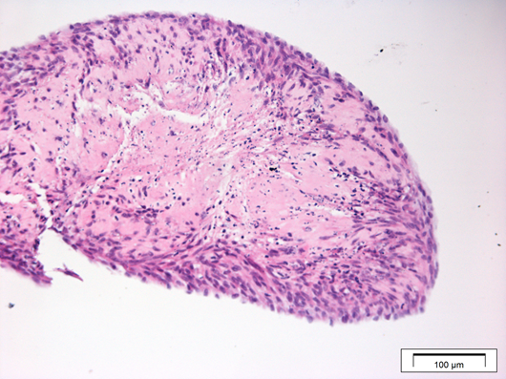

100 µm

Figure 7.1 CAF contraction in TE-FDM
After 28-day culture, CAF-DM were stained using H&E with a representative image showing evidence of contraction in culture. (N=1, n=2).

Figure 7.2

After 24 hours no differences in cell attachment was observed for FNB6 cells seeded onto NOF-DM or CAF-DM with mean percentages of 97.04 ± 1.30% and 80.91 ± 11.86% respectively.
No significant differences were observed for H357 seeded onto NOF-DM, but cell attachment significantly reduced when H357 were seeded onto CAF-DM. Showing a reduced percentage to 68.16 ± 6.36%, p=0.0197.

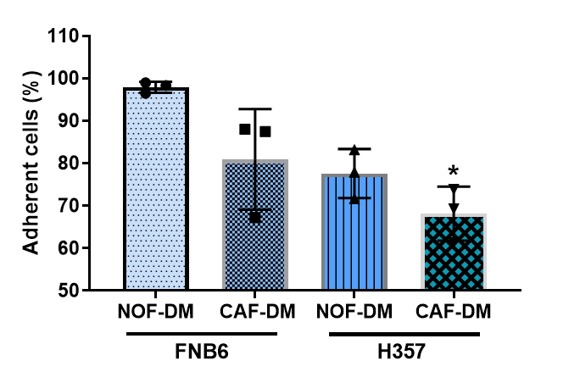

Figure 7.2 Keratinocyte adhesion onto NOF- and CAF-DM
Normal (FNB6) and OSCC (H357) keratinocytes were seeded onto NOF- and CAF-DM and the % of adherent cells after 24 h determined. Data is presented as mean ±SD (N=3, n=3) as analysed by Kruskal-Wallis with Dunn’s multiple comparison test.

Figure7.3

Increased proliferation was observed between H357 and FNB6 cells. FNB6 proliferated significantly more on CAF-DM than NOF-DM, p=0.0048. H357 on NOF- and CAF-DM were also significantly increased compared to FNB6 on NOF-DM, with a p=0.0268 for H357 on NOF-DM and p=0.001 for H357 on CAF-DM.

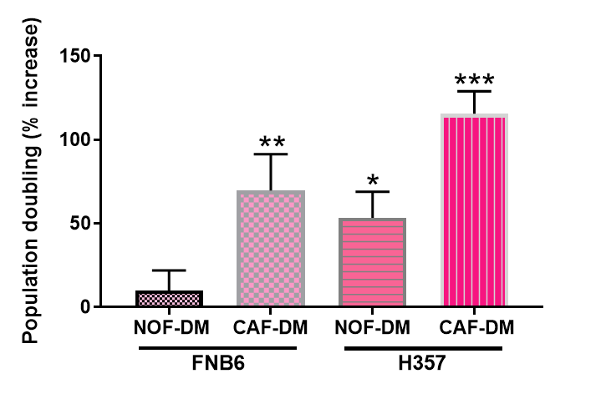

Figure 7.3 Assessment of the proliferation of H357 and FNB6 cells on NOF- and CAF-DM
Percentage doubling was calculated at 24 h for both FNB6 and H357 cells on NOF- and CAF-DM using live-cell imaging microscopy. Data is presented as mean ± SD (N=3, n=3). * Denotes p <0.05, ** p <0.01, *** p <0.001 as analysed by ordinary one-way ANOVA with Dunnett’s multiple comparison.

Figure 7.4

Rete ridges are visible across TENOM models as evidenced by epithelial cell projections.

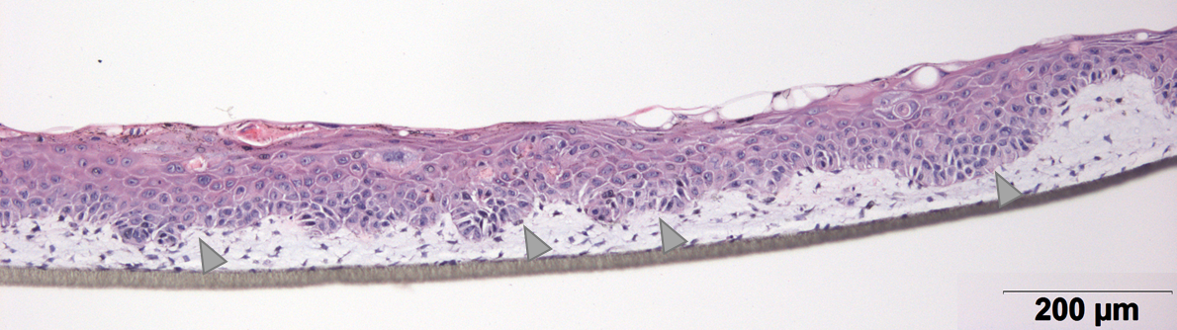

Figure 7.4 Histological analysis of tissue-engineered normal oral mucosa (TENOM) model generated using NOF-DM
After a 28-day NOF-DM development the addition of FNB6 cells produced a full-thickness stratified epithelium (A) over a further 14 days. H&E analysis shows evidence of rete ridge formation (N=5, n=3).

Figure 7.5
Epidermal thickness was measured after 42 days on tissue-engineered oral mucosa models. Analysis of epidermal thickness using ImageJ measurement software on H&E stained images of 42-day models showed a significant reduction in epidermal thickness for the TESCCM compared to TENOM models from 116.6 ± 15.95 to 39.47 ± 22.57 µm, p <0.0001.

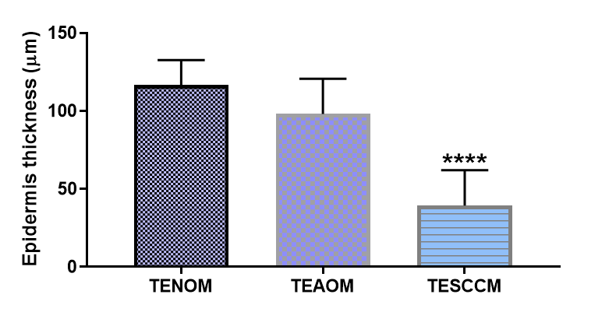

Figure 7.5 Variations in epidermal thickness in tissue-engineered oral mucosa models
The thickness of the epidermis was measured using ImageJ measurement plug-in after 42 days for TENOM, TEAOM, and TESCCM. Data presented shows mean ± SD (N=3, n=3) as analysed using ordinary one-way ANOVA with a post-hoc Dunnett’s comparison test comparing to TENOM, **** p <0.0001.

Figure 7.6

COLIV expression was also visible in the stromal compartment of TEAOM.

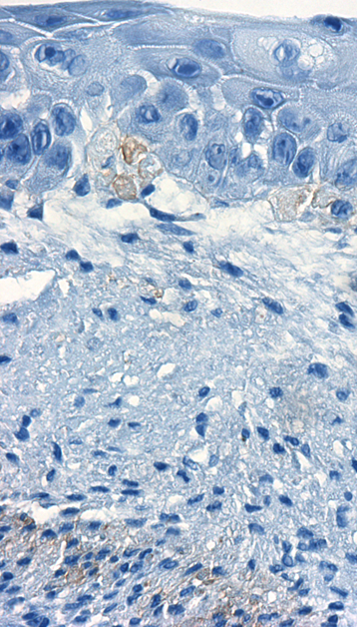

Figure 7.6 Immunohistochemical analysis of COLIV in tissue-engineered atypical oral mucosa models
Full thickness tissue-engineered models were developed on FDM and cultured for 12 days at an air-to-liquid interface before being subjected to histological processing and immunohistochemical staining for COLIV (brown) and haematoxylin counterstain (blue). Representative images of TEAOM. Scale bar = 50 µm.

References

AHLFORS, J.W and BILLIAR, K.L. (2007). ‘Biomechanical and biochemical characteristics of a human fibroblast-produced and remodelled matrix.’ Biomaterials, 28, 2183-2191.
ALBRENGUES, J. Bertero, T., Grasset, E., Bonan, S., Maiel, M., Bourget, I., Phillippe, C., Serrano, C.H., Benamar, S., Croce, O., Sanz-Moreno, V., Meneguzzi, G., Feral, C.C., Cristofari, G, and Gaggioli, C. (2015). ‘Epigenetic switch drives the conversion of fibroblasts into pro-invasive cancer-associated fibroblasts.’ Nature Communications, (6).
ALBRENGUES, J. Bourget, I. Pons, C. Butet, V. Hofman, P, Tartare-Deckert, S. Feral, C.C. Meneguzzi, G. and Gaggoli, C. (2014). ‘LIF Mediates Pro-invasive Activation of Stromal Fibroblasts in Cancer.’ Cell reports, 7, 1664-1678.
ANNES J.P., Munger J.S, Rifkin D.B. (2003) ‘Making sense of latent TGF-beta activation’. J Cell Sci 116: 217–224.
BADYLAK, S.F, Freytes, D.O, and Gilbert, T.W (2009). ‘Extracellular matrix as a biological scaffold material: Structure and function.’ Acta Biomaterialia: (5) 1–13.
BAGAN, J.V and SCULLY, C. (2008). “Recent advances in oral oncology 2007: epidemiology, aetiopathogenesis, diagnosis and prognostication”. Oral Oncol ,44:103-108.
BARCELLOS-HOFF, M.H. & Ravani, S.A. (2000). “Irradiated mammary gland stroma promotes the expression of tumorigenic potential by unirradiated epithelial cells”. Cancer Res. 60, 1254–1260.
BARKAN, D. Green, J E. and Chambers, A.F. (2010). ‘Extracellular Matrix: A Gatekeeper in the Transition from Dormancy to Metastatic Growth’. Eur J Cancer; 46 (7): 1181–1188.
BECHTEL, W. McGoohan S, Zeisberg E.M., Müller G.A., Kalbacher H, Salant D.J., Müller C..A, Kalluri R, Zeisberg M.. (2010). ‘Methylation determines fibroblast activation and fibrogenesis in the kidney’. Nat. Med. 16, 544–550.
BERGERS, G., and BENJAMIN L.E. (2003). ‘Tumorigenesis and the angiogenic switch’. Nat Rev Cancer 3: 401–410.
BERNDT, A. Richter, P. Kosmehl, H and Franz, M. (2015) ‘Tenascin-C and carcinoma cell invasion in oral and urinary bladder cancer’, Cell Adhesion & Migration, 9:1-2, 105-111.

BERNING, M. Prätzel-Wunder, S. Bickenbach, J.R. and Boukamp, P. (2015). ‘Three-Dimensional in vitro skin and skin cancer models based on human fibroblast-derived matrix.’ Tissue Engineering, (21), 9, 958-970.
BHARATH, K. Malathi, N. Narashiman, S and Rajan, S.T. (2014). ‘Evaluation of Myofibroblasts by Expression of Alpha Smooth Muscle Actin: A Marker in Fibrosis, Dysplasia and Carcinoma.’ Journal of Clinical and Diagnostic Research.8 (4): ZC14-ZC17.
BRAAKHUIS B.J, Sneeuwloper G, and Snow, G.B. (1984). ‘The potential of nude mouse xenograft model for the study of head and neck cancer.’ Arch Otorhinolaryngol; 239: 69-79.
BREDFELDT, J.S. Liu, Y. Pehlke, C.A. Conklin, M.W. Szulczewski, J.M. Inman, D.R. Keely, P.J. Nowak, R.D. Mackie, T.R. and Eliceiri, K.W. (2014). "Computational segmentation of collagen fibers from second-harmonic generation images of breast cancer," J. Biomed. Opt. 19, 016007–016007. (http://loci.wisc.edu/software/ctfire).
BREGENZER M.E., Horst E.N., Mehta P, Novak C.M., Raghavan S, Snyder C.S., and Mehta, G (2019). ‘Integrated cancer tissue engineering models for precision medicine.’ PLoS ONE 14 (5): e0216564.
BRESLIN, S., and O’DRISCOLL, L. (2013). ‘3D cell culture: the missing link in drug discovery.’ Drug Discovery today; 18(5/6):241-249.
BROWN, E., McKee, T., DiTomaso, E., Pleun, A., Seed, B., Boucher, Y., and Jain, R.K. (2013) ‘Rheological Properties of Extracellular Matrix Derived Gels’. Nature Medicine: 9 (6):796-800.
BROWN, J.M., and ATTARDI, L.D. (2005). ‘The role of apoptosis in cancer development and treatment response’. Nat reviews cancer, 5: 231-237.
BUTCHER D. T., Alliston T., Weaver V.M. (2009). ‘A tense situation: forcing tumour progression’. Nat. Rev. Cancer; 9, 108–122.
CALVO, F. Ege, N., Grande-Garcia, A., Hooper, S., Jenkins, R.P., Chaudhry, S.I., Harrington, K., Williamson, P., Charras, G.L., and Sahai, E. (2013). ‘Mechanotransduction and YAP-dependent matrix remodelling is required for the generation and maintenance of cancer-associated fibroblasts’. Nat. Cell Biol. 15, 637–646.
CHAKRAVARTHY A, Khan L, Bensler N.P., Bose P, and De Carvalho D.D. (2018). ‘TGF-β-associated extracellular matrix genes link cancer-associated fibroblasts to immune evasion and immunotherapy failure.’ Nature communications. 9:4692.
CHAUDHURI O., Koshy S.T., Branco da Cunha C., Shin, J-W., Verbeke C.S., Allison, K.H and Mooney, D.J. (2014). ‘Extracellular matrix stiffness and composition jointly regulate the induction of malignant phenotypes in mammary epithelium.’ Nature materials; 13: 970-978.
CHEN R, Khormaee S, Eccleston M.E., Slater N.K. (2009). ‘The role of hydrophobic amino acid grafts in the enhancement of membranedisruptive activity of pH-responsive pseudo-peptides’. Biomaterials 30:1954–1961.
CHENG Y.S., Champliaud M.F., Burgeson R.E, Marinkovich M.P., and Yurchenco P.D. (1997) ‘Self-assembly of laminin isoforms’. J Biol Chem; 272:31525–31532.
COLLER, H.A. Sang, L and Roberts, J.M. (2006). ‘A new description of cellular quiescence.’ PLoS Biol, 4(3): e83.
COLLEY, H.E, Hearnden V, Jones A.V., Weinreb P.H., Violette S.M., MacNeil S, Thornhill M.H. and Murdoch C (2011). ‘Development of tissue-engineered models of oral dysplasia and early invasive oral squamous cell carcinoma.’ British Journal of Cancer; 105, 1582 – 1592.
COMPER W.D and Laurent T.C. (1978). ‘Physiological functions of connective tissue polysaccharides’. Physiol Rev; 58: 255-315.
CONKLIN M.W, Eickhoff J.C, Riching K.M, Pehlke C.A, Eliceiri K.W, Provenzano P.P, Friedl A, Keely P.J. (2011). ‘Aligned Collagen Is a Prognostic Signature for Survival in Human Breast Carcinoma.’ The American Journal of Pathology. 178:1221–1232.
COUGHLIN, M.F. Bielenberg, D.R. Lenormand, G. Marinkovic, M. Waghorne, C.G. Zetter, B.R. and Fredberg, J.J. (2013). ‘Cytoskeletal stiffness, friction, and Fluidity of cancer cell lines with different metastatic potential.’ Clin Exp Metastisis, 30:237-250.
COX, T.R and Erler, J.T. (2011). ‘Remodelling and homeostasis of the ECM; implications for fibrotic diseases and cancer.’ Dis model Mech; 4 (2); 165-178.
CurveAlign software, LOCI, version 4.0, 2017, (http://loci.wisc.edu/software/curvealign).
DARBY, I. A., Laverdet, B., Bonte, F. & Desmouliere, A. (2014). ‘Fibroblasts and myofibroblasts in wound healing’. Clin. Cosmet. Investigat. Dermatol. 7, 301–311.
DAVID L, Dulong V, Le C.D, Chauzy C, Norris V, Delpech B, Lamacz M, Vannier J.P (2004). ‘Reticulated hyaluronan hydrogels: a model for examining cancer cell invasion in 3D’. Matrix Biol 23:183– 193.
DE WEVER, O. Demetter, P. Mareel, M and Bracke, M. (2008). ‘Stromal myofibroblasts are drivers of invasive cancer growth.’ Int .j. Cancer: 123, 2229-2238.
DEBELLE, L., and Alix, A.J. (1999). ‘The structures of elastins and their function’. Biochimie 81, 981-994.
DESMOULIERЀ, A., Guyot, C. and Gabbiani, G. (2004). ‘The Stroma reaction myofibroblast: a key player in the control of tumour cell behaviour.’ Int. J. Dev. Biol, (48), 509-517.
DESMOULIERЀ, A., Guyot, C., Gabbiani, F., and Gabbiani, G. (1993). ‘Transforming Growth Factor-β Induces α-Smooth Muscle Actin Expression in Granulation Tissue Myofibroblasts and in Quiescent and Growing Cultured Fibroblasts’. Journal of Cell Biology; 122 (1); 103-111.
DISCHER D.E., Janmey P., and Wang, Y.L. (2005). ‘Tissue cells feel and respond to the stiffness of their substrate.’ Science. 310 (5751):1139-43.
DVORAK, H.F. (2015). ‘Tumours; wounds that do not heal- redux.’ Cancer immunol Res; 3; 1-11.
DVORAK, H. F. (1986). ‘Tumours: wounds that do not heal. Similarities between tumour stroma generation and wound healing’. N. Engl. J. Med. 315, 1650–1659.
EKERT, J.E., Johnson, K., Strake, B., Pardinas, J., Jarantow, S., Perkinson, R. and Colter, D.C. (2014). ‘Three-dimensional lung tumor microenvironment modulates therapeutic compound responsiveness in vitro–implication for drug development’. PLoS ONE 9, e92248.
EL GHALBZOURI, A. Commandeur, S. Reietveld, M.H. Mulder, A.A. Willemze, R. (2009). ‘Replacement of animal-derived collagen matrix by human fibroblast-derived dermal matrix for human skin equivalent products.’ Biomaterials, (30), 71-78.
ELSTROM R.L, Bauer D.E, Buzzai M, Karnauskas R, Harris M.H, Plas D.R, Zhuang H, Cinalli R.M, Alavi A, Rudin C.M. (2004) ‘Akt stimulates aerobic glycolysis in cancer cells’. Cancer Res 64: 3892–3899.
FISCHBACH C, Chen R, Matsumoto T, Schmelzle T, Brugge J.S, Polverini P.J and Mooney D.J. (2007). ‘Engineering tumours with 3D scaffolds.’ Nature methods 4, 855-860.
FONG, E. L., Wan, X., and Yang, J. (2016). ‘A 3D in vitro Model of patient-derived prostate Cancer xenograft for controlled interrogation of in vivo tumour-stromal interactions’. Biomaterials 77, 164–172.
FRANCO-BARRAZA, J, Beacham, D.A, Amatangelo, M.D, and Cukierman, E (2016). ‘Preparation of extracellular matrices produced by cultured and primary fibroblasts’. Curr Protoc Cell Biol. 71: 10.9.1–10.9.34.
FRANK, C.J., and McCreery, R.L. (1995). ‘Raman Spectroscopy of Normal and Diseased Human Breast Tissues.’ Anals. Chem; 67:777-783.
FRANTZ, C. Stewart, K.M, and Weaver, V.M. (2010). ‘The extracellular matrix at a glance.’ Journal of cell science, 123, 4195-4200.
FREYER JP, Sutherland RM (1980). ‘Selective dissociation and characterization of cells from different regions of multicell tumour spheroids’. Cancer Res 40:3956–3965.
GABBIANI G, Ryan GB, Majno G. (1971). ‘Presence of modified fibroblasts in granulation tissue and their possible role in wound contraction’. Experientia;27 (5):549–550.
GAGGIOLI, C. Hooper, S. Hidalgo-Carcedo, C. Grosse, R. Marshall, J.F. Harrington, K. and Sahai, E. (2007). ‘Fibroblast-led collective invasion of carcinoma cells with differing roles for RhoGTPases in leading and following cells.’ Nat. Cell Biol: 9 1392-1400.
GHARIBI, B and HUGHES, F.J. (2012). ‘Effects of Medium Supplements on Proliferation, Differentiation Potential, and In Vitro Expansion of Mesenchymal Stem Cells.’ Stem cells translational medicine, 1:771–782.
GIALLELI, C, Theocharis, A.D., and Karamanos, N.K. (2011). ‘Roles of matrix metalloproteinases in cancer progression and their pharmacological targeting.’ FEBS journal, 278, 16-27.
GILL, B.J and WEST, J.L. (2014). ‘Modelling the tumour extracellular matrix: Tissue engineering tools repurposed towards new frontiers in cancer biology’. Journal of Biomechanics 47; 1969–1978.
GILMORE, A.P., Metcalfe, A.D., Romer, L.H., Streuli, C.H. (2000). ‘Integrin mediated survival signals regulate the apoptotic function of Bax through its conformation and subcellular localisation.’ J cell biol, 149: 431-446.
GRINNELL, F. Fukamizu, H. Oawelek, P, and Nakagawa, S. (1989). ‘Collagen processing, crosslinking, and fibril bundle assembly in matrix produced by fibroblasts in long-term cultures supplemented with ascorbic acid’. Exp. Cell Res., 181, 483–491.
GURSKI L.A., Jha A.K., Zhang C, Jia X, Farach-Carson M.C. (2009). ‘Hyaluronic acid-based hydrogels as 3D matrices for in vitro evaluation of chemotherapeutic drugs using poorly adherent prostate cancer cells.’ Biomaterials 30:6076–6085.
HAHN, W.C., Counter, C.M., Lundberg, A.S., Beijersbergen, R.L., Brooks, M.W. and Weinberg, R.A. (1999). ‘Creation of human tumour cells with defined genetic elements’. Nature, 400, 464-468.
HAMASAKI, H, Koga, K, Aoki, M, Hamasaki, M, Koshikawa N, Seiki M, Iwasaki H, Nakayama J, and Nabeshima K. (2011). ‘Expression of laminin 5-g2 chain in cutaneous squamous cell carcinoma and its role in tumour invasion’. British Journal of Cancer, 105, 824 – 832.
HANAHAN, D and Weinberg, R.A. (2000). ‘The Hallmarks of Cancer.’ Cell; 100, 57-70.
HANAHAN, D and Weinberg, R.A. (2010). ‘The Hallmarks of Cancer: The next generation.’ Cell; 144: 646-674.
HANLEY, C.J, Noble, F, Ward, M. Bullock, m. Drifka, C. Mellone, M. Manousopoulou, A. Johnston, H.E. Hayden, A. Thirdborough, S. Lui, Y. Smith, D.M. Mellows, T. Kao, W.J. Garbis, S.D. Mirenzami, A, Underwood, T.J. Eliceiri, K.W. and Thomas, G,J. (2016). ‘A sub-set of myofibroblastic cancer-associated fibroblast regulates collagen fibre elongation, which is prognostic in multiple cancers.’ Oncotarget, 2;7 (5):6159-74.
HEINO, J., Huhtala, M., Käpylä, J., and Johnson, M.S. (2009). ‘Evolution of collagen-based adhesion systems’ International Journal of biochemistry and cell biology. 41, 341-348.
HERRMANN, D. Conway, J.R.W, Vennin, C, Magenau, A. Hughes, WG. Morton, J. P and Timpson, P. (2014) ‘Three-dimensional cancer models mimic cell–matrix interactions in the tumour microenvironment’. Carcinogenesis (00), no.00 1-9.
HIELSCHER A.C. and Gerecht S. (2012). ‘Engineering Approaches for Investigating Tumour Angiogenesis: Exploiting the Role of the Extracellular Matrix. Cancer Res, 72 (23), 6089-96.
HILDAGO, M and ECKHARDT, G. (2001). ‘Development of Matrix Metalloproteinase Inhibitors in Cancer Therapy.’ Journal of the National Cancer Institute, (93), 3.
HILL, D.S., Robinson, N.D.P., Caley, M.P., Chen, M., O'Toole, E.A., Armstrong, J.L., Przyborski, S. & Lovat, P.E. (2015). A novel fully-humanised 3D skin equivalent to model early melanoma invasion. Molecular Cancer Therapeutics 14(11): 2665-2673
HINDERMANN W, Berndt A, Borsi L, Luo X, Hyckel P, Katenkamp D, Kosmehl H. (1999). ‘Synthesis and protein distribution of the unspliced large tenascin-C isoform in oral squamous cell carcinoma’. J Pathol: 189:475-80.
HINTERMANN E., and Quaranta V. (2004). ‘Epithelial cell motility on laminin-5: regulation by matrix assembly, proteolysis, integrins and erbB receptors’. Matrix Biol; 23: 75–85.
HINZ, B. (2009). ‘Tissue stiffness, latent TGF-β1 activation, and mechanical signal transduction: implications for the pathogenesis and treatment of fibrosis’. Curr. Rheumatol. Rep. 11, 120–126.
HOLLIDAY D.L., Brouilette K.T., Markert A, Gordon L.A., Jones J.L. (2009). ‘Novel multicellular organotypic models of normal and malignant breast: tools for dissecting the role of the microenvironment in breast cancer progression’. Breast Cancer Res 11:R3.
HUGHES, C.S. (2010) “Matrigel: a complex protein mixture required for optimal growth of cell culture”. Proteomics, 10, 1886–1890.
HUO, C.W. Chew, G. Hill, P. Huang, D. Ingman, W. Hodson, L. Brown, K.A. Manginau, A. Allam, A.H. McGhee, E. Timpson, P. Henderson, M.A. Thompson, E.W, and Britt, K. (2015). ‘High mammographic density is associated with an increase in stromal collagen and immune cells within the mammary epithelium.’ Breast cancer Res; 17(1):79.
HYNES R.O. (2009), ‘Extracellular matrix: not just pretty fibrils.’ Science, 27: 326(5957):1216-1219.
HYNES R.O.’ (2007). ‘Cell-matrix adhesion in vascular development’. J Thromb Haemost 5: 32–40.
IMAI K., Hiramatsu A., Fukushima D., Pierschbacher M.D., Okada Y. (1997). ‘Degradation of decorin by matrix metalloproteinases: identification of the cleavage sites, kinetic analyses and transforming growth factor-β1 release’. Biochem. J; 322:809–814.
IOZZO R.V. (1998). ‘Matrix proteoglycans: From Molecular Design to Cellular Function.’ Annu. Rev. Biochem; 67:609–52.
ISHII G., Ochiai A., and Neri S. (2016). ‘Phenotypic and functional heterogeneity of cancer-associated fibroblast within the tumour microenvironment’. Advanced Drug Delivery Reviews, 99 (Pt B), 186–196.
JENNINGS L, Colley H.E, Ong J, Panagakos F, Masters J, Trivedi H, Murdoch C & Whawell S (2016). ‘Development and characterisation of in vitro human oral mucosal equivalents derived from immortalised oral keratinocytes’. Tissue Engineering Part C: Methods, 22(2), 1108-1117.
JUNTTILA M.R., De Sauvage F.J. (2013) Influence of tumour micro-environment heterogeneity on therapeutic response. Nature. 501:346–54.
KALLURI R. (2016). ‘The biology and function of fibroblasts in cancer.’ Nature Reviews Cancer; 16, 582–598.
ΚΑΤΟ Κ, Hara Α, Kuno Τ, Kitaori Ν, Huilan Ζ, Mori Η, Toida Μ, Shibata Τ. (2005). ‘Matrix metalloproteinases 2 and 9 in oral squamous cell carcinomas: manifestation and localization of their activity.’
KENNY P.A, Lee G.Y, Myers C.A, Neve R.M, Semeiks J.R., Spellman P.T,. Lorenz K, Lee EH, Barcellos-Hoff M.H., Petersen O.W., Gray J.W., Bissell M.J. (2007). ‘The morphologies of breast cancer cell lines in three-dimensional assays correlate with their profiles of gene expression’. Mol Oncol 1:84–96.
KIDD S., Spaeth E., and Watson K. (2012). ‘Origins of the tumour microenvironment: quantitative assessment of the adipose-derived and bone derived stroma.’ PloS One: 7, e30563.
KIM T.H, Mount C.W, Gombotz W.R, and Pun S.H (2010). ‘The delivery of doxorubicin to 3-D multicellular spheroids and tumours in a murine xenograft model using tumour-penetrating triblock polymeric micelles’. Biomaterials 31:7386–7397.
KIMLIN L., Kassis J., and Virador V. (2013). ‘3D in vitro tissue models and their potential for drug screening.’ Expert Opinion Drug Discovery; 8(12); 1-12.
KLEINMAN H.K and MARTIN G.R (2005). ‘Matrigel: basement membrane matrix with biological activity’. Semin Cancer Biol 15:378–386.
KLEINMAN H.K, McGarvey M.L, Hassell J.R, Star V.L, Cannon FB, Laurie G.W, and Martin G.R. (1986). ‘Basement membrane complexes with biological activity’. Biochemistry; 25:312–318.
KNIGHT E and PRZYBORSKI S (2015). ‘Advances in 3D cell culture technologies enabling tissue-like structures to be created in vitro’. J. Anat. 227, 746-756.
KNIGHT E, Murray B, Carnachan R, and Przyborski S. (2011). ‘Alvetex®: polystyrene scaffold technology for routine three dimensional cell culture’. Methods Mol Biol. 695:323-40.
KOJIMA Y., Acar A., Eaton E.N., Mellody K.T., Scheel C., Ben-Porath I., Onder T.T., Wang Z.C., Richardson A.L., Weinberg R.A., and Orimo A. (2010). ‘Autocrine TGF-beta and stromal cell-derived factor-1 (SDF-1) signalling drives the evolution of tumour-promoting mammary stromal myofibroblasts.’ Proc Natl Acad Sci U S A.; 107(46):20009-14.
KOPANSKA K.S, Alcheikh Y, Staneva R, Vignjevic D, Betz T (2016). ‘Tensile Forces originating from cancer spheroids facilitate tumour invasion’. PLoS ONE 11(6): e0156442.
KRAMAN M., Bambrough P.J., Arnold J.N., Roberts E.W., Magiera L., Jones J.O., Gopinatha A., Tuveson D.A., Fearon D.T. (2010). ‘Suppression of antitumor immunity by stromal cells expressing fibroblast activation protein-alpha’. Science, 330, 827–830.
KRAMER R.H, Bensch K.G, and Wong J (1986). ‘Invasion of reconstituted basement membrane matrix by metastatic human tumour cells.’ Cancer Res 46:1980–1989.
KUMAR S. Shabi T.S. and Goormaghtigh E. (2014). ‘A FTIR Imaging Characterization of Fibroblasts Stimulated by Various Breast Cancer Cell Lines.’ PLoS One; 9(11): e111137.
KUMARI K, Ghosh S, Patil S, Augustine D, Venkatesiah S.S, Roa R.S. (2016). ‘Expression of type III collagen correlation with poor prognosis in OSCC’. J Invest Clin Dent; 00:1-7.
KUNZ-SCHUGHART L.A, Kreutz M, and Knuechel R (1998). ‘Multicellular spheroids: a three-dimensional in vitro culture system to study tumour biology’. Int J Exp Pathol 79:1–23.
LAWLOR E.R., Scheel C., and Irving J. (2002). ‘Anchorage-Independent Multi-Cellular Spheroids as an In Vitro Model of Growth Signaling in Ewing Tumours’. Oncogene, 21, 307–318.
LEE G.Y, Kenny P.A, Lee E.H, Bissell M.J (2007). ‘Three-dimensional culture models of normal and malignant breast epithelial cells.’ Nat Meth 4:359–36.
LEIGHT J.L., Wozniak M.A., Chen S., Lynch M.L., Chen C.S. (2012). ‘Matrix rigidity regulates a switch between TGF-beta1-induced apoptosis and epithelial-mesenchymal transition’. Mol Biol Cell 23: 781–791.
LOESSNER D, Stok K.S, Lutolf M.P, Hutmacher D.W, Clements J.A and Rizzi S.C. (2010). ‘Bioengineered 3D platform to explore cell–ECM interactions and drug resistance of epithelial ovarian cancer cells’. Biomaterials. 31, 32, 8494-8506.
LOHR, M. (2001). ‘Transforming growth factor-β1 induces desmoplasia in an experimental model of human pancreatic carcinoma’. Cancer Res. 61, 550–555.
LU P., Weaver V.M., and Werb Z. (2012). ‘The Extracellular Matrix; a dynamic niche in cancer progression.’ J Cell Biol, 196, 395.
LÜ W-D, Zhang L, Wu C-L, Liu Z-G, Lei G-Y, Liu J. (2014). ‘Development of an Acellular Tumor Extracellular Matrix as a Three-Dimensional Scaffold for Tumor Engineering’. PLoS ONE 9(7): e103672.
LUCA A.C., Mersch S., Deenen R., Schmidt S., Messner I., Schäfer K.L., Baldus S.E., Huckenbeck, W., Piekorz, R.P., Knoefel, W.T., Krieg, A., and Stoeckhlein, N.H. (2013). ‘Impact of the 3D microenvironment on phenotype, gene expression, and EGFR inhibition of colorectal cancer cell lines’. PLoS ONE, 8, e59689.
LUKASHEV M.E, and Werb Z. (1998). ‘ECM signalling: orchestrating cell behaviour and misbehaviour’. Trends Cell Biol; 8:437–441.
LYNCH C.C, and MATRISIAN L.M. (2002). ‘Matrix metalloproteinases in tumour-host cell communication’. Differentiation;70(9–10):561–73.
MACAULAY, V.M, O’Byrne, K.J, Saunder, M.P, Braybrooke, J.P, Long, L, Gleeson, F, Mason, C.S, Harris, A.L, Brown, P and Talbot, D.C. (1999). ‘Phase 1 study of Intrapleural Batimastat (BB-94), a matrix metalloproteinase inhibitor, in the treatment of malignant pleural effusions.’ Clinical Cancer Research, 5, 513-520.
MARISA, L., De Reynies, A., Duval, A., Selves, J., Gaub, M.P., Vescovo, L., ̀ Etienne-Grimaldi, M.C., Schiappa, R., Guenot, D., Ayadi, M. (2013). ‘Gene expression classification of colon cancer into molecular subtypes: characterization, validation, and prognostic value’. PLoS Med. 10, e1001453.
MARSH, D., Suchak, K., Moutasim, K. A., Vallath, S., Hopper, C., Jerjes, W., Upile, T., Kalavrezos, N., Weinreb, P. H., Chester, K A., Chana, J. S., Marshall, J. F., Hart, I. R., HACKSHAW, A. K., Piper, K., & Thomas, G. J. (2011). ‘Stromal features are predictive of disease mortality in oral cancer patients’. The Journal of Pathology, 223(4), 470–81.
MCGEE G.S., Davidson J.M, Buckley A., (1988) ‘Recombinant basic fibroblast growth-factor accelerates wound-healing’. J Surg Res;45:145-153.
MEDICO, E., Russo, M., Picco, G., Cancelliere, C., Valtorta, E., Corti, G., Buscarino, M., Isella, C., Lamba, S., Martinoglio, B. et al. (2015). ‘The molecular landscape of colorectal cancer cell lines unveils clinically actionable kinase targets’. Nat. Commun. 6, 7002.
MELLING, G.E. (2015). The role of mRNA-145 in the tumour microenvironment.’ PhD thesis, The University of Sheffield.
MELLONE, M., Hanley, C.J., Tirdborough, S., Mellows, T., Garcia, E., Woo, J., Tod, J., Frampton, S., Jenei, V., Moutasim, K.A., Kabir, T.D, Brennan, P.A., Venturi, G., Ford, K., Herranz, N., Peng, K., Clarke, J., Lambert, D.W, Prime, S.S, Underwood, T.J., Vijayanand, P.., Eliceiri, K.W., Woelk, C., King, E.V., Gil, J., Ottensmeier, C.H., and Thomas, G.J. (2016). Induction of fibroblast senescence generates a non-fibrogenic myofibroblast phenotype that differentially impacts on cancer prognosis.’ Aging, 9(1): 114–131.
MEYAARD, L. (2008). ‘The inhibitory collagen receptor LAIR-1 (CD305)’. J Leukoc Biol 83: 799–803.
MOHARAMZADEH, K, Brook, I.M, Van Noort, R, Scutt, A.M and Thornhill, M.H (2007). ‘Tissue-engineered Oral Mucosa: a Review of the Scientific Literature.’ Journal of Dental Research, 86(2), 115-124.
MONAZZAM A, Razifar P, Ide S, Rugaard JM, Josephsson R, Blomqvist C, Langstrom B, Bergstrom M (2009) Evaluation of the Hsp90 inhibitor NVP-AUY922 in multicellular tumour spheroids with respect to effects on growth and PET tracer uptake. Nucl Med Biol 36:335–342.
MONAZZAM A, Razifar P, Simonsson M, Qvarnstrom F, Josephsson R, Blomqvist C, Langstrom B, Bergstrom M (2006). ‘Multicellular tumour spheroid as a model for evaluation of [18F] FDG as biomarker for breast cancer treatment monitoring.’ Cancer Cell Int 6:6.
MONTERO, P.H, and PATEL, S.G. (2015). ‘Cancer of the oral cavity.’ Surg Oncol Clin N Am; 24 (3): 491-508.
MONTESANO R, Orci L, Vassalli P. (1983) ‘In vitro rapid organization of endothelial cells into capillary-like networks is promoted by collagen matrices’. J Cell Biol 97: 1648–1652.
MOSS N.M, Barbolina M.V, Liu Y, Sun L, Munshi H.G, and Stack M.S.
(2009). ‘Ovarian cancer cell detachment and multicellular aggregate formation are regulated by membrane type 1 matrix metalloproteinase: a potential role in metastatic dissemination.’ Cancer Res; 69(17):7121e9.
MUELLER-KLIESER W (1997). ‘Three-dimensional cell cultures: from molecular mechanisms to clinical applications.’ Am J Physiol 273:C1109–C1123.
MULLER, P.A. Caswell, P.T., Doyle B, Iwanicki M.P., Tan E.H., Karim S, Lukashchuk N, Gillespie D.A., Ludwig, R.L., Gosselin P, Cromer A, Brugge J.S., Sansom O.J., Norman J.C., Vousden K.H. (2009) “Mutant p53 drives invasion by promoting integrin recycling”. Cell, 139, 1327–1341.
MYERS, J.N, Holsinger, FC, Jasser, S.A, Bekele, B.N, Fidler, I.J. (2002). ‘An orthotopic nude mouse model of oral tongue squamous cell carcinoma.’ Clin Cancer Res; 8, 293-8.
NABA, A., Clauser K.R., Lamar, J.M., Carr, S.A., and Hynes, R.O. (2014). ‘Extracellular matrix signatures of human mammary carcinoma identify novel metastasis promotors.’ Elife 3; e01308.
NAKAMURA, T., Matsumoto, K., Kiritoshi, A. & Tano, Y. (1997) “Induction of hepatocyte growth factor in fibroblasts by tumour-derived factors affects invasive growth of tumour cells: in vitro analysis of tumour–stromal interactions”. Cancer Res. 57, 3305–3313.
NETTI, P.A. (2000). ‘Role of Extracellular Matrix Assembly in Interstitial Transport in Solid Tumours.’ Cancer research 60, 2497–2503.
NITHIANANTHAN, S., Crawford, A., Cooper Knock, J., Lambert, D.W., and Whawell, S.A. (2016). ‘Physiological fluid flow moderates fibroblast responses to TGFβ-1.’ Journal of Cellular Biochemistry 9999:1–13.
NTGA, A. Chemma, U and Loizidou, M. (2011). ‘3D tumour models: novel in vitro approaches to cancer studies.’ Journal of Cell Communication and Signalling, (5) 239.
NUNES, Q.M, Yong L, Changye S, Tarja K.K and D.G. Fernig D.G. (2016). ‘Fibroblast growth factors as tissue repair and regeneration therapeutics.’ PeerJ, (4) 1535.
O ’CONNOR R.S., Hao X., Shen K., Bashour K., Akimova T., Hancock W.W., Kam L.C, Milone M.C. (2012). ‘Substrate rigidity regulates human T cell activation and proliferation’. J Immunol 189: 1330–1339.
O’CONNELL, F.C., and MARTIN, F. (2000). ‘Laminin-rich ECM association with mammary epithelial cells suppresses BRCA1 expression.’ Cell death differ. 7;360-367.
OXLUND, H., Manschot, J and Vidik, A. (1998). ‘The role of elastin in the mechanical properties of skin’. 1. Biomechmics; 21. (3,) pp 213-218.
PATTABIRAMAN, P.P and Rao, P.V. (2010). ‘Mechanistic basis of Rho GTPase-induced extracellular matrix synthesis in trabecular meshwork cells.’ Am Journal Physiology and Cell Physiology; 298:749-763.
PICK-UP, M.W., Mouw, J.K., and Weaver, V.M. (2014). ‘The ECM modulates the hallmarks of cancer.’ EMBO reports, (15), 12; 1243-1253.
PIETRAS, K., and Östman, A. (2010). ‘Hallmarks of cancer: Interactions witht eh tumour stroma.’ Experimental cell research; 316, 1324-1331.
PINNELL, SR. (1985). ‘Regulation of Collagen Biosynthesis by Ascorbic Acid: A Review.’ The Yale Journal of biology and medicine, 58, 553-559.
PRIME, S.S. Cirillo, N. Hassona, Y. Lambert, D.W, Paterson, I.C. Mellone, M. Thomas, G.J. James, E.N.L. and Parkinson, E.K. (2016). ‘Fibroblast activation and senescence in oral cancer.’ J Oral Pathol Med.
PROVENZANO P.P, Eliceiri K.W, Campbell J.M, Inman D.R, White J.G and Keely P.J. (2006). ‘Collagen reorganisation at the tumour-stromal interface facilitates local invasion’. BMC medicine; 4:38.
PROVENZANO, P.P and Hingorani, S.R. (2013). ‘Hyaluronan, fluid pressure, and stromal resistance in pancreas cancer’. British Journal of Cancer, 108, 1–8.
PUKKILA, M. Kosunen, A. Ropponen, K. Virtaniemi, J. Kellokoski, J. Kumpulainen, E. Pirinen, R. Nuutinen, J. Johansson, R. and Kosma, V-K (2007). ‘High stromal versican expression predicts unfavourable outcome in oral squamous cell carcinoma’. J Clin Pathol; 60:267–272.
RADISKY D., Hagios C., and Bissell M.J. (2001). ‘Tumours are unique organs defined by abnormal signalling and context.’ Semin. Cancer Biol; 11, 87–95.
RAEBER G.P., Lutolf M.P., Hubbell J.A. (2005). ‘Molecularly engineered PEG hydrogels: a novel model system for proteolytically mediated cell migration’. Biophys J 89:1374–138.
RAHMAN A, Carey S.P., K-Rush C.M., Goldblatt Z.E., Bordeleau F, Lampi M.C., Lin D.Y., García A.J. and Reinhart-King C.A. (2016). ‘Vinculin Regulates Directionality and Cell Polarity in 2D, 3D Matrix and 3D Microtrack Migration’. Molecular biology of the cell. 27(9).
RAITZ R, Martins M.D., and Araujo V.C. (2003). ‘A study of the extracellular matrix in salivary gland tumors’. J Oral Pathol Med; 32:290-6.
RALSTON, D.R. Layton, C. Dallery, A.J. Boyce, S.G. Freedlander, E. and MacNeil, S. (1997). ‘Keratinocytes contract dermal extracellular and reduced soluble fibronectin by fibroblasts in a skin composite model.’ British Journal of plastic Surgery, (50): 408-415.
RAMOS, D.M., Chen, B.L., Regezi, J., Zardi, L. and Pytela, R. (1998). ‘TN-C matrix assembly in oral squamous-cell carcinoma. Int. J. Cancer, 75, 680–687.
RAVI, M. Paramesh, V. Kaviya, S.R. Anuradha, E. and Solomon, F.D.P. (2015). ‘3D Cell Culture Systems: Advantages and Applications.’ J.Cell Physiol. 230: 16-26.
RHIM, A.D, Mirek, E.T, Aiello N.M, Maitra A, Bailey J.M, McAllister F, Reichert M, Beatty G.L, Rustgi AK and Vonderheide R.H (2012). ‘EMT and dissemination precede pancreatic tumour formation’ Cell 148 349–61.
ROBERTS, A.B., McCune B.K., Sporn M.B. (1992). ‘TGF-β: Regulation of extracellular matrix.’ Kidney International, (41), 557-559.
ROTHENBERG, S.M. and Ellisen, L.W. (2012). ‘The Molecular pathogenesis of HNSCC.’ J Clinical Invest; 122(6); 1951-1957.
ROUTRAY, S. Sunkavali, A, and Bari, K.A. (2014). ‘Carcinoma-associated fibroblasts, its implication in head and neck squamous cell carcinoma: a mini review. Oral Diseases, 20, 546-253.
SCHENK, S., Hintermann E., Bilban M., Koshikawa N., Hojilla C., Khokha R., Quaranta V. (2003). ‘Binding to EGF receptor of a laminin-5 EGF-like fragment liberated during MMP-dependent mammary gland involution’. J Cell Biol; 161:197–209.
SCHOR, S. L., Schor, A. M. & Rushton, G. (1988). ‘Fibroblasts from cancer patients display a mixture of both foetal and adult-like phenotypic characteristics’. J. Cell Sci. 90, 401–407.
SEETHALAKSHMI, C. (2013). ‘Early Detection of Oral Squamous Cell Carcinoma (OSCC) – Role of Genetics: A Literature Review.’ J Clinical Diagnosis. Res; 7(8):1824-1826.
SEEWALDT, V. (2014). ‘ECM Stiffness paves the way for tumour cells.’ Nature medicine, (20), 332-333.
SEREBRIISKII, I, Castello-Cros, R, Lamb, A, Goelmis, A.E, and Cukierman, E. (2008). ‘Fibroblast-derived 3D matrix differentially regulates the growth and drug-responsiveness of human cancer cells’. Matrix Biol: (6): 573–585.
SHERMAN-BAUST, C.A. Weeraratna, A.T. Rangel, L. B.A. Pizer, E.S. Cho, K. R. Schwartz, D. R. Shock, T. and Morin, P.J. (2003).’Remodelling of the extracellular matrix through overexpression of collagen VI contributes to cisplatin resistance in ovarian cancer cells’. Cancer Cell, 4(3):377-386.

SHU Q, Wong K.K., Su J.M., Leung, H.C., Li, X.N. (2008). ‘Direct orthotopic transplantation of fresh surgical specimen preserves CD133+ tumor cells in clinically relevant mouse models of medulloblastoma and glioma’. Stem Cells; 26:1414 –1424.
SINGER, I.L. (1979). “The fibronexus: a transmembrane association of fibronectin-containing fibres and bundles of 5 nm microfilaments in hamster and human fibroblasts”. Cell: (3); 675-85.
SLEDGE, G.W, Qulali, M, Goulet R, Bone, E.A, and Fife, R. (1995). ‘effect of matrix metalloproteinase inhibitor batimastat on breast cancer regrowth and metastasis.’ J natl cancer inst., 87 (20): 1546-50.
SOBRAL, L.M., Bufalino, A., Lopes, M.A., Graner, E., Salo, T., & Coletta, R.D. (2011). ‘Myofibroblasts in the stroma of oral cancer promote tumorigenesis via secretion of activin A’. Journal of Oral Oncology, 47(9), 840–6.

SQUIER, C.A and KREMER, M.J. (2001). ‘Biology of oral mucosa and oesophagus.’ JNCI monographs, (29): 7-15.
SRIRAM, G. Bigliardi, P.L. and Bigliardi-Qi, M. (2015). ‘Fibroblast heterogeneity and its implications for engineering organotypic skin models in vitro’. European Journal of Cell Biology, (94), 483-512.
STAMOV, D.R., and Pompe, T. (2012). ‘Structure and function of ECM-inspired composite collagen type 1 scaffolds.’ Soft Matter; 8, 10200-10212.
STEPHENS, P, Davies K.J, Occleston N, Pleass R.D, Kon C, Daniels J, Khaw P.T, Thomas D.W. (2001). ‘Skin and oral fibroblasts exhibit phenotypic differences in extracellular matrix reorganization and matrix metalloproteinase activity’. Br J Dermatol. 144(2): 229-37.
STERNLICHT, M.D and WERB, Z. (2001). ‘How matrix metalloproteinases regulate cell behaviour.’ Annu Rev Cell Dev Biol; 17: 463–516.
STETLER-STEVENSON, W.G, Hewitt, R, and Corcoran, M. (1996). ‘matrix metalloproteinases and tumour invasion: from correlation and causality to the clinic.’ Cancer biology, 7, 147-154.
STEWART, R. L and O’Connor, K. L (2015). ‘Clinical significance of the integrin α6β4 in human malignancies’. Lab Invest. 95(9): 976–986.
STRUTZ, F, Okada, H, Lo, C.W., Danoff, T., Carone, R.L., Tomaszewski, J.E., Neilson, E.G. (1995). ‘Identification and characterization of a fibroblast marker: FSP1’. J. Cell Biol., 130, 393–405.
SUGIMOTO, H., Mundel, T.M, Kieran M.W., and Kalluri R. (2006). ‘Identification of fibroblast heterogeneity in the tumor microenvironment.’ Cancer Biol Ther.;5(12):1640-6.
TALARI, A.C.S., Movasaghi, Z., Rehman, S., and Rehman, I.U. (2015). ‘Raman Spectroscopy of Biological Tissues’. Applied Spectroscopy Reviews; 50:46–111.
TERAI S, Fushida S, Tsukada T, Kinoshita J, Oyama K, Okamoto K, Makino I, Tajima H, Ninomiya I, Fujimura T (2015). ‘Bone marrow derived ‘fibrocytes’ contribute to tumor proliferation and fibrosis in gastric cancer’. Gastric Cancer 18: 306-313.
THEOCHARIS, A.C. Skandalis, S.S. Gialeli, C. and Karamanos, N.K. (2016). ‘Extracellular matrix structure.’ Advanced drug delivery Reviews: 97, 4-27.
THROM, A.M., Lui, W-C., Lock, C-H., and Billar, K.L. (2010). ‘Development of a cell-derived matrix: effects of epidermal growth factor in chemically defined culture’. J. Biomed. Mater.Res. A, 92, 533–541.
TZU, J., and Marinkovich, M.P. (2008). ‘Bridging structure with function: structural, regulatory, and developmental role of laminins’. Int J Biochem Cell Biol; 40(2): 199–214.
VANDER HEIDEN M.G., Cantley L.C, Thompson C.B. (2009). ‘Understanding the Warburg effect: the metabolic requirements of cell proliferation’. Science 324: 1029–1033.
VARKI R, Sadowski S, Pfendner E., and Uitto J. (2006). ‘Epidermolysis bullosa. I. Molecular genetics of the junctional and hemidesmosomal variants’. J Med Genet; 43:641–652.
VERED, M. Allon, I. Buchner, A. Dayan, D. (2009). ‘Stromal Myofibroblasts accompany Modifications in the Epithelial Phenotype of Tongue Dysplastic and Malignant Lesions Cancer.’ Microenvironment; 2:49-57.
VILLANUEVA I, Weigel C.A., Bryant S.J. (2009). Cell-matrix interactions and dynamic mechanical loading influence chondrocyte gene expression and bioactivity in PEG-RGD hydrogels. Acta Biomaterials 5:2832–2846
WANG C.C, Bajikar S.S, Jamal L, Atkins K.A, Janes K.A (2014). ‘A time- and matrix dependent TGFBR3-JUND-KRT5 regulatory circuit in single breast epithelial cells and basal-like premalignancies’. Nat Cell Biol; 16:345–56.
WANG Y, and McNiven M.A. (2012). ‘Invasive matrix degradation at focal adhesions occurs via protease recruitment by a FAK-p130Cas complex’. J Cell Biol 196: 375–385.
WANG, P. Ballestrem, C. and Streuli, C.H. (2011). ‘The C Terminus of talin links integrins to cell cycle progression.’ J. Cell Biol, 195:499-513.
WEINBERG, R.A. and Orimo, A. (2006). ‘Heterogeneity of Stromal Fibroblast in Tumours.’ Cancer Biol Ther, 5 (12): 1640-6.
WIGHT, T.N. (2002). ‘Versican: a versatile extracellular matrix proteoglycan in cell biology.’ Current Opinion in Cell Biology; 14:617–623.
WOLF K., Alexander S., Schacht V., Coussens L.M, von Andrian U.H., van Rheenen J., Deryugina E., and Friedl P (2009) ‘Collagen-based cell migration models in vitro and in vivo’. Semin Cell Dev Biol 20: 931 – 941.
WYLIE S, MacDonald I.C., Varghese H.J., Schmidt E.E., Morris V.L., Groom A.C. and Chambers A. (1999). ‘The matrix metalloproteinase inhibitor Batimastat inhibits angiogenesis in liver metastases of B16F1 melanoma cells.’ Clin Exp Metastasis.17(2):111-7.
XING, F. Saidou, J. and Watabe, K. (2011). ‘Cancer associated fibroblasts (CAFs) in the tumour microenvironment.’ Front Biosci; 15: 166-179.
XIONG, J., Balcioglu, H.E., and Danen, E.H (2013). ‘Integrin signalling in control of tumour growth and progression.’ Int j biochem cell biol, 45: 1012-1015.
YU S.T., Chen L, Wang H.J, Tang X.D, Fang D.C, and Yang SM (2009). ‘hTERT promotes the invasion of telomerase-negative tumour cells in vitro’. Int J Oncol 35: 329–336
YURCHENCO, P.D., and Wadsworth W.G. (2004). ‘Assembly and tissue functions of early embryonic laminins and netrins’. Curr Opin Cell Biol;16: 572–579.
ZHOU, J. Tao, D. Xu, Q. Gao, Z. and Tang, P (2015). ‘Expression of E-cadherin and vimentin in oral squamous cell carcinoma.’ Int J Clin Exp Pathol;8(3):3150-3154.
ZIOBER B.L, Turner M.A, Palefsky JM, Banda, M.J and Kramer R.H. (2000). ‘Type 1 collagen degradation by invasive oral squamous cell carcinoma.’ Oral oncology, 36, 365-372.

